INVESTIGATING DIFFERENTIAL EXCITOTOXIC SUSCEPTIBILITY ACROSS BRAIN REGIONS

A Dissertation Presented for the
Doctor of Philosophy
Degree
The University of Tennessee, Knoxville

Debalina Acharyya
December 2024
DEDICATION

I lovingly dedicate this dissertation to my mum (Sujata Acharyya) and dad (Debi Prasad Acharyya) for their unwavering faith in me and my dreams. My mum sowed the seed of curiosity early in my life and has taught me to question everything. My dad taught me the meaning hard work in the face of any adversity. Their grace, strength, and support have been instrumental in my goals to be a better version of myself every day.

I would also like to dedicate my dissertation to my grandfather (Sisir Kumar Bhattacharyya) and my grandmother (Gauri Bhattacharyya) for their wisdom. Their words have always encouraged me to fulfil my bigger goal to be a good human being at heart and productive citizen of the world.

I would finally dedicate my dissertation to the various women scientists who have come before me, mentored me, encouraged me, and believed in me that I have what it takes to be a good scientist. Their research and lives continue to inspire me in every step that I take.

ACKNOWLEDGEMENTS

I would begin by first acknowledging my mentor and supervisor, Dr. Rebecca Prosser for taking a chance with me. Her patience, wisdom, scientific acumen has been the corner stone of my research and my journey in the graduate school. I would also like to take acknowledge the current and previous members of the lab who build a strong a foundation and supported me to through the journey.
Next, I would like to acknowledge my committee members: Dr. Jim Hall, Dr. Matthew Cooper and Dr. Roberto Romero Fernandez. Their varied perspectives and input on my dissertation have been instrumental in my research and their clinical implications.
Furthermore, I would like to acknowledge the faculty at the Department of Biochemistry, Cellular & Molecular Biology for their support and encouragement. Special thanks to Dr. Mariano Labrador, Dr. Vitaly. Ganusov, Dr. Andreas Nebenfuehr and Jaydeep Kolape for their expertise in microscopy and imaging techniques that was employed by me in the dissertation. I would also like to thank all the faculty members and student members of NeuroNET for their support and providing me with resources to further my neuroscience training at The University of Tennessee
I would also take this opportunity to extend my gratitude to my amazing colleagues in the department for their support. Specially thanks to Victoria Norman and Elsie Adams for being my biggest cheerleader through all the challenges of graduate school.
I would also like to express my gratitude to the undergraduate students who have worked with me on the project: Rachel Brandeis, Christiane Alvarez, Felicia Willets, Donnovan Willets, Jimin Lee, Kara Holt, Klara Houck, Laila Kozmann, Emma Kate Martin, Gabrielle Pence and Jackson Major.
Lastly, I would like to thank my parents who believed in me, my friends in Knoxville who have been a constant source of support. Special thanks to my best friends: Dr. Debjyoti Kundu and Suddha Satwa Sen for their unwavering faith in my potential and brutal honesty.
I would like to finish off by thanking I, me, and myself for never giving up in the face of adversity and being stupidly stubborn.

ABSTRACT

Various pathological conditions generate excitotoxic conditions resulting in cell death. We have observed that the suprachiasmatic nucleus (SCN) region of the brain is more resistant to excitotoxic damage compared to the surrounding hypothalamus (AH) and cortex. Additionally, we have observed time-of-day differences in excitotoxic susceptibility in all three areas with the areas being more susceptible during the subjective night compared to the day.
Given that excitotoxic stimuli can induce changes in the activity of the resident immune cells of the brain, called microglia, we are investigating whether differences in microglial responses may contribute to SCN’s excitotoxic resiliency and to the day-night susceptibility differences that we have observed. Observations from the current research have revealed that the microglial cells in the cortex are more sensitive to excitotoxicity induced changes in activity, as shown by a shift in morphology, compared to the SCN and AH. Additionally, there are time-of-day differences in microglial activity in different brain compartments in terms of microglial number, morphology, and expression of pro-inflammatory and anti-inflammatory cell surface markers. We have also investigated microglia in different brain regions across the 24 h in acutely fixed brain slices to elucidate regional, time of day differences and how they are different from microglia in brain slices that had been maintained in vitro. Finally, we investigated the release of cytokines from brain slices containing the SCN, AH and cortex. Although there were some significant differences observed in the expression of some cytokines, such as IL-10 that was higher in the hypothalamus compared to cortex, these differenced were not reproducible due to technical issues. The results presented here shed new light on the heterogenous activity of the microglia in different brain compartments and across 24 h. These differences may explain some of the regional and time-of-day differences in susceptibility and will have therapeutic implications in treating excitotoxicity associated disorders.

TABLE OF CONTENTS
Chapter I: Background……………………………………………………………………………1
- Glutamate signaling and excitotoxicity…………………………………………………...2
- NMDA receptors and excitotoxicity……………………………………………………....4
- Calcium ions and their role in propagating excitotoxicity…………………………….......7
- Cellular signaling pathways associated with excitotoxicity………….…………………...8
- Glial cells and excitotoxicity………………………………………………..…………….9
- Complexity in morphological and functional classification of microglia……………….12
- Circadian rhythms and the suprachiasmatic nucleus…………..………………………...13
- Circadian rhythms in the immune system……………………………………………….16
- The suprachiasmatic nucleus as a model to study excitotoxicity………………………..18
- Goals of my research…………………………………………………………………….19
Chapter II: Ex vivo comparative investigation of suprachiasmatic nucleus excitotoxic resiliency…………………………………………………………………………………………22
- Abstract…………………………………………………………………………………..24
- Introduction………………………………………………………………………………25
- Materials and Methods……………………………………………………………...........26
- Results……………………………………………………………………………............31
- Discussion………………………………………………………………………………..40
- Appendix I.………………………………………………………………………………51
Chapter III: Investigating regional and time-of-day differences in microglial cell responses to an excitotoxic stimulus………………………………………………………………………...……57
- Abstract…………………………………………………………………………………..58
- Introduction………………………………………………………………………………59
- Material and Methods…………………………………………………………………....63
- Results……………………………………………………………………………………69
- Discussion…………………………………………………………………………..........83
- Appendix II……………………………………………………………………………..102
Chapter IV: Investigating cytokine release from hypothalamus and cortex ex vivo brain slices under control and excitotoxic conditions……………………………………………………….116
- Abstract………………………………………………………………………………....117
- Introduction……………………………………………………………………………..117
- Materials and Methods………………………………………………………………….119
- Results………………………………………………………………………………......125
- Discussion………………………………………………………………………………126
- Appendix III………………………………………………………………………….....130
Chapter V: Summary and Conclusion………………………………………………………….131
References………………………………………………………….……………………….......143
Appendix IV…………………………………………………………………………………….175
Vita……………………………………………………………………………………………...195

.

LIST OF FIGURES
Figure 1: Representative images of propidium iodide (PI) and DAPI staining of different regions of the brain under control and NMDA conditions……………………………………………….51

Figure 2: The percentage of healthy (Grade 1), damaged (Grade 2) and dead (Grade 3) cells in different brain slice regions under control conditions at ZT6 analyzed using the IBCC protocol, the PACC protocol or MGV analysis……………………………………………………………52

Figure 3: The percentage of healthy (Grade 1), damaged (Grade 2) and dead (Grade 3) cells in different regions of the brain under control vs. 50µM NMDA treatment at ZT6 using the IBCC protocol or the PACC protocol or MGV analysis………………………………………………..53

Figure 4: Correlations between the different image analysis procedures based on the results from 50µM NMDA and control treatments at ZT6 for the three brain regions ………………………54

Figure 5: Dose response data for the SCN, AH and cortex under control conditions and when exposed to increasing concentrations of NMDA (50µM-10mM) or NMDA (500µM) + AMPA (50µM) at ZT6…………………………………………………………………………………...55

Figure 6: Time of day differences in excitotoxic responses in the SCN, AH and cortex treated with 50µM NMDA ……………………………………………………………………………...56

Figure 7: Representative images of IBA1/CD86/CD206 staining in SCN, AH and cortex and 3-D rendition of microglial cells on IMARIS……………………………………………………….102

Figure 8: Regional and time of day differences in microglial numbers………………….…….103

Figure 9: Regional and time of day differences in cell body: total area ratio…………………..104

Figure 10: Regional and time of day différences in average microglial surface area……….....105

Figure 11: Regional and time of day différences in average microglial volume…………..…..106

Figure 12: Regional and time of day differences in percentage of CD86⁺ cells………………107

Figure 13: Regional and time of day differences in percentage of CD206⁺ cells …………….108

Figure 14: Regional and time of day differences in microglial number in acute brain slices…109

Figure 15: Regional and time of day differences in cell body : total area ratio in acute brain slices…………………………………………………………………………………………….110

Figure 16: Regional and time of day différences in average microglial surface area in acute brain slice……………………………………………………………………………………………..111

Figure 17: Regional and time of day différences in average microglial volume in acute brain slices…………………………………………………………………………………………….112

Figure 18: Regional and time of day differences in percentage of CD86⁺ cells in acute brain slices…………………………………………………………………………………………….113

Figure 19: Regional and time of day differences in percentage of CD206⁺ cells in acute brain slices…………………………………………………………………………………………….114

Figure 20: Representative images if microglial with alternate morphology……………………115

Figure 21: Cytokine measurements in hypothalamus and cortex………………………………130

Figure 22: Example of Grade 1, Grade 2, and Grade 3 cells…………………………………...177

Figure 23: Example of clumping on ImageJ……………………………………………………182

Figure 24: Icons and Dialog boxes associated with IMARIS………………………………......188

LIST OF ABBREVIATIONS

NMDA | N-methyl-D-aspartate
NMDAR | N-methyl-D-aspartate Receptor
Ex-NMDA | Extrasynaptic N-methyl-D-aspartate Receptor
Syn-NMDA | Synaptic N-methyl-D-aspartate Receptor
AMPA | α-amino-3-hydroxy-5-methyl-4-isoxazolepropionic acid
Na⁺ | Sodium Ion
Ca²⁺ | Calcium Ion
mGluR | Metabotropic Glutamate Receptors
EAAT1/2 | Excitatory Amino Acid Transporter 1/2
GLT-1 | Glutamate Transporter 1
TNF-α | Tumor Necrosis Factor-α
VGLUT 1 &2 | Vesicular Glutamate Factor 1 and 2
TREK-1 | TWIK-related K⁺ channel 1
TWIK | Tandem of p domains in a Weak Inward rectifying K channel
ATP | Adenosine triphosphate
CREB | cAMP Response Element Binding Protein
cAMP | Cyclic Adenosine Monophosphate
PSD-95 | Post Synaptic Density 95
SAP102 | Synapse Associated Protein 102
DAPK1 | Death Associated Protein Kinase 1
CP-AMPA | Ca²⁺ - permeable AMPA receptors
IP3-DAG | Inositol triphosphate - Diacylglycerol
MCU | Mitochondrial Calcium Uniporter
LETM1 | Leucine zipper-EF-hand containing transmembrane protein 1
ROS | Reactive oxygen species
BCL2 | B-cell lymphoma protein
MAPK/ERK | Mitogen-Activated Protein Kinase/ Extracellular signal-regulated kinase 1/2
PI3/AKT/GSK3β | Phosphoinositide-3-kinase-protein kinase B/Akt/Glycogen synthase Kinase 3β
BAD | BCL2 associated agonist of cell death
FOXO | Forkhead box O transcription factor
BIM | BCL2 interactor mediator of cell death
FasL | Fas Ligand (Type II membrane family belonging to TNF superfamily)
p53 | Tumor protein 53 (tumor suppressor gene)
p38 | Mitogen-activated protein kinase p38
P2X7 | Purigenic P2X Receptor subfamily 7
IL-1β | Interleukin 1β
EGF | Epidermal Growth Factor
GLAST | L-glutamate/L-aspartate transporter 1
CD200L/R | Cluster of differentiation 200 Ligand/Receptor
P2Y₁₂R | Purigenic Receptor P2Y12
IL-6 | Interleukin 16
IFN-γ | Interferon γ
IL-1 | Interleukin 1
NO | Nitric Oxide
xCT | Sodium independent cystine-glutamate antiporter
SCN | Suprachiasmatic Nucleus
RHT | Retino-hypothalamic Tract
GRP | Gastrin-releasing peptide
VIP | Vasoactive Intestinal Polypeptide
JNK | Janus Kinase Pathway
AH | Anterior Hypothalamus
mTOR | Mammalian target of rapamycin
IL-1α | Interleukin 1α
IBA1 | Ionized calcium binding adaptor molecule 1
CD86 | Cluster of Differentiation 86
CD206 | Cluster of Differentiation 206
PI | Propidium Iodide
IHC | Immunohistochemistry
ELISA | Enzyme-Linked Immunosorbent Assay
LD | Light/Dark conditions

Chapter I
Background

Glutamate signaling and excitotoxicity
Glutamate is the principle excitatory neurotransmitter within the vertebrate nervous system. It acts via three families of ionotropic receptors: N-methyl-D-aspartate (NMDA), α-amino-3-hydroxy-5-methyl-4-isoxazolepropionic acid (AMPA) and kainate acid (KA) receptors. These receptors include ion channels that are permeable to Na⁺ and Ca²⁺ to a differential degree and show heterogeneity in their distribution in the brain¹. Additionally, glutamate binds to metabotropic glutamate receptors (mGluR). These are G-protein coupled receptors whose transmission mechanisms are slower and more modulatory in nature².
Glutamate is synthesized from glutamine in glutamatergic neuron terminals by mitochondrial glutaminase and then sorted into pre-synaptic vesicles. A depolarizing current (typically the result of an action potential reaching the axon terminal) activates voltage gated Ca²⁺ channels, leading to an increase in intracellular calcium concentration and vesicular release of glutamate into the synaptic cleft, allowing it to activate its receptors. Following its release, glutamate is taken up primarily by astrocytes via excitatory amino acid transporter (EAAT1 and EAAT2) in humans and their murine homologs glutamate-aspartate transporter (GLAST) and glutamate transporter-1 (GLT-1) respectively. Oligodendrocytes also play a role in the removal of glutamate from the extracellular space via EAAT1, EAAT3 and spiced variants of EAAT1, such as GLASt1c³ . Although glial cells are the primary cells removing excess glutamate from the extracellular space, there is some uptake of glutamate by the neurons via EAAT4 and excitatory amino acid carrier 1 (EAAC1)⁴. In astrocytes, glutamate is converted to glutamine by glutamine synthase, which is released by astrocytes and taken back up by adjacent neurons.^{5,6}Astrocytes can also release glutamate, such as in response to inflammatory molecules such as tumor necrosis factor alpha (TNF-α) and prostaglandin E. Glutamate release from astrocytes may occur through various mechanisms such as by Ca²⁺ mediated exocytosis via vesicular glutamate transporter 1 and 2 (VGLUT 1 and 2) or by glutamate permeable potassium channel subfamily K member 2 (TREK 1)^{7,8,}. In addition to these mechanisms, glutamate can be released from astrocytes through reversal of the re-uptake receptors mentioned earlier and by the hemichannels^{9,10} . This release of glutamate from the astrocytes adds to the extracellular glutamate concentration in the brain and may exacerbate CNS injury associated with neuroinflammation.
In the developing brain, glutamate has been shown to participate in early developmental events such as proliferation, migration, and differentiation. Additionally, there is strong support for a role of glutamate in a variety of neuroplasticity mechanisms including long-term potentiation (LTP), regulation of spine density, and synaptic reorganization¹¹. The above roles of glutamate support the strong association of glutamate signaling with learning and memory. Under normal physiological conditions, the optimal extracellular glutamate concentration is maintained by a balance of astrocytic uptake and neural/astrocytic release. This balancing act is important to limit the excitatory activity of glutamate. In addition to this, γ-aminobutyric acid (GABA) also acts to modulate excitatory neurotransmission. Being the primary inhibitory transmitter, GABA counteracts the activity of glutamate by acting on ionotropic (chloride channel) receptors that limit neuronal depolarization. This excitatory/inhibitory balance, however, becomes precariously dysfunctional during pathological conditions such as ischemic stroke, traumatic brain injury, and neurodegenerative diseases¹².
The normal extracellular glutamate concentration in the brain is about 0.6umol/L ¹³. During stroke or traumatic brain injury, there is a rapid increase in extracellular glutamate concentration due to mechanical damage of neurons and energy impairment inhibiting the reuptake of glutamate via glutamate transporters¹³. During trauma, extracellular glutamate concentrations can reach 10umol/L. This excess excitation leads to additional neurotransmitter and ion release into the extracellular space, Na⁺/K⁺ pump failure, and ATP depletion. The ensuing ionic imbalance leads to depolarization and sustained Ca²⁺ influx causing a continued rise in glutamate release. These events result in an osmotic imbalance that is countered by a rapid influx of Na⁺, Ca²⁺ and chloride ions followed by water leading to membrane rupture and eventual death^{14,15}. This phenomenon is called excitotoxicity, a term coined by Olney in 1969¹⁶. Given glutamate’s central role in excitatory neurotransmission, it is not surprising that so much attention has been focused on the role of glutamate receptors (particularly NMDA receptors) in excitotoxicity.
NMDA receptors and excitotoxicity
Although both ionotropic and metabotropic glutamate receptors have been associated with excitotoxicity, the high permeability of NMDA receptors (NMDARs) to Ca²⁺ influx has made it the prime culprit of excitotoxicity¹⁷. NMDARs are ubiquitously expressed in most neurons and over-activation of these receptors leads to rapid increases in intracellular calcium levels that cannot be easily buffered by the cells. This rapid and sustained increase in intracellular Ca²⁺ levels trigger a cascade of events including activation of Ca²⁺-dependent enzymes such as calpains, endonucleases and phospholipases that are capable of damaging cells; impairing mitochondrial energy production; and inducing free radical generation that ultimately leads to apoptosis and necrosis (under higher concentrations)¹⁸.
NMDARs are tetrameric structures composed of an obligatory GluN1 subunit combined with GluN2A-D and GluN3A-B subunits. GluN1 subunits, required for the formation of functional NMDARs, are ubiquitously expressed in the brain. Global knockout of GluN1 is postnatally lethal within hours of birth; minor changes in GluN1 expression have major effects on synaptic signaling of NMDARs, underlining the importance of GluN1 subunits on the overall functioning of NMDARs^{19,20}. The GluN2A-D and the GluN3A-B subunits on the other hand, regulate NMDAR functional properties and receptor sensitivity, endowing NMDARs with varying pharmacological properties and pronounced differences in regional and developmental expression. The potency of glutamate and glycine/D-serine binding to NMDARs is influenced by the GluN2 subunits²¹. Glutamate exhibits a 6 to 10-fold decrease in its EC₅₀ binding to NMDARs consisting of di-heteromeric GluN1/2D compared to NMDARs containing GluN1/2A, 2B and 2C subunits²¹. Additionally, NMDARs containing GluN1/2A and 2B subunits have higher channel conductance and increased probability of channel opening when bound to agonist compared to GluN1/2C and 2D containing NMDARs²¹. GluN3 subunits have been shown to bind glycine and D-serine and in rodents ²¹, and their mRNA levels are highest in the during the first two week after birth²². Their exact functional and physiological roles, however, remain elusive.
In the adult forebrain, GluN2A and N2B are the predominant GluN2 subunits. NMDARs containing GluN2A subunits show faster kinetics compared to GluN2B-containing NMDARs²³. Given the different channel properties of GluN2A and N2B containing NMDARs, it is tempting to speculate that these two subunits have different functions. Additionally, these two subunits have spatial differences, with GluN2A-containing NMDARs primarily localized in synaptic (syn-NMDAR) vs GluN2B-containing NMDARs occupying extra-synaptic regions (ex-NMDAR). An influential study showed that activation of syn-NMDARs stimulates pro-survival signaling, such as activation of cAMP response element-binding protein (CREB) in cultured neurons²⁴. There have also been studies reporting that activation of either ex-NMDAR or syn-NMDARs individually can increase expression of pro-survival CREB signaling while co-activation of syn-NMDAR and ex-NMDAR dampens CREB signaling and triggers cell death²⁵. Thus, there exists a pool of evidence suggesting the differential signaling cascades associated with GluN2A and N2B containing NMDARs is based at least in part on their spatial distribution.
This spatial distribution is regulated by the large cytoplasmic C-terminal of GluN2 and its binding partners. Co-immunoprecipitation studies have shown differential association of GluN2A/postsynaptic density protein 95 (PSD95) and GluN2B/synapse associated protein 102 (SAP102), dictating the synaptic and extra-synaptic localization of GluN2A and N2B, respectively²⁶. Additionally, the GluN2B C-terminal domain has been shown to have distinct binding sites for death associated kinase protein 1 (DAPK1) and has been hypothesized to be an important signaling hub for apoptotic signaling following cerebral ischemia. Whether this binding exists for GluN2A is unclear²⁶.
In addition to NMDARs, non-NMDARs also may participate in excitotoxicity. Historically, non-NMDARs were not implicated in excitotoxicity because they have a 100-fold reduced permeability to calcium ions. However, identification of high calcium permeable AMPA receptors (CP-AMPARs) in a subset of hippocampal neurons spiked interest in these receptors²⁷. Since then, interest in their potential involvement in excitotoxicity has increased²⁸ . Metabotropic glutamate receptors (mGluR), especially mGlu5, have also been reported to be associated with glutamate-induced excitotoxicity via increased calcium signaling though activation of phospholipase C²⁹. Thus, although neuronal dysfunction associated with excitotoxicity has largely been thought to be mediated by NMDA receptors, there is a growing body of evidence that additional ionotropic and metabotropic glutamate receptors either operate individually or in association with NMDARs to amplify excitotoxicity.

Calcium ions and their role in propagating excitotoxicity
Calcium is an important intracellular messenger associated with a myriad of cellular functions such as differentiation and growth, membrane excitability, exocytosis, and synaptic activity. The pivotal role of Ca²⁺ in intracellular functions requires a tight regulation of Ca²⁺ concentration that is brought about by a complex interplay of Ca²⁺ influx, Ca²⁺ efflux, Ca²⁺ buffering and internal Ca²⁺ storage. During resting state conditions, the cytosolic Ca²⁺ concentration is maintained at a low level of 100nM³⁰.
Glutamatergic activation of ionotropic and metabotropic receptors leads to increases in intracellular Ca²⁺ concentration via entry of Ca²⁺ through Ca²⁺-permeable ionotropic receptors and via mobilization of Ca²⁺ from internal sources following activation of the inositol triphosphate-diacylglycerol (IP3-DAG) pathway by metabotropic receptors^{31,32}. Unlike the transient spikes in intracellular Ca²⁺ concentration that occur during physiological processes, sustained and/or excessive increases in intracellular Ca²⁺ such as those that occur during excitotoxicity lead to mitochondrial injury.
The major protein complex involved in mitochondrial Ca²⁺ uptake is the mitochondrial Ca²⁺ uniporter (MCU). This uptake system ensures high-capacity Ca²⁺ uptake. Mitochondrial Ca²⁺ uptake is balanced by the activity of proteins such as the Na⁺/Ca²⁺ exchanger and leucine zipper EF-hand containing transmembrane protein 1 (LETM1) that release Ca²⁺ back into the cytosol³³. Excess mitochondrial uptake of Ca²⁺ can lead to production of reactive oxygen species (ROS) and opening of a high conductance transition pore in the inner mitochondrial membrane. The opening of this pore is followed by an influx of ions and water, leading to mitochondrial swelling, damage in the respiratory chain, decreased oxidative phosphorylation, diminished ATP production, and eventually rupturing of the mitochondria and release of Ca²⁺ and apoptotic factors in the cytosol³⁴. These apoptotic factors include the B-cell lymphoma/leukemia 2 protein (BCL2) family of proteins, cytochrome-c, and procaspase 2, 3, and 9, which activate caspase-dependent apoptosis³⁵.
In addition to this, excessive Ca²⁺ influx also activates phospholipases that contribute to neuronal membrane destruction through lipid peroxidation, and proteases such as calpain that increase production of free radicals leading to oxidative stress¹⁸. Unlike other organs, the brain is especially sensitive to free radicals because it has a less extensive endogenous antioxidant system³⁶. Not only do these free radicals disrupt the functioning of cellular proteins, but they also cause DNA fragmentation and modification that may cause irreversible damage.
Cellular signaling pathways associated with excitotoxicity
Downstream of glutamate receptor activation and increases in intracellular Ca²⁺, multiple pathways have been proposed to be contributing to cell death associated with excitotoxicity. One of these is the phosphatidylinositol 3-kinase (PI3)-serine/threonine protein kinase Akt (also known as protein B)-glycogen synthase kinase 3 beta (GSK3β) pathway. Inhibition of PI3/Akt/GSK3-β exacerbates neuronal death. Stimulation of PI3/Akt by NMDAR causes neuroprotection through multiple mechanisms, including: phosphorylating and subsequent inactivation of GSK3-β and the BCL-2-activated agonist of death (BAD) protein; phosphorylation of Forkhead box transcription factors (FOXO) causing inhibition of FOXO-dependent transcription of death-inducing factors such as Fas ligand (FasL) and BCL-2 interacting mediator of cell death (BIM-1); inhibition of tumor suppressor activity of tumor protein 53 (p53); and inhibition of death promoting genes³⁷. Thus, inhibition of the PI3-Akt pathway causes cell death.
A second pathway associated with excitotoxicity is the mitogen-activated protein kinase/extracellular signal regulated kinase 1/2 (MAPK/ERK) pathway. Some reports support glutamate-induced excitotoxicity being accompanied by a significant increase in MAPK expression in cortex and hippocampus³⁸. Activation of MAPK leads to the phosphorylation and activation of various downstream elements such as Jun N-terminal kinase (JNK) and the p38 mitogen activated protein, which play important roles in cell survival and cell death. Canonical JNK signaling leads to activation of transcription factors such as JUN that exacerbate cell death. JNK inhibition has been tremendously effective in protecting cortical neurons from excitatory damage. Activation of p38 MAPK increases activation of cytosolic phospholipase A2 at Ser 505, which catalyzes release of arachidonic acid, the initial substrate of prostaglandin E2 biosynthesis, leading to an inflammatory reaction^{39,40}.
In addition to the above-mentioned pathways, acute excitotoxicity can also lead to osmotic imbalance that can eventually rupture the cells. Movement of chloride ions has been reported to be a key factor in driving this osmotic imbalance. In certain cases, inhibition of cation-dependent Cl⁻ transport protein Na-K-Cl transporter 1(NKCC1), has been shown to reduce glutamate-mediated excitotoxicity in neuronal cells⁴¹.
Excitotoxicity has also been involved in oxidative stress by producing reactive oxygen species (ROS). ROS production can lead to mitochondrial damage via activation of JNK and nuclear factor κβ (NF-κβ) transcription. JNK signaling has been linked to regulating NF-κβ signaling and exacerbating excitotoxicity mediated cell damage by releasing cytochrome c from the mitochondria leading to apoptosis^{42–44}.
Glial cells and excitotoxicity
In addition to neurons, the brain contains multiple types of glial cells. When first discovered by leading neuroscientists of the 19th century Rudolf Virchow, Santiago Ramon y Cajal, and Pio del Rio-Hortega, glial cells were largely considered to be providing physical and chemical support in the overall functioning of neurons. However, it is now clear that these cells play an important role in brain function through modulating neurodevelopment, providing nutrition and growth factors, maintaining homeostasis, releasing and responding to neurotransmitters, and responding to toxic and infectious stimuli. Glial cells in the brain largely consist of three distinct populations: 1) microglia, 2) astrocytes, and 3) oligodendrocytes. Each of these cell types have overlapping and distinct roles in contributing to excitotoxicity associated cell death⁴⁵.
Astrocytes contribute significantly to the earliest steps of glutamate toxicity via the activity of the glutamate transporters EAAT1 and EAAT2. As mentioned previously, these transporters play important roles in maintaining extracellular glutamate concentrations at optimal levels and contributing to the glutamate-glutamine cycle⁴⁶. The expression of these transporters is reduced following hypoxia/ischemia (events leading to excitotoxicity), resulting in extrasynaptic glutamate accumulation⁴⁷. Additionally, the energy failure associated with excitotoxicity contributes to impairment of the ATP-dependent conversion of glutamate to glutamine via astrocytic glutamine synthetase. This increases glutamate concentrations in astrocytes, leading to reduced glutamate uptake and/or enhanced glutamate release^{48,49}. This release of glutamate by astrocytes may involve a shift in P2X7-purinergic receptors to a more ‘dilated’ conformation facilitating the release of glutamate under pathological conditions⁵⁰. Astrocytes have also been reported to express a variety of large pore hemi-channels that open in response to excitotoxic challenges and lead to Ca²⁺ dependent release of inflammatory factors such as interleukin 1β (IL-1B), epidermal growth factor (EGF)⁵¹ and TNF-α⁵².
Oligodendrocytes form myelin sheaths around axons and generally support the functioning of white matter, brain regions containing large areas of myelinated axonal projections. White matter is especially vulnerable to ischemia⁵³. This has spurred investigation of oligodendrocytes in the context of ischemic white matter injury⁴⁵. Notably, oligodendrocytes are particularly vulnerable to energy deprivation⁵⁴. Energy deprivation under oxygen-glucose deprivation, such as in an in vitro model for eliciting ischemic stroke⁵⁵, or in response to an excitotoxic stimulus, leads to the release of glutamate from the oligodendrocytes via transporters such as glutamate-aspartate transporter (GLAST) that contributes to glutamate toxicity⁵⁶.
Microglia are the resident macrophages of the brain and account for about 10-15% of the total cells of the central nervous system (CNS). They act as sentinels of the CNS, scanning the environment for healthy and damaging signals. Microglia interact with a wide variety of cells in the brain to maintain homeostasis. For example, healthy neurons express the cluster of differentiation 200 ligand (CD200) which interacts with its cognate CD200 receptor (CD200R) expressed by microglial cells to modulate microglial activity⁵⁷. Additionally, microglia have been shown to respond to ATP released by neurons via their G-protein coupled P2Y₁₂ receptors⁵⁸. Similar chemokine signaling contributes to crosstalk between astrocytes and microglia, especially under diseased conditions⁵⁹. Microglia can also modulate oligodendrocyte development in the subventricular zone via the release of TNF-α, IL-16, IFN-γ, IL-1β⁶⁰. Thus, there is an emerging body of evidence highlighting microglial crosstalk with the other cell types in the brain. This crosstalk not only aids in maintaining homeostasis in the brain but also in responding to tissue and cellular damage as observed during excitotoxicity.
Under normal physiological conditions, microglia extend ramifications and conform to a surveillance mode. During damage or when exposed to a toxic stimulus, such as those observed during an excitotoxic challenge, the microglia sense these pathologies via their transmembrane receptors collectively referred to as pattern recognition receptors (PRR). Specific receptors of the PRRs such as Toll-like receptors (TLR) and Nod-like receptors (NLR) can play an active role to transform microglia to an activated state⁶¹. This state can involve an increase in the release of inflammatory cytokines such as TNF-α, IL-1 and interferons. These cytokines can trigger a localized accumulation of microglia (microgliosis) in the affected region and can stimulate nearby cells to release more inflammatory cytokines in a vicious positive feedback cycle⁶². Additionally, the activated state may be associated with increased glutamate release from the microglial cells into the extrasynaptic space via the xCT system and gap junction hemi-channels, which can exacerbate excitotoxic cell death and damage^{63–65}.The release of pro-inflammatory cytokines such as IL-1 and TNF-α not only can affect nearby neurons and but also can alter the function of glutamate transporters in oligodendrocytes and astrocytes, which can further increase the concentration of glutamate in the extrasynaptic space^{66,67}.
On the other hand, microglia can also response to pathological stimuli in an anti-inflammatory manner. In this scenario they can release anti-inflammatory cytokines such as IL-10 and IL-4 and growth factors such as BDNF and GDNF. Thus, while microglia are highly sensitive to changes in the environment, they are extremely complex cells with varied states and associated functions that are not yet fully understood.
Complexity in morphological and functional classification of microglia
The range of microglial physiological functions is complex. The first description of microglia in 1919 by Pio del Rio-Hortega, depicted a two-state paradigm where microglia can conform to either a ramified state (associated with its resting phase) or an amoeboid state (associated with an activated state). However, the subsequent century of research has broadened our insights into the behavioral and physiological spectrum of these cells. It is now clear that microglial functions, morphologies, and interactions with other cells constitute a context-dependent panorama⁶⁸.
This shift in the understanding of microglial functional diversity has direct implications on the functional classification of microglia based solely on phenotypic appearance. We now understand that there is not a clear relationship between the expression of pro- or anti-inflammatory markers with any specific microglial morphology. Additionally, activated microglia were initially thought to be in either a pro-inflammatory (M1) state or an anti-inflammatory (M2) state, following the paradigm used by for macrophages⁶⁹. These two states were associated with the changes in the release of specific sets of proteins and expression of specific cell surface markers⁷⁰. However, with the advances of microglial research in neurodegenerative diseases, it is clear that microglia exist in multiple polarization states⁷¹. These polarization states occur along a continuous scale; depending on the combination of stimuli received by the microglia, their functional state can shift in various ways. The diversity of the microglia morphology and functions is also shaped by the spatial heterogeneity of these cells⁷². Heterogeneity in microglial numbers along with differences in molecular signatures across different compartments of the CNS adds an increased layer of complexity to understanding their roles in healthy brain and in disease responses. Circadian rhythms and the suprachiasmatic nucleus
The term circadian rhythm is derived from the Latin ‘circa diem’ which means ‘about a day’. The term was coined by Franz Halberg to describe endogenous oscillations in organisms observed in approximate association with earth’s daily rotation cycle. The rotation of the earth causes daily rhythms in various environmental parameters including light intensity, temperature, and food availability. Evolutionarily, most organisms have developed an internal time-keeping mechanism enabling them to anticipate and respond to these environmental changes. This internal clock generates approximately 24h (circadian) cycles in behavior, physiology, and metabolism⁷³. Circadian rhythms are ubiquitous across organisms including animals, plants, fungi and even some bacteria (e.g., cyanobacteria)⁷⁴. Importantly, over the past fifteen years circadian oscillations in components of immune systems have been observed that could potentially affect disease onset and severity, and therefore the effectiveness of disease therapies⁷⁵.
In mammals, the primary circadian clock is located in the suprachiasmatic nucleus (SCN). The SCN is a bilateral structure located in the hypothalamus of the brain that is dorsal to the optic chiasm and straddles the third ventricle. Lesion studies in rodents provided the initial evidence that the SCN is the site of the circadian pacemaker⁷⁶. Lesioning the SCN eliminates circadian rhythms, while transplantation of fetal SCN tissue into SCN-lesioned animals restores rhythmicity. The SCN synchronizes behavioral and physiological rhythms to the external day-night cycle using photic information received by the retinas and transmitted via the retinohypothalmic tract (RHT)⁷⁷. Although most SCN cells are GABAergic, based initially on differences in neuropeptide expression and afferent and efferent projections, the SCN can be subdivided into dorsal (i.e., shell) and ventral (i.e., core) regions. The ventral SCN expresses gastrin-releasing peptide (GRP) and vasoactive intestinal peptide (VIP) and receives most afferent inputs, including glutamatergic input from the retinas. In contrast, the dorsal SCN contains vasopressin-expressing neurons and is where most efferent projections originate⁷⁷. These different areas of the SCN play distinctive roles in the generation and synchronization of the circadian rhythms.
Individual cells in the SCN generate circadian rhythms via a series of interconnected positive and negative feedback loops; these feedback loops regulate the transcription, translation and activity of clock genes and proteins. The major players involved in generating cellular circadian rhythms include the transcription factors circadian locomotor output cycles kaput (CLOCK) and brain and muscle ARNT-like protein 1 (BMAL1). These proteins, when dimerized, drive the transcription of specific target genes in the Period (Per1, Per2, and Per3) and Cryptochrome (Cry1 and Cry2) gene families; in turn PER and CRY proteins inhibit CLOCK/BMAL1-mediated transcription; together this creates a transcriptional translational feedback loop (TTFL)⁷⁸. The molecular players that constitute the clock are conserved across cells throughout the body, including the immune cells of the brain.
The SCN is composed of neurons and glial cells. Neurons and astrocytes have been shown to exhibit day-night differences in their activity, and they interact in regulating the circadian clock. SCN astrocytes undergo circadian variations in their morphology, as indicated by changes in GFAP distribution across 24hrs⁷⁹. They also have higher metabolic activity and intracellular Ca²⁺ in the night, and they release glutamate at night. This increase in glutamate stimulates local GABA release by adjacent SCN neurons, thereby suppressing overall neuronal activity at night⁸⁰. Conversely, SCN neurons are more active and have higher intracellular Ca²⁺ in the day. Likely due to their lower baseline activity at night, SCN neurons generate larger Ca²⁺ transients when stimulated by NMDA during the night vs. during the day⁸¹. Thus, overall, the activity of the different cellular and molecular components of the clock shows distinct rhythms in the day and night.
In contrast to the neurons and astrocytes, microglial cells have not been studied extensively in the SCN. Ablating microglia in the SCN in vivo using a colony stimulating factor 1R (CSF1R) inhibitor leads to no change in circadian clock function as measured by the overall pattern of locomotor activity of the mice housed under constant dark⁸². However, a separate study isolated the SCN in organotypic slices, then treated the slices to eliminate all microglial cells. They subsequently observed a change in the amplitude of clock circadian output (shown by bioluminescence monitoring) when the slices were co-cultured with microglial cells previously polarized to either a pro-inflammatory (M1) or anti-inflammatory (M2) state. Slices treated with M2 microglia exhibited an increase in the circadian amplitude, while there was no change in the circadian amplitude in slices co-cultured with M1 microglia⁸³. There are also studies that have indicated that depleting microglia from the SCN does affect the expression of clock genes such and Per1 and Bmal1 protein expression in the SCN region⁸⁴. Additionally, immune activity of microglial cells as observed by cytokine expression and C11b expression vary as a function of age with more expression occurring in aged mice compared to young mice⁸⁵. While these studies are helpful and indicate that microglia may be playing a role in the SCN, which in turn may affect the diurnal rhythms in temperature and locomotor activity, it still leaves substantial gaps in our understanding in knowledge if the microglial activity in the SCN can also answer the increased resiliency of the region again cell death under excitotoxic conditions.
Circadian rhythms in the immune system
As previously mentioned, the SCN is the central clock of the body. In addition to maintaining its internal oscillation and entrainment properties, it reinforces a temporally regulated circadian program across the whole organism. One physiological process that exhibits a circadian rhythm is the immune system. Circadian oscillations in peripheral immune system components such as hematopoietic stem cells, leukocytes, neutrophils, macrophages etc. have been studied extensively over the last 15 years. Circadian regulation of the immune system involves a complex interplay of hormones and local autonomic innervation. The major hormones associated with this process are the glucocorticoids, adrenaline and noradrenaline⁸⁶, which are part of the hypothalamic-pituitary-adrenal (HPA) axis. The HPA axis receives input from the SCN via the paraventricular nucleus in the hypothalamus. Glucocorticoids exert their effects via glucocorticoid receptors, while adrenaline/noradrenaline acts through α-adrenergic or β-adrenergic receptors. These receptors have been shown to have diverse effects the immune cells influencing their responses across the 24h⁸⁷.
The peripheral immune cells show distinct patterns of activity across the day. The circulating levels of hematopoietic stem and progenitor cells (HPSCs) and most mature leukocytes (except for CD8⁺ T-cells) peak during the resting phase of rodents and decrease during their active phase^{75,88}. In contrast to HPSCs and leukocytes, glucocorticoid, adrenaline, and noradrenaline levels, along with pro-inflammatory cytokines such as TNF-α and IL-1β, peak during the active phase of mice ^{75,88}. These rhythms not only affect the disease manifestation of an organism, but also the response to immune insults across 24h. An example of this is the responses to lipopolysaccharide (LPS) across different times of day. LPS is an antigenic molecule isolated from Gram-negative bacteria that can elicit an acute inflammatory response both in vivo and ex vivo⁸⁹. It functions by activating Toll-like receptors 4 (TLR4)⁹⁰. LPS injections given to mice at the beginning of their active period leads to greater increases in serum levels of cytokines such as IL-6, IL-12, CCL2, CCL5 and CXCL1 compared to injections given at the beginning of their resting phase⁹¹. The increased levels of circulating cytokines induced at the beginning of the active phase leads to an exacerbated immune response in these animals. However, this response is abrogated in mice with macrophages lacking circadian clock genes such as in Nr1d1 and Bmal1, supporting the rhythmic immune response being strongly regulated by the circadian clock⁹¹.
Similar to the peripheral immune system, the immune cells of the brain also show day-night differences in their activity. Microglial cells in the hippocampus exhibit day-night differences in expression of cytokines such as IL-6, TNF-α, IL-1β that peak at various times during the light phase of the animal⁹². Additionally, hippocampal microglia show time-of-day differences in their morphology, with microglia exhibiting a higher ramification index during the night compared to the day in animals housed under 12:12 light-dark (LD) conditions^{93,94}. These microglia rhythms are noteworthy given that hippocampal cells in the rats exhibit more cell death when rats are subjected to an ischemic insult at the beginning of their active period vs. the beginning of their inactive period⁹⁵. However, there is no information currently available about whether similar rhythms in microglia and/or ischemic responses occur in other brain regions, including the SCN, and if there are any functional connections between these microglial rhythms and rhythms in the immune activity of these areas when exposed to an excitotoxic stimulus.
In humans, too, there are day-night differences in the outcome of ischemic stroke. Although the incidence of stroke is higher in the day compared to the night, the neurological outcomes of the stroke are worse when they occur at night compared to the day⁹⁶. The neurological outcome being worse after nighttime strokes is consistent with studies of ex vivo LPS stimulation of whole blood from human samples that show a higher inflammatory response when volunteers are challenged with LPS at night⁹⁷. Thus, although whether this increased immune response is directly connected to the worsening ischemic results in the night remains to be tested, there does exists a time-of-day correlation between activity of the immune cells and the neurological outcome of diseases.
The suprachiasmatic nucleus as a model to study excitotoxicity
The brain is a heterogeneous organ in terms of the diversity of functions regulated, neural circuitry and crosstalk between different areas, as well as in the diversity of cellular and molecular signatures. This heterogeneity is the reason why the brain does not respond uniformly to any stimulus, whether it be physiological or pathological. With respect to excitotoxicity, this differential response was first observed experimentally when kainic acid was injected into the lateral hypothalamus and the degree of cell death observed in the SCN region was minimal compared to the surrounding hypothalamus⁹⁸. More recent studies have highlighted the resilience of the SCN in in vitro cell culture models^{99,100}. The resilience of the SCN has also been studied in the context of Alzheimer’s disease (AD) and aging, given circadian impairments observed under these conditions¹⁰¹. However, post-mortem histological samples of the SCN from humans have shown no implicit degeneration of the area, which suggests that circadian dysfunctions occurring during AD or aging are not related to disruptions occurring specifically in the SCN area¹⁰² . Thus, while there is evidence of SCN resiliency to pathological events, there has been no in-depth quantitative comparison of this resiliency with other areas of the brain. Moreover, the mechanisms behind this differing responses of the SCN under pathological conditions have not been fully elucidated. Nevertheless, based on existing data, we believe the SCN could be used as a good model for studying excitotoxicity to potentially give us insight into mechanisms that can enhance resiliency. With this, we may be able to extrapolate mechanisms found in the SCN to other areas of the brain that show higher degrees of cell death following an excitotoxic stimulus, such as in the cortex¹⁰³.
Goals of my research
While there have been some studies indicating the resiliency of SCN cells, a quantitative comparison to other areas of the brain is missing. Additionally, since these studies will be done using ex vivo brain slice preparations that keep the tissue architecture intact, these studies are better in recapitulating the contextual cues available in an intact brain. Thus, the results from these studies will be more therapeutically applicable to treating excitotoxicity-associated disorders. Furthermore, we are not only interested in quantitatively comparing the resiliency of the SCN region with other brain areas but are also interested in elucidating mechanisms that might be driving this resiliency. Separately, although there is evidence of rhythms in microglial activity and excitotoxic responses in the brain, there have been no quantitative investigations of these rhythms and to what extent they differ across brain regions.

Recently there has been a huge push to study microglia cells under physiological and diseased conditions to determine the extent to which their activity affects cell survival. Under neurodegenerative conditions, microglia can exacerbate cell death by releasing pro-inflammatory cytokines¹⁰⁴. On the other hand, some results highlight a neuroprotective aspect of microglial activity with the expression of anti-inflammatory cytokines¹⁰⁵. Under in vitro conditions, the dual roles of microglia expressing pro- and anti-inflammatory cytokines are shaped by their responses to different cytokines. Heterogeneity in microglial phenotype could lead to differences in microglial activity between brain areas, but whether these differences influence the survival of neuronal cells in the respective brain regions is still unclear.
Thus, the broad goals and associated hypotheses of my research are as follows:
- Quantitatively assess cell death in the SCN under control and excitotoxic conditions compared to the anterior hypothalamus (AH) and cortex. I hypothesize that the SCN is more resilient to excitotoxicity induced cell death compared to the AH and cortex. I also hypothesize that under control conditions, the amount of cell death will not be significantly different across different regions.
- Determine if excitotoxic susceptibility in the SCN, AH and cortex exhibits diurnal rhythms. I hypothesize that there are day-night differences in cell death under control conditions that are exaggerated under excitotoxic conditions the SCN, AH and cortex. I also hypothesize that these rhythms in the SCN are in anti-phase with the AH and cortex because neuronal activity in the SCN is anti-phase to that of AH and cortex.
- Compare the density, morphology, and percentage of microglial cells expressing pro-inflammatory and anti-inflammatory cell surface markers (CD86 and CD206 respectively) in the SCN, AH and cortex under control and excitotoxic conditions and across different times of day. I hypothesize that the SCN has a lower microglial density, more ramified microglia morphology, and lower percentage of microglial cells expressing the pro-inflammatory cell surface marker, CD86, compared to the AH and cortex under control conditions, a difference that will be exacerbated in the presence of excitotoxic stimulus. I also hypothesize that the times of day when we see higher cell death under excitotoxic conditions will be associated with higher microglial density, microglia conforming to an amoeboid shape and higher percentage of microglial cells expressing the CD86 cell surface marker compared to the CD206 cell surface marker. I also hypothesize that, under control conditions, we will not observe day-night differences in microglial density but there will be differences in the morphology and expression of CD86⁺ and CD206⁺ across the 24h in the SCN, AH and cortex.
- Compare microglial density, morphology, and cell surface marker expression in the SCN, AH and cortex in acutely fixed brain slices with brain slices that have been maintained in vitro. I hypothesize that microglial density will be lower in the SCN compared to the AH and cortex, but the overall morphology of microglial cells percentage of cells expressing CD86 and CD206 will be similar across different regions. I also hypothesize that we will observe day-night differences in microglial morphology and the percentage of CD86⁺ and CD206⁺ microglial cells but not day-night differences in overall microglial density.
- Quantify cytokines released from brain slices containing the cortex and the hypothalamus under control and excitotoxic conditions. I hypothesize that under excitotoxic conditions, the cortex will express more pro-inflammatory cytokines compared to anti-inflammatory cytokines while the reverse will be true for the hypothalamic region.

Chapter II
Ex vivo comparative investigation of suprachiasmatic nucleus excitotoxic resiliency

A version of this chapter was originally published by Debalina Acharyya, Joanna Cooper and Rebecca A. Prosser, and is included with permission from the journal F1000Research, copyright 2023: Debalina Acharyya, Joanna Cooper and Rebecca A. Prosser “Ex vivo comparative investigation of suprachiasmatic nucleus excitotoxic resiliency” F1000Research 2023 11: 1242.
(https://doi.org/10.12688/f1000research.125332.3)

This article is presented in its as-published form. Debalina was responsible for conducting the experiments, collecting the data, running the analyses, and writing the manuscript. Joanna Cooper, a postdoctoral fellow and now faculty research associate in the laboratory of Dr. Dudley Strickland at the University of Maryland School of Medicine, participated in the project conception and performed the initial tissue collection starting when she was a graduate student in the lab of Dr. Rebecca Prosser, and in editing the manuscript. Rebecca Prosser participated in the project conception, conducting the experiments, data analysis, and editing of the manuscript.

Abstract
Glutamate signaling in the brain is regulated by release, reuptake, and receptor responsiveness. In diseased conditions, glutamate signaling can exceed normal regulatory processes, giving rise to a condition called excitotoxicity. Although regional differences in the excitotoxic effects of glutamate in the brain have been reported, the extent and characteristics of these potential differences are not clear. Here we compared the excitotoxic resiliency of the suprachiasmatic nucleus (SCN), anterior hypothalamus (AH) and cortex. We treated acute brain slices containing either the SCN and AH or the cortex from adult male mice at different times across the diurnal cycle with varying concentrations of N-methyl-D-aspartate (NMDA), NMDA+ α-amino-3-hydroxy-5-methyl-4-isoxazolepropionic acid (AMPA) or control medium. The extent of cell damage was assessed using propidium iodide (PI), a cell death marker. The results indicate that all three brain regions exhibited increasing cell damage/death when treated with increasing concentrations of NMDA. However, higher concentrations of NMDA were needed to significantly increase cell damage in the SCN compared to the cortex and AH. All three brain regions also exhibited greater cell death/damage when treated in the nighttime compared to the daytime, although the SCN exhibited increased cell death during a more restricted time interval compared to the AH and cortex. Together, these data confirm previous studies showing excitotoxic resiliency in the SCN, while extending them in two ways. First, we demonstrate a dose-dependency in excitotoxic susceptibility that differentiates the SCN from the surrounding AH and the cortex using a brain slice preparation. Second, we demonstrate a diurnal rhythm in excitotoxic susceptibility with a broadly similar phase across all three brain regions. These data increase our understanding of the extent and nature of the SCN excitotoxic resiliency, which will inform future studies on the cellular mechanisms underlying this phenomenon.

Introduction

Glutamate is the primary excitatory neurotransmitter in the brain and as such is critical for proper neural functioning⁶. Under physiological conditions, the optimal extracellular glutamate concentration is maintained by a balance between astrocytic reuptake and neural/astrocytic release¹⁰⁶. However, certain disease conditions, including ischemic stroke, traumatic brain injury and neurodegenerative diseases, are accompanied by an excess accumulation of extracellular glutamate. For example, an increase in extracellular glutamate is seen after severe trauma that persists for more than 4 days ¹⁰⁷. This leads to over-activating N-methyl-D-aspartate (NMDA) and α-amino-3-hydroxy-5-methyl-4-isoxazolepropionic acid (AMPA) receptors and ultimately cell damage and death, a phenomenon known as excitotoxicity¹⁰⁸.
Although excitotoxicity is initiated by glutamate, Ca²⁺ is the primary mediator of excitotoxic damage. Excessive glutamate-induced influx of Ca²⁺ disrupts normal metabolic processes, creates oxidative stress, and activates cell death pathways¹⁰⁹. Importantly, the degree of cell death induced by excess glutamate/Ca²⁺ signaling may differ across the brain. The characteristics and mechanism(s) underlying these regional differences are not clearly understood but determining intrinsic/extrinsic mechanisms that enhance excitotoxic resiliency could help in developing treatments for this debilitating pathology.
The suprachiasmatic nucleus (SCN), site of the primary circadian oscillator in mammals, is thought to be resilient to excitotoxic damage. This was first reported in 1980 by Peterson et.al⁹⁸; when kainic acid injections into the lateral hypothalamus and ventrolateral geniculate led to widespread death while sparing the SCN. Subsequent studies demonstrated that immortalized rat SCN cells (SCN 2.2 cells) exhibit resiliency to glutamate-induced excitotoxic damage compared to hypothalamic (GT1-7) cells¹⁰⁰. Although informative, these latter studies investigated dispersed cells in culture, which lack the normal in situ cellular and extracellular environment. Thus, whether the same resiliency differences and potential underlying mechanism(s) occur under intact tissue conditions remains unclear. Moreover, the resiliency of the SCN has not been quantitatively compared to other brain regions, such as the cortex, known to exhibit high excitotoxic susceptibility¹¹⁰. Lastly, although the SCN exhibits circadian rhythms in many cellular mechanisms, its excitotoxic resiliency has not been investigated across different times of the day. Therefore, we investigated excitotoxic resiliency using acute murine brain slices, comparing the effects across multiple brain regions, different times of the day and using different strengths of excitotoxic stimuli. Our results show 1) the SCN is more resilient to excitotoxic damage compared to the adjacent anterior hypothalamus (AH) and the cortex; 2) the resiliency of all three brain regions is dose dependent; and 3) the SCN, AH and cortex all exhibit a diurnal rhythm in excitotoxicity resiliency.

Materials and Methods
Brain slice preparation
Acute coronal brain slices (500μm) containing both the SCN and adjacent AH or the cortex were prepared from adult male (2-3 months) C57Bl/6 mice (Envigo; Indianapolis, IN) housed under a 12:12 light-dark cycle with food and water available ad libitum. Although specific cortical areas were not targeted for this study, all cortex slices were from the midline and most contained somatosensory cortex immediately posterior to bregma. All procedures with the animals were approved by the University of Tennessee IACUC committee, protocol #1453, and all efforts were made to minimize suffering of the animals. Slices were prepared between Zeitgeber Time 0-2 (ZT 0-2, where ZT 0 = lights on and ZT 12 = lights off in the donor animal colony) or ZT 10-12 and placed in Hatton-style brain slice dishes perfused with Earle’s Balanced Salt Solution (EBSS) (MP Biomedicals; OH, USA) supplemented with glucose and sodium bicarbonate; pH 7.4, gassed with 95% O₂/5% CO₂ and maintained at 37^{ο}C as described elsewhere¹¹¹. Depending on the experiment, brain slices were maintained for approximately 4 or 10 h prior to experimental treatment.
Excitotoxic treatment
At the designated time relative to the animal colony light cycle (ZT 6, 12, 16 or 22), perfusion of the brain slice chamber was paused, and the slices were left untreated or treated by bath application of EBSS supplemented with NMDA (50μM – 10mM) (Sigma Aldrich; MO, USA) for 1h. In some experiments, slices were treated with EBSS supplemented with 500μM NMDA + 50μM AMPA (Sigma Aldrich). Following the 1h treatment, the perfusion medium was replaced with normal EBSS, and perfusion was resumed for an additional 3 h.
Propidium iodide staining and tissue fixation
At the end of the 3 h, brain slice perfusion was switched to EBSS containing 4.6μg/ml propidium iodide (PI) (Invitrogen; OR, USA) for an additional 2 h. At the end of this period, the tissues were placed in 4% paraformaldehyde (Electron Microscopy Sciences; PA, USA) for 10 min, then transferred to a 30% sucrose solution and incubated overnight at 4^{ο}C. The following the day, the slices were embedded in optimum temperature cutting compound (Tissue Tek; CA, USA), and the resulting tissue blocks were stored in -80^{ο}C until sectioning.
Tissue sectioning and Imaging
The tissues were sectioned (10μm) with a cryostat and the sections were collected on gelatin-coated slides and stored in -80^{ο}C. For the imaging, slides containing the tissue sections were air dried and then washed in phosphate buffered saline. After washing, the slides were cover- slipped with Vectashield mounting medium (Thermofisher Scientific; CA, USA) containing 4’,6’-diamidino-2-phenylindole (DAPI) and the edges were sealed with nail-polish. Fluorescence images were acquired using a Leica DM6000B microscope at 10X magnification. Similar settings were maintained for the acquisition of all images.
Image Analysis
All image analyses were performed using ImageJ software (NIH). Given the lack of consensus in the literature for evaluating the extent of cell death/damage in histological images, we compared the utility of three different image analysis protocols: intensity-based cell count (IBCC), particle analysis cell count (PACC) and mean gray value (MGV). For all three protocols, the images acquired were first split into individual channels: blue (DAPI, 405nm) and red (PI, ~570-610nM). Using the blue channel, the region of interest (ROI) was marked in each section. The subsequent steps for each procedure are detailed below. In all cases, one image was analyzed per brain slice for each experimental condition and a total of 3-8 replicates were analyzed for each experimental condition (replicate numbers varied across experiments). Images were analyzed by at least 3 individuals blind to the treatment, with greater than 85% consistency across all individuals. The mean of the individual analyses for each image was used for statistical analysis.
Intensity Based Cell Count (IBCC): The total number of cells in each ROI were manually counted using the blue channel. The red channel exhibited a range of PI intensities, consistent with cells having varying degrees of excitotoxic damage. Based on a random sampling of these intensities across the entire image, thresholds were determined that separated the cells into three categories: Grade 1 (little or no PI staining; healthy cells), Grade 2 (moderate PI staining; damaged cells) and Grade 3 (intense and sharply delineated PI staining; dead cells)¹¹². The percentage of cells in each category was determined by dividing the number of cells in each category by total number of cells in the ROI. This method of analyzing PI intensity was found to correlate with neuron physiological status with respect to membrane potentials and action potential generation. Macklis and Madison (1990)¹⁰ showed that cells with minimal PI staining exhibited normal resting membrane potentials (-35mV to -50mV) and were able to generate action potentials, cells with moderate PI staining exhibited more depolarized resting membrane potentials (-10mV to -30mV) and were unable to generate action potentials, and cells with the highest PI staining were unable to sustain resting membrane potentials.

Particle analysis Cell Count (PACC): The background was subtracted from both the red and the blue channels. Next, the threshold was adjusted in the blue channel to delineate individual cells, using the watershed procedure on ImageJ to separate clumped cells. The total number of cells in the ROI were counted in the blue channel using the particle analysis option. Using the red channel, the threshold was adjusted twice in ImageJ, once to show only Grade 3 cells and a second time so that Grade 2+3 cells were shown. In both cases, the particle analysis option on ImageJ was used to count the resulting shown cells in the ROI. The number of Grade 3 cells was subtracted to determine the number of Grade 2 cells. The number of Grade 1 cells was calculated by subtracting the number of Grade 2+3 cells from the total number of cells. The percentage of cells in each category was calculated by dividing the number of cells in each category by the total number of cells in the ROI.
Mean Gray Value (MGV): The background was subtracted from both the red and the blue channels. Next, the mean gray value in the ROI was determined for each channel. The PI:DAPI ratio was calculated to determine the relative amount of PI staining across the entire ROI without reference to different degrees of staining intensity. The percentage of Grade 2+3 (unhealthy) cells and Grade 1 (healthy) cells were calculated by the formulas:
Grade 2+3 cells (unhealthy cells) = 100*[PI/DAPI]

Grade 1 cells (healthy cells) = 100*[1-PI/DAPI]
Graphing and Statistical Analysis
The data were graphed, and statistical analysis was performed using GraphPad Prism software (Version 8.0.1). Spearman Pearson correlation was performed to compare the three-imaging analysis (IBCC, PACC and MGV) procedures. Note that the experiments were not designed to test for differences in the percentage of cells across Grades (i.e., whether the percentages of Grade 1, 2 and 3 cells differ from each other). Instead, the experiments were designed to test whether there were significant changes within a particular cell Grade based on experimental condition. Therefore, one-way ANOVA (testing for changes in cell percentages within Grades under different experimental conditions) followed by Tukey-test was performed to investigate inter-region differences under control conditions and to compare dose responses to increasing NMDA concentrations within each brain area. Based on our results demonstrating statistical differences across regions under control conditions, subsequent analyses were restricted to within-region comparisons. One-tailed Student’s T-tests (only assessing treatment-induced decreases in healthy cells or increases in damaged/dead cells; Microsoft Excel) were used, as indicated, testing for changes within Grades, within each region of interest, across the various experimental conditions. Differences were considered statistically significant at p<0.05.

Results

PI imaging protocols identify regional differences in cell health under control conditions
To confirm that PI imaging would be useful for assessing excitotoxic damage, tissue slices containing the different regions were left untreated or treated with 50µM NMDA at ZT6. Figure 1(shown in Appendix I) shows representative images of the different brain areas. All the figures from this chapter is located in Appendix I. The ROIs are marked by the white lines. Clear differences in overall PI staining are apparent, suggesting there are differences in tissue health across the brain regions under both control and NMDA-treated conditions. Based on these apparent differences, we proceeded to compare the extent of regional cell death and damage, beginning with control conditions, using all three of the analysis protocols. The data from these comparisons are summarized in Figure 2 (shown in Appendix I).
IBCC: Overall, IBCC analysis found no differences between SCN and AH, but identified differences between these two areas and the cortex. More specifically, one-way ANOVA determined that there were no statistically significant differences in the percentage of Grade 1 (healthy), 2 (damaged) or 3 (dead) cells (p=0.9) between the SCN and AH under control conditions. However, one-way ANOVA indicated a statistically significant difference between the SCN and cortex (p<0.05). Post-hoc analysis determined that there was a statistically significant difference in the percentage of Grade 1 cells between SCN and cortex (p=0.0001) but not for the percentage of Grade 2 (p=0.0880) or Grade 3 (p= 0.2860) cells. One-way ANOVA also indicated a statistically significant difference between the AH and cortex (p<0.05). Post-hoc analysis determined there was a statistically significant difference in Grade 1 cells (p<0.0001) and Grade 2 cells (p=0.0164) but not Grade 3 cells (p= 0.2860) between AH and cortex under control conditions.
PACC: Overall, PACC analyses also found no differences between SCN and AH, but again found differences between these two areas and the cortex. More specifically, one-way ANOVA determined that there were no statistically significant differences in the percentage of Grade 1 (healthy), Grade 2 (damaged) or Grade 3 (dead) cells (p=0.9) between the SCN and AH under control conditions. However, one-way ANOVA showed there was a statistically significant difference between the SCN and cortex (p<0.05). Post-hoc analysis determined that there was a statistically significant difference in the percentage of Grade 1 cells between the SCN and cortex (p=0.0012) but not Grade 2 (p=0.1956) or Grade 3 (p=0.6074) cells. One-way ANOVA also showed a statistically significant difference between the AH and cortex (P<0.05). Post-hoc analysis determined that there was statistically significant difference in the percentage of Grade 1 cells between AH and cortex (P= 0.0027) but not Grade 2 (p=0.5235) or Grade 3 (p= 0.4377) cells.
MGV: Similar to the IBCC and PACC analyses, MGV analysis found no differences between SCN and AH, but identified differences between these two areas and the cortex. Specifically, one-way ANOVA determined there were no statistically significant differences in the percentage of Grade 1 (healthy) or Grade 2/3 (unhealthy) cells (p=0.9) between the SCN and AH. However, one-way ANOVAs revealed statistically significant differences in Grade 1 (healthy) cells between the SCN and cortex (p=0.0014) and between the AH and cortex (p=0.0034). However, no significant differences in Grade 2/3 (unhealthy) cells were observed.
Thus, overall, we found that under control conditions the SCN and AH exhibit robust health, and that cortical slices exhibit more tissue damage compared to both the AH and SCN regions. The differences were largely restricted to significant decreases in the percentage of Grade 1 (healthy) cells in the cortex and some significant increases in the percentage of Grade 2 (damaged) cells, with no significant differences in the percentage of Grade 3 (dead) cells (based on IBCC and PACC analyses) across the three regions. Given the baseline differences in overall health of the cortex compared to the SCN and AH under control conditions, we determined that the effects of excitotoxic treatments should be assessed separately within each brain region rather than directly comparing across regions.
Comparing the extent of excitotoxic damage using the different image analysis protocols
Next, we sought to compare the three analysis protocols for their ability to assess differences in excitotoxic damage based on the intensity of PI staining in each region under control vs. NMDA (50µM) conditions. The results, based on the three image analysis protocols, are shown in Figure 3. Based on our experimental design, we focused on potential changes within the different cell Grades within each region across the different experimental conditions.
Using the IBCC analysis protocol, Student’s t-tests were used to test for changes in Grade 1 (healthy), Grade 2 (damaged) and Grade 3 (dead) cells separately within individual regions. There were no significant differences in the percentage of Grade 1 (p=0.195), Grade 2 (p=0.155) and Grade 3 (p=0.314) cells in the SCN, in the AH [Grade 1 (p=0.100), Grade 2 (p=0.058) and Grade 3 (p=0.059) cells] or in the cortex [Grade 1 (p=0.354), Grade 2 (p=0.337), and Grade 3 (p=0.428) cells] when comparing control vs. NMDA treated conditions within each brain region individually. Likewise, based on the PACC analysis procedure, Student’s t-tests determined there were no statistically significant differences in the percentage of Grade 1 (p=0.229), Grade 2 (p=0.067) and Grade 3 (p=0.4613) cells in the SCN, in the AH [Grade 1 (p=0.265), Grade 2 (p=0.361) and Grade 3 (p=0.063) cells] or in the cortex [Grade 1 (p=0.345), Grade 2 (p=0.431) and Grade 3 (p=0.353) cells] when comparing control vs. NMDA treated conditions within each brain region individually. Thus, both IBCC and PACC analyses found no significant differences within brain regions in response to 50μM NMDA treatment.
Using data from the MGV procedure, Student’s t-tests determined there were no statistically significant differences in the percentage of Grade 2/3 (unhealthy) cells in either the SCN (p=0.072) or the cortex (p=0.200) under control vs. NMDA treated conditions. However, Student’s t-tests determined there was a statistically significant difference in the unhealthy cells in the AH region between control and NMDA conditions (p=0.041). These results, therefore, are somewhat different from those using the previous two procedures.
To further compare the three analysis procedures, we performed a Pearson Correlation Analysis for each pair of analysis protocols using both the control and 50µM NMDA treatment data (Figure 4). The results show that the three methodologies are highly correlated, with each pairwise comparison having an R value exceeding 0.98 and with p <0.0001. Thus, all three image analysis protocols appear to generate generally consistent data and are all useful for comparing the extent of PI staining across different tissues/conditions. However, although the MGV procedure is the most straight-forward, it provides less detail than the other two methods, which are able to distinguish damaged vs. dead cells. The PACC and IBCC methods also appear to be slightly more conservative than the MGV procedure in terms of assessing cell damage/death. Based on these results, for the remainder of the experiments we chose to analyze the images using the IBCC method only.

The SCN exhibits greater dose-dependent resiliency to excitotoxic damage compared to the AH and cortex
Given the minimal effects of 50µM NMDA treatment at ZT6 across all three brain regions, we proceeded to investigate whether more robust excitotoxic stimuli would increase cell damage when applied at this time point. For this, we treated the brain slices with increasing concentrations of NMDA (up to 10mM) as well as with a combination of NMDA (500µM) and AMPA (50µM). The data are summarized in Figure 5.
In the SCN, one-way ANOVA determined that there were statistically significant differences across the treatment conditions (p<0.05). Post-hoc analysis determined that there was a statistically significant difference in Grade 1 (p=0.0432) and Grade 2 (p=0.0221) cells between control and 10mM NMDA conditions, but not when comparing control with lower concentrations of NMDA. Thus, at the highest concentration of NMDA we used there was a decrease in Grade 1 (healthy) cells and a concomitant increase in the percentage of Grade 2 (damaged) cells but not Grade 3 (dead) cells in the SCN.
In the AH, one-way ANOVA also showed statistically significant differences across the treatment conditions (p<0.05). Post-hoc analysis determined there were statistically significant differences in Grade 1 (healthy) cells between control and 1mM NMDA (p<0.0001) and between control and 10mM NMDA (p=0.0042). For Grade 2 (damaged) cells there were statistically significant differences between control and 1mM NMDA (p=0.0001) and control and 10mM NMDA (p=0.0024). For Grade 3 (dead) cells there was a statistically significant difference between control and 1mM NMDA conditions (p=0.0002) but no difference between control and 10mM. Thus, both 1 mM and 10 mM NMDA treatments decreased the percentage of Grade 1 (healthy) cells and increased the percentage of Grade 2 (damaged)/Grade 3 (dead) and cells in the AH.
With respect to the cortex, one-way ANOVA indicated that there was a statistically significant difference across the experimental conditions (p<0.05). Post-hoc analysis indicated there were statistically significant differences in the percentage of Grade 1 (healthy) cells between control and 1mM NMDA (p=0.0251) and between control and 10mM NMDA (p=0.0157). Thus, similar to the AH, both 1 mM and 10 mM NMDA treatments decreased the percentage of Grade 1 (healthy) cells and in the cortex.
One-way ANOVA determined that the combined treatment of NMDA (500µM) + AMPA (50µM) induced statistically significant changes in the AH compared to control (p<0.05). Post-hoc analysis determined there were statistically significant differences in Grade 1 cells (p<0.0001) and Grade 2 cells (p=0.0003) in the AH region between control vs. NMDA+AMPA conditions. Additionally, one-way ANOVA revealed statistically significant differences when comparing the response of the AH to 500µM NMDA to that of NMDA (500µM) + AMPA (50µM). Post-hoc analysis determined that there were statistically significant differences between Grade 1 (p=0.0001), Grade 2 (p=0.0017) and Grade 3 (p=0.0229). In contrast, one-way ANOVA determined that there were no significant differences in the SCN region under control vs. NMDA+AMPA conditions (p>0.05). Similarly, NMDA+AMPA did not induce statistically significant changes in the cortex compared to control (p>0.05). There also were no statistically significant differences in the SCN when comparing the response to 500µM NMDA vs. NMDA (500µM) + AMPA (50µM). Such a comparison, however, was not possible for the cortex because we did not treat cortical slices with 500µM NMDA alone.
To expand our analysis of the dose-response data, we shifted back to the MGV procedure to analyze these same tissue sections, which allows us to directly compare the percentage of healthy (equivalent to Grade 1 cells) and unhealthy (equivalent to Grade 2 and 3) cells in each brain region under each experimental condition. Using Student’s t-tests, we found that in the SCN, the percentage of healthy cells was statistically higher than the percentage of unhealthy cells under control (p<0.001), 50μM NMDA (p<0.001), 100μM NMDA (p<0.001), 500μM NMDA (p=0.019), and 1mM NMDA (p<0.001) conditions. For the AH, we found that the percentage of healthy cells was statistically higher than the percentage of unhealthy cells under control (p<0.001), 50μM (p<0.001) and 100 μM (p<0.001) conditions. For the cortex, we found that the percentage of healthy cells was statistically higher than the percentage of unhealthy cells under control (p=0.009) and 50μM NMDA (p<0.001) conditions. Under the other conditions there either was no significant difference in the percentage of healthy and unhealthy cells in the cortex (1mM NMDA and AMPA+NMDA) or the percentage of unhealthy cells was significantly higher than the percentage of unhealthy cells [10mM NMDA (p=0.007)]. Thus, using the MGV procedure, although the results are slightly different, we nevertheless see a similar pattern with respect to the SCN being less susceptible to NMDA-induced excitotoxicity compared to either the AH or the cortex.
The SCN, AH and cortex are more susceptible to excitotoxic damage during the night than during the day
To determine whether excitotoxic susceptibility exhibits diurnal variations, tissue slices containing the different brain regions were left untreated or treated with 50µM NMDA at ZT6, 12, 16 or 22. Because preparing brain slices during the lights-off period can reset the circadian clock¹¹, we prepared all the slices in the lights-on period. Due to this constraint, treating the slices at four different ZTs required that they be maintained in vitro for different amounts of time. To account for this, slices treated at ZT6 and ZT16 were prepared 4-6 hours prior to treatment, while slices treated at ZT12 and ZT22 were prepared 10-12 hours prior to treatment. Again, because we were investigating changes in the percentage of cells within each Grade in individual regions in response to treatments at different times of day, we used Student t-tests for the statistical analyses. The data are summarized in Figure 6.
In the SCN treated at ZT6 and ZT12, Student’s t-tests determined there were no statistically significant differences between control and NMDA treated conditions [Grade 1 (healthy) (P=0.026; not considered significant because the trend was in the opposite direction from the one-tailed test), Grade 2 (damaged) (p=0.096), and Grade 3 (dead) (p=0.94) cells]. However, with the SCN treated at ZT16 Student’s t-tests revealed a statistically significant difference between control and NMDA treated slices in the percentage of Grade 3 cells (p=0.047) but not for Grade 1 (p=0.326) or Grade 2 (p=0.150) cells. For the SCN treated at ZT22, Student’s t-tests revealed statistically significant differences in the percentage of Grade 1 (p=0.009) and Grade 2 (p=0.005) cells between control and NMDA treated conditions but no statistically significant difference between Grade 3 cells under the two conditions (p=0.205). Taken together, these data suggest that SCN is more susceptible to excitotoxic damage during the middle and late night than during the day, with an increase in dead cells only occurring after treatment at ZT 16.
For the AH treated at ZT6 and ZT12, Student’s t-tests determined that there were no statistically significant differences between control and NMDA conditions [Grade 1 (healthy) (p=0.263), Grade 2 (damaged) (p=0.427) and Grade 3 (dead) (p=0.067) cells]. However, for the AH treated at ZT16, Student’s t-tests indicated statistically significant differences in the percentage of Grade 1 (p=0.0002), Grade 2 (p=0.005) and Grade 3 (p=0.006) cells between control and NMDA treated conditions. A similar pattern was observed for the AH treated at ZT22, where Student’s t-tests indicated statistically significant differences in Grade 1 (p=0.0009), Grade 2 (p=0.005) and Grade 3 (p=0.006) cells between control and NMDA treated conditions. Thus, the AH is also more susceptible to excitotoxic damage during the night vs. the day. Moreover, the degree of excitotoxic damage appears to be more substantial in the AH vs. the SCN, based on significant decreases in Grade 1 cells and increases in Grade 2 and Grade 3 cells in the AH after treatment at both ZT 16 and 22.
For cortical brain slices treated at ZT6, Student’s t-test indicated that there were no statistically differences in the percentage of Grade 1 (healthy) (P=0.389), Grade 2 (damaged) (p=0.337) or Grade 3 (dead) (p=0.428) cells between control vs NMDA conditions. For cortical slices treated at ZT12, Student’s t-test indicated that there was a difference in the percentage of Grade 3 cells that did not quite reach significance (p=0.0541) between control vs NMDA conditions. For cortical slices treated at ZT16, Student’s t-test indicated a statistically significant difference in the percentage of Grade 2 cells (p=0.034) under NMDA treated conditions compared to control conditions but not Grade 1 (p=0.103) or Grade 3 (p=0.395) cells. Lastly for cortical slices treated at ZT22, Student’s t-test indicated statistically significant differences in the percentage of Grade 1 (p=0.00002), Grade 2 (p=0.00007) and Grade 3 (p=0.0039) cells between control and NMDA treated conditions. Thus, the cortex is also more susceptible to excitotoxic damage during the night vs. the day. Further, the degree of excitotoxic damage again appears to be more substantial compared to the SCN based on the percentages of healthy, damaged, and dead cells as well as possibly the range of times when it exhibits greater excitotoxic susceptibility.

Discussion

Although previous studies have reported that the SCN is resilient to excitotoxic stimuli, neither its degree of resilience compared to other brain areas nor whether there are diurnal variations in its resiliency have been investigated previously. Using acute brain slices, which preserve the in vivo cytoarchitecture, we assessed differences in excitotoxic susceptibility across multiple brain regions and time points and tested varying strengths of excitotoxic stimulation. Together, our data demonstrate that the SCN is more resistant to NMDA-induced excitotoxicity compared to the AH and the cortex. The data also show that there are time-of-day differences in excitotoxic resiliency, with the extent and pattern of excitotoxic susceptibility differing across each region.
We began with comparing the general health of the cells within brain slices containing each brain region under control conditions. This was done to distinguish differences due intrinsic and/or slice preparation factors vs. differences in excitotoxic resiliency. Using three image analysis protocols, we determined that under our control conditions cell damage in cortical brain slices is greater than in either the SCN or the AH. This could be due to differences in neuronal phenotype, the extent of damage to fibers of passage, or other factors. Regardless, the differences under baseline conditions required us to analyze the excitotoxic responses in each brain region separately.
Regional differences in excitotoxic susceptibility
We initially assessed excitotoxic susceptibility by determining the effect of 50μM NMDA applied to the brain slices at ZT6, maintaining the tissues for a total of 6 h after the onset of NMDA treatment, and 5 h after the end of the NMDA treatment. This post-treatment interval was implemented to allow time for initial cellular changes to unfold, whether they involved recovery or damage/death processes. We again analyzed the data using three image analysis protocols in order to compare their utility. Using the MGV analysis, which only distinguishes between healthy (Grade 1) vs. unhealthy (Grade2+3) cells, we found a significant increase in unhealthy cells in the AH but not in the SCN or the cortex in response to 50μM NMDA. These data are consistent with those from previous studies. Peterson et.al⁹⁸ showed that kainic acid induces more cell damage in hypothalamic areas surrounding the SCN vs. the SCN itself, although it is possible that the regional differences were influenced by the extent of kainic acid diffusion through the tissue. Separately, Bottum et.al¹⁰⁰ used cultures of immortalized cells to show that glutamate induces more cell death in GT1-7 (hypothalamic) cells than SCN2.2 cells. However, results using immortalized cells in culture could differ from either in vivo or ex vivo preparations due to the loss of the intact tissue environment¹¹³. Importantly, similar to the MGV analysis protocol, both of these previous studies utilized analyses that would not necessarily distinguish between dead and damaged cells.
On the other hand, the IBCC and PACC analyses, which distinguish between healthy, damaged, and dead cells, did not show significant increases in excitotoxic damage in any of the three regions in response to 50μM NMDA. Despite the different results across the three analyses, Pearson Correlation analysis confirmed that the data generated by all three protocols are highly correlated. Nevertheless, comparing the results obtained using the three protocols suggests that the more nuanced analyses (IBCC and PACC) provide a different, albeit perhaps more conservative, assessment of the degree of excitotoxic damage inflicted on cells in our brain slices compared to the MGV analysis. Based on these differences, we decided to use the IBCC analysis protocol for the remainder of the study. Nevertheless, in future studies of this nature a further exploration of analytical methods could potentially identify advantages/disadvantages of different approaches.
Our dose-response experiments, where we treated the slices with increasing concentrations of NMDA, confirm and build upon the enhanced excitotoxic resiliency of the SCN shown in previous studies. Specifically, we show that the AH and the cortex exhibit a significant decrease in the percentage of healthy cells in response to both 1mM and 10 mM NMDA compared to control conditions, with the AH also showing significant increases in damaged and dead cells in response to 1mM NMDA. The SCN, on the other hand, only exhibits decreases in healthy cells and increases in damaged cells in response to the highest concentration of NMDA used (10mM). The differences between the SCN and AH are notable given that the data are generated from the same brain slices, and from adjacent areas within the brain slices (e.g., see Figure 1). Thus, differences in slice preparation, tissue handling, or other factors that could vary between individual slices cannot account for these differences. Although we did not test cortical slices with 100 or 500μM NMDA, the substantial cell death/damage seen in response to 1mM NMDA is clearly different from that seen in the SCN. If anything, such data would show an even greater susceptibility of the cortex to excitotoxic stimulation.
The lack of significant increases in dead or damaged cells in the cortex while there are significant decreases in healthy cells could be due to the percentage of both Grade 2 and Grade 3 cells appearing to increase to similar extents (see Figure 5), such that neither change by itself reaches significance. This pattern is different from that seen in both the SCN and AH, where the percentage of dead cells consistently appears lower than the percentage of damaged cells. Moreover, the percentage of Grade 1 cells in the cortex decreases to the same level as that of Grade 2 and Grade 3 cells in response to both 1mM and 10 mM NMDA, consistent with substantial cell death/damage in the cortex under these stronger excitotoxic conditions. Again, this differs substantially from the pattern seen in the SCN. Taken together, the results are consistent with the SCN having at least a 10-fold greater resiliency to NMDA-induced excitotoxicity compared to the AH and cortex.
This pattern of changes led us to repeat our analysis of these data using the MGV procedure, even though we had determined that the MGV procedure appears to be a less conservative analytical approach and it provides less precision. Because Grade 2 and 3 cells are grouped together as “unhealthy”, using the data provided by the MGV procedure allows us to analyze the data along a different dimension, namely to test for significant differences in the overall percentage of healthy vs. unhealthy cells under each experimental conditions. Indeed, our analysis of MGV data found more differences between the SCN and other brain regions with respect to the extent of excitotoxic susceptibility: the AH and cortex only exhibited significantly more healthy than unhealthy cells under control and 50uM NMDA (for AH) or 100 μM NMDA (for cortex) conditions, while the SCN exhibited significant differences in the percentage of healthy vs. unhealthy cells under all conditions except for 10mM NMDA. Taken together, the results from both analysis are consistent with the SCN having at least a 10-fold greater resiliency to NMDA-induced excitotoxicity compared to the AH and cortex.
In addition to treating brain slices with increasing concentrations of NMDA, we also treated them with a combination of NMDA and AMPA. This was done because AMPA receptor activation can enhance NMDA receptor signaling by removing the Mg²⁺ block¹¹⁴. Using the IBCC analysis procedure we determined that combining 50μM AMPA with 500μM NMDA does not exacerbate cell damage in the SCN or cortex beyond that seen in response to control or (for SCN) 500μM NMDA alone, but it significantly increases the percentage of damaged cells in the AH compared to both control and 500μM NMDA alone. It is possible that lack of an additive effect of AMPA in the SCN is due to the neurons in this region already having a relatively high resting membrane potential¹¹⁵. The fact that cell damage does not increase significantly in the cortex in response to NMDA+AMPA compared to control conditions again could be, as seen in response to 1mM and 10 mM NMDA, because the percentages of both Grade 2 and Grade 3 cells appear to increase to similar extents to levels comparable to that of Grade 1 cells, so that the changes within each cell Grade do not reach significance.
On the other hand, when we analyzed the AMPA+NMDA data using the MGV procedure, all three brain regions exhibited non-significant differences in the percentage of healthy vs. unhealthy cells, indicating that all three brain regions were affected by the AMPA+NMDA treatment. Again, our data strongly point to the MGV procedure being a less conservative analytical approach, so finding significant changes in response to AMPA+NMDA using this analysis but not the IBCC approach makes interpreting these data more difficult. Overall, we believe comparing excitotoxic effects of NMDA in the presence and absence of AMPA across different brain regions could provide additional insights into regional differences in excitotoxic effects but deserves more attention.
Although in this study we have compared the excitotoxic susceptibility of the SCN to the surrounding hypothalamus and the cortex, there are other data showing regional differences in excitotoxic effects. For example, the CA2 region of the hippocampus has been reported to be more resistant to cell damage than other areas of the hippocampus in both human and animal models of hypoxia and traumatic brain injury¹¹⁶. Additionally, retinal ganglion cells have also been reported to be resistant to NMDA toxicity both in in vitro and in situ models¹¹⁷. It would be interesting in future studies to compare these two regions, together with the SCN, to potentially explore their distinct responses to excitotoxic challenges.
Possible mechanisms of excitotoxic resiliency
Although excitotoxicity involves multiple cellular process, including mitochondrial dysfunction and increased generation of reactive oxygen species¹¹⁶, it generally is initiated by excessive glutamate stimulation followed by a surge in intracellular Ca²⁺ . Since NMDA receptors typically have the highest Ca²⁺ permeability^{117,118}, they are a primary factor driving excitotoxic damage. In this regard, heterogeneity in NMDA receptor expression and subunit composition could contribute to regional differences in the observed excitotoxic susceptibility. In particular, GluN2B subunit expression has been associated with increased excitotoxicity-induced neuronal apoptosis, while GluN2A subunit expression is associated with enhanced neuronal survival in both in vitro and ex vivo models of ischemic stroke¹¹⁹. Bottum et.al (2010) found in cell culture studies that GluN2A mRNA is expressed at higher levels in SCN2.2 cells compared to GT1-7 cells¹⁰⁰. These data are consistent with an increased resiliency of the SCN; however, it will be important to determine if the differences in mRNA translate to similar differences in the protein levels, and to assess whether these differences are also seen under in vivo and ex vivo conditions. Bottum et.al also found that SCN2.2 cells express GluN2B mRNA which was undetectable in GT1-7 cells ¹⁰⁰. This is unexpected, given that GluN2B subunit expression is associated with increased excitotoxicity induced apoptosis¹¹⁹, although GluNR2B-containing NMDA receptors may play a neuroprotective role in developing hippocampal neurons¹²⁰. These differences regarding a role for GluNR2B in excitotoxicity might be due to different subunit locations (extra-synaptic region vs. the synaptic) and their interactions with intracellular proteins^{121–123} . With respect to cortical excitotoxic susceptibility, both GluN2A and GluN2B mRNA are expressed throughout the forebrain in both mice and rats in levels that vary across age^{118,119}. However, the relative percentages of these two subunits compared to the hypothalamus have not been studied. Thus, any contribution that NR2B and NR2B subunit expression has on the differential resiliency to excitotoxicity seen in this study remains to be elucidated.
It is interesting to speculate as to whether the enhanced excitotoxic resiliency of the SCN is important because the SCN receives a large amount of glutamate stimulation from retinal ganglion cells in response to light, and therefore needs compensatory mechanisms¹²⁴. As noted above, a key factor in excitotoxicity is a surge in intracellular Ca²⁺. If not quickly buffered, the increase in cytoplasmic Ca²⁺ can damage intracellular organelles and activate Ca²⁺ -dependent cell death pathways¹²⁵. Cells that can effectively buffer Ca²⁺ surges might exhibit greater resiliency to excitotoxic damage. In this regard, the SCN contains a dense population of cells expressing the Ca²⁺ binding protein calbindin¹²⁶. It also expresses another Ca²⁺ binding protein, calreticulin, although to a lesser extent¹²⁷. On the other hand, the SCN expresses lower levels of the Ca²⁺ binding protein parvalbumin, which is more abundant in the cortex¹²⁸. The differential expression of these proteins might enhance the Ca²⁺ buffering capacity of the SCN cells, although this would need to be explored in future studies.
Time-of-day differences in excitotoxic susceptibility
In addition to showing regional differences in NMDA-induced excitotoxic susceptibility, our study also determined that excitotoxic susceptibility within each region follows a diurnal rhythm. In all three regions, 50μM NMDA decreases the percentage of healthy cells and/or increases the percentage of damaged/dead cells during the night more than during the day. In line with the resiliency shown in the dose-response experiments, the excitotoxic effects in the SCN again are less than those seen in both the AH and cortex, both in terms of the range of times that excitotoxic effects are seen as well and number of timepoints when significant increases in cell death occur. Although a circadian rhythm in cell death has been shown previously in the hippocampus in response to global ischemia¹²⁹, this is the first time a rhythm in excitotoxic susceptibility has been identified in the cortex, SCN and AH under these well-controlled conditions.
It is not surprising that the SCN exhibits a daily rhythm in excitotoxic resiliency, given that it is the site of the primary mammalian circadian oscillator and as such it expresses circadian rhythms in numerous cellular processes¹³⁰. The rhythm in excitotoxic resiliency could be due to a variety of previously characterized processes, including rhythms in NMDA receptor composition and activity. Studies have shown that GluNR2B mRNA expression in the SCN is higher at ZT10 and ZT16 compared to other time points, and phosphorylation of GluN2B subunits, which increases their activity, is highest at ZT20¹³¹. Additionally, the NMDA component of post-synaptic potentials recorded in the SCN in response to optic nerve stimulation are larger in the night compared to the day, consistent with NMDA activity being required for phase shifting of the clock in the night^{132,133}. Also, NMDA-induced Ca²⁺ transients in the SCN are more robust in response to bath application of NMDA at night compared to the day¹³⁴. Thus, greater NMDA receptor activity (and increases in intracellular Ca²⁺ in the SCN at night) could contribute to greater excitotoxic responses at night in the SCN. Along with this, decreased nighttime calbindin expression, and therefore decreased Ca²⁺ buffering, could also increase excitotoxic susceptibility at night¹³⁵.
It is also possible that time-of-day differences in SCN excitotoxic susceptibility involve glial cells. Astrocytes in the SCN have daily rhythms of glial fibrillary acid protein (GFAP) expression, synapse-associated morphology, ATP release and glutamate release^{78,136–138}. Decreased astrocytic arborization and synaptic proximity concurrent with increased astrocytic glutamate release at night could potentially raise the extracellular glutamate concentration, which could increase excitotoxic susceptibility. However, such a possibility would need to be investigated further.
Shifting to the AH and cortex, many extra-SCN brain regions have also been shown to exhibit circadian rhythms in cellular activity¹³⁹. However, generally their rhythms have a reversed phase compared to the SCN^{80,140}. Thus, it is surprising that all three areas investigated in this study exhibit a similar phase (more at night vs. the middle of the day) in rhythmic excitotoxic susceptibility. Importantly, the staggered times of brain slice preparation we used in these experiments eliminates time in vitro as an explanation for this rhythm in excitotoxic susceptibility. This suggests that exploring aspects of cellular physiology that exhibit similar phases across these three brain regions could prove fruitful in the search for mechanisms contributing to excitotoxic resiliency.
Limitations of the study
There are several limitations of this study. First, we did not investigate the critical issue of whether the time of day differences we observed are regulated by the circadian clock or whether they are the result of the light-dark environment. Subsequent investigations can address this by repeating the experiments in tissue collected from animals housed in constant lighting conditions. Second, we only analyzed the effects of a single duration of excitotoxic stimulation (1 h) followed by a total of 5 h post-stimulus prior to tissue fixation. As noted, we chose these parameters so we could assess tissue responses proximal to the excitotoxic stimulus. Although the use of acute brain slices limits experimental durations to some extent, it would be interesting to assess longer excitotoxic exposures as well as longer post-exposure periods. For example, we have performed similar experiments exposing SCN and cortex slices to amyloid oligomers for 4 h during the daytime, followed by 2 of post-exposure perfusion prior to fixation and found significant increases in cell death and damage¹⁴¹. Third, we did not parse our analyses to investigate subregions within the cortex or SCN. As illustrated in Figure 1, our ROIs encompassed the entire coronal aspect of the SCN and included all cortical sublayers contained in our histological sections. Thus, exploring cell-type differences in excitotoxic susceptibility within each region could provide insight into potential cell-type differences. Fourth, we only used PI incorporation to assess the extent of cell damage. Using additional methods such as lactate dehydrogenase release or apoptotic marker expression could provide additional information into the cellular processes occurring in response to the excitotoxic stimulation. Lastly, we only used tissues from young adult male mice for these experiments. Comparing the effects across sex and age could again provide important clinically relevant information.
In summary we have confirmed and extended previous reports indicating that the SCN is more resilient to excitotoxic damage compared to other brain regions. The excitotoxic susceptibility in all three brain regions we investigated is dose dependent. However, compared to the AH and cortex, a ten-fold higher concentration of NMDA applied at ZT 6 is needed to increase cellular damage in the SCN, and even at the highest dose we tested there are no statistically significant increases in cell death in the SCN. We have also demonstrated, for the first time, that in the SCN (and other brain regions) excitotoxic susceptibility is dependent on the time-of-day when the stimulus is applied, with greater susceptibility occurring during the night period. However, consistent with the greater dose-dependent resiliency seen in the SCN, an increase in cell death is only observed in the SCN after treatment at ZT 16, and an increase in cell damage is only seen in the SCN after treatment at ZT 22, while both the AH and cortex exhibit increases in cell death and damage across a broader range of treatment times. As discussed, the increased resiliency of the SCN could be due to a variety of factors. Future studies identifying these neuroprotective mechanisms could help in developing therapies aimed at treating conditions linked to excitotoxic damage, including neurodegenerative diseases, stroke, and traumatic brain injury.

Appendix I
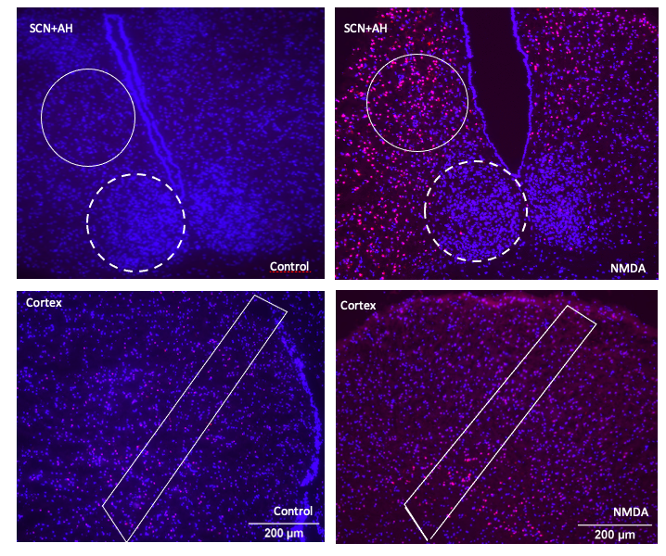

Cortex

Figure 1: Representative images of propidium iodide (PI) and DAPI staining of different regions of the brain under control and NMDA conditions. A and B: SCN (dashed line) and anterior hypothalamus (AH) (solid line) under control and NMDA conditions respectively. C and D: cortical sections under control and NMDA conditions respectively. Differences in the intensity of PI staining are evident across the different images based on region and treatment condition.

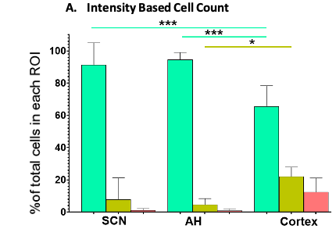
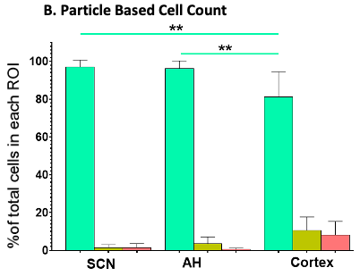
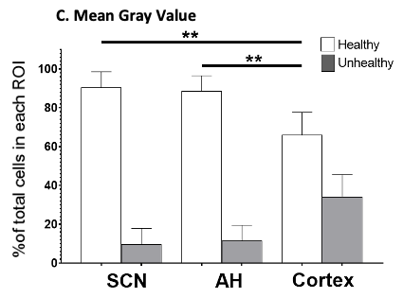

Figure 2: The percentage of healthy (Grade 1), damaged (Grade 2) and dead (Grade 3) cells in different brain slice regions under control conditions at ZT6 analyzed using (A) the IBCC protocol or (B) the PACC protocol. (C) The percentage of healthy vs. unhealthy cells calculated using the MGV analysis protocol. *p<0.05; **p<0.005; ***p<0.001. N=6 for each group. (One-way ANOVA).

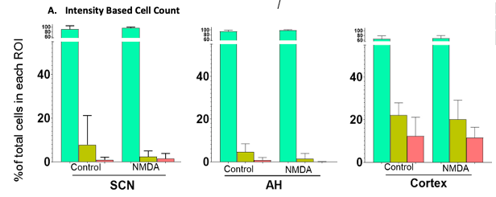
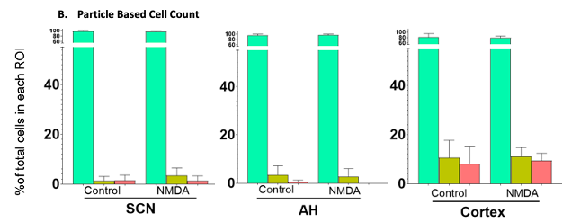
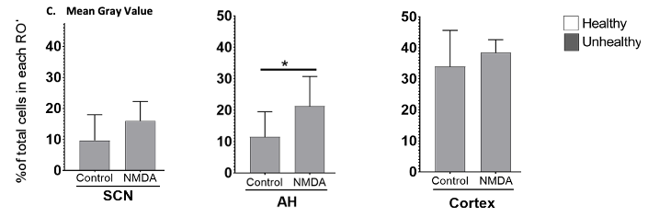

Figure 3: The percentage of healthy (Grade 1), damaged (Grade 2) and dead (Grade 3) cells in different regions of the brain under control vs. 50µM NMDA treatment at ZT6 using (A) the IBCC protocol or (B) the PACC protocol. (C) The percentage of healthy vs. unhealthy cells calculated using the MGV analysis protocol. *p<0.05; **p<0.005; ***p<0.001. N=6 for each group. (Student’s t-test).

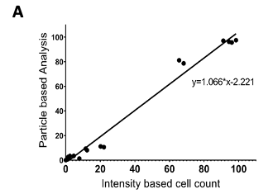
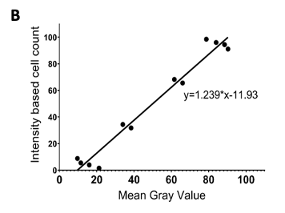
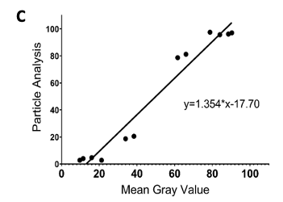
Figure 4: Correlations between the different image analysis procedures based on the results from 50µM NMDA and control treatments at ZT6 for the three brain regions. (A) correlation between the PACC and IBCC protocols (R=0.9908, p<0.0001); (B) correlation between IBCC and MGV protocols (R=0.9825, p<0.0001); (C) correlation between MGV and PACC protocols (R=0.9791, p<0.0001). For B and C, Grade 2 and Grade 3 cell percentages determined using the IBCC and PACC protocols were combined to compare with unhealthy cells based on the MGV protocol, while Grade 1 cell percentages from the IBCC and PACC analyses were compared with the healthy cells based on the MGV protocol.

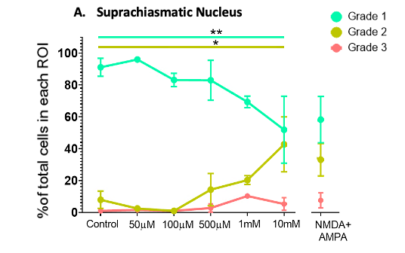
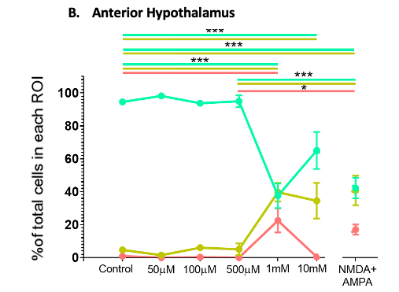
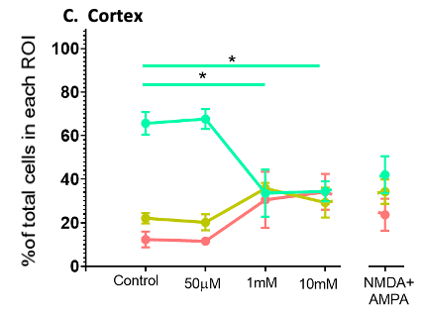
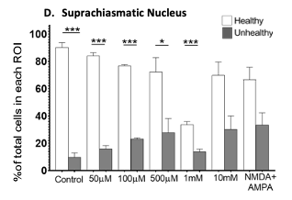
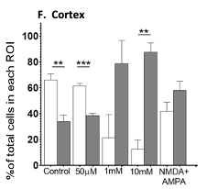
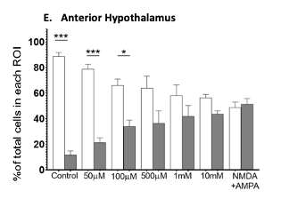

Figure 5: Dose response data for the SCN, the AH and the cortex exposed to increasing concentrations of NMDA (50µM-10mM) or NMDA (500µM) + AMPA (50µM) at ZT6. One-way ANOVA followed by Tukey’s post-hoc analysis revealed significant differences in the percentage of healthy (Grade 1), damaged (Grade 2) and/or dead (Grade 3) cells in the (A) SCN, (B) the AH and (C) cortex. *p<0.05; ** p<0.005; ***p<0.001. N=3-6 for each group.

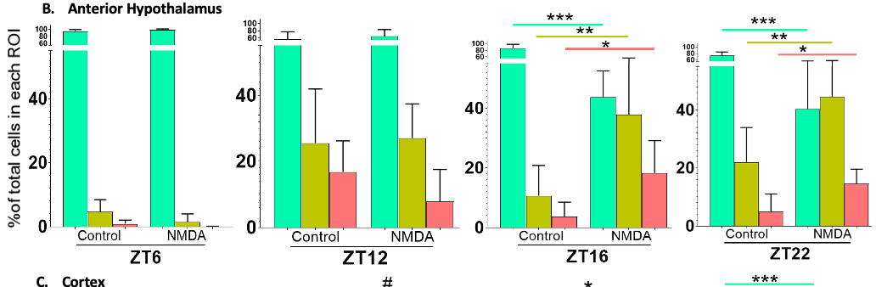
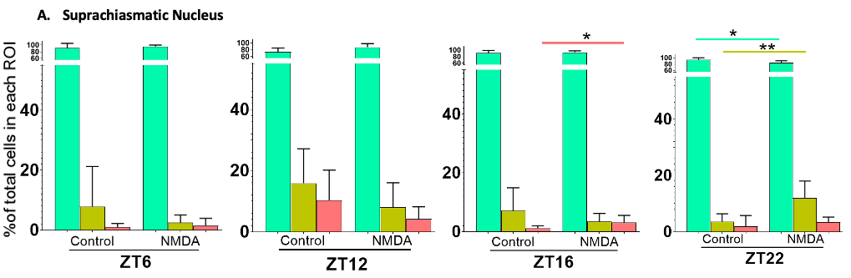
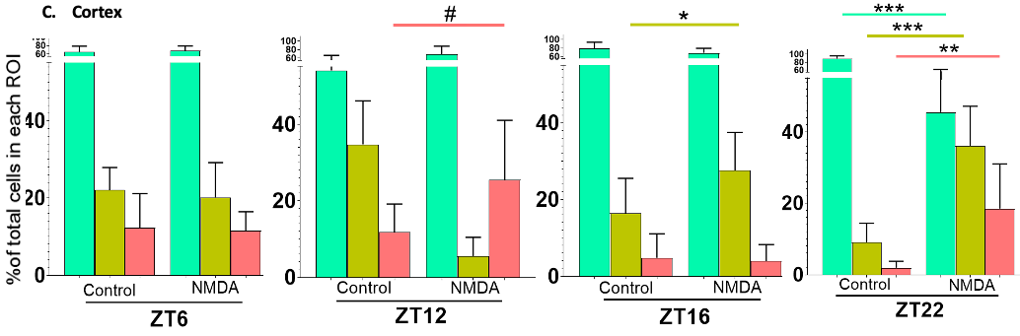

Figure 6: Time of day differences in excitotoxic responses in the SCN, AH and cortex treated with 50µM NMDA. Non-paired student t-tests between control and treated samples at different treatment times (ZT6, ZT12, ZT16 and ZT22) revealed significant differences in the percentage of healthy (Grade 1), damaged (Grade 2) and/or dead (Grade 3) cells. * p<0.05; ** p<0.005; *** p<0.001, # p approaching significance. N=6 for each group.

Chapter III
Investigating regional and time-of-day differences in microglial cell responses to an excitotoxic stimulus

Abstract
Microglial cells are known to play neuroprotective or neurodamaging roles in the brain in response to pathological conditions. Data suggests these opposing roles of the microglia vary across brain regions, possibly shaped by distinct signaling cues they experience. Given that we have shown regional and time-of-day differences in excitotoxic susceptibility, with the suprachiasmatic nucleus (SCN) being more resilient than the anterior hypothalamus (AH) and cortex, we investigated whether there are differences in microglial cell responses to excitotoxicity in these regions. We treated acute brain slices containing either the cortex or the SCN and AH from adult male mice at different times of day with 10mM N-methyl-D-aspartate (NMDA). After the treatment, the slices were stained with IBA1 (a pan-microglial marker) and either CD86 or CD206 (cell surface markers expressed by pro-inflammatory and anti-inflammatory marker respectively). We determined microglial density, morphology, and cell surface marker expression in all three regions under control and excitotoxic conditions at four times of day. We also compared these parameters in acutely fixed brain slices vs. brain slices that had been maintained in vitro. Our results indicate that compared to the SCN and AH, microglial cells are more dense in the cortex, and that NMDA-induced changes in morphology are more significant in the cortex compared to SCN and AH. Additionally, there are diurnal differences in microglial density and morphology in the cortex, with microglial density being higher and the microglia appearing to exhibit a more complex morphology in the cortex under NMDA conditions during the middle of the day compared to other times. These diurnal differences were not observed in the SCN or AH. Together, these data identify regional and time-of-day differences in microglial responses to excitotoxic conditions that could contribute to regional differences in excitotoxic susceptibility.

Introduction
Microglia are the resident macrophages of the brain and account for about 10-15% of the total cells of the central nervous system (CNS).¹⁴² Unlike the other cells of CNS, which are of neuroectodermal origin, microglia are cells of myeloid origin making them similar to other myeloid progenitor cells such as macrophages that are phagocytic and participate in immune functions¹⁴³. However, microglia are more than just immune cells; they have crucial roles in brain development and maintenance of homeostasis throughout an organism’s lifetime.
Under normal physiological conditions, microglia continually extend ramifications, surveying their surroundings to assess the health status of neighboring cells ^{144–147}. This monitoring involves recognizing damage-associated molecular pattern (DAMP) signals released by nearby cells that interact with pattern recognition receptors, including Toll-like receptors, expressed on the surface of microglia cells. Microglia also respond to changes in neuronal activity, for example through sensing increased calcium transients associated with a shift in neuronal activity to a more active state¹⁴⁸. Additionally, pathological increases in extracellular glutamate can shift microglial status to a more reactive state. Studies have shown that excessive glutamatergic stimulation, associated with various neurodegenerative disease, creates an excitotoxic state affecting microglia-neuron interactions that can result in changes in microglial shape, protein expression and cytokine release¹⁴⁹. The morphological transformation involves a variety of signaling mechanisms. For example, NMDA receptor activation of neurons triggers the release of purines such as ATP that activate P2Y12 receptors to cause microglial processes to extend towards the source of ATP release ^{58,150}. Furthermore, microglial cells express NMDA receptors (in addition to other types of ionotropic and metabotropic glutamatergic receptors) that can enhance the release of cytokines such as TNF-α, IL-1 and interferons when stimulated^{151,152}. Glutamate can also activate group II mGluRs and initiate microglial death via depolarization and apoptosis¹⁵¹. That can increase the release of inflammatory cytokines such as TNF-α, IL-1 and interferons that can result in microgliosis in the affected region and induce nearby cells to release more inflammatory cytokines, creating a vicious downward cycle. In addition to ATP and glutamate, chloride (Cl⁻) channels may also participate in driving the morphological transformation of microglia. However, the pharmacology of Cl⁻ channels participating in this response remains unclear¹⁵³.
The shift of microglia from a ramified to an amoeboid shape allows them to move towards sites of injury and to engulf damaged cells. Although microglia can change morphology when faced with injury/damage, their ultimate response depends on the nature and the severity of the pathological conditions. However, morphology taken by itself is not a good indication of microglial functional state. Recent studies have indicated that there exists little correlation between microglial cell morphology and their activity⁶⁸.
Along with microglial morphology, researchers utilize cell-surface markers and the cytokines expressed by the microglia to aid in characterizing their functional state. Classically, microglia responding to cell damage signals have been classified as either M1 (pro-inflammatory) or M2 (anti-inflammatory)¹⁵⁴. These two states of the microglia are associated with distinct cell surface markers, the cytokines they release and their effects on surrounding cells. However, with the use of more in-depth gene and protein expression analyses, it is clear that microglia exist in a continuum, with classically identified M1 and M2 microglia representing the extremes of that continuum¹⁵⁵. Thus, microglia should be investigated within the context of their complex combination of activities, acknowledging that microglia are constantly active and reacting to changes in the brain, especially under diseased conditions.
That said, one can begin to investigate microglial responses using characteristics that represent the two extremes of the spectrum. Thus, M1 microglia are activated in response to TNF-α and IFN-γ. They are associated with upregulation of cell surface markers such as MHC-II and CD86 that function as antigen presenting cells and signal the nearby T-cells. The pro-inflammatory cytokines released by these microglia include TNF-α, interleukin- (IL-) 6, IL-1B, and 12, and chemokine ligand (CC) ⁶⁹. Additionally, they release NADPH oxidase and reactive oxygen species (ROS) that can contribute to neurological damage¹⁵⁶. M2 microglia, conversely, are induced by the release of anti-inflammatory cytokines IL-4 and IL-3 that stimulate these microglia to produce and release cytokines such as IL-10 and factors such as TGF-β, CSF-1, IGI-1, BDNF and GDNF that support neuronal survival and growth. The cell surface markers they express include P2Y12, CD200R, CD163, RT1B and CD206 to name a few¹⁵⁶. Their activity promotes phagocytosis of misfolded proteins, tissue repair, and neuronal growth.
While the basic building blocks of the brain remain consistent, the complex task of information processing requires the brain to be organized into separate regions with unique features and functions¹⁵⁷. This underlying heterogeneity shapes the responses of the different brain regions to external stimuli. For example, the suprachiasmatic nucleus (SCN) exhibits less susceptibility to excitotoxic cell death compared to the surrounding anterior hypothalamus (AH) and the cortex¹⁵⁸. Although many factors likely contribute to these differences, we hypothesize that microglial cells contribute to the SCN’s enhance excitotoxic resiliency.
A number of studies have reported heterogeneity in the number of microglia and their morphology across different brain areas. For example, based on IBA1 staining, there are more microglial cells in the frontal cortex compared to the cerebellum¹⁵⁹. These results have been further corroborated by flow cytometry results that show a lower density of microglial cells in the spinal cord and cerebellum compared to cortical regions¹⁶⁰. A similar heterogeneity also occurs in microglial morphology, with microglia having smaller somas, larger cytoplasm areas and less complex ramifications in the cerebellum compared to striatum, hippocampus, and frontal cortex^{159,161}. Studies have also shown that microglia display an amoeboid morphology with shorter processes under normal physiological conditions in regions with an incomplete blood-brain-barrier (BBB)¹⁶². Not only are there differences in microglial characteristics in different brain regions under physiological conditions, but microglia also exhibit different regional sensitivities to inflammation. For example, upon lipopolysaccharide (LPS) administration, the substantia nigra pars reticulata (SNPr) and entorhinal cortex show a more robust activation of microglia compared to the ventral tegmental area (VTA), cerebellum and corpus callosum¹⁶³. Thus, regional heterogeneity in the microglial activity and their function is a well-established fact that supports our hypothesis.
In addition to the regional heterogeneity in excitotoxicity we quantified, we observed time-of-day differences in excitotoxic resiliency in all three brain regions we investigated. Given previously identified rhythms in immune system responses⁸⁶, we hypothesize that there are time-of-day differences in microglia and their responses to excitotoxic stimuli. To address our two hypotheses, we compared microglia morphology and cell surface markers in acute mouse brain slices containing different brain areas that were exposed to control vs. excitotoxic conditions at different times across the 24h. Since microglia are extremely dynamic cells that can alter their functional status in response to brain slice preparation and maintenance, we also investigated microglial numbers, morphology and cell surface markers in the SCN, AH and cortex in brain slices prepared at different times across the 24h and immediately fixed. This allowed us to investigate in vivo rhythms in microglial characteristics and to compare the microglia in immediately fixed brain slices to microglia in slices that had been maintained in vitro under control conditions.
Materials and Methods
Tissue Collection
Acute coronal brain slices (500μm) containing both the SCN and adjacent AH or the cortex were prepared from adult male C57Bl/6 mice (2-3 month old) (Envigo; Indianapolis, IN) housed under a 12:12 light-dark cycle with food and water available ad libitum. The identification of the SCN and AH regions were made based on previously established anatomical markers. The area of the cortex from which the slices were made included the anterior cingulate area, somatomotor area, and part of the retrosplenial area of the cortex.
Brain slices for ex vivo excitotoxic stimulus experiments were prepared between zeitgeber time 0-2 (ZT0-2, where ZT0 = lights on and ZT12 = lights off in the donor animal colony) for tissues being treated at ZT6 or ZT12, or between ZT10-12 for tissues being treated at ZT16 and ZT23. Slices were placed in Hatton-style brain slice dishes perfused with Earle’s Balanced Salt Solution (EBSS) (MP Biomedicals; OH, USA) supplemented with glucose and sodium bicarbonate; pH 7.4, gassed with 95% O₂/5% CO₂ and maintained at 37^{ο}C as described elsewhere ⁹. Depending on the experiment, brain slices were maintained for approximately 5 or 11 h prior to experimental treatment.
For acute fixation experiments, brain slices containing the SCN and AH or the cortex were prepared at ZT6, 12, 16 or 23 and immediately placed in 4% paraformaldehyde (Electron Microscopy Sciences; PA, USA) for fixation overnight, then transferred to 30% sucrose (Fisher Scientific; MO, USA) overnight. For slices prepared at ZT16 and 23 the mice were euthanized and the brains removed under dim red-light conditions. The fixed tissues were embedded in optimum temperature cutting compound (OCT) (Tissue Tek; CA, USA) and stored at -80°C before being sectioned (25μm) in the cryostat. Adjacent sections were collected on different slides and alternate slides were processed for IHC staining.
Excitotoxic treatment
At the designated time (ZT6, ZT12, ZT16 or ZT23) the perfusion in the brain slice chamber was paused, and the slices left untreated or treated with EBSS supplemented with NMDA (10mM) (Sigma Aldrich; MO, USA) for 1h. We used this concentration of NMDA because our previous experiments determined that it generates excitotoxic damage in all 3 brain regions¹⁵⁸. After the NMDA treatment, the tissues were allowed to respond for 3h before being fixed in 4% paraformaldehyde overnight then transferred to 30% sucrose overnight. The fixed tissues were then embedded in OCT and stored at -80°C before being sectioned (25μm) in the cryostat.
Immunohistochemical Staining
Alternate slides containing tissue sections of the SCN and AH or cortex were co-stained for IBA1 and CD86 or IBA1and CD206. IBA1 is a pan-microglial marker we used to quantify the number of microglia and microglia morphology. CD86 and CD206 are cell-surface markers that are consistent with M1 and M2 functional states, respectively. For IBA1/CD86 co-staining, the sections were blocked with blocking buffer containing 3% Normal Donkey Serum (Millipore, MA, USA) and 0.3% Tween-20 (Acros Organics, NJ, USA) for 30min after being after being washed with PBS. The blocking buffer was then replaced with blocking buffer containing IBA1 (Fujifilm Wako, VA, USA) antibody diluted to 1:1000 concentration and CD86 (Abcam, UK) diluted to 1:200 concentration and incubated overnight at 4°C. The following day, the sections were again washed 4 times with PBS for a duration of 5min each and incubated with secondary antibodies diluted in blocking buffer for 2h. The secondary antibodies were Donkey anti-Rabbit 488 (Abcam) diluted to 1:1000 and Donkey anti-Goat 568 (Abcam) diluted to 1:000. Following the secondary incubation, the sections were washed 4 times with PBS for a duration of 10min each. The slides were then coverslipped with VECTASHIELD (Vector Laboratories, CA, USA), sealed using nail-polish and stored in 4°C until imaging was conducted.
For IBA1/CD206 staining, the sections were blocked with blocking buffer containing 3% Normal Goat Serum and 0.3% Tween-20 for 30min after being washed with PBS. The blocking buffer was then replaced with blocking buffer containing IBA1 antibody diluted to 1:1000 concentration and CD206 (Abcam) diluted to 1:200 concentration and incubated overnight at 4°C. The following day, the sections were again washed 4 times with PBS for a duration of 5min each, and then incubated with secondary antibodies diluted in blocking buffer for 2h. The secondary antibodies used were Goat anti-Rabbit 488 and diluted to 1:1000 and Goat anti-Rat 568 diluted to 1:000 using blocking. Following the secondary incubation, the sections were again washed 4 times with PBS for a duration of 10min each. The slides were then coverslipped with VECTASHIELD, sealed using nail-polish and stored in 4°C until imaging was conducted.
Image Acquisition:
All the images were acquired using a confocal microscope Leica (SP8 Confocal Microscope) (Leica Biosystems, IL,USA) The images were acquired as a z-stack using 20X magnification. The images were then processed using ImageJ software (NIH) and IMARIS (Oxford Instruments, MA, USA).
Image Processing:
One tissue section was analyzed from each tissue slice. For the SCN/AH, a tissue section was chosen that contained a region approximately mid-way between the anterior and posterior ends of the SCN, based on the shape of the underlying optic chiasm. A region of interest (ROI) was then created for each image that was being analyzed. The SCN region was identified based on the DAPI staining, as the SCN has a greater cell density than the surrounding hypothalamus. The AH ROI (created by shifting the ROI surround created for the SCN) was chosen based on following parameters: an area near the SCN, in the same section, that did not include the epithelial cells lining the ventricle or tears from cryostat sectioning. For the cortex, we generated a rectangular ROI of approximately the same size area to that of the SCN and AH that spanned multiple cell layers through the cortex. We used the same ROI, with minor changes to adjust for differences in tissue section size and shape, for all the cortical sections analyzed for this study. Examples of the different ROIs are shown in (Figure 7).
A total of 3-10 samples were analyzed for each experimental condition (numbers varied across experiments). Images were analyzed by at least 3 individuals without knowledge of the experimental treatment. The mean of the individual analyses for each image was used for statistical analysis. For the acute slices, 2 individuals without knowledge of the experimental conditions analyzed each image.
Image Analysis using ImageJ: ImageJ was used to count the total number of microglia and to assess microglia morphology in a given ROI based on IBA1 staining. We began by creating a single z-projection of the z-stacked image and counting the number of microglial cells. All the microglia were counted and marked in each ROI. To account for small differences in ROI size, microglia density in each ROI was calculated by dividing the total number of microglia in the ROI by the ROI area (μm²x10⁻⁴). After counting the microglia, we used the thresholding function in ImageJ to obtain 1) the sum of microglia cell body areas within the ROI and 2) the sum of the total microglia areas that included the cell bodies and major ramifications within the ROI (see Figure 7). We then calculated the ratio of these two areas and expressed microglia morphology within that ROI using the formula below. A higher cell body area:total area ratio was considered to indicate a more amoeboid morphology (smaller/fewer ramifications) and a lower ratio was considered to indicate a more ramified morphology. The details of the image analysis and calculations are included in the appendix.
Sum of microglial cell body areas
Microglial Morphology (ImageJ) =
Sum of total microglia areas (cell bodies + ramifications)

Image Analysis using IMARIS: IMARIS (Version 10.1.1) was used to analyze the morphology of the microglia in three dimensions, calculating their surface area and volume based on the IBA1 staining using the same ROI used previously for ImageJ analysis. Additionally, we performed co-localization analysis between IBA1 and either CD86 or CD206 cell surface markers using IMARIS software in the previously defined ROIs. For the morphology analysis, using the IBA1 channel we created a 3-D rendition of the microglia from the z-stacked images we acquired (see Figure 7). Using the IMARIS software, we measured the surface area and volume of each microglial cell. We then calculated the total surface area and total volume for all the microglial cells and divided them by the total number of microglia (determined previously in ImageJ) to obtain the average surface area and volume of the microglial cells in each ROI. For the co-localization analysis, we switched to the channel showing either CD86 or CD206 staining. We again created 3-D renditions, then merged the images from the two channels to identify cells showing colocalization of IBA1 with either CD86 or CD206 (see Figure 7). Rotating the image in various axes allowed us to eliminate false positive colocalizations. The details of the image analysis calculations are included in the appendix.
Statistical Analysis
To quantify differences in the microglial parameters within each region across different times of day, two-way ANOVAs with a time-of-day x treatment condition design were performed using GraphPad Prism (Version 10.2.3) followed by Tukey’s test for post hoc analysis. To quantify differences in the microglial parameters across different brain regions within each time of day, two-way ANOVAs with a region x treatment condition design were performed using GraphPad Prism followed by Tukey’s test for post hoc analysis. The alpha value was kept at 0.05. Post-hoc analyses for this second set of ANOVAs only included comparisons across regions.
For acutely fixed slices, a two-way ANOVA was performed with a time-of-day x slice condition (acutely fixed slices vs brain slices maintained in vitro) design using GraphPad Prism followed by a Tukey’s test for post hoc analysis. The alpha value was kept at 0.05. This was performed to compare microglial parameters across different times (ZT6, 12, 16 and 23) in the acutely fixed slices and to compare microglial parameters between acutely fixed slices and slices maintained in vitro. Post hoc analysis for this set only included comparisons of acutely fixed brain slices across 24 h and between acutely fixed brain slice and slices maintained in vitro at any single time-point. To observe differences in microglia parameters across different brain areas in acutely fixed slices, a one-way ANOVA was performed for each time point using GraphPad Prism (Version 10.2.3) followed by Tukey’s post hoc analysis. The alpha was kept at 0.05 followed by Tukey’s post hoc test.
Results
Time of day differences in microglial density under control and excitotoxic conditions
Two-way ANOVAs indicated there were no statistically significant interactions between time of day and treatment condition on the microglial density in either the SCN (p=0.8411) or AH (p=0.0660) (Figure 8). All image from this chapter is in Appendix II. Two-way ANOVA also indicated that there was no statistically significant interaction between the time of day and treatment condition on microglial density in the cortex (p=0.2635), but there were statistically significant effects of time of day (p<0.0001) and of treatment condition factors (p<0.0001) separately on microglial density (Figure 8). Post-hoc analyses indicated that, under control conditions, the microglial density was significantly higher in the cortex at ZT6 compared to ZT23 (p=0.0010) and higher at ZT16 compared to ZT23 (p=0.0441). Under NMDA conditions, post-hoc analyses indicated that the microglial density was significantly higher at ZT6 compared to ZT12 (p=0.0416), ZT16 (p=0.0078) and ZT23 (p=0.0002). Post-hoc analyses also indicated that the microglial density was significantly higher in control conditions compared to NMDA conditions at ZT6 (p=0.0475) and at ZT16 (p<0.0001) but not at ZT12 (p=0.0631) and ZT23 (p=0.0519). For both ZT6 and ZT16 there was a lower microglia density in NMDA vs. control conditions, and there is a trend for a lower microglia density under NMDA conditions at ZT12 and ZT23. Taken together these data indicate that neither time of day nor NMDA treatment affected the microglial density in the SCN and AH, while there were both time of day-dependent and NMDA-induced changes in microglia density in the cortex.
Time of day differences in microglia cell body: total area ratios under control and excitotoxic conditions
Two-way ANOVA indicated that there was no statistically significant interaction between the time of day and treatment condition on the microglial cell body: total area ratio in the SCN (p=0.2868) (Figure 9). In the AH, however, two-way ANOVA indicated there was a statistically significant interaction between the time of day and treatment condition on the microglial cell body: total area ratio (p=0.0135) (Figure 9). Tukey’s post-hoc analysis indicated that under control conditions, the microglial cell body: total area ratio was significantly higher at ZT6 compared to ZT12 (p=0.0056), ZT16 (p=0.0452), and ZT23 (p=0.0306), with microglia conforming to a more amoeboid morphology at ZT6 compared to ZT12, ZT16 and ZT23. In contrast, there were no statistically significant differences in the microglial cell body: total area ratio in the NMDA-treated AH across the different time points. Also, there were no statistically significant differences in microglial morphology between control and NMDA conditions within a given time-of-day in the AH.
In the cortex, two-way ANOVA indicated that there was a statistically significant interaction between time of day and the treatment condition on the microglial cell body: total area ratio (p<0.0001) (Figure 9). Post-hoc analysis indicated that the cell body: total area ratio of microglia in the cortex at ZT6 was significantly higher compared to ZT12 (p<0.0001), ZT16 (p<0.0001), and ZT23 (p<0.0001) under control conditions. Similar trend was observed under NMDA condition across different time-of-day. The microglial cell body: total area ratio at ZT6 was significantly higher compared to ZT12 (p=0.0002), ZT16 (p<0.0001), and ZT23 (p<0.0001). Additionally, there were statistically significant differences in the cell body: total area ratio with microglia adopting a higher cell body: total area ratio under control conditions compared to NMDA conditions in the cortex at ZT6 (p<0.0001) and at ZT16 (p=0.0380). Thus, each of the three brain regions exhibited distinct patterns of microglia cell body: total area ratios depending on time of day and experimental condition.
Time of day differences in microglia surface area and volume under control and excitotoxic conditions
To expand on our ImageJ analyses of microglia morphology, we shifted to a 3-dimensional analysis using IMARIS, which allowed us to determine microglial surface areas and volumes under the different experimental conditions. Two-way ANOVAs indicated there was no statistically significant interaction between time of day and treatment condition on the average surface area of the microglial cells in either the SCN (p=0.8414; Figure 10) or in the AH (p=0.3502; Figure 10). However, two-way ANOVA indicated a statistically significant interaction between time of day and treatment condition on the average surface area (p<0.0001) of the microglial cells in the cortex (Figure 10). Post-hoc analysis indicated that there were no statistically significant differences in the microglial surface area across different times of the day under control conditions, but there was a statistically significant difference in average surface area of microglia under NMDA conditions in cortex. Under NMDA conditions, average microglial surface area was significantly higher in cortex at ZT6 compared to ZT12 (p<0.0001), ZT16 (p<0.0001), and ZT23 (p<0.0001). Additionally, at ZT6, the average surface area was significantly higher under control conditions compared to NMDA conditions (p<0.0001)
Shifting to the average microglia volume, two-way ANOVAs indicated no statistically significant interaction between time of day and treatment condition on the average volume of microglia in either the SCN (p=0.5850; Figure 11) or the AH (p=0.2080; Figure 11). However, two-way ANOVA indicated a statistically significant interaction between time of day and treatment condition on the average volume (p<0.0001) of the microglial cells in the cortex (Figure 11). Post-hoc analysis indicated that there were no statistically significant differences in the average microglial volume across different times of the day under control conditions, but there were statistically significant differences under NMDA conditions in average microglial volume. Under NMDA conditions, average microglial volume was significantly higher ZT6 compared to ZT12 (p<0.0001), ZT16 (p<0.0001), and ZT23 (p<0.0001). Additionally, at ZT6 the average microglial volume was significantly higher under control conditions compared to NMDA conditions (p<0.0001). Thus, cortical microglia morphology is affected by both time-of-day and experimental condition, while SCN and AH microglia showed no significant changes in microglia surface area or volume.
Time of day differences in microglia CD86 and CD206 expression under control and excitotoxic conditions
Two-way ANOVAs indicated that there was not a statistically significant interaction between the time of day and treatment condition on the percentage of cells expressing the CD86 cell surface marker in either the SCN (p=0.0592; Figure 12) or in the AH (p=0.1034; Figure 12). However, there was a statistically significant interaction between the time of day and treatment condition on the percentage of cells expression CD86 (p<0.0001) in the cortex (Figure 12). Post hoc analysis indicated that there were no statistically significant differences in the percentage of CD86 expressing cells at different times of day under control conditions, but under NMDA conditions percentage of microglial cell expressing CD86 was significantly higher at ZT6 compared to ZT12 (p=0.0177), ZT16 (p=0.0050), and ZT23 (p<0.0001). Also, at ZT6, the percentage of microglial cells expressing CD86 was significantly higher under control conditions compared to NMDA conditions (p=0.0043).
Two-way ANOVA indicated a statistically significant interaction between the time of day and treatment condition on the percentage of cells expressing CD206 cell surface marker (p= 0.0052) in the SCN (Figure 13). Post hoc analysis indicated that there was a significantly higher percentage of CD206 expressing cells under control conditions between ZT16 compared to ZT6 (p=0.0296). Under NMDA conditions, there was a significantly higher percentage of CD206 expressing cells at ZT23 compared to ZT6 (p=0.0070) and ZT16 (p=0.0177). Post hoc analysis also indicated that there was a significantly higher percentage of CD206 cells at ZT16 (p=0.0046) under control vs. NMDA conditions but not at other time-points.
In the AH, two-way ANOVA indicated there was a statistically significant interaction between time of day and treatment condition on the percentage of cells expressing CD206 (p=0.0227) (Figure 13). Post hoc analysis revealed significantly lower percentage of cells expressing CD206 under control conditions at ZT6 compared to ZT16 (p=0.0097) and ZT23 (p=0.0054). Similarly, percentage of microglial cell expressing CD206 was significantly lower at ZT12 compared to ZT16 (p=0.0469) and ZT23 (p=0.0317).
In the cortex, two-way ANOVA indicated there was not a statistically significant interaction between time of day and treatment condition on percentage of cells expressing CD206 (p=0.3635). However, there was a statistically significant effect of the time-of-day factor alone (p<0.0001) on the percentage of cells expressing CD206 (Figure 13). Post hoc analysis indicated that under control conditions percentage of CD206-positive cells was significantly lower at ZT6 compared to ZT12 (p=0.0083) and ZT23 (p<0.0001). Under NMDA conditions, percentage of CD206-positive cells was lower at ZT6 compared to ZT12 (p=0.0003), and ZT23 (p<0.0001). Additionally, percentage of CD206⁺ cells was lower at ZT16 compared to ZT12 (p=0.0084) and ZT23 (p=0.0038). In summary, all three brain regions exhibited time-of-day and treatment-induced changes in the expression of the CD86 and CD206 microglial cell markers.
Regional differences in the microglial density under control and excitotoxic conditions
Because an important aspect of these experiments was to compare microglia across the three brain regions under control and excitotoxic conditions, a separate set of two-way ANOVA analyses were performed for each experimental parameter assessed at each timepoint in a region x treatment design. When ANOVA analyses deemed appropriate, the only post-hoc comparisons conducted were between regions, so as not to overlap with the previous statistical analyses.
Two-way ANOVA indicated that there was a statistically significant interaction between region and treatment condition at ZT6 (p=0.0357) (Figure 8) on microglial density. Post hoc analysis indicated that microglial density was significantly higher in cortex compared to SCN (p<0.0001) and AH (p<0.0001) under control conditions. Under NMDA conditions, post hoc analysis indicated the microglial density was significantly lower in SCN compared to cortex (p=0.0002) under NMDA conditions. At ZT12, two-way ANOVA indicated no significant interactions between region and treatment condition (p=0.2914) (Figure 8). At ZT16, two-way ANOVA indicated there was a statistically significant interaction between region and treatment condition on the microglial density (p<0.0001) (Figure 8). Post hoc analysis indicated that microglial density was significantly higher at cortex compared to SCN (p=0.0108) and AH (p=0.0002) under control conditions. At ZT23, two-way ANOVA indicated there was a statistically significant interaction between region and treatment condition on the microglial density (p=0.0090) (Figure 8). Post hoc analysis indicated there was a significantly higher microglial density in cortex compared to AH (p=0.0313) under control conditions. Thus, there were significant differences in microglial density between the two hypothalamic areas compared with the cortex that varied depending on experimental condition and time of day, but no statistical differences between the SCN and AH.
Regional differences in microglia cell body: total area ratio under control and excitotoxic conditions
At ZT6, two-way ANOVA indicated there was not a statistically significant interaction between region and treatment condition on the microglial cell body: total area ratio (p=0.36777) (Figure 9). However, region and treatment factors individually had significant effects on the microglial cell body: total area ratio (p<0.0001 in both cases). Post hoc analysis indicated significant higher cell body: total area ratio in cortex compared to SCN (p=0.0015) and AH (p=0.0196) under control conditions. At ZT12, there was not a statistically significant interaction between region and treatment condition on the microglial cell body: total area ratio (p=0.3384) (Figure 9). At ZT16, two-way ANOVA indicated a statistically significant interaction between region and treatment condition on the microglial cell body: total area ratio (p=0.0037) (Figure 9). Post hoc analysis indicated a higher cell body: total area ratio in AH compared to cortex (p=0.0469) under NMDA conditions. At ZT23, two-way ANOVA indicated a statistically significant interaction between region and treatment condition on the microglial cell body: total area ratio (p=0.0050) (Figure 8). However, post hoc analysis did not show any significant differences in the cell body: total area ratio between regions. Thus, these data again show there are significant differences in microglial morphologies across the three brain regions depending on experimental condition and time of day.
Regional differences in microglia morphology based on average surface area and average volume under control and excitotoxic conditions
At ZT6, two-way ANOVA indicated a statistically significant interaction between region and treatment condition on the average surface area of the microglial cells (p=0.0002) (Figure 10). Post hoc analysis indicated that average surface area of microglial cells was significantly higher in cortex compared SCN (p=0.0003) and AH (p=0.0047) under NMDA conditions. Two-way ANOVA indicated there were no statistically significant interactions between region and treatment condition on average surface area of microglial cells at ZT12 (p=0.8616, Figure 10), ZT16 (p=0.6506, Figure 9) or ZT23 (p=0.3637, Figure 10).
A similar pattern was observed when analyzing microglia volume. At ZT6, two-way ANOVA indicated a statistically significant interaction between region and treatment condition on the average volume of the microglial cells (p=0.0008) (Figure 11). Post hoc analysis indicated that average volume of microglial cells was significantly higher in cortex compared to SCN and (p=0.0010) and AH (p=0.0172) under NMDA conditions. Two-way ANOVA indicated there were no statistically significant interactions between region and treatment condition on average surface area of the microglial cells at ZT12 (p=0.9154, Figure 11), ZT16 (p=0.5526, Figure 11) and ZT23 (p=0.2789, Figure 11). Thus, these data again show there were significant differences in microglia morphologies across the three brain regions depending on experimental condition and time of day, with the majority of the regional differences seen at ZT6 between the hypothalamic regions and the cortex.

Regional differences in the percentage of microglial cells expressing CD86 and CD206 under control and excitotoxic conditions
Two-way ANOVAs indicated no statistically significant interactions between region and treatment condition on the percentage of cells expressing the pro-inflammatory marker, CD86, at either ZT6 (p=0.0537, Figure 12) or ZT12 (p=0.0679, Figure 12). However, two-way ANOVAs indicated that there were statistically significant interactions between region and treatment condition on the percentage of cells expressing CD86 at ZT16 (p=0.0441, Figure 12) and at ZT23 (p=0.0027, Figure 12). Post hoc analysis however showed no statistically significant differences in the percentage of microglial cells expressing CD86 between different regions and treatment condition. Thus, the statistically significant differences in these two ANOVAs were due to treatment and not regional differences, which were presented earlier.
Two-way ANOVAs indicated no statistically significant interactions between region and treatment condition on the percentage of microglial cells expressing the anti-inflammatory marker, CD206, at ZT6 (p=0.5594, Figure 13), ZT12 (p=0.3227, Figure 13), ZT16 (p=0.3951, Figure 13) or ZT23 (p=0.2805, Figure 13). Together, these data indicate that microglial expression of CD86, but not CD206, exhibited significant differences across brain region.
Acutely fixed brain slices vs. brain slices maintained in vitro: time-of-day differences in microglial density
In the SCN. two-way ANOVA indicated that there was a statistically significant interaction between time-of-day and brain slice condition (p=0.0062) (Figure 14). Post hoc analysis indicated that the microglial density in the SCN of acutely fixed slices between was significantly higher at ZT6 compared to ZT12 (p=0.0002) and ZT23 (p=0.0002).
In the AH, two-way ANOVA indicated that there was a statistically significant interaction between time-of-day and brain slice condition (p=0.0001) (Figure 14). Post hoc analysis indicated that microglial density in the acutely fixed slices was significantly higher ZT6 compared to ZT12 (p=0.0128) and ZT23 (p<0.0001). Additionally, at ZT16 microglial density was significantly higher at ZT16 compared to ZT23 (p=0.0289).
In the cortex, two-way ANOVA indicated that there was a statistically significant interaction between time-of-day and brain slice condition (p=0.0040) (Figure 14). Post hoc analysis indicated that microglial density was significantly higher in acutely fixed brain slices compared to slices maintained in vitro at ZT16 (p=0.0027). However, there were no differences in microglial density in the cortex across time-of-day when assessing acutely fixed brain slices.
Acutely fixed brain slices vs. brain slices maintained in vitro: time-of-day differences in microglial cell body: total area ratio
In the SCN, two-way ANOVA indicated there was not a statistically significant interaction between time-of-day and brain slice condition (Figure 15). However, two-way ANOVAs showed statistically significant interactions between time-of-day and brain slice condition in the AH (p=0.0010) (Figure 15) and cortex (p<0.0001) (Figure 15). Post hoc analyses comparing acutely fixed brain and slices maintained in vitro indicated significantly higher cell body: total area ratio under in acutely fixed brain slices at ZT6 in the AH (p=0.0008) and the cortex (p<0.0001) compared to slices maintained in vitro.
Acutely fixed brain slices vs. brain slices maintained in vitro: time-of-day differences in microglial average surface area and volume
In the SCN, two-way ANOVA indicated there was not a statistically significant interaction between time of day and brain slice condition on average surface area of microglia (Figure 16). Two-way ANOVA showed a statistically significant interaction between time-of-day and brain slice condition in AH (p=0.0082) on average microglial surface area (Figure 16). However, post hoc analysis indicated no statistically significant differences in the acutely fixed brain slices across 24 h or between acutely fixed slices and slices maintained in vitro in any time points. In the cortex, two-way ANOVA showed no statistically significant interaction between time of day and brain slice condition on microglial surface area (Figure 16). However, the time-of-day factor alone had statistically significant effects with the average microglial surface area in acutely fixed brain slices (p<0.0001). Post hoc analysis indicated significantly higher microglial surface area in the cortex at ZT12 compared to ZT6 (p=0.0299) and at ZT23 compared to ZT16 (p=0.0302).
In the SCN, two-way ANOVA indicated there was not a statistically significant interaction between time of day and brain slice condition average microglial volume (Figure 17). In the AH, two-way ANOVA showed a statistically significant interaction between time-of-day and brain slice condition on average microglial volume (p=0.0073) (Figure 17). However, post hoc analysis indicated no significant differences in the acutely fixed brain slices across 24h or between acutely fixed slices and slices maintained in vitro in any time points. In the cortex, two-way ANOVA showed no statistically significant interaction between time of day and brain slice condition on average microglial volume (Figure 17). However, the time-of-day factor alone had a statistically significant effect on microglial surface area in the cortex in acutely fixed slices (p<0.0001). Post hoc analysis indicated significantly higher microglial volume at ZT23 compared to ZT6 (p=0.0065), and ZT12 (p<0.0001). Additionally, microglial volume was also higher at ZT16 compared to ZT12 (p=0.0387) when comparing acutely fixed brain slices in the cortex across 24h.
Acutely fixed brain slices vs. brain slices maintained in vitro: time-of-day differences in microglial CD86 and CD206 expression
Two-way ANOVAs indicated no statistically significant interactions between time of day and brain slice condition on the percentage of microglial cell expressing CD86 in either the SCN or the AH (Figure 18). In the cortex, two-way ANOVA indicated a statistically significant interaction between time of day and brain slice condition on the percentage of microglial cell expressing CD86 (p=0.0326) (Figure 18). Post hoc analysis indicated there were significantly lower percentage of microglial cell expressing CD86 in acutely fixed brain slices at ZT23 compared to ZT12 (p=0.0277) and ZT16 (p=0.0015). Additionally, there were significantly lower percentage of microglial cells expressing CD86 in acutely fixed sliced compared to brain slices maintained in vitro at ZT6 (p=0.0017), ZT12 (p=0.0118) and ZT23 (p< 0.0001).
In the SCN, two-way ANOVA indicated no statistically significant interaction between time of day and brain slice condition on the percentage of microglial cells expressing CD206 in SCN (Figure 19). In the AH, two-way ANOVA indicated a statistically significant interaction between time of day and brain slice condition on the expression of CD206 (p=0.0159) (Figure 19) but post hoc analysis did not reveal any significant differences in percentage of microglial cells expressing CD206 in acutely fixed brain slices across 24h or between acutely fixed brain slices and slices maintained in vitro. In the cortex, two-way ANOVA indicated a statistically significant interaction between time of day and brain slice condition on the expression of CD206 (p=0.0048) (Figure 19). Post hoc analysis that there were significantly lower percentage of microglial cells expressing CD206 between acutely fixed slices compared to slices maintained in vitro at ZT12 (p=0.0133) and at ZT23 (p<0.0001).
Regional differences in microglial density in acutely fixed brain slices
In addition to comparing microglial densities within each brain region in acutely fixed brain slices across 24h, we were also interested in regional differences in microglial density. For this, we conducted a separate set of one-way ANOVAs comparing the different brain regions in acutely fixed brain slices at each of the different times of day. We conducted similar one-way ANOVAs for each of the microglial characteristics we quantified.
One-way ANOVA indicated there were statistically significant differences in the microglial density in acutely fixed brain slices across SCN, AH and cortex at ZT6 (p<0.0001) (Figure 14). Post hoc analysis indicated that at ZT6, microglial density was significantly higher in the cortex compared to the SCN (p<0.0001) and the AH (p<0.0001). However, microglial density was not significantly different between the different regions at ZT12 (p=0.4100), ZT16 (p=0.3563) or ZT23 (p=0.9759).
Regional differences in microglial cell body: total area ratio in acutely fixed brain slices
One-way ANOVA indicated statistically significant differences in cell body:total area ratio in acutely fixed brain slices across the SCN, AH and cortex at ZT6 (p=0.0002) (Figure 15). Post hoc analysis indicated that the cell body:total area ratio was significantly higher in the cortex compared to the SCN (p=0.0010) and the AH (p=0.0005). Similarly, at ZT16, one-way ANOVA indicated statistically significant differences in cell body:total area ratio across different regions (p=0.008) (Figure 15). Post hoc analysis indicted that cell body:total area ratio was significantly higher in the cortex compared to the SCN (p=0.0179) and the AH (p=0.0215). One-way ANOVA, however, did not indicate statistically significant differences in cell body:total area ratio across the different regions at ZT12 (p=0.0749) or and ZT23 (p=0.2011) (Figure 15).
Regional differences in microglial average volume and surface area in acutely fixed brain slices
One-way ANOVA indicated statistically significant differences in the average surface area in acutely fixed brain slices across the different brain regions at ZT6 (p=0.0357) (Figure 16). Post hoc analysis indicated that the average surface area was significantly higher in the SCN compared to the cortex (p=0.0342). Similarly, at ZT23, one-way ANOVA indicated statistically significant differences across different regions in average microglial surface area (p=0.0002) (Figure 16). Post hoc analysis indicated that microglial surface area was significantly higher in the cortex compared to the SCN (p=0.0037) and the AH (p=0.0002). One-way ANOVA did not indicate statistically significant differences in the average microglial surface area across different regions at ZT12 (p=0.5065) or ZT16 (p=0.2539) (Figure 16).
One-way ANOVA indicated statistically significant differences in the average microglial volume in acutely fixed brain slices across different brain regions at ZT6 (p=0.0149) (Figure 17). Post hoc analysis indicated that the SCN had a significantly higher microglial volume compared to the AH (p=0.0266) and the cortex (p=0.0264). At ZT12, one-way ANOVA indicated statistically significant differences in the microglial volume across different brain regions (p=0.0021) (Figure 17). Post hoc analysis indicated that microglial volume was significantly lower in the cortex compared to the SCN (p=0.0250) and the AH (p=0.0018). At ZT23, again, one-way ANOVA indicated statistically significant differences in microglial volume across the different brain regions (p=0.0002) (Figure 17). Post hoc analysis indicated that microglial volume in the cortex was significantly higher compared to the SCN (p=0.0042) and the AH (p=0.0001). However, one-way. ANOVA did not indicate any statistically significant differences in microglial volume across the different brain regions at ZT16 (p=0.3176) (Figure 17).
Regional differences in microglial CD86 and CD206 expression in acutely fixed brain slices
One-way ANOVA indicated that there were no statistically significant differences in the percentage of CD86⁺ cells in acutely fixed brain slices across the different brain areas at ZT6 (p=0.5551), ZT12 (p=0.3915), ZT16 (p=0.2106) and ZT23 (p=0.1141) (Figure 18). Similarly, one-way ANOVA indicated no statistically significant differences in the percentage of CD206⁺ cells across the different areas at ZT6 (p=0.9376), ZT12 (p=0.0782) and ZT16 (p=0.1308) (Figure 19). However, at ZT23 one-way ANOVA indicated there was a statistically significant difference in the percentage of microglial cells expressing CD206 across the different brain areas (p=0.0.442), and post hoc analysis indicated that the percentage of CD206+ microglial cells was significantly higher in the AH compared to the cortex (p=0.0495) (Figure 19).
Discussion
While previous research has provided evidence of microglial cells responding to excitotoxicity through sensing DAMP signals (such as ATP) from damaged neurons¹⁶⁴, those studies did not investigate if these responses vary across in different brain regions and/or different times of day. In our current study we assessed various microglial characteristics, including microglial numbers, morphology and cell surface markers, across different brain regions and different time-of-day in ex vivo tissue preparations under control and excitotoxic conditions. We also compared acutely fixed brain slices to brain slices maintained in vitro. Together our data demonstrate that microglial cells exhibit distinct sets of characteristics under both control and excitotoxic conditions that are also shaped by the brain region and the time of day. While regional differences in microglial phenotypes under control conditions have been reported previously, our data are the first to identify regional differences in the response of the microglial cells under excitotoxic condition between cortex and hypothalamic region. Additionally, we identified diurnal differences in microglial under control and excitotoxic conditions using multiple microglial parameters, was also something new. Furthermore, we also compared microglial parameters under in vitro conditions and in acutely fixed brain slices. This comparison is important to parse out how maintaining brain slices in vitro affects microglial phenotypes and their responses to excitotoxic stimuli. These differences may contribute to the differences in cell death and damage in response to excitotoxic damage that we observed across different areas of the brain and different times of the day¹⁵⁸. In the following sections, I will discuss the observed differences and their potential implications in relation to the differential resiliency/susceptibility of the different brain regions to excitotoxicity stimuli across the 24h.
Differences in the microglial density
We began by comparing microglia density across 24h in each brain region under control and excitotoxic conditions. We determined that there are no significant differences in microglial cell density across the different times of day in either the SCN or AH under either control or excitotoxic conditions. However, in the cortex, under control conditions, there is a significant decrease in microglia density when comparing between ZT6 and ZT23 and between ZT16 and ZT23. It is possible that these differences could be attributed to the total time the slices were maintained in vitro. The ZT23 brain slices were maintained in vitro for about 6 hours longer than both the ZT6 and ZT16 brain slices. However, if this were the sole cause of the differences, then we should have also seen a difference between ZT6 and ZT12 brain slices, which did not occur.
In response to NMDA treatment, although we saw no differences in the SCN and AH in microglial cell density, in the cortex there is a clear pattern across the 4 timepoints, with the highest density at ZT6 and the lowest density at ZT24. This pattern is interesting given the increase in cell death and damage seen in the cortex in response to NMDA treatments at ZT12, ZT16 and ZT23 compared to ZT6 ¹⁵⁸ (also see chapter II). Importantly, when comparing control and NMDA conditions, the cortex is the only region that shows a significant decrease in microglial density under excitotoxic compared to control conditions, occurring at both ZT6 and ZT16. Based on this, one could speculate that cortical microglial cells, even under control conditions, are more susceptible to death when maintained in vitro during the nighttime compared to SCN and AH, and further, that there is a greater increase in microglial cell death in the cortex in response to NMDA during the night compared to the day. An alternative (but not mutually exclusive) scenario is that damage and/or death of cortical cells in general, whether due to tissue damage or excitoxicity, could result in a greater release of danger signals leading to increased expression of pro-inflammatory cytokines, exacerbating cell death of non-microglial cells. To clarify what is taking place, in future experiments it will be important to assess the types of cells that are dying or damaged in the different brain regions in response to an excitotoxic stimulus using cell-type markers [e.g., neurons (NeuN), astrocytes (GFAP), microglial (IBA1) and oligodendrocytes (NG2)]. Importantly, we do not see a similar decrease in microglial cell density in either the SCN or AH, even though both of these brain regions also exhibit excitotoxic cell death and damage at night in response to NMDA. This supports there being regional differences in the responses of the microglia and in the causes of excitotoxic death/damage.
In fact, when directly comparing microglial density across regions, we see significant regional differences. The pattern under control conditions is for increased microglial cell density in the cortex compared to SCN and AH, although there are variations across times of day. Overall, these data are in accordance with previous studies that have shown differences in microglial cell density across different brain areas¹⁶⁰. The regional differences in baseline microglial density could be attributed to the underlying differences in the proliferation rate of the microglial cells in the different brain regions. Studies have shown differences in the proliferation rate in the microglia isolated from the neurogenic subependymal region compared to non-neurogenic regions^{165,166}.
Interestingly, these regional differences are mostly absent under NMDA conditions, with the exception of the SCN vs. cortex at ZT6. This appears to be because NMDA treatment decreases cortical microglial density to closer to control levels in the SCN and AH, while microglial density in the hypothalamic areas are not affected by NMDA treatment. Together these data demonstrate that one needs to take time of day into consideration when comparing microglia across brain regions under both control and excitotoxic conditions.
Switching to the acutely fixed brain slices, there are time-of-day differences in the SCN and AH, with greater microglia density at ZT12 and 23 compared to ZT6 in both regions, plus greater microglia density at ZT23 compared to ZT16 in the AH. The fact that we do not observe these differences under in vitro conditions, might be because of the longer time spent in vitro by the slices treated at ZT12 and ZT23 (8-10 h) compared to those treated at ZT6 and ZT16 (4-6 h). The differential time in vitro might lead to more death and damage to microglial cells in these areas, eliminating the time-of-day differences seen in the acutely fixed slices. Interestingly, no time-of-day differences in microglial density are observed in the acutely fixed brain slices in the cortex. Although the cortex exhibits daily rhythms in microglial morphology, these rhythms may not extend to rhythms in microglial cell density. The mechanisms generating these rhythms, especially as observed in the SCN and AH, are unclear. One possible factor is the permeability of the blood-brain-barrier (BBB). There is a growing body of evidence that there is a circadian rhythm in BBB permeability¹⁶⁷. For example, studies involving drosophila have indicated that intravenously injected iodine-labelled TNF-α is taken more readily in the spinal cord between ZT20 and ZT23¹⁶⁸. Rhythmic permeability of the BBB might allow differential infiltration of IBA1-expressing peripheral macrophages, which would influence the overall number of IBA1-expressing cells we observed in our acutely fixed brain slices ^{29–31}. However, as mentioned earlier, more in-depth analyses would be required to understand if this was the case. To assess for such differences, we could use microglial markers such as P2ry12 and TMEM119 that distinguish between resident microglial cells and infiltrating peripheral macrophages¹⁶⁹.
When comparing acutely fixed brain slices to those maintained in vitro, there are very few differences based on brain slice condition. In the cortex at ZT16 there is a higher density of microglia in the slices maintained in vitro. We are unsure how to explain the increase microglia density in the cortex in in vitro slices compared to those fixed acutely. When comparing microglial density across different regions in acutely fixed brain slices, the cortex has a higher density of microglial cells at ZT6 compared to SCN and AH, which was not observed at other time points. This parallels the pattern seen in both the control and NMDA-treated brain slices maintained in vitro, suggesting this is a robust difference in microglia phenotype across brain regions.
Thus, overall, when comparing microglia density across different regions, it appears that the cortex has a higher density of microglial cells compared to SCN and AH under control conditions, both in acutely fixed brain slices and those maintained in vitro. On the other hand, the cortex is the only region where microglial density decreases between the day and night under control conditions and is the only region where NMDA treatment significantly decreases microglial density. The higher control density of microglial cells in the cortex could provide greater surveillance under physiological conditions, but it could also provide the conditions for more excitotoxic susceptibility if the microglia respond in a pro-inflammatory direction in response to NMDA or to tissue damage.
Differences in microglia morphology
After observing the number of microglia, we were next interested in their morphology across the times of day and across brain regions under control and excitotoxic conditions. Based on the available literature, ramified microglia, which have small cell bodies with extensive branching, are associated with increased surveillance monitoring of neuronal activity. However, when faced with potentially dangerous signals, microglial cells can transform into amoeboid/activated microglial with round cell bodies and short branches, and they release cytotoxic substances. While there is disagreement regarding whether a particular morphology is associated with a specific function, it is clear that changes in microglia morphology are associated with shifts in their function and are crucial in understanding in microglial dynamics¹⁷⁰.
Along these lines, although circadian or daily oscillations in the expression of clock genes and cytokine expression in microglial cells have been extensively studied¹⁷¹, there is limited evidence as to whether these changes are accompanied by rhythms in morphology. Morphological assessment of microglial cells in the somatosensory cortex has shown that microglia tend to have increased branching processes at ZT14, indicative of a more ramified microglia, compared to ZT2¹⁷². On the other hand, to our knowledge, there are no reports on microglia morphology rhythms in the SCN or surrounding AH. Thus, we were interested to see if we see similar rhythms in our cortical tissues and if there are daily rhythms in microglia morphology in the SCN and AH.
We used multiple analyses to assess microglial morphology. First, we calculated the cell body: total area ratio as an indicator of the extent of ameboid vs. ramified morphology. Second, we used three-dimensional calculations of average surface area and average volume to help differentiate ameboid vs. ramified microglia. Previously, changes in microglial surface area and volume have been used to assess microglial responses under heart failure conditions¹⁷³. In that study the authors induced heart failure in the mice and then isolated the paraventricular nucleus of hypothalamus and central amygdala areas to assess structural remodeling of microglial cells using 3D reconstruction in IMARIS software. This prompted us to use similar parameters to assess morphometric changes in microglia in our experiments.
In the SCN we see no significant differences in the microglial morphology in either treatment condition across the 24 h. However, in the AH, there is a higher microglia cell body: total area ratio under control conditions at ZT6 compared to ZT12, ZT16 and ZT23, suggesting the microglia are in a more amoeboid morphology at ZT6. However, neither average surface area nor average volume of the microglial cells are significant different in the AH across the 24 h. The differences between these two results likely are because of the inherent differences in analysis methodology. The analysis using ImageJ works with 2D images and involves a thresholding step where is can be difficult to include the full extent of the microglia ramifications while excluding background noise. The IMARIS software used to calculate the cell surface and volume parameters of the microglial cells, in addition to making calculations based on the 3D images, can eliminate artifacts to provide a more accurate assessment of the average microglial morphology. While the ImageJ protocol is less precise that the IMARIS software, one of its advantages is having a higher throughput capacity compared to IMARIS. It also provides a straight-forward method for identifying ROIs and counting cells. Since both the imaging systems have pros and cons, we decided to use both for our analyses.
Moving on to the cortex, we find that it also exhibits differences in microglial morphology under control conditions. Like the AH, based on the cell body: total area ratio, the microglial cells in the cortex exhibit a more amoeboid morphology at ZT6 compared to ZT12, 16 and ZT23. A similar trend has been previously observed in the microglial cells of the somatosensory cortex¹⁷². The apparently more extensive ramification of the microglial morphology at ZT12, ZT16 and ZT23 in both the AH and cortex under control conditions could reflect the neuronal activity in these areas, which is higher during the active period of the mice¹⁷⁴. Microglial cells in zebrafish have been shown to gravitate towards region with higher neuronal activity and to make more microglia-neuron contact sites with their ramifications in these regions¹⁷⁵. However, as with the AH, the differences in microglial cell body: total area ratio in the cortex under control conditions are not recapitulated in the analyses of microglial surface area and volume. Again, this discrepancy could be attributed to differences in analysis methodologies.
Given that we see rhythms in microglial cell morphology in the cortex and AH, it is surprising that we do not seem them in the SCN, where the circadian clock is located. This is something discussed more below. Considering we do not see these differences in either in vitro or acutely fixed brain slices supports a lack of microglia morphology rhythms in the SCN generally. However, given that we have shown diurnal differences in excitotoxic cell death in both the SCN, and AH could indicate that either the excitotoxicity rhythms in the SCN are not driven by differences in microglial activity or there might be differences in SCN microglial phenotypes that are not being picked up by the techniques we employed.
Focusing on the excitotoxic stimulation, we see no NMDA-induced effects on microglia morphology metrics in either the SCN or the AH. However, there is a significant decrease in the microglia cell body: total area ratio in the cortex at ZT6 and ZT16 compared to control conditions, suggesting the shift to a more ramified morphology at these times. Additionally, under NMDA conditions, the microglia cell body: total area ratio is significantly lower at ZT12, 16, and 23 compared to ZT6, again suggesting that the microglia exhibit a more ramified morphology at night. Likewise, our data show an NMDA-induced increase in average cell volume in the cortex at ZT6 that results in significantly lower levels at the other timepoints under NMDA conditions. Both of these metrics suggest a shift to a more ameboid morphology in response to NMDA at ZT6 compared to the other times of day. On the other hand, when looking at the average surface area, there is again an NMDA-induced increase at ZT6 in the cortex, which in this case would be consistent with a more ramified morphology at ZT6 compared to more ameboid microglia at the other timepoints. This was not anticipated given that we were assuming average surface area and average volume would shift in opposite directions as glial morphology switched to from ramified to amoeboid shape under excitotoxic conditions, as shown in a previous study¹⁷⁶.
Taken together, it is clear that NMDA is inducing changes in microglia morphology in the cortex, but these changes vary across time of day, and they are different from the SCN (which exhibits no changes in any of the morphology parameters) and the AH (which only shows a rhythm in cell body: total area ratio under control conditions). Additionally, the changes may be more complex than we anticipated.
The parallel increases in microglial cell surface area and volume in the cortex suggest a type of morphology change that does not fit with the ameboid/ramified dichotomy. Indeed, many morphological variations in microglia have been noted in the literature¹⁷⁷. One example of a shape that could lead to an increase in both cell volume and cell surface are ramified microglia having bulbous ends, which has been linked to microglia exhibiting phagocytic activity¹⁷⁷. Thus, when we combine our cell body:total area ratio, average cell surface, and average volume data together, we propose that in response to NMDA, microglia in the cortex at ZT6 may shift to a ramified shape with bulbous tips, while cortical microglia at the other times of day on average have a different morphology. This bulbous tip shape could be associated with increased phagocytic activity of the cortical microglial in the day compared to the night under excitotoxic conditions. If that is the case, it could contribute to the greater excitotoxic resiliency of the cortex in the day compared to other times. However, given that this shift in the microglial morphology in response to NMDA is pronounced in cortex and not seen in the SCN and AH, this supports there being additional factors, apart from the activity/morphology of the microglial cells, playing a role in exacerbating cell death in SCN and AH in the night vs. the day.
Based on these analyses, we looked back at some of our images, and saw many microglia that could potentially fit the description of being ramified with bulbous tips (Figure 20). However, it is clear that in order to more precisely investigate differences in microglia morphology under our different experimental conditions it will require more complex analyses and different technical approaches. While surface area and volume are important parameters to characterize microglia, they are not enough to describe the morphology of such a complex shape. For example, studies have optimized machine learning algorithms to classify and describe microglial morphology based on convex hull area, soma perimeter, circularity, and process solidity¹⁷⁸. Separately, different microscopic imaging approaches will likely be necessary such as super resolution imaging or electron microscope. Together, these approaches should shed more light on the diversity in microglial morphology we are seeing hints of in our data.
Shifting to regional differences in microglial morphology, based on the cell body: total area ratio, under control conditions there is a significant difference in microglial morphology between both the SCN and AH and the cortex, with the microglia being more amoeboid in the cortex compared to the SCN and AH at ZT6, but not at other times. At ZT16 under NMDA conditions, there is a significant difference in the microglial morphology only between the AH and cortex, with the microglia being more ameboid in the AH. We do not observe any significant regional differences in body: total area ratio at either ZT12 or ZT23. Given that all three brain regions show higher excitotoxic susceptibility at night compared to the day, the lack of substantial changes in body: total area ratio in response to NMDA suggest that microglia morphology may not play a role in the time-of-day or regional differences in excitotoxic susceptibility.
On the other hand, we do see regional differences in average surface area and volume of the microglial cells in response to NMDA. This is solely the result of NMDA-induced increases in both metrics in the cortex at ZT6. This increase in both surface area and volume could again be indicative of a more phagocytic morphology of the microglia as discussed in the previous section. If so, one could speculate that the enhanced phagocytic activity increases cortex excitotoxic resiliency during the day. However, without further analysis, for example with a specific phagocytic marker such a CD11b¹⁷⁹, and testing whether inhibiting phagocytosis enhances susceptibility, this is still speculative.
Based on the above results, regional differences in microglial morphology are seen almost exclusively at ZT6, are only seen when comparing the hypothalamic areas and cortex, and they are seen under both control and excitotoxic conditions. This is the time of day where we previously found a significant difference the dose-dependency of excitotoxic susceptibility, with the SCN being 10x more resilient than the other two regions¹⁵⁸. Thus, the regional differences in morphology (and microglial numbers) we see under control and/or NMDA conditions, especially in the cortex, could be contributing to its greater excitotoxic susceptibility. If that is the case, it would suggest that we would not see the same dose-dependent differences in excitotoxic susceptibility between the three brain regions at night. It also suggests that other factors must explain the different dose-dependent susceptibilities between the SCN and AH.
When comparing the microglia morphology in acutely fixed brain slices with those maintained in vitro, we see no treatment or time-of-day differences in the SCN, and the only differences we see in the AH and cortex are a higher cell body: total area ratio in brain slices maintained in vitro compared to acutely fixed slices. This would suggest a shift to a more ameboid morphology in the AH and cortex at ZT6 in response to being maintained in vitro. However, we see no differences in average surface area or volume, which makes these data more difficult to interpret.
Focusing just on the acutely fixed brain slices, the cortex (but not the SCN or AH) exhibits a number of time-of-day differences in average surface area and volume. Acutely fixed slices have a larger average surface area at ZT12 and 23 compared to ZT6 and 16, respectively. On the other hand, average cell volumes are higher at ZT23 compared to both ZT6 and12, and higher at ZT16 compared to ZT12. Because these differences across time-of-day are mostly (although not exclusively) in parallel, they do not fit the ameboid/ramified dichotomy we were initially considering. Interpreting these data will require a more in-depth investigation as suggested above. It is interesting that the cortex and hypothalamus both exhibit daily rhythms in microglia, but in different metrics. How and whether these differences contribute to regional differences in excitotoxic susceptibility remain to be determined. And again, across all the microglia morphology measures we do not see time-of-day differences in the SCN. This certainly goes against our expectations given that so much of SCN physiology exhibits circadian and daily rhythms^{78,171}. Lastly, it is interesting that, especially in the SCN and AH, we see few differences in microglia morphology and microglia density in brain slices maintained in vitro conditions compared to acutely fixed brain slices. This suggests that investigating the microglia in an in vitro preparation may not dramatically change microglia phenotype. This is important to consider when trying to study these dynamic cells and weighing whether to use an in vivo or in vitro approach.
Differences in cell surface markers
We used two cell surface markers, CD86 and CD206, to assess differences in microglial functional state in these experiments. CD86 is a cell surface marker usually expressed by microglial cells conforming to a pro-inflammatory state. CD86 is a membrane co-stimulatory receptor associated with the proliferation of immune cells and production of the pro-inflammatory cytokine, IL-2¹⁸⁰. CD206 on the other hand is a cell surface marker expressed by microglial cells that conform to an anti-inflammatory state. CD206 is a mannose receptor associated with a neuroprotective role in microglia based on their phagocytic activity and recognition of pathogens in the brain¹⁸¹.
We see no significant differences in the percentage of microglial cells co-expressing CD86 and IBA1 in any of the three regions across the 24 h under control conditions. NMDA treatment does not affect CD86 co-expression in the SCN and AH, but in the cortex it decreases the percentage of IBA1 cells co-expressing CD86 at ZT6 compared to control conditions, which results in lower co-expression of CD86 at ZT6 under NMDA conditions compared to the other times of day. This decrease in CD86 at ZT6 in the cortex is consistent with there being less excitotoxic cell death at this time compared to the night, given that CD86 expression is pro-inflammatory. However, the lack of change in the SCN and AH suggests that other factors contribute to their day/night rhythm in excitotoxic susceptibility.
With respect to microglial cells expressing CD206, there is a general trend across all three regions for a higher percentage of CD206-positive cells in the night compared to ZT6 under control conditions, with minor variations in the 24h patterns. This pattern of co-expression remains generally the same after NMDA treatment, again with minor regional differences, but there is a significant decrease in CD206 co-expression in the SCN at ZT16. The overall higher CD206 (anti-inflammatory) expression at night is opposite of what we had hypothesized, given that all three regions show greater excitotoxic susceptibility at night compared to the day. On the other hand, the decrease in CD206 co-expression in the SCN at ZT16 could be a factor in its enhanced susceptibility at night.
When comparing across regions, we did not observe any significant differences in the expression of either CD86 and CD206 at any time across the 24h, either under control conditions or after NMDA treatment. As discussed above, we speculate that using a single surface marker to classify microglia as belonging to a pro-inflammatory or an anti-inflammatory state is not sufficient. It is also possible that there are no functional differences in the microglial cells these brain regions, although the differences we observed in microglial numbers and morphology run counter to that possibility. Again, more research is needed to clarify these issues.
Thus, in combination, while the expression of CD86 and CD206 are consistent with some of the time-of-day differences in resiliency and susceptibility of the SCN, AH and cortex, there are also some aspects of their expression that suggest no involvement or even appear to go in the opposite directions than hypothesized. This undoubtedly is related to the heterogeneity of microglial functional states. While we used CD86 and CD206 markers of a binary classification of the microglia belonging to either a pro-inflammatory (M1) and anti-inflammatory state (M2), in reality the microglia exist in a continuum across the M1-M2 spectrum. To fully understand the time-of-day differences in microglia under control and excitotoxic conditions, additional pro-and anti- inflammatory markers will need to be analyzed. It is also important to note that microglial cells can co-express both CD86 and CD206. The simultaneous expression of the markers has been observed in microglial cells during active retinal degeneration conditions and are associated with phagocytosis rather than inflammatory action¹⁸². A similar condition may also exist in our case and will only be determined if we co-stain our microglial cells for both CD86 and CD206.
In our acutely fixed brain slices, there are no differences in the percentage of microglial cells expressing CD86 and CD206 in the SCN and AH across different times of day. We only observe time-of-day differences in the percentage of microglial cells expressing CD86 in the cortex between ZT12 and 23 and between ZT16 and ZT23. These differences are similar to those seen in average surface area and cell volume noted above, both in their timing and the fact that they are seen in the cortex and not the hypothalamus.
When comparing acutely fixed brain slices to slices maintained in vitro, there are higher percentages of microglial cells expressing CD86 in the cortex at ZT6, ZT12 and ZT23 in slices maintained in vitro compared to acutely fixed brain slices, but not in the SCN and AH. We also see higher percentages of microglial cells expressing CD206 in slices maintained in vitro compared to acutely fixed slices at ZT12 and ZT23. The time-of-day differences in the percentage of CD86 cells that are seen in acutely fixed slices in the cortex and not in the SCN and AH is again surprising given that the SCN is the primary circadian clock. However, they are consistent with microglial phenotypes responding to day-night differences in neuronal activity in the cortical region. ZT23 is when the cortex is ending its less active period and (perhaps) undergoing changes in anticipation of the active period starting. It would be interesting to investigate changes in the release of cytokines or other signaling molecules at that time to see if they might account for changes in CD86 expression. Also, investigating additional cell surface markers such as CD16, CD32, CD40 we might be informative. Separately, investigating additional cell surface markers in the SCN and AH across the 24h could identify time-of-day differences not seen with the markers we focused on. We also see higher percentages of microglial cells expressing CD206 in slices maintained in vitro compared to acutely fixed slices at ZT12 and ZT23 only in the cortex. Although these lower expression levels of CD86 and CD206 in the cortex of acutely fixed brain slices compared to slices maintained in vitro do not provide a clear indication of the microglia functional state, they are a sign that those changes are occurring in response to maintaining brain slices in vitro that aren’t as readily apparent in the microglia numbers and morphology assessments.
Comparing acutely fixed brain slices and brain slices maintained in vitro
Preparing and maintaining brain slices in vitro induces trauma to the tissue, which can lead to changes in the microglia. While brain slices are a good preparation for investigating the cellular and functional characteristics of microglia, microglia have been shown to undergo significant alterations once removed from the brain. Freshly isolated microglial cells isolated from mice and immediately subjected to transcriptomic analysis exhibit a very different transcription landscape compared to primary microglia cultures isolated from the mice¹⁸³. Cell culture conditions have been shown to reduce microglial expression of SALL1, P2RY12 and CX3CR1, which are important microglial activity¹⁸⁴. Thus, it was important for us to investigate how the microglia in our brain slices may have been affected by being maintained in vitro conditions.
With respect to microglia cell numbers, the only differences we see are more microglia in the AH at ZT23 and fewer microglia in the cortex at ZT16 in acutely fixed brain slices compared to slices maintained in vitro. We see a significantly lower microglial cell body: total area ratio in both the AH and cortex in acutely fixed brain slices compared to slices maintained in vitro. We see no differences in the average surface area or average cell volume in any region between brain slice conditions. Lastly, we see no differences in the percentage of microglial cells expressing CD86 or 206 in the SCN and AH, while there are lower levels of CD86 (at ZT6, 12 and 23) and CD206 (at ZT12 and 23) in the cortex of acutely fixed brain slices compared to slices maintained in vitro. These differences are important to consider because illustrate the dynamic nature of microglial cells and increase our understanding of how these cells react and respond differently across different brain areas. It is interesting to note that the cell surface markers only change in the cortex and not in the SCN or AH in response to being maintained in vitro. Apart from this, we see very few differences between the microglia comparing acutely fixed slices with those maintained in vitro. These results indicate, first, that the microglia respond differently across brain regions, with the majority of changes seen in the cortex, a few changes seen in the AH, and no changes being seen in the SCN. This supports our hypothesis that there would be regional differences in microglia phenotypes. Importantly, the differences between the SCN and AH, areas contained in the same brain slices, indicates that differences in tissue health are not the sole cause of the regional differences we see. Second, the majority of changes we see are with the cell surface makers. This suggests that cell surface markers are a more sensitive measure of microglia functional state. This conclusion is consistent with previous reports indicating that a comprehensive understanding of microglia functional status should include assessment of cell surface markers as well as genetic approaches such as single cell RNA sequencing¹⁷⁰. Thus, without additional data, such as analyzing cytokine expression or additional surface markers in the brain slices it is difficult to interpret the functional relevance of the changes we observe. But the fact that we do see differences indicates a level of complexity that needs to be considered while elucidating the biological significance of microglial activity on contributing to susceptibility and resiliency. Thirdly, when taken together, the absence of substantial differences in microglial metrics when comparing across brain slice condition, especially in the hypothalamus, provides general support for the validity of our experimental design in evaluating microglial responses and being able to potentially translate them into in vivo conditions.
Concluding remarks
Here we have shown, for the first time, regional and time-of-day differences in the number of microglial cells, their morphology, and their expression of the cell surface markers CD86 and CD206 under control conditions and in response to an excitatory stimulus. While the patterns we see may explain some of the regional and time of day differences in excitotoxicity susceptibility that we have previously identified¹⁵⁸, there are many aspects of the regional and time of day differences in susceptibility that cannot explained based on microglial activity alone. For example, the increased excitotoxic susceptibility that we see in the AH compared to the SCN is not reflected in differences in microglial characteristics between these adjacent regions. On the other hand, there are many differences when comparing microglia in the cortex with those in the hypothalamus. Broadly speaking, compared to the AH and SCN, cortex microglia are more abundant, have a different morphology, express more time-of-day differences, and exhibit more changes in response to NMDA treatment. Additional experiments investigating microglia as well as other aspects of neuronal physiology are needed to understand these important regional and time-of-day differences in excitotoxic resiliency.

Appendix II

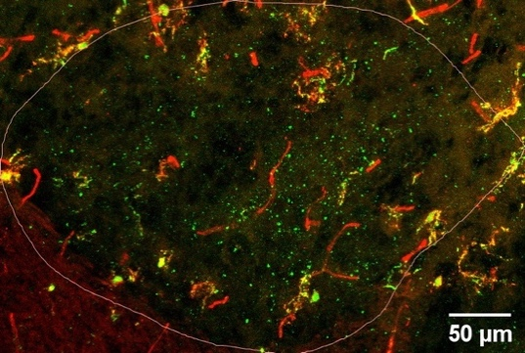
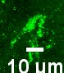
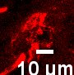
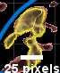

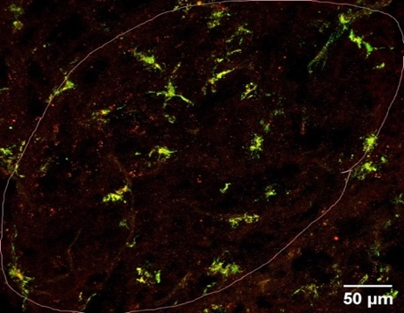
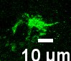
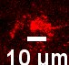
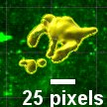
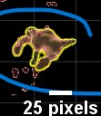
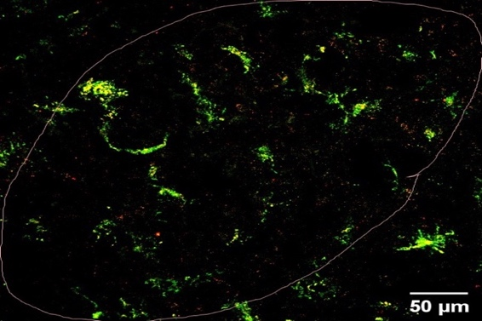
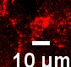
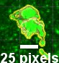
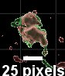
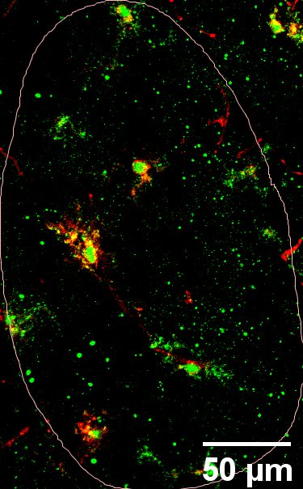
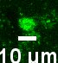
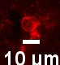
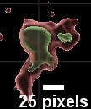
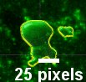
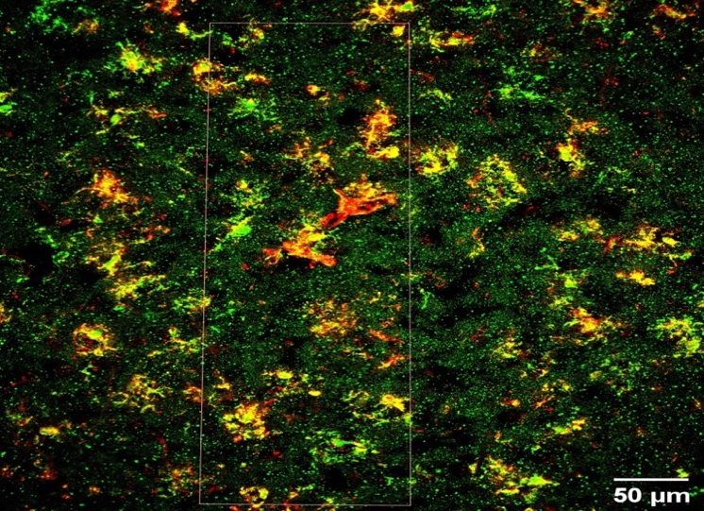
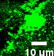
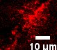
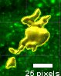
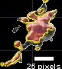
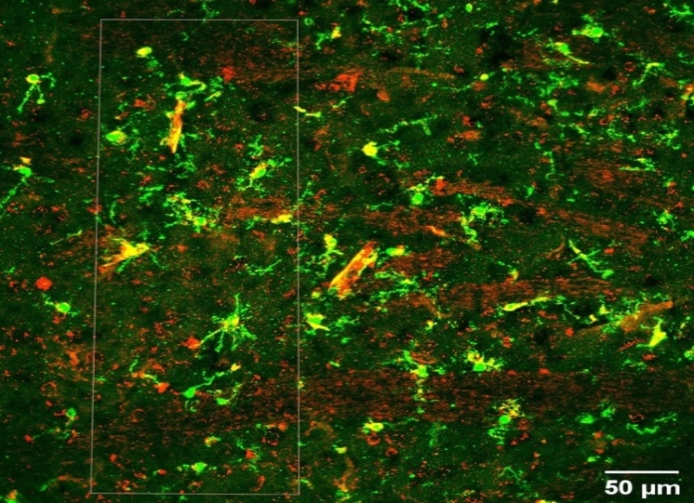
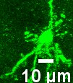
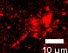
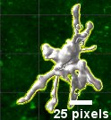
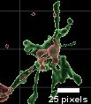
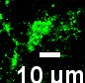

IBA1
CD86
IBA1
CD206
SCN
SCN
IBA1
CD86
IBA1
CD206
AH
AH
IBA1
CD86
IBA1
CD206
Cortex
Cortex
Figure 7: Representative images of the SCN, AH and cortex regions of interest. IHC staining and 3-D rendering of a microglial cell from each region (white arrow) are shown on the side of each image.

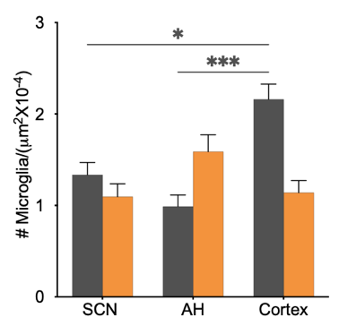
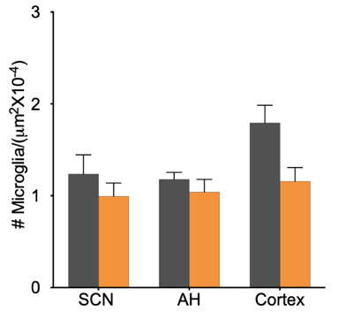
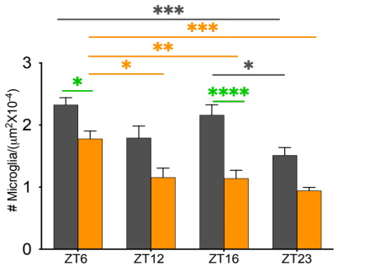
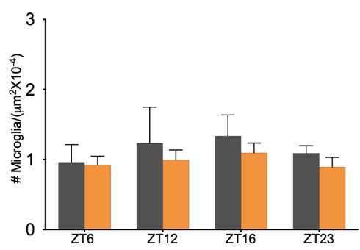
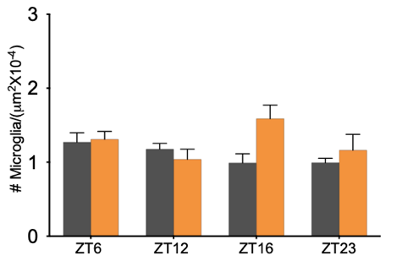
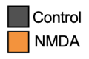
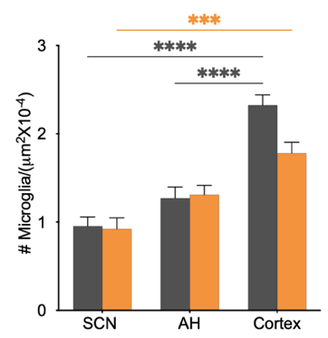
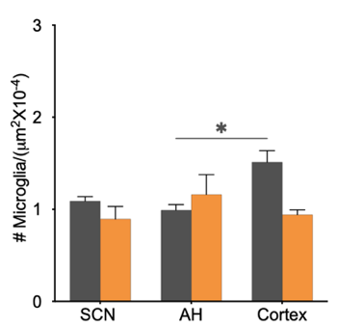
Anterior Hypothalamus
Cortex
ZT6
ZT12
ZT16
ZT23
Suprachiasmatic Nucleus

Figure 8. Left: Time of day differences microglial cell density in the suprachiasmatic nucleus, anterior hypothalamus, and cortex. Right: Regional differences in microglial cell density at ZT6, ZT12, ZT23 and ZT23. Significant differences across control conditions (*), NMDA conditions (*) and between control and treatment conditions (*) are indicated (*p<0.05, **p<0.01, ***p<0.001, ****p<0.0001).

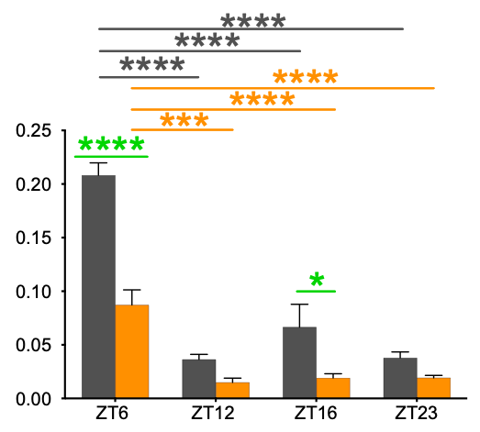
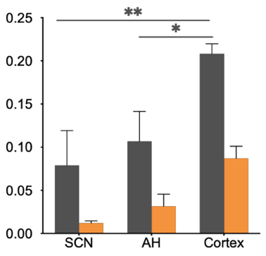
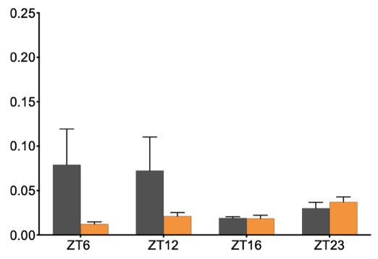
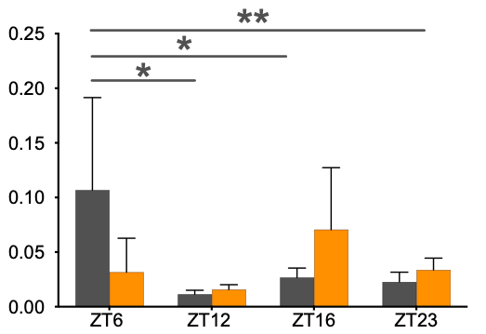
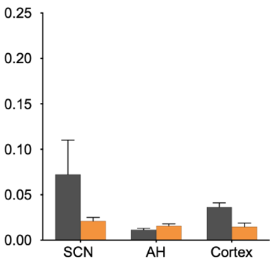
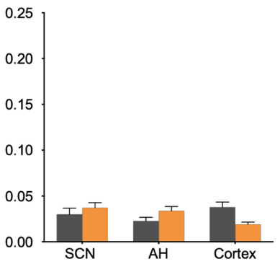
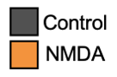
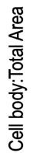
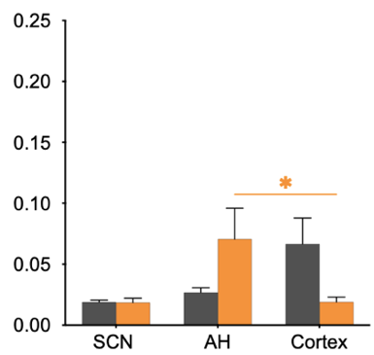
Suprachiasmatic Nucleus
Anterior Hypothalamus
Cortex
ZT6
ZT12
ZT16
ZT23

Figure 9. Left: Time of day differences microglial cell body: total area ratio in the suprachiasmatic nucleus, anterior hypothalamus, and cortex. Right: Regional differences in microglial cell body: total area ratio at ZT6, ZT12, ZT23 and ZT23. Significant differences across control conditions (*), NMDA conditions (*) and between control and treatment conditions (*) are indicated (*p<0.05, **p<0.01, ***p<0.001, ****p<0.0001).

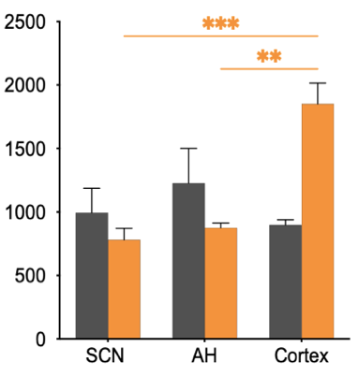
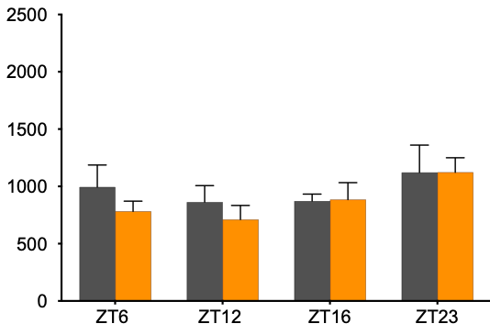
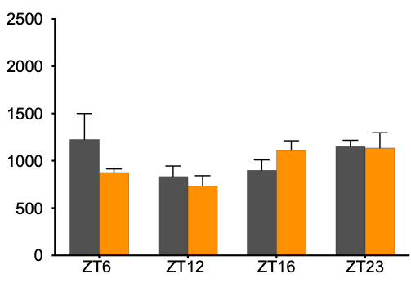
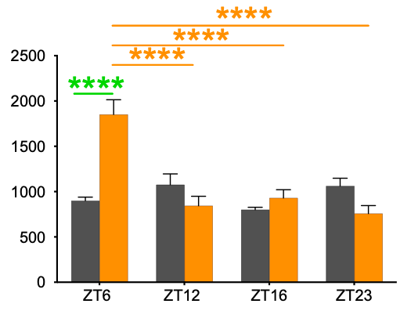
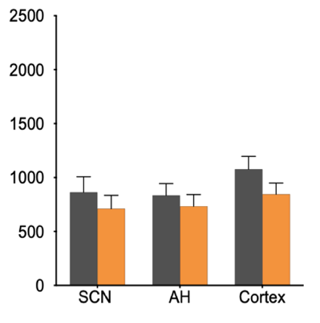
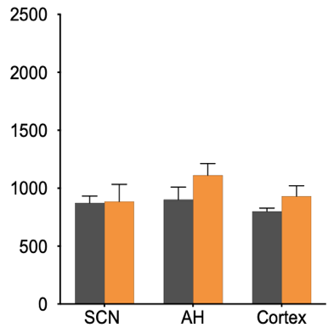
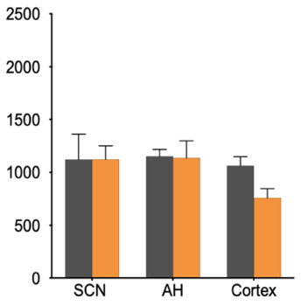
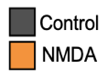
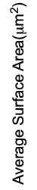
Suprachiasmatic Nucleus
Anterior Hypothalamus
Cortex
ZT12
ZT16
ZT23
ZT6

Figure 10. Left: Time of day differences microglial surface area in the suprachiasmatic nucleus, anterior hypothalamus, and cortex. Right: Regional differences in microglial surface area at ZT6, ZT12, ZT23 and ZT23. Significant differences across control conditions (*), NMDA conditions (*) and between control and treatment conditions (*) are indicated (*p<0.05, **p<0.01, ***p<0.001, ****p<0.0001).

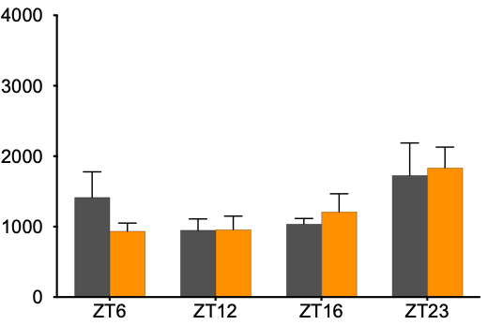
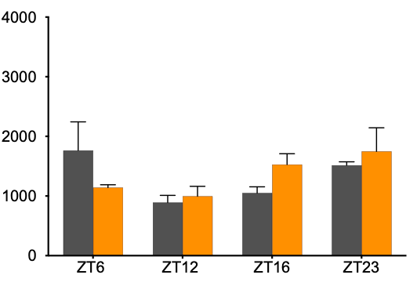
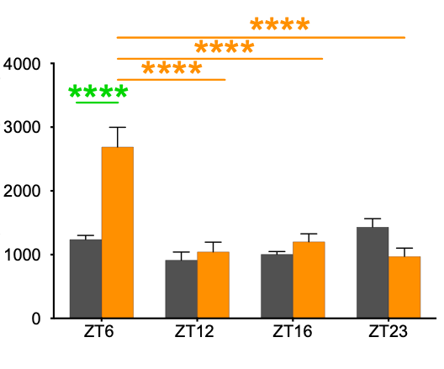
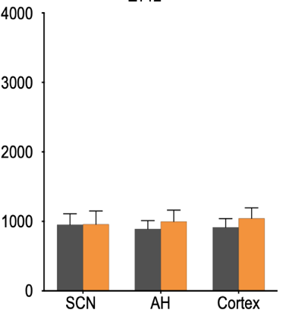
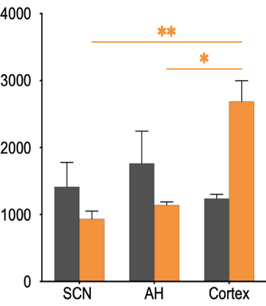
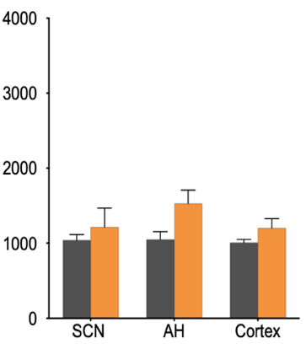
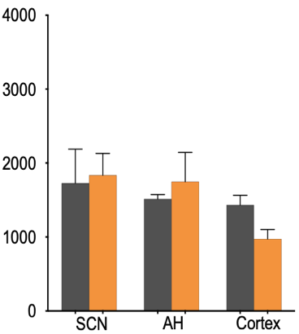
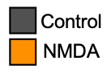
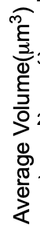
Suprachiasmatic Nucleus
Anterior Hypothalamus
Cortex
ZT12
ZT16
ZT23
ZT6

Figure 11. Left: Time of day differences microglial volume in the suprachiasmatic nucleus, anterior hypothalamus, and cortex. Right: Regional differences in microglial volume at ZT6, ZT12, ZT23 and ZT23. Significant differences across control conditions (*), NMDA conditions (*) and between control and treatment conditions (*) are indicated (*p<0.05, **p<0.01, ***p<0.001, ****p<0.0001).

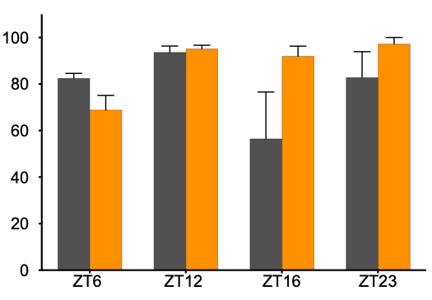
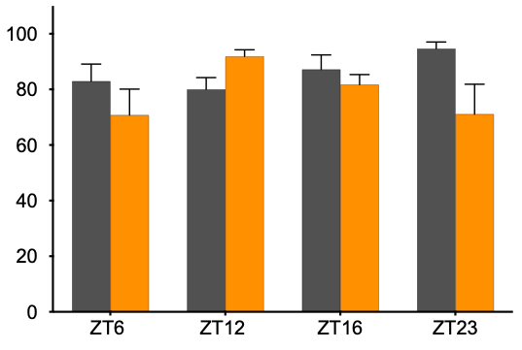
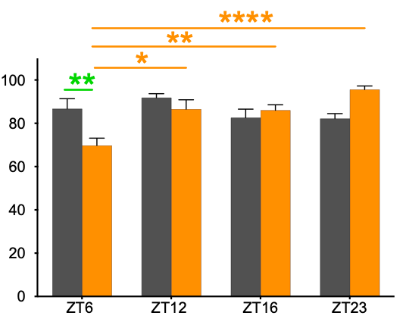
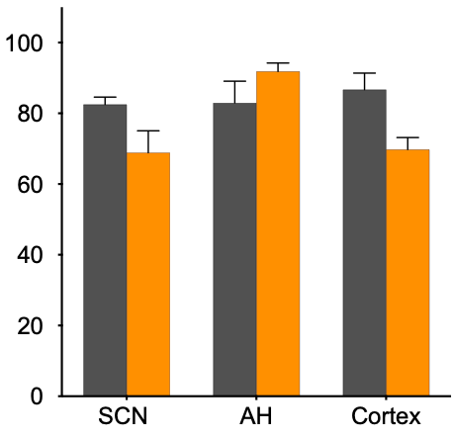
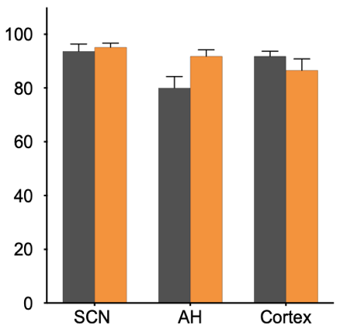
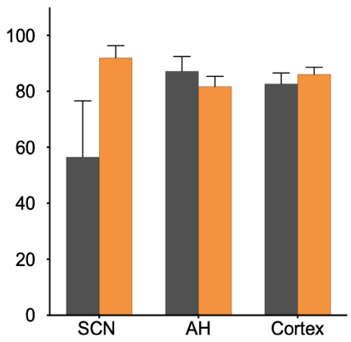
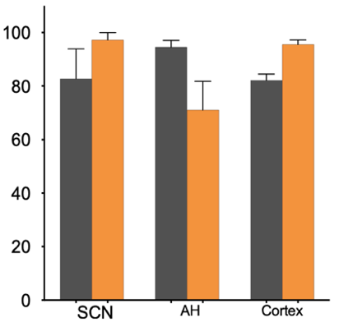
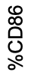
Suprachiasmatic Nucleus
Anterior Hypothalamus
Cortex
ZT12
ZT16
ZT23
ZT6

Figure 12. Left: Time of day differences in the percentage of CD86⁺ microglial cell in the suprachiasmatic nucleus, anterior hypothalamus, and cortex. Right: Regional differences in % of CD86⁺ microglial cells at ZT6, ZT12, ZT23 and ZT23. Significant differences across control conditions (*), NMDA conditions (*) and between control and treatment conditions (*) are indicated (*p<0.05, **p<0.01, ***p<0.001, ****p<0.0001).

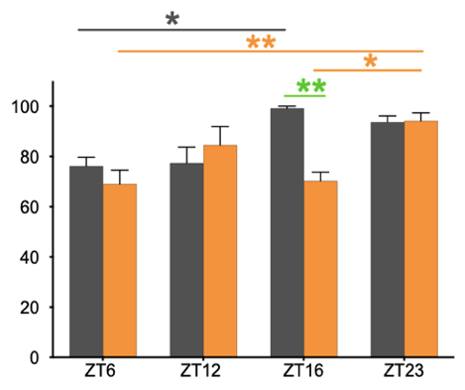
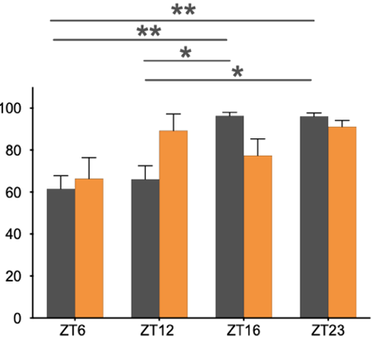
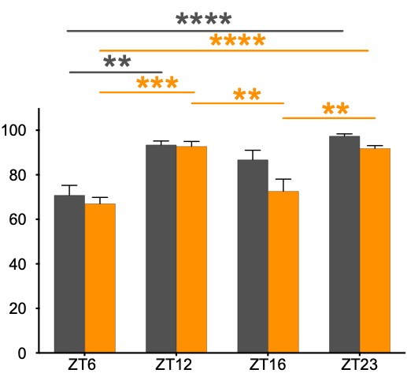
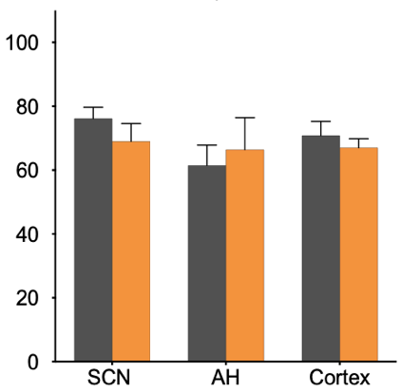
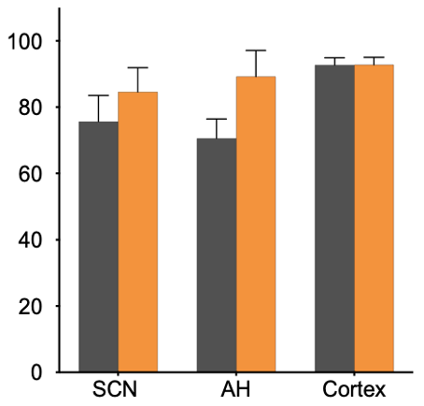
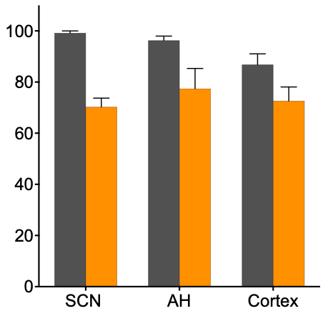
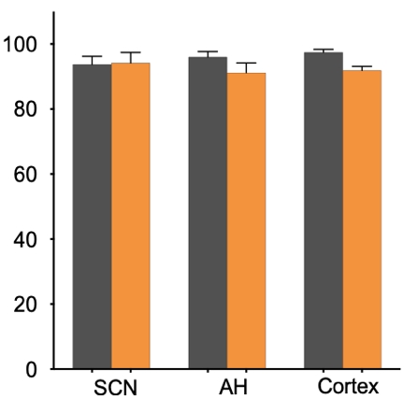
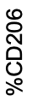
Suprachiasmatic Nucleus
Anterior Hypothalamus
Cortex
ZT12
ZT16
ZT23
ZT6

Figure 13. Left: Time of day differences in the percentage of CD206⁺ microglial cell in the suprachiasmatic nucleus, anterior hypothalamus, and cortex. Right: Regional differences in % of CD206⁺ microglial cells at ZT6, ZT12, ZT23 and ZT23. Significant differences across control conditions (*), NMDA conditions (*) and between control and treatment conditions (*) are indicated (*p<0.05, **p<0.01, ***p<0.001, ****p<0.0001).

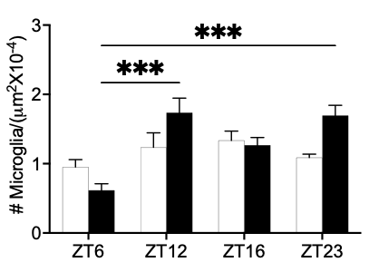
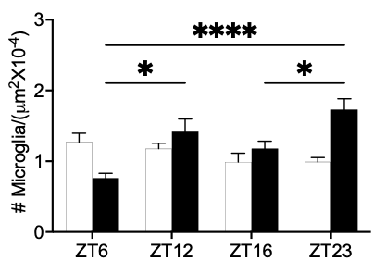
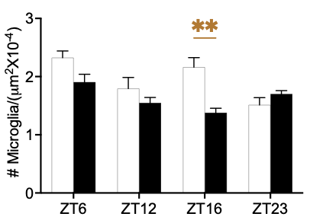
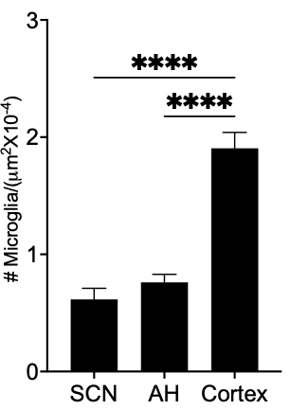
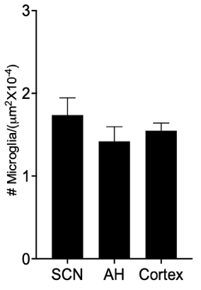
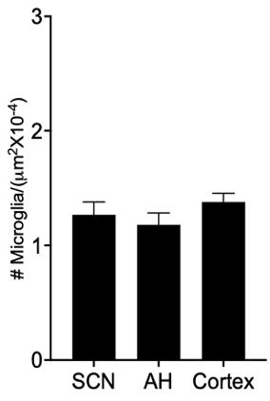
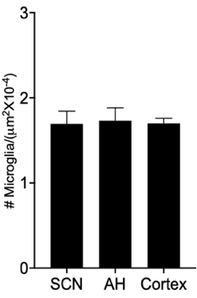
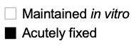
Suprachiasmatic Nucleus
Anterior Hypothalamus
Cortex
ZT12
ZT16
ZT23
ZT6

Figure 14. Left: Time of day differences microglial cell density in the suprachiasmatic nucleus, anterior hypothalamus, and cortex. Right: Regional differences in microglial cell density at ZT6, ZT12, ZT23 and ZT23. Significant differences across acutely fixed sections (*) and between in vitro and acutely fixed slices (*) are indicated (*p<0.05, **p<0.01, ***p<0.001, ****p<0.0001).

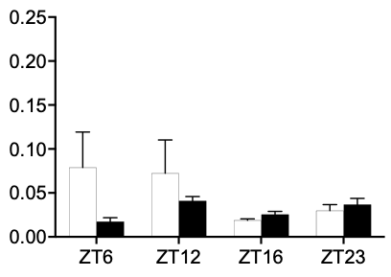
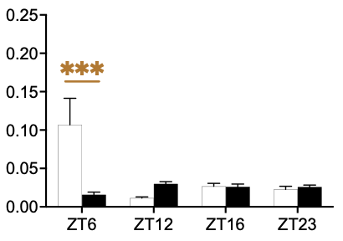
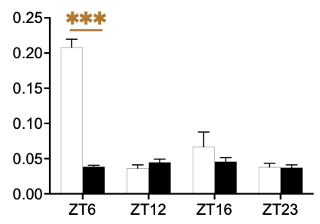
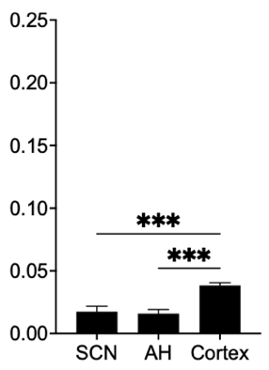
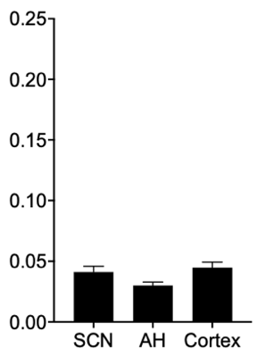
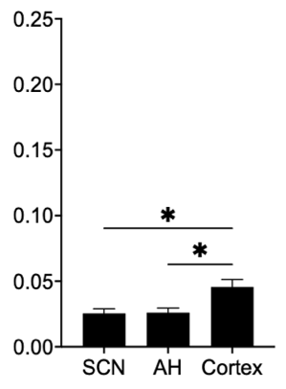
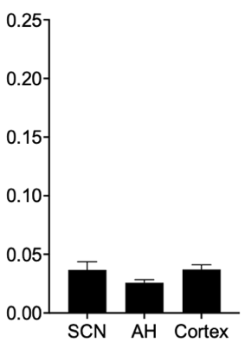
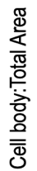
Suprachiasmatic Nucleus
Anterior Hypothalamus
Cortex
ZT12
ZT16
ZT23
ZT6

Figure 15. Left: Time of day differences microglial cell body: total area ratio in the suprachiasmatic nucleus, anterior hypothalamus, and cortex. Right: Regional differences in microglial cell body: total area ratio at ZT6, ZT12, ZT23 and ZT23. Significant differences across acutely fixed sections (*) and between in vitro and acutely fixed slices (*) are indicated (*p<0.05, **p<0.01, ***p<0.001, ****p<0.0001).

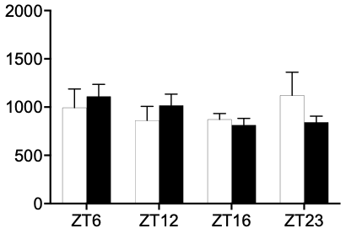
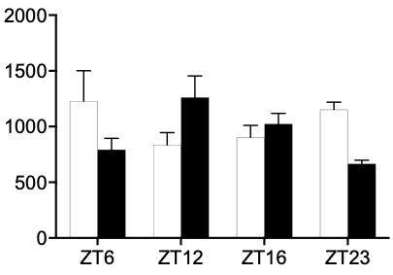
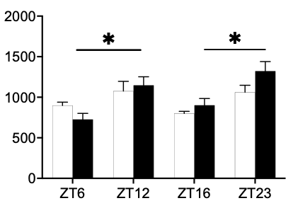
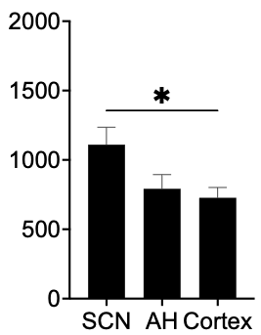
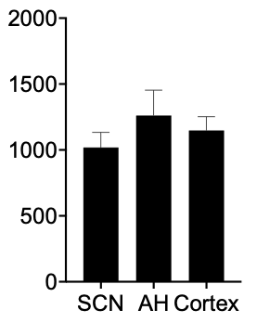
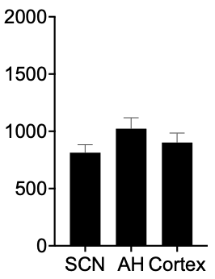
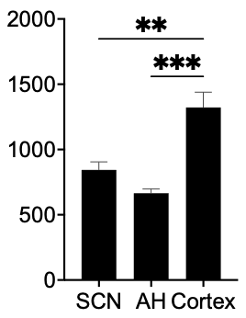
Suprachiasmatic Nucleus
Anterior Hypothalamus
Cortex
ZT12
ZT16
ZT23
ZT6

Figure 16. Left: Time of day differences microglial cell surface area in the suprachiasmatic nucleus, anterior hypothalamus, and cortex. Right: Regional differences in microglial cell surface area at ZT6, ZT12, ZT23 and ZT23. Significant differences across acutely fixed sections (*) and between in vitro and acutely fixed slices (*) are indicated (*p<0.05, **p<0.01, ***p<0.001, ****p<0.0001).

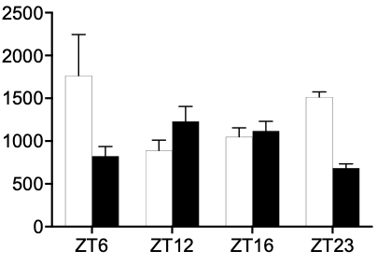
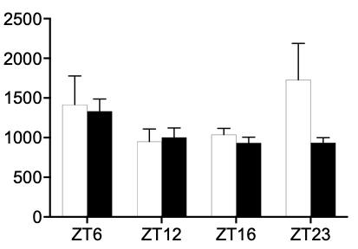
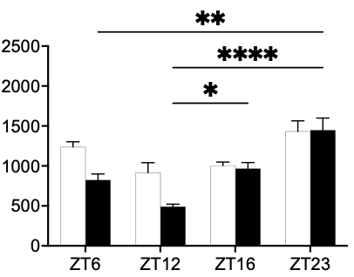
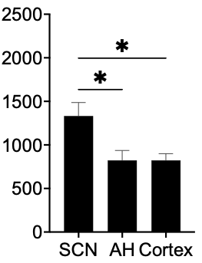
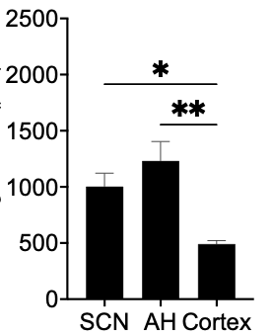
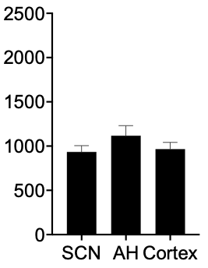
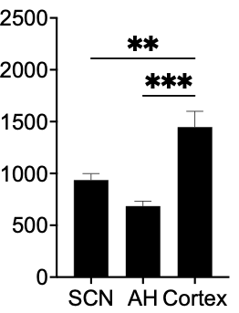
Suprachiasmatic Nucleus
Cortex
ZT12
ZT16
ZT23
ZT6

Figure 17. Left: Time of day differences microglial cell volume in the suprachiasmatic nucleus, anterior hypothalamus, and cortex. Right: Regional differences in microglial volume at ZT6, ZT12, ZT23 and ZT23. Significant differences across acutely fixed sections (*) and between in vitro and acutely fixed slices (*) are indicated (*p<0.05, **p<0.01, ***p<0.001, ****p<0.0001).

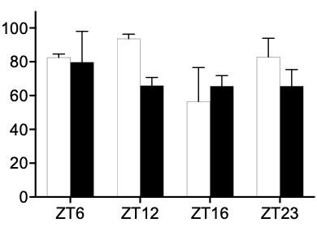
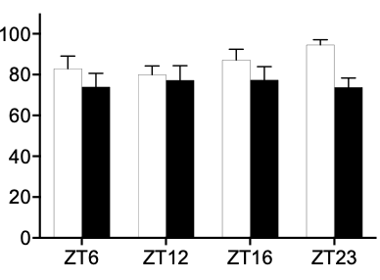
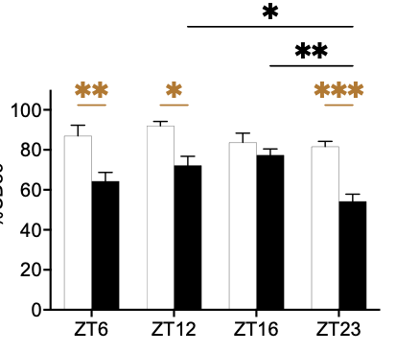
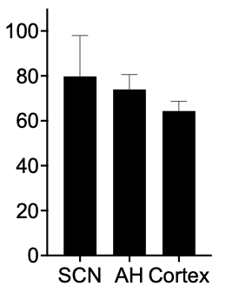
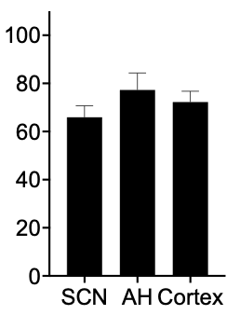
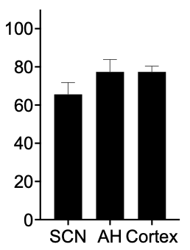
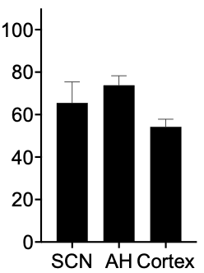
Suprachiasmatic Nucleus
Anterior Hypothalamus
Cortex
ZT12
ZT16
ZT23
ZT6

Figure 18. Left: Time of day differences in the percentage of CD86⁺ microglial cells in the suprachiasmatic nucleus, anterior hypothalamus, and cortex. Right: Regional differences in % of CD86⁺ microglial cells at ZT6, ZT12, ZT23 and ZT23. Significant differences across acutely fixed sections (*) and between in vitro and acutely fixed slices (*) are indicated (*p<0.05, **p<0.01, ***p<0.001, ****p<0.0001).

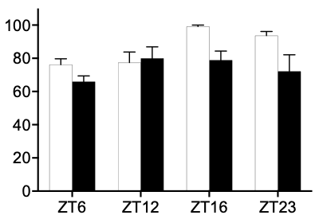
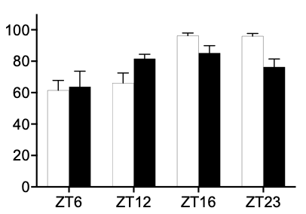
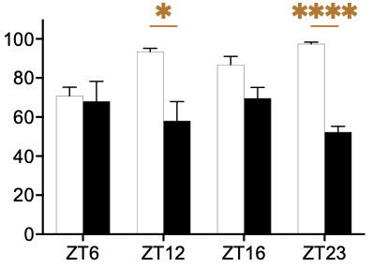
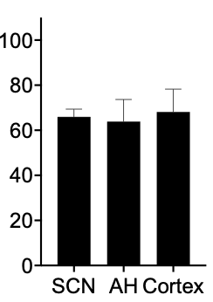
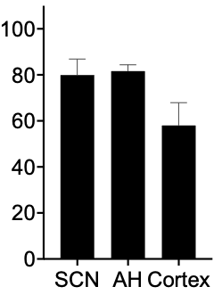
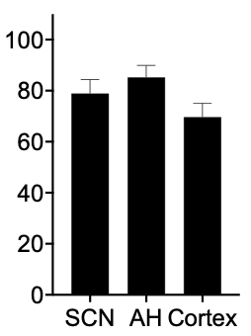
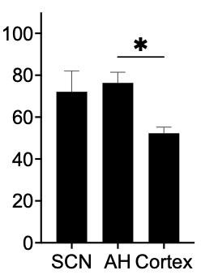
Suprachiasmatic Nucleus
Anterior Hypothalamus
Cortex
ZT12
ZT16
ZT23
ZT6

Figure 19. Left: Time of day differences in the percentage of CD206⁺ microglial cells in the suprachiasmatic nucleus, anterior hypothalamus, and cortex. Right: Regional differences in % of CD206⁺ microglial cells at ZT6, ZT12, ZT23 and ZT23. Significant differences across acutely fixed sections (*) and between in vitro and acutely fixed slices (*) are indicated (*p<0.05, **p<0.01, ***p<0.001, ****p<0.0001).

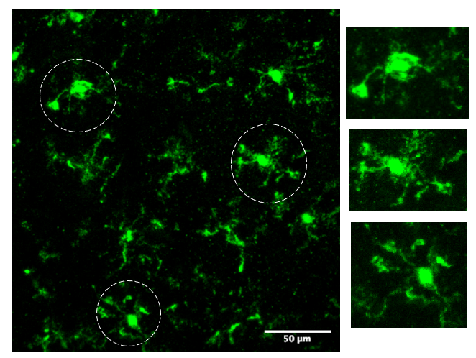
Figure 20: Representative images showing microglia (dashed circles) that potentially exhibit a ramified morphology with bulbous tips.

Chapter IV
Investigating cytokine release from hypothalamus and cortex ex vivo brain slices under control and excitotoxic conditions

Abstract
Cytokines are effector molecules that are released by both neuronal and glial cells and are known to be released in response to an excitotoxic stimulus, which in turn exacerbates neuroinflammation. Since we have observed differences in excitotoxicity-induced cell death in the suprachiasmatic nucleus (SCN), anterior hypothalamus (AH) and cortex, we were interested in investigating the cytokine profile of these regions under control and excitotoxic conditions. We used an Enzyme-Linked Immunosorbent Assay to quantify interleukin-6, interleukin 10 tumor necrosis factor α, interferon gamma, interleukin 1α and interleukin 1β in tissue perfusates collected from the hypothalamus (SCN and surrounding AH) and cortex under control and excitotoxic conditions. We also processed the brain slices for propidium iodide staining to observe the amount of cell death in each of the regions. Preliminary results show that all the cytokines were detected in the tissue perfusates, but there were very few differences across regions under either control or excitotoxic conditions. We speculate that this is because of low concentration of cytokines that is present in the tissue perfusates.

Introduction
Cytokines are secreted proteins that play immunomodulatory and neuromodulatory roles in the central nervous system (CNS)^{185–187}. They influence the activity of both neuronal and glial cells¹⁸⁸. Under normal physiological conditions, the levels of released cytokines are relatively low in the CNS. However, they can increase dramatically in response to injury or a toxic stimulus, such as during excitotoxicity¹⁸⁹. Excitotoxicity often leads to neuronal cell damage or death and triggers the release of cytokines from neighboring immune cells such as microglial and astrocytes¹⁹⁰. Although this response can lead to a reduction in the severity of the injury, it also can exacerbate the damage via neuroinflammatory and neurotoxic cascades. While cytokines are released by all glial cells, immune cells and neurons, here we will focus on cytokine expression by microglial cells.
During chronic and acute damage associated with neurological disorders, damaged neurons and glial cells release adenosine triphosphate (ATP) into the extracellular space^{191,192}. ATP is an important damage-associated molecular pattern (DAMP) molecule that binds to purinergic receptors and leads to the release of cytokines such as interleukin 6 (IL-6), tumor necrosis factor α (TNF-α), interleukin 1 (IL-1) by activating the mammalian target of rapamycin (mTOR) pathway¹⁹³. In addition to this, microglial cells also have functional N-methyl-D-Aspartate (NMDA) receptors that have been shown to drive the release of pro-inflammatory cytokines such as interleukin 1α (IL-1α), interleukin 1β (IL-1β), tumor necrosis factors (TNF-α) under in vitro conditions¹⁹⁴. This NMDA-stimulated release is thought to occur in response to increased oxidative stress, like the response of microglial cells to treatment with lipopolysaccharide (LPS). Not only does NMDA induce cytokine release, but studies have shown that cytokines such as IL-1β can reciprocally affect NMDA receptors to increase intracellular calcium concentration via Src kinases¹⁹⁵. Thus, understanding the cytokine milieu generated in the brain post-injury is critical in identifying potential treatment options.
Cytokines can be broadly categorized as pro-inflammatory or anti-inflammatory. The major pro-inflammatory cytokines include IL-6, TNF-α and interferons, and have been shown to exacerbate neuronal damage during brain injury^{196,197}. On the other-hand, anti-inflammatory cytokines such as IL-10 and IL-4 have been studied with respect to their roles in neuroprotection, especially under neuroinflammatory conditions^{198,199}.
While many studies have investigated the heterogeneity of glial cells in terms of their function and response to cytotoxic stimuli, it is unclear if this heterogeneity includes differences in their cytokine expression. Given our data showing microglial heterogeneity across the Suprachiasmatic nucleus (SCN), anterior hypothalamus (AH) and cortex in their numbers, morphology and cell-surface protein expression under control conditions and in response to an excitotoxic stimulus, we continued our research project by investigating if there are differences in cytokine expression across brain areas under different treatment conditions that might be driving the regional differences in excitotoxic susceptibility. Since cytokines are the primary effector molecules of microglia, we hypothesized that NMDA treatment would increase the release of pro-inflammatory cytokines and decrease the release of anti-inflammatory cytokines compared to control conditions in all the regions. We also hypothesized that the increased resiliency of the SCN would be associated with a lower expression of pro-inflammatory cytokines and higher expression of anti-inflammatory cytokines compared to excitotoxically susceptible areas such as the cortex and AH.
Materials and Methods
Tissue collection
Acute coronal brain slices (500μm) containing either the SCN and adjacent AH or the cortex were prepared from adult male C57Bl/6 mice (Envigo; Indianapolis, IN) housed under a 12:12 light-dark cycle with food and water available ad libitum. Brain slices containing the SCN and AH regions were identified based on previously established anatomical markers. The area of the cortex from which the slices were made included the anterior cingulate area, somatomotor area, and part of the retrosplenial area of the cortex. The slices were prepared between zeitgeber time ZT0 and 2 (where ZT0 = lights on and ZT12 = lights off in the donor animal colony). Slices were placed in Hatton-style brain slice dishes perfused with Earle’s Balanced Salt Solution (EBSS) (MP Biomedicals; OH, USA) supplemented with glucose and sodium bicarbonate; pH 7.4, gassed with 95% O₂/5% CO₂ and maintained at 37^{ο}C as described elsewhere ²⁰⁰. Hypothalamic slices containing the SCN and AH were maintained in separate dishes from cortex slices. The SCN and AH could not be separated from each other without substantial tissue damage, so their cytokine data represent both areas combined. However, histological analyses of the two areas remained separate.
Excitotoxic Treatment
At ZT6, the perfusion in the brain slice chamber was paused, and the slices were left untreated or treated with EBSS supplemented with NMDA (10mM) (Sigma Aldrich; MO, USA) for 1h. This concentration was chosen because we previously found that it induces excitotoxic damage in all three brain regions at ZT 6¹⁵⁸. We chose to assess cytokine release in response to NMDA treatment at ZT6 (rather than ZT16) because this was the time where we quantified a dose-dependent difference in excitotoxic susceptibility across the three brain regions.
After the treatment, the slices were shifted to a static mini-well and incubated with fresh EBSS (250uL) media for 3h. The medium surrounding the tissue slices was collected at the end of 3h and stored in aliquots in -80^{ο}C for ELISA Assay.
In a separate experiment, we repeated the process outlined previously with one additional step where we collected the tissues after perfusate collection to observe the cell death in each region using propidium iodide staining. After perfusate collection, the tissues were further incubated in the static mini-well with propidium iodide (PI) (4.6μg/ml) (Invitrogen; OR, USA) for an additional 2h. At the end of this period, the tissues were placed in 4% paraformaldehyde (Electron Microscopy Sciences; PA, USA). The tissues were then transferred to a 30% sucrose solution and again incubated overnight at 4^{ο}C. The fixed tissues were then embedded in OCT (Tissue Tek; CA, USA) and stored at -80°C before being sectioned (25μm) in the cryostat. For the cortex, we had a sample size of 8 each for control and NMDA treated conditions. For the SCN and AH, we had a sample size of 12 each for control and NMDA conditions.
Enzyme-Linked Immuno-Sorbent Assay (ELISA)
The tissue perfusates were analyzed using an Enzyme Linked Immune Sorbent Assay (ELISA) kit [Q-Plex Array Mouse Cytokine Panel 1 (6-Plex), Quansys Biosciences, 2022, Utah, USA] using the protocol provided with the kit. The kit detects an array of pro-inflammatory cytokines (IFNγ, IL-1α, IL-1β, IL-6, and TNFα) and one anti-inflammatory cytokine (IL-10). A total of 5 experimental samples were analyzed for each experimental condition. Two independent ELISAs were conducted. For the Trial 1 we used 5 biological replicates and 3 technical replicates, and we diluted the samples by 50% for Trial 1. Trial 2 also consisted of 5 biological replicates (n=5) but we did not have sufficient sample volumes to have technical replicates. Additionally, we did not dilute the samples in Trial 2.
Immunohistochemical Staining:
The tissue sections were stained with the pan-microglial marker IBA1 using IHC to observe the percentage of microglial cells damaged or dead when treated with NMDA compared to control conditions. For IBA1 staining, the sections were blocked with a blocking buffer containing 3% Bovine Serum Albumin (Invitrogen, MA, USA) and 0.3% Triton X-100 for an hour after being washed with Phosphate Buffered Saline (PBS) for 4-times with a duration of 5 mins each. The blocking buffer was then replaced with blocking buffer containing IBA1 (Fujifilm Wako, VA, USA) antibody diluted to 1:1000 concentration and incubated overnight at 4°C. The following day, the sections were again washed 4 times with PBS for duration of 5 mins each and incubated with secondary antibody diluted in PBS for one hour at room temperature. The secondary antibody used was Donkey anti-Rabbit 488 (Abcam, UK) and diluted to 1:1000. Following the secondary incubation, the sections were again washed 4 times with PBS for a duration of 10 mins each. The slides were then coverslipped with VECTASHIELD (Vector Laboratories, CA, USA), sealed using nail polish and stored in 4°C until imaging was conducted.
Image Acquisition:
We used two different imaging systems to analyze the 96 well plates for the ELISA kits: a Q-view imager LS (Quansys Biosciences) and a Chemidoc Touch Imaging system (BioRAD, USA). This allowed us to compare differences in the quality of the imaging systems.
For the histology, all the images were acquired using a confocal Leica SP8 (Germany) microscope. The images were acquired as a z-stack with using 20X magnification. The images were then processed using ImageJ software (NIH). Each image was 25-30μm thick with a step-size of 1μm. One image was collected from each replicate.
Image Processing and Analysis:
For the ELISAs, all images were analyzed together in one-plate using the Q-view software (Quansys Biologicals, Utah, USA). The concentration of each cytokine was calculated using the standard curve of respective cytokine provided by with the ELISA kits. For Trial 1 we used 5 biological replicates and 3 technical replicates, and we diluted the samples by 50%. When plotting the results from Trial 1, we multiplied the cytokine concentration by the dilution. Trial 2 also consisted of 5 biological replicates (n=5) but we did not have sufficient sample volumes to have technical replicates. Additionally, we did not dilute the samples in Trial 2. The technical replicates allowed us to compute reliability within the individual cytokine measurements in Trial 1. However, we were not able to compute reliability between trials because Trial 2 had no technical replicates.
For the histology, one tissue section was analyzed from each tissue slice. For the SCN/AH, a tissue section was chosen that contained a region approximately mid-way between the anterior and posterior ends of the SCN, based on the shape of the underlying optic chiasm. A region of interest (ROI) was then created for each image that was being analyzed. The SCN region was identified based on the DAPI staining, as the SCN has a greater cell density than the surrounding hypothalamus. The AH ROI (created by shifting the ROI surround created for the SCN) was chosen based on following parameters: an area near the SCN, in the same section, that did not include the epithelial cells lining the ventricle or tears from cryostat sectioning. For the cortex, we generated a rectangular ROI of approximately the same size area to that of the SCN and AH that spanned multiple cell layers through the cortex. We used the same ROI with minor changes for all the cortical sections that were being analyzed for this study. Six samples were analyzed for each condition, and the images were analyzed by at least 3 individuals without knowledge of the experimental treatment. The mean of the individual analyses for each image was used for statistical analysis.
Using ImageJ (NIH), for each ROI, we counted the total number of cells based on the DAPI channel. Next, based on the protocol we have used previously ¹⁵⁸ we counted the total number each of dead and damaged cells in each ROI based on the PI staining. We then counted the total number of microglial cells in each ROI using the IBA1 channel. By merging the PI and IBA1 channel, we then counted how many IBA1 cells were either dead or damaged.
We then calculated the percentage of microglial cells that are dead and damaged for each ROI using the formulas:
Total IBA cells
X 100 = % dead microglial cells
# IBA1+intense PI stained cells
X 100 = % damaged microglial cells
# IBA1+diffuse PI stained cells
Total IBA cells
The percentage of healthy IBA1 cells is the total number of cells minus the dead/damaged cells.
To estimate the percentage of all dead and damaged cells in each ROI that were microglial cells, we used the formulas:
# IBA1+diffuse PI stained cells
X 100 = % of dead cells that are microglia
Total number of intense PI⁺ cells
# IBA1+intense PI stained cells
Total number of diffuse PI⁺ cells
X 100 = % of dead cells that are microglia
The percentage of total healthy cells is the total number of cells minus the dead/damaged microglia.
Statistical Analysis
The Q-view software calculates the cytokine measurements for each of our samples. We plotted the data using GraphPad Prism. To compare differences in cytokine expression, two-way ANOVAs with brain region x treatment conditions were performed using GraphPad Prism for each cytokine. Differences were considered statistically significant at p<0.05.
To determine the percentage of microglial cells that are dead or damaged in different areas under control and NMDA conditions, we plotted the mean and SEM of the analyses for each image using GraphPad Prism. To compare differences in the percentage of microglial cells that were healthy, damaged or dead in each region, separate two-way ANOVAs with brain region x treatment conditions were performed for each cell health status category using GraphPad Prism. Similar analyses were performed that focused on the proportion of all dead, damaged and healthy cells in each ROI that were dead, damaged or healthy microglial cells. Differences in all cases were considered statistically significant at p<0.05.
Results
ELISA Assay using the Q-view imager
In Trial 1 (Figure 21), two-way ANOVAs revealed there were no statistically significant interactions between brain regions and treatment conditions on the expression of IFN-γ (p=0.8588), IL-1α (p=0.9526), IL-1b (p=0.9639), IL-6 (p=0.1362) or TNF-α (p=0.3491). However, there was a statistically significant interaction between brain region and treatment condition on the expression of IL-10 (p=0.0176). Post hoc analysis indicated a significantly lower IL-10 expression in cortex compared to hypothalamus under control conditions (p= 0.0167). Additionally, within the hypothalamus, there was significantly higher expression of IL-10 under control conditions compared to NMDA conditions (p=0.0120).
In Trial 2 (Figure 21), there were no statistically significant interactions between brain areas and treatment conditions on the expression on the expression of IFN-γ (p-value could not be calculated because no cytokine was detected in any of the samples), IL-1α (p=0.9855), IL-1β (p=0.1599), IL-6 (p=0.4489), TNF-α (p=0.2745) or IL-10 (p=0.6778).
ELISA Assay using the BioRAD imager
In Trial 1 (Figure 21), two-way ANOVAs revealed there were no statistically significant interactions between brain area and treatment condition on the expression of IFN-γ (p=0.4006), IL-1α (p=0.4671), IL-1b (p=0.9006), IL-6 (p=0.2190), TNF-α (p=0.3363) or IL-10 (p=0.1875). In Trial 2 (Figure 21), two-way ANOVAs revealed no statistically significant interactions between brain areas and treatment conditions on the expression of IFN-γ (p-value could not be calculated as there no IFN-γ was detected), IL-1α (p=0.9169), IL-1b (p=0.3322), IL-6 (p=0.3550), TNF-α (p=0.3033) or IL-10 (p-value could not be calculated because there was no variation in experimental replicates possibly due technical issues. ).
Percentage of microglial cells in the SCN, AH and cortex that were dead/damaged
Data are not yet analyzed.
Percentage of total dead/damaged cells SCN, AH and cortex that were microglial cells.
Data are not yet analyzed.
Discussion
The overall aim of this study was to investigate the types of cytokines being released by brain slices containing the SCN and AH compared to an excitotoxically susceptible region of the brain, i.e., the cortex. Our results (using the Q-view imager) show no statistically significant differences in the concentration of any of the pro-inflammatory cytokines such as IFN-γ, IL1α, IL1β, TNF-α and IL-6 between cortex and hypothalamus under control and excitotoxic conditions in either Trial 1 or 2. On the other hand, in Trial 1, the data indicate that the cortex has significantly lower levels of IL-10 secretion compared to the hypothalamus under control conditions. Further, the data indicate that IL-10 release in the hypothalamus is significantly lower when the brain slices are treated with NMDA compared to control conditions. Although neither of these results are replicated in Trial 2, they do support there being regional differences in cytokines that could be relevant to the regional differences in excitotoxic susceptibility that we have demonstrated. The lower control IL-10 levels could, for example, set the stage for the cortex being less resilient to an excitotoxic stimulus. The decrease in IL-10 in the hypothalamus in response to NMDA treatment is not consistent with the higher resiliency of the SCN, but it would be consistent with the lower resiliency of the AH. It would also be consistent with microglia in the hypothalamus reacting in a pro-inflammatory direction, but this idea is inconsistent with the lack of significant increase in any of the pro-inflammatory cytokines.
With respect to the results obtained using the BioRAD imager, it is clear that across the board there are lower values compared to those obtained using the Q-view imager, in both Trial 1 and 2. This was likely because the resolution of the BioRAD images are lower than those acquired using the Q-view imager. Although we did not do a statistical analysis of this, the overall pattern supports the Q-view imager having higher sensitivity than the BioRAD imager, a potentially important factor when analyte concentrations are very low. For example, this difference could underlie the IL-10 data in Trial 1 not having statistically significant differences when using the BioRAD imager.
While in these experiments we were unable to separate the SCN and AH, given their differences in excitotoxic resiliency, future experiments could compare these two regions by doing immunohistochemical analyses of the brain slices exploring the expression of specific cytokines. Additionally, future experiments could expand the number of cytokines investigated. The cytokines detected in the ELISAs we used have been previously implicated in excitotoxic cell damage and neurodegenerative disease ²⁰¹, and hence were interesting candidates for our analysis. However, additional cytokines could prove informative such as IL-4, CCL2, CX3CL1 etc. Investigating additional anti-inflammatory cytokines would be good. In general, understanding the expression profile of the cytokines are imperative as they provide important therapeutic targets to treat diseases that are associated with excitotoxic damage.
When comparing Trials 1 and 2, there is a lot of variation in the concentrations of the cytokines that were measured between the two trials as well as their overall patterns across the different conditions and brain regions. It is possible that the variation is due to the low concentration of the cytokines in the tissue perfusates. The concentrations of the cytokines obtained in the analyses are at the low end of the sensitivity range of the kits, which could limit their reliability. Another factor increasing the variability of the results could be that we were unable to maintain the number of technical replicates between the two trials because we did not have enough sample volume. Given that the slices were in a static bath prior to collecting the perfusates, it is also possible that a majority of the cytokines released by the cells remained in the tissue slices. These issues could be addressed in future experiments by maintaining the slices in a microfluidic device that allows tissue perfusion but substantially reduces the overall perfusate volume. We are currently testing a new microfluidic device that improves on a previous one we helped develop and test¹⁴¹. We hope to use it in future experiments to investigate cytokine release from brain slices.
Another way to address the issues of sensitivity and reproducibility is to use a more sensitive analysis technique. Along these lines, we are collaborating with Dr. Bhavya Sharma in the Department of Chemistry who is developing a Raman-based Spectroscopy technique that can be used to detect cytokines (and other analytes) in the femtomolar range. This will not only help us detect cytokines that are being released at low concentrations but will also allow us to detect a broader range of cytokines compared to pre-determined ELISA kits that can only assess a limited number of cytokines.
The propidium iodide imaging along with the cytokine data will give us an indication of the percentage of microglial cells that are being affected by the excitotoxic conditions compared to control conditions in each region and the percentage total cells affected by the excitotoxic conditions that are microglial cells. These data will provide preliminary results to support future experiments investigating the mechanisms underlying the regional and time-of-day differences in excitotoxic susceptibility we have previously shown.

Appendix III

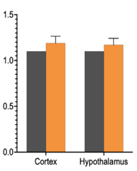
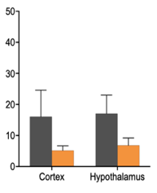
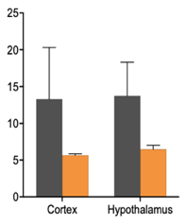
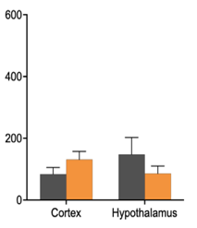
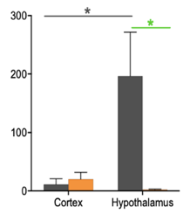
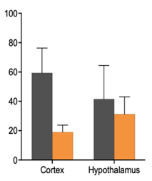
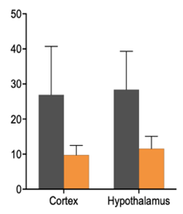
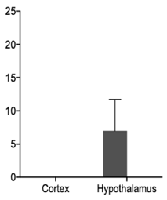
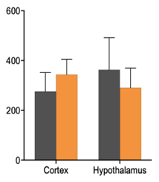
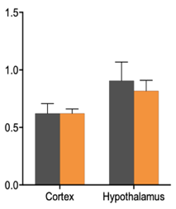
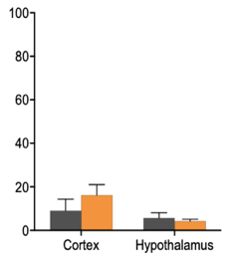
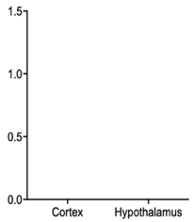
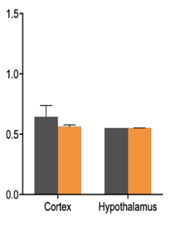
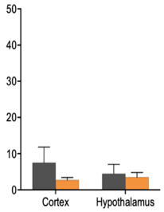
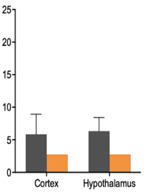
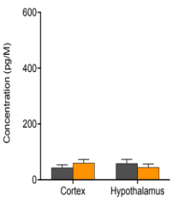
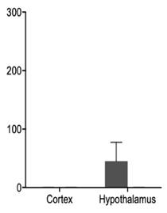
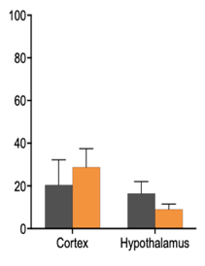
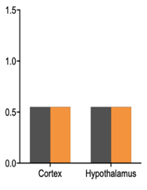
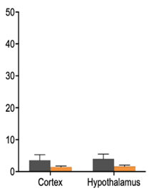
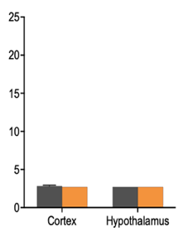
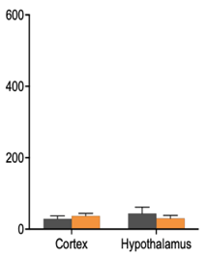
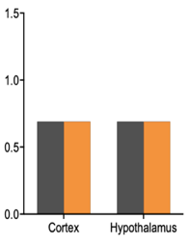
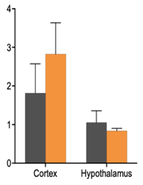
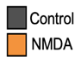
IL-10
IFN-γ
IL-1α
IL-1β
IL-6
TNF-α
Q-view Trial 1
Q-view Trial 2
BioRAD Trial 1
BioRAD Trial 2

Figure 21: Mean + SEM cytokine release concentrations determined using the Q-view and BioRAD imagers. *p<0.05

Chapter V
Summary and Conclusions

Excitotoxicity has been implicated in the progression of pathologies such as stroke and traumatic brain injury and diseases such Alzheimer’s, Parkinson’s and schizophrenia to name a few¹¹⁸. Excitotoxicity in these conditions arises due to an increase in glutamate concentration in the extracellular space of the brain which over-activates glutamatergic receptors such as N-Methyl-D-Aspartate (NMDA), α-amino-3-hydroxy-5-methyl-4-isoxazolepropinic acid (AMPA) and kainic acid (KA) receptors¹¹⁸. This leads to a surge in intracellular Ca²⁺ ions, switching on of cell death pathways and ultimately cell death and damage³⁰. While there have been a few reports indicating increased resilience of certain brain areas to excitotoxicity associated cell death⁹⁸, in depth qualitative and quantitative comparison of regional heterogeneity in susceptibility to excitotoxicity had not been undertaken. While an increased resiliency, specifically of the suprachiasmatic nucleus (SCN) has been previously reported using cell culture preparations, studies investigating the health of the SCN in intact tissues were missing^{99,202}. These gaps in knowledge prompted us to use ex vivo slice preparations to quantitatively compare the resiliency of SCN, the surrounding anterior hypothalamus (AH) and the cortex. We used N-Methyl-D-Aspartate (NMDA) as the excitotoxic stimulus for our studies. This was done because NMDA is the major receptor that is associated with excitotoxicity.
We began by isolating acute coronal brain slices containing the SCN and adjacent AH or the cortex from C75Bl/6 mice and maintaining them in Hatton-style brain slice dishes. To compare the response of the brain slices to excitotoxicity we left the brain slices untreated or exposed them to varying concentrations of NMDA (50uM-10mM) at zeitgeber time 6 (ZT6, where ZT 0 = lights on and ZT 12 = lights off in the donor animal colony) for 1h. The slices were allowed to respond to NMDA treatment for 3h before being stained with the cell death marker propidium iodide (PI). The amount of cell death was assessed using three separate imaging protocols using ImageJ software based on PI intensity. Based on this analysis (summarized in Chapter II) we observed that the SCN requires a10-fold higher concentration of NMDA to inflict damage in the region compared to the AH and cortex¹⁵⁸. In separate experiments we found that supplementing 500uM NMDA with 50uM AMPA does not change the excitotoxic response in any of the three regions¹⁵⁸.
Next, we wanted to investigate if the excitotoxic susceptibility exhibits a diurnal variation. To assess this, we treated SCN, AH and cortex brain slices with 50uM NMDA (a concentration that did not significantly affect cell health in the three regions at ZT6) for 1h at ZT6, ZT12, ZT16 or ZT22. The slices were allowed to respond to the excitotoxic stimulus, stained with PI, and analyzed as above. Based on the analysis (summarized in Chapter II) we determined that there is a day-night difference in the amount of cell death in all three brain regions, with more cell death occurring at ZT16 and ZT22 compared to ZT6 and ZT12¹⁵⁸. Together, these experiments were the first to quantitatively show the excitotoxic resiliency of the SCN compared to other brain regions. Additionally, this study was the first to show a time-of-day difference in excitotoxic resiliency across any brain regions. The time-of-day results, in particular, are noteworthy because the enhanced susceptibilities of all three of the brain regions are in the same phase. Given the antiphase patterns of neuronal activity in the SCN vs. AH and cortex, the fact that we observe similar rhythms in cell death across all the three areas was interesting and suggests the involvement of mechanisms separate from those directly linked to neuronal activity, such as differences in intracellular Ca²⁺ concentration/buffering, NMDA receptor expression, glutamate uptake from the extracellular space or activity of glial cells^{134,139,203}.
While there are multiple mechanisms that might be influencing the regional and time-of-day differences in excitotoxic resiliency, we chose to investigate the role of microglial cells. This is for several reasons: First, microglial cells are implicated in excitotoxicity, and they respond to toxic signals in their environment²⁰⁴. Second, microglial cells have functional NMDA receptors and therefore able to respond directly to an excitotoxic stimulus via the secretion of cytokines and other factors¹⁶⁴. Third, little information has been published about microglia in the SCN. Fourth, while heterogeneity in microglial cells across some brain areas have previously been shown, generally these studies only investigated one or two microglia parameters and/or only looked at 1 or 2 times of day¹⁶⁰. Therefore, we chose to investigate multiple microglial phenotypic parameters that previously had been shown to change in response to different types of tissue damage or compromised immune status, including microglia density, morphology and cell surface markers, assessing them across different brain regions and times-of-day.
Previous research has shown a correlation between microglial density and disease progression. One such study reported that depletion of microglia using a CSF1R inhibitor exacerbates brain infarction volume and increases neuroinflammation in mice subjected to middle artery occlusion (MCAO) surgery²⁰⁵. This prompted us to quantify microglial density in different brain regions and investigate if there was a correlation between NMDA-induced cell death in different brain compartments and microglial density. In addition to microglial density, the morphology of the microglial cells is also an important parameter to elucidate their activity. While an amoeboid microglial shape classically was associated with active microglia and a ramified morphology was associated with a more surveillant microglia, current advances in the field have reported that such classification might not be biologically relevant²⁰⁶. To address this, in the current study we have adopted a less biased approach to observe the morphology. To observe the extent of ramification, we calculated the cell body:total area of the microglial cells. Additionally, we used IMARIS to analyze the morphology using surface area and volume in three-dimensional space to give us a clearer picture of the microglial morphology. Both qualitative and quantitative assessments of microglia are considered critical for microglial research and both can provide important insights into the range of morphologies exhibited by the microglial cells¹⁷⁰.
To support our morphology data, we investigated the functional state of the microglial cells using the expression of pro-inflammatory and anti-inflammatory cell surface markers. In addition to this, we assessed the cytokines released by brain slices containing the different regions. This was done because cytokines are the effector molecules driving cell survival or cell death and should ideally correlate with the resilience and susceptibility of the different region under control and excitotoxic conditions.
Finally, we believed it was important to investigate the extent to which maintaining our brain slices in vitro alters the microglia baseline activity or responses to NMDA. This is because microglia are extremely dynamic cells and are affected by being maintained in cell cultures¹⁸⁴. For this, we compared acutely fixed brain slices to brain slices that had been maintained in vitro.
Based on our results (summarized in Chapter III), we see many differences in microglial responses, both across brain area and across different times of day. Inter-regional differences were observed in terms of microglial density and morphology, but not in the expression of CD86 and CD206. The cortex was associated with higher microglial density and higher average surface area and volume compared to the SCN and AH.
The regional differences in microglial phenotype in the cortex compared to the hypothalamic regions may be shaped by a variety of factors. One of these factors is the difference in the proportion of white matter and gray matter. While the cortex is comprised primarily of gray matter, the hypothalamus consists of both white and gray matter^{207,208}. Studies have shown that microglial cells associated with white matter are more phagocytic compared to gray matter under basal conditions²⁰⁹. Furthermore, the number of microglia expressing the purigenic receptor P2Y12 (P2RY12), which is a resting phase marker, is reduced during the late scaring phase after ischemic stroke in the white matter compared to the gray matter, indicating a differential response of microglial cells in the two brain compartments. In addition to the proportion of white matter and gray matter in the cortex vs the hypothalamic region, neuron-microglia crosstalk is an important factor that can drive regional heterogeneity in microglial activity. One example involves the expression of fractalkine (CX3CL1), a ligand expressed by neurons, and its cognate receptor on the microglia, fractalkine receptor (CX3CR1). While the Cx3cr1 gene is expressed in the cortical, hypothalamic, and basal ganglia regions, CX3CL1 is expressed only in the cortex and basal ganglia¹⁶⁰. Thus, this differential expression of ligand and receptors could drive differences in microglial activity in the cortex compared to hypothalamus. Other factors that can contribute to differences in microglial activity is calcium signaling by neurons and the activity by matrix metalloproteinases. Microglia have been shown to be excellent sensors of neuronal calcium signaling that drive microglial association with synapses²¹⁰. However, whether these factors drive differences in microglial activity between the cortex and hypothalamus still remains to be investigated. Microglial heterogeneity can also be shaped by the differences in microglia-vasculature interactions in the cortex compared to the hypothalamus²¹¹. Understanding these differences is therapeutically relevant because based on the diversity of microglia and the area it is residing, a “one type fits all” approach to treat excitotoxicity associated disorders might not be effective. This is especially true for treating white matter associated disorders such as multiple sclerosis, stroke, etc²¹².
Recent advances in genetic tools have led to classifying microglia into six subtypes based on a broad genetic marker diversity. Of these, a microglial subtype called the dark microglia is specifically found in the hypothalamic area²¹³. Functionally they are extremely active, with thin processes allowing to make contacts to synaptic elements. However, the exact mechanism of this diversity and their impact on cell viability in different brain compartment remains to be understood.
Based on our morphology data, the microglial cells in the SCN are more ramified compared to that of cortex and they do not shift their morphology under NMDA conditions. Observations of microglial morphology in mouse organotypic hippocampal slices have shown that ramified microglia are more neuroprotective because of their enhanced capabilities to screen the environment and inhibit cell death in the CA3 and dentate gyrus under NMDA conditions²¹⁴. Thus, our data are consistent with previous reports, and suggest that ramified microglia offer neuroprotection making the SCN more resilient to cell death compared to the cortex. The fact that we also see the microglial cells conforming to a ramified shape in the AH, which we found to be equally susceptible to cell death as the cortex, was something that we did not anticipate. It is possible that the increased cell death in the AH is driven by a different factor not being captured by the analysis techniques we used.
In addition to regional differences in the various microglial parameters, we also observed time-of-day differences in microglial density, activity, and cell surface markers, most notably when comparing the hypothalamic areas to the cortex. Most differences across times-of-day were observed in the cortex, including differences in microglial density, morphology and expression of CD86 and CD206. These time-of-day differences were more prominent in the cortex compared to SCN or AH. Additionally, microglial density and morphology were more affected by NMDA at ZT6 in the cortex compared to the SCN and AH. While microglial cells have been shown to exhibit diurnal differences in activity¹⁷¹, we expected the cortex to show more responses to NMDA at night because neuronal activity in the cortex, in parallel to the overall activity of mice, is higher in the at night^{171,215}. This could be because intracellular microglial Ca²⁺ levels were lower in wakefulness compared to sleep conditions²¹⁶. We speculate this lower intracellular Ca²⁺ concentration of microglia during the resting period primes the microglia to respond more to excitotoxicity because of an increase probability in the switching-on of Ca²⁺ based intracellular pathways that regulate inflammatory responses in microglial cells. Of note, our data showing increased NMDA responsiveness (although not necessarily the excitotoxic susceptibility) in the cortex at ZT6 is consistent with clinical data showing that the onset of stroke during night in humans (similar to rest phase in mice) is more severe and associated with increased incidences of neurological disorders²¹⁷.
It is interesting that time-of-day differences were not observed in the SCN or AH, especially with changes in microglial density and morphology. Firstly, this is because the SCN is the primary circadian clock, and as such exhibits many circadian rhythms in cell physiology. Second, based on the day/night difference in excitotoxic resiliency of both the SCN and AH, we hypothesized there would be day/night differences in microglia phenotype. The lack of rhythms could be because non-microglial factors underlie the time-of-day differences in cell death in the SCN and AH, or it could be that diurnal differences in microglial activity in the SCN and AH are either too subtle or involve characteristics not identified based on our techniques and analysis methods.
We were also interested in investigating the extent to which maintaining our brain slices in vitro altered their baseline activity or responses to NMDA. This was because microglia are extremely dynamic cells and they lose some of their transcriptomic signature after leaving the CNS¹⁸⁴.When comparing acutely fixed slices with slices maintained in vitro, there were very few differences in the SCN and AH region. However, we did see some differences in the cortex, in particular in the expression of cell surface markers. Thus, our data indicate that microglial cells in the cortex are much more sensitive to being maintained in vitro compared to microglia from the hypothalamic region.
Another interesting finding is that the microglia in acutely fixed brain slices exhibit more time-of-day differences in all three brain regions compared to the microglia in brain slices that had been maintained in vitro. Again, however, the parameters that exhibit rhythms differ between regions, with the SCN and AH having lower microglia density in the day vs. other times of day, while the cortex exhibits rhythms in microglia morphology. Taken together these data suggest that the microglial rhythms in intact brain are driven by regional differences and by factors that are absent in ex vivo preparations. These could include behavioral or neural signals modulating the SCN, AH or cortex that are lost during slice preparation. A more thorough investigation into microglia rhythms across brain regions would shed light on this issue.
Although the microglia characteristics we investigated can provide some indication of their functional state, another more definitive way to investigate this is to measure differences in the cytokines they express. In our study analyzed pro-inflammatory (IFN-γ, TNF-α, IL-6, IL1α, IL1β) and one anti-inflammatory cytokine (IL-10) in our tissue perfusates. These cytokines have been implicated in various neurodegenerative diseases and have been shown to influence the health of surrounding cells.
For these experiments we followed the same experimental methods as before, except that we only investigated slices treated at ZT6, collecting the media around the slices after 3h to measure cytokine release, followed by incubating the slices with PI for histological assessment. As summarized in Chapter IV, most of our results do not show statistically significant differences in the cytokines released from hypothalamic (SCN+AH) or cortex brain slices under control vs. NMDA conditions. We believe this is likely due to the low concentration of cytokines in our samples. We hope to address this in future experiments by 1) using microfluidics to collect more concentrated samples, and/or 2) utilize Raman spectroscopy-based cytokine detection technique in a collaboration with Dr. Bhavya Sharma at the Department of Chemistry in The University of Tennessee.
Meanwhile, we have processed the brain slices from these experiments for histology. We plan to analyze them for the percentage of dead, damaged, and healthy cells as in previous experiments. These analyses are ongoing and would give us an indication of the percentage of microglial cells that are dead or damaged in the SCN, AH and cortex and well as the percentage of total dead/damaged cells that are microglia.
Based on the data presented here, there are several broad conclusions that can be drawn: (1) the SCN is more resilient to excitotoxic damage compared to the AH and cortex; (2) all three brain regions are more susceptible to excitotoxic damage at night compared to the day; (3) there are time-of-day differences observed in microglial density and morphology in the cortex but not in SCN and AH under control conditions; (4) the microglia in the cortex exhibit excitotoxicity-induced changes that are not observed in the SCN or AH, including microglia density, morphology, and cell surface markers.; and (5) there are regional and time-of-day differences in microglial parameters that are present in acutely fixed brain slices but not in brain slices that had been maintained in vitro, indicating the experimental set up influences the microglial activity and should be taken under consideration when studying microglial activity.
Ongoing and future directions
Although these results are both novel and interesting, at this point they are correlative and not causative. They do not directly address the question of whether changes in microglial activity contribute to the differences in excitotoxic resiliency between the SCN, AH, and cortex. To begin to address this question, we have run an additional experiment using minocycline. Minocycline is a drug that suppresses the activity of microglial cells. We hypothesize that inhibiting microglial activity at ZT6 and ZT16 in brain slices containing the cortex will decrease the amount of cell death in the region in response to an excitotoxic stimulus. We chose these two times because that is when we see a shift in microglia morphology in response to NMDA stimulation in the cortex.
For these experiments we prepared brain slices containing the cortex either at ZT0-2 (for slices being treated at ZT6) or at ZT10-12 (for slices being treated at ZT16). The slices were pre-treated with 10uM/L minocycline for 1h before being treated with 10mM NMDA + 0.01uM/mL minocycline for 1h at ZT6 and ZT16. The slices were maintained for 3h, then incubated with PI for additional 2h for histological analysis. We will analyze these brain slices to determine microglia density, morphology, and cell surface markers as in our previous experiments, using both ImageJ and IMARIS. Although this experiment will not provide a comparison across brain regions, the results of these experiments should provide a more definitive answer as to whether microglia are involved in excitotoxic susceptibility in the cortex across times of day and can be used as preliminary data to support further investigations along these lines.
The investigation of how microglia are involved in the regional and time-of-day variations in excitotoxic susceptibility is just beginning. There are many experiments to be conducted in the future such as 1) comparative studies of gene expression profiles of the microglial cells across different regions; 2) 2-photon microscopy to elucidate the complex spectrum of morphologies exhibited by the microglial cells; and 3) additional experiments directly testing whether differences in microglia activity contribute to the regional and time-of-day differences. Given the devastating effects of excitotoxicity in the cortex associated with stroke, traumatic brain injury, and neurological diseases, a better understanding of the extent to which microglia contribute to cell damage could advance research into better therapies to combat these conditions. Additionally, it is imperative that a multi-faceted approach to study microglia is important to give us an overall picture of microglial role in excitotoxicity.

References

(1) Agrawal, S. K.; Fehlings, M. G. Role of NMDA and Non-NMDA Ionotropic Glutamate Receptors in Traumatic Spinal Cord Axonal Injury. The Journal of Neuroscience 1997, 17 (3), 1055–1063. https://doi.org/10.1523/JNEUROSCI.17-03-01055.1997.
(2) Flores-Soto, M. E.; Chaparro-Huerta, V.; Escoto-Delgadillo, M.; Vazquez-Valls, E.; González-Castañeda, R. E.; Beas-Zarate, C. Structure and Function of NMDA-Type Glutamate Receptor Subunits. Neurología (English Edition) 2012, 27 (5), 301–310. https://doi.org/10.1016/j.nrleng.2011.10.003.
(3) Suárez-Pozos, E.; Thomason, E. J.; Fuss, B. Glutamate Transporters: Expression and Function in Oligodendrocytes. Neurochem Res 2020, 45 (3), 551–560. https://doi.org/10.1007/s11064-018-02708-x.
(4) Rothstein, J. D.; Martin, L.; Levey, A. I.; Dykes-Hoberg, M.; Jin, L.; Wu, D.; Nash, N.; Kuncl, R. W. Localization of Neuronal and Glial Glutamate Transporters. Neuron 1994, 13 (3), 713–725. https://doi.org/10.1016/0896-6273(94)90038-8.
(5) Zhang, D.; Hua, Z.; Li, Z. The Role of Glutamate and Glutamine Metabolism and Related Transporters in Nerve Cells. CNS Neurosci Ther 2024, 30 (2). https://doi.org/10.1111/cns.14617.
(6) Zhou, Y.; Danbolt, N. C. Glutamate as a Neurotransmitter in the Healthy Brain. J Neural Transm 2014, 121 (8), 799–817. https://doi.org/10.1007/s00702-014-1180-8.
(7) Malarkey, E. B.; Parpura, V. Mechanisms of Glutamate Release from Astrocytes. Neurochem Int 2008, 52 (1–2), 142–154. https://doi.org/10.1016/j.neuint.2007.06.005.
(8) Mahmoud, S.; Gharagozloo, M.; Simard, C.; Gris, D. Astrocytes Maintain Glutamate Homeostasis in the CNS by Controlling the Balance between Glutamate Uptake and Release. Cells 2019, 8 (2), 184. https://doi.org/10.3390/cells8020184.
(9) Malarkey, E. B.; Parpura, V. Mechanisms of Glutamate Release from Astrocytes. Neurochem Int 2008, 52 (1–2), 142–154. https://doi.org/10.1016/j.neuint.2007.06.005.
(10) Ye, Z.-C.; Wyeth, M. S.; Baltan-Tekkok, S.; Ransom, B. R. Functional Hemichannels in Astrocytes: A Novel Mechanism of Glutamate Release. The Journal of Neuroscience 2003, 23 (9), 3588–3596. https://doi.org/10.1523/JNEUROSCI.23-09-03588.2003.
(11) Pal, M. M. Glutamate: The Master Neurotransmitter and Its Implications in Chronic Stress and Mood Disorders. Front Hum Neurosci 2021, 15. https://doi.org/10.3389/fnhum.2021.722323.
(12) Teleanu, R. I.; Niculescu, A.-G.; Roza, E.; Vladâcenco, O.; Grumezescu, A. M.; Teleanu, D. M. Neurotransmitters—Key Factors in Neurological and Neurodegenerative Disorders of the Central Nervous System. Int J Mol Sci 2022, 23 (11), 5954. https://doi.org/10.3390/ijms23115954.
(13) Leighton P. Mark, R. W. P. J. L. U. M. M. S. D. L. D. J. M. S. W. D. B. and L. H.-B. Pictorial Review of Glutamate Excitotoxicity: Fundamental Concepts for Neuroimaging.
(14) Wang, Y.; Qin, Z. Molecular and Cellular Mechanisms of Excitotoxic Neuronal Death. Apoptosis 2010, 15 (11), 1382–1402. https://doi.org/10.1007/s10495-010-0481-0.
(15) Lai, T. W.; Zhang, S.; Wang, Y. T. Excitotoxicity and Stroke: Identifying Novel Targets for Neuroprotection. Prog Neurobiol 2014, 115, 157–188. https://doi.org/10.1016/j.pneurobio.2013.11.006.
(16) Olney, J. W. Glutamate, a Neurotoxic Transmitter. J Child Neurol 1989, 4 (3), 218–226. https://doi.org/10.1177/088307388900400315.
(17) Lau, C. G.; Takeuchi, K.; Rodenas-Ruano, A.; Takayasu, Y.; Murphy, J.; Bennett, M. V. L.; Zukin, R. S. Regulation of NMDA Receptor Ca2+ Signalling and Synaptic Plasticity. Biochem Soc Trans 2009, 37 (6), 1369–1374. https://doi.org/10.1042/BST0371369.
(18) Kristián, T.; Siesjö, B. K. Calcium in Ischemic Cell Death. Stroke 1998, 29 (3), 705–718. https://doi.org/10.1161/01.STR.29.3.705.
(19) Chen, P. E.; Errington, M. L.; Kneussel, M.; Chen, G.; Annala, A. J.; Rudhard, Y. H.; Rast, G. F.; Specht, C. G.; Tigaret, C. M.; Nassar, M. A.; Morris, R. G. M.; Bliss, T. V. P.; Schoepfer, R. Behavioral Deficits and Subregion-Specific Suppression of LTP in Mice Expressing a Population of Mutant NMDA Receptors throughout the Hippocampus. Learning & Memory 2009, 16 (10), 635–644. https://doi.org/10.1101/lm.1316909.
(20) Forrest, D.; Yuzaki, M.; Soares, H. D.; Ng, L.; Luk, D. C.; Sheng, M.; Stewart, C. L.; Morgan, J. I.; Connor, J. A.; Curran, T. Targeted Disruption of NMDA Receptor 1 Gene Abolishes NMDA Response and Results in Neonatal Death. Neuron 1994, 13 (2), 325–338. https://doi.org/10.1016/0896-6273(94)90350-6.
(21) Hansen, K. B.; Yi, F.; Perszyk, R. E.; Menniti, F. S.; Traynelis, S. F. NMDA Receptors in the Central Nervous System; 2017; pp 1–80. https://doi.org/10.1007/978-1-4939-7321-7_1.
(22) Nilsson, A.; Duan, J.; Mo-Boquist, L.-L.; Benedikz, E.; Sundström, E. Characterisation of the Human NMDA Receptor Subunit NR3A Glycine Binding Site. Neuropharmacology 2007, 52 (4), 1151–1159. https://doi.org/10.1016/j.neuropharm.2006.12.002.
(23) Tian, M.; Stroebel, D.; Piot, L.; David, M.; Ye, S.; Paoletti, P. GluN2A and GluN2B NMDA Receptors Use Distinct Allosteric Routes. Nat Commun 2021, 12 (1), 4709. https://doi.org/10.1038/s41467-021-25058-9.
(24) Hardingham, G. E.; Fukunaga, Y.; Bading, H. Extrasynaptic NMDARs Oppose Synaptic NMDARs by Triggering CREB Shut-off and Cell Death Pathways. Nat Neurosci 2002, 5 (5), 405–414. https://doi.org/10.1038/nn835.
(25) Zhou, X.; Hollern, D.; Liao, J.; Andrechek, E.; Wang, H. NMDA Receptor-Mediated Excitotoxicity Depends on the Coactivation of Synaptic and Extrasynaptic Receptors. Cell Death Dis 2013, 4 (3), e560–e560. https://doi.org/10.1038/cddis.2013.82.
(26) Sun, Y.; Xu, Y.; Cheng, X.; Chen, X.; Xie, Y.; Zhang, L.; Wang, L.; Hu, J.; Gao, Z. The Differences between GluN2A and GluN2B Signaling in the Brain. J Neurosci Res 2018, 96 (8), 1430–1443. https://doi.org/10.1002/jnr.24251.
(27) Iino, M.; Ozawa, S.; Tsuzuki, K. Permeation of Calcium through Excitatory Amino Acid Receptor Channels in Cultured Rat Hippocampal Neurones. J Physiol 1990, 424 (1), 151–165. https://doi.org/10.1113/jphysiol.1990.sp018060.
(28) Guo, C.; Ma, Y.-Y. Calcium Permeable-AMPA Receptors and Excitotoxicity in Neurological Disorders. Front Neural Circuits 2021, 15. https://doi.org/10.3389/fncir.2021.711564.
(29) Niswender, C. M.; Conn, P. J. Metabotropic Glutamate Receptors: Physiology, Pharmacology, and Disease. Annu Rev Pharmacol Toxicol 2010, 50 (1), 295–322. https://doi.org/10.1146/annurev.pharmtox.011008.145533.
(30) Arundine, M.; Tymianski, M. Molecular Mechanisms of Calcium-Dependent Neurodegeneration in Excitotoxicity. Cell Calcium 2003, 34 (4–5), 325–337. https://doi.org/10.1016/S0143-4160(03)00141-6.
(31) Willard, S. S.; Koochekpour, S. Glutamate, Glutamate Receptors, and Downstream Signaling Pathways. Int J Biol Sci 2013, 9 (9), 948–959. https://doi.org/10.7150/ijbs.6426.
(32) Wang, H.; Zhuo, M. Group I Metabotropic Glutamate Receptor-Mediated Gene Transcription and Implications for Synaptic Plasticity and Diseases. Front Pharmacol 2012, 3. https://doi.org/10.3389/fphar.2012.00189.
(33) Marchi, S.; Pinton, P. The Mitochondrial Calcium Uniporter Complex: Molecular Components, Structure and Physiopathological Implications. J Physiol 2014, 592 (5), 829–839. https://doi.org/10.1113/jphysiol.2013.268235.
(34) Bauer, T. M.; Murphy, E. Role of Mitochondrial Calcium and the Permeability Transition Pore in Regulating Cell Death. Circ Res 2020, 126 (2), 280–293. https://doi.org/10.1161/CIRCRESAHA.119.316306.
(35) Giorgi, C.; Baldassari, F.; Bononi, A.; Bonora, M.; De Marchi, E.; Marchi, S.; Missiroli, S.; Patergnani, S.; Rimessi, A.; Suski, J. M.; Wieckowski, M. R.; Pinton, P. Mitochondrial Ca2+ and Apoptosis. Cell Calcium 2012, 52 (1), 36–43. https://doi.org/10.1016/j.ceca.2012.02.008.
(36) Lee, K. H.; Cha, M.; Lee, B. H. Neuroprotective Effect of Antioxidants in the Brain. Int J Mol Sci 2020, 21 (19), 7152. https://doi.org/10.3390/ijms21197152.
(37) Shen, Z.; Xiang, M.; Chen, C.; Ding, F.; Wang, Y.; Shang, C.; Xin, L.; Zhang, Y.; Cui, X. Glutamate Excitotoxicity: Potential Therapeutic Target for Ischemic Stroke. Biomedicine & Pharmacotherapy 2022, 151, 113125. https://doi.org/10.1016/j.biopha.2022.113125.
(38) Shah, S. A.; Lee, H. Y.; Bressan, R. A.; Yun, D. J.; Kim, M. O. Novel Osmotin Attenuates Glutamate-Induced Synaptic Dysfunction and Neurodegeneration via the JNK/PI3K/Akt Pathway in Postnatal Rat Brain. Cell Death Dis 2014, 5 (1), e1026–e1026. https://doi.org/10.1038/cddis.2013.538.
(39) Lin, L.-L.; Wartmann, M.; Lin, A. Y.; Knopf, J. L.; Seth, A.; Davis, R. J. CPLA2 Is Phosphorylated and Activated by MAP Kinase. Cell 1993, 72 (2), 269–278. https://doi.org/10.1016/0092-8674(93)90666-E.
(40) Kramer, R. M.; Roberts, E. F.; Um, S. L.; Börsch-Haubold, A. G.; Watson, S. P.; Fisher, M. J.; Jakubowski, J. A. P38 Mitogen-Activated Protein Kinase Phosphorylates Cytosolic Phospholipase A2 (CPLA2) in Thrombin-Stimulated Platelets. Journal of Biological Chemistry 1996, 271 (44), 27723–27729. https://doi.org/10.1074/jbc.271.44.27723.
(41) STAUB, F.; STOFFEL, M.; BERGER, S.; ERISKAT, J.; BAETHMANN, A. Treatment of Vasogenic Brain Edema with the Novel Cl ⁻ Transport Inhibitor Torasemide. J Neurotrauma 1994, 11 (6), 679–690. https://doi.org/10.1089/neu.1994.11.679.
(42) Jiang, X.; Wang, X. Cytochrome C -Mediated Apoptosis. Annu Rev Biochem 2004, 73 (1), 87–106. https://doi.org/10.1146/annurev.biochem.73.011303.073706.
(43) Ruan, J.; Qi, Z.; Shen, L.; Jiang, Y.; Xu, Y.; Lan, L.; Luo, L.; Yin, Z. Crosstalk between JNK and NF-ΚB Signaling Pathways via HSP27 Phosphorylation in HepG2 Cells. Biochem Biophys Res Commun 2015, 456 (1), 122–128. https://doi.org/10.1016/j.bbrc.2014.11.045.
(44) Tournier, C.; Hess, P.; Yang, D. D.; Xu, J.; Turner, T. K.; Nimnual, A.; Bar-Sagi, D.; Jones, S. N.; Flavell, R. A.; Davis, R. J. Requirement of JNK for Stress- Induced Activation of the Cytochrome c-Mediated Death Pathway. Science (1979) 2000, 288 (5467), 870–874. https://doi.org/10.1126/science.288.5467.870.
(45) Belov Kirdajova, D.; Kriska, J.; Tureckova, J.; Anderova, M. Ischemia-Triggered Glutamate Excitotoxicity From the Perspective of Glial Cells. Front Cell Neurosci 2020, 14. https://doi.org/10.3389/fncel.2020.00051.
(46) Todd, A. C.; Hardingham, G. E. The Regulation of Astrocytic Glutamate Transporters in Health and Neurodegenerative Diseases. Int J Mol Sci 2020, 21 (24), 9607. https://doi.org/10.3390/ijms21249607.
(47) Sheldon, A. L.; Robinson, M. B. The Role of Glutamate Transporters in Neurodegenerative Diseases and Potential Opportunities for Intervention. Neurochem Int 2007, 51 (6–7), 333–355. https://doi.org/10.1016/j.neuint.2007.03.012.
(48) Wang, R.; Reddy, P. H. Role of Glutamate and NMDA Receptors in Alzheimer’s Disease. Journal of Alzheimer’s Disease 2017, 57 (4), 1041–1048. https://doi.org/10.3233/JAD-160763.
(49) Mahmoud, S.; Gharagozloo, M.; Simard, C.; Gris, D. Astrocytes Maintain Glutamate Homeostasis in the CNS by Controlling the Balance between Glutamate Uptake and Release. Cells 2019, 8 (2), 184. https://doi.org/10.3390/cells8020184.
(50) Duan, S.; Anderson, C. M.; Keung, E. C.; Chen, Y.; Chen, Y.; Swanson, R. A. P2X ₇ Receptor-Mediated Release of Excitatory Amino Acids from Astrocytes. The Journal of Neuroscience 2003, 23 (4), 1320–1328. https://doi.org/10.1523/JNEUROSCI.23-04-01320.2003.
(51) Morita, M.; Saruta, C.; Kozuka, N.; Okubo, Y.; Itakura, M.; Takahashi, M.; Kudo, Y. Dual Regulation of Astrocyte Gap Junction Hemichannels by Growth Factors and a Pro‐inflammatory Cytokine via the Mitogen‐activated Protein Kinase Cascade. Glia 2007, 55 (5), 508–515. https://doi.org/10.1002/glia.20471.
(52) Giaume, C.; Leybaert, L.; C. Naus, C.; C. Sáez, J. Connexin and Pannexin Hemichannels in Brain Glial Cells: Properties, Pharmacology, and Roles. Front Pharmacol 2013, 4. https://doi.org/10.3389/fphar.2013.00088.
(53) Wang, Y.; Liu, G.; Hong, D.; Chen, F.; Ji, X.; Cao, G. White Matter Injury in Ischemic Stroke. Prog Neurobiol 2016, 141, 45–60. https://doi.org/10.1016/j.pneurobio.2016.04.005.
(54) Fern, R.; Möller, T. Rapid Ischemic Cell Death in Immature Oligodendrocytes: A Fatal Glutamate Release Feedback Loop. The Journal of Neuroscience 2000, 20 (1), 34–42. https://doi.org/10.1523/JNEUROSCI.20-01-00034.2000.
(55) Babu, M.; Singh, N.; Datta, A. In Vitro Oxygen Glucose Deprivation Model of Ischemic Stroke: A Proteomics-Driven Systems Biological Perspective. Mol Neurobiol 2022, 59 (4), 2363–2377. https://doi.org/10.1007/s12035-022-02745-2.
(56) Matute, C.; Domercq, M.; Sánchez‐Gómez, M. Glutamate‐mediated Glial Injury: Mechanisms and Clinical Importance. Glia 2006, 53 (2), 212–224. https://doi.org/10.1002/glia.20275.
(57) Lyons, A.; Downer, E. J.; Crotty, S.; Nolan, Y. M.; Mills, K. H. G.; Lynch, M. A. CD200 Ligand–Receptor Interaction Modulates Microglial Activation In Vivo and In Vitro : A Role for IL-4. The Journal of Neuroscience 2007, 27 (31), 8309–8313. https://doi.org/10.1523/JNEUROSCI.1781-07.2007.
(58) Eyo, U. B.; Peng, J.; Swiatkowski, P.; Mukherjee, A.; Bispo, A.; Wu, L.-J. Neuronal Hyperactivity Recruits Microglial Processes via Neuronal NMDA Receptors and Microglial P2Y12 Receptors after Status Epilepticus. Journal of Neuroscience 2014, 34 (32), 10528–10540. https://doi.org/10.1523/JNEUROSCI.0416-14.2014.
(59) Jha, M. K.; Jo, M.; Kim, J.-H.; Suk, K. Microglia-Astrocyte Crosstalk: An Intimate Molecular Conversation. The Neuroscientist 2019, 25 (3), 227–240. https://doi.org/10.1177/1073858418783959.
(60) Hagemeyer, N.; Hanft, K.-M.; Akriditou, M.-A.; Unger, N.; Park, E. S.; Stanley, E. R.; Staszewski, O.; Dimou, L.; Prinz, M. Microglia Contribute to Normal Myelinogenesis and to Oligodendrocyte Progenitor Maintenance during Adulthood. Acta Neuropathol 2017, 134 (3), 441–458. https://doi.org/10.1007/s00401-017-1747-1.
(61) Ransohoff, R. M.; Brown, M. A. Innate Immunity in the Central Nervous System. Journal of Clinical Investigation 2012, 122 (4), 1164–1171. https://doi.org/10.1172/JCI58644.
(62) Gao, C.; Jiang, J.; Tan, Y.; Chen, S. Microglia in Neurodegenerative Diseases: Mechanism and Potential Therapeutic Targets. Signal Transduct Target Ther 2023, 8 (1), 359. https://doi.org/10.1038/s41392-023-01588-0.
(63) Socodato, R.; Portugal, C. C.; Rodrigues, A.; Henriques, J.; Rodrigues, C.; Figueira, C.; Relvas, J. B. Redox Tuning of Ca 2+ Signaling in Microglia Drives Glutamate Release during Hypoxia. Free Radic Biol Med 2018, 118, 137–149. https://doi.org/10.1016/j.freeradbiomed.2018.02.036.
(64) Umebayashi, D.; Natsume, A.; Takeuchi, H.; Hara, M.; Nishimura, Y.; Fukuyama, R.; Sumiyoshi, N.; Wakabayashi, T. Blockade of Gap Junction Hemichannel Protects Secondary Spinal Cord Injury from Activated Microglia-Mediated Glutamate Exitoneurotoxicity. J Neurotrauma 2014, 31 (24), 1967–1974. https://doi.org/10.1089/neu.2013.3223.
(65) Takeuchi, H.; Jin, S.; Wang, J.; Zhang, G.; Kawanokuchi, J.; Kuno, R.; Sonobe, Y.; Mizuno, T.; Suzumura, A. Tumor Necrosis Factor-α Induces Neurotoxicity via Glutamate Release from Hemichannels of Activated Microglia in an Autocrine Manner. Journal of Biological Chemistry 2006, 281 (30), 21362–21368. https://doi.org/10.1074/jbc.M600504200.
(66) Zumkehr, J.; Rodriguez-Ortiz, C. J.; Medeiros, R.; Kitazawa, M. Inflammatory Cytokine, IL-1β, Regulates Glial Glutamate Transporter via MicroRNA-181a in Vitro. Journal of Alzheimer’s Disease 2018, 63 (3), 965–975. https://doi.org/10.3233/JAD-170828.
(67) Domercq, M.; Sánchez-Gómez, M. V.; Sherwin, C.; Etxebarria, E.; Fern, R.; Matute, C. System Xc− and Glutamate Transporter Inhibition Mediates Microglial Toxicity to Oligodendrocytes. The Journal of Immunology 2007, 178 (10), 6549–6556. https://doi.org/10.4049/jimmunol.178.10.6549.
(68) Vidal-Itriago, A.; Radford, R. A. W.; Aramideh, J. A.; Maurel, C.; Scherer, N. M.; Don, E. K.; Lee, A.; Chung, R. S.; Graeber, M. B.; Morsch, M. Microglia Morphophysiological Diversity and Its Implications for the CNS. Front Immunol 2022, 13. https://doi.org/10.3389/fimmu.2022.997786.
(69) Colonna, M.; Butovsky, O. Microglia Function in the Central Nervous System During Health and Neurodegeneration. Annu Rev Immunol 2017, 35 (1), 441–468. https://doi.org/10.1146/annurev-immunol-051116-052358.
(70) Guo, S.; Wang, H.; Yin, Y. Microglia Polarization From M1 to M2 in Neurodegenerative Diseases. Front Aging Neurosci 2022, 14. https://doi.org/10.3389/fnagi.2022.815347.
(71) Wu, Y.-G.; Song, L.-J.; Yin, L.-J.; Yin, J.-J.; Wang, Q.; Yu, J.-Z.; Xiao, B.-G.; Ma, C.-G. The Effects and Potential of Microglial Polarization and Crosstalk with Other Cells of the Central Nervous System in the Treatment of Alzheimer’s Disease. Neural Regen Res 2023, 18 (5), 947. https://doi.org/10.4103/1673-5374.355747.
(72) Tan, Y.-L.; Yuan, Y.; Tian, L. Microglial Regional Heterogeneity and Its Role in the Brain. Mol Psychiatry 2020, 25 (2), 351–367. https://doi.org/10.1038/s41380-019-0609-8.
(73) Vitaterna, M. H.; Takahashi, J. S.; Turek, F. W. Overview of Circadian Rhythms. Alcohol Res Health 2001, 25 (2), 85–93.
(74) Wager-Smith, K.; Kay, S. A. Circadian Rhythm Genetics: From Flies to Mice to Humans. Nat Genet 2000, 26 (1), 23–27. https://doi.org/10.1038/79134.
(75) Haus, E.; Smolensky, M. H. Biologic Rhythms in the Immune System. Chronobiol Int 1999, 16 (5), 581–622. https://doi.org/10.3109/07420529908998730.
(76) Weaver, D. R. The Suprachiasmatic Nucleus: A 25-Year Retrospective. J Biol Rhythms 1998, 13 (2), 100–112. https://doi.org/10.1177/074873098128999952.
(77) Ramkisoensing, A.; Meijer, J. H. Synchronization of Biological Clock Neurons by Light and Peripheral Feedback Systems Promotes Circadian Rhythms and Health. Front Neurol 2015, 6. https://doi.org/10.3389/fneur.2015.00128.
(78) Welsh, D. K.; Takahashi, J. S.; Kay, S. A. Suprachiasmatic Nucleus: Cell Autonomy and Network Properties. Annu Rev Physiol 2010, 72 (1), 551–577. https://doi.org/10.1146/annurev-physiol-021909-135919.
(79) viaIle, M. La; Servière, J. Circadian Fluctuations in GFAP Distribution in the Syrian Hamster Suprachiasmatic Nucleus. Neuroreport 1993, 4 (11), 1243–1246. https://doi.org/10.1097/00001756-199309000-00008.
(80) Brancaccio, M.; Patton, A. P.; Chesham, J. E.; Maywood, E. S.; Hastings, M. H. Astrocytes Control Circadian Timekeeping in the Suprachiasmatic Nucleus via Glutamatergic Signaling. Neuron 2017, 93 (6), 1420-1435.e5. https://doi.org/10.1016/j.neuron.2017.02.030.
(81) Colwell, C. S. NMDA‐evoked Calcium Transients and Currents in the Suprachiasmatic Nucleus: Gating by the Circadian System. European Journal of Neuroscience 2001, 13 (7), 1420–1428. https://doi.org/10.1046/j.0953-816x.2001.01517.x.
(82) Matsui, F.; Yamaguchi, S. T.; Kobayashi, R.; Ito, S.; Nagashima, S.; Zhou, Z.; Norimoto, H. Ablation of Microglia Does Not Alter Circadian Rhythm of Locomotor Activity. Mol Brain 2023, 16 (1), 34. https://doi.org/10.1186/s13041-023-01021-1.
(83) Honzlová, P.; Semenovykh, K.; Sumová, A. The Circadian Clock of Polarized Microglia and Its Interaction with Mouse Brain Oscillators. Cell Mol Neurobiol 2023, 43 (3), 1319–1333. https://doi.org/10.1007/s10571-022-01252-1.
(84) Sominsky, L.; Dangel, T.; Malik, S.; De Luca, S. N.; Singewald, N.; Spencer, S. J. Microglial Ablation in Rats Disrupts the Circadian System. The FASEB Journal 2021, 35 (2). https://doi.org/10.1096/fj.202001555RR.
(85) Deng, X.-H.; Bertini, G.; Palomba, M.; Xu, Y.-Z.; Bonaconsa, M.; Nygård, M.; Bentivoglio, M. GLIAL TRANSCRIPTS AND IMMUNE-CHALLENGED GLIA IN THE SUPRACHIASMATIC NUCLEUS OF YOUNG AND AGED MICE. Chronobiol Int 2010, 27 (4), 742–767. https://doi.org/10.3109/07420521003681498.
(86) Scheiermann, C.; Kunisaki, Y.; Frenette, P. S. Circadian Control of the Immune System. Nat Rev Immunol 2013, 13 (3), 190–198. https://doi.org/10.1038/nri3386.
(87) Leach, S.; Suzuki, K. Adrenergic Signaling in Circadian Control of Immunity. Front Immunol 2020, 11. https://doi.org/10.3389/fimmu.2020.01235.
(88) Le Minh, N. Glucocorticoid Hormones Inhibit Food-Induced Phase-Shifting of Peripheral Circadian Oscillators. EMBO J 2001, 20 (24), 7128–7136. https://doi.org/10.1093/emboj/20.24.7128.
(89) Tawfik, D. M.; Lankelma, J. M.; Vachot, L.; Cerrato, E.; Pachot, A.; Wiersinga, W. J.; Textoris, J. Comparison of Host Immune Responses to LPS in Human Using an Immune Profiling Panel, in Vivo Endotoxemia versus Ex Vivo Stimulation. Sci Rep 2020, 10 (1), 9918. https://doi.org/10.1038/s41598-020-66695-2.
(90) Rosadini, C. V; Kagan, J. C. Early Innate Immune Responses to Bacterial LPS. Curr Opin Immunol 2017, 44, 14–19. https://doi.org/10.1016/j.coi.2016.10.005.
(91) Gibbs, J. E.; Blaikley, J.; Beesley, S.; Matthews, L.; Simpson, K. D.; Boyce, S. H.; Farrow, S. N.; Else, K. J.; Singh, D.; Ray, D. W.; Loudon, A. S. I. The Nuclear Receptor REV-ERBα Mediates Circadian Regulation of Innate Immunity through Selective Regulation of Inflammatory Cytokines. Proceedings of the National Academy of Sciences 2012, 109 (2), 582–587. https://doi.org/10.1073/pnas.1106750109.
(92) Fonken, L. K.; Frank, M. G.; Kitt, M. M.; Barrientos, R. M.; Watkins, L. R.; Maier, S. F. Microglia Inflammatory Responses Are Controlled by an Intrinsic Circadian Clock. Brain Behav Immun 2015, 45, 171–179. https://doi.org/10.1016/j.bbi.2014.11.009.
(93) Nakanishi, H.; Ni, J.; Nonaka, S.; Hayashi, Y. Microglial Circadian Clock Regulation of Microglial Structural Complexity, Dendritic Spine Density and Inflammatory Response. Neurochem Int 2021, 142, 104905. https://doi.org/10.1016/j.neuint.2020.104905.
(94) Steffens, S. K.; Stenberg, T. H.; Wigren, H. M. Alterations in Microglial Morphology Concentrate in the Habitual Sleeping Period of the Mouse. Glia 2023, 71 (2), 366–376. https://doi.org/10.1002/glia.24279.
(95) Karmarkar, S. W.; Tischkau, S. A. Influences of the Circadian Clock on Neuronal Susceptibility to Excitotoxicity. Front Physiol 2013, 4. https://doi.org/10.3389/fphys.2013.00313.
(96) Fodor, D. M.; Marta, M. M.; Perju-Dumbravă, L. Implications of Circadian Rhythm in Stroke Occurrence: Certainties and Possibilities. Brain Sci 2021, 11 (7), 865. https://doi.org/10.3390/brainsci11070865.
(97) Abele, S. H.; Meadows, K. E.; Medeiros, D.; Silver, A. C. Time Is on the Immune System’s Side, Yes It Is. Yale J Biol Med 2019, 92 (2), 225–231.
(98) Peterson, G. M.; Moore, R. Y. Selective Effects of Kainic Acid on Diencephalic Neurons. Brain Res 1980, 202 (1), 165–182. https://doi.org/10.1016/S0006-8993(80)80042-4.
(99) Karmarkar, S. W.; Bottum, K. M.; Krager, S. L.; Tischkau, S. A. ERK/MAPK Is Essential for Endogenous Neuroprotection in SCN2.2 Cells. PLoS One 2011, 6 (8), e23493. https://doi.org/10.1371/journal.pone.0023493.
(100) Bottum, K.; Poon, E.; Haley, B.; Karmarkar, S.; Tischkau, S. A. Suprachiasmatic Nucleus Neurons Display Endogenous Resistance to Excitotoxicity. Exp Biol Med 2010, 235 (2), 237–246. https://doi.org/10.1258/ebm.2009.009244.
(101) Ahmad, F.; Sachdeva, P.; Sarkar, J.; Izhaar, R. Circadian Dysfunction and Alzheimer’s Disease – An Updated Review. AGING MEDICINE 2023, 6 (1), 71–81. https://doi.org/10.1002/agm2.12221.
(102) Fernandez, F.-X.; Kaladchibachi, S.; Negelspach, D. C. Resilience in the Suprachiasmatic Nucleus: Implications for Aging and Alzheimer’s Disease. Exp Gerontol 2021, 147, 111258. https://doi.org/10.1016/j.exger.2021.111258.
(103) Baracaldo-Santamaría, D.; Ariza-Salamanca, D. F.; Corrales-Hernández, M. G.; Pachón-Londoño, M. J.; Hernandez-Duarte, I.; Calderon-Ospina, C.-A. Revisiting Excitotoxicity in Traumatic Brain Injury: From Bench to Bedside. Pharmaceutics 2022, 14 (1), 152. https://doi.org/10.3390/pharmaceutics14010152.
(104) Smith, J. A.; Das, A.; Ray, S. K.; Banik, N. L. Role of Pro-Inflammatory Cytokines Released from Microglia in Neurodegenerative Diseases. Brain Res Bull 2012, 87 (1), 10–20. https://doi.org/10.1016/j.brainresbull.2011.10.004.
(105) Cherry, J. D.; Olschowka, J. A.; O’Banion, M. K. Neuroinflammation and M2 Microglia: The Good, the Bad, and the Inflamed. J Neuroinflammation 2014, 11 (1), 98. https://doi.org/10.1186/1742-2094-11-98.
(106) Mahmoud, S.; Gharagozloo, M.; Simard, C.; Gris, D. Astrocytes Maintain Glutamate Homeostasis in the CNS by Controlling the Balance between Glutamate Uptake and Release. Cells 2019, 8 (2), 184. https://doi.org/10.3390/cells8020184.
(107) Guerriero, R. M.; Giza, C. C.; Rotenberg, A. Glutamate and GABA Imbalance Following Traumatic Brain Injury. Curr Neurol Neurosci Rep 2015, 15 (5), 27. https://doi.org/10.1007/s11910-015-0545-1.
(108) Choi, D. W. Excitotoxicity: Still Hammering the Ischemic Brain in 2020. Front Neurosci 2020, 14. https://doi.org/10.3389/fnins.2020.579953.
(109) Wang, Y.; Qin, Z. Molecular and Cellular Mechanisms of Excitotoxic Neuronal Death. Apoptosis 2010, 15 (11), 1382–1402. https://doi.org/10.1007/s10495-010-0481-0.
(110) King, A. E.; Chung, R. S.; Vickers, J. C.; Dickson, T. C. Localization of Glutamate Receptors in Developing Cortical Neurons in Culture and Relationship to Susceptibility to Excitotoxicity. J Comp Neurol 2006, 498 (2), 277–294. https://doi.org/10.1002/cne.21053.
(111) Gillette, M. U.; Prosser, R. A. Circadian Rhythm of the Rat Suprachiasmatic Brain Slice Is Rapidly Reset by Daytime Application of CAMP Analogs. Brain Res 1988, 474 (2), 348–352. https://doi.org/10.1016/0006-8993(88)90449-0.
(112) Macklis, J. D.; Madison, R. D. Progressive Incorporation of Propidium Iodide in Cultured Mouse Neurons Correlates with Declining Electrophysiological Status: A Fluorescence Scale of Membrane Integrity. J Neurosci Methods 1990, 31 (1), 43–46. https://doi.org/10.1016/0165-0270(90)90007-3.
(113) Hirsch, C.; Schildknecht, S. In Vitro Research Reproducibility: Keeping Up High Standards. Front Pharmacol 2019, 10. https://doi.org/10.3389/fphar.2019.01484.
(114) Blanke ML, V. AMJ. Activation Mechanisms of the NMDA Receptor.
(115) Colwell, C. S. Linking Neural Activity and Molecular Oscillations in the SCN. Nat Rev Neurosci 2011, 12 (10), 553–569. https://doi.org/10.1038/nrn3086.
(116) Dudek, S. M.; Alexander, G. M.; Farris, S. Rediscovering Area CA2: Unique Properties and Functions. Nat Rev Neurosci 2016, 17 (2), 89–102. https://doi.org/10.1038/nrn.2015.22.
(117) Ullian, E. M.; Barkis, W. B.; Chen, S.; Diamond, J. S.; Barres, B. A. Invulnerability of Retinal Ganglion Cells to NMDA Excitotoxicity. Molecular and Cellular Neuroscience 2004, 26 (4), 544–557. https://doi.org/10.1016/j.mcn.2004.05.002.
(118) Dong, X.; Wang, Y.; Qin, Z. Molecular Mechanisms of Excitotoxicity and Their Relevance to Pathogenesis of Neurodegenerative Diseases. Acta Pharmacol Sin 2009, 30 (4), 379–387. https://doi.org/10.1038/aps.2009.24.
(119) Lau, C. G.; Takeuchi, K.; Rodenas-Ruano, A.; Takayasu, Y.; Murphy, J.; Bennett, M. V. L.; Zukin, R. S. Regulation of NMDA Receptor Ca2+ Signalling and Synaptic Plasticity. Biochem Soc Trans 2009, 37 (6), 1369–1374. https://doi.org/10.1042/BST0371369.
(120) Monyer, H.; Burnashev, N.; Laurie, D. J.; Sakmann, B.; Seeburg, P. H. Developmental and Regional Expression in the Rat Brain and Functional Properties of Four NMDA Receptors. Neuron 1994, 12 (3), 529–540. https://doi.org/10.1016/0896-6273(94)90210-0.
(121) Paoletti, P.; Bellone, C.; Zhou, Q. NMDA Receptor Subunit Diversity: Impact on Receptor Properties, Synaptic Plasticity and Disease. Nat Rev Neurosci 2013, 14 (6), 383–400. https://doi.org/10.1038/nrn3504.
(122) Martel, M.-A.; Wyllie, D. J. A.; Hardingham, G. E. In Developing Hippocampal Neurons, NR2B-Containing N-Methyl-d-Aspartate Receptors (NMDARs) Can Mediate Signaling to Neuronal Survival and Synaptic Potentiation, as Well as Neuronal Death. Neuroscience 2009, 158 (1), 334–343. https://doi.org/10.1016/j.neuroscience.2008.01.080.
(123) Hardingham, G. E.; Bading, H. Synaptic versus Extrasynaptic NMDA Receptor Signalling: Implications for Neurodegenerative Disorders. Nat Rev Neurosci 2010, 11 (10), 682–696. https://doi.org/10.1038/nrn2911.
(124) Petralia, R. S. Distribution of Extrasynaptic NMDA Receptors on Neurons. The Scientific World Journal 2012, 2012, 1–11. https://doi.org/10.1100/2012/267120.
(125) Papouin, T.; Oliet, S. H. R. Organization, Control and Function of Extrasynaptic NMDA Receptors. Philosophical Transactions of the Royal Society B: Biological Sciences 2014, 369 (1654), 20130601. https://doi.org/10.1098/rstb.2013.0601.
(126) Fernandez, D. C.; Chang, Y.-T.; Hattar, S.; Chen, S.-K. Architecture of Retinal Projections to the Central Circadian Pacemaker. Proceedings of the National Academy of Sciences 2016, 113 (21), 6047–6052. https://doi.org/10.1073/pnas.1523629113.
(127) Ureshino; Erustes; Bassani; Wachilewski; Guarache; Nascimento; Costa; Smaili; Pereira. The Interplay between Ca2+ Signaling Pathways and Neurodegeneration. Int J Mol Sci 2019, 20 (23), 6004. https://doi.org/10.3390/ijms20236004.
(128) LeSauter, J.; Stevens, P.; Jansen, H.; Lehman, M. N.; Silver, R. Calbindin Expression in the Hamster SCN Is Influenced by Circadian Genotype and by Photic Conditions. Neuroreport 1999, 10 (15), 3159–3163. https://doi.org/10.1097/00001756-199910190-00007.
(129) Ikeda, M.; Allen, C. N. Developmental Changes in Calbindin-D28k and Calretinin Expression in the Mouse Suprachiasmatic Nucleus. European Journal of Neuroscience 2003, 17 (5), 1111–1118. https://doi.org/10.1046/j.1460-9568.2003.02515.x.
(130) Bjerke, I. E.; Yates, S. C.; Laja, A.; Witter, M. P.; Puchades, M. A.; Bjaalie, J. G.; Leergaard, T. B. Densities and Numbers of Calbindin and Parvalbumin Positive Neurons across the Rat and Mouse Brain. iScience 2021, 24 (1), 101906. https://doi.org/10.1016/j.isci.2020.101906.
(131) Beker, M. C.; Caglayan, B.; Yalcin, E.; Caglayan, A. B.; Turkseven, S.; Gurel, B.; Kelestemur, T.; Sertel, E.; Sahin, Z.; Kutlu, S.; Kilic, U.; Baykal, A. T.; Kilic, E. Time-of-Day Dependent Neuronal Injury After Ischemic Stroke: Implication of Circadian Clock Transcriptional Factor Bmal1 and Survival Kinase AKT. Mol Neurobiol 2018, 55 (3), 2565–2576. https://doi.org/10.1007/s12035-017-0524-4.
(132) Vinall, P. E.; Kramer, M. S.; Heinel, L. A.; Rosenwasser, R. H. Temporal Changes in Sensitivity of Rats to Cerebral Ischemic Insult. J Neurosurg 2000, 93 (1), 82–89. https://doi.org/10.3171/jns.2000.93.1.0082.
(133) Martinez-Tapia, R. J.; Estrada-Rojo, F.; Lopez-Aceves, T. G.; Rodríguez-Mata, V.; Perez-Torres, A.; Barajas-Martinez, A.; Garcia-Velasco, S.; Ugalde-Muñiz, P.; Navarro, L. Diurnal Variation Induces Neurobehavioral and Neuropathological Differences in a Rat Model of Traumatic Brain Injury. Front Neurosci 2020, 14. https://doi.org/10.3389/fnins.2020.564992.
(134) Estrada-Rojo, F.; Morales-Gomez, J.; Coballase-Urrutia, E.; Martinez-Vargas, M.; Navarro, L. Diurnal Variation of NMDA Receptor Expression in the Rat Cerebral Cortex Is Associated with Traumatic Brain Injury Damage. BMC Res Notes 2018, 11 (1), 150. https://doi.org/10.1186/s13104-018-3258-0.
(135) Tischkau, S. A.; Cohen, J. A.; Stark, J. T.; Gross, D. R.; Bottum, K. M. Time-of-Day Affects Expression of Hippocampal Markers for Ischemic Damage Induced by Global Ischemia. Exp Neurol 2007, 208 (2), 314–322. https://doi.org/10.1016/j.expneurol.2007.09.003.
(136) Wang, L. M.; Schroeder, A.; Loh, D.; Smith, D.; Lin, K.; Han, J. H.; Michel, S.; Hummer, D. L.; Ehlen, J. C.; Albers, H. E.; Colwell, C. S. Role for the NR2B Subunit of the N-Methyl-d-Aspartate Receptor in Mediating Light Input to the Circadian System. European Journal of Neuroscience 2008, 27 (7), 1771–1779. https://doi.org/10.1111/j.1460-9568.2008.06144.x.
(137) Pennartz, C. M. A.; Hamstra, R.; Geurtsen, A. M. S. Enhanced NMDA Receptor Activity in Retinal Inputs to the Rat Suprachiasmatic Nucleus during the Subjective Night. J Physiol 2001, 532 (1), 181–194. https://doi.org/10.1111/j.1469-7793.2001.0181g.x.
(138) Mintz, E. M.; Marvel, C. L.; Gillespie, C. F.; Price, K. M.; Albers, H. E. Activation of NMDA Receptors in the Suprachiasmatic Nucleus Produces Light-Like Phase Shifts of the Circadian Clock In Vivo. The Journal of Neuroscience 1999, 19 (12), 5124–5130. https://doi.org/10.1523/JNEUROSCI.19-12-05124.1999.
(139) Colwell, C. S. NMDA‐evoked Calcium Transients and Currents in the Suprachiasmatic Nucleus: Gating by the Circadian System. European Journal of Neuroscience 2001, 13 (7), 1420–1428. https://doi.org/10.1046/j.0953-816x.2001.01517.x.
(140) Hamada, T.; LeSauter, J.; Lokshin, M.; Romero, M.-T.; Yan, L.; Venuti, J. M.; Silver, R. Calbindin Influences Response to Photic Input in Suprachiasmatic Nucleus. The Journal of Neuroscience 2003, 23 (26), 8820–8826. https://doi.org/10.1523/JNEUROSCI.23-26-08820.2003.
(141) Gray, A. L. H.; Sawaya, M. R.; Acharyya, D.; Lou, J.; Edington, E. M.; Best, M. D.; Prosser, R. A.; Eisenberg, D. S.; Do, T. D. Atomic View of an Amyloid Dodecamer Exhibiting Selective Cellular Toxic Vulnerability in Acute Brain Slices. Protein Science 2022, 31 (3), 716–727. https://doi.org/10.1002/pro.4268.
(142) Xavier, A. L.; Menezes, J. R. L.; Goldman, S. A.; Nedergaard, M. Fine-Tuning the Central Nervous System: Microglial Modelling of Cells and Synapses. Philosophical Transactions of the Royal Society B: Biological Sciences 2014, 369 (1654), 20130593. https://doi.org/10.1098/rstb.2013.0593.
(143) Ginhoux, F.; Prinz, M. Origin of Microglia: Current Concepts and Past Controversies. Cold Spring Harb Perspect Biol 2015, 7 (8), a020537. https://doi.org/10.1101/cshperspect.a020537.
(144) Umpierre, A. D.; Bystrom, L. L.; Ying, Y.; Liu, Y. U.; Worrell, G.; Wu, L.-J. Microglial Calcium Signaling Is Attuned to Neuronal Activity in Awake Mice. Elife 2020, 9. https://doi.org/10.7554/eLife.56502.
(145) Wake, H.; Moorhouse, A. J.; Jinno, S.; Kohsaka, S.; Nabekura, J. Resting Microglia Directly Monitor the Functional State of Synapses In Vivo and Determine the Fate of Ischemic Terminals. The Journal of Neuroscience 2009, 29 (13), 3974–3980. https://doi.org/10.1523/JNEUROSCI.4363-08.2009.
(146) Nimmerjahn, A.; Kirchhoff, F.; Helmchen, F. Resting Microglial Cells Are Highly Dynamic Surveillants of Brain Parenchyma in Vivo. Science (1979) 2005, 308 (5726), 1314–1318. https://doi.org/10.1126/science.1110647.
(147) Eyo, U. B.; Wu, L.-J. Microglia: Lifelong Patrolling Immune Cells of the Brain. Prog Neurobiol 2019, 179, 101614. https://doi.org/10.1016/j.pneurobio.2019.04.003.
(148) Umpierre, A. D.; Wu, L. How Microglia Sense and Regulate Neuronal Activity. Glia 2021, 69 (7), 1637–1653. https://doi.org/10.1002/glia.23961.
(149) Czapski, G. A.; Strosznajder, J. B. Glutamate and GABA in Microglia-Neuron Cross-Talk in Alzheimer’s Disease. Int J Mol Sci 2021, 22 (21), 11677. https://doi.org/10.3390/ijms222111677.
(150) Eyo, U. B.; Peng, J.; Murugan, M.; Mo, M.; Lalani, A.; Xie, P.; Xu, P.; Margolis, D. J.; Wu, L.-J. Regulation of Physical Microglia–Neuron Interactions by Fractalkine Signaling after Status Epilepticus. eNeuro 2016, 3 (6), ENEURO.0209-16.2016. https://doi.org/10.1523/ENEURO.0209-16.2016.
(151) Liu, H.; Leak, R. K.; Hu, X. Neurotransmitter Receptors on Microglia. Stroke Vasc Neurol 2016, 1 (2), 52–58. https://doi.org/10.1136/svn-2016-000012.
(152) Murugan, M.; Sivakumar, V.; Lu, J.; Ling, E.; Kaur, C. Expression of N ‐methyl <scp>D</Scp> ‐aspartate Receptor Subunits in Amoeboid Microglia Mediates Production of Nitric Oxide via NF‐κB Signaling Pathway and Oligodendrocyte Cell Death in Hypoxic Postnatal Rats. Glia 2011, 59 (4), 521–539. https://doi.org/10.1002/glia.21121.
(153) Eder, C.; Klee, R.; Heinemann, U. Involvement of Stretch-Activated Cl ⁻ Channels in Ramification of Murine Microglia. The Journal of Neuroscience 1998, 18 (18), 7127–7137. https://doi.org/10.1523/JNEUROSCI.18-18-07127.1998.
(154) Gao, C.; Jiang, J.; Tan, Y.; Chen, S. Microglia in Neurodegenerative Diseases: Mechanism and Potential Therapeutic Targets. Signal Transduct Target Ther 2023, 8 (1), 359. https://doi.org/10.1038/s41392-023-01588-0.
(155) Paolicelli, R. C.; Sierra, A.; Stevens, B.; Tremblay, M.-E.; Aguzzi, A.; Ajami, B.; Amit, I.; Audinat, E.; Bechmann, I.; Bennett, M.; Bennett, F.; Bessis, A.; Biber, K.; Bilbo, S.; Blurton-Jones, M.; Boddeke, E.; Brites, D.; Brône, B.; Brown, G. C.; Butovsky, O.; Carson, M. J.; Castellano, B.; Colonna, M.; Cowley, S. A.; Cunningham, C.; Davalos, D.; De Jager, P. L.; de Strooper, B.; Denes, A.; Eggen, B. J. L.; Eyo, U.; Galea, E.; Garel, S.; Ginhoux, F.; Glass, C. K.; Gokce, O.; Gomez-Nicola, D.; González, B.; Gordon, S.; Graeber, M. B.; Greenhalgh, A. D.; Gressens, P.; Greter, M.; Gutmann, D. H.; Haass, C.; Heneka, M. T.; Heppner, F. L.; Hong, S.; Hume, D. A.; Jung, S.; Kettenmann, H.; Kipnis, J.; Koyama, R.; Lemke, G.; Lynch, M.; Majewska, A.; Malcangio, M.; Malm, T.; Mancuso, R.; Masuda, T.; Matteoli, M.; McColl, B. W.; Miron, V. E.; Molofsky, A. V.; Monje, M.; Mracsko, E.; Nadjar, A.; Neher, J. J.; Neniskyte, U.; Neumann, H.; Noda, M.; Peng, B.; Peri, F.; Perry, V. H.; Popovich, P. G.; Pridans, C.; Priller, J.; Prinz, M.; Ragozzino, D.; Ransohoff, R. M.; Salter, M. W.; Schaefer, A.; Schafer, D. P.; Schwartz, M.; Simons, M.; Smith, C. J.; Streit, W. J.; Tay, T. L.; Tsai, L.-H.; Verkhratsky, A.; von Bernhardi, R.; Wake, H.; Wittamer, V.; Wolf, S. A.; Wu, L.-J.; Wyss-Coray, T. Microglia States and Nomenclature: A Field at Its Crossroads. Neuron 2022, 110 (21), 3458–3483. https://doi.org/10.1016/j.neuron.2022.10.020.
(156) Jurga, A. M.; Paleczna, M.; Kuter, K. Z. Overview of General and Discriminating Markers of Differential Microglia Phenotypes. Front Cell Neurosci 2020, 14. https://doi.org/10.3389/fncel.2020.00198.
(157) Balasubramanian, V. Heterogeneity and Efficiency in the Brain. Proceedings of the IEEE 2015, 103 (8), 1346–1358. https://doi.org/10.1109/JPROC.2015.2447016.
(158) Acharyya, D.; Cooper, J.; Prosser, R. A. Ex Vivo Comparative Investigation of Suprachiasmatic Nucleus Excitotoxic Resiliency. F1000Res 2023, 11, 1242. https://doi.org/10.12688/f1000research.125332.2.
(159) Verdonk, F.; Roux, P.; Flamant, P.; Fiette, L.; Bozza, F. A.; Simard, S.; Lemaire, M.; Plaud, B.; Shorte, S. L.; Sharshar, T.; Chrétien, F.; Danckaert, A. Phenotypic Clustering: A Novel Method for Microglial Morphology Analysis. J Neuroinflammation 2016, 13 (1), 153. https://doi.org/10.1186/s12974-016-0614-7.
(160) Tan, Y.-L.; Yuan, Y.; Tian, L. Microglial Regional Heterogeneity and Its Role in the Brain. Mol Psychiatry 2020, 25 (2), 351–367. https://doi.org/10.1038/s41380-019-0609-8.
(161) Stowell, R. D.; Wong, E. L.; Batchelor, H. N.; Mendes, M. S.; Lamantia, C. E.; Whitelaw, B. S.; Majewska, A. K. Cerebellar Microglia Are Dynamically Unique and Survey Purkinje Neurons in Vivo. Dev Neurobiol 2018, 78 (6), 627–644. https://doi.org/10.1002/dneu.22572.
(162) Abbott, N. J.; Patabendige, A. A. K.; Dolman, D. E. M.; Yusof, S. R.; Begley, D. J. Structure and Function of the Blood–Brain Barrier. Neurobiol Dis 2010, 37 (1), 13–25. https://doi.org/10.1016/j.nbd.2009.07.030.
(163) Brandi, E.; Torres-Garcia, L.; Svanbergsson, A.; Haikal, C.; Liu, D.; Li, W.; Li, J.-Y. Brain Region-Specific Microglial and Astrocytic Activation in Response to Systemic Lipopolysaccharides Exposure. Front Aging Neurosci 2022, 14. https://doi.org/10.3389/fnagi.2022.910988.
(164) Dissing-Olesen, L.; LeDue, J. M.; Rungta, R. L.; Hefendehl, J. K.; Choi, H. B.; MacVicar, B. A. Activation of Neuronal NMDA Receptors Triggers Transient ATP-Mediated Microglial Process Outgrowth. Journal of Neuroscience 2014, 34 (32), 10511–10527. https://doi.org/10.1523/JNEUROSCI.0405-14.2014.
(165) Marshall, G. P.; Demir, M.; Steindler, D. A.; Laywell, E. D. Subventricular Zone Microglia Possess a Unique Capacity for Massive in Vitro Expansion. Glia 2008, 56 (16), 1799–1808. https://doi.org/10.1002/glia.20730.
(166) Marshall, G. P.; Deleyrolle, L. P.; Reynolds, B. A.; Steindler, D. A.; Laywell, E. D. Microglia from Neurogenic and Non-Neurogenic Regions Display Differential Proliferative Potential and Neuroblast Support. Front Cell Neurosci 2014, 8. https://doi.org/10.3389/fncel.2014.00180.
(167) Cuddapah, V. A.; Zhang, S. L.; Sehgal, A. Regulation of the Blood–Brain Barrier by Circadian Rhythms and Sleep. Trends Neurosci 2019, 42 (7), 500–510. https://doi.org/10.1016/j.tins.2019.05.001.
(168) Cuddapah, V. A.; Zhang, S. L.; Sehgal, A. Regulation of the Blood–Brain Barrier by Circadian Rhythms and Sleep. Trends Neurosci 2019, 42 (7), 500–510. https://doi.org/10.1016/j.tins.2019.05.001.
(169) Haage, V.; Semtner, M.; Vidal, R. O.; Hernandez, D. P.; Pong, W. W.; Chen, Z.; Hambardzumyan, D.; Magrini, V.; Ly, A.; Walker, J.; Mardis, E.; Mertins, P.; Sauer, S.; Kettenmann, H.; Gutmann, D. H. Comprehensive Gene Expression Meta-Analysis Identifies Signature Genes That Distinguish Microglia from Peripheral Monocytes/Macrophages in Health and Glioma. Acta Neuropathol Commun 2019, 7 (1), 20. https://doi.org/10.1186/s40478-019-0665-y.
(170) Green, T. R. F.; Rowe, R. K. Quantifying Microglial Morphology: An Insight into Function. Clin Exp Immunol 2024, 216 (3), 221–229. https://doi.org/10.1093/cei/uxae023.
(171) Guzmán‐Ruiz, M. A.; Guerrero‐Vargas, N. N.; Lagunes‐Cruz, A.; González‐González, S.; García‐Aviles, J. E.; Hurtado‐Alvarado, G.; Mendez‐Hernández, R.; Chavarría‐Krauser, A.; Morin, J.; Arriaga‐Avila, V.; Buijs, R. M.; Guevara‐Guzmán, R. Circadian Modulation of Microglial Physiological Processes and Immune Responses. Glia 2023, 71 (2), 155–167. https://doi.org/10.1002/glia.24261.
(172) Barahona, R. A.; Morabito, S.; Swarup, V.; Green, K. N. Cortical Diurnal Rhythms Remain Intact with Microglial Depletion. Sci Rep 2022, 12 (1), 114. https://doi.org/10.1038/s41598-021-04079-w.
(173) Althammer, F.; Ferreira-Neto, H. C.; Rubaharan, M.; Roy, R. K.; Patel, A. A.; Murphy, A.; Cox, D. N.; Stern, J. E. Three-Dimensional Morphometric Analysis Reveals Time-Dependent Structural Changes in Microglia and Astrocytes in the Central Amygdala and Hypothalamic Paraventricular Nucleus of Heart Failure Rats. J Neuroinflammation 2020, 17 (1), 221. https://doi.org/10.1186/s12974-020-01892-4.
(174) Ananthasubramaniam, B.; Meijer, J. H. Regulation of Rest, Rather Than Activity, Underlies Day-Night Activity Differences in Mice. Front Physiol 2020, 11. https://doi.org/10.3389/fphys.2020.00268.
(175) Li, Y.; Du, X.; Du, J. Resting Microglia Respond to and Regulate Neuronal Activity in Vivo. Commun Integr Biol 2013, 6 (4), e24493. https://doi.org/10.4161/cib.24493.
(176) Gao, C.; Jiang, J.; Tan, Y.; Chen, S. Microglia in Neurodegenerative Diseases: Mechanism and Potential Therapeutic Targets. Signal Transduct Target Ther 2023, 8 (1), 359. https://doi.org/10.1038/s41392-023-01588-0.
(177) Vidal-Itriago, A.; Radford, R. A. W.; Aramideh, J. A.; Maurel, C.; Scherer, N. M.; Don, E. K.; Lee, A.; Chung, R. S.; Graeber, M. B.; Morsch, M. Microglia Morphophysiological Diversity and Its Implications for the CNS. Front Immunol 2022, 13. https://doi.org/10.3389/fimmu.2022.997786.
(178) Leyh, J.; Paeschke, S.; Mages, B.; Michalski, D.; Nowicki, M.; Bechmann, I.; Winter, K. Classification of Microglial Morphological Phenotypes Using Machine Learning. Front Cell Neurosci 2021, 15. https://doi.org/10.3389/fncel.2021.701673.
(179) Pinto, M. V.; Fernandes, A. Microglial Phagocytosis—Rational but Challenging Therapeutic Target in Multiple Sclerosis. Int J Mol Sci 2020, 21 (17), 5960. https://doi.org/10.3390/ijms21175960.
(180) Jurga, A. M.; Paleczna, M.; Kuter, K. Z. Overview of General and Discriminating Markers of Differential Microglia Phenotypes. Front Cell Neurosci 2020, 14. https://doi.org/10.3389/fncel.2020.00198.
(181) Tanaka, S.; Ohgidani, M.; Hata, N.; Inamine, S.; Sagata, N.; Shirouzu, N.; Mukae, N.; Suzuki, S. O.; Hamasaki, H.; Hatae, R.; Sangatsuda, Y.; Fujioka, Y.; Takigawa, K.; Funakoshi, Y.; Iwaki, T.; Hosoi, M.; Iihara, K.; Mizoguchi, M.; Kato, T. A. CD206 Expression in Induced Microglia-Like Cells From Peripheral Blood as a Surrogate Biomarker for the Specific Immune Microenvironment of Neurosurgical Diseases Including Glioma. Front Immunol 2021, 12. https://doi.org/10.3389/fimmu.2021.670131.
(182) Zhang, Y.; Park, Y. S.; Kim, I.-B. A Distinct Microglial Cell Population Expressing Both CD86 and CD206 Constitutes a Dominant Type and Executes Phagocytosis in Two Mouse Models of Retinal Degeneration. Int J Mol Sci 2023, 24 (18), 14236. https://doi.org/10.3390/ijms241814236.
(183) Gosselin, D.; Skola, D.; Coufal, N. G.; Holtman, I. R.; Schlachetzki, J. C. M.; Sajti, E.; Jaeger, B. N.; O’Connor, C.; Fitzpatrick, C.; Pasillas, M. P.; Pena, M.; Adair, A.; Gonda, D. D.; Levy, M. L.; Ransohoff, R. M.; Gage, F. H.; Glass, C. K. An Environment-Dependent Transcriptional Network Specifies Human Microglia Identity. Science (1979) 2017, 356 (6344). https://doi.org/10.1126/science.aal3222.
(184) Warden, A. S.; Han, C.; Hansen, E.; Trescott, S.; Nguyen, C.; Kim, R.; Schafer, D.; Johnson, A.; Wright, M.; Ramirez, G.; Lopez-Sanchez, M.; Coufal, N. G. Tools for Studying Human Microglia: In Vitro and in Vivo Strategies. Brain Behav Immun 2023, 107, 369–382. https://doi.org/10.1016/j.bbi.2022.10.008.
(185) Roberto, M.; Patel, R. R.; Bajo, M. Ethanol and Cytokines in the Central Nervous System; 2017; pp 397–431. https://doi.org/10.1007/164_2017_77.
(186) Salvador, A. F.; de Lima, K. A.; Kipnis, J. Neuromodulation by the Immune System: A Focus on Cytokines. Nat Rev Immunol 2021, 21 (8), 526–541. https://doi.org/10.1038/s41577-021-00508-z.
(187) Zipp, F.; Bittner, S.; Schafer, D. P. Cytokines as Emerging Regulators of Central Nervous System Synapses. Immunity 2023, 56 (5), 914–925. https://doi.org/10.1016/j.immuni.2023.04.011.
(188) Anderson, W. D.; Vadigepalli, R. Neuroinflammation, Glia, and Cytokines: Networks of Networks. In Encyclopedia of Computational Neuroscience; Springer New York: New York, NY, 2022; pp 2281–2287. https://doi.org/10.1007/978-1-0716-1006-0_100694.
(189) Smith, J. A.; Das, A.; Ray, S. K.; Banik, N. L. Role of Pro-Inflammatory Cytokines Released from Microglia in Neurodegenerative Diseases. Brain Res Bull 2012, 87 (1), 10–20. https://doi.org/10.1016/j.brainresbull.2011.10.004.
(190) Baracaldo-Santamaría, D.; Ariza-Salamanca, D. F.; Corrales-Hernández, M. G.; Pachón-Londoño, M. J.; Hernandez-Duarte, I.; Calderon-Ospina, C.-A. Revisiting Excitotoxicity in Traumatic Brain Injury: From Bench to Bedside. Pharmaceutics 2022, 14 (1), 152. https://doi.org/10.3390/pharmaceutics14010152.
(191) Fiebich, B. L.; Akter, S.; Akundi, R. S. The Two-Hit Hypothesis for Neuroinflammation: Role of Exogenous ATP in Modulating Inflammation in the Brain. Front Cell Neurosci 2014, 8. https://doi.org/10.3389/fncel.2014.00260.
(192) Dosch, M.; Gerber, J.; Jebbawi, F.; Beldi, G. Mechanisms of ATP Release by Inflammatory Cells. Int J Mol Sci 2018, 19 (4), 1222. https://doi.org/10.3390/ijms19041222.
(193) Hu, Y.; Mai, W.; Chen, L.; Cao, K.; Zhang, B.; Zhang, Z.; Liu, Y.; Lou, H.; Duan, S.; Gao, Z. MTOR‐mediated Metabolic Reprogramming Shapes Distinct Microglia Functions in Response to Lipopolysaccharide and ATP. Glia 2020, 68 (5), 1031–1045. https://doi.org/10.1002/glia.23760.
(194) Kaindl, A. M.; Degos, V.; Peineau, S.; Gouadon, E.; Chhor, V.; Loron, G.; Le Charpentier, T.; Josserand, J.; Ali, C.; Vivien, D.; Collingridge, G. L.; Lombet, A.; Issa, L.; Rene, F.; Loeffler, J.; Kavelaars, A.; Verney, C.; Mantz, J.; Gressens, P. Activation of Microglial N‐methyl‐D‐aspartate Receptors Triggers Inflammation and Neuronal Cell Death in the Developing and Mature Brain. Ann Neurol 2012, 72 (4), 536–549. https://doi.org/10.1002/ana.23626.
(195) Viviani, B.; Bartesaghi, S.; Gardoni, F.; Vezzani, A.; Behrens, M. M.; Bartfai, T.; Binaglia, M.; Corsini, E.; Di Luca, M.; Galli, C. L.; Marinovich, M. Interleukin-1β Enhances NMDA Receptor-Mediated Intracellular Calcium Increase through Activation of the Src Family of Kinases. The Journal of Neuroscience 2003, 23 (25), 8692–8700. https://doi.org/10.1523/JNEUROSCI.23-25-08692.2003.
(196) Mira, R. G.; Lira, M.; Cerpa, W. Traumatic Brain Injury: Mechanisms of Glial Response. Front Physiol 2021, 12. https://doi.org/10.3389/fphys.2021.740939.
(197) Ziebell, J. M.; Morganti-Kossmann, M. C. Involvement of Pro- and Anti-Inflammatory Cytokines and Chemokines in the Pathophysiology of Traumatic Brain Injury. Neurotherapeutics 2010, 7 (1), 22–30. https://doi.org/10.1016/j.nurt.2009.10.016.
(198) Wang, J.; Wang, L.; Wu, Q.; Cai, Y.; Cui, C.; Yang, M.; Sun, B.; Mao, L.; Wang, Y. Interleukin-4 Modulates Neuroinflammation by Inducing Phenotypic Transformation of Microglia Following Subarachnoid Hemorrhage. Inflammation 2024, 47 (1), 390–403. https://doi.org/10.1007/s10753-023-01917-z.
(199) Porro, C.; Cianciulli, A.; Panaro, M. A. The Regulatory Role of IL-10 in Neurodegenerative Diseases. Biomolecules 2020, 10 (7), 1017. https://doi.org/10.3390/biom10071017.
(200) Gillette, M. U. The Suprachiasmatic Nuclei: Circadian Phase-Shifts Induced at the Time of Hypothalamic Slice Preparation Are Preserved in Vitro. Brain Res 1986, 379 (1), 176–181. https://doi.org/10.1016/0006-8993(86)90273-8.
(201) Smith, J. A.; Das, A.; Ray, S. K.; Banik, N. L. Role of Pro-Inflammatory Cytokines Released from Microglia in Neurodegenerative Diseases. Brain Res Bull 2012, 87 (1), 10–20. https://doi.org/10.1016/j.brainresbull.2011.10.004.
(202) Bottum, K.; Poon, E.; Haley, B.; Karmarkar, S.; Tischkau, S. A. Suprachiasmatic Nucleus Neurons Display Endogenous Resistance to Excitotoxicity. Exp Biol Med 2010, 235 (2), 237–246. https://doi.org/10.1258/ebm.2009.009244.
(203) Chi-Castañeda, D.; Ortega, A. Circadian Regulation of Glutamate Transporters. Front Endocrinol (Lausanne) 2018, 9. https://doi.org/10.3389/fendo.2018.00340.
(204) Haroon, E.; Miller, A. H.; Sanacora, G. Inflammation, Glutamate, and Glia: A Trio of Trouble in Mood Disorders. Neuropsychopharmacology 2017, 42 (1), 193–215. https://doi.org/10.1038/npp.2016.199.
(205) Jin, W.-N.; Shi, S. X.-Y.; Li, Z.; Li, M.; Wood, K.; Gonzales, R. J.; Liu, Q. Depletion of Microglia Exacerbates Postischemic Inflammation and Brain Injury. Journal of Cerebral Blood Flow & Metabolism 2017, 37 (6), 2224–2236. https://doi.org/10.1177/0271678X17694185.
(206) Vidal-Itriago, A.; Radford, R. A. W.; Aramideh, J. A.; Maurel, C.; Scherer, N. M.; Don, E. K.; Lee, A.; Chung, R. S.; Graeber, M. B.; Morsch, M. Microglia Morphophysiological Diversity and Its Implications for the CNS. Front Immunol 2022, 13, 997786. https://doi.org/10.3389/fimmu.2022.997786.
(207) Lemaire, J.-J.; Nezzar, H.; Sakka, L.; Boirie, Y.; Fontaine, D.; Coste, A.; Coll, G.; Sontheimer, A.; Sarret, C.; Gabrillargues, J.; Salles, A. Maps of the Adult Human Hypothalamus. Surg Neurol Int 2013, 4 (4), 156. https://doi.org/10.4103/2152-7806.110667.
(208) Mercadante, A. A.; Tadi, P. Neuroanatomy, Gray Matter; 2024.
(209) Lee, J.; Hamanaka, G.; Lo, E. H.; Arai, K. Heterogeneity of Microglia and Their Differential Roles in White Matter Pathology. CNS Neurosci Ther 2019, 25 (12), 1290–1298. https://doi.org/10.1111/cns.13266.
(210) Peng, J.; Pan, B.-X. Microglial Calcium: An Exquisite Sensor for Neuronal Activity. Neurosci Bull 2021, 37 (4), 582–584. https://doi.org/10.1007/s12264-021-00655-2.
(211) Ngozi, Z.; Bolton, J. L. Microglia Don’t Treat All Neurons the Same: The Importance of Neuronal Subtype in Microglia-Neuron Interactions in the Developing Hypothalamus. Front Cell Neurosci 2022, 16. https://doi.org/10.3389/fncel.2022.867217.
(212) Larionov, G. M. [Imported Cases of Melioidosis and the Epidemiological Surveillance of Its Spread]. Zh Mikrobiol Epidemiol Immunobiol 1987, No. 3, 93–97.
(213) Mendes, N. F.; Jara, C. P.; Zanesco, A. M.; de Araújo, E. P. Hypothalamic Microglial Heterogeneity and Signature under High Fat Diet–Induced Inflammation. Int J Mol Sci 2021, 22 (5), 2256. https://doi.org/10.3390/ijms22052256.
(214) Vinet, J.; van Weering, H. R.; Heinrich, A.; Kälin, R. E.; Wegner, A.; Brouwer, N.; Heppner, F. L.; van Rooijen, N.; Boddeke, H. W.; Biber, K. Neuroprotective Function for Ramified Microglia in Hippocampal Excitotoxicity. J Neuroinflammation 2012, 9 (1), 27. https://doi.org/10.1186/1742-2094-9-27.
(215) Ripperger, J. A.; Jud, C.; Albrecht, U. The Daily Rhythm of Mice. FEBS Lett 2011, 585 (10), 1384–1392. https://doi.org/10.1016/j.febslet.2011.02.027.
(216) Ma, C.; Li, B.; Silverman, D.; Ding, X.; Li, A.; Xiao, C.; Huang, G.; Worden, K.; Muroy, S.; Chen, W.; Xu, Z.; Tso, C. F.; Huang, Y.; Zhang, Y.; Luo, Q.; Saijo, K.; Dan, Y. Microglia Regulate Sleep through Calcium-Dependent Modulation of Norepinephrine Transmission. Nat Neurosci 2024, 27 (2), 249–258. https://doi.org/10.1038/s41593-023-01548-5.
(217) Korostovtseva, L. S.; Kolomeichuk, S. N. Circadian Factors in Stroke: A Clinician’s Perspective. Cardiol Ther 2023, 12 (2), 275–295. https://doi.org/10.1007/s40119-023-00313-w.

Appendix IV

Intensity Based Cell-counting:
- Start with opening the .jpg file with the ROI on the ImageJ program.
- Once the image is open, select the freehand tool from the panel and draw over the already drawn ROI of the image. Once drawn open go to Analyze-Tools-ROI Manager and click add. This adds the image ROI to the manager.
- Once this step is done, open the .tif file of the image. Start with opening the image in the Image J program by simply dragging the image on the Image J panel.
- Change the brightness and contrast of the image by clicking Image-Adjust-Brightness & Contrast and click the Auto button.
- Following this split the different channels of the image by clicking Image- Color- Split Channels.
- After this step always duplicate your image before processing it. Start off by duplicating the DAPI channel image. (Ctrl-Shift-D) then minimize one of each duplicate image.
- Add the ROI from the ROI manager by simply clicking Image-Overlay-From ROI manager.
- Now select the multi-point tool from the Image J and start counting the cells in a single ROI. If you mark a spot/cell with the tool by mistake, you can delete it by holding down Ctrl while clicking on the point; you should see it disappear. Once you have all the cells counted, they can be added to the ROI Manager by simply clicking Add in the ROI Manager.
- Next, open the image in the Red Channel and finalize our threshold by measuring the intensity from the entire section. You can invert the image by clicking on Image-Invert LUT. Click the ROI containing the counted cells from the blue image from the ROI manager. The point ROI counted from the blue channel will now be transferred to the red channel. This will add the ROIs and the counted cells to the red channel image. Refer to the representative of what healthy/damaged/dead cells looks like (see Figure 22) to find the threshold.
- Now from the ROI channel box, select the ROI containing the counted cells and click Measure. This will give you the PI intensity measures of the counted cells. Copy these data into the Excel Sheet and sort them in increasing order.
- REPEAT this step for each ROI, using the DAPI image, and transferring to the PI image. You must do this for each ROI individually.
- Based off on these threshold intensity values, determine the number of cells that fall under each intensity range in the excel sheet. If you wish, you can make a bar graph for a clear visual representation.

Mean Gray Value
MGV is the sum of the gray values of all the pixels in the selection divided by total pixel number.
- With the .jpg image, create/trace ROIs and enter them into manager (Analyze > tools > ROI manager>add)

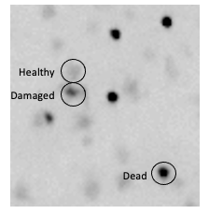

Figure 22: Image showing Grade 1, Grade 2, and Grade 3 cells

  - If you are creating ROIs for the first time, be sure to save a jpg file with the ROI. Check that the ROI has been saved on the image. May need to use Image>overlay>from ROI manager
- Open and duplicate tif file image and minimize one copy
- Adjust image brightness/contrast (auto). Duplicate image and minimize
- Separate colors (Image > Color > split channels). For each channel:
  - Process > Subtract background (2 pixels, sliding paraboloid; disable smoothing. DUPLICATE both channels.
  - Overlay ROI(s) onto each channel
  - Measure in the ROI manager (save to excel file the area and mean value for each channel and for each ROI)
  - Calculate PI/DAPI MGV for each ROI and include it in the excel file.

Particle Based Cell Count

(boxed directions are the same as above; you don’t need to repeat if you are continuing directly after doing MGV.]
- With the .jpg image, create/obtain ROIs and enter them into manager (Analyze > tools > ROI manager>add)
- Open the .tiff image, duplicate image and minimize one copy
- Adjust image brightness/contrast (auto)
- Separate colors (Image > Color > split channels). For each channel: Process > Subtract background (2 pixels, sliding paraboloid; disable smoothing, preview: check to see the setting has not eliminated true cells, but is clears up background noise/haze. Duplicate both channels.
    - DAPI:
  - Image > Adjust > Threshold (255 and variable) Have duplicate channel image open for comparison. Zooming in can help. Adjust the upper slide scale so that all cells are shown in red but no artifacts are red. [Entire cells don’t need to be filled in red.] You are trying to keep all cells while eliminating the very small, faint dots. In some brain regions (e.g., hippocampus) it is hard to get a threshold that works for the entire tissue section. If that is the case, you may need to set a distinct threshold for each ROI. For other brain regions (e.g., hypothalamus, cortex) a single threshold should work for the entire image. [Don’t try to match the threshold scale number across different images.] Save the threshold you use to an excel file.
      - If there are an excessive number of cell clumps, you can try setting the threshold using an image that has not had the brightness/contrast adjusted, or one where the brightness/contrast has been adjusted after colors were separated (be sure background is subtracted).
  - Process > Binary (watershed) - - hopefully most clumps will get separated into individual cells.
  - Overlay ROI by choosing (clicking on) the ROI in the ROI manager
  - Analyze > Analyze Particles (using default settings, bare outlines, summary).
  - Save to excel file the cell number of cells for each ROI as indicated in the “summary” window.
    - Dealing with clumps: Compare the outlined areas with the image you used to compare with and add points when multiple cells are clumped together (see image below).
Note: for each “clump” you add N-1 dots. That is, if the clump represents 2 cells, add 1 point. If it represents 3 cells, add 2 points.
When finished, add these points to ROI manager, then select “measure”. Add that number of cells to the previous total calculated by the “analyze particles” process and save the new total. [Alternatively, when you are finished, add one more point where you can see the number; the number to add to the previous total will be one less than that.
    - PI:
  - Image > Adjust > Threshold (255 and variable) Have duplicate split channel image open for comparison. Zooming in can help. Adjust the upper slide scale so that all cells you wish to identify are shown in red. [Entire cells don’t need to be filled in red.]
    - There are two separate thresholds you need to identify: one that separates Grade 3 (high intensity, sharp edges) from Grade 2 (medium intensity, sharp edges) cells. In this case, set the threshold so only the brightest (dead) cells are red. Write down the threshold you use in the excel file. The second threshold separates Grade 0/1 (minimal PI staining) from Grades 2 + 3 (more PI staining). For this one, set the threshold so all but the dim (healthy) cells are red. Save the threshold you use in the excel file. After each thresholding:
  - Process > Binary (watershed) - - hopefully all cells will get separated and not remain in clumps. If not, use ‘dealing with clumps’ procedure outlined above.
  - Overlay ROI; choose (click on) ROI in ROI manager
  - Analyze > Analyze Particles (using defaults; summary).
  - Save to excel file the cell number of cells identified with each threshold for each ROI as indicated in the “summary” window.
Important Note: the number of cells calculated with the lower threshold (eliminating Grade 0/1 cells only) includes Grade 2 + Grade 3 cells. You need to subtract the number of Grade 3 cells (determined with the higher threshold) to get the number of Grade 2 cells.
After you finish and have the cell numbers, go back to the original brightened image and see if the numbers roughly seem to match. E.g., if you calculated 10% Grade 3 cells, but looking at the original image there seems to be a lot more Grade 3 cells, you might try analyzing again.

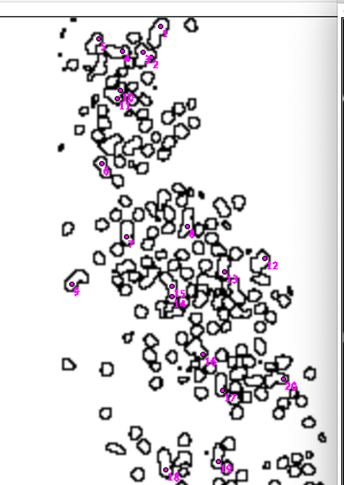
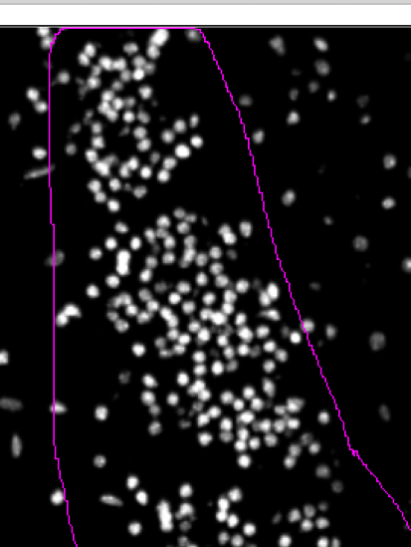

Figure 23: Example of clumping on ImageJ

Imaging Analysis of Microglia Morphology and Polarization Analysis using IMARIS
Part 1: Analyzing microglia number, morphology, volume
- Open the Prosser Lab shortcut on the desktop and double-click the image that needs to be analyzed. This will be an image with the MX_Composite_ROI.ims file where the ‘X’ stands for the image number that is being analyzed.
Open the corresponding .jpg file on ImageJ and have it over to the side. Use it to help with subtracting background and setting thresholds (below).
- At this point the upper menu option should be on “Surpass” (Figure 24) option and on ‘3D view’ (Figure 24)
- Immediately below that, on the left-panel, click on the ‘Add New Surfaces’ icon.(Figure 24)

- If the display adjustment tab (Figure 24) is not displayed, go to Edit > Show Display Adjustment. This will show all the channels (red/green/blue) that are present in the Image. Select ‘Channel 2’ in the display adjustment tab.

Tip: The check box associated with the channels can be switched on/off and doing that you can control what you see. Make sure that the Channel 2 corresponds to Green and shows the IBA1 (microglial staining) and Channel 2 corresponds to Red and shows the CD86/CD206 staining

- After clicking on ‘Add New Surfaces’ a panel opens down (Figure 24). Under the Create tab (Figure 25) there, check ‘classify surfaces’ and ‘object-object statistics’ under the Algorithm settings. If any other options are selected, de-select them before proceeding. Click on the blue button located down to proceed to the next step (see figure 24).
- In the drop-down menu under Source Channel make sure you are selecting Channel 2 (green channel). Enable ‘smooth’ (keep surface detail at 0.909um). Under the Thresholding option, select the ‘Background subtraction’ radio-button and enter a distance as measured outlined in the next step.
- For thresholding, click on ‘Background Subtract’. You will need to enter a distance. To measure this distance, click on the ‘Slice’ (see con on Figure 24) option at the top of the screen. Using the up/down slide bar on the left, scroll through the image z-stack to find the cell with the biggest soma area. Double-click on one edge of the soma, and a plus sign will appear. Click on the other edge of the soma and a second plus sign will appear. Pull them around to find the largest distance. The distance is displayed on a measure tab on the upper right corner of the screen.
- Sometimes the tab it is hidden by the display adjustment dialog box, which you can move over to the side. Make a note of the distance.
- Go back to “3D View” (menu at top of screen) and enter the distance in the “background subtraction” box that you measured in the previous step. Click on the blue button to proceed.
- Now you are on the ‘Background Subtract’ tab. Here you will be thresholding the image like in ImageJ by moving the threshold (lower left). Find how much of the area you want to keep by sliding the slide bar back and forth.
- You want to NOT eliminate cell body blobs, DO eliminate the smallest blobs, and don’t worry too much if you are separating projections from their cell bodies. You will be able to delete and reconnect things later. Make a note of your threshold. When you are done, click on the blue button to proceed.
- This will take you to another thresholding step (Figure 24). At this point you can do more thresholding to remove additional objects from the background. This step is optional. The changes are less precise compared to the previous step since entire blobs are removed. But it can clear up the image a bit.
After this you can finish by clicking the green button double headed to create the objects.
- Now click on the colored cube in the lower panel. Under Color tab select ‘Base’ and select the ‘Material’ button.
- Tip: Choose the fourth option from the scroll bar for materials because of visibility. You can choose a different material if you prefer but this is the best material to visualize co-localization if any.
- Now you will be able to see the different objects in the images. Click on the “Edit” (same panel as that of the colored cube).
- Based on your judgement, you can merge or eliminate objects by clicking on the object (or multiple objects while holding down the control button) in the image (it/they will turn yellow) and choosing “unify” or “delete”.
- Tip: Use the .jpg file a lot in this part to help assess whether an object is a unique cell body (with at least 1 projection), an extension off another cell, or a partial something that should be deleted. Also delete cells that are at the edge and cut off too much. Use the ROI marked in the image that you open using ImageJ to better make the distinction. On the IMARIS Rotate/zoom the image to help determine if objects are overlapping, close together, separated, etc.
Tip: Additionally, you can click the checkbox associated with the ‘Surfaces 1’. Unchecking/checking this box might help you with visualization or the arborization better.
- IMPORTANT: You can “separate” objects you united, but you can’t undo a delete. So be careful at this step.
When you are done, take a screenshot (using Snapshot in the top menu, see figure 24) to help us compare in the future. Close the snapshot window.
- Once you are satisfied, click on the ‘Statistics’ button. (Figure 24).
- First choose overall statistics. Scroll down to “total number of surfaces”, which gives you the total number of microglia. Shift right to see the total number. Write it down.
Next, go to individual data using the ‘Selection’ tab, then click on ‘Specific Values’ from the 2 dropdown menus, and then select ‘Volume’ at the bottom of the list. Choose individual microglia to and record their volume on an excel sheet. Additionally, you will also be recording the ‘Area’ (by selecting the drop-down menu at the ‘Specific Value’ tab) of the individual microglia in an excel sheet.

- Open your EXCEL file and create a sheet named with the image number. Click on each object in the image and find its volume (displayed in the lower left-hand panel). Add this number to your Excel file. Repeat for each microglia. Make sure you have entered them all by comparing with the “total number of surfaces” from above. Add the distance, threshold, and number of microglia from your notes. Save the Excel file.
Part 2: Analysis of the co-localization between IBA1 and CD86/CD206.
- So now we have a surfaces/objects (shown as ‘Surface 1’) created for the green channel (IBA1). We will repeat steps 4-14 to create the surfaces/objects for the Red Channel (CD86/CD206). In order to see the red channel (CD86/CD206 cells), we will begin by first de-selecting channel 2 and selecting channel 1 from the Display Adjustment dialog box. Also, de-select the check box of “Surfaces 1” that you created. Repeat steps as same.
- Tip: During ‘Background subtraction step’ keep the distance the same as you have entered earlier for Channel 2. In this step include some of the small blobs (but not the very small blobs) and because a lot of these blobs might colocalize with the microglial cells. Also remove any object that might look like a blood vessel. You can do this either during thresholding or when you are unifying/deleting objects.
Tip: De-selecting the ‘Surfaces 2’ check box is a useful to visualize the objects better.

- Now you have two surfaces: Surface 1 represents the microglial cells and Surface 2 represents either CD86⁺ or CD206⁺ cells. To see co-localization, de-select Channel 1 and Channel 2 from Display Adjustment dialog box. Select ‘Surfaces 1’ and ‘Surfaces 2’ that you created and count total number of microglial cells and the number of microglial cells that show co-localization. You can zoom-in the image, move it around in various degrees to analyze the images better. Take a screenshot of this for future references.

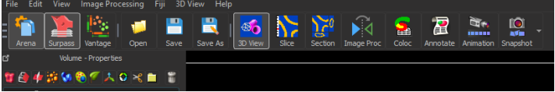
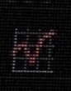
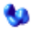


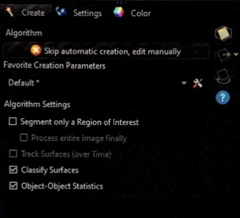
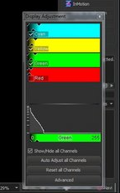

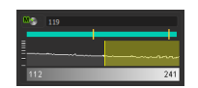
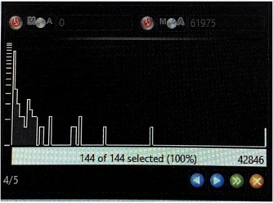

Figure 24: The top panel shows the icons associated with 3-D view, Surpass, “Add surfaces”, Snapshot and Statistics. The middle panel shows the Display and Create surfaces dialog box. The lower panel shows the dialog box associated with background subtraction and thresholding step on IMARIS

Imaging pipeline for Microglial Polarization Analysis using ImageJ for z-stacked images

Manually Counting the Cells

When the images are being processed in ImageJ, the C=0 comprises of the DAPI channel, C=1 is the green channel and C=2 is the red channel. These images are stacks and will need to be Z-projected when the analysis is commenced.

We will begin by counting the number of microglial cells in each given ROI. To do this:

- Open ImageJ and upload your file. (Since the C=1 is the image from IBA1 staining you will be uploading the image marked with C=1 for this). Drag and drop the image onto the ImageJ toolbar.
- The images given to you will be stacked. Collapse all the slices by clicking on Image>Stacks>Z-project. In the z-projection dialog box, make sure the Projection Type is Average Intensity. The selection can be changed by clicking the drop-down menu.
- Subtract the background: Process > Subtract Background, set the Rolling Ball radius to 20 pixels and choose Sliding Paraboloid and Disable Smoothening. Click OK. The image should change.
- Following this change the brightness of the image by clicking Image>Adjust>Brightness and Contrast and then hit AUTO.
- Upload the ROI in the image: Drag the ROI file(s) onto the ImageJ toolbar. They will show up on the .tif image. ADD them to the ROI manager (Analyze>Tools>ROI Manager and click Add). Then click somewhere on the .tif image so the ROI is not shown. Duplicate the image (Ctrl+Shift+ D on Microsoft and Command+Shift+D for MacOS) and overlay the ROI on the image by clicking on Image>Overlay>From ROI Manager. Now using the multi-point tool count the number of microglia in the given ROI and make a note.
To count CD86/CD206 cells.
- Begin by opening the channel C=1. Z-project the image by clicking on Image>Stacks>Z-project. In the z-projection dialog box, make sure the Projection Type is Average Intensity. The selection can be changed by clicking the drop-down menu.
- Subtract the background: Process > Subtract Background, set the Rolling Ball radius to 20 pixels and choose Sliding Paraboloid and Disable Smoothening. Click OK.
- Repeat step 1-2 by opening C=2 channel file on Image J. Take a screenshot of the C=2 image because we will be later using this screenshot for thresholding to calculate the Pearson’s correlation coefficient and Mander’s number.
- Merge the two channels by going to Image>Color>Merge. While merging make sure that the images you select using the drop-down menu is of correct color. C1 is red and should have the red channel image and C2 is green and should have the image from the green channel. Check “Create Composite” option and click OK.
- Change the brightness by clicking Image>Adjust>Brightness and contrast and click Auto. The slide beneath the image depicts the two channels. Slide them to change the brightness and contrast of both the red and the green channel.
After this change the image type to RGB by clicking on Image>Type>RGB.
- Add the ROI in the resulting image by clicking on Image>Overlay> From ROI Manager.
- After this Click on Image>Adjust>Color Threshold and in the dialog box that comes up move the slider under the Hue to include just the Yellow part of the Bell curve (34-47) that comes up. Click the threshold color to be white using the drop-down menu.
The white color shows all the areas where there is a co-localization. Count the number of cell where there is a co-localization between red and green in the given ROI and make a note.
Calculate what % of cells areCD86/CD206 positive by the formula: (No. of CD86/CD206 cells/No. of total microglia cells) *100.

Calculating the Pearson Correlation Coefficient and Mander’s Coefficient of the Region of Interest.

In this case you already be given the images with the ROI already there for both the green and the red channel. And you will need a plug-in Just Another Colocalization Plug-In (JACop) for ImageJ.
- Go to Plug-In option on Image J and select JACop.
- Drag the C=1 image and drop in the ImageJ toolbar. The first image dragged gets assigned Image A. Collapse the slices from the z-stack as done previously and subtract background. Choose images from the two channels and assign them as Image A and Image B. I prefer using the Green Channel Image for Image A and Red Channel Image for Image B. For thresholding the green channel, make sure you are including the microglia soma and the projections. For the red channel use the screenshot you took earlier of the C=2 channel and use it to include all the necessary areas.
- In the Analysis to Perform section, check Pearson’s Coefficient and M1&M2 Coefficient.
- Go to the threshold option and threshold for Image A and Image B. This is going to be a subjective assessment so be sure to include maximum of the cell area in both cases. For CD86, consider the blood vessels when thresholding for CD86⁺ cells.
- After this click analyze and note the Pearson Coefficient and the M1&M2 Coefficient that will be shown in the results dialog box that appears.
Selection of tissue sections for imaging
After fixing the tissue blocks, the tissues were frozen in OCT blocks before being sectioned. For DAPI/PI staining, the sections were maintained at 10um thickness and for IBA1/CD86/CD206 staining, the sections were maintained at 25um thickness. The sections were collected sequentially in alternate slides such that all slides had a combination of sections from each layers of tissue block. For all sections, we made sure to not include the sections towards either end of the tissue block. This was especially important when observing cell death using Propidium Iodide.
Image acquisition:
For fluorescent microscope:
We used the Leica DM6000B to image sections for PI/DAPI staining. When setting the exposure time for DAPI of the FITC channel /red channel make sure you do not overexpose the channels. For the DAPI channel we maintained an exposure time of 0.08-0.7 msec. For FITC channel we maintained an exposure time of 0.5-1.5msec. For each image not down the slice no, the section number and image settings used. After the image was acquired, we opened the image using ImageJ, marked the ROI using the DAPI staining and saved the image as .jpg. This file was used by the blind observers to make the ROI when analyzing. All the analysis was done on .tif files. All the images were coded using numbers to avoid any bias.

For confocal microscope:
We used the Leica SP8 to image sections for IBA1/CD86/CD206 staining. The laser power for DAPI (405) was maintained between 5-15%, for IBA1 (488 channel) and CD86/CD206 (548 channel) the laser power was maintained between 25-50%. The images are acquired as .lif file which can be opened using the ImageJ program. For each image, all the three channels are hyper stacked, and you will have to individually split each image into the different channel to mark the ROI. Each image is associated with a specific number to avoid any bias. The images are saved as XX_C=0_ROI, XX_C=1_ROI and XX_C=2_ROI for images with region of interest marked for DAPI, green and red channel respectively. For images analyzed using the IMARIS, all the channels with their ROI marked are merged and the format is changed into RGB by clicking Image> Type>RGB. This is useful for analyzing the microglia morphology in the green channel and the colocalization in the red channel. The merged image is saved as XX_Composite_RGB_ROI.
Solutions used
- Earle’s Balanced Salt Solution (for 500mL) (pH=7.4)
Sodium Bicarbonate (NaHCO₃) = 1.1 gm
Glucose = 5.42 gm
Earle’s = 4.35 gm
- N-Methyl-D-Aspartate Solution (Stock Solution of 10mM)
Molecular Weight of N-Methyl D-Aspartate = 147 gm
EBSS Solution = 20mL
N-Methyl-D-Aspartate = 0.029 gm
- AMPA solution (Stock Solution of 500 uM)
Molecular weight of AMPA = 267.08 gm
EBSS Solution = 20 mL
AMPA = 0.0026 gm
- Propidium Iodide Solution (Stock Solution 1.0 mg/mL)
Final concentration used for experiment = 4.6 ug/ML
Stock solution = 630 uL
EBSS = 150 mL
- Minocycline (Stock solution 10uM/mL diluted with EBSS)
Final concentration used for experiment = 10uM/L (0.01uM/mL)
- Phosphate Buffered Saline (10X) (recipe found online)
- Tris Buffered Saline (10X) (recipe found online)

Vita

Debalina completed her bachelor’s and Master’s in Microbiology from India before shifting to US for her graduate studies in 2017. She has worked with Dr. Rebecca Prosser in the Department of Biochemistry, Cellular and Molecular Biology on investigating the mechanism of excitotoxic resiliency in the Suprachiasmatic Nucleus. Her work has received a lot of interests in various conferences and seminars where she has presented her work. Her project has received considerable funding from the university and from NeuroNET. During her graduate school, she has extensively participated in the various organization both at the department and university levels, various outreach initiatives and was the student leader for the Project. Bridge Chapter in UTK. She has held leadership position in the Graduate School Senate, BCMB Graduate School Organization and was the graduate student representative in the NeuroNET Executive Board at UTK. Debalina is also the 3MT winner for 2022 has represented the University at the Conference of Southern Graduate School in 2023. During her downtime she enjoys reading books, painting, and cooking.

