Enhancement of Chronically-induced Breast Carcinogenesis by Combined Environmental and Dietary Carcinogens and Suppression by Dietary Agents

A Dissertation Presented for the
Doctor of Philosophy
Degree
The University of Tennessee, Knoxville

Lenora A. Pluchino
December 2014

Copyright © 2014 by Lenora A. Pluchino
All rights reserved.

DEDICATION

This dissertation is dedicated to David Antoine, the greatest friend anyone ever had. You will forever be in my heart. May you rest in peace and take solace in knowing that someday we will be together again.

ACKNOWLEDGEMENTS
I express my gratitude and sincere regards to my mentor Dr. Hwa-Chain Robert Wang for giving me an opportunity to work and learn in his laboratory and for his guidance, supervision and encouragement during my training. His goal-oriented research ethic and constant advice has instilled scientific culture in my life and motivated me to pursue my goals. I would like to also extend my sincere gratitude to members of my advisory committee, Drs. Ranjan Ganguly, Brynn Voy, and Hong Guo for their time, advice and guidance.
I express my thanks to all past and present members of the laboratory for providing a helpful and stimulating research environment. Specifically, I would like to thank Drs. Shilpa Sood, Shambhunath Choudhary and Kusum Rathore for all the help and time they have given me during my formative years in the lab.
I thank the Program for Excellence and Equity in Research (PEER) and the Graduate School of Genome Science and Technology (GST) for the opportunity and financial support needed to conduct my research. I would like to especially thank Drs. Sekeenia Haynes, Cynthia Peterson and Albrect von Arnim for enabling me to pursue graduate study under the PEER fellowship and the GST program and for their unwavering support during my years of training. I would like to acknowledge my colleges, Ms. Dianne Trent for her technical assistance with flow cytometry experiments and Ms. Misty Bailey for her textual editing of the manuscripts.
I express my deepest gratitude to my mother Nadine and brother John who have always supported me and motivated me to come this far. Special thanks to Diamond, Bella, Slinky, Nala, Eddie, Bruno and Rosa for providing me with your unconditional love and comic relief during all my years of hard work away from home.
-Lenora A. Pluchino
ABSTRACT
Most breast cancers occur sporadically due to long-term exposure to low-dose carcinogens present in our environment and diet. American lifestyles involve frequent exposures to smoke, polluted air, and high temperature-cooked meats comprising multiple carcinogens, such as 4-(methylnitrosamino)-1-(3-pyridyl)-1-butanone (NNK), benzo[α[alpha]]pyrene (B[α[alpha]]P), and 2-amino-1-methyl-6-phenylimidazo[4,5-b]pyridine (PhIP). To investigate whether these carcinogens may act together to enhance breast cell carcinogenesis, we used our chronically-induced breast cell carcinogenesis model wherein we repeatedly expose non-cancerous human breast epithelial MCF10A cells to physiologically-achievable doses of carcinogens to progressively induce cellular acquisition of cancer-associated properties including reduced dependence on growth factors, anchorage-independent growth, increased cell proliferation, migration and invasion and enriched stem-like cell population. These properties are then used as targets to identify dietary agents capable of blocking carcinogen-induced breast cell carcinogenesis.
In the first part of this research (Chapter 2), we demonstrated that cumulative exposures to combined NNK and B[α[alpha]]P (NB) holistically enhanced progression of breast cell carcinogenesis chronically-induced by PhIP. Cells co-exposed to NB and PhIP (NBP) acquired higher degrees of cancer-associated properties including enhanced induction of the epithelial-to-mesenchymal transition program and enriched stem-like cell populations compared to cells sequentially exposed to NB followed by PhIP (NB/P). Using these cancer-associated properties as targets, we demonstrated that combined green tea catechins (GTCs) were more effective than individual catechins in suppression of cellular carcinogenesis chronically induced by NBP.
Studies in Chapter 3 revealed that reactive oxygen species (ROS) and ERK pathway activation were transiently induced by NBP during each exposure. Cross-talk between reinforced ROS elevation and the ERK pathway played an essential role in increased DNA oxidation and damage which contributed to enhanced initiation of cellular carcinogenesis and led to enhanced acquisition of cancer-associated properties. Using NBP-induced transient changes and cancer-associated properties as targets, we revealed that physiologically-achievable levels of combined dietary ergosterol and mimosine were highly effective in blocking NBP-induced transient endpoints, including ROS-mediated DNA oxidation, which accounted for their ability to suppress progression of NBP-induced cellular carcinogenesis. Thus, combined dietary components such as GTCs, ergosterol and mimosine should be considered for affordable prevention of sporadic breast cancer associated with long-term exposure to environmental and dietary carcinogens.

TABLE OF CONTENTS
CHAPTER 1: Background and Overview……...……………………………………………..…..1
Introduction…………………………………………………………...............…………..2
Breast Cancer……………………………………………….……………………………..2
Stages of Breast Cancer…………………………………………………………...3
Classification of Breast Cancer……………………………………………………5
Risk Factors for Breast Cancer…………………………………...……………….7
Environmental Carcinogens……………………………………………………………….9
Related to Lifestyle………………………………………………………………..9
Tobacco Smoking………………………………………………………..10
Alcohol Consumption………………………………………….………...10
Diet………………………………………………………...…………….10
Obesity and Sedentary Lifestyle....………………………………………11
Naturally-occurring Substances…………………………………………………11
Ultraviolet Radiation……………………………………………………..11
Infectious Agents………………………………………………………...12
Radon…………………………………………………………………….12
Chemicals in the Home or Workplace…………………………………………...13
Diesel Exhaust…………..……………………..………………………...13
Second-hand Smoke…………………………………………….……….13
Asbestos………………………………………………………………….14
Medical Treatments………………………………………...……………………14
Others………...………………………………………………………………….15
4-(methylnitrosamino)-1-(3-pyridyl)-1-butanone (NNK)...…………………….16
Benzo[α]pyrene (B[α]P)……....………...……………………………………….17
2-amino-1-methyl-6-phenylimidazo[4, 5-b]pyridine (PhIP)...…....………….…18
Hallmarks of Cancer…..………………………………………………………………....19
Precancerous Model of Cancer Progression.….…………………………………………24
Detection of Cancer Progression….……..………………………………………………26
Reduced Dependence on Growth Factors.………………………………………26
Anchorage-independent Growth...………………………………………………26
Wound Healing…………………………………………………………………..27
Migration and Invasion...………………………………………………………...27
Role of ERK pathway in Cancer......………….…………………………………………28
Role of Reactive Oxygen Species in Cancer....………………………………………….29
NADPH-oxidase 1………….……………...……………………………...……..31
Cancer Stem Cells…....….…...…...……………………………………………………...32
Mammary Stem Cells and Breast Cancer.…………………………………….....34
Identification and Isolation of Mammary Stem Cells............................................35
Mammospheres.……..……………...……………………………………35
ALDH Activity.….….……...……………………………………………35
Immunostaining.………………………………………….……………...36
Extensive Self-renewal and Multi-lineage Differentiation.………….…..36
Epithelial-to-Mesenchymal Transition....……....………………………………………...36
EMT and Cancer Stem Cells…….………………………………………………38
Dietary Cancer Prevention..…………...…………………………………………………39
Chemopreventive Compounds in Fruit, Vegetables, Spices and Tea...…………40
Green Tea………………......……………………………………………………42
Epicatechin-3-gallate (ECG)…….………………………………………43
Epigallocatechin-3-gallate (EGCG)……….…………………………….44
Ergosterol…….………………………………………………………………….45
Mimosine…………………………………………………....…………………...46
Cancer Prevention Strategies Using Combined Dietary Agents….......………....48
LIST OF REFERENCES………………………..………………………………………51
APPENDIX………….…..………………………………………………………………80

CHAPTER 2: Chronic Exposure to Combined Carcinogens Enhances Breast Cell Carcinogenesis with Mesenchymal and Stem-like Cell Properties..……….…………………………….….…...99
Abstract...……....……….………………………………………………………………101
Introduction..………………..….……………………………………………………….102
Materials and Methods….………………………………………………………………104
Cell Cultures and Reagents………………...…………………………………...104
Chronic Induction of Cellular Carcinogenesis……..…………………………...105
DNA Damage Assay..……...….………………………………………………..105
Reduced Dependence on Growth Factors…..……….……………………….…106
Anchorage-independent Growth…………….…….……………………………106
Measurement of Intracellular ROS..…....………………………………………106
Cellular Proliferation Assay…….………………………………………………107
Reverse-transcription PCR…...….…………….………………………………..107
Immunoblotting...………….…….……………………………………………...107
Serum-independent Non-adherent Growth..…….……..….……………………108
Aldehyde Dehydrogenase (ALDH) Assay…...…..……..………………………108
In vitro Cell Migration and Invasion.…..……………………………………….109
Cell Motility Wound Healing Assay……..……...……………………….……..109
Statistical Analysis…...…………………………………………………………110
Results and Discussion…………….….…………...……………………………………110
Enhanced Cellular Acquisition of Cancer-associated Properties by Combined Carcinogens….………..………………………………………….……………..110

Enhanced Acquisition of Stem-like and Mesenchymal Cell Properties by Combined Carcinogens……....…………………………………………...…..…112
NBP Enhanced Cancer-associated Properties in Breast Cancer MCF7 Cells......114
Intervention of NBP-induced Carcinogenesis.………………………………….115
LIST OF REFERENCES…….…………………………………………………………120
APPENDIX……………….…………………………………………………………….126

CHAPTER 3: Reactive oxygen species-mediated breast cell carcinogenesis enhanced by multiple carcinogens and intervened by dietary ergosterol and mimosine…………………….......….....140
Abstract…….…….………...………………………………………………….………..142
Introduction..…….….…………………………………………………………………..143
Materials and Methods...…….………………………………………………………….146
Cell Cultures and Reagents……….…………………………………......……...146
Chronic Induction of Cellular Carcinogenesis...………………………………..146
Cell Viability………………………………....…….……...……………………147
Reduced Dependence on Growth Factors……….……………………………...147
Anchorage-independent Growth…………….………………………………….147
Cell Proliferation………….…………………………………………………….148
Serum-independent Non-adherent Growth………..…………………………....148
Aldehyde Dehydrogenase (ALDH)...…………………………………..............148
In vitro Cell Migration and Invasion.….………………………………………..149
Cell Motility Wound-Healing……….…..……………….……………………..149
Intracellular ROS……….……………………………….……………………...149
DNA Damage……..……….….…….…………………...……………………...150
DNA Oxidation…………………….…………………………………………...150
Reverse-transcription PCR.……….………….…………………………………151
Immunoblotting……….……………....……….………………………………..151
Statistical Analysis………………….….…………………….………………….152
Results...……….……………….……………………………………………………….152
Exposure-dependent Enhancement of Cancer-associated Properties by Combined Carcinogens…...………….……………………………….………………….…152
Enhanced Initiation of Cellular Carcinogenesis by Combined Carcinogens…...154
ROS and the Ras-ERK Pathway in Initiation and Maintenance of Cellular Carcinogenesis...…………………………………………………………….......155
Ergosterol and Mimosine Intervened in Cellular Carcinogenesis….……..….....156
Ergosterol and Mimosine Suppressed Oxidative DNA Damage Induced by Carcinogens………….……………..……………………………………….......158
Induction of cellular carcinogenesis in MCF12A cells and suppression by ergosterol and mimosine……...............................................................................158
Discussion……………………………………………………………………….……....160
LIST OF REFERENCES..…….………….……………………….…………………....163
APPENDIX.....…………………………………………………….……………………169

CHAPTER 4: General Discussion…………………………………………………………..…..195
Enhancement of Chronically Induced Breast Cell Carcinogenesis by Combined Environmental and Dietary Carcinogens ….………...……………..………………..….196
Intervention of Chronic Breast Cell Carcinogenesis by Combined Dietary Agents..…..198
Conclusion..……………………………………………………………………………..200
Future Directions…………………………………………….………………………….201
LIST OF REFERENCES…………….…………………………………………………203
APPENDIX…………………….……………………………………………………….206

VITA...………………………….………………………………………………………………209

LIST OF TABLES
  - PhIP content in cooked meats………………………………………………………………..81
  - List of known EMT markers…………………………………………………………………82
  - List of chemopreventive compounds and their common sources……………………………83

LIST OF FIGURES
1.1 Worldwide incidence of breast cancer in 2008…....................................................................84
1.2 Stages of breast cancer……………………………………………………………………….85
1.3 Molecular subtypes of breast cancer…………………………………………………………86
1.4 Risk factors for breast cancer………………………………………………………………...87
1.5 Environmental or non-hereditary potential cancer-causers…………………………….….....88
1.6 Chemical structure of carcinogens…………………………………………………………...89
1.7 Hallmarks of cancer………………………………………………………………………….90
1.8 Emerging hallmarks and enabling characteristics...…………….………………….………...91
1.9 Precancerous model of cancer progression………………..…..………………………….….92
1.10 Ras signaling and ERK pathway activation………………………………………………...93
1.11 Changes during Epithelial-to-Mesenchymal Transition………………...………………......94
1.12 Pathways activated during EMT……………………………………….…………………....95
1.13 Anticancer mechanisms of dietary agents……………………………………………….….96
1.14 Chemical structure of green tea catechins………………………………………..…….…...97
1.15 Chemical structure of ergosterol and mimosine…………..………………………….…......98
2.1 Enhanced cellular acquisition of cancer-associated properties by combined carcinogens....129
2.2 Enhanced acquisition of stem-like and mesenchymal cell properties by combined carcinogens………………………………………………………………………………….132
2.3 NBP enhanced cancer-associated properties in breast cancer MCF7 cells…………………135
2.4 Intervention of NBP-induced carcinogenesis……………………………………………….138
3.1 Exposure-dependent enhancement of cancer-associated properties by combined carcinogens……………………………………………………………………………….....172
3.2 Enhanced initiation of cellular carcinogenesis by combined carcinogens………………….176
3.3 ROS and the Ras-ERK pathway in initiation and maintenance of cellular carcinogenesis...180
3.4 Cytotoxicity of ergosterol and mimosine in MCF10A and MCF12A cell lines…………....183
3.5 Ergosterol and mimosine intervened in cellular carcinogenesis...……………………….…186
3.6 Ergosterol and mimosine suppressed oxidative DNA damage induced by carcinogens...…190
3.7 Induction of cellular carcinogenesis in MCF12A cells and suppression by ergosterol and mimosine………………….……………………...……….………………………………...193
4.1 Schematic representation of progressive induction of cancer-associated properties by chronic exposure to carcinogens and its suppression by dietary compounds……………....207
4.2 Hypothetical mechanism of NBP-induced cellular carcinogenesis and suppression by dietary compounds……………………………………………………...…………………………..208

ABREVIATIONS
AIG Anchorage-independent growth
ALDH Aldehyde dehydrogenase
ATCC American Type Culture Collection
B[α]P Benzo[α]pyrene
BrdU 5-bromo-2’-deoxyuridine
CDK Cyclin-dependent kinase
CM-H2DCF-DA Chloromethyl-dichlorodihydrofluorescin-diacetate
CM Complete MCF10A medium
EC Epicatechin
ECG Epicatechin-3-gallate
ECM Extracellular matrix
EGC Epigallocatechin
EGCG Epigallocatechin-3-gallate
ELISA Enzyme-linked immunosorbent assay
EMT Epithelial-to-mesenchymal transition
EpCAM Epithelial cell adhesion molecule
ERK Extracellular signal regulatory kinase
GTC Green tea catechin
H₂O₂ Hydrogen peroxide
LM medium Low-mitogen medium
MAPK Mitogen-activated protein kinase
MMP-9 Matrix metalloproteinase 9
MTT Methyl thiazolyl tetrazolium
NAC N-acetyl-L-cysteine
NNK 4-(methylnitrosamino)-1-(3-pyridyl)-1-butanone
Nox-1 NADPH oxidase-1
PBS Phosphate buffered saline
PhIP 2-amino-1-methyl-6-phenylimidazo[4, 5-b]pyridine
RDGF Reduced dependence on growth factors
ROS Reactive oxygen species
RTK Receptor tyrosine kinase

CHAPTER 1

Background and Overview

Introduction
Given the ubiquitous nature of tobacco smoke, carbon exhaust, and cooked meat in modern societies, it is important to holistically examine the role of carcinogens, such as NNK, B[α]P, and PhIP, in induction of breast cell carcinogenesis to reveal associated mechanisms and targeted endpoints for intervention. The objectives of this study were to (1) elucidate the ability, and associated mechanisms, of environmental carcinogens NNK and B[α]P to enhance breast cell carcinogenesis induced by dietary carcinogen PhIP and (2) demonstrate the ability, and associated mechanisms, of combined dietary agents to more effectively suppress breast cell carcinogenesis induced by combined NNK, B[α]P, and PhIP.

Breast Cancer
Cancer refers to a group of diseases characterized by abnormal and uncontrollable cell growth which ultimately leads to the formation of a mass or tumor. Breast cancer can begin in the breast tissue, which consists of fatty, connective and lymphatic tissues, the glands for milk production, called lobules, or the ducts that connect these lobules to the nipple [1]. Cancers that originate in the duct are known as ductal carcinomas while those originating in the lobules are called lobular carcinomas [2]. Breast cancer is the most common type of cancer and second-leading cause of cancer related death among women in North America and Europe [1,2]. The National Cancer Institute projects there will be 232,670 new cases of invasive breast cancer in American women in 2014 resulting in approximately 40,000 deaths [2]. On a global scale, breast cancer represents 23% of all cancers diagnosed in women [3]. While rates of breast cancer vary around the world, developed countries typically have rates that are much higher than developing countries [4] (Figure 1.1).

Stages of Breast Cancer
Staging is the process of assessing how advanced a cancer has progressed and where it is located in the body. The purpose of staging is to ascertain the extent and severity of the disease in an individual [5]. Staging of breast cancer is important for determining prognosis and treatment options. As described by the National Cancer Institute [6], the four stages of breast cancer are as follows (Figure 1.2):
Stage 0: (carcinoma in situ)
This is a pre-cancerous stage of which three types exist:
- Ductal carcinoma in situ (DCIS): a non-invasive condition in which abnormal cells are found in the lining of a breast duct. These cells have not spread outside of the duct to other tissues of the breast.
- Lobular carcinoma in situ (LCIS): a non-invasive condition in which abnormal cells are found in the lobules of the breast. These cells have not spread outside of the lobule to other tissues of the breast; however, having LCIS increases the risk of developing invasive breast cancer.
Stage I:
During Stage I, cancer has formed in either breast. Stage one tumors are typically 2 centimeters or less in diameter and have not spread outside of the breast tissue.

Stage II:
Stage II describes invasive breast cancer in which one of the following is true:
- The tumor is 2 centimeters or less in diameter, but has spread to the lymph nodes under the arm.
- The tumor is 2-5 centimeters in diameter and may or may not have spread to the lymph nodes under the arm.
- No tumor is found in the breast, but breast cancer cells are found in the lymph nodes under the arm.
- The tumor is more than 5 centimeters in diameter, but hasn’t spread to any lymph nodes.
Stage III:
Stage III cancers are invasive but have not yet spread to distant sites. This stage is further divided into three substages:
- Stage IIIA: Breast tumor is more than 5 centimeters in diameter and has spread to one to three lymph nodes under the arm; or tumor can be any size and has spread to multiple lymph nodes under the arm.
- Stage IIIB: A tumor of any size that has spread to skin or muscle tissues near the breast and may have spread to lymph nodes under the arm or within the breast itself.
- Stage IIIC: A tumor of any size that has spread to 10 or more lymph nodes under the arm, lymph nodes within the breast, and to lymph nodes around the collarbone and neck.

Stage IV:
Stage IV cancers are metastatic and have spread beyond the breast and the adjacent lymph nodes to distant organs of the body such as the lungs, liver, bone or brain.

Classification of Breast Cancer
Breast cancer is a group of diseases which encompasses various subtypes defined by distinct morphological characteristics and clinical outcomes. According to the World Health Organization, the most common type of breast cancer is invasive ductal carcinoma (IDC) [7]. IDC, which represents 8 out of 10 invasive breast cancers, starts in the milk duct and then spreads into the fatty tissue of the breast [7]. From here, it may metastatize to other organs of the body through the bloodstream or lymphatic system. The next most common type of breast cancer is invasive lobular carcinoma (ILC) which arises from the milk-producing gland and also can metastasize throughout the body [7].
Newer technologies such as immunohistochemistry, cytogenetics and cDNA microarray analysis have been employed to further classify invasive breast cancers into four distinct molecular subtypes based on genetic factors, hormone receptor status and HER2/neu status [8]. As seen in Figure 1.3, these subtypes are named Luminal A, Luminal B, Triple negative/basal-like, and HER2 type [8]:
- Luminal A: Luminal tumors occur in the inner lining of the mammary duct and account for most breast cancers. Luminal A tumor cells are estrogen receptor-positive (ER⁺) and/or progesterone receptor-positive (PR⁺) and human epidermal growth factor receptor-negative (HER2/neu⁻). These tumors are typically low-grade (grade 1 or 2) and are slow-growing and well-differentiated. Mutations in the tumor suppressor gene p53, which are correlated with poor prognosis, occur in less than 15% of luminal A tumors. These tumors have the best prognosis of all four subtypes of breast cancer with high survival and low recurrence rates.
- Luminal B: These tumors also occur in the inner lining of the mammary duct. Luminal B tumor cells are ER⁺ and/or PR⁺, and HER2/neu⁺ and/or highly positive for Ki67, a marker for tumor cell proliferation. Compared to luminal A tumors, luminal B tumors have a poorer prognosis due to higher grade tumors (grade 3) which are larger, fast-growing and poorly-differentiated, invasion of cancer cells into the lymph nodes, and p53 mutations in about 30% of all tumors. Luminal B tumors are also more commonly diagnosed in women at a younger age. However, women with luminal B tumors still have considerably high survival rates, although not as high as women with luminal A tumors.
- Triple negative/basal-like: Triple negative tumor cells are ER⁻, PR⁻, and HER2/neu⁻. Most triple negative tumors are classified as basal-like because the tumor cells resemble cells of the outer (basal) lining of the mammary duct. Triple negative tumors account for 15-20% of all breast cancers and are often aggressive, fast growing and have poor prognosis. Most contain p53 mutations and mutations in the BRCA1 gene. Since triple negative tumors do not express any hormone receptors, they do not respond to traditional hormone-based chemotherapies and are therefore more difficult to treat. Triple negative breast cancer is more common in younger women and women of African-American decent and is more likely to recur than any other subtype of breast cancer.
- HER2 type: HER2 type tumors are usually HER2⁺ (although they can be HER2⁻), ER⁻, and PR⁻. They account for 10-15% of all breast cancers and have a fairly poor prognosis due to high grade tumors, invasion of cancer cells into the lymph nodes, and p53 mutations in about 75% of all tumors. They recur often, have a tendency to metastasize early, and occur more commonly in younger women than luminal A or B tumors.

Risk Factors for Breast Cancer
A risk factor is any environmental or genetic factor that increases a person’s chance of getting a disease. Since cancer represents a diverse group of diseases, different cancers therefore have different risk factors. Figure 1.4 summarizes the known risk factors for breast cancer as stated by the Breast Cancer Organization [9]. Being a woman is the biggest risk factor for developing breast cancer as men account for less than 1% of all new breast cancer cases. After gender, age is the most significant risk factor with about two-thirds of invasive breast cancers occurring in women 55 or older. Family history also contributes to breast cancer risk. Women that have a first-degree relative (mother, daughter, sister) that has been diagnosed with breast cancer have double the average risk of developing the disease.
Approximately 5-10% of breast cancers are thought to be hereditary [9]. Most cases of hereditary breast cancer are associated with mutations in the BRCA1/2 tumor suppressor genes [9, 10]. The BRCA1/2 proteins form a complex that participates in a DNA damage response pathway that initiates homologous recombination and double-strand break repairs [11]. Loss of functional BRCA1/2 results in an inability to repair DNA leading to mutations in other genes. As a result, women who have inherited inactivating mutations in either the BRCA1 or BRCA2 genes have a significantly increased risk of developing breast and/or ovarian cancer [10].
One’s personal history of breast or other cancers can influence the risk of developing new breast cancer. If you’ve previously had breast cancer, you are 3-4 times more likely to develop new cancer in a different part of the breast and this risk is in addition to the risk of the original cancer coming back (recurrence) [9]. Even being diagnosed with certain benign breast conditions can increase the risk of breast cancer development. Also, radiation exposure to the chest or face to treat another type of cancer can increase the risk for developing breast cancer later in life [9].
Other biological factors known to be associated with increased risk of breast cancer are early first menses (age 12 or younger), late occurring menopause (after age 55), and not having had a full-term pregnancy by age 30 [9]. Race and ethnicity also play a role in assessing breast cancer susceptibility. While Caucasian women are slightly more likely to develop breast cancer than African-American, Hispanic or Asian women, African-American women are more likely to develop aggressive, early-onset, and advanced-stage breast cancer [9].
Overweight and obese women are at a higher risk for developing breast cancer than women who maintain a normal weight, especially after menopause [9]. Being overweight can also increase the risk of recurrence in women who have already had the disease. Other lifestyle factors that contribute to increased risk of breast cancer include lack of exercise, smoking, alcohol consumption and using hormone replacement therapy after menopause [9].
Studies have shown that only 5-10% of breast cancers have a genetic basis [12]. Most breast cancers are non-genetic and are caused by environmental factors. Subsequently, it is important to understand the role of these environmental factors in breast cancer development.

Environmental Carcinogens
Carcinogens are any naturally-occurring or synthetic substance that can cause cancer. Humans are exposed to a variety of chemicals from the environment each day. Chemicals in air, water, soil and food as well as occupational exposure and lifestyle factors all contribute to the complex exposure situation most people experience in their daily lives [13]. Approximately 90% of breast cancers are considered non-hereditary or ‘sporadic’ [12]. These sporadically occurring cancers often result from chronic exposure of human tissues to low-doses of environmental carcinogens. Thus, it is imperative to study and understand the factors that contribute to sporadic breast cancers in order to devise an effective strategy for preventing and controlling these diseases. Figure 1.5 shows the types of environmental factors that have the potential to cause non-hereditary cancer. The American Cancer Society [14] has classified these factors as related to lifestyle (tobacco, alcohol, diet, inactivity, being overweight), naturally-occurring substances (ultraviolet radiation, infectious agents, radon), chemicals in the home or workplace (auto exhaust, second-hand smoke, asbestos), medical treatments (hormone-replacement therapy, immune-suppressing treatments) and others.

Related to Lifestyle
Factors related to lifestyle are often not cancer-causing agents themselves, but are risk factors associated with the genesis of cancer since they ultimately result in exposure to higher levels of carcinogens [15]. It is well recognized that tobacco use, alcohol consumption, diet imbalance, obesity and sedentary lifestyle can contribute to cancer especially in affluent countries [15].
Tobacco Smoking
Tobacco smoking is a significant risk factor for the initiation and progression of human carcinogenesis in multiple organs [16]. Tobacco smoke contains thousands of carcinogenic compounds including mutagens such as polycyclic aromatic hydrocarbons and nitrosamines [16]. Smoking is a risk factor for many types of cancer, most notably lung cancer, but also cancers of the digestive tract, bladder, liver, esophagus, kidney, stomach, pancreas, breast and cervix [17]. The link between smoking and breast cancer is controversial; however, recent studies indicate that exposure to tobacco smoke can increase breast cancer risk, especially in post-menopausal women [18-20]. Since many of these cancers are associated with poor prognosis, tobacco use is by far the most widespread link between exposure to carcinogens and cancer-related death [16].

Alcohol Consumption
Alcohol is not by itself mutagenic to DNA and therefore is not a true carcinogen. Rather, alcohol acts mainly as a co-carcinogen by influencing the metabolic activation of other carcinogens [16]. Epidemiological data supports the classification of alcohol as a human carcinogen [21] and other studies have shown that alcohol can potentiate the carcinogenic potential associated with other risk factors such as smoking [22].

Diet
Several studies have indicated an association between a diet rich in calories and fat and low in fiber and the development of several cancers (prostate, breast and colon) in developed countries [23,24]. A major class of dietary carcinogens is heterocyclic amines which are present in high quantities in well-done meats [25]. These compounds are highly mutagenic and epidemiological studies have indicated that consumption of well-done meat may play a role in the development of breast and other cancers [26].

Obesity and Sedentary Lifestyle
Obesity and inactivity are touted as important risk factors contributing to the development of a myriad of diseases, including many cancers [27]. Obesity was also shown to increase cancer-related mortality in a cohort of US adults [28]. Rates of breast and other cancers are higher in developed countries where a substantial portion of the population is obese or overweight due to poor diet and physical inactivity [29]. According to the American Institute for Cancer Research, body fat alone is responsible for over 100,000 cancers in the US annually including cancers of the endometrium, esophagus, pancreas, kidney, gallbladder, breast and colon [30].

Naturally-Occurring Substances

Ultraviolet Rays
Ultraviolet rays and ionizing radiation have the potential to cause DNA damage and contribute to cancer development, particularly melanoma [31]. In fact, UV irradiation is one of the most relevant risk factors for the development of skin cancer [32]. UV radiation is considered a complete carcinogen since it is mutagenic and acts as both a tumor initiator and tumor promoter [32]. Partially due to increased recreational sunbathing and use of tanning beds, UV-induced tumors are rapidly rising in incidence not only in the US but also in Europe and Australia [33].

Infectious Agents
Studies have indicated that 18-20% of cancers are linked to infectious agents such as viruses, bacteria and parasites [34]. Some infectious agents cause inflammation which may enhance tumorigenicity [34] and retroviruses can cause incorporation or disruption of proto-oncogenes [35]. The bacterium H. pylori has been shown to have a causal relationship to gastric cancer [36] and human papilloma virus (HPV) has been linked to cervical cancer [37]. New studies are consistently detecting numerous emerging pathogens capable of causing cancer in humans [38].

Radon
Radon, a colorless, odorless, radioactive gas, is produced from the radioactive decay of uranium or thorium and is among the most widely studied environmental carcinogens [39]. It is found in soil, rock and water and can even get into indoor and outdoor air [40]. Levels are especially high in basements where radon leaks in through gaps in the floor or walls [40]. Exposure to high levels of radon has been linked to lung cancer and is the second leading cause of lung cancer incidence after smoking [39]. In the US alone, radon is responsible for approximately 22,000 lung cancer-related deaths annually [39].

Chemicals in the Home or Workplace
A large number of chemical carcinogens are recognized by the National Institute of Environmental Health Sciences as “known” or “reasonably anticipated” to cause cancer. The list includes benzene, diesel exhaust, tobacco smoke, pesticides, substances used for some industrial processes such as cadmium used to manufacture batteries and compounds found in some consumer goods such as diethanolamine (DEA) which is present in many shampoos and lotions [41]. Many other environmental substances are currently under investigation to determine their carcinogenic potential. Some important chemical carcinogens are discussed in detail below.

Diesel Exhaust
Diesel exhaust is produced from the combustion of diesel fuel given off by vehicles that run on diesel engines such as cars, trucks, farm equipment and construction vehicles [42]. It is a major component of air pollution as it contains many toxic contaminants such as sulfur oxides and particulate matter [42] and is classified as an environmental carcinogen [41]. Exposure to diesel exhaust is associated with increased risk of lung cancer with those experiencing high occupational exposure being the most susceptible [43].

Second-hand Smoke
Also referred to as passive smoke, second-hand smoke contains over 4,000 chemical compounds, over 60 of which are either known or suspected to cause human cancer [44]. Second-hand smoke is especially unhealthy in enclosed areas such as homes, cars, offices and restaurants. Exposure to second-hand smoke has been shown to be linked with increased incidence of lung cancer [45] and breast cancer, especially in post-menopausal women [18-20].

Asbestos
Asbestos is a commercial term used to refer to a group of naturally-occurring fibrous silicate minerals once widely used in the construction industry to insulate homes and buildings [46]. Still found in older buildings, exposure to asbestos is known to increase the risk of lung and laryngeal cancers, malignant mesothelioma (a rare cancer of the outer protective lining of the lung and inner chest cavity) as well as non-cancerous respiratory diseases such as asbestosis, especially in those who experience high occupational exposure [47]. The total number of deaths in the US due to asbestos-related lung cancer, mesothelioma and asbestosis resulting from workplace exposure is estimated to be over 200,000 in 2014 [48].

Medical Treatments
Hormone replacement therapy (HRT) is used extensively to treat osteoporosis and relieve symptoms of menopause. However, its widespread long-term use for prevention of cardiovascular disease or cognitive decline has been disputed by several epidemiological studies that have linked such therapies to a variety of cancers [49-53]. The risk of breast cancer varies with the type of HRT. The most significant risk is associated with opposed estrogen (combined estrogen and progesterone) given in oral form, which further increases breast cancer risk the longer it is used [50]. HRT has also been shown to increase the risk of ovarian [51], colorectal [52] and brain cancers [53].
Immunosuppressive medications are necessary to prevent graft or organ rejection in patients who have recently received transplants. As a result of suppressing the immune system, organ transplant recipients are at an increased risk for developing infections and certain types of cancers [54-55]. The mechanisms by which immunosuppressive medications promote tumor growth is not currently known, however several studies have associated the type, duration and intensity of immunosuppressive treatments with the development of skin cancer [56] and lymphoma [57].

Others
There are many other environmental factors that play a role in cancer development. Air-borne particulate materials from vehicles and industrial processes that cause cancer include powdered cobalt and nickel and crystalline silica [58]. Other carcinogens we encounter in our everyday lives include antiperspirants, talcum powder, hair dyes and some cosmetics [59], but exposure to these chemicals needs to be at occupational levels to cause a significant carcinogenic effect [60].
This study concerns the activity of the environmental carcinogens 4-(methylnitros-amino)-1-(3-pyridyl)-1-butanone (NNK) and benzo[α]pyrene (B[α]P) and the dietary carcinogen 2-amino-1-methyl-6-phenylimidazo [4,5-b] pyridine (PhIP) to induce and enhance breast cell carcinogenesis. These carcinogens are discussed in detail in following sections.

4-(methylnitrosamino)-1-(3-pyridyl)-1-butanone (NNK)
The role of tobacco carcinogens in the development of human breast cancer is still up for debate, however increasing evidence suggests a link between active and passive smoking and high incidence of sporadic breast cancer, especially in post-menopausal women [16, 18-20, 61-64]. Therefore, it is important to investigate the impact of long-term cumulative exposure to tobacco carcinogens on chronic transformation of breast epithelial cells in order to elucidate the roles of these carcinogens in the progressive development of breast cancer.
Nicotine-derived nitrosamine ketone (NNK), or 4-(methylnitrosamino)-1-(3-pyridyl)-1-butanone (Figure 1.6A), is a tobacco-specific nitrosamine produced from the nitrosation of nicotine that occurs during the curing and processing of tobacco [65]. NNK is a pro-carcinogen that requires metabolic activation by the cytochrome P450 enzyme CYP2A6 [66]. NNK is considered one of the most potent carcinogens in tobacco products and is known to induce a high incidence of lung cancers in humans [67-68] and laboratory animals [69-70]. Active metabolites of NNK frequently form DNA adducts which result in activating point mutations of proto-oncogenes [71, 72]. NNK also acts as a potent agonist for β-adrenergic and α7-nicotinic acetylcholine receptors and stimulates arachidonic acid-dependent and ERK-dependent mitogenic pathways associated with these receptors [73-76].
The association between smoking and breast cancer is still controversial. Some studies have indicated that smoking has no influence on breast cancer incidence [77] while others have shown a correlation between the two [78]. Recent cohort studies in Canada [18] and the United States [20] have determined that active smoking and exposure to second-hand smoke increases breast cancer risk, especially in post-menopausal women [19]. However, despite increasing evidence, NNK is still considered a non-mammary carcinogen. Therefore, the role of tobacco carcinogens on breast cell carcinogenesis needs to be further investigated.

Benzo[α]pyrene (B[α]P)
Benzo[α]pyrene (B[α]P) (Figure 1.6B) is a five-ring aromatic polycyclic hydrocarbon generated from the incomplete combustion of organic materials [16]. B[α]P is known to be involved in human cancers of the lungs, skin and bladder and is classified as a Group I carcinogen by the IARC since its metabolites are highly mutagenic and carcinogenic [17]. Metabolic activation of B[α]P is mediated by CYP1B1 [77]. B[α]P is found in coal tar, charcoal barbequed and wood-fire grilled foods, automobile exhaust (especially from diesel engines) and tobacco smoke [16, 42, 44]. Cooked meats have been shown to contain B[α]P [78] up to 5.5 ng/g in fried chicken [79] and 62.6 ng/g in well-done barbecued beef [80]. Therefore, B[α]P is considered both an environmental and dietary carcinogen.
B[α]P intercalates into DNA by covalently bonding to nucleophilic guanine bases at the N2 position causing distortion of the double-helix. Perturbation of DNA structure disrupts normal DNA copying and induces mutations ultimately leading to cancer development following exposure [81]. B[α]P has been identified as a mammary carcinogen in rodents [63, 82, 83], and some studies have indicated that B[α]P may contribute to human breast cancer development because its metabolites form strong DNA adducts that cause DNA lesions [81, 83, 84]. However, the correlation between B[α]P exposure and breast cancer occurrence in women is modest [84-86]. Therefore, B[α]P may be considered a weak mammary carcinogen in humans, but may play an important role in enhancement of precancerous carcinogenesis of human breast cells caused by other carcinogens.
2-amino-1-methyl-6-phenylimidazo [4,5-b] pyridine (PhIP)
2-amino-1-methyl-6-phenylimidazo [4,5-b] pyridine (PhIP) (Figure 1.6C) is a heterocyclic amine (HCA) generated during the cooking of meats from the breakdown of creatine, amino acids and sugars [87]. PhIP is the most abundant HCA found in cooked meats and, as shown in Table 1.1, its abundance increases with cooking time and temperature with particularly high amounts found in well-done meats [26]. PhIP is a pro-carcinogen that requires metabolic activation through CYP1A2-mediated N-oxidation or O-acetylation mediated by polymorphic N-acetyltransferase 2 (NAT2) [26]. PhIP possesses high mutagenic activity compared to other HCAs because its structure (N-methyl group in the 1-position) makes it more available for interaction with the enzyme active sites of CYP1A2 and NAT2 resulting in higher rates of oxidation or acetylation, respectively [88]. The mutagenic potency of the resulting PhIP metabolites is 100-fold higher than those of related HCAs due to increased stability of the reactive intermediates and the resulting DNA adducts [88].
PhIP is known to induce mammary cancer in rodents [25, 89-91] and its link to human cancers of the breast, colorectum and prostate is well established [26, 92-99]. Epidemiological studies have indicated a strong correlation between consumption of well-done meats and increased risk of breast cancer [26, 95, 96-98]. Risk of breast cancer development from PhIP exposure is particularly high in post-menopausal women and women possessing a NAT2 polymorphism exhibiting high O-acetyltransferase activity [94, 95, 97, 99]. A study on PhIP-DNA adducts in normal breast tissue of women with newly diagnosed breast cancer indicated that the extent of adduct formation was positively correlated with well-done meat consumption and NAT2 genotype [99].

Human consumption of PhIP at microgram levels results in systemic exposure at pico to low nanomolar levels [25] and detection of PhIP as high as 59 pg/mL in the milk of healthy women indicates that ductal mammary epithelial cells are directly exposed to PhIP [100]. PhIP is known to induce activation mutations in the H-Ras proto-oncogene [25, 91] and exposure to low nanomolar doses of PhIP increased proliferation and activated the MAP kinase pathway in non-cancerous immortalized human breast epithelial MCF10A cells [101]. This indicates that PhIP can stimulate the activation of oncogenic signaling pathways at levels close to human exposure [101].
We are all exposed to multiple mutagenic agents, such as the ones described above, in our environment and diet each day. Since most breast cancers occur as a result of long-term carcinogen exposure, it is important to examine how multiple carcinogens act together to induce breast cell carcinogenesis. Additionally, further studies are needed to investigate how tobacco carcinogen NNK and weak human mammary carcinogen B[α]P can contribute to precancerous breast cell carcinogenesis.

Hallmarks of Cancer
The hallmarks of cancer consist of six biological capabilities acquired by cells during carcinogenic transformation (Figure 1.7) [102]. As normal cells become neoplastic, they successively acquire these hallmark characteristics enabling them to become tumorigenic and metastatic. These properties include sustaining proliferative signaling, evading growth suppressors, resisting apoptosis, enabling replicative immortality, inducing angiogenesis and activating invasion and metastasis [102].
Cancer cells can acquire the capacity to sustain proliferative signaling in a number of ways. They may over-express cell surface growth factor receptors, exhibit deregulation of growth factor signaling pathways, participate in paracrine proliferative signaling with normal cells in the stromal environment or participate in autocrine proliferative signaling in which cancer cells produce their own growth factor ligands [102]. Constitutive activation of proliferative signaling pathways often results in growth factor independence since there is no longer a need to stimulate these pathways by ligand-mediated receptor activation [102]. Enhancement of proliferative signaling may also result from defects in negative feedback mechanisms meant to attenuate signaling, such as those mediated by PTEN or mTOR [103].
To ensure continued growth, cancer cells must evade programs that negatively regulate proliferation, often through the action of tumor suppressors such as p53 or retinoblastoma protein (pRb). Anti-growth signals block proliferation by inducing cells to enter either a temporary quiescent state or a terminally differentiated post-mitotic state. During the G1 phase transition of the cell cycle, cells are actively monitoring their surrounding environment for external signals that will ultimately determine whether they will proliferate or enter into a quiescent or post-mitotic state [102-103]. These signaling circuits can be disrupted in various ways in different types of tumors. In many cancers, mutations eliminate expression of p53 and pRb tumor suppressors, which play central roles in governing cell fate. Loss of pRB results in deregulated proliferation and loss of p53 desensitizes cells to cell cycle checkpoints [104]. Some tumor cells lose responsiveness to anti-proliferative signals due to down-regulated, mutated or disrupted receptors. Additionally, tumor cells can turn off expression of integrins and other cell adhesion molecules that send anti-proliferative signals [102-103].
Apoptosis serves as a natural barrier to cancer development. During the course of tumorigenesis, cancer cells experience a variety of apoptosis-inducing stresses including hyperactive signaling by oncoproteins and DNA damage from hyperproliferation. The ability of tumor cells to evade the apoptotic program ultimately leads to high-grade malignancy and resistance to therapeutics [103]. The most common mechanism for avoiding apoptosis is through loss of the p53 tumor suppressor. In normal cells, p53 induces apoptosis in response to substantial DNA breaks and chromosomal abnormalities. However, p53-mediated DNA damage sensing machinery is often impaired in cancer which eliminates this critical component from the apoptosis-inducing circuitry [104]. Alternatively, tumor cells may evade apoptosis by increasing expression of anti-apoptotic regulators, such as Bcl-2, or decreasing expression of proapoptotic factors, such as Bax and Bim. Tumor cells may also increase production of survival signals, such as insulin growth factor 1/2 (Igf1/2), to circumvent activation of apoptotic machinery [103].
Cancer cells require unlimited replicative potential in order to form tumors. Normal cells are only able to pass through a limited number of division cycles before cells enter senescence, and ultimately crisis, which culminates in cell death. Cells that have avoided senescence and survive crisis are said to be immortalized and exhibit the capacity for unlimited replication. Telomeres protecting the ends of chromosomes are centrally involved in unlimited replicative potential. Telomeres usually shorten during each successive cell cycle leading to a loss in their protective functions, triggering entrance into crisis. Telomerase, a DNA polymerase that adds telomere repeat segments to the ends of chromosomal DNA, is over-expressed in immortalized cells, including cancer cells. Over-expression of telomerase is associated with resistance to senescence and crisis-associated cell death allowing cells to replicate indefinitely [103].
During tumor progression, an “angiogenic switch” is almost always activated to induce the growth of tumor-associated neovasculature which provides tumor cells with nutrients and oxygen while allowing them to get rid of carbon dioxide and metabolic wastes. The best known angiogenic inducers and inhibitors are vascular endothelial growth factor-A (VEGF-A) and thrombospondin-1 (TSP-1), respectively, and regulation of angiogenesis depends on counterbalance between the two. Expression of VEGF-A and its associated receptors can be up-regulated in tumor cells by oncogene signaling downstream of Ras or Myc and by hypoxia which often results from the high metabolic rates of cancer cells. Once angiogenesis is activated, other proangiogenic factors, such as members of the fibroblast growth factor (FGF) family, are chronically up-regulated to sustain tumor angiogenesis. A variety of other cell types have been implicated in tumor angiogenesis, such as many bone-marrow derived cells of the innate immune system including macrophages, neutrophils, mast cells and myeloid progenitors. These cells can infiltrate tumors where they help trip the usually dormant angiogenic switch [103].
Progression of epithelial-derived carcinomas to higher pathological grades is characterized by local invasion and metastasis. In order to accomplish this, tumor cells must alter their attachment to other cells and to the extracellular matrix (ECM). As a result, expression of genes involved in cell-cell or cell-ECM adhesion, such as E-cadherin, are often down-regulated in carcinoma cells. Loss of E-cadherin or other adhesion molecules is known to potentiate invasive and metastatic phenotypes. Conversely, adhesion molecules associated with cell migration during embryogenesis and inflammation, such as N-cadherin, are often up-regulated. It has become clear that a normally inactive developmental regulatory program called the epithelial-to-mesencymal (EMT) transition program is involved in conferring cancer cells with invasive capabilities. The EMT program can become aberrantly activated in transformed epithelial cells enabling them to acquire increased motility, invasiveness and dissemination [103]. The EMT program and its role in cancer will be discussed in further detail below.
Since characterization of these six hallmarks of cancer in 2000 [102], several enabling characteristics and emerging hallmarks have been identified (Figure 1.8) [103]. Acquisition of the established hallmarks is made possible by two enabling characteristics, genomic instability and chronic inflammation. First, the development of genomic instability in cancer cells generates random gene mutations and chromosomal rearrangements which result in genetic changes that induce or enhance hallmark capabilities. In fact, the acquisition of most hallmark characteristics depends largely on genomic alterations in neoplastic cells. Besides mutations, epigenetic mechanisms such as DNA methylation or histone modifications can also contribute to cellular transformation. Essential to the orchestration of tumorigenesis is a breakdown in one or more components of the genomic maintenance machinery, such as p53, via inactivating mutation or epigenetic repression [103].
The second enabling characteristic is the inflammatory state of premalignant and malignant lesions driven by immune cells. Most tumors are densely infiltrated with cells of the innate and adaptive immune system that mimic inflammatory conditions in normal tissues. Ironically, this immune response meant to eradicate tumors from the body’s tissues often has the paradoxical effect of enhancing tumorigenesis. Inflammation can contribute to acquisition of hallmark capabilities by ensuring a steady supply of bioactive molecules, such as growth factors, proangiogenic factors and extracellular matrix-modifying enzymes, to the tumor microenvironment. Additionally, inflammatory cells can also release molecules, such as reactive oxygen species, that are actively mutagenic to tumor cells [103].
Two attributes of cancer cells have recently been recognized as being functionally important for cancer development and therefore may be considered as emerging hallmarks. The first is major reprogramming of cellular energy metabolism to support constant cell growth and proliferation. Non-cancerous cells usually rely on mitochondrial oxidative phosphorylation to produced ATP for cellular processes, initiating glycolysis only under anaerobic conditions. However, cancer cells can reprogram their energy production to fuel high glycolytic rates even when oxygen is present. This is known as the Warburg effect. Initially proposed as the underlying cause of cancer, it is now recognized to be a result of carcinogenic development. Since glycolysis is an inefficient method of ATP production, cancer cells must make up for this by increasing glucose uptake. Given this inefficiency, the benefit of this metabolic reprogramming to cancer cells is still unclear [103].
The second emerging hallmark of cancer cells is the ability to evade immune destruction. Constant immune surveillance is responsible for recognizing and eradicating that vast majority of cancer cells, so any tumors that do form must have managed to escape detection by the immune system. As mechanisms of immunoevasion, tumor cells may release high levels of immuno-suppressive factors, such as TGF-β, or recruit inflammatory cells that are actively immuno-suppressive, such as regulatory T cells. In epidemiological studies, significant increases in certain types of cancers have been observed in immunocompromised individuals and high levels of killer lymphocytes is associated with better prognosis in colon and ovarian cancers [103].

Precancerous Model of Cancer Progression
Most breast cancers occur sporadically, often as a result from chronic exposure to low-doses of carcinogens present in the environment and diet. It is important to study the agents that contribute to sporadic breast cancers in order understand the mechanisms behind development of these diseases and to devise effective strategies for prevention. To address this need, we have developed a cellular model (Figure 1.9) that mimics chronic human breast cell carcinogenesis by repeatedly exposing non-cancerous human breast epithelial cells to low physiologically-achievable pico to nanomolar concentrations of environmental and dietary carcinogens, such as NNK, B[α]P and PhIP, to imitate the carcinogen exposure encountered by people in their daily lives. Metabolites of NNK can be detected at picomolar concentrations in the body fluids of tobacco users [105] and metabolites of B[α]P can be detected at picomolar concentrations in human fat and liver [106]. Human consumption of PhIP at microgram levels results in systemic exposure at low nanomolar levels [25]. This model is used to reveal the potency of carcinogens to induce chronic carcinogenesis of breast cells by measuring progressive cellular acquisition of identifiable cancer-associated properties. These cancer-associated properties are then used as targeted endpoints to identify dietary agents that are capable of reducing cellular acquisition of these properties and suppressing carcinogenesis. Using this model, we repeatedly exposed immortalized, non-cancerous human breast epithelial MCF10A cells to NNK, B[α]P and/or PhIP, at pico or nanomolar concentrations, mimicking long-term exposure of breast tissues to the low but ever-present levels of carcinogens present in the environment and diet. A single exposure to these carcinogens induced transient biochemical, molecular and cellular changes which contributed to progressive acquisition of cancer-associated properties after cumulative exposures [107-115]. Importantly, our model highlights the relevance of using precancerous stages as targets for cancer prevention in contrast to a therapeutic approach used to treat malignancies.

Detection of Cancer Progression
Reduced Dependence on Growth Factors
A lack of growth factors causes normal cells to undergo cell-cycle arrest and apoptosis; however, transformed cells acquire a reduced dependence on growth factors (RDGF) to increase survivability [108-115]. The constitutive activation of proliferative signaling pathways downstream of growth factor receptors commonly seen in cancer cells eliminates the need for ligand-mediated activation of these receptors. This often results in cellular acquisition of growth factor independence conferring cancer cells with the ability to grow and proliferate without stimulation from external growth signals [102].

Anchorage-Independent Growth
Anchorage of cells to the ECM is necessary for cellular survival in a multicell environment. Normal cells that fail to stay attached to the ECM undergo a programmed cell death response termed anoikis [116]. Anchorage-independent growth (AIG) aberrantly acquired to promote cell survivability can contribute to malignant transformation. Cellular acquisition of AIG is associated with phenotypic changes, such as the loss of contact inhibition and the ability to colonize in soft agar, and is correlated with increased tumorigenicity and invasiveness in several cell types [102, 116].

Wound Healing
Cancerous cells acquire increased motility compared to their normal counterpart cells [117]. When cell monolayers are scratched or “wounded” in culture, cells at the wound margin respond to the disruption in cell-cell contacts by increasing their production of growth and other stimulatory factors to heal the wounded area by a combination of increased proliferation and motility [118,119]. Cancerous cells must acquire increased motility in order to migrate and invade surrounding tissues. In many cases, activation of the EMT program enables cancerous epithelial cells to acquire mesenchymal-like migratory capabilities [103]. Alternatively, some cancer cells may acquire the ability to migrate in an ameboid-like manner similar to leukocytes [117]. Increased cell motility in cancerous cells is closely related to the hallmark characteristics of cell migration and invasion discussed below.

Migration and Invasion
The abilities of migration and invasion allow neoplastic cells to move through surrounding tissues, enabling their dissemination through the lymphatic and blood vasculature ultimately leading to metastatic growth in distant organs [120]. The capabilities for invasion and metastasis enable cancer cells to break free of the primary tumor biomass and successfully colonize new sites in the body. The acquired capacity for metastasis represents the final stage of multi-step tumor development [103] and is the primary factor responsible for cancer-related deaths [3].

Role of ERK Pathway in Cancer
The mitogen-activated protein kinase (MAPK) signaling cascade transmits and amplifies signals sent from cell surface receptors to downstream transcription factors to alter gene expression in response to external stimuli. MAPKs direct cellular responses to diverse signaling molecules, including growth factors, pro-inflammatory cytokines, steroid hormones, and G-protein receptor mediated ligands, and are known to regulate genes involved in proliferation, differentiation and apoptosis. Three major MAPK pathways exist in humans, but the one involving Erk1/2 is the most relevant to breast cancer development [121]. Signal transduction from cell surface to nucleus requires multiple modulators in between. The Ras/Raf/Mek/Erk cascade (Figure 1.10) couples signals from receptor tyrosine kinases to transcription factors which regulate cell cycle progression [122].
Binding of growth factors to receptor tyrosine kinases stimulates autophosphorylation of specific tyrosine residues on the receptor. The phosphorylated receptor then binds to the adapter protein GRB2, which in turn recruits SOS (son of sevenless) to the membrane. SOS is a guanine nucleotide exchange factor that displaces GDP from the Ras small GTPase, which allows for the binding of GTP. GTP binding activates Ras which then recruits and activates Raf. Raf initiates a protein phosphorylation cascade by first phosphorylating Mek1/2, which in turn phosphorylates Erk1/2. Phosphorylated Erk1/2 translocates from the cytoplasm to the nucleus where it subsequently phosphorylates a number of transcription factors, including Elk-1, which activate expression of specific sets of target genes. Ras activity is limited by the hydrolysis of GTP back to GDP by GTPase activating proteins. Ras is a well-known proto-oncogene and is known to be mutationally activated in about 30% of all human cancers [122].
The involvement of MAPK activation in human breast cancer tissues was first
documented by Sivaraman et al. back in 1997 [123]. In comparing primary breast cancers with benign tissues using substrate based MAPK enzyme assays and immunoblotting methods, they found that all breast cancer tissues tested exhibited markedly high levels of activated MAPK. In 1999, Sahl et al. [124] demonstrated the over-expression of activated Erk1/2 in human breast cancers. Using substrate based enzyme assays and immunoprecipitation studies, they detected up to a 2.5-fold increase in phosphorylated Erk1/2 in 50% of the breast tumors tested. Another study by Von Lintig et al. [125] investigated the mechanisms for up-regulation of MAPK signaling in breast tumors. They suggested that if the appropriate receptors are present, up-regulation of ligands may be responsible for elevated MAPK signaling in human breast cancers. This possibility is supported by the in vitro studies of Xing and Imagawa [126] who demonstrated that EGF could increase activated MAP kinase in primary cultures of mouse mammary cells. These studies, taken together, suggest that further correlation of activated MAP kinase with biological characteristics of tumors is warranted [121]. Studies have shown that high dose exposure to environmental carcinogens leads to ERK pathway activation [127], but whether low doses of environmental and dietary carcinogens can induce ERK pathway activation in breast cancer needs to be further clarified.

Role of Reactive Oxygen Species in Cancer
Reactive oxygen species (ROS) are oxygen-containing, chemically-reactive molecules generated mainly in the mitochondria as a byproduct of oxidative phosphorylation during cellular respiration. ROS can be produced from endogenous sources, such as from mitochondria, peroxisomes, and inflammatory cell activation, or from exogenous sources such as chemical or environmental agents and pharmaceuticals. ROS include O₂⁻-derived free radicals containing an unpaired electron, such as superoxide anion radical (O₂⁻) and hydroxyl radical (OH⁻), as well as nonradical derivatives of O₂ such as hydrogen peroxide (H₂O₂) [128, 129].
Chemical and physical agents that produce ROS can be involved in the initiation and modulation of the multistep carcinogenesis process. Various environmental agents including chlorinated compounds, phorbol esters, metal ions, barbiturates, radiation and acrylonitrile have been shown to induce oxidative stress during in vitro and in vivo studies. Oxidative stress may cause DNA, protein and lipid damage, leading to chromosomal instability, genetic mutation, and alteration of cell growth that may contribute to cancer development [129]. Oxidative DNA damage is a major source of mutations in living organisms, with more than one hundred oxidative DNA adducts having been identified [130-133]. Accordingly, several recent studies have demonstrated an important role for ROS in tumor development in various cancer types [134-137]. High-dose exposure to carcinogens has been shown to produce ROS in some studies [138-140], but the effect of low-dose environmental carcinogens in ROS production needs further evaluation.
In addition to their effect on inducing oxidative stress and damage, ROS can also function as signaling molecules. Growing evidence suggests that the production of ROS is tightly regulated in mammalian cells and that these redox agents serve as intracellular signaling molecules involved in various pathways, including the Ras/ERK pathway. Although the mechanisms are not fully understood, ROS and Ras GTPase appear to exist in a feedback loop in which ROS function as effector molecules to stimulate Ras activation and Ras functions as a positive regulator of ROS production. Active Ras signaling can contribute to ROS generation via ERK pathway-mediated activation of NADPH oxidase (Nox) enzymes, which are the major source of ROS production outside of the mitochondria and will be discussed in further detail below. ROS have been shown to promote Ras activation by stimulating dissociation of GDP and many small GTPases in the Ras superfamily were found to have redox-active motifs important for ROS-mediated regulation [141]. Additionally, Kerzee and Ramos demonstrated that activation of Ras by oxidative carcinogen metabolites involves a redox signaling mechanism [142]. ROS has also been shown to stimulate activation of the ERK pathway in a Ras-independent manner via p38 MAPK in neutrophils [143]. The mutual interplay between ROS and the Ras/ERK pathway and its involvement in cancer development and progression represents a promising area in cancer research and warrants further investigation.

NADPH-oxidase 1
NADPH oxidases are a family of enzymes with seven isoforms (Nox-1-5 and DUOX1-2) that produce reactive oxygen species by transporting electrons across membranes, thereby reducing oxygen to superoxide. The Nox-1 isoform is expressed in a variety of cell types including epithelial cells, endothelial cells, retinal pericytes, osteoclasts and vascular smooth muscle cells [144], and has been implicated in the etiology of several diseases [144-150]. For instance, ROS produced by Nox-1 enzyme activity are known to function in angiotensin II-mediated redox signaling pathways in vascular cells and thus participate in the pathogenesis of cardiovascular disease [145].
Evidence is also mounting for the involvement of Nox-1 in various cancers. High expression of Nox-1 has been reported in cases of colon cancer where it may function to stimulate NF-kappaβ-dependent anti-apoptotic pathways in colon tumor cells [146,147]. Nox-1 was also found to be highly expressed in breast and ovarian tumors, where deregulation of Nox-1 redox signaling reportedly contributed to tumorigenesis [148]. More recently, Pervin et al. demonstrated that oxidative stress induced through Nox-1 activity promotes breast tumor formation by down-regulating survivin, a member of the inhibitor of apoptosis (IAP) family that is highly expressed in aggressive triple-negative breast tumors and confers these tumors with increased survival, angiogenesis and drug resistance [149]. Over-expression of Nox-1 stimulated cell growth and proliferation and was found to induce a transformed phenotype in mouse fibroblasts, which translated to increased tumorigenicity in nude mice models [150]. Furthermore, Nox-1 was found to participate in the angiogenic switch by up-regulating VEGF expression and inducing matrix metalloproteinase activity, thus increasing the vascularity of tumors in a mouse model of prostate cancer [151]. Further research revealed that Nox-1 can also downregulate the expression and activity of the anti-angiogenic nuclear receptor peroxisome proliferator-activated receptor α (PPARα) and contributes to angiogenesis in mouse models of melanoma and Lewis lung carcinoma [144]. Since Nox-1 expression is induced through the Ras-ERK pathway [152], it plays an important role in the interplay that occurs between ERK pathway activation and ROS production and may function to maintain and augment cancer-associated properties in breast epithelial cells.

Cancer Stem Cells
Stem cells are distinguished from other cell types based on their ability to self-renew, sometimes after long periods of inactivity, and their capability to differentiate into specialized tissue-specific cell types. Stem cells undergo a special type of asymmetric cell division in which one of the daughter cells differentiates into a specialized cell type while the other retains stem cell capabilities. In this way, the pool of stem cells in the body remains constant [153]. The other defining property of stem cells is their “potency”, which refers to their ability to differentiate into various types of specialized cells. Early embryonic stem cells are totipotent and able to give rise to any cell type in the body including placental cells. Later embryonic stem cells are pluripotent and able to give rise to any tissue type excluding placenta. Adult stem cells are considered to be multi- or unipotent and are able to develop into a few or only one type of cell, respectively [154].
Cancer develops when normal cells aberrantly gain certain characteristics including stem-like properties, such as existing in an undifferentiated state and exhibiting extensive self-renewal or “immortality” [153, 155]. The stem-cell model for cancer progression predicts that tumors consist of different cell types with different capacities for self-renewal and proliferation. Subsequently, only small subpopulations of stem-like cancer cells have the capacity to initiate tumor growth and reproduce the various cell types comprising the tumor [155].
The past decade has accumulated tremendous evidence for the involvement of stem cells in cancer development. Cancer stem cells may arise from the mutational transformation of normal stem cells via aberrant activation of self-renewal promoting signaling pathways, or of differentiated cells via a process known as epithelial-to-mesenchymal transition (EMT), which will be discussed in further detail below [155]. It has been postulated that existing stem cells may be preferential targets of initial oncogenic mutations because they are the only long-lived populations in most tissues and are therefore exposed to more genotoxic stresses than their shorter-lived, differentiated progeny [153, 156]. Further support for the stem-cell model for cancer progression is provided by the observation of tumor heterogeneity: even though most tumors arise from a single cell, not all the cells within a tumor are identical suggesting that a single cell gave rise to different cell types [155, 156]. Additionally, cancer stem cells are highly enriched for the ability for reform tumors following transplantation relative to bulk tumor cells. Importantly, cancer stem cells often exhibit resistance to traditional chemotherapies, making it necessary to kill or differentiate cancer stem cells in order to fully eradicate cancer [153, 155, 156].

Mammary Stem Cells and Breast Cancer
Although their involvement in cancer is virtually ubiquitous, stem cells have been extensively characterized in breast cancer development [155]. The mammary gland is a dynamic organ which undergoes significant developmental changes during puberty, pregnancy and lactation. Mammary stem cells provide the source of cells necessary for normal growth of the mammary gland during puberty and gestation but also play an important role in carcinogenesis of the breast [157-159]. The isolation and characterization of mammary stem cells has been hindered because of the scarcity of suitable markers and lack of adequate systems to maintain the stem cells in an undifferentiated state [158].
A decade ago, Al Hajj et al. became the first to identify tumorigenic mammary stem cell markers [160]. They found that only a small population of breast cancer cells had the ability to form new tumors. They identified and isolated these tumor-initiating cells as having CD44⁺ CD24^{-/low} Lineage⁻ cell surface marker expression and demonstrated their ability to generate tumors when injected into nude mice at numbers as low as 100 and to reproduce all the different types of cells present in mature tumors [160]. A major advancement in the field was achieved when Dontu et al. cultured mammary stem cells as anchorage-independent colonies in suspensions under low serum conditions, creating spheroids termed mammospheres [161], which will be discussed in further detail below.

Identification and Isolation of Mammary Stem Cells
Recent advancements in stem cell research have made it possible to identify and isolate mammary stem cells at better efficiency than ever before. There are various markers and characteristics used to differentiate them from other surrounding cells.

Mammospheres
When grown in anchorage independent conditions, normal epithelial cells undergo a special type of apoptosis called anoikis that occurs when the cells are detached from the ECM [162]. However, when undifferentiated multi-potent populations of mammary cells are grown in suspension under low serum conditions, they form discrete spheroid clusters known as mammospheres. Mammospheres are enriched in progenitor cells and after several passages the mammosphere consists mostly of stem cells [161].

ALDH Activity
Ginestier et al. showed that normal and cancerous mammary epithelial cells exhibiting stem/progenitor properties also had increased activity of aldehyde dehydrogenase (ALDH), a polymorphic enzyme responsible for the oxidation of aldehydes to carboxylic acids. They found that high ALDH activity can be used to identify tumorigenic mammary cells capable of self-renewal and of generating tumors that recapitulate the heterogeneity of the parental tumor. Additionally, high expression of ALDH in breast carcinomas was correlated with poor prognosis. This finding offers an important new tool for the study of normal and malignant breast stem cells and facilitates the clinical application of stem cell concepts [163].
Immunostaining
Immunostaining and cell sorting based on surface marker expression is a widely used technique to enrich the population of stem cells. Stem Cell Antigen-1 (SCA-1) has been used to identify mammary stem/progenitor cells [164]. Mammary stem cells have also been identified using the cell surface markers CD44⁺ CD24^{-/low} Lineage⁻ which are seen to be over expressed in breast tumor cells [160].

Extensive self-renewal and multi-lineage differentiation
Stem cells derived from mammospheres have the capacity for extensive self-renewal and can differentiate into various types of cells. When they are grown on collagen under various conditions, such as in 2D culture systems, matrigel or in the presence of prolactin, these stem cells can generate the entire repertoire of cell types found in mammary tissue by differentiating into alveolar, acinar or ductal structures [158].

Epithelial-to-Mesenchymal Transition
Epithelial-to-mesenchymal transition (EMT) is a developmental regulatory program that can become aberrantly activated in transformed epithelial cells, conferring cells with increased migratory and invasive capabilities and stem-like properties [103]. EMT involves an orchestrated sequence of events in which cell-cell and cell-ECM interactions are disrupted to release epithelial cells into the surrounding tissue. The cytoskeleton is reorganized to facilitate movement through the ECM and a new transcriptional program is activated to maintain the mesenchymal phenotype [164]. During EMT, epithelial cells undergo multiple physical and biochemical changes including alterations in morphology, cellular architecture, adhesion and migration capacity that enable them to assume a mesenchymal cell phenotype resulting in enhanced invasiveness, elevated resistance to apoptosis, and greatly increased production of ECM components [165]. Induction of the EMT program is detected primarily by measuring expression of associated molecular markers (Figure 1.11) including increased expression of N-cadherin and Vimentin, nuclear localization of β-catenin, and increased production of transcription factors such as Snail, Slug, Twist, ZEB1/2 and E47 which inhibit production of E-cadherin. Phenotypic markers for EMT include increased cell motility, migration and three-dimensional invasion, as well as resistance to anoikis and apoptosis [166]. A summary of known EMT markers are listed in Table 1.2.
Although induction of EMT has been shown to be highly tissue- and cell type-specific, some of the general cytoplasmic signal transduction pathways involved in EMT (Figure 1.12) have been fairly well defined [167]. The binding of the cytokine transforming growth factor-β (TGF-β) to its cell surface receptors induces EMT through activation and nuclear translocation of SMAD proteins which subsequently activate EMT-associated transcription factors Snail and ZEB1/2 [168]. In other cases, activation of EMT involves more pleiotropic signals. ROS produced through Nox-1 enzyme activity or in response to exposure to matrix metalloproteinases (MMPs) play a key role in EMT by modulating signaling pathways involved in cell adhesion and migration resulting in disruption of cell-cell adhesion, redistribution of E-cadherin, deregulation of integrins and eventual loss of the epithelial phenotype [165, 169]. Several other oncogenic signaling pathways including Src, Ras-MAPK, Wnt/beta-catenin and Notch have also been implicated in EMT [170, 171]. In particular, Ras-MAPK has been shown to activate two related transcription factors known as Snail and Slug, both of which are transcriptional repressors of E-cadherin and known to be involved in EMT induction [172]. Additionally, studies have shown that activation of the phosphatidylinositol 3' kinase (PI3K)/AKT cascade may be a central modulator of EMT due to its involvement in regulation of E-cadherin gene expression and subcellular localization [173]. Since EMT enables transformed epithelial cells to acquire the mesenchymal traits that facilitate metastasis, it has therefore been associated with aggressive breast cancer subtypes and poor clinical outcome.

EMT and Cancer Stem Cells
EMT is associated with dedifferentiation of epithelial cells and has been shown to generate cells with stem-like properties. In 2008, Mani et al. reported that the induction of EMT in immortalized human mammary epithelial cells (HMLEs) resulted in the acquisition of mesenchymal traits and the expression of stem cell markers [174]. Additionally, they found that stem-like cells isolated from human mammary glands or mammary carcinomas expressed EMT-associated markers. Furthermore, transformed human mammary epithelial cells that have undergone EMT have enhanced ability form mammospheres, soft agar colonies and tumors. These findings illustrate a direct link between the induction of EMT and the acquisition of epithelial stem-like properties [174].
Several studies have suggested the importance of environmental carcinogens in activation of EMT [175-177] and generation of cancer stem cells [178]. The ability to identify and target cancer stem cells in therapy is a fast growing research area; therefore it is important to identify the origin of cancer stem cells and role of EMT during the precancerous stages of cancer progression induced by chronic exposure to environmental and dietary cracinogens. This may help to prevent the formation of cancer stem cells and might be a powerful tool in reducing the risk of cancer occurrence and relapse in patients.

Dietary Cancer Prevention
Broad geographical variation in breast cancer incidence and mortality rates is thought to be the result of differences in lifestyle and environmental factors, including diet [179, 180]. Dynamic studies that link changes in cancer occurrence within countries to environmental or dietary changes have suggested that diet and other lifestyle factors can substantially influence cancer risk [181]. According to Doll and Peto, dietary factors may contribute to an estimated one-third of all cancer-related deaths [179]; however, this estimate can vary from 10% to 70% [182]. The World Health Organization has estimated that at least 30-40% of all cancer-related deaths are preventable [183]. Numerous studies have indicated that high intake of fruits and vegetables is associated with decreased risk of various cancers including pancreatic, lung, colon, breast, cervical, esophageal, oral, stomach and bladder [184].
Naturally-occurring agents in dietary sources have been intensely investigated for the intervention of various diseases including cancer due to their low toxicity and ease of availability [185]. Research over the last decade has identified multiple bioactive compounds in fruits and vegetables that can reduce the occurrence of various cancers [186]. Given the important role of diet in cancer prevention, effective and practical chemopreventive strategies need to be developed and should focus on high-risk populations, such as smokers [187].

Chemopreventive Compounds in Fruit, Vegetables, Spices and Tea
Prevention of cancer through use of chemical intervention regimes, or “chemoprevention”, is an emerging field with broad implications for influencing cancer incidence especially among high risk groups. Many potentially chemopreventive compounds have been identified in dietary sources, some of which are listed in Table 1.3. Fruits, vegetables, spices and tea contain classes of primary metabolites such as vitamins (vitamin C, vitamin D, pro-vitamin A, folate) and minerals (calcium, magnesium, selenium, zinc) as well as secondary metabolites such as phytochemicals (flavonoids, carotenoids, phenolics polyphenols, terpenoids, alkaloids) that behave as bioactive molecules and provide substantial health benefits beyond basic nutrition [186, 188]. These molecules can block any stage of the multi-step oncogenic process by exerting antioxidant, anti-proliferative, anti-inflammatory, anti-angiogenic or pro-apoptotic effects, mediated by various signal transduction pathways (Figure 1.13) [188].
Carotenoids, such as beta-carotene and lycopene, are commonly found in orange- or red- pigmented vegetables and fruits including sweet potatoes, carrots, pumpkin, tomatoes, red peppers, papaya, mango and cantaloupe [186]. Other carotenoids, such as leutin, are found in dark leafy greens such as spinach and kale. Carotenoids act as chemopreventive agents through biological activities such as antioxidant activity, immune enhancement, protection against cellular mutagenesis, or cell cycle arrest, but evidence for their involvement in breast cancer prevention has been inconclusive [188]. Organosulfur compounds, such as dithiolthiones and isothiocyanates found in cruciferous vegetables like broccoli, cabbage and cauliflower, and diallyl sulfides and allyl methyl trisulfides found in onions, garlic, leeks and chives, can increase the activity of enzymes involved in the detoxification of carcinogens, prevent DNA adduct formation and induce cell cycle arrest. These compounds have shown promise as preventive agents against breast cancer as they have demonstrated anti-proliferative and pro-apoptotic effects on breast cancer cells [188, 189]. The antioxidants vitamin C, found in citrus fruits, papaya, strawberries, bell peppers, kale and broccoli, and vitamin D, found in mushrooms, dairy products and cereals, protect cell membranes and DNA from oxidative damage. Vitamin C may further help prevent cancer via its ability to scavenge and reduce nitrite, thereby reducing substrate for the formation of nitrosamines [190]. Curcumin, a naturally-occurring pigment and major component of the spice turmeric, possesses potent antioxidant and anti-inflammatory activity and prevents carcinogenesis by inhibiting genes associated with proliferation and metastasis, inducing cell cycle arrest or inducing apoptosis. Curcumin had been shown to be effective in preventing prostate and colorectal cancers; however, its therapeutic effects on breast cancer remain to be determined [188].
Flavonoids, such as querticin, kaempferol and catechins, are polyphenolic antioxidants most commonly found in fruits, tea, soybeans and wine [188]. In addition to their antioxidant activity, flavonoids also protect against carcinogens by increasing the pump-mediated efflux of certain carcinogens from cells [191] or by inducing detoxification enzymes [192]. Soybeans contain genistein, an isoflavonoid and phytoestrogen that has been shown to reduce the risk of breast cancer by decreasing the activation of carcinogens or by acting as a negative regulator of protein tyrosine kinase and estrogen receptor signaling in breast cancer cells [188]. Fruit, vegetables, and legumes are also major sources of dietary fiber, which has been widely accepted as a dietary protective agent against colon cancer [193].
Various dietary sources have different bioactive compounds that help prevent cancer through diverse mechanisms. Therefore, a balanced diet is recommended for cancer prevention [194]. In this study we have examined the importance of the green tea catechins (-)-epicatechin-3-gallate (ECG) and (-)-epigallocatechin-3-gallate, as well as the plant sterol ergosterol and the rare plant amino acid mimosine in the prevention of chronic breast cell carcinogenesis.

Green Tea
Green tea is made from leaves of the Camellia sinesis plant that have undergone little to no oxidation during processing. It is the most globally consumed beverage in the world after water and is a traditional drink in many Asian countries, but is also popular in North Africa, the United States and Europe [195, 196]. Green tea contains characteristic polyphenolic compounds called catechins. The four major catechins present in green tea are (-)-epigallocatechin-3-gallate (EGCG), (-)-epigallocatechin (EGC), (-)-epicatechin-3-gallate (ECG), and (-)-epicatechin (EC) in a typical composition of 10-15% EGCG, 6-10% EGC, 2-3% ECG, and 2% EC [196]. The polyphenolic structure of green tea catechins (GTCs) allows electron delocalization to quench free radicals including reactive oxygen species. GTCs are also strong chelators of free metal ions which prevents the formation of ROS [197].
Accumulating evidence from animal studies has demonstrated that tea and tea polyphenols have an inhibitory effect on tumor formation and growth in various organs including the mammary gland [198-202]. GTC extract is able to suppress rat mammary carcinogenesis induced by 7,12-dimethylbenz[α]anthracene and N-methyl-nitrosourea and exhibits anti-proliferative and pro-apoptotic effects in human breast cancer cells in vitro [200, 201]. The inhibitory function of GTCs is associated with antioxidant activity, decreased cell proliferation, increased apoptosis and suppression of angiogenesis [197]. Epidemiological studies have not yet yielded conclusive evidence on the protective effect of tea consumption against the development of cancer in humans [197, 203-206], however some epidemiological and clinical data suggests that regular consumption of GTCs can suppress breast cancer recurrence and development of colon cancer from premalignant lesions [207-209].
Although EGCG is the most commonly studied preventive GTC [197], some studies have shown that ECG can be more effective than EGCG in intervention of carcinogenesis using various cellular models [112, 210, 211]. In the present study, we examined the preventive activity of ECG and EGCG individually and in combination to suppress breast cell carcinogenesis chronically induced by combined environmental and dietary carcinogens. ECG and EGCG have similar molecular masses, 442.37 and 458.37 g/mol respectively, indicating similar absorption efficiencies that will result in comparable bioavailability [197]. Since ECG is present in much lower concentrations than EGCG in green tea or green tea extract, additional supplementation with pharmacological concentrations of ECG may be considered for long-term prevention of breast cancer.

Epicatecin-3-gallate (ECG)
Like all catechins, epicatechin gallate (ECG) is a flavan-3-ol with four additional hydroxyl groups and two chiral carbons (Figure 1.14A). ECG can intervene in multiple cell signaling pathways and has various molecular targets, which likely act together to reduce the risk of carcinogenesis. The anti-carcinogenic mechanisms of ECG include inhibition of CYP450 enzymes that metabolize carcinogens to active compounds, activation of detoxification and antioxidant enzymes, arrest of cell cycle progression, induction of pro-apoptotic and anti-inflammatory signaling and mediation of metastasis [212-216]. Many of these effects may be due to its direct or indirect interaction with numerous molecular targets such as NSAID activated gene-1 (NAG-1), activator protein 1 (AP-1), 5α-reductase and platelet derived growth factor (PDGF) [217]. By chelating copper and zinc metals ions, ECG may also inhibit the enzymatic activity of RNase A and MMPs, which are important cofactors for angiogenesis and metastasis. Structure and function analysis revealed that the gallate moiety of ECG is important for mediating these inhibitory effects and may enhance its chemopreventive ability [216].

Epigallocatechin-3-gallate (EGCG)
Epigallocatechin-3-gallate (EGCG) is the ester of epigallocatechin and gallic acid (Figure 1.14B). EGCG is the major component of the polyphenolic fraction of green tea accounting for approximately 15% of the overall catechin content [197]. EGCG is a potent scavenger of free radicals which protects cellular components from oxidative damage and a number of studies have demonstrated its anti-mutagenic, anti-tumorigenic, anti-angiogenic, anti-proliferative and pro-apoptotic effects on mammalian cells in vitro and in vivo. Increasing evidence indicates that EGCG can be effective against brain, prostate, cervical and bladder cancers [218-220]. Research suggests that EGCG may suppress carcinogenesis through inhibition of MAP kinases and growth factor-mediated cell signaling, and activation of AP-1, nuclear factor-B (NF-kappaB), topoisomerase I and MMPs [221]. EGCG has also been shown to inhibit the anti-apoptotic protein Bcl-xl, which has been implicated in cancer cell survival [222].
Therefore, EGCG is a dynamic anticancer agent which provides convincing evidence to support the anticancer potential of green tea.

Ergosterol
Wild-growing and cultivated mushrooms are consumed in many countries around the world often as a delicacy. Ergosta-5,7,22-trien-3β-ol, or simply ergosterol, is a sterol found exclusively in fungi and forms the major constituent of the fungal cell membrane serving the same purpose as cholesterol in animal cells (Figure 1.15A) [223]. Ergosterol is a provitamin that is converted by UV irradiation to Vitamin D₂; subsequently, mushrooms exposed to UV light contain 2-4 times the Food and Drug Administration’s daily recommendation of Vitamin D [224]. Common dietary sources of ergosterol include mushrooms of the Agaricus bisporus (white button or portobello), Lentinula edodes (shiitake), Pleurotus ostreatus (oyster mushroom) and Tuber (truffle) species [223], as well as products made with yeasts such as soy sauce, bread and beer [225-227].
Ergosterol and its derivatives, including ergosterol peroxide, possess immunosuppressive, anti-inflammatory, anti-viral and anticancer activities in vitro and in vivo. High mushroom intake is associated with lower risk of cardiovascular disease due in part to the anti-inflammatory and antioxidant effects of ergosterol [228]. There is solid evidence for the potential of ergosterol as an anticancer agent. In a two stage experimental carcinogenesis study, ergosterol extracted from Japanese edible mushroom Hypsizigus marmoreus exhibited inhibitory effects against 12-O-tetradecanoyl-phorbol-13-acetate (TPA)-induced ear and skin inflammation and tumor promotion in mice [229, 230]. Ergosterol peroxide suppressed the proliferation rates of a variety of tumor cell lines by up to 40% [231]. Ergosterol has also been identified as a protective agent against the promotion of carcinogen-induced bladder tumors in rats [232].
The mechanism of ergosterol’s anticancer activity has not been fully elucidated, but is thought to be due in part to direct inhibition of angiogenesis in solid tumors. Using two in vivo models, Takaku et al. showed that intraperitoneal administration of ergosterol inhibited neovascularization in a mouse model of Lewis lung carcinoma and in female C57BL/6 mice injected subcutaneously with Matrigel containing proangiogenic factors [233]. Ergosterol peroxide was also shown to inhibit angiogenesis in multiple myeloma cells by targeting the JAK2/STAT3 signaling pathway and inhibiting subsequent activation of VEGF [234]. Moreover, ergosterol peroxide and ergosterol were found to suppress the growth of colon adenocarcinoma cells through inhibition of MAPK phosphorylation and block lipopolysaccharide (LPS)-induced inflammatory responses in macrophages through inhibition of NF-κB transcriptional activity [235]. Additionally, these compounds have exhibited cytotoxicity against human pancreatic and breast cancer cell lines [236]. There is also evidence that ergosterol peroxide may attenuate microRNA-mediated chemoresistance in tumor cells by selectively killing aggressive cancer cells [237]. However, there is scarcity of knowledge regarding the ability of ergosterol to act as a preventive agent against the development of breast cancer.

Mimosine
Mimosine (β-[N-(3-hydroxy-4-oxypyridyl)]-R-aminopropionic acid), also known as leucenol, is a rare alkaloid amino acid found exclusively in tropical legumes of the Mimosa and Leucaena genera. It is a non-proteinogenic, plant-origin, free amino acid structurally analogous to tyrosine (Figure 1.15B) that can cause toxicosis in non-ruminant animals at high concentrations by causing renal and liver failure [238]. The leaves, seeds and fruits of various Leucaena species are widely consumed throughout India, Indonesia, Central America and Thailand, though as minor constituents of the diet they do not often cause mimosine toxicity in humans [239].
Some of the mechanisms by which mimosine exerts its toxic action may be responsible for its anticancer effects. Mimosine is an iron chelator that inhibits DNA synthesis and causes cell cycle arrest in late G₁ phase [238]. Mimosine arrests cell cycle progression at the G₁-S phase border prior to the onset of DNA replication [240]. Several mechanisms have been proposed to explain the effects of mimosine on blocking cell cycle progression. At high micromolar concentrations, mimosine has been shown to specifically inhibit expression of cyclin D1 and to upregulate the protein expression levels of p21^{CIP1} and p27^{KIP1} cyclin-dependent kinase (CDK) inhibitors [241, 242]. Subsequently, high doses of mimosine have been effective in reducing the proliferation rates of several types of cancer cell lines including lung [241], cervical [243], prostate [244] and breast cancer cells [245], as well as reducing tumor growth in vivo in mouse xenograft models of human non-small cell lung carcinoma [246] and pancreatic cancer [247].
The metal chelating function of mimosine is closely associated with its toxicity and anti-proliferative effects. Iron chelation by mimosine disturbs the action of metal-containing enzymes causing inhibition of some biological reactions [239] including translation of mRNA [243] and the initiation and elongation steps of DNA replication [248]. Accordingly, inhibition of DNA synthesis by the iron chelating function of mimosine was found to block cell cycle progression in breast cancer cells [245] and induce apoptosis in mouse leukemia cells [249] and human pancreatic cancer cells [247]. Although much research has focused on the use of high doses of mimosine to block proliferation or induce apoptosis in cancer cells, little work has been undertaken to evaluate the effectiveness of mimosine at low non-cytotoxic doses to inhibit cellular carcinogenesis.

Cancer Prevention Strategies using Combined Dietary Agents
Prevention strategies making use of combined dietary agents with different molecular mechanisms are advantageous over those using individual agents due to higher efficacy and lower toxicity. Since carcinogenesis occurs in multiple stages, a variety of agents with distinct modes of action targeting different signaling pathways are needed to effectively suppress this complex process. Accordingly, there are many lines of evidence that support the use of combined dietary agents for the prevention of various malignancies. For instance, consuming a variety of chemopreventive agents from fruits, vegetables and soy is associated with decreased risk of
breast cancer among postmenopausal women in Singapore [251] and combining vitamin E with vitamin C or β-carotene more effectively reduced UV-induced skin inflammation in human trials and is associated with decreased risk of melanoma and non-melanoma skin cancers [252].
Dietary phytochemicals can inhibit or delay carcinogenesis by displaying antioxidant activity, regulating inflammatory or proliferative signaling, or by inducing apoptosis. Therefore, one effective strategy for cancer prevention is to combine dietary agents with differing methods of antioxidant activities, such as combining molecules which scavenge ROS with molecules that prevent generation of ROS. Combining 1-acetoxychavicol acetate (ACA), a phenylpropanoid occurring in the rhizomes of Alpinia galangal which is consumed in Southeast Asia, with superoxide dismutase (SOD), an ROS-scavenging enzyme present in cereal grains and cruciferous vegetables, synergistically suppressed ROS generation in inflammatory leukocytes compared to individual agents. The high efficacy of this combination is due to the complementary effects of ACA, which prevents ROS generation by inhibiting Nox family enzymes, and SOD which neutralizes ROS [253]. Similar results were seen with ACA/caffeic acid, EGCG/SOD, EGCG/ genistein, EGCG/benzyl isothiocyanate and benzyl isothiocyanate/ genistein combinations [250, 253].
Another effective strategy is to combine dietary agents with complementary anti-inflammatory functions. In a rat model of human prostate cancer, animals fed a combination of soy protein and green tea had reduced occurrence of prostate malignancy markers and hyperplasia, lower number of inflammatory cells infiltrated into the prostate and decreased protein expression of inflammatory cytokines in the prostate. Interestingly, none of these effects were seen in animals fed individual agents. Mechanistically, Hsu et al. found that the soy/green tea combination suppressed prostate cancer development by mitigating chronic inflammation through modulation of NF-kappaβ signaling. Bioactive compounds in green tea decreased the DNA binding activity of the p50 subunit of NF-kappaβ and bioactive compounds in soy restored levels of the NF-kappaβ inhibitor p-IκBα to that of the control group [254]. Paradoxically, green tea catechin EGCG has also been shown to increase inflammatory cytokines produced by RAW264.7 macrophages. However, the cytokine-inducing properties of EGCG were completely masked by combined treatment with the soybean isoflavonoid genistein resulting in marked suppression of pro-inflammatory signaling [250]. This result highlights another important advantage of combination strategies; combining one dietary agent with another can abolish or attenuate potential side-effects while still increasing efficacy.
A third common and effective strategy is to combine dietary agents that can increase apoptotic death in cancer cells. In the rat model of prostate cancer mentioned above, Hsu et al. also found that the rats fed the soy/green tea combination showed increased apoptotic signaling in prostate tissues compared to animals fed individual agents. The combination of soy and green tea resulted in increased expression of pro-apoptotic Bax and decreased expression of anti-apoptotic BcL-2 and cellular inhibitor of apoptosis 1 (cIAP-1) [254]. In another animal model of prostate cancer, TRAMP (transgenic adenocarcinoma of the mouse prostate) mice fed a combination of tomato powder and soy germ showed increased apoptotic index (AI) in the prostate epithelium contributing to reduced prostate cancer incidence compared to mice fed individual agents [255]. In vitro experiments using normal and cancerous human colon cell lines revealed that combinations of indoles and isothiocyanates from cruciferous vegetables more effectively induced apoptosis in colon cancer cells, but not in normal cells, when compared to individual agents. Interestingly, a combination of indole and isothiocyanate agents also markedly reduced DNA damage caused by B[α]P [256].
Numerous other strategies have been designed to maximize cancer suppression by exploiting the various preventive mechanisms of dietary agents. Zhou et al. determined that tea and soy combinations contribute to breast and colon cancer prevention by targeting various metabolic syndrome elements in mice in a synergistic manner resulting in reprogramming of aberrant metabolic signaling [257]. Other research has indicated that a combination of polyphenols from green tea and sulforaphane from cruciferous vegetables, which inhibit DNA methyltransferases (DNMTs) and histone deacetylases (HDACs) respectively, results in epigenetic modifications that reactivate ERα-receptor signaling in ERα-negative breast cancer cells conferring them with increased drug sensitivity [258]. In a rat model of colorectal cancer, a combination of green tea and selenium was more effective in decreasing aberrant crypt foci formation and all tumor-associated endpoints through targeting different cellular responses to oncogenic DNA lesions [259]. In the present work, we propose that a combination of dietary agents is the best course of action against breast cell carcinogenesis induced by multiple environmental and dietary agents.
LIST OF REFERENCES
- Breast Cancer Facts and Figures. (2014) American Cancer Society.
http://www.cancer.org/acs/groups/content/@research/documents/document/acspc-040951.pdf
- National Cancer Institute Breast Cancer Home Page. (2014) National Institutes of Health.
http://www.cancer.gov/cancertopics/types/breast
- WHO World Cancer Report. (2008) International Agency for Research on Cancer, World Health Organization.
http://globocan.iarc.fr/factsheets/populations/factsheet.asp?uno=900
- Breast Cancer Statistics. (2014) Susan G. Komen for the Cure.
http://www.komen.org/breastcancer/statistics.html
- Cancer Staging. (2010) American Joint Committee on Cancer. http://cancerstaging.org/references-tools/Pages/What-is-Cancer-Staging.aspx
- Breast Cancer Treatment: Stages of Breast Cancer. (2013) National Cancer Institute, National Institutes of Health.
http://www.cancer.gov/cancertopics/pdq/treatment/breast/Patient/page2
- Frank GA, Danilova NV, Andreeva IuIu, Nefedova NA (2013) WHO classification of tumors of the breast, 2012. Arkh Patol 75: 53-63.

Guiu S, Michiels S, André F, Cortes J, Denkert C, et al. (2012) Molecular subclasses of breast cancer: how do we define them? The IMPAKT 2012 Working Group Statement. Ann Oncol 23: 2997-3006.

Breast Cancer Risk Factors. (2013) Breast Cancer Organization.

http://www.breastcancer.org/risk/factors
- King MC, Marks JH, Mandell JB, the New York Breast Cancer Study Group (2003) Breast and ovarian cancer risks due to inherited mutations in BRCA1 and BRCA2. Science 302: 643-646.
- Chen JJ, Silver D, Cantor S, Livingston DM, Scully R (1999) BRCA1, BRCA2, and Rad51 operate in a common DNA damage response pathway. Cancer Res 59: 1752s-1756s.

Tan DS, Marchio C, Reis-Filho JS (2008) Hereditary breast cancer: from molecular pathology to tailored therapies. J Clin Pathol 61: 1073-1082.
- Gray J, Evans N, Taylor B, Rizzo J, Walker M (2009) State of the evidence: the connec-tion between breast cancer and the environment. Int J Occup Environ Health 15: 43-78.

What Causes Cancer? (2013) American Cancer Society.

http://www.cancer.org/cancer/cancercauses/index
- Irigaray P, Newby JA, Clapp R, Hardell L, Howard V, et al. (2007) Lifestyle-related factors and environmental agents causing cancer: an overview. Biomed Pharmacother 61: 640-658.
- Wogan GN, Hecht SS, Felton JS, Conney AH, Loeb LA (2004) Environmental and chemical carcinogenesis. Semin Cancer Biol 14: 473-486.
- Tobacco smoke and involuntary smoking. (2004) International Agency for Research on Cancer, World Health Organization. IARC Press, Lyon.
- Johnson KC, Miller AB, Collishaw NE, Palmer JR, Hammond SK, et al. (2010) Active smoking and secondhand smoke increase breast cancer risk: the report of the Canadian Expert Panel on Tobacco Smoke and Breast Cancer Risk. Tobacco Control. 20: e2.
- Luo J, Margolis KL, Wactawski-Wende J, Horn K, Messina C, et al. (2011) Association of active and passive smoking with risk of breast cancer among postmenopausal women: A prospective cohort study. BMJ 342: d1016.
- Hartz AJ, He T (2013) Cohort study of risk factors for breast cancer in post-menopausal women. Epidemiol Health 35: e2013003.
- Alcohol drinking. (1988) International Agency for Research on Cancer, World Health Organization. IARC Press, Lyon.
- Pöschl G, Seitz HK (2004) Alcohol and cancer. Alcohol 39: 155-65.
- Block G, Patterson B, Subar A (1992) Fruit, vegetables, and cancer prevention: a review of the epidemiological evidence. Nutr Cancer 18: 1-29.
- Kelloff GJ, Crowell JA, Steele VE, Lubet RA, Malone WA, et al. (2000) Progress in cancer chemoprevention: development of diet-derived chemopreventive agents. J Nutr 130: 467S-471S.
- Sugimura T, Wakabayashi K, Nakagama H, Nagao M (2004) Heterocyclic amines: mutagens/carcinogens produced during cooking of meat and fish. Cancer Sci 95: 290-299.
- Zheng W, Lee SA (2009) Well-done meat intake, heterocyclic amine exposure, and cancer risk. Nutr Cancer 61: 437-446.
- Osório-Costa F, Rocha GZ, Dias MM, Carvalheira JB (2009) Epidemiological and molecular mechanisms aspects linking obesity and cancer. Arq Bras Endocrinol Metabol 53: 213-226.
- Calle EE, Rodriguez C, Walker-Thurmond K, Thun MJ (2003) Overweight, obesity, and mortality from cancer in a prospectively studied cohort of U.S. adults. N Engl J Med 348: 1625-1638.
- Weight control and physical activity. (2002) International Agency for Research on Cancer, World Health Organization. IARC Press, Lyon.

Archived press releases: AICR website. (2009) American Institute for Cancer Research.

http://www.aicr.org/press/press-releases/new-estimate-excess-body-fat-alone-causesover-100000-cancers-in-us-each-year.html
- Urbach F (1997) Ultraviolet radiation and skin cancer of humans. J Photochem Photobiol B 40: 3-7.
- D'Orazio J, Jarrett S, Amaro-Ortiz A, Scott T (2013) UV Radiation and the Skin. Int J Mol Sci 14: 12222-12248.
- Beissert S, Loser K (2008) Molecular and cellular mechanisms of photo-carcinogenesis. Photochem Photobiol 84: 29-34.
- Alibek K, Kakpenova A, Mussabekova A, Sypabekova M, Karatayeva N (2013) Role of viruses in the development of breast cancer. Infect Agent Cancer 8: 32.

Robinson HL (1982) Retroviruses and cancer. Rev Infect Dis 14: 1015-1025.
- Peter S, Beglinger C (2007) Helicobacter pylori and gastric cancer: the causal relationship. Digestion 75: 25-35.
- Mighty KK, Laimins LA (2014) The role of human papillomaviruses in oncogenesis. Recent Results Cancer Res 193: 135-148.
- Kutikhin AG, Yuzhalin AE, Brusina EB, Briko NI (2012) Role of infectious agents in the emergence of malignant tumors. Zh Mikrobiol Epidemiol Immunobiol 5: 104-114.
- Turner MC, Krewski D, Chen Y, Pope CA III, Gapstur S, et al. (2011) Radon and lung cancer in the American Cancer Society cohort. Cancer Epidemiol Biomarkers Prev
20: 438-448.
- A Citizen's Guide to Radon. (2012) U.S. Environmental Protection Agency.
http://www.epa.gov/radon/pubs/citguide.html
- The Report on Carcinogens. (2011) National Institute of Environmental Health Sciences, National Toxicology Program. 12th ed.
http://ntp.niehs.nih.gov/ntp/roc/twelfth/roc12.pdf

Wichmann HE (2007) Diesel exhaust particles. Inhal Toxicol 19: 241-244.
- Steenland K, Deddens J, Stayner L (1998) Diesel exhaust and lung cancer in the trucking
industry: exposure-response analyses and risk assessment. Am J Ind Med 34: 220-228.
- Talhout R, Schulz T, Florek E, van Benthem J, Wester P, et al. (2011) Hazardous compounds in tobacco smoke. Int J Environ Res Public Health 8: 613-628.
- Besaratinia A, Pfeifer GP (2008) Second-hand smoke and human lung cancer. Lancet Oncol 9: 657-666.
- Mossman BT, Bignon J, Corn M, Seaton A, Gee JB (1990) Asbestos: scientific developments and implications for public policy. Science 247: 294-301.
- Selikoff IJ, Seidman H (1991) Asbestos-associated deaths among insulation workers in the United States and Canada, 1967-1987. Ann NY Acad Sci 643: 1-14.
- Nicholson WJ, Perkel G, Selikoff IJ (1982) Occupational exposure to asbestos: population at risk and projected mortality 1980-2030. Am J Ind Med 3: 259-311.
- Beral V, Million Women Study Collaborators (2003) Breast cancer and hormone-replacement therapy in the Million Women Study. Lancet 362: 419-427.
- Opatrny L, Dell'Aniello S, Assouline S, Suissa S (2008) Hormone replacement therapy use and variations in the risk of breast cancer. BJOG 115: 169-175.
- Zhou B, Sun Q, Cong R, Gu H, Tang N, et al. (2008) Hormone replacement therapy and ovarian cancer risk: a meta-analysis. Gynecol Oncol 108: 641-651.
- Rennert G, Rennert HS, Pinchev M, Lavie O, Gruber SB (2009) Use of hormone replacement therapy and the risk of colorectal cancer. J Clin Oncol 27: 4542-4547.
- Pines A (2011) Hormone therapy and brain tumors. Climacteric 14: 215-216.
- Finn OJ (2008) Cancer immunology. N Engl J Med 358: 2704-2715.
- Grulich AE, van Leeuwen MT, Falster MO, Vajdic CM (2007) Incidence of cancers in people with HIV/AIDS compared with immunosuppressed transplant recipients: a meta-analysis. Lancet 370: 59-67.
- Togsverd-Bo K, Sørensen SS, Hædersdal M (2013) Organ transplant recipients need intensive control and treatment of skin cancer. Ugeskr Laeger 175: 1408-1411.
- D'Haens G and Rutgeerts P (2009) Immunosuppression-associated lymphoma in IBD. Lancet 374: 1572-1573.
- Chen H, Goldberg MS, Villeneuve PJ (2008) A systematic review of the relation between long-term exposure to ambient air pollution and chronic diseases. Rev Environ Health 23: 243-297.
- Tzonou A, Polychronopoulou A, Hsieh CC, Rebelakos A, Karakatsani A, et al. (1993) Hair dyes, analgesics, tranquilizers and perineal talc application as risk factors for ovarian cancer. Int J Cancer 55: 408-410.
- Stellman JM, Stellman SD (1996) Cancer and the workplace. CA Cancer J Clin 46: 70-92.
- Guengerich FP (2000) Metabolism of chemical carcinogens. Carcinogenesis 3: 345-351.
- DeBruin LS, Josephy PD (2002) Perspectives on the chemical etiology of breast cancer.
Environ Health Perspect 110: 119-128.
- Hecht SS (2002) Tobacco smoke carcinogens and breast cancer. Environ Mol Mutagen
39: 119-126.
- Reynolds P, Hurley S, Goldberg DE, Anton-Culver H, Bernstein L, et al. (2004) Active smoking, household passive smoking, and breast cancer: evidence from the California Teachers Study. J Natl Cancer Inst 96: 29-37.
- Hecht SS, Hoffmann D (1988) Tobacco-specific nitrosamines, an important group of carcinogens in tobacco and tobacco smoke. Carcinogenesis 9: 875-884.
- Hecht SS (1996) Recent studies on mechanisms of bioactivation and detoxification of 4-
(methylnitrosamino)-1-(3-pyridyl)-1-butanone (NNK), a tobacco, specific lung carcinogen. Crit Rev Toxicol 26: 163-181.
- Hecht SS (1999) Tobacco smoke carcinogens and lung cancer. J Natl Cancer Inst 91: 1194-1210.
- Pfeifer GP, Denissenko MF, Olivier M, Tretyakova N, Hecht SS, et al. (2002) Tobacco smoke carcinogens, DNA damage and p53 mutations in smoking-associated cancers. Oncogene 21: 7435-7451.
- Hecht SS, Isaacs S, Trushin N (1994) Lung tumor induction in A/J mice by the tobacco smoke carcinogens 4-(methylnitrosamino)-1-(3-pyridyl)-1-butanone and benzo[α]pyrene: a potentially useful model for evaluation of chemopreventive agents. Carcinogenesis 15: 2721-2725.
- Ohnishi T, Fukamachi K, Ohshima Y, Jiegou X, Ueda S, et al. (2007) Possible application of human c-Ha-ras proto-oncogene transgenic rats in a medium-term bioassay model for carcinogens. Toxicol Pathol 35: 436-443.
- O’Shaughnessy JA, Kelloff GJ, Gordon GB, Dannenberg AJ, Hong WK, et al. (2002) Treatment and prevention of intraepithelial neoplasia: an important target for accelerated new agent development. Clin Cancer Res 8: 314-346.
- Sanders ME, Schuyler PA, Dupont WD, Page DL (2005) The natural history of low-grade ductal carcinoma in situ of the breast in women treated by biopsy only revealed over 30 years of long-term follow-up. Cancer 103: 2481-2484.
- Hecht SS (1996) Recent studies on mechanisms of bioactivation and detoxification of 4-
(methylnitrosamino)-1-(3-pyridyl)-1-butanone (NNK), a tobacco, specific lung carcinogen. Crit Rev Toxicol 26: 163-181.
- Schuller HM, Orloff M (1998) Tobacco-specific carcinogenic nitrosamines: ligands for
nicotinic acetylcholine receptors in human lung cancer cells. Biochem Pharmacol
55: 1377-1384.
- Schuller HM, Tithof PK, Williams M, Plummer III H (1999) The tobacco-specific carcinogen 4-(methylnitrosamino)-1-(3-pyridyl)-1-butanone is a beta-adrenergic agonist and stimulates DNA synthesis in lung adenocarcinoma via beta adrenergic receptor-mediated release of arachidonic acid. Cancer Res 15: 4510-4515.
- Schuller HM, Porter B, Riechert A (2000) Beta-adrenergic modulation of NNK-induced lung carcinogenesis in hamsters. J Cancer Res Clin Oncol 126: 624-630.

Das DN, Panda PK, Mukhopadhyay S, Sinha N, Mallick B, et al. (2014) Prediction and validation of apoptosis through cytochrome P450 activation by benzo[α]pyrene. Chem Biol Interact 208: 8-17.
- Le Marchand L, Hankin JH, Pierce LM, Sinha R, Nerurkar PV, et al. (2002) Well-done red meat, metabolic phenotypes and colorectal cancer in Hawaii. Mut Res 506: 205-214.
- Truswell AS (2002) Meat consumption and cancer of the large bowel. Eur J of Clin Nutr 56: S19-24.
- Kazerouni N, Sinha R, Hsu CH, Greenberg A, Rothman N (2002) Analysis of 200 food items for benzo[α]pyrene and estimation of its intake in an epidemiologic study. Food and Chem Tox 40: 133.
- Rundle A, Tang D, Hibshoosh H, Estabrook A, Schnabel F, et al. (2000) The relationship between genetic damage from polycyclic aromatic hydrocarbons in breast tissue and breast cancer. Carcinogenesis 21: 1281-1289.
- el-Bayoumy K, Chae YH, Upadhyaya P, Rivenson A, Kurtzke C, et al. (1995) Comparative tumorigenicity of benzo[α]pyrene, 1-nitropyrene and 2-amino-1-methyl-6-phenylimidazo[4,5-b]pyridine administered by gavage to female CD rats. Carcinogenesis 16: 431-434.
- Cavalieri E, Rogan E, Sinha D (1988) Carcinogenicity of aromatic hydrocarbons directly applied to rat mammary gland. J Cancer Res Clin Oncol 114: 3-9.
- Morris JJ, Seifter E (1992) The role of aromatic hydrocarbons in the genesis of breast cancer. Med Hypotheses 38: 177-184.
- Gammon MD, Sagiv SK, Eng SM, Shantakumar S, Gaudet MM, et al. (2004) Polycyclic aromatic hydrocarbon-DNA adducts and breast cancer: a pooled analysis. Arch Environ Health 59: 640-649.
- Gammon MD, Santella RM, Neugut AI, Eng SM, Teitelbaum SL, et al. (2002) Environmental toxins and breast cancer on Long Island. I. Polycyclic aromatic hydrocarbon DNA adducts. Cancer Epidemiol Biomarkers Prev 11: 677-685.
- Gooderham NJ, Zhu H, Lauber S, Boyce A, Creton S (2002) Molecular and genetic toxicology of 2-amino-1-methyl-6-phenylimidazo[4,5-b]pyridine (PhIP). Mutat Res 506-507: 91-99.
- Felton JS, Knize MG, Wu RW, Colvin ME, Hatch FT, et al. (2007) Mutagenic potency of food-derived heterocyclic amines. Mutat Res 616: 90-94.
- Imaida K, Hagiwara A, Yada H, Masui T, Hasegawa R, et al. (1996) Dose-dependent induction of mammary carcinomas in female Sprague-Dawley rats with 2-amino-1-methyl-6-phenylimidazol[4,5-b]pyridine. Jpn J Cancer Res 87: 1116-1120.
- Nagao M, Ushijima T, Wakabayashi K, Ochiai M, Kushida H, et al. (1994) Dietary carcinogens and mammary carcinogenesis: Induction of rat mammary carcinomas by administration of heterocyclic amines in cooked foods. Cancer 74: 1063-1069.
- Yu M, Snyderwine EG (2002) H-ras oncogene mutations during development of 2-amino-1-methyl-6-phenylimidazo[4,5-b]pyridine (PhIP)-induced rat mammary gland cancer. Carcinogenesis 23: 2123-2128.
- Butler LM, Sinha R, Millikan RC, Marin CF, Newman B, et al. (2003) Heterocyclic amines, meat intake, and association with colon cancer in a population-based study. Am J Epidemiol 157: 434-445.
- Kadlubar F, Kaderlik RK, Mulder GJ, Lin D, Butler MA, et al. (1995) Metabolic activation and DNA adduct detection of PhIP in dogs, rats, and humans in relation to urinary bladder and colon carcinogenesis. Princess Takamatsu Symp 23: 207-213.
- Deitz AC, Zheng W, Leff MA, Gross M, Wen WQ, et al. (2000) N-Acetyltransferase-2 genetic polymorphism, well-done meat intake, and breast cancer risk among postmenopausal women. Cancer Epidemiol Biomarkers Prev 9: 905-910.
- Fu Z, Deming SL, Fair AM, Shrubsole MJ, Wujcik DM, et al. (2011) Well-done meat intake and meat-derived mutagen exposures in relation to breast cancer risk: the Nashville Breast Health Study. Breast Cancer Res Treat 129: 919-928.
- Sinha R, Gustafson DR, Kulldorff M, Wen WQ, et al. (2000) 2-amino-1-methyl-6-phenylimidazo[4,5-b]pyridine, a carcinogen in high-temperature-cooked meat, and breast cancer risk. J Natl Cancer Inst 92: 1352-1354.
- Steck SE, Gaudet MM, Eng SM, Britton JA, Teitelbaum SL, et al. (2007) Cooked meat and risk of breast cancer-lifetime versus recent dietary intake. Epidemiology 18: 373-382.
- Zheng W, Gustafson DR, Sinha R, Cerhan JR, Moore D, et al. (1998) Well-done meat intake and the risk of breast cancer. J Natl Cancer Inst 90: 1724-1729.
- Zhu J, Chang P, Bondy ML, Sahin AA, Singletary SE, et al. (2003) Detection of 2- amino-1-methyl-6-phenylimidazo [4,5-b]-pyridine-DNA adducts in normal breast tissues and risk of breast cancer. Cancer Epidemiol Biomarkers Prev 12: 830-837.
- DeBruin LS, PA Martos, Josephy PD (2001) Detection of PhIP (2-amino-1-methyl-6-phenylimidazo[4,5-b]pyridine) in the milk of healthy women. Chem Res Toxicol 14: 1523-1528.
- Gooderham NJ, Creton S, Lauber SN, Zhu H (2007) Mechanisms of action of the carcinogenic heterocyclic amine PhIP. Toxicol Lett 168: 269-277.
- Hanahan D, Weinberg R (2000) The hallmarks of cancer. Cell 100: 57-70.
- Hanahan D, Weinberg R (2011) Hallmarks of cancer: The next generation. Cell 144: 646-674.

Hickman ES, Moroni MC, Helin K (2002) The role of p53 and pRB in apoptosis and cancer. Curr Opin Genet Dev 12: 60-66.
- Hecht SS, Carmella SG, Chen M, Dor Koch JF, Miller AT, et al. (1999) Quantitation of urinary metabolites of a tobacco-specific lung carcinogen after smoking cessation. Cancer Res 59: 590-596.
- Obana H, Hori S, Kashimoto T, Kunita N (1981) Polycyclic aromatic hydrocarbons in human fat and liver. Bull Environ Contam Toxicol 27: 23-27.
- Mei J, Hu H, McEntee M, Plummer H, Song P, et al. (2003) Transformation of noncancerous human breast epithelial cell MCF10A induced by the tobacco-specific carcinogen NNK. Breast Cancer Res Treat 79: 95-105.
- Siriwardhana N, Wang HC (2008) Precancerous carcinogenesis of human breast epithelial cells by chronic exposure to benzo[α]pyrene. Mol Carcinogenesis 47: 338-348.
- Siriwardhana N, Choudhary S, Wang HC (2008) Precancerous model of human breast epithelial cells induced by the tobacco-specific carcinogen NNK for prevention. Breast Cancer Res Treat 109: 427-441.
- Song X, Siriwardhana N, Rathore K, Lin D, Wang HC (2010) Grape seed proantho-cyanidin suppression of breast cell carcinogenesis induced by chronic exposure to combined 4-(methylnitrosamino)-1-(3-pyridyl)-1-butanone and benzo[α]pyrene. Mol Carcinogenesis 49: 450-463.
- Rathore K, Wang HC (2012) Green tea catechin extract in intervention of chronic breast cell carcinogenesis induced by environmental carcinogens. Mol Carcinogenesis 51: 280-289.
- Rathore K, Choudhary S, Odoi A, Wang HC (2012) Green tea catechin intervention of reactive oxygen species-mediated ERK pathway activation and chronically induced breast cell carcinogenesis. Carcinogenesis 33: 174-183.
- Choudhary S, Sood S, Donnell RL, Wang HC (2012) Intervention of human breast cell carcinogenesis chronically induced by 2-amino-1-methyl-6-phenylimidazo-[4,5-b] pyridine. Carcinogenesis 33: 876-885.
- Rathore K, Wang HC (2013) Mesenchymal and stem-like cell properties targeted in suppression of chronically-induced breast cell carcinogenesis. Cancer Lett 333: 113-123.
- Pluchino LA, Wang HC (2014) Chronic exposure to combined carcinogens enhances breast cell carcinogenesis with mesenchymal and stem-like cell properties. PLoS One (Accepted).
- Reddig PJ, Juliano RL (2005) Clinging to life: Cell to matrix adhesion and cell survival. Cancer Metastasis Rev 24: 425-439.
- Madsen CD, Sahai E (2010) Cancer dissemination-lessons from leukocytes. Dev Cell 1: 13-26.
- Coomber BL, Gotlieb AI (1990) In vitro endothelial wound repair. Interaction of cell migration and proliferation. Arteriosclerosis 10: 215-222.
- Zahm JM, Kaplan H, Herard AL, Doriot F, Pierrot D, et al. (1997) Cell migration and proliferation during the in vitro wound repair of the respiratory epithelium. Cell Motil Cytoskeleton 37: 33-43.
- Chambers AF, Groom AC, MacDonald IC (2002) Dissemination and growth of cancer cells in metastatic sites. Nature Rev Cancer 2: 563-572.
- Santen RJ, Song RX, McPherson R, Kumar R, Adam L, et al. (2002) The role of
mitogen-activated protein (MAP) kinase in breast cancer. J Steroid Biochem Mol Biol 80: 239-256.
- Downward J (2003) Targeting RAS signaling pathways in cancer therapy. Nat Rev Cancer 3: 11-22.
- Sivaraman VS, Wang H, Nuovo GJ, Malbon CC (1997) Hyperexpression of mitogen activated protein kinase in human breast cancer. J Clin Invest 99: 1478-1483.
- Salh B, Marotta A, Matthewson C, Ahluwalia M, Flint J, et al. (1999) Investigation of the MEK-MAP kinase-Rsk pathway in human breast cancer. Anticancer Res 19: 731-740.
- Von Lintig FS, Dreilinger AD, Varki NM, Wallace AM, Casteel DE, et al. (2000) Ras activation in human breast cancer. Breast Cancer Res Treatment 62: 51-62.
- Xing C, Imagawa W (1999) Altered MAP kinase (ERK-1, -2) regulation in primary cultures of mammary tumor cells: elevated basal activity and sustained response to EGF.
Carcinogenesis 20: 1201-1208.
- Ho YS, Chen CH, Wang YJ, Pestell RG, Albanese C, et al. (2005) Tobacco-specific carcinogen 4-(methylnitrosamino)-1-(3-pyridyl)-1-butanone (NNK) induces cell proliferation in normal human bronchial epithelial cells through NFkappaB activation and cyclin D1 up-regulation. Toxicol Appl Pharmacol 205: 133-148.

Murphy MP (2009) How mitochondria produce reactive oxygen species. Biochem J 417: 1-13.
- Klaunig JE, Kamendulis LM, Hocevar BA (2010) Oxidative stress and oxidative damage in carcinogenesis. Toxicol Pathol 38: 96-109.
- Lu AL, Li X, Gu Y, Wright PM, Chang DY (2001) Repair of oxidative DNA damage: mechanisms and functions. Cell Biochem Biophys 35: 141-170.
- Von Sonntag C (1987) New aspects in the free-radical chemistry of pyrimidine nucleobases. Free Radic Res Commun 2: 217-224.
- Dizdaroglu M (1992) Oxidative damage to DNA in mammalian chromatin. Mutat Res 275: 331-342.
- Fraga CG, Shigenaga MK, Park JW, Degan P, Ames BN (1990) Oxidative damage to DNA during aging: 8-hydroxy-2'-deoxyguanosine in rat organ DNA and urine. PNAS 87: 4533-4537.
- Kumar B, Koul S, Khandrika L, Meacham RB, Koul HK (2008) Oxidative stress is inherent in prostate cancer cells and is required for aggressive phenotype. Cancer Res 68: 1777-1785.
- Ishikawa K, Takenaga K, Akimoto M, Koshikawa N, Yamaguchi A, et al. (2008) ROS-generating mitochondrial DNA mutations can regulate tumor cell metastasis. Science 320: 661-664.

Jezierska-Drutel A, Rosenzweig SA, Neumann CA (2013) Role of oxidative stress and the microenvironment in breast cancer development and progression. Adv Cancer Res 119: 107-125.

Gorrini C, Harris IC, Mak TW (2013) Modulation of oxidative stress as an anticancer strategy. Nat Rev Drug Discov 12: 931-947.

Sun L, Wang X, Yao H, Li W, Son YO, et al. (2012) Reactive oxygen species mediate Cr(VI)-induced S phase arrest through p53 in human colon cancer cells. J Environ Pathol Toxicol Oncol 31: 95-107.
- Shi H, Timmins G, Monske M, Burdick A, Kalyanaraman B et al. (2005) Evaluation of spin trapping agents and trapping conditions for detection of cell-generated reactive oxygen species. Arch Biochem Biophys 437: 59-68.

Jrah-Harzallah H, Ben-Hadj-Khalifa S, Almawi WY, Maaloul A, Houas Z et al. (2013) Effect of thymoquinone on 1,2-dimethyl-hydrazine-induced oxidative stress during initiation and promotion of colon carcinogenesis. Eur J Cancer 49: 1127-1135.

Ferro E, Goitre L, Retta SF, Trabalzini L (2012) The interplay between ROS and Ras GTPases: Physiological and pathological implications. J Signal Transduct 365769.
- Kerzee JK, Ramos KS (2000) Activation of c-Ha-ras by benzo(a)pyrene in vascular smooth muscle cells involves redox stress and aryl hydrocarbon receptor. Mol Pharmacol 58: 152-158.
- Keshari RS, Verma A, Barthwal MK (2013) Reactive oxygen species-induced activation of ERK and p38 MAPK mediates PMA-induced NETs release from human neutrophils. J Cell Biochem 114: 532-540.
- Garrido-Urbani S, Jemelin S, Deffert C, Carnesecchi S, Basset O, et al. (2011) Targeting Vascular NADPH Oxidase 1 Blocks Tumor Angiogenesis through a PPARα Mediated Mechanism. PLoS ONE 6: e14665.
- Lassegue B, Sorescu D, Szocs K, Yin Q, Akers M, et al. (2001) Novel gp91(phox) homologues in vascular smooth muscle cells: nox1 mediates angiotensin II-induced superoxide formation and redox-sensitive signaling pathways. Circ Res 88: 888-894.
- Fukuyama M, Rokutan K, Sano T, Miyake H, Shimada M, et al. (2005) Overexpression of a novel superoxide-producing enzyme, NADPH oxidase 1, in adenoma and well differentiated adenocarcinoma of the human colon. Cancer Lett 221: 97-104.
- Szanto I, Rubbia-Brandt L, Kiss P, Steger K, Banfi B, et al. (2005) Expression of NOX1, a superoxide-generating NADPH oxidase, in colon cancer and inflammatory bowel disease. J Pathol 207: 164-176.
- Desouki MM, Kulawiec M, Bansal S, Das GM, Singh KK (2005) Cross talk between mitochondria and superoxide generating NADPH oxidase in breast and ovarian tumors. Cancer Biol Ther 4: 1367-1373.
- Pervin S, Tran L, Urman R, Braga M, Parveen M, et al. (2013) Oxidative stress specifically downregulates survivin to promote breast tumour formation. Br J Cancer 108: 848-858.
- Suh YA, Arnold RS, Lassegue B, Shi J, Xu X, et al. (1999) Cell transformation by the superoxide-generating oxidase Mox1. Nature 401: 79-82.
- Arbiser JL, Petros J, Klafter R, Govindajaran B, McLaughlin ER, et al. (2002) Reactive oxygen generated by Nox1 triggers the angiogenic switch. PNAS 99: 715-720.

Adachi Y, Shibai Y, Mitsushita J, Shang WH, Hirose K, et al. (2008) Oncogenic Ras upregulates NADPH oxidase 1 gene expression through MEK-ERK-dependent phosphorylation of GATA-6. Oncogene 27: 4921-4932.
- Lobo NA, Shimono Y, Qian D, Clarke MF (2007) The biology of cancer stem cells. Annu Rev Cell Dev Biol 23: 675-699.
- Stem Cell Basics. (2014) National Institutes of Health.
http://stemcells.nih.gov/info/basics/pages/basics1.aspx
- Pardal R, Clarke MF, Morrison SJ (2003) Applying the principles of stem-cell biology to cancer. Nat Rev Cancer 3: 895-902.
- Reya T, Morrison SJ, Clarke MF, Weissman IL (2001) Stem cells, cancer, and cancer stem cells. Nature 414: 105-111.
- Liu S, Dontu G, Wicha MS (2005) Mammary stem cells, self-renewal pathways, and carcinogenesis. Breast Cancer Res 7: 86-95.
- Dontu G, Al-Hajj M, Abdallah WM, Clarke MF, Wicha MS (2003) Stem cells in normal breast development and breast cancer. Cell Prolif 36 Suppl 1: 59-72.
- Smalley M, Ashworth A (2003) Stem cells and breast cancer: A field in transit. Nat Rev Cancer 3: 832-844.
- Al-Hajj M, Wicha MS, Benito-Hernandez A, Morrison SJ, Clarke MF (2003) Prospective identification of tumorigenic breast cancer cells. PNAS 100: 3983-3988.
- Dontu G, Abdallah WM, Foley JM, Jackson KW, Clarke MF (2003) In vitro propagation and transcriptional profiling of human mammary stem/progenitor cells. Genes Dev 17: 1253-1270.
- Frisch SM, Francis H (1994) Disruption of epithelial cell-matrix interactions induces apoptosis. J Cell Biol 124: 619-626.
- Ginestier C, Hur MH, Charafe-Jauffret E, Monville F, Dutcher J, et al. (2007) ALDH1 is a marker of normal and malignant human mammary stem cells and a predictor of poor clinical outcome. Cell Stem Cell 1: 555-567.
- Welm BE, Tepera SB, Venezia T, Graubert TA, Rosen JM, et al. (2002) Sca-1(pos) cells in the mouse mammary gland represent an enriched progenitor cell population. Dev Biol 245: 42-56.
- Radisky DC (2005) Epithelial-mesenchymal transition. J Cell Sci 118: 4325-4326.
- Lee JM, Dedhar S, Kalluri R, Thompson EW (2006) The epithelial-mesenchymal transition: new insights in signaling, development and disease. J Cell Biol 172: 973-981.
- Thiery JP (2003) Epithelial-mesenchymal transitions in development and pathologies. Curr Opin Cell Biol 15: 740-746.
- Miyazono K (2009) Transforming growth factor-β signaling in epithelial-mesenchymal transition and cancer progression. Proc Jpn Acad Ser B Phys Biol Sci 85: 314-323.

Mori K, Shibanuma M, Nose K (2004) Invasive potential induced under long-term oxidative stress in mammary epithelial cells. Cancer Res 64: 7464-7472.

Janda E, Lehmann K, Killisch I, Jechlinger M, Herzig M, et al. (2002) Ras and TGF[beta] cooperatively regulate epithelial cell plasticity and metastasis: dissection of Ras signaling pathways. J Cell Biol 156: 299-313.

Thiery JP, Sleeman JP (2006) Complex networks orchestrate epithelial-mesenchymal transitions. Nat Rev Mol Cell Biol 7: 131-142.

Chen YS, Mathias RA, Mathivanan S, Kapp EA, Moritz RL, et al. (2011). Proteomics profiling of Madin-Darby canine kidney plasma membranes reveals Wnt-5a involvement during oncogenic H-Ras/TGF-beta-mediated epithelial-mesenchymal transition. Mol Cell Proteomics 10: M110.001131.

Larue L, Bellacosa A (2005) Epithelial-mesenchymal transition in development and cancer: role of phosphatidylinositol 3' kinase/AKT pathways. Oncogene 24: 7443-7454.
- Mani SA, Guo W, Liao MJ, Eaton EN, Ayyanan A, et al. (2008) The epithelial-mesenchymal transition generates cells with properties of stem cells. Cell 133: 704-715.
- Shin SR, Sánchez-Velar N, Sherr DH, Sonenshein GE (2006) 7,12-dimethyl-benz(a)anthracene treatment of a c-rel mouse mammary tumor cell line induces epithelial to mesenchymal transition via activation of nuclear factor-kappaB. Cancer Res 66: 2570-2575.
- Dasari V, Gallup M, Lemjabbar H, Maltseva I, McNamara N (2006) Epithelial-mesenchymal transition in lung cancer: is tobacco the "smoking gun"? Am J Respir Cell Mol Biol 35: 3-9.
- Yoshino I, Kometani T, Shoji F, Osoegawa A, Ohba T, et al. (2007) Induction of epithelial-mesenchymal transition-related genes by benzo[α]pyrene in lung cancer cells. Cancer 110: 369-374.
- Tokar EJ, Qu W, Waalkes M (2011) Arsenic, stem cells, and the developmental basis of adult cancer. Toxicol Sci 120: S192-203.
- Doll R, Peto R (1981) The causes of cancer: Quantitative estimates of avoidable risks of cancer in the United States today. J Natl Cancer Inst 66: 1191-1308.
- World Cancer Research Fund/American Institute for Cancer Research. Second Expert Report (AICR, Washington, D. C., 2007).
- Martínez ME, Marshall JR, Giovannucci E (2008) Diet and cancer prevention: the roles of observation and experimentation. Nat Rev Cancer 8: 694-703.
- Willett WC (1999) Goals for nutrition in the year 2000. CA Cancer J Clin 49: 331-352.
- Danaei G, Vander Hoorn S, Lopez AD, Murray CJ, Ezzati M (2005) Comparative Risk
Assessment collaborating group. Causes of cancer in the world: comparative risk assessment of nine behavioural and environmental risk factors. Lancet 366: 1784-1793.
- Block G, Patterson B, Subar A (1992) Fruit, vegetables, and cancer prevention: a review of the epidemiological evidence. Nutr Cancer 18: 1-29.
- Kelloff GJ, Crowell JA, Steele VE, Lubet RA, Malone WA et al. (2000) Progress in cancer chemoprevention: development of diet-derived chemopreventive agents. J Nutr 130: 467S-471S.
- Liu RH (2013) Health-promoting components of fruits and vegetables in the diet. Adv Nutr 4: 384S-392S.
- Bode AM, Dong Z (2009) Cancer prevention research-then and now. Nat Rev Cancer 9: 508-516.
- Vadodkar AS, Suman S, Lakshmanaswamy R, Damodaran C (2012) Chemoprevention of breast cancer by dietary compounds. Anticancer Agents Med Chem 12: 1185-1202.
- Bueding E, Ansher S, Dolan P (1986) Carcinogenic and other protective effects of dithiolthiones. Basic Life Sci 39: 48348-48349.
- National Research Council Committee on Diet and Health. (1989) Diet and Health,
National Academy Press, Washington, DC.
- Phang JM, Poore CM, Lopaczynska J, Yeh GC (1993) Flavonol-stimulated efflux of 7,12-dimethylbenz(a)anthracene in multidrug-resistant breast cancer cells. Cancer Res 53: 5977-5981.
- Dragsted LO, Strube M, Larsen JC (1993) Cancer-protective factors in fruits and vegetables: biochemical and biological background. Pharmacol Toxicol 72: 116-135.
- Jacobs LR (1988) Fiber and colon cancer. Gastroenterol Clin North Am 17: 747-760.
- Steinmetz KA, Potter JD (1996) Vegetables, fruit, and cancer prevention: a review. J Am Diet Assoc 96: 1027-1039.
- Mukhtar H, Ahmad N (2000) Tea polyphenols: prevention of cancer and optimizing health. Am J Clin Nutr 71: 1698S-1702S.
- Chacko SM, Thambi PT, Kuttan R, Nishigaki I (2010) Beneficial effects of green tea: a
literature review. Chin Med 5: 13.
- Yang CS, Wang X, Lu G, Picinich S (2009) Cancer prevention by tea: animal studies, molecular mechanisms and human relevance. Nat Rev Cancer 9: 429-439.
- Wang ZY, Huang MT, Ferraro T, Wong CQ, Lou YR, et al. (1992) Inhibitory effect of green tea in the drinking water on tumorigenesis by ultraviolet light and 12-O-tetra-decanoylphorbol-13-acetate in the skin of SKH-1 mice. Cancer Res 52: 1162-1170.
- Hara Y, Matsuzaki S, Nakamura K (1992) Anti-tumor Activity of Tea Catechins. Jpn Soc Nutr Food Sci 42: 39-45.
- Kavanagh KT, Hafer LJ, Kim DW, Mann KK, Sherr DH, et al. (2001) Green tea extracts decrease carcinogen-induced mammary tumor burden in rats and rate of breast cancer cell proliferation in culture. J Cell Biochem 82: 387-398.
- Roomi MW, Roomi NW, Ivanov V, Kalinovsky T, Niedzwiecki A, et al. (2005) Modulation of N-methyl-N-nitrosourea induced mammary tumors in Sprague-Dawley rats by combination of lysine, proline, arginine, ascorbic acid and green tea extract. Breast Cancer Res 7: 291-295.
- Cao Y, Cao R (1999) Angiogenesis inhibited by drinking tea. Nature 398: 381.
- Goldbohm RA, Hertog MG, Brants HA, van Poppel G, van den Brandt PA (1996) Consumption of black tea and cancer risk: a prospective cohort study. J Natl Cancer Inst 88: 93-100.
- Blot WJ, Chow WH, McLaughlin JK (1996) Tea and cancer: a review of the epidemiological evidence. Eur J Cancer Prev 5: 425-438.
- Yang CS, Wang ZY (1993) Tea and cancer. J Natl Cancer Inst 85: 1038-1049.
- Ju J, Lu G, Lambert JD, Yang CS (2007) Inhibition of carcinogenesis by tea constituents. Semin Cancer Biol 17: 395-402.
- Inoue M, Tajima K, Mizutani M, Iwata H, Iwase T, et al. (2001) Regular consumption of green tea and the risk of breast cancer recurrence: follow-up study from the Hospital-based Epidemiologic Research Program at Aichi Cancer Center (HERPACC), Japan. Cancer Lett 167: 175-182.
- Seely D, Mills EJ, Wu P, Verma S, Guyatt GH (2005) The effects of green tea consumption on incidence of breast cancer and recurrence of breast cancer: A systematic review and meta-analysis. Integr Cancer Ther 4: 144-155.
- Bettuzzi S, Brausi M, Rizzi F, Castagnetti G, Peracchia G, et al. (2006) Chemo-prevention of human prostate cancer by oral administration of green tea catechins in volunteers with high-grade prostate intraepithelial neoplasia: a preliminary report from a one-year proof-of-principle study. Cancer Res 66: 1234-1240.
- Kurbitz C, Heise D, Redmer T, Goumas F, Arlt A, et al. (2011) Epicatechin gallate and catechin gallate are superior to epigallocatechin gallate in growth suppression and anti-inﬂammatory activities in pancreatic tumor cells. Cancer Sci 102: 728-734.
- Pan MH, Chiou YS, Wang YJ, Ho CT, Lin JK (2011) Multistage carcinogenesis process as molecular targets in cancer chemoprevention by epicatechin-3-gallate. Food Funct 2: 101-110.
- Wang ZY, Das M, Bickers DR, Mukhtar H (1988) Interaction of epicatechins derived from green tea with rat hepatic cytochrome P-450. Drug Metab Dispos 16: 98-103.
- Kong AN, Owuor E, Yu R, Hebbar V, Chen C, et al. (2001) Induction of xenobiotic enzymes by the MAP kinase pathway and the antioxidant or electrophile response element (ARE/EpRE). Drug Metab Rev 33: 255-271.
- Hong J, Smith TJ, Ho CT, August DA, Yang CS (2001) Effects of purified green and black tea polyphenols on cyclooxygenase- and lipoxygenase-dependent metabolism of arachidonic acid in human colon mucosa and colon tumor tissues. Biochem Pharmacol 62: 1175-1183.
- Manna S, Mukherjee S, Roy A, Das S, Panda CK (2009) Tea polyphenols can restrict benzo[α]pyrene-induced lung carcinogenesis by altered expression of p53-associated genes and H-ras, c-myc and cyclin D1. J Nutr Biochem 20: 337-49.
- Pan MH, Chiou YS, Wang YJ, Ho CT, Lin JK (2011) Multistage carcinogenesis process as molecular targets in cancer chemoprevention by epicatechin-3-gallate. Food Funct 2: 101-110.
- Kuzuhara T, Suganuma M, Fujiki H (2008) Green tea catechin as a chemical chaperone in cancer prevention. Cancer Lett 261: 12-20.
- Das A, Banik NL, Ray SK (2010) Flavonoids activated caspases for apoptosis in human glioblastoma T98G and U87MG cells but not in human normal astrocytes. Cancer 116: 164-176.
- Hsieh TC, Wu JM (2009) Targeting CWR22Rv1 prostate cancer cell proliferation and gene expression by combinations of the phytochemicals EGCG, genistein and quercetin. Anticancer Res 29: 4025-4032.
- Qiao Y, Cao J, Xie L, Shi X (2009) Cell growth inhibition and gene expression regulation by epigallocatechin-3-gallate in human cervical cancer cells. Arch Pharm Res 32: 1309-1315.
- Chen L, Zhang HY (2007) Cancer preventive mechanisms of the green tea polyphenol (-)-epigallocatechin-3-gallate. Molecules 12: 946-957.
- Philips BJ, Coyle CH, Morrisroe SN, Chancellor MB, Yoshimura N (2009) Induction of apoptosis in human bladder cancer cells by green tea catechins. Biomed Res 30: 207-215.
- Kalac P (2013) A review of chemical composition and nutritional value of wild-growing and cultivated mushrooms. J Sci Food Agric 93: 209-218.
- Koyyalamudi SR, Jeong SC, Song CH, Cho KY, Pang G (2009) Vitamin D2 formation and bioavailability from Agaricus bisporus button mushrooms treated with ultraviolet irradiation. J Agric Food Chem 57: 3351-3355.
- Shurtleff W, Aoyagi A (2012) History of soy sauce (160 CE to 2012). Soyinfo Center; Lafayette, CA.
- Young JC, Games DE (1993) Supercritical fluid extraction and supercritical fluid chromatography of the fungal metabolite ergosterol. J Agric Food Chem 41: 577-581.
- Jedličková L, Gadas D, Havlová P, Havel J (2008) Determination of Ergosterol Levels in Barley and Malt Varieties in the Czech Republic via HPLC. J Agric Food Chem 56: 4092-4095.
- Guillamon E, Garcia-Lafuente A, Lozano M, D´Arrigo M, Rostagno MA, et al. (2010) Edible mushrooms: role in the prevention of cardiovascular diseases. Fitoterapia 81: 715-723.
- Yasukawa K, Takashi A, Takido M, Ikekawa T, Saito H, et al. (1994) Inhibitory effects of ergosterol isolated from the edible mushroom Hypsizigus marmoreus on TPA-induced inflammatory ear edema and tumour promotion in mice. Phytother Res 8:10-13.
- Yasukawa K, Akihisa T, Kanno H, Kaminaga T, Izumida M, et al. (1996) Inhibitory effects of sterols isolated from Chlorella vulgaris on 12-0-tetradecanoylphor. Biol Pharm Bull 19: 573-576.
- Bok JW, Lermer L, Chilton J, Klingeman HG, Towers NGH (1999) Antitumor sterols from the mycelia of Cordyceps sinensis. Phytochemistry 51: 891-898.
- Yazawa Y, Yokota M, Sugiyama K (2000) Antitumor promoting effect of an active component of Polyporus, ergosterol and related compounds on rat urinary bladder carcinogenesis in a short-term test with concanavalin A. Biol Pharm Bull 11: 1298-1302.
- Takaku T, Kimura Y, Okuda H (2001) Isolation of an antitumor compound from Agaricus blazei murill and its mechanism of action. J Nutr 131: 1409-1413.
- Rhee YH, Jeong SJ, Lee HJ, Lee HJ, Koh W, et al. (2012) Inhibition of STAT3 signaling and induction of SHP1 mediate antiangiogenic and antitumor activities of ergosterol peroxide in U266 multiple myeloma cells. BMC Cancer 12: 28.
- Kobori M, Yoshida M, Ohnishi-Kameyama M, Shinmoto H (2007) Ergosterol peroxide from edible mushroom suppresses inflammatory responses in RAW264.7 macrophages and growth of HT29 colon adenocarcinoma cells. Br J Pharmacol 150: 209-219.
- Ma L, Chen H, Dong P, Lu X (2013) Anti-inflammatory and anticancer activities of extracts and compounds from the mushroom Inonotus obliquus. Food Chem 139: 503-508.
- Wu QP, Xie YZ, Deng Z, Li XM, Yang W, et al. (2012) Ergosterol peroxide isolated from Ganoderma lucidum abolishes microRNA miR-378-mediated tumor cells on chemoresistance. PLoS One 7: e44579.
- Singh B, Bhat TK (2003) Potential therapeutic applications of some antinutritional plant secondary metabolites. J Agric Food Chem 51: 5579-5597.
- Leucaena leucocephala: A nutrition profile. (2013) United Nations University.
http://archive.unu.edu/unupress/food/8F163e/8F163E08.htm
- Lalande M (1990) A reversible arrest point in the late G1 phase of the mammalian cell cycle. Exp Cell Res 186: 332-339.
- Chang HC, Lee TH, Chuang LY, Yen MH, Hung WC (1999) Inhibitory effect of mimosine on proliferation of human lung cancer cells is mediated by multiple mechanisms. Cancer Lett 145: 1-8.
- Wang G, Miskimins R, Miskimins WK (2000) Mimosine arrests cells in G1 by enhancing the levels of p27 (Kip1). Exp Cell Res 254: 64-71.
- Dong Z, Zhang JT (2003) EIF3 p170, a mediator of mimosine effect on protein synthesis and cell cycle progression. Mol Biol Cell 14: 3942-3951.
- Chung LC, Tsui KH, Feng TH, Lee SL, Chang PL, et al. (2012) Mimosine blocks cell proliferation via upregulation of B-cell translocation gene 2 and N-myc downstream regulated gene 1 in prostate carcinoma cells. Am J Physiol Cell Physiol 302: 676-685.
- Kulp KS, Vulliet PR (1996) Mimosine blocks cell cycle progression by chelating iron in asynchronous human breast cancer cells. Toxicol Appl Pharmacol 139: 356-364.
- Chang HC, Weng CF, Yen MH, Chuang LY, Hung WC (2000) Modulation of cell cycle regulatory protein expression and suppression of tumor growth by mimosine in nude mice. Int J Oncol 17: 659-665.
- Zalatnai A, Bocsi J (2003) Mimosine, a plant-derived amino acid induces apoptosis in human pancreatic cancer xenografts. Anticancer Res 23:4007-4009.

Tsvetkov LM, Russev GC, Anachkova BB (1997) Effect of mimosine on DNA synthesis in mammalian cells. Cancer Res 57: 2252-2255.
- Mikhailov I, Russev G, Anachkova B (2000) Treatment of mammalian cells with mimosine generates DNA breaks. Mutat Res 459: 299-306.

Ohigashi H, Murakami A (2004) Cancer prevention with food factors: alone and in combination. Biofactors 22: 49-55.
- Butler LM, Wu AH, Wang R, Koh WP, Yuan JM, et al. (2010) A vegetable-fruit-soy dietary pattern protects against breast cancer among postmenopausal Singapore Chinese women. Am J Clin Nutr 91: 1013-1019.
- Bialy TL, Rothe MJ, Grant-Kels JM (2002) Dietary factors in the prevention and treatment of nonmelanoma skin cancer and melanoma. Dermatol Surg 28: 1143-1152.

Murakami A, Takahashi D, Koshimizu K, Ohigashi H (2003) Synergistic suppression of superoxide and nitric oxide generation from inflammatory leukocytes by combined food factors. Mutat Res 523-524: 151-161.

- Hsu A, Bruno RS, Löhr CV, Taylor AW, Dashwood RH, et al. (2011) Dietary soy and tea mitigate chronic inflammation and prostate cancer via NFκB pathway in the Noble rat model. J Nutr Biochem 22: 502-510.

255. Zuniga KE, Clinton SK, Erdman JW (2013) The interactions of dietary tomato powder and soy germ on prostate carcinogenesis in the TRAMP model. Cancer Prev Res 6: 548-557.
256. Bonnesen C, Eggleston IM, Hayes JD (2001) Dietary indoles and isothiocyanates that are generated from cruciferous vegetables can both stimulate apoptosis and confer protection against DNA damage in human colon cell lines. Cancer Res 61: 6120-6130.
257. Zhou JR, Li L, Pan W (2007) Dietary soy and tea combinations for prevention of breast and prostate cancers by targeting metabolic syndrome elements in mice. Am J Clin Nutr 86: s882-888.
258. Meeran SM, Patel SN, Li Y, Shukla S, Tollefsbol TO (2012) Bioactive dietary supplements reactivate ER expression in ER-negative breast cancer cells by active chromatin modifications. PLoS One 7: e37748.
259. Hu Y, McIntosh GH, Le Leu RK, Nyskohus LS, Woodman RJ, et al. (2013) Combination of selenium and green tea improves the efficacy of chemoprevention in a rat colorectal cancer model by modulating genetic and epigenetic biomarkers. PLoS One 8: e64362.

APPENDIX
Table 1.1
PhIP content in cooked meats
Meat type | Cooking variation | PhIP ng/g +/- SD
Beef (1.5 cm thick) | Fried – medium rare (51ºC) | 0.29 +/- 0.14
Beef (1.5 cm thick) | Fried – well-done (63ºC) | 0.73 +/- 0.02
Beef (1.5 cm thick) | Fried – very well-done (74ºC) | 7.33 +/- 0.11
Lamb Chop | Fried – medium (75ºC) | 0
Lamb Chop | Fried – well-done (85ºC) | 2.4
Pork (2 cm thick) | Fried – medium (63ºC) | 0.37 +/- 0.06
Pork (2 cm thick) | Fried – well-done (83ºC) | 7.82 +/- 1.13
Mince Beef Patty (2 cm thick) | Fried – medium (51ºC) | 0
Mince Beef Patty (2 cm thick) | Fried – well-done (58ºC) | 3.96 +/- 0.13
Chicken (2.5 cm, no skin) | Fried – lightly browned (63ºC) | 0.2 +/- 0.005
Chicken (2.5 cm, no skin) | Fried – well-done (79ºC) | 17.54 +/- 0.17
Sausage | Fried – lightly browned (42ºC) | 0
Sausage | Fried – well browned (70ºC) | 0.61 +/- 0.06
Bacon, middle | Fried – lightly cooked | 0.11 +/- 0.002
Bacon, middle | Fried – well cooked | 1.93 +/- 0.37

Adapted from Wikipedia
(http://en.wikipedia.org/wiki/2-Amino-1-methyl-6-phenylimidazo(4,5-b)pyridine)
Table 1.2
List of known EMT markers
Proteins that increase in abundance | Proteins whose activity increases
N-cadherin | ILK
Vimentin | GSK-3β
Fibronectin | Rho
Snail1 (Snail) | Proteins that accumulate in the nucleus
Snail2 (Slug) | β-catenin
Twist | Smad-2/3
FOXC2 | NFκB
Sox10 | Snail1 (Snail)
MMP-2 | Snail2 (Slug)
MMP-3 | Twist
MMP-9 | In vitro functional markers
Integrin αvβ6 | Increased migration
Proteins that decrease in abundance | Increased invasion
E-cadherin | Increased scattering
Desmoplakin | Elongation of cell shape
Cytokeratin | Resistance to anoikis

Adapted from Lee et al. (2006) J Cell Biol 172: 973-981.

Table 1.3
List of chemopreventive compounds and their common sources
Preventive Compound | Source
Allium Compound | Onions, garlic, scallions, leeks, chives
Carotenoids | Carrots, sweet potatoes, tomatoes, dark leafy greens
Coumarins | Tonka beans, mullein, cassia, cinnamon, sweet clover
Dietary fiber | Soybeans and other legumes
Flavonoids | Green tea, wine, citrus fruits, dark chocolate
Folic acid | Green leafy vegetables, cereals
Indole-3-carbinal | Broccoli, cabbage, cauliflower, Brussels sprouts, collard greens, kale
Isoflavones | Soybeans, green beans, alfalfa sprouts, cowpeas
Isothiocyanate | Horseradish, mustard, radish, Brussels sprouts, watercress, capers
Vitamin C | Citrus fruits, chiles, broccoli, strawberries

Adapted from Rathore (2011) PhD diss., University of Tennessee.
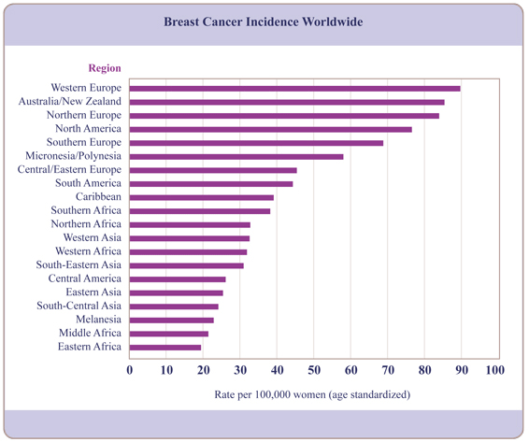
Figure 1.1
Worldwide incidence of breast cancer in 2008

Adapted from Susan G. Komen (http://www.komen.org/BreastCancer/Statistics.html#worldvar)
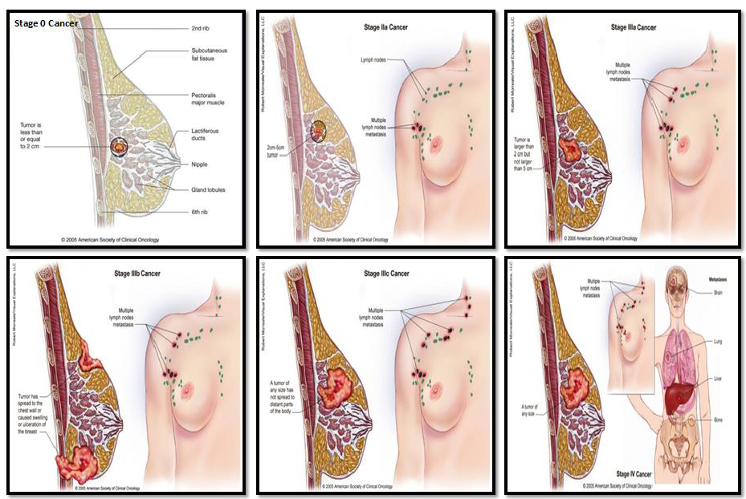
Figure 1.2
Stages of breast cancer

Adapted from the Society for Clinical Oncology
(http://www.asco.org/)
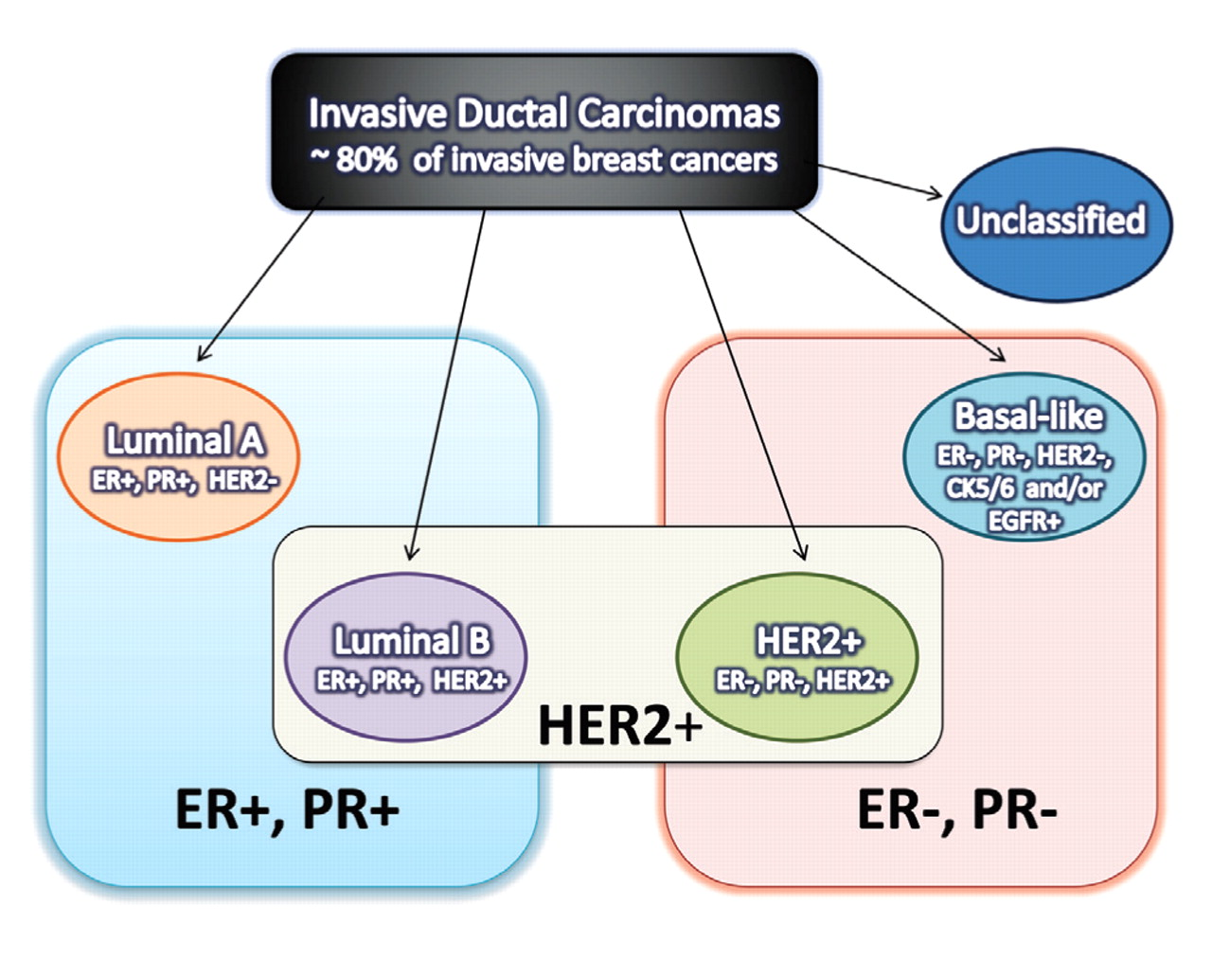
Figure 1.3
Molecular subtypes of breast cancer

Adapted from Sandhu et al. (2010) Lab Med. 41: 364-372.
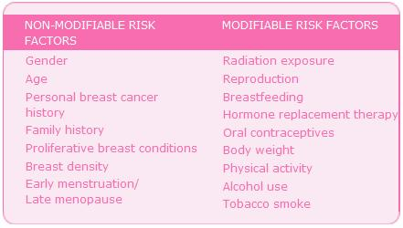
Figure 1.4
Risk factors for breast cancer

Adapted from Breast Cancer Organization
(http://www.breastcancer.org/risk/factors)
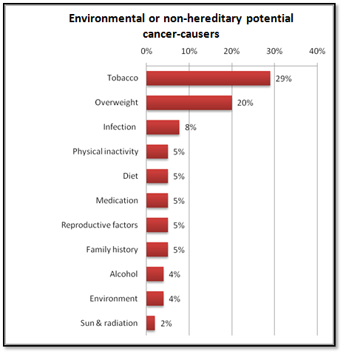
Figure 1.5
Environmental or non-hereditary potential cancer-causers

Adapted from Cancer News in Context
(http://www.cancernewsincontext.org)
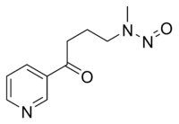
A)
B)
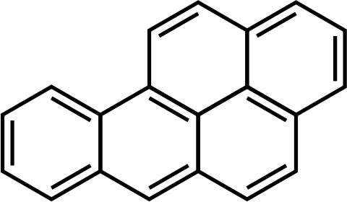
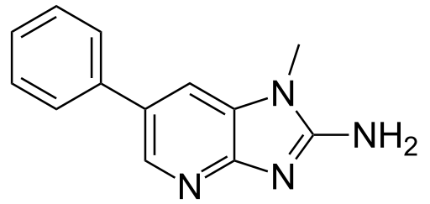
C)
Figure 1.6
Chemical structure of carcinogens
- Structure of 4-(methylnitrosamino)-1-(3-pyridyl)-1-butanone (NNK)
- Structure of benzo[α]pyrene (B[α]P)
- Structure of 2-amino-1-methyl-6-phenylimidazo [4, 5-b] pyridine (PhIP)

Adapted from Wikipedia
(commons.wikimedia.org)
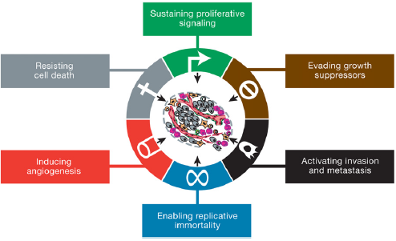
Figure 1.7
Hallmarks of cancer

Adapted from Hanahan et al. (2011) Cell. 144: 646-674.
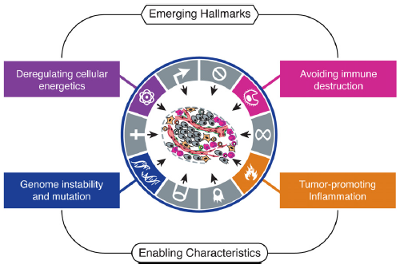
Figure 1.8
Emerging hallmarks and enabling characteristics

Adapted from Hanahan et al. (2011) Cell. 144: 646-674.
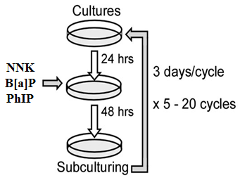
Figure 1.9
Precancerous model of cancer progression

Adapted from Rathore et al. (2012) Carcinogenesis. 33: 174-183.
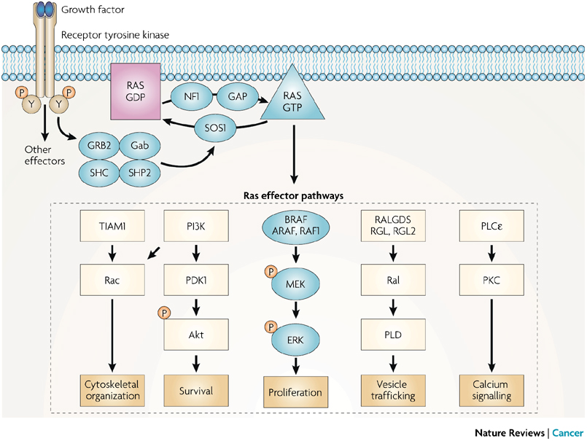
Figure 1.10
Ras signaling and ERK pathway activation

Adapted from Schubbert et al. (2007) Nat Rev Cancer 7: 295-308.
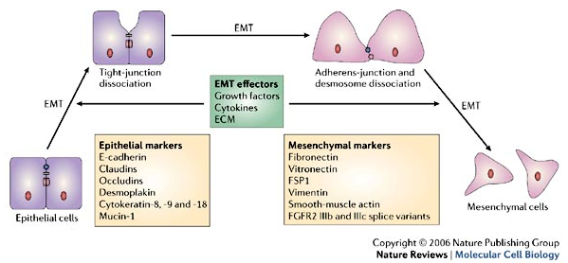
Figure 1.11
Changes during Epithelial-to-Mesenchymal Transition

Adapted from Thiery and Sleeman (2006) Nat Rev Mol Cell Biol 7: 131-142.
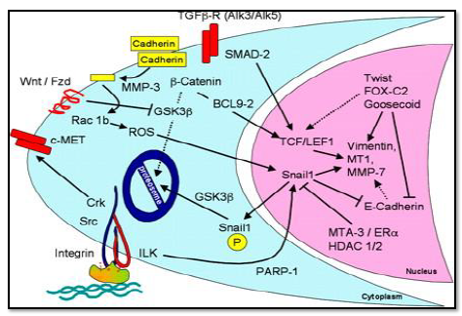
Figure 1.12
Pathways activated during EMT

Adapted from Lee et al. (2006) J Cell Biol 172: 973-981.
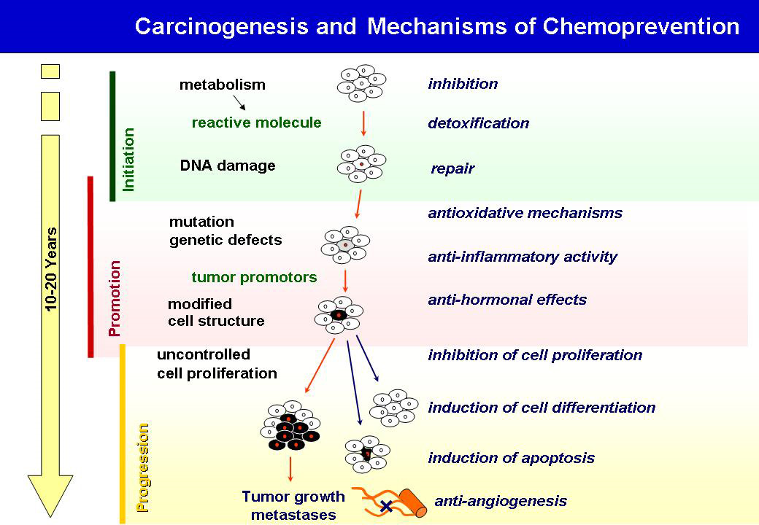
Figure 1.13
Anticancer mechanisms of dietary agents

Adapted from German Cancer Research Center
https://www.dkfz.de/en/index.html
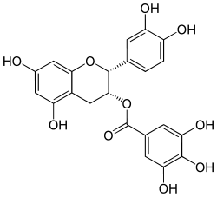
B)
A)
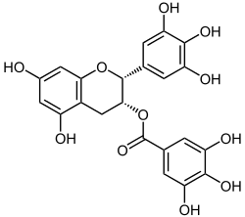
Figure 1.14
Chemical structure of green tea catechins
- Structure of (-)-epicatechin-3-gallate (ECG)
- Structure of (-)-epigallocatechin-3-gallate (EGCG)

Adapted from Wikipedia
(commons.wikimedia.org)
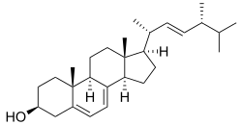
B)
A)
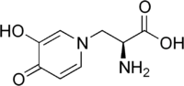
Figure 1.15
Chemical structure of ergosterol and mimosine
- Structure of ergosta-5,7,22-trien-3β-ol (ergosterol)
- Structure of (2S)-2-Amino-3-(3-hydroxy-4-oxopyridin-1-yl)propanoic acid (mimosine)

Adapted from Wikipedia
(commons.wikimedia.org)

CHAPTER 2

Chronic Exposure to Combined Carcinogens Enhances Breast Cell Carcinogenesis with Mesenchymal and Stem-like Cell Properties

Research described in this chapter is a slightly modified version of an article that has been accepted for publication in PLoS ONE by Lenora Ann Pluchino and Hwa-Chain Robert Wang

Lenora Ann Pluchino and Hwa-Chain Robert Wang. Chronic Exposure to Combined Carcinogens Enhances Breast Cell Carcinogenesis with Mesenchymal and Stem-like Cell Properties. (PLoS ONE, Accepted)

In this paper “our” and “we” refers to me and co-authors. My contribution in the paper includes
(1) Selection of the topic (2) Compiling and interpretation of the literature (3) Designing experiments (4) understanding the literature and interpretation of the results (5) providing comprehensive structure to the paper (6) Preparation of the graphs and figures (7) Writing and editing

Abstract
Most breast cancers occur sporadically due to long-term exposure to small quantities of multiple carcinogens present in the environment and diet via a multi-step process involving the progressive transformation of cells from a non-cancerous stage to pre-cancerous and cancerous stages. To understand how multiple carcinogens act together to induce cellular carcinogenesis, we studied the activity of environmental carcinogens 4-(methyl-nitrosamino)-1-(3-pyridyl)-1-butanone (NNK) and benzo[α]pyrene (B[α]P), and dietary carcinogen 2-amino-1-methyl-6-phenylimidazo[4,5-b]pyridine (PhIP) using our breast cell carcinogenesis model. Our study revealed, for the first time, that combined NNK and B[α]P (NB) enhanced breast cell carcinogenesis chronically induced by PhIP in both non-cancerous and cancerous breast cells. Co-exposure to NB and PhIP was more potent than sequential exposure to NB followed by PhIP in initiating and progressing carcinogenesis. Initiation of carcinogenesis was measured by transient endpoints induced in a single exposure, while progression of carcinogenesis was measured by acquisition of constitutive endpoints after cumulative exposures. Transient endpoints included DNA damage, Ras-ERK-Nox pathway activation, reactive oxygen species elevation, and increased cellular proliferation. Constitutive endpoints included various cancer-associated properties and signaling modulators, as well as enrichment of cancer stem-like cell population and activation of the epithelial-to-mesenchymal transition program. Using transient and constitutive endpoints as targets, we detected that a combination of the green tea catechins ECG and EGCG, at non-cytotoxic levels, was more effective than individual agents in intervention of cellular carcinogenesis induced by combined NNK, B[α]P, and PhIP. Thus, use of combined ECG and EGCG should be seriously considered for early intervention of breast cell carcinogenesis associated with long-term exposure to environmental and dietary carcinogens.
Introduction
Breast cancer is the most common type of cancer and second leading cause of cancer-related death among women in North America and Europe [1,2]. Over 85% of breast cancers occur sporadically due to long-term exposure to low doses of multiple carcinogens [3–7]. This chronic disease process involves cumulative genetic and epigenetic alterations which progressively transform cells from a non-cancerous stage to pre-cancerous and cancerous stages [3-6]. Since we are all exposed to various environmental and dietary carcinogens each day, it is important to investigate how multiple carcinogens act together to induce cellular carcinogenesis. We have developed a cellular model that mimics breast cell carcinogenesis induced by cumulative exposures to physiologically-achievable doses of environmental and dietary carcinogens to understand the cellular, biochemical, and molecular changes involved in cellular carcinogenesis for the purposes of intervention.
American lifestyles involve frequent consumption of high-temperature cooked meats containing carcinogens, such as 2-amino-1-methyl-6-phenylimidazo[4,5-b]pyridine (PhIP), and wide exposures to smoke and polluted air containing 4-(methylnitrosamino)-1-(3-pyridyl)-1-butanone (NNK) and benzo[α]pyrene (B[α]P). PhIP is the most abundant heterocyclic amine found in meats cooked at high temperatures, and consumption of PhIP at microgram levels results in systemic exposure at low nanomolar levels [8,9]. Gastric administration of PhIP induces mammary tumors in rats [10,11], and epidemiological studies have indicated a close association between well-done meat consumption and human breast cancer risk [12–14]. NNK, a tobacco-specific nitrosamine ketone, can be detected at picomolar concentrations in body fluids of tobacco users [15–17]. Although gastric administration of NNK into rats resulted in DNA adducts and tumor development in the mammary gland [18,19], NNK is not recognized as a mammary carcinogen. The link between smoking and breast cancer is controversial; however, recent studies indicate that exposure to tobacco smoke can increase breast cancer risk, especially in post-menopausal women [20–22]. Thus, the role of tobacco carcinogens in breast cancer needs to be clarified. B[α]P, on the other hand, is recognized as a weak mammary carcinogen. B[α]P is a polycyclic aromatic hydrocarbon present in carbon exhaust, charcoal-barbequed foods, and tobacco smoke; it can be found in picomolar concentrations in human fat and liver [23–28].
Our studies have shown that NNK at100 pmol/L, B[α]P at 100 pmol/L, and PhIP at 10 nmol/L are able to induce initiation and progression of breast cell carcinogenesis [29–35]. A single exposure to these carcinogens induces transient changes, which play essential roles in the induction of carcinogenesis and can be used as transient endpoints to promptly reveal carcinogenic activity. Cumulative exposures to carcinogens progressively induce cellular acquisition of various cancer-associated properties and activation of associated pathways; these properties are measurable constitutive endpoints used to determine the progression of cellular carcinogenesis [29–35]. Our model also reveals increases of cancer stem-like cell populations and activation of the epithelial-to-mesenchymal transition (EMT) program during carcinogen-induced cellular carcinogenesis [35,36]. Development of cancer stem-like cells, involving induction of the EMT program, plays an important role in generating and maintaining pre-malignant and malignant lesions [37]. Thus, we also used increased cancer stem-like cell population and induced EMT program as constitutive endpoints in our studies. We then used these endpoints as targets to identify preventive agents, such as green tea catechins (GTCs) epicatechin (EC), epicatechin-3-gallate (ECG), epigallocatechin (EGC), and epigallocatechin-3-gallate (EGCG), at non-cytotoxic levels, capable of intervening in breast cell carcinogenesis induced by NNK, B[α]P, or PhIP [31–36].
In this communication, we report the potency of co-exposure versus pre-exposure to combined NNK and B[α]P (NB) with PhIP in chronic induction of breast cell carcinogenesis. Co-exposure to NB and PhIP (NBP) induced higher levels of transient and constitutive endpoints than pre-exposure to NB followed by PhIP. We also studied the activity of ECG and EGCG, at non-cytotoxic levels, in suppression of NBP-induced endpoints. We determined that a combination of ECG and EGCG was more effective than either agent alone, at equivalent doses, in intervention of NBP-induced cellular carcinogenesis.

Materials and Methods
Cell cultures and reagents
MCF10A (American Type Culture Collection [ATCC], Rockville, MD) and derived cell lines were maintained in complete (CM) medium (1:1 mixture of DMEM and HAM's F12, supplemented with 100 ng/mL cholera enterotoxin, 10 µg/mL insulin, 0.5 µg/mL hydrocortisol, 20 ng/mL epidermal growth factor, and 5% horse serum) [29–36]. Human breast cancer MCF7 cells (ATCC) were maintained in DMEM supplemented with 10% heat-inactivated fetal calf serum [34,35]. All cultures were supplemented with 100 U/mL penicillin and 100 µg/mL streptomycin and maintained in 5% CO₂ at 37°C. Stock solutions of NNK (Chemsyn, Lenexa, KS), B[α]P (Aldrich, Milwaukee, WI), PhIP (Midwest; NCI Chemical Carcinogen Reference Standard Repository), U0126 (Cell Signaling, Beverly, MA), and CM-H₂DCF-DA (Invitrogen, Carlsbad, CA) were prepared in DMSO; ECG, EGCG (Sigma-Aldrich, St. Louis, MO), and N-acetyl-L-cysteine (NAC) (Alexis, San Diego, CA) were prepared in distilled water. All were diluted in CM medium for assays.

Chronic induction of cellular carcinogenesis
Twenty-four hours after each subculturing, human breast cells were treated with the indicated carcinogens for 48 h as one cycle of exposure for 20 cycles. Cells were subcultured every 3 days [29–36].

DNA Damage Assay
DNA damage was detected with a comet assay [38]. Cells were trypsinized and collected in phosphate-buffered saline (PBS) at a density of 2 × 10⁴ cells/ml. Cell suspension was mixed with an equal volume of 1% low-melting agarose (Fisher, Fair Lawn, NJ) and placed on agarose-coated slides. Slides were then immersed in lysis solution (1.2 mol/l NaCl, 100 mmol/l Na2-EDTA, 1% Triton X-100 and 0.3 nmol/l NaOH, pH 13) at 25º C for 1 h and rinsed three times with alkaline buffer (2 mmol/l Na2-EDTA and 300 mmol/l NaOH) for 20 min each. After electrophoresis in the same alkaline buffer at 20 V for 30 min, slides were stained with 2.5 µg/ml of propidium iodide for 20 min and examined with a Zeiss fluorescence microscope (Carl Zeiss Inc, Thornwood, NY) equipped with an excitation filter of 546 nm and barrier filter of 590 nm. Fifty nuclei per slide were scored for tail moment (% of DNA in the tail × tail length) as a parameter using CometScore software (Tritek Corp, Sumerduck, VA).

Reduced dependence on growth factors
A total of 5 × 10³ cells were seeded in 60-mm culture dishes and maintained in low-mitogen (LM) medium (1:1 mixture of DMEM/F12, 2 ng/mL cholera enterotoxin, 200 ng/mL insulin, 10 ng/mL hydrocortisol, 0.4 ng/mL epidermal growth factor, and 0.1% horse serum), containing reduced total serum and mitogenic additives to 2% of the concentration formulated in CM medium, for 10 days to develop cell colonies [32–35].

Anchorage-independent growth
A total of 1 × 10⁴ cells were mixed with soft agar consisting of 0.4% low-melting agarose (Sigma-Aldrich, St. Louis, MO) in a mixture (1:1) of CM medium with 3-day conditioned medium prepared from MCF10A cultures, plated on top of a 2% low-melting agarose base layer in 60-mm culture dishes and maintained for 14 days to develop cell clones [32–35].

Measurement of intracellular ROS
Cultures were labeled with 5 µmol/L CM-H₂DCF-DA for 1 h. Cells were trypsinized and resuspended in PBS for analysis of reactive oxygen species (ROS) by flow cytometry, using a
15 mW, air-cooled argon laser to produce 488 nm light. DCF fluorescence emission was collected with a 529 nm band pass filter. The mean fluorescence intensity of 2 × 10⁴ cells was quantified using Multicycle software (Phoenix Flow System, San Diego, CA) [32–35].

Cellular proliferation assay
Cell proliferation was determined using the 5-bromo-2-deoxyuridine (BrdU) cell proliferation enzyme-linked immunosorbent assay (ELISA) kit (Roche, Indianapolis, IN). A total of 5 × 10³ cells/well in 96-well culture plates were labeled with BrdU for 12 h, fixed, incubated with peroxidase-conjugated BrdU-specific antibodies and stained with the peroxidase substrate.
Quantification of BrdU-labeled cells was determined by an ELISA reader (Bio-Tek, Winooski, VT).

Reverse-transcription PCR
Total RNA isolated from cultures using the Absolutely RNA kit (Stratagene, La Jolla, CA) was reverse transcribed to complementary DNA using the Verso cDNA Kit (Thermo Scientific, Waltham, MA). The resulting cDNAs were subjected to PCR for H-Ras (forward: 5’-GACGGAAT ATAAGC TGGTGG-3’; reverse: 5’-AGGCACGTCTCCCCATCAAT-3’) and β-actin (forward: 5’-GGACTTCGAGCAAGAGATGG-3’; reverse: 5’-AGCACTGTGTTGGCGT ACG-3’). PCR products were electrophoresed on agarose gels and visualized using ethidium bromide staining.

Immunoblotting
Cell lysates were prepared in buffer (10 mM Tris-HCl, 150 mM NaCl, 1% Triton X-100, 5 mM EDTA, 10 mM sodium pyrophosphate, 10% glycerol, 0.1% Na3VO4, 50 mM NaF, pH 7.4) [31,32]. Protein concentration in cell lysates was measured using the BCA assay (Pierce, Rockford, IL). Equal amounts of cellular proteins were resolved by electrophoresis in 10% or 12% sodium dodecyl sulfate-polyacrylamide gels for Western immunoblotting using specific antibodies to detect H-Ras, phosphorylated Erk1/2 (p-Erk1/2), Erk1/2, Nox-1, EpCAM, E-cadherin, MMP-9, Vimentin, and β-actin (Santa Cruz Biotechnology, Santa Cruz, CA). Antigen-antibody complexes on filters were detected by the Supersignal chemiluminescence kit (Pierce, Rockford, IL).

Serum-independent non-adherent growth
A total of 1 × 10⁴ cells were seeded on top of 1% agarose-coated, non-adherent 100-mm culture plates, incubated in serum-free CM medium supplemented with 0.4% bovine serum albumin and maintained for 10 days to develop mammospheres [35,36].

Aldehyde dehydrogenase (ALDH) assay
An ALDEFLUOR Kit (StemCell Technologies, Durham, NC) was used to detect ALDH-expressing cells [35,36]. A total of 1 × 10⁵ cells/ml were resuspended in assay buffer, mixed with activated Aldefluor substrate BAAA (BODIPY-aminoacetaldehyde), and incubated in the presence and absence of the ALDH inhibitor diethylaminobenzaldehyde (DEAB) at 37º C for 40 min. Then, cells were resuspended in assay buffer for flow cytometric analysis by using a 15 mW air-cooled argon laser to produce 488 nm light. Fluorescence emission was collected with a 529-nm band pass filter. The mean fluorescence intensity of cells was quantified using Multicycle software (Phoenix Flow System, San Diego, CA). Cells incubated with BAAA in the presence of DEAB were used to establish the baseline of fluorescence for determining the ALDH-expressing cell population (%) in which ALDH activity was not inhibited by DEAB.
In vitro cell invasion and migration
The in vitro cell invasion assay was performed using 24-well Transwell insert chambers
with a polycarbonate filter with a pore size of 8.0 µm (Costar, Corning, NY). A total of 2 × 10⁴ cells in serum-free medium were seeded on top of a Matrigel-coated filter (BD Biosciences, Franklin Lakes, NJ) in each insert chamber. Then, insert chambers were placed into wells on top of culture medium containing 10% horse serum as a chemoattractant. After 24 h, the invasive ability of cells was determined by the number of cells translocated to the lower side of filters [33–36].
The in vitro migration assay was performed using 24-well Transwell insert chambers
with a polycarbonate filter not coated in Matrigel. The migration ability of cells was determined by the number of cells translocated to the lower side from the upper side of filters [33–36].

Cell motility wound-healing assay
Cells were seeded in 6-well plates and grown to confluence in CM medium. Cells were rinsed with PBS and serum-starved for 15 h in DMEM/Ham’s F12 medium containing 2% horse serum. The monolayer was then scratched with a 23-gauge needle (BD Biosciences, Franklin Lakes, NJ) to generate wounds, rinsed with CM medium to remove floating cells, and then maintained in CM medium. The wounded areas were examined 6, 12 and 24 h after scratches to detect healing. The area not healed by the cells was subtracted from the total area of the initial wound to calculate the wound healing area at time intervals of 6 and 12 h, using Total Lab TL100 software (Total Lab, Newcastle, NE) [36].

Statistical Analysis
The Student t test was used to analyze statistical significance, indicated by * P<0.05, ** P<0.01, and *** P<0.001; a P value <0.05 was considered significant.

Results and Discussion
Enhanced cellular acquisition of cancer-associated properties by combined carcinogens
Previous studies have shown that NNK and B[α]P exhibit comparable abilities to induce breast cell carcinogenesis [33,34]. Combining NNK and B[α]P (NB) additively increased degrees of all acquired constitutive cellular endpoints except tumorigenicity [33,34], indicating that NNK and B[α]P may act as weak breast carcinogens. To detect whether NB could enhance breast cell carcinogenesis induced by the potent breast carcinogen PhIP, we first used a comet assay to measure the ability of these carcinogens to induce cellular DNA damage after one exposure, which is essential for the induction of cellular carcinogenesis [37]. Exposure to combined NB and PhIP (NBP) induced a significantly higher level of DNA damage than either NB or PhIP (Figure 2.1A). Blockage of the ERK pathway (with the Mek-specific inhibitor U0126) or ROS production (with the general antioxidant NAC) significantly reduced NB-, PhIP-, and NBP-induced DNA damage (Figure 2.1A). These results indicate that co-exposure to NB and PhIP was more potent than either was alone to induce DNA damage for induction of cellular carcinogenesis, and the ERK pathway and ROS production are required for this process.
To verify whether cumulative exposures to NB and PhIP would result in enhanced cellular carcinogenesis, we exposed MCF10A cells to NB, PhIP, and NBP for 20 cycles, resulting in the NB20, P20, and NBP20 cell lines, respectively. NB20 cells were then exposed to PhIP for an additional 20 cycles, resulting in the NB20/P20 cell line. We then compared the potency of these resulting cell lines by measuring degrees of acquired cancer-associated properties/constitutive endpoints [29–35]. Growth factors and cellular adhesion to the extracellular matrix are required for normal epithelial cell survival; in contrast, cancerous cells acquire a reduced dependence on growth factors (RDGF) and anchorage-independent growth (AIG) to increase survivability [37]. Increased ROS production and cellular proliferation are also closely associated with cellular transformation [37]. We detected that NB20/P20 and NBP20 cells acquired higher degrees of RDGF (Figure 2.1B-1), AIG (2.1B-2), ROS content (2.1B-3), and cellular proliferation (2.1B-4) than NB20 or P20 cells. NBP20 cells acquired higher degrees of these endpoints than NB20/P20 cells, reaching levels comparable to malignant control MCF10A-Ras cells, in which oncogenic H-Ras is ectopically expressed in MCF10A cells [39]. The results indicate that pre-exposure (NB20/P20) or co-exposure (NBP20) to NB significantly enhanced PhIP-induced constitutive endpoints, with co-exposure being the most potent.
Our previous studies showed that up-regulated H-Ras gene expression, as a constitutive molecular endpoint, and activated Ras-ERK-Nox pathway, as a constitutive biochemical endpoint, are essential for maintaining constitutive cellular endpoints induced by PhIP [35]. In studying if these molecular and biochemical changes were enhanced by NBP, we detected that cumulative pre- and co-exposures to NB and PhIP resulted in highly up-regulated H-Ras gene expression (Figure 2.1B-5), increased H-Ras protein level, and activated downstream ERK-Nox pathway (2.1B-6) in NB20/P20 and NBP20 cells; these endpoints were up-regulated to higher levels in NBP20 cells than in NB20/P20 cells but did not reach their counterpart levels in MCF10A-Ras cells. These results indicate that NNK and B[α]P can enhance the ability of PhIP to induce breast epithelial cell carcinogenesis, even though NNK is not considered a mammary carcinogen, and B[α]P is considered a weak mammary carcinogen. Co-exposure to these carcinogens is more potent than pre-exposure to induce cellular acquisition of cancer-associated properties. The constitutive biochemical endpoints of Ras-ERK-Nox pathway activation and ROS elevation were induced consistently with constitutive cellular endpoints and may play important roles in maintaining cancer-associated properties in NBP-exposed cells.
To verify roles the ERK pathway and ROS may play in NBP-exposed cells, we used U0126 to inhibit Mek and NAC to inhibit ROS in NB20/P20 and NBP20 cells. Treatment with U0126 did not affect H-Ras expression but reduced Erk1/2 activity, Nox-1 expression (Figure 2.1C-1), ROS level (2.1C-2), and cell proliferation (2.1C-3), indicating that the ERK-Nox pathway plays an important role in maintaining ROS production and cell proliferation in both NB20/P20 and NBP20 cells. NAC treatment suppressed the Ras-ERK-Nox pathway (Figure 2.1C-1), ROS level (2.1C-2), and cell proliferation (2.1C-3), indicating an essential role for ROS production in maintaining activated Ras-ERK-Nox pathway and increased cell proliferation. These results reveal a cross-talk between the Ras-ERK-Nox pathway and ROS production, which are necessary for maintaining increased cell proliferation, and possibly other cancer-associated properties, in NBP-exposed cells.

Enhanced acquisition of stem-like and mesenchymal cell properties by combined carcinogens
Mammary stem-like cells are able to self-renew in serum-free media, are known to exhibit high levels of ALDH activity, and have a unique ability to form discrete spheroid clusters called mammospheres in non-adherent cultures [40,41]. We have reported that enrichment of ALDH-positive cell populations and increased formation of mammospheres were induced by cumulative exposures to NB [36] or PhIP [35] in MCF10A cells. However, increased stem-like cell population is not yet fully appreciated as a breast cancer-associated property. Growth of mammospheres (serum-independent non-adherent growth, SINAG) involves the properties of RDGF and AIG, both of which are enhanced by NBP exposure. Thus, it was important to understand whether NBP-enhanced cellular carcinogenesis was accompanied by enhanced stem-like cell properties. As shown in Figure 2.2, mammospheres (2.2A) and ALDH-positive cell population (2.2B) were increasingly induced in NB20, P20, NB20/P20, and NBP20 cells (NB20 < P20 < NB20/P20 < NBP20). Accordingly, cumulative co-exposures of cells to NBP resulted in acquisition of significantly increased stem-like cell populations that should be considered a novel cancer-associated property used to measure the progression of breast cell carcinogenesis.
The ability to develop stem-like cells is associated with activation of the EMT program [37]. During EMT, reduction of epithelial cellular adhesion molecule (EpCAM) and E-cadherin is associated with a loss in cell-cell adhesion [42] while an increase in matrix metalloproteinase-9 (MMP-9) is involved in degradation of the extracellular matrix [37]; increased Vimentin plays a role in filament formation and cell motility [43]. We detected that EpCAM and E-cadherin were reduced but MMP-9 and Vimentin were increased (Figure 2.2C) in NB- and/or PhIP-exposed cells, and these changes occurred consistently with degrees of increased mammosphere formation (2.2A) and enriched ALDH-positive stem-like cell populations (2.2B). Induction of the EMT program has been postulated to not only contribute to cellular acquisition of stem-like properties but also increased migratory and invasive capabilities [37]. We detected that increased degrees of cell migration (Figure 2.2D) and invasion (2.2E) were closely correlated with the increased degrees of mammosphere formation (2.2A), stem-like cell population (2.2B), and EMT markers (2.2C) acquired by NB- and/or PhIP-exposed cells: NBP20 > NB20/P20 > P20 > NB20. In addition, using a wound healing assay, we detected that increased cell motility (Figure 2.2F-1 and 2.2F-2) was also accordingly acquired by these NB- and/or PhIP-exposed cells. These results indicate that cumulative exposure to NBP significantly enhanced cellular acquisition of stem-like and EMT-associated markers and properties. Cellular acquisition of stem-like and EMT-associated properties should be considered as novel cancer-associated properties and constitutive endpoints in measurement of the progression of breast cell carcinogenesis.

NBP enhanced cancer-associated properties in breast cancer MCF7 cells
To clarify whether the enhanced acquisition of cancer-associated properties induced by NBP was limited to MCF10A cells, we exposed human breast cancer MCF7 cells to NBP, NB, and PhIP. A single exposure to NBP induced more DNA damage in MCF7 cells than either NB or PhIP (Figure 2.3A) indicating that NBP is more potent than either NB or PhIP alone to induce DNA damage for cellular carcinogenesis, even in cancer cells. After five cycles of carcinogen exposure, we detected significantly increased degrees of the cancer-associated properties of RDGF (Figure 2.3B-1), AIG (2.3B-2), cell migration (2.3B-3), and invasion (2.3B-4) acquired by carcinogen-exposed MCF7 cells versus parental cells. Although parental MCF7 cells possessed levels of these cancer-associated properties comparable to levels in NBP20 and MCF10A-Ras cells, these properties were significantly increased by NBP exposure, indicating that cumulative exposures to NBP may increase the potency of already cancerous cells. NBP was more potent than NB or PhIP in MCF7 cells, which is consistent with results seen in MCF10A cells. We next investigated if cumulative exposures to NBP, NB, and PhIP also resulted in induction of the biochemical endpoints of ROS elevation and Ras-ERK-Nox pathway activation in MCF7 cells as they did in MCF10A cells. We detected that parental MCF7 cells possessed higher levels of ROS (Figure 2.3B-5), H-Ras expression, Erk1/2 activation, and Nox-1 expression (2.3B-6) than MCF10A cells, and cumulative exposures to NBP were able to furthermore increase ROS production and Ras-ERK-Nox pathway induction in MCF7 cells. Exposure to NBP resulted in higher levels of ROS production (Figure 2.3B-5) and Ras-ERK-Nox pathway induction (2.3B-6) in MCF7 cells than either NB or PhIP alone, consistent with the higher levels of cancer-associated properties (2.3B-1 to 2.3B-4) acquired by NBP-exposed versus NB- or PhIP-exposed MCF7 cells. Thus, these results lead us to suggest that cumulative exposures to combined NNK, B[α]P, and PhIP were able to constitutively induce cellular acquisition of cancer-associated properties and associated biochemical endpoints in not only non-cancerous MCF10A cells, but also in cancerous MCF7 cells in a similar manner. A combination of multiple carcinogens was more potent than individual carcinogens in long-term induction of breast cell carcinogenesis. Thus, co-exposure to low doses of NNK, B[α]P, and PhIP should be seriously considered in epidemiological studies to reveal the value of these carcinogens in the development of sporadic breast cancer. Given their ability to increase cancer-associated properties in non-cancerous or cancerous cells alike, it is important to identify dietary agents capable of blocking breast cell carcinogenesis induced by cumulative exposures to combined carcinogens for early intervention of this disease.

Intervention of NBP-induced carcinogenesis
In our previous reports, we demonstrated that GTCs, at non-cytotoxic levels, were capable of suppressing breast cell carcinogenesis induced by NB or PhIP [33–35]. EGCG, the major catechin present in green tea extract, is the most commonly studied preventive GTC [44], but some studies have shown that ECG may be more effective than EGCG in intervention of cellular carcinogenesis [34,45,46]. ECG and EGCG have similar molecular masses, 442.37 and 458.37 g/mol, respectively. Our previous studies revealed that both ECG and EGCG at 40 µg/mL are toxic to MCF10A cells [34]. However, at a non-cytotoxic dose of 10 µg/mL, ECG is more effective than EGCG in suppression of NB-induced cellular carcinogenesis [34]. ECG at 10 µg/mL and EGCG at 5 µg/mL show comparable effectiveness in suppression of PhIP-induced cellular carcinogenesis [35]. Thus, to address whether ECG, EGCG, or a combination of both would be most effective in suppressing NBP-induced cellular carcinogenesis, we initially studied the effectiveness of ECG and EGCG, at non-cytotoxic doses, in blocking transient endpoints induced by a single exposure to NBP and subsequently verified their ability to suppress NBP-induced constitutive endpoints after cumulative exposures.
As shown in Figure 2.4, both ECG (E) and EGCG (G), at 10 or 20 µg/mL, were able to block NBP-induced transient endpoints of ROS elevation (2.4A-1) and DNA damage (2.4A-2), with ECG being more effective than EGCG in suppressing these properties. Interestingly, a combination of ECG and EGCG (E+G) at 5 or 10 µg/mL each was more effective than individual catechins at 10 or 20 µg/mL, respectively, in suppression of NBP-induced ROS and DNA damage, indicating that combined ECG and EGCG were optimal for blocking ROS elevation and DNA damage induced by combined NNK, B[α]P, and PhIP. Consistently, ECG was more effective than EGCG, and a combination of ECG and EGCG was more effective than individual catechins in suppression of Ras expression, Erk1/2 activity, and Nox-1 expression (Figure 2.4A-3), as well as cellular proliferation (2.4A-4) transiently induced by a single exposure to NBP. These results indicate that a combination of ECG and EGCG, at non-cytotoxic levels, was more effective than individual agents in blocking induction of breast cell carcinogenesis by NBP.
To verify the ability of ECG and EGCG to intervene with the progression of NBP-induced cellular carcinogenesis, we repeatedly exposed MCF10A cells to NBP in the absence or presence of 20 µg/mL ECG (E), 20 µg/mL EGCG (G), or combined 10 µg/mL ECG and 10 µg/mL EGCG (E/G) for 10 cycles, resulting in the NBP10, NBP-E10, NBP-G10, and NBP-E/G10 cell lines, respectively. In studies of the ability of ECG and/or EGCG to block NBP-induced cancer-associated properties, we detected that ECG was more effective than EGCG and a combination of ECG and EGCG was more effective than individual catechins in intervention of cellular acquisition of RDGF (Figure 2.4B-1), AIG (2.4B-2), increased cell migration (2.4B-3), invasion (2.4B-4), and proliferation (2.4B-5), as well as ROS elevation (2.4B-6) and Ras-ERK-Nox pathway activation (2.4B-7). Furthermore, NBP-increased mammosphere formation (Figure 2.4B-8) and ALDH-positive stem-like cell population (2.4B-9) as well as EMT-associated MMP-9 induction, Vimentin induction, EpCAM reduction, and E-cadherin reduction (2.4B-10) were also blocked by co-exposure to ECG and EGCG. Consistently, ECG was more effective than EGCG, and a combination of ECG and EGCG was more effective than individual catechins in suppressing these properties. These results clearly indicate the effectiveness of ECG and EGCG, at non-cytotoxic levels, in intervention of breast cell carcinogenesis associated with long-term exposure to NBP. A combination of ECG and EGCG was more effective than either agent alone, at equivalent doses in intervention of NBP-induced breast cell carcinogenesis.
Our unique model presents several advantages over others to advance our understanding of human breast carcinogenesis and early intervention. It is highly sensitive in detecting physiologically-achievable, low doses of either weak or potent carcinogens capable of inducing breast cell carcinogenesis. It takes a unique approach of exposing cells to carcinogens in a cumulative manner for progressive induction of chronic carcinogenesis from non-cancerous to pre-cancerous and cancerous stages. In addition, it uses measurable transient and constitutive cellular, biochemical, and molecular endpoints to determine the induction and progression of cellular carcinogenesis and to identify non-cytotoxic agents effective in intervention. In this communication, we used our model to demonstrate, for the first time, the ability of two relatively weak breast carcinogens, NNK and B[α]P, to enhance breast cell carcinogenesis induced by potent breast carcinogen PhIP; we also identified the ability of combined ECG and EGCG, which was more effective than individual catechins, to intervene in carcinogenesis induced by combined NNK, B[α]P, and PhIP. We reported that transient induction of ROS, the Ras-ERK-Nox pathway, cell proliferation, and DNA damage accounted for the mechanisms of initiation of cellular carcinogenesis during each exposure to NNK, B[α]P, and/or PhIP [34,35], ultimately leading to acquisition of cancer-associated properties and progression of cellular carcinogenesis induced by cumulative exposures. These transient endpoints were highly enhanced by combined NNK, B[α]P, and PhIP. Blockage of ROS elevation or the Ras-ERK-Nox pathway significantly reduced NBP-induced DNA damage and cell proliferation, indicating essential roles of ROS elevation and Ras-ERK-Nox pathway activation in NBP-induced cellular carcinogenesis. Accordingly, transient induction of ROS elevation and the Ras-ERK-Nox pathway served not only as markers for detecting NBP effects but also as targets for suppressing NBP-induced carcinogenesis. As we demonstrated in this communication, we initially used ROS elevation and the Ras-ERK-Nox pathway as targets to detect the optimal concentration and combination of ECG and EGCG effective in suppression of NBP-induced transient endpoints. Subsequently, we used cancer-associated properties/constitutive endpoints as targets to verify the effectiveness of combined ECG and EGCG in intervention of NBP-induced progression of cellular carcinogenesis. In addition, our model system is able to address whether preventive agents are effective in intervention of cancer stem-like cell development. Development of cancer stem-like cells, involving induction of the EMT program, has been postulated to play important roles in cancer development [37] and cancer recurrence after chemotherapy [47]. Using our model, we demonstrated that combined ECG and EGCG was more effective than individual agents in intervention of NBP-increased stem-like cell population and EMT program induction. Thus, applying our model will accelerate our understanding of low-dose carcinogens in breast cell carcinogenesis and identification of preventive agents effective in reducing the health risk of sporadic breast cancer associated with chronic exposure to low doses of environmental and dietary carcinogens.

LIST OF REFERENCES
- Gray J, Evans N, Taylor B, Rizzo J, Walker M (2009) State of the evidence: the connection between breast cancer and the environment. Int J Occup Env Health 15: 43–78.
- Bray F, Ren JS, Masuyer E, Ferlay J (2013) Global estimates of cancer prevalence for 27 sites in the adult population in 2008. Int J Cancer 132: 1133–1145.
- Guengerich FP (2000) Metabolism of chemical carcinogens. Carcinogenesis 21: 345–351.
- Kelloff GJ, Hawk ET, Sigman CC (2005) Cancer chemoprevention: strategies for cancer chemoprevention. Vol 2. Totowa, New Jersey: Human Press. 528 p.
- DeBruin LS, Josephy PD (2002) Perspectives on the chemical etiology of breast cancer. Environ Health Perspect 110: 119–128.
- Hecht SS (2002) Tobacco smoke carcinogens and breast cancer. Environ Mol Mutagen 39: 119–126.
- Mehta RG (2000) Experimental basis for the prevention of breast cancer. Eur J Cancer 36: 1275–1282.
- Sugimura T, Wakabayashi K, Nakagama H, Nagao M (2004) Heterocyclic amines: mutagens/ carcinogens produced during cooking of meat and fish. Cancer Sci 95: 290–299.
- Gooderham NJ, Creton S, Lauber SN, Zhu H (2007) Mechanisms of action of the carcinogenic heterocyclic amine PhIP. Toxicol Lett 168: 269–277.
- Imaida K, Hagiwara A, Yada H, Masui T, Hasegawa R, et al. (1996) Dose-dependent induction of mammary carcinomas in female Sprague-Dawley rats with 2-amino-1-methyl-6-phenylimidazol [4,5-b]pyridine. Jpn J Cancer Res 87: 1116–1120.
- Nagao M, Ushijima T, Wakabayashi K, Ochiai M, Kushida H, et al. (1994) Dietary carcinogens and mammary carcinogenesis. Induction of rat mammary carcinomas by administration of heterocyclic amines in cooked foods. Cancer 74: 1063–1069.
- Zheng W, Lee SA (2009) Well-done meat intake, heterocyclic amine exposure, and cancer risk. Nutr Cancer 61: 437–446.
- Zheng W, Gustafson DR, Sinha R, Cerhan JR, Moore D, et al. (1998) Well-done meat intake and the risk of breast cancer. J Natl Cancer Inst 90: 1724–1729.
- Sinha R, Gustafson DR, Kulldorff M, Wen WQ, Cerhan JR, et al. (2000) 2-Amino-1-methyl-6-phenylimidazo[4,5-b]pyridine, a carcinogen in high-temperature-cooked meat, and breast cancer risk. J Natl Cancer Inst 92: 1352–1354.
- Hecht SS (1988) Tobacco-specific nitrosamines, an important group of carcinogens in tobacco and tobacco smoke. Carcinogenesis 9: 875–884.
- Hecht SS, Hoffman D (1996) Recent studies on mechanisms of bioactivation and detoxification of 4-(methylnitrosamino)-1-(3-pyridyl)-1-butanone (NNK), a tobacco specific lung carcinogen. Crit Rev Toxicol 26: 163–181.
- Hecht SS (1999) Tobacco smoke carcinogens and lung cancer. J Natl Cancer Inst 91: 1194–1210.
- Chhabra SK, Anderson LM, Perella C, Desai D, Amin S, et al. (2000) Coexposure to ethanol with N-nitrosodimethylamine or 4-(methylnitrosamino)-1-(3-pyridyl)-1-butanone during lactation of rats: Marked increase in O(6)-methylguanine-DNA adducts in maternal mammary gland and in suckling lung and kidney. Toxicol Appl Pharmacol 169: 191–200.
- Ohnishi T, Fukamachi K, Ohshima Y, Jiegou X, Ueda S, et al. (2007) Possible application of human c-Ha-ras proto-oncogene transgenic rats in a medium-term bioassay model for carcinogens. Toxicol Pathol 35: 436–443.
- Johnson KC, Miller AB, Collishaw NE, Palmer JR, Hammond SK, et al. (2010) Active smoking and secondhand smoke increase breast cancer risk: the report of the Canadian Expert Panel on Tobacco Smoke and Breast Cancer Risk. Tobacco Control 20: e2.
- Luo J, Margolis KL, Wactawski-Wende J, Horn K, Messina C, et al. (2011) Association of active and passive smoking with risk of breast cancer among postmenopausal women: A prospective cohort study. BMJ 342: d1016.
- Hartz AJ, He T (2013) Cohort study of risk factors for breast cancer in post menopausal women. Epidemiol Health 35: e2013003.
- Rubin H (2001) Synergistic mechanisms in carcinogenesis by polycyclic aromatic hydrocarbons and by tobacco smoke: A bio-historical perspective with updates. Carcinogenesis 22: 1903–1930.
- Obana H, Hori S, Kashimoto T, Kunita N (1981) Polycyclic aromatic hydrocarbons in human fat and liver. Bull Environ Contam Toxicol 27: 23–27.
- Rundle A, Tang D, Hibshoosh H, Estabrook A, Schnabel F, et al. (2000) The relationship between genetic damage from polycyclic aromatic hydrocarbons in breast tissue and breast cancer. Carcinogenesis 21: 1281–1289.
- Morris JJ, Seifter E (1992) The role of aromatic hydrocarbons in the genesis of breast cancer. Med Hypotheses 38: 177–184.
- Gammon MD, Santella RM, Neugut AI, Eng SM, Teitelbaum SL, et al. (2002) Environmental toxins and breast cancer on Long Island. I. Polycyclic aromatic hydrocarbon DNA adducts. Cancer Epidemiol Biomarkers Prev 11: 677–685.
- Gammon MD, Sagiv SK, Eng SM, Shantakumar S, Gaudet MM, et al. (2004) Polycyclic aromatic hydrocarbon-DNA adducts and breast cancer: a pooled analysis. Arch Environ Health 59: 640–649.
- Mei J, Hu H, McEntee M, Plummer H, Song P, et al. (2003) Transformation of noncancerous human breast epithelial cell MCF10A induced by the tobacco-specific carcinogen NNK. Breast Cancer Res Treat 79: 95–105.
- Siriwardhana N, Wang HC (2008) Precancerous carcinogenesis of human breast epithelial cells by chronic exposure to benzo[α]pyrene. Mol Carcinogenesis 47: 338–48.
- Siriwardhana N, Choudhary S, Wang HC (2008) Precancerous model of human breast epithelial cells induced by the tobacco-specific carcinogen NNK for prevention. Breast Cancer Res Treat 109: 427–441.
- Song X, Siriwardhana N, Rathore K, Lin D, Wang HC (2010) Grape seed proanthocyanidin suppression of breast cell carcinogenesis induced by chronic exposure to combined 4-(methylnitrosamino)-1-(3-pyridyl)-1-butanone and benzo[α]pyrene. Mol Carcinogenesis 49: 450–463.
- Rathore K, Wang HC (2012) Green tea catechin extract in intervention of chronic breast cell carcinogenesis induced by environmental carcinogens. Mol Carcinogenesis 51: 280–289.
- Rathore K, Choudhary S, Odoi A, Wang HC (2012) Green tea catechin intervention of reactive oxygen species-mediated ERK pathway activation and chronically induced breast cell carcinogenesis. Carcinogenesis 33: 174–183.
- Choudhary S, Sood S, Donnell RL, Wang HC (2012) Intervention of human breast cell carcinogenesis chronically induced by 2-amino-1-methyl-6-phenylimidazo-[4,5-b]pyridine. Carcinogenesis 33: 876–885.
- Rathore K, Wang HC (2013) Mesenchymal and stem-like cell properties targeted in suppression of chronically-induced breast cell carcinogenesis. Cancer Lett 333: 113-123.
- Hanahan D, Weinberg RA (2011) The hallmarks of cancer: the next generation. Cell 144: 646–674.
- Olive PL, Banath JP (2006) The comet assay: a method to measure DNA damage in individual cells. Nat Protoc 1: 23–29.
- Datta S, Hoenerhoff MJ, Bommi P, Sainger R, Guo W-J, et al. (2007) Bmi-1 cooperates with H-Ras to transform human mammary epithelial cells via dysregulation of multiple growth-regulatory pathways. Cancer Res 67: 10286–10295.
- Dontu G, Abdallah WM, Foley JM, Jackson KW, Clarke MF, et al (2003) In vitro propagation and transcriptional profiling of human mammary stem/progenitor cells. Genes Dev 17: 1253–1270.
- Ginestier A, Hur MH, Charafe-Jauffret E, Monville F, Dutcher J, et al. (2007) ALDH1 is a marker of normal and malignant human mammary stem cells and a predictor of poor clinical outcome. Cell Stem Cell 1: 555–567.
- Litvinov SV, Balzar M, Winter MJ, Bakker HA, Briaire-de Bruijn IH, et al. (1997) Epithelial cell adhesion molecule (Ep-CAM) modulates cell–cell interactions mediated by classic cadherins. J Cell Biol 139: 1337–1348.
- Vuoriluoto K, Haugen H, Kiviluoto S, Mpindi JP, Nevo J, et al. (2011) Vimentin regulates EMT induction by Slug and oncogenic H-Ras and migration by governing Axl expression in breast cancer. Oncogene 30: 1436–1448.
44. Yang CS, Wang X, Lu G, Picinich SC (2009) Cancer prevention by tea: animal studies, molecular mechanisms and human relevance. Nat Rev Cancer 9: 429–439.
- Kurbitz C, Heise D, Redmer T, Goumas F, Arlt A, et al. (2011) Epicatechin gallate and catechin gallate are superior to epigallocatechin gallate in growth suppression and anti-inﬂammatory activities in pancreatic tumor cells. Cancer Sci 102: 728–734.
- Pan MH, Chiou YS, Wang YJ, Ho CT, Lin JK (2011) Multistage carcinogenesis process as molecular targets in cancer chemoprevention by epicatechin-3-gallate. Food Funct 2: 101-10.
- Al-Ejeh F, Smart CE, Morrison BJ, Chenevix-Trench G, López JA, et al. (2011) Breast cancer stem cells: treatment resistance and therapeutic opportunities. Carcinogenesis 32: 650-658.

APPENDIX

Figure 2.1. Enhanced cellular acquisition of cancer-associated properties by combined carcinogens. (A) MCF10A cells were treated with combined 100 pmol/L NNK and 100 pmol/L B[α]P (NB), 10 nmol/L PhIP (P), or combined NB and PhIP (NBP) in the absence and presence of 10 µmol/L U0126 (U0) or 5 mmol/L NAC for 24 h. DNA damage was measured by a comet assay and normalized by the value of average tail moment determined in untreated counterpart cells, set as 1 (X, arbitrary unit). Representative images detected in the comet assay are shown. (B-1 to B-6) MCF10A (10A) cells were repeatedly exposed to NB, PhIP, or NBP for 20 cycles, resulting in the NB20, P20, and NBP20 cell lines, respectively. NB20 cells were then exposed to PhIP for an additional 20 cycles resulting in the NB20/P20 cell line. MCF10A-Ras (Ras) cells were used as a malignant control. (C-1 to C-3) NB20/P20 and NBP20 cells were treated with 10 µmol/L U0 or 5 mmol/L NAC for 48 h. (B-1) To determine cellular acquisition of RDGF, cells were maintained in LM medium for 10 days. Cell colonies ≥0.5 mm diameter were counted. (B-2) To determine cellular acquisition of AIG, cells were seeded in soft agar for 14 days. Cell colonies ≥0.1 mm diameter were counted. (B-3 and C-2) Relative level of ROS as fold induction (X, arbitrary unit) was normalized by the level determined in untreated cells, set as 1. (B-4 and C-3) Relative cell proliferation was determined and normalized by the value of BrdU detected in untreated cells, set as 100%. B-5: Total RNA was isolated and analyzed by RT-PCR with specific primers to determine relative gene expression levels of H-Ras, with β-actin as a control, and these levels were quantified by densitometry. (B-6 and C-1) Cell lysates were analyzed by immunoblotting using specific antibodies to detect levels of H-Ras, phosphorylated-Erk1/2 (p-Erk1/2), Erk1/2, and Nox-1, with β-actin as a control, and these levels were quantified by densitometry. The levels of H-Ras (Ras/actin) and Nox-1 (Nox/actin) were calculated by normalizing with the level of β-actin and the level set in untreated control cells as 1 (X, arbitrary unit). Levels of specific phosphorylation of Erk1/2 (p/Erk) were calculated by normalizing the levels of p-Erk1/2 with the levels of Erk1/2, then the level set in control cells as 1 (X, arbitrary unit). Columns, mean of triplicates; bars, SD. All results are representative of three independent experiments. Statistical significance is indicated by * P<0.05, ** P<0.01, and *** P<0.001.

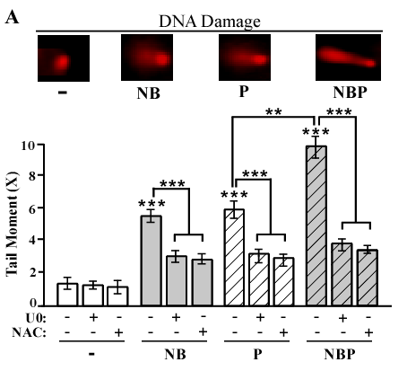
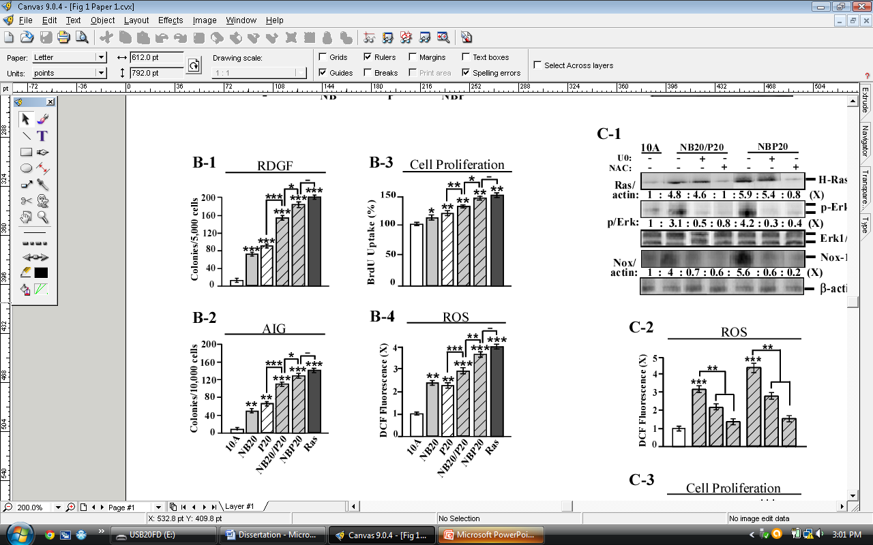
Figure 2.1
Enhanced cellular acquisition of cancer-associated properties by combined carcinogens
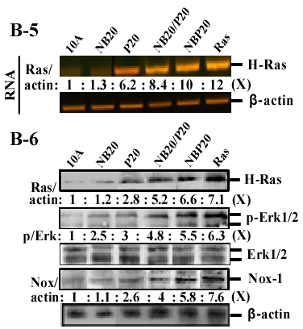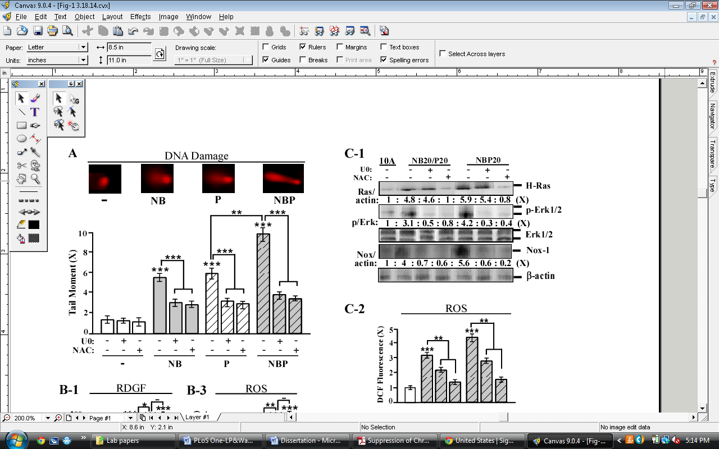
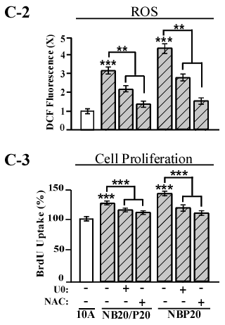
Figure 2.1
Enhanced cellular acquisition of cancer-associated properties by combined carcinogens
Figure 2.2. Enhanced acquisition of mesenchymal and stem-like cell properties by combined carcinogens. (A) To determine cellular acquisition of the ability of serum-independent non-adherent growth (SINAG), MCF10A (10A), NB20, P20, NB20/P20, NBP20, and MCF10A-Ras (Ras) cells were seeded in non-adherent cultures for 10 days; then, mammospheres (≥0.1 mm diameter) were counted. (B) Mammospheres were collected and trypsinized, and ALDH-expressing (ALDH⁺) cell population (%) was measured by flow cytometry. (C) Cell lysates were analyzed by immunoblotting using specific antibodies to detect levels of EpCAM, E-cadherin, MMP-9 and Vimentin, with β-actin as a control, and these levels were quantified by densitometry. The levels of EpCAM, E-cadherin, MMP-9, and Vimentin were calculated by normalizing with the level of β-actin and the level set in untreated control cells as 1 (X, arbitrary unit). (D) Cellular migratory and E: invasive activities were determined by counting the numbers of cells translocated through a polycarbonate filter without or with coated Matrigel, respectively, in 10 arbitrary visual fields. (F-1) Cellular acquisition of increased motility was determined by wound healing assay. The wounded areas were examined (magnification, 100×) 6, 12, and 24 h afterward. Arrows indicate width of wounded areas. (F-2) To quantitatively measure cell motility detected in F-1, the area not healed by the cells was subtracted from the total area of the initial wound to calculate the wound healing area (%) at intervals of 6 (white columns) and 12 h (gray columns). Columns, mean of triplicates; bars, SD. All results are representative of three independent experiments. Statistical significance is indicated by * P<0.05, ** P<0.01, and *** P<0.001.

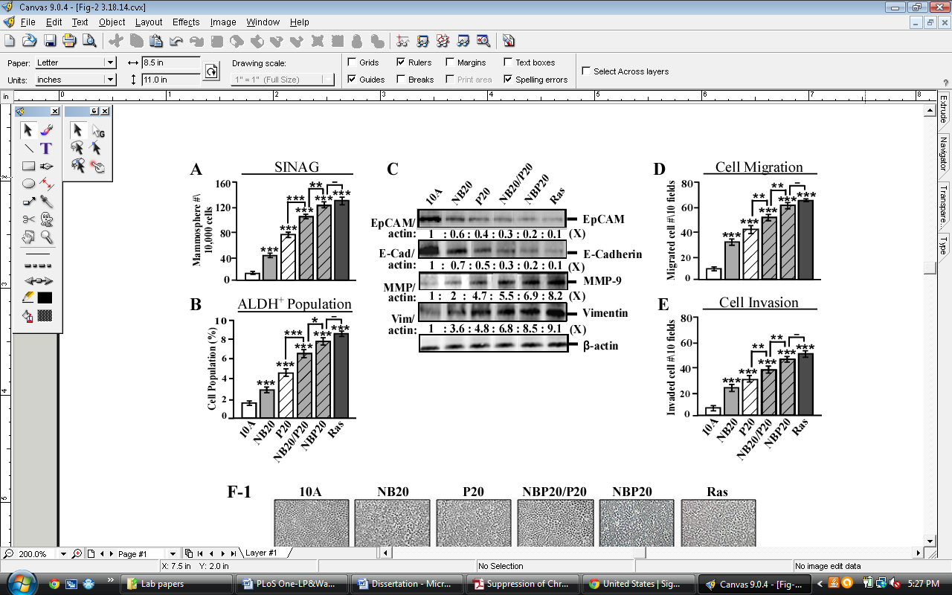
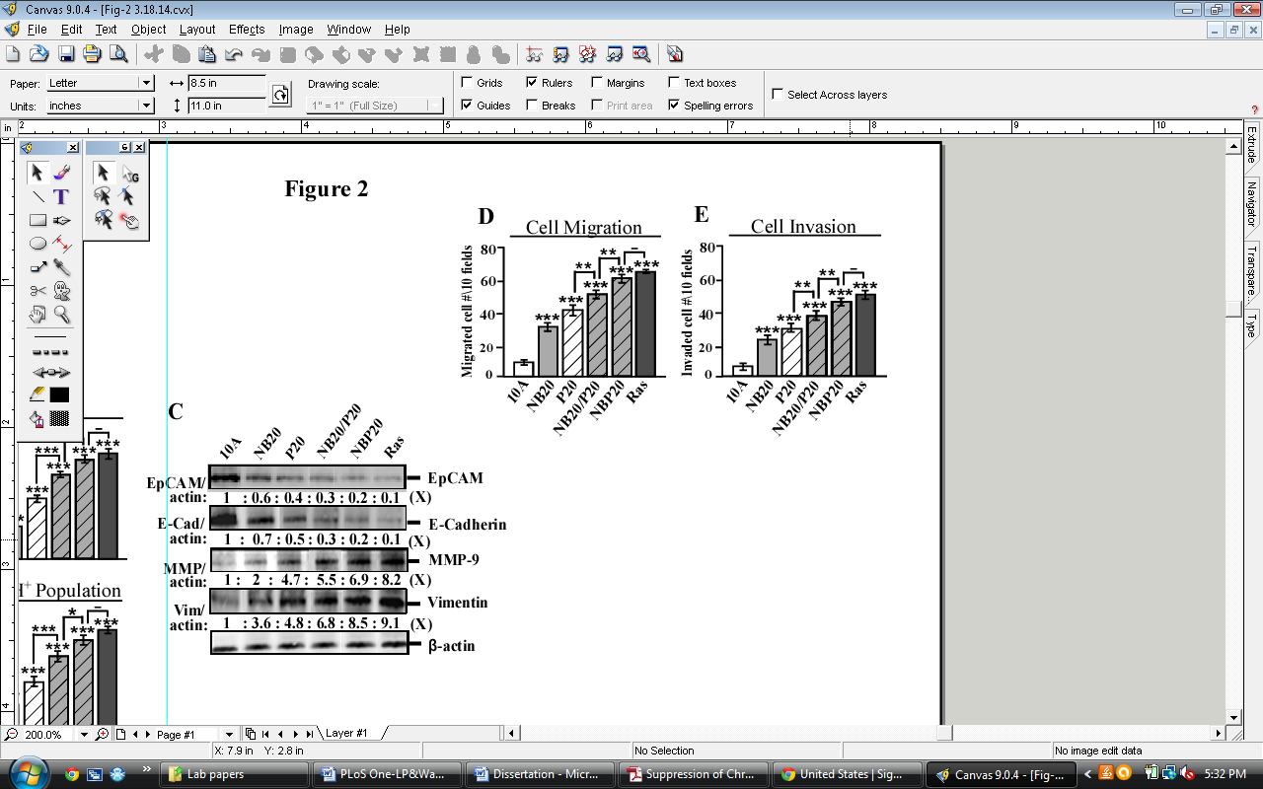
Figure 2.2
Enhanced acquisition of mesenchymal and stem-like cell properties by combined carcinogens
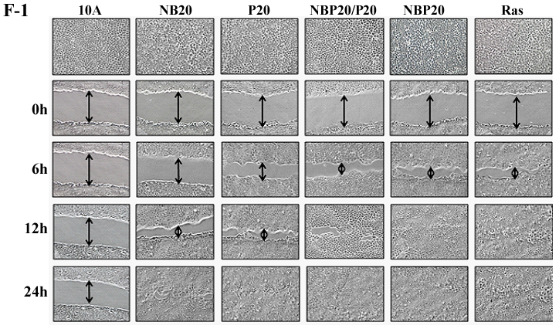
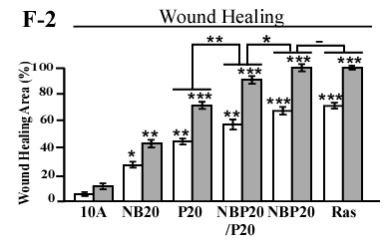
Figure 2.2
Enhanced acquisition of mesenchymal and stem-like cell properties by combined carcinogens
Figure 2.3. NBP-enhanced cancer-associated properties in breast cancer MCF7 cells. (A) MCF10A cells (10A) were treated with NBP, and MCF7 cells were treated with NBP, NB, or PhIP (P) for 24 h. DNA damage was measured by a comet assay and normalized by the value of average tail moment determined in untreated counterpart cells, set as 1 (X, arbitrary unit). (B-1 to B-6) MCF7 cells were exposed to NBP, NB, or PhIP for five cycles (NBP5, NB5, and P5). The NBP20 and MCF10A-Ras (Ras) cell lines were used as comparisons. (B-1) To determine cellular acquisition of RDGF, cells were maintained in LM medium for 10 days. Cell colonies ≥0.5 mm diameter were counted. (B-2) To determine cellular acquisition of AIG, cells were seeded in soft agar for 14 days. Cell colonies ≥0.1 mm diameter were counted. Cellular migratory (B-3) and invasive (B-4) activities were determined by counting the numbers of cells translocated through a polycarbonate filter without or with coated Matrigel, respectively, in 10 arbitrary visual fields. (B-5) Relative level of ROS as fold induction (X, arbitrary unit) was normalized by the level determined in untreated cells, set as 1. (B-6) Cell lysates were analyzed by immunoblotting using specific antibodies to detect levels of H-Ras, p-Erk1/2, Erk1/2, and Nox-1, with β-actin as a control, and these levels were quantified by densitometry. Levels of H-Ras (Ras/actin) and Nox-1 (Nox/actin) were calculated by normalizing with the level of β-actin and the level set in untreated control cells as 1 (X, arbitrary unit). Levels of specific phosphorylation of Erk1/2 (p/Erk) were calculated by normalizing the levels of p-Erk1/2 with the levels of Erk1/2, then the level set in control cells as 1 (X, arbitrary unit). Columns, mean of triplicates; bars, SD. All results are representative of three independent experiments. Statistical significance is indicated by * P<0.05, ** P<0.01, and *** P<0.001.

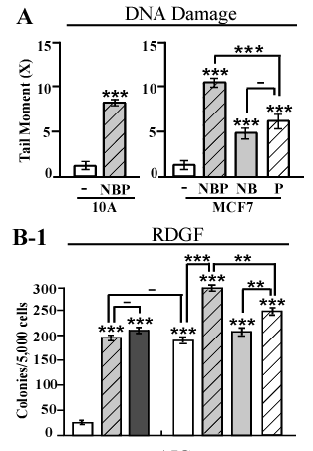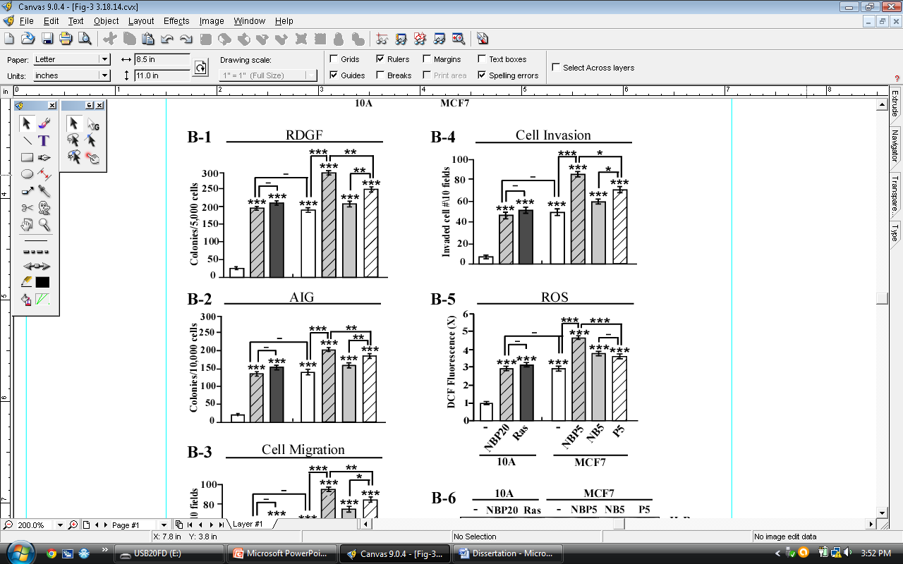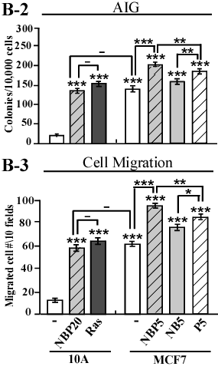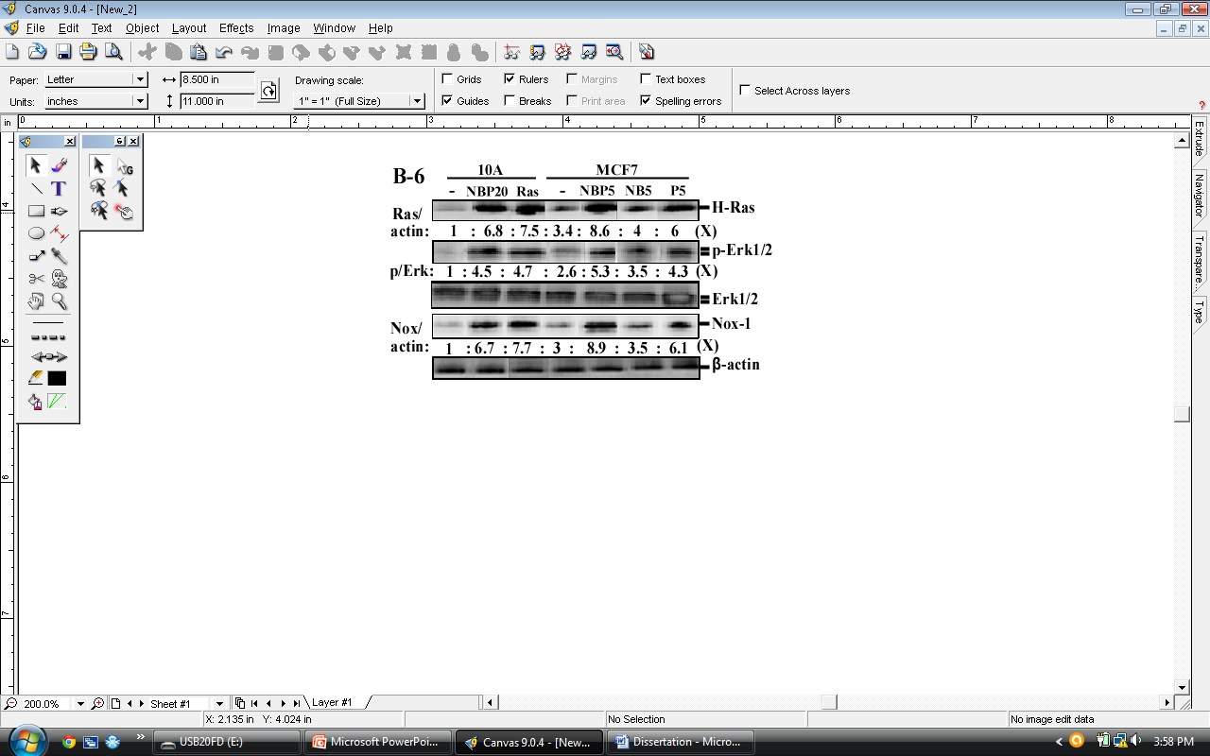
Figure 2.3
NBP-enhanced cancer-associated properties in breast cancer MCF7 cells
Figure 2.4. Intervention of NBP-induced carcinogenesis. (A-1 to A-4) MCF10A cells were treated with NBP in the absence and presence of ECG (E), EGCG (G), or a combination of ECG and EGCG (E+G) for 24 hr. (B-1 to B-10) MCF10A (10A) cells were exposed to NBP in the absence and presence of 20 µg/mL ECG, 20 µg/mL EGCG, or combined 10 µg/mL ECG and 10 µg/mL EGCG (E/G) for 10 cycles, resulting in the NBP10, NBP-E10, NBP-G10, and NBP-E/G10 cell lines, respectively. (A-1 and B-6) Relative level of ROS as fold induction (X, arbitrary unit) was normalized by the level determined in untreated cells, set as 1. (A-2) Relative DNA damage was measured by a comet assay and normalized by the value of average tail moment determined in untreated counterpart cells, set as 1 (X, arbitrary unit). (A-3 and B-7) Cell lysates were analyzed by immunoblotting using specific antibodies to detect levels of H-Ras, phosphorylated-Erk (p-Erk), Erk, and Nox-1, with β-actin as a control, and these levels were quantified by densitometry. Levels of H-Ras and Nox-1 were calculated by normalizing with the level of β-actin and the level set in untreated control cells as 1 (X, arbitrary unit). Levels of specific phosphorylation of Erk (p/Erk) were calculated by normalizing the levels of p-Erk with the levels of Erk, then the level set in control cells as 1 (X, arbitrary unit). (A-4 and B-5) Relative cell proliferation was determined and normalized by the value of BrdU detected in untreated cells, set as 100%. (B-1) To determine cellular acquisition of RDGF, cells were maintained in LM medium for 10 days. Cell colonies ≥0.5 mm diameter were counted. (B-2) To determine cellular acquisition of AIG, cells were seeded in soft agar for 14 days. Cell colonies ≥0.1 mm diameter were counted. (B-3) Cellular migratory and (B-4) invasive activities were determined by counting the numbers of cells translocated through a polycarbonate filter without or with coated Matrigel, respectively, in 10 arbitrary visual fields. (B-8) To determine cellular acquisition of the ability of serum-independent non-adherent growth (SINAG), cells were seeded in non-adherent cultures for 10 days; then, mammospheres (≥0.1 mm diameter) were counted. (B-9) Mammospheres were collected and trypsinized, and ALDH-expressing (ALDH⁺) cell population (%) was measured by flow cytometry. (B-10) Cell lysates were analyzed by immunoblotting using specific antibodies to detect levels of EpCAM, E-cadherin, MMP-9 and Vimentin, with β-actin as a control, and these levels were quantified by densitometry. The levels of EpCAM, E-cadherin, MMP-9 and Vimentin were calculated by normalizing with the level of β-actin and the level set in untreated control cells as 1 (X, arbitrary unit). Columns, mean of triplicates; bars, SD. All results are representative of three independent experiments. Statistical significance is indicated by * P<0.05, ** P<0.01, and *** P<0.001.

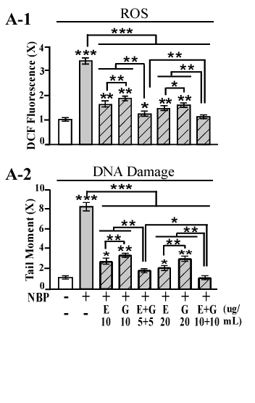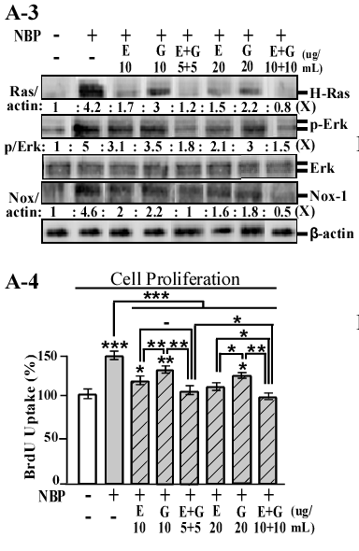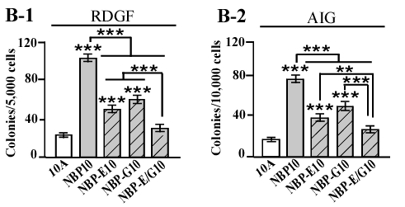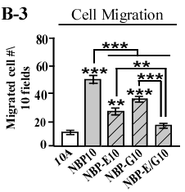
Figure 2.4
Intervention of NBP-induced carcinogenesis
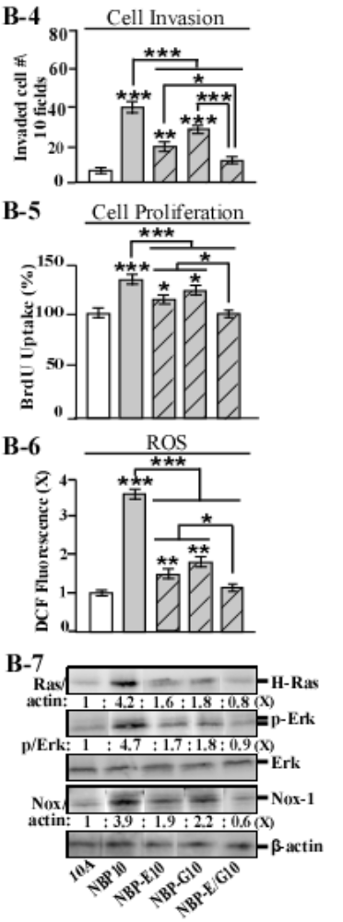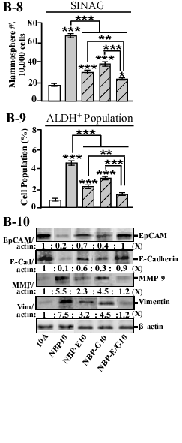
Figure 2.4
Intervention of NBP-induced carcinogenesis

CHAPTER 3

Reactive oxygen species-mediated breast cell carcinogenesis enhanced by multiple carcinogens and intervened by dietary ergosterol and mimosine
Research described in this chapter is a slightly modified version of an article that has been submitted for publication in Free Radical Biology and Medicine by Lenora Ann Pluchino, Amethyst Kar-Yin Liu and Hwa-Chain Robert Wang

Lenora Ann Pluchino, Amethyst Kar-Yin Liu and Hwa-Chain Robert Wang. Reactive oxygen species-mediated breast cell carcinogenesis enhanced by multiple carcinogens and intervened by dietary ergosterol and mimosine. (Free Radical Biology and Medicine, Submitted June 2014).

In this paper “our” and “we” refers to me and co-authors. My contribution in the paper includes
(1) Selection of the topic (2) Compiling and interpretation of the literature (3) Designing experiments (4) understanding the literature and interpretation of the results (5) providing comprehensive structure to the paper (6) Preparation of the graphs and figures (7) Writing and editing

Abstract
Most breast cancers occur sporadically due to long-term exposure to low doses of carcinogens present in the polluted environment and diet. American lifestyles involve frequent exposures to smoke, polluted air and high temperature-cooked meats comprising multiple carcinogens, such as 4-(methylnitrosamino)-1-(3-pyridyl)-1-butanone (NNK), benzo[α]pyrene (B[α]P), and 2-amino-1-methyl-6-phenylimidazo[4,5-b]pyridine (PhIP). However, whether these carcinogens may act together to enhance breast cell carcinogenesis is unclear. Here, we demonstrate that co-exposure to physiologically-achievable doses of NNK, B[α]P, and PhIP (NBP) holistically enhanced initiation and progression of breast cell carcinogenesis. Reactive oxygen species (ROS) and ERK pathway activation were transiently induced by each NBP exposure, and cross-talk between reinforced ROS elevation and ERK activation played an essential role in increased DNA oxidation and damage. After cumulative NBP exposures, this cross-talk contributed to enhanced initiation of cellular carcinogenesis and led to enhanced acquisition of cancer-associated properties. Using NBP-induced transient changes, such as ROS elevation and ERK pathway activation, and cancer-associated properties as targeted endpoints, we revealed, for the first time, that two less-studied dietary compounds, ergosterol and mimosine, at biologically-achievable non-cytotoxic levels, were highly effective in suppressing NBP-induced cellular carcinogenesis. Combined ergosterol and mimosine was more effective than individual agents in blocking NBP-induced transient endpoints, including ROS-mediated DNA oxidation, which accounted for its ability to suppress progression of NBP-induced cellular carcinogenesis. Thus, dietary components such as mushrooms containing ergosterol and legumes containing mimosine should be considered for affordable prevention of sporadic breast cancer associated with chronic exposure to environmental and dietary carcinogens.
Introduction
Breast cancer is the most common type of cancer and second-leading cause of cancer-related death among North American and European women [1]. Most breast cancers occur sporadically due to chronic exposure to multiple environmental carcinogens in a multi-step process that results in the transformation of breast cells from a non-cancerous stage to pre-cancerous and cancerous stages [2,3]. We have developed a chronically-induced breast cell carcinogenesis model to mimic sporadic breast cancer development associated with long-term exposure to low doses of carcinogens [4-9]. In this model, we repeatedly expose immortalized, non-cancerous, human breast epithelial cells to physiologically-achievable doses of carcinogens to progressively induce cellular acquisition of various cancer-associated properties for studies to reveal cellular, biochemical, and molecular changes. Then, we use these changes as targeted endpoints to identify preventive agents capable of intervening in cellular carcinogenesis [4-9].
The mammary carcinogen 2-amino-1-methyl-6-phenylimidazo[4,5-b]pyridine (PhIP) is the most abundant heterocyclic amine produced in high-temperature cooked meat, and circulating plasma levels of PhIP can reach nanomolar levels in humans following cooked meat consumption [10]. In rats, gastric administration of PhIP induces mammary tumors [11]. In addition, epidemiological studies have indicated a close association between well-done meat consumption and human breast cancer risk [12,13]. The tobacco-specific nitrosamine ketone 4-(methylnitrosamino)-1-(3-pyridyl)-1-butanone (NNK) is widely accepted as a lung carcinogen and can be detected at picomolar concentrations in the body fluids of tobacco users [14]. Despite evidence that gastric administration into rats resulted in mammary tumor development [15], NNK is not recognized as a mammary carcinogen. Although the link between smoking and breast cancer is controversial, recent studies have indicated that exposure to tobacco smoke can increase breast cancer risk, especially in post-menopausal women [16,17]. Benzo[α]pyrene (B[α]P) is a polycyclic aromatic hydrocarbon in smoke produced from the incomplete combustion of organic materials, such as fossil fuels and tobacco [18]. B[α]P can be found at picomolar concentrations in human fat and liver [19] and is classified as a weak mammary carcinogen in humans [18,20,21]. American lifestyles involve frequent consumption of high-temperature cooked meats containing carcinogens such as PhIP and wide exposures to smoke and polluted air containing NNK and B[α]P. However, whether these carcinogens may act together to cause breast cell carcinogenesis needs to be verified.
Epidemiological and experimental evidence suggests that certain dietary compounds possess anticancer activities [3]. Ergosterol is a sterol that forms the major constituent of the fungal cell membrane [22]. Common dietary sources include mushrooms, morels, and truffles [22], as well as products made with yeasts such as soy sauce, bread, and beer [23-25]. Studies showed that ergosterol at micro-molar levels is cytotoxic against human breast cancer cell lines and a variety of other tumor cell lines [26,27]. In vivo studies identified ergosterol as a protective agent against the promotion of carcinogen-induced bladder tumors in rats [28] and tumor promotion in mice [29]. Mimosine is an alkaloid, non-proteinogenic amino acid found exclusively in tropical legumes of the Mimosa and Leucaena genera [30]. Mimosine is an iron chelator that inhibits DNA synthesis and causes cell cycle arrest in late G₁ phase [30]. Studies showed that micro-molar levels of mimosine inhibit proliferation of breast, lung, and ovarian cancer cell lines [31-33], and mimosine is effective in reducing xenograft development of human lung and pancreatic carcinoma cells by increasing the apoptotic index of cancer cells [34,35]. Although much research has focused on the use of high doses of ergosterol and mimosine to inhibit growth or induce apoptosis of cancer cells, little work has been undertaken to evaluate the ability of these agents, at non-cytotoxic levels, to prevent cellular carcinogenesis.
Given the ubiquitous nature of tobacco smoke, carbon exhaust, and cooked meat in modern societies, it is important to holistically examine the role of carcinogens, such as NNK, B[α]P, and PhIP, in induction of breast cell carcinogenesis to reveal associated mechanisms and targeted endpoints for intervention. Previously, we used our breast cell carcinogenesis model system to demonstrate the ability of NNK at100 pmol/L, B[α]P at 100 pmol/L, and PhIP at 10 nmol/L to individually induce initiation and progression of breast cell carcinogenesis [4,5,9]. NNK and B[α]P exhibited comparable abilities to induce cellular carcinogenesis, and combining NNK and B[α]P (NB) additively increased degrees of acquired cancer-associated properties, such as reduced dependence on growth factors and anchorage-independent growth, as well as stem-like cell- and epithelial-to-mesenchymal transition (EMT)-associated properties [6-9]. These measurable cancer-associated properties, acquired by cells after cumulative exposures to carcinogens, represent constitutive endpoints to reveal stages in the progress of cellular carcinogenesis from non-cancerous to premalignant and malignant stages. Using our model, we have also identified endpoints that are transiently induced by a single carcinogen exposure, such as DNA damage and increased cell proliferation, which play essential roles in induction of carcinogenesis and account for the mechanisms of initiation of cellular carcinogenesis during each carcinogen exposure [6,7,9]. Our model system enables us to develop a two-step strategy by also using these transient and constitutive endpoints as targets to identify preventive agents capable of blocking cellular carcinogenesis [5-9].
Herein, we describe use of our model system to elucidate the ability, and associated mechanisms, of NB to enhance PhIP-induced cellular carcinogenesis. We also used our model as a target system to demonstrate, for the first time, the ability, and associated mechanisms, of ergosterol and mimosine individually and in combination to suppress cellular carcinogenesis induced by combined NNK, B[α]P, and PhIP.

Materials and Methods
Cell cultures and reagents
MCF10A, MCF12A (American Type Culture Collection [ATCC], Rockville, MD) and derived cell lines were maintained in complete medium (CM) (1:1 DMEM/HAM's F12, 100 ng/mL cholera enterotoxin, 10 µg/mL insulin, 0.5 µg/mL hydrocortisol, 20 ng/mL epidermal growth factor, and 5% horse serum) [4-9]. All cultures were supplemented with 100 U/mL penicillin and 100 µg/mL streptomycin and maintained in 5% CO₂ at 37°C. Stock solutions of NNK (Chemsyn, Lenexa, KS), B[α]P (Aldrich, Milwaukee, WI), PhIP (Midwest; NCI Chemical Carcinogen Reference Standard Repository), U0126 (Cell Signaling, Beverly, MA), and CM-H₂DCF-DA (Invitrogen, Carlsbad, CA) were prepared in DMSO; ergosterol (Sigma-Aldrich, St. Louis, MO) was prepared in chloroform; N-acetyl-L-cysteine (NAC) (Alexis, San Diego, CA) was prepared in distilled water, and mimosine (Sigma-Aldrich) was prepared in distilled water with 10% NaOH. All were diluted in CM for assays.

Chronic induction of cellular carcinogenesis
Twenty-four hours after subculturing, human breast cells were treated with the indicated carcinogens and/or preventive agents for 48 h as one cycle of exposure for 5-20 cycles. Cells were subcultured every 3 days [4-9].
Cell viability
A methyl thiazolyl tetrazolium (MTT) assay kit (ATCC) was used to measure cell viability. A total of 5×10³ cells/well in 96-well culture plates were incubated with MTT reagent for 4 h, followed by incubation with detergent reagent for 24 h. Reduced MTT reagent in cultures was quantified with an ELISA reader (Bio-Tek) at 570 nm.

Reduced dependence on growth factors
A total of 5×10³ cells were seeded in 60-mm culture dishes and maintained in low-mitogen (LM) medium (1:1 DMEM/F12, 2 ng/mL cholera enterotoxin, 200 ng/mL insulin, 10 ng/mL hydrocortisol, 0.4 ng/mL epidermal growth factor, and 0.1% horse serum), containing reduced total serum and mitogenic additives to 2% of the concentration formulated in CM, for 10 days to develop cell colonies [4-9].

Anchorage-independent growth
A total of 1×10⁴ cells were mixed with soft agar consisting of 0.4% low-melting agarose (Fisher, Fair Lawn, NJ) in a mixture (1:1) of CM with 3-day conditioned medium prepared from MCF10A cultures, plated on top of a 2% low-melting agarose base layer in 60-mm culture dishes and maintained for 14 days to develop cell colonies [4-9].

Cell proliferation
Cell proliferation was determined using the 5-bromo-2-deoxyuridine (BrdU) cell
proliferation enzyme-linked immunosorbent assay (ELISA) kit (Roche, Indianapolis, IN); BrdU-
labeled cells were quantified using an ELISA reader (Bio-Tek, Winooski, VT), as described previously [4-9].

Serum-independent non-adherent growth
A total of 1×10⁴ cells were seeded on top of 1% agarose-coated, non-adherent 100-mm culture plates, incubated in serum-free CM supplemented with 0.4% bovine serum albumin and maintained for 10 days to develop mammospheres [8,9].

Aldehyde dehydrogenase (ALDH)
An ALDEFLUOR Kit (StemCell Technologies, Durham, NC) was used to detect ALDH-expressing cells by flow cytometry, as described previously [8.9]. Mean fluorescence intensity of cells was quantified using Multicycle software (Phoenix Flow System). Cells incubated with activated Aldefluor substrate BODIPY-aminoacetaldehyde (BAAA) in the presence of the ALDH inhibitor diethylaminobenzaldehyde (DEAB) were used to establish the baseline of fluorescence for determining the ALDH-expressing cell population (%) in which ALDH activity was not inhibited by DEAB.

In vitro cell invasion and migration
The in vitro cell invasion assay was performed using 24-well transwell insert chambers with an 8.0 µm pore size polycarbonate filter (Costar, Corning, NY). A total of 2×10⁴ cells in serum-free CM were seeded on top of a Matrigel-coated filter (BD Biosciences, Franklin Lakes, NJ) in each insert chamber. Insert chambers were then placed into wells on top of culture medium containing 10% horse serum as a chemoattractant. The in vitro migration assay was performed using 24-well Transwell insert chambers with a polycarbonate filter not coated in Matrigel. After 24 h, the migratory and invasive ability of cells was determined by the number of cells translocated to the lower side of filters [8,9].

Cell motility wound-healing
Cells were seeded in 6-well plates, grown to confluence in CM, rinsed with PBS and serum-starved for 15 h in DMEM/Ham’s F12 medium containing 2% horse serum. The monolayer was scratched with a 23-gauge needle (BD Biosciences) to generate wounds, rinsed with CM to remove floating cells, and then maintained in CM. The wounded areas were examined 6, 12 and 24 h after scratches to detect healing. The area not healed by the cells was subtracted from the total initial wound area to calculate the wound healing area at time intervals of 6 and 12 h, using Total Lab TL100 software (Total Lab, Newcastle, NE) [7,8].

Intracellular ROS
Cells were labeled with 5 µmol/L chloromethyl-dichlorodihydrofluorescein-diacetate (CM-H2DCF-DA) for 1 h to detect ROS by flow cytometry as described previously [4-9]. Mean fluorescence intensity of dichlorodihydrofluorescein (DCF) was quantified using Multicycle software (Phoenix Flow System, San Diego, CA).

DNA damage
DNA damage was detected using the comet assay [38]. A total of 2×10⁴ cells in cold phosphate-buffered saline (PBS) were mixed with 1% low-melting agarose (Fisher) and placed on agarose-coated slides. Slides were immersed in alkaline lysis solution (pH 13) at 25º C for 1 h, rinsed with alkaline buffer (pH>13), electrophoresed in the same buffer at 20 V for 30 min, stained with propidium iodide and examined with a fluorescence microscope (Carl Zeiss Inc., Thornwood, NY), as described previously [4-9]. Fifty nuclei per slide were scored for tail moment (% DNA in the tail × tail length) using CometScore software (Tritek, Sumerduck, VA).

DNA oxidation
DNA oxidation was detected using a modified comet assay [39]. In brief, after seeding cells onto agarose-coated slides, slides were immersed in neutral lysis solution (2.5 mol/L NaCl, 0.1 mol/L Na₂-EDTA and 10 mmol/L Tris, pH 8) and incubated with enzyme reaction buffer (40 mmol/L HEPES, 0.1 mol/L KCl, 0.5 mmol/L Na₂-EDTA and 0.2 mg/mL BSA, pH 8) buffer with and without formamidopyrimidine (fapy)-DNA glycosylase (Fpg) enzyme. Slides were then placed in alkaline buffer, electrophoresed in alkaline buffer, rinsed with neutralization buffer (0.4 mol/L Tris, pH 7.5), stained with propidium iodide, and examined with a fluorescence microscope, as described above.

Reverse-transcription PCR
Total RNA isolated from cultures using the Absolutely RNA kit (Stratagene, La Jolla, CA) was reverse transcribed to complementary DNA using the Verso cDNA Kit (Thermo Scientific, Waltham, MA). The resulting cDNAs were subjected to PCR for H-Ras (forward: 5’-GACGGAATATAAGCTGGTGG-3’; reverse: 5’-AGGCACGTCTCCCCATCAAT-3’) and β-actin (forward: 5’-GGACTTCGAGCAAGAGATGG-3’; reverse: 5’-AGCACTGTGTTGGCGTACG-3’). PCR products were electrophoresed on agarose gels and visualized using ethidium bromide staining.

Immunoblotting
Cell lysates were prepared and protein concentrations were measured using the BCA assay (Pierce, Rockford, IL), as described previously [4-9]. Equal amounts of cellular proteins were resolved by electrophoresis in 8%, 10% or 12% sodium dodecyl sulfate-polyacrylamide gels and transferred to nitrocellulose membranes for immunoblotting, using specific antibodies to detect H-Ras, Raf-1, phosphorylated Erk1/2 (p-Erk1/2), Erk1/2, Nox-1, EpCAM, E-cadherin, MMP-9, Vimentin, β-actin (Santa Cruz Biotechnology, Santa Cruz, CA), p-Raf-1, p-Mek1/2 and Mek1/2 (Cell Signaling). Antigen-antibody complexes on membraness were detected by the Supersignal chemiluminescence kit (Pierce).

Statistical analysis
The Student t test was used to analyze statistical significance, indicated by * P<0.05,
**P<0.01, and *** P<0.001; a P value <0.05 was considered significant.

Results
Exposure-dependent enhancement of cancer-associated properties by combined carcinogens
To investigate the ability of combined NNK and B[α]P (NB) to enhance PhIP-induced breast cell carcinogenesis, we repeatedly exposed MCF10A cells to PhIP in the absence and presence of NB for 5, 10, 15, and 20 cycles. Then, we measured the degrees of two acquired cancer-associated properties to assess the progression of cellular carcinogenesis. Growth factors and cellular adhesion to the extracellular matrix are required for normal epithelial cell survival; in contrast, cancerous cells acquire a reduced dependence on growth factors (RDGF) and anchorage-independent growth (AIG) to increase aberrant survival [40]. As shown in Figures 3.1A-1 and 3.1A-2, cumulative exposures to individual or combined NB and PhIP resulted in increasing acquisition of RDGF and AIG in an exposure-dependent manner. NB and PhIP exhibited comparable abilities to induce cellular acquisition of these cancer-associated properties; combined NB and PhIP (NBP) exhibited significantly higher abilities than individual agents to increase acquisition of these properties.
To further understand the exposure-dependent nature of NBP-induced carcinogenesis, we established MCF10A-NBP5, -NBP10, -NBP15, and -NBP20 cell lines resulting from repeated exposures of MCF10A cells to NBP for 5, 10, 15, and 20 cycles, respectively. We investigated additional cancer-associated properties acquired by these NBP-induced cell lines and used the MCF10A-Ras cell line [41], in which oncogenic H-Ras is ectopically expressed in MCF10A cells, as a malignant control. ROS elevation and increased cell proliferation are closely associated with cellular transformation [40]. As shown in Figures 3.1B-1 and 3.1B-2, cumulative exposure to NBP resulted in increased ROS elevation and cell proliferation in these cell lines in an exposure-dependent manner. Upregulation of the Ras-ERK pathway contributes to increased cell proliferation and leads to expression of NADPH oxidase-1 (Nox-1), which mediates non-mitochondrial production of ROS [42]. We detected that H-Ras gene expression was increasingly upregulated by cumulative exposures to NBP (Figure 3.1B-3); H-Ras protein level, phosphorylation of downstream kinases Raf-1, Mek1/2, and Erk1/2, as well as Nox-1 expression were accordingly upregulated in these cells (3.1B-4). These results indicate that the Ras-ERK-Nox pathway was activated in concert with progression of NBP-induced breast cell carcinogenesis.
Stem-like cells and the EMT program play important roles in various stages of cancer development [40]. Our previous studies suggested that acquisition of stem-like cell- and EMT-associated properties is associated with breast cell carcinogenesis [8,9]. Mammary stem-like cells have a unique ability to form discrete non-adherent mammospheres and have high levels of aldehyde dehydrogenase (ALDH) activity [43,44]. As shown in Figures 3.1B-5 and 3.1B-6, both the number of mammospheres and the population of ALDH-positive cells were progressively increased by cumulative exposures to NBP. The ability to develop stem-like cells is associated with activation of the EMT program, which confers cells with mesenchymal properties such as increased migration and invasion [40]. As shown in Figure 3.1B-7, the epithelial cell markers EpCAM and E-cadherin and the EMT markers MMP-9 and Vimentin were reduced and increased, respectively, in concert with NBP-induced cellular carcinogenesis and increased stem-like cell populations. In addition, the EMT-associated properties of cell migration (3.1B-8) and invasion (3.1B-9) were also accordingly increased. These results, taken together, indicate that cumulative exposures to physiologically-achievable doses of NB and PhIP in combination were able to enhance cellular acquisition of cancer-associated properties, including stem-like and mesenchymal cell properties, in an exposure-dependent manner.

Enhanced initiation of cellular carcinogenesis by combined carcinogens
To investigate the mechanisms of NB in enhancing PhIP-induced cellular carcinogenesis, we studied the ability of NB, PhIP, and NBP to induce transient endpoints that are essential for induction of cellular carcinogenesis in a single exposure [7,9]. We detected that a single NBP exposure induced higher levels of DNA damage (Figure 3.2A-1), ROS elevation (3.2A-2), cell proliferation (3.2A-3), Ras gene upregulation (3.2A-4), Ras-ERK activation, and Nox-1 upregulation (3.2A-5) than either NB or PhIP. These results indicate that co-exposure to NB enhanced the ability of PhIP to induce these transient endpoints. It has been reported that ROS elevation may lead to activation of the ERK pathway, and activation of the ERK-Nox pathway induces ROS elevation [42,45,46]. To elucidate whether ROS elevation and the ERK-Nox pathway interplayed during NB-, PhIP-, and NBP-initiated cellular carcinogenesis, we studied the time course of ROS elevation and ERK pathway activation. We detected that NB, PhIP, and NBP induced distinct profiles of ROS elevation (Figure 3.2B-1 & 3.2B-2) and ERK pathway activation (3.2C-1 & 3.2C-2). NBP exposure promptly induced ROS to maximal levels in 6 hr, while NB and PhIP progressively induced ROS to maximal levels in 12 and 24 hr, respectively; NBP induced significantly higher levels of ROS than NB or PhIP (3.2B-1 & 3.2B-2). These carcinogens induced ERK activation reaching maximal levels by 24 hr; however, NBP induced higher degrees of ERK activation than either NB or PhIP (3.2C-1 & 3.2C-2). These results indicate that NB and NBP induced ROS elevation prior to ERK pathway activation, and PhIP induced ROS elevation and ERK activation in parallel; both Nox-dependent and -independent ROS elevations were involved in initiation of cellular carcinogenesis by NB, PhIP, and NBP. Co-exposure to NB not only significantly increased but also accelerated PhIP-induced ROS elevation and ERK pathway activation. These data suggest that ROS elevation and the ERK-Nox pathway may interplay during initiation of cellular carcinogenesis.

ROS and the Ras-ERK pathway in initiation and maintenance of cellular carcinogenesis
To address whether ROS elevation cross-talked with the ERK pathway, we used the Mek1/2 inhibitor U0126 to block ERK pathway (Figure 3.3A-1) and the general antioxidant N-acetyl-L-cysteine (NAC) to block ROS (3.3A-2). Treatment with U0126 blocked NB-, PhIP-, and NBP-induced ERK activation and Nox-1 elevation, but did not significantly affect H-Ras expression (3.3A-1). U0126 treatment failed to reduce NB-induced ROS elevation but significantly reduced PhIP- and NBP-induced ROS (3.3A-2), indicating the role of ERK activation in ROS elevation induced by PhIP and NBP, but not NB. NAC treatment reduced NB-, PhIP-, and NBP-induced H-Ras expression, ERK activation, and Nox-1 elevation (3.3A-1), indicating the role of ROS elevation in activation of the Ras-ERK-Nox pathway by all these carcinogens. Accordingly, ROS elevation and the ERK pathway mutually interplayed in the initiation of cellular carcinogenesis induced by PhIP or NBP; in contrast, ROS elevation led to ERK activation during NB-initiated carcinogenesis. Blockage of either ROS elevation or ERK pathway activation significantly suppressed cell proliferation and DNA damage induced by all these carcinogens (Figure 3.3A-3 & 3.3A-4), indicating that ROS elevation and ERK pathway activation were essential for increased cell proliferation and DNA damage during the initiation of cellular carcinogenesis by NB, PhIP, and NBP. However, how ROS elevation results in ERK pathway activation by NB remains to be investigated.
To validate the roles of ROS elevation and ERK pathway activation in the progression of cellular carcinogenesis, we repeatedly exposed MCF10A cells to NB, PhIP, or NBP in the absence and presence of U0126 or NAC for 10 cycles. Blockage of either the ERK pathway or ROS elevation in each cycle resulted in significant suppression of cellular acquisition of RDGF, AIG, cell migration, and invasion after accumulated exposures (Figures 3.3B-1 to 3.3B-4). These results indicate that inhibition of either the ERK pathway or ROS elevation in each exposure cycle effectively blocked progression of carcinogenesis induced by cumulative exposures to carcinogens.

Ergosterol and mimosine intervened in cellular carcinogenesis
Co-exposure to NB was able to significantly enhance PhIP’s ability to induce cellular carcinogenesis. Identifying dietary agents effective in intervention of NBP-induced cellular carcinogenesis is an affordable option for prevention of breast cancer. Considering the toxicity resulting from long-term use of anticancer agents, use of dietary agents at non-cytotoxic levels should be adopted as the key strategy for cancer prevention. In searching for optimal dietary agents, we detected that ergosterol and mimosine were effective in suppressing NBP-induced cellular carcinogenesis. Initially, by measuring the effects of various concentrations of ergosterol and mimosine individually on MCF10A cell viability, we determined the non-cytotoxic concentrations of ergosterol at ≤1 µmol/L and mimosine at ≤5 µmol/L (Figures 3.4A-1 to 3.4A-2). Subsequently, we determined that a combination of ≤0.5 µmol/L ergosterol and ≤0.5 µmol/L mimosine was not cytotoxic to MCF10A cells (Figure 3.4A-3). Studies indicated physiologically-achievable doses of ergosterol and mimosine at nano-molar levels [36,37]. Accordingly, we used 10 nmol/L ergosterol, 10 nmol/L mimosine, and combined 5 nmol/L ergosterol and 5 nmol/L mimosine to determine their ability to intervene in NBP-induced cellular carcinogenesis. Using NBP-induced transient endpoints as targets, we detected that ergosterol or mimosine was able to suppress NBP-induced DNA damage (Figure 3.5A-1), ROS elevation (3.5A-2), cell proliferation (3.5A-3), and Ras-ERK-Nox pathway activation (3.5A-4); a combination of ergosterol and mimosine completely blocked these NBP-induced transient endpoints. To validate the ability of ergosterol and mimosine to intervene with progression of carcinogenesis induced by cumulative exposures to NBP, we repeatedly exposed MCF10A cells to NBP in the absence and presence of ergosterol and mimosine individually and in combination for 10 cycles. Exposure to either ergosterol or mimosine simultaneously with NBP significantly reduced cellular acquisition of RDGF (Figure 3.5B-1), AIG (3.5B-2), ROS elevation (3.5B-3), increased cell proliferation (3.5B-4), and Ras-ERK-Nox pathway activation (3.5B-5). Exposure to either ergosterol or mimosine also significantly reduced mammosphere formation (3.5B-6), ALDH-positive cell population (3.5B-7), and the EMT-associated markers MMP-9 and Vimentin (3.5B-8), as well as decreased the EMT- and cancer-associated properties of cell migration (3.5B-9), invasion (3.5B-10), and motility (3.5C-1 & 3.5C-2). Combined ergosterol and mimosine was more effective than either agent in suppressing these properties and appeared to completely suppress cellular acquisition of all cancer-associated properties (3.5B-1 to 3.5B-10, 3.5C-1 & 3.5C-2). Thus, ergosterol plus mimosine appeared to be the optimal combination for intervention of cellular carcinogenesis induced by long-term exposure to NBP.
Ergosterol and mimosine suppressed oxidative DNA damage induced by carcinogens
DNA damage, resulting from ROS-mediated oxidation, is an underlying cause of cellular carcinogenesis [40,47]. ROS elevation was essential for initiation of NBP-induced cellular carcinogenesis. To further understand if ROS-mediated oxidation of DNA was involved in DNA damage induced by carcinogens, we used the repair endonuclease Fpg. Fpg removes oxidized DNA bases to cause broken strands that are detectable with a modified comet assay [39]. We detected that DNA oxidation was induced in concert with DNA damage induced by NNK, B[α]P, NB, PhIP, and NBP (Figure 3.6A-1 & 3.6A-2); blockage of ROS elevation by NAC suppressed DNA oxidation (3.6B-1 & 3.6B-2), indicating that ROS-mediated oxidation of DNA was involved in carcinogen-induced DNA damage.
Both ergosterol and mimosine were able to reduce NBP-induced ROS elevation and DNA damage. To determine if ergosterol and mimosine were able to block carcinogen-induced DNA oxidation, we treated cells with carcinogens in the absence and presence of ergosterol and/or mimosine. We detected that combined ergosterol and mimosine was more effective than individual agents in suppression of DNA damage, ROS elevation, and DNA oxidation induced by carcinogens (Figures 3.6C-1 to 3.6C-3). These results indicate the antioxidant ability of ergosterol and mimosine to protect chromosomal DNA from oxidative damage in cells during exposure to NNK, B[α]P, and PhIP.

Induction of cellular carcinogenesis in MCF12A cells and suppression by ergosterol and mimosine
To investigate whether the ability of NB to enhance PhIP-induced cellular carcinogenesis and the effectiveness of ergosterol and mimosine in intervention of breast cell carcinogenesis were limited to the estrogen receptor (ER)-negative MCF10A cell line, we performed studies on the non-cancerous human breast epithelial ER-positive MCF12A cell line, which is unrelated to MCF10A cells. Based on the results of non-cytotoxic concentrations of ergosterol and mimosine on MCF12A cells (Figures 3.4B-1 to 3.4B-3), we again used 10 nmol/L ergosterol, 10 nmol/L mimosine, and combined 5 nmol/L ergosterol and 5 nmol/L mimosine. Consistently, NB co-exposure enhanced PhIP-induced transient endpoints of DNA damage, ROS elevation, cell proliferation, and Ras-ERK-Nox pathway in MCF12A cells in a single cycle and combined ergosterol and mimosine were more effective than individual agents in suppression of these transient endpoints (Figures 3.7A-1 to 3.7A-4). After 20 cycles of exposure, we detected that cells exposed to NBP acquired significantly higher degrees of all the measured cancer-associated properties than cells exposed to either NB or PhIP; these cancer-associated properties included RDGF, AIG, ROS elevation, increased cell proliferation, Ras-ERK-Nox pathway activation, mammosphere formation, enriched stem-like cell population, EMT markers, cell migration, and cell invasion (Figures 3.7B-1 to 3.7B-10). To verify the ability of ergosterol and mimosine to intervene in NBP-induced cancer-associated properties, we repeatedly exposed MCF12A cells to NBP in the absence and presence of ergosterol and mimosine individually and in combination for 10 cycles. We detected that combined ergosterol and mimosine was more effective than either agent in suppressing NBP-induced cancer-associated properties, and combined ergosterol and mimosine completely suppressed cellular acquisition of cancer-associated properties induced by cumulative exposures to NBP (Figures 3.7B-1 to 3.7B-10). Thus, the ability of co-exposure to NB to enhance PhIP-induced cellular carcinogenesis and the ability of ergosterol and mimosine to intervene in breast cell carcinogenesis were not cell line-dependent.

Discussion
In this communication, we demonstrated that cumulative co-exposures to physiologically-achievable levels of multiple environmental and dietary carcinogens resulted in enhanced breast cell carcinogenesis. Nano-molar PhIP and pico-molar NNK and B[α]P are physiologically achievable in the human body [10,14,19]. Our model system permits a highly relevant approach to determine mechanisms involved in the development of sporadic breast cancer associated with long-term exposure to low doses of carcinogens existing in our environment and diets. The findings then can be used as targets for identifying preventive agents effective in intervention of cancer development.
ROS elevation and ERK pathway activation appeared to play key roles in NBP-induced cellular carcinogenesis. NB and PhIP induced distinct elevation kinetics of ROS, and NB-exposed cells reached maximal ROS level earlier than PhIP-exposed cells. Co-exposure to NB and PhIP not only accelerated but also significantly increased ROS elevation in cells. It is recognized that ROS are actively mutagenic and contribute to genomic instability that is necessary for cellular carcinogenesis [40]. Conversely, NB and PhIP induced similar activation kinetics of the ERK pathway and combined NB and PhIP resulted in enhanced activation of the ERK pathway over NB or PhIP alone. ROS elevation and the ERK pathway were mutually dependent; blockage of one resulted in suppression of the other. Our previous studies suggested that NB exposure induces ROS elevation leading to ERK pathway activation [7] and that PhIP induces Ras-ERK-Nox pathway activation resulting in ROS production [9]. Accordingly, co-exposure to NB and PhIP induced both ROS to the ERK-Nox pathway and the ERK-Nox pathway to ROS elevation simultaneously, resulting in reinforced, accelerated and enhanced ROS elevation. The accelerated and increased ROS levels induced higher levels of DNA oxidation and damage in each exposure cycle, contributing to enhanced initiation of cellular carcinogenesis and leading to enhanced acquisition of cancer-associated properties by cells after cumulative NBP exposure cycles. Combined NB and PhIP enhanced cellular acquisition of all the cancer-associated properties we tested, including stem-like and mesenchymal cell properties. However, whether co-exposure to NB and PhIP may enhance cellular tumorigenicity and mammary tumor development in animals, as well as human breast cancer development, remains to be determined.
In our model system, we use transient and constitutive endpoints as targets to validate preventive agents capable of blocking carcinogenesis initiation and suppressing carcinogenesis progression, respectively [5-9]. In this communication, we identified two less studied agents, ergosterol and mimosine, capable of intervening with NBP-induced breast cell carcinogenesis. Both ergosterol and mimosine, at physiologically-achievable non-cytotoxic levels, were effective in blocking ROS elevation, Ras-ERK-Nox pathway activation, DNA oxidation, DNA damage, and cell proliferation induced by a single NBP exposure, which accounted for their ability to suppress constitutive endpoints induced by cumulative NBP exposures. The combination of ergosterol and mimosine was more effective than individual agents in blocking transient and constitutive endpoints. Combined ergosterol and mimosine, used at 5 nmol/L each, was more effective than individual agents used at 10 nmol/L, indicating that these two agents may act synergistically in suppression of transient and constitutive properties. It has been suggested that prevention strategies making use of combined dietary agents are advantageous over those using individual agents due to higher efficacy and lower toxicity [48]. In addition, considering our previous [6-9] and current results, combined ergosterol and mimosine appeared to be more effective and less cytotoxic than green tea catechins for intervention of breast cell carcinogenesis induced by NB and PhIP. Thus, ergosterol and mimosine should be seriously considered in dietary prevention of sporadic breast cancer associated with long-term exposure to multiple environmental and dietary carcinogens.
Over 85% of breast cancers are sporadic and attributable to long-term exposure to small quantities of carcinogens [2,3]. Long-term exposure to polluted air, smoke, and diets with high-temperature cooked meats are closely associated with American lifestyles [10,16,20]. In this communication, we demonstrated that co-exposure to the environmental carcinogens NNK and B[α]P with the dietary carcinogen PhIP resulted in holistically enhanced initiation and progression of breast cell carcinogenesis. Using our model as a target, we demonstrated, for the first time, that a combination of two less recognized dietary constituents, ergosterol and mimosine, was highly effective in intervention of breast cell carcinogenesis. Notably, NNK/B[a]P/PhIP-enhanced cellular carcinogenesis and ergosterol/mimosine-mediated intervention were independent of breast cell type and ER status. Ergosterol is rich in dietary sources, such as mushrooms, morels, and soy sauce, which are readily available in the United States [22,23,49]. Mimosine-containing legumes are consumed daily throughout Southeast Asia and Central America [50]. Thus, dietary components containing ergosterol and mimosine should be seriously considered in the American diet for affordable prevention of sporadic breast cancer. However, the roles of long-term human exposure to combined low-dose NNK, B[α]P, and PhIP in enhanced sporadic breast cancer development and combined use of ergosterol- and mimosine-containing dietary components in breast cancer intervention will need epidemiological and clinical studies for validation.
LIST OF REFERENCES
- Bray F, Ren JS, Masuyer E, Ferlay J (2013) Global estimates of cancer prevalence for 27 sites in the adult population in 2008. Int J Cancer 132: 1133–1145.
- DeBruin LS, Josephy PD (2002) Perspectives on the chemical etiology of breast
cancer. Environ Health Perspect 110 Suppl 1: 119-128.
- Kelloff GJ, Hawk ET, Sigman CC (2005) Cancer chemoprevention: strategies for cancer chemoprevention. Vol 2. Totowa, New Jersey: Human Press. 528 p.
- Siriwardhana N, Wang HC (2008) Precancerous carcinogenesis of human breast epithelial cells by chronic exposure to benzo[a]pyrene. Mol Carcinogenesis 47: 338–48.
- Siriwardhana N, Choudhary S, Wang HC (2008) Precancerous model of human breast epithelial cells induced by the tobacco-specific carcinogen NNK for prevention. Breast Cancer Res Treat 109: 427–441.
- Rathore K, Wang HC (2012) Green tea catechin extract in intervention of chronic breast cell carcinogenesis induced by environmental carcinogens. Mol Carcinogenesis 51: 280-289.
- Rathore K, Choudhary S, Odoi A, Wang HC (2012) Green tea catechin intervention of reactive oxygen species-mediated ERK pathway activation and chronically induced breast cell carcinogenesis. Carcinogenesis 33: 174-183.
- Rathore K, Wang HC (2013) Mesenchymal and stem-like cell properties targeted in suppression of chronically-induced breast cell carcinogenesis. Cancer Lett 333: 113-123.
- Choudhary S, Sood S, Donnell RL, Wang HC (2012) Intervention of human breast cell carcinogenesis chronically induced by 2-amino-1-methyl-6-phenylimidazo-[4,5-b] pyridine. Carcinogenesis 33: 876-885.
- Gooderham NJ, Creton S, Lauber SN, Zhu H (2007) Mechanisms of action of the carcinogenic heterocyclic amine PhIP. Toxicol Lett 168: 269-277.
- Imaida K, Hagiwara A, Yada H, Masui T, Hasegawa R, et al. (1996) Dose-dependent induction of mammary carcinomas in female Sprague-Dawley rats with 2-amino-1-methyl-6-phenylimidazol[4,5-b]pyridine. Jpn J Cancer Res 87: 1116-1120.
- Zheng W, Gustafson DR, Sinha R, Cerhan JR, Moore D, et al. (1998) Well-done meat intake and the risk of breast cancer. J Natl Cancer Inst 90: 1724-1729.
- Sinha R, Gustafson DR, Kulldorff M, Wen WQ, et al. (2000) 2-amino-1-methyl-6-phenylimidazo[4,5-b]pyridine, a carcinogen in high-temperature-cooked meat, and breast cancer risk. J Natl Cancer Inst 92: 1352-1354.
- Hecht SS, Carmella SG, Chen M, Dor Koch JF, Miller AT, et al. (1999) Quantitation of urinary metabolites of a tobacco-specific lung carcinogen after smoking cessation. Cancer Res 59: 590-596.
- Ohnishi T, Fukamachi K, Ohshima Y, Jiegou X, Ueda S, et al. (2007) Possible application of human c-Ha-ras proto-oncogene transgenic rats in a medium-term bioassay model for carcinogens. Toxicol Pathol 35: 436-443.
- Luo J, Margolis KL, Wactawski-Wende J, Horn K, Messina C, et al. (2011) Association of active and passive smoking with risk of breast cancer among postmenopausal women: A prospective cohort study. BMJ 342: d1016.
- Hartz AJ, He T (2013) Cohort study of risk factors for breast cancer in post-menopausal women. Epidemiol Health 35: e2013003.
- Morris JJ, Seifter E (1992) The role of aromatic hydrocarbons in the genesis of breast cancer. Med Hypotheses 38: 177-184.
- Obana H, Hori S, Kashimoto T, Kunita N (1981) Polycyclic aromatic hydrocarbons in human fat and liver. Bull Environ Contam Toxicol 27: 23-27.
- Rundle A, Tang D, Hibshoosh H, Estabrook A, Schnabel F, et al. (2000) The relationship between genetic damage from polycyclic aromatic hydrocarbons in breast tissue and breast cancer. Carcinogenesis 21: 1281-1289.
- Gammon MD, Sagiv SK, Eng SM, Shantakumar S, Gaudet MM, et al. (2004) Polycyclic aromatic hydrocarbon-DNA adducts and breast cancer: a pooled analysis. Arch Environ Health 59: 640-649.
- Kalac P (2013) A review of chemical composition and nutritional value of wild-growing and cultivated mushrooms. J Sci Food Agric 93: 209-218.
- Shurtleff W, Aoyagi A (2012) History of soy sauce (160 CE to 2012). Soyinfo Center; Lafayette, CA.
- Young JC, Games DE (1993) Supercritical fluid extraction and supercritical fluid chromatography of the fungal metabolite ergosterol. J Agric Food Chem 41: 577-581.
- Jedličková L, Gadas D, Havlová P, Havel J (2008) Determination of Ergosterol Levels in Barley and Malt Varieties in the Czech Republic via HPLC. J Agric Food Chem 56: 4092-4095.
- Bok JW, Lermer L, Chilton J, Klingeman HG, Towers NGH (1999) Antitumor sterols from the mycelia of Cordyceps sinensis. Phytochemistry 51: 891-898.
- Ma L, Chen H, Dong P, Lu X (2013) Anti-inflammatory and anticancer activities of extracts and compounds from the mushroom Inonotus obliquus. Food Chem 139: 503-508.
- Yazawa Y, Yokota M, Sugiyama K (2000) Antitumor promoting effect of an active component of Polyporus, ergosterol and related compounds on rat urinary bladder carcinogenesis in a short-term test with concanavalin A. Biol Pharm Bull 11: 1298-1302.
- Yasukawa K, Takashi A, Takido M, Ikekawa T, Saito H, et al. (1994) Inhibitory effects of ergosterol isolated from the edible mushroom Hypsizigus marmoreus on TPA-induced inflammatory ear edema and tumour promotion in mice. Phytother Res 8:10-13.
- Singh B, Bhat TK (2003) Potential therapeutic applications of some antinutritional plant secondary metabolites. J Agric Food Chem 51: 5579-5597.
- Chang HC, Lee TH, Chuang LY, Yen MH, Hung WC (1999) Inhibitory effect of mimosine on proliferation of human lung cancer cells is mediated by multiple mechanisms. Cancer Lett 145: 1-8.
- Restivo A, Brard L, Granai CO, Swamy N (2005) Antiproliferative effect of mimosine in ovarian cancer. J Clin Oncol 23: 3200.
- Kulp KS, Vulliet PR (1996) Mimosine blocks cell cycle progression by chelating iron in asynchronous human breast cancer cells. Toxicol Appl Pharmacol 139: 356-364.
- Chang HC, Weng CF, Yen MH, Chuang LY, Hung WC (2000) Modulation of cell cycle regulatory protein expression and suppression of tumor growth by mimosine in nude mice. Int J Oncol 17: 659-665.
- Zalatnai A, Bocsi J (2003) Mimosine, a plant-derived amino acid induces apoptosis in human pancreatic cancer xenografts. Anticancer Res 23: 4007-4009.
- Zhao YY, Cheng XL, Liu R, Ho CC, Wei F, et al. (2011) Pharmacokinetics of ergosterol in rats using rapid resolution liquid chromatography–atmospheric pressure chemical ionization multi-stage tandem mass spectrometry and rapid resolution liquid chromatography/tandem mass spectrometry. J Chromatogr B 879: 1945-1953.
- El Harith EA, Mohme H, ter Meulen U, Bartha M, Gunther KD (1980) Effects of mimosine on some serum enzyme activities in rats. J Anim Physiol Anim Nutr 46: 255-263.
- Olive PL, Banath JP (2006) The comet assay: a method to measure DNA damage in individual cells. Nat Protoc 1: 23–29.
- Collins AR, Duthie SJ, Dobson VL (1993) Direct enzymic detection of endogenous oxidative base damage in human lymphocyte DNA. Carcinogenesis 14: 1733-1735.
- Hanahan D, Weinberg R (2011) Hallmarks of cancer: The next generation. Cell 144: 646-674.
- Datta S, Hoenerhoff MJ, Bommi P, Sainger R, Guo W-J, et al. (2007) Bmi-1 cooperates with H-Ras to transform human mammary epithelial cells via dysregulation of multiple growth-regulatory pathways. Cancer Res 67: 10286–10295.

Adachi Y, Shibai Y, Mitsushita J, Shang WH, Hirose K, et al. (2008) Oncogenic Ras upregulates NADPH oxidase 1 gene expression through MEK-ERK-dependent phosphorylation of GATA-6. Oncogene 27: 4921-4932.
- Dontu G, Abdallah WM, Foley JM, Jackson KW, Clarke MF (2003) In vitro propagation and transcriptional profiling of human mammary stem/progenitor cells. Genes Dev 17: 1253-1270.
- Ginestier C, Hur MH, Charafe-Jauffret E, Monville F, Dutcher J, et al. (2007) ALDH1 is a marker of normal and malignant human mammary stem cells and a predictor of poor clinical outcome. Cell Stem Cell 1: 555-567.

Ferro E, Goitre L, Retta SF, Trabalzini L (2012) The interplay between ROS and Ras GTPases: Physiological and pathological implications. J Signal Transduct 365769.
- Keshari RS, Verma A, Barthwal MK (2013) Reactive oxygen species-induced activation of ERK and p38 MAPK mediates PMA-induced NETs release from human neutrophils. J Cell Biochem 114: 532-540.
- Cooke MS, Evans MD, Dizdaroglu M, Lunec J (2003) Oxidative DNA damage: mechanisms, mutation, and disease. FASEB J 17: 1195-1214.

Ohigashi H, Murakami A (2004) Cancer prevention with food factors: alone and in combination. Biofactors 22: 49-55.

Li J, Zou L, Chen W, Zhu B, Shen N, et al. (2014) Dietary mushroom intake may reduce the risk of breast cancer: evidence from a meta-analysis of observational studies. PLoS One 9: e93437.
- Rushkin FR (1984) Leucaena: promising forage and tree crops for the tropics. 2nd ed, National Research Council. National Academy Press, Washington, DC.

APPENDIX

Figure 3.1. Exposure-dependent enhancement of cancer-associated properties by combined carcinogens. (A-1 and A-2) MCF10A (10A) cells were repeatedly exposed to combined 100 pmol/L NNK and 100 pmol/L B[α]P (NB), 10 nmol/L PhIP (P), or combined NB and PhIP (NBP) for 5, 10, 15 and 20 cycles. (B-1 to B-9) MCF10A (10A) cells were repeatedly exposed to combined NB and PhIP (NBP) for 5, 10, 15 and 20 cycles resulting in the NBP5, NBP10, and NBP15 and NBP20 cell lines, respectively. MCF10A-Ras (Ras) cells were used as a malignant control. (A-1) To determine cellular acquisition of reduced dependence on growth factors (RDGF), cells were maintained in LM medium for 10 days. Cell colonies ≥0.5 mm diameter were counted. (A-2) To determine cellular acquisition of anchorage-independent growth (AIG), cells were seeded in soft agar for 14 days. Cell colonies ≥0.1 mm diameter were counted. (B-1) ROS levels were measured with CM-H2DCF-DA labeling and normalized by the level determined in untreated cells, set as 1 (X, arbitrary unit). (B-2) Relative cell proliferation was determined and normalized by the value of BrdU detected in untreated cells, set as 100%. (B-3) Total RNA was isolated and analyzed by RT-PCR with specific primers to determine relative gene expression levels of H-Ras, with β-actin as a control, and these levels were quantified by densitometry. The levels of H-Ras (Ras/actin) were calculated by normalizing with the level of β-actin and the level set in untreated control cells as 1 (X, arbitrary unit). (B-4) Cell lysates were prepared and analyzed by western immunoblotting using specific antibodies to detect levels of H-Ras, phosphorylated-Raf-1 (p-Raf-1), Raf-1, p-Mek1/2, Mek1/2, p-Erk1/2, Erk1/2, and Nox-1, with β-actin as a control, and these levels were quantified by densitometry. The levels of H-Ras (Ras/actin) and Nox-1 (Nox/actin) were calculated by normalizing with the level of β-actin and the level set in untreated control cells as 1 (X, arbitrary unit). Levels of specific phosphorylation of Raf-1 (p/Raf), Mek1/2 (p/Mek) and Erk1/2 (p/Erk) were calculated by normalizing the levels of p-Raf-1, p-Mek1/2 and p-Erk1/2 with the levels of Raf-1, Mek1/2 and Erk1/2, respectively, then the level set in control cells as 1 (X, arbitrary unit). (B-5) To determine cellular acquisition of serum-independent non-adherent growth (SINAG), cells were seeded in non-adherent cultures for 10 days. Mammospheres ≥0.1 mm diameter were counted. (B-6) Mammospheres were collected and trypsinized, and ALDH-expressing (ALDH⁺) cell population (%) was measured by flow cytometry. (B-7) Cell lysates were prepared and analyzed by western immunoblotting using specific antibodies to detect levels of EpCAM, E-cadherin, MMP-9 and Vimentin, with β-actin as a control, and these levels were quantified by densitometry. The levels of EpCAM (EpCAM/actin), E-cadherin (E-cad/actin), MMP-9 (MMP/actin), and Vimentin (Vim/actin) were calculated by normalizing with the level of β-actin and the level set in untreated control cells as 1 (X, arbitrary unit). (B-8) Cellular migratory and (B-9) invasive activities were determined by counting the numbers of cells translocated through a polycarbonate filter without or with coated Matrigel, respectively, in 10 arbitrary visual fields. Columns, mean of triplicates; bars, SD. All results are representative of three independent experiments. Statistical significance is indicated by * P<0.05, ** P<0.01, and *** P<0.001.

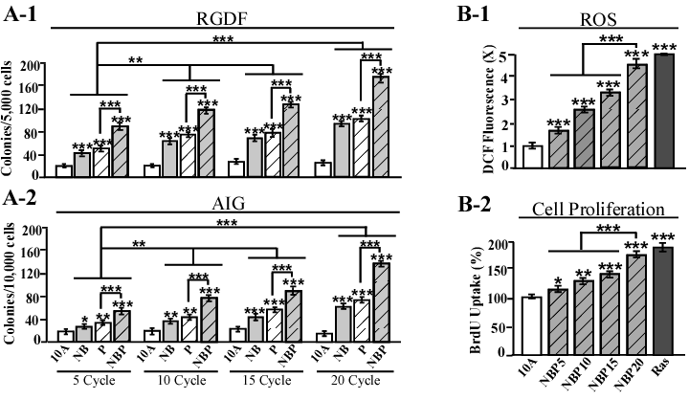
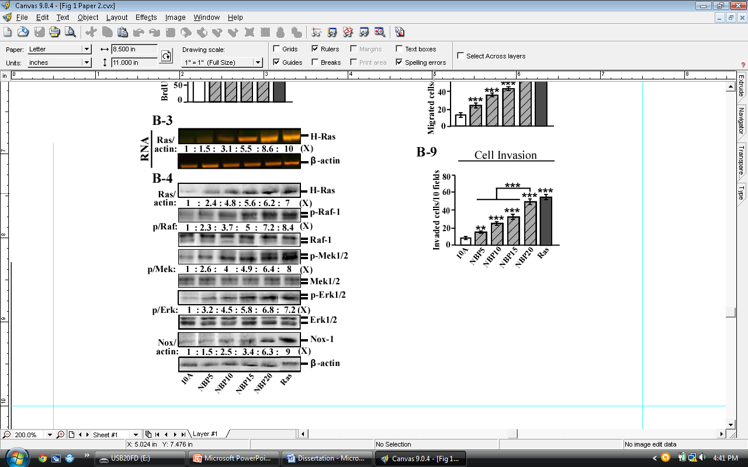
Figure 3.1
Exposure-dependent enhancement of cancer-associated properties by combined carcinogens
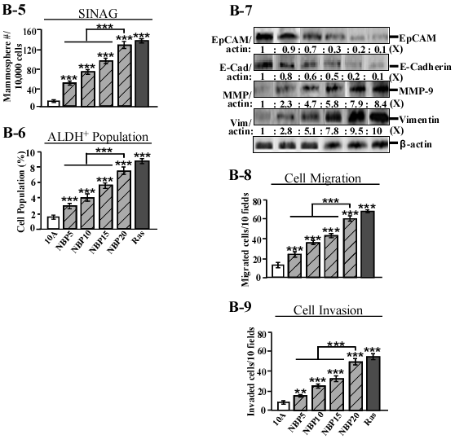
Figure 3.1
Exposure-dependent enhancement of cancer-associated properties by combined carcinogens

Figure 3.2. Enhanced initiation of cellular carcinogenesis by combined carcinogens. (A-1 to A-5) MCF10A cells were exposed to combined 100 pmol/L NNK and 100 pmol/L B[α]P (NB), 10 nmol/L PhIP (P), or combined NB and PhIP (NBP) for 24 h. (B-1 to C-2) MCF10A cells were exposed to combined 100 pmol/L NNK and 100 pmol/L B[α]P (NB), 10 nmol/L PhIP (P), or combined NB and PhIP (NBP) for 6, 12, 24 and 48 h. (A-1) DNA damage was measured by a comet assay and normalized by the value of average tail moment determined in untreated counterpart cells, set as 1 (X, arbitrary unit). Representative images detected in the comet assay are shown. (A-2, B-1 and B-2) ROS levels were measured with CM-H2DCF-DA labeling and normalized by the level determined in untreated cells, set as 1 (X, arbitrary unit). (A-3) Relative cell proliferation was determined and normalized by the value of BrdU detected in untreated cells, set as 100%. (A-4) Total RNA was isolated and analyzed by RT-PCR with specific primers to determine relative gene expression levels of H-Ras, with β-actin as a control, and these levels were quantified by densitometry. The levels of H-Ras (Ras/actin) were calculated by normalizing with the level of β-actin and the level set in untreated control cells as 1 (X, arbitrary unit). (A-5) Cell lysates were prepared and analyzed by western immunoblotting using specific antibodies to detect levels of H-Ras, phosphorylated-Erk1/2 (p-Erk1/2), Erk1/2, and Nox-1, with β-actin as a control, and these levels were quantified by densitometry. The levels of H-Ras (Ras/actin) and Nox-1 (Nox/actin) were calculated by normalizing with the level of β-actin and the level set in untreated control cells as 1 (X, arbitrary unit). Levels of specific phosphorylation of Erk1/2 (p/Erk) were calculated by normalizing the levels of p-Erk1/2 with the levels of Erk1/2, then the level set in control cells as 1 (X, arbitrary unit). (C-1 and C-2) Cell lysates were prepared and analyzed by western immunoblotting using specific antibodies to detect levels of p-Erk1/2 and Erk1/2 and these levels were quantified by densitometry. The levels of specific phosphorylation of Erk1/2 (p/Erk) were calculated by normalizing the levels of p-Erk1/2 with the levels of Erk1/2, then the level set in control cells as 1 (X, arbitrary unit). Columns, mean of triplicates; bars, SD. All results are representative of three independent experiments. Statistical significance is indicated by * P<0.05, ** P<0.01, and *** P<0.001.

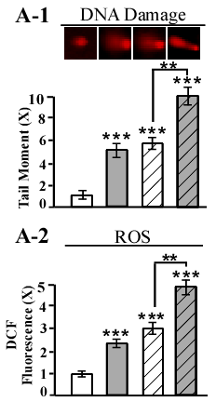
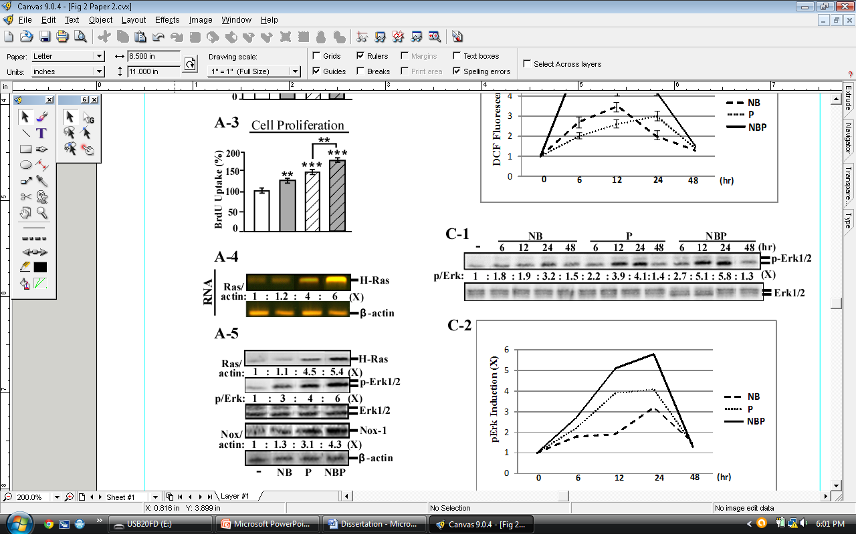
Figure 3.2
Enhanced initiation of cellular carcinogenesis by combined carcinogens
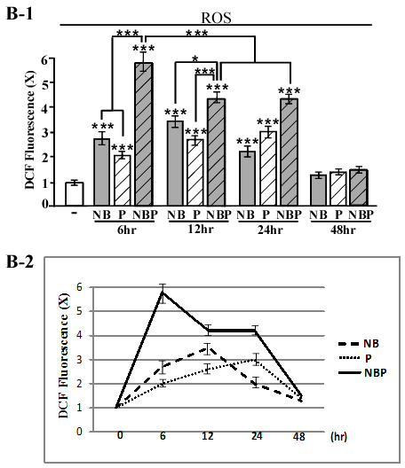
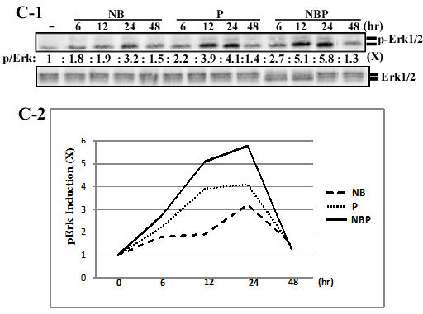
Figure 3.2
Enhanced initiation of cellular carcinogenesis by combined carcinogens
Figure 3.3. ROS and the Ras-ERK pathway in initiation and maintenance of cellular carcinogenesis. (A-1 to A-4) MCF10A (10A) cells were exposed to 10 µmol/L U0126 (U) or 5 mmol/L NAC (N) for 24 h; MCF10A cells were exposed to combined 100 pmol/L NNK and 100 pmol/L B[α]P (NB), 10 nmol/L PhIP (P), or combined NB and PhIP (NBP) in the absence and presence of 10 µmol/L U0126 (U0) or 5 mmol/L NAC for 24 h. (B-1 to B-4) MCF10A (10A) cells were treated with 10 µmol/L U0126 (U) or 5 mmol/L NAC (N) for 10 cycles resulting in the 10A/U10 and 10A/N10 cell lines; MCF10A cells were exposed to combined 100 pmol/L NNK and 100 pmol/L B[α]P (NB), 10 nmol/L PhIP (P), or combined NB and PhIP (NBP) in the absence and presence of 10 µmol/L U0126 (U) or 5 mmol/L NAC (N) for 10 cycles resulting in the NB10, NB/U10, NB/N10, P10, P/U10, P/N10, NBP10 NBP/U10 and NBP/N10 cell lines respectively. (A-1) Cell lysates were prepared and analyzed by western immunoblotting using specific antibodies to detect levels of H-Ras, p-Erk1/2, Erk1/2, and Nox-1, with β-actin as a control, and these levels were quantified by densitometry. The levels of H-Ras (Ras/actin) and Nox-1 (Nox/actin) were calculated by normalizing with the level of β-actin and the level set in untreated control cells as 1 (X, arbitrary unit). Levels of specific phosphorylation of Erk1/2 (p/Erk) were calculated by normalizing the levels of p-Erk1/2 with the levels of Erk1/2, then the level set in control cells as 1 (X, arbitrary unit). (A-2) ROS levels were measured with CM-H2DCF-DA labeling and normalized by the level determined in untreated cells, set as 1 (X, arbitrary unit). (A-3) Relative cell proliferation was determined and normalized by the value of BrdU detected in untreated cells, set as 100%. (A-4) DNA damage was measured by a comet assay and normalized by the value of average tail moment determined in untreated counterpart cells, set as 1 (X, arbitrary unit). (B-1) To determine cellular acquisition of reduced dependence on growth factors (RDGF), cells were maintained in LM medium for 10 days. Cell colonies ≥0.5 mm diameter were counted. (B-2) To determine cellular acquisition of anchorage-independent growth (AIG), cells were seeded in soft agar for 14 days. Cell colonies ≥0.1 mm diameter were counted. (B-3) Cellular migratory and (B-4) invasive activities were determined by counting the numbers of cells translocated through a polycarbonate filter without or with coated Matrigel, respectively, in 10 arbitrary visual fields. Columns, mean of triplicates; bars, SD. All results are representative of three independent experiments. Statistical significance is indicated by * P<0.05, ** P<0.01, and *** P<0.001.

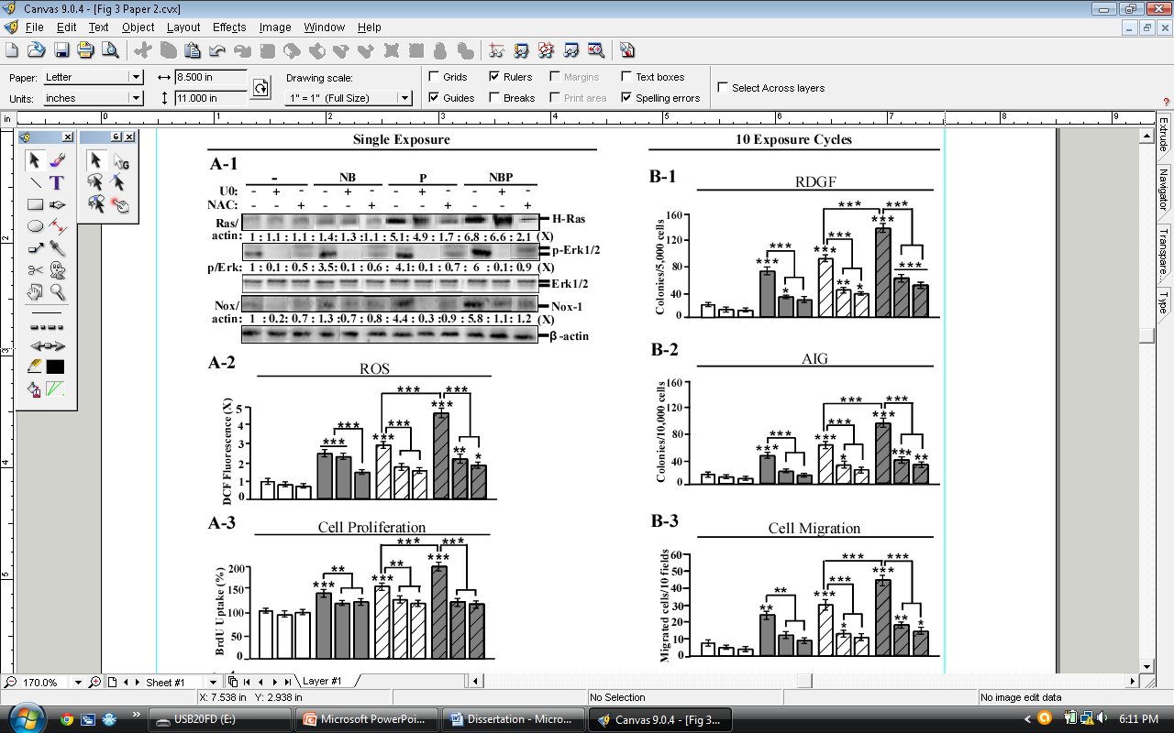
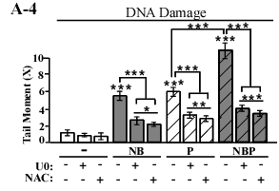
Figure 3.3
ROS and the Ras-ERK pathway in initiation and maintenance of cellular carcinogenesis
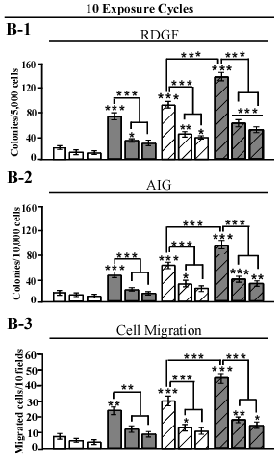
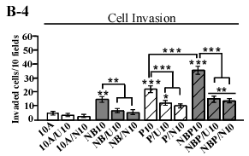
Figure 3.3
ROS and the Ras-ERK pathway in initiation and maintenance of cellular carcinogenesis

Figure 3.4. Cytotoxicity of ergosterol and mimosine in MCF10A and MCF12A cell lines. (A-1 to A-3) MCF10A cells or (B-1 to B-3) MCF12A cells were treated with 100pM, 1nM, 10nM, 100nM, 1µM, 5µM, 20µM and 50µM ergosterol and mimosine individually, or combined in equal parts. Quantification of cell viability was determined with an MTT Assay Kit, and relative cell viability was normalized by the value determined in untreated counterpart cells, set as 100%. Columns, mean of triplicates; bars, SD. All results are representative of three independent experiments. Statistical significance is indicated by * P<0.05, ** P<0.01, and *** P<0.001.

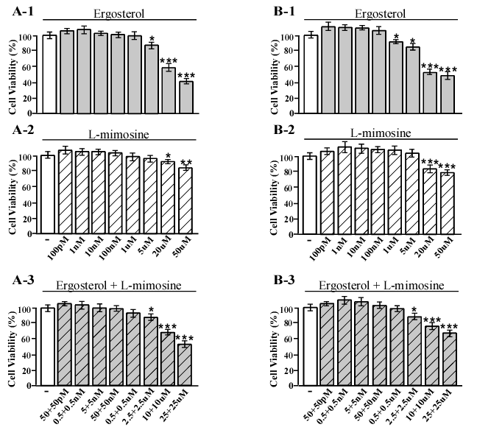
Figure 3.4
Cytotoxicity of ergosterol and mimosine in MCF10A and MCF12A cell lines

Figure 3.5. Ergosterol and mimosine intervened in cellular carcinogenesis. (A-1 to A-4) MCF10A cells were exposed to 100 pmol/L NNK, 100 pmol/L B[α]P, and 10 nmol/L PhIP (NBP) in the absence and presence of 10nM ergosterol (E), 10nM mimosine (M), or combined ergosterol and mimosine (E+M) at 5nM each for 24 h. (B-1 to C-2) MCF10A cells were exposed to 100 pmol/L NNK, 100 pmol/L B[α]P, and 10 nmol/L PhIP (NBP) in the absence and presence of 10nM ergosterol (E), 10nM mimosine (M), or combined ergosterol and mimosine (E+M) at 5nM each for 10 cycles resulting in the NBP10, NBP/E10, NBP/M10 and NBP/E+M10 cell lines, respectively. (A-1) DNA damage was measured by a comet assay and normalized by the value of average tail moment determined in untreated counterpart cells, set as 1 (X, arbitrary unit). Representative images detected in the comet assay are shown. (A-2 and B-3) ROS levels were measured with CM-H2DCF-DA labeling and normalized by the level determined in untreated cells, set as 1 (X, arbitrary unit). (A-3 and B-4) Relative cell proliferation was determined and normalized by the value of BrdU detected in untreated cells, set as 100%. (A-4 and B-5) Cell lysates were prepared and analyzed by western immunoblotting using specific antibodies to detect levels of H-Ras, p-Erk1/2, Erk1/2, and Nox-1, with β-actin as a control, and these levels were quantified by densitometry. The levels of H-Ras (Ras/actin) and Nox-1 (Nox/actin) were calculated by normalizing with the level of β-actin and the level set in untreated control cells as 1 (X, arbitrary unit). Levels of specific phosphorylation of Erk1/2 (p/Erk) were calculated by normalizing the levels of p-Erk1/2 with the levels of Erk1/2, then the level set in control cells as 1 (X, arbitrary unit). (B-1) To determine cellular acquisition of reduced dependence on growth factors (RDGF), cells were maintained in LM medium for 10 days. Cell colonies ≥0.5 mm diameter were counted. (B-2) To determine cellular acquisition of anchorage-independent growth (AIG), cells were seeded in soft agar for 14 days. Cell colonies ≥0.1 mm diameter were counted. (B-6) To determine cellular acquisition of serum-independent non-adherent growth (SINAG), cells were seeded in non-adherent cultures for 10 days. Mammospheres ≥0.1 mm diameter were counted. (B-7) Mammospheres were collected and trypsinized, and ALDH-expressing (ALDH⁺) cell population (%) was measured by flow cytometry. (B-8) Cell lysates were prepared and analyzed by western immunoblotting using specific antibodies to detect levels of EpCAM, E-cadherin, MMP-9 and Vimentin, with β-actin as a control, and these levels were quantified by densitometry. The levels of EpCAM (EpCAM/actin), E-cadherin (E-cad/actin), MMP-9 (MMP/actin), and Vimentin (Vim/actin) were calculated by normalizing with the level of β-actin and the level set in untreated control cells as 1 (X, arbitrary unit). (B-9) Cellular migratory and (B-10) invasive activities were determined by counting the numbers of cells translocated through a polycarbonate filter without or with coated Matrigel, respectively, in 10 arbitrary visual fields. (C-1) Cellular acquisition of increased motility was determined by wound healing assay. The wounded areas were examined (magnification, 100×) 6, 12, and 24 h afterward. Arrows indicate width of wounded areas. (C-2) To quantitatively measure cell motility detected in F-1, the area not healed by the cells was subtracted from the total area of the initial wound to calculate the wound healing area (%) at intervals of 6 (white columns), 12 h (light gray columns) and 24 h (dark gray columns). Columns, mean of triplicates; bars, SD. All results are representative of three independent experiments. Statistical significance is indicated by * P<0.05, ** P<0.01, and *** P<0.001.

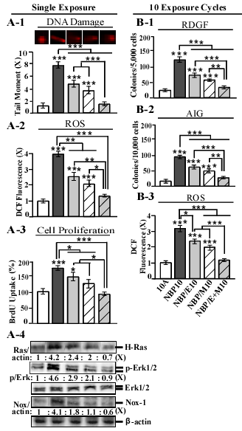
Figure 3.5
Ergosterol and mimosine intervened in cellular carcinogenesis
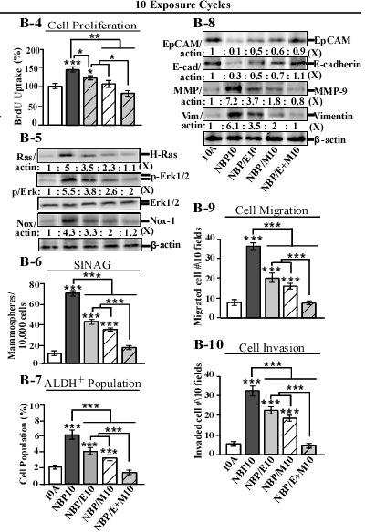
Figure 3.5
Ergosterol and mimosine intervened in cellular carcinogenesis
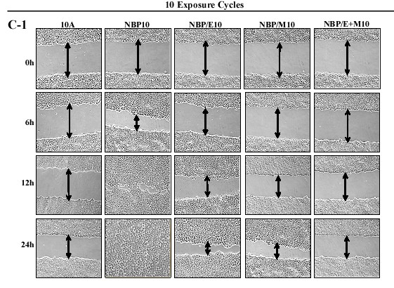
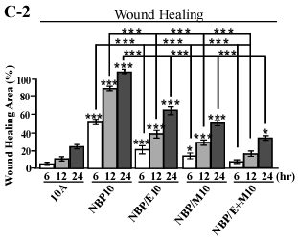
Figure 3.5
Ergosterol and mimosine intervened in cellular carcinogenesis

Figure 3.6. Ergosterol and mimosine suppressed oxidative DNA damage induced by carcinogens. (A-1 and A-2) MCF10A cells were exposed to 100 pmol/L NNK (N), 100 pmol/L B[α]P (B), combined NNK and B[α]P (NB), 10 nmol/L PhIP (P), or combined NB and PhIP (NBP) for 24 h. (B-1 and B-2) MCF10A cells were exposed to N, B, combined NB, P, or combined NBP in the absence and presence of 5 mmol/L NAC for 24 h. (C-1 to C-3) MCF10A cells were exposed to N, B, combined NB, P, or combined NBP in the absence and presence of 10nM ergosterol (E), 10nM mimosine (M), or combined ergosterol and mimosine (E+M) at 5nM each for 24 h. (A-1 and C-1) DNA damage was measured by a comet assay and normalized by the value of average tail moment determined in untreated counterpart cells, set as 1 (X, arbitrary unit). Representative images detected in the comet assay are shown. (A-2, B-2 and C-3) DNA oxidation was measured by an Fpg modified comet assay and reported as the difference in tail moment between Fpg treated and non-Fpg treated cells and normalized by the value of average tail moment determined in untreated counterpart cells, set as 1 (X, arbitrary unit). (B-1 and C-2) ROS levels were measured with CM-H2DCF-DA labeling and normalized by the level determined in untreated cells, set as 1 (X, arbitrary unit). Columns, mean of triplicates; bars, SD. All results are representative of three independent experiments. Statistical significance is indicated by * P<0.05, ** P<0.01, and *** P<0.001.

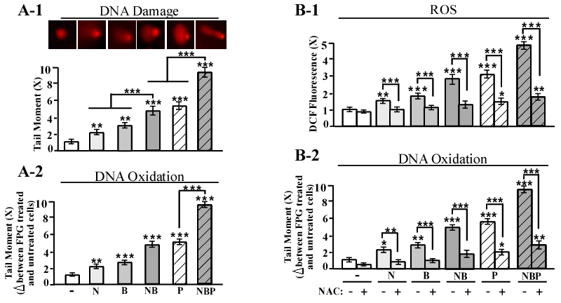
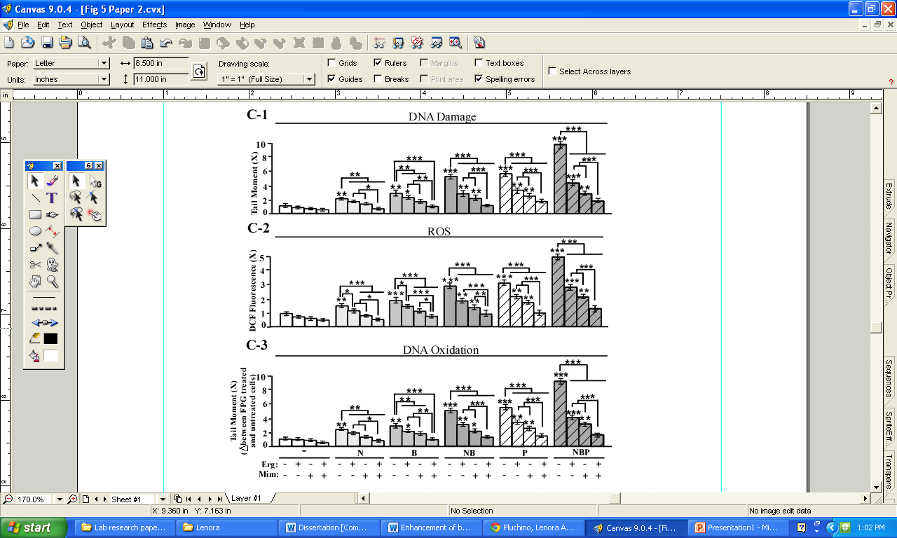
Figure 3.6
Ergosterol and mimosine suppressed oxidative DNA damage induced by carcinogens
Figure 3.7. Induction of cellular carcinogenesis in MCF12A cells and suppression by ergosterol and mimosine. (A-1 to A-4) MCF12A cells (12A) were exposed to combined 100 pmol/L NNK and 100 pmol/L B[α]P (NB), 10 nmol/L PhIP (P), combined NB and PhIP (NBP) and NBP in the presence of 10nM ergosterol (E), 10nM mimosine (M), or combined ergosterol and mimosine (E+M) at 5nM each for 24 h. (B-1 to B-10) MCF12A cells (12A) were repeatedly exposed to combined 100 pmol/L NNK and 100 pmol/L B[α]P (NB), 10 nmol/L PhIP (P), or combined NB and PhIP (NBP) for 20 cycles; MCF12A cells (12A) were repeatedly exposed to combined NB and PhIP (NBP) in the absence and presence of 10nM ergosterol (E), 10nM mimosine (M), or combined ergosterol and mimosine (E+M) at 5nM each for 10 cycles. (A-1) DNA damage was measured by a comet assay and normalized by the value of average tail moment determined in untreated counterpart cells, set as 1 (X, arbitrary unit). Representative images detected in the comet assay are shown. (A-2 and B-3) ROS levels were measured with CM-H2DCF-DA labeling and normalized by the level determined in untreated cells, set as 1 (X, arbitrary unit). (A-3 and B-4) Relative cell proliferation was determined and normalized by the value of BrdU detected in untreated cells, set as 100%. (A-4 and B-5) Cell lysates were prepared and analyzed by western immunoblotting using specific antibodies to detect levels of H-Ras, p-Erk1/2, Erk1/2, and Nox-1, with β-actin as a control, and these levels were quantified by densitometry. The levels of H-Ras (Ras/actin) and Nox-1 (Nox/actin) were calculated by normalizing with the level of β-actin and the level set in untreated control cells as 1 (X, arbitrary unit). Levels of specific phosphorylation of Erk1/2 (p/Erk) were calculated by normalizing the levels of p-Erk1/2 with the levels of Erk1/2, then the level set in control cells as 1 (X, arbitrary unit). (B-1) To determine cellular acquisition of reduced dependence on growth factors (RDGF), cells were maintained in LM medium for 10 days. Cell colonies ≥0.5 mm diameter were counted. (B-2) To determine cellular acquisition of anchorage-independent growth (AIG), cells were seeded in soft agar for 14 days. Cell colonies ≥0.1 mm diameter were counted. (B-6) To determine cellular acquisition of serum-independent non-adherent growth (SINAG), cells were seeded in non-adherent cultures for 10 days. Mammospheres ≥0.1 mm diameter were counted. (B-7) Mammospheres were collected and trypsinized, and ALDH-expressing (ALDH⁺) cell population (%) was measured by flow cytometry. (B-8) Cell lysates were prepared and analyzed by western immunoblotting using specific antibodies to detect levels of EpCAM, E-cadherin, MMP-9 and Vimentin, with β-actin as a control, and these levels were quantified by densitometry. The levels of EpCAM (EpCAM/actin), E-cadherin (E-cad/actin), MMP-9 (MMP/actin), and Vimentin (Vim/actin) were calculated by normalizing with the level of β-actin and the level set in untreated control cells as 1 (X, arbitrary unit). (B-9) Cellular migratory and (B-10) invasive activities were determined by counting the numbers of cells translocated through a polycarbonate filter without or with coated Matrigel, respectively, in 10 arbitrary visual fields. Columns, mean of triplicates; bars, SD. All results are representative of three independent experiments. Statistical significance is indicated by * P<0.05, ** P<0.01, and *** P<0.001.

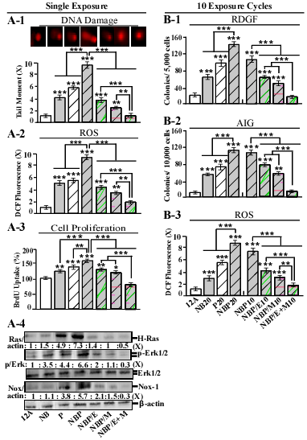
Figure 3.7
Induction of cellular carcinogenesis in MCF12A cells and suppression by ergosterol and mimosine
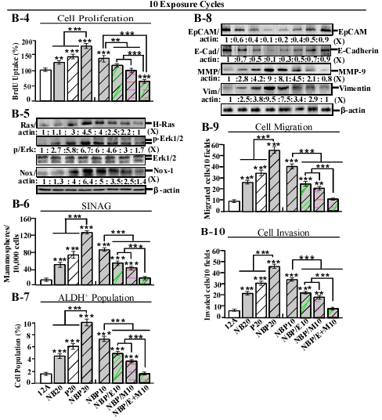
Figure 3.7
Induction of cellular carcinogenesis in MCF12A cells and suppression by ergosterol and mimosine

CHAPTER 4

General Discussion

General Discussion
The research presented in this dissertation was designed to (1) investigate the ability, and associated mechanisms, of NB to enhance PhIP-induced chronic breast cell carcinogenesis (2) evaluate the efficacy of combined dietary agents, such as green tea catechins, ergosterol and mimosine, in intervention of breast cell carcinogenesis induced by chronic exposure to combined environmental and dietary carcinogens.

Enhancement of Chronically Induced Breast Cell Carcinogenesis by Combined Environmental and Dietary Carcinogens
The activity of low doses of multiple carcinogens to induce breast cell carcinogenesis is an under-investigated area. Since we are all exposed to various carcinogens each day from our environment and diet, it is important to examine the biochemical and molecular mechanisms and pathways associated with cellular carcinogenesis induced by each carcinogen and how these factors interact when carcinogens are combined. Our model system presents several unique features to advance our understanding of sporadically-occurring human breast carcinogenesis. It is highly sensitive to detect low physiologically-achievable doses of either weak or potent carcinogens capable of inducing breast cell carcinogenesis, it exposes cells to carcinogens in a cumulative manner to mimic progressive induction of chronic carcinogenesis, and it provides measurable transient and constitutive cellular, biochemical, and molecular endpoints to determine the induction and progression of cellular carcinogenesis. In contrast, most existing systems study the activity of carcinogens at high concentrations for acute induction of cellular carcinogenesis [1-8]. However, since most human cancers result from long-term exposure to low doses of carcinogens, a chronic low-dose approach is a more relevant way to study the effects of environmental carcinogens on human breast cancer development.
Using our cellular model, we demonstrated the ability of the relatively weak mammary carcinogens NNK and B[α]P (NB) to enhance breast cell carcinogenesis induced by potent mammary carcinogen PhIP [9]. In addition, we characterized the mechanisms of NB-mediated enhancement of PhIP-induced cellular carcinogenesis [10]. Our studies revealed that either pre- or co-exposure to NB significantly enhanced cellular carcinogenesis induced by PhIP, with co-exposure being the most potent [9]. MCF10A cells repeatedly exposed to combined NB and PhIP (NBP) increasingly acquired cancer-associated properties in an exposure-dependent manner to significantly higher levels than cells exposed to either NB or PhIP alone [9, 10]. Cumulative exposures to NBP resulted in enhanced acquisition of the cancer-associated properties of reduced dependence on growth factors and anchorage-independent growth, the stem-like cell properties of increased mammosphere formation and ALDH-positive cell population and the EMT-associated properties of increased cell migration, invasion and motility [10]. Although induction of the EMT program and development of stem-like cells have been postulated to play important roles in cancer development and progression [11], enriched stem-like cell population is not yet fully appreciated as a breast cancer-associated property. Applying our model system has advanced our understanding of the involvement of EMT and stem-like cells during breast cell carcinogenesis and our results suggest that activation of the EMT program and increased stem-like cell population should be considered as novel cancer-associated properties used to measure the progression of breast cell carcinogenesis.
Mechanistic studies revealed that transient ROS elevation induced by short-term exposure to NBP played a key role in activating the Ras-ERK-Nox pathway, leading to increased cellular proliferation [10]. Hyperproliferation and elevated ROS levels increased cellular susceptibility to chromosomal DNA damage and oxidation, which is essential for the induction of cellular carcinogenesis [11]. Ras-ERK pathway-mediated induction of Nox-1 potentiated ROS elevation and facilitated the interplay that occurred between the ERK pathway and ROS production, both of which were required for the initiation and maintenance of NBP-induced cancer-associated properties. Co-exposure to NB enhanced the capability of PhIP to induce these transient endpoints during each exposure cycle enabling enhanced initiation of cellular carcinogenesis and ultimately contributing to enhanced acquisition of cancer-associated, stem-like and mesenchymal cell properties after cumulative exposures. We demonstrated that cellular exposure to carcinogens can stimulate ROS-mediated Ras-ERK pathway signaling providing evidence for the involvement of ROS as important signaling modulators during induction and progression of cellular carcinogenesis induced by chronic carcinogen exposure.

Intervention of Chronic Breast Cell Carcinogenesis by Combined Dietary Agents
Use of combined dietary agents has gained traction in recent years as an effective strategy for preventing human cancer development. Prevention strategies making use of combined dietary agents are advantageous over those using individual agents due to higher efficacy and lower toxicity [12]. Since carcinogenesis occurs in a multi-step process, a variety of agents with complementary modes of action are needed to effectively suppress this complex disease. Accordingly, there have been numerous studies that support the use of combined dietary agents for the prevention of various malignancies including breast cancer [13-21]. In this research, we used our cellular model as a target system to identify novel combinations of dietary agents effective in intervention of breast cell carcinogenesis induced by chronic exposure to environmental and dietary carcinogens. We employed a two-step strategy which initially used short-term biological, biochemical and molecular endpoints transiently induced by carcinogen exposure as targets to identify dietary agents that can block cellular carcinogenesis. The second step subsequently used long-term cellular acquisition of cancer-associated properties, including stem-like and mesenchymal cell properties, induced by chronic carcinogen exposure to validate the ability of preventive dietary agents to suppress cellular carcinogenesis.
Using our cellular model as a target system, we were able to verify the enhanced preventive activity of combined green tea catechins ECG and EGCG and combined ergosterol and mimosine, at non-cytotoxic levels, in suppression of NBP-induced chronic cellular carcinogenesis. In addition, we have identified the mechanisms through which these agents can counteract the biological, biochemical, and molecular effects of exposure to NNK, B[α]P and PhIP. We have shown that green tea catechins, ergosterol and mimosine, when used individually or in combination, are capable of blocking NBP-induced transient ROS elevation, ERK pathway activation, cell proliferation and chromosomal DNA damage, which accounted for the cytotoxic-independent ability of these agents to suppress cellular acquisition of cancer-associated, stem-like and mesenchymal cell properties. We also revealed the ability of ergosterol and mimosine to protect chromosomal DNA from oxidative damage caused by carcinogen-induced ROS.
Although ECG was slightly more effective than EGCG, and mimosine was slightly more effective than ergosterol, a combination of green tea catechins, and of ergosterol and mimosine, were more effective than individual agents in suppressing induction and progression of NBP-induced breast cell carcinogenesis. Although precise mechanisms still need to be elucidated, it was evident that the enhanced antioxidant activity of combined green tea catechins and combined ergosterol and mimosine markedly reduced ROS elevation caused by NBP giving the DNA in these cells a level of protection against proliferative and oxidative DNA damage that neither agent achieved alone. Based on our results, it appears as though a combination of dietary agents is the best course of action to suppress cellular carcinogenesis caused by exposure to combined environmental and dietary carcinogens. Therefore, applying our cellular model will advance our understanding of novel preventive agents that are effective in reducing the health risk of sporadic breast cancer associated with chronic exposure to carcinogens present in environmental pollution and American diet.

Conclusion
This study has shown that repeated exposure of non-cancerous, human breast epithelial
MCF10A cells to low doses of the environmental carcinogens NNK and B[α]P enhances various cancer-associated properties, including reduced dependence on growth factors, anchorage independent growth, enriched stem-like cell population and activation of the EMT program, induced by chronic exposure to the dietary carcinogen PhIP. We also detected the ability of dietary compounds such as green tea catechins, ergosterol and mimosine, at non-cytotoxic concentrations, to suppress progressive carcinogenesis of breast epithelial cells induced by chronic exposure to multiple carcinogens. This scheme is summarized in Figure 4.1.
To identify the mechanisms involved in NBP-induced chronic breast cell carcinogenesis, we characterized biological, biochemical, and molecular changes transiently induced by short-term carcinogen exposure. Short-term exposure to physiologically-achievable doses of NBP induced transient ROS elevation leading to ERK pathway activation, cell proliferation, and chromosomal DNA damage (Figure 4.2A). Ras-ERK pathway-mediated induction of the Nox-1 enzyme facilitated further production of ROS which led to elevated levels of oxidative DNA damage. We observed that a combination of the green tea catechins ECG and EGCG, as well as a combination of the fungal sterol ergosterol and the rare plant amino acid mimosine, were more effective than individual agents in blocking NBP-induced ROS elevation, ERK pathway activation, cell proliferation, DNA damage and DNA oxidation, and ultimately suppressing the progression of cellular carcinogenesis (Figure 4.2B). Our work suggests that use of combined dietary agents should be seriously considered for early intervention of breast cell carcinogenesis associated with long-term exposure to multiple environmental and dietary carcinogens.

Future Directions
Co-exposure to NB and PhIP enhanced cellular acquisition of all the cancer-associated properties we tested; however, whether co-exposure to NB and PhIP may enhance cellular tumorigenicity and mammary tumor development in animals, as well as human breast cancer development, remains to be determined. Suppression of cellular acquisition of stem-like cell- and EMT-associated properties by green tea catechins, ergosterol and mimosine were indicated by reduction in mammosphere formation, decreased ADLH-positive cell populations and reversal of EMT marker expression. However, whether or not these dietary agents are able to protect mammary tissues from acquiring carcinogen-induced stem-like cell and EMT-associated properties to reduce the risk of invasive tumors remains to be studied.
In our studies, exposure of MCF10A cells to NNK and B[α]P (NB) did not induce any detectable upregulation of Ras or phosphorylated-Raf, both of which are upstream from Mek1/2 and Erk1/2. Thus, it appears that NB-elevated ROS induced the ERK pathway in a Ras/Raf-independent manner. However, the mechanism for NB-mediated Ras-independent Mek1/2 phosphylation and ERK pathway activation and how ROS was able to induce Ras/Raf-dependent and -independent activation of Mek1/2 and Erk1/2 remains to be determined. As a major source of ROS production, Ras-ERK-dependent expression of Nox-1 plays an important role in redox signaling and mediates the interplay that occurs between ROS production and the Ras-ERK pathway in NBP-exposed cells. Cellular exposure to NB did not induce significant expression of Nox-1 in our studies, presumably because NB did not upregulate Ras expression. However, whether expression of Nox-1 is reliant on Ras-dependent ERK activation has yet to be clarified.

LIST OF REFERENCES
- DeBruin LS, Josephy PD (2002) Perspectives on the chemical etiology of breast
cancer. Environ Health Perspect 110 Suppl 1: 119-128.
2. Hecht SS (2002) Tobacco smoke carcinogens and breast cancer. Environ Mol Mutagen 39: 119-126. Carcinogenesis 21: 345-351.
3. Guengerich FP (2000) Metabolism of chemical carcinogens.
4. Mehta RG (2000) Experimental basis for the prevention of breast cancer. Eur J Cancer 36: 1275-1282.
5. Cavalieri E, Rogan E, Sinha D (1988) Carcinogenicity of aromatic hydrocarbons directly applied to rat mammary gland. J Cancer Res Clin Oncol 114: 3-9.
6. Li D, Zhang W, Sahin AA, Hittelman WN (1999) DNA adducts in normal tissue adjacent to breast cancer: a review. Cancer Detect Prev 23: 454-462.
7. Rundle A, Tang D, Hibshoosh H, Estabrook A, Schnabel F, et al. (2000) The relationship between genetic damage from polycyclic aromatic hydrocarbons in breast tissue and breast cancer. Carcinogenesis 21: 1281-1289.
8. Rubin H (2011) Synergistic mechanisms in carcinogenesis by polycyclic aromatic hydrocarbons and by tobacco smoke: a bio-historical perspective with updates. Carcinogenesis 22: 1903-1930.
9. Pluchino LA, Wang HC (2014) Chronic exposure to combined carcinogens enhances breast cell carcinogenesis with mesenchymal and stem-like cell properties. PLOS One (Accepted).
10. Pluchino LA, Liu AK, Wang HC (2014) Reactive oxygen species-mediated enhancement of breast cell carcinogenesis by multiple carcinogens intervened by the dietary
constituents ergosterol and mimosine. Free Radicial Biology and Medicine (Submitted).
11. Hanahan D, Weinberg RA (2011) The hallmarks of cancer: the next generation. Cell 144: 646-674.

12. Ohigashi H, Murakami A (2004) Cancer prevention with food factors: alone and in combination. Biofactors 22: 49-55.
13. Butler LM, Wu AH, Wang R, Koh WP, Yuan JM, et al. (2010) A vegetable-fruit-soy dietary pattern protects against breast cancer among postmenopausal Singapore Chinese women. Am J Clin Nutr 91: 1013-1019.
- Bialy TL, Rothe MJ, Grant-Kels JM (2002) Dietary factors in the prevention and treatment of nonmelanoma skin cancer and melanoma. Dermatol Surg 28: 1143-1152.

Murakami A, Takahashi D, Koshimizu K, Ohigashi H (2003) Synergistic suppression of superoxide and nitric oxide generation from inflammatory leukocytes by combined food factors. Mutat Res 523-524: 151-161.

- Hsu A, Bruno RS, Löhr CV, Taylor AW, Dashwood RH, et al. (2011) Dietary soy and tea mitigate chronic inflammation and prostate cancer via NFκB pathway in the Noble rat model. J Nutr Biochem 22: 502-510.

17. Zuniga KE, Clinton SK, Erdman JW (2013) The interactions of dietary tomato powder and soy germ on prostate carcinogenesis in the TRAMP model. Cancer Prev Res 6: 548-557.

18. Bonnesen C, Eggleston IM, Hayes JD (2001) Dietary indoles and isothiocyanates that are generated from cruciferous vegetables can both stimulate apoptosis and confer protection against DNA damage in human colon cell lines. Cancer Res 61: 6120-6130.
19. Zhou JR, Li L, Pan W (2007) Dietary soy and tea combinations for prevention of breast and prostate cancers by targeting metabolic syndrome elements in mice. Am J Clin Nutr 86: s882-888.
20. Meeran SM, Patel SN, Li Y, Shukla S, Tollefsbol TO (2012) Bioactive dietary supplements reactivate ER expression in ER-negative breast cancer cells by active chromatin modifications. PLoS One 7: e37748.
21. Hu Y, McIntosh GH, Le Leu RK, Nyskohus LS, Woodman RJ, et al. (2013) Combination of selenium and green tea improves the efficacy of chemoprevention in a rat colorectal cancer model by modulating genetic and epigenetic biomarkers. PLoS One 8: e64362.

APPENDIX

Figure 4.1
Schematic representation of progressive induction of cancer-associated properties by chronic exposure to carcinogens and its suppression by dietary compounds

A)
B)

Figure 4.2
- Hypothetical mechanism of NBP-induced cellular carcinogenesis
- Hypothetical mechanism of suppression of NBP-induced cellular carcinogenesis by dietary compounds

VITA
Lenora A. Pluchino was born in Queens, New York on June 2nd, 1986. She completed her primary and secondary education in the New York City Public School system. She graduated Magna cum laude from the State University of New York at Oswego in 2008 with a Bachelor of Science degree in Zoology with a minor in Chemistry. In 2009, she joined the Graduate School of Genome Science and Technology at the University of Tennessee as a Program for Equity and Excellence in Research (PEER) scholar. She joined the lab of Dr. Hwa-Chain Robert Wang in the Department of Biomedical and Diagnostic Sciences at the College of Veterinary Medicine in 2010 to pursue her Doctor of Philosophy degree in Life Sciences with a concentration in Molecular Oncology. After obtaining her PhD in the summer of 2014, she plans to pursue her post-doctoral training.

