Microstructure-Based High Temperature Processing and Failure Analyses of Engineering Alloys under Complex Conditions

A Dissertation Presented for the
Doctor of Philosophy
Degree
The University of Tennessee, Knoxville

Dong Han
August 2024

Copyright © 2024 by Dong Han
All rights reserved.

Acknowledgements

I would like to express my sincere gratitude to all those who supported and helped me throughout my Ph.D. study. This dissertation would not have been possible without them. My deepest appreciation goes first to my advisor, Prof. Yanfei Gao, for his continuous academic support and guidance in my professional career development. It has been an honor to work with him. His knowledge, professionalism, and thought-provoking discussions have significantly contributed to my research. I’m also grateful to my co-advisor, Prof. Zhili Feng, for his project support and inspiring guidance. His valuable opportunities and advice have greatly aided my career development.
I extend my thanks to my committee members, Prof. Hahn Choo and Prof. Claudia J. Rawn, for their kind agreement to serve on my Doctoral Committee, and for their insightful comments and guidance from different scientific perspectives. Their outstanding knowledge and enthusiasm for science have greatly impressed and guided me in pursuing a successful academic career.
These acknowledgments would not be complete without mentioning my group members and friends who have constantly helped and shared happiness with me. They include Dr. Wei Zhang, Dr. Xue Wang, Dr. Liubin Xu, Dr. Di Xie, Dr. Chao Pu, Dr. Yi Yang, Mr. Andrew Kocak, Ms. Lia Amalia, Dr. Yiyun Huang and his wife Lingling Lin, Dr. Fengpei Yuan, Dr. Ziming Liu, Mr. Zhenghao Zhu, Mr. Hao Ye, and many other friends who have provided support and help.
Finally, I would like to acknowledge the Manufacturing and Materials Joining Innovation Center (Ma2JIC) for funding this work.
Abstract

From traditional petrochemical applications to contemporary manufacturing techniques, advanced structural materials are subjected to intricate thermomechanical and environmental conditions. In these engineering domains, high-temperature deformation plays a pivotal role, profoundly influencing the ultimate outcomes of industrial applications. Nevertheless, the underlying mechanisms of this deformation remain elusive, largely due to the absence of a microstructure-based mechanistic understanding of high-temperature processing and failure of materials.
This dissertation endeavors to comprehensively examine these mechanisms through computational methodologies, focusing on three quintessential topics: grain boundary cavitation failures (2 examples: stress relaxation cracking (SRC) and grain size dependence), high-temperature hydrogen attack (HTHA), and additive friction stir deposition (AFSD). Firstly, a micromechanical finite element framework incorporating precipitate-free zones is proposed to investigate SRC. This framework enhances our comprehension of residual stress evolution, the impact of material constitutive parameters on lifetime predictions. Secondly, a microstructure-informed and micromechanics-based model is developed, integrating the interplay between hydrogen transport and intergranular cavity-based fracture processes. This model offers a robust methodology for computing Nelson curves, providing novel insights into their mechanisms and elucidating the roles of two critical parameters: pipe thickness and applied stresses. Finally, a numerical model utilizing the Coupled Eulerian Lagrangian (CEL) method is implemented to validate our theoretical analysis of the effects of processing parameters during AFSD. This simulation
not only replicates but also explicates the experimental results.

Table of Contents

Chapter 1 Introduction 1
1.1 Background and Motivation 1
1.1.1 High Temperature Creep Failures: Stress Relaxation Cracking 1
1.1.2 High Temperature Hydrogen Attack 3
1.1.3 Additive Friction Stir Deposition 5
1.2 Outline 8
Chapter 2 An Integrated Computational Framework for High Temperature Creep Failures 9
2.1 Introduction 9
2.2 Deformation and Damage Mechanisms at High Temperatures 12
2.2.1 Intergranular Cavity Failure Model at Elevated Temperatures 14
2.2.2 Deformation Model 14
2.2.3 The Smear-Out Failure Model 15
2.2.4 Cavity Nucleation and Growth 15
2.2.5 Grain Boundary Sliding 18
2.3 Numerical Simulation 19
2.4 Case Studies 19
2.4.1 Case Study 1: Grain Size Dependence 19
2.4.2 Case Study 2: SRC Simulations 26
2.4.3 Case Study 3: the Role of PFZ 29
2.5 Conclusions 33
Chapter 3 A Mechanistic Interpretation of Nelson Curves for PVP Failures under High Temperature Hydrogen Attack 34
3.1 Introduction 34
3.2 Thermodynamic and Kinetic Processes 40
3.2.1 Hydrogen Adsorption 40
3.2.2 Hydrogen Diffusion 41
3.2.3 Reaction with Carbides 42
3.3 Creep Fracture Model 43
3.3.1 Numerical Implementation 44
3.4 Simulation Approach 44
3.4.1 Finite Element Method 44
3.4.2 Material Parameters 49
3.5 Results and Discussion 49
3.5.1 Calibration of Creep Deformation 49
3.5.2 Simplifying Nelson Curves with Odette-Vagarali Model 53
3.5.3 HTHA with Uniform Hydrogen Distribution (Equivalent to Ultrathin Wall) 55
3.5.4 HTHA with Nonuniform Hydrogen Distribution (i.e., Thick Walls) 57
3.6 Summary 61
Chapter 4 An Analytical Solution to the Printing Temperature in Additive Friction Stir Deposition 63
4.1 Introduction 63
4.2 Heat Generation Model 67
4.3 Revisiting Rosenthal’s Equation 68
4.4 Analytical Solution of Multi-Pass Process 70
4.5 CEL Finite Element Simulations 72
4.5.1 Model Setup 72
4.5.2 Predicted Torque, Axial Force and Temperature Evolution 76
4.5.3 The Effect of Model Size and Boundary Conditions 80
4.6 Summary 82
Chapter 5 Conclusions and Perspectives 84
List of References 87
Vita 98

LIST OF TABLES
Table 2.1 Representative values for material parameters for Grade 91 ferritic steel at different temperatures. 22
Table 2.2 Representative values for material parameters in base metal at different temperatures. 27
Table 2.3 Representative values for material parameters in heat affected zone (HAZ) at different temperatures. 28
Table 3.1 Representative values for material parameters used for stress-induced hydrogen diffusion model. 50
Table 3.2 Representative values for material parameters in creep fracture model. 50
Table 4.1 Constitutive parameters in CEL simulations of AA6061-T6 [87,88]. 75
Table 4.2 Thermomechanical properties for AA6061-T6 [89,90]. 75

LIST OF FIGURES

Figure 1.1 HTHA internal damage in carbon steel: (a) optical image depicting pearlite decomposition and grain boundary fissuring at a magnification of 1000x; (b) SEM image showing grain-boundary bubbles at a magnification of 10000x [10]. 4
Figure 1.2 (a) A picture showing AFSD equipped with a hollow tool and an illustrative diagram highlighting some fundamental physical processes in the local region of deposition. (b) A comparison of thermal boundary conditions between FSW and AFSD [18]. 6
Figure 2.1 The cross-sectional models with (a) ideal microstructure of the base metal, (b) heat affected zone (HAZ), and (c) HAZ with precipitate-free-zone (PFZ) finite element meshes as shown in the inset. 13
Figure 2.2 Schematic plots for (a) a number of spherical-cap-shaped cavities located on the grain boundaries and (b) the smeared-out representation of grain boundary cavitation in terms of a continuous varying separation. 16
Figure 2.3 (a) Stress dependence of steady-state creep rate from experimental data for Grade 91 ferritic steel at 923 K. (b) Predicted stress versus lifetime behavior using the micromechanical model for Grade 91 ferritic steel, compared with experimental data from the literature at 923 K. The experimental data are sourced from [52]. 21
Figure 2.4 Double logarithmic plot of applied stress vs. time to rupture in terms of different grain sizes for Grade 91 steel: (a) 5 μm, (b) 0.5 μm and (c) 0.1 μm. 23
Figure 2.5 Deformation mechanism maps for Grade 91 steel with grain sizes of 5 μm, 0.5 μm and 0.1 μm. 25
Figure 2.6 Experimental creep test data of 347 stainless steel from National Institute of Materials Science (NIMS), Japan, at 873 K, 923 K, 973 K and 1023 K under different applied loads. Simulation results are based on the intergranular cavity model. 27
Figure 2.7 Residual stress relaxation process, (a) the initial status of the residual stress field in the model cross-section; (b-c) the residual stress is gradually relaxed and the crack initiation can be found; (d) the final failure status as the residual stress has already relaxed and the penetration crack can be found. 30
Figure 2.8 Residual stress variation in simulation models with different microstructures: only base metal without cavity failure; only base metal with cavity failure model; weldment with HAZ failure; weldment with HAZ and PFZ. Refer to Fig. 2.3 for these microstructures. These stress relaxation history results can be compared to the schematic illustration in Fig. 2.2(c). (a) 873 K and (b) 1023 K. 32
Figure 3.1 (a) Nelson curves and experimental data for pressure vessels and piping (PVP) of C-0.5Mo ferritic steel [7,8]. (b) Replotted Nelson curves with respect to the hydrogen partial pressure and the reciprocal of temperature. 35
Figure 3.2 Schematic illustrations of the stress state for a unit cell containing a single cavity under HTHA in (a) and that with an applied hydrostatic tension in (b). Superposing (a) and (b) leads to the stress state in (c) with a stress-free cavity [58,59]. 46
Figure 3.3 Schematic illustration of the finite element mesh and the concentration-dependent cohesive elements between two neighboring grains. The initial separation in these cohesive elements is zero. Concentration and pressure information are stored in each cohesive element. 46
Figure 3.4 A schematic illustration of the coupled model: left being the thermodynamic calculation of hydrogen transport, and right showing the steps for cavity-induced failure. These two modules have different time steps, but communicate through a number of COMMON BLOCKs. 48
Figure 3.5 (a) Stress dependence of steady state creep rate for C-0.5Mo steel at 723 K. (b) Stress vs. creep life behavior predicted using the micromechanical model for PVP of C-0.5Mo steel in comparison with the literature experimental data at 723 K. NIMS data are obtained from [52]. 52
Figure 3.6 (a) Predicted equilibrium methane partial pressure from 773 K to 1173 K according to Odette-Vagarali model [57]. (b) Final converted Nelson curves by combining (a) and Fig. 3.1(b). 54
Figure 3.7 Predicted Nelson curves with total pressure and the reciprocal of temperature under HTHA with uniform hydrogen distribution, obtained from solving a set of ordinary differential equations (ODE model) under external loading of 100 MPa and 200 MPa in (a), and from finite element method (FEM) under external loading of 100 MPa, 200 MPa and 300 MPa in (b). The differences lie on the nature of statistical averages in FEM. The grain size (i.e., ledge size of the hexagonal grain) is 300 $μm$. 56
Figure 3.8 Contour plot of the von Mises stress distribution in the PVP of C-0.5Mo steel by 100-grain structure. Typical failure occurs under HTHA with a very thick wall, so that hydrogen does not penetrate to the outer diameter. Here, the left side is the inner diameter (exposed to hydrogen) and the right side is the outer diameter. The left surface is fixed with horizontal displacement, while the bottom surface is fixed with vertical displacement. A magnification ratio of 2000 is used here for the displacement field to illustrate the microcracks clearly. Simulation parameters include those listed in Tables 3.1 and 3.2, together with T=773 K, no applied stress, grain size of 300 $μm$, and hydrogen concentration at inner diameter of ${10}^{8} atom/μm^{3}$. The snapshot was taken near the final failure when the vertical elongation increases catastrophically. 58
Figure 3.9 (a) Total pressure vs. creep rupture time under HTHA with nonuniform hydrogen distribution by our coupled model for 100 MPa. (b) Predicted Nelson curves with total pressure and the reciprocal of temperature under HTHA with a thick wall for 100 MPa. The grain size is 300 $μm$. 60
Figure 4.1 Three-dimensional heat flow during welding of semi-infinite workpiece [91]. 69
Figure 4.2 A schematic plot for the superposition of temperature field in AFSD muti-pass process. 71
Figure 4.3 Schematic illustrations of finite element setup using the Coupled Eulerian-Lagrangian (CEL) approach to mimic AFSD process. (a) Eulerian and Lagrangian domains in the model. (b) Cross-sectional view of the substrate material with the dashed box being the tracking area. (c) The cladding-substrate interface with the dashed box being the tracing area. 73
Figure 4.4 Representative results of the strain rate, temperature, and Mises stress fields are given with their corresponding tool locations in first pass during AFSD. 77
Figure 4.5 The evolution of representative parameters during AFSD: (a) temperature, (b) torque and (c) axial force. 78
Figure 4.6 The relationship between temperature and torque: (a) original model, (b) new model with a same width with the tool and (c) original model without fixed velocity boundary conditions for surrounding side surfaces. 79
Figure 4.7 AFSD Experimental data. The rotational speed is 135 RPM and the reference temperature is 300 K. (Courtesy of Mr. Andrew Kocak, Mr. Josh Kincaid, and Prof. Tony Schmitz). 81

Chapter 1 Introduction

Background and Motivation
High-temperature deformation refers to the alteration in shape or form that materials undergo when subjected to elevated temperatures. At these temperatures, materials can become more malleable or ductile, leading to changes in their mechanical properties. The dislocations can climb as well as glide so that recovery due to dislocation rearrangement and pair annihilation proceeds quickly. Sometimes recrystallization occurs during deformation. For polycrystalline metals, grain boundary sliding and migration also play an important role. Under a very low stress, the deformation occurs not by dislocation motion, but exclusively by diffusion. The understanding of this deformation is crucial in industries such as welding, refinery, petrochemical and other chemical facilities and, possibly, high pressure steam boiler, where materials are often exposed to extreme thermal conditions and must maintain structural integrity.

1.1.1 High Temperature Creep Failures: Stress Relaxation Cracking
Material selection and structural integrity studies in pressure vessels and pipeline (PVP) have been extensively studied for traditional petrochemical and power-generation industries. Challenges arise with modern energy storage and transportation that connect clean energy production to the power grid, and also with more pressing needs in revisiting and redesigning structural components due to the aging infrastructure in the US. Welding is the primary joining method used in PVPs due to its operational convenience and capability to maintain the thermal-mechanical properties of the materials after joining compared to other methods [1]. Despite the adoption of optimal welding techniques, unexpected failures still occur during service, with the majority of failure cases in pipeline
systems occur at weldments.
Of the particular importance is the stress relaxation cracking (SRC) or called strain aging cracking (SAC), where cracks emerge at variously heat-treated weldments [2-6]. SRC during post-weld heat treatment (PWHT), often referred to as reheat cracking, is primarily a result of grain boundary embrittlement from carbide precipitation during the PWHT process. The generation of the residual stress is the result of the local melting process, the rapid heating and cooling which cause the thermal expansion and contraction in the fusion zone (FZ) and heat affected zone (HAZ). A subsequent reheating could be the post-welding heat treatment (PWHT) that aims to relieve the residual stress (thus leading to the calling of SRC if crack occurs in this stage), or the service condition at intermediate or high temperatures (thus leading to the name of SAC). We will focus on a generalized thermal history and thus do not differentiate these two terms in this work. The highest susceptibility to such a failure mode occurs when a high accumulation of residual stress, thermomechanical property and microstructural gradients, and their evolutions are all present. These multiple factors contribute synergistically to the eventual failure mechanism as governed by the operating conditions and microstructural information.
A leading literature explanation of this failure suggests that the residual stress relaxation and the precipitation dissolution and/or re-precipitation occur in the same temperature range, which can lead to locally high strains and thus to crack at the grain boundaries. Since in situ spatial measurements of residual stress fields, microstructural evolution, and failure processes are nearly infeasible, a feasible computational approach
that studies SRC susceptibility is greatly required.

1.1.2 High Temperature Hydrogen Attack
High temperature hydrogen attack (HTHA), bringing the permanent/irreversible deterioration of mechanical properties of petroleum refinery and petrochemical plant equipment fabricated mostly by carbon and low alloy steels, has always been of the major concern to the pressure vessels and piping (PVP) community [7,8]. As a very complicated mechanical-physical-chemical process, HTHA entails absorption of hydrogen from the surface of steels, diffusion of hydrogen atoms along grain boundaries, formation of methane resulting from chemical reaction between hydrogen and carbon (interstitial ones or from carbides in the microstructure) and growth of cavities driven by applied stresses and internal pressure due to the accumulation of the methane gas [9]. The growth of cavities can be promoted by local creep processes, i.e., diffusion of atoms along grain boundaries and dislocation creep in the adjacent grains. And fissures (Fig. 1.1 [10]) typically form and grow upon the growth and coalescence of cavities and finally results in a macroscopic intergranular fracture [11,12].
A traditional method known as "Nelson curves" has been utilized for more than fifty years to assist in choosing the proper steel grade as well as its safe hydrogen partial pressure and safe operating limits for carbon and low-alloy steels in high temperature and high-pressure hydrogen [7,8]. These curves are typically developed by gathering data from reported high-temperature hydrogen attack (HTHA) failures, HTHA-damaged but non-failed components, and successful HTHA operations on various steels. Operational conditions are classified into non-damaged and damaged regimes based on hydrogen partial pressure, material compositions, and temperature, with specific lifetimes indicated
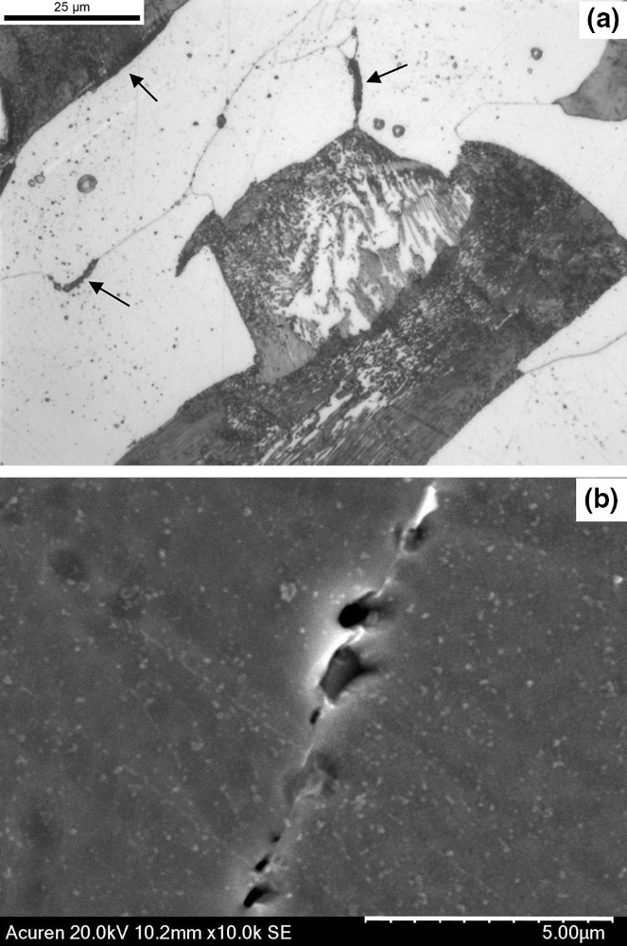
Figure 1.1 HTHA internal damage in carbon steel: (a) optical image depicting pearlite decomposition and grain boundary fissuring at a magnification of 1000x; (b) SEM image showing grain-boundary bubbles at a magnification of 10000x [10].

on the Nelson curves. Experimental data clearly demonstrate that the bottom left regime denotes safe operating conditions.
Despite some success of this approach in safety design due to its simplicity, the usage of Nelson curves is only restricted to a small number of commonly used steels and remains empirical, lacking a mechanistic explanation (i.e., actual microstructure-based failure processes in HTHA). This highlights the discrepancies between the empirical model and available creep data. Consequently, predicting Nelson curves from the extensive creep
experiments and the studies of hydrogen thermodynamics and kinetics is crucial.

1.1.3 Additive Friction Stir Deposition
Additive manufacturing (AM) has gained significant traction over the past decades. Predominantly, AM technology encompasses the fusion of metal powder through either an electron beam or laser [13]. The rapid solidification inherent to this process profoundly impacts both the micro-features and mechanical attributes of the fabricated part [14]. Yet, owing to the swift solidification akin to casting, there's a susceptibility to issues like solidification cracking and porosity [15].
In light of these challenges, the additive friction stir deposition (AFSD) technique has emerged as a promising alternative, marrying the concepts of AM and friction stir welding (FSW) as shown in Fig. 1.2 (b) [16-18]. The AFSD process involves three processing stages: (1) depositing preparation, (2) initial deposition, and (3) steady-state deposition, as shown in Fig. 1.3 [19]. During the AFSD process (Fig. 1.2 (a) [18]), the feedstock material is delivered through the hollow shoulder at a very low feeding rate and a high rotation rate with the tool prior to deposition. Due to the continuous extrusion of the feed rod and
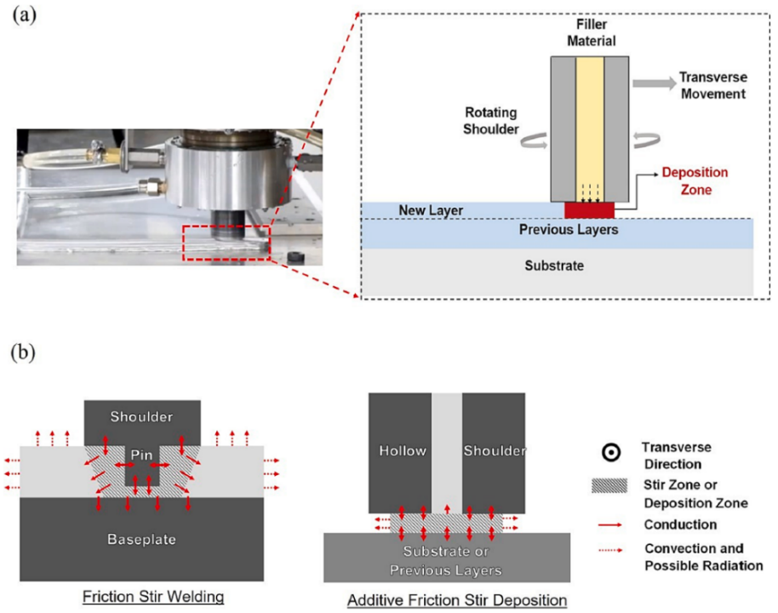
Figure 1.2 (a) A picture showing AFSD equipped with a hollow tool and an illustrative diagram highlighting some fundamental physical processes in the local region of deposition. (b) A comparison of thermal boundary conditions between FSW and AFSD [18].
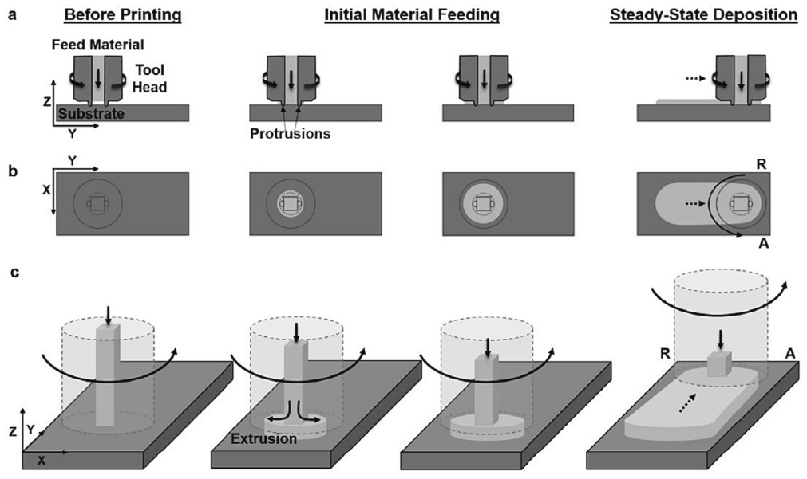
Fig. 1.3 Schematic diagrams showing the main AFSD processing steps (from left to right): before processing, initial material feeding, and steady-state deposition. This includes (a) side view, (b) top view, and (c) isometric view [19].

transverse motion, dynamic contact friction generates frictional heat at the tool-material and material-substrate interfaces, raising the temperature of the feedstock material and tool. The feedstock material softens as the temperature rises, promoting severe plastic deformation. The heat generated by the contact friction and the plastic deformation stabilized. Metallic components with tailored geometrical properties are manufactured through the continuous flow of feedstock material and motion along the scanning path, which yields equiaxed, fine microstructures [20-21], and exhibits mechanical properties reminiscent of wrought materials [22]. Nonetheless, when benchmarked against electron beam or laser-driven AM, AFSD also has its constraints, notably lower precision and adaptability in manufacturing. Challenges such as hook defects, cavity defects, and kissing-bond defects arise [23], contingent upon factors like material choice, tool dimensions, and process specifications. Thanks to the rapid deposition capabilities of the AFSD process, sizable components can be swiftly fabricated, facilitating the evaluation of novel materials and geometries. Concurrently, the potential of AFSD has been tentatively explored in areas like aluminum matrix composites [23], material recycling [24], and additive repairs [25].
However, as a relatively new AM technique, AFSD is still in its early stages and has been in use for about ten years since it was first patented in 2014 [26]. An in-depth study on processes, microstructure and properties is needed. The as-deposited morphology and microstructure, as well as subsequent properties, are highly dependent on temperature evolution and deformation behaviors. Heat generation in AFSD has a strong influence on temperature evolution. Interfacial friction and plastic deformation produce heat during this process. Although there are a lot of measurements of heat generation and temperature contour in AFSD, a rational explanation on the effect of AFSD processing parameters on heat generation and temperature evolution is still lacking.

Outline
This thesis work is organized as follows. In Chapter 2, we present a micromechanical finite element framework on the high temperature failure as the nucleation and growth of grain boundary cavities, which includes various parameters such as thermomechanical loading history and its evolution, the competition of grain-interior
dislocation creep and grain-boundary diffusion in failure lifetime, and microstructural heterogeneities, to understand the grain size effect and residual stress evolution and lifetime prediction in SRC. In Chapter 3, we aim to develop a microstructure-informed and micromechanics-based model by incorporating a synergy between hydrogen transport and intergranular-cavity-based fracture process to obtain Nelson curves, reveal its underling mechanism and elucidate the effect of the pipe thickness and applied stresses on Nelson curves in HTHA. In Chapter 4, a Coupled Eulerian Lagrangian (CEL) model in finite element method is constructed to investigate and validate our theoretical analysis on the effect of processing parameters on heat generation and temperature evolution in AFSD. The last chapter presents the conclusions and future suggestions.

Chapter 2 An Integrated Computational Framework for High Temperature Creep Failures

2.1 Introduction
This chapter is majorly based on the following publication:
- Y. Yang, D. Han, W. Zhang, Y.F. Gao, J. Penso, Z.L. Feng, "Identifying multiple synergistic factors on the susceptibility to stress relaxation cracking in variously heat-treated weldments" Mechanics of Materials (2024): 105013.
SRC represents a significant high-temperature creep failure mode in equipment subjected to prolonged service at elevated temperatures. This phenomenon has been extensively observed in thick-walled welded components made from austenitic stainless steel, ferritic stainless steel, heat-resistant steel, and nickel-based alloys. The susceptibility to SRC is influenced by material properties such as microstructure and grain size, as well as operational conditions including service temperature and residual stress levels. Accurately simulating the entire failure process and estimating the failure lifetime under these synergistic factors is notably complex.
Previous research [4,27] indicates that creep rupture involving diffusion and creep failure, is a common high-temperature failure mode. The formation and accumulation of cavities at grain boundaries under thermal-mechanical conditions are primary causes, with precipitation evolution playing a key role in cavity coalescence, crack initiation, and propagation, particularly when precipitation preferentially forms at grain boundaries. These behaviors can be explained through appropriate failure mechanisms or their combinations. Diffusion-controlled failure is more likely under high-temperature service conditions. Within the service temperature range considered, failure initially occurs through dislocation creep within the grain interior due to high stress levels, subsequently transitioning to diffusion control as residual stress decreases and service temperature increases. The wide range of thermal treatment temperatures, from mid- to high-temperature, adds further complexity to determining the controlling failure mechanism. Previous studies have employed simulations to predict service lifetime. For instance, Hayhurst et al. [28] utilized a continuous damage method to predict the lifetime of high-temperature, low-alloy ferritic steel weldments, successfully identifying failure locations despite noticeable prediction errors when comparing 2D to 3D results and experimental data. Gaffard et al. [29] explored the relationship between microstructural state and low creep strength in weldments, developing correlated experiments and models. However, limitations in sample shape and the ability to extrapolate findings to other conditions must be acknowledged.
Residual stress, induced by welding and evolving during post-weld heat treatment (PWHT) and subsequent service conditions, is a primary contributor to SRC. Assessing the evolution of residual stress in relation to thermal history presents significant challenges. Although residual stress measurements of welded structures are routinely performed at ambient conditions, nondestructive real-time measurements at elevated temperatures remain elusive. These challenges have impeded the development of an optimal thermal history that can prevent SRC. PWHT is typically applied post-welding to reduce residual stress levels, with higher temperatures leading to more rapid stress relaxation. However, this can also enhance SRC susceptibility due to undesirable microstructural changes. The dissolution of precipitates creates precipitate-free zones (PFZ) near grain boundaries, leading to strain redistribution and accumulation at these sites, which is hypothesized to contribute to SRC [30]. Nevertheless, detailed stress mapping to validate this hypothesis is lacking.
Moreover, the intricate relationship between precipitate generation and annihilation,
as well as changes in thermal-mechanical properties, can significantly influence the failure process. For example, the working environment profoundly impacts the thermal-mechanical properties of 347H austenitic stainless steel, a high-alloy, precipitation-strengthened material. Variations include increased creep rate, decreased yield strength, and gradual precipitation evolution over time. Various precipitates, including NbC, Cr23C6, Fe-rich α, Cr-rich α′, sigma phase, G-phase, Z-phase (NbCrN), and Laves phase, exist in 347H stainless steel at different service stages. The sequence of precipitate formation determines the extent of crack initiation and propagation. For example, during the stabilizing annealing stage, NbC significantly reduces susceptibility to intergranular cracking. During welding and PWHT, Cr₂₃C₆ formation in the heat-affected zone (HAZ) occurs alongside carbon redistribution. During service at approximately 400°C, Fe-rich α, Cr-rich α′, and G-phase form due to ferrite spinodal decomposition [31]. The effects of each phase vary; for instance, Cr₂₃C₆ and sigma phase do not contribute to strengthening as they accumulate along grain boundaries, providing nucleation sites for cavities and driving crack initiation, contributing to the carbon-free process [32-33]. The effects of other types of precipitation are not clearly defined. Precipitate size and distribution significantly affect microstructure evolution, and variations in grain size, precipitate fraction, and precipitate type dictate the degradation of mechanical properties in different
locations.
Therefore, to address the failure process more precisely, this study aims to establish a microstructure-explicit simulation model based on grain boundary cavities, with constitutive laws governing cavity nucleation and growth, directly linked to grain boundary diffusion, viscous grain boundary sliding, and other mechanisms. In Section 2.2, we have a recap on the fundamental deformation and damage mechanisms of crystalline materials at high temperatures. As explained in Section 2.3, both diffusive and creep-constrained cavity growth models will be integrated into the finite element method (FEM) framework, enabling an explicit representation of the failure processes at the microstructural length scale. Section 2.4 discusses several case studies including the effect of grain size, SRC and the role of PFZ by the FEM model elaborated in the above section. In the end, the concluding remarks are given in Section 2.5.

2.2 Deformation and Damage Mechanisms at High Temperatures
During service at elevated temperatures and/or during stress-relieving heat treatment following welding or plastic deformation, the failure process is a complex phenomenon influenced by multiple synergistic factors. Various types of cracks can be observed in weldments [34,35], with Type-IV failure being the most prevalent, characterized by longitudinal cracks. Our failure model is predicated on the formation of intergranular cavities. The relevant microstructures can be any depicted in Fig. 2.1 (a) to 2.1 (c). The mechanism governing cavity growth may be diffusive under conditions of low stress and high temperature, or creep-controlled under conditions of high stress and intermediate temperature [36].
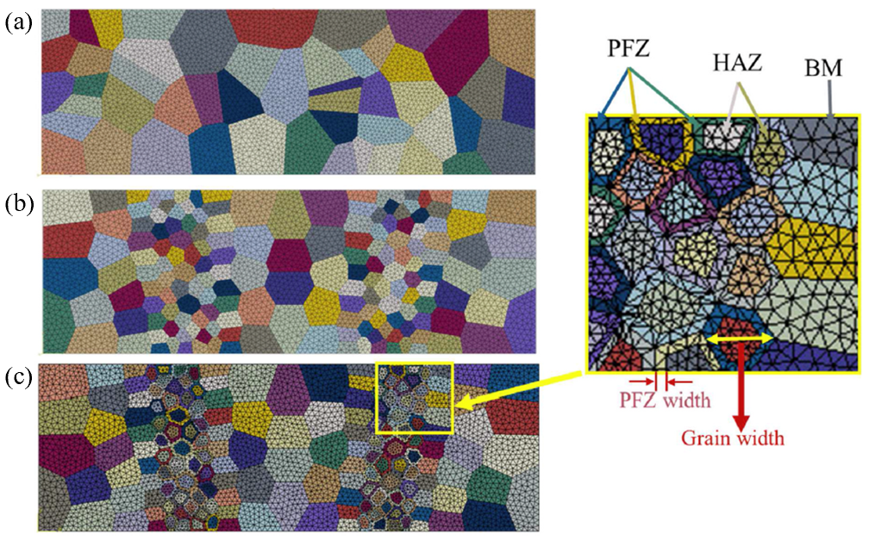
Figure 2.1 The cross-sectional models with (a) ideal microstructure of the base metal, (b) heat affected zone (HAZ), and (c) HAZ with precipitate-free-zone (PFZ) finite element meshes as shown in the inset.

2.2.1 Intergranular Cavity Failure Model at Elevated Temperatures
The failure mechanism identified in this study is Type IV intergranular creep fracture. This failure mode typically manifests in the heat-affected zone (HAZ) at grain boundaries, where precipitates of varying scales act as nucleation sites for cavities, as confirmed through microstructural analysis. The detailed mechanisms of failure control,
including the processes of cavity nucleation, growth, and coalescence, are elucidated in the subsequent sections.

2.2.2 Deformation Model
We posit that plastic deformation is primarily governed by dislocation (power-law) creep within the grains. The total strain rate encompasses both the elastic strain rate and the creep rate, which can be individually represented as follows:
${\dot{ε}}_{ij}^{e}=\frac{1+v}{E}\left({\dot{σ}}_{ij}-\frac{v}{1+v}{\dot{σ}}_{kk}δ_{ij}\right)$, (2.2.1)
${\dot{ε}}_{ij}^{p}=A_{dis}\frac{EbD_{l}}{k_{B}T}{\left(\frac{σ_{e}}{σ_{0}}\right)}^{n}\frac{3S_{ij}}{2σ_{e}}{\overline{M}}^{I}$. (2.2.2)
In the two equations, ν is Poisson’s ratio and E is Young’s modulus separately. $δ_{ij}$ represents the Kronecker delta; $k_{B}$ is the Boltzmann’s constant; b is the Burgers vector; T is the absolute temperature; $σ_{e}$ is the von Mises stress; n is the stress exponent; $σ_{0}$ is the
reference stress; $A_{dis}$ is the material constant; $D_{l}$ is the diffusivity coefficient for the dislocation. And the normalized micromechanical Taylor factor for the $I_{th}$ grain ${\overline{M}}^{I}=M^{I}/max\left(M^{1},M^{2},…,M^{I},…,M^{N_{g}}\right)$, where N is the total number of grains within the polycrystalline model. A separate crystal plasticity finite element simulation is necessary to acquire this information, which will not be elaborated upon in this context. It is important
to note that Coble creep is incorporated into the subsequent cavity growth process; hence,
this mechanism does not require explicit consideration.

2.2.3 The Smear-Out Failure Model
Grain boundary cavities, typically exhibiting a spherical-cap shape, are often described using the following shape parameters including radius a, half-spacing b, and cavity tip angle ψ as Fig. 2.2 (a) shows. Onck et al. [37] suggest that the cavity tip angle ψ should be about 75° during the growth of cavities. The cavity volume V is described by
$V=\frac{4}{3}πa^{3}h\left(ψ\right)$. (2.2.3)
Here $h\left(ψ\right)$ is the spherical-caps shape parameter, which is formulated by
$h\left(ψ\right)=\frac{\left[{\left(1+\cos{ψ}\right)}^{-1}-1/2\cos{ψ}\right]}{\sin{ψ}}$ . (2.2.4)
As illustrated in Fig. 2.2 (b), Rice introduced a method for representing grain boundary cavities in a smeared-out sense [38], enabling the model to be substituted by a continuously varying separation $u_{n}=V/\left(πb^{2}\right)$, when reckoning with the complexity of the specific modelling on each individual cavity on grain boundaries. This approach simplifies the complex modeling of individual cavities on grain boundaries. After this simplification, the rate of normal separation can be expressed in terms of the volumetric growth rate $\dot{V}$ of the cavities and the rate of change of the cavity spacing $\dot{b}$,
${\dot{u}}_{n}=\frac{\dot{V}}{πb^{2}}-\frac{2V\dot{b}}{πb^{3}}$ . (2.2.5)

2.2.4 Cavity Nucleation and Growth
Regarding the cavity nucleation, a comprehensive physical understanding of the mechanism is currently lacking. Therefore, a phenomenological model as proposed by Tvergaard [39] is utilized in this study. When $σ_{n}>0$, the cavity nucleation rate is given
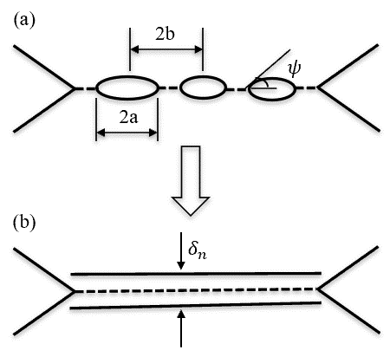
Figure 2.2 Schematic plots for (a) a number of spherical-cap-shaped cavities located on the grain boundaries and (b) the smeared-out representation of grain boundary cavitation in terms of a continuous varying separation.

by
$\dot{N}=F_{n}{\left(\frac{σ_{n}}{Σ_{0}}\right)}^{2}{\dot{ε}}_{e}^{c}$, (2.2.6)
here $F_{n}$ is the material parameter which shows the effect of microstructural features, $Σ_{0}$ is
a reference stress, $σ_{n}$ is the normal stress near the grain boundary and ${\dot{ε}}_{e}^{c}$ is the effective
creep rate in the form of ${\dot{ε}}_{e}^{c}={\dot{ε}}_{0}{\left(σ_{e}/σ_{0}\right)}^{n}$, where reference strain rate ${\dot{ε}}_{0}=A_{dis}\frac{EbD_{l}}{k_{B}T}$ . Onck et al. [40-42] proposed a parameter as the function of stress and strain accumulation,
$S={\left(\frac{σ_{n}}{Σ_{0}}\right)}^{2}ε_{e}^{c}$ for $σ_{n}>0$. (2.2.7)
It appears to reach a threshold value $S_{thr}=\frac{N_{i}}{F_{n}}$, at which cavity nucleation is initiated. Here $N_{i}$ is the initial cavity density. And the cavity spacing will decrease as stated by
$\frac{\dot{b}}{b}=\frac{1}{2}\left({\dot{ε}}_{I}+{\dot{ε}}_{Ⅱ}\right)-\frac{1}{2}\frac{\dot{N}}{N}$ , (2.2.8)
as cavities keep nucleating on grain boundaries. Here ${\dot{ε}}_{I}$ and ${\dot{ε}}_{Ⅱ}$ are in-plane principle logarithmic strain rate at the grain boundary.
According to the pioneering work of Needleman and Rice [43], grain boundary diffusion and dislocation creep deformation both contribute to the volumetric cavity growth, which are defined respectively as
${\dot{V}}_{1}=4πD\frac{σ_{n}-\left(1-f\right)σ_{s}}{ln\left(1/f\right)-\frac{1}{2}\left(3-f\right)\left(1-f\right)}$, (2.2.9)
${\dot{V}}_{2}=\left\{\begin{aligned}±2π{\dot{ε}}_{e}^{c}a^{3}h\left(ψ\right){\left[α_{n}\left|\frac{σ_{m}}{σ_{e}}\right|+β_{n}\right]}^{n} for ±\frac{σ_{m}}{σ_{e}}>1 \\ 2π{\dot{ε}}_{e}^{c}a^{3}h\left(ψ\right){\left(α_{n}+β_{n}\right)}^{n}\frac{σ_{m}}{σ_{e}} for \left|\frac{σ_{m}}{σ_{e}}\right|<1\end{aligned}\right.$, (2.2.10)
Here $σ_{s}$ is the sintering stress, $α_{n}=3/\left(2n\right)$ and $β_{n}=\left(n-1\right)\left(n+0.4319\right)/n^{2}$. f is the effective cavity volume fraction is formulated by
$f=max\left[{\left(\frac{a}{b}\right)}^{2}\text{,}{\left(\frac{a}{a+1.5L}\right)}^{2}\right]$, (2.2.11)
As a stress and temperature dependent material length scale, $L={\left(D\frac{σ_{e}}{{\dot{ε}}_{e}^{c}}\right)}^{1/3}$ shows the contribution to the cavity growth from the coupling of creep deformation and grain boundary diffusion [44].
The effect of dislocation creep is trivial when L is larger than radius a. On the contrary, the cavity growth will be dominated by dislocation creep as L becomes smaller.
And D is the grain boundary diffusion parameter as follows:
$D=\frac{D_{b0}δ_{b}Ω}{k_{B}T}exp\left(\frac{-Q_{b}}{RT}\right)$, (2.2.12)
where $Q_{b}$ is the activation energy of grain boundary diffusion, $D_{b0}δ_{b}$ is the grain boundary diffusion coefficient and $Ω$ is the atom volume. Hence the cavity growth rate can be gotten
by
$\dot{a}=\dot{V}/\left(4πa^{2}h\left(ψ\right)\right)$. (2.2.13)

2.2.5 Grain Boundary Sliding
Grain boundary sliding (GBS) follows a Newtonian viscous law [45] and is essentially a thermally activated process, governed by
${\dot{u}}_{t}=\frac{Ωη_{0}exp\left(-Q_{gbs}/RT\right)}{k_{B}T}σ_{t}$. (2.2.14)
Here ${\dot{u}}_{t}$ is the relative sliding velocity of adjoining grains triggered by the shear stress $σ_{t}$ in the grain boundaries, $η_{0}$ is a characteristic sliding velocity and $Q_{gbs}$ is the activation energy for grain boundary sliding. It is also one of the competing mechanisms on creep deformation and damage [46,47].

2.3 Numerical Simulation
Based on the constitutive law outlined above, Zhang et al. [34] proposed a nonlinear finite element method directly linked to the material microstructure. Elastic deformation and dislocation creep within the grain interior were defined using a user-defined material (UMAT) subroutine implemented in ABAQUS. Concurrently, grain boundary cavitation and grain boundary sliding (GBS) were modeled using a rate-dependent cohesive element via a user-defined element (UEL) subroutine. Building on their previous work, a two-dimensional digital model incorporating microstructural features was developed to compare various microstructural configurations with actual microstructural evolution. Three distinct cases were simulated by progressively adding microstructural features, starting with the base metal (BM) case. This approach enabled fitting the simulation results to available experimental data, such as those from the National Institute for Materials Science (NIMS) in Japan. Subsequently, the fusion zone (FZ) and heat-affected zone (HAZ) were included to minimize the discrepancy between the simulation model and actual morphology, considering the differing magnitudes of thermal-mechanical properties among the BM, HAZ, and FZ.

2.4 Case Studies

2.4.1 Case Study 1: Grain Size Dependence
When examining crystalline solids with microstructural gradients, an important question arises: how do grain sizes influence the deformation mechanisms? To address this inquiry, we can use our FEM model to obtain a deformation mechanism map that delineates the dominant deformation mechanisms as grain size continues to decrease.

2.4.1.1 Calibration of Material Parameters
The reliability of lifetime predictions across different microstructures depends critically on the accuracy of the base metal material parameters employed in the simulation model. Fig. 2.3 presents the results of creep tests for Grade 91 ferritic steel conducted at 923 K. These results have been accurately fitted by adjusting several primary control factors and accounting for other variables, as detailed in Table 2.1. The principal factors influencing the model, such as stress exponent n, cavity nucleation parameter F_{n}, grain boundary diffusivity D, grain boundary viscosity, were determined using the Arrhenius equation $\ln{k}=\ln{A}-E_{\text{a}}/RT$, (k is rate constant, A is frequency factor, $E_{\text{a}}$ is activation energy, R is gas constant, T is temperature in Kelvin) and the creep rate relation formulated with applied stress through a power law. The comparison between the discrete experimental data and the simulated data shows a strong correlation. The experimental data also revealed two distinct slopes, corresponding to creep and diffusion failure mechanisms. The slope of the experimental data for $\log\left(σ\right)-\log\left(t_{\text{r}}\right)$ is approximately equal to $-$1, indicating that the lifetime is inversely proportional to the stress. This finding is consistent with the conclusions of Hull and Rimmer [48], who asserted that creep failure is primarily governed by atom diffusion-induced cavity growth under low applied stress conditions.

2.4.1.2 Results and Discussion
To simplify the problem, we employ a base metal cross-sectional model, as depicted in Fig. 2.1(a). Three different grain sizes are considered: 5 μm, 0.5 μm, and 0.1 μm. The dependence of lifetime on stress is determined through our simulations, as shown in Fig. 2.4. As the grain size decreases, the transition stress level from creep deformation
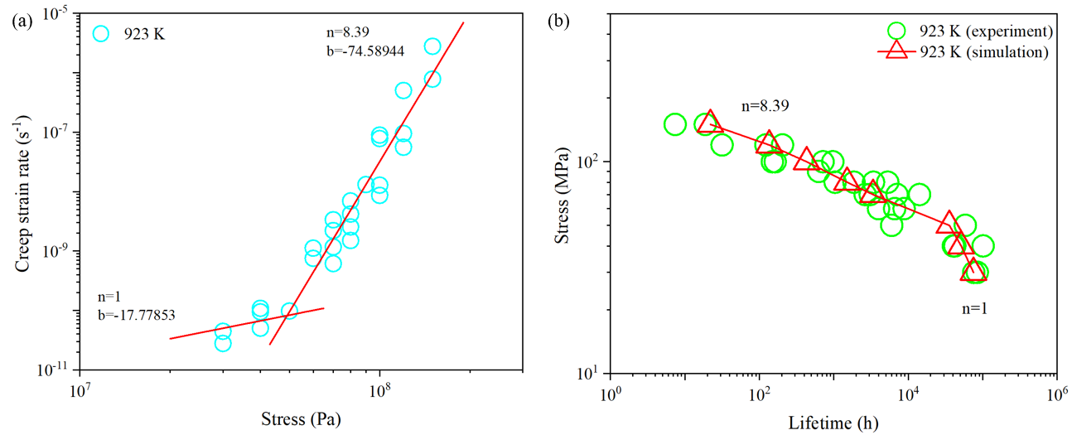
Figure 2.3 (a) Stress dependence of steady-state creep rate from experimental data for Grade 91 ferritic steel at 923 K. (b) Predicted stress versus lifetime behavior using the micromechanical model for Grade 91 ferritic steel, compared with experimental data from the literature at 923 K. The experimental data are sourced from [52].

Table 2.1 Representative values for material parameters for Grade 91 ferritic steel at different temperatures.
 | Temperature (K) |  | 823 | 873 | 923 | 973 | 1023 | 1123 | 1223 | 1323
Reference stress (MPa) |  |  | 60 | 60 | 60 | 60 | 60 | 60 | 60 | 60
 | Stress exponent, 𝑛 |  | 8.39 | 8.39 | 8.39 | 8.39 | 8.39 | 8.39 | 8.39 | 8.39
 | Cavity nucleation parameter (10⁹) |  | 1.5 | 1.5 | 1.5 | 1.5 | 1.5 | 1.5 | 1.5 | 1.5
 | Heterogeneity factor |  | 1 | 1 | 1 | 1 | 1 | 1 | 1 | 1
 | Reference stress for nucleation law (MPa) |  | 100 | 100 | 100 | 100 | 100 | 100 | 100 | 100
 | Poisson’s ratio, ν |  | 0.3 | 0.3 | 0.3 | 0.3 | 0.3 | 0.3 | 0.3 | 0.3
 | Young's modulus, E (GPa) |  | 134.0 | 110.9 | 90.1 | 72.9 | 60.2 | 52.9 | 45.6 | 38.3
 | Diffusion parameter, D  (10⁻²² mm⁵N⁻¹s⁻¹) | 1.6 |  | 6.6 | 23.0 | 70.0 | 190.4 | 1072.1 | 4517.9 | 1.5$×$10⁴
 | Grain boundary viscosity  (10¹³) |  | 1.4 | 0.35 | 0.10 | 0.03 | 0.01 | 2.1$×$10⁻³ | 5.1$×$10⁻⁴ | 1.5$×$10⁻⁴
 | Reference strain rate (10⁻¹² s⁻¹) |  | 7.1 | 28.8 | 99.9 | 303.9 | 827.0 | 4657.2 | 2.0$×$10⁴ | 6.6$×$10⁴
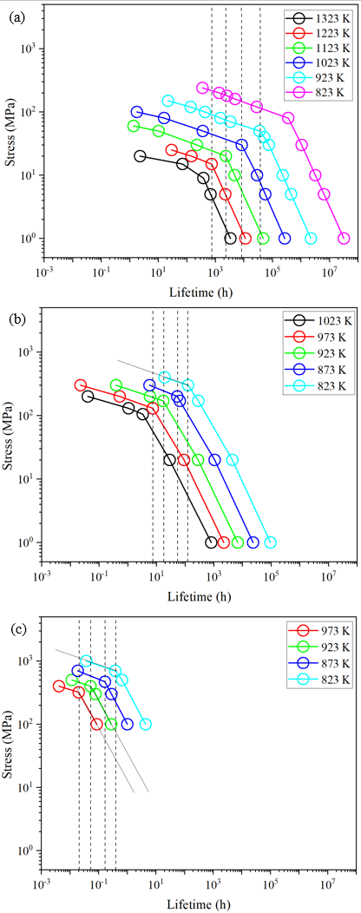
Figure 2.4 Double logarithmic plot of applied stress vs. time to rupture in terms of different grain sizes for Grade 91 steel: (a) 5 μm, (b) 0.5 μm and (c) 0.1 μm.

to diffusion deformation increases for each temperature. However, at the same stress level, the lifetime decreases in magnitude.
The deformation mechanism map can be derived from Fig. 2.4 by extracting relevant stress and temperature values at specific strain rates. In Fig. 2.5, for a grain size of d=5μm, the map distinctly delineates three primary regimes: low-temperature plasticity, power-law creep, and diffusional flow. Within the power-law creep regime, core-diffusion-controlled creep is dominant at lower temperatures, whereas lattice-diffusion-controlled dislocation creep prevails at higher temperatures. The diffusional flow regime is prominent under high-temperature, low-stress conditions and includes grain boundary diffusion-controlled Coble creep and lattice diffusion-controlled Nabarro-Herring creep. As the grain size decreases to 0.5 μm, the diffusional flow regime expands at the expense of the power-law creep regime, with grain boundary diffusion becoming the dominant mechanism. This shift results in a reduction of lattice diffusion-controlled dislocation creep, and Nabarro-Herring creep disappears from the deformation map. Further decreasing the grain size to 0.1 μm leads to grain boundary diffusion (Coble creep) being the primary contributor to total deformation, while dislocation activities are significantly restricted due to the small lattice geometry. In the high-temperature regime, grain boundary diffusion progressively becomes the predominant deformation mechanism as grain size decreases from 5 μm to 0.1 μm. In the low-temperature plasticity field, material strength increases as grain size decreases from 5 μm to 0.1 μm, following the Hall-Petch relationship, which describes the grain boundary strengthening effect. It is important to note that grain boundary sliding is not depicted in the deformation mechanism map.
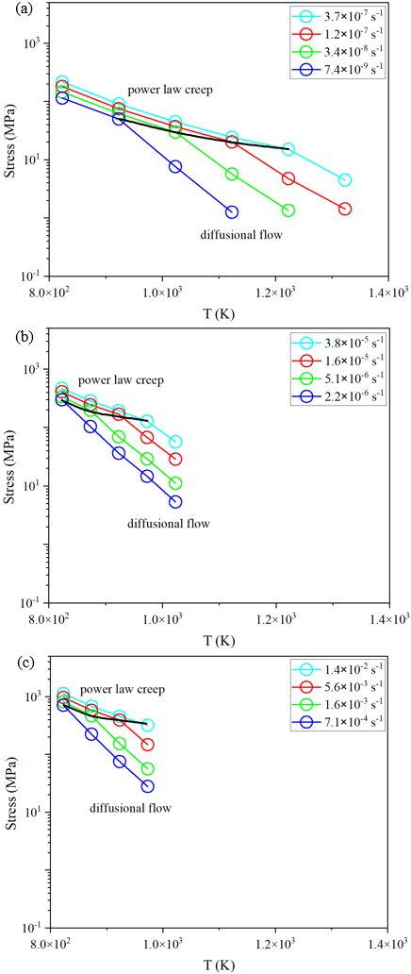
Figure 2.5 Deformation mechanism maps for Grade 91 steel with grain sizes of 5 μm, 0.5 μm and 0.1 μm.

2.4.2 Case Study 2: SRC Simulations

2.4.2.1 Calibration of Material Parameters
Before deducing the material parameters for HAZ, it is necessary to compare the simulation results with creep test results on the base metal. Fig. 2.6 displays the creep test results for the base metal at four different temperature levels. These results have been accurately fitted by adjusting several key control factors and considering additional variables as outlined in Table 2.2. However, the limited availability of creep data for 347H stainless steel in the NIMS database necessitates extrapolating the results to other temperatures using creep equations and the Arrhenius equation.
Experimental data for the HAZ and FZ, which are crucial for determining the lifetime of service components, are rarely available. Consequently, an estimation method can be employed to generate material parameters for the FZ and HAZ. This estimation assumes that lifetimes in these locations are an order of magnitude shorter than in the BM, as suggested by limited weldment failure data [34]. The corresponding HAZ constitutive parameters are presented in Table 2.3. The formation of precipitate-free zones (PFZ) eliminates strengthening precipitates, thereby reducing creep resistance. Although quantitative measurements are scarce, literature studies [49-51] suggest that the strain rate for dislocation creep increases by an order of magnitude, as described in Eq. (2.2.2).

2.4.2.2 Residual Stress History
Previous research has indicated that the HAZ experiences the highest residual stress under various operating conditions. Thus, in the two-dimensional (2D) failure model, it is essential to ensure that the peak residual stress is situated within the HAZ. Typically, to
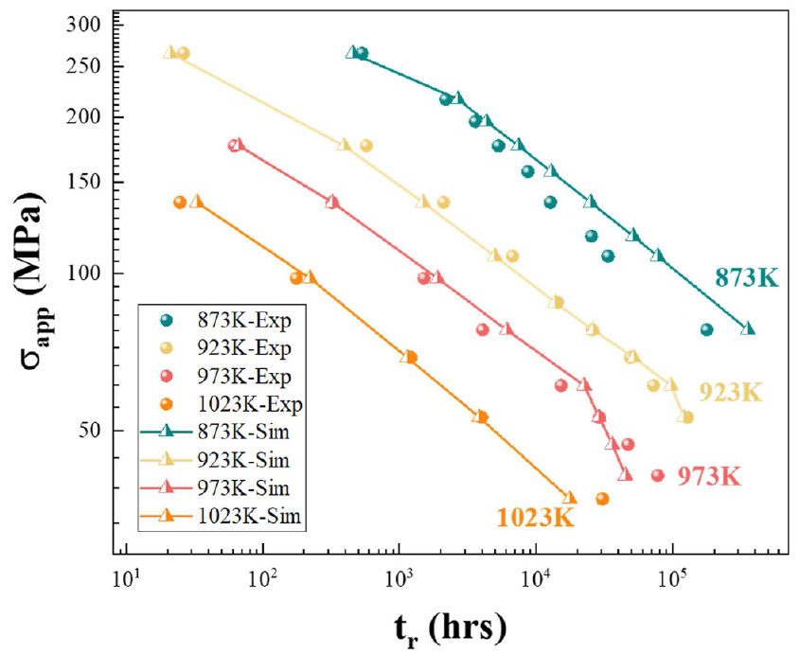
Figure 2.6 Experimental creep test data of 347 stainless steel from National Institute of Materials Science (NIMS), Japan, at 873 K, 923 K, 973 K and 1023 K under different applied loads. Simulation results are based on the intergranular cavity model.
Table 2.2 Representative values for material parameters in base metal at different temperatures.
Parameter | 873 K | 923 K | 973 K | 1023 K
Reference stress (MPa) | 142 | 142 | 142 | 142
Stress exponent, 𝑛 | 6.25 | 7.65 | 8.32 | 5.44
Grain size (10⁻³mm) | 5 | 5 | 5 | 5
Cavity nucleation parameter | 1.5$×$10⁸ | 6$×$10⁸ | 6$×$10⁸ | 6$×$10⁸
Heterogeneity factor | 1 | 1 | 1 | 1
Reference stress for nucleation law (MPa) | 100 | 100 | 100 | 100
Poisson’s ratio, ν | 0.3 | 0.3 | 0.3 | 0.3
Young's modulus, E (GPa) | 146.6 | 142.0 | 137.3 | 132.6
Diffusion parameter, D (mm⁵N⁻¹s⁻¹) | 1.10$×$10⁻²¹ | 5.33$×$10⁻²¹ | 2.19$×$10⁻²⁰ | 5$×$10⁻²⁰
Grain boundary viscosity | 5.81$×$10¹⁴ | 1.20$×$10¹⁴ | 2.93$×$10¹³ | 8.2$×$10¹²
Reference strain rate (s⁻¹) | 1.416$×$10⁻⁹ | 1.159$×$10⁻⁸ | 6.099$×$10⁻⁸ | 1.405$×$10⁻⁶

Table 2.3 Representative values for material parameters in heat affected zone (HAZ) at different temperatures.
Parameter | 873 K | 923 K | 973 K | 1023 K
Reference stress (MPa) | 142 | 142 | 142 | 142
Stress exponent, 𝑛 | 6.25 | 7.65 | 8.32 | 5.44
Grain size (10⁻³mm) | 5 | 5 | 5 | 5
Cavity nucleation parameter | 5$×$10⁸ | 1.7$×$10⁹ | 2.6$×$10⁹ | 3.2$×$10⁹
Heterogeneity factor | 1 | 1 | 1 | 1
Reference stress for nucleation law (MPa) | 100 | 100 | 100 | 100
Poisson’s ratio, ν | 0.3 | 0.3 | 0.3 | 0.3
Diffusion parameter, D (mm⁵N⁻¹s⁻¹) | 4$×$10⁻²⁰ | 1.94$×$10⁻¹⁹ | 7.96$×$10⁻¹⁹ | 1.82$×$10⁻¹⁸
Grain boundary viscosity | 5.81$×$10¹³ | 1.20$×$10¹³ | 2.93$×$10¹² | 8.2$×$10¹¹
Reference strain rate (s⁻¹) | 1.416$×$10⁻⁸ | 1.159$×$10⁻⁷ | 6.099$×$10⁻⁷ | 1.405$×$10⁻⁵

prevent bending or warping, actual welding procedures employ V-shape or Y-shape initial geometries, which helps to avoid further stress concentrations, gradually converging toward the sample surface. Consequently, both the temperature field influence area and the microstructure variation area progressively expand. This indicates that the peak residual stress value will exhibit a V-shape or Y-shape along the thickness direction. Therefore, the FZ and HAZ are angled, rather than being perfectly perpendicular to the plate's top and bottom surfaces, with an angle of approximately 50° to 70° commonly applied to flatten the weldments. The temperature and residual stress fields, along with their evolution in a multi-pass welding process, resemble those in a single pass welding procedure, with residual stresses predominantly concentrated in the HAZ. For brevity, we will not delve into the detailed simulation procedures. Instead, we will use a simplified residual stress field, introduced through a user-defined subroutine (SIGINI), described by the following equation:
$σ_{\text{r}}=y_{0}+\frac{A}{\left(w×\sqrt{\frac{π}{4×\text{ln}\left(2\right)}}\right)}×\text{exp}\left(-4×\text{ln}\left(2\right)×{\left(x-x_{\text{c}}\right)}^{2}/w^{2}\right)$ (2.4.1)
where y₀, A, w and x_{c} are set as 50 MPa, 500 MPa, 10.4 mm and 14.1 mm respectively. By integrating residual stress in the failure model, we can mimic a clear residual stress relaxation cracking process as shown in Fig. 2.7: (1) the initial state of the residual stress field; (2) gradual relaxation of residual stress accompanied by crack initiation; (3) the final failure state, marked by completely relaxed residual stress and the formation of a penetration crack.

2.4.3 Case Study 3: the Role of PFZ
Finally, the FEM model incorporated the PFZ to reflect the microstructural features
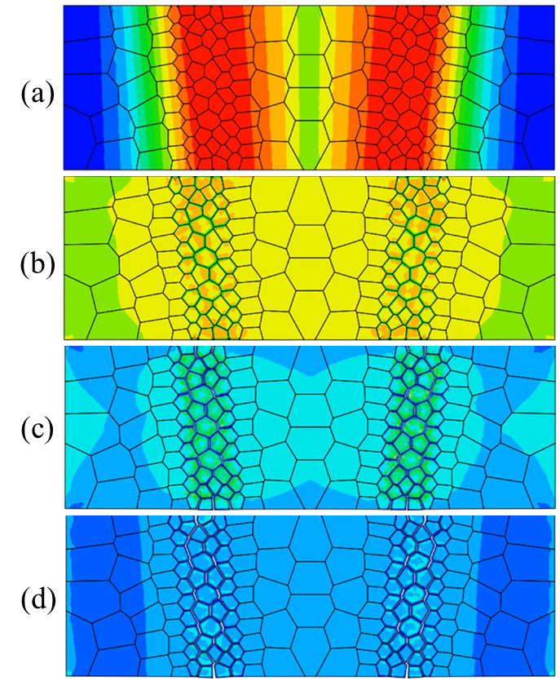
Figure 2.7 Residual stress relaxation process, (a) the initial status of the residual stress field in the model cross-section; (b-c) the residual stress is gradually relaxed and the crack initiation can be found; (d) the final failure status as the residual stress has already relaxed and the penetration crack can be found.

observed during the late service stage of the component. Precipitation within the grain interior enhances its strength, while the depletion of particles at the grain boundaries forms PFZs, resulting in weakened grain boundaries. This phenomenon is crucial for the initiation and propagation of cracks during the late service stage. To simulate these conditions, digital microstructures were created with random crystallographic orientations and material properties assigned via a UMAT subroutine, as depicted in Fig. 2.1 (c). The simulation model's boundary conditions were established to mirror the actual service conditions, with fixed edges on the left and right, and free expansion at the top and bottom surfaces. By varying the ratio between PFZ thickness and grain size, we can assess the impact of microstructural evolution on the susceptibility to SRC.
Three microstructural setups illustrated in Fig. 2.1 were simulated to generate the stress versus time plots shown in Fig. 2.8. These plots represent the overall magnitude of the stress fields at hold temperatures of 873 K and 1023 K in (a) and (b), respectively. In the absence of the cavity failure model, residual stress relaxation would continue indefinitely at a slow pace. However, when cavities and more realistic microstructures are incorporated, the stress-time curves exhibit sudden drops, indicating the coalescence of grain boundary cavities, which allows for the determination of lifetimes. For example, at 873 K, the base metal (BM)-only scenario exhibits a failure time of 1.353 × 10⁹ hours, which decreases to 3.332 × 10⁸ hours in the HAZ scenario, and further reduces to 1.682 × 10⁸ hours in the HAZ + PFZ scenario. At 1023 K, the corresponding lifetimes are 4.514×10⁷, 3.541×10⁶, and 6.889 ×10⁵ hours, respectively.
This comparison reveals that microstructure gradients significantly reduce failure
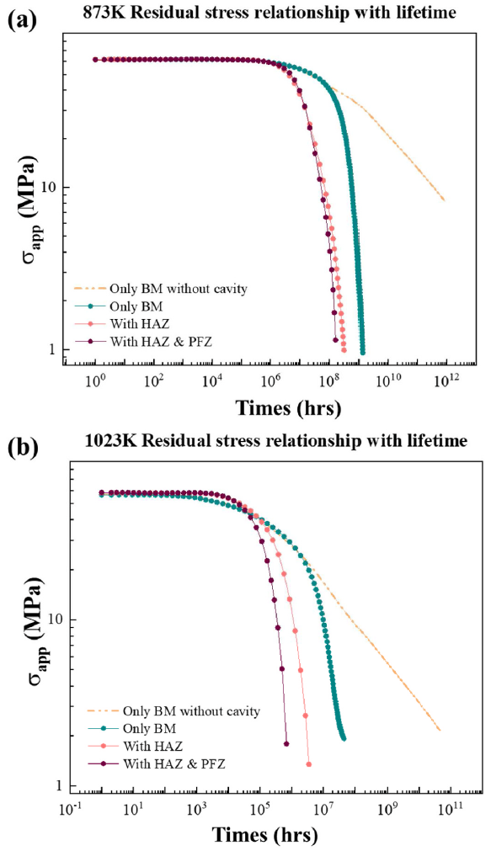
Figure 2.8 Residual stress variation in simulation models with different microstructures: only base metal without cavity failure; only base metal with cavity failure model; weldment with HAZ failure; weldment with HAZ and PFZ. Refer to Fig. 2.3 for these microstructures. These stress relaxation history results can be compared to the schematic illustration in Fig. 2.2 (c). (a) 873 K and (b) 1023 K.

time. Although precipitation strengthening, particularly from NbC formation, enhances mechanical properties, the adverse effects of PFZ widening become more pronounced with prolonged service time. The interplay between these factors is time-dependent and influenced by service temperature. As NbC migrates into the grain interior and the PFZ volume fraction increases, the disparity in thermal-mechanical properties at the grain boundary grows. Moreover, other precipitates (e.g., M23C6, G-phase, Z-phase) that preferentially form at grain boundaries further accelerate the processes of void formation, coalescence, and crack propagation.

2.5 Conclusions
Identifying the controlling failure mechanisms and performing lifetime predictions consistently remain a difficulty for weldments subjected to various heat treatments. It is known that residual stress evolution, microstructural change, and detailed failure processes
indicates a faster drop in yield strength, leading to a lower susceptibility to crack formation. The stress and strain concentrations all contribute to the final SRC and SAC, but a quantitative assessment of these synergistic factors is not feasible experimentally. In this work, focusing on the SRC susceptibility of 347H stainless steel weldments, we develop two simulation steps, the first one on the residual stress development during welding and upon reheating, and the second on the microstructure-explicit, micromechanics-based failure processes. Despite the limited knowledge of material constitutive parameters in the heterogeneous microstructure, it is found that the leading factor is the residual stress development, reduction and evolution, while others (especially the PFZ) at most change the lifetime’s order of magnitude but not its trends.

Chapter 3 A Mechanistic Interpretation of Nelson Curves for PVP Failures under High Temperature Hydrogen Attack

3.1 Introduction
This chapter is based on the following publication:
- D. Han, Y.F. Gao, P.E. Loya, M. Swindeman, J. Penso, Z.L. Feng, "A mechanistic interpretation of Nelson curves for PVP failures under high temperature hydrogen attack" Mechanics of Materials (2024): 105079.
In early attempts, by collecting data from reported HTHA failures, HTHA-damaged but non-failed components and several cases of satisfactory operation of HTHA on different steels, a set of curves, known as "Nelson curves", are developed to assess the susceptibility to HTHA and establish the safe operating limits for carbon and low-alloy steels in high temperature and high-pressure hydrogen [7,8]. The American Petroleum Institute (API) maintains and offers updated Nelson curves through Recommended Practice (RP) 941 [7], which serve as an authoritative guide for safe material choice to avoid the occurrence of HTHA. As a representative example, Nelson curves of C-0.5Mo steel are given in Fig. 3.1 (a). Based on hydrogen partial pressure, material compositions and temperature, operational conditions can be divided into non-damaged and damaged regimes with certain lifetimes labeled on these Nelson curves. Experimental data have been collected that clearly show the bottom left regime being the safe operating conditions. Although this approach has found some successes in safety design due to its simplicity, the usage of Nelson curves is only restricted to a small number of commonly used steels. On the other hand, a more complete creep lifetime database exists, such as those provided by National Institute of Materials Research (NIMS), Japan [52]. A key question that naturally
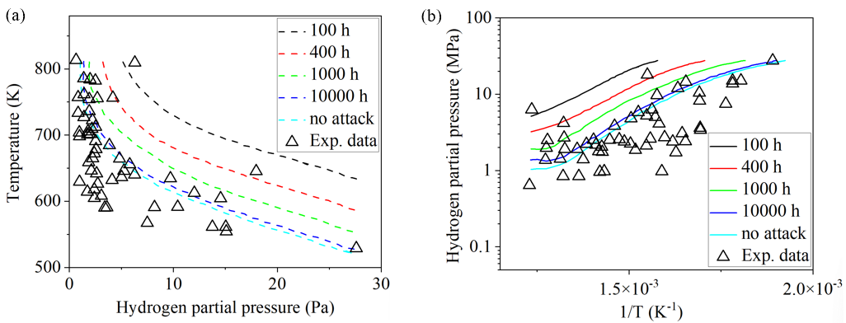
Figure 3.1 (a) Nelson curves and experimental data for pressure vessels and piping (PVP) of C-0.5Mo ferritic steel [7,8]. (b) Replotted Nelson curves with respect to the hydrogen partial pressure and the reciprocal of temperature.

arises is whether we can predict such Nelson curves from the extensive creep experiments and the studies of hydrogen thermodynamics/kinetics.
Aiming to turn empirical Nelson curves to mechanistic ones, we start from the Sherby-Dorn equation [53] for creep fracture lifetime, given by

$t_{r}=Ap^{-n}exp\left(Q/RT\right)$, (3.1.1)
where $t_{r}$ represents the time to a particular damage state, such as incubation, cracking or failure, A is a material constant depending on the properties of steels, p is the applied stress, and $Q$ is the activation energy reflecting the dominant deformation mechanism (e.g., dislocation creep or grain boundary diffusion). Rearranging Eq. (3.1.1) to a logarithmic form gives
${lnt}_{r}=-nlnp+\frac{Q}{RT}+lnA$, (3.1.2)
$lnp=\frac{Q}{nRT}+\frac{lnA-{lnt}_{r}}{n}$. (3.1.3)
Now replot Nelson curves in Fig. 3.1 (a) with respect to the hydrogen partial pressure and the reciprocal of temperature as shown in Fig. 3.1(b). If we blindly take p as the hydrogen partial pressure, we should see linear or piece-wise linear curves with the slopes being $Q/{nR}$. These converted Nelson curves do not show such geometric features, and even an intentional curve fitting will give a $Q$ value that is one order of magnitude smaller than the creep measurements. In contrast, the creep fracture dataset will clearly demonstrate two straight lines, one being controlled by grain boundary diffusion at high temperature and low stress, and the other by dislocation creep at intermediate temperature and high stress. The slopes can be used to obtain the activation energies.
The failure of the Sherby-Dorn equation in Fig. 3.1(b) suggests that the first step in understanding Nelson curves lies with the thermodynamics and kinetics of hydrogen, including hydrogen adsorption on the PVP inner diameter (ID), hydrogen transport into the
bulk through grain boundaries, and then reaction and formation into methane. These thermodynamic and kinetic processes are fairly understood as will be summarized in Section 3.2, which will convert the hydrogen partial pressure into a total pressure (consisting of hydrogen and methane) that plays the same role of the applied stress. As will be demonstrated later, there still exist considerable discrepancies between the converted Nelson curves using the total pressure and the creep fracture dataset. The missing link clearly lies on the actual microstructure-based failure processes.
Important earlier investigations into HTHA failure processes can be grouped into cavity nucleation and growth models [54,55]. Of these two, growth models are more sophisticated and capable of predictions within an order of magnitude in comparison to experiments [55]. They consider methane production rate (represented by a function of cavity size/volume) and either unconstrained or constrained cavity growth by creep. For a single cavity contained within a cylindrical or a spherical unit cell, analytical relations have been attempted for both diffusive and creep-constrained cavity growth modes. For example,
Shih and Johnson [56] applied a void growth model that involved methane reaction kinetics to calculate the Nelson curve for plain carbon steel. Methane pressure was considered the driving force for void growth, which was considered to be dominated by grain-boundary diffusion at the early stage and later by creep. Noting that methane fugacity in bubbles is significantly higher than methane pressure, Odette and Vagarali [57] presented an "equation-of-state" for a better assessment of methane pressure (in carbon steel), which is necessary for a successful modeling. Later, the synergy between creep deformation due to external stress and grain boundary cavitation due to methane bubble growth was numerically investigated by Shewmon [12]. Based on Odette-Vagarali model [57] for methane pressure calculation, Van der Burg, Van der Giessen and colleagues [58-61] calculated HTHA damage and the remaining life of the component in HTHA-susceptible service by adding model for the growth and coalescence of grain-boundary cavities under macro-scale stress. The model was used for the calculation of the Nelson curves. Schlögl and Van der Geissen [62] used finite element method (FEM) to present a more general numerical microstructure model which is based on a variational approach that coupled two processes, namely carbon diffusion in ferrite and the chemical reaction between hydrogen and carbon to form methane. Dadfarnia et al. [63] also presented "a simple (one-dimensional) constraint-based model" by improving the mechanistic models of 1980s. They established Nelson-type curves for the material at different levels of stress; the curves were no longer merely phenomenological (i.e., safe vs. unsafe), but showed time to failure. Using a damage mechanics approach, Chavoshi et al. [64] presented a continuum damage
mechanics model that combined creep and HTHA damage to evaluate a C-0.5Mo steel
after 80,000 h at 350-500 °C and under a hydrogen pressure of 4 MPa. They used hydrogen fugacity and a coupling between Fick’s diffusion law and a multi-axial creep ductility model, whereas the ratio of certain strain measure to this ductility defines the damage parameter.
Among the above literature works, finite element simulations are mostly compared
to fracture morphology (e.g., [64]), and analytical models of single cavities focus on carbon/hydrogen diffusion and growth rate (e.g., [62]). While the latter has been compared to Nelson curves with some successes, these models essentially do not have a hydrogen gradient over a length scale larger than the grain size. Important features such as the applied load (and its distribution) and the PVP wall thickness are not considered in these literature studies. All these limitations prevent us from predicting Nelson curves from available information, including microstructure, loading conditions, creep dataset, and hydrogen thermodynamics and kinetics with the known material composition.
The objective of this study is to establish a mechanistic explanation of the Nelson curves with the focus on the discrepancies between such an empirical model and the available creep data. The main hypothesis is that combining the well-established thermodynamic model for hydrogen reaction/transport with the creep lifetime data will not be able to quantitatively explain Nelson curves. Instead, with a micromechanical constitutive framework that can be implemented in a nonlinear finite element method (FEM), we can simulate the critical roles played by microstructural information, which eventually identifies the gaps to the prediction of Nelson curves. In Section 3.2, the thermodynamic and kinetic processes governing the reaction and transport of hydrogen will be reviewed. Section 3.3 discusses a smear-out model that links the responses of individual cavities to the grain boundary fracture. Both diffusive and creep-constrained cavity growth models will be incorporated in the FEM model that explicitly captures the failure processes on the microstructural length scale, as explained in Section 3.4. Calibrated from NIMS creep strain-rate and lifetime data [52], our microstructure-explicit failure model can predict Nelson curves under arbitrary geometric and loading conditions. Subsequently, the gradients in hydrogen concentration and load distributions are systematically studied, and our nonlinear FEM simulations reveal the drastic shift of these Nelson curves with the change of applied stress and PVP thickness. Implications of these findings will be discussed with respect to the uniqueness of Nelson curves and their predictive capabilities in Section 3.5. The concluding remarks will be given in Section 3.6.

3.2 Thermodynamic and Kinetic Processes
The adsorption, transport, and reaction of hydrogen with many steel alloys have been well understood. Since our objective is on the microstructure-based failure processes, we rather restrict this work to C-0.5Mo steel, which is a ferritic steel commonly used under high temperature conditions. With optimal heat treatment, the combination of solid solution strengthening due to Mo alloying and precipitation strengthening upon tempering results into the needed creep resistance. Discussions in this section primarily follow the Odette-Vagarali model [57].

3.2.1 Hydrogen Adsorption
When the PVP inside surface is exposed to a hydrogen-rich environment, hydrogen atoms can be adsorbed onto the steel surface. The thermodynamic equilibrium between
hydrogen gas and dissolved atomic hydrogen is expressed by the general form of Sieverts Law [65]
$c_{H}=S\left(T\right)f_{H_{2}}^{1/2}$, (3.2.1)
where $c_{H}$ and $S\left(T\right)$ are the equilibrium hydrogen concentration and the equilibrium
solubility of hydrogen gas, respectively. Given that the solution is also affected by the hydrostatic pressure in the steels, $S\left(T\right)$ can be described as
$S\left(T\right)=S_{0}exp\left[\left(-∆G-p{\overline{V}}_{H}\right)/RT\right]$. (3.2.2)
Here $S_{0}$ is the solubility coefficient. $∆G$ is the activation energy for solubility. $p$ is the hydrostatic pressure in the steel. And ${\overline{V}}_{H}$ is the partial molar volume of hydrogen in iron-based alloys. $f_{H_{2}}$is the equilibrium hydrogen fugacity and given as a function of hydrogen
partial pressure [58],

$f_{H_{2}}=P_{H_{2}}exp\left[P_{H_{2}}∙y\left(T\right)\right]$, (3.2.3)
$y\left(T\right)=1.54×{10}^{-6}{Pa}^{-1}∙K/\left(T+459.67K\right)+4.69×{10}^{-11}{Pa}^{-1}$. (3.2.4)

3.2.2 Hydrogen Diffusion
After adsorption, hydrogen can penetrate the steel material itself. Hydrogen atoms, being relatively small and light, can diffuse through the metal lattice. The diffusion can occur through different paths: lattice diffusion, grain boundary diffusion and dislocation and defect (such as vacancies and inclusions) diffusion. Numerous studies and models such as Fisher's classical model [66] and Whipple's analytical model [67], indicate that the diffusivity of impurities (like hydrogen) along grain boundaries can be several orders of magnitude, e.g., 10⁵~10⁸, higher than the bulk diffusivity. Thus, the diffusion process in non-preferred paths (like bulk or grains) is always neglected in the studies of corrosion assisted fracture.
Therefore, the diffusion equation can be expressed as a one-dimensional form since
only diffusion along grain boundary path is considered in our model. Considering that hydrogen diffusion is driven by gradients of concentration and local pressure, the diffusion equation can be written as,
$\frac{∂c_{H}}{∂t}=D\left(T\right)\left(∇^{2}c_{H}+\frac{{\overline{V}}_{H}}{RT}∇c_{H}∙∇p+\frac{{\overline{V}}_{H}c_{H}}{RT}∇^{2}p\right)$, (3.2.5)
where $D\left(T\right)$ is the diffusion coefficient of hydrogen as a function of the temperature,
$D\left(T\right)=D_{0}exp\left[-∆E/RT\right]$. (3.2.6)
Here $D_{0}$ and $∆E$ are diffusion coefficient and activation energy for diffusion separately. And the stress gradient will be evaluated through mechanical responses, as will be discussed later.

3.2.3 Reaction with Carbides
As the reverse of adsorption, desorption of hydrogen, namely the release of hydrogen atoms or molecules previously adsorbed onto or within the steels or surface, is inclined to happen during the diffusion of hydrogen atoms. This process can be driven by factors like increased temperature or reduced pressure. In the steels, the diffused hydrogen atoms usually recombine to form hydrogen molecules inside voids, cracks, or imperfections on grain boundaries. Therefore, Sieverts Law and Eq. (3.1.3) and Eq. (3.2.1) can also be applied to desorption of hydrogen. As hydrogen atoms and molecules amass inside or near inside voids, cracks, or imperfections, carbides tend to react with hydrogen to form methane. Due to the large size, it is not feasible for methane to easily diffuse through the steels. It builds up at the above sites, forms bubbles/cavities, and results in the increasingly large internal pressure. Driven by the methane pressure, the growth and coalescence of these bubbles leads to the deterioration and eventually failure.
A typical reaction between hydrogen gas and carbides is
$M_{x}C_{y}+2yH_{2}⇄yCH_{4}+xM$. (3.2.7)
Based on the definition of the equilibrium constant $K_{0}$ of a chemical reaction, the fugacity
of methane $f_{CH_{4}}^{e}$ can be derived from the hydrogen partial pressure $P_{H_{2}}$ as
$f_{CH_{4}}^{e}≈K_{0}∙P_{H_{2}}^{2}$, (3.2.8)
where the specific value of $K_{0}$ depends on the type of carbide. For cementite it is approximately [57]
$K_{0}=1.6×{10}^{-6}exp\left(\frac{113640}{RT}\right){MPa}^{-1}$. (3.2.9)
Similar to Eq. (3.1.3), Odette et al. [57] linked the equilibrium methane pressure and the
fugacity of methane by an implicit relationship
$f_{CH_{4}}^{e}=P_{{CH}_{4}}exp\left[P_{{CH}_{4}}∙C\left(T\right)\right]$, (3.2.10)
here $P_{{CH}_{4}}$ is the methane partial pressure. And a simplification for $C\left(T\right)$ is $\left\{\begin{aligned}C\left(T\right)=0.005 {MPa}^{-1} for f_{CH_{4}}^{e}<{10}^{3} MPa \\ C\left(T\right)=\frac{1.1875}{T}+3.0888×{10}^{-3}{ MPa}^{-1} for {10}^{3} MPa< f_{CH_{4}}^{e}<{10}^{4} MPa \\ C\left(T\right)=\frac{2.375}{T}+1.1776×{10}^{-3}{ MPa}^{-1} for f_{CH_{4}}^{e}>{10}^{4} MPa\end{aligned}\right.$, (3.2.11)
which is used to predict the methane pressure for various temperature-pressure.

3.3 Creep Fracture Model
High temperature failure has three representative modes: rupture, intergranular creep fracture and transgranular creep fracture, as illustrated on the fracture mechanism map [34,68]. The most common intergranular creep fracture occurs at grain boundaries at elevated temperature and relatively low stress. Driven by stress and strain concentrations, cavities on grain boundaries tend to nucleate and then grow, which is heavily affected by the competition of dislocation creep in the surrounding grains, grain boundary diffusion, and viscous grain boundary sliding. Subsequently, the coalescence of these cavities can finally lead to grain boundary microcracks. In the end, intergranular failure occurs after the linking-up of neighboring microcracks [69-71]. Detailed formulation of creep fracture model has been well elaborated in Chapter 2.

3.3.1 Numerical Implementation
By substituting Eq. (2.2.7), (2.2.8), (2.2.9), (2.2.10) into Eq. (2.2.5), the normal separation rate can be derived as function of the normal traction,
${\dot{u}}_{n}=C_{2}σ_{\text{n}}^{2}+C_{1}σ_{n}+C_{0}$, (3.3.1)
where
$C_{2}=\frac{V}{πb^{2}}\frac{1}{N}\frac{F_{\text{n}}}{Σ_{0}^{2}}{\dot{ε}}_{\text{e}}^{\text{c}}$, (3.3.2)
$C_{1}=\frac{1}{πb^{2}}\frac{4πD}{ln\left(1/f\right)-\frac{1}{2}\left(3-f\right)\left(1-f\right)}$, (3.3.3)
$C_{0}=\frac{{\dot{V}}_{2}}{πb^{2}}-\frac{V}{πb^{2}}\left({\dot{ε}}_{I}+{\dot{ε}}_{Ⅱ}\right)$ (3.3.4)
The three terms on the right side of Eq. (3.3.1) represent contributions of cavity nucleation, grain boundary diffusion and the creep deformation to the total normal separation of the grain boundary. Combining Eq. (2.2.14) with Eq. (3.3.1), the material Jacobian matrix is obtained as
$\left\{\begin{matrix}∆σ_{\text{n}} \\ ∆σ_{\text{t}}\end{matrix}\right\}=\left[\begin{matrix}\frac{1}{\left({2C}_{2}σ_{n}+C_{1}\right)∆t} & 0 \\ 0 & \frac{k_{B}T}{Ωη_{0}exp\left(-Q_{gbs}/RT\right)∆t}\end{matrix}\right]\left\{\begin{matrix}∆u_{\text{n}} \\ ∆u_{\text{t}}\end{matrix}\right\}$ (3.3.5)
This is what is needed in the finite element implementation as explained in the next section.

3.4 Simulation Approach

3.4.1 Finite Element Method
Based on our previous work [34,72], the microstructure-informed and micromechanics-based model is implemented in a commercial finite element software, Abaqus, through user defined subroutines. To simulate the dislocation creep within grain interiors in Eqs. (2.2.3) and (2.2.4), a user-defined material subroutine (UMAT) is applied in this model. Besides, to study the grain boundary cavitation and growth and GBS under HTHA, a rate-dependent cohesive element is developed by implementing a user-defined element subroutine (UEL). These two subroutines need to be coupled: stress induced diffusion is affected by local stress from both grain boundaries and adjacent grains, and simultaneously, the transporting hydrogen can deteriorate grain boundaries and thus alter stress field of grain interiors. To be more specific, as Fig. 3.2 shows, the total internal pressure including hydrogen partial pressure and methane partial pressure is regarded as an applied force (i.e., hydrostatic stress p) superposed on the applied stress state in cohesive elements and thus integrated into the residual vector in UEL by substituting $σ_{n}$ by $σ_{n}-p$ [58,59]. The adoption of ${pa^{2}}/{b^{2}}$ is not justified from the linear superposition scheme in Fig. 3.2.
To illustrate how user-defined cohesive elements are coupled with two neighboring grains, Fig. 3.3 shows a sketch of the finite element mesh, where three adjacent grains are zoomed in to display the cohesive elements and hydrogen flows along the grain boundaries. The grain interiors are segmented by 4-node hybrid elements with reduced integration under hourglass control (CPE4RH) to simulate the deformation in the grain interiors. The 4-node cohesive elements are added on each grain boundary to simulate crack initiation and growth, together with hydrogen diffusion at the meantime. In the unstressed state, the corresponding nodes of the cohesive element are initially aligned together. When an external load is applied, it induces both normal and tangential stresses on the faces of the
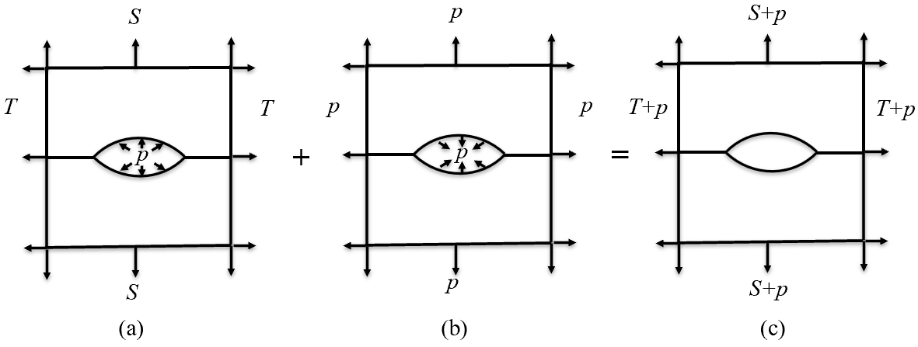
Figure 3.2 Schematic illustrations of the stress state for a unit cell containing a single cavity under HTHA in (a) and that with an applied hydrostatic tension in (b). Superposing (a) and (b) leads to the stress state in (c) with a stress-free cavity [58,59].
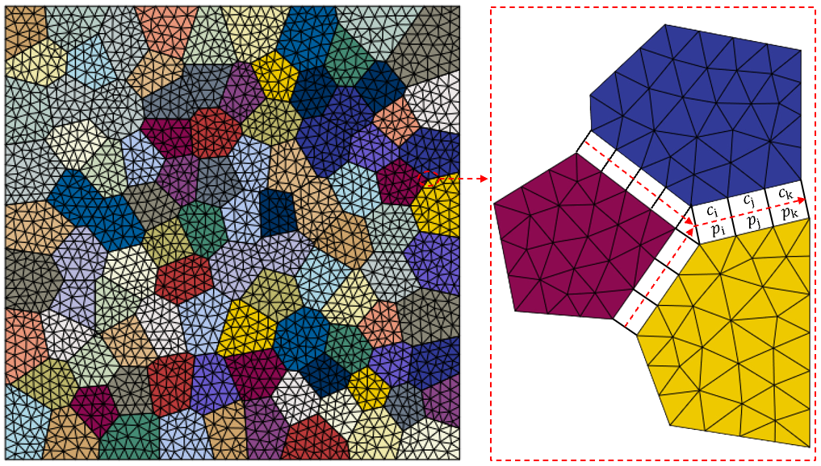 Figure 3.3 Schematic illustration of the finite element mesh and the concentration-dependent cohesive elements between two neighboring grains. The initial separation in these cohesive elements is zero. Concentration and pressure information are stored in each cohesive element.

element. These stresses, in turn, lead to interface separations, governed by the constitutive laws mentioned in Chapter 2.
In order to gather the essential values for hydrogen diffusion and simulate creep fracture behavior, COMMON BLOCKs are used for data storage and acquisition within the UMAT and UEL subroutines. Specifically, these blocks store details such as pressure and concentration relating to hydrogen diffusion, as well as information concerning state variables in creep fracture. The state variables are retained when the UMAT subroutine is
engaged to compute the deformation within the grain interior. Subsequently, these variables are accessed by the UEL subroutine to calculate the development of creep fracture along the grain boundaries.
The stress-coupled diffusion equation Eq.( 3.2.2) is solved by finite difference (FD) method with a uniform increment,
$\frac{c_{j}^{n+1}-c_{j}^{n}}{∆t}=D\left[\frac{c_{j+1}^{n}-2c_{j}^{n}+c_{j-1}^{n}}{{\left(∆x\right)}^{2}}+\frac{{\overline{V}}_{H}}{RT}\frac{\left(c_{j+1}^{n}-c_{j-1}^{n}\right)\left(p_{j+1}^{n}-p_{j-1}^{n}\right)}{4{\left(∆x\right)}^{2}}+\frac{{\overline{V}}_{H}c_{j}^{n}}{RT}\frac{p_{j+1}^{n}-2p_{j}^{n}+p_{j-1}^{n}}{{\left(∆t\right)}^{2}}\right]$ (3.4.1)
where $c_{j}^{n}$ and $p_{j}^{n}$ denote the concentration and pressure respectively at the j_{th} element and
the n_{th} time increment. Considering the pressure definition in the 2D cohesive element, p is equal to $-(σ_{n}-P_{total})$, where $P_{total}=P_{H_{2}}+P_{{CH}_{4}}$. Therefore, there are two different time steps from finite difference method and finite difference method (FEM) in this The FEM time step as automatically computed and provided to UMAT and UEL is generally
much larger than the FD time step, so that this asynchronous step of Eq. (3.4.1) needs to be conducted within UEL. These two steps and their communications through the COMMON BLOCKs are illustrated by a schematic illustration of the coupled model (Fig. 3.4). It clarifies the specific implementation of the hydrogen diffusion and cavity growth
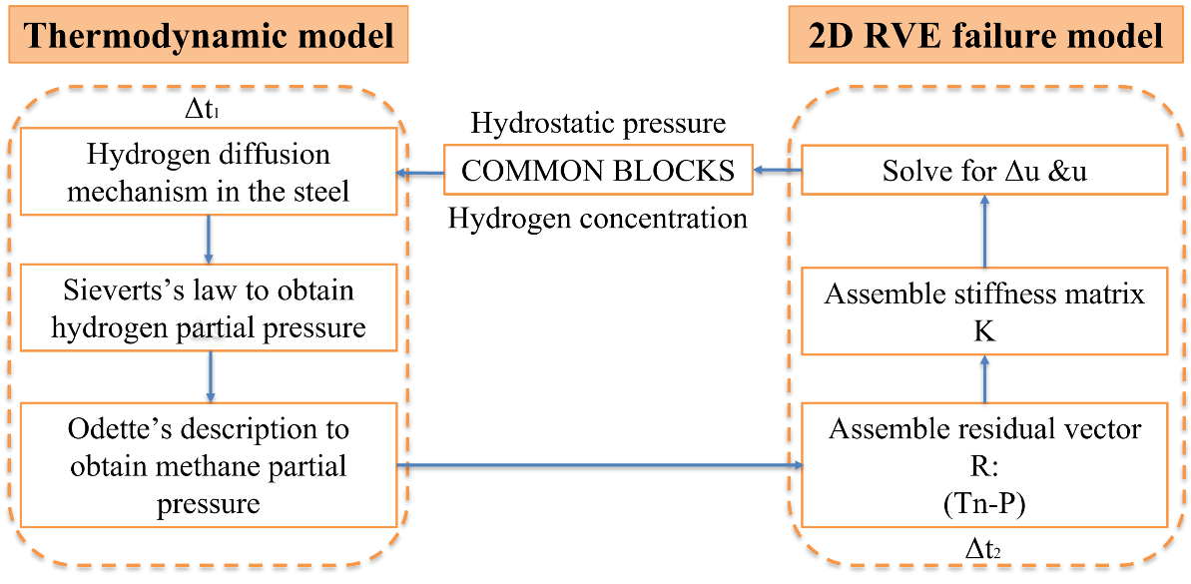
Figure 3.4 A schematic illustration of the coupled model: left being the thermodynamic calculation of hydrogen transport, and right showing the steps for cavity-induced failure. These two modules have different time steps, but communicate through a number of COMMON BLOCKs.

model within the finite element framework. This sets the algorithm used in the UEL subroutine.

3.4.2 Material Parameters
The material parameters for hydrogen diffusion are listed in Table 3.1. Diffusion coefficient, activation energy for diffusion, partial molar volume of hydrogen, solubility coefficient, activation energy for solubility are taken from Chavoshi et al.’s work [64]. For creep fracture, when average grain size is 0.3 mm, the values of materials properties are listed in Table 3.2. Among these parameters, the reference stress $Σ_{0}$ is taken as that suggested by Onck et al. [40-42]. Initial cavity radius $a_{0}=6.7×{10}^{-4} R_{0}$, where $R_{0}$ is the average grain size. Initial half-spacing $b_{0}=0.16 R_{0}$ [34]. Young’s modulus at different temperatures can be attained by linear interpolation of data from the literature [64]. The sintering stress $σ_{s}$ is usually relatively small and can be neglected. The stress exponent n, reference strain rate ${\dot{ε}}_{0}$, cavity nucleation parameter $F_{n}$, grain boundary diffusion parameter D are determined via calibration with the experimental creep data for C-0.5Mo steel. These parameters are crucial in governing the relative contribution of characteristic time scales of nucleation, diffusion, and creep deformation.

3.5 Results and Discussion

3.5.1 Calibration of Creep Deformation
To account for the microstructural heterogeneities inherent in C-0.5Mo steel, a two-dimensional digital microstructure is constructed in an open-source software NEPER utilizing the Voronoi tessellation, as illustrated in Fig. 3.3. The digital microstructure aligns closely with the experimental sample in terms of its topological and structural attributes.
Parameter | Value
Diffusion coefficient, $D_{0}$ | $$2.53×{10}^{-7}m^{2}/s$$
Activation energy for diffusion, $∆E$ | $$13030J/mol$$
Partial molar volume of hydrogen, ${\overline{V}}_{H}$ | $$2000{mm}^{3}/mol$$
Solubility coefficient, $S_{0}$ | $$0.167mol/\left(m^{3}\sqrt{Pa}\right)$$
Activation energy for solubility, $∆G$ | $$21100J/mol$$
Table 3.1 Representative values for material parameters used for stress-induced hydrogen diffusion model.

Parameter | 623 K | 673 K | 723 K | 773 K | 823 K
Reference stress, $Σ_{0}$ (MPa) | 100 | 100 | 100 | 100 | 100
Average grain size, $R_{0}$ (mm) | 0.3 | 0.3 | 0.3 | 0.3 | 0.3
Young’s modulus, E (GPa) | 179.9 | 169.4 | 158.9 | 148.4 | 137.9
Lattice diffusion, $Q_{l}$ (kJ/mol) | 450 | 450 | 450 | 450 | 450
GB diffusion, $Q_{b}$ (kJ/mol) | 174 | 174 | 174 | 174 | 174
Stress exponent, n | 7.79 | 7.79 | 7.79 | 7.79 | 7.79
Reference strain rate ${\dot{ε}}_{0}$ (s⁻¹) | 1.23$×$10⁻¹⁸ | 7.85$×$10⁻¹⁶ | 2.04$×$10⁻¹³ | 2.59$×$10⁻¹¹ | 1.82$×$10⁻⁹
Cavity nucleation parameter, $F_{n}$ | 4$×$10⁵ | 4$×$10⁵ | 4$×$10⁵ | 4$×$10⁵ | 4$×$10⁵
GB diffusion parameter, D (mm⁵N⁻¹s⁻¹) | 8.64$×$10⁻²⁰ | 1.05$×$10⁻¹⁸ | 9.00$×$10⁻¹⁸ | 5.85$×$10⁻¹⁷ | 3.03$×$10⁻¹⁶
Reference stress, $σ_{0}$ (MPa) | 100 | 100 | 100 | 100 | 100
Table 3.2 Representative values for material parameters in creep fracture model.

The creep strain rate versus stress curve and the creep rupture data from NIMS [52] serves as a reference dataset for calibrating the unknown material parameters in the computational model.
As illustrated in Fig. 3.5 (a), we can only perform the calibration of the material parameters for dislocation creep in the high-stress regime by matching the power-law creep rate with experimental data due to lack of Coble creep (diffusional creep) data. The stress exponent for dislocation creep, represented by the slope of the plot, is identified to be approximately 7.79. And the creep rupture data without enough long-term rupture data for C-0.5Mo steel [52] is depicted in Fig. 3.5 (b), serving to calibrate the material parameters ( $F_{n}$ and D). The numerical outcomes concerning the creep rupture life align quantitatively with the experimental findings.
At high temperature and low applied stress, the governing failure mechanism is diffusion-controlled grain boundary cavity growth, so that the stress~$1/T$ plot, converted from Fig. 3.5 (b), should have a slope of ${Q_{b}}/R$ with $Q_{b}$ being the activation energy for grain boundary diffusion and $n=1$ in this case. At intermediate temperature and high applied stress, failure is controlled by grain-boundary cavity growth driven by $1/T$ plot should be ${Q_{l}}/{nR}$ with $Q_{l}$ being the activation energy for lattice diffusion and $n>1$ in this case. The piecewise nature in Fig. 3.5 (b) support such a transition of failure mechanisms and can be used to derive the activation energies in Table3.2. It should be noted that variations in the dataset can be observed, which can be attributed to differences in heat treatment conditions, material compositions, and other factors.

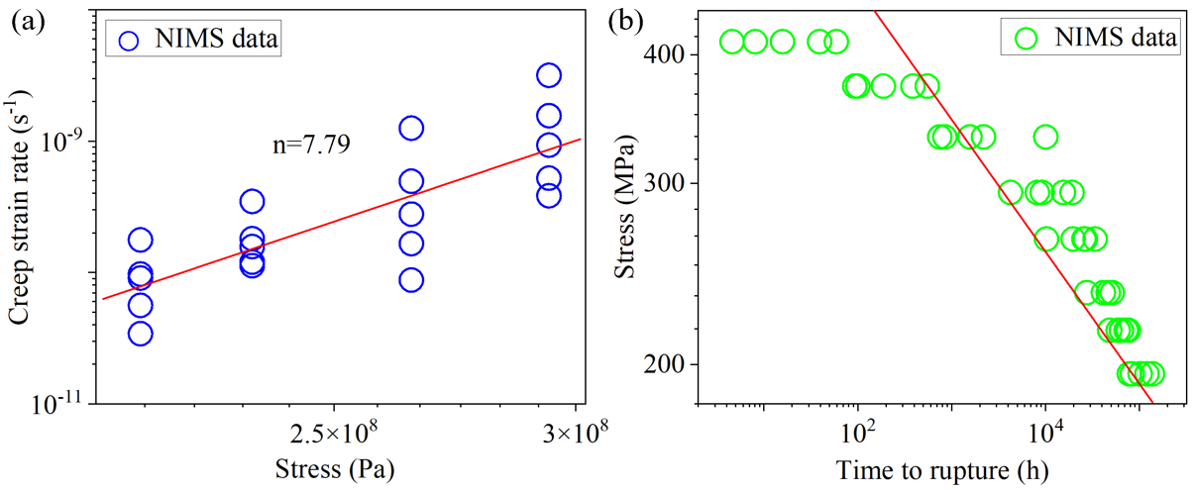
Figure 3.5 (a) Stress dependence of steady state creep rate for C-0.5Mo steel at 723 K. (b) Stress vs. creep life behavior predicted using the micromechanical model for PVP of C-0.5Mo steel in comparison with the literature experimental data at 723 K. NIMS data are obtained from [52].

3.5.2 Simplifying Nelson Curves with Odette-Vagarali Model
The Nelson curves provide a comprehensive overview of PVP performance in partial pressures. It distinctly marks the various modes of damage (i.e., surface decarburization, fissuring, and material decarburization) on the depicted equipment data points. Nelson curves play an integral role in the design and fabrication of pressure vessels and pumps operating at temperatures above 205°C and hydrogen pressures exceeding 690 KPa. They delineate the operational boundaries for specific steels when used in high-temperature hydrogen environments.
As previously explained in Fig. 3.1 (b), there is a lack of piece-wise characteristics in the hydrogen partial pressure versus the reciprocal of temperature plot, with some particular obscure features along the tails of these curves at low pressure and high temperature. Considering the Odette-Vagarali model and the total pressure (summing hydrogen and methane partial pressures) being the applied load as shown in Fig. 3.2, we now convert Nelson curves further to the plot in Fig. 3.6. Within a wide range of temperatures (from 773 K to 1173 K), the methane partial pressure varies rapidly with respect the initial increase of the hydrogen partial pressure, but slows down at the later stage, as shown in Fig. 3.6 (a). It is evident that the fitted expressions in Eqs. (3.2.3) and (3.2.10) of the temperature dependent coefficient $C\left(T\right)$ results in sudden sharp discontinuities at the transitions, but these jumps are small and will not affect our results. Eventually, by combining Fig. 3.1 (b) and Fig. 3.6 (a), we can obtain a final converted Nelson curves in Fig. 3.6 (b), which could be delineated into two distinct regimes, i.e., dislocation-creep-controlled or grain boundary diffusion-assisted cavity growth. And
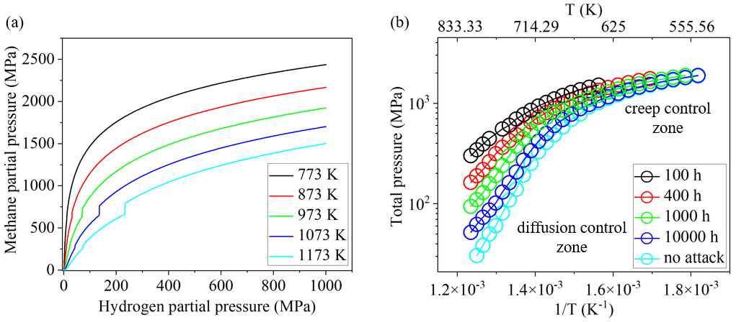
Figure 3.6 (a) Predicted equilibrium methane partial pressure from 773 K to 1173 K according to Odette-Vagarali model [57]. (b) Final converted Nelson curves by combining (a) and Fig. 3.1(b).

there is a clear transition from creep control region to diffusion control region at about 700 K.

3.5.3 HTHA with Uniform Hydrogen Distribution (Equivalent to Ultrathin Wall)
To further investigate the Nelson curves, here we study a special case in which the pipeline steel is thin enough so that the hydrogen distribution is uniform across the thickness and takes the value of Eq. (3.2.1). Using the Odette-Vagarali model gives the methane pressure, which thus provides inputs to the creep fracture model (e.g., Eqs. (2.2.11) and (2.2.12)). Assuming an initial ratio of $a/b$ and integrating these ODEs, we can calculate the separation vs time curve of only one grain boundary lying normal to the
loading direction. The lifetime is determined from the catastrophic growth of the separation, corresponding to the cavity coalescence stage. An interpolation is needed to find out the critical stress (or hydrogen partial pressure) to reach a given lifetime (e.g., 100 hours in Fig. 3.7). From this method, a series of simulations are performed under external loading of 100 MPa and 200 MPa within a temperature range from 623 K to 823 K. Alternatively, we can employ the FEM in Section 3.4 with a constant total pressure calculated from the Odette-Vagarali model. Results from both methods are given in Fig.
3.7 (a) and 3.7 (b), respectively, in the plots of total pressure versus temperature with contour lines denoting a certain lifetime. The contrast of these two sub-figures clearly results from the statistical average of grain boundaries oriented in all possible directions in Fig. 3.3. It should be noted that the transition temperature at which the slope changes rapidly is similar in both results, because this transition results from the competition between diffusive vs creep-constrained cavity growth processes.
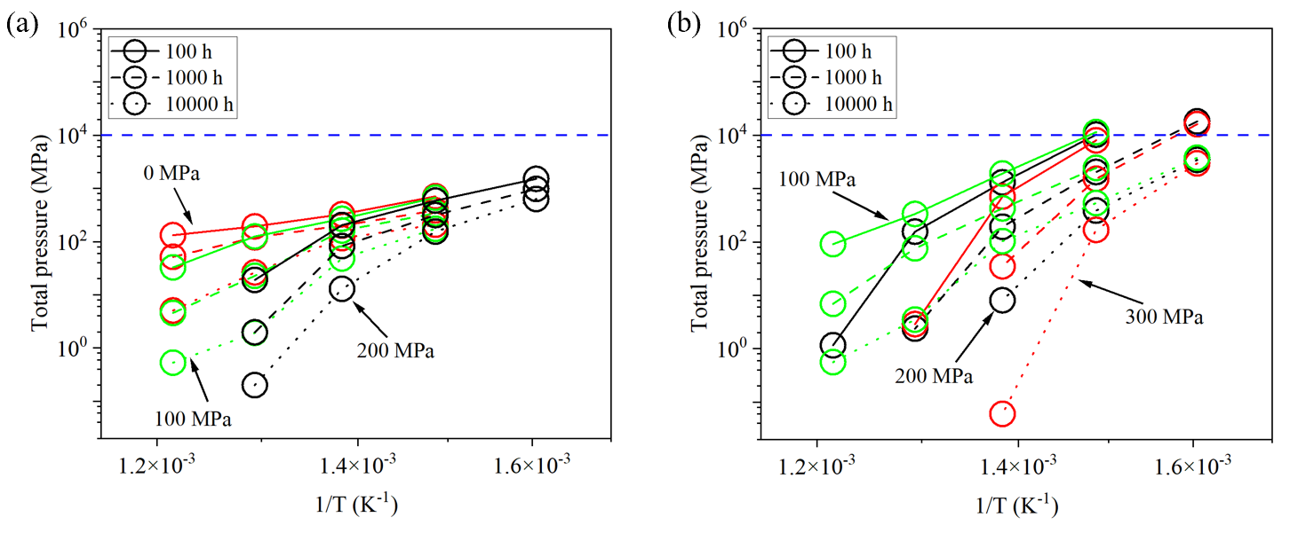
Figure 3.7 Predicted Nelson curves with total pressure and the reciprocal of temperature under HTHA with uniform hydrogen distribution, obtained from solving a set of ordinary differential equations (ODE model) under external loading of 100 MPa and 200 MPa in (a), and from finite element method (FEM) under external loading of 100 MPa, 200 MPa and 300 MPa in (b). The differences lie on the nature of statistical averages in FEM. The grain size (i.e., ledge size of the hexagonal grain) is 300 $μm$.

Comparing to the converted Nelson curves in Fig. 3.6 (b) (compiled from experimental observations), our FEM results in Fig. 3.7 (b) underpredicts at high temperature but overpredicts at low temperature, both by about one order of magnitude. The transition temperature is again well predicted. Again, in addition to a wide range of unknown applied stress, experimental data in Fig. 3.1 (a) also have many unknown factors, such as wall thickness, microstructural information (that might considerably change parameters in Tables 3.1 and 3.2), failure locations (some literature indicating failure occurring at weldments), or others. Since hydrogen concentration is assumed to be constant through the thickness, results exaggerate its contribution to the final failure. The role of
thickness will be studied in the next subsection.

3.5.4 HTHA with Nonuniform Hydrogen Distribution (i.e., Thick Walls)
Our microstructure-informed and micromechanics-based model solves the transient and coupled behavior of both hydrogen diffusion and intergranular cavity growth, so that the roles of microstructural heterogeneities, distribution of the applied load, gradient of the hydrogen field, and others can be easily investigated. In this work, the hydrogen concentration at the inner diameter surface is determined from the Sieverts law in Section 3.2.1, and that at the outer surface is taken as zero. As mentioned before, grain boundary diffusivity is usually 10⁵~10⁸ times higher than that inside grain [52,53]. Thus, only diffusion coefficient $D_{0}=2.53×{10}^{-7}m^{2}/s$ with the activation energy for diffusion $∆E=13030J/mol$ is adopted in our work.
For a representative thick-wall example, Fig. 3.8 presents the contour plot of the von Mises stress distribution for the whole sample of C-0.5Mo steel with hydrogen
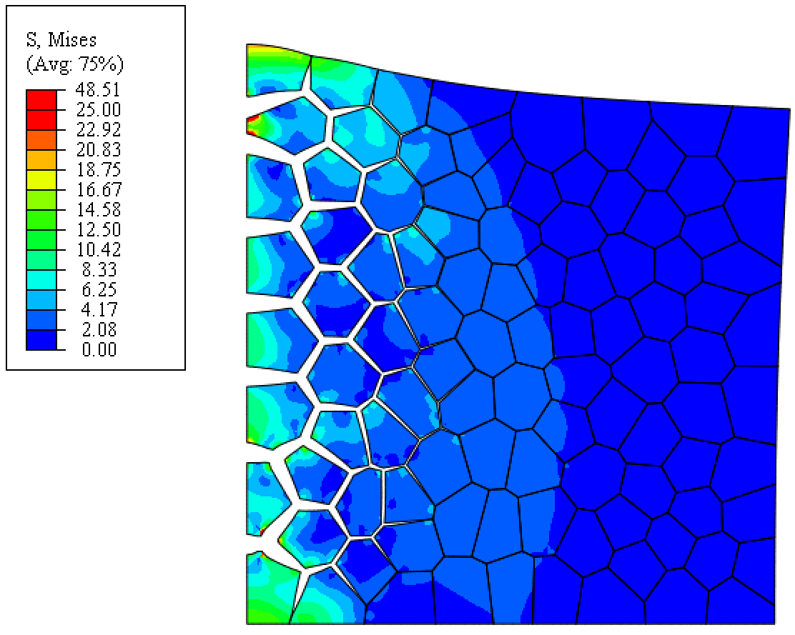
Figure 3.8 Contour plot of the von Mises stress distribution in the PVP of C-0.5Mo steel by 100-grain structure. Typical failure occurs under HTHA with a very thick wall, so that hydrogen does not penetrate to the outer diameter. Here, the left side is the inner diameter (exposed to hydrogen) and the right side is the outer diameter. The left surface is fixed with horizontal displacement, while the bottom surface is fixed with vertical displacement. A magnification ratio of 2000 is used here for the displacement field to illustrate the microcracks clearly. Simulation parameters include those listed in Tables 3.1 and 3.2, together with T=773 K, no applied stress, grain size of 300 $μm$, and hydrogen concentration at inner diameter of ${10}^{8} atom/μm^{3}$. The snapshot was taken near the final failure when the vertical elongation increases catastrophically.

concentration of ${10}^{8} atom/μm^{3}$ under 773K and without any applied stress. HTHA is successfully simulated by using the micromechanics model. Note that the deformation is enlarged for better visualization. Hydrogen diffusion clearly takes time, but as hydrogen penetrates further, localized damage occurs simultaneously which in turns facilitates the hydrogen diffusion into the bulk. In this case, even without applied stress, the resulting stress concentration can be as high as tens of MPas. The crack opening displacement also shows an evident gradient. Simulations were performed with rather uniform properties on the grain boundaries. Should there be any microstructural heterogeneities, "hot spots" of microcrack initiation might be found away from the inner diameter. The penetration depth
of hydrogen field can be estimated from the characteristic diffusion length,
$L_{d}=\sqrt{Dt}$, (3.5.1)
which is about 1 mm in this simulation example. Compared to a grain size of 0.3 mm in this case, it is therefore natural to see the damage layer as deep as a few grains.
The synergistic effects of applied load and PVP wall thickness can be illustrated in Fig. 3.9. Further parametric studies beyond the representative example in Fig. 3.8 need to be done with varying temperature and applied stress, giving rise to the total pressure versus lifetime curves in Fig. 3.9 (a). Again, an interpolation step is needed to find the critical total pressure for a given lifetime such as 100 hours, as shown by the vertical dashed lines there. The resulting Nelson curves in Fig. 3.9 (b) show a clear contrast to uniform-hydrogen-field results in Fig. 3.7 (b) as described below. First, the transition from diffusive to creep-controlled cavity growth can still be seen from the slope change, but these slope values are heavily affected by external loading (not being equal to stress exponent in creep
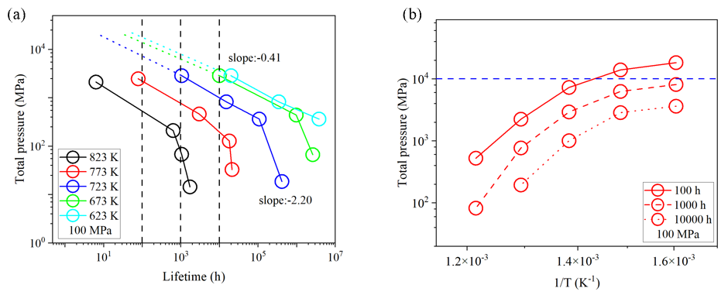
Figure 3.9 (a) Total pressure vs. creep rupture time under HTHA with nonuniform hydrogen distribution by our coupled model for 100 MPa. (b) Predicted Nelson curves with total pressure and the reciprocal of temperature under HTHA with a thick wall for 100 MPa. The grain size is 300 $μm$.

control region or to unity 1 in diffusion control region). Second, the range of the calculated total pressure for a lifetime change from 100 h to 10000 h is much more reduced here when compared to Fig. 3.7 (b). This agrees favorably with the experimental Nelson curves in Fig. 3.6(b). Third, combining the calculation results in Figs. 3.7 (b) and 3.9 (b), it is therefore derived that a favorable agreement with the experimental Nelson curves in Fig. 3.6 (b) can
only be made for a thick wall with some moderate applied stress, provided with a carefully
calibrated set of material parameters.
For brevity, this work does not include additional simulations on the role of grain size and microstructural heterogeneities. While these lines of information are not known in
the API Nelson curves, we have conducted a number of HTHA experiments under bending tests, which illustrate various fracture morphologies with respect to microstructural heterogeneities. The grain size changes the NIMS data (e.g., Fig. 3.5) dramatically, so that it is anticipated that the corresponding Nelson curves (e.g., Fig. 3.7 and Fig. 3.9) will change accordingly. Any experimental validation will therefore require a fine knowledge of material microstructure and grain size, which are not known in the present Nelson curves.

3.6 Summary
A fully coupled micromechanical model has been developed to investigate both the thermodynamic/kinetic processes of hydrogen and the simultaneous cavity growth, from which the failure lifetime can be obtained with respect to variables such as microstructural heterogeneities, load distributions, geometrical feature sizes, and prior residual stress fields. These predictions can be used to construct the Nelson curves, which delineates the safety design regimes in the plot of the hydrogen partial pressure with respect to the temperature. While the converted Nelson curves can clearly exhibit two stages, as governed by diffusive cavity growth or by creep-constrained cavity growth, the computed Nelson curves underpredict at high temperature and low stress but overpredict at intermediate temperature and high stress. These numerical predictions are found to be sensitive to applied stress and PVP wall thickness, and potentially to variations of constitutive parameters that are sensitive to microstructural heterogeneities. A comprehensive parametric study and a complete knowledge of boundary/initial conditions and material properties are certainly the prerequisite for a quantitative assessment of Nelson curves, despite our ability to delineate the governing creep failure mechanisms.

Chapter 4 An Analytical Solution to the Printing Temperature in Additive Friction Stir Deposition

4.1 Introduction
Unlike conventional subtractive material technologies, additive manufacturing (AM) is based on the innovative principle of "material increment", which enables the design and production of complex and customized metallic components without the limitations inherent in traditional processing techniques. Metal AM has emerged as a transformative paradigm in the design and manufacture of high-performance components across various industries, including aerospace, automotive, medical, and energy sectors [73]. Several metal additive manufacturing techniques, such as Binder Jetting, Directed Energy Deposition (DED), Laser Powder Bed Fusion (LPBF), Sheet Lamination, and Material Extrusion, are employed to fabricate parts for a wide array of applications. These techniques vary in system configuration, power sources, and processing approaches, contributing to their process flexibility and diverse applicability.
Despite the advantages, several limitations impede the widespread industrial adoption of these AM techniques. These limitations include the requirement for a sealed chamber in LPBF, restricted build volumes, challenges in defect controllability, scalability issues, and a limited range of materials. Furthermore, AM techniques that employ laser and electron beam power sources for in situ melting of materials often result in significant defects, such as porosity and cracks, in the final components due to rapid cooling and resolidification of the melt pools [73–75]. The crack formation problem constrains the range of printable metals and alloys, thereby limiting the full potential of metal AM [76].
Additive friction stir deposition (AFSD) has recently been introduced as an
innovative technique for fabricating fully dense three-dimensional (3D) components through solid-state deformation metallurgy bonding, thereby obviating the need for melting and solidification processes. This advancement significantly expands the range of printable materials and enables the production of nearly crack- and pore-free parts suitable for a wide array of applications [77]. As an emerging solid-state, low temperature AM technique, AFSD was developed and patented by Aeroprobe Corporation (now MELD Manufacturing) [78,79], integrates the concept of friction stirring with a material feeding process to manufacture site-specific components [77]. Operating in an open environment without the requirement for a sealed chamber or powder bed system, AFSD imposes no limitations on the bounding volume of the final structure. Moreover, AFSD equipment, akin to traditional CNC and milling machines, can be scaled up as needed, rendering it particularly suitable for the fabrication of large parts. Unlike other additive manufacturing technologies, AFSD typically eliminates the need for additional post-processing steps such as hot isostatic pressing (HIP), thereby reducing both production time and energy consumption.
In contrast to the columnar grains commonly produced by fusion-based AM due to rapid melting and solidification, AFSD achieves a fine and fully equiaxed microstructure, enabling the fabrication of isotropic components. Furthermore, AFSD boasts a markedly improved build rate, with the capability to deposit material at speeds exceeding those of other AM processes by more than an order of magnitude.
Despite all of the benefits listed above, AFSD is still in its early stages. As introduced in Chapter 1, The steady-state deposition process begins once the actuation force and torque have stabilized. The morphology, microstructure, and properties of final
metallic components are highly sensitive to temperature evolution and deformation behaviors. Heat generation, which is contingent upon manufacturing parameters, exerts a significant influence on the thermal field and its distribution during additive friction stir deposition (AFSD), thereby affecting the performance of the final AFSD product. Consequently, two fundamental questions must be addressed to maximize the impact of AFSD:
- What is the typical thermal and deformation history of the deposited material during AFSD, i.e. temperature and strain as a function of time?
- How do the processing parameters in AFSD, such as tool head rotation rate, determine the thermal and deformation history?
During FSW, increasing the $ω/v$ ratio results in a rise in the nugget temperature, as demonstrated in previous studies [80,81]. Arbegast and Hartley [82] established a relationship for aluminum alloys that correlates the nugget temperature with the processing parameters ($ω$, $v$):
$\frac{T}{T_{\text{m}}}=K{\left(\frac{ω^{2}}{v∙{10}^{4}}\right)}^{α}$ (4.1.1)
where $T_{\text{m}}$ is the alloy melting point, and the constants $α$, K vary between 0.04 and 0.06 and 0.65 and 0.75, respectively. AFSD originates from FSW and shares a similar underlying mechanism. Experimental investigations have been conducted to understand the thermal evolution during AFSD, facilitated by the fact that the deposited material lies atop the substrate rather than being constrained by surrounding material, rendering temperature measurements relatively straightforward. Garcia et al. [83] measured the peak temperature, exposure time, reheating rate, and cooling rate during AFSD of Al-Mg-Si and Cu under various conditions and found consistent physical trends. The peak temperature was found to be ∼ 50%–90% of the melting temperature, the exposure time is ∼ 10¹ s, the reheating rate is ∼ 10¹–10² K/s, and the natural cooling rate is ∼ 10¹ K/s. Based on the measured data, the authors also established a similar empirical power-law relationships linking the peak temperature to the AFSD processing parameters. Griffiths et al. [84] established that the settings of process variables which yield fully dense, high-quality depositions delineate the feasible process window. However, they noted that the tool rotational speed to traverse speed ratio alone is insufficient to determine traction forces and shear strains without accounting for torque or normal load during AFSD. The comprehensive understanding of how AFSD processing parameters influence heat generation and the overall temperature field remains an area requiring further elucidation.
The objective of this study is to establish a theoretical framework for the heat generation and associated temperature evolution governed by AFSD processing parameters. Utilizing experimental data, we develop an analytical solution for heat generation and printing temperature during AFSD. Concurrently, a Coupled Eulerian Lagrangian (CEL) nonlinear finite element model is implemented to validate our theoretical findings. Section 4.2 provides a detailed explanation of the heat generation rate and addresses critical issues related to boundary conditions, with a particular focus on parameters p and δ. Section 4.3 revisits Rosenthal’s analysis of heat flow in welding. By considering the superposition of temperature fields, we derive an analytical equation for the entire multi-pass process during AFSD in Section 4.4. In Section 4.5, a CEL finite element model is introduced to simulate the multi-pass AFSD process and validate the theoretical framework developed in Section 4.4. Finally, concluding remarks are presented in Section 4.6.

4.2 Heat Generation Model
To elucidate the relationship between processing parameters and microstructure evolution, it is imperative to understand the impact of print parameters on the thermomechanical history of the deposited material. During friction stir processes, heat is generated through both friction and plastic work. This heating is necessary to sufficiently soften the metal for processing, while plastic flow is essential for extruding and bonding the feed material. The interactions at the contact surface can manifest as stick (surface shearing), slip (frictional heating), or, more realistically, a combination of both. The ratio of the surface area that is sticking to the area that is slipping (c/a) determines the thermomechanical response of the material. The total heat generation is the summation of frictional and plastic work converted to heat. By neglecting elastic deformation and assuming all plastic work is converted to heat, the total heat generation rate can be described by the sum of the area integrals.
$Q_{total}=\int_{stick}^{ }{τ_{yield}ωr dA}+\int_{slip}^{ }{μ_{f}pωr dA}$ (4.2.1)
where p is the contact pressure, ω is the rotation speed of the tool, r is the size of the tool shoulder τ_{yield} is the shear yield strength, and μ_{f} is Coulomb's friction coefficient. Despite being composed of surface integral components; this equation accounts for equation accounts for plastic deformation in the bulk of the work piece. Applying Gauss’s theorem to the definition of heat generated due to plastic work can redefine the equation as a surface integral because the divergence of the stress tensor is zero due to stress balance.
As demonstrated in Wang’s work [85], the resulting torque on the tool can be calculated from the shear stress on the whole surface of the tool, which can be written as the following relationship
$M_{Z}=\int_{0}^{a}{τ_{θz|_{μ<∞}2πr^{2}dr}}$ (4.2.2)
The total heat generation rate can be computed from the preceding results and Eq. (4.2.1). For the simplified case of neglecting elasticity and assuming that Taylor-Quinney ratio is 1, then we can know
$Q_{\text{total}}=ωM_{Z}$ (4.2.3)

4.3 Revisiting Rosenthal’s Equation
Fig. 4.1 [91] illustrates the three-dimensional heat flow in a semi-infinite workpiece during welding. The origin of the coordinate system moves with the heat source at a constant speed V in the negative-x direction. Except for the initial and final transients of welding, the heat flow in a sufficiently long workpiece is steady, or quasi-stationary, with respect to the moving heat source. In other words, for an observer moving with the heat source, the temperature distribution and the pool geometry remain unchanged with time. This steady-state assumption was first utilized by Rosenthal [86] to simplify the mathematical treatment of heat flow during welding. Rosenthal subsequently [86] developed an analytical method to predict the temperature history in fusion welding. The Rosenthal’s equation is acclaimed for its simplicity and wide applicability allowing for the prediction of temperature history as a function of time, temperature gradient, cooling rate, and solidification rate. The derivation of the Rosenthal equation is based on the following assumptions:
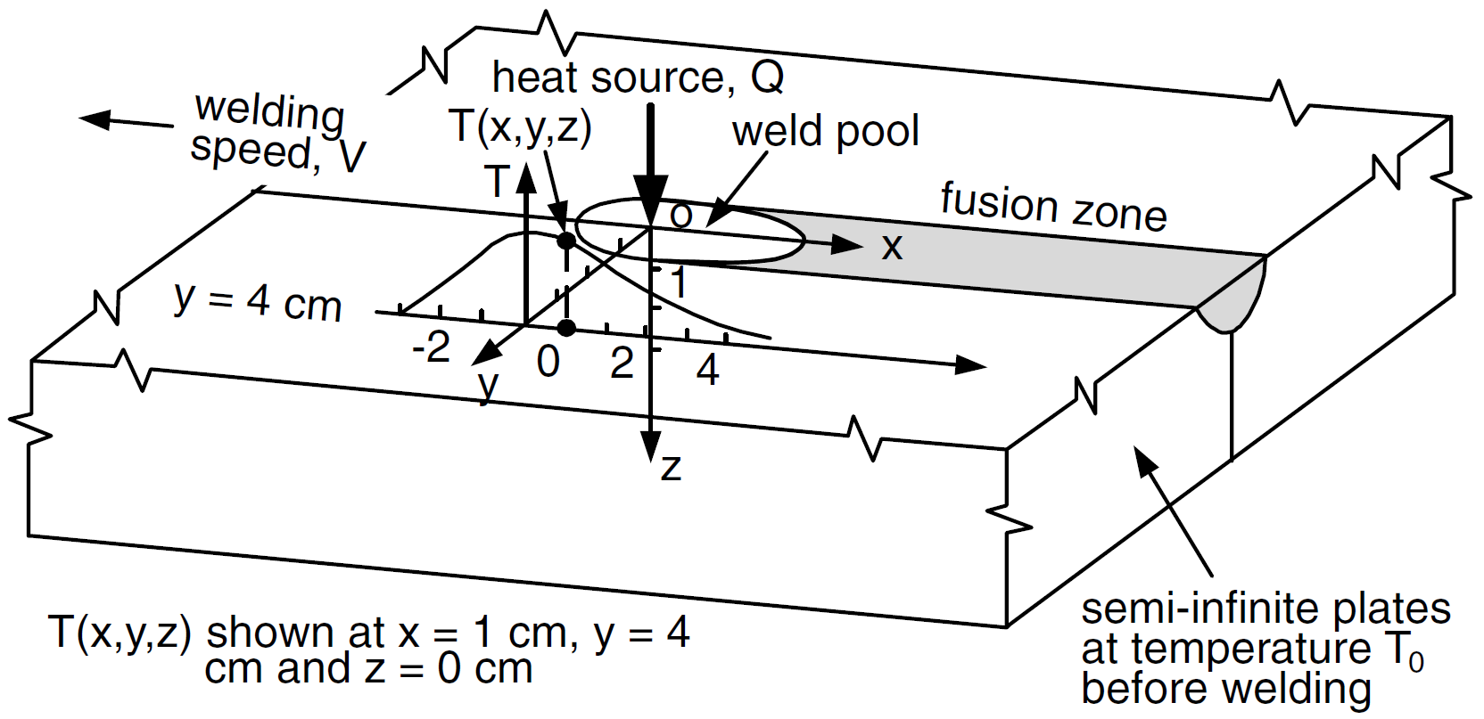
Figure 4.1 Three-dimensional heat flow during welding of semi-infinite workpiece [91].

- The thermophysical properties, including thermal conductivity, density, and specific heat, are temperature independent. The latent heat due to phase change is not included.
- The scanning speed and power input are constant, leading to a quasi-stationary condition of the temperature distribution around the melt pool.
- The heat source is a point source.
- Heat losses from surface convection and radiation are not considered, and convection in the liquid pool is neglected. Therefore, the heat transfer is governed purely by conduction.
The resulting analytical solution, that is, the Rosenthal equation, is as follows:
$T\left(x,R\right)=T_{0}+\frac{Q}{2πk}\left(\frac{1}{R}\right)e^{-\frac{V_{x}}{2α}(R-x)}$ (4.3.1)
where T₀ is the temperature at locations away from the top surface ( i.e., reference
temperature), R is the radial distance from the origin, namely, ${\left(x^{2}+y^{2}+z^{2}\right)}^{1/2}$. 𝑘 is
thermal conductivity, $α= \frac{k}{ρ C_{p}}$ is thermal diffusivity, $V_{x}$ is scanning velocity of the tool.

4.4 Analytical Solution of Multi-Pass Process
We posit that the multi-pass AFSD process can be conceptualized as a continuous single pass by sequentially spreading out each completed pass (i.e., first pass, second pass, etc.), as depicted in Fig. 4.2. For each completed pass, Rosenthal’s equation can be utilized to describe the temperature history near the edge of the tool. By superimposing the temperature distributions of each completed pass, a comprehensive temperature history for the entire multi-pass process can be derived,

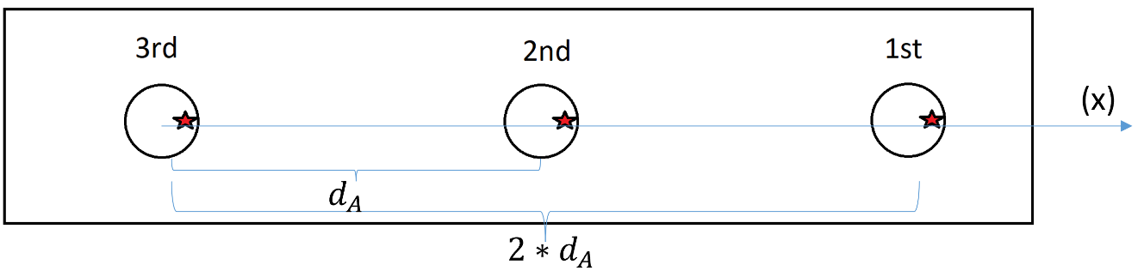
Figure 4.2 A schematic plot for the superposition of temperature field in AFSD muti-pass process.

$T_{1}^{*}=T_{0}+C_{1}\frac{Q'}{2π k a}=T_{\text{ref}}^{1}+C_{1}\frac{Q'}{2π k a}$ (4.4.1)
$T_{2}^{*}=T_{0}+C_{1}\frac{Q'}{2π kd_{A}}+C_{2}\frac{Q''}{2π k a}=T_{\text{ref}}^{2}+C_{2}\frac{Q''}{2π k a}$ (4.4.2)
$T_{3}^{*}=T_{0}+C_{1}\frac{Q'}{2π k{2d}_{A}}+C_{2}\frac{Q''}{2π kd_{A}}+C_{3}\frac{Q'''}{2π k a}=T_{\text{ref}}^{3}+C_{3}\frac{Q'''}{2π k a}$ (4.4.3)
where a is the size of the tool, $d_{A}$ is the length of scanning pass, $C_{i}$ is a set of constant parameters, $T_{\text{ref}}^{i}$ is the reference temperature for the ith pass. Therefore, the temperature history for Nth completed pass can be described by,
$T_{N}=T_{\text{ref}}^{N}+C_{N}\frac{Q}{2π k a}$ (4.4.4)
where $C_{N}$~1. Combining Eq. 4.2.3 and Eq. 4.4.4, we can obtain the final relationship between temperature field and AFSD processing parameters,
$T_{N}=T_{\text{ref}}^{N}+C\frac{ωM_{Z}}{2π k a}$ (4.4.5)
Here, C should be in the range of 0 to 1 given that only some plastic work converts to heat (e.g., 60%~90% for most metals). In Section 4.5, we will further study and validate this theory by our simulations.

4.5 CEL Finite Element Simulations

4.5.1 Model Setup
The CEL finite element simulations are performed to replicate the muti-pass AFSD process and compute torque, axial force and temperature fields. As illustrated in Fig. 4.3, the three-dimensional (3D) CEL model, developed using Abaqus Explicit, comprises a Eulerian part with dimensions of 40×30×14.5 mm This includes the workpiece domain (thickness of 13 mm) and the "void" domain (thickness of 1.5 mm), with a total of 85,760 EC3D8RT elements. The tool is modeled as a Lagrangian body with a circular bottom radius of 𝑎 = 6.5 mm. In our initial configuration, the tool is idealized without a pin or tilt.
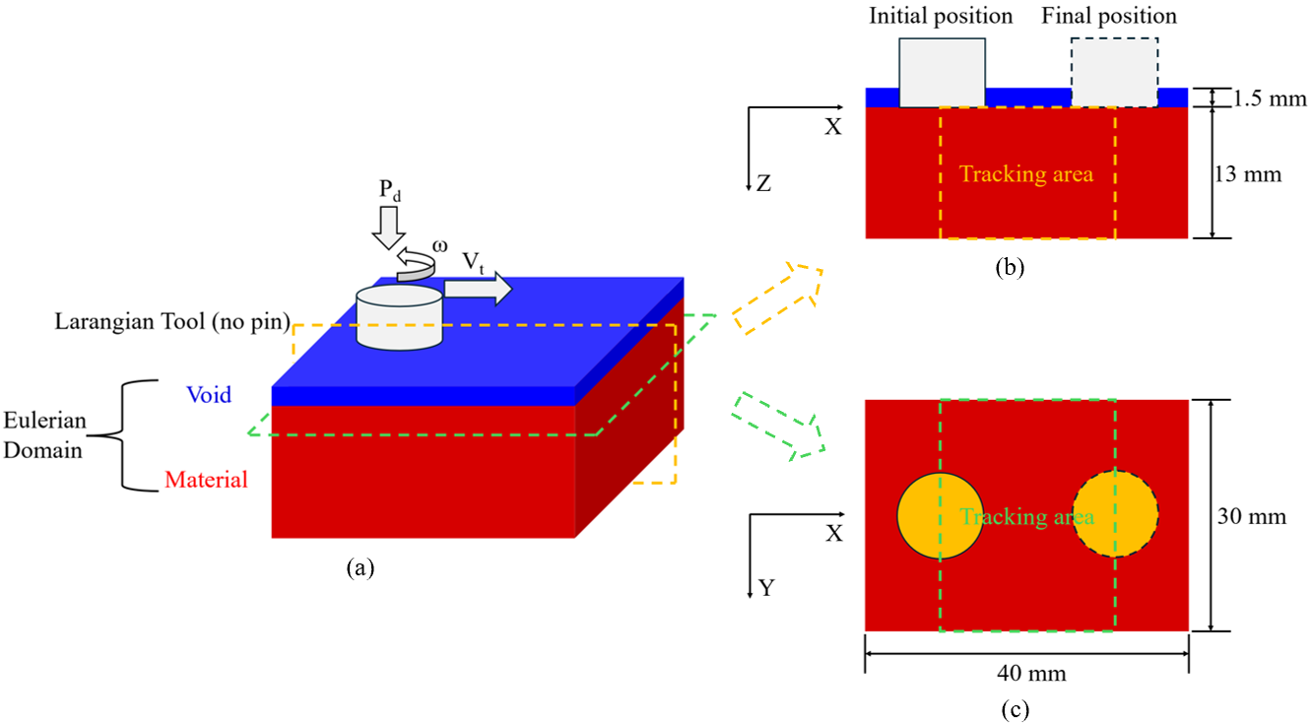
Figure 4.3 Schematic illustrations of finite element setup using the Coupled Eulerian-Lagrangian (CEL) approach to mimic AFSD process. (a) Eulerian and Lagrangian domains in the model. (b) Cross-sectional view of the substrate material with the dashed box being the tracking area. (c) The cladding-substrate interface with the dashed box being the tracing area.

Certainly, these are important geometric features when comparing our predictions to experimental results. Velocity constraints are applied at model boundaries to prevent material escape, while the interaction between the Lagrangian and Eulerian domains is facilitated by Coulomb friction, with a constant friction coefficient of 𝜇_{𝑓} = 0.5 throughout this study.
The workpiece material can be modeled in two configurations for the multi-pass AFSD process, as shown in Fig. 4.3. In Fig. 4.3 (b), the material is divided into two parts in a butt configuration, while in Fig. 4.3 (c), it is arranged as a cladding layer on the top of a substrate. The cladding thickness can be systematically varied, with the example in Fig. 4.3 (c) corresponding to a thickness of 1 mm. Each single process is modeled in three stages: tool plunging, dwelling, and traveling (i.e., lateral movement of the tool). As for the selection of processing parameters, the rotational speed of 𝜔 is 400 rpm, the travelling speed of 𝑉_{𝑡} is 2 mm/s and the increment of plunging depth of ℎ_{𝑝} for each pass is 2 mm. The torque and axial force can be calculated subsequently.
The material is modeled by the hyperbolic-sine creep law, given by
${\dot{ε}}_{\text{creep}}=A_{\text{n}}{\left[sinh\left(\frac{σ}{σ_{ref}}\right)\right]}^{n}\text{exp}\left(-\frac{Q}{RT}\right)$ (4.5.1)
where 𝐴_{𝑛} is a pre-factor, 𝜎_{𝑟𝑒𝑓} is the reference stress, 𝑛 is the stress exponent, 𝑄 is the activation energy, and 𝑅 is the gas constant. The test material of interest is a precipitation-strengthened aluminum alloy, AA6061-T6, with the corresponding parameters given in Table 4.1 [87,88]. Density of AA6061-T6 is taken as 2690 kg m⁻³. Other thermomechanical properties used in the simulation are listed in Table 4.2 [89,90]. The Taylor-Quinney factor that describes the fraction of plastic work to be converted to heat is
A_{n} (s⁻¹) | $σ_{\text{ref}}$ (MPa) | n | Q (kJ/mol)
$$2.41×{10}^{8}$$ | 22.22 | 3.55 | 145
Table 4.1 Constitutive parameters in CEL simulations of AA6061-T6 [87,88].

Temperature (K) | Specific  heat  (Jkg⁻¹ K⁻¹ ) | Young’s  modulus  (GPa) | Poisson’s ratio | Thermal conductivity (Wm⁻¹ K⁻¹ ) | Thermal expansion (10⁻⁶ K⁻¹ )
298 | 945 | 66.94 | 0.33 | 162 | 23.5
373 | 978 | 63.21 | 0.334 | 177 | 24.6
422 | 1000 | 61.32 | 0.335 | 184 | 25.7
477 | 1030 | 56.8 | 0.336 | 192 | 26.6
533 | 1052 | 51.15 | 0.338 | 201 | 27.6
589 | 1080 | 47.17 | 0.36 | 207 | 28.5
644 | 1100 | 43.51 | 0.4 | 217 | 29.6
700 | 1130 | 28.77 | 0.41 | 229 | 30.7
755 | 1276 | 20.2 | 0.42 | 243 | -
Table 4.2 Thermomechanical properties for AA6061-T6 [89,90].

taken as 0.7.

4.5.2 Predicted Torque, Axial Force and Temperature Evolution
In our simulations, three pass AFSD is performed by the CEL finite element model. The computed strain rate, stress, and temperature fields in the first pass are illustrated by representative examples in Fig. 4.4. The temperature field over the contact zone varies very slowly, whereas the strain rate and stress fields are concentrated near the tool edge and are highly sensitive to the interface stick-slip behavior.
As shown in Fig. 4.5, data on temperature, torque, and axial force for each pass are extracted from our simulations. For each pass, the temperature increases over time due to frictional forces and plastic deformation. Conversely, torque and axial force initially increase during the deposition preparation and initial deposition phases to generate sufficient heat to soften the material. These parameters then gradually decrease and stabilize once the steady-state deposition process commences. In the steady-state, temperature reaches a comparable value and materials melt in a large region near the tool. This stabilization results in a significantly reduced requirement for torque (or axial force) to maintain heat generation. Consequently, as the AFSD process progresses through successive passes, the maximum values of torque and axial force exhibit a continuous decrease.
To validate our theoretical framework regarding the relationship between heat generation and temperature evolution as discussed in Section 4.4, a plot of torque and temperature is presented in Fig. 4.6 (a), which combines data from Fig. 4.5 (a) and (b). The reference temperatures $T_{\text{ref}}^{1a}$, $T_{\text{ref}}^{2a}$, $T_{\text{ref}}^{3a}$ are about 298 K, 525 K and 625 K separately. The
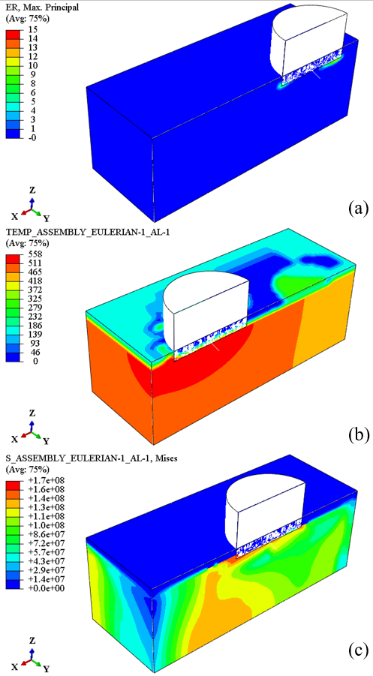
Figure 4.4 Representative results of the strain rate, temperature, and Mises stress fields are given with their corresponding tool locations in first pass during AFSD.

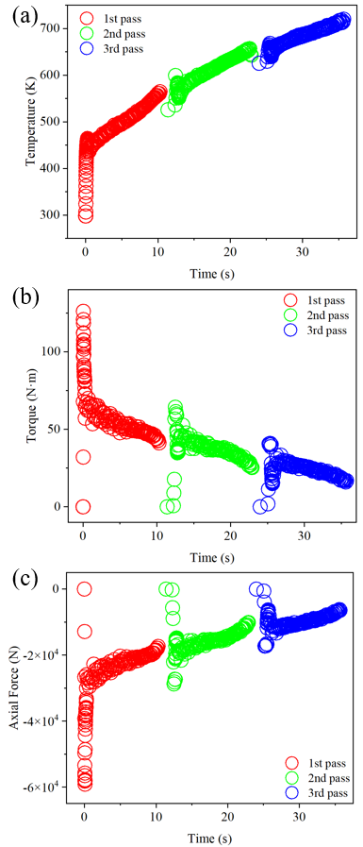

Figure 4.5 The evolution of representative parameters during AFSD: (a) temperature, (b) torque and (c) axial force.

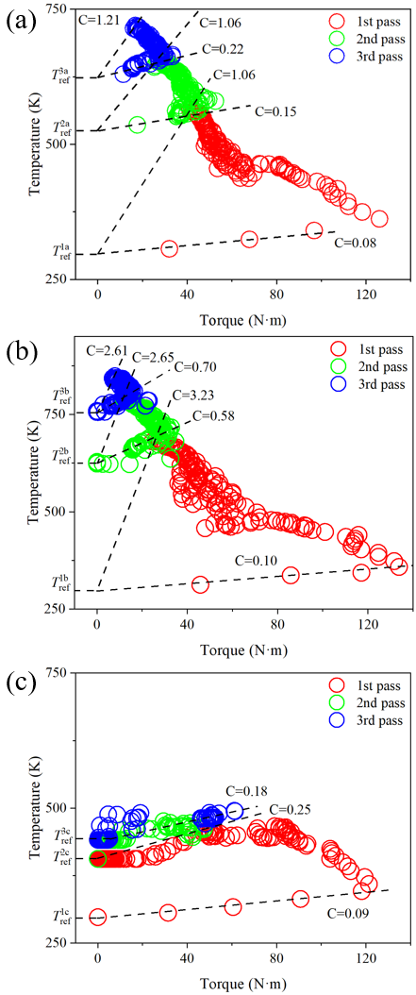
Figure 4.6 The relationship between temperature and torque: (a) original model, (b) new model with a smaller size and (c) original model without fixed velocity boundary conditions for surrounding side surfaces.

curves exhibit a "number 7" shape, indicating that torque stabilizes during the steady-state deposition process. This behavior aligns well with the experimental results shown in Fig. 4.7. The turning points occur at approximately 30 N·m, 45 N·m, and 126 N·m, respectively. At the beginning of each pass, the values of C range from 0 to 1. As the tool moves away from the starting point, especially after the turning points, the value of C gradually increases, ultimately reaching about 1. It is notable that, while our calculations assume a constant reference temperature for each pass, in reality, the reference temperature increases along the entire path due to continuous heat transfer from the moving heat source, which directly reduces the C values.

4.5.3 The Effect of Model Size and Boundary Conditions
As detailed in the model setup, our finite element model has a finite size, which slightly contradicts the theoretical assumption of a semi-infinite material size. Therefore, it is imperative to evaluate the effect of model size. We established an additional model with a material width almost equal to the diameter of the tool, while maintaining the same dimensions in the other two directions as our original model. The relationship between temperature and torque is determined using the same methodology. In Fig. 4.6 (b), the reference temperatures $T_{\text{ref}}^{1b}$, $T_{\text{ref}}^{2b}$, $T_{\text{ref}}^{3b}$ are about 298 K, 626 K and 756 K separately. Each
"number 7" curve exhibits a noticeable leftward shift, particularly in the second and third passes, which turn at approximately 15 N·m and 30 N·m, respectively. This shift results from the reduced width of the material, necessitating lower heat generation to sustain the AFSD process compared to the original model. Consequently, the overall temperature field increases, and the corresponding C values are naturally larger. Based on these simulation
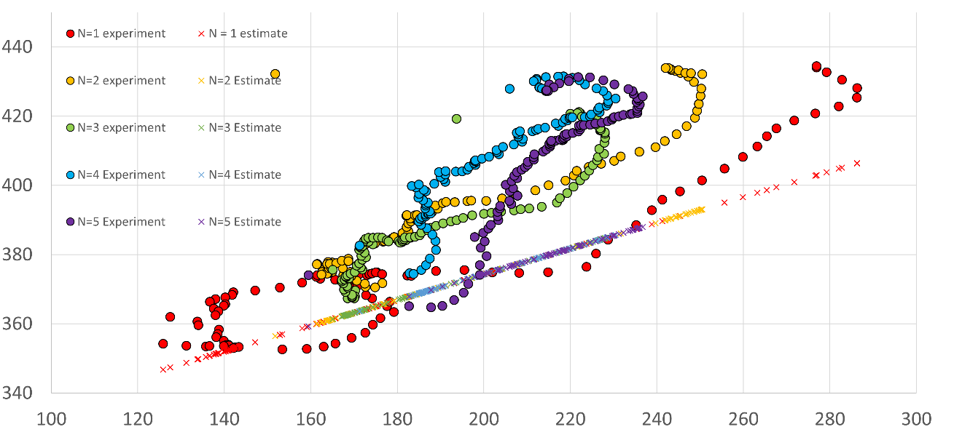
Figure 4.7 AFSD Experimental data. The rotational speed is 135 RPM and the reference temperature is 300 K. (Courtesy of Mr. Andrew Kocak, Mr. Josh Kincaid, and Prof. Tony Schmitz).

results, we can predict that as the material size increases, all "number 7" curves will progressively shift from left to right. Ultimately, if a semi-infinite status is achieved, the curves will exhibit no turning points. This indicates that the influence of material size on the thermal and mechanical behavior during the AFSD process is significant and must be carefully considered in modeling and analysis.
Additionally, boundary conditions (i.e., the setup of the AFSD process) significantly impact the final evolution of temperature and torque. To examine this effect, we removed the rigidly fixed velocity boundary conditions for the surrounding side surfaces, allowing material to flow out of the model under compression and rotation. As depicted in Fig. 4.6 (c), during the late stage of each pass, the temperature stabilizes and may even return to the reference temperature, while the torque approaches zero. This behavior suggests that the tool spins idle without generating heat during this phase. Thus, the setup of the AFSD process profoundly influences heat generation, highlighting the necessity of a proper setup for accurate modeling and process optimization.

4.6 Summary
A Coupled Eulerian Lagrangian (CEL) nonlinear finite element model has been developed to simulate the multi-pass AFSD process and investigate the effects of processing parameters on heat generation and the temperature field throughout the process. These simulation results are used to validate our theoretical solution, derived from Rosenthal’s analysis of the relationship between heat generation and temperature history, and they show good agreement with previous experimental findings. Moreover, the effect of model size has been examined. As the model size increases, the "number 7" curve, including the turning point, shifts progressively from left to right until it conforms to the theoretical solution. Additionally, the influence of boundary conditions has been tested. Although initial findings indicate significant effects, a comprehensive study and a complete understanding of boundary and initial conditions are essential for further advancement in AFSD process modeling.

Chapter 5 Conclusions and Perspectives
As concluding remarks, the objective of this dissertation work is to understand the high-temperature deformation mechanisms of structural materials in practical engineering scenarios by using computational methods at different length scales. To achieve this goal, a series of microstructure-based mechanisms-based finite element models have been developed to investigate the high temperature processing and failure of alloys under complex conditions. The summary of the thesis work is as follows,
- we recourse to a micromechanical finite element framework that models the high temperature failure as the nucleation and growth of grain boundary cavities, whereas various parameters such as thermomechanical loading history and its evolution, the competition of grain-interior dislocation creep and grain-boundary diffusion in failure lifetime, and microstructural heterogeneities (such as the precipitate free zone near grain boundaries) can be quantitatively incorporated. It can be concluded from these microstructure-explicit simulations that an accurate knowledge of residual stress evolution and a carefully calibrated set of material constitutive parameters are the essential prerequisites for lifetime predictions. These results suggest that the criticality of residual stress evolution, but not the precipitation-induced local strains, be the leading factor for SRC.
- We develop a microstructure-informed and micromechanics-based model by incorporating a synergy between hydrogen transport and intergranular-cavity-based fracture process. Based on the available creep lifetime data of C-0.5Mo steels, we are able to calibrate material constitutive parameters, and then conduct nonlinear finite element simulations that reveal a real-time stress-induced hydrogen diffusional transport along grain boundaries, coupled with a microstructure-explicit failure process, from which Nelson curves can be computed. Such failure analyses allow us to delineate two distinct regimes on the Nelson curves, i.e., dislocation-creep-controlled or grain boundary diffusion-assisted cavity growth. More importantly, we found that a small change of the pipe thickness and applied stresses can significantly shift these lifetime curves. However, these two parameters are usually not provided in Nelson curves, thus limiting their usage in material selection and safety design. This discrepancy can clearly be mitigated by extensive parametric studies from our micromechanical modeling/simulation framework.
- We propose a Coupled Eulerian Lagrangian (CEL) nonlinear finite element model to simulate the multi-pass AFSD process and investigate the effects of processing parameters on heat generation and the temperature field throughout the process. The simulation results are utilized to validate our theoretical solution, derived from Rosenthal’s analysis of the relationship between heat generation and temperature history, demonstrating strong agreement with previous experimental findings. Additionally, the impact of model size has been examined. As the model size increases, the "number 7" curve, including its turning point, progressively shifts from left to right, eventually aligning with the theoretical solution. Furthermore, the influence of boundary conditions has been assessed. While initial findings indicate significant effects, a comprehensive study and thorough understanding of boundary and initial conditions are essential for further advancements in AFSD process modeling based on the specific experimental setup.
Although many insightful results are obtained in this dissertation, there are still a lot of work needed to be explored in the future:
- Some related material parameters in our computational models for high temperature creep and high temperature hydrogen attack are still based on some theoretical assumptions. An accurate calibration of failure-related parameters is urgent to model and catch more details for these deformation behavior.
- As a result of that AFSD could be sensitive to lots of uncertain factors such as control mode (torque control or displacement control), it’s imposed to have a close interaction with experimental details. With more information of the specific experimental setup, our computational model can be refined.

                - List of References
- C.L. Bauer and G.G. Lessmann, Metal-joining methods, Annu. Rev. Mater. Sci. 6 (1976): 361-387.
- A. Kromm, T. Lausch, D. Schroepfer, M. Rhode, T. Kannengiesser, Influence of welding stresses on relief cracking during heat treatment of a creep-resistant 13CrMoV steel Part II: mechanisms of stress relief cracking during post weld heat treatment, Weld World 64 (2020): 819–829.
- J.C. Chang, B.S. Kim, N.H. Heo, Stress relief cracking on the weld of T/P 23 steel, Procedia Eng. 10 (2011): 734–739.
- J.G. Nawrocki, J.N. Dupont, C.V. Robino, A.R. Marder, The stress-relief cracking susceptibility of a new ferritic-steel Part I: single-pass heat-affected zone simulations, Weld. J. Res. Suppl. (1999): 1-21.
- J.G. Nawrocki, J.N. Dupont, C.V. Robino, J.D. Puskar, A.R. Marder, The mechanism of stress-relief cracking in ferritic alloy steel, Weld. J. (2003): 25-35.
- C. Sarich, B. Alexandrov, A. Benatar, J. Penso, Test for stress relief cracking susceptibility in creep resistant chromium-molybdenum steels, Sci. Technol. Weld. Joining 4 (2022): 265-281.
- American Petroleum Institute, Steels for Hydrogen Service at Elevated Temperatures and Pressures in Petroleum Refineries and Petrochemical Plants (2016).
- G.A. Nelson, Hydrogenation plant steels. In: Beachem, C.D. (Ed.), Hydrogen Damage, American Society for Metals (1977): 377–394.
- M. Bharadwaj, Studies of High Temperature Hydrogen Related Damage in Welded Carbon Steel Components used in Refineries, PhD Thesis, University of Tennessee (2015).
- K. Poorhaydari, A Comprehensive Examination of High-Temperature Hydrogen Attack—A Review of over a Century of Investigations. J. Mater. Eng. Perform. 30 (2021): 7875-7908
- T.A. Parthasarathy, Mechanisms of hydrogen attack of carbon and 214Cr-1Mo steels, Acta Metall. 33 (1985): 1673-1681.
- P. Shewmon, Synergism between creep ductility and grain boundary bubbles, Acta Metall. 35 (1987): 1317-1324.
- W.E. Frazier, Metal additive manufacturing: A review. J. Mater. Eng. Perform. 23 (2014): 1917–1928.
- W.J. Sames, F.A. List, S. Pannala, R.R. Dehoff, S.S. Babu, The metallurgy and processing science of metal additive manufacturing. Int. Mater. Rev. 61 (2016): 315–360.
- P. Agrawal, S. Thapliyal, S.S. Nene, R.S. Mishra, B.A. McWilliams, K.C. Cho, Excellent strength-ductility synergy in metastable high entropy alloy by laser powder bed additive manufacturing. Addit. Manuf. 32 (2020): 101098.
- S. Liu, T.C. Bora, A.A. Van der Stelt, H.J.M. Geijselaers, C. Kwakernaak, A.M. Kooijman, J.M.C. Mol, R. Akkerman, A.H. van den Boogaard, A. Friction surface cladding: An exploratory study of a new solid state cladding process. J. Mater. Process. Technol. 229 (2016): 769–784.
- A.A. Van Der Stelt, T.C. Bor, H.J.M. Geijselaers, R. Akkerman, A.H. van den Boogaard, Cladding of advanced Al alloys employing friction stir welding. Key Eng. Mater. 554 (2013): 1014–1021.
- H.Z. Yu, M.E. Jones, G.W. Brady, R.J. Griffiths, D. Garcia, H.A. Rauch, C.D. Cox, N. Hardwick, Non-beam-based metal additive manufacturing enabled by additive friction stir deposition, Scr. Mater. 153 (2018): 122–130.
- M. Perry, H.A. Rauch, R.J. Griffiths, D. Garcia, H.Z. Yu, Tracing plastic deformation path and concurrent grain refinement during additive friction stir deposition, Materialia 18 (2021): 101159.
- C. Mason, R.I. Rodriguez, D.Z. Avery, B.J. Phillips, B.P. Bernarding, M.B. Williams, S.D. Cobbs, J.B. Jordon, P.G. Allison, Process structure-property relations for as-deposited solid-state additively manufactured high-strength aluminum alloy. Addit. Manuf. 40 (2021): 101879.
- J.R. Calvert, Microstructure and Mechanical Properties of WE43 Alloy Produced via Additive Friction Stir Technology. Master’s Thesis, Virginia Tech, Blacksburg, VA, USA, (2015).
- K.K. Jha, R. Kesharwani, M. Imam, Microstructural and micro-hardness study on the fabricated Al 5083-O/6061-T6/7075-T6 gradient composite component via a novel route of friction stir additive manufacturing. Mater. Today Proc. 56 (2022): 819–825.
- R.J. Griffiths, M.E.J. Perry, J.M. Sietins, Y. Zhu, N. Hardwick, C.D. Cox, H.A. Rauch, H.Z. Yu, A perspective on solid-state additive manufacturing of aluminum matrix composites using MELD. J. Mater. Eng. Perform. 28 (2019): 648–656.
- J. Jordon, P.G. Allison, B.J. Phillips, D.Z. Avery, R.P. Kinser, L.N. Brewer, C. Cox, K. Doherty, Direct recycling of machine chips through a novel solid-state additive manufacturing process. Mater. Des. 193 (2020): 108850.
- R.J. Griffiths, D.T. Petersen, D. Garcia, H.Z. Yu, Additive friction stir-enabled solid-state additive manufacturing for the repair of 7075 aluminum alloy. Appl. Sci. 9 (2019): 3486.
- J. P. Schultz and K. D. Creehan, US8636194 b2, (2014).
- J. Shin and C.J. McMahon Jr, Mechanisms of stress relief cracking in a ferritic steel, Acta Metall. 32 (1984): 1535-1552.
- D.R. Hayhurst, I.W. Goodall, R.J. Hayhurst, D.W. Dean, Lifetime predictions for high-temperature low-alloy ferritic steel weldments, J. Strain Anal. Eng. Des. 40 (2005): 675-701.
- V. Gaffard, A.F. Gourgues-Lorenzon, J. Besson, High temperature creep flow and damage properties of 9Cr1MoNbV steels: Base metal and weldment, Nucl. Eng. Des. 235 (2005): 2547–2562.
- J.A. Siefert, J.P. Shingledecker, J.N. DuPont, S.A. David, Weldability and weld performance of candidate nickel based superalloys for advanced ultrasupercritical fossil power plants Part II: weldability and cross-weld creep performance, Sci. Technol. Weld. Joining 21 (2016): 396-428.
- Z. Wu, J. Penso, T. Chen, D.N. Leonard, D. Zhang, S.A. David, Z.L. Feng,
Microstructural examination of 347H austenitic stainless-steel weld after 30-years’ refinery service, Proceedings of the ASME Pressure Vessels & Piping Conference (2020): PVP2020-21641.
- Y.S. Kim, S.B. Ahn, Y.M. Cheong, Precipitation of crack tip hydrides in zirconium alloys, J. Alloys Compd. 429 (2007): 221–226.
- G.R. Pulliam, Precipitation in microscopic cracks, J. Am. Ceram. Soc. 42 (1959): 477-482.
- W. Zhang, X. Wang, Y.Y. Wang, X.H. Yu, Y.F. Gao, Z.L. Feng, Type IV failure in weldment of creep resistant ferritic alloys: II. Creep fracture and lifetime prediction, J. Mech. Phys. Solids 134 (2020): 103775.
- F. Abe, T.U. Kern, R. Viswanathan, Creep-Resistant Steels, Woodhead Publishing (2008).
- C. Gandhi and M.F. Ashby, Overview no. 5: Fracture-mechanism maps for materials which cleave: FCC, BCC and HCP metals and ceramics, Acta Metall. 27 (1979): 1565-1602.
- P. Onck and E. Van der Giessen, Microstructurally based modelling of intergranular creep fracture using grain elements, Mech. Mater. 26 (1997): 109-126.
- J.R. Rice, Constraints on the diffusive cavitation of isolated grain boundary facets in creeping polycrystals, Acta Metall. 29 (1981): 675-681.
- V. Tvergaard, On the creep constrained diffusive cavitation of grain boundary facets, J. Mech. Phys. Solids 32 (1984): 373–393.
- P. Onck and E. Van der Giessen, Growth of an initially sharp crack by grain boundary cavitation, J. Mech. Phys. Solids 47 (1998): 99-139.
- P. Onck and E. Van der Giessen, Micromechanics of creep fracture: simulation of intergranular crack growth. Comput. Mater. Sci. 13 (1998): 90-102.
- P. Onck and E. Van der Giessen, Microstructural modelling of creep crack growth from a blunted crack, Int. J. Fract. 92 (1998): 373-399.
- A. Needleman and J.R. Rice, Plastic creep flow effects in the diffusive cavitation of grain boundaries, Acta Metall. 28 (1980): 1315-1332.
- J.R. Rice, Time dependent fracture of materials at elevated temperature. US Department of Energy Report 130 (1979).
- M.F. Ashby, Boundary defects, and atomistic aspects of boundary sliding and diffusional creep, Surf. Sci. 31 (1972): 498-542.
- F. Abe, T.U. Kern, R. Viswanathan (Eds.). Creep-Resistant Steels. Elsevier (2008).
- S. Kimmins and D. Smith, On the relaxation of interface stresses during creep of ferritic steel weldments, J. Strain Anal. Eng. Des. 33 (1998): 195–206.
- D. Hull and D.E. Rimmer. The growth of grain-boundary voids under stress, Phil. Mag. 4 (1959): 673–687.
- P.N.T. Unwin, G.W. Lorimer, R.B. Nicholson, The origin of the grain boundary precipitate free zone, Acta Metall. 17 (1969): 1363-1377.
- H. Jiang and R.G. Faulkner, Modelling of grain boundary segregation, precipitation and precipitate-free zones of high strength aluminum alloys—I. The model, Acta Mater. 44 (1996): 1857-1864.
- N. Ryum, The influence of a precipitate-free zone on the mechanical properties of an Al-Mg-Zn alloy, Acta Metall. 16 (1968): 327-332.
- National Institute of Materials Research (NIMS), Japan, Proceedings of the NIMS Creep Data Sheet (2003).
- T.G. Nieh, J. Wadsworth, O.D. Sherby, Superplasticity in Metals and Ceramics, Cambridge University Press (1997).
- F.H. Vitovec, Investigation of models for hydrogen attack of steel, J. Mater. Sci., 19 (1984): 2771–2774
- G. Sundararajan and P.G. Shewmon, The kinetics of hydrogen attack of steels, Metall. Trans. A 12 (1981): 1761-1775.
- H. Shih and H.H. Johnson, A model calculation of the Nelson curves for hydrogen attack, Acta Metall. 30 (1982): 537-545.
- G.R. Odette and S.S. Vagarali, An equation-of-state for methane for modeling hydrogen attack in ferritic steels, Metall. Trans. A 13 (1982): 299-303.
- M.W.D. Van der Burg and E. Van der Giessen, A continuum damage relation for hydrogen attack cavitation, Acta Mater. 45 (1997): 3047-3057.
- M.W.D. Van der Burg, E. Van der Giessen and T. Viggo, A continuum damage analysis of hydrogen attack in a 2.25 Cr–1Mo pressure vessel, Mater. Sci. Eng. A 241 (1998): 1-13.
- M.W.D. Van der Burg and E. Van der Giessen, Non-uniform hydrogen attack cavitation and the role of interaction with creep, Mater. Sci. Eng. A 220 (1996): 200-214.
- M.W.D Van der Burg, E. Van der Giessen and R.C. Brouwer, Investigation of hydrogen attack in 2.25 Cr-1Mo steels with a high-triaxiality void growth model, Acta Mater. 44 (1996): 505-518.
- S.M. Schlögl and E. Van der Giessen, Computational model for carbon diffusion and methane formation in a ferritic steel during hydrogen attack, Scr. Mater. 46 (2002): 431-436.
- M. Dadfarnia, M.L. Martin, D.E. Moore, S.E. Orwig, P. Sofronis, model for high temperature hydrogen attack in carbon steels under constrained void growth, Int. J. Fract. 219 (2019): 1-17.
- S.Z. Chavoshi, L.T. Hill, K.E. Bagnoli, R.L. Holloman, K.M. Nikbin, A combined fugacity and multi-axial ductility damage approach in predicting high temperature hydrogen attack in a reactor inlet nozzle, Eng. Fail. Anal. 117 (2020): 104948.
- A. Sieverts, The solubility of deuterium and hydrogen in solid palladium, Z. phys. Chem. 174 (1935) 359–364.
- J.C. Fisher, Calculation of diffusion penetration curves for surface and grain boundary diffusion, J. Appl. Phys. 22 (1951): 74-77.
- R.T.P. Whipple, Concentration contours in grain boundary diffusion, London, Edinburgh, Dublin Philos, Mag. J. Sci. 45 (1954): 1225-1236.
- C. Gandhi and M.F. Ashby, Fracture-mechanism maps for materials which cleave: FCC, BCC and HCP Metals and ceramics, Acta Metall. 27 (1979) 1565-1602.
- A.S. Argon, Mechanisms and mechanics of fracture in creeping alloys, Pineridge Press, Recent Advances in Creep and Fatigue of Engineering Materials and
Structures (1983): 1-52.
- A.C.F. Cocks, and M.F. Ashby, On creep fracture by void growth, Prog. Mater. Sci. 27 (1982): 189-244.
- H. Riedel, Fracture at High Temperatures, Springer (2014).
- C. Pu, Y.F. Gao, Y. Wang, T.L. Sham, Diffusion-coupled cohesive interface simulations of stress corrosion intergranular cracking in polycrystalline materials, Acta Mater. 136 (2017): 21-31.
- T. DebRoy, H.L. Wei, J.S. Zuback, T. Mukherjee, J.W. Elmer, J.O. Milewski, A.M. Beese, A. Wilson-Heid, A. De, W. Zhang, Additive manufacturing of metallic components - process, structure and properties, Prog. Mater Sci. 92 (2018): 112–224.
- K. Kempen, L. Thijs, B. Vrancken, S. Buls, J.P. Kruth, Producing crack-free, high density M2 HSS parts by selective laser melting: Pre-heating the baseplate, utwired.engr.utexas.edu (2013).
- L.N. Carter, M.M. Attallah, R.C. Reed, Laser Powder Bed Fabrication of Nickel-Base Superalloys: Influence of Parameters; Characterization, Quantification and Mitigation of Cracking, Superalloys 2012, 2012.
- J.H. Martin, B.D. Yahata, J.M. Hundley, J.A. Mayer, T.A. Schaedler, T.M. Pollock, 3d printing of high-strength aluminum alloys, Nature 549 (2017) 365.
- R.J. Griffiths, M.E.J. Perry, J.M. Sietins, Y.H. Zhu, N. Hardwick, C.D. Cox, H.A. Rauch, H.Z. Yu, A perspective on solid-state additive manufacturing of aluminum matrix composites using MELD, J. Mater. Eng. Perform. 28 (2019): 648–656.
- J. P. Schultz, K. D. Creehan, US8636194 b2, (2014).
- J. P. Schultz, K. D. Creehan, US20160107262, (2016).
- W. Tang, X. Guo, J.C. McClure, L.E. Murr, A. Nunes, J. Mater. Process. Manuf. Sci. 7 (1998):163.
- T. Hashimoto, S. Jyogan, K. Nakata, Y.G. Kim, M. Ushio, In Proceedings of the first international symposium on friction stir welding, Thousand Oaks, CA, USA; June 14–16, 1999.
- W.J. Arbegast and P.J. Hartley, In Proceedings of the fifth international conference on trends in welding research, Pine Mountain, GA, USA; June 1–5, 1998.
- D. Garcia, W.D. Hartley, H.A. Rauch, R.J. Griffiths, R. Wang, Z.J. Kong, Y. Zhu, H.Z. Yu, In situ investigation into temperature evolution and heat generation during additive friction stir deposition: a comparative study of Cu and Al-Mg-Si, Addit. Manuf. 34 (2020):101386.
- R.J. Griffiths, D. Garcia, J. Song, V.K. Vasudevan, M.A. Steiner, W.J. Cai, H.Z. Yu, Solid-state additive manufacturing of aluminum and copper using additive friction stir deposition: Process-microstructure linkages, Mater. 15 (2021): 100967.
- X. Wang, Y.F. Gao, X. Liu, M. McDonnell, Z.L. Feng, Tool-workpiece stick-slip conditions and their effects on torque and heat generation rate in the friction stir welding, Acta Mater. 213 (2021): 116969.
- D. Rosenthal, Mathematical theory of heat distribution during welding and cutting. Weld. J. 20 (1941):220–234.
- T. Sheppard and A. Jackson, Constitutive equations for use in prediction of flow stress during extrusion of aluminum alloys, Mater. Sci. Tech. 13 (1997): 203–209.
- R. Crawford, G. Cook, A. Strauss, D. Hartman, M. Stremler, Experimental defect analysis and force prediction simulation of high weld pitch friction stir welding, Sci. Tech. Welding Joining 11 (2006): 657–665.
- F. Al-Badour, N. Merah, A. Shuaib, A. Bazoune, Coupled Eulerian Lagrangian finite element modeling of friction stir welding processes, J. Mater. Proc. Tech. 213 (2013): 1433–1439.
- Y. Chao, S. Liu, C.H. Chien, Friction stir welding of al 6061-T6 thick plates: Part II-numerical modeling of the thermal and heat transfer phenomena, J. Chin. Inst. Eng. 3 (2008): 769–779.
- S. Kou, Welding metallurgy, New Jersey, USA 431.446 (2003): 223-225.

                - Vita
Dong Han was born in Shengzhou, Zhejiang, China, on January 28, 1994. He obtained his Bachelor of Science degree from the Department of Modern Mechanics at the University of Science and Technology of China in 2016. From 2016 to 2019, he pursued his Master of Science degree at the Institute of Mechanics, Chinese Academy of Sciences, under the advising of Prof. Yunjiang Wang, and successfully completed the program in 2019. In August 2020, he joined the Department of Materials Science and Engineering at the University of Tennessee, Knoxville, working with Prof. Yanfei Gao and Prof. Zhili Feng.

