Determining if host serum IgG titer is associated with Toxoplasma gondii virulence

An Honors Thesis Submitted to
the Department of Microbiology
in partial fulfillment of the Honors requirements

UNIVERSITY OF TENNESSEE

by
RILEY BYRD
4/27/2018

TABLE OF CONTENTS

List of Tables – page 4

List of Figures – page 5

Abstract – page 6

Introduction – page 7

Methods – pages 7 to 9

Serum samples – page 7

Serological testing – page 8

Statistical analysis – page 9

Results – pages 9 to 12

Cats – pages 9 to 10

Dogs – pages 10 to 11

Humans – pages 11 to 12

Discussion – pages 13 and 14

Role in project – page 15

References – page 16

Acknowledgements – page 17

Appendix – pages 18 to 45

Data – pages 18 to 40

MAT protocol – pages 41 to 45
LIST OF TABLES

Table 1. MAT titers of cat samples.
Table 2. MAT titers of dog samples.
Table 3. MAT titers of human samples
Supplementary Table 1. All relevant data from each serum sample.

LIST OF FIGURES

Figure 1. MAT test plate example.
Figure 2. MAT titers of cat samples.
Figure 3. MAT titers of dog samples.
Figure 4. MAT titers of human samples.
Figure 5. MAT titers of Egyptian cat samples.
Figure 6. MAT titers of Brazilian cat samples.
Figure 7. MAT titers of Chinese cat samples.
Figure 8. MAT titers of Ethiopian cat samples.
Figure 9. MAT titers of Tennessean cat samples.
Figure 10. MAT titers of Sri Lankan dog samples.
Figure 11. MAT titers of Egyptian dog samples.
Figure 12. MAT titers of Brazilian dog samples.
Figure 13. MAT titers of Colombian dog samples.
Figure 14. MAT titers of Vietnamese dog samples.
Figure 15. MAT titers of Tennessean human samples.
Figure 16. MAT titers of Brazilian human samples.
Figure 17. MAT titers of cat samples.
Figure 18. MAT titers of dog samples.

ABSTRACT

Toxoplasma gondii is a protozoan parasite that causes the disease toxoplasmosis in animals and humans. This parasite has two infectious forms: oocysts shed in the feces of felids (domestic and wild cats) and tissue cysts in chronically infected animals. Humans may become infected via the ingestion of food or water contaminated with oocysts, the consumption of tissue cysts in undercooked meats, or vertical transmission from the mother to the fetus. Previous studies have found that T. gondii strains from South America are genetically diverse and tend to be more virulent and causing of more severe diseases in infected hosts than strains from elsewhere and that higher anti-T. gondii IgG levels are correlated with severity of toxoplasmosis in humans. We hypothesize that more virulent strains can induce a stronger immune response to chronic infection than less virulent strains resulting in higher IgG antibody levels in the hosts. If true, we would expect higher IgG levels in the serum of animals and humans from South America than elsewhere. To test this hypothesis, we used the modified agglutination test (MAT) to measure anti-T. gondii IgG levels in serum samples from animal hosts (cats & dogs) from South America and elsewhere. In addition, human serum samples from USA and Brazil were compared. The IgG titers were then compared to determine if IgG level can be used as a marker to predict parasite virulence at the population level. Our results revealed that IgG titers were similar between cats from South American and other continents. Slightly differential IgG titers were observed in South American dogs compared to dogs from other continents, but this result needs to be confirmed using a higher sample size. There, however, was a large difference between IgG levels in humans from USA and Brazilian human serum samples, with the latter having much higher titers, suggesting that parasite genotypes may be associated with parasite virulence in humans.

INTRODUCTION

Toxoplasma gondii is a protozoan parasite that causes the disease toxoplasmosis in animals and humans. One third of the world’s human population is chronically infected with this parasite, and it can infect all warm-blooded animals as an intermediate host (Tenter et al., 2000). Toxoplasma gondii has two infectious forms: oocysts shed in the feces of felids (domestic and wild cats) and tissue cysts in chronically infected animals. Humans may become infected via ingestion of food or water contaminated with oocysts, the consumption of tissue cysts in undercooked meats, or vertical transmission from the mother to the fetus.
Previous studies have found that T. gondii strains from South America are genetically diverse from and tend to be more virulent and causing more severe diseases in humans than strains from elsewhere (Shwab et al., 2016). Also, another study found that higher anti-Toxoplasma IgG levels were correlated with severity of toxoplasmosis in humans (Bharti et al., 2016). We hypothesize that the suspected to be more virulent strains from South America can induce a stronger immune response to chronic infection than the less virulent strains from other continents, resulting in higher IgG antibody levels in the hosts. To test this hypothesis, we used the modified agglutination test (MAT) to measure anti-Toxoplasma IgG levels in serum samples from animals (cats & dogs) and humans from South America and elsewhere. The IgG titers were then compared to determine if IgG level can be used as a marker to predict parasite virulence at the population level.

MATERIALS AND METHODS

Serum Samples
obtained 477 (n=477) serum samples. Three hundred and twenty-five (325) of these samples were obtained from the parasitic diseases laboratory at the USDA. These samples include 119 from dogs and 206 from cats. One hundred and nine of the cat samples came from Egypt, 37 came from Brazil, 25 came from China and 35 came from Ethiopia. Twelve of the dog samples came from Sri Lanka, 27 came from Egypt, 24 came from Brazil, 29 came from Colombia, and 20 came from Vietnam. In addition, 82 human serum samples from Brazil and 70 cat samples from the University of Tennessee-Knoxville College of Veterinary Medicine were also included. All serum samples were stored at -20°C until use.
Serological Testing
All serum samples were tested for the presence of anti-T. gondii IgG using the MAT test (Figure 1; Protocol in Appendix). Whole-cell T. gondii antigen was used for IgG binding. Twenty-four human samples from Nashville, TN evaluated in a previous study (Mawlood et al., 2016) were also included to be used in comparison with the Brazilian human samples. The initial MAT test from 1:25 to 1:3,200 was performed as described by Desmonts & Remington (1980). Fifty microliters of each diluted serum sample, along with positive (a serum sample previously determined to have a titer of 1:200) and negative (uninfected fetal bovine serum) controls, was diluted with phosphate buffer solution (PBS) to 1:25 and added to the first row of a 96 well plate and 25 microliters were added to all other wells (Figure 1). From there 25 microliters of the diluted serum was diluted into the next well in the column, continuing this dilution serially until a dilution of 1:3200 was reached. Twenty-five microliters of an antigen mixture consisting of 2.5mL of an alkaline buffer, 35µL of 2-mercaptoethanol, 50µL of Evan’s Blue Dye, and 150µL of whole-cell T. gondii antigen. The plate was then covered and incubated at 37°C in 5.0% CO₂ for 24 hours and the results were read. Wells with a blue pellet collected at the bottom were read as negative and those with a clear bottom or “mat” of diffuse cells were read as positive. Those serum samples that were positive to 1:3,200 were then further tested using this procedure, though starting at a higher dilution, to 1:409,600 or until a negative result was reached. Samples were considered seropositive at 1:25.

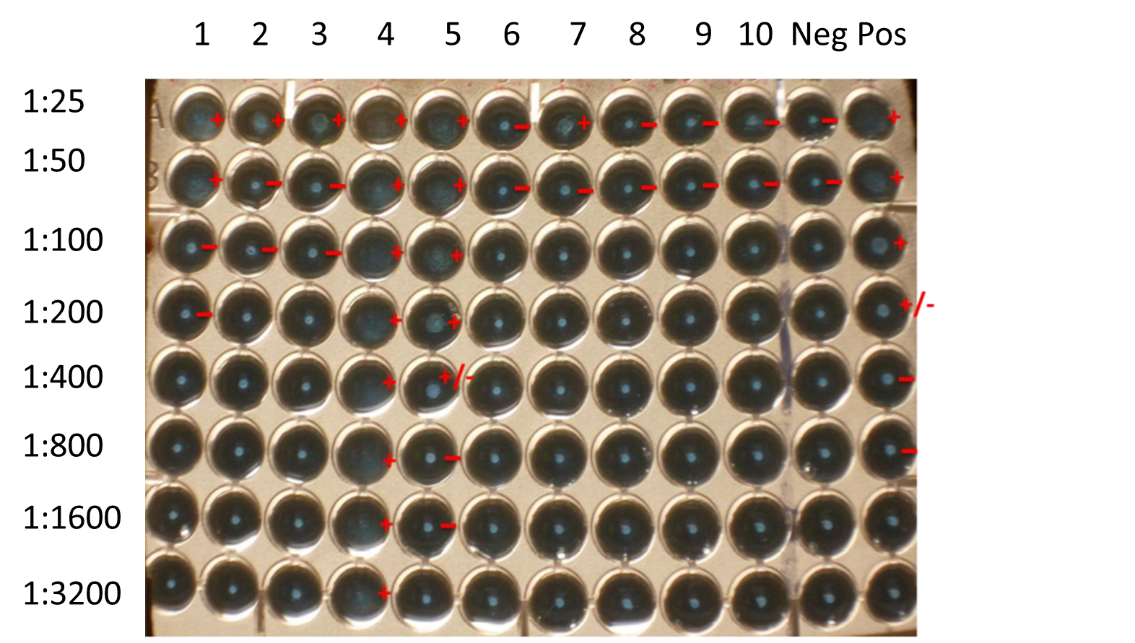
Figure 1. MAT test plate example. Wells with blue pellet were read as negative, while clear wells or those with a “mat” of cells were read as positive. A titer of ≥ 1:25 was considered positive. Plates were incubated at 37ׄ°C in 5.0% CO₂ for 24 hours before being read.

Statistical analysis
Mann-Whitney U tests were performed to test the relationship between titer, country of origin, and species. Data was organized by sample and analyzed using JMP Pro version 14.0 to determine if the Anti-Toxoplasma IgG titer was associated with the country of origin of each sample for each species. Seronegative samples were not included in this analysis.

RESULTS

Cats
The most common, or mode of the, IgG titers among all the cat samples was found to fall between approximately 1:400 and 1:3,200 (Figure 2; Table 1). For positive samples, the titers range from 1:100 to 1:204,800. The mode of the IgG titers for the Egyptian cats was found to be 1:3200 (Figure 5 in Appendix). For the Brazilian cats the mode was 1:400, 1:800, and 1:3200 (Figure 6 in Appendix). For the Chinese cats it was 1:400 and 1:800 (Figure 7 in Appendix). For the Ethiopian cats it was 1:200 and 1:600 (Figure 8 in Appendix). For the Tennessean cats it was 1:1600 (Figure 9 in Appendix). The Chinese and Brazilian were found to exhibit the highest IgG titers, at 1:409,600. The Ethiopian cats exhibited lower titers overall compared to the other cats. A direct comparison of the IgG titers of the South American cats (those from Brazil) against the cats from all other regions is shown in Figure 17 (In Appendix). It can once again be seen that the mode of both sets of samples fell between approximately 1:400 and 1:3,200.
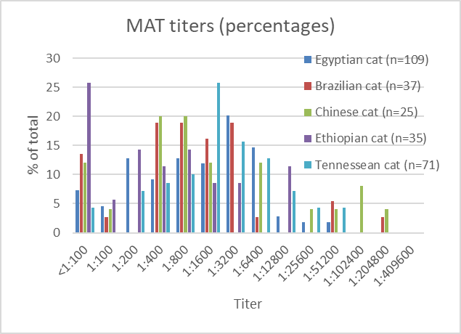
Figure 2. MAT titers of cat samples. The mode of the titers fell between approximately 1:400 and 1:3200 for cats from all locations including Brazil, Egypt, China, Ethiopia, and USA (Tennessee).

Table 1. MAT titers of cat samples. The number in parenthesis is the percentage of the cat samples of that titer versus the total number of samples from that country.

 | Egyptian cat | Brazilian cat | Chinese cat | Ethiopian cat | Tennessean cat
<1:100 | 8 (7.34%) | 5 (13.51%) | 3 (12.00%) | 9 (25.71%) | 3 (4.23%)
1:100 | 5 (4.59%) | 1 (2.70%) | 1 (4.00%) | 2 (5.71%) | 0 (0.00%)
1:200 | 14 (12.84%) | 0 (0.00%) | 0 (0.00%) | 5 (14.29%) | 5 (7.04%)
1:400 | 10 (9.17%) | 7 (18.92%) | 4 (20.00%) | 4 (11.43%) | 6 (8.57%)
1:800 | 14 (12.84%) | 7 (18.92%) | 5 (20.00%) | 5 (14.29%) | 7 (9.86%)
1:1,600 | 13 (11.93%) | 6 (16.22%) | 3 (12.00%) | 3 (8.57%) | 18 (25.35%)
1:3,200 | 22 (20.18%) | 7 (18.92%) | 0 (0.00%) | 3 (8.57%) | 11 (15.49%)
1:6,400 | 16 (14.68%) | 1 (2.70%) | 3 (12.50%) | 0 (0.00%) | 9 (12.68%)
1:12,800 | 3 (2.75%) | 0 (0.00%) | 0 (0.00%) | 4 (11.43%) | 5 (7.04%)
1:25,600 | 2 (1.83%) | 0 (0.00%) | 1 (4.00%) | 0 (0.00%) | 3(4.22%)
1:51,200 | 2 (1.83%) | 2 (5.41%) | 1 (4.00%) | 0 (0.00%) | 3 (4.22%)
1:102,400 | 0 (0.00%) | 0 (0.00%) | 2 (8.00%) | 0 (0.00%) | 0 (0.00%)
1:204,800 | 0 (0.00%) | 1 (2.70%) | 1 (4.00%) | 0 (0.00%) | 0 (0.00%)
total | 109 | 37 | 25 | 35 | 70

Dogs
MAT results for all dogs are summarized in Figure 3. For positive samples, the titers range from 1:50 to 1:800. The mode of the IgG titers for the Sri Lankan dogs was found to be 1:100 (Figure 10 in Appendix). For Egyptian dogs the mode was 1:200 (Figure 11 in Appendix). For Brazilian dogs the mode was 1:800 (Figure 12 in Appendix). For Colombian dogs the mode was 1:50 (Figure 13 in Appendix). For Vietnamese dogs the mode was 1:25 (Figure 14 in Appendix). The Brazilian dogs were found to exhibit the highest IgG titers, at 1:3200 (Figure 3; Table 2). The Vietnamese dogs exhibited IgG titers that were overall lower than that of the other dogs. A direct comparison of the IgG titers of the South American dogs (those from Brazil or Colombia) against the dogs from all other regions is shown in Figure 18 (In Appendix). Here it can be seen that the highest distribution of IgG titers fell between 1:100 and 1:200 for the dogs from countries not in South America, while for those countries in South America the highest distribution flanked those values and fell between 1:25 and 1:50 or 1:400 and 1:800.

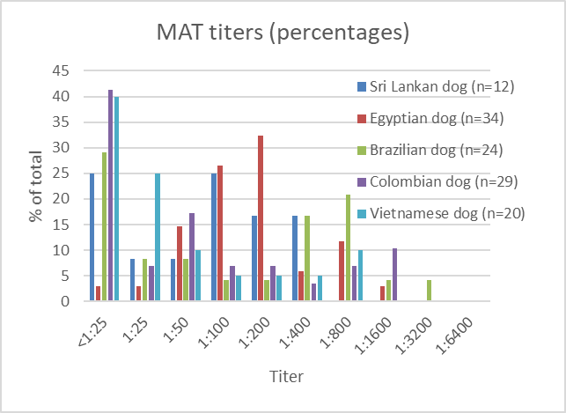
Figure 3. MAT titers of dog samples. The mode of the Brazil dog results fell between 1:400 and 1:800 and the Colombia dog between 1:25 and 1:100. The modes for the Sri Lanka dog, Egypt dog, and Vietnam dog fell a bit lower, between 1:100 and 1:200.

Table 2. MAT titers of dog samples. The number in parenthesis is the percentage of the dog samples of that titer versus the total number of samples from that country.

 | Sri Lankan dog | Egyptian dog | Brazilian dog | Colombian dog | Vietnamese dog
<1:25 | 3 (25.00%) | 1 (2.94%) | 7 (29.17%) | 12 (41.38%) | 8 (40.00%)
1:25 | 1 (8.33%) | 1 (2.94%) | 2 (8.33%) | 2 (6.90%) | 5 (25.00%)
1:50 | 1 (8.33%) | 5 (14.71%) | 2 (8.33%) | 5 (17.24%) | 2 (10.00%)
1:100 | 3 (25.00%) | 9 (26.47%) | 1 (4.17%) | 2 (6.90%) | 1 (5.00%)
1:200 | 2 (16.67%) | 11 (32.35%) | 1 (4.17%) | 2 (6.90%) | 1 (5.00%)
1:400 | 2 (16.67%) | 2 (5.88%) | 4 (16.67%) | 1 (3.45%) | 1 (5.00%)
1:800 | 0 (0.00%) | 4 (11.76%) | 5 (20.83%) | 2 (6.90%) | 2 (10.00%)
1:1,600 | 0 (0.00%) | 1 (2.94%) | 1 (4.17%) | 3 (10.34%) | 0 (0.00%)
1:3,200 | 0 (0.00%) | 0 (0.00%) | 1 (4.17%) | 0 (0.00%) | 0 (0.00%)
1:6,400 | 0 (0.00%) | 0 (0.00%) | 0 (0.00%) | 0 (0.00%) | 0 (0.00%)
total | 12 | 34 | 24 | 29 | 20

Humans
MAT results for all humans are summarized in Figure 4. The mode of IgG titers of the Tennessean humans, as determined by Malwood et al. (2017), was found to be 1:400 (Figure 15 in Appendix). For the Brazilian humans the mode was found to be 1:3200 and 1:6400 (Figure 16 in Appendix). The overall distribution of the IgG titers of the Tennessean humans was quite a bit lower than that of the Brazilian humans (Figure 4; Table 3).

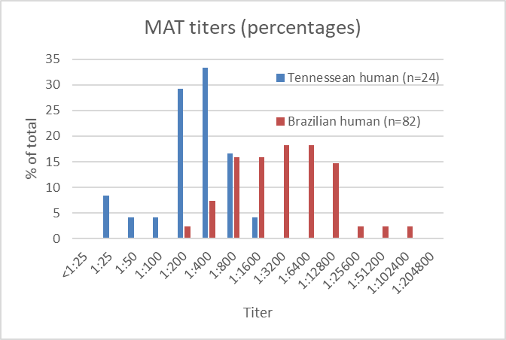
Figure 4. MAT titers of human samples from Brazil and USA (Mawlood et al., 2017). The mode for the samples from Tennessee humans fell between 1:200 and 1:400. The mode for the Brazilian human samples was considerably higher, around 1:3200 to 1:6400.

Table 3. MAT titers of human samples (Mawlood et al., 2017). The number in parenthesis is the percentage of the dog samples of that titer versus the total number of samples from that country.

 | Tennessean human | Brazilian human
<1:25 | 0 (0.00%) | 0 (0.00%)
1:25 | 2 (8.33%) | 0 (0.00%)
1:50 | 1 (4.17%) | 0 (0.00%)
1:100 | 1 (4.17%) | 0 (0.00%)
1:200 | 7 (29.17%) | 2 (2.44%)
1:400 | 8 (33.33%) | 6 (7.32%)
1:800 | 4 (16.67%) | 13 (15.84%)
1:1,600 | 1 (4.17%) | 13 (15.84%)
1:3,200 | 0 (0.00%) | 15 (18.29%)
1:6,400 | 0 (0.00%) | 15 (18.29%)
1:12,800 | 0 (0.00%) | 12 (14.63%
1:25,600 | 0 (0.00%) | 2 (2.44%)
1:51,200 | 0 (0.00%) | 2 (2.44%)
1:102,400 | 0 (0.00%) | 2 (2.44%)
1:204,800 | 0 (0.00%) | 0 (0.00%)
total | 24 | 82

DISCUSSION

We conclude that the serum samples from the more virulent South American strains of T. gondii did not exhibit differential IgG titers compared to cats from other continents. The cat samples tested tended to have fairly high titers overall, with the average seropositive titer being approximately 1:1600. In most sets of samples evaluated in this experiment, at least a few samples exhibited a negative seropositivity result. Due to the nature of this study, these results were not valuable but were included to increase the variety of titers shown. While the Ethiopian cat samples’ mode and distribution was a bit lower than the general distribution and range of modes from all of the other cat samples, this difference was not deemed large enough to disrupt the overall pattern of distribution among the cat samples. The correlation between continent of origin and IgG titers for cats was not significant (p=0.1228, Mann-Whitney test).
The dog samples tested tended to exhibit somewhat low titers overall, with the common seropositive titer being approximately 1:200. Averaged together, the mode of the IgG titers of dogs from the two South American countries equals that of the overall mode of the non-South American dog samples. Although the mode of the titers of the Brazil dogs was slightly higher than that of the Colombia dogs, this difference needs to be confirmed using a larger sample size. While the overall IgG titers in cats were similar among samples collected from different locations, they were slightly higher than that in dogs. The correlation between continent of origin and IgG titers for dogs was not significant (p=0.8484, Mann-Whitney test).
However, we found a large difference between IgG levels from the USA (range: 1:25 to 1:1600) and Brazilian human serum samples (range: 1:200 to 1:102,400), with the latter having much higher titers, suggesting that parasite genotypes may be associated with parasite virulence in humans. However, as the actual genotype of the samples are unknown, this conclusion is based solely on the previously found data that T. gondii genotypes from South America are more virulent than their genotypes from other continents (Schwab et al., 2016). The correlation between continent of origin and IgG titers for humans was significant (p=<0.0001, Mann-Whitney test).
Given the small sample size of the human samples from the USA and that these samples were tested by a different researcher than all of the other samples, additional studies with larger sample sizes are necessary. Future studies should also be performed in order to determine if the results found are indicative of IgG host responses in other animals, such as sheep and cows, and in continents and countries not examined in this study. Also, further confirmation of the differential response of humans to more virulent T. gondii strains should be performed.

ROLE IN PROJECT

The student, Riley Byrd, solely performed all data collection, analysis, and interpretation. Advice on which project the student should conduct this thesis on was given by the PI, Dr. Chunlei Su. Some assistance and advice on the analysis and interpretation of the results was given by the PI and other members of the Su lab, but the student both conducted and finalized all analysis and interpretation.

REFERENCES

Bharti, A. R., McCutchan, A., Deutsch, R., Smith, D. M., Ellis, R. J., Cherner, M., ... & Letendre, S. L. 2016. Latent Toxoplasma infection and higher Toxoplasma gondii immunoglobulin G levels are associated with worse neurocognitive functioning in HIV-infected adults. Clinical Infectious Diseases ciw655.
Desmonts, G. E. O. R. G. E. S., & Remington, J. S. 1980. Direct agglutination test for diagnosis of Toxoplasma infection: method for increasing sensitivity and specificity. Journal of Clinical Microbiology 11(6): 562-568.
Dubey, J. P. 2004. Toxoplasmosis–a waterborne zoonosis. Veterinary Parasitology 126(1): 57-72.
Mawlood, H. H., Mero, W. M., Su, C., & Isa, A. M. 2017. Comparison of MAT with ELISA and LAT tests in detecting Toxoplasma gondii antibodies in human sera. Science Journal of University of Zakho 5(1): 28-31.
Shwab, E. K., Jiang, T., Pena, H. F., Gennari, S. M., Dubey, J. P., & Su, C. 2016. The ROP18 and ROP5 gene allele types are highly predictive of virulence in mice across globally distributed strains of Toxoplasma gondii. International Journal for Parasitology 46(2): 141-146.
Tenter, A. M., Heckeroth, A. R., & Weiss, L. M. 2000. Toxoplasma gondii: from animals to humans. International Journal for Parasitology 30(12-13): 1217-1258.

ACKNOWLEDGEMENTS

We would like to thank Dr. J. P. Dubey from the USDA for providing the animal serum samples, Dr. Solange Gennari at the University of Sao Paulo for providing the human serum samples, and Dr. John New at the University of Tennessee-Knoxville College of Veterinary Medicine for providing the Tennessean cat serum samples. We would also like to thank Brandon Buck, Alison Easter, and Matthew Scott for their contributions to this project as well as the rest of the Su Lab team.

APPENDIX

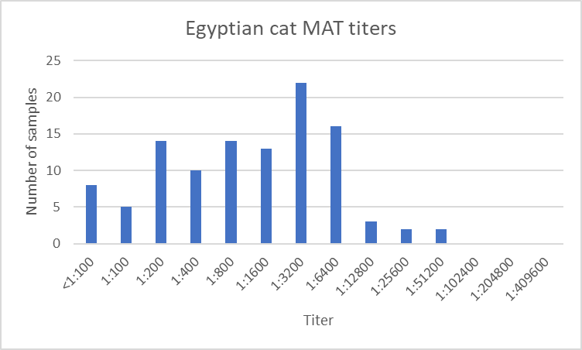
Figure 5. MAT titers of Egyptian cat samples.

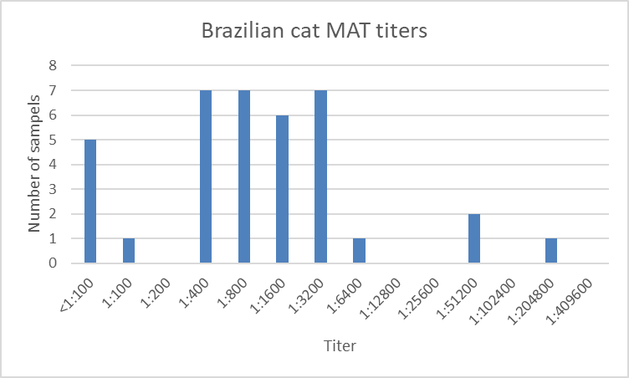
Figure 6. MAT titers of Brazilian cat samples.

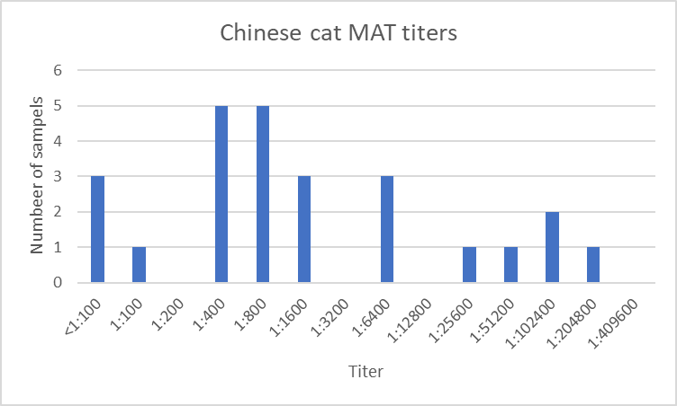
Figure 7. MAT titers of Chinese cat samples.

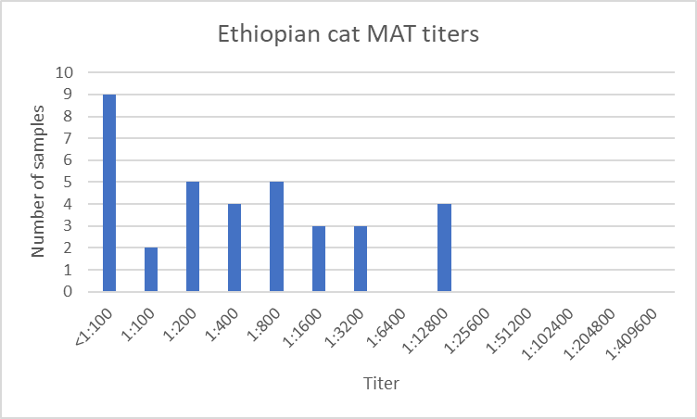
Figure 8. MAT titers of Ethiopian cat samples.

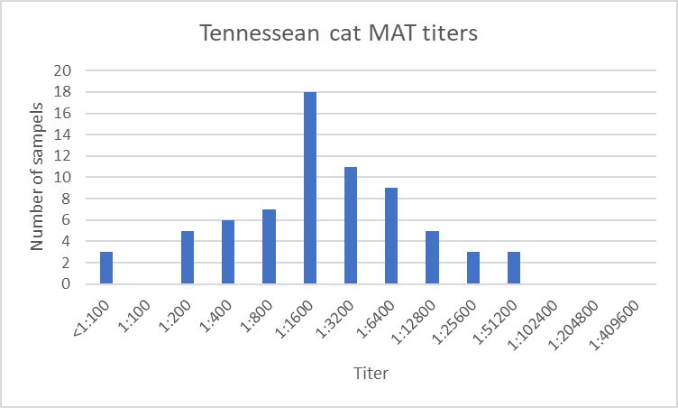
Figure 9. MAT titers of Tennessean cat samples.

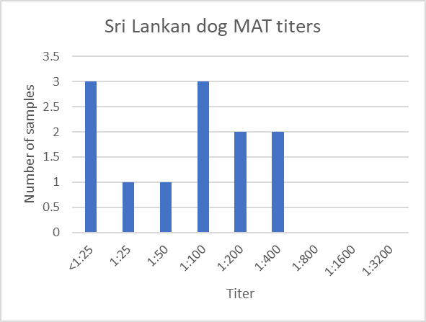
Figure 10. MAT titers of Sri Lankan dog samples.

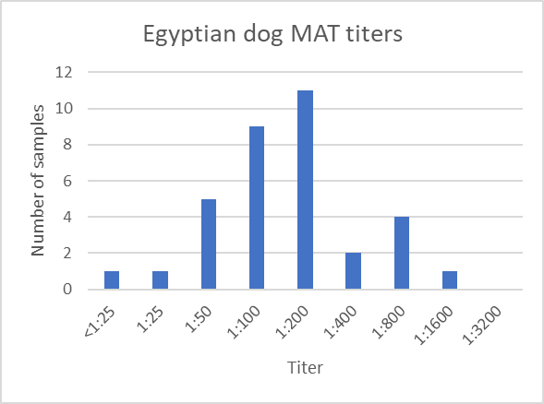
Figure 11. MAT titers of Egyptian dog samples.

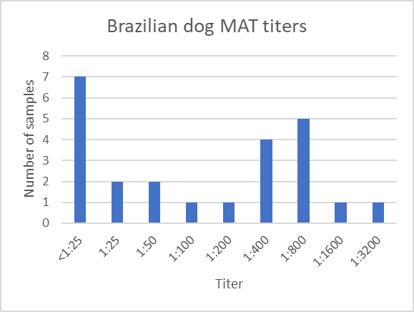
Figure 12. MAT titers of Brazilian dog samples.

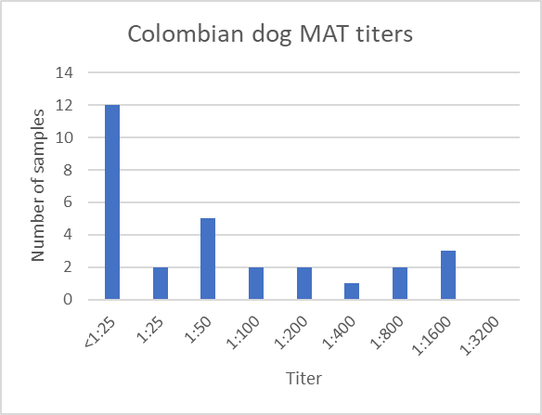
Figure 13. MAT titers of Colombian dog samples.

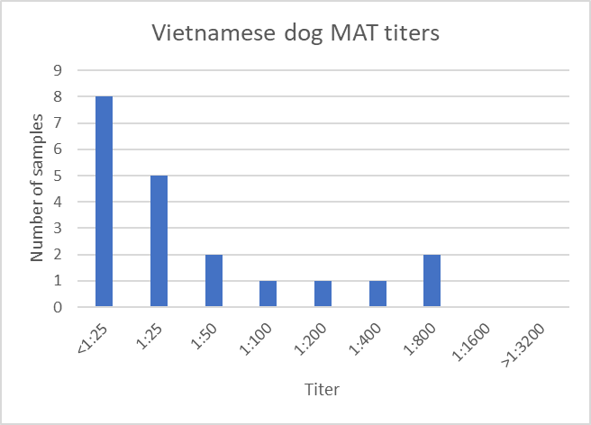
Figure 14. MAT titers of Vietnamese dog samples.

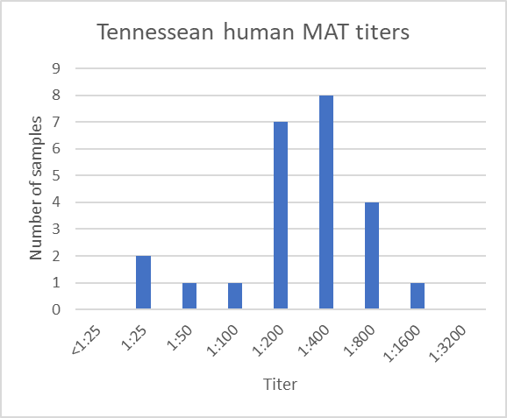
Figure 15. MAT titers of Tennessean human samples (Mawlood et al., 2017).

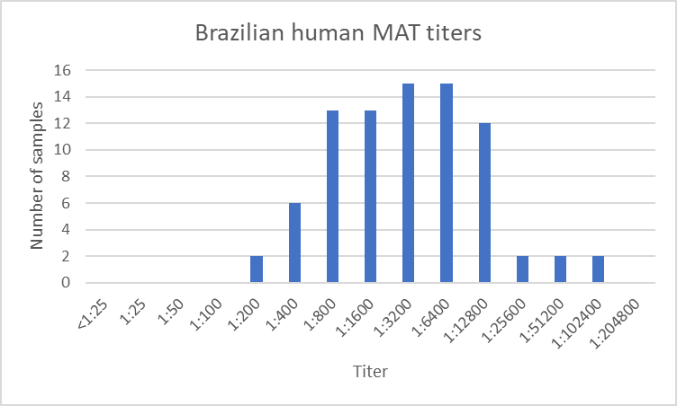
Figure 16. MAT titers of Brazilian human samples.

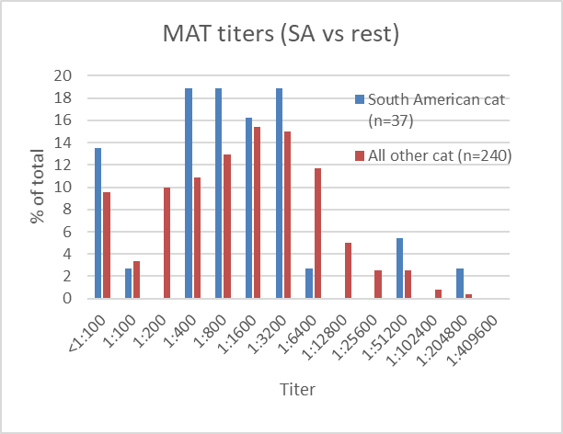
Figure 17. MAT titers of cat samples. Samples from South America are compared to non-South American regions. The modes of the titers from both regions are similar, approximately 1:400 to 1:3200.

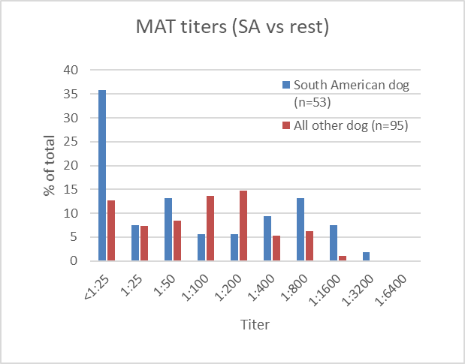
Figure 18. MAT titers of dog samples. Dog samples from South America are compared to non-South American regions. The modes of the titers from both regions are similar, approximately 1:100 to 1:200.

Supplementary Table 1. All relevant data from each serum sample.

Toxo designation | Sample ID | T. gondii Strain ID | Species | Country of Origin | Continent of Origin | Seropositivity | Final Titer
Tx351 | 1 | TgCatEg23 | Cat | Egypt | Africa | Yes | 1:800
Tx351 | 2 | TgCatEg24 | Cat | Egypt | Africa | Yes | 1:6400
Tx351 | 3 | TgCatEg25 | Cat | Egypt | Africa | Yes | 1:400
Tx351 | 4 | TgCatEg26 | Cat | Egypt | Africa | Yes | 1:100
Tx351 | 7 | TgCatEg27 | Cat | Egypt | Africa | Yes | 1:3200
Tx351 | 8 | TgCatEg28 | Cat | Egypt | Africa | No | <1:25
Tx351 | 9 | TgCatEg29 | Cat | Egypt | Africa | Yes | 1:800
Tx351 | 10 | TgCatEg30 | Cat | Egypt | Africa | Yes | 1:1600
Tx351 | 11 | TgCatEg31 | Cat | Egypt | Africa | Yes | 1:3200
Tx351 | 12 | TgCatEg32 | Cat | Egypt | Africa | Yes | 1:1600
Tx351 | 13 | TgCatEg33 | Cat | Egypt | Africa | Yes | 1:3200
Tx351 | 14 | TgCatEg34 | Cat | Egypt | Africa | Yes | 1:3200
Tx351 | 15 | TgCatEg35 | Cat | Egypt | Africa | Yes | 1:6400
Tx351 | 16 | TgCatEg36 | Cat | Egypt | Africa | Yes | 1:12800
Tx351 | 17 | TgCatEg37 | Cat | Egypt | Africa | No | <1:25
Tx351 | 19 | TgCatEg38 | Cat | Egypt | Africa | Yes | 1:3200
Tx351 | 20 | TgCatEg39 | Cat | Egypt | Africa | Yes | 1:25
Tx351 | 21 | TgCatEg40 | Cat | Egypt | Africa | Yes | 1:25
Tx351 | 22 | TgCatEg41 | Cat | Egypt | Africa | Yes | 1:400
Tx351 | 23 | TgCatEg42 | Cat | Egypt | Africa | Yes | 1:6400
Tx351 | 24 | TgCatEg43 | Cat | Egypt | Africa | Yes | 1:200
Tx351 | 25 | TgCatEg44 | Cat | Egypt | Africa | Yes | 1:12800
Tx351 | 26 | TgCatEg45 | Cat | Egypt | Africa | Yes | 1:200
Tx351 | 27 | TgCatEg46 | Cat | Egypt | Africa | Yes | 1:800
Tx351 | 28 | TgCatEg47 | Cat | Egypt | Africa | Yes | 1:200
Tx345 | 1 | TgCatEg1 | Cat | Egypt | Africa | Yes | 1:200
Tx345 | 13 | TgCatEg2 | Cat | Egypt | Africa | Yes | 1:1600
Tx345 | 15 | TgCatEg3 | Cat | Egypt | Africa | Yes | 1:200
Tx345 | 16 | TgCatEg4 | Cat | Egypt | Africa | Yes | 1:1600
Tx345 | 18 | TgCatEg5 | Cat | Egypt | Africa | Yes | 1:12800
Tx345 | 19 | TgCatEg6 | Cat | Egypt | Africa | Yes | 1:51200
Tx345 | 20 | TgCatEg7 | Cat | Egypt | Africa | Yes | 1:3200
Tx345 | 22 | TgCatEg8 | Cat | Egypt | Africa | Yes | 1:6400
Toxo designation | Sample ID | T. gondii Strain ID | Species | Country of Origin | Continent of Origin | Seropositivity | Final Titer
Tx345 | 29 | TgCatEg10 | Cat | Egypt | Africa | Yes | 1:1600
Tx345 | 30 | TgCatEg11 | Cat | Egypt | Africa | Yes | 1:200
Tx345 | 31 | TgCatEg12 | Cat | Egypt | Africa | No | <1:25
Tx345 | 32 | TgCatEg13 | Cat | Egypt | Africa | Yes | 1:1600
Tx345 | 33 | TgCatEg14 | Cat | Egypt | Africa | Yes | 1:800
Tx345 | 34 | TgCatEg15 | Cat | Egypt | Africa | Yes | 1:1600
Tx345 | 37 | TgCatEg17 | Cat | Egypt | Africa | Yes | 1:800
Tx345 | 39 | TgCatEg18 | Cat | Egypt | Africa | Yes | 1:100
Tx345 | 40 | TgCatEg19 | Cat | Egypt | Africa | Yes | 1:50
Tx345 | 41 | TgCatEg20 | Cat | Egypt | Africa | Yes | 1:3200
Tx345 | 42 | TgCatEg21 | Cat | Egypt | Africa | Yes | 1:6400
Tx345 | 45 | TgCatEg22 | Cat | Egypt | Africa | Yes | 1:25
Tx373 | 1 | TgCatEg48 | Cat | Egypt | Africa | Yes | 1:800
Tx373 | 2 | TgCatEg49 | Cat | Egypt | Africa | Yes | 1:3200
Tx373 | 3 | TgCatEg50 | Cat | Egypt | Africa | Yes | 1:3200
Tx373 | 4 | TgCatEg51 | Cat | Egypt | Africa | Yes | 1:3200
Tx373 | 5 | TgCatEg52 | Cat | Egypt | Africa | Yes | 1:6400
Tx373 | 6 | TgCatEg53 | Cat | Egypt | Africa | Yes | 1:800
Tx373 | 7 | TgCatEg54 | Cat | Egypt | Africa | Yes | 1:3200
Tx373 | 8 | TgCatEg55 | Cat | Egypt | Africa | Yes | 1:1600
Tx373 | 9 | TgCatEg56 | Cat | Egypt | Africa | Yes | 1:3200
Tx373 | 11 | TgCatEg58 | Cat | Egypt | Africa | Yes | 1:1600
Tx373 | 12 | TgCatEg59 | Cat | Egypt | Africa | Yes | 1:3200
Tx373 | 14 | TgCatEg60 | Cat | Egypt | Africa | Yes | 1:800
Tx373 | 15 | TgCatEg61 | Cat | Egypt | Africa | Yes | 1:3200
Tx373 | 16 | TgCatEg62 | Cat | Egypt | Africa | Yes | 1:800
Tx373 | 18 | TgCatEg63 | Cat | Egypt | Africa | Yes | 1:25600
Tx373 | 19 | TgCatEg64 | Cat | Egypt | Africa | Yes | 1:6400
Tx373 | 20 | TgCatEg65 | Cat | Egypt | Africa | Yes | 1:3200
Tx373 | 21 | TgCatEg66 | Cat | Egypt | Africa | Yes | 1:3200
Tx373 | 22 | TgCatEg67 | Cat | Egypt | Africa | Yes | 1:400
Tx373 | 23 | TgCatEg68 | Cat | Egypt | Africa | Yes | 1:6400
Tx373 | 25 | TgCatEg69 | Cat | Egypt | Africa | Yes | 1:100
Toxo designation | Sample ID | T. gondii Strain ID | Species | Country of Origin | Continent of Origin | Seropositivity | Final Titer
Tx373 | 27 | TgCatEg70 | Cat | Egypt | Africa | Yes | 1:200
Tx373 | 28 | TgCatEg71 | Cat | Egypt | Africa | Yes | 1:200
Tx373 | 29 | TgCatEg72 | Cat | Egypt | Africa | Yes | 1:200
Tx373 | 30 | TgCatEg73 | Cat | Egypt | Africa | Yes | 1:100
Tx373 | 31 | TgCatEg74 | Cat | Egypt | Africa | Yes | 1:400
Tx373 | 33 | TgCatEg75 | Cat | Egypt | Africa | Yes | 1:400
Tx373 | 34 | TgCatEg76 | Cat | Egypt | Africa | Yes | 1:6400
Tx373 | 36 | TgCatEg77 | Cat | Egypt | Africa | Yes | 1:400
Tx373 | 37 | TgCatEg78 | Cat | Egypt | Africa | Yes | 1:200
Tx373 | 38 | TgCatEg79 | Cat | Egypt | Africa | Yes | 1:1600
Tx373 | 39 | TgCatEg80 | Cat | Egypt | Africa | Yes | 1:3200
Tx373 | 40 | TgCatEg81 | Cat | Egypt | Africa | Yes | 1:1600
Tx373 | 42 | TgCatEg82 | Cat | Egypt | Africa | Yes | 1:800
Tx373 | 45 | TgCatEg83 | Cat | Egypt | Africa | Yes | 1:400
Tx373 | 46 | TgCatEg84 | Cat | Egypt | Africa | No | <1:100
Tx373 | 49 | TgCatEg85 | Cat | Egypt | Africa | Yes | 1:3200
Tx373 | 52 | TgCatEg87 | Cat | Egypt | Africa | Yes | 1:1600
Tx373 | 54 | TgCatEg89 | Cat | Egypt | Africa | Yes | 1:400
Tx373 | 55 | TgCatEg90 | Cat | Egypt | Africa | Yes | 1:6400
Tx373 | 56 | TgCatEg91 | Cat | Egypt | Africa | Yes | 1:800
Tx373 | 57 | TgCatEg92 | Cat | Egypt | Africa | Yes | 1:6400
Tx373 | 58 | TgCatEg93 | Cat | Egypt | Africa | Yes | 1:200
Tx373 | 59 | TgCatEg94 | Cat | Egypt | Africa | Yes | 1:6400
Tx373 | 60 | TgCatEg95 | Cat | Egypt | Africa | Yes | 1:400
Tx373 | 61 | TgCatEg96 | Cat | Egypt | Africa | Yes | 1:6400
Tx373 | 62 | TgCatEg97 | Cat | Egypt | Africa | Yes | 1:200
Tx373 | 63 | TgCatEg98 | Cat | Egypt | Africa | Yes | 1:100
Tx373 | 64 | TgCatEg99 | Cat | Egypt | Africa | Yes | 1:25600
Tx373 | 65 | TgCatEg100 | Cat | Egypt | Africa | Yes | 1:6400
Tx373 | 66 | TgCatEg101 | Cat | Egypt | Africa | Yes | 1:1600
Tx373 | 69 | TgCatEg102 | Cat | Egypt | Africa | Yes | 1:200
Tx373 | 70 | TgCatEg103 | Cat | Egypt | Africa | Yes | 1:400
Tx373 | 71 | TgCatEg104 | Cat | Egypt | Africa | Yes | 1:800
Toxo designation | Sample ID | T. gondii Strain ID | Species | Country of Origin | Continent of Origin | Seropositivity | Final Titer
Tx373 | 72 | TgCatEg105 | Cat | Egypt | Africa | Yes | 1:800
Tx373 | 73 | TgCatEg106 | Cat | Egypt | Africa | Yes | 1:51200
Tx373 | 77 | TgCatEg108 | Cat | Egypt | Africa | Yes | 1:200
Tx373 | 78 | TgCatEg109 | Cat | Egypt | Africa | Yes | 1:800
Tx373 | 79 | TgCatEg110 | Cat | Egypt | Africa | Yes | 1:3200
Tx373 | 80 | TgCatEg111 | Cat | Egypt | Africa | Yes | 1:3200
Tx373 | 81 | TgCatEg112 | Cat | Egypt | Africa | Yes | 1:3200
Tx373 | 82 | TgCatEg113 | Cat | Egypt | Africa | Yes | 1:3200
Tx373 | 83 | TgCatEg114 | Cat | Egypt | Africa | Yes | 1:3200
Tx373 | 84 | TgCatEg115 | Cat | Egypt | Africa | Yes | 1:6400
Tx109 | 2 | TgCatBr1 | Cat | Brazil | South America | Yes | 1:1600
Tx109 | 3 | TgCatBr2 | Cat | Brazil | South America | Yes | 1:3200
Tx109 | 5 | TgCatBr3 | Cat | Brazil | South America | Yes | 1:1600
Tx109 | 6 | TgCatBr4 | Cat | Brazil | South America | Yes | 1:800
Tx109 | 8 | TgCatBr5 | Cat | Brazil | South America | Yes | 1:3200
Tx109 | 9 | TgCatBr6 | Cat | Brazil | South America | Yes | 1:400
Tx109 | 11 | TgCatBr7 | Cat | Brazil | South America | Yes | 1:1600
Tx109 | 20 | TgCatBr8 | Cat | Brazil | South America | Yes | 1:3200
Tx109 | 21 | TgCatBr9 | Cat | Brazil | South America | Yes | 1:6400
Tx120 | 1 | TgCatBr23 | Cat | Brazil | South America | Yes | 1:51200
Tx120 | 2 | TgCatBr24 | Cat | Brazil | South America | Yes | 1:51200
Tx120 | 3 | TgCatBr25 | Cat | Brazil | South America | Yes | 1:400
Tx120 | 4 | TgCatBr26 | Cat | Brazil | South America | Yes | 1:800
Tx120 | 5 | TgCatBr27 | Cat | Brazil | South America | Yes | 1:202800
Tx120 | 6 | TgCatBr28 | Cat | Brazil | South America | Yes | 1:3200
Tx120 | 7 | TgCatBr29 | Cat | Brazil | South America | No | <1:100
Tx120 | 8 | TgCatBr30 | Cat | Brazil | South America | Yes | 1:1600
Tx120 | 9 | TgCatBr31 | Cat | Brazil | South America | Yes | 1:1600
Tx120 | 10 | TgCatBr32 | Cat | Brazil | South America | Yes | 1:800
Tx120 | 11 | TgCatBr33 | Cat | Brazil | South America | Yes | 1:800
Tx120 | 12 | TgCatBr34 | Cat | Brazil | South America | Yes | 1:400
Tx120 | 13 | TgCatBr35 | Cat | Brazil | South America | Yes | 1:100
Tx120 | 14 | TgCatBr36 | Cat | Brazil | South America | No | <1:100
Toxo designation | Sample ID | T. gondii Strain ID | Species | Country of Origin | Continent of Origin | Seropositivity | Final Titer
Tx120 | 15 | TgCatBr37 | Cat | Brazil | South America | Yes | 1:800
Tx114 | 1 | TgCatBr10 | Cat | Brazil | South America | Yes | 1:400
Tx114 | 7 | TgCatBr11 | Cat | Brazil | South America | Yes | 1:800
Tx114 | 9 | TgCatBr12 | Cat | Brazil | South America | No | <1:100
Tx114 | 11 | TgCatBr13 | Cat | Brazil | South America | Yes | 1:1600
Tx114 | 13 | TgCatBr14 | Cat | Brazil | South America | No | <1:100
Tx114 | 14 | TgCatBr15 | Cat | Brazil | South America | Yes | 1:400
Tx114 | 18 | TgCatBr16 | Cat | Brazil | South America | Yes | 1:3200
Tx114 | 20 | TgCatBr17 | Cat | Brazil | South America | Yes | 1:400
Tx114 | 22 | TgCatBr18 | Cat | Brazil | South America | Yes | 1:400
Tx114 | 23 | TgCatBr19 | Cat | Brazil | South America | No | <1:100
Tx114 | 24 | TgCatBr20 | Cat | Brazil | South America | Yes | 1:3200
Tx114 | 25 | TgCatBr21 | Cat | Brazil | South America | Yes | 1:3200
Tx114 | 26 | TgCatBr22 | Cat | Brazil | South America | Yes | 1:800
Tx477 | 77 | N/A | Cat | China | Asia | Yes | 1:25600
Tx225 | 1 | N/A | Cat | China | Asia | Yes | 1:1600
Tx225 | 4 | N/A | Cat | China | Asia | Yes | 1:102400
Tx225 | 6 | N/A | Cat | China | Asia | Yes | 1:6400
Tx244 | 8 | N/A | Cat | China | Asia | No | <1:100
Tx244 | 11 | N/A | Cat | China | Asia | Yes | 1:800
Tx251 | 20 | N/A | Cat | China | Asia | Yes | 1:800
Tx251 | 21 | N/A | Cat | China | Asia | Yes | 1:102400
Tx251 | 23 | N/A | Cat | China | Asia | Yes | 1:202800
Tx251 | 24 | N/A | Cat | China | Asia | Yes | 1:51200
Tx251 | 25 | N/A | Cat | China | Asia | Yes | 1:400
Tx251 | 26 | N/A | Cat | China | Asia | Yes | 1:400
Tx269 | 42 | N/A | Cat | China | Asia | No | <1:100
Tx269 | 43 | N/A | Cat | China | Asia | Yes | 1:100
Tx269 | 44 | N/A | Cat | China | Asia | No | <1:100
Tx269 | 45 | N/A | Cat | China | Asia | Yes | 1:400
Tx269 | 46 | N/A | Cat | China | Asia | Yes | 1:1600
Tx269 | 47 | N/A | Cat | China | Asia | Yes | 1:6400
Tx269 | 48 | N/A | Cat | China | Asia | Yes | 1:400
Toxo designation | Sample ID | T. gondii Strain ID | Species | Country of Origin | Continent of Origin | Seropositivity | Final Titer
Tx269 | 49 | N/A | Cat | China | Asia | Yes | 1:400
Tx601 | 3 | N/A | Cat | China | Asia | Yes | 1:800
Tx601 | 5 | N/A | Cat | China | Asia | Yes | 1:800
Tx601 | 9 | N/A | Cat | China | Asia | Yes | 1:1600
Tx601 | 10 | N/A | Cat | China | Asia | Yes | 1:6400
Tx601 | 11 | N/A | Cat | China | Asia | Yes | 1:800
Tx480 | 1 | N/A | Cat | Ethiopia | Africa | Yes | 1:800
Tx480 | 3 | N/A | Cat | Ethiopia | Africa | Yes | 1:800
Tx480 | 4 | N/A | Cat | Ethiopia | Africa | Yes | 1:200
Tx480 | 5 | N/A | Cat | Ethiopia | Africa | No | <1:100
Tx480 | 6 | N/A | Cat | Ethiopia | Africa | Yes | 1:400
Tx480 | 8 | N/A | Cat | Ethiopia | Africa | No | <1:100
Tx480 | 9 | N/A | Cat | Ethiopia | Africa | Yes | 1:200
Tx480 | 14 | N/A | Cat | Ethiopia | Africa | Yes | 1:3200
Tx480 | 15 | N/A | Cat | Ethiopia | Africa | No | <1:100
Tx480 | 16 | N/A | Cat | Ethiopia | Africa | Yes | >1:12800
Tx480 | 17 | N/A | Cat | Ethiopia | Africa | No | <1:100
Tx480 | 18 | N/A | Cat | Ethiopia | Africa | Yes | 1:800
Tx480 | 19 | N/A | Cat | Ethiopia | Africa | No | <1:100
Tx480 | 20 | N/A | Cat | Ethiopia | Africa | Yes | 1:3200
Tx480 | 21 | N/A | Cat | Ethiopia | Africa | Yes | 1:400
Tx480 | 22 | N/A | Cat | Ethiopia | Africa | Yes | 1:100
Tx480 | 25 | N/A | Cat | Ethiopia | Africa | Yes | 1:200
Tx480 | 26 | N/A | Cat | Ethiopia | Africa | Yes | 1:800
Tx480 | 27 | N/A | Cat | Ethiopia | Africa | Yes | 1:200
Tx480 | 28 | N/A | Cat | Ethiopia | Africa | Yes | 1:1600
Tx480 | 29 | N/A | Cat | Ethiopia | Africa | Yes | 1:800
Tx480 | 31 | N/A | Cat | Ethiopia | Africa | Yes | 1:400
Tx480 | 32 | N/A | Cat | Ethiopia | Africa | No | <1:100
Tx480 | 33 | N/A | Cat | Ethiopia | Africa | Yes | 1:3200
Tx480 | 34 | N/A | Cat | Ethiopia | Africa | No | <1:100
Tx480 | 35 | N/A | Cat | Ethiopia | Africa | No | <1:100
Tx480 | 36 | N/A | Cat | Ethiopia | Africa | No | <1:100
Toxo designation | Sample ID | T. gondii Strain ID | Species | Country of Origin | Continent of Origin | Seropositivity | Final Titer
Tx480 | 38 | N/A | Cat | Ethiopia | Africa | Yes | 1:1600
Tx480 | 40 | N/A | Cat | Ethiopia | Africa | Yes | 1:1600
Tx480 | 43 | N/A | Cat | Ethiopia | Africa | Yes | >1:12800
Tx480 | 44 | N/A | Cat | Ethiopia | Africa | Yes | 1:400
Tx480 | 45 | N/A | Cat | Ethiopia | Africa | Yes | 1:100
Tx480 | 46 | N/A | Cat | Ethiopia | Africa | Yes | 1:200
Tx480 | 48 | N/A | Cat | Ethiopia | Africa | Yes | >1:12800
Tx480 | 49 | N/A | Cat | Ethiopia | Africa | Yes | >1:12800
N/A | 116-3 | N/A | Cat | USA (Tennessee) | North America | Yes | 1:400
N/A | 117-7 | N/A | Cat | USA (Tennessee) | North America | Yes | 1:6400
N/A | 117-5 | N/A | Cat | USA (Tennessee) | North America | Yes | 1:1600
N/A | 117-2 | N/A | Cat | USA (Tennessee) | North America | Yes | 1:1600
N/A | 114-2 | N/A | Cat | USA (Tennessee) | North America | Yes | 1:3200
N/A | 114-1 | N/A | Cat | USA (Tennessee) | North America | Yes | 1:1600
N/A | 109-1 | N/A | Cat | USA (Tennessee) | North America | Yes | 1:800
N/A | 108-1 | N/A | Cat | USA (Tennessee) | North America | Yes | 1:3200
N/A | 107-6 | N/A | Cat | USA (Tennessee) | North America | Yes | 1:800
N/A | 104-14 | N/A | Cat | USA (Tennessee) | North America | Yes | 1:6400
N/A | 104-13 | N/A | Cat | USA (Tennessee) | North America | Yes | 1:1600
N/A | 104-6 | N/A | Cat | USA (Tennessee) | North America | Yes | 1:3200
N/A | 103-5 | N/A | Cat | USA (Tennessee) | North America | Yes | 1:1600
N/A | 103-4 | N/A | Cat | USA (Tennessee) | North America | Yes | 1:1600
N/A | 103-3 | N/A | Cat | USA (Tennessee) | North America | Yes | 1:3200
N/A | 103-2 | N/A | Cat | USA (Tennessee) | North America | Yes | 1:1600
N/A | 103-1 | N/A | Cat | USA (Tennessee) | North America | Yes | 1:6400
N/A | 102-2* | N/A | Cat | USA (Tennessee) | North America | Yes | 1:1600
N/A | 102-2 | N/A | Cat | USA (Tennessee) | North America | Yes | 1:800
N/A | 423-6 | N/A | Cat | USA (Tennessee) | North America | Yes | 1:6400
N/A | 419-4 | N/A | Cat | USA (Tennessee) | North America | No | <1:200
N/A | 395-11 | N/A | Cat | USA (Tennessee) | North America | Yes | 1:800
N/A | 394-2 | N/A | Cat | USA (Tennessee) | North America | No | <1:200
N/A | 424-1 | N/A | Cat | USA (Tennessee) | North America | Yes | 1:25600
N/A | 419-7 | N/A | Cat | USA (Tennessee) | North America | Yes | 1:200
Toxo designation | Sample ID | T. gondii Strain ID | Species | Country of Origin | Continent of Origin | Seropositivity | Final Titer
N/A | 421-8 | N/A | Cat | USA (Tennessee) | North America | Yes | 1:200
N/A | 398-6 | N/A | Cat | USA (Tennessee) | North America | Yes | 1:1600
N/A | 398-7 | N/A | Cat | USA (Tennessee) | North America | Yes | 1:3200
N/A | 399-1 | N/A | Cat | USA (Tennessee) | North America | Yes | 1:1600
N/A | 399-2 | N/A | Cat | USA (Tennessee) | North America | Yes | 1:400
N/A | 396-3 | N/A | Cat | USA (Tennessee) | North America | Yes | 1:3200
N/A | 420-2 | N/A | Cat | USA (Tennessee) | North America | Yes | 1:6400
N/A | 398-1 | N/A | Cat | USA (Tennessee) | North America | Yes | 1:1600
N/A | 439-1 | N/A | Cat | USA (Tennessee) | North America | Yes | 1:6400
N/A | 395-12 | N/A | Cat | USA (Tennessee) | North America | Yes | 1:200
N/A | 438-2 | N/A | Cat | USA (Tennessee) | North America | Yes | 1:12800
N/A | 438-3 | N/A | Cat | USA (Tennessee) | North America | Yes | 1:400
N/A | 439-3 | N/A | Cat | USA (Tennessee) | North America | Yes | 1:3200
N/A | 439-5 | N/A | Cat | USA (Tennessee) | North America | Yes | 1:12800
N/A | 439-7 | N/A | Cat | USA (Tennessee) | North America | No | <1:200
N/A | 442-1 | N/A | Cat | USA (Tennessee) | North America | Yes | 1:6400
N/A | 443-1 | N/A | Cat | USA (Tennessee) | North America | No | <1:200
N/A | 526-4 | N/A | Cat | USA (Tennessee) | North America | Yes | 1:1600
N/A | 447-3 | N/A | Cat | USA (Tennessee) | North America | Yes | 1:12800
N/A | 443-5 | N/A | Cat | USA (Tennessee) | North America | Yes | 1:200
N/A | 475-3 | N/A | Cat | USA (Tennessee) | North America | Yes | 1:1600
N/A | 526-6 | N/A | Cat | USA (Tennessee) | North America | Yes | 1:200
N/A | 476-22 | N/A | Cat | USA (Tennessee) | North America | Yes | 1:400
N/A | 443-6 | N/A | Cat | USA (Tennessee) | North America | Yes | 1:400
N/A | 526-4 | N/A | Cat | USA (Tennessee) | North America | Yes | 1:3200
N/A | 472-1 | N/A | Cat | USA (Tennessee) | North America | Yes | 1:800
N/A | 474-4 | N/A | Cat | USA (Tennessee) | North America | Yes | 1:1600
N/A | 442-1 | N/A | Cat | USA (Tennessee) | North America | Yes | 1:12800
N/A | 443-1 | N/A | Cat | USA (Tennessee) | North America | Yes | 1:400
N/A | 104-6 | N/A | Cat | USA (Tennessee) | North America | Yes | 1:1600
N/A | 114-1 | N/A | Cat | USA (Tennessee) | North America | Yes | 1:6400
N/A | 114-2 | N/A | Cat | USA (Tennessee) | North America | Yes | 1:1600
N/A | 103-5 | N/A | Cat | USA (Tennessee) | North America | Yes | 1:1600
Toxo designation | Sample ID | T. gondii Strain ID | Species | Country of Origin | Continent of Origin | Seropositivity | Final Titer
N/A | 103-2 | N/A | Cat | USA (Tennessee) | North America | Yes | 1:1600
N/A | 104-13 | N/A | Cat | USA (Tennessee) | North America | Yes | 1:800
N/A | 106-1 | N/A | Cat | USA (Tennessee) | North America | Yes | 1:3200
N/A | 362-1 | N/A | Cat | USA (Tennessee) | North America | Yes | 1:12800
N/A | 356-3 | N/A | Cat | USA (Tennessee) | North America | Yes | 1:3200
N/A | 519-3 | N/A | Cat | USA (Tennessee) | North America | Yes | 1:51200
N/A | 504-4 | N/A | Cat | USA (Tennessee) | North America | Yes | 1:51200
N/A | 513-1 | N/A | Cat | USA (Tennessee) | North America | Yes | 1:51200
N/A | 513-6 | N/A | Cat | USA (Tennessee) | North America | Yes | 1:3200
N/A | 445-3 | N/A | Cat | USA (Tennessee) | North America | Yes | 1:6400
N/A | 225-4 | N/A | Cat | USA (Tennessee) | North America | Yes | 1:25600
N/A | 225-2 | N/A | Cat | USA (Tennessee) | North America | Yes | 1:25600
Tx256 | 1 | N/A | Dog | Sri Lanka | Asia | No | <1:25
Tx256 | 2 | N/A | Dog | Sri Lanka | Asia | Yes | 1:100
Tx256 | 11 | N/A | Dog | Sri Lanka | Asia | Yes | 1:200
Tx256 | 15 | N/A | Dog | Sri Lanka | Asia | Yes | 1:200
Tx256 | 16 | N/A | Dog | Sri Lanka | Asia | Yes | 1:100
Tx256 | 22 | N/A | Dog | Sri Lanka | Asia | Yes | 1:400
Tx256 | 23 | N/A | Dog | Sri Lanka | Asia | Yes | 1:25
Tx256 | 25 | N/A | Dog | Sri Lanka | Asia | No | <1:25
Tx256 | 48 | N/A | Dog | Sri Lanka | Asia | No | <1:25
Tx256 | 51 | N/A | Dog | Sri Lanka | Asia | Yes | 1:400
Tx256 | 52 | N/A | Dog | Sri Lanka | Asia | Yes | 1:50
Tx256 | 54 | N/A | Dog | Sri Lanka | Asia | Yes | 1:100
Tx496 | 5 | TgDogEg1 | Dog | Egypt | Africa | Yes | 1:200
Tx496 | 6 | TgDogEg2 | Dog | Egypt | Africa | Yes | 1:400
Tx496 | 7 | N/A | Dog | Egypt | Africa | Yes | 1:25
Tx496 | 9 | TgDogEg3 | Dog | Egypt | Africa | Yes | 1:1600
Tx496 | 10 | N/A | Dog | Egypt | Africa | Yes | 1:50
Tx496 | 11 | TgDogEg4 | Dog | Egypt | Africa | Yes | 1:800
Tx496 | 12 | TgDogEg5 | Dog | Egypt | Africa | Yes | 1:50
Tx496 | 13 | TgDogEg6 | Dog | Egypt | Africa | Yes | 1:800
Tx496 | 14 | TgDogEg7 | Dog | Egypt | Africa | No | <1:25
Toxo designation | Sample ID | T. gondii Strain ID | Species | Country of Origin | Continent of Origin | Seropositivity | Final Titer
Tx496 | 15 | N/A | Dog | Egypt | Africa | Yes | 1:100
Tx496 | 17 | TgDogEg8 | Dog | Egypt | Africa | Yes | 1:50
Tx496 | 18 | TgDogEg9 | Dog | Egypt | Africa | Yes | 1:100
Tx496 | 21 | N/A | Dog | Egypt | Africa | Yes | 1:200
Tx496 | 23 | TgDogEg10 | Dog | Egypt | Africa | Yes | 1:100
Tx496 | 25 | TgDogEg11 | Dog | Egypt | Africa | Yes | 1:200
Tx496 | 26 | TgDogEg12 | Dog | Egypt | Africa | Yes | 1:100
Tx496 | 27 | TgDogEg13 | Dog | Egypt | Africa | Yes | 1:50
Tx496 | 28 | N/A | Dog | Egypt | Africa | Yes | 1:100
Tx496 | 29 | TgDogEg14 | Dog | Egypt | Africa | Yes | 1:100
Tx496 | 30 | N/A | Dog | Egypt | Africa | Yes | 1:200
Tx496 | 31 | N/A | Dog | Egypt | Africa | Yes | 1:200
Tx496 | 32 | TgDogEg15 | Dog | Egypt | Africa | Yes | 1:200
Tx496 | 33 | TgDogEg16 | Dog | Egypt | Africa | Yes | 1:200
Tx496 | 34 | N/A | Dog | Egypt | Africa | Yes | 1:200
Tx496 | 37 | TgDogEg17 | Dog | Egypt | Africa | Yes | 1:200
Tx496 | 38 | TgDogEg18 | Dog | Egypt | Africa | Yes | 1:200
Tx496 | 40 | N/A | Dog | Egypt | Africa | Yes | 1:800
Tx496 | 43 | TgDogEg19 | Dog | Egypt | Africa | Yes | 1:400
Tx496 | 45 | N/A | Dog | Egypt | Africa | Yes | 1:800
Tx496 | 46 | TgDogEg20 | Dog | Egypt | Africa | Yes | 1:100
Tx496 | 47 | N/A | Dog | Egypt | Africa | Yes | 1:50
Tx496 | 48 | TgDogEg21 | Dog | Egypt | Africa | Yes | 1:100
Tx496 | 49 | TgDogEg22 | Dog | Egypt | Africa | Yes | 1:200
Tx496 | 50 | N/A | Dog | Egypt | Africa | Yes | 1:100
Tx215 | 3 | N/A | Dog | Brazil | South America | Yes | 1:50
Tx215 | 4 | N/A | Dog | Brazil | South America | Yes | 1:400
Tx215 | 12 | N/A | Dog | Brazil | South America | No | <1:25
Tx215 | 13 | N/A | Dog | Brazil | South America | Yes | 1:50
Tx215 | 14 | N/A | Dog | Brazil | South America | No | <1:25
Tx215 | 23 | N/A | Dog | Brazil | South America | Yes | 1:3200
Tx215 | 24 | N/A | Dog | Brazil | South America | No | <1:25
Tx220 | 5 | N/A | Dog | Brazil | South America | Yes | 1:800
Toxo designation | Sample ID | T. gondii Strain ID | Species | Country of Origin | Continent of Origin | Seropositivity | Final Titer
Tx220 | 13 | N/A | Dog | Brazil | South America | Yes | 1:800
Tx220 | 14 | N/A | Dog | Brazil | South America | No | <1:25
Tx220 | 18 | N/A | Dog | Brazil | South America | No | <1:25
Tx220 | 19 | N/A | Dog | Brazil | South America | Yes | 1:200
Tx224 | 9 | N/A | Dog | Brazil | South America | Yes | 1:100
Tx224 | 18 | N/A | Dog | Brazil | South America | No | <1:25
Tx224 | 20 | N/A | Dog | Brazil | South America | Yes | 1:25
Tx243 | 8 | N/A | Dog | Brazil | South America | Yes | 1:1600
Tx243 | 9 | N/A | Dog | Brazil | South America | Yes | 1:25
Tx248 | 1 | N/A | Dog | Brazil | South America | Yes | 1:400
Tx248 | 3 | N/A | Dog | Brazil | South America | Yes | 1:400
Tx248 | 8 | N/A | Dog | Brazil | South America | Yes | 1:400
Tx248 | 10 | N/A | Dog | Brazil | South America | Yes | 1:800
Tx248 | 17 | N/A | Dog | Brazil | South America | No | <1:25
Tx248 | 18 | N/A | Dog | Brazil | South America | Yes | 1:800
Tx248 | 21 | N/A | Dog | Brazil | South America | Yes | 1:800
Tx235 | 16 | N/A | Dog | Colombia | South America | No | <1:25
Tx235 | 19 | N/A | Dog | Colombia | South America | No | <1:25
Tx235 | 39 | N/A | Dog | Colombia | South America | Yes | 1:25
Tx235 | 44 | N/A | Dog | Colombia | South America | Yes | 1:50
Tx238 | 51 | N/A | Dog | Colombia | South America | No | <1:25
Tx238 | 1 | N/A | Dog | Colombia | South America | No | <1:25
Tx238 | 3 | N/A | Dog | Colombia | South America | No | <1:25
Tx238 | 6 | N/A | Dog | Colombia | South America | Yes | 1:50
Tx238 | 9 | N/A | Dog | Colombia | South America | Yes | 1:50
Tx238 | 14 | N/A | Dog | Colombia | South America | Yes | 1:50
Tx238 | 15 | N/A | Dog | Colombia | South America | No | <1:25
Tx238 | 16 | N/A | Dog | Colombia | South America | Yes | 1:100
Tx238 | 26 | N/A | Dog | Colombia | South America | Yes | 1:200
Tx238 | 37 | N/A | Dog | Colombia | South America | Yes | 1:1600
Tx247 | 15 | N/A | Dog | Colombia | South America | Yes | 1:800
Tx247 | 28 | N/A | Dog | Colombia | South America | Yes | 1:1600
Tx247 | 46 | N/A | Dog | Colombia | South America | Yes | 1:200
Toxo designation | Sample ID | T. gondii Strain ID | Species | Country of Origin | Continent of Origin | Seropositivity | Final Titer
Tx249 | 10 | N/A | Dog | Colombia | South America | Yes | 1:800
Tx250 | 15 | N/A | Dog | Colombia | South America | No | <1:25
Tx250 | 33 | N/A | Dog | Colombia | South America | Yes | 1:400
Tx250 | 37 | N/A | Dog | Colombia | South America | Yes | 1:100
Tx250 | 38 | N/A | Dog | Colombia | South America | No | <1:25
Tx250 | 39 | N/A | Dog | Colombia | South America | No | <1:25
Tx250 | 41 | N/A | Dog | Colombia | South America | Yes | 1:1600
Tx250 | 43 | N/A | Dog | Colombia | South America | Yes | 1:25
Tx250 | 48 | N/A | Dog | Colombia | South America | No | <1:25
Tx250 | 49 | N/A | Dog | Colombia | South America | No | <1:25
Tx250 | 47 | N/A | Dog | Colombia | South America | No | <1:25
Tx254 | 5 | N/A | Dog | Colombia | South America | Yes | 1:50
Tx241 | 1 | N/A | Dog | Vietnam | Asia | No | <1:25
Tx241 | 2 | N/A | Dog | Vietnam | Asia | Yes | 1:50
Tx241 | 3 | N/A | Dog | Vietnam | Asia | Yes | 1:200
Tx241 | 5 | N/A | Dog | Vietnam | Asia | Yes | 1:400
Tx241 | 6 | N/A | Dog | Vietnam | Asia | Yes | 1:25
Tx241 | 7 | N/A | Dog | Vietnam | Asia | No | <1:25
Tx241 | 8 | N/A | Dog | Vietnam | Asia | Yes | 1:25
Tx241 | 9 | N/A | Dog | Vietnam | Asia | No | <1:25
Tx241 | 10 | N/A | Dog | Vietnam | Asia | No | <1:25
Tx241 | 11 | N/A | Dog | Vietnam | Asia | No | <1:25
Tx241 | 12 | N/A | Dog | Vietnam | Asia | Yes | 1:800
Tx241 | 13 | N/A | Dog | Vietnam | Asia | No | <1:25
Tx241 | 14 | N/A | Dog | Vietnam | Asia | No | <1:25
Tx241 | 15 | N/A | Dog | Vietnam | Asia | Yes | 1:100
Tx241 | 16 | N/A | Dog | Vietnam | Asia | Yes | 1:800
Tx241 | 17 | N/A | Dog | Vietnam | Asia | Yes | 1:25
Tx241 | 18 | N/A | Dog | Vietnam | Asia | Yes | 1:25
Tx241 | 19 | N/A | Dog | Vietnam | Asia | No | <1:25
Tx241 | 20 | N/A | Dog | Vietnam | Asia | Yes | 1:50
Tx241 | 2 | N/A | Dog | Vietnam | Asia | Yes | 1:25
N/A | 1 | N/A | Human | Brazil | South America | Yes | 1:3200
Toxo designation | Sample ID | T. gondii Strain ID | Species | Country of Origin | Continent of Origin | Seropositivity | Final Titer
N/A | 3 | N/A | Human | Brazil | South America | Yes | 1:6400
N/A | 4 | N/A | Human | Brazil | South America | Yes | 1:12,800
N/A | 5 | N/A | Human | Brazil | South America | Yes | 1:800
N/A | 9 | N/A | Human | Brazil | South America | Yes | 1:1600
N/A | 10 | N/A | Human | Brazil | South America | Yes | 1:6400
N/A | 11 | N/A | Human | Brazil | South America | Yes | 1:800
N/A | 12 | N/A | Human | Brazil | South America | Yes | 1:6400
N/A | 13 | N/A | Human | Brazil | South America | Yes | 1:1600
N/A | 14 | N/A | Human | Brazil | South America | Yes | 1:6400
N/A | 15 | N/A | Human | Brazil | South America | Yes | 1:3200
N/A | 16 | N/A | Human | Brazil | South America | Yes | 1:6400
N/A | 21 | N/A | Human | Brazil | South America | Yes | 1:3200
N/A | 25 | N/A | Human | Brazil | South America | Yes | 1:6400
N/A | 26 | N/A | Human | Brazil | South America | Yes | 1:1600
N/A | 27 | N/A | Human | Brazil | South America | Yes | 1:800
N/A | 29 | N/A | Human | Brazil | South America | Yes | 1:800
N/A | 35 | N/A | Human | Brazil | South America | Yes | 1:6400
N/A | 36 | N/A | Human | Brazil | South America | Yes | 1:1600
N/A | 37 | N/A | Human | Brazil | South America | Yes | 1:12800
N/A | 38 | N/A | Human | Brazil | South America | Yes | 1:12800
N/A | 43 | N/A | Human | Brazil | South America | Yes | 1:6400
N/A | 48 | N/A | Human | Brazil | South America | Yes | 1:200
N/A | 49 | N/A | Human | Brazil | South America | No | <1:200
N/A | 58 | N/A | Human | Brazil | South America | Yes | 1:800
N/A | 64 | N/A | Human | Brazil | South America | Yes | 1:400
N/A | 65 | N/A | Human | Brazil | South America | Yes | 1:12800
N/A | 67 | N/A | Human | Brazil | South America | Yes | 1:12800
N/A | 69 | N/A | Human | Brazil | South America | Yes | 1:25600
N/A | 70 | N/A | Human | Brazil | South America | Yes | 1:3200
N/A | 75 | N/A | Human | Brazil | South America | Yes | 1:3200
N/A | 174 | N/A | Human | Brazil | South America | Yes | 1:3200
N/A | 175 | N/A | Human | Brazil | South America | Yes | 1:12800
N/A | 185 | N/A | Human | Brazil | South America | Yes | 1:400
Toxo designation | Sample ID | T. gondii Strain ID | Species | Country of Origin | Continent of Origin | Seropositivity | Final Titer
N/A | 199 | N/A | Human | Brazil | South America | Yes | 1:51200
N/A | 206 | N/A | Human | Brazil | South America | Yes | 1:12800
N/A | 209 | N/A | Human | Brazil | South America | Yes | 1:6400
N/A | 234 | N/A | Human | Brazil | South America | Yes | 1:51200
N/A | 243 | N/A | Human | Brazil | South America | Yes | 1:6400
N/A | 246 | N/A | Human | Brazil | South America | Yes | 1:800
N/A | 247 | N/A | Human | Brazil | South America | Yes | 1:1600
N/A | 250 | N/A | Human | Brazil | South America | Yes | 1:12800
N/A | 257 | N/A | Human | Brazil | South America | Yes | 1:12800
N/A | 349 | N/A | Human | Brazil | South America | Yes | 1:800
N/A | 357 | N/A | Human | Brazil | South America | Yes | 1:1600
N/A | 364 | N/A | Human | Brazil | South America | Yes | 1:6400
N/A | 365 | N/A | Human | Brazil | South America | Yes | 1:3200
N/A | 367 | N/A | Human | Brazil | South America | Yes | 1:12800
N/A | 364 | N/A | Human | Brazil | South America | Yes | 1:400
N/A | 365 | N/A | Human | Brazil | South America | Yes | 1:1600
N/A | 367 | N/A | Human | Brazil | South America | Yes | 1:3200
N/A | 368 | N/A | Human | Brazil | South America | Yes | 1:400
N/A | 370 | N/A | Human | Brazil | South America | Yes | 1:800
N/A | 373 | N/A | Human | Brazil | South America | Yes | 1:1600
N/A | 374 | N/A | Human | Brazil | South America | Yes | 1:1600
N/A | 376 | N/A | Human | Brazil | South America | Yes | 1:400
N/A | 383 | N/A | Human | Brazil | South America | Yes | 1:400
N/A | 386 | N/A | Human | Brazil | South America | Yes | 1:800
N/A | 391 | N/A | Human | Brazil | South America | Yes | 1:3200
N/A | 398 | N/A | Human | Brazil | South America | Yes | 1:1600
N/A | 400 | N/A | Human | Brazil | South America | Yes | 1:1600
N/A | 409 | N/A | Human | Brazil | South America | Yes | 1:12800
N/A | 422 | N/A | Human | Brazil | South America | Yes | 1:800
N/A | 424 | N/A | Human | Brazil | South America | Yes | 1:6400
N/A | 155 | N/A | Human | Brazil | South America | Yes | 1:102400
N/A | 292 | N/A | Human | Brazil | South America | Yes | 1:3200
N/A | 298 | N/A | Human | Brazil | South America | Yes | 1:6400
Toxo designation | Sample ID | T. gondii Strain ID | Species | Country of Origin | Continent of Origin | Seropositivity | Final Titer
N/A | 299 | N/A | Human | Brazil | South America | Yes | 1:25600
N/A | 308 | N/A | Human | Brazil | South America | Yes | 1:6400
N/A | 310 | N/A | Human | Brazil | South America | Yes | 1:3200
N/A | 311 | N/A | Human | Brazil | South America | Yes | 1:12800
N/A | 321 | N/A | Human | Brazil | South America | Yes | 1:3200
N/A | 332 | N/A | Human | Brazil | South America | Yes | 1:6400
N/A | 336 | N/A | Human | Brazil | South America | Yes | 1:12800
N/A | 452 | N/A | Human | Brazil | South America | Yes | 1:102400
N/A | 466 | N/A | Human | Brazil | South America | Yes | 1:1600
N/A | 467 | N/A | Human | Brazil | South America | Yes | 1:800
N/A | 468 | N/A | Human | Brazil | South America | Yes | 1:3200
N/A | 469 | N/A | Human | Brazil | South America | Yes | 1:3200
N/A | 471 | N/A | Human | Brazil | South America | Yes | 1:1600
N/A | 482 | N/A | Human | Brazil | South America | Yes | 1:800
N/A | 484 | N/A | Human | Brazil | South America | Yes | 1:800
N/A | 25 | N/A | Human | USA (Tennessee) | North America | Yes | 1:25
N/A | 20 | N/A | Human | USA (Tennessee) | North America | Yes | 1:25
N/A | 27 | N/A | Human | USA (Tennessee) | North America | Yes | 1:50
N/A | 3 | N/A | Human | USA (Tennessee) | North America | Yes | 1:100
N/A | 84 | N/A | Human | USA (Tennessee) | North America | Yes | 1:200
N/A | 86 | N/A | Human | USA (Tennessee) | North America | Yes | 1:200
N/A | 6 | N/A | Human | USA (Tennessee) | North America | Yes | 1:200
N/A | 50 | N/A | Human | USA (Tennessee) | North America | Yes | 1:200
N/A | 49 | N/A | Human | USA (Tennessee) | North America | Yes | 1:400
N/A | 51 | N/A | Human | USA (Tennessee) | North America | Yes | 1:400
N/A | 94 | N/A | Human | USA (Tennessee) | North America | Yes | 1:400
N/A | 44 | N/A | Human | USA (Tennessee) | North America | Yes | 1:400
N/A | 10 | N/A | Human | USA (Tennessee) | North America | Yes | 1:200
N/A | 52 | N/A | Human | USA (Tennessee) | North America | Yes | 1:200
N/A | 35 | N/A | Human | USA (Tennessee) | North America | Yes | 1:200
N/A | 57 | N/A | Human | USA (Tennessee) | North America | Yes | 1:400
N/A | 36 | N/A | Human | USA (Tennessee) | North America | Yes | 1:400
N/A | 34 | N/A | Human | USA (Tennessee) | North America | Yes | 1:800
Toxo designation | Sample ID | T. gondii Strain ID | Species | Country of Origin | Continent of Origin | Seropositivity | Final Titer
N/A | 85 | N/A | Human | USA (Tennessee) | North America | Yes | 1:400
N/A | 91 | N/A | Human | USA (Tennessee) | North America | Yes | 1:800
N/A | 56 | N/A | Human | USA (Tennessee) | North America | Yes | 1:800
N/A | 12 | N/A | Human | USA (Tennessee) | North America | Yes | 1:400
N/A | 30 | N/A | Human | USA (Tennessee) | North America | Yes | 1:800
N/A | 92 | N/A | Human | USA (Tennessee) | North America | Yes | 1:1600

Toxoplasma Modified Agglutination Test (MAT)

Materials:
a). TgMAT antigens, 2x10^8/ml. Toxoplasma whole-cell antigen, formalin-fixed tachyzoites.
b). Alkaline Buffer. (Dissolve 7.01g NaCl, 3.09g boric acid (H₃BO₃), and 1g sodium azide in 950 ml distilled water, add 20 ml of 1N NaOH and adjust pH to 8.95. Add 4g of bovine plasma albumin, bring volume to 1 liter using distilled water.)
c). Phosphate Buffered Saline (PBS). (dissolve 7.20g NaCl, 1.48g Na₂HPO₄ (anhydrous), 0.43g KH₂PO₄ (anhydrous) in 1 liter of distilled water).
d). Positive control serum
e). Negative control serum
f). 2% Evans blue dye (2g in 100 ml distilled H₂O)
g). 2-mercaptoethanol.
h). 96-well U-bottom microtiter plates
i). Serum samples. Note: The minimum amount of serum for a sample is 3 μl.
Note: All reagents should be stored at 4ºC, except serum at -20ºC.

Procedure:
- Make 1:25 dilution of serum samples and the controls in PBS.
PBS 72.0 μl
Serum sample or control 3.0 μl
Total volume 75.0 μl Mix well.

- To a 96-well U-bottom microtiter plate, transfer 50 μl of diluted samples to the first and fifth rows from column 1 to column 10 of the plate. Transfer 50 μl of diluted negative and positive controls to the first wells of columns 11 and 12, respectively (20 samples, 1 negative and 1 positive control).
See Template 1 for sample layout.

- Add 25 μl of PBS to the rest of the wells.

- Using a multichannel pipette, take 25 μl of diluted samples (10 samples) from row 1, make serial dilution to row 4, remove 25 μl from the last dilution and discard. Repeat the procedure for the 10 samples in row 5. For negative and positive controls, make serial dilution to 1:3,200 and remove 25 μl from the last dilutions.

- Prepare antigen mixture (each 96-well plate):
Alkaline Buffer 2.5 ml
2-mercaptoethanol 35 μl
Evans blue dye (2 mg/ml in H₂O) 50 μl
TgMAT antigen 150 μl
Total 2.735 ml

6. Mix antigen well by pipetting, immediately transfer 25 μl antigen mixture to each well using multichannel pipette. To prevent carryover of serum, the pipette tips should not touch the bottom of wells. Tap the plate lightly to bring the liquid to the bottom of the wells.
Note: Each well has 3x10^5 tachyzoites.

7. Cover the plate with sealing tape and incubate at 37°C for 16-24 hours. A pellet at the bottom of the well means negative. Samples without pellets are positive.

8. For positive samples with titers >= 1:200, further test can be performed to determine titers. Serial dilutions include 1:25, 50, 100, 200, 400, 800, 1600, and 3200. See Template 2 for sample layout.

Reference:
Desmonts G., Remington JS. Direct agglutination test for diagnosis of Toxoplasma infection: Method for increasing sensitivity and specificity. J. Clin. Microbiol. 1980. 11:562-568.

Dubey JP, Desmonts G. Serological responses of equids fed Toxoplasma gondii oocysts. Equine Vet. J. 1987. 19:337-339.

Note:
One milliliter TgMAT antigens can test six and half of 96-well plates. Each plate can screen 20 serum samples. Therefore, a total of 130 samples can be screened.

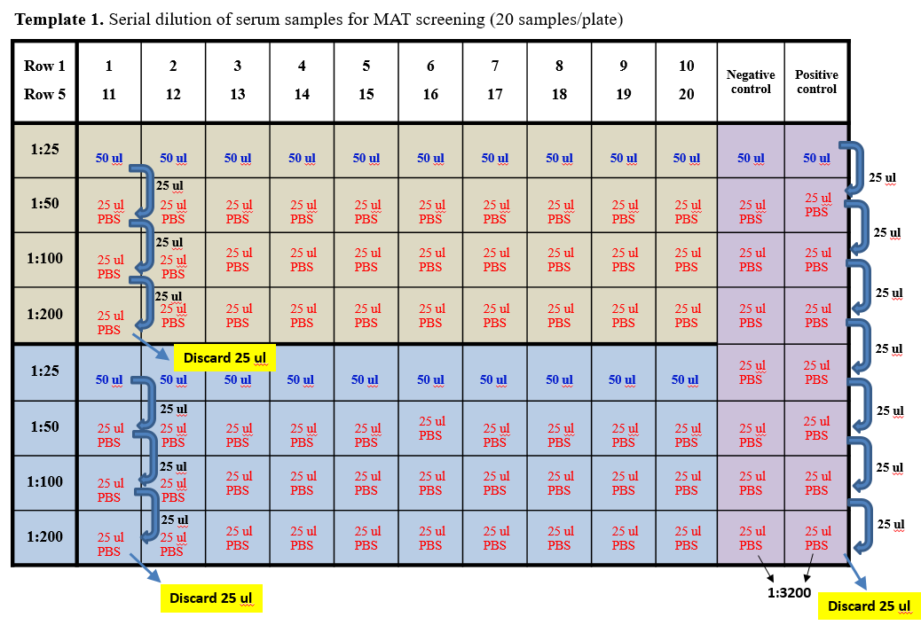
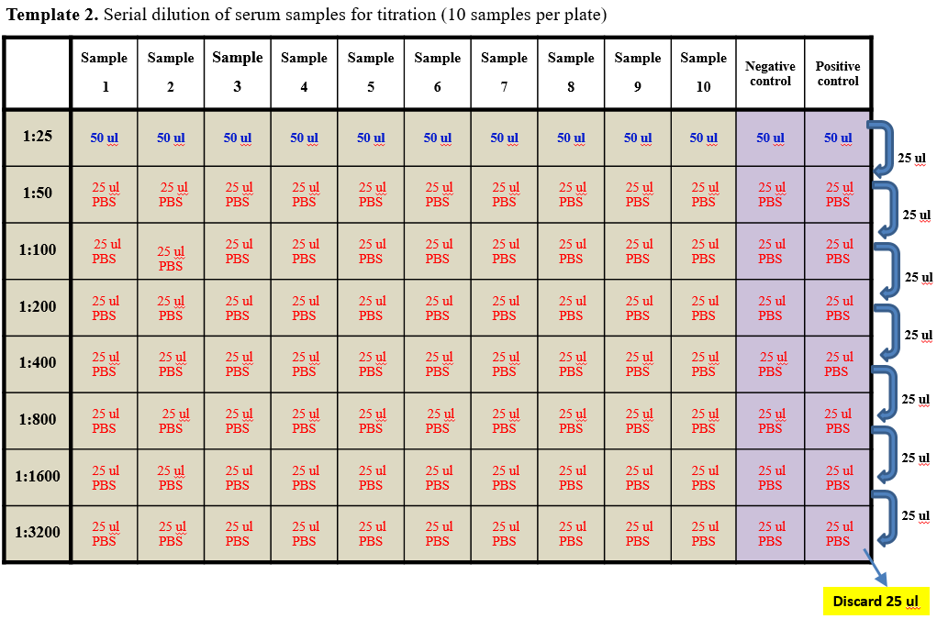
Example of MAT test results (8 titers for each sample):
