A Lean Information Management Model for Efficient Operations of an
Educational Entity at University of Tennessee

A Thesis Presented for the
Master of Science
Degree
The University of Tennessee, Knoxville

Harshitha Muppaneni

Copyright © 2014 by Harshitha Muppaneni
All rights reserved.

DEDICATION
ACKNOWLEDGEMENTS
ABSTRACT

A software based Management Information System (MIS) is designed and implemented in the Department of Industrial and Systems Engineering at University of Tennessee to handle different types of data requests that are currently processed through multiple steps. This thesis addresses the current resource intensive data management model in educational institutions and proposes a decentralized and customized solution. The proposed software based data management system provides information to authorized sources in the requested format with minimal or no time consumption. The quantification of the new systems’ impact is done by comparing it with current data management process using Graph Theoretic Approach (GTA). A Variable Permanent Function (VPF) is utilized to determine the impact of various factors on the information flow in generating requests with current and proposed data processing techniques. The analysis indicates improvement with new departmental information system in terms of reducing process variations. There is also an increase in productivity of delivering reports on time to the requesting sources. The proposed system enables standardization of the information request handling process by increasing the ease of access to data, decreasing the number of resources, time and finally, allowing departments to customize data management.

PREFACE

Table of Contents
CHAPTER I INTRODUCTION 1
1.1 Information management in educational institutions 1
1.2 Assessment of University of Tennessee’s data management system 4
1.2.1 Information management’s importance 4
1.2.2 Value stream map for data flow 6
1.2.3 Variables affecting flow of data requests 9
1.2.4 Root cause analysis 9
1.2.5 Pareto analysis 12
1.3 Assessment summary of UTK’s current data management system 12
1.4 Objective and hypothesis of the study 13
1.5 Implementing efficient information management systems 14
1.6 Benefits of MIS 15
1.7 Guidelines for implementing a management information system 15
CHAPTER II Literature Review 19
2.1 Studies of Management Information Systems 19
2.1.1 Affected areas in organizations using MIS 19
2.2 List of Assessment Tools for MIS 21
2.2.1 Statistical tools 21
2.2.2 Graph theoretical analysis model for MIS 22
CHAPTER III Materials and Methods 27
3.1 Evaluation through the graph theoretical model 27
3.1.1 Application of graph theoretical module to current problem 27
3.2 Development of MIS for Department of ISE 37
3.2.1 Data collection process and choice of questionnaire 38
3.2.2 System architecture 38
3.2.3 Conceptual design 43
3.2.4 Relational model 44
Student MIS (Graduate and Undergraduate) 48
Graduate Admissions 49
MIS data restriction 51
System design 51
System authentication 51
User classes 53
Reporting Software 54
CHAPTER IV ANALYSIS AND Results 57
4.1 Analyzing flow of information request processing after implementing MIS 59
4.2 Evaluation of current and future state of information processing in ISE 63
4.3 Assessing variable permanent factor for current process in the department of ISE 63
4.4 Assessing variable permanent factor department of ISE after implementation of MIS 67
4.5 Value assessment of present and proposed MIS 71
4.6 Analysis of cost in implementing MIS in every department at an educational institution 73
CHAPTER V CONCLUSIONS AND FUTURE WORK 74
5.1 Summary of advantages with software based MIS implementation 74
5.2 Future work 75
APPENDIX A 76
APPENDIX B 78
LIST OF REFERENCES 81
Vita 83

LIST OF FIGURES

Figure 1.1: Data management within different sections at the University of Tennessee 2

Figure 1.2: Flow of process in generating reports for requesting sources by the Department of ISE 3

Figure 1.3: Flow of the Department of ISE’s current process in generating reports based on type of data and type of source 5

Figure 1.4: Value stream map with processes contributing to data reporting at the University of Tennessee 7

Figure 1.5 Variations in requests processed in terms of time taken for a request 8

Figure 1.6: Dependency of variables with type of reports requested based on process time 10

Figure 1.7: Cause-and-effect analysis: Evaluation of current practice of information flow in UTK’s ISE Department 11

Figure 1.8 Pareto analysis determining the area having high impact on late delivery of reports 12

Figure 1.9 Roadmap of presented work in thesis ordered by chapters 14

Figure 3.1: Flow chart illustrating MIS evaluation using the graph theoretical model (Source: Gurumurthy et al., 2013) 28

Figure 3.2: Digraphs capturing inheritances and interdependencies among requesting sources and variables 31

Figure 3.4: Information System Development Cycle (O'Brien James) 39

Figure 3.5: MIS development architecture 43

Figure 3.6: Relationships between different entities of MIS 45

Figure 3.7: Relational model depicting primary and secondary keys used to generate data in the database 46

Figure 3.8: Flow of pages in MIS 47

Figure 3.9 User classes representing primary and secondary keys in the MIS web design 55

Figure 3.10 Relationship model for MIS report 56

Figure 4.1: Screenshot of login screen of MIS 58

Figure 4.2: Screenshot of dashboard of report generating interface 58

Figure 4.3: Flow of process in generating reports for requesting sources by the department of ISE through MIS 60

Figure 4.4: Flow of the Department of ISE’s process in generating reports for requesting sources based on type of data through MIS reporting system 61

Figure 4.5: Future value stream map with processes contributing to data reporting with MIS reporting system at University of Tennessee 62

LIST OF TaBLES

Table 1.1 Categorization of data management issues into types of waste (Source: (Hicks, 2007) 18

Table 2.1 Literature focusing on MIS in various applications 24

Table 2.1 Literature focusing on MIS in various applications (continued) 25

Table 3.1 Factors used for assessing impact of information flow in the Department of ISE 30

Table 3.2 Factors considered for scaling each main factor’s impact on the department 36

Table 3.3 Scale for determining each main factor’s impact on the department 36

Table 3.4 Queries provided by Staff and Faculty for MIS (continued) 41

Table 3.5 Classification of Queries 42

Table 4.1 Comparison of current and future variable permanent functions 72

Table 4.2 Estimation of cost of implementing MIS in department of ISE 73

CHAPTER I
INTRODUCTION

1.1 Information management in educational institutions
Higher education institutions generate large amounts of data but are not competent in converting it to easily accessible information. These institutions need to be able to access quality information in a timely manner to reduce uncertainty and improve their decision making regarding academic, research, personnel and other concerns (Premkumar, Ramamurthy, & Saunders, 2003). Individuals send and receive data in organizations; yet organizational information processing is more than simply processing data through individuals. Specific data types at an educational level involve several different functions before being presented in a required format (Daft & Lengel, 1986). In educational institutions, managers with administrative function handle student data. For example, the Office of the Registrar has the primary responsibility of managing and distributing student demographic data; the Office of Research maintains data related to student research; and the Graduate/Undergraduate Schools manage student-enrollment and curricular data (Ruzicka & Weckmueller, 1997). Information in educational institutions is traditionally requested through a central entity that manages student demographics and curricular data (Figure 1.1). Financial, budgetary, and faculty information is managed and controlled by entities such as Instruction Research and Institution Services (IRIS), the Bursar’s Office and Degree Audit Reporting System (DARS). Access to this data is restricted by data type or authority; therefore, individuals without access but requiring the data have to submit requests to the corresponding office.
The data management system in its current form requires multiple steps to gather and share data since a universal system does not exist. Hence, the level of effort required of data management is very high, placing a heavy burden on responsible individuals. Figure 1.2 shows the complexity of acquiring data from the different sources presented in Figure 1.1. One solution to address this problem at a departmental level is to create a departmental Management Information System (MIS). This solution is possible because individual departments in an educational setting are most closely associated with their students. To demonstrate this possibility, a pilot MIS was created in the Department of Industrial and Systems Engineering (ISE) to enable data to be configured and used efficiently.
Office of Registrar
Office of Research

Graduate school
DARS
Reporting services
BURSAR’S
IRIS
Student
course registration
Student
admissions information
Student
demographics
Student
financial information
Department
financial information

Figure 1.1: Data management within different sections at the University of Tennessee

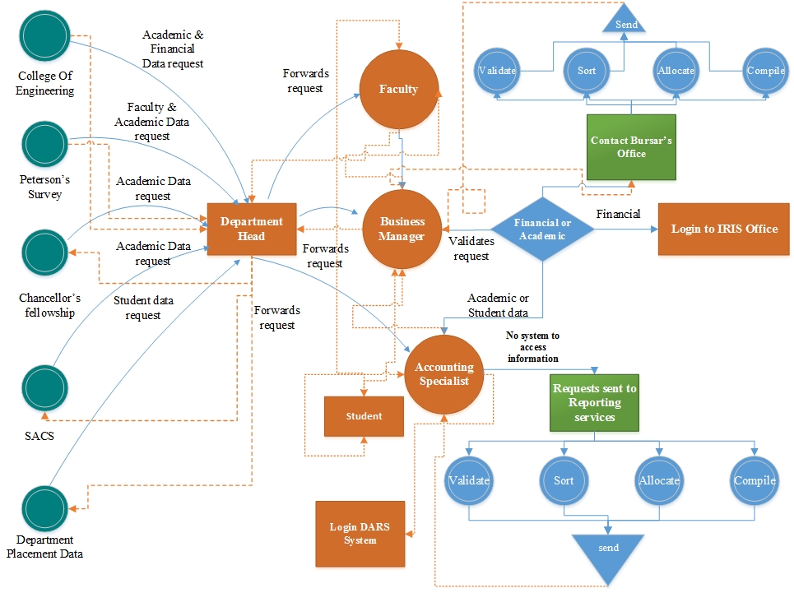
Figure 1.2: Flow of process in generating reports for requesting sources by the Department of ISE

1.2 Assessment of University of Tennessee’s data management system
Prior to implementing the MIS in ISE, the data management processes at UTK were evaluated using established methods to better understand the areas needing improvement. These methods are discussed and presented in later sections as background leading to the problem statement and objective of this thesis. Feedback from the staff and involved divisions of the University are considered (Appendix A).

1.2.1 Information management’s importance
Convenient and prompt access to data from various sources for maintaining departmental ranking and good standards were considered when evaluating MIS deliverables for departments such as ISE. Each department at the University of Tennessee requests data related to students, faculty, and finances. The ISE Department processes these requests through departmental staff members, such as accounting managers and business managers. Figure 1.3 presents the flow of information and requests in the ISE Department. As illustrated in Figure 1.3, the complexity of getting data is evident as each request must go through a number of steps before the data is mined and presented. Information is processed via email between staff and faculty and between staff and different sections of the University (IRIS Office, Bursar’s Office, and DARS System) while departmental staff request student demographic information for faculty through a web-based form directed to Reporting Services.

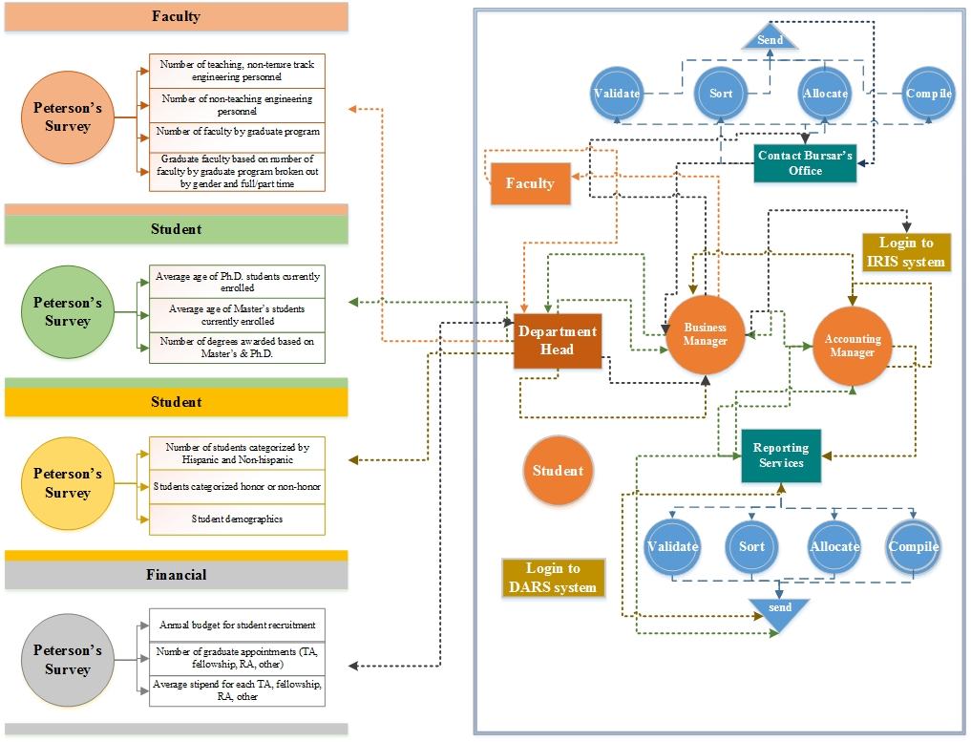
Figure 1.3: Flow of the Department of ISE’s current process in generating reports based on type of data and type of source

1.2.2 Value stream map for data flow
Reporting Services accepts requests in batches from within the University and sorts them according to the deadline and personnel hierarchy. According to Reporting Services (Appendix B) 74% of the deadlines are met, though this percentage varies based on the number of requests on any given day. After a processed report is sent back to staff an accounting specialist checks the data and then returns the report to the business manager, who checks the format and forwards the report to the department head. Figure 1.4 shows the data flow evaluation using a value stream map to determine the impact of each step in handling data by reporting services, while Figure 1.5 shows the time consumed in each step.
The value stream map indicates the total wait time for a request to be processed and helps determine variation in different types of reports requested. According to reporting services staff (via e-mail), the major variables affecting on-time delivery of data are the following:
- Type of information
- Span of data requested
- Various sources mined to process a request
- Multiple data managers working on a single request.

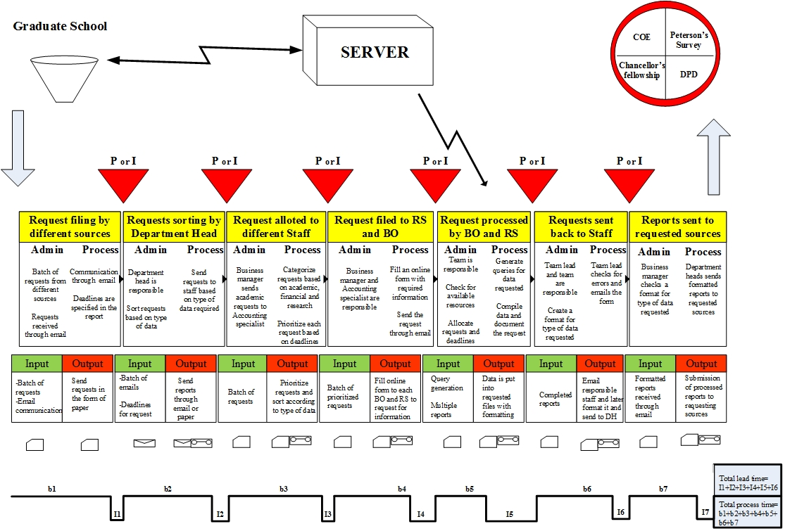
Figure 1.4: Value stream map with processes contributing to data reporting at the University of Tennessee

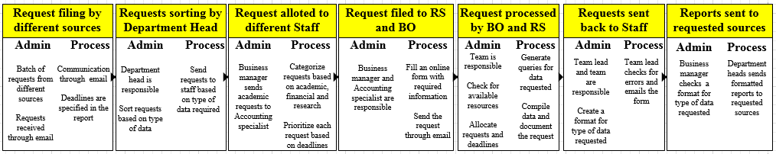
Figure 1.5 Variations in requests processed in terms of time taken for a request

1.2.3 Variables affecting flow of data requests
Pertinent problems and related factors are represented in Figure 1.6 with the data type and process variations with respect to influence of presented variables (V1, V2, V3, and V4). Reports R1-R18 originated from the ISE Department and were obtained from departmental staff (Appendix II). To determine the cause for longer processing time, specific requests were studied to establish connections between variables and types of requests. The requests highlighted in red in Figure 1.6 took more than 3 days to process while others took less time (red > orange > yellow > green). Based on the analysis, requests containing student information consumed more processing time and out of all the variables had the most impact.

1.2.4 Root cause analysis
Root cause analysis was performed on the student data delivery system to identify the steps causing maximum processing delays (Rooney & Heuvel, 2004). The analysis shows dependencies in sections involved in data delivery: departments, Reporting Services, sources of requests, Bursar’s Office, and human factors. Figure 1.7 demonstrates different factors and sub factors for each category related to student-data delivery. Under each category, a problem is identified by considering all the sub factors involved. All the problems at the end of each tail of main categories lead to the department’s inefficiency of information request processing. Root-cause analysis suggests that the number of variations and the lack of easy access result in late delivery of information requested.

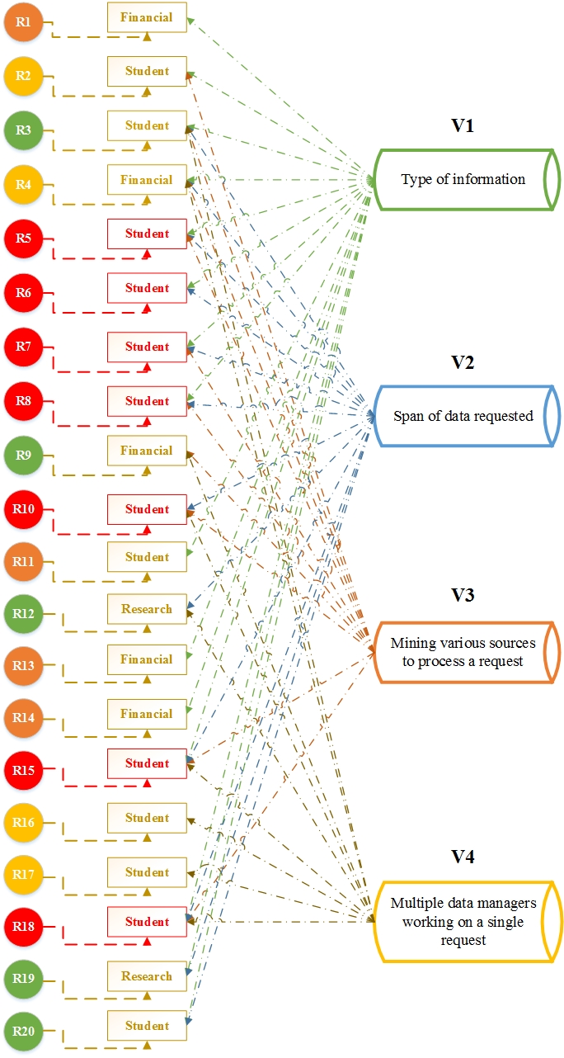
Figure 1.6: Dependency of variables with type of reports requested based on process time

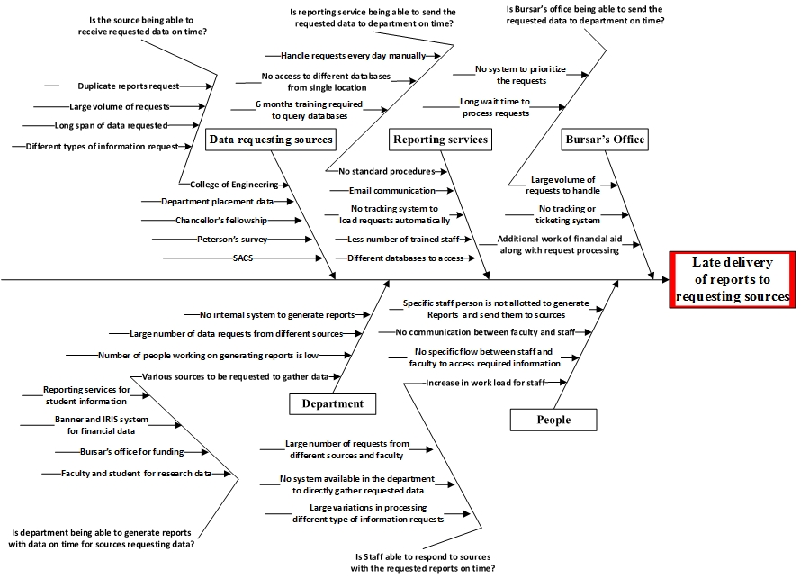
Figure 1.7: Cause-and-effect analysis: Evaluation of current practice of information flow in UTK’s ISE Department

1.2.5 Pareto analysis
Figure 1.8 shows the Pareto analysis on different sections and their impact categorized by an assessment factor. This analysis helps in prioritizing individual sections in the process needing improvement. The ISE staff handling the data assessed each section’s impact on data processing (using a scale of 1-10 with 1 being the least impact and 10 being the most impact). Figure 1.8 shows that data process efficiency is most affected at the department level due to various dependencies (described in the root-cause analysis).

Figure 1.8 Pareto analysis determining the area having high impact on late delivery of reports

1.3 Assessment summary of UTK’s current data management system
An analysis of UTK’s data management system provided the following details:
- Requests for data originating from ISE depend on different sections managing data.
- Based on - root cause analysis and Pareto analysis, the highest burden on the department to access student data is due to lack of proper information flow.
- The lack of proper information flow impact is mainly reflected on long processing time for data access

1.4 Objective and hypothesis of the study
The objective of this work is to elaborate on the performance of educational institutions in Information Management through a conceptual framework and strong guidelines for accepting, executing, and assessing the research. The activities of information management in educational institutions can be considered to be: data input, representation, reuse, sharing and disposal of information.
The hypothesis of this thesis is that implementation of database information systems will significantly increase the efficiency of data processing while reducing the time required to access the information shared among different segments of an education institution. This hypothesis is evaluated through various process assessment techniques utilized in current literature. The following chapters will provide details of this particular attempt at solving data management needs of educational institution, such as the University of Tennessee, as shown in Figure 1.9, beginning with a review of literature to understand the current information systems and methods to analyze and implement them.
1
2
3
3
5
4
4
Figure 1.9 Roadmap of presented work in thesis ordered by chapters

1.5 Implementing efficient information management systems

The complexity of multiple data types and of different data handling techniques is a major hurdle to overcome for educational institutions using traditional data management techniques. Yet, implementing a new system to improve efficiency can also be difficult due to the necessity of training personnel and replacing an established process across platforms.
MIS is a software-based solution integrating business functions and data into a single system sharable throughout an organization. The major goal of MIS is to increase operating efficiency by improving the business process and decreasing costs. It allows different departments with diverse needs to communicate with each other by sharing the same information within a single system. MIS also standardizes processes and data within an organization with best practices of data collection and sharing for better decision making. Among the challenges of implementing information system in an educational institution is adequately managing information collected on a term-to-term basis. This type of data ranges from general to specific student information. Institutions of higher education develop sophisticated management information systems to support their academic mission and to help manage their institutional data. Faculty, students, deans, academic and administrative department heads, administrators, and even the public interact with these management information systems (Ruzicka & Weckmueller, 1997).

1.6 Benefits of MIS

The benefits of MIS are the following:

- Ease of information access, including web-based access
- Years of data easily archived
- Improvement of organizational efficiency, data quality, and analysis
- Automated log-in, tracking, and data management
- Automated customer reports.

1.7 Guidelines for implementing a management information system

Implementing an information system involves dedicated valuable resources, such as time and people. In attempting to eliminate variations and improve the ISE Department’s information flow, the following implementation guidelines were established for an information system with the objective of achieving a standardized departmental MIS:
- Identify requirements that would become “decisive flaws”
- Validate requirements based on the size of the department or organization
- Categorize requirements based on identified wastes in the current information system as shown in Table 1.1. Design a system that can be continuously improved with ease and integrated with different functionalities in the departments, the type of organization and their requirement to generate reports. Implement the system that eliminates waiting time
- Report progress through ongoing communication with personnel involved in information processing
- Customize interfaces based on feedback from different entities requiring access to the system
- Follow a contingency plan for further improvements
- Ensure that the programming language and operating system MIS is built on are capable of defensive programming. The programming language should contain salient handling and robust features to ensure security and reliability
- Use HTML web pages and Structured Query Language, Java and C# programming languages for ease of implementation and low cost
- Select business intelligence software, proven to handle and generate big data, based on cost and organization size
- Directly link programs to the database and customize with the data required for different departmental personnel with authorized access

Issue | Indication of waste | Type of waste
Retrieval of student information when requested | Failure to transfer information between personnel must be rectified to provide information on demand. | Information flow on demand
Manual data entry | Processes and resources in and around the University are not utilized or not available. | System failure
Information flow from University system to staff and faculty | Flow of information does not follow a sequential pattern; therefore, there are many other ways of extracting the information. | System and information flow on demand failure
Storage of information | An excessive amount of information is available in both internal and external sources. | Excess information flow
Duplication of information | Extra effort is needed to eliminate duplication of requested data. | Faulty information flow
Present system over LIS system | Information is stored and accessed internally; however, this process needs to be replaced. | Value added
Use of information systems and maintenance  (Hicks, 2007) | Although people are not in favor of implementation, information systems would eliminate waste and improve information flow. | Value added
Implementation of information systems | Activities are anticipated as waste from implementing information systems, but actually can reduce waste and save time. | Value added
Table 1.1 Categorization of data management issues according to types of waste (Source: (Hicks, 2007)

CHAPTER II
Literature Review
Management information systems (MIS) and their organizational applicability are reviewed in this chapter. Their global effect, specifically on education institutions, is addressed. The literature pertaining to analyzing ongoing improvement with guidelines for implementing information systems is presented, followed by a summary of information systems’ impact on productivity in industry and educational institutions.

2.1 Studies of Management Information Systems
A management information system (MIS) is a computer-based database developed to meet the managers’ information requirements in an institution or in an institution’s organizational subunit. MIS is defined as “an organizational method of providing past, present and projected information related to internal operation with external intelligence. MIS is known to support planning, control and operational functions of an organization by furnishing consistent information in proper time frame to assist the decision makers.” The desired information is presented in periodic reports or special request reports or as mathematical simulations’ outputs (Asemi, Safari, & Zavareh, 2011).

2.1.1 Affected areas in organizations using MIS
The success of management information systems in both small and large organizations over the past two decades is well documented. The organizational objective of using an MIS is to keep on going supply of information flowing to management. By using intuitive data bases to reduce the amount of inventory, manufacturing organizations save 25-30% of their inventory holding costs. For example, CPTR of Durban, South Africa, assists decision makers such as transport planners and managers in extracting synthesized information from a massive public transport database (PTMIS) developed by Stewart Scott (Asemi et al., 2011). Melville et al proposed developing a research strategy with information systems innovation for sustainable practices, demonstrating the role of MIS in shaping environmental forecasts and economic performance. The development of the Belief-Action-Outcome (BAO) framework and associated research agenda provided the basis for a new discourse regarding environmental sustainability (Melville, 2010).
MIS has been an integral part in automating most business activities aiming to provide methods of planning, reporting, and operation control. Information systems have also reduced health care costs and improved outcomes (Ragowsky, Ahituv, & Neumann, 1996). In health care, MIS has augmented information technology’s functionality to better co-ordinate the clinical and diagnostic equipment data for both providers and receivers (Fichman, Kohli, & Krishnan, 2011). However, an MIS is high priced with costly assets, requiring detailed planning of its design, implementation, and operational processes (Kornkaew, 2012). Furthermore, cost-effective information technologies (IT) are essential in supply chain management (Lee & Whang, 2000).
In summary, according to the literature, the main advantages of MIS are to facilitate decision making; to facilitate organizational learning; and to stimulate innovation, all of which are directly linked to the ongoing adaptability of an organization to its competitive environment (Lannon, 2013). Table 2.1 identifies literature focusing on MIS applications in different organizations, with a summary of their relationship to the current study.

2.2 List of Assessment Tools for MIS
The application of MIS in organizations is evaluated using various statistical and analytical tools to prove credibility. The following sections discuss these assessment tools and their findings in literature.

2.2.1 Statistical tools
Lubbe et al emphasized the impact of information systems at a tertiary institution by conducting a survey among users to determine responses to the design and implementation of these systems, thereby increasing these systems’ chance of success. The chi-square test was applied to determine the information system’s level of use in the institution. The ANOVA technique was used to determine the frequency of information system access and how different information systems were used. This analysis revealed that 76% of the respondents indicated information content met their needs, 75% indicated the systems were easy to use, and 77% indicated the systems were user friendly (Lubbe & Bopape, 2008).
Naranjo-Gil et al collected data from 92 top management teams to determine top management’s role in the relationship between management information systems and strategic performance. Using theoretical development and hypothesis formulation, their analysis included how the relationship affects strategic performances, which in turn focus on cost reduction and flexibility. Results of the formulation showed the management information system’s effect on strategic performance and concluded that diversity is an important variable influencing the relationship between MIS and strategic performance (Naranjo-Gil & Hartmann, 2007).
Premkumar et al used Galbraith’s information processing theory to examine both the fit between information processing needs and the systems capability in an inter-organizational supply chain context and effect on performance. As part of the information processing theory, the authors discuss a strategy of redesigning organizations’ business processes and of implementing integrated information systems that can improve information flow and reduce uncertainty within organizational subunits. These researchers collected data on 142 products through personal interviews and surveys; used cluster analysis techniques to develop taxonomies; and used analysis of variance (ANOVA) to test the fit between needs and capability, modeled as an interaction effect. The ANOVA results reveal that the interaction of information needs and capability has a significant effect on performance (Premkumar et al., 2003).

2.2.2 Graph theoretical analysis model for MIS
Analyzing an information system’s impact on an organization determines the system’s effectiveness in improving managerial decision making and overall process efficiency. Based on the literature, graph theoretical model analysis is normally used to evaluate organizational management as part of an organization’s Total Quality Management (TQM). For this study, a graph theoretical model was used to evaluate the ISE Department’s current data management process and to implement an information system. Literature pertaining to the general practices and the work done using the graph theoretical model is presented.
Activities such as data collection and analysis, problem solving, information presentation to groups, and group decision making are key elements in TQM-related work (Taveira, James, Karsh, & Sainfort, 2003). Taveira et al examined hypotheses regarding TQM’s influence on work environment and concluded that most TQM elements were significantly related to work environment scales, such as innovation, task clarity, and task orientation (Grover, Agrawal, & Khan, 2006). Grover et al discussed the interdependencies and impact of human factors on TQM using a mathematical model by applying the graph theoretic approach, which is a systematic and logical approach applied in various disciplines to create and analyze systems. This model examined human factors to improve the current procedure by understanding and identifying environmental factors, which interact with each other in varying degrees. Their approach proved that systematically implementing the methodology helps industry identify, analyze and evaluate factors responsible for the TQM environment (Grover*, Agrawal, & Khan, 2004). Bayazit et al developed a framework based on ANP to identify the degree of impact of factors affecting TQM implementation and investigated the Turkish manufacturing industry’s readiness to adopt TQM practices based on a survey among 250 large manufacturing companies in Turkey (Bayazit & Karpak, 2007).
Authors (Year) | Organization/Field | Size of Organiza-tion | MIS Utility | Soft-ware |  | Assessment tools/ techniques | Area of impact | Association with current study
(Asemi et al., 2011) | Transportation | N/A | Transporta-tion planning | COBOL |  | N/A | Better decision making | Report generation
(Hong & Kim, 2002) | Information Technology | N/A | Determining organizational fit | SAP/  ORACLE |  | Cronbach's alpha & Correlation matrix | Moderator of relationships for organization fit in terms of business needs | Graph theoretic approach to assess impact on department
(Motwani, Subramanian, & Gopalakrishna, 2005) | Manufacturing | 6600 | Production scheduling | N/A |  | Process mapping and diagnostic techniques | Reduced production lead times and provided real time order information to customers | Use of digraphs to map the process
(Motwani et al., 2005) | Energy | N/A | Sales and marketing | N/A |  | Process metrics | Reduced cost and improved data visibility | Increased data visibility for MIS with reporting web interface
(Motwani et al., 2005) | Automobile | N/A | Supply chain | N/A |  | Process metrics | Introduced centralized supply chain to support business needs | Centralization of data access
(Motwani et al., 2005) | Pharmaceutical | N/A | Production planning and materials management | N/A |  | Research framework | Integrated accounting, inventory and materials management | Integration of student demographics, courses, publications and research data
(Kornkaew, 2012) | Fenix system (Swedish armed forces) | N/A | Monitor aircraft maintenance | N/A |  | Research framework | Closer relationship with suppliers | Web-interface data access, improving data requesting services
Table 2.1 Literature focusing on MIS in various applications
Authors (Year) | Organization/Field | Size of Organiza-tion | MIS Utility |  | Soft-ware | Assessment tools/ techniques | Area of impact | Association with current study
(Melville, 2010) | Environmental sustainability | N/A | Shaping environmental forecasts |  | N/A | Coleman’s Micro Macro model | Improved environmental sustainability | Graph theoretic approach to determine improvement in process flow
(Gurbaxani & Whang, 1991) | Manufacturing | N/A | Transaction processing |  | N/A | ANOVA | Reduced costs related to acquisition | N/A
(Premkumar et al., 2003) | Supply chain | N/A | Information processing |  | N/A | Agency theory, cost economics | Reduced process lead times | Process-time evaluation
(Sacks, Koskela, Dave, & Owen, 2010) | Construction | N/A | Information management |  | N/A | ANOVA | Increased productivity of working crew | N/A
(Watson, Boudreau, Chen, & Sepúlveda, 2011) | Transportation | N/A | Sustainable consumption and emissions |  | N/A | Field testing | Providing fundamental information needs | MIS provides access to information requested
(Hicks, 2007) | Information management | N/A | Software applications |  | SAP/ ORACLE | N/A | Efficiency, quality and management- process improvement | Value stream mapping to map current practice and to determine flow and variability
(Gunasekaran & Ngai, 2004) | Supply chain | N/A | Information system’s integration in supply chain management |  | SAP | Value stream and flow | Enabling strategic planning and supply-chain management implementation | Ability to submit reports on time
Table 2.1 Literature focusing on MIS in various applications (continued)
Gurumurthy et al discuss “organization readiness” before implementing/adapting lean thinking. Presenting a hypothetical case study of an Indian organization to assess organizational readiness, they used a graph theoretic approach, which can integrate and model inter-related factors (Gurumurthy, Mazumdar, & Muthusubramanian, 2013).
The interdependencies and impact of information systems on TQM are discussed in this thesis using a mathematical model by applying the graph theoretic approach. The main purpose is to consider not only the number of factors causing problems in the system but also the factors’ interdependencies. The primary benefit of improved customer focus in TQM can be beneficial as the information systems have interactive complexity leading to TQM environment in an organization (Grover et al., 2006).
In summary, assessment tools were used in the current study to implement MIS in UTK’s Department of Industrial and Systems Engineering. The following chapter on methodology discusses in detail the analytical tools and techniques used.

CHAPTER III
Materials and Methods
A computer-based MIS is proposed for the Department of Industrial and Systems Engineering at the University of Tennessee, Knoxville, to streamline student-data access at the departmental level. The proposed MIS’s architecture and conceptual design are described; along with description of analytical techniques for evaluating the present system and the variables affecting data process is presented in this chapter.

3.1 Evaluation through the graph theoretical model
The MIS’s impact is determined by variable permanent factor calculation and is evaluated by using the graph theoretical analysis model described in the literature (Grover et al., 2006; Gurumurthy et al., 2013). The procedure for conducting the impact factor analysis is shown in Figure 3.1.

3.1.1 Application of graph theoretical module to current problem
Factors related to human interactions impact the organization data processing capabilities. Better control of these factors help enhance an organization’s reputation in a competitive scenario. Fulfillment of data requirements on time is also essential in creating a long term and sustainable relation in organizations relying heavily on customer or institutional information. Similarly, for educational entities (UTK), generating reports for sources such as COE, Peterson’s Survey, Chancellor’s Fellowship, and SACS; requesting information maintains a good relationship between those sources and the department (ISE).
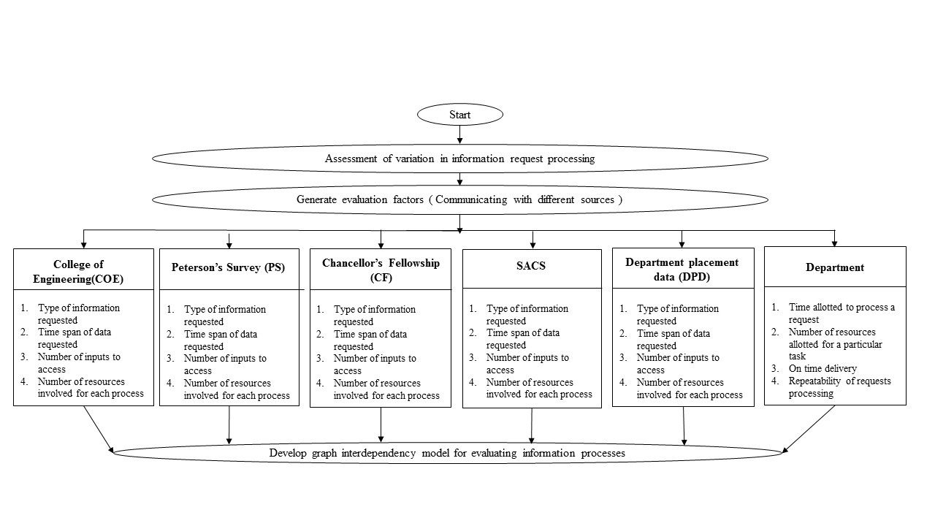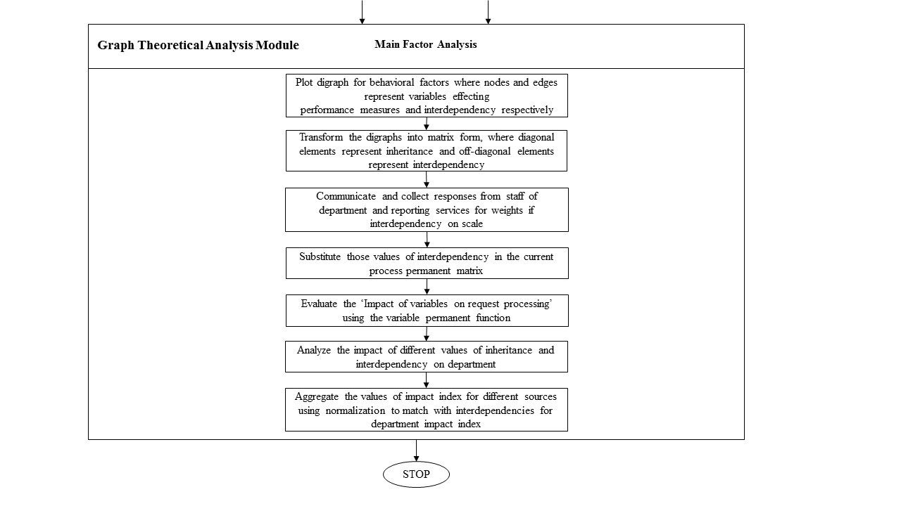
Figure 3.1: Flow chart illustrating MIS evaluation using the graph theoretical model (Gurumurthy et al., 2013)

The graph theory approach is divided into different phases, including digraph representation, matrix representation, and determination of permanent function. Digraph representation is used for modeling and visual analysis. Matrix representation is used for computer processing to obtain a quantified numerical value. Table 3.1 lists the factors and variables considered for assessing information flow’s impact. With the help of the first two phases, a permanent value function is determined to represent the impact of information systems on an educational entity like ISE with a single number/index, which is useful for comparison, ranking, and optimum selection (Grover et al., 2006; Gurumurthy et al., 2013). A detailed description of these phases is presented below:
Phase I: Development of digraphs

Step 1: To determine the problem for which graph theoretical model can be applied. In this study, the problem is to assess MIS implementation’s impact on the Department of ISE.
Step 2: To identify various factors affecting the problem through root cause analysis and to label them as B_{i}s.
Step 3: To determine relationships among main factors based on their interdependencies using a digraph. The digraph in Figure 3.2 represents the relationships between the factors ($B^{i })$and their interdependencies $(b_{ij})$ in the forms of nodes and edges with $b_{ij}$ indicating the degree of dependency of the $j^{th}$ attribute on the $i^{th}$ attribute (Gurumurthy et al., 2013).

Main factors for data request | Interdependencies | Abbreviation | Notation
College of Engineering |  | COE | B₁
Peterson’s Survey |  | PS | B₂
Chancellor’s Fellowship |  | CF | B₃
SACS |  | SACS | B₄
Department placement data |  | DPD | B₅
 | Type of information | TOI | B₁ª
 | Time restriction on data requested | TROD | B₂ª
 | Number of inputs to access | NOI | B₃ª
 | Lack of co-ordination and multiple processors working on a request | LOC | B₄ª
Department of ISE |  | ISE | B₆
 | Time allotted to process a request | TA | B₁^{d}
 | Number of people working without scheduled responsibility | NOR | B₂^{d}
 | On-time delivery of reports | OTD | B₃^{d}
 | Repeatability of requests processed | NOE | B₄^{d}
Table 3.1 Factors used for assessing impact of information flow in the Department of ISE

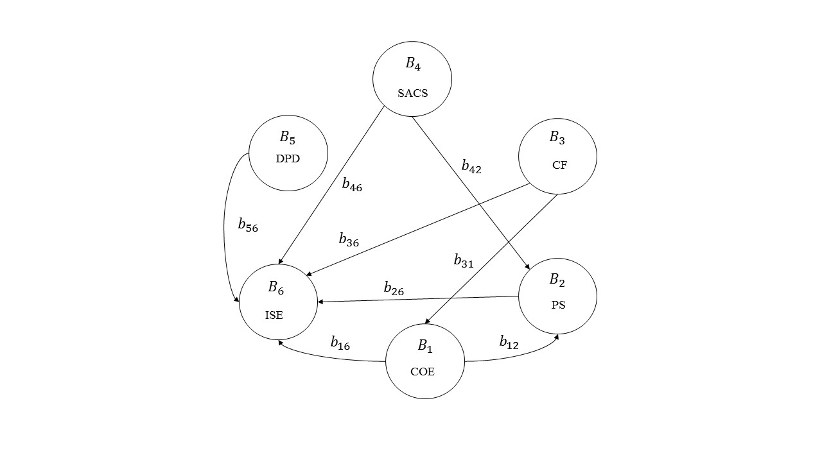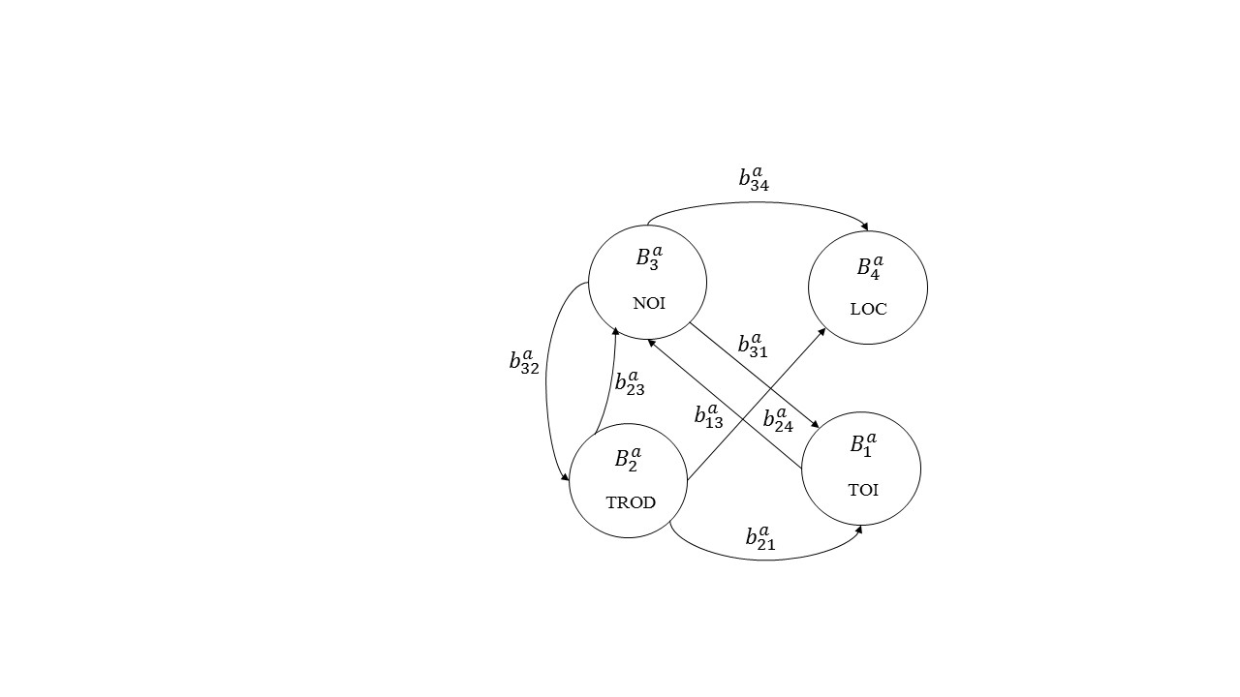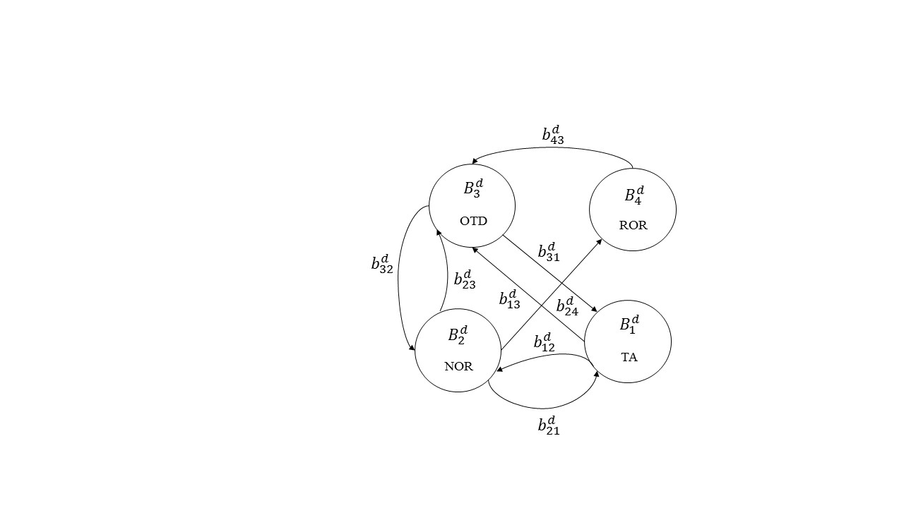
Figure 3.2: Digraphs capturing inheritances and interdependencies among requesting sources and variables
Figure 3.2 shows the effect of ISE’s main factor B₆ on the other factors, building a directed edge with B₁, B₂, B₃, B₄, and B5. The interaction is described below. The ISE Department is involved in gathering data for all sources requiring data corresponding to its operations. However, COE can be dependent on PS for information it collects from different departments every year, creating a directed edge from node 1 to node 2.
Phase 2: Matrix representation - derivation of variable permanent matrix (VPM)

Step 4: The digraph is helpful as a visual analysis tool. However, for computation, the digraph is converted to a matrix (Grover et al., 2006) using the representation in Figure 3.2. To analyze each requesting source’s impact on the late delivery of reports, the digraphs for COE, CF, PS, SACS and DPD are created as shown in the figure. The four variables defining characteristics of the reports generated by different sources are:
- Type of information requested
- Span of data requested
- Mining inputs to access data in order to process a report
- Multiple resources working on processing a single request
The department’s contribution in processing a request is a function of four elements (Table 3.1):
- Time allotted to process a request
- Number of people working without scheduled responsibility
- On-time delivery of reports
- Repeatability of requests processed
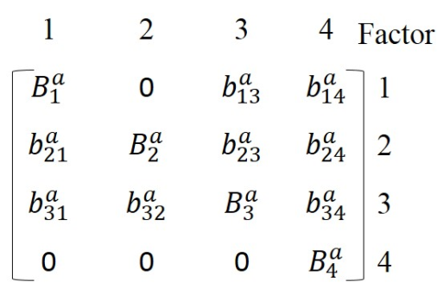
$B_{RS}$=
3.11

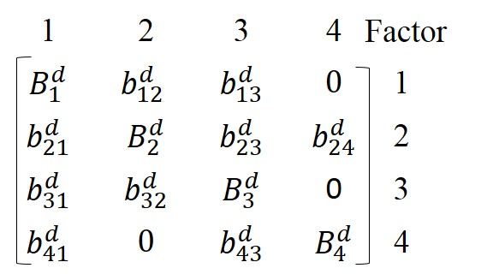
$B_{D}$=
3.2
$$\prod_{i=1}^{4}{C_{i}} + \sum_{i}{\sum_{j}{\sum_{k}{\sum_{l}{\left(C_{ij}C_{ji}\right)C_{k}C_{l} }}}}$$
$$+ \sum_{i}{\sum_{j}{\sum_{k}{\sum_{l}{{(C}_{ij}C_{jk}C_{ki}+C_{ik}C_{kj}C_{ji})C_{l}}}}}$$
Per (B) =

3.3
$$+ \sum_{i}{\sum_{j}{\sum_{k}{\sum_{l}{ {(C}_{ij}C_{ji}){(C}_{kl}C_{lk})}}}} +$$
$$\sum_{i}{\sum_{j}{\sum_{k}{\sum_{l}{(C_{ij}C_{jk}C_{kl}C_{li}+C_{il}C_{lk}C_{kj}C_{ji})}}}}$$

The VPM represented as matrix A for assessing the above elements’ impact on the department based on the digraph (Figure 1) is given below
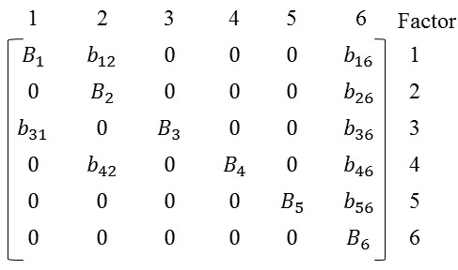
3.4
A=
The nodes in the digraph $B_{1 }$to $B_{6}$ represent the main factors’ impact on the department’s efficiency in processing reports on time, whereas the off-diagonal elements represent the main factors’ interdependencies on other factors.
Step 5: The permanent function defined below (i.e., equation (3.5)) is the complete expression for the main factor effect, considering the presence of all attributes and their interdependencies (Grover et al., 2006).
Phase 3: Quantification of B_{i} and B_{ij} of the matrix for the given problem
Step 6: Quantification of B_{i} and B_{ij} as variables affecting the system. Matrix (3.1) can be considered a system that most of the variables are affecting. Each variable is represented as $B_{i }^{a}$ where a = {COE, PS, CF, SACS, DPD} and i represents the requesting sources affecting the department, which is the main factor considered.
Step 7: Quantifying B_{ij} for variables that affect the late delivery of reports
The values of B_{ij} show the relationship among the department, requesting sources, and the variables affecting them. The scale to measure each factor is shown below. To assess the impact of the factors on the department, a weight value was assigned to each factor after feedback from department staff and Reporting Services staff. The value of a measurement related to a particular factor directly affects the main factor (ISE).

Per (B) =
$$+ \sum_{i}{\sum_{j}{\sum_{k}{\sum_{l}{\sum_{m}{\sum_{n}{\left(C_{ij}C_{jk}C_{ki}+ C_{ik}C_{kj}C_{ji}\right)C_{l}}}C_{m}C_{n} }}}}$$
$$\prod_{i=1}^{6}{C_{i}} +\sum_{i}{\sum_{j}{\sum_{k}{\sum_{l}{\sum_{m}{\sum_{n}{\left(C_{ij}C_{ji}\right)C_{k}C_{l}}}C_{m}C_{n} }}}}$$
$$+ \sum_{i}{\sum_{j}{\sum_{k}{\sum_{l}{\sum_{m}{\sum_{n}{\left(C_{ij}C_{jk}C_{ki}C_{li}+ C_{il}C_{lk}C_{kj}C_{ji}\right)}}C_{m}C_{n} }}}}$$
$$+ \sum_{i}{\sum_{j}{\sum_{k}{\sum_{l}{\sum_{m}{\sum_{n}{\left(C_{ij}C_{jk}C_{kl}C_{lm}C_{mi}+C_{im}C_{ml}C_{lk}C_{kj}C_{ji}\right)}}C_{n} }}}}+ \sum_{i}{\sum_{j}{\sum_{k}{\sum_{l}{\sum_{m}{\sum_{n}{\left(C_{ij}C_{jk}C_{ki}+ C_{lm}C_{ml}\right)}}C_{n} }}}}$$

3.5
$$+ \sum_{i}{\sum_{j}{\sum_{k}{\sum_{l}{\sum_{m}{\sum_{n}{\left(C_{ij}C_{jk}C_{ki})( C_{lm}C_{mn}C_{nl}\right)}} }}}}$$
$$+ \sum_{i}{\sum_{j}{\sum_{k}{\sum_{l}{ \sum_{m}{\sum_{n}{\left(C_{ij}C_{jk}C_{ki} C_{lm}C_{mn}C_{ni}\right)}}{+(C}_{in}C_{nm}C_{ml}C_{lk}C_{kj}C_{ji})}}}}$$
$$+ \sum_{i}{\sum_{j}{\sum_{k}{\sum_{l}{\sum_{m}{\sum_{n}{\left(C_{ij}C_{ji})( C_{lk}C_{kl}\right)(}}C_{m}C_{n}) }}}}+ \sum_{i}{\sum_{j}{\sum_{k}{\sum_{l}{\sum_{m}{\sum_{n}{\left(C_{ij}C_{ji})( C_{kl}C_{lm}C_{mn}C_{nk}\right)}} }}}}$$
$$+ \sum_{i}{\sum_{j}{\sum_{k}{\sum_{l}{\sum_{m}{\sum_{n}{\left(C_{ij}C_{jk}C_{kl}C_{lm}C_{mi}+C_{im}C_{ml}C_{lk}C_{kj}C_{ji}\right)}}C_{n}}}}}$$
$$+\sum_{i}{\sum_{j}{\sum_{k}{\sum_{l}{\sum_{m}{\sum_{n}{\left(C_{ij}C_{ji})( C_{lk}C_{kl}\right)(}}C_{m}C_{n}) }}}}$$
$$+ \sum_{i}{\sum_{j}{\sum_{k}{\sum_{l}{\sum_{m}{\sum_{n}{\left(C_{ij}C_{ji}+ C_{lk}C_{kl}\right)}}C_{m}C_{n} }}}}+ \sum_{i}{\sum_{j}{\sum_{k}{\sum_{l}{\sum_{m}{\sum_{n}{\left(C_{ij}C_{ji}+ C_{lk}C_{kl}\right)}}C_{m}C_{n} }}}}$$

Scale | Degree of importance
1 | Extremely low
2 | Very low
3 | Low
4 | Marginally low
5 | Average
6 | Marginally high
7 | High
8 | Very high
9 | Extremely high

Table 3.2: Factors considered for scaling each main factor’s impact on the department
Qualitative measurement of interdependency | Assigned value of factor
Very strong | 5
Strong | 4
Medium | 3
Weak | 2
Very weak | 1

Table 3.3: Scale for determining each main factor’s impact on the department

Phase 4: Evaluating the VPM matrix

Step 9: The matrix is evaluated using diagonal and off-diagonal values. Diagonal element values are obtained from the permanent values estimated for each factor.
Phase 5: Calculating the impact index for current and future information flow

Impact index values are calculated with a permanent function for the system-level matrix using Equations (3.4) & (3.5). These equations are programmed in the General Algebraic Modeling System (GAMS), which is used to solve generic linear and non-linear optimization problems. The matrices’ values are fed into the program, which generates the permanent value.
Based on the current system’s permanent factor, the graph theoretical approach is also used to calculate the impact on the department when MIS is implemented. Methodology and procedures followed to develop an information system for an educational entity are shown below.

3.2 Development of MIS for Department of ISE

Information system is developed and integrated to a system to avoid variations in process and to replace variation with a centralized process with less or no variation in processes. The information systems’ development cycle, shown in Figure 3.4, is a five-step process: (1) investigation; (2) analysis; (3) design; (4) implementation; and (5) maintenance. System investigation determines how to develop a project management plan and obtain management’s approval. System analysis focuses on identifying information needs and developing a system’s functional requirements. System design is the process of planning and developing specifications for hardware, software, data, people, and network. In addition, this phase involves deploying systems, testing and training. System maintenance involves making necessary changes to the system’s functionality (Kornkaew, 2012; O'Brien James, 1990).

3.2.1 Data collection process and choice of questionnaire

One of the important tasks in developing ISE’s MIS was creating a customized data base with requirements feedback from all personnel involved in data processing. To identify the process requirements and assign access for personnel, faculty and staff were consulted to provide the required information. Table 3.4 shows the queries requested. A set of queries was collected and categorized as value added and non-value added information based on the information requested over the past few months as shown in Table 3.5. The same feedback was considered to design web pages for MIS.

3.2.2 System architecture

MIS system architecture was designed to provide authorized access to department personnel. The information system’s architecture is shown in Figure 3.5. Within the architecture, communication between web servers and database server is included, with user access to the system through a web interface.
This system was built on C#, .NET (Liberty, 2009) using Visual Studio® for the web interface and MySQL® (MySQL, 2001) for building the database. Interface allows access to SQL database connectivity, enabling data to be entered, edited, and retrieved. The information entered through the web interface is transferred to the SQL database through connection string and retrieved for editing. The system’s functionality was written in C# with MySQL as the application programming interface (API).

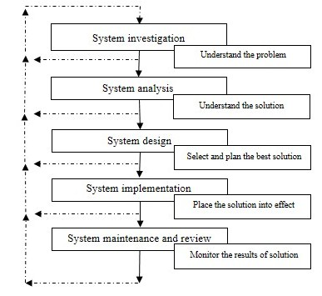
Figure 3.4: Information System Development Cycle (O'Brien James)

Undergraduate Queries |  | Graduate Queries
1. Number of students enrolled in the program, categorized by honors and non-honors |  | 1. Number of students enrolled in graduate studies, categorized by concentration, MS or PhD, part-time vs. full-time, mode of study, dual degree
2. Number of acquisitions and losses: number of students entering the system and number leaving the system, categorized by semester and reason |  | 2. MS and PhD advisees for each faculty member
3. Student % in following categories:  - minorities, by ethnicity  - gender  - citizenship  - co-op or engineering internship  - transfer student  - state vs. out-of-state |  | 3. Number of graduate students graduating, categorized by MS and PhD
4. Computed means of the following:  - age when admitted to the program  - number of course credit-hours attempted, total and per semester  - value of scholarship support and source  - value of student loans and source  - number of years of prior work experience  - ACT and SAT scores  - high school GPA  - UT GPA, overall and in IE subjects  - total number of semesters to graduate, categorized by those entering as freshmen and transfer students  - score on FE exam, categorized by morning and afternoon sessions  - number of job offers  - number of plant visits  - starting salary |  | 4. % of students in following categories:  - minorities, by ethnicity  - gender  - citizenship  - foreign student representation from the world’s major geographical regions  - full-time vs. part-time  - IE undergraduate degrees, other engineering degrees, non-engineering degrees  - state support vs. grant support vs. no support  - PhD students who first earned Master’s degrees  - PhD students who earned Master’s degree at UT vs elsewhere
Table 3.4 Queries provided by staff and faculty for MIS
5. Companies/organizations that hired IE undergraduates | 5. Computed means of the following:  - age when admitted to the program  - number of course credit-hours attempted, total and per semester  - value of financial support, computed as the average of those on support, total and categorized by source  - number of years of prior work experience  - GRE scores  - undergraduate GPA  - total number of semesters to graduate, categorized by MS and PhD  - number of student credit hours earned to complete requirements for degree, categorized by MS and PhD
6. Job titles of graduates accepting permanent employment | 6. Computed metrics  - total number of student credit hours (number of students x number of course credit hours summed across all courses offered) categorized by semester  - number of graduate students per faculty FTE, categorized by MS and PhD  - number of student credit hours per faculty FTE

Table 3.4 Queries provided by Staff and Faculty for MIS (continued)

Value added | Non-value added
1. Number of students enrolled in the program | 1. Number of acquisitions and losses
2. Minorities, by ethnicity, gender, citizenship, transfer or non-transfer, state vs. out of state | 2. Student loans, total and by source
3. Internships and summer work | 3. Students no longer seeking employment
4. ACT and SAT scores | 4. Age when admitted to the program
5. High school GPA | 5. Number of plant visits
6. Number of job offers | 6. Base budget by the number of student credit hours produced

Table 3.5: Classification of queries
Data storage-space requirements for MIS were carefully considered. Space for categories of system was allotted by dividing it into four main components: web server, database server, development server, and web interface. The web server receives input from the development server and publishes information to web interface through a firewall. For security reasons, the web server is situated outside the firewall and is accessed when a user inputs data. The database server stores information and retrieves it when the user-interface (Web MIS) or reporting software requests the information. The development server acts as a web and database server for developing the interface and helps distribute applications to different servers.
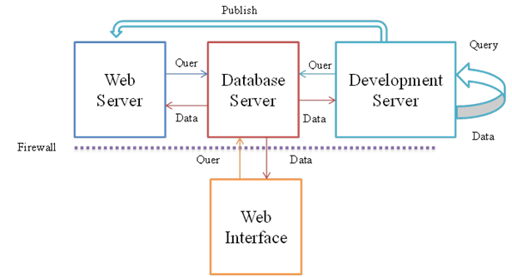

Figure 3.5: MIS development architecture

3.2.3 Conceptual design

Database for student information is created through tables categorized on the queries in Table 3.4. After system requirements were gathered using the popular MySQL database, an entity relationship (ER) model was developed to check with the process of collecting data. ER diagrams are used to design database, model data, and create capability of multiple views (Chen, 1976). Figure 3.6 illustrates the ER model to support required data. The student-data modeling components are shown in Figure 3.7. A primary key was assigned to the student component, acting as other system components’ secondary key for optimizing space allocation in the database. For designing the entity relationship model, entities were identified along with significant interactions. Student entity is related to other entities, such as courses, publications, and project participation as shown in Figure 3.6.

3.2.4 Relational model

The relational model is used to enable users understand how data is organized in the student database. The database is designed in a way that even if the external representation changes (change of data through interface), the internal representation (data in the database) will remain unaltered. Changes in data representation are needed depending on changes in the query and update in the type of information stored (Codd, 2001).
A detailed diagram of relational model for MIS database design is shown in Figure 3.6. Student entity represents their relationship with other entities. Retrieving student information can only be done using Student ID, since all the information related to Student is linked to it, as shown in Figure 3.7. Data is entered by the student through the web interface following a specific flow of pages designed based on the requirement specifications from staff and faculty as shown in Figure 3.8.

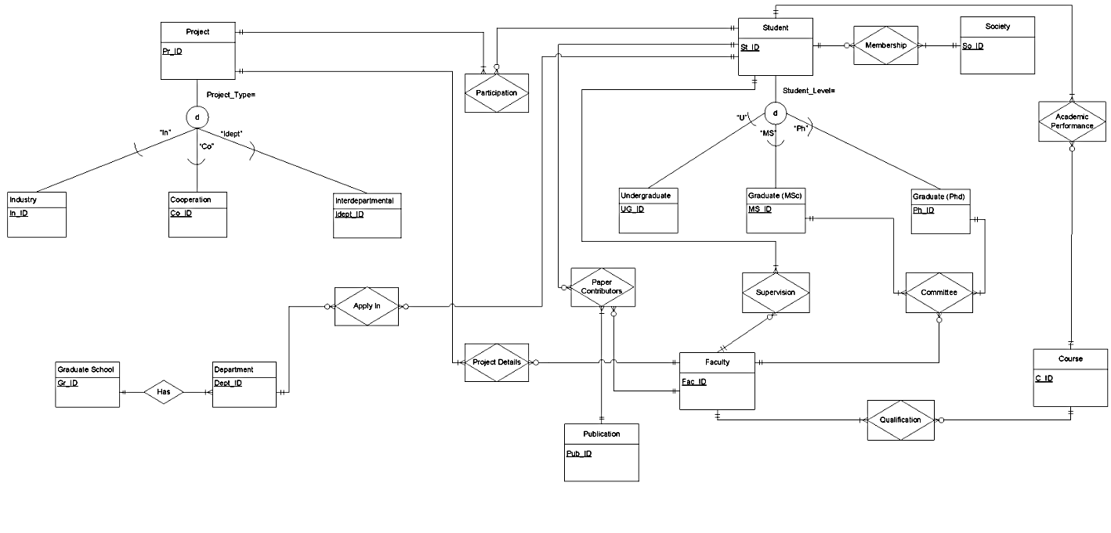
Figure 3.6: Relationships between different entities of MIS
                - 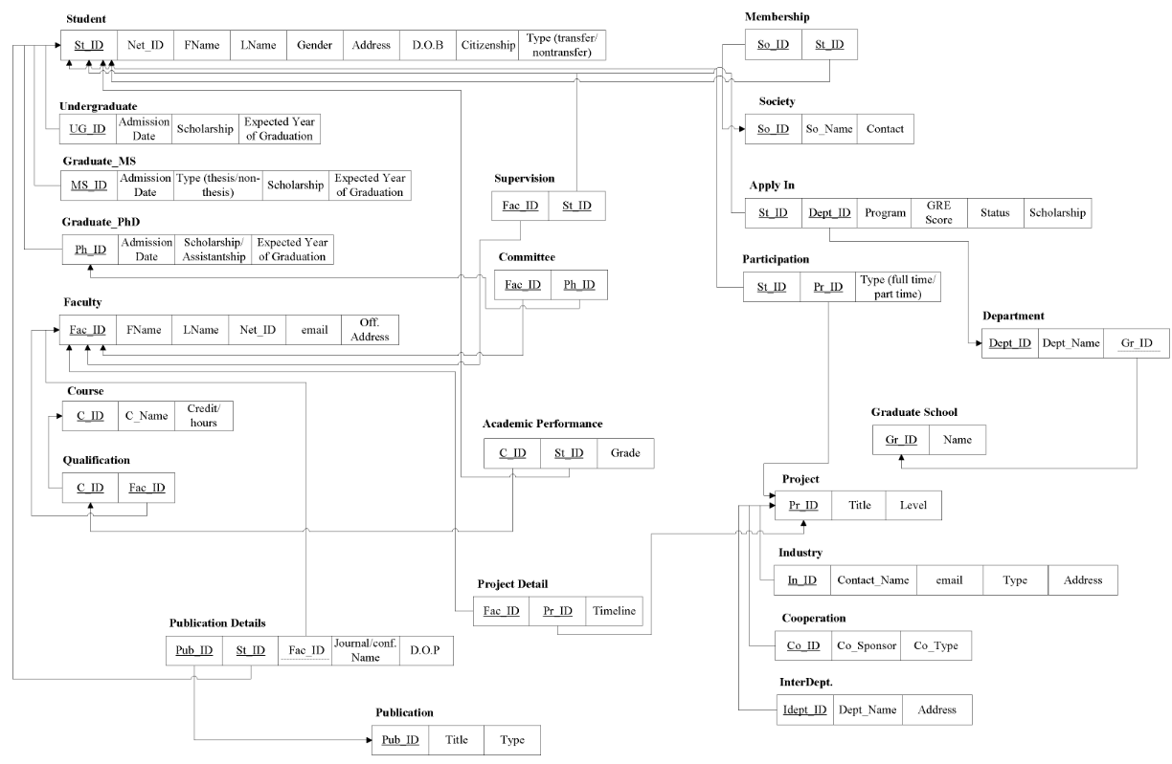

Figure 3.7: Relational model depicting primary and secondary keys used to generate data in the database

                - 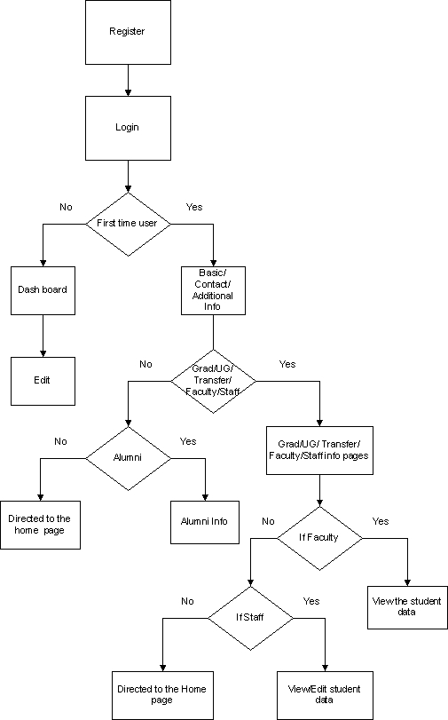
Figure 3.8: Flow of pages in MIS

Student MIS (Graduate and Undergraduate)
MIS-Graduate and MIS-Undergraduate were created as parallel modules sharing similar functionalities. This section introduces the modules’ common functions and as well as each module’s specific functionalities.
Information gathered at the department level is as important as its accessibility for students, faculty and staff. MIS-Graduate and MIS-Undergraduate modules enables the department to keep track of student’s progress throughout their program. Data is collected by allowing students to enter their information into the web interface system through authorized access. Staff has access to edit and review data for accuracy, while students have limited editing permissions. Visibility and access to data are different for different personnel. The developed MIS supports the following data functionalities for students and alumni:
- Basic Information: Student Name, Net ID, UTK email, Gender, Ethnicity, Citizenship, Student level (Graduate or Undergraduate), Address
- Background Information: Previous school information, Scores, Major, GPA, Number of credit hours
- Course Information: Number of courses taken, Grades, Course plan for next semester, cumulative GPA
- Financial support information: Scholarships, Assistantships, Grants, Proposals
- Publications: Publications every year, Journal information, Cited journal information, Number of publications
- Project information: Projects in progress, Company or inter-department details
- Statistics and report generation: Admission; number of students admitted, graduated, and enrolled in the program
In addition to the active students, alumni of the department have web-interface access to input their employment status, accomplishments, and contact information. This would help maintain strong alumni relations and to establish a student mentoring program for current students’ professional development.
In addition to the above-mentioned data functionalities, the graduate module consists of graduate admissions.

Graduate Admissions
The graduate admission process is crucial for both the graduate school and the department. Students seeking admission to the university send their GRE scores and transcripts, along with the application form, to graduate school, which reviews the application and forwards it to the department for a second review. After reviewing the application, department notifies graduate school, its decision of acceptance or rejection. This graduate-admission process is very time consuming, requiring several data exchanges between the graduate school and department.
To make the graduate-admission process more efficient, the MIS-Graduate module was created with the following features:

- Students can login to MIS system before being accepted by the department.
- Aspiring students can submit their documents directly to a specific department as well as to the graduate school.
- Students are provided instant feedback regarding their status and application requirements on the web-interface as well as through e-mail.
MIS Undergraduate module
The MIS-Undergraduate module has the following features in addition to functionalities of Graduate module:
- Course Plan: Undergraduate students are allowed to take independent study every semester. The MIS system allows students to input their planned program of study. This enables the department head to prepare a schedule for upcoming semester, while students can plan their courses in advance, which eliminates last minute changes in the curriculum of additional independent study credits
- Inbuilt course catalog: Students are given access to the system to review course catalog, enabling them to keep track of their course enrollment and graduation requirements

MIS data restriction

Information from students is stored in the MIS using an SQL database. Once data is entered, students can review and modify it by logging back into the system. The MIS report functionality helps department personnel access information. Staff and faculty have the same access to the information, while students’ access is restricted to certain information.

System design

Design of MIS was reviewed by staff and faculty to make necessary changes before implementing. An interactive user-centered design with the ability to receive feedback with each module’s implementation that enables system improvements is applied (Simes-Marques & Nunes, 2012). The system’s analysis and design paradigm was used in designing and implementing code, facilitating system’ maintainability. Also, object-oriented programming was used to define functions in terms of class order (Chen, 1976).

System authentication

Data security is the most important part in providing authorized access to users using the system.
Regarding the system’s access functionality, two types of users were identified:
- Long-term users: Faculty, staff, administrator and department head are the long- term users of this system, having unrestricted access.
- Short-term users: These users are primarily students who enter and update their information every semester. The maximum time they use the system is two to five years.
UTK email ID authentication: Email authentication is used for those who do not have access or are not associated with the University. When a student registers in the system, its mandatory that they register using UTK authorized email ID and password. A restriction of eight characters is enabled to create password to make it virtually impossible to guess password and access information. A line of code in PHP is inserted to enable password confirmation. Staff accesses the system database to verify login ID with University system. This facilitates having department-related data, instead of unidentified data that is treated as waste in the system.
If a user forgets his/her password, an option on the web-interface system allows the user to reset the password. Once the user requests to reset his/her password, a link is emailed to the user, who can then reset the password and log back into the system.
Student ID verification: Student ID plays a significant role in the system as it acts as a primary key for all the information related to student. Hence, verification of this ID is considered to be very important. After a student is registered in the system, the student ID is required to log in. This ID is verified by using the email ID linked to the account. Student is allowed to navigate only if the ID matches with the email. For example, students cannot log in as faculty because faculties IDs are also registered in the system. For the system to give unauthorized access to redirect pages, it has to check IDs within the groups.
Similarity in web pages for Graduate and Undergraduate students
Components in MIS system share similar functionality required by some of the pages. For example, all pages require information to be gathered from students. Graduate and undergraduate students share some pages requiring the same information to maintain the code’s re-usability.
A single user might have various roles when using the system. For example, a specific faculty member can be an advisor and also a committee member for students. An undergraduate student can apply for a graduate degree. Therefore, the database was designed to track changes and redirect the user to a specific page.
The code developed, represents navigating pages according to the students’ level. This feature serves as one of the lean technique- optimization. Depending on the type of user, appropriate access is provided for the system. Users logging in to the system for first time must have write access, whereas users logging in for the second time (i.e., assuming they have entered data into the system) have access to input and re-write data.

User classes
User-related information is divided into separate classes, such as gender, citizenship, ethnicity, address, educational background, internship details, test scores, and employment. The web-interface is divided into specific information-generating pages. The first few page includes basic information divided into student levels and corresponding data required like address, contact information, and other basic information. Internship, employment, and transfer information depends on the student’s level. Figure 3.9 shows that student is the higher class entity with student ID, net ID, name, address, type of student as its components. The entities below student share the student components plus their own components. For example, the undergraduate entity has undergraduate ID which refers to Student ID and Admission time as its components. Every entity under student has a different ID, which relates to student ID. The web-interface design focuses more on the end user. In order to use the web interface easily, the interface was designed with the user’s perspective in mind. A dummy interface was created and tested with a few students. Feedback is requested from students regarding the following: the way data was represented, ease of use, how intuitive the interface was, and other options they would like the system to provide. To improve the system interface, end users’ feedback is as important as the faculty’s.

Reporting Software

Qlikview: To analyze information in the database, a report must be generated for department personnel review. Qlikview is report generation software used to analyze data and generate reports. It enables both features of connecting to database and gathering information through its own scripting language. It gathers pertinent data from various sources into a single application; analyzes associations within the data; and facilitates social decision-making through secure, real-time collaboration. This software also enables users to visualize data directly and indirectly ("Qlikview," 2013). Furthermore, this platform uses a lean technique, integrated into the system to provide rich contextual information that can be leveraged to support just-in-time access to task-relevant information (Budzik & Hammond, 2000). The relationship between entities is presented in Figure 3.10 showing interaction between each factor and their dependencies.
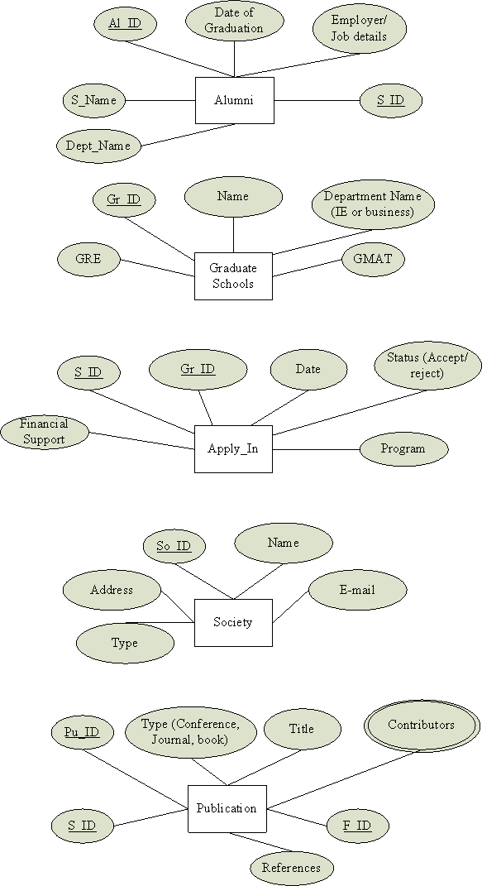
Figure 3.9 User classes representing primary and secondary keys in the MIS web design
                - 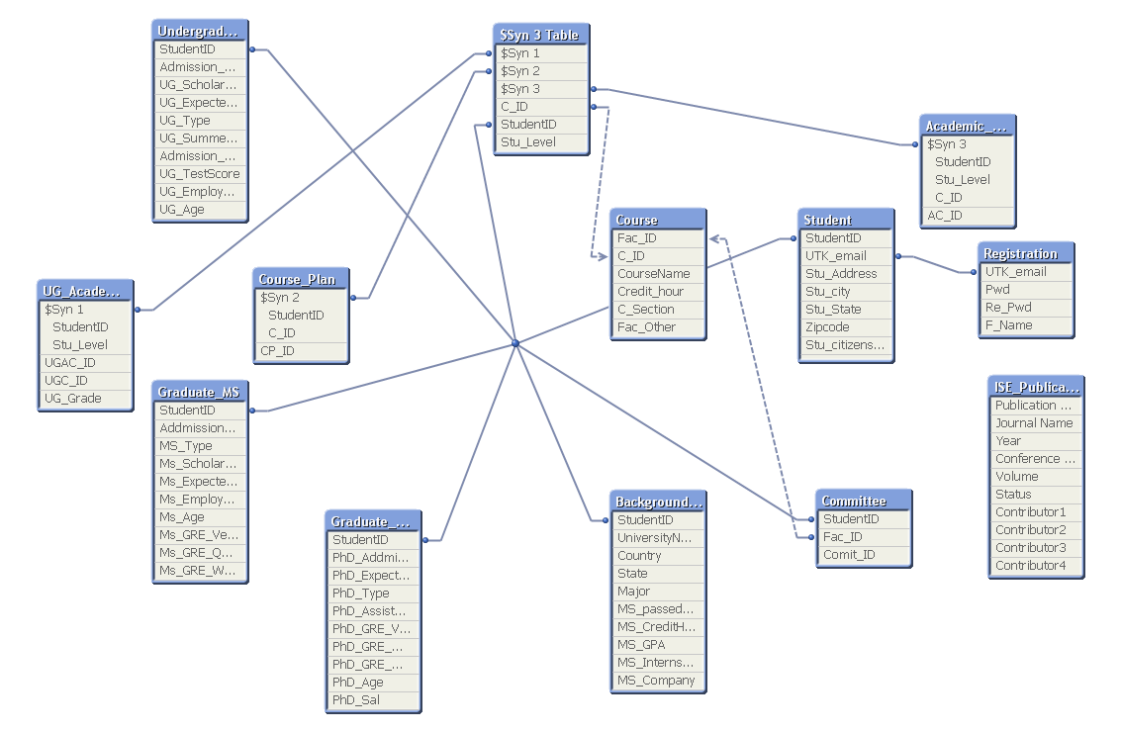
Figure 3.10 Relationship model for MIS report

CHAPTER IV
ANALYSIS AND Results
The management information system is developed and implemented as presented in methodology for department of Industrial and Systems Engineering at the University of Tennessee. MIS is developed using by gathering requirements for the system and designing the system using a web interface. Data from students is gathered using a web interface with authorized login, which is captured into a predesigned data base designed using MySQL. Web-design programming languages C#, .NET, HTML and JavaScript are utilized to program to create forms in Visual Studio which are later hosted on to the web.
The web-interface of login for students and faculty is as shown in Figure 4.1 that allows login for students with their authorized university ID, and registration is verified. Students then systematically enter required data into separate forms for each data type presented on the screen. Data from web interface is collected into the database which is then used to generate reports using business intelligence report generation software, Qlikview. Figure 4.2 shows the dashboard designed to visualize data from database in the form of graphs. Access to this web hosted report generation software is through authorized login similar to student access log in (Figure 4.1). Once the data required is selected from dashboard, the software provides an option to export data to an Excel spreadsheet or to a printer.
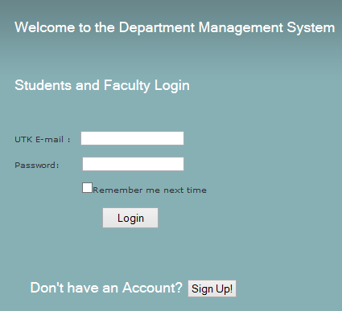
Figure 4.1: Screenshot of login screen of MIS
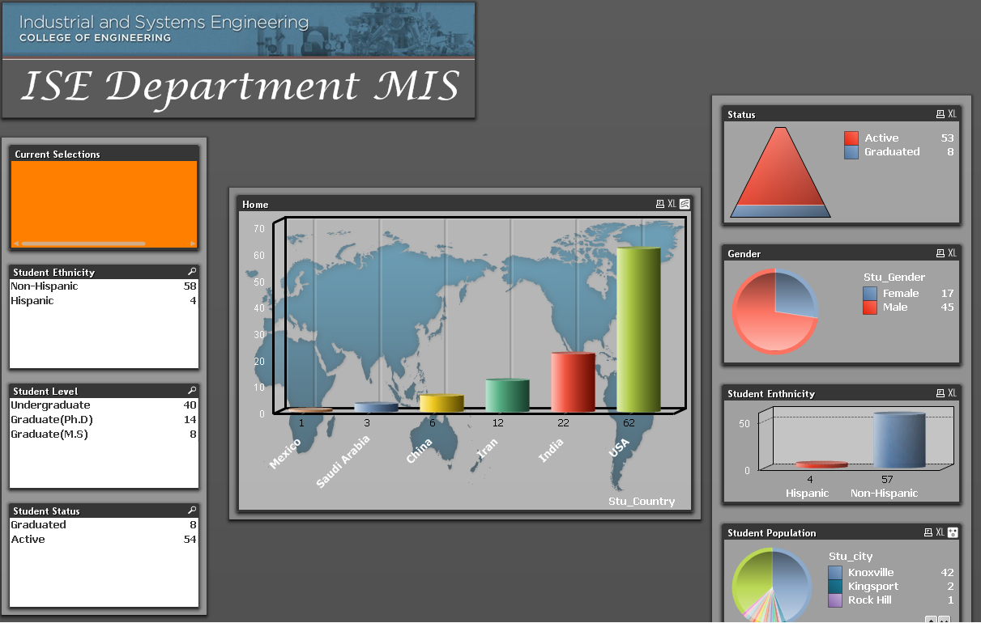
Figure 4.2: Screenshot of dashboard of report generating interface

4.1 Analyzing flow of information request processing after implementing MIS
Implementing MIS for ISE showed an impact on reducing number of processes that the department follows to process a data request. Figure 4.3 represents the effected data flow in processing a request generated sources. Department head has authority to sort the received requests from various sources and forwards the academic and student information requests to accounting specialist who has access to MIS reporting system. This reduces the business manager work load for specific responsibility of processing only financial information requests. The current MIS focusses in collection and retrieval of student information, accounting specialist or department head access reports directly from MIS as shown in Figure 4.4. Retrieving information when required using MIS reduces the number of steps in processing a request as shown in Figure 4.5 representing the future value stream map of request processing with implementation of MIS into the department.
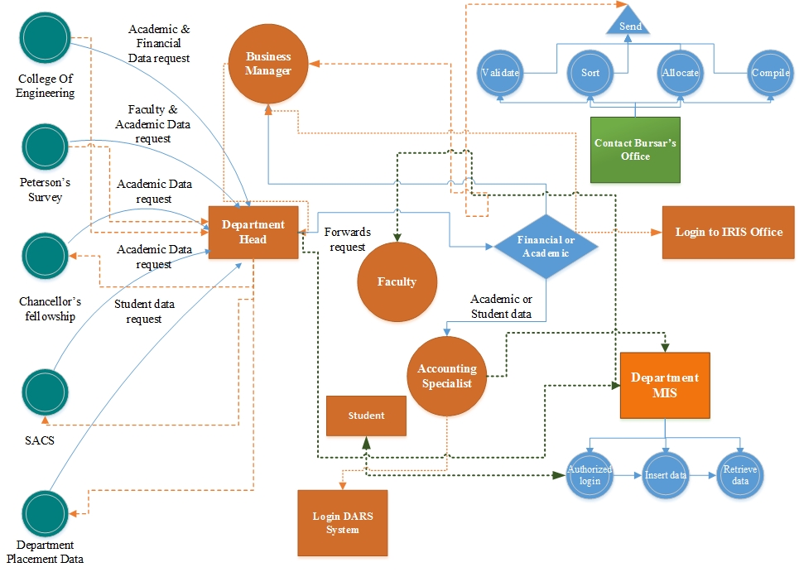

Figure 4.3: Flow of process in generating reports for requesting sources by the department of ISE through MIS
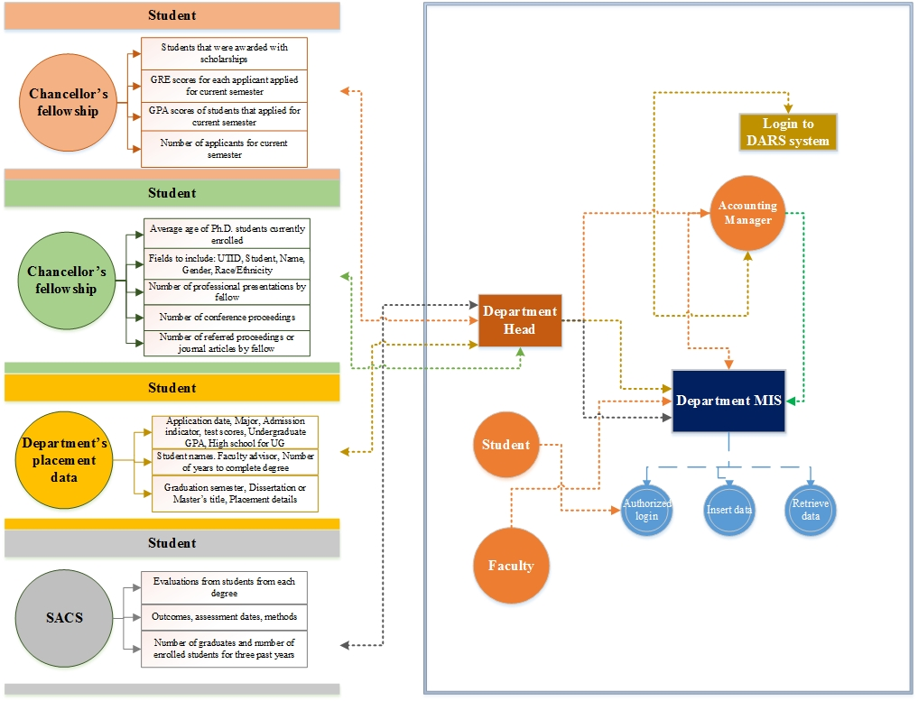

Figure 4.4: Flow of the Department of ISE’s process in generating reports for requesting sources based on type of data through MIS reporting system
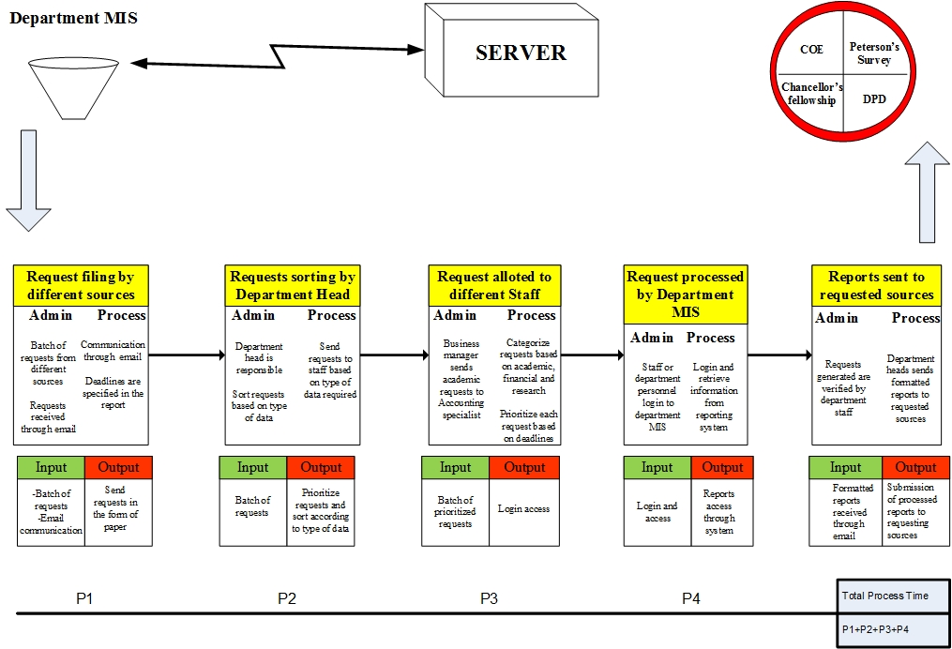

Figure 4.5: Future value stream map with processes contributing to data reporting with MIS reporting system at University of Tennessee

4.2 Evaluation of current and future state of information processing in ISE

4.2.1 Evaluation of MIS

Graph theoretical method is utilized to evaluate the existing information processing method and results are presented in following sections. The model enables to compare and evaluate the new and old MIS utilizing impact factor calculation.

4.3 Assessing variable permanent factor for current process in the department of ISE

Calculation of impact factors

Step 1: Determination of numerical values

Numerical values for various factors are determined using table 3.2 and 3.3 to represent inheritance of attributes and interactions between variables and the main factor. The variable permanent matrices for all the requesting sources using the digraphs are shown in Equations 4.1- 4.6. For College of Engineering (COE) the values are ${ B}_{1}^{a}=9{ B}_{2}^{a}=4$ $B_{3}^{a}=9$ $B_{4}^{a}=5$. The values taken from table 4 are${ b}_{13}^{a}=4 b_{14}^{a}=3$
${ b}_{21}^{a}=3 b_{23}^{a}=5 { b}_{31}^{a}=3{ b}_{32}^{a}=3{ b}_{31}^{a}=3{ b}_{32}^{a}=2{ b}_{34}^{a}=4$.
Step 2: Substituting these values into the matrix
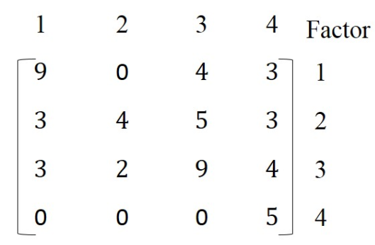
VPM B_{COE} =
4.1
Similarly, variable permanent matrices for other requesting sources are represented as
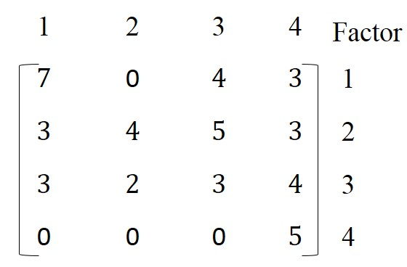
VPM B_{PS} =
4.2
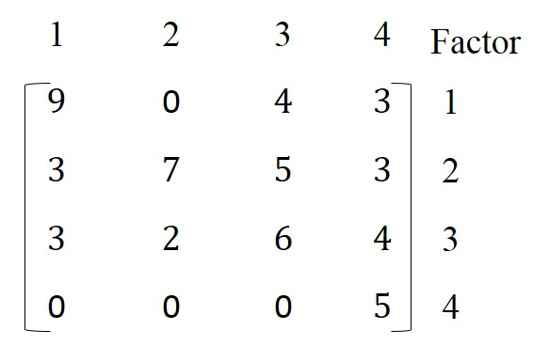
VPM B_{CF} =
4.3
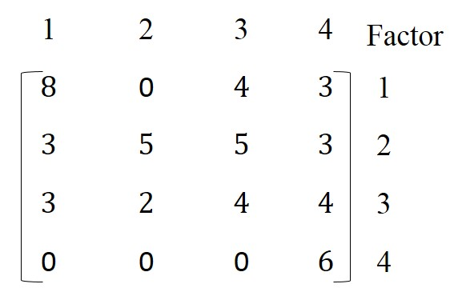
VPM B_{SACS} =
4.4
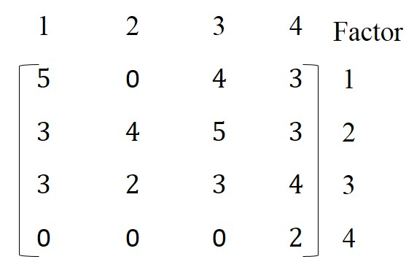
VPM B_{DPD} =
4.5

The matrix for department has different inheritance and interdependence variables. Hence the values are different when compared to other permanent matrices of requesting sources. ${ B}_{1}^{d}=9$ $B_{2}^{d}=7$ $B_{3}^{d}=6$ $B_{4}^{d}=8$ , interdependencies ${ b}_{12}^{d}=5{ b}_{13}^{d}=5$ ${ b}_{21}^{d}=4 b_{23}^{d}=3 {b_{24}^{d}=3 b}_{31}^{d}=3{ b}_{32}^{d}=4{ b}_{41}^{d}=4{ b}_{43}^{d}=4$
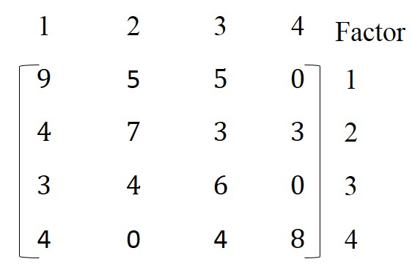
VPM B_{ISE} =
4.6
Step 3:
The variable permanent factor of matrices of${ B}_{COE}$ ,${ B}_{PS}$, $B_{CF}$ , ${ B}_{SACS}$, ${ B}_{DPD}$ and ${ B}_{ISE}$ which points to inheritance of requesting sources as behavioral factors is evaluated based on Equation 3.4.
The value of variable permanent function for ${ B}_{COE}$ points to inheritance of factors TOI, LOC, NOI and TROD. Substituting values from matrix 4.1:
$${Per B}_{COE}=5100$$
Similarly the values of permanent function for all the requesting sources are evaluated from the matrices (4.2), (4.3), (4.4), (4.5) and (4.6).
To rationalize the decision making process, the obtained permanent value is made simple by expressing it in logarithmic terms (with base 10). For instance $\log_{10 }\left(5100\right)$ is equal to 3.7. Similarly the values for remaining requesting sources are obtained.
The normalized values in logarithmic terms (log (base 10)) are shown below:
- ${ Per B}_{COE}=5100 or 3.7$
- ${Per B}_{Ps}=3500 or 3.54$
- ${Per B}_{CF}=6090 or 3.78$
- ${Per B}_{SACS}=5184 or 3.71$
- ${Per B}_{DPD}=1192 or 3$
- ${Per B}_{ISE}=15498 or 4.19$
Step 4:
Main factors digraph is shown in the Figure (3.2) and matrix at current system level is developed through equations (3.1), (3.2) and (3.4). Variable permanent matrix for the current system of information request processing is shown in (4.7). The values of diagonal are substituted from above step and the off diagonal values are considered from Tables (3.2 & 3.3). However an original permanent value like 5100 is substituted in the matrix instead of logarithmic values. Table (3.3) represents the degree of dependence among factors based on scale given in Table (3.2) (Grover et al., 2006).
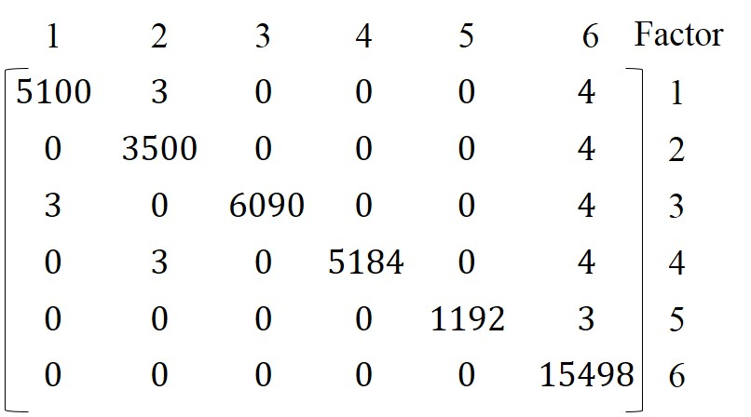
VPM B_{CS} =
4.7
Step 5:
Value of variable permanent function for current system is evaluated from equation (3.5). The permanent value of above matrix (4.7) is 1.041E+22, which when expressed in logarithmic value equals 22.017. This value represents the impact index which is used to compare how conductive a system is (Gurumurthy et al., 2013).

4.4 Assessing variable permanent factor department of ISE after implementation of MIS

After assessing the impact factor of current process of information flow in the department, an analysis is done to compare the values of current and future variable permanent factor. Similar process is followed as shown above for the current process. Step 1: The digraphs and the equations are similar to the previous approach. The only difference is the change in scale based on the feedback from Staff and graduate students who were trained to access information from MIS. For College of Engineering (COE) the values from table 3 are${ B}_{1}^{a}=9{ B}_{2}^{a}=4$ $B_{3}^{a}=9 B_{4}^{a}=3$. The values taken from Table 3.3 are${ b}_{13}^{a}=4 b_{14}^{a}=3$ ${ b}_{21}^{a}=3 b_{23}^{a}=5 { b}_{31}^{a}=3{ b}_{32}^{a}=2{ b}_{31}^{a}=4{ b}_{32}^{a}=2{ b}_{34}^{a}=3$.
Substituting these values into the matrix
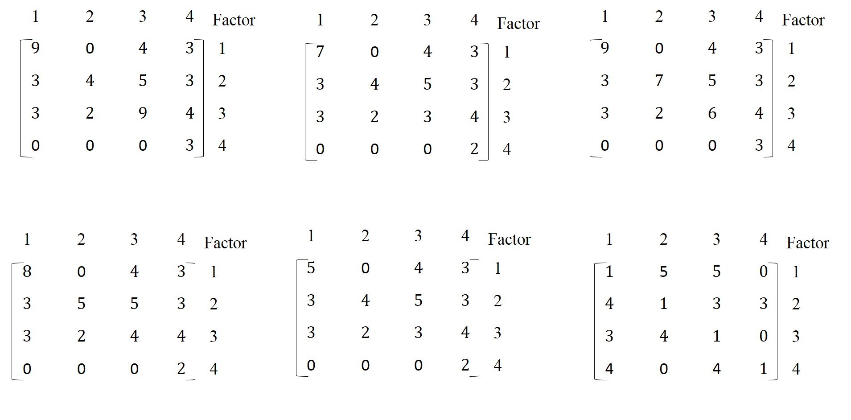
4.8
${VPM B}_{COE}^{1}$ =
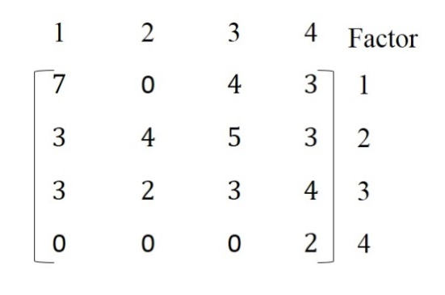
4.9
${VPM B}_{PS}^{1}$ =
4.10
${VPM B}_{CF}^{1}$ =
4.11
${VPM B}_{SACS}^{1}$ =
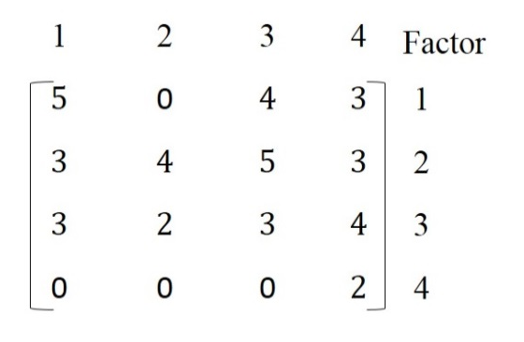
4.12
${VPM B}_{DPD}^{1}$ =
Step 2: Since department has different affecting variables, the inheritances and interdependencies between them are different from other requesting sources as shown in the digraph and matrix. Hence${ B}_{1}^{d}=1$ $B_{2}^{d}=1$ $B_{3}^{d}=1$ $B_{4}^{d}=1$ , interdependencies are${ b}_{12}^{d}=5 b_{13}^{d}=5$ $b_{21}^{d}=4 b_{23}^{d}=3 {b_{24}^{d}=3b}_{31}^{d}=3{ b}_{32}^{d}=4{ b}_{41}^{d}=4{ b}_{43}^{d}=4$.
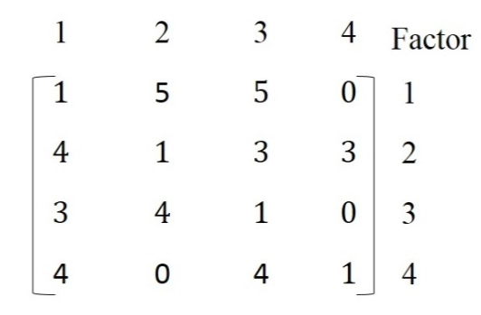
4.13
${VPM B}_{ISE}^{1}$ =
Step 3: The matrices are solved using equation (3.5) to get the following permanent values (both original and logarithmic) for each requesting source:
- ${ Per B}_{COE}=3060 or 3.48$
- ${Per B}_{Ps}=1400 or 3.14$
- ${Per B}_{CF}=3654 or 3.56$
- ${Per B}_{SACS}=1728 or 3.23$
- ${Per B}_{DPD}=1192 or 3$
- ${Per B}_{ISE}=5346 or 3.72$
Step 4: Original values are used in the matrix to calculate variable permanent factor for the system with MIS implementation.
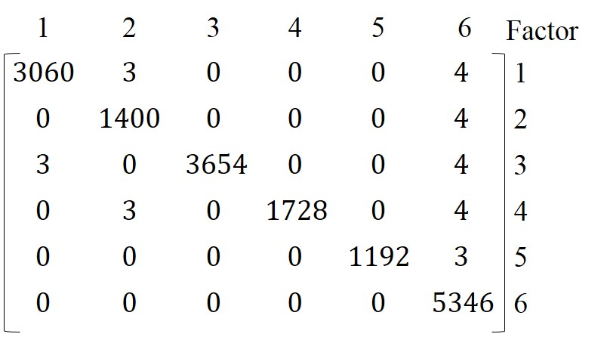
4.14
${VPM B}_{FS}^{1}$ =
Step 5: Value of variable permanent function for future system is evaluated using Equation 3.5. The permanent value of above matrix (Equation 4.14) is 1.724E+20, which when expressed in logarithmic value equals 20.2365.

4.5 Value assessment of present and proposed MIS

The impact index values for current process of information flow and the normalized impact index for future process of information flow with the integration of MIS into the current process are calculated. It is observed that there exists significant difference between the current process impact on the department and the impact of future process in delivery of report to requesting sources. Table 4.1 also shows that the impact factor of individual sources have also reduced significantly, in terms of time required for a request from specific entity. For example, requests from COE had significant impact on on-time delivery of reports in current practice of information processing based on the VPF (logarithmic value of 3.7), whereas the impact reduced to a certain amount when the same reports were generated through MIS, based on VPF (logarithmic value of 3.48), which is nearly a 22% reduction. The calculations imply difference in the processing time between current and future process for every requesting source except for DPD due to little or no processing time in software based MIS. The highest level of impact was on department of ISE (VPF logarithmic value of 4.19), because of the influence of all the sources. Integration of MIS reduced the impact factor for the department of ISE by 47% (VPF logarithmic value of 3.72). Considering all the above impact factors the overall impact on ISE with the current practice is found to be 1.041E+22 (logarithmic value: 22). Table 4.1 demonstrates that MIS implementation can reduce the overall data processing effort and time as represented by calculated value factors under various department (ISE) depending agencies in UTK.
System Sources (Table 3.1) | Current value before integrating MIS (VPF) | Current normalized VPF  Log₁₀ (VPF) | Future value After integrating MIS  (VPF) | Future normalized VPF  Log₁₀ (VPF)
B_{COE} | 5100 | 3.7 | 3060 | 3.48
B_{PS} | 3500 | 3.54 | 1400 | 3.14
B_{CF} | 6090 | 3.78 | 3654 | 3.56
B_{SACS} | 5184 | 3.71 | 1728 | 3.23
B_{DPD} | 1192 | 3.00 | 1192 | 3.00
B_{ISE} | 15498 | 4.19 | 5346 | 3.72
B _{System} | 1.041E+22 | 22. 02 | 1.72E+20 | 20. 23
Table 4.1 Comparison of current and future variable permanent functions

4.6 Analysis of cost in implementing MIS in every department at an educational institution

Cost of implementation of the proposed MIS in department of ISE is estimated based on approximate market price of the technology. Table 4.2 shows the cost break-down for the department with 160 estimated users, including graduate students, undergraduate students and department personnel. Maintenance and training cost for the new system can be offset with replacing the current available system, which require IT support and preparation for the data processing personnel.
Software | Utility | Estimated # of users | Cost ($)
Microsoft SQL server | Database design | 2 | 100
Microsoft Visual studio | Web interface design | 3 | 998
Server | Web hosting | 150 | 5000
Qlikview reporting software | Reporting | 5 | 12000
Total |  | 160 | 18098
Table 4.2 Estimation of cost of implementing MIS in department of ISE

CHAPTER V
CONCLUSIONS AND FUTURE WORK

5.1 Summary of advantages with software based MIS implementation

Implementation of MIS in the department of ISE is expected to create an environment which provides the following benefits.
Ease of data access
MIS implementation with data gathering and report generation web-interface provides instant data access to personnel in the department of ISE.
Lower human resource requirement for data processing
System integration into the department saves time for different sources towards collection of data. Department head can accesses data to provide information to the required entities of university. Human resources in terms of number of people working on a request and number of sources department have to reach for data processing can be reduced.
Less time to process a request
Increasing the ease of access and decreasing the amount of resources to generate reports can help reduce the process time.
Customization of MIS based on specific needs
Implementing MIS can provide opportunity to customize the needs of each specific department. This application can also be extended to research labs where data can be collected and stored for future analysis of performance of labs in the department. The option to customization allows to deliver and effective and cost minimizing data processing systems to each entity in educational institutions.

5.2 Future work

The current worked showed capability of a software based, integrated management information system (MIS) to replace the existing interdependent data processing method. Thorough development, design, and evaluation steps are presented in detail with focus on department of Industrial and Systems Engineering at the University of Tennessee. The proposed MIS is evaluated and compared to current data processing system to prove the enhanced capabilities of factors related to information sharing in UTK.
Future work in MIS for education institutions are proposed to perform a process time variation analysis after implementing MIS into the current practice. Cost-benefit analysis comparing the impact of long term utility of proposed software based solution can also performed to analyze the cost related to implement MIS.

APPENDIX A
Questionnaire or discussion through email
Source: Reporting Services

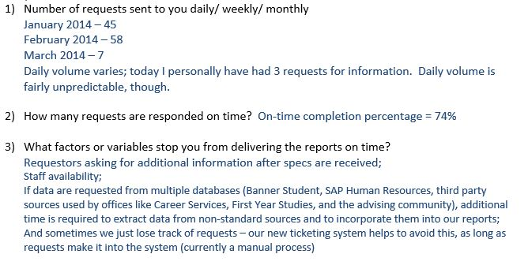
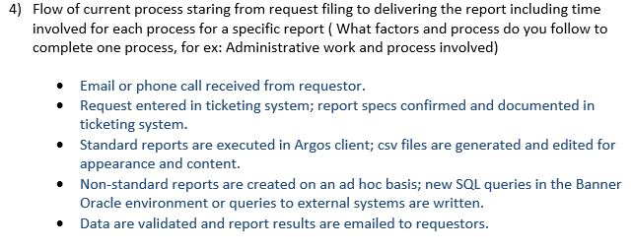
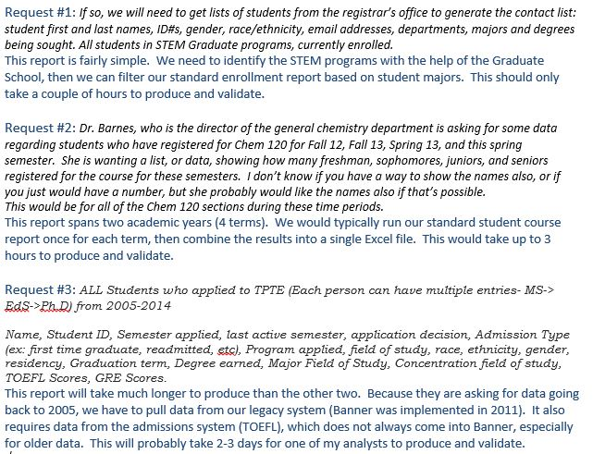

APPENDIX B
Reports requested by different sources sorted by type
Source: Department of ISE and Reporting Services

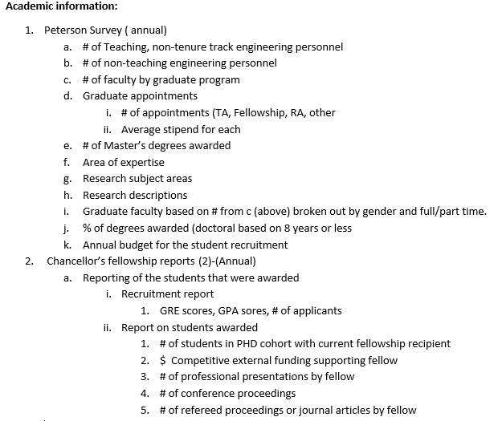
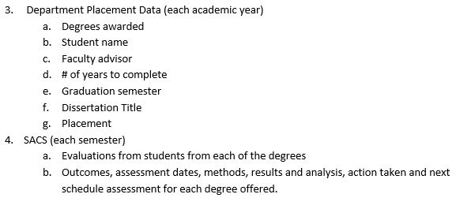
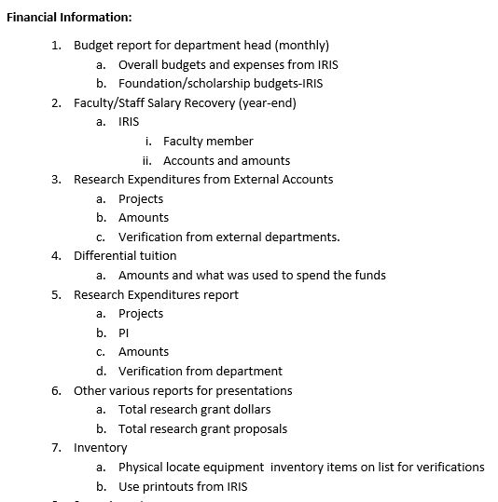

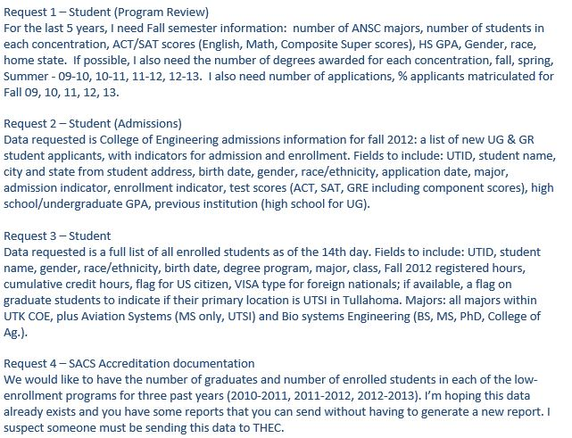

LIST OF REFERENCES
Asemi, A., Safari, A., & Zavareh, A. A. (2011). The Role of Management Information System (MIS) and Decision Support System (DSS) for Manager's Decision Making Process. International Journal of Business & Management, 6(7).
Bayazit, O., & Karpak, B. (2007). An analytical network process-based framework for successful total quality management (TQM): An assessment of Turkish manufacturing industry readiness. International journal of production economics, 105(1), 79-96.
Budzik, J., & Hammond, K. J. (2000). User interactions with everyday applications as context for just-in-time information access. Paper presented at the Proceedings of the 5th international conference on Intelligent user interfaces.
Chen, P. P.-S. (1976). The entity-relationship model—toward a unified view of data. ACM Transactions on Database Systems (TODS), 1(1), 9-36.
Codd, E. F. (2001). A relational model of data for large shared data banks Pioneers and Their Contributions to Software Engineering (pp. 61-98): Springer.
Daft, R. L., & Lengel, R. H. (1986). Organizational information requirements, media richness and structural design. Management science, 32(5), 554-571.
Fichman, R. G., Kohli, R., & Krishnan, R. (2011). The role of information systems in healthcare: current research and future trends. Information systems research, 22(3), 419-428.
Grover, S., Agrawal, V., & Khan, I. (2006). Role of human factors in TQM: a graph theoretic approach. Benchmarking: An International Journal, 13(4), 447-468.
Grover*, S., Agrawal, V., & Khan, I. (2004). A digraph approach to TQM evaluation of an industry. International journal of production research, 42(19), 4031-4053.
Gunasekaran, A., & Ngai, E. W. (2004). Information systems in supply chain integration and management. European Journal of Operational Research, 159(2), 269-295.
Gurbaxani, V., & Whang, S. (1991). The impact of information systems on organizations and markets. Communications of the ACM, 34(1), 59-73.
Gurumurthy, A., Mazumdar, P., & Muthusubramanian, S. (2013). Graph theoretic approach for analysing the readiness of an organisation for adapting lean thinking: A case study. International Journal of Organizational Analysis, 21(3), 396-427.
Hicks, B. (2007). Lean information management: Understanding and eliminating waste. International journal of information management, 27(4), 233-249.
Hong, K.-K., & Kim, Y.-G. (2002). The critical success factors for ERP implementation: an organizational fit perspective. Information & Management, 40(1), 25-40.
Kornkaew, A. (2012). Management Information System Challenges, Success key issues, Effects and Consequences: A case study of FENIX System.
Lannon, J. (2013). understanding the role and the impact of information systems in today's business environment. Certified Public Accountants. Retrieved February, 2013, 2013.
Lee, H. L., & Whang, S. (2000). Information sharing in a supply chain. International Journal of Manufacturing Technology and Management, 1(1), 79-93.
Liberty, J. (2009). Programming C#: Building. NET Applications with C#: O'reilly.
Lubbe, S., & Bopape, M. The Social Impact of Information Systems at a Tertiary Institution. Management, Informatics and Research Design, 251.
Lubbe, S., & Bopape, M. (2008). The Social Impact of Information Systems at a Tertiary Institution. Management, Informatics and Research Design, 251.
Melville, N. P. (2010). Information systems innovation for environmental sustainability. MIS quarterly, 34(1), 1-21.
Motwani, J., Subramanian, R., & Gopalakrishna, P. (2005). Critical factors for successful ERP implementation: exploratory findings from four case studies. Computers in Industry, 56(6), 529-544.
MySQL, A. (2001). MySQL.
Naranjo-Gil, D., & Hartmann, F. (2007). Management accounting systems, top management team heterogeneity and strategic change. Accounting, Organizations and Society, 32(7), 735-756.
O'Brien James, A. Management Information Systems Managing Information Technology in the Business Enterprise. 6: Mc Graw Hill Irwin.
O'Brien James, A. (1990). Management information systems: Galgotia Publications.
Premkumar, G., Ramamurthy, K., & Saunders, C. S. (2003). Information processing view of organizations: an exploratory examination of fit in the context of interorganizational relationships. Journal of management information systems, 22(1), 257-294.
Ragowsky, A., Ahituv, N., & Neumann, S. (1996). Identifying the value and importance of an information system application. Information & Management, 31(2), 89-102.
Rooney, J. J., & Heuvel, L. N. V. (2004). Root cause analysis for beginners. Quality progress, 37(7), 45-56.
Ruzicka, M. T., & Weckmueller, B. L. (1997). Student records management: A handbook: Greenwood Publishing Group.
Sacks, R., Koskela, L., Dave, B. A., & Owen, R. (2010). Interaction of lean and building information modeling in construction. Journal of Construction Engineering and Management, 136(9), 968-980.
Simes-Marques, M., & Nunes, I. (2012). Usability of interfaces.
Taveira, A. D., James, C. A., Karsh, B.-T., & Sainfort, F. (2003). Quality management and the work environment: an empirical investigation in a public sector organization. Applied Ergonomics, 34(4), 281-291.
Watson, R. T., Boudreau, M.-C., Chen, A. J., & Sepúlveda, H. H. (2011). Green projects: An information drives analysis of four cases. The Journal of Strategic Information Systems, 20(1), 55-62.

Vita

