- Running title:

- Plant genotype, not nutrients, shape aphid population dynamics

- Heather Tran, Lara Souza, Nathan J. Sanders, and Aimée T. Classen

- Department of Ecology and Evolutionary Biology, 569 Dabney Hall, University of Tennessee, Knoxville, Tennessee 37996

- submitted to:

- Number of pages: 16

- Number of figures: 4

Corresponding author: Heather Tran, Department of Ecology and Evolutionary Biology, 569 Dabney Hall, The University of Tennessee, Knoxville, Tennessee 37996
- Introduction

The importance of within species variation in shaping ecosystem processes associated in plant communities has been well recognized in the ecological literature (Reush et al. 2005, Schweitzer et al. 2005, Crutsinger et al. 2006, Whitham et al. 2006, Whitlock et al. 2007, Hughes et al. 2008). Recently, studies have also documented the role of within species variation in shaping plant-insect interactions in host-parasite systems (Mitchell et al. 2005) as well as structuring arthropod communities (Crutsinger et al. 2006). For instance, Crutsinger et al. (2006) documented substantial intraspecific variation in arthropod abundance and richness across Solidago altissima genotypes, indicating that genetic variation can determine population and community dynamics of associated herbivores and predators. However, little is known on how intraspecific variation determines population dynamics of phloem-feeding arthropods (Rowntree et al. 2010).

Soil nutrients have played a critical role in structuring plant communities by shaping their structure and function, but also in altering plant and insect interactions. Enhanced levels of nitrogen and other nutrients have been shown to increase aboveground net primary productivity (ANPP), while reduced levels of nutrients have been shown to decrease ANPP, regardless of the level of plant species diversity (Baer 2003, DiTommaso 1989, Foster & Gross 1998, Fridley 2002). Nutrient amendments, in particular macronutrients such as nitrogen (N) and phosphorus (P), can increase plant-species susceptibility to herbivores (Stamp 2003), likely resulting from an increase in plant quality and/or quantity. However, little is known on how nutrients may interact to mediate effects of genotypic variation in aphid population dynamics (Rowntree et al. 2010).

Solidago altissima (hereafter Solidago), also known as tall goldenrod, is a common perennial plant found in old-field ecosystems throughout eastern North America. As a dominant species, Solidago has been shown to greatly influence ecosystem processes and the productivity and resource uptake of the plant community (Schmitz 2003; Abrahamson et al. 2005; Crutsinger et al. 2008; Schmitz et al. 2008; Wise and Abrahamson 2008; Souza et al. in review).

Nutrient amendments may determine associated trophic levels indirectly by modifying plant quality/quantity and/or modifying plant traits, thereby shaping population dynamics of associated arthropods including, aphids (Pors & Werner 1989, Crutsinger et al. 2006). Our study aimed at answering the following questions: (1) Does resource availability and genotype identity shape aphid population dynamics? (2) Do predators shape aphid population dynamics?

- Methods
- Plant Collections
- We collected 20 Solidago altissima genotypes by excavating Solidago rhizomes across three sites in Eastern Tennessee (near Oak Ridge, Tennessee). By excavating Solidago rhizomes in natural old-field patches growing 50 – 150 m part, we ensured that we collected 20 individual genotypes. We propagated individual rhizomes during the 2009 growing season in 20-gallon pots in a common garden environment at the University of Tennessee Institute of Agriculture (near Knoxville, TN). We measured a suíte of morphological and physiological performance traits and phenological and resistance plant traits.

- Experimental Design
- We performed a principal component analysis including all plant traits across the 20 Solidago genotypes and selected 10 genotypes that maximized trait variance across the first two principle component axes. In May 2010, we established a common garden experiment where we manipulated intraspecific diversity and resource availability. We manipulated intraspecific diversity by establishing monoculture plots containing six individuals of a single Solidago genotype and diversity plots containing six individuals of differing genotypes. We manipulated resource availability in the field by creating four treatments: (1) control (no resource manipulation), (2) soil nitrogen (N) addition (10 g m⁻² yr⁻¹), (2) soil phosphorus (P) addition (10 g m⁻² yr⁻¹), and soil P and N addition (P= 5 g m⁻² yr⁻¹ and N= 5 g m⁻² yr⁻¹).

- Plant Trait Data
- We collected plant performance, plant resistance, and plant phenology data across all genotypes monthly during summer 2010. Plant performance data included morphological data (height, stem diameter, leaf length, leaf width, internode length, plant biomass), resistance data (leaf toughness, leaf damage), and phenological data (first and last day of flowering, flowering duration). We estimated plant biomass by using an established allometric equation (Breza et al. In Preparation) with stem diameter and height as predictor variables (y = 0.010x + 1.055, R² = 0.83). Leaf toughness across genotypes was measured using a force gauge penetrometer (Type 516; Chatillon, Largo, Florida).

- Aphid Populations
- We tracked aphid populations for seven weeks in August and September 2010 by counting the numbers of aphids on the stems of Solidago genotypes every seven days. We first identified every Solidago individual with an aphid community and counted the total number of aphids. We then randomly selected two individuals per plot and assigned them to one of two treatments: uncaged (unmanipulated control) and caged (enclosed plants with bridal veil to prevent predation and/or dispersal). Given that only two diversity plots contained aphids on Solidago individuals, we focused on the effects of genotype identity and resource availability in shaping aphid population dynamics. The control treatment tested for the combined effects of genotypic identity, nutrients, and predation in shaping aphid populations whereas the caged treatment tested for the effects of genotypic identity and nutrients on aphid populations while controlling for predation/parasitism.

- We used a two-way analysis of variance (ANOVA) to test for the effects of genotype identity and resource availability on aphid populations in both caged and uncaged treatments. We used Tukey’s HSD to determine treatment differences at alpha=0.05. We also built a correlation matrix that included a variety of plant trait data (morphological, resistance, and phenological) that may shape aphid population dynamics across all census dates. We then built linear regressions to quantify the relationship between key plant trait data and aphid abundance.

- Results
- A significant difference in productivity over time emerged across the Solidago genotypes, but there was not a significant difference in productivity over time across the four fertility treatments or between the monocultures and mixtures (Figure 1, Figure 2). The two-way ANOVA for the effects of intraspecific diversity and resource availability found no significant variation in productivity among the differing nutrient addition or control plots. In addition, there was no significant variation in productivity among the plots when intraspecific diversity and resource availability were factored together. The one-way ANOVA found significant variation in productivity among the different genotype identities of the Solidago individuals. The variation in productivity decreased over time, with the most variation occurring in June and the least variation occurring in August.

- Discussion

One study on an old-field system that had been established for 17 years did not find significant variation in productivity with the addition of nutrients, possibly because high background levels of nutrients in the field made any increases in nutrients insignificant to the plant species (DiTommaso 1989). This could also explain why our study did not find significant variation in productivity due to nutrient addition, as the system is located on a historically agricultural site. The lack of significant results with respect to the monocultures and mixtures could simply be due to the fact that three months is not enough time to allow variation in productivity to emerge at a detectable level.

Intraspecific diversity has been shown to influence a wide range of responses, including productivity, from the population level to the ecosystem level (Crutsinger et al. 2006, Hughes et al. 2008). Likewise, the variation in total aboveground biomass, i.e., the variation in productivity, found within this study can also be attributed to genotypic diversity within a population of Solidago altissima.

The sensitivity of old field communities to changes in climatic conditions allow researchers an opportunity to detect and predict these changes before they become apparent in other ecosystems (Knapp et al. 2001). The productivity of a dominant, late successional plant species such as Solidago altissima greatly informs and influences the productivity and plant species composition of old field ecosystems; therefore, we must be able to understand how productivity is influenced by intraspecific variation.

- Acknowledgements
- Thanks to L. Breza, M. Cregger, O. Schmitz and H. Smith for assisting with plant collections and to Gordon Robinson, Katie Stuble, Lacy Chick, Laura Marsh, Melissa Burt, Tander Simberloff, Melissa Cregger, Emily Austin, for helping with the establishment and data collection of the experiment. UT Science Alliance Program (Joint Directed Research and Development) for providing funding for AC and NS and the Undergraduate Summer Internship (UT Office of Research) for providing research funding for HT.

Literature Cited

- Baer, S.G., Blair, J.M., Collins, S.L. & Knapp, A.K. (2003). Soil resources regulate productivity and diversity in newly established tallgrass prairie. Ecology 84, 724-735.

- Crawford, K.M., Crutsinger, G.M. & Sanders, N.J. (2007). Host-plant genotypic diversity mediates the distribution of an ecosystem engineer. Ecology 88, 2114-2120.

- Crutsinger, G.M., Colllins, M.D., Fordyce, J.A., Gompert, Z., Nice, C.C. & Sanders, N.J. (2006). Plant genotypic diversity predicts community structure and governs an ecosystem process. Science 313, 966-968.

- Crutsinger, G.M., Souza, L. & Sanders, N.J. (2008). Intraspecific diversity and dominant genotypes resist plant invasions. Ecology Letters 11, 16-23.

- DiTommaso, A. & Aarssen, L.W. (1989). Resource manipulations in natural vegetation: a review. Plant Ecology 84, 9-29.

- Foster, B.L. & Gross, K.L. (1998). Species richness in a successional grassland: effects of nitrogen enrichment and plant litter. Ecology 79, 2593-2602.

- Fridley, J.D. (2002). Resource availability dominates and alters the relationship between species diversity and ecosystem productivity in experimental plant communitites. Oecologia 132, 271-277.

- Fridley, J.D., Grime, J.P. & Bilton, M. (2007). Genetic identity of interspecific neighbours mediates plant responses to competition and environmental variation in a species-rich grassland. Journal of Ecology 95, 908-915.

- Hooper, D.U. et al. (2005). Effects of biodiversity on ecosystem functioning: A consensus of current knowledge. Ecological Monographs 75, 3-35

- Hughes, A.R., Inouye, B.D., Johnson, M.T.R., Underwood, N. & Vellend, M. (2008). Ecological consequences of genetic diversity. Ecology Letters 11, 609-623.

- Hughes, A.R. & Stachowicz, J.J. (2004). Genetic diversity enhances the resistance of a seagrass ecosystem to disturbance. Proc. Natl. Acad. Sci. USA 101, 8998-9002.

- Knapp, A.K. & Smith, M.D. (2001). Variation among biomes in temporal dynamics of aboveground primary production. Science 291, 481-484.

- Pors, B. & Werner P.A. (1989). Individual flowering time in a goldenrod (Solidago Canadensis): Field experiment shows genotype more important than environment. American Journal of Botany 76, 1681-1688.

- Schmitz, O.J. 2003. Top predator control of plant biodiversity and productivity in an old-
- field ecosystem. Ecology Letters 6, 156-163

- Spehn, E.M. et al. (2005). Ecosystem effects of biodiversity manipulations in European
- grasslands. Ecological Monographs 75, 37-63

Table 1.

Aphid Density- Caged
 |  | Mean | SE | F | P
Week 1 | Genotype 1 | 0.2ª | 0.51 | 2.5 | 0.04
 | Genotype 2 | 0.47ª | 0.25
 | Genotype 4 | 1.02ª | 0.29
 | Genotype 6 | 0.5ª | 0.23
 | Genotype 11 | 1.97ª | 0.51
 | Genotype 12 | 0.15ª | 0.25
 | Genotype 13 | 0.31ª | 0.21
 | Genotype 20 | 1.25ª | 0.36
 | Genotype 26 | 0.86ª | 0.23
Week 2 | Genotype 1 | 0.11^{b} | 0.46 | 3.56 | 0.01
 | Genotype 2 | 0.37^{b} | 0.23
 | Genotype 4 | 0.49^{b} | 0.26
 | Genotype 6 | 0.28^{b} | 0.2
 | Genotype 11 | 2.5ª | 0.46
 | Genotype 12 | 1.02^{ab} | 0.23
 | Genotype 13 | 0.4^{b} | 0.19
 | Genotype 20 | 0.18^{b} | 0.32
 | Genotype 26 | 0.34^{b} | 0.2
Week 3 | Genotype 1 | 0.34^{ab} | 0.76 | 2.38 | 0.05
 | Genotype 2 | 0.35^{ab} | 0.38
 | Genotype 4 | 1.26^{ab} | 0.44
 | Genotype 6 | 0.12^{b} | 0.34
 | Genotype 11 | 3.09ª | 0.76
 | Genotype 12 | 1.4^{ab} | 0.38
 | Genotype 13 | 0.81^{ab} | 0.31
 | Genotype 20 | 0.47^{ab} | 0.54
 | Genotype 26 | 0.96^{ab} | 0.34
Week 4 | Genotype 1 | 1.13ª | 1.25 | 0.6 | 0.77
 | Genotype 2 | 0.8ª | 0.63
 | Genotype 4 | 0.26ª | 0.72
 | Genotype 6 | 0.58ª | 0.56
 | Genotype 11 | 0.06ª | 1.25
 | Genotype 12 | 1.8ª | 0.63
 | Genotype 13 | 1.08ª | 0.51
 | Genotype 20 | 0.17ª | 0.89
 | Genotype 26 | 1.22ª | 0.56
Week 5 | Genotype 1 | 1.24ª | 0.94 | 0.36 | 0.93
 | Genotype 2 | 0.69ª | 0.47
 | Genotype 4 | 0.3ª | 0.54
 | Genotype 6 | 0.46ª | 0.42
 | Genotype 11 | 0.03ª | 0.94
 | Genotype 12 | 1.05ª | 0.47
 | Genotype 13 | 0.77ª | 0.38
 | Genotype 20 | 0.16ª | 0.67
 | Genotype 26 | 0.72ª | 0.42
Week 6 | Genotype 1 | 1.83ª | 0.73 | 1.02 | 0.45
 | Genotype 2 | 0.58ª | 0.37
 | Genotype 4 | 0.13ª | 0.42
 | Genotype 6 | 0.16ª | 0.33
 | Genotype 11 | 0.16ª | 0.73
 | Genotype 12 | 0.78ª | 0.37
 | Genotype 13 | 0.5ª | 0.3
 | Genotype 20 | 0.06ª | 0.52
 | Genotype 26 | 0.01ª | 0.33
Week 7 | Genotype 1 | -1.39E-17 | 0.44 | 0.35 | 0.94
 | Genotype 2 | 0.25ª | 0.22
 | Genotype 4 | 0.05ª | 0.25
 | Genotype 6 | 0.03ª | 0.19
 | Genotype 11 | -1.67E-16 | 0.44
 | Genotype 12 | 0.19ª | 0.22
 | Genotype 13 | 0.36ª | 0.18
 | Genotype 20 | -1.39E-17 | 0.31
 | Genotype 26 | 0.08 | 0.19

- Table 1. (con’t)

Aphid Density- UnCaged
 |  | Mean | SE | F | P
Week 1 | Genotype 1 | 1.33ª | 0.99 | 0.69 | 0.7
 | Genotype 2 | 0.79ª | 0.5
 | Genotype 4 | 0.55ª | 0.57
 | Genotype 6 | 0.71ª | 0.44
 | Genotype 11 | 0.09ª | 0.99
 | Genotype 12 | 0.22ª | 0.5
 | Genotype 13 | 0.43ª | 0.41
 | Genotype 20 | 1.56ª | 0.7
 | Genotype 26 | 1.3ª | 0.44
Week 2 | Genotype 1 | 0.35ª | 0.54 | 0.88 | 0.55
 | Genotype 2 | 0.38ª | 0.27
 | Genotype 4 | 0.77ª | 0.31
 | Genotype 6 | 0.12ª | 0.24
 | Genotype 11 | 0.72ª | 0.54
 | Genotype 12 | 0.66ª | 0.27
 | Genotype 13 | 0.68ª | 0.23
 | Genotype 20 | 0.87ª | 0.38
 | Genotype 26 | 0.22ª | 0.24
Week 3 | Genotype 1 | 0.16ª | 1.24 | 0.69 | 0.69
 | Genotype 2 | 0.68ª | 0.62
 | Genotype 4 | 1.85ª | 0.72
 | Genotype 6 | 0.25ª | 0.55
 | Genotype 11 | 0.19ª | 1.24
 | Genotype 12 | 1.04ª | 0.62
 | Genotype 13 | 0.52ª | 0.51
 | Genotype 20 | 0.13ª | 0.88
 | Genotype 26 | 0.03ª | 0.55
Week 4 | Genotype 1 | 0ª | 0.42 | 0.57 | 0.79
 | Genotype 2 | 0.47ª | 0.21
 | Genotype 4 | 0.24ª | 0.24
 | Genotype 6 | 0.09ª | 0.19
 | Genotype 11 | 0.02ª | 0.42
 | Genotype 12 | 0.36ª | 0.21
 | Genotype 13 | 0.48ª | 0.17
 | Genotype 20 | 0.15ª | 0.3
 | Genotype 26 | 0.21ª | 0.19
Week 5 | Genotype 1 | 0.12ª | 0.12 | 0.75 | 0.64
 | Genotype 2 | 0.08ª | 0.06
 | Genotype 4 | 0.14ª | 0.07
 | Genotype 6 | 0.18ª | 0.05
 | Genotype 11 | 0.07ª | 0.12
 | Genotype 12 | 0.01ª | 0.06
 | Genotype 13 | 0.14ª | 0.05
 | Genotype 20 | 0.04ª | 0.09
 | Genotype 26 | 0.1ª | 0.05
Week 6 | Genotype 1 | 5.55E-17 | 0.05 | 0.78 | 0.62
 | Genotype 2 | 0.01ª | 0.03
 | Genotype 4 | 0.1ª | 0.03
 | Genotype 6 | 0.03ª | 0.02
 | Genotype 11 | 0.06ª | 0.05
 | Genotype 12 | 0.02ª | 0.03
 | Genotype 13 | 0.05ª | 0.02
 | Genotype 20 | 0.03ª | 0.03
 | Genotype 26 | 0.05ª | 0.02
Week 7 | Genotype 1 | 0ª | 0.03 | 1.3 | 0.3
 | Genotype 2 | 0.02ª | 0.01
 | Genotype 4 | 0ª | 0.02
 | Genotype 6 | 0.3ª | 0.01
 | Genotype 11 | 0ª | 0.03
 | Genotype 12 | 0ª | 0.01
 | Genotype 13 | 0.04ª | 0.01
 | Genotype 20 | 0ª | 0.02
 | Genotype 26 | 0.01ª | 0.01

Table 2.

Aphid Density- Caged
 |  | Mean | SE | F | P
Week 1 | Control | 0.51ª | 0.2 | 0.48 | 0.7
 | N-added | 0.7ª | 0.2
 | P-added | 0.81ª | 0.27
 | NP-added | 0.48ª | 0.2
Week 2 | Control | 0.42ª | 0.2 | 1.45 | 0.25
 | N-added | 0.25ª | 0.2
 | P-added | 0.84ª | 0.27
 | NP-added | 0.71ª | 0.19
Week 3 | Control | 0.53ª | 0.3 | 0.38 | 0.77
 | N-added | 0.84ª | 0.3
 | P-added | 0.89ª | 0.4
 | NP-added | 0.94ª | 0.28
Week 4 | Control | 0.39ª | 0.38 | 1.31 | 0.29
 | N-added | 0.71ª | 0.38
 | P-added | 1.6ª | 0.51
 | NP-added | 1.02ª | 0.36
Week 5 | Control | 0.64ª | 0.29 | 0.34 | 0.79
 | N-added | 0.79ª | 0.29
 | P-added | 0.7ª | 0.39
 | NP-added | 0.4ª | 0.27
Week 6 | Control | 0.13ª | 0.13 | 0.46 | 0.71
 | N-added | 0.27ª | 0.13
 | P-added | 0.03ª | 0.18
 | NP-added | 0.11ª | 0.12
Week 7 | Control | 0.1ª | 0.31 | 1.04 | 0.39
 | N-added | 0.57ª | 0.31
 | P-added | 1.19ª | 0.42
 | NP-added | 0.45ª | 0.3

Table 2. (con’t)

Aphid Density- Uncaged
 |  | Mean | SE | F | P
Week 1 | Control | 0.1ª | 0.31 | 1.04 | 0.39
 | N-added | 0.57ª | 0.31
 | P-added | 1.19ª | 0.42
 | NP-added | 0.45ª | 0.3 | 1.25 | 0.31
Week 2 | Control | 0.24ª | 0.17
 | N-added | 0.55ª | 0.17
 | P-added | 0.35ª | 0.23
 | NP-added | 0.66ª | 0.16
Week 3 | Control | 0.57ª | 0.46 | 0.66 | 0.58
 | N-added | 0.69ª | 0.46
 | P-added | 1.43ª | 0.62
 | NP-added | 0.38ª | 0.44
Week 4 | Control | 0.38ª | 0.12 | 1.92 | 0.15
 | N-added | 0.15ª | 0.12
 | P-added | 0.54ª | 0.17
 | NP-added | 0.14ª | 0.12
Week 5 | Control | 0.17ª | 0.04 | 1.04 | 0.39
 | N-added | 0.06ª | 0.04
 | P-added | 0.12ª | 0.05
 | NP-added | 0.12ª | 0.04
Week 6 | Control | 0.06ª | 0.02 | 1.47 | 0.24
 | N-added | 0.03ª | 0.02
 | P-added | 0.08ª | 0.02
 | NP-added | 0.02ª | 0.02
Week 7 | Control | 0.01ª | 0.01 | 1.18 | 0.33
 | N-added | 0.02ª | 0.01
 | P-added | 0.01ª | 0.01
 | NP-added | 0.03ª | 0.01

Table 3.

First Day Flowering
 | Mean | SE | F | P
Genotype 1 | 264.7^{ab} | 0.44 | 45.27 | <0.0001
Genotype 2 | 261.81^{ab} | 0.75
Genotype 4 | 261.68^{ab} | 0.59
Genotype 6 | 260.50^{b} | 0.71
Genotype 11 | 264.97ª | 0.56
Genotype 12 | 246.83^{d} | 1.48
Genotype 13 | 263.46^{ab} | 0.61
Genotype 20 | 260.33^{b} | 0.90
Genotype 26 | 252.60^{c} | 1.15
Last Day Flowering
 | Mean | SE | F | P
Genotype 1 | 298.46^{ab} | 1.01 | 16.94 | <0.0001
Genotype 2 | 294.04^{b} | 1.04
Genotype 4 | 294.54^{ab} | 1.45
Genotype 6 | 296.50^{ab} | 0.73
Genotype 11 | 297.09^{ab} | 1.24
Genotype 12 | 294.19^{ab} | 1.55
Genotype 13 | 299.15ª | 0.59
Genotype 20 | 286.10^{c} | 0.99
Genotype 26 | 287.73^{c} | 1.07
Flowering Duration
 | Mean | SE | F | P
Genotype 1 | 33.75^{b} | 0.92 | 19.48 | <0.0001
Genotype 2 | 32.23^{b} | 1.35
Genotype 4 | 32.85^{b} | 1.56
Genotype 6 | 36.00^{b} | 0.61
Genotype 11 | 32.13^{b} | 1.70
Genotype 12 | 47.35ª | 1.06
Genotype 13 | 35.68^{b} | 0.46
Genotype 20 | 25.77^{c} | 1.14
Genotype 26 | 35.13^{b} | 1.64
Leaf Toughness
 | Mean | SE | F | P
Genotype 1 | 80.00ª | 10.51 | 19.84 | <0.0001
Genotype 2 | 54.58^{ab} | 4.54
Genotype 4 | 59.17^{ab} | 4.93
Genotype 6 | 35.21^{b} | 4.44
Genotype 11 | 40.63^{b} | 5.29
Genotype 12 | 55.41^{ab} | 4.57
Genotype 13 | 36.92^{b} | 6.31
Genotype 20 | 56.67^{ab} | 10.22
Genotype 26 | 33.54^{b} | 5.12
Leaf Damage
 | Mean | SE | F | P
Genotype 1 | 8.01^{ab} | 0.87 | 2.22 | 0.0251
Genotype 2 | 9.35^{ab} | 0.60
Genotype 4 | 7.56ª | 0.63
Genotype 6 | 9.07^{ab} | 0.70
Genotype 11 | 10.83^{b} | 0.73
Genotype 12 | 8.39^{ab} | 0.71
Genotype 13 | 10.12^{ab} | 0.79
Genotype 20 | 9.36^{ab} | 0.76
Genotype 26 | 8.30^{ab} | 0.59

Figure Legend

- Figure 1.

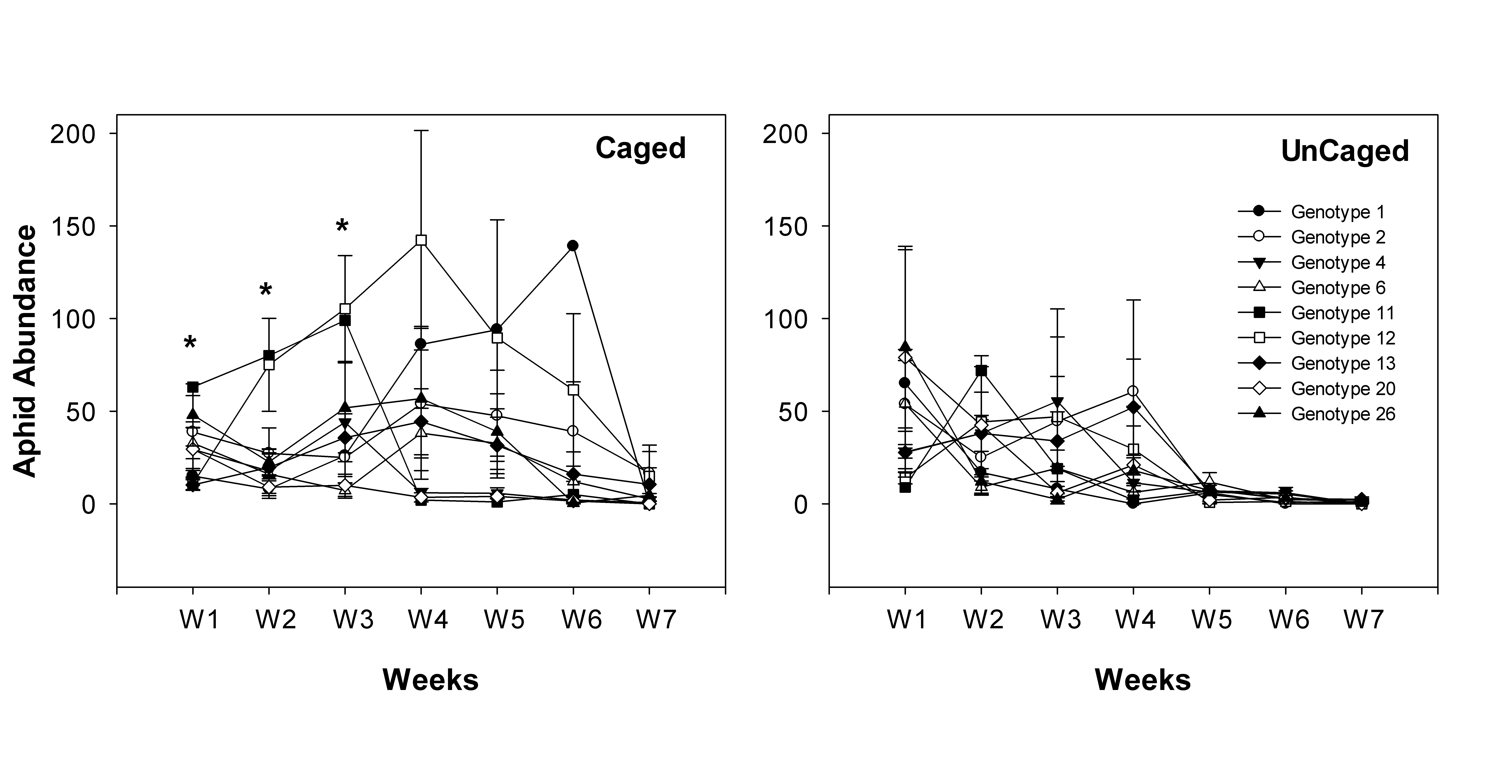

Figure 2.

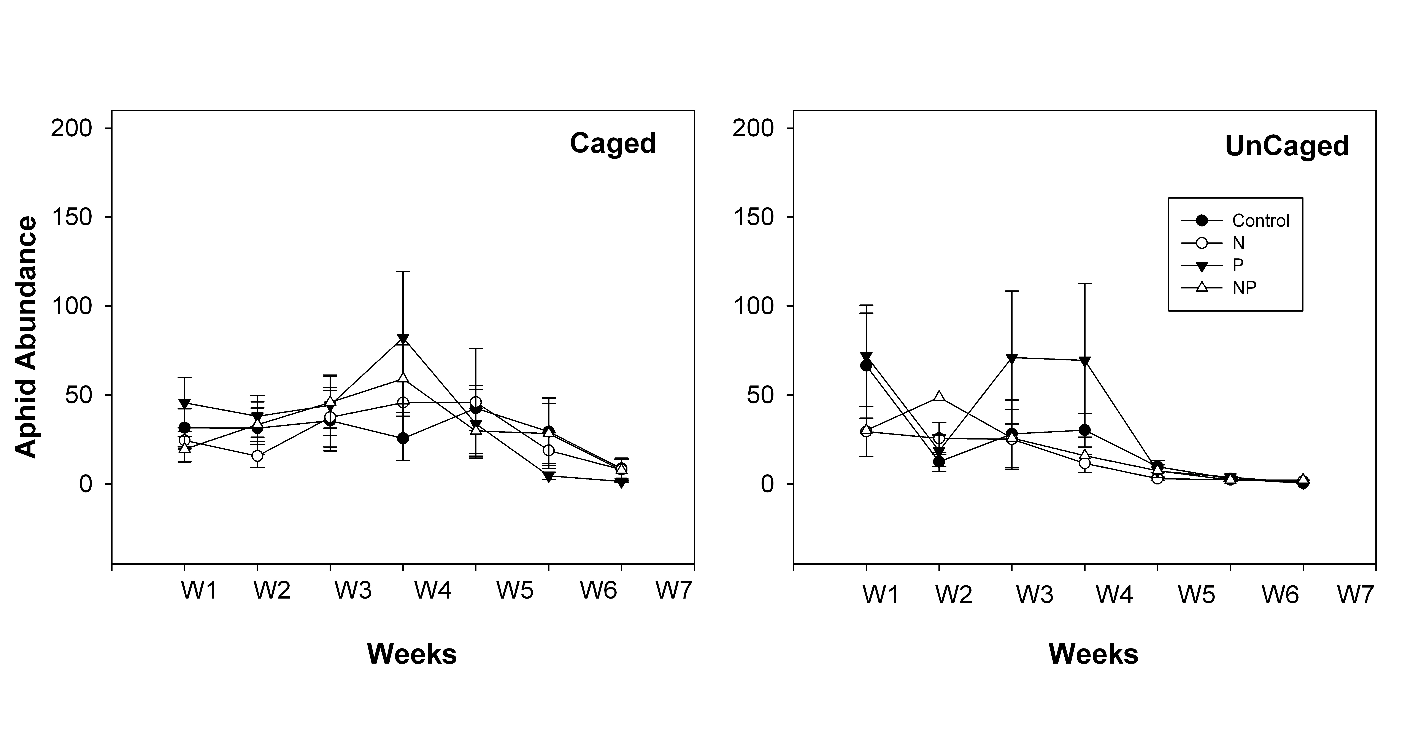

Figure 3.

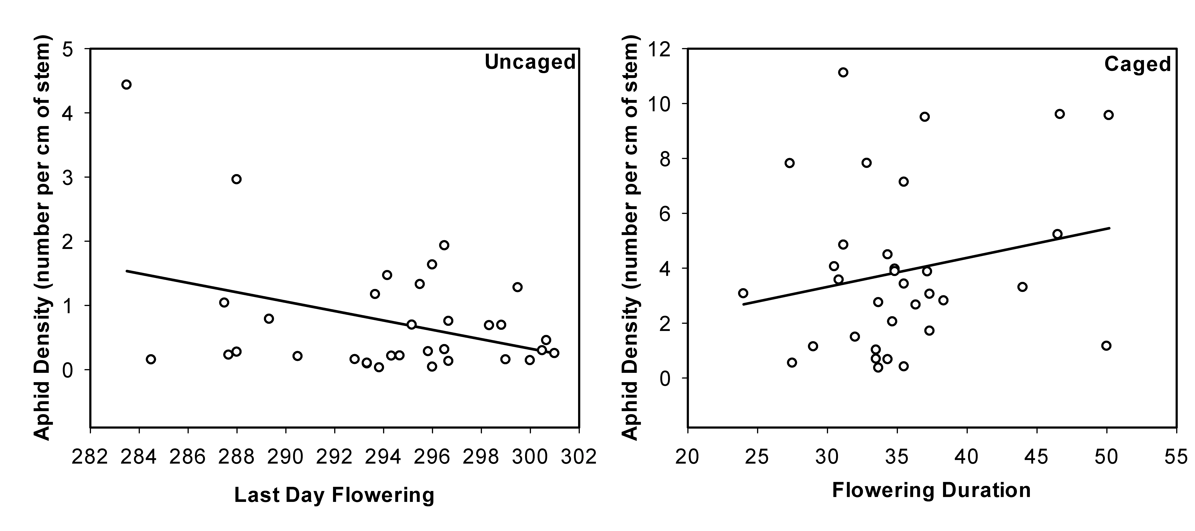

Figure 4.

