The Evaluation of a Process Model Questionnaire for the Measurement of
Emotion Regulation Processes in Middle Childhood

A Dissertation Presented for the
Doctor of Philosophy
Degree
The University of Tennessee, Knoxville

Alayna Joi Watson
August 2024
DEDICATION
To the children and families I have had the honor of listening to, learning from, and walking alongside; you have taught me an incomprehensible amount of compassion and perspective.
I could not be more grateful to do this work.

To my not-so-little brothers, for being the first little ones I ever fell in love with teaching, guiding, and caring for.

To my parents, for showing me the meaning of working hard for everything you have and fighting your way into spaces despite people telling you that you don’t belong.
For believing in me when I didn’t have quite enough belief in myself.

And to my grandma, who always wanted there to be a “Dr. Watson” in the family.
I get to be the first. I wish you all were here to see me. I share this with you.

ACKNOWLEDGEMENTS
This dissertation encapsulates my belief that emotions—as messy, complex, and incomprehensible as they are—are the stuff of life. I have never experienced a more extensive range of emotions than I have as I’ve endured the journey toward this degree. I have several people to thank for their unconditional and unwavering support throughout five intense years, a global pandemic, and lots of unknowns. Words are insufficient to truly capture my gratitude.
Thank you to the clinical psychology program at the University of Tennessee, for creating an environment where I was able to learn, grow, and be exponentially curious about the science of being human.
Much appreciation to the faculty members and community professionals who both formally and informally provided me with invaluable friendship and mentoring. Specifically, Drs. Lettie Flores, Sarah Thompson, Jenn Bolden Bush, Renee Repka, Allison Elledge, Alden Gaertner, and Marisa Whitley.
Many thanks to my advisor, Dr. Chris Elledge, and my committee members, Drs. Todd Moore, Jenn Bolden Bush, and Lori Caudle, for their insight and guidance in the process of completing my dissertation.
Endlessly indebted to my fellow graduate students and lifelong friends who filled my time in graduate school with laughter and meaning. You all are incredible.
Finally, to my parents, Andrea and Roy. Without you, this would have been insurmountable. Thank you for your patience, your kindness, your prayers.

ABSTRACT
The capacity to regulate emotion in adaptive ways is associated with more positive outcomes across academic, social, and emotional functioning, yet significant limitations exist in the measurement of emotion regulation in childhood. Existing measures of emotion regulation developed for children only capture a limited number of emotion regulation processes; few measures integrate an empirically supported theoretical model of emotion regulation in the structure of the measure. The goal of the present study was to validate a comprehensive, theoretically informed self-report measure of emotion regulation processes for school age children, the Emotion Regulation Process Scale for Children (ERPS-C). The psychometric properties of this new measure were examined based on scores from a sample of 308 third- and fourth-grade children recruited from several elementary schools. Participants completed the ERPS-C in addition to existing self- and parent-report measures of emotion regulation and existing measures of coping skills, internalizing distress, positive/negative emotions, and peer relations. Confirmatory factor analysis indicated support for a nine-factor, 39-item measure. Supplemental analyses revealed expected relationships between participant scores on the ERPS-C and scores on existing measures of emotion regulation and socioemotional functioning, confirming its convergent validity. The ERPS-C also displayed measurement invariance over two time points and several subscales of the measure at Time 1 uniquely predicted socioemotional outcomes at Time 2. The present study demonstrates some reliability and validity in the ERPS-C and suggests further exploration and refinement of the measure may help it be a valuable tool for assessing emotion regulation processes in children.

TABLE OF CONTENTS
CHAPTER ONE: INTRODUCTION 1
Emotion Regulation 1
Emotion Regulation Strategies 3
Measurement of Emotion Regulation 5
Theoretical Framework of Emotion Regulation 6
CHAPTER TWO: THE PRESENT STUDY 8
CHAPTER THREE: METHODOLOGY 11
CHAPTER FOUR: DATA ANALYSIS 16
CHAPTER FIVE: RESULTS 19
CHAPTER SIX: DISCUSSION AND LIMITATIONS 28
Discussion 28
Limitations 32
CHAPTER SEVEN: CONCLUSIONS AND FUTURE RESEARCH 34
LIST OF REFERENCES 35
APPENDIX OF TABLES AND FIGURES 45
APPENDIX OF STUDY MEASURES 70
VITA 97

LIST OF TABLES
Table 1. Description of processes and strategies in the ERPS-C 45
Table 2. Descriptive information for observed variables in Cohorts 1 and 2 46
Table 3. Correlations among observed variables and primary study variables from the ERPS-C 47
Table 4. Factor loadings for the final ERPS-C CFA model 48
Table 5. Reliability coefficient for factors of the ERPS-C 49
Table 6. Correlations among latent factors on the ERPS-C and the ERQ-CA 50
Table 7. Regression examining the ERPS-C latent factors and child-reported ER 51
Table 8. Correlations among latent factors on the ERPS-C and the ERC 52
Table 9. Correlations among latent factors on the ERPS-C and the SRCM-C 53
Table 10. Regression examining the ERPS-C latent factors and child-reported coping 54
Table 11. Correlations among latent factors on the ERPS-C and the PROMIS-A-SF and PROMIS-D-SF 55
Table 12. Regression examining the ERPS-C latent factors and child-reported internalizing symptoms 56
Table 13. Correlations among latent factors on the ERPS-C and the RPQ 57
Table 14. Regression examining the ERPS-C latent factors and child-reported reactive aggression 58
Table 15. Correlations among latent factors on the ERPS-C and the PANAS-C 59
Table 16. Regression examining the ERPS-C latent factors and child-reported positive and negative affect 60
Table 17. Correlations among latent factors on the ERPS-C and the PROMIS-PR-SF 61
Table 18. Regression examining the ERPS-C latent factors and child reported peer relationships 62
Table 19. Longitudinal measurement invariance model fit statistics for the ERPS-C 63
Table 20. Correlations among ERPS-C latent factors at Time 1 and Time 2 64
Table 21. Model fit statistics for structural equation models examining predictive validity of the ERPS-C in relation to socioemotional functioning 65
Table 22. Regression examining the ERPS-C at Time 1 predicting child-reported socioemotional outcomes at Time 2 66

LIST OF FIGURES
Figure 1: Diagram of emotion regulation processes and strategiese; partially referenced from the Process Model of Emotion Regulation (Gross, 1998) 67
Figure 2: Example CFA Model for Goal 1 68
Figure 3: Final Figural Model for the ERPS-C 69

CHAPTER ONE
INTRODUCTION

Emotion Regulation
Individuals routinely face circumstances that elicit a wide range of negative or positive emotions. The experience of an emotion can activate a variety of systems (e.g., attention, memory, motivation, motor) that coordinate responses to environmental stimuli (Levenson, 1999). The magnitude and duration of an affective response to stimuli may not always be optimal to a person’s needs or goals. For instance, a child arguing with their peer at school may incur behavioral consequences when their reaction is to yell or fight out of anger; a person experiencing high levels of anxiety may have a difficult time effectively completing their high-stakes work presentation. The ability to respond adaptively to emotion eliciting stimuli is necessary for adequate psychological, social, academic, and occupational functioning. Methods by which individuals manage and change if, when, and how emotions are experienced and expressed are described as emotion regulation (Gross, 2014). Processes of emotion regulation can involve the up-regulation or down-regulation of positive or negative emotions and can be automatic or effortful in nature (Campbell-Sills, Ellard, & Barlow, 2014; Gross & Thompson, 2007). Emotion regulation has emerged as an impactful affective construct in the study of children’s psychological and behavioral functioning over the last few decades (Webb, Miles, & Sheeran, 2012). A flood of empirical research has debated the conceptual definition of emotion regulation, its theoretical underpinnings, differentiation from related constructs, various methods used to employ it, its impact on psychopathology and physical health, and its development over the human lifespan (Gross, 2013).
The capacity to regulate emotion is thought to emerge in early childhood—typically developed infants and toddlers are aware of their own distress and can make attempts to self-soothe (Eisenberg et al., 2001; Blandon et al., 2008). During this developmental period, emotion regulation is largely facilitated via caregivers (e.g., comforting a crying child), a relational process which serves to model regulatory practices so that children can increasingly deploy these skills independently (Eisenberg, Cumberland, & Spinrad, 1998; Eisenberg & Sulik, 2012; Thompson, 1994). In early childhood, children’s general understanding of emotions becomes more robust, including more advanced skills in assessing emotionally arousing situations and determining causes and consequences of their own responses to such situations (Gullone, Hughes, King, & Tonge, 2010). Additionally, related self-regulatory habits and executive functioning skills are also emerging (Eisenberg, Hofer, Sulik, & Spinrad, 2015); effortful control of one’s own emotional and behavioral responses via increasingly internal cognitive processes continues to develop from early childhood into adolescence (Eisenberg, Spinrad, & Eggum, 2010). The successful transition into increasingly structured environments as children progress through diverse academic and social contexts requires the ability to properly regulate in emotionally arousing situations (Blandon et al., 2008).
Deficits in the effective use of emotion regulation strategies are associated with the development of greater internalizing problems (i.e., anxiety and depression), externalizing behaviors (i.e., impulsive and disruptive behavior), victimization, and peer conflict, directly impacting a child’s academic success, social functioning, and overall psychological health (Eisenberg, Spinrad, & Eggum, 2014; Gardner et al., 2017). Conversely, the adaptive use of emotion regulation strategies has been found to promote positive psychological and behavioral functioning (e.g., decreased anxiety symptoms, depressive symptoms, and externalizing behaviors) and serve as a protective factor for children predisposed to mental health concerns due to genetic vulnerabilities (e.g., parental mental health challenges) or environmental adversity (e.g., child maltreatment; Daniel, Abdel-Baki, & Hall, 2020). As early and middle childhood subsume the initial development of emotion regulation capabilities, the measurement of emotion regulation and subsequent increased understanding of the refinement of adaptive emotion regulation processes is critical to the development of effective preventative and therapeutic interventions that may target emotion regulation in youth. Acquisition of adaptive emotion regulation abilities may be particularly critical in this time period prior to entering adolescence, where shifting social and academic demands emerge alongside heightened emotional reactivity, increased risk-taking behaviors, and greater impulsivity (Young, Sandman, & Craske, 2019).

Emotion Regulation Strategies
Comprehensive measurement of emotion regulation must consider the different functions of emotion regulation and the diversity of emotion regulation processes and strategies subsumed under particular functional domains. Various methods of regulating emotions have been identified in the literature as more or less adaptive. Emotion regulation strategies like cognitive reappraisal and problem solving are thought to be adaptive strategies for modulating emotions and are often associated with lower internalizing symptoms, lower experiences of negative affect, and increased interpersonal functioning (Aldao, Nolen-Hoeksema, & Schweizer, 2010; Goldin, McRae, Rame, & Gross, 2007; Richards & Gross, 2000). Cognitive reappraisal describes the ability to alter one’s thinking about a situation to diminish the intensity or duration of an emotional response. The ability to develop more benign or positive perceptions of emotionally arousing situations via reappraisal can reduce the level of situational distress (Gross, 1998). Deficits in the ability to shift one’s thinking about stressful situations has been tied to several theoretical models of anxiety and mood disorders (Beck, 1976; Clark, 1986). Problem solving efforts involve intentional efforts to alter a stressful situation or manage its consequences. The modification or removal of stressors through the deployment of problem-solving strategies is thought to reduce the intensity or duration of a negative affective response (Aldao, Nolen-Hoeksema, & Schweizer, 2010). Alternatively, poorly developed skills in problem solving have also been theoretically and empirically linked to psychopathology, including mood and anxiety disorders (Chang, Downey, & Salata, 2004; Gotlib & Arsanow, 1979; Kaslow, Tanenbaum, Abramson, Peterson, & Seligman, 1983).
Alternatively, utilizing suppression, avoidance, or rumination as methods of regulating affective experiences are often considered maladaptive strategies for modulating emotion (Aldao, Nolen-Hoeksema, & Schweizer, 2010). Expressive suppression (i.e., efforts to reduce the outward expression of an emotion) and experiential suppression (i.e., efforts to suppress and avoid experience of an emotion) involve the intentional avoidance of emotional engagement that often leads to a short-term reduction in emotional intensity but long-term difficulties with increased emotional arousal and hypersensitivity to stressors (Gross, 1998; Gross & Thompson, 2007; Wenzlaff & Wegner, 2000). The pervasive use expressive or experiential suppression as a regulator strategy is considered a risk factor for mood and anxiety disorders, interpersonal challenges, and overall negative wellbeing (Gross, 2014; Gross & John, 2003). Rumination on the experience of a negative emotion or negative stimuli is also considered a less adaptive regulatory strategy (Aldao, Nolen-Hoeksema, & Schweizer, 2010). Sustained and repetitive focus on experiences of distress appear to disrupt adaptive problem solving and decision-making processes, as frequently identified in symptomology related to anxiety and depressive disorders (Nolen-Hoeksema, Stice, Wade, & Bohon, 2007).

Measurement of Emotion Regulation
As emotion dysregulation is increasingly recognized as a key deficit for individuals with mood and anxiety disorders, research on the measurement of emotion regulation has proliferated. However, significant limitations exist in the self-report measurement of emotion regulation strategies in children (Cracco, Durme, & Braet, 2015). For younger populations, typical methods for assessing psychological constructs involve both direct observational assessment and mixed informant sources. Other-report measures (e.g., from teachers, parents) of emotion regulation are informative yet limited to their assessment of observable behaviors. While it is often assumed that children may have developmentally appropriate limitations in reflecting on and reporting about their own complex intrapsychic processes, child reports of emotion-related symptoms (e.g., anxiety and depressive symptoms) are often found to be more predictive of meeting criteria for diagnostic outcomes than parent reports (Cosi, Canals, Hernandez-Martinez, & Vigil-Colet, 2010; Moretti, Fine, Haley, & Marriage, 1985). As regulatory processes for affective experiences are more internal in nature (e.g., choosing to think differently about an emotional situation, choosing to suppress the expression of an emotion), having adequate self-report assessment tools is necessary. This gap in existing research is significant, as understanding the use of emotion regulation processes during the developmental period may have significant implications for the field’s understanding of children’s emotion management choices.
Initial studies on how to measure regulatory processes in children focused on methods of coping with stress via problem-focused, emotion-focused, approach, and avoidance coping methods (De Boo, & Wicherts, 2009; Billings & Moos, 1981; Folkman & Lazarus, 1988). However, these measures focus generally on how children might manage environmental stressors rather than specifically examining the modulation of emotions. More recently, assessment tools have been developed to examine how children and adolescents regulate negative emotions. Measures like the Cognitive Emotion Regulation Questionnaire (Garnefski, Rieffe, Jellesma, & Terwogt, 2007), the Emotion Regulation Questionnaire for Children and Adolescents (Gullone & Taffe, 2012), the Children’s Response Styles Questionnaire (Abela, Brozina, & Haigh, 2002), and the Children’s Emotion Management Scale (Zeman, Shipman, & Suveg, 2002) are widely used and have adequate psychometric properties. However, most of these measures are limited in the number of emotion regulation strategies they assess (e.g., assessing cognitive reappraisal and expressive suppression only). Moreover, few existing measures of emotion regulation in children integrate an empirically supported theoretical model of emotion regulation in the structure of the measurement tool. For instance, the FEEL-KJ (Grob & Smolenski, 2005) measures a broad range of regulatory strategies while lacking a nuanced theoretical structure to organize its content.

Theoretical Framework of Emotion Regulation
A well-established theoretical model for the utilization of emotion regulation processes exists (Gross, 1998). Gross’s Process Model and Extended Process Model (PM and EPM; Gross 1998, 2007) provide a framework that places the deployment of regulatory strategies within a temporal sequence. This model posits that individuals assess and implement emotion regulation strategies that are either antecedent-focused (occurring before an emotion response is generated) or response-focused (occurring after an emotional response is generated), in order to manage emotions in ways that promote goal attainment. First, an emotionally stimulating circumstance arises (situation), after which an individual must apply their focus (attention) and make interpretations about the situation (appraisal) based on their goals. This sequence yields an emotional reaction (response) which may subsequently alter the situation and re-start the process (Dryman & Heimberg, 2018; Gross, 1998). Throughout this sequence, the Process Model places particular emotion regulation strategies into five categories of action: (1) selecting situations that elicit particular emotions, (2) modifying the emotion-eliciting situation itself, (3) shifting one’s attention to different aspects of an emotion-eliciting situation, (4) altering one’s cognitions about the emotion-eliciting situation, and (5) modulating one’s emotional responses to the situation (Gross, 1998; 2015). Table 1 describes some specific strategies classified and defined within their regulatory process category. The structure of this framework is outlined in extant literature as explicative of the role that emotion dysregulation can play in the presence of psychopathology (Gross, 2015). While limited research has examined the applicability of this entire model in emotion regulation development or emotion regulation use in young children, existing studies on child emotion regulation have operationalized some strategies within Gross’s Process Model (e.g., Cognitive Reappraisal, Expressive Suppression; Gullone, Hughes, King, & Tonge, 2010).

CHAPTER TWO
THE PRESENT STUDY
The proposed dissertation study was designed to develop and validate a theoretically informed self-report measure of emotion regulation processes (Emotion Regulation Process Scale for Children; ERPS-C) in middle childhood. The aim of the current investigation was to address several limitations pertaining to the measurement of emotion regulation. First, the proposed measure strives to assess several emotion regulation strategies representative of the various domains of emotion regulation processes. Existing measures often assess only two or three categories of emotion regulation strategies (e.g., the ERQ-CA assessing expressive suppression and cognitive reappraisal only), despite the recognition of other emotion regulation processes. Second, the proposed measure was designed to incorporate Gross’s Process Model of emotion regulation, accounting for the five steps of the emotion regulation process and their related strategies (Gross, 1998; 2015). Existing measures often organize strategies into adaptive and maladaptive factor structures, without integrating a more comprehensive framework. This framework has been established in the literature on emotion regulation across the lifespan, but few studies have examined its proficiency in capturing emotion regulation within a specific developmental age group. Finally, the proposed measure was developed and validated in a sample of third and fourth grade children, ranging from approximately eight to ten years old. Existing self-report measures available for children of this age are limited, though this period is a critical developmental range in which many regulatory strategies may emerge and be utilized in increasingly complex social contexts (Gullone, Hughes, King, & Tonge, 2010). As such, this study aims to validate a measure developmentally appropriate for young school-age children.
Goal 1. The first project goal was to validate the ERPS-C in a large sample of elementary school-aged children and to examine the psychometric properties of the measure. The internal structure of the ERPS-C was examined, with the goal of replicating a specified thirteen-factor structure (Process Model; Gross, 1998; 2015) explicated in Figure 1, via confirmatory factor analysis (CFA). The proposed CFA model is displayed in Figure 2.
Goal 2. Second, this project intended to establish the criterion validity of the ERPS-C by examining whether emotion regulations processes measured by the ERPS-C are associated with other established measures of emotion regulation. To evaluate the criterion validity of the ERPS-C, we investigated its relation to the Emotion Regulation Checklist (ERC; parent-report; Shields & Cicchetti, 1997) and the Emotion Regulation Questionnaire for Children and Adolescents (ERQ-CA; self-report; Gullone & Taffe, 2012). Overall, we expected positive associations between the adaptive strategies on the ERC and ERQ-CA (i.e., emotion regulation, cognitive reappraisal) and the ERPS-C (i.e., problem solving, cognitive reappraisal). We also expected positive associations between the maladaptive strategies on the ERC and ERQ-CA (i.e., negative lability, expressive suppression) and the ERPS-C (i.e., rumination, suppression).
This project also intended to establish the convergent validity of the ERPS-C by examining associations between subfactors of the proposed measure and several other measures of psychological and social functioning. As suggested by extant literature, we expected problem solving, reappraisal, and perspective taking (subfactors of the proposed ERPS-C measure) to be positively associated with self-reports of coping skills, positive emotions, and healthy social functioning. We expected problem solving, reappraisal, and perspective taking to be negatively associated with self-reports of anxiety, depressive symptoms, and negative emotions. Conversely, we expected rumination and suppression to be negatively associated with self-reports of coping skills, positive emotions, and peer relationships. We expected problem solving, reappraisal, and perspective taking to be positively associated with self-reports of anxiety, depressive symptoms, and negative emotions. The ERPS-C also strives to expand examination of relationships between emotion regulation strategies and related outcomes that have not been previously examined; we expected that situation selection strategies and distraction strategies would also be negatively associated with self-reports of anxiety, depressive symptoms, and negative emotions and positively associated with self-reports of coping skills, positive emotions, and peer relationships.
Goal 3. Third, this study aimed to examine the predictive validity of the ERPS-C by examining its longitudinal measurement invariance and determining whether scores on any specific subfactors of the ERPS-C at an initial timepoint would emerge as significant predictors of other measures of social and psychological functioning. Previous studies have indicated that the use of certain adaptive or maladaptive emotion regulation strategies is predictive of changes in internalizing symptoms (Aldao, Nolen-Hoeksema, & Schweizer, 2010; Nolen-Hoeksema, Stice, Wade, & Bohon, 2007). As such, we also expected that endorsement of utilizing ERPS-C subfactors problem solving and reappraisal would emerge as negative predictors of anxiety and depressive symptoms. Alternatively, we expected that endorsement of ERPS-C subfactors rumination and suppression would emerge as positive predictors of anxiety and depressive symptoms.

CHAPTER THREE
METHODOLOGY
Procedure
Participants were recruited from third and fourth grade classrooms within six elementary schools in Knox County. Excluded from the study were (1) children in self-contained special education classes and (2) children with a pervasive developmental disorder whose pattern of symptoms would inhibit them from being able to accurately answer study questions. Data collection occurred at two time points, in the spring of one academic year and fall of the next academic year. The University Institutional Review Board approved the project prior to the start of data collection. After acquiring principal approval from each school, project information was sent to teachers; this information included a description of the purpose of the study and procedures for teacher distribution of materials to their students. Teachers sent home consent forms to all students in their classroom. Returned child assent and parent consent forms were required for participation in the project.
The first cohort of participating children completed questionnaires in the spring semester of 2022 and again in the fall semester of 2022. Due to low rates of returned consent forms in the first recruitment effort, permission was granted to recruit again in the fall semester for an additional cohort of participants who completed questionnaires only in the fall semester of 2022. Questionnaires were completed in groups overseen by trained research assistants who read all instructions and items aloud. Parents completed one set of demographic forms and study questionnaires via paper measure packets sent home by teachers in an envelope. The assessment procedure for consented children was identical in both spring and fall data collections.

Participants
Data were collected from 308 third and fourth grade students across six public elementary schools in the southeastern United States. Participants were recruited in two different cohorts; Cohort 1 participated in a Time 1 data collection in the Spring and a Time 2 data collection in the Fall, while Cohort 2 participated only in a Time 1 data collection in the Fall. Cohort 1 was comprised of 196 students and Cohort 2 was comprised of 112 students. The total sample of participants were 45.4% male and 54.6% female. Participants were between the ages of 8 and 12 years (M = 9.53 years, SD = .714). The majority of participants identified as White (68.8%), followed by mixed race (10.4%), Black (10.1%), Hispanic (8.0), 2.4% (Asian), and less than 1% identified as other in the racial/ethnic category. There were minor differences in the demographic makeup of Cohorts 1 and 2, with Cohort 2 being less White (6.3% less) and less male (6.9% less).
Measures
Development of Proposed Measure (ERPS-C). The newly developed Emotion Regulation Process Scale for Children (ERPS-C) aims to assess the use of emotion regulation strategies across antecedent-focused and response-focused domains. This measure was developed by the principal investigator via extensive review of the literature on the Process Model (Gross, 1998; 2015) of emotion regulation and additional empirical studies examining the model’s use in organizing the identification and implementation of various emotion regulation strategies (Allen & Windsor, 2019; Gullone, Hughes, King & Tonge, 2010; Webb, Miles, & Sheeran, 2012). Categorization of strategies within Gross’s process categories and descriptions of strategies were crafted based on existing descriptions. Expert feedback was elicited from other expert researchers in the field of child development and psychopathology; feedback on measure structure, language, and items was discussed and integrated as the lead researchers saw fit.
The proposed initial draft of the ERPS-C measure is a 43-item measure assessing a child’s tendency to engage in situation selection, situation modification, attentional deployment, cognitive change, and response modulation in order to regulate the occurrence of negative affect. Items are rated on a 5-point scale from 1 (Never) to 5 (Always). The 43 items on this measure fall across 13 sub-categories of emotion regulation processes. Within situation selection is (1) avoidance of negative elicitation and (2) seeking of positive elicitation. Within situation modification is (3) active problem solving and (4) reflective problem solving. Within attentional deployment is (5) positive distraction, (6) neutral distraction, (7) rumination on feelings, and (8) rumination on situation. Within cognitive change is (9) reappraisal of feeling, (10) reappraisal of situation, and (11) perspective taking. Finally, within response modulation is (12) expressive suppression and (13) experiential suppression. Table 1 describes the specific strategies classified and defined within each regulatory process category.
Emotion regulation (parent-report). The Emotion Regulation Checklist (ERC; Shields & Cicchetti, 1997) is a 24-item parent-report measure of children’s self-regulation. Items are rated on a 4-point scale from 1 (Never) to 4 (almost always) and assess a child’s use of emotion regulation as well as their emotional negativity and lability. Previous studies have found the ERC has acceptable internal consistency and validity (Shields & Cicchetti, 1997).
Emotion regulation (child-report). The Emotion Regulation Questionnaire for Children and Adolescents (ERQ-CA; Gullone & Taffe, 2012) is a 10-item self-report questionnaire measuring a child’s tendency to use expressive suppression and cognitive reappraisal as methods of regulating their emotions. Items are rated on a 5-point scale from 1 (completely disagree) to 5 (completely agree). Previous studies have found satisfactory internal consistency for both subscales as well as sound construct and convergent validity (Gullone & Taffe, 2012; Gullone, Hughes, King, & Tonge, 2010).
Coping skills. The Self-Report Coping Measure- Child Version (Causey & Dubow, 1992) is a 34-item measure that examines a child’s use of problem solving, social support seeking, internalizing habits, externalizing habits, and distancing habits in response to stressful situations. Items are scored on a 5-point scale from 1 (Never) to 5 (Always). Previous studies have found satisfactory internal consistency across all subscales in addition to adequate construct validity (Causey & Dubow, 1992).
Internalizing distress. The PROMIS-A-SF (8 items) assesses anxiety symptoms and the PROMIS-D-SF (8 items) assesses depressive symptoms. These measures come from the Patient-Reported Outcomes Measurement Information System (Irwin et al., 2010; Varni et al., 2013). Items are scored on a 5-point scale from 0 (Never) to 4 (Almost Always) and averaged. PROMIS measures were developed using state-of-the-art procedures for item selection and have undergone rigorous psychometric validation demonstrating good reliability and validity (Irwin et al., 2010; Varni et al., 2013).
Reactive aggression. A modified version of the Reactive Proactive Aggression Questionnaire (RPQ; Raine et al., 2006) measures reactive aggression and externalizing behaviors. The 11 items that make up the reactive aggression subscale will be sued for this study, with one item’s language being modified to fit the developmental level of our sample. The subscale will measure a child’s self-report of how often they engage in aggressive and externalized behavior in response to a perceived threat or provocation. Items are scored on a 5-point scale from 1 (Never) to 5 (Almost Always). The RPQ has proven to be a reliable and valid measure of proactive and reactive aggression in child and adolescent samples (Raine et al., 2006).
Positive and negative emotions. The Positive and Negative Affect Questionnaire-Child (PANAS-C, 20 items; Lauren et al., 1999; Watson, Clark, & Tellegen, 1988) measures the presence of positive and negative emotions. Children are provided with 20 emotion words (10 positive, 10 negative). Items are scored on a 5-point scale from Very Slightly or Not at All to A lot and children are asked to respond with how much they have felt this way [specific emotion] in the past few weeks. Previous studies have found satisfactory internal consistency for both the positive and negative affect subscales; adequate convergent validity has also been established (Hughes & Kendall, 2009; Lawlor et al., 2014; Schonert-Reichl & Lawlor, 2010).
Peer relationships. The PROMIS-PR-SF (De-Walt et al., 2013) assesses peer relationship functioning. This measure comes from the Patient-Reported Outcomes Measurement Information System and is specifically designed to measure peer relationships. The 8-item self-report measure assesses friendship quality and peer acceptance. Items are rated on a 5-point scale from 1 (Never) to 5 (Almost Always). PROMIS measures were developed using state-of-the-art procedures for item selection and have undergone rigorous psychometric validation; the PROMIS-PR-SF has demonstrated acceptable reliability and validity (Devine et al., 2018; DeWalt et al., 2013).

CHAPTER FOUR
DATA ANALYSIS
Descriptive statistics for observed variables and correlations among primary study variables were estimated using SPSS 29; primary Confirmatory Factor Analyses (CFAs) and structural models were estimated using Mplus 8.8. As analyses were based on Likert-scale responses that produce categorical (ordinal) data (Rhemtulla, Brosseau-Liard, & Savalei, 2012), robust weighted least-squares with mean and variance adjustment (WLSMV) estimator were used. This estimator is recommended when conducting confirmatory factor analysis with categorical data (Flora & Curran, 2004; Muthén, Du Toit, & Spisic, 1997); data containing missing values is listwise deleted. For confirmatory factor analyses, the factor identification method was used, setting the scale of each latent variance to 1.0 to obtain standardized estimates (T. D. Little, Slegers, & Card, 2006). Model fit for CFAs were evaluated using the criteria, CFI > .90, RMSEA < .08, and SRMR < .08 (Bentler, 1990; T. A. Brown, 2015; Hu & Bentler, 1999; T. D. Little, 2013).
To address Goal 1, confirmatory factor analysis was conducted to examine the measurement properties of the proposed model. Items measuring specific constructs were set to load onto latent constructs (proposed item subscales) informed by the theoretical model. The examination of modification indices indicated adjustments that could be made to the model to improve model fit. Specifically, proposed modifications with respect to correlating residuals between items with similar wording and items that appeared to load onto an additional factor. To address Goals 2 and 3 (establishment of convergent and predictive validity), confirmatory factor analyses and structural equation models were estimated to examine the cross-sectional and longitudinal associations between emotion regulation processes and measures of emotional, psychological, and social functioning.
For Goal 3, longitudinal CFA was utilized to examine the measurement invariance of the best fitting model to data from Cohort 1 across timepoints 1 and 2. This is done by continuously setting the equality of the measurement model parameters over time. First, the configural invariance model tested whether the same general pattern of factor loadings holds across time points. Next, the weak invariance model set corresponding factor loadings to be equal across time points. Finally, the strong invariance model equated corresponding factor loadings and thresholds to be equal across time points. At each level of invariance, the change in CFI and RMSEA were examined to determine whether there was a significant difference between the more and less restrictive model. Changes in CFI less than 0.01 and model RMSEA values falling within each other’s confidence interval were criteria for establishing each level of factorial invariance. To establish predictive validity of the ERPS-C, ten longitudinal structural equation models were estimated to examine whether scores on the latent factors of the ERPS-C at Time 1 significantly predicted changes in socioemotional constructs over time. ERPS-C subfactors and Time 1 scores on the dependent variable were simultaneously entered in regressions predicting Time 2 scores on the dependent variable. Confirmatory factor analysis models were estimated to establish factorial invariance of constructs over time prior to estimating SEM models following the same procedures outlined previously.
Treatment of Missing Data
Across demographic and child report variables, approximately 10% of data was missing, with the percentage of missing data ranging from 0 to 10.7%. In the case of collected parent measures, approximately 56% of participant parents completed and returned parent-report emotion regulation measures. As such, models utilizing parent data were run utilizing a subsample (n = 171) of participants whose parents completed and returned their measures. There were no significant demographic differences between this subsample of participants in comparison to the larger participant sample, aside from some difference in racial/ethnic makeup. The subsample of participants who turned in parent-report measures were 75.2% White, as opposed to the 68.8% White makeup of the entire sample.

CHAPTER FIVE
RESULTS
Descriptive Statistics
Descriptive statistics for observed variables in Cohorts 1 and 2 are presented in Table 2. Correlations among primary observed and latent study variables are presented in Table 3. Of note, participants identifying as female were significantly correlated with higher scores on the ERPS-C Rumination (r = .236, p < .001), the ERPS-C Expressive Suppression (r = .145, p = .040), the PANAS Negative Affect (r = .130, p = .035), the PROMIS-A-SF Anxiety (r = .192, p = .002), and the PROMIS-D Depression (r = .142, p = .023) subscales. Participant racial/ethnic minority status was significantly correlated with higher scores on the ERPS-C Experiential Suppression (r = .174, p = .020) and SRCM-C Distancing (r = .140, p = .037) subscales.
Primary Analyses
Study Goal 1: Factor Structure of the ERPS-C
Confirmatory factor analysis. The baseline theoretically informed thirteen-factor model for the full sample at Time 1 yielded error messages and out of bounds estimates (e.g., correlations greater than 1.0) that warranted closer examination of the factor structure. Several latent factors in the initial model of the ERPS-C were highly correlated: (1) Rumination on Feelings correlated with Rumination on Situation at .944; (2) Reappraisal of Feelings correlated with Reappraisal of Situation at 1.042; (3) Neutral Distraction correlated with Positive Distraction at 1.005; (4) Neutral Distraction correlated with Reflective Problem Solving at 1.248; and (5) Positive Distraction correlated with Reflective Problem Solving at 1.198. As such, initial modifications to the baseline model included collapsing latent subscales on the ERPS-C with high correlations. This yielded a nine-factor model with new latent subscales: (1) Rumination (Rumination on Feelings and Rumination on Situation), (2) Reappraisal (Reappraisal of Feelings and Reappraisal of Situation), and (3) Cognitive Distraction (Positive Distraction, Neutral Distraction, and Reflective Problem Solving). Combining these latent constructs resolved the initial error messages and eliminated correlations greater than 1.0; all factor loadings were significant at p < .001.
When examining the pattern of item loadings across each latent factor, a number of items did not perform well and were removed one at a time. Model fit and loadings were re-evaluated at each step. Items 3 (“I try not to do things that make me upset”), 4 (“When I feel upset, I try to remember that it’s okay to feel upset sometimes”), 6 (“When I feel upset, I think a lot about what I’m feeling”), and 24 (“When I feel upset, I make sure no one else knows how I feel”) were removed from the model, resulting in an improved pattern of factor loadings for latent factors and overall model fit. Additionally, item 42 (“When I feel upset, I think of what I could do to make things better”) appeared to load better on the Reappraisal factor rather than in its original designation on the Cognitive Distraction factor. As such, that item was moved to load onto Reappraisal. A final nine-factor, 39-item model was associated with good model fit (CFI = 0.930; RMSEA = 0.046; SRMR = 0.058). All factor loadings were significant (p < .0001) and ranged from .49 to .91. Correlations among latent factors ranged from -.24 to .82. Subsequent analyses and models for this study were estimated using this updated ERPS-C model. Correlations among latent factors and factor loadings from the final model of the ERPS-C are presented in Table 3 and Table 4, respectively. A visual representation of the final model is displayed in Figure 3.
Reliability. Inter-scale reliability of the ERPS-C’s subscales was calculated using McDonald’s omega, an equivalent of Cronbach’s alpha for ordinal data (Zumbo, Gadermann, & Zeisser, 2007). Omega coefficients ranged from .625 (Seeking Positive Elicitation) to .870 (Cognitive Distraction) and are reported in Table 5
Study Goal 2.1: Criterion Validity of the ERPS-C
To assess the ERPS-C’s relation to another child report measure of emotion regulation, correlations with the ERQ-CA were estimated via confirmatory factor analysis in the full sample at Time 1 data. Correlations are displayed in Table 6. Additionally, structural models were estimated to examine any unique associations between factors of the ERPS-C and the ERQ-CA. Regression coefficients are presented in Table 7. Results confirmed expected relationships: (1) scores on the ERPS-C Reappraisal subscale were significantly correlated with the Cognitive Reappraisal subscale on the ERQ-CA (r = .769, p < .001); (2) scores on the ERPS-C Expressive Suppression and Experiential Suppression subscales showed significant correlations with the Expressive Suppression subscale on the ERQ-CA (r = .721, p < .001; r = .252, p = .001). Results of the structural model revealed that scores on the ERPS-C Reappraisal subscale emerged as a unique and significant correlate with scores on the Cognitive Reappraisal subscale of the ERQ-CA (β = 1.112, p = .018).
Also examined was the relation between ERPS-C factors and parent-reported ERC factors. Due to the significant amount of missing parent report measures, these analyses were calculated with a subset of the full sample (n = 171) that included data solely from participants whose parents returned parent measures. Correlations from the confirmatory factor analysis are displayed in Table 8. Several expected relationships were found: (1) scores on the ERPS-C Seeking Positive Elicitation subscale were significantly negatively correlated with the Lability/Negativity subscale on the ERC (r = -.199, p = .023); (2) scores on the ERPS-C Active Problem Solving subscale were significantly negatively correlated with the Lability/Negativity subscale on the ERC (r = -.238, p = .006); (3) scores on the ERPS-C Cognitive Distraction subscale were significantly negatively correlated with the Lability/Negativity subscale on the ERC (r = -.241, p = .004); (4) scores on the ERPS-C Reappraisal subscale were significantly negatively correlated with the Lability/Negativity subscale on the ERC (r = -.200, p = .015); (5) scores on the ERPS-C Rumination subscale were significantly positively correlated with the Lability/Negativity subscale on the ERC (r = .201, p = .007); (6) scores on the ERPS-C Expressive Suppression subscale were significantly positively correlated with the Lability/Negativity subscale on the ERC (r = .287, p = .001); and (7) scores on the ERPS-C Experiential Suppression subscale were significantly positively correlated with the Lability/Negativity subscale on the ERC (r = .227, p = .008). No scores on any subscale of the ERPS-C yielded significant correlations with the broad Emotion Regulation subscale on the ERC. Results of the structural model examining unique associations between scores on the ERPS-C factors and subscales of the ERC did not converge. Lack of convergence was likely due an inadequate sample size to estimate this complex model.
Study Goal 2.2: Convergent Validity of the ERPS-C
To examine the ERPS-C’s relation to other child reports of socioemotional functioning, correlations with the SRCM-C, PROMIS-Anxiety, PROMIS-Depression, RPQ, PANAS-C, and PROMIS-Peer Relations were estimated via confirmatory factor analyses. Correlations for each model are displayed in Tables 9, 11, 13, 15, and 17. Scores on the ERPS-C subscale Avoidance of Negative Elicitation were significantly (p < .001) correlated with subscale scores measuring Problem Solving (r = .290) and Peer Relations (r = .250). Scores on the ERPS-C subscale Seeking of Positive Elicitation were significantly (p < .001) correlated with subscale scores measuring Problem Solving (r = .516), Social Support Seeking (r = .328), Positive Affect (r = .359), and Peer Relations (r = .480). Scores on the ERPS-C subscale Active Problem Solving were significantly (p < .001) correlated with subscale scores measuring Problem Solving (r = .572), Social Support Seeking (r = .375), Positive Affect (r = .365), and Peer Relations (r = .420). Scores on the ERPS-C subscale Cognitive Distraction were significantly (p < .001) correlated with subscale scores measuring Problem Solving (r = .459), Social Support Seeking (r = .414), Distancing (r = .367), Positive Affect (r = .422), and Peer Relations (r = .392). Scores on the ERPS-C subscale Rumination were significantly (p < .001) correlated with subscale scores measuring Internalized Coping, (r = .609), Externalized Coping (r = .359), Anxiety Symptoms (r = .541), Depressive Symptoms (r = .624), Reactive Aggression (r = .429), Positive Affect (r = -.217), and Negative Affect (r = .497). Scores on the ERPS-C subscale Reappraisal were significantly (p < .001) correlated with subscale scores measuring Problem Solving (r = .596), Social Support Seeking (r = .519), Distancing (r = .301), Positive Affect (r = .358), and Peer Relations (r = .429). Scores on the ERPS-C subscale Perspective Taking were significantly (p < .001) correlated with subscale scores measuring Problem Solving (r = .522), Social Support Seeking (r = .520), Positive Affect (r = .334), and Peer Relations (r = .271). Scores on the ERPS-C subscale Expressive Suppression were significantly (p < .001) correlated with subscale scores measuring Problem Solving (r = .308), Internalized Coping (r = .366), Distancing (r = .296), and Depressive Symptoms (r = .255). Scores on the ERPS-C subscale Experiential Suppression were significantly (p < .001) correlated with subscale scores measuring Problem Solving (r = .373), Social Support Seeking (r = .391), Distancing (r = .469), and Peer Relations (r = .272).
Structural models were again estimated to examine any unique associations between factors of the ERPS-C and the aforementioned child-report measures of socioemotional functioning. Regression coefficients for each model are presented in Tables 10, 12, 14, 16, and 18. Results of the structural model revealed that scores on the ERPS-C Seeking Positive Elicitation subscale emerged as a unique and significant correlate with scores on the Problem Solving subscale of the SRCM-C (β = .586, p = .044) and the PROMIS-PR-SF Peer Relations scale (β = .607, p = .035). Scores on the ERPS-C Cognitive Distraction subscale emerged as a unique and significant correlate with scores on the Distancing subscale of the SRCM-C (β = .423, p = .035). Scores on the ERPS-C Rumination subscale emerged as a unique and significant correlate with scores on the Internalizing subscale of the SRCM-C (β = .626, p < .001), the Externalizing subscale of the SRCM-C (β = .399, p = .001), the RPQ Reactive Aggression scale (β = .504, p < .000), the PROMIS-A Anxiety scale (β = .544, p = .008), the PROMIS-D Depression scale (β = .593, p = .001), and PANAS-C Negative Affect scale (β = .522, p < .000). Lastly, scores on the ERPS-C Perspective Taking subscale emerged as a unique and significant correlate with scores on the Problem Solving subscale of the SRCM-C (β = .400, p = .010), the Social Support Seeking subscale of the SRCM-C (β = .346, p = .003), the Internalizing subscale of the SRCM-C (β = .290, p = .027), and the PANAS-C Positive Affect Scale (β = .310, p = .014).
Study Goal 3: Predictive validity of the ERPS-C
Measurement invariance across time points. To establish factorial invariance of the ERPS-C across two time points, fit of the model at each separate time point was first estimated. Model fit values were acceptable for both Time 1 (CFI = 0.931; RMSEA = 0.047; SRMR = 0.069) and Time 2 (CFI = 0.920; RMSEA = 0.062; SRMR = 0.072), allowing for further examination of invariance. Fit of the configural model was also acceptable (CFI = 0.924; RMSEA = 0.033; SRMR = 0.075) so factor loadings were then constrained to equality across tie in order to test for weak factorial invariance. The weak invariance model fit was also acceptable (CFI = 0.925; RMSEA = 0.033; SRMR = 0.078) and there were non-significant differences in CFI and RMSEA between the configural and weak invariance model, thus establishing no significant difference in item loadings over time. Next strong factorial invariance was tested by constraining item thresholds to equality across the two time points. The strong invariance model yielded acceptable fit indices (CFI = 0.925; RMSEA = 0.032; SRMR = 0.078) and demonstrated little change in CFI and RMSEA when moving from a model with item thresholds freely estimated to a model where item thresholds were constrained across time. The test of strong invariance revealed item thresholds were equivalent over time. Overall, these results suggest that the nine-factor model of the ERPS-C meets criteria for longitudinal factorial invariance over six months. Invariance model fit statistics for the ERPS-C are displayed in Table 19. Subfactors of the ERPS-C were also stable over time. Significant (p <.001) positive correlations emerged between all ERPS-C subfactors at Time 1 and Time 2. Subfactor correlations across time points are displayed in Table 20.
Finally, to establish predictive validity of the ERPS-C, longitudinal structural models were estimated to examine whether scores on the latent factors of the ERPS-C at Time 1 significantly predicted changes in assessed socioemotional constructs over time. Confirmatory factor models revealed constructs were invariant over time and model fit for weak invariance models was acceptable for anxiety and depression (CFI = .934; RMSEA = .025; SRMR = .077), aggression (CFI = 0.914; RMSEA = 0.027; SRMR = 0.082), problem solving (CFI = 0.931; RMSEA = 0.028; SRMR = 0.077), social support seeking (CFI = 0.930; RMSEA = 0.028; SRMR = 0.077), internalized coping (CFI = 0.901; RMSEA = 0.031; SRMR = 0.084), externalized coping (CFI = 0.926; RMSEA = 0.029; SRMR = 0.079), distancing (CFI = .894; RMSEA = .033; SRMR = .085), positive affect (CFI = .928; RMSEA = .027; SRMR = .079), negative affect (CFI = 0.919; RMSEA = 0.028; SRMR = 0.080), and peer relations (CFI = 0.928; RMSEA = 0.028; SRMR = 0.078).
Model fit for all subsequent structural models was also in the acceptable range; model fit information is presented in Table 21. Results from structural equation models are presented in Table 22. Results confirmed some expected relationships. Scores on the ERPS-C Avoidance of Negative Elicitation subscale emerged as a significant negative predictor of change in anxiety symptoms (β = -.505, p = .019) and negative affect (β = -.607, p = .001). Scores on the ERPS-C Seeking Positive Elicitation subscale emerged as a significant negative predictor of change in distancing coping skills (β = .516, p = .014). Scores on the ERPS-C Active Problem Solving subscale emerged as a significant negative predictor of change in reactive aggression (β = -1.228, p = .031), internalized coping skills (β = -1.151, p = .033), and externalized coping skills (β = -.723, p = .049). Scores on the ERPS-C Cognitive Distraction subscale emerged as a significant positive predictor of problem-solving skills (β = 1.920, p = .025), social support seeking (β = 1.516, p = .007), distancing coping skills (β = .867, p = .423), and positive affect (β = 1.129, p = .029). Scores on the ERPS-C Rumination subscale emerged as a significant negative predictor of positive affect (β = -.605, p = .004) and peer relations (β = -.426, p = .031), and as a significant positive predictor of negative affect (β = .676, p = .005). Scores on the ERPS-C Perspective Taking subscale emerged as a significant negative predictor of aggression (β = -.572, p = .039). Scores on the ERPS-C Expressive Suppression subscale emerged as a significant positive predictor of distancing coping skills (β = .781, p = .010). Finally, scores on the ERPS-C Experiential Suppression subscale emerged as a significant negative predictor of problem solving (β = -1.686, p = .040), social support seeking (β = -1.575, p = .026), positive affect (β = -1.471, p = .006), and peer relations (β = -1.569, p = .001). Structural models also revealed some unexpected positive relationships. Scores on the ERPS-C Reappraisal subscale emerged as a significant positive predictor of aggression (β = 2.218, p = .016). Scores on the ERPS-C Experiential Suppression subscale emerged as a significant negative predictor of distancing coping skills (β = -1.099, p = .016). Scores on the ERPS-C Expressive Suppression subscale emerged as a significant positive predictor of problem-solving skills (β = 1.259, p = .033), social support seeking (β = 1.208, p = .012), positive affect (β = .870, p = .014), and peer relations (β = .877, p = .002).

CHAPTER SIX
DISCUSSION AND LIMITATIONS

Discussion
The goal of the present study was to examine the psychometric properties of a theoretically based, comprehensive measure of emotion regulation processes in school-aged children, the ERPS-C. The successful development of this measure would help address significant gaps in the field regarding measuring emotion regulation in a broad, developmentally appropriate, and theoretically informed manner. Confirmatory factor analysis indicated that the structure of the ERPS-C is best represented by a 9-factor model, as opposed to the theoretically imposed 13 factor model (Gross, 1998). Additionally, no higher order latent factors emerged in a well-fitting model to adequately represent Gross’s theorized temporal categories (antecedent-focused and response-focused) or overarching groups of processes (e.g., Situation Modification, Attentional Deployment). Examination of the proposed factor structure indicates that fewer distinct emotion regulation processes emerged across identified domains of regulation in this sample of 3rd and 4th grade children. Specifically, the best fitting CFA model suggests that (1) Neutral Distraction, Positive Distraction, and Reflective Problem Solving, (2) Reappraisal on Feelings and Reappraisal on Situation, and (3) Rumination on Feelings and Rumination on Situation were each correlated highly enough to suggest that their items may be capturing a single construct.
This collapse in previously distinct categories of regulatory processes may suggest a less nuanced understanding or employment of emotion regulation processes in school-age children. Empirical literature suggests that preschool and school-age children largely begin to learn and adopt regulatory processes by way of observation and socialization; children are first influenced in regulating their emotions via emotional expression and modulation being modeled and encouraged in the environment (Cole, Michel, & O’Donnell Teti, 1994). As such, many initial regulatory processes practiced by children in infancy, toddlerhood, and early childhood are behavioral in nature (e.g., soothing by seeking comforting touch). Advances in cognitive development and the ability to self-reflect on behavior, thoughts, and emotions develops across the lifespan; the use of increasingly internal cognitive processes to effortfully control one’s own emotional and behavioral responses continues to develop from early childhood into adolescence (Eisenberg, Spinrad, & Eggum, 2010). Of note, several of the identified emotion regulation processes captured in the ERPS-C are fairly cognitive in nature and may entail more mature metacognitive abilities in order to both be aware of their deployment and adequately speak to utilizing them. For example, a child’s ability to differentiate between thinking differently (reappraising) about a situation versus reappraising their emotions about a situation may not be well-developed. Similarly, the capacity to differentiate whether a ruminative capacity is directed towards an emotionally arousing situation or the emotions being aroused may be limited.
The regulatory processes captured in the ERPS-C’s Positive Distraction, Neutral Distraction, and Reflective Problem Solving subfactors created an aggregate subfactor. Given the cognitive capacity required to engage in each of these strategies, it seems appropriate to speculate that thinking about or developing plans to solve problems may be conceptualized as a form of distraction in a less developmentally mature sample. Furthermore, the extent to which a school-age child is able to explicitly differentiate between neutral and positive forms of distraction may be limited. In summation, it is likely that the defined regulatory processes within the ERPS-C’s original theoretically informed model are more specific than what can be demonstrated in a sample of school-age children. One might argue that Gross’s five overarching categories of regulatory processes may contain fewer distinct methods in an earlier developmental sample than what has emerged in empirical studies within adult populations.
This study did establish the criterion and convergent validity of the ERPS-C. Subfactors on the child-report ERQ-CA (Cognitive Reappraisal, Expressive Suppression) were highly positively correlated with subfactors on the ERPS-C with similar item content (Reappraisal, Expressive Suppression). Additionally, scores on the child-report ERPS-C subfactors displayed expected associations with the Lability/Negativity subscale of the parent-report ERC. More adaptive regulatory processes on the ERPS-C (Seeking Positive Elicitation, Active Problem Solving) were negatively correlated with scores on the ERC Lability/Negativity subscale while less adaptive regulatory processes on the ERPS-C (Rumination, Expressive Suppression) were positively correlated with the Lability/Negativity subscale of the ERC. Associations were not found between subfactors of the ERPS-C and the Emotion Regulation subscale of the parent-report ERC. This may be due to the broad nature of the ERC’s Emotion Regulation subscale capturing varied emotion regulation strategies, which makes it difficult to map on to the much more specified processes measured in the ERPS-C.
Further, the ERPS-C’s convergent validity was established in examination of the measure’s associations with other indicators of socioemotional functioning and distress. Significant relationships were found amongst more adaptive regulatory processes on the ERPS-C (e.g., Seeking Positive Elicitation, Active Problem Solving, Perspective Taking) with scores on measures of more adaptive coping skills and functioning (e.g., Problem Solving, Social Support Seeking, Peer Relations). This is consistent with extant literature suggesting that adaptive use of emotion regulation strategies has been associated with positive psychological and behavioral functioning (e.g., decreased anxiety symptoms, depressive symptoms, and externalizing behaviors) (Daniel, Abdel-Baki, & Hall, 2020; Eisenberg, Spinrad, & Eggum, 2014; Gardner et al., 2017). Additionally, significant relationships emerged among subfactors of the ERPS-C capturing less adaptive regulatory processes (e.g., Rumination, Expressive Suppression) and more negative socioemotional constructs (e.g., Anxiety, Depression, Internalized Coping, Negative Affect). This is also consistent with previous studies suggesting that the use of maladaptive emotion regulation strategies is associated with greater internalizing symptoms and poorer socioemotional functioning (Garnefski, Kraaij, & Spinhoven, 2001; Young, Sandman, & Craske, 2019). These theoretically expected relationships suggest that the ERPS-C is convergently valid in capturing nuanced adaptive and maladaptive regulatory processes within the sample.
Finally, examination of the ERPS-C model’s measurement invariance established that the same factor structure identified in the initial Study Goal 1 confirmatory factor analysis fit the data at both time points for Cohort 1. As such, the ERPS-C appears to consistently measure the same nine regulatory processes across a six-month time period within the sample. The ERPS-C also displays some predictive validity across time in relation to several categories of social and emotional functioning. Generally, scores on more adaptive subscales of the ERPS-C (e.g., Active Problem Solving, Perspective Taking) emerged as significant unique negative predictors of change in less positive domains of functioning (e.g., reactive aggression, internalized coping, externalized coping). Conversely, scores on less adaptive subscales of the ERPS-C (e.g., Rumination, Experiential Suppression) emerged as significant unique negative predictors of change in more positive domains of functioning (e.g., positive affect, peer relations, problem solving, social support seeking). Although hypothesized that scores on the ERPS-C would be significantly predictive of change in internalizing symptoms, significant relationships between scores on ERPS-C subscales and measures of anxiety and depression did not emerge. Research suggests that utilization of emotion regulation strategies such as rumination and suppression is predictive of internalizing symptoms (Eisenberg, Spinrad, & Eggum, 2014; Gardner et al., 2017); while significant correlations existed between these variables in our study within a single timepoint, the longitudinal data was not supportive. Additional unexpected findings from the longitudinal analyses included scores on the Reappraisal subscale of the ERPS-C positively predicting change in aggression. Within our single timepoint analyses, scores on the Reappraisal subscale performed as expected and exhibited negative relationships with aggression and other maladaptive functioning domains (e.g., anxiety, depression). Further, scores on the Expressive Suppression subscale positively predicted change in problem solving, social support seeking, positive affect, and peer relations. This may suggest that a child’s use of suppression to manage emotional responses temporarily reduces emotionality and allows for engagement in other more adaptive habits (e.g., seeking out social support, engaging positively with peers). Longitudinal analyses spanning a greater amount of time might indicate more expected positive relationships between a child’s use of suppression and maladaptive functioning.

Limitations
While the results of this study do provide psychometric support for the ERPS-C, several limitations should be acknowledged. Foremost, the sample size for the study is small relative to the complexity of the analyses and models estimated. Replicating these models within a larger sample of school-age children would strengthen the validity of the measure and potentially allow for further refinement in its factor structure. Limitations in sample size and lack of returned measures from parents also inhibited the examination of the ERPS-C in relation to an existing parent measure of emotion regulation. In terms of limitations in the measure, the ERPS-C did not display overwhelmingly adequate internal consistency. McDonald’s omega coefficients for the ERPS-C’s subscale factors were largely in the questionable to acceptable range. This is likely partially due to the small number (e.g., only two or three) of items existing on some of the pruned subfactors in the final CFA model. Existing research has established that children and adults alike employ varying regulatory processes depending on the specific emotion experienced or anticipated (Gross, 2007). While we know that generally regulatory efforts in daily life are typically directed towards managing negative emotions, it may be beneficial for measures of emotion regulation to capture the use of strategies across specific and varied emotions. The ERPS-C was designed to broadly capture how children may choose to regulate any negative affective arousal. Future iterations of the ERPS-C could be developed to better examine regulatory process use across the emotional spectrum in a more specific way. Finally, while our items were developed at an appropriate reading level for the sample, the final version of the ERPS-C is a lengthy measure at 39 items. Utility of this measure in research and some clinical contexts may be limited due to the length and resources required to administer it.

CHAPTER SEVEN
CONCLUSIONS AND FUTURE RESEARCH
Overall, the results of this study pose the Emotion Regulation Process Scale for Children (ERPS-C) as a 39-item child-report measure capturing nine domains of emotion regulation processes informed by Gross’s Process Model of emotion regulation. While the limited sample size and complex factor structure of the model yielded some limited reliability coefficients for the subscales, good model fit, established convergent validity, and factorial measurement invariance over time suggest that the ERPS-C should continue to be examined as a comprehensive measure of emotion regulation processes in school-age children. The potential clinical utility of this measure is significant, especially considering the breadth of emotional and behavioral outcomes associated with adaptive emotion regulation use. Concerns for regulating emotions and adaptive use of affect management strategies are common in school-age children and may precede increasing concerns for mental health and behavior. The use of a measure such as the ERPS-C, comprehensive and developmentally appropriate in nature, may allow for clearer and more specific assessment of strengths and deficits in use of emotion regulation in childhood. This could better inform chosen interventions geared at addressing emotional lability, poor inhibition, and internalizing and externalizing behaviors. Future studies may test the measure within a larger and/or clinical sample and complete additional psychometric examinations to further refine and establish the structure of the measure. Additional research on this measure is necessary to support its use in the beneficial assessment of emotion regulation in children, both in research and clinical applications.

LIST OF REFERENCES
Abela, J., Brozina, K., & Haigh, E. (2002) An examination of the response styles theory of depression in third- and seventh-grade children: A short-term longitudinal study. Journal of Abnormal Child Psychology. 30(5), 515– 527. doi:https://doi.org/10.1023/A:1019873015594
Aldao, A., Nolen-Hoeksema, S., & Schweizer, S. (2010). Emotion-regulation strategies across psychopathology: A Meta-analytic review. Clinical Psychology Review, 30(2), 217-237. doi:https://doi.org/10.1016/j.cpr.2009.11.004
Allen, V. & Windsor, T. (2017). Age differences in the use of emotion regulation strategies derived from the process model of emotion regulation: a systematic review. Aging & Mental Health, 23(1), 1-14. https://doi.org/10.1080/13607863.2017.1396575.
Beck, A. T. (1976). Cognitive therapy and the emotional disorders. International Universities Press.
Bentler, P. M. (1990). Comparative fit indexes in structural models. Psychological Bulletin, 107(2), 238-246. doi:http://dx.doi.org/10.1037/0033-2909.107.2.238
Billings, A., & Moos, R. (1981). The role of coping responses and social resources in attenuating the stress of life events. Journal of Behavioral Medicine, 4(2), 129-157. doi:https://doi.org/10.1007/BF00844267
Blandon, A., Calkins, S., Keane, S., & O’Brien, M. (2008). Individual difference in trajectories of emotion regulation processes: The effects of maternal depressive symptomology and children’s physiological regulation. Developmental Psychology, 44(4), 1110-23. doi:https://doi.org/10.1037/0012-1649.44.4.1110
Brown, T. A. (2015). Confirmatory factor analysis for applied research (2nd ed. ed.): Guilford Press, New York, NY.
Campbell-Sills, L., Ellard, K. K., & Barlow, D. H. (2014). Emotion regulation in anxiety disorders. In J. J. Gross (Ed.), Handbook of emotion regulation (pp. 393–412). The Guilford Press.
Causey, D. L., & Dubow, E. F. (1992). Development of a self-report coping measure for elementary school children. Journal of Clinical Child Psychology, 21(1), 47–59. doi:https://doi.org/10.1207/s15374424jccp2101_8
Chang, E. C., Downey, C. A., & Salata, J. L. (2004). Social Problem Solving and Positive Psychological Functioning: Looking at the Positive Side of Problem Solving. In E. C. Chang, T. J. D'Zurilla, & L. J. Sanna (Eds.), Social problem solving: Theory, research, and training (pp. 99–116). American Psychological Association. doi:https://doi.org/10.1037/10805-006
Clark D. M. (1986). A cognitive approach to panic. Behaviour research and therapy, 24(4), 461–470. doi:https://doi.org/10.1016/0005-7967(86)90011-2
Cole, P. M., Michel, M. K., & Teti, L. O. (1994). The development of emotion regulation and dysregulation: a clinical perspective. Monographs of the Society for Research in Child Development, 59(2-3), 73–100.
Cosi, S., Canals, J., Hernández-Martinez, C., & Vigil-Colet, A. (2010). Parent–child agreement in SCARED and its relationship to anxiety symptoms. Journal of Anxiety Disorders, 24(1), 129–133. doi:https://doi.org/10.1016/j.janxdis.2009.09.008
Cracco, E., Van Durme, K., & Braet, C. (2015). Validation of the FEEL-KJ: An instrument to measure emotion regulation strategies in children and adolescents. PLoS ONE, 10(9), 1-18. doi:https://doi.org/10.1371/journal.pone.0137080
Daniel, S. K., Abdel-Baki, R., & Hall, G. B. (2020). The protective effect of emotion regulation on child and adolescent wellbeing. Journal of Child and Family Studies. Advance online publication. doi:https://doi.org/10.1007/s10826-020-01731-3
﻿ De Boo, G. M., & Wicherts, J. M. (2009). Assessing cognitive and behavioral coping strategies in children. Cognitive Therapy and Research, 33(1), 1-20. doi:https://doi.org/10.1007/s10608-007-9135-0
Devine, K., Willard, V., Hocking, M., Stapleton, J., Rotter, D., Bukowski, W., & Noll, R. (2018). PROMIS Peer Relationships Short Form: How well does self-report correlate with data from peers? Journal of Pediatric Psychology, 43(9), 1059-1067. doi:https://doi.org/10.1093/jpepsy/jsy038
Dewalt, D. A., Thissen, D., Stucky, B. D., Langer, M. M., Morgan Dewitt, E., Irwin, D. E., Lai, J. S., Yeatts, K. B., Gross, H. E., Taylor, O., & Varni, J. W. (2013). PROMIS Pediatric Peer Relationships Scale: development of a peer relationships item bank as part of social health measurement. Health psychology : official journal of the Division of Health Psychology, American Psychological Association, 32(10), 1093–1103. doi:https://doi.org/10.1037/a0032670
Dryman, M. T., & Heimberg, R. G. (2018). Emotion regulation in social anxiety and depression: a systematic review of expressive suppression and cognitive reappraisal. Clinical psychology review, 65, 17–42. doi:https://doi.org/10.1016/j.cpr.2018.07.004
Eisenberg, N., & Sulik, M. J. (2012). Emotion-Related Self-Regulation in Children. Teaching of Psychology, 39(1), 77-83. doi:https://doi.org/10.1177/0098628311430172
Eisenberg, N., Cumberland, A., & Spinrad, T. L. (1998). Parental Socialization of Emotion. Psychological inquiry, 9(4), 241–273. doi:https://doi.org/10.1207/s15327965pli0904_1
Eisenberg, N., Cumberland, A., Spinrad, T. L., Fabes, R. A., Shepard, S. A., Reiser, M., Murphy, B. C., Losoya, S. H., & Guthrie, I. K. (2001). The relations of regulation and emotionality to children’s externalizing and internalizing problem behavior. Child Development, 72(4), 1112-1134. doi: https://doi.org/10.1111/1467-8624.00337
Eisenberg, N., Hofer, C., Sulik, M. J., & Spinrad, T. L. (2014). Self-regulation, effortful control, and their socioemotional correlates. In J. J. Gross (Ed.), Handbook of emotion regulation (pp. 157–172). The Guilford Press.
Eisenberg, N., Spinrad, T., & Eggum, N. (2010). Emotion-related self-regulation and its relation to children’s maladjustment. Annual Review of Clinical Psychology, 6, 495-525. doi: https://doi.org/10.1146/annurev.clinpsy.121208.131208
Eisenberg, N., Hofer, C., Sulik, M. J., & Spinrad, T. L. (2014). Self-regulation, effortful control, and their socioemotional correlates. In J. J. Gross (Ed.), Handbook of emotion regulation (pp. 157–172). The Guilford Press.
Enders, C. K. (2010). Applied missing data analysis. Guilford Press.
Flora, D. B., & Curran, P. J. (2004). An Empirical Evaluation of Alternative Methods of Estimation for Confirmatory Factor Analysis With Ordinal Data. Psychological Methods, 9(4), 466–491. https://doi.org/10.1037/1082-989X.9.4.466
Folkman, S., & Lazarus, R. S. (1988). Coping as a mediator of emotion. Journal of Personality and Social Psychology, 54(3), 466–475. doi:https://doi.org/10.1037/0022-3514.54.3.466
﻿Gardner, S. E., Betts, L. R., Stiller, J., & Coates, J. (2017). The role of emotion regulation for coping with school-based peer-victimisa- tion in late childhood. Personality and Individual Differences, 107, 108–113. doi:https://doi.org/10.1016/j.paid.2016.11.035
Garnefski, N., Rieffe, C., Jellesma, F., & Terwogt, M. (2007). Cognitive emotion regulation strategies and emotional problems in 9-11-year-old children: The development of an instrument. European Child & Adolescent Psychiatry, 16(1), 1-9. doi:https://doi.org/10.1007/s00787-006-0562-3
Goldin, P.R., McRae, K., Ramel, W. & Gross, J.J. (2008) The Neural Bases of Emotion Regulation: Reappraisal and Suppression of Negative Emotion. Biological Psychiatry, 63, 577-586. doi:http://dx.doi.org/10.1016/j.biopsych.2007.05.031
Gotlib, I. H., & Asarnow, R. F. (1979). Interpersonal and impersonal problem-solving skills in mildly and clinically depressed university students. Journal of Consulting and Clinical Psychology, 47(1), 86–95. doi:https://doi.org/10.1037/0022-006X.47.1.86
Grob, A., & Smolenski, C. (2005). FEEL-KJ: Manual und Fragebogen zur Erhebung der Emotionsregulation bei Kindern und Jugendlichen.
﻿Gross, J. J., & John, O. P. (2003). Individual differences in two emotion regulation processes: implications for affect, relationships, and well-being. Journal of Personality and Social Psychology, 85(2), 348. doi:https://doi.org/10.1037/0022-3514.85.2.348
﻿﻿Gross, J. J. (1998). The emerging field of emotion regulation: an integrative review. Review of General Psychology. 2, 271–299. doi:https://doi.org/10.1037/1089-2680.2.3.271
Gross, J. J. (Ed.). (2007). Handbook of emotion regulation. The Guilford Press.
Gross, J. J. (2013). Emotion regulation: Taking stock and moving forward. Emotion, 13(3), 359–365. doi:https://doi.org/10.1037/a0032135
Gross, J. J. (Ed.). (2014). (2nd ed.). The Guilford Press.
Gross, J. J., & Thompson, R. A. (2007). Emotion Regulation: Conceptual Foundations. In J. J. Gross (Ed.), Handbook of emotion regulation (pp. 3–24). The Guilford Press.
﻿Gullone, E., & Taffe, J. (2012). The Emotion Regulation Questionnaire for Children and Adolescents (ERQ–CA): A psychometric evaluation. Psychological Assessment, 24(2), 409–417. doi:https://doi.org/10.1037/a0025777
﻿Gullone, E., Hughes, E. K., King, N. J., & Tonge, B. (2010). The normative development of emotion regulation strategy use in children and adolescents: a 2‐year follow‐up study. Journal of Child Psychology and Psychiatry, 51(5), 567–574. doi:https://doi. org/10.1111/j.1469-7610.2009.02183.x
Hu, L., & Bentler, P. M. (1999). Cutoff criteria for fit indexes in covariance structure analysis: Conventional criteria versus new alternatives. Structural Equation Modeling, 6(1), 1-55. doi:http://dx.doi.org/10.1080/10705519909540118
Hughes, A. A., & Kendall, P. C. (2009). Psychometric properties of the Positive and Negative Affect Scale for Children (PANAS-C) in children with anxiety disorders. Child Psychiatry and Human Development, 40(3), 343–352. doi:https://doi.org/10.1007/s10578-009-0130-4
Irwin, D. E., Stucky, B., Langer, M. M., Thissen, D., Dewitt, E. M., Lai, J. S., Varni, J. W., Yeatts, K., & DeWalt, D. A. (2010). An item response analysis of the pediatric PROMIS anxiety and depressive symptoms scales. Quality of life research : an international journal of quality of life aspects of treatment, care and rehabilitation, 19(4), 595–607. doi:https://doi.org/10.1007/s11136-010-9619-3
Kaslow, N. J., Tanenbaum, R. L., Abramson, L. Y., Peterson, C., & Seligman, M. E. P. (1983). Problem-solving deficits and depressive symptoms among children. Journal of Abnormal Child Psychology, 11(4), 497–501. doi:https://doi.org/10.1007/BF00917078
Kline, R. B. (2011). Principles and Practice of Structural Equation Modeling: Guilford Publications.
Laurent, J., Catanzaro, S. J., Joiner, T. E., Jr., Rudolph, K. D., Potter, K. I., Lambert, S., Osborne, L., & Gathright, T. (1999). A measure of positive and negative affect for children: Scale development and preliminary validation. Psychological Assessment, 11(3), 326–338. doi:https://doi.org/10.1037/1040-3590.11.3.326
Lawlor, M. S., Schonert-Reichl, K. A., Gadermann, A. M., & Zumbo, B. D. (2014). A validation study of the Mindful Attention Awareness Scale adapted for children. Mindfulness, 5(6), 730-741. doi:http://dx.doi.org/10.1007/s12671-013-0228-4
Levenson, R. W. (1999). The intrapersonal functions of emotion. Cognition and Emotion, 13(5), 481–504. doi: https://doi.org/10.1080/026999399379159
Little, R. J. A. (1995). Modeling the drop-out mechanism in repeated-measures studies. Journal of the American Statistical Association, 90(431), 1112-1121. doi:10.2307/2291350
Little, T. D. (2013). Longitudinal structural equation modeling: Guilford Press, New York, NY.
Little, T. D., Slegers, D. W., & Card, N. A. (2006). A non-arbitrary method of identifying and scaling latent variables in SEM and MACS models. Structural Equation Modeling: A Multidisciplinary Journal, 13(1), 59-72. doi:10.1207/s15328007sem1301_3
Moretti, M. M., Fine, S., Haley, G., & Marriage, K. (1985). Childhood and adolescent depression: child-report versus parent-report information. Journal of the American Academy of Child Psychiatry, 24(3), 298–302. https://doi.org/10.1016/s0002-7138(09)61090-6
Muthen, B., du Toit, S. H. C., & Spisic, D. (1997). Robust inference using weighted least squares and quadratic estimating equations in latent variable modeling with categorical and continuous outcomes. Psychometrika, 75, 1–45.
Nolen-Hoeksema, S., Stice, E., Wade, E., & Bohon, C. (2007). Reciprocal relations between rumination and bulimic, substance abuse, and depressive symptoms in female adolescents. Journal of abnormal psychology, 116(1), 198–207. doi:https://doi.org/10.1037/0021-843X.116.1.198
Rhemtulla, M., Brosseau-Liard, P. É., & Savalei, V. (2012). When can categorical variables be treated as continuous? A comparison of robust continuous and categorical SEM estimation methods under suboptimal conditions. Psychological Methods, 17(3), 354–373. doi:https://doi.org/10.1037/a0029315
Richards, J. M., & Gross, J. J. (2000). Emotion regulation and memory: The cognitive costs of keeping one's cool. Journal of Personality and Social Psychology, 79(3), 410–424. doi:https://doi.org/10.1037/0022-3514.79.3.410
Schonert-Reichl, K. A., & Lawlor, M. S. (2010). The effects of a mindfulness-based education program on pre- and early adolescents’ well-being and social and emotional competence. Mindfulness, 1(3), 137-151. doi:http://dx.doi.org/10.1007/s12671-010-0011-8
Shields, A., & Cicchetti, D. (1997). Emotion regulation among school-age children: The development and validation of a new criterion Q-sort scale. Developmental Psychology, 33(6), 906-916. doi:https://doi.org/10.1037/0012-1649.33.6.906
﻿Thompson, R. A. (1994). Emotion regulation: A theme in search of definition. Monographs of the Society for Research in Child Development, 59(2-3), 25–52, 250–283. doi:https://doi.org/10.2307/1166137
Varni, J. W., Magnus, B., Stucky, B. D., Liu, Y., Quinn, H., Thissen, D., Gross, H. E., Huang, I. C., & DeWalt, D. A. (2014). Psychometric properties of the PROMIS ® pediatric scales: precision, stability, and comparison of different scoring and administration options. Quality of life research : an international journal of quality of life aspects of treatment, care and rehabilitation, 23(4), 1233–1243. doi:https://doi.org/10.1007/s11136-013-0544-0
Watson, D., Clark, L., & Tellegen, A. (1988). Development and validation of brief measures of positive and negative affect: the PANAS scales. Journal of Personality and Social Psychology, 54(6), 1063-1070. doi:https://doi.org/10.1037/0022-3514.54.6.1063
Webb, T. L., Miles, E., & Sheeran, P. (2012). Dealing with feeling: A meta-analysis of the effectiveness of strategies derived from the process model of emotion regulation. Psychological Bulletin, 138(4), 775–808. doi:https://doi.org/10.1037/a0027600
Wenzlaff, R. M., & Wegner, D. M. (2000). Thought suppression. Annual Review of Psychology, 51, 59–91. doi:https://doi.org/10.1146/annurev.psych.51.1.59
Young, K., Sandman, C., & Craske, M. (2019). Positive and negative emotion regulation in adolescence: Links to anxiety and depression. Brain Sciences, 9(4), 76. doi:https://doi.org/10.3390/brainsci9040076
﻿Zeman, J., Shipman, K., & Suveg, C. (2002). Anger and sadness regulation: Predictions to internalizing and externalizing symptoms in children. Journal of Clinical Child & Adolescent Psychology, 31(3), 393–398. doi:https://doi.org/10.1207/S15374424JCCP3103_11

APPENDIX OF TABLES AND FIGURES
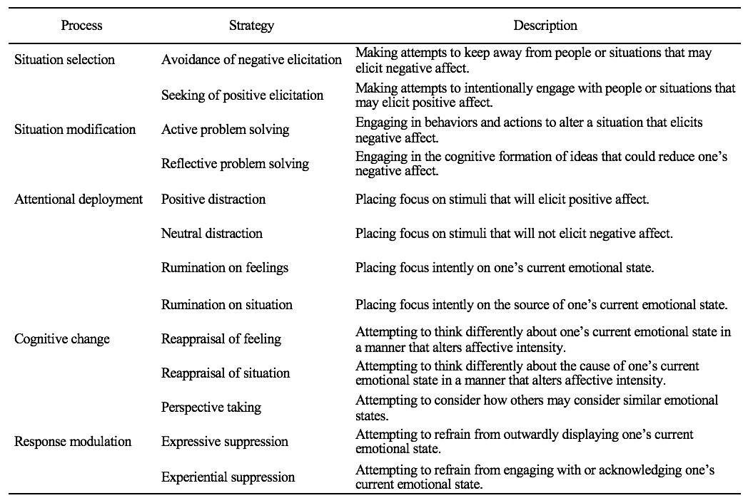
Table 1. Description of processes and strategies in the ERPS-C

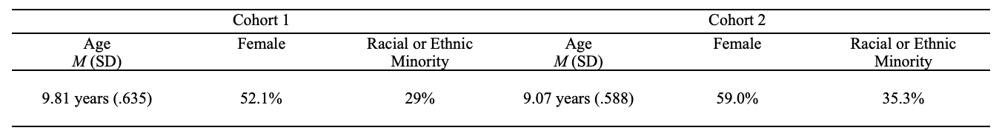
Table 2. Descriptive information for observed variables in Cohorts 1 and 2

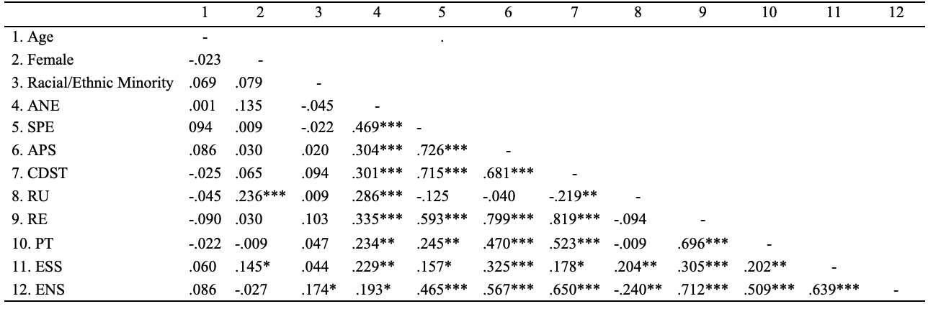
Table 3. Correlations among observed variables and primary study variables from the ERPS-C
Note. ANE, Avoidance of Negative Elicitation; SPE, Seeking of Positive Elicitation; APS, Active Problem Solving; CDST, Cognitive Distraction; RU, Rumination; RE, Reappraisal; PT, Perspective Taking; ESS, Expressive Suppression; ENS, Experiential Suppression.
*p < .05, **p < .01, ***p < .001

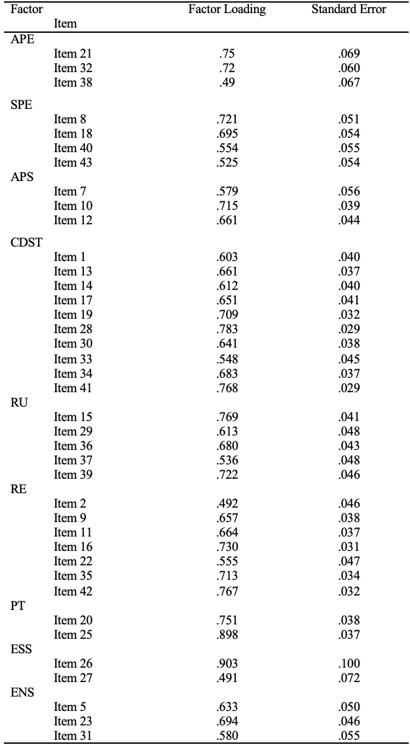
Table 4. Factor loadings for the final ERPS-C CFA model

Note. ANE, Avoidance of Negative Elicitation; SPE, Seeking of Positive Elicitation; APS, Active Problem Solving; CDST, Cognitive Distraction; RU, Rumination; RE, Reappraisal; PT, Perspective Taking; ESS, Expressive Suppression; ENS, Experiential Suppression.

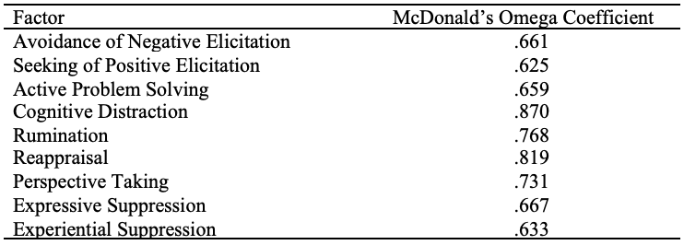
Table 5. Reliability coefficient for factors of the ERPS-C

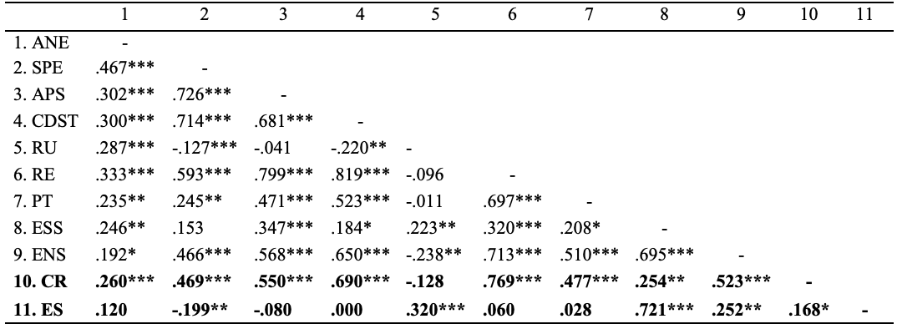
Table 6. Correlations among latent factors on the ERPS-C and the ERQ-CA
Note. ANE, Avoidance of Negative Elicitation; SPE, Seeking of Positive Elicitation; APS, Active Problem Solving; CDST, Cognitive Distraction; RU, Rumination; RE, Reappraisal; PT, Perspective Taking; ESS, Expressive Suppression; ENS, Experiential Suppression; CR, Cognitive Reappraisal (ERQ-CA); ES, Expressive Suppression (ERQ-CA).
*p < .05, **p < .01, ***p < .001

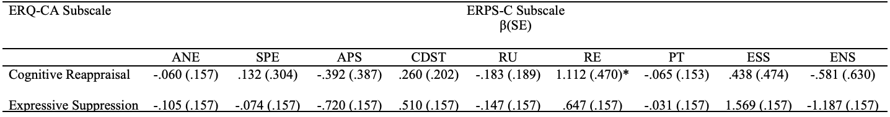
Table 7. Regression examining the ERPS-C latent factors and child-reported emotion regulation
Note. ANE, Avoidance of Negative Elicitation; SPE, Seeking of Positive Elicitation; APS, Active Problem Solving; CDST, Cognitive Distraction; RU, Rumination; RE, Reappraisal; PT, Perspective Taking; ESS, Expressive Suppression; ENS, Experiential Suppression.
*p < .05, **p < .01, ***p < .001

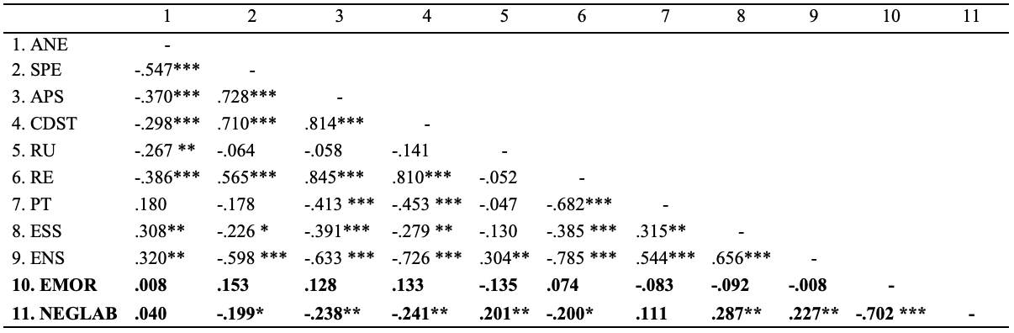
Table 8. Correlations among latent factors on the ERPS-C and the ERC
Note. ANE, Avoidance of Negative Elicitation; SPE, Seeking of Positive Elicitation; APS, Active Problem Solving; CDST, Cognitive Distraction; RU, Rumination; RE, Reappraisal; PT, Perspective Taking; ESS, Expressive Suppression; ENS, Experiential Suppression; EMOR, Emotion Regulation (ERC); NEGLAB, Negativity/Lability (ERC).
*p < .05, **p < .01, ***p < .001

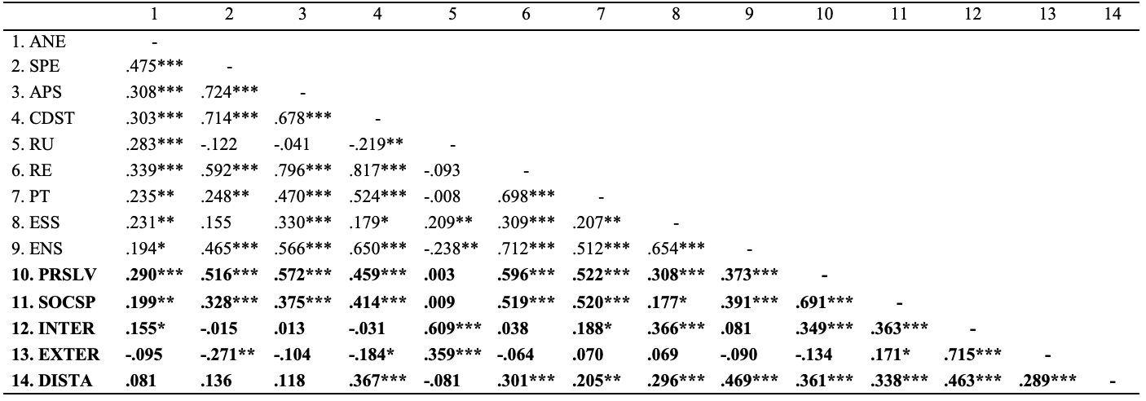
Table 9. Correlations among latent factors on the ERPS-C and the SRCM-C
Note. ANE, Avoidance of Negative Elicitation; SPE, Seeking of Positive Elicitation; APS, Active Problem Solving; CDST, Cognitive Distraction; RU, Rumination; RE, Reappraisal; PT, Perspective Taking; ESS, Expressive Suppression; ENS, Experiential Suppression; PRSLV, Problem Solving (SRCM-C); SOCSP, Social Support Seeking (SRCM-C); INTER, Internalizing (SRCM-C); EXTER, Externalizing (SRCM-C); DISTA, Distancing (SRCM-C).
*p < .05, **p < .01, ***p < .001

Table 10. Regression examining the ERPS-C latent factors and child-reported coping skills
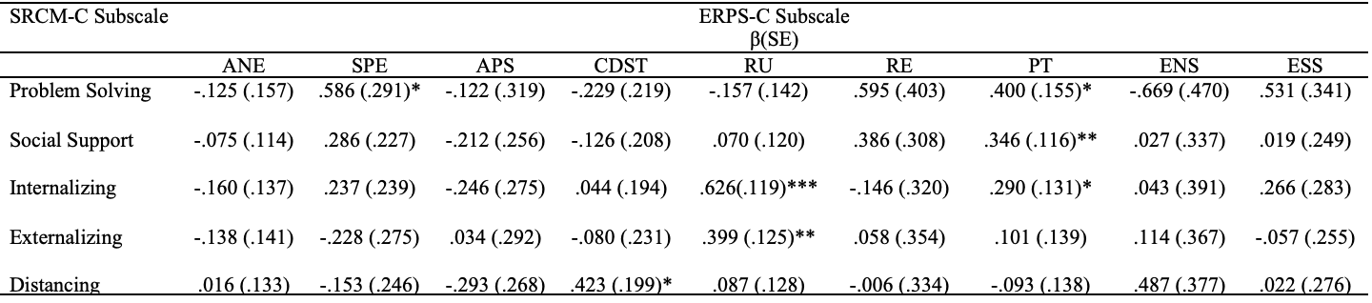
Note. ANE, Avoidance of Negative Elicitation; SPE, Seeking of Positive Elicitation; APS, Active Problem Solving; CDST, Cognitive Distraction; RU, Rumination; RE, Reappraisal; PT, Perspective Taking; ESS, Expressive Suppression; ENS, Experiential Suppression.
*p < .05, **p < .01, ***p < .001

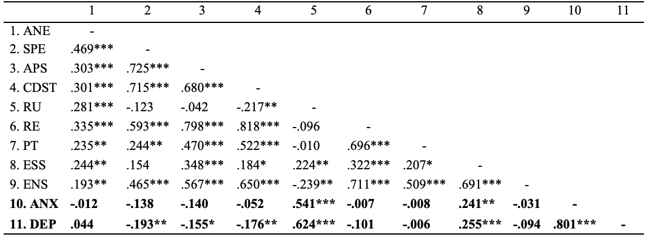
Table 11. Correlations among latent factors on the ERPS-C and the PROMIS-A-SF and PROMIS-D-SF
Note. ANE, Avoidance of Negative Elicitation; SPE, Seeking of Positive Elicitation; APS, Active Problem Solving; CDST, Cognitive Distraction; RU, Rumination; RE, Reappraisal; PT, Perspective Taking; ESS, Expressive Suppression; ENS, Experiential Suppression; ANX, anxiety (PROMIS-A-SF); DEP, Depression (PROMIS-D-SF).
*p < .05, **p < .01, ***p < .001

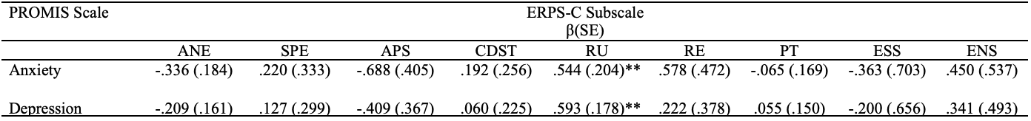
Table 12. Regression examining the ERPS-C latent factors and child-reported internalizing symptoms
Note. ANE, Avoidance of Negative Elicitation; SPE, Seeking of Positive Elicitation; APS, Active Problem Solving; CDST, Cognitive Distraction; RU, Rumination; RE, Reappraisal; PT, Perspective Taking; ESS, Expressive Suppression; ENS, Experiential Suppression.
*p < .05, **p < .01, ***p < .001

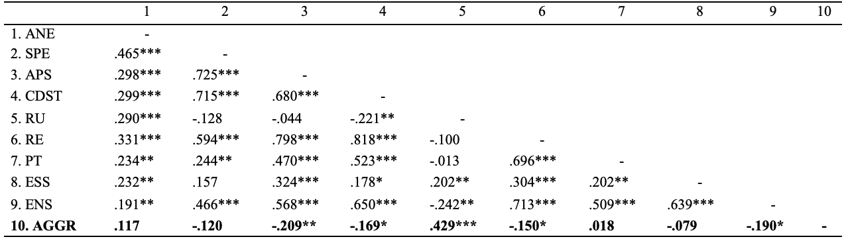
Table 13. Correlations among latent factors on the ERPS-C and the RPQ
Note. ANE, Avoidance of Negative Elicitation; SPE, Seeking of Positive Elicitation; APS, Active Problem Solving; CDST, Cognitive Distraction; RU, Rumination; RE, Reappraisal; PT, Perspective Taking; ESS, Expressive Suppression; ENS, Experiential Suppression; AGGR, Reactive Aggression (RPQ).
*p < .05, **p < .01, ***p < .001

Table 14. Regression examining the ERPS-C latent factors and child-reported reactive aggression
Note. ANE, Avoidance of Negative Elicitation; SPE, Seeking of Positive Elicitation; APS, Active Problem Solving; CDST, Cognitive Distraction; RU, Rumination; RE, Reappraisal; PT, Perspective Taking; ESS, Expressive Suppression; ENS, Experiential Suppression.
*p < .05, **p < .01, ***p < .001

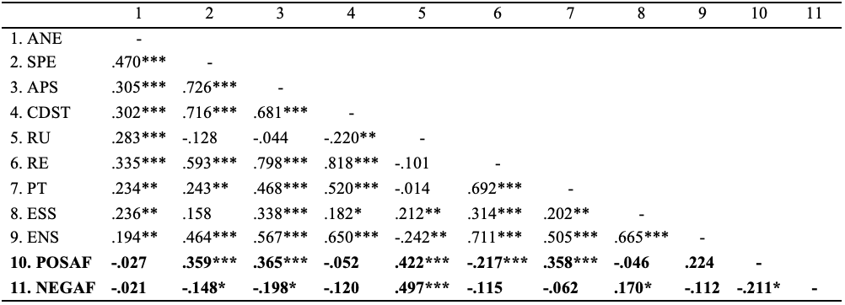
Table 15. Correlations among latent factors on the ERPS-C and the PANAS-C
Note. ANE, Avoidance of Negative Elicitation; SPE, Seeking of Positive Elicitation; APS, Active Problem Solving; CDST, Cognitive Distraction; RU, Rumination; RE, Reappraisal; PT, Perspective Taking; ESS, Expressive Suppression; ENS, Experiential Suppression; AGGR, Reactive Aggression (RPQ).
*p < .05, **p < .01, ***p < .001

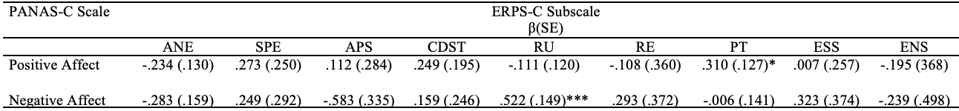
Table 16. Regression examining the ERPS-C latent factors and child-reported positive and negative affect
Note. ANE, Avoidance of Negative Elicitation; SPE, Seeking of Positive Elicitation; APS, Active Problem Solving; CDST, Cognitive Distraction; RU, Rumination; RE, Reappraisal; PT, Perspective Taking; ESS, Expressive Suppression; ENS, Experiential Suppression.
*p < .05, **p < .01, ***p < .001

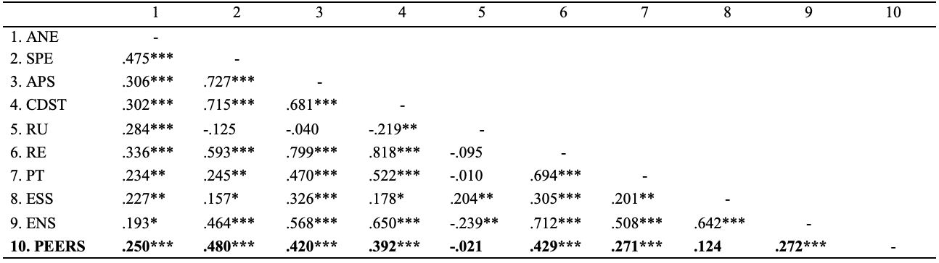
Table 17. Correlations among latent factors on the ERPS-C and the PROMIS-PR-SF
Note. ANE, Avoidance of Negative Elicitation; SPE, Seeking of Positive Elicitation; APS, Active Problem Solving; CDST, Cognitive Distraction; RU, Rumination; RE, Reappraisal; PT, Perspective Taking; ESS, Expressive Suppression; ENS, Experiential Suppression; PEERS, Peer Relations (PROMIS-PR-SF).
*p < .05, **p < .01, ***p < .001

Table 18. Regression examining the ERPS-C latent factors and child-reported peer relationships
Note. ANE, Avoidance of Negative Elicitation; SPE, Seeking of Positive Elicitation; APS, Active Problem Solving; CDST, Cognitive Distraction; RU, Rumination; RE, Reappraisal; PT, Perspective Taking; ESS, Expressive Suppression; ENS, Experiential Suppression.
*p < .05, **p < .01, ***p < .001

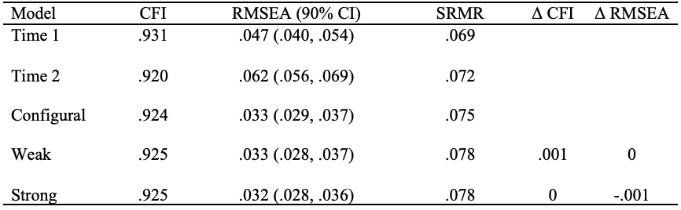
Table 19. Longitudinal measurement invariance model fit statistics for the ERPS-C
Note. CFI, comparative fit index; RMSEA, root mean square error of approximation; SRMR, standardized root mean square residual.

Table 20. Correlations among ERPS-C latent factors at Time 1 and Time 2
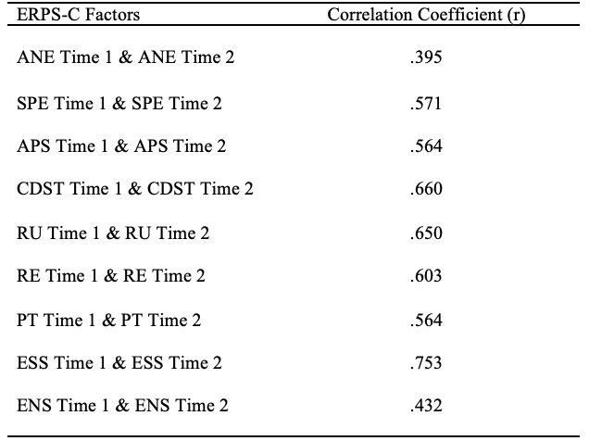
Note. ANE, Avoidance of Negative Elicitation; SPE, Seeking of Positive Elicitation; APS, Active Problem Solving; CDST, Cognitive Distraction; RU, Rumination; RE, Reappraisal; PT, Perspective Taking; ESS, Expressive Suppression; ENS, Experiential Suppression.
All correlation coefficients displayed are significant, p < .001.

Table 21. Model fit statistics for structural equation models examining predictive validity of the ERPS-C in relation to socioemotional functioning
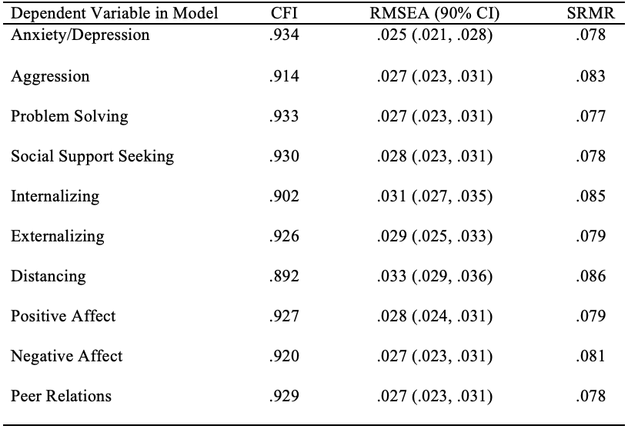
Note. CFI, comparative fit index; RMSEA, root mean square error of approximation; SRMR, standardized root mean square residual.

Table 22. Regression examining the ERPS-C at Time 1 predicting child-reported socioemotional outcomes at Time 2
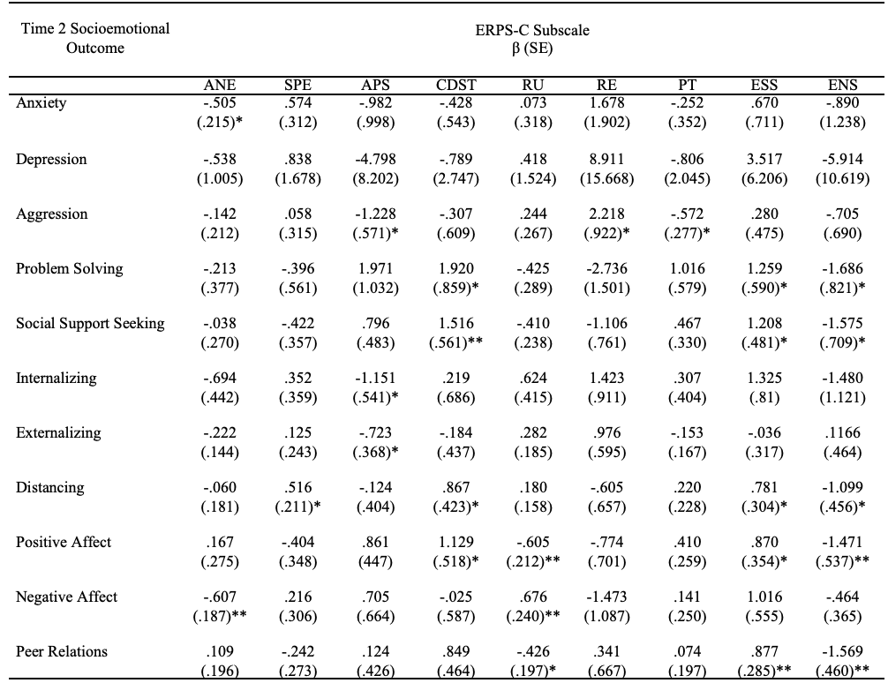 Note. ANE, Avoidance of Negative Elicitation; SPE, Seeking of Positive Elicitation; APS, Active Problem Solving; CDST, Cognitive Distraction; RU, Rumination; RE, Reappraisal; PT, Perspective Taking; ESS, Expressive Suppression; ENS, Experiential Suppression.
*p < .05, **p < .01, ***p < .001

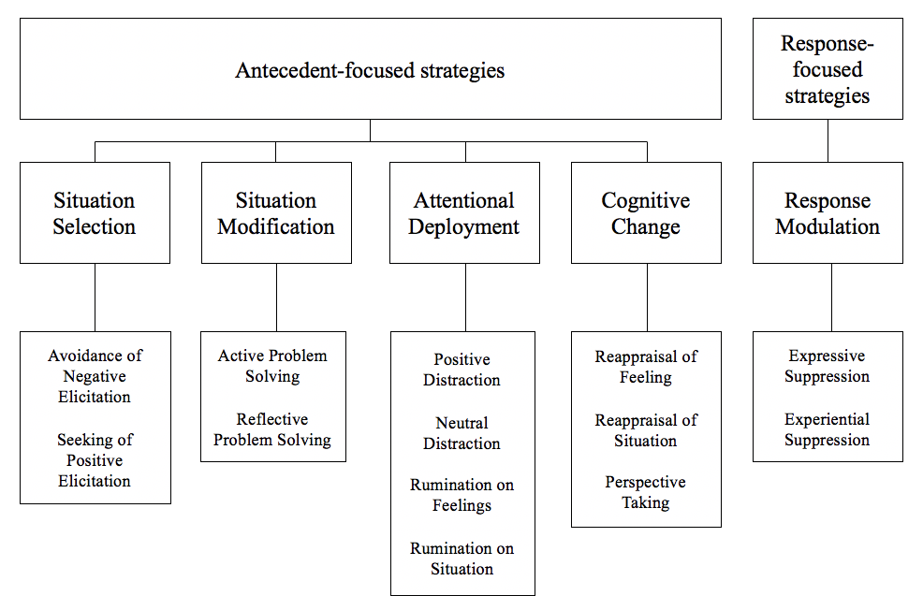Figure 1: Diagram of emotion regulation processes and strategies; partially referenced from the Process Model of Emotion Regulation (Gross, 1998)

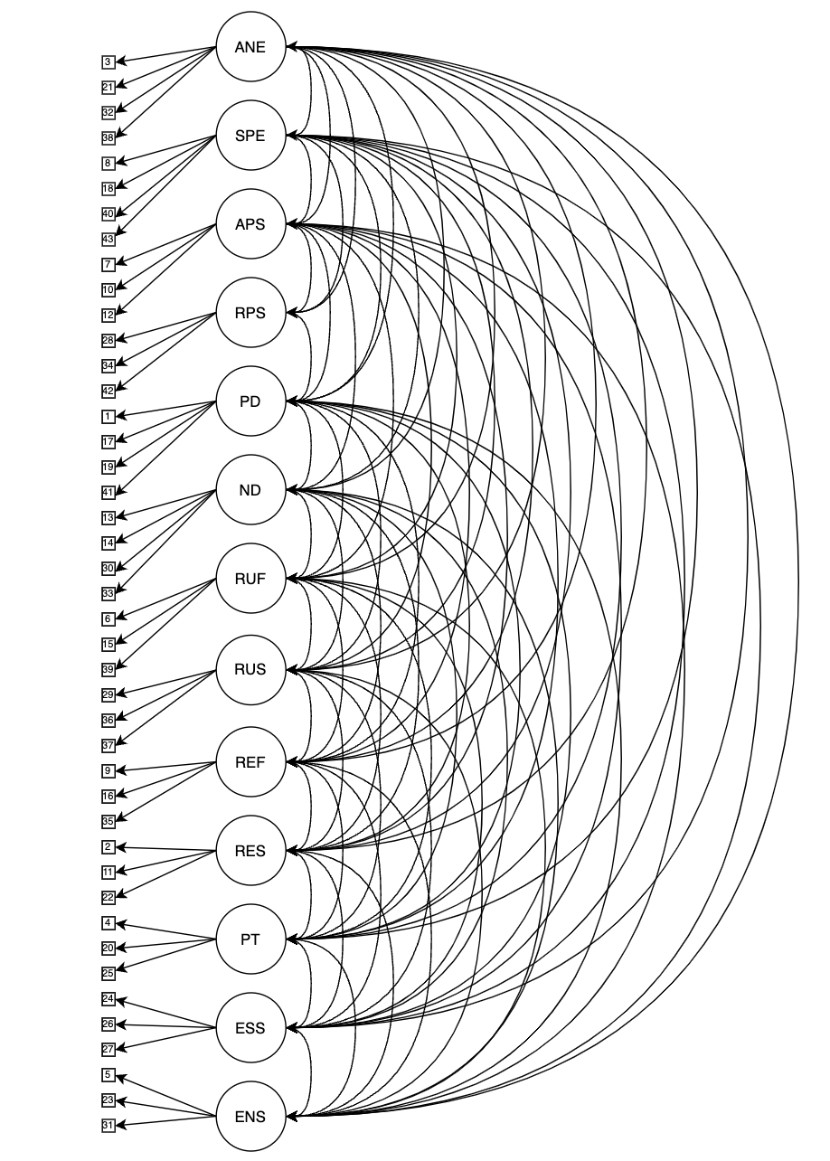
Figure 2: Example CFA Model for Goal 1
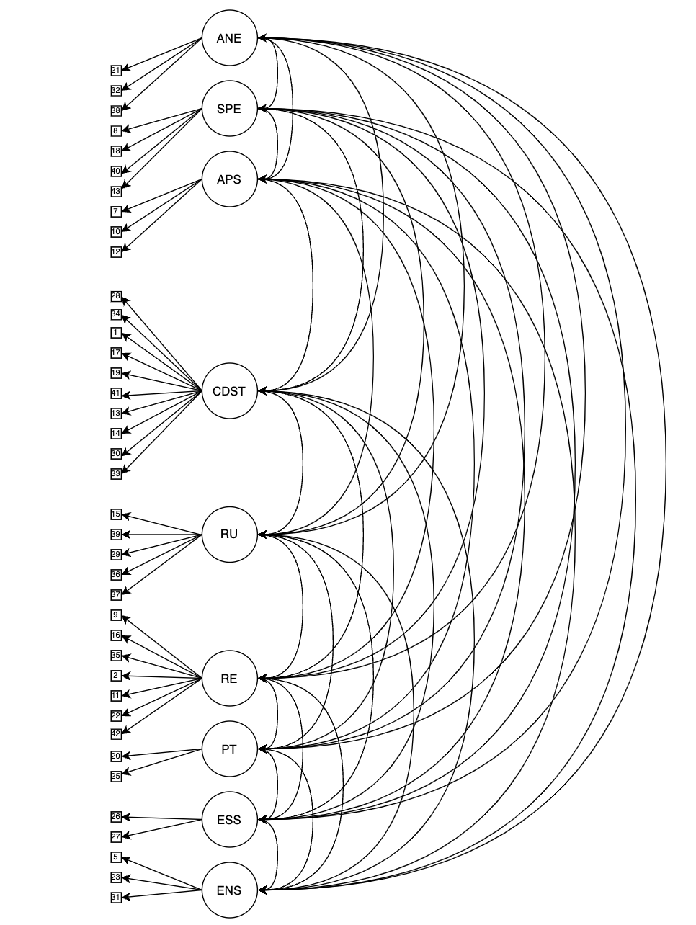
Figure 3: Final Figural CFA Model for the ERPS-C

APPENDIX OF STUDY MEASURES
Emotion Regulation Process Scale for Children
ERPS-C
All responses are voluntary.
Instructions: Each question will be read out loud to you. Please respond to each question or statement by marking one box per row.

- When I feel upset, I find something to do that makes me happy.
Never | Almost Never | Sometimes | Often | Almost Always

- When I feel upset, I try to think differently about people who made me upset.
Never | Almost Never | Sometimes | Often | Almost Always

- When I feel upset, I pretend that I am not feeling that way.
Never | Almost Never | Sometimes | Often | Almost Always

- When I feel upset, I try to do something about it.

Never | Almost Never | Sometimes | Often | Almost Always

- I try to do things that make me feel good.

Never | Almost Never | Sometimes | Often | Almost Always

- When I feel upset, I try to change the way I think about my upsetting feelings (like anger, sadness, worry).

Never | Almost Never | Sometimes | Often | Almost Always

- When I feel upset, I try to fix what made me feel that way.

Never | Almost Never | Sometimes | Often | Almost Always

- When I feel upset, I change how I think about what made me feel that way.

Never | Almost Never | Sometimes | Often | Almost Always

- When I feel upset, I try to change what made me feel that way.

Never | Almost Never | Sometimes | Often | Almost Always

- When I feel upset, I try to keep my mind on something different.

Never | Almost Never | Sometimes | Often | Almost Always

- When I feel upset, I try to do an activity that distracts me.

Never | Almost Never | Sometimes | Often | Almost Always

- When I feel upset, the feeling sticks with me for a long time.

Never | Almost Never | Sometimes | Often | Almost Always

- When I feel upset, I try to think differently about my feelings.

Never | Almost Never | Sometimes | Often | Almost Always

- When I feel upset, I do an activity that makes me happy.

Never | Almost Never | Sometimes | Often | Almost Always

- I try to find situations that make me feel good.

Never | Almost Never | Sometimes | Often | Almost Always

- When I feel upset, I imagine something that makes me happy.

Never | Almost Never | Sometimes | Often | Almost Always

- When I feel upset, I try to remember that sometimes other people feel this way too.

Never | Almost Never | Sometimes | Often | Almost Always

- I try to stay away from situations that make me upset.

Never | Almost Never | Sometimes | Often | Almost Always

- When I feel upset, I try to think differently about things that made me feel upset.

Never | Almost Never | Sometimes | Often | Almost Always

- When I feel upset, I try not to think about what I’m feeling.

Never | Almost Never | Sometimes | Often | Almost Always

- When I feel upset, I try to remember that sometimes everyone feels upset.

Never | Almost Never | Sometimes | Often | Almost Always

- When I feel upset, I work to keep my feelings in.

Never | Almost Never | Sometimes | Often | Almost Always

- When I feel upset, I try not to show how I am feeling on the outside.

Never | Almost Never | Sometimes | Often | Almost Always

- When I feel upset, I try to come up with ways to make me feel happy.

Never | Almost Never | Sometimes | Often | Almost Always

- When I feel upset, I think about what made me upset for a long time.

Never | Almost Never | Sometimes | Often | Almost Always

- When I feel upset, I try to think of anything else.

Never | Almost Never | Sometimes | Often | Almost Always

- When I feel upset, I try to push down that feeling.

Never | Almost Never | Sometimes | Often | Almost Always

- I try to stay away from people who make me upset.

Never | Almost Never | Sometimes | Often | Almost Always

- When I feel upset, I try to keep myself busy.

Never | Almost Never | Sometimes | Often | Almost Always

- When I feel upset, I imagine ways of making things better.

Never | Almost Never | Sometimes | Often | Almost Always

- When I feel upset, I think about my upsetting feelings in a way that helps me feel better.

Never | Almost Never | Sometimes | Often | Almost Always

- When I feel upset, I can’t get what happened off of my mind.

Never | Almost Never | Sometimes | Often | Almost Always

- When I feel upset, I think a lot about what made me feel that way.

Never | Almost Never | Sometimes | Often | Almost Always

- I try not to spend time with people who might upset me.

Never | Almost Never | Sometimes | Often | Almost Always

- When I feel upset, I can’t get the bad feeling off of my mind.

Never | Almost Never | Sometimes | Often | Almost Always

- I try to spend time with people who make me feel good.

Never | Almost Never | Sometimes | Often | Almost Always

- When I feel upset, I try to think of something that makes me happy.

Never | Almost Never | Sometimes | Often | Almost Always

- When I feel upset, I think of what I could do to make things better.

Never | Almost Never | Sometimes | Often | Almost Always

- I try to find friends that I feel good around.

Never | Almost Never | Sometimes | Often | Almost Always

Parent Demographic Form

All responses are voluntary.

ID#: _________________________ (leave blank) DATE: _______________

CHILD’S SCHOOL: ______________________ GRADE: ___________________

CHILD’S TEACHER: _____________________

CHILD’S BIRTHDATE: ___________

Please answer the questions below. All responses are voluntary.

- What is the biological sex of your child?
- MALE
- FEMALE

2. Is this the 1st year your child is at this school
- YES
- NO

3. What is your child’s race or ethnicity?
- WHITE
- BLACK
- ASIAN
- ESKIMO/ALEUT
- SPANISH/HISPANIC
- AMERICAN INDIAN
- PACIFIC ISLANDER
- BI/MULTI-RACIAL
- OTHER:_______________

4. What language is spoken most often in your home?
- ENGLISH
- SPANISH
- OTHER: ________________

5. Are there any other languages spoken in your home?
- ENGLISH
- SPANISH
- OTHER: ________________
6. Who lives in the home with your child? Their:
- MOTHER
- STEP-MOTHER
- FATHER
- STEP-FATHER
- MOTHER’S PARTNER
- FATHER’S PARTNER
- GRANDMOTHER
- GRANDFATHER
- UNCLE
- AUNT
- COUSIN
- OTHER: ___________________

7. How many siblings live in the home? __________________

8. Does your child receive a free or reduced lunch at school?
- YES
- NO

9. What is your annual household income?
- Less than 10,000 dollars
- 10,000-25,000 dollars
- 25,000-35,000 dollars
- 35,000-50,000 dollars
- 50,000-100,000 dollars
- Greater than 100,000 dollars

Emotion Regulation Checklist

ERC
All responses are voluntary.
Instructions: Please rate each item on a scale from 1 to 4 based on your child.

- Is a cheerful child.

Never | Sometimes | Often | Almost Always

2. Exhibits wide mood swings (child’s emotional state is difficult to anticipate because he/she moves quickly from positive to negative moods).

Never | Sometimes | Often | Almost Always

3. Responds positively to neutral or friendly overtures by adults.

Never | Sometimes | Often | Almost Always

4. Transitions well from one activity to another; does not become anxious, angry, distressed or overly excited when moving from one activity to another.

Never | Sometimes | Often | Almost Always

5. Can recover quickly from episodes of upset or distress (for example, does not pout or remain sullen, anxious or sad after emotionally distressing events).

Never | Sometimes | Often | Almost Always

6. Is easily frustrated.

Never | Sometimes | Often | Almost Always

7. Responds positively to neutral or friendly overtures by peers.

Never | Sometimes | Often | Almost Always

8. Is prone to angry outbursts/tantrums easily.

Never | Sometimes | Often | Almost Always

9. Is able to delay gratification.

Never | Sometimes | Often | Almost Always

10. Takes pleasure in the distress of others (for example, laughs when another person gets hurt or punished; enjoys teasing others).

Never | Sometimes | Often | Almost Always

11. Can modulate excitement in emotionally arousing situations (for example, does not get carried away in high-energy play situations, or overly excited in inappropriate contexts).

Never | Sometimes | Often | Almost Always

12. Is whiny or clingy with adults.

Never | Sometimes | Often | Almost Always

13. Is prone to disruptive outbursts of energy and exuberance.

Never | Sometimes | Often | Almost Always

14. Responds angrily to limit setting by adults.

Never | Sometimes | Often | Almost Always

15. Can say when he/she is feeling sad, angry or mad, fearful or afraid.

Never | Sometimes | Often | Almost Always

16. Seems sad or listless.

Never | Sometimes | Often | Almost Always

17. Is overly exuberant when attempting to engage others in play.

Never | Sometimes | Often | Almost Always

18. Displays flat affect (expression is vacant and inexpressive; child seems emotionally absent).

Never | Sometimes | Often | Almost Always

19. Responds negatively to neutral or friendly overtures by peers (for example, may speak in an angry tone of voice or responds fearfully).

Never | Sometimes | Often | Almost Always

20. Is impulsive.

Never | Sometimes | Often | Almost Always

21. Is empathic towards others; shows concern when others are upset or distressed.

Never | Sometimes | Often | Almost Always

22. Displays exuberance that others find intrusive or disruptive.

Never | Sometimes | Often | Almost Always

23. Displays appropriate negative emotions (anger, fear, frustration, distress) in response to hostile, aggressive or intrusive acts by peers.

Never | Sometimes | Often | Almost Always

24. Displays negative emotions when attempting to engage others in play.

Never | Sometimes | Often | Almost Always

Emotion Regulation Questionnaire – Children and Adolescent
ERQ-CA

All responses are voluntary.

Instructions: Each question will be read out loud to you. Please respond to each question or statement by marking one box per row.

- When I want to feel happier, I think about something different.

Completely disagree | Disagree | Neither agree or disagree | Agree | Completely Agree

2. I keep my feelings to myself.

Completely disagree | Disagree | Neither agree or disagree | Agree | Completely Agree

3. When I want to feel less bad (like sad, angry or worried), I think about something different.

Completely disagree | Disagree | Neither agree or disagree | Agree | Completely Agree

4. When I am feeling happy, I am careful not to show it.

Completely disagree | Disagree | Neither agree or disagree | Agree | Completely Agree

5. When I’m worried about something, I make myself think about it in a way that helps me feel better.

Completely disagree | Disagree | Neither agree or disagree | Agree | Completely Agree

6. I control my feelings by not showing them.

Completely disagree | Disagree | Neither agree or disagree | Agree | Completely Agree

7. When I want to feel happier about something, I change the way I’m thinking about it.

Completely disagree | Disagree | Neither agree or disagree | Agree | Completely Agree

8. I control my feelings about things by changing the way I think about them.

Completely disagree | Disagree | Neither agree or disagree | Agree | Completely Agree

9. When I’m feeling bad (e.g., sad, angry or worried), I’m careful not to show it.

Completely disagree | Disagree | Neither agree or disagree | Agree | Completely Agree

10. When I want to feel less bad (like sad, angry or worried) about something, I change the way I’m thinking about it.

Completely disagree | Disagree | Neither agree or disagree | Agree | Completely Agree

Self-Report Coping Measure – Child Version
SRCM-C

All responses are voluntary.

Instructions: Each question will be read out loud to you. Please respond to each question or statement by marking one box per row.

1. When I have an argument or a fight with a friend, I tell a friend or family member what happened.

Never | Hardly Ever | Sometimes | Most of the Time | Always

2. When I have an argument or a fight with a friend, I try to think of different ways to solve it.

Never | Hardly Ever | Sometimes | Most of the Time | Always

3. When I have an argument or a fight with a friend, I make believe nothing happened.

Never | Hardly Ever | Sometimes | Most of the Time | Always

4. When I have an argument or a fight with a friend, I take it out on others because I feel sad or angry.

Never | Hardly Ever | Sometimes | Most of the Time | Always

5. When I have an argument or a fight with a friend, I talk to somebody about how it made me feel.

Never | Hardly Ever | Sometimes | Most of the Time | Always

6. When I have an argument or a fight with a friend, I change something so things will work out.

Never | Hardly Ever | Sometimes | Most of the Time | Always

7. When I have an argument or a fight with a friend, I go off by myself.

Never | Hardly Ever | Sometimes | Most of the Time | Always

8. When I have an argument or a fight with a friend, I become so upset that I can't talk to anyone.

Never | Hardly Ever | Sometimes | Most of the Time | Always

9. When I have an argument or a fight with a friend, I get help from a friend.

Never | Hardly Ever | Sometimes | Most of the Time | Always

10. When I have an argument or a fight with a friend, I decide on one way to deal with the problem and I do it.

Never | Hardly Ever | Sometimes | Most of the Time | Always

11. When I have an argument or a fight with a friend, I forget the whole thing.

Never | Hardly Ever | Sometimes | Most of the Time | Always

12. When I have an argument or a fight with a friend, I worry too much about it.

Never | Hardly Ever | Sometimes | Most of the Time | Always

13. When I have an argument or a fight with a friend, I ask a friend for advice.

Never | Hardly Ever | Sometimes | Most of the Time | Always

14. When I have an argument or a fight with a friend, I do something to make up for it.

Never | Hardly Ever | Sometimes | Most of the Time | Always

15. When I have an argument or a fight with a friend, I tell myself it doesn't matter.

Never | Hardly Ever | Sometimes | Most of the Time | Always

16. When I have an argument or a fight with a friend, I cry about it.

Never | Hardly Ever | Sometimes | Most of the Time | Always

17. When I have an argument or a fight with a friend, I ask a family member for advice.

Never | Hardly Ever | Sometimes | Most of the Time | Always

18. When I have an argument or a fight with a friend, I know there are things I can do to make it better.

Never | Hardly Ever | Sometimes | Most of the Time | Always

19. When I have an argument or a fight with a friend, I just feel sorry for myself.

Never | Hardly Ever | Sometimes | Most of the Time | Always

20. When I have an argument or a fight with a friend, I refuse to think about it.

Never | Hardly Ever | Sometimes | Most of the Time | Always

21. When I have an argument or a fight with a friend, I yell to let off steam.

Never | Hardly Ever | Sometimes | Most of the Time | Always

22. When I have an argument or a fight with a friend, I ask someone who has had this problem what he or she would do.

Never | Hardly Ever | Sometimes | Most of the Time | Always

23. When I have an argument or a fight with a friend, I go over in my mind what to do or say.

Never | Hardly Ever | Sometimes | Most of the Time | Always

24. When I have an argument or a fight with a friend, I do something else to take my mind off of it.

Never | Hardly Ever | Sometimes | Most of the Time | Always

25. When I have an argument or a fight with a friend, I worry that others will think badly of me.

Never | Hardly Ever | Sometimes | Most of the Time | Always

26. When I have an argument or a fight with a friend, I curse out loud.

Never | Hardly Ever | Sometimes | Most of the Time | Always

27. When I have an argument or a fight with a friend, I try to understand why this happened to me.

Never | Hardly Ever | Sometimes | Most of the Time | Always

28. When I have an argument or a fight with a friend, I say I don't care.

Never | Hardly Ever | Sometimes | Most of the Time | Always

29. When I have an argument or a fight with a friend, I ignore it when people say something.

Never | Hardly Ever | Sometimes | Most of the Time | Always

30. When I have an argument or a fight with a friend, I get mad and throw or hit something.

Never | Hardly Ever | Sometimes | Most of the Time | Always

31. When I have an argument or a fight with a friend, I get help from a family member.

Never | Hardly Ever | Sometimes | Most of the Time | Always

32. When I have an argument or a fight with a friend, I get mad at myself for doing something that I shouldn't have done.

Never | Hardly Ever | Sometimes | Most of the Time | Always

33. When I have an argument or a fight with a friend, I try extra hard to keep this from happening again.

Never | Hardly Ever | Sometimes | Most of the Time | Always

34. When I have an argument or a fight with a friend, I talk to the teacher about it.

Never | Hardly Ever | Sometimes | Most of the Time | Always

PROMIS-A-SF
PROMIS-A-SF
All responses are voluntary.
Instructions: Each question will be read out loud to you. Please respond to each question or statement by marking one box per row.

In the past 7 days…

1. I felt like something awful might happen.

Never | Almost Never | Sometimes | Often | Almost Always

2. I felt nervous.

Never | Almost Never | Sometimes | Often | Almost Always

3. I felt scared.

Never | Almost Never | Sometimes | Often | Almost Always

4. I felt worried.

Never | Almost Never | Sometimes | Often | Almost Always

5. I worried when I was at home.

Never | Almost Never | Sometimes | Often | Almost Always

6. I got scared really easy.

Never | Almost Never | Sometimes | Often | Almost Always

7. I worried about what could happen to me.

Never | Almost Never | Sometimes | Often | Almost Always

8. I worried when I went to bed at night.
Never | Almost Never | Sometimes | Often | Almost Always

PROMIS-D-SF
PROMIS-D-SF
All responses are voluntary.
Instructions: Each question will be read out loud to you. Please respond to each question or statement by marking one box per row.

In the past 7 days…

1. I could not stop feeling sad.

Never | Almost Never | Sometimes | Often | Almost Always

2. I felt alone.

Never | Almost Never | Sometimes | Often | Almost Always

3. I felt everything in my life went wrong.

Never | Almost Never | Sometimes | Often | Almost Always

4. I felt like I couldn’t do anything right.

Never | Almost Never | Sometimes | Often | Almost Always

5. I felt lonely.

Never | Almost Never | Sometimes | Often | Almost Always

6. I felt sad.

Never | Almost Never | Sometimes | Often | Almost Always

7. I felt unhappy.

Never | Almost Never | Sometimes | Often | Almost Always

8. It was hard for me to have fun.
Never | Almost Never | Sometimes | Often | Almost Always

Positive and Negative Affect Questionnaire – Child
PANAS-C
All responses are voluntary.
Instructions: Each question will be read out loud to you. Please respond to each question or statement by marking one box per row.

How much have you felt this way during the past few weeks?

1. Sad

Very slightly or not at all | A little bit | Somewhat | Quite a bit | A lot

2. Excited

Very slightly or not at all | A little bit | Somewhat | Quite a bit | A lot

3. Upset

Very slightly or not at all | A little bit | Somewhat | Quite a bit | A lot

4. Happy

Very slightly or not at all | A little bit | Somewhat | Quite a bit | A lot

5. Strong

Very slightly or not at all | A little bit | Somewhat | Quite a bit | A lot

6. Nervous

Very slightly or not at all | A little bit | Somewhat | Quite a bit | A lot

7. Guilty

Very slightly or not at all | A little bit | Somewhat | Quite a bit | A lot
8. Energetic

Very slightly or not at all | A little bit | Somewhat | Quite a bit | A lot

9. Scared

Very slightly or not at all | A little bit | Somewhat | Quite a bit | A lot

10. Miserable

Very slightly or not at all | A little bit | Somewhat | Quite a bit | A lot

11. Cheerful

Very slightly or not at all | A little bit | Somewhat | Quite a bit | A lot

12. Active

Very slightly or not at all | A little bit | Somewhat | Quite a bit | A lot

13. Proud

Very slightly or not at all | A little bit | Somewhat | Quite a bit | A lot

14. Afraid

Very slightly or not at all | A little bit | Somewhat | Quite a bit | A lot

15. Joyful

Very slightly or not at all | A little bit | Somewhat | Quite a bit | A lot

16. Lonely

Very slightly or not at all | A little bit | Somewhat | Quite a bit | A lot

17. Mad

Very slightly or not at all | A little bit | Somewhat | Quite a bit | A lot

18. Delighted

Very slightly or not at all | A little bit | Somewhat | Quite a bit | A lot

19. Gloomy

Very slightly or not at all | A little bit | Somewhat | Quite a bit | A lot

20. Lively

Very slightly or not at all | A little bit | Somewhat | Quite a bit | A lot

PROMIS-PR-SF
PROMIS-PR-SF
All responses are voluntary.
Instructions: Each question will be read out loud to you. Please respond to each question or statement by marking one box per row.

In the past 7 days…

1. I felt accepted by other kids my age.

Never | Almost Never | Sometimes | Often | Almost Always

2. I was able to count on my friends.

Never | Almost Never | Sometimes | Often | Almost Always

3. I was able to talk about everything with my friends.

Never | Almost Never | Sometimes | Often | Almost Always

4. I was good at making friends.

Never | Almost Never | Sometimes | Often | Almost Always

5. My friends and I helped each other out.

Never | Almost Never | Sometimes | Often | Almost Always

6. Other kids wanted to be my friend.

Never | Almost Never | Sometimes | Often | Almost Always

7. Other kids wanted to be with me.

Never | Almost Never | Sometimes | Often | Almost Always

8. Other kids wanted to talk to me.
Never | Almost Never | Sometimes | Often | Almost Always

VITA
Alayna Watson was born in Asheville, North Carolina to parents Roy and Andrea Watson. After attending Apex High School in Apex, North Carolina, she attended the University of Alabama in Tuscaloosa, Alabama. She received her Bachelor of Science in Psychology with a minor in Sociology in the spring of 2018. In the fall of 2018, Alayna began her doctoral studies in the Clinical Psychology program at The University of Tennessee, Knoxville, studying under her advisor, Dr. L. Christian Elledge. She received her Master of Arts Degree in Clinical Psychology in the spring semester of 2020. In the summer of 2023, she began her predoctoral internship in Pediatric Psychology at Nationwide Children’s Hospital in Columbus, Ohio.

