Cell Separation Delay and Membrane Trafficking Defects in Cdc42 GAP Mutants

Haylee Young

December 12, 2019
Das Lab
Maitreyi Das, Brian Hercyk
The University of Tennessee, Knoxville

Abstract
Cytokinesis is the final step in cell division, where a cell separates into two daughter cells. Cytokinesis involves many steps that must be organized in a spatiotemporal manner. In most eukaryotes, this involves the assembly and constriction of an actomyosin ring. The fission yeast Schizosaccharomyces pombe serves as a good model system to study cytokinesis because they divide via actomyosin-dependent-cytokinesis.
The Rho-family of small GTPases are molecules involved in the regulation of cell growth and division. The GTPase Cdc42 helps promote timely onset of ring constriction and septum formation in fission yeast. Studies with many other organisms show that Cdc42 must also be inactivated at certain points during cell division for proper cytokinesis. Cells lacking Rga4 and Rga6, the GAPs that inactive Cdc42, exhibit delayed cell separation, due to overactive Cdc42.
We find that the GAP mutants display membrane remodeling defects during cell abscission. Cdc42 is likely involved in the regulation of membrane trafficking. Indeed, fimbrin, an endocytic marker displays abnormal localization in the GAP mutant. This suggests that there is an endocytic defect in cells lacking both Rga4 and Rga6. Future directions will investigate the specifics of how endocytosis and membrane trafficking are disrupted in these cells.

Introduction
Fission yeast divide by actomyosin-ring-dependent cytokinesis. Cytokinesis involves multiple steps that are spatiotemporally organized for successful cell separation. After the ring assembles, it constricts concurrent with membrane ingression and septum formation (Stachowiak et al., 2014; Wu et al., 2003). The septum is composed of primary and secondary septum (Johnson et al., 1973). After the septum forms it is then digested by glucanases to promote cell separation (Johnson et al., 1973). The glucanases digest the primary septum, leaving the secondary septum to form the cell wall of the new daughter cells. These different steps must occur in the correct order for successful cytokinesis (Guertin et al., 2002; Wei et al., 2016; Wu et al., 2003). We have discovered that the spatiotemporal activation pattern of the GTPase Cdc42 promotes distinct events during cytokinesis (Wei et al., 2016). Cdc42 is activated when it is GTP bound, and inactivated when it is GDP bound (Figure1). Cdc42 is spatiotemporally activated by two distinct Guanine exchange factors (GEFs), Gef1 and Scd1, to promote different events during cytokinesis (Coll et al., 2003; Hirota et al., 2003; Merla and Johnson, 2000). Gef1 localizes to the actomyosin ring and activates Cdc42 to promote timely onset of ring constriction and septum ingression. The activator Scd1 localizes to the membrane barrier behind the ring and facilitates proper septum formation. While activation of Cdc42 is required for the earlier stages of cytokinesis, we find that constitutively active Cdc42 leads to cytokinetic failure (Wei et al., 2016). Similar defects can be observed in many organisms such as Xenopus, Drosophila, and S. cerevisiae (Atkins et al., 2013; Crawford et al., 1998; Drechsel et al., 1997). Thus, Cdc42 must be turned off at certain stages for successful completion of cytokinesis. This information led us to ask what happens when this inactivation does not happen? Cdc42 is inactivated by the GTPase activating proteins (GAPs), Rga4 and Rga6 (Das et al., 2007; Revilla-Guarinos et al., 2016). Rga4 and Rga6 localize to the division site after the initiation of septum formation. This suggests that the GAPs localize to the division site in a timely manner to inactivate Cdc42 and promote completion of cytokinesis. Thus, we investigated the cytokinetic defects in mutants lacking rga4 and rga6 to better understand why Cdc42 inactivation is required for completion of cytokinesis.

Figure 1: Cdc42 spatiotemporally organizes different cytokinetic events. Cdc42 is active when GTP bound and inactive when GDP bound. Cdc42 is activated by guanine nucleotide exchange factors (GEFs) and inactivated by GTPase activating proteins (GAPs).

Results and Discussion 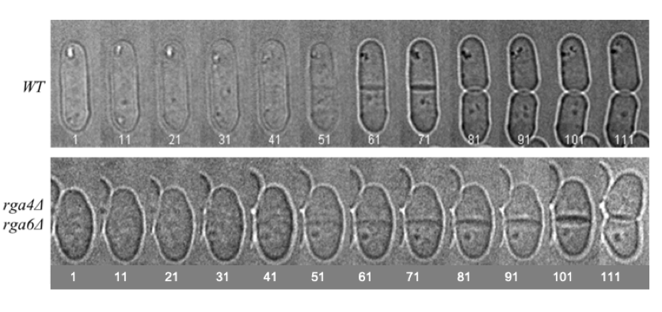
A
B
Figure 2: The Cdc42 GAPs Rga4 and RGa6 promote cell separation. A. The Cdc42 double GAP mutant, rga4Δrga6Δ, shows a delay in cell separation when compared to wild type. B. Quantification of duration of cell separation in GAP mutants with reference to wildtype.

Cdc42 inactivation is impaired in rga4Δrga6Δ mutants (Das et al., 2007). Previous data showed that these cells exhibit a delay in cell separation when compared to wild type, as shown and quantified in Figure 2. While in wild type cells the duration for cell separation from the completetion of ring constriction is about 20 mins, it takes longer in rga4Δ mutants and rga4Δrga6Δ double mutants. This indicated that loss of rga4/6 prolongs cytokinesis resulting in delayed cell separation.

Rga4 and Rga6 also inactivate another Rho GTPase, Rho2, which is involved in cell integrity in fission yeast (Arellano et al., 1999). To determine if the cytokinetic delay was Cdc42 dependent or Rho2 dependent, we analyzed cell separation in rga4Δrga6Δrho2Δ triple mutants. If the delay in cell separation in rga4Δrga6Δ mutants is due to hyperactive Rho2, then loss of rho2 should rescue this defect. We imaged wild type, rga4Δrga4Δ, rho2Δ and rga4Δrga6Δrho2Δ cells after staining with calcofluor (Figure 3). Calcofluor binds to the cell wall and the septum.

B
A
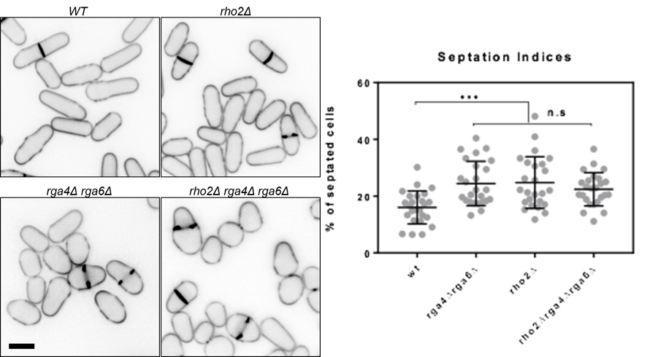
Figure 3: Loss of rho2 does not rescue the cytokinetic defect observed in Cdc42 GAP mutants. A. Calcofluor stained WT, rho2Δ, rga4Δrga6Δ, rga4Δrga6Δrho2Δ cells, B. Quantification of septation indices with reference to wildtype shown. Scale bar is 5 microns.

The images were analyzed to produce septation indices (fraction of cells with a septum). rga4Δrga6Δ cells have a higher septation index than wild type cells due to the cytokinetic delay. If the delay seen was Rho2 dependent, then deleting rho2 should bring the septation index back to wild type level. As seen in the quantification in Figure 3B above, deleting rho2 did not have this effect. This told us the defect was not Rho2 dependent. It is likely that the cytokinetic defect observed in rga4Δrga6Δ cells is due to hyperactive Cdc42.

The cell separation delay observed in rga4Δrga6Δ cells could be due to septum defects resulting in their improper digestion. To further investigate the nature of the cytokinetic defect we analyzed rga4Δrga6Δ mutants by Transmission electron microscopy (TEM). In wild type cells the septum appears as a trilayer composed of a primary septum flanked by secondary septae. The septum is flanked by the plasma membrane (Figure 4). When compared to wild type, rga4Δrga6Δ mutants show membrane remodeling defects. We see an accumulation of endocytic vesicles near the leading edge of the ingressing membrane. This suggests that rga4Δrga6Δ mutants show membrane trafficking defects.
Wild type
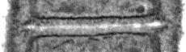
rga4∆rga6∆
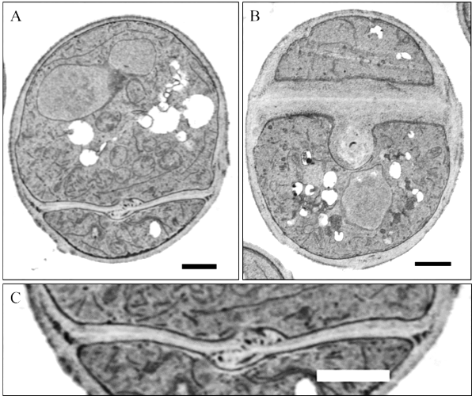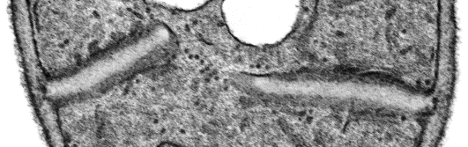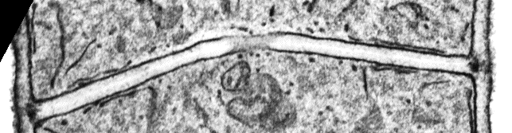

Figure 4: Loss of Cdc42 GAPs leads to membrane remodeling defects at the diffusion site. Membrane Remodeling Defects seen in electron micrographs of WT and rga4∆rga6∆ cells. rga4∆rga6∆ show abnormal septum morphology and vesicle accumulation (red box).

It has been reported that Cdc42 is required for proper endocytosis (Onwubiko et al., 2019). We asked if the membrane trafficking defects observed in rga4Δrga6Δ cells were due to impaired endocytosis. In wild type cells endocytosis at the division site is mostly restricted to the outer rim of the membrane barrier (Wang et al., 2016). We find that in rga4Δrga6Δ cells, endocytosis is no longer restricted to the rim of the membrane barrier and is instead observed all over the membrane as indicated by the endocytic marker, fimbrin, Fim1-GFP (Figure 5). This was shown by quantifying the distribution of endocytic patches at constricting rings.
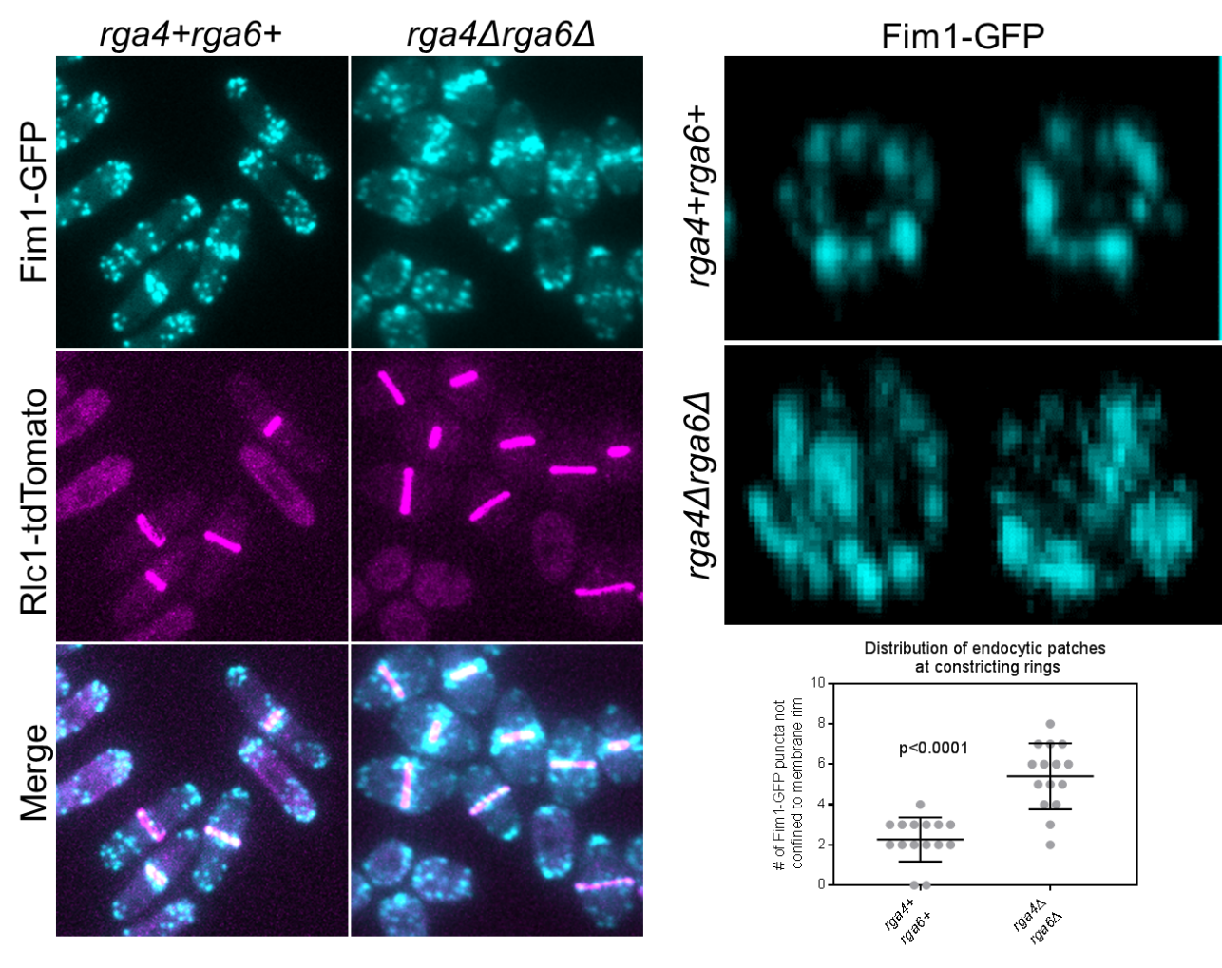
C
B
A
Figure 5: Loss of Cdc42 GAPs leads to mislocalized endocytosis A. Endocytic patches marked by Fim1-GFP localize to the division site and (B) 3D reconstructed membrane barriers display Fim1-GFP localization at the outer rim in wild type cells, rga4Δrga4Δ double mutants fail to restrict Fim1-GFP to the outer rim of the membrane barrier. C. Quantification of Fim1-GFP not restricted to the outer rim of the membrane barrier in the indicated strains.

The abnormal localization of fimbrin suggests that it is likely a defect in endocytosis that causes a cell separation delay in the Cdc42 GAP mutants. We also looked at other membrane trafficking proteins such as the exocyst protein, Exo70 and the septin, Spn2. These proteins did not show any change in their localization between wildtype and rga4∆rga6∆ cells, as show in Figure 6 below. Thus, the membrane trafficking events involving the exocyst and the septin are not impaired in rga4Δrga6Δ mutants.
A
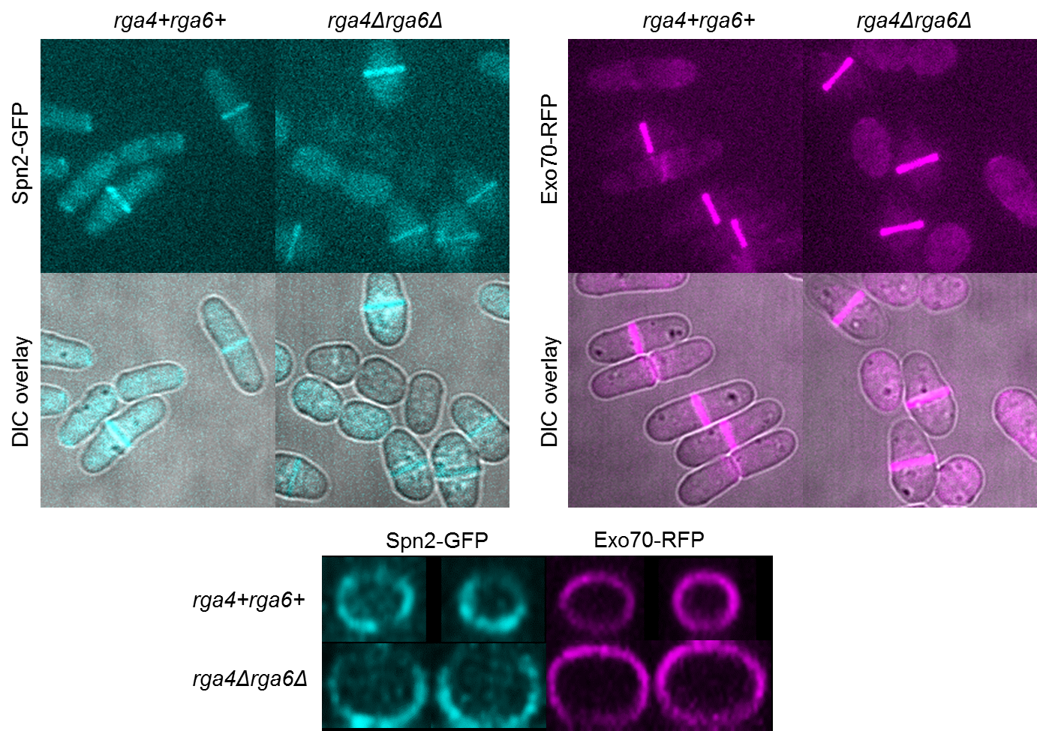
C
B

Figure 6: Localization of exocyst proteins, Spn2 and Exo70 are not regulated by the Cdc42 GAPs. A. Septin marked by Spn2-GFP and (B) exocyst marlked by Exo-70-GFP show similar localization in wild type and rga4Δrga6Δ double mutants. C. 3-D reconstructed division site did not show defects in septin and exocyst localization in the indicated strains.

Conclusion
Cytokinesis, the final step in cell division, requires the spatiotemporal organization of many steps to be completed properly (Guertin et al., 2002; Wei et al., 2016; Wu et al., 2003). The unique activation patterns of the GTPase Cdc42 by GEFs and GAPs play a pivotal role in proper cytokinesis (Figure 7) (Wei et al., 2016). Deleting the GAPs, rga4 and rga6, that inactivate Cdc42 leads to membrane remodeling defects and a delay in cell separation. We find that endocytosis, as determined by fimbrin localization, is no longer restricted to the outer rim of the membrane barrier in these mutants. It is possible that unrestricted endocytosis leads to improper membrane remodeling thereby distorting septum morphology. This may lead to inefficient septum digestion and cell separation delays. In the future, we will focus on the role GAPs play in endocytosis, and how exactly these endocytic membrane remodeling defects impair cytokinesis.

Figure 7: Cdc42 is spatiotemporally regulated by its GEFs and GAPs to organize distinct cytokinetic events. Gef1 and Scd1 activate Cdc42 and promote proper septum formation while the GAPs Rga4 and Rga6 promote cell separation.

Materials and Methods
Strains and Cell Culture
The S. pombe strains that were used in this study were all isogenic to the original strain 972, from Paul Nurse. Cells were cultured and grown exponentially at 25°C in yeast extract (YE) medium.

Microscopy
A VT-Hawk two-dimensional array laser scanning confocal microscopy system with an Olympus IX-83 inverted microscope with a 100x numerical aperture was used to acquire images at room temperature. For z-series, cells were mounted onto glass slides with a #1.5 coverslip (Fisher Scientific, Waltham, MA). The images were acquired at a depth interval of 0.4 μm. Images were analyzed using ImageJ. Statistically significant differences between the groups of cells was determined by p value from t test.

Cell Staining
To stain the septum and cell wall, cells were stained in YE liquid with 50 μg/ml Calcofluor White M2R (Sigma-Aldrich, St. Louis, MO) at room temperature.

References

Arellano, M., M.H. Valdivieso, T.M. Calonge, P.M. Coll, A. Duran, and P. Perez. 1999. Schizosaccharomyces pombe protein kinase C homologues, pck1p and pck2p, are targets of rho1p and rho2p and differentially regulate cell integrity. J Cell Sci. 112 ( Pt 20):3569-3578.
Atkins, B.D., S. Yoshida, K. Saito, C.F. Wu, D.J. Lew, and D. Pellman. 2013. Inhibition of Cdc42 during mitotic exit is required for cytokinesis. J Cell Biol. 202:231-240.
Coll, P.M., Y. Trillo, A. Ametzazurra, and P. Perez. 2003. Gef1p, a new guanine nucleotide exchange factor for Cdc42p, regulates polarity in Schizosaccharomyces pombe. Molecular biology of the cell. 14:313-323.
Crawford, J.M., N. Harden, T. Leung, L. Lim, and D.P. Kiehart. 1998. Cellularization in Drosophila melanogaster is disrupted by the inhibition of rho activity and the activation of Cdc42 function. Dev Biol. 204:151-164.
Das, M., D.J. Wiley, S. Medina, H.A. Vincent, M. Larrea, A. Oriolo, and F. Verde. 2007. Regulation of cell diameter, For3p localization, and cell symmetry by fission yeast Rho-GAP Rga4p. Molecular biology of the cell. 18:2090-2101.
Drechsel, D.N., A.A. Hyman, A. Hall, and M. Glotzer. 1997. A requirement for Rho and Cdc42 during cytokinesis in Xenopus embryos. Curr Biol. 7:12-23.
Guertin, D.A., S. Trautmann, and D. McCollum. 2002. Cytokinesis in eukaryotes. Microbiol Mol Biol Rev. 66:155-178.
Hirota, K., K. Tanaka, K. Ohta, and M. Yamamoto. 2003. Gef1p and Scd1p, the Two GDP-GTP exchange factors for Cdc42p, form a ring structure that shrinks during cytokinesis in Schizosaccharomyces pombe. Mol Biol Cell. 14:3617-3627.
Johnson, B.F., B.Y. Yoo, and G.B. Calleja. 1973. Cell division in yeasts: movement of organelles associated with cell plate growth of Schizosaccharomyces pombe. J Bacteriol. 115:358-366.
Merla, A., and D.I. Johnson. 2000. The Cdc42p GTPase is targeted to the site of cell division in the fission yeast Schizosaccharomyces pombe. European journal of cell biology. 79:469-477.
Onwubiko, U.N., P.J. Mlynarczyk, B. Wei, J. Habiyaremye, A. Clack, S.M. Abel, and M.E. Das. 2019. A Cdc42 GEF, Gef1, through endocytosis organizes F-BAR Cdc15 along the actomyosin ring and promotes concentric furrowing. J Cell Sci. 132.
Revilla-Guarinos, M.T., R. Martin-Garcia, M.A. Villar-Tajadura, M. Estravis, P.M. Coll, and P. Perez. 2016. Rga6 is a Fission Yeast Rho GAP Involved in Cdc42 Regulation of Polarized Growth. Mol Biol Cell.
Stachowiak, M.R., C. Laplante, H.F. Chin, B. Guirao, E. Karatekin, T.D. Pollard, and B. O'Shaughnessy. 2014. Mechanism of cytokinetic contractile ring constriction in fission yeast. Dev Cell. 29:547-561.
Wang, N., I.J. Lee, G. Rask, and J.Q. Wu. 2016. Roles of the TRAPP-II Complex and the Exocyst in Membrane Deposition during Fission Yeast Cytokinesis. PLoS Biol. 14:e1002437.
Wei, B., B.S. Hercyk, N. Mattson, A. Mohammadi, J. Rich, E. DeBruyne, M.M. Clark, and M. Das. 2016. Unique spatiotemporal activation pattern of Cdc42 by Gef1 and Scd1 promotes different events during cytokinesis. Mol Biol Cell. 27:1235-1245.
Wu, J.Q., J.R. Kuhn, D.R. Kovar, and T.D. Pollard. 2003. Spatial and temporal pathway for assembly and constriction of the contractile ring in fission yeast cytokinesis. Dev Cell. 5:723-734.

