Wide-area Measurement and Applications in Power System Dynamic Modeling and Control

A Dissertation Presented for the
Doctor of Philosophy
Degree
The University of Tennessee, Knoxville

Yong Liu
November 2013

Copyright © 2013 by Yong Liu
All rights reserved.

ACKNOWLEDGEMENTS

                - First and foremost, I would like to express my sincere gratitude to my advisor, Dr. Yilu Liu for her patient guidance and consistent encouragement in my academic and personal life. I cannot be luckier to have Dr. Yilu Liu as my Ph.D. advisor.
                - Next, thanks go to Dr. Fangxing Li, Dr. Kai Sun and Dr. Joshua Fu for their serving in my Ph.D. committee. I greatly appreciate their suggestions and comments on this dissertation.
                - Then, thanks are extended to all those graduated and current Power IT lab colleagues, for their consistent friendships and valuable suggestions. I am especially thankful for the patient help from Dr. Yingchen Zhang, Dr. Lang Chen, Dr. Yanzhu Ye, Dr. Zhenzhi Lin, Dr. Yuming Liu, Dr. Changgang Li, and Dr. Ke Zhang, who inspired me a lot. I truly enjoy the life and friendship in the Power IT lab.
                - Finally, I would like to express my deepest love to my family: my father Fuhong Liu, my mother Aiying Wang, and my wife Chen Zhang, for their endless love and support.
                - ABSTRACT
                - Synchrophasor is becoming the foundational element of wide-area measurement system (WAMS) in modern power system since first developed in 1980s. By utilizing Global Positioning System (GPS) time synchronization technique, synchrophasor devices could offer highly accurate time-synchronized phasor measurements, which can provide system operators with unprecedentedly deep insights of operation status and make possible the wide-area control of bulk power system.
                - Frequency Disturbance Recorders (FDRs) are installed at the distribution level to measure power system dynamics and known as a kind of single-phase synchrophasor. In this work, a preliminary test of FDR’s dynamic performance was carried out and a detailed procedure for its calibration was also summarized. Moreover, this work investigated the impact of GPS signal quality and availability on FDRs’ measurement accuracy and both high sensitivity GPS receiver and non-GPS based timing techniques were tested as a backup for synchrophasor timing.
                - Among the various applications of synchrophasor measurements, the wide-area control of renewable energy sources (variable-speed wind generators or solar Photovoltaic (PV) generators) for frequency regulation and inter-area oscillation damping has attracted significant attentions. In this work, based on the user-defined wind/PV generator electrical control model and the 16,000-bus Eastern Interconnection (EI) dynamic model, various controllers for frequency regulation and inter-area oscillation damping were developed and the potential contributions of renewables to the EI system frequency regulation and inter-area oscillation damping were demonstrated.
                - Measurement-based power system modeling is another important application of synchrophasor measurement, especially considering the fact that only a limited number of transfer functions or models are critical to system stability evaluation and real-time control. In this work, how to construct a measurement-based power system dynamic model was discussed. Based on a linear model structure, a concept of dynamic response estimation was proposed and its overall performance was examined. Identifying angular and voltage stability issues was also explored in this work as an example of this measurement-based model’s applications.

TABLE OF CONTENTS
Chapter 1 Introduction of Frequency Monitoring Network (FNET) 1
1.1 Frequency Monitoring Network Framework 1
1.2 Frequency Disturbance Recorder (FDR) 2
Chapter 2 Calibration and Dynamic Test of Frequency Disturbance Recorder (FDR) 4
2.1 Hardware Structure of Frequency Disturbance Recorder 4
2.2 Calibration of Frequency Disturbance Recorder 5
2.3 Dynamic Testing Method of Frequency Disturbance Recorder 8
2.4 Case Study of FDR Calibration and Dynamic Testing 9
2.4.1 Calibration of FDRs 12
2.4.2 Dynamic Testing of FDRs 15
2.4.3 FDR Data Completeness Test 18
2.5 Conclusion 18
Chapter 3 Impact of GPS Signal Quality on Performance of Phasor Measurements 19
3.1 Time Synchronization via Global Position System (GPS) 19
3.2 GPS Signal Loss Test 20
3.2.1 Test Preparation 20
3.2.2 Test Procedures and Results 21
3.3 Comparison of High Sensitivity and Conventional GPS Receivers 26
3.4 Possible Backup Time Synchronization Technology 30
3.5 Conclusions 31
Chapter 4 Wide-area Control of Variable-speed Wind Generators for Frequency Regulation and Oscillation Damping in the Eastern Interconnection (EI) 33
4.1 Background 33
4.2 Fast Active Power Control Techniques of Variable-speed Wind Generators 34
4.3 Variable-speed Wind Generator and Power System Model 36
4.3.1 Wind Generator Model 36
4.3.2 Power System Model 38
4.3.3 Simulation Scenario Construction 38
4.4 Contribution of Variable-speed Wind Generators to the EI Frequency Regulation 39
4.4.1 Wind Inertia Control 39
4.4.2 Wind Governor Control 40
4.4.3 Wind AGC Control 41
4.4.4 Case Study-Generation Trip 41
4.4.5 Case Study-Load Shedding 45
4.4.6 Frequency Regulation Movie Display 47
4.4.7 Discussion 48
4.5 Contribution of Variable-speed Wind Generators to the EI Oscillation Damping 48
4.5.1 Wind PSS Control 49
4.5.2 Oscillation Damping Using Local Signal 49
4.5.3 Inter-area Oscillation Damping Using Wide-area Signals 51
4.5.4 Coordinated Inter-area Oscillation Damping Using Wide-area Signal 53
4.5.5 Inter-area Oscillation Damping Movie Display 56
4.5.6 Discussion 56
4.6 Conclusion 57
Chapter 5 Wide-area Control of PV Plants for Frequency Regulation and Oscillation Damping in the Eastern Interconnection (EI) 58
5.1 Background 58
5.2 PV Generation Model 60
5.3 Contribution of PV Plants to the EI Frequency Regulation 61
5.3.1 PV Inertia Control 61
5.3.2 PV Governor Control 62
5.3.3 PV AGC Control 63
5.3.4 Case Study-Generation Trip 63
5.3.5 Case Study-Load Shedding 65
5.4 Contribution of PV Plant to the EI Oscillation Damping 66
5.5 Comparison of Wind and PV Control in Frequency Regulation 68
5.5.1 Comparison of Wind and PV Inertia Control 68
5.5.2 Comparison of Wind and PV Governor Control 70
5.5.3 Comparison of Wind and PV AGC Control 72
5.6 Construction of the EI Simulation Scenarios with High Penetrations of Renewable Energy Resources 73
5.7 Conclusion 74
Chapter 6 Wide-area Measurement Based Dynamic Modeling 75
6.1 Algorithm for ARX Model 76
6.2 Power System Linearity Study 77
6.3 Accuracy Index 81
6.4 Observability Index 82
6.5 Performance Testing 86
6.5.1 Comparison of different model inputs and outputs 86
6.5.2 Comparison of Different Excitation Sources 87
6.5.3 Validation Using Synchrophasor Data 89
6.5.4 Observability Study 92
6.5.5 Tolerance to System Topological Changes 93
6.5.6 Influence from the Synchrophasor Number 97
6.5.7 Influence from Synchrophasor Locations 98
6.6 Potential in Early Warning Instability 99
6.6.1 Angular Instability 100
6.6.2 Voltage Collapse 104
6.7 Summary 107
Chapter 7 Conclusion and Future Work 109
7.1 Conclusion 109
7.2 Future Work 110
List of References 111
Appendix 116
Appendix A Technical Specifications of Frequency Disturbance Rrcorder 117
Appendix B User-defined Wind Generator electrical Control MODEL (Active Power Part) 118
Appendix C User-defined PV electrical Control MODEL (Active Power Part) 121
Appendix D Influence of Oberverbility on Estimation Accuracy Index 122
Appendix E Influence of Inputs Types on Dynamic Response Estimation 125
Appendix F Influence of Excitation Types on Dynamic Response Estimation 127
Appendix G Influence of Topological Change on Dynamic Response Estimation 129
Appendix H Application in Out of Step Prediction 131
Appendix I Application in Voltage Stability Prediction 133
Appendix J Some EI System Simulation Studies 135
Vita 144

LIST OF TABLES
Table 6-1 Observability Index between Input Bus Group and Output Bus 84
Table 6-2 Input Groups when the Output is Frequency/Voltage/Angle 87
Table 6-3 Input Groups when the Output is Active/Reactive Power 87
Table 6-4 Events of Different Types of Excitation Sources and Estimated Events 88
Table A-1 Technical Specifications of FDR 117
Table B-1 Parameter of User-defined WT3 Electrical Control Model (Part) 119
Table B-2 Parameters of Wind Inertia Control Loop 120
Table B-3 Parameter of Wind Governor Control Loop 120
Table J-1 Generation Trips in Different Regions Used to Incite Inter-area Oscillations 136

LIST OF FIGURES
Figure 1-1 World-wide Deployments of FNET Sensors 1
Figure 1-2 FNET Architecture 2
Figure 1-3 Second-Generation FDR 3
Figure 2-1 FDR Hardware Structure 4
Figure 2-2 “Saw Teeth” Error and Its Correction 7
Figure 2-3 the Linear Frequency Ramp 9
Figure 2-4 Flowcharts of Calibration and Dynamic Testing Process 10
Figure 2-5 Block Diagram of the Calibrating and Testing Connection 11
Figure 2-6 Connection for FDR Calibration 11
Figure 2-7 Connection for FDR Dynamic Test 12
Figure 2-8 “Saw Teeth” Elimination in the Angle Curve 13
Figure 2-9 Voltage Magnitude before and after Calibration 14
Figure 2-10 Voltage Angle before and after Calibration 15
Figure 2-11 Step Test of Voltage Magnitude 16
Figure 2-12 Step Test of Frequency 16
Figure 2-13 Ramp Test of Frequency 17
Figure 3-1 Block Diagram of the GPS Signal Loss Test 21
Figure 3-2 Setup of the GPS Signal Loss Test 21
Figure 3-3 Voltage Angle Difference between Unit 756 and 762 22
Figure 3-4 Voltage Angle Difference between Unit 763 and 762 23
Figure 3-5 Voltage Angle Difference between Unit 787 and 762 23
Figure 3-6 Frequency Difference between Unit 787 and 762 25
Figure 3-7 Voltage Magnitude Difference between Unit 787 and 762 25
Figure 3-8 GPS Receiver and Antenna Placement Locations 27
Figure 3-9 Signal Quality of GPS receivers near the Window 28
Figure 3-10 Signal Quality of GPS Receivers in the Office Drawer 29
Figure 3-11 Measurement Errors of FDR Units Equipped with CW12 and M12+ after GPS Signal Loss 30
Figure 3-12 Radio Signal Transmitting Tower of eLoran System 31
Figure 3-13 Receiving Antennas of eLoran System 31
Figure 4-1 Over-speed for Variable-speed Wind Generator 36
Figure 4-2 Structure of WT3 Wind Turbine Stability Model in PSS/E [37] 37
Figure 4-3 Major Wind Farm Locations in the Simulated EI System 39
Figure 4-4 Wind Inertia Control Structure 40
Figure 4-5 Wind Governor Control Structure 41
Figure 4-6 Frequency Responses of the EI after a Generation Trip Event with Different Wind Generator Controls 43
Figure 4-7 Active Power Outputs of a Typical Wind Farm after a Generation Trip Event with Different Wind Generator Controls 43
Figure 4-8 Turbine Speed Deviations of a Typical Wind Farm after a Generation Trip Event with Different Wind Generator Controls 44
Figure 4-9 Reactive Power Outputs of a Typical Wind Farm after a Generation Trip Event with Different Wind Generator Controls 44
Figure 4-10 Frequency Responses of the EI after a Load Shedding Event with Different Controls 45
Figure 4-11 Active Power Outputs of a Typical Wind Farm after a Load Shedding Event with Different Controls 46
Figure 4-12 Turbine Speed Deviations of a Typical Wind Farm after a Load Shedding Event with Different Controls 46
Figure 4-13 Reactive Power Outputs of a Typical Wind Farm after a Load Shedding Event with Different Controls 47
Figure 4-14 Movie Display of the EI System Wind Generation Control for Frequency Regulation 48
Figure 4-15 Wind PSS Control Structure 49
Figure 4-16 Local Frequency Response with Wind PSS control 50
Figure 4-17 Active Power Output with Wind PSS Control 50
Figure 4-18 NW-South Inter-area Oscillation Damping Using Local Signals 51
Figure 4-19 NW-South Inter-area Oscillation Damping Using Wide-area Signals 52
Figure 4-20 NW-NE Inter-area Oscillation 52
Figure 4-21 Inter-area Oscillation Damping using Coordinated Wide-area Wind Control 54
Figure 4-22 Wind Generation Performance under Inter-area Oscillation Damping Control 55
Figure 4-23 Movie Display of the EI Wide-area Wind Generator Control for Inter-area Oscillation Damping 56
Figure 5-1 Over-voltage Working Condition of PV Panel 59
Figure 5-2 PV Model Connectivity Diagram[37] 60
Figure 5-3 PV Inertia Control Structure 62
Figure 5-4 PV Governor Control Structure 62
Figure 5-5 Frequency Responses of the EI after a Generation Trip Event with Different PV Generation Controls 64
Figure 5-6 Active Power Outputs of a Typical PV Plant after a Generation Trip Event with Different Controls 64
Figure 5-7 Frequency Responses of the EI after a Load Shedding Trip Event with Different PV Generation Controls 65
Figure 5-8 Active Power Outputs of a Typical PV Plant after a Load Shedding Trip Event with Different Controls 66
Figure 5-9 Inter-area Oscillation Damping using Coordinated Wide-area PV Plant Control 67
Figure 5-10 Movie Display of the EI Wide-area PV Plant Control for Inter-area Oscillation Damping 68
Figure 5-11 Active Power Outputs of either Wind or PV Inertia Control 69
Figure 5-12 Frequency Response of the EI with either Wind or PV Inertia Control 70
Figure 5-13 Active Power Output of either Wind or PV Governor Control 71
Figure 5-14 Frequency Response of the EI with either Wind or PV Governor Control 71
Figure 5-15 Active Power Output of either Wind or PV AGC Control 72
Figure 5-16 Frequency Response of the EI with either Wind or PV AGC Control 73
Figure 6-1 Disturbance Locations for the Bulk Power Grid Linearity Study 78
Figure 6-2 the Monitoring Point’s Linearity after Event 1 and 2 78
Figure 6-3 the Monitoring Point’s Linearity after Event 3 and 4 79
Figure 6-4 the Monitoring Point’s Linearity after Event 5 and 6 79
Figure 6-5 Voltage Nonlinearity Zone of the Monitoring Point 80
Figure 6-6 the Monitoring Point’s Linearity after Event 7 and 8 80
Figure 6-7 Angle Nonlinearity Zone of the Monitoring Point 81
Figure 6-8 Schematic Map of Input and Output Bus Locations 84
Figure 6-9 Relationship between Observability Index and Model Accuracy Index (for Voltage and Angle) 85
Figure 6-10 Events Distribution Detected by FNET in a Single Day 88
Figure 6-11 FDR Deployment of Michigan Area 89
Figure 6-12 Generation Trip Event Used for Model Training 90
Figure 6-13 Load Shedding Event Used for Model Validation 91
Figure 6-14 Comparison of Estimated Frequency Response and Actual Frequency Measurement 91
Figure 6-15 Comparison of Estimated Angle Response and Actual Angle Measurement 92
Figure 6-16 Coverage Map of Three Input Buses in TVA Area 93
Figure 6-17 Map of Line Trips 94
Figure 6-18 Observability Index Changes after Line Trips in the Radial Direction 96
Figure 6-19 Boundary Map of Topology Change’s Influence 96
Figure 6-20 Accuracy Index Trend with Different Numbers of Inputs 97
Figure 6-21 Accuracy Index Trending with Different Distances between Inputs and Outputs 99
Figure 6-22 Map of Florida Area Power Grid 100
Figure 6-23 Frequency Response after the Sequence of Disturbances 101
Figure 6-24 Angle Response after the Sequence of Disturbances 101
Figure 6-25 Frequency Response Used for Model Identification 102
Figure 6-26 Accuracy Index of Frequency Response Estimation Following the Sequence of Disturbances-Fixed Model 103
Figure 6-27 Accuracy Index of Frequency Response Estimation Following the Sequence of Disturbances-Adaptive Model 104
Figure 6-28 Map of Massachusetts Area Grid 105
Figure 6-29 Voltage Response of the Output Bus Following the Sequence of Trips 105
Figure 6-30 Accuracy Index of Voltage Response Estimation Following the Sequence of Disturbances-Fixed Model 106
Figure 6-31 Voltage Response Estimation Following the Sequence of Disturbances-Adaptive Model 107
Figure B-1 User-defined WT3 Electrical Control Model (Active Power Part) 118
Figure C-1 User-defined WT3 Electrical Control Model (Active Power Part) 121
Figure D-1 Frequency Estimation with Different Levels of Observability Index 122
Figure D-2 Voltage Estimation with Different Levels of Observability Index 123
Figure D-3 Angle Estimation with Different Levels of Observability Index 124
Figure E-1 Different Groups of Inputs when the Output is Frequency/Voltage/Angle-Generation Trip as Excitation to Estimate Generation Trip 125
Figure E-2 Different Groups of Inputs when the Output is Active/Reactive Power-Generation Trip as Excitation to Estimate Load Shedding 126
Figure F-1 Excitation Types-Generation Trip as Excitation 127
Figure F-2 Excitation Types-Line Trip as Excitation 128
Figure G-1 Dynamic Response Estimation after Topological Change-Far 129
Figure G-2 Dynamic Response Estimation after Topological Change-Near 130
Figure H-1 Frequency Response Estimation Following the Sequence of Disturbances-Fixed Model 131
Figure H-2 Frequency Response Estimation Following the Sequence of Disturbances-Adaptive Model 132
Figure I-1 Voltage Response Estimation Following the Sequence of Disturbances-Fixed Model 133
Figure I-2 Voltage Response Estimation Following the Sequence of Disturbances-Adaptive Model 134
Figure J-1 Inter-area Oscillations in EI incited by Disturbances in Different Regions 137
Figure J-2 Frequency Responses of the EI system with Different Penetration Levels of “Fake” Renewables 139
Figure J-3 Voltage Responses of the EI system with Different Penetration Levels of “Fake” Renewables 140
Figure J-4 16,000-bus EI Model Validation Using FNET Measurement Data-North Anna Event 141
Figure J-5 16,000-bus EI Model Validation Using FNET Measurement Data-TVA Line Trip Event 142
Figure J-6 Forced Inter-area Oscillations in the EI by Control of PV Generation 143

Introduction of Frequency Monitoring Network (FNET)

Frequency Monitoring Network Framework
                - As an academia-run wide-area measurement system (WAMS) of the power grids, Frequency Monitoring Network (FNET) at the University of Tennessee, Knoxville (UTK) has been continuously providing real-time independent observation of the dynamic performance of the main electric power grids in the world since 2003 (Figure 1-1) [1]-[3].

                - 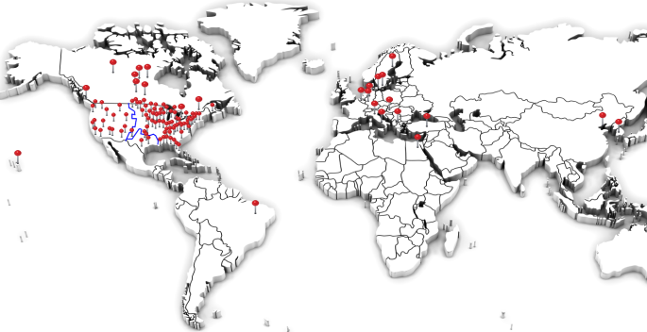
Figure 1-1 World-wide Deployments of FNET Sensors

                - As depicted in Figure 1-2, the FNET system consists of two major components: a) hundreds of frequency disturbance recorders (FDRs), the ground-level sensors which perform local GPS-synchronized frequency measurements and send data to the server through the Internet, and b) the information management system (IMS), which includes data collection and storage service, data communication service, database operation service, and web service.

                - Figure 1-2 FNET Architecture

Frequency Disturbance Recorder (FDR)
                - The sensors FNET uses to capture the electric power grid dynamics (frequency, voltage and phase angle) are usually referred to as Frequency Disturbance Recorders (FDR, Figure 1-3), which are essentially the single-phase GPS-synchronized Phasor Measurement Units (PMUs) [1-3]. Since the FDR sensors are installed on the distribution level (120V in the U.S.), they do not require the extensive installation efforts as what PMUs needs at the high voltage substations. FDR sensors are low-cost, easy to install, and thus are widely installed in offices, residential households and renewable generation sites of North America, Europe, East Asia and Brazil.

                - 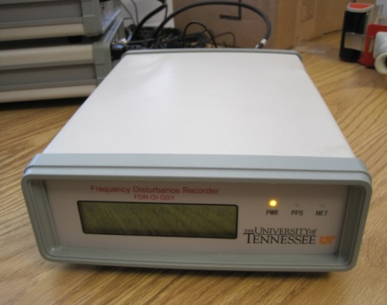
                - Figure 1-3 Second-Generation FDR

Calibration and Dynamic Test of Frequency Disturbance Recorder (FDR)
                - The technical specifications of second-generation FDR are listed in Appendix A. In order to make sure all the FDRs meet the same accuracy criteria, the calibration and dynamic test process need to be carefully carried out and will be introduced in this chapter.

Hardware Structure of Frequency Disturbance Recorder
                - Compared to its commercial counterpart PMU, the FDR’s hardware structure is relatively simple, including a step-down voltage transformer, an analog low-pass filter, an analog to digital (A/D) converter, a GPS receiver, a microprocessor and a network communication module, as shown in Figure 2-1.

                - Figure 2-1 FDR Hardware Structure

                - PMUs are all installed in the high voltage level substations (110kV above) and thus high-precision Potential Transformer (PT) or Current Transformer (CT) is indispensable to attenuate the kV-voltage or kA-current level to 100-V or 5-A in order for voltage or current measurement. Comparatively, as a low-cost, easily-deployed synchrophasor on the distribution level, the FDR sensor only needs a simple step-down voltage transformer to take the analog voltage waveform from a 110-V wall. Then, the analog low-pass filter inside the sensor eliminates the high-frequency components of the voltage waveform, and the A/D converter transforms the analog signal into digital data. The microprocessor is used to generate the sampling pulses which are synchronized to the 1 PPS from the GPS receiver. Then, the phase angle, frequency, and rate of change of frequency are all computed in the digital signal processor (DSP) using phasor techniques developed specifically for single phase measurements. As the last step, the computed values are time-stamped in the microprocessor, packaged (maybe also encrypted) in the network communication module and then transmitted to the data server via the Internet.

Calibration of Frequency Disturbance Recorder
Due to the small differences of the electronics components such as low-pass filter and A/D converter, different FDR units may own slightly different dynamic characteristics. In order to achieve the optimal measurement precision, the calibration process of FDRs should be completed before their installation. In this section, three types of calibrations: “saw teeth” calibration, voltage magnitude calibration and voltage angle calibration will be introduced.
1) Saw Teeth
For the second generation FDRs, the voltage waveform sampling rate is 1440 per second and the clock frequency of the microcontroller is 30 Million per second. Therefore, the number of clock pulses in each sampling period is given below:
$N_{clkpus_{sampling}}=floor\left(\frac{N_{clkpus_{PPS}}}{M}\right)=floor\left(\frac{30,000,000}{1440}\right)=20833$ 2-1
$N_{clkpus_sampling}$ is the number of system clock pulses between adjacent sampling pulses, $N_{clkpus_PPS}$ is the number of the system clock pulses between two consecutive PPSs, and $M$ is the voltage waveform sampling point per second. $floor(N_{clkpu{s_}_{PPS}}/M)$ stands for the largest integer that’s smaller than $N_{clkpu{s_}_{PPS}}/M$. Obviously, a residue of 480 clock pulses exists in every second because $N_{clkpus_PPS}$ could not be divided by $M$.
$Residue=30,000,000-\left(1440*20833\right)=480$ 2-2
This residue amounts to 16 µs for the second-generation FDR if converted into time. Though it seems to be negligible, it would result in the accumulation of voltage angle error and finally cause a sudden change (referred to as “saw teeth”) in the end of each PPS period due to the correction effect of a new PSS. However, considering the angle “saw teeth” error within each second is linearly accumulated and strictly proportional to the data point number, which is the number of tenths of a second (remember 10 measurement points per second), the errors can be calculated and eliminated easily. Note that a constant frequency deviation from the nominal value also causes the angle measurements to change linearly. Therefore, the effect of frequency deviation must also be taken into account.
The illustration of the “saw teeth” error in the presence of a constant frequency deviation is drawn in Figure 2-2. The solid curve is the angle measurement, and the broken straight line is the true angle value. The goal is to bring the measurement from solid line to the broken straight line, for example, to move the measurement point $10k+6$ to the dot on the broken line as directed by the arrow. More specifically, the slope difference between the solid straight line and the broken straight line $β$ in Figure 2-2 is the coefficient that the compensation procedure needs to amend the measurements with. From Figure 2-2, it is easy to know that the coefficient $β$ can be obtained by adding the slope of the solid straight line χ and the slope of the broken straight line α, which can be easily calculated by following equations:
$α=\frac{Angle\left[10k\right]-Angle[10(k+1)]}{10}$ 2-3
$χ=\frac{Angle\left[10k\right]-Angle[10k+9]}{9}$ 2-4
                - Figure 2-2 “Saw Teeth” Error and Its Correction

After the coefficient $β$ is obtained, for the $k th$ sample in a second, subtract $kβ$ from the original value to obtain the compensated angle. In this way, the “saw teeth” issue could be addressed.
2) Voltage Magnitude Coefficient
Due to the difference in electronic components such as the transformer, low-pass filter, A/D converter and other pieces of circuitry, it is also necessary to calibrate the voltage magnitude in the phasor calculation. If standard 120V voltage source is applied on FDRs during the calibration process, the voltage magnitude measurements $V_{i} (i=1,2,…,n)$ will be collected and the voltage magnitude correction coefficient $V_{coff}$ can be calculated by
$V_{coff}=\frac{120n}{\sum_{i=1}^{n}{V_{i}}}$ 2-5
Where $n$ is the number of total measurement points. Finally, the phasor estimation algorithm is modified in the DSP through multiplying every voltage magnitude by $V_{coff}$to obtain the accurate measurement of voltage magnitude.
3) Voltage Angle Shift
Voltage angle, which is used to calculate power grid frequency in the FDR, provides the most useful information for power system analysis. Similar to voltage magnitude, voltage angle shift may be generated due to the different characteristics of hardware circuits. After calibrating the voltage magnitude and eliminating the “saw teeth” of voltage angle, the last step of calibration is to eliminate the angle shift. If a standard 60Hz/0 phase angle voltage source is applied during the calibration process, the angle shift can be calculated as follows:
$φ_{shift}=2π-\frac{1}{n}\sum_{i=1}^{n}{φ_{i}} (i=1, 2,…,n)$ 2-6
Where n is the number of phase angle measurement points. Then, the correction coefficient $φ_{shift}$is added to each angle measurement in the algorithm so that all the FDRs can have the same reference frame.

Dynamic Testing Method of Frequency Disturbance Recorder
IEEE C37.118-2005 standard states that different PMUs will behave differently and "Behavior under transient conditions is not mandated"[4]-[5]. However, the dynamic accuracy of synchrophasors proves to be more valuable than the steady-state accuracy during transient conditions. Therefore, the section will introduce dynamic testing method of FDRs.
1) Step Testing
Step testing is a basic method to test the dynamic performance of FDRs during transient conditions, such as a line fault and a load switching. Though step change is not true reflection of wide-area grid frequency, they are of great value for disturbance detection application. Both positive and negative step testing of voltage and frequency are considered in this section.
2) Ramp Testing
Ramp testing is another test method considered in this work. It can be seen from Figure 2-3 that the process of frequency ramp between start and stop frequency consists of three phases, namely, ramp, hold and return phases. The ramp rate should be chosen carefully so that the frequency ramp can emulate the transient conditions in real power systems to some extent.

                - Figure 2-3 the Linear Frequency Ramp

Case Study of FDR Calibration and Dynamic Testing
In summary, the calibration and dynamic testing process can be described by the flowchart in Figure 2-4.
                - Figure 2-4 Flowcharts of Calibration and Dynamic Testing Process

The block diagram of the calibration and testing is presented in Figure 2-5. Doble F6150 Power System Simulator (GPS synchronized) is used as the standard power source here. In the calibrating part, the standard voltage source signal from Doble F6150 was applied on the FDRs and measurement data from FDRs were collected by the data server, as shown in Figure 2-6. Agilent 6811B AC Power Source/Analyzer, Tektronix AFG 3021B Arbitrary/Function Generator and Trek PZD350A M/S Piezo Driver/Amplifier were used for the purpose of dynamic performance testing. In the dynamic testing part, 110 V voltage signal from Agilent 6811B was applied on the FDRs for step testing of FDRs, and 10 V voltage signal from Tektronix AFG 3021B was amplified by Trek PZD350A M/S, and fed to FDRs for ramp testing, as shown in Figure 2-7.

                - Figure 2-5 Block Diagram of the Calibrating and Testing Connection

                - 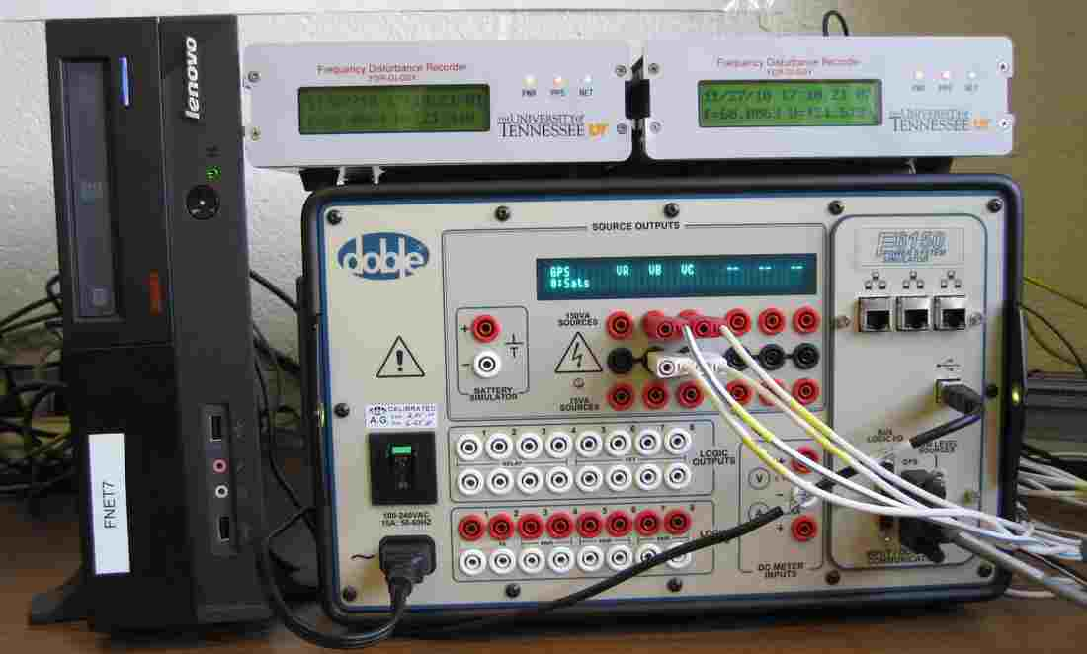
                - Figure 2-6 Connection for FDR Calibration
                - 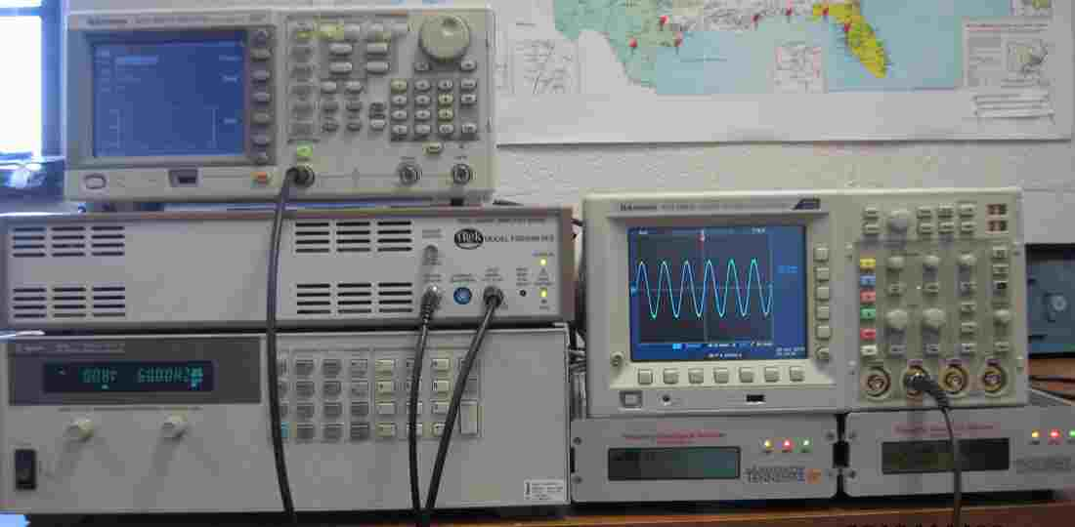
                - Figure 2-7 Connection for FDR Dynamic Test

Calibration of FDRs
During the calibration process, standard 120V/60Hz voltage signals generated by Doble F6150 are applied on the FDRs. This section will give the detailed calibrating results.
1) “Saw Teeth” Calibration
As shown in Figure 2-8, small “saw teeth” within per second can be seen in the angle curves of the PSU and Bismarck FDRs which are not calibrated. However, they are not noticeable in the angle curves of ARI, FSU, and ISONE FDRs, which have been calibrated before their installations. In a word, the “saw teeth” problem can be satisfactorily resolved by the technique mentioned above.

                - 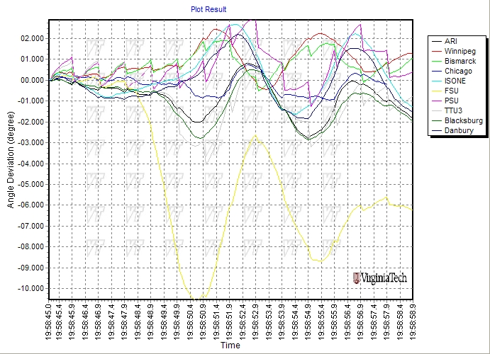
                - Figure 2-8 “Saw Teeth” Elimination in the Angle Curve

2) Voltage Magnitude
The second step is voltage magnitude calibration. Figure 2-9 shows the results of voltage magnitude measured by one FDR before and after calibration. The original average voltage is equal to 119.9342V, and then the voltage magnitude coefficient can be calculated by Equation 2-5 and is equal to 1.00055. As seen from Figure 2-9, voltage magnitude after calibration is equal to 120V.

                - Figure 2-9 Voltage Magnitude before and after Calibration

3) Voltage Angle
The result of voltage angle calibration is shown in Figure 2-10. The original average voltage angle is equal to 2.8223 rad. The angle shift is calculated by Equation 2-6 and is equal to 3.46084 rad. As seen from Figure 2-10, the voltage angle after calibration is equal to 0.

                - Figure 2-10 Voltage Angle before and after Calibration

Dynamic Testing of FDRs
In the dynamic testing, dynamic performance will be evaluated by comparing the testing FDR with the standard FDR which has been calibrated and tested before. The following section will present the step and ramp testing results respectively. In this work, the dynamic range of voltage was tested from 114V to 126V and the dynamic range of frequency was tested from 55 Hz to 65 Hz as IEEE C37.118-2005 standard recommends [6].
1) Step Test
Figure 2-11 shows the results associated with the step test of voltage magnitude. As shown in Figure 2-11, the voltage signal has an initial period of constant magnitude, which was followed by several periods of magnitude step changes. It can be seen from Figure 2-11 that the testing FDR can quickly respond to the sudden positive and negative step of voltage as the standard FDR does.
                - Figure 2-11 Step Test of Voltage Magnitude

                - Figure 2-12 Step Test of Frequency

Figure 2-12 shows the results associated with the step test of frequency. It can also be seen from Figure 2-12 that the testing FDR can quickly respond to the sudden positive and negative step of frequency.
2) Ramp Test
The parameters shown in Figure 2-3 should be set before the ramp testing. In this study, the start frequency $f_{start}$ is set to 60 Hz and the stop frequency $f_{stop}$ is set to 55 Hz or 60 Hz. The ramp, hold and return times are all set to 5 seconds according to [6]. The voltage magnitude is set to 120V. Then, the result associated with linear ramp test of frequency is shown in Figure 2-13. As shown in Figure 2-13, the voltage signal has an initial period of constant frequency followed by a series of periods of positive frequency ramp, constant frequency, and negative frequency ramp. It can be seen that the testing FDR can quickly respond to the sudden positive and negative ramp of frequency.

                - Figure 2-13 Ramp Test of Frequency

FDR Data Completeness Test
In order to ensure the FDR performance stability over time, it is important to check the completeness of the recorded data by the testing FDR after the calibration and dynamic testing. The testing FDR is plugged into the 120V electrical outlets for several days. Then, the total number of data recorded by FDR in each day is checked. If the testing FDR can operate reliably after this period of time and the missing data is less than 2% of the total in each day, the FDR data completeness testing is considered to be acceptable.

Conclusion
The calibration and dynamic testing process was presented for testing the accuracy and dynamic performance of FDRs. The FDRs after calibration can well exceed the required accuracy and dynamic performance needs of wide-area measurement.

Impact of GPS Signal Quality on Performance of Phasor Measurements

Time Synchronization via Global Position System (GPS)
                - Global position system (GPS) is made up of a constellation of twenty-four active satellites orbiting approximately 20, 200 kilometers above the surface of the earth. Originally deployed by the United States Department of Defense (DOD), all of these satellites have onboard atomic clocks that synchronize to within 3 ns of the official atomic clock located at the United States Naval Observatory (USNO). Furthermore, the basic accuracy of each GPS receiver is within 0.2 µs of Coordinated Universal Time (UTC). The GPS signals can be received across the globe, and a position solution can be solved by acquiring at least four satellites. And once an accurate position solution is given, the receiver will only need one satellite for clock synchronization. The unique fact that the signals from these satellites are synchronized with the atomic clock allows the end users of the system to receive synchronized frequency information.
                - Besides the initial prerequisite of acquiring a fix with four satellites, the GPS has a number of factors that could affect its performance in providing accurate timing. Most importantly, the GPS antenna position plays a crucial role in obtaining accurate timing information. For optimal performance, the antenna should have an unobstructed view of the horizon in all directions. This will enable the receiver to monitor the maximum number of satellites simultaneously, and to provide a more stable GPS lock. On the other hand, there are number of factors that affect GPS performance which are uncontrollable. These factors can include atmospheric delays, signal multi-path interference, satellite geometry and satellites orbital errors. Overall, the drawbacks of GPS as a timing reference are overshadowed by the overall accuracy and that makes the GPS a top candidate for time synchronization in WAMS measurements. For example, the current FDR design is based on Motorola M12+ GPS receiver to provide timing information. With these receivers, the timing accuracy is specified to reach below 10 nanoseconds [7]. Clearly, the M12+ receiver has the ability to perform very well in time synchronization, given the condition that it has a stable lock on the satellites.

GPS Signal Loss Test
                - As discussed in the previous section, the accuracy of phasor measurement could be greatly improved with the help of GPS time synchronization. Therefore, PMU and FDR devices should have a stable lock on the satellites in order to achieve time synchronization and offer accurate measurements. However, there are a series of complex factors that could affect the availability of GPS signals. Based on previous experiences, the GPS receiver tends to lose signals at times even when the antenna is placed in a location with unobstructed view of the satellites. Therefore, it’s necessary for us to explore the phasor measurement accuracy when the GPS receiver has lost the acquisition of satellite signals.

Test Preparation
                - The test was designed and completed on FDRs as the test bed. A block diagram of the test is presented in Figure 3-1. In this setup, Doble Power System Simulator F6150 (GPS antenna included) is used as the standard power source that provides the standard 110 V, 60Hz, 0° voltage signal. In the test block diagram, the voltage signal from Doble F6150 is applied on the FDR units and the measurement data from the FDR units are sent to the FNET server via Internet. Finally, a picture of the setup is shown in Figure 3-2.

                - Figure 3-1 Block Diagram of the GPS Signal Loss Test

                - Figure 3-2 Setup of the GPS Signal Loss Test

Test Procedures and Results
                - As indicated previously, FDR devices can measure voltage phase angle, voltage magnitude, and system frequency at a very precise level with the help of GPS synchronization. However, among the three parameters measured by FDR units, the accuracy of voltage angle measurement is what we concern most, simply because the frequency is not directly measured but calculated through the rate of voltage angle change [8]. Furthermore, voltage angle is also the most sensitive parameter to GPS signal loss. Therefore, voltage angle is chose as the test parameter to reflect the influence of GPS signal loss on the measurement accuracy.
                - The test involves 4 FDR units. The first FDR, unit 762, should have a stable lock on the GPS satellites during the whole test procedure in order to ensure sufficient measurement accuracy. Therefore, its measurement can be considered as the reference. For FDR unit 756, its antenna will be unplugged to simulate the effect of losing GPS signal for 15 minutes and then will be re-plugged to let the GPS receiver re-gain stable GPS signals. After that, the antenna of unit 756 again would be unplugged for another 30 minutes. For FDR unit 763 and unit 787, their antennas will be unplugged for 60 minutes and 120 minutes, respectively. The voltage angle data recorded by FDR units 756,763, 787 are subtracted from the reference value measured by unit 762 and the results are shown in Figure 3-3, Figure 3-4 and Figure 3-5. It should be noted that all the FDR units had been working normally before the test.

                - 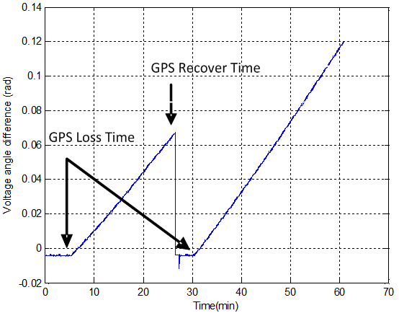
                - Figure 3-3 Voltage Angle Difference between Unit 756 and 762
                - 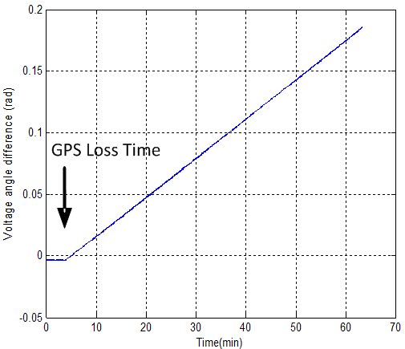
                - Figure 3-4 Voltage Angle Difference between Unit 763 and 762

                - 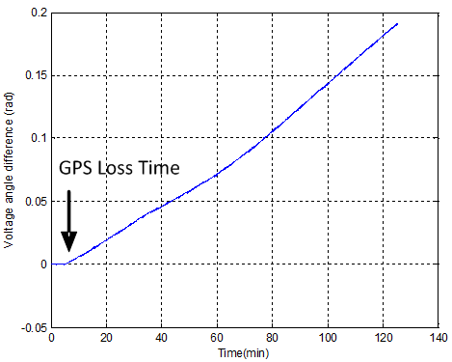
                - Figure 3-5 Voltage Angle Difference between Unit 787 and 762

                - From the results shown above, it’s obvious that the voltage angle measurement errors of FDR units increase linearly with the GPS loss duration time. This is due to the fact that the sampling clock of FDR A/D converter is no longer synchronized with the GPS and the error will accumulate over time. Furthermore, it’s important to note that despite the similar linear relations between measurement error and GPS loss duration time, the slopes of the curves, in other words, the error accumulating rates are quite different for different FDR units. For example, the slope of FDR unit 756 is about 0.0043 rads/min while those of units 763 and 787 are about 0.0030 and 0.0016 rads/min, separately. Considering the fact that FDR units have to depend on the internal clock of GPS receiver M12+ for synchronization after losing GPS signals, it could be concluded that the GPS receiver oscillator clock is not accurate enough for time-synchronized measurements. Hence, once the GPS receiver loses the satellite signals, the voltage angle measurements are susceptible to errors in the sampling clock.
                - Despite the obvious error of angle measurement after GPS signal loss, it can be seen that the frequency and voltage magnitude difference between unit 787 and 762 are minimal from Figure 3-6 and Figure 3-7, which implies the measurement errors of frequency and voltage are much smaller than that of the angle, just as what was discussed at the beginning of the section. However, the case may be much worse for commercial PMUs. Because the parameters that the PMU measures, such as active and reactive power injections, transmission line power flows, are partly based on the accuracy of the angle measurement; they will be inevitably influenced by the measurement errors created by the inaccurate sampling clock.

                - 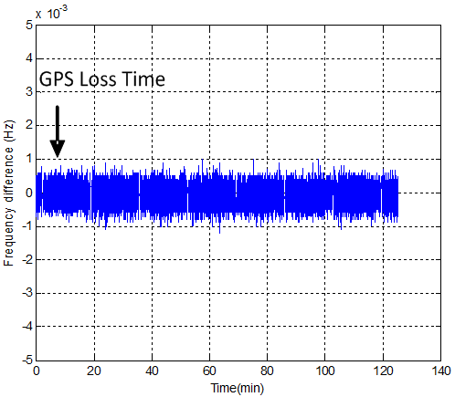
                - Figure 3-6 Frequency Difference between Unit 787 and 762

                - 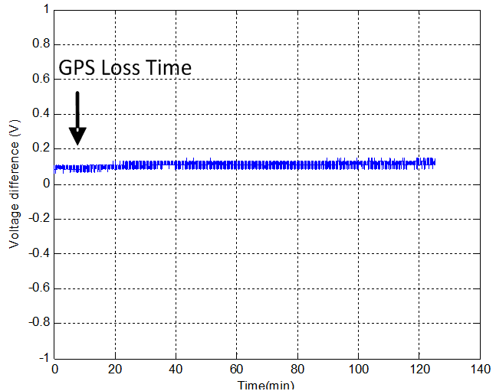
                - Figure 3-7 Voltage Magnitude Difference between Unit 787 and 762

                - However, from Figure 3-3, it can be concluded that given a large measurement error produced by losing GPS signal as it is shown in the first 26 minutes, the FDR measurement errors can be corrected as soon as the GPS signal is picked up again. Thus, the measurement accuracy of the FDRs is highly dependent on the acquisition of GPS signals.

Comparison of High Sensitivity and Conventional GPS Receivers
                - As mentioned above, the GPS signal loss problem of wide-area phasor measurement could happen from time to time. For PMUs, the inaccuracies and missing data caused by the GPS signal loss is a big issue in the power system state estimation. Therefore, a great deal of efforts should be made in ensuring the availability of GPS signals for wide-area measurement devices.
                - The high sensitivity GPS receiver, commonly known as the indoor GPS, uses a large number of correlators and additional digital signal processing technique to search for GPS signals [9]; thus, it can be used to provide position or time information under conditions where GPS signals are extremely weak. As a possible solution to losing GPS signals, it is worthwhile to explore alternative GPS time references for our synchronized measurement. In this case, the performance of a high sensitivity GPS receiver, Navsync CW12, was tested in several locations (see Figure 3-8) using the commercial GPS evaluation software Winoncore 12. To compare with the conventional GPS receiver Motorola M12+ used in the current FDR, results are shown in Figure 3-9 and Figure 3-10.

                - 
Near the unobstructed window In the office drawer
                - Figure 3-8 GPS Receiver and Antenna Placement Locations

                - 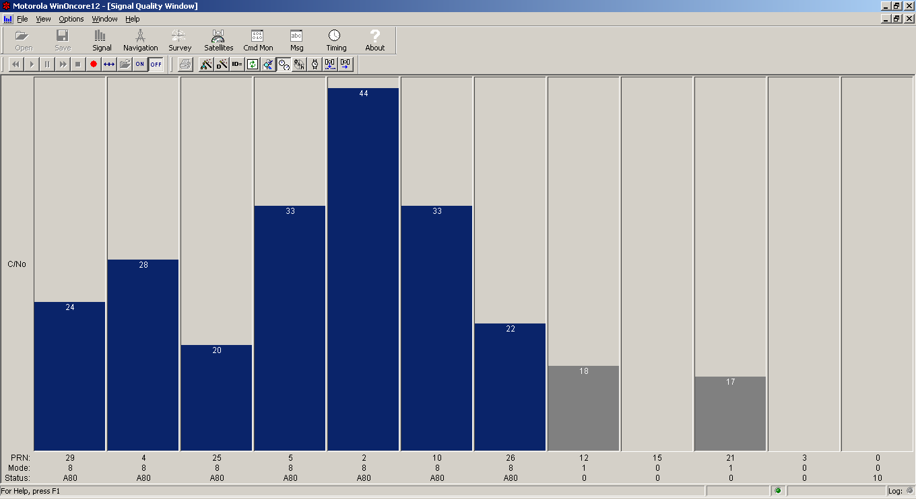
                - (a) Signal Quality of GPS Receiver CW12 near the Window
                - 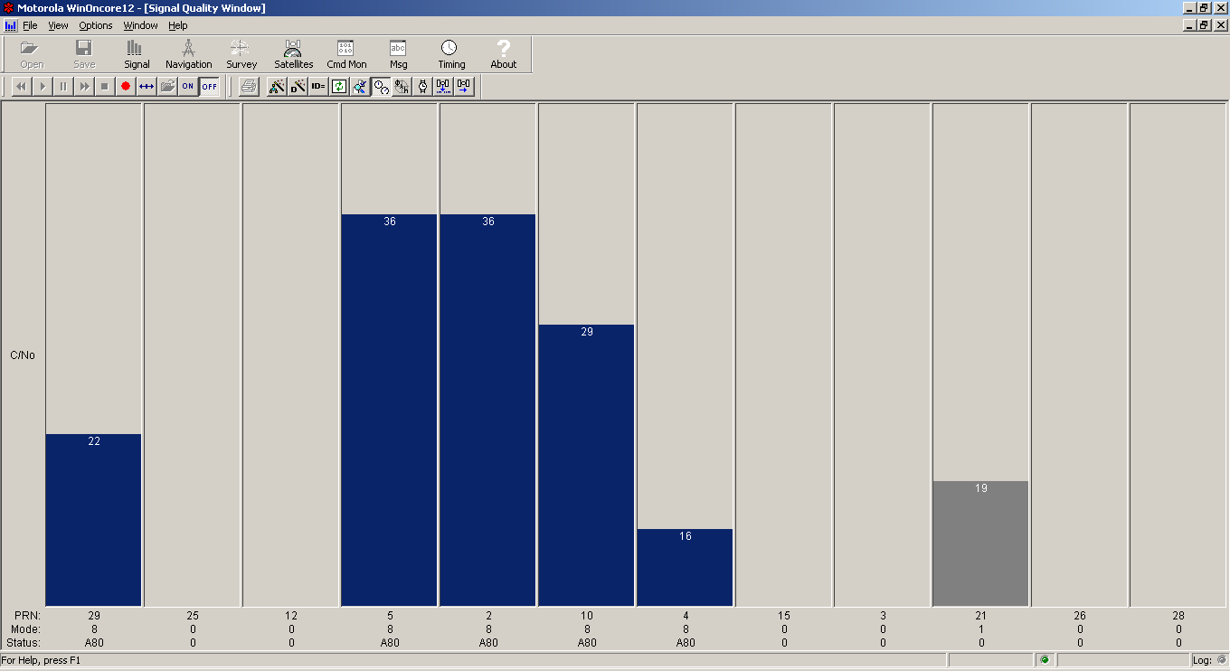
                - (b) Signal Quality of GPS Receiver M12+ near the Window
                - Figure 3-9 Signal Quality of GPS receivers near the Window

                - 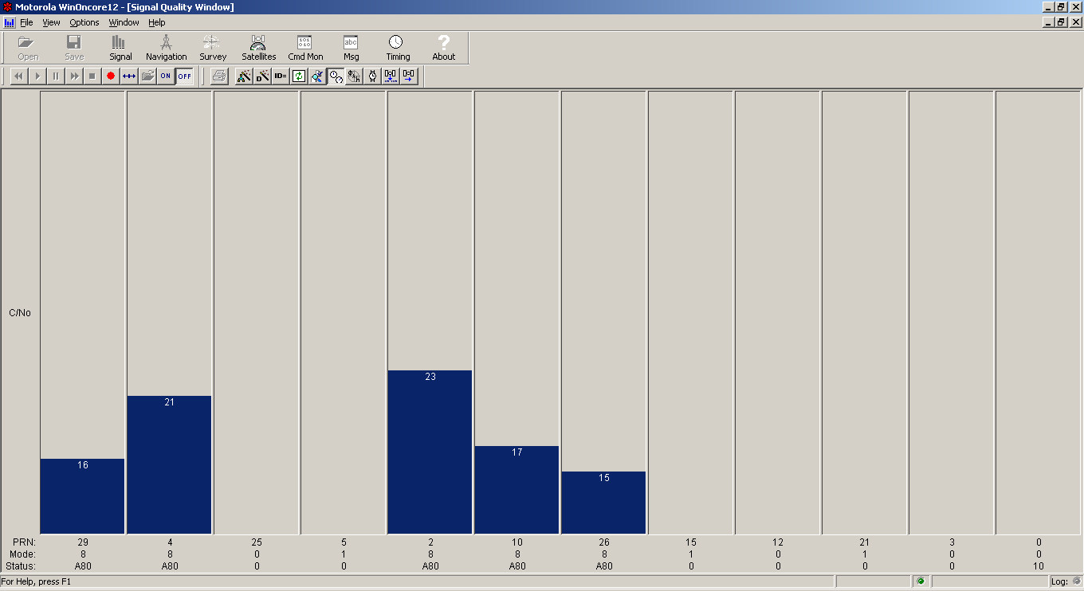
                - (a) Signal Quality of CW12 in the Office Drawer
                - 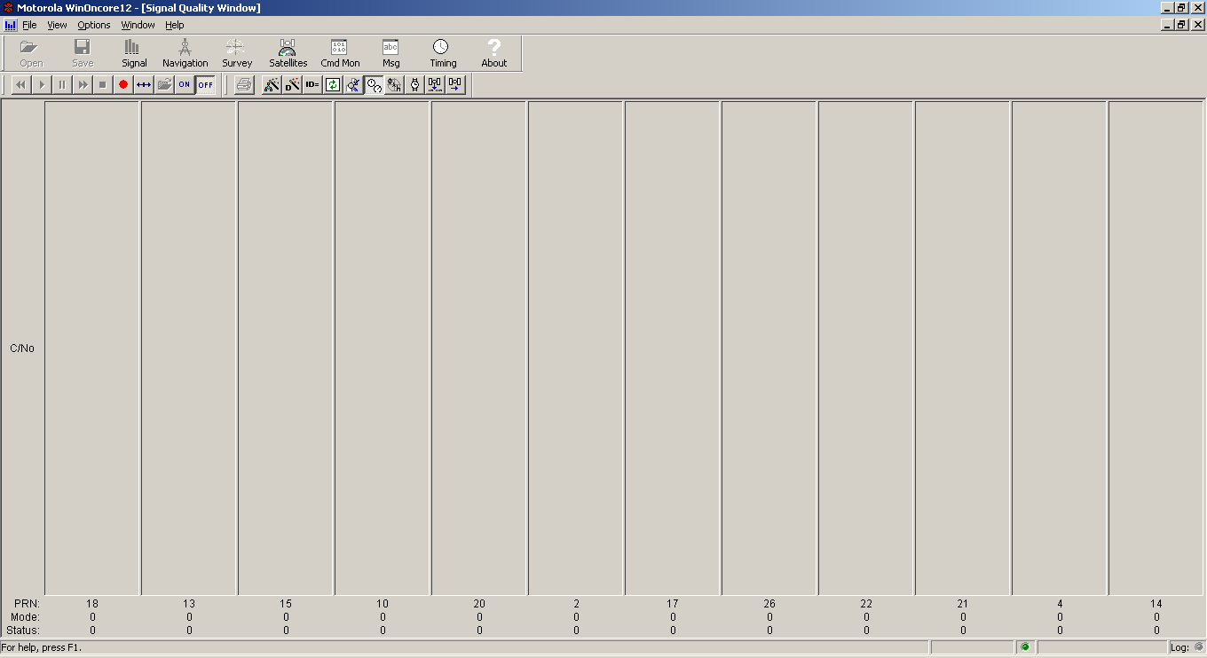
                - (b) Signal Quality of M12+ in the Office Drawer
                - Figure 3-10 Signal Quality of GPS Receivers in the Office Drawer

                - The blue bars represent the values of carrier to noise ratio (C/No), which is a measure of GPS signal quality of each satellite tracked by the GPS receiver. From Figure 3-9, it can be seen that both GPS receivers obtained lock on more than four satellites. Comparatively, the high sensitivity GPS receiver CW12 was able to track more satellites. However, when the antenna was placed in the office drawer, the M12+ could not track any satellite while the CW12 could still obtain stable lock on several satellites (see Figure 3-10). Apparently, the high sensitivity GPS is capable of acquiring stronger GPS signals. This test result may well justify the future application of high sensitivity GPS receiver in WAMS measurement devices.
                - However, Figure 3-10(a) shows that the acquired GPS signals could be attenuated due to various factors such as multipath and reflections from obstructions. There are times when the indoor GPS receiver would have difficulty acquiring any signals. Therefore, it’s necessary to examine the influence of GPS signal loss on the accuracy of angle measurements. The test procedure is similar to the one of conventional GPS receiver and the result is given in Figure 3-11. Note that FDR unit 734 is equipped with high sensitivity GPS receiver CW12 and unit 787 with the M12+ GPS receiver. The result shows us that the measurement error of the unit equipped with high sensitivity GPS receiver is still linear to some extent. However, it seems to be more sensitive to the environmental distortion, so the rate of error accumulation is difficult to characterize.

                - Figure 3-11 Measurement Errors of FDR Units Equipped with CW12 and M12+ after GPS Signal Loss

Possible Backup Time Synchronization Technology
Enhanced Loran is an internationally-standardized positioning, navigation, and timing (PNT) service for use by many modes of transport and in other applications [10]. This technology utilizes AM radio signal instead of GPS signal to offer wide-area locating and timing service. The radio signal transmitting tower is shown in Figure 3-12 and the antennas are given in Figure 3-13. This technology has great potential to be a reliable supplement of GPS.
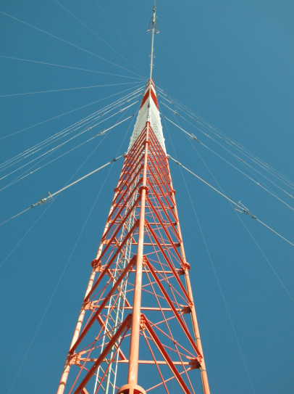
Figure 3-12 Radio Signal Transmitting Tower of eLoran System

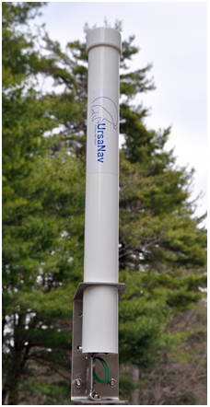
E-field Antenna H-field Antenna
                - Figure 3-13 Receiving Antennas of eLoran System

Conclusions
                - Results from several experiments are presented in this chapter. These include the influence of losing GPS signals on synchrophasor measurements, as well as a comparison of the measurement results obtained by using conventional and high sensitivity GPS. Test results show that without acquiring GPS signals, the measurement accuracy of FDR devices with conventional GPS would be dramatically impaired and the error accumulation in phase angle measurement seems to be a linear function of GPS signal missing time. It is also shown that the frequency accuracy is less affected compared with the phase angle measurements. Nevertheless, it is also shown that a high sensitivity GPS receiver could provide better availability. Furthermore, the accuracy of the high sensitivity GPS is more sensitive to the environment distortion and its timing solution is susceptible to signal attenuations.
                - Considering the drawbacks associated with GPS time synchronization and the continuing research and development efforts for low-cost, high precision reference clocks, other advanced time synchronization methods, like eLoran technology, could be considered in the future.

Wide-area Control of Variable-speed Wind Generators for Frequency Regulation and Oscillation Damping in the Eastern Interconnection (EI)

Background
                - Today, most of major power systems around the world are experiencing an increase in wind in their generation mix. This is causing concerns over the stability of the grid and other difficulties in system operation. Though some subjects such as voltage and reactive power control, power quality requirements, fault ride-through capability, have already been carefully examined and corresponding technical solutions may also be commercially available now, some other rising issues still remain to be addressed. For example, conventional synchronous generators play the pivotal role for primary frequency control and all other frequency regulations; however, due to the absence of synchronization torque for variable-speed wind generators, higher penetration of wind generation may continuously lead to the decrease of overall system inertia as well as the reduction of frequency regulation capabilities [11]-[15].
                - Another serious issue is the inter-area oscillation. Many studies have repeatedly shown that replacing conventional generation with DFIG-based wind farms has a significantly negative effect on the damping of inter-area modes of the interconnected system [16]-[19]. Moreover, for the Eastern Interconnection (EI), the majority of wind generation is now and in the near future will be located in the northwestern part of the system, which is far from the load centers in the northeast. Thus, new transmission lines may be necessary to transmit wind energy from western generation centers to eastern load centers, which may introduce new, difficultly damped inter-area modes as well as influence the damping of existing ones.
                - However, thanks to the development of modern power electronics technology, the answer to the mentioned problems wind generation causes may lie in wind generation itself. Though the steady-state active power delivered to the grid solely depends on the mechanical energy transferred from the wind turbines, the electrical power of variable-speed wind generators can be effectively controlled by modern electronics converters in a fast manner. As a result, wind generators have significant control capabilities to engage in bulk power system frequency regulation and oscillation damping, especially when the wind penetration is considerably high. In this chapter, fast active power control techniques of variable-speed wind generators will be discussed and how to apply those controls to the EI system frequency regulation and oscillation damping will be introduced. This Chapter is structured as follows: In Section 4.2, fast active power control techniques of variable-speed wind generators will be summarized and discussed; in Section 4.3, the wind generator and power system model used in this chapter’s simulation will be introduced; and in Section 4.4 and 4.5, the potential contributions of variable-speed wind generators to the EI system frequency regulation and oscillation damping will be studied respectively.

Fast Active Power Control Techniques of Variable-speed Wind Generators
                - Variable-speed wind generation mainly refers to permanent-magnet synchronous generators (PMSGs) and doubly-fed induction generators (DFIGs). A PMSG contains a multi-pole magnetic rotor and a back-to-back AC/DC/AC converter attached to the stator. The energy is transmitted through the converter from the stator to the grid and consequently, the generator is fully decoupled from the grid. DFIGs are more common, whose rotors that supply the AC excitation current are connected to the power system through the converters and stators are connected directly to the power system. During normal conditions, power electronics converters enable the variable-speed wind generators to capture wind energy over a wide range of wind speeds to their maximum extent (the maximum power point tracking, MPPT), improve power quality and regulate both active and reactive power.
                - During transient conditions, additional controllers could be installed on the converters or pitch controllers to achieve the fast active power controls [20]-[27]. In some studies, variable-speed wind generators could transiently support system frequency by implementing the kinetic energy-based active power control techniques, such as "hidden" inertia emulation, fast power reserve emulation or inertia droop control etc., to enable wind generators to have the “artificial” inertial response that behaves in a manner similar to conventional generators [27]. This type of control utilizes the kinetic energy stored in wind turbines to inject more active power into the power grid in seconds. The active power output of wind farms are only increased temporally, thus the normal operation point of wind generators remains unchanged. In fact, General Electric ® already has a commercial inertia droop control, known as WindINTERIA® [28]. Besides the inertial response, the function of power system stabilizer (PSS) in conventional generators could also be emulated utilizing kinetic energy-based active power control technique [29]-[36]. In this case, variable-speed wind generators could also contribute to the power system small-signal stability significantly. It should be noted that the sustained loss of kinetic energy would cause the rotational speed of a wind turbine to decrease and the turbine to stall if the rotational speed falls too low. Consequently, appropriate limits need to be imposed to avoid removing too much the kinetic energy.
                - As discussed above, normally, wind generation works on the MPPT curve in order to utilize the wind power to the most extent, since wind energy is both environment-friendly and low-cost. However, if wind turbines operate over de-loading curves instead of the MPPT and saves some of the available power as reserve by pitch control or increasing the rotational speed from the MPPT value (usually referred to as over-speeding, shown in Figure 4-1), certain control techniques could be implemented to enable wind generators to emulate the frequency droop characteristics (“governor response”) of conventional generators. In fact, the time constant of pitch control is relatively large to be implemented in practice and frequent adjustment of pitch blades could radically reduce their lifetime. So pitch control is neither practical nor economical for fast active power control purpose. Conversely, rotational speed control is provided by the power electronics converter, thus it could act in a considerably fast manner, which makes possible the utilization of power reserve saved by over-speeding to balance the instantaneous power consumption and provide support for the long-term frequency regulation [20]. Furthermore, though no research has covered this topic yet, wind generation may also act to automatic generation control (AGC) regulation order from the operator as effectively as conventional generation if reserves exist with the help of fast active power control.

Figure 4-1 Over-speed for Variable-speed Wind Generator

                - In sum, by implementing fast active power control techniques, variable-speed wind generators could emulate the inertial and governor response of conventional generators to provide frequency regulation service and PSS function to contribute to bulk power system small-signal stability.

Variable-speed Wind Generator and Power System Model

Wind Generator Model
                - This chapter evaluates the potential contributions of variable-speed wind generators to frequency regulation and oscillation damping in the EI system. PSS/E has the capability to handle both large-scale power system dynamic simulation and wind generation system modeling, thus is employed in this chapter’s simulation. The variable-speed wind generator model used in this chapter’s simulation and the buildup of the EI simulation scenarios are introduced in this section. Since DFIG is the prevailing wind generation type nowadays, variable-speed wind generators are simulated as DFIGs in this chapter. WT3 wind turbine stability model was developed in PSS/E to simulate the performance of a wind turbine employing a doubly-fed induction generator (DFIG) with the active control by a power converter connected to the rotor terminals [37]. There are four basic components for WT3 model (shown in Figure 4-2), namely:
• WT3G: generator/converter model
• WT3E: electrical control model
• WT3T: mechanical control (wind turbine) model
• WT3P: pitch control model.

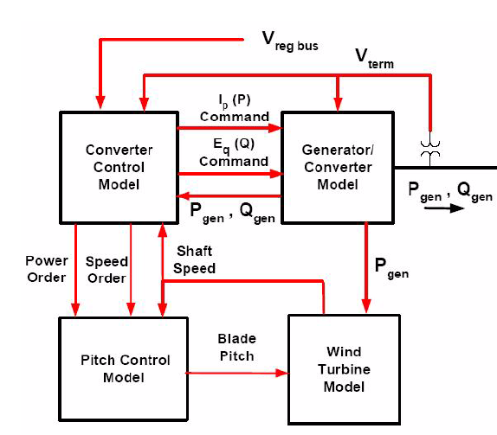
Figure 4-2 Structure of WT3 Wind Turbine Stability Model in PSS/E [37]

Typical parameters of a GE® 1.5MW wind generator from PSS/E are employed in the simulations of this study. And in order to realize the mentioned fast active power control techniques, a user-defined electrical control model has to be developed in PSS/E based on the original WT3E model using FORTRAN (Parameters and control structure given in Appendix B). Please note that since pitch control and reactive power control are not considered in this study, WT3P part is ignored and constant reactive power control mode is selected in all the simulations.

Power System Model
The Eastern Interconnection (EI) is one of the two major alternating current power grids in North America. It reaches from central Canada eastward to the Atlantic coast (excluding Quebec), south to Florida, and back west to the foot of Rocky Mountain (excluding most of Texas). Its detailed 16, 000-bus dynamic model is selected as the base case in this study’s simulation. The total generation capacity of this model is around 590 GW, which includes roughly 3,000 generators (This model is protected by Non-disclosure Agreement with Tennessee Valley Authority (TVA), thus no detailed information is allowed to be released). However, no wind generation is modeled in the original model; therefore a simulation scenario with 5% capacity of wind penetration needs to be developed by the author.

Simulation Scenario Construction
To simulate a relatively realistic penetration of wind generation in the EI system, 5% of EI generation capacity is converted to wind generators in this study. Their locations are shown in Figure 4-3. Though most of current wind generators are located in the Northwest area of the EI, a significant number of off-shore wind farms are expected to be installed in the near future, as shown in Figure 4-3. And one thing should be noted that is that wind generators are and will be mostly located on the edge of the EI system, which gives them more potential to help damp the inter-area oscillations. Since wind generator is used to replace the same amount of conventional generations in the EI, the original power flow remains unchanged.

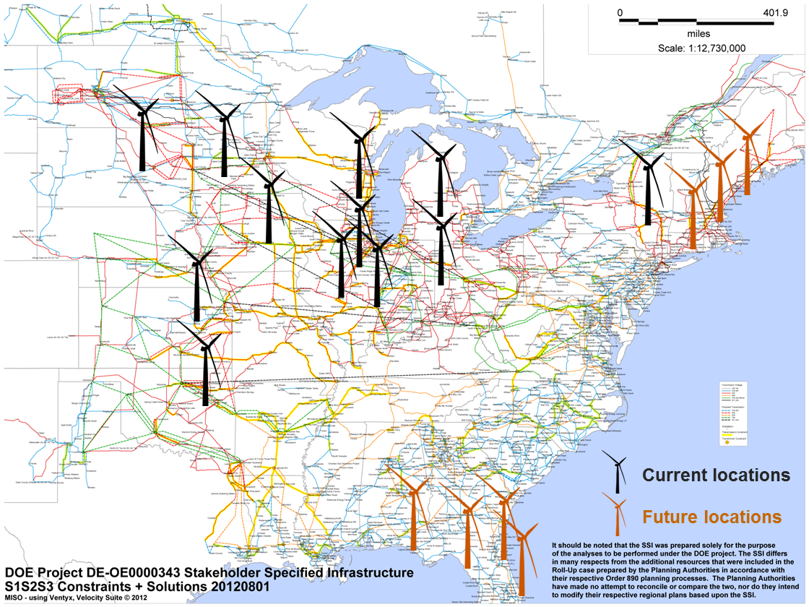
Figure 4-3 Major Wind Farm Locations in the Simulated EI System

Contribution of Variable-speed Wind Generators to the EI Frequency Regulation
In order to enable variable-speed wind generators engage in frequency regulation, several active power control techniques are employed in the user-defined PSS/E WT3 electrical control model, including wind inertia control, wind governor control and wind AGC control, which are introduced respectively in this section.

Wind Inertia Control
The wind inertia control here is of the same philosophy as GE WindINERTIA® technology, whose objective is to let variable-speed wind generators provide inertial response similar to what conventional generators do. Droop control is utilized to produce active power output change that is proportional to the frequency deviation, which is given by
$∆f=f_{meas}-f_{ref}$ 4-1
where $f_{meas}$ is the measured system frequency and $f_{ref}$ is the reference frequency. The structure of wind inertia droop control is shown in
Figure 4-4, in which frequency deviation is filtered out DC component and goes through the gain and washout component. And the descriptions of parameters are given in Table B-2.

Figure 4-4 Wind Inertia Control Structure

Wind Governor Control
As discussed in 4.2, if working in over-speeding zone, wind turbines could decrease its rotational speed to release the power reserve in seconds. Therefore, governor response could be achieved on wind generation utilizing the wind reserve. Again, droop control is used and the wind governor control is shown in Figure 4-5. And the parameters are given in Appendix B.

Figure 4-5 Wind Governor Control Structure

Wind AGC Control
Automatic Generation Control (AGC) maintains the long-term balance of system generation and consumption in the bulk power system. Though no paper has covered this topic yet, wind generator could act to the AGC regulation order from the operator as effectively as conventional generators as long as the reserve exists. Actually, thanks to the fast response speed of power electronics converters, the power output of wind generators could ramp up/down quickly, which makes wind generation system good candidates for AGC regulation. The only disadvantage is still the waste of wind energy due to the reserve during normal conditions.

Case Study-Generation Trip
To evaluate the potential contribution of wind generation to the EI system frequency regulation, a case of 1000 MW generation trip is simulated under various control scenarios in this section. The frequency responses following the event are shown in Figure 4-6 and the active power outputs of a typical wind farm are shown in Figure 4-7.
From Figure 4-6 and Figure 4-7, if only with wind inertia control (green line), the wind generator increases its active power temporally in the several seconds following the generation trip disturbance by use of the kinetic energy stored in the wind blades. However, as discussed previously, the active power increase could not be sustained and after the temporal active power surge, the wind generator active power output would go through a “dip”, during which the inertia energy of turbine blades are “recharged”. At the same time, the turbine speed could be observed to go through the phase of “deceleration” to release some amount of kinetic energy and the phase of “acceleration” to “recharge”, which is shown in Figure 4-8. Apparently, while the Wind Inertia Control function did not contribute to the long-term frequency recovery, it did help reduce the frequency drop nadir, which is shown clearly in Figure 4-6.
If only deployed in Wind Governor Control mode, wind generators would behave just like the conventional generators but in a much faster manner (Figure 4-7, red line), which means the wind generator active power output would ramp up to a higher level because of the existence of the “governor” function and the wind reserve would be utilized by moving the operation point away from over-speeding zone to some extent. In this way, the governor control could help reduce not only the nadir but also the steady-state frequency deviation.
If the inertia and governor control are applied together, the frequency nadir would be reduced further and the steady-state frequency deviation would also decrease (Figure 4-7, light green line). However, in order to further reduce steady-state frequency deviation, AGC order should be considered. In the last scenario of Figure 4-6 and Figure 4-7, all the wind generators receives the AGC order at 10-th second to increase their active power outputs. In this case, the steady-state frequency deviation would be reduced further, even back to the nominal value.

Figure 4-6 Frequency Responses of the EI after a Generation Trip Event with Different Wind Generator Controls

Figure 4-7 Active Power Outputs of a Typical Wind Farm after a Generation Trip Event with Different Wind Generator Controls
Figure 4-8 Turbine Speed Deviations of a Typical Wind Farm after a Generation Trip Event with Different Wind Generator Controls

Figure 4-9 Reactive Power Outputs of a Typical Wind Farm after a Generation Trip Event with Different Wind Generator Controls
Furthermore, as shown in Figure 4-9, reactive power outputs of variable-speed wind generation in all cases are similar because the constant reactive power control mode is selected for all of them.

Case Study-Load Shedding
Please note that wind generation could also contribute to the frequency response improvement in load shedding cases. In this case, instead of decreasing wind turbine speed and release the reserve, wind turbines accelerate to store more energy in the blades and save more reserve so the frequency excursion would be reduced. To demonstrate this, a load shedding event of 724MW was simulated. Similar to generation trip case, system frequency response, active power, reactive power, and turbine speed are given below, respectively.

Figure 4-10 Frequency Responses of the EI after a Load Shedding Event with Different Controls

Figure 4-11 Active Power Outputs of a Typical Wind Farm after a Load Shedding Event with Different Controls

Figure 4-12 Turbine Speed Deviations of a Typical Wind Farm after a Load Shedding Event with Different Controls
Figure 4-13 Reactive Power Outputs of a Typical Wind Farm after a Load Shedding Event with Different Controls

Frequency Regulation Movie Display
To demonstrate the overall effect of wind generation control on the EI frequency regulation, a movie was made based on the EI simulation data, a snapshot of which is given below. Each red dot in the right side map in the movie stands for one bus in the system and contour drawing method was used to give the whole picture of the EI. From Figure 4-14, it’s clear that the EI system frequency response could be improved dramatically, including both frequency drop nadir and steady-state frequency deviation.
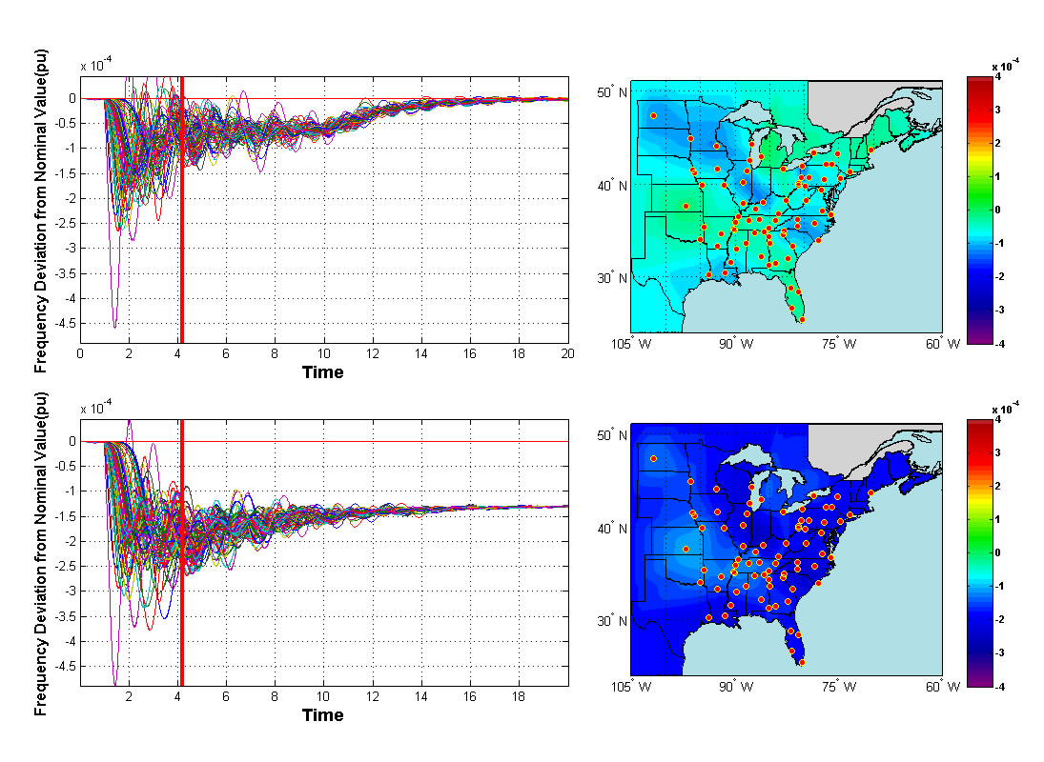
Figure 4-14 Movie Display of the EI System Wind Generation Control for Frequency Regulation

Discussion
Nowadays, though wind penetration is still very low (3.4% of all generated electrical energy in U.S. in 2012 and 5% of total capacity in this scenario), variable-speed wind generation already owns the ability to contribute to the frequency regulation effectively. If wind generation penetration could finally reach 20% of U.S. electricity by 2030 as expected by the U.S. Department of Energy’s 2008 report, wind generation would be the game-changer of frequency regulation service market and therefore the corresponding control strategies should be well studied.

Contribution of Variable-speed Wind Generators to the EI Oscillation Damping
                - Inter-area oscillation is another serious issue increasing wind generation brings about. The wind generation’s potential in oscillation damping has already been noticed by many researchers [29]-[36]. In this section, the potential of variable-speed wind generation’s contribution to oscillation damping in the EI will be investigated. The kinetic energy stored in wind turbine is the ideal energy source for oscillation damping due to its small time constant.

Wind PSS Control
                - For conventional generations, power system stabilizer adds damping to the generator rotor oscillations by producing a component of electrical torque in phase with the rotor speed deviations. A control structure similar to conventional generation PSS could be also employed by variable-speed wind generators for oscillation damping (Figure 4-15), which is referred to as Wind PSS in this study. The signal washout block serves as a high-pass filter, with time constant $T_{wowi}$ high enough to allow signals associated with oscillations to pass unchanged. Either a local or wide-area control signal could be used as the input to the Wind PSS controller.

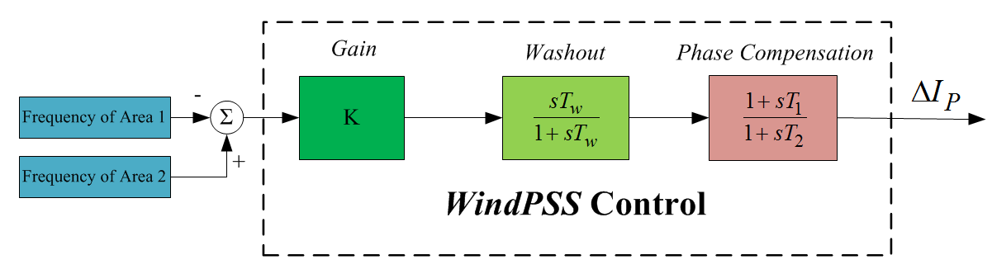
Figure 4-15 Wind PSS Control Structure

Oscillation Damping Using Local Signal
                - Fed by local frequency signal, wind PSS could efficiently damp the local frequency fluctuation or oscillation. A case study of the EI system wind generators in damping local frequency oscillation triggered by a line trip is given below. From Figure 4-16, it’s obvious that the local frequency oscillation is well damped. The corresponding active power fluctuation is shown in Figure 4-17. It’s clear that the wind generator provides an effective damping electrical torque to damp the local frequency oscillation.

Figure 4-16 Local Frequency Response with Wind PSS control

Figure 4-17 Active Power Output with Wind PSS Control
                - Just like conventional PSS, wind generation PSS could also play a significant role in inter-area oscillation damping. In this following case study, a generation trip of 814 MW in Florida is simulated to trigger the inter-area oscillation between Northwest and South (NW-South) regions of the EI, as monitored by FNET system in the actual EI system [38]. Even fed by local frequency signal, the inter-area oscillation damping effect of wind PSS is still significant, as shown in Figure 4-18.

Figure 4-18 NW-South Inter-area Oscillation Damping Using Local Signals

Inter-area Oscillation Damping Using Wide-area Signals
                - Nevertheless, previous studies have demonstrated that introducing wide-area signal to PSSs could improve the inter-area oscillation damping effect to a great extent. In this case study, if introducing the frequency difference of NW-South as the input signal to wind PSS, the oscillation between NW-South could be damped much more effectively than just using local frequency signal, which is shown in
                - Figure 4-19. It should be noted that the inter-area oscillation between Northwest-Northeast (NW-NE) may be negatively influenced (Figure 4-20), which implies the necessity of the coordinated wide-area control.

Figure 4-19 NW-South Inter-area Oscillation Damping Using Wide-area Signals

Figure 4-20 NW-NE Inter-area Oscillation

Coordinated Inter-area Oscillation Damping Using Wide-area Signal
                - To further improve the overall oscillation damping effect, a simple coordinated strategy is developed in this section. As long monitored by FNET system [38], the main oscillations in the EI involves three main areas: NW (Northwest), NE (Northeast) and South. The coordinated wide-area wind PSS controller of each wind generator proposed in this section would automatically compare the frequency differences between two areas, such as NW-South and NW-NE, and always choose the larger one to damp. In this way, a coordinated oscillation damping effect could be achieved. A case study is given below. A generation trip of 814 MW is simulated in the Florida region of the EI to excite the oscillation between South and NW, and between South and NE. The inter-oscillation damping results using both local signal control and coordinated wide-area control are shown in Figure 4-21. From the results, using local signal could already damp the oscillation significantly but if with coordinated wide-area control, the inter-area oscillation could damped almost completely.

Figure 4-21 Inter-area Oscillation Damping using Coordinated Wide-area Wind Control

Figure 4-22 Wind Generation Performance under Inter-area Oscillation Damping Control

Inter-area Oscillation Damping Movie Display
To demonstrate the overall effect of wind generation control on the EI frequency regulation, a movie was also made based on the EI simulation data, one snapshot of which is given below in Figure 4-23. From the below figure, it’s clear that the EI inter-area oscillations could be damped effectively with the wide-area wind generation control.

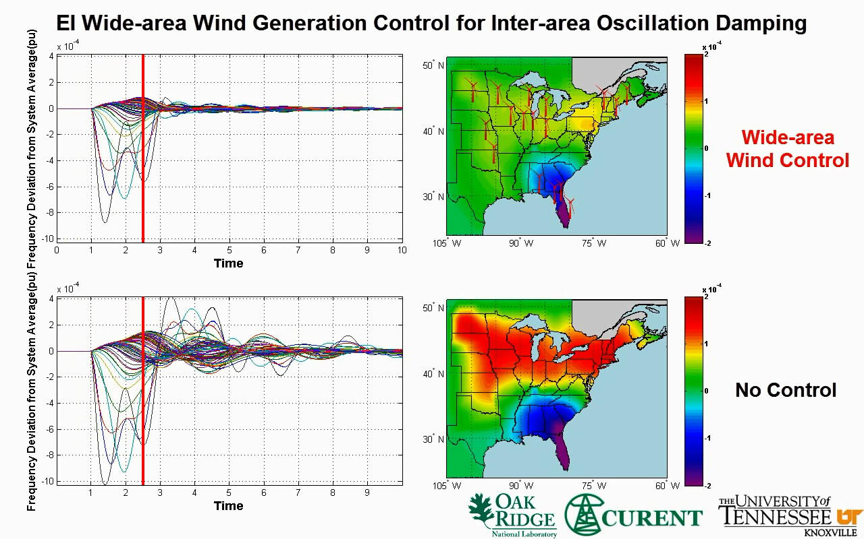
Figure 4-23 Movie Display of the EI Wide-area Wind Generator Control for Inter-area Oscillation Damping

Discussion
                - Though promising as shown in this section, only very simple controller design is employed in this study so far. The controller design definitely needs to be improved and the parameter needs to be tuned. Furthermore, the majority of wind generation capacity is located in Northwest part of the EI, which means only the oscillation involved by Northwest part may be well damped. However, with the planned offshore wind generator in Northeast and South part of the EI system, wind generation has great potentials in the EI system oscillation damping.

Conclusion
                - Based on the 16,000-bus EI model and the user-defined wind generator electrical control model, a relatively realistic scenario of the EI system with wind power was utilized to evaluate the potential contribution of variable-speed wind generation to EI system frequency regulation and oscillation damping. Simulation results demonstrate that current and future penetration of wind power is promising in providing frequency regulation and oscillation damping service in EI system.

Wide-area Control of PV Plants for Frequency Regulation and Oscillation Damping in the Eastern Interconnection (EI)

Background
                - Solar photovoltaic (PV) generation is another important category of renewable energy sources. Originally limited by the low efficiency of silicon solar cells, the capacity of PV system remained as low as kW-level and could only be treated as distributed generation (DG) in the local micro grids [39]-[43]. However, because of the dramatic enhancement of silicon solar cell technology in the recent years, the capacity of single PV plant could finally reach 100 MW-level now [44] and thus PV generation is widely expected to be able to reach a high penetration in the future generation mix. In fact, PV generation is gradually catching up the electric power market and their penetration has been steadily increasing now. Especially considering that the amount of solar energy reaching the Earth is more than 10,000 times the current energy consumption by human beings, solar energy and PV generation has been considered by some people as the ultimate solution to the energy problem.
                - Similar to variable-speed wind generators, Maximum Power Point Tracking (MPPT) operation of PV plant has also been extensively studied by the academia in order to realize the maximum power extraction from PV panels [45]-[49]. And naturally, under MPPT operation mode, PV plants do not participate in any frequency regulation or oscillation damping service for the bulk power grid since they are not synchronized with the grid.
                - As discussed in Chapter 4, variable-speed wind generators may work in the over-speed zone instead of MPPT mode in order to retain power reserve for frequency regulation and oscillation damping. And as shown by the simulation results in Chapter 4, variable-speed wind generators have great potentials to contribute to the EI system frequency regulation and oscillation damping even at a relatively low penetration (5%). Thus, with the increasing penetration, it will also be beneficial to include PV plants in the bulk power system frequency support and small-signal stability control.
                - One important feature of PV generation system is that, unlike wind and conventional generators, it does not involve any rotating mechanical parts, and fully relies on the power electronic inverter/converter interface to be interconnected to the grid. It means PV generation system inherently has a very small time constant and thus the significant capability to participate in frequency support and contribute to small-signal stability if with additional control loops. As depicted by the P-V characteristic of PV panel in Figure 5-1, the active power of PV panel could be controlled flexibly by adjusting the output voltage. Again, due to the fast response speed of power electronic devices, PV plant’s active power output could be controlled in a fast manner. Similarly, to retain some power reserve for frequency support and oscillation damping, PV plant needs to work in the de-loaded (or “over-voltage”) zone instead of MPPT operation mode (in Figure 5-1). In this way, the retained power reserve can be utilized to improve frequency regulation and oscillation damping in the bulk power system.

Figure 5-1 Over-voltage Working Condition of PV Panel

PV Generation Model
                - In order to investigate the role that PV generation may play in the EI system frequency regulation and oscillation damping, PV generation needs to be inserted to the EI model in PSS/E. In PSS/E version 32, due to the structure similarity between Solar PV plant and PMSG wind generator, the solar PV unit dynamic stability model was developed in PSS/E based on the WT4 PMSG model to simulate the performance of PV plant connected to the grid via a power converter [37]. As depicted by Figure 5-2, the PV generic wind model may include the following modules:
• PVGU: power converter/generator model
• PVEU: electrical control model
• PANEL: linearized model of a panel’s output curve
• IRRAD: linearized solar irradiance profile

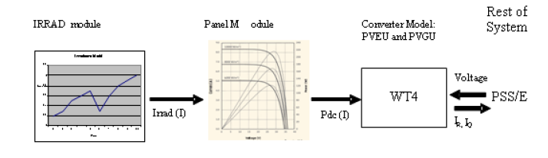
Figure 5-2 PV Model Connectivity Diagram[37]

                - Apparently, IRRAD module introduces the impact of solar irradiance into the dynamic simulation. However, since this study only focuses on the short-term (tens of seconds-level) PV plant control, solar irradiance is unlikely to change dramatically and thus the modules of IRRAD and PANEL are not included in this chapter’s simulations.
                - To achieve the wide-area control of PV plant’s active power output for frequency regulation and oscillation damping, additional controllers need to be designed and incorporated into the current PV electrical control module. Similar to what has been done in Chapter 4, a user-defined PV electrical control module that could incorporate additional active power controllers was developed by the author in this chapter, whose active power control part is shown in Appendix C. Note that typical parameters from PSS/E are employed.

Contribution of PV Plants to the EI Frequency Regulation
Similar to the frequency regulation control of variable-speed wind generators, several active power control techniques are employed in the user-defined PSS/E PV electrical control model in order to enable PV plants engage in frequency regulation, including PV inertia control, PV governor control and PV AGC control.

PV Inertia Control
The PV inertia control here is of the same structure as wind inertia control technology introduced in Chapter 4, whose objective is to allow PV generation to provide the “artificial” inertial response. Again, droop control is utilized to produce active power output change that is proportional to the frequency deviation, which is given by
$∆f=f_{meas}-f_{ref}$ 5-1
where $f_{meas}$ is the measured system frequency and $f_{ref}$ is the reference frequency. The structure of PV inertia droop control is shown in Figure 5-3. The only difference between PV inertia droop control and wind inertia droop control is that the output of this controller is the change of active power order $∆P$, not current command$∆I_{P}$ in the wind case.

Figure 5-3 PV Inertia Control Structure

PV Governor Control
As discussed in Chapter 4, if working in over-speed zone, wind turbines could decrease their rotational speeds to release the power reserve in seconds and therefore, governor response could be emulated on wind generators utilizing the wind reserve. Similarly, if working in over-voltage zone, PV panel could also decrease its output voltage to release the retained power reserve to emulate the governor response. The structure of PV governor controller is shown in Figure 5-4. Again, the output is active power order change$∆P$, not current command $∆I_{P}$ in the wind case.

Figure 5-4 PV Governor Control Structure

PV AGC Control
As demonstrated by Chapter 4, variable-speed wind generators could respond to the AGC regulation order from the operators as effectively as conventional generation if reserve exists. Because of the fast response speed of power electronic converters, PV generation could also realize the AGC control easily, even faster. The only disadvantage is still the waste of reserve during normal operation conditions.

Case Study-Generation Trip
To demonstrate the effectiveness of the frequency support of PV plant, a generation trip of the EI (with 5% PV penetration) is simulated in this section as a case study. Figure 5-5 describes the frequency responses of the EI with different PV control schemes while in Figure 5-6 one typical PV plant’s active power outputs are given.
Depicted by the green line in Figure 5-5 and Figure 5-6, PV inertia control can significantly reduce the frequency drop nadir by increasing the PV plant’s active power temporally in the several seconds following the event, but not help with the longer-term frequency recovery since the increased active power gradually diminish due to the control. Comparatively, if only with PV governor control (red line), PV plant is able to reduce not only the frequency drop nadir but also the long-term frequency deviation compared to the base case, since the existence of “governor” function propels the PV generation to generate an active power increase which is proportional to the frequency deviation. Of course, the active power increase is physically limited by the amount of reserve retained.
Though the combination of PV inertia control and PV governor control does improve the frequency response further (light green line), it reveals that PV AGC control is still highly desirable since PV plants have the ability to respond to AGC regulation order in an unprecedentedly fast manner. From Figure 5-6, after receiving the AGC order at 10th second, the active power of PV generation rises to its new operating point almost immediately, which indicates the fast speed of power electronic devices.
Figure 5-5 Frequency Responses of the EI after a Generation Trip Event with Different PV Generation Controls

Figure 5-6 Active Power Outputs of a Typical PV Plant after a Generation Trip Event with Different Controls

Case Study-Load Shedding
Note that PV plant can also contribute to the frequency response improvement in load shedding cases. In this scenario, instead of decreasing PV panel voltage and release the reserve, the panel voltage is increased to retain more reserve so that the frequency excursion will be reduced. To demonstrate this, a load shedding event of 724MW is simulated in the EI. Similar to the generation trip case, power system frequency response and active power are given below, respectively.

Figure 5-7 Frequency Responses of the EI after a Load Shedding Trip Event with Different PV Generation Controls

Figure 5-8 Active Power Outputs of a Typical PV Plant after a Load Shedding Trip Event with Different Controls

Contribution of PV Plant to the EI Oscillation Damping
Besides frequency regulation, oscillation damping is another important contribution that PV plant could make if with appropriate control schemes. Employing the same inter-area oscillation damping strategies developed in Chapter 4, the great potential of PV plant in the EI inter-area oscillation damping will be demonstrated in this section. The same event (a generation trip of 814 MW) in Chapter 4 is simulated in the Florida region of the EI to excite the oscillation between South and NW (Northwest) regions, and between South and NE (Northeast) regions. The inter-area oscillation damping result using the coordinated wide-area control is shown in Figure 5-9. From the results, if with coordinated wide-area control, the inter-area oscillation could be damped almost completely. One snapshot of a movie showing the damping effect of PV PSS is also given below in Figure 5-10.

Figure 5-9 Inter-area Oscillation Damping using Coordinated Wide-area PV Plant Control
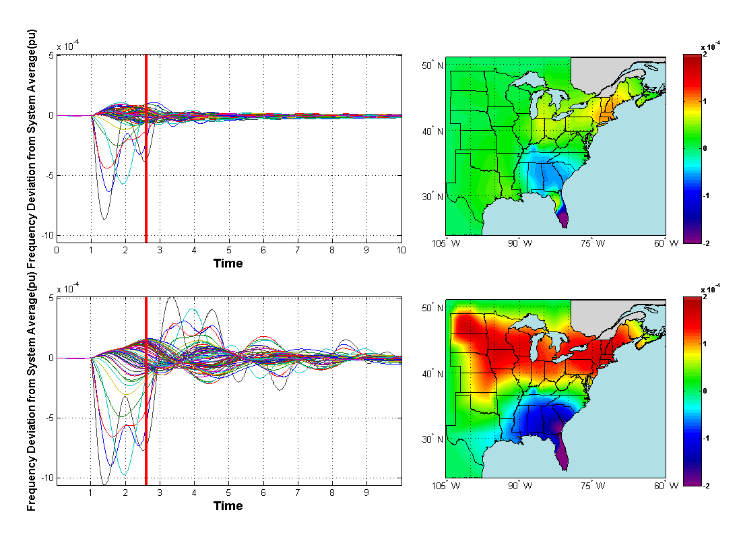
Figure 5-10 Movie Display of the EI Wide-area PV Plant Control for Inter-area Oscillation Damping

Comparison of Wind and PV Control in Frequency Regulation
In this section, the performance of wind and PV generators will be compared in order to understand them thoroughly and develop corresponding strategies in the EI frequency regulation.

Comparison of Wind and PV Inertia Control

Wind inertia control enables the wind generator increase its active power temporally in the several seconds (2-8s in Figure 5-11) following the generation trip by use of the kinetic energy stored in the wind blades. However, the active power increase cannot be sustained and after the temporal active power surge, the wind generator active power output would go through a “dip” (10-20 seconds in Figure 5-11), during which the inertial energy of the turbine blades is “recharged”. At the same time, the turbine speed goes through the phase of “deceleration” to release some amount of kinetic energy and the phase of “acceleration” to “recharge”. Unlike variable-speed wind generators, PV plant with the same inertia control scheme acts in a different way. Fully depending on the adjustment of PV panel output voltage to provide the inertial response for frequency support, PV plant doesn’t have a “dip” of active power output as wind generators. As a result, the EI frequency response with the PV inertia control also does not have an obvious “dip” (Blue line in Figure 5-11).

Figure 5-11 Active Power Outputs of either Wind or PV Inertia Control

Figure 5-12 Frequency Response of the EI with either Wind or PV Inertia Control

Comparison of Wind and PV Governor Control
In this subsection, the performance of wind and PV generators with governor control will be compared. The time constant of wind generators is expected to be much larger than PV due to the involvement of rotating mechanicals such as the wind turbines. This time constant difference can be reflected in the comparison of wind and PV governor control.
In Figure 5-13, due to the same gain parameter of wind and PV governor control, the final active power increases in two cases are identical. However, wind and PV systems display the totally different dynamics. Due to the small time constant, PV plant acts to the frequency change much more promptly than wind generators, and thus proves to be more effective in reducing frequency drop nadir. Furthermore, it’s interesting to point out that, PV governor control can also help damp the frequency oscillations to some extent, as shown by Figure 5-14.
Figure 5-13 Active Power Output of either Wind or PV Governor Control

Figure 5-14 Frequency Response of the EI with either Wind or PV Governor Control

Comparison of Wind and PV AGC Control
                - The effect of the smaller constant of PV plant is even more obvious in the AGC control. In Figure 5-15, after receiving the AGC control signal, it takes about 10 seconds for wind generators to finally reach their new operating point, which is already much faster than the conventional generators. However, for PV plant, it almost manages to change to a new operating point simultaneously after receiving the order, which demonstrates the effectiveness of PV AGC control.

Figure 5-15 Active Power Output of either Wind or PV AGC Control

Figure 5-16 Frequency Response of the EI with either Wind or PV AGC Control

Construction of the EI Simulation Scenarios with High Penetrations of Renewable Energy Resources
                - In all the previous case studies, the EI simulation scenarios with 5% wind or PV penetration have been utilized to evaluate the potential contributions of variable-speed wind or PV generators to the EI system frequency regulation and oscillation damping. However, in the future the penetration of renewable energy resources in the EI is expected to far exceed 5%. Therefore, the EI simulation scenarios with high penetrations of renewable generation are highly desirable.
                - The similar method used in the 5% penetration simulation scenario was still used in this section: a certain portion of active power output of a selected list of conventional generators is converted to wind or PV generators, but the reactive power remains unchanged. In this way, voltage stability problem is unlikely to occur. Based on the author’s 16,000 bus EI system simulation experience, there are some other guidelines that should be noted in order to avoid numerical instability:
- No more than 50% of the active power should be converted to renewables.
- Generators whose capacity exceeds 1500 MW should not be converted.
- Wind and PV generators may not be attached to the same bus.
Note that the guidelines are just for the 16,000-bus EI model. So far, the simulation scenario with 20% penetration of wind or PV has proved to be numerically stable.

Conclusion
                - Based on the 16,000-bus EI model and the user-defined PV generator electrical control model, a relatively realistic scenario of the EI with PV penetration was utilized to evaluate the potential contributions of PV plant to the EI system frequency regulation and oscillation damping. Simulation results demonstrate that current and future penetrations of PV system are promising in providing frequency regulation and oscillation damping service in the EI system.

Wide-area Measurement Based Dynamic Modeling
                - Traditional power system simulation models are very complex due to the intricacies of power system networks. Those models can also be inaccurate because of multiple layers of components and their operational intricacies involved in the modern bulk grid, and due to the fact that power system topologies constantly change as breakers open or close, lines are taken out of service and generators are re-dispatched. In the present power grid operating paradigm, dynamic models are usually updated once every few months or less often, and thus, the accuracy of the simulation models would be severely limited. Furthermore, traditional dynamic simulations are time-consuming even using high performance computing (HPC), which would limit the performance of online applications for power system stability and control. On the other hand, even for a high-dimensional complex power system, only a limited number of transfer functions (or models) of the system are critical to determine its stability and control actions. Therefore, a possibility exists to develop an appropriate power system model of a reduced dimension in real-time online operational mode. With the availability of a large number of synchrophasors, e.g. phasor measurement units (PMUs), being deployed, it is possible to dynamically construct power system models based purely on real-time synchrophasor measurements, which could lead to new development of online application for power system stability and control. Typically, measurement-based models can be updated every several minutes or even a few seconds, allowing them to reflect most recent changes in the system.
                - In [50] and [51], the approach for creating a reduced dynamic power grid model by means of the autoregressive with exogenous input (ARX) model structure is proposed. That grid model is purely based on wide area synchrophasor measurements and identified by regressive least square technique to reflect changes that occur in the bulk power system. Unlike traditional linear system model around an operating point which is derived from nonlinear equations with some simplifications and constraints, the proposed model is able to overcome the computational burden and modeling errors when it comes to large scale power systems. Assuming the operation point of the power grid does not change dramatically, the proposed model is expected to have good accuracy and speed needed for dynamics estimation and control.
                - In this chapter, after a brief introduction of ARX model structure and the concept of dynamic system response estimation, the results of a detailed examination on the capability of the proposed model in estimating dynamic system response will be presented. A series of influencing factors, such as excitation source types, and the locations and number of inputs will be examined and then, this chapter will also explore the proposed model’s applications in instability prediction.

Algorithm for ARX Model
                - As a generalized linear model structure, the ARX model provides a much simpler model identification problem of a multi-variable system than state-space and other models [52]. The mathematical structure expression of the ARX model is given below:
$A_{k}\left(z\right){\hat{y}}_{k}\left(t\right)=\sum_{j=1}^{n_{j}}{B_{jk}\left(z\right)u_{j}\left(t\right)+e(t)}$ 6-1
                - where $t$ is the sampled data number, $e(t)$ is the system noise, $u_{j}$ and ${\hat{y}}_{k}$is the model’s $j$-th input and $k$-th output, respectively. $A_{k}(z)$ and $B_{jk}(z)$ are the ARX nominator and denominator polynomials respectively, which are given by:
$A_{k}\left(z\right)=1+a_{k1}z^{-1}+…+a_{kn_{a_{k}}}z^{-n_{a_{k}}}$ 6-2
$B_{jk}\left(z\right)=b_{jk0}+b_{jk1}z^{-1}+…+b_{jk(n_{b_{jk}}-1)}z^{-(n_{b_{jk}}-1)}$ 6-3
                - where $n_{a_{k}}$ and $n_{b_{jk}}$ are the orders of the model, and $j$, $k$ are the numbers of inputs and outputs, respectively. The model parameters of a multi-variable ARX model can be estimated by a regressive least-squares (RLS) technique. The least squares estimation problem is solved by using QR factorization to optimize the ARX model parameters and the least squares loss function is defined as:
$V_{LS}=\sum_{t=n_{s}+1}^{N}{ε_{ARX}{(t)}^{2}}$ 6-4
                - where the equation error criterion $ℇ_{ARX}(t)$ is described by:
$ε_{ARX}\left(t\right)=A_{k}\left(z\right)y_{k}\left(t\right)-\sum_{j=1}^{n_{j}}{B_{jk}(z)u_{j}(t)}$ 6-5
                - The details of ARX structure and algorithm are discussed in [52]. After obtaining the model orders and parameters, the identified models can be evaluated by comparing their outputs with the actual system outputs.

Power System Linearity Study
                - As discussed at the very beginning of this chapter, the application of ARX-structured modeling method is under the assumption that the power system to be modeled is relatively linear around certain operation points. Though it’s common sense that the electric power grid is a nonlinear system in nature, the operating point of the large-scale power grid (such as the EI) does not change dramatically often, which means the bulk power grid shows linear characteristics in most of the time and thus ARX-structured method may have great merits in bulk power grid modeling. However, it’s still necessary to measure the linearity of bulk power grid in order to guarantee the validity of the proposed method.
                - In this section, the 16,000-bus EI system will be utilized as a case study to investigate the linearity of bulk power systems. Assuming there is a monitoring point in the Tennessee region of the EI system, four pairs of events of similar magnitudes are selected based on their distances to the monitoring point. The two events of each pair have the similar distance but each pair’s distance to the monitoring point is longer than the previous pair (Figure 6-1). Then, for each pair, three dynamic simulations were carried out. First, the two events were simulated individually, and then the simulation of two events together was carried out. In this way, the sum of the monitoring point’s two responses of the two individual events could be compared to the response of the simulation that includes both events. If the perfect linearity of bulk power system exists, the sum of two individual events’ responses should be identical to the response of the simulation that includes two events together.
Figure 6-1 Disturbance Locations for the Bulk Power Grid Linearity Study

Figure 6-2 the Monitoring Point’s Linearity after Event 1 and 2

                - The comparison results of event 1 and 2 are given in Figure 6-2. It can be seen that, no matter frequency, voltage magnitude or angle, the simulation result of event 1 and 2 together is almost identical to the sum of simulation results of two individual events, which demonstrates that the linearity at the measuring point is high if the disturbance is far away. Similar conclusion could also be drawn based on the simulation results of event 3 and 4.

Figure 6-3 the Monitoring Point’s Linearity after Event 3 and 4

                - However, if the disturbances are not far away enough from the measuring point, like event 5 and 6 in this case study, the linearity of the measuring point may not be as strong as the previous cases. In Figure 6-4, through the frequency and voltage angle still show a great linearity, the voltage case has started to show some extent of nonlinearity since the voltage result of event 5 and 6 together apparently differs from the sum of two individual events’ results now. Therefore, it’s possible to draw out a voltage nonlinearity zone around the measuring point beyond which the disturbance won’t influence the linearity of the measuring point’s voltage (Figure 6-5).

Figure 6-4 the Monitoring Point’s Linearity after Event 5 and 6

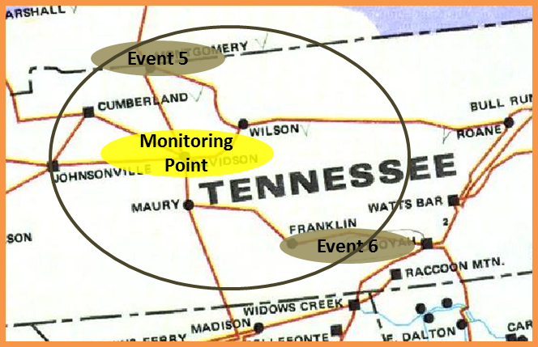
Figure 6-5 Voltage Nonlinearity Zone of the Monitoring Point

                - As shown by Figure 6-1, event 7 and 8 are even closer than Event 5 and 6. Since event 7 and 8 are already in the voltage nonlinearity zone, it’s understandable that the voltage response of event 7 and 8 together does not match the sum of two individual voltages. Furthermore, the angle case also starts to show the discrepancy, which means event 7 and 8 lie on the border of the angle nonlinearity zone (Figure 6-7).

Figure 6-6 the Monitoring Point’s Linearity after Event 7 and 8

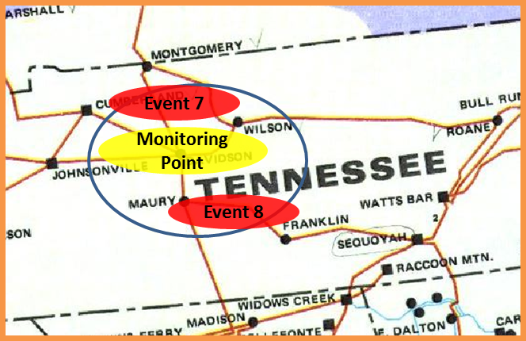
Figure 6-7 Angle Nonlinearity Zone of the Monitoring Point

                - Though the linearity study here in this section is very preliminary, it still proves that the linearity of bulk power grid can be significant, thus lending great support to the application of linear structure in power system dynamic modeling.

Accuracy Index
                - As discussed above, a generalized linear model structure ARX model could be employed in the measurement-based model identification process to describe power system dynamics. In order to evaluate the identified models’ quality, the model accuracy index defined below can be calculated for each output over a time window (assuming that the window has L data points):
${Accuracy}_{k}=\left\{1-\frac{\sqrt{\sum_{l=1}^{L}{{[y_{k}\left(l\right)-{\hat{y}}_{k}\left(l\right)]}^{2}}}}{\sqrt{\sum_{l=1}^{L}{{[y_{k}\left(l\right)-{\overline{y}}_{k}]}^{2}}}}\right\}×100$ 6-6
                - where $y_{k }(l)$ and ${\hat{y}}_{k}\left(l\right)$ are respectively the measured and estimated responses of the $k$-th output at the $l$-th data point, and ${\overline{y}}_{k }$is the mean value of measured response over the time window. This is the most widely used evaluation index in system identification. It is mainly used to reflect the accuracy of the model in describing dynamic characteristics and thus suitable to describe the accuracy of the ARX model. The index of 100 means a perfect match between the estimated response and the measured response, and the model identified can fully reflect the dynamic characteristics of the system. If the index is 0, it means the estimated response is no better than the mean value of measured response. In that case, the identified model cannot describe the system’s dynamic characteristics. It should be noted that, the proposed index can also be negative, which means the estimated response and the measured response are not related at all.
                - The proposed approach uses the ARX model to represent a power system, which is a nonlinear system. When the state of the power system is around its stable equilibrium point and far enough from the boundary of stability, the power system behaves like a linear system. Then, the ARX model may achieve a high accuracy to estimate power system responses. However, if the state approaches the boundary of stability, the system will exhibit more nonlinear-system behavior. Then, the model may not accurately estimate system response. For that case, the accuracy index may be low. If the system loses stability, the accuracy index would probably be close to zero or even negative, which means the accuracy index may potentially be used as an indicator of the stability level of the system. In the later part of chapter, the accuracy index will be calculated for two cascading outage scenarios that lead to angular and voltage instability. The results match the above supposition. However, further investigation is needed on the relationship between the accuracy index and the stability level of the system.

Observability Index
                - In power flow calculations, power transfer distribution factor (PTDF) is the relative change in power ﬂow on a particular line due to a change in injection and corresponding withdrawal at a pair of buses. Therefore, by definition, PTDF is an index to describe the “connectivity” or “sensitivity” between two power lines. As shown by previous studies, PTDF depends on the topology of the electric power system and the operating point. Likewise, an observability index could be defined in a similar way to describe the “connectivity” or “electrical distance” between two buses instead of two lines.
                - Specifically, the observability index between two buses could be defined as the absolute value of voltage change at bus $i$ if the current injection at bus $k$ is varied by 1.0 pu. Since this index has the unit of impedance, $\left|Z (i, k) \right|$ could be used to denote it. Actually,$Z (i, k)$ is the $(i, k)$ element of matrix$Z_{bus}$, which is the inverse of power system admittance matrix$Y_{bus}$. From the definition, it’s apparent that larger observability index means better “connectivity” while smaller observability index indicates less “connectivity.”
                - To verify the effectiveness of this observability index in describing two buses’ “connectivity”, a test was carried out. Please note that Eastern Interconnection (EI) serves as the test bulk power system in all the following tests and all the calculations and simulations are based on the EI 16,000-bus model. In this test, one output bus and three different groups of input buses were carefully selected from EI model (as shown in Figure 6-8) based on the observability index between the input-output bus pairs and all the observability indices are shown in the following Table 6-1. As for the observability index calculations, the EI system admittance matrix $Y_{bus}$ was exported from PSS/E EI model and the inverse process was completed in Matlab®.

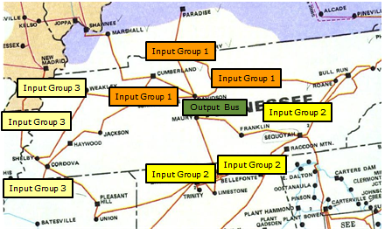
Figure 6-8 Schematic Map of Input and Output Bus Locations

Table 6-1 Observability Index between Input Bus Group and Output Bus
 | Z between Input Bus and Output Bus | Observability  Index | Average of Group
Group1 | 0.00039459+0.0045866i | 0.0046035 | 0.0046969
Group1 | 0.00040728+0.0046761i | 0.0046938 | 0.0046969
Group1 | 0.00045713+0.0047715i | 0.0047934 | 0.0046969
Group2 | 7.6358e-005+0.00096488i | 0.0009679 | 0.0009666
Group2 | 0.000107+0.001166i | 0.0011709 | 0.0009666
Group2 | 7.7666e-005+0.00075692i | 0.0007609 | 0.0009666
Group3 | 2.5415e-005-7.4279e-005i | 7.8507e-005 | 3.0604e-05
Group3 | 1.0593e-005-6.0988e-006i | 1.2223e-005 | 3.0604e-05
Group3 | 1.1014e-006+1.0021e-005i | 1.0081e-005 | 3.0604e-05

                - The accuracy of the models with different input groups was examined to show the relationship between observability index and model accuracy. The locations of all the input and output buses are shown in Figure 6-8. Frequency, voltage and angle results are respectively shown in Appendix D. From those results, it’s clear that the model accuracy decreases from group 1 to group 3, which means the smaller the observability index, the smaller the accuracy index. Therefore, observability index could serve as an effective index of two buses’ “connectivity” or “electrical distance.”
                - The relationships between observability index and model accuracy index for voltage and angle cases are also shown in Figure 6-9. Based on Figure 6-9, it is possible to suggest a threshold for observability index, for example 0.00003 for EI system. This means the average observability index of the input bus group should be larger than 0.00003 to make sure the model has high enough accuracy. For frequency, the estimation accuracy is much higher (the model accuracy index is above 90% in all the three cases).

                - 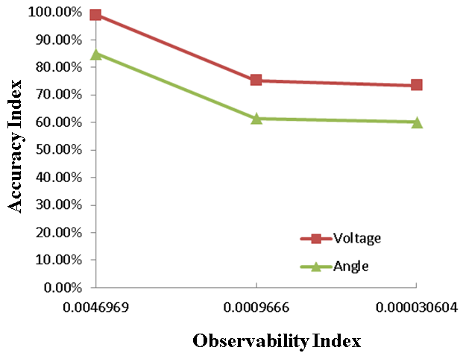
Figure 6-9 Relationship between Observability Index and Model Accuracy Index (for Voltage and Angle)

Performance Testing
                - With synchrophasors being increasingly deployed in transmission systems, high-resolution, real-time wide-area synchronized measurements would be available to improve power system dynamics monitoring and control. A concept of dynamic response estimation based on synchrophasor data is proposed to achieve the goal of dynamics prediction or estimation for a power system. Unlike traditional state estimation and dynamic state estimation techniques that focus on estimating relatively stationary state vectors such as bus voltage magnitudes during steady and quasi-steady states, dynamic response estimation seeks to estimate or predict the dynamic response or waveform of a power system during transient periods. The basic idea of dynamic response estimation is to identify the real-time dynamic model of the power system and use that model to estimate or predict the power system’s dynamic response of interest. ARX model structure and least squares techniques will be employed to identify the needed dynamic model for response estimation.
                - Theoretically, all the variables in the power system can be considered as inputs or outputs of the proposed model since it is purely measurement-based. It is also possible that a combination of different kinds of “inputs” can lead to a better accuracy of the proposed model. Therefore, for a certain output, it’s necessary to find out the optimal group of inputs that could lead to the most accurate model.

Comparison of different model inputs and outputs
                - Time-domain simulations were conducted on generation trips, load shedding and line outages to generate data for testing the approach. As shown in the following two tables, the approach was tested using different groups of variables as inputs or outputs.

Table 6-2 Input Groups when the Output is Frequency/Voltage/Angle
Output | Frequency | Voltage | Angle
Input Group 1 | Frequency | Voltage | Angle
Input Group 2 | Frequency and active power | Voltage and active power | Angle and active power
Input Group 3 | Frequency and reactive power | Voltage and reactive power | Voltage and reactive power
Input Group 4 | Frequency, voltage and angle | Frequency, voltage and angle | Frequency, voltage and angle

Table 6-3 Input Groups when the Output is Active/Reactive Power
Output | Active power | Reactive power
Input Group 1 | Active power | Reactive power
Input Group 2 | Frequency, voltage and angle | Frequency, voltage and angle
Input Group 3 | Frequency and angle | Voltage and angle

                - From those tests, input group 1 is the optimal input group in either case, which indicates that, when the inputs are the same type of variables as the output, the resulting model has the highest accuracy in estimating the output. Besides, those tests also show that introducing more inputs may not necessarily result in a more accurate model since distorting information may also be introduced to the model identification process. As examples, Figure E-1 in Appendix E compares the actual system responses of frequency, voltage and angle following a generation trip event with the estimates from the trained model and Figure E-2 compares the actual system responses of real and reactive powers following a load shedding event with the estimates from the trained model.

Comparison of Different Excitation Sources
                - Theoretically, all the disturbances in a power system, including generation trip, load shedding, line trip, and fault, could serve as the “excitation” sources of the trained model (Figure 6-10). However, while the system response of generation trip and load shedding cases can be monitored in a wide-area sense, the line trip events can only be seen in a relatively small part of the grid. Therefore, it is very likely that the models “excited” by different disturbances will have different system coverage extents and accuracy levels. From Table 6-4, four different events that occur in New York region were used to train the model respectively. Then, the trained model was used to estimate system responses following three events in Florida. All data were generated from time-domain simulations of those events. Here, the input and output variables are assumed to be of the same type.

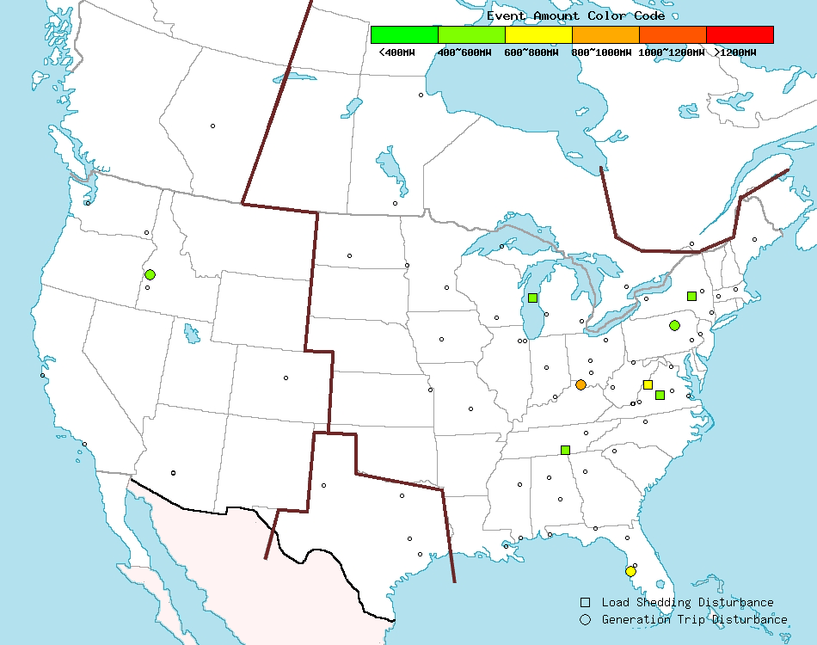
Figure 6-10 Events Distribution Detected by FNET in a Single Day

Table 6-4 Events of Different Types of Excitation Sources and Estimated Events
Location | Event Type | Amount (MW)
New York | Generation Trip | 839
New York | Load Shedding | 809
New York | Line Trip | 790
New York | Line Fault | 800
Florida | Generation Trip | 810
Florida | Load Shedding | 877
Florida | Line Fault | 2000
From test results, the dynamic responses estimated by the trained model match the actual responses well. However, the model trained using data on generation trip and load shedding events has much better accuracies than the model trained using the line trips. To illustrate that, Figure F-1 and Figure F-2 in Appendix F respectively show the estimation results using the models trained by generation trip data and line trip data.

Validation Using Synchrophasor Data
                - Historical event data from the Frequency Monitoring Network (FNET) operated at the University of Tennessee were used to validate the approach [1]-[3]. As shown in Figure 6-11, five FDRs deployed in Michigan Area were selected to test the approach. Four FDRs were considered as inputs and one FDR as the output. Their specific locations were marked as the red spots on the map in Figure 6-11.

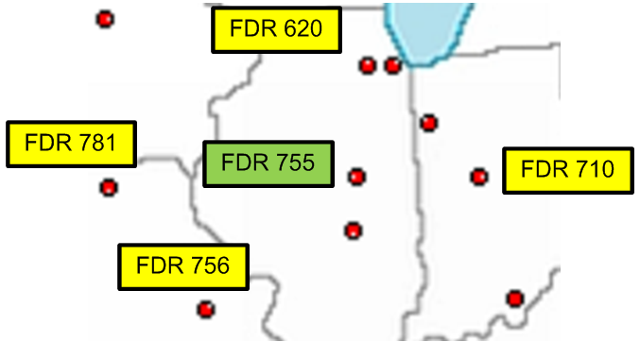
Figure 6-11 FDR Deployment of Michigan Area

                - Similar to the previous simulation study, one generation trip event (as indicated in Figure 6-12) detected by FNET system on 21:42:37, Jan. 1, 2012 was used to train the model, and then a load shedding event that happened about 23 minutes later (as indicated in Figure 6-13) was used to test the accuracy of the identified model. Because the accuracies of frequency and angle measurements of FDRs have been widely validated, frequency or angle was considered the model’s output in this test. The comparison between estimated frequency/angle response and the real measurement data (FDR 755) were given in Figure 6-14 and Figure 6-15, respectively. Apparently, both the estimated frequency and angle responses match the real measurements well.

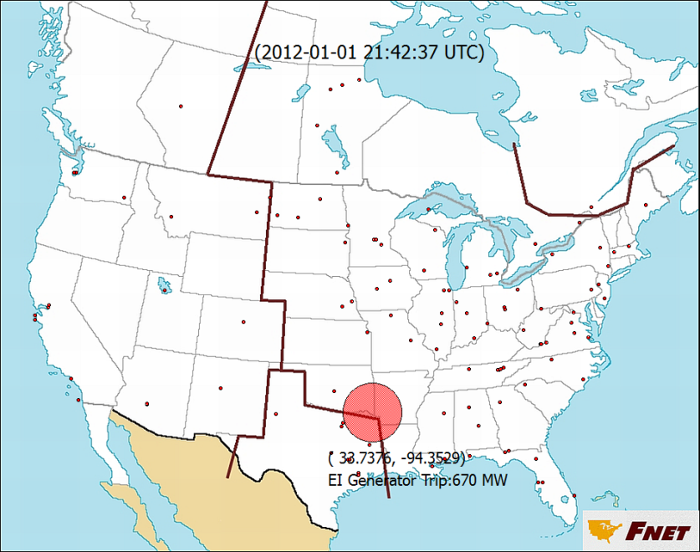
Figure 6-12 Generation Trip Event Used for Model Training

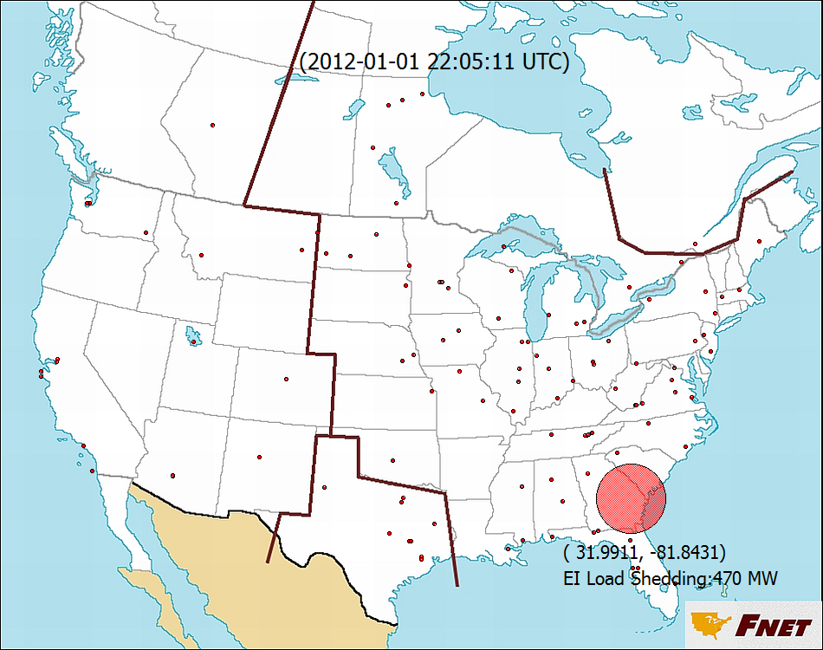
Figure 6-13 Load Shedding Event Used for Model Validation

Figure 6-14 Comparison of Estimated Frequency Response and Actual Frequency Measurement

Figure 6-15 Comparison of Estimated Angle Response and Actual Angle Measurement

Observability Study
                - In previous sections, observability index has been defined to describe the “connectivity” or “electrical distance” between the input and output buses and based on that, a criterion of observability index is also given: the average observability index of input buses should be larger than 0.00003 in order to make the model accuracy relatively good. Based on this criterion, a coverage map could also be obtained. For example, assume there are three buses with PMUs in TVA area that could be considered as input buses in the response estimation. According to the previous criterion, in order to make the response estimation results relatively accurate, the average observability index between these three input buses and the output bus should be larger than 0.00003. Therefore, all the output buses that meet this criterion could be roughly drawn on a map in Figure 6-16. As long as the output bus lies within the boundary, the accuracy of response estimation could be guaranteed to some extent. It also should be noted that the criterion of 0.00003 is only valid for EI system and any other system should find its own criterion.

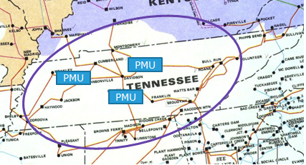
Figure 6-16 Coverage Map of Three Input Buses in TVA Area

Tolerance to System Topological Changes
                - The proposed power system dynamic model is supposed to be updated online using wide area measurements so that the change of the power grid operating point would be reflected. Some extent of tolerance to topological changes of this model is still needed since some unobservable small events still can happen during the time interval of model update due to the extremely large size of today’s electric interconnection. Therefore, it would be desirable for the proposed model to have some tolerance to topological change of the power grid.
                - In this test, after training the model, some events were introduced to change the topology of the grid to some extent and the model’s tolerance to grid topological changes was studied. Similar to what was used previously, a generation trip in Florida is used to train the model first. But after the model got trained, another two events respectively in New York and Tennessee were introduced to change the grid topology. Note that the inputs and outputs of the model are all located in Tennessee. That is why one event in New York (which is considered as a trivial topological change) and one in Tennessee (which is considered as a significant topological change) were selected. From Figure G-1 and Figure G-2 in Appendix G, the dynamic response estimation is accurate even after a topological change of the power grid.
                - Since observability index is already defined, studying the impact of a change in the power system topology on the model accuracy could be achieved by looking into the topology change’s influence on the observability index between the input and output buses. Intuitionally, nearby events, whether generation trips, load shedding, or line trips, could pose significant impact on the observability index since they change the topology to a greater extent. If the observability index between the input and output buses is changed much, the model trained before the topology change would no longer be reliable and thus new model would need to be trained.

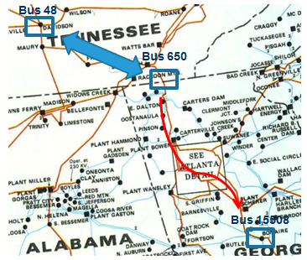
Figure 6-17 Map of Line Trips
                - A test was carried out to verify that. First, the observability index between bus 48 and 650 is calculated, then a series of line trips are created (one per time) from bus 650 in the radial direction until bus 15508( as shown by the red arrow in Figure 6-17), including line 650-15097, line 15097-15001, line 15001-15502, line 15502-15509, line 15509-15510, line 15510-15875, and line 15875-15508. After each of the line trips, the observability index of bus 48 and 650 is re-calculated until it remains relatively stable. The results are given in Figure 6-18.
                - From Figure 6-18, after the line 650-15097 tripped, observability index change is around 50% of the original value, which indicates a huge change due to the nearby event. Then after the second line trip 15097-15001, the observability index change is around 20% and after the third line trip 15001-15502, the change could be hardly noticed. Thus, based on this test, it could be concluded that only nearby events could influence the observability index. Furthermore, it’s interesting that beyond line 15001-15502, the observability index would not be influenced dramatically by the topology change, which suggests that the line 15001-15502 could be considered as the “boundary” of the topology change’s influence. Outside the boundary, the topology change won’t influence the observability index much.

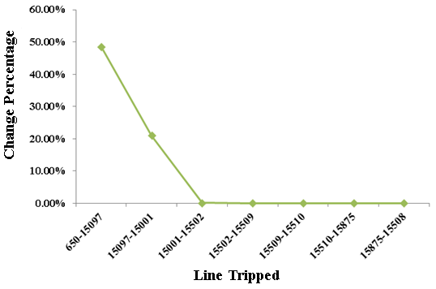
Figure 6-18 Observability Index Changes after Line Trips in the Radial Direction

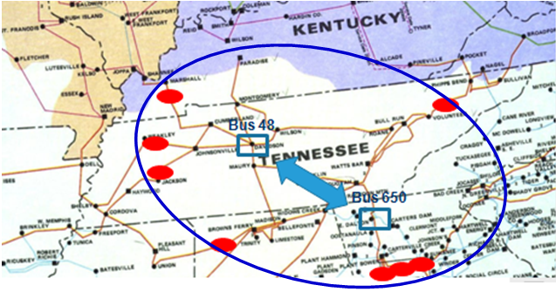
Figure 6-19 Boundary Map of Topology Change’s Influence

                - Therefore, using this similar method, it’s possible to determine the “boundary” of topology change’s influence in all the directions. After completing that, it’s easy to obtain a rough “boundary map,” as shown in Figure 6-19. All the topology change beyond the boundary would not change the observability index significantly, thus not harming the accuracy of the model based on the input and output buses.

Influence from the Synchrophasor Number
                - The number of synchrophasors is another important factor that would influence the model accuracy. Generally speaking, increasing the number of inputs may be able to improve the accuracy of the model to some extent. However, it is highly likely that there exists a “saturation limit” for the number of inputs. Figure 6-20 shows how the accuracy changes with the increase of the number of synchrophasors in terms of estimation of the frequency, voltage and angle. There is a “saturation limit” in all the estimations, after which the accuracy of the model does not improve significantly.

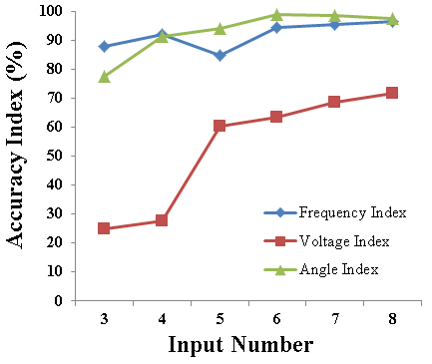
Figure 6-20 Accuracy Index Trend with Different Numbers of Inputs

Influence from Synchrophasor Locations
                - In this test, four groups of input buses are selected to perform the estimation. Those groups have different electrical distances to the output bus. The input buses in Group 1 are directly connected to the output bus (note that all the input buses and output buses are 500kV high voltage buses). Groups 2, 3, and 4 are two buses, three buses and more than three buses away from the output bus, respectively. Considering the fact that all the buses are high voltage buses, it means a long geographical distance even it is only one high voltage bus away. The results are demonstrated in Figure 6-21. For the frequency estimation case, it seems group 3 (three high voltage buses away from the output bus) is the optimal location of synchrophasors since it can maintain the needed accuracy and also the longest distance. For the voltage and angle case, though the accuracy of the model does not strictly decrease with the increase of distance, the overall trending is that the accuracy of the model is inversely proportional to the distance between the input buses and the output bus. However, it seems that the distance of three high voltage buses should be enough to achieve the necessary accuracy of the model.

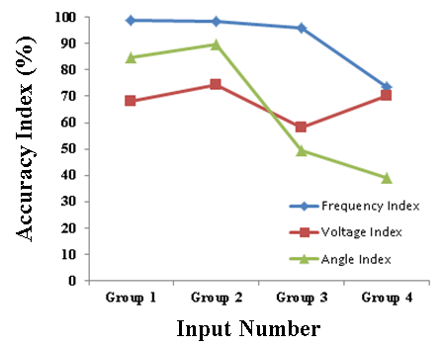
Figure 6-21 Accuracy Index Trending with Different Distances between Inputs and Outputs

Potential in Early Warning Instability
                - Voltage instability/collapse and rotor angle instability are two major power system stability issues. The potential of the proposed ARX model in predicting the two stability issues after cascading outages has been investigated and case study results are presented in this section. The basic procedure for testing the proposed method in predicting voltage collapse and angular instability is given below:
- First, a voltage collapse or angular instability scenario following a sequence of disturbances will be designed and simulated on the EI test system using PSS/E.
- Then, a model in the proposed ARX model structure would be identified using a period of system response data following the first disturbance.
- After obtaining that model, the system responses following the rest of the disturbance sequence would be applied to the model to perform the response estimation.

Angular Instability
                - As discussed above, case studies would be used to investigate the potential of the proposed model in predicting angular instability. The first step of case studies is to carefully design a sequence of disturbances, either trips of lines or generators, around the interface between two control areas without causing out of step until the last disturbance. Because the power grid of Florida area is relatively independent of the other part of the EI system, it could be considered as a different control area with the rest of EI system (as shown in Figure 6-22). Therefore, a sequence of disturbances, including both generation and line trips, between those two control areas (in the purple rectangle in Figure 6-22) is designed and whether the identified model and estimation accuracy can indicate the out of step of Florida area power grid from the rest of EI system correctly is investigated.

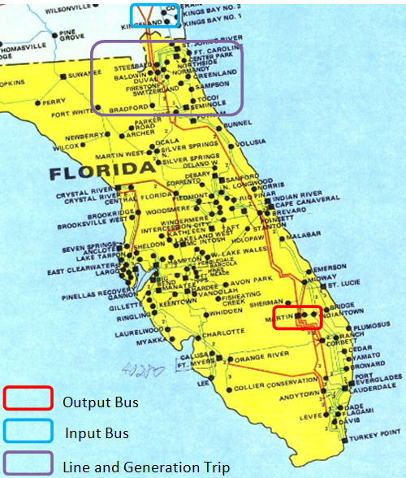
Figure 6-22 Map of Florida Area Power Grid
                - The sequence of disturbances were simulated based on the EI model using PSS/E and the system responses of input and output buses after the line trips or generation trips are shown in Figure 6-23 and Figure 6-24. It can be seen that the Florida area power grid kept synchronized with the other part of EI system until the 5-th trip, following which the Florida area power grid is out of step.

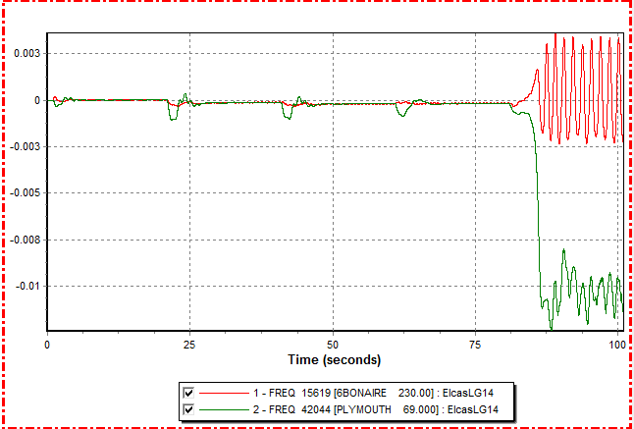
Figure 6-23 Frequency Response after the Sequence of Disturbances

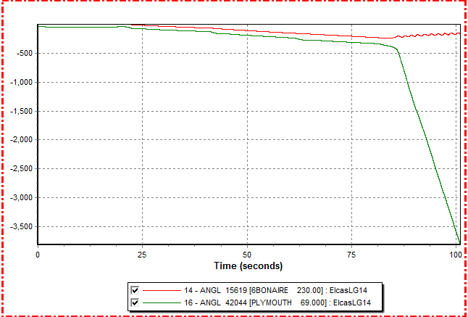
Figure 6-24 Angle Response after the Sequence of Disturbances
                - The detailed frequency response after the sequence of trips is shown in Figure 6-25. The five second system response (frequency) following the first disturbance was used to obtain the model and then the frequency responses following 2nd to 5th trips were applied to the model to perform the response estimation.

Figure 6-25 Frequency Response Used for Model Identification

                - The response estimations were shown in Figure H-1 in Appendix H and the accuracy indices were shown in Figure 6-26. From Figure 6-26, it’s clearly shown that the estimated accuracy decreases gradually with the series of disturbances. Following the 4-th disturbance, the accuracy index becomes negative, which implies the Florida area is going to lose synchronism with the rest of the EI system.
                - Besides that fixed model used for dynamic response estimation, an adaptive model was also considered in the test. Unlike the previous fixed model, the adaptive model was trained using the data following each disturbance in the sequence, and was used to estimate the frequency response after the next anticipant disturbance. The comparison results were given in Figure H-2 in Appendix H. From Figure 6-27, the adaptive model has higher accuracy before the system loses stability since it uses the data from the most recent disturbance. Both modes show a change in the sign of the accuracy index after the 4th disturbance, indicating the loss of stability after the 5th disturbance.

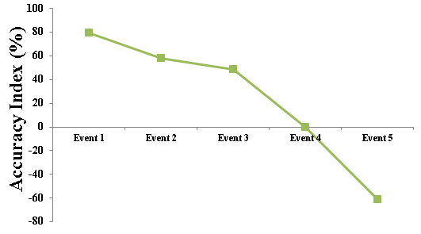
Figure 6-26 Accuracy Index of Frequency Response Estimation Following the Sequence of Disturbances-Fixed Model

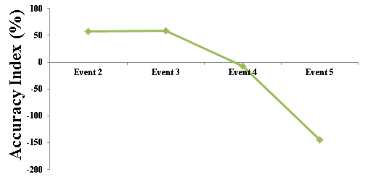
Figure 6-27 Accuracy Index of Frequency Response Estimation Following the Sequence of Disturbances-Adaptive Model

Voltage Collapse
                - First, the power grid of Massachusetts area (indicated in Figure 6-28) is chose as the test system because it is a load center vulnerable to voltage instability. A sequence of trips of lines or generators around the boundary of the Massachusetts power grid was added to the boundary of that load center area to gradually reduce remote power supplies until an operating condition (at about 60s) very close to voltage instability and then a very slight 1% load increase was made in the area to trigger voltage collapse at about 80s. The system response is shown in Figure 6-29.

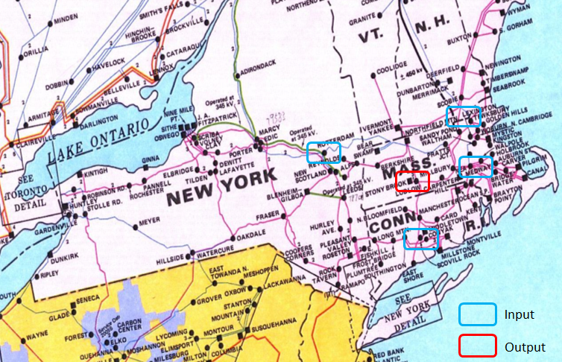
Figure 6-28 Map of Massachusetts Area Grid

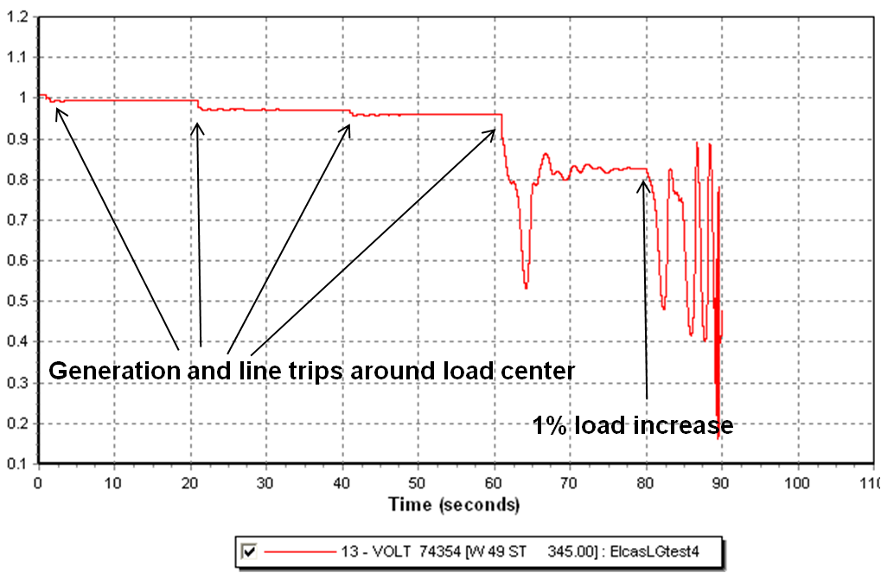
Figure 6-29 Voltage Response of the Output Bus Following the Sequence of Trips

                - Similar to the previous section, the ten seconds system response following the first disturbance was used to obtain the model and then the voltage responses following the 1st~4th disturbances were applied to the model to perform the voltage response estimation. The voltage response estimations are shown in Figure I-1 in Appendix I and the accuracy index trending is shown in Figure 6-30. Figure 6-30 illustrates clearly that the accuracy of voltage estimation decreases continuously under the sequence of disturbances. That may imply the trend toward voltage collapse. The low accuracy following the 4th disturbance predicts the voltage collapse following the next disturbance. Similar to the angular stability case, the results of an adaptive model strategy are given in Figure I-2 in Appendix I, which indicate higher estimation accuracies of the model before the system loses stability.

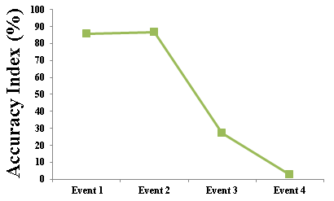
Figure 6-30 Accuracy Index of Voltage Response Estimation Following the Sequence of Disturbances-Fixed Model

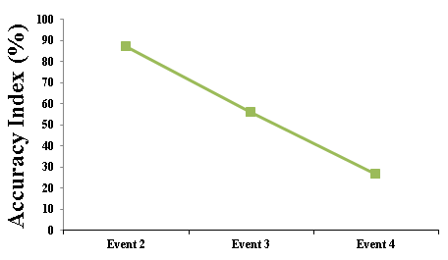
Figure 6-31 Voltage Response Estimation Following the Sequence of Disturbances-Adaptive Model

Summary
                - This chapter focused on a measurement-based power system dynamic modeling method for power system response estimation and instability prediction. The basic idea is to dynamically identify a reduced equivalent model for the power system and use that model to estimate or predict the power system’s dynamic response of interest. ARX model structure and least-squares techniques are employed to identify the parameters of that model for response estimation. For a large-scale power grid, the identification of the proposed model is computationally efficient and suitable for online applications. An application of the ARX model involves first training the model using actual measured event data and then using the trained model to predict system dynamics performance following an event.
                - Case studies were conducted to test the proposed model’s observability, accuracy and reliability with different excitation sources for model training, different numbers and locations of synchrophasors, topological changes in the power grid, and cascading events leading to out-of-step or voltage collapse. The results indicate that the proposed approach seems to be effective in estimating power system dynamic response from limited synchrophasor measurements and seems to be promising in predicting instability for out-of-step and voltage collapse caused by cascading outages. However, additional investigation of accuracy and observability of the ARX model using rigorous test cases is needed.

Conclusion and Future Work

Conclusion
                - This dissertation covers a wide variety of topics around synchrophasor and its applications, including synchrophasors’ calibration, dynamic performance test and timing techniques, as well as the applications in wide-area control of renewable energy sources and measurement-based dynamic model construction.
                - At the very beginning, this dissertation introduced a preliminary test of FDR’s dynamic performance and summarized the basic procedure for its calibration. Moreover, this dissertation also investigated the impact of GPS signal quality and availability on FDRs’ measurement accuracy and suggested both high-sensitivity GPS receiver and non-GPS based timing techniques, such as eLoran technology, as a backup for current synchrophasor timing.
                - Secondly, the wide-area control of renewable energy sources (including both variable-speed wind generators and solar Photovoltaic (PV) generators) for frequency regulation and inter-area oscillation damping was discussed in this dissertation as an example of synchrophasor applications. Specifically, based on the user-defined wind/PV electrical control model developed in this dissertation and the 16,000-bus Eastern Interconnection (EI) dynamic model, various controllers for frequency regulation and inter-area oscillation damping were developed and the potential contributions of renewable energy sources to the EI system frequency regulation and inter-area oscillation damping were evaluated. Simulation results demonstrate that even at a relatively low penetration level (5% in this dissertation’s simulation) renewable energy resources have already been able to contribute significantly.
                - After that, this dissertation proposed a measurement-based power system dynamic modeling method, which is another important application of synchrophasor measurement. In this work, based on a linear ARX model structure, a concept of dynamic response estimation was proposed and its overall performance was examined by a series of tests. Case studies also demonstrate that this measurement-based model could help with identifying angular and voltage stability issues.

Future Work
                - This dissertation explored some research territories around synchrophasor and its applications. Though very promising results have been presented in this dissertation, there is still a lot of interesting future work that can be done.
                - For the FDR dynamic test part, the new synchrophasor standards (IEEE C37.118.1-2011) released in 2011 gives very detailed specifications for synchrophasor dynamic performance. Therefore, new dynamic tests should be planned and performed in order to make sure FDRs meet the new standard.
                - As for the wide-area control of renewable energy sources part, better coordinated control strategies are necessary to be developed and a practical way of tuning controller parameters also needs to be proposed. Furthermore, how to consider the frequency regulation and oscillation damping together and how to create the simulation scenarios with higher renewable penetration are also highly desirable.
                - For the dynamic model construction part, more theoretical analysis needs to be done for quantifying the bulk power system linearity and analyzing the parameters that may contribute to system linearity. The future applications in power system control and small-signal stability of this proposed method also enjoys great potentials.

List of References
- B. Qiu, L. Chen, V. Centeno, X. Dong, and Y. Liu, “Internet-based Frequency Monitoring Network (FNET),” in IEEE Power Engineering Society Winter Meeting, pp. 1166-1171, 2001.
- Z. Zhong, C. Xu, B. J. Billian, L. Zhang, S. S. Tsai, R. W. Conners, V.A. Centeno, A. G. Phadke, and Y. Liu, “Power System Frequency Monitoring Network (FNET) Implementation,” IEEE Transactions on Power Systems, vol. 20, pp. 1914-1921, 2005.
- L. Wang, J. Burgett, J. Zuo, C. Xu, B.J. Billian, R.W. Conners, and Y. Liu, "Frequency Disturbance Recorder Design and Developments," in IEEE Power Engineering Society General Meeting, pp.1-7, 2007.
- IEEE Standard for Synchrophasors for Power Systems, IEEE Std C37.118.2005, Mar. 2006.
- B. Vandiver, A. Apostolov, and F. Steinhauser, “Testing of Phasor Measurement Units,” in Proc. the 63rd Annual Conference for Protective Relay Engineers, pp. 1-5, 2010.
- G. Stenbakken, Ming Zhou, “Dynamic Phasor Measurement Unit Test System,” in Proc. 2007 IEEE Power Engineering Society General Meeting, pp. 1-8, 2007.
- Motorola, “M12 Oncore User’s Guide Supplement,” 2000, http://www.deetc.isel.ipl.pt/sistemastele/ST1/arquivo/M12%20_Supplement.pdf.
- Yingchen Zhang, P. Markham, Tao Xia, Lang Chen, Yanzhu Ye, Zhongyu Wu, Zhiyong Yuan, Lei Wang, J. Bank, J. Burgett, R. W. Conners, and Yilu Liu, “Wide-area Frequency Monitoring Network (FNET) Architecture and Applications,” IEEE Transaction on Smart Grid, 1(2): 159-167, 2010.
- Navsync, “CW12 software User’s Guide,” 2010, http://www.navsync.com/docs/cw12-tim_um.pdf.
- Basker. S, Williams. P, Bransby M, Last J D, Offermans G, Helwig A., "Enhanced Loran: Real-time maritime trials," in 2008 IEEE/ION Position Location and Navigation Symposium, pp.792-799, 2008.
- Miller N W, Shao M, Venkataraman S, Loutan C, Rothleder M., "Frequency Response of California and WECC under High Wind and Solar Conditions", in Power and Energy Society General Meeting, pp: 1-8, 2012.
- Ruttledge L, Miller NW, O'Sullivan J, Flynn D. "Frequency Response of Power Systems with Variable-Speed Wind Turbines", IEEE Transactions on Sustainable Energy, 3(4): 683-691, 2012.
- Haan JES, Frunt J, Kling WL. "Grid Frequency Response of Different Sized Wind Turbines", in Universities' Power Engineering Conference (UPEC), pp: 1-6, 2011.
- Mackin P, Daschmans R, Williams B, Haney B, Hunt R, Ellis J, Eto JH., "Dynamic Simulation Study of the Frequency Response of the Western Interconnection with Increased Wind Generation". In International Conference on System Sciences (HICSS), pp: 2222-2229, 2013.
- Villena-Lapaz J, Vigueras-Rodriguez A, Gomez-Lazaro E, Molina-Garcia A, Fuentes-Moreno JA., "Evaluation of Frequency Response of Variable Speed Wind Farms for Reducing Stability Problems in Weak Grids", in Power Electronics and Machines in Wind Applications (PEMWA), pp:1-5, 2011.
- Slootweg JG, Kling WL, "The Impact of Large Scale Wind Power Generation on Power System Oscillations", Electric Power Systems Research, 67(1): 9-20.
- Thakur D, Mithulananthan N. "Influence of Constant Speed Wind Turbine Generator on Power System Oscillation", Electric Power Components and Systems, 37: 478-494.
- Modi N, Saha TK, Mithulananthan N. "Effect of Wind Farms with Doubly-fed Induction Generators on Small-signal Stability—A Case Study on Australian Equivalent System", in IEEE PES Innovative Smart Grid Technologies Asia (ISGT), pp: 1-7, 2011.
- Vowles DJ, Samarasinghe C, Gibbard MJ, Ancell G. "Effect of Wind Generation on Small-signal Stability: a New Zealand Example", in IEEE Power Energy Society General Meeting, pp: 1-8, 2008.
- Janssens NA, Lambin G, Bragard N. "Active Power Control Strategies of DFIG Wind Turbines", 2007 IEEE Lausanne Power Tech, pp: 516-521, 2007.
- Mauricio JM, Marano A, Gomez-Exposito A, Martinez Ramos JL, "Frequency Regulation Contribution through Variable-speed Wind Energy Conversion Systems", IEEE Transactions on Power Systems, 24(1): 173-180.
- Conroy JF, Watson R. "Frequency Response Capability of Full Converter Wind Turbine Generators in Comparison to Conventional Generation", IEEE Transactions on Power Systems, 23(2): 649-656.
- Ramtharan G, Ekanayake JB, Jenkins N. "Frequency Support from Doubly-fed Induction Generator Wind Turbines", IET Renewable Power Generation, 1(1): 3-9.
- Lalor G, Mullane A, O'Malley M, "Frequency Control and Wind Turbine Technologies", IEEE Transactions on Power Systems, 20(4): 1905-1913.
- Almeida RG, Castronuovo ED, Peas Lopes JA, "Optimum Generation Control in Wind Parks when carrying out System Operator Requests", IEEE Transactions on Power Systems, 21(2): 718-725.
- Almeida RG, Peas Lopes JA. "Participation of Doubly-fed Induction Wind Generators in System Frequency Regulation", in IEEE Transactions on Power Systems, 22(3): 944-950.
- Yuan-Zhang Sun, Zhao-Sui Zhang, Guo-jie Li, Jin Lin. "Review on Frequency Control of Power Systems with Wind Power Penetration", in International Conference on Power System Technology (POWERCON), pp:1-8, 2010.
- WindINERTIA Control Fact Sheet, GE Energy, 2009. (http://site.geenery.com/prod_serv/products/renewable_energy/en/downloads/GEA17210.pdf)
- Tsourakis G, Nomikos BM, Vournas CD, "Contribution of Doubly-fed Wind Generators to Oscillation Damping", IEEE Transactions on Energy Conversion, 24(3): 783-791.
- Ledesma P, Gallardo C, "Contribution of Variable-speed Wind Farms to Damping of Power system Oscillations". Power Tech, pp: 190-194, 2007.
- Zhixin M, Lingling F, Osborn D, Yuvarajan S. "Control of DFIG-based Wind Generation to Improve Inter-area Oscillation Damping". In Power and Energy Society General Meeting-Conversion and Delivery of Electrical Energy in the 21st Century, pp: 1-7, 2008.
- Liu X, McSwiggan D, Littler TB, Kennedy J. "Measurement-based Method for Wind Farm Power System Oscillations Monitoring", IET Renewable Power Generation, 4(2): 198-209.
- Lingling F, Haiping Y, Zhixin M. "On active/reactive Power Modulation of DFIG-based Wind Generation for Inter-area Oscillation Damping", IEEE Transactions on Energy Conversion, 26(2): 513-521.
- Knuppel T, Nielsen JN, Jensen KH, Dixon A, Ostergaard J. "Power Oscillation Damping Capabilities of Wind Power Plant with Full Converter Wind Turbines considering its Distributed and Modular Characteristics", in IET Conference on Renewable Power Generation, pp: 1-6, 2011.
- Knuppel T, Nielsen JN, Jensen KH, Dixon A, Otergaard J. "Power Oscillation Damping Controller for Wind Power Plant Utilizing Wind Turbine Inertia as Energy Storage", in Power and Energy Society General Meeting, pp: 1-8, 2011.
- Tsourakis G, Nomikos BM, Vournas CD. "Contribution of Doubly-fed Wind Generators to Oscillation Damping", IEEE Transactions on Energy Conversion, 24(3): 783-791.
- PSSE Version 32 User Manual, 2012.
- Zhiyong Y, Tao X, Yingchen Z, Lang C, Markham, PN, Gardner RM, Yilu L. "Inter-area Oscillation Analysis Using Wide-area Voltage Angle Measurements from FNET", in Power and Energy Society General Meeting, pp: 1-7, 2010.
- De Haan, S. W H; Oldenkamp, H.; Wildenbeest, E. J., "Test results of a 130 W AC module; a modular solar AC power station," in Conference Record of the Twenty Fourth IEEE Photovoltaic Specialists Conference, pp: 925-928, 1994.
- Wills, R.H.; Hall, F.E.; Strong, S.J.; Wohlgemuth, J.H., "The AC Photovoltaic Module," in Conference Record of the Twenty Fifth IEEE Photovoltaic Specialists Conference, pp: 1231-1234, 1996.
- Yatsuki, S.; Wada, K.; Shimizu, T.; Takagi, H.; Ito, M., "A Novel AC Photovoltaic Module System Based on the Impedance-admittance Conversion Theory," in IEEE 32nd Annual Power Electronics Specialists Conference, pp: 2191-2196, 2001.
- Prapanavarat, C.; Barnes, M.; Jenkins, N., "Investigation of the Performance of a Photovoltaic AC Module," IEE Proceedings-Generation, Transmission and Distribution, 149(4): 472-478, 2002.
- Bzura, J.J., "The AC Module: An Overview and Update on Self-contained Modular PV Systems," in 2010 IEEE Power and Energy Society General Meeting, pp: 1-3, 2010.
- List of photovoltaic power stations, http://en.wikipedia.org/wiki/List_of_photovoltaic_power_stations
- Hossain, M.I.; Khan, S.A.; Shafiullah, M.; Hossain, M.J., "Design and Implementation of MPPT Controlled Grid Connected Photovoltaic System," in 2011 IEEE Symposium on Computers & Informatics (ISCI), pp: 284-289, 2011.
- Desai, H.P.; Patel, H.K., "Maximum Power Point Algorithm in PV Generation: An Overview," in 7th International Conference on Power Electronics and Drive Systems, pp: 624-630, 2007.
- Veerachary, M.; Senjyu, T.; Uezato, K., "Neural-network-based Maximum-power-point tracking of Coupled-inductor Interleaved-boost-converter-supplied PV System using Fuzzy Controller," IEEE Transactions on Industrial Electronics, 50(4): 749-758, 2003.
- Esram, T.; Chapman, P.L., "Comparison of Photovoltaic Array Maximum Power Point Tracking Techniques," IEEE Transactions on Energy Conversion, 22(2): 439-449, 2007.
- Weidong Xiao; Ozog, N.; Dunford, W.G., "Topology Study of Photovoltaic Interface for Maximum Power Point Tracking," IEEE Transactions on Industrial Electronics, 54(3): 1696-1704, 2007.
- Monitoring and Estimation of Power System Dynamic Response Using Synchrophasors: Measurement-based Power System Dynamic Modeling. EPRI, Palo Alto, CA: 2012. 1026456.
- Y. Liu, K. Sun, Y. Liu, “Measurement-based Power System Dynamic Model for Response Estimation”, in IEEE PES General Meeting, pp: 1-6, 2012.
- Lennart Ljung, System Identification: Theory for the User (2nd Edition), New Jersey: PTR Prentice, 1999.

Appendix

Technical Specifications of Frequency Disturbance Recorder

Table A-1 Technical Specifications of FDR
Voltage range | 90V to 140V with power supply 120 V.  (a 50 Hz, 240V version is also available for installation in Europe, Asia, and Africa)
i/p voltage | Voltage input is sampled at 1,440 Hz
GPS | GPS synchronized data collection using UTC time
Output data rate | 1.2 kB/second
Measurement accuracy | Frequency: ±0.0005Hz;  Angle: 0.003 rad;  Voltage: 0.2V
Other specifications | Outputs: frequency, absolute phase angle, UTC time, location, and voltage magnitude at 10 data messages per second
Other specifications | Continuous data transmission with local LCD display
Other specifications | Ethernet-enabled; data are transmitted via the Internet to the FNET servers

User-defined Wind Generator electrical Control MODEL (Active Power Part)

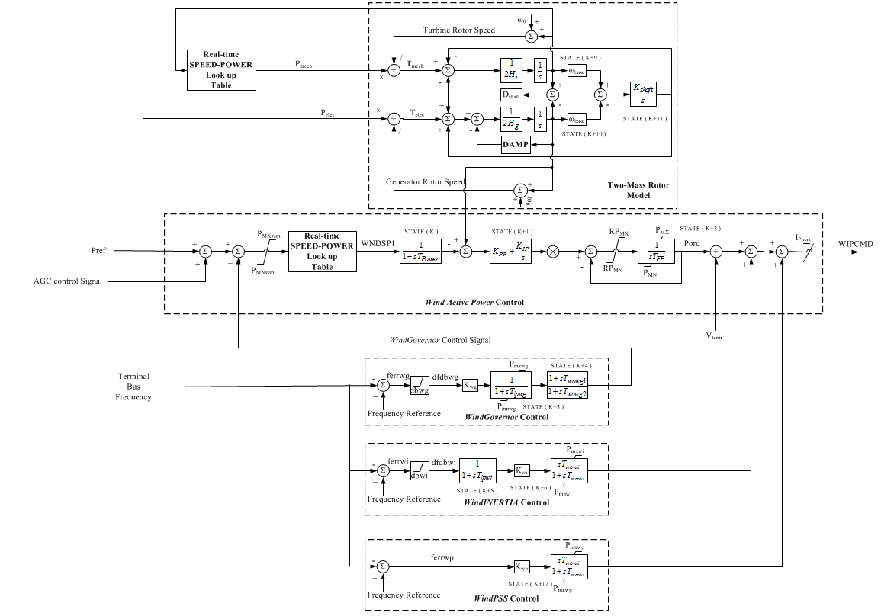
Figure B-1 User-defined WT3 Electrical Control Model (Active Power Part)

Table B-1 Parameter of User-defined WT3 Electrical Control Model (Part)
Constant No. | Constant Name
CON(J) | T_{Power}, Power filter time constant
CON(J+1) | K_{PP}, Proportional gain in torque regulator(pu)
CON(J+2) | K_{IP}, Integrator gain in torque regulator(pu)
CON(J+3) | RP_{MX}, Max power order derivative
CON(J+4) | RP_{MN}, Min power order derivative
CON(J+5) | P_{MX}, Max limit in torque regulator (pu)
CON(J+6) | P_{MN}, Min limit in torque regulator (pu)
CON(J+7) | IP_{MAX}, Max reactive current limit
CON(J+8) | T_{FP}, Filter time constant in torque regulator
CON(J+22) | Q_{MX}, Max limit in voltage regulator (pu)
CON(J+23) | Q_{MN}, Min limit in voltage regulator (pu)
CON(J+24) | V_{MAXCL}, Max voltage limit
CON(J+25) | V_{MINCL}, Min voltage limit
CON(J+26) | Kqi , MVAR/Voltage gain
CON(J+27) | XIQmax
CON(J+28) | XIQmin
CON(J+29) | Kqv, Voltage/MVAR gain
CON(J+37) | H, total inertia constant, sec
CON(J+38) | Htfrac, turbine inertia fraction(Htur/H)
CON(J+39) | DAMP, machine damping factor, pu P/pu speed
CON(J+40) | Dshaft, Shaft damping factor(pu)
CON(J+41) | Freq1, First shaft torsional resonant frequency, Hz

Table B-2 Parameters of Wind Inertia Control Loop
Constant No. | Constant Name
CON(J+9) | dbwi, WindInertia deadband
CON(J+10) | TIpwi, WindInertia filter time constant
CON(J+11) | Kwi, WindInertia Gain
CON(J+12) | Twowi, WindInertia washout time constant
CON(J+13) | Pmxwi, WindInertia maximum additional power
CON(J+14) | Pmnwi, WindInertia maximum additional power

Table B-3 Parameter of Wind Governor Control Loop
Constant No. | Constant Name
CON(J+15) | dbwg, WindGovernor deadband
CON(J+16) | TIpwg, WindGovernor filter time constant
CON(J+17) | Kwg, WindGovernor Gain
CON(J+18) | Twowg1, WindGovernor washout time constant1
CON(J+19) | Twowg2, WindGovernor washout time constant2
CON(J+20) | Pmxwg, WindGovernor maximum additional power
CON(J+21) | Pmnwg, WindGovernor minimum additional power

User-defined PV electrical Control MODEL (Active Power Part)

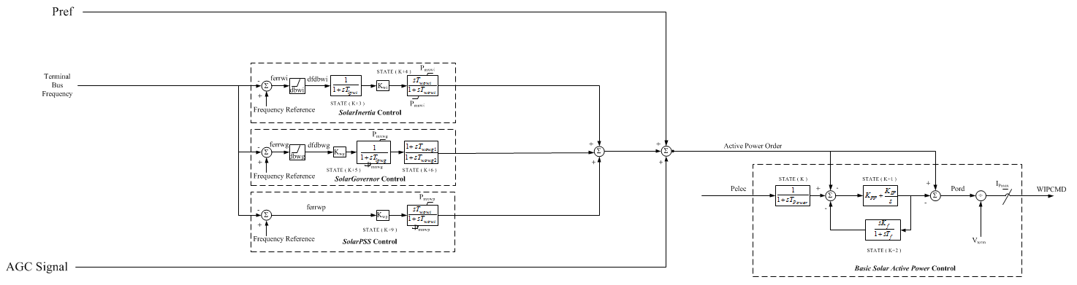
Figure C-1 User-defined WT3 Electrical Control Model (Active Power Part)

Influence of Oberverbility on Estimation Accuracy Index

                - 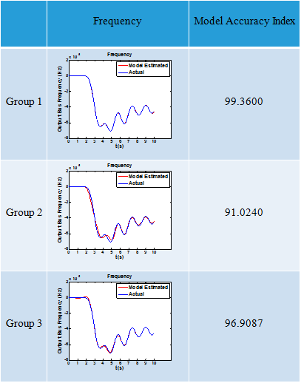
Figure D-1 Frequency Estimation with Different Levels of Observability Index
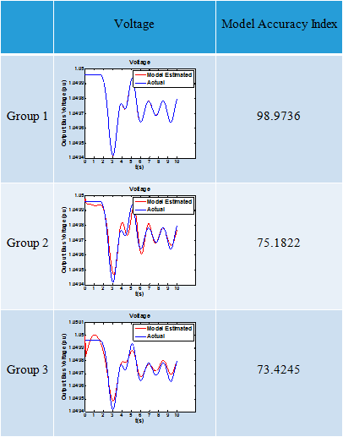
Figure D-2 Voltage Estimation with Different Levels of Observability Index
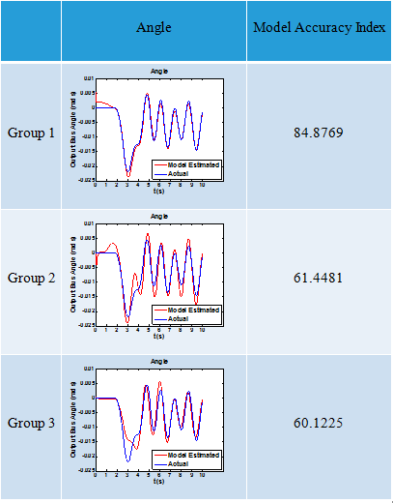
Figure D-3 Angle Estimation with Different Levels of Observability Index

Influence of Inputs Types on Dynamic Response Estimation

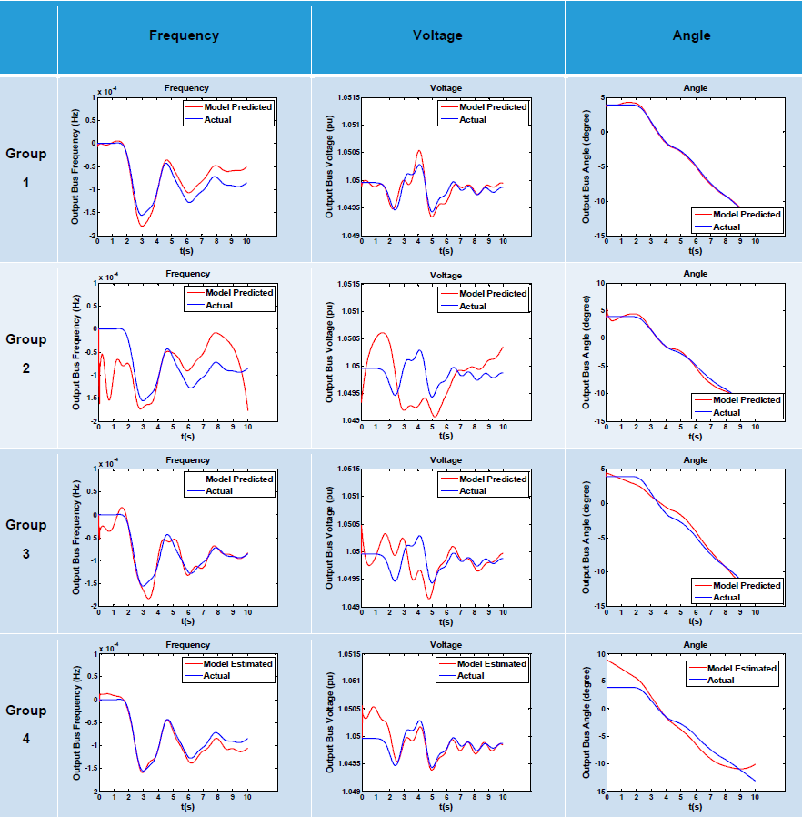
Figure E-1 Different Groups of Inputs when the Output is Frequency/Voltage/Angle-Generation Trip as Excitation to Estimate Generation Trip
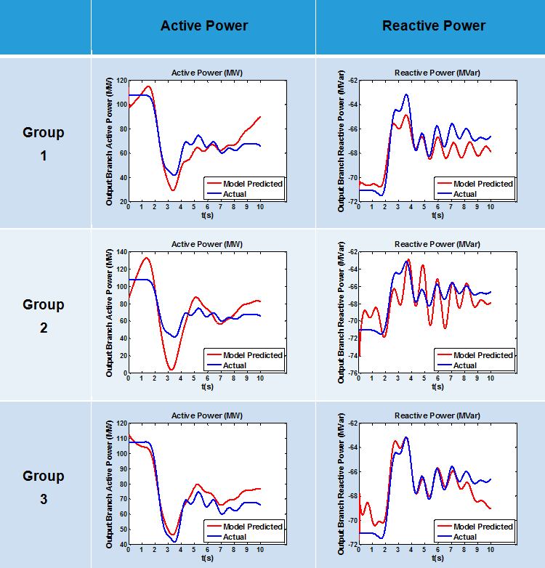
Figure E-2 Different Groups of Inputs when the Output is Active/Reactive Power-Generation Trip as Excitation to Estimate Load Shedding

Influence of Excitation Types on Dynamic Response Estimation

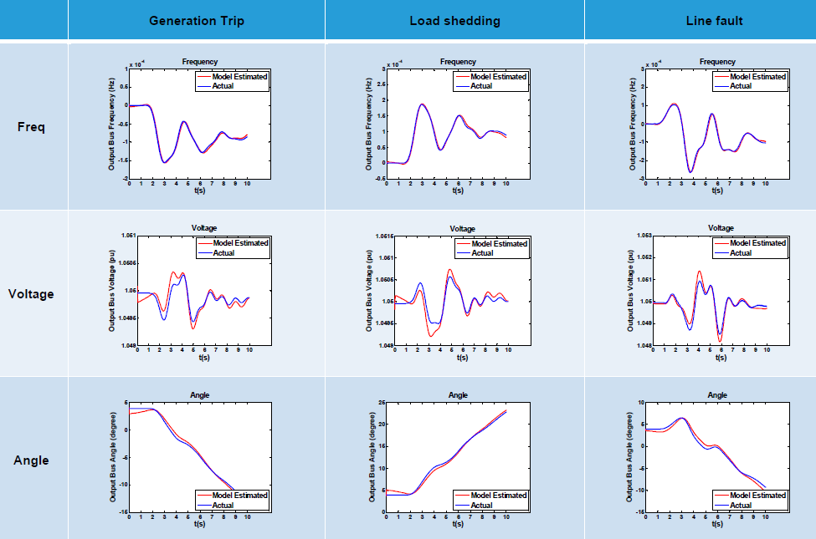
Figure F-1 Excitation Types-Generation Trip as Excitation
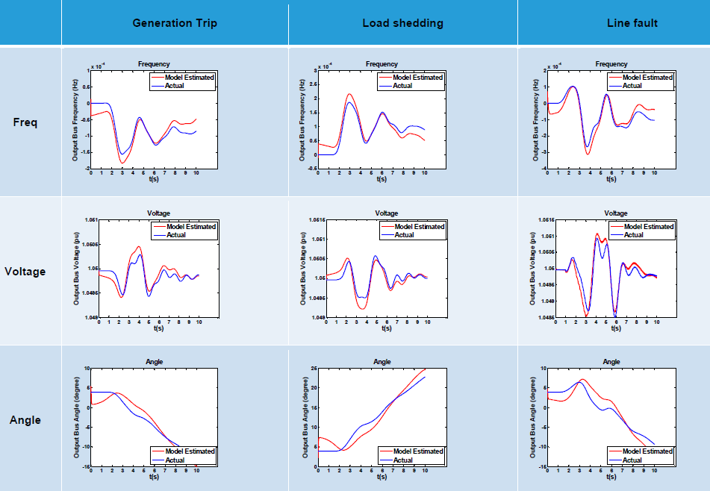
Figure F-2 Excitation Types-Line Trip as Excitation

Influence of Topological Change on Dynamic Response Estimation

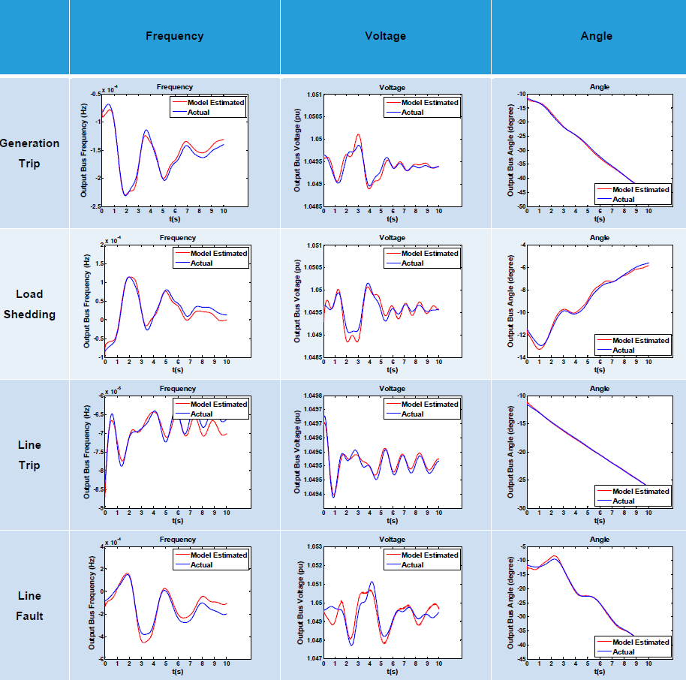
Figure G-1 Dynamic Response Estimation after Topological Change-Far

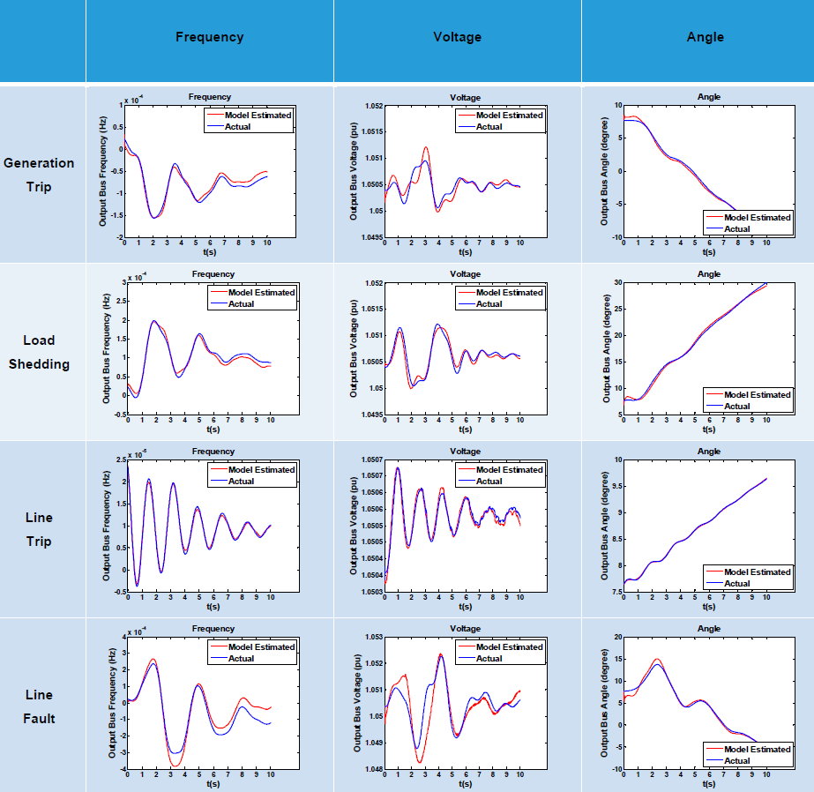
Figure G-2 Dynamic Response Estimation after Topological Change-Near

Application in Out of Step Prediction

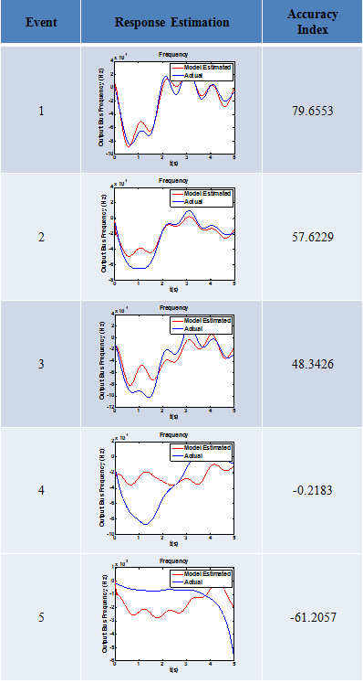
Figure H-1 Frequency Response Estimation Following the Sequence of Disturbances-Fixed Model
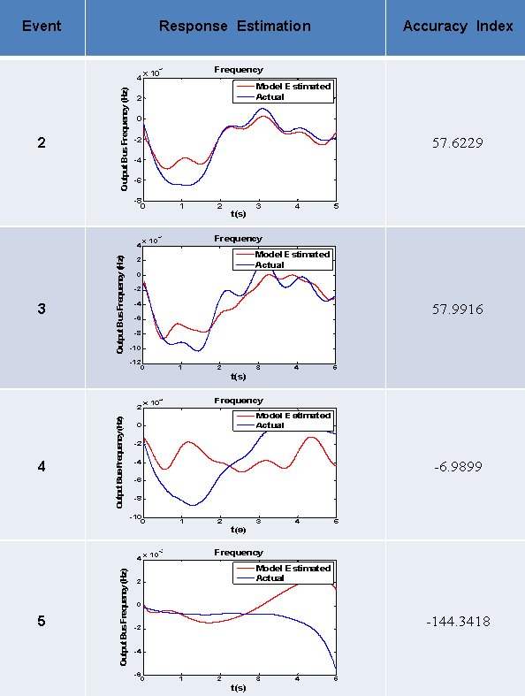
Figure H-2 Frequency Response Estimation Following the Sequence of Disturbances-Adaptive Model

Application in Voltage Stability Prediction

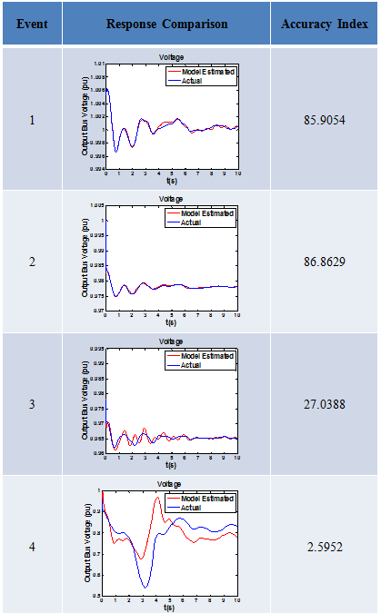
Figure I-1 Voltage Response Estimation Following the Sequence of Disturbances-Fixed Model
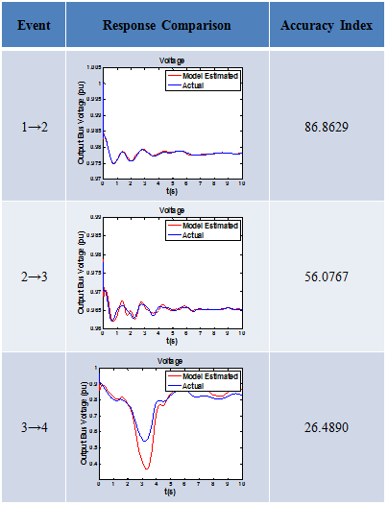
Figure I-2 Voltage Response Estimation Following the Sequence of Disturbances-Adaptive Model

Some EI System Simulation Studies
                - In this appendix, four individual EI system simulation studies will be briefly introduced.
- Influence of Disturbance Location on Inter-area Oscillation
                - The FNET inter-area oscillation monitoring since 2005 has demonstrated that the disturbances that occur in different locations may incite the inter-area oscillations with different characteristics. For example, in [38], it demonstrated that the disturbances in different locations may incite different inter-area oscillation modes involving different areas.
                - In this section, four generation trips of almost the same capacity were simulated in different regions of the EI system (detailed information given in the table below), and the incited inter-area oscillations were plotted in Figure J-1. Note that the frequency deviations from whole system average instead of nominal value were plotted. From Figure J-1, it could be observed that the disturbance that occurred in Tennessee incited much less oscillations than other disturbances, which confirms that it’s easier to incite the inter-area oscillation if the disturbance occurs on the edges of bulk power grid. Another phenomenon that should be noticed from the simulation results is that the inter-area oscillations incited by generation trips are usually between the region where the disturbances occur and the rest of the EI. This could also be verified by the measurement [38].

Table J-1 Generation Trips in Different Regions Used to Incite Inter-area Oscillations
Location | Capacity Tripped
Tennessee | 692 MW
Northeast | 681 MW
Florida | 692 MW
North Dakota | 721 MW

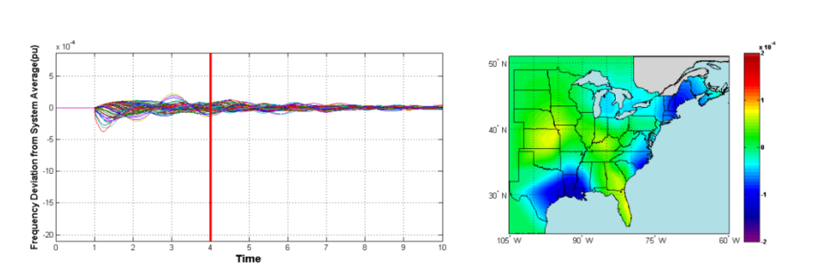
Disturbance Location in TN
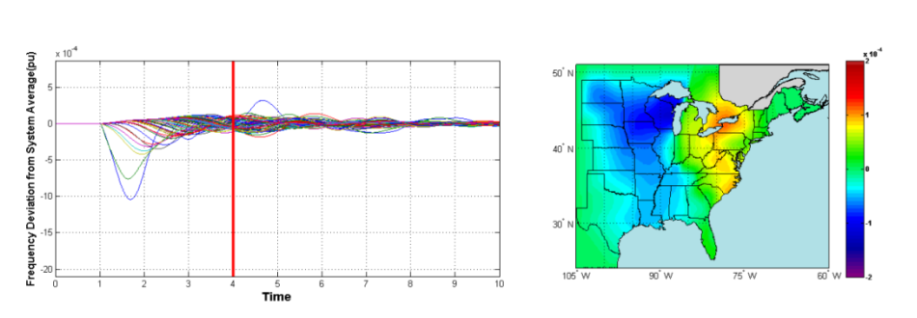
Disturbance Location in Northeast
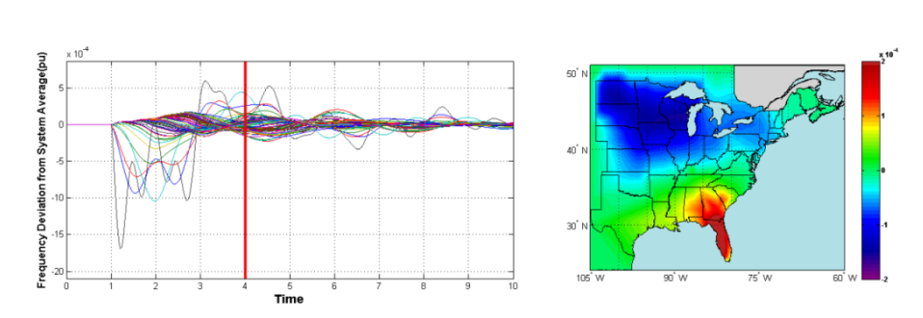
Disturbance in Florida
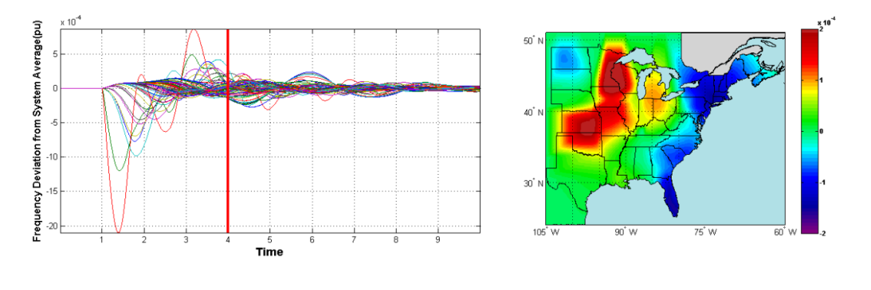
Disturbance in North Dakota
Figure J-1 Inter-area Oscillations in EI incited by Disturbances in Different Regions

- Impact of the Renewable Penetration Levels on the EI System Frequency and Voltage Response
                - Hundreds of technical papers have focused on investigating the impact of renewable penetration on the bulk power grid frequency and voltage response around the world since the very beginning of renewables development and these researches have repeatedly demonstrated that increasing penetration of renewable generation would change the traditional way of system operation and corresponding regulation policies needs to be modified to address those issues, such as decrease of frequency and voltage support capabilities. However, up to now, there is no specific study carried out for the EI system yet. Apparently, the lack of the appropriate EI system model (with high penetrations of renewables) is the largest hurdle preventing us from doing that.
                - However, it’s not impossible to investigate this topic without the appropriate EI system model. One of the main differences between renewable and conventional generations is the “hidden” inertia of renewable generations and lack of frequency and voltage support capabilities under current control situations. Therefore, the whole system inertia can be scaled down proportionally and a portion of conventional turbine governors can be disabled to mimic the impact of a desired renewable penetration level on the EI system frequency response. In this way, the influence of different renewable penetration levels on the EI frequency response could be investigated. Similarly, for the voltage response study, a portion of conventional generator exciters can be disabled to mimic the influence of renewables on the voltage response. However, please note that disabling governors/exciters only means those conventional generators would lose frequency and voltage support capabilities and does not mean these generators would behave exactly the same as renewable generators.
                - An automated Python file is written to mimic the 30%, 40% and 60% three levels of renewable penetration and the simulation results are given below in Figure J-2 and Figure J-3. From the frequency response result, it can be concluded that the increasing penetration level would dramatically deteriorate the frequency response, including the frequency drop rate, frequency drop nadir and steady-state frequency recovery.
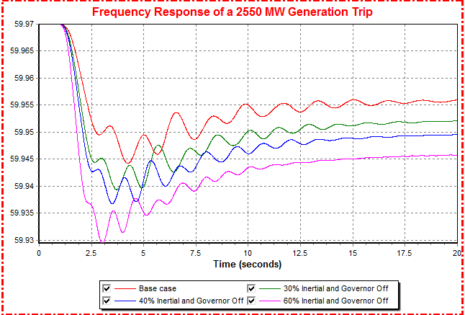

Figure J-2 Frequency Responses of the EI system with Different Penetration Levels of “Fake” Renewables

                - In the voltage case (Figure J-3), it’s also obvious that the increasing penetration level would negatively influence the system voltage response. Please be note that the 60% case is already unstable; however, it gives us some hints on how the renewable penetration levels impact the system voltage profile. From the simulation results, current regulation policies need to be modified to improve the system frequency and voltage response.

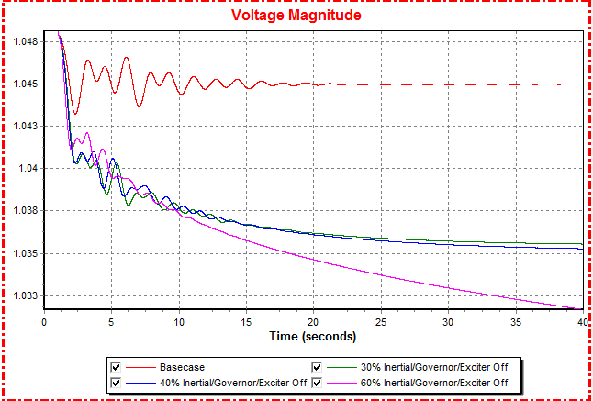

Figure J-3 Voltage Responses of the EI system with Different Penetration Levels of “Fake” Renewables

- EI Model Validation Using FNET Measurement Data
                - FNET-based model validation is an attempt to correct frequency response from simulations so that the simulation output is close to frequency measurement obtained from system events. Practically, model validation also needs to be periodically performed to ensure that system models are updated along with system changes. This section continues the FNET-aided model validation work by giving two more recent case studies.
- Case 1: The two nuclear reactors at North Anna Power Station (about 1800MW) in Mineral, Va., automatically shut down following a 5.8 magnitude earthquake in Central Virginia on Aug. 23, 2011, at 1:51 p.m. ET.
Figure J-4 16,000-bus EI Model Validation Using FNET Measurement Data-North Anna Event

                - To make the simulation result match the real frequency response, system inertial, governors, and load composition were carefully tuned. In this specific case, it turns out that disabling all the governors, scaling up the system inertia by 30%, and using 80% constant active power and 20% constant current power for the load composition gives the best match (as shown by Figure J-4).
- Case 2: Severe storms moving through the Southeast dealt a severe blow to the Tennessee Valley Authority on April 27, 2011, knocking out 11 high-voltage power lines in Mississippi and north Alabama.
To make the simulation result match the real frequency response of this TVA line trip case, it seems that disabling 80% of the governors, scaling down the system inertia by 30%, and using 80% constant active power and 20% constant current power for the load composition would give the best match (Figure J-5). From these two case studies, it tells that, the system model validation process may need to be done periodically and the system-level tuning process may also have its limitations.

Figure J-5 16,000-bus EI Model Validation Using FNET Measurement Data-TVA Line Trip Event

- Forced Inter-area Oscillation in the EI
                - As demonstrated by Chapter 4 and 5, Wind/PV plants can be utilized to help damp the inter-area oscillation if with appropriate control schemes, which proves the effectiveness of wind/PV plant’s role as the “actuator” in the power grid. Instead of oscillation damping, wind/PV plants can also be used to incite the forced inter-area oscillations in the EI, as demonstrated by Figure J-6. In Figure J-6, a group of PV plants in the northeastern region of the EI are ordered to decrease their active power output by 100MW while another group of PV plants in the northeastern region increase by 100 MW. In this case, obvious oscillations can be observed.

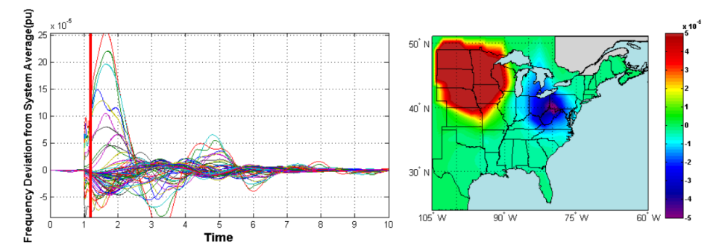
Figure J-6 Forced Inter-area Oscillations in the EI by Control of PV Generation

Vita

                - Yong Liu received his B.S. and M.S. in electrical engineering from Shandong University in 2007 and 2010, respectively. He started his Ph. D study at the University of Tennessee, Knoxville, in August 2010 and his current research interests involve wide-area power system monitoring and control, renewable energy integration and power system dynamic analysis.

