Mitigation of aging in low voltage electrical cables in nuclear power plants
Contributing Authors:
Joe Ulrich
Robert York
Grant Murphy
Daniel Prather

Faculty Advisor: Dr. Roberto Benson
Partner in Industry: Trevor Toll
Analysis and Measurement Services Corporation

MSE489 Senior Design
4/22/2015
Department of Materials Science and Engineering
University of Tennessee
Knoxville, TN

ABSTRACT

The proposed project focuses on the research and design of a method to slow degradation occurring in the polymer layers that surround and protect electrical cables in a nuclear power plant. The degradation mechanisms include aging due to thermal, chemical, and environmental factors, along with radiation exposure. The mitigation method required by the Analysis and Measurement Services Corporation (AMS) must serve to slow the effects of this degradation – with an emphasis on the most prevalent, thermal oxidation. The proposed solution protects the cable from further degradation and provides an improvement in functionality in tensile strength and elastic modulus. Industrial test standards such as elongation at break, cable indenter modulus, differential scanning calorimetry, and thermogravimetric analysis were used to determine the improved properties of the suggested material, ensuring its viability until the cable can be replaced. The project objectives include: investigation and selection of a material and an application method, evaluation of selection(s), design of a prototype, and testing of the prototype according to accelerated aging experiments carried out by AMS.

BACKGROUND

I. Introduction
When a new nuclear power plant is opened in the United States, it is typically certified to operate for 40 years. Today, most nuclear power plants in existence are operating under renewed licenses that have been extended to 20 years past their original operation lifetime (IAEA, 2000). As a next step, federal regulators are considering the extension of these licenses an additional 20 years, for a total of an 80-year lifetime. This involves replacing aging assets that were originally qualified for 40 years of operation. The wholesale replacement of electrical cables in nuclear power plants is not a practical option due to time and budget restraints. Therefore, the integrity of these cables must be assessed to verify their relative health and ability to operate for the remainder of the plant’s certified lifetime. For cables that do not meet the specifications, mitigation techniques are needed that will extend operating life and will support this long-term operation without causing the shutdown of the power plant. A nuclear power plant is worth around $1 million per day, so shutting down the plant should be avoided at all costs (U.S.NRC ).
Electrical cables are used in a variety of applications in power plants and can be divided into five general categories: instrumentation, control, AC power, DC power, and communication (detailed further in Table 1 from IAEA). This study will focus on low voltage cables (voltages < 1 kV), which fall under the AC Power cables category. These cables exist in a variety of configurations but they typically include these basic components:
- Conductor (wire)
- Insulation (dielectric material)
- Shield
- Jacket
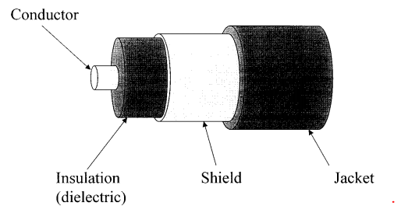
Figure 1: Basic cable components. The layers in this diagram are representative of low voltage electrical cables, as shown by IAEA (2000, p.10). This cable shows the simplest construction, but as this project will deal with only the shield and the jacket, the simplest construction is sufficient.

The original cables were produced in the 1970’s and 1980’s, when the majority of the nuclear power plants in the United States were built. A diagram representing one typical construction of one of these low voltage power cables can be seen in Figure 1. At the time these cables were manufactured, the jackets and shields that protected them from the environment were primarily made from cross-linked polyethylene (XLPE), ethylene propylene rubber (EPR), chlorosulfonated polyethylene (CSPE), and polyvinyl chloride (PVC) (IAEA, 2000).
Table 1: Distribution of circuit types
 | Circuit Type | Approx. No. of Circuits | Percentage of Total
 | Instrumentation | 10,180 | 20%
 | Control | 31,500 | 61%
 | AC power | 6,580 | 13%
 | DC power | 530 | 1%
 | Communication | 2,560 | 5%
Total |  | 51,350
The approximate amount of each type of circuit present in a nuclear power plant has been represented in this table by IAEA (2000, p.11). The cables of interest to this study are in the AC power category, which represent 13% of the more than 51,000 cables that run throughout a typical plant.
II. Materials
For this project, two irradiated cables were received from AMS for material testing and analysis of the polymer jacket and shield. These cables are AC power cables, which represent 13% of all of the cables used in a typical nuclear power plant, as can be seen in Table 1 to the left. These cables were taken from a plant and will be used throughout this project as a standard against which to test new materials. The shields are composed of EPR and XLPE. The jackets are CSPE and chlorinated polyethylene (CPE).

II.A. Ethylene propylene rubber
Through the use of Fourier transform infrared spectroscopy (FTIR), the insulation of one of the cables was found to be ethylene propylene rubber (EPR). The spectrum produced from the insulation can be seen in Figure 2 below. The characteristic peaks at 1375, 1456, and 2913 cm⁻¹ prove this material to be EPR.
Figure 2: FTIR spectrum of ethylene propylene rubber. Peaks at 2913, 1456, and 1375 are characteristic of EPR.

EPR is a synthetic elastomer composed of ethylene and propylene monomers. These ethylene and propylene monomers are copolymerized in such a way as to form a random copolymer (IISRP, 2012). Many different types of EPR elastomers can be produced depending on the copolymer composition and crystallinity. The backbone of EPR is classified as saturated because all of the bonds between individual C atoms are single bonds.
EPR has good electrical resistivity and good resistance to polar solvents, such as water, acids, alkalis, and phosphate esters. Amorphous or low crystalline grades have excellent low temperature flexibility with glass transition points of about -60°C (IISRP, 2012). This means that they retain their flexibility, even at temperatures as low as -60ºC, because their transition to a glassy state occurs at an extremely low temperature. As mentioned previously, the saturated backbone of EPR provides it with some useful mitigation properties, such as resistance to heat, oxidation, ozone and therefore, aging. Compared with XLPE and PVC, EPR also has higher flexibility, which combine with its ability to act as a barrier, making it a candidate for use as insulation. However, when compared to other cable insulation materials, EPR has a much higher coefficient of dielectric loss, averaging 0.001 whereas polyethylene stays around 0.0001 (IISRP, 2012).

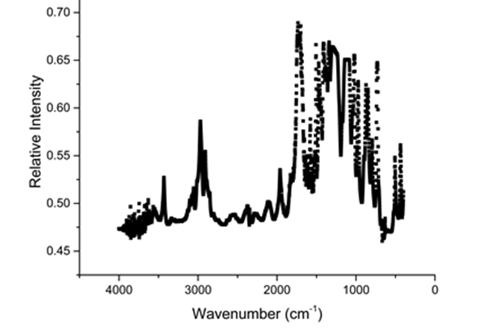
II.B. Cross-linked polyethylene
Figure 3: FTIR spectrum of cross-linked polyethylene from AMS.

Cross-linked polyethylene was determined to be one of the materials provided by AMS based on the FTIR image in Figure 3. The characteristic peaks were cross-referenced with literature in order to determine the identity of this sample. Multiple absorption bands from around 1700 down to 750 cm⁻¹ are not typical for PE. These peaks indicate the presence of silane, which is a cross-linker.
The determination of XLPE as the identity of one of the polymer compounds was far from a surprise. As stated previously, XLPE is one of the most common polymers used for this application, especially during the time period that these cables were manufactured. Many types of PE exist, each with different strengths and weaknesses. This specific type is generally a network of high molecular weight chains that have been cross-linked together as shown by the final product of the reaction in Figure 4, on the following page. This process forms a network that improves impact strength, environmental stress crack resistance, and creep/abrasion resistance without sacrificing tensile strength or polymer density (Tamboli, 2004).
The cross-linking process consists of four steps: Initiation, propagation, branching, and termination. In brief, initiation involves the action of a chemical or physical agent that creates a free radical. This free radical causes polymer chains to join, creating more free radicals in a reaction step called propagation. Branching describes the tendency of polymer chains to join to each other in different conformations and is closely related with propagation. Termination occurs when these radicals join with each other, taking away the active species, i.e. free radical, and the means for cross-linking to occur. An in-depth analysis of these steps can be found in the paper by Tamboli et al (2004).

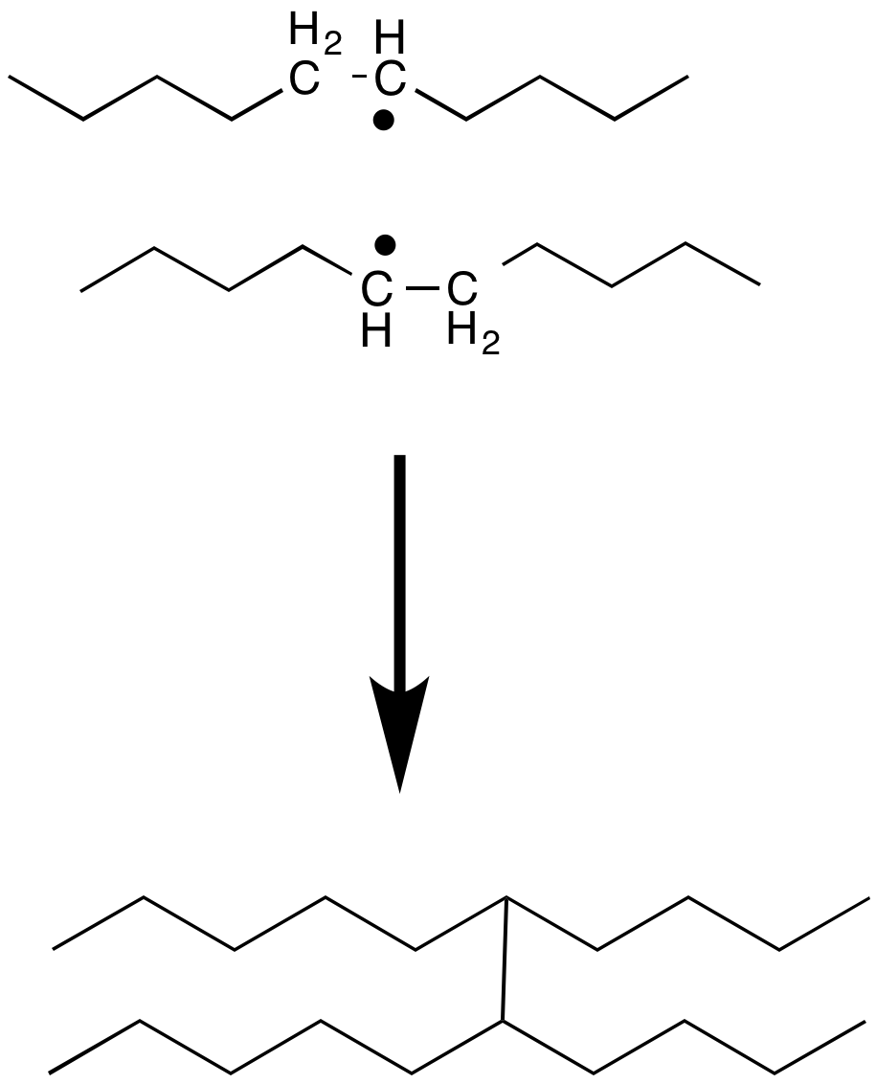
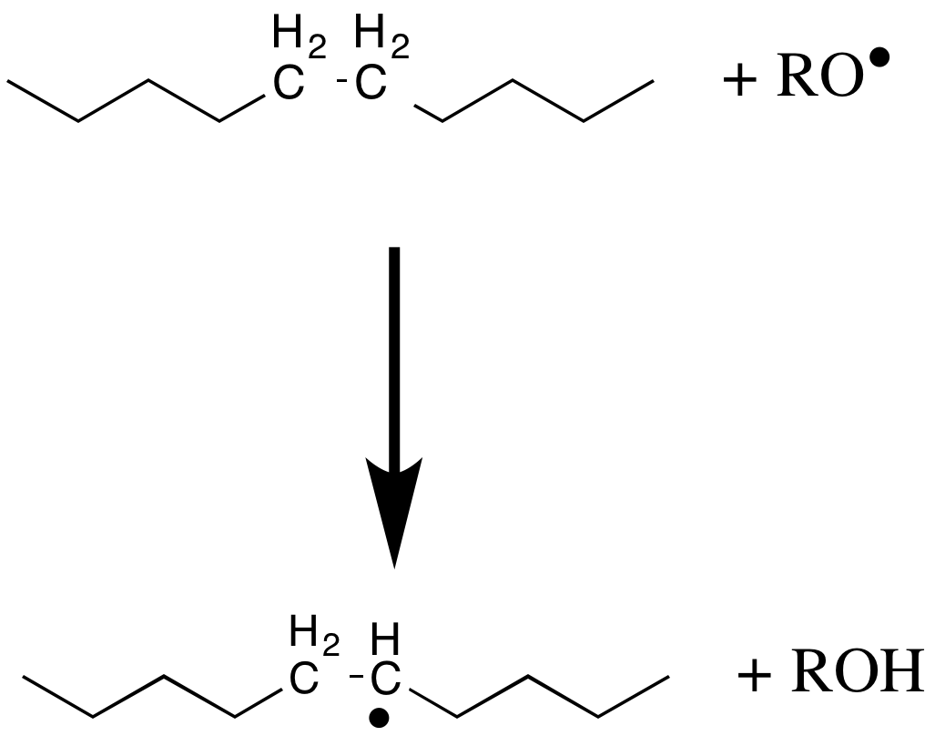

Figure 4: Cross-linking of polyethylene. The formation of a free radical allows a bond to form between two adjacent polymer chains. This can happen multiple times, resulting in a cross-linked polymer matrix.

Polyethylene can be cross-linked in many different ways. The physical method of initiating this process is due to radiation. When the polymer is exposed to ionizing radiation, a free radical is created by the removal of a hydrogen atom from a carbon, leaving an unbound electron. Two other methods of initiation are realized through chemical cross-linkers. Either peroxide or silane can be used to accomplish this goal. The table below from Tamboli et al (2004) provides a comparison between the three methods. Radiation can be done at room temperature, requires no additives, is completed in one step, and has high output. However, it is costly and has related safety precautions that are always a concern. Peroxide is very simple to compound and provides excellent heat stability and homogeneous cross-linking density. Although these methods are both viable options, PE cross-linked with silane was identified to be the material received from AMS, as stated previously.
Cross-linking by silane generally does not provide properties that are as consistent as those provided by peroxide. XLPE produced using silane tends to have higher heterogeneity of cross-linking, which produces weak spots in the material and makes it more susceptible to degradation (Tamboli, 2004). However, this method is often used because it is inexpensive. Regardless of the method used, cross-linking tends to improve the characteristics of PE with respect to cable insulation. This process alters the foundation of the polymer, transforming it from a thermoplastic, which melts at high temperature, to a thermoset, which does not melt. Overall, XLPE will have resistance to melt flow and permanent damage because it no longer has a softening temperature. It will have a higher operating temperature and reduced need for short-circuit and overload protection when compared with PE (Tamboli, 2004).
Table 2. Comparison of cross-linking mechanisms
 | Peroxide | Silane | Radiation
No. of Steps | One Step | Two Step | One Step
Crosslinking Mechanism | Free Radical | Grafting | Free Radical
Gel % | >75 | >65 | >60
Curing Mechanism | Homolysis temperature of peroxide | Condensation reaction | -
Curing Temperature | 150-160°C | 80-90°C | Room Temperature
Curing Time | Less | Very High | Very Low
Additives | No | Peroxide for grafting | Peroxide for initiating
Equipment Cost | Medium | Low | High
Bond Strength | Strong | Weak as compared to peroxide | Strong
Degree of Crosslinking | Constant throughout the article | Varies with time in water bath and temperature of bath | Varies with thickness of article
The two primary methods of cross-linker identification for this project were cost and bond strength. Radiation is not the method used because of high cost. Silane is the most likely because of its low cost. However, silane does not have high bond strength, so it will degrade much easier than a polymer cross-linked by peroxide (Tamboli, 2004).

The most common failure with this type of cable is thermally-induced oxidation (Tamboli, 2004). This causes embrittlement and leads to cracking and loss of dielectric strength. The physical properties of XLPE can be used as degradation markers to show when these cables are in danger of failure. Thermal analysis can show the maximum temperature that these cables have been exposed to. In the paper by Anandakumaran and Stonkus (1992) a good correlation was shown between thermal degradation and other properties, such as reduced elongation and crystallinity, as shown in Figure 5, below.
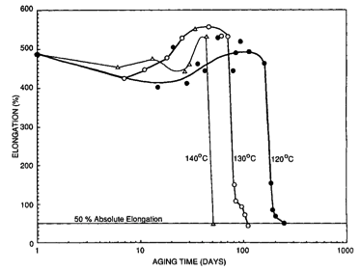
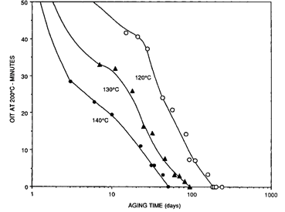
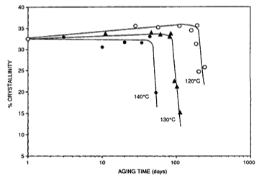
Figure 5: XLPE Aging Response at Elevated Temperature. A) The leftmost graph shows the gradual increase, but then rapid decrease of crystallinity observed upon aging XLPE. It can be seen that higher temperature causes this reaction to occur after fewer days. B) The middle graph shows the oxidation induction time (OIT) at elevated temperature. Based on the graph, O2 is shown to permeate into the structure of XLPE much more quickly at a higher temperature. C) In the rightmost graph, the percent elongation response to aging is shown at elevated temperature. Once again, the property in question declines much more quickly at higher temperature, which is unfavorable for each of these three mechanical properties. (Anandakumaran, 1992).
Even with properties that seemed favorable at the time of implementation, XLPE - especially when cross-linked with silane - is very susceptible to the degradation modes mentioned previously. The most prevalent failure associated with XLPE consists of a combination of thermal and oxidative effects. XLPE tends to become brittle and crack with temperature, allowing the oxygen to penetrate deeper into the polymer, promoting further degradation. These effects are shown in the three parts of Figure 5, on the previous page. As can be seen, even only a 20ºC change in aging temperature significantly decreases the point at which the material fails.

II.C. Chlorinated polyethylene/chlorosulfonated polyethylene
The jackets on the samples received from AMS were identified as chlorinated polyethylene. CPE exhibits excellent physical and mechanical properties including resistance to chemicals, oil, heat, abrasion, and weathering. The largest application of CPE is as a modifier to other elastomers used in various applications, such as a wire and cable jacketing, roofing membranes, geomembranes, automotive and industrial tubing, coatings, molded shapes and extruded profiles (Sirisinha, 2002).

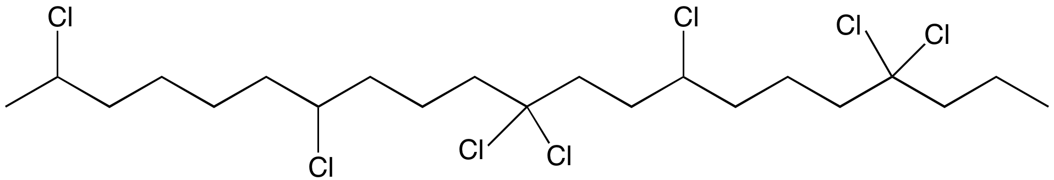
Figure 6: CPE polymer chain. This figure shows an example of a section of CPE with Cl molecules scattered randomly along the PE backbone
Standard CPE consists of 25-45 wt% Cl and is typically blended with PVC or other elastomers. The Cl atoms are attached sporadically along the chain. The mechanical properties of CPE change according to the weight percent of Cl present in the polymer. For example, an increase in weight percent will increase percent elongation at break. Conversely, modulus and tensile strength have been shown to have an inverse relationship with the Cl concentration (Sirisinha, 2002). Figures 8 and 9 on the following page demonstrate the overall decline in mechanical properties of CPE after being exposed to thermal degradation.
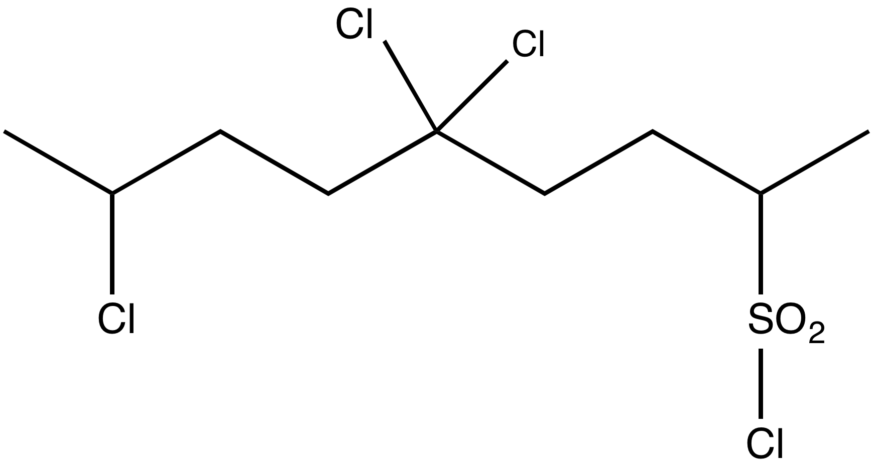

Figure 7: Structure of CSPE polymer chain.

Chlorosulfonated polyethylene (CSPE) is similar to CPE in mechanical and thermal properties. As shown in Figure 7, to the right, the structure of the two polymers is nearly identical, except for an SO₂ linkage in CSPE joining some of the Cl molecules to the main chain. When CPE or CSPE degrade, the degradation products are Cl₂ gas and HCl, both of which are highly toxic to anyone working near these cables. For this reason, they are actively being phased out of use for this application.
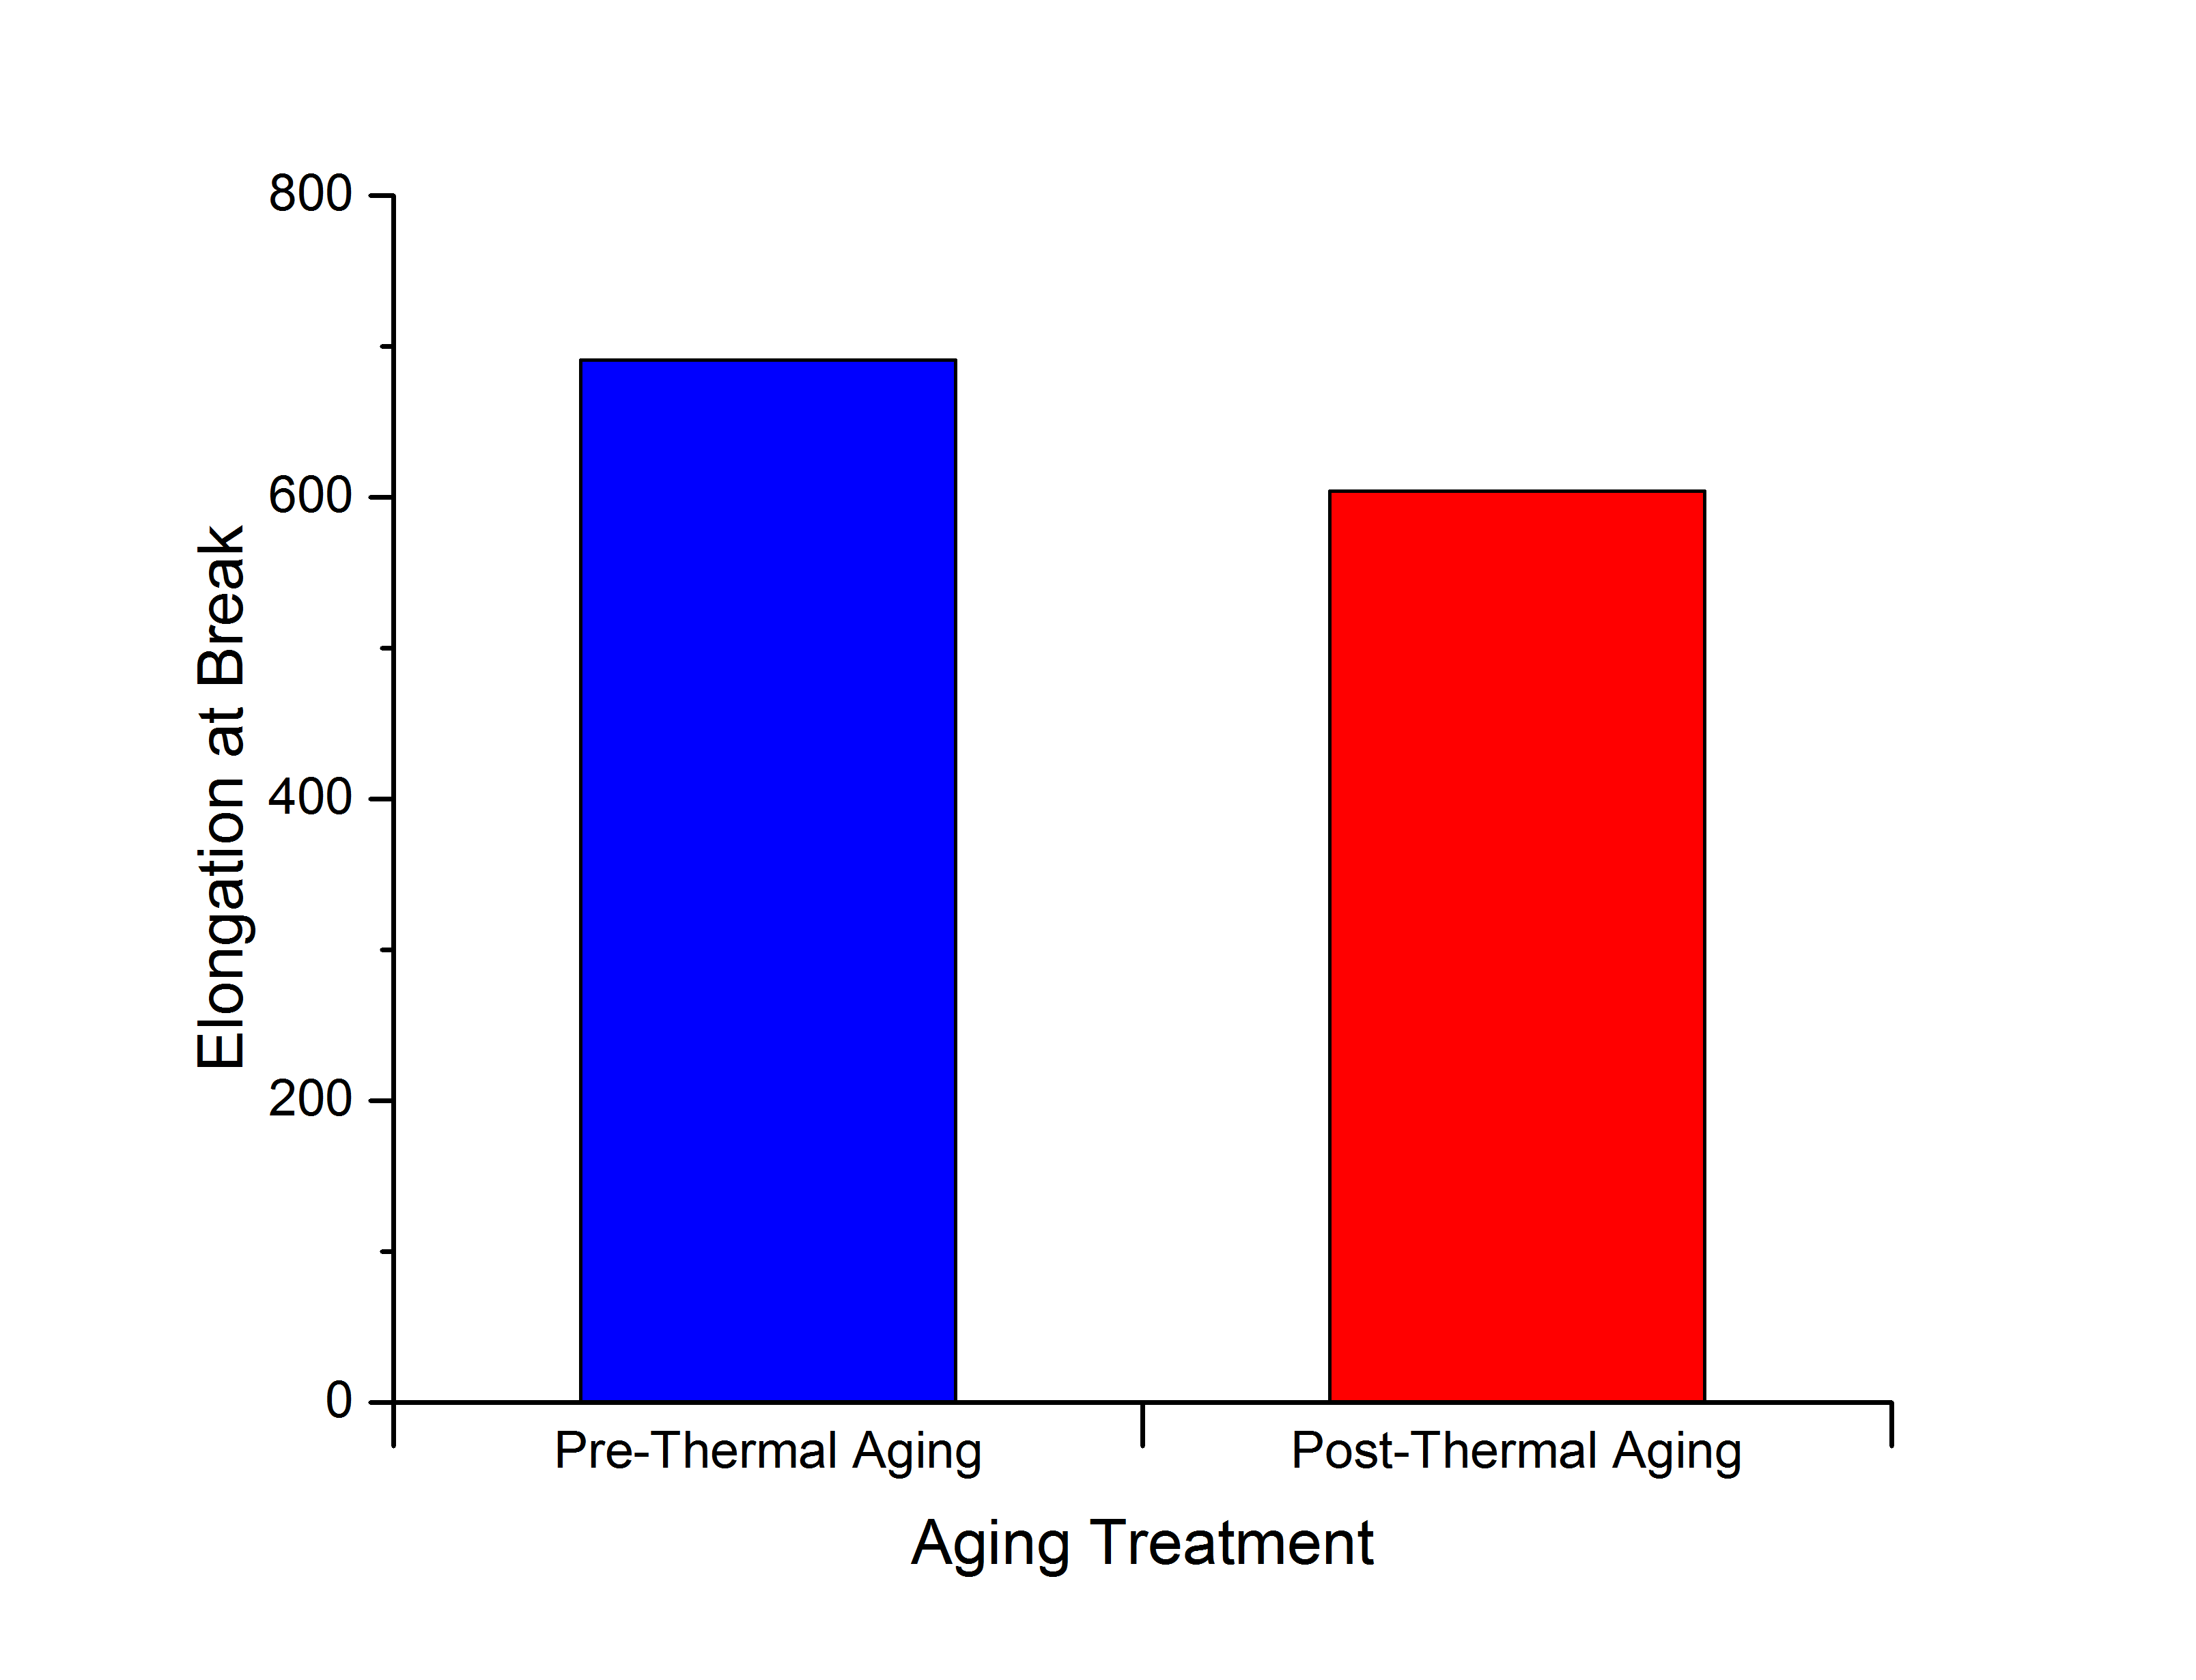
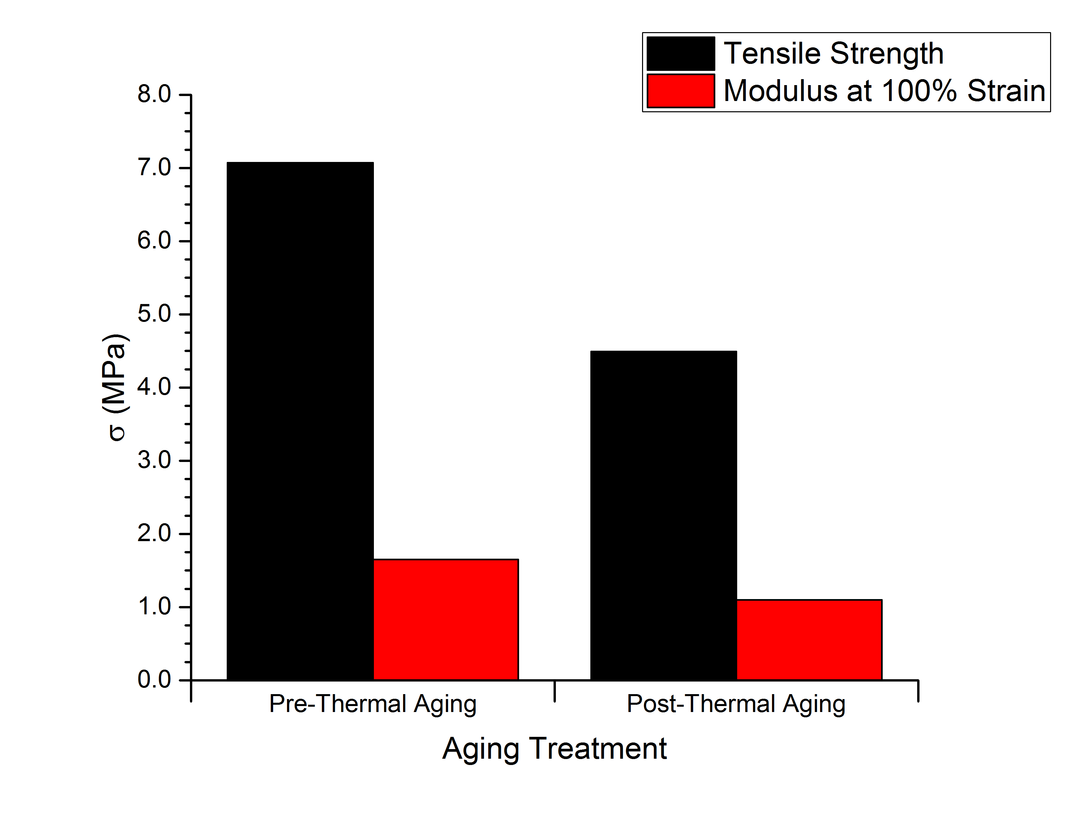
Figure 8: CPE Tensile strength and modulus
Figure 9: CPE elongation at break.
The decrease in tensile, modulus, and elongation represented
above were due to an aging treatment of 100ºC for just 24 hours (Yasin, 2012).

III. Polymer Degradation
Long-term exposure of polymeric materials to environmental conditions present in a nuclear power plant will lead to degradation, resulting in decreased performance of electrical cables and potential safety hazards. Degradation of the polymeric materials protecting these cables comes primarily from four sources: elevated temperature, radiation, and the permeation of water and oxygen.

III.A. Thermal Degradation
Thermal degradation manifests in many different ways in a polymer. These are generally broken down into processes that involve chain scission and those that involve crosslinking. Chain scission is a chemical reaction that involves breaking the bonds of a polymer, resulting in two separate pieces. The degradation reactions that occur due to chain scission are: random scission, elimination, and depolymerization, as illustrated in Figure 10, on the following page. Random scission is the splicing of a bond in either the carbon backbone of a polymer or its side groups. It occurs unpredictably throughout the chain and results in a rapid decrease in the molecular weight. Elimination also involves the breaking off of the side groups from the polymer chain. However, during elimination, the side chain takes a proton when it leaves, resulting in a stable molecule and double bond where it used to be attached to the polymer backbone. Depolymerization refers to the total breakdown of a polymer back into monomer units (Benson).

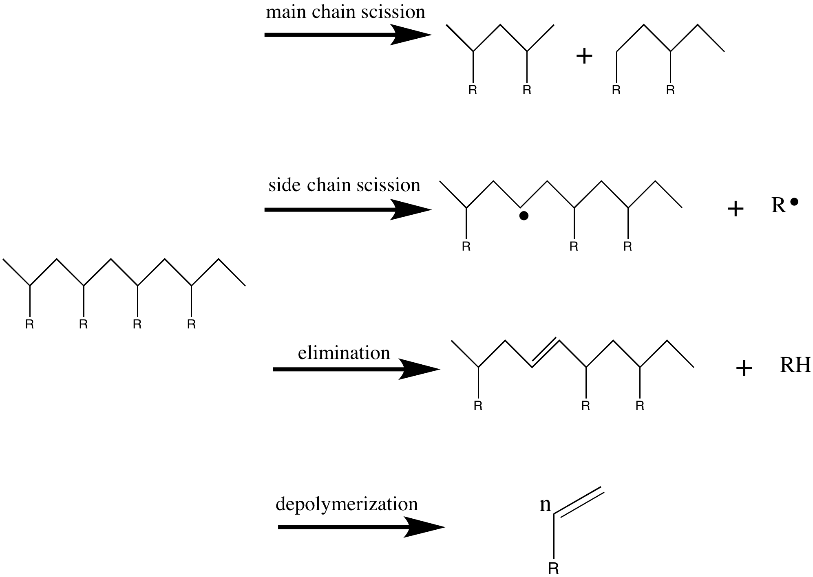
Figure 10: Thermal degradation via chain scission. When polymers are exposed to elevated temperatures, they react in one of four ways. A) Main chain scission happens when a bond is broken in the polymer backbone. B) Side chain scission occurs when a C-containing substituent is cleaved off of the backbone. C) Elimination occurs when a C-containing side group is cleaved, but the group takes a H with it, leaving behind a double bond in the backbone. D) Depolymerization refers to the conversion of a chain polymer back into its monomer units. (Benson)

The remaining types of thermal degradation proceed without chain scission. These three types are dehydrohalogenation, side-chain cyclization, and cross-linking, depicted in Figure 10 on the following page. Dehydrohalogenation occurs in polymers with halogen side groups. When a halogen-containing polymer is exposed to elevated temperature, the halogen atom and a proton separate from the polymer chain to form an acid. The removal of the H results in a double bond in the polymer backbone. This process is nearly identical to elimination. However, since the leaving group is a halogen instead of a C group, the process is not considered ‘scission’. Thus, the process is referred to as dehydrohalogenation, referencing the two atoms that are removed. Side-chain cyclization describes the grouping of side chains to form ring structures in the chain. Finally, cross-linking occurs when branches form between adjacent polymer chains, joining polymer strands into a cross-linked network (Benson).

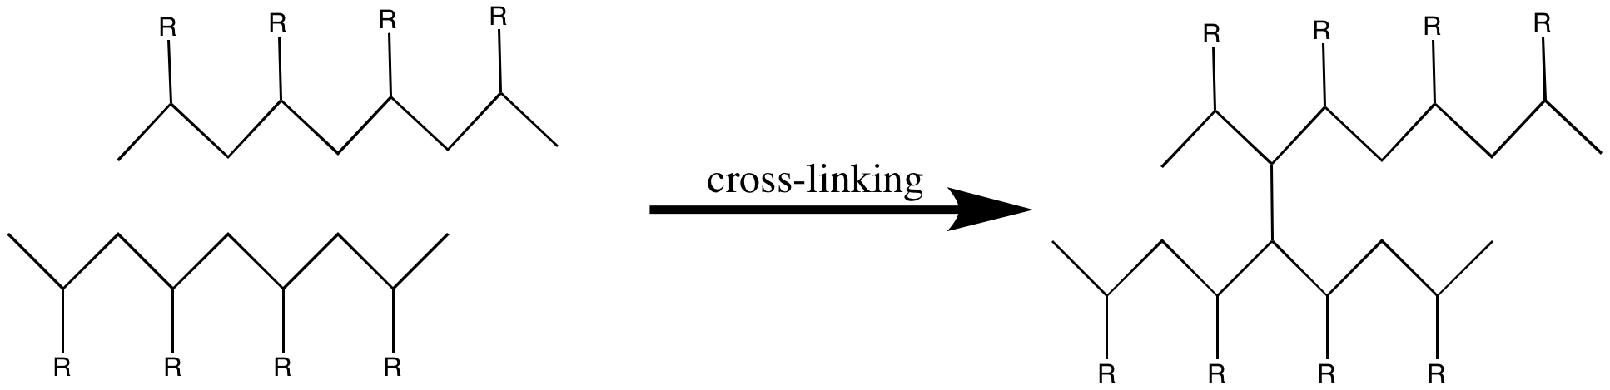
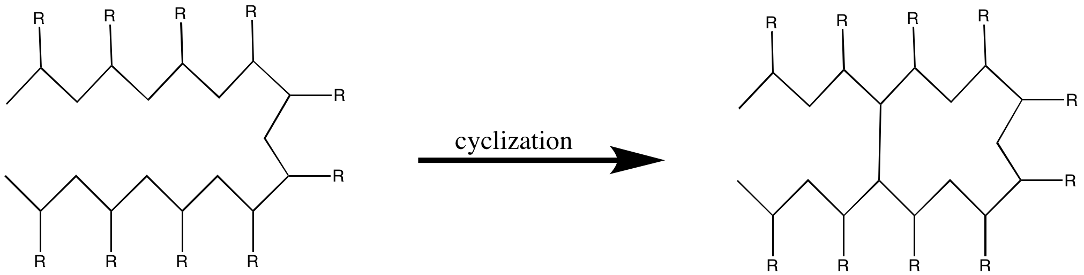
Figure 11: Thermal degradation mechanisms without chain scission. A) The process of cyclization involves the joining of the polymer to itself to produce a ring structure. This is accomplished when a bond forms to connect side chain groups. B) The process of cross-linking occurs when a bond is formed between two adjacent polymer chains (Benson).

III.B. Irradiative Degradation

Electrical cables run through the entirety of a nuclear power plant. In addition to areas of elevated temperature, they are also exposed to areas where they are dosed with gamma radiation. High-energy radiation can break bonds or form new ones, generating free radicals and ions within the molecular structure. When this occurs, the polymer chains respond through chain scission, cross-linking, grafting, or polymerization (Benson). The polymers of interest to this study are those that tend toward a competition between scission and cross-linking when exposed to radiation dosage. Priority will be given to polymers that express a greater tendency to crosslink than to degrade through chain scission. Table 3 on the previous page compares the tendency of common polymers to undergo cross-inking G(X) with the tendency to undergo scission G(S). The relative amount is given by the ratio of scission to cross-linking. Polymers chosen to study based on a low ratio – higher cross-linking tendency – were polyethylene, polymethylacrylate, natural rubber, and polybutadiene.

Table 3. Scission and crosslinking tendencies of common polymers
Polymeric Material | Crosslinking G(X) | Scission G(S) | Ratio G(S)/G(X)
Low Density Polyethylene | 0.8-1.1 | 0.4-0.5 | 0.47
High Density Polyethylene | 0.5-1.1 | 0.4-0.5 | 0.56
Polyvinylidene Fluoride | 1.00 | 0.30 | 0.30
Polymethylmethacrylate | 0.50 | 0.77 | 1.54
Polymethylacrylate | 0.50 | 0.04 | 0.07
Nylon 6 | 0.67 | 0.68 | 1.01
Nylon 6,6 | 0.50 | 0.70 | 1.40
Polyvinylacetate | 0.30 | 0.07 | 0.23
Atactic Polypropylene | 0.27 | 0.22 | 0.81
Isotactic Polypropylene | 0.16 | 0.24 | 1.50
Polystyrene | 0.019-0.051 | 0.0094-0.019 | 0.41
Natural Rubber | 1.05 | 0.1-0.2 | 0.14
Polybutadiene | 5.3 | 0.53 | 0.10
Polytetrafluoroethylene | 0.1-0.3 | 3.0-5.0 | 20
Polyisobutylene | 0.5 | 5 | 10
Cellulose | (low) | 11.00 | (high)
The ratio described by G(S)/G(X) describes the relative tendency of polymers to undergo scission, as opposed to cross-linking (Benson 2). Therefore, polymers with a ratio >1.0 are those of the most interest to this study.

Table 4. Radiation tolerances of common polymers
Polymer Type | Radiation Stability | Tolerance Dose Dt (kGy) | Detrimental Effects Above Dt
Polyethylene | Good-Excellent | 100-3,000 | Discoloration
Polypropylene | Poor-Fair | 10-80 | Discoloration, Disintegration
Polystyrene | Excellent | 800-30,000 | Brittleness, Discoloration
PET | Excellent | 1,500-30,000 | Brittleness, Discoloration
PVC | Good-Excellent | 400-15,000 | Brittleness, Discoloration
Polyurethane | Good-Excellent | 100-1,000 | Brittleness, Discoloration
Polycarbonate | Excellent | 5,000-10,000 | Discoloration
PTFE | Poor | 5-60 | Disintegration
Cellulose | Fair | 80-600 | Brittleness, Discoloration
The tolerance dose and detrimental effects combine to produce a qualitative measure for radiation stability (Benson, 2). One advantage to the use of PE is that, above the tolerance dose, the polymer is characterized by discoloration, where other polymers tend to become brittle.

In addition to crosslinking tendency, measurements for the tolerance dose can be taken to determine radiation stability. Polymers have been tested under various amounts of radiation to determine at what point their physical properties begin to be altered (Benson 2). The polymers that are of interest based on their ability to withstand large doses of radiation are polyethylene, polyethylene terephthalate, and polycarbonate. An interesting side note about polyethylene and polycarbonate is that the only detrimental physical property listed at the tolerance dose is discoloration, as shown in Table 4. Not only does this mean that these polymers could likely stand up to much higher radiation doses; it means that they would also give a warning to the maintenance crew in the form of a color change when the dose of radiation began to damage the cables.

III.C Oxidation and Hydrolysis
The final two modes of degradation are oxidation and hydrolysis. Both of these methods are attributed to chemical changes brought on by the incorporation of O₂ or H₂O into the structure of the polymer. When these chemical reactions begin to occur in a polymer, the result will be increasing brittleness and a drastic decrease in service life. Fortunately, these modes of degradation are easier to address than temperature and radiation. The mechanism for hydrolysis is represented by Figure 12. The incorporation of H₂O into the polymer chain tends to cause the chain to undergo scission into separate pieces with a hydrogen and hydroxyl functional group. The mechanism of oxidation in Figure 13 shows the characteristic formation of a carbonyl peak that makes this type of degradation easily identifiable. The presence of the carbonyl is not only easily measured, though. It also leads to brittleness and cracking in the polymer.

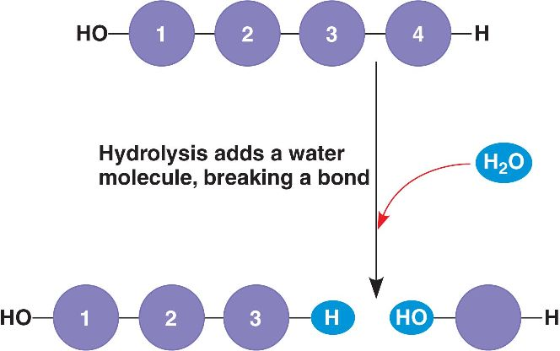
Figure 12: Mechanism of degradation due to permeation of water. The mechanism of hydrolysis is much simpler than that of oxidation. The main chain splits into two sections: one containing an OH group, the other being stabilized by the remaining proton from the original water molecule.

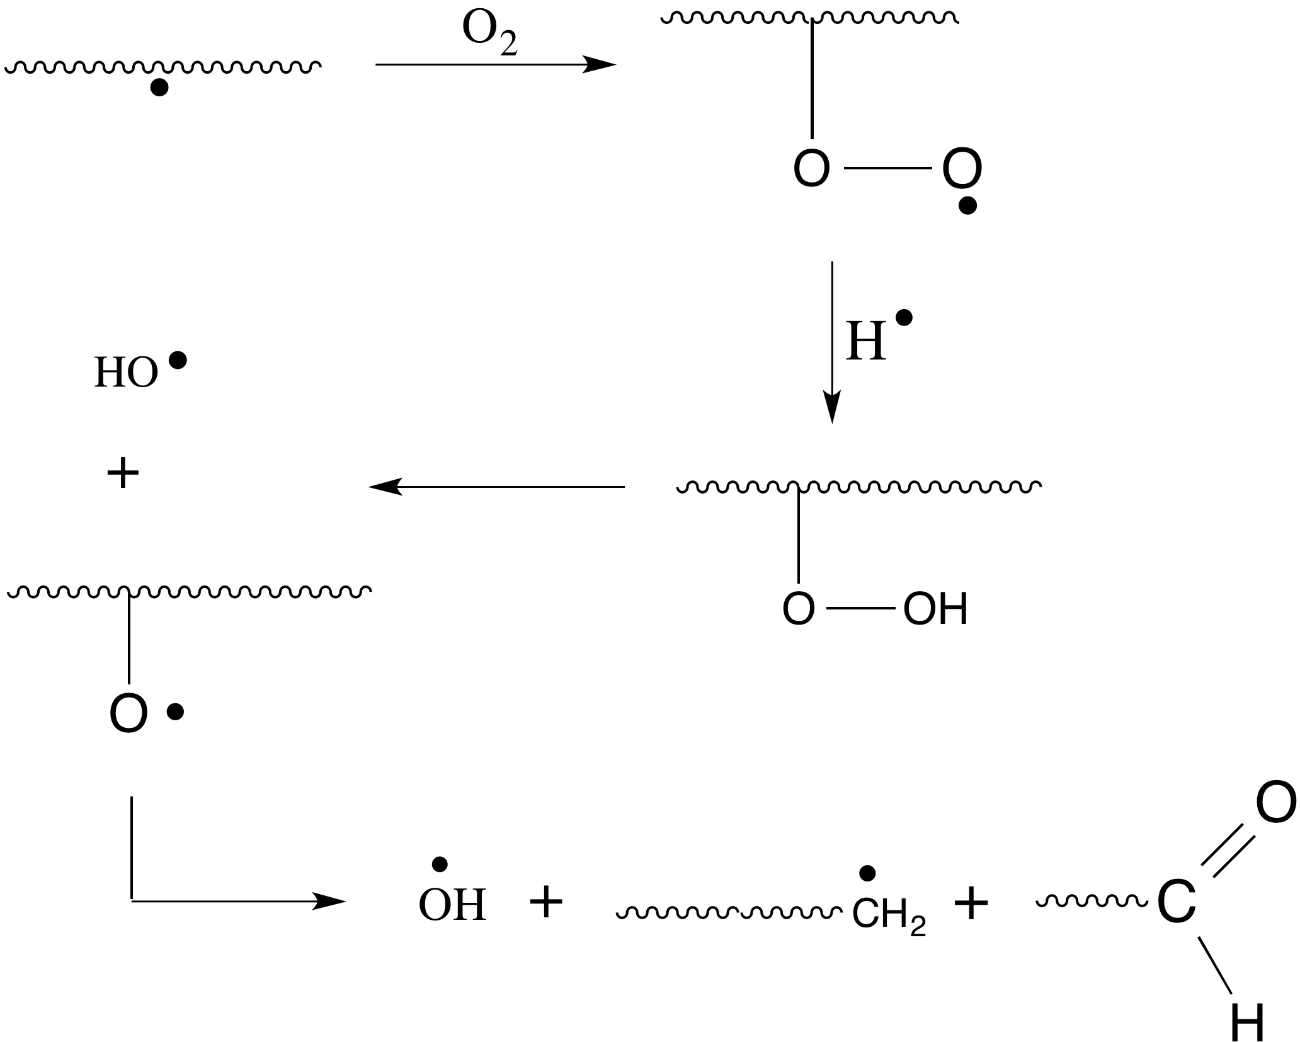

Figure 13: Mechanism of degradation due to permeation of oxygen. The mechanism of oxidation is relatively complex. One important observation is that the oxygen is incorporated into the polymer backbone. This happens by the presence of a free radical, produced by either elevated temperature or radiation exposure. A second observation is the formation of a carbonyl product, which can be used to measure when oxidation has started to occur, normally by spectroscopy.

IV. Project Scope
The challenge presented by this project is due to the simultaneous action of each mode of degradation. Polymers that effectively block out oxygen and water must also stand up to the thermal and irradiative forces present in a nuclear power plant. One positive aspect oxidation and hydrolysis is that the degradation force will remain relatively constant. The amount of water or oxygen that the cables are exposed to will remain relatively constant. Therefore, oxidation and hydrolysis can be addressed by simply using polymers that are resistant to permeation of these two compounds. However, when considering radiation and temperature, extensive measurements must be taken to determine the extremes that electrical cables are exposed to in various locations throughout the plant.
Again, the combined effect of the various modes of degradation complicates matters. As an example, Table 5 has been included. Shown below, various properties of XLPE and EPR are compared at elevated temperatures. It can be seen from this data that the Induction Time for Drastic Increase of Carbonyl Intensity decreases significantly as temperature increases. The Carbonyl (C=O) Intensity comes from the influence of oxidative degradation. This means that the increase of temperature also increases the rate at which O₂ can penetrate the polymer matrix and begin to alter the structure.

Table 3. Effect of temperature on useable life of XLPE and EPR
 | Aging Period (Days)
Material | Aging Temperature (°C) | Induction Time for Drastic Increase of Carbonyl Intensity | Induction Time for Drastic Decrease in % Elongation | Time for Drastic Increase of Gel Content | Time for Drastic Decrease of Crystallinity | Time for 25% Reduction of Initial Penetration Distance | Time to Reach Zero OIT | Time to Reach 50% Absolute Elongation
XLPE | 140 | 45 | 48 | - | 45 | - | 52 | 51
XLPE | 130 | 86 | 80 | 82 | 85 | - | 94 | 112
XLPE | 120 | 170 | 180 | 190 | 170 | - | 185 | 242
EPR | 145 | 49 | 48 | - | - | 50 | 52 | 55
EPR | 130 | 180 | 175 | - | - | 173 | 185 | 195
EPR | 115 | 540 | 520 | - | - | 500 | 540 | 780
The detrimental effects of elevated temperature can be seen in this table from the work of Anandakumaran and Stonkus (1992). With increased aging temperature, oxidation occurs much more easily, as evidenced by the decrease of Time for Increase of Carbonyl Intensity. These two degradation modes combine to influence a vast array of mechanical properties, such as % elongation and crystallinity.

IV.A. Suggested Materials
In the previous pages, theoretical data has been presented to explain the basis of the reasoning behind the materials that have been proposed to mitigate the degradation process. A common material that has shown up in multiple tests with favorable properties is polyethylene. One important point to make is that many different types of PE exist, which have very different properties based on molecular weight, density, or the presence of cross-linking. XLPE, with typical degrees of crosslinking ranging from 65-89%, and CPE are two such materials that are beginning to be replaced by other types of PE, which have been developed to have more favorable properties.
Already, PE has been shown to have good temperature and radiation resistance. Also important is the tendency of PE to cross-link versus to undergo scission. Different degrees of cross-linking produce different properties in PE. For example, in XLPE, which contains a high degree of cross-linking, increasing this even more by radiation produces a decline in the mechanical properties, such as a loss of ductility and an increase in brittleness. However, in other types of PE, cross-linking due to radiation can actually improve the mechanical properties. This vast array of physical properties means that types of PE exist that will hold up much better than XLPE and CPE in the environment found in a nuclear power plant. These alternate types of PE – combined with the extent to which cross-linking affects their properties – are the basis for the materials selection of this project.

IV.A.1. Linear low-density polyethylene
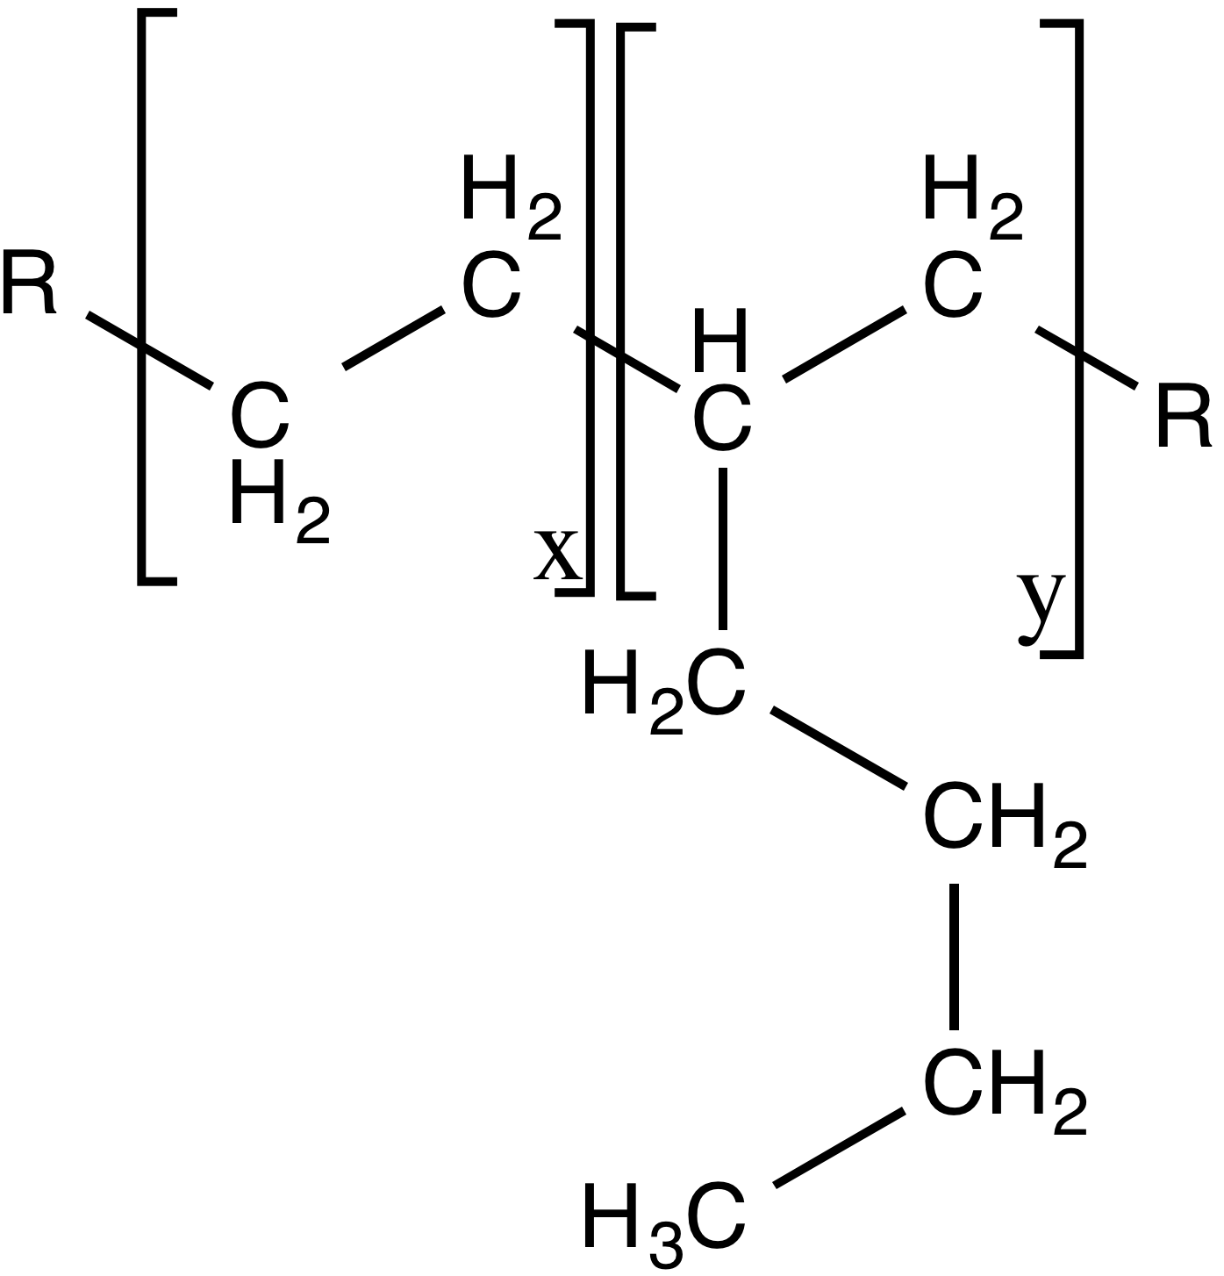
Figure 14: Structure of linear low-density polyethylene, as used in this project. This LLDPE was a copolymer of ethylene and hexane monomers.

Linear low-density polyethylene (LLDPE) is a prime candidate to replace the polymers currently being used. The LLDPE used for this study is a copolymer of hexane and ethylene monomers, as shown in Figure 14, above. One of the most useful properties of LLDPE is that exposure to radiation actually increases the thermal and mechanical properties. As previously mentioned, radiation can cause a competition to occur in a polymer’s structure between the processes of cross-linking and chain scission. In LLDPE, the polymer chains are short and do not commonly break off when exposed to radiation, meaning that the radiation causes almost exclusively cross-linking to occur. Even though it is a form of ‘degradation’, this reaction has favorable outcomes, such as a rise in melting point and softening temperature, along with an increase in tensile strength and modulus

Figure 15, below, shows the changes in thermal properties with increasing amounts of radiation, where T_{m} is the melting temperature, T_{c} is the crystallization temperature, and VST is the Vacat softening temperature. The increase in softening temperature means that the polymer can maintain its structural integrity at higher temperatures due to the amount of cross-linking present. However, the cross-linking does hinder flexibility during drawing which causes the elongation at break to decrease (Al-Madeed, 2006).
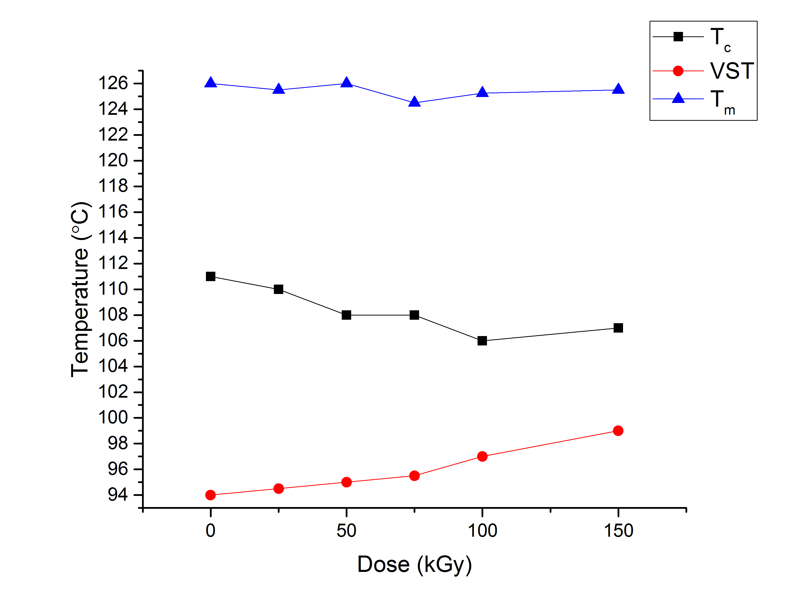

Figure 15: Linear low-density polyethylene irradiation degradation effects on thermal properties. As can be seen to the left, with increasing dose and increasing degree of crystallinity, the softening temperature (VST) increases, the melting temperature (T_{m}) decreases, and the crystallization temperature (T_{c}) stays approximately the same. (Al-Madeed, 2006)

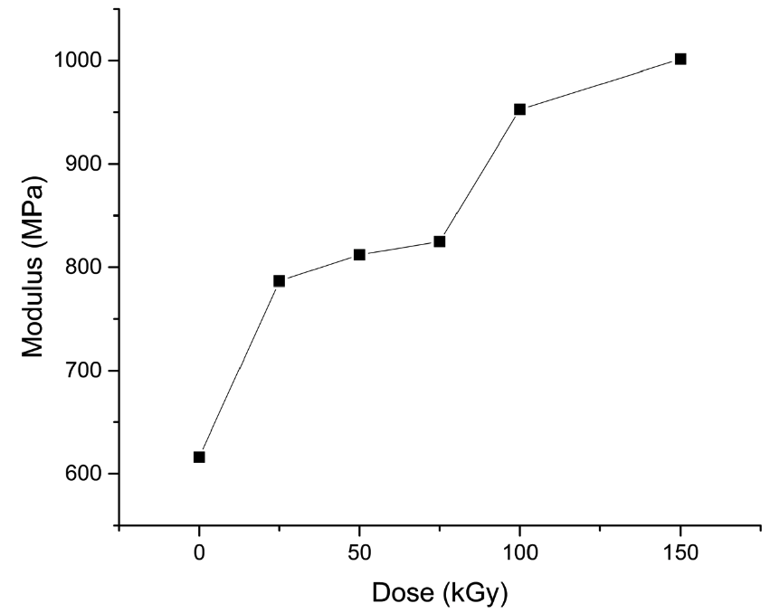

Figure 16: Linear low-density polyethylene irradiation degradation effects on thermal properties. As can be seen from the figure to the left, with increasing dose, the elastic modulus of the LLDPE increases. This is another signal of increased stiffness in the material. (Al-Madeed, 2006)

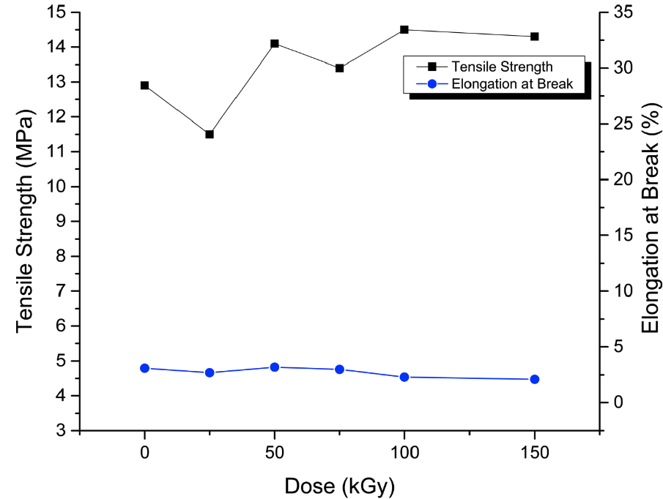
Figure 17: Linear low-density polyethylene irradiation degradation effects on tensile strength and elongation at break. A general increase in the tensile strength can be seen, along with a slight decrease in the elongation at break. Both of these properties are due to an increased amount of cross-linking present in the material due to the effects of irradiative degradation.

Figure 16 on the previous page depicts the change in elastic modulus due to the effects of irradiative degradation. The modulus increases due to cross-linking, which causes the polymer chains to be bound together and require more force to be stretched apart. Figure 17, above, shows the response of tensile strength and elongation with increasing exposure to radiation. The tensile strength increases and the percent elongation slightly decreases. Both of these effects are also largely due to cross-linking within the material.

IV.A.2. Ultra-high molecular weight polyethylene
Ultra high molecular weight polyethylene (UHMWPE) is an ethylene-based polymer with chain lengths ten times that of high-density polyethylene (Yasin, 2012). It has significantly high tensile strength and abrasion resistance for a polymer as shown in the table below This is due to the high amount of overlap in the polymer chain, which amplifies the Van der Waals forces, strengthening the bonding within the polymer matrix and increasing the mechanical properties.

Table 4. Properties of Ultra High Molecular Weight Polyethylene (Al-Madeed, 2006)
Polymer |  | Tensile Strength (MPa) | Elongation at Break (%) | Elastic Modulus (MPa)
UHMWPE |  | 40 | 300 | 552
HDPE |  | 32 | 400 | 1379
LDPE |  | 9.7 | 100 | 393

Numerous studies of UHMWPE have concluded that the primary mode of degradation of this polymer is due to oxidation (Lu, 2001). Oxidation has a dramatic effect on the tensile strength and elongation at break, reducing these properties down to 20% of their original value, but the modulus of elasticity stays largely intact. These effects are illustrated in Figure 18 from the work of Lu et al (2001).

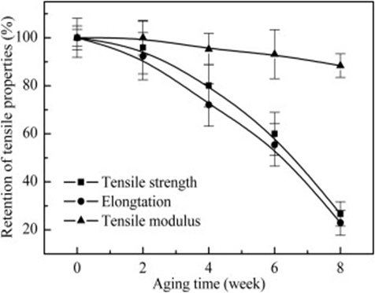
Figure 18: Oxidation effects on the mechanical properties of UHMWPE.

EXPERIMENTAL

In order to compare the effects of irradiation on suggested materials, tensile testing, indenter testing, and FTIR were performed before and after irradiation. Four polyethylene materials were chosen for testing:
- Ultra Low-Density Polyethylene
- Hexane Based-Linear Low Density Polyethylene
- Low Density Polyethylene
- High Density Polyethylene
I. Differential scanning calorimetry
The samples were tested using the Q20 DSC located in TANDEC to determine the melting point of each polymer. A 4mg sample of each polymer was placed in individual pans and heated up to 150°C, cooled to 80°C and then heated again to 150°C. The first heat cycle was used to remove any factory processing that was done previously. The second heat cycle was to determine the melting temperature.

II. Hot-pressing
The samples were pressed into film for testing using the Auto NE Series Carver press located in TANDEC. The pellets were placed on a Kapton sheet that was sprayed with silicone so the films could be more easily removed after pressing. A second Kapton sheet was placed on top of the pellets and placed on the bottom plate. The plates were heated to 125°C for each sample except the HDPE which had to be formed at 135°C due to uneven pressing at the lower temperature. The plates were then brought close together and held there for 2 minutes so the pellets could soften and melt to make pressing them easier. The plates were then pressed together at 7 tons of force for 1 minute and 30 seconds. The films were peeled off the Kapton sheets and ready to be tested.

III. Fourier transform infrared spectroscopy
Fourier transform infrared spectroscopy (FTIR) was performed in order to determine what materials were used to create the cable samples used in this research. FTIR works by passing infrared radiation through the sample. Some of the radiation is absorbed, while the rest passes through. The spectrum created by measuring this radiation represents the amount of radiation absorbed creates a “molecular fingerprint” of the sample, thus allowing for identification of an unknown sample (ThermoNicolet, 2001). In our research, a sample was tested from the jacket and insulation of each cable resulting in a total of four samples.

IV. Tensile testing
Tensile testing was performed at AMS using an Instron 3343 tensile tester with a model number 2519-105 Force Transducer and 1000N load cell. Samples were cut into strips according to ASTM Standard Test Method D882 Tensile Properties of Thin Plastic Sheeting. These strips had a gauge length of 50mm and were 5.0mm wide and .25mm thick. The test was run at a 500mm/min rate of grip separation to achieve an initial strain rate of 10.0 mm/mm*min. The test was repeated five times for each sample. Tensile samples were tested according to the same procedure after irradiation. However, only one sample could be run, based on remaining amount of material.

V. Irradiation by scanning electron microscope
Samples were irradiated by an electron beam at doses of 50 and 100 kGy. This was performed in a Scanning Electron Microscope with beam energy of 30 keV. The beam was set to raster over a 5 mm x 7 mm area which covered the width of two samples. The dosages were achieved by letting the samples sit under the beam for either 40 or 60 minutes. These exposure times were calculated by using Equation 1:

$$t=\frac{Dose*d_{p}*A*ρ}{E*I}$$

With d_{p} being the penetration depth of the beam, A the irradiated area, ρ the material density, E the energy of the beam, and I the beam current. The beam current was set to 1.0 nA and the penetration depth of the beam was calculated from Equation 2:

$$d_{p}=\frac{E}{P_{s}ρ}$$

P_{s} is the stopping power of the material for a given energy. (Berger, 1998) This depth calculation resulted in penetration depths of 32 μm. The post-irradiation tensile samples were cut smaller in order to allow for a greater percentage of the sample to be irradiated. These samples were 2.5 mm wide and .25 mm thick with gauge lengths of 7.5 mm (the irradiated area). The rate of grip separation was then adjusted to 70.5 mm/min to allow the strain rate to remain at 10.0 mm/mm*min.
After irradiation, FTIR and tensile testing were performed again on the irradiated samples.

RESULTS AND DISCUSSION

The FTIR result for one of the polymers used to protect these cables from the environment was cross-linked polyethylene (XLPE). This determination was based upon the comparison of the collected spectrum with that from literature, which is examined in detail in this section. Another important discovery was that this polyethylene appears to have been cross-linked with silane, which has important implications on its physical properties.
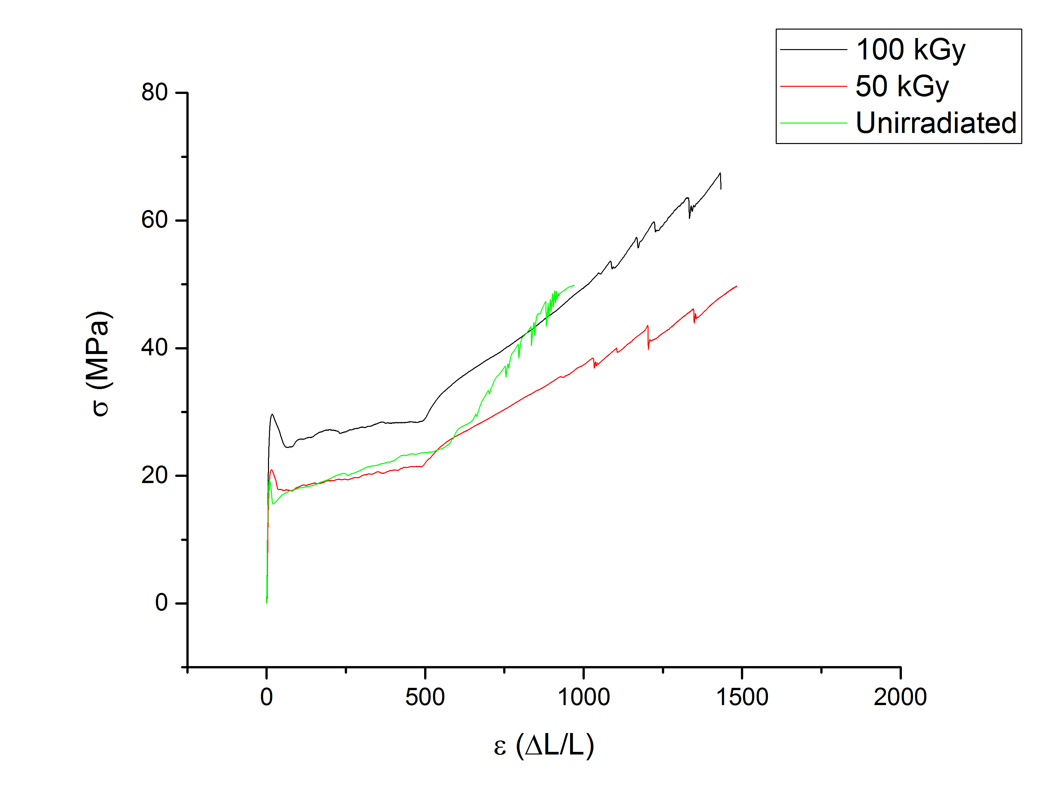
Figure 20: Comparison of linear low-density polyethylene before and after irradiation with the SEM to 50 and 100 kGy. It can be seen that radiation treatment improves tensile strength and elongation.

As seen in Figure 20 on the previous page, the irradiation doses have positively affected the tensile strength and elongation at break of the material. A significant increase in tensile strength as well as an increase in elongation at break measurements is seen when comparing the irradiated LLDPE to the virgin material. A trend can be established for increase in tensile strength as the radiation dosage is increased. The cross-linking of the material is the cause of this increase in strength. It is also important to note that the elongation at break only slight decreases from 50 kGy to 100 kGy. This pattern is seen holds true for each material. The cross-linking of the material is the cause of this increase in strength.
The FTIR spectra of the irradiated materials have far less intensity in their peaks when compared to the virgin materials. This trend continues as radiation dose increases. This proves the continued cross-linking of the material as radiation dose increases.
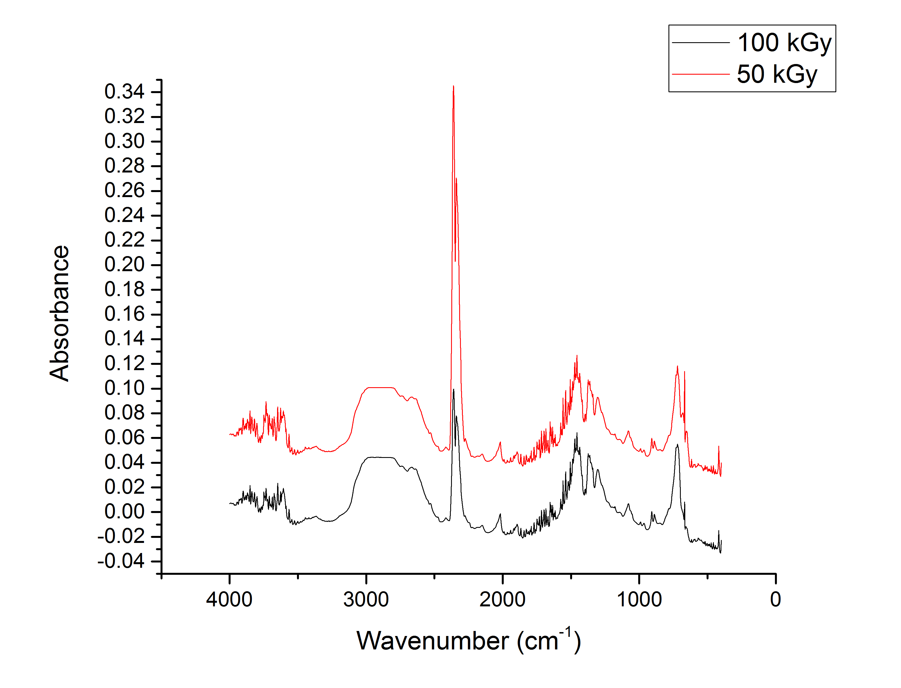
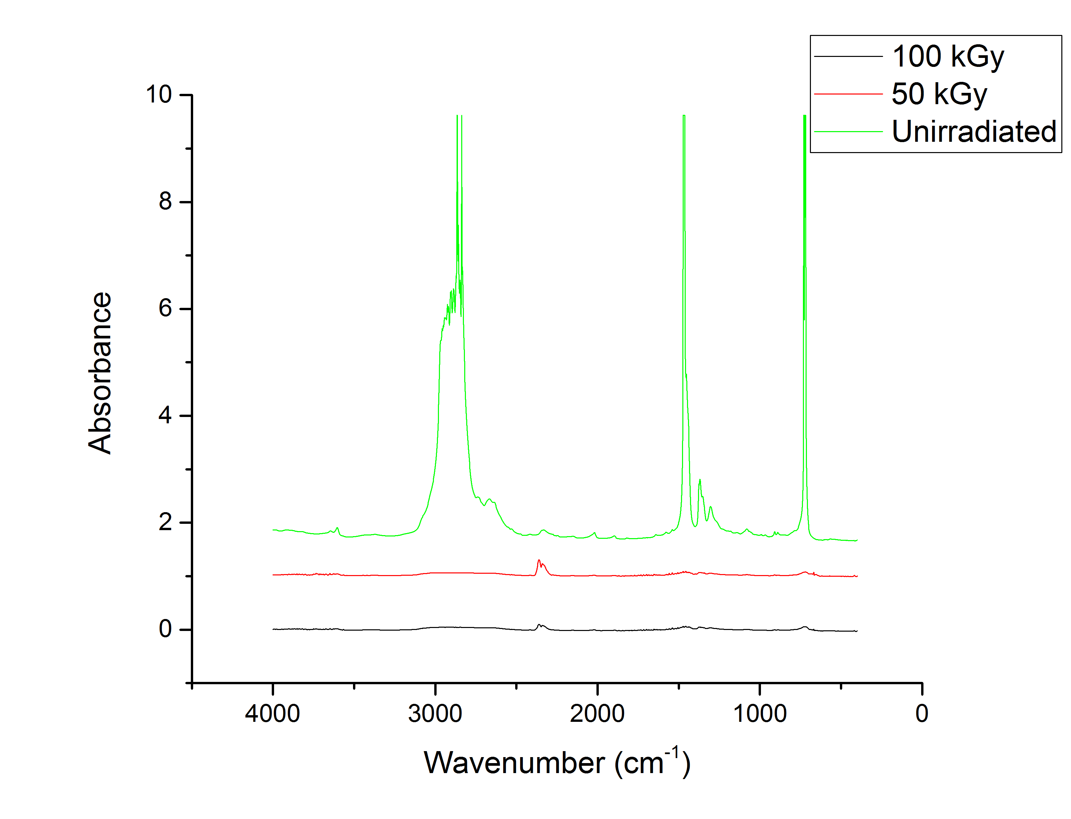
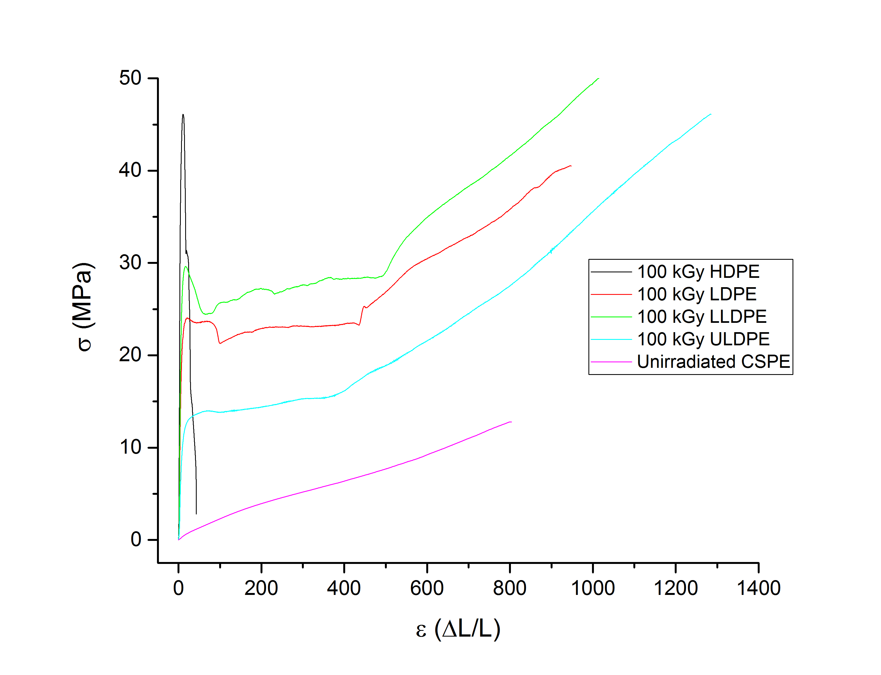
When comparing the irradiated materials to the unirradiated CSPE, it is seen in Figure 21, above, that all of the irradiated materials except for HDPE display higher tensile strengths and greater elongations at break than CSPE (which had the best of these properties out of all the in use materials). This shows that when the suggested materials undergo degradation due to irradiation their mechanical properties increase past the threshold of those from the best material used in the field. It is also important to note that LLDPE displayed the greatest increase in tensile strength and ULDPE showed the greatest resistance to reduction in elongation at break.

Future Direction

I. Mitigation Methods
While the degradation of the cables is four-fold, it would only be on rare occasions that all four of the degradation modes were present in a location along the length of a cable. However, one focus of this project is to design a single protective barrier that can be applied to guard against each of the four degradation modes simultaneously, protecting weak areas in the cables from further degradation due to any of the modes presented. Three methods currently exist to help mitigate the cable degradation: a wrap method, a spray-coating method, and an holistic injection method. The wrap method consists of a multi-layer wrap, which is applied locally to an area of question. Each layer offers a different level of protection and is detailed in Figure 2. This is the project focus method. The next process step involves choosing a material (LLDPE or UHMWPE) to make the prototype wrap with and build a prototype.

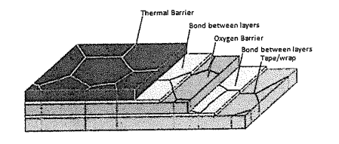
Figure 19: Multilayer wrap approach (Toll, 2014)

CONCLUSION

All of the irradiated materials that were tested (with the exception of HDPE) showed an increase in their tensile strength without greatly sacrificing their elongation. It could therefore be concluded that the material could be exposed to higher doses than 100 kGy before seeing a great reduction in their flexibility. As noted above the LLDPE and ULDPE are the two materials on the extreme ends in tensile strength increase and resistance to reduction of elongation at break. Therefore, these would be our suggested mitigation materials for irradiation resistance. However, to model the behavior of fully irradiated samples a higher energy radiation source should be used due to the low penetration depth of the SEM. Also, these materials should be exposed to accelerated age testing to model the effects of thermal degradation on their mechanical properties as well. Another material that should be investigated is Ultra High Molecular Weight Polyethylene. This material has been proven to have high irradiation resistance due to its high molecular weight. After this further testing is performed a prototype wrap of melt-blown material would be tested again in similar environments to demonstrate its resistance in situ.

ACKNOWLEDGEMENTS
Roberto S. Benson, Ph.D. Professor and Associate Department Head of the Materials Science and Engineering department at the University of Tennessee, Knoxville.
Trevor Toll, Analysis and Measurement Services Corporation contact.
Greg Jones, Senior Technical Specialist and Safety Officer at the University of Tennessee, Knoxville.
Textiles and Nonwovens Development Center for allowing us use of their instruments for sample preparation and testing.

REFERENCE LIST

Al-Ma'adeed, M.A., Al-Qaradawi, I.Y., Madi, N. and Al-Thani, N.J. (2006) 'The effect of gamma irradiation and shelf aging in air on the oxidation of ultra-high molecular weight polyethylene.' Applied Surface Science, 252 (9), pp. 3316-3322. Available at:
http://www.sciencedirect.com/science/article/pii/S0169433205012377

Anandakumaran, K. and Stonkus. D.J. (1992) ‘Assessment of oxidative thermal degradation of crosslinked polyethylene and ethylene propylene rubber cable insulation.’ Polymer Engineering and Science, 32 (18), pp. 1386-1393. Available at:
http://onlinelibrary.wiley.com/doi/10.1002/pen.760321808/abstract

ASTM Standard D882 (2012) “Standard Test Method for Tensile Properties of Thin Plastic Sheeting,” ASTM International, West Conshohocken, PA, 2012. Available at:
www.astm.org

Benson, R.S. (2008) Polymer Degradation. University of Tennessee.

Benson, R.S. (2009) Surface Modification. University of Tennessee.

Berger, M.J., Coursey, J.S., Zucker, M.A. and Chang, J. (1998) "ESTAR-stopping-power and Range Tables for Electrons." NIST Physical Measurement Laboratory, Oct. 1998. Web. 14 Apr. 2015.

IAEA (2000) Assessment and Management of Ageing of Major Nuclear Power Plant Components Important to Safety: In-containment Instrumentation and Control Cables. Vienna: International Atomic Energy Agency. Volume 1: Techdoc-1188. Available at:
http://www-pub.iaea.org/MTCD/publications/PDF/te_1188v1_prn.pdf

IHS (2015) 'Chlorinated Polyethylene Resins and Elastomers.' Chemical Economics Handbook. Englewood, CO: IHS, Inc.

IISRP (2012) Ethylene-Propylene Rubbers & Elastomers (EPR/EPDM). Houston, TX: International Institute of Synthetic Rubber Producers, Inc. Available at:
http://iisrp.com/WebPolymers/AboutRubber/10EPDM16Aug2012.pdf

Lu, S., Buchanan, F.J. and Orr, J.F. (2001) 'Analysis of variables influencing the accelerated ageing behaviour of ultra-high molecular weight polyethylene (UHMWPE).' Polymer Testing, 21 (6), pp. 623-631. Available at:
http://www.sciencedirect.com/science/article/pii/S0142941801001349

Li, C.S., Zhan, M.S., Huang, X.C. and Zhou, H. (2012) ‘Degradation behavior of ultra high molecular weight polyethylene fibers under artificial accelerated weathering.’ Polymer Testing, 31 (7), pp. 938-943. Available at:
http://www.researchgate.net/publication/256971583_Degradation_behavior_of_ultra-high_molecular_weight_polyethylene_fibers_under_artificial_accelerated_weathering

Shafiq, M. and Yasin, T. (2012) 'Effect of gamma irradiation on linear low density polyethylene/magnesium hydroxide/sepiolite composite.' Radiation Physics and Chemistry. Online, 81 (1), pp. 52-56. Available at:
http://www.researchgate.net/publication/259378638_Effect_of_gamma_irradiation_on_linear_low_density_polyethylenemagnesium_hydroxidesepiolite_composite

Sirisinha, C., Pongdhorn, S. and Guaysomboon, J. (2002) 'Mechanical properties, oil resistance, and thermal aging properties in chlorinated polyethylene/natural rubber blends.' Journal of Applied Polymer Science, 84 (1), pp. 22-28. Available at:
http://onlinelibrary.wiley.com/doi/10.1002/app.10171/abstract

Tamboli, S.M., Mahske, S.T. and Kale, D.D. (2004) 'Crosslinked Polyethylene.' Indian Journal of Chemical Technology, 11, pp. 853-864. Available at:
http://www.researchgate.net/publication/267405888_Crosslinked_polyethylene

ThermoNicolet (2001) Introduction to Fourrier Infrared Spectroscopy. Madison, WI: ThermoNicolet Coporation. Available at:
http://mmrc.caltech.edu/FTIR/FTIRintro.pdf

Toll, T. (2014) Cable Aging Mitigation Project Outline. Knoxville, TN: Analysis and Measurement Services Corporation.

U.S.NRC (2015) Operating Reactors. Rockville, MD: United States Nuclear Regulatory Commission. Available at:
http://www.nrc.gov/reactors/power.html

