Effects of Preceptor Clinical Reasoning Training on Preparedness

Whitney L. Leon
University of Tennessee, Knoxville
DNP Scholarly Project
Pamela Hardesty, Ph.D., RN
Amanda Makely, BSN, RN

Tables and Figures
Figure 1
Adapted PRISMA Flow Diagram
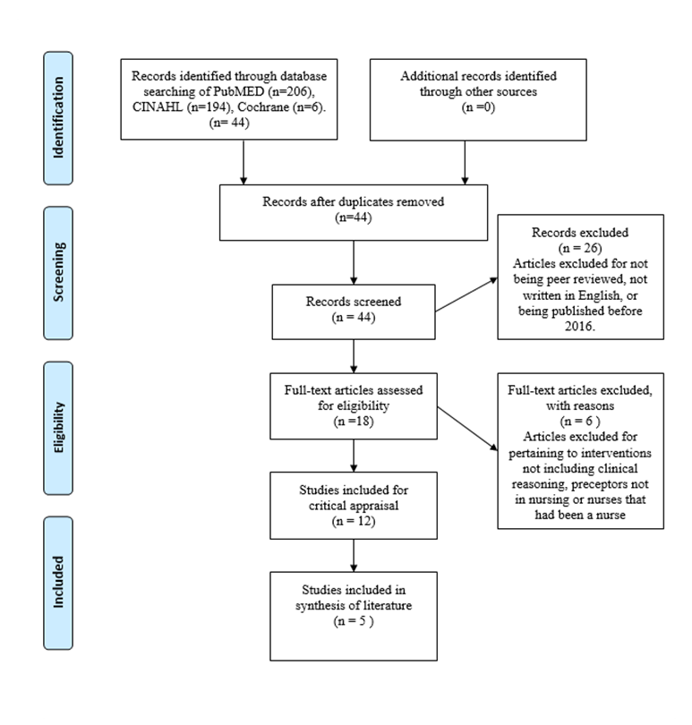

Table 1
Literature Evaluation
Article Citation | Purpose | Design/ Method | Sample/  Setting | Variables | Measurement | Data Analysis | Findings | Worth to Practice
Alfayoumi, I. (2019). The impact of combining concept-based learning and concept-mapping pedagogies on nursing students’ clinical reasoning abilities. Nurse Education Today, 72(1), 40-46. https://doi.org/10.1016/j.nedt.2018.10.009 | To evaluate the effectiveness of blending the teaching strategies on clinical reasoning abilities. | Quasi-experimental, with pre and post testing. Level II | 40 second year nursing students. | Independent Variable: Clinical reasoning training  Dependent Variable: Perceived ability to critically think | General Clinical-Reasoning Behavior Scale, Independence in Clinical-Reasoning and Clinical-Judgment scales were completed by the students at the beginning and end of the courses. | Mean  Standard Deviation  P value | Mean before training 1.9 and standard deviation 0.646. After training mean 2.18 and standard deviation of 0.616. P value after clinical reasoning training 0.005 | Clinically significant p value of knowledge and preparedness after receiving critical reasoning training.

Table 1 (Cont’d)
Article Citation | Purpose | Design/ Method | Sample/  Setting | Variables | Measurement | Data Analysis | Findings | Worth to Practice
Bagioni, D., Breda, K.., Eichar, S., Karl, C. (2020). Enhancing preceptor prearation with the 5-minute preceptor. Nursing, 50(12), 15-17. https://doi.org/10.1097/01.NURSE.0000721784.15879.23 | To evaluate the effectiveness of blending the teaching strategies on clinical reasoning abilities. | Quasi-experimental, with pre and post testing. Level II | 15 nurse preceptors at a large acute care hospital. | Independent Variable: Clinical reasoning training  Dependent Variable: preparedness | Likert scale | percentage | 90% of nurse preceptor “stongly agreed” that the preceptor training increased their preparedness to properly teach and correct new nurses on clinical reasoning. | Nurse preceptors strongly agree with the use of the 5 minute preceptor training and felt that the training helped them to be prepared to successfully train new nurses.

Table 1 (Cont’d)
Article Citation | Purpose | Design/ Method | Sample/  Setting | Variables | Measurement | Data Analysis | Findings | Worth to Practice
Liao,H., Yang, Y., Li, C., Chen, J., Huang, L. (2019). The effectiveness of a clinical reasoning teaching workshop on clinical teaching ability in nurse preceptors. Journal of Nursing Management, 27 (5), 1047-1054. https://doi.org/10.1111/jonm.12773. | To evaluate the effectiveness of clinical reasoning teaching in preceptors teaching ability and self-efficacy of clinical reasoning teaching. | Quasi-experimental, with pre and post testing of preceptors. Level II | 33 preceptors and 92 newly Registered Nurses in an acute care hospital. | Independent Variable: Clinical reasoning preceptor training  Dependent Variable: Untrained preceptors | Likert | Mean  Standard Deviation  P value | Mean score for knowledge of clinical reasoning teaching was 23.03 with a standard deviation of ±5.47 in pretest and mean of 27.64 and a standard deviation of ±3.94 for the trained preceptor with a p value of < 0.001, which is statistically significant. | Statistically significant p value of knowledge and increased preparedness after receiving critical reasoning training.

Table 1 (Cont’d)
Article Citation | Purpose | Design/ Method | Sample/  Setting | Variables | Measurement | Data Analysis | Findings | Worth to Practice
Powers, K., Herron, E., Pagel, J. (2019). Nurse preceptor role in new graduate nurses’  transition to practice. Dimensions of Critical Care Nursing, 38(3), 131-136. https://doi.org/10.1097/DCC.0000000000000354 | To discuss the literature on transition to practice and enhancing new graduate clinical reasoning abilities | Nonexperimental  Level Va | Critical care in an acute care setting. | N/A | N/A | Percentage | Clinical reasoning programs reduced turnover rates by 10.3% and increased preceptor preparedness for coaching clinical reasoning. | Training preceptors in clinical reasoning is imperative for having preceptors feel prepared to coach new nurses in clinical reasoning. Clinical reasoning is essential for helping new nurses transition into practice and take full patient loads.

Table 1 (Cont’d)
Article Citation | Purpose | Design/ Method | Sample/  Setting | Variables | Measurement | Data Analysis | Findings | Worth to Practice
Quek, G. and Shorey, S. (2018). Perceptions, experiences, and needs of nursing preceptors  and their preceptees on preceptorship: An integrative Review. Journal of  Professional Nursing, 34(5). 417-428. https://doi.org/10.1016/j.profnurs.2018.05.003 | To evaluate the perceptions of preceptorship from preceptors and orientees. | Systematic Review | 20 articles were reviewed | Independent Variable: Trained Preceptor Program  Dependent Variable: Preceptor preparedness | N/A | Percentage | 65% of preceptor reported feeling prepared to teach and assess abilities of new graduate nurses. | 72% of preceptor reported feeling confident in teaching and assessing abilities of new graduate nurses.  Focusing on clinical reasoning and thinking during preceptor training lead to big picture thinking and rationales for nursing process. This in turn led to greater retention rates of new graduate nurses.
Table 2
Synthesis Table Effects of Training Preceptors on Clinical Reasoning
Outcome | Alfayoumi, 2019 | Bagioni et al, 2020 | Liao et al, 2019 | Powers et al, 2019 | Quek and Shorey, 2018
Preparedness | ↑^{c} | ↑^{s} | ↑^{s} | ↑ | ↑ ^{c}
Knowledge | ↑^{c} | ↑^{s} | ↑^{s} | ↑ | ↑^{s}
Retention | ∅ | ∅ | ↑^{c} | ↑ | ↑
Sample Size | 40  Nursing Students | 15 Nurse Preceptors | 33 Preceptors and 92 new graduates | N/A | 20 Article
Level of Evidence | II | II | II | V | I
Quality of Evidence | B | B | A | A | A
Legend: ↓=decrease; ↑=increase; ∅=not discussed in study; s=statistical significance, c= clinical significance.

Table 3
Table of Recommendation(s) for Practice Change
Recommendation | References in Support of Recommendation | Rationale | Level of Evidence using a level of hierarchy scale JHNEBP | Quality of Evidence using a quality or grading scale from JHNEBP
- Implementation of a formal preceptor clinical reasoning training before training new nurses to improve the preparedness of nurse preceptors. | Alfayoumi, 2019 | Training preceptors in clinical reasoning have clinically significant effects on clinical reasoning preparedness and knowledge. | II | B
 | Bagioni et al., 2020 | Nurse preceptors felt significantly more prepared after training on clinical reasoning and felt the training led them to be more successful in training new nurses. | II | B
 | Liao et al., 2019 | To teach effectively, preceptors must familiarize themselves with clinical reasoning principles and teaching procedures. After training, preparedness and self-efficacy increased significantly. | II | A
 | Quek and Shorey, 2018 | Focusing on clinical reasoning and thinking during preceptor training led to increased preparation to teach new nurses and led to big-picture thinking and rationales for the nursing process. | I | A

Table 4
Strength of Recommendations
Recommendation | Strength of Evidence for Recommendation | References in Support of Recommendation
- I recommend implementing clinical reasoning preceptor training before training new graduate nurses to improve preceptor preparedness to teach and train new nurses. | This recommendation for practice change was made based on good and consistent strength of evidence. This rating was based on JHNEBP level of evidence and quality ratings (Dang & Dearholt, 2018). | Alfayoumi, 2019  Bagioni et al., 2020  Liao et al., 2019  Powers et al., 2019  Quek and Shorey, 2018
- I recommend implementing clinical reasoning preceptor training before training new graduate nurses to improve preceptor knowledge on clinical reasoning. | This recommendation for practice change was made based on good and consistent strength of evidence. This rating was based on JHNEBP level of evidence and quality ratings (Dang & Dearholt, 2018). | Alfayoumi, 2019  Bagioni et al., 2020  Liao et al., 2019  Powers et al., 2019  Quek and Shorey, 2018

Table 5
Preceptor Training Project Evaluation Plan
Variable Name | Variable Code | Variable Description | Data Source | Possible Range of Values | Level of Measurement | Time Frame for collection
Preparedness  Level | PRP | Self- report of preparedness level on clinical reasoning during survey | Survey | 1=Very Unprepared  2=Unprepared  3=Neutral  4=Prepared  5=Very Prepared | Ordinal | Pre and posttest
Knowledge Level | KNW | Self- report of support level during survey | Survey | 1=Very Knowledgeable  2= Unknowledgeable  3=Neutral  4= Knowledgeable  5=Very Knowledgeable | Ordinal | Pre and posttest

Table 6
Preceptor Training Pre and Post Survey Results

