The Phenomenon of Outbound Medical Tourism in the United States
Tanner Cabbage
University of Tennessee
Business Analytics and Statistics
Professor John Anderson
Chancellors Honors Program Thesis

December 10, 2014

Abstract
Outbound medical tourism is an extremely immature idea in the United States, however it has the potential to grow at an exponential rate in the near future. Medical insurance companies, hospitals, and doctors will all be influenced by medical outbound tourism in the coming years. I conducted a small qualitative survey with 72 participants of which 36 were male and 36 were female. The purpose of the survey was to determine whether or not participants would travel internationally for a medical procedure and if they would travel internationally for a medical procedure if they were incentivized with free a free flight, hotel, and a guest. The participants ranged from “18-20” to “60 or older.” There were a total of eleven states represented and various socioeconomic and religious backgrounds.
The results of the survey concluded that there is no correlation between relationship status, occupation, religion, current student, or amount of exercise per week and participants’ answer to the two questions. There was a correlation between gender, education level, state of residency, income level and the answer to the two questions about traveling internationally for a medical treatment. However, the strongest correlation was found between having insurance and the answer to the two questions. The likelihood ratio was 0.0041 and the p-value was 0.0171. These indicate a major statistical significance in the correlation between the variables. The significance of these findings is that it suggests outbound medical tourism is, indeed, a growing phenomenon with potential to be beneficial to both patients and insurance companies. If insurance companies properly exploit this opportunity then it could become prevalent in the near future.
Table of Contents
Introduction…………………………………………………………………………………………………….4
Methods…………………………………………………………………………………………………………13
Results/Discussion…………………………………………………………………………………………14
Conclusion……………………………………………………………………………………………………...21
Recommendations…………………………………………………………………………………………..22
Appendix………………………………………………………………………………………………………...26

Introduction
For years the healthcare industry in the United States has benefitted from inbound medical tourism. This revenue generator is beginning to shift in the opposite direction. According to dictionary.com, medical tourism is defined as “tourist travel for the purpose of receiving medical treatment or improving health or fitness.” For the purposes of this paper I will be discussing medical tourism with respect to traveling internationally. Inbound medical tourism is the traveling of people from foreign countries into the United States to seek medical treatment. Outbound medical tourism is the traveling of United States’ citizens to foreign countries to seek medical treatment. Inbound medical tourism has been a strength of the healthcare industry in the United States, but recently this phenomenon has begun shifting from inbound to outbound. In this report I will talk about the possibility that outbound medical tourism becomes a prevalent idea in the near future. This is a problem for both patients as well as doctors. Outbound medical tourism can have negative impacts on the quality of care, it can have a major impact on doctors, and there are major risks associated with it.
Medical tourism has begun leaving the United States more than it is entering the country. Rising costs in the United States with respect to medical procedures are causing patients to seek medical care internationally. Comparable medical procedures can be performed in other countries for up to 70-80% less than in the United States. There are several reasons as to why this is happening. The United States’ economy has been suffering for several years. Additionally, healthcare prices have risen higher than anywhere in the world. The combination of these two events has caused patients to seek alternative healthcare options internationally. For example, in India, many medical procedures can be obtained for 20% or less of the cost of comparable procedures in the United States. The figure below shows a list of medical procedures and their cost in various countries.
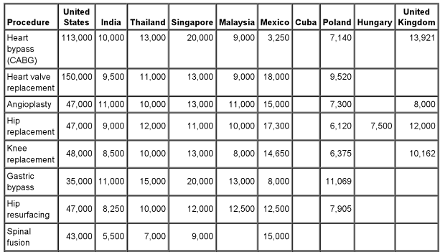
India is one of the most viable alternatives for these treatments due to relatively minimal costs and increasingly innovative technology. For example, as seen above, a heart bypass or valve replacement can be performed at between 5-10% of the cost that it can be performed in the United States. These savings are enormous and, in turn, the driving force behind this new phenomenon. Recent reports show that India’s medical tourism sector is expected to grow 30% annually from 2009 to 2015. It is estimated that over 180,000 patients visited India’s medical centers during the first eight months of the 2008 fiscal year. India is preparing for this expected growth and thus far has not encountered any supply-side constraints.
According to a second source, the International Federation of Health Plans, a CT scan in the United States’ will cost, on average, $510 compared to a CT scan in India which costs a mere $43. The average cost per hospital day in the United States is $3,950 while in India it is only $236. An appendectomy in the United States costs an average of $13,000 while only $255 in India. A heart bypass can be performed for only $10,000 in India while it would cost an eye popping $113,000 in the United States. As a final example of the overall cost differences between India and the United States I use the example of Howard Staab, a 53-year-old carpenter from North Carolina. In 2004 he needed a mitral valve replacement. He and his wife went to their local hospital, uninsured, to consult with the surgeon and find out what the procedure would cost. They found out it would cost them upwards of $200,000 in total. They shopped around and, after speaking with their son, a second-year medical student at Stanford University; they decided to fly to India to get the procedure done. The total cost of the procedure, including a three-week stay in the hospital, cost $10,000. The graph below shows the difference in costs for various procedures in various countries.
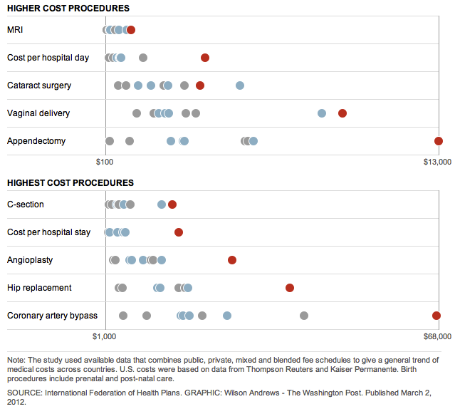
Red dots represent United States and the grey dots on the far left represent India. Other grey dots are various Asian countries

Recently there has been an increasing sophistication in medical treatments in foreign countries. This has decreased the risk of seeking medical procedures overseas. Companies such as the Joint Commission International are accrediting more and more international hospitals. In turn, more health care providers are covering international hospitals for their insured customers to use. In fact, many insurance companies such as Companion Global Healthcare, a South Carolina subsidiary company of BlueCross BlueShield, have begun persuading its customers to seek treatments in Singapore and India to cut down on costs. Furthermore, Americans are seeking international medical treatment at an accelerated rate. The Deloitte Center for Health Solutions found that approximately 750,000 Americans traveled overseas seeking medical treatment in 2007. Below is a graph from the Medical Clinics of North America that represents the increasing number of Americans who are traveling overseas to seek medical procedures.
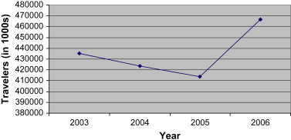
Fig. 1. United States airline travelers to overseas and Mexico who report health treatment as one purpose of the trip, 2003–2006.

After conducting a survey and major research, the organization expects it to increase to roughly 6 million by 2017, a 35% growth per year, which can be seen by the following graph.
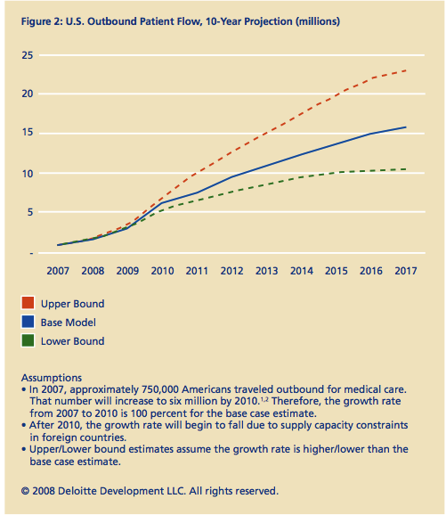
In contrast, inbound medical tourism is projected to be approximately 560,000 patients by 2017. While Americans are rapidly leaving the country to seek medical treatment, international patients are entering the United States to seek medical treatment at a decelerated rate.
One of the major issues with outbound medical tourism is the quality of care in these international hospitals. Although a hospital may be certified and authorized by American health insurers, the quality of care is not necessarily equivalent to the quality provided by hospitals in the United States. This is very difficult to quantify, as there have not been several studies done to compare the quality in various countries with quality in the United States. One of the major reasons for why the quality of care is not as high in countries overseas is due to the state-of-the-art technology in the United States being superior to most other hospitals in the world. However, low-risk procedures have a very insignificant difference in terms of the quality of the procedure while high-risk procedures have a larger gap in quality overseas.
While outbound medical tourism has effects on patients it also has a major effect on orthopedic surgeons. I have been shadowing Dr. Edwin Spencer, a shoulder and elbow orthopedic surgeon at Fort Sanders West Hospital. I conducted an interview with Dr. Spencer over the telephone and he said, “Outbound medical tourism is an unfortunate phenomenon. It is still fairly young so I have not felt an impact so far but I am certainly aware of it.” Dr. Spencer explained that the majority of his patients are elderly women who are not fully capable of traveling for medical procedures so he does not expect it to impact his work. However, he said some of his fellow surgeons are aware of the trend and somewhat fearful of its potential growth, especially with the implementation of the Affordable Health Care Act. It is certainly a concern for hospitals and doctors. According to NPR, “Vanderbilt University Medical Center in Nashville, Tennessee recently launched a national advertising and marketing campaign promoting its cancer and heart disease treatments based on an individual’s DNA.”
I asked Dr. Spencer if he had been the beneficiary of inbound medical tourism and he responded, “Because most of my patients are women in their 60’s or older and I work in Knoxville, I was not receiving many foreign patients. A few of my friends (surgeons in San Francisco and Johns Hopkins University) have noticed a change in the number of foreign patients in their practices.” He did, however, note that he has heard of insurance companies incentivizing patients to seek medical procedures overseas to cut down on expenses.
Medical tourism will likely be impacted significantly due to insurance companies. They have begun offering incentives such as luxurious hotels, free airfare, and paid dinners to patients in an attempt to cut down on costs. These companies are turning a medical procedure in o a vacation for their customers because the costs of comparable procedures internationally are exceedingly lower. As this trend becomes more common, Dr. Spencer is fearful that “this could potentially lead to insurers demanding that its customers seek treatment in other countries.” This could significantly impact all doctors, including Dr. Spencer. The salary of these doctors could be substantially reduced. While I could not find any numbers on how much a salary could decrease, Dr. Spencer believes that it could be significant if the trend continues as predicted.
In addition to the reduced quality of care overseas, there are many other risks associated with outbound medical tourism. One risk that is often over looked but could be even life threatening is the possibility of complications after the procedure is performed. Complications are not exceedingly uncommon with procedures, especially in countries where the quality of treatment may not be extraordinary. For example, what is a patient supposed to do when they have just flown back from India and a complication arises from the procedure? They most likely cannot fly back to India. Many local doctors may not be willing to help them for just the price of a co-pay. The doctor has lost thousands of dollars on that patient when they chose to fly overseas for treatment, so they very well may not want to perform follow up treatment. I asked Dr. Spencer what he thought about this and he said, “If I lost a patient because they chose to go to another country for the procedure, I would not want to follow up with them and treat any complications that arose.” He did, however, go on to explain that if it were severe enough his conscious would not allow him to knowingly deny a patient whose life is in jeopardy. However, many doctors may not have the same morals. An additional risk associated with traveling to other countries to seek medical treatment is the toll that traveling takes on your body. After a high-risk medical procedure such as an open-heart surgery, it may be very stressful on one’s body to make a 15-hour plane flight. Insurance companies may not pay for the cost of staying in that country for additional recovery time. This could lead to out-of-pocket expenses for the patient.
The US International Patient Department conducted a survey among 48 hospitals across the country, of which 26% of people completed the entire survey. The results showed that only about 1.5% of in-patients in these hospitals were foreign citizens however 75% of respondents reported that they project that number to increase over the next 12 months. Comfort and hesitation is the largest roadblock for outbound medical tourism. Many people are hesitant to travel far away and get treatment in a location that they are not comfortable with just to save money on these procedures. Deloitte conducted a survey in 2009 asking people specific questions about medical tourism, both internationally and domestically. The results, which can be seen in the figure below, show that between seven and eight times the number of people would not travel to seek medical procedures compared to people who said they would.
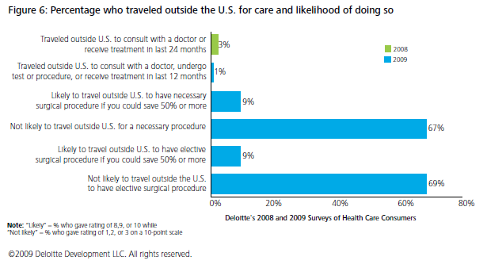
Methods
To further collect data on whether or not patients would seek international treatments I created my own survey (Appendix 1). This survey included 72 respondents, of which 36 were male and 36 were female. The survey was administered via Facebook. A wide range of ages, races, religions, incomes, and residencies were gathered to eliminate as much bias as possible in the results. A great amount of analysis was performed using JMP, a statistical software program, to determine if there was any correlation between race, gender, income, education level, relationship status, state of residence, amount of exercise per week, religion, whether or not one has insurance, who pays for the insurance or the potential savings and whether or not one would travel internationally for medical procedures. Interestingly, 100% of participants that said they would travel internationally for a medical procedure if the flight and hotel of both them and a friend or family member were paid for also said they would travel internationally for a medical procedure if their health insurer paid for just their hotel and flight. Therefore the analysis will be the same for both answers. I analyzed whether the previously stated demographic factors would affect the answers to two questions: “Would you travel internationally for a medical procedure?” (I will refer to this as the first question) and “Would you travel internationally for a medical procedure if your health insurer paid for your flight and hotel?” (I will refer to this as the second question).
Results and Discussion
In total, 62.5% of people would travel internationally for a medical procedure if their insurance provider paid for their flight and hotel. Comparatively, only 47% of people would travel internationally for a medical procedure without any incentive other than potentially saving money on hospital bills (see figures below).
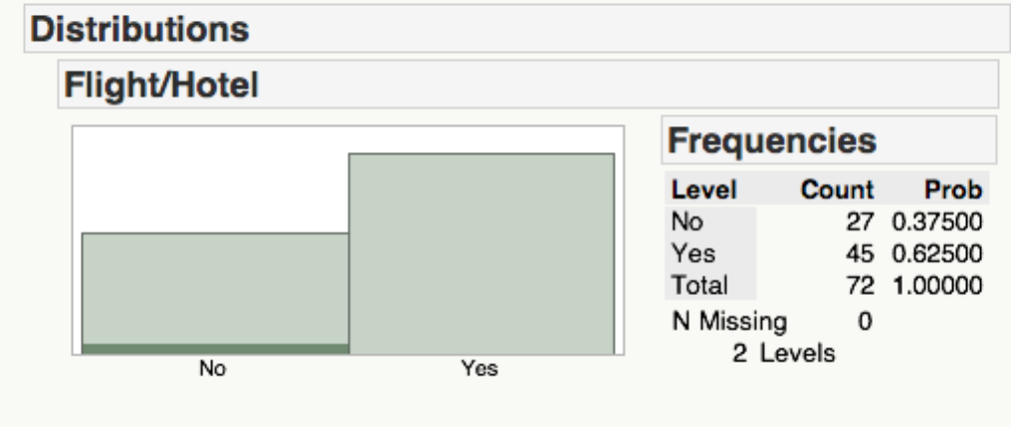
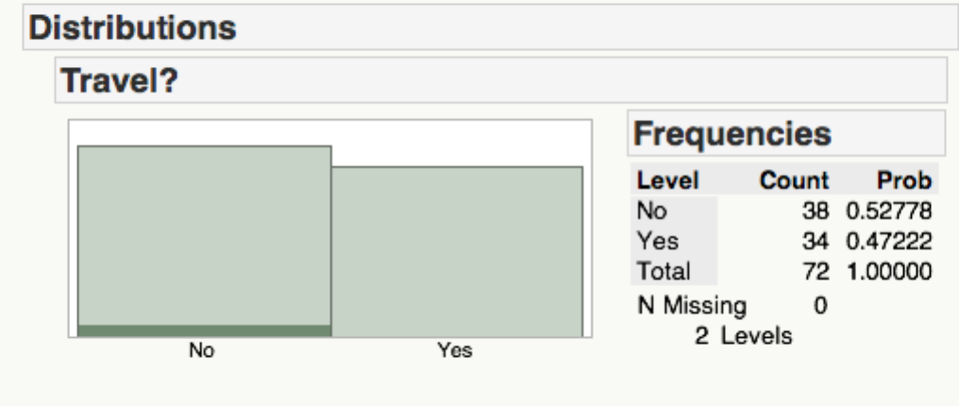
I found that there was no correlation between relationship status, occupation, religion, current student, or amount of exercise per week and the answer to the two questions.
When comparing whether or not one would travel for medical procedures based on their age there is no correlation. Results were split and remained consistent despite many various age ranges. When respondents were asked whether they would travel internationally for a medical procedure if the hotel and flight were paid for by their health insurer there did appear to be a correlation between the answer and age. 23 of the 32 (72%) respondents that were younger than 30 answered that they would. Comparatively, only 22 of 40 (55%) that were 30 or older said they would. The breakdown is shown in the table below.
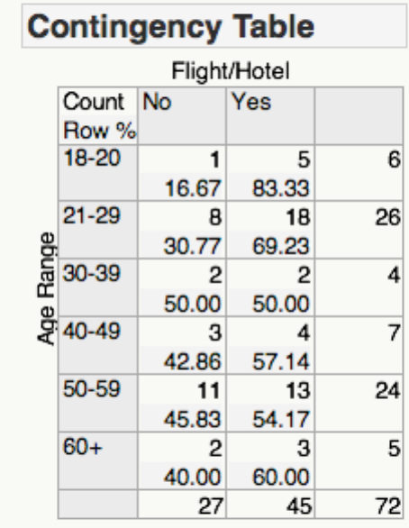
Next I looked at whether gender would affect the answer to the two questions. According to Fisher’s Test there is an 88.11% probability that more females would answer yes to the first question than males and a 92.82% chance that females would answer yes to the second question than males.
Interestingly, 46% of respondents with a Bachelor’s degree answered yes to the first question but when incentivized with a flight and hotel, 65% answered yes to the second question (see table below). Participants with other education levels remained consistent in their responses to the two questions. However, there does not appear to be a correlation between education level and the answer to each question independently.
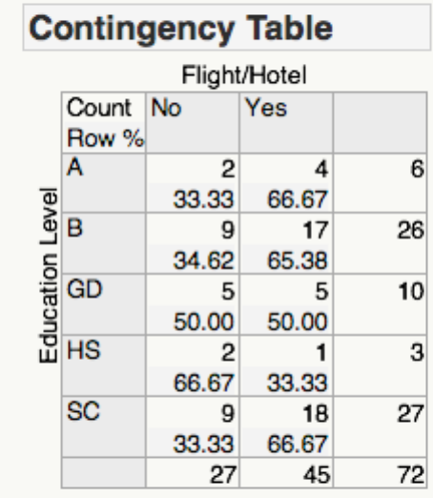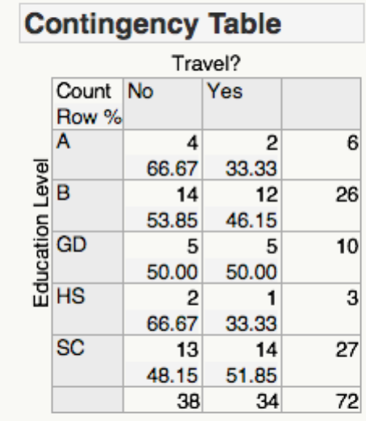
There appears to potentially be a correlation between residence and the answer to these questions however it is impossible to determine with certainty due to the incredibly low sample size. Participants who lived in California all answered yes to the second question while only 57% of participants from Tennessee answered yes (see table below). However, without a larger sample size we cannot make any assumptions.
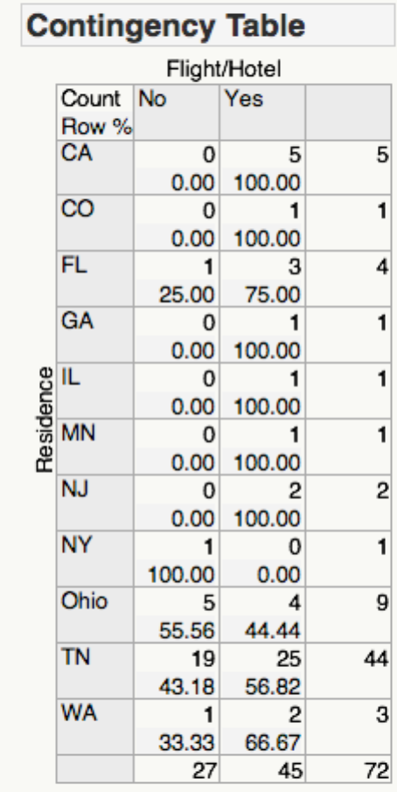
There is no correlation between income and participants’ answer to the first question however, according to the Likelihood Ratio on JMP (see table below), there is a statistically significant relationship between income and the answer to the second question. For participants with an annual income below $125,000 per year there were a higher percentage of people who would travel internationally for a medical procedure when the health insurer compared pays for the flight and hotel to participants with an annual income of $125,000 or more.
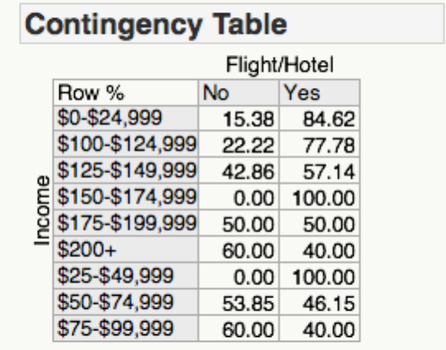
According to Fisher’s Test and the Likelihood Ratio there is a statistically significant correlation between whether or not someone has health insurance and their answer to the two questions. 100% of people without health insurance answered that they would not travel regardless or the incentives. However, 50% of people with health insurance answered yes to the first question and 66% answered yes to the second question (see table below). This appears to be the strongest correlation of any variable.
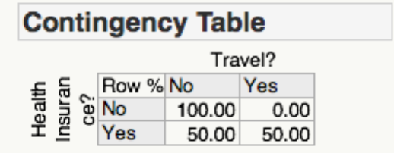
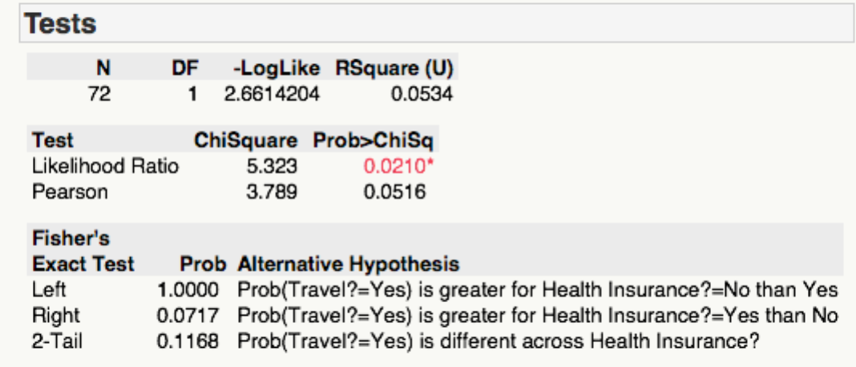
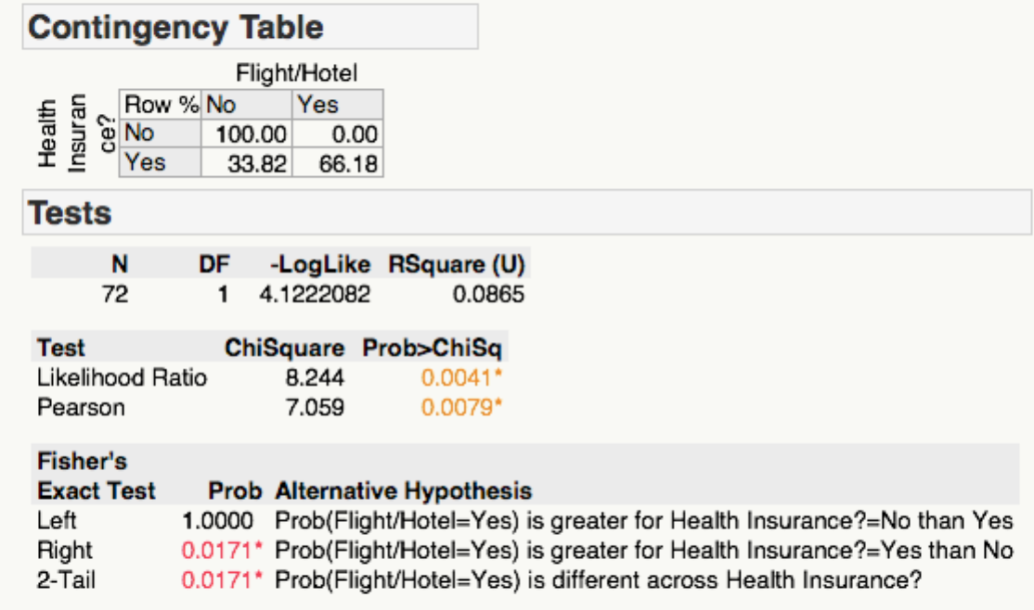
Again, 45 of the 72 participants said they would travel internationally for a medical procedure if there were incentives. Below is a breakdown of the countries they would be willing to travel to if they answered yes.

Country | Count | Percent
India | 7 | 15.56%
France | 27 | 60.00%
Germany | 33 | 73.33%
Switzerland | 31 | 68.89%
Spain | 16 | 35.56%
Canada | 35 | 77.78%
Argentina | 5 | 11.11%
Chile | 4 | 8.89%
Indonesia | 1 | 2.22%
Singapore | 6 | 13.33%
Philippines | 1 | 2.22%
Malaysia | 2 | 4.44%
None | 4 | 8.89%

It is to no surprise that countries whose culture is more similar to the United States have a higher percent than countries in Asia or Hispanic/Spanish countries.
Conclusion
Outbound medical tourism is an interesting trend that is growing in America. With health care costs rising and the current economy struggling, outbound medical tourism is becoming a popular option that both patients and insurance companies are seeking. It could potentially be so significant that some insurers require it of their customers. Outbound tourism can have grave consequences for both patients and doctors in the United States. Doctors could face a reduction in patients, which could impact their salary. Patients face risks such as a lower quality in health care, issues with follow-ups and potential complications after the procedure, and greater out-of-pocket expenses.
Based on research I performed, a majority of people would entertain the idea of traveling internationally for medical procedures and that percentage increases significantly if health insurance companies incentivize these patients. The strongest correlation was with outbound medical tourism and whether or not patients had health insurance. This is interesting because now all Americans are required to have healthcare according to the Affordable Care Act so it will become a more prevalent phenomenon. Although the correlation was not as significant, there was still a correlation between outbound medical tourism and age, education level, income, and residence.
There was an increase of 15% when patients were incentivized with traveling internationally. Due to this analysis, it is my opinion that if insurance companies spend money and resources in their research and development department to find successful and cost efficient ways to incentivize their customers then they will achieve a high degree of success with promoting outbound medical tourism. They need to focus on income levels, specifically below $125,000 annual household income. They should also target younger customers. People below the age of 30 are more likely to travel for medical procedures. This is incredibly important for them to capitalize on. If they change the mindset of younger generations and how they view receiving health care then future generations will likely become more accepting of this phenomenon.
Recommendations
There are some limitations on this research and analysis. The biggest limitation is the incredibly small sample size. It is difficult to make assumptions and generalize the data because the sample size is so small. In a future experiment it would be sufficient to have 1,000 participants. I would also like to find other potential variables that impact the results such as political views and how many times one has traveled in their life and where they have traveled internationally. These suggestions require more time and financial resources that I did not have access to.

Works Cited
"Affect of Outbound Medical Tourism on Orthopedic Surgeons." Telephone
interview. 16 Apr. 2013.
Baliga H. “Medical tourism is the new wave of outsourcing from India,” India Daily,
Dec 23, 2006.

Brunette, Gary, MD, et al. CDC Health Information for International Travel 2010: The
Yellow Book. Mosby Ltd., 2009
Horowitz MD and Rosensweig JA. “Medical Tourism - Health Care in the Global
Economy,” The Physician Executive, Nov/Dec 2007
Keckley, Paul H. "Medical Tourism." Deloitte n.d.: 1-28. Web. 4 Apr. 2013.
Medical Tourism: Consumers In Search Of Value. Deloitte Center For Health Solutions. 2009
"The High Cost of Medical Procedures in the U.S." The Washington Post 2 Mar. 2012:
1. Print.
Turner, Leigh. "‘First World Health Care at Third World Prices’: Globalization,
Bioethics and Medical Tourism." BioSocieties 2.3 (2007): 303-25. www.palgrave-journals.com. London School of Economics and Political Science. Web. 4 Apr. 2013.
Zhani, Elizabeth E. "The Joint Commission Expands Performance Measurement
Requirements." The Joint Commission 30 Nov. 2012: 0-1. Web. 5 Apr. 2013

Appendix 1
University of Tennessee Chancellor’s Honors Thesis Survey

Instructions: Please circle an answer or fill in the blank

- What is your age? _______________

- Gender: Male Female

- Which of the following best describes your current relationship status?

Married Widowed Divorced Separated

In a domestic partnership or civil union

Single but cohabiting w/ significant other Single, never married

- What is the highest level of school you have completed or the highest degree you have received?

Less than high school degree High school degree or equivalent (GED)

Some college but no degree Associate degree

Bachelor degree Graduate degree
- Which of the following best describes your current occupation?
Management Occupations
Business and Financial Operations Occupations
Computer and Mathematical Occupations
Architecture and Engineering Occupations
Life, Physical, and Social Science Occupations
Community and Social Service Occupations
Legal Occupations
Education, Training, and Library Occupations
Arts, Design, Entertainment, Sports, and Media Occupations
Healthcare Practitioners and Technical Occupations
Healthcare Support Occupations
Protective Service Occupations
Food Preparation and Serving Related Occupations
Building and Grounds Cleaning and Maintenance Occupations
Personal Care and Service Occupations
Sales and Related Occupations
Office and Administration Support Occupations
Farming, Fishing, and Forestry Occupations
Construction and Extraction Occupations
Installation, Maintenance, and Repair Occupations
Production Occupations
Transportation and Materials Moving Occupations
Other (please specify) ____________________________________________________

- In a typical week, how many days do you exercise?
I don’t regularly work out One day 2-4 days 5-7 days
- Do you identify with any of the following religions? (Select all that apply)
Protestantism
Catholicism
Christianity
Judaism
Islam
Buddhism
Hinduism
Native American
Inter/Non-denominational
No religion
Other (please specify) ____________________________________________________

- In what state or U.S. territory do you live? ________________________________

- Are you currently enrolled as a student?
Yes, full time in graduate school
Yes, part time in graduate school
Yes, full time at a four-year undergraduate college/university
Yes, part time at a four-year undergraduate college/university
Yes, full time at a two-year undergraduate college/university
Yes, part time at a two-year undergraduate college/university
Yes, at a high school or equivalent
No, I am not currently enrolled as a student
- What is your approximate average household income?
$0-$24,999
$25,000-$49,999
$50,000-$74,999
$75,000-$99,999
$100,000-$124,999
$125,000-$149,999
$150,000-$174,999
$175,000-$199,999
$200,000 and up
- Do you currently have health insurance, or not? Yes No

- Who pays for your health insurance? (Select all that apply)
Current employer
Former employer
National government
State government
Local government
Self-funded
Other (please specify) ____________________________________________________
- Would you consider traveling outside of the U.S. for a medical procedure?
Yes No
- I would travel outside of the U.S. for a medical procedure if:
It saved 0-39% in cost
It saved 40-50% in cost
It saved 51-60% in cost
It saved 61-70% in cost
It saved 71-80% in cost
It saved 81% or more in cost
I would not travel outside the U.S. regardless of the savings
- Would you travel outside of the U.S. for a medical procedure if your health insurer paid for the flight and hotel?
Yes No
- Would you travel outside of the U.S. for a medical procedure if your health insurer paid for you and a friend or family member to travel with you (hotel and flight)?
Yes No
- Which of the following countries/areas would you travel to for a medical procedure?
India
France
Germany
Switzerland
Spain
Argentina
Chile
Canada
Indonesia
Malaysia
Philippines
Singapore
None of the above

- Which race/ethnicity best describes you?
American Indian or Alaskan Native
Asian/Pacific Islander
Black or African American
Hispanic American
White/Caucasian

