Agrobacterium-mediated transformation of rice (Oryza sativa) for drought-inducible synthetic promoters

A Thesis Presented for the
Master of Science
Degree
The University of Tennessee, Knoxville

Paolo Montano Tagaloguin
December 2020

Copyright © 2020 by Paolo Tagaloguin
All rights reserved

Acknowledgments

I want to thank Dr. Neal Stewart for accepting me as his graduate student and for the opportunity to work in his laboratory. I appreciate his support and invaluable insights into conceiving this project. My special thanks to the other members of my thesis committee, Dr. Reginald Millwood, Dr. Feng Chen, and Dr. Tessa Burch-Smith, for their advice and support.
I also acknowledge Dr. Yongil Yang for assisting and supporting me in this project. Special thanks to Dr. Stephen Rigoulot and Holly Brabazon for helping me with the fluorescence-inducing laser projector (FILP). My appreciation for Yuanhua Shao for providing me the Agrobacterium-lines for transformation. I also want to thank Magen Poindexter for her assistance in the genomic DNA extraction and polymerase chain reaction (PCR). My gratitude to the rest of the members of the Stewart laboratory for the support and encouragement.
I express my gratefulness to the US Foreign Fulbright Program, the University of Tennessee-Knoxville Plant Sciences Department, and the Philippine Commission on Higher Education (CHED) for the opportunity to pursue my master's degree.
My deepest thanks to my family and friends in the Philippines for their moral support. Most significantly, my praises to God almighty for the provision and guidance throughout this journey.

Abstract

21st-century drought can potentially affect global rice supply. The next chapters discuss the drought phenomenon and its impacts on rice and how transgenic approaches can improve drought-tolerant rice varieties. Synthetic promoters were designed and tested for drought-stress response in stable transgenic rice (O. sativa ssp Japonica cv. Taipei 309). GFP-expression was measured by qRT-PCR before and after drought-stress imposition. (INSERT MAJOR FINDINGS). This study demonstrated synthetic promoter activity, which can be highly useful in developing drought-tolerant rice.

Table of Contents
1. Literature Review 1
1.1 Abstract 1
1.2 Introduction 1
1.3 Drought is a complex phenomenon 2
1.3.1 Drought definition 2
1.3.2 Drought socioeconomic impacts 3
1.4 Drought impacts to rice production 6
1.4.1 Top rice producers and exporters will experience extreme 21st century drought 6
1.4.2 Drought-induced responses in rice cause substantial yield loss 10
1.5 Transgenic approaches to drought tolerant rice 13
1.5.1 Drought tolerance genes were identified and introduced in rice 13
1.5.2 Constitutive expression can cause negative effects 15
1.5.3 Synthetic promoters as gene switch for drought-tolerant genes in rice 16
1.6 Concluding remarks 17
1.7 References 18
2. Agrobacterium-mediated transformation of rice (O. sativa) for drought inducible synthetic promoter screening 1
2.1 Abstract 1
2.2 Introduction 1
2.3 Materials and Methods 3
2.3.1 Plant Material 3
2.3.2 Bioinformatic analysis for selection of stress-responsive motif 4
2.3.3 Construction of plasmids with fluorescent reporter genes 4
2.3.4 Agrobacterium-mediated transformation 5
2.3.5 Visual confirmation of putative transgenics 6
2.3.6 Molecular confirmation of putative transgenics 6
2.3.7 Abiotic stress treatment 7
2.3.8 Quantitative RT-PCR 8
2.3.9 Statistical analysis 8
2.4 Results 9
2.4.1 Synthetic promoter design 9
2.4.2 Agrobacterium-mediated transformation 10
2.4.3 Visual and molecular confirmation of putative transgenics 10
2.4.4 Abiotic stress treatment 10
2.5 Discussion 11
2.6 Conclusions 15
2.7 References 16
Appendix 26
Vita 38

List of tables

Table 2 List of primer sequences used for qRT-PCR and PCR amplification. 26
Table 3 List of synthetic promoters used in Agrobacterium-mediated transformation of Nipponbare and Taipei 309 rice. SD (synthetic promoter from drought stress-inducible promoters) motifs; SS (synthetic promoter from salt stress inducible promoter) (Yang et al, 2020; submitted). The synthetic cis-regulatory elements were composed of five (5), seven (7), or eight (8) base pairs repeated seven times. ND = not detected. FRFP – Forward RFP. 27
Table 4 Transformation frequency. Frequency of Agrobacterium-mediated transformation using rice-calli induced from mature seed (cultivar Nipponbare and Taipei 309). *Transformation frequency (independent transgenic plant/inoculated calli * 100). 28

List of figures

Figure 1 Schematic diagram comparing native and synthetic promoters. A. 500 bp to 2000 bp long native promoter. Complex expression profile determined by binding of different transcription factors (TF) in cis-elements in the proximal and distal region. B. Designing short synthetic promoters by removing the spaces between cis-elements in the proximal and distal region. C. Building synthetic promoters for binding of specific transcription factors. Several (left) or similar (right) cis-motifs were fused with a core promoter. DT gene = drought tolerant gene (Original figure created with BioRender.com) 29
Figure 3 Stacking of multiple genes driven by different synthetic promoters to create drought-tolerant (DT) rice. In the onset of drought, specific TFs (indigo) bind to Synthetic Promoter 1 expressing a TF-coding gene. Subsequently, desired TFs (red) are produced and bind to Synthetic Promoter 2 expressing a drought-tolerant gene. (Original figure created with BioRender.com) 30
Figure 4 Synthetic promoter constructs. Binary vectors contained a series synthetic promoters (SD-series) fused to GFP. The core promoter sequence for synthetic promoters was the -46 35S promoter with the TMV Ω 5’ UTR leader sequence for transcriptional initiation. Vectors also contained a reverse (A) or forward (B) 35S::RFP reporter cassette that served as an internal positive control. The constructs harboring the forward 35S::RFP reporter cassette were labeled FRFP (SD9-1 FRFP, SD9-2 FRFP, SD9-3 FRFP). The synthetic cis-regulatory elements were composed of either 5, 7 or 8 base pairs (SD and SS motifs) repeated 7 times. The negative construct does not contain any cis-regulatory element. (Yang et al., 2020; submitted). 31
Figure 5 Agrobacterium-mediated transformation of rice calli. Calli growth after 30 days in Kanamycin (A) and Hygromycin (B-C) selection medium; regenerated shoots after 26-30 days in regeneration medium (D-F). Selection medium supplemented with Kan⁵⁰ + Tim¹⁵⁰ or Hyg³⁵ + Tim¹⁵⁰. Regeneration medium supplemented with NAA (0.02mg/L) + Kinetin (2mg/L) and appropriate antibiotic (Kan or Hyg). 32
Figure 6 Fluorescence inducing laser projector images of transgenic rice. Laser power for both the 465 and 525 nm lasers were 1.4W and images were acquired using a camera exposure time of 300 ms from a distance of 3 meters. Scale bars represent 5 cm. The same WT was used for all images and is denoted in the merged image using a white asterisk. 33
Figure 7 Confirmation of transgenes in transgenic rice by genomic PCR analysis. Genomic DNA was isolated from wild-type (WT) and putative transgenic rice plants. Genomic DNA sample was used for PCR in the presence of gfp, and OsUbi1 (Nipponbare) or OsAct1 (Taipei 309) specific primers. M marker; - blank; WT wild type; P positive control (Pest#12 plasmid). 37

1. Literature Review

1.1 Abstract
Transgenic approaches to engineer drought-tolerant rice (O. sativa) rely on appropriate promoter choice. Several genes have been introduced to confer drought-tolerance in rice, mostly relying on cauliflower mosaic virus (CaMV) 35S promoter. However, constitutive expression of drought-tolerance genes can cause pleiotropic effects to the crop. Thus, the use of an inducible promoter is advantageous in expressing drought-tolerant genes. Inducible synthetic promoters were developed recently, but not extensively in rice. Intensifying synthetic promoter development is vital in stacking multiple genes to engineer the "21st-century" rice.

1.2 Introduction
Rice is an important crop worldwide¹. However, extreme drought poses risks to the global rice supply²⁻⁵. Transgenic approaches contribute significantly to enhance the crop’s drought-tolerance⁶. Nevertheless, precise transgene expression relies on the regulation of an appropriate genetic switch known as promoter⁷. Promoters are upstream DNA sequences driving gene expression through DNA recognition sequences that interact with the basic transcription machinery^{8, 9}. These promoters can be constitutive, spatiotemporal, or inducible^{10, 11}. Constitutive promoters drive gene expression across all tissues and throughout the life cycle of the plant^{7, 12}. Spatiotemporal promoters restrict gene expression in particular tissues or developmental stages of the plant^{8, 13}. Inducible promoters direct gene expression in response to a particular stimulus¹⁴⁻¹⁶. Thus, promoter choice is essential in any transgenic approach based on a desired gene expression pattern. Synthetic biology sparked synthetic promoter development recently^{10, 11}. Synthetic promoters are generally composed of a core-promoter region and multiple repeats and combinations of cis-motifs or transcription factor binding elements¹⁷. Synthetic promoters are envisaged to control ectopic gene expression and reduce the complexity of natural promoters' expression patterns^{10, 17, 18}. Here, I reviewed the impacts of drought on rice and the current state of synthetic promoter development to enhance the crop’s tolerance to drought.

1.3 Drought is a complex phenomenon

1.3.1 Drought definition

Drought is a complex natural phenomenon ³ involving the interaction of hydrologic (precipitation), atmospheric (temperature, vapor pressure), and bio-geophysical processes (evapotranspiration, solar radiation). This interaction results in a sustained water-deficit¹⁹, causing severe hydrological imbalance².
However, there is no universally accepted criterion for what constitutes drought²⁰, which is evident in various definitions, metrics, and indices tailored to a particular research community's needs. For instance, an extended period without rainfall in a region characterized by seasonal or year-round precipitation regime represents meteorological drought^{21, 22}. A below-average water level in streamflow, reservoir, and groundwater involves hydrological drought ^{23, 24}. A water-deficit in the topmost layer, root-zone, or the unsaturated-zone of the soil that impacts crops represents agricultural drought^{2, 23}.
Regardless of these perceived differences, there is a strong linkage among drought types²⁵. This linkage is known as drought propagation, where one type translates to another type. Meteorological drought essentially initiates the other two drought types.
As meteorological drought progresses, it propagates to a hydrological drought²⁶. In turn, the sustained lack of precipitation (meteorological drought) and poor irrigation due to low water levels in reservoirs or streams (hydrological drought) can manifest into an agricultural drought²³. This idea of drought propagation puts the definition for each type into one general idea - that drought is a prolonged absence of rainfall affecting the soil moisture and the amount of water in runoffs and reservoirs. As drought propagation ends in agricultural drought, it implies severe negative impacts on crops, especially in areas depending on the traditional rainfed agriculture²⁷.

1.3.2 Drought socioeconomic impacts

The last ten years recorded various drought events worldwide: 2010-2018 in Southwestern North America²⁸, 2017-2018 in Northern China²⁹, 2015 and 2018 in Eastern Europe³⁰⁻³², 2015-2016 in Africa^{33, 34}, 2015 in Brazil³⁵, 2011-2014 in California³⁶, 2012 in the US Central Great Plains³⁷, 2010-2011 in the Horn of Africa²⁷, and 2009-2011 in southwestern China³⁸.
These previous droughts had grave socioeconomic impacts, especially in the agricultural sector. For example, China lost 98.9 million hectares of crops in the 2009-2011 drought³⁸. The total economic loss for the said drought amounted to 1.1 billion USD. During the 2014 California drought, the total economic loss summed up to 2.2 billion USD, 1.8 million USD of which accounted for crop loss in the said period³⁹. In an assessment report of the National Oceanic and Atmospheric (NOAA) - Drought Task Force in 2013, the US Central Great Plains drought in 2012 resulted in 12.0 billion USD estimated economic loss^{37, 40}. Corn yield also declined by 26%. The agribusiness sector in Brazil lost 5 billion USD due to drought in 2015⁴¹. The 2015-2016 drought in South Africa led to 690 thousand USD agricultural loss in 2015 alone⁴². According to the Emergency Events Database, an international disaster database established by the World Health Organization and the Belgian Government, Africa's drought from 2015-2016 has an estimated 2 million USD economic loss³⁴.

1.3.3 Drought estimation
The projected increase in drought intensity, duration, and frequency in the 21st century ⁴³⁻⁴⁵ could amplify these current agroeconomic losses. Recent climatic studies attribute worsening drought conditions to human-induced global warming ^{19, 23, 43-45}, although disruption in the global hydrologic cycle naturally causes extreme drought and precipitation events in particular regions globally². Primarily, the El Niño Southern Oscillation (ENSO) causes episodic drought. Southeast Asia, Australia, Indonesia, some parts of Africa, northeast Brazil, and Central America are highly likely to experience drought during the El Niño events^{2, 20}. Meanwhile, Peru, Ecuador, and the naturally wet areas during El Niño are dryer throughout the La Niña event².With the combined effects of global warming due to increased greenhouse gas (GHG: carbon dioxide CO2, methane CH4, nitrous oxide N2O, and fluorinated gases) emissions, “dry regions” receive limited precipitation, whereas wet regions receive excessive rain than the natural effect of ENSO or other hydrological imbalance alone^{2, 45}.
Depicting future drought characteristics utilizes various 21st-century GHG emission scenarios called Relative Concentration Pathways (RCPs; RCP 2.5, 4.0, 6.0, 8.0)⁴⁵. These four RCPs scenarios are categorized based on the perceived 21st-century GHG concentrations (expressed in ppm CO₂-eq concentration), the corresponding increase in global temperature relative to the pre-industrial conditions (1850-1900 CE), and the equivalent radiative forcing (RF) relative to 1750 CE. RCP 2.6 scenario represents low carbon emission, increased reliance on renewable energy, and a strong global effort to mitigate climate change⁴⁵. In this scenario, the average global temperature will increase by 0.3ºC to 1.7ºC in 2100. The RCP 2.6 scenario accords with the 2015 Paris Agreement to limit the global temperature rise to well below 2.0ºC. Meanwhile, RCP 8.5 depicts high fossil-fuel use, limited use of renewable energy, and fragmented global cooperation to mitigate climate change. The RCP 8.5 describes a “business-as-usual” or “worst-case” scenario where global temperature will rise between 2.6ºC to 4.8ºC. The RCP 4.5 and 6.0 are intermediate pathways where the global temperature increases to 1.8ºC and 2.2ºC, respectively. These RCP scenarios are then used as inputs to analyze global climate change impacts using the multiple climatic models integrated into the Coupled Model Intercomparison Project (CMIP). The CMIP subsequently forecasts spatiotemporal changes in precipitation patterns, atmospheric temperature, soil moisture, and evapotranspiration⁴⁵. The forecasted climatic conditions will now be fed into various indices to measure, monitor, and predict the occurrence, intensity, and frequency of drought in the 21st century.
There are three most commonly used indices to characterize drought. A negative value indicates drought for all three indices, while a positive value indicates a wet spell. The Palmer Drought Severity Index (PDSI) has been in use for 55 years to quantify long-term drought for a particular location and time²². It uses temperature and precipitation data to estimate relative dryness. However, PDSI provides inconsistent results across diverse climatological regions, making spatial comparison difficult, if not meaningless⁴⁶. The self-calibrating PDSI (sc-PDSI) introduced by Wells et al. (2004) addresses this problem by replacing the empirical constants in the original computation of the index with a more dynamically calculated values⁴⁶. Using the sc-PDSI allows spatial comparison that is not possible with the original PDSI. Another caveat to using PDSI is that it has a fixed timescale, limiting drought identification across a wide range of temporal scales^{47, 48}. The Standardized Precipitation Index (SPI) addresses this limitation of the PDSI⁴⁹. SPI can monitor short-term drought (agricultural drought) and long-term drought (hydrological and meteorological drought) because it can quantify drought at various timescales using the precipitation data only^{26, 49}. Its simplicity and low-data requirement explains its wide acceptability in drought-monitoring and analysis. This index's primary constraint is that it excludes evapotranspiration, limiting its usefulness for some applications and research questions²⁰. The Standardized Precipitation Evapotranspiration Index (SPEI) takes advantage of the SPI's multi-scalar and robust statistical feature while including evapotranspiration data in characterizing drought^{20, 48}. SPEI takes into account the effects of temperature, evapotranspiration, soil water holding capacity, and wind speed along with precipitation data in drought assessment⁴⁸. Because SPEI is multivariable, it is comparable to the sc-PDSI. However, because SPEI is also multi-scalar, it remains more advantageous than the sc-PDSI. Overall, SPEI is superior to the other two indices because it can better reflect the impact of drought, especially in agriculture ⁵⁰.

1.4 Drought impacts to rice production

1.4.1 Top rice producers and exporters will experience extreme 21st century drought

China ranked first on global milled rice production in 2018/2019, followed by India and other Southeast Asian countries (Indonesia, Bangladesh, Vietnam, Thailand, Myanmar, and the Philippines) (Table 1)⁵¹. Japan and Brazil then trailed as the ninth and tenth top global rice-producers, respectively. These countries are consistently the leading rice producers in the last 20 years ⁵². On the other hand, India has the highest exported rice in 2018/2019⁵³. China fell short to sixth place in exporting rice while Thailand, Vietnam, Pakistan, and the United States ranked second to the fifth, respectively. The other leading global rice-exporters are Myanmar, Cambodia, Brazil, and Uruguay.
SPEI values were estimated using multi-model ensembles to characterize the 21st-century drought under the different warming (RCP) scenarios. These drought projections consistently show an increasing drought frequency, intensity, and severity in the next 80 years, most especially in these top rice producing and exporting countries. 21st-century drought can potentially threaten food security, especially on populations that depend on rice as a staple commodity.
Yao et al. ⁴⁷ projected the 21st-century drought in China using 28 global climate models (GCMs) under the RCP 4.5 and the RCP 8.5 scenarios ⁴⁷. The arid and the semi-arid western and northwestern China are more likely to experience drought under RCP 4.5. However, northeastern and southeastern China will experience an increase in precipitation under the same RCP 4.5 and RCP 8.5 scenarios. These predictions are consistent with the same study by Guo et al. ⁵⁰. Northern, northwestern, and southwestern China are drier under RCP 4.5, while China's southeastern part is highly likely to get wetter at the end of the 21st century ⁵⁰. However, at RCP 8.5, all regions in China will get drier⁴⁷. China may experience moderate to severe drought at the end of the 21st century under the RCP 8.5 scenario. Drought frequency will also increase by 60% to 70%, which could last for 96 months to 240 months under the RCP 4.5 and RCP 8.5 scenarios, respectively.
Similar drought projections were observed in India. There will be an increased drought occurrence, severity, duration, and affected-areas⁵⁴. Using the RCP 8.5 scenario, Aadhar⁵⁵ identified drought frequency to increase two to three times each decade. Furthermore, the area affected by drought will increase to 150%.
In Bangladesh, SPEI calculations for the 21st-century drought predict higher frequency and severity in shorter timescales⁵⁶. A more frequent and shorter drought pattern can permanently damage an ecosystem⁵⁷. Schwalm et al.⁵⁷ studied drought recovery time, which describes how long an ecosystem can revert to its pre-drought functional condition. The tropics and the high northern latitudes have the longest drought recovery time. The time between droughts may be shorter as the droughts become more frequent. This frequent drought pattern will put ecosystems in a chronic state of incomplete recovery from the previous drought. Downward SPEI trend in Bangladesh until the end of the 21st century implies future extreme drought. While there will be a shift in wet to dry regime over the northeast of Bangladesh, the rest of the country will experience severe drought.
In the Indochina region (ICR; Cambodia, Laos, Myanmar, Malaysia, Thailand, and Vietnam), severe drought hazards will increase in both the RCP 4.5 and the RCP 8.5 scenarios⁵⁸. Cambodia and Thailand were identified as drought-prone countries in the 21st century. The ICR already experiences 10 to 16 droughts during the 30 years of the baseline period (1976-2005). This drought frequency will rise all over ICR except Cambodia and Thailand. Drought lasts for 5 to 10 months in the baseline period. Yet, this can go up to 60 months, especially in Cambodia and Thailand.
Leading rice producers in the US are mainly in the southeast region (Arkansas, Louisiana, Mississippi)⁵⁹. Texas, Missouri, and California are also among the top rice producers. Mitra et al.⁶⁰ estimated 21st-century drought in the southeast of the USA. The study covered Texas, Oklahoma, Arkansas, Louisiana, Tennessee, Mississippi, Alabama, Georgia, Florida, North Carolina, and South Carolina⁶⁰. SPI and SPEI were used to estimate drought under the RCP 4.5 and RCP 8.5 scenarios. Using the SPI, which relies on precipitation data alone, Texas will be dry while the rest of the states will have higher precipitation during the winter and spring season in both the RCP 4.5 and RCP 8.5 scenarios. Meanwhile, SPEI drought estimation, which considers temperature and potential evaporation data, predicts drying all over the states during the winter and spring seasons in both the RCP scenarios. Summer and fall season observe a similar trend for both the SPI and SPEI estimations but with more intense drying. This increase in drought severity and frequency during the summer season which corresponds to the growing season may result in lower soil moisture that can impact crop production. Williams et al.²⁸ compared the 2000-2018 megadrought in Southwestern North America (SWNA; western America and Northern Mexico) with other megadroughts in the last 1200 years. Historical droughts were reconstructed using tree-ring data and hydrological models. Megadrought periods were determined as prolonged drought events with at least a 19-year low soil moisture condition. Four historical SWNA megadroughts were identified in the reconstruction: the late 800s, the mid-1100s, the 1200s, and the late 1500s. The comparison demonstrates that the 2000-2018 megadrought is the second driest 19-year period in the last 1200 years, next to the megadrought that occurred in 1575-1593 CE (common era; CE).
On a global scale, Martin⁶¹ projected future pluvial and drought events using the SPI. The hotspots for worsening drought are the Americas, Central America, the Caribbean, and the Amazon⁶¹. Meanwhile, North America and Europe will experience worsening pluvial events. Using the SPEI, Naumann et al.⁴ predicted increasing drought magnitude and duration in most of Africa (except equatorial Africa), the Caribbean, southern Europe, Australia, and West Asia under 3ºC global warming⁴. The drought lengths can go up to 18 months under the same warming scenario. Drought will also occur five to ten times more for most of Africa, the Caribbean, Central America, Central and West Asia, Oceania, and north‐west China. Cook et al.⁴⁴ used more robust GCMs under the most recent sixth phase of the CMIP (CMIP6)⁴⁴. Western North America, Central America, Europe, the Mediterranean, the Amazon, China, Australia, and Southeast Asia will experience robust drying and an increase in extreme drought occurrence.
There are still uncertainties in these 21st-century drought projections⁵⁸. Such ambiguities may come from i) the models used to simulate future climate^{19, 62-64}, ii) the RCP scenarios^{65, 66}, or iii) the climate's random internal variability⁶⁷. Nevertheless, these drought simulations provide scientists and policy-makers insights into the future drought scenarios that can negatively affect rice and other important crops.

1.4.2 Drought-induced responses in rice cause substantial yield loss

Severe drought conditions put risks to the global rice supply³⁻⁵. Rice is mostly grown in paddies for weed management⁶⁸⁻⁷⁰, and continuous flooding is unnecessary for increased yield^{71, 72}. However, in extreme drought scenarios, the prolonged absence of precipitation and insufficient water supply can result in a soil-moisture deficit². The lack of soil-moisture can negatively impact rice and other essential crops.
Drought effects on rice were studied at the molecular, biochemical, physiological and morphological levels. Molecularly, drought alters gene expression in plants. Under drought stress, rice encodes the genes for transcription-factors and defense-related proteins against dehydration⁷³⁻⁷⁶.
The gene for the WRKY53 transcription factor is elevated during drought stress⁷⁷. In Arabidopsis thaliana (A. thaliana), AtWRKY53 is responsible for senescence-induced cell death⁷⁸. The AREB1, AREB2, and ABF2 transcription factors belonging to the ABRE-binding (AREB) proteins are also upregulated by drought stress⁷⁹. The three ABRE transcription factors function cooperatively in abscisic acid (ABA) signaling as a drought stress response. The OsGRAS23 gene is induced by drought, salt, and jasmonic acid treatments⁸⁰. It encodes a drought-stress responsive GRAS transcription factor involved in the induction of stress-responsive genes. The OsbZIP46 gene is highly expressed under drought, heat, hydrogen peroxide, and ABA treatments⁸¹. The OsbZIP46 gene encodes for a transcription factor belonging to the bZIP transcription factors in rice. The stress-related genes activated by the OsbZIP46 are entirely different from those induced by the AREB transcription factors. The OsMYB2 gene expression is upregulated by drought, salt, and cold stresses⁸². It encodes a stress-responsive MYB-transcription factor. The transcription factors produced under drought stress are mainly involved in signal transduction and transcriptional regulation⁷⁷.
The proteins created in response to drought are late embryogenesis proteins, detoxifiers, or osmoprotectant-synthesizing enzymes^{77, 83, 84}.
Biochemically, drought stress results in the accumulation of osmoprotectants⁷³⁻⁷⁵. These osmoprotectants are proline, polyamines, antioxidants, and sugars. When there is water-deficit in plant cells due to drought, plants accumulate inorganic and organic solutes in the cytosol resulting in lower osmotic potential to maintain cell turgor⁷⁴. This process is known as osmotic adjustment. The release of osmoprotectants improves water uptake from the drying soil⁷⁴. Physiologically, drought results in reduced photosynthesis, stomatal conductance, transpiration, water-use efficiency, photosystem II activity, membrane stability, and carbon isotope discrimination^{73-75, 77, 83, 84}. ABA accumulation was also observed as a drought stress response. Morphologically, drought causes reduced stomatal density, germination, plant height, plant biomass, number of tillers, and leaf area⁷³⁻⁷⁵.
Rao et al. (2019) investigated the influence of drought stress on pollen traits and physiology at the flowering stage of two rice genotypes⁸⁵. Under greenhouse conditions, drought reduced net photosynthetic rate and decreased maximal photochemical efficiency of photosystem II in the two rice genotypes. Drought stress also significantly reduced pollen members on stigma, anther dehiscence rate, pollen germination rate, pollen viability, and anther starch contents. As a result, yield and yield components (grain/panicles, 1000-grain weight, effective panicles, and seed set percentage) were substantially reduced. Meanwhile, drought stress elevated levels of antioxidants malondialdehyde (MDH), superoxidase (SOD), peroxidase (POD), and catalase (CAT)^{74, 85}. Activities of the said antioxidants can effectively diminish reactive oxygen species (ROS), reducing the negative impacts of drought.
In another study, drought stress impacts at the flowering stage on rice physiological traits, grain yield, and quality were investigated⁸⁶. Field experiments were conducted on two rice cultivars under two water treatments: traditional flooding and drought stress at the flowering stage. Similar to Rao et al. (2019), photosynthetic rate (Pn), transpiration rate (Tr), and stomatal conductance (Gs) decreased under drought stress in field conditions. Typically, physiological traits revert to normal levels after two days of rehydration. However, the activity of physiological traits (Pn, Tr, and Gs) further decreased after 20 days of rehydration. Although drought stress did not affect protein content, amylose content, and overall nutritional quality of rice under drought stress, rice quality is significantly affected. Drought stress increased chalkiness and chalky kernel levels at 74.0-76.0% and 53.0-67.0%, respectively—drought stress in rice resulted in low grain quality^{71, 86-88}.
In a meta-analysis study, the effect of drought on agronomic traits was also investigated⁸⁹. Drought stress resulted in decreased rice yield and biomass at 25.4% and 25.2%, respectively. Furthermore, yield loss is highest when drought occurred during rice's flowering stage than when drought occurred during its vegetative phase^{74, 86, 89}. Leng and Hall (2019) estimated potential drought-induced yield loss in rice, wheat, corn, and soybean³. Crop-country specific SPI and census yield information in 1961-2016 were used to project yield losses due to drought. Rice has the highest yield loss risk than any of the three crops. Historical drought-induced yield loss in rice is approximately 60%. By the end of the 21st-century, drought-induced yield loss in rice can increase to 79%. This projection means an estimated yield loss risk of 19% in rice. Meanwhile, wheat, corn, and soybean yield-loss risk are 12.0 %, 7%, and 16%, respectively.
Overall, understanding rice responses to drought shed light on the development or selection of drought-tolerant rice. For example, upregulated genes during drought stress can be used in transgenic approaches to develop drought-tolerant rice. Investigating varieties with high proline content will facilitate germplasm selection for conventional breeding. Rice panicle and spikelet morphogenesis are critical factors in rice grain development. Hence, it is critical to ensure appropriate water management strategy during the rice flowering stage. Adaptive measures should be in place to guarantee sustainable rice production in the 21st century.

1.5 Transgenic approaches to drought tolerant rice

1.5.1 Drought tolerance genes were identified and introduced in rice

Drought tolerance is a multigenic trait. Several genes were recently introduced for overexpression in rice. These genes function in a variety of ways: i) enhance root growth and development^{6, 90, 91}, ii) encodes for transcription factor that responds to drought^{92, 93}, iii) sugar signaling⁹⁴, iv) improve reactive oxygen scavenging (ROS)⁹⁵, v) enhance stomatal closure⁹⁵, and vii) improve ABA-sensitivity¹⁶.
Rice Root Architecture Associated 1 (OsRAA1) gene is involved in extensive root development^{6, 91}. Transgenic lines were tolerant to drought stress than the wild type, have higher proline and abscisic acid accumulation, and have lower lipid peroxidation. Under drought conditions, transgenic rice lines have more tillers, higher spikelet fertility, and developed larger grains, hence, an observed 20.0-40.0% higher grain yield than the wild type. Here, it demonstrated that extensive root growth and development allow more efficient uptake and improved access to moisture at greater soil depth^{6, 90}.
Overexpression of MYB Family gene OsMYB6 in rice is involved as a transcription factor that responds to drought and salt stress^{6, 92}. Here, overexpression of OsMYB6 have no negative effect to the development of the transgenic rice. Transgenic lines have higher tolerance to drought and salt stress than the wild type, have higher proline content, increased SOD and CAT activities, and lower relative electrolyte leakage (REL) and malondialdehyde (MDA) content. SOD and CAT are antioxidants that serve as osmoprotectants while REL and MDA are closely related with the degree of cell membrane damage under abiotic stress^{73-75, 92}.
OsMT6 is another gene that was recently used to confer drought-tolerance⁹⁴. It encodes for a monosaccharide transporter protein that is critical to cell-to-cell and long-distance sugar distribution throughout the plant. In this study, physiological analysis show that transgenic Arabidopsis thaliana increased membrane stability, lower water loss rate, higher relative water content, and higher total soluble sugar than the parental genotype^{94, 96}.
OsPUB67 gene encodes for E-3 Ubiquitin ligase and is significantly induced by drought, salt, cold, jasmonic acid, and ABA⁹⁵. Overexpression of such gene enhanced stomatal closure activity and improved ROS activity.
Overexpression of OsPYL10 gene that encodes for an ABA-receptor PYL (Pyrabactin Resistance-like) protein was also explored¹⁶. At vegetative drought stress, transgenic rice lines have higher grain yield (40.0-58.0%). At reproductive stage drought stress, one of the three transgenic rice lines has twice as much grain yield than the wild type. Similar with other studies, transgenic rice lines have higher membrane stability index, relative water content, and chlorophyll content whereas MDA and peroxide accumulation is low. This study demonstrated that overexpression of OsPYL10 gene conferred ABA-hypersensitivity of rice thereby improving its drought tolerance.

1.5.2 Constitutive expression can cause negative effects

Overexpression of some drought tolerance genes driven under a constitutive promoter such as 35S from CaMV (Cauliflower mosaic virus), ZmUbi1 from maize (Zea mays), PvUbi1 and PvUbi2 from switchgrass (Panicum virgatum), or OsAct1 from rice have been shown to lead to undesirable phenotypes, metabolic burden, epigenetic silencing, or off-target effects^{9, 14-16, 97}. Constitutive expression of drought-tolerance genes in transgenic rice led to floret sterility, reduced shoot length, smaller flag-leaf area, as well as lesser panicle and tillers, which could potentially manifest decreased rice yield¹². For example, constitutive overexpression of OsTZF5 driven by ZmUbi1 promoter resulted in drought-tolerant transgenic rice but with lower biomass, reduced seed setting, and underdeveloped panicles than the wild-type variety¹⁵. In contrast, overexpression of the same OsTZF5 gene driven by drought-stress inducible OsNAC6 promoter generated transgenic rice with normal phenotype with significantly higher yield than the wild-type genotype under drought-condition¹⁵. Constitutive overexpression of OsRAA1 under the ZmUbi1 promoter resulted in drought-tolerant transgenic rice exhibiting floret sterility (abnormal filament length, white and shrunken anthers)⁹¹. Whereas, overexpression of the same gene under the control of the drought-inducible promoter pHAK1 generated drought-tolerant transgenic rice with normal floret phenotypes, regardless of drought conditions⁶. The use of an inducible promoter, therefore, is advantageous in generating crops that accumulate transgene products only under stressed conditions.

1.5.3 Synthetic promoters as gene switch for drought-tolerant genes in rice

Recent studies for drought-tolerance transgene expression in rice reported use of drought-inducible native promoters of the following genes: OsHAK1 ⁹⁸, OsNAC6 ¹⁵, OsRhoGAP2 ⁹⁹, Osr40c1 ¹⁰⁰, OsNAC14 ⁹⁰, OsHox24 ¹⁰¹, Rab21 ¹⁰¹, and OsLEA3-1 ¹⁰¹. Nevertheless, induction condition, specificity, expression level, and size are the major constraints to native promoter activity ¹⁷. Native promoters are generally longer (>1000 bp) and some have a weak expression profile than some constitutive viral promoters like the CaMV 35S which are ambiguously used in plant biotechnology (Figure 1 A). Such limitations prompted the engineering of smaller, robust, and versatile synthetic promoters, which are generally composed of a core-promoter region and multiple repeats and combinations of cis-motifs or transcription factor binding elements ¹⁸ (Figure 1 B-C). Designing drought-stress inducible synthetic promoters is a promising field but only a few have been published in rice thus far. The latest report developed inducible synthetic promoters Ap, Dp, and ANDp in combination with functional genes CAARK1 (cytosolic abscisic acid (ABA) receptor kinase 1), and RCAR11 (regulatory components of ABA receptor 11), resulting in drought-tolerant Arabidopsis thaliana ¹⁰². In rice, the latest literature on stress-inducible promoter was reported in 2011 and 2015. Chen et al. (2015) designed an ABA-responsive complex (ABRC) based synthetic promoter (3xABRC21) to control late embryogenesis abundant protein HVA1 expression ¹⁰³. 3xABRC21:HVA1 transgenic rice lines demonstrated stress tolerance to ABA, salt, dehydration, and cold without compensating for rice yield . Ganguly et al. (2011) utilized four-tandem repeats of the ABA-responsive element (4xABRE) and two-tandem repeats of the ABA-responsive complex (2xABRC) linked to gusA gene, in comparison with a stress-inducible native promoter Rab16A ¹⁰⁴. Results indicated that 4XABRE and 2xABRE have higher GUS expression (142 pmol h⁻¹ug⁻¹ and 161 pmol h⁻¹ug⁻¹, respectively) than the native Rab16A promoter (100 pmol h⁻¹ug⁻¹) after the application of 100 uM ABA to 21-day-old T₂ transgenic plants ¹⁰⁴. Further literature search revealed that the most recent work on synthetic promoters in rice is limited to tissue-specific promoters ^{13, 105}.

1.6 Concluding remarks

Drought is projected to be more frequent and highly intense in the future which may potentially affect global rice supply. Transgenic approaches can be exploited to generate drought-tolerant rice. However, gene expression relies on the control of appropriate promoter. Constitutive expression of some drought-tolerance genes may be detrimental to the crop. Alternatively, the use of inducible promoters may be exploited. Nevertheless, designing synthetic promoters for drought inducibility should further be explored in rice (Figure 2). Since effect of drought to yield loss is highest at flowering stage in rice, synthetic promoters that can be temporally expressed at this stage may also be done. Engineering for 21st century rice would involve various genes that confer traits for drought-tolerance, increased-yield, advanced nutrition, and insect-resistance. This can be achieved by multiple stacking of genes. Using the same promoter may result in homology-dependent gene-silencing. Developing a battery of short, highly-inducible, synthetic promoters would be necessary to run the gene circuit.

1.7 References
References

1. Ye, X. et al. Engineering the provitamin A (β-carotene) biosynthetic pathway into (carotenoid-free) rice endosperm. Science 287, 303 (2000).
2. Trenberth, K.E. et al. Global warming and changes in drought. Nature Climate Change 4, 17-22 (2014).
3. Leng, G. & Hall, J. Crop yield sensitivity of global major agricultural countries to droughts and the projected changes in the future. Science of The Total Environment 654, 811-821 (2019).
4. Naumann, G. et al. Global changes in drought conditions under different levels of warming. Geophysical Research Letters 45, 3285-3296 (2018).
5. Wang, Y. et al. Mitigating rice production risks from drought through improving irrigation infrastructure and management in China. Australian Journal of Agricultural and Resource Economics 62, 161-176 (2018).
6. Chen, G. et al. Driving the expression of RAA1 with a drought-responsive promoter enhances root growth in rice, its accumulation of potassium and its tolerance to moisture stress. Environmental and Experimental Botany 147, 147-156 (2018).
7. Jiang, P. et al. Characterization of a strong and constitutive promoter from the Arabidopsis serine carboxypeptidase-like gene AtSCPL30 as a potential tool for crop transgenic breeding. BMC Biotechnology 18, 59 (2018).
8. Dutt, M. et al. Temporal and spatial control of gene expression in horticultural crops. Horticulture Research 1, 14047 (2014).
9. Xue, M. et al. Isolation and characterization of a green-tissue promoter from common wild rice (Oryza rufipogon Griff.). Int J Mol Sci 19, 2009 (2018).
10. Liu, W. & Stewart, C.N. Plant synthetic promoters and transcription factors. Current Opinion in Biotechnology 37, 36-44 (2016).
11. Hernandez-Garcia, C.M. & Finer, J.J. Identification and validation of promoters and cis-acting regulatory elements. Plant Science 217-218, 109-119 (2014).
12. Bhattacharjee, A. et al. Over-expression of OsHOX24 confers enhanced susceptibility to abiotic stresses in transgenic rice via modulating stress-responsive gene expression. Frontiers in Plant Science 8 (2017).
13. Wang, R. et al. Novel green tissue-specific synthetic promoters and cis-regulatory elements in rice. Sci Rep 5, 18256-18256 (2015).
14. Singh, P. et al. Development of efficient protocol for rice transformation overexpressing MAP kinase and their effect on root phenotypic traits. Protoplasma 256, 997-1011 (2019).
15. Selvaraj, M.G. et al. Expression of the CCCH-tandem zinc finger protein gene OsTZF5 under a stress-inducible promoter mitigates the effect of drought stress on rice grain yield under field conditions. Plant Biotechnology Journal n/a (2020).
16. Verma, R.K. et al. Overexpression of ABA receptor PYL10 gene confers drought and cold tolerance to indica rice. Frontiers in Plant Science 10 (2019).
17. Ali, S. & Kim, W.C. A fruitful decade using synthetic promoters in the improvement of transgenic plants. Frontiers in Plant Science 10 (2019).
18. Bilas, R. et al. Cis-regulatory elements used to control gene expression in plants. Plant Cell, Tissue and Organ Culture (PCTOC) 127, 269-287 (2016).
19. Lu, J. et al. Uncertainty and hotspots in 21st century projections of agricultural drought from CMIP5 models. Sci Rep 9, 4922 (2019).
20. Ault, T.R. On the essentials of drought in a changing climate. Science 368, 256 (2020).
21. Wilhite, D.A. & Glantz, M.H. Understanding the drought phenomenon: the role of definitions. Water International 10, 111-120 (1985).
22. Palmer, W.C. Meteorological drought, Vol. 30. (US Department of Commerce, Weather Bureau, 1965).
23. Van Loon, A.F. et al. Drought in the anthropocene. Nature Geoscience 9, 89-91 (2016).
24. Tallaksen, L.M. & Van Lanen, H.A. Hydrological drought: processes and estimation methods for streamflow and groundwater, Vol. 48. (Elsevier, 2004).
25. Eltahir, E.A.B. & Yeh, P.J.F. On the asymmetric response of aquifer water level to floods and droughts in Illinois. Water Resources Research 35, 1199-1217 (1999).
26. Huang, S. et al. The propagation from meteorological to hydrological drought and its potential influence factors. Journal of Hydrology 547, 184-195 (2017).
27. Dutra, E. et al. The 2010–2011 drought in the Horn of Africa in ECMWF reanalysis and seasonal forecast products. International Journal of Climatology 33, 1720-1729 (2013).
28. Williams, A.P. et al. Large contribution from anthropogenic warming to an emerging North American megadrought. Science 368, 314-318 (2020).
29. Wang, L. et al. The 2017–2018 winter drought in North China and its causes. Atmosphere 10, 60 (2019).
30. Ionita, M. et al. The European 2015 drought from a climatological perspective. Hydrol. Earth Syst. Sci. 21, 1397-1419 (2017).
31. Laaha, G. et al. The European 2015 drought from a hydrological perspective. Hydrology and Earth System Sciences 21, 1397-1491 (2017).
32. Brunner, M.I. & Tallaksen, L.M. Proneness of European catchments to multiyear streamflow droughts. Water Resources Research 55, 8881-8894 (2019).
33. Baudoin, M.A. et al. Living with drought in South Africa: lessons learnt from the recent El Niño drought period. International Journal of Disaster Risk Reduction 23, 128-137 (2017).
34. Guha-Sapir, D. EM-DAT: The emergency events database. Universite catholique de Louvain (UCL)—CRED. Belgium: July (2017).
35. Portela, M.M. et al. Drought analysis in southern Paraguay, Brazil and northern Argentina: regionalization, occurrence rate and rainfall thresholds. Hydrology Research 46, 792-810 (2015).
36. Seager, R. et al. Causes of the 2011–14 California drought. Journal of Climate 28, 6997-7024 (2015).
37. Hoerling, M. et al. Causes and predictability of the 2012 Great Plains drought. Bulletin of the American Meteorological Society 95, 269-282 (2014).
38. Sun, C. & Yang, S. Persistent severe drought in southern China during winter–spring 2011: Large‐scale circulation patterns and possible impacting factors. Journal of Geophysical Research: Atmospheres 117 (2012).
39. Howitt, R. et al. Economic analysis of the 2014 drought for California agriculture. (Center for Watershed Sciences University of California, Davis, CA, 2014).
40. Hoerling, M. et al. An interpretation of the origins of the 2012 central great plains drought. Assessment Report from the NOAA Drought Task Force Narrative Team (2013).
41. Nobre, C.A. et al. Some characteristics and impacts of the drought and water crisis in Southeastern Brazil during 2014 and 2015. Journal of Water Resource and Protection 8, 252-262 (2016).
42. Bahta, Y.T. et al. Communal farmers' perception of drought in South Africa: Policy implication for drought risk reduction. International Journal of Disaster Risk Reduction 20, 39-50 (2016).
43. Tokarska, K.B. et al. Past warming trend constrains future warming in CMIP6 models. Sci Adv 6, 9549-9549 (2020).
44. Cook, B. et al. Twenty‐first century drought projections in the CMIP6 forcing scenarios. Earth's Future 8 (2020).
45. International Panel on Climate Change (IPCC). Climate Change 2014: Synthesis Report. (2014).
46. Wells, N. et al. A self-calibrating Palmer Drought Severity Index. Journal of Climate 17, 2335-2351 (2004).
47. Yao, N. et al. Projections of drought characteristics in China based on a standardized precipitation and evapotranspiration index and multiple GCMs. Science of The Total Environment 704, 135245 (2020).
48. Vicente-Serrano, S.M. et al. A multiscalar drought index sensitive to global warming: the Standardized Precipitation Evapotranspiration Index. Journal of Climate 23, 1696-1718 (2010).
49. McKee, T.B. et al. The relationship of drought frequency and duration to time scales. in Proceedings of the 8th Conference on Applied Climatology. Vol. 17. 179-183 (Boston, 1993).
50. Guo, X. et al. Drought trend analysis based on the Standardized Precipitation–Evapotranspiration Index using NASA’s earth exchange global daily downscaled projections, high spatial resolution Coupled Model Intercomparison Project Phase 5 projections, and assessment of potential impacts on China’s crop yield in the 21st Century. Water 11, 2455 (2019).
51. United States Department of Agriculture (USDA). Leading countries based on the production of milled rice in 2018/2019 (in million metric tons)*. (2020). at <https://www.statista.com/statistics/255945/top-countries-of-destination-for-us-rice-exports-2011/>
52. Food and Agriculture Organization (FAO). Production of rice, paddy: top 10 producers (1994-2018). (2020). at <http://www.fao.org/faostat/en/#data/QC/visualize>
53. US Department of Agriculture Foreign Agricultural Service. Grain: World markets and trade. (2020). at <https://www.statista.com/statistics/255947/top-rice-exporting-countries-worldwide-2011/>
54. Bisht, D.S. et al. Drought characterization over India under projected climate scenario. International Journal of Climatology 39, 1889-1911 (2019).
55. Aadhar, S. & Mishra, V. Impact of climate change on drought frequency over India. Book Climate Change and Water Resources in India Publisher: Ministry of Environment, Forest and Climate Change (MoEF&CC), Government of India (2018).
56. Khan, J.U. et al. Future changes in meteorological drought characteristics over Bangladesh projected by the CMIP5 multi-model ensemble. Climatic Change (2020).
57. Schwalm, C.R. et al. Global patterns of drought recovery. Nature 548, 202-205 (2017).
58. Chhin, R. et al. Drought projection in the Indochina Region based on the optimal ensemble subset of CMIP5 models. Climatic Change (2020).
59. United States Department of Agriculture (USDA). Crop production 2019 summary. (2020).
60. Mitra, S. et al. Probabilistic assessment of projected climatological drought characteristics over the Southeast USA. Climatic Change 147, 601-615 (2018).
61. Martin, E.R. Future projections of global pluvial and drought event characteristics. Geophysical Research Letters 45, 11,913-911,920 (2018).
62. Herrera-Estrada, J.E. & Sheffield, J. Uncertainties in future projections of summer droughts and heat waves over the contiguous United States. Journal of Climate 30, 6225-6246 (2017).
63. Prudhomme, C. et al. Hydrological droughts in the 21st century, hotspots and uncertainties from a global multimodel ensemble experiment. Proceedings of the National Academy of Sciences 111, 3262-3267 (2014).
64. Zhao, T. & Dai, A. Uncertainties in historical changes and future projections of drought. Part II: model-simulated historical and future drought changes. Climatic Change 144, 535-548 (2017).
65. Ashrafi, S. et al. Uncertainties in runoff projection and hydrological drought assessment over Gharesu basin under CMIP5 RCP scenarios. Journal of Water and Climate Change (2020).
66. Shi, L. et al. Quantifying future drought change and associated uncertainty in southeastern Australia with multiple potential evapotranspiration models. Journal of Hydrology 590, 125394 (2020).
67. Deser, C. et al. Projecting North American climate over the next 50 years: Uncertainty due to internal variability. Journal of Climate 27, 2271-2296 (2014).
68. Caton, B.P. et al. Canopy development of direct-seeded rice and some important grass and sedge weeds in response to water management. Agricultural and Forest Meteorology 111, 39-53 (2002).
69. Hill, J. et al. Water and weed management in direct-seeded rice: are we headed in the right direction? in International Rice Research Conference, Los Baños, Laguna (Philippines), 31 Mar-3 Apr 2000. (IRRI, 2001).
70. Bhager, R. et al. Effect of water, tillage and herbicide on ecology of weed communities in intensive wet-seeded rice system. Crop Protection 18, 293-303 (1999).
71. Kumar, A. et al. Effects of water deficit stress on agronomic and physiological responses of rice and greenhouse gas emission from rice soil under elevated atmospheric CO2. Science of The Total Environment 650, 2032-2050 (2019).
72. Lampayan, R.M. et al. Adoption and economics of alternate wetting and drying water management for irrigated lowland rice. Field Crops Research 170, 95-108 (2015).
73. Pandey, V. & Shukla, A. Acclimation and tolerance strategies of rice under drought stress. Rice Science 22, 147-161 (2015).
74. Korres, N.E. et al. Temperature and drought impacts on rice production: an agronomic perspective regarding short- and long-term adaptation measures. Water Resources and Rural Development 9, 12-27 (2017).
75. Anupama, A. et al. Morphological, transcriptomic and proteomic responses of contrasting rice genotypes towards drought stress. Environmental and Experimental Botany 166, 103795 (2019).
76. Shinozaki, K. et al. Regulatory network of gene expression in the drought and cold stress responses. Current Opinion in Plant Biology 6, 410-417 (2003).
77. Khan, M. et al. Detection of biochemical and molecular changes in Oryza sativa L during drought stress. Biocatalysis and Agricultural Biotechnology 19, 101150 (2019).
78. Zentgraf, U. et al. The complex regulation of WRKY53 during leaf senescence of Arabidopsis thaliana. European Journal of Cell Biology 89, 133-137 (2010).
79. Yoshida, T. et al. AREB1, AREB2, and ABF3 are master transcription factors that cooperatively regulate ABRE-dependent ABA signaling involved in drought stress tolerance and require ABA for full activation. The Plant Journal 61, 672-685 (2010).
80. Xu, K. et al. OsGRAS23, a rice GRAS transcription factor gene, is involved in drought stress response through regulating expression of stress-responsive genes. BMC Plant Biology 15, 141 (2015).
81. Tang, N. et al. Constitutive Activation of Transcription Factor OsbZIP46 Improves Drought Tolerance in Rice. Plant Physiology 158, 1755 (2012).
82. Yang, A. et al. A R2R3-type MYB gene, OsMYB2, is involved in salt, cold, and dehydration tolerance in rice. Journal of Experimental Botany 63, 2541-2556 (2012).
83. Dash, P.K. et al. Drought induced signaling in rice: delineating canonical and non-canonical pathways. Frontiers in Chemistry 6 (2018).
84. Sahoo, S. et al. Physiological introspection into differential drought tolerance in rice cultivars of North East India. Acta Physiologiae Plantarum 41, 53 (2019).
85. Rao, G. et al. Low soil temperature and drought stress conditions at flowering stage affect physiology and pollen traits of rice. Journal of Integrative Agriculture 18, 1859-1870 (2019).
86. Yang, X. et al. The different influences of drought stress at the flowering stage on rice physiological traits, grain yield, and quality. Sci Rep 9, 3742 (2019).
87. Zhang, Y. et al. The effects of dry cultivation on grain-filling and chalky grains of upland rice and paddy rice. Food and Energy Security n/a, e198 (2020).
88. Chen, J. et al. Effects of short-term high temperature on grain quality and starch granules of rice (Oryza sativa L.) at post-anthesis stage. Protoplasma 254, 935-943 (2017).
89. Zhang, J. et al. Effect of drought on agronomic traits of rice and wheat: a meta-analysis. Int J Environ Res Public Health 15, 839 (2018).
90. Shim, J.S. et al. Overexpression of OsNAC14 improves drought tolerance in rice. Frontiers in Plant Science 9 (2018).
91. Ge, L. et al. Overexpression of OsRAA1 causes pleiotropic phenotypes in transgenic rice plants, including altered leaf, flower, and root development and root response to gravity. Plant Physiology 135, 1502-1513 (2004).
92. Tang, Y. et al. Overexpression of a MYB family gene, OsMYB6, increases drought and salinity stress tolerance in transgenic rice. Frontiers in Plant Science 10 (2019).
93. Latha, G.M. et al. Genetic engineering of indica rice with AtDREB1A gene for enhanced abiotic stress tolerance. Plant Cell, Tissue and Organ Culture (PCTOC) 136, 173-188 (2019).
94. Monfared, H.H. et al. Overexpression of a rice monosaccharide transporter gene (OsMST6) confers enhanced tolerance to drought and salinity stress in Arabidopsis thaliana. Plant Molecular Biology Reporter 38, 151-164 (2020).
95. Qin, Q. et al. A U-box E3 ubiquitin ligase OsPUB67 is positively involved in drought tolerance in rice. Plant Molecular Biology 102, 89-107 (2020).
96. Yamada, K. et al. Functional analysis of an Arabidopsis thaliana abiotic stress-inducible facilitated diffusion transporter for monosaccharides. J Biol Chem 285, 1138-1146 (2010).
97. Xu, W. et al. A profilin gene promoter from switchgrass (Panicum virgatum L.) directs strong and specific transgene expression to vascular bundles in rice. Plant Cell Reports 37, 587-597 (2018).
98. Chen, G. et al. Functional characterization of OsHAK1 promoter in response to osmotic/drought stress by deletion analysis in transgenic rice. Plant Growth Regulation 88, 241-251 (2019).
99. Huang, J. et al. OsRhoGAP2 promoter drives inflorescence-preferential expression and confers responses to abiotic stresses in transgenic Arabidopsis. Acta Physiologiae Plantarum 41, 67 (2019).
100. De Silva, W.S.I. et al. In silico analysis of osr40c1 promoter sequence isolated from indica variety Pokkali. Rice Science 24, 228-234 (2017).
101. Teng, H. et al. Responsiveness comparison of three stress inducible promoters in transgenic rice. Acta Physiologiae Plantarum 40, 179 (2018).
102. Ge, H. et al. The Expression of CARK1 or RCAR11 Driven by Synthetic Promoters Increases Drought Tolerance in Arabidopsis thaliana. Int J Mol Sci 19, 1945 (2018).
103. Chen, Y.S. et al. A late embryogenesis abundant protein HVA1 regulated by an inducible promoter enhances root growth and abiotic stress tolerance in rice without yield penalty. Plant Biotechnology Journal 13, 105-116 (2015).
104. Ganguly, M. et al. Inducibility of three salinity/abscisic acid-regulated promoters in transgenic rice with gusA reporter gene. Plant Cell Reports 30, 1617 (2011).
105. Bai, J. et al. Comprehensive construction strategy of bidirectional green tissue-specific synthetic promoters. Plant Biotechnology Journal 18, 668-678 (2020).

2. Agrobacterium-mediated transformation of rice (O. sativa) for drought inducible synthetic promoter screening

2.1 Abstract

2.2 Introduction

Rice (Oryza sativa) is an important crop and staple food worldwide ¹. Its production in 2018-2019 was recorded at 495.90 Mt showing a modest margin with the total rice consumption in the same period at 490.27 Mt ². The main areas of rice cultivation are China, India, South East Asia, USA, and Brazil ^{2, 3}. However, recent climate models projected a five- to ten-fold increase in drought frequency and intensity in these rice-producing areas if global temperature increases by 3ºC higher than the pre-industrial conditions ^{4, 5}. Furthermore, drought-induced yield-loss risk was forecasted to be greater in rice compared with soybean, wheat, and maize ⁶. Drought stress in rice causes sterile florets ⁷, a slower grain-filling rate ⁸, reduced grain-size ⁹, lower grain-weight ¹⁰, and ultimately lower grain yield ¹¹. Undeniably, extreme drought conditions pose threats to global rice production. One approach to increase drought tolerance in rice is through genetic engineering.
Several genes were recently shown to confer drought-tolerance to rice in the last five years ¹²⁻¹⁹. However, overexpression of most of these genes under a constitutive promoter have been shown to lead to undesirable phenotypes ²⁰, metabolic burden ²¹, epigenetic silencing ²², or off-target effects ²³ . In transgenic rice, constitutive overexpression of the drought-tolerance genes led to sterile florets ²⁴, reduced shoot and root length ¹⁴, smaller flag-leaf area, fewer tillers and panicles, lower biomass ¹⁷, underdeveloped panicles, reduced seed-setting, and decreased yield compared to wild-type (WT) genotypes . Contrastingly, when transgenes were placed under the control of drought-inducible promoters, the off-target effects were ameliorated resulting in drought-tolerant rice with higher yield than the WT genotypes under drought conditions ^{12, 17}. Hence, the use of inducible promoters is advantageous in expressing drought-tolerance genes only when drought-stress ensues. Promoters of some drought-responsive native genes were recently reported to be drought-inducible in rice ²⁵⁻²⁸. However, promoter activity is constrained by its size, induction condition, specificity, and expression level ²⁹. Such limitations prompted the engineering of smaller, robust, and versatile synthetic promoters, which are generally composed of a core-promoter region and multiple repeats and combinations of cis-motifs or transcription factor binding elements ³⁰.
Development of drought-inducible synthetic promoters was explored recently, yet only a few have been identified in rice thus far. The most recent was in 2018 which developed drought-inducible synthetic promoters driving the expression of a known functional gene in Arabidopsis thaliana ³¹. In rice, the latest studies were reported in 2011 and 2015 using multiple repeats of abscisic acid (ABA)-responsive complexes (ABRC) and ABA responsive elements (ABRE) ^{32, 33}. The transgenic rice lines demonstrated stress tolerance to drought, as well as ABA, salt, and cold without affecting rice yield ³². Expression levels are also higher in synthetic promoters than a known drought-inducible native promoter ³³. Further literature search shows that the most recent works on synthetic promoters in rice are confined to tissue-specific promoters ^{34, 35}. These observations spurred the interest for further developing drought-inducible synthetic promoters for transgenic rice applications.
In this study, I designed eleven synthetic promoters with heptamerized cis-motifs, fused to a common core promoter sequence downstream, to express a green fluorescent protein (GFP) gene. Eleven osmotic stress inducible motifs were identified by de novo motif detecting software. These synthetic promoters were introduced in rice via Agrobacterium-mediated transformation to verify stress inducibility. Here, we envisage a suite of synthetic promoters with high specificity, immediate inducibility, and high expression of functional genes in developing drought-tolerant rice.

2.3 Materials and Methods

2.3.1 Plant Material

Rice cultivar Nipponbare and Taipei 309 seeds (Oryza sativa L. ssp. Japonica cv. Nipponbare/Taipei 309) were sourced from the United States Department of Agriculture-Agricultural Research Service (USDA-ARS). The seeds were surface-sterilized in a 5% bleach solution and rinsed thoroughly with sterile water. The seeds were subjected to callus induction on N6-C medium, as described by Wu and Sui (2019)³⁶. Embryogenic calli were used for Agrobacterium-mediated transformation. Regenerated plants were grown on ProMix BK25 soil (Premier Tech, Quakertown, PA) in 0.50 L pots submerged in approximately 2 inches of water. The plants were maintained in the greenhouse.

2.3.2 Bioinformatic analysis for selection of stress-responsive motif

All promoter sequences for bioinformatic analysis were profiled from BioMart³⁷ integrated in Phytozome v12.1.6 (www.phytozyme.org). Two kilobase upstream sequences flanking the ATG start codon were collected from Populus trichocarpa v 3.0 genome annotation³⁸. The promoter sequences were subjected to command line application of MEME Suite (v5.0.5), MotifSampler (v3.2.2), and Weeder (v 2.0). DNA motifs up to 20 bases in length were predicted to design reliable core sequences for downstream experiments. The DNA motifs were submitted to the database of plant cis-acting regulatory DNA elements (PLACE; https://www.dna.affrc.go.jp/PLACE/) with default analysis parameters to find cis-elements.

2.3.3 Construction of plasmids with fluorescent reporter genes

For synthetic promoter construct generation, a binary backbone plasmid constructing two different gene constructs was generated by the Goldengate cloning technique: i) a gene construct for synthetic promoter cloning site including BsaI restriction site, CaMV 35S core domain (-42 to -1 bp), and TMV 5’ UTR (Ω) leader, fused with TurboGFP, ii) a gene construct including 2× CaMV 35S short promoter driving TurboRFP expression³⁹.
Synthetic promoter fragments were generated by reannealing two complementary single stranded oligonucleotides consisting of heptameric repeats of a DNA motif plus a 5ˊ overhangs of BsaI digestion sites on the backbone plasmid. A pair of complementary strands was combined together and incubated at 95°C for 2 min followed by 65°C for 5 min, and then was cooled down gradually to 4°C using a thermal cycler. The annealed double strands were cloned into a BsaI-digested final destination vector. All gene construct DNA sequences and ligation conditions were verified by Sanger sequencing analysis (UT Genomics Core, Knoxville, TN).

2.3.4 Agrobacterium-mediated transformation

The plasmids were transfected into Agrobacterium strain EHA105 by the liquid nitrogen transformation method⁴⁰. Agrobacterium-mediated transformation was done as described by Wu and Sui (2019)³⁶. Primary culture was prepared by inoculating a loopful of Agrobacterium colony onto 3 mL YEP broth with 50 mg/L Kanamycin and 50mg/L Rifampicin overnight at 28ºC with constant shaking at 150 rpm. Secondary culture was prepared by pipetting 100 µL of the primary culture onto 50 ml YEP broth with 50mg/L Kanamycin and 50mg/L Rifampicin. The secondary culture was incubated overnight at 28ºC with constant shaking at 150 rpm. The secondary culture was induced with 100 µM acetosyringone for two hours, before centrifuging at 4000 rpm to pellet. The pelleted Agrobacterium was resuspended in 2N6-AS medium to OD600=0.5. 30-day old embryogenic rice callus culture was soaked in the 2N6-AS/Agrobacterium suspension for five minutes. The suspension was poured-off, and the calli were dried in sterile filter paper. The calli were transferred on sterile filter paper placed on top of 2N6-AS solid. Co-cultivation in the dark was done at 25ºC for three days. After co-cultivation, the calli were washed five times in sterile water and finally in Timentin water (sterile water with 150mg/L Timentin). The calli were grown in 2N6-selection medium (with 50mg/L Kanamycin + 150 mg/L Timentin or 35mg/L Hygromycin +150 mg/L Timentin) in the dark at 28ºC for one month. Subculture was done every two weeks. Calli surviving the selection media were moved to MS-Regeneration medium (with 2 mg/L Kinetin + 0.05 mg/L NAA and appropriate antibiotics). Shoot induction and development was done for 30 days with subculturing every two weeks. Regenerated shoots were grown in 1/2 MS-Rooting medium for two weeks for root induction and complete regeneration. Regenerated plantlets were transferred onto soil and acclimated in the growth chamber before moving to the greenhouse.

2.3.5 Visual confirmation of putative transgenics

Visual confirmation of putative transgenic rice (T0) was done using the Fluorescence-inducing laser projector (FILP) from Necsel IP, Inc. (Milpitas, CA). Images of putative transgenic rice (T0) at $≥$ 3 m Andor Zyla 5.5 sCMOS camera 190 equipped with a 50 mm focal length lens (86-574, Edmund Optics). Laser power for both the 465 and 525 nm lasers were 1.4W and images were acquired using a camera exposure time of 300 ms. Assembly of the FILP images was done using the ImageJ analysis software (version 1.53a)⁴¹.

2.3.6 Molecular confirmation of putative transgenics

Genomic DNA was extracted from two-months old putative transgenic rice as described by Kang and Yang (2004)⁴² with modification. Leaf-tissues were rapidly frozen in liquid nitrogen and homogenized by TissueLyser II (Qiagen, Hilden, Germany). The samples were centrifuged quickly and added with 400 µL DNA extraction buffer (200mM Tris-HCl pH 7.5, 250mM NaCl, 25mM EDTA pH 8.0, 3.5% SDS), vortexed briefly, and incubated at 65ºC for 30 minutes. The samples were centrifuged at 13,000 rpm for five minutes and 300 µL of the supernatant was transferred to a new tube. Equal volume of chloroform:isoamyl alcohol (24:1) was added, vortexed briefly, and centrifuged at 13,000 rpm for ten minutes. 300 µL of the upper phase solution was transferred onto a new tube. Equal volume of isopropanol was added and incubated at room temperature for five minutes. This is followed by centrifugation at 13,000 rpm for 10 minutes. The supernatant was removed and 300 µL of 70% ice-cold ethanol was added to pellet. Centrifugation was done at 13, 000 rpm for five minutes and the 70% ethanol was completely removed and air-dried for 10 minutes. The pellet was resolved in sterile water.
100 ng of genomic DNA was subjected to DreamTaq Green PCR master mix (Thermo Scientific) including 200 nM of specific forward and reverse primers of GFP (Table 2). PCR reaction was performed as 1 cycle of 95°C for 5 min, 35 cycles repeating a chain of 95°C for 30 sec, 60°C for 30 sec, and 72°C for 30 sec, and final extension at 72°C for 10 min.
Rice Actin1 (OsAct1) and Ubiquitin 1 (OsUbi1) genes were used as positive control for Taipei 309 Nipponbare genomic DNA, respectively. The said genes were amplified using gene-specific primers (Table 2).

2.3.7 Abiotic stress treatment

T1 seeds were initially screened by germinating in ½ MS medium with 35 mg/L Hygromycin. four-day old seedlings were transferred and grown in the soil for another ten days. Drought treatment was done by water-cessation for three, six and nine days. GFP expression was measured by qRT-PCR at the respective time points.
Mock plants transformed with the same plasmids by the same process was watered every 2 days with deionized water.

2.3.8 Quantitative RT-PCR

Plants were grown in triplicates inside the growth chamber at 24ºC. Total RNA was extracted using TRIzol (Life technologies) from leaf number one from each of the three plants and treated with DNAse (Life Technologies, Carlsbad, California). One μg of purified total RNA was used to perform the reverse transcription reaction with RevertAid First Strand cDNA Synthesis Kit (ThermoFisher scientific, Waltham, MA). The five-times diluted single strand cDNA was subjected into 20 μl of total volume with 1× PowerUp SYBR Green Master Mix including gene specific primers (Table 2). Rice Actin1 (OsAct1) was used as internal reference. The qPCR profile was 50°C for 2 min, 95°C for 10 min, and 40 cycles of 95°C for 15 sec and 60°C for 30 sec. The relative gene expression change was determined by the 2^{–ΔΔCt} equation⁴³.

2.3.9 Statistical analysis

Three technical replications were performed on each of three biological replications for each analysis. Statistical analyses of all measurements were performed by Student t-test integrated in R⁴⁴.

2.4 Results

2.4.1 Synthetic promoter design
Eleven synthetic promoters were rationally designed using de-novo motif detecting software (Table 3; Yang et al., 2020; submitted). The cis-regulatory elements (CREs) were identified by submitting motifs putatively related to water-stress and salt-stress to plant cis-acting regulatory DNA elements database (PLACE⁴⁵). The identified motifs from water-deficit stress inducible promoters are referred as SD (synthetic promoter from drought stress-inducible promoters) motifs. The motifs from salt-deficit stress inducible promoters are referred to as SS (synthetic promoter from salt stress inducible promoter). SD18 motif contains auxin-responsive motif, and sequences for MYB transcription factor and ICE binding factor. SD9 motif was detected to contain a metal-responsive factor binding sequence. SD13 and SS16 motifs were not reported as (CREs). However, SS16 was identified as a highly conserved 20-base motif in salt-stress inducible promoters of Poplar (Populus spp.). The synthetic SD motifs were composed of either 7 or 8 base pairs and repeated seven times. The synthetic SS motifs were composed of 5 base pairs and repeated seven times. Synthetic promoters were fused to TurboGFP and the binary vectors contain gene construct including 2× CaMV 35S short promoter driving TurboRFP expression as an internal control (Figure 3). A negative control was designed containing only the CaMV 35S core domain (-42 to -1 bp), and TMV 5’ UTR (Ω) leader, fused with TurboGFP (Figure 3).

2.4.2 Agrobacterium-mediated transformation
The eleven synthetic promoter and negative control constructs were transformed into rice through Agrobacterium-mediated transformation. A total of 112 transgenic events from all twelve constructs harboring the hpt gene (Hygromycin resistance) were generated. Albino shoots were generated from constructs with the nptII gene (Kanamycin resistance) (Figure 4). The putatively transformed calli have profuse growth after 30 days in Kanamycin selection media compared to those in Hygromycin selection. Only 3 independent transgenic events were regenerated from two different lines in Nipponbare cultivar (2 from SD 18-1 and 1 from Neg). The remaining transgenic events were generated from Taipei 309 cultivar. Variable regeneration frequencies were observed for each Taipei 309 line (3% to 22%).

2.4.3 Visual and molecular confirmation of putative transgenics
Three representative putative transgenic rice were used for visual confirmation using the FILP. RFP expression was observed on all putative transgenics (Figure 5). Background GFP expression was also apparent in some transgenic lines. Molecular confirmation was done by PCR amplification of GFP. All Nipponbare transgenic events showed the desired GFP amplicon. 105 out of 109 transgenic events from Taipei 309 showed the GFP amplicon. SD9-2, SD18-3, SD9-3 FRFP, and Neg lines each have one transgenic event without the GFP amplicon.

2.4.4 Abiotic stress treatment
T1 seeds from Nipponbare SD18-1 transgenic events were grown on ½ MS medium supplemented with 35mg/L Hygromycin. Healthy growing shoots after five-days of germination were transferred to soil and grown in the growth chamber for 30 days. Drought was imposed by withholding water for 3-, 6-, and 9-days. ADD DATA

2.5 Discussion

Rice (O. sativa) is an important crop and a staple food⁴⁶⁻⁴⁸. It accounts for approximately 20% of the daily calorie intake of ~half the global population. It is the first crop with a sequenced genome⁴⁹. Its genome size is 389 Mb - the smallest relative to other major cereals. Genetic transformation of rice is easy, and its genome is extensively collinear among the grass family. As such, rice is an essential monocot plant model.
Unfortunately, global warming can induce heat and drought stress more frequently and severely in the 21st century⁴. Heat, drought and other abiotic stresses (such as salinity, submergence, and cold) induce undesirable physiological and molecular responses in plants^{47, 50-52}. Stressed plants may exhibit extensive damage in various cellular metabolic processes, gene expression changes, and photosynthesis inhibition, among others. Sustainable rice production in the 21st century requires appropriate farm management and improved genetic characteristics.
Genetic engineering allows the development of superior crop qualities. Trans- or exogenous genes are introduced to express desired agronomic characteristics e.g. resistance to herbicides, insects, and various abiotic stresses like drought, temperature fluctuations, and high salinity levels^{47, 53}. However, a significant challenge is to precisely express these introduced genes that rely on an appropriate promoter^{54, 55}.
Promoters are upstream DNA sequences that drive gene expression through DNA recognition sequences interacting with the basic transcription machinery^{56, 57}. The promoter regulating the gene of interest should be chosen conscientiously for the desired pattern and level of gene expression^{31, 35, 58}. Promoter choice significantly influences transgene transcription leading to changes in the concentration and spatiotemporal-specific gene expression⁵⁹.
Several promoters were characterized and made available for transgene expression recently 16. Most of which derived from dicotyledonous plants. Cauliflower Mosaic Virus 35S (CaMV 35S) promoter is a ubiquitously utilized promoter⁶⁰. Although CaMV35S promoter drives high constitutive transgenic expression, it results in stunted growth and reduced yield in plants³¹. The use of the CaMV35S promoter in monocots was observed to be relatively lower than in dicots^{58, 59, 61, 62} . Conversely, monocot-derived promoters have relatively low promoter activity when used in dicots⁶¹. This observation emphasizes the specificity of promoters across different plant-types⁵⁸. Monocot constitutive promoters have also been explored, such as ZmUbi1from maize^{62, 63} and Act1⁶⁴, OsTubA1⁶⁵, OsCc1⁵⁹, OsAct2⁶⁶, RUBQ1⁶⁷, RUBQ2, and rubi3⁶⁸ from rice. However, constitutive gene expression may not be necessary. Using tissue-specific or inducible promoters may be more advantageous⁵⁶. To date, synthetic biology sparked the interest of using synthetic promoters that provide unique expression profiles and offer more promising features than the known and widely used native promoters⁶⁹.
Synthetic promoters are mainly a unique combination of proximal and distal promoter sequences, leading introns, and core promoters⁷⁰. Synthetic promoters are intended to control ectopic gene expression and reduce the complexity of natural promoters' expression pattern. Designing synthetic promoters explore various cis-element arrangement and inclusion of intronic sequences to provide rigorous specificity and intensity of promoter activity.
Here, we rationally designed synthetic promoters using de novo cis motif detecting software. The synthetic promoters which contain the cis-motifs SD18, SD9, and SD13 were shown to be highly induced with salt and water-deficit stresses. The synthetic promoters with the cis-motifs SS16 were highly inducible with salt stress. The predicted elements in the PLACE database for the SD18 cis-motif involve an auxin responsive factor, MYC, and ICE1 binding element. SD9 cis-motif has copper and oxygen responsive factors and calmodulin binding elements predicted by the PLACE database. However, SD13 and SS16 motifs have no data and have not been identified as stress-inducible cis-element in the PLACE database. The predicted cis-elements in PLACE for the SD18 and SD9 motifs have been studied to be involved in abiotic stress responses. The auxin responsive factor binds to auxin-responsive elements located upstream of auxin-inducible genes⁷¹. The auxin-response genes regulate glucosinolate levels that regulate stomatal closure⁷². It is widely known that stomatal regulation is influenced by ABA. In Arabidopsis, auxin acts independently of the ABA in regulating stomatal aperture. Regulating stomatal closure either through ABA or auxin signaling can be considered for engineering drought-tolerant crops. In Arabidopsis, a drought responsive gene rd22 promoter contains closely located putative recognition sites for the basic helix-loop-helix protein MYC and one for MYB⁷³. The MYC and MYB sites functions as cis-acting elements in the dehydration-induced expression of the rd22 gene. ICE1 is involved in freezing tolerance in Arabidopsis⁷⁴. Calmodulin binding regions contain CGCG cis-elements found in promoters of genes involved in ethylene signaling and abscisic acid signaling ⁷⁵. Ethylene and ABA signaling are both involved in abiotic stress response in plants. Here, a logical approach for designing synthetic promoters by using de novo motif detecting software is demonstrated.
Generation of stable-transgenic lines is a superior technique to elucidate synthetic promoter function in planta, albeit the time and labor demands⁶⁹. Thus, an Agrobacterium-mediated transformation using rice-calli was done. Here, low transformation efficiency was achieved (1 to 22 %) compared to other studies reporting 20 to 90% transformation⁷⁶. Various factors are to be considered for efficient transformation using Agrobacterium. The choice of a selectable marker is important. The use of the hygromycin phosphotransferase (hpt) gene which confers resistance to hygromycin is found to be the most efficient for rice transformation. The neomycin phosphotransferase (nptII) gene which confers resistance to neomycin and kanamycin may also be used. However, if nptII gene is used as a selectable marker, gellan gum (Gelrite, Phytagel) should be replaced with agar or agarose^{36, 76}. Kanamycin is insoluble and rendered inactive in gellan gum⁷⁷. In this work, the white shoots regenerated from the initial Agro-transformation using the nptII gene as selectable marker might be accounted to the media composition using gellan gum or phytagel as a gelling agent. Other factors to consider for efficient Agrobacterium-mediated transformation include the choice of Agrobacterium strain, the genotype, and calli quality⁷⁶.
Due to the time and labor demand in generating stable-transgenic lines, other approach must be used to weed out low-performing synthetic promoters. The use of rice protoplasts has been widely explored as a powerful tool for studying transient expression of genes ⁷⁸⁻⁸¹. Protoplasts provide a versatile system as they can be transformed efficiently using multiple gene constructs, can render high resolution than the intact tissues, and can generate initial data that could discriminate low-performing candidate genes/targets (e.g., promoter function and strength)^{69, 78, 82}. Transient-expression-assay (TEA) using protoplasts provide a valuable resource for breaking the bottleneck of the design-build-test cycle due to its simplicity, fast-speed, low-cost value, degree of robustness, and high efficiency ⁶⁹.

2.6 Conclusions

2.7 References
References

1. Ye, X. et al. Engineering the provitamin A (β-carotene) biosynthetic pathway into (carotenoid-free) rice endosperm. Science 287, 303 (2000).
2. United States Department of Agriculture (USDA). Leading countries based on the production of milled rice in 2018/2019 (in million metric tons)*. (2020). at <https://www.statista.com/statistics/255945/top-countries-of-destination-for-us-rice-exports-2011/>
3. FAO. Paddy rice production worldwide in 2017 and 2018, by country (in million metric tons)* [Graph]. (2018). at <https://www.statista.com/statistics/255937/leading-rice-producers-worldwide/>
4. Naumann, G. et al. Global changes in drought conditions under different levels of warming. Geophysical Research Letters 45, 3285-3296 (2018).
5. Trenberth, K.E. et al. Global warming and changes in drought. Nature Climate Change 4, 17-22 (2014).
6. Leng, G. & Hall, J. Crop yield sensitivity of global major agricultural countries to droughts and the projected changes in the future. Science of The Total Environment 654, 811-821 (2019).
7. Sheoran, I.S. & Saini, H.S. Drought-induced male sterility in rice: changes in carbohydrate levels and enzyme activities associated with the inhibition of starch accumulation in pollen. Sexual Plant Reproduction 9, 161-169 (1996).
8. Yang, X. et al. The different influences of drought stress at the flowering stage on rice physiological traits, grain yield, and quality. Sci Rep 9, 3742 (2019).
9. Acuña, T.L.B. et al. Genotype×environment interactions for grain yield of upland rice backcross lines in diverse hydrological environments. Field Crops Research 108, 117-125 (2008).
10. Lilley, J.M. & Fukai, S. Effect of timing and severity of water deficit on four diverse rice cultivars III. Phenological development, crop growth and grain yield. Field Crops Research 37, 225-234 (1994).
11. Lafitte, H.R. et al. Whole plant responses, key processes, and adaptation to drought stress: the case of rice. Journal of Experimental Botany 58, 169-175 (2006).
12. Chen, G. et al. Driving the expression of RAA1 with a drought-responsive promoter enhances root growth in rice, its accumulation of potassium and its tolerance to moisture stress. Environmental and Experimental Botany 147, 147-156 (2018).
13. Tang, Y. et al. Overexpression of a MYB family gene, OsMYB6, increases drought and salinity stress tolerance in transgenic rice. Frontiers in Plant Science 10 (2019).
14. Bhattacharjee, A. et al. Over-expression of OsHOX24 confers enhanced susceptibility to abiotic stresses in transgenic rice via modulating stress-responsive gene expression. Frontiers in Plant Science 8 (2017).
15. Qin, Q. et al. A U-box E3 ubiquitin ligase OsPUB67 is positively involved in drought tolerance in rice. Plant Molecular Biology 102, 89-107 (2020).
16. Sengupta, S. et al. An actin-depolymerizing factor from the halophyte smooth cordgrass, Spartina alterniflora (SaADF2), is superior to its rice homolog (OsADF2) in conferring drought and salt tolerance when constitutively overexpressed in rice. Plant Biotechnology Journal 17, 188-205 (2019).
17. Selvaraj, M.G. et al. Expression of the CCCH-tandem zinc finger protein gene OsTZF5 under a stress-inducible promoter mitigates the effect of drought stress on rice grain yield under field conditions. Plant Biotechnology Journal n/a (2020).
18. Verma, R.K. et al. Overexpression of ABA receptor PYL10 gene confers drought and cold tolerance to indica rice. Frontiers in Plant Science 10 (2019).
19. Shim, J.S. et al. Overexpression of OsNAC14 improves drought tolerance in rice. Frontiers in Plant Science 9 (2018).
20. Ito, Y. et al. Functional Analysis of Rice DREB1/CBF-type Transcription Factors Involved in Cold-responsive Gene Expression in Transgenic Rice. Plant and Cell Physiology 47, 141-153 (2006).
21. Karlowski, W.M. & Hirsch, A.M. The over-expression of an alfalfa RING-H2 gene induces pleiotropic effects on plant growth and development. Plant Molecular Biology 52, 121-133 (2003).
22. Schubert, D. et al. Silencing in Arabidopsis T-DNA Transformants: The Predominant Role of a Gene-Specific RNA Sensing Mechanism versus Position Effects. The Plant Cell 16, 2561 (2004).
23. Anand, A. et al. Stable transgene expression and random gene silencing in wheat. Plant Biotechnology Journal 1, 241-251 (2003).
24. Ge, L. et al. Overexpression of OsRAA1 causes pleiotropic phenotypes in transgenic rice plants, including altered leaf, flower, and root development and root response to gravity. Plant Physiology 135, 1502-1513 (2004).
25. Chen, G. et al. Functional characterization of OsHAK1 promoter in response to osmotic/drought stress by deletion analysis in transgenic rice. Plant Growth Regulation 88, 241-251 (2019).
26. Huang, J. et al. OsRhoGAP2 promoter drives inflorescence-preferential expression and confers responses to abiotic stresses in transgenic Arabidopsis. Acta Physiologiae Plantarum 41, 67 (2019).
27. De Silva, W.S.I. et al. In silico analysis of osr40c1 promoter sequence isolated from indica variety Pokkali. Rice Science 24, 228-234 (2017).
28. Teng, H. et al. Responsiveness comparison of three stress inducible promoters in transgenic rice. Acta Physiologiae Plantarum 40, 179 (2018).
29. Liu, W. et al. Advanced genetic tools for plant biotechnology. Nature Reviews Genetics 14, 781-793 (2013).
30. Bilas, R. et al. Cis-regulatory elements used to control gene expression in plants. Plant Cell, Tissue and Organ Culture (PCTOC) 127, 269-287 (2016).
31. Ge, H. et al. The Expression of CARK1 or RCAR11 Driven by Synthetic Promoters Increases Drought Tolerance in Arabidopsis thaliana. Int J Mol Sci 19, 1945 (2018).
32. Chen, Y.S. et al. A late embryogenesis abundant protein HVA1 regulated by an inducible promoter enhances root growth and abiotic stress tolerance in rice without yield penalty. Plant Biotechnology Journal 13, 105-116 (2015).
33. Ganguly, M. et al. Inducibility of three salinity/abscisic acid-regulated promoters in transgenic rice with gusA reporter gene. Plant Cell Reports 30, 1617 (2011).
34. Bai, J. et al. Comprehensive construction strategy of bidirectional green tissue-specific synthetic promoters. Plant Biotechnology Journal 18, 668-678 (2020).
35. Wang, R. et al. Novel green tissue-specific synthetic promoters and cis-regulatory elements in rice. Sci Rep 5, 18256-18256 (2015).
36. Wu, C. & Sui, Y. in Transgenic Plants 95-103 (Springer, 2019).
37. Smedley, D. et al. The BioMart community portal: an innovative alternative to large, centralized data repositories. Nucleic Acids Res 43, W589-W598 (2015).
38. Tuskan, G.A. et al. The genome of black cottonwood, Populus trichocarpa (Torr. & Gray). science 313, 1596-1604 (2006).
39. Engler, C. et al. A golden gate modular cloning toolbox for plants. ACS synthetic biology 3, 839-843 (2014).
40. Höfgen, R. & Willmitzer, L. Storage of competent cells for Agrobacterium transformation. Nucleic Acids Res 16, 9877 (1988).
41. Rasband, W.S. (Bethesda, MD, 1997).
42. Kang, T.-J. & Yang, M.-S. Rapid and reliable extraction of genomic DNA from various wild-type and transgenic plants. BMC Biotechnology 4, 20 (2004).
43. Livak, K. Analysis of relative gene expres-KJ and Schmittgen TD: Analysis of relative gene expres-TD: Analysis of relative gene expression data using real-time quantitative PCR and the 2 (-Delta Delta C (T)) method. Methods 25, 40 (2001).
44. Team, R.C. R: a language and environment for statistical computing. R Foundation for Statistical Computing, Vienna. http s. www. R-proje ct. org (2017).
45. Higo, K. et al. Plant cis-acting regulatory DNA elements (PLACE) database: 1999. Nucleic Acids Res 27, 297-300 (1999).
46. Dabul, A.N.G. et al. Screening of a broad range of rice (Oryza sativa L.) germplasm for in vitro rapid plant regeneration and development of an early prediction system. In Vitro Cellular & Developmental Biology - Plant 45, 414-420 (2009).
47. Rerksiri, W. et al. Expression and Promoter Analysis of Six Heat Stress-Inducible Genes in Rice. The Scientific World Journal 2013, 9 (2013).
48. Fraiture, M.-A. et al. Biotech rice: Current developments and future detection challenges in food and feed chain. Trends in Food Science & Technology 52, 66-79 (2016).
49. Sasaki, T. & International Rice Genome Sequencing, P. The map-based sequence of the rice genome. Nature 436, 793-800 (2005).
50. Sarangi, S. et al. Agrobacterium-mediated genetic transformation of indica rice varieties involving Am-SOD gene. Indian Journal of Biotechnology 10, 9-18 (2011).
51. Sah, S.K. et al. Genetic transformation of rice: problems, progress and prospects. Rice Research 3, 1-10 (2014).
52. Sah, S.K. et al. Abscisic Acid and Abiotic Stress Tolerance in Crop Plants. Frontiers in plant science 7, 571-571 (2016).
53. Kim, N. et al. Functional characterization and reconstitution of ABA signaling components using transient gene expression in rice protoplasts. Frontiers in Plant Science 6 (2015).
54. Jiang, P. et al. Characterization of a strong and constitutive promoter from the Arabidopsis serine carboxypeptidase-like gene AtSCPL30 as a potential tool for crop transgenic breeding. BMC Biotechnology 18, 59 (2018).
55. Bhattacharyya, J. et al. Native polyubiquitin promoter of rice provides increased constitutive expression in stable transgenic rice plants. Plant Cell Reports 31, 271-279 (2012).
56. Dutt, M. et al. Temporal and spatial control of gene expression in horticultural crops. Horticulture Research 1, 14047 (2014).
57. Xue, M. et al. Isolation and characterization of a green-tissue promoter from common wild rice (Oryza rufipogon Griff.). Int J Mol Sci 19, 2009 (2018).
58. Furtado, A. et al. Comparison of promoters in transgenic rice. Plant Biotechnology Journal 6, 679-693 (2008).
59. Jang, I.-C. et al. High-level and ubiquitous expression of the rice cytochrome c gene OsCc1 and its promoter activity in transgenic plants provides a useful promoter for transgenesis of monocots. Plant physiology 129, 1473-1481 (2002).
60. Zhou, J. et al. Enhanced transgene expression in rice following selection controlled by weak promoters. BMC Biotechnology 13, 29 (2013).
61. Park, S.-H. et al. Analysis of five novel putative constitutive gene promoters in transgenic rice plants. Journal of experimental botany 61, 2459-2467 (2010).
62. Christensen, A.H. et al. Maize polyubiquitin genes: structure, thermal perturbation of expression and transcript splicing, and promoter activity following transfer to protoplasts by electroporation. Plant Molecular Biology 18, 675-689 (1992).
63. Christensen, A.H. & Quail, P.H. Ubiquitin promoter-based vectors for high-level expression of selectable and/or screenable marker genes in monocotyledonous plants. Transgenic Research 5, 213-218 (1996).
64. McElroy, D. et al. Isolation of an efficient actin promoter for use in rice transformation. The Plant Cell 2, 163-171 (1990).
65. Jeon, J.S. et al. Tissue-preferential expression of a rice alpha-tubulin gene, OsTubA1, mediated by the first intron. Plant physiology 123, 1005-1014 (2000).
66. He, C. et al. Identification of a rice Actin2 gene regulatory region for high-level expression of transgenes in monocots. Plant Biotechnology Journal 7, 227-239 (2009).
67. Wang, J. & Oard, J.H. Rice ubiquitin promoters: deletion analysis and potential usefulness in plant transformation systems. Plant Cell Reports 22, 129-134 (2003).
68. Lu, J. et al. Activity of the 5′ regulatory regions of the rice polyubiquitin rubi3 gene in transgenic rice plants as analyzed by both GUS and GFP reporter genes. Plant Cell Reports 27, 1587 (2008).
69. Hernandez-Garcia, C.M. & Finer, J.J. Identification and validation of promoters and cis-acting regulatory elements. Plant Science 217-218, 109-119 (2014).
70. Liu, W. & Stewart, C.N. Plant synthetic promoters and transcription factors. Current Opinion in Biotechnology 37, 36-44 (2016).
71. Gray, W.M. et al. Auxin regulates SCFTIR1-dependent degradation of AUX/IAA proteins. Nature 414, 271-276 (2001).
72. Salehin, M. et al. Auxin-sensitive Aux/IAA proteins mediate drought tolerance in Arabidopsis by regulating glucosinolate levels. Nat Commun 10, 4021-4021 (2019).
73. Abe, H. et al. Role of Arabidopsis MYC and MYB homologs in drought-and abscisic acid-regulated gene expression. The Plant Cell 9, 1859-1868 (1997).
74. Chinnusamy, V. et al. ICE1: a regulator of cold-induced transcriptome and freezing tolerance in Arabidopsis. Genes & development 17, 1043-1054 (2003).
75. Yang, T. & Poovaiah, B. A calmodulin-binding/CGCG box DNA-binding protein family involved in multiple signaling pathways in plants. Journal of Biological Chemistry 277, 45049-45058 (2002).
76. Hiei, Y. & Komari, T. Agrobacterium-mediated transformation of rice using immature embryos or calli induced from mature seed. Nature Protocols 3, 824-834 (2008).
77. Chauvin, J.-E. et al. Effects of gelling agents on in vitro regeneration and kanamycin efficiency as a selective agent in plant transformation procedures. Plant Cell, Tissue and Organ Culture 58, 213-217 (1999).
78. Chen, S. et al. A highly efficient transient protoplast system for analyzing defence gene expression and protein–protein interactions in rice. Molecular Plant Pathology 7, 417-427 (2006).
79. Zhang, Y. et al. A highly efficient rice green tissue protoplast system for transient gene expression and studying light/chloroplast-related processes. Plant Methods 7, 30-30 (2011).
80. Jabnoune, M. et al. An Efficient Procedure for Protoplast Isolation from Mesophyll Cells and Nuclear Fractionation in Rice. Bio-Protocol, 1-7 (2015).
81. Page, M.T. et al. A high-throughput transient expression system for rice. Plant Cell Environ 42, 2057-2064 (2019).
82. Faraco, M. et al. One Protoplast Is Not the Other! Plant Physiology 156, 474-478 (2011).

Appendix

Table 1 List of primer sequences used for qRT-PCR and PCR amplification.
Primer ID | Sequence
TurboGFP_genotyping_for | GGATCTGGATCTGAGTCTGATGAGTCT
TurboGFP_genotyping_rev | CCTTGAAATCTCCGATCACTCTTCCAG
TurboGFP_qPCR_for | CCAGAACCTTCTCACTTAGAGATGGTG
TurboGFP_qPCR_rev | CCTTGAAATCTCCGATCACTCTTCCAG
OsUbi1_for | ATGGAGCTGCTGCTGTTCTA
OsUbi1_rev | TTCTTCCATGCTGCTCTACC
Act1_for | ATCCTTGTATGCTAGCGGTCGA
Act1_rev | ATCCAACCGGAGGATAGCATG
OsDREB1G_for | TGTGTACGAGCAAACTAGAGGAGATC
OsDREB1G_rev | AACGTGCCGAGCCAGAGC

Table 2 List of synthetic promoters used in Agrobacterium-mediated transformation of Nipponbare and Taipei 309 rice. SD (synthetic promoter from drought stress-inducible promoters) motifs; SS (synthetic promoter from salt stress inducible promoter) (Yang et al, 2020; submitted). The synthetic cis-regulatory elements were composed of five (5), seven (7), or eight (8) base pairs repeated seven times. ND = not detected. FRFP – Forward RFP.
Synthetic Promoter ID | heptamerized cis-element sequence | no. of base pairs | Predicted element in PLACE
SD 18-1 | GCTCATAT | 8 | MYC,ICE1 binding  auxin responsive factor  light induced
SD 9-2 | CGCGCAA | 7 | copper and oxygen responsive; calmodulin binding
SD 9-3 | CAAGCTG | 7 | copper and oxygen responsive; calmodulin binding
SD 13-1 | ATGGTCG | 7 | N.D.
SD 18-3 | CCACTGG | 7 | MYC,ICE1 binding  auxin responsive factor  light induced
SD 9-1 FRFP | GTCGAGGT | 8 | copper and oxygen responsive; calmodulin binding
SD 9-2 FRFP | CGCGCAA | 7 | copper and oxygen responsive; calmodulin binding
SD 9-3 FRFP | CAAGCTG | 7 | copper and oxygen responsive; calmodulin binding
SS 16-1 | CAGAT | 5 | ND
SS 16-2 | ATCTG | 5 | ND
SS 16-3 | TCCGA | 5 | ND
Neg | without synthetic promoter | 0 | control; only contains the minimal CaMV 35 S

Table 3 Transformation frequency. Frequency of Agrobacterium-mediated transformation using rice-calli induced from mature seed (cultivar Nipponbare and Taipei 309). *Transformation frequency (independent transgenic plant/inoculated calli * 100).

Gene | Cultivar | Selection | RF (%)
SD 9-2 | Nipponbare | Kanamycin | 17.00
Neg | Nipponbare | Kanamycin | 12.00
SD 18-1 | Nipponbare | Hygromycin | 2.00
SD 9-2 | Nipponbare | Hygromycin | 0.00
SD 9-3 | Nipponbare | Hygromycin | 0.00
Neg | Nipponbare | Hygromycin | 1.00
SD 18-1 | Taipei 309 | Hygromycin | 6.00
SD 18-3 | Taipei 309 | Hygromycin | 11.00
SD 9-2 | Taipei 309 | Hygromycin | 7.00
SD 9-3 | Taipei 309 | Hygromycin | 3.00
SD 13-1 | Taipei 309 | Hygromycin | 7.00
SD 9-1 FRFP | Taipei 309 | Hygromycin | 19.00
SD 9-2 FRFP | Taipei 309 | Hygromycin | 4.00
SD 9-3 FRFP | Taipei 309 | Hygromycin | 15.00
SS 16-1 | Taipei 309 | Hygromycin | 10.00
SS 16-2 | Taipei 309 | Hygromycin | 14.00
SS 16-3 | Taipei 309 | Hygromycin | 2.00
Neg | Taipei 309 | Hygromycin | 5.00

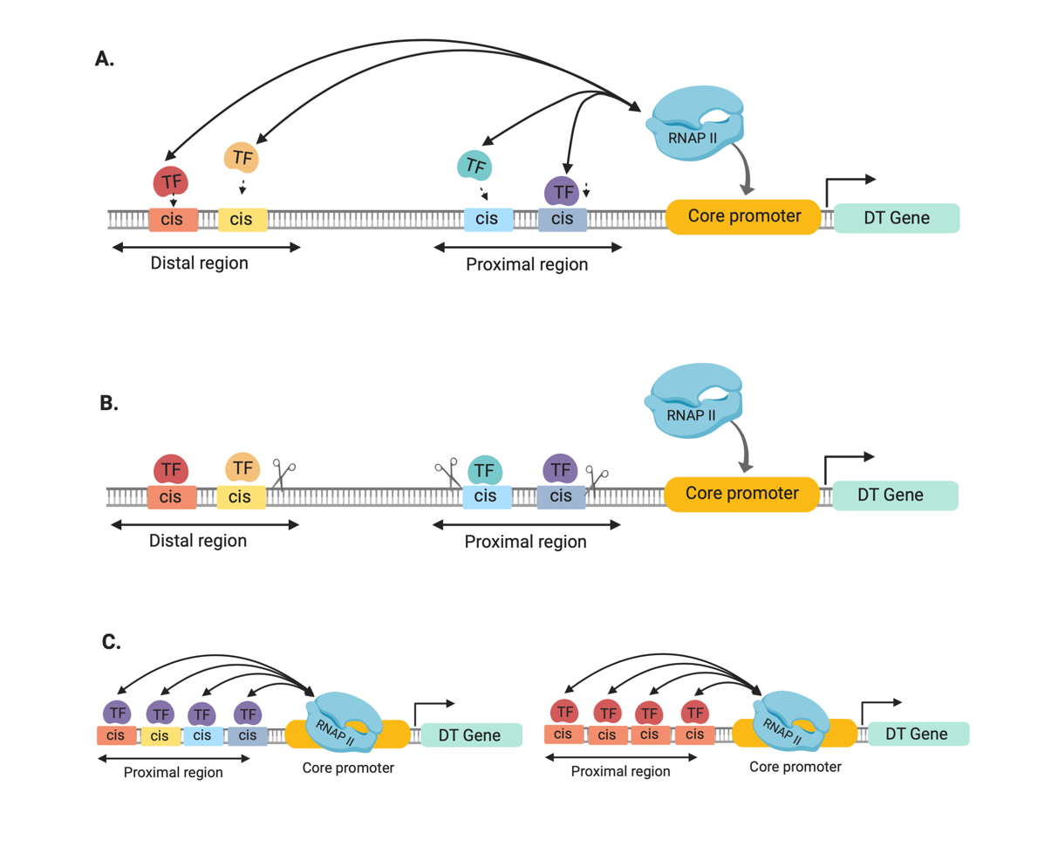
Figure 1 Schematic diagram comparing native and synthetic promoters. A. 500 bp to 2000 bp long native promoter. Complex expression profile determined by binding of different transcription factors (TF) in cis-elements in the proximal and distal region. B. Designing short synthetic promoters by removing the spaces between cis-elements in the proximal and distal region. C. Building synthetic promoters for binding of specific transcription factors. Several (left) or similar (right) cis-motifs were fused with a core promoter. DT gene = drought tolerant gene (Original figure created with BioRender.com)

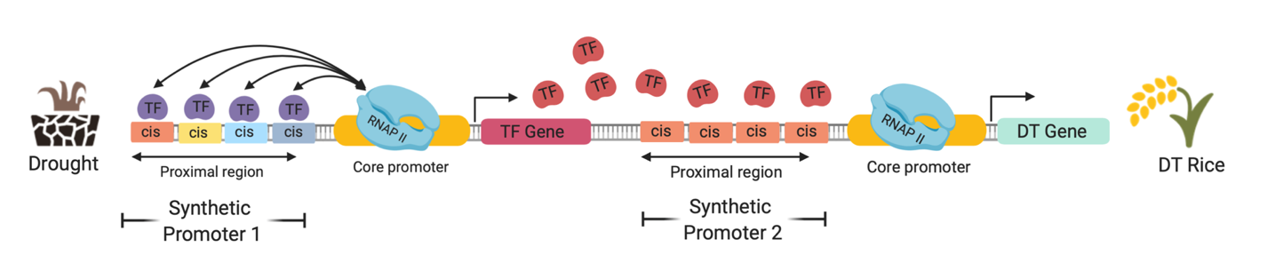
Figure 2 Stacking of multiple genes driven by different synthetic promoters to create drought-tolerant (DT) rice. In the onset of drought, specific TFs (indigo) bind to Synthetic Promoter 1 expressing a TF-coding gene. Subsequently, desired TFs (red) are produced and bind to Synthetic Promoter 2 expressing a drought-tolerant gene. (Original figure created with BioRender.com)

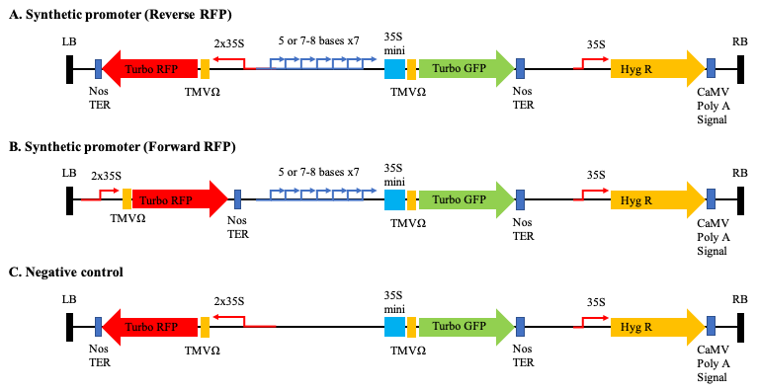

Figure 3 Synthetic promoter constructs. Binary vectors contained a series synthetic promoters (SD-series) fused to GFP. The core promoter sequence for synthetic promoters was the -46 35S promoter with the TMV Ω 5’ UTR leader sequence for transcriptional initiation. Vectors also contained a reverse (A) or forward (B) 35S::RFP reporter cassette that served as an internal positive control. The constructs harboring the forward 35S::RFP reporter cassette were labeled FRFP (SD9-1 FRFP, SD9-2 FRFP, SD9-3 FRFP). The synthetic cis-regulatory elements were composed of either 5, 7 or 8 base pairs (SD and SS motifs) repeated 7 times. The negative construct does not contain any cis-regulatory element. (Yang et al., 2020; submitted).

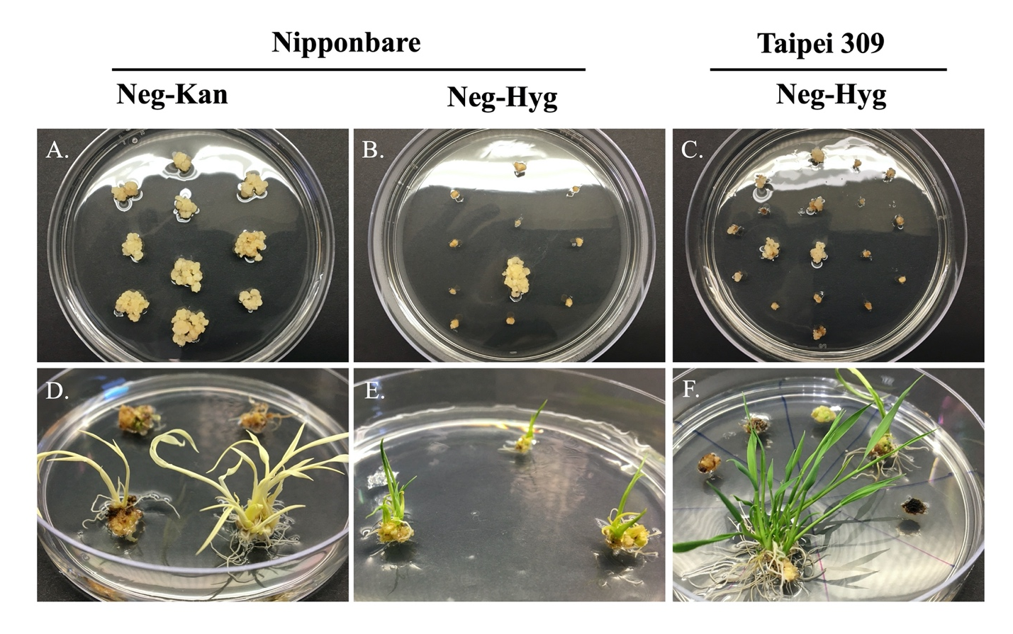
Figure 4 Agrobacterium-mediated transformation of rice calli. Calli growth after 30 days in Kanamycin (A) and Hygromycin (B-C) selection medium; regenerated shoots after 26-30 days in regeneration medium (D-F). Selection medium supplemented with Kan⁵⁰ + Tim¹⁵⁰ or Hyg³⁵ + Tim¹⁵⁰. Regeneration medium supplemented with NAA (0.02mg/L) + Kinetin (2mg/L) and appropriate antibiotic (Kan or Hyg).

Figure 5 Fluorescence inducing laser projector images of transgenic rice. Laser power for both the 465 and 525 nm lasers were 1.4W and images were acquired using a camera exposure time of 300 ms from a distance of 3 meters. Scale bars represent 5 cm. The same WT was used for all images and is denoted in the merged image using a white asterisk.

GFP
465 ex. & 525/50 em.
RFP
525 ex. & 575/40 em.
Merged
SD 9-3
Neg
SD 18-1
SD 9-2
*
*
*
*

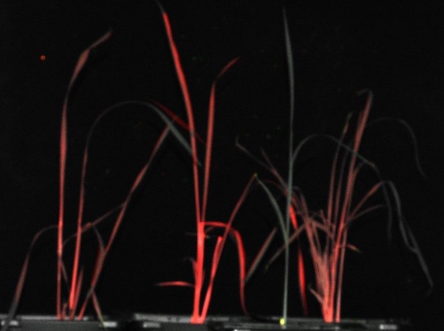


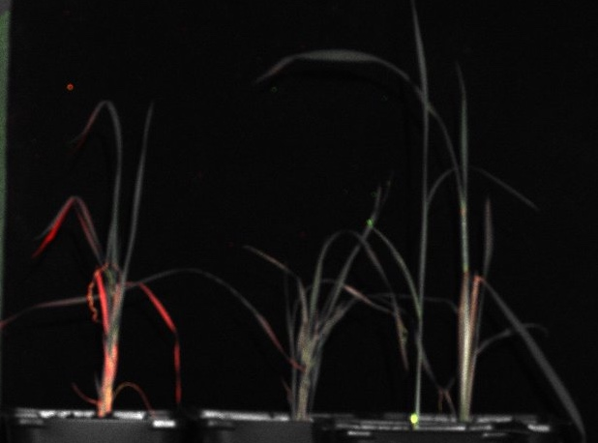
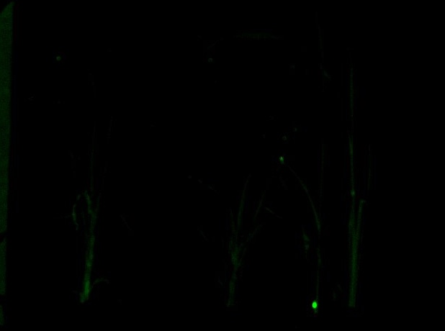

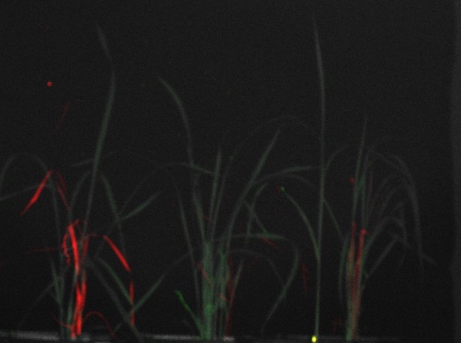


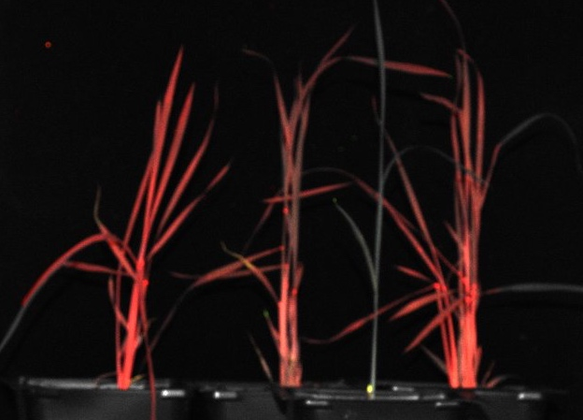
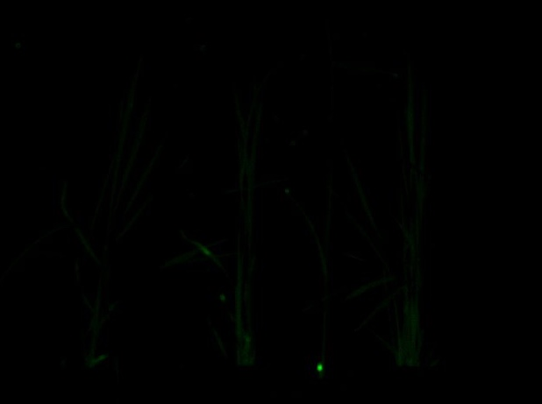
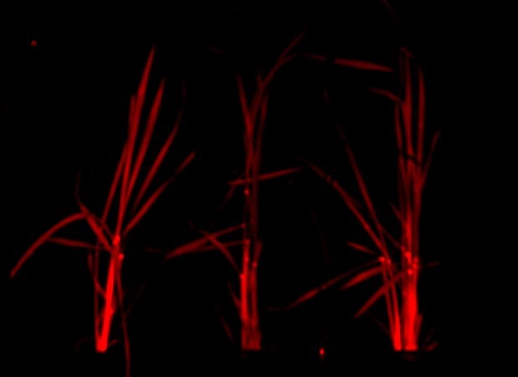
*
*
*
*
GFP
465 ex. & 525/50 em.
RFP
525 ex. & 575/40 em.
Merged
SS 16-1
SS 16-2
SS 16-3
SD 9-1 F

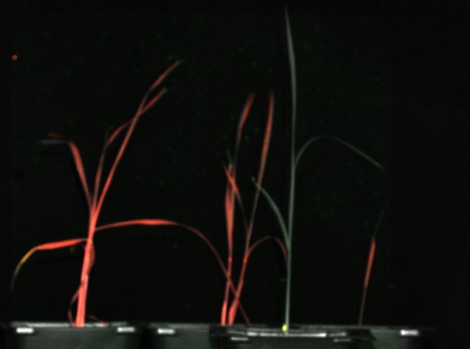


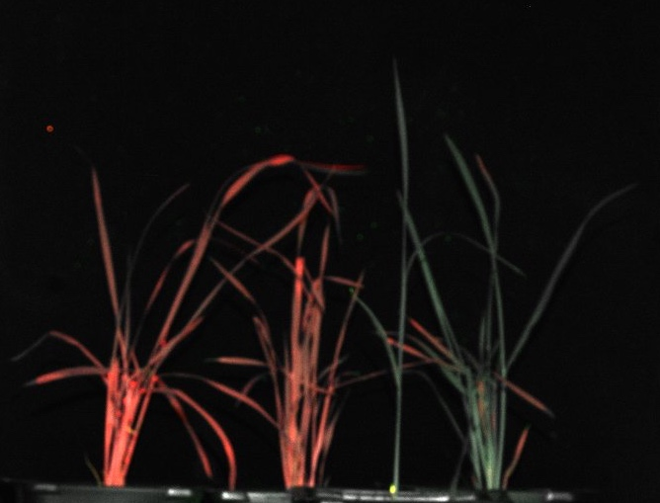


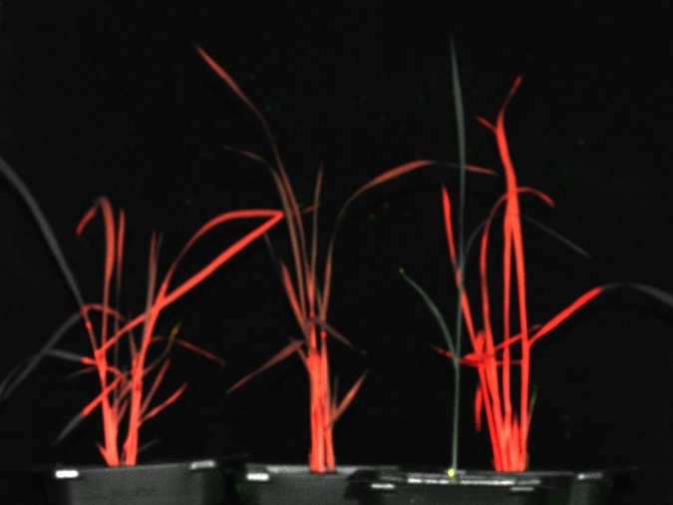


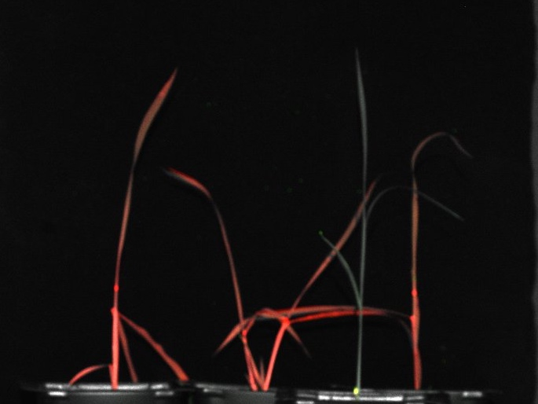


GFP
465 ex. & 525/50 em.
RFP
525 ex. & 575/40 em.
Merged
*
*
*
*
SD 9-2 F
SD 9-3 F
SD 13-1
SD 18-3

Figure 6 Confirmation of transgenes in transgenic rice by genomic PCR analysis. Genomic DNA was isolated from wild-type (WT) and putative transgenic rice plants. Genomic DNA sample was used for PCR in the presence of gfp, and OsUbi1 (Nipponbare) or OsAct1 (Taipei 309) specific primers. M marker; - blank; WT wild type; P positive control (Pest#12 plasmid).

Vita

Paolo M. Tagaloguin was born on December 3, 1993. He earned his Bachelor’s degree in Mindanao State University, General Santos City, Philippines. He spent five years in the same university as an instructor in Biology before coming to the US for studying a Master’s degree in Plant Sciences at the Stewart Laboratory.

