Signatures of genomic nucleotide metabolism and diel
partitioning in an algal virocell

A Dissertation Presented for the
Doctor of Philosophy
Degree
The University of Tennessee, Knoxville

Alexander Roy Truchon
December 202
Abstract
Viruses in marine systems are often a contributor to mortality and the reintroduction of particulate and dissolved organic matter into the microbial loop via the viral shunt. Viral activity can contribute on an ecological scale that is felt beyond the life histories of individual cells, as population-wide viral infection has frequently been associated with the collapse of harmful algal blooms. These collapses can have ecosystem-wide effects, though frequently the physiological and intracellular mechanisms driving full populations to collapse are not completely understood. The harmful algal bloom causing Aureococcus anophagefferens is a eukaryote that can detrimentally affect ecosystems through both light attenuation and the production of a hypothesized shellfish toxin. At the peak of bloom activity, it has been shown that many (~37%) cells are visibly infected with an icosahedral virus, now isolated and known as Kratosvirus quantuckense, or AaV. This work has continued the characterization of AaV in the context of infection in A. anophagefferens primarily through a focus on the virocell (i.e. infected host cell) and the metabolic shifts that occur during infection. To examine infection in the context of a diel cycle that may be observed in situ, frequent physiological measurements were taken throughout the growth cycle of infected and uninfected A. anophagefferens over the course of a day. It was noted that A. anophagefferens swells in size through carbon fixation and reduces in size after dividing overnight. Likewise, it was noted that AaV infected cells continue to increase in size throughout the light cycle, but do not shrink again. Further evidence of viral interference in transcription of cell cycle genes was identified. To characterize the epigenetic modification on AaV and what function it may play in infection, the AaV genome was sequenced using Nanopore technology to establish a viral methylome. Nine unique motifs were identified as being targeted for methylation and certain motifs do not overlap in specific regions throughout the genome. To understand the shift in GC-usage between A. anophagefferens and AaV, open reading frames were analyzed for codon biases. Here it was found that AaV utilized a similar codon bias to that which was found in host organelle genes, whereas the major capsid protein exhibited similarities to chromosomal A. anophagefferens genes. Likewise, inhibition of deaminase activity with zebularine revealed a connection between deaminase activity and proper production of viral particles. Overall, this work has provided entry to novel avenues in research surrounding the metabolism of the AaV virocell.

Table of Contents
Chapter One: A history of Aureococcus anophagefferens and its virus 1
Publication note and author contributions 2
Publication note 2
Author contributions 2
Introduction 3
Aureococcus anophagefferens as an agent of harmful algal blooms 4
An ecologically relevant alga 4
Aureococcus anophagefferens is robust and persistent 6
Kratosvirus quantuckense (AaV): History and novelty 7
A virus infecting Aureococcus anophagefferens 7
Kratosvirus quantuckense represents a clade of understudied algal viruses 9
The “Little Giant”: structural analysis and cryptic entry 11
Evidence of viral genomic streamlining and adaptation 12
Kratosvirus quantuckense encodes a dense genetic repertoire 14
The viral transcriptome and proteome signify robust host takeover capabilities 16
Kratosvirus quantuckense infection drives morphological shifts in the virocell 19
Abiotic factors shape infection dynamics 21
Kratosvirus quantuckense on a global scale: An active contributor 23
Mechanisms of resistance to infection on a pangenome scale: a knowledge gap 24
Conclusion 26
Characteristics of DNA methylation across organisms 27
Multicellular Eukaryotes 28
Single-Celled Eukaryotes 30
Prokaryotes 30
Viruses 31
Works in this dissertation 33
Appendix 35
Chapter Two: The diel disconnect between cell growth and division in Aureococcus is interrupted by giant virus infection 44
Publication note and author contributions 45
Publication note 45
Author contributions 45
Abstract 46
Introduction 47
Methods 49
Culture conditions 49
Cell diameter estimates 49
Infection with Kratosvirus quantuckense 50
Transcriptome analyses of A. anophagefferens infection by AaV 51
Determining vertical transport rates 52
Statistical Analyses 52
Results 53
Diel partitioning of cellular growth and division 53
Infected cells increase in diameter while division is inhibited 54
Separate cell cycle transcriptomic activity between day and night 55
DNA damage and p53-associated genes respond to AaV infection 56
Infection alters host cell sinking rate 57
Discussion 58
Growth of A. anophagefferens is constrained by the diel cycle 58
Virocells display arrested division phenotypes, but respond to light 59
A. anophagefferens’ cell cycle is transcriptionally constrained to diel effects 60
AaV infection drives transcriptional shifts in cell cycle regulation 62
Export from the water column is enhanced by viral infection 64
Considerations for environmental sampling and diel cycles 64
Conclusions 65
Acknowledgements 66
Appendix 67
Chapter Three: Epigenome analysis of an algae-infecting giant virus reveals a unique methylation motif catalogue 94
Publication note and author contributions 95
Publication note 95
Author contributions 95
Abstract 96
Introduction 97
Methods 99
Culture conditions 99
Preparation of viral particles for DNA extraction 99
DNA extraction and sequencing 100
Whole genome resequencing 100
Methylation calling and initial analysis 101
Methylation targeted motif identification and characterization 102
Phylogenetic analysis of viral methyltransferases 102
Restriction enzyme digestion 103
Results 103
Whole genome resequencing yields a single circular AaV genome 103
Methyltransferases and methylated adenines in AaV 104
Nucleotide bias surrounding adenines influences methylation 106
Several complex motifs identified display variable methylation levels 107
Phylogenetics of AaV methyltransferases show their potential origin 109
Genes cluster based on enrichment of specific motifs 111
Discussion 111
Detection of AaV methylation is highly repeatable 112
Targeted methylation is influenced by divergent nucleotide motifs 114
Motif distribution reveals importance of AaV methylation 115
Conclusions 116
Acknowledgements 118
Appendix 119
Chapter Four: Viral-derived strategies for nucleotide salvaging in the face of a GC-content and codon usage disparity 150
Abstract 151
Introduction 152
Methods 154
Culture conditions, zebularine incubations, and AaV infections 154
Principal component analysis of relative synonymous codon usage 155
Neutrality, effective number of codon, and parity rule 2 plots 155
Phylogenetic analysis 156
Calculation of transcript GC-content 157
Results 157
AaV GC-content and codon biases strongly differ from those of its host 157
Codon usage bias in individual genes reveals overlaps between virus and host 159
Cytidine deaminase-like genes are common in viruses with GC-content disparities 161
Inhibition of deaminase activity can limit the production of viral particles 162
Discussion 163
Codon usage biases exacerbate the known GC-disparity 163
Amino acids and tRNAs are effected by codon usage biases 164
AaV genes vary in codon bias compared to chromosomal genes but mirror organelles 165
Deaminases are found in distinct giant virus families 167
Potential of zebularine for inhibition of deaminases during infection 167
Conclusions 168
Acknowledgements 169
Appendix 170
Chapter Five: Conclusions 197
Conclusions 198
AaV takes over the algal diel cycle for maximum virion production 198
The relevance of the genome persists in a modern -omics-based world 199
Understanding the driving factors behind nucleotide usage disparity 200
Leveraging a previously generated infection transcriptome 201
Future Directions 202
List of References 204
Vita 237

List of Tables
Table 1.1. A curated table for methods involved in studying AaV and A. anophagefferens. 36
Table 1.2. Carbohydrate metabolism genes encoded by AaV and other Nucleocytoviricota. 37
Table 2.1. Average population growth rates and changes in cell diameter during the diel cycle. 69
Table 2.2. Average growth dynamics in the complete presence or absence of light. 70
Table 2.3. Growth dynamics of A. anophagefferens CCMP1984 when infected with AaV at differing MOIs. 71
Table 2.4. Gene set enrichments of cell cycle genes between differing diel time points. 72
Table 2.5. Counts of differentially expressed cell cycle genes between time points. 73
Table 2.6. Infected A. anophagefferens highly DE cell cycle-associated genes. 74
Table 2.7. Infected A. anophagefferens weakly DE cell cycle-associated genes. 75
Table 3.1. Sequencing statistics from the resequencing of the AaV genome 122
Table 3.2. A description of all methyltransferases encoded by AaV 122
Table 3.3. Methyltransferase and genome size statistics for each tested Nucleocytoviricota genome. 123
Table 3.4. Detection of methyltransferase targeted motifs across the AaV genome 124
Table 3.5. AaV genes that are positively or negatively enriched in each motif. 125
Table 4.1. Details regarding GC-content for various Nucleocytoviricota virus-host pairs. 171
Table 4.2. Codon usage table of AaV and the tRNAs it encodes. 172
Table 4.3. Codon usage table of A. anophagefferens along with the tRNAs encoded by AaV. 173
Table 4.4. Codon enrichment table for AaV. 174
Table 4.5. Codon enrichment table for A. anophagefferens. 175
Table 4.6. Correlation and regression statistics for neutrality plots. 176
Table 4.7. PR₂ plot statistics for sets of genes. 177

List of Figures
Figure 1.1. Metatranscriptomic reads mapped to A. anophagefferens and AaV detailing bloom peak and collapse. 39
Figure 1.2. A phylogenetic tree of the Imitervirales order which contains AaV. 40
Figure 1.3. Cryo-electron microscopy images of AaV viral particles. 41
Figure 1.4. AaV genomic map, GC-content and encoded tRNAs. 42
Figure 1.5. Electron microscopy images of infected and uninfected A. anophagefferens cells. 43
Figure 1.6. The many states of A. anophagefferens. 44
Figure 2.1. Correlation between violet side scatter and cell diameter. 78
Figure 2.2. A. anophagefferens CCMP1984 growth over three light-dark cycles. 79
Figure 2.3. A. anophagefferens CCMP1984 and CCMP1850 growth with frequent night measurements. 80
Figure 2.4. Changes in A. anophagefferens cell size under three light conditions. 81
Figure 2.5. A. anophagefferens growth under a free-running clock. 82
Figure 2.6. Infected and uninfected A. anophagefferens cultures during the light-dark cycle. 83
Figure 2.7. Effect of decreasing MOI on average cell diameter after infection. 84
Figure 2.8. Percent similarity between control and infected A. anophagefferens cultures. 85
Figure 2.9. A. anophagefferens cultures exposed to AaV over three light-dark cycles. 86
Figure 2.10. NMDS plot of uninfected A. anophagefferens transcriptomes. 87
Figure 2.11. Clustered heat map of DE cell cycle-associated genes in uninfected A. anophagefferens throughout a diel cycle. 88
Figure 2.12. Cell cycle genes differentially expressed between early day and early night in uninfected cultures. 89
Figure 2.13. Cell cycle genes differentially expressed between late day and late night in uninfected cultures. 90
Figure 2.14. TPM counts of differentially expressed cell cycle genes. 91
Figure 2.15. Clustered heat map showing all cell cycle genes that are differentially expressed between infected and control cultures. 92
Figure 2.16. Correlation between relative cell diameter and sinking velocity. 93
Figure 2.17. Sinking velocity of uninfected and infected A. anophagefferens cells. 94
Figure 2.18. A simplified p53/cell cycle checkpoint pathway based on differential transcription of A. anophagefferens genes during viral infection. 95
Figure 3.1. Genomic maps comparing the original and resequenced AaV genomes. 130
Figure 3.2. Methyltransferases encoded by various Nucleocytoviricota 131
Figure 3.3. Distribution of methylation frequency across all sites in the AaV genome. 132
Figure 3.4. Methylation frequency scores compared across sequencing libraries 133
Figure 3.5. Genomic maps of methylation frequency on all adenines and cytosines 134
Figure 3.7. Genomic areas which were enriched with high methylation frequencies. 135
Figure 3.6. Adenine methylation frequency and enrichment maps of AaV. 136
Figure 3.8. Methylation frequency averages relative to all AaV genes. 137
Figure 3.9. First noted time of expression and methylation frequencies in the upstream region of AaV genes. 138
Figure 3.10. Methylation frequencies of adenines and surrounding nucleotide pentamers. 139
Figure 3.11. Methylation frequencies of adenines that surround other methylated adenines. 140
Figure 3.12. Nucleotide proportion as a function of nearby adenine’s methylation frequency. 141
Figure 3.13. Methylation frequency grouped into motif and non-motif sites. 142
Figure 3.14. Whole genome amplification correction of motif methylation frequency. 143
Figure 3.15. Distribution of methylation score means and deviations for all identified motifs 144
Figure 3.16. Hemi-methylation patterns for all identified palindromic motifs. 145
Figure 3.17. Restriction enzyme digest of AaV, A. anophagefferens, and WGA AaV DNA. 146
Figure 3.18. Tandem restriction enzyme digest of AaV and amplified AaV DNA. 147
Figure 3.19. Protein phylogeny of Nucleocytoviricota type II methyltransferases. 148
Figure 3.20. Unrooted phylogeny of Nucleocytoviricota type II methyltransferases. 149
Figure 3.21. Expression of AaV methyltransferases throughout different stages of infection. 150
Figure 3.22. Gene clusters based on motifs that are enriched in their vicinity. 151
Figure 4.1. GC-content disparity between various Nucleocytoviricota and their hosts. 178
Figure 4.2. Gene and third codon position GC-content between A. anophagefferens and AaV. 179
Figure 4.3. Codon and amino acid bias across all genes for AaV and A. anophagefferens. 180
Figure 4.4. Amino acid frequencies in A. anophagefferens and AaV predicted proteins 181
Figure 4.5. Distribution of GC-content across tRNAs. 182
Figure 4.6. Principal component analysis plot of genes based on codon usage. 183
Figure 4.7. PCA plot of A. anophagefferens chromosomal genes, including complete and partial ORFs. 184
Figure 4.8. Hierarchical clustering of all codons across virus and host genomes. 185
Figure 4.9. Neutrality plots of AaV and A. anophagefferens. 186
Figure 4.10. Effective number of codon plots of AaV and A. anophagefferens. 187
Figure 4.11. PR₂ plots showing biases towards pyrimidines or purines 188
Figure 4.12. Gene set enrichment analysis on type II genes in A. anophagefferens. 189
Figure 4.13. Reconstructed cytidine deaminase protein phylogeny of the Nucleocytoviricota. 190
Figure 4.14. Unrooted protein phylogeny of Nucleocytoviricota cytidine deaminases. 191
Figure 4.15. GC-content of AaV transcriptomes over the course of infection. 192
Figure 4.16. Growth of A. anophagefferens when exposed to zebularine. 193
Figure 4.17. Growth of A. anophagefferens after exposure to zebularine with uracil. 194
Figure 4.18. Growth of infected A. anophagefferens when treated with 80 µM zebularine. 195
Figure 4.19. Infected A. anophagefferens cultures in the context of zebularine and nucleotide amendments. 196
Figure 4.20. Burst sizes of infected A. anophagefferens cultures after short-period exposure to zebularine. 197

Chapter One

A history of Aureococcus anophagefferens and its virus

Publication note and author contributions

Publication note
This chapter has been adapted from a publication in Frontiers in Microbiology and authored by Alexander R. Truchon, Emily E. Chase, Eric R. Gann, Mohammad Moniruzzaman, Brooke A. Creasey, Frank O. Alyward, Chuan Xiao, Christopher J. Gobler, and Steven W. Wilhelm. The citation for this work is:

Truchon AR, Chase EE, Gann ER, Moniruzzaman M, Creasey BA, Aylward FO, Xiao C, Gobler CJ, Wilhelm SW. Kratosvirus quantuckense: the history and novelty of an algal bloom disrupting virus and a model for giant virus research. Front Microbiol. 2023 Nov 30;14:1284617. doi: 10.3389/fmicb.2023.1284617.

Author contributions
Alexander R. Truchon provided the transmission electron microscopy imagery. Eric R. Gann and River Xiao generated the cryogenic electron microscopy imagery. Frank O. Aylward provided the phylogenetic trees. Christopher J. Gobler provided images of in situ bloom events. This chapter was written by Alexander R. Truchon, Emily E. Chase, and Steven W. Wilhelm, with all authors providing comments on initial and revised drafts.

Introduction
Viruses are among the most abundant entities on the planet, and are particularly bountiful in marine systems in which there can be up to ~10⁸ viruses in a single milliliter of water (Suttle, 2005) while only composing a small fraction of total biomass (Suttle, 2007). As a result, a predicted 20% of marine biomass is lysed every day, which allows for the shunting of large amounts of dissolved and particulate organic matter towards lower trophic levels (Wilhelm and Suttle, 1999; Suttle, 2007). Thus, viruses act as a significant factor in biogeochemical cycling not only in coastal ecosystems but also in the open ocean (Muratore et al., 2025) and cold polar regions (Gilbert Naomi et al., 2023). While a large proportion of marine viruses are known to be bacteriophages (Proctor and Fuhrman, 1990), eukaryotic viruses have become a focal point of study in recent years.
Eukaryotic phytoplankton are also important contributors to nutrient cycling in marine systems (Olsen, 1989; Bratbak et al., 1993; Gobler et al., 1997). In global oceans, a diverse consortium of eukaryotic algae drives biogeochemical processes through photosynthetic sequestration of CO₂ (Worden et al., 2012; Pierella Karlusich et al., 2020). In some contexts, these single-celled organisms can grow to densities an order of magnitude or more beyond baseline biomass levels and act as a carbon sink as well as a reservoir or source of other organic nutrients (Proctor and Fuhrman, 1991; Fagerbakke et al., 1996). These dense populations (colloquially known as “blooms”) eventually collapse, leading to the reintroduction of dissolved and particulate organic matter into the water column (Gobler et al., 1997; Fuhrman, 1999). Of specific interest in aquatic ecosystems are phytoplankton proliferations that are detrimental to ecosystems. This can occur through processes including consumption of nutrients, production of secondary metabolites that can act as toxins that impact other organisms (Tarutani et al., 2001; Steffen et al., 2017; Martin et al., 2020), attenuation of light (Gobler and Sunda, 2012), or a combination of these effects (Landsberg, 2002), colloquially known as harmful algal blooms (HABs). Bloom collapse and subsequent consumption of released organic bloom matter by heterotrophic bacteria can lead to the generation of hypoxic zones that negatively impact macrofauna (Watson et al., 2016; Anderson et al., 2021). In multiple cases, bloom demise has been attributed to widespread viral infection in both HAB and non-HAB contexts (Schroeder et al., 2002; Brussaard et al., 2004; Maruyama and Ueki, 2016).
Understanding the drivers of algal bloom dynamics is a path toward mitigating their damage. While there is an abundance of single-celled eukaryotes in the ocean, few have been infected with viruses in culture (Coy et al., 2018). An emerging model organism for the study of bloom demise via viral infection is Aureococcus anophagefferens, a unicellular pelagophyte that is a causative agent of brown tides endemic to bays in the eastern United States, China, and South Africa (Sieburth et al., 1988; Probyn et al., 2001; Zhang et al., 2012). Brown tides typically form in the late spring and reach peak density in early summer, before crashing mid-summer after which the microbial population of the water column is overtaken by heterotrophic bacteria (Gobler et al., 2011). A. anophagefferens is the host to a large DNA virus originally named Aureococcus anophagefferens Virus (AaV) (Rowe et al., 2008b), and now classified into the species Kratosvirus quantuckense (Aylward et al., 2022). Evidence suggests that this virus is at least partially responsible for the collapse of annual HABs formed by A. anophagefferens (Gastrich et al., 2004a; Gann et al., 2021).
Since the isolation of K. quantuckense, a combination of in vitro, in situ, and in silico analyses have been performed to elucidate the role it plays in modulating HAB dynamics. Significant progress has been made to improve assays used to characterize infection of A. anophagefferens and virus propagation (Table 1.1). Below, we review known observations of this novel host-virus system and place their importance in context to further our understanding of HAB-virus interactions. We propose the A. anophagefferens – K. quantuckense culture-based approach as a valid model system for further research into HAB dynamics as well as the ecology of underrepresented clades of the Nucleocytoviricota.

Aureococcus anophagefferens as an agent of harmful algal blooms

An ecologically relevant alga
For our purposes, an algal bloom can be defined as a rapid proliferation of one or more dominant species of phytoplankton in excess of the mortality normally caused by natural processes (both biotically and abiotically) (Buskey et al., 1997); (Schleyer and Vardi, 2020). Blooms generally follow an “initiation, exponential growth, and termination” pattern (Schleyer and Vardi, 2020), as well as occasional maintenance stages of steady photosynthetic activity before eventual collapse (Weisberg et al., 2016; Tang et al., 2018; Zepernick et al., 2021) (Figure 1.1A). A. anophagefferens blooms have been documented annually in the northeastern United States since the 1980s, particularly around Long Island, NY, and is frequently detected in other coastal waters of the country (Sieburth et al., 1988; Gobler and Sunda, 2012). It has been proposed that a 1985 bloom in Barnegat Bay (New Jersey) was previously misidentified as Nannochloris atomus and was A. anophagefferens (Anderson et al., 1989; Olsen, 1989; Anderson et al., 1993; Gobler et al., 2005). Since then, this pelagophyte has been documented annually in Maryland, Virginia, and New Jersey (starting in 1995) (Gastrich et al., 2004a; Gobler et al., 2005). More broadly, it has been confirmed that A. anophagefferens persists in the United States coastally from Florida to Maine (Anderson et al., 1993; Popels et al., 2003). While its presence is generally not at bloom levels and they are instead found at “background concentrations,” under the right conditions these seed populations may produce future blooms (Popels et al., 2003). We note that another pelagophyte, Aureoumbra lagunensis DeYoe et Stockwell, can form blooms throughout the coastline of the Gulf of Mexico (DeYoe et al., 1997; Gobler and Sunda, 2012; Anderson et al., 2021) and as far as the east coast of Florida which are also colloquially referred to as brown tide events (Morris et al., 2018; Lopez et al., 2021): herein “brown tide” will solely reference A. anophagefferens.
Blooms have also been documented outside the USA, including Saldanha Bay, South Africa ca. 1997 (Pitcher and Calder, 2000; Probyn et al., 2001; Gobler et al., 2005), and coastal waters of China ca. 2009 (Kong et al., 2012; Zhang et al., 2012; Chen et al., 2019). Due to the later appearance of bloom events in Saldanha Bay and the Bohai Sea it was thought that A. anophagefferens may have travelled by ballast water contained in ships (Doblin et al., 2004). This was made more plausible by the discovery of a dormant (resting) cell stage (Ma et al., 2020). However, this hypothesis has been complicated by sediment core analyses that provide evidence of a historical presence of A. anophagefferens in China’s Bohai Sea of over 1,500 years, and subsequently a confirmation of global distribution similar to other pelagophytes (Tang et al., 2019; Choi et al., 2020). Thus, global initiation of brown tides may be a result of local background populations blooming due to extenuating circumstances rather than being seeded by an foreign source.
Brown tide bloom events are designated HABs due to their negative impacts on local ecological communities, including macrofauna and macroflora. Die-offs in the eelgrass Zostera marina have been linked to light attenuation by these HABs (Figure 1.1C) (Cosper et al., 1987; Dennison et al., 1989). Eelgrass beds are majors nurseries and shelters for marine fish and invertebrates, making their demise ecologically devastating (Bricelj and Lonsdale, 1997b). Brown tides are detrimental to bivalve species including clams, oysters, mussels, and scallops (Mercenaria mercenaria, Mytilus edulis, Argopecten irradians (Gastrich and Wazniak, 2002; Gobler and Sunda, 2012)). While the loss of habitat may be significant in the killing of bivalves, inhibition of bivalve feeding by certain A. anophagefferens strains implies the presence of a yet unidentified algal toxin (Robbins et al., 2010). Brown tides are economically damaging: an early estimate of annual economic loss in Long Island, New York brown tides based on declines in scallop populations was $3M USD (Kahn and Rochel, 1988), a value that compounded over three decades of presumed annual brown tides would now exceed $100M USD. Outside of the effects on macrofauna and macroflora, an intricate web of interactions occur among A. anophagefferens and other microbial organisms (Frazier et al., 2007), including viruses (Sieburth et al., 1988) (Figure 1.1B).

Aureococcus anophagefferens is robust and persistent
Described as a picoplankton with spherical cells of 1.5–2 μm in size with a “golden” color (Sieburth et al., 1988), subsequent observations place these cells at 2–3 μm in a vegetative state (Bricelj and Lonsdale, 1997b; Ma et al., 2020). A. anophagefferens cells possess a single nucleus, chloroplast, and mitochondria, as well as an exopolysaccharide layer (glycocalyx), of which little of the molecular content is understood (Sieburth et al., 1988). Resting stage cells, or “dormant” cells, generated by growth at 4° C in the absence of light have notable physiological differences compared to their vegetative counterparts and are larger (4–6 μm) in size (Tang et al., 2019; Ma et al., 2020). These resting stage cells are capable of “germination” (returning to normal growth conditions) 10 days after re-entry to 21° C and fresh medium (Ma et al., 2020). Previous work has shown that vegetative A. anophagefferens can be stored for at least two weeks in the dark before a return and acclimation to increased temperature and light availability (Doblin et al., 2004; Popels et al., 2007).
Assimilation of carbon and nitrogen are an important component of the A. anophagefferens relationship with their environment – especially in the context of a bloom initiation and termination. Of specific note, blooms can occur at points when dissolved organic nitrogen levels are high (Laroche et al., 1997) and when inorganic nutrients are low (Keller and Rice, 1989), as summarized by (Gobler et al., 2002). Utilization of many forms of organic nitrogen has been verified in culture (Berg et al., 2002; Gann et al., 2022) and transporters specific for nucleosides, oligopeptides, and purines in the algal genome suggest the capability of diverse nitrogen species assimilation when inorganic nitrogen is depleted (Gobler et al., 2011). Additionally, dissolved organic carbon consumption may also be important during the growth stage of a bloom (Gobler et al., 2002; Gobler et al., 2004). Evidence of heterotrophy in A. anophagefferens via glucose uptake has been demonstrated in culture (Dzurica et al., 1989; Berg et al., 1997a; Lomas et al., 2001). Heterotrophy (making A. anophagefferens a mixotroph) likely permits continued growth or population maintenance during a bloom where a species exhibiting exclusively photoautotrophy may not persist. Specifically, light attenuation, and consequently the inability for an A. anophagefferens population to meet their requirement for photosynthetic carbon would be counteracted by heterotrophic assimilation (Berg et al. 1997). Other marine algae have also been noted to employ mixotrophy to feed on nitrogen or phosphorus-rich organic matter as a means obtaining macronutrients (Jeong, 2011; Koppelle et al., 2022), strategies that may also be important for A. anophagefferens.
Trace elements have also been tied to successful propagation of A. anophagefferens. Of particular importance is selenium, an element required for biosynthesis of the 21st amino acid selenocysteine, which in turn has been identified in 59 proteins encoded by A. anophagefferens (Gobler et al., 2011). Increasing selenium concentrations as high as 0.01 nM in culture with A. anophagefferens was correlated with increased growth rate and in situ dissolved selenium concentration was found to be highest prior to brown tide bloom initiation and lowest during bloom termination (Gobler et al., 2013). Similar to many other HAB-forming species, A. anophagefferens is an auxotroph for vitamin B₁₂ and biotin (Tang et al., 2010). Likewise, vitamins B₁₂ and B₁ depleted populations of A. anophagefferens exhibited increased growth when introduced to vitamin replete conditions, signifying a dependence on external sources of these vitamins (Koch et al., 2013).

Kratosvirus quantuckense (AaV): History and novelty

A virus infecting Aureococcus anophagefferens
While a virus infecting A. anophagefferens was not isolated until the late 1990s, virus-like particles within this brown tide system had been previously noted in detail (Sieburth et al., 1988). During the initial characterization of A. anophagefferens in 1985 via transmission electron microscopy (TEM), infection by large icosahedral viruses was observed in vivo, both before and after the dissolution of most cellular organelles (Sieburth et al., 1988). It was shown that a population of lytic viruses of A. anophagefferens were present in brown tide blooms, as lysing A. anophagefferens cells were observed expelling viral particles (Sieburth et al., 1988). Infected A. anophagefferens was also observed in the food vacuole of phagotrophic grazers (Sieburth et al., 1988).
TEM studies of bloom samples between 1999 – 2002 revealed icosahedral viral-like particles in A. anophagefferens cells in coastal New York and New Jersey as early as April and as late as September (Gastrich et al., 2004a). The proportion of virally infected cells was shown to vary. Between May and June (the bloom’s peak in cell density), TEM imaging revealed less than 10% of cells were infected at any given time, while in July and onwards 20-38% of A. anophagefferens were infected (Gastrich et al., 2004a). By the last sampling date in September when the bloom had decreased in cell density by over 30-fold, 21.4% of cells contained viral particles (Gastrich et al., 2004). This approach with natural populations of A. anophagefferens was the initial driver used to suggest that viral infections were a major factor in collapse of brown tide blooms (Gastrich et al., 2004a).
Although infection within natural populations had been visualized, isolation of a virus proved difficult. Originally, a concentrated viral fraction vis a vis (Suttle et al., 1991) of brown tide seawater was used to lyse lab-grown cultures of A. anophagefferens (Milligan and Cosper, 1994). Electron microscopy of this lysate revealed numerous tailed viral particles resembling bacteriophages (Milligan and Cosper, 1994). Capsids were approximately 60 nm in diameter, and multiple viral particles were shown associated with A. anophagefferens at any given time, yet no images of tailed viral particles were found within the cell (Milligan and Cosper, 1994). Further analyses were performed using these isolates to study the life cycle of the virus, which appeared to confirm the ability of a phage-like particle to infect and lyse the eukaryotic host (Garry et al., 1998; Gastrich et al., 1998). However, the presence of heterotrophic bacteria in A. anophagefferens cultures (Frazier et al., 2007) and significant morphological discrepancies between the free “phage” and viruses particles seen inside infected cells (Gastrich et al. 2004) cast doubt on this claim. Subsequently it has been suggested that the collapse of host populations from environmental samples were a result of bacteria-induced lysis, as several algolytic bacteria were isolated from bloom water (Frazier et al., 2007). The identification of phage-like particles was instead proposed as an artifact of increased bacteriophage activity due to expanding heterotrophic bacterial populations feeding on organic carbon from dead A. anophagefferens cells (Frazier et al., 2007; Gobler et al., 2007).
It was not until 2002 that the virus now known as K. quantuckense was isolated from Quantuck Bay, NY, with scanning electron microscopy (SEM) and TEM imaging used to confirm large viral particles were attaching to algal cells and viral particles were produced internally (Rowe et al., 2008b). This isolated virus was similar to those seen in cells from brown tide blooms, lacking the tail-like structure described in Milligan and Cosper, 1994, and was confirmed to be a lytic agent of A. anophagefferens after successive isolations and infections (Rowe et al., 2008b). The newly isolated virus was screened for infectivity on a litany of algal species and was found to lyse 8 out of 19 A. anophagefferens strains tested and unable to lyse phylogenetically distinct species (Gobler et al., 2007). After numerous attempts to characterize the viruses using PCR-based molecular tools designed for algal viruses (of the order Algavirales) (Rowe et al., 2008b), the genome of K. quantuckense was sequenced in 2014 (and re-sequenced in 2022) to better resolve functional capabilities of the virus by defining the genetic potential (Moniruzzaman et al., 2014; Truchon et al., 2022a).

Kratosvirus quantuckense represents a clade of understudied algal viruses
Following DNA sequencing, K. quantuckense was found to phylogenetically fit into the phylum Nucleocytoviricota (Moniruzzaman et al., 2014). These viruses are notable for their size and are associated primarily with infection of eukaryotic organisms, ranging from Amoebozoa to humans (Wilhelm et al., 2017). At the time of sequencing, only a handful of viruses collectively known as “giants” were available for study. Since then, the known diversity of Nucleocytoviricota has been expanded by metagenome-assembled genomes (MAGs) generated from diverse environments, including aquatic, terrestrial, permafrost, and arthropod-associated derived datasets, especially those closely related to K. quantuckense (Moniruzzaman et al., 2020; Schulz et al., 2020). These studies have revealed a wealth of diversity existing among phylogenetically similar viruses, although for most host information is lacking (Needham et al., 2019). Phylogenomic structuring of the Nucleocytoviricota taxonomy using the information provided from MAGs has helped to resolve discrete lineages of viruses previously undefined due to limited viral and host isolation (Aylward et al., 2021). Through concatenation of several core genes a novel phylogeny of the Imitervirales, a monophyletic order consisting of all Mimiviridae and “extended Mimiviridae” (Aylward et al., 2021), was constructed including MAG representatives from publicly available metagenomes (Figure 1.2).
Phylogenetically, K. quantuckense groups with other large double stranded DNA viruses of eukaryotic algae (both in single gene phylogenetic reconstruction and concatenated protein phylogenies, including DNA polymerase B (polB) and the major capsid protein (MCP)), most of which have phototrophic hosts (Figure 1.2) (Coy et al., 2018; Stough et al., 2019b). K. quantuckense is most closely related to Prymnesium kappa Virus (PkV; Biavirus raunefjordenense) among all presently isolated viruses (Figure 1.2) (Johannessen et al., 2015). Also closely related are Tetraselmis virus 1 (Oceanusvirus kaneohense), Pyramimonas orientalis Virus (Heliosvirus raunefjordenense), and the proposed Mesomimiviridae clade which includes the Organic Lake phycodnaviruses (Sandaa et al., 2001; Yau et al., 2011; Schvarcz and Steward, 2018). With the inclusion of viral MAGs, K. quantuckense groups into the recently demarcated family Schizomimiviridae, where PkV represents the only other cultured representative. This increase in diversity across closely related viruses highlights that isolated viruses only represent a small proportion of all environmental algal viruses.
Of the virus isolates which neighbor K. quantuckense (Figure 1.2), the only one which does not infect a phototroph is a putative choanoflagellate infecting virus, Mimiviridae sp. ChoanoV1, identified through single-cell metagenomics (Needham et al., 2019). This alga centric clade of giant viruses shares many common core genes including two DNA-directed RNA polymerase 2 subunits (Rpb2) in each genome (Blanc-Mathieu et al., 2021). Although originally attributed to the Mesomimiviridae alone, resequencing of the K. quantuckense genome revealed a second Rpb2 gene that had previously not been detected (Truchon et al., 2022a). These divergent subunits are likely the result of an ancient gene duplication event in a common ancestor (Blanc-Mathieu et al., 2021). Other Nucleocytoviricota outside of this monophyletic clade are known to share this trait: Cafeteria roenbergensis Virus (CroV; Rheavirus sinusmexicani) also has two copies of this gene, though these have a much higher amino acid identity (>99%), pointing to a more recent duplication event (Fischer et al., 2010). While DNA-directed RNA polymerases are a conserved genotype among Nucleocytoviricota (Sharma et al., 2014), the presence of divergent Rpb2 subunits in these clades may be a defining characteristic of viruses of phototrophic algae. This host-virus system presents a unique opportunity to explore the role of these duplicated genes during infection and to infer conserved characteristics among viruses of other bloom-forming algae.

The “Little Giant”: structural analysis and cryptic entry
Although taxonomically it is a “giant virus”, K. quantuckense has an icosahedral capsid that is approximately 190 nm (Figure 1.3A; adapted from Gann et al., 2020c), smaller than the capsids of amoebal Nucleocytoviricota (Rowe et al., 2008b; Legendre et al., 2018) although the same size as Paramecium bursaria Chlorella virus (PBCV-1) which infects the green algae Chlorella variabilis (Shao et al., 2022). The capsid is mainly composed of a single MCP trimerizing into a pseudohexagonal capsomer covering most of the capsid surface (Gann et al., 2020c). Pentameric capsomers are located at the vertices of the capsid, though it is unclear which protein(s) form these structures (Gann et al., 2020c) (Figure 1.3B-C). A capsid composed of multiple minor capsid protein subunits alongside the MCP has been described previously (Xiao et al., 2017). The capsid has a triangulation number, or T number, of 169, with h and k values of 7 and 8 respectively (Gann et al., 2020c). Like other Nucleocytoviricota, the MCP has a “double-jelly roll” structure, which is very common in icosahedral viruses (Krupovic and Koonin, 2017). However, unlike some other Nucleocytoviricota, K. quantuckense lacks additional structures extending from the viral capsid (La Scola et al., 2003a; Cherrier et al., 2009; Abrahao et al., 2018; Gann et al., 2020c)). Additional structures are commonly associated with attaching and eventual entry into the host cell, leaving no such evidence in the case of K. quantuckense (Cherrier et al., 2009; Milrot et al., 2017). Without obvious additional surface structures, this necessitates further structural analyses of the viral capsid to identify additional binding mechanisms outside the protein layer.
Similar to other Nucleocytoviricota, there is evidence to suggest K. quantuckense possesses an internal membrane (Gann et al., 2020c). This is likely involved in fusion between the host cell and the viral cell upon infection. During infection of Chlorella variabilis NC64A by PBCV-1, the spike protein initiates contact with the host cell (Cherrier et al., 2009), before the viral membrane fuses with the host membrane and DNA is injected into the cell (Milrot et al., 2017). It is possible that a similar method of infection occurs between K. quantuckense and A. anophagefferens, in which membrane fusion facilitates the entry of viral DNA into the host. This was implied through early SEM imaging (Rowe et al., 2008b). In other cases, such as that of APMV where the entire viral particle is taken up into the cell, the internal membrane fuses with a phagosome after the opening of the viruses’ “stargate” portal, a specific vertex on the viral capsid that can undergo a conformational change (Zauberman et al., 2008; Xiao et al., 2009). Like APMV in this case, K. quantuckense possesses a pocket beneath vertices of the particle, showing that the internal membrane is not evenly spaced beneath the capsid (Gann et al., 2020c). It is possible that packaged proteins within the particle, of which K. quantuckense has 43, are present in these pockets and may be involved in the initiation of infection, as they will be the first proteins to interact with the host (Gann et al., 2020c). But while cryo-electron microscopy has revealed unique vertices in certain Mimiviruses (Xiao et al., 2005; Xiao et al., 2017), no such portal structure is yet identified on the K. quantuckense capsid (Gann et al., 2020c), thus leaving a missing piece in our understanding of infection in this host-virus system. Still, key similarities with other Nucleocytoviricota despite its own unique characteristics make this virus an interesting focal point for studying algal virus infection initiation.

Evidence of viral genomic streamlining and adaptation
The genome of K. quantuckense has been analyzed to determine coding potential of the virus (Figure 1.4A). The first assembly of the K. quantuckense genome generated from Illumina short reads, was 371 kbp with 376 coding regions and eight tRNAs (Moniruzzaman et al., 2014). The virus notably had a highly distinct GC-content compared to the host: 28.7% vs. 69.9% (Gobler et al., 2011; Moniruzzaman et al., 2014) (Figure 1.4B). This increase in adenine/thymine frequency in the virus may suggest utilization of a salvage pathway to convert host nucleotides to nucleotides suitable for the K. quantuckense genome, a shift common to viruses of single-celled eukaryotes (Brown and Bidle, 2014; Simón et al., 2021). A high conservation of tRNAs in T4-like Myoviridae has further been proposed as a means for maintaining a large disparity in GC-content between virus and host (Limor-Waisberg et al., 2011) and although no such analysis has been observed in Nucleocytoviricota, the presence of tRNAs and tRNA synthetases in these genomes may imply an evolutionary specialization for specific hosts (Abergel et al., 2007; Santini et al., 2013; Rodrigues et al., 2019) (Figure 1.4C). K. quantuckense appears to favor tRNAs encoding for AT-rich anticodons rather than GC-rich anticodons in most cases. While most of these specific tRNAs are also encoded by the host A. anophagefferens CCMP1984 genome, A. anophagefferens tRNA anticodons have a GC-content of 51.3% while K. quantuckense tRNA anticodons have a GC-content of 25%, possibly pointing to an enrichment in GC-depleted tRNAs during infection.
Recently the virus was re-sequenced using a combination of Oxford Nanopore long-reads and Illumina short-reads, providing a new representative genome which better resolved the repetitive regions of the viral genome (Truchon et al., 2022a). Long reads which extended beyond the terminal ends confirmed that this genome is circular instead of linear and contained 384 coding regions, including several duplications of previously annotated genes (Truchon et al., 2022a). It is as of yet unclear whether these changes can be explained by evolution of the viral genome through maintenance of the strain during the last 20 years in a laboratory setting or simply higher resolution databases and tools used for predicting genes.
The previously hypothesized “terminal” ends of the genome were characterized by leucine-rich repeats and proteins containing domain of unknown function (DUF285) (Moniruzzaman et al., 2014). Although the role of these regions is unknown in K. quantuckense, they have been implied to be involved in the mobilome, or the entirety of mobile genetic elements incorporated in a genome (Frost et al., 2005), of certain bacteria, and more specifically Mollicutes (Röske et al., 2010). Based on the new resequencing data, the viral genome appears to be divided into a repetitive DUF285-rich region representing approximately two thirds of the genome and a non-repetitive region dense in coding potential and conserved Nucleocytoviricota orthologs (Moniruzzaman et al., 2014).
Of the Nucleocytoviricota infecting unicellular eukaryotes, K. quantuckense has a relatively small genome, rivaled by the similarly sized PBCV-1 and the 180 kbp genomes of the Prasinoviruses (Van Etten et al., 1991; Derelle et al., 2008; Moreau et al., 2010; Moniruzzaman et al., 2014). Genome streamlining is common among obligately intracellular life forms, both viruses and bacteria alike (Luo et al., 2011; Leobold et al., 2018). One can imagine the expansion of a virus pangenome to permit infection of variable hosts and strains, and a cyclic removal of extraneous genes as host-virus co-evolution occurs (e.g., the Red Queen effect (Elde et al., 2012)). However, a noted difference between the newly sequenced genome and the formerly sequenced genome is the apparent duplication of genes (Truchon et al., 2022a). This was previously hypothesized to have occurred within the DUF285 regions of the virus and would serve the opposite function of genomic streamlining (Moniruzzaman et al., 2014). The role of these duplication events and how frequently they occur remains unclear, but their presence points to some functional significance that better improves the fitness of the virus. In poxviruses, gene duplication events trigger a phenomenon described as a “genomic accordion” mechanism, in which expansion and loss of coding regions at the terminal ends of the genome occurs, posited to encourage rapid evolution of these genes (Elde et al., 2012). Further investigation into environmental strains of K. quantuckense or new isolates compared to the current laboratory isolate may reveal heterogeneity among viruses, elucidating evolutionary history and differences in fitness.

Kratosvirus quantuckense encodes a dense genetic repertoire
Within the genome, the coding regions of K. quantuckense that can be functionally characterized represent a diverse repertoire of coding potential. Only 123 of the 384 potential coding regions have putative functions, 38 of which are DUF285 containing proteins (Moniruzzaman et al., 2014). Only 16 of the 384 coding regions have an associated annotation in widely used protein functional databases (i.e., Kyoto Encyclopedia of Genes and Genomes (KEGG)). These genes, and over 100 more, possibly originated from instances of horizontal gene transfer, as they bear more similarity to bacteria (72 genes) and eukaryotes (56 genes) than other viral representatives based on best reciprocal blast hit (Moniruzzaman et al., 2014). Similarly to the bloom-terminating Emiliania huxleyi Virus and the HAB-terminating Heterosigma akashiwo Virus, K. quantuckensis has very few conserved orthologs with other frequently studied Nucleocytoviricota (Maruyama and Ueki, 2016). Even when compared to phylogenetically similar viruses, including PkV, Phaeocystis globosa Virus, and Chrysochromulina ericina Virus, only a fraction of protein-coding genes are conserved (Gallot-Lavallee et al., 2015; Gallot-Lavallee et al., 2017). Between these three viruses, there are 49 conserved homologs, and when two more divergent Mimiviridae isolates are included in this genomic analysis, K. quantuckense still encodes for 274 unique genes (71.35%) (Gallot-Lavallee et al., 2017).
Genetic elements in K. quantuckense similar to those in other Nucleocytoviricota include machinery for DNA replication, transcription, and translation (Yutin et al., 2009). The virus encodes for a litany of RNA polymerase subunits and core Nucleocytoviricota replication genes including DNA polymerase B, a topoisomerase, helicase, and a DNA photolyase (Moniruzzaman et al., 2014). And while many Nucleocytoviricota lack translation-specific machinery, K. quantuckense encodes a eukaryotic translation initiator-like protein and a translation elongation factor. Also encoded are proteins likely involved in the process of generating translatable mRNA through methylation (e.g., ubiquitin transferases and an mRNA capping protein). The presence of these and similar eukaryote-like genes may highlight the evolutionary past of the virus with a history of horizontal gene transfer, as while they are conserved between other similar algal viruses, they are holistically different from translational machinery in other Nucleocytoviricota (Jeudy et al., 2012; Moniruzzaman et al., 2014).
The viral genome also possesses three coding sequences which bear no similarity to other known viral proteins. These encode for putative pectate lyases, proteins involved in the degradation of complex plant tissue (Moniruzzaman et al., 2014). These proteins do not appear to be acquired from their host as determined by phylogeny (Gann et al., 2020c) but instead potentially bacterial in origin based on sequence homology. Polysaccharide degrading enzymes are not unique to this system, as one was recently isolated from the PBCV-1 viral particle and was used to shown to digest the cell wall of non-specific Chlorella hosts (Agarkova et al., 2021). While A. anophagefferens cells lack a cell wall, the dissolution of the glycocalyx during infection occurs both in natural blooming populations and in culture (Sieburth et al., 1988; Rowe et al., 2008b). It should be noted, however, that A. anophagefferens does encode for phylogenetically distinct pectate lyases, which is typically uncommon in eukaryotes (Gobler et al., 2011) These viral genes could also serve to maintain metabolic functions for required nutritional needs after host machinery has been broken down through infection. Whether these pectate lyases are engaged in this function remains to be seen, but their prevalence in the genome implies an important function.
Like the pectate lyase genes, there are five homologous putative concanavalin A-like lectin/glucanases (Moniruzzaman et al., 2014). This orthologous group consists of genes encoding proteins which either bind or break down complex polysaccharides (Burgess et al., 2009). This superfamily includes proteins that degrade carbohydrates of algae and plants including xylan and alginate. Various algae are also a source of lectin/glucanases used in biomedical research and three strains of A. anophagefferens encode for a potential lectin/glucanase as well (Gann et al., 2022) This may highlight a point of origin for the presence of these lectin/glucanases in the viral genome. There appears to be a conserved role in polysaccharide binding and degradation within the viral genome, given the encoded three putative pectate lyases and the five putative lectin/glucanases. While carbohydrate metabolism genes are common in Nucleocytoviricota, in many cases they are primarily glycosyltransferases (Table 1.2) (Van Etten et al., 2017). Such a high frequency of non-glycosyltransferase carbohydrate metabolism genes in K. quantuckense implies an important role of at least some of these proteins in infection. Notably, one pectate lyase and three lectin/glucanases were packaged within the viral particle, underscoring their importance and effectively making the viral particle capable of these metabolic processes immediately upon host invasion (Gann et al., 2020c). Molecular cloning and purification of some of these proteins of interest is vital to further understanding the mechanisms of the K. quantuckense infection cycle.
There were eight putative nucleic acid methyltransferases encoded by the virus in the initial annotation of K. quantuckense. While one is likely associated with the mRNA capping process, the other seven are predicted to methylate viral or host DNA: five of these have been predicted by the gold-standard database REBASE (Roberts et al., 2022). While the targeted motif for these proteins remains unknown, DNA methylation is not uncommon among giant viruses (Jeudy et al., 2020). While certain Nucleocytoviricota do not have any detectable methylation in their genomes despite encoding methyltransferases, others have been shown to methylate their own DNA (Jeudy et al., 2020). As an example, PBCV-1 encodes for several adenine-specific methyltransferases, as well as the tandem restriction endonucleases (Xia and Van Etten, 1986; Zhang et al., 1998; Coy et al., 2020). Likewise, Phaeocystis globosa Virus (PgV) encodes for several methyltransferases, only one of which shares high homology to genes encoded by distinct lineages of Mimiviruses (Santini et al., 2013). These are likely important for protecting viral DNA from digestion by the virus’ own endonucleases, which are used to target the host genome (Chan et al., 2006) and significantly degrade the host DNA within 60 minutes of infection (Agarkova et al., 2006). It has been shown in iridoviruses that methylation of viral DNA is associated with the generation of a larger viral progeny (Goorha et al., 1984).
The role of methylation in K. quantuckense requires further examination, as it is unclear whether it is required for the propagation of the viral progeny. The virus does encode a relatively higher number of methyltransferases compared to other Nucleocytoviricota (Coy et al., 2020). DNA methylation may also serve as a means for controlling expression of viral genes in different stages, as temporal gene expression is an important element of the infection cycle. Ultimately, the uniqueness of the K. quantuckense coding potential makes it an interesting focal point of study that might better define similar uncultured viruses.

The viral transcriptome and proteome signify robust host takeover capabilities
To better understand the infection cycle of K. quantuckense and how the host responds to viral invasion, transcriptomic profiling was performed following inoculation of A. anophagefferens CCMP1984 with virus (Moniruzzaman et al., 2018b). Transcription of K. quantuckense genes was observed within five minutes, and although there were very few viral reads at this time point, the virus accounted for 50% of all transcripts by the 21-hour time point (Moniruzzaman et al., 2018b).
Host transcriptional responses rapidly changed following infection with K. quantuckense, with over one thousand genes being differentially expressed five minutes following infection (Moniruzzaman et al., 2018b). This rapid shift in expression patterns following infection is not unique to this system, but temporal transcriptomes of Nucleocytoviricota infections are sparse highlighting a gap in our understanding of these viruses (Blanc et al., 2014; Ku et al., 2020). Twelve hours after infection, 43% of A. anophagefferens host genes were differentially expressed, a pattern which continued as the infection progresses (Moniruzzaman et al., 2018b). It is likely that the initial shift in host gene expression is driven by an immediate response to infection, potentially as a means of defense, before the virocell develops.
Almost one third of all viral genes were expressed within the first five minutes of infection (Moniruzzaman et al., 2018b). By the final time point only three genes had gone undetected in the transcriptome (Moniruzzaman et al., 2018b). Given a temporal pattern of gene expression had been detected like other Nucleocytoviricota, coding regions of the genome were examined for early and late promoters (Legendre et al., 2010; Blanc et al., 2014; Rodrigues et al., 2020). While no significant promoters were detected for genes expressed later in the infection cycle, a motif conferring early transcription was enriched among genes expressed within the first six hours of infection (Moniruzzaman et al., 2018b). Notable genes expressed early in the infection cycle were a combination of methyltransferases, carbohydrate metabolism-associated genes, proteases, and transcription factors. While genes exclusively expressed in the latent stage of infection (between 12 and 21 hours) were largely associated with virion structure and composition, the MCP was expressed immediately and constitutively throughout infection, making up over half of all viral reads by the 21-hour time point (Moniruzzaman et al., 2018b). This is a unique element in the K. quantuckense infection cycle, as in many previously described Nucleocytoviricota structural components are not expressed until later stages of infection (Blanc et al., 2014; Rodrigues et al., 2020). It has been noted, however, that MCP transcripts are the most readily detectable Nucleocytoviricota elements across multiple species in a bloom setting (Moniruzzaman et al., 2016). Infection patterns in other Nucleocytoviricota entail early genes being “shut off” later in transcription and “host takeover” genes being forgone for auxiliary metabolic genes and structural components (Blanc et al., 2014; Rodrigues et al., 2020). However, in K. quantuckense all viral genes increase in expression throughout infection (Moniruzzaman et al., 2018b). This unique pattern highlights the diversity of infection cycles across the Nucleocytoviricota and even across algal viruses, further justifying the importance of introducing new model systems such as this one for holistically understanding marine viral infection dynamics.
Evidence for “repurposing” of the host machinery has been identified in the A. anophagefferens and K. quantuckense host-virus system as well as other Nucleocytoviricota. This includes an early suppression of cytoskeleton and fatty acid metabolism and increased expression of transcription regulation genes (Moniruzzaman et al., 2018b). Later in the infection cycle, selenocysteine-containing proteins, translational machinery, and polyamine biosynthesis genes were overexpressed (Moniruzzaman et al., 2018b). The overexpression of phosphate transporters may also implicate a need for extracellular phosphorus by the virus (Gann et al., 2020c). However, it has been noted that these transporters could potentially be used for acquisition of selenium (a micronutrient required by the host) as well (Lazard et al., 2010). Initially following infection, expression of photosynthesis-related genes was significantly decreased (Moniruzzaman et al., 2018b). This transcriptional shift has been proposed as a host defense mechanism, to both reduce energy availability for viral production and to increase the presence of photosynthetic derivatives like porphyrins, which may make the host cellular environment unsuitable for viruses (Moniruzzaman et al., 2018b). Still, the sheer volume of differentially expressed host genes in infected A. anophagefferens cells implies more than simply a host reacting to a foreign agent, and instead the colloquial “take-over” associated with viral infection in Eukaryotes.
While the earliest detectable transcripts are important to “takeover” of the host cell, the first viral elements to initiate infection are those that are packaged as proteins inside the viral particle. Apart from the MCP, proteomics conducted on the viral particle has revealed 42 proteins present in the intact virus particle (Gann et al., 2020c). As stated, there is an enrichment of polysaccharide degrading enzymes packaged in the capsid (Gann et al., 2020c). Likewise, early expression of viral genes and initiation of the infection cycle after five minutes is likely the result of K. quantuckense packaging six transcription related proteins (Gann et al., 2020c). The number of packaged proteins of Nucleocytoviricota is correlated to the size of the viral particle and genome (Renesto et al., 2006; Gann et al., 2020c). Still, other Nucleocytoviricota of similar capsid diameters package more transcriptional machinery, meaning K. quantuckense may be relatively more reliant on the host cell for beginning its infection cycle (Fischer et al., 2014; Abrahao et al., 2018) though packaging of viral mRNA has also been shown to occur in similar viruses (Boyer et al., 2009). PBCV-1 must translocate its DNA into the host’s nucleus in order to access host RNA polymerases, which may be closer to what K. quantuckense does rather than packaging all necessary transcriptional machinery like certain Mimiviruses (Fischer et al., 2014; Milrot et al., 2017). Despite this, K. quantuckense and other Mimiviridae cluster with the Marseilleviruses based on best reciprocal blast hits of the proteome rather than the Algavirales, making the K. quantuckense proteome an intriguing point of study as it represents one of the only algal virus proteomes of its kind (Gann et al., 2020c).

Kratosvirus quantuckense infection drives morphological shifts in the virocell
Following infection A. anophagefferens undergoes physiological alterations as it becomes a virocell: a cell undergoing lytic infection that is morphologically, transcriptionally, and metabolically distinct from a healthy host cell (Forterre, 2011). This occurs rapidly after infection, as the electron density of the A. anophagefferens cytoplasm increases significantly (Gastrich et al., 2002; Gastrich et al., 2004a). Stark changes in host cell structure are common among Nucleocytoviricota infections and can be identified relatively quickly after initiation (Yoshikawa et al., 2019) (Figure 1.5). Upon infection of A. anophagefferens, the polysaccharide-rich glycocalyx disappears, pointing to a degradation occurring possibly via viral enzymatic processes (Sieburth et al., 1988; Rowe et al., 2008b; Gann et al., 2020c). As this layer will be the first thing the virus interacts with and its preservation may confer resistance to viral infection, the glycocalyx structure remains an interesting focal point of research to further develop our understanding of this host-virus system. This process also mirrors the initial degradation of the cell wall upon infection in other algae infected with Nucleocytoviricota (Meints et al., 1984; Van Etten et al., 2017; Agarkova et al., 2021) (Table 1.2).
Infection of single-celled eukaryotes by a giant virus, such as in the amoeba-infecting Mimiviridae, typically causes the formation of a viral factory, an organelle-associated structure in the cytoplasm devoted to viral genome replication and capsid construction (Suzan-Monti et al., 2007; Abrahão et al., 2014). Although there is no evidence of these forming in K. quantuckense, an electron-dense inclusion, which is the apparent location of viral assembly, forms near the host nucleus, appearing as a separate, unique compartment (Gastrich et al., 1998), similarly to that of Heterocapsa circularisquama Virus (Nagasaki et al., 2003). In situ analyses of virus infected A. anophagefferens have shown that particles are visible while the nucleus is still intact (Sieburth et al., 1988). As virus-like particles begin to form, the host nucleus and other organelles disappear, pointing to the virus repurposing cellular materials (e.g., nucleotide and lipid salvaging) for replicating its own genome (Gastrich et al., 1998; Gastrich et al., 2002) (Figure 1.5B). During the final stages of infection, the chloroplast is the only remaining organelle (Gastrich et al., 1998; Gastrich et al., 2002; Gobler et al., 2007) (Figure 1.5C). Chloroplast persistence during Nucleocytoviricota infection has been observed in other algae, though often additional organelles are also noted to persist up until lysis (Derelle et al., 2008; Johannessen et al., 2015; Mirza et al., 2015; Pagarete et al., 2015). This suggests a method for the virocell to continue photosynthesizing after infection, though light harvesting complexes are globally down-regulated (Moniruzzaman et al., 2018b). Furthermore, a decrease of in situ fluorescence (effectively chlorophyll per cell) of late stage infected A. anophagefferens cells has been noted (Gann et al., 2020b). While these factors may indicate a decrease in photosynthetic efficiency of the infected cell, the retention of the chloroplast may be a sign of the importance of light to the infection cycle. This is not unheard of, as in certain viruses of Cyanobacteria, virally encoded photosystem II genes are thought to be required for replication of the viral genome (Lindell et al., 2005), an important facet as cyanophages are known for degrading nutrient-rich host phycobilisomes (Yoshida-Takashima et al., 2012).
Eventually, virus-like particles fill the entirety of the virocell in a uniform fashion, forming a lattice, leaving only space enough for the undegraded chloroplast (Gastrich et al., 2002; Gobler et al., 2007) (Figure 1.5C-D). The infection cycle is completed after approximately 24 hours, at which point host cells lyse and release virus particles, with burst sizes estimated to be between 400 and 500 virions per cell (Rowe et al., 2008b; Brown and Bidle, 2014; Gann et al., 2020b). Free viral particles have been identified at the 21 hour time point, though these particles may be present as a result of host cells beginning to lyse and not egress from a still intact host cell (Brown and Bidle, 2014). Our understanding of the K. quantuckense virocell provides context towards viral dynamics in similar hosts to A. anaophagefferens and may be used to further elucidate how many cells are infected at a given time point in a bloom. Characterization of the virocell in this system and others is of critical importance to understanding metabolic potential of in situ algal populations and the factors that lead to bloom demise.

Abiotic factors shape infection dynamics
The efficiency of K. quantuckense infection is shaped by the factors constraining propagation of the host cell i.e., the intracellular and extracellular environments of the virocell (Gann et al., 2020b). Ecologically, a higher natural availability of macronutrients (inorganic phosphorus and nitrogen) and micronutrients (silicates) correlated to an increase in viral species richness, showing that propagation of specific Nucleocytoviricota families depends on external environmental conditions (Clerissi et al., 2014). Under different sources and decreased concentrations of dissolved nitrogen A. anophagefferens undergoes significant transcriptional shifts (Frischkorn et al., 2014). Reduced growth of A. anophagefferens during nutrient stress could theoretically limit the viral burst size as production of viral particles relies on the availability of nutrients in a cell (Berg et al., 1997b; Gobler et al., 2004; Berg et al., 2008). It has been found that a 100-fold reduction in inorganic nitrogen concentration decreased burst size by ~50% (Gann et al., 2020b). Such a phenomenon was observed in other host-virus systems, with a decreased burst size and increased length of infection cycle (Cheng et al., 2015; Maat and Brussaard, 2016). This was also shown to be a direct result of internal nitrogen within the host cell, as altering nitrogen concentration in the media following infection had no effect on burst size (Gann et al., 2020b).
Virus production has also been verified as being tied to light availability for A. anophagefferens (Gobler et al., 2007; Gann et al., 2020a). A decrease in the production of viruses and delay in viral lysis has been noted when A. anophagefferens was grown at lower light levels (Gobler et al., 2007; Gann et al., 2020a). This corresponded with a decreased host growth rate, where doubling time shifted from 1.39 days to 1.76 days under low light (Gann et al., 2020a). This decrease in growth rate is likely what caused a decrease in viral burst size when cells are infected under lower light. Energy stored in algal cells acclimated to high irradiance levels leads to increased viral lysis of cells in the dark, pointing to viral reliance on photosynthetic-driven generation of ATP (Baudoux and Brussaard, 2008). Although data suggests A. anophagefferens can grow heterotrophically, at least for short periods (Popels et al., 2007), it appears that infection and the production of new virus particles requires energy and metabolites associated with phototrophic growth. Similar findings have been described during infection of the bloom-forming Micromonas pusilla by Micromonas pusilla Virus (Brown et al., 2007).
Publicly available transcriptomes detailing A. anophagefferens gene expression under high (100 µmol m⁻² s⁻¹) and low (30 µmol m⁻² s⁻¹) light (Frischkorn et al., 2014) have been compared to a viral infection transcriptome (Moniruzzaman et al., 2018b). The strongest inverse correlation between the low light and infected transcriptomes consisted of genes tied to ribosome biogenesis (Gann et al., 2020a). Decrease in available ribosomal machinery in A. anophagefferens under low light may impact the production of viral proteins necessary for the culmination of the infection cycle (Frischkorn et al., 2014; Gann et al., 2020a). As previously stated, pelagophytes have been shown to enter a non-vegetative resting stage (Kang et al., 2017; Ma et al., 2020). As decreases in temperature and irradiance increase the length of infection (Gobler et al., 2007), this resting stage may confer resistance to infection which may ultimately associate the success of infection with the energy partitioning of the host. Such requirements for photosynthetic processes could explain the generation of virally encoded proteorhodopsins found in other Nucleocytoviricota, like the HAB-terminating PgV (Yutin and Koonin, 2012). Importantly, differences in susceptibility to infection based on temperature has been characterized in other HAB-forming algae (Nagasaki et al., 2003). Still, infection under these conditions has not yet been properly defined. The spatial positioning of A. anophagefferens in the water column should be further analyzed to reveal whether infected cells sink to colder, darker depths as a means of resisting or delaying the effects of infection.
Other factors, like temperature, are theorized to impact viral propagation as well. In cyanobacteria, infection by phage has been shown to depend on the availability of phosphorus to the host cell (Wilson et al., 1996). External phosphorus concentration, particularly the ratio of nitrogen to phosphorus, is also implicated in A. anophagefferens growth dynamics, as shown through differential expression of algal genes under different phosphorus concentrations (Wurch et al., 2019; Gann et al., 2020b). Over expression of phosphate transporters in the infected host point to the virus repurposing host metabolism to increase the amount of phosphorus in the cell (Moniruzzaman et al., 2018b). Often virocells display increased expression of transporters relative to an uninfected host cell, implicating a transition in the priority of host cell growth to nutrient acquisition for viral production (Monier et al., 2017; Waldbauer et al., 2019). Availability of phosphorus, both internal and external, in theory should be directly correlated to the burst size of the virus (Gann et al., 2020b). Burst efficiency depending on phosphorus has been described in other viruses of bloom-forming algae, particularly Micromonas pusilla Virus and PgV (Maat et al., 2016a; Maat et al., 2016b).

Kratosvirus quantuckense on a global scale: An active contributor
Ecologically, K. quantuckense and phylogenetically similar viruses are pertinent in A. anophagefferens bloom progression. Amplification of Mimiviridae MCP via PCR revealed K. quantuckense and a highly similar (87% amino acid identity) virus were among the most abundant viruses in the early stages of the bloom (Moniruzzaman et al., 2016). Furthermore, mapping metatranscriptomic reads from brown tide blooms to K. quantuckense reveals that normalized K. quantuckense read count follows the trajectory of the bloom itself, collapsing in frequency at the same time A. anophagefferens reads disappear (Gann et al., 2021). While the total viral community was highly diverse throughout the bloom, eukaryotic DNA viruses shifted from being less abundant than bacterial DNA viruses following bloom collapse (Gann et al., 2021). Specifically, changes in the community of Mimiviridae in brown tide blooms in multiple locations was heavily associated with the progression of the blooms from peak abundance to collapse (Moniruzzaman et al., 2016). This points to the rise of diverse bacteria that colonize bloom waters in the absence of A. anophagefferens, though A. anophagefferens can cohabitate the water column with other microbes, namely diatoms and cyanobacteria (Gobler et al., 2011; Gann et al., 2021). A co-occurrence network analysis of brown tide metatranscriptomes revealed activity of diatoms, other pelagophytes, other Mimiviridae, and ssDNA viruses associated with K. quantuckense and A. anophagefferens (Moniruzzaman et al., 2017). Thus, we see a diverse community of virus-host pairs in which the infection and nutrient cycling dynamics of one pair may dictate the succession of another.
The role of K. quantuckense in A. anophagefferens blooms has been defined around North America to an extent, but its ecological role on a global scale has gone largely uncharacterized. While there is a lack of sequenced Pelagophyceae genomes available and very few type representatives from cultured sources, these algae are globally distributed at the marine deep chlorophyll maximum (Worden et al., 2012; Choi et al., 2020) and exhibit extremely diverse life histories (Wetherbee et al., 2021; Freyria et al., 2022). Thus, it stands to reason that viral infection of pelagophytes may be an important driver of community composition in other contexts than bloom formation. TARA Oceans-derived metagenomes were analyzed for polysaccharide lyases of viral origin, five of which were clustered with K. quantuckense putative pectate lyases (Gann et al., 2020c). Interestingly, of the five putative viruses originating from three sampling sites, four were from the South Atlantic Ocean off the coast of Cape Town, South Africa (Gann et al., 2020c). As A. anophagefferens blooms have been documented in coastal water of South Africa (Probyn et al., 2001), this may implicate K. quantuckense-like viruses as significant factors in brown tide blooms at other locations world-wide. Other -omics studies have revealed K. quantuckense-like viruses in different locations globally (Endo et al., 2020; Gao et al., 2021). Putative viral metagenomic sequences closely related to K. quantuckense were identified at approximately 2% of the viral population in the North Atlantic and Arctic Oceans, despite a low abundance of Pelagophyceae (Gao et al., 2021). Nucleocytoviricota polB sequences from TARA Oceans metagenomes revealed an enriched clade of K. quantuckense-like viruses in non-polar regions (Endo et al., 2020). One study based on construction of high confidence marine Nucleocytoviricota MAGs from publicly available worldwide metagenomes identified 41 novel MAGs in a clade where K. quantuckense was the only isolated representative (Moniruzzaman et al., 2020). Another similar study identified 50 marine K. quantuckense-like MAGs, though several were also identified in freshwater environments (Schulz et al., 2020). This information implies that there is a wealth of diversity of K. quantuckense-like viruses in Earth’s oceans, as they consistently appear in -omics datasets. While it is unclear whether these uncultured viruses infect other strains of A. anophagefferens or even other pelagophytes, their presence in coastal blooms and other marine ecosystems suggests they play an important role in biogeochemical nutrient cycling and further validates the use of A. anophagefferens and K. quantuckense as a relevant model system for heretofore uncultured yet ecologically relevant Nucleocytoviricota.

Mechanisms of resistance to infection on a pangenome scale: a knowledge gap
Several strains of A. anophagefferens are resistant to infection by Kratosvirus, however, mechanisms of resistance to viral infection in eukaryotic algae are largely undescribed save for a few tractable examples (Thomas et al., 2011). Only two strains of A. anophagefferens have been shown to be completely susceptible to K. quantuckense infection: the frequently studied A. anophagefferens CCMP1984 and the less studied A. anophagefferens CCMP1851 (Brown and Bidle, 2014). Other strains of the pelagophyte often used in host-centric research are not lysed when inoculated (Brown and Bidle, 2014). Adsorption assays have revealed that some of these resistant strains are completely resistant to virus attachment as well (Brown and Bidle, 2014). Given the disintegration of the glycocalyx occurs early during successful infection, membrane and extracellular components of different strains may affect virion binding, though any metabolic differences between strains are unclear.
Inhibition of viral adsorption is not the only proposed resistance mechanism against viral infection. A. anophagefferens CCMP1848 shows a loss in cell density due to viral inoculation, but this does not lead to complete lysis of the culture or production of viral particles (Brown and Bidle, 2014). Gobler et al., (2007) reported a similar outcome for strains CCMP1850 and 1852. This could mean that while K. quantuckense can invade the host cells, a functional defense response by the host could provide resistance to viral production, as has been described in other algal infection studies (Feldmesser et al., 2021). With so little known about the mechanism of viral entrance to the host, this system and the tools that have been developed (Table 1.1) facilitates further research into host-virus binding specificity and adsorption of the virus, with a particular focus on metabolites of infected, uninfected, and resistant cells.
Many viruses with multiple strains including PBCV-1, Emiliania huxleyi Virus, Ostreococcus tauri Virus, and Heterosigma akashiwo Virus display differential infection patterns on variable hosts (Clerissi et al., 2012; Quispe et al., 2017; Feldmesser et al., 2021; Funaoka et al., 2023). Likewise, toxin production has been described as a mechanism for resistance in the HAB-forming dinoflagellate Heterosigma circularisquama against ssRNA virus infection (Tomaru et al., 2009). The lone isolated strain of K. quantuckense remains the only virus known to infect A. anophagefferens to date, but co-occurrence networks suggest similar strains are present in the environment (Moniruzzaman et al., 2016). Therefore, resistance to viral infection may be widespread and diverse in the context of in situ algal blooms in the context of all types of viruses, which should be investigated more holistically in future studies. Consequently, the read mapping of environmental sequences to newly sequenced A. anophagefferens genomes shows that blooms are a consortium of closely-related strains, suggesting circumventing viral infection may be a strong evolutionary driver of defense mechanisms between strains (Gann et al., 2022). Furthermore, up to 37% of A. anophagefferens cells show visible signs of infection in a bloom (Gastrich et al., 2004a), possibly implying infection of other strains of A. anophagefferens and thus heterogeneity in the viral population. One possible explanation for the persistence of A. anophagefferens following bloom-wide infection is the presence of Lavidaviridae-like virophages, which have been described and are predicted to allow for the recovery of the algal host through inhibition of its infecting virus (Yau et al., 2011; Fischer, 2021). Isolation and genome sequencing of novel virus strains as well as the development and cryopreservation of lab viral samples under evolutionary pressure could be effective in improving our understanding of these mechanisms. On the level of individual cells, single-cell transcriptomics may prove fruitful in determining how A. anophagefferens in situ and in vitro reacts to infection (Ku et al., 2020).

Conclusion
We have presented here an overview of the A. anophagefferens – K. quantuckense host-virus system due to its stark differences from other thoroughly studied Nucleocytoviricota isolates. This system represents a unique opportunity of research potential where many foundational components of research have been addressed, yet interesting questions and gaps in our knowledge for immediate study persist. Viral infection (Figure 1.6A) has been characterized and transcriptomic data is available, however many intricacies of the system have not yet been elucidated, such as the exact mechanism of viral particle entry at the commencement of infection or even high-resolution microscopy over the course of infection. Furthermore, continued -omics based analyses of the virus have provided a higher resolution perspective into the capabilities of the virus and its evolution, specifically the function of unique proteins and those relevant to other Nucleocytoviricota host-virus systems. Ultimately, the molecular databases of genomes, transcriptomes, and proteomes provide the groundwork for an abundance of analyses on this system, which will only further elaborate the capabilities of the virus.
A. anophagefferens presents a useful model given its designation as a harmful algal bloom (Figure 1.6B) and its status as one of the only organisms in its family with an isolated virus. Namely, bloom dynamics (especially the initiation process and termination factors – including the presence of the virus itself) present a useful and meaningful point of study in situ. This area is made all the more accessible by readily available strains of A. anophagefferens – both virus resistant and susceptible – with publicly accessible genomes. The host’s physiology has been intensely studied (e.g. nutrients and light effects on the host, effect of the host on other organisms in the environment), however some interesting phenomena have yet to the fully characterized. This includes the role of the glycocalyx in infection, the algae’s transition to and metabolic capabilities in dormancy (Figure 1.6C), and its status as a mixotroph (i.e. evidence of heterotrophy (Figure 1.6D)). How these relate to bloom formation and dynamics, overwintering, and interaction with virions remains to be elucidated. These algae-specific components are also not decoupled from the host-virus system, given that viral particles must also overwinter and no doubt the presence of dormant cells and the algae’s mixotrophy play a role in the host’s relationship to the virus. For example, can dormant cells be infected? Does a heterotrophic state cell permit viral lysis? A wealth of questions related to this system are emergent given the current foundational knowledge of both the virus and host.
Finally, attention must be paid to any algae implicated in harmful algal blooms. Not only is this a current issue, but also one that will only increase in prevalence given the changing climate. A. anophagefferens blooms are not an isolated phenomenon and have appeared in several independent areas geographically, with evidence of the ubiquitous nature of A. anophagefferens in general. Although brown tide bloom formation is a complex phenomenon, and no model predicts their appearance at present, background populations of A. anophagefferens cannot be exclusively ruled out as potential bloom seeds in new areas globally. Given the diverse nature of harmful algal blooms and their potential regulators, we recommend similar analyses as the ones described here be conducted on other lineages of algae infecting Nucleocytoviricota. The introduction of more systems for study in this diverse and variable phylum will only lead to a more holistic understanding of bloom-virus dynamics. A continued understanding of this alga, and this host-virus system, will surely be valuable for our future approach to harmful algal blooms.

Characteristics of DNA methylation across organisms
DNA methylation is the process by which a methyl group is added onto the nitrogenous base of a nucleotide, typically either cytosine or adenine. DNA cytosine methyltransferase (DNMT or Dcm) or DNA adenine methyltransferase (Dam) catalyzes the addition of the methyl group by using S-adenosyl methionine as the methyl group donor to a specific site on the nucleotide (Marinus and Løbner-Olesen, 2014). Dcm methylation typically yields a 5-methylcytosine (5mC) whereas Dam methylation typically yields a N6-methyldeoxyadenosine (6mA). While methylation is perhaps the most well-characterized process, additional processing of methylated sites can yield different DNA decoration, including successive oxidation of a 5mC site that generates 5-hydroxymethylcytosine (5hmC), 5-formylcytosine (5fC), and 5-carboxycytosine (5CaC) (Liyanage et al., 2014). Other sites can be targeted for methylation, specifically generation of N4-methylcytosine (4mC), which occurs more frequently in prokaryotes (Rodriguez et al., 2022). Collectively, while methylation can occur in many forms across many types of life, function and frequency can vary heavily (Moore et al., 2013).

Multicellular Eukaryotes
Epigenetic and epigenomic research has almost entirely been centered around multicellular eukaryotes, which often focus on humans and their associated model systems (Schmitz et al., 2019). As such, this has influenced the perspective that methylation throughout eukaryotes behaves similarly to how it has been observed in vertebrates, though this is not always the case (Feng et al., 2010). Vertebrates tend to favor highly methylated genomes in a CpG context, which has been observed as high as 80% methylation frequency in mice (Feng et al., 2010). However, plants and invertebrates have been characterized as containing a wide range of methylation frequencies at CpG sites, with some measured at less than 1% (honey bee) and certain insects like Drosophila sp. possessing zero identifiable CpG methylation (Feng et al., 2010; Bewick et al., 2017).
Methylation has been studied extensively in the context of vertebrate development, with changes in 5mC methylation changing throughout the transition from germ cells, to fetal cells, to mature tissue, which can be associated with transcriptional regulation (Luo et al., 2018). Vertebrates typically possess multiple methyltransferases, including Dnmt1, involved in maintenance methylation, and various Dnmt3s, which can perform de novo methylation (Schmitz et al., 2019). Though methylation is noted to be high in vertebrates, promoter regions are typically unmethylated with frequently repeating CpG islands which disrupt histone binding, those these can exist with motifs other than CpG in non-mammals (Deaton and Bird, 2011).
Invertebrates tend to possess similar methyltransferases to vertebrates, though as previously stated methylation levels can be drastically reduced (Bewick et al., 2017). Methylation levels have been noted to vary significantly across lower taxonomic levels, as the order Blattodea (cockroaches and termites) has representatives with CpG methylation frequencies as high as 40% and as low as 1% (Bewick et al., 2017). The methylation phenotype can be observed at the intersection of vertebrates and invertebrates as ancient vertebrates like lampreys possess globally methylated genomes, while the chordate invertebrate sea squirt is fractionally methylated (Tweedie et al., 1997). The reduction in methylation within invertebrate genomes has been suggested to provide an avenue toward genomic plasticity (Roberts and Gavery, 2012).
In plants, while CpG methylation may or may not be observed, CHG methylation is often more common (Zhang et al., 2006; Feng et al., 2010). Methylation in plants has also been tied in both CpG and CHG contexts to nutrient availability, with reduced nitrate corresponding to dropped methylation levels (Mager and Ludewig, 2018). Like vertebrates, plants typically encode orthologs of Dnmt1 which maintains methylation on CpG sites, as well as a rearranged Dnmt3 protein called DRM2 which is largely associated with de novo methylation (Zhong et al., 2014). Additionally, plants encode a plant specific methyltransferase called CHROMOMETHYLASE3 (CMR3), which are associated with CHG maintenance methylation (Zhong et al., 2014) and inactivation of retrotransposon activity (Lindroth et al., 2001). Methylation in plants is not typically as universal as observed in vertebrates, with certain regions and often gene promoters unmethylated (Suzuki and Bird, 2008). Genetic manipulation of plants genomes has shown that a lack of methylation can lead to growth defects and death (Schmitz et al., 2019).
Four types of methyltransferases have been observed in fungi, including the orthologous Dnmt1 as well as the unique DNMT5, DIM-2, and RID (Zemach et al., 2010; Schmitz et al., 2019). Generally, methylation in CpG, CpH, and CpN contexts is detected in highest frequency among the basidiomycetes (i.e. mushrooms) though high levels of methylation have also been observed in the filamentous Neurospora crassa (Bewick et al., 2019). However, methylation is completely absent in some lineages of fungi, including Aspergillus flavus (Liu et al., 2012). In fungal genomes that do possess observable methylation patterns, it is typically found in mosaic fashion, with larger regions of unmethylated DNA and dense methylation in repetitive transposable elements, much like plants (Suzuki and Bird, 2008).
Certain other cases of methylation in multicellular organisms has been observed. The macroalgae Saccharina japonica has low frequency of cytosine methylation, though its level does vary between life stages (Fan et al., 2020). Inhibition of methylation in the slime mold Physarum polycephalum prohibits sporulation, suggesting the importance of epigenomic modification for its life cycle (Hildebrandt, 1986). In the red seaweed Gracilaria dura, heavy metal exposure has also been associated with demethylation (Ferrari et al., 2023). Still, the greater role of methylation in many of these organisms remains unknown.

Single-Celled Eukaryotes
In single-celled eukaryotes, most DNA methylation analyses have been performed on model organisms, though even in these cases empirical evidence is still lacking. For example, a large swath of research has been focused on the model green alga Chlamydomonas reinhardtii, particularly in the context of methylation in its chloroplast (Bolen et al., 1982). However, patterns of chromosomal methylation have been detected, interestingly in both 5mC (Feng et al., 2010) and 6mA contexts (Fu et al., 2015). Genomic context has shown that these decorations tend to appear around transcription start sites for 6mA (Fu et al., 2015) and within exons for 5mC, a characteristic not often observed in other eukaryotes (Feng et al., 2010).
It should be noted that 6mA methylation in many eukaryotic systems has come under scrutiny, due to the possibility that these methylated regions are contamination from improperly binned bacterial contigs, though its presence in C. reinhardtii seems likely (Kong et al., 2022). Similarly, in the ciliate Tetrahymena thermophila, while less than 1% of adenines appear methylated, there is an enrichment of 6mA residues in linker DNA regions between histone binding sites (Kong et al., 2022). Other single-celled eukaryotes, like Leishmania major and Toxoplasma gondii, reveal no evidence of 6mA methylation (Luo et al., 2016).
Other examples of DNA methylation in single-celled eukaryotes are few and far between. CpG and CHH associated methylation has been observed in the parasitic Plasmodium falciparum (Pollack et al., 1991), with evidence again for methylation in exons (Ponts et al., 2013). A specific gene in Amoeba proteus was found to be methylated on adenines in a GATC context, pointing to methyltransferase activity by an infecting bacterium (Jeon, 2008). Methyltransferase activity varies in single-celled algae, with green algae like Chlorella spp. possessing similar methyltransferases and methylation patterns to plants while dinoflagellates encode fungal-like methyltransferases at a high copy number (Ferrari et al., 2023). Still, 5mC methylation is frequently much lower in algae genome-wide as compared to plants (Ferrari et al., 2023).

Prokaryotes
Methylation in prokaryotes is most classically ascribed to 6mA modifications in the context of a host defense mechanism. Methyltransferases encoded by bacteria are frequently incorporated within restriction modification systems and thus paired with a restriction endonuclease. Both enzymes target the same DNA recognition domain with the endonuclease only able to cleave unmethylated DNA motifs. As such, this allows for a remedial immune system in the bacteria that employ these enzymes as the bacteria’s own DNA is protected from degradation while foreign, unmethylated DNA, such as that of an infecting virus, can be targeted and cleaved (Papoulis et al., 2021). The most well-studied system in bacteria is the dpnI methyltransferase-endonuclease pair first identified in Escherichia coli, which targets the adenine in the motif GATC (Barras and Marinus, 1989).
The GATC motif is of extreme importance to E. coli in its replication process. As DNA is synthesized, fully methylated motifs (i.e. containing a methylated adenine on both strands) become hemi-methylated, with methylation only occurring on one strand (Coy et al., 2020). Hemi-methylation of GATC sites near the origin of replication in E. coli genomes has been tied to the timing of DNA synthesis, with replication initiation being blocked from occurring more than once by hemi-methylation (Murphy et al., 2013). Dam methylation has also been associated with regulation, in the context of methylated GATC sites inhibiting promoter and repressor binding (Marinus and Casadesus, 2009). These cases of regulation have been noted to impact transposon activity as well as activity on virulence plasmids in Salmonella (Marinus and Casadesus, 2009).
While often times Dam methylation is centered around the motifs GATC and, to a lesser extent, CATG, thousands of methyltransferases have been discovered in bacteria that target a wide variety of motifs (Roberts et al., 2022). Helicobacter pylori has been a particularly relevant species to study, given they encode a highly variable RM systems between individual strains, which has led to the commercial production of many of its restriction enzymes (Sitaraman, 2014). Cyanobacteria have also been shown to encode unique RM systems, with significantly more of these systems found in toxic, bloom-forming individuals, implicating the importance of surviving viral infection for the formation of algal blooms (Papoulis et al., 2021). Although Dam methylation does often earn most of the focus for methylation in prokaryotes, Dcm methylation is extremely well conserved within certain species of bacteria, though the true function of Dcm methylation is elusive (Militello et al., 2012). There is some evidence to suggest that partial cytosine methylation of motifs in bacteria may allow for transition of 5-methylcytosine into thymine, as an infrequent mutagenic strategy (Kahramanoglou et al., 2012).

Viruses
While viruses encode much fewer genes as compared to cellular organisms, methyltransferases are found fairly frequently across viruses, including within extremely small viral genomes which contain relatively few genes. Still, viral methyltransferases that target DNA are poorly understood and under-characterized. Frequently, single stranded RNA viruses, such as the coronaviruses and the flaviviruses encode for an RNA-specific methyltransferase. This protein is typically associated with mRNA capping, a process that helps viral transcripts evade host immune responses to foreign nucleotide sequences. Both positive and negative sense ssRNA viruses have been shown to possess mRNA capping methyltransferases, making the product a potential drug target.
Several dsDNA bacteriophages have been characterized as possessing type II DNA methyltransferases, many of which are orphan in nature, meaning they are not encoded alongside a restriction endonuclease which targets the same region (Murphy et al., 2013). One of the first characterized methyltransferases in a bacteriophage was that of T4 phage in E. coli, which much like E. coli’s own methyltransferases, acts as a Dam methyltransferase on GATC sites (Kossykh et al., 1997). Thus, orphan methyltransferases that are acquired from the host may serve as a mechanism for evading host immune response to foreign DNA, making the incorporation of host DNA a viable strategy for bacteriophage. Collectively, bacteriophages possessing methyltransferases are infective on a wide range of hosts, from the Enterobacteriaceae like Salmonella (Rodea M et al., 2024), to Pseudomonas aeruginosa (Ipoutcha et al., 2024), and the cyanobacteria Synechococcus sp. (Luo et al., 2023). Additional evidence for the importance of DNA methylation in phage has shown that certain lysogenic phages must be methylated or they will be excised from the host genome (Murphy et al., 2008).
Few studies have delved into the presence of methyltransferases in large dsDNA viruses, i.e. Nucleocytoviricota. DNA methyltransferases have been identified in the pandoraviruses, chloroviruses, and marseilleviruses, which infect a range of heterotrophic and phototrophic single-celled eukaryotes (Coy et al., 2020; Jeudy et al., 2020). Among the marseilleviruses, a clear phylogenetic split can be noted in which a monophyletic clade of these viruses possess both a methyltransferase and a restriction endonuclease (Jeudy et al., 2020). This could signify these genes were gained by the virus relatively recently. Many chloroviruses also encode for restriction modification systems, such as PBCV-1 (Zhang et al., 1992; Agarkova et al., 2006). These adenine methyltransferases, which target the classical prokaryote motifs CATG and GATC, and are largely thought to act as a defense against their own endonucleases, which can target host DNA for degradation (Coy et al., 2020).
PBCV-1 does also encode for several orphan methyltransferases, and while their target recognition domain is unknown, they are still likely to target adenine (Coy et al., 2020). Orphan methyltransferases are exclusively found in the pandoraviruses, which interestingly target cytosine rather than adenine, a unique trait among described viral methyltransferases (Jeudy et al., 2020). The motifs targeted by these enzymes are long, usually six or more nucleotides, making them fairly less common in the genome than a typical GATC, which begs the question of whether their function differs from what is seen among non-orphan methyltransferases (Jeudy et al., 2020).
Given the orphan nature of many of the methyltransferases found in large dsDNA, it is assumed that they have been acquired from bacteria (Jeudy et al., 2020). As many Nucleocytoviricota representatives infect amoeba and other phagocytic organisms, there is a possibility for interaction with bacterial DNA within the phagosome as the host preys on bacteria or even with obligately intracellular bacteria like Legionella (Suzan-Monti et al., 2007; Jeon, 2008). However, while many of these methyltransferases do not have a cognate restriction endonuclease, their maintenance within the viral genome implies an evolutionary function that begets further investigation.

Works in this dissertation
In this dissertation, we have continued to examine the intricacies surrounding the A. anophagefferens – AaV system, delving into core concepts surrounding the infection cycle and nucleotide metabolism conducted by the virus. To accrue a better understanding of how AaV contributes to bloom termination and its greater role in marine nutrient cycling during brown tides, we have sought to improve insights into specific host-virus interactions that can be analyzed in vitro and in silico.
For instance, efforts have been made to enable genetic tractability in harmful algae (Waller et al., 2018), however little success has been made in A. anophagefferens. Given the possibility that invading DNA (i.e. a plasmid transformation) appears to be digested by the host cell, understanding how AaV DNA can persist within A. anophagefferens may allow for the eventual introduction of genetics into this system. Thus, we analyzed the epigenome of AaV and revealed that it is highly methylated at specific adenine motifs. Likewise, understanding how the virocell differs from an uninfected A. anophagefferens cell regarding the diel cycle may inform how the infection cycle progresses during different stages of the day. For this reason, we performed an in-depth analysis on the cell diameter and population growth of infected A. anophagefferens cells in response to the diel cycle and showed that the virus interrupts the cell cycle before division. Finally, to better interpret direct interactions between host and virus, we examined nucleotide usage biases between both organisms, as well as examined the role of viral cytidine deaminase in infection.

Appendix
Table 1.1. A curated table for methods involved in studying AaV and A. anophagefferens.
Protocol Name | Relevant DOI or Link | Summary
Algae Related
Cell counting by CytoFLEX | doi.org/10.17504/protocols.io.q26g7yby9gwz/v1 | High throughput method to determine A. anophagefferens cells abundance and other descriptive measurements such as relative size (Violet Side Scatter channel approach).
Cell and population characterization by FlowCam | doi.org/10.17504/protocols.io.14egn2336g5d/v1 | A method for characterizing cells physically and to a high number of culture/sample images
Photosynthetic efficiency and quantum yield of culture | doi.org/10.17504/protocols.io.yxmvm2785g3p/v1 | A sensitive method for evaluating photosynthesis of A. anophagefferens cultures under different treatments.
Culture maintenance media | doi.org/10.17504/protocols.io.g29byh6 | A tried and true media used for the culturing of A. anophagefferens for both maintenance and experimental setup
Electroporation for plasmid insertion | doi.org/10.17504/protocols.io.g2vbye6 | Successfully insertion of a plasmid into A. anophagefferens by application of electrical pulse (i.e., physical transfection)
Virus Related
Viral particle counting by CytoFLEX | doi.org/10.17504/protocols.io.dm6gpj331gzp/v1 | A high throughput method of determining viral particle counts in a population or lysate by SYBR Gold staining.
Infectivity of viral particles by plaque assay | doi.org/10.17504/protocols.io.g2nbyde | A simple plate-based method that permits estimates of K. quantuckense viral particle infectivity.
Infectivity of viral particles by most probably number | doi.org/10.17504/protocols.io.gunbwve | A SpectraMax based method that permits estimates of K. quantuckense viral particle infectivity.
Major capsid protein copy count determination | doi.org/10.1371/journal.pone.0226758 | A qPCR-based approach to confirming K. quantuckense MCP in culture based or in situ samples.
High molecular weight viral DNA extraction | https://dx.doi.org/10.17504/protocols.io.n2bvjx7owlk5/v1 | Extraction of K. quantuckense nucleic acid at high throughput sequencing quality
Table 1.2. Carbohydrate metabolism genes encoded by AaV and other Nucleocytoviricota. Annotations of metabolism genes, glycosyltransferases, and polysaccharide lyases are based on the Carbohydrate Active Enzymes (CAZy) database (Drula et al., 2021).

Virus | CM Genes | Glycosyltransferases | Polysaccharide Lyases | CM Genes / Genome Size (Mbp) | Notes
Imitervirales
Kratosvirus quantuckense | 8 | 4 | 3 | 20.779 | Pectate lyase-like
Tethysvirus hollandense | 6 | 6 | 0 | 13.044
Tethysvirus raunefjordenense | 11 | 10 | 0 | 23.228
Oceanusvirus kaneohense | 5 | 3 | 0 | 7.485
Rheavirus sinusmexicani | 3 | 3 | 0 | 4.859
Theiavirus salishense | 6 | 5 | 0 | 4.329
Cotonvirus japonicum | 10 | 9 | 0 | 6.773
Tupanvirus altamarinense | 18 | 12 | 0 | 12.504
Tupanvirus salinum | 19 | 13 | 0 | 12.531
Megavirus chilense | 8 | 8 | 0 | 6.353
Mimivirus bradfordmassiliense | 13 | 12 | 0 | 11.003
Moumouvirus moumou | 9 | 9 | 0 | 8.812
Algavirales
Micromonas pusilla virus SP1 | 4 | 4 | 0 | 23.061
Ostreococcus tauri virus OtV5 | 8 | 6 | 0 | 42.847
Ostreococcus lucimarinus virus OlV5 | 8 | 7 | 0 | 43.882
Paramecium bursaria Chlorella virus 1 | 16 | 9 | 2 | 48.395 | Alginate lyase-like
Acanthocytis turfacea Chlorella virus 1 | 12 | 6 | 2 | 41.659 | Glucoronan/alginate lyase-like
Ectocarpus siliculosus virus 1 | 2 | 1 | 0 | 5.960
Emiliania huxleyi virus 86 | 1 | 1 | 0 | 2.455

Table 1.2. Continued.
Virus | CM Genes | Glycosyltransferases | Polysaccharide Lyases | CM Genes / Genome Size (Mbp) | Notes
Pimascovirales
Tunisvirus | 2 | 2 | 0 | 5.263
Lausannevirus | 2 | 2 | 0 | 5.768
Marseillevirus marseillevirus | 2 | 2 | 0 | 5.428
Other
Pandoravirus kuranda | 2 | 1 | 0 | 1.048
Pithovirus sibericum | 3 | 3 | 0 | 4.918
Mollivirus sibericum | 1 | 1 | 0 | 1.535

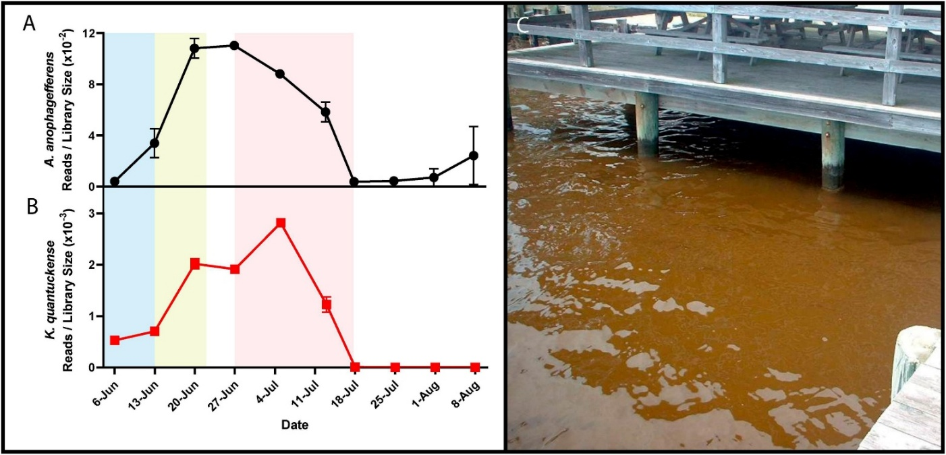
Figure 1.1. Metatranscriptomic reads mapped to A. anophagefferens and AaV detailing bloom peak and collapse. RNA reads mapped to A. anophagefferens (A) and AaV (B) coding regions were normalized by library size throughout the stages of a brown tide bloom. Shaded regions depict the bloom’s initiation (blue), exponential growth (yellow), and collapse and termination (red). A dense brown tide bloom off the coast of Long Island, NY (C).

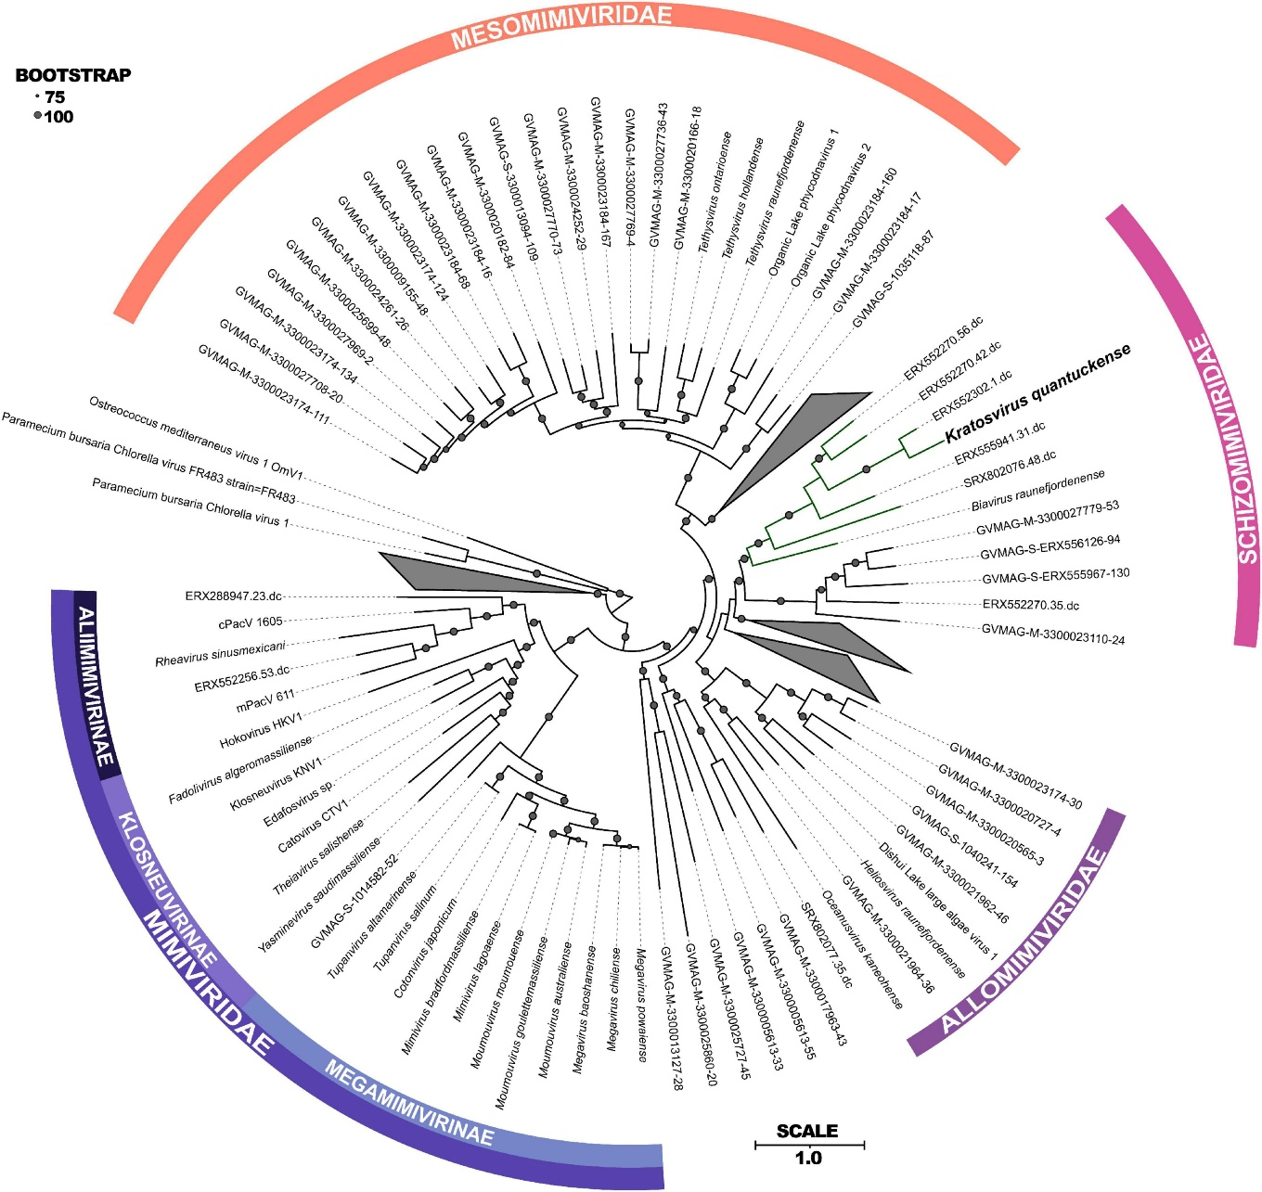
Figure 1.2. A phylogenetic tree of the Imitervirales order which contains AaV. The maximum-likelihood phylogenetic tree constructed with RAxML and visualized using IToL (Stamatakis, 2014; Letunic and Bork, 2021) of concatenated protein sequences among all Imitervirales. Bootstrap values greater than 0.75 are shown with size corresponding to confidence. Families and subfamilies are detailed by different colors. Distinct clades containing only environmentally sequenced viruses are collapsed.

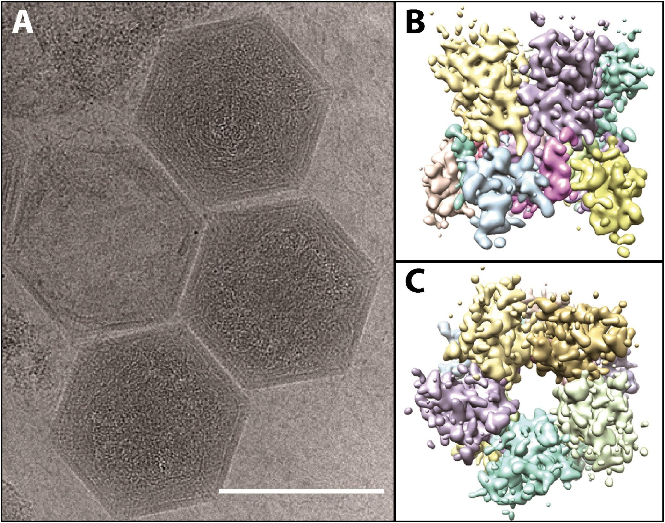
Figure 1.3. Cryo-electron microscopy images of AaV viral particles. (A) For microscopy the scale bar is 1500 Å. Computational reconstruction of major capsid protein detailing the side (B) and top (C) view of the pentomeric capsomer. Images are adapted from work performed in Gann et al., 2020c.

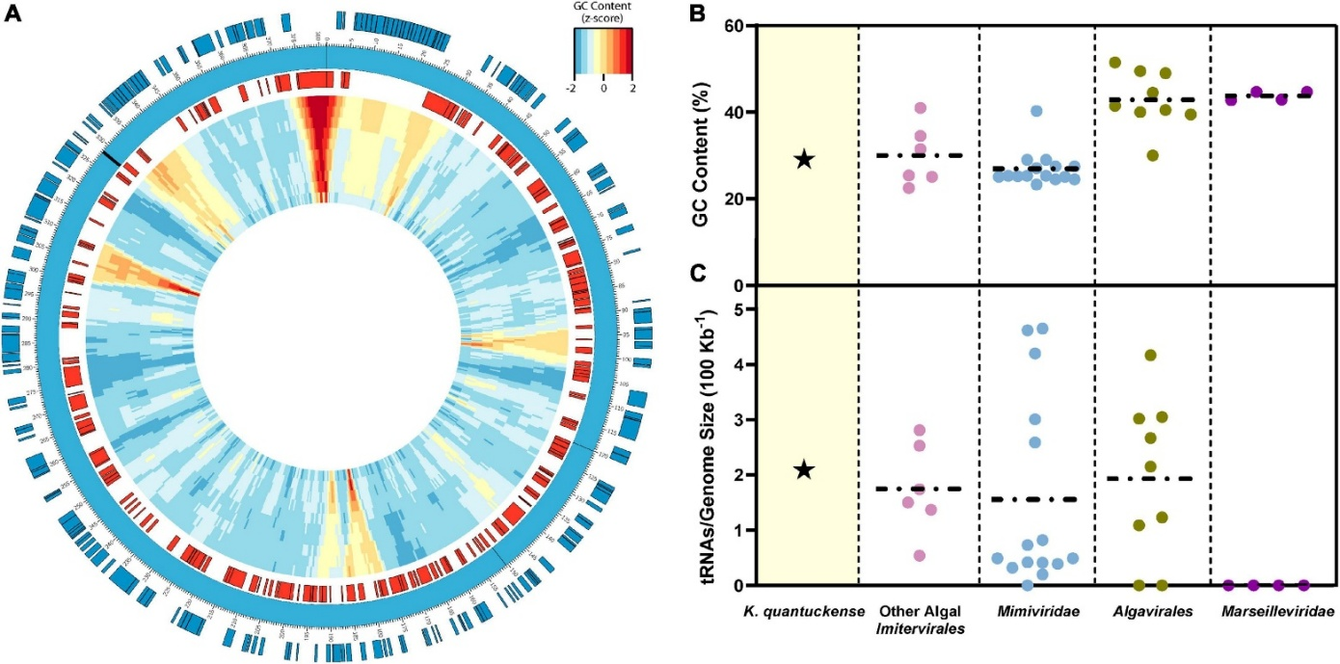
Figure 1.4. AaV genomic map, GC-content and encoded tRNAs. Coding sequences on the positive strand are shown in blue and coding sequences on the negative strand are shown in red (A). Genomic GC-content is displayed in relative z-score via a window moving 500 bp with a size ranging from 10000 bp to 1000 bp from the outer ring to the inner ring. tRNAs are labeled on the genome as black bars. (B) GC content and (C) tRNAs encoded normalized to genome size of K. quantuckense as compared to several other taxa of Nucleocytoviricota. Horizontal dotted lines depict the mean of each individual group of viruses for GC content and tRNAs.

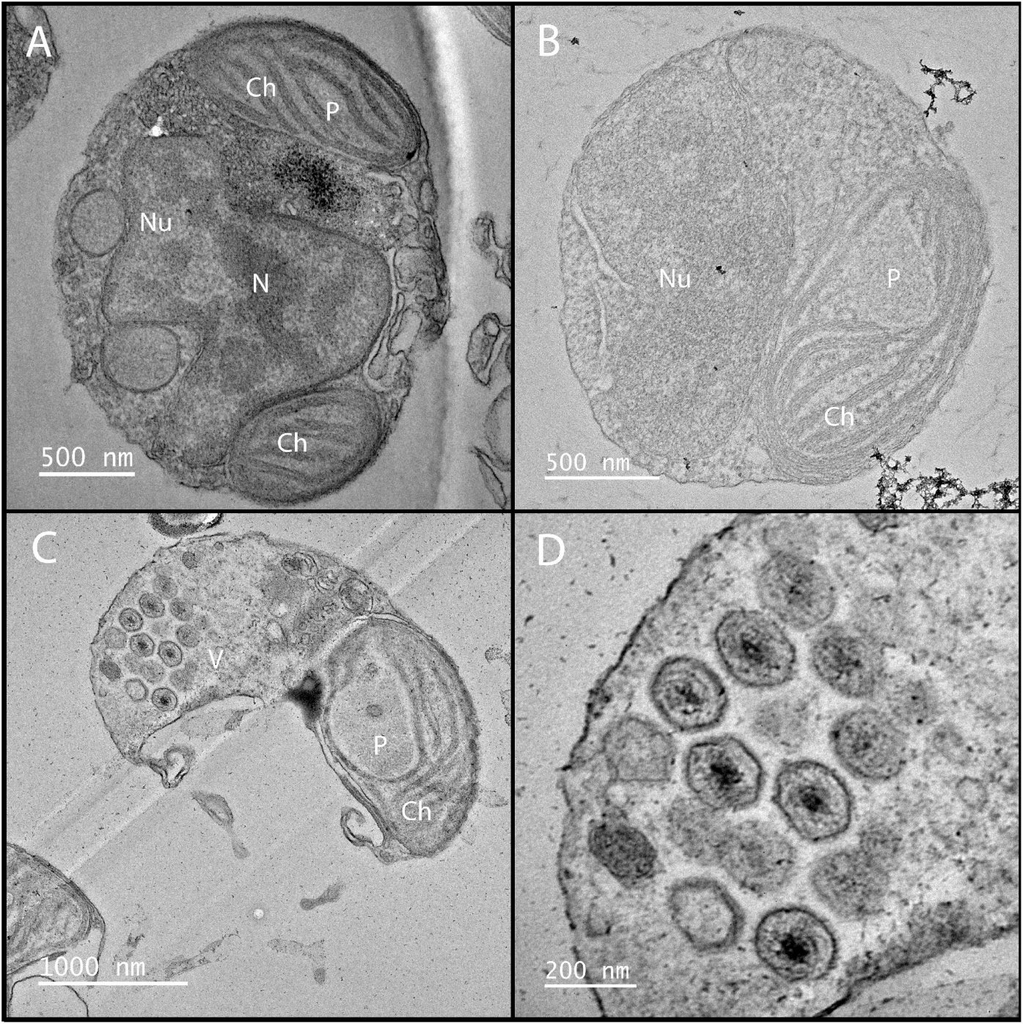
Figure 1.5. Electron microscopy images of infected and uninfected A. anophagefferens cells. Shown are early stages of infection (B) and formation of viral particles (C-D) inside a host A. anophagefferens cell as compared to a healthy host (A). Nu; nucleus, N; nucleolus, Ch; chloroplast, P; pyrenoid, V; viroplasm.

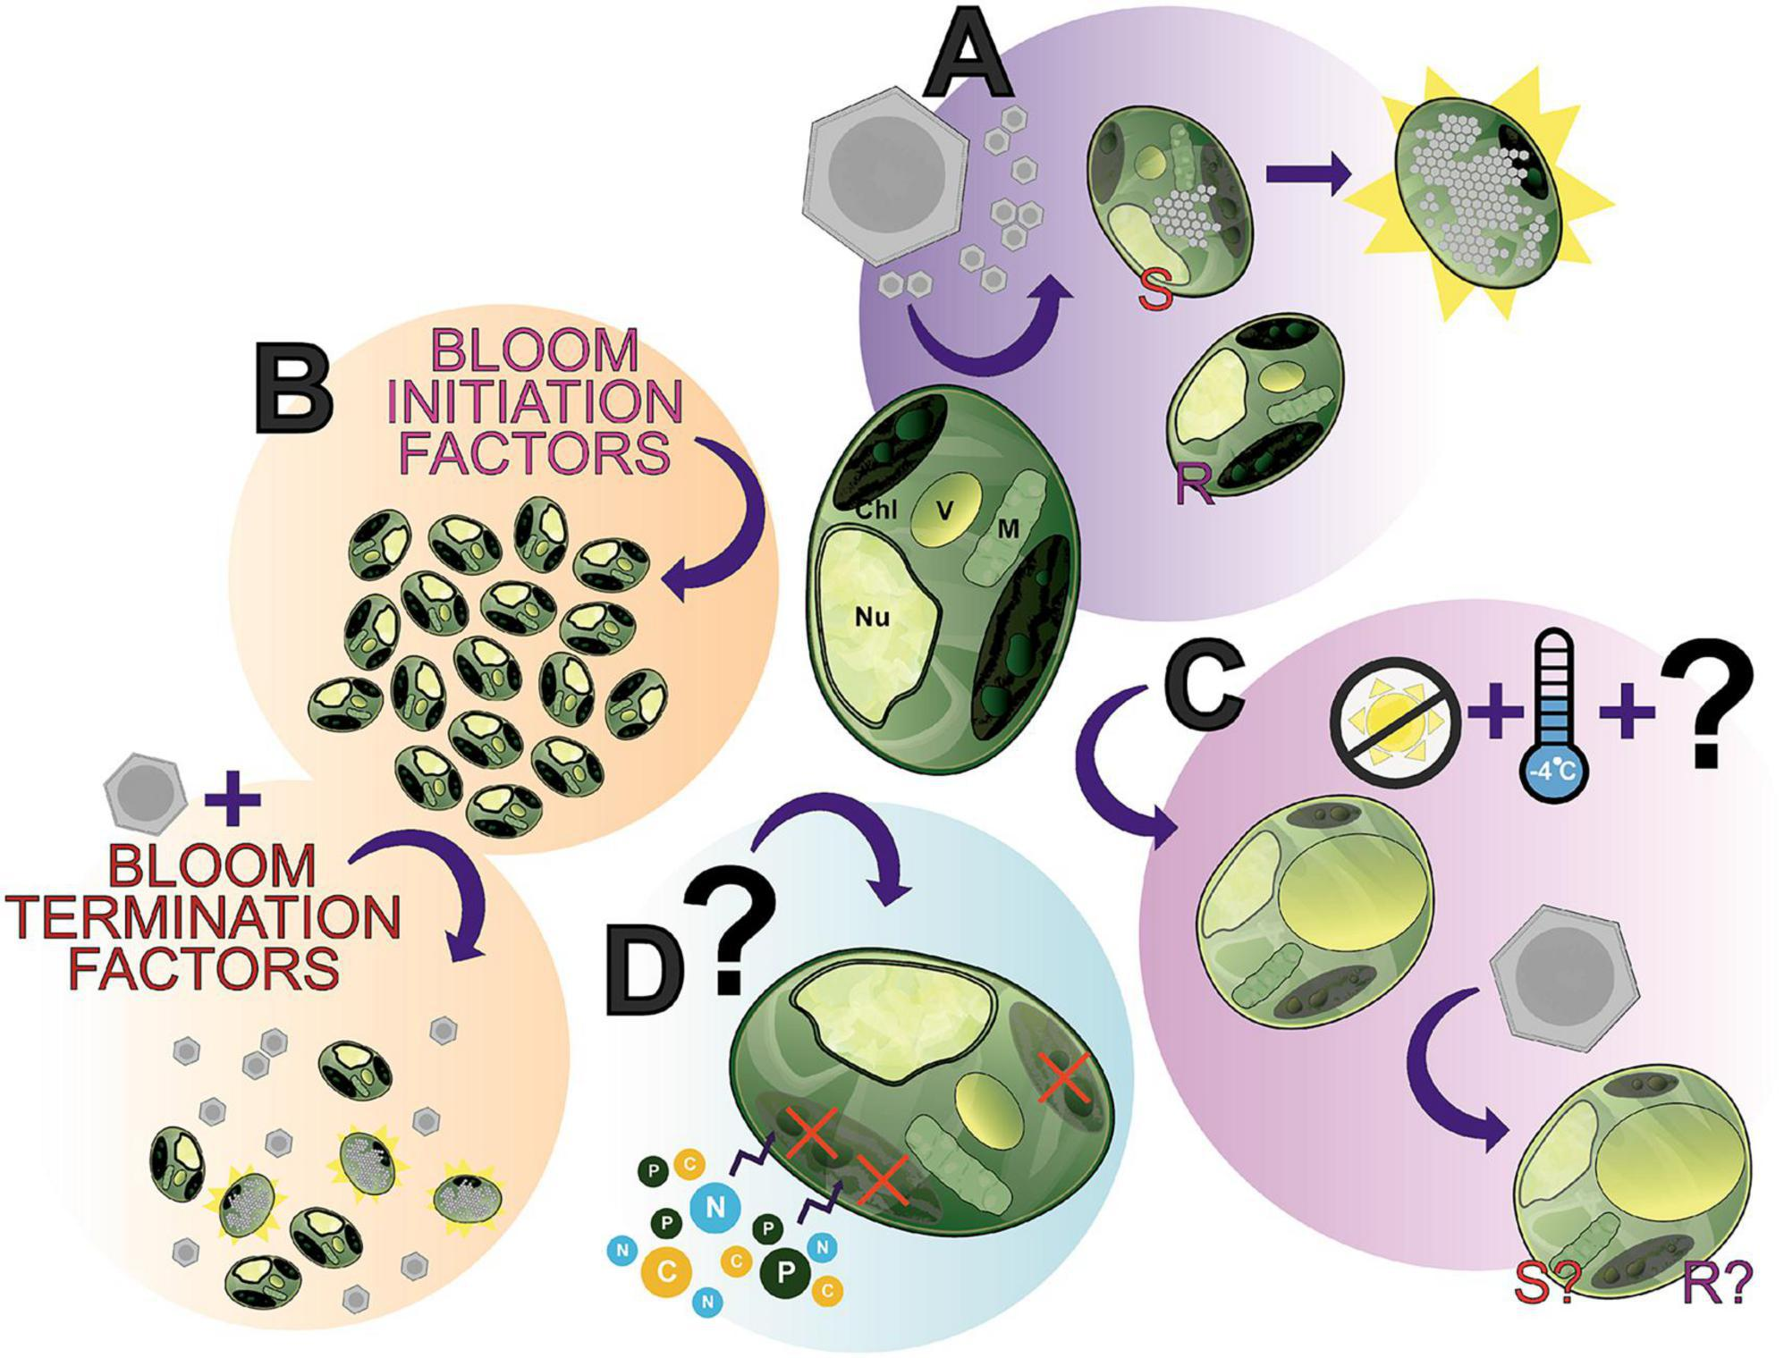
Figure 1.6. The many states of A. anophagefferens. A showcase of what makes this alga an interesting study species and where future research can be directed, between vegetative cells, virocells, and dormant cells. (A) A. anophagefferens forms a host-virus system with K. quantuckensis with the inclusion of both resistant (R) and susceptible (S) strains of A. anophagefferens readily available for experimentation. (B) A complex of bloom inititation factors produce harmful algae blooms (HABs) of A. anophagefferens in situ. (C) An understudied apparent “resting stage cell” or dormant cell has been documented, seemingly the result of low temperatures and the absence of light, thereby producing a cell with unique properties. (D) Early studies suggested that under certain conditions A. anophagefferens switches to primarily heterotrophy, another understudied aspect of A. anophagefferens. Chl; chloroplast, V; vacuole, M; mitochondrion, Nu; nucleus.

Chapter Two

The diel disconnect between cell growth and division in Aureococcus is interrupted by giant virus infection

Publication note and author contributions

Publication note
This chapter has been published in Frontiers in Microbiology and authored by Alexander R. Truchon, Emily E. Chase, Ashton R. Stark, and Steven W. Wilhelm. The citation for this work is:
Truchon AR, Chase EE, Stark AR, Wilhelm SW. The diel disconnect between cell growth and division in Aureococcus is interrupted by giant virus infection. Front Microbiol. 2024 Aug 21;15:1426193. doi: 10.3389/fmicb.2024.1426193.

Author contributions
This study was developed by Alexander R. Truchon, Emily E. Chase, Ashton R. Stark, and Steven W. Wilhelm. Alexander R. Truchon and Emily E. Chase ran the flow cytometer and collected infection cell size and concentration measurements. Ashton R. Stark performed the sinking velocity experiments. Alexander Truchon performed all bioinformatic and statistical analyses. Alexander Truchon and Steven Wilhelm wrote the chapter with Emily Chase writing pieces of the introduction and all authors providing comments in the initial draft and revisions.

* Alexander R. Truchon and Emily E. Chase contributed equally to this work.

Abstract
Viruses of eukaryotic algae have become an important research focus due to their role(s) in nutrient cycling and top-down control of algal blooms. Omics-based studies have identified a boon of genomic and transcriptional potential among the Nucleocytoviricota, a phylum of large dsDNA viruses which have been shown to infect algal and non-algal eukaryotes. However, little is still understood regarding the infection cycle of these viruses, particularly in how they take over a metabolically active host and convert it into a virocell state. Of particular interest are the roles of light and the diel cycle in virocell development. Yet despite such a large proportion of Nucleocytoviricota infecting phototrophs, little work has been done to tie infection dynamics to the presence, and absence, of light. Here, we examine the role of the diel cycle on the physiological and transcriptional state of the pelagophyte Aureococcus anophagefferens while undergoing infection by Kratosvirus quantuckense strain AaV. Our observations demonstrate how infection by the virus interrupts the diel growth and division of this cell line, and that infection further complicates the system by enhancing export of cell biomass.

Introduction
Diel patterns in phytoplankton are common. Specific factors known to cycle on a diel basis (i.e., diel periodicity) among phytoplankton include population density, biomass, community species composition, intracellular metabolism, resources (e.g., nutrients, organic constituents, DNA concentration), enzymatic activity, and primary production (Prezelin, 1992). Early field-based studies acknowledged these diel cycles, and began investigating the influence that time-of-collection for sampling might have on aquatic plankton research (Maxwell and Mikihiko, 1957; Yentsch and Ryther, 1957; Shimada, 1958; Doty, 1959). By the 1960s, green algae, dinoflagellates, and diatoms had all been observed to have diel patterns in vitro (Harding et al., 1981). Generally, this diel cycle of phytoplankton has been thought to be decoupled from ambient light (Harding et al., 1981; Yoshikawa and Furuya, 2006). Still, higher resolution of this cycle in various algal systems during experimentation enhances the reproducibility of results. In a cell division periodicity study of 26 clonal cultures of marine algal cultures (representing 13 species), it was found that intraspecific variation does occur, and that different algal species can exhibit diel periodicity with division occurring at night or during the day (Nelson and Brand, 1979). For example, it was found that in phytoplankton collected from Sagami Bay (Japan), photosynthetic maximum (normalized absorption; mol C m^{–2} h^{–1}) was highest at noon, and lower at dawn and dusk, with end-of-day timepoints being significantly variable (Yoshikawa and Furuya, 2006). Thus, photosynthetic variations were thought to be endogenously regulated (Behrenfeld et al., 2004). In the polymorphic haptophyte Phaeocystis pouchetii, it has been shown that synchronized cell division occurs midway through the dark cycle (on a 12/12 light:dark cycle), and that at higher light intensities or longer light cycles, cells could experience a division rate of greater than once per day (Jacobsen and Veldhuis, 2005).
Recent examinations of diel periodicity have focused on the functional roles and dynamics of important marine microbes, which has been given further context through new methods including metatranscriptomics and flow cytometry (Aylward et al., 2015; Hu et al., 2018; Henderikx Freitas et al., 2020). Many studies have explored the implications of diel periodicity in Bacteria, Eukaryota, and Archaea in important coastal and open ocean systems (Ottesen et al., 2014; Groussman et al., 2021; Muratore et al., 2022). In the North Pacific Subtropical Gyre, autotrophic metabolism was heightened during the day, and authors found that diel cycles in bacteria (e.g., Synechococcus and Prochlorococcus) included an increase in cell-size during the day, and cell division around dusk (Hu et al., 2018). Other studies have shown that picocyanobacterial gene expression is tied to diel periodicity (Zinser et al., 2009). However, picocyanobacterial cell counts remained stable in the gyre, as their diel metabolic activity was linked with the diel activity of dinoflagellates, haptophytes, ciliates and marine stramenopiles which would graze on the newly divided cells around dusk. Furthermore, diel periodicity of dominant photoautotrophs (e.g., Ostreococcus and Prochlorococcus) has been shown to shape community dynamics via light-based carbon acquisition at the base of the food web (Poretsky et al., 2009; Aylward et al., 2015). However, there have been few studies exploring important bloom producing algae, nor how viral infection of algae and the formation of a virocell (a cell actively undergoing viral infection and thus with altered metabolic function) are affected by diel cycling. Although viruses were not explored in these studies, it is logical that they would also be influenced by their hosts’ reaction to the diel cycle.
In theory, the dominant algae within a system can change during blooms, establishing a new community dynamic still potentially coupled to diel cycles. Such effects could include shifts in populations grazing on a phytoplankton, shifts in primary productivity, and/or changes in light penetration of the water system. Viruses have been demonstrated to be important factor in bloom dynamics and are specifically implicated in bloom termination (Jacquet et al., 2002; Brussaard et al., 2005; Steffen et al., 2017). Their role also has implications for biogeochemical cycling, including open ocean impacts on carbon cycling (i.e., the viral shunt; Wilhelm and Suttle, 1999) and carbon export (i.e., the viral shuttle; Sullivan et al., 2017). Indeed, a recent mesocosm study of carbon release showed viruses drove a 2- to 4-fold increase in extracellular carbon during bloom termination (Vincent et al., 2023). Thus, the effects of bloom events and bloom termination in the context of diel periodicity are important, especially given the diversity of life cycle strategies used by the causative agents of blooms and their viruses.
For the past two decades the brown tide bloom agent Aureococcus anophagefferens and “giant virus” Kratosvirus quantuckense (family Schizomimiviridae) have been studied in detail (Sieburth et al., 1988; Rowe et al., 2008b; Truchon et al., 2023). The pelagophyte A. anophagefferens was characterized in 1985 (Sieburth et al., 1988) and has continued to produce blooms along the East Coast of the United States (Narragansett Bay, Barnegat Bay, Long Island bays) (Bricelj and Lonsdale, 1997a), off the coast of China (near Qinhuangdao); Bohai Sea) (Zhang et al., 2012) and a bay on the South West coast of South Africa (Saldanha Bay) (Probyn et al., 2010). Brown tides are designated as harmful algal blooms (HABs) because of their economic and ecological detriment (Gobler et al., 2005). The virus K. quantuckense has been implicated as a regulator of A. anophagefferens brown tide bloom termination via population-wide cell mortality (Gastrich et al., 2004b). Notably, irradiance levels have previously been tied to viral burst size in an in vitro setting, demonstrating virus particles produced during an infection cycle are dependent on the availability of light (Gann et al., 2020a). If light is important to infection, then it is possible that stages of the viral life cycle as well as viral gene expression are tied to the diel cycle as well. Given the need to better understand the physiological ecology and energetics of brown tides, we monitored the diel periodicity of this brown tide agent alone and during viral infection in lab studies to determine how viral infection can affect the alga’s response to light. We observed a strict partitioning of physiological and metabolic processes by A. anophagefferens in relation to diel periodicity that was interrupted by viral infection.

Methods

Culture conditions
Three non-axenic isolates of Aureococcus anophagefferens were studied, including two that are resistant (strains CCMP1850 and CCMP1707) and a third (A. anophagefferens CCMP1984) susceptible to lytic infection by Kratosvirus quantuckense strain AaV (Aureococcus anophagefferens Virus) (Rowe et al., 2008b). Cultures were maintained at 19° C under a 12:12 light dark cycle in ASP12A growth media (Gann, 2016). Light levels for maintenance and experimental cultures were ~70 µmol photons m⁻² s⁻¹. Shading experiments were conducted by wrapping one or two layers of neutral density screening around individual culture tubes that reduced irradiance to 40 and 20 µmol photons m⁻² s⁻¹, respectfully. Prior to experimentation under reduced light conditions, cultures were moved and acclimated to the specific light treatment for at least 72 h. The concentration of cells in A. anophagefferens cultures was determined using a CytoFLEX flow cytometer (Beckman Coulter, Brea, CA) (Chase et al., 2022). Abundance in samples for gated cellular populations was quantified via violet side scatter (V-SSc) versus chlorophyll fluorescence (absorption 488 nm, emission 690 nm) (Chase et al., 2022).

Cell diameter estimates
Individual cell diameters were determined based on measurements from a FlowCam 8000 (Fluid Imaging Technologies, Scarborough, ME). Briefly, culture samples were diluted to approximately 1 x 10⁶ cells/mL and then imaged using the FlowCam’s 20X objective. Ten thousand individual cellular images were used to calculate average cell diameter and volume as well as for verification of cell concentration (using VisualSpreadsheet 2). FlowCam measurements for average diameter were compared to flow cytometry measurements taken on the Violet Side Scatter channel (V-SSc) using a 405 nm violet laser (CytoFLEX C07821), an approach which has previously been utilized for estimating cell size in algae and small particles (Chioccioli et al., 2014; McVey et al., 2018). A. anophagefferens CCMP1984 was compared on both devices over the course of 24 h after either being infected (see below) or treated with filtered viral lysate . To determine the relation between these measurements, a Pearson’s coefficient was calculated.

Infection with Kratosvirus quantuckense
The AaV strain of K. quantuckense has been maintained in culture since its isolation in 2008 (Rowe et al., 2008b). Fresh AaV particles were generated by infection of 1 L of a 7d-old culture of A. anophagefferens CCMP1984 grown in ASP₁₂A medium as above. After allowing the population to lyse (14 d), lysate was filtered sequentially through 1-µm and 0.45-µm pore-size, 47-mm diameter low protein binding Durapore (PVDF) membrane filters (MilliporeSigma; Burlington, MA). Viruses in the filtered lysate were concentrated via tangential flow filtration through a 30 kDa Pelicon XL (MilliporeSigma; Burlington MA) filter to an approximate volume of 50 mL as previously described (Coy and Wilhelm, 2020). Following concentration of viruses from lysate, contaminating bacteria were removed via centrifugation (3,500 xG, 10 min). Viral particles were enumerated via flow cytometry (Chase et al., 2023). Briefly, lysate was fixed with 1% glutaraldehyde solution in the dark at 4° C for at least 1 h. Lysate was then stained with SYBR Gold (Invitrogen; Waltham, MA) at a final concentration 0.5X at 80° C for 10 min. Virus particles were enumerated using the violet laser on a CytoFLEX flow cytometer (C07821) (Beckman Coulter; Brea, CA) (Chase et al., 2023; Zhao et al., 2023).
For experiments, infection of A. anophagefferens was performed on cells in exponential growth stage diluted to 1 x 10⁶ cells ml⁻¹ in fresh ASP₁₂A medium. Viral lysate was added to diluted A. anophagefferens cells at a multiplicity of infection (MOI) of ~100 viral particles per A. anophagefferens cell (unless otherwise specified) to approach uniform infection (Gann et al., 2020a). To control for non-viral effects lysate may have on algal cells, lysate was sterilized through a 0.02-µm Anotop 25 syringe filter (Whatman; Maidstone, UK) for all control infection cultures. Cell concentrations during infection were determined via flow cytometry (Chase et al., 2022). Following lysis of samples, aliquots were fixed using 1% glutaraldehyde for further enumeration of released viral particles. When infecting at lower MOIs, cell diameter measurements were determined via flow cytometry 23 hr following infection before the initiation of the light cycle. This allowed for measurements of cell size before cell lysis without the input of any additional light.

Transcriptome analyses of A. anophagefferens infection by AaV
We took advantage of an existing transcriptomics data set (Moniruzzaman et al., 2018b) to query the progression of infection at the molecular level. Trimmed reads of infected and uninfected cultures of A. anophagefferens were mapped to the reference genome (GCF_000186865.1) using default parameters in CLC Genomics Workbench (v. 21.0.4) and read counts were analyzed for differential expression using DESeq2 (v. 1.42.0) in R 4.3.2 (Love et al., 2014). Control (uninfected) samples were compared to identify shifts in transcript abundance throughout the diel cycle. Control time points were divided into four periods based on when samples were collected during the original transcriptome. These samples were defined as early day, taken between two and three hours after the initiation of the light cycle, late day, taken eight hours after the initiation of the light cycle, early night, taken approximately 30 min after the initiation of the dark cycle, and late night, taken nine hours after the initiation of the dark cycle. Individual genes with a log₂-fold change of at least 2 and a p-value of < 0.05 for at least two of the four periods were defined as differentially expressed. The same parameters were applied to identify differentially expressed genes between control and infected treatments, though due to a limited number of identifiable genes at this level a log₂-fold change of > 1.5 and a p-value < 0.05 was used to identify other potentially altered expression levels. To identify other genes of interest that may be up or downregulated at a specific timepoint at a lower significance level, a log₂-fold change of 0.58 (a fold change of > 1.5; p-value < 0.05) was also examined. As a caveat, downregulation and upregulation will be used to equate proportional representation of mapped reads between treatments throughout this paper. Likewise, references to “differential expression” will be referred to in place of significantly altered transcript abundance levels.
To examine infection-driven inhibition of cell division, differentially expressed genes were filtered to only those associated with the cell cycle based on functional annotation in the Kyoto Encyclopedia of Genes and Genomes (KEGG Release 105.0) pathways map04110 (Cell cycle), map04111(Cell cycle – yeast), map04210 (Apoptosis), map04115 (P53 signaling pathway), and map04218 (Cellular senescence). Read abundance calculations for individual gene transcription trends and for incorporations into heatmaps were performed using the transcripts-per-million (TPM) method (Wagner et al., 2012). Heatmaps were constructed using Heatmapper.ca (Babicki et al., 2016) with genes clustered via single linkage clustering.

Determining vertical transport rates
To assess the sinking rate of A. anophagefferens CCMP1984, cells in logarithmic growth were inoculated into a vertical settling column containing 225 mL ASP₁₂A and allowed to settle. After 2 h the bottom 50 mL of the column was drained through the collection tube and agitated to homogenize the cells to a uniform concentration. This process was repeated for the remaining 200 mL of media. Cell concentrations and diameters were calculated via flow cytometry. To determine the sinking rate of infected cells, A. anophagefferens CCMP1984 was infected with AaV at an MOI of 100 either 2 h (early infection) or 16 h prior (late infection) to sinking rate assessment. Sinking velocity ($Ψ$) was calculated using the following formula:
$$Ψ= \frac{βs}{βt}* \frac{l}{T}$$
In which $βs$ is total exported cells, $βt$ is total cells in the column, $l$ is distance traveled in meters, and $T$ is time in hours (Bienfang, 1981; Mao et al., 2021).

Statistical Analyses
Population growth rate (r) was calculated using the following formula on cultures in exponential growth phase:
$$r=\ln\left(\frac{N_{t}}{N_{0}}\right)*\frac{1}{t}$$
Where t is time in days, N_{t} is the cell concentration at the time in days, and N₀ is the initial cell concentration.
Statistics were performed using Prism 9.1.0. Differences between population growth rates, cell sizes, and sinking rates were determined using a one-way ANOVA followed by Tukey’s post hoc testing using a standard significance level of p < 0.05. Correlation coefficients were determined using a simple linear regression. Non-metric multidimensional scaling (nMDS) and hierarchical clustering analysis of host transcriptional shifts in the uninfected reference transcriptome was performed in PRIMER v7.0 (Clarke, 2015) using a Bray-Curtis dissimilarity matrix.

Results

Diel partitioning of cellular growth and division
A. anophagefferens CCMP1984 cultures grown under a 12:12 light:dark cycle were observed every 4 h during the light period to determine cell concentration and relative fluorescence measurements throughout the light cycle. A. anophagefferens cell diameter determined from the FlowCam 8000 was correlated strongly with the violet side-scatter (V-SSc) measurements detected using a 405 nm violet laser (p < 0.001; R² = 0.9413) (Figure 2.1). This correlation was consistent for both virus-infected and uninfected A. anophagefferens cells through different stages of the growth and infection cycle. For this reason, V-SSc was used as a proxy for average cell diameter for the remainder of the experimentation.
During light periods, A. anophagefferens CCMP1984 cell densities were generally constant (Figure 2.2A). However, after the dark period cell abundance increased, consistent with a diel association with cellular division. V-SSc relative fluorescence indicated a similar pattern between the light and the dark cycle, with average cell diameter (Figure 2.1) and V-SSc fluorescence (Figure 2.2B) increasing throughout the day and reducing during the night. Population-wide increases in cell size were not linear, with the rate of cell diameter growth increasing along with the length of exposure to light. While other strains of A. anophagefferens differed in specific population growth rate and percent change in cell size over light and dark periods, all strains we tested followed the pattern of division in the dark, impeded division during the day, and cyclical cell-size changes (Table 2.1). A significant increase in cell density occurred within eight hours of the dark period for CCMP1984 (p = 0.024) and within 12 h of the dark period for CCMP1850 (p = 0.051) (Figure 2.3).
Given A. anophagefferens CCMP1984 has been maintained in our laboratory for an extended period (over 10 years) and thus may have grown accustomed to these light settings, circadian rhythms could not be ruled out as a factor in diel-associated cellular growth and cell division. To test this possibility, A. anophagefferens cultures were exposed to reduced light levels. While no discernable growth differences were detected between medium and high light levels (40 and 70 µmols photons m⁻² s⁻¹, respectively; p-value = 0.213), cell diameters in cultures maintained at 20 µmols photons m⁻² s⁻¹ had significantly (p-value < 0.0001) reduced diameters (~ 2.4 µm), as compared to high light treatments (2.9 µm) after 12 h of light exposure. Cells in low light cultures increased in diameter by 39.3%, while full irradiance cultures increased in diameter by 114.8% (Figure 2.4A-C). Population growth was also significantly impeded in low light cultures over 72 h (Figure 2.4D). Entraining cultures on a 12:12 light dark cycle only to either leave the lights on after 12 h of light or leave the lights off after 12 h of darkness showed that A. anophagefferens did not in these instances display any characteristics of a free-running clock (Figure 2.5). Furthermore, A. anophagefferens had population growth rates of approximately zero or lower when exposed to 24-h light or 24-h dark (Table 2.2). In 24-h light, cells continuously increased in size over the course of 48 h, while cells continuously decreased in size in 24-h darkness (Table 2.2). While increasing the length of the light period did lead to continued increases in cell size, longer light periods did not have much effect on net population growth rate.

Infected cells increase in diameter while division is inhibited
A. anophagefferens CCMP1984 was infected with AaV to observe the effects of viral infection on the diel growth cycle. During the first 12 h of infection, (during the light cycle) no differences were observed between infected and control samples treated with filtered lysate (Figure 2.6). However, during the night cycle, infected cultures did not divide and stayed at the same cell concentration (Figure 2.6A) and cell diameter observed at the termination of the light cycle (Figure 2.6B). Following the first 24 h, average cell diameter increased again, with average cell diameter larger than after the first light cycle (Figure 2.9C). It is unclear if the cells that continued to increase in size were the same group of infected cells or were instead previously uninfected cells that are continuing to skew the average size higher as they continue to grow. To determine whether size shifts between infected and uninfected cells were evident in a single culture, size was measured at lower MOIs approximately 23 h following infection. A higher MOI led to an increased average diameter of infected cultures following the night cycle, with cultures infected at an MOI of 100 displaying a 30% increase in average V-SSc as compared to those infected at an MOI of 10 (Table 2.3, Figure 2.7). A negative correlation (R² = 0.9427, slope = -0.372) between MOI and percent similarity in size of infected cultures to control cultures was found (Figure 2.8A).
A. anophagefferens strain CCMP1850 which displays a resistant phenotype to viral infection by AaV was tested for its physiological response to viral exposure over the course of several days. Continued growth following the initial 24-h period in infected strains was evident in CCMP1984, before average cell diameter diminished coinciding with the total lysis of the culture around 48 hours (Figure 2.9). CCMP1850 also appeared to be inhibited in cell division (Figure 2.9B) but maintained normal cell size cycling throughout the light:dark period as compared to uninfected cells (Figure 2.9D). This may imply that whatever stress viral presence places on this strain, it is unrelated to diel cycling and the cell cycle.

Separate cell cycle transcriptomic activity between day and night
We returned to a transcriptome from a previous infection study (Moniruzzaman et al., 2018b) to identify cell division genes differentially expressed between the light and dark periods. Samples were subdivided into four categories: the early day (n = 9, two to three hrs. into the light period), late day (n = 3, eight hrs. into the light period), early night (n = 3, ~30 min. into the dark period), and late night (n = 3, nine hrs. into the dark period). Cluster analyses revealed an almost cyclical relationship among uninfected samples with similarity between categories strongest for neighboring groups (e.g., late day was most like early day and early night) (Figure 2.10). Gene set enrichment analysis revealed enrichment of cell cycle-associated transcripts between time points, most evidently when comparing the early night time point to all other time points (normalized enrichment score = 1.80, p-value = 0.0) (Table 2.4). Although we will focus on homologs of cell cycle-associated genes, in total 1,823 genes were identified as differentially expressed between at least two of the time periods analyzed under our highly conservative parameters (Table 2.5).
A clear partition in cell cycle gene read counts throughout different stages of the day was evident (Figure 2.11). Periods that differed most notably from one another were the early day/early night (22 differentially expressed genes; Figure 2.12) and the late day/late night (13 differentially expressed genes; Figure 2.13). Cohesin subunit homologs (scc1, scc2, scc3, smc1, and smc3) were differentially expressed between early morning and early night (Figure 2.11; Figure 2.12) with a consistent drop off in expression during the late night and markedly low expression throughout the day (Figure 2.11; Figure 2.13). Condensin subunit-like genes smc4, and ycs4 were overexpressed during the late-night timepoint as compared to the day, with steady down regulation of ycs4 in the early night (Figure 2.11-2.13).
Regarding cyclin associated homologs and their expression throughout the cell cycle, ccnb2 (Cyclin B) was expressed significantly more at night as compared to the day (log₂ fold change = 2.47, p < 0.001), though one homolog (ccnb2i; 12473) was under expressed in the early night as compared to the morning. A cdc20 and a cdk1 homolog were expressed late at night, but not earlier. Cdc45 was also expressed early in the night and not present late at night.
A homolog for tumor (i.e., cell division) suppressor gene p53 is not encoded by A. anophagefferens. Still, certain homologs of genes associated with p53 do display changes in expression. In the early day mdm2 was highly expressed, while it was downregulated in the early night. It was also highly expressed late at night and barely expressed mid-day. A homolog of tumor suppressor rb1 was differentially expressed in the late day/early night period from the morning. Cell cycle regulation genes tp53i3 (tumor protein p53 inducible protein 3), hrad1 (Rad1 checkpoint protein homolog), atm (serine/threonine kinase), erk (extracellular signal-regulated kinase), and rrm2 (ribonucleoside reductase regulatory subunit M2), many of which are expressed downstream of p53, also followed this pattern (Figure 2.11).

DNA damage and p53-associated genes respond to AaV infection
Given cell division appears inhibited when A. anophagefferens is infected with AaV, we sought to identify associated genes that might be targeted by the virus for regulation. When comparing the infection transcriptome to the control, only 11 cell cycle associated genes were identified at a log₂-fold change of ≥ 1.5 (Table 2.6). While most of these genes were in the late night time point of the infection cycle, three genes were identified 12 h following infection (early night) and one at the 6 h mark (late day). Interestingly, all three genes identified at the 12 h timepoint were homologs of the mdm2 gene, two of which were down-regulated in the infected samples with the other highly up-regulated. While all these transcripts increased in abundance as the night continued, their role in infected samples in the early night may also be relevant.
At the 21-h timepoint, seven cell cycle genes were differentially expressed between control and infected samples, including four SMC-like genes. Two cohesin-associated genes were up-regulated (smc1 and smc3), one condensin-associated gene was up-regulated with the other down-regulated (smc2 and smc4, respectively) (Figure 2.14). The cell cycle regulatory genes skp1 and pcna were also upregulated at this time point (Liu et al., 2005; Zhang et al., 2023). Another regulator of the cell cycle, a homolog for the myt1/wee1 gene which induces cell cycle delay, was downregulated (Détain et al., 2021).
Using a less conservative method for defining differential expression (i.e., the 1.5-fold change described in Moniruzzaman et al., 2018) an additional 64 cell cycle genes were differentially expressed between all infected and control samples (Figure 2.15, Table 2.7). Among these genes, seven were consistently upregulated in infected samples, 19 were consistently downregulated, and five alternated between upregulated and downregulated. Multiple inhibitors of cell cycle regulation genes (myt1/wee1) were consistently upregulated, including a protein arginine methyltransferase (prmt5) and rbx1 which can target CDKIs (Jia et al., 2011; Beketova et al., 2022). Also upregulated was a ubiquitin-protein lyase homolog (siah1), which can act downstream from p53 in cell cycle arrest pathways (Frew et al., 2002).
Of the consistently down-regulated genes, many are associated with DNA replication and checkpoints for DNA damage repair. Regarding initiation of replication, two mini-chromosome maintenance (MCM) subunits and one origin recognition complex (ORC) subunit were downregulated in infected samples. Likewise, downregulated genes associated with suppressing the cell cycle due to DNA damage include rrm2, prkdc, ddb2, and myt1/wee1 (Figure 2.14) (Chen et al., 2021a; Chen et al., 2021b; Détain et al., 2021; Zuo et al., 2024). Condensin and separase (esp1) trancripts decreased in abundance as well. Outside of genes associated with DNA replication and repair are various other downstream effectors of the conventional p53 pathway. Negative feedback regulators including the previously mentioned three mdm2 homologs and the ppm1d protein phosphatase were downregulated throughout the infection cycle.
In addition to shifts in transcript abundance across all time points, genes differentially expressed at single time points may provide insight into how viral infection impacts the cell cycle of A. anophagefferens. For instance, while several condensin-associated genes were downregulated at the 12-hour time point, they became upregulated at the 21-hour time point. Such dynamics implicate AaV derived regulation of host genes beyond simply turning a gene on or off. The rb1 homolog was also upregulated at the 21-hour time point (Mendoza et al., 2014). Interestingly, while a cyclin B homolog was downregulated at the 21-hour time point, cyclin D and cyclin H were upregulated at 12 and 21 hpi, respectively (Table 2.7). Cyclin-dependent kinases also acted contrarily, with some (cdc28, cdc6, cdc5, cdc15 and cdk1) downregulated at certain time points and other (cdc7 and cdk7) upregulated (Table 2.7).

Infection alters host cell sinking rate
To assess biophysical consequences of diel shifts in cell size / composition in the presence and absence of AaV, sinking rates of A. anophagefferens were measured. In calm waters (no upwelling) A. anophagefferens sinks in the water column and does not maintain a natural buoyancy. The sinking velocity of uninfected A. anophagefferens cells was constant regardless of time of day or cell size (Figure 2.16). Within two hours of infection of A. anophagefferens by AaV, the alga sinking rate increased compared to control (uninfected) cells (Figure 2.17A). A similar trend was noted 16 h after infection, suggesting cells in the early and late stages of the virocell state would be exported from the water column at the same rate (Figure 2.17A). When comparing cell diameter or volume for uninfected cells at the bottom of the settling column to cells at the top, there were no significant differences (Figure 2.17B-C).

Discussion
In the past, studies of marine algal growth patterns have generally been conducted with daily sampling at consistent time points (relative to light:dark cycles) (Tang, 2003; Shirai et al., 2008; Perrin et al., 2016; Gann et al., 2020b; Gann et al., 2022). While this method increases comparability over long-term sampling schemes, it excludes physiological changes that occur in response to prolonged exposure to light or the absence of light. Thus, other time points (i.e., 6 daylight hours, 12 daylight hours, etc.) likely need to be considered as they potentially offer other physiological states. Furthermore, studies that have focused on hourly changes in algal growth dynamics often have not considered the growth cycle, physiology, and metabolism of virocells which may make up a significant portion of the natural community (Brussaard et al., 1996; Vincent et al., 2021). Indeed at least some algal viruses rely on light during infection (Derelle et al., 2018; Gann et al., 2020a) with certain giant viruses even encoding rhodopsins (Needham et al., 2019). Collectively this implicates the diel cycle as a potential modulator of virus activity in phototrophs. We examined physiological shifts of infected and uninfected A. anophagefferens in the context of diel periodicity. We also explored transcriptomic data to understand shifts in transcript abundance in infected and uninfected cells.

Growth of A. anophagefferens is constrained by the diel cycle
A. anophagefferens cell diameter gradually increased during the light period, with cell division (i.e., size reduction and cell density increase) almost exclusively occurring during the dark period. While this separation of growth and division has been observed in phytoplankton, rarely has the distinction been so distinct, as cellular growth is often seen during both dark and light periods (Harding et al., 1981; Goto and Johnson, 1995; Jacobsen and Veldhuis, 2005; Moulager et al., 2007). Moreover, we observed no change in cell concentrations during the light period, with occasional (yet statistically insignificant) decreases in cell count when the light period is increased (Table S1). Attempts to disrupt the diel cycle by extension of light or dark periods or incident light reduction revealed that the growth periods observed under normal conditions were primarily associated with the diel cycle, and not a result of circadian rhythms. A. anophagefferens does encode a homolog of an animal-like cryptochrome containing a photolyase domain, meaning circadian responses to light are not necessarily absent in this system (Petersen et al., 2021). While circadian control of the cell cycle has only been studied in a few model species (Chlamydomonas reinhardtii, Ostreococcus tauri, Phaeodactylum tricornutum), it is possible that specific expression levels of cell cycle-associated genes are constrained to a circadian clock in A. anophagefferens, without strict constraint of carbon fixation and cell growth-associated genes (Coesel et al., 2009; Heijde et al., 2010; Beel et al., 2012; Petersen et al., 2021). This necessitates further analyses of transcriptomic and proteomic profiles of A. anophagefferens under a free-running clock to draw any further conclusions.
Pelagophytes like A. anophagefferens exist in open oceans at the deep chlorophyll maximum, spatially deeper than cyanobacteria and dinoflagellates (Latasa et al., 2017). Given a preference for decreased light and increased nutrient availability, it is possible that these cells are highly susceptible to photooxidative stress and DNA damage when unshaded (Latasa et al., 2017). If light stresses are a factor, cells may benefit from cell division and DNA synthesis occurring during dark periods. G1 to S phase likely requires a DNA damage checkpoint to be met, though the genes regulating this transition are not well defined in A. anophagefferens (Hlavová et al., 2011). It is possible that to proceed to the downstream transcriptional effects of the cell cycle, a photoreceptor-like trigger must first be deactivated, akin to the red/far-red phytochrome receptor in plants (Mawphlang and Kharshiing, 2017). This is supported by our work showing that A. anophagefferens cannot grow in 24-hour light. Further experimentation, possibly using known cell cycle inhibitors that may either lock the cell in G1 or G2 phase, may be necessary to further validate these hypotheses.

Virocells display arrested division phenotypes, but respond to light
Infection of A. anophagefferens by AaV inhibited cell division during the dark period of the diel cycle. The virocells maintained the same size overnight, as opposed to the uninfected cells which decreased in average diameter in parallel with division. Virocells also did not divide (Figure 3). One explanation for the inability to divide may be diversion of host energy away from the cell cycle to stress response mechanisms. However, large DNA viruses, as well as retro and RNA viruses, have been noted for their ability to disrupt the cell cycle by blocking entry into S phase or causing cells to accumulate in G2 phase (Emmett et al., 2005). This active disruption may benefit viral propagation as increased volume of the cell and reduced host usage of cell cycle resources may drive increased virion production (Flemington, 2001). . It is possible that the cells were unable to enter mitosis either through degradation of the host genome by viral endonucleases or an increase in the density of early-stage viral particles. Likewise, virus-induced physiological changes to structures important for cell cycle progression, like repurposing the nucleolus (Emmett et al., 2005; Matthews et al., 2011) and reorganization of host microtubules (Naghavi and Walsh, 2017) could feasibly prevent the cell cycle from progressing. However, viral particle formation and the degradation of most organelles does not occur until later in the infection cycle. This leads to the possibility that transcription under viral infection prevents the cell cycle from progressing and locks the infected cells into a prolonged G2 phase before the cell can enter mitosis. This is notably not the only outcome of virus-host interaction, as infecting the partially resistant CCMP1850 with AaV reveals inhibition of division but consistent cycling of cell size (Gobler et al., 2007).
Another element of the infection dynamics of A. anophagefferens and AaV is the similar growth during the light cycle between infected and uninfected samples. As previous studies have shown, light is an important constraint on the burst size of AaV (Gann et al., 2020a). Combined with the fact that viral production approaches zero under very low light conditions (≤ 5 µmol photons m⁻² s⁻¹)(Gann et al., 2020a), successful infection of a host may require a prolonged irradiance period. While transcription of viral genes begins within the first five minutes of infection, the cellular growth during light periods remains the same, meaning this portion of the growth cycle is perhaps relevant to the virus’s propagation. While we may define this period as nutritional stockpiling by an uninfected host to prepare for DNA synthesis and cell division, in the case of viral infection the same stockpiling must occur, only to be used in production of viral particles (Gann et al., 2020b). In considering what metabolic processes the virus alters for its own benefit, we also must consider which processes are left unaltered and how these too may serve a purpose in viral infection.

A. anophagefferens’ cell cycle is transcriptionally constrained to diel effects
Analysis of the viral infection transcriptome revealed that cell cycle arrest and regulation genes were changed during viral infection, but also that transcription of many cell cycle-associated genes in uninfected cells is constrained to a diel cycle. Notably, a significant contingent of cell cycle genes are enriched at the early night time point, implicating a shift in gene expression following the termination of the light cycle (Table S2). One of the most consistent observations of diel-driven differential expression within this dataset was the expression of cohesin and condensin genes. The cohesin complex, which binds sister chromatids together following DNA replication and prior to anaphase, acts as an important intermediate complex before sister chromatids are segregated to opposite ends of the cell (Peters et al., 2008). The condensin complex begins functioning typically after the nuclear envelope has broken down from prophase to anaphase (Hirano, 2012; Leonard et al., 2015). Further research has shown that in C. reinhardtii, condensin subunits are likely involved in proper formation of the mitotic spindle (Breker et al., 2018). The expression patterns of these subunits in A. anophagefferens, cohesin homologs upregulated in the early night and condensin homologs upregulated in the late night, suggest that cells were progressing through mitosis at these time points. Thus, DNA replication likely occurred either soon before or after the dark period began. Likewise, we have shown that cell division primarily occurs after 6-7 h in the dark (Figure 2.3), meaning condensin should be heavily expressed at this time point (Skibbens, 2019).
Further evidence for the temporal partitioning of cell cycle pathway genes is shown by the expression pattern of pcna. In the red alga Cyanidioschyzon merolae, pcna was used as a marker of cell cycle progression and peaked in fluorescence mid S-phase, before dissipating throughout the remainder of the cell cycle (Sumiya et al., 2014). A similar expression was observed in the A. anophagefferens control transcriptomic dataset, with the pcna homolog exclusively peaking in expression in the early night. This indicates DNA synthesis may occur around the transition from light to dark. Along with pcna, several other A. anophagefferens genes including cyclin B (ccnb2ii), cdc45 (which has been tied to replication fork initiation (Sanchez-Pulido and Ponting, 2011)), cdc5, five cohesin subunits, and the DNA damage repair gene rrm2 show this pattern (Figure 2.11). We hypothesize that these genes are largely associated with DNA synthesis. Several genes expressed heavily in the early night are also detected at increased levels in the late day (tp53i3, hrad1, atm, and erk). Such genes could be attributed to acting as a catalyst for DNA damage repair and preventing cellular division with damaged or incompletely replicated DNA. Likewise, a close homolog to the yeast gene cdc28, which is active late in G1 phase (Mendenhall and Hodge, 1998), was upregulated in the early hours of the night, as well as mid-day, identifying a possible early trigger to encourage DNA synthesis in A. anophagefferens. This gene is notably not expressed in the late night, signaling that many cells may have progressed past the early stages of the cell cycle.
Among the A. anophagefferens genes expressed differentially in the late night were the p53 inhibiting mdm2 homologs, cdc20, monopolar spindle 1 kinase (mps1), and two condensin subunits, of which A. anophagefferens only encodes three (Figure 2.11). Based on the presence of genes like cdc20, mdm2 and mps1 which actively either drive or regulate mitotic cell division (Mendoza et al., 2014; Pecani et al., 2022), it seems evident that the cells at the late time point were actively in the process of mitosis. Their abundance in these contexts indicates cell division may be heavily down-regulated late in the day but encouraged after several hours in the night cycle. However, due to the nature of this study, the turnover of RNA throughout the day is uncertain, and increases in transcript counts may be a result of accumulation throughout the entire day.

AaV infection drives transcriptional shifts in cell cycle regulation
Viral infection of A. anophagefferens revealed heavy regulation of genes associated with DNA replication. Several cohesin subunits and the pcna gene were upregulated late in the infection cycle (late night) after their transcript levels had decreased in the control samples (Figure 2.15). These genes may be utilized in replication of the viral genome, which would justify such an elevated expression level. Host cohesin genes have specifically been identified as important factors in the infection cycle for other DNA viruses (Li et al., 2021). Notably, many genes associated with cell cycle arrest based on DNA damage have altered expression levels during viral infection (Figure 2.18). Three homologs of myt1/wee1 were downregulated in A. anophagefferens under infecting conditions, one of which was downregulated at all three latter time points. WEE1 is typically considered a tumor suppressing protein and is often involved in the prevention of mitosis when DNA is damaged by way of phosphorylating CDK1 (Hlavová et al., 2011; Ghelli Luserna di Rorà et al., 2020). In accordance with this downshift in expression, four negative regulators of wee1 (cul1, skp1, rbx1, and prmt5), were frequently upregulated during infection while three more DNA damage response genes (rrm2, prkdc, and ddb2) were downregulated. DNA damage repair has previously been found to limit the cytotoxicity of adenoviruses (Connell et al., 2011), thus downregulation of these genes could promote untethered viral genome replication. To further associate the DNA damage with viral genome replication, ubiquitination of PCNA by certain checkpoint proteins may lead to stalling of replication(Moldovan et al., 2007), thus it is possible an upregulation of this gene as well as a down-regulation of damage associated genes would allow for viral DNA synthesis to proceed. The role of these genes has gone understudied in algae and the Nucleocytoviricota alike and further analysis is warranted.
From this concept there arises a conflicting dichotomy in the viral transcriptome in which genes that both lead to and prevent cell cycle arrest are regulated. While these DNA damage checkpoint genes may be downregulated, p53 inhibitors, which would naturally promote the cell cycle, are downregulated as well (Figure 2.18). We see a very complex expression pattern in which some homologs of the downstream effectors of p53 like the apoptotic pathway and rb1 are promoted under viral expression, while others that relate back to DNA damage control which might halt the cell cycle during S-phase are blocked in expression. Other DNA viruses, including papilloma viruses and adenoviruses, encode genes which can induce apoptosis to aid in viral dissemination (Gupta et al., 2015). Another perspective is that certain promoters of cell cycle progression are not altered by viral infection. While a total of 175 A. anophagefferens genes were functionally categorized as cell cycle genes, only 67 of them appeared in our differentially expressed dataset, meaning over 60% were statistically unchanged by viral infection. For example, A. anophagefferens encodes for 10 anaphase promoting complex gene homologs, only one subunit was downregulated at one time point. While this does not confirm that these processes were not at all affected by the invading virus, it does suggest that continued activation of some of these pathways has at the very least a net neutral effect on viral particle production. A highly specialized virus must be able to streamline the infection process, and the host processes that are neutral, beneficial, or essential must remain active while anything deleterious be targeted for downregulation. For this reason, we believe that if the virus prevents the host cell from entering mitosis, the natural progression of the cell cycle may be important for the culmination of the infection cycle.
Though these possibilities are intriguing, our interpretations are limited by the lack of a complete cell cycle model in A. anophagefferens. Not only are most of the genes described herein attributed to putative functions through sequence homology, but many common genes also appear to be completely missing. For example, there are zero homologs to conventional CDK inhibitors encoded in any sequenced A. anophagefferens genome. Likewise, though we reference the p53-associated pathway for growth suppression often, there is no known homolog for p53 encoded by A. anophagefferens or any other plant or algal lineage. However, with such a robust representation of associated genes, including the direct downstream gene of tp53i3 and the high abundance of mdm2-like p53 regulators, the presence of a functional p53 equivalent in A. anophagefferens, as well as other algae, is likely (Nedelcu, 2006).

Export from the water column is enhanced by viral infection
Settling rate assessment of uninfected and infected A. anophagefferens helped link ecological relevance to physiological changes. While increases in cell size did not affect sinking velocity, viral infection increased vertical transport and suggests an increased rate of export from the water column. Notably, this was not the result of aggregation of cells through production of any extracellular polysaccharide complexes according to FlowCam measurements. An interesting question that arises from the export of virally infected cells is whether the behavior is a result of viral activity inside the virocell or is instead host driven. One possibility is the increased production of high density viral proteins (Fischer et al., 2004; Liu et al., 2022) increases density within the virocell, expediting sinking. Yet there was no significant increase in sinking velocity during later stages of infection (when virus proteins are more abundant within the cell) relative to the early (2 h) stage. A contrasting hypothesis is that infected A. anophagefferens cells are exported from the water column through metabolic shifts following infection. This would create a separation between uninfected cells and new viruses released into the water column (an innate defense against community infection). Moreover, given the reduced efficiency of AaV infection on A. anophagefferens in the dark (Gann et al., 2020a), the expediated sinking could foster an opportunity for survival against infection, given cellular mechanisms a chance to purge the virus or enter a cyst-like state and prevent viral propagation (Ma et al., 2020). It is yet unclear if entering this resting stage has such an effect or if the lytic cycle continues once the cell is metabolically active again. This manifestation of the “virus shuttle” (Sullivan et al., 2017) provides a selective mechanism for reinforcement at evolutionary scales.

Considerations for environmental sampling and diel cycles
This study illustrates the importance of sampling phototrophs throughout the solar day. Clear physiological and transcriptional differences were evident among A. anophagefferens cells depending on light history. Moreover viral transcripts in field samples have been tied to different stages of the diel cycle, with reads decreasing 10-fold between day samples and night samples on a viral species, but not genus level (Martinez-Hernandez et al., 2020) – to this end perhaps our observations should not be surprising. Yet this becomes an important caveat in the analysis of environmental-omics. Over 1,800 genes in uninfected cells were differentially expressed between at least two sampling points, corresponding to ~11% of all predicted genes in A. anophagefferens (Gann et al., 2022). Such heterogeneity in transcript abundance among control samples is compelling and indicates that cells in non-synchronous infections are transcriptionally and metabolically distinct at different times of day. Yet some of the signal is also due to virus-shaped metabolism: if light shapes responses in the field as it has in our lab study, it means that when a significant portion of the population is infected (e.g., up to 37.5%, Gastrich et al. 2004) that large degrees of variability in the data could simply be the infected vs non-infected state.

Conclusions
We have demonstrated the effects the diel cycle on growth and division of the pelagophyte A. anophagefferens and that infection by a “giant virus”, Kratosvirus quantuckense strain AaV, inhibits the diel cycling of cell size and cell division. Our findings demonstrate an important linkage between cellular energetics and physiology and that this process is interrupted by viral takeover. These findings also illustrate the importance of light in the infection cycle of viruses of phototrophic hosts. When considering the activity of marine viruses, it may become important to consider sampling multiple times throughout both the day and night to achieve a higher resolution on environmental viral infection. Likewise, ignoring virocells leaves large holes in measurements of ecological physiology. Further analysis into the transcriptome of individual cells (i.e., single cell transcriptomics) in the presence and absence of infectious particles may better show the extent to which these cells vary throughout something as simple as the diel cycle. Still, our findings have revealed a continuously altering physiological profile in algae which likely extends beyond light into other environmental stimuli that should be further explored on an in situ basis.

Acknowledgements
We thank Dr. Brittany Zepernick, Dr. Naomi Gilbert, Dr. Robbie Martin, Dr Gary LeCleir, Laura Smith, and David Niknejad for their contributions and valuable discussions. This work was supported by the Simons Foundation (735077) and funds from the National Science Foundation (IOS1922958). ARS was supported by a REU Site Award (NSF 2050743).

Appendix
Table 2.1. Average population growth rates and changes in cell diameter during the diel cycle. Three A. anophagefferens strains are used which are either susceptible (CCMP1984) or resistant (CCMP1850 and CCMP1707) to infection by AaV. Day periods refer only to when the cultures are exposed to light, night periods refer only to when the cultures are in the absence of light. Standard deviation is denoted in parentheses.
 | CCMP1850 | CCMP1984 | CCMP1707
Total Growth Rate (D⁻¹) | 0.373 (± 0.06) | 0.386 (± 0.05) | 0.251 (± 0.04)
Day Growth Rate (D⁻¹) | 0.089 (± 0.07) | 0.023 (± 0.05) | 0.026 (± 0.05)
Night Growth Rate (D⁻¹) | 0.657 (± 0.13) | 0.749 (± 0.12) | 0.475 (± 0.06)
Day Change in Cell Diameter (%) | 23.44 (± 2.58) | 35.54 (± 2.79) | 15.15 (± 1.36)
Night Change in Cell Diameter (%) | -26.25 (± 3.03) | -30.35 (± 3.68) | -18.96 (± 1.25)

Table 2.2. Average growth dynamics in the complete presence or absence of light. Cultures were incubated outside of the standard diel cycle conditions. Population growth rate and percent change in cell diameter are shown. Standard deviation is denoted in parentheses.

 | CCMP1707 |  | CCMP1850 |  | CCMP1984
 | Dark | Light | Dark | Light | Dark | Light
Growth Rate @24 hr (d⁻¹) | 0.016 (0.001) | -0.095 (0.077) | 0.029 (0.028) | -0.118 (0.017) | 0.002 (0.020) | -0.021 (0.028)
Growth Rate @48 hr (d⁻¹) | 0.012 (0.020) | -0.147 (0.116) | 0.022 (0.021) | -0.094 (0.016) | 0.007 (0.013) | 0.017 (0.055)
% Change in Cell Size (@24 hr) | -4.35 (1.81) | 7.08 (2.98) | -8.45 (0.60) | 5.45 (1.15) | -0.282 (4.21) | 22.60 (2.62)
% Change in Cell Size (@48 hr) | -18.30 (2.92) | 16.10 (5.18) | -17.23 (1.42) | 4.61 (0.45) | -12.27 (1.63) | 34.50 (5.56)

Table 2.3. Growth dynamics of A. anophagefferens CCMP1984 when infected with AaV at differing MOIs. Measurements were taken 23 hours following viral infection with AaV. Cell size following the night cycle was recorded prior to the initiation of the light cycle. Percent change in cell size was determined based on the peak cell size at the initiation of the dark cycle and the final size at the end of the dark cycle. Standard deviation is denoted in parentheses.

 | Control | MOI 10 | MOI 50 | MOI 100
Growth rate (D⁻¹) | 0.535 (± 0.16) | 0.191 (± 0.20) | 0.100 (± 0.17) | -0.379 (± 0.16)
Cell size after night cycle (V-SSc * 10⁻⁵) | 7.352 (±0.091) | 7.981 (± 0.121) | 9.545 (± 0.569) | 10.410 (± 0.639)
Percent decrease in cell size (%) | 38.87 (± 4.19) | 29.41 (± 4.47) | 22.13 (± 2.08) | 20.48 (± 1.52)

Table 2.4. Gene set enrichments of cell cycle genes between differing diel time points. Time points across different stages of the diel cycle from an uninfected A. anophagefferens transcriptome was used. Columns represent time points as dependent variables and rows represent time points as independent variables, with positive values corresponding to increased representation (transcript abundance) of the dependent variable and negative values representing decreased representation. The “rest” variables represent the testing of one time point against all other time points. Nominal p-values testing whether the gene set is significantly enriched between time points are displayed in parentheses.

 | Early Day | Late Day | Early Night | Late Night | Rest
Early Day |  | 1.18 (0.17) | 1.87 (0.0) | 1.35 (0.0) | 1.28 (0.19)
Late Day | -1.20 (0.15) |  | 1.55 (0.0) | 1.27 (0.12) | 1.04 (0.45)
Early Night | -1.88 (0.0) | -1.54 (0.0) |  | -1.73 (0.0) | -1.81 (0.0)
Late Night | -1.36 (0.0) | -1.29 (0.09) | 1.73 (0.0) |  | -0.79 (0.78)
Rest | -1.29 (0.18) | -1.05 (0.42) | 1.80 (0.0) | 0.80 (0.79)

Table 2.5. Counts of differentially expressed cell cycle genes between time points. Fractions of all A. anophagefferens genes (11,706 for all genes and 170 for cell cycle genes) and all differentially expressed genes are represented as percentages.

 | Any Time Points |  | Night V. Day |  | Early Night V. Early Day |  | Late Night V. Late Day
 | All Genes | Cell Cycle Genes | All Genes | Cell Cycle Genes | All Genes | Cell Cycle Genes | All Genes | Cell Cycle Genes
DE Genes | 1823 | 35 | 1683 | 30 | 1220 | 22 | 520 | 13
% of Total Genes | 15.57 | 20.59 | 14.38 | 17.65 | 10.42 | 12.94 | 4.44 | 7.65
% of DE Genes | NA | 1.92 | NA | 1.78 | NA | 1.80 | NA | 2.50

Table 2.6. Infected A. anophagefferens highly DE cell cycle-associated genes. Differential expressions are based on TPM in infected cultures as compared to TPM from control cultures. Samples that are differentially expressed (|log₂fold| > 1.5) at 6-, 12-, or 21-hours post infection are included. For all genes p-value < 0.05.
Gene ID | Gene Name | Time | Direction | Fold Change (log₂) | Notes
32157 | cdc15 | 6 | Down | -1.51 | Protein kinase; cell division control protein
12504 | mdm2 | 12 | Up | 2.79 | E3 ubiquitin-protein ligase; p53 regulation
24297 | mdm2 | 12 | Down | -1.72 | E3 ubiquitin-protein ligase; p53 regulation
3154 | mdm2 | 12 | Down | -1.51 | E3 ubiquitin-protein ligase; p53 regulation
36910 | smc2 | 21 | Up | 1.84 | Structural maintenance of chromosome; Condensin subunit
58667 | skp1 | 21 | Up | 1.82 | S-phase kinase-associated protein 1; Myt1 regulator
70503 | smc1 | 21 | Up | 1.81 | Structural maintenance of chromosome; Cohesin subunit
70163 | pcna | 21 | Up | 1.77 | Proliferating cell nuclear antigen
72635 | smc3 | 21 | Up | 1.55 | Structural maintenance of chromosome; Cohesin subunit
72516 | myt1 | 21 | Down | -1.75 | Mitosis inhibitor protein kinase
72033 | smc4 | 21 | Down | -1.5 | Structural maintenance of chromosome; Condensin subunit

Table 2.7. Infected A. anophagefferens weakly DE cell cycle-associated genes. Differential expressions are based on TPM in infected cultures as compared to TPM from control cultures. Samples that are differentially expressed (|log₂fold| > 0.58) at 6-, 12-, or 21-hours post infection are included. For all genes p-value < 0.05.
Gene_ID | Gene | 6-hour (log2-fold change) | 12-hour (log2-fold change) | 21-hour (log2-fold change) | Notes
Cohesin, Condensin, and Other Associated Genes
AURANDRAFT_64106 | SCC1 | NA | Down (-0.64) | Up (1.14) | Cohesin complex subunit 1
AURANDRAFT_70503 | SMC1 | NA | Down (-0.69) | Up (1.81) | Structural maintenance of chromosome 1; Cohesin subunit
AURANDRAFT_72635 | SMC3 | NA | NA | Up (1.55) | Structural maintenance of chromosome 3; Cohesin subunit
AURANDRAFT_60440 | STAG1_2 | NA | Down (-1.15) | Up (1.34) | Cohesin complex subunit SA-1
AURANDRAFT_26480 | SCC2 | Down (-0.94) | Down (-1.49) | Down (-1.39) | Cohesin loading factor subunit 2
AURANDRAFT_63990 | SCC2 | NA | NA | Up (1.43) | Cohesin loading factor subunit 2
AURANDRAFT_36910 | SMC2 | NA | Up (0.75) | Up (1.84) | Structural maintenance of chromosome 2; Condensin subunit
AURANDRAFT_72033 | SMC4 | NA | Down (-1.02) | Down (-1.50) | Structural maintenance of chromosome 4; Condensin subunit
AURANDRAFT_65310 | YCS4 | NA | Down (-0.80) | Down (-1.44) | Condensin complex subunit 1
AURANDRAFT_72664 | ESP1;NDC80 | Down (-0.89) | Down (1.07) | Down (-0.87) | Separin
Swe1 Regulation
AURANDRAFT_53628 | Myt1;Wee1 | Down (-0.84) | Down (-0.65) | Down (-1.30) | Mitosis inhibitor protein kinase
AURANDRAFT_71641 | Myt1;Wee1;Swe1 | NA | Down (-0.92) | Down (-1.31) | Mitosis inhibitor protein kinase
AURANDRAFT_72516 | Myt1;Wee1;Swe1 | NA | Down (-0.94) | Down (-1.75) | Mitosis inhibitor protein kinase
AURANDRAFT_22094 | PRMT5 | Up (0.60) | Up (1.01) | Up (1.24) | Type II protein arginine methyltransferase; Swe1 regulation
PRMT1 | PRMT5 | Up (0.74) | Up (0.64) | Up (1.16) | Type II protein arginine methyltransferase; Swe1 regulation
AURANDRAFT_22764 | RBX1 | Up (0.79) | NA | Up (1.19) | E3 ubiquitin-protein ligase; Swe1 regulation
AURANDRAFT_8889 | RBX1 | NA | Down (-0.80) | Up (1.31) | E3 ubiquitin-protein ligase; Swe1 regulation
AURANDRAFT_58667 | SKP1 | NA | NA | Up (1.82) | S-phase kinase-associated protein 1; Swe1 regulation
AURANDRAFT_52007 | CUL1 | NA | NA | Up (0.80) | Cullin 1; Swe1 regulation
AURANDRAFT_55274 | CUL1 | NA | Down (-0.58) | NA | Cullin 1; Swe1 regulation
AURANDRAFT_4905 | CDC5 | NA | Down (-1.17) | NA | Cell division control protein 5; Swe1 regulation
Table 2.7. Continued
Apoptotis Associated Genes
AURANDRAFT_28360 | CYC | NA | Down (-0.67) | NA | Cytochrome C
AURANDRAFT_59926 | CYC | Up (0.72) | NA | Up (1.41) | Cytochrome C
AURANDRAFT_31918 | PERP | NA | NA | Up (1.16) | TP53 apoptosis effector proteins
AURANDRAFT_28417 | TP53I3 | NA | NA | Up (0.65) | P53-inducible protein 3
AURANDRAFT_20166 | SIAH1 | Up (0.69) | Up (0.71) | NA | E3 ubiquitin-protein ligase; methyltransferase domain
AURANDRAFT_72557 | LRDD | NA | NA | Down (-0.97) | Death domain-containing protein
p53 Negative Feedback
AURANDRAFT_12504 | MDM2 | Down (-1.23) | Up (2.79) | NA | E3 ubiquitin-protein ligase; p53 regulation
AURANDRAFT_24297 | MDM2 | Down (-0.97) | Down (-1.72) | Down (-1.03) | E3 ubiquitin-protein ligase; p53 regulation
AURANDRAFT_27943 | MDM2 | NA | Down (-1.18) | Down (-0.74) | E3 ubiquitin-protein ligase; p53 regulation
AURANDRAFT_3154 | MDM2 | Down (-0.85) | Down (-1.51) | Down (-1.03) | E3 ubiquitin-protein ligase; p53 regulation
AURANDRAFT_33333 | MDM2 | NA | Down (-0.89) | NA | E3 ubiquitin-protein ligase; p53 regulation
AURANDRAFT_72197 | MDM2 | NA | Down (-0.63) | NA | E3 ubiquitin-protein ligase; p53 regulation
AURANDRAFT_63280 | PPM1D | Down (-0.77) | Down (-1.00) | Down (-1.08) | Protein phosphatase 1D; p53 regulation
Regulation of DNA Replication
AURANDRAFT_70336 | MCM3 | NA | Down (-0.79) | NA | DNA replication licensing factor 3
AURANDRAFT_63773 | MCM4 | Up (0.71) | NA | NA | DNA replication licensing factor 4
AURANDRAFT_33815 | MCM4 | NA | Down (-0.60) | NA | DNA replication licensing factor 4
AURANDRAFT_38450 | MCM5 | NA | Down (-0.75) | Down (-0.68) | DNA replication licensing factor 5
AURANDRAFT_24050 | MCM6 | NA | Down (-0.59) | NA | DNA replication licensing factor 6
AURANDRAFT_53352 | MCM7 | NA | Down (-0.84) | Down (-0.81) | DNA replication licensing factor 7
AURANDRAFT_72178 | MCM7 | NA | Down (-0.85) | NA | DNA replication licensing factor 7
AURANDRAFT_63471 | ORC2 | NA | Down (-0.67) | Down (-0.62) | Origin recognition complex subunit 1
AURANDRAFT_70163 | PCNA | NA | NA | Up (1.77) | Proliferating cell nuclear antigen
AURANDRAFT_62055 | CDC6 | NA | NA | Down (-1.17) | Cell division control protein; DNA replication-associated
AURANDRAFT_20277 | CDC7 | NA | NA | Up (0.62) | Cell division control protein; DNA replication-associated
AURANDRAFT_71439 | DDB2 | Down (-0.91) | Down (-0.91) | Down (-1.25) | DNA damage-binding protein 2
Table 2.7 Continued  AURANDRAFT_68528 | PRKDC | Down (-1.09) | Down (-0.90) | Down (-1.18) | DNA-dependent protein kinase
RRS3 | RRM2 | NA | Down (-0.64) | Down (-1.18) | Ribonucleoside-diphosphate reductase M2
AURANDRAFT_64915 | CCDN2 | NA | Up (0.58) | NA | G1/S-specific cyclin D2
Regulation/Termination of Mitosis
AURANDRAFT_22946 | APC7 | NA | NA | Up (0.61) | Anaphase-promoting complex subunit 7
AURANDRAFT_28025 | APC7 | NA | NA | Up (0.62) | Anaphase-promoting complex subunit 7
AURANDRAFT_28134 | APC7 | NA | Down (-0.63) | NA | Anaphase-promoting complex subunit 7
AURANDRAFT_9374 | APC11 | Up (0.77) | NA | NA | Anaphase-promoting complex subunit 11
AURANDRAFT_28425 | FZR1 | NA | NA | Down (-1.18) | Cell division cycle 20 protein; cofactor of APC complex
AURANDRAFT_12473 | CCNB2 | NA | NA | Down (-0.94) | G2/mitotic-specific cyclin B2
AURANDRAFT_38949 | CCNB2 | NA | NA | Down (-0.75) | G2/mitotic-specific cyclin B2
AURANDRAFT_64231 | CCNB2 | NA | NA | Down (-1.37) | G2/mitotic-specific cyclin B2
AURANDRAFT_71534 | CCNB2 | NA | NA | Down (-0.59) | G2/mitotic-specific cyclin B2
AURANDRAFT_31094 | CDK1 | NA | NA | Down (-0.97) | Cyclin-dependent kinase 1; G2 to M-phase
AURANDRAFT_13918 | TTK/MPS1 | NA | NA | Down (-0.88) | Monopolar spindle kinase
AURANDRAFT_19390 | MAD2 | NA | NA | Down (-0.75) | Mitotic spindle assembly checkpoint protein
AURANDRAFT_70730 | HRAD1 | NA | NA | Up (0.88) | Cell cycle checkpoint protein
AURANDRAFT_71576 | PTEN | NA | Down (-0.95) | Down (-1.23) | Phosphatase and tensin homolog; tumor supression
AURANDRAFT_32347 | TEM1 | NA | NA | Up (1.07) | GTP-binding protein; termination of M-phase
AURANDRAFT_32157 | CDC15 | Down (-1.51) | Down (-1.23) | NA | Protein kinase; cell division control protein
Other Cell Cycle-Associated Genes
AURANDRAFT_30303 | ERK;MAPK1_3 | NA | NA | Down (-1.09) | Mitogen-activated protein kinase
AURANDRAFT_31374 | ERK/MAPK1_3 | NA | NA | Up (0.79) | Mitogen-activated protein kinase
AURANDRAFT_39527 | ERK/MAPK1_3 | NA | NA | Down (-0.63) | Mitogen-activated protein kinase
AURANDRAFT_55239 | ERK/MAPK1_3 | Up (0.59) | NA | Up (1.21) | Mitogen-activated protein kinase
CDK1 | CDC28/CDC2 | NA | Down (-0.73) | NA | Cyclin-dependent kinase
AURANDRAFT_58854 | CDK7 | NA | NA | Up (0.87) | Cyclin-dependent kinase 7
AURANDRAFT_69594 | CCNH | NA | NA | Up (0.67) | Cyclin H
AURANDRAFT_12637 | RB1 | NA | NA | Up (1.24) | Retinoblastoma-associated protein-like; ribonuclease H2
AURANDRAFT_68494 | GSK3B | Down (-0.97) | NA | NA | Glycogen synthase kinase 3

Figure 2.1. Correlation between violet side scatter and cell diameter. Violet side scatter measurements were taken via flow cytometry and cell diameter measurements were taken using a FlowCam.

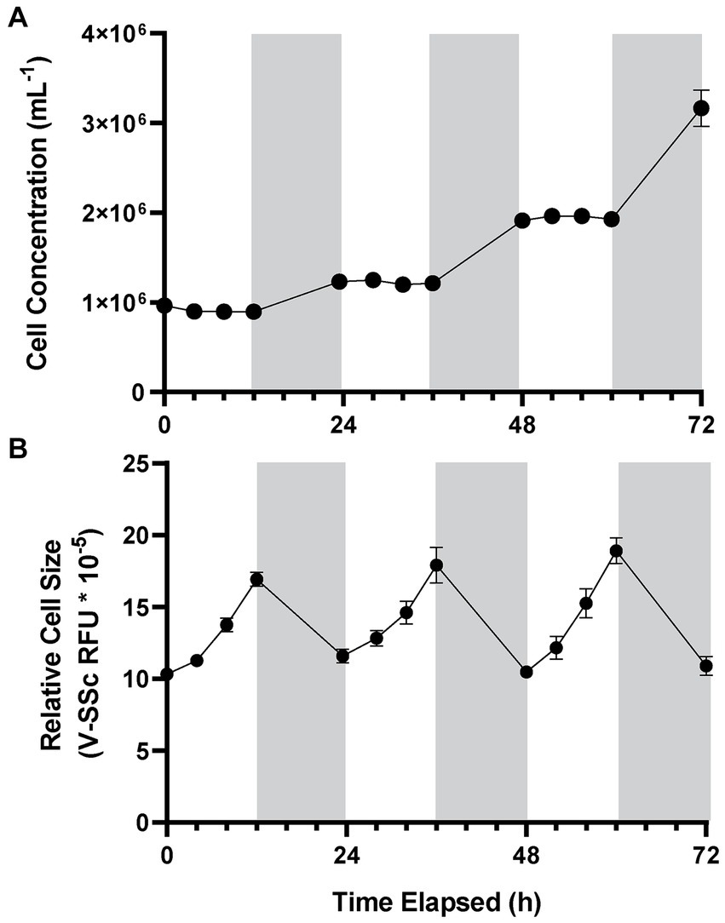
Figure 2.2. A. anophagefferens CCMP1984 growth over three light-dark cycles. Cell concentration (A) and average relative cell diameter as measured via violet side-scatter (B) of A. anophagefferens over the course of 72 hours with samples taken every four hours during the light cycle. Periods of light are indicated in white, and periods of dark are indicated in gray (n = 5).

Figure 2.3. A. anophagefferens CCMP1984 and CCMP1850 growth with frequent night measurements. Time of division is shown overnight. Cell concentrations (A) and relative cell diameter (B) of two A. anophagefferens strains, CCMP1984 (red) and CCMP1850 (blue).

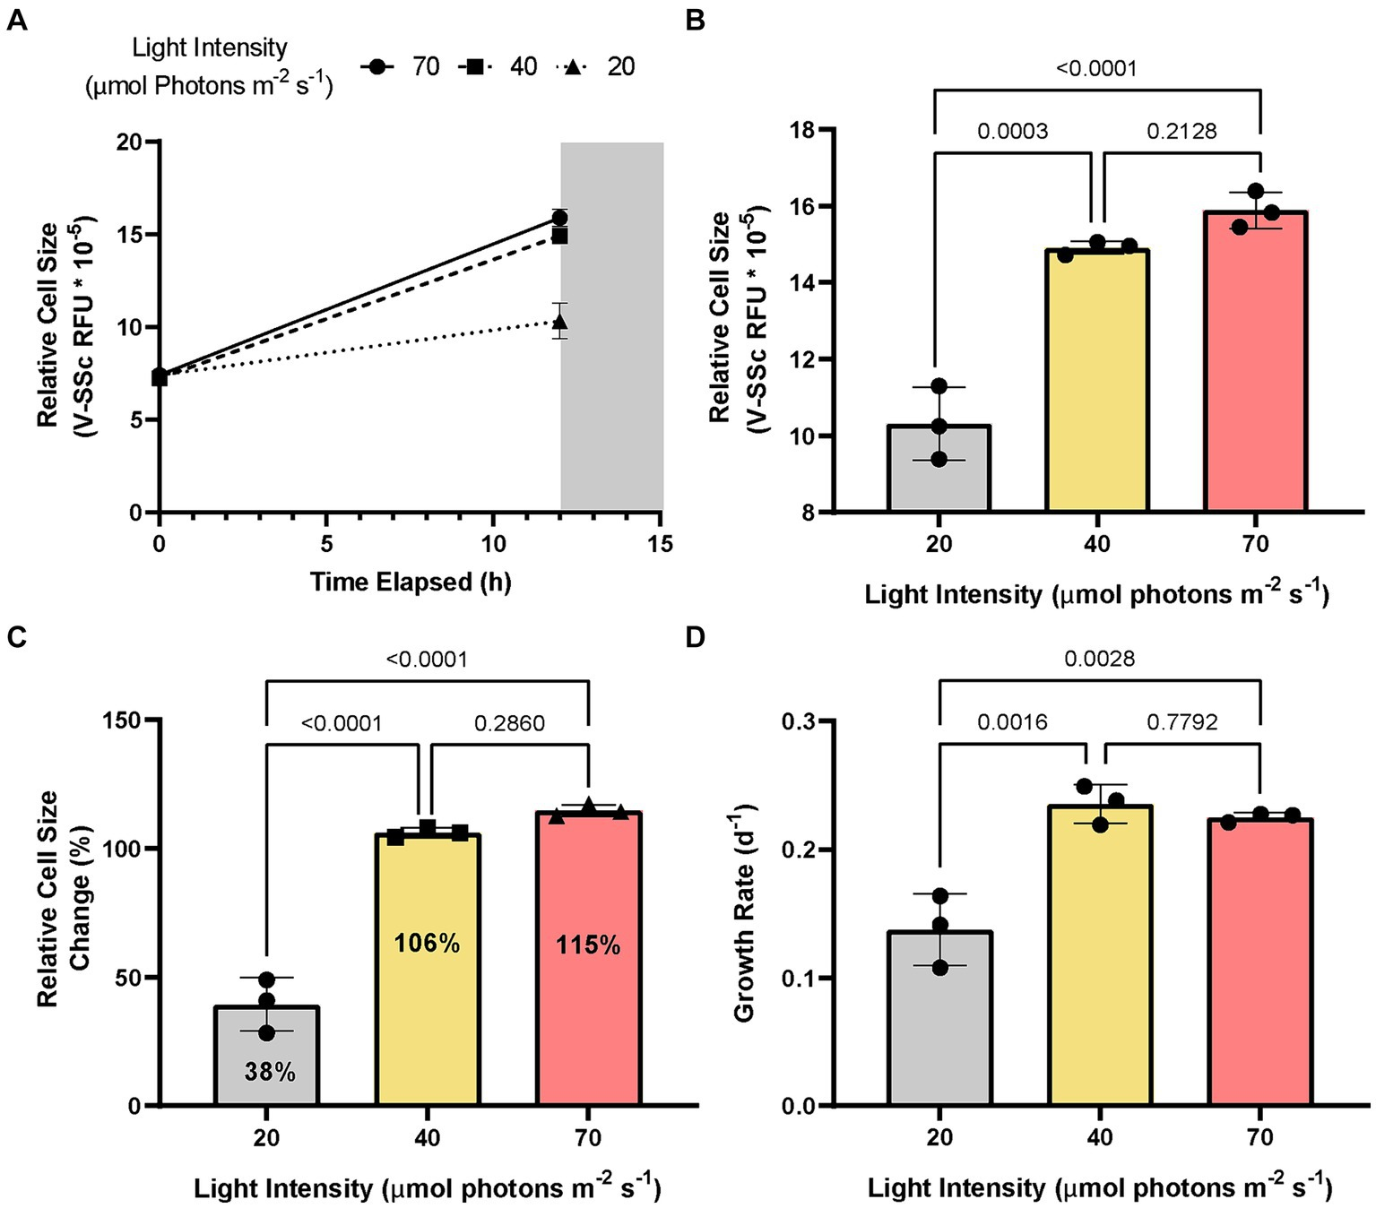
Figure 2.4. Changes in A. anophagefferens cell size under three light conditions. Average A. anophagefferens CCMP1984 relative cell diameter as measured via violet side-scatter over the course of a single 12-hour light period (A) and final average relative cell diameter at the termination of the light period (B) with cultures kept at 3 different irradiance levels (high: red, ~70 µmol m⁻² s⁻¹; medium: yellow, ~40 µmol m⁻² s⁻¹; low: grey, ~20 µmol m⁻² s⁻¹). (C) Population growth rate of A. anophagefferens over the course of 72 h under the 3 irradiance levels. P values are represented above separate irradiance levels compared via two-way ANOVA and post-hoc multiple comparisons adjusted with Tukey’s HSD (n = 3).

Figure 2.5. A. anophagefferens growth under a free-running clock. Cultures were entrained to a consistent diel cycle before and either left in the same cycle at the start of the light period (red) or moved to a parallel fully dark incubator (black) at the 24-hour timepoint. Cell concentrations were measured frequently in the first 12 hours of the free-running clock (A) after 96 hours (B) either in complete darkness or in the regular diel cycle. Relative cell diameter was also measured within the first 12 hours of the free-running clock (C). Grey and white backgrounds only refer to the light cycle of the entrained samples while red and black periods above the graphs refer to the entrainment period and the free-running clock.

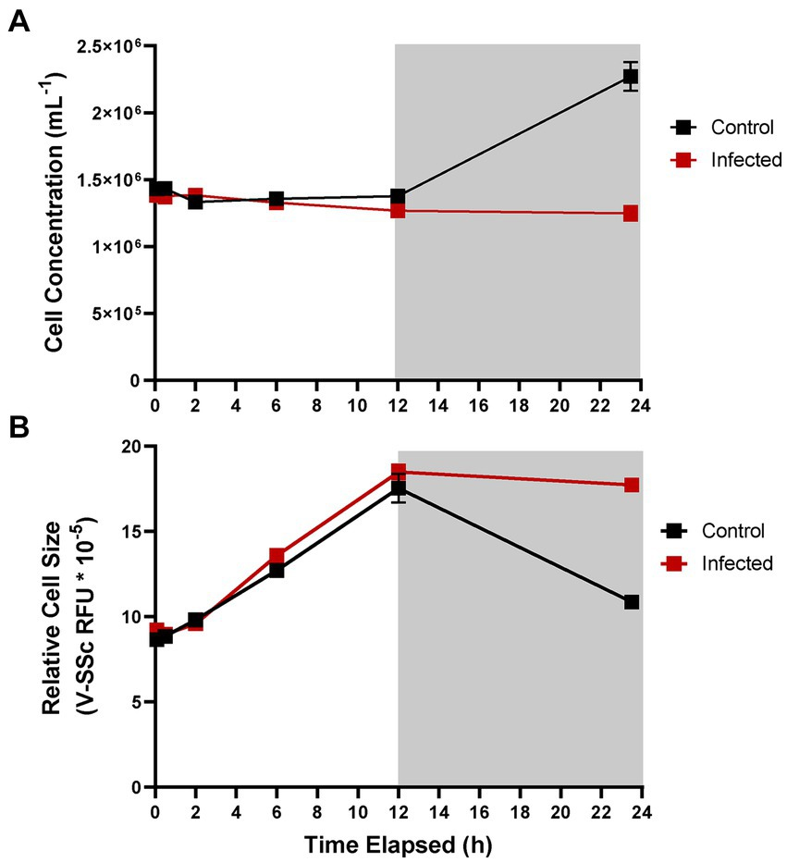
Figure 2.6. Infected and uninfected A. anophagefferens cultures during the light-dark cycle. Cell concentration (A) and average cell diameter as measured via violet side-scatter (B) of A. anophagefferens CCMP1984 over the course of 24 hours in the presence of AaV. Samples treated with viral lysate are indicated in red and control samples are indicated in black. Light periods are indicated by a white background while dark periods are indicated with a grey background (n = 3).

Figure 2.7. Effect of decreasing MOI on average cell diameter after infection. Measurements taken 24 hours after infection. Different letters signify statistically significant differences (p-value < 0.05).
Figure 2.8. Percent similarity between control and infected A. anophagefferens cultures. Percent similarity between control samples and infected treatment samples were calculated via the overlay function in the Cytoflex flow cytometry software CytExpert on the violet side-scatter channel using a violet laser (A). Correlation between percent similarity to the control after 23 hours of infection and MOI is denoted (n = 3). Cytograms detailing the overlap of individual control samples and samples of each MOI are shown (B-D).

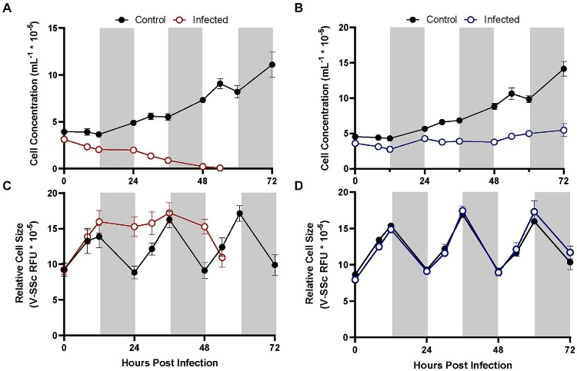
Figure 2.9. A. anophagefferens cultures exposed to AaV over three light-dark cycles. Growth of different A. anophagefferens strains CCMP1984 (A, C) and CCMP1850 (B, D) in the presence and absence of viral lysate over the course of 72 hours. Cell concentrations (A-B) and relative cell size (C-D) are denoted. Light periods are indicated by white backgrounds while dark periods are indicated by gray backgrounds. Black lines represent uninfected cultures, solid-colored lines represent cultures infected at the initiation of the light cycle (n = 3).

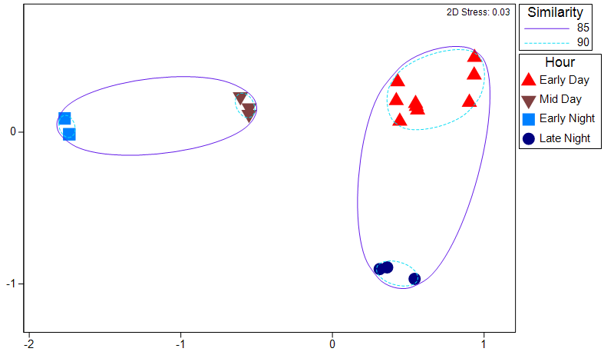
Figure 2.10. NMDS plot of uninfected A. anophagefferens transcriptomes. Colors of different points signify different times of day. Samples are clustered by percent similarity.

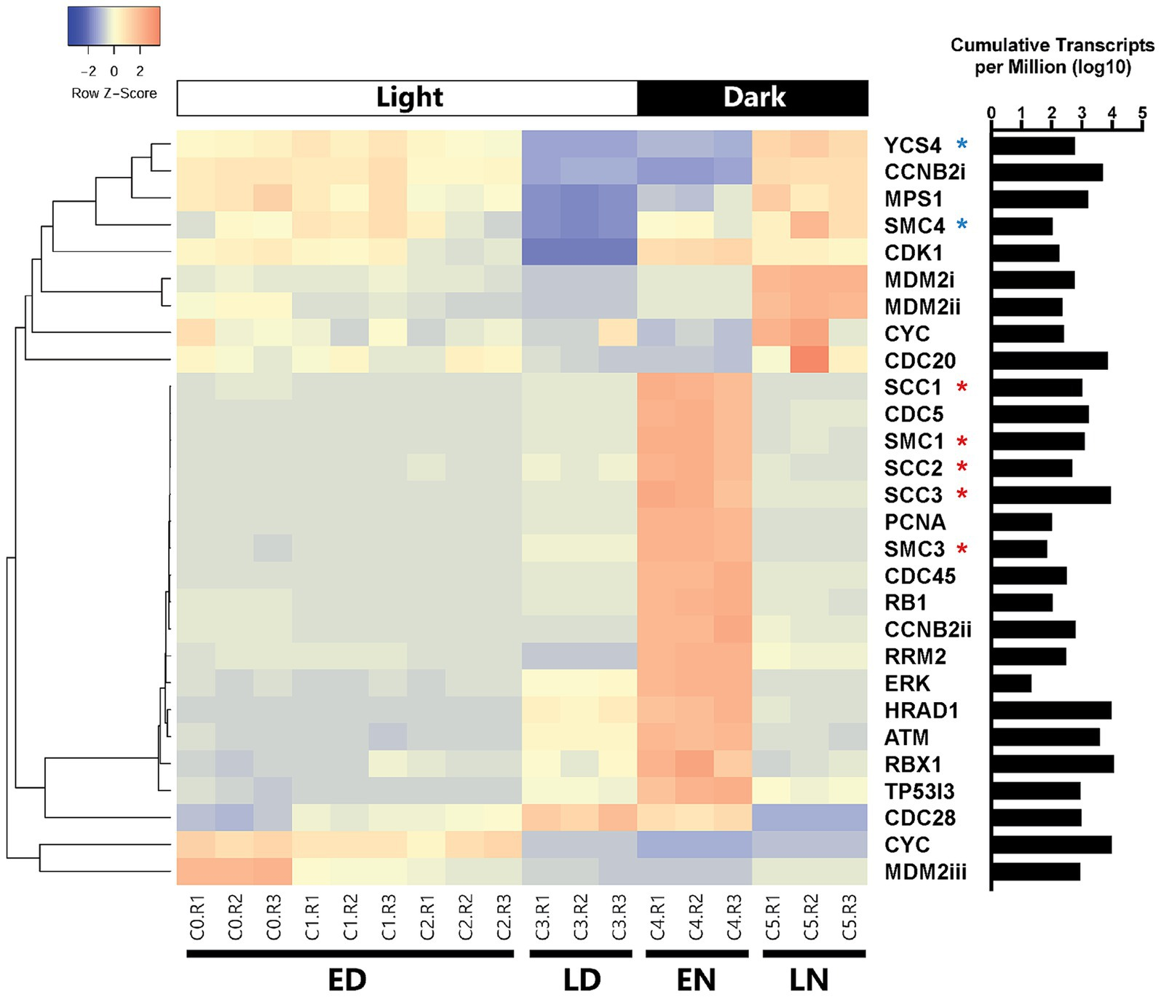
Figure 2.11. Clustered heat map of DE cell cycle-associated genes in uninfected A. anophagefferens throughout a diel cycle. Cell cycle genes characterized by KEGG databases that were differentially expressed between at least two of the four categorical time points (ED: early day; LD: late day; EN: early night; LN: late night). Rows were clustered through Pearson correlation as indicated by the cladogram and z-scored based on TPM values. The sum of transcripts across all treatments for each individual gene are indicated in log(TPM).

Figure 2.12. Cell cycle genes differentially expressed between early day and early night in uninfected cultures. Heatmap of DESeq2 normalized cell cycle gene read counts that were found to be differentially expressed (p-value < 0.05, log2fold change > 2 or < -2) between the early day and the early night control transcriptome samples. The sum of transcripts across all treatments for each individual gene are indicated in log(TPM).

Figure 2.13. Cell cycle genes differentially expressed between late day and late night in uninfected cultures. Heatmap of DESeq2 normalized cell cycle gene read counts that were found to be differentially expressed (p-value < 0.05, log2fold change > 2 or < -2) between the late day and late night control transcriptome samples. The sum of transcripts across all treatments for each individual gene are indicated in log(TPM).

Figure 2.14. TPM counts of differentially expressed cell cycle genes. A selection of differentially expressed genes between and their relative expression patterns (TPM) throughout the infection cycle between control uninfected (black) and infected (red) treatments. (A) Expression of cohesin associated genes, (B) Swe1 and several of its regulatory genes, (C) genes involved in DNA replication and regulation of DNA damage, (D) apoptosis associated genes, and (E) drivers of mitotic division.

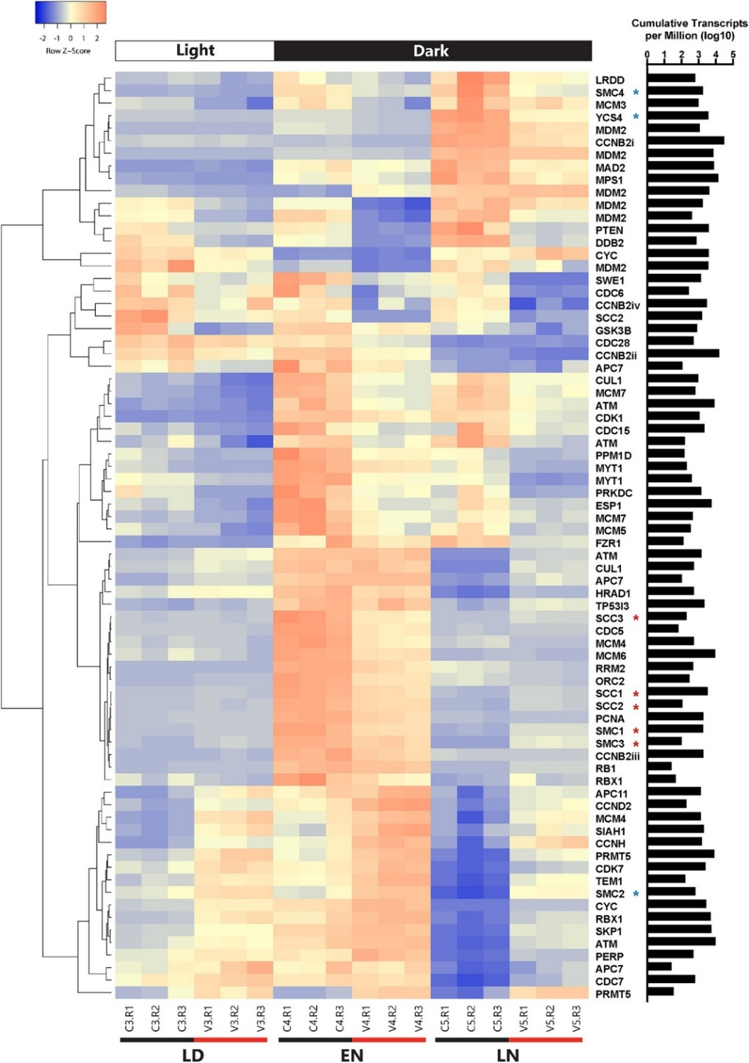
Figure 2.15. Clustered heat map showing all cell cycle genes that are differentially expressed between infected and control cultures. DE A. anophagefferens genes at one or more timepoints (LD: late day; EN: early night; LN: late night) are shown. Early morning timepoints were not included due to high variability in transcript abundance among infected samples at this period. Infected samples are indicated by a V and control samples are indicated by a C. Rows were clustered through Pearson correlation as indicated by the cladogram and z-scored based on TPM values. The sum of transcripts across all treatments for each individual gene are indicated in log(TPM).

Figure 2.16. Correlation between relative cell diameter and sinking velocity. A. anophagefferens strain CCMP1984 was used. The black line indicates the linear regression of the data.

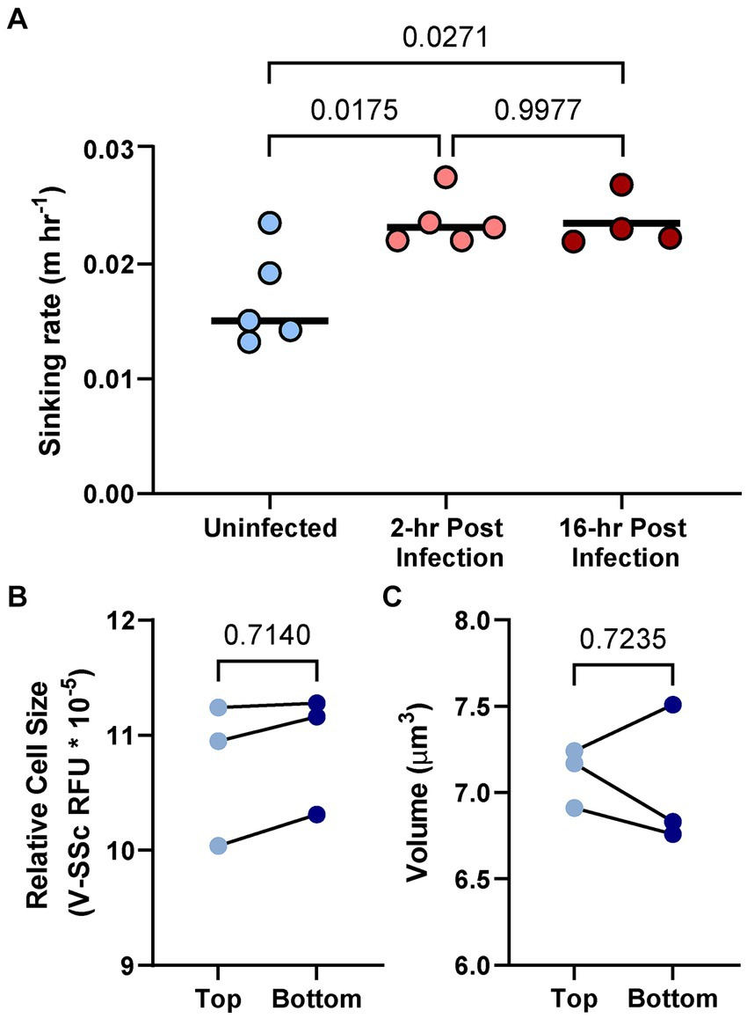
Figure 2.17. Sinking velocity of uninfected and infected A. anophagefferens cells. Sinking rate of A. anophagefferens CCMP1984 cells as it relates to the length of infection (A). Relative fluorescence as a proxy for cell diameter (B) and volume as determined via the FlowCam (C) of CCMP1984 in the top portion and bottom portion of the sinking column after incubation.

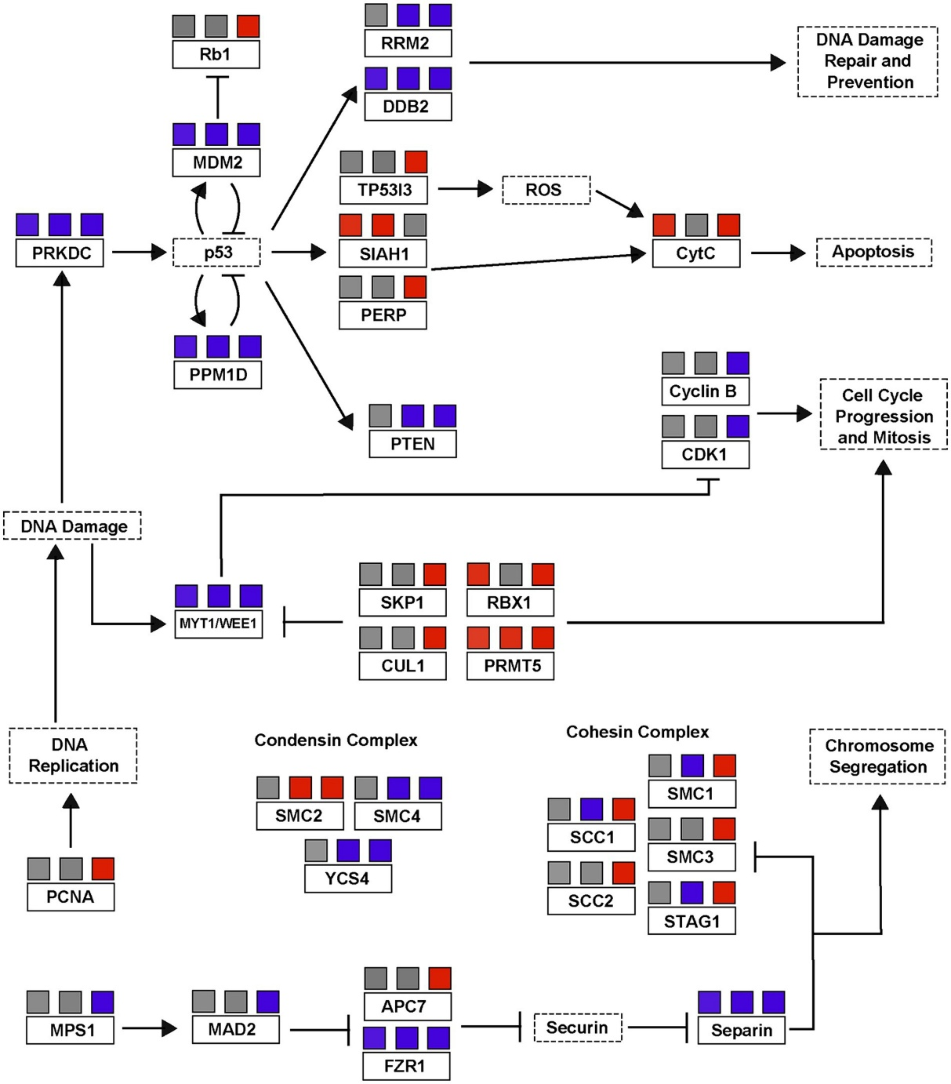
Figure 2.18. A simplified p53/cell cycle checkpoint pathway based on differential transcription of A. anophagefferens genes during viral infection. Genes present in the A. anophagefferens genome are indicated in boxes with solid outlines. Other genes not known to be encoded by A. anophagefferens or downstream effects of a certain pathway are in boxes with dashed outlines. Upregulation in samples is indicated by red boxes and downregulation is indicated by blue boxes, with the three boxes above each respective gene corresponding to their expression versus control samples during the late day, early night, and late night. Promotion of a gene/pathway is indicated by an arrow while inhibition is indicated by blunt arrows. Pathway is based on KEGG pathways map04110 and map04115.

Chapter Three

Epigenome analysis of an algae-infecting giant virus reveals a unique methylation motif catalogue

Publication note and author contributions

Publication note
A portion of this chapter has been published in Microbial Resource Announcements and authored by Alexander R. Truchon, Eric R. Gann, and Steven W. Wilhelm. The citation for this work is:
Truchon AR, Gann ER, Wilhelm SW. 2022. Closed, Circular Genome Sequence of Aureococcus anophagefferens Virus, a Lytic Virus of a Brown Tide-Forming Alga. Microbiol Resour Announc 11:e00282-22. https://doi.org/10.1128/mra.00282-22

Author contributions
This study was developed by Alexander R. Truchon, Eric R. Gann, Erik Zinser and Steven W. Wilhelm. Alexander R. Truchon extracted DNA, performed DNA sequencing. Eric R. Gann provided the framework for the bioinformatic analysis of the genome. Alexander R. Truchon assembled the genome and performed downstream bioinformatic analyses, including all methylation calling. Alexander Truchon and Steven Wilhelm wrote the chapter with all authors providing comments in the initial draft and revisions.

Abstract
DNA methylation can epigenetically alter gene expression and serve as a mechanism for genomic stabilization. Advancements in long-read sequencing technology have allowed for increased exploration into the methylation profiles of various organisms, including viruses. Studies into the Nucleocytoviricota phylum of giant dsDNA viruses have revealed unique strategies for genomic methylation. However, given the diversity across this phylum, further inquiries into specific lineages are necessary. Kratosvirus quantuckense is predicted to encode six distinct methyltransferases, which bear homology to other methyltransferases across the many clades of Nucleocytoviricota. We found that this virus methylates its own DNA with high consistency and targets up to nine different motifs for DNA adenine methylation. Methylation levels varied depending on the associated motif. Likewise, distinct motifs were enriched within unique genomic regions. Collectively this suggests that each methyltransferase targets unique DNA regions and may suggest they have varying functionality. This work reveals an array of methyltransferase activity in Kratosvirus quantuckense and begins to implicate the importance of DNA methylation to the Nucleocytoviricota infection cycle.

Introduction
The role of DNA methylation has been characterized largely through robust genetic analysis in a handful of model organisms (Zhang et al., 2006; Hoelzer et al., 2008; Mager and Ludewig, 2018; Schmitz et al., 2019). DNA methyltransferases (MTases) catalyze the addition of a methyl group typically onto either an adenine, yielding N⁶-methyladenine (6mA), or a cytosine, yielding often 5-methylcytosine (5mC) in either a CpG or non-CpG context, and less often N⁴-methylcytosine (4mC) or 5-hydroxymethylcytosine (5hmC) (Ratel et al., 2006; Schmitz et al., 2019; He et al., 2021; Rodriguez et al., 2022). These modifications can have significant effects on the functional potential and structure of the organism’s genome. While 5mC methylation has been classically attributed to repressing gene promoter activity, particularly in eukaryotes (Zemach et al., 2010), 6mA methylation has been shown to exhibit a myriad of functions in prokaryotes (Barras and Marinus, 1989). In addition to regulating gene expression (Sitaraman, 2014), DNA adenine methylation (6mA) has been largely associated with restriction modification (RM) systems that in tandem methylate an organism’s DNA while targeting unknown DNA for degradation via restriction endonuclease activity (Barras and Marinus, 1989; Ratel et al., 2006; Papoulis et al., 2021; Gao et al., 2023). While RM systems have not been identified in eukaryotes, evidence of 6mA methylation has been identified in single-celled eukaryotes (Fu et al., 2015; Luo et al., 2016), which may point to acquisition of methylation genes via horizontal gene transfer or even activity of symbiotic bacteria (Kong et al., 2022). 6mA methylation has also been associated with DNA replication and mismatch repair (Gao et al., 2023).
Few analyses into the Nucleocytoviricota have delved into the methylation of viral genomes, despite a high abundance of DNA MTases encoded within their genomes (Coy et al., 2020; Jeudy et al., 2020). Of particular significance is Paramecium bursaria Chlorella Virus 1 (PBCV-1), which encodes five predicted DNA MTases, two of which have strongly defined functionality (Agarkova et al., 2006; Chan et al., 2006; Coy et al., 2020). These two adenine-specific MTases, M. CviAI and M. CviAII, are flanked by restriction endonucleases which target GATC and CATG cut sites, respectively (Agarkova et al., 2006). Methylation of the virus’s own genome provides protection from these self-encoded restriction enzymes while allowing for degradation of host DNA, similarly to the Dam RM systems typical of bacteria which target invading phage DNA. For this reason, a high proportion of GATC or CATG sites are fully methylated on each strand, with most of the remaining sites being hemi-methylated (Coy et al., 2020). Given the importance of evading restriction endonucleases for proper replication of the viral genome, universal genomic methylation is an expected functionality of these types of MTases.
The three other DNA MTases encoded by PBCV-1 have not yet been shown to be functional, though if they are, they likely target cytosine sites rather than adenine (Agarkova et al., 2006). They are also not genomically colocalized with known restriction enzymes. This is the case for many DNA MTases encoded by the Nucleocytoviricota (Jeudy et al., 2020), thus bringing their function into question. Several DNA MTases were characterized in the Pandoraviruses, a lineage of Nucleocytoviricota with particularly large genomes (Legendre et al., 2018), which methylate a variety of cytosine motifs and bear high phylogenetic identity to Acanthamoeba spp. MTases, suggesting these are genes are host derived (Jeudy et al., 2020). However, Mollivirus sibericum, Cedratvirus kamchatka, and several Marseilleviruses encode for adenine-specific MTases and do methylate their own genomes (Jeudy et al., 2020). In Marseilleviruses in particular, this appears to again be associated with an RM system (Jeudy et al., 2020; Sahmi-Bounsiar et al., 2021). Outside of this information the role of DNA methylation in viral infection is still largely unclear.
This is particularly significant regarding Kratosvirus quantuckense, a virus of the Nucleocytoviricota which infects the eukaryotic brown alga Aureococcus anophagefferens (Moniruzzaman et al., 2014; Truchon et al., 2023). K. quantuckense encodes for several DNA-specific MTases (Moniruzzaman et al., 2014). However, these MTases are not homologous to the functionally defined MTases of PBCV-1, nor do they co-occur with any identifiable restriction endonucleases. The high density of MTases encoded by K. quantuckense merits further analysis of their function during infection, their activity on genomic viral DNA, and the variability of sites that are targeted for methylation. Moreover, the diversity among these MTases may imply divergent functionality, possibly involving genomic stability within the virocell and regulation of DNA packaging.
Here we used Nanopore long-read sequencing to define the methylation landscape of Kratosvirus quantuckense strain AaV. Repeated whole genome sequencing of four biological replicates of viral DNA revealed consistent methylation patterns of both adenines and cytosines. Analyses of these methylation patterns across the genome revealed the presence of several motifs which are likely targeted by different MTases encoded by AaV. We present this information in the context of virus-host interactions, the diversity of methylation strategies across the Nucleocytoviricota, and how this generally overlooked aspect of the viral genome shapes the potential success of this pathogen.

Methods

Culture conditions
Three 750 mL batch cultures of non-axenic Aureococcus anophagefferens CCMP1984 were grown in ASP₁₂A media (Gann, 2016) on a 12:12 light:dark cycle at 19° C and an irradiance of ~90 µmol photons m⁻² s⁻¹. After one week of logarithmic growth, cultures were diluted 10:1 in ASP₁₂A to 1 L to prevent nutrient starvation. Two days following dilution, cultures were infected with 10 mL of fresh K. quantuckense strain AaV in ASP₁₂A (Moniruzzaman et al., 2014). Fresh AaV had been prepared through infection of a 25 mL culture of A. anophagefferens CCMP1984 with AaV, after which lysate was pushed through a Durapore 0.45-µM nominal pore-size PVDF-membrane syringe filter (MilliporeSigma; Burlington, MA) before inoculation. Once infected cultures were completely lysed (~3 d), lysate was stored at 4° C.

Preparation of viral particles for DNA extraction
Lysate was prefiltered through an Isopore™ 0.4-µM nominal pore-size 25-mm diameter polycarbonate membrane syringe filters (MilliporeSigma; Burlington, MA) to remove lysed cellular material and surplus heterotrophic bacteria. Each liter of filtered lysate was then concentrated by tangential flow filtration (TFF) as previously described (Coy and Wilhelm, 2020). Briefly, lysate was sequentially concentrated with a Pellicon XL 30 kDa Cassette (MilliporeSigma; Burlington, MA) using a Labscale TFF System (MilliporeSigma; Burlington, MA). Lysate was concentrated from 1 L to approximately 25 mL, yielding a theoretical 40-fold increase in viral particle concentration. Concentrated lysate was once again filtered through a Durapore 0.45 µm pore-size PVDF membrane syringe filter (MilliporeSigma; Burlington, MA). Lysate was enumerated on a CytoFLEX flow cytometer (C07821) by gating on the Violet Side Scatter channel using a 405 nm violet laser (Chase et al., 2023) to ensure production of viral particles. To further clean AaV particles, lysate was centrifuged at 2,000 xG for 5 min to pellet remaining bacterial cells. The supernatant was moved to a clean tube and 10% Triton X-100 was added at a final concentration of 1%. To concentrate particles, the supernatant was then centrifuged at 29,000 rpm for 75 min to pellet viral particles, which were subsequently resuspended in 400 µL ASP₁₂A.

DNA extraction and sequencing
Lysozyme (120 µL of 20 mg/mL) and 1 µL RNase (10 mg/mL) were added to the concentrated viral particles and incubated at 37° C for 30 min. Viral particles were then treated with 10 µL of proteinase K solution (20 mg/mL, 3 mM CaCl₂, 200 mM Tris buffer) along with 40 µL lysis solution (0.5% SDS, 10 mM EDTA, 20 mM sodium acetate) and incubated at 55˚C for 2 hours while gently shaking. DNA was extracted using a standard phenol-chloroform method. DNA concentration and purity was determined on a NanoDrop spectrophotometer and size of extracted DNA was visualized using gel electrophoresis.
DNA extracts from each replicate were individually sequenced using a new MinION Mk1B sequencing device fitted with a Flongle adapter for Flongle Flow Cells (R10.4.1) (Oxford Nanopore Technologies; Oxford, UK). Sequencing libraries were prepared according to manufacturer’s instructions using a V14 Ligation Sequencing Kit (SQK-LSK114) and the Flongle Sequencing Expansion (EXP-FSE002) (Oxford Nanopore Technologie; Oxford, UK).
To serve as a control, DNA was extracted from a fourth biological replicate of concentrated viral lysate. This DNA was diluted to approximately 3 ng/µL before performing whole genome amplification (WGA) with the NEB phi29-XT WGA Kit (New England Biolabs, Ipswich, MA). This WGA DNA and an aliquot of the original, undiluted DNA from the fourth replicate were then sequenced on tandem Flongle Flow Cells (R10.4.1). All sequencing runs performed for this analysis are summarized in Table 3.1.

Whole genome resequencing
Viral DNA was extracted from a lysed, xenic A. anophagefferens culture for whole genome assembly via a gel electrophoresis-based method (Truchon et al., 2022b). Briefly, virions were concentrated using tangential flow filtration and ultra-centrifugation to enrich virus particles. Particles were digested in agarose CHEF plug molds (Bio-Rad, Hercules, CA, USA) with proteinase K before being run on a low-melting agarose gel. High molecular weight DNA was excised from the gel and purified using a phenol-chloroform method (Truchon et al., 2022b).
Long read sequencing was performed using Oxford Nanopore Technologies MinION (ONT, Oxford, UK). Genomic DNA libraries generated using the ligation sequencing kit (ONT, Oxford, UK) were sequenced on a MinION R9.4.1 flow cell (ONT, Oxford, UK), producing 284,000 reads that averaged 2,503 bp. Bases were called using Guppy basecaller version 3.0.3 using the config file dna_r9.4.1_450bps_fast.cfg (Wick et al., 2019). Adapter sequences were removed using Porechop version 0.2.4 (Wick et al., 2017) and reads trimmed using a quality score of 9 and a minimum length of 500 bp using NanoFilt version 2.7.1 (De Coster et al., 2018). Reads aligned to the AaV reference genome using BBMap version 38.90 (Bushnell, 2022), were used in the assembly performed using Canu version 2.1 (Koren et al., 2017).
DNA was also extracted for short read sequencing by treating concentrated virions with proteinase K for 1 hour at 37°C and extraction via standard phenol-chloroform methods (Dunigan and Agarkova, 2016). The DNA library was prepared and sequenced on a NextSeq 2000 (Illumina, San Diego, CA, USA) by the Microbial Genome Sequencing Center, generating 12,378,846 x 150 bp paired-end reads. Illumina short reads were trimmed for quality using the default settings in CLC Genomics Workbench (Qiagen, Hilden, Germany) and mapped to the Canu-assembled contig using bowtie2 version 2.2.3 (Langmead and Salzberg, 2012). The assembly was polished with the Illumina reads using Pilon version 1.23 (Walker et al., 2014), which generated a closed, circular contig of 381,717 bp. Coding sequences and tRNAs were predicted using Prodigal version 2.6.3 (Hyatt et al., 2010) and tRNAscan-SE version 2.0 (Chan and Lowe, 2019), respectively. Functions were predicted from translated amino acid sequences using the eggNOG-mapper web server (Huerta-Cepas et al., 2017).

Methylation calling and initial analysis
POD5 files generated from long-read sequencing were aligned to the most recent version of the AaV genome (Truchon et al., 2022a) and called for 5mC and 6mA methylation using Bonito basecaller with the dna_r10.4.1_e8.2_400bps_hac@v5.0.0 model with a minimum q-score of 9 (Seymour, 2019). Called and aligned reads were sorted and indexed using Samtools (Li et al., 2009). BedMethyl tables, which display total methylation at all genomic sites, were created using the Modkit pileup command (Oxford Nanopore Technologies). To avoid considering methylation at sites with only a small number of reads mapped (i.e., single nucleotide polymorphisms) python scripts were used to filter the bedMethyl file down to only sites that contain the respective nucleotide (either adenine for 6mA methylation or cytosine for 5mC methylation). Methylation frequency (i.e. proportion of nucleotides at a given site methylated) for each individual site was calculated using the equation:
$$methylation frequency= \frac{\# methylated nucleotides at site}{total reads mapped to site}$$
Likewise, genomic methylation fraction was calculated by determining the proportion of all sites in the genome that meet the threshold to be considered methylated, which, for the purpose of this study, is 70% methylation frequency. For methylated site enrichment scores of specific genomic regions, every 1000 bp frequently methylated sites were counted within a sliding window of 5000 bp before being normalized by the total number of the respective site within the region. Z-scores from enrichment scores were calculated and used for Circos heatmaps.
To determine WGA-corrected methylation frequency for each site, methylation frequency scores from the WGA-amplified library BedMethyl files were subtracted from the methylation frequency scores from the respective unamplified library. Python scripts were used to determine the frequency of nucleotides surrounding highly methylated sites (>80% for 6mA and >50% for 5mC). Methylation maps were generated using python scripts and imaged using Circos.

Methylation targeted motif identification and characterization
To identify DNA sequences likely to be targeted for methylation in the AaV genome, corrected BedMethyl tables were run through the motif detection software Nanomotif using the motif discovery function. This process was performed for all three libraries and any motifs identified were retained for future analysis. Overall, nine putative targeted motifs were discovered, five of which were palindromic. For palindromic motifs, python scripts were used to pair scores belonging to the same palindrome on opposite strands to determine hemi-methylation of these sites.
To identify genomic regions in which specific motifs are enriched, the web server DistAMo was used to visualize motif distribution. Coding regions that were overrepresented with a specific motif with a Z-score >= 2 were identified for each motif. Genes that were found to be associated with a specific motif were clustered using Cytoscape where every line connects a gene to any motifs that are overrepresented in the region.

Phylogenetic analysis of viral methyltransferases
To better characterize the DNA MTases, genes were called from sequenced Nucleocytoviricota genomes (including AaV) using the Nanomotif tool MTase-linker, which compares coding regions of each respective genome to the entire REBASE database and flags likely DNA MTases. The number of DNA MTases identified through this process was normalized to both the length of the respective virus’s genome as well as the number of identified coding regions for comparison across all viruses.
To generate a phylogenetic framework of Nucleocytoviricota DNA MTases, protein sequences for each gene were aligned using MAFFT v7.520 using a maximum number of iterative refinements of 1000. Sequence alignments were then trimmed using trimAl v1.4.rev15 with a gap threshold of 0.9 and a 25% conservation. A maximum-likelihood protein tree was constructed using IQ-TREE version 2.2.0.3 with 1000 bootstraps and visualized in IToL.

Restriction enzyme digestion
To verify results noted from motif analysis, three restriction enzymes were used to verify the presence of methylation on AaV adenines. These included Hpy166II, which targets the GTNNAC motif, XhoI, which targets the CTCGAG motif (i.e. a proxy for CTNNAG), and XbaI, which targets the TCTAGA motif (i.e., a proxy for CTAG). DpnI and DpnII were used as controls, which are expected to digest methylated and unmethylated motifs respectively. All digestions were performed with either AaV, whole genome amplified AaV, or A. anophagefferens DNA in rCutSmart Buffer (New England Biolabs, Ipswich, MA) for 15 min at 37° C. Reactions were inactivated at 65° C for 20 min and then visualized via gel electrophoresis.

Results

Whole genome resequencing yields a single circular AaV genome
AaV has been propagated on its pelagophyte host, Aureococcus anophagefferens, since its isolation in the early 2000s and was first sequenced and assembled using Illumina reads in 2014 (Gobler et al., 2007; Rowe et al., 2008b; Moniruzzaman et al., 2014). Since then, the virus has been maintained via co-culture with A. anophagefferens CCMP 1984. The original assembly was predicted to have terminal ends rich in leucine repeat-containing coding sequences (Gobler et al., 2011; Moniruzzaman et al., 2014). As repetitive regions can lead to improper assemblies when employing short-read sequencing exclusively, we re-sequenced AaV using short and long-read sequencing (Jain et al., 2016).
Resequencing the AaV genome yielded a closed, circular contig of 381,717 bp with 384 coding sequences (CDS) and 8 tRNAs. As the original assembly only encoded for 376 genes, several of the novel genes were identified. One novel CDS encodes for a putative DNA-dependent RNA polymerase subunit (Rpb2). Only one of the 11 RNA polymerase genes encoded by AaV is homologous to the novel subunit, though the two sequences have an amino acid identity below 30%. This supports the hypothesis that two copies of this gene arose from an ancestral duplication among Mimiviruses of eukaryotic phototrophs (Blanc-Mathieu et al., 2021). Among other changes to the genome are apparent duplications, gene elongations, and gene combinations missed during initial assembly (Figure 3.1).

Methyltransferases and methylated adenines in AaV
AaV encodes seven nucleotide-associated MTases, one of which is likely to act as an RNA methylase based on homologous sequences. Among the six remaining MTases, five appear in the Restriction Enzyme Database (REBASE), a catalog identifying restriction endonucleases and MTases (Roberts et al., 2022). All are considered type II MTases, meaning they exist as distinct ORFs with no associated endonuclease domains. All have the characteristic domains of an MTase [i.e., fgg, dppy, and the DNA target recognition domain (TRD)] (Table 3.2) (Klimasauskas et al., 1989; Roberts, 2003). Four of these MTases fit into the γ subclass, signifying a motif order of fgg-dppy-TRD, while the final MTase belongs to the β subclass, signifying a motif order of dppy-TRD-fgg (Roberts et al., 2003). When characterizing the function of these MTases using the Nanomotif MTase-caller tool (Heidelbach et al., 2024), the five genes described above are characterized as adenine-specific MTases, while an additional MTase was identified as potentially cytosine-specific. This final gene, which was not described in REBASE, contains three of the six characteristic domains of a cytosine-specific MTase (fgg, pc, and env), though it appears truncated and lacks the three terminal domains that are consistent with cytosine specific MTases (qrr, ix, and x) (Pósfai et al., 1989). This gene bears a high identity to two MTases encoded by the A. anophagefferens mitochondrion (59.48% amino acid identity), one of which is also truncated while the other contains all six motifs. As it is unclear if the protein product for this gene is functional, it will not be further analyzed in this study. Furthermore, none of the MTases appear to be packaged in the viral capsid (Gann et al., 2020c), meaning they are likely only active after transcription initiation.
When compared to other giant viruses, AaV encodes more MTases in the context of the entire genome. Despite being one of the smaller Nucleocytoviricota with a genome size of just ~380 kb, AaV encodes six MTases out of 384 ORFs, giving it a high ratio of MTases per genome (Figure 3.2A) and MTases per total encoded genes (Figure 3.2B) as compared to other similar viruses (Table 3.3). Of the viruses examined, these represent some of the highest rates of encoded DNA MTases, in a similar fashion to Ostreococcus lucimarinus Virus (OlV; 4 DNA MTases in a 190 kb genome), PBCV-1 (5 DNA MTases in a 330 kb genome), and Phaeocystis globosa Virus (5 DNA MTases in a 460 kb genome). While the larger Nucleocytoviricota like the pandoraviruses or Bodo saltans Virus do encode DNA MTases, none display the density seen in AaV (Table 3.3). Moreover, many amoebal Mimiviridae, like Acanthamoeba castellanii Mimivirus (APMV), do not appear to encode any traditional DNA MTases according to REBASE standards (Table 3.3).
Methylation frequency of both adenines (6mA) and cytosines in the AaV genome was consistent between successive sequencing runs (Figure 3.3). The standard deviation of the methylation frequency is lower than 10% for 99% of AaV adenines (Figure 3.4A) and lower than 7% for 99% of cytosines (Figure 3.4B). The standard deviation of the methylation frequency also follows a nonlinear quadratic regression in relation to the mean methylation frequency for both adenines and cytosines, showing that both low methylation and high methylation sites have reduced variability (Figure 3.4A-B). A vast majority of adenines have low methylation scores, i.e. below 25%, while the range of methylation scores for a given site increases as the mean increases (Figure 3.4C). However, while it is expected for there to be a higher standard deviation around larger scores, the absolute highest methylation frequencies have very consistent scores across all libraries (Figure 3.4D).
Genomic maps of the methylation of AaV are detailed in Figure 3.5. 6mA methylated adenines (Figure 3.5A) occur consistently throughout much of the genome at relatively even rates while 5mC methylated cytosines (Figure 3.5B) are frequently in distinct clusters. Several specific genes are highly methylated on adenine residues within the intragenic region, including the major capsid protein (MCP) in which 5.7% of adenines are methylated at a frequency over 75% (compared to 0.90% genome-wide) (Figure 3.6A). Highly methylated cytosines are frequently found in repeat containing proteins, one of which 9.1% of cytosines methylated at a frequency over 50% (compared to 0.63% genome-wide) (Figure 3.6B). Regardless, methylation enrichment occurs for both 6mA and 5mC methylation in different locations depending on the strand (Figure 3.7). On average, cytosines in the AaV genome are methylated at a rate of approximately 4.59% with 0.664% of cytosines being methylated at a rate higher than 50%. Adenines in the AaV genome are methylated at a rate of approximately 6.55% with 1.917% of adenines being methylated at a rate higher than 50%.
Methylation across intragenic regions, as well as the 1 kb upstream region and 1 kb downstream region for each gene were characterized collectively across the entire AaV genome. Intragenic regions for each gene were normalized into ten distinct regions, while each 50 bp within the upstream and downstream regions were considered for methylation frequency. Average methylation frequency for these sites was determined based on the total adenines a given region, and the averaged methylation scores across said region. Notably, methylation frequency across the gene body was consistently lower on the sense strand as compared to the anti-sense strand, which averaged 6-7% and 7-9% respectively (Figure 3.8). Despite this, methylation did not vary largely within different intragenic regions (Figure 3.8A).
In regions both 100 bp upstream and 50 bp downstream of coding regions, a decrease in methylation frequency was visible (Figure 3.8A). This decrease was most notably exacerbated within the 50-bp immediately upstream of the gene body on the sense strand. This drop in methylation was significantly lower than the 19 other sites upstream of the gene body (Figure 3.8B). A similar pattern is notable on the antisense strand upstream of the gene body as well as on both strands downstream of the gene body, if not to a lesser extent.
The drop in methylation frequency immediately upstream of coding regions may be attributable to a promoter motif that has been associated with early gene expression during infection: “[AT][AT][AT][TA]AAAAATGAT[ATG][AG][AC]AAA[AT]”. This motif lacks any of the methylation motifs defined in this study, which may explain the decrease in methylation frequency in the promoter region. However, we found no connection between methylation in the promoter region and temporal gene expression (Figure 3.9). In fact, several genes that are expressed early in the infection cycle, including MCP (Figure 3.6A), have particularly high methylation within the promoter region.

Nucleotide bias surrounding adenines influences methylation
6mA methylation was found to be highly dependent on the nucleotides surrounding the adenine, indicating motif dependent DNA binding typical of MTases (Figure 3.10). Sequence specific analysis revealed that a disproportionate number of methylated adenines occur in the CTAG motif, a 4mer which boasts an average methylation frequency ranging from 34.48 to 57.49%, a stark difference from the average methylation rate of adenines throughout the genome. While methylation frequency at these sites is relatively high, this motif is not common in the viral genome, with the “CTAGG” motif occurring approximately once every 4500 bases, while the analogous “TCAGG” motif occurs once every 360 bases. Likewise, polyadenine regions were largely unmethylated, a pattern that is particularly exacerbated by the presence of one or more adenines downstream of the adenine in question. Classical dam motifs GATC and CATG, which have been identified in the Chlorovirus PBCV-1 and are typically associated with RM systems, bear slight methylation signals at frequencies of 8.3-18.5% and 12.3-14.7% respectively.
To test for co-occurrence of adenine methylation, the methylation frequencies of adenines within ten nucleotides of highly methylated adenines (methylation frequency > 80%) were collectively examined. Sites that are located 2-3 nucleotides upstream and 2 nucleotides downstream on the same strand of the highly methylated adenine are frequently hypomethylated (Figure 3.11). Interestingly, sites that are three and five nucleotides upstream of the highly methylated adenine display elevated methylation frequencies on the opposite strand (Figure 3.11). Biases that exist in favor of nucleotide occurrence surrounding a methylated adenine can also be identified using this approach. When considering only sites surrounding a methylated adenine, the proportion of adenines at 5 and 4 bases upstream and 1 base downstream, and the proportion of guanines 1 base upstream, steadily decreased as a function of minimum methylation frequency (Figure 3.12). Likewise, the proportion of thymine at 5 bases upstream, guanine at 4 bases upstream, and cytosine 1 base upstream, increase (Figure 3.12).

Several complex motifs identified display variable methylation levels
To search for more complicated motifs, Nanomotif was used to identify motifs in the genome that were enriched for methylation, using a stringent cut-off of 70% methylation frequency to define methylated sites. Nine motifs were identified between the three sequencing libraries (Table 3.4), including the CTAG motif previously identified. Other derivative motifs to CTAG were also identified, either containing additional nucleotides within (CTNNAG) or flanking the motif (CTAGY). These variations of the CTAG motif represented seven out of nine of those identified, not including GTNNAC and TGNNCA. However, these two motifs, along with CTNNAG, were identified as targeted for methylation in each library.
Across the nine motifs, GTNNAC and TGNNCA were also the most highly methylated, with an average methylation frequency of 74.52% and 74.08% respectively. Meanwhile, CTAG and CTNAG exhibited the lowest average methylation frequency of identified motifs, at 58.78% and 58.06% respectively. Collectively, the identified motifs represent a vast majority of the methylated sites, including approximately 74% of sites with a methylation frequency > 50% and approximately 92% of sites with a methylation frequency greater than 70% (Figure 3.13). Motifs distribution is also largely consistent with highly methylated sites found globally throughout the genome. To rule out false signals that might be attributed to sequencing errors, a WGA library was used to correct methylation frequency scores. Most sites attributed to motifs remained significantly methylated, as compared to classical methylation motifs CATG and GATC (Figure 3.14). Interestingly, while the motifs enjoy a more cosmopolitan distribution, the CATG motif is clearly more abundant at one end of the linearized genome (Figure 3.14).
Most sites displayed similar distributions regarding variance, with most standard deviations below 10% and barely any above 20% (Figure 3.15). Distribution of methylation frequency means for each individual site varied more depending on the motif, however (Figure 3.15). In certain cases, motifs targeted for methylation contain ambiguous nucleotides (e.g. the ambiguous CTNAG) in one library while being defined in other libraries (e.g. the specified CTAAG). Comparing the shifts in mean methylation frequency and standard deviation between ambiguous motifs and their respective specified motifs reveals that the specified motifs are both more consistently and frequently methylated (Figure 3.15A-B). Still, a proportion of the highly methylated sites belong to the ambiguous motif only, implying that the specified motif does not completely account for all the associated methylation.
Considering that five motifs are palindromic (i.e. the reverse complement sequence is identical), we sought to determine rates of full and hemi-methylation. To be considered a fully methylated motif, both respective adenines on the positive and negative strand had to reach a minimum methylation frequency of 70%, whereas only one strand being methylated at this level was considered hemi-methylation. The palindromic motifs that are derivatives of the CTAG motif, thus CTAG itself, CTNAG, and CTNNAG, all had low levels of full methylation (<20%) and were hemi-methylated over 50% of the time (Figure 3.16A-C). The GTNNAC and TGNNCA motifs, while still displaying high rates of hemi-methylation, were much more likely to be fully methylated (40-60% of sites) while also being much less likely to be completely unmethylated than the CTAG derivatives (Figure 3.16D-E). In these respective motifs, a significant increase in proportional full methylation was detected as compared to the CTAG derivatives (Figure 3.16F-G).
To further verify the authenticity of the defined methylation motifs, a series of restriction enzyme digests were performed using the enzymes Hpy166II (targeting GTNNAC), XhoI (targeting CTCGAG), and XbaI (targeting TCTAGA). DpnI and DpnII only cleave GATC in which the adenine is either methylated or unmethylated, respectively. Considering GATC sites are apparently unmethylated in AaV, these enzymes were used as negative and positive controls for the restriction digests. None of these enzymes were capable of degrading raw viral DNA, though degradation by DpnII showed the viral genome is definitively not methylated at GATC sites (Figure 3.17). WGA viral DNA was clearly digested by Hpy166II, with potential digestion by XhoI and XbaI as well, compared to the negative control (Figure 3.17). What’s more, A. anophagefferens DNA was heavily digested by both Hpy166II and XhoI, implicating divergent methylation patterns between host and virus. As neither XhoI nor XbaI showed strong digestion on AaV or amplified DNA, likely due to the motifs’ infrequency in the viral genome, both were used concurrently. While the two enzymes together showed digestion of amplified DNA, unamplified DNA was unaffected (Figure 3.18).

Phylogenetics of AaV methyltransferases show their potential origin
The six DNA MTases encoded by AaV were placed into a phylogenetic tree of Nucleocytoviricota MTases which have either been shown to methylate a specific site (Jeudy et al., 2020) or are predicted to do so based on homology to defined sequences in REBASE (Figure 3.19). The resulting phylogeny can be broken into four distinct clades, of which three contain AaV MTases.
Clades I and II contain one AaV MTase each (Figure 3.20). Clade I contains one AaV MTase (AaV_128) which is predicted to target the CTSAG motif based on REBASE homology. This is also the only type II β MTase encoded by AaV, as all others are of the γ subclass. Despite other Imitervirales and Algavirales methyltranferases in this clade, the AaV MTase bears relatively increased similarity (approximately 35%-40% amino acid similarity) to those of Cedratvirus, Pithovirus and Mollivirus sibericum, which again target either a CTNNAG motif derivative or CTNAG motif derivative. Notably, while REBASE initially predicted that the Cedratvirus MTase would target CTSAG as well, PacBio sequencing revealed that it instead targets the CTCGAG motif (Jeudy et al., 2020). This may imply that the related AaV MTase either targets the CTNNAG motif or the CTNAG motif.
Interestingly, Clade I contains a cluster of cytosine specific MTases (subclass IA; Figure 3.20), which belong to either the Pandoraviruses or Molliviruses. A monophyletic sub-clade of these genes belongs exclusively to the Pandoraviruses with zero homologs outside of this specific viral family. While these enzymes perform 5mC methylation (Jeudy et al., 2020), two of the described motifs mirror the CTNAG and CTNNAG motifs identified in the AaV methylome. In fact, the CTCGAG motif appears in both several Pandoraviruses as well as Cedratvirus kamchatka, though cytosine and adenine are targeted respectively between the two viral MTases.
Clade II is primarily comprised of MTases of the Algavirales, among which is the PBCV-1 gene M.CviAII, which targets the adenine in the CATG motif and M.CviAII which targets the adenine in the GATC motif (Zhang et al., 1992). Despite this, this clade varies in both the predicted motif for methylation as well as type of methylation (6mA or 5mC). Still, distinct lineages including the Marseilleviruses and the Imitervirales are present throughout this clade. The truncated cytosine-specific MTase AaV_322 falls within subclade IIC (Figure 3.19, Figure 3.20), which has 100% bootstrap support as distinct from the adenine-specific enzymes in this clade.
Clade III contains the four remaining AaV MTases, though they cluster into three distinct subclades supported by high bootstrap values (Figure 3.19, Figure 3.20). Notably, all defined MTases in this clade are predicted to target adenine. Two AaV MTases are in subclade IIIA, which are predicted to target an ambiguous RAG motif and a TCNNGA motif. The MTases identified in this clade belong to both Algavirales and Imitervirales and do not group taxonomically. While the RAG targeting MTase may be unclear, the TCNNGA targeting MTase may be instead represent the methylation of the TGNNCA motif. The only associated MTase that is defined by REBASE is that of the Organic Lake phycodnavirus, which is only characterized based on the prototype restriction endonuclease Hpy178III.
Subclade IIIB and IIIC contain the final two AaV MTases which are predicted to target the GTNNAC motif and the CTNNAG motif. The MTases identified in these subclades exclusively belong to the Imitervirales specifically belonging to the Mesomimiviridiae, including Heterosigma akashiwo Virus, Phaeocystis globosa Virus, and Bodo saltans Virus. While the defined motifs for these viruses are largely based on homology alone, the further appearance of the experimentally verified motifs from the AaV methylome in these clades is a strong indication of their targeted sequence. With this information in mind, the expression level of AaV MTases during infection was identified from a previous study (Moniruzzaman et al., 2018b). Notably, the cytosine specific MTase was expressed at the highest level within 12 hours of infection (Figure 3.21). Of the adenine-specific MTases, the gene predicted to target the GTNNAC region was also highly expressed at the 12 hpi and the highest expressed MTase at 23 hpi (Figure 3.21).

Genes cluster based on enrichment of specific motifs
To determine whether the identified motifs were enriched in ORFs encoded by AaV, we used the DistAMo web tool to map the frequency of each motif relative to genomic position. Genes with a z-score greater than two were identified for each motif and annotated functionally from the AaV reference genome (Table 3.5). Genes were then clustered in Cytoscape with a single connection between a gene and a motif signifying overrepresentation of the given motif in said gene (Figure 3.22).
Overall, 135 genes (35% of all predicted coding regions in AaV) were enriched with at least one of the identified motifs. Each individual motif is enriched within 18 to 25 genes. 55 of the overrepresented genes (41%) could be functionally annotated, which is elevated from the full genome of AaV in which only ~25% of genes can be assigned to functional clusters of orthologous groups (COGs). While there was no obvious relationship in function for genes clustered around a specific motif, several important COG categories were represented across all motifs. Fourteen genes related to DNA replication and repair were identified, including several DNA polymerases, along with nine related to transcription and another nine related to virion structure, including the major capsid protein (Table 3.5).
While certain genes are often enriched with multiple motifs, most clustering appears to primarily occur between closely related motifs (i.e. CTAG and CTAGY). Motifs like CTNNAG, CYTAGC, GTNNAC, and TGNNCA are largely isolated with few connections to other clusters. Repeat-rich proteins are also detected in every cluster, many of which belong to the domain of unknown function (DUF) 285 family. While these proteins are present in the same family, their genetic makeup seems to differ heavily, with one motif repeating dozens of times and none of the other motifs being detectable.

Discussion
Laboratory studies as well as metagenomic and metatranscriptomic data from natural systems have yielded remarkable discoveries among the “giant viruses” (Van Etten et al., 1983; La Scola et al., 2003b). Yet beyond nucleotide sequence, little is known about their genomes with respect to the relevance of epigenetic modification of Nucleocytoviricota DNA. This is of particular importance considering the wide range of Nucleocytoviricota species as well as the high density of DNA MTases encoded by certain viruses relative to the total genomic coding potential (see Figure 3.2B). Methylation of viral DNA has been shown to influence the number of infectious viral particles produced during lysis (Goorha et al., 1984) and allows for resistance to DNA digestion via endonuclease activity (Coy et al., 2020; Jeudy et al., 2020). Given DNA methylation has also been ascribed to virus-resistance mechanisms in both bacteria (Papoulis et al., 2021) and eukaryotes (Rowe et al., 2013), the physical proximity between viral and host genetic material may serve as a means for acquisition and repurposing of host MTases to allow for invading genome survival. Thus, characterization of methylation profiles across viral genomes may improve our ability to predict infection outcomes.
Annotation of a given sequence’s methylation state is generally untethered from traditional sequencing approaches: it has historically required lengthy, multi-step analyses like whole genome bisulfite sequencing and restriction enzyme-based analyses. Yet advancements in long-read sequencing have provided the ability to detect methylation through traditional library preparation techniques (Simpson et al., 2017). Moreover, analysis with the Nanopore MinION Flongle attachment allows for fiscally reasonable high throughput genotyping of small bacterial and viral genomes with both high genomic coverage and read length (Yuen et al., 2021). This can then allow for the assembly and subsequent read mapping to a complete genome, providing high-confidence methylation scores for adenines and cytosines in a genome (Fu et al., 2025).
To further our understanding of how giant viruses utilize MTases, we completed a comprehensive genomic sequencing approach of the algal virus Kratosvirus quantuckense strain AaV using Nanopore long-read sequencing. By sequencing the AaV genome in biological triplicate, we have provided a perspective on not only the methylation state of the viral genome, but also the consistency of methylation across multiple generations of packaged viral DNA. From this we defined nucleotide biases that influence the targeted sequences for methylation and characterize several unique DNA methylation motifs which can be loosely ascribed to specific AaV MTases. Based on the distribution of methylation across the AaV genome, we suggest genomic methylation may serve as both functional and ancestral traits in Nucleocytoviricota genomes.

Detection of AaV methylation is highly repeatable
Adenine and cytosine methylation of the AaV genome was consistent, with standard deviations for replicate infections of host cultures consistently below 10% for most sites. Considering different environmental conditions can alter genomic methylation (Mager and Ludewig, 2018; Breckell and Silander, 2022), the homogeneity of the highly methylated sites serves as an important baseline for future studies. The relationship between mean methylation frequency and standard deviation for a given site prefers to follow a quadratic association, with the highest amount of variation detected in the sites that average a moderate methylation frequency, around 50%. This suggests that the sites responsible for the highest methylation frequency scores are universally targeted for methylation, at least under the conditions tested here. From a consistency standpoint, this may indicate a strong selective pressure for methylation of these sites for the propagation of viral progeny. Meanwhile, the sites with moderate levels of methylation may be inconsistently methylated due to a lack of the same pressure, possibly the result of non-specific binding of an MTase to a site other than its preferred recognition domain.
While most nucleotides are definitively unmethylated across the AaV genome, adenine-specific methylation clearly displays higher methylation frequency and genomic methylation fraction compared to all cytosine-specific methylation. This may be attributed to the sheer number of MTases predicted to be adenine-specific (five) compared to only a single cytosine-specific MTase. However, the fact that, within 12 hours of infection, the normalized read abundance of this cytosine-specific MTase is often more than double that of the adenine-specific MTases (Figure 3.21), reveals a false equivalence. Higher MTase expression does not correspond to increased methylation levels. Thus, it is likely that the cytosine-specific MTase is either extremely inefficient or provides an additional function for the virus during infection, possibly in nucleotide metabolism or even methylation of the host cytosines as a potential gene silencer (Brown and Bidle, 2014). We note that the host A. anophagefferens also encodes cytosine-specific MTases, and thus methylated cytosine residues on the viral genome may be a result of host MTase activity.
Spatial distributions of highly methylated sites imply a functional role in this activity among both cytosines and adenines. Several genome regions are heavily enriched in highly methylated cytosines, with these areas primarily being repeat-dense. This may be representative of altering the steric hindrance around these sites to influence the formation of tertiary structures in the DNA strand during synthesis or affect the binding of transcriptional proteins (Buitrago et al., 2021; Charvin et al., 2023). Likewise, the significant decrease in methylated adenines in the region immediately upstream of coding regions may imply that methylation of viral DNA can act as a deterrent to transcription initiation, at the very least. Methylation shifts in the promoter region are highly common in many eukaryotic systems (Zhang et al., 2006; Schmitz et al., 2019). However, as there are no linkages between promoter region methylation frequency and time of expression during infection, it does not restrict transcription. For example, the major capsid protein, which is expressed within the first five minutes of infection, contains an adenine methylated at approximately 70% immediately upstream of the start codon.

Targeted methylation is influenced by divergent nucleotide motifs
While initial attempts at identifying nucleotide biases surrounding methylated sites revealed several preferred nucleotide pentamers, particularly in association with the “CTAGN” motif, very few pentamers had truly high methylation frequencies. Further motif analysis revealed that this is likely the effect of many of the defined motifs containing multiple ambiguous nucleotides. Among the motifs identified, GTNNAC and TGNNCA were targeted at the highest methylation frequency and genomic methylation fraction, two motifs that have largely not been identified as targets for viral DNA methylation. CATG and GATC, two motifs functionally characterized as methylation targets in PBCV-1 (Coy et al., 2020), were unmethylated, for the most part, pointing to a unique ancestry of MTases in AaV as well as the possibility of a diversified function.
Seven motifs identified within the AaV methylome ascribe to a CTAG-like structure, with generic and specific forms being identified across the three sequencing libraries. These include the generic CTAG being specified into CTAGY and CYTAGC and the generic CTNAG being specified into CTAAG and TTCTNAG. In all cases, specification of a motif yielded an increase in average methylation frequency and genomic methylation fraction, though specification did not account for all the highly methylated sites of the original generic motif. This may be an indicator of a “leaky methylation” phenotype. As such, there are likely five adenine-specific DNA MTases encoded by the AaV genome, despite the presence of nine identified motifs. This suggests that some MTases are responsible for methylation of multiple motifs. Thus, a MTase may have an optimal DNA recognition sequence which ends up very consistently methylated (i.e., CTAAG), but may also non-specifically bind to other similar derivatives of the same motif, explaining why CTNAG is frequently recognized by motif detection software. Given seven of the nine identified motifs possess at least one ambiguous nucleotide, it is possible that many of the AaV MTases have become leaky with time, allowing for more varied methylation across the genome.
Nucleotide proportion as a function of minimum methylation frequency displays unique distribution depending on the nucleotide and site in question, in some cases appearing largely linear while in other cases displaying polynomial distributions (Figure 3.12). This could be reflective of the motif that is causing the distribution. For instance, none of the identified motifs contain adenine immediately following the 6mA site, explaining the rapid decrease in adenine proportion at that site. Meanwhile, a thymine five bases upstream of the 6mA is likely to belong to the TGNNCA motif, which could also be said regarding a cytosine one base upstream. Likewise, a guanine four bases upstream of the 6mA likely represents the GTNNAC motif.

Motif distribution reveals importance of AaV methylation
Phylogenetic analysis of the AaV adenine-specific DNA MTases has allowed for the association with several possible DNA recognition sequences which correspond to previously identified motifs. The clade I MTase likely targets CTNAG or CTNNAG, the clade IIIC MTase likely targets GTNNAC, and the clade IIIB MTase likely targets CTNNAG. While one clade IIIA MTase is predicted to target TCNNGA, this is instead most likely representative of the TGNNCA motif which was identified in the AaV methylome. The other clade IIIA MTase is predicted to target an RAG sequence, which is unlikely to be an actual motif targeted by any AaV MTases due to its simplicity and abundance in the AaV genome. It is unclear whether this MTase is representative of one of the identified motifs, as many of them contain an adenine followed by a guanine, or whether it instead targets a motif that was unidentified by our analysis.
The presence of a MTase in clade I is particularly intriguing considering there are seemingly zero closely related Mimiviridae MTases and this gene is more phylogenetically like those of the Pithoviruses and Molliviruses than anything else. The origin of such an MTase is thus perplexing, though these may have been acquired from an ancestral eukaryotic host. Additionally, confounding is the lack of type II MTases encoded by the classical Mimiviridae including Acanthamoeba polyphaga Mimivirus (APMV), Moumouvirus, and Megaviruses (Raoult et al., 2004; Yoosuf et al., 2012). While the closely related “extended Mimiviridae” or Mesomimiviridae including AaV appear to often encode multiple DNA MTases, these amoebal viruses are apparently unmethylated (Jeudy et al., 2020). This seems to suggest that these genes can be lost, at least in the context of some host backgrounds, though most algal viruses appear to encode at least one MTase.
Though adenine-specific motifs are generally distributed evenly throughout the AaV genome, they are overrepresented in certain areas. Identifying genes located in these areas reveals that certain genes may be more likely to be affected by methylation of some motifs as compared to others. Clustering of genes based on their connection to the nine defined motifs showed that while there is an overlap between closely related motifs, divergent motifs largely affect different genes.
Individual clusters of genes were not found to share any connections based on gene ontology or ancestral source (i.e. viral or host-derived). However, the formation of clusters does suggest that in many cases there is not a functional redundancy introduced by the five AaV adenine MTases. In accordance with the phylogenetic analysis, it is unlikely that the MTases target the same motif and thus they end up targeting different regions of the genome as well as affecting different genes. The heterogeneity of MTases in this virus mirrors that of certain bacteria, including Helicobacter pylori and Microcystis aeruginosa, which may encode between 20 and 50 methylation systems in a single genome (Zhao et al., 2018; Yano et al., 2020; Papoulis et al., 2021). This creates a paradigm in which the expression of all MTases during infection is important, as absence of one of the MTases may leave certain areas undermethylated. Whether this would result in improper packaging of viral DNA, degradation by host endonucleases, or shifted gene expression is yet unknown, but the prevalence and distribution of methylation across the viral genome still implies functional significance.

Conclusions
Beyond defining the methylome of AaV, our analysis has shown that the annotation and characterization of methylation on a large viral genome can be performed at a relatively low cost and high efficiency. We sequenced the AaV genome a total of four times in this analysis, which yielded three characterized methylomes which displayed high consistency. Our characterization was further justified when WGA-sequencing showed that amplification of the AaV genome (i.e., a negative control) quenched the methylation signal reported in the pipeline, supporting our consensus that the sites described are in fact methylated and are not a byproduct of the sequencing technology used. Collectively this base methylome for the virus provides the opportunity for research into the factors that influence methylation and the downstream effects of differential methylation. Nutrient stress has been associated with changes in methylation in some plant species, and reducing the activity of MTases during infection may reveal more about the nature of methylation in Nucleocytoviricota infection. Similar observations like those made in plants as well as other mechanistically focused studies moving forward can now consider how genomic modifications can constrain biological function and/or success beyond the base-code of a genome.

Acknowledgements
We thank Brittany Zepernick, Robbie Martin, Tim Sparer, Brad Binder, Todd Reynolds, Katelyn Houghton, Laura Smith, and Kennedi Hambrick for discussions regarding this work. This work was supported by grants from the Simons Foundation (735007) as well as the National Science Foundation (IOS1922958)

Appendix
Table 3.1. Sequencing statistics from the resequencing of the AaV genome
Sequencing Date | Sequencing Device | Chemistry | Reads Generated (Reads/1000) | Bases Sequenced (Mb) | N50 (kb) | Reads After Filtering (Reads/1000)
7/24/2024 | MinION Flongle | R10.4.1 | 280.8 | 451.1 | 2.55 | 228.81
7/25/2024 | MinION Flongle | R10.4.1 | 400.1 | 501.6 | 2.57 | 148.61
8/16/2024 | MinION Flongle | R10.4.1 | 1936.4 | 1422.6 | 1.14 | 482.25
12/19/2024 | MinION Flongle | R10.4.1 | 32.8 | 121.6 | 7.12 | 19.73
1/22/2025 | MinION Flongle | R10.4.1 | 57.1 | 137.5 | 6.24 | 30.01

Table 3.2. A description of all methyltransferases encoded by AaV. Time of expression is calculated based on (Moniruzzaman et al., 2018b). fgg, SAM binding site; dppy, catalytic site; TRD, target recognition domain; pc, motif IV; env, motif VI.

Gene | Modification | Time of Expression | Motif Domains
AaV_112 | 6mA | 5 min | fgg-dppy-TRD
AaV_113 | 6mA | 1 hr | fgg-dppy-TRD
AaV_128 | 6mA | 6 hr | dppy-TRD-fgg
AaV_295 | 6mA | 6 hr | fgg-dppy-TRD
AaV_324 | 6mA | 1 hr | fgg-dppy-TRD
AaV_322 | 5mC | 6 hr | fgg-pc-env
AaV_367 | RNA | 12 hr | dppy

Table 3.3. Methyltransferase and genome size statistics for each tested Nucleocytoviricota genome.
Accession | Name | Genome Size (Mb) |  | CDS | MTase | MTase/Mb | MTase/CDS
Imitervirales
KJ645900.1 | Aureococcus anophagefferens Virus |  | 0.38 | 384 | 6 | 15.78947 | 15.625
NC_075036.1 | Bodo Saltans Virus |  | 1.38 | 1126 | 5 | 3.623188 | 4.440497
NC_014637.1 | Cafeteria roenbergensis Virus |  | 0.62 | 557 | 4 | 6.451613 | 7.181329
HQ336222.2 | Acanthamoeba polyphaga mimivirus |  | 1.18 | 1008 | 0 | NA | NA
JN258408.2 | Megavirus chiliensis |  | 1.28 | 1159 | 0 | NA | NA
KX008963.1 | Heterosigma akashiwo Virus |  | 0.27 | 292 | 3 | 11.11111 | 10.27397
AP024483.1 | Cotonvirus japonicus |  | 1.48 | 1312 | 0 | NA | NA
MG807320.1 | Moumouvirus australiensis |  | 1.1 | 991 | 0 | NA | NA
KC662249.1 | Phaeocystis globosa Virus |  | 0.46 | 437 | 5 | 10.86957 | 11.44165
MH918795.1 | Chrysochromulina parva Virus |  | 0.44 | 411 | 3 | 6.818182 | 7.29927
KT820662.1 | Chrysochromulina ericina Virus |  | 0.47 | 516 | 2 | 4.255319 | 3.875969
KY322437.1 | Tetraselmis Virus 1 |  | 0.69 | 663 | 2 | 2.898551 | 3.016591
Algavirales
JF411744.1 | Paramecium bursaria Chlorella Virus 1 |  | 0.33 | 382 | 5 | 15.15152 | 13.08901
EU304328.2 | Ostreococcus tauri Virus |  | 0.19 | 255 | 2 | 10.52632 | 7.843137
HQ632827.1 | Ostreococcus lucimarinus Virus |  | 0.19 | 278 | 4 | 21.05263 | 14.38849
HG999358.1 | Prymnesium kappa Virus |  | 1.42 | 1306 | 1 | 0.704225 | 0.765697
AJ890364.1 | Emiliania huxleyi Virus 86 |  | 0.41 | 490 | 0 | NA | NA
HQ632826.1 | Micromonas pusila Virus |  | 0.21 | 265 | 2 | 9.52381 | 7.54717
AF204951.2 | Ectocarpus siliculosus Virus |  | 0.34 | 422 | 0 | NA | NA
Pandoraviruses
NC_022098.1 | Pandoravirus salinus |  | 2.5 | 1430 | 3 | 1.2 | 2.097902
NC_021858.1 | Pandoravirus dulcis |  | 1.9 | 1070 | 4 | 2.105263 | 3.738318
Other
NC_023423.1 | Pithovirus sibericum |  | 0.61 | 486 | 1 | 1.639344 | 2.057613
NC_027867.1 | Mollivirus sibericum |  | 0.65 | 571 | 3 | 4.615385 | 5.25394
GU071086.1 | Marseillevirus marseillevirus |  | 0.37 | 504 | 1 | 2.702703 | 1.984127
NC_076969.1 | Acanthamoeba castellanii Medusavirus |  | 0.38 | 471 | 1 | 2.631579 | 2.123142
Table 3.4. Detection of methyltransferase targeted motifs across the AaV genome. Methylation frequency of the specific motif and the genomic methylation fraction at 70% are listed. To detect motifs, the MTase-linker tool was used. Motifs marked with an X were identified in the listed sequencing library. Underlined “A’s” are the sites targeted for methylation.
Motif | Library 1 | Library 2 | Library 3 | Methylation Frequency (%) | Genomic Methylation Fraction (70%)
CTAG |  | X | X | 58.78 | 34.92
CTAGY | X |  |  | 67.39 | 51.44
CTNAG | X | X |  | 58.06 | 33.06
TTCTNAG |  |  | X | 66.94 | 52.00
CTAAG |  |  | X | 72.60 | 65.04
CTNNAG | X | X | X | 63.73 | 47.19
CYTAGC |  | X | X | 73.56 | 68.82
GTNNAC | X | X | X | 74.52 | 69.34
TGNNCA | X | X | X | 74.08 | 66.03

Table 3.5. AaV genes that are positively or negatively enriched in each motif. For each motif, genes are sorted based on Z-score, with higher values corresponding to more motifs found in the genomic region. Types for each gene are adjusted COG categories in which each letter represents a category as follows: F, nucleotide transport and metabolism; L, replication, recombination, and repair; O, post-translational modification, protein turnover, and chaperones; H, coenzyme transport and metabolism; K, transcription; D, cell cycle control, cell division, and chromosome partitioning; B, chromatin structure and dynamics; G, carbohydrate transport and metabolism; I, lipid transport; J, translation, ribosomal structure and biogenesis; M, cell wall, membrane, and envelope biogenesis; V, virion structure; Z, defense mechanisms; R, repeat; S, function unknown.
Gene | Function | Z-score | Type
CTAG
AaV_194 | hypothetical protein | 5.83 | S
AaV_321 | hypothetical protein | 5.68 | S
AaV_009 | contains DUF285 repeats | 4.78 | R
AaV_268 | hypothetical protein | 3.93 | S
AaV_376 | putative zf-DHHC domain containing protein | 3.48 | S
AaV_249 | EsV-1-7 cysteine-rich motif | 2.67 | S
AaV_318 | putative deoxyuridine 5'-triphosphate nucleotidohydrolase | 2.65 | F
AaV_156 | hypothetical protein | 2.62 | S
AaV_282 | metallo-phosphoesterase | 2.49 | L
AaV_042 | putative lon protease | 2.37 | O
AaV_140 | hypothetical protein | 2.33 | S
AaV_280 | hypothetical protein | 2.3 | S
AaV_345 | hypothetical protein | 2.3 | S
AaV_195 | hypothetical protein | 2.27 | S
AaV_288 | putative SAM dependent methyltransferase | 2.27 | H
AaV_355 | contains DUF285 repeats | 2.26 | R
AaV_360 | hypothetical protein | 2.26 | S
AaV_131 | putative DNA directed RNA polymerase II subunit E | 2.24 | K
AaV_006 | contains DUF285 repeats | 2.11 | R
AaV_270 | hypothetical protein | 2.05 | S
AaV_385 | hypothetical protein | 2.01 | S
AaV_290 | putative ERV/ALR sulphydryl oxidase | 2 | OD
CTAAG
AaV_008 | contains DUF285 repeats | 6.2 | L
AaV_360 | hypothetical protein | 5.99 | S
AaV_228 | putative E3 ubiquitin ligase | 4.02 | O
AaV_241 | putative ribonuclease H | 4 | L
AaV_039 | contains DUF2722 domain | 3.81 | BK
AaV_357 | putative SCF ubiquitin ligase | 3.69 | K
AaV_072 | contains DUF285 repeats | 3.48 | R

Table 3.5. Continued
AaV_101 | putative methyltransferase | 3.3 | H
AaV_275 | hypothetical protein | 3.12 | S
AaV_044 | putative DNA polymerase X family protein | 2.78 | L
AaV_022 | contains DUF285 repeats | 2.68 | R
AaV_151 | hypothetical protein | 2.59 | S
AaV_349 | contains DUF285 repeats | 2.5 | R
AaV_196 | hypothetical protein | 2.49 | S
AaV_004 | contains DUF285 repeats | 2.23 | R
AaV_030 | Holliday junction branch migration helicase | 2.22 | L
AaV_024 | virion structural protein | 2.19 | V
AaV_007 | contains DUF285 repeats | 2.11 | R
AaV_096 | putative capsid protein | 2.07 | V
CTNAG
AaV_360 | hypothetical protein | 5.46 | S
AaV_039 | contains DUF2722 domain | 4.8 | BK
AaV_228 | putative E3 ubiquitin ligase | 4.69 | O
AaV_008 | contains DUF285 repeats | 4.08 | L
AaV_151 | hypothetical protein | 3.35 | S
AaV_241 | putative ribonuclease H | 3.22 | L
AaV_030 | Holliday junction branch migration helicase | 2.99 | L
AaV_343 | contains DUF285 repeats | 2.72 | R
AaV_044 | putative DNA polymerase X family protein | 2.71 | L
AaV_189 | contains valine-glycine-serine rich repeats | 2.68 | K
AaV_275 | hypothetical protein | 2.62 | S
AaV_119 | putative phage structural protein | 2.61 | V
AaV_101 | putative methyltransferase | 2.6 | H
AaV_096 | putative capsid protein | 2.46 | V
AaV_118 | translation elongation factor | 2.45 | J
AaV_349 | contains DUF285 repeats | 2.38 | R
AaV_182 | hypothetical protein | 2.33 | S
AaV_306 | ABC transporter | 2.28 | Z
AaV_319 | hypothetical protein | 2.22 | S
AaV_196 | hypothetical protein | 2.22 | S
AaV_024 | virion structural protein | 2.14 | V
AaV_357 | putative SCF ubiquitin ligase | 2.12 | K
AaV_022 | contains DUF285 repeats | 2.1 | R
AaV_082 | putative class II DNA photolyase | 2.08 | L
CTNNAG
AaV_275 | hypothetical protein | 4.12 | S
AaV_106 | hypothetical protein | 3.29 | S
AaV_260 | hypothetical protein | 3.01 | S
AaV_040 | hypothetical protein | 2.97 | S
Table 3.5. Continued
AaV_291 | hypothetical protein | 2.92 | S
AaV_378 | putative family 25 glycosyltransferase | 2.7 | M
AaV_021 | contains DUF285 repeats | 2.69 | R
AaV_136 | hypothetical protein | 2.61 | S
AaV_367 | putative RNA methylase | 2.48 | H
AaV_087 | hypothetical protein | 2.42 | S
AaV_001 | contains DUF285 repeats | 2.4 | R
AaV_103 | hypothetical protein | 2.39 | S
AaV_086 | contains DUF285 repeats | 2.38 | R
AaV_308 | putative bZIP transcription factor | 2.38 | M
AaV_107 | hypothetical protein | 2.37 | S
AaV_382 | contains DUF285 repeats | 2.37 | R
AaV_345 | hypothetical protein | 2.35 | S
AaV_125 | putative ribonuclease H1 | 2.3 | L
AaV_267 | hypothetical protein | 2.18 | S
AaV_261 | putative HD superfamily phosphohydrolase | 2.16 | Z
AaV_319 | hypothetical protein | 2.11 | S
AaV_039 | contains DUF2722 domain | 2.08 | BK
AaV_151 | hypothetical protein | 2.08 | S
AaV_061 | putative WWE domain containing protein | 2.05 | O
AaV_303 | ferrochelatase | 2.01 | O
CYTAGC
AaV_028 | contains DUF285 repeats | 4.4 | R
AaV_096 | putative capsid protein | 4.27 | V
AaV_017 | contains DUF285 repeats | 4.24 | R
AaV_190 | putative serine threonine protein kinase haspin | 3.71 | D
AaV_360 | hypothetical protein | 3.66 | S
AaV_357 | putative SCF ubiquitin ligase | 3.64 | K
AaV_123 | putative S-phase-kinase-associated protein 1 | 3.47 | D
AaV_244 | putative ribonulease HII | 3.47 | L
AaV_019 | contains DUF285 repeats | 3.25 | R
AaV_020 | hypothetical protein | 3.2 | S
AaV_253 | putative RNA polymerase Rpb5 | 2.83 | K
AaV_349 | contains DUF285 repeats | 2.83 | R
AaV_378 | putative family 25 glycosyltransferase | 2.77 | M
AaV_209 | contains thioredoxin-like fold | 2.76 | S
AaV_027 | hypothetical protein | 2.7 | S
AaV_039 | contains DUF2722 domain | 2.69 | BK
AaV_234 | putative nucleoside diphosphate hydrolase | 2.45 | F
AaV_072 | contains DUF285 repeats | 2.32 | R
AaV_264 | contains DUF285 repeats | 2.32 | R
AaV_342 | hypothetical protein | 2.29 | S
Table 3.5. Continued
AaV_238 | hypothetical protein | 2.23 | S
AaV_142 | putative heat shock protein 40 | 2.08 | O
AaV_235 | putative E3 ubiquitin ligase | 2.06 | L
GTNNAC
AaV_060 | hypothetical protein | 4.69 | S
AaV_037 | putative HMG box containing protein | 3.74 | K
AaV_172 | hypothetical protein | 3.53 | S
AaV_140 | hypothetical protein | 3.5 | S
AaV_152 | putative C3H2C3-type E3 ubiquitin ligase | 3.12 | O
AaV_275 | hypothetical protein | 2.97 | S
AaV_384 | putative repeat containing protein | 2.92 | R
AaV_345 | hypothetical protein | 2.77 | S
AaV_139 | hypothetical protein | 2.5 | S
AaV_317 | hypothetical protein | 2.5 | S
AaV_252 | hypothetical protein | 2.32 | S
AaV_072 | contains DUF285 repeats | 2.3 | R
AaV_129 | hypothetical protein | 2.25 | S
AaV_305 | hypothetical protein | 2.16 | M
AaV_344 | hypothetical protein | 2.14 | S
AaV_174 | putative DNA directed RNA polymerase K subunit | 2.06 | K
AaV_157 | contains DUF285 repeats | 2.02 | R
AaV_023 | contains DUF285 repeats | 2 | R
TGNNCA
AaV_331 | putative CDP-alcohol phosphatidyltransferase | 4.35 | I
AaV_312 | hypothetical protein | 3.6 | S
AaV_212 | contains DUF285 repeats | 3.52 | R
AaV_259 | hypothetical protein | 2.96 | S
AaV_186 | hypothetical protein | 2.91 | S
AaV_224 | putative RNA polymerase subunit RPB5 | 2.86 | K
AaV_366 | hypothetical protein | 2.66 | S
AaV_233 | putative replication factor C small subunit 2 | 2.56 | L
AaV_358 | hypothetical protein | 2.54 | S
AaV_161 | hypothetical protein | 2.39 | S
AaV_016 | contains DUF285 repeats | 2.36 | R
AaV_195 | hypothetical protein | 2.29 | S
AaV_323 | DNA primase | 2.28 | L
AaV_185 | putative transmembrane domain containing protein | 2.19 | S
AaV_255 | putative undecaprenyl pyrophosphate synthase | 2.14 | H
AaV_299 | hypothetical protein | 2.14 | S
AaV_155 | hypothetical protein | 2.11 | S
AaV_100 | putative family 14 glycosyltransferase | 2.08 | M
AaV_079 | putative exoribonuclease | -2 | J
Table 3.5. Continued
AaV_277 | contains DUF285 repeats | -2.51 | R
TTCTNAG
AaV_039 | contains DUF2722 domain | 5.93 | BK
AaV_008 | contains DUF285 repeats | 4.9 | L
AaV_360 | hypothetical protein | 4.8 | S
AaV_119 | putative phage structural protein | 4.48 | V
AaV_120 | putative phage structural protein | 3.9 | V
AaV_258 | DNA polymerase III subunit gamma | 3.75 | L
AaV_007 | contains DUF285 repeats | 3.5 | R
AaV_288 | putative SAM dependent methyltransferase | 3.4 | H
AaV_228 | putative E3 ubiquitin ligase | 3.35 | O
AaV_075 | putative class I DNA binding protein | 3.32 | BK
AaV_241 | putative ribonuclease H | 3.13 | L
AaV_033 | hypothetical protein | 3.08 | S
AaV_090 | hypothetical protein | 3.06 | S
AaV_004 | contains DUF285 repeats | 2.81 | R
AaV_038 | putative pectate lyase | 2.77 | G
AaV_282 | metallo-phosphoesterase | 2.7 | L
AaV_044 | putative DNA polymerase X family protein | 2.65 | L
AaV_022 | contains DUF285 repeats | 2.6 | R
AaV_043 | putative small conductance mechanosensetive channel protein | 2.48 | M
AaV_322 | DNA methyltransferase | 2.13 | L
AaV_308 | putative bZIP transcription factor | 2.11 | M
AaV_072 | contains DUF285 repeats | 2.08 | R
AaV_275 | hypothetical protein | 2.06 | S
AaV_144 | putative AIM24 domain containing protein | 2.05 | S
AaV_245 | hypothetical protein | 2 | S

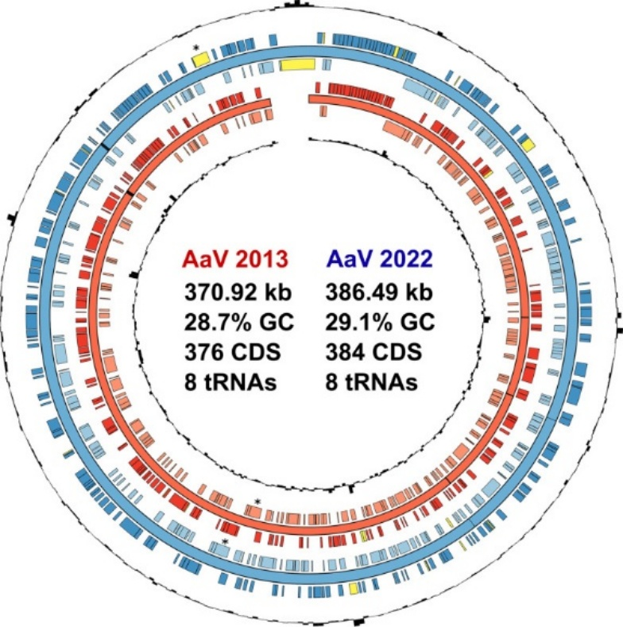
Figure 3.1. Genomic maps comparing the original and resequenced AaV genomes. Genomic maps were created in Circos (Krzywinski et al., 2009). The complete genome sequences of the two assemblies were aligned, and the coding densities were compared. The rings (from inner to outer) indicate the GC content (2013), minus-strand coding sequences (2013), genomic sequence (2013), plus-strand coding sequences (2013), minus-strand coding sequences (2022), genomic sequence (2022), plus-strand coding sequences, and GC content (2022). Coding sequences present in only one genome are highlighted in yellow, and tRNAs are represented on the genomic sequence (2022) by black bands. Novel and known Rpb2 coding sequences are marked with an asterisk.

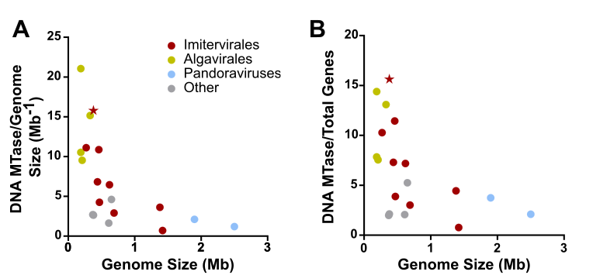
Figure 3.2. Methyltransferases encoded by various Nucleocytoviricota. DNA methyltransferase counts are normalized by genome size (A) and total open reading frames (B) found in the viral genome. AaV is indicated with a star. Colors indicate different orders of viruses.

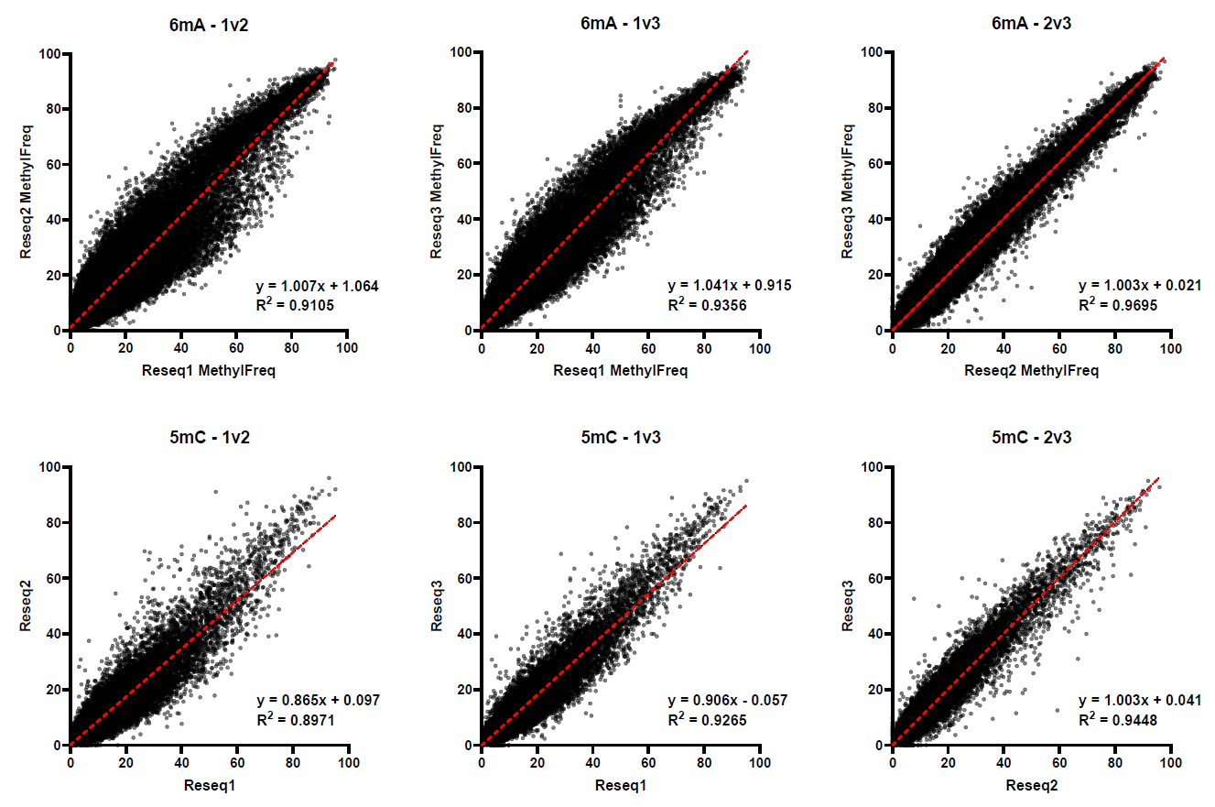
Figure 3.3. Methylation frequency scores compared across sequencing libraries. Scores for each adenine (top) and cytosine (bottom) are contrasted across all three sequencing libraries. Red dotted lines portray simple linear regressions of the data.
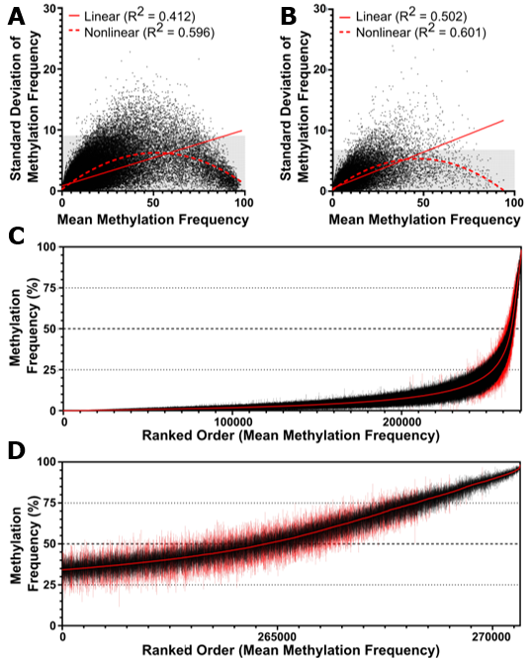
Figure 3.4. Distribution of methylation frequency across all sites in the AaV genome. Methylation frequency average scores and standard deviations (n=3) among all adenines (A) and cytosines (B) within the AaV genome are shown. Gray regions of the graph represent the lower 99% of standard deviations. R-squared statistics of linear and non-linear quadratic regressions are denoted. Adenines in AaV are sorted by ranked order of lowest to highest mean methylation frequency (C-D). Mean methylation scores are denoted as the red line in the center, while lines extending from the center represent the range for each respective site. Sites within the 99th percentile of standard deviation have red ranges. Figure 3.3D displays a magnified view of the most highly methylated sites in 3.3C.

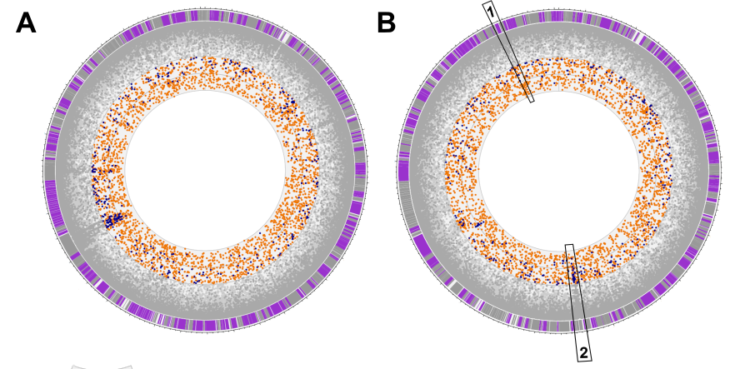
Figure 3.5. Genomic maps of methylation frequency on all adenines and cytosines. The forward (A) and reverse (B) strands of the AaV genome are shown. The inner ring represents 100% methylation, and the outer ring represents 0%. Sites below 50% methylaton frequency are shaded gray, cytosines above 50% are colored blue and adenines above 50% are colored orange. Genes on the sense strand for each map are purple while genes on the antisense strand are gray.

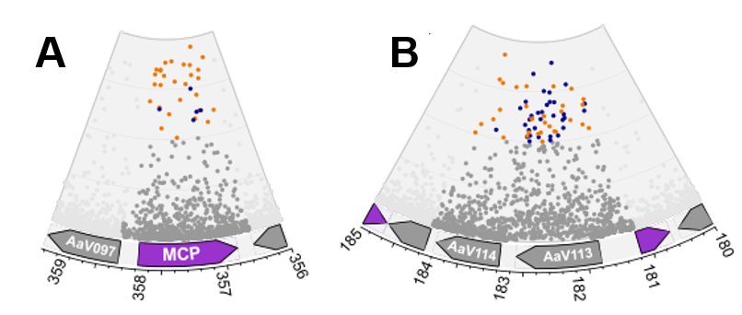
Figure 3.7. Genomic areas which were enriched with high methylation frequencies. Segments 1 and 2 of Figure 3.5 are enhanced in A and B, respectively. The major capsid protein shows an abundance of highly methylated adenines (A), while other regions are densely populated with methylated cytosines (B). In A and B sites within coding regions outside those of interest are not shown.

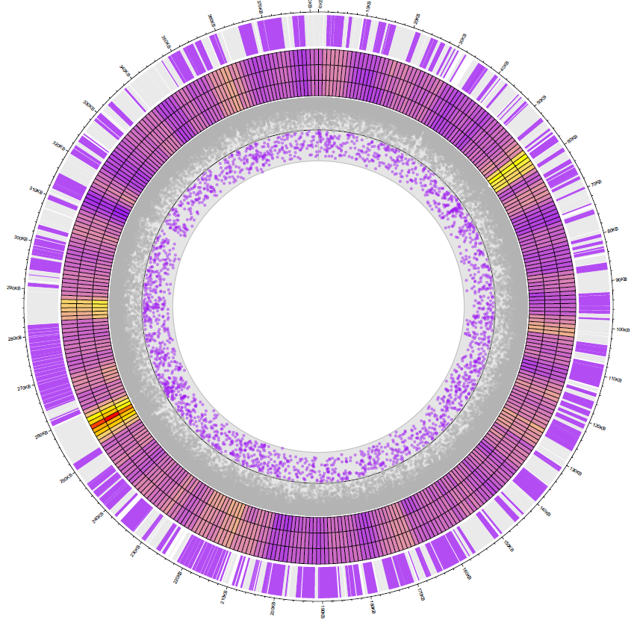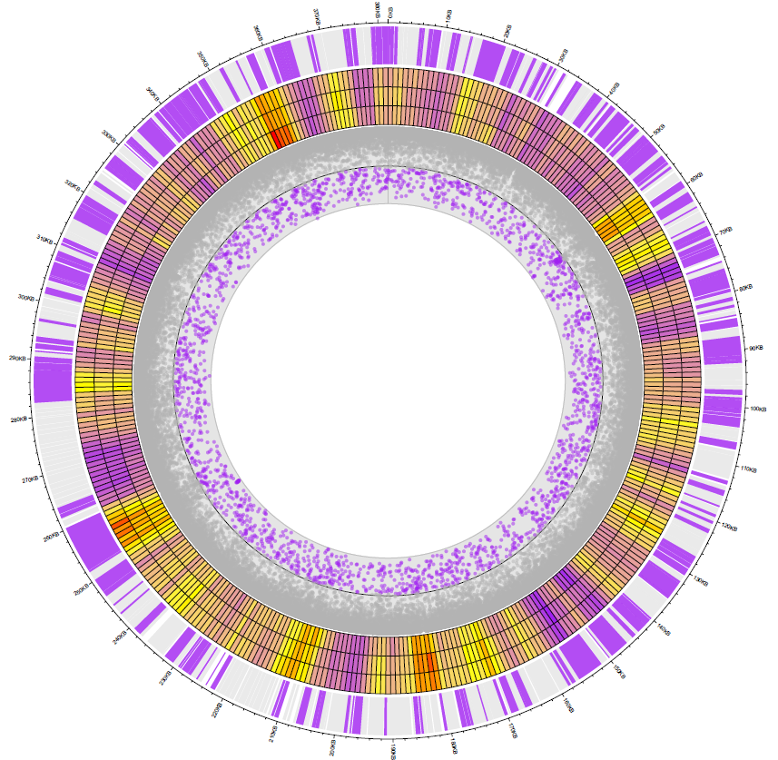
Figure 3.6. Adenine methylation frequency and enrichment maps of AaV. Positive (left) and negative (right) strands are shown. Outer ring: Genes on the coding strand are displayed in purple, while genes on the template strand are displayed in gray. Middle ring: Enrichment of methylation based on MethylFreq Z-score of 1000 bp sliding windows on the coding strand, red implicating a high enrichment and purple representing a low enrichment. Each ring of the heatmap represents calculated scores from different sequencing libraries. Inner ring: MethylFreq of each site with sites lower than 50% blotted out in gray.

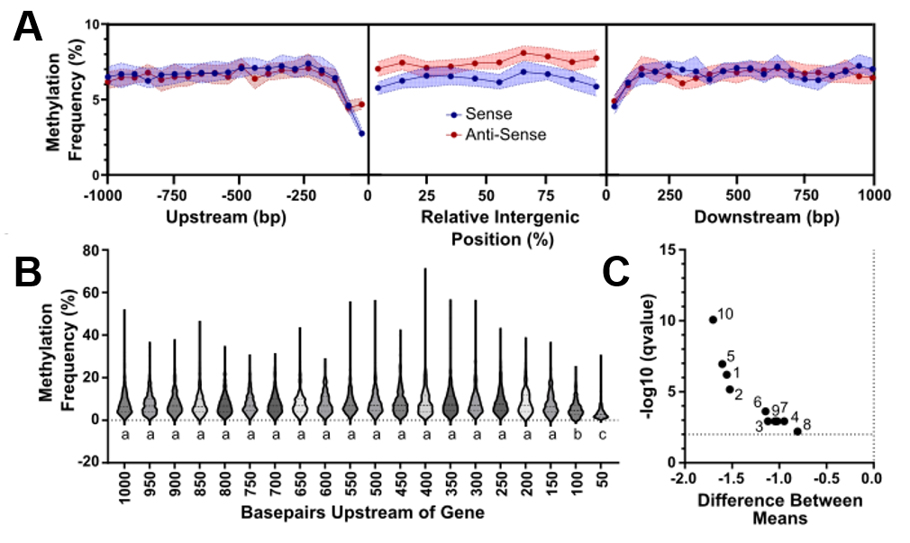
Figure 3.8. Methylation frequency averages relative to all AaV genes. Median methylation frequency is associated with intragenic regions along with the 1000 bp upstream and downstream regions for all coding regions of AaV (A), with 95% confidence intervals around the site shown in the respective color of the strand. Distribution of methylation frequencies in the upstream sense region for each gene is displayed in violin plots (B), with different letters above each plot signifying significant statistical difference (p<0.0001). The difference between means of each normalized intragenic region is displayed in a volcano plot (C), with numbers representing the position along the gene (i.e., the terminal 5’ end represented by 1 and the terminal 3’ end represented by 10).

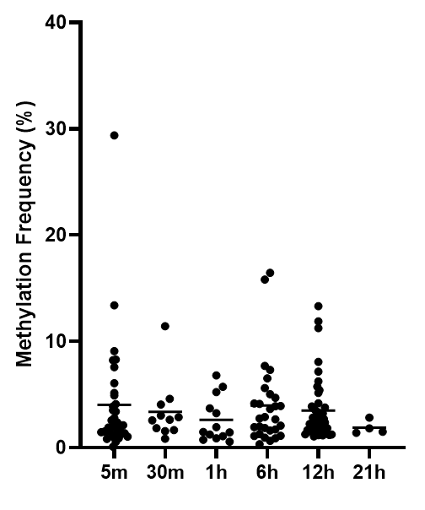
Figure 3.9. First noted time of expression and methylation frequencies in the upstream region of AaV genes. Average methylation frequency is taken across the 50 bp region upstream of the gene’s start codon. First detected time of expression is derived from (Moniruzzaman et al., 2018b).

Figure 3.10. Methylation frequencies of adenines and surrounding nucleotide pentamers. Rows and columns are clustered based on a dissimilarity matrix, and each pentamer is colored based on mean methylation frequency. Rows represent the two nucleotides upstream of the base in question and columns represent the two nucleotides downstream.

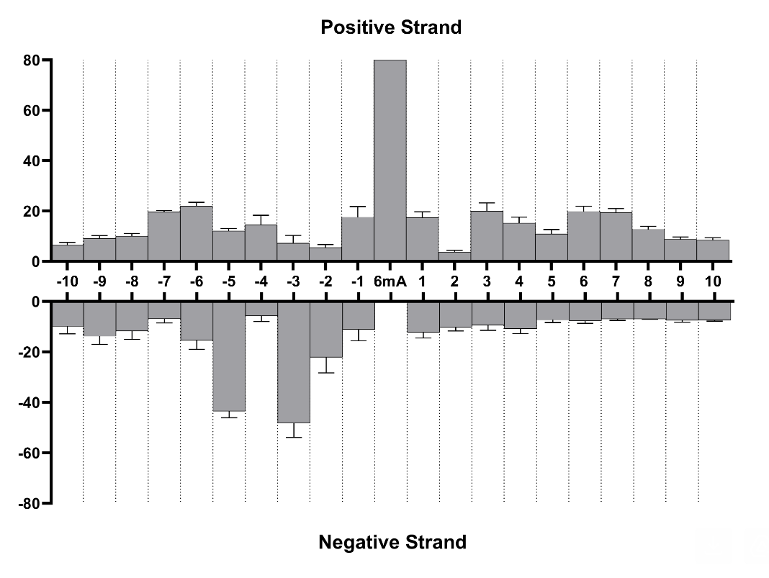
Figure 3.11. Methylation frequencies of adenines that surround other methylated adenines. All adenines that are within 10 bp of an adenine with a methylation frequency of 80% or higher averaged over three libraries. Standard deviation is indicated in error bars.

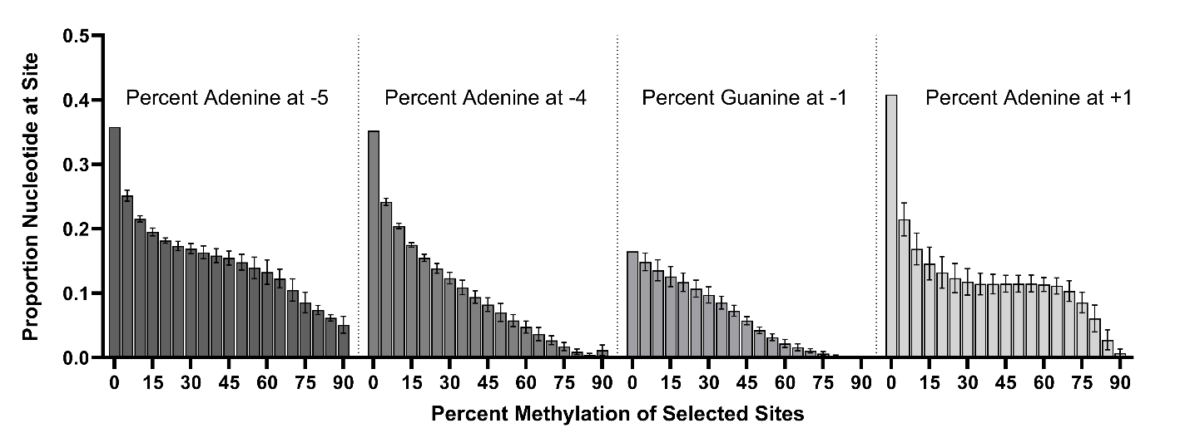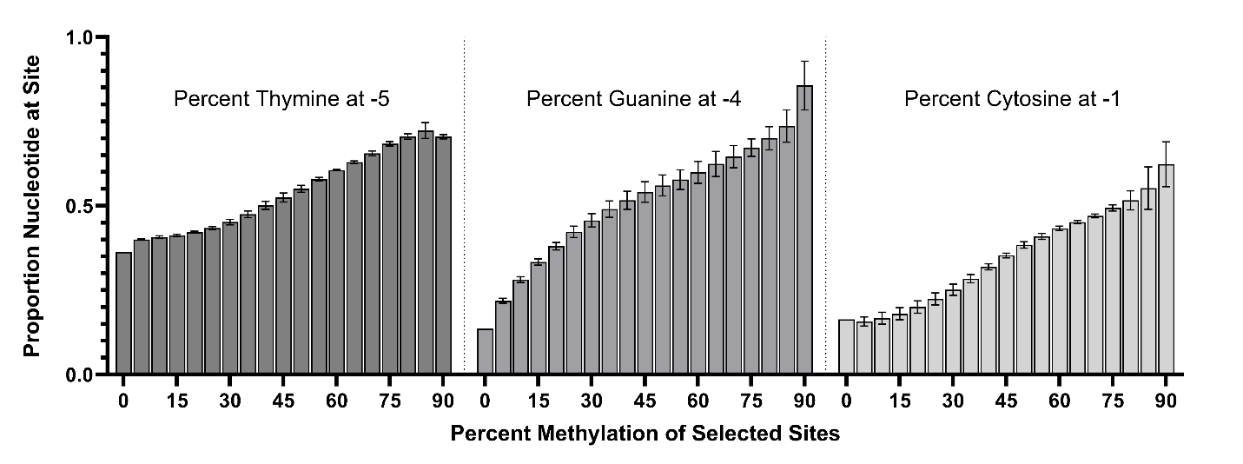
Figure 3.12. Nucleotide proportion as a function of nearby adenine’s methylation frequency. Position relative to the adenine is listed above the graph. A negative position is upstream of the adenine and a positive position is downstream. Average proportion of nucleotides at a site are taken from three libraries with standard deviations indicated in error bars.

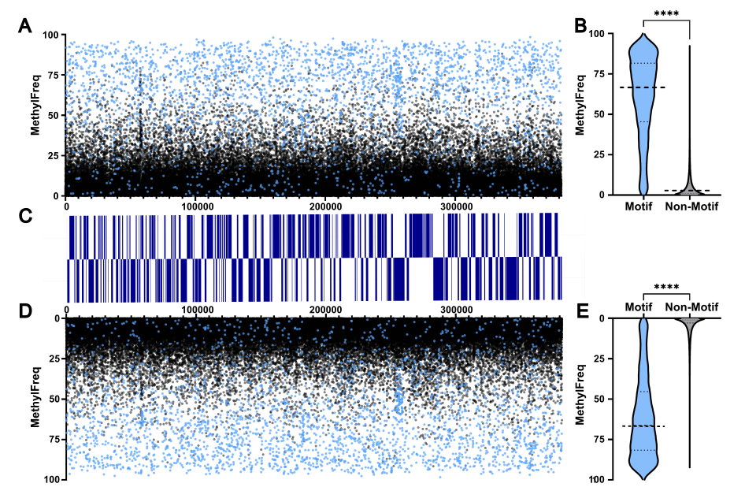
Figure 3.13. Methylation frequency grouped into motif and non-motif sites. Mean methylation frequency for each adenine on the AaV genome on the positive strand (A) and negative strand (D) are colored based on whether the site is associated with one of the 9 identified motifs (blue) or not (black). Respective coding regions for each strand are shown in blue (C). Violin plots for each strand detail the differences between motif-associated and non-motif sites on positive (B) and negative (E) strands.

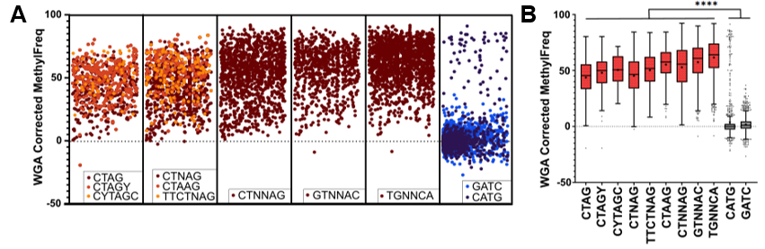
Figure 3.14. Whole genome amplification correction of motif methylation frequency. Scores for the identified motifs as well as the two classical recognition motifs GATC and CATG were corrected with WGA library scores (A). Each box in A represents a linearized genome meaning each site corresponds to its respective position. Tukey’s box plots were generated to show the distribution of WGA-corrected methylation frequencies, with means denoted as plus symbols (B). ****: p < 0.0001

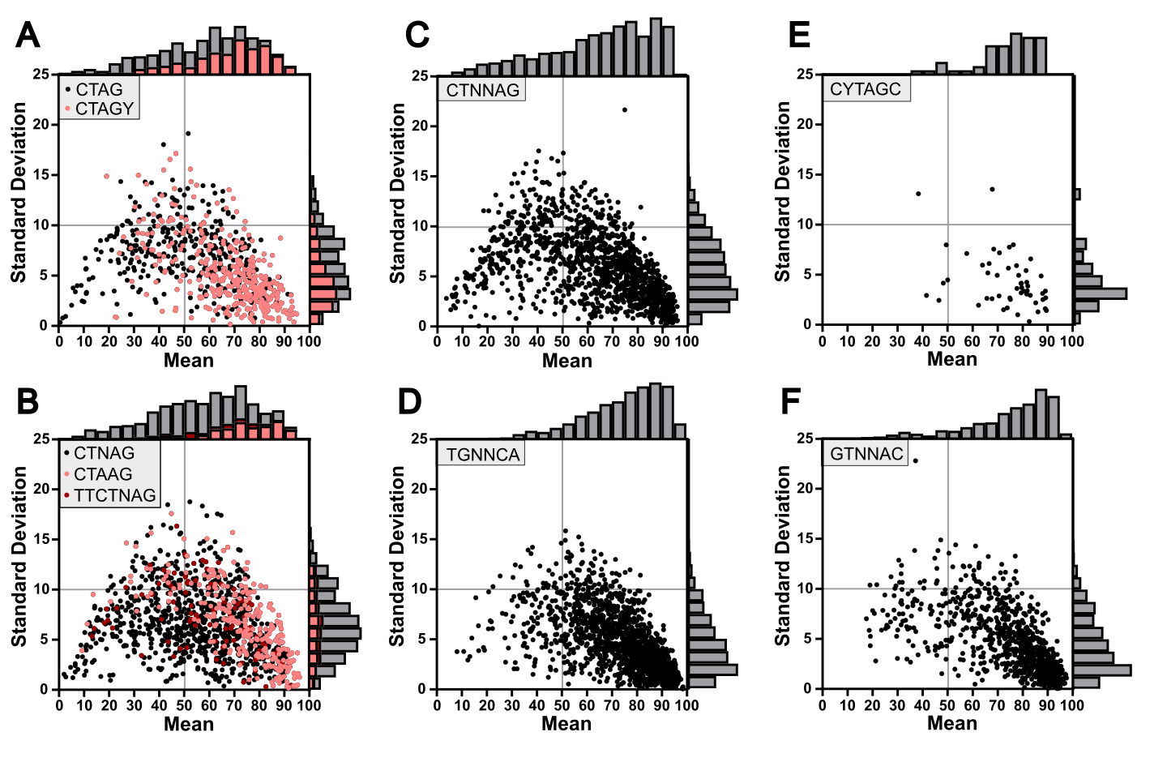
Figure 3.15. Distribution of methylation score means and deviations for all identified motifs. Derivative motifs are clustered into single plots (A-B). Histograms detail total counts of sites within respective regions.

Figure 3.16. Hemi-methylation patterns for all identified palindromic motifs. Reciprocal methylation plots for all palindromic motifs with fully methylated sites displayed in dark red, hemi-methylated sites displayed in pink, and unmethylated sites displayed in gray.

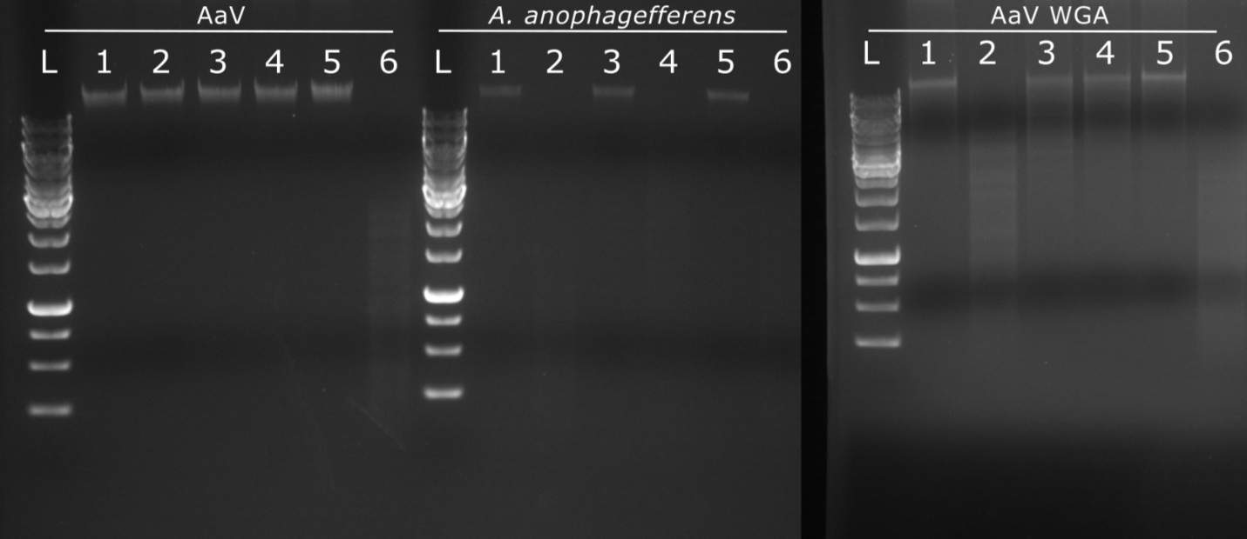
Figure 3.17. Restriction enzyme digest of AaV, A. anophagefferens, and WGA AaV DNA. Digestion by various restriction enzymes compared to a 1kb ladder (L): no enzyme control (1), Hpy166II (2), XbaI (3), XhoI (4), DpnI (5), DpnII (6).

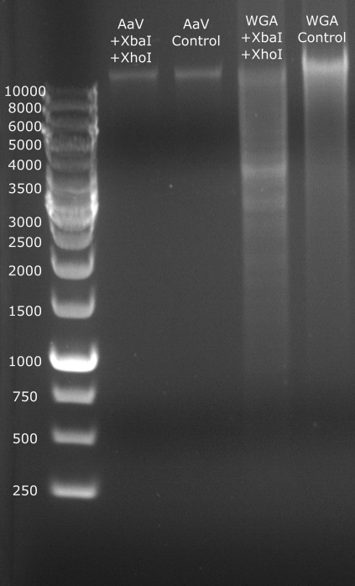
Figure 3.18. Tandem restriction enzyme digest of AaV and amplified AaV DNA. Unamplified AaV DNA (lanes 2 and 3) and WGA AaV DNA (lanes 4 and 5) digested by both XbaI and XhoI enzymes together (lanes 2 and 4) or undigested (lanes 3 and 5). All digestions are compared to a 1Kb ladder.

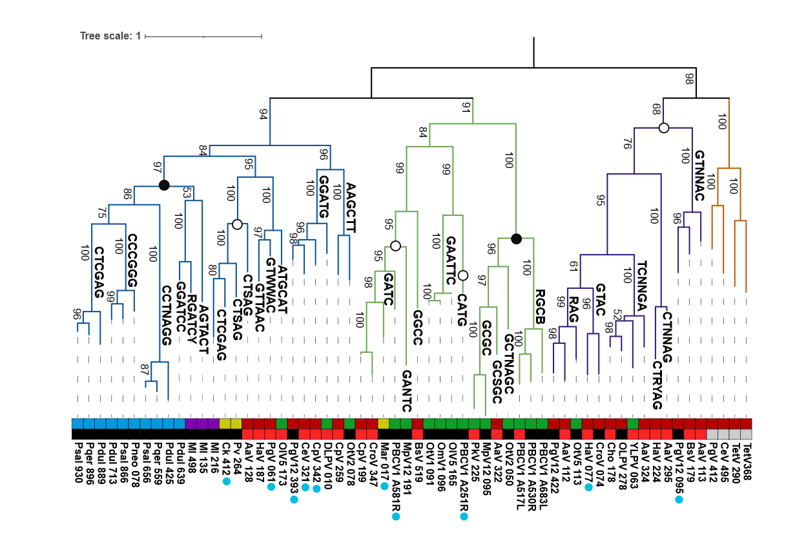
Figure 3.19. Protein phylogeny of Nucleocytoviricota type II methyltransferases. Branches which have a defined or predicted motif are labeled as such. The upper colored bar defines the respective family for each virus while the lower colored bar defines the quality of the predicted target sequence, black meaning the MTase is predicted to target the corresponding sequence by REBASE and red meaning the MTase is predicted to target the corresponding sequence based on homology to other MTases alone. Blue dots below sequence IDs represent the presence of a neighboring restriction endonuclease. Dots on nodes signify the targeted base of all known MTases within the clade, either cytosine (black) or adenine (white). Bootstraps are displayed on branches. Psal: Pandoravirus salinus; Pdul: Pandoravirus dulcis; Pqer: Pandoravirus quercus; Pneo: Pandoravirus neocaledonia; Ml: Mollivirus; Ck: Cedratvirus kamtchatka; Pv: Pithovirus sibericum; AaV: Aureococcus anophagefferens Virus; PgV: Phaeocystis globosa Virus; CeV: Chrysochromulina ericina Virus; CpV: Chrysochromulina parva Virus; DLPV: Dishui Lake Phycodnavirus; EhV: Emiliania huxleyi Virus; MpV: Micromonas pusila Virus; Mar; Marseillevirus; CroV: Cafeteria roenbergensis Virus; OlV: Ostreococcus lucimarinus Virus; OtV: Ostreococcus tauri Virus; OmV: Ostreococcus mediterraneus Virus; HaV: Heterosignma akashiwo Vius; TetV: Tetraselmis Virus; BsV: Bodo saltans Virus.

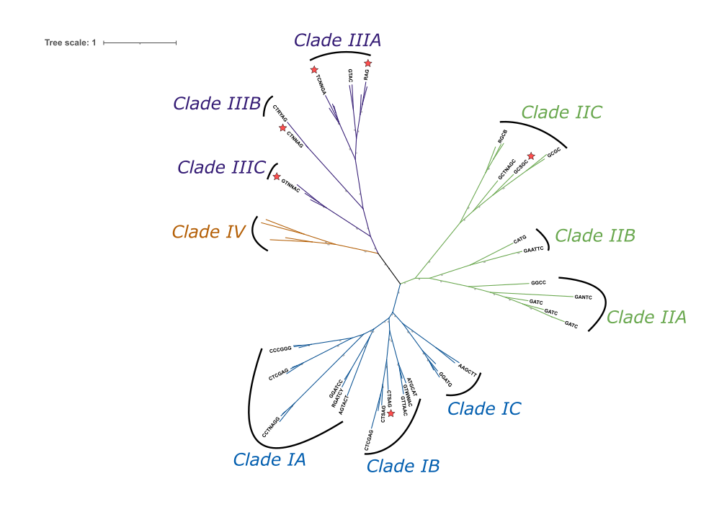
Figure 3.20. Unrooted phylogeny of Nucleocytoviricota type II methyltransferases. AaV methyltransferases are denoted with red stars.

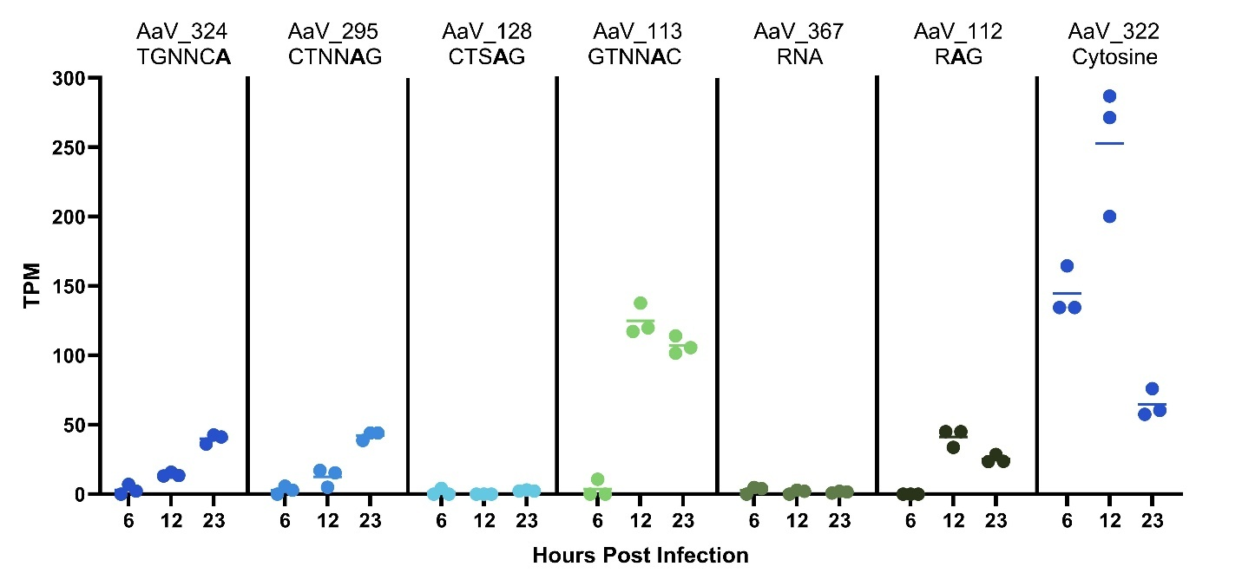
Figure 3.21. Expression of AaV methyltransferases throughout different stages of infection. Expression levels are recorded in TPM based off of RNA seq analysis in (Moniruzzaman et al., 2018b). Motifs are assigned to each methyltransferase based on predicted motif shown in the phylogeny in Figure 3.19.

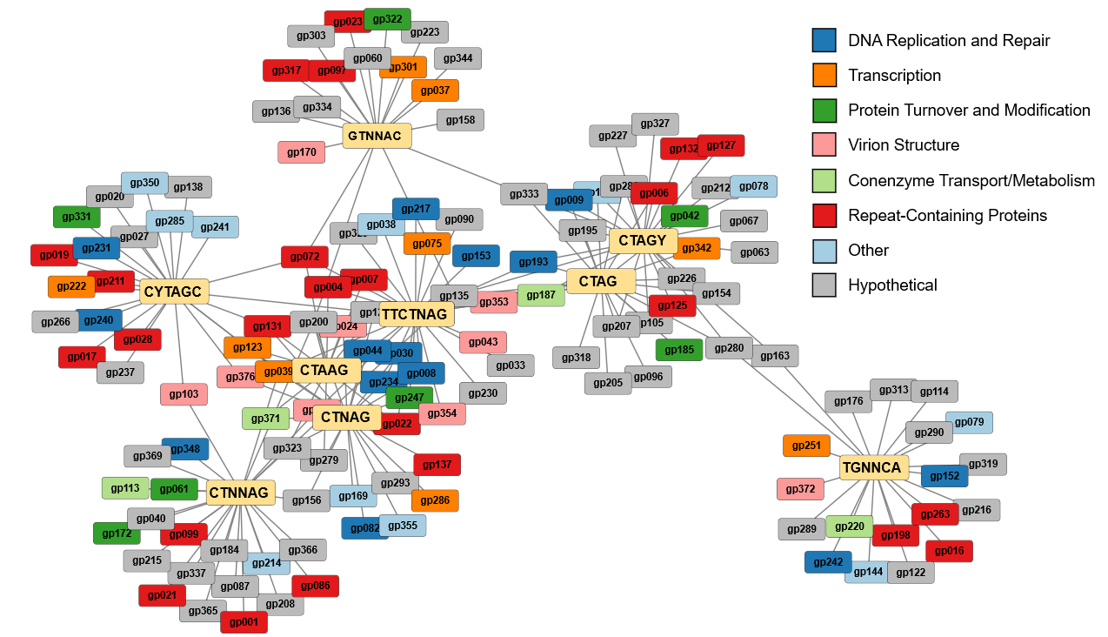
Figure 3.22. Gene clusters based on motifs that are enriched in their vicinity. Each motif (yellow) is connected to any genes that are enriched with the given motif. Different COG classifications of genes are denoted by color.

Chapter Four

Viral-derived strategies for nucleotide salvaging in the face of a GC-content and codon usage disparity

Abstract
The GC-disparity detected between the genomes of giant viruses and their hosts is a well-described phenomenon, though little work has been done to interpret the role of this shift in nucleotide usage. Furthermore, there is a gap in understanding as to how these viruses overcome such a discrepancy, as the nucleotides that are perhaps underrepresented within the host genome make up most of the viral genomic and transcriptomic sequences. We sought to better explain this occurrence in the algal-virus system comprised of Aureococcus anophagefferens and Kratosvirus quantuckense (AaV). This pair displays one of the highest known gaps in GC-usage between a host and a virus, with A. anophagefferens maintaining a GC-rich genome (69%), while that of AaV is GC-poor (28%). Further investigation into the nucleotide usage patterns between AaV and A. anophagefferens revealed that the disparity is heightened particularly within the third codon position of open reading frames. By analyzing the relative synonymous codon usage within AaV genes along with A. anophagefferens chromosomal and organelle genes, we found that AaV genes closely align in codon bias to those in the A. anophagefferens chloroplast and mitochondria. We also found that certain AaV genes bear increased similarity to A. anophagefferens chromosomal genes, particularly genes associated with cellular localization. Finally, we hypothesized that AaV utilizes a self-encoded cytidine deaminase to convert host cytosines into uracil and thymine. To test this, we used a deaminase inhibitor, zebularine, and revealed the importance of deaminase activity within the uninfected and infected cell.

Introduction
Successful viral infection for the purpose of virion production relies on the conversion of a host cell into a virocell: effectively the infected host cell altered into an optimal state for viral particle production (Forterre, 2011). And while some cells continue to “grow” (i.e., assimilate resources) during infection, many viruses have evolved to capitalize primarily on the available resources within the host cell at the time of infection (Gann et al., 2020b). This is not a novel concept, as viruses by definition rely on host components (proteins) in one way or another, whether they are machinery for DNA synthesis, transcription, or energy acquisition (Lindell et al., 2005; Mertens and Knipe, 2021; Guo et al., 2023a).
For giant viruses (the Nucleocytoviricota), propagation has been directly tied to the metabolic status of host cells (Gann et al., 2020a; Gann et al., 2020b). Many viruses encode genes that are involved in reprogramming and repurposing host proteins through inhibition and modification (Comeau and Krisch, 2005). Often, these are encoded by auxiliary metabolic genes, with origins indicating previous virus-host pairings and the subsequent packaging of host genomic material within the virus’ genome (Monier et al., 2017; Puxty et al., 2018; Mizuno et al., 2019; Waldbauer et al., 2019). The preservation of such genes throughout multiple generations, as well as the host and habitat dependence of auxiliary metabolic gene profiles, suggests that there are at least instances of positive selective pressure to maintain host-like material in the viral genome (Luo et al., 2022).
Based on these characteristics, it would be logical for different viruses to use mechanisms like those of their host cell to allow for a more efficient infection. In this vein, biases surrounding codon usage within certain viral genes have been shown to align with biases found in host genes, in theory to allow for more efficient translation (Babayan et al., 2018; Plant and Ye, 2022). For example, Flaviviridae genomes have been found to persist under the same evolutionary pressures as their hosts, with nucleotide biases trending in the same direction (Lobo et al., 2009). In other cases, viruses share biases only with specific sets of host genes (Jitobaom et al., 2020), which might benefit the virus in manipulating host proteins and sharing translational machinery. However, nucleotide-specific biases are not a definitively shared trait between all virus and host pairs (Simón et al., 2021; Gaunt and Digard, 2022; Willemsen et al., 2025). For instance, broad spectrum ssRNA viruses have been shown to utilize a more divergent pool of tRNAs as compared to their generic hosts as well as maintaining unique codon biases (Tian et al., 2018). This should be expected among viruses with broader host ranges, as a universal codon pool should allow for the ability to take advantage of hosts with a variety of nucleotide usage biases.
Questions regarding host range and nucleotide usage arise in the phylum Nucleocytoviricota, colloquially known as “giant viruses”. The host range for many of these viruses is not well characterized, although many have been identified as infective on various amoeba species (La Scola et al., 2003a; Boyer et al., 2009; Arslan et al., 2011; Yoosuf et al., 2012; Andreani et al., 2017; Aherfi et al., 2018). In part this observation is a direct result of the use of amoeba, particularly Acanthamoeba polyphaga and Acanthamoeba castellanii) as an enrichment tool for giant viruses, as they seem to act as a generic host where many phylogenetically distinct giant viruses can propagate (Fischer, 2016). However, there is no indication that these are the only hosts for these viruses, and the true host range may extend into a broader scope of phagocytic eukaryotes. It has, in fact, been noted that codon usage among giant viruses acts as a poor indicator of amoeba-virus interactions (Colson et al., 2013; Willemsen et al., 2025).
Additionally compelling are the presence of giant viruses with only one known host outside of the amoeba culture system. These viruses often infect algae (Van Etten et al., 1982; Sandaa et al., 2001; Derelle et al., 2008; Rowe et al., 2008a; Gallot-Lavallee et al., 2015; Stough et al., 2019a) or other unicellular eukaryotes (Fischer et al., 2010; Deeg et al., 2018; Needham et al., 2019). While these have been studied in varying amounts of detail, in all cases a wider host range has yet to be discovered. Though few analyses have been performed on these viruses, it is understood that they are diverse and encompass broad GC-content patterns (Truchon et al., 2023; Witt et al., 2024). Likewise, while some viruses use codons that correspond to abundant host tRNAs (Michely et al., 2013), others encode for their own tRNAs, presumably to circumvent the biased shift (Colson et al., 2013). And while divergence from host nucleotide usage may facilitate infection of a broader host range (Tian et al., 2018), many such viruses have very low GC-content (Willemsen et al., 2025), begging the question of why a generalist would exist at such an extreme. Thus, given the incredible diversity within the Nucleocytoviricota, it is important to examine biases that exist between uncharacterized virus-host pairs along with the molecular mechanisms for overcoming shifts in bias.
In this manuscript, we explored the GC-content disconnect and shifts in genome-wide codon bias between A. anophagefferens and its lytic virus Kratosvirus quantuckense strain AaV. We examined codon usage among individual genes of AaV and A. anophagefferens, which revealed two distinct clusters of host genes as well as a strong overlap between viral genes and host organellar genomes. Furthermore, we characterized the prevalence of cytidine deaminase among Nucleocytoviricota genomes, including AaV, to characterize its potential as a significant factor in overcoming the GC gap between host and viral genome. Collectively we developed two potential hypotheses for mechanistic recovery of adenines, thymines, and uracils for viral genomic synthesis and transcription herein. [1] AaV can use mitochondrial nucleotide pools as a resource for early-stage transcription and DNA synthesis. [2] AaV dCMP deaminase converts A. anophagefferens chromosomal nucleotide pools into uracil and thymine through DNA cytosine methyltransferase activity. Collectively, these results revealed the magnitude of the GC and codon bias shifts from host to virus within the Nucleocytoviricota and indicate a new direction for investigation concerning how a virus can both use and manipulate host nucleotide pools.

Methods

Culture conditions, zebularine incubations, and AaV infections
Xenic A. anophagefferens strain CCMP1984 was grown in a modified ASP₁₂A medium (Gann, 2016) on a 12:12 light:dark cycle at an irradiance of ~ 90 µmol photons m⁻² s⁻¹ and a temperature of 19° C. A. anophagefferens cell concentration was monitored via a CytoFLEX flow cytometer (C07821) via PerCP daily (Chase et al., 2022). For infections, fresh AaV lysate was prepared by first infecting 500 mL culture of A. anophagefferens undergoing logarithmic growth with AaV at a multiplicity of infection (MOI) of ~10:1 virus per cell. Following lysis, lysate was sequentially filtered through 1 µm and 0.45 µm Durapore filters to remove lysed cellular matter and contaminating bacteria, after which clean lysate was stored at 4° C. Cultures were diluted to approximately 1 x 10⁶ cells ml⁻¹ then infected with clean lysate at a MOI of 100:1 viruses per cell (Gann et al., 2020b). Viral particles were enumerated on the CytoFLEX by gating on the Violet Side Scatter channel using a 405 nm violet laser (Chase et al., 2023).
To test its efficacy as a deaminase inhibitor in both infected and uninfected A. anophagefferens cells, zebularine, a cytidine analog, was added to cultures. Zebularine was prepared in a solution of MilliQ water at a concentration of 20 mmol then filter sterilized through a 0.2 µm Durapore PVDF syringe filter. Zebularine was then added to A. anophagefferens cultures at a final concentration of 80 µmol unless otherwise noted. Uninfected cultures were allowed either 12 or 3 d incubation in the presence of zebularine prior to infection with AaV. To alleviate the negative impact zebularine apparently has on available uracil, cultures were amended with uracil. Uninfected experimental cultures were supplemented with uracil dissolved in DMSO at different concentrations, though equal proportions of DMSO were always added to each culture. Cultures were serially passaged for three generations (~21 d) under their respective uracil concentration to ensure adjustment to the given conditions.

Principal component analysis of relative synonymous codon usage
Relative synonymous codon usage (RSCU) is the ratio of the frequency of a codon in a gene to the expected frequency of the same codon if each codon for the same respective amino acid was used without bias (Sharp and Li, 1986; Jitobaom et al., 2020). “Synonymous codons” refer to all codons which encode an identical amino acid. Thus, the RSCU was calculated as follows:
$$RSCU=\frac{n_{c}}{\frac{1}{N} \sum_{c=1}^{N}{n_{c}}}$$
in which n_{c} represents the number of occurrences of codon c and N is the total number of codons that encode for the same amino acid as codon c. Thus, RSCUs with values greater than one imply a usage higher than what would be expected for the given codon under unbiased conditions, and vice versa. RSCU was calculated for every gene in AaV, A. anophagefferens, and the A. anophagefferens mitochondria and chloroplast.
PCA analysis was performed using the prcomp function in R 4.5.1 on the RSCU values calculated for all the above genes. A scree plot was generated from PCA eigenvalues to elect the preferred principal components for use in PCA plotting. Hierarchical clustering of RSCU values for each codon among all AaV genes, A. anophagefferens chromosomal genes, A. anophagefferens organellar genes, and the major capsid protein (MCP) was performed in R 4.5.1 using the pheatmap function.
To identify functional differences between the two clusters of A. anophagefferens genes, the clusters were divided into two classes, type I and type II based on the PC1 axis. To ascribe functional GO categories to all A. anophagefferens genes, the makeOrgPackage function from the R package AnnotationForge (Carlson M., 2025). Next the enrichGO function from the R package clusterProfiler (Yu et al., 2012) was used on type II A. anophagefferens genes to select functions that are enriched in the divergent group of genes. Dotplots displaying the functions that are enriched in type II genes were generated using the enrichplot package (Yu, 2025).

Neutrality, effective number of codon, and parity rule 2 plots
Neutrality plots are frequently used as a proxy for defining directional selection and random mutation pressure on codon bias (Sueoka, 1999; Yu et al., 2021). When genes exhibit a strong correlation and the slope of the regression approaches 1, this implicates mutational pressure as the cause of the codon bias. Neutrality plots were generated by calculating the GC₃ (i.e. the average GC-content at the third codon position) and the GC₁₂ (i.e. the average GC-content at the first and second codon positions) for each ORF in both A. anophagefferens and AaV. For genes in A. anophagefferens only complete genes (i.e. not partial) were considered. Simple linear regression analyses were conducted, and a Pearson correlation coefficient (r) was calculated for each dataset. However, weak correlation and a slope approaching 0 implicates selective pressure on codon bias.
The distribution of genes on an effective number of codon (ENC) plot is in reference to the curve defines whether codon usage in the gene behaves similarly to how codon usage would occur if the bias for all synonymous codons was equivalent (Wright, 1990; Yin et al., 2013). Deviation from the curve implies directionality towards the selection of codons. ENC plots were generated by once again utilizing the GC₃ value against the number of specific codons in a single gene (i.e. a maximum value of 62 in AaV and 63 in A. anophagefferens for genes which encode a selenocysteine) (Yin et al., 2013). The expected number of codons curve in each plot was based on the equation defined in (Wright, 1990).
Parity rule 2 (PR2) plots were used to identify biases in favor of either C or G and A or T in the third codon position of ORFs (Lobry, 1995; Sueoka and Kawanishi, 2000). Plots are generated by calculating the percentage of guanines out of all codons that end in a guanine or cytosine in a gene, as well as calculating the percentage of adenines out of all codons that end in an adenine or thymine in a gene. For four codon amino acids, the same is done for every usage of an amino acid throughout the genome. Leucine, serine, and arginine are only counted by the four codons with an identical first two positions (i.e. UUA and UUG would not be included for leucine, but CUU, CUC, CUA, and CUG would).

Phylogenetic analysis
To analyze the distribution of cytidine deaminases across the Nucleocytoviricota, a phylogenetic tree was constructed from a concatenated protein sequence alignment with representatives across the phylum. To select representatives to be used in the phylogeny, genomic protein sequences from the Giant Virus Database (Aylward et al., 2021) were downloaded, with a focus on cultured viruses to provide a host-virus GC-disconnect context. The concatenated protein alignment was performed using the ncldv_markersearch.py script (Moniruzzaman et al., 2020). The alignment was composed of six orthologous groups including GVOGm0013 (DEAD/SNF2-like helicase), GVOGm0054 (DNA polymerase family B), GVOGm0172 (transcription initiation factor IIB), GVOGm0461 (DNA topoisomerase II), GVOGm0760 (A32 packaging ATPase), and GVOGm0890 (late transcription factor VLTF3). As per the ncldv_markersearch.py script, alignment was performed using Clustal Omega (Sievers et al., 2011). Tree construction was performed using IQ-TREE 3 (Wong, 2025) using 1000 bootstraps and modelfinder (Kalyaanamoorthy et al., 2017), which determined the best-fit model for substitution was Q.PFAM+F+I+R8.
AaV opening reading frames characterized as cytidine deaminases were added to a blast database. Diamond (Buchfink et al., 2015) was used to identify similar proteins among the Giant Virus Database based on an e-value cutoff of 10e⁻⁵ or less. To identify other cytidine deaminases in the Giant Virus Database, Nucleocytoviricota genes assigned to the orthologous group NCVOG1064 (cytidine and deoxycytidylate deaminase) (Yutin et al., 2009) were added to a blast database, and diamond blast was used again. All genes identified in this dataset were aligned using MAFFT v7 (Katoh et al., 2002) at a maxiterate setting of 1000. Tree construction was performed using IQ-TREE 3 using 1000 bootstraps and modelfinder, which determined the best-fit model for substitution was WAG+F+R4.

Calculation of transcript GC-content
To determine how GC-content varied over the course of infection, reads from a previous transcriptomic analysis of AaV infection on A. anophagefferens (Moniruzzaman et al., 2018b) were mapped to the AaV reference genome in CLC Genomics Workbench. GC-content of all AaV reads for each library at each time point was calculated using python scripts. To remove all MCP reads, AaV reads were mapped to the nucleotide sequence AaV_096 using BBMap (Bushnell, 2022), and unmapped reads were saved. BBmap was also used to calculate the TPM normalized count of reads at each timepoint that mapped to any of the three AaV deaminases, after which a linear regression was performed to identify correlation between reads mapped to deaminases and viral transcriptome GC-content.

Results

AaV GC-content and codon biases strongly differ from those of its host
The GC-content disconnect between AaV and A. anophagefferens is one of the largest noted among Nucleocytoviricota-host pairs (Figure 4.1). With a difference of 38.5% (a GC-content of 67.4 in the host and 28.9 in the virus), it ranks second among these systems in which both host and virus have publicly available sequenced genomes, the only higher disparity being that of Cafeteria roenbergensis and its virus at 46.8% (Table 4.1). Collectively, the Imitervirales along with the Algavirales and Marseilleviruses, represent most of the viruses which exhibit this divergence in nucleotide usage as compared to their host. This includes the classical Mimiviruses, many of which were enriched for using Acanthamoeba as a capture system, meaning these hosts may not be ecologically authentic. Although it is unclear if AaV and other algal viruses can infect an amoebae host, their defined hosts are expected to be highly representative of in situ interactions due to an extremely narrow host range. Among viruses that maintain a similar GC-content to that of their hosts are poxviruses, Asfuvirales, and Pandoraviruses (Figure 4.1). The Pimascovirales, which can infect arthropods, fish, and amphibians, vary significantly in both nucleotide usage and GC-content difference, with several uniquely encoding a more GC-rich genome as compared to their host (Figure 4.1).
The pattern of GC-content disconnect is not limited to complete genomes but can also be observed within individual genes. While there was a clear significant difference between GC-content of A. anophagefferens ORFs and AaV ORFs, this difference was exacerbated when observing the GC-content of the third codon position (GC₃) (Figure 4.2). Between both organisms the three codon positions varied in nucleotide usage when averaged across all ORFs. Across all AaV codons, the first position had a GC-content (GC₁) of 38.3%, the second position (GC₂) averaged 28.2%, and GC₃ an average of only 21.6%. A. anophagefferens nucleotide usage by codon position further exacerbated the difference compared to its virus, with an average GC₁ 69.7%, an average GC₂ of 50.9%, and an average GC₃ of 91.7% (Figure 4.3A). This means that while the whole genomes of AaV and A. anophagefferens varied in GC usage by nearly 40%, the third position of their collective codon usage varied by ~70%.
Codon usage bias in the virus favored the use of adenine or uracil in the third position (Figure 4.3B; Table 4.2). For all amino acids, codons with an adenine or uracil in this position occur more frequently within predicted AaV genes than codons ending in a guanine or cytosine (Table 4.2). For instance, out of 7,452 serines only 1,290 (17.3%) ended in a cytosine or guanine. Much like the trends in GC-content between host and virus, A. anophagefferens strongly differed in codon bias from AaV (Figure 4.3B; Table 4.3). Codons that were over 10-fold more abundant in AaV included phenylalanine (UUU), leucine (UUA), isoleucine (AUU and AUA), valine (GUA), serine (UCU and UCA), threonine (ACU and ACA), tyrosine (UAU), asparagine (AAU), lysine (AAA), aspartate (GAU), and arginine (AGA). Codons that were over 10-fold more abundant in A. anophagefferens included leucine (CUC and CUG), proline (CCG), alanine (GCC and GCG), arginine (CGC and CGG), and glycine (GGC).
This disparity was so strong that the only codons ending in a C or G that were more common in AaV ORFs were methionine (AUG) and serine (UUG) though the overrepresentation of these codons was not particularly strong (Figure 4.3B). The effect of codon bias was also notable on the level of predicted amino acid usage. Amino acids with codons comprised of mostly adenine and thymine, such as asparagine, isoleucine, and lysine, were over-represented in AaV proteins (Figure 4.3C). Conversely, amino acids like alanine, arginine, and glycine, which have CG-rich codons, were more often found in the host (Figure 4.3C). Alanine was perhaps the most extreme case, with A. anophagefferens encoding for 152 alanines per 1000 amino acids, while AaV only encoded for 34 per 1000 (Figure 4.4). There was no detectable bias in favor of amino acids with specific properties between AaV and A. anophagefferens.
Following this pattern, the eight unique tRNAs anticodons encoded by AaV had a much lower GC-content (25%) compared to those of A. anophagefferens (51.3%) (Figure 4.5). Oddly, two of these anticodons had a G in their third position, corresponding to asparagine (AAC) and tyrosine (UAC) (Table 4.2). Both codons were relatively uncommon among coding regions in AaV and both were synonymous with codons that are entirely made up of adenine and uracil (i.e., AAU and UAU, respectively).

Codon usage bias in individual genes reveals overlaps between virus and host
While codon usage bias is typically considered in the context of the entire genome, codon bias for individual genes can differ compared to the collective, especially when considering the mosaic nature of viral genomes (Jitobaom et al., 2020). To define codon bias within individual genes, RSCU scores were calculated (see methods) for each codon excluding methionine, tryptophan, and stop codons (Table 4.4; Table 4.5). A principal component analysis composed of RSCU scores for each codon in every gene in A. anophagefferens and AaV revealed very little overlap between any of the chromosomal genes (Figure 4.6). A majority of A. anophagefferens genes (type I genes; 86.8%) clustered distantly from all AaV genes, while a smaller proportion (type II genes, 13.2%) bore similarity to some viral genes, including MCP, though they still largely remain distinct. Though certain genes from the A. anophagefferens assembly are considered partial (i.e., the respective contig is terminated before the 5’ or 3’ end of the gene is identified), partial genes were not overrepresented in either cluster (Figure 4.7). Interestingly, the RSCU-based codon usage bias within organellar genes did consistently overlap with the majority of AaV genes (Figure 4.6). By separating chloroplast and mitochondria genes from the chromosomal A. anophagefferens genes, cluster analysis revealed that the codon usage in organellar genomes was increasingly more consistent with that of AaV (Figure 4.8). Likewise, AaV MCP clustered preferentially with the A. anophagefferens chromosome (Figure 4.8).
Neutrality, ENC, and PR₂ plots, are all approaches used to identify selective pressure in favor of specific nucleotide usage in coding regions. Neutrality plots, which compare the correlation between GC₃ to GC₁ and GC₂, were generated from both A. anophagefferens and AaV ORFs. While all gene sets had relatively low correlation statistics (Table 4.6), AaV ORFs exhibited a stronger correlation in GC₃ to GC₁₂, while A. anophagefferens had a weaker correlation (Figure 4.9A-B). Simply examining the neutrality of type I A. anophagefferens genes revealed zero correlation, indicating a strong selective pressure on their codon usage (Figure 4.9C).
ENC plots were generated to compare GC₃ of AaV (Figure 4.10A), A. anophagefferens (Figure 4.10B), and A. anophagefferens organellar genes (Figure 4.10C-D) against the total number of codons appearing in the respective genes. Deviation from the expected curve in these plots further confirmed that the codon usage among AaV genes and to a greater extent A. anophagefferens genes is influenced by directional selection (Figure 4.10). Many type I A. anophagefferens genes, characterized by their high GC-content, had remarkably high ENC counts despite having a GC₃ approaching 100%.
PR₂ plots were used to identify biases in favor of pyrimidine versus purine usage in the third codon position. No detectable bias could be found in AaV ORFs for guanine over cytosine, nor in A. anophagefferens ORFs for adenine over thymine (Figure 4.11A-B; Table 4.7). This may indicate mutational pressure at these sites rather than selective pressure. However, AaV slightly favors thymine, while A. anophagefferens slightly favors cytosine (Figure 4.11A-B). The strongest bias identified was in A. anophagefferens mitochondrial genes, which were much more likely to utilize thymine in the third codon position (Table 4.7). Additionally, PR₂ plots generated for A. anophagefferens on four codon amino acids reveal that valine, leucine, and glycine were preferentially encoded with a third position cytosine, while threonine and to a lesser extent alanine were preferentially encoded with a third position guanine (Figure 4.11D).
To further investigate the role of the A. anophagefferens genes which are increasingly similar in codon usage bias to those of AaV, as well as the organellar genomes, a gene enrichment analysis was performed on all A. anophagefferens genes from the PCA plot with a PC1 score > 2.5 (type II genes). Frequently enriched in this gene set were cellular localization associated proteins, including the GO terms microtubule-based movement, intracellular transport, and cilium organization (Figure 4.12). Included within these enriched genes were KEGG annotations attributed to dyneins, kinesins, myosins, and microtubules. While the highest enrichment in this cluster belonged to genes attributed to the farnesyl/mevalonate pathway for isoprenoid biosynthesis, most were found to be associated with one specific gene, a 3-hydroxy-methylglutaryl CoA synthase, which may be falsely increasing these numbers.

Cytidine deaminase-like genes are common in viruses with GC-content disparities
Collectively, most of the viruses that exhibit a negative disconnect in GC-content against their respective host encode for one or more putative cytidine deaminase-like genes (Table 4.1). The distribution of deaminase-encoding viruses across the Nucleocytoviricota phylogeny was largely contained within the Imitervirales and Algavirales, with these genes present in most of the representatives (Figure 4.13). Several exceptions existed, however, as among the Imitervirales two representatives that had a large GC-disconnect with their host, Bodo saltans Virus and Chryschromulina parva Virus (CpV) (Table 4.1), did not possess a strongly conserved cytidine deaminase. It should be noted that CpV does encode a predicted deaminase that is divergent from the ones defined in this study. Among the prasinoviruses, viruses infecting Bathycoccus spp. did not possess a cytidine deaminase either, though these viruses had one of the lowest GC-disparities among the Algavirales.
Other lineages along the phylogeny were noted to share a similar GC-content bias to that of their host organism. Pimascovirales, Chitovirales, and Asfuvirales, which range from having slightly decreased GC-contents to highly increased GC-contents compared to their host, almost exclusively encoded zero deaminases. A lone exception is the faustoviruses, which appeared to encode a similar gene to AaV cytidine deaminase (AaV_094). An interesting case was noted within the Pandoravirales. While the eponymous pandoraviruses did not encode any cytidine deaminases that share similarities to AaV deaminases and utilize a similar GC-content to their amoebal hosts, genes encoded by these viruses were frequently characterized as NCVOG1064. However, examining the phylogeny of all NCVOG1064-like genes among Nucleocytoviricota revealed that the pandoravirus-specific cytidine deaminase was highly divergent from other deaminases in the tree (Figure 4.14). This did not apply to the coccolithoviruses (e.g., viruses which infect Gephyrocapsa huxleyi), which differed significantly in GC-usage while also encoding for a cytidine deaminase-like gene (Figure 4.13).
Leveraging existing transcriptomes of AaV infection in A. anophagefferens, we assessed the nucleotide usage among viral transcripts shifts over time. Within the first 12 hr following infection, normalized GC-content of transcripts mapped to the viral genome decreased from approximately 43.5% to 38.5% before increasing again at the 21-hr time point (Figure 4.15A). This increase in GC usage within the viral transcriptome at this timepoint could be ascribed to the increased expression of the major capsid protein (MCP) gene late in the infection cycle, which has a GC-content of 52.9% itself, a contrast to the rest of the AaV genome. Removing reads mapped to MCP highlighted the continual decrease in GC usage among transcripts, as at the 21-hr timepoint the remaining reads had an average GC-content of approximately 32% (Figure 4.15B). There was a strong negative correlation between reads mapped to viral deaminases and the viral transcriptome GC-content (without MCP reads) as well, signifying that as deaminase activity increases in the virocell, the nucleotide bias across the viral transcriptome drops (Figure 4.15C).

Inhibition of deaminase activity can limit the production of viral particles
To gauge the importance of deaminase activity in AaV virocells, cultures of A. anophagefferens were treated with the cytosine analog zebularine with the intention of inhibiting deamination and methylation of cytosine. Notably, zebularine treatment at a concentration of 80 µmol lead to complete inhibition of growth following 10-14 days of exposure (Figure 4.16A). Transfer of zebularine treated cultures, and therefore a dilution of the zebularine present in each culture did not alleviate the growth defect (Figure 4.16B). To compare the growth defect to a methyltransferase inhibitor which may not impact deaminase activity, A. anophagefferens cultures were exposed to similar concentrations of decitabine. While clear decreases in growth rate were visible when exposed to zebularine, no changes were observed with decitabine exposure (Figure 4.16C-D).
The observed growth defect can likely be attributed to a depletion of available uracil in the cell after being drawn down into RNA. To test this hypothesis, cultures of A. anophagefferens were incubated in the presence or absence of excess uracil for one week prior to treatment with zebularine. Cultures incubated in the presence of uracil and zebularine continued to grow at an increased rate as compared to zebularine only cultures, implying the growth defect is mostly associated with uracil depletion (Figure 4.17A).
Unsurprisingly, cultures that have been exposed to 80 µmol zebularine for extended periods of time (i.e. 10 days) took longer to lyse and yielded a reduced number of viral particles upon lysis (Figure 4.18). The defect in lysis could be eliminated by amending cultures with thymidine and uracil (Figure 4.19). To mitigate the negative effect of zebularine on the cell, A. anophagefferens cultures were exposed to 80 µmol zebularine for only three days prior to dilution and subsequent growth analyses. Uracil amended cultures were included for both zebularine and control cultures, though the amount of uracil was reduced by 10- and 100-fold as increased amounts of uracil have a negative impact on viral propagation (Figure 4.17B). No differences in growth rate were detected between control and zebularine treated cultures. When infected, all cultures lysed at approximately the same rate. The burst size (i.e. the number of viruses produced per lysed cell) of cultures treated with zebularine decreased as compared to the control, though not significantly (Figure 4.20). Among uracil amended cultures, slight increases in burst size were detected, particularly when cultures were only incubated with 0.7 µmol uracil.

Discussion
The difference in GC-content between many Nucleocytoviricota and their hosts has been noted in the past, though few studies have directly addressed this disconnect (Moniruzzaman et al., 2023; Moreira et al., 2025; Willemsen et al., 2025). While GC-content can predict host-virus interaction in prokaryotes, there is a reduced correlation in eukaryotic systems (Simón et al., 2021). Observations show GC-content can vary heavily within viral families, suggesting directional selection favoring nucleotide usage dependent on their host (Witt et al., 2024). Here, we have shown that nucleotide usage among giant viruses falls into two main categories, a usage like the host organism or one that is highly divergent. Most viruses with a distinct GC-content favor a genome heavily enriched in AT compared to their hosts. This is definitively the case between the harmful algal bloom-causing A. anophagefferens and its giant virus.

Codon usage biases exacerbate the known GC-disparity
Codon usage within predicted coding regions showed biases that favor GC-rich codons in the A. anophagefferens genome and GC-poor codons in AaV. Almost universally, codons which contain a terminal C or G were more commonly found within host genes, while the opposite is seen within viral genes. The few exceptions have uncomplicated explanations. A true bias in methionine and tryptophan usage shouldn’t be expected, given each are encoded by only one codon. While the UUG codon for leucine is more often found in viral genes, A. anophagefferens appeared to prefer the usage of synonymous CUC and CUG codons in its place. It was also noted that the GC-content exclusively measured at the third codon position exacerbated the previously noted GC disconnect between AaV and its host, with nearly 80% of AaV codons ending in an A or T and over 90% of A. anophagefferens codons ending in a G or C.
The third codon position has been subject to scrutiny among phylogenetic studies, as the lack of functional constraint has been noted to lead to high evolutionary turnover along with low rate heterogeneity and an increased transition-transversion rate (Bofkin and Goldman, 2006). However, the data suggest that there is strong evolutionary pressure to maintain a high GC content in the third position in A. anophagefferens, with little identifiable transition events (i.e. guanine to adenine or cytosine to thymine). In a study on individual human genes, the GC-content of codon position 3 varied heavily (Sueoka and Kawanishi, 2000), and has furthermore been shown to encompass a wider range of nucleotide usage than that of codon position 1 or 2 (Elhaik et al., 2009). Still, while there are exceptions in A. anophagefferens, the GC-content of codon position 3 was very consistently high, with many genes encoding zero codons which end in an A or T. Neutrality plots (Figure 4.9) and ENC plots (Figure 4.10), which focus on observed nucleotide usage in the third codon position in regards to other genic measurements, collectively showed that natural selection is likely responsible for the noted discrepancies as opposed to random mutation events (Sueoka, 1999). Thus, it is likely that the high GC-usage of A. anophagefferens genes provides a selective advantage, perhaps regarding viral infection. The same might be said, in turn, about the low GC-usage of the virus.

Amino acids and tRNAs are effected by codon usage biases
In most cases, the eight tRNAs found encoded by the AaV genome were associated with codons which range from 7 to 20-fold more common in the virus compared to the host. These tRNAs are likely important for the proper translation of AaV proteins, as they may not be as frequently identified in the uninfected host cell given the reduced usage of these codons in host genes. The two exceptions were an asparagine tRNA (AAC) and a tyrosine tRNA (UAC), codons which were both found slightly more often in A. anophagefferens genes. Despite being less common in AaV genes, their synonymous codons were highly prevalent (i.e. AAU and UAU, respectively). Ultimately, these tRNAs could be important for maintaining a fluidity to translation, as certain codon pairs have been noted to improved tRNA-codon binding efficiency (Plant and Ye, 2022).
Of particular interest is the downstream effect of codon bias between host and virus. The preference for specific codons may be noted on the protein level, as amino acid preference followed the same pattern. In some cases, these preferences may have limited effect on overall protein structure. For instance, while AaV favored the positively charged, basic, and amphipathic lysine, A. anophagefferens proteins more often contained arginine which provides similar properties. However, there was not always consistent reciprocation of functional groups. Polar amino acids were more often identified in AaV proteins rather than those of A. anophagefferens, with asparagine being four times as common in the viral proteins. Glycine and proline were both over-represented among A. anophagefferens amino acids, which may ultimately affect protein tertiary structure. Interestingly, AaV encodes for three tRNAs that correspond to amino acids that were under-represented in A. anophagefferens (AAC: asparagine; AUA: isoleucine; UAC: tyrosine). Two of these codons (AAC and UAC) were, as previously noted, less common in AaV despite their corresponding amino acid being more common. Thus, these tRNAs could improve viral translation efficiency during infection, as the corresponding amino acids may not be as abundant in the virocell.

AaV genes vary in codon bias compared to chromosomal genes but mirror organelles
Together, the codon bias and amino acid usage statistics contradict the understanding that viruses should make use of the resources available within their host. Codon usage of human ssRNA viruses bares high similarities to certain human genes, while differences between the genomic codon bias were present (Jitobaom et al., 2020). However, very few AaV genes even remotely coincided with the codon usage of A. anophagefferens. While most of the exceptions to this observation were hypothetical proteins with unknown functions, MCP remains a notable example of a gene that bore increased resemblance to those of the host. This discrepancy between MCP and other AaV genes may signify an evolutionary role, as MCP is expressed within five min of infection and undergoes the highest level of transcription among viral genes throughout the entire infection cycle (Moniruzzaman et al., 2018a).
A possible solution to the contradiction in codon usage is the high similarity in GC-content and codon bias between AaV and A. anophagefferens organellar genes, as shown in RSCU analysis (Figure 4.6; Figure 4.8). Evidence for organelles playing an important role in cytoplasmic virus infection has been noted in the past. In A. anophagefferens infections, the chloroplast is noted to persist in the virocell throughout most of the process and does not appear to be degraded as early as other organelles, suggesting possible interactions with the virus (Sieburth et al., 1988; Gastrich et al., 1998; Gastrich et al., 2002; Truchon et al., 2023). Infection by AaV appears heavily dependent on the diel cycle (Truchon et al., 2024). Exposure to light throughout the infection cycle as well as photosystem II activity also drives the size of the viral progeny (Chase et al., 2024), further implicating the importance of photosynthesis and thus the chloroplast during infection. Interactions between giant viruses and organelles have been detected previously, including recruitment of mitochondria to viral factories (de Castro et al., 2013; Pereira Andrade et al., 2019; Seligmann, 2019), genomic incorporation of mitochondrial genes, specifically chaperones (Rolland et al., 2021; Sheikh et al., 2023), and chloroplast persistence during infection (Derelle et al., 2008; Johannessen et al., 2015; Mirza et al., 2015). The possibility of giant viruses targeting organelles for adjusting to a GC disconnect is supported by the fact that many high GC amoeba-infecting giant viruses replicate in the nucleus, while low GC viruses replicate in the cytoplasm (Willemsen et al., 2025).
Analysis of the chromosomal A. anophagefferens genes that fall into the type II set revealed that many are associated with intracellular trafficking and localization. While the genes in the respective cluster were represented in multiple pathways, the prevalence of trafficking genes, including motor proteins, may suggest that these genes are important for interactions with organelles as well as viral proteins. For many of the ORFs defined in the A. anophagefferens genome, there had been a clear shift towards high GC usage to the point that certain ORFs contain zero third codon ATs. As these genes may have undergone strong evolutionary pressure to maintain such an imbalance in codon usage, it stands to reason that the genes that do not follow this pattern are not under the same pressure. Instead, there must be an impetus for maintaining relatively low GC usage. Given these ORFs shared similarities with organellar genes, they may require different codon usage to favor interaction with organellar proteins. Cellular localization proteins would certainly need to be able to interact in such a way. Thus, AaV may benefit from its codon bias two-fold, in both sharing high concordance with organellar genes as well as chromosomal localization genes. Another dsDNA virus, monkeypox virus, has an increased codon usage identity with human genes that are downregulated during infection, rather than upregulated (Guo et al., 2023b). This could suggest that high codon similarity allows for favorable interactions between AaV and A. anophagefferens, which ultimately inactivates host genes, either through DNA degradation or RNA inhibition. This could also indicate that the directional selection noted among A. anophagefferens chromosomal genes is a result of generations of adaptation to resist viral infection.

Deaminases are found in distinct giant virus families
The propensity to encode dCMP deaminase-like genes is also of note among low GC giant viruses. Our analysis revealed that among the viruses that share a large GC gap with their host, most encoded a deaminase-like gene, which could encourage the transition of cytosines into uracils. Likewise, AaV encoded for a cytosine-specific methyltransferase, relevant as deaminase activity on 5-methylcytosine yields thymine (Sassa et al., 2016). This would allow for the recovery of two of the three high abundance nucleotides represented in the AaV genome. Though no pathway for recovery of adenine has been identified in the AaV genome, A. anophagefferens does encode for adenylosuccinate synthase and adenylosuccinate lyase, which could be repurposed in the virocell for the conversion of inosine into adenine (Gobler et al., 2011).
However, the presence of dCMP deaminases in these viruses acts in contrast to what has been noted in other eukaryotic systems. Certain human viruses, including HIV-1 and hepatitis B virus, are genomically manipulated by host cytidine deaminases, particularly the human gene APOBEC3 (Malim, 2009; Janahi and McGarvey, 2013). Through hyper-deamination of viral genomes, this gene can induce mutations within viral genes, leading to both inhibition of viral DNA synthesis and a reduction in the stability of viral genetic products (Malim, 2009). Thus, the question arises how AaV can encode so many similar genes without hyper-deaminating its own DNA. As other viruses have manipulated host cell defense mechanisms into virulence factors (Coy et al., 2020), could deaminases in AaV instead act exclusively on host DNA?

Potential of zebularine for inhibition of deaminases during infection
Zebularine, a demethylating agent and deaminase inhibitor, was utilized in culture to determine whether inhibition of deaminase activity during viral infection could limit the production of viruses (Lemaire et al., 2009). While zebularine did limit viral burst size after the host cell had endured extended exposure periods, this can likely be attributed to an inhibition of growth rate, which could be destructive to many aspects of viral propagation. The effect of zebularine on A. anophagefferens was also apparently irreversible, as dilution of the culture into fresh media without zebularine did not ever allow for a recovery in growth. It is also interesting that while zebularine is a growth inhibitor on A. anophagefferens, methyltransferase inhibitors like decitabine did not have the same effect. This may be reason to believe that the growth defect phenotype is solely related to deaminase inhibition.
It was noted that the inhibition of growth rate was likely a result of uracil depletion within the host cell, indicating that deaminase activity within A. anophagefferens is important for maintaining nucleotide pools for transcription and protein production. Furthermore, deaminase did present a negative effect on viral infection, which can be remediated in the presence of nucleotides, though significance of these results requires further attention. A possible confounding factor in the zebularine experiments is the presence of a thymidylate synthase in many Nucleocytoviricota genomes, including AaV (Moniruzzaman et al., 2014; Ha et al., 2023). Such a gene could be capable of converting pools of dUMP into dCMP, thus relieving most of the stress caused by inhibition of deamination activity. Thus, deeper analyses are required to determine the true role of cytidine deamination in giant viruses, perhaps with a perspective on the collective nucleotide pools that exist within the cells at any given time.

Conclusions
We have explored the nucleotide usage biases that exist between the algal A. anophagefferens and its lone sequenced Nucleocytoviricota isolate, AaV. We have leveraged whole codon, amino acid, and GC₃ preferences between both the virus as well as nuclear and organellar coding regions of the algal to implicate evolutionary pressure in selecting nucleotide usage between host and virus. Likewise, we have identified a common element to giant virus-host GC disconnect in the presence of cytidine deaminases, which may allow for the salvaging of cytosine into more beneficial nucleotides. While the limitations in this system may impede our ability to clearly characterize the importance of cytidine deaminase in this process, we assert that the identification and initial description of its role in viral infection reported here warrants further analysis in other host-virus systems. Collectively, we have shown that a combination of shared nucleotide bias with host organellar genomes and the use of cytidine deaminases may be important for overcoming a GC-content disconnect in the A. anophagefferens virocell.

Acknowledgements
We thank Robbie Martin, Laurra Smith, Katarina Brown, Hector Campagna, Ashton Stark, and Katelyn Houghton for discussions regarding this work. This work was supported by grants from the Simons Foundation (735007) as well as the National Science Foundation (IOS1922958).

Appendix
Table 4.1. Details regarding GC-content for various Nucleocytoviricota virus-host pairs. Viruses and their respective hosts whole genome GC-content are shown, with the difference representing the host GC-content – the virus GC-content.
Virus | Virus GC-Content |  |  | Host | Host GC-Content |  |  | Change
CroV |  | 23.3 | Cafeteria roenbergensis |  |  | 70.1 | 46.8
AaV |  | 28.9 | Aureococcus anophagefferens |  |  | 67.4 | 38.5
CpV |  | 25.1 | Chrysochromulina parva |  |  | 63.5 | 38.5
Megavirus chiliensis |  | 25.3 | Acanthamoeba castellanii |  |  | 58.4 | 33.1
Cotonvirus |  | 25.5 | Acanthamoeba castellanii |  |  | 58.4 | 32.9
APMV |  | 27.9 | Acanthamoeba polyphaga |  |  | 58.7 | 30.8
Bodo Saltans Virus |  | 25.3 | Bodo Saltans |  |  | 51.6 | 26.3
MpV |  | 40.6 | Micromonas pusilla |  |  | 65.7 | 25.1
EhV |  | 40.2 | Emiliania huxleyi |  |  | 64.5 | 24.3
Only Syngen Virus 5 |  | 42.4 | Chlorella variabilis |  |  | 65.5 | 23.1
PBCV-1 |  | 40.0 | Chlorella variabilis |  |  | 60.6 | 20.6
OlV |  | 40.9 | Ostreococcus lucimarinus |  |  | 60.4 | 19.5
Orpheovirus |  | 25.0 | Vermamoeba vermiformis |  |  | 42.5 | 17.5
Tetraselmis virus 1 |  | 41.2 | Tetraselmis sp. |  |  | 57.9 | 16.7
Tunisvirus |  | 43.0 | Acanthamoeba polyphaga |  |  | 58.7 | 15.7
Lausannevirus |  | 42.9 | Acanthamoeba castellanii |  |  | 58.4 | 15.5
Brazillian marseillevirus |  | 43.3 | Acanthamoeba castellanii |  |  | 58.4 | 15.1
OtV |  | 44.8 | Ostreococcus tauri |  |  | 59.2 | 14.4
ATCV-1 |  | 49.4 | Chlorella variabilis |  |  | 60.6 | 11.2
Abalone asfa-like virus |  | 31.3 | Abalone |  |  | 41.0 | 9.7
Camelpox |  | 33.2 | Camel |  |  | 41.5 | 8.3
IIV 6 |  | 28.6 | Rice Borer |  |  | 36.4 | 7.8
Monkeypox |  | 33.1 | Squirrel |  |  | 40.1 | 7.0
IIV 22 |  | 28.0 | Black Fly |  |  | 32.8 | 4.8
Shrimp Iridescent Virus |  | 34.6 | Shrimp |  |  | 37.1 | 2.5
Daphnia iridovirus |  | 38.8 | Daphnia |  |  | 40.5 | 1.7
European Chub |  | 38.4 | European Chub |  |  | 38.6 | 0.2
Cherax iridovirus |  | 34.6 | Cherax |  |  | 33.0 | -1.6
Pandoravirus salinus |  | 61.7 | Acanthamoeba polyphaga |  |  | 58.7 | -3.0
IIV 31 |  | 35.1 | Pill Bug |  |  | 30.3 | -4.8
Pandoravirus dulcis |  | 63.7 | Acanthamoeba polyphaga |  |  | 58.7 | -5.0
Singapore Grouper Iridovirus |  | 48.6 | Grouper |  |  | 41.3 | -7.3
IIV 1 |  | 35.0 | Crane Fly |  |  | 20.8 | -14.2

Table 4.2. Codon usage table of AaV and the tRNAs it encodes. AaV tRNA are bolded. Counts describe the raw number of codons in all AaV genes and frequency describes the number of codons per 1000 codons total.

Codon | Frequency | Count | Codon | Frequency | Count | Codon | Frequency | Count | Codon | Frequency | Count
UUU | 41.36 | 4466 | UCU | 21.16 | 2285 | UAU | 35.43 | 3826 | UGU | 12.23 | 1321
UUC | 15.42 | 1665 | UCC | 3.36 | 363 | UAC | 8.57 | 925 | UGC | 3.42 | 369
UUA | 32.07 | 3463 | UCA | 21.87 | 2362 | UAA | 2.39 | 258 | UGA | 0.69 | 75
UUG | 13.09 | 1414 | UCG | 5.35 | 578 | UAG | 0.40 | 43 | UGG | 10.63 | 1148
CUU | 16.09 | 1737 | CCU | 13.37 | 1444 | CAU | 12.89 | 1392 | CGU | 9.01 | 973
CUC | 2.77 | 299 | CCC | 2.75 | 297 | CAC | 3.79 | 409 | CGC | 1.66 | 179
CUA | 7.17 | 774 | CCA | 11.46 | 1238 | CAA | 22.64 | 2445 | CGA | 3.87 | 418
CUG | 1.90 | 205 | CCG | 1.68 | 181 | CAG | 4.82 | 521 | CGG | 0.88 | 95
AUU | 53.70 | 5799 | ACU | 20.35 | 2197 | AAU | 71.68 | 7740 | AGU | 14.03 | 1515
AUC | 10.82 | 1168 | ACC | 3.34 | 361 | AAC | 13.84 | 1495 | AGC | 3.23 | 349
AUA | 27.42 | 2961 | ACA | 24.22 | 2615 | AAA | 81.77 | 8830 | AGA | 13.47 | 1455
AUG | 24.68 | 2665 | ACG | 3.72 | 402 | AAG | 21.70 | 2343 | AGG | 1.65 | 178
GUU | 23.87 | 2578 | GCU | 15.35 | 1658 | GAU | 56.26 | 6075 | GGU | 18.04 | 1948
GUC | 4.82 | 521 | GCC | 3.18 | 343 | GAC | 11.83 | 1278 | GGC | 4.78 | 516
GUA | 14.67 | 1584 | GCA | 11.97 | 1293 | GAA | 58.21 | 6286 | GGA | 14.79 | 1597
GUG | 6.45 | 696 | GCG | 3.77 | 407 | GAG | 15.71 | 1696 | GGG | 2.49 | 269

Table 4.3. Codon usage table of A. anophagefferens along with the tRNAs encoded by AaV. AaV tRNA are bolded. Counts describe the raw number of codons in all AaV genes and frequency describes the number of codons per 1000 codons total.

Codon | Frequency | Count | Codon | Frequency | Count | Codon | Frequency | Count | Codon | Frequency | Count
UUU | 3.60 | 21419 | UCU | 2.05 | 12193 | UAU | 1.82 | 10857 | UGU | 1.41 | 8422
UUC | 29.69 | 176602 | UCC | 16.88 | 100452 | UAC | 20.79 | 123753 | UGC | 16.91 | 100671
UUA | 1.49 | 8887 | UCA | 1.78 | 10568 | UAA | 0.41 | 2464 | UGA | 0.40 | 2397
UUG | 5.95 | 35443 | UCG | 21.08 | 125472 | UAG | 0.54 | 3196 | UGG | 13.38 | 79639
CUU | 3.41 | 20282 | CCU | 2.25 | 13393 | CAU | 2.30 | 13718 | CGU | 2.91 | 17293
CUC | 55.29 | 329139 | CCC | 22.30 | 132722 | CAC | 18.68 | 111194 | CGC | 44.80 | 266687
CUA | 1.79 | 10656 | CCA | 2.35 | 13973 | CAA | 3.15 | 18749 | CGA | 4.20 | 24995
CUG | 24.16 | 143788 | CCG | 31.40 | 186896 | CAG | 19.78 | 117736 | CGG | 25.57 | 152220
AUU | 2.51 | 14956 | ACU | 1.75 | 10409 | AAU | 2.78 | 16522 | AGU | 1.49 | 8897
AUC | 21.79 | 129704 | ACC | 9.68 | 57628 | AAC | 18.65 | 111018 | AGC | 13.88 | 82600
AUA | 1.30 | 7724 | ACA | 1.98 | 11764 | AAA | 4.31 | 25641 | AGA | 1.32 | 7850
AUG | 15.95 | 94933 | ACG | 32.02 | 190577 | AAG | 32.83 | 195413 | AGG | 2.72 | 16212
GUU | 2.59 | 15436 | GCU | 4.55 | 27109 | GAU | 5.26 | 31339 | GGU | 3.12 | 18562
GUC | 47.43 | 282301 | GCC | 53.70 | 319647 | GAC | 63.56 | 378323 | GGC | 64.35 | 383044
GUA | 1.42 | 8459 | GCA | 4.15 | 24685 | GAA | 5.90 | 35123 | GGA | 3.23 | 19212
GUG | 21.40 | 127407 | GCG | 90.26 | 537249 | GAG | 50.23 | 298988 | GGG | 11.42 | 67958

Table 4.4. Codon enrichment table for AaV. Shown is the frequency of codons in AaV genes relative to the total number of synonymous codons. RSCU values were calculated based on the total number of synonymous codons across all genes and the observed number of the specified codon. The expected RSCU value is 1, thus any codon with a value greater than 1 is overrepresented and any codon with a value less than 1 is underrepresented. Stop codons and single codon amino acids were not included.

Codon |  | RSCU | Codon |  | RSCU | Codon |  | RSCU | Codon |  | RSCU
UUU | Phe | 1.457 | UCU | Ser | 1.840 | UAU | Tyr | 1.611 | UGU | Cys | 1.563
UUC |  | 0.543 | UCC |  | 0.292 | UAC |  | 0.389 | UGC |  | 0.437
UUA | Leu | 2.633 | UCA |  | 1.902 | UAA |  | NA | UGA |  | NA
UUG |  | 1.916 | UCG |  | 0.465 | UAG |  | NA | UGG |  | NA
CUU |  | 1.321 | CCU | Pro | 1.828 | CAU | His | 1.546 | CGU | Arg | 1.770
CUC |  | 0.227 | CCC |  | 0.376 | CAC |  | 0.454 | CGC |  | 0.326
CUA |  | 0.588 | CCA |  | 1.567 | CAA | Gln | 1.649 | CGA |  | 0.760
CUG |  | 0.156 | CCG |  | 0.229 | CAG |  | 0.351 | CGG |  | 0.173
AUU | Ile | 1.752 | ACU | Thr | 1.576 | AAU | Asn | 1.676 | AGU | Ser | 1.220
AUC |  | 0.353 | ACC |  | 0.259 | AAC |  | 0.324 | AGC |  | 0.281
AUA |  | 0.895 | ACA |  | 1.876 | AAA | Lys | 1.581 | AGA | Arg | 2.647
AUG |  | NA | ACG |  | 0.288 | AAG |  | 0.419 | AGG |  | 0.324
GUU | Val | 1.917 | GCU | Ala | 1.792 | GAU | Asp | 1.652 | GGU | Gly | 1.800
GUC |  | 0.291 | GCC |  | 0.371 | GAC |  | 0.348 | GGC |  | 0.477
GUA |  | 0.883 | GCA |  | 1.397 | GAA | Glu | 1.575 | GGA |  | 1.475
GUG |  | 0.388 | GCG |  | 0.440 | GAG |  | 0.425 | GGG |  | 0.248

Table 4.5. Codon enrichment table for A. anophagefferens. Shown is the frequency of codons in A. anophagefferens genes relative to the total number of synonymous codons. RSCU values were calculated based on the total number of synonymous codons across all genes and the observed number of the specified codon. The expected RSCU value is 1, thus any codon with a value greater than 1 is overrepresented and any codon with a value less than 1 is underrepresented. Stop codons and single codon amino acids were not included.

Codon |  | RSCU | Codon |  | RSCU | Codon |  | RSCU | Codon |  | RSCU
UUU | Phe | 0.216 | UCU | Ser | 0.215 | UAU | Tyr | 0.161 | UGU | Cys | 0.154
UUC |  | 1.784 | UCC |  | 1.772 | UAC |  | 1.839 | UGC |  | 1.846
UUA | Leu | 0.098 | UCA |  | 0.186 | UAA |  | NA | UGA |  | NA
UUG |  | 0.394 | UCG |  | 2.213 | UAG |  | NA | UGG |  | NA
CUU |  | 0.222 | CCU | Pro | 0.154 | CAU | His | 0.220 | CGU | Arg | 0.214
CUC |  | 3.602 | CCC |  | 1.530 | CAC |  | 1.780 | CGC |  | 3.297
CUA |  | 0.117 | CCA |  | 0.161 | CAA | Gln | 0.275 | CGA |  | 0.309
CUG |  | 1.574 | CCG |  | 2.155 | CAG |  | 1.725 | CGG |  | 1.882
AUU | Ile | 0.294 | ACU | Thr | 0.154 | AAU | Asn | 0.259 | AGU | Ser | 0.157
AUC |  | 2.553 | ACC |  | 0.853 | AAC |  | 1.741 | AGC |  | 1.457
AUA |  | 0.152 | ACA |  | 0.174 | AAA | Lys | 0.232 | AGA | Arg | 0.097
AUG |  | NA | ACG |  | 2.819 | AAG |  | 1.768 | AGG |  | 0.200
GUU | Val | 0.142 | GCU | Ala | 0.119 | GAU | Asp | 0.153 | GGU | Gly | 0.152
GUC |  | 1.953 | GCC |  | 1.407 | GAC |  | 1.847 | GGC |  | 3.134
GUA |  | 0.059 | GCA |  | 0.109 | GAA | Glu | 0.210 | GGA |  | 0.157
GUG |  | 0.882 | GCG |  | 2.365 | GAG |  | 1.790 | GGG |  | 0.556

Table 4.6. Correlation and regression statistics for neutrality plots. AaV, A. anophagefferens, and A. anophagefferens type I genes were analyzed for neutrality in the third codon position. Pearson r statistics and R-squared values were calculated based on a Pearson correlation test. Slopes were derived from simple linear regression analysis, with a slope approaching one indicating neutrality and a slope closer to zero indicating directional selection. Significance refers to a p-value calculated in the linear regression to indicate the slope is significantly non-zero.

Gene Source | Pearson r | R-squared | Slope | Significance (p-value)
AaV | 0.558 | 0.311 | 0.422 | <0.0001
Aureococcus | 0.432 | 0.187 | 0.193 | <0.0001
Aureococcus Type I | -0.009 | 7.80E-05 | -0.016 | 0.4765

Table 4.7. PR₂ plot statistics for sets of genes. Mean and standard deviations are shown for each genome for proportion of purines out of all third codon nucleotides. A mean less than 50 signifies a higher proportion of thymine or cytosine, and a mean greater than 50 signifies a higher proportion of guanine or adenine.

 | A₃/AT₃ |  | G₃/GC₃
Genome | µ (%) | σ (%) | µ (%) | σ (%)
AaV | 44.8 | 12.2 | 52.6 | 21.7
Aureococcus | 44.1 | 27.9 | 44.0 | 6.5
Chloroplast | 45.1 | 10.9 | 56.3 | 18.5
Mitochondria | 33.6 | 10.2 | 54.2 | 18.8

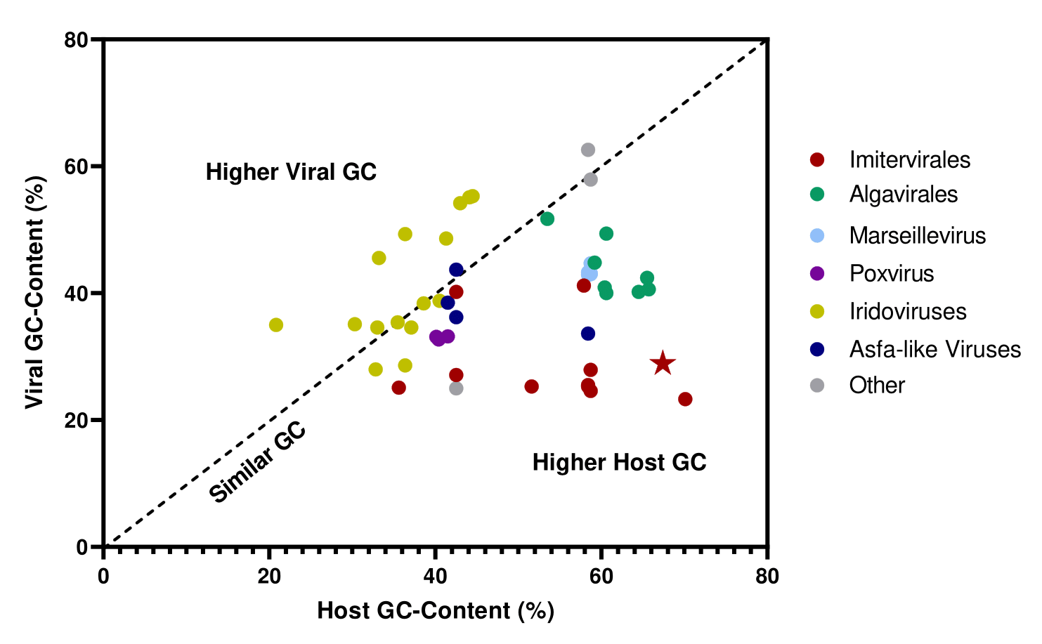
Figure 4.1. GC-content disparity between various Nucleocytoviricota and their hosts. Viral orders are denoted by colors. AaV is indicated by a star. GC-content is averaged over the entire genomic sequence for each virus and host.

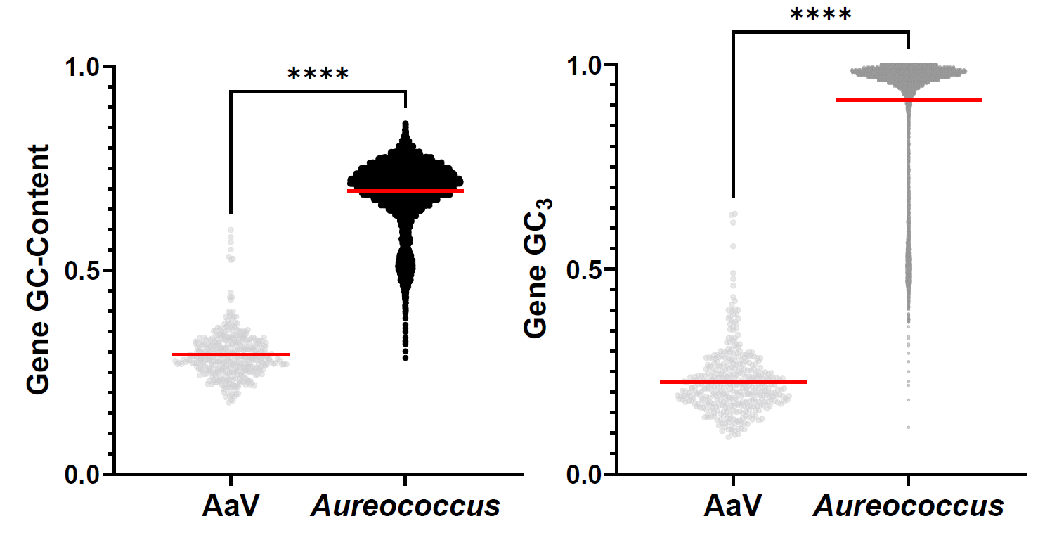
B
A
Figure 4.2. Gene and third codon position GC-content between A. anophagefferens and AaV. For each coding region, total GC-content and the GC-content of the third codon position (GC₃) are taken. Four asterisks (****) indicate a p-value < 0.0001.

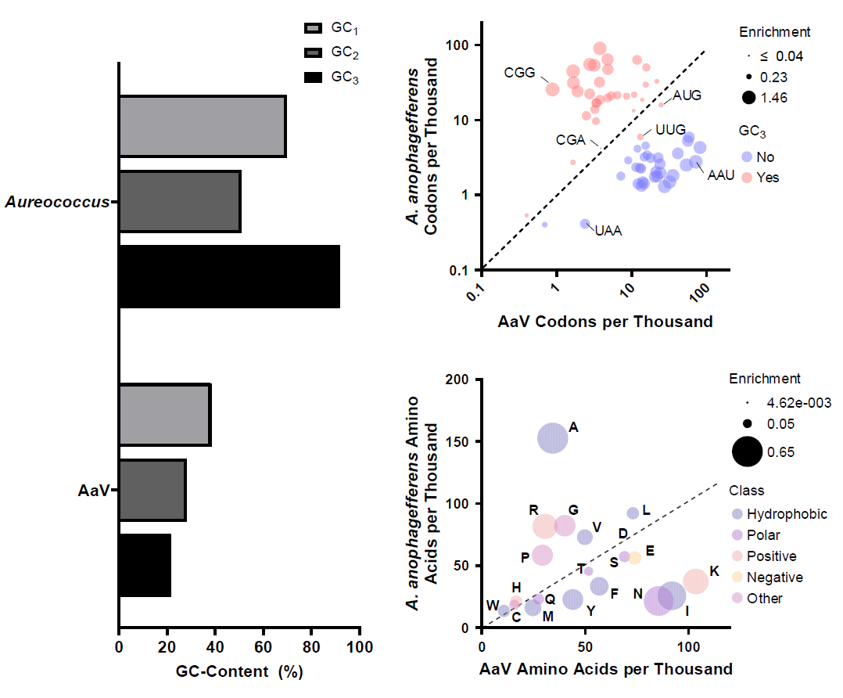
C
B
A
Figure 4.3. Codon and amino acid bias across all genes for AaV and A. anophagefferens. (A) Average GC-content for the 1st, 2nd, and 3rd codon positions for the entire genome are indicated for A. anophagefferens and AaV. (B) The frequency of each possible codon in A. anophagefferens ORFs and AaV ORFs. Codons with a G or C in the third position are colored red, codons with an A or T are colored blue. Enrichment scores are based on |log₁₀(A. anophagefferens frequency/AaV frequency) and indicated by size. Both axes are on a logarithmic scale. (C) The frequency of each predicted amino acid in all A. anophagefferens ORFs and AaV ORFs. Amino acids are colored based on their properties. Enrichment scores are based on |log₁₀(A. anophagefferens frequency/AaV frequency)

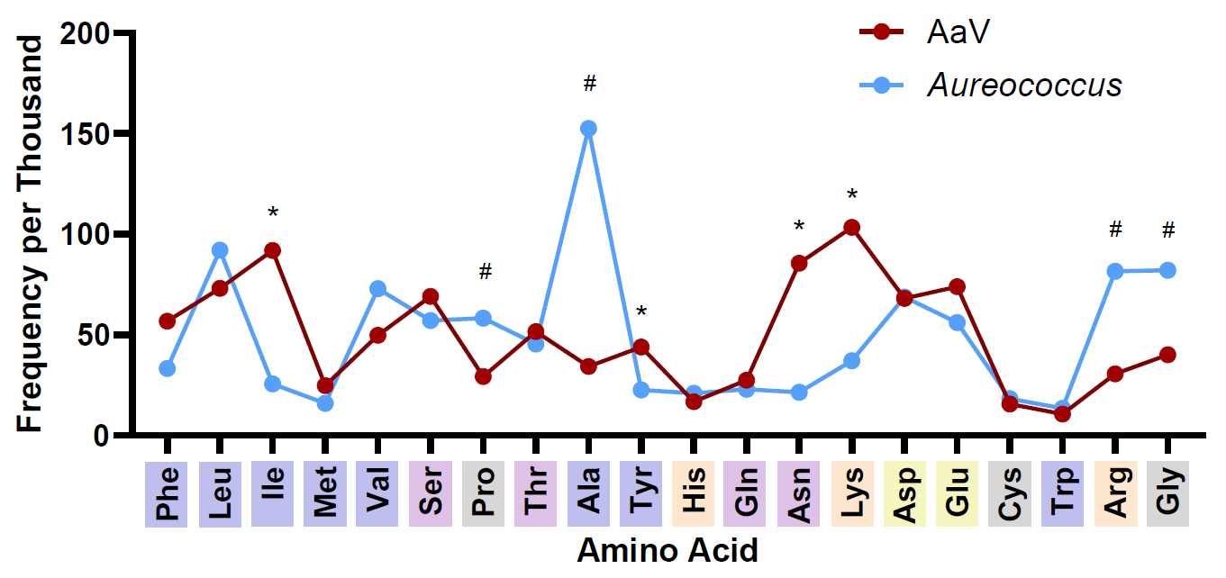
Figure 4.4. Amino acid frequencies in A. anophagefferens and AaV predicted proteins. Amino acid frequencies are denoted as number of amino acid per thousand amino acids in all genes. Asterisks denote amino acids that have a frequency in AaV greater than 2-fold that in A. anophagefferens. Pound symbols denote amino acids that have a frequency in A. anophagefferens greater than 2-fold that in AaV. Colors over amino acids indicate their general physiological properties. Blue, nonpolar; purple, polar; orange, positively charged; yellow, negatively charged; gray, others.

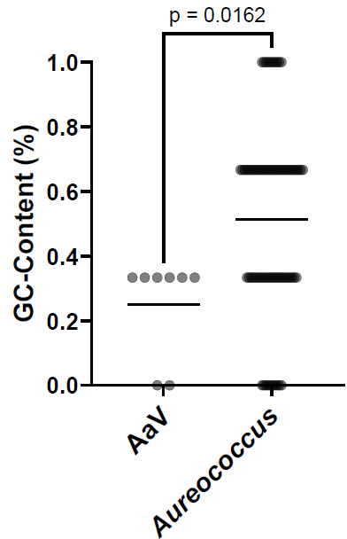
Figure 4.5. Distribution of GC-content across tRNAs. Mean GC-content of all tRNAs is indicated by the horizontal line.

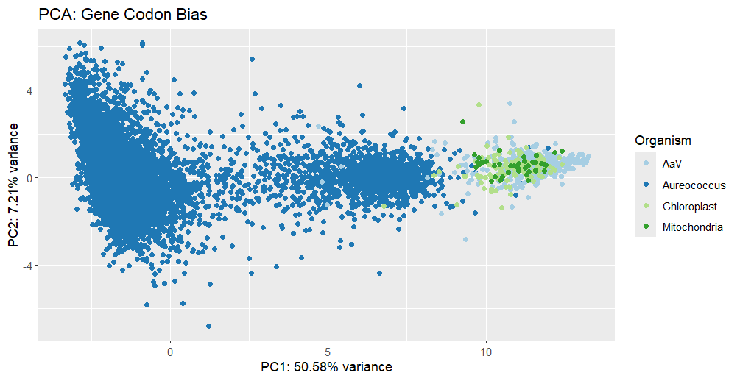
Figure 4.6. Principal component analysis plot of genes based on codon usage. A. anophagefferens genes are shown in dark blue, AaV genes in light blue, A. anophagefferens chloroplast genes in light green, and A. anophagefferens mitochondria genes in dark green. For every gene, relative synonymous codon usage (RSCU) was calculated for every potential codon, excluding stop codons and single codon amino acids (i.e. methionine and tryptophan). A two-dimensional PCA plot was generated based on the two eigenvalues that contribute to the most variance.

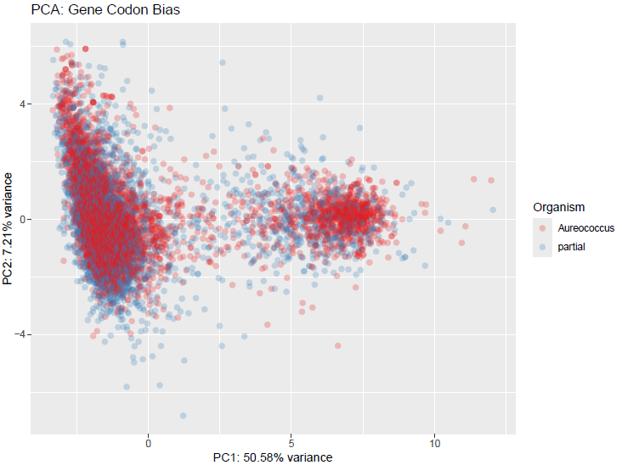
Figure 4.7. PCA plot of A. anophagefferens chromosomal genes, including complete and partial ORFs. For every gene, relative synonymous codon usage (RSCU) was calculated for every potential codon, excluding stop codons and single codon amino acids (i.e. methionine and tryptophan). A two-dimensional PCA plot was generated based on the two eigenvalues that contribute to the most variance. Partial genes are characterized as ORFs that are expected to produce transcripts but are lacking either a start or stop codon due to the scaffold level completeness of the A. anophagefferens genome.

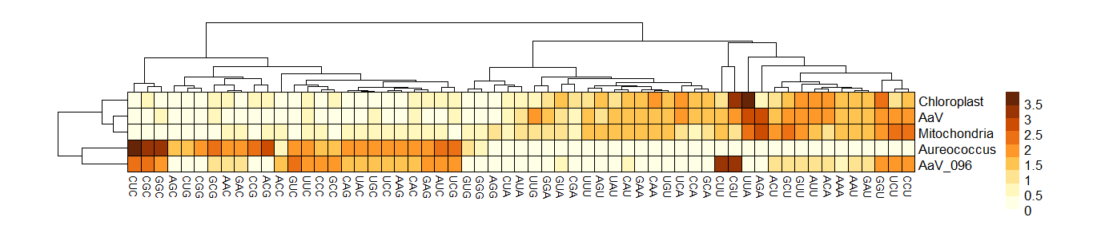
Figure 4.8. Hierarchical clustering of all codons across virus and host genomes. Scores for each codon are based on average RSCU calculations across all genes, with a score of greater than one signifying codon usage over the expected amount. Rows and clusters are clustered. For each genome, all respective genes are considered, while the major capsid protein (AaV_096) is only based on scores from a single gene.

C
B
A
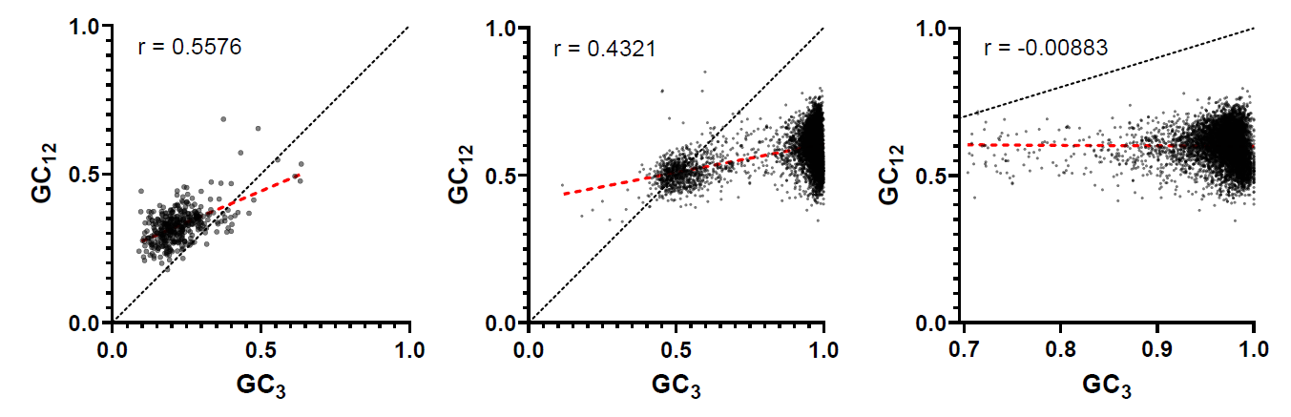
Figure 4.9. Neutrality plots of AaV and A. anophagefferens. Correlation between the GC of the third codon position (GC₃) and the first two codon positions (GC₁₂) is shown. For every gene in AaV (A), A. anophagefferens (B), and for all type I genes in A. anophagefferens (C), GC-content for each codon position was calculated. Red dotted lines show the linear regression of each plot, while black dotted lines show an expected neutral regression between codon positions with a slope of one.

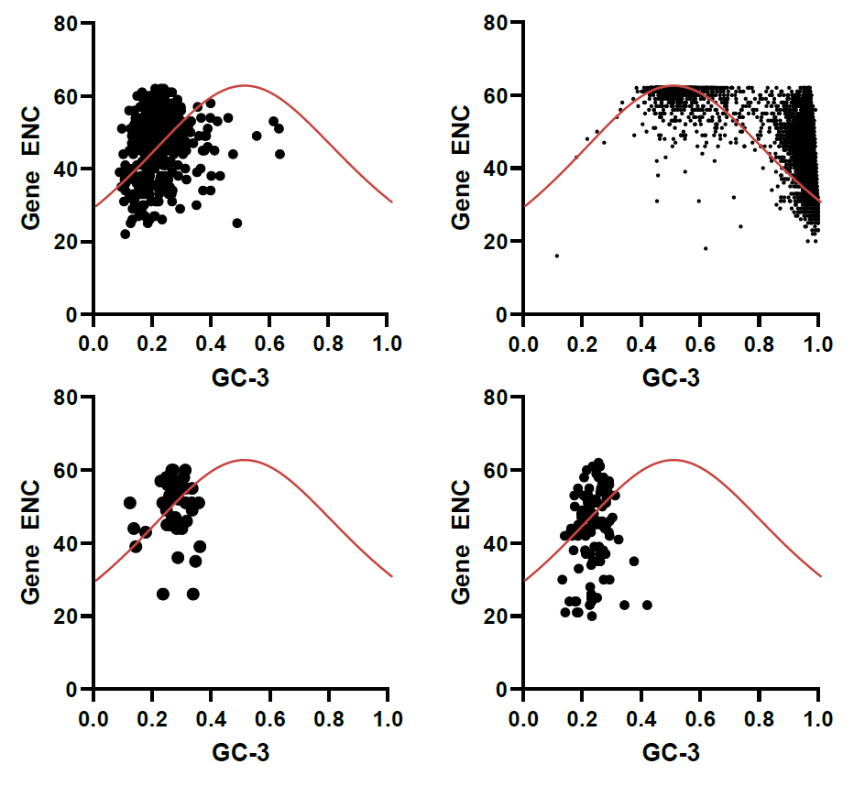
D
C
B
A
Figure 4.10. Effective number of codon plots of AaV and A. anophagefferens. Chromosomal and organellar genes are shown separately for A. anophagefferens. Each plot shows the average GC of the third codon position and the number of codons contained in each gene in AaV (A), A. anophagefferens (B), and the A. anophagefferens mitochondria (C) and chloroplast (D). The red line defines the expected distribution of genes given random mutations as reported in Wright, 1990.

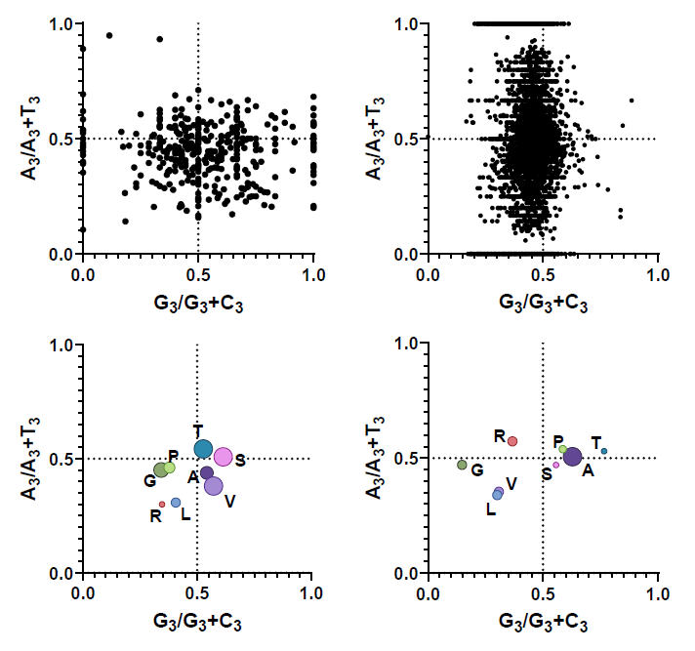
D
C
A
B
Figure 4.11. PR₂ plots showing biases towards pyrimidines or purines. AaV is depicted in A and A. anophagefferens is depicted in B. X-axes display the frequency of guanine in the third codon position as a fraction of all GC, and y-axes display the frequency of adenines in the third codon position as a fraction of all AT for each gene. Four codon amino acids for AaV (C) and A. anophagefferens (D) are described by taking every codon for the given amino acid and determining the proportion of third codon guanine or adenine. For amino acids with more than four codons, the four codons identical in the first and second position are selected. Size of dots corresponds to the frequency of the amino acid.

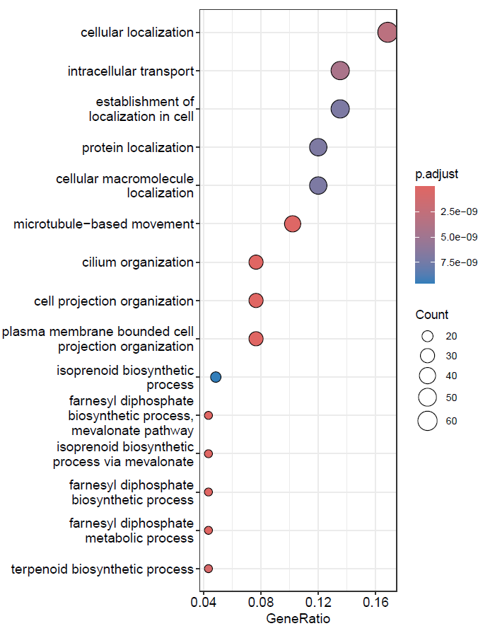
Figure 4.12. Gene set enrichment analysis on type II genes in A. anophagefferens. Type II genes in A. anophagefferens were divided into GO categories and enrichment was determined using the R package clusterProfiler. The top 15 GO categories are displayed based on adjusted p-value. Adjusted p-value is displayed with color, number of type II genes in the category is shown by dot size, and number of genes relative to all type II genes (i.e., GeneRatio) is plotted on the x-axis.
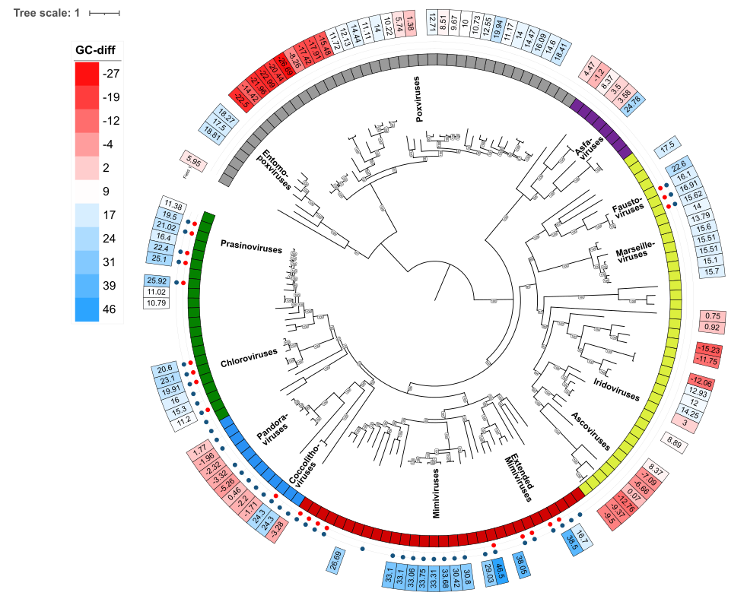
Figure 4.13. Reconstructed cytidine deaminase protein phylogeny of the Nucleocytoviricota. The concatenated protein alignment was constructed using genomes from the Giant Virus Database (Aylward et al., 2021) and the ncldv_markersearch.py script (Moniruzzaman et al., 2020) including the DEAD/SNF2-like helicase (GVOGm0013), DNA polymerase family B (GVOGm0054), transcription initiation factor IIB (GVOGm0172), DNA topoisomerase II (GVOGm0461), A32 packaging ATPase (GVOGm0760), and late transcription factor VLTF3 (GVOGm0890). Nucleocytoviricota orders are colored on the inner ring: green, Algavirales; blue, Pandoravirales; red, Imitervirales; yellow, Pimascovirales; purple, Asfuvirales; gray, Chitovirales. Red dots signify the presence of an ORF that is significantly similar to AaV_094 and blue dots signify the presence of an ORF which is homologous to a gene characterized in NCVOG1064. Outer rings display the GC-disparity between host and virus, with blue corresponding to increased host GC-content and red corresponding to increased virus GC-content. Bootstraps are denoted in boxes.

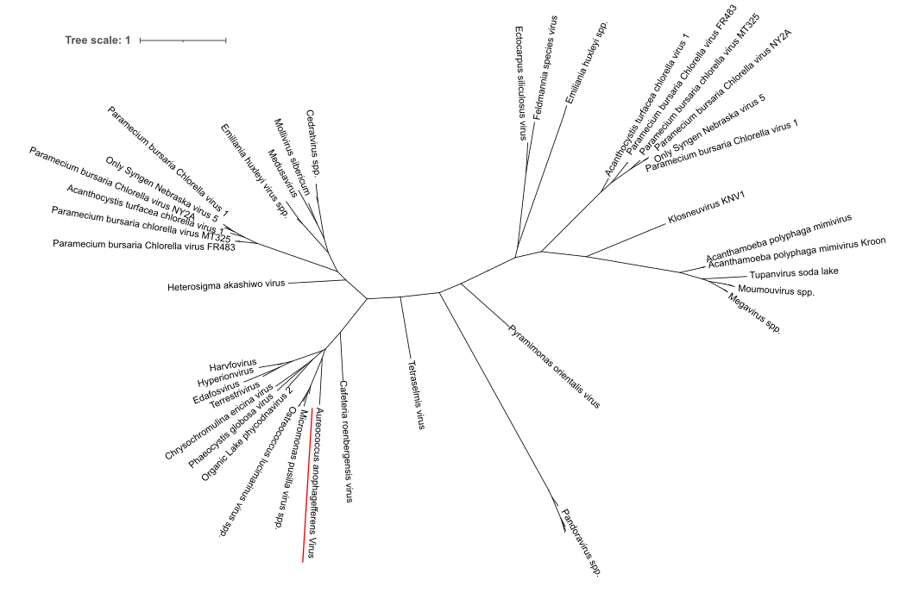
Figure 4.14. Unrooted protein phylogeny of Nucleocytoviricota cytidine deaminases. Deaminases for this tree were pulled from Nucleocytoviricota genomes in the Giant Virus Database using diamond blast against a preconstructed database consisting of proteins defined as NCVOG1064. Clades which contain several strains of the same species of virus and are supported by a bootstrap value greater than 98 are labeled under an ‘spp.’ tag. AaV_094 is underlined in red.

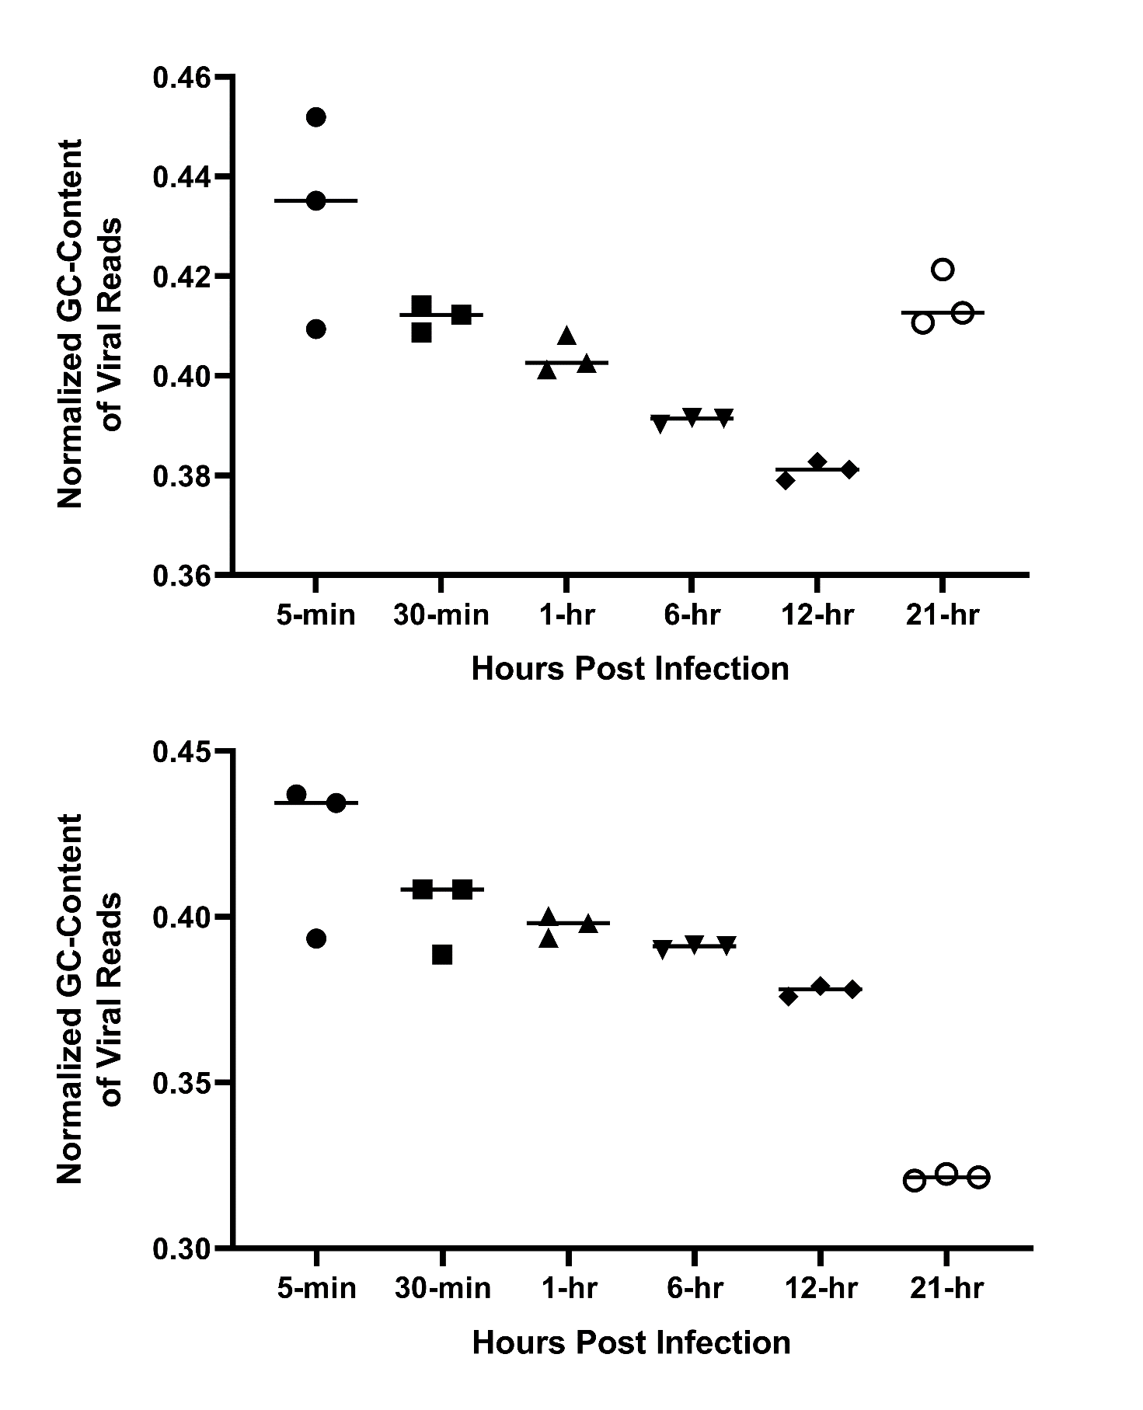
B
A
C
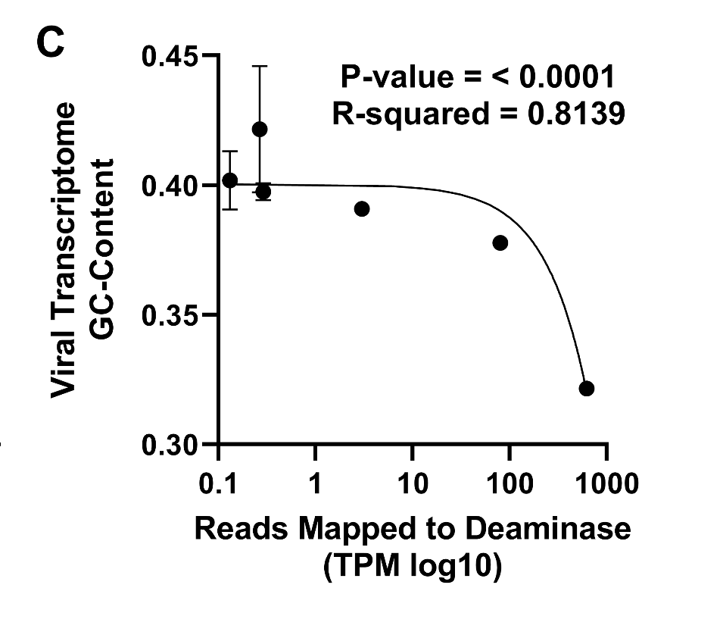
Figure 4.15. GC-content of AaV transcriptomes over the course of infection. GC-content for all transcripts mapping to AaV with (A) or without (B) MCP was measured. Reads were mapped to the viral deaminase at each time point, and tested for correlation against the viral transcriptome GC-content (-MCP) via linear regression (C).

Figure 4.16. Growth of A. anophagefferens when exposed to zebularine. A. anophagefferens growth rate is impeded when higher concentrations of zebularine are utilized (A). Cultures treated with zebularine for 12 days were diluted four-fold in fresh media to test any ability to continue growing after reducing the zebularine concentration in culture (B). A. anophagefferens growth rates after six days (C) and twelve days (D) of exposure to zebularine and methyltransferase inhibitor decitabine at different concentrations are shown. Significance between growth rate was calculated via two-way ANOVA, with letters corresponding to significantly different averages (n = 3; p < 0.05).

Figure 4.17. Growth of A. anophagefferens after exposure to zebularine with uracil. Growth of control cultures and cultures amended with uracil in the presence and absence of 80 µM zebularine (A). Cultures were exposed to 80 µM zebularine for 12 days in the presence or absence of uracil and infected with AaV at an MOI of 100 to generate burst size (viral particles per cell lysed) measurements (B). Significance between burst sizes was calculated using a one-way ANOVA (n=3; * p < 0.05).

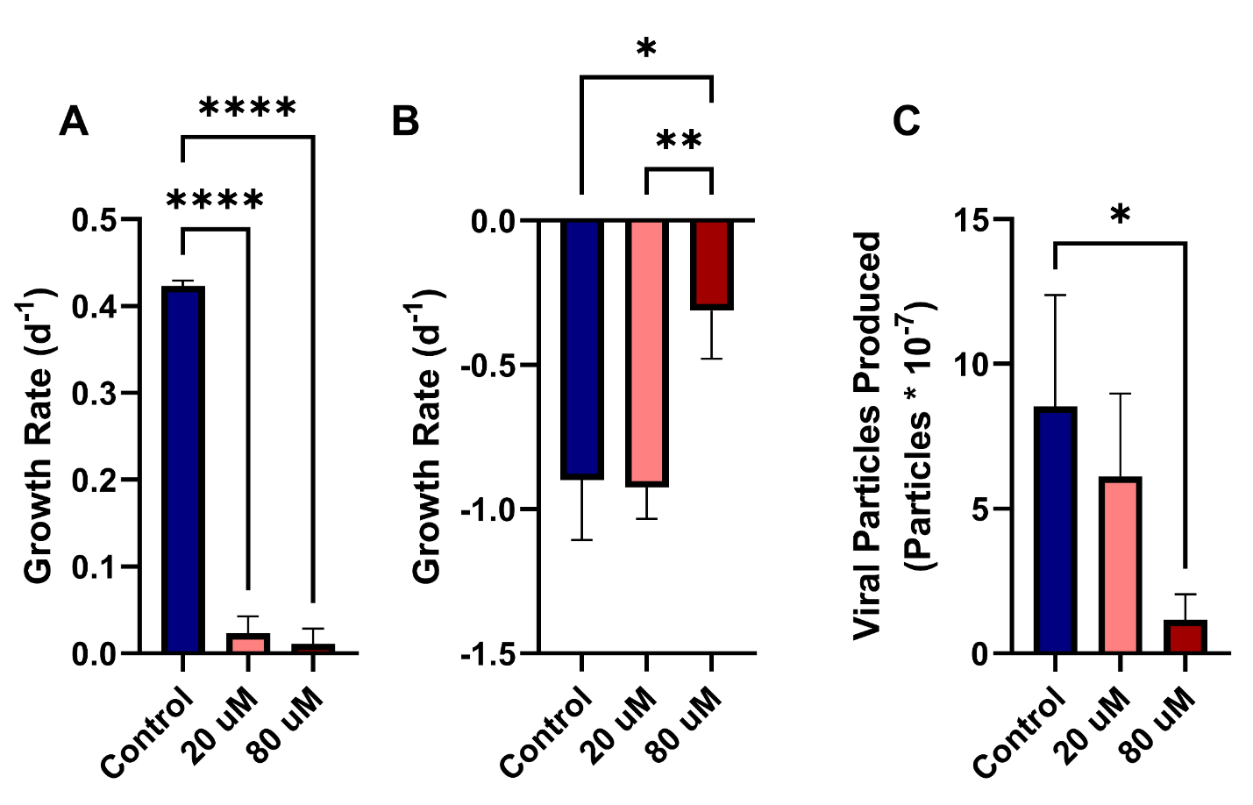
Figure 4.18. Growth of infected A. anophagefferens when treated with 80 µM zebularine. Growth rate of A. anophagefferens after 12 days of treatment with zebularine with (20 µM) or without (80 µM) dilution before infection (A). Growth rate was measured over the course of infection after being infected with AaV at an MOI of 100 (B). Raw counts of viral particles produced for each culture were measured (C). Significant differences between samples were calculated via two-way ANOVA (n=3; **** : p < 0.0001; ** : p < 0.01; * : p < 0.05).

Figure 4.19. Infected A. anophagefferens cultures in the context of zebularine and nucleotide amendments. Cultures were treated with either 80 µM zebularine for 12 days, amended with cytidine and uracil (Nuc+), or both. Significant differences in growth rate were calculated using a two-way ANOVA (n=3).

Figure 4.20. Burst sizes of infected A. anophagefferens cultures after short-period exposure to zebularine. Cultures were exposed to zebularine for 3 days before being infected with AaV at an MOI of 100. Each culture was amended with a specific concentration of uracil to test if this could alleviate stress from zebularine. Significance between burst sizes was calculated between individual uracil treatments using a student’s t-test (n=3).

Chapter Five

Conclusions

Conclusions
Our work has been built on a strong background of research into the dynamic system of interactions between A. anophagefferens and Kratosvirus quantuckense strain AaV. Previous work in this system has focused two-fold on the transcriptional state of the virus throughout infection both in vitro (Moniruzzaman et al., 2018b) and in situ (Moniruzzaman et al., 2016) as well as on the physiological composition and nutrient profile of the virus and its virocell (Gann et al., 2020b; Gann et al., 2020c). Effects of light limitation were previously analyzed, revealing the dependence on light for proper initiation and completion of the infection cycle (Gann et al., 2020a). We followed this by investigating deeper into the specific physiological effects the light cycle has on uninfected and infected A. anophagefferens cells. Likewise, in the past, (Gann et al., 2020c) showed that there is a cohort of packaged proteins within the AaV particle, which allowed for the identification of proteins that will be injected into the host cell immediately upon infection. Additional works herein have continued analysis on some proteins of interest, namely DNA methyltransferases and cytidine deaminases, as well as investigated the nucleotide makeup of the AaV genome and biases within.

AaV takes over the algal diel cycle for maximum virion production
Diel patterns in phytoplankton have been characterized historically, though little consideration for physiological and transcriptional changes throughout the cycle are considered during sampling (Harding et al., 1981; Zinser et al., 2009). Even less is understood about how viruses of phototrophic hosts are affected by the diel cycle. Certain evidence suggests that viruses of eukaryotic green algae such as Ostreococcus sp. are transcriptionally active most during the night, with lysis occurring towards the end of the dark cycle (Derelle et al., 2018). In the AaV – A. anophagefferens system, evidence suggests that light is highly important for infection and that initiation of the infection cycle may not even occur in the absence of light (Gann et al., 2020a). What’s more, viral propagation can be directly tied to the amount of light a virocell receives during infection, with infections initiating at later stages of the day yielding fewer viral particles (Chase et al., 2024).
Thus, we sought to examine the physiological effects of viral infection on the host A. anophagefferens cell in greater context with the diel cycle. Notably, we found that while A. anophagefferens cells increase in size throughout the day in cohort with carbon fixation, infected cells remain at the inflated size throughout the night rather than “shrinking” via division like uninfected cells. The light response of algal cell growth is directly related to available light and is not obviously constrained by any detectable circadian signaling pathway. Likewise, analyses of the A. anophagefferens transcriptome indicate that cell cycle responses are heavily tied to these patterns in both infected and uninfected cells, with certain genes that progress the cell cycle becoming overexpressed in the absence of light (Moniruzzaman et al., 2018b). While these data do reveal important characteristics regarding the life cycle of AaV and how it has evolved in cohort with a photosynthetic organism, they also highlight the importance of consistent sampling times for ecological sampling, as well as the variation that can exist in a single transcriptome throughout one solar day.

The relevance of the genome persists in a modern -omics-based world
Without a strong protocol for cryopreservation, AaV stocks have been serially passaged since its isolation in 2008 (Rowe et al., 2008b). What’s more, the resolution of complete Nucleocytoviricota genomes is complicated by frequent lengthy tandem repeats which can lead to inconsistencies in genome assembly (Tørresen et al., 2019; Erdozain et al., 2023). By resequencing the AaV genome in 2022 using long-read sequencing, we provided a higher completeness genomic assembly with evidence of circularity or genetic circularity as well as an updated perspective of the viral genome after 15 years in culture (Truchon et al., 2022a). Long reads allowed for the bridging of a repeat dense region of the AaV genome, with a highly divergent GC-content from the remainder of the genome.
In addition to the increased confidence in the AaV genome, whole genome resequencing provided a template for the continued sequencing and epigenome analysis of AaV methylation techniques. Though transcriptomic (Moniruzzaman et al., 2016) and genomic (Truchon et al., 2022a) analyses on AaV-A. anophagefferens virocell provide a detailed perspective on the potential of the viral genetic catalogue, additional information lurks in the decoration of genomic sequences via methylation. Methylation in viruses has been linked to a sufficient viral yield (Goorha et al., 1984) as well as the evasion of its own endonucleases (Zhang et al., 1992; Coy et al., 2020). Moreover, Nucleocytoviricota have a diverse profile of methylation target motifs, which may be attributed to their capabilities in circumnavigating variable host immune responses and even in competition for domination over a host against other viruses and virophages (Jeudy et al., 2020).
Methyltransferases are particularly common among the Nucleocytoviricota (Zhang et al., 1998; Schroeder et al., 2009; Jeudy et al., 2020), though AaV may possess one of the largest and most diverse repertoires of methyltransferases in parallel to many chloroviruses (Agarkova et al., 2006). While many are thought to be orphan methyltransferases (Jeudy et al., 2020), certain viruses like PBCV-1 encode for complete restriction modification systems, which may allow for the digestion of host DNA for assimilation (Coy et al., 2020). We sought out to analyze the epigenome of AaV in hopes of identifying possible explanations for the high number of methyltransferases encoded in the genome.
Through consecutive long-read Nanopore sequencing runs on the same viral genome, we were able to confirm that methylation patterns on AaV are highly consistent across different viral lysis events. Given methylation is apparently conserved across AaV replicates, this opens a pathway for analyzing factors that positively or negatively drive methylation (Mager and Ludewig, 2018). In addition, several unique motifs that were significantly targeted for methylation were identified across the AaV genome and ranged from simple (CATG) to more complicated and uncommon (CYTAGC). This, in cohort with the fact that methylated motifs were enriched in specific genomic regions and methylation frequency dropped in the immediate upstream region before genes, may suggest a functional role to methylation in AaV that exceeds beyond protection from digestion.

Understanding the driving factors behind nucleotide usage disparity
Similar usage of GC-content as well as corresponding nucleotide biases have been used to tie viruses to host (Lobo et al., 2009; Babayan et al., 2018). However, certain viruses, particularly dsDNA viruses of eukaryotes such as the Nucleocytoviricota, exhibit large disconnects in genomic and ORF GC-content compared to their hosts (Witt et al., 2024). This is particularly exemplified in AaV, possessing a genome that displays a 38.5% drop in GC-content compared to that of A. anophagefferens, one of the largest among Nucleocytoviricota (Gobler et al., 2011; Truchon et al., 2022a). To identify the reasons behind the large drop in GC-content between host and virus as well as possible mechanisms for overcoming a possible adenine/thymine poor environment, we looked for nucleotide and codon usage biases between AaV and A. anophagefferens chromosomal and organellar genomes. We also examined a potential inhibitor of cytidine deaminase activity as a method for characterizing its role in AaV infection.
While complete genomic GC-content may be a poor indicator of host-virus association (Witt et al., 2024), investigating the nucleotide biases that exist in the third codon position can be fruitful in defining historic selection of base preference (Jitobaom et al., 2020; Yu et al., 2021). The third codon position is often less functionally restricted, thus mutation rates at this site occur much more frequently than the first two sites (Bofkin and Goldman, 2006). There are statistical analyses that allow for the interpretation of variation at the third codon position, which informs whether changes that have accumulated at these sites over time result from random mutation or directional selection (Wright, 1990; Sueoka, 1999). Additionally, while whole genome GC-content may vary, overlapping nucleotide biases between individual genes may indicate signs of interaction between proteins and use of shared transcriptional and translational machinery (Jitobaom et al., 2020). Using this information and these strategies, we have identified strong evidence for directional selection on the third codon position of most A. anophagefferens genes, as they have been driven to almost exclusively use guanines and cytosines in this site. Likewise, overlaps in nucleotide usage bias occur between AaV and the A. anophagefferens mitochondrial and chloroplast genes, suggesting the possibility of interaction between viral and organellar nucleic acids. Finally, A. anophagefferens genes that bare an increased similarity in nucleotide bias to AaV genes are frequently associated with intracellular trafficking and structure. Given described co-occurrence of virus factories with host organelles in other systems, these results point to a shared interaction between the virus and host extra-nuclear structures (de Castro et al., 2013; Sheikh et al., 2023).
Additionally, we examined the possibility of cytidine deaminase as an important gene for the recovery of thymine and uracil in the virocell. Zebularine is an inhibitor of deaminase which prevents the conversion of thymine into uracil (Lemaire et al., 2009). Deaminases are found across distinct lineages of the Nucleocytoviricota, often within the genomes of viruses that exhibit a large GC-disconnect with their host (Zhang et al., 2007). While early indications point to the deamination of cytidine being important for both A. anophagefferens and AaV propagation, limitations in the application of the inhibitor and the effects it has on the host require further investigation.

Leveraging a previously generated infection transcriptome
In each of the studies described here, previously established transcriptomic analyses have been utilized for the purpose of characterizing specific genes and their role in infection (Moniruzzaman et al., 2018b). The strength of these types of transcriptomes, which track the progress of viral transcript propagation over the course of the infection cycle, lies in their reusability and the sheer amount of metadata that can be utilized in future studies (Rosenwasser et al., 2019; Rodrigues et al., 2020). Further analyses such as these should be performed across the Nucleocytoviricota phylum, to better define the temporal shift in viral gene expression and infection progression, as these viruses often provide more complexities than can be observed in a single timepoint (Derelle et al., 2018).

Future Directions
One avenue that should be further studied in this system is the metabolomic profile of A. anophagefferens during infection. Early observations of the A. anophagefferens virocell indicated a rapid shift in glycocalyx structure (Gastrich et al., 1998) and degradation of some but not all organelles (Sieburth et al., 1988). Likewise, nutrient amendment analyses have implicated specific viral genes in changing the metabolic profile of the host cell (Gann et al., 2020b). However, performing metabolomics on A. anophagefferens has proven difficult, perhaps due to the cell’s apparent robustness during stressful periods (Truchon et al., 2023).
Shifts in metabolite fractions throughout the infection cycle may be indicative of the changes that occur in the cell regarding nucleotide usage. While the work described in Chapter Four has pointed out potential avenues for nucleotide salvaging during infection, the mechanistic processes that lead to nucleotide salvaging are still largely a mystery. For example, evidence suggests that AaV genes share nucleotide usage frequencies with host chloroplasts and mitochondria, as opposed to host chromosomal genes. Thus, the fate of organelles along with their DNA, ribosomes, and transcription factors becomes an important point of emphasis during viral infection. While we are aware of organelles like the nucleus and mitochondria disappearing at later stages of the infection cycle (Gastrich et al., 1998), we do not currently know the timing of this process nor how the contents of the organelle benefit the virus. There is a potential for targeting mitochondrial structures and compounds for staining, possibly in combination with in situ hybridization of viral DNA, to better understand how the virus interacts with these organelles (Chu et al., 2021). Similar virus-organelle interactions may be extremely important for the A. anophagefferens nucleus as well. Regarding the chloroplast, the last remaining organelle in the infected cell prior to lysis, the strength behind allowing this organelle to persist in the cell and continue fixing carbon is evident. However, how the chloroplast persists is unclear. There is a chance that the chloroplast is composed of unique lipids to the mitochondria, and this allows for its persistence during infection. A foray into lipidomics of the A. anophagefferens cell, as well as the isolated chloroplast could reveal relevant information about their structure.
The fate of chromosomal DNA warrants further analysis, as this is a potential source of nucleotides for viral genome replication, via deaminase activity. However, AaV also encodes for a histone acetyltransferase. As the virus does not possess any histones itself, it stands to reason that it must be interacting with A. anophagefferens histones, though it is unknown whether this occurs before or after breakdown of the nuclear envelope. Precipitation of histones during infection may provide an indication as to whether viral DNA is interacting with them, and at what points (Wysocka, 2006).
Additional work is also necessary for deeper examination into various proteins that have been identified as important for infection. There is a potential for cloning viral genes into tractable systems to directly confirm their role (Zhang et al., 1998). This could be valuable for attributing specific methyltransferases to definitive motifs in dam/dcm negative E. coli (Barras and Marinus, 1989). Performing genetics on viral genes could allow for characterizing exact function of specific genes, as although deaminases and methyltransferases are ascribed to the function via homology, it does not imply that they are necessarily functional. Investigation into other giant virus deaminases that share homologous domains with the AaV deaminases could also be undertaken. An improved understanding of the functional domains of the deaminases would allow for identifying potential compounds that may serve as specific inhibitors of AaV deaminases, without inhibiting host deaminases.
Finally, much of the work described here are focused on in vitro and in silico analysis. Although other strains of A. anophagefferens which are both resistant and susceptible to viral infection have been considered, these results must still be better contrasted with explicit in situ studies. Determining methylation rates in situ as well as visualizing the effects of infection on cell physiology in true environmental diel cycling will confirm whether these studies are consistent. Collectively, deeper analysis into the responses detected here should provide more insight into bloom dynamics and virus-induced collapse.

List of References
Abergel, C., Rudinger-Thirion, J., Giegé, R., and Claverie, J.M. (2007). Virus-encoded aminoacyl-tRNA synthetases: structural and functional characterization of mimivirus TyrRS and MetRS. J Virol 81(22), 12406-12417. doi: 10.1128/jvi.01107-07.
Abrahao, J., Silva, L., Silva, L.S., Khalil, J.Y.B., Rodrigues, R., Arantes, T., et al. (2018). Tailed giant Tupanvirus possesses the most complete translational apparatus of the known virosphere. Nature Communications 9. doi: ARTN 749
10.1038/s41467-018-03168-1.
Abrahão, J.S., Dornas, F.P., Silva, L.C., Almeida, G.M., Boratto, P.V., Colson, P., et al. (2014). Acanthamoeba polyphaga mimivirus and other giant viruses: an open field to outstanding discoveries. Virol J 11, 120. doi: 10.1186/1743-422x-11-120.
Agarkova, I.V., Dunigan, D.D., and Van Etten, J.L. (2006). Virion-associated restriction endonucleases of chloroviruses. Journal of Virology 80(16), 8114-8123. doi: 10.1128/Jvi.00486-06.
Agarkova, I.V., Lane, L.C., Dunigan, D.D., Quispe, C.F., Duncan, G.A., Milrot, E., et al. (2021). Identification of a Chlorovirus PBCV-1 Protein Involved in Degrading the Host Cell Wall during Virus Infection. Viruses 13(5), 782. doi: 10.3390/v13050782.
Aherfi, S., Andreani, J., Baptiste, E., Oumessoum, A., Dornas, F.P., Andrade, A.C.D.P., et al. (2018). A Large Open Pangenome and a Small Core Genome for Giant Pandoraviruses. Frontiers in Microbiology 9. doi: ARTN 1486
10.3389/fmicb.2018.01486.
Anderson, D.M., Fensin, E., Gobler, C.J., Hoeglund, A.E., Hubbard, K.A., Kulis, D.M., et al. (2021). Marine harmful algal blooms (HABs) in the United States: History, current status and future trends. Harmful Algae 102, 101975. doi: 10.1016/j.hal.2021.101975.
Anderson, D.M., Keafer, B.A., Kulis, D.M., Waters, R.M., and Nuzzi, R. (1993). An immunofluorescent survey of the brown tide chrysophyte Aureococcus anophagefferens along the northeast coast of the United States. Journal of Plankton Research 15(5), 563-580. doi: 10.1093/plankt/15.5.563.
Anderson, D.M., Kulis, D.M., and Cosper, E.M. (Year). "Immunofluorescent Detection of the Brown Tide Organism, Aureococcus Anophagefferens", in: Novel Phytoplankton Blooms, eds. E.M. Cosper, V.M. Bricelj, E.J. Carpenter, E.M. Cosper, V.M. Bricelj & E.J. Carpenter (Berlin, Heidelberg), 213-228.
Andreani, J., Khalil, J.Y.B., Sevvana, M., Benamar, S., Di Pinto, F., Bitam, I., et al. (2017). Pacmanvirus, a New Giant Icosahedral Virus at the Crossroads between Asfarviridae and Faustoviruses. Journal of Virology 91(14). doi: UNSP e00212
10.1128/JVI.00212-17.
Arslan, D., Legendre, M., Seltzer, V., Abergel, C., and Claverie, J.M. (2011). Distant Mimivirus relative with a larger genome highlights the fundamental features of Megaviridae. Proc Natl Acad Sci U S A 108(42), 17486-17491. doi: 10.1073/pnas.1110889108.
Aylward, F.O., Abrahao, J.S., Brussard, C., Fischer, M.G., Moniruzzaman, M., Ogata, H., et al. (2022). Create 3 new families, 3 subfamilies, 13 genera, and 20 new species within the order Imitervirales (phylum Nucleocytoviricota) and rename two existing species. . International Committee on Taxonomy of Viruses.
Aylward, F.O., Eppley, J.M., Smith, J.M., Chavez, F.P., Scholin, C.A., and DeLong, E.F. (2015). Microbial community transcriptional networks are conserved in three domains at ocean basin scales. Proc Natl Acad Sci U S A 112(17), 5443-5448. doi: 10.1073/pnas.1502883112.
Aylward, F.O., Moniruzzaman, M., Ha, A.D., and Koonin, E.V. (2021). A phylogenomic framework for charting the diversity and evolution of giant viruses. PLOS Biology 19(10), e3001430. doi: 10.1371/journal.pbio.3001430.
Babayan, S.A., Orton, R.J., and Streicker, D.G. (2018). Predicting reservoir hosts and arthropod vectors from evolutionary signatures in RNA virus genomes. Science 362(6414), 577-580. doi: doi:10.1126/science.aap9072.
Babicki, S., Arndt, D., Marcu, A., Liang, Y., Grant, J.R., Maciejewski, A., et al. (2016). Heatmapper: web-enabled heat mapping for all. Nucleic Acids Res 44(W1), W147-153. doi: 10.1093/nar/gkw419.
Barras, F., and Marinus, M.G. (1989). The great GATC: DNA methylation in E. coli. Trends in Genetics 5, 139-143. doi: https://doi.org/10.1016/0168-9525(89)90054-1.
Baudoux, A.C., and Brussaard, C.P.D. (2008). Influence of irradiance on virus-algal host interactions. Journal of Phycology 44(4), 902-908. doi: 10.1111/j.1529-8817.2008.00543.x.
Beel, B., Prager, K., Spexard, M., Sasso, S., Weiss, D., Müller, N., et al. (2012). A flavin binding cryptochrome photoreceptor responds to both blue and red light in Chlamydomonas reinhardtii. Plant Cell 24(7), 2992-3008. doi: 10.1105/tpc.112.098947.
Behrenfeld, M.J., Prasil, O., Babin, M., and Bruyant, F. (2004). IN SEARCH OF A PHYSIOLOGICAL BASIS FOR COVARIATIONS IN LIGHT-LIMITED AND LIGHT-SATURATED PHOTOSYNTHESIS. Journal of phycology 40(1), 4-25. doi: 10.1046/j.1529-8817.2004.03083.x.
Beketova, E., Owens, J.L., Asberry, A.M., and Hu, C.D. (2022). PRMT5: a putative oncogene and therapeutic target in prostate cancer. Cancer Gene Ther 29(3-4), 264-276. doi: 10.1038/s41417-021-00327-3.
Berg, G.M., Gilbert, P.M., Lomas, M.W., and Burford, M.A. (1997a). Organic nitrogen uptake and growth by the chrysophyte Aureococcus anophagefferens during a brown tide event. Marine biology 129(2), 377-387. doi: 10.1007/s002270050178.
Berg, G.M., Glibert, P.M., Lomas, M.W., and Burford, M.A. (1997b). Organic nitrogen uptake and growth by the chrysophyte Aureococcus anophagefferens during a brown tide event. Marine Biology 129(2), 377-387. doi: DOI 10.1007/s002270050178.
Berg, G.M., Repeta, D.J., and Laroche, J. (2002). Dissolved organic nitrogen hydrolysis rates in axenic cultures of Aureococcus anophagefferens (Pelagophyceae): comparison with heterotrophic bacteria. Appl Environ Microbiol 68(1), 401-404.
Berg, G.M., Shrager, J., Glockner, G., Arrigo, K.R., and Grossman, A.R. (2008). Understanding nitrogen limitation in Aureococcus anophagefferens (Pelagophyceae) through cDNA and qRT-PCR analysis. Journal of Phycology 44(5), 1235-1249. doi: 10.1111/j.1529-8817.2008.00571.x.
Bewick, A.J., Hofmeister, B.T., Powers, R.A., Mondo, S.J., Grigoriev, I.V., James, T.Y., et al. (2019). Diversity of cytosine methylation across the fungal tree of life. Nat Ecol Evol 3(3), 479-490. doi: 10.1038/s41559-019-0810-9.
Bewick, A.J., Vogel, K.J., Moore, A.J., and Schmitz, R.J. (2017). Evolution of DNA Methylation across Insects. Mol Biol Evol 34(3), 654-665. doi: 10.1093/molbev/msw264.
Bienfang, P.K. (1981). SETCOL — A Technologically Simple and Reliable Method for Measuring Phytoplankton Sinking Rates. Canadian Journal of Fisheries and Aquatic Sciences 38(10), 1289-1294. doi: 10.1139/f81-173.
Blanc-Mathieu, R., Dahle, H., Hofgaard, A., Brandt, D., Ban, H., Kalinowski, J., et al. (2021). A Persistent Giant Algal Virus, with a Unique Morphology, Encodes an Unprecedented Number of Genes Involved in Energy Metabolism. Journal of Virology 95(8). doi: 10.1128/jvi.02446-20.
Blanc, G., Mozar, M., Agarkova, I.V., Gurnon, J.R., Yanai-Balser, G., Rowe, J.M., et al. (2014). Deep RNA Sequencing Reveals Hidden Features and Dynamics of Early Gene Transcription in Paramecium bursaria Chlorella Virus 1. Plos One 9(3). doi: ARTN e90989
10.1371/journal.pone.0090989.
Bofkin, L., and Goldman, N. (2006). Variation in Evolutionary Processes at Different Codon Positions. Molecular Biology and Evolution 24(2), 513-521. doi: 10.1093/molbev/msl178.
Bolen, P.L., Grant, D.M., Swinton, D., Boynton, J.E., and Gillham, N.W. (1982). Extensive methylation of chloroplast DNA by a nuclear gene mutation does not affect chloroplast gene transmission in chlamydomonas. Cell 28(2), 335-343. doi: 10.1016/0092-8674(82)90351-8.
Boyer, M., Yutin, N., Pagnier, I., Barrassi, L., Fournous, G., Espinosa, L., et al. (2009). Giant Marseillevirus highlights the role of amoebae as a melting pot in emergence of chimeric microorganisms. Proceedings of the National Academy of Sciences of the United States of America 106(51), 21848-21853. doi: 10.1073/pnas.0911354106.
Bratbak, G., Egge, J.K., and Heldal, M. (1993). Viral Mortality of the Marine Alga Emiliania-Huxleyi (Haptophyceae) and Termination of Algal Blooms. Marine Ecology Progress Series 93(1-2), 39-48. doi: DOI 10.3354/meps093039.
Breckell, G.L., and Silander, O.K. (2022). Growth condition-dependent differences in methylation imply transiently differentiated DNA methylation states in Escherichia coli. G3 Genes|Genomes|Genetics 13(2). doi: 10.1093/g3journal/jkac310.
Breker, M., Lieberman, K., and Cross, F.R. (2018). Comprehensive Discovery of Cell-Cycle-Essential Pathways in Chlamydomonas reinhardtii. Plant Cell 30(6), 1178-1198. doi: 10.1105/tpc.18.00071.
Bricelj, V.M., and Lonsdale, D.J. (1997a). Aureococcus anophagefferens: Causes and ecological consequences of brown tides in U.S. mid-Atlantic coastal waters. Limnology and Oceanography 42(5part2), 1023-1038. doi: 10.4319/lo.1997.42.5_part_2.1023.
Bricelj, V.M., and Lonsdale, D.J. (1997b). Aureococcus anophagefferens: Causes and ecological consequences of brown tides in US mid-Atlantic coastal waters. Limnology and Oceanography 42(5), 1023-1038. doi: DOI 10.4319/lo.1997.42.5_part_2.1023.
Brown, C.M., and Bidle, K.D. (2014). Attenuation of virus production at high multiplicities of infection in Aureococcus anophagefferens. Virology 466-467, 71-81. doi: 10.1016/j.virol.2014.07.023.
Brown, C.M., Campbell, D.A., and Lawrence, J.E. (2007). Resource dynamics during infection of Micromonas pusilla by virus MpV-Sp1. Environmental Microbiology 9(11), 2720-2727. doi: 10.1111/j.1462-2920.2007.01384.x.
Brussaard, C.P.D., Kempers, R.S., Kop, A.J., Riegman, R., and Heldal, M. (1996). Virus like particles in a summer bloom of Emiliania huxley in the North Sea. Aquatic Microbial Ecology - AQUAT MICROB ECOL 10, 105-113. doi: 10.3354/ame010105.
Brussaard, C.P.D., Kuipers, B., and Veldhuis, M.J.W. (2005). A mesocosm study of Phaeocystis globosa population dynamics. Harmful Algae 4(5), 859-874. doi: 10.1016/j.hal.2004.12.015.
Brussaard, C.P.D., Short, S.M., Frederickson, C.M., and Suttle, C.A. (2004). Isolation and phylogenetic analysis of novel viruses infecting the phytoplankton Phaeocystis globosa (Prymnesiophyceae). Applied and Environmental Microbiology 70(6), 3700-3705. doi: 10.1128/aem.70.6.3700-3705.2004.
Buchfink, B., Xie, C., and Huson, D.H. (2015). Fast and sensitive protein alignment using DIAMOND. Nat Methods 12(1), 59-60. doi: 10.1038/nmeth.3176.
Buitrago, D., Labrador, M., Arcon, J.P., Lema, R., Flores, O., Esteve-Codina, A., et al. (2021). Impact of DNA methylation on 3D genome structure. Nature Communications 12(1), 3243. doi: 10.1038/s41467-021-23142-8.
Burgess, A., Mornon, J.P., de Saint-Basile, G., and Callebaut, I. (2009). A concanavalin A-like lectin domain in the CHS1/LYST protein, shared by members of the BEACH family. Bioinformatics 25(10), 1219-1222. doi: 10.1093/bioinformatics/btp151.
Bushnell, B. (2022). BBMap [Online]. Available: https://sourceforge.net/projects/bbmap [Accessed].
Buskey, E.J., Montagna, P.A., Amos, A.F., and Whitledge, T.E. (1997). Disruption of grazer populations as a contributing factor to the initiation of the Texas brown tide algal bloom. Limnology and Oceanography 42(5part2), 1215-1222. doi: 10.4319/lo.1997.42.5_part_2.1215.
Carlson M., P.H. (2025). "AnnotationForge: Tools for building SQLite-based annotation data packages.". R package version 1.50.0 ed.).
Chan, P.P., and Lowe, T.M. (2019). tRNAscan-SE: Searching for tRNA Genes in Genomic Sequences. Methods Mol Biol 1962, 1-14. doi: 10.1007/978-1-4939-9173-0_1.
Chan, S.H., Zhu, Z., Dunigan, D.D., Van Etten, J.L., and Xu, S.Y. (2006). Cloning of Nt.CviQII nicking endonuclease and its cognate methyltransferase: M.CviQII methylates AG sequences. Protein Expr Purif 49(1), 138-150. doi: 10.1016/j.pep.2006.04.002.
Charvin, M., Halter, T., Blanc-Mathieu, R., Barraud, P., Aumont-Nicaise, M., Parcy, F., et al. (2023). Single-cytosine methylation at W-boxes repels binding of WRKY transcription factors through steric hindrance. Plant Physiol 192(1), 77-84. doi: 10.1093/plphys/kiad069.
Chase, E.E., Truchon, A.R., Coy, S.R., and Wilhelm, S.W. (2023). Aureococcus anophagefferens Virus (AaV)/Kratosvirus quantuckense viral particle count by SYBR Green staining and flow cytometry (CytoFLEX S Flow Cytometer Beckman Coulter) V.2 [Online]. Available: https://www.protocols.io/view/aureococcus-anophagefferens-virus-aav-kratosvirus-dm6gpj331gzp/v2 [Accessed].
Chase, E.E., Truchon, A.R., Creasey, B.A., and Wilhelm, S.W. (2024). Time of day of infection shapes development of a eukaryotic algal-Nucleocytoviricota virocell. FEMS Microbiology Ecology 100(10). doi: 10.1093/femsec/fiae123.
Chase, E.E., Truchon, A.R., and Wilhelm, S.W. (2022). Aureococcus anophagefferens population count, and relative size (Violet SSC) by flow cytometry (CytoFLEX S Flow Cytomer Beckman Coulter) [Online]. protocols.io. [Accessed].
Chen, L., Bellone, R.R., Wang, Y., Singer-Berk, M., Sugasawa, K., Ford, J.M., et al. (2021a). A novel DDB2 mutation causes defective recognition of UV-induced DNA damages and prevalent equine squamous cell carcinoma. DNA Repair (Amst) 97, 103022. doi: 10.1016/j.dnarep.2020.103022.
Chen, S., Lees-Miller, J.P., He, Y., and Lees-Miller, S.P. (2021b). Structural insights into the role of DNA-PK as a master regulator in NHEJ. Genome Instab Dis 2(4), 195-210. doi: 10.1007/s42764-021-00047-w.
Chen, Z.-F., Zhang, Q.-C., Kong, F.-Z., Liu, Y., Zhao, Y., Zhou, Z.-X., et al. (2019). Resolving phytoplankton taxa based on high-throughput sequencing during brown tides in the Bohai Sea, China. Harmful Algae 84, 127-138. doi: 10.1016/j.hal.2019.03.011.
Cheng, Y.S., Labavitch, J., and VanderGheynst, J.S. (2015). Organic and Inorganic Nitrogen Impact Chlorella variabilis Productivity and Host Quality for Viral Production and Cell Lysis. Appl Biochem Biotechnol 176(2), 467-479. doi: 10.1007/s12010-015-1588-0.
Cherrier, M.V., Kostyuchenko, V.A., Xiao, C.A., Bowman, V.D., Battisti, A.J., Yan, X.D., et al. (2009). An icosahedral algal virus has a complex unique vertex decorated by a spike. Proceedings of the National Academy of Sciences of the United States of America 106(27), 11085-11089. doi: 10.1073/pnas.0904716106.
Chioccioli, M., Hankamer, B., and Ross, I.L. (2014). Flow cytometry pulse width data enables rapid and sensitive estimation of biomass dry weight in the microalgae Chlamydomonas reinhardtii and Chlorella vulgaris. PLoS One 9(5), e97269. doi: 10.1371/journal.pone.0097269.
Choi, C.J., Jimenez, V., Needham, D.M., Poirier, C., Bachy, C., Alexander, H., et al. (2020). Seasonal and Geographical Transitions in Eukaryotic Phytoplankton Community Structure in the Atlantic and Pacific Oceans. Front Microbiol 11, 542372. doi: 10.3389/fmicb.2020.542372.
Chu, Y., Park, J., Kim, E., and Lee, S. (2021). Fluorescent Materials for Monitoring Mitochondrial Biology. Materials (Basel) 14(15). doi: 10.3390/ma14154180.
Clarke, K.R.a.G., R.N. (2015). PRIMER v7: User Manual/Tutorial. Plymouth: PRIMER-E.
Clerissi, C., Desdevises, Y., and Grimsley, N. (2012). Prasinoviruses of the marine green alga Ostreococcus tauri are mainly species specific. J Virol 86(8), 4611-4619. doi: 10.1128/jvi.07221-11.
Clerissi, C., Grimsley, N., Subirana, L., Maria, E., Oriol, L., Ogata, H., et al. (2014). Prasinovirus distribution in the Northwest Mediterranean Sea is affected by the environment and particularly by phosphate availability. Virology 466, 146-157. doi: 10.1016/j.virol.2014.07.016.
Coesel, S., Mangogna, M., Ishikawa, T., Heijde, M., Rogato, A., Finazzi, G., et al. (2009). Diatom PtCPF1 is a new cryptochrome/photolyase family member with DNA repair and transcription regulation activity. EMBO Rep 10(6), 655-661. doi: 10.1038/embor.2009.59.
Colson, P., Fournous, G., Diene, S.M., and Raoult, D. (2013). Codon usage, amino acid usage, transfer RNA and amino-acyl-tRNA synthetases in Mimiviruses. Intervirology 56(6), 364-375. doi: 10.1159/000354557.
Comeau, A.M., and Krisch, H.M. (2005). War is peace — dispatches from the bacterial and phage killing fields. Current Opinion in Microbiology 8(4), 488-494. doi: https://doi.org/10.1016/j.mib.2005.06.004.
Connell, C.M., Shibata, A., Tookman, L.A., Archibald, K.M., Flak, M.B., Pirlo, K.J., et al. (2011). Genomic DNA damage and ATR-Chk1 signaling determine oncolytic adenoviral efficacy in human ovarian cancer cells. J Clin Invest 121(4), 1283-1297. doi: 10.1172/jci43976.
Cosper, E.M., Dennison, W.C., Carpenter, E.J., Bricelj, V.M., Mitchell, J.G., Kuenstner, S.H., et al. (1987). Recurrent and Persistent Brown Tide Blooms Perturb Coastal Marine Ecosystem. Estuaries 10(4), 284. doi: 10.2307/1351885.
Coy, S.R., Gann, E.R., Papoulis, S.E., Holder, M.E., Ajami, N.J., Petrosino, J.F., et al. (2020). SMRT Sequencing of Paramecium Bursaria Chlorella Virus-1 Reveals Diverse Methylation Stability in Adenines Targeted by Restriction Modification Systems. Frontiers in Microbiology 11. doi: 10.3389/fmicb.2020.00887.
Coy, S.R., Gann, E.R., Pound, H.L., Short, S.M., and Wilhelm, S.W. (2018). Viruses of Eukaryotic Algae: Diversity, Methods for Detection, and Future Directions. Viruses-Basel 10(9). doi: ARTN 487
10.3390/v10090487.
Coy, S.R., and Wilhelm, S.W. (2020). Concentrating viruses by tangential flow filtration [Online]. protocols.io. [Accessed].
de Castro, I.F., Volonté, L., and Risco, C. (2013). Virus factories: biogenesis and structural design. Cell Microbiol 15(1), 24-34. doi: 10.1111/cmi.12029.
De Coster, W., D’Hert, S., Schultz, D.T., Cruts, M., and Van Broeckhoven, C. (2018). NanoPack: visualizing and processing long-read sequencing data. Bioinformatics 34(15), 2666-2669. doi: 10.1093/bioinformatics/bty149.
Deaton, A.M., and Bird, A. (2011). CpG islands and the regulation of transcription. Genes Dev 25(10), 1010-1022. doi: 10.1101/gad.2037511.
Deeg, C.M., Chow, C.-E.T., and Suttle, C.A. (2018). The kinetoplastid-infecting Bodo saltans virus (BsV), a window into the most abundant giant viruses in the sea. eLife 7, e33014. doi: 10.7554/eLife.33014.
Dennison, W.C., Marshall, G.J., and Wigand, C. (Year). "Effect of “Brown Tide” Shading on Eelgrass (Zostera Marina L.) Distributions", in: Novel Phytoplankton Blooms, eds. E.M. Cosper, V.M. Bricelj, E.J. Carpenter, E.M. Cosper, V.M. Bricelj & E.J. Carpenter (Berlin, Heidelberg), 675-692.
Derelle, E., Ferraz, C., Escande, M.L., Eychenie, S., Cooke, R., Piganeau, G., et al. (2008). Life-Cycle and Genome of OtV5, a Large DNA Virus of the Pelagic Marine Unicellular Green Alga Ostreococcus tauri. Plos One 3(5). doi: ARTN e2250
10.1371/journal.pone.0002250.
Derelle, E., Yau, S., Moreau, H., and Grimsley, N.H. (2018). Prasinovirus Attack of Ostreococcus Is Furtive by Day but Savage by Night. Journal of Virology 92(4). doi: UNSP e01703-17
10.1128/JVI.01703-17.
Détain, A., Redecker, D., Leborgne-Castel, N., and Ochatt, S. (2021). Structural conservation of WEE1 and its role in cell cycle regulation in plants. Sci Rep 11(1), 23862. doi: 10.1038/s41598-021-03268-x.
DeYoe, H.R., Stockwell, D.A., Bidigare, R.R., Latasa, M., Johnson, P.W., Hargraves, P.E., et al. (1997). Description and characterization of the algal species Aureoumbra lagunensis gen. et sp. nov. and referral of Aureoumbra and Aureococcus to the Pelagophyceae. Journal of Phycology 33(6), 1042-1048. doi: DOI 10.1111/j.0022-3646.1997.01042.x.
Doblin, M.A., Popels, L.C., Coyne, K.J., Hutchins, D.A., Cary, S.C., and Dobbs, F.C. (2004). Transport of the Harmful Bloom Alga <i>Aureococcus anophagefferens</i> by Oceangoing Ships and Coastal Boats. Applied and Environmental Microbiology 70(11), 6495-6500. doi: 10.1128/AEM.70.11.6495-6500.2004.
Doty, M.S. (1959). Phytoplankton photosynthetic periodicity as a function of latitude. Journal of Marine Biological Association of India 1(1), 66-68.
Drula, E., Garron, M.-L., Dogan, S., Lombard, V., Henrissat, B., and Terrapon, N. (2021). The carbohydrate-active enzyme database: functions and literature. Nucleic Acids Research 50(D1), D571-D577. doi: 10.1093/nar/gkab1045.
Dunigan, D., and Agarkova, I.V. (2016). "Isolation and Purification of DNA from Chlorella Viruses". (protocols.io).
Dzurica, S., Lee, C., Cosper, E.M., and Carpenter, E.J. (1989). "Role of Environmental Variables, Specifically Organic Compounds and Micronutrients, in the Growth of the Chrysophyte Aureococcus Anophagefferens." (Berlin, Heidelberg: Springer Berlin Heidelberg), 229-252.
Elde, N., Child, S., Eickbush, M., Kitzman, J., Rogers, K., Shendure, J., et al. (2012). Poxviruses Deploy Genomic Accordions to Adapt Rapidly against Host Antiviral Defenses. Cell 150(4), 831-841. doi: 10.1016/j.cell.2012.05.049.
Elhaik, E., Landan, G., and Graur, D. (2009). Can GC Content at Third-Codon Positions Be Used as a Proxy for Isochore Composition? Molecular Biology and Evolution 26(8), 1829-1833. doi: 10.1093/molbev/msp100.
Emmett, S.R., Dove, B., Mahoney, L., Wurm, T., and Hiscox, J.A. (2005). The cell cycle and virus infection. Methods Mol Biol 296, 197-218. doi: 10.1385/1-59259-857-9:197.
Endo, H., Blanc-Mathieu, R., Li, Y., Salazar, G., Henry, N., Labadie, K., et al. (2020). Biogeography of marine giant viruses reveals their interplay with eukaryotes and ecological functions. Nature Ecology &amp; Evolution 4(12), 1639-1649. doi: 10.1038/s41559-020-01288-w.
Erdozain, S., Barrionuevo, E., Ripoll, L., Mier, P., and Andrade-Navarro, M.A. (2023). Protein repeats evolve and emerge in giant viruses. Journal of Structural Biology 215(2), 107962. doi: https://doi.org/10.1016/j.jsb.2023.107962.
Fagerbakke, K.M., Heldal, M., and Norland, S. (1996). Content of carbon, nitrogen, oxygen, sulfur and phosphorus in native aquatic and cultured bacteria. Aquatic Microbial Ecology 10(1), 15-27.
Fan, X., Han, W., Teng, L., Jiang, P., Zhang, X., Xu, D., et al. (2020). Single-base methylome profiling of the giant kelp Saccharina japonica reveals significant differences in DNA methylation to microalgae and plants. New Phytol 225(1), 234-249. doi: 10.1111/nph.16125.
Feldmesser, E., Ben-Dor, S., and Vardi, A. (2021). An Emiliania huxleyi pan-transcriptome reveals basal strain specificity in gene expression patterns. Scientific Reports 11(1). doi: 10.1038/s41598-021-00072-5.
Feng, S., Cokus, S.J., Zhang, X., Chen, P.-Y., Bostick, M., Goll, M.G., et al. (2010). Conservation and divergence of methylation patterning in plants and animals. Proceedings of the National Academy of Sciences 107(19), 8689-8694. doi: doi:10.1073/pnas.1002720107.
Ferrari, M., Muto, A., Bruno, L., and Cozza, R. (2023). DNA Methylation in Algae and Its Impact on Abiotic Stress Responses. Plants (Basel) 12(2). doi: 10.3390/plants12020241.
Fischer, H., Polikarpov, I., and Craievich, A.F. (2004). Average protein density is a molecular-weight-dependent function. Protein Sci 13(10), 2825-2828. doi: 10.1110/ps.04688204.
Fischer, M.G. (2016). Giant viruses come of age. Curr Opin Microbiol 31, 50-57. doi: 10.1016/j.mib.2016.03.001.
Fischer, M.G. (2021). The Virophage Family Lavidaviridae. Current Issues in Molecular Biology 40(1), 1-24.
Fischer, M.G., Allen, M.J., Wilson, W.H., and Suttle, C.A. (2010). Giant virus with a remarkable complement of genes infects marine zooplankton. Proc Natl Acad Sci U S A 107(45), 19508-19513. doi: 10.1073/pnas.1007615107.
Fischer, M.G., Kelly, I., Foster, L.J., and Suttle, C.A. (2014). The virion of Cafeteria roenbergensis virus (CroV) contains a complex suite of proteins for transcription and DNA repair. Virology 466, 82-94. doi: 10.1016/j.virol.2014.05.029.
Flemington, E.K. (2001). Herpesvirus lytic replication and the cell cycle: arresting new developments. J Virol 75(10), 4475-4481. doi: 10.1128/jvi.75.10.4475-4481.2001.
Forterre, P. (2011). Manipulation of cellular syntheses and the nature of viruses: The virocell concept. Comptes Rendus Chimie 14(4), 392-399. doi: 10.1016/j.crci.2010.06.007.
Frazier, A.D., Rowe, J.M., Rentz, C.A., Gobler, C.J., and Wilhelm, S.W. (2007). Bacterial lysis of Aureococcus anophagefferens CCMP 1784 (Pelagophyceae). Journal of Phycology 43(3), 461-465. doi: 10.1111/j.1529-8817.2007.00353.x.
Frew, I.J., Dickins, R.A., Cuddihy, A.R., Del Rosario, M., Reinhard, C., O'Connell, M.J., et al. (2002). Normal p53 function in primary cells deficient for Siah genes. Mol Cell Biol 22(23), 8155-8164. doi: 10.1128/mcb.22.23.8155-8164.2002.
Freyria, N.J., Kuo, A., Chovatia, M., Johnson, J., Lipzen, A., Barry, K.W., et al. (2022). Salinity tolerance mechanisms of an Arctic Pelagophyte using comparative transcriptomic and gene expression analysis. Commun Biol 5(1), 500. doi: 10.1038/s42003-022-03461-2.
Frischkorn, K.R., Harke, M.J., Gobler, C.J., and Dyhrman, S.T. (2014). De novo assembly of Aureococcus anophagefferens transcriptomes reveals diverse responses to the low nutrient and low light conditions present during blooms. Front Microbiol 5, 375. doi: 10.3389/fmicb.2014.00375.
Frost, L.S., Leplae, R., Summers, A.O., and Toussaint, A. (2005). Mobile genetic elements: the agents of open source evolution. Nature Reviews Microbiology 3(9), 722-732. doi: 10.1038/nrmicro1235.
Fu, Y., Luo, G.-Z., Chen, K., Deng, X., Yu, M., Han, D., et al. (2015). N6-Methyldeoxyadenosine Marks Active Transcription Start Sites in Chlamydomonas. Cell 161(4), 879-892. doi: 10.1016/j.cell.2015.04.010.
Fu, Y., Timp, W., and Sedlazeck, F.J. (2025). Computational analysis of DNA methylation from long-read sequencing. Nature Reviews Genetics. doi: 10.1038/s41576-025-00822-5.
Fuhrman, J.A. (1999). Marine viruses and their biogeochemical and ecological effects. Nature 399(6736), 541-548. doi: Doi 10.1038/21119.
Funaoka, Y., Hiromoto, H., Morimoto, D., Takahashi, M., Wada, K., and Nagasaki, K. (2023). Diversity in Infection Specificity between the Bloom-forming Microalga Heterosigma akashiwo and Its dsDNA Virus, Heterosigma akashiwo Virus. Microbes Environ 38(2). doi: 10.1264/jsme2.ME23036.
Gallot-Lavallee, L., Blanc, G., and Claverie, J.M. (2017). Comparative Genomics of Chrysochromulina Ericina Virus and Other Microalga-Infecting Large DNA Viruses Highlights Their Intricate Evolutionary Relationship with the Established Mimiviridae Family. Journal of Virology 91(14). doi: UNSP e00230-17
10.1128/JVI.00230-17.
Gallot-Lavallee, L., Pagarete, A., Legendre, M., Santini, S., Sandaa, R.A., Himmelbauer, H., et al. (2015). The 474-Kilobase-Pair Complete Genome Sequence of CeV-01B, a Virus Infecting Haptolina (Chrysochromulina) ericina (Prymnesiophyceae). Microbiology Resource Announcements 3(6). doi: ARTN e01413-15
10.1128/genomeA.01413-15.
Gann, E.R. (2016). ASP12A Recipe for culturing Aureococcus anophagefferens [Online]. Available: https://www.protocols.io/view/asp12a-recipe-for-culturing-aureococcus-anophageff-f3ybqpw [Accessed].
Gann, E.R., Gainer, P.J., Reynolds, T.B., and Wilhelm, S.W. (2020a). Influence of light on the infection of Aureococcus anophagefferens CCMP 1984 by a “giant virus”. PLOS ONE 15(1), e0226758. doi: 10.1371/journal.pone.0226758.
Gann, E.R., Hughes, B.J., Reynolds, T.B., and Wilhelm, S.W. (2020b). Internal Nitrogen Pools Shape the Infection of Aureococcus anophagefferens CCMP 1984 by a Giant Virus. Frontiers in Microbiology 11. doi: 10.3389/fmicb.2020.00492.
Gann, E.R., Kang, Y., Dyhrman, S.T., Gobler, C.J., and Wilhelm, S.W. (2021). Metatranscriptome Library Preparation Influences Analyses of Viral Community Activity During a Brown Tide Bloom. Frontiers in Microbiology 12. doi: 10.3389/fmicb.2021.664189.
Gann, E.R., Truchon, A.R., Papoulis, S.E., Dyhrman, S.T., Gobler, C.J., and Wilhelm, S.W. (2022). Aureococcus anophagefferens (Pelagophyceae) genomes improve evaluation of nutrient acquisition strategies involved in brown tide dynamics(1). J Phycol. doi: 10.1111/jpy.13221.
Gann, E.R., Xian, Y., Abraham, P.E., Hettich, R.L., Reynolds, T.B., Xiao, C., et al. (2020c). Structural and Proteomic Studies of the Aureococcus anophagefferens Virus Demonstrate a Global Distribution of Virus-Encoded Carbohydrate Processing. Frontiers in Microbiology 11. doi: 10.3389/fmicb.2020.02047.
Gao, C., Xia, J., Zhou, X., Liang, Y., Jiang, Y., Wang, M., et al. (2021). Viral Characteristics of the Warm Atlantic and Cold Arctic Water Masses in the Nordic Seas. Appl Environ Microbiol 87(22), e0116021. doi: 10.1128/AEM.01160-21.
Gao, Q., Lu, S., Wang, Y., He, L., Wang, M., Jia, R., et al. (2023). Bacterial DNA methyltransferase: A key to the epigenetic world with lessons learned from proteobacteria. Frontiers in Microbiology 14. doi: 10.3389/fmicb.2023.1129437.
Garry, R.T., Hearing, P., and Cosper, E.M. (1998). Characterization of a lytic virus infectious to the bloom-forming microalga Aureococcus anophagefferens (Pelagophyceae). Journal of Phycology 34(4), 616-621.
Gastrich, M.D., Anderson, O.R., Benmayor, S.S., and Cosper, E.M. (1998). Ultrastructural analysis of viral infection in the brown-tide alga, Aureococcus anophagefferens (Pelagophyceae). Phycologia 37(4), 300-306. doi: 10.2216/i0031-8884-37-4-300.1.
Gastrich, M.D., Anderson, O.R., and Cosper, E.M. (2002). Viral-like particles (VLPS) in the alga, Aureococcus anophagefferens (Pelagophyceae), during 1999-2000 brown tide blooms in Little Egg Harbor, New Jersey. Estuaries 25(5), 938-943. doi: Doi 10.1007/Bf02691342.
Gastrich, M.D., Leigh-Bell, J.A., Gobler, C.J., Anderson, O.R., Wilhelm, S.W., and Bryan, M. (2004a). Viruses as potential regulators of regional brown tide blooms caused by the alga, Aureococcus anophagefferens. Estuaries 27(1), 112-119. doi: Doi 10.1007/Bf02803565.
Gastrich, M.D., Leigh-Bell, J.A., Gobler, C.J., Roger Anderson, O., Wilhelm, S.W., and Bryan, M. (2004b). Viruses as potential regulators of regional brown tide blooms caused by the alga,Aureococcus anophagefferens. Estuaries 27(1), 112-119. doi: 10.1007/BF02803565.
Gastrich, M.D., and Wazniak, C.E. (2002). A Brown Tide Bloom Index based on the potential harmful effects of the brown tide alga, <i>Aureococcus anophagefferens</i>. Aquatic Ecosystem Health & Management 5(4), 435-441. doi: 10.1080/14634980290002011.
Gaunt, E.R., and Digard, P. (2022). Compositional biases in RNA viruses: Causes, consequences and applications. Wiley Interdiscip Rev RNA 13(2), e1679. doi: 10.1002/wrna.1679.
Ghelli Luserna di Rorà, A., Cerchione, C., Martinelli, G., and Simonetti, G. (2020). A WEE1 family business: regulation of mitosis, cancer progression, and therapeutic target. Journal of Hematology & Oncology 13(1), 126. doi: 10.1186/s13045-020-00959-2.
Gilbert Naomi, E., LeCleir Gary, R., Pound Helena, L., Strzepek Robert, F., Ellwood Michael, J., Twining Benjamin, S., et al. (2023). Giant Virus Infection Signatures Are Modulated by Euphotic Zone Depth Strata and Iron Regimes of the Subantarctic Southern Ocean. mSystems 8(2), e01260-01222. doi: 10.1128/msystems.01260-22.
Gobler, C.J., Anderson, O.R., Gastrich, M.D., and Wilhelm, S.W. (2007). Ecological aspects of viral infection and lysis in the harmful brown tide alga Aureococcus anophagefferens. Aquatic Microbial Ecology 47(1), 25-36. doi: DOI 10.3354/ame047025.
Gobler, C.J., Berry, D.L., Dyhrman, S.T., Wilhelm, S.W., Salamov, A., Lobanov, A.V., et al. (2011). Niche of harmful alga Aureococcus anophagefferens revealed through ecogenomics. Proc Natl Acad Sci U S A 108(11), 4352-4357. doi: 10.1073/pnas.1016106108.
Gobler, C.J., Boneillo, G.E., Debenham, C.J., and Caron, D.A. (2004). Nutrient limitation, organic matter cycling, and plankton dynamics during an Aureococcus anophagefferens bloom. Aquatic Microbial Ecology 35(1), 31-43. doi: DOI 10.3354/ame035031.
Gobler, C.J., Hutchins, D.A., Fisher, N.S., Cosper, E.M., and Sanudo-Wilhelmy, S.A. (1997). Release and bioavailability of C, N, P, Se, and Fe following viral lysis of a marine chrysophyte. Limnology and Oceanography 42(7), 1492-1504. doi: DOI 10.4319/lo.1997.42.7.1492.
Gobler, C.J., Lobanov, A.V., Tang, Y.Z., Turanov, A.A., Zhang, Y., Doblin, M., et al. (2013). The central role of selenium in the biochemistry and ecology of the harmful pelagophyte, Aureococcus anophagefferens. Isme Journal 7(7), 1333-1343. doi: 10.1038/ismej.2013.25.
Gobler, C.J., Lonsdale, D.J., and Boyer, G.L. (2005). A review of the causes, effects, and potential management of harmful brown tide blooms caused by Aureococcus anophagefferens (Hargraves et Sieburth). Estuaries 28(5), 726-749.
Gobler, C.J., Renaghan, M.J., and Buck, N.J. (2002). Impacts of nutrients and grazing mortality on the abundance of Aureococcus anophagefferens during a New York brown tide bloom. Limnology and Oceanography 47(1), 129-141. doi: 10.4319/lo.2002.47.1.0129.
Gobler, C.J., and Sunda, W.G. (2012). Ecosystem disruptive algal blooms of the brown tide species, Aureococcus anophagefferens and Aureoumbra lagunensis. Harmful Algae 14, 36-45. doi: 10.1016/j.hal.2011.10.013.
Goorha, R., Granoff, A., Willis, D.B., and Murti, K.G. (1984). The role of DNA methylation in virus replication: inhibition of frog virus 3 replication by 5-azacytidine. Virology 138(1), 94-102. doi: 10.1016/0042-6822(84)90150-8.
Goto, K., and Johnson, C.H. (1995). Is the cell division cycle gated by a circadian clock? The case of Chlamydomonas reinhardtii. J Cell Biol 129(4), 1061-1069. doi: 10.1083/jcb.129.4.1061.
Groussman, R.D., Coesel, S.N., Durham, B.P., and Armbrust, E.V. (2021). Diel-Regulated Transcriptional Cascades of Microbial Eukaryotes in the North Pacific Subtropical Gyre. Front Microbiol 12, 682651. doi: 10.3389/fmicb.2021.682651.
Guo, J., Zhu, Y., Ma, X., Shang, G., Liu, B., and Zhang, K. (2023a). Virus Infection and mRNA Nuclear Export. Int J Mol Sci 24(16). doi: 10.3390/ijms241612593.
Guo, X., Zou, J., Yang, K., Chang, S., Zhang, Y., Li, Y., et al. (2023b). Non-adaptive evolution in codon usage of human-origin monkeypox virus. Comparative Immunology, Microbiology and Infectious Diseases 100, 102024. doi: https://doi.org/10.1016/j.cimid.2023.102024.
Gupta, S.K., Gandham, R.K., Sahoo, A.P., and Tiwari, A.K. (2015). Viral genes as oncolytic agents for cancer therapy. Cell Mol Life Sci 72(6), 1073-1094. doi: 10.1007/s00018-014-1782-1.
Ha, A.D., Moniruzzaman, M., and Aylward, F.O. (2023). Assessing the biogeography of marine giant viruses in four oceanic transects. ISME Communications 3(1), 43. doi: 10.1038/s43705-023-00252-6.
Harding, L.W., Meeson, B.W., Prézelin, B.B., and Sweeney, B.M. (1981). Diel periodicity of photosynthesis in marine phytoplankton. Marine biology 61(2-3), 95-105. doi: 10.1007/BF00386649.
He, B., Zhang, C., Zhang, X., Fan, Y., Zeng, H., Liu, J.e., et al. (2021). Tissue-specific 5-hydroxymethylcytosine landscape of the human genome. Nature Communications 12(1), 4249. doi: 10.1038/s41467-021-24425-w.
Heidelbach, S., Dall, S.M., Bøjer, J.S., Nissen, J., van der Maas, L.N.L., Sereika, M., et al. (2024). Nanomotif: Identification and Exploitation of DNA Methylation Motifs in Metagenomes using Oxford Nanopore Sequencing. bioRxiv, 2024.2004.2029.591623. doi: 10.1101/2024.04.29.591623.
Heijde, M., Zabulon, G., Corellou, F., Ishikawa, T., Brazard, J., Usman, A., et al. (2010). Characterization of two members of the cryptochrome/photolyase family from Ostreococcus tauri provides insights into the origin and evolution of cryptochromes. Plant Cell Environ 33(10), 1614-1626. doi: 10.1111/j.1365-3040.2010.02168.x.
Henderikx Freitas, F., Dugenne, M., Ribalet, F., Hynes, A., Barone, B., Karl, D.M., et al. (2020). Diel variability of bulk optical properties associated with the growth and division of small phytoplankton in the North Pacific Subtropical Gyre. Appl Opt 59(22), 6702-6716. doi: 10.1364/AO.394123.
Hildebrandt, A. (1986). Methylation is an early and necessary step in the sporulation programme of the slime mold Physarum polycephalum. Exp Cell Res 167(1), 271-275. doi: 10.1016/0014-4827(86)90225-9.
Hirano, T. (2012). Condensins: universal organizers of chromosomes with diverse functions. Genes Dev 26(15), 1659-1678. doi: 10.1101/gad.194746.112.
Hlavová, M., Čížková, M., Vítová, M., Bišová, K., and Zachleder, V. (2011). DNA damage during G2 phase does not affect cell cycle progression of the green alga Scenedesmus quadricauda. PLoS One 6(5), e19626. doi: 10.1371/journal.pone.0019626.
Hoelzer, K., Shackelton, L.A., and Parrish, C.R. (2008). Presence and role of cytosine methylation in DNA viruses of animals. Nucleic Acids Research 36(9), 2825-2837. doi: 10.1093/nar/gkn121.
Hu, S.K., Connell, P.E., Mesrop, L.Y., and Caron, D.A. (2018). A Hard Day's Night: Diel Shifts in Microbial Eukaryotic Activity in the North Pacific Subtropical Gyre. Frontiers in Marine Science 5. doi: 10.3389/fmars.2018.00351.
Huerta-Cepas, J., Forslund, K., Coelho, L.P., Szklarczyk, D., Jensen, L.J., von Mering, C., et al. (2017). Fast Genome-Wide Functional Annotation through Orthology Assignment by eggNOG-Mapper. Mol Biol Evol 34(8), 2115-2122. doi: 10.1093/molbev/msx148.
Hyatt, D., Chen, G.-L., Locascio, P.F., Land, M.L., Larimer, F.W., and Hauser, L.J. (2010). Prodigal: prokaryotic gene recognition and translation initiation site identification. BMC Bioinformatics 11(1), 119. doi: 10.1186/1471-2105-11-119.
Ipoutcha, T., Racharaks, R., Huttelmaier, S., Wilson Cole, J., Ozer Egon, A., and Hartmann Erica, M. (2024). A synthetic biology approach to assemble and reboot clinically relevant Pseudomonas aeruginosa tailed phages. Microbiology Spectrum 12(3), e02897-02823. doi: 10.1128/spectrum.02897-23.
Jacobsen, A., and Veldhuis, M.J.W. (2005). Growth characteristics of flagellated cells of Phaeocystis pouchetii revealed by diel changes in cellular DNA content. Harmful Algae 4(5), 811-821. doi: https://doi.org/10.1016/j.hal.2004.12.001.
Jacquet, S., Heldal, M., Iglesias-Rodriguez, D., Larsen, A., Wilson, W., and Bratbak, G. (2002). Flow cytometric analysis of an Emiliana huxleyi bloom terminated by viral infection. Aquatic Microbial Ecology 27(2), 111-124. doi: doi:10.3354/ame027111.
Jain, M., Olsen, H.E., Paten, B., and Akeson, M. (2016). The Oxford Nanopore MinION: delivery of nanopore sequencing to the genomics community. Genome Biology 17(1). doi: 10.1186/s13059-016-1103-0.
Janahi, E.M., and McGarvey, M.J. (2013). The inhibition of hepatitis B virus by APOBEC cytidine deaminases. J Viral Hepat 20(12), 821-828. doi: 10.1111/jvh.12192.
Jeon, T.J. (2008). DNA adenine methylation of sams1 gene in symbiont-bearing Amoeba proteus. J Microbiol 46(5), 564-570. doi: 10.1007/s12275-008-0129-8.
Jeong, H.J. (2011). Mixotrophy in Red Tide Algae Raphidophytes. Journal of Eukaryotic Microbiology 58(3), 215-222. doi: https://doi.org/10.1111/j.1550-7408.2011.00550.x.
Jeudy, S., Abergel, C., Claverie, J.-M., and Legendre, M. (2012). Translation in Giant Viruses: A Unique Mixture of Bacterial and Eukaryotic Termination Schemes. PLoS Genetics 8(12), e1003122. doi: 10.1371/journal.pgen.1003122.
Jeudy, S., Rigou, S., Alempic, J.-M., Claverie, J.-M., Abergel, C., and Legendre, M. (2020). The DNA methylation landscape of giant viruses. Nature Communications 11(1). doi: 10.1038/s41467-020-16414-2.
Jia, L., Bickel, J.S., Wu, J., Morgan, M.A., Li, H., Yang, J., et al. (2011). RBX1 (RING box protein 1) E3 ubiquitin ligase is required for genomic integrity by modulating DNA replication licensing proteins. J Biol Chem 286(5), 3379-3386. doi: 10.1074/jbc.M110.188425.
Jitobaom, K., Phakaratsakul, S., Sirihongthong, T., Chotewutmontri, S., Suriyaphol, P., Suptawiwat, O., et al. (2020). Codon usage similarity between viral and some host genes suggests a codon-specific translational regulation. Heliyon 6(5), e03915. doi: 10.1016/j.heliyon.2020.e03915.
Johannessen, T.V., Bratbak, G., Larsen, A., Ogata, H., Egge, E.S., Edvardsen, B., et al. (2015). Characterisation of three novel giant viruses reveals huge diversity among viruses infecting Prymnesiales (Haptophyta). Virology 476, 180-188. doi: 10.1016/j.virol.2014.12.014.
Kahn, J., and Rochel, M. (1988). Measuring The Economic Effects of Brown Tides. Journal of Shellfish Research 7, 677-682.
Kahramanoglou, C., Prieto, A.I., Khedkar, S., Haase, B., Gupta, A., Benes, V., et al. (2012). Genomics of DNA cytosine methylation in Escherichia coli reveals its role in stationary phase transcription. Nature Communications 3(1), 886. doi: 10.1038/ncomms1878.
Kalyaanamoorthy, S., Minh, B.Q., Wong, T.K.F., von Haeseler, A., and Jermiin, L.S. (2017). ModelFinder: fast model selection for accurate phylogenetic estimates. Nature Methods 14(6), 587-589. doi: 10.1038/nmeth.4285.
Kang, Y., Tang, Y.-Z., Taylor, G.T., and Gobler, C.J. (2017). Discovery of a resting stage in the harmful, brown-tide-causing pelagophyte,Aureoumbra lagunensis: a mechanism potentially facilitating recurrent blooms and geographic expansion. Journal of Phycology 53(1), 118-130. doi: 10.1111/jpy.12485.
Katoh, K., Misawa, K., Kuma, K., and Miyata, T. (2002). MAFFT: a novel method for rapid multiple sequence alignment based on fast Fourier transform. Nucleic Acids Res 30(14), 3059-3066. doi: 10.1093/nar/gkf436.
Keller, A.A., and Rice, R.L. (1989). EFFECTS OF NUTRIENT ENRICHMENT ON NATURAL POPULATIONS OF THE BROWN TIDE PHYTOPLANKTON AUREOCOCCUS ANOPHAGEFFERENS (CHRYSOPHYCEAE)1. Journal of Phycology 25(4), 636-646. doi: https://doi.org/10.1111/j.0022-3646.1989.00636.x.
Klimasauskas, S., Timinskas, A., Menkevicius, S., Butkienè, D., Butkus, V., and Janulaitis, A. (1989). Sequence motifs characteristic of DNA[cytosine-N4]methyltransferases: similarity to adenine and cytosine-C5 DNA-methylases. Nucleic Acids Res 17(23), 9823-9832. doi: 10.1093/nar/17.23.9823.
Koch, F., Sañudo-Wilhelmy, S.A., Fisher, N.S., and Gobler, C.J. (2013). Effect of vitamins B1 and B12 on bloom dynamics of the harmful brown tide alga, Aureococcus anophagefferens (Pelagophyceae). Limnology and Oceanography 58(5), 1761-1774. doi: https://doi.org/10.4319/lo.2013.58.5.1761.
Kong, F., Yu, R., Zhang, Q., Yan, T., and Zhou, M. (2012). Pigment characterization for the 2011 bloom in Qinhuangdao implicated “brown tide” events in China. Chinese Journal of Oceanology and Limnology 30(3), 361-370. doi: 10.1007/s00343-012-1239-z.
Kong, Y., Cao, L., Deikus, G., Fan, Y., Mead, E.A., Lai, W., et al. (2022). Critical assessment of DNA adenine methylation in eukaryotes using quantitative deconvolution. Science 375(6580), 515-522. doi: 10.1126/science.abe7489.
Koppelle, S., López-Escardó, D., Brussaard, C.P.D., Huisman, J., Philippart, C.J.M., Massana, R., et al. (2022). Mixotrophy in the bloom-forming genus Phaeocystis and other haptophytes. Harmful Algae 117, 102292. doi: https://doi.org/10.1016/j.hal.2022.102292.
Koren, S., Walenz, B.P., Berlin, K., Miller, J.R., Bergman, N.H., and Phillippy, A.M. (2017). Canu: scalable and accurate long-read assembly via adaptive k-mer weighting and repeat separation. Genome Res 27(5), 722-736. doi: 10.1101/gr.215087.116.
Kossykh, V.G., Schlagman, S.L., and Hattman, S. (1997). Comparative studies of the phage T2 and T4 DNA (N6-adenine)methyltransferases: amino acid changes that affect catalytic activity. J Bacteriol 179(10), 3239-3243. doi: 10.1128/jb.179.10.3239-3243.1997.
Krupovic, M., and Koonin, E.V. (2017). Multiple origins of viral capsid proteins from cellular ancestors. Proceedings of the National Academy of Sciences 114(12), E2401-E2410. doi: doi:10.1073/pnas.1621061114.
Krzywinski, M., Schein, J., Birol, I., Connors, J., Gascoyne, R., Horsman, D., et al. (2009). Circos: an information aesthetic for comparative genomics. Genome Res 19(9), 1639-1645. doi: 10.1101/gr.092759.109.
Ku, C., Sheyn, U., Sebé-Pedrós, A., Ben-Dor, S., Schatz, D., Tanay, A., et al. (2020). A single-cell view on alga-virus interactions reveals sequential transcriptional programs and infection states. Science Advances 6(21), eaba4137. doi: 10.1126/sciadv.aba4137.
La Scola, B., Audic, S., Robert, C., Jungang, L., de Lamballerie, X., Drancourt, M., et al. (2003a). A giant virus in amoebae. Science 299(5615), 2033. doi: 10.1126/science.1081867.
La Scola, B., Audic, S., Robert, C., Jungang, L., de Lamballerie, X., Drancourt, M., et al. (2003b). A giant virus in amoebae. Science 299, 2033. doi: 10.1126/science.1081867.
Landsberg, J.H. (2002). The effects of harmful algal blooms on aquatic organisms. Reviews in fisheries science 10(2), 113-390.
Langmead, B., and Salzberg, S.L. (2012). Fast gapped-read alignment with Bowtie 2. Nature Methods 9(4), 357-359. doi: 10.1038/nmeth.1923.
Laroche, J., Nuzzi, R., Waters, R., Wyman, K., Falkowski, P., and Wallace, D. (1997). Brown Tide blooms in Long Island’s coastal waters linked to interannual variability in groundwater flow. Global Change Biology 3(5), 397-410. doi: https://doi.org/10.1046/j.1365-2486.1997.00117.x.
Latasa, M., Cabello, A.M., Morán, X.A.G., Massana, R., and Scharek, R. (2017). Distribution of phytoplankton groups within the deep chlorophyll maximum. Limnology and Oceanography 62(2), 665-685. doi: https://doi.org/10.1002/lno.10452.
Lazard, M., Blanquet, S., Fisicaro, P., Labarraque, G., and Plateau, P. (2010). Uptake of Selenite by Saccharomyces cerevisiae Involves the High and Low Affinity Orthophosphate Transporters. Journal of Biological Chemistry 285(42), 32029-32037. doi: 10.1074/jbc.m110.139865.
Legendre, M., Audic, S., Poirot, O., Hingamp, P., Seltzer, V., Byrne, D., et al. (2010). mRNA deep sequencing reveals 75 new genes and a complex transcriptional landscape in Mimivirus. Genome research 20(5), 664-674. doi: 10.1101/gr.102582.109.
Legendre, M., Fabre, E., Poirot, O., Jeudy, S., Lartigue, A., Alempic, J.M., et al. (2018). Diversity and evolution of the emerging Pandoraviridae family. Nat Commun 9(1), 2285. doi: 10.1038/s41467-018-04698-4.
Lemaire, M., Momparler, L.F., Raynal, N.J., Bernstein, M.L., and Momparler, R.L. (2009). Inhibition of cytidine deaminase by zebularine enhances the antineoplastic action of 5-aza-2'-deoxycytidine. Cancer Chemother Pharmacol 63(3), 411-416. doi: 10.1007/s00280-008-0750-6.
Leobold, M., Bézier, A., Pichon, A., Herniou, E.A., Volkoff, A.-N., and Drezen, J.-M. (2018). The Domestication of a Large DNA Virus by the Wasp Venturia canescens Involves Targeted Genome Reduction through Pseudogenization. Genome Biology and Evolution 10(7), 1745-1764. doi: 10.1093/gbe/evy127.
Leonard, J., Sen, N., Torres, R., Sutani, T., Jarmuz, A., Shirahige, K., et al. (2015). Condensin Relocalization from Centromeres to Chromosome Arms Promotes Top2 Recruitment during Anaphase. Cell Rep 13(11), 2336-2344. doi: 10.1016/j.celrep.2015.11.041.
Letunic, I., and Bork, P. (2021). Interactive Tree Of Life (iTOL) v5: an online tool for phylogenetic tree display and annotation. Nucleic Acids Research 49(W1), W293-W296. doi: 10.1093/nar/gkab301.
Li, H., Handsaker, B., Wysoker, A., Fennell, T., Ruan, J., Homer, N., et al. (2009). The Sequence Alignment/Map format and SAMtools. Bioinformatics 25(16), 2078-2079. doi: 10.1093/bioinformatics/btp352.
Li, X., Yu, Y., Lang, F., Chen, G., Wang, E., Li, L., et al. (2021). Cohesin promotes HSV-1 lytic transcription by facilitating the binding of RNA Pol II on viral genes. Virol J 18(1), 26. doi: 10.1186/s12985-021-01495-2.
Limor-Waisberg, K., Carmi, A., Scherz, A., Pilpel, Y., and Furman, I. (2011). Specialization versus adaptation: two strategies employed by cyanophages to enhance their translation efficiencies. Nucleic Acids Research 39(14), 6016-6028. doi: 10.1093/nar/gkr169.
Lindell, D., Jaffe, J.D., Johnson, Z.I., Church, G.M., and Chisholm, S.W. (2005). Photosynthesis genes in marine viruses yield proteins during host infection. Nature 438(7064), 86-89. doi: 10.1038/nature04111.
Lindroth, A.M., Cao, X., Jackson, J.P., Zilberman, D., McCallum, C.M., Henikoff, S., et al. (2001). Requirement of CHROMOMETHYLASE3 for maintenance of CpXpG methylation. Science 292(5524), 2077-2080. doi: 10.1126/science.1059745.
Liu, J., Jiao, N., Hong, H., Luo, T., and Cai, H. (2005). Proliferating cell nuclear antigen (PCNA) as a marker of cell proliferation in the marine dinoflagellate Prorocentrum donghaiense Lu and the green alga Dunaliella salina Teodoresco. Journal of Applied Phycology 17(4), 323-330. doi: 10.1007/s10811-005-5943-3.
Liu, S.-Y., Lin, J.-Q., Wu, H.-L., Wang, C.-C., Huang, S.-J., Luo, Y.-F., et al. (2012). Bisulfite Sequencing Reveals That Aspergillus flavus Holds a Hollow in DNA Methylation. PLoS ONE 7(1), e30349. doi: 10.1371/journal.pone.0030349.
Liu, X., Oh, S., and Kirschner, M.W. (2022). The uniformity and stability of cellular mass density in mammalian cell culture. Front Cell Dev Biol 10, 1017499. doi: 10.3389/fcell.2022.1017499.
Liyanage, V.R., Jarmasz, J.S., Murugeshan, N., Del Bigio, M.R., Rastegar, M., and Davie, J.R. (2014). DNA modifications: function and applications in normal and disease States. Biology (Basel) 3(4), 670-723. doi: 10.3390/biology3040670.
Lobo, F.P., Mota, B.E., Pena, S.D., Azevedo, V., Macedo, A.M., Tauch, A., et al. (2009). Virus-host coevolution: common patterns of nucleotide motif usage in Flaviviridae and their hosts. PLoS One 4(7), e6282. doi: 10.1371/journal.pone.0006282.
Lobry, J.R. (1995). Properties of a general model of DNA evolution under no-strand-bias conditions. J Mol Evol 40(3), 326-330. doi: 10.1007/bf00163237.
Lomas, M.W., Glibert, P.M., Clougherty, D.A., Huber, D.R., Jones, J., Alexander, J., et al. (2001). Elevated organic nutrient ratios associated with brown tide algal blooms of Aureococcus anophagefferens (Pelagophyceae). Journal of Plankton Research 23(12), 1339-1344. doi: 10.1093/plankt/23.12.1339.
Lopez, C.B., Tilney, C.L., Muhlbach, E., Bouchard, J.N., Villac, M.C., Henschen, K.L., et al. (2021). High-Resolution Spatiotemporal Dynamics of Harmful Algae in the Indian River Lagoon (Florida)—A Case Study of Aureoumbra lagunensis, Pyrodinium bahamense, and Pseudo-nitzschia. Frontiers in Marine Science 8. doi: 10.3389/fmars.2021.769877.
Love, M.I., Huber, W., and Anders, S. (2014). Moderated estimation of fold change and dispersion for RNA-seq data with DESeq2. Genome Biology 15(12), 550. doi: 10.1186/s13059-014-0550-8.
Luo, C., Hajkova, P., and Ecker, J.R. (2018). Dynamic DNA methylation: In the right place at the right time. Science 361(6409), 1336-1340. doi: 10.1126/science.aat6806.
Luo, G.-Z., Wang, F., Weng, X., Chen, K., Hao, Z., Yu, M., et al. (2016). Characterization of eukaryotic DNA N6-methyladenine by a highly sensitive restriction enzyme-assisted sequencing. Nature Communications 7(1), 11301. doi: 10.1038/ncomms11301.
Luo, H., Friedman, R., Tang, J., and Hughes, A.L. (2011). Genome Reduction by Deletion of Paralogs in the Marine Cyanobacterium Prochlorococcus. Molecular Biology and Evolution 28(10), 2751-2760. doi: 10.1093/molbev/msr081.
Luo, L., Ma, X., Guo, R., Jiang, T., Wang, T., Shao, H., et al. (2023). Characterization and genomic analysis of a novel Synechococcus phage S-H9-2 belonging to Bristolvirus genus isolated from the Yellow Sea. Virus Res 328, 199072. doi: 10.1016/j.virusres.2023.199072.
Luo, X.-Q., Wang, P., Li, J.-L., Ahmad, M., Duan, L., Yin, L.-Z., et al. (2022). Viral community-wide auxiliary metabolic genes differ by lifestyles, habitats, and hosts. Microbiome 10(1), 190. doi: 10.1186/s40168-022-01384-y.
Ma, Z., Hu, Z., Deng, Y., Shang, L., Gobler, C.J., and Tang, Y.Z. (2020). Laboratory Culture-Based Characterization of the Resting Stage Cells of the Brown-Tide-Causing Pelagophyte, Aureococcus anophagefferens. Journal of Marine Science and Engineering 8(12), 1027. doi: 10.3390/jmse8121027.
Maat, D.S., and Brussaard, C.P.D. (2016). Both phosphorus- and nitrogen limitation constrain viral proliferation in marine phytoplankton. Aquatic Microbial Ecology 77(2), 87-97. doi: 10.3354/ame01791.
Maat, D.S., de Blok, R., and Brussaard, C.P.D. (2016a). Combined Phosphorus Limitation and Light Stress Prevent Viral Proliferation in the Phytoplankton Species Phaeocystis globosa, but Not in Micromonas pusilla. Frontiers in Marine Science 3. doi: UNSP 160
10.3389/fmars.2016.00160.
Maat, D.S., van Bleijswijk, J.D.L., Witte, H.J., and Brussaard, C.P.D. (2016b). Virus production in phosphorus-limited Micromonas pusilla stimulated by a supply of naturally low concentrations of different phosphorus sources, far into the lytic cycle. Fems Microbiology Ecology 92(9). doi: ARTN fiw136
10.1093/femsec/fiw136.
Mager, S., and Ludewig, U. (2018). Massive Loss of DNA Methylation in Nitrogen-, but Not in Phosphorus-Deficient Zea mays Roots Is Poorly Correlated With Gene Expression Differences. Frontiers in Plant Science 9. doi: ARTN 497
10.3389/fpls.2018.00497.
Malim, M.H. (2009). APOBEC proteins and intrinsic resistance to HIV-1 infection. Philos Trans R Soc Lond B Biol Sci 364(1517), 675-687. doi: 10.1098/rstb.2008.0185.
Mao, Y., Li, X., Zhang, G., Liao, Y., Qian, G., and Sun, J. (2021). Sinking Rate and Community Structures of Autumn Phytoplankton Responses to Mesoscale Physical Processes in the Western South China Sea. Frontiers in Microbiology 12. doi: 10.3389/fmicb.2021.777473.
Marinus, M.G., and Casadesus, J. (2009). Roles of DNA adenine methylation in host-pathogen interactions: mismatch repair, transcriptional regulation, and more. FEMS Microbiol Rev 33(3), 488-503. doi: 10.1111/j.1574-6976.2008.00159.x.
Marinus, M.G., and Løbner-Olesen, A. (2014). DNA Methylation. EcoSal Plus 6(1). doi: 10.1128/ecosalplus.ESP-0003-2013.
Martin, R.M., Moniruzzaman, M., Stark, G.F., Gann, E.R., Derminio, D.S., Wei, B., et al. (2020). Episodic Decrease in Temperature Increases mcy Gene Transcription and Cellular Microcystin in Continuous Cultures of Microcystis aeruginosa PCC 7806. Front Microbiol 11, 601864. doi: 10.3389/fmicb.2020.601864.
Martinez-Hernandez, F., Luo, E., Tominaga, K., Ogata, H., Yoshida, T., DeLong, E.F., et al. (2020). Diel cycling of the cosmopolitan abundant Pelagibacter virus 37-F6: one of the most abundant viruses on earth. Environ Microbiol Rep 12(2), 214-219. doi: 10.1111/1758-2229.12825.
Maruyama, F., and Ueki, S. (2016). Evolution and Phylogeny of Large DNA Viruses, Mimiviridae and Phycodnaviridae Including Newly Characterized Heterosigma akashiwo Virus. Frontiers in Microbiology 7. doi: ARTN 1942
10.3389/micb.2016.01942.
Matthews, D., Emmott, E., and Hiscox, J. (2011). Viruses and the Nucleolus. The Nucleolus 15, 321-345. doi: 10.1007/978-1-4614-0514-6_14.
Mawphlang, O.I.L., and Kharshiing, E.V. (2017). Photoreceptor Mediated Plant Growth Responses: Implications for Photoreceptor Engineering toward Improved Performance in Crops. Front Plant Sci 8, 1181. doi: 10.3389/fpls.2017.01181.
Maxwell, S.D., and Mikihiko, O. (1957). Evidence for a Photosynthetic Daily Periodicity. Limnology and oceanography 2(1), 37-40.
McVey, M.J., Spring, C.M., and Kuebler, W.M. (2018). Improved resolution in extracellular vesicle populations using 405 instead of 488 nm side scatter. J Extracell Vesicles 7(1), 1454776. doi: 10.1080/20013078.2018.1454776.
Meints, R.H., Lee, K., Burbank, D.E., and Van Etten, J.L. (1984). Infection of a chlorella-like alga with the virus, PBCV-1: Ultrastructural studies. Virology 138(2), 341-346. doi: https://doi.org/10.1016/0042-6822(84)90358-1.
Mendenhall, M.D., and Hodge, A.E. (1998). Regulation of Cdc28 cyclin-dependent protein kinase activity during the cell cycle of the yeast Saccharomyces cerevisiae. Microbiol Mol Biol Rev 62(4), 1191-1243. doi: 10.1128/mmbr.62.4.1191-1243.1998.
Mendoza, M., Mandani, G., and Momand, J. (2014). The MDM2 gene family. Biomol Concepts 5(1), 9-19. doi: 10.1515/bmc-2013-0027.
Mertens, M.E., and Knipe, D.M. (2021). Herpes Simplex Virus 1 Manipulates Host Cell Antiviral and Proviral DNA Damage Responses. mBio 12(1). doi: 10.1128/mBio.03552-20.
Michely, S., Toulza, E., Subirana, L., John, U., Cognat, V., Maréchal-Drouard, L., et al. (2013). Evolution of codon usage in the smallest photosynthetic eukaryotes and their giant viruses. Genome Biol Evol 5(5), 848-859. doi: 10.1093/gbe/evt053.
Militello, K.T., Simon, R.D., Qureshi, M., Maines, R., VanHorne, M.L., Hennick, S.M., et al. (2012). Conservation of Dcm-mediated cytosine DNA methylation in Escherichia coli. FEMS Microbiol Lett 328(1), 78-85. doi: 10.1111/j.1574-6968.2011.02482.x.
Milligan, K.L.D., and Cosper, E.M. (1994). Isolation of Virus Capable of Lysing the Brown Tide Microalga, Aureococcus Anophagefferens. Science 266(5186), 805-807. doi: DOI 10.1126/science.266.5186.805.
Milrot, E., Shimoni, E., Dadosh, T., Rechav, K., Unger, T., Van Etten, J.L., et al. (2017). Structural studies demonstrating a bacteriophage-like replication cycle of the eukaryote-infecting Paramecium bursaria chlorella virus-1. Plos Pathogens 13(8). doi: ARTN e1006562
10.1371/journal.ppat.1006562.
Mirza, S.F., Staniewski, M.A., Short, C.M., Long, A.M., Chaban, Y.V., and Short, S.M. (2015). Isolation and characterization of a virus infecting the freshwater algae Chrysochromulina parva. Virology 486, 105-115. doi: 10.1016/j.virol.2015.09.005.
Mizuno, C.M., Guyomar, C., Roux, S., Lavigne, R., Rodriguez-Valera, F., Sullivan, M.B., et al. (2019). Numerous cultivated and uncultivated viruses encode ribosomal proteins. Nature Communications 10. doi: ARTN 752
10.1038/s41467-019-08672-6.
Moldovan, G.-L., Pfander, B., and Jentsch, S. (2007). PCNA, the Maestro of the Replication Fork. Cell 129(4), 665-679. doi: https://doi.org/10.1016/j.cell.2007.05.003.
Monier, A., Chambouvet, A., Milner, D.S., Attah, V., Terrado, R., Lovejoy, C., et al. (2017). Host-derived viral transporter protein for nitrogen uptake in infected marine phytoplankton. Proceedings of the National Academy of Sciences of the United States of America 114(36), E7489-E7498. doi: 10.1073/pnas.1708097114.
Moniruzzaman, M., Erazo Garcia, M.P., Farzad, R., Ha, A.D., Jivaji, A., Karki, S., et al. (2023). Virologs, viral mimicry, and virocell metabolism: the expanding scale of cellular functions encoded in the complex genomes of giant viruses. FEMS Microbiol Rev 47(5). doi: 10.1093/femsre/fuad053.
Moniruzzaman, M., Gann, E.R., LeCleir, G.R., Kang, Y., Gobler, C.J., and Wilhelm, S.W. (2016). Diversity and dynamics of algal Megaviridae members during a harmful brown tide caused by the pelagophyte, Aureococcus anophagefferens. Fems Microbiology Ecology 92(5). doi: ARTN fiw058
10.1093/femsec/fiw058.
Moniruzzaman, M., Gann, E.R., and Wilhelm, S.W. (2018a). Infection by a Giant Virus (AaV) Induces Widespread Physiological Reprogramming in Aureococcus anophagefferens CCMP1984-A Harmful Bloom Algae. Frontiers in Microbiology 9. doi: ARTN 752
10.3389/fmicb.2018.00752.
Moniruzzaman, M., Gann, E.R., and Wilhelm, S.W. (2018b). Infection by a Giant Virus (AaV) Induces Widespread Physiological Reprogramming in Aureococcus anophagefferens CCMP1984 - A Harmful Bloom Algae. Front Microbiol 9, 752. doi: 10.3389/fmicb.2018.00752.
Moniruzzaman, M., LeCleir, G.R., Brown, C.M., Gobler, C.J., Bidle, K.D., Wilson, W.H., et al. (2014). Genome of brown tide virus (AaV), the little giant of the Megaviridae, elucidates NCLDV genome expansion and host-virus coevolution. Virology 466-467, 60-70. doi: 10.1016/j.virol.2014.06.031.
Moniruzzaman, M., Martinez-Gutierrez, C.A., Weinheimer, A.R., and Aylward, F.O. (2020). Dynamic genome evolution and complex virocell metabolism of globally-distributed giant viruses. Nat Commun 11(1), 1710. doi: 10.1038/s41467-020-15507-2.
Moniruzzaman, M., Wurch, L.L., Alexander, H., Dyhrman, S.T., Gobler, C.J., and Wilhelm, S.W. (2017). Virus-host relationships of marine single-celled eukaryotes resolved from metatranscriptomics. Nature Communications 8. doi: ARTN 16054
10.1038/ncomms16054.
Moore, L.D., Le, T., and Fan, G. (2013). DNA Methylation and Its Basic Function. Neuropsychopharmacology 38(1), 23-38. doi: 10.1038/npp.2012.112.
Moreau, H., Piganeau, G., Desdevises, Y., Cooke, R., Derelle, E., and Grimsley, N. (2010). Marine Prasinovirus Genomes Show Low Evolutionary Divergence and Acquisition of Protein Metabolism Genes by Horizontal Gene Transfer. Journal of Virology 84(24), 12555-12563. doi: 10.1128/jvi.01123-10.
Moreira, T.I.R., Carvalho, J., Filho, C.A.C., Souza, J.W., de Azevedo, B.L., Abrahão, J.S., et al. (2025). Investigations into the Diversity and Distribution of tRNA and Phylogenetics of Translation Factors in Amoebozoa-Infecting Nucleocytoviricota. Viruses 17(3). doi: 10.3390/v17030328.
Morris, L., Chamberlain, R., and Jacoby, C. (2018). Summary report for the northern Indian River Lagoon. Seagrass integrated mapping and monitoring report (2).
Moulager, M., Monnier, A., Jesson, B.l., Bouvet, R.g., Mosser, J., Schwartz, C., et al. (2007). Light-Dependent Regulation of Cell Division in Ostreococcus: Evidence for a Major Transcriptional Input. Plant Physiology 144(3), 1360-1369. doi: 10.1104/pp.107.096149.
Muratore, D., Boysen, A.K., Harke, M.J., Becker, K.W., Casey, J.R., Coesel, S.N., et al. (2022). Complex marine microbial communities partition metabolism of scarce resources over the diel cycle. Nat Ecol Evol 6(2), 218-229. doi: 10.1038/s41559-021-01606-w.
Muratore, D., Gilbert, N.E., LeCleir, G.R., Wilhelm, S.W., and Weitz, J.S. (2025). Diel partitioning in microbial phosphorus acquisition in the Sargasso Sea. Proceedings of the National Academy of Sciences 122(11), e2410268122. doi: doi:10.1073/pnas.2410268122.
Murphy, J., Mahony, J., Ainsworth, S., Nauta, A., and van Sinderen, D. (2013). Bacteriophage orphan DNA methyltransferases: insights from their bacterial origin, function, and occurrence. Appl Environ Microbiol 79(24), 7547-7555. doi: 10.1128/aem.02229-13.
Murphy, K.C., Ritchie, J.M., Waldor, M.K., Løbner-Olesen, A., and Marinus, M.G. (2008). Dam methyltransferase is required for stable lysogeny of the Shiga toxin (Stx2)-encoding bacteriophage 933W of enterohemorrhagic Escherichia coli O157:H7. J Bacteriol 190(1), 438-441. doi: 10.1128/jb.01373-07.
Nagasaki, K., Tomaru, Y., Tarutani, K., Katanozaka, N., Yamanaka, S., Tanabe, H., et al. (2003). Growth characteristics and intraspecies host specificity of a large virus infecting the dinoflagellate Heterocapsa circulatisquama. Applied and Environmental Microbiology 69(5), 2580-2586. doi: 10.1128/Aem.69.5.2580-2586.2003.
Naghavi, M.H., and Walsh, D. (2017). Microtubule Regulation and Function during Virus Infection. J Virol 91(16). doi: 10.1128/jvi.00538-17.
Nedelcu, A.M. (2006). Evidence for p53-like-mediated stress responses in green algae. FEBS Letters 580(13), 3013-3017. doi: https://doi.org/10.1016/j.febslet.2006.04.044.
Needham, D.M., Yoshizawa, S., Hosaka, T., Poirier, C., Choi, C.J., Hehenberger, E., et al. (2019). A distinct lineage of giant viruses brings a rhodopsin photosystem to unicellular marine predators. Proceedings of the National Academy of Sciences 116(41), 20574. doi: 10.1073/pnas.1907517116.
Nelson, D.M., and Brand, L.E. (1979). Cell Division Periodicity in 13 Species of Marine Phytoplankton on a Light: Dark Cycle. Journal of Phycology 15(1), 67-75. doi: 10.1111/j.1529-8817.1979.tb02964.x.
Olsen, P.S. (Year). "Development and Distribution of a Brown-Water Algal Bloom in Barnegat Bay, New Jersey with Perspective on Resources and Other Red Tides in the Region", in: Novel Phytoplankton Blooms, eds. E.M. Cosper, V.M. Bricelj, E.J. Carpenter, E.M. Cosper, V.M. Bricelj & E.J. Carpenter (Berlin, Heidelberg), 189-212.
Ottesen, E.A., Young, C.R., Gifford, S.M., Eppley, J.M., Marin, R., Schuster, S.C., et al. (2014). Multispecies diel transcriptional oscillations in open ocean heterotrophic bacterial assemblages. Science 345(6193), 207-212. doi: doi:10.1126/science.1252476.
Pagarete, A., Grebert, T., Stepanova, O., Sandaa, R.A., and Bratbak, G. (2015). Tsv-N1: A Novel DNA Algal Virus that Infects Tetraselmis striata. Viruses-Basel 7(7), 3937-3953. doi: 10.3390/v7072806.
Papoulis, S.E., Wilhelm, S.W., Talmy, D., and Zinser, E.R. (2021). Nutrient Loading and Viral Memory Drive Accumulation of Restriction Modification Systems in Bloom-Forming Cyanobacteria. mBio 12(3), e0087321. doi: 10.1128/mBio.00873-21.
Pecani, K., Lieberman, K., Tajima-Shirasaki, N., Onishi, M., and Cross, F.R. (2022). Control of division in Chlamydomonas by cyclin B/CDKB1 and the anaphase-promoting complex. PLoS Genet 18(8), e1009997. doi: 10.1371/journal.pgen.1009997.
Pereira Andrade, A., Victor de Miranda Boratto, P., Rodrigues, R.A.L., Bastos, T.M., Azevedo, B.L., Dornas, F.P., et al. (2019). New Isolates of Pandoraviruses: Contribution to the Study of Replication Cycle Steps. J Virol 93(5). doi: 10.1128/JVI.01942-18.
Perrin, L., Probert, I., Langer, G., and Aloisi, G. (2016). Growth of the coccolithophore Emiliania huxleyi in light- and nutrient-limited batch reactors: relevance for the BIOSOPE deep ecological niche of coccolithophores. Biogeosciences 13(21), 5983-6001. doi: 10.5194/bg-13-5983-2016.
Peters, J.M., Tedeschi, A., and Schmitz, J. (2008). The cohesin complex and its roles in chromosome biology. Genes Dev 22(22), 3089-3114. doi: 10.1101/gad.1724308.
Petersen, J., Rredhi, A., Szyttenholm, J., Oldemeyer, S., Kottke, T., and Mittag, M. (2021). The World of Algae Reveals a Broad Variety of Cryptochrome Properties and Functions. Frontiers in Plant Science 12. doi: 10.3389/fpls.2021.766509.
Pierella Karlusich, J.J., Ibarbalz, F.M., and Bowler, C. (2020). Phytoplankton in the Tara Ocean. Annual Review of Marine Science 12(1), 233-265. doi: 10.1146/annurev-marine-010419-010706.
Pitcher, G.C., and Calder, D. (2000). Harmful algal blooms of the southern Benguela Current: a review and appraisal of monitoring from 1989 to 1997. South African Journal of Marine Science 22(1), 255-271. doi: 10.2989/025776100784125681.
Plant, E.P., and Ye, Z. (2022). Bias at the third nucleotide of codon pairs in virus and host genomes. Sci Rep 12(1), 4522. doi: 10.1038/s41598-022-08570-w.
Pollack, Y., Kogan, N., and Golenser, J. (1991). Plasmodium falciparum: Evidence for a DNA methylation pattern. Experimental Parasitology 72(4), 339-344. doi: https://doi.org/10.1016/0014-4894(91)90079-C.
Ponts, N., Fu, L., Harris, E.Y., Zhang, J., Chung, D.W., Cervantes, M.C., et al. (2013). Genome-wide mapping of DNA methylation in the human malaria parasite Plasmodium falciparum. Cell Host Microbe 14(6), 696-706. doi: 10.1016/j.chom.2013.11.007.
Popels, L.C., Cary, S.C., Hutchins, D.A., Forbes, R., Pustizzi, F., Gobler, C.J., et al. (2003). The use of quantitative polymerase chain reaction for the detection and enumeration of the harmful alga Aureococcus anophagefferens in environmental samples along the United States East Coast. Limnology and Oceanography: Methods 1(1), 92-102. doi: 10.4319/lom.2003.1.92.
Popels, L.C., MacIntyre, H.L., Warner, M.E., Zhang, Y.H., and Hutchins, D.A. (2007). Physiological responses during dark survival and recovery in Aureococcus anophagefferens (Pelagophyceae). Journal of Phycology 43(1), 32-42. doi: 10.1111/j.1529-8817.2006.00303.x.
Poretsky, R.S., Hewson, I., Sun, S., Allen, A.E., Zehr, J.P., and Moran, M.A. (2009). Comparative day/night metatranscriptomic analysis of microbial communities in the North Pacific subtropical gyre. Environ Microbiol 11(6), 1358-1375. doi: 10.1111/j.1462-2920.2008.01863.x.
Pósfai, J., Bhagwat, A.S., Pósfai, G., and Roberts, R.J. (1989). Predictive motifs derived from cytosine methyltransferases. Nucleic Acids Res 17(7), 2421-2435. doi: 10.1093/nar/17.7.2421.
Prezelin, B.B. (1992). Diel periodicity in phytoplankton productivity. Hydrobiologia 238(1), 1-35. doi: 10.1007/BF00048771.
Probyn, T., Pitcher, G., Pienaar, R., and Nuzzi, R. (2001). Brown Tides and Mariculture in Saldanha Bay, South Africa. Marine Pollution Bulletin 42(5), 405-408. doi: 10.1016/S0025-326X(00)00170-3.
Probyn, T.A., Bernard, S., Pitcher, G.C., and Pienaar, R.N. (2010). Ecophysiological studies on Aureococcus anophagefferens blooms in Saldanha Bay, South Africa. Harmful Algae 9(2), 123-133. doi: 10.1016/j.hal.2009.08.008.
Proctor, L.M., and Fuhrman, J.A. (1990). Viral mortality of marine bacteria and cyanobacteria. Nature 343(6253), 60-62. doi: 10.1038/343060a0.
Proctor, L.M., and Fuhrman, J.A. (1991). Roles of Viral-Infection in Organic Particle-Flux. Marine Ecology Progress Series 69(1-2), 133-142. doi: DOI 10.3354/meps069133.
Puxty, R.J., Evans, D.J., Millard, A.D., and Scanlan, D.J. (2018). Energy limitation of cyanophage development: implications for marine carbon cycling. Isme Journal 12(5), 1273-1286. doi: 10.1038/s41396-017-0043-3.
Quispe, C.F., Esmael, A., Sonderman, O., McQuinn, M., Agarkova, I., Battan, M., et al. (2017). Characterization of a new chlorovirus type with permissive and non-permissive features on phylogenetically related algal strains. Virology 500, 103-113. doi: 10.1016/j.virol.2016.10.013.
Raoult, D., Audic, S., Robert, C., Abergel, C., Renesto, P., Ogata, H., et al. (2004). The 1.2-Megabase Genome Sequence of Mimivirus. Science 306(5700), 1344-1350. doi: doi:10.1126/science.1101485.
Ratel, D., Ravanat, J.L., Berger, F., and Wion, D. (2006). N6-methyladenine: the other methylated base of DNA. Bioessays 28(3), 309-315. doi: 10.1002/bies.20342.
Renesto, P., Abergel, C., Decloquement, P., Moinier, D., Azza, S., Ogata, H., et al. (2006). Mimivirus giant particles incorporate a large fraction of anonymous and unique gene products. Journal of Virology 80(23), 11678-11685. doi: 10.1128/Jvi.0094.06.
Robbins, H.M., Bricelj, V.M., and Ward, J.E. (2010). In vivoEffects of Brown Tide on the Feeding Function of the Gill of the Northern Quahog Mercenaria mercenaria(Bivalvia: Veneridae). The Biological Bulletin 219(1), 61-71. doi: 10.1086/BBLv219n1p61.
Roberts, R.J. (2003). REBASE: restriction enzymes and methyltransferases. Nucleic Acids Research 31(1), 418-420. doi: 10.1093/nar/gkg069.
Roberts, R.J., Belfort, M., Bestor, T., Bhagwat, A.S., Bickle, T.A., Bitinaite, J., et al. (2003). A nomenclature for restriction enzymes, DNA methyltransferases, homing endonucleases and their genes. Nucleic Acids Res 31(7), 1805-1812. doi: 10.1093/nar/gkg274.
Roberts, R.J., Vincze, T., Posfai, J., and Macelis, D. (2022). REBASE: a database for DNA restriction and modification: enzymes, genes and genomes. Nucleic Acids Research 51(D1), D629-D630. doi: 10.1093/nar/gkac975.
Roberts, S.B., and Gavery, M.R. (2012). Is There a Relationship between DNA Methylation and Phenotypic Plasticity in Invertebrates? Front Physiol 2, 116. doi: 10.3389/fphys.2011.00116.
Rodea M, G.E., González-Villalobos, E., Espinoza-Mellado, M.d.R., Hernández-Chiñas, U., Eslava-Campos, C.A., Balcázar, J.L., et al. (2024). Genomic analysis of a novel phage vB_SenS_ST1UNAM with lytic activity against Salmonella enterica serotypes. Diagnostic Microbiology and Infectious Disease 109(3), 116305. doi: https://doi.org/10.1016/j.diagmicrobio.2024.116305.
Rodrigues, R.A.L., Louazani, A.C., Picorelli, A., Oliveira, G.P., Lobo, F.P., Colson, P., et al. (2020). Analysis of a Marseillevirus Transcriptome Reveals Temporal Gene Expression Profile and Host Transcriptional Shift. Frontiers in Microbiology 11(651). doi: 10.3389/fmicb.2020.00651.
Rodrigues, R.A.L., Mougari, S., Colson, P., La Scola, B., and Abrahao, J.S. (2019). "Tupanvirus", a new genus in the family Mimiviridae. Archives of Virology 164(1), 325-331. doi: 10.1007/s00705-018-4067-4.
Rodriguez, F., Yushenova, I.A., DiCorpo, D., and Arkhipova, I.R. (2022). Bacterial N4-methylcytosine as an epigenetic mark in eukaryotic DNA. Nature Communications 13(1), 1072. doi: 10.1038/s41467-022-28471-w.
Rolland, C., Andreani, J., Sahmi-Bounsiar, D., Krupovic, M., La Scola, B., and Levasseur, A. (2021). Clandestinovirus: A Giant Virus With Chromatin Proteins and a Potential to Manipulate the Cell Cycle of Its Host Vermamoeba vermiformis. Front Microbiol 12, 715608. doi: 10.3389/fmicb.2021.715608.
Rosenwasser, S., Sheyn, U., Frada, M.J., Pilzer, D., Rotkopf, R., and Vardi, A. (2019). Unmasking cellular response of a bloom-forming alga to viral infection by resolving expression profiles at a single-cell level. Plos Pathogens 15(4). doi: ARTN e1007708
10.1371/journal.ppat.1007708.
Röske, K., Foecking, M.F., Yooseph, S., Glass, J.I., Calcutt, M.J., and Wise, K.S. (2010). A versatile palindromic amphipathic repeat coding sequence horizontally distributed among diverse bacterial and eucaryotic microbes. Bmc Genomics 11(1), 1-20.
Rowe, J.M., Dunigan, D.D., Blanc, G., Gurnon, J.R., Xia, Y.N., and Van Etten, J.L. (2013). Evaluation of higher plant virus resistance genes in the green alga, Chlorella variabilis NC64A, during the early phase of infection with Paramecium bursaria chlorella virus-1. Virology 442(2), 101-113. doi: 10.1016/j.virol.2013.04.018.
Rowe, J.M., Dunlap, J.R., Gobler, C.J., Anderson, O.R., Gastrich, M.D., and Wilhelm, S.W. (2008a). Isolation of a non-phage-like lytic virus infecting Aureococcus anophagefferens. Journal of Phycology 44, 71-76.
Rowe, J.M., Dunlap, J.R., Gobler, C.J., Anderson, O.R., Gastrich, M.D., and Wilhelm, S.W. (2008b). Isolation of a Non-Phage-Like Lytic Virus Infecting Aureococcus Anophagefferens(1). J Phycol 44(1), 71-76. doi: 10.1111/j.1529-8817.2007.00453.x.
Sahmi-Bounsiar, D., Rolland, C., Aherfi, S., Boudjemaa, H., Levasseur, A., La Scola, B., et al. (2021). Marseilleviruses: An Update in 2021. Front Microbiol 12, 648731. doi: 10.3389/fmicb.2021.648731.
Sanchez-Pulido, L., and Ponting, C.P. (2011). Cdc45: the missing RecJ ortholog in eukaryotes? Bioinformatics 27(14), 1885-1888. doi: 10.1093/bioinformatics/btr332.
Sandaa, R.A., Heldal, M., Castberg, T., Thyrhaug, R., and Bratbak, G. (2001). Isolation and characterization of two viruses with large genome size infecting Chrysochromulina ericina (Prymnesiophyceae) and Pyramimonas orientalis (Prasinophyceae). Virology 290(2), 272-280.
Santini, S., Jeudy, S., Bartoli, J., Poirot, O., Lescot, M., Abergel, C., et al. (2013). Genome of Phaeocystis globosa virus PgV-16T highlights the common ancestry of the largest known DNA viruses infecting eukaryotes. Proceedings of the National Academy of Sciences of the United States of America 110(26), 10800-10805. doi: 10.1073/pnas.1303251110.
Sassa, A., Kanemaru, Y., Kamoshita, N., Honma, M., and Yasui, M. (2016). Mutagenic consequences of cytosine alterations site-specifically embedded in the human genome. Genes Environ 38(1), 17. doi: 10.1186/s41021-016-0045-9.
Schleyer, G., and Vardi, A. (2020). Algal blooms. Current Biology 30(19), R1116-R1118. doi: 10.1016/j.cub.2020.07.011.
Schmitz, R.J., Lewis, Z.A., and Goll, M.G. (2019). DNA Methylation: Shared and Divergent Features across Eukaryotes. Trends Genet 35(11), 818-827. doi: 10.1016/j.tig.2019.07.007.
Schroeder, D.C., Oke, J., Malin, G., and Wilson, W.H. (2002). Coccolithovirus (Phycodnaviridae): Characterisation of a new large dsDNA algal virus that infects Emiliania huxleyi. Archives of Virology 147(9), 1685-1698. doi: 10.1007/s00705-002-0841-3.
Schroeder, D.C., Park, Y., Yoon, H.M., Lee, Y.S., Kang, S.W., Meints, R.H., et al. (2009). Genomic analysis of the smallest giant virus--Feldmannia sp. virus 158. Virology 384(1), 223-232. doi: 10.1016/j.virol.2008.10.040.
Schulz, F., Roux, S., Paez-Espino, D., Jungbluth, S., Walsh, D.A., Denef, V.J., et al. (2020). Giant virus diversity and host interactions through global metagenomics. Nature 578(7795), 432-436. doi: 10.1038/s41586-020-1957-x.
Schvarcz, C.R., and Steward, G.F. (2018). A giant virus infecting green algae encodes key fermentation genes. Virology 518, 423-433. doi: 10.1016/j.virol.2018.03.010.
Seligmann, H. (2019). Giant viruses: spore-like missing links between Rickettsia and mitochondria? Ann N Y Acad Sci 1447(1), 69-79. doi: 10.1111/nyas.14022.
Seymour, C. (2019). "Bonito: A PyTorch Basecaller for Oxford Nanopore Reads".).
Shao, Q., Agarkova, I.V., Noel, E.A., Dunigan, D.D., Liu, Y., Wang, A., et al. (2022). Near-atomic, non-icosahedrally averaged structure of giant virus Paramecium bursaria chlorella virus 1. Nat Commun 13(1), 6476. doi: 10.1038/s41467-022-34218-4.
Sharma, V., Colson, P., Giorgi, R., Pontarotti, P., and Raoult, D. (2014). DNA-Dependent RNA Polymerase Detects Hidden Giant Viruses in Published Databanks. Genome Biology and Evolution 6(7), 1603-1610. doi: 10.1093/gbe/evu128.
Sharp, P.M., and Li, W.-H. (1986). An evolutionary perspective on synonymous codon usage in unicellular organisms. Journal of Molecular Evolution 24(1), 28-38. doi: 10.1007/BF02099948.
Sheikh, S., Pánek, T., Gahura, O., Týč, J., Záhonová, K., Lukeš, J., et al. (2023). A Novel Group of Dynamin-Related Proteins Shared by Eukaryotes and Giant Viruses Is Able to Remodel Mitochondria From Within the Matrix. Mol Biol Evol 40(6). doi: 10.1093/molbev/msad134.
Shimada, B.M. (1958). Diurnal Fluctuation in Photosynthetic Rate and Chlorophyll "a" Content of Phytoplankton from Eastern Pacific Waters. Limnology and oceanography 3(3), 336-339. doi: 10.4319/lo.1958.3.3.0336.
Shirai, Y., Tomaru, Y., Takao, Y., Suzuki, H., Nagumo, T., and Nagasaki, K. (2008). Isolation and characterization of a single-stranded RNA virus infecting the marine planktonic diatom Chaetoceros tenuissimus Meunier. Applied and Environmental Microbiology 74(13), 4022-4027. doi: 10.1128/aem.00509-08.
Sieburth, J.M., Johnson, P.W., and Hargraves, P.E. (1988). Ultrastructure and Ecology of Aureococcus-Anophagefferens Gen-Et-Sp-Nov (Chrysophyceae) - the Dominant Picoplankter during a Bloom in Narragansett Bay, Rhode-Island, Summer 1985. Journal of Phycology 24(3), 416-425. doi: DOI 10.1111/j.1529-8817.1988.tb04485.x.
Sievers, F., Wilm, A., Dineen, D., Gibson, T.J., Karplus, K., Li, W., et al. (2011). Fast, scalable generation of high-quality protein multiple sequence alignments using Clustal Omega. Mol Syst Biol 7, 539. doi: 10.1038/msb.2011.75.
Simón, D., Cristina, J., and Musto, H. (2021). Nucleotide composition and codon usage across viruses and their respective hosts. Frontiers in Microbiology 12.
Simpson, J.T., Workman, R.E., Zuzarte, P.C., David, M., Dursi, L.J., and Timp, W. (2017). Detecting DNA cytosine methylation using nanopore sequencing. Nature Methods 14(4), 407-410. doi: 10.1038/nmeth.4184.
Sitaraman, R. (2014). Helicobacter pylori DNA methyltransferases and the epigenetic field effect in cancerization. Frontiers in Microbiology 5. doi: 10.3389/fmicb.2014.00115.
Skibbens, R.V. (2019). Condensins and cohesins - one of these things is not like the other! J Cell Sci 132(3). doi: 10.1242/jcs.220491.
Stamatakis, A. (2014). RAxML version 8: a tool for phylogenetic analysis and post-analysis of large phylogenies. Bioinformatics 30(9), 1312-1313. doi: 10.1093/bioinformatics/btu033.
Steffen, M.M., Davis, T.W., McKay, R.M.L., Bullerjahn, G.S., Krausfeldt, L.E., Stough, J.M.A., et al. (2017). Ecophysiological Examination of the Lake Erie Microcystis Bloom in 2014: Linkages between Biology and the Water Supply Shutdown of Toledo, OH. Environmental Science & Technology 51(12), 6745-6755. doi: 10.1021/acs.est.7b00856.
Stough, J.M.A., Yutin, N., Chaban, Y.V., Moniruzzaman, M., Gann, E.R., Pound, H.L., et al. (2019a). Genome and Environmental Activity of a Chrysochromulina parva Virus and Its Virophages. Frontiers in Microbiology Volume 10 - 2019. doi: 10.3389/fmicb.2019.00703.
Stough, J.M.A., Yutin, N., Chaban, Y.V., Moniruzzaman, M., Gann, E.R., Pound, H.L., et al. (2019b). Genome and Environmental Activity of a Chrysochromulina parva Virus and Its Virophages. Frontiers in Microbiology 10. doi: ARTN 703
10.3389/fmicb.2019.00703.
Sueoka, N. (1999). Two Aspects of DNA Base Composition: G+C Content and Translation-Coupled Deviation from Intra-Strand Rule of A=T and G=C. Journal of Molecular Evolution 49(1), 49-62. doi: 10.1007/PL00006534.
Sueoka, N., and Kawanishi, Y. (2000). DNA G+C content of the third codon position and codon usage biases of human genes. Gene 261(1), 53-62. doi: https://doi.org/10.1016/S0378-1119(00)00480-7.
Sullivan, M.B., Weitz, J.S., and Wilhelm, S. (2017). Viral ecology comes of age. Environ Microbiol Rep 9(1), 33-35. doi: 10.1111/1758-2229.12504.
Sumiya, N., Fujiwara, T., Kobayashi, Y., Misumi, O., and Miyagishima, S.Y. (2014). Development of a heat-shock inducible gene expression system in the red alga Cyanidioschyzon merolae. PLoS One 9(10), e111261. doi: 10.1371/journal.pone.0111261.
Suttle, C.A. (2005). Viruses in the sea. Nature 437(7057), 356-361. doi: 10.1038/nature04160.
Suttle, C.A. (2007). Marine viruses — major players in the global ecosystem. Nature Reviews Microbiology 5(10), 801-812. doi: 10.1038/nrmicro1750.
Suttle, C.A., Chan, A.M., and Cottrell, M.T. (1991). Use of Ultrafiltration To Isolate Viruses from Seawater Which Are Pathogens of Marine Phytoplankton. Applied and Environmental Microbiology 57(3), 721-726. doi: 10.1128/aem.57.3.721-726.1991.
Suzan-Monti, M., La Scola, B., Barrassi, L., Espinosa, L., and Raoult, D. (2007). Ultrastructural characterization of the giant volcano-like virus factory of Acanthamoeba polyphaga Mimivirus. PLoS One 2(3), e328. doi: 10.1371/journal.pone.0000328.
Suzuki, M.M., and Bird, A. (2008). DNA methylation landscapes: provocative insights from epigenomics. Nature Reviews Genetics 9(6), 465-476. doi: 10.1038/nrg2341.
Tang, K.W. (2003). Grazing and colony size development in Phaeocystis globosa (Prymnesiophyceae): the role of a chemical signal. Journal of Plankton Research 25(7), 831-842. doi: 10.1093/plankt/25.7.831.
Tang, X., Krausfeldt, L.E., Shao, K., LeCleir, G.R., Stough, J.M.A., Gao, G., et al. (2018). Seasonal Gene Expression and the Ecophysiological Implications of Toxic Microcystis aeruginosa Blooms in Lake Taihu. Environmental Science & Technology 52(19), 11049-11059. doi: 10.1021/acs.est.8b01066.
Tang, Y.Z., Koch, F., and Gobler, C.J. (2010). Most harmful algal bloom species are vitamin B1 and B12 auxotrophs. Proc Natl Acad Sci U S A 107(48), 20756-20761. doi: 10.1073/pnas.1009566107.
Tang, Y.Z., Ma, Z., Hu, Z., Deng, Y., Yang, A., Lin, S., et al. (2019). 3,000 km and 1,500-year presence of Aureococcus anophagefferens reveals indigenous origin of brown tides in China. Molecular Ecology 28(17), 4065-4076. doi: 10.1111/mec.15196.
Tarutani, K., Nagasaki, K., Itakura, S., and Yamaguchi, M. (2001). Isolation of a virus infecting the novel shellfish-killing dinoflagellate Heterocapsa circularisquama. Aquatic Microbial Ecology 23(2), 103-111. doi: DOI 10.3354/ame023103.
Thomas, R., Grimsley, N., Escande, M.L., Subirana, L., Derelle, E., and Moreau, H. (2011). Acquisition and maintenance of resistance to viruses in eukaryotic phytoplankton populations. Environmental Microbiology 13(6), 1412-1420. doi: 10.1111/j.1462-2920.2011.02441.x.
Tian, L., Shen, X., Murphy, R.W., and Shen, Y. (2018). The adaptation of codon usage of +ssRNA viruses to their hosts. Infect Genet Evol 63, 175-179. doi: 10.1016/j.meegid.2018.05.034.
Tomaru, Y., Mizumoto, H., and Nagasaki, K. (2009). Virus resistance in the toxic bloom-forming dinoflagellate Heterocapsa circularisquama to single-stranded RNA virus infection. Environ Microbiol 11(11), 2915-2923. doi: 10.1111/j.1462-2920.2009.02047.x.
Tørresen, O.K., Star, B., Mier, P., Andrade-Navarro, M.A., Bateman, A., Jarnot, P., et al. (2019). Tandem repeats lead to sequence assembly errors and impose multi-level challenges for genome and protein databases. Nucleic Acids Res 47(21), 10994-11006. doi: 10.1093/nar/gkz841.
Truchon, A.R., Chase, E.E., Gann, E.R., Moniruzzaman, M., Creasey, B.A., Aylward, F.O., et al. (2023). Kratosvirus quantuckense: the history and novelty of an algal bloom disrupting virus and a model for giant virus research. Frontiers in Microbiology 14. doi: 10.3389/fmicb.2023.1284617.
Truchon, A.R., Chase, E.E., Stark, A.R., and Wilhelm, S.W. (2024). The diel disconnect between cell growth and division in Aureococcus is interrupted by giant virus infection. Front Microbiol 15, 1426193. doi: 10.3389/fmicb.2024.1426193.
Truchon, A.R., Gann, E.R., and Wilhelm, S.W. (2022a). Closed, Circular Genome Sequence of Aureococcus anophagefferens Virus, a Lytic Virus of a Brown Tide-Forming Alga. Microbiology Resource Announcements, e00282-00222.
Truchon, A.R., Gann, E.R., and Wilhelm, S.W. (2022b). Extraction of High Molecular Weight DNA from Aureococcus anophagefferens Virus [Online]. protocols.io. Available: https://www.protocols.io/view/extraction-of-high-molecular-weight-dna-from-aureo-n2bvjx7owlk5/v1 [Accessed].
Tweedie, S., Charlton, J., Clark, V., and Bird, A. (1997). Methylation of genomes and genes at the invertebrate-vertebrate boundary. Mol Cell Biol 17(3), 1469-1475. doi: 10.1128/mcb.17.3.1469.
Van Etten, J.L., Agarkova, I., Dunigan, D.D., Tonetti, M., De Castro, C., and Duncan, G.A. (2017). Chloroviruses Have a Sweet Tooth. Viruses-Basel 9(4). doi: ARTN 88
10.3390/v9040088.
Van Etten, J.L., Burbank, D.E., Kuczmarski, D., and Meints, R.H. (1983). Virus infection of culturable chlorella-like algae and development of a plague assay. Science 219, 994-996.
Van Etten, J.L., Lane, L.C., and Meints, R.H. (1991). Viruses and viruslike particles of eukaryotic algae. Microbiological Reviews 55(4), 586-620.
Van Etten, J.L., Meints, R.H., Kuczmarski, D., Burbank, D.E., and Lee, K. (1982). Viruses of symbiotic Chlorella-like algae isolated from Paramecium bursaria and Hydra viridis. Proceedings of the National Academy of Sciences of the United States of America 79(12), 3867-3871. doi: 10.1073/pnas.79.12.3867.
Vincent, F., Gralka, M., Schleyer, G., Schatz, D., Cabrera-Brufau, M., Kuhlisch, C., et al. (2023). Viral infection switches the balance between bacterial and eukaryotic recyclers of organic matter during coccolithophore blooms. Nat Commun 14(1), 510. doi: 10.1038/s41467-023-36049-3.
Vincent, F., Sheyn, U., Porat, Z., Schatz, D., and Vardi, A. (2021). Visualizing active viral infection reveals diverse cell fates in synchronized algal bloom demise. Proc Natl Acad Sci U S A 118(11). doi: 10.1073/pnas.2021586118.
Wagner, G.P., Kin, K., and Lynch, V.J. (2012). Measurement of mRNA abundance using RNA-seq data: RPKM measure is inconsistent among samples. Theory Biosci 131(4), 281-285. doi: 10.1007/s12064-012-0162-3.
Waldbauer, J.R., Coleman, M.L., Rizzo, A.I., Campbell, K.L., Lotus, J., and Zhang, L. (2019). Nitrogen sourcing during viral infection of marine cyanobacteria. Proc Natl Acad Sci U S A 116(31), 15590-15595. doi: 10.1073/pnas.1901856116.
Walker, B.J., Abeel, T., Shea, T., Priest, M., Abouelliel, A., Sakthikumar, S., et al. (2014). Pilon: An Integrated Tool for Comprehensive Microbial Variant Detection and Genome Assembly Improvement. PLOS ONE 9(11), e112963. doi: 10.1371/journal.pone.0112963.
Waller, R.F., Cleves, P.A., Rubio-Brotons, M., Woods, A., Bender, S.J., Edgcomb, V., et al. (2018). Strength in numbers: Collaborative science for new experimental model systems. Plos Biology 16(7). doi: ARTN e2006333
10.1371/journal.pbio.2006333.
Watson, S.B., Miller, C., Arhonditsis, G., Boyer, G.L., Carmichael, W., Charlton, M.N., et al. (2016). The re-eutrophication of Lake Erie: Harmful algal blooms and hypoxia. Harmful algae 56, 44-66.
Weisberg, R.H., Zheng, L., Liu, Y., Corcoran, A.A., Lembke, C., Hu, C., et al. (2016). Karenia brevis blooms on the West Florida Shelf: A comparative study of the robust 2012 bloom and the nearly null 2013 event. Continental Shelf Research 120, 106-121. doi: https://doi.org/10.1016/j.csr.2016.03.011.
Wetherbee, R., Bringloe, T.T., Costa, J.F., van de Meene, A., Andersen, R.A., and Verbruggen, H. (2021). New pelagophytes show a novel mode of algal colony development and reveal a perforated theca that may define the class. Journal of Phycology 57(2), 396-411. doi: https://doi.org/10.1111/jpy.13074.
Wick, R.R., Judd, L.M., Gorrie, C.L., and Holt, K.E. (2017). Completing bacterial genome assemblies with multiplex MinION sequencing. Microbial Genomics 3(10). doi: 10.1099/mgen.0.000132.
Wick, R.R., Judd, L.M., and Holt, K.E. (2019). Performance of neural network basecalling tools for Oxford Nanopore sequencing. Genome Biology 20(1), 129. doi: 10.1186/s13059-019-1727-y.
Wilhelm, S.W., Bird, J.T., Bonifer, K.S., Calfee, B.C., Chen, T., Coy, S.R., et al. (2017). A Student's Guide to Giant Viruses Infecting Small Eukaryotes: From Acanthamoeba to Zooxanthellae. Viruses-Basel 9(3). doi: ARTN 46
10.3390/v9030046.
Wilhelm, S.W., and Suttle, C.A. (1999). Viruses and Nutrient Cycles in the Sea: Viruses play critical roles in the structure and function of aquatic food webs. BioScience 49(10), 781-788. doi: 10.2307/1313569.
Willemsen, A., Manzano-Marín, A., and Horn, M. (2025). Novel High-Quality Amoeba Genomes Reveal Widespread Codon Usage Mismatch Between Giant Viruses and Their Hosts. Genome Biol Evol 17(1). doi: 10.1093/gbe/evae271.
Wilson, W.H., Carr, N.G., and Mann, N.H. (1996). The effect of phosphate status on the kinetics of cyanophage infection in the oceanic cyanobacterium Synechococcus sp WH7803. Journal of Phycology 32(4), 506-516. doi: DOI 10.1111/j.0022-3646.1996.00506.x.
Witt, A.S.A., Carvalho, J., Serafim, M.S.M., Arias, N.E.C., Rodrigues, R.A.L., and Abrahão, J.S. (2024). The GC% landscape of the Nucleocytoviricota. Braz J Microbiol 55(4), 3373-3387. doi: 10.1007/s42770-024-01496-7.
Wong, T.K.F.L.-T., N.; Ren, H.; Banos, H.; Roger, A.J.; Susko, E.; Bielow, C.; De Maio, N.; Goldman, N.; Hahn, M.W.; Huttley, G.; Lanfear, R.; Minh, B.Q. (2025). IQ-TREE 3: Phylogenomic Inference Software using Complex Evolutionary Models. doi: https://doi.org/10.32942/X2P62N.
Worden, A.Z., Janouskovec, J., McRose, D., Engman, A., Welsh, R.M., Malfatti, S., et al. (2012). Global distribution of a wild alga revealed by targeted metagenomics. Curr Biol 22(17), R675-677. doi: 10.1016/j.cub.2012.07.054.
Wright, F. (1990). The 'effective number of codons' used in a gene. Gene 87(1), 23-29. doi: 10.1016/0378-1119(90)90491-9.
Wurch, L.L., Alexander, H., Frischkorn, K.R., Haley, S.T., Gobler, C.J., and Dyhrman, S.T. (2019). Transcriptional Shifts Highlight the Role of Nutrients in Harmful Brown Tide Dynamics. Frontiers in Microbiology 10. doi: ARTN 136
10.3389/fmicb.2019.00136.
Wysocka, J. (2006). Identifying novel proteins recognizing histone modifications using peptide pull-down assay. Methods 40(4), 339-343. doi: 10.1016/j.ymeth.2006.05.028.
Xia, Y., and Van Etten, J.L. (1986). DNA methyltransferase induced by PBCV-1 virus infection of a Chlorella-like green alga. Molecular and cellular biology 6(5), 1440-1445.
Xiao, C., Fischer, M.G., Bolotaulo, D.M., Ulloa-Rondeau, N., Avila, G.A., and Suttle, C.A. (2017). Cryo-EM reconstruction of the Cafeteria roenbergensis virus capsid suggests novel assembly pathway for giant viruses. Sci Rep 7(1), 5484. doi: 10.1038/s41598-017-05824-w.
Xiao, C., Kuznetsov, Y.G., Sun, S.Y., Hafenstein, S.L., Kostyuchenko, V.A., Chipman, P.R., et al. (2009). Structural Studies of the Giant Mimivirus. Plos Biology 7(4), 958-966. doi: ARTN e1000092
10.1371/journal.pbio.1000092.
Xiao, C.A., Chipman, P.R., Battisti, A.J., Bowman, V.D., Renesto, P., Raoult, D., et al. (2005). Cryo-electron microscopy of the giant mimivirus. Journal of Molecular Biology 353(3), 493-496. doi: 10.1016/j.jmb.2005.08.060.
Yano, H., Alam, M.Z., Rimbara, E., Shibata, T.F., Fukuyo, M., Furuta, Y., et al. (2020). Networking and Specificity-Changing DNA Methyltransferases in Helicobacter pylori. Front Microbiol 11, 1628. doi: 10.3389/fmicb.2020.01628.
Yau, S., Lauro, F.M., DeMaere, M.Z., Brown, M.V., Thomas, T., Raftery, M.J., et al. (2011). Virophage control of antarctic algal host–virus dynamics. Proceedings of the National Academy of Sciences 108(15), 6163-6168.
Yentsch, C.S., and Ryther, J.H. (1957). Short-Term Variations in Phytoplankton Chlorophyll and Their Significance. Limnology and oceanography 2(2), 140-142.
Yin, X., Lin, Y., Cai, W., Wei, P., and Wang, X. (2013). Comprehensive analysis of the overall codon usage patterns in equine infectious anemia virus. Virology Journal 10(1), 356. doi: 10.1186/1743-422X-10-356.
Yoosuf, N., Yutin, N., Colson, P., Shabalina, S.A., Pagnier, I., Robert, C., et al. (2012). Related giant viruses in distant locations and different habitats: Acanthamoeba polyphaga moumouvirus represents a third lineage of the Mimiviridae that is close to the megavirus lineage. Genome Biol Evol 4(12), 1324-1330. doi: 10.1093/gbe/evs109.
Yoshida-Takashima, Y., Yoshida, M., Ogata, H., Nagasaki, K., Hiroishi, S., and Yoshida, T. (2012). Cyanophage infection in the bloom-forming cyanobacteria Microcystis aeruginosa in surface freshwater. Microbes Environ 27(4), 350-355. doi: 10.1264/jsme2.me12037.
Yoshikawa, G., Blanc-Mathieu, R., Song, C., Kayama, Y., Mochizuki, T., Murata, K., et al. (2019). Medusavirus, a Novel Large DNA Virus Discovered from Hot Spring Water. Journal of Virology 93(8). doi: 10.1128/jvi.02130-18.
Yoshikawa, T., and Furuya, K. (2006). Effects of diurnal variations in phytoplankton photosynthesis obtained from natural fluorescence. Marine biology 150(2), 299-311. doi: 10.1007/s00227-006-0331-3.
Yu, G. (2025). "enrichplot: Visualization of Functional Enrichment Result.". R package version 1.28.4, ed.).
Yu, G., Wang, L.G., Han, Y., and He, Q.Y. (2012). clusterProfiler: an R package for comparing biological themes among gene clusters. Omics 16(5), 284-287. doi: 10.1089/omi.2011.0118.
Yu, X., Liu, J., Li, H., Liu, B., Zhao, B., and Ning, Z. (2021). Comprehensive analysis of synonymous codon usage patterns and influencing factors of porcine epidemic diarrhea virus. Archives of Virology 166(1), 157-165. doi: 10.1007/s00705-020-04857-3.
Yuen, Z.W.-S., Srivastava, A., Daniel, R., McNevin, D., Jack, C., and Eyras, E. (2021). Systematic benchmarking of tools for CpG methylation detection from nanopore sequencing. Nature Communications 12(1). doi: 10.1038/s41467-021-23778-6.
Yutin, N., and Koonin, E.V. (2012). Proteorhodopsin genes in giant viruses. Biol Direct 7, 34. doi: 10.1186/1745-6150-7-34.
Yutin, N., Wolf, Y.I., Raoult, D., and Koonin, E.V. (2009). Eukaryotic large nucleo-cytoplasmic DNA viruses: Clusters of orthologous genes and reconstruction of viral genome evolution. Virology Journal 6. doi: Artn 223
10.1186/1743-422x-6-223.
Zauberman, N., Mutsafi, Y., Ben Halevy, D., Shimoni, E., Klein, E., Xiao, C., et al. (2008). Distinct DNA exit and packaging portals in the virus Acanthamoeba polyphaga mimivirus. Plos Biology 6(5), 1104-1114. doi: ARTN e114
10.1371/journal.pbio.0060114.
Zemach, A., McDaniel, I.E., Silva, P., and Zilberman, D. (2010). Genome-Wide Evolutionary Analysis of Eukaryotic DNA Methylation. Science 328(5980), 916-919. doi: doi:10.1126/science.1186366.
Zepernick, B.N., Gann, E.R., Martin, R.M., Pound, H.L., Krausfeldt, L.E., Chaffin, J.D., et al. (2021). Elevated pH Conditions Associated With Microcystis spp. Blooms Decrease Viability of the Cultured Diatom Fragilaria crotonensis and Natural Diatoms in Lake Erie. Frontiers in Microbiology 12. doi: 10.3389/fmicb.2021.598736.
Zhang, D., Yu, Z., Hu, S., Liu, X., Zeng, B., Gao, W., et al. (2023). Genome-wide identification of members of the Skp1 family in almond (Prunus dulcis), cloning and expression characterization of PsdSSK1. Physiol Mol Biol Plants 29(1), 35-49. doi: 10.1007/s12298-023-01278-9.
Zhang, Q.-C., Qiu, L.-M., Yu, R.-C., Kong, F.-Z., Wang, Y.-F., Yan, T., et al. (2012). Emergence of brown tides caused by Aureococcus anophagefferens Hargraves et Sieburth in China. Harmful Algae 19, 117-124. doi: 10.1016/j.hal.2012.06.007.
Zhang, X., Yazaki, J., Sundaresan, A., Cokus, S., Chan, S.W.L., Chen, H., et al. (2006). Genome-wide High-Resolution Mapping and Functional Analysis of DNA Methylation in Arabidopsis. Cell 126(6), 1189-1201. doi: 10.1016/j.cell.2006.08.003.
Zhang, Y., Maley, F., Maley, G.F., Duncan, G., Dunigan, D.D., and Van Etten, J.L. (2007). Chloroviruses encode a bifunctional dCMP-dCTP deaminase that produces two key intermediates in dTTP formation. J Virol 81(14), 7662-7671. doi: 10.1128/jvi.00186-07.
Zhang, Y., Nelson, M., Nietfeldt, J., Xia, Y., Burbank, D., Ropp, S., et al. (1998). Chlorella virus NY-2A encodes at least 12 DNA endonuclease/methyltransferase genes. Virology 240(2), 366-375. doi: 10.1006/viro.1997.8936.
Zhang, Y., Nelson, M., Nietfeldt, J.W., Burbank, D.E., and Van Etten, J.L. (1992). Characterization of Chlorella virus PBCV-1 CviAII restriction and modification system. Nucleic Acids Res 20(20), 5351-5356. doi: 10.1093/nar/20.20.5351.
Zhao, L., Song, Y., Li, L., Gan, N., Brand, J.J., and Song, L. (2018). The highly heterogeneous methylated genomes and diverse restriction-modification systems of bloom-forming Microcystis. Harmful Algae 75, 87-93. doi: https://doi.org/10.1016/j.hal.2018.04.005.
Zhao, Y., Zhao, Y., Zheng, S., Zhao, L., Zhang, W., Xiao, T., et al. (2023). Enhanced resolution of marine viruses with violet side scatter. Cytometry Part A 103(3), 260-268. doi: https://doi.org/10.1002/cyto.a.24674.
Zhong, X., Du, J., Hale, C.J., Gallego-Bartolome, J., Feng, S., Vashisht, A.A., et al. (2014). Molecular mechanism of action of plant DRM de novo DNA methyltransferases. Cell 157(5), 1050-1060. doi: 10.1016/j.cell.2014.03.056.
Zinser, E.R., Lindell, D., Johnson, Z.I., Futschik, M.E., Steglich, C., Coleman, M.L., et al. (2009). Choreography of the transcriptome, photophysiology, and cell cycle of a minimal photoautotroph, prochlorococcus. PLoS One 4(4), e5135. doi: 10.1371/journal.pone.0005135.
Zuo, Z., Zhou, Z., Chang, Y., Liu, Y., Shen, Y., Li, Q., et al. (2024). Ribonucleotide reductase M2 (RRM2): Regulation, function and targeting strategy in human cancer. Genes Dis 11(1), 218-233. doi: 10.1016/j.gendis.2022.11.022.

Vita
Alexander R. Truchon was born in Framingham, Massachusetts, U.S.A., in 1996. He was raised in Millis, Massachusetts. After graduating from Millis High School, he attended the University of Massachusetts Amherst where he received a B.S. degree in Microbiology in 2019. He remained at the University of Massachusetts Amherst to earn his M.S. degree in Microbiology in 2020. He moved from Amherst to attend the University of Tennessee Knoxville to pursue his PhD.

