The Whitesburg Bridge Site, Monumentality, and Population Maintenance in the Middle Tennessee River Valley, USA

A Dissertation Presented for the
Doctor of Philosophy
Degree
The University of Tennessee, Knoxville

Matthew David Gage
August 2025

ACKNOWLEDGEMENTS
This dissertation includes data derived from the 2002 excavations of the Whitesburg Bridge site (1Ma10) conducted by The University of Alabama, Office of Archaeological Research and originally presented in the project report (Gage 2011). For additional information about the site, please refer to the report of investigations.
Thanks to the crew of archaeologists and the staff of the Office of Archaeological Research at The University of Alabama for their dedication and effort in excavating, analyzing, and presenting the findings of the investigations of the Whitesburg Bridge site. Steven Barry, Sharon Freeman, Chris Wilkins, Joel Watkins, Scott Meeks, Kareen Hawsey, Katherine Roberts Mickelson; John Newman, Daryl Berryman and many others assisted with analysis and interpretation. Myron Estes, Jan Jamison, and Chase Childs helped with map production. John Lieb created thousands of photographs of the excavations, artifacts, and features. Renee Walker conducted the faunal analysis. Sarah Sherwood conducted the geoarchaeological analysis and dove headfirst into the research of a possible Late Archaic mound in the Tennessee Valley. She tolerated my never-ending questions and pushed to get this done. Thanks to the Alabama Department of Transportation for funding the project and to Bill Turner, their archaeologist, who shepherded us through the project and in the process became a cherished friend. Eugene Futato has spent more than half a century providing his insight into the archaeology of the region. I cannot thank him enough for his guidance, expertise, and wisdom. Without all of these people’s efforts, this would not be possible.
Thanks to David Anderson for his kindness and guidance through the literature and existing body of work on hunter-gatherer communities and monumentality. Thanks to Sally Horn for helping me to understand what is possible from old cores and how to approach research topics from different angles. Thanks to Kandace Hollenbach for her kindness, support, insight, and friendship. If she had not agreed to help, I would not have been able to finish.
Special thanks to Jan Simek for believing in me to finish. Jan’s support, guidance, and friendship mean so much to me.
Finally, thanks to my family for supporting me. This work is dedicated to my wife Kathryn who urged me to finish and supported me in every way.
Thank you all.
ABSTRACT
Within the Middle Tennessee River Valley and throughout the Southeast the Late Archaic period (ca. 5,800 to 3,000 cal yr B.P.) was a time of change in resource procurement and cultural patterns. Horticulture was practiced in the region (Anderson and Sassaman 2012; Carmody 2014; Chapman and Watson 1993; Fritz 1997; Gremillion 1998, 2004; Hollenbach and Carmody 2019; Sassaman 1993; Scarry 2003; Yarnell 1993; Yarnell and Black 1985) and large accretional middens/shell mounds were formed from the remains of processed gastropods. These middens have been interpreted as both spoil piles (Marquardt and Watson 2005; May 2005; Milner and Jeffries 1998; Webb 1939, Webb and DeJarnette 1942, 1948a, 1948b, 1948c; 1948d; Webb and Wilder 1951) and as possible monumental architecture (Claassen 1996a, 1996b, 2010; Randall and Sassaman 2017; Russo 1994, 2004; Sassaman 2004). Some have interpreted the occupation of these sites as having been the result of long term semi-sedentary occupations (Lewis and Kneberg 1959; Milner 2004) while others suggest these sites are the result of cyclical occupations as part of a system of seasonal rounds (Dye 1980; Futato 1983a:417, 422). I propose that while being part of the latter, these sites are not simply seasonal occupations, but regional aggregation sites which provide a necessary point of interaction for exchange and mating networks, among other reasons. Their importance to communities transcends utilitarian function and reflects the importance of long-term tradition and corporate cohesion separate from, but likely influenced by, changing subsistence and technology.
By examining the diagnostic lithic artifacts and the chronology of the Late Archaic occupation of the Whitesburg Bridge site, contemporaneous site distribution in the surrounding area, and estimations of population density, I consider the development and evolution of monumentality in the Middle Tennessee River Valley. The goal of this effort is to understand the material culture left behind by the Late Archaic inhabitants, look to their efforts at extracurricular activities, consider their specific hunter-gatherer social dynamics, scrutinize their essentials for existence, and provide regional context and plausible explanations as to how the archaeological record they left came to be.
Table of Contents
CHAPTER ONE INTRODUCTION 1
Monumentality 1
The Whitesburg Bridge Site (1Ma10) 4
The Flint River Site (1Ma48) 10
Modeling Late Archaic Population Maintenance 10
Organization of this Study 13
CHAPTER TWO PHYSICAL ENVIRONMENT 16
Physiography and Geology 16
Climate 21
Flora 22
Fauna 29
CHAPTER THREE RELEVANT REGIONAL CHRONOLOGY 34
Archaic Stage (11,500–3000 cal yr B.P.) 35
Early Archaic Period (11,500–8900 cal yr B.P.) 37
Middle Archaic Period (8900–5800 cal yr B.P.) 37
Late Archaic Period (5800–3000 cal yr B.P.) 39
Gulf Formational Stage (4500–2100 cal yr B.P.) 43
Woodland Stage (3200–1000 cal yr B.P.) 45
Early Woodland Period (2600–2400 cal yr B.P.) 45
Middle Woodland Period (2400–1500 cal yr B.P.) 46
Late Woodland Period (1500–1100 cal yr B.P.) 47
Mississippian Stage (AD 900–AD 1600) 47
Protohistoric to Historic (AD 1650–Present) 49
CHAPTER FOUR PREVIOUS INVESTIGATIONS 57
Edward Palmer and Cyrus Thomas 57
Clarence B. Moore 59
TVA, WPA, and the Alabama Museum of Natural History 59
Key Personnel 63
WPA Field Method, Theory, and Artifact Recovery 64
Summary of WPA Investigations 68
1999-2002 Investigations 69
CHAPTER FIVE METHODOLOGICAL APPROACH AND RESULTS OF LITHIC ANALYSIS 72
Raw Material Resources and Availability 72
Classification of Lithic Raw Materials 73
Local Resources 73
Regional Resources 77
Exotic Resources 79
Classification of Stone Artifacts 80
Fractures, Failures, and Completeness 81
Debitage 82
Other Rock 82
Results of the Chipped Stone Artifact Analysis 83
Hafted Thin Bifaces 83
Thin Biface Fragment 106
Other Bifacially Flaked Tools 106
Uniface and Flake Tools 112
Perforators and Reamers 117
Microlithic Tools 119
Cores and Core Tools 119
Discussion 125
CHAPTER SIX FEATURES 132
Pre-Contact Features 142
Post Holes 142
Hearths 142
Refuse Filled Pits 147
Shell Middens 151
Earthen Mound 154
Feature Associations and Possible Structures 155
Pre-Contact Feature Discussion 160
CHAPTER SEVEN PATTERNS OF POPULATION MAINTAINENCE IN LATE ARCHAIC PERIOD SOCIAL GROUPS: A VIEW FROM THE MIDDLE TENNESSEE RIVER VALLEY 162
Two Shell Middens in the Middle Tennessee River Valley 167
Late Archaic Period Occupation and Potential Occupation of the Area 169
Factors of Mobility on Site Density 175
Implications for Social Structure and Interpretations 177
CHAPTER EIGHT THE WHITESBURG BRIDGE SITE DEVELOPMENT AND INTRASITE PATTERNS 184
The Late Archaic Period 184
Subsequent Gulf Formational and Woodland Stage Occupations 190
Summary 190
CHAPTER NINE THE ROLE OF SOCIAL IDENTITY IN POPULATION MAINTENANCE IN THE LATE ARCHAIC MIDDLE TENNESSEE RIVER VALLEY 193
A Southeastern Perspective 194
Hunter-Gatherer Complexity 196
Material Resources of the Middle Tennessee River Valley and Their Presence in Late Archaic Sites of the Lower Mississippi Valley 198
Direct Control of Resources and Trade Networks 202
Communal Membership 205
Economic Benefit 209
CHAPTER TEN CONCLUSION AND CONSIDERATION 212
LIST OF REFERENCES 215
APPENDICES 273
APPENDIX A: LITHIC ANALYSIS 274
APPENDIX B. FEATURE DATA 291
APPENDIX C: GEOARCHAEOLOGICAL ANALYSIS 309
VITA 384
LIST OF TABLES
Table 2.1. Plant remains from Late Archaic features (Roberts 2011)……………………27
Table 2.2. Plant remains from Gulf Formational- Woodland features…………………...28
Table 2.3. Fish remains from the Whitesburg Bridge site (Walker 2011)…………….....30
Table 2.4. Amphibian remains from the Whitesburg Bridge site (Walker 2011)…….….30
Table 2.5. Bird remains from the Whitesburg Bridge site (Walker 2011)…………….....30
Table 2.6 Mammal remains from the Whitesburg Bridge site (Walker 2011)………..….31
Table 2.7. Invertebrate remains from the Whitesburg Bridge site (Walker 2011)…….....31
Table 3.1. Radiocarbon dates from Site 1Ma10……………….……………………..…..36
Table 5.1. Description of fracture types after Johnson (1981)……….……………….......82
Table 5.2. Summary of hafted thin bifaces………….……………………………….…...84
Table 5.3. Summary of other bifacial artifacts and cores………………….………..….....85
Table 5.4. Summary of uniface tools, microliths, and flake tools…………………...…...86
Table 7.1. Population densities and the necessary area for viable mating networks from Wobst 1976:51………………………………………………………………………… 180
Table A.1. Summary of debitage by count……………………..…………………...…..275
Table A.2. Summary of debitage by weight in grams…………………………………..277
Table A.3. Proveniences selected for debitage analysis…………………………………279
Table A.4. Summary of pecked, ground, and polished stone……………………………289
Table A.5. Distribution of sandstone and soapstone sherds from general excavations…289
Table A.6. Summary of other rock………………………………………………………290
Table B.1. Summary of information on features………………………………………...292
Table C.1. Geoarchaeological bulk sample log…………………………………………378
Table C.2. Particle size analysis results…………………………………………………380
Table C.3. Organic carbon and carbonate analyses results……………………………..382
LIST OF FIGURES
Figure 1.1. The Whitesburg Bridge site and the project area. 5
Figure 1.2. Location of Phase II test trenches (from Meeks 2002). 7
Figure 1.3. Archaeological excavations at Site 1Ma10. 8
Figure 1.4. Stratigraphy of Block 1 excavations. 10
Figure 2.1. Physiographic setting of Site 1Ma10 (reproduced from the Department of Geography, The University of Alabama, Physiographic map based on Sapp and Emplaincourt 1975). 18
Figure 2.2 Geological map showing distribution of major formations (reproduced from geological units defined by Geological Survey of Alabama [Osborne et al. 1989]). 20
Figure 2.3. Hickory nuts dominated the floral assemblage at the Whitesburg Bridge site (Roberts 2011). assemblage. 26
Figure 2.4. Faunal remains from the Whitesburg Bridge site (Walker 2011). 33
Figure 4.1. General view of 1939 WPA excavations. Blocks 1 and 2 and eroding shell midden shown in center (photo courtesy of the Alabama Museum of Natural History). 62
Figure 4.2. Excavation of Block 5 by 1 ft levels (photo courtesy of Alabama Museum of Natural History). 66
Figure 5.1. Source formations of many of the lithic raw materials found at 1Ma10 (based on units defined in Osborn et al. 1989). 74
Figure 5.2. Middle Archaic hafted thin bifaces. a, Cypress Creek; b-c, Crawford Creek; d-f, Sykes/White Springs from the Whitesburg Bridge site. 87
Figure 5.3. Late Archaic hafted thin bifaces. a-c, Kays; d-e, Ledbetter; f, Pickwick; g-h, Mulberry Creek from the Whitesburg Bridge site. 89
Figure 5.4. Little Bear Creek hafted biface from the Whitesburg Bridge site. 91
Figure 5.5. Other hafted thin bifaces. a-c, Residual Stemmed; d-e, Hamilton; f, Beacon Island hafted bifaces from the Whitesburg Bridge site. 93
Figure 5.6. Cotaco Creek hafted bifaces from the Whitesburg Bridge site. 94
Figure 5.7. Limestone hafted bifaces from the Whitesburg Bridge site. 95
Figure 5.8. Wade hafted bifaces from the Whitesburg Bridge site. 97
Figure 5.9. Motley hafted bifaces from the Whitesburg Bridge site. 98
Figure 5.10. Flint Creek hafted bifaces from the Whitesburg Bridge site. 100
Figure 5.11. Greeneville cluster and Spike cluster. a, Bradley Spike; b-c, Nolichucky; d-e, Greeneville; f-h, Copena; i-k, Candy Creek hafted bifaces from the Whitesburg Bridge site. 102
Figure 5.12. Lanceolate Expanded Stemmed cluster. a-c, Swan Lake; d-i, Bakers Creek hafted bifaces from the Whitesburg Bridge site. 105
Figure 5.13. Axes and adz. a-b, axe; c, adz from the Whitesburg Bridge site. 107
Figure 5.14. Preforms. Top row, Preform I; bottom row, Preform II from the Whitesburg Bridge site. 109
Figure 5.15. Bifaces. Top row, Biface I; bottom row, Biface II from the Whitesburg Bridge site. 110
Figure 5.16. Drills and scrapers. a-d, hafted thinned bifaces reworked into scrapers; e, stemmed drill; f-i, expanded base drill; j-m, drill fragment from the Whitesburg Bridge site. 111
Figure 5.17. Uniface tools. a-c, graver; d, scraper/graver; e-g, denticulate; h-j, spokeshave; k-m, side scraper; n-p, end scraper from the Whitesburg Bridge site. 113
Figure 5.18. Uniface, flake, and blade tools. a-d, utilized flake; e-g, retouched flake; h-k, utilized blade; l-n, retouched blade; o-p, uniface scraper fragment from the Whitesburg Bridge site. 115
Figure 5.19. Perforators and reamers. Top row, perforators; middle row, expanded base perforators; bottom row, reamers from the Whitesburg Bridge site. 118
Figure 5.20. Microlith needles and perforators. Top row, microlith needle; bottom row, microlith perforator from the Whitesburg Bridge site. 120
Figure 5.21. Microlith reamers and drills. a-d, microlith reamer; e-f, micro drill; g-h, expanded base microlith drill from the Whitesburg Bridge site. 121
Figure 5.22. Amorphous core from the Whitesburg Bridge site. 123
Figure 5.23. Core and scraper on a core. a, scraper on a core; b, microlith core. c-f, blade core; h-j, utilized core from the Whitesburg Bridge site. 123
Figure 5.24. Core choppers from the Whitesburg Bridge site. 125
Figure 5.25. Raw material distribution by availability. 127
Figure 5.26. Raw material distribution by availability. 127
Figure 6.1. Features in Block 1, Stratum II, at the Whitesburg Bridge site. 133
Figure 6.2. Features in Block 1, Stratum III, at the Whitesburg Bridge site. 134
Figure 6.3. Features in Block 1, Stratum IV, at the Whitesburg Bridge site. 135
Figure 6.4. Features in Block 1, Stratum IVz, at the Whitesburg Bridge site. 136
Figure 6.5. Features in Block 2, Stratum II, at the Whitesburg Bridge site. 137
Figure 6.6. Features in Block 2, Stratum III, at the Whitesburg Bridge site. 138
Figure 6.7. Features in Block 2, Stratum IV, at the Whitesburg Bridge site. 139
Figure 6.8. Feature 7, a historic post hole with remnant of cedar post at the Whitesburg Bridge site. 140
Figure 6.9. Feature 29, a cluster of preforms at the Whitesburg Bridge site. 140
Figure 6.10. Feature 30, a cluster of fire cracked rock at the Whitesburg Bridge site. (Part of Feature 29 is visible at lower right.) 141
Figure 6.11. Feature 23 at the Whitesburg Bridge site, plan and profile drawings. 144
Figure 6.12. Feature 41 with zones overlaid at the Whitesburg Bridge site. 144
Figure 6.13. Feature 41 at the Whitesburg Bridge site, plan and profile drawings. 145
Figure 6.14. Feature 406 at the Whitesburg Bridge site, plan and profile drawings. 147
Figure 6.15. Feature 14 at the Whitesburg Bridge site, plan and profile drawings. 148
Figure 6.16. Feature 371 at the Whitesburg Bridge site, plan and profile drawings. 149
Figure 6.17. Feature 378 at the Whitesburg Bridge site after excavation. 149
Figure 6.18. Feature 378 at the Whitesburg Bridge site, plan and profile drawings. 150
Figure 6.19. Feature 410 partially excavated at the Whitesburg Bridge site. 152
Figure 6.20. Feature 202, shell midden with intrusive post holes at the Whitesburg Bridge site. 153
Figure 6.21. Feature 348, shell midden with intrusive post holes at the Whitesburg Bridge site. 153
Figure 6.22. Block 1, Feature Association 1 at the Whitesburg Bridge site. 156
Figure 6.23. Block 1, Feature Associations 2 and 3 at the Whitesburg Bridge site. 157
Figure 6.24. Block 2, Feature Associations 4 and 5 at the Whitesburg Bridge site. 158
Figure 7.1. The temporal division of Archaic stage sites within the Tennessee River drainage basin of Alabama (data derived from the Alabama State Site File, Moundville). 163
Figure 7.2. Flint River site (1Mao48) profile (photo courtesy of Alabama Museums of Natural History [Webb and DeJarnette 1948a:25]). 168
Figure 7.3. View to the west of the Whitesburg Bridge site in the Winter of 1939 (photo courtesy of the Alabama Museum of Natural History. 169
Figure 7.4. Feature 70 prepared clay mound at the Whitesburg Bridge site (Gage and Wilkins 2003). 170
Figure 7.5. Subject area and distribution of Late Archaic sites within the upper portion of the Middle Tennessee River Valley. 171
Figure 7.6. Subject area and distribution of known sites with Ledbetter components within the upper portion of the Middle Tennessee River Valley. 173
Figure 7.7. Subject area and distribution of known sites with Wade components within the upper portion of the Middle Tennessee River Valley. 174
Figure 8.1. Calibrated plots of all radiocarbon dates from Site 1Ma10 with time periods and Ledbetter and Wade phases overlain. 185
Figure 8.2. Pits found at the base of the Archaic 3 stratum during the WPA excavations (Webb and DeJarnette 1948c:17: Figure 4[a]). 188
Figure A.1. Lithic material by stratum. 280
Figure A.2. Regionally available lithic material by stratum. 281
Figure A.3. Regionally available lithic material used for tool production. 282
Figure A.4. Blue Gray Bangor chert by stratum. 283
Figure A.5. Other Bangor chert by stratum. 284
Figure A.6. Other fossiliferous Bangor chert by stratum. 285
Figure A.7. Blue-Gray Fort Payne chert by stratum. 286
Figure A.8. Fossiliferous Bangor chert by stratum. 287
Figure A.9. Black Bangor chert by stratum. 288
Figure A.10. Percentage of sandstone and soapstone sherds from general excavations by stratum. 290
Figure C.1. Geology of the project area (from Malmberg and Sanford [1963]). 311
Figure C.4. Radiocarbon dates in relation to their location in the control profile. (Modified from Kocis and Sherwood [2006]). 318
Figure C.5. Control profile cumulative per cent particle-size distribution, per cent organic matter (%OM), and per cent organic carbon (%OC). 319
Figure C.6. Block 1 excavation in progress showing portions of Feature 70. 319
Figure C.7. West profile of Block 1, E5128, view to west showing the red strata of Feature 70. 320
Figure C.8. Photomicrograph of typical Stratum V silt loam matrix. Sample 02WB33. 320
Figure C.9. Photomicrograph of typical Stratum IV silty clay loam matrix. Sample 02WB54. 321
Figure C.10. Photomicrograph of Stratum IVa with increased vughs due to bioturbation. 321
Figure C.11. Photomicrograph of clay coatings in Stratum IVa. Sample 02WB57. 321
Figure C.12. North profile of N5026E5132 showing concentrated artifacts and charcoal in Stratum IV, below Stratum IVz. 322
Figure C.13. Photomicrograph of Stratum IV, note fish bone in center of image. Sample 02WB23. 323
Figure C.14. Feature 50, a burned surface on Stratum IV. Phase II Backhoe Trench 8 is visible in the lower right. 323
Figure C.15. Photomicrograph of granostriated b-fabric surrounding ancient fecal pellets. The b-fabric is clearly visible as bright clay domains under cross-polarized light in the right hand image. Sample 02WB23. 324
Figure C.16. Photomicrograph of Stratum IV, note vertically oriented chert microdebitage in lower center. Voids appearing as large masses, white in plane polarized light (left) and black in cross-polarized light (right), represent increased vughs. Sample 02WB41. 324
Figure C.17. Photomicrograph of Stratum IV fabric illustrating the generally homogeneous silty clay loam matrix. Sample 02WB41. 325
Figure C.18. Photomicrograph of Stratum IVz illustrating two different textures of soil material adjacent to one another with clay infilled cracks derived from the source area. Sample 02WB39. 326
Figure C.19. Photomicrograph of a silty clay matrix with a crack or channel infilled with coarse alluvial soil material. Sample 02WB39. 326
Figure C.20. Photomicrograph of Stratum IVz illustrating papules (fragments of illuvial clay coatings) mixed into the matrix with more recent voids with no clay coatings. Examples of the papules are circled in yellow in the cross-polarized light image (right). Sample 02WB53. 327
Figure C.21. Photomicrograph of Stratum IVz illustrating papules (fragments of illuvial clay coatings) concentrated in the matrix with more recent voids with no clay coatings. Papules are bright yellow and red in the plane polarized light image (left). Sample 02WB46. 327
Figure C.22. Photomicrograph of the abrupt Stratum IVz/IV boundary. The lower material is generally composed of a fine grained silt to silty clay material with a more coarse deposit making up part of Stratum IVz. Sample 02WB54. 328
Figure C.23. Photomicrograph of the abrupt Stratum IVz/IV boundary. The lower material is coarser than the dense silty clay of Stratum IVz above. Sample 02WB40. 329
Figure C.24. Photomicrograph of the embedded papules (laminated birefringent clay coating fragments) in Zone C. Sample 02WB50. 330
Figure C.25. Photomicrograph of a concentration of embedded papules in Zone C, contributing to the red color. Sample 02WB45. 330
Figure C.26. Photomicrograph of a localized active clay coating. Sample 02WB45. 330
Figure C.27. Photomicrograph of rounded clay aggregates in a silty clay loam matrix. Sample 02WB38. 331
Figure C.28. Photomicrograph representative of the Zone A matrix to be compared to Zone C (Figures C.25-C.26). Sample 02WB50A. 331
Figure C.29. Detail of profile E5128 (Figure 15) showing Zone B with intermixed red silty clay due to bioturbation. 332
Figure C.30. Photomicrograph illustrating charcoal fragments embedded and broken in place in the Zone B matrix. Sample 02WB45. 332
Figure C.31. Photomicrograph illustrating dusty and birefringent clay coatings accumulating in the upper portion of Zone B. Sample 02WB44. 333
Figure C.32. Block 2, N5018E5152 south and west profiles with main strata labeled, also shows the micromorphology column. 333
Figure C.33. Photomicrograph illustrating the homogeneous dense silty clay loam of Stratum IV with a bioturbated microstructure. Sample 02WB32. 334
Figure C.34. Photomicrograph illustrating dusty clay coating a large void with two types of partially decalcified shell at the bottom of the image. Sample 02WB32. 335
Figure C.35. Photomicrograph illustrating dusty clay coatings in voids in the upper portion of Stratum IV. Sample 02WB31. 335
Figure C.36. Block 2, N5018E5152, west profile with the features labeled. 336
Figure C.37. Photomicrograph of burned soil clast in the matrix of Feature 241. Sample 02WB31. 336
Figure C.38. Photomicrograph illustrating decalcification of shell in progress in Feature 241. Sample 02WB30. 337
Figure C.39. Photomicrograph of calcite coating a void. Sample 02WB30. 337
Figure C.40. Photomicrograph showing infilled channel and rounded aggregates suggestive of bioturbation mixing loamy sand from Stratum IIIz into the finer underlying matrix of Stratum IIIy. Sample 02WB27. 338
Figure C.41. Photomicrograph of dusty clay coating voids in the sandy loam matrix of Stratum IIIz. Sample 02WB26A. 338
Figure C.42. Photomicrographs illustrating concentrations of calcareous silt loam adjacent to a large channel void. Sample 02WB25. 339
Figure C.43. Photomicrograph representing a close up of the red silty clay clasts of well developed soil material incorporated into Feature 202. Sample 02WB26A. 339
Figure C.44. Photomicrograph of the abrupt contact between the base of Feature 241 and the underlying Stratum IIIz. Sample 02WB26A. 340
Figure C.45. Vertically exaggerated profile of Block 1, E5128, west profile, emphasizing Feature 70. 341
Figure C.46. Format example for thin section slide descriptions. 343
Figure C.47. Sample: 02WB20. 344
Figure C.48. Sample 02WB21. 344
Figure C.49. Sample 02WB22. 345
Figure C.50. Sample 02WB23. 346
Figure C.51. Sample 02WB24. 347
Figure C.52. Sample 02WB25. 348
Figure C.53. Sample 02WB26A. 349
Figure C.54. Sample 02WB27. 350
Figure C.55. Sample 02WB28. 351
Figure C.56. Sample 02WB29. 352
Figure C.57. Sample 02WB30. 353
Figure C.58. Sample 02WB31. 354
Figure C.59. Sample 02WB32. 355
Figure C.60. Sample 02WB33. 356
Figure C.61. Sample 02WB36. 357
Figure C.62. Sample 02WB37. 358
Figure C.63. Sample 02WB38. 359
Figure C.64. Sample 02WB39. 360
Figure C.65. Sample 02WB40. 361
Figure C.66. Sample 02WB41. 362
Figure C.67. Sample 02WB42. 363
Figure C.68. Sample 02WB43. 364
Figure C.69. Sample 02WB44. 365
Figure C.70. Sample 02WB45. 366
Figure C.71. Sample 02WB46. 367
Figure C.72. Sample 02WB47. 368
Figure C.73. Sample 02WB48. 369
Figure C.74. Sample 02WB50A. 370
Figure C.75. Sample 02WB51. 371
Figure C.76. Sample 02WB52. 372
Figure C.77. Sample 02WB53. 373
Figure C.78. Sample 02WB54. 374
Figure C.79. Sample 02WB55. 375
Figure C.80. Sample 02WB56. 376
Figure C.81. Sample 02WB57. 377

Chapter One
Introduction
For roughly 7,000 years people occupied the same small area of land on the right bank of the Tennessee River, below the modern City of Huntsville, Alabama. The occupations spanned hundreds of generations, witnessed significant environmental changes that upended broadscale subsistence strategies, and experienced ever-changing cultural norms and traditions. What tied these people to this specific location and how can we perceive the catalysts behind their choices? Understanding what initially led to the occupation of the Whitesburg Bridge site (1Ma10) and later motivated the people who inhabited the region to return again and again must be at least partially derived from the material culture. Specifically, how did culture and environmental change influence the material culture of the Late Archaic occupants of the site? What were the incentives that led to the creation of monumental shell and earthen features on the landscape, regional interaction, and how can we understand the population density and strategies of population maintenance from the archaeological record? The site, therefore, serves as an opportunity to examine the changing cultural dynamics of the region in the context of a changing environment.

Monumentality
Archaic Stage monumentality has been the focus of extensive research, particularly in the past thirty years with the recognition of the antiquity of sites such as the earthen mounds of Watson Brake, Caney, Lower Jackson, Poverty Point, and Frenchman’s Bend among others in Louisianna and Mississippi (e.g. Kidder and Grooms 2023; Kidder et al. 2017; Kidder et al. 2021; Russo 1994, 1996, 2004; Saunders 2010, 2012; Saunders et al. 1997; Sassaman 2004, 2005a, 2005b). The massive shell mounds of the major river valleys of the Southeast as well as mounds and rings of Atlantic and Gulf Coastal regions have also come to be considered monumental. Their inclusion in this realm as more than just piles of detritus with greater time depth has taken longer (Bissett 2016; Claassen 1996; Dye 1996; Randall and Sassaman 2017; Sassaman and Randall 2012; Thomas and Sanger 2010), but their inclusion is appropriate when one considers the size and composition of many of these features.
The appearance of both types of features has been linked to environmental factors (Kidder 2010; Meeks 2003; Anderson and Sassaman 2012), as well as the changing political and social structure of the Southeast (Gibson 1996; Russo 2004, Randall 2015; Randall and Sassaman 2017; Sassaman 2010; Sassaman and Randall 2012). This scenario likely did not occur in isolation, nor did it occur without a catalyst. Whether that catalyst is purely environmental (i.e. environmental determinism where climate drives cultural change [see Kidder 2010 for a discussion of the Climate Hypothesis]) or the changing dynamic of an effort at memorialization of ancestral beings (Anderson and Sassaman 2012; Randall and Sassaman 2017; Thompson and Andrus 2011) remains open for debate. The two are not mutually exclusive and the initial development of these features on the landscapes of the Southeast coincides with a number of environmental and social changes starting in the Middle Archaic of the Middle Holocene (ca. 8200-4200 cal yr B.P.). The Middle Holocene was a dynamic period of changing climate with fluctuations of generally warmer wetter conditions interspersed with cooler drier oscillations (Meeks 2003). A cooler drier period during the Mid Holocene Climatic Optimum (ca. 9,000-5,000 cal yr B.P.) coincides with the development of many of the shell middens in the Tennessee River Valley (Bissett 2014). The drier conditions likely facilitated the increased use of the lowland settings and promoted the availability of some shellfish along the course of the river. The drier conditions also likely affected the availability of forest mast resources, restricting their ranges to areas of appropriate moisture content (Kidder 2006; Meeks 2003).
Shell mounds and middens continued to be built during the Late Holocene (4200 cal yr B.P.–present) when evidence indicates rapid population increase. Chapman (1985) noted that Late Archaic sites became “widespread and frequent” occupying more diverse environments. Site file data for the Cumberland and Tennessee river valleys indicate a much greater number of sites attributable to this period than the previous time periods and sites are found in new locations, taking greater advantage of riverine resources. While some are built atop older Middle Archaic sites, such as Eva, Cherry, Ledbetter Landing (Bissett 2014), many are first time occupations where it is likely resources had previously been considered ancillary rather than primary. With increased population density comes increased social pressures to maintain or increase territory and the development of mounding likely represents a reaction to this increased social stress. The mapping of a population on a landscape, where known resources became vital and territoriality replaced broader hunting and foraging strategies, is essential to meet the needs of a group. Anderson (2004) suggested that during the Middle Archaic social groups, similar to the concept of tribes first appeared. The “circumscription” of populations is evident in the Middle Tennessee River Valley where we see evidence of extensive storage, interpersonal violence, specialized crafting, and mounding.
Claassen (1996) began arguing for the special meaning that mounds represented almost three decades ago. Where others saw opportunistic exploitation of increased shellfish populations caused by environmental change, Claassen argued that the creation of such features and the increased use of shell middens for places of burial was clear evidence of their increased importance in mortuary ritual and the precursor to the use of earthen mounds as places of burial in the subsequent Woodland Stage’s Hopewell, Adena, and Copena. This was later supported and expanded on by Sassaman’s (2010) concept of the importance of history to corporate groups who continued to reuse these locations for memorializing their past. All of this ties in with the concept of social groups requiring territorial control to provide stable access to resources and the development of social constructs that facilitate this control.
Mounding represents a distinct act to either memorialize individuals and events and/or display territorial ownership of a specialized location. In the same vein, it can be used to provide for specific needs, such as supporting long term relationships and social bonds that require frequent renewal and justification. The ever-increasing inventory of Southeastern earthen mounds extending back as far as 5400 cal yr B.P. (Anderson and Sassaman 2012; Saunders et al. 1997) and shell mounds and rings that date even older (8400-8200 cal yr B.P. [Bissett 2014]) indicate the variability of built landscapes and levels of socio-cultural organization previously reserved for discussions of later, sedentary groups who were at least partially dependent upon horticultural or agricultural subsistence practices.
The foundation had been laid for labor organization and mound building in northeast Louisiana by the construction of Watson Brake more than 1,900 years before the earthen mounds and ridges at Poverty Point were built. Both presaged a dramatic shift in the way social groups projected their cultural identity. By cultural identity I refer to the material expressions of social units that can be found within the archaeological record (Andrefsky 2001; Binford 1980, 2001; Futato 1983; Gibson 2001; Krause 1986; Sassaman 2010; Willey and Phillips 1958; see also Bintliff 2013 for a cautionary discussion). These expressions are nowhere more clearly portrayed than in the sun-bleached shell mounds, rings, and earthen mounds, particularly the bright red clay structures found throughout the Southeast (Gage and Sherwood 2009). Whether piles of discarded refuse or intentional icons of cultural unity or both, their presence on the landscape is a highly visible symbol of occupation, if not a clear indication of territoriality. Aggregation sites such as those represented by some earthen and shell mounds across the Southeast served the multi-purpose role of generating communal bonds, facilitating mate exchange (sensu Wobst 1976), and promoting the distribution of technological innovation between geographically distant and possibly territorially conscripted groups (Bailey 2022).

The Whitesburg Bridge Site (1Ma10)
Prior to European contact, the Middle Tennessee River Valley was one of the most densely occupied regions in North America. The archaeological record derived from the Paleoindian through Mississippian Stage provides evidence that the rich environments of the river valley supported resource procurement camps, extensive villages, and large civic ceremonial complexes throughout the at least 13,500 years of human occupation. The Whitesburg Bridge site (1Ma10) lies in the middle of this region and serves as a record of the changing patterns of subsistence, technology, and culture found in the valley (Figure 1.1).
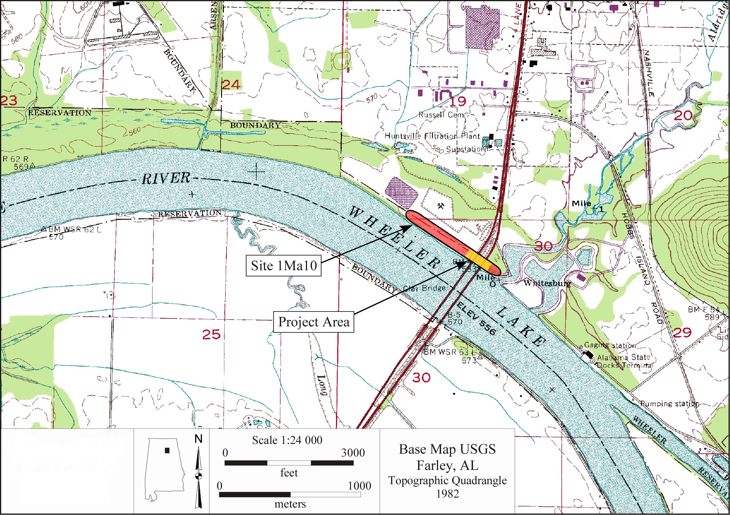
Figure 1.1. The Whitesburg Bridge site and the project area.

Well known for more than 120 years, the site was formally recorded in 1932 by Walter B. Jones and James Hayes of the University of Alabama. In subsequent years, the site has been revisited during numerous archaeological investigations in the Wheeler Basin area. In July 1961, Dan and Phyllis Morse noted that the main part of the site extended 300 ft and was up to 3 ft deep. They also noted that the bridge construction planned for 1962 would impact the site (Alabama State Site File 2025). The site was later examined in 1990 by Charles Hubbert, University of Alabama, during a Wheeler Lake above pool survey conducted for the Tennessee Valley Authority (TVA). At that time a shell lens approximately 60 cm thick could be seen extending to a maximum depth of 1 m (Shaw 2000).
The Whitesburg Bridge site was visited again in 1997 during the TVA’s Shoreline Initiative survey project (Spry and Hollis 1997). At the time of this visit, the site was described as a large site (750 m by 30 m) with shell deposits from the surface to a depth of 150 cm and a zone of fire cracked rock and lithic debris from 150 cm to 300 cm. The lower zone was observed along the lower portions of the eroded riverbank. Artifacts observed consisted of limestone-tempered and grog-tempered ceramics in the upper portion as well as lithic debitage, fire cracked rock, and bone fragments throughout.
Personnel from The University of Alabama, Office of Archaeological Research (OAR) evaluated the Whitesburg Bridge site in June of 1999 during a reconnaissance
level cultural resources survey of the area to be impacted by the proposed U.S. 231 bridge replacement project (Meeks 1999) for the Alabama Department of Transportation. Visual inspection of the Whitesburg Bridge site revealed a large volume of cultural material and shell scattered along the shoreline of the site and extensive, intact midden deposits within (eroding from) the riverbank. Excavation of three riverbank profiles within the Alabama Department of Transportation right-of-way (ca. 240 m wide) revealed multiple strata resulting from both natural and human activities. The upper strata represented approximately 30 cm to 80 cm of recent alluvium and/or road fill (i.e., brick and gravel) capping the underlying cultural bearing deposits. The upper cultural bearing deposits, extending to 150 cm below ground surface (cmbs), consisted of massive shell lenses while the lower cultural bearing deposits (ca. 300-350 cmbs) consisted of lenses of fire cracked rock and lithic debris. Visual inspection of the exposed bank profile additionally revealed that the shell midden deposits extended approximately 190 m along an east-west axis with cultural material becoming less dense away from the site center. We should note here that the eastern site boundary was given as “about 100 feet west of the Whitesburg Bridge” by Webb and DeJarnette (1948c:12). More recent investigations, however, indicated that the eastern site boundary lies some 120 m east of the bridge.
In November and December of 1999, OAR conducted limited Phase II archaeological investigations at the Whitesburg Bridge site (Meeks 2000a) and more extensive Phase II investigations followed in May and June 2001 (Meeks 2002) (Figure 1.2). The impetus for this testing program was to gather information regarding the general stratigraphic, area, and contextual characteristics of the site to further inform an anticipated data recovery (Phase III) plan in advance of the planned U.S. Highway 231 bridge construction. The testing program revealed intact midden deposits (non-shell in nature) identified in Stratum IIIb.
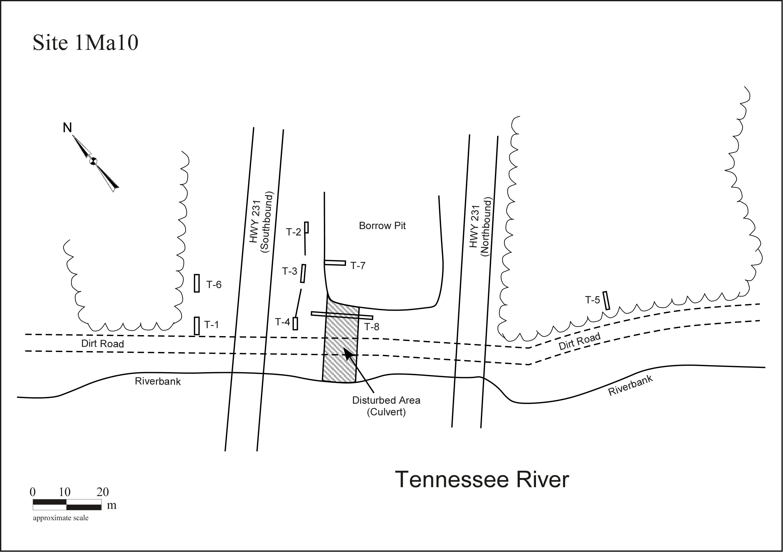
Figure 1.2. Location of Phase II test trenches (from Meeks 2002).

Although the Whitesburg Bridge site had been impacted by a variety of construction activities over the past century, these activities had one positive effect on the site; the precontact occupations had been capped by several feet of fill and remained
intact in many areas of the site. Buried beneath these layers of recent fill, the midden not only possessed a dense amount of cultural material including chipped stone tools, debitage, fire cracked rock, and bone, but at least one precontact feature, a hearth, was noted in the Phase II testing in Trench T-6 at the base of the midden deposit. Based on calibrated ages (2 sigma) of 1513-1382 cal BC and 1519 to 1367 cal BC (Beta 137099) and 3160±50 B.P. (Beta 137098) obtained from Stratum IIIb, the midden deposit was tentatively associated with Late Archaic/Gulf Formational occupations (Meeks 2002). These intact deposits became the focus of the subsequent Phase III investigations of the site (Figure 1.3).

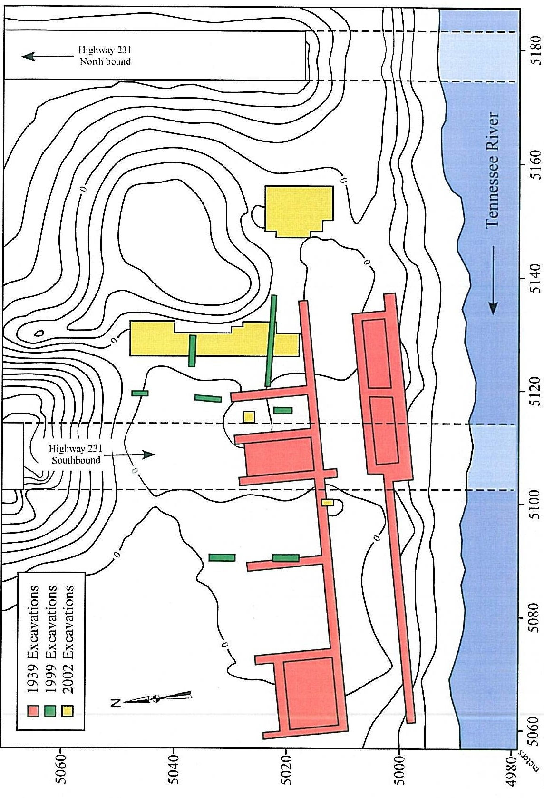
Figure 1.3. Archaeological excavations at Site 1Ma10.
As discussed in Stein (1992), understanding the formation and age of archaeological and geological deposits is essential in investigating archaeological sites. This is particularly true in a floodplain context because deposits that form through geological processes can potentially affect the development of archaeological deposits. Geoarchaeological and geomorphological research in the Middle Tennessee River Valley has documented a history of river meandering and alluviation in the region (Cobb 1987; Cobb et al. 1995; Collins and Goldberg 2000; Collins et al. 1994, 1995; Davis et al. 2024). Although these studies have been directed toward forming an under-standing of the effects of both river degradation and deflation of prehistoric archaeological sites dating to the late Pleistocene in the region, these studies have provided information concerning river hydrology and depositional episodes of the Tennessee River over the last 14,000 years. The formation of archaeological and geological deposits at the Whitesburg Bridge site will provide additional information for such studies; specifically, the development of floodplain deposits in the Wheeler Basin during the Middle and Late Holocene.
The reconstruction of the physical characteristics of the site depends, in large part, on sedimentological studies. Selected profiles were recorded and sampled for geomorphological analysis. Soil samples were analyzed using standard techniques to separate constituent particles by size and characterize particle conformation as to the geological processes that produced them. The stratigraphy of the deposits was relatively clear with five primary strata (Figure 1.4). However, more indepth analysis was necessary to parse out the nature of the deposits. Micromorphology was investigated through petrographic analysis to determine the nature of deposits and investigate the anthropogenic influences of the site’s formation processes. This type of analysis added to other sedimentological techniques by providing directionally oriented sectional views of the stratigraphy, particularly microstratigraphy, and sediment fabric, allowing precise interpretation of depositional episodes, post-depositional changes, and microscopic inclusions.
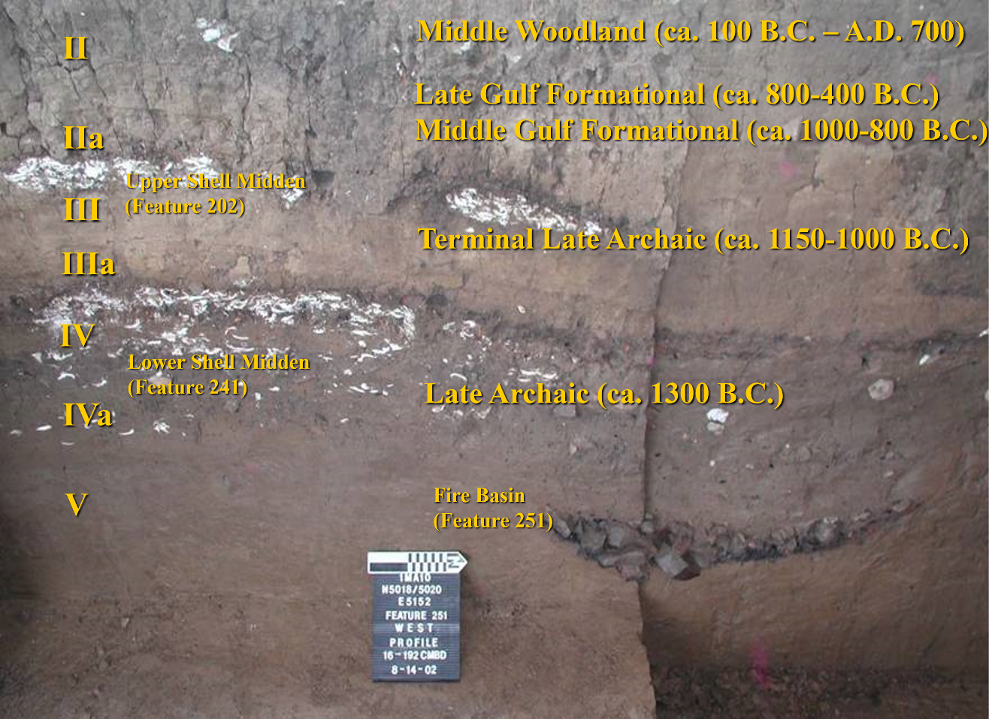
Figure 1.4. Stratigraphy of Block 1 excavations.

The Flint River Site (1Ma48)
Upstream 9.2 km (5.7 miles) lies the Flint River site (1Ma48) at the mouth of the Flint River at its confluence with the Tennessee River. The site was originally recorded in 1933 during the river basin survey (Webb 1939; Webb and DeJarnette 1948a). Like the Whitesburg Bridge site, the Flint River site was subjected to extensive excavations in
1939, in some instances by the same crews that were working on the Whitesburg Bridge site (Webb and deJarnette 1948c). It lies on the same right bank of the river as Whitesburg and includes stratified shell and non-shell midden dating to the Late Archaic through Late Woodland. Numerous soapstone and sandstone vessels were found at the site, but as will be discussed later, there are differences between the sites.

Modeling Late Archaic Population Maintenance
Given the presence of well-stratified and well-preserved archaeological deposits, the Whitesburg Bridge site provides a unique opportunity to contribute to regional research questions concerning past precontact life-ways in the Middle Tennessee River Valley. Specific research concerns of the original mitigation included typological and chronological characteristics, problems relating to cultural patterns and processes such as settlement and subsistence practices and inter-regional interaction, as well as taphonomic
questions concerning the development of geological and archaeological deposits in a floodplain context. The question of how Late Archaic hunter-gatherer communities maintained cultural autonomy while forging long-distance relationships has been largely unanswered. The expressions of territoriality are evident in the use, reuse, and repurposing of archaeological sites while maintaining traditional aspects of technology over relatively long periods of time. Here I present a model of the overall pattern of Late Archaic occupation and population maintenance. I focus on addressing three main questions:
- What is the distribution of particular diagnostic lithic artifacts within the Middle Tennessee River Valley and how do they indicate interrelatedness of the Late Archaic populations of the area?
- If the hunter-gatherer subsistence strategies were consistent with ethnographically documented populations in similar sub-tropical riverine environments, then is it possible to estimate population density based on regional site file data and artifact distributions for a particular time and space?
- What are the artifactual expressions of the cultural factors employed to maintain viable populations and cultural traditions and how did they change throughout the Late Archaic.
The relative abundance of lithic materials present at the Whitesburg Bridge site provided for interpretation of the technological organization of hunter-gatherers in the region. Compared with site file data and other excavation reports, it also provided for this interpretation of the interrelatedness of disparate populations across a broader area. The data presented herein is derived from the analysis of the function of chipped stone tools, patterns of lithic reduction and manufacturing, strategies of tool maintenance and discard, raw material use and procurement patterns, and most importantly for the purpose of this dissertation, inter and intra-site distributions. Documenting such patterning is paramount in understanding the overall organization of lithic technology at the site, local, and regional levels as well as investigating changes in the organization of lithic technology through time. I use the data as an indication of relationships and employ it to develop a distribution of Late Archaic occupation.
The majority of the large-scale excavations in the Wheeler Basin area were conducted during the massive WPA-era salvage excavations in the 1930s (Webb 1939, Webb and DeJarnette 1942, 1948a, 1948b, 1948c, 1948d; Webb and Wilder 1951), prior to the development of methods to recover small floral and faunal remains (Watson 1974, 1990; Yarnell 1974). In the past, shell was often considered only as detritus and disregarded. But shell is far more important than that to settlement organization. Although extensive archaeological survey and excavations have been conducted in the Wheeler Basin and adjacent areas, studies concerning precontact settlement systems in the Middle Tennessee River Valley area are lacking. Researchers have highlighted the need to elaborate on Late Archaic occupations and patterns of exchange (Goad 1980; Mitch 2023). This study is an effort to answer some of these questions: how were populations distributed across the region, how did they interact, and what are the archaeological expressions that indicate their interrelatedness? Information collected from the most recent Whitesburg Bridge site excavations, combined with old excavations and site file data, provide the relevant information for this interpretation of settlement systems at the local level, plus baseline data necessary to begin examining settlement systems at a regional scale.
Our understanding of relationships within and between populations within the Middle Tennessee River Valley at the end of the Archaic (ca. 5800–3000 cal yr B.P.) is currently relatively limited (see Bailey 2022 for adjacent areas). The two horizons primarily considered in this portion of the study are referred to as the Ledbetter and Wade phases (Futato 1983; Walthall 1980). The Whitesburg Bridge site has occupation strata attributable to both phases. The Flint River site, on the other hand, is only known to have the Ledbetter component. The major difference in artifact assemblages and features between the two sites is associated with this Wade occupation. At the Whitesburg Bridge site, the stratum attributable to the later Wade component is isolated from the overlying ceramic-bearing Middle Gulf Formational, Bluff Creek phase and the earlier Ledbetter component. Considering that the Ledbetter phase is considered to span the first two thousand years of the Late Archaic period (4000 to 2000 BC) while the Wade phase is assigned to the next 1000 years (2000 to 1000 BC), all other things being equal, the later phase should have roughly half of the number of sites as the preceding Ledbetter phase. Instead, the number is only roughly one third. In addition, while both sites exhibit extensive shell deposits, only the Whitesburg Bridge site includes the presence of a clay mound. By examining the available data and hunter-gatherer information from similar environments (Wobst 1976) we can speculate about the population of the surrounding area during both phases.
The monumental architectural styles, both shell and earth, found in the area around the Whitesburg Bridge site are discussed in terms of their relationship to cultural interactions and their overall development in the Southeast. This poses the question of what was happening at the end of the Archaic that caused such drastic changes and the eventual florescence of the traditions that we see in the Woodland with the implementation of intensive horticulture/agriculture and wide-scale earthen mound construction. The investigations at the Whitesburg Bridge site provide a unique opportunity to explore these changes.

Organization of this Study
Although poorly summarized, the Late Archaic occupation of the Middle Tennessee River Valley has been the focus of extensive investigations since the nineteenth century. The characteristics of the Tennessee River’s fluvial environment were undoubtedly a significant influence on those who chose to occupy the region. Chapter Two includes a brief introduction to the physical environment and available resources that provided for the selection of the Whitesburg Bridge site. The site’s position on the river was dependent on access to resources and geological features that provided a relatively unique position to exploit shellfish and contributed to the nature and distribution of the archaeological features found at the site.
Chapter Three provides an overview of the previous research in the subject area. In particular it discusses the Works Projects (Progress) Administration’s (WPA) investigations of both the Whitesburg Bridge and the Flint River sites. These large-scale excavations were part of a broader research/salvage effort that included sites up and down the Tennessee River Valley. The push to create massive hydroelectric projects in the 1930s stemmed from three factors: navigation, flood control, and economic development. The result was a complete transformation of the river system and fluvial environment.
Chapter Four presents the relevant regional chronology and places the Whitesburg Bridge site within a historic time frame. The site’s occupation spanned millennia marked by periods of intensive utilization with variability in function divided by hiatuses likely related to changes in environmental and cultural factors.
Chapter Five defines the methodological approach to the lithic analysis that serves as the basis for the interpretation of inter-site relationships. The distribution of certain projectile point types and raw materials highlight specific relationships and cultural boundaries that influenced and were influenced by the development of the site. These distributions highlight cultural, and likely, territorial boundaries that influenced population demographics of the region. The focus is on the results of the Late Archaic to Woodland lithic assemblage as that period is of primary interest here. It also allows for an interpretation of Late Archaic mobility and regional interactions. The pottery, which overlapped with this period of interest is not discussed, but can be reviewed be reviewed in Hawsey’s (2011) review of the ceramics from the site.
Chapter Six identifies the features and specialized use loci at the site. It incorporates the environmental factors in a discussion of site form and function and intra-site feature distributions. It incorporates the taphonomic factors that influenced the disposition of these features and highlights the elements that influence the interpretation of purpose. The inclusion of the feature information in this study incorporates the overall site function and allows for an exploration of the relationship and context of the stratified deposits, continuity of certain functions, and the drastic changes that are apparent in the site’s occupation through time. Features such as fire hearths and smudge pits, architectural elements, and refuse disposal are relatively straight forward and consistent. But shell midden and later earthen mound construction highlight the changing strategies of the inhabitants and allows for interpretation of their reactions to changing environmental and cultural conditions.
Chapter Seven presents a discussion of monumentality and the relationship of the Whitesburg Bridge site to others in the broader area. It includes an interpretation of population demographics and proposes the means of population maintenance during the Late Archaic by bringing together the results of the lithic analysis and feature interpretation. The occupants of the sites in the region chose these locations for specific reasons that can be, at least partially, understood from both the artifactual remains and site distribution.
Chapter Eight serves to summarize the findings of excavations and analysis, and presents my interpretations.
Chapter Nine places the site within a regional context and the swirling milieu of Late Archaic cultural dynamics in the Southeast. It includes an interpretation of the influencing factors and archaeological expressions of cultural identity in terms of the essential function of population maintenance.
Chapter Ten provides concluding remarks and suggests potential future research for the Middle Tennessee River Valley.
Three appendices are included. Appendix A presents the the results of the lithic analysis which provides the foundation for the regional interaction and chronological and cultural placement of the Whitesburg Bridge site. Appendix B provides the data regarding the features encountered at the site. Finally, Appendix C includes the geomorphological analysis written by Sarah C. Sherwood (2011). She has graciously allowed me to include her report to provide the specific information associated with the formation processes of the site and particularly the information on the geomorphology of Feature 70, an earthen mound found buried beneath flood sediment and later occupations.

Chapter Two
Physical Environment
The Middle Tennessee River Valley is a unique geological region with a diverse set of microenvironments and abundant resources for populations dependent on a gathering and hunting or early agricultural/horticultural subsistence strategy. It is unique in the extent of diversity and in the geological components that make up the river system and adjacent drainages.

Physiography and Geology
Prior to construction of locks and dams, the Tennessee River was a dynamic system that fluctuated greatly in depth and flow. It could be waded at select locations during much of the year when water was low, but much of its course was deep and would have needed to be floated. Gravel bars and shoals existed that provided shallow places to cross during dry periods. During the Pleistocene, the river’s hydrology was that of a braided stream system along much of its course, with diverging channels meandering together and forming individual channels. It became entrenched into its current course during the Middle Archaic, roughly 8,500 cal yr B.P. (Sherwood 2011) with periods of extreme floods occurring 7900 cal yr B.P., 6000-5000 cal yr B.P., and 1000 cal yr B.P. (Davis et al. 2024). The flood of record in the Tennessee Valley occurred in AD 1867 which reached an estimated 679 ft AMSL, or roughly 58 ft above the normal river level, and had a peak discharge of approximately 9,000 to 11,000 cubic meters per second (cms) (Davis et al. 2024; Harden and O’Conner 2017). It was the largest flood ever documented in the valley and completely inundated downtown Chattanooga, Tennessee (NWS 2025). The paleoflood record indicates that the floods that occurred between 6000 and 5000 years ago, during the Middle Holocene, were much larger than the flood of record at 12,743 to 16,282 cms (Davis et al. 2024; Lombardi et al. 2020).
Navigation systems established for US waterways are divided into river miles (RM) which are based on the center of the main channel of a waterway. Major tributaries often have their own river miles and the Tennessee River, which feeds into the Ohio and eventually the Mississippi River, has its own mileage designation starting with RM 0.0 at the confluence of the Ohio and leading upstream to its formation at the confluence of the French Broad and Holston rivers at RM 652. The bank of the river is determined by the descending side where right (R) and left (L) banks are used rather than cardinal directions as waterways meander. The Whitesburg Bridge site is located within the alluvial valley of the Tennessee River. More specifically, the site is situated on the natural levee on the right bank (north side) between RM 332.9R and 333.6R. The Tennessee River makes a northward bend approximately 1.6 km upstream from Whitesburg Bridge, rounding the southern end of a series of limestone hills including Green Mountain and McKinley Mountain. The course of U.S. Highway 231 through the Whitesburg area follows a centuries-old trail and roadway system that crossed the Tennessee River here at a natural ford (Arrowsmith 1817). The area is marked by a limestone shoal which served as the fording point prior to the construction of a series of locks and dams by the Tennessee Valley Authority. The dams were built to increase the accessibility of the area to water transportation and to reduce the unpredictability of the flood-prone Tennessee River.
Wilson Dam was built by the federal government near Florence and Muscle Shoals, Alabama during World War I. The dam was intended, in part, to provide navigation over the Big and Little Mussel Shoals (Ortmann 1924, cited in Webb 1939). Wilson Lake inundated an area stretching 28 km upstream from the dam, bringing the water level up to approximately 500 ft (152 m) AMSL. Wheeler Dam was constructed 25 km upstream with work beginning in November, 1933. The dam was completed in November of 1936, inundating an area stretching 131 km upstream and raising the water level to above the 550 ft (168 m) contour. Standing more than 21.9 m high and stretching more than 1,933 m across, the dam provides hydroelectric power and maintains barge traffic across the shoals by means of two locks. The reservoir flooded an area of approximately 27,142 hectares (67,070 acres) (TVA 2025). Raising the water level to create Wheeler Reservoir covered the limestone shoals and the ford at Whitesburg year-round.
Site 1Ma10 is located in an area of physiographic diversity (Figure 2.1), the Tennessee Valley district of the Highland Rim physiographic section. It lies at the Valley’s boundary with the Jackson County Mountains district of the Cumberland Plateau section (Sapp and Emplaincourt 1975). The geology of the region is important to
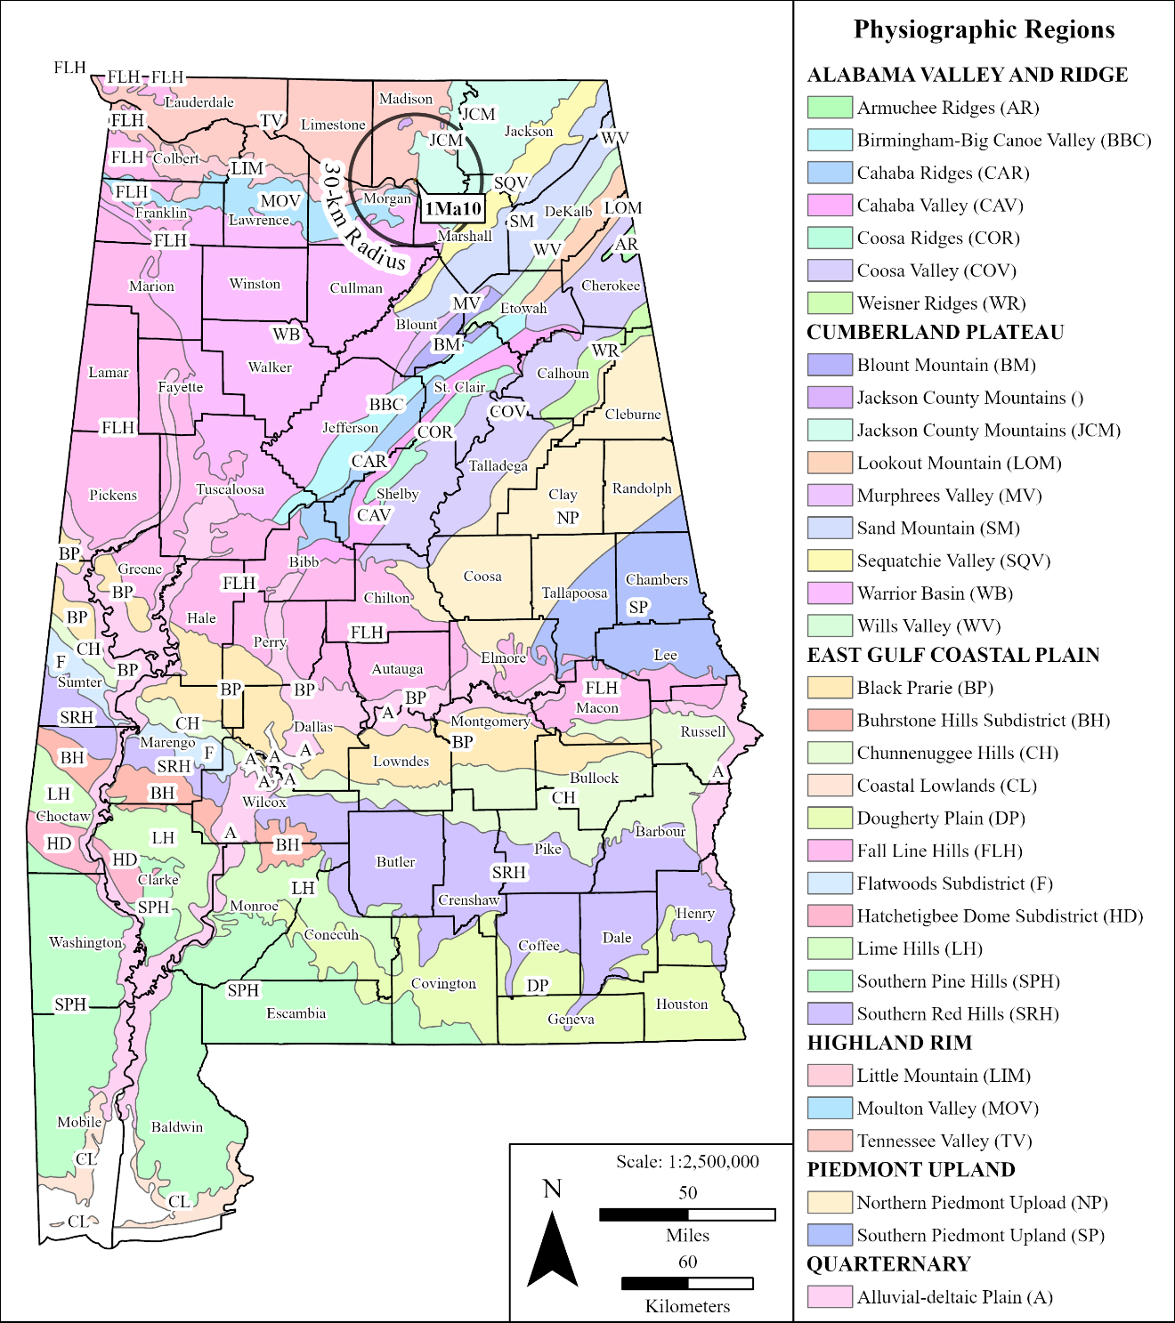
Figure 2.1. Physiographic setting of Site 1Ma10 (reproduced from the Department of Geography, The University of Alabama, Physiographic map based on Sapp and Emplaincourt 1975).

any study of precontact sites where lithic tool manufacture, utilization, and discard was an essential occurrence. The inhabitants knew the locations to access specific lithic sources and likely made frequent forays to these areas or established territorial control over their sources.
The Tennessee Valley, as a whole, is geologically diverse with a number of features that contribute to resource acquisition by the occupants of the region. The Warrior Basin district of the Cumberland Plateau and the Little Mountain district of the Highland Rim lie just across the river. The Moulton Valley district of the Highland Rim is just a few kilometers downstream. All of these areas likely fall within the sphere of local activities of the occupants of the site.
The Tennessee Valley district is described as a plateau with moderate relief ranging in elevation from 600 to 800 ft (183 to 244 m) above mean sea level. A chert belt, the gray lands, composed of the pale gray cherty limestone of the Fort Payne formation, exists in the northern portion of the district. To the south and southeast lies a limestone plain, the red lands (Figure 2.2) comprised of the decomposed limestone, the parent material of the red clays of north Alabama. Areas farther south and east, along the river and major tributaries, consist of general alluvium (Sapp and Emplaincourt 1975; Swenson et al. 1958).
The red lands are underlain by the Tuscumbia limestone formation, a light-brownish-gray to light-gray fossiliferous limestone containing chert lenses and nodules (Copeland et al. 1975). This formation includes the Warsaw and St. Louis limestones. The St. Louis limestone contains almost no chert, while the lower Warsaw limestone is very cherty (Swenson et al. 1958). The bedrock thickness of the Tuscumbia formation averages 46 m with exposures visible near the river in the southern portion of Madison County. The shoals at Whitesburg Bridge are formed by the exposure of the Tuscumbia formation at the base of Huntsville Mountain, to the north, and McCutchen Mountain to the south. Soils derived from its erosion are red to brownish-red clay with angular blocks of chert.
The Tuscumbia limestone is underlain by Fort Payne limestone, a very light gray to light gray fossiliferous limestone, with siliceous and dolomitic limestone and dolomite
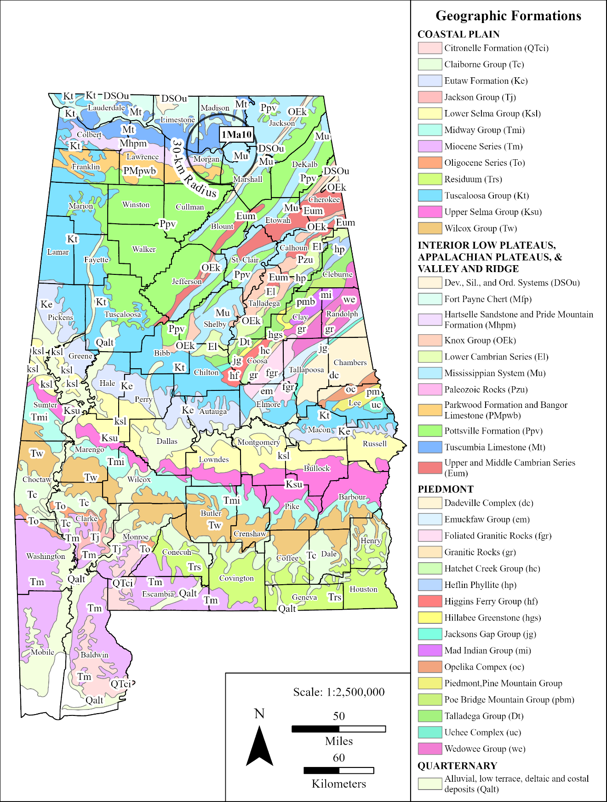
Figure 2.2 Geological map showing distribution of major formations (reproduced from geological units defined by Geological Survey of Alabama [Osborne et al. 1989]).

along with beds of dense, bluish gray, nodular chert (Copeland et al. 1975). Fresh exposures include almost 50 percent chert (Malmberg and Downing 1957:34). Fort Payne chert was originally defined by Eugene Smith in 1890 as including all the rocks between the Chattanooga shale and the Hartselle sandstone (Malmberg and Downing 1957; Mahlburg and Sanford 1963). This was later subdivided into the Tuscumbia limestone, St. Genevieve limestone, and the Gasper formation. The Fort Payne was later limited to pre-Warsaw rocks underlain by the Chattanooga shale. Fort Payne chert outcrops, forming the gray lands, in the northwest part of the county and along Flint River and its tributaries in the central and northern part of the county. The outcrops along Flint River are in steep bluffs up to 18 m high (Malmberg and Downing 1957).
Shale occurs within the area in rocks of Silurian and Ordovician ages, as well as in the Chattanooga shale, Bangor limestone, and the Pottsville formation. Chattanooga shale occurs along Flint River and Limestone, Tyrone, Hester, and Mountain Fork Creeks. It is described as black, fissile shale occurring on broad, flat floodplains or terraces along the banks of creeks (Malmberg and Downing 1957:30). Shales of the Pottsville formation are commercially quarried from Whitesburg Mountain, south of the river in Marshall County.
Soils underlying the site are identified as Huntington silt loam (Avon Burke and O’Neal 1917; Swenson et al. 1958) and more recently as Huntington fine sandy loam and Lindside silty clay loam (USDA NRCS 2025). The soils are well drained, permeable, and are found on bottom lands surrounding larger streams in the southern part of Madison County, Alabama. They are derived from limestone intermixed with sandstone and shale (Swenson et al. 1958:51). The surrounding areas along the Tennessee River include Huntington fine sandy loam and Egam silty clay loam, both derived from similar parent
material. The Egam silty clay loam is considered as general alluvium that occurs on slightly higher elevations than the Huntington series and includes an appreciable amount of mica.

Climate
The climate of Huntsville, Alabama is humid and subtropical with an average annual temperature of around 61° F degrees between 1971 and 2000 and 62.1° F between 1981 and 2010 (National Oceanic and Atmospheric Administration, National Climate Data Center 2018). The average temperature for January between 1971 and 2000 was 39.8° F and the average for July was 79.5° F. The average precipitation for the same period of time shows that March had the highest average of 6.68 inches and August the lowest with 3.32 inches with an annual rainfall of 57.51 inches (National Weather Service [NWS] 2003). For the period of 1981 to 2010 the average January temperature increased to 41.5° F and July to 80.6° F. Rainfall seems to be increasing earlier in the season with December averaging the highest at 5.77 inches and October being the driest with 3.59 inches. Rainfall is usually heavier in the winter and least in the fall with floods most common from December to mid-April. However, summertime downpours are common and are caused by rising air in convection cells. The last frost in the area is usually no later than April 5 and the first frost usually occurs around October 31 (Swenson et al. 1958). Snow occurs almost annually but rarely remains on the ground for more than a few days. Winds, generally from the northwest, are strongest in the winter and weaker in the summer, except in the case of tornadoes. These storms are most common during the spring and summer months. In August of 1974, Madison County experienced six tornadoes in a 24-hour period (NWS Forecast Office 2003). These patterns would likely have been much different during the Pleistocene when temperatures in the region averaged much lower. However, by the time of the Holocene and particularly the initial occupation of the Whitesburg Bridge site during the Holocene Climatic Optimum (ca. 9,000-5,000 cal yr B.P.), modern climate patterns would have begun with fluctuations coming during various global and regional events (Viau et al. 2006).

Flora
The precontact inhabitants of the Whitesburg Bridge site had access to a wide variety of plants for food, medicine, dyes, textiles, construction materials, and many other uses. Futato (1977) lists 97 plants from Harper (1942, 1943, 1944), US Department of the Interior (USDI) (1974), and TVA (n.d.) for which there is documentation of Native American use by Swanton (1946) or Yanovsky (1936). While this list was compiled for the vicinity of Site 1Ja300 upstream in Guntersville Basin, a list for the vicinity of Whitesburg Bridge would not be very different.
The Whitesburg Bridge site now lies within a mesic oak-hickory forest of the southern temperate deciduous forest that dominates much of the mid South. Two natural forest types exist within the Basin: upland hardwood and mixed and bottomland hardwood forests (USDI 1974). Harper (1942), however, described separate forest communities for the gray lands in the higher limestone hills of the Fort Payne Formation to the north, the red lands and bottomlands formed of the Tuscumbia Limestone along the river, and the mountain slopes in the Southeast. The species information below is taken from Harper (1942, 1943) Little et al. (1998), Swenson et al. (1958), and USDI (1974).
The changing environment of the Pleistocene/Holocene transition led to a dramatic shift in the floral and faunal communities across the Eastern Woodlands (Carmody 2014). The changes are clearly shown in pollen assemblages (Viau et al. 2002; Viau et al. 2006; Willard 2025). The Early-Holocene interval (11,650 – 8,900 cal. yr B.P.) witnessed major compositional changes in the local forest communities and mixed mesic forest communities came to dominate the region (Krause et al. 2018; Overpeck et al. 1992:1072). The success of xeric species like oak and pine indicate the forest response to warmer and drier conditions (Carmody 2014; Prentice et al. 1991:2046). This is followed by a further decline in mesic species occurred between 10,000 and 8,400 cal yr BP, at the expense of oak and hickory species (Willard 2025).
Prior to the extensive historic clearing activities, oaks, hickory, poplar, and chestnut were some of the most common deciduous trees. Oaks include black (Quercus velutina), blackjack (Q. maylandica), post (Q. stellata), white (Q. alba), red (Q. schneckii), laurel (Q. laurifolia), Spanish (Q. falcata), chestnut (Q. montana), and willow oak (Q. phellos). The hickory species include shagbark (Carya ovata), pignut (C. glabra), and sand (C. pallida) hickory along with black walnut (Juglans nigra). Other common hardwoods include sweet gum (Liquidambar styraciflua), black gum (Nyssa sylvatica), tupelo gum (N. uniflora), red (Ulmus rubra) and white (U. americana) elms, beech (Fagus grandiflora), red maple (Acer rubrum), silver maple (A. saccharinum), cherry (Prunus serotina), ash (Fraxinus americana), persimmon (Diospyros virginiana), sassafras (Sassafras variifolium), ironwood (Carpinus caroliniana), sourwood (Oxydendrum arboreum), dogwood (Cornus florida), willow (Salix nigra), birch (Betula nigra), sycamore (Platanus occidentalis), redbud (Cercis canadensis), plum (Prunus americana), hackberry (Celtis mississipiensis), buckeye (Aesculus glabra), honey locust (Gleditsia triacanthos), and black locust (Robinia pseudo-acacia).
Some pines are intermixed, especially in the sandy soils of the higher grounds in the region. These are most commonly loblolly (Pinus taeda), but include some shortleaf (P. echinata), slash (P. elliottii), and scrub pine (P. virginiana) as well. In the areas where limestone bedrock lies near or at the ground surface, eastern red cedars (Juniperus virginiana) are abundant.
One tree that is currently abundant at the site is Osage Orange or Bodock (Maclura pomifera). The name Bodock is derived from the French name for the tree, bois d’arc or bow wood, referring to its use for manufacturing bows by Native Americans (Little et al. 1998; Schambach 2000). It was also an important dye source. Historically, the wood was commonly used for fence posts because of its rot-resistance. The abundance of these trees at the site could have historic or precontact implications for environmental modifications. Schambach (2000) presents a related discussion of Osage Orange, its possible limited distribution following the Pleistocene and the extinction of megafauna, and later use by Mississippian peoples of the Arkansas River Valley. He suggests that the last groves of Bodock existed along the Red River and that it became a resource controlled and exploited by a select group of Native Americans who managed the resource and commodified it as part of a broader exchange network. He speculates its range expanded across the Eastern Woodlands only after it became used by historic Euro-American farmers.
There is less information available on shrubs, vines, and herbaceous plants. Partial lists are provided by Harper (1942, 1944) and the USDI (1974). However, we know from botanical analyses (Lustek 2011; Roberts 2011; Roberts and Gage 2003) that many species of fruit bearing shrubs and vines were exploited by the site’s inhabitants. By the Late Archaic, the climatic record of the region indicates an increase in prescribed burning and forest management (Delcourt and Delcourt 1997; Gage 2011).
The origins of agriculture in the region have been well summarized by Hollenbach and Carmody (2019, 2022; Carmody 2014; see also Miller 2018). They point out the nine plants that formed the Eastern Agricultural Complex include pepo gourds (Cucurbita pepo subsp. ovifera), sunflower (Helianthus annuus var. macrocarpus), sumpweed (Iva annua var. macrocarpa), goosefoot (Chenopodium berlandieri subsp. jonesianum), erect knotweed (Polygonum erectum subsp. watsoniae), maygrass (Phalaris caroliniana), little barley (Hordeum pusillum), giant ragweed (Ambrosia trifida), and amaranth (Amaranthus spp.). They were first cultivated in Eastern North America, particularly the area encompassed by the Ozarks on the west, the Tennessee Valley on the south, the Appalachians on the east, and the Great Lakes to the north (Hollenbach and Carmody 2019:).
The trend intensified through time and the ethnographic records indicate that by the Late Mississippian, not only were communities across the Southeast practicing extensive crop agriculture but were also maintaining expansive woodlands and orchards. In 1540, Garcilaso de la Vega, el Inca described the pueblo of Talomeco in the province of Cofitacheiqui, likely in what is now eastern South Carolina, along the Wateree River near Camden, as being surrounded by a “long league” that “had the appearance of a garden, where there were many trees, fruit-bearing and others; and one could pass between them on horseback without any inconvenience because they were separated from one another as if they had been set out by hand” (Clayton et al. 1993:297). This tradition likely had its origins in the intensification of crop production and forest management that had been practiced for millennia by the inhabitants of the region.
During the Late Archaic, the inhabitants of the Whitesburg Bridge site extensively exploited hickory nuts. Hickory nuts made up the vast majority of botanical remains recovered from Late Archaic contexts indicating the importance of the resource to the inhabitants (Figure 2.3). Hickory was followed in frequency of appearance in the archaeological record by acorn and then walnut (Roberts 2011). It must be noted that the abundance of hickory as opposed to acorn may be a reflection of the durability of hickory nutshell compared to acorn. Persimmon, honey locust pods, and grape were also consumed and maygrass, pokeweed, and chenopod were the most commonly found

Figure 2.3. Hickory nuts dominated the floral assemblage at the Whitesburg Bridge site (Roberts 2011). assemblage.

starchy seeds from the site (Roberts 2011). The implication is that the Late Archaic inhabitants of the Whitesburg Bridge site were not only exploiting the adjacent shoal for riverine resources, but also the more exposed margins of the river and clearings where starchy seeds most frequently grew (Roberts 2011). In addition, to hickory, other nutshells and seeds were found in samples taken from several Late Archaic features (Table 2.1). They include acorn and black walnut as well as seeds of persimmon, grape, chenopod, pokeweed, honey locust, purslane, and maygrass.
Hollenbach and Carmody (2019) state that these starchy seeds, such as maygrass, were some of the first cultigens in the region. Maygrass’s natural range does not extend to the area of the Whitesburg Bridge site, growing primarily along the coast and the Lower Mississippi Valley (Crites and Terry 1984). It is likely that its presence in the archaeological record is a result of intentional cultivation by the Late Archaic inhabitants.
In comparison, the Gulf Formational to transitional Woodland features revealed lesser amounts, but in similar proportions to the Late Archaic (Table 2.2).
The botanical samples from Late Archaic occupations contained all of the taxa discussed in the section above, suggesting use of the site during the fall, winter, spring, and possibly summer. Honey locust seeds are available summer through fall while purslane and pokeweed are available spring through fall. These species are found only

Table 2.1. Plant remains from Late Archaic features at the Whitesburg Bridge site (Roberts 2011).
 |  | FEATURE 41 |  | FEATURE 251 |  | FEATURE 362 |  | TOTAL
 |  | Count | Wt (g) | Count | Wt (g) | Count | Wt (g) | Count | Wt (g)
WOOD AND STEM
Wood |  | N.A. | 22.53 | N.A. | 3.50 | N.A. | 11.28 | N.A. | 37.31
Cane Stem |  | 3 | 0.02 | - | - | - | - | 3 | 0.02
Other Stem |  | 6 | 0.08 | - | - | - | - | 6 | 0.08
NUT
Thick Hickory Nutshell |  | 1,377 | 20.90 | 85 | 2.12 | 324 | 6.46 | 1,786 | 29.48
Thin Hickory Nutshell |  | 312 | 5.01 | 5 | 0.08 | 106 | 1.48 | 423 | 6.57
Juglandaceae Nutshell |  | 2,495 | 15.85 | 90 | 0.56 | 729 | 2.22 | 3,314 | 18.63
Acorn Nutshell |  | 6,952 | 17.20 | 25 | 0.05 | 1,649 | 3.23 | 8,626 | 20.48
Black Walnut Nutshell |  | 2 | 0.03 | - | - | 45 | 0.88 | 47 | 0.91
Other Nutshell |  | 2 | 0.06 | - | - | - | - | 2 | 0.06
Nutmeat (not acorn) |  | 8 | 0.03 | - | - | - | - | 8 | 0.03
SEED
Persimmon |  | 18(9) | 0.16 | 1(1) | 0.04 | 1(1) | 0.01 | 20(11) | 0.21
Grape |  | 3(2) | N.A. | - | - | 1(1) | N.A. | 4(3) | N.A.
Maygrass |  | 210 | N.A. | - | - | 4 | N.A. | 214 | N.A.
Chenopod |  | 116 | N.A. | - | - | - | - | 116 | N.A.
Pokeweed |  | 1 | N.A. | - | - | - | - | 1 | N.A.
Honey Locust |  | 1 | 0.04 | 6 | 0.04 | - | - | 7 | 0.08
Purslane |  | 6 | N.A. | - | - | - | - | 6 | N.A.
Unidentified |  | 34 | N.A. | - | - | 1 | N.A. | 35 | N.A.
OTHER
Unidentified Fleshy Fruit |  | 1 | 0.02 | - | - | - | - | 1 | 0.02
Gall |  | 1 | 0.01 | - | - | 5 | 0.04 | 6 | 0.05
Unidentified |  | 118 | 0.86 | 15 | 0.07 | 46 | 0.31 | 179 | 1.24
TOTAL WEIGHT |  |  | 82.80 |  | 6.46 |  | 25.91 |  | 115.17

Table 2.2. Plant remains from Gulf Formational- Woodland features at the Whitesburg bridge site (Roberts 2011).
 |  | FEATURE 65 |  | FEATURE 68 |  | FEATURE 131 |  | FEATURE 140 |  | FEATURE 333 |  | FEATURE 376 |  | FEATURE 396 |  | TOTAL
 |  | Count | Wt (g) | Count | Wt (g) | Count | Wt (g) | Count | Wt (g) | Count | Wt (g) | Count | Wt (g) | Count | Wt (g) | Count | Wt (g)
WOOD AND STEM
Wood |  | N.A. | 0.11 | N.A. | 1.03 | N.A. | 0.02 | N.A. | 0.01 | N.A. | 0.30 | N.A. | 0.05 | N.A. | 1.43 | N.A. | 2.95
Cane Stem |  | - | - | - | - | - | - | 1 | 0.01 | - | - | - | - | 2 | 0.01 | 3 | 0.02
NUT
Thick Hickory Nutshell |  | 4 | 0.10 | 50 | 0.89 | - | - | 11 | 0.22 | 34 | 1.05 | - | - | 257 | 5.53 | 356 | 7.79
Thin Hickory Nutshell |  | - | - | 5 | 0.06 | - | - | - | - | 6 | 0.11 | - | - | 33 | 0.75 | 44 | 0.92
Juglandaceae Nutshell |  | 13 | 0.14 | 183 | 1.20 | 1 | 0.01 | 23 | 0.17 | 96 | 0.81 | - | - | 560 | 4.40 | 876 | 6.73
Acorn Nutshell |  | 2 | 0.01 | 3 | 0.17 | - | - | 3 | 0.01 | 10 | 0.05 | - | - | 23 | 0.13 | 41 | 0.37
Black Walnut Nutshell |  | 3 | 0.15 | 0 | 0 | - | - | - | - | - | - | - | - | 8 | 0.21 | 11 | 0.36
Other Nutshell |  | - | - | 4 | 0.01 | - | - | - | - | - | - | - | - | 7 | 0.21 | 11 | 0.22
Nutmeat (not acorn) |  | - | - | - | - | - | - | - | - | 2 | 0.12 | - | - | - | - | 2 | 0.12
SEED
Persimmon |  | - | - | 1(1) | 0.01 | - | - | - | - | 1(1) | 0.01 | - | - | 1(1) | 0.01 | 3(3) | 0.03
Grape |  | - | - | - | - | - | - | 1(1) | N.A. | 1(1) | N.A. | - | - | - | - | 2(2) | N.A.
Maygrass |  | - | - | 25 | N.A. | - | - | - | - | 3 | N.A. | - | - | 20 | N.A. | 48 | N.A.
Chenopod |  | - | - | 1 | N.A. | - | - | - | - | 2 | N.A. | - | - | - | - | 3 | N.A.
Fabaceae |  | - | - | 1 | N.A. | - | - | - | - | - | - | - | - | - | - | 1 | N.A.
Chenopodiaceae |  | - | - | - | - | - | - | - | - | 1 | N.A. | - | - | - | - | 1 | N.A.
Unidentified |  | - | - | 3 | N.A. | - | - | 1 | N.A. | 4 | N.A. | - | - | 20 | N.A. | 28 | N.A.
OTHER
Unidentified |  | 2 | 0.03 | 2 | 0.09 | - | - | - | - | - | - | - | - | - | - | 4 | 0.12
TOTAL WEIGHT |  |  | 0.54 |  | 3.46 |  | 0.03 |  | 0.42 |  | 2.45 |  | 0.05 |  | 12.68 |  | 19.63

during the Late Archaic occupation of the Whitesburg Bridge site and may simply reflect the comparatively large sample size of this time period. These three taxa are minimally
represented, which may be an indication of the use of parts other than the seed. The samples from the Gulf Formational-Woodland occupations yielded all types of nut taxa along with both maygrass and chenopod. This may reflect use of the site during all seasons, except possibly summer.
The suggestions of seasonal use of the Whitesburg Bridge site developed by Roberts (2011; see also Roberts and Gage 2003)) is tenuous as the seasonal availability of these taxa spans more than one season, both in the wild and under cultivation. In addition, storage of any of these items negates any indication of when these taxa were consumed and/or discarded (Roberts 2011).

Fauna
The faunal assemblage from the Whitesburg Bridge site provides evidence of a diverse diet for its inhabitants (Tables 2.3-2.7). The most obvious fauna encountered at the site were the Bivalvia that make up the shell bearing deposits at the Whitesburg Bridge site. Their distribution is extensive during the Late Archaic Period occupation, diminishes to almost nothing during the Late Gulf Formational period, and again increases during the Middle Woodland period indicating a possible change in availability or subsistence strategies (Curren 1973, 1974; Curren et al. 1977; Walker 2011). Based on recent evidence for this portion of the Tennessee River Valley (Davis et al. 2024), the flooding during the end of the Late Archaic period led to the Tennessee River and other river basins in the region being less hospitable to shellfish (Bense 1987).
From mammals to mollusks, the fauna of this region provided more than food. Bones, shells, and teeth served as raw materials for tools, ornaments, and other implements. Fur and feathers, though seldom preserved in the archaeological record, were used in clothing, costumes, and ritual paraphernalia.
Numerous mammal species exist within Wheeler Basin. Among those listed by Brown (1997), Burt (1976), and Harper (1942) are: opossum (Didelphis marsupialis), mole (Scalopus aquaticus), shrews (Sorex sp.), bats (Vespertilionidae), raccoon (Procyon lotor), weasel, skunks, and mink (Mustelidae), otter (Lutra canadensis), mice, rats, and
Table 2.3. Fish remains from the Whitesburg Bridge site (Walker 2011).
TAXON | COUNT | WEIGHT (g)
Aplodinotus grunniens | 62 | 65.7
Catostomidae | 1 | 0.1
Centrarchidae | 1 | 0.1
Ictaluridae | 3 | 1.3
Indeterminate Fish | 41 | 6.5
TOTAL | 108 | 73.7

Table 2.4. Amphibian remains from the Whitesburg Bridge site (Walker 2011).
TAXON | COUNT | WEIGHT (g)
Anura | 1 | 0.1
Indeterminate amphibian | 2 | 0.2
Subtotal Amphibian | 3 | 0.3
Apalone spp. | 17 | 21.0
Colubridae | 15 | 1.8
Crotalidae | 10 | 1.5
Emydidae | 58 | 34.8
Serpentes | 19 | 2.3
Terrapene carolina | 13 | 6.6
Testudines | 67 | 20.6
Subtotal Reptile | 199 | 88.6
TOTAL | 202 | 88.9

Table 2.5. Bird remains from the Whitesburg Bridge site (Walker 2011).
TAXON | COUNT | WEIGHT (g)
Indeterminate Bird | 88 | 28.1
Large Bird | 25 | 14.3
Meleagris gallopavo | 8 | 18.7
Medium Bird | 18 | 8.4
Medium/Large Bird | 14 | 4.3
Small Bird | 3 | 1.4
Small/Medium Bird | 38 | 9.9
TOTAL | 194 | 85.1

Table 2.6 Mammal remains from the Whitesburg Bridge site (Walker 2011).
TAXON | COUNT | WEIGHT (g)
Artiodactyla | 23 | 20.3
Bos taurus | 8 | 272.7
Cervus elaphus | 3 | 19.7
Canis familiaris | 1 | 168.0
Canidae | 2 | 0.8
Canis sp. | 2 | 1.3
Castor canadensis | 1 | 1.9
Cervidae | 44 | 40.5
Didelphis marsupialis | 3 | 5.6
Indeterminate Mammal | 869 | 233.5
Large Mammal | 1,039 | 1,939.5
Marmota monax | 2 | 0.5
Medium Mammal | 16 | 7.2
Medium/Large Mammal | 964 | 614.4
Odocoileus virginianus | 704 | 2,875.0
Procyon lotor | 22 | 15.3
Scalopus aquaticus | 2 | 0.2
Sciurius carolinensis | 13 | 2.0
Sylvilagus floridanus | 7 | 1.3
Sus scrofa | 37 | 331.6
Small Mammal | 19 | 2.5
Small/Medium Mammal | 31 | 5.6
Ursus americanus | 1 | 2.2
Urocyon cinereoargenteus | 2 | 0.7
TOTAL | 3,815 | 6,562.3

Table 2.7. Invertebrate remains from the Whitesburg Bridge site (Walker 2011).
TAXON | COUNT | WEIGHT (g)
Gastropoda | 6 | 1.4
Other Mollusca | 1 | 2.3
Pelecypoda | 1 | 0.5
Indeterminate Invertebrate | 13,333 | 4501.6
TOTAL | 8 | 4505.8

voles (Cricetidae), muskrat (Ondatra zibethica), groundhog (Marmota monax), chipmunk (Tamias striatus), squirrel (Sciurius sp.), beaver (Castor canadensis), rabbits (Sylvilagus sp.), white-tailed deer (Odocoileus virginianus), gray fox (Urocyon cinereoargentus), red fox (Vulpes vulpes fulva), panther (Felis sp.), bobcat (Lynx rufus), bear (Ursus americanus), and wolf (Canis sp.). Dogs (Canis sp.) were also common in populated areas and are frequently found in varying context in the archaeological record (Walker et al. 2005).
Mammals that were present prior to European contact, but which have disappeared from this area due to over-hunting, clear cutting, or other reasons, include red wolf (Canis rufus), elk (Cervus canadensis), American bison (Bison bison) (Brown 1997:214–215), and porcupine (Erethizon dorsatum) (Parmalee 1963, 1973).
Aside from mollusks, white-tailed deer comprised the most frequently found animal species at the site. This frequency was relatively consistent within all strata, except for a marked increase within Stratum IV, the Late Archaic component. Stratum IV contained 46 percent of the white-tailed deer remains from the 2002 excavations. Walker (2011:258-259) stated: “Thirty of the white-tailed deer remains had cut marks and many of the remains were from the skull, lower legs and axial skeleton, which often represents on-site butchery or transport of the entire skeleton back to the habitation site.” In addition, dogs were represented in the assemblage but seem to be mostly constrained to the later Gulf Formational to Woodland components.
Other identified species were far less common and generally represent the utilization of riverine habitats (fish and pond turtles) and woodland or woodland edge environments (deer, elk, turkey, woodchuck, fox, rabbit and squirrel) (Figure 2.4) (Walker 2011). The abundance of white-tailed deer may again be a result of robustness of the remains as opposed to the more fragile remains of birds, smaller mammals, and fish. The acidic soils of the mesic forest community that likely dominated much of the surrounding river valley would have caused rapid deterioration of the remains under normal conditions. However, the shell midden deposits at the site affect the soil acidity and serve to help preserve faunal remains. In addition, much of the bone encountered was

Figure 2.4. Faunal remains from the Whitesburg Bridge site (Walker 2011).

calcined, which also serves to prevent bone from deteriorating as rapidly. Walker (2011:259) summarizes the assemblage thus:
The faunal remains from the Whitesburg Bridge site represent an interesting, multi-occupational assemblage. While the majority of the remains (75 percent) were unfortunately unidentifiable, the remainder allowed a sense of what animals people were collecting. They utilized both aquatic and terrestrial resources, which were habitats readily available adjacent to the site. They prepared their food by butchering then roasting sections of the meat, this resulted in a percentage of the bone remains being burned and calcined. Domestic dogs were clearly present at the site, as is indicated by the presence of one complete dog skull and a small quantity of carnivore gnawed faunal remains. In sum, the faunal remains from this site represent typical remains associated with habitation sites.

Chapter Three
Relevant Regional Chronology
The study region referred to here as the Middle Tennessee River Valley, includes those portions of the river that extend across north Alabama, northeast Mississippi, and southeast Tennessee and now form Nickajack, Guntersville, Wheeler, Wilson, and Pickwick Reservoirs. The Whitesburg Bridge site is a large multicomponent site in the upper portion of the Wheeler Basin with significant occupations attributable to the end of the Late Archaic, the Early and Middle Gulf Formational, and Middle Woodland, as well as nineteenth century Euroamerican agricultural and commercial activities. Mississippian and Late Woodland use of the site is apparent but is limited to the disturbed plow zone deposits.
First a disclaimer is appropriate to place the current effort at interpretations in context, both historically and regionally. Cultural chronology is often cited as a tool of limited benefit. As Anderson (2010), among others (Russo 2010; Sassaman 2010a; 2010b), notes: for certain things the stages, periods, horizons, cultures, and phases defined by archaeologists for their need to explain archaeological remains have little or no purpose. For others, they are essential. In this work I embrace the terminology of these admittedly arbitrarily defined and oft confining terms to address differences in cultures through time and distance. Their use is intended to provide specific reference to artifact types and traditions in technology in keeping with what Willey and Phillips (1958) saw as the primary criteria for recognizing stages for pre-agricultural populations. The changing technology was diagnostic of changing subsistence traditions and reflections of social, political, religious, and aesthetic change (Jenkins and Krause 1986: 21; Willey and Phillips 1958). The employment of stages, periods, horizons, cultures, and phases is intended as a simplified means to discuss cultural relationships as reflected in technological trajectories of the specific space and time of the occupation of the Whitesburg Bridge and adjacent sites. These units provide the means for a discussion of interrelatedness, population demographics, and the means by which relatively low density populations are able to maintain their numbers and viability.
Besides actual dates, phases are typically defined based on the presence of certain artifacts within a certain spatial area at a select time. They are intended only to provide analytical units of comparison. For this study, I use the characteristic projectile point (hafted thinned biface) morphology and the lithic raw material distribution as diagnostic markers of the site’s occupations. They inform the separation and grouping of what is inferred as cultural units and allow for a diachronic comparison of earlier and later groups who used the site in ways that imply both purposeful reuse, i.e. Sassaman’s (2010; Randall and Sassaman 2017) “historicity”, and cultural transformation.
Evidence indicates that the initial occupation of the site began during the Middle Archaic and is limited to deeply buried deposits with few artifacts and no evidence of features. The implication is that the site was ephemerally occupied at the time when the river system was newly entrenched in its current channel and the landform had stabilized (Meeks 2000a; Sherwood 2011). The next chapter considers those portions of regional cultural/temporal chronology which relate to the results of the excavations and provide a context for the site’s occupation. Table 3.1 presents the radiocarbon dates obtained from both bulk samples and feature context and highlights the longevity of the site’s use.

Archaic Stage (11,500–3000 cal yr B.P.)
The Archaic Stage is defined by a shift in material culture, undoubtedly associated with changes in the ecological setting of the region. With the end of the Pleistocene, the last of the North American megafauna reached extinction. The forest environment north of 33 degrees latitude shifted to mixed hardwoods of the mesic forest and what Williams et al. (2004: 312-313) identify as the temperated deciduous forest and the warm mixed forest. The northward expasion of many species is not clearly expressed in the biome maps, but vegetation throughout the late Holocene is dynamic and plant populations change drammatically by gradually shifting distributions from south to north as regional climates change (Jacobson et al. 1987; Willard 2025; Williams et al. 2004:321-322).
The Archaic stage has been divided into three periods: Early (11,500–8900 cal yr B.P.), Middle (8900–5800 cal yr B.P.), and Late (5800–3200 cal yr B.P.). The chronological organization of data from Archaic complexes is the result of excavations of
Table 3.1. Radiocarbon dates from Site 1Ma10.
SAMPLE # | SAMPLE DESCRIPTION | CONVENTIONAL RADIOCARBON DATE | 13C/12C RATIO | 2 SIGMA  CALIBRATION (95.4%)
BETA-177488 | Feature 376. Wood charcoal from hearth in N5020E5156, Stratum II, Level 1 (19-29 cmbd). | 170 +/- 40 BP | -24.6 o/oo | 1657-1905 cal AD
BETA-137000 | Organic sediment at ca. 30-50 cmbs (Meeks 2002) | 930 +/- 80 BP |  | 989-1269 cal AD
BETA-177487 | Feature 371. Wood charcoal from pit in N5022E5156,  Stratum III, Level 1 (58-68 cmbd). | 2430 +/- 70 BP | -25.9 o/oo | 763-400 cal BC
BETA-177985 | Feature 265. Carbonized grass/cane in N5040E5130,  Stratum IV, Level 1 (127-137 cmbd). | 3010 +/- 60 BP | -25.0* o/oo | 1413-1055 cal BC
BETA-177474 | Feature 92. Wood charcoal from hearth in N5028E5116, Stratum IV, Level 1 (110-120 cmbd). | 3040 +/- 50 BP | -26.5 o/oo | 1420-1127 cal BC
BETA-177491 | Feature 251. Charred hickory nutshell from basin hearth in N5018E5150, Stratum IVa, Level 1 (114-124 cmbd). | 3050 +/- 60 BP | -25.0* o/oo | 1436-1124 cal BC
BETA-177492 | Feature 410. Wood charcoal from bottom of fire pit in N5014E5154, Stratum IV, Level 1 (95-105 cmbd). | 3050 +/- 60 BP | -25.0* o/oo | 1436-1124 cal BC
BETA-177484 | Non-feature wood charcoal from N5034E5128,  Stratum IVz, Level 3 (105-115 cmbd). | 3070 +/- 40 BP | -24.9 o/oo | 1423-1223 cal BC
BETA-177987 | Feature 315. Wood charcoal from charcoal lens in N5018E5156, Stratum IVx, Level 1 (110-119 cmbd). | 3070 +/- 120 BP | -25.0* o/oo | 1611-994 cal BC
BETA-177986 | Feature 362. Wood charcoal from shell midden in N5014E5100.5, Stratum III, Level 3 (77-87 cmbd). | 3080 +/- 140 BP | -25.0* o/oo | 1626-930 cal BC
BETA-177485 | Feature 364. Wood charcoal from fire pit in N5018E5156, Stratum IIIy, Level 1 (93-103 cmbd). | 3120 +/- 50 BP | -25.3 o/oo | 1499-1266 cal BC
BETA-169605 | Feature 70. Wood charcoal from prepared clay surface in N5020E5128, Stratum III, Level 5 (Stratum IVz)  (87-97 cmbd). | 3120 +/- 40 BP | -25.7 o/oo | 1496-1275 cal BC
BETA-137001 | Organic sediment at ca. 110-130 cmbs (Meeks 2002) | 3130 +/- 80 BP |  | 1602-1130 cal BC
BETA-169606 | Feature 241. Wood charcoal from shell midden in N5018E5152, Stratum IIIy, Level 2 (97-107 cmbd). | 3150 +/- 40 BP | -26.0 o/oo | 1505-1301 cal BC
BETA-166941 | Feature 32. Wood charcoal from clay lined hearth in N5044E5130, Stratum IV (117-126 cmbd). | 3170 +/- 40 BP | -26.0 o/oo | 1513-1311 cal BC
BETA-169607 | Feature 251, Zone A. Charred hickory nutshell from basin hearth in N5020E5152, Stratum IV, Level 7  (166-176 cmbd). | 3180 +/- 40 BP | -26.0 o/oo | 1519-1321 cal BC
BETA-177475 | Feature 70. Wood charcoal from prepared clay surface in N5020E5128, Stratum III, Level 5 (Stratum IVz)  (87-97 cmbd). | 3510 +/- 40 BP | -25.9 o/oo | 1943-1699 cal BC
BETA-137002 | Organic sediment at ca. 190-210 cmbs (Meeks 2002) | 3780 +/- 70 BP |  | 2456-2030 cal BC
BETA-177477 | Feature 70. Wood charcoal from prepared clay surface in N5220E5128, Stratum III, Level 3 (Stratum IVz)  (75-85 cmbd). | 4130 +/- 40 BP | -26.7 o/oo | 2874-2578 cal BC
BETA-138534 | Organic sediment at ca. 290-310 cmbs (Meeks 2002) | 4690 +/- 80 BP |  | 3644-3139 cal BC
BETA-177478 | Feature 202. Wood charcoal from upper shell midden in Block 2. | >31890 BP | -25.0* o/oo | Coal contamination from overlying Stratum I.

buried deposits in cave and rockshelter sites (DeJarnette et al. 1962; Driskell 1992; Griffin 1974; Sherwood et al. 1994; Thulman 2017), well stratified open air sites predominantly situated in riverine environments (Cable 1996; Chapman 1977a; Davis 1990; Lewis and Lewis 1961), and surface collection from throughout the Southeast.

Early Archaic Period (11,500–8900 cal yr B.P.)
The Early Archaic period coincided with the initiation of the Holocene epoch in the Southeast. Differing sometimes imperceptibly from Late Paleoindian period occupation trends, the seasonal dichotomy model has been promoted for much of the mid- and lower-Southeast. This model suggests that inhabitants of the region followed seasonal rounds occupying upland sites during the colder seasons and riverine sites during the warmer time of the year (Futato 1983, 1996). Anderson and Hanson (1988) elaborated on this model suggesting that social organization included band and macroband-level social systems. At the band level, groups of roughly 50 to 150 individuals would have been responsible for seasonal movements within a single drainage basin with some migration into portions of surrounding drainages. At selected seasonal intervals, regional groups would have participated in gatherings of 500 to 1,500 people facilitating mating networks and economic and social interaction (Anderson 1996). Hollenbach (2009) has an alternative model for the Tennessee River Valley employing more seasonal scheduling of movement based on availability of resources.

Middle Archaic Period (8900–5800 cal yr B.P.)
The Middle Archaic period (8900–5800 cal yr B.P.) in the Middle Tennessee River Valley coincided with the Mid-Holocene, Hypsithermal or Altithermal Interval, a time of warmer temperatures and drier conditions in the mid-continent (Finkelstein et al. 2006; LaMoreaux et al. 2009) and a highly variable climate with generally warmer and drier conditions for the Southeast (Medina-Elizalde et al. 2022). The changing environment of the Middle Holocene undoubtedly influenced the settlement and procurement strategies of people living in the region (Anderson et al. 2007). It was during the Middle Archaic that the massive shell middens along the Tennessee River began to be constructed (Bissett 2014) and the Whitesburg Bridge site was first occupied (Sherwood 2011).
By 4000 BC, major environmental changes had taken place across the Southeast (Medina-Elizalde et al. 2022). The effects of the Hypsithermal are noted from pollen data collected in St. Clair County, Alabama; Georgia; Coastal Alabama; and the Tennessee Valley (Delcourt 1979, Delcourt et al. 1983; Driese et al. 2008; Willard 2025). The oak-hickory, mixed hardwood, and mixed-oak hickory and southern pine forests were firmly developed across the area (Delcourt et al. 1983). Even with the changing environment, increased populations, evidenced by site density, suggest increased settlement pressures resulting in greater social stress factors. Walthall (1980a:57–58) indicated an increase in territorialism and provincial diversity as environments evolved into modern regional patterns.
For the portion of the Middle Tennessee River Valley that includes much of Pickwick and lower Wilson lakes, the Seven Mile Island phase (Futato 1983) has been defined. Futato (1983:417–419) originally subsumed this phase under the Late Archaic period, but it was later pushed back to the Middle Archaic when the date range for Seven Mile Island components was found to be between 4500 and 3600 BC (Driskell 1994). Diagnostic artifacts for the Seven Mile Island phase include Benton and Sykes/White Springs Cluster projectile points (Meeks 1994). The phase is likely related to the Walnut phase in the upper Tombigbee River Drainage where Benton points were also collected (Bense 1982; Futato 1983).
As the climate became drier and the smaller waterways less reliable, occupation bases may have tended towards the larger river systems (Davis 1990:219). Forays into the smaller drainages would have been limited to acquiring particular resources. The increased population densities in the main river valleys would have made these forays a frequent event, accounting for the numerous Middle Archaic sites away from major waterways (Anderson and Sassaman 2012; Bissett 2014). But the main habitation sites would have been restricted to within close proximity to larger, more permanent water courses. In addition, the restriction of long-term habitation away from the rivers and the establishment of base camps along the major waterways would have facilitated the trade networks that became so prevalent during the Middle Archaic. Traders would have known destinations to deliver their goods, and people living on or close to major waterways would have been much more easily accessible. These trends may have continued into the Late Archaic when trade networks continued to be an important aspect of social interaction.

Late Archaic Period (5800–3000 cal yr B.P.)
From archaeological data derived from the region, the Late Archaic period (5800–3200 cal yr B.P.) is known as a time of rapid population increase (Anderson 1996; Anderson and Sassaman 2012; Chapman 1985). This is evidenced by larger and more numerous sites found throughout the Southeast (Meeks 2003). Sites interpreted as single family occupations along the first river terraces are evidenced by rock filled fire pits (Chapman 1985:150). Larger multi-family sites, represented by a denser pattern of these fire pits, suggest these sites were established on a relatively long-term basis (Chapman 1994:51-53; Walthall 1980:67-76). Late Archaic occupations were also responsible for many of the large shell midden sites along the major waterways of the Southeast. Although the initial regional appearance of these structures can be traced to the Middle Archaic (Bissett 2014; Gardner 1994; Morse 1967; Parmalee 1962; Sassaman 2010a; Saunders and Russo 2011; Walthall 1980; Webb and DeJarnette 1942), Late Archaic subsistence groups appear to have relied heavily on seasonal harvesting of riverine shellfish for their subsistence strategies and subsequent midden development. Walthall (1980:68-76) assigned these components to the Lauderdale culture (4000-1000 BC), a moniker first coined by Lewis and Kneberg (1959:162) as the Lauderdale phase.
By the beginning of the Late Archaic, modern climatic conditions were established, but in North Alabama, they likely exhibited less influence from oceanic temperature shifts and more so from terrestrial precipitation recycling (Dominguez et al. 2006; Li et al. 2013; Medina-Elezalde et al. 2025, Salonen et al. 2025; see Davis et al. 2024 for a discussion of the disconformity between the pollen data and flood record). The period was marked by a continued increase in population and evidence for social institutions , more stable settlement patterns, and increased trade interaction (Anderson and Sassaman 2012; Sassaman 2010a). Evidence for increased sedentism is noted by larger sites, such as extensive shell middens, with denser occupation deposits (Bailey 2022; Webb and DeJarnette 1942, 1948a-c). Social institutions and ceremonialism are noted by the appearance of monumental architecture in portions of the Southeast and the inclusion of grave goods including stone vessels (Gibson 2004; Russo 2010). The greater inclusion of non-local artifacts at large sites hints at the regional interaction and trade of material goods (Sassaman 2010a).
During this time, exploitation of environments became even more specialized with large shell middens appearing along many of the major rivers and evidence suggesting increasing harvest of white-tailed deer. Hickory nut and acorn continued to dominate the plant remains of Late Archaic sites, but a gradual shift is noted throughout much of the Midsouth and Southeast. Large storage pits filled with nut shells are known from terminal Archaic sites in northern Alabama and southern Tennessee (Bentz 1996; Crites 1996a, 1996b; Futato 1983; Oakley and Futato 1975). Again, hickory nut dominated the plant remains found in these pits. However, plant remains from the Tennessee Valley, the Cumberland Plateau in eastern Kentucky, and southeastern Tennessee suggest that by the Late Archaic the cultivation of at least some seed crops, including sunflower, maygrass, chenopod, and gourd, namely Cucurbita, had occurred (Chapman et al. 1982; Chapman and Shea 1981; Chapman and Watson 1993; Gremillion 1996, 2004; Hollenbach and Carmody 2019; Saunders and Russo 2011; Smith 2006; Yarnell 1993; Yarnell and Black 1985). For instance, the domestication of sunflower was a well established in the Eastern Woodlands by this time (Blackman et al. 2011; Carmody 2014; Hollenbach and Carmody 2019)
Davis (1990) divided the Late Archaic into two phases in eastern Tennessee. The presence of the Savannah River Stemmed projectile points marks the earlier phase, while the presence of the smaller, Iddins Undifferentiated Stemmed projectile points marks the later phase. Savannah River phase sites supported a continuation of the trend Davis recognized for the Middle Archaic, namely the increased territorialism and concentration of base camps near major waterways (Davis 1990:226). The Iddins phase witnessed a more localized settlement pattern with a greater focus on resources available within the Little Tennessee River Valley.
In the Middle Tennessee River Valley, several relatively large, stemmed, hafted biface types, including Ledbetter, Wade, and Little Bear Creek (Cambron and Hulse 1975; Futato 1983; Little et al. 1997), serve as hallmarks of the Late Archaic material culture. They also serve as markers for the Ledbetter horizon (3000-1000 BC), the Little Bear Creek horizon (2000-1000 BC), and the Wade horizon (1700-1000 BC). Typical Ledbetter horizon diagnostics include Ledbetter, Pickwick, Mulberry Creek, and Maples points. The Little Bear Creek horizon is marked by the presence of Little Bear Creek points. The terminal Late Archaic period Wade horizon is typified by Wade, Limestone, and Cotaco Creek points. The point types typically attributed to the Little Bear Creek and Wade horizons are slightly smaller than those of the Ledbetter horizon, suggesting a change in strategy or raw material availability.
Evidence in the archaeological record for Late Archaic architecture in this region is limited. Most structural evidence has been interpretted as open-sided cabanas or windbreaks found in association with Ledbetter components (Faulkner and McCollough 1974:201-204). At the Ewell III site in central Tennessee, excavated during the Normandy Reservoir project, a Wade component structure was identified and interpreted as a circular, tension frame, cold-weather house (Duvall 1982:552). Scattered post holes as well as lines and arcs of posts were found atop Zone B in Units 3 and 4 at Site 1Lu25, the Perry site, located at the upstream end of Seven Mile Island in Pickwick Lake (Webb and DeJarnette 1948b). Some of these were described as marking windbreaks or possible crude structures, but they are consistently associated with a centrally located fired clay area. According to analysis by Futato (2000, 2002), these structures date to the Little Bear Creek horizon, the latest portion of the Archaic. This latest portion of the loosely defined Lauderdale culture (Walthall 1980) has been assigned by Oakley and Futato (1975:102-108) to the Perry phase, the last preceramic phase of the Late Archaic period. The phase is named for the Perry site (1Lu25) and is characterized by Little Bear Creek and Flint Creek projectile points. The end of the phase is marked by the appearance of the Wheeler series ceramics in the Pickwick Lake area.
Potential influence from the Poverty Point culture has been suggested for portions of the Middle Tennessee River Valley. Poverty Point in the Lower Missisissippi Valley, built between 1700 and 1100 BC, represents the largest Late Archaic monumental earthworks in North America (Ellerbe and Greenlee 2015; Gibson 2000; Kidder 2011). The concentric semi-circular berms that form the eastern portion of the site stretch from edge to edge of Bayou Macon. The six mounds at the site include Mound A (Bird Mound), a roughly T-shaped mound that lies at the center west of the berms. It is built of approximately 238,000 m³ of silt and sediment. The influence of Poverty Point extends across the Southeast from the Falls of the Ohio to the Atlantic and Gulf coasts with baked clay objects being considered a hallmark of Poverty Point related interactions (Hays et al. 2016). The objects were hand-formed irregular masses of fired clay (Gibson 2000; Hagg 1986; Thomas et al. 2004). Most consider them to have been used for cooking, but another function has been suggested: that they served as symbols or tokens of a relationship to Poverty Point (Hays et al. 2016:214).
The presence of soapstone from the Appalachian Piedmont and sandstone vessels found within the Wheeler Basin of the Middle Tennessee River Valley has been linked to the extensive trade networks that spanned the area from north-western Georgia to northeast Louisiana (Graham 1966; Jeter and Futato 1990; Newman and Berryman 2003; Sassaman 1993, 2005).
This poses some interesting questions if exchange in stone bowls was the foundation for a major trade relationship between the southern Appalachians and the Mississippi Valley (Sassaman 1993, 2005; Walthall 1980) and is a pillar for the investigation of “one-way” trade where it appears that material goods were going to Poverty Point, but it is unclear as to what material item, if any, was being traded from Poverty Point (Anderson and Sassaman 2012; Carr and Stewart 2004; Thomas et al. 2004).
Besides stone vessels, projectile points, and other chippped stone tools; stone tool technology of the Late Archaic also included grooved axes and limestone digging implements. Long distance trade has been inferred from the archaeological record by the presence of non-local artifacts, such as marine shell, copper, non-local lithic raw materials and greenstone transported great distances to Late Archaic settlements (Carr and Stewart 2004; Chapman 1994:51-53; Lewis and Kneberg 1958:34).

Gulf Formational Stage (4500–2100 cal yr B.P.)
The Gulf Formational Stage, as defined by Walthall and Jenkins (1976) was geographically limited to the Atlantic Coastal Plain of South Carolina, Georgia, and Florida, and the Gulf Coast states of Alabama, Mississippi, west Tennessee, and Louisiana. The hallmark for the stage was the appearance of early fiber and sand tempered pottery, the earliest of which appears to have been the fiber tempered Stallings series from the Savannah River drainage (Hodge 2005; Sassaman 1991, 1993; Sears 1950a, 1950b) which is referred to as Late Archaic pottery along the Atlantic Coast by many (Anderson and Sassaman 2012; Marrinan 2010; Sassaman 2010). Walthall and Jenkins (1976) argue that fiber tempered ceramics originated to the east and moved west over time (Bullen 1972). Rather than follow the trend of referring to the appearance of ceramics as marking the Woodland (Griffin 1952; Hudson 1976; Sassaman 1993), they proposed the term Gulf Formational to differentiate the early fiber tempered vessels (Wheeler series) and subsequent sand tempered (Alexander series) wares of the Gulf ceramic tradition from slightly later Woodland ceramic traditions from areas farther north (Jenkins et al. 1986; Walthall 1980).
The Gulf Formational Stage is divided into the Early (4500-3200 cal yr B.P.), Middle (3200-2500 cal yr B.P.), and Late (2500-2100 cal yr B.P.) periods. The Early Gulf Formational period occurred along the Atlantic coast and likely began with the Stallings Island pottery (Walthall and Jenkins 1976; Sassaman 1993). In the western Middle Tennessee River Valley, the earliest pottery is found in the Pickwick Basin during the Middle Gulf Formational period. The fiber-tempered Wheeler pottery of the Bluff Creek phase appeared first in the western portion of the basin and moved upstream, eastward, toward the Wheeler and Guntersville Basins. The lithic technology associated with the Bluff Creek phase includes the typical Late Archaic point types of Little Bear Creek, Wade, and Cotaco Creek.
The Late Gulf Formational period over most of Alabama was marked by the appearance of sand tempered Alexander series ceramics. Graham (1966) reported Alexander ceramics from several sites within the H. Neely Henry Lake area in the Coosa drainage to the southeast and O’Hear (1990) identified Alexander pottery throughout the upper Tombigbee drainage to the west. Rather than include Alexander in the Late Gulf Formational, Knight (1998:190-191) incorporated these pottery types within the Early Woodland. He based his interpretation on the understanding that the Gulf Formational Stage does not represent a drastic change in pre-contact economics, but rather an early pottery tradition. Since no other pottery tradition is given the status of marking the change of stages, he suggests that the Gulf Formational should be subsumed into the Woodland Stage (Knight, personal communication, 2000).
Dye (1980) assigned the rubric Hardin phase to the Late Gulf Formational occupations of the Middle Tennessee River Valley. A date from the sealed Late Gulf Formational component at the Sakti-Chaha site in Hardin County, Tennessee, places the occupation at 758–206 cal B.C. (Dye and Galm 1986). To the south in the central Tombigbee River drainage, Jenkins (1982) identified the Henson Springs phase. Further to the east in the Coosa Valley, Walling and Schrader (1983) defined the Dry Branch phase.
Other than the appearance of pottery, Middle and Late Gulf Formational occupations were consistent with the Late Archaic traditions of the Middle Tennessee River Valley. In some instances, fiber-tempered pottery has been found in the same stratified midden contexts as soapstone vessels (Gage et al. 2003), indicating a temporal and spatial overlap of the different container technologies (Sassaman 2006). Gulf Formational sites tend to center around riverine and swampy environments. By the Late Gulf Formational, more permanent occupations are evidenced by the presence of large, often bell-shaped, storage pits (Sanger 2017; Sassaman 2022; Walthall and Jenkins 1976). These pits were also used for interments of both cremated and flexed burials (Walthall and Jenkins 1976). The trend towards these types of environments and the presence of large storage pits may correspond with the onset of the current Sub-Atlantic climatic period, approximately 2,500 years ago, and the return to colder, drier conditions for the Tennessee Valley and surrounds with extensive evidence of flooding (Davis et al. 2024).

Woodland Stage (3200–1000 cal yr B.P.)
The Woodland Stage in Southeast is typically recognized as starting at the end of the Archaic at approximately 3200 cal yr B.P. and continuing to the Mississippian at roughly 1000 cal yr B.P (Anderson and Sassaman 2012:115). The regional variations are based on historic efforts at classification by regional archaeologists. The legacy of archaeologists like James B. Griffin, Albert Spaulding, William H. Sears, Madeline Kneberg, Thomas M.N. Lewis, and Jesse D. Jennings, among others, heavily influences regional discussions of chronology (Anderson and Mainfort 2002; Anderson and Sassaman 2012; Johnson 1993; Tushingham et al. 2002).
In Alabama the stage has been broken into Early (2600-2400 cal yr B.P.), Middle (2400 to 1500 cal yr B.P.), and Late (1500-1100 cal yr B.P.) periods (Futato 1998: Walthall 1980).

Early Woodland Period (2600–2400 cal yr B.P.)
The cultural and chronological divisions of the Woodland Stage depend on regional attributes. In Alabama, the temporal overlap with the Gulf Formational may have lasted as long as 800 years. The spatial relationship involved a regional boundary that separated the eastern and western Middle Tennessee River Valley occupations. The Late Gulf Formational period, Alexander culture of the western Middle Tennessee River Valley appear to have been contemporaneous with the Early Woodland period Colbert I phase of the eastern Middle Tennessee River Valley (Futato 1998a, 1998b). The most obvious artifactual difference between the two was the appearance of limestone tempered Long Branch Fabric Marked pottery in Colbert I phase assemblages vs. the ornately decorated sand tempered Alexander series. Interestingly, the Late Gulf Formational/Early Woodland boundary (Futato 1998a; Walthall 1980) lies in a similar area to that represented by the Late Archaic soapstone and Middle Gulf Formational fiber tempered pottery (Sassaman 1993, 2010), i.e., Green Mountain at the confluence of the Flint and Tennessee rivers in Madison County, Alabama. The implication is that the ceramic boundary was a direct consequence of an existing cultural boundary. However, the similarities in some aspects of cultural components from each side of the boundary suggest that this interpretation is much too simplistic to fully explain the social interactions of the time.
The onset of the Woodland Stage corresponds to the Sub-Atlantic Cooling period with cooler and drier conditions than the preceding period of frequent flooding and warmer wetter conditions of the end of the Late Archaic (Davis et al. 2024). Whether in response to this climate change or not, a fluctuation in settlement patterns is seen in the archaeological record, with more Early Woodland sites concentrated near the major river channels (Rafferty 2002). Early Woodland settlements were located along the first and second terraces of rivers and major tributaries of the Upper Tennessee River Valley, as typified by the Camp Creek and Rankin sites. Davis (1990:226-227) suggested a regionally stronger riverine focus than the preceding Late Archaic Iddins phase.

Middle Woodland Period (2400–1500 cal yr B.P.)
Larger villages and associated middens as well as monumental architecture and localized artifact assemblages, point to increased sedentism throughout the Southeast during the Middle Woodland. Horticulture became firmly established with small grains serving as a major diet component (Hollenbach and Carmody 2019; Mueller 2018; Yarnell and Black 1985). Pan-regional interaction is evident from the trade items found at Midsouth sites from the upper Midwest, Atlantic Coastal region, and the Gulf Coast (Morse 1967; Walthall 1980). Cranial deformation, non-local burial goods, and monumental architecture highlight the intricate ceremonialism associated with the Middle Woodland.
The Middle Woodland period in the Middle Tennessee River Valley included an extremely diverse set of pottery types. The diversity highlights the development of local assemblages with extensive regional interaction (Futato 1983, 1998a; Knight 1990; Meyer 2006; Meyer and Spry 2002).
A hallmark of the Middle Woodland period in the Middle Tennessee River Valley was the Copena Mortuary Complex extending from the Pickwick Basin in the west to Guntersville Basin in the east (Cole 1981). Copena was coined by Webb (1939:201) to refer to a focus of the Hopewellian phase in which burials were often accompanied by copper and galena artifacts. Hopewell was a far reaching Woodland cultural tradition that influenced vast portions of eastern North America from the Mississippi Valley on the west to the Great Lakes on the north, to the Atlantic on the east, and to the Gulf Coast to the south (Anderson and Sassaman 2012; Charles and Buikstra 2006; Mills 1906). Subsistence strategies, ceremonialism and mound building, and even burial practices were all influenced by the Hopewellian Interaction Sphere (Cole 1981). Burials were placed in caves and mound contexts throughout the Middle Tennessee River Valley. The mounds were typically low and conical and formed of red clay (Cole 1981; Futato 1983; Wilkins 2004).

Late Woodland Period (1500–1100 cal yr B.P.)
The Late Woodland in the Middle Tennessee River Valley has been divided into two phases: the end of the McKelvey I phase and McKelvey II phase and a single culture isolated to the eastern portion of the Wheeler Basin (the Flint River culture). The Flint River culture’s ceramic assemblage was dominated by Mulberry Creek Plain and Flint River Brushed (now known as Mulbery Creek Plain, var. Flint River).
Settlement patterns continued to focus on riverine habitation sites with permanent villages located along rivers and creeks (Johnnessen 1993). Upland sites were dominated by temporary hunting camps (Walthall 1980). Peacock (2002) has emphasized the importance of shellfish procurement during the Woodland Stage, in particular during the end of the Middle and beginning of the Late Woodland. In the Middle Tennessee River Valley, the number of sites with both Middle and Late Woodland components has been suggested as a continuity of existing lifeways (Dye 1980). However, an increase in single-component Late Woodland sites in different environmental contexts points to a potential diversification of the resource base. What is more, the environmental changes that occurred during the Late Woodland, corresponding to the cooling trend of the Dark Ages Cold Period (AD 400-765) (Helama et al. 2017; Meeks 2003; Stahle et al. 1985), supports the concept of the need for the ever-increasing Late Woodland populations to have sought new food sources and to have broadened their subsistence base.

Mississippian Stage (AD 900–AD 1600)
The Mississippian Stage is marked by a distinct shift in political, social, and general cultural conditions in the Southeast. The cradle for Mississippian society was the Mississippi Valley, but it quickly spread east and incorporated local variations (Anderson and Sassaman 2012:155-163; Kelly 1990; Pauketat 2007; Smith 1990). Walthall (1980:185–245) provided a summary of the Mississippian Stage for Alabama and portions of the surrounding region. Pottery with shell tempering was produced as were small triangular points (Hamilton and Madison types) indicative of the bow and arrow; and floodplain horticulture centered on the triad of maize, squash, and later beans. Massive ceremonial centers were constructed, such as Cahokia and Moundville, and ceremonialism incorporating aspects of agriculturalism was practiced. Like the preceding stages, the Mississippian is divided into Early (roughly AD 900–1100), Middle (roughly AD 1100–1400), and Late (roughly AD 1400–1600) periods, each with a variety of regional phases.
As with much of the archaeological data from the region, most of the Mississippian site excavations in the Middle Tennessee River Valley were conducted by the Works Progress Administration (WPA) prior to reservoir inundation (Webb 1939; Webb and DeJarnette 1942). More recent discoveries have included the cave research conducted throughout Tennessee and northern Alabama (Simek and Cressler 2018) and investigations of sites throughout the surrounding regions (i.e., Anderson et al. 2013; Baden 1983; Davis 1990; Polhemus 1987; Shroedl et al. 1985).
In the Middle Tennessee River Valley, the only Early Mississippian components have been assigned to the Langston phase defined for sites in Guntersville Basin (Krause 1988; Walthall 1980) but having recognized components as far west as the Pickwick Basin (Futato 1998). Langston phase sites have been found on high ground and include mounds and associated villages with both single-set post and wall trench with open corner structures. A stockade, complete with protected entry way and bastions, was also present at the Gunter’s Landing site. Inside the stockade was a large, multi-construction episode, temple mound (Walthall 1980:201–205). The interaction of the Langston phase inhabitants of the Middle Tennessee River Valley with the Hiwassee Island phase of eastern Tennessee and Moundville to the south has been highlighted by the presence of certain ceramics (Griffin 1939; Futato 1998:226).
The Kogers Island phase included single-set post architecture and single or multiple mound sites with associated villages on islands (Walthall 1980; Webb 1942). Although identifiable relationships to Moundville are evidenced by several common motifs, Walthall (1980:228–229) suggested that the Kogers Island phase assemblages reflected a closer tie to the Mississippian groups of the Tennessee Cumberland region.
The Hobbs Island phase (Walthall 1980) was concentrated in the central portion of the Wheeler Basin, from Tick Island to the west, to the Flint River and Painted Bluff on the east (Gage and Marcoux 2004).
In the Guntersville Basin, the Henry Island phase incorporated a mixture of elements seen in other regions including the Nashville Basin, the Etowah Mounds, and the Hiwassee Island region. Stone box burials were found at the Henry Island site along with sand-tempered, complicated-stamped pottery and repoussé copper plates (Walthall 1980). Diagnostic lithics included Hamilton and Madison points, though the recycling of older points is also common.
Data for the subsistence strategies of the Late Mississippian sites in this area are extremely limited. The inhabitants of the region focused on a mixed subsistence strategy of maize horticulture/agriculture supplemented with hunting and gathering of seasonally available plants and animals similar to the pattern seen throughout the region.

Protohistoric to Historic (AD 1650–Present)
The early contact and colonial/modern period is included for two reasons: the first is to discuss the progression of regional occupation and the development of the tribes historically known for the area. The second is to provide some explanation as to the cause of much of the disturbance to deposits at the Whitesburg Bridge site, particularly by the historic use of the area.
Dramatic shifts occur in regional populations that mark the decline of Mississippian occupation of the western and central portions of the Middle Tennessee River Valley by AD 1600. To the east in the Guntersville Basin and north into the Ridge and Valley of eastern Tennessee, the shift from the Mississippian to the Historic Cherokee included local variability within an overarching regional culture.
In the Guntersville Basin, the Crow Creek phase followed the Henry Island phase. Walthall (1980:252) noted the close relationship between the Crow Creek phase and the Dallas culture to the north. The occupants continued the practice of floodplain horticulture and constructing earthen mounds. The major difference was the appearance of the shell-tempered, McKee Island series, which included McKee Island Incised, McKee Island Brushed, and McKee Island Cord Marked on carinated bowls and beaded fillets on vessel rims (Futato 1998:228). Also recovered from Crow Creek phase sites were pearl and shell beads, knobbed pins, and plain or scalloped gorgets (Walthall 1980:257). The Cox site in the Guntersville Basin in Jackson County, Alabama included a relatively large, stratified, truncated, earthen mound built in three stages of construction. Several structures were identified within the mound. The remains of one unusual structure consisted of a semicircular wall trench with a straight wall of single-set posts enclosing the other end. A narrow doorway provided access into the structure (Walthall 1980:256–257).
Following the Crow Creek phase, ethnographic accounts identify the various tribes, namely the Cherokees in the Ridge and Valley including the Eastern (Upper) Tennessee Valley, and the Chickasaws in the Middle and Western Tennessee Valley (Swanton 1979). The first European incursion into the region was the expedition of Hernando DeSoto in 1539 followed twenty years later, in 1559, by an expedition of soldiers dispatched from the Spanish colony on the Alabama River by Tristan de Luna (Clayton et al. 1993a, 1993b; Hudson 1976; Walthall 1980). While DeSoto’s expedition entered the Hiwasssee River and worked their way downstream into the Guntersville Basin, de Luna’s forces came north through the Coosa Valley and into the eastern portion of the Middle Tennessee River Valley (Hudson 1976; Little 2008).
The historically identified tribes occupying the Middle Tennessee River Valley and the Ridge and Valley included the Chickasaws, Mvskoke (Creeks), Shawnee, Natchez, and Cherokees. In the Pickwick and Wheeler Basins, Chickasaw sites are known as far east as Hobbs Island, originally called Chickasaw Island (Futato 1998a; Swanton 1946, 1979; Webb 1939:172, 184-185). The island’s original name came from the Chickasaw Old Fields settlement established around 1765 and depopulated around 1769, after a battle with the Cherokees over territorial issues (Swanton 1979:112; Webb 1939:184). A second village was noted near the mouth of the Elk River (Webb 1939:172-174). The Chickasaws reportedly were in conflict with the Cherokees, Shawnee, Choctaws, and Mvskoke over similar territorial disagreements in the region. Interaction between the Chickasaws and Europeans during the late seventeenth century and into the eighteenth century focused heavily on the fur trade. Aligning themselves with the English, the Chickasaws attacked French traders on the Mississippi and fought alongside the British during the French and Indian War. At least two factions separated from the main body of the Chickasaws and did not move west: one settling within Creek territory and the other settling in South Carolina on the Savannah River under the leadership of Squirrel King (Swanton 1979:117). During the American Revolution, the Chickasaws remained relatively neutral, and in 1786, signed the Treaty of Hopewell opening official relations with the United States. The treaty established the boundary of Chickasaw lands that would include what became the western part of Tennessee, the southwest corner of Kentucky, the northern portion of Mississippi, and the northwest corner of Alabama encompassing lands south and west of the northern bend of the Tennessee River, east of the Mississippi, and south of the Ohio.
In the following years, American settlers’ pressure for land led to the 1832 signing of a treaty in which the Chickasaws ceded all lands east of the Mississippi. The majority, some through funds provided by the sale of their lands, removed themselves west to the Indian Territory where they settled among the Choctaws. In 1855, separation between the Choctaws and Chickasaws was established and a separate governing body was recognized.
The presence of the Natchez in the Middle Tennessee River Valley is identified by Fatherland Incised and Addis Plain var. St. Catherine (Futato 1998a:229-230), which likely represent trade items rather than evidence of Natchez occupation that far north and east of the lower Mississippi Valley. With European encroachment into the area, the Natchez had strained relations with the French for more than a century. Later, two groups of Natchez were granted refuge by the Cherokees and the Upper Creeks after having been forced from their homelands to the west. A third group moved to South Carolina until 1744 when they left in fear of retribution from the Catawbas (Swanton 1979:160). The Mvskoke, divided into the Upper Creeks and the Lower Creeks, were limited in their occupation to the south side of the Tennessee River which served as the northern boundary of their territory (Webb 1939:177-178). The central area of the Upper Creeks’ territory was the Coosa and Tallapoosa rivers in Alabama and Georgia.
At the time of European contact, the Cherokees occupied both sides of the Appalachians and were split into the Lower, Middle/Valley, and the Overhill, who occupied the Little Tennessee and Hiwassee River Valleys. Arguments for Cherokee incursion into Muskogean territory were presented by Webb (1938:376-382) for Norris Basin. However, it has become more widely accepted that a continuum of Cherokee cultural descendants can be traced over much of the region (Schroedl and Russ 1986:5-16). Those who occupied the Tennessee River near the present day border of Alabama, Tennessee, and Georgia are well known as the Chickamaugas, comprised primarily of Cherokees with representatives of other groups unhappy with incursions into their territory. Dragging Canoe allied with the British and attacked Euro-American settlements throughout Tennessee and North Carolina including the Watauga settlement. It was not until the end of 1794 after a territorial militia attacked and decimated the towns of Nickajack and Running Water, that the Chickamaugas dispersed with many joining the Overhill Cherokees in signing treaties with the United States (King 1979).
The material culture of the native populations was greatly influenced through trade with the Euroamericans (Baden 1983:44, 144; Newman 1986:417-418, 448-452; Schroedl 1986:543-545). Stone tool manufacture was quickly replaced or largely supplemented by iron implements. The ceramic technology remained relatively the same. The assemblage is dominated by shell tempered plain vessels (Overhill Plain). Shell tempered simple stamped, check stamped, and curvilinear complicated stamped types distinguish this series from that of earlier Mississippian phases. Vessel forms are represented mostly by jars, hemispherical bowls, cazuela bowls, and pans. The amount of trade goods recovered from archaeological contexts indicate a high degree of interaction and trade between Euroamerican settlers and the Cherokees. Large numbers of European glass trade beads have been identified. Glass, metal, and nonlocal ceramics have also been identified and are often used as temporal markers.
Sustained Euroamerican activities within the Cherokee territory began in 1673 with James Needham and Gabriel Arthur’s visit. Shortly thereafter, the Cherokees became entangled with the French and British conflict over control of the southeastern region (Newman 1986; Schroedl and Russ 1986). By 1746, the British had come to dominate trade with the Cherokees and had agents in all of the larger Overhill Cherokee towns (Newman 1986:416). As the American Revolution began, the Cherokees were firmly aligned with the British. Shortly after the start of the war and after the colonists had severed British supply lines and destroyed several towns, the Cherokees sued for peace with the Americans (Newman 1986:416). American encroachment into Cherokee territory rapidly intensified. The Cherokees were forced south of the Little Tennessee River in 1794, and eventually either onto reservations beyond the Mississippi in 1835, or into the folds of the Appalachians. The Western Band was located in the Indian Territory and the Eastern Band of the Cherokees established the Qualla Boundary, a tribal land trust in Cherokee, North Carolina, that was recognized by the Federal government in 1848. Those forced west to Oklahoma likely passed the Whitesburg Bridge site as they were marched or were ferried in flat bottom boats along the infamous Trail of Tears.
Even prior to Indian removal, Angloamerican settlement of the area had intensified. At the turn of the nineteenth century, well before Alabama was declared the 22nd state in 1819, settlement in the Madison County, Alabama, region had already begun. Most of the early settlers venturing into the Tennessee Valley came from the general vicinity of Virginia or North Carolina, settling along streams and rivers. When John Hunt, namesake of the town of Huntsville, first arrived in the area in 1804, he stayed overnight with another group of recent settlers, the Criner families of brothers Isaac and Joseph, who resided in the vicinity of the community of Triana, west of Huntsville, near the Tennessee River. Hunt eventually settled by the Big Spring located in the current city of Huntsville (Taylor 1976). It seems both groups were preceded into the area by James Ditto, who had migrated down with his family from South Carolina sometime around the turn of the century (Dupre 1997). Old Man Ditto, as he was referred to, settled along the banks of the river in the general vicinity of the Whitesburg Bridge, with the idea of establishing an Indian trading post. These three groups comprised the whole known non-Indian settlement in the general Madison County area at this time. However, by 1809, with the lure of fertile land and room to spread out, there were approximately 2,000 settlers living in the area (Record 1970). This number had increased to 14,000 by 1816, with the population comprised of 10,000 whites along with 4,000 slaves (Taylor 1976).
By 1807, Ditto had a well-established ferry service at his location, having modified a flatboat propelled by sweep oars to transport settlers back and forth across the Tennessee River. In fact, the Ditto ferry was soon utilized by two famous persons in American history. In 1813 General Andrew Jackson used the ferry to transport his troops across the river on their way to the Battle of New Orleans, and later in the same year, to the Coosa River area for the Creek Indian War. In 1815, Davy Crockett, who had accompanied Jackson during his wartime venture, again utilized the Ditto ferry to cross the river heading south on one of his own explorative expeditions (Kanon 2003).
In an ironic note, Ditto never owned the land upon which he established his business. The Federal government had control of the property initially, and sold it to local merchant Leroy Pope in 1812. In 1817, Pope assigned the land to John Brahan, who eventually sold it to a wealthy merchant from Virginia named Colonel James White in 1822 (Dupre 1997). White established a number of business ventures at the Dittos Landing site, shipping in salt and iron from his works in Virginia to supply the growing population of Huntsville. In fact the name of the settlement was changed to Whitesburg in 1824 in honor of Colonel White and the impact he had on the local economy (Thornhill 2025).
Dittos Landing had quickly become a major factor in the area’s transportation. As Huntsville began to grow and prosper through the cultivation of cotton, practically all needed supplies were transported down the Tennessee River from points north and unloaded at Dittos Landing. The supplies were transferred to wagons and pack mules and hauled to Huntsville on the Meridian Road, which ran from Huntsville to Dittos Landing. In turn, cotton produced in the general Madison County area was shipped out at Dittos Landing on its way to New Orleans. By the early 1820s, several businesses had sprung up around the landing, including general stores, warehouses, and a boatyard (Harris 1977).
By the time Dittos Landing had evolved into Whitesburg in the middle 1820s a second shipping alternate had emerged to the west. Indian Creek, which runs from near the Big Spring area of Huntsville to the Tennessee River in the vicinity of Triana had been dredged and widened to allow barge traffic to reach much closer to Huntsville than the overland shipping method from Whitesburg to Huntsville. This business venture never really succeeded, and the town of Whitesburg continued to prosper as a shipping hub for cotton and other commodities (Taylor 1976).
Dittos Landing was part of a darker event in American history as a group of Cherokee Indians, under the escort of 2nd Lt. Edward Deas, utilized Dittos Landing as a temporary stopover point on their Trail of Tears migration to the new lands in Oklahoma on May 17, 1837.
The boats continued to float all last-night and until today at noon, when they reached Ditto’s Landing 30 miles from point of starting. They were then obliged to stop until 5 PM on account of wind, when they again set out, and are still floating. (10 o'clock P.M.) (Deas journal entry for May 17, 1837).
Whitesburg was burned during the Civil War on July 17, 1862, but managed to rebuild and recover economically (Dupre 1997). It was the advent of the railroad that signaled the economic end of Whitesburg. Water traffic declined significantly and those towns dependent on it for survival began to disappear. In 1905 the post office at Whitesburg was closed as the town had basically ceased to exist (Dupre 1997). This was not the complete end of activity at the location though, as Whites Ferry, as it had come to be known, continued to provide transportation across the river for travelers.
Wheeler Reservoir is one of nine main stem river reservoirs in the Tennessee Valley Authority (TVA) system. Construction began on November 21, 1933, and was completed July 31, 1937, just seven months after the completion of TVA’s first reservoir (Norris) on the Clinch River in Tennessee. Wheeler Dam and Reservoir are located in northern Alabama approximately 15 miles (24 km) above the upper end of Wilson Lake (TVA 2005; Webb 1939:1, 3). Along with downstream reservoirs Pickwick Landing and Wilson, Wheeler Reservoir serves to provide a continuous navigation channel with a depth of 9 ft (2.7 m) the entire length of the Tennessee River (TVA 1940:9).
The dam and reservoir were named for Confederate General Joseph Wheeler who served in both the Civil and Spanish American Wars. Over a mile long, the dam impounds 326,484 acre feet (40271 hectare meters) of water at full storage capacity (Tennessee Valley Authority 2005). The site chosen for the dam was at the head of Wilson Lake in order to extend the required navigable depth from the head of Wilson to a site near Guntersville, Alabama. Of two sites under consideration, the one at mile 274.9 was selected because it required less dredging and was more economical than the site at river mile 275.1 (Tennessee Valley Authority 1940:9).
In 1927 the State legislature passed a bill authorizing the construction of a series of fifteen toll bridges in various locations across the state. One of these was the C. C. Clay Memorial Bridge which opened in 1931 at its present location (Owen 1930). This bridge now acts as the north bound crossing, with the adjacent bridge, constructed in the 1960s, serving as the south bound crossing. This ended the last vestige of the town of Whitesburg/Dittos Landing, until its revival as a public marina in 1979. A commemorative sign now stands on the lawn of the marina office noting the general location of the town of Whitesburg (Dittos Landing) and the role it played in local history.

Chapter Four
Previous Investigations
The Whitesburg Bridge site was firmly entrenched in the archaeological record by the later portion of the nineteenth century. Prior to that, Chickasaw Old Fields, an area occupied by Chickasaw people up until 1769, extended west from the nearby Painted Bluff, approximately 18 km (11 miles) upstream and included the area of the site. When the Treaty of Chickasaw Island (Hobbs Island) was signed in September 1807, the large shell midden would likely have served as a landmark to identify the boundary between Cherokee and Chickasaw lands. However, archaeological inquiry into the site was not recorded until the end of the century.

Edward Palmer and Cyrus Thomas
The first documented archaeological investigations were directed by Edward Palmer in May of 1883. Palmer was a collector for the Smithsonian Institution specializing in botany and anthropology. At the time, he was working under the direction of Cyrus Thomas and the Smithsonian’s Bureau of Ethnology exploring archaeological sites across the Southeast (Jeter 1990; Thomas 1894; Weiss 1998). On May 27, 1883, Palmer wrote, “The famous shell banks at Whitesburg are on both banks of the Tennessee River. At this place is a ferry an old Indian crossing – At this place the shell heap is 3 ft thick & from 400 to 500 ft. long. This was once a famous landing – Railroads have crippled it –” (Palmer 1960:253). Though his reference to the site as the “famous shell banks at Whitesburg” points to the fact that the site was widely known, no previous published mention has been found.
Palmer worked for Thomas’s congressionally sanctioned Bureau of Ethnology’s Mound Division Survey from 1881 to 1884. His efforts at the Whitesburg Bridge site included excavations mentioned in his 1883 report in which he writes:
Shell Bank at Whitesburg Madison Co Alabama ─ it is on the bank of the Tennessee River is a bank of mussel shells about 3 feet thick and four to five hundred yards long This bank is now but a few feet through the overflow of the river having carried away many feet of it.
The residents of the place inform me of seeing … stone [implements] and pottery. The specimens from this bank are sent in packages marked … numerous peices of pottery with arrow heads and stone tools was found among the shells also one copper bead For years this bank has not only been disturbed by floods, large building stood their on the floods caused their removed now upon the remaining bank a wagon road runs, post holes have been dug about it ─ little good can now be found therein one peculiar feature is noticed part of the shells are more or less acted upon by fire. May they not have been heated so as to compell them to open The calcured(?) shells are the smallest number ─ while the others may have been opened after being heat in water a great number of split water worn rocks lay on the top of the shell bank and are variously intermixed among the shells sometimes loose at other time in position as if thus utalized The most characteristic part of the bank presented this appearance 3 feet thick
This drawing is to represent shells with pieces of split river rocks hear and their among them and arranged in roundish and elongated forms these are represented by dotts it is among these arrange rocks the ashes are found as if they where fire places for heating the shells and may not the ancient clam eaters have followed the practice of modern Indians by putting the clams in a pott, wooden bowl, or Basket with water then drop in hot rocks so to force the clams to open A sample of these rocks is sent marked (B) could not represent the mussel shells among the rocks [sic] (Palmer 1883 as quoted in Weiss 1998:82-83).
His work in the region was reported to Thomas, who incorporated Palmer’s findings into the mound explorations in the Twelfth Annual Report of the Bureau of Ethnology to the Secretary of the Smithsonian Institution, 1890-’91 (Thomas 1894). Artifacts recovered by Palmer in his excavations were returned to, and curated at, the Smithsonian Institution. The collection catalogue generated by Thomas lists a polished celt, hammerstone, copper, sandstone hoes, a tool sharpener, lance heads, flush knives, scrapers, perforators, fragments of deer bone, bone perforators, shells, pottery fragments, copper ornaments, charred bones, and teeth ornaments (Weiss 1998:35). Much of this information is compiled from the work of Mary Shannon Weiss (1998). In the summer of 1997, Weiss conducted research into the mound explorations of the Smithsonian Institution in Alabama for her Master’s of Arts the-sis at the University of Alabama. She included transcripts of Palmer’s notes and his reports submitted to Thomas. She also attempted to locate the artifacts listed in Thomas’ catalogue, but found that they were not with the other artifacts in the Alabama collections (Weiss 1998).
During his investigations of the mounds of North America, Cyrus Thomas wrote of 1Ma10:
Near Whitesburg, on the north bank of the Tennessee river, is a long, narrow shell heap, between 400 and 500 yards in length and 3 or 4 feet high; at present it is only a few yards in width, but was probably wider in former times, as a portion of the river side appears to have been carried away by the freshets...
A great number of split, water-worn stones were scattered through the bank to the depth of 3 feet, sometimes loosely and without order, but frequently in such relation as to indicate an intentional arrangement; in this case they were accompanied by ashes, as though marking the place where fires had been built for cooking purposes (Thomas 1894:285).

Clarence B. Moore
Following Thomas, Clarence B. Moore (1915) published a brief synopsis of his visit to the site in the Journal of the Academy of Natural Sciences of Philadelphia. Moore wrote, “At White’s Ferry, on property of Mr. Lawson White, of Huntsville, Ala., is a dwelling-site and shell deposit similar to a number along the river in this region. As the site was planted in grass and clover, digging was out of the question” (Moore 1915:278).

TVA, WPA, and the Alabama Museum of Natural History
The Tennessee Valley Authority Act passed in 1933 and marked the start of the largest archaeological research project ever undertaken in the Southeast (Dye 2016; Hagg 1985; Means 2016; Olinger and Howard 2009; Pritchard 2009). The goal of the TVA was the construction of lock and dam systems and the creation of several reservoirs including Pickwick, Wheeler, and Guntersville lakes of Alabama and Tennessee. In 1932, the Alabama Museum of Natural History, with funds provided by the National Research Council and labor from the Civil Works Administration, began a two year survey of archaeological sites within the Tennessee Valley. During the survey, Walter B. Jones and his crew recorded 237 sites in the Wheeler Basin. One of these sites documented by Jones and James Hays was the Whitesburg Bridge site. The Alabama State Site File designation of 1Ma10 derives from this survey during which time the site was labeled MaV10, the “V” designating a village, i.e. a site that produced pottery sherds. While investigating the site, Jones and Hays recovered soapstone vessel fragments, plain pottery sherds, flint chips, projectile points, and human skeletal remains (Webb 1939:94).
Public outcry, professional interest by the likes of Carl Guthe (1952; Haag 1985; Lyon 1996; Dye 2016), and the New Deal administrations of Franklin D. Roosevelt and the need for labor-intensive projects led to the idea of a large-scale archaeological salvage operation in the Tennessee Valley. The projects provided work to unemployed Americans left impoverished by the Great Depression. Work began shortly after the passage of the Tennessee Valley Act and continued until the termination of the Works Projects Administration (WPA) and the start of World War II.
A survey and excavation of selected sites in the Wheeler Basin was begun in December of 1933 under the direction of Burnam S. Colburn of the TVA. He was replaced in January of 1934 by Major William S. Webb, the appointed supervising archaeologist for the TVA (Webb 1939; Webb and DeJarnette 1942, 1948a-c). With the use of Civil Works Administration and Federal Emergency Relief Administration labor, excavations continued until July 1, 1934. During that time 19 sites were excavated, the findings of which were published by the Bureau of American Ethnology (Webb 1939). Of the 19 sites, five (1Ma1-5) were excavated on Hobbs Island in the Madison County stretch of the river, less than two kilometers upstream from the Whitesburg Bridge site. These sites included three mounds (1Ma1-3) and two associated village sites (1Ma4 and 1Ma5).
Site 1Ma10, however, did not undergo intensive archaeological investigations until years later, after the TVA had already closed the flood gates to Wheeler Dam, raising the water table, and impacting the southern portion of the shell midden deposits (Figure 4.1). Consequently, the excavations were not included in the report of the archaeological survey of Wheeler Basin (Webb 1939), but in a separate publication dedicated solely to 1Ma10 (Webb and DeJarnette 1942).
Following the completion of Guntersville Dam in January of 1939, a Huntsville-based WPA work crew finally became available and was put to excavating the Whitesburg Bridge site. Under the direction of H. Summerfield Day and Hugh Capps, they labored from January 26, 1939 until April 1940. During the last seven months of the excavation, a crew of African American men and women completed the fieldwork (Lyon 1996; Webb and DeJarnette 1948c).
Unfortunately, the field and laboratory notes pertaining to the WPA investigations have not been found. Information about zones or strata observed during the WPA investigations is taken from Webb and DeJarnette’s (1948c) report. Based on data from pottery and lithic studies, Webb and DeJarnette concluded that Zones A and B were associated with the then designated Pottery 2 Period (Middle to Late Woodland periods), Zone C was described as associated with the Pottery 1 Period (Gulf Formational Stage), and Zone D was considered to have an Archaic 3 occupation (terminal Late Archaic Period). Finally, Zone E was associated with an Archaic 2 occupation (Middle to Late Archaic periods).
Since the soil from the excavation was not screened, artifact recovery from 1Ma10 was contingent upon the discretion of each crew member. All artifacts from the WPA excavation were given individual field specimen numbers. The field specimen list recorded the provenience identified for the artifact’s location along with the artifact type or description.
A total of 1,500 individual artifacts or artifact clusters received field specimen numbers. An additional 472 numbers were assigned to artifacts once they had been removed to the laboratory and not all of the items received field specimen numbers.
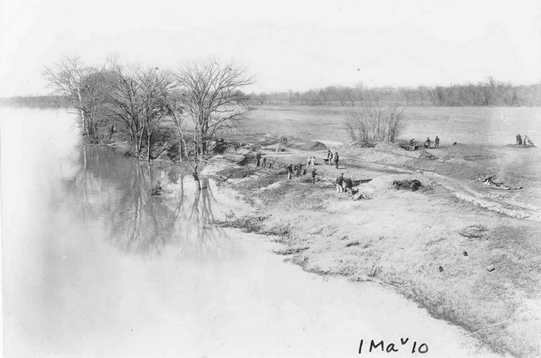
Figure 4.1. General view of 1939 WPA excavations. Blocks 1 and 2 and eroding shell midden shown in center (photo courtesy of the Alabama Museum of Natural History).

Some other items on the field specimen list include flint points and tools; soapstone and sandstone vessel fragments; copper ornaments; bannerstones, hoes and celts, slate ornaments and abraders; shell beads; clay objects; bone tools; and pottery (Webb and DeJarnette 1948c).

Key Personnel
A WPA work crew conducted excavations at the Whitesburg Bridge site from January 26, 1939, until April 1940, for a total of 4,800 person-days of labor. William S. Webb, David L. DeJarnette, and H. Summerfield Day were all influential figures involved with the Whitesburg Bridge site as well as other sites excavated in the Southeast by the WPA. These men came from very different backgrounds, each contributing to the excavations at the site in their own way (Lyon 1996; Tushingham et al. 2002). Hugh Capps was also involved with the excavations at the site, but no additional records for his involvement with other sites could be found.
After receiving his Master of Science degree in physics from the University of Kentucky, Webb conducted additional graduate studies at the University of Chicago. Being trained as a scientist with little background in archaeology, Webb understood the importance of keeping accurate field notes and quickly gained archaeological experience by excavating numerous sites in Kentucky with William D. Funkhouser (Lyon 1996). In 1933, the Smithsonian Institute recommended Webb for the task of organizing and implementing the Tennessee Valley Authority archaeology program (Haag 1961). He compared his approach to relief archaeology to his experience in World War I, “When this country went to war 4.5 million men went into its army, and gave every man a job. Many of these men knew nothing about their new jobs, but they had to do them and they did” (Lyon 1996).
Acting as the director of the TVA relief project, Webb selected David L. DeJarnette as the supervisor for the Wheeler Basin excavations (Lyon 1996). Together they were responsible for organizing the excavations at Whitesburg Bridge and for writing up the final report. DeJarnette held a Bachelor of Science degree in electrical engineering from the University of Alabama. After graduating in 1929, he was the assistant curator at the University of Alabama Museum of Natural History until 1931. It was there that he conducted his earliest archaeological work under the direction of Walter B. Jones at Moundville. In 1932, DeJarnette received formal training at the University of Chicago field school at the Kincaid site under Fay-Cooper Cole. From his training at Kincaid, DeJarnette brought the Chicago Method back to Alabama and, for the next six decades, trained numerous archaeologists in more efficient and controlled excavation techniques (Griffin 1975; Lyon 1996; Tushingham et al. 2002).
The field supervisors for the Whitesburg Bridge excavations were H. Summerfield Day and Hugh Capps. Day received his Bachelor of Arts degree from the University of Illinois in 1933 and was a graduate student at Harvard. He was also employed as an archaeologist for the National Park Service at Jamestown from 1935 to 1937 (Lyon 1996). Prior to January 26, 1939, Day had been working on the Flint River site, about two miles upstream from Whitesburg. But because of high water levels, work was suspended and Day was assigned to begin excavations at the Whitesburg Bridge site. He served as the field supervisor at Whitesburg Bridge until March 1939 when the water levels dropped and work could resume at the “more important” Flint River site (Webb and DeJarnette 1948a, 1948c). Hugh Capps was then appointed as field supervisor at the Whitesburg Bridge site, a position that he would fill for eleven out of the total sixteen months of excavation. Day eventually returned to the site when Capps resigned in February 1940.

WPA Field Method, Theory, and Artifact Recovery
During the WPA era, archaeologists adopted a new approach to excavating sites that has been called the “Stratigraphic Revolution” by Gordon Willey and Jeremy Sabloff (1980). Excavating sites by arbitrary levels and recording the natural stratigraphy became an advantageous field method for establishing cultural chronologies throughout the Southeast and North America. The theoretical foundation for this technique served well for the prevailing paradigm of the time, the Cultural Historical approach. This new approach came to the South through students, like DeJarnette, who received training at the University of Chicago field school in the early 1930s (Griffin 1976; Howe 2016).
The Chicago Method is evident in the excavation techniques utilized by WPA supervisors at 1Ma10 and numerous other sites in the Tennessee River Valley. For mound sites, test pits were dug at select localities to define the boundaries of the site before excavations started. When the boundaries were established, the excavation area was staked off in 5 ft intervals on a grid set along the axis of the site. Parallel rows were staked on each side of the axis until the entire site was included (Cole and Deuel 1937). The baseline axes were numbered and coordinates were used to identify each square within the grid. One of many advantages for laying out the grid was to enable excavators to record the location of burials, artifacts, and features within each square.
The next step in the Chicago Method was to begin at the zero lines of the grid and excavate each 5 ft square in arbitrary levels, which typically ranged from six inches to one foot, using light mattocks (Cole and Deuel 1937). This method of vertical and horizontal slicing was considered to be a “carefully controlled method that can be stopped as any foreign object is encountered” Cole and Deuel 1937:7). At each 5 ft line, profiles were drawn and photographed. It was also noted, that “whenever necessary, the dirt should be screened to secure small objects” (Cole and Deuel 1937:26).
One major disadvantage of the above-mentioned techniques was encountered when shell middens were excavated along the Tennessee River. Using the trench system, lenses of occupation, clay floors, and fire hearths were evident in the profiles, but because of the variable thickness of each deposit, correlating consecutive profiles became problematic. Field methods were adjusted by excavating parallel trenches some distance apart around the shell deposits. This resulted in isolating a “block” with profiles exposed on all four sides. The block was then taken down in arbitrary levels or by natural zones. The technique was helpful in determining how the shell was deposited across the site. Another advantage of the block technique was the decreased risk of any material falling from a higher level than that at which it was found (Webb and DeJarnette 1942).
At the Whitesburg Bridge site, both natural stratigraphic and 1-ft arbitrary levels were employed using the block and trench technique. Day cleared and staked 14 exploratory trenches and five blocks in the shell midden area of the site. The 14 exploratory trenches were excavated without regard to arbitrary or natural levels. The block excavations began with Block 3, which was completely excavated by natural zones. The remaining blocks were excavated in the order of 2, 1, 4, and 5. In Block 1, Zone A
was removed and the rest of the block was excavated in 1-ft levels. Block 2 was excavated in a similar manner, with the removal of Natural Zones A and B and the rest of the block taken out in 1-ft levels. Blocks 4 and 5 were taken down in 1-ft arbitrary levels with no regard to the natural stratigraphy (Figure 4.2).
Artifact analysis was conducted at the Central Archaeological Laboratory in Birmingham, Alabama. Over 4,500 pottery sherds were recovered during field investigations. Marion L. Dunlevy assigned each sherd to a pottery category and generated tables to illustrate the type distribution for each excavation block. The most common pottery type recovered during the WPA excavations was Long Branch Fabric
Marked (n=3,884). Block 4 (Figure 1.3) had the highest pottery sherd count with 746 sherds recorded. She found that the Middle Woodland period Long Branch Fabric Marked pottery was the most common type across the site, but that it was concentrated in the first 3 ft of the deposits. The deeper deposits included Late Gulf Formational Alexander series ceramics, but in very limited amounts. Interestingly, later Mississippian shell tempered pottery was very limited.
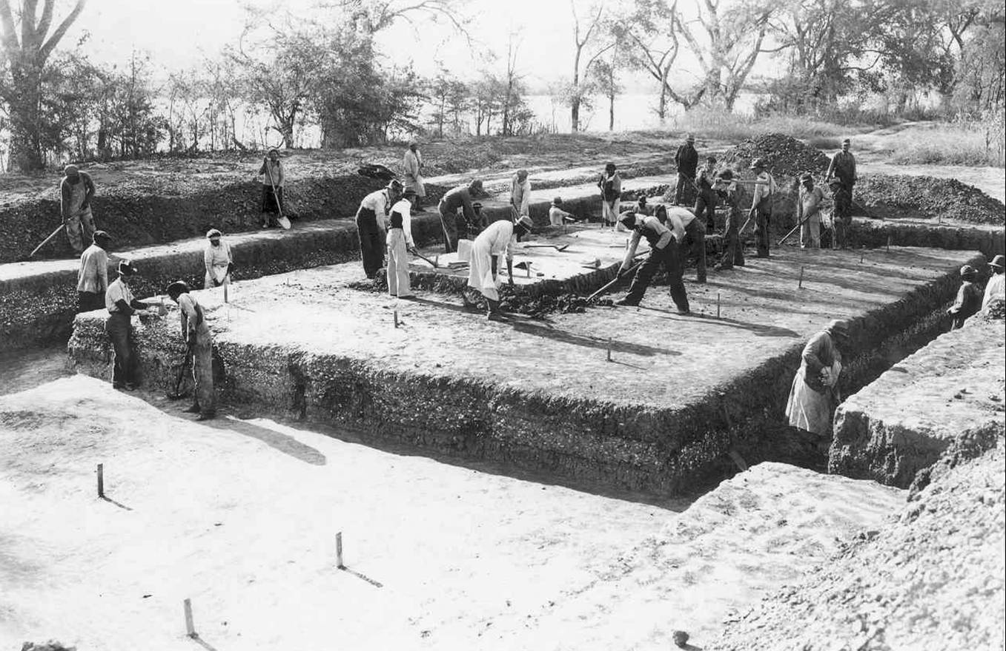
Figure 4.2. Excavation of Block 5 by 1 ft levels (photo courtesy of Alabama Museum of Natural History).
James Foster, an archaeologist with TVA, conducted the lithic analysis. Foster analyzed over 4,280 lithic artifacts and classified the projectile points using the Guntersville and Pickwick classificatory systems. The other lithic categories included scrapers, drills, spalls, broken unclassified, and unfinished unclassified. Using this information, Foster was also able to create a table showing the distribution of tools and projectile point types in each zone. The traditional Late Archaic period stemmed points make up the majority with the Flint Creek and Little Bear Creek types being most common, particularly in the deeper Zone D, followed by the Wade type in these deeper, Late Archaic period, deposits. It is also apparent from the collection and from the 2002 re-excavation of a portion of a WPA test trench, that none of the lithic debitage recovered in the field was kept for future study.
Other artifacts recovered from the site include five soapstone and two sandstone bowls. Of the seven stone vessels recovered, six were found associated with features. The majority of stone vessel fragments were found in Zone D. A total of 204 soapstone and 182 sandstone vessel fragments were also found, further supporting an Archaic 3 (or Late Archaic) occupation in Zone D.
Twenty-nine cultural features were recorded during the WPA excavations. These features include circular fire pits in the shell midden (n=7), fired clay hearth areas (n=10), a concentration of gastropods (n=1), and fire basins floored with river pebbles (n=2). No separate documentation or artifacts for these features were found. In addition, 117 human burials and 9 dog burials were found. Other features identified during the fieldwork, but which were not given feature designations, were numerous circular pits intrusive into Zone E. These pits were not assigned a feature number because their purpose was not obvious and their contents were no different from that of Zone E deposits. Webb and DeJarnette (1942c:18) do comment that these pits may have been “storage bins or midden pits.”
The conclusion derived from the pottery study was interesting in its summary assessment:
The presence of large concentrations of limestone pottery in Zones A and B, while many of the artifacts in these zones are quite similar to those in the non-pottery zones, D and E, would seem to suggest continuous occupancy by a single people in Pottery 2 period who took on the manufacture of grit tempered pottery and continued to use many of the same types of artifacts in bone and stone as in the Archaic 3 period. After the Pottery 2 period, occupancy seems to have completely ceased. The site is remarkable in the fact that so little shell-tempered pottery was found there. Only two sherds with shell tempering were found in the whole excavation, and not a single burial which could be assigned to the Pottery 3 period.
This clearly means that in Pottery 3 times, very few, if any, of the so-called Middle Mississippi people or as designated in the Pickwick Basin , the Kroger Island people, ever came on this site, and none used this shell midden for a cemetery (Webb and DeJarnette 1948c:43-44).

Summary of WPA Investigations
Compared to the high operating costs of road and building construction, Haag (1961) commented that the government was in favor of employing people to excavate archaeological sites not only to conserve archaeological remains but also because archaeological projects used over 90 percent of the allotted relief funds for labor rather than supplies. Through the federally sponsored projects, the largest archaeological endeavor in the history of Southeastern archaeology was undertaken. The results of these efforts have been both praised and critically analyzed by scholars (Dye 2016; Lyon 1996; Olinger and Howard 2009).
Futato (1980) outlined some pros and cons of the WPA archaeological program in the Wheeler Basin. One of his major points was the bias to excavate only four types of sites: Mississippian mounds, Mississippian villages and cemeteries, Copena burial mounds, and large shell middens. Other criticisms he noted were the amount of work accomplished in comparison to the amount required due to the high number of sites considered for excavation and the relatively short amount of time available. In addition, only summary reports could be written for each site. Howeverr, Futato (1980) pointed out that the quality of the WPA work cannot be discounted because it held to the highest standards of the time period. Furthermore, the WPA research laid the foundation for the initial cultural chronologies that have continued to develop and be revised with the discovery of new sites in the Tennessee Valley.
Griffin (1975) listed several important contributions of relief labor salvage programs to Eastern archaeology. He highlights that the excavations greatly increased the number of known sites in the eastern United States; provided field and laboratory experience for many of the influential figures in Southeastern archaeology; marked a theoretical change from a timeless culture area approach to a chronological-developmental strategy; and encouraged the establishment of archaeological programs at many universities.
The WPA excavations of Site 1Ma10 were conducted during a period of monumental growth in method and theory in American archaeology. The use of the block and trench technique at the site is representative of the most advanced field techniques of the time. In addition, several of the most important figures in Southeastern archaeology were involved with the excavations at the Whitesburg Bridge site and their legacy is still evident today. The results of this earlier work also provided valuable guidance to the 2002 investigations at the site.

1999-2002 Investigations
The next round of investigations into the site began in 1999 with a preliminary study (Phase I) of the site to determine the extent of deposits and determine the need for additional testing before Alabama Department of Transportation could proceed with the undertaking of replacing the bridge (Meeks 1999). Three riverbank profiles were excavated to identify the vertical extent of the site. It was determined that the intact deposits were likely still extensive and a testing program (Phase II) was established to examine the deposits both within test trenches and exposed along the bank of the river.
Scott C. Meeks of The University of Alabama, Office of Archaeological Research was assigned as the project director. He had five main goals, 1) establish the northern site boundary, 2) determine the depth of cultuural bearing deposits, 3) investigate the formation and age of the deposits, 4) determine the extent of the impact of a culvert that had been installed during the construction of the existing bridge, and 5) determine the extent of impact to the site by the construction of the north-bound bridge. Meeks conducted testing consisting of shovel testing, 1-m by 1-m test unit excavation, and mechanical excavations of 12 trenches. The trenching was completed with the assistance of Sarah C. Sherwood who conducted the initial geoarchaeological investigations of the site (Meeks 2002). It was determined that five primary strata (I-V) were present with multiple areally specific sub-strata demarkated by alphabebtic designations (a-d). the occupations were determined to be attributable to the Late Archaic, Gulf formational, Middle Woodland, and nineteenth century (Meeks 2002). The recommendation to ALDOT was that the proposed undertaking would have an adverse effect and a research design was presented to mitigate the effects through a data recovery program.
In April of 2002, I was assigned as the principal investigator and project director. The excavations began with the opening of Block 1 on the western side of the drainage cut and culvert excavated and installed between the two bridges (Figure 1.3). Block 1 encompassed the area of impact for the proposed bridge replacement on the west side. Two additional test units were laced to the west with the intent of investigating the shell midden in that area as well as attempting to locate the WPA trenches. Shortly afterward, Block 2 was opened on the eastern side of the drainage, adjacent to the abuttment of the northbound bridge. For a period of seven months excavations continued with a crew of approximately 30 people.
By November of 2002, excavations were completed and analysis began. The effort took four years to complete and included a symposium entitled Archaeology Under the Whitesburg Bridge: Late Holocene Occupation of the Middle Tennessee River Valley at the 60th annual meeting of the Southeastern Archaeological Conference in Charlotte, North Carolina, in 2003. John O’Hear, David Dye, and Eugene Futato served as discussants for the symposium.
It would take another seven years to complete the report which was submitted to and approved by ALDOT in 2011 (Gage 2011a). The geoarchaeological evaluation of the site was conducted by Sarah C. Sherwood (Sherwood 2011). The feature analysis and discussion of associations was conducted by James C. Wilkins, Joel H. Watkins, and me (Gage and Wilkins 2011). The lithic analysis was conducted by Sharon A. Freeman, Steven E. Barry and me with the stone bowl analysis conducted by John B. Newman, Daryll R. Berryman and me (Barry and Gage 2011; Gage 2011b; Gage and Freeman 2011; Newman et al. 2011). The ceramic anaylsis was conducted by Kareen L. Hawsey (2011). Historic artifacts were analyzed by Joel H. Watkins (2011). The faunal analysis was conducted by Renee B. Walker (2011). The botanical analysis was completed by Katherin Roberts (2011) with the phytolith analysis conducted by Robert Lusteck (2011).

Chapter Five
Methodological Approach and Results of Lithic Analysis
The lithic analysis for the 1Ma10 assemblage followed a series of established guidelines that included recording characteristics of general morphology such as overall size and shape, the presence and form of hafting elements, and the nature and position of the working edge(s) or surface(s). The raw material type was also noted. Efforts were made to avoid functional names and thus implications. Current nomenclature, however, is such that avoidance of these implications is virtually impossible. The terminology is, therefore, heavily based on the existing terminology for lithic artifacts, with some modifications. The names for certain tools are based on the regional classification schemes established in the Southeast during the last century of archaeological inquiry, most particularly the work of James W. Cambron and David C. Hulse (1975).

Raw Material Resources and Availability
The first act in the production of any stone tool is the acquisition of suitable raw material. The position of the Whitesburg Bridge site within the central portion of the Tennessee Valley afforded its inhabitants an ample supply of readily available chert and other materials for the production of stone tools. The presence at the site of nonlocal materials for both chipped stone tools and other lithic artifacts points to the preference of the inhabitants for materials from other regions as well as the existence of extensive interaction spheres across broad geographic areas.
Futato (1983:153) has listed three technological factors (absent of socially-based requirements or prohibitions) in the selection of raw material for tool production. These are access to raw materials, technologies for manufacturing tools, and intended function. The absence of social influences, i.e. style, obviously oversimplifies the equation when personal preference, knowledge of nonlocal availability, and factors such as tradition are considered. Tradition is easily the most influential of these considerations as artifacts considered diagnostic are the result of a continuum of artifact morphology that spans generations, cultures, raw material, and regional boundaries. In all instances, these artifacts reflect the commonality of knowledge or preference for certain forms over extensive areas.
Reference here to the proximity of the sources of raw material to the site will be in terms of local and nonlocal (Figure 5.1). These definitions are significant in that they reflect the effort involved in procurement and thus have implications regarding interaction. Local materials are those which can be found within the Middle Tennessee River Valley within approximately 25 km of the site. This includes areas from the upper portion of Wheeler Basin to above Guntersville Dam, the southern portion of Flint River, the sandstone capped mountains to the south, and the limestone hills to the west.
Nonlocal materials are subdivided into regional and exotic, with regional referring to those materials that occur within the four general areas of Pickwick, Wilson, Wheeler, and Guntersville Lakes. It also includes portions of the tributaries of these, namely the drainages of Cedar Creek, Flint Creek, Elk River, Flint River, and Paint Rock River, where known sources of raw material have been identified. The area extends more than 150 km west into Mississippi, 100 km east to the edge of the Piedmont, 100 km south to the southern extent of the Cumberland Plateau and the Alabama Valley and Ridge, and more than 100 km north into the Nashville Basin. Exotic materials include artifacts with sources beyond the bounds of these areas. Predominantly this is limited to greenstone (Hillabee schist) and soapstone from areas well southeast of the Middle Tennessee River Valley. Tallahatta quartzite from southwestern Alabama or southeastern Mississippi and Dover chert from northwestern Tennessee are the other exotic resources found at Site 1Ma10.

Classification of Lithic Raw Materials

Local Resources
Blue-Gray Bangor chert. This color variant of Bangor chert is the most prevalent material type found in the chipped stone tools and debitage at Site 1Ma10. Readily available in river cobbles within the Middle Tennessee River Valley, this fine-grained chert is semi-translucent and ranges from a greenish-blue to bluish-gray. Finished tools made from the material are rarely heat treated, evidencing its high quality. Futato
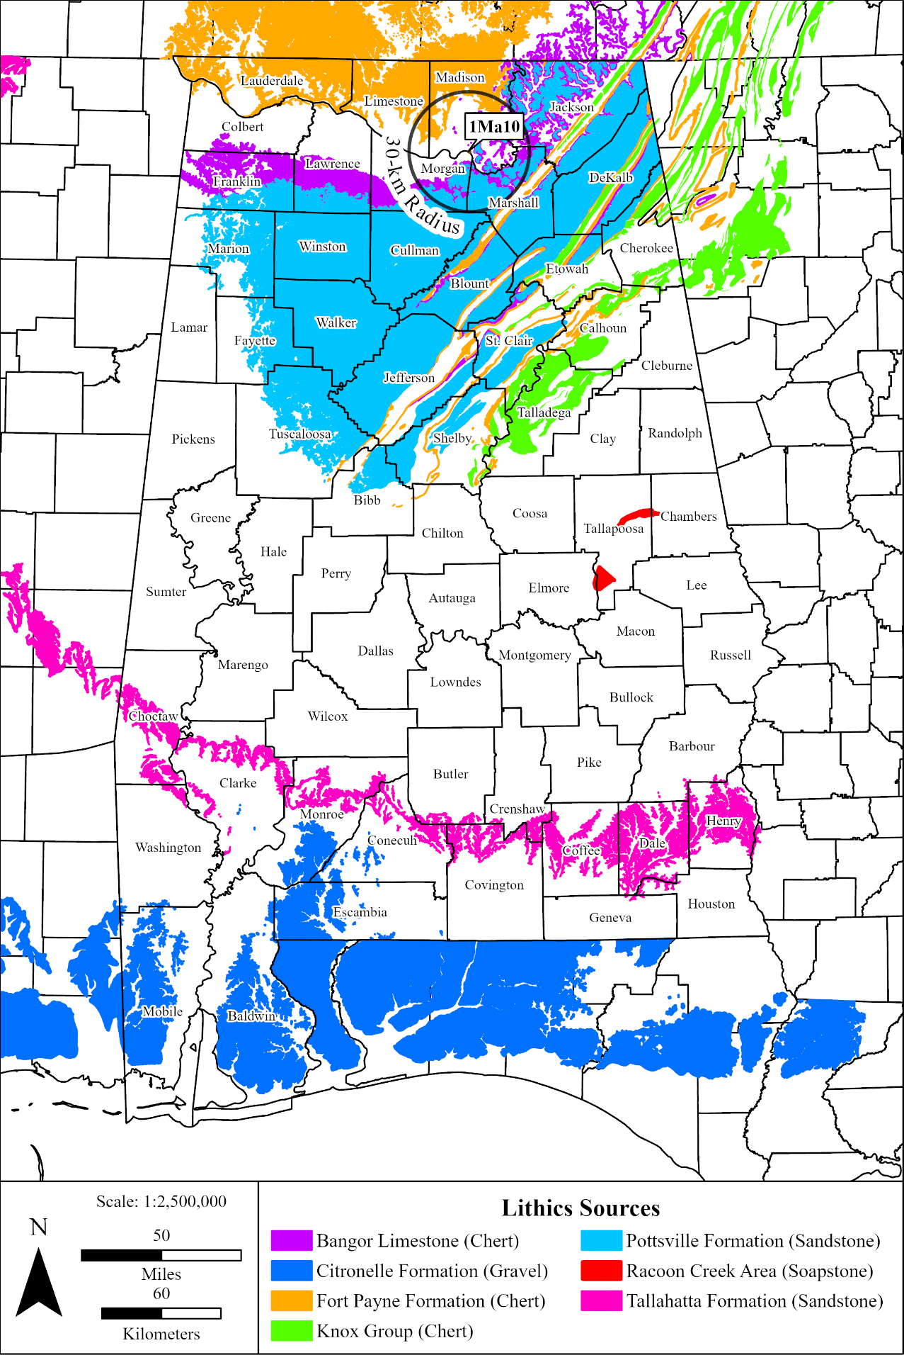
Figure 5.1. Source formations of many of the lithic raw materials found at 1Ma10 (based on units defined in Osborn et al. 1989).
(1983:156) notes the exchange of “blue green Bangor” with occupants of the Cedar Creek and Upper Bear Creek drainages as well as Poverty Point. Some of this chert contains occasional small fossils and was classified as Other Fossiliferous Bangor chert.
Other Bangor chert. This variant of Bangor chert includes other colors of Bangor chert and variegated or mottled specimens. It is suspected that the sources for this material are the same as for Blue-Gray Bangor chert. Some of this chert contains occasional small fossils and was identified as other Fossiliferous Bangor chert.
Chalcedony. Chalcedony is often hard to differentiate from agate as both are translucent, hard material. Unlike chert, chalcedony exhibits a fibrous non-crystalline structure. It is formed by the percolation of silica-bearing groundwater into cavities within rock. Chalcedony is found in both sedimentary and igneous formations and has been identified in association with dolomitic formations such as the Shady dolomite formation in the Tellico Basin of southeastern Tennessee (Kimball 1985). The chalcedony found at Whitesburg Bridge is believed to be a local resource, occurring along with the Bangor chert.
Limestone. Limestone is found throughout the area surrounding Whitesburg Bridge. There are various classification schemes for these formations and some of the less prominent formations are often undifferentiated on maps. Two major formations, however, the Bangor and Tuscumbia limestones, outcrop in the immediate vicinity of Site 1Ma10 (Swenson et al. 1958; Osborne et al. 1989). These are the most likely sources of the limestone at that site, although actual procurement could have been from secondary sources such as stream and river gravels. Bangor limestone is the uppermost of these formations. It is described as a medium gray limestone with interbedded mudstone in the upper part (Osborne et al. 1989). Bangor limestone outcrops on the upper mountain slopes of those mountains capped by the Pottsville formation and forms the top of certain mountains when the Pottsville has eroded away. Bangor limestone also occurs immediately across the Tennessee River from Site 1Ma10 at the eastern end of Moulton Valley. The other major limestone formation near the Whitesburg Bridge site is the Tuscumbia limestone, divided by Swenson et al. (1958) into the Warsaw and St. Louis limestones. Osborne et al. (1989) describe Tuscumbia limestone as a light gray limestone, partly oolitic near the top, but commonly a bioclastic crinoidal limestone. Chert nodules are scattered throughout the formation and are abundant in places. This limestone forms the floor of most of the Tennessee Valley north and northwest of Site 1Ma10.
No attempt has been made to assign the limestone found at Site 1Ma10 to either of these formations or to any of the other limestones in the area. Limestone at the site was most commonly found burned or fire cracked. A few chipped stone artifacts were made of limestone. Most of these are axes, adzes, or preforms; artifacts not showing fine flaking. Limestone was also used for pottery temper and a few pieces of building limestone were found in Stratum I or historic features.
Sandstone. Sandstone is a medium grained sedimentary rock composed of abundant (85 to 90 per cent) sand size particles with rounded or angular texture set in a fine-grained matrix (silt or clay) firmly united by a cementing material such as silica, iron oxide, or calcium carbonate. It is considered the consolidated equivalent of sand, intermediate between conglomerate and shale (Gary et al. 1974). The sandstone recovered from the Whitesburg Bridge site is dominated by material from the Pottsville and Hartselle formations.
The Hartselle sandstone forms much of the upper bedrock layer just south of the Tennessee River in the southern uplands of the Highland Rim (Sapp and Emplaincourt 1975). It is Mississippian in age and consists of varyingly bedded deposits that extend over a large geographic region from western Colbert County to eastern Morgan County. The major outcrop area of the Hartselle sandstone forms Little Mountain, which separates the Tennessee Valley and Moulton Valley. The eastern end of Little Mountain forms the southern border of the Tennessee River valley just downstream from Site 1Ma10.
For the prehistoric occupants of the region, sandstone served as the raw material for multiple technologies including Late Archaic vessel production, food preparation surfaces (grinding stones), abraders, and decorative adornments, not to mention its prevalence in the samples of fire cracked rock recovered from the site. Both the Pottsville and Hartselle formations are considered local sources of raw material. Pottsville and Hartselle sandstone are available from outcrops near Site 1Ma10, and from abundant cobbles in streams and the river.
Shale. Shale is a clastic sedimentary rock composed of silt and clay sized particles (Boggs 1995). Commonly found exposed in the uplands near Whitesburg Bridge, shale is used here to describe fine-grained, fissile rock, showing lamination. Shales of the Pottsville formation and various other formations were readily available to the occupants of the Whitesburg Bridge site, both in outcrops and within the streambeds of surrounding drainages. Shale abraders and a gorget fragment were recovered during excavations.
Siltstone. Siltstone is comprised of silt sized particles (here the term is used synonymous with mudstone or mudrock) and is found throughout the Middle Tennessee River Valley. It appears in the Mississippian Borden Formation, north of the Fort Payne Formation. It differs from shale in the absence of fine laminations.
Unidentified chert. A small amount of chert could not confidently be identified as to source. It is possible that many of these examples are unusual color variants or other aberrant examples of local or regional materials.

Regional Resources
Black and Fossiliferous Bangor chert. These cherts occur together in the Bangor formation, the difference between them being the presence of fossils, almost exclusively small crinoid stem sections. The cherts outcrop beneath the Hartselle Sandstone along the edges of Sand Mountain in the northeastern part of the state and in the northwestern portion of Alabama around Cedar Creek in Franklin County, near the western end of Moulton Valley. Both materials are a dark black to dark gray with the fossiliferous material including lighter colored gray or translucent white fossils (Skrivan and King 1983). The material classified as other Fossiliferous Bangor is a variety of Blue-Gray Bangor that also contains fossils. It is distinctive from Fossiliferous Bangor not only in color scheme, but in that it occurs along with the Blue-Gray Bangor all around the Tennessee River in north-central Alabama.
Blue-Gray Fort Payne and Fossiliferous/Upper Fort Payne chert. Blue-Gray Fort Payne chert is the typical chert of the western Middle Tennessee River Valley, concentrated along Pickwick and Wilson Lakes and lower Wheeler Lake. It also outcrops along the Elk River in northern Madison and Limestone Counties. The color of Blue-Gray Fort Payne chert can overlap much of the Blue-Gray Bangor chert. Fort Payne chert, however, is coarser in texture and thus less translucent. Fort Payne chert also has distinctive mottling and may contain quartz inclusions. Upper Fort Payne chert is generally lighter in color: white, cream, tan, or light gray. It occurs as hilltop residuum in parts of the Tennessee Valley. Large bedrock outcrops of Upper Fort Payne chert in northeastern Mississippi were extensively quarried prehistorically (Johnson 1981; Thorne et al. 1981). Fossiliferous Fort Payne occurs with the Upper Fort Payne. It, too, is generally light in color and often contains small dark fossils, giving it a salt-and-pepper appearance.
Jackson County Agate. Jackson County Agate is found in the Paint Rock River drainage area of Jackson County, Alabama, upstream from the Whitesburg Bridge. It is a white to light gray, very hard, translucent agate. Due to its hardness, this material was often used for hammerstones and thick bifaces.
Knox chert. A very few specimens of cream colored or dark gray to black chert appear to be Knox chert. The nearest exposures of the Knox group are in the Sequatchie Valley, north of Guntersville Lake, but it also occurs throughout the Alabama Valley and Ridge physiographic section.
Pickwick chert. Pickwick chert occurs in far northwestern Alabama and northeastern Mississippi just north and west of the westernmost areas where Black Bangor and Fossiliferous Bangor occur. Its coloring is unique, with a tan or yellow rind covering red, then gray or blue interior portions. The color differentiation is speculated to be the result of minerals leaching into cobbles (Van D. King, Jr., personal communication, 2002).
Quartzite. Although classified as a regional material, quartzite (including vein quartz) occurs all over Alabama’s central and southern areas. Like Jackson County Agate, it is a translucent material but with a much coarser texture resulting from its granular or inter-locking crystalline structure.
Tuscaloosa Gravel. Tuscaloosa Gravel is found in northwestern Alabama as cobbles in the various minor drainage systems and riverbeds. The gravels are found in the basal beds of the Tuscaloosa formation which extends across much of the state. In the eastern portion, the gravels are predominantly quartz and quartzite originating in the Piedmont. The gravels gradually include more chert until this is the dominant material in the western and northwestern portions of the state (Adams et al. 1926:233). This is a yellow to yellowish-brown chert which was frequently heated to a bright red prior to knapping.

Exotic Resources
Dover chert. Dover chert is a distinctive and well-known tan to grayish brown chert originating in the St. Louis limestone. Large Dover chert quarries and workshops are located along the Cumberland River near Dover in Stuart County, Tennessee. These quarries are particularly associated with the production of large artifacts that were widely traded during Mississippian times as perhaps first described by Kneberg (1952). The most notable artifacts include swords, maces, and other ceremonial objects, but axes, adzes, and hoes were also produced. Nance (2000) reports St. Louis chert with a similar appearance but different chemical signature throughout the lower Cumberland drainage.
Greenstone. Greenstone is an exotic resource at 1Ma10. Based on its visual characteristics, this material is a chlorite schist from the Hillabee schist in the Alabama Piedmont. Hillabee schist is a durable, fine grained metamorphic rock. These characteristics result in the material’s wide use for artifacts such as polished stone celts and spades. Gall (1995) has characterized Hillabee schist and identified it as the primary source of greenstone at Moundville, Alabama. Hillabee schist artifacts are commonly found in the Middle Tennessee River Valley. They have been identified from areas as far away as northeastern Arkansas (Gall et al. 2002).
Soapstone. An exotic resource at 1Ma10, soapstone is a metamorphic talc of massive, schistose, or interlaced fibrous or flakey texture and soft, unctuous feel. It includes varying amounts of micas, chlorite, amphibole, and pyroxenes and is derived from the alteration of ferromagnesian silicate materials (Neuendorf et al. 2005). It is available in the Piedmont region of North Carolina, Alabama, Georgia, and South Carolina. The closest sources for this material are in Tallapoosa County, Alabama and Soapstone Ridge, near Atlanta, Georgia. The material has a fine texture, and its composition makes it quite malleable and thus suitable for use as a raw material for ground stone tool, especially stone vessel manufacturing. It has a slick, almost greasy texture and is very resistant to heat fractures and damage from plant acids (Holmes 1919; Wells 2006).
Tallahatta sandstone (quartzite). Tallahatta sandstone is an opalized claystone found in southwest Alabama and southeast Mississippi. Also referred to as sugar quartz or moldy quartz, it has a grainy mottled appearance that includes opaque white and gray blotches. The stone is found associated with a siliceous sandstone near the base of the series of sandstone, indurated white clay, glauconitic sandstone, and siliceous or aluminous sandstone of the Tallahatta formation (Adams et al. 1926:269; Raymond 1988).

Classification of Stone Artifacts
The lithic artifacts from the Whitesburg Bridge site point to wide variation in both form and function of chipped stone tools. Finished tools, meaning items that exhibit evidence of retouch or use-wear (i.e. attrition) on any given edge or surface, range from random flakes to finely retouched hafted thin bifaces (e.g. projectile points/knives). Expedient tools are the most common. These are usually flakes or retouched flakes of Bangor chert.
The recovered chipped stone tools include a wide assortment of hafted bifaces, stage reduction bifaces (e.g., preforms and bifaces), other flaked tools, and cores. Tools were classified under a techno-morphological approach in order to obtain data on cultural-historical and technological aspects of the assemblage. This involved the sorting of the chipped stone tools into five major categories: hafted thin bifaces, other bifaces, other bifacially flaked tools, unifaces, and cores. These categories include tools sharing characteristics of size, shape, and technology. The names assigned to each tool from the site are not necessarily intended to imply function, but names common in the literature will be used for convenience of communication and comparison. The descriptions of the individual tool types, which are based on categories outlined by Ensor (1981), Futato (1983), Johnson (1989), and Skrivan and King (1983), are provided in a later section of this chapter.
Hafted Thin Bifaces. Hafted thin bifaces are thin, bifacially-flaked tools exhibiting basal modification resulting in a distinct hafting element. Also included within this category are lanceolate bifaces and small triangular bifaces lacking a distinct haft element but exhibiting basal modification assumed to be related to hafting. Traditional cultural-historical type descriptions for the region, as outlined by Cambron and Hulse (1975) and Justice (1987), will be used to categorize projectile point types. Other hafted thin bifaces, stemmed scrapers, drills, etc., are placed into techno-morphological groups.
Other Bifaces. Other bifaces are bifacially flaked stone tools lacking a hafting element and representing successive stages of biface reduction. This category was divided into four sub-categories: Preform I, Preform II, Biface I, and Biface II.
Other Bifacially Flaked Tools. This is a broad group of tools including artifacts ranging from drills and perforators to axes and adzes.
Uniface Tools. This category includes tools exhibiting technological modification in the form of systematic retouch along only one face (e.g., unifaces and retouched flakes). Also included within this category are simple flake tools exhibiting evidence of edge damage (i.e., attrition) associated with utilization but displaying no evidence of intentional retouched (i.e., utilized flakes). One subcategory has been identified in the Site 1Ma10 assemblage. Microliths included in this subcategory are very small, flaked tools (generally produced on blades or blade-like flakes) that exhibit fine unifacial retouch, and in some instances bifacial retouch.
Cores. The core category consists of the products of initial reduction which exhibit large, negative flake scars, possess one or more striking platforms, and display no evidence of further modification into a tool. This category was divided into three subcategories: amorphous core, blade core, and microlith core.
Pecked, Ground, and Polished Stone. This category includes artifacts that exhibited surfaces that have been deliberately smoothed, abraded, pecked and/or polished. These artifacts are made from lithic material such as soapstone, greenstone, schist, and other nonlocal stone. The artifacts will be referred to by names associated with form or function and found in the literature (i.e. soapstone bowl, celt, gorget, etc.).

Fractures, Failures, and Completeness
The completeness and fracture or failure type was recorded for all chipped stone artifacts. Fracture and failure types were identified using the descriptions given by Johnson (1979, 1981) (Table 5.1). The following terms were used to identify the completeness of chipped stone artifacts:
Very minor fractures, i.e. less than approximately 2 mm, were generally disregarded. For example, a biface only missing an estimated 1-2 mm from the tip would still be classified as intact.

Debitage
Debitage includes the by-products from the manufacturing and maintenance of chipped stone tools. All debitage was analyzed using the mass analysis technique as outlined by Ahler (1989). Debitage from general excavations was sorted by raw material type and presence/absence of cortex, and size graded using a set of nested screens with round holes and graduated sizes of 2.0 in, 1.0 in, 0.5 in, and 0.25 in. Materials passing the 0.25 inch screen was considered debris, as it was too small to have been systematically sampled in the field.
A selected sample of the debitage was taken from floatation samples from 11 excavation units and 38 features. This sample was reanalyzed by a single individual, in an effort to minimize observer error in the analysis. This sample constituted just over 30,000 flakes or about one-sixth of the recovered total. The debitage analysis is included as Appendix A.

Other Rock
Fire cracked rock is any type of nonflaked stone which has been fractured as a result of exposure to heat and which does not exhibit evidence of other intentional human modification (i.e., thermally altered flakes, tools, etc). The vast majority of the fire cracked rock found at the site consists of angular fragments of sandstone cobbles.
Table 5.1. Description of fracture types after Johnson (1981).
TERM | DEFINITION
Intact | Complete
Distal | Possessing the tip but are missing the base. Anterior portions of the haft element may be present
Proximal | Possessing the base but are missing the tip. Portions of the blade may be present
Medial | Lacking both the tip and the base. Portions of the haft element may be present
Lateral | Possessing only portions of one lateral edge
Central | Retaining no bifacial edge
Although fire cracked rock can result from both natural and cultural processes, the majority of the fire-cracked rock recovered from Site 1Ma10 is most likely cultural in origin. This category also includes apparently unmodified rock, mostly small, naturally occurring pebbles. Coal is also included in the Other Rock category.

Results of the Chipped Stone Artifact Analysis
Excavations at Whitesburg Bridge recovered a total of 3,754 chipped stone artifacts, including 1,314 hafted thin bifaces, 1,876 other bifacial artifacts and cores, and 564 microliths and unifacial and flake tools (Tables 5.2-5.4). Their distribution and information on debitage and raw material distribution is presented in Appendix A.

Hafted Thin Bifaces
Table 5.2 presents a summary of hafted thin bifaces from the site. Although the dominant occupation of the Whitesburg Bridge site occurred during the Late Archaic through Middle Woodland, diagnostic hafted thin bifaces attributable to Early Archaic through Mississippian occupation are present. The classification of these specimens is based on existing cultural-historical typologies developed for the region (Cambron and Hulse 1975; Futato 1983; Justice 1987). The distribution of hafted thin bifaces is given in Appendix A, Tables A.1-A.3. The metric data is presented in Appendix A, Table A.4. Below are presented the projectile point types that encompass the Late Archaic diagntostic cultural-historical types as well as only those that temporally bracket the occupation (i.e. Middle Archaic and Gulf Formational/Woodland) (see Gage and Freeman 2011 for a complete discuss of all points recovered).

Cypress Creek Cluster
The Cypress Creek cluster (Figure 5.2) was used by Futato (1983) to include two point types that share some similarities of form and chronological placement. These types are Cypress Creek and Crawford Creek. Cambron and Hulse (1964) defined Cypress Creek based on specimens from the Eva site, particularly those identified as Cypress Creek II (Lewis and Lewis 1961). The Cypress Creek I specimens were similar to Kirk Corner Notched and Cypress Creek II was smaller and less distinctly corner notched. Projectile points from this cluster have been associated with latter Early Archaic to Middle Archaic times.
Table 5.2. Summary of hafted thin bifaces.
TYPE | BLOCK 1 | BLOCK 2 | FEATURES | TOTAL
Bakers Creek | 10 | 1 | 1 | 12
Beacon Island | 1 | - | - | 1
Big Sandy | 1 | 1 | - | 2
Bradley Spike | - | 1 | - | 1
Candy Creek | 3 | 5 | 1 | 9
Coosa | - | 1 | - | 1
Coosa Notched | - | 1 | - | 1
Copena | 12 | 9 | 2 | 23
Copena Triangular | 1 | - | - | 1
Cotaco Creek | 42 | 9 | 3 | 54
Crawford Creek | 1 | - | - | 1
Cypress Creek | 1 | 1 | - | 2
Flint Creek | 65 | 37 | 16 | 118
Gary | - | - | 1 | 1
Greeneville | 8 | 18 | - | 26
Hamilton | 1 | 1 | - | 2
Hamilton Stemmed | 1 |  | - | 1
Jacks Reef Pentagonal | 1 | - | - | 1
Kays | - | 2 | - | 2
Kirk Corner Notched | - | - | 1 | 1
Ledbetter | 2 | 1 | - | 3
Limestone | 24 | 10 | 8 | 42
Little Bear Creek | 18 | 2 | 3 | 23
Lost Lake | - | 1 | - | 1
MacCorkle Stemmed | 1 | - | - | 1
Motley | 11 | 4 | 2 | 17
Mulberry Creek | 3 | 1 | - | 4
Nolichucky | 1 | 1 | - | 2
Palmer | 1 | - | - | 1
Pickwick | 2 | - | - | 2
Stanley Stemmed | 1 | - | - | 1
Swan Lake | - | 3 | 1 | 4
Sykes-White Springs | - | 3 | - | 3
Wade | 46 | 12 | 7 | 65
Residual Bifurcate | - | 1 | - | 1
Residual Greeneville Cluster | 7 | 4 | 3 | 14
Residual Stemmed | 37 | 18 | 4 | 59
Thin Biface Fragment | 444 | 289 | 78 | 811
TOTAL | 746 | 437 | 131 | 1314

Table 5.3. Summary of other bifacial artifacts and cores.
CATEGORY | BLOCK 1 | BLOCK 2 | FEATURES | TOTAL
Adz | 5 | 2 | 1 | 8
Ax | 2 | - | 1 | 3
Core Chopper | 10 | 6 | 1 | 17
Hoe | 1 | - | - | 1
Notched Weight | - | 1 | - | 1
Biface Scraper | 4 | - | - | 4
Stemmed Scraper | 5 | 1 | - | 6
Expanded Base Drill | 5 | 2 | - | 7
Stemmed Drill | 1 |  | - | 1
Shaft Drill | - | - | 1 | 1
Drill Fragment | 11 |  | 1 | 12
Expanded Base Perforator | 1 | 2 | 1 | 4
Perforator | 2 | 2 | 1 | 5
Reamer | 6 | 2 | - | 8
Biface I | 137 | 95 | 23 | 255
Biface II | 145 | 45 | 12 | 202
Biface Fragment | 50 | 40 | 26 | 116
Preform I | 159 | 109 | 74 | 342
Preform II | 153 | 98 | 32 | 283
Amorphous Core | 218 | 134 | 100 | 452
Blade Core | 4 | 5 | - | 9
Microlith Core | 1 | - | - | 1
Utilized Core | 34 | 32 | 15 | 81
Core Fragment | 35 | 17 | - | 52
Chipped Stone Fragment | 4 | 1 | - | 5
TOTAL | 993 | 594 | 289 | 1876

Table 5.4. Summary of uniface tools, microliths, and flake tools.
CATEGORY | BLOCK 1 | BLOCK 2 | FEATURES | TOTAL
End Scraper | 6 | 4 | 1 | 11
Side Scraper | 6 | 2 | 2 | 10
Side/End Scraper | 2 | - | - | 2
Scraper on Biface Fragment | - | - | 1 | 1
Scraper/Spokeshave | 1 | 1 | 1 | 3
Spokeshave | 4 | 5 | 3 | 12
Scraper Fragment | 16 | 20 | 6 | 42
Denticulate | 4 | - | - | 4
Denticulate/Graver | - | - | 1 | 1
Graver | 6 | 10 | 1 | 17
Flake Perforator | - | - | 1 | 1
Flake Tool | 4 | 1 | - | 5
Expanded Base Microlith | - | 3 | - | 3
Microlith Drill | - | 2 | - | 2
Microlith Needle | 4 | 4 | 2 | 10
Microlith Perforator | 25 | 10 | 3 | 38
Microlith Reamer | 2 | 1 | 1 | 4
Microlith Fragment | 2 | - | - | 2
Retouched Blade | 8 | 7 | 1 | 16
Retouched Flake | 70 | 52 | 22 | 144
Utilized Blade | 12 | 8 | - | 20
Utilized Flake | 152 | 46 | 18 | 216
TOTAL | 324 | 176 | 64 | 564

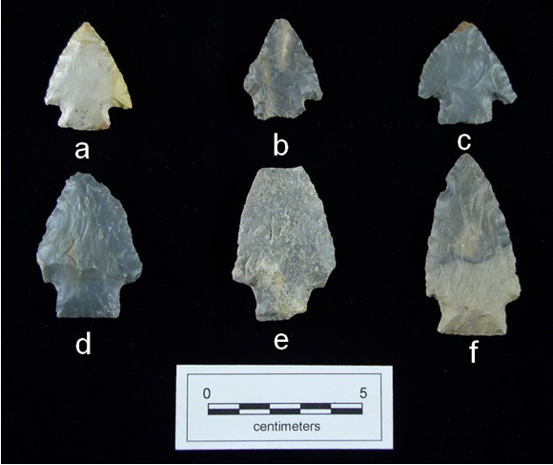
Figure 5.2. Middle Archaic hafted thin bifaces. a, Cypress Creek; b-c, Crawford Creek; d-f, Sykes/White Springs from the Whitesburg Bridge site.

Cypress Creek (Figure 5.2a). Two specimens from Whitesburg Bridge are assigned to this point type. Cypress Creeks are generally small and corner notched to expanded stemmed. Both are intact with no obvious error and both are manufactured from Blue-Gray Bangor chert. One specimen was recovered from Block 1, Stratum II and is beveled on both blade edges and the other is from Block 2, Stratum IV.
Crawford Creek (Figure 5.2b-c). Crawford Creek is a medium-sized, stemmed point with a usually straight, sometimes serrated blade (Cambron and Hulse 1975). Crawford Creeks are described as having an acute distal end, straight stem sides, and tapered shoulders. One intact specimen from Site 1Ma10 represents this type. The specimen is produced from Black Bangor chert, and was excavated from Block 1, Stratum II.

Sykes/White Springs Cluster
The Sykes/White Springs cluster contains specimens variously typed as Sykes or White Springs, or often as a combined Sykes/White Springs type (Figure 5.2d-f). White Springs, originally defined at Stanfield-Worley Bluff Shelter (DeJarnette et al. 1962), has a short, broad stem formed by small corner removals. White Springs is at one end of the range of variability of Sykes as defined by Lewis and Lewis (1961) although Sykes is also applied to examples with somewhat longer, more narrow stems. The cluster extends over most of the Middle Archaic, from Morrow Mountain through Benton times, and may extend into the Late Archaic, as well.
Sykes-White Springs (Figure 5.2d-f). Three specimens recovered from Block 2 were assigned to this cultural type. Two intact specimens have no observable fracture/failure errors. The one proximal portion exhibits an impact fracture on the distal end. Two specimens each have one barb missing. Two examples are made of Blue-Green Bangor chert and the other is made from Other Fossiliferous Bangor chert. All three Sykes-White Springs were excavated from Stratum IV at depths of 117 cmbd to 139 cmbd. They may represent the earliest occupation of this portion of Site 1Ma10.

Ledbetter Cluster
The Ledbetter cluster includes two types, Ledbetter and Pickwick (Figure 5.3). These points are characteristic of the earlier Late Archaic in the region of Whitesburg
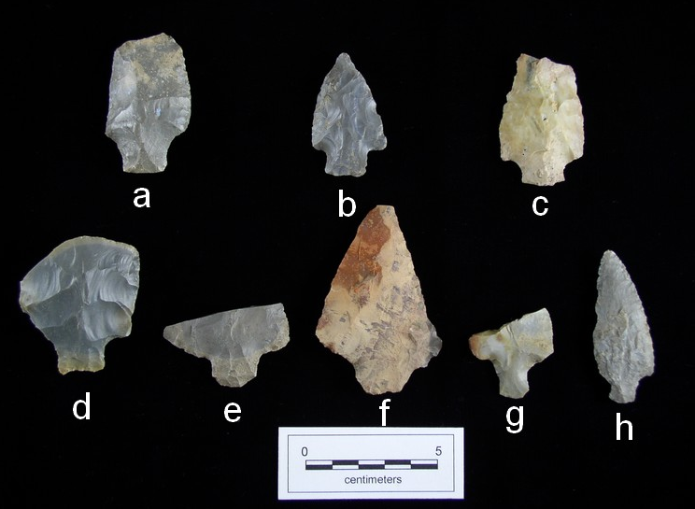
Figure 5.3. Late Archaic hafted thin bifaces. a-c, Kays; d-e, Ledbetter; f, Pickwick; g-h, Mulberry Creek from the Whitesburg Bridge site.

Bridge. The types are contemporaneous and share certain characteristics of form. Similar attributes include a medium to large size, contracting stems, and broad random flaking. The main distinguishing morphological trait is blade configuration. Ledbetter has an asymmetrical blade. Pickwick possesses a more symmetrical blade with expanding shoulders.
Ledbetter (Figure 5.3d-e). Three specimens were placed in this cultural type. Two were excavated from Stratum II and one from Stratum IV. All three are proximal portions manufactured from Blue-Gray Bangor chert. Two specimens exhibit lateral snaps and the third specimen exhibits a perverse fracture. Both fracture types are associated with late stage production failures and these are likely aborted tools.
Pickwick (Figure 5.3f). Pickwick is represented by two specimens recovered from Block 1, Stratum II. Both specimens are intact. One specimen is manufactured from Other Bangor chert and the other specimen from Pickwick chert. One Pickwick has apparently been recycled and exhibits retouch on the tip actually dulling the tip considerably giving the tool a scraper-like appearance.

Little Bear Creek Cluster
Three cultural types from Whitesburg Bridge have been placed in the Little Bear Creek cluster: Little Bear Creek, Mulberry Creek, and Gary. All three types are relatively long and thin with long, thin haft elements. Mulberry Creek is distinguished by an expanding blade and Gary by its contracting stem and rounded base. Little Bear Creeks are the dominant type in the cluster and are the marker for the Little Bear Creek horizon (ca. 2000-1000 BC). A total of 29 Little Bear Creek cluster bifaces were found in the excavations, apparently marking the first substantial occupation of this portion of Site 1Ma10.
Gary. One intact specimen was assigned to this cultural type. The specimen has no fractures and with the exception of some cortex remaining on one face, it appears to be a finished tool. It exhibits some fine retouch flaking but it is not clear if this flaking indicates use and resharpening. This specimen was found in Feature 408, characterized as a charcoal and fired clay concentration.
Little Bear Creek (Figure 5.4). The Little Bear Creek type is represented by 23 specimens: 18 from Block 1, 2 from Block 2, and 1 each from Features 30, 241, and 251. Eight came from the Late Archaic Stratum IV and ten from Stratum II, which contained
Late Archaic through Middle Woodland materials. Radiocarbon dates are available for two of the three features which yielded Little Bear Creeks. Feature 241 was a shell midden. This feature has a calibrated date of 1505 to 1301 cal BC (BETA-169606). Feature 251 was a fire pit or deep basin hearth with a date of 1519 to 1321 cal BC (BETA-169607). Both features were located in Block 2, Stratum IV. The raw materials for these specimens are 78 per cent Blue-Gray Bangor chert (N=18), 17 per cent Other Bangor chert (N=4), and 4 per cent Other Fossiliferous Bangor chert (N=1). Seven of the ten intact specimens have no observable flaking errors. One intact specimen has a color change indicative of thermal alteration. Two proximal portions have been exposed to heat, showing obvious crenated fractures. Eight tools (four intact) exhibit fine pressure retouch associated with possible re-sharpening.
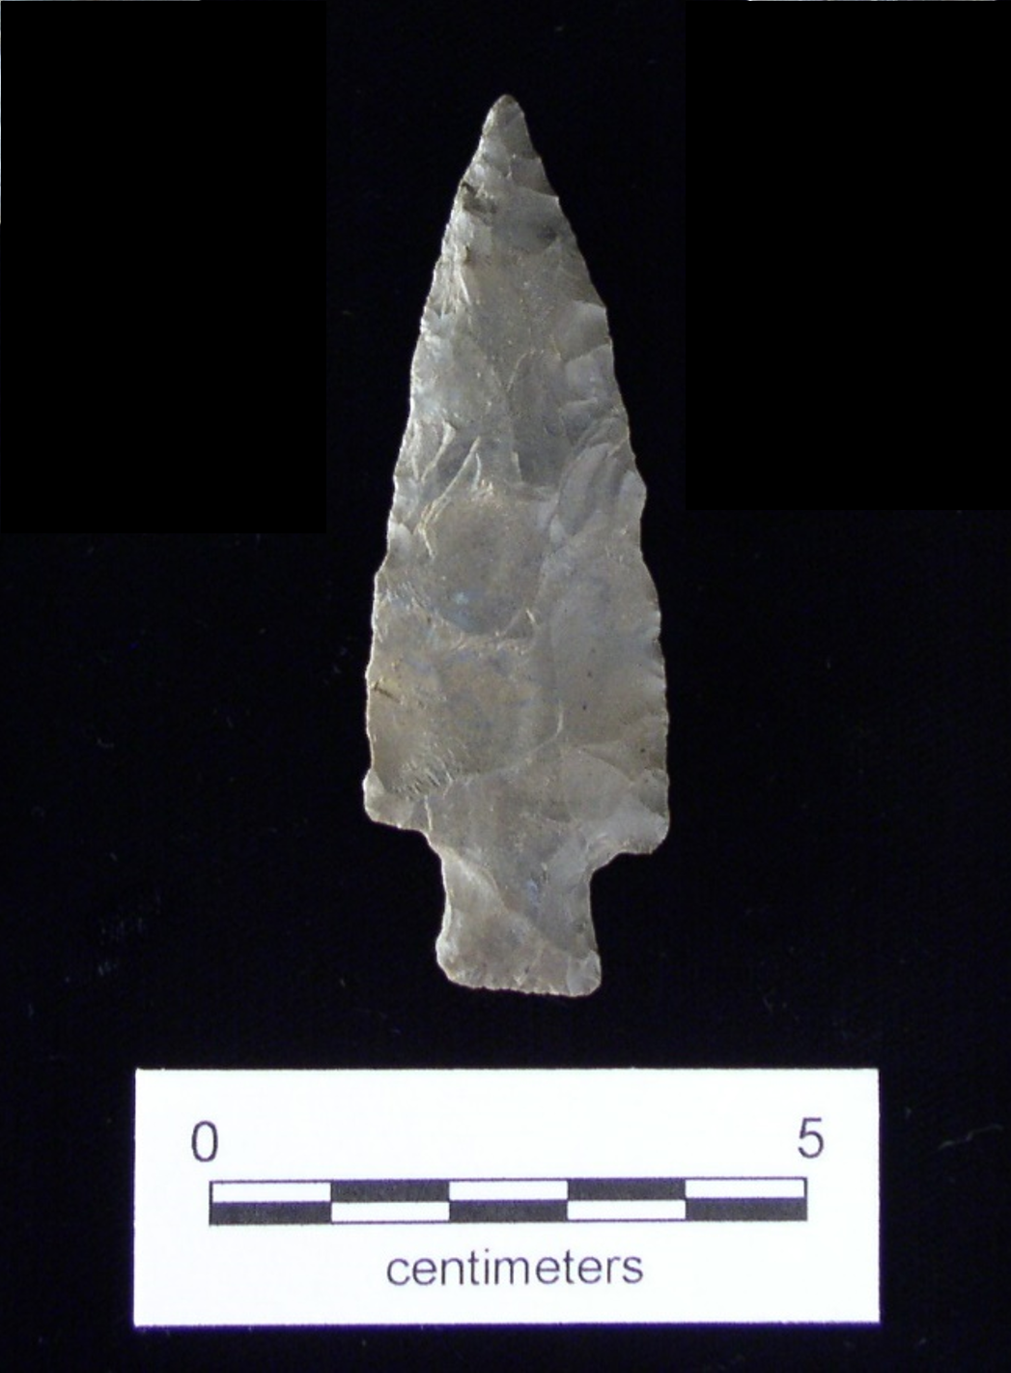
Figure 5.4. Little Bear Creek hafted biface from the Whitesburg Bridge site.

Mulberry Creek (Figure 5.2g-h). This cultural type is morphologically associated with Little Bear Creek projectile points as they share similar haft element morphology. Four examples of Mulberry Creek were found, three from Block 1 and one from Block 2. All were found in Stratum II. Three examples are manufactured from Blue-Gray Bangor chert and one from Blue-Gray Fort Payne chert.

Wade Cluster
The Wade cluster ordinarily includes three similar and contemporaneous types: Wade, Limestone, and Cotaco Creek. These are three of the four most common types found in the excavations and the Wade cluster is the most frequently occurring cluster at Site 1Ma10. The types generally share triangular blades and expanded haft elements with straight edges. The main differences are in shoulder configuration: barbed for Wade, rounded for Cotaco Creek, and horizontal for Limestone. One Beacon Island was also included in the Wade cluster at Site 1Ma10 due to its overall form and the presence of barbs. Its rounded stem, however, is distinctive. Wade cluster hafted thin bifaces are associated with Late Archaic and Gulf Formational occupations in the Tennessee Valley
Beacon Island (Figure 5.5f). Cambron and Hulse (1975) describe Beacon Island as a medium-sized point with an expanded-rounded stem, straight blade edges, and weak to strong barbs. One Blue-Gray Bangor chert specimen from Site 1Ma10 was placed in this type due to its basal configuration. The example from 1Ma10 is a longitudinal portion with a perverse fracture. It was found in the disturbed Stratum I.
Cotaco Creek (Figure 5.6). Cotaco Creek is a medium to large, straight-stemmed point with rounded shoulders and straight blade edges. Cotaco Creek projectile points are strongly associated with the Late Archaic in north Alabama and have been found in direct association with fiber tempered ceramics (Benthall 1965). This type is very well represented at 1Ma10 (N=54) with the majority excavated from Stratum II (N=37). Six Cotaco Creeks were excavated from Stratum IV and one each from Features 208, 241, and 336. The completeness status of these projectiles is as follows: distal (N=5), intact (N=32), longitudinal (N=1), medial (N=3), and proximal (N=13). Distal fragments (i.e. lacking the base) exhibited two incipient fractures, two haft snaps, and one crenated fracture. Nearly intact specimens had a variety of minor fractures including three early
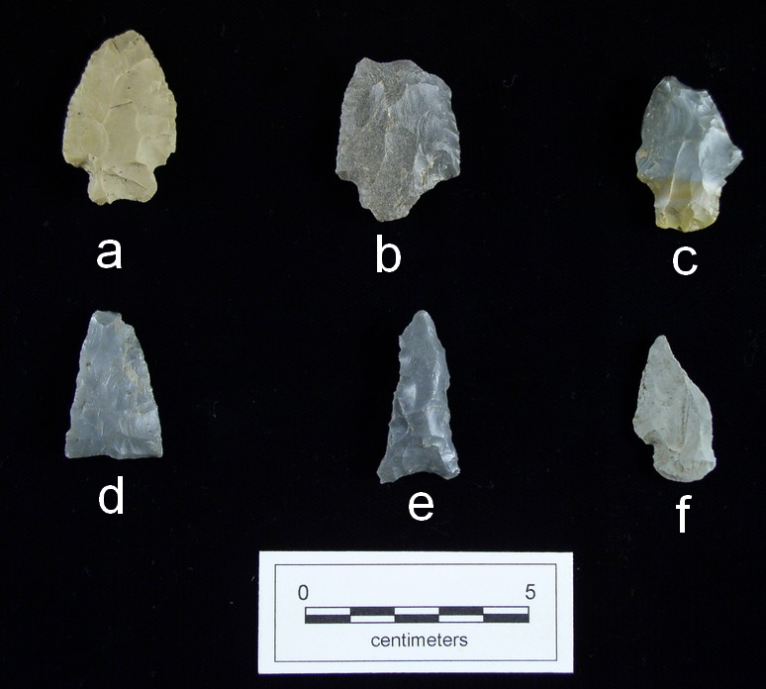
Figure 5.5. Other hafted thin bifaces. a-c, Residual Stemmed; d-e, Hamilton; f, Beacon Island hafted bifaces from the Whitesburg Bridge site.

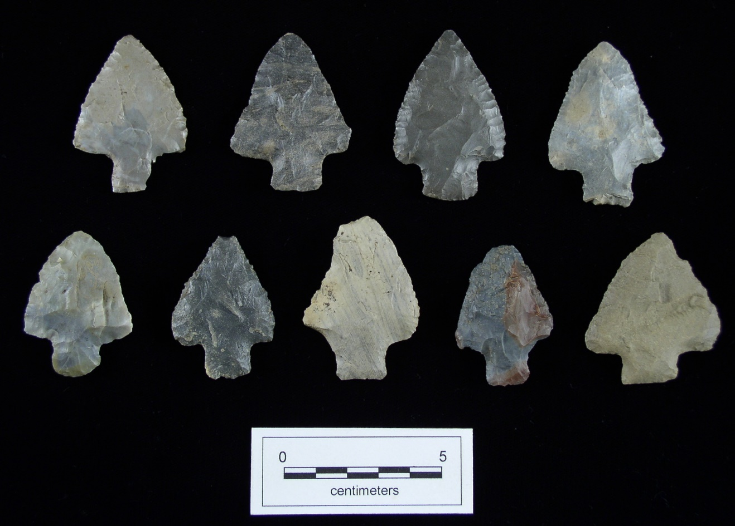
Figure 5.6. Cotaco Creek hafted bifaces from the Whitesburg Bridge site.

stage type fractures, one late stage, and four associated with use, while twenty-one
Cotaco Creeks do not have any observable fractures. Longitudinal, medial, and proximal specimens exhibit a wide variety of fractures with the majority being late stage fractures. The raw materials used for manufacture are overwhelmingly Bangor chert with 39 Blue-Gray, 5 Other, 4 Fossiliferous, 3 Other Fossiliferous, and 1 Black. The remaining two examples are Blue-Gray Fort Payne chert and Knox chert.
Limestone (Figure 5.7). Specimens representing this type total 42. Limestone hafted thin bifaces were excavated from Strata II (N=8), III (N=7), and IV (N=19). Eight were recovered from feature context with one each from Features 30, 37, 50, 70, 136, 266, 315, and 408. Twenty-eight specimens are intact specimens. One medial and thirteen proximal fragments are also present. Indications of fracture/failures on these tools suggest late-stage manufacturing errors, even though there are four with hinge fractures, generally associated with early-stage failures. Nevertheless, these are small hinges on what appear to be finished biface tools and likely did not cause tool discard. Other errors
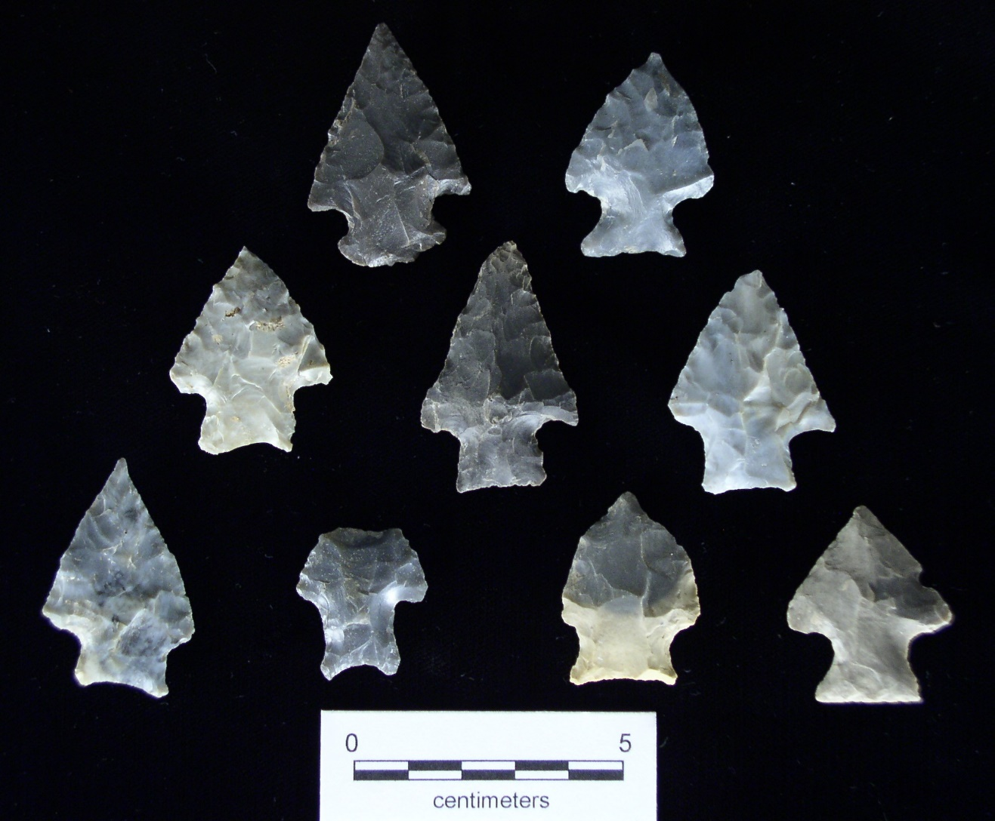
Figure 5.7. Limestone hafted bifaces from the Whitesburg Bridge site.

on the Limestones also indicate late-stage fractures, including one haft snap, three impact fractures, and one indeterminate fracture. One intact tool possibly has a small crenated fracture at the very distal tip, and in conjunction with a glossy appearance, is indicative of thermal alteration. Of the thirteen proximal portions, the highest frequency of fracture/failures is crenated (N=4) and impact (N=5), with two lateral snaps and two perverse fractures also present. Only three specimens exhibit beveling along the base with no beveling observed on blades. All of the Limestones are made of Bangor chert: 2 Black, 37 Blue-Gray, 1 Other, and 2 Other Fossiliferous.
Wade (Figure 5.8). Wade projectile points have the second highest frequency at 1Ma10 with a total of sixty-five. Strata II (N=23), III (N=10), and IV (N=22) produced the majority of Wade projectiles. Three were found in Stratum I and one was a surface find. Features 50, 168, 241, 299, 315, 348, and 408 yielded one example each. Completeness status for these tools is as follows: distals (N=3), longitudinal (N=1), medials (N=3), proximal (N=24), and intact (N=34). Twenty of the specimens classified as intact have no observable fractures or errors. Five specimens have use fractures and
five have with indirect fractures from exposure to heat. One Wade exhibits a hinge fracture and three fractures are unidentifiable. The majority of the fragmentary examples exhibit late stage errors along with small frequencies of early stage, use, and heat induced errors. Beveling was not a common practice on Wades with two specimens having basal beveling, four with beveled blade edges, and two with both blade and basal edges exhibiting evidence of beveling. All of the Wades except one are made of Bangor chert. There are 57 made of Blue-Gray Bangor chert, 3 each of Other Bangor and Other Fossiliferous Bangor, and 1 of Black Bangor. The final example is made of Jackson County Agate.

Motley Cluster
The Motley cluster includes only the Motley type. Motleys are characterized by wide, rounded corner notches resulting in a narrow stem. Motley projectile points in north Alabama date from Late Archaic through Gulf Formational times.
Motley (Figure 5.9). Seventeen specimens represent this cultural type. Motleys are distributed throughout the Site 1Ma10 strata with three from Stratum Ia, seven from

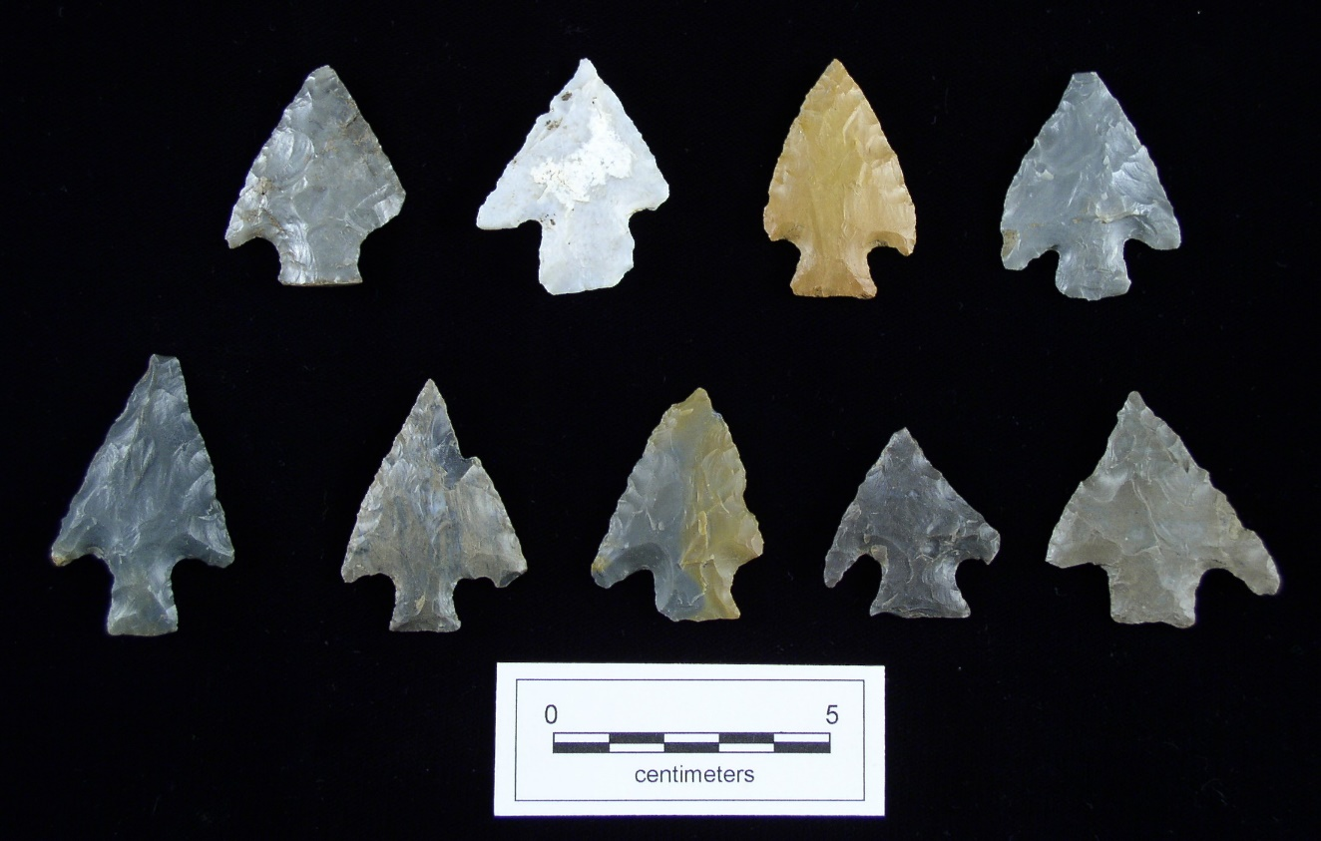
Figure 5.8. Wade hafted bifaces from the Whitesburg Bridge site.

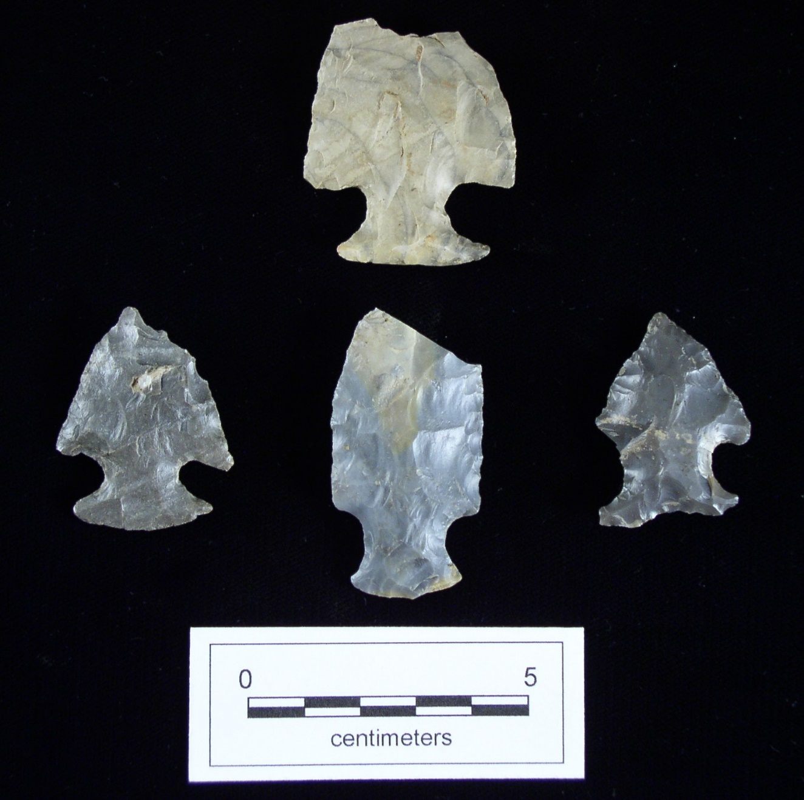
Figure 5.9. Motley hafted bifaces from the Whitesburg Bridge site.

Stratum II, two from Stratum III, and three from Stratum IV. Features 29 and 30 also contained one example each. All of the Motleys are made of Bangor chert: 13 Blue-Gray, 2 Other, 1 Other Fossiliferous, and 1 Black. Only two intact specimens were present along with fifteen proximal portions. Only one of the intact Motleys exhibits no errors or fractures. The majority (66 per cent) of tool fractures, however, are associated with late stage errors. Both intact examples appear to have been resharpened and five of the proximal portions have been resharpened as well. Basal beveling is present on three of the proximal portions.

Flint Creek Cluster
The Flint Creek cluster includes only the Flint Creek type. The Flint Creek type is distinguished primarily by its expanding to knobby haft element and fine retouch flaking on the blade edges. The type is widespread throughout northern Alabama and adjacent portions of Mississippi and Tennessee. Flint Creeks are found in Late Archaic to Middle Woodland assemblages but their strongest association is with the Late Gulf Formational. Flint Creeks were the most common individual type at 1Ma10 by a factor of almost two and the Flint Creek cluster was second in frequency only to the Wade cluster.
Flint Creek (Figure 5.10). Flint Creek is represented by 118 examples. They were found throughout the deposits but were most common in Stratum II (N=41) and Stratum IV (N=27). Stratum I produced 19 examples and 11 were found in Stratum III. Four specimens were surface finds. The remaining sixteen Flint Creeks were found in association with a wide variety of features, including five examples from historic features. Of the sixty-two intact specimens, forty-two have no visible fractures or failures. The other intact specimens have minor fractures including hinge (N=8), pot lid (N=4), impact (N=3), incipient (N=3), and indeterminant (N=2). Proximal portions (N=46) exhibited the highest frequency (N=11) of heat related fractures, crenated and pot lid fractures, combined. Bangor chert was used for the manufacture of 115 of the Flint Creeks, including 90 Blue-Gray, 10 Other Fossiliferous, 6 Black, 6 Other, and 1 Black. The other three include one example each of Blue-Gray Fort Payne chert, 1 Camden chert, and 1 quartzite.

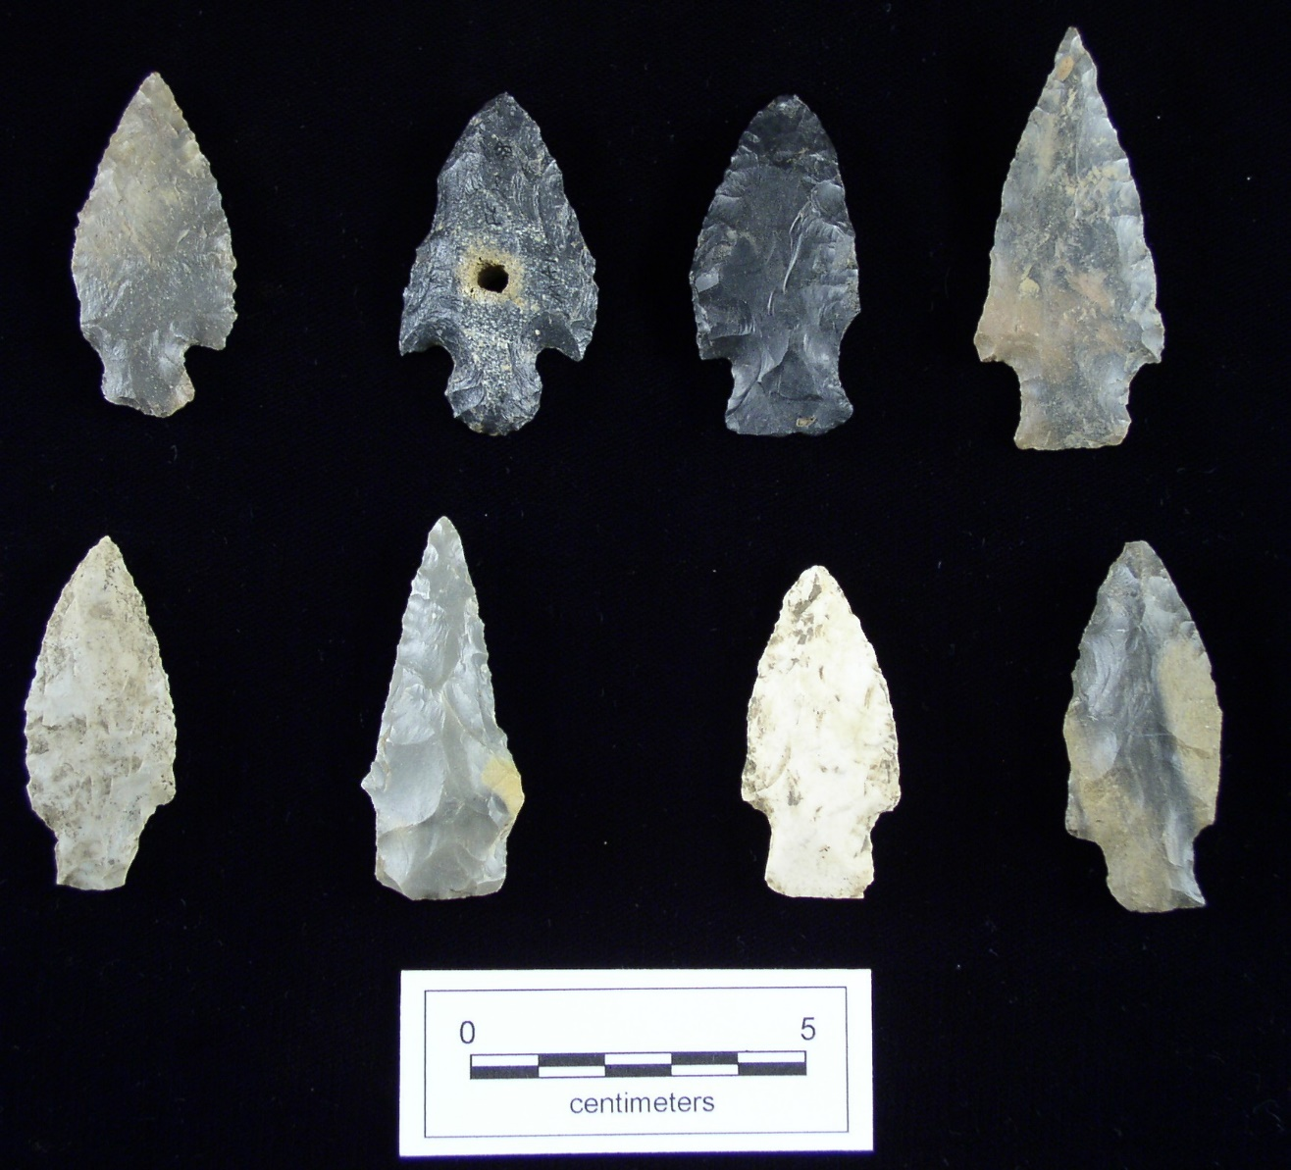
Figure 5.10. Flint Creek hafted bifaces from the Whitesburg Bridge site.

Other Late Archaic/Gulf Formational Hafted Thin Bifaces
Kays (Figure 5.2a-c). Two specimens represent this straight-stemmed Late Archaic type. One was made from Blue-Gray Bangor chert and one from Other Fossiliferous Bangor chert. Both were found near the base of the site, one from Stratum IV and the other from Stratum V. One Kays exhibits a perverse fracture near the distal end. The other specimen exhibits an impact fracture.
Residual Stemmed (Figure 5.6a-c). A total of 59 stemmed hafted thin bifaces could not be assigned to any type. Some specimens were too fragmentary for classification, others simply did not conform to any recognized type. Residual Stemmed bifaces were found throughout the site but were concentrated in Stratum II with smaller numbers in Stratum I. They presumably date from Late Archaic to Woodland times.

Greeneville Cluster
The Greeneville cluster is represented by six cultural types totaling seventy-five specimens; Candy Creek (N=9), Copena (N=23), Copena Triangular (N=1), Greeneville (N=26), and Nolichucky (N=2), along with a Residual Greeneville Cluster group (N=14). These types are all middle sized triangular forms separated by variations of form, mainly blade shape. Greeneville cluster types are common throughout Middle Woodland sites in northern Alabama and adjacent areas. This cluster grouping was termed the McFarland cluster by Faulkner and McCollough (1973) for the Normandy Reservoir project and included medium-large triangular projectiles with straight to excurvate to elongated blades. Lafferty (1981) utilized this term also for the Phipps Bend project (1981). Futato
(1983) used the term Greeneville cluster to reflect the association of these types with the previously defined Greeneville complex (Larson 1959).
Candy Creek (Figure 5.11i-k). The Candy Creek type is typically a medium-sized, auriculate tool with recurved edges and an incurvate base (Cambron and Hulse 1975:23). Candy Creek hafted thinned bifaces are represented by four specimens from Stratum I, three from Stratum II, one from Stratum IV, and one from Feature 372. Six specimens are intact, one of which has an impact fracture, one a pot lid fracture, and four with no obvious errors. Three proximal portions have late stage fractures (impact, half
snap, and lateral snap). Blue-Gray Bangor chert was utilized for seven specimens,
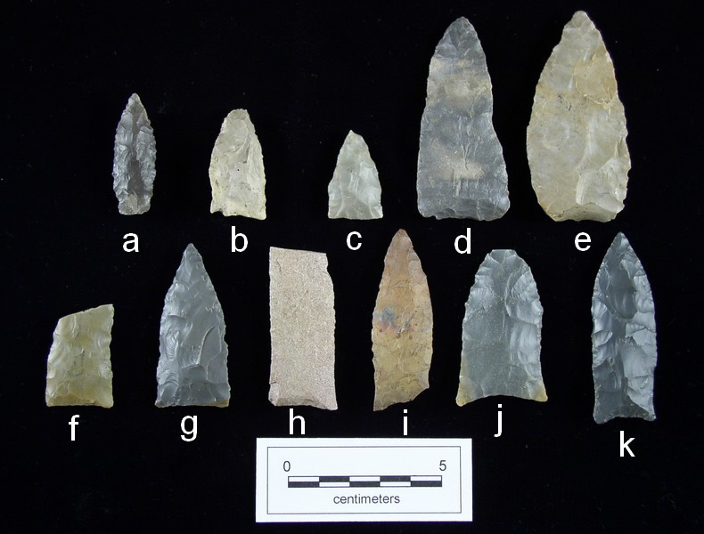
Figure 5.11. Greeneville cluster and Spike cluster. a, Bradley Spike; b-c, Nolichucky; d-e, Greeneville; f-h, Copena; i-k, Candy Creek hafted bifaces from the Whitesburg Bridge site.

Fossiliferous Bangor chert for one, and Other Fossiliferous Bangor chert also for one.
Copena (Figure 5.11h-k). Copena projectiles are medium to large-sized, triangular thin bifaces with recurvate blade edges and an acute tip. At 1Ma10, there are a total of twenty-three specimens with two from Feature 14 and twenty-one from general excavation units. The majority of Copena tools are from the upper levels of Stratum II in Block 1 and from Strata I and II in Block 2. Of the nine intact specimens, three have hinge failures, three have no fracture/failures, two have haft snaps and one has a heat related crenated fracture. All specimens are produced from Blue-Gray Bangor chert with the exception of one Fossiliferous Bangor chert and one Other Bangor chert.
Copena Triangular (Figure 5.11g). Copena Triangular is identified by excurvate blade edges trending toward parallel at the base. This type at 1Ma10 is represented by one proximal specimen excavated from Block 1, Stratum II. Blue-Gray Bangor chert was utilized to produce this projectile. This tool is broken in half by a haft snap fracture and has a small amount of cortex present.
Greeneville (Figure 5.11d-f). Greeneville is the most abundant Middle Woodland type from 1Ma10, represented by twenty-six specimens. The form of Greeneville is very similar to that of Copena Triangular with the only difference being a tendancy toward straighter blade edges in Greeneville. Greenevilles are concentrated in the upper portion of Site 1Ma10 with 24 of the 26 examples found in Strata I-II. Local materials were selected for these tools. Blue-Gray Bangor chert dominates with 20 examples. Three are made of Other Bangor chert, two of Other Fossiliferous Bangor chert, and one of Blue-Gray Fort Payne chert. Seven Greenevilles were classified as intact. Five of these have minor hinge failures. One may be unfinished, possibly due to the hinge failure. Of the sixteen basal portions, seventy-five percent exhibit late stage fractures (perverse=8, lateral snap=4).
Nolichucky (Figure 5.11b-c). This cultural type is represented by two specimens, one from Stratum II of Block 1 and one from Stratum I of Block 2. Both specimens are manufactured from Blue-Gray Bangor chert, and are intact. One has a hinge failure with a small amount of cortex present at the widest part of the hinge. The manufacturer likely was unable to overcome this error, yet it cannot be said with certainty whether this tool was discarded due to the hinge failure or if it was put to use.
Residual Greeneville Cluster. A total of 14 broken specimens could be assigned in general to the Greeneville cluster but not to any of the specific types.

Lanceolate Expanded Stemmed Cluster
Two cultural types with sixteen members represent this cluster: Bakers Creek (N=12) and Swan Lake (N=4). Mud Creek is another type in this cluster. While Mud Creeks are fairly common in northern Alabama, none of the hafted thin bifaces from Whitesburg Bridge were placed in this type. Specimens placed in the Bakers Creek category exhibited narrow and usually tapered shoulders with a distinct expanded base. Specimens placed in the Swan Lake category have narrow and tapered shoulders as a result of broad, shallow side notches.
Bakers Creek (Figure 5.12d-i). Bakers Creek is typically a biface of medium size with a broad stemmed hafting element and usually an acute distal tip (Cambron and Hulse 1975:8). According to Justice (1995) they have a broad distribution in the southeast and are quite common in the Tennessee River Valley in Tennessee and Alabama, so it is not surprising to find this point type present at Site 1Ma10. A total of twelve specimens were recovered with three from Stratum I, seven from Stratum II, one from Stratum III, and one from Feature 25. Three are intact with no obvious errors. All three have been resharpened with one recycled into a hafted scraper. The tools exhibit extensive evidence of reshaping with beveling noted on one blade and on the basal portion. One proximal specimen has an early stage hinge error. Half of the proximal portions exhibiting heat related errors and half exhibit impact fractures, presumably possibly use related. Two of the proximal portions have basal beveling. Blue-Gray Bangor chert was utilized to produce eleven of the Bakers Creeks and Other Fossiliferous Bangor chert was utilized to produce one specimen.
Swan Lake (Figure 5.12a-c). Four specimens were assigned to the Swan Lake cultural type with three from Block 2, Stratum II and one from Feature 3. Two intact specimens exhibit small hinge fractures, one of which was significant enough that resharpening created an asymmetrical tip. This specimen was possibly utilized as an awl or perforator. Three Swan Lakes were manufactured from Blue-Gray Bangor chert and
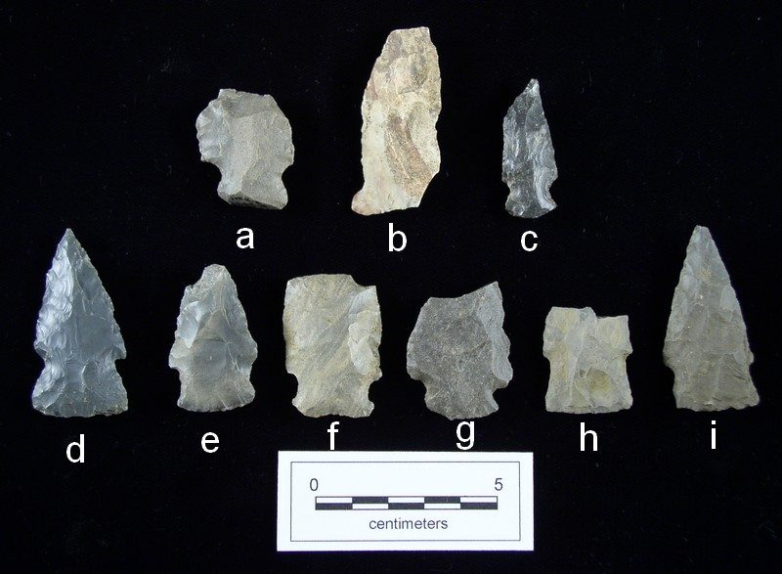
Figure 5.12. Lanceolate Expanded Stemmed cluster. a-c, Swan Lake; d-i, Bakers Creek hafted bifaces from the Whitesburg Bridge site.

the fourth from Other Bangor chert.

Spike Cluster
The Spike cluster can include a variety of lanceolate shaped, contracting stems and narrow or absent shouldered projectiles that can include such types as Bradley Spike, Flint River Spike, New Market, and Ebenezer. However, this cluster is poorly represented at 1Ma10 by a single Bradley Spike projectile point. The Spike cluster is generally assigned to the latter Middle Woodland and probably post-dates the Woodland occupation of this portion of Site 1Ma10.
Bradley Spike (Figure 5.11a). The Bradley Spike from Site 1Ma10 is a small to medium-sized, very narrow, thick, spike-like projectile with straight edges and a median ridge on both sides. The specimen was recovered from Block 2, Stratum I. The specimen is intact with no obvious errors. It was manufactured from Blue-Gray Bangor chert.

Thin Biface Fragment
Unidentifiable thin biface fragments totaled 811. These specimens have been thinned to a considerable state and, therefore, do not represent the earlier stages of the manufacturing process. These fragments were likely produced during the latter part of the thinning process or by using the thinned bifaces.

Other Bifacially Flaked Tools
Axe (Figure 5.13a-b). Three specimens represent this category with one from Stratum II, one from Stratum IV, and one from Feature 30. Two specimens are intact and one is a proximal portion. Each specimen is produced from a different material with one from Fossiliferous Bangor chert, one from Blue-Gray Bangor chert, and one from limestone. All three specimens were recovered from Block 1. These specimens typically exhibit extensive battering from use.
Adz (Figure 5.13c). Seven specimens represent this category with one from a surface collection, four from Stratum II, one from Stratum III, and one from Feature 241. Very little difference separates an axe from an adz in this collection. The adzes are thick and crude, while the axes are more thinned. The adzes were produced from a variety of materials with eight from local sources: limestone (n=4), Blue-Gray Bangor chert (n=3), and Other Bangor chert (n=1). Two were made from regional sources: Fossiliferous Fort
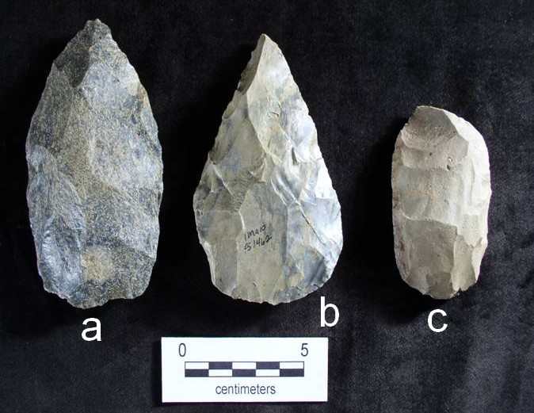
Figure 5.13. Axes and adz. a-b, axe; c, adz from the Whitesburg Bridge site.

Payne chert (n=1) and Fossiliferous Bangor chert (n=1).
Preform I (Figure 5.14, top row). Preforms are typically an ovoid, sometimes large bifacial tool produced in the early stages of the manufacturing process. This category is divided into Preform I and Preform II, based on minor technological and morphological differences. Technological attributes for the Preform I category include a lack of secondary flaking, large random flake scars, and usually some degree of cortex present. A total of three hundred and forty-two bifaces were categorized as Preform I tools. Of these, a relatively equal number were recovered from Strata II (28%), IV (29%), and feature context (22%). Curiously, only one Preform I was recovered from Stratum IV in Block I and forty-five from the same stratum in Block 2 suggesting the reduction stage may have taken place elsewhere or the manufacturing techniques for chipped stone tools at the time did not require the production of this biface type during production.
Twenty-two features each contained varying numbers of specimens. Many contained a single Preform I (as well as other tools); however, several features bear mentioning due to the presence of a high frequency of preforms. Feature 30, a rock cluster, contained ten Preform I tools, Feature 70 contained eight, Feature 241 contained twenty-two, Feature 392 contained five, and Feature 408 contained eight.
Preform II (Figure 5.14, bottom row). Specimens placed in the Preform II category are technologically and morphologically similar to the Preform I category. The major difference is the presence of at least a small amount of secondary flaking. Preform II includes a total of two hundred and eighty-three specimens.
Preforms II tools are present in all strata at 1Ma10, but the majority were excavated from Stratum II (42%) and Stratum IV (24%) and from features (11%). Feature 70 contained four, Feature 241 contained 12, and Features 392 and 408 contained four each. With the exception of Feature 30, Preform II tools are present in high frequencies in the same features as Preforms I.
Biface I (Figure 5.15, top row). Biface I tools typically are formed from preforms as more shaping takes place in the manufacturing process of chipped stone tools. Biface I tools are separated from preforms by additional shaping and some thinning. At this point in the biface production trajectory we see less cortex and more secondary flaking. Biface
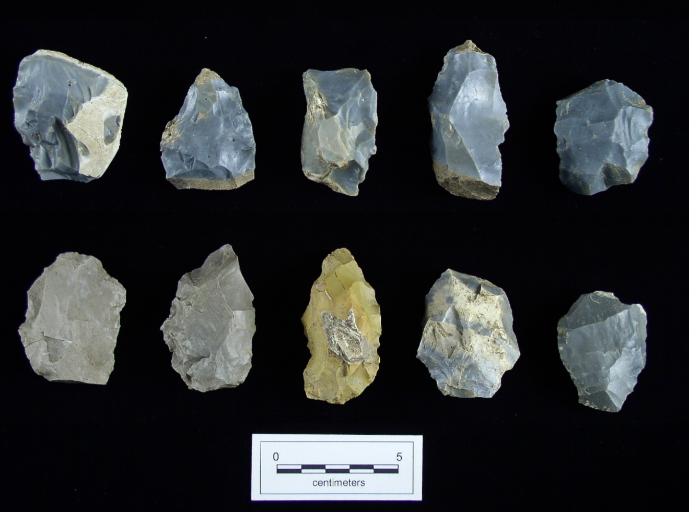
Figure 5.14. Preforms. Top row, Preform I; bottom row, Preform II from the Whitesburg Bridge site.

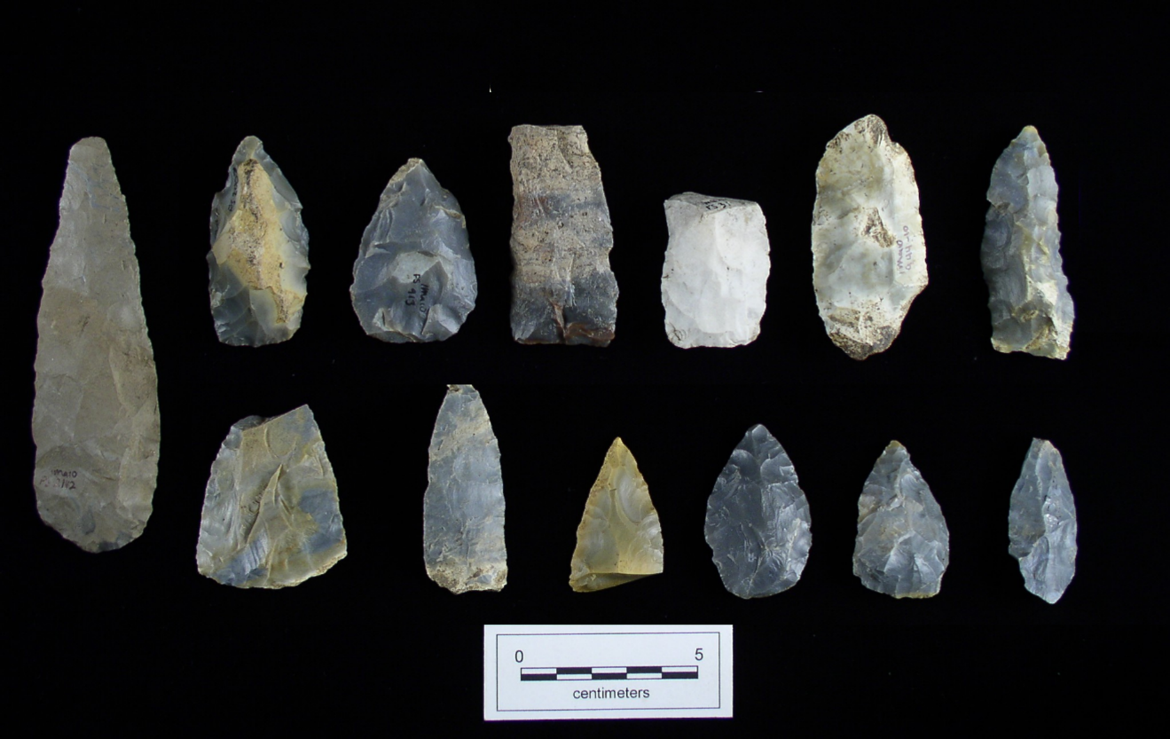
Figure 5.15. Bifaces. Top row, Biface I; bottom row, Biface II from the Whitesburg Bridge site.
I is distinguished from finished biface tools by a lack of extensive thinning. A total of two hundred and fifty-five Biface I tools were excavated with the majority recovered from Strata II (37%) and III (24%). Biface I tools were recovered from other strata and from features, but in smaller frequencies. Three specimens were excavated from Feature 30 and six from Feature 241. The majority of the fifteen features containing these tools had only a single specimen in this category.
Biface II (Figure 5.15, bottom row). Biface II tools at Site 1Ma10 exhibit extensive secondary flaking and shaping. They exhibit fine retouch along the edges of the biface and a considerable amount of thinning. They are essentially a projectile point without the hafting element. If the manufacturing process were to be continued, the next stage could include shaping of a haft element and additional fine pressure retouch and thinning. Two hundred and two specimens were excavated at Site 1Ma10 with the majority from Strata II (53%), I (16%), and IV (14%). Eight features contained one Biface II each and two features (Features 241 and 351) contained two specimens each.
Stemmed Scraper (Figure 5.16a-d). Stemmed scrapers in this collection are essentially hafted thinned bifaces reworked or modified into scraping tools. Six
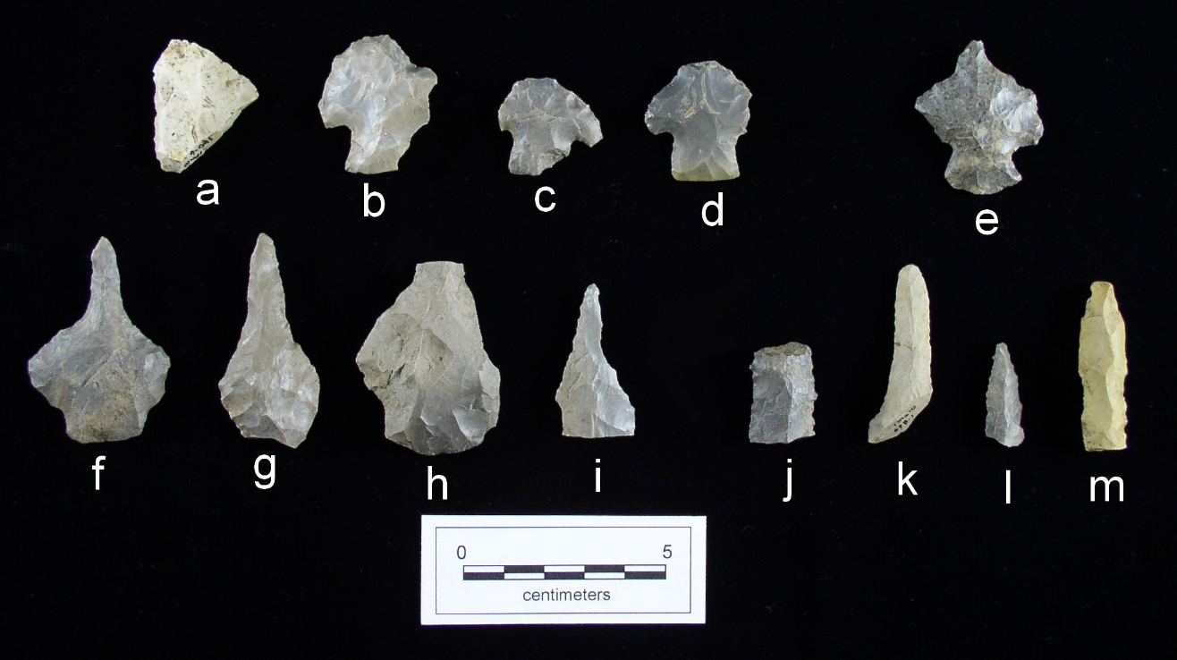
Figure 5.16. Drills and scrapers. a-d, hafted thinned bifaces reworked into scrapers; e, stemmed drill; f-i, expanded base drill; j-m, drill fragment from the Whitesburg Bridge site.

specimens represent this category with one specimen each in Strata I and III, and two specimens each in Strata II and IV. Three are produced from Blue-Gray Bangor chert, two from Fossiliferous Bangor chert, and one from Other Bangor chert. Two specimens have less than fifty per cent of cortex remaining and there is no indication of heat alteration on any of the stemmed scrapers. Two specimens were recycled from Flint Creek projectile points, one from a Little Bear Creek, and one from an unidentified hafted thinned biface.
Biface Scraper. The surface layer and Strata I, II and IV each have a single biface scraper. Two specimens are intact with no obvious fractures and two specimens are distal portions; one with a lateral snap and one with a perverse fracture. Three specimens were produced from Blue-Gray Bangor chert and one from Fossiliferous Bangor chert.
Expanded Base Drill (Figure 5.16f-i). Seven specimens represent expanded base drills with five from Block 1 and two from Block 2. Six are produced from Blue-Gray Bangor chert and one from Other Bangor chert. The completeness of these tool types are as follows: three are intact, two are proximal portions, and two are distal portions. All three intact specimens and both proximal portions appear to have been recycled from hafted projectile points.
Stemmed Drill (Figure 5.16e). One specimen representing this category was recovered from Stratum II, Block 1. It was manufactured from Other Bangor chert. This tool is likely a hafted thinned biface recycled into a drill.
Drill Fragment (Figure 5.16j-m). Twelve specimens represent incomplete drills having been broken either in manufacturing process or during use. The majority of these tool types were recovered from the upper strata: four from Stratum I and five from Stratum II. One each was recovered from Stratum III, V and Feature 372. No drill fragments were recovered from Stratum IV. Nine fragments were made from Blue-Gray Bangor chert and three from Other Bangor chert. Interestingly, all but one from Feature 372 (Block 2) are from Block 1. Seven appear to have been recycled from other tools, most likely from hafted projectile points. Five of the distal specimens had an acute tip.

Uniface and Flake Tools
End Scraper (Figure 5.17n-p). End scrapers typically exhibit limited modification along the side(s) as opposed to the end of the tool. Eleven specimens represent this category at 1Ma10 with six from Block 1, four from Block 2 and one from Feature 396 (Block 2). Ten specimens are produced from Blue-Gray Bangor chert and one from Fossiliferous Black Bangor chert. Ten specimens were intact and one is a distal portion. Only one exhibits thermal alteration. The majority of this tool type exhibit flaking only along the working edge while four exhibit prior shaping. Three specimens indicated flaking along the side and end of the tools. As expected with tools of an informal nature, eight had cortex present.
Graver (Figure 5.17a-c). A typical graver exhibits a sharp tip utilized to engrave wood, bone, or stone, and are associated with hide working as well. Graver tips are seen on a broad array of tools, for example; reworked projectiles and scrapers. Seventeen specimens represent the graver category with one from Stratum I, twelve from Stratum II, and three from Stratum IV. No specimens were recovered from Stratum III. One thermally altered specimen was excavated from Feature 129. With the exception of two Fossiliferous Bangor chert specimens all were produced from Blue-Gray Bangor chert.

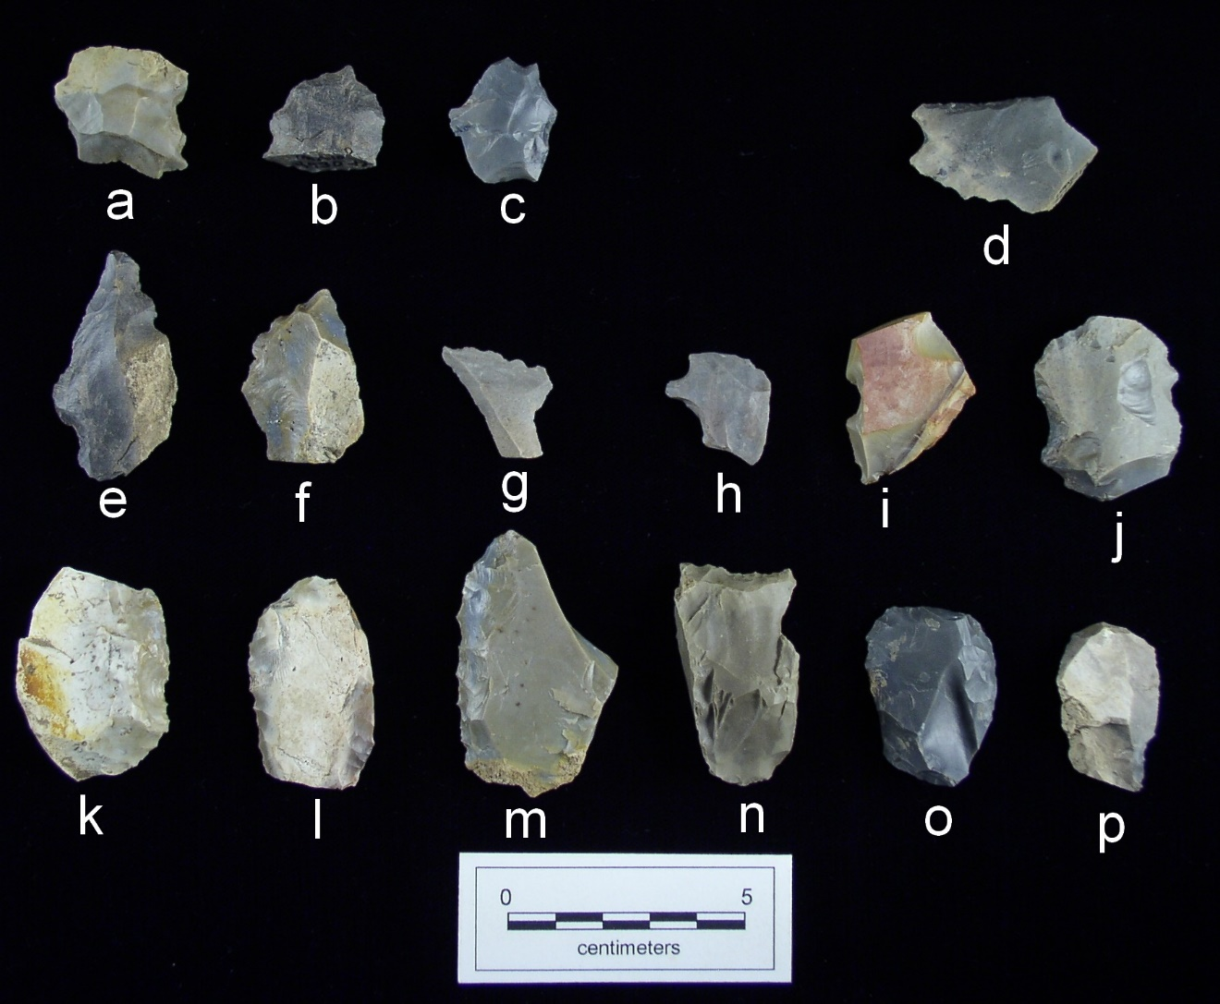
Figure 5.17. Uniface tools. a-c, graver; d, scraper/graver; e-g, denticulate; h-j, spokeshave; k-m, side scraper; n-p, end scraper from the Whitesburg Bridge site.

Denticulate (Figure 5.17e-g). Denticulate tools exhibit an edge with the appearance of notches or serrations. Four specimens represent this category with all four excavated from Stratum II. One specimen is a combination tool with a graver tip and was excavated from Feature 336. All are produced from Blue-Gray Bangor chert and all are produced on expanding flakes. Three of the four have cortex remaining on the tool.
Spokeshave (Figure 5.17h-j). This tool type exhibits an intentionally notched area resembling a lunar shape, utilized to smooth, shape, or shave wooden implements. Typically categorized as an expedient tool, spokeshaves can be fashioned quickly on a broad array of stone artifacts. Flakes and scrapers are the most common tool utilized to produce a spokeshave. Twelve tools represent this category in the 1Ma10 collection with eight excavated from Stratum II and one from Stratum IV. Features 5, 310 and 310 each produced one specimen. One specimen is produced from Fossiliferous Black Bangor chert and eleven from Blue-Gray Bangor chert.
Side Scraper (Figure 5.17k-m). Eleven specimens represent this category with three from Stratum I and four from Stratum II. The following each have one specimen: surface, Stratum IV, Feature 315, and Feature 396. All are produced from Blue-Gray Bangor chert with nine intact specimens and two distal portions. Six specimens have cortex present. With the exception of one, all specimens have flaking on the working edge only.
Side/End Scraper. This category includes two tools with modification on the end and side. One is from Stratum II and another from Stratum III and both were produced from Blue-Gray Bangor chert.
Scraper/Spokeshave. This category includes chipped stone with a scraping edge as well as notching. Three specimens represent this multi-use, expedient category. One specimen was excavated from Stratum I, one from Stratum II, and one from Feature 315.
Uniface Scraper Fragment (Figure 5.18o-p). Specimens in this category are fragments of varying sizes. Forty-two specimens represent this category with one recovered from a surface context, eleven from Stratum I, fourteen from Stratum II, two from Stratum III, and eight from Stratum IV. Six specimens are from a feature context with one each from Features 6, 30, 376, and 392, and two from Feature 70. All specimens
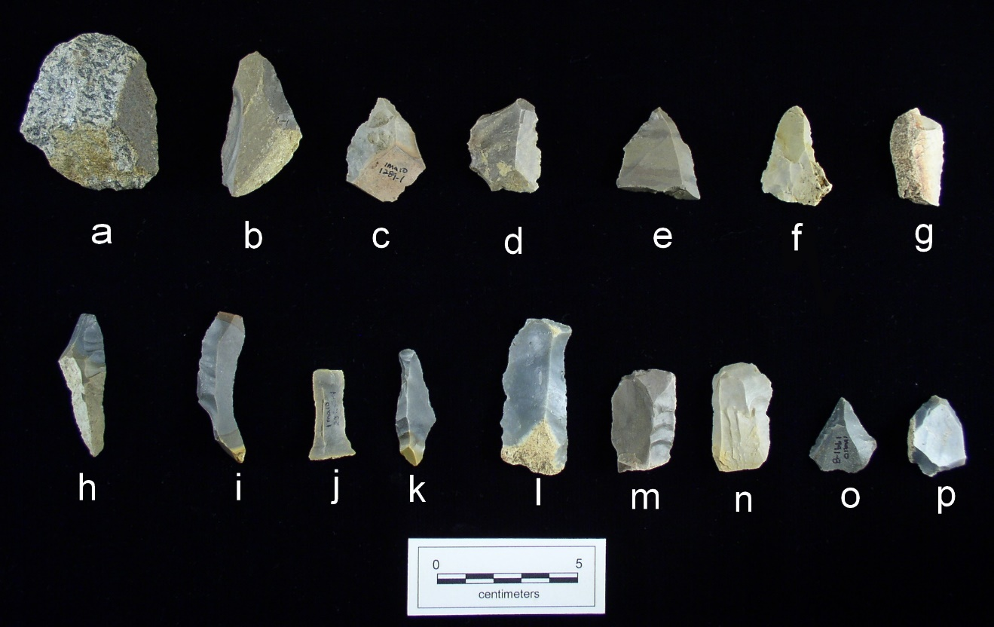
Figure 5.18. Uniface, flake, and blade tools. a-d, utilized flake; e-g, retouched flake; h-k, utilized blade; l-n, retouched blade; o-p, uniface scraper fragment from the Whitesburg Bridge site.

are produced from Blue-Gray Bangor chert except one produced from Fossiliferous Bangor chert, and one from Other Bangor chert.
Retouched Flake (Figure 5.18e-g). A retouched flake typically exhibits deliberate modification by fine pressure retouch along the cutting edge. One hundred and forty-four flakes were identified as exhibiting obvious retouch along an edge, having a rather uniform appearance. Five specimens were collected from the surface, twenty-five from Stratum I, sixty-seven from Stratum II, ten from Stratum III, fifteen from Stratum IV, and twenty-two from a feature context. Of the twenty-two specimens from a feature context, seven were recovered from Feature 70. Features 30 and 315 contained two specimens each. Eleven features contained one specimen each: Features 7, 14, 50, 107, 170, 300, 311, 344, 380, 396, and 408. Six per cent of this category was heated and forty-one
percent had cortex present. Local raw material was utilized in the manufacture of 92 percent of these tools.

Utilized Flake (Figure 5.18h-k). In contrast to a retouched flake, utilized flakes exhibit random jagged flake scars along the cutting edge resulting from use rather than exibiting larger, more systematic, deliberate flaking. Two hundred and sixteen flakes were identified as possibly having evidence of utilization. Thirty-five specimens were recovered from Stratum I, one hundred and thirty from Stratum II, fifteen from Stratum III, eighteen from Stratum IV, and eighteen from feature contexts. Feature 408 contained three specimens, otherwise four features contained two specimens each (Feature 30, 341, 347, and 380), and seven features contained one specimen each (Features 7, 310, 365, 377, 378, 393, and 396). Six per cent of the flakes in this category were heated and forty-two per cent had cortex present. The dominant raw materials were the locally available Blue-Gray Bangor chert and Other Bangor chert, comprising ninety-two per cent. The remaining eight per cent were of regionally available materials.
Retouched Blade (Figure 5.18l-n). Retouched blades (flakes at least twice as long as wide) typically exhibit deliberate modification by fine retouch along the cutting edge. Sixteen specimens were placed into the retouched blade category with two from Stratum I, eight from Stratum II, two from Stratum III, one from Stratum IV, and one from Feature 408. Fifty-six per cent of the retouched blades had cortex remaining. Only one example indicated thermal alteration. Locally available materials (Blue-Gray Bangor chert and other Bangor chert) comprise eighty-seven per cent and regionally available materials (Blue-Gray Fort Payne chert and Fossiliferous Black Bangor chert) comprise thirteen per cent of the raw materials utilized to produce this tool type.
Utilized Blade (Figure 5.18h-k). In contrast to a retouched blade, utilized blades exhibit random jagged flake scars along the cutting edge resulting from use rather than from deliberate flaking. Twenty specimens were identified as a utilized blade.
Flake Tool. This is a general, undifferentiated, category with five specimens. They are quite small, and without a platform, preventing orientation. One flake tool was excavated from Stratum I, three from Stratum II, and one from Stratum IV. One is produced from Black Bangor chert and four from Blue-Gray Bangor chert.

Perforators and Reamers
Two distinctions were made with perforating type tools. The first was to separate perforators from reamers. Reamers were characterized as appearing to have been hand held, thick and usually exhibiting a dulled distal end. Perforators were characterized as a hand held or hafted punch type tool having an acute distal end. Perforators are typically produced from flakes in an informal fashion. The second distinction was to separate perforators and reamers based on size. The smaller tools in these categories (a guide of <30 mm in length was used in addition to overall appearance) were then placed into microlith categories: microlith reamer, microlith perforator, expanded base microlith perforator, microlith drill, microlith needle, and microlith fragment. Larger tools in these categories were placed into the following categories: reamer, perforator, expanded base perforator, and flake perforator. Tools in both the perforator and reamer categories may have been utilized to modify wood, hide, and possibly other materials.
Perforator (Figure 5.19, top row) Five specimens represent the perforator category with two from Stratum I, two from Stratum II, and one from Feature 408. Three specimens are intact, one is a distal portion, and one is a proximal portion. The specimen from Feature 408 is the largest at 7.1 g and 32.5 mm in length. Almost half of the surface area exhibits cortex. All specimens exhibit minimal bilateral retouch.
Flake Perforator. Only one tool is included in this category. Being informal and expedient, the flake perforator is a secondary flake with a projection having minimal evidence of intentional modification.
Expanded Base Perforator (Figure 5.19, middle row). Four specimens represent the expanded base perforator category with three from Stratum II and one from Feature 241. These tools were fashioned on expanding flakes, exhibit bilateral dorsal retouch, and may have been hafted. Three were produced from Blue-Gray Bangor chert and one from other Bangor chert.
Reamer (Figure 5.19, middle row). Eight reamers were excavated with half from Stratum II (n=4), and the remainder are distributed evenly among the other strata. Blue-Gray Bangor chert was the dominant raw material for this tool type with Black Bangor chert used for one specimen and Fossiliferous Bangor also used for one.
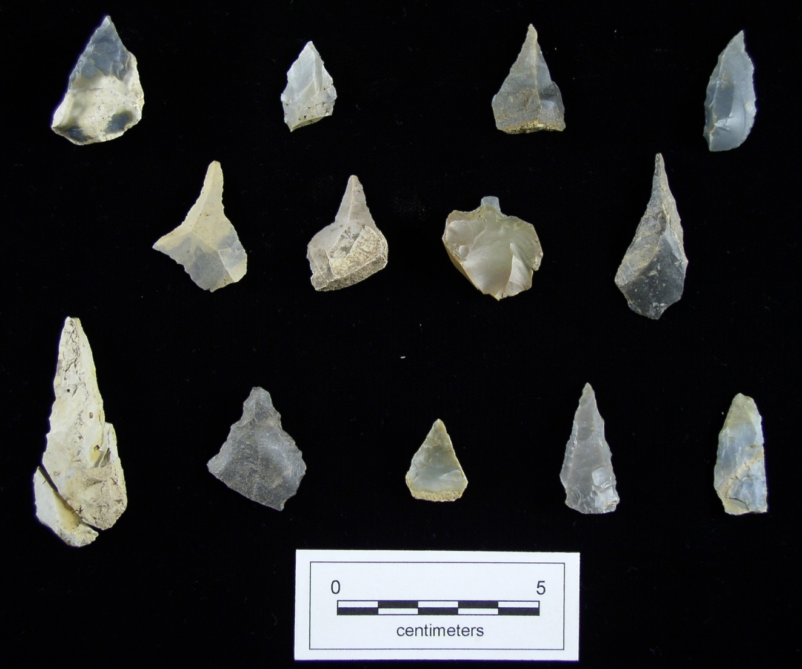
Figure 5.19. Perforators and reamers. Top row, perforators; middle row, expanded base perforators; bottom row, reamers from the Whitesburg Bridge site.

Microlithic Tools
Microlith Perforator (Figure 5.20, bottom row). Microlith perforators are well represented at Site 1Ma10 with thirty-eight specimens. The majority (fifty-eight per cent) were excavated from Stratum II, sixteen per cent from Stratum III, and fourteen per cent from Stratum IV. Features 15, 311 and 241 each had one mircrolith perforator. Ninety-four per cent were produced from Blue-Gray Bangor and six per cent from Other Bangor. All specimens are informal and none appear to have been recycled.
Microlith Needle (Figure 5.20, top row). Microlith needles are small and very narrow. Microlith needles are represented by ten specimens, with four from Block 1, four from Block 2, and one each from Feature 68 and Feature 408. Their distribution patterns include three from Stratum II, two from Stratum III, and three from Stratum IV. At least
half of the specimens exhibit bilateral retouch with two exhibiting dorsal retouch. Nine specimens are intact with one proximal section.
Microlith Reamer (Figure 5.21a-d). Four specimens represent the microlith reamer category. Three are from Stratum II and one from Feature 26. All specimens are produced from Blue-Gray Bangor chert. There is no cortex remaining on the tool surfaces. All four specimens have alternate flaking creating steep working angles on alternate edges.
Micro Drill (Figure 5.21e-f). Two excellent examples of microlithic drills represent this category. Both are from Stratum I, Block 2. Both are intact and fashioned from flakes.
Expanded Base Microlith Drill (Figure 5.21g-h). These tools were fashioned on small expanding flakes. Three specimens represent this category, with one each from Strata II, III, and IV.
Microlith Fragment. Two specimens represent this category. They are obvious microlith tools; however, they are fragmentary and incomplete. Both were produced from Blue-Gray Bangor chert.

Cores and Core Tools
Cores are pieces of stone from which flakes have been removed, rendering the core smaller and smaller as more flakes are produced. The core ultimately becomes so
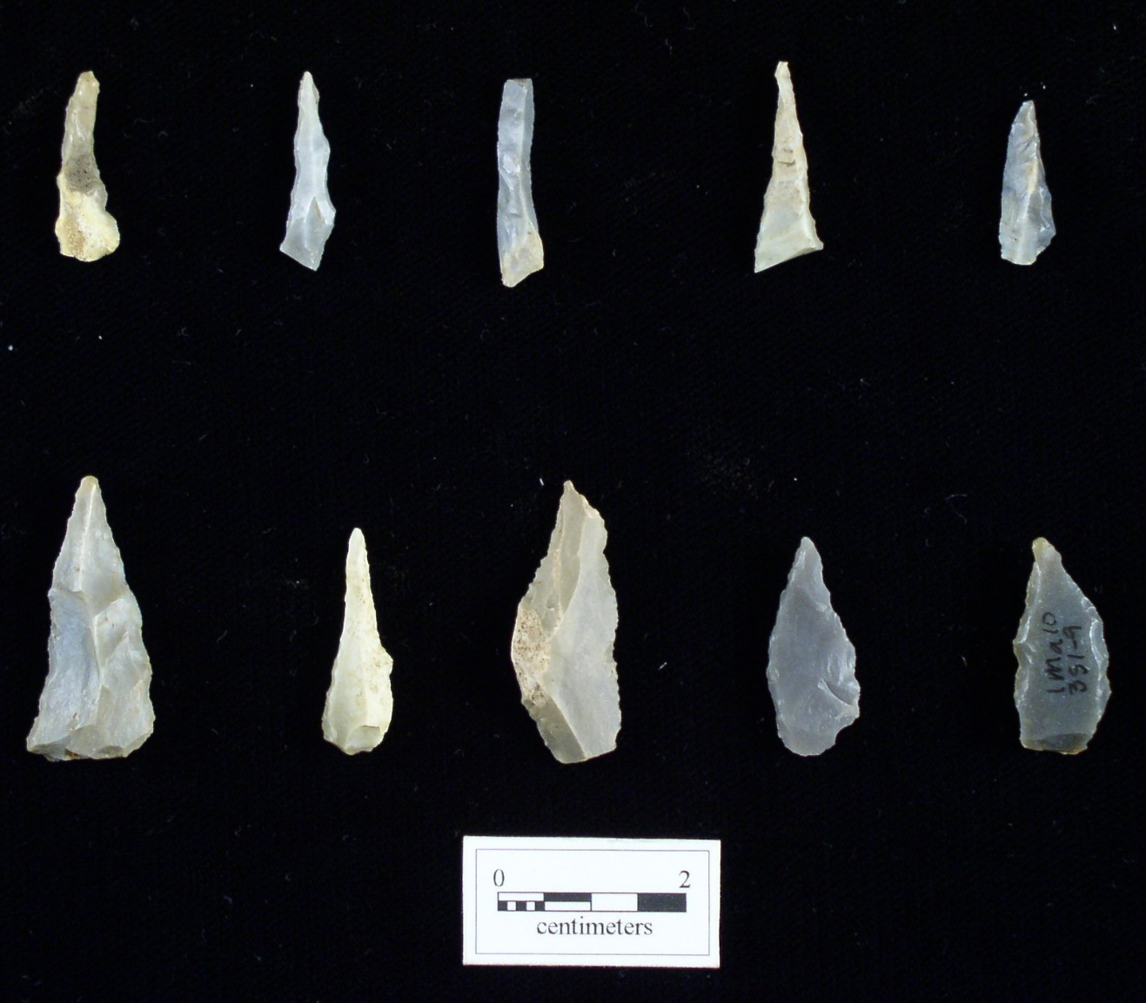
Figure 5.20. Microlith needles and perforators. Top row, microlith needle; bottom row, microlith perforator from the Whitesburg Bridge site.

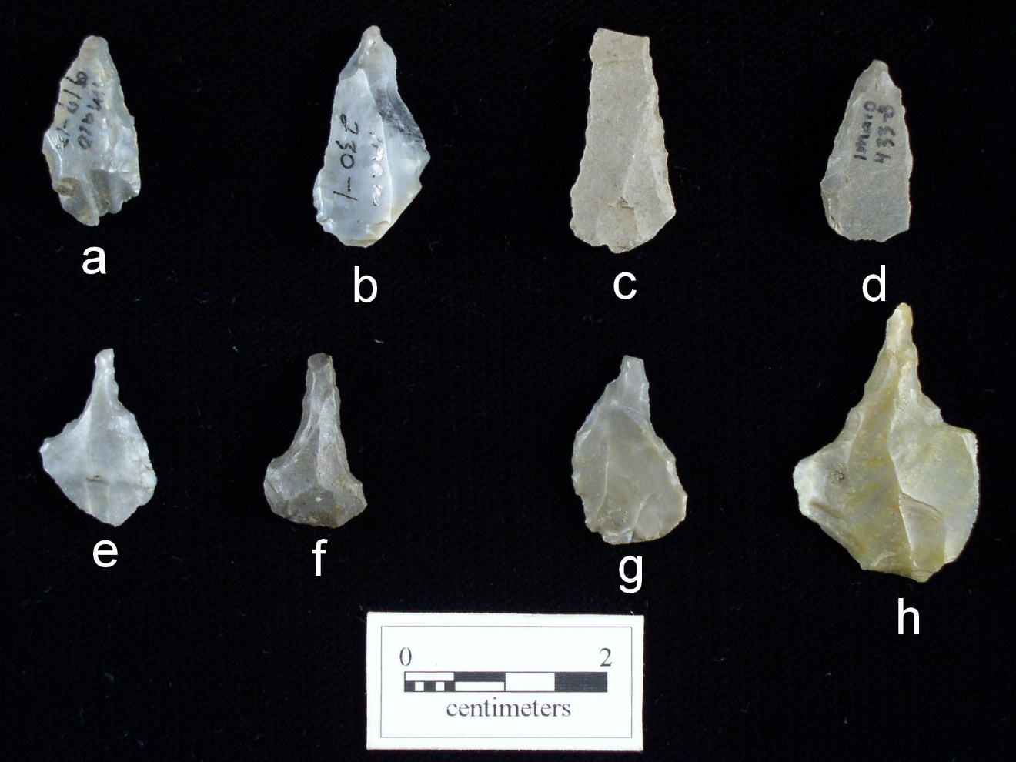
Figure 5.21. Microlith reamers and drills. a-d, microlith reamer; e-f, micro drill; g-h, expanded base microlith drill from the Whitesburg Bridge site.

small that it is expended or exhausted and too small for continued flake removal. Cores may also serve as tools and are utilized for chopping and scraping, as spokeshaves, abraders, and any number of tool types. Many of the cores from 1Ma10 were utilized for tasks other than serving as a core exclusively. A core was placed into the core tool category if any edge modification or evidence of battering, chopping, or scraping was present. Minor edge modification can indicate expedient tasks requiring very little preparation.
Cores are well represented at Site 1Ma10 and include the following categories: amorphous core (n=414), blade core (n=9), utilized core (n=78), microlith core (n=1), core chopper (n=17), core tool (n=3), and core fragment (n=52).
Amorphous Core (Figure 5.22). Amorphous cores exhibit flake scars and platforms in more than one direction. Amorphous cores require no specialized technology or skill. A total of four hundred and fourteen amorophous cores exhibiting random multidirectional flake scars were excavated. These specimens were distributed among all strata, with the majority from Strata II (30%), Stratum IV (27%), and from a feature context (24%). Four features stand out for the high frequencies of cores recovered: Feature 29 (n=11), Feature 241 (n=22), Feature 392 (n=8), and Feature 408 (n=17).
Blade Core (Figure 5.23c-f). A blade scar is typically twice as long in length as in width and cores having blade scars were prepared for flake removal in a different manner than amorphous cores. Blade core platforms are prepared at a different angle and flakes are removed in a systematic fashion known to be quite economical in terms of flake
production. A total of nine blade cores were recovered with no particular pattern of distribution observable. No blade cores were recovered from a feature context.
Microlith Core (Figure 5.23b). A microlith core is utilized to remove small debitage typically used in the subsequent production of microlith tools. This category is represented by one specimen recovered from Stratum II, Block 1.
Utilized Core (Figure 5.23h-j). Utilized cores exhibit evidence of some type of use in the form of a battered or modified edge. Eighty-one specimens represent this category with thirty-four recovered from Block 1, thirty-two from Block 2, and fifteen
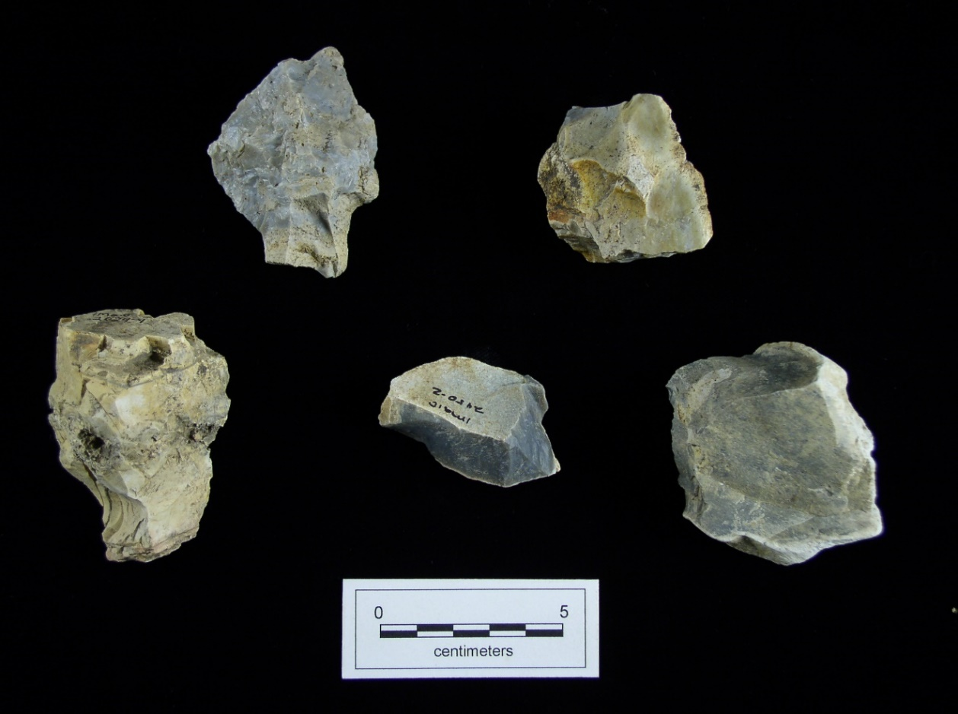
Figure 5.22. Amorphous core from the Whitesburg Bridge site.

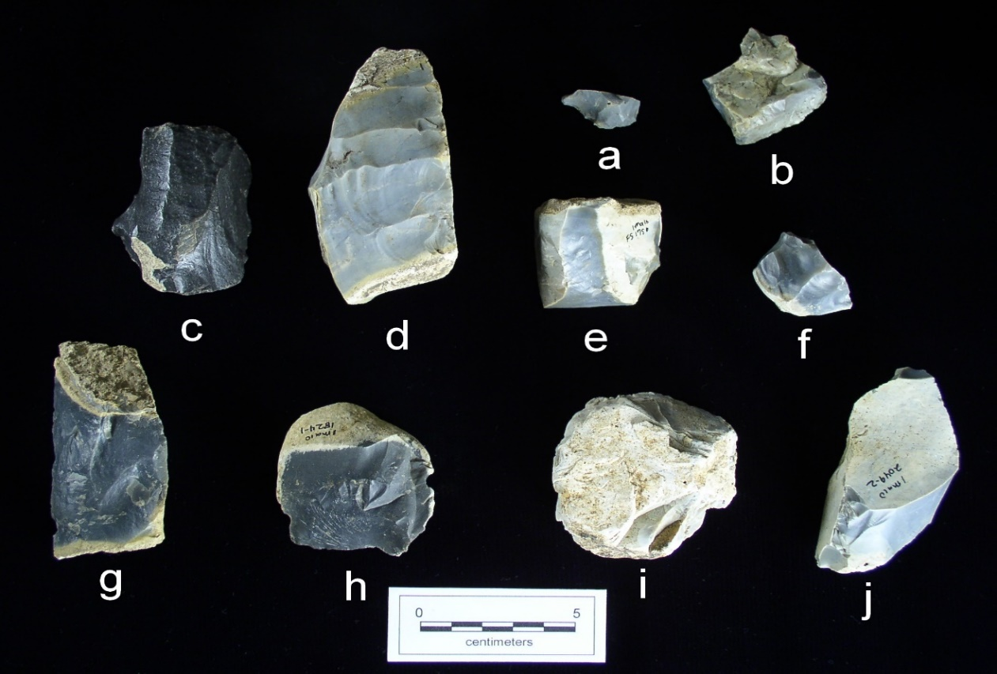
Figure 5.23. Core and scraper on a core. a, scraper on a core; b, microlith core. c-f, blade core; h-j, utilized core from the Whitesburg Bridge site.
from a feature context. One utilized core was recovered from each of the following features: Features 29, 30, 240, 241, 313, and 364, and two each from the following features: 70, 336, and 392. Only Feature 408 contained three utilized cores. One of these tools was recovered from the surface. The rest were distributed by stratum in the following manner: Stratum I (n=10). Stratum II (n=33), Stratum III (n=1), and Stratum IV (n=21).
Blue-Gray Bangor chert was utilized for manufacture of ninety-three per cent of the utilized cores with Black Bangor chert, Fossiliferous Black Bangor chert, and Other Bangor chert materials comprising minor amounts. Additionally, sixteen examples of this tool type exhibit a combination of blade flake scars and random flake scars with the remainder having only random, multidirectional flake scars.
Core Chopper (Figure 5.24). This category includes cores utilized as a chopping implement likely used in the butchering process as well as other food preparation. Core choppers can be quite large and have an angular cutting edge. Seventeen specimens represent this category with ten excavated from Block 1, six from Block 2, and one from Feature 137, characterized as containing a cache of cores. Feature 137 included a total of five cores: three amorphous cores, one core chopper, and one core with retouch along one edge.
Core Fragment. Core fragments represent broken or possibly exhausted
specimens. Fifty-two specimens represent this group with thirty-five recovered from Block 1, seventeen from Block 2, and none recovered from a feature context. Twenty-one were recovered from the surface, eight from Stratum I, twelve from Stratum II, two from Stratum III, and nine from Stratum IV.
Not surprisingly, seventy-three per cent show cortex on less than half the surface, and twenty-five per cent have no cortex remaining. Only two per cent having cortex on more than half the surface. One would expect a low number of fragmentary or exhausted cores to have a high amount of cortex remaining. Fifty-one out of fifty-two specimens are made of Blue-Gray Bangor chert.

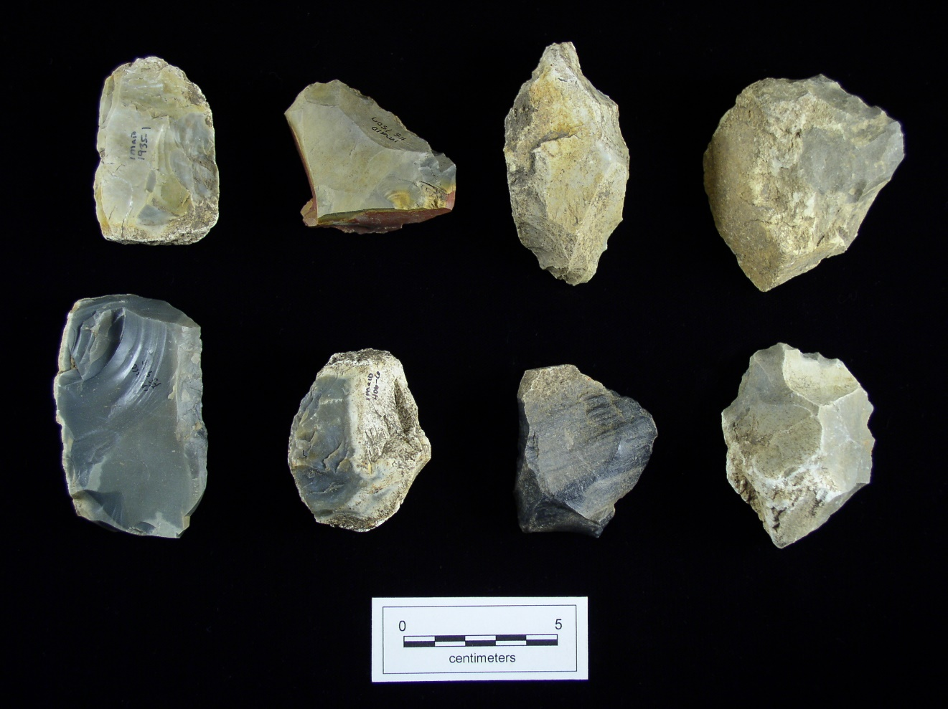
Figure 5.24. Core choppers from the Whitesburg Bridge site.

Discussion
As expected, local materials dominate the entire chipped stone collection with a total of 89 percent. Local materials utilized to produce chipped stone tools include Blue-Gray Bangor chert, Other Bangor chert, and unspecified limestone (Figure 5.25). Tools from all categories reflect the dominance of Blue-Gray Bangor chert in all stages of manufacturing and in all chipped stone tool categories. These local materials were readily available and appear to be high quality. Regionally available materials present include quartzite, Knox chert, Pickwick chert, Blue-Gray Fort Payne chert, Upper Fort Payne chert, Fossiliferous Fort Payne chert, Fossiliferous Black Bangor chert, Black Bangor chert, and Jackson County agate. Bangor materials combined (80%) and Blue-Gray Fort Payne (11%) comprise the majority of regional materials with other categories including only very small frequencies (Figure 5.26). The implication is that the occupants of the site had ready access, either through direct access or trade to these resources as opposed
Figure 5.25. Raw material distribution by availability.

Figure 5.26. Raw material distribution by availability.

to others or that the material was preferred for certain tool types.
The hafted thin bifaces recovered from the excavated strata and from feature context indicate a strong preference of the occupants for Flint Creek and Wade type points. This preference is maintained between Strata IV and II, indicating a continuation in lithic technology between the preceramic components of Stratum IV and the ceramic bearing deposits of Stratum II. Variation between the two deposits, however, is evident in the increased numbers of Cotaco Creek points and medium to large triangular hafted thin bifaces, such as Copena and Greeneville, in Stratum II. All three are prevalent in Stratum II and almost non-existent in Stratum IV.
Wade types have been recovered from Late Archaic associations at the Flint River site 6 km upstream (Webb and DeJarnette 1948a). Wades are also present at the Poverty Point site and at Late Archaic sites in Kentucky, and Illinois (Justice 1987). Wade cluster types have a strong Late Archaic through Gulf Formational association in Tennessee and the western Tennessee Valley and in the Cedar Creek drainage (Futato 1983). In the Cumberland river valley, Wade is assigned to the Archaic-Woodland transition
(McNutt and Weaver 1983) and in the Duck River drainage Wade has been dated to 1010 ± 135 BC (McCollough and Faulkner 1976).
All of the Early Archaic period points (Palmer, Big Sandy, MacCorkle Stemmed, Kirk Corner Notched, Lost Lake, and Residual Bifurcate) were encountered in either sur-face collections of the site or in the upper portion of Stratum II, at the base of the plowzone (Stratum I). Their presence at the site can likely be attributed to secondary contexts and fortuitous recycling of found projectile points by post-Early Archaic occupants of the site. As discussed in Chapter IV, all these Early Archaic types predate the landform upon which Site 1Ma10 is situated.
While several of the Middle Archaic hafted thin bifaces (Crawford Creek, Cypress Creek, Morrow Mountain, Stanley Stemmed, and Sykes/White Springs) also likely represent reuse of found objects by the later occupants of the site, but the presence of three Sykes/White Springs points within the Stratum IV deposits may not. By far the most prevalent points types (Ledbetter, Kays, Limestone, Wade, Motley, Pickwick, Little Bear Creek, Mulberry Creek, Hamilton Stemmed, Flint Creek, Cotaco Creek, Beacon Island, Gary, and Residual Stemmed) at the site fall within diagnostic categories assigned to the Middle of the Late Archaic and the terminal Late Archaic and Late Gulf Formational.
The occupation of Site 1Ma10 continued well into the Middle Woodland. Occupation into Colbert II phase times is clearly indicated by the presence of increasing numbers of later Middle Woodland point types (Greeneville cluster, Coosa, and Coosa Notched) found in the Stratum I plow zone and upper portions of the Stratum II midden. The presence of Late Woodland and Mississippian hafted thin biface types (Jacks Reef Pentagonal and Hamilton) is very limited at the site. Their presence within the Block I and II excavation units is limited solely to Strata I and II.
Throughout the occupation of the Whitesburg Bridge site, an exploitation of nearby raw materials is reflected in the reductive and maintenance strategies. This is likely a result of the readily available quality raw materials found in outcrops and stream beds of the region. During the Late Archaic period at Whitesburg Bridge evidence of minimal retooling is obvious, with moderate early stage reductive activity. It is during this time period that preforms may have been used as cores. In addition, there is a microlith and expedient tool assemblage present. This shift in technology suggests a possible increase in sedentism, reflected by an increase in microlith and expedient tools associated with the Late Gulf Formational and Woodland stage occupations. There is also a shift in early-stage reductive activity during this time reflected by an increase in cores, hammerstones, and pre-forms. This implies the acquisition and transport of raw materials in cobble or nodule form to the site as opposed to initial reduction at the source and transport of late-stage preforms or finished tools.
Similarly, the debitage analyzed (see Appendix A) provides interesting information on the changing procurement strategies related to the acquisition of lithic raw material. The site’s inhabitants relied heavily upon a single, abundant local lithic resource, Blue-Gray Bangor chert, along with its other minor variants. Together, these comprise 97 per cent of the total debitage. Very few flakes larger than 1.00 inch were recovered and noncortical flakes out number cortical flakes roughly two to one. This suggests that some initial reduction of the raw material likely took place away from the site.
Analysis of the regional raw materials indicate changing preferences for lithic materials over the site’s roughly two thousand years of occupation. The preference for Fort Payne chert as opposed to Bangor during the earlier occupations is reversed in the latter. This may reflect the increase in territorialism proposed by some for the latter occupations of the Archaic (Anderson and Sassaman 2012; Futato 1983; Smith 2011). Whether the changes in raw material acquisition are due to exchange or the seasonal mobility of people living in the diverse environments of northern Alabama is unclear. What can be said about the raw materials and the changes in preference is that all the nonlocal material shows evidence of reduction prior to entering the Whitesburg Bridge site’s assemblage, with the unusual and unexpected exception of Pickwick chert. Pickwick chert is present in every stratum and, with the exception of Stratum IV, the amount of cortical debitage has a higher occurrence than non-cortical debitage. As stated earlier, this is curious since it is expected that regional materials would be reduced prior to transport to ease the costs. Another overall pattern seen in the data is the difference between the Late Archaic (Strata IV) and the later Gulf Formational/Woodland occupations (Strata II and I). The Late Archaic data suggest a reliance on Fossiliferous Bangor, Black Bangor, and Pickwick cherts, while the later stages shift to Blue-Gray Fort Payne as the primary regional material with some use of the Jackson County agate. The nature of this shift can be speculated as changes in mobility patterns, growing sedentism, and/or communal relations. With the former resources primarily being to the west and the latter being to the east, it appears that a shift in regional ties occurs. The stresses associated with environmental factors, namely increased flooding, may have caused population shifts throughout the Tennessee Valley. The previous close ties to downstream areas and its inhabitants may have been changed to a less hospitable relationship brought on by either demographic shifts (e.g. populations in the Tombigbee drainage associated with the Gulf ceramic traditions moving north and displacing extant populations from the lower Wheeler and Pickwick Basins [Futato 1998:210; Jenkins and Krause 1986), and more closely tied groups migrating north and east into the Upper Tennessee River Valley. The ceramic traditions that developed slightly later in the eastern Middle Tennessee River Valley are tied more closely with the Woodland ceramic traditions that developed to the north (Futato 1998).
The archaeological sequence for Wheeler Basin has been established on the basis of diagnostic hafted thin biface types and ceramics. Fortunately, the Whitesburg Bridge site has an abundance of both, although only the lithics are discussed herein. Based on chipped stone tool data there is a strong representation of the Late Archaic with the appearance of the Wade, Little Bear Creek, and Flint Creek clusters associated with the loosely defined Lauderdale culture. An obvious overlap exists in technology from the Late Archaic through the Gulf Formational. There is also an occupation from later in the Middle Woodland period, possibly associated with the Copena Mortuary Complex or the Green Mountain phase (Knight 1990). In terms of lithics, the occupation is identified by the presence of substantial numbers of Greeneville and Lanceolate Expanded Stemmed cluster types. There is a near absence of chipped stone tools associated with the Late Woodland, except for two Hamilton cluster points and a Jacks Reef Pentagonal, suggesting the excavated portion of the Whitesburg Bridge site was only ephemerally occupied during this time period.

Chapter Six
Features
Each feature identified at the Whitesburg Bridge site was cleaned, photographed, and drawn in plan view prior to excavation. Features were then bisected and drawn in cross section. Once the entire feature was excavated it was again photographed and drawn in plan view. Flotation samples of 10 liters, or the available volume if less, were recovered from all prehistoric features and a sample of historic features. The remainder of the fill from prehistoric features was returned to the laboratory where it was screened through 1/8 in mesh. Historic feature fill was screened on-site through 1/4 in mesh with complete recovery of a selected sample of features. Human burials were treated differently under an agreed upon Burial Treatment Plan established by the Federal Highway Administration (FHWA), the Chickasaw Nation, and the Alabama State Historic Preservation Officer under a signed Memorandum of Agreement. The agreement was also submitted to the Advisory Council on Historic Preservation for review. Jefferson Keel, Lt. Governor of the Chickasaw Nation, arranged for the repatriation ceremony. Burials will not be discussed here other than to show location on feature maps depicting where they were found. No photographs of burials or funerary objects are included. This is also true for a dog burial identified during excavations.
Altogether, 411 feature numbers were assigned during excavations. Summary information on each is given in Appendix B, Table B.1. The locations of the features are shown in Figures 6.1-6.7. Of the 411 total, 62 assigned feature numbers were voided when they were determined to be roots or probable roots or were found to be of noncultural origin upon excavation. In all, 349 recorded archaeological features, including 11 human burials were identified.
The great majority of features were post holes or possible post holes, with 161 prehistoric and 54 historic examples (Figure 6.8). Other common prehistoric features included 36 hearths, 29 pits, and 29 concentrations of artifacts or material such as charcoal, fired clay, or fire cracked rock (Figures 6.9-6.10). Five prepared surfaces, five areas of shell midden, and the one dog burial were also recorded. Four areas of stained or
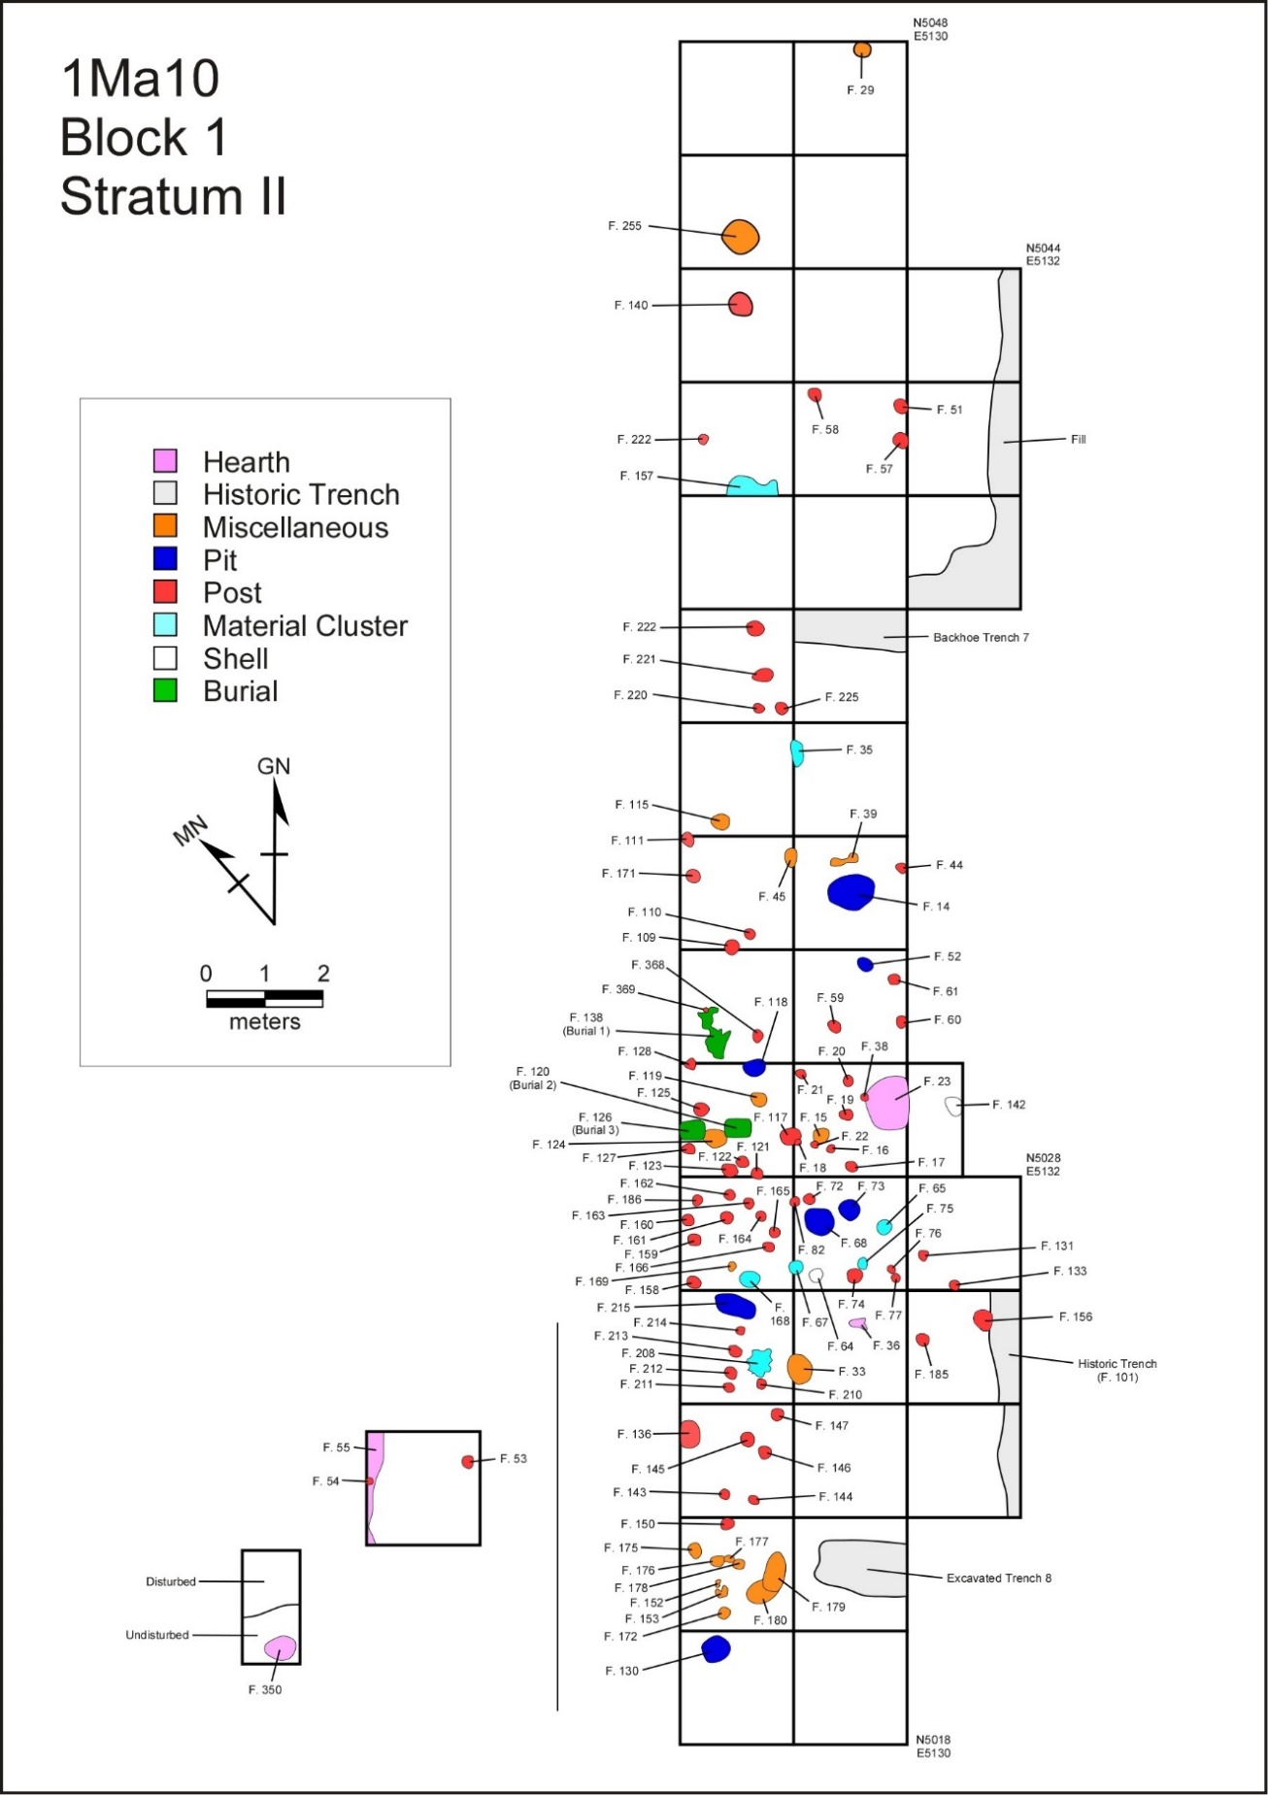
Figure 6.1. Features in Block 1, Stratum II, at the Whitesburg Bridge site.

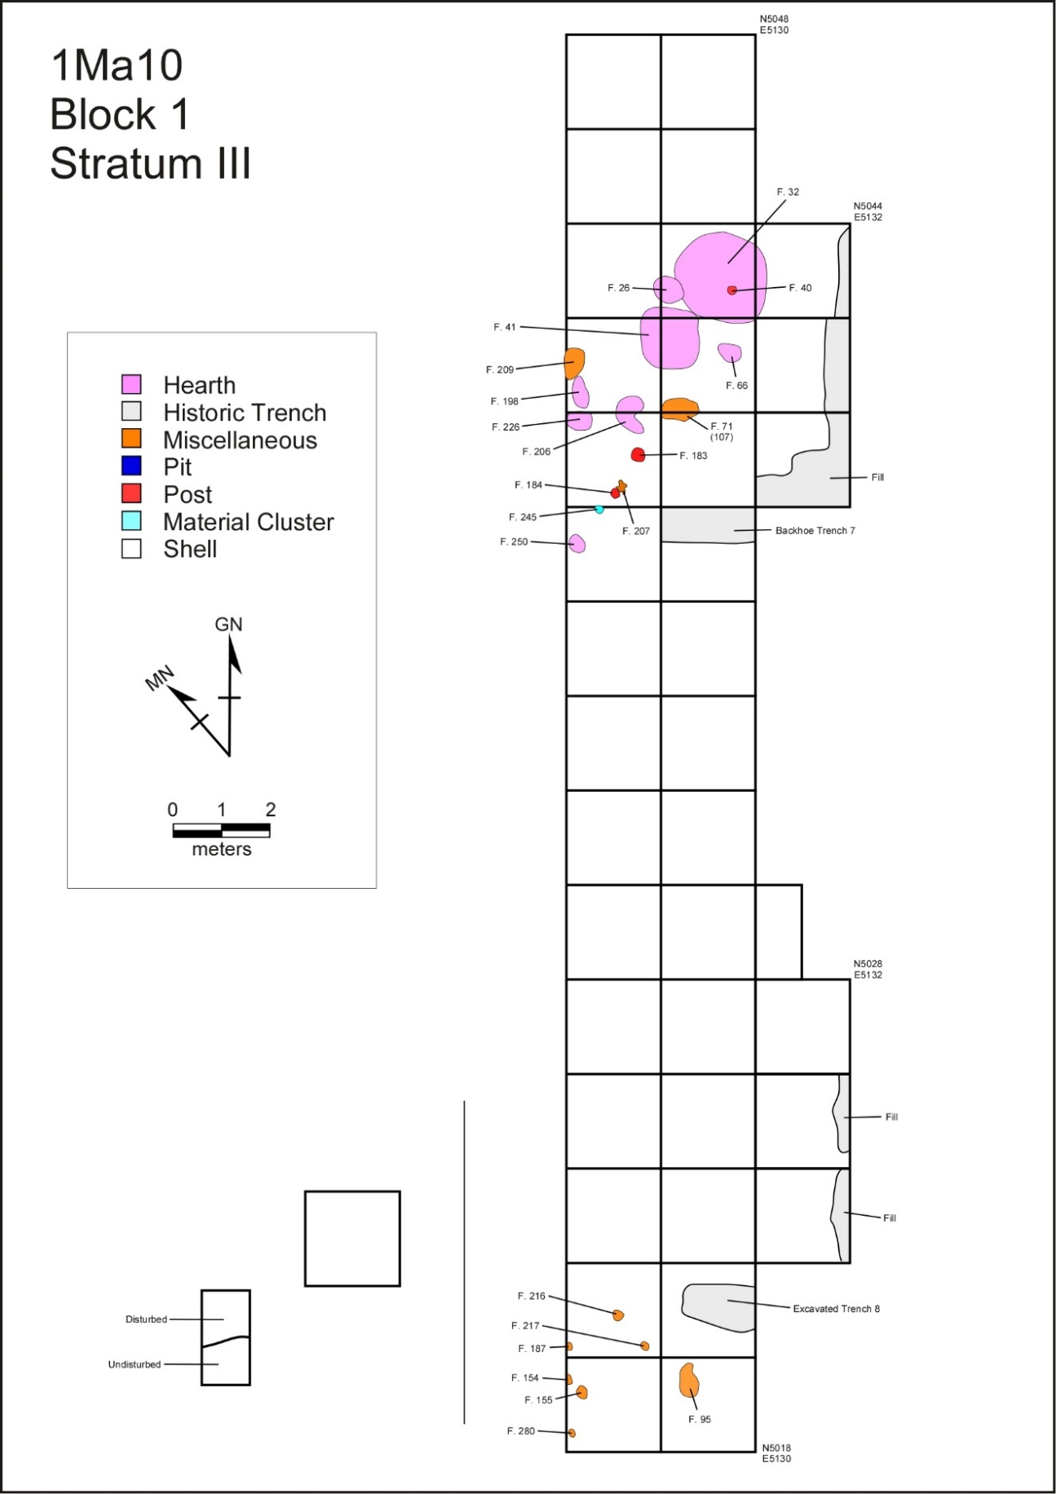
Figure 6.2. Features in Block 1, Stratum III, at the Whitesburg Bridge site.
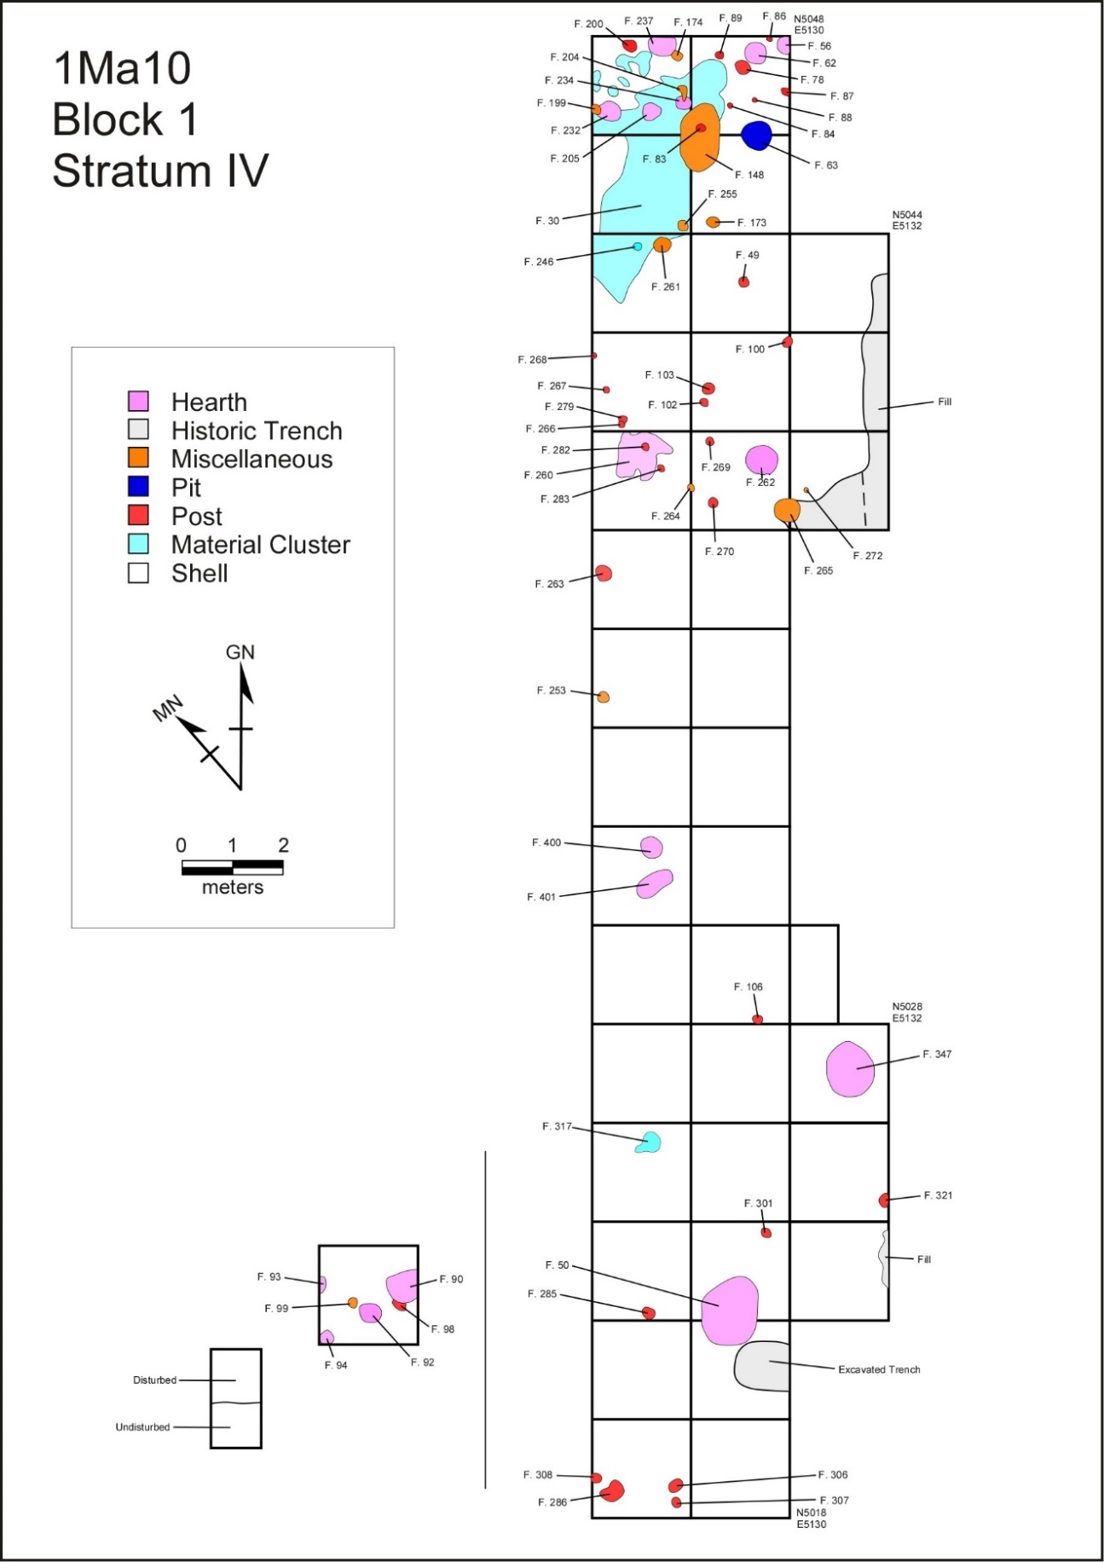
Figure 6.3. Features in Block 1, Stratum IV, at the Whitesburg Bridge site.
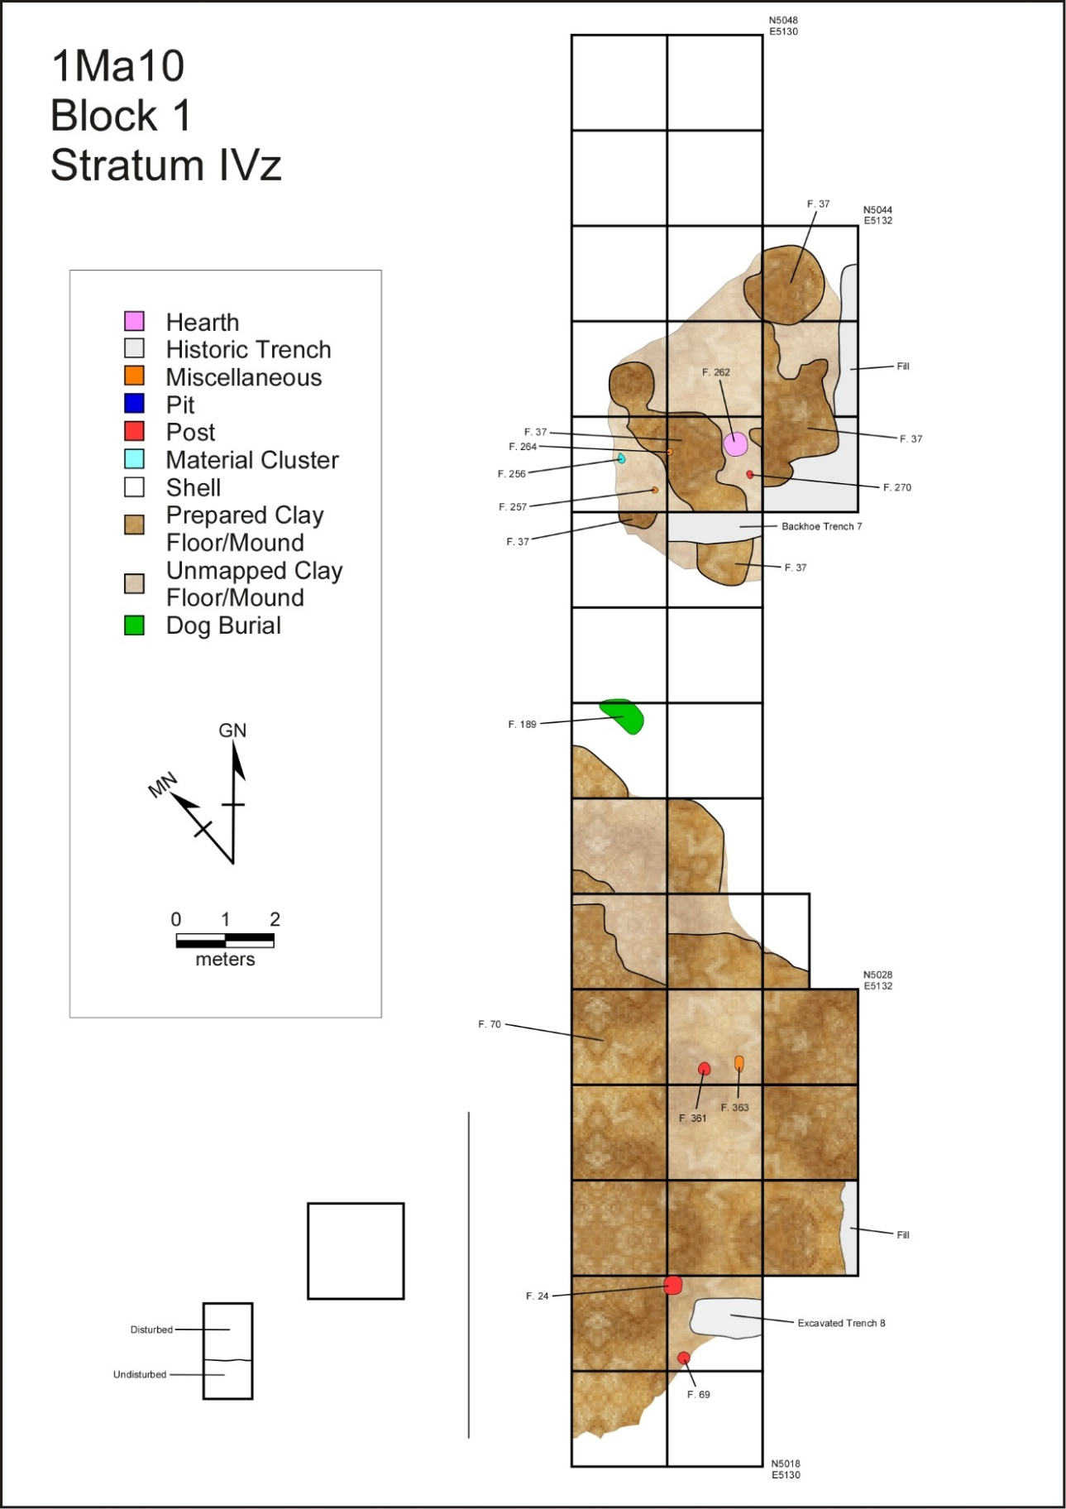
Figure 6.4. Features in Block 1, Stratum IVz, at the Whitesburg Bridge site.
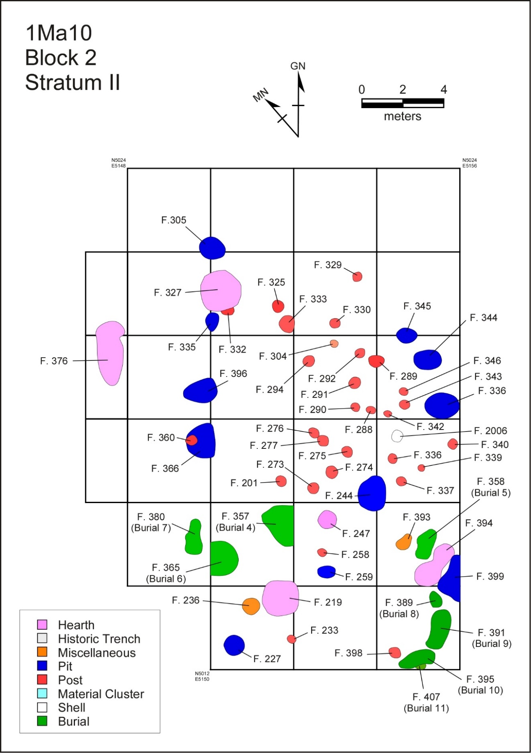
Figure 6.5. Features in Block 2, Stratum II, at the Whitesburg Bridge site.
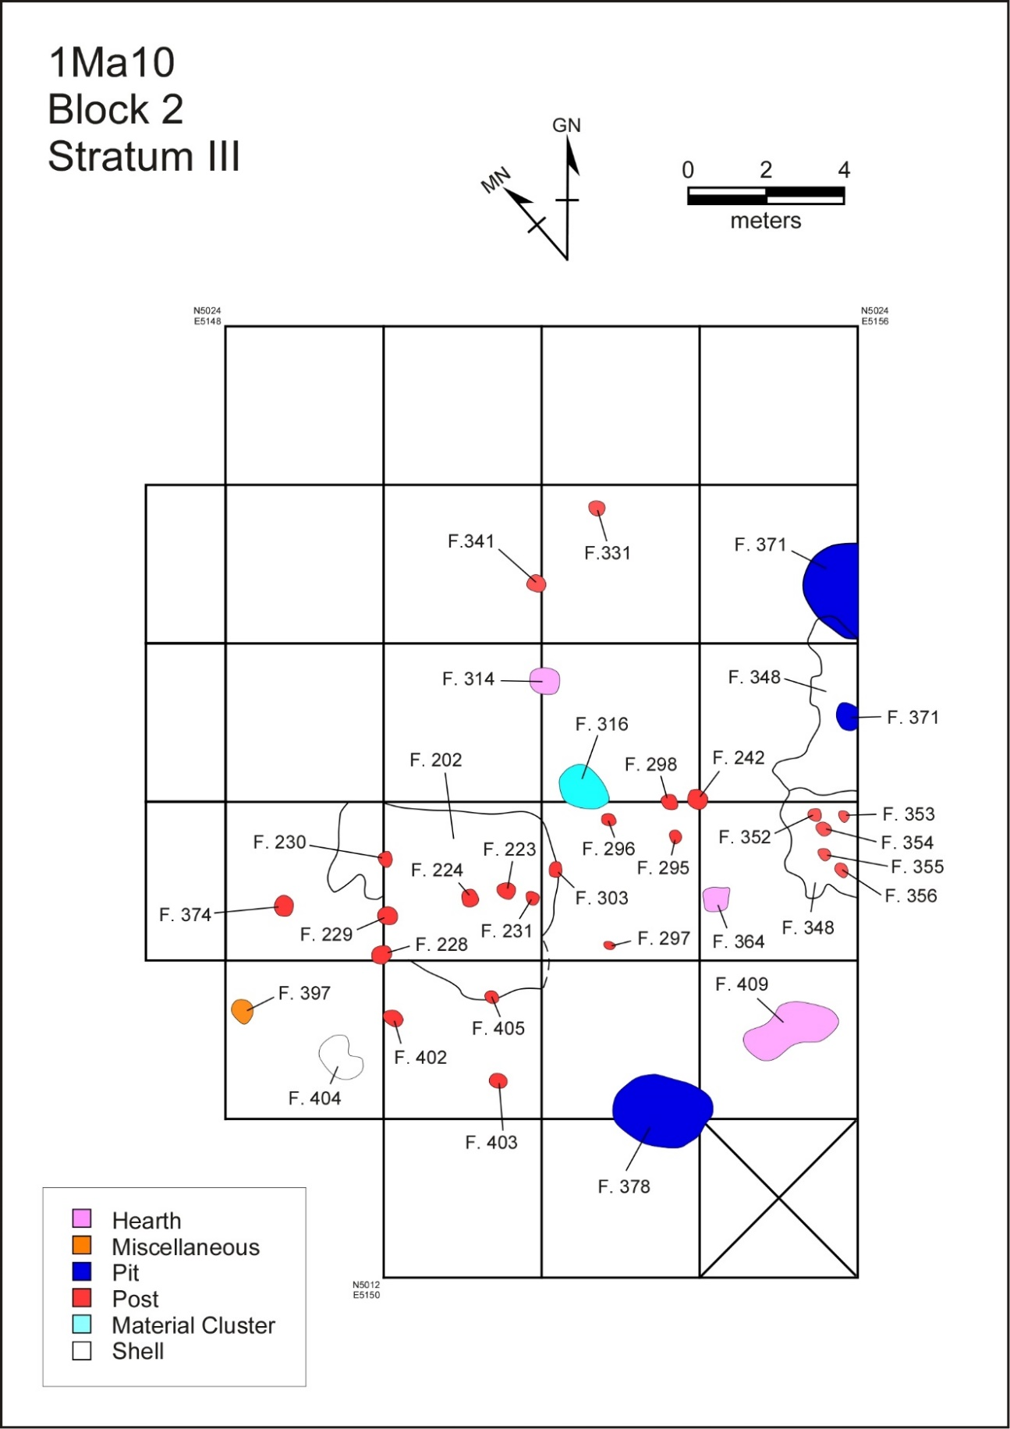
Figure 6.6. Features in Block 2, Stratum III, at the Whitesburg Bridge site.
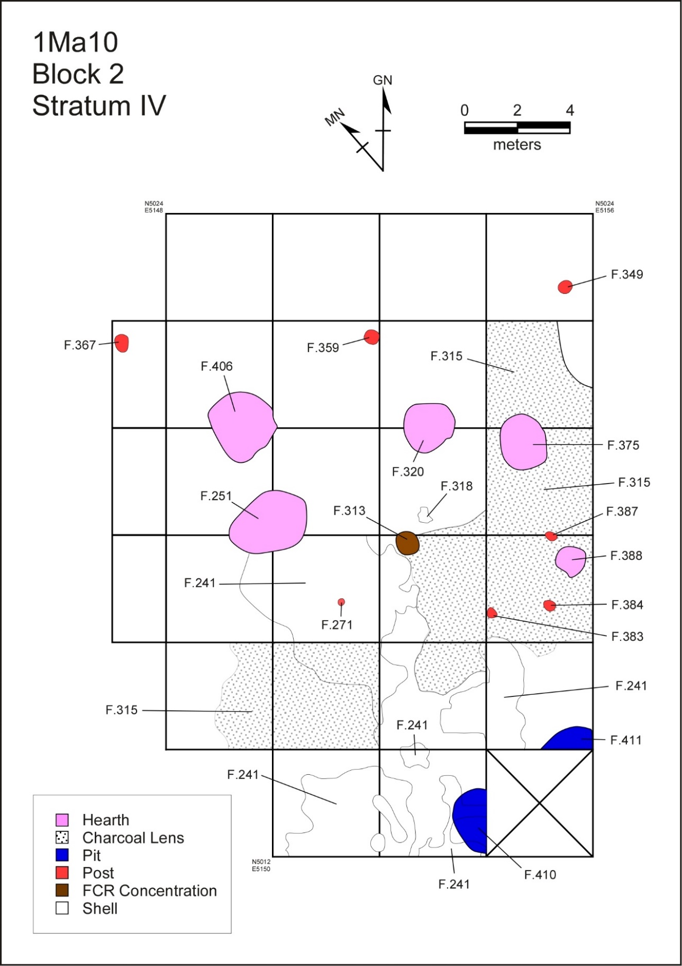
Figure 6.7. Features in Block 2, Stratum IV, at the Whitesburg Bridge site.
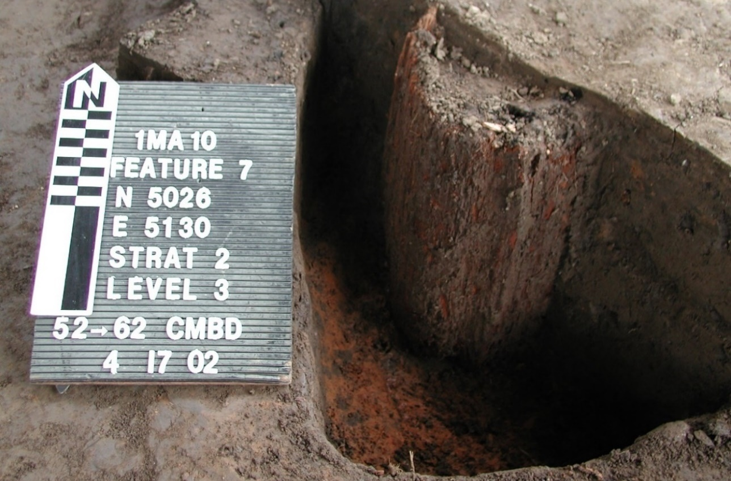
Figure 6.8. Feature 7, a historic post hole with remnant of cedar post at the Whitesburg Bridge site.
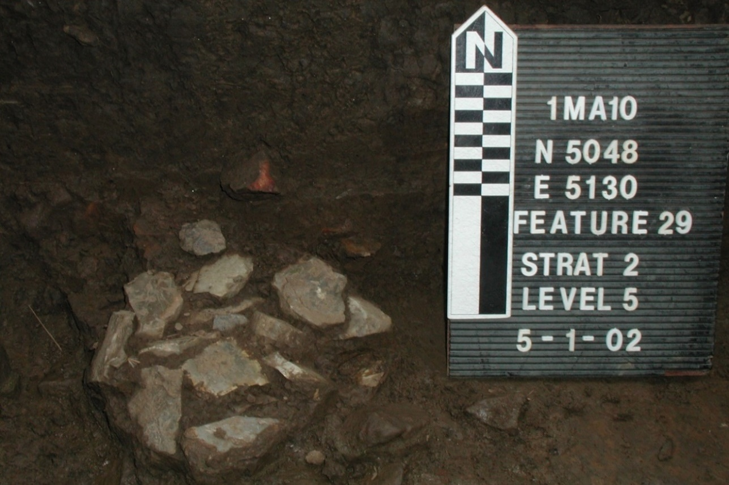
Figure 6.9. Feature 29, a cluster of preforms at the Whitesburg Bridge site.
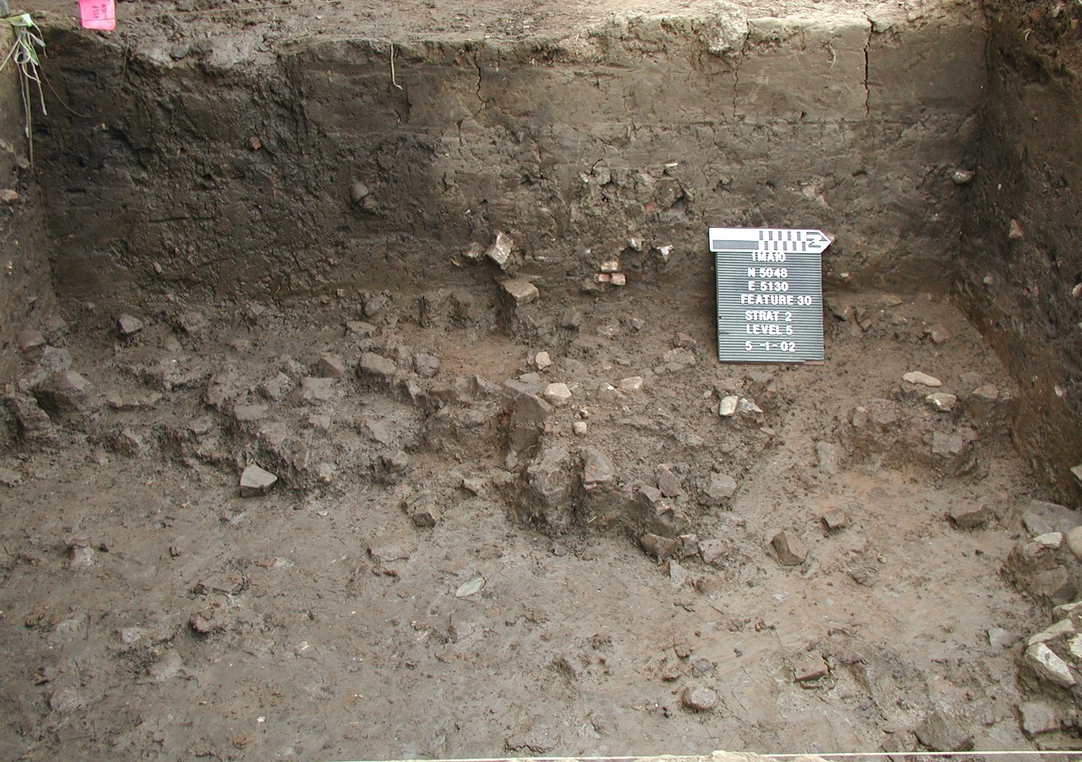
Figure 6.10. Feature 30, a cluster of fire cracked rock at the Whitesburg Bridge site. (Part of Feature 29 is visible at lower right.)

mottled soil were also found. The remaining historic features comprised seven pits and seven trenches, including one trench resulting from the Phase II investigations. The historic features will not be described further, however their presence in the upper deposits of the site, did include deep disturbance of some of the underlying older deposits.
Stratum I of Block 1 contained only historic features, 1 pit and 10 post holes. Two WPA excavation trenches were also found here. Historic features first detected in Stratum II of Block 1 included 19 post holes and 2 additional trenches. Among the prehistoric features were 3 human burials, a dog burial, 2 prepared surfaces, 59 post holes, 2 hearths, 11 pits, and 16 miscellaneous material concentrations or soil stains. Feature 70, a large, prepared clay surface or mound was first observed in Stratum II. Its base, and thus its origin, however, was in Stratum IV. Stratum III contained 2 prepared surfaces, 7 hearths, 11 post holes, and 2 miscellaneous features. One historic pit and two trenches were also first observed in Stratum III. Three pits, 13 hearths, and 30 post holes originated in Stratum IV along with 1 area of shell midden and 6 miscellaneous features. Among the miscellaneous features is Feature 265, the carbonized remains of a bundle of split reeds and grass. Stratum V yielded 3 hearths and a post hole.
Features detected in Stratum I of Block 2 were mainly historic: 4 pits, 16 post holes, and 1 trench. The only prehistoric features in Stratum I were 1 human burial and 1 prepared surface. An additional historic pit and 9 historic post holes were found in Stratum II. Prehistoric features in Stratum II included 7 human burials, 9 pits, 5 hearths, an area of shell midden, and a cluster of lithic debitage. Stratum III produced 3 hearths, 3 pits, 3 areas of shell midden, 23 post holes, and 2 miscellaneous concentrations of shell or rock. Two of the shell middens areas, Features 202 and 348, were comparably large. The features in Stratum IV comprised 3 hearths, 3 pits, 5 post holes, and 5 miscellaneous clusters of charcoal or rock. The only feature recorded in Stratum V of Block 2 was a cluster of rocks.

Pre-Contact Features

Post Holes
Post holes are here defined as circular or near circular depressions with diameters from approximately 15-30 cm. A total of 161 prehistoric postholes were recognized during the field season. Of this total, 90 were shallow, hemispherical in shape, 33 were cone shaped, 22 were blunt shaped, and 6 were deep and straight walled with a rounded bottom. The form of 10 was indeterminate. Instead of dealing with each post hole as an individual entity, they are considered below as elements of feature clusters, associated with groups of other features and representing the remains of various structures. A discussion of these clusters is presented in a subsequent section of this chapter. Descriptive information on all the post holes is presented in Appendix B, Table B.1.

Hearths
A total of 36 surface or shallow basin hearths were recognized. Two relatively deep fire pits were also found. The surface hearths were oval, circular, or irregular. Some of these consisted only of areas of burned soil and charcoal. Shallow basin hearths were similar to shallow basins identified as pits except the hearths contained a red clay lining or oxidized soil in the fill suggesting that the feature was subject to extreme heat. Fire cracked rock and charcoal were commonly associated with hearths and helped to establish their identification. This feature type includes not simply open hearth but smudge and roasting pits as well. Smudge pits (Binford 1980, 2001) functioned as the source for smoking meats or possibly as insect repellent. The pits include poorly carbonized botanical remains often from burning green wood or other vegetation to create a denser smoke than would be made from dried wood. Roasting pits (Black and Thorns 2017; Fedoroff 2009) also fit into this category and likely represent a combination of inground cooking for tubors and bulbous-root plants as well as faunal based proteins (e.g. white-tailed deer). Selected hearths are described below. Appendix B, Table B.1 provides information on all features from the site.
Feature 23 (Block 1, Stratum II). Feature 23 was a large shallow hearth extending into the east profile of Unit N5030E5130 (Figure 6.11). The exposed area of the hearth measured 89 cm by at least 76 cm and was 17 cm in maximum depth. A small fleck of bone and charcoal were observed in the field, but only debitage was recovered from the fill.
Feature 41 (Block 1, Stratum IIa). Feature 41 appears to be large, frequently reused, basin hearth 216 cm in length, 140 cm in width, and with a depth of 52 cm (Figures 6.12-6.13). This feature was recognized in the field as having alternating layers of heated clay, black organic fill, and alluvial fill. Zone A was 10 cm thick and represented alluvial fill. A few artifacts including a core, preform, and a utilized flake were recovered from this zone. Zone B was 12 cm thick and contained fire cracked rock, crushed bone, charcoal, and ash imbedded in a black organic soil. A core was recovered from this zone. Zone C was 5 cm thick and consisted of a fire hardened red clay that lines the zone. A small quantity of fire cracked rock was recovered from this zone. Zone D was 6 cm thick and contained a large quantity of fire cracked rock within a matrix of dark organic soil. Two biface fragments were recovered from this zone. Crushed bone was also recognized in Zone D. Zone E was 2 cm thick and consisted of a thin red clay lining. A small quantity of fire cracked rock was recovered from this zone. Zone F was11 cm thick and consisted of a dense layer of fire cracked rock along the bottom and walls of the
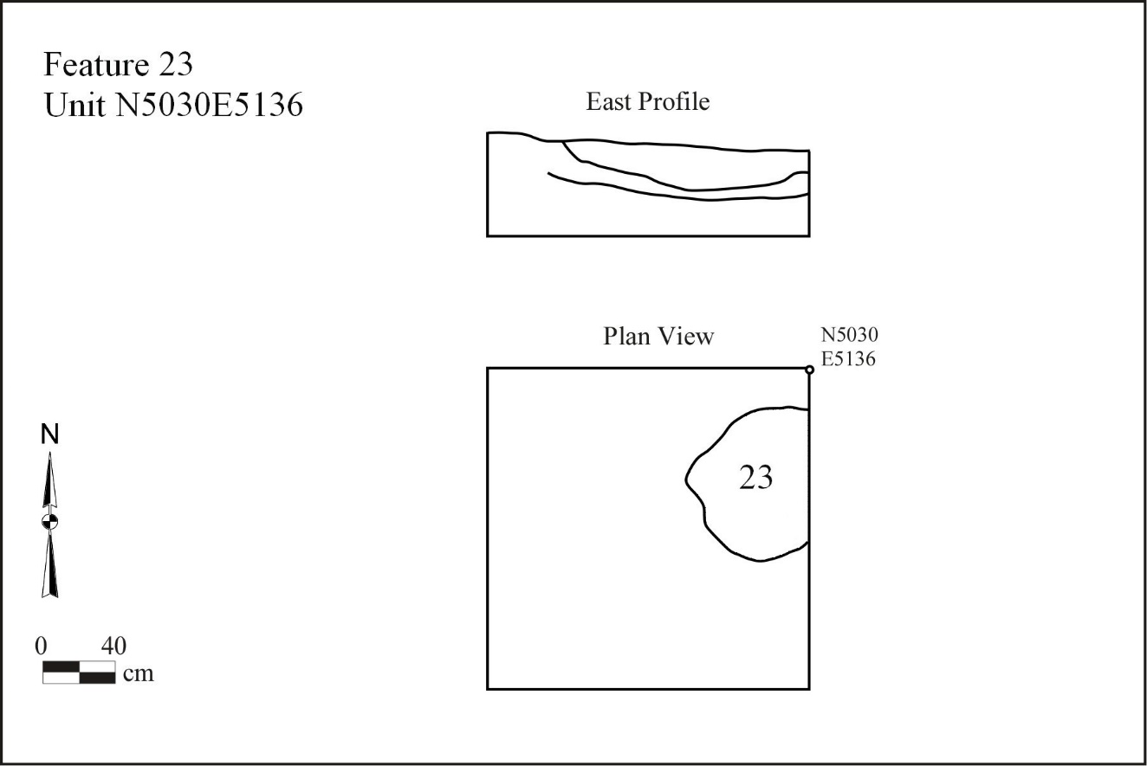
Figure 6.11. Feature 23 at the Whitesburg Bridge site, plan and profile drawings.

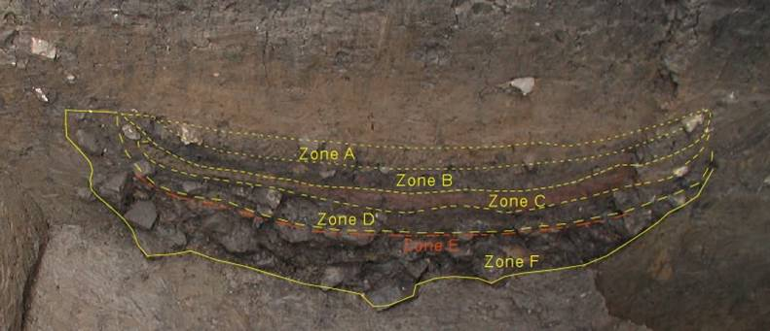
Figure 6.12. Feature 41 with zones overlaid at the Whitesburg Bridge site.

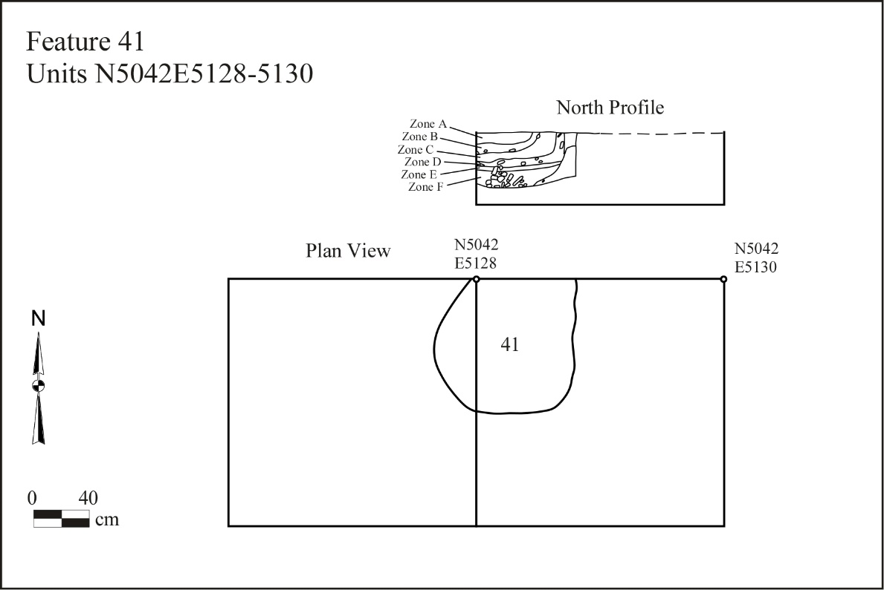
Figure 6.13. Feature 41 at the Whitesburg Bridge site, plan and profile drawings.

zone. Ash, charcoal, and crushed bone were recognized. Carbonized hickory nut remains were found within the charcoal remains in all layers. It was not uncommon for the thick-walled shells of hickory nuts to be used as fuel for hearths. Although the inclusion of carbonized hickory nut shell might suggest hickory nut processing within this feature, fire cracked rock and crushed bone would not be expected. Typically, the method used for the extraction of hickory nutmeats and oils consists of lining a pit with an animal skin, adding water, and applying an indirect heat source such as hot stones (Patricia Munson 1986:280). Usually there will be a hearth located nearby that was used to heat the rocks. This method would not typically result in fire cracked rock or other debris associated with hearths and fire pits. There are two exceptions to this case: 1) The feature was subsequently used as a hearth, or 2) the feature was subsequently used to dispose of trash and the debris possibly represents sweepings from a nearby hearth used in heating the hot stones. Feature 32 (Block 1, Stratum III) is within a few centimeters of Feature 41 and may have served this purpose. This feature was a hearth 180 cm in length, 177 cm in width, and 23 cm in depth. The cross section was basin shaped.

Feature 50 (Block 1, Stratum IV). This feature was a relatively shallow hearth measuring 101 cm in length, 46 cm in width, and 13 cm in depth. Three irregular zones were recognized in the fill of this feature. Zone A was 8 cm thick and contained oxidized soil. Zone B was 3 cm thick and consisted of dark grayish brown silty clay. Zone C was 13 cm thick and contained oxidized soil. Charcoal was recognized throughout the feature.
Feature 92 (Block 1, Stratum IV). Feature 92 was a small hearth 44 cm in diameter and 8 cm deep. This hearth appeared to contain the remains of grass or tinder bundles. Also evident within this feature were the remains of two carbonized logs. This feature may represent a smoking hearth/smudge pit (Binford 1980).
Feature 251 (Block 2, Stratum IV). Feature 251 was a basin hearth 115 cm in length, 105 cm in width, and 78 cm in depth. This feature was similar to Feature 41 in that they were both deep and appeared to have stratified fill. Fire cracked rock was recovered from throughout the fill of Feature 251 and the walls were apparently lined with rock imbedded in a red clay lining. Charcoal was also found throughout the fill and along the side walls but was particularly dense on the bottom of the feature. Carbonized hickory nut was found amongst the charcoal in all layers of this feature. Large, grapefruit sized, rocks were also found along the bottom of this feature. Bone was recovered throughout the fill. A date with a calibrated age range of 1519-1321 cal BC at a 95.4 percent confidence level (3180 + 40 BP) (BETA-169607) was obtained for this feature (Table 3.1). A single Flint Creek point was recovered from this feature associating it with the Late Archaic occupation.
Features 320 and 406 (Block 2, Stratum IV). These two hearths were located in the same general vicinity as the large shell midden (Feature 241) in Stratum IV of Block 2. Feature 320 was a hearth 96 cm in length, 92 cm in width, and 45 cm in depth. Charcoal, unidentified bone, fire cracked rock, and a nutting stone were recovered from the fill of this feature. Feature 406 was a hearth 128 cm in length, over 114 cm in width, and 11 cm in depth (Figure 6.14). Fire cracked rock and charcoal were recognized throughout the feature fill.

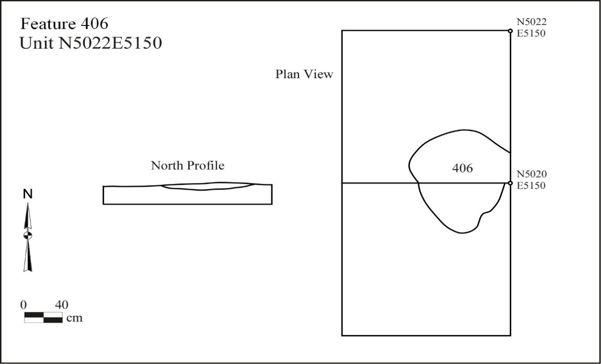
Figure 6.14. Feature 406 at the Whitesburg Bridge site, plan and profile drawings.

Refuse Filled Pits
A total of 29 refuse filled pits were encountered during the 2002 field season. Of this total, 20 were basin-shaped and 9 were U-shaped. Plan views of these pits revealed that 12 were oval, 15 were circular, and 2 were irregular in outline. Pits can be similar to hearths but are generally deeper and lack evidence of extreme heating as in a red fired clay lining or oxidized soil within the fill. They can, however, contain fire cracked rock and charcoal as this may represent sweepings deposited into the pit. The charcoal may also be from whatever materials were deposited in the pit for storage or disposal. A number of the pits are small and are described in Appendix B, Table B.1 as pits or post holes. Several pits, such as Features 309-312, are modern historic pits including concrete, asphalt, and other materials. Information on selected pits is presented below.
Feature 14 (Block 1, Stratum II). Feature 14 was a refuse filled pit 102 cm in length and 65 cm in width with a depth of 43 cm (Figure 6.15). The cross section was basin shaped. Several artifacts were recovered from this pit including Greeneville cluster triangular points and Long Branch Fabric Marked pottery associated with the Middle Woodland period. Judging from the amount of charred nut shell, both acorn and hickory,
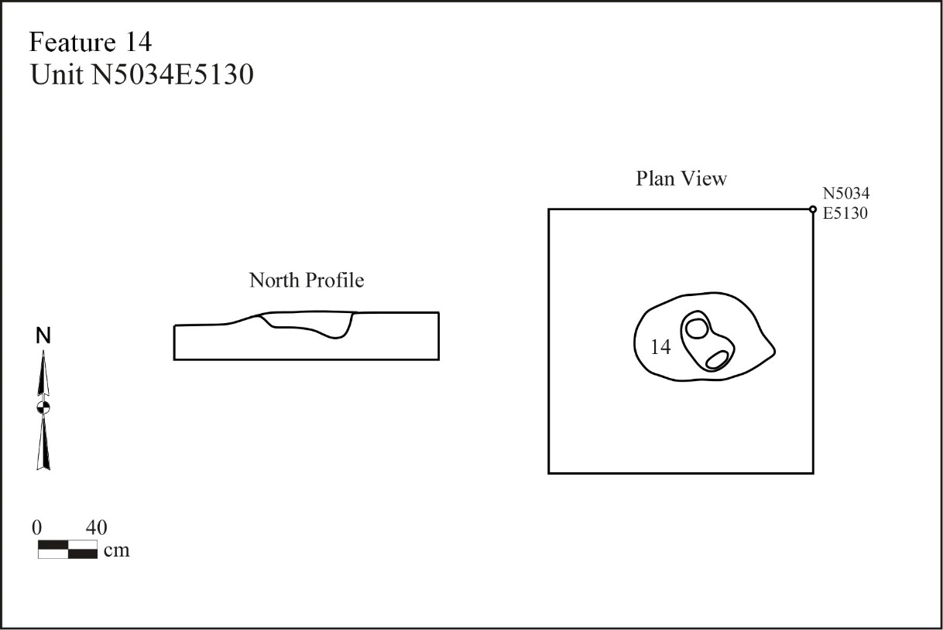
Figure 6.15. Feature 14 at the Whitesburg Bridge site, plan and profile drawings.

and the presence of finished points and a fragmented vessel, this feature likely represents a storage pit. Charcoal recovered from this feature yielded a calibrated age range of 150 cal BC to cal AD 60 at the 95 per cent confidence level (BETA-259531).
Feature 371 (Block 2, Stratum III). Feature 371 was a refuse filled pit 118 cm in length, greater than 63 cm in width, and with a depth of 23 cm (Figure 6.16). The cross section was basin shaped. Charcoal recovered from this feature yielded a calibrated age range of 763 to 400 cal BC at the 95.4 per cent confidence level (2430 + 70) (BETA-177487). Long Branch Fabric Marked pottery found in the pit supports Middle Woodland utilization. This feature likely represents a storage pit.
Feature 378 (Block 2, Stratum III). This feature was a refuse filled pit at least 106 cm in length, 106 cm in width, and 85 cm in depth (Figures 6.17-6.18). The cross section was U-shaped. The feature initially resembled burials from the 1939 excavation; however, no bones were located in the fill. Instead, several large rocks imbedded in sand were deposited in this feature. Four of these were determined to be mortars, and a fifth
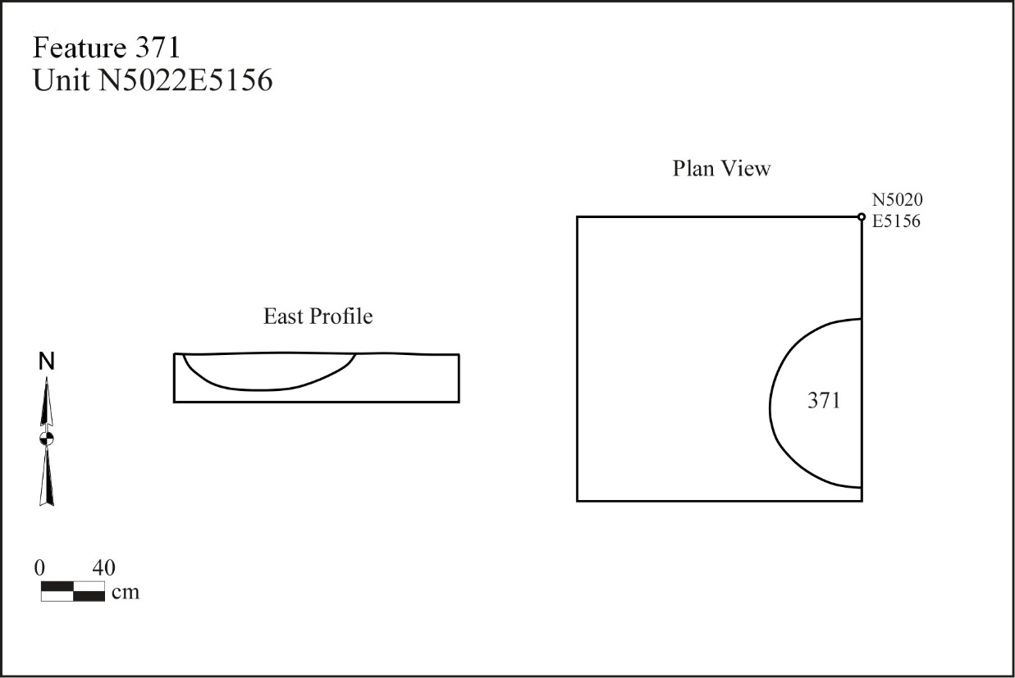
Figure 6.16. Feature 371 at the Whitesburg Bridge site, plan and profile drawings.

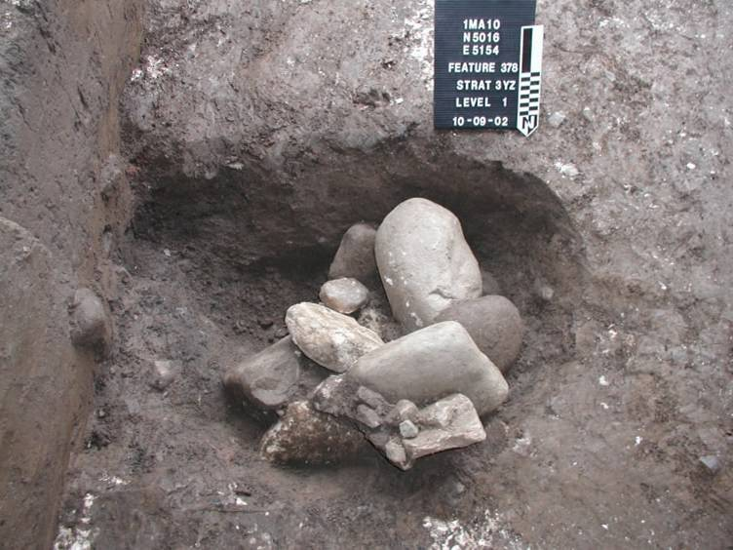
Figure 6.17. Feature 378 at the Whitesburg Bridge site after excavation.
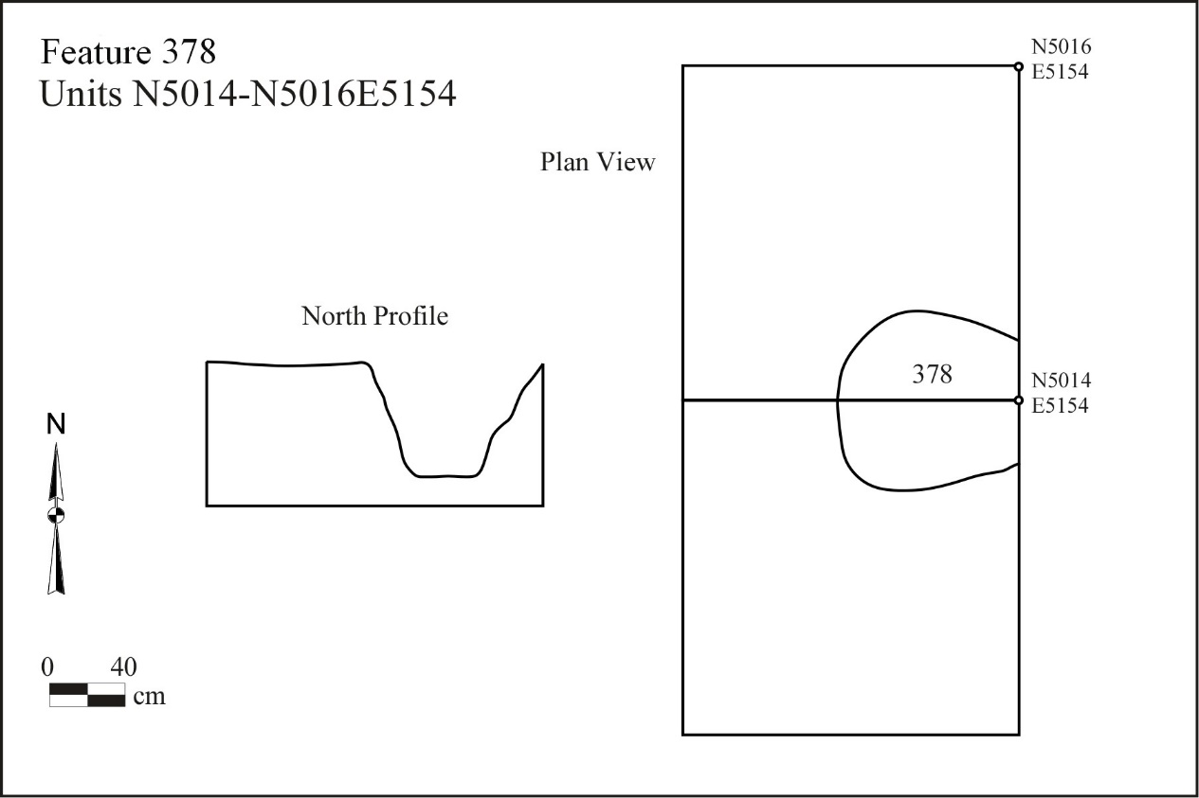
Figure 6.18. Feature 378 at the Whitesburg Bridge site, plan and profile drawings.

was determined to be a pestle. A few cores and bifaces were also recovered from the pit.
The shape of this pit suggests a use for storage. However, after several rain storms and sump pumping episodes exposed more of the feature, a new idea emerged. This pit was more likely a roasting pit utilized through indirect heating source, namely the large stones found in the fill. A hearth (Feature 409, Block 2, Stratum IIIz) 100 cm in length, 70 cm in width, and 10 cm in depth was identified less than 1 m from Feature 378 and at the same level. Food processing stones may have been cached within the fill of the pit, along with the other stones, for intended reuse at a latter date. Sand may have been added to the fill so that minimal cleaning needed to be performed upon reuse, or more likely the sand is alluvium washed in during a flood episode. This feature is the best example of a hickory nut processing area found at 1Ma10. The pit lacked evidence of direct heating, was found to contain food processing tools and other large rocks possibly used for hot rock cooking, and was located within a meter of a hearth possibly used to heat the rocks. A large charcoal lens located within 2 m of both the pit (Feature 378) and the hearth (Feature 409) contained carbonized hickory nut shell fragments.
Feature 410 (Block 2, Stratum IV). Feature 410 was a refuse filled pit 125 cm in length, 50 cm in width, with a depth of 20 cm (Figure 6.19). The cross section was basin shaped. The pit contained shell and a layer of ash at the bottom. A date with a calibrated age range of 1436 to 1124 BC at the 95.4 per cent confidence level (3050 + 60 BP) (BETA-177492) was obtained for this feature affiliating it with the Late Archaic. This pit resembles a hearth but is lacking oxidized soil. The original function of this pit may have been for storage. This pit was encountered on the last day of excavation and was only partially removed.
Feature 411 (Block 2, Stratum IV). This feature was a refuse filled pit 99 cm in length, 48 cm in width, and with a depth of 33 cm. The cross section was basin shaped.
The pit contained shell, bone, and fire cracked rock but lacked oxidized soil. Several biface fragments and a bone awl were recovered from this feature. The original function of this pit may have been for storage.

Shell Middens
Three comparatively large shell middens (Features 202, 241, and 348) were identified in Block 2. Feature 202, approximately 10-19 cm thick, and Feature 348, approximately 20 cm thick, occurred in Stratum III (Figures 6.20-6.21). Initially there were no recognizable associations with any other features. These middens, however, are within 2 m of Feature 378, a possible hickory nut processing feature, and Feature 409, a possible hearth used to heat hot rocks for indirect cooking. Artifacts recovered from the shell middens include a preform, core, a Wade projectile point, and two limestone tempered sherds. This area of the site may have been a shellfish processing area during the Middle Woodland.
A single large shell midden, Feature 241, was recognized in Stratum IV of Block 2. This midden was at least 6 m in diameter and reached a maximum thickness of 40 cm. The midden contained fire cracked rock, unidentified bone, and charcoal in addition to the shell. Several chipped stone tools and an antler billet were recovered from the midden. A calibrated age range of1505-1301 cal BC at the 95 percent confidence level (3150 +/- 40 BP) (BETA-169606) was obtained from charcoal found within this feature indicating Late Archaic utilization. This date range coincides with the recovery of a Flint
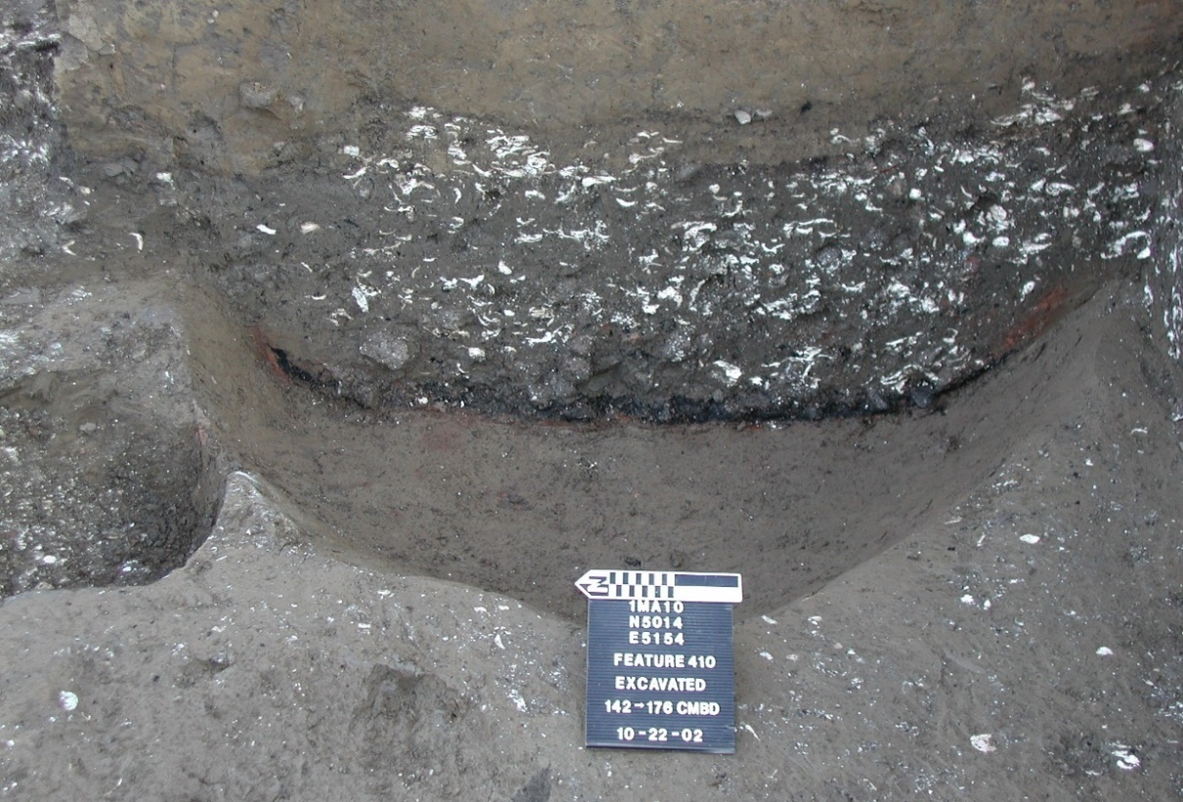
Figure 6.19. Feature 410 partially excavated at the Whitesburg Bridge site.

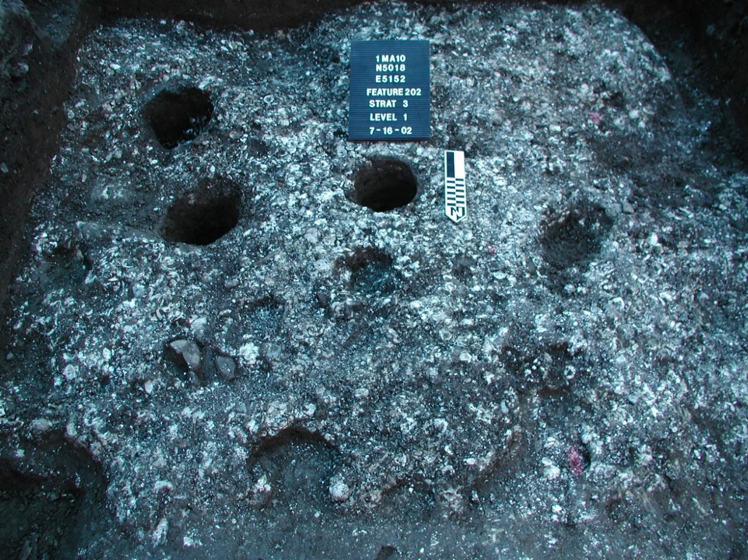
Figure 6.20. Feature 202, shell midden with intrusive post holes at the Whitesburg Bridge site.

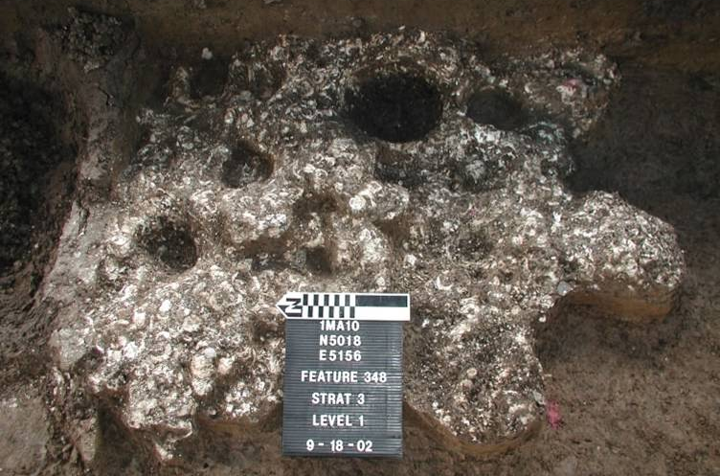
Figure 6.21. Feature 348, shell midden with intrusive post holes at the Whitesburg Bridge site.
Creek and Cotaco Creek points from within the midden. This shell midden lay immediately next to Feature 251, a deep basin hearth discussed above. Three other hearths (Features 320, 375, and 406) lay within 2.5 m of the shell midden. Finally, a charcoal lens approximately 2-6 cm in thickness and covering all or part of six units, nearly engulfs the shell midden. This lens drapes over several shallow depressions that may have also have been hearths. The lens is attributed to a large mussel roasting episode that resulted in the shell midden identified as Feature 241. The hearths located nearby were also likely used in the shellfish processing.
It should be noted that Feature 362 is likely the western extension of Feature 241. The shell middens are concentrated in that portion of the site closest to the river. Feature 362 was roughly the same distance from the river’s edge, but encountered in the isolated unit (N5014E5100.5) 46.5 m west of Block 2 and Feature 241.

Earthen Mound
A large earthen feature, Feature 70, was identified within Block 1. Feature 70 is described and illustrated in detail by Sherwood (2011). Her geoarchaeological analysis of the site is included with her permission as Appendix C. The feature lies surrounded by the matrix of Stratum III, a deposit of approximately 40 cm of brown silty and very fine silty clay corresponding to Webb and DeJarnette’s Zone C. They characterized this zone as “nearly sterile”. The 2002 excavations indicate the presence of sealed cultural deposits within and adjacent to Stratum III that date to the terminal Late Archaic. This feature is actually a series of deposits that resulted in a massive, circular, prepared clay surface stretching more than 14 m north to south and 12 m east to west with a remaining maximum height of 48 cm. Core drilling was utilized to identify the western edge of the feature. A sample recovered at grid coordinates N5026E5122 contained the westernmost remnants of the red clay surface. Its original height is unknown as the upper portion had been truncated by Stratum II occupation activity and probable erosion. Within Feature 70, separate episodes of deposition were apparent and were identified as subzones A through E. These deposits appear to represent construction phases of a low prepared clay surface or mound. A sample of charcoal associated with the feature provided an age range of 1496–1275 cal BC with a 95.4 percent confidence (3120 + 40BP) (BETA-169605), placing it in the terminal Late Archaic.
Based on the micromorphological analysis these subzones are composed of well developed B Horizon or subsoil material collected from nearby alluvial soils and deposited here. The red color is due to illuvial clay from that original soil that was disrupted when moved. In fact the surface or mound was certainly red as it was being constructed, but most likely became more so as the clay broke down or was redispersed. This clay shows up in thin section as bright orange clay coatings that are not in their original positions. The variable subzones in Feature 70 are due to a shift in the material brought in to build the mound, for example Zone B contains more organic material and less clay.
Feature 70 immediately overlies Stratum IVz, a thick series of localized deposits. Artifacts recovered from this stratum include lithic debitage as well as soapstone and sandstone vessel fragments. The localized deposits resulted in a mottled appearance in the field. Based on the abrupt boundaries, mixed parent material, and the disrupted soil features in these zones, Stratum IVz may be the equivalent of basket loading that has been compressed and reworked due to trampling.

Feature Associations and Possible Structures
A loose set of criteria was set up in defining structural feature associations. These criteria consist of a series of postholes in uniform diameter, shape, and depth forming a geometric pattern such as circle, oval, or rectangle. The inclusion of a hearth within the bounds of the association lent more credibility to the possibility of these patterns being a structure. However, a hearth was not required in defining feature associations. The layout of Block 1 did not lend itself easily to the recognition of feature associations suggestive of structures. Unless the said structure was situated along the same axis, and within the block, only a partial association would be recognized. The rectilinear layout of Block 2 made it potentially easier for recognizing feature associations as there was a greater chance of encompassing the entire association. A total of five feature associations were recognized in the lab (Figures 6.22-6.24). None of these associations form a complete structural pattern, but still suggest the possibility of structures.

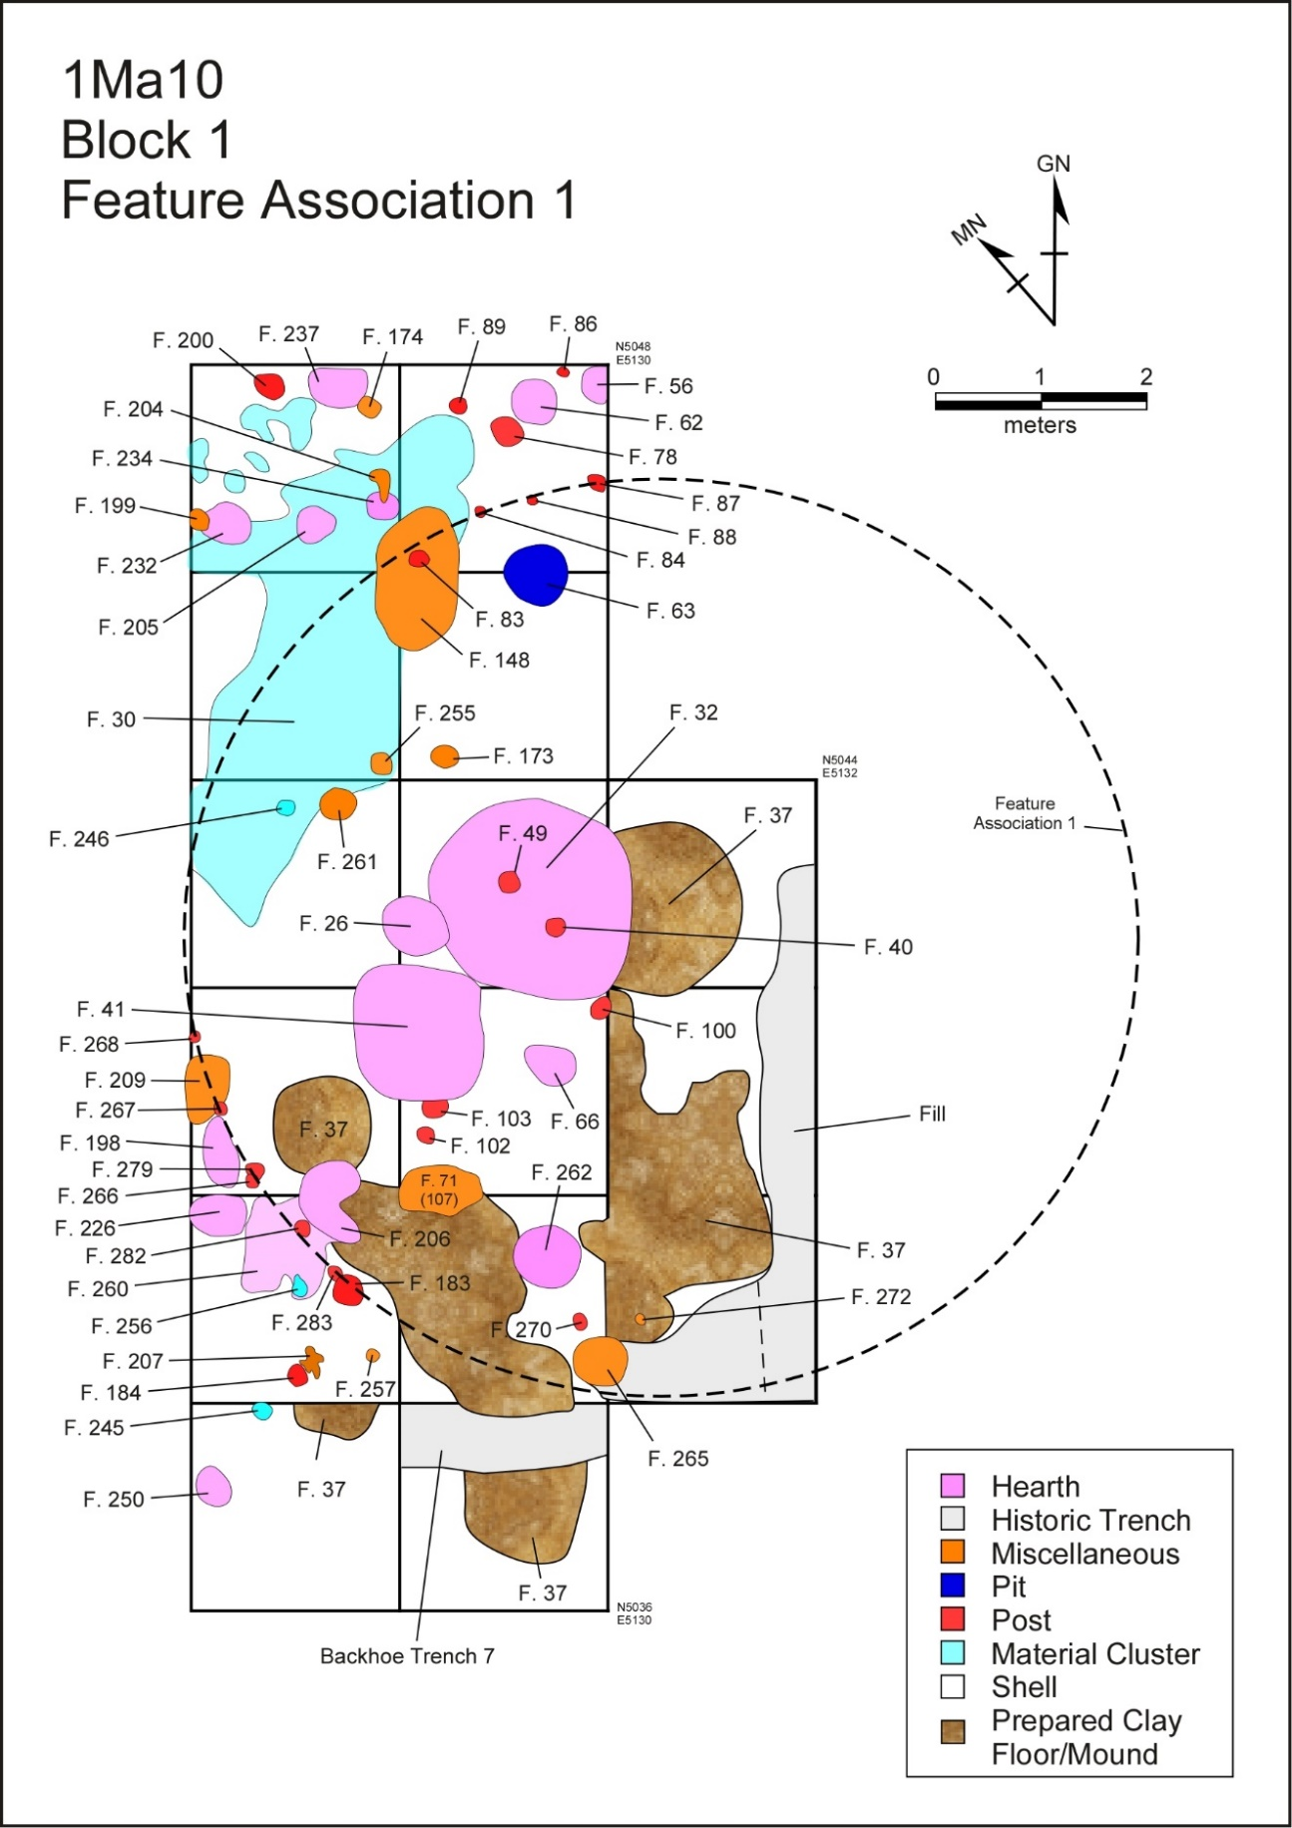
Figure 6.22. Block 1, Feature Association 1 at the Whitesburg Bridge site.
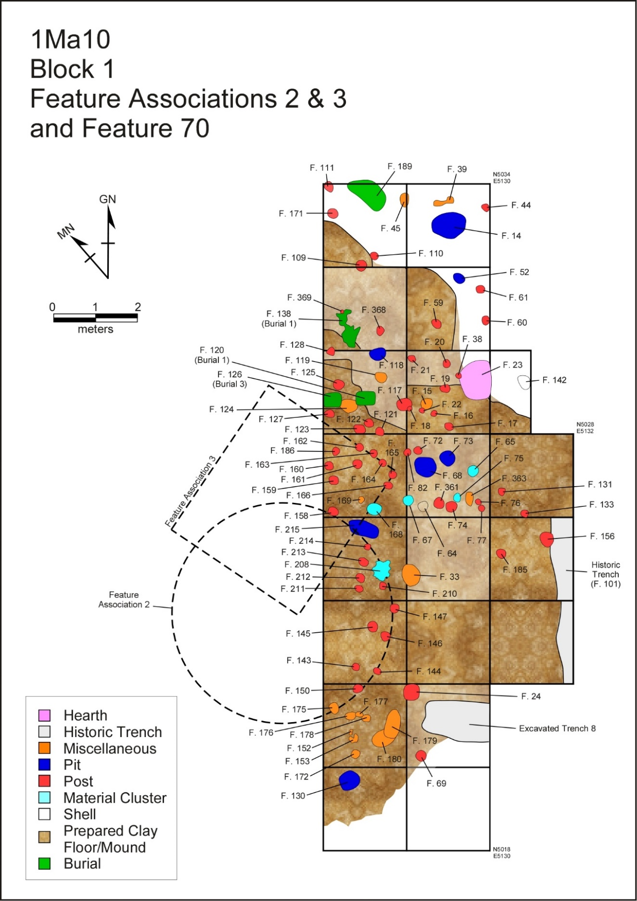
Figure 6.23. Block 1, Feature Associations 2 and 3 at the Whitesburg Bridge site.
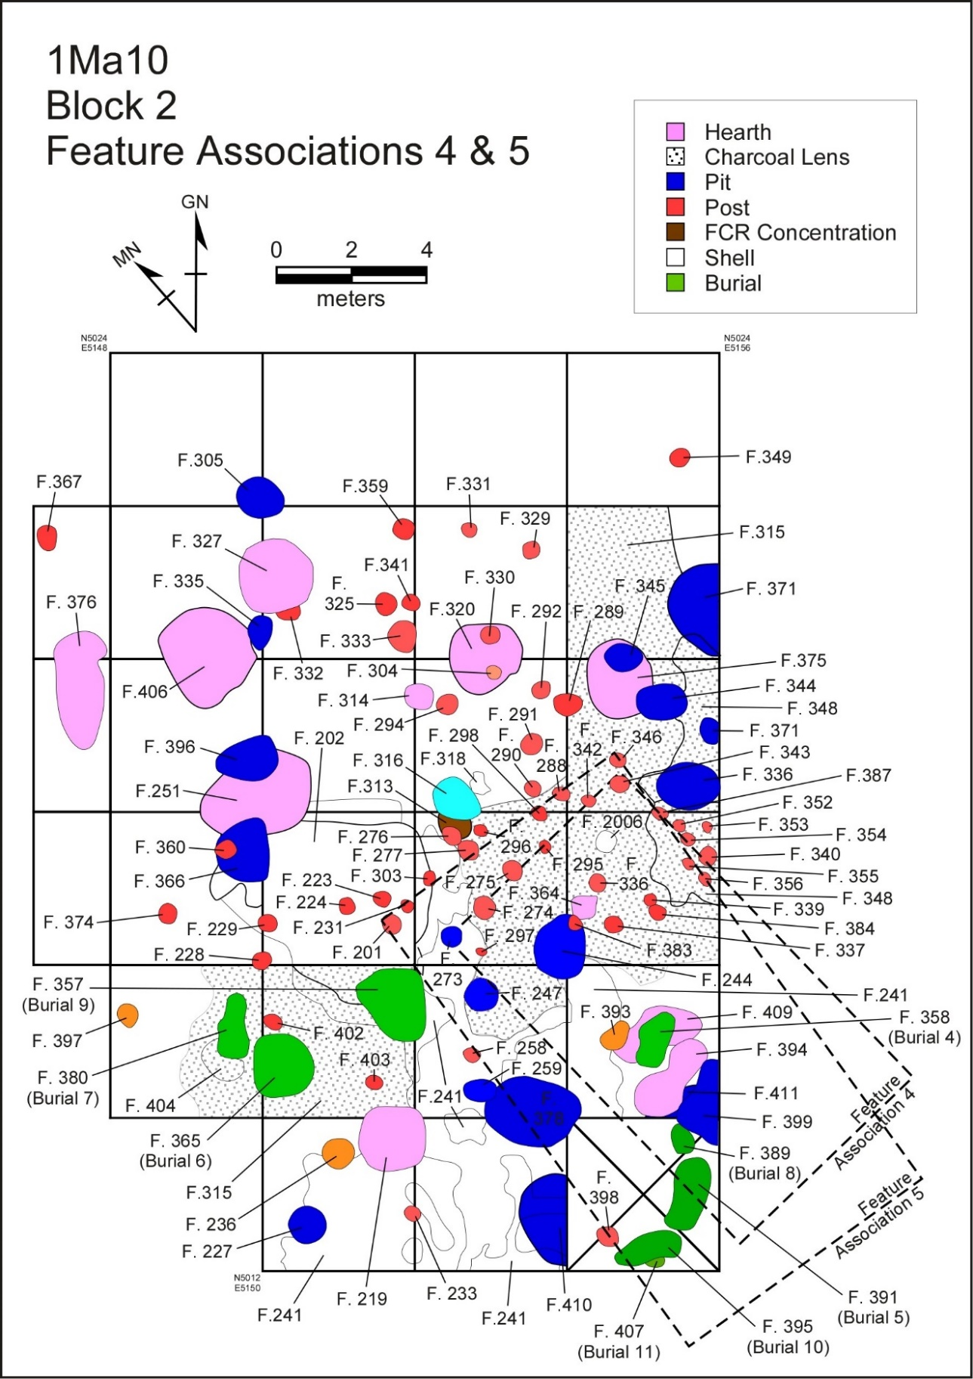
Figure 6.24. Block 2, Feature Associations 4 and 5 at the Whitesburg Bridge site.

Feature Association 1. This association consists of 15 postholes forming a semicircular pattern around a possible prepared clay floor. The postholes ranged from 10 cm to 27 cm in diameter with a mean of 16.5 cm. If the structure is truly circular then approximately 50 per cent of this structure was revealed during the excavations. If complete, the structure would have been approximately 9 m in diameter. The prepared clay floor (Feature 37) is sporadic throughout the southern half of the association, and partially extends beyond the projected limits of the structure. An initial theory was developed in the field suggesting that the clay floor may have been the remains of a wall that had collapsed. Evidence such as daub, however, is lacking. Remains of a reed or grass mat (Feature 265) have been located immediately within the southern boundary of this proposed structure. A calibrated age range of 1413 to 1055 cal BC at the 95.4 per cent confidence level ( 3010 + 60 BP) (BETA-177985) was obtained from this mat. Located near the center of this structure is a hearth (Feature 32). The calculated age range for this feature is 1513 to 1311 cal BC at the same confidence level (3170+ 40 BP) (BETA-166941). A single Flint Creek point, attributed to the Late Archaic period, was recovered from the surface of the clay floor. All indications suggest that this is a Late Archaic period structure. One calibrated age range from the mound (Feature 70) south of this association is nearly identical to results from the hearth feature assigned to Feature Association 1 suggesting that the two co-existed.
Feature Association 2. Feature Association 2 consists of nine postholes also forming a semi-circular pattern. The postholes ranged from 17 cm to 33 cm in diameter with a mean of 22 cm. If the structure were perfectly circular it would have a diameter of approximately 4 m, however, less than half has been exposed. No hearth has been associated with this association but it could lay just to the west of the excavation. Two post holes located just inside the eastern periphery of the structure may represent an entrance, or interior supports (Features 143 and 145). Two additional posts not included in the total count for this structure may also have served as interior posts (Features 211 and 212).
Feature Association 3. Feature Association 3 consists of five postholes forming a corner of a possible structure. The postholes ranged from 19 cm to 24 cm in diameter with a mean of 21.6 cm. There is no indication of the possible size or shape of the structure other than square or rectangular as the structure would have extended to the west beyond our excavations. No additional features have been associated with this structure.
Feature Association 4. This association is comprised of nine postholes that range from 13 cm to 28 cm in diameter with a mean of 20 cm. There is no indication of the size of this structure but the shape probably is square or rectangular. The single wall confined
within the excavation block is approximately 3 m in length southwest to northeast. The postholes on this structure are regularly spaced at close intervals on two of the visible walls. The third side is lacking postholes suggesting that it may have been a three walled structure with the fourth side open. This feature association could represent a summer structure with an open side to allow for air circulation. Two hearths (Feature 394 and 409) and a pit (Feature 399) are possibly associated with this structure. Pottery recovered from the pit suggests a Woodland utilization. A Flint Creek point (Late Archaic/Early Woodland) was also recovered. One burial (Burial 4, Feature 358) was located inside the footprint of this structure.
Feature Association 5. Association 5 is composed of twelve postholes ranging from 12 cm to 26 cm in diameter with a mean of 18.5 cm. There is no indication of size but the shape is rectangular. The north wall of the structure is approximately 4 m in length. A total of three postholes are evenly spaced along the southwestern wall, one of them being a corner post. This could be suggestive of another open faced summer structure like that of Feature Association 4. As this structure has nearly the same footprint as Feature Association 4, it may represent a rebuild. This association shares the same internal features as Feature Association 4. In addition, a pit (Feature 247) and four burials (Features 389-Burial 8, 391-Burial 5, 395-Burial 10, Feature 407-Burial 11) are located within the confines of this structure.

Pre-Contact Feature Discussion
In the simplest terms, the Whitesburg Bridge site’s Late Archaic period occupations show evidence of being a late summer to early fall seasonal base camp where the inhabitants took advantage of the abundance of seasonal natural resources, including shellfish and nuts, afforded by the Tennessee River Valley (Roberts 2011). However, the variety and large quantity of features at the Whitesburg Bridge site suggest a diversity of activities there. The Late Archaic period saw the Whitesburg Bridge site used as a shellfish and hickory nut processing station. In addition, the remains of a possible circular structure with a prepared clay floor and associated clay mound suggest frequent use and possibly semi-sedentary habitation. Toward the end of the Late Archaic into the Middle and Late Gulf Formational, a drastic shift occurred with limited use of the site for shellfish exploitation and evidence of flooding (i.e. much of Stratum III). The subsequent Middle Woodland period saw the return of the use of the site as a shellfish and hickory nut processing station. Three-walled structures suggest a summer habitation. The existence of the Late Archaic mound was known by the Middle Woodland peoples as several features were added within the footprint, albeit above it. Three Woodland burials are located near the apex of this mound and a small circular Woodland structure nearly caps it. It seems unlikely that their placement was a coincidence and instead, the location lasted in the collective memory of the community and its importance to those who knew the site continued.

Chapter Seven
Patterns of Population Maintainence in Late Archaic Period Social Groups: A View from the Middle Tennessee River Valley
In the Midsouth, the Late Archaic period was a time of changing subsistence strategies and social dynamics and population growth (Figure 7.1). The region is home to vast geographic variability with isolated microenvironments and extensive resource availability. The current archaeological record suggests that the Late Archaic was a time when hunting and gathering peoples occupied the region and culturally affiliated groups covered extensive areas traveling across the boundaries of the various environments and resource patches. These areas or “ranges” encompassed lithic raw material sources as well as specialized food procurement areas. The variability of environments across the region compared to the technological innovations suggests these people had an extensive understanding of their surroundings and just as extensive of a communication network with their neighbors. These networks incorporated thousands of square kilometers, bridged geologic boundaries, and likely required considerable travel to sustain. Maintenance of such networks would have required not only a viable population but also set means of interaction and exchange. Interaction networks have been the topic of much research in the Midsouth. Yet the driving forces behind these networks remain unclear. By considering two examples from the archaeological record of the upper Middle Tennessee River Valley, the Whitesburg Bridge and Flint River sites, it is possible to highlight a few of the social forces at the root of these networks and suggest a possible model for interpreting the regional settlement patterns and socio-political organization of the Southeast’s pre-ceramic hunter-gatherer groups.
Within the Middle Tennessee River Valley and throughout the Southeast, the Late Archaic period was a time of change in resource procurement and cultural patterns. The terminal period of the Archaic Stage was the last pre-ceramic occupation and a time when surrounding regions witnessed the introduction of limited horticulture (Anderson and Sassaman 2012; Blackman et al. 2011; Chapman and Watson 1993; Fritz 1997; Gremillion 1998, 2004; Hollenbach and Carmody 2019; Miller 2018; Sassaman 1993,

Figure 7.1. The temporal division of Archaic stage sites within the Tennessee River drainage basin of Alabama (data derived from the Alabama State Site File, Moundville).

2010; Yarnell 1993; Yarnell and Black 1985). It was also a time when large accretional middens were formed from the remains of processed gastropod shell. These middens have been interpreted as both spoil piles (Marquardt 2010; Marquardt and Watson 2005; May 2005; Milner and Jeffries 1998; Webb 1939, Webb and DeJarnette 1942, 1948a, 1948b; Webb and Wilder 1951) and as possible monumental architecture (Claassen 1996a, 2010; Randall 2015; Randall and Sassaman 2017; Russo 1994, 2004; Sassaman 2004, 2010; Thomas and Sanger 2010; Thompson 2010). Some have interpreted the occupation of these sites as having been the result of long term semi-sedentary occupations (Lewis and Kneberg 1959; Milner 2004) while others suggest these sites are the result of seasonal occupations as part of a system of cyclic rounds (Dye 1980; Futato 1983a:417, 422). I propose that while being part of the latter, these sites are not simply seasonal occupation sites, but regional aggregation sites which provided a necessary point of interaction for facilitating mating networks. In addition, they may have functioned as trading entrepôts where particular resources and manufactured objects were exchanged (Bailey 2022).
As features of the landscape, shell middens are, by their very nature, obvious aspects of the river valley floodplain terrain. The massive deposits of shell (more than 6 m thick at sites such as Bluff Creek [Dye 1996; Webb and DeJarnette 1942]) present at many of these sites suggest one of three possibilities: (1) repeated use as part of a seasonal round over extended periods of time by a relatively small number of individuals; (2) a rapid buildup of debris by a large gathering of people; or (3) a gradual development by a small group inhabiting the site almost continuously. I support the second possibility as the most likely scenario for shell midden development during portions of the late Archaic period. This is not to say that all shell middens are the same or that they represent one type of site in varying form. Although numerous, they do not occur everywhere or in a manner suggestive of simple resource procurement. Rather, I suggest that at a particular time during the Late Archaic period, certain sites were utilized for very specific reasons above and beyond the acquisition of mollusks. As Claassen (1996a:242) pointed out, “Archaic shell-dirt mounds occur in so few places that neither optimal foraging theory nor environmental change can explain either their advent or demise. Instead, sites attributable to the SMA [Shell Mound Archaic] constitute a landscape shaped by social concerns.” Claassen suggested that these sites may be short-term aggregation sites (Claassen 1996a:247) and that their size confers symbolism (Claassen1996a:248, 1996b:139, 2010). I agree with the former statement, and believe that these sites do indeed bear symbolism, but not simply by their size and not consistently through time.
Milner (2004:34-53; see also Milner and Jeffries 1998:130) supported a different view of shell middens and early mounds. He suggests the large piles of shell and earth are evidence of a more sedentary pattern of subsistence where inhabitants identified and focused on relatively reliable resource patches and held set territories. Conflict over territorial issues were eased through the use of communication and exchange networks between groups. While he held that most shell mounds are simply refuse middens (Milner and Jeffries 1998), he also proposed that the appearance of burials within shell and earthen mounds may symbolize formal burial grounds, which are often viewed around the world as signals of control over valued land and resources (Milner 2004:52-53).
It is well established that population densities were on the rise during the Late Archaic period (Anderson 1996:165-166; Anderson and Sassaman 2012; Dye 1996:158; Futato 1983a:416; Sassaman and Anderson 1995:100-104; Solis and Futato 1987; Walthall 1980:67). Although the increase appears minimal (one percent increase between the Early and Middle Archaic periods as compared to a 10 percent increase between the Middle Archaic and Late Archaic periods), more archaeological sites within the Middle Tennessee River Valley exhibit components attributable to Late Archaic occupations than either of the previous periods (Figure 7.1). This is in keeping with the general long term population growth trends of other regional studies (Anderson and Sassaman 2012; see also Milner 2004:28-29 and Anderson 1996:158, 160-166).
The rise in population certainly increased the likelihood of interaction between individuals. It must have also improved their potential for accessing available mates. However, and as will be discussed further, even given this increase, the population of viable mates within a local group or family unit (see Wobst 1974:154, 1976) would have remained relatively low. This is especially the case if indeed the Late Archaic inhabitants of the region followed a seasonal round where family units or local groups splintered off from the overall social unit at various times or during the majority of the year. If the local group size of 15 to 75 individuals (Birdsell 1968; Wobst 1974, 1976) is considered accurate and the basic human taboos against incest were in place, then the need for exogamous mating networks is apparent to maintain minimal equilibrium size (Wobst 1974:154). The use of the term exogamous here is not meant to refer to those outside of a known realm of individuals, such as a tribe (see Anderson 2002:246-248, 2004:271-273), but outside of an individual’s own local group or unilineal descent group (Parkin 1997:19).

Wobst (1976) has suggested that for Pleistocene populations, networks of interaction must be maintained while the tendency towards converging settlements in areas of certain predictable resources, or “central placism”, must be avoided (Wobst 1976:55). To counteract this Wobst suggested a society can:
(1) increase social solidarity through more society-specific rituals;
(2) increase interaction opportunities for local groups and decrease the potential for differential communication efficiency;
(3) intensify territorial symbolism and ritual related to their habitually exploited resource areas tying the network’s members to a geographic location;
(4) encourage stable patterns of mate exchange making mate selection more predictable;
(5) marginal groups can intensify inter-societal exchange through resource acquisition and trade (Wobst 1976:55).
While these are all inferable to some degree within the archaeological record of the Pleistocene, they are also applicable to later Holocene groups and may well be used to identify the evolution of complexity within cultures. Whether dealing with organic chemistry, crystalline structure, or societal evolution, emergent complexity (Hazen 2005) is a punctuated continuum with an overarching tendency towards more intricate structure (Read 2002). The implication put forth by Sassaman (2005:80-81) that complexity is a relative factor is not negated here. Indeed, hierarchical social structure likely found its origins early on in the evolution of cultures in the region. Archaeological remains from Archaic Stage cultures of the Middle Tennessee River Valley highlight an association with a shift towards new forms of societal complexity. This can be seen in the extensive trade networks within the region that incorporate large ceremonial bifaces (Johnson and Brookes 1989; Meeks 2000; Milner 2004:46), and soapstone and sandstone vessels (Finn and Goldman Finn 1997; Newman and Berryman 2003; Sassaman 1993; Truncer 2005; Wells 2006). It is also evident in carved bone pins found in sites throughout the southern Midwest (Jeffries 1996; Milner 2004:46).
Evidence of the Middle Tennessee River Valley’s Late Archaic occupants’ engagement with new and more multifaceted patterns of behavior is likely untenable through direct interpretation of the present archaeological record, at least without the application of theoretical constructs (Anderson 2002, 2004; Sassaman 2005:81, 2010). However, even standing on its own, the archaeological record does point towards new behavioral trends and efforts intended for the maintenance of interaction networks within and between hunter-gatherer groups. By modeling the potential for site distribution and diachronically comparing the archaeological remains of sites, it may be possible to interpret cultural dynamics at the end of the Archaic Stage.

Two Shell Middens in the Middle Tennessee River Valley
Hundreds of shell middens exist within the Middle Tennessee River Valley and across the Midsouth (Classen 1996a:236-237; Webb 1939; Webb and DeJarnette 1942; Webb and Wilder 1951). As case studies, components from Whitesburg Bridge and the Flint River site serve as examples of the variability of occupations and a diachronic comparison serves to present the complexity of the region. The Flint River site (1Ma48) is located at the mouth of Flint River near the southern terminus of Green Mountain. The Whitesburg Bridge site is located only a short distance (9.8 km) downstream. Both sites were subject to excavation by Work Projects Administration under the supervision of H. Summerfield Day (Webb and DeJarnette 1948a, 1948b).
The Flint River site extends more than 150 m along the confluence of the Flint and Tennessee Rivers. At the time of the WPA excavations, the site stood more than 2 m above the surrounding terrain and extended to a depth of more than 4 m below the ground surface (Figure 7.2). Four strata were identified at the site, Zones A, B, C, and D. Zones A and B are attributed to later Gulf Formational and Woodland occupations with pottery and features showing a marked difference from those in the underlying deposits. The site has a well defined pre-ceramic occupation identified as Zones C and D. While the boundaries between Zone B and C were well defined, those between C and D were not (Webb and DeJarnette 1948a:33-37). Both contained soapstone and sandstone vessels, often in association with burials, though the number and amount of all artifacts in Zone D was considerably less than in Zone C. Although radiocarbon dating had not been developed at the time of the excavation of the Flint River site, both Zones C and D are
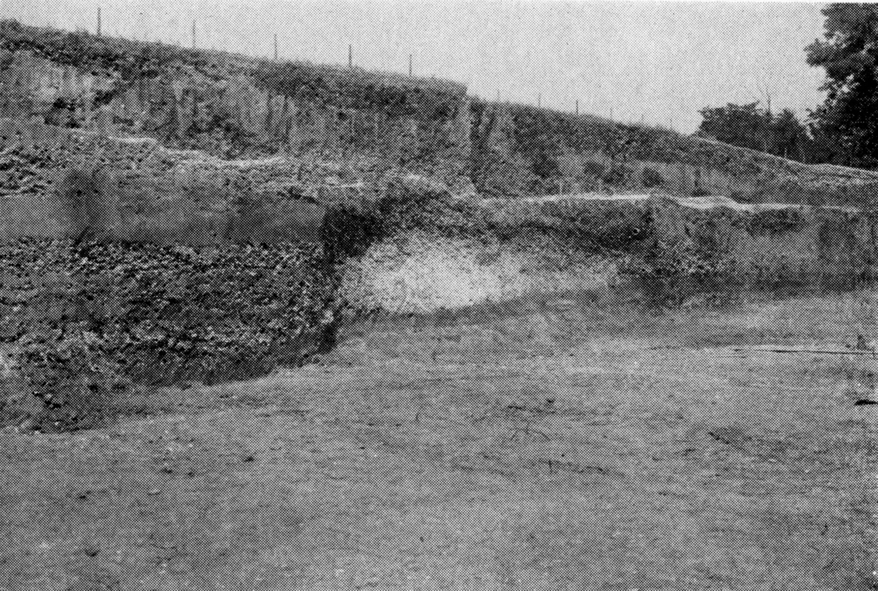
Figure 7.2. Flint River site (1Mao48) profile (photo courtesy of Alabama Museums of Natural History [Webb and DeJarnette 1948a:25]).

attributable to Late Archaic occupations based on the presence of diagnostic artifacts, namely Ledbetter hafted bifaces. The Whitesburg Bridge site is situated 9.8 km downstream (Figure 7.3). The site was recorded as 190 m long and 30 m wide, but the more recent investigations have found it to extend at least 300 m along the riverbank and more than 60 m inland (Gage et al. 2003; Meeks 2000) and the site is now recognized as being composed of more than just shell midden deposits. At the shoreline, the shell midden extends to 2 m below the ground surface.
As discussed earlier, the WPA era excavations of the site identified five strata: Zone A, B, C, D, and E. The latter three Zones are all preceramic with artifacts attributable to two Late Archaic components. The 2002 excavations of the site identified a similar series of strata with Stratum IV being the sealed Late Archaic component with several hearths, charcoal and FCR concentrations, storage pits, and shell and hickory nut processing areas associated with Zone D of the WPA era excavations. Above this was another sealed, aceramic, Late Archaic deposit with few hearths, few pits, and a large prepared clay mound
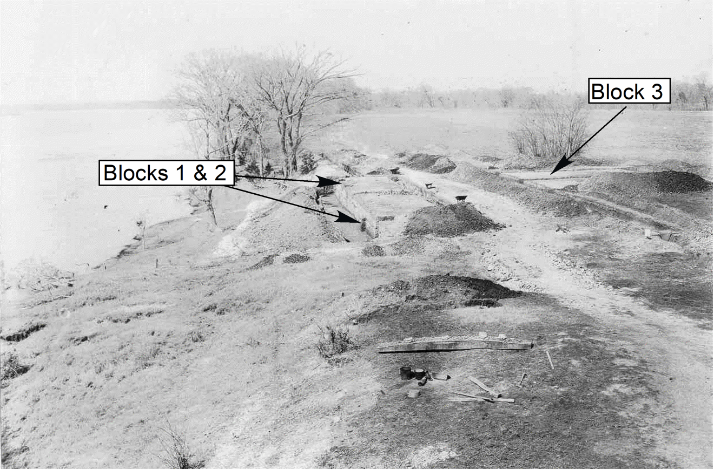
Figure 7.3. View to the west of the Whitesburg Bridge site in the Winter of 1939 (photo courtesy of the Alabama Museum of Natural History.

(Feature 70) measuring roughly 14 m in diameter and eroded down to 48 cm in height (Figure 7.4) (Gage et al. 2003; Wilkins 2003). As had been described, the mound was formed of red clay in stark contrast to its dark brown surrounding matrix. Dates for charcoal associated with the mound indicate an age of 1496–1275 cal BC (3120 + 40) (BETA 169605), 1943–1699 BC (3510 + 40) (BETA 177475), and 2874–2578 cal BC (4130 + 40) (BETA 177477). Also associated with this stratum was an inordinate
amount of charcoal and fragmented bone, much of which is from large mammals, namely deer. Charcoal associated with the shell midden east of the mound was dated at 1505 to 1301 cal BC (3150 + 40 BP) (BETA 169606). The red clay mound is an anthropogenic structure built during the Late Archaic occupation of the site and represents the earliest such mound known for the Middle Tennessee River Valley to date.

Late Archaic Period Occupation and Potential Occupation of the Area
Placing these two sites into their local and temporal context requires a consideration of evidence for occupation of the area. The Alabama Archaeological Site
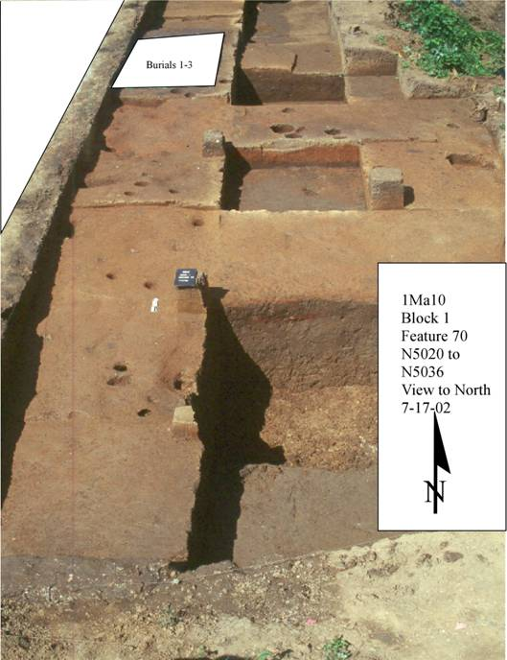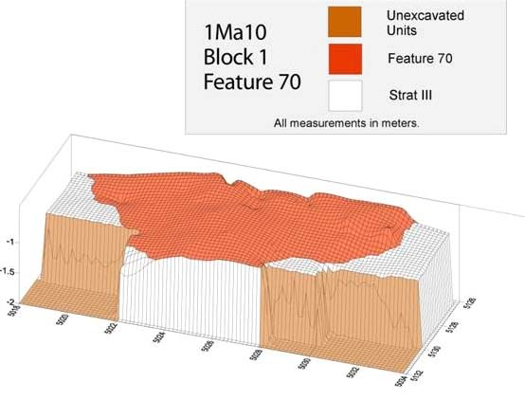
N

Figure 7.4. Feature 70 prepared clay mound at the Whitesburg Bridge site (Gage and Wilkins 2003).

File lists a total of 382 sites recorded within a 30-km radius of the Whitesburg Bridge site assigned to the Late Archaic period (Figure 7.5). The majority of these sites were recorded during Phase I cultural resources reconnaissance surveys conducted either in accordance with Section 106 of the National Historic Preservation Act or as shoreline studies conducted under the auspices of the Tennessee Valley Authority (Shaw 2000). In addition, several others have been recorded by local avocational archaeologists. Eugene M. Futato (personal communication 2018) developed the on-line site file to include component data attributable to various horizons and phases.
For the Late Archaic in this portion of the upper Wheeler Basin, the two horizons considered here are referred to as the Ledbetter and Wade components. The Whitesburg Bridge site has occupation strata attributable to both phases. The Flint River site, on the other hand, is only known to have the Ledbetter component. The stratum from the Whitesburg Bridge site that has been attributed to the Wade component is isolated from both the later ceramic-bearing Middle Gulf Formational, Bluff Creek phase and the earlier Ledbetter components by clear stratigraphic boundaries. Both sites include shell
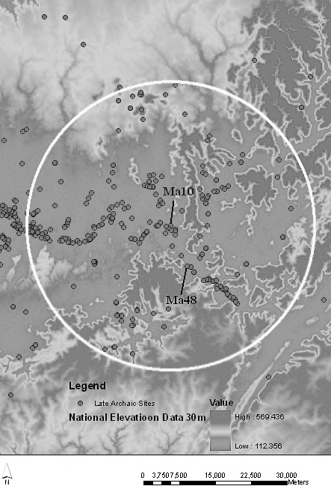
Figure 7.5. Subject area and distribution of Late Archaic sites within the upper portion of the Middle Tennessee River Valley.

midden deposits attributed to this earlier component, but only the Whitesburg Bridge site has a clay mound. Comparing the two sites diachronically requires a means of understanding the regional occupations within each component’s time frame.
To generate a proxy for the number of local groups occupying an area within a 30 km radius it is first necessary to identify the number of sites attributable to known components, in this case the Ledbetter and Wade phases and compare them to the amount of area surveyed. Within a 30-km radius of the Whitesburg Bridge site is an area of approximately 2,830 km². Of this area, 10.3 percent or 290.3 km² have been surveyed for cultural resources. Surveys and avocational archaeologists in the area have identified a total of 283 sites with Ledbetter components (Figure 7.6). In comparison, 99 sites with Wade components have been found (Figure 7.7). Considering that the Ledbetter phase is considered to span the first two thousand years of the late Archaic period (4000 to 2000 BC) while the Wade phase is assigned to the next 1000 years (2000 to 1000 BC), all other things being equal, the later phase should have roughly half of the number of sites as the preceding Ledbetter phase. Instead, the number is roughly one-third.
For the purposes of the model, it is assumed that within the 2,830 km² area, Ledbetter or Wade occupations could have occurred anywhere and that the 10.3 percent of the area that has been surveyed represents an equal distribution of investigation across this omni-occupiable landscape. This is obviously not the case as several mountains, including Green, Monte Sano, and the Whitesburg Mountains are all present within the area and would have offered steep slopes and bluffs with limited areas for habitation. In addition, the surveys have included several shoreline specific studies (Shaw 2000; Webb 1939, Gage and Herrmann 2009) that have resulted in the vast majority of the sites being located on the banks of the Tennessee River, a place which may indeed represent the vast majority of the area’s occupations and which likely biases the sample towards increased

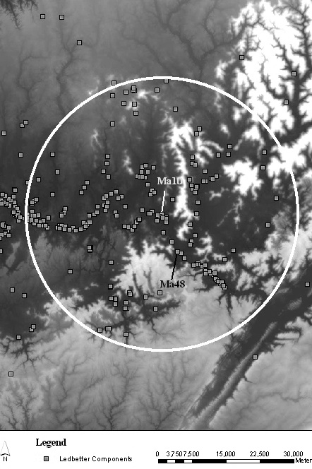
Figure 7.6. Subject area and distribution of known sites with Ledbetter components within the upper portion of the Middle Tennessee River Valley.
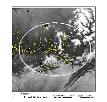
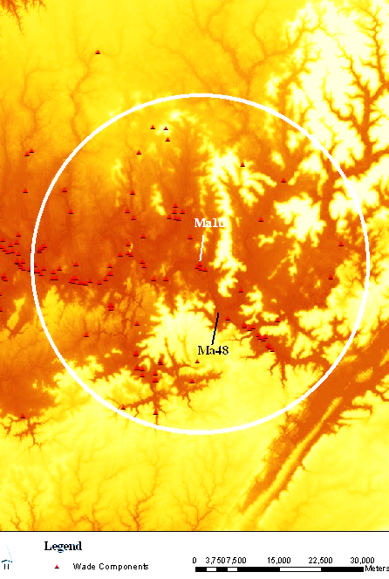
Figure 7.7. Subject area and distribution of known sites with Wade components within the upper portion of the Middle Tennessee River Valley.
site counts. To simplify for the purpose of this discussion, the entire area encompassed within the 30-km radius of Whitesburg Bridge is considered uniformly habitable and to include a projected total of 3,714.7 sites with Ledbetter components and 1,299.5 sites with Wade components. If groups attributable to Ledbetter were occupying the area during a period of cooler and drier conditions and the Wade were occupying the area during a wetter period, viable areas of occupation may have varied to some degree.

Factors of Mobility on Site Density
To place the activities and mobility of the Late Archaic occupants of the region in perspective, it is necessary to take the dubious step of drawing analogies to more recent examples of hunter gatherer societies. I say “dubious” in the sense that it requires an accurate understanding of the paleoenvironment, lifeways, and culture to make an absolute statement about past societies. However, applying ethnographic analogy provides us with a possible suite of explanations for understanding such groups. Ethnographic data (Kelly 1995:112-115) suggest the average number of residential moves of hunter gatherer groups is approximately 16.8 moves/year. This incorporates groups from many different environments and subsistence strategies. According to Binford and Murdock, the effective temperature (ET) of temperate forests (see Binford 1980 and Kelly 1995:66-73, 116-120), such as the pollen record suggests for the Middle Tennessee River Valley during the Late Archaic (Delcourt et al. 1983; Dye 1996), is 13° to 12° C (see Binford 1980:14 and Kelly 1995:117). Of the settlement patterns documented by Murdock, 60.3 percent (n=32) with an ET of this value are semi-nomadic (Kelly1995:117). Since individuals in resource-rich environments often tend to move less, the number of moves predicted for groups living in the Middle Tennessee River Valley is probably lower. In an effort to reduce this number and eliminate some of the groups with extreme mobility patterns (up to 60 per year for the Baffinland Inuit and Ona of Patagonia), the highest outliers are removed. The resultant average is 14.3 moves per annum. By removing the nine groups with the highest residential mobility, the average drops further to 9.4. Kelly (1995:122) noted that hunter-gatherer groups subsisting on aquatic resources would likely move less than those dependent on non-aquatic food sources. Aquatic resources are considered more reliable and evidence of a broader subsistence base (Dye 1996:140-141). However, this assumes a more continuous dependence on such resources rather than occasional harvesting as part of a seasonal round. These moves would have incorporated seasonal availability of resource patches such as migrating animal species, mast harvesting, seed and fruit gathering, and shellfish processing (see May 2005 for a discussion of when shellfish harvesting typically occurs).
The archaeological data for the Middle Tennessee River Valley, particularly the Wheeler Basin, remains relatively limited given the lack of published data on Late Archaic archaeological sites in the immediate area. However, paleoethnobotanical and zooarchaeological studies from nearby drainages and adjacent areas support the notion of seasonal rounds for the Late Archaic inhabitants of the region (Carmody 2014; Futato 1983a; Jenkins 1974; Roberts 2011; Walker 2011; Walthall 1980).
For simplicity’s sake, it is assumed that each group moves across the landscape reoccupying a series of 9.4 sites for roughly the duration of a generation (25 years). This assumes that 25 years per generation serves as a proxy for blocks of time attributable to site occupations. It also assumes that individuals reoccupy a site for the length of a
generation. This assumption is likely biased, since annual movements between resource patches could easily incorporate new, if nearby, sites. It also biases the results towards a greater number of individuals by assuming that a generation makes fewer sites than they likely did.
But if we continue with the assumption that a generation is 25 years, over the span of the Ledbetter occupations (occurring over 2000 years from 4000 to 2000 BC) roughly 80 generations existed. The remains assigned to Wade components (occurring over 1000 years from 2000 to 1000 BC) resulted from only 40 generations.
If 3,714.7 sites with Ledbetter components are the result of 80 different generations (25 years for each generation over a 2000 year span of time), then a conservative prediction is that 46.4 sites are attributable to any given generation of local groups within the area. By applying the residential-mobility-average variable derived from the ethnographic data of 9.4 moves a year, the number of local groups creating Ledbetter occupations within a 30 km radius around the Whitesburg Bridge site would have been in the neighborhood of five (4.94). Each group would likely have been composed of approximately 25 people (Birdsell 1968; Kelly 1995). The population of the 2,830 km² area would have been approximately 124 people or 0.044 people/km².
In comparison, if 1,299.5 sites with Wade components were the result of only 40 generations of occupation, then 32.5 sites may be attributed to a generation. If each local group moved 9.4 times per year, then the number of groups within the 30 km radius dropped to three and a half (3.46). Again, assuming 25 people per local group, the population of the 2,830 km² area would have been approximately 86 people or 0.030 people/km².
Each of the sites visited within a generation’s series should represent a specific resource patch with its own associated procurement strategies and thus material remains (Binford 1982:15-18). One of the potential problems with these population figures is the variability of land/site usage through time. Depending on subsistence strategies and a host of other variables and organizational parameters, the footprint left behind by a population may not be an accurate indicator of the number of groups or individuals. It may also overlap between procurement strategies and be difficult to infer from the archaeological record, such as where poor preservation limits the assessment of organic materials. This remains a topic for further consideration.

Implications for Social Structure and Interpretations
The population densities developed through this model are consistent with the ethnographic record of modern hunter gatherer societies. Johnson (1982:392-393; Kelly 1995:210-211) has pointed out that when more than six social units act together, a new level of hierarchy develops to coordinate activities. Twenty-five individuals typically represent between five and seven families (Kelly 1995:211). Wobst (1974:158) suggested that the number of individuals in a minimal social aggregate is 25. The population of 25 individuals seems to be a boundary between a minimal social aggregate (Wobst 1974:158) and a point at which social hierarchies develop (Kelly 1995:211, 2013). As Wobst (1974:157) pointed out, populations with local groups of this size have three non-violent options for sustaining their mating pool: (1) they can relax restrictive mating rules making more mates available for a given population size; (2) they can include neighboring bands into their mating networks (exogamy); or (3) they can wait until the mating pool is matched by other members of the group who reach reproductive age. The first two choices offer the best chances for resolving the problem.
Prior to the end of the Middle Archaic period, violent conflict, likely over available resources (Dye 1996:157; Milner 2004:46-47) or mates (Claassen 1996a [see also Sassaman 1995 as cited in Classen 1996a]), is evidenced by the presence of burials with projectile points imbedded within the skeletal remains or other indications of deliberate trauma (Smith 1996:142-144). Traumatic death resulting from anthropogenic causes is well documented during the Morrow Mountain Horizon/phase (Seven Mile Island phase [Futato 1983a] or Sanderson Cove phase [Walthall 1980]). Projectile points imbedded in human skeletal materials and evidence of social conflict have been found at the Mulberry Creek site (1Ct27) in the Pickwick Basin (Dye 1996:82, 157; Webb and DeJarnette 1942:244-245) as well as in other portions of the Southeast (see Milner 2004:46-47; Sassaman 1995; Sassaman and Anderson 1995:178). Social stress during the Middle Archaic, Morrow Mountain Horizon may have had its origins in the effects of the Mid-Holocene Climatic Optimum, only ending with the relative stabilization of climatic conditions and resultant environmental changes that occurred at the end of the Middle Holocene (Dye 1996; Meeks 2003).
Regardless of its catalyst, the end of the Middle Archaic period witnessed the demise of a long standing pattern of lifeways and the decline of at least one of the extensive exchange networks—the Benton Interaction Sphere (Johnson and Brookes 1989: Meeks 2000). The beginning of the Late Archaic period is marked by a trend towards a much different subsistence pattern where an expanded resource base included more extensive use of aquatic resources, domesticates, and material culture included new projectile point and container forms. Another exchange network, namely sandstone and soapstone, increased in intensity during this time (Finn and Goldman-Finn 1997; Newman and Berryman 2003; Sassaman 1993; Truncer 2004; Wells 2006). Source areas for sandstone with requisite quarrying evidence exists within the Flint River drainage (Van D. King, Jr. personal communications 2003) a short distance upstream from the Flint River site. This area was likely the source for most of the sandstone vessels and fragments found at both the Whitesburg Bridge and Flint River sites .
The evolution of the Late Archaic cultures is undoubtedly a result of well established trends founded in the preceding period. It is likely that the increase in intensity of long distance interaction and trade, including of soapstone and sandstone vessels (Sassaman 1993), stems from a response to the preceding periods of societal stresses. This is not to suggest a smoothly contoured continuum from one period to the next. Rather it should more accurately be considered as a sequence formed by a series of dramatic alterations to the overall pattern. It is apparent that Late Archaic populations developed new and innovative systems of interaction as a way of offsetting societal pressures.
Given the population density suggested by the above model, exogamy was a likely factor in the reproductive practices of these Late Archaic populations. If, during the Ledbetter and Wade occupations, the population density was in the range of 86 (Wade) and 124 (Ledbetter), then the viable pool of mates would have represented only a limited portion of the population. The number of individuals available for any one person to mate with would be limited by age (past the age of menarche and pre-menopausal), gender, and cultural controls on mating (Kelly 1995:205-259). As Wobst (1976:51) pointed out, the area a mating network covers is directly related to population density. With a density of around 0.044 persons/ km², the mating network would likely need to include an area of 9,500 km² and 11,875 km² (Table 7.1)(Wobst 1976:51). These areas have radii of between 60 km and 67.5 km, much more than most ethnographically documented hunter-gatherers traverse (Kelly 1995:112-115). Access to viable mates would most likely have included exchange between local groups in a pattern of overlapping mating networks (Wobst 1976). Such networks would have required long-distance information exchange as well as the establishment of a time and place for such interaction. Perhaps not surprisingly, shell midden sites fit these conditions very well.
Table 7.1. Population densities and the necessary area for viable mating networks from Wobst 1976:51.
Area and Diameter of Mating Networks at Different Population Densities
Population Density (person/km²) | Area (km²) | Diameter (km)
0.05 | 9500 | 120
0.04 | 11875 | 135
0.03 | 15833 | 156
0.02 | 23750 | 1191
0.01 | 47500 | 270
0.009 | 52777 | 285
0.008 | 59375 | 302
0.007 | 67857 | 323
0.006 | 79166 | 349
0.005 | 95000 | 382

Typically situated close to the natural habitats of gastropods, namely natural cataract or stream confluences and relatively shallow water, the locations of shell midden sites were often existing stopping points, portages, or habitations for those traveling the waterways or exploiting adjacent resources. The sites served as convenient coalescing points for groups living up and downstream. Archaeological deposits developed in such active fluvial environments as the Middle Tennessee River Valley are often heavily stratified. Seasonal flooding and subsequent sediment deposits are common, resulting in interbedded shell midden lenses, natural flood sediments, and non-shell midden deposits, creating long, low mounds on the shoreline. The highly visible bleached white shell shorelines created by the massive piles of gastropods are beacons for locating such landscape features as the Whitesburg Bridge and the Flint River sites (see Figure 7.3).
During the Ledbetter occupation of the Whitesburg Bridge and Flint River sites, the processing of shellfish likely adhered to well-established traditions of rendezvous times imbedded within the patterns of seasonal rounds. The deposits associated with this component include numerous storage pits, mast processing stations, hearths, and massive middens spread over large areas. Evidence for structures is limited to one possible prepared clay floor with associated post holes found during the 2002 excavations of the Whitesburg Bridge site (Wilkins 2003) and isolated postsholes and postmolds scattered throughout both sites. In essence, these sites appear to have been occupied during the fall and for relatively short amounts of time. The presence of storage facilities may represent the need for long-term storage associated with temporary abandonment and the intention of returning to the location later in the year or the need to hide consumables from competitors (DeBoer 1988).
While possibly not the case for all shell midden sites or all components within a single shell midden site, many of these occupations and resultant features likely represent multiple local groups aggregating for the purpose of resource acquisition and interactive exchange over a short period of time. In the stratum containing the later Wade component at the Whitesburg Bridge site, the number and types of features varies from the preceding occupation, suggesting a new wrinkle in interaction patterns. The presence of storage pits appears differently in time between early and later components. More are present in the earlier occupation’s deposits and few are present in the later stratum. Hearths are generally small, but large deposits of charcoal and fragmented bone are common. In addition, the appearance of a large clay mound indicates a dramatic shift in cultural practices or social organization.
Putting such change into the context of Wobst’s (1976:54) overlapping mating networks, the avoidance of the tendency for groups to move towards the center of a mating network was necessary. If all groups moved towards a given central location, the increased population density places more resource and social stresses on the groups. This may provide insight into the culture of its occupants and the decisions made for when and how to aggregate. The aggregation of smaller groups into larger bands during specific times when the construction of monumental architecture and site specific resource exploitation could be undertaken not only suggests a change in the complexity of social organization but also serves to offset the deleterious effects of what appears to be low population density. Three of Wobst’s (1976:55) social mechanisms are employed in such activity: (1) increased social solidarity through society-specific activity; (2) bringing far flung individuals together to reestablish communication efficiency; and (3) tying the participants to a geographic location by providing a symbol of macro-group unity.
Such activities directly affect exchange networks and mating populations as well. By bringing together multiple social groups for presumably non-violent interaction, familiarity with other individuals and potential mates contributes to the broadening of the mating pool and strengthens social ties and cultural solidarity into what Anderson (2002) considers the formation of tribal societies.
This, in effect, is what Schlanger (1992:97; see also Thompson 2010:218-219) suggests leads to “persistent places”, or “places that were repeatedly used during long-term occupations of regions.” These places take on special meaning of their own and become the destinations for repeated occupations/utilizations. The Whitesburg Bridge and Flint River sites were repeatedly occupied throughout the period of time associated with the Ledbetter components, when aggregating groups actively constructed shell mounds. But a shift in patterns at the Whitesburg Bridge site becomes apparent during the subsequent Wade occupation. It is during the latter that we see increased evidence of flooding and the creation of the red clay mound. The communal activity required to build a mound, whether shell or earth, would have served not only as an opportunity for corporate labor and evidence of cohesive cultural activity if not beliefs, but also as an obvious symbol of the territorial claim of the builders. If increased flooding became a factor in the shellfish population of the sites (Davis et al. 2024; Kidder et al. 2017), then the occupants may have shifted their focus to non-consumable construction activities that would have been just as visible, namely the construction of a red clay mound.
To summarize, the occupations of the Whitesburg Bridge and Flint River sites represent a pattern of cultural change evident in a diachronic comparison of component attributes. In brief, the Wade component at the Whitesburg Bridge site differs from the earlier components at it and the Flint River site by the absence of evidence for subsurface storage or concealment, the presence of earthen monumental architecture, and the distribution of sites across the surrounding landscape. Based on the timeframe for the domestication of seed crops in the region it is possible that these pits were being used for long term storage of more than just nuts (Carmody 2014; Hollenbach and Carmody 2019). At a time when the population of the area was possibly declining due to changing resource base and increasing sedentism associated with crop production, new patterns of social interaction were implemented, potentially in an effort to stem the tide of a decline in the mating pool. By increasing the ties that bind local groups into larger social entities, populations improve their chance of survival. Evolving patterns of interaction serve as an avenue to achieve such a goal. The danger of marginal local groups leaving the mate exchange network for other adjacent, and likely closer networks, could possibly have been dissuaded by an additional factor – material exchange. For the Whitesburg Bridge and Flint River sites, this factor was well established by the Ledbetter occupations of both sites through the exchange, and likely manufacture, of sandstone vessels. It was only later, however, that the innovation of culturally directed labor activities involving earthen mound building, contributed to the equation of sustaining the population, possibly as a replacement to the previous activity of building shell mounds.

Chapter Eight
The Whitesburg Bridge Site Development and Intrasite Patterns
Does the need to maintain a population in a region of high resource availability and temperate climate still drive people to employ strategies of political alliance and social networking that are not supported by necessity, or does culture and tradition trump agency and individualism in a world where uncharacteristic communal behavior benefits an entire regional population? To the first part, it is apparent that changing environmental conditions undoubtedly had an effect on how the Whitesburg Bridge site was used. The transition from building shell mounds to earthen mounds did not come about at a time when both resources (shell and red clay) were available, but one where shellfish populations were assumedly on a decline based on their absence from the archaeological record and flood events were more frequent (Davis et al. 2024). This leads to an answer to the second part of the question: rather than abandon the location for less flood-prone and equally accessible areas, did people continue to gather at the location that had been a tradition or persistent place for generations.

The Late Archaic Period
The first terrace on which the Whitesburg Bridge site exists appeared during the early to mid Holocene, approximately 3650 to 3300 cal BC (BETA 138534) when climatic conditions facilitated fluvial deposits and soil development. By roughly 2000 BC, the terrace was well established, although the site area does not seem to have been occupied. Intensification of the use of the site did not occur until the latter portion of the Late Archaic, around 1600 BC when the inhabitants took advantage of the natural shoals formed by cherty limestone that creates an excellent environment for gastropods. If similar environmental conditions were present prior to this, why was the Whitesburg Bridge site not more heavily utilized earlier? The answer likely resides in the gradual shift of Late Archaic practices of resource exploitation.
The sequence of radiocarbon dates from the site (Table 4.1) points to continued use throughout the cultural periods outlined in Chapter 4. A display of the sample dates obtained shows this trend in Figure 8.1. The intact deposits include the Late Archaic
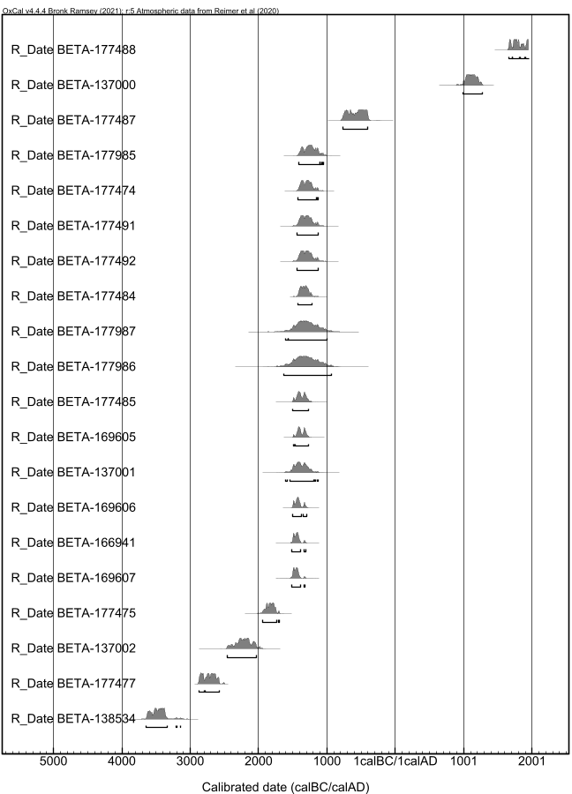
Middle Archaic
Wade
Ledbetter
Gulf
Form
Woodland
Late Archaic
Miss
Figure 8.1. Calibrated plots of all radiocarbon dates from Site 1Ma10 with time periods and Ledbetter and Wade phases overlain.

Stratum IV, the period of limited use and flood deposit episodes in Stratum III, and the lower portion of Stratum II, where Middle and Late Gulf Formational occupation generated accretional deposits and into which Middle Woodland features protrude below the mixed upper Stratum I plow zone.
The intermixing of cultural deposits in the upper portion of Stratum II and all of Stratum I resulted from a number of factors, not the least of which was frequent use of the landform for centuries. The most significant disturbance can likely be attributed to historic cultivation of the area. Historic photographs depict fields, structures, and what appear to be garden plots at the location. Later disturbances associated with road and utility construction undoubtedly played a part in destroying the context of the archaeological deposits. Fortunately, the WPA-era excavations offer not only a glimpse of the site prior to the construction of the south-bound bridge, but also a comparison between different parts of the site. In truth, the collections obtained from the 1939-1941 excavations and their divergent results from the 2002 excavations create a certain number of questions, most of which have to do with recovery techniques that lacked screening as described in Chapter Four. Although far more area was excavated during the 1939-1941 excavation (approximately 985 m² versus 226 m²), more material was retained from the latter excavation.
The variability between the feature assemblages found in the two excavations (1939 versus 2002) is even more perplexing. One of the most interesting differences between the two is the number of pits identified. Of the 312 non-burial features in the present excavations, only six are pits in Strata III or IV or their substrata. In comparison, the 1939-1941 excavations found storage pits so common, they were not counted as features (Webb and DeJarnette 1948c).
Many circular pits were found dug into the sand base below Zone E. These pits were filled with shell midden, but contained no burial or any evidence of their purpose, so were not listed as features. They may have been storage bins or midden pits, but their content was not different from that of Zone E (Webb and DeJarnette 1948c:18).
A view (Figure 8.2) of several such pits is presented in Figure 4(a) of their report (Webb and DeJarnette 1948c:17). This variation in recovery is unlikely the result of excavation technique, but rather the result of excavation of two distinct portions of the site. The 2002 excavation of shell midden deposits was limited, because the portion of the site excavated was farther from the river’s edge, where the shell midden is present. Unlike the 1939-1941 investigations, which focused on excavating the portion of the site where more than a meter of gastropod shells existed and shellfish processing appears to have been the dominant activity, the 2002 excavations provided additional evidence of other forms of food processing, habitation, and ancillary activities.
The ethnobotanical analysis reveals the importance of nut meats to the inhabitants. Acorns (Quercus sp.) dominate the botanical remains followed closely by hickory (Carya spp.). Their presence in Late Archaic burn features, whether hearths or earth ovens, indicates processing and not subterranean storage. While such processing would likely have been done during the fall when the nuts were gathered, the possibility also exists that storage involved above ground facilities/vessels and that stored nuts were being processed post-storage and for final consumption. This latter possibility falls in line with the argument that stone bowl technology was designed in direct association with storage and consumption of nut mast (Truncer 2004). This possibility, however, is not supported by residue analysis conducted on soapstone vessel fragments from the Applebarn site (40BT90) in the southern Appalachians of East Tennessee, which indicate that soapstone vessels there were being used for processing chenopod, little barley, and/or
wild rye seeds (Wells et al. 2014). This use of stone vessels could have been the case at the Whitesburg Bridge site as well, especially since we know both chenopod and little barley were present at the site (Roberts 2011).
Clay linings are often found in association with storage pits to prevent water seepage from spoiling the pits’contents (DeBoer 1988). The argument for seasonal occupation of the site based on the gathering of hickory and acorn is substantiated by the faunal remains identified within the Stratum IV deposits (Walker 2011). Both indicate that the site was occupied during the late summer and fall. Both also highlight the importance of white tailed deer,hickories and walnuts, and acorn to the Late Archaic
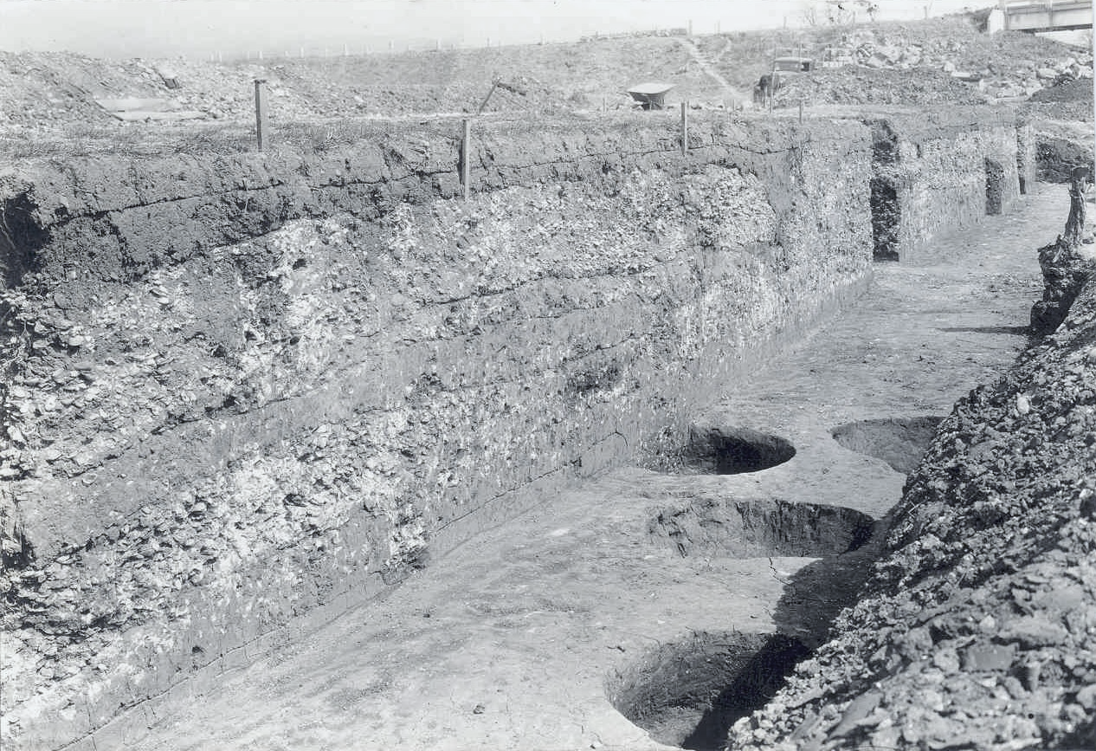
Figure 8.2. Pits found at the base of the Archaic 3 stratum during the WPA excavations (Webb and DeJarnette 1948c:17: Figure 4[a]).

inhabitants of a shell processing site.
The subsistence strategy of the Late Archaic inhabitants of the Whitesburg Bridge site follows a relatively common trend for inhabitants of the region. Jenkins (1974) outlined these strategies for the western Middle Tennessee River Valley. Similar observations are offered by others such as Dye (1980), Futato (1983), and Morse (1967). Shellfish collection, hunting particularly of white tailed deer, and nut collecting were the three prime subsistence strategies. At the Whitesburg Bridge site, this three-resource subsistence strategy was augmented with fish, including fresh water drum, plus turtles, turkey, and possibly snakes, as well as gathered and likely cultivated seeds and fruits including maygrass, chenopod, purslane, persimmon, and grape (Roberts 2011).
Technological innovations in container technology, namely large, heavy, sandstone and soapstone bowls have been suggested as indicators of increased sedentism (Walthall 1980:60-70). The widespread appearance of such vessels across a large region highlights the importance of interaction networks. East of the Tennessee Valley and upstream of Guntersville Basin, sandstone vessels decrease in frequency (Finn and Goldman-Finn 1997; Newman and Berryman 2003; Sassaman 1993; Webb and Wilder 1951). But their presence is well documented downstream into the Pickwick Basin (Futato 1983; Webb and DeJarnette 1942) and is well documented at Poverty Point (Exnicios and Woodiel 1986:91; Finn and Goldman-Finn 1997; Hagg 1986). Morse (1967) suggested that the relationship between the Appalachian Piedmont and Lower Mississippi Valley is based on an exchange of materials that included stone bowls traded from the Piedmont area through the Tennessee Valley in exchange for shell being sent to the northeast.
The relationship between Poverty Point and the Whitesburg Bridge site is also likely shown by the presence of Pickwick chert, Tallahatta quartzite, and the large, circular, earthen mound found in Block 1. Such structures are known from sites throughout Louisiana and the Lower Mississippi Valley extending back to 7400 cal yr BP (Gibson 1996; Russo 1994, 1996; Sassaman 2004). Gibson (1996:301-304) has argued that the trade between Poverty Point and distant locations was a one-way affair with nothing of Poverty Point local origin being sent back to the outlying regions. And, unlike the ceremonial consumption assumed for the earlier Middle Archaic interaction networks and the subsequent Hopewellian interaction sphere, he argues that Poverty Point’s occupants were all allowed access to exotic goods and that it was a matter of egalitarian function rather than elitism (Gibson 1996:302). While perishable trade goods are always a consideration, the more likely item of exchange was not a physical entity, but rather an esoteric one involving beliefs and ideaological exchange, possibly as economic based as tribute to a shared place/deity/or sociopolitical figurehead.
Evidence for Late Archaic structures in Stratum IV lie in the various isolated posts and the large prepared clay surface, hearth, and posts identified in the northern portion of Block 1. The prepared clay surface (Feature 37) and ring of posts, discussed in Chapter V as Feature Association 1, suggest a semi-circular structure or open front structure typical of Late Archaic sites (Bentz 1996:50-66; Faulkner and McCollough 1974:245; Morse 1967:13-14; Webb and DeJarnette 1948b).

Subsequent Gulf Formational and Woodland Stage Occupations
In comparison to the Late Archaic occupation, the subsequent depositional strata are far more heterogeneous. The site’s Gulf Formational occupants left few identifiable features. Only a single posthole (Feature 73) suggests an intact Bluff Creek phase feature, with five Wheeler Plain pottery sherds present. The Bluff Creek ceramics from this portion of Site 1Ma10 are 97.0 percent Wheeler Plain, 90.0 per cent var. Wheeler. This is indicative of an early Bluff Creek phase association. The later Hardin phase is possibly represented by only two postholes, one with Alexander Pinched and one with Baldwin Plain pottery. The remainder of the features with pottery include later Woodland types. This is another difference between the 2002 excavations and those of the WPA, where fiber-tempered ceramics “…did occur as a dominant form in Zone C” (Webb and DeJarnette 1948c:43). The vertical distribution of sand-tempered and fiber-tempered sherds in the 2002 excavations does show an increase in number fiber-tempered versus sand-tempered sherds in the deeper portions of Stratum II but the separation is not as pronounced as in the WPA excavations.
The Stratum II cultural debris indicates that occupations extend from the Bluff Creek and Hardin phases through Colbert I and II to the Green Mountain phase. The majority of the features within this stratum date to Colbert and Green Mountain. Watts Bar Fabric Marked is a significant minority type in Strata I and II and hints at association with areas to the east in the Ridge and Valley of Tennessee during the Early Woodland.
A Colbert II occupation is evident in Stratum II and is typified by the presence of Greeneville cluster points and Long Branch Fabric Marked pottery along with minor amounts of Wright Check Stamped and, perhaps, Alexander series ceramics (Cole 1981; Futato 1998; Knight 1990). Knight’s provisional Green Mountain phase, with a predominance of Mulberry Creek Plain, is also recognized from both Stratum II levels and from feature context.

Summary
The excavations of the Whitesburg Bridge Site by the WPA in 1939-41, and by The University of Alabama, Office of Archaeological Research in 2002, reveal markedly different results for the two portions of the site investigated. Those differences are, however, not unexpected. As with any large habitation site, different areas were used for different activities and these locations shifted from one occupation to another. Proximity to the river, topography (both natural and anthropogenic), and a myriad of other ecological and social factors influenced the intrasite distribution of material remains.
What is clear from both excavations is the presence of a sealed Late Archaic com-ponent at the base of a series of relatively rapidly deposited alluvial sediments. Evidence from this component hints at the importance of regional trade networks to the occupants of the Middle Tennessee River Valley. This occupation of the Whitesburg Bridge site fits well into models devised for the hunter-gatherers of the Late Archaic, with seasonal occupations of various resource areas or patches. Although limited, seasonality data suggests the site was occupied during late summer and fall. This supports an interpretation of its function during the Late Archaic as an aggregation site where groups gathered to process riverine and bottomland resources, exchange materials and mates, and to build both shell and earthen mounds.
Feature 70 was one focus of these present investigations. The geoarchaeological analysis indicates that Feature 70 was purposefully constructed with basal deposits and a red clay cap (Appendix C). The size and complexity of Feature 70 suggests that is represents something other than the fired or packed clay living surfaces common to shell middens in this region. Unfortunately, the top of the red clay cap has been truncated by later precontact and historic Euro-American occupation of the area. As a result, we have no information regarding the type of activities which might have occurred on the mound. Nevertheless, Feature 70 adds to our knowledge of Archaic mound building and extends the known range of this practice into the Middle Tennessee River Valley.
By the Middle Woodland, the period of rapid alluviation had subsided and the terrace on which the site is located was subjected only to occasional flood activity, a circumstance that continues today, even after the building of the locks and dams by TVA. Woodland occupation of the site continued, evidently with only slight variation in site function. Whether the site then became occupied year round remains to be seen. The importance of the site to human occupation continued into historic times as Dittos Landing became a center for transportation, commerce, and some light industry. This period continued until railways supplanted dependence on river traffic and the C. C. Clay Memorial Bridge subsequently eliminated the need for a ferry at this location.

Chapter Nine
The Role of Social Identity in Population Maintenance in the Late Archaic Middle Tennessee River Valley
Human social organization is influenced by a combination of environmental and cultural factors which are seminal to the maintenance of populations. These influences are derived from within the local community, as well as distant sources on the fringes of interaction networks. Their recognition in the archaeological record is dependent on diagnostic artifacts and stylistic continuity between groups that form the material expressions of a common ideology (Claassen 1996a; Dye 1996; Gibson 2001; Johnson 1996; Randall 2015; Randall and Sassaman 2017; Russo 1994, 1996, 2004; Sassaman 2005).
Sociocultural evolutionary theory often incorporates the discussion of archaeological sites, their location on the landscape, and their occupants’ socio-political organization in terms of their economic basis for existence (Trigger 2003:42; Yoffee 2005). Its practitioners’ reluctance to see large sites outside of the context of economic/resource exchange stems from current, and past, trends in theory. As Yoffee (2005:187) stated;
The high level theory that is most familiar to archaeologists is formalist economics theory, the theory that the cost of a good is proportional to the distance the good is moved, that economic goals are optimized; and that there are regularities of supply and demand (Yoffee 2005:187).
Hence, the widespread use of least-cost analysis in interpreting settlement patterns and trade networks (Anderson 2010; Bell and Lock 2000; Hollenbach 2009; Wheatley and Gillings 2002), the study of interaction spheres and networks of exchange (Sassaman 1993, 2005; Meeks 2000), and the emphasis put towards displays of prestige, such as hypertrophic artifacts (Jeffries 1996; Meeks 2000; Randall 2015; Sassaman 2005). This approach is by no means a deleterious addition to archaeologists’ theoretical tool kit. However, it, like so many other aspects of the discipline, requires a multifaceted approach and application of theoretical constructs.

A Southeastern Perspective
Prior to the Woodland Stage, the Southeast was occupied by egalitarian hunter-gatherer groups who moved across the boundaries of various environments and resource patches that covered extensive areas (Anderson 2002; Anderson and Sassaman 2012; Sassaman 2010). These areas or “ranges” encompassed lithic raw material sources, specialized food procurement areas, and culturally, including spiritually, significant landscapes. The variability in environments and similarity in technology points to extensive communication networks between neighboring groups (sensu Johnson 1996:212). Maintenance of such networks would have required not only a viable population, but set means of interaction and exchange. Access to raw material sources and exchange networks was determined by one of three control factors: (1) through a group or individuals’ ability to control such resources directly, (2) by promoting themselves as laudable members of a broader community deserving of access, or (3) by providing a beneficial return to those in control.
Direct control could be maintained through limiting access by force, coercion, or by proving an inalienable right to controlling access through a common ideology or perception of “ownership” (e.g. ancestor worship and claims of kin proximity to a common ancestor). Craft specialization dominated by those who control access to resources has also been discussed in terms of the formulation of cultural identity and maintenance of power (Schambach 2000; Spielmann 1998).
Communal identity resulted in the development of territories, orchestrated interactions betweens groups, and led to increased social complexity. In egalitarian societies, the cultural norms that lead to sharing activities require not only willingness on the part of the controller, but also an agreed-upon sense of deservedness for the recipient. This sense is achieved typically through recognition of kinship ties, which may include ancestor worship, or through communal relationships that promote inclusive behavior within a social unit. Aggrandizement by the resource controller and, in the case of hierarchically or even heterarchically structured societies, subjugation (or at least debts of obligation) by the recipient may be at the root of this behavior.

Finally, the economic benefit is obvious to an individual or group who controls access to a desirable resource. Self promotion within a social unit that leads to better access to necessities or to items or activities deemed pleasurable are the two broad categories under which most of these perceived benefits fall. Necessities incorporate all of the typical needs of daily life such as sufficient food, shelter, and water. It also includes access to viable mates for the maintenance of a viable population. Non-necessities identified within the context of known Southeastern Late Archaic exchange networks include everything from hypertrophic items and stone bowls to information and ability to organize labor for the creation of monumental architecture. While all confer some advantage to those in control, the ability to allocate labor and control information are culturally significant factors that appear and develop during the Middle and Late Archaic periods.
Evidence for reciprocal exchange from the Lower Mississippi Valley to the Tennessee Valley is limited. Typical Poverty Point baked clay objects as well as diagnostic bird, other zoomorphic, and anthropomorphic effigies are unreported from Late Archaic context sites within the Tennessee Valley. Outside of the immediate Poverty Point area, Webb (1968:303) mentioned biconical Poverty Point objects from Gibson County, Tennessee, and Mainfort (1994) has reported baked clay objects from the Obion River Drainage (Site 40GB42) (Hays et al. 2016). As others have noted, what may have been provided in return for exotic trade goods, labor expenditures, or access to controlled resources from the Middle Tennessee River Valley and beyond might not have been a physical item, but information and an ideological concept that was desirable to those in control of the sources of materials and trade routes involved in the exchange networks.
In all three resource control models, symbols of power and prestige become fused within a common ideology that binds social units together. Whether this comes in the form of hypertrophic blades, monumental architecture, or exotic trade goods remains irrelevant to the basic concept, as long as a community has cognitively recognized items that indicate a group’s or individual’s position within a broader community.

Hunter-Gatherer Complexity
The pitfalls of using modern hunter-gatherers as proxies and the application of ethnographic analogy have been well explored over the years (Hodder 1986:149; Kelly 1995, 2013; Lee and DeVore 1968; Peregrine 1996; White 1963). On the opposite end of the social developmental spectrum, at least 130,000 years (McDougall et al. 2005) of modern human evolution cannot be ignored. Although occupation of the Americas accounts for only about 1/10 of this time span, it is impossible to discount those millennia before human arrival in the New World and the influence on the populations of immigrants and their descendents. After all, the baggage of culture and tradition was unlikely to have been left on the doorstep of the Americas. Universal behavioral traits, hinging on basic human nature and biological needs, have been espoused as the underlying cause of the evolution of sociocultural complexity (Brown 1991; Trigger 2003).
Social complexity is often restricted to the realm of social evolution with the hunter-gatherer traditions of the past relegated to bands and tribes and subsequent agriculturalists organizing themselves into chiefdom- and state-level groups (Anderson 2002; Service 1962). The small size of bands (25-50 people) facilitated the highly mobile, egalitarian lifestyle. Tribes represented larger units (100s to 1000s), with semi-permanent settlements, and non-centralized political organization orchestrated by part-time officials (aggrandizers). Chiefdoms were still larger (1000s of individuals) and were organized with multiple permanent communities controlled by a central authority with ascribed status. Finally, states had much larger populations (100,000s) with many permanent settlements, centralized authority, formal offices in multiple governing bodies, and power based on codified laws (Service 1962). Bands and tribes were held together through kinship and stratification only existed through economic and social subjugation and a sense of obligation.
As populations increased and the need for increased efficiency in information exchange resulted, increased social complexity and the compartmentalization of social units developed. It was under these conditions that ideology became an ever increasing aspect of group identity and cultural cohesion (sensu Kennett and Kennett 2007:252).
Following the nomadic and semi-nomadic settlement system of the Paleoindian, Early Archaic, and Middle Archaic, the subsequent gradual trend towards new settlement patterns of the Late Archaic reflect shifting subsistence strategies and population interaction networks. The increased sedentism was an elaboration of the existing Macro-band basecamp — Micro-band basecamp — procurement site settlement strategy long espoused for the preceding periods (Anderson 1996a:39; Anderson and Hanson 1988; Anderson and Sassaman 2012; Custer 1984:96-97; Futato 1983; Hofman 1986; Jenkins 1974:186-187; Walthall 1980:69). The Late Archaic evidence for the exchange of exotic goods, monumental architecture and required labor expenditures, as well as population densities in the Middle Tennessee River Valley highlight this alternating complexity of social interaction networks.
During the Late Archaic, expanding populations of the Southeast facilitated the increasing utility of cultural identity. Interaction networks and resource access were dependent on the development and maintenance of relationships (alliances) between key agents (Sassaman 2005). Association to these agents required identification as a member of a cohesive unit that directly or indirectly controlled access to resources and the maintenance of territories.
Complexity, according to Arnold (1996:93), consists of institutionalized control over non-kin labor, as well as hereditary inequality (inherited status or wealth), and usually, but not necessarily, multi-community political authority. Evidence of complexity as she defined it is limited in the Southeast. While Marquardt and Watson (2005:637) did not advocate the use of “complex hunter-gatherers” for the occupants of the middle Green River, they suggested it does apply elsewhere. Indeed, the case for such complexity can and has been made for groups heavily involved in the Poverty Point interaction (Gibson 2001; Sassaman 2005; Webb and Ford 1956; Widmer 2004).
Unlike other regions (i.e. Mesopotamia [Flannery 1998; Kennett and Kennett 2007; Marcus 1998], Mesoamerica [Marcus 1998; Marcus and Flannery 2000], and China [Chang 1971; Stein 2001]), the Southeast’s shift towards complexity (Anderson 2002) is not directly linked to the introduction and wide-spread conversion from transitory hunter-gatherers to sedentary agriculturalism. Rather, the impetus to the development of middle range hierarchical social structure is likely associated more with individual aggrandizers and efficient exploitation of existing trade networks. Why did Poverty Point not get built in the Middle Tennessee River Valley, near sources of highly prized chert, or to eastern Tombigbee River drainage where sandstone vessels were manufactured (Wright and Henson 1968), or as far east as the Piedmont and Appalachian Summit where soapstone was available for the manufacture of highly prized soapstone vessels (Wells 2006)? Primarily because of the efficiency of those agents capable of building alliances, fostering interaction, and drawing people to themselves. Political influence and social power derived from the charisma of those willing to create, develop, and maintain trade networks and the sense of cultural identity that made others want to associate themselves with these individuals. By others, I refer not only to local inhabitants in direct, if not daily contact with these leaders, but to outsiders who came to feel a sense of benefit by associating themselves with the enigmatic forces touted by foreigners. And what they themselves acquired in the exchange may not have been a tangible item or access to a particular physical/organic resource, but rather a paradigm of power that gave them influence and a sense of personal well-being over their contemporaries.

Material Resources of the Middle Tennessee River Valley and Their Presence in Late Archaic Sites of the Lower Mississippi Valley
As Hodder (1982:207) noted, “exchange must be studied within a social context and as part of a system of production.” As with people, objects gather significance through their comparison to others. This may be based on utilitarian aspects of efficiency and performance or on perceived cultural value. Exchange is conducted within a well developed set of rules and regulations that govern interactions, transportation, and obligations (Hodder 1982:206).
The involvement in Archaic regional exchange between the Middle Tennessee River Valley and the Lower Mississippi Valley have been presented by several scholars (Carr and Stewart 2004; Ford and Webb 1956; Gibson 1994; Goad 1978; Hurst and Larson 1958; Lehmann 1991; Mitch 2023; Webb 1968; see Sassaman 2005 for a contrasting view in which he suggests that shell midden occupants o fthe Middle Tennessee River Valley was “apparently apart from the goings on at Poverty Point, despite geographic proximity [Sassaman 2005:351]). They highlight the interaction, trade networks, and artifact distribution that point to a strong relationship between the Middle Tennessee River Valley and the distant communities to the west. For instance, Jaketown phase sites with Tennessee River Valley lithics identified in Lehmann’s (1991:Table 1, 189) Groups 1 (sites with early occupations) and 2 (sites with later occupations) include:

Group 1 Cloverdale (22BO573)
Teoc Creek (22CR504)
Hebe (22WS521)
Savory (22SH518)

Group 2 Tackett (22QU567)
Norman (22QU518)
Swan Lake (22CO551)
Meredith (22CO543)
Bramlett (22CO551)
Jaketown (22QU505)
Joe George (22QU577)
Falls (22LF507)
Neill (22LF500)
Gamer (22CO521)
Waller (22YZ585)

Each of those in Group 1, considered early in the Poverty Point Period sequence, also included materials from the Ouchita Mountains of Arkansas (novaculite, quartz and quartz crystals, volcanic tuff, nepheline syenite, slate, hematite, magnetite, and possibly a dense gray to blackish quartzite [Lehmann 1991:187]), Upper Mississippi and Ohio River Valleys (dark gray cherts, galena, and banded slate [Lehmann 1991:188]), and local sources (Catahoula whitish sandstone, petrified wood and crinoids stems, Jasper, Tallahata quartzite, and Kosciusko quartzite ([Lehmann 1991:187]). Group 2 also included material from Southeast Missouri (galena, a white fossiliferous chert, magnetite, hematite, and fluorite [Lehmann 1991:187-188; see also Mitch 2023]). The implication is that the Poverty Point Interaction Sphere encompassed a vast area, including the Whitesburg Bridge site area, where specific resource availability most certainly had to involve local knowledge and willing trade partners.
The use of chert from these areas highlights two aspects of Poverty Point trade networks: first, the desire for high quality, non-local lithic raw material; and second, the knowledge and information exchange necessary to identify and incorporate the various source areas. From the Ohio River Valley came gray northern flint. From the middle Mississippi River Valley came Burlington, Salem, and Mill Creek cherts. From the Red and Arkansas River Valleys came novaculite and Citronelle gravels. From the Tombigbee River Valley came Tallahatta Quartzite. From the Duck River Valley came Dover and Fort Payne cherts. From the Middle Tennessee River Valley came Fort Payne and Pickwick cherts. And, from the Upper Tennessee Valley came Knox chert (Carr and Stewart 2004; Gibson 1994).
Copper sources in the southern Appalachians have been exploited throughout deep history. Hurst and Larson (1958; Goad 1978:48) in their investigation of copper exchange, found that a number of Mississippian artifacts were manufactured from copper ores indigenous to the Southeast. Trace element analysis, optical emission spectroscopy, and neutron activation analysis indicated that the majority of Late Archaic and subsequent Woodland Hopewellian interaction sphere trade seemed to exploit copper sources in the Great Lakes and Northeast region with exploitation of southern Appalachian sources increasing during subsequent time periods (Goad 1978:221). Goad (1978) speculated that copper was traded through Indian Knoll where it entered the network from the north and Atlantic and Gulf Coast shells entered from the south. From that point, exotic materials were redistributed to occupants of far flung regions incorporated within the trading network, including the Middle Tennessee River Valley.
Smith (1991:174-177) indicated that samples of soapstone from Poverty Point Period sites can be traced to known quarry sites including Green Quarry, North Carolina; Jackson Hill Quarry, Georgia; Soapstone Ridge Quarry, Georgia, and Site 1Tp21 in Alabama. However, it should be noted that the accuracy of the sourcing conducted by Smith (1991) has come into question (see Truncer et al.1998; Wells 2006).
Access to any of these resources likely required traversing cultural boundaries, yet the amount of trade goods at Poverty Point is staggering. Carr and Stewart (2004) suggested that these quantities were the result of lineages attempting to create artificial surplus and project status indications. Jackson (1991) has suggested that Poverty Point was in essence a massive trade fair — the ultimate hunter-gatherer aggregation site. Gibson (1994, 2001) indicated that it is simply the result of a heavily populated town’s desire for exotic material and tribute directed towards a “chiefly” class. Whatever the reason, the interaction across the region was extensive and far in excess of anything seen previously.
For the nearby Yazoo Basin, Lehmann (1991) has suggested that the Jaketown phase abandoned its interaction with the Tennessee River after the Mississippi settled into the present channel around 2800 BP while Poverty Point phase people continued in their use of materials from the region. He speculates that maybe Poverty Point peoples were not dependent on the Yazoo Basin for access to Middle Tennessee River Valley resources and perhaps their interactions with that area were independent of one another (Lehmann 1991:190). Likely, much of the interaction within the region was independent with social groups establishing very fluid trade relations that fluctuated with the rise and fall of social alliances (Kidder 2011; see also Kidder and Grooms 2023 for a reconsideration of the associations and discussion of the accuracy of dating sites thought to be contemporaneous). The speed at which Poverty Point appears to have been built, and it’s short use life, point to a complex political climate (Hargrove et al. 2021; Kidder et al. 2021). The occupants organized an exceptionally motivated labor force that built the site and its various features very quickly (Kidder et al. 2021). Such a labor effort undoubtedly required political cachet that also translated into establishment and maintenance of long distance trade networks and interactioni spheres.
An almost direct route from source areas in the southern Appalachians to Late Archaic sites with soapstone present in the Lower Mississippi Valley would have exceeded 800 km. The transport of stone vessels from the Appalachians almost undoubtedly utilized watercraft similar to those known from Archaic sites in Florida (Wheeler et al. 2003), as stone vessels often weighed in excess of 4.5 kg (Gibson 2001; Sassaman 1993). A riverine route from soapstone quarry sites in the southern Appalachians and involving the Tennessee Valley would have encompassed more than 1,550 km. The distance from the eastern end of the Middle Tennessee River Valley, near present day Huntsville, Alabama, to the Poverty Point area is in excess of 1,300 km via the Tennessee, Ohio, and Mississippi Rivers. However, control over all aspects of these trade networks did not require militaristic domination of the entire region, only control of certain vital points or “nodes” and “corridors” along the route (Smith 2005; Welch 1996).

Direct Control of Resources and Trade Networks
Control over select resources and their distribution can lead to the complete control over an entire economy (Martin et al. 2020; Welch 1996:89). In addition, access points such as strategic points along major waterways and overland routes, provide some restrictive control over resource acquisition (Smith 2007). Prominent sites are often located in “environmentally marginal” areas but their occupants have the potential for controlling long distance trade. Renfrew’s (1977:72) Law of Monotonic Decrement indicates, that barring some supplemental factors, the frequency of a commodity of exchange will monotonically decrease the farther it is found from its source. The plotted exponential distance decay forms a fall-off curve reflective of the amount of effort required to move materials from a source. In essence, the abundance of artifacts found along trade routes should decrease the farther one travels from the source, until a destination or distribution centers are reached.
For soapstone this must incorporate multiple destinations that include sites throughout the Southeast. However, in terms of transport from the Appalachians to the lower Mississippi River Valley, this is less of a smooth fall-off curve on a linear scale, and more of a punctuated fall-off indicative of central distribution loci (i.e. Central-Place Theory [Renfrew 1977:85-87]). The influence of various cultural groups in the middle Tennessee River Valley on transport between source areas in the Appalachians and the Lower Mississippi Valley may have led to the unusually high quantity of soapstone found in this region (Finn and Goldman-Finn 1997; Newman and Berryman 2003). Besides the source areas and manufacturing loci, the vital points along the trade routes included shoals and portage points along the rivers, the same topographic features and environments where shellfish were heavily exploited and large shell middens were formed during the Late Archaic.
Movement through a region, such as the Middle Tennessee River Valley, would have involved traversing numerous cultural boundaries and interaction with multiple social groups. Their interactions with the transporters and possibly their own forays into the Southern Appalachians likely resulted in the vast quantities of soapstone vessel remains found in the area. These exchanges may have been in the form of direct reciprocal exchange, possibly providing sustenance for traders passing through, or even a toll levied for safe passage through select territory.
Hostility may not have been a necessary element of direct resource control or access through territories. Symbolic displays and well established cultural boundaries may have been enough to limit the extent of conflict between resource controllers and those seeking access. However, symbolic displays are limited in their effectiveness if those seeking access are unfamiliar with a controlling culture’s stylistic behavior and representations of ownership or if they choose to ignore it (Wobst 1977). The result of competition for available resources may have been violent conflict, and evidence for violent trauma is well established in the archaeological record of the Late Archaic Southeast (Devore 2013; DeVore et al. 2018; Dye 2009a; 2009b; Fenton 1991; Herrmann 2002; Lambert 2002; Mensforth 1996, 2005, 2007; Ross-Stallings 2007; Smith 1997; Turner 2006; Webb and DeJarnette 1942).
Patricia Lambert’s (2002) overview of North American precontact warfare may go too far in her identification of what is “warfare.” Her use of settlement behavior and injuries in skeletal populations incorporates data that can be interpreted in a multitude of ways, not just intergroup, or even interpersonal, conflict on the scale of “warfare”, which she defines as armed hostility between politically autonomous groups (Lambert 2002:209; sensu Meggitt 1977:10). This incorporates “raiding, ambush, and surprise attacks, that tend to characterize tribal warfare” and “formal battles more typical of state-level warfare” (Lamberrt 2002:209). Her evidence for warfare derived from skeletal populations includes:
…embedded projectiles or scars from spears, arrows, darts, or bullets; depressed skull fractures, nasal fractures, tooth fractures, broken ribs, and forearm parry fractures from clubbing implements; decapitation, scalping, dismemberment and other signs of trophy taking; more extensive bone breakage, cut marks, punctures, burning, and related perimortem damage suggestive of torture, corpse mutilation, and/or cannibalism; and more subtle evidence such as carnivore tooth marks or other signs of corpse exposure that suggest unnatural death (Lambert 2002:210).
Cannibalism, trophy taking (postmortem versus perimortem), and carnivore tooth marks may have nothing to do with interpersonal conflict whatsoever. Whether the result of ancestor worship or accidental exposure of remains during precontact site reoccupation, these factors are limited in their utility for identifying combative activities. Evidence for perimortem mutilation and trophy taking should be differentiated from postmortem retrieval of skeletal elements (sensu Smith 1997 and Ross-Stallings 2007:339-342; see Fenton 1991).
Perimortem violent trauma is evident from several Late Archaic sites in the western Tennessee River Valley, including Eva, Cherry, Big Sandy, Oak View Landing, McDaniel, Kays Landing, and possibly Ledbetter Landing (Bissett 2014; DeVore 2013; Smith 1997:247-257) and in Middle Tennessee at the Robinson site (Smith 1993) and in the Upper Valley (Ross-Stallings 2007). Whether the result of ceremonial sacrifice or reciprocal assault for the murder of the primary burial, several scenarios can be envisioned that might result in such an interment. All are indicators of some form of competition-induced conflict where site occupants or their descendent communities are responding to stresses.
Although evidence for conflict from the Middle Tennessee River Valley remains less than from the western portion of the valley, it does exist (DeVore 2013; DeVore et al. 2018; Jacobi and Dye 2001; Turner 2006). The Bluff Creek, Mulberry Creek, Perry, and Long Branch sites in northwest Alabama as well as the Flint River site in the north central portion of the state, all show evidence of possible trophy taking (Mensforth 2007; Walthall 1980; Webb and DeJarnette 1942). Mensforth’s data set, like Lambert’s, varies from missing and partially burned cranial elements to imbedded projectile points and scalping marks. Again, several examples seem open to interpretation as evidence of conflict, and although most are obvious evidence of intentionally induced trauma, others likely represent evidence for ancestor worship.
Besides the archaeological remains that indicate efforts at direct control through violent interaction, the ability to provide informative indicators of ownership or restriction through symbolism (see King 1991) without violence also applies to the archaeological record of the Late Archaic Middle Tennessee River Valley. Wobst’s (1977) considerations of items of display indicates the increased significance of more obvious items of cultural symbology, such as outerwear and headgear. This symbolism translates well to monumental architecture and can be applied to 6-m-tall shell middens displayed along a 100-m length of exposed river bank (e.g. the Bluff Creek, Flint River, Whitesburg Bridge, Perry, Bear Creek and many other sites in the Middle Tennessee River Valley (Webb and DeJarnette 1942, 1948a, 1948b, 1948c) or even larger earthworks (Gibson 2001). Associating oneself with a social unit through symbolism can offset the need for violent competition and conflict by providing necessary identifiers of communal membership and supporting a claim to access to desired resources.

Communal Membership
During the Late Archaic period, the Southeast witnessed an increase in long distance exchange networks and an overarching ideology of association. The basic unit of human interaction during the pre-ceramic periods in the region was undoubtedly kin-based (Anderson 2004; Widmer 2004:238). In contrast to ethnographic records and current traditions of many Southeastern tribes, patrilineal descent (or at least patrilocal residence patterns) has been suggested for Late Archaic groups living in the Southeast based on biological distance measures (Herrmann 2002:172; Tomczak and Powell 2003). These groups likely incorporated extended families living in relatively well defined territories either circumscribed by natural boundaries, such as mountain ranges, or possibly low-yielding resource areas, major water courses, or culturally defined boundaries. Again, these territories encompassed certain resource patches that allowed kin-group control over exploitation and, likely, some control over distribution.
Herrmann (2002) has identified a strong variation between the Late Archaic occupants of the Tennessee River Valley shell middens and those of the Green River Valley to the north. A morphological comparison of populations between the Indian Knoll, Ward, Barrett, Chiggerville, Read, Carlston Annis, Pond River, Cypress Creek, and Eva sites indicate that the individuals living within the Green River drainage exhibited less variability in their biological distance structure than their contemporaries to the south. The implication is that the populations of the Green River Valley were involved in local mate exchange networks between proximate groups (Herrmann 2002: 169-170). In comparison, the Tennessee River Valley populations show greater variation and a broader range, highlighting greater distance exchange networks (see Jeffries 1996 and 1997:482 for an alternative interpretation). Herrmann (2002:170) noted the relationship between these findings and Hofman’s (1986) model of Middle to Late Archaic hunter-gatherer settlement strategy employing logistical migration to resources and seasonal aggregation sites.
In support of the patrilineal exogamous model for mate exchange, Herrmann (2002:171-172) also indicated that the divergent ratio tests he conducted tentatively suggest greater female mobility. Hence, the viable mates within the Green River drainage were exchanged between proximate social groups within a circumscribed area, while those in the Tennessee Valley were likely able to take advantage of a broader region.
Aggregation sites within both the limited range of the Green River Valley populations and the more divergent populations of the Tennessee Valley both served the multi-purpose role of generating communal bonds, facilitating mate exchange (sensu Wobst 1976), and distribution of technological innovation.
The role of mating networks is directly linked to the establishment and maintenance of communal ties. The area a mating network covers is directly related to population density of an area. The lower the population density, the larger the mating network must be if groups are to survive (Wobst 1976:51). The trading networks evident during the Late Archaic facilitated the mating networks and likely enlarged the area through the efforts of individuals or groups seeking resource access. Even given evidence for increased population densities throughout the Southeast during the Late Archaic, population densities still would have been relatively low, somewhere in the neighborhood of 0.044 people/km² to 0.030 people/km². In fact, Sassaman (1995:189) went so far as to suggest that many of the incidents of violent death in the Midsouth, some of which are discussed in the previous section, can be tied to competition for mates. In essence, viable mates necessary for maintenance of a social group represent another resource, and likely one of the most essential resources, sought by Late Archaic cultural units.
While the Green River populations are suggested to have limited their marriage networks to within the river valley (Herrmann 2002), Powell (1995; see also Jeffries 1996) envisioned long distance interaction networks involving exogamous marriages at a regional scale. Marriage and kin-based alliances were likely manipulated to increase territorial access and control of specific resources. As Sassaman (1995:189) has stated:
…if we view territorial behavior as regulating access to human resources (e.g., Cashdan 1983), then competition is referable to the development and maintenance of alliances. In this sense, the ability to increase one’s production or productivity for purposes of alliance building hinges on the ability to appropriate the labor of others. Inasmuch as these relations are reciprocal, participants enjoy mutual benefits. The potential for inequalities exists in all such relations, though most entail imbalances that are readily corrected or masked. Marriages, on the other hand, are generally binding, long-term relations that not only obligate married individuals to each other, but also define, to a large extent, the availability of kin-obligated labor. And because marriage is the cultural basis for biological reproduction, the alliances created for and by marriage have long-term consequences for labor distribution. It is thus easy to imagine how the manipulation of marriage alliances could spawn competition and societal closure to regulate access to mates (Sassaman 1995:189).
Exogamous marriage practices would have created ties to surrounding groups and likely allowed for some overlapping of territories and possibly for seasonal aggregations centered on large shell midden sites along the rivers and focusing on maintenance of alliances and exchange. Social bonds were likely created and/or strengthened by mate exchange between groups seeking access to select resources or to allay violent interaction due to competition.
In a similar manner, feasting and common labor practices serve to generate similar communal bonds (Anderson 2004; Anderson and Sassaman 2012; Thompson 2010; Widmer 2004). Mounds represent communal history — a unifying feature that exists to support the commonality of the group and ties to a place or area/territory. Such monumentality does not simply indicate a unified large expenditure, but a common “corporate memory” that is shared by the group for generations, features instilled with spiritual meaning that, unlike temporary possession (Rowlands 1986:6), is held permanently, as a symbol of community. Mounds and shell middens could represent communal control over a deity or for some other means of general prosperity (Rowlands 1986:7) (i.e. renewal ceremonies such as the Green Corn Ceremony).
Symbolism and cultural identity are vital to the maintenance of social groups seeking to uphold unity. Besides the daily visible elements such as exotic material, monumental architectural displays, exchange, and mating networks, burial practices also serve as indicators of efforts towards group unity. If Bender (1985) is accurate in her discussion of communal ties in Late Archaic groups in the Midcontinent, burial practices which incorporate multiple individuals are suggestive of a desire to maintain a sense of social unity, even in death (see also Mires 1991). Such burial practices are seen in contemporary sites from the Middle Tennessee River Valley. Burials 8-11 from the Whitesburg Bridge site included multiple individuals from within a single, poorly defined, pit (Gage et al. 2003; Wilkins 2003). Burials 40, 41, 43, 45, 47, and 50 from the Flint River site were also found within a single pit (Webb and DeJarnette 1948b). Burials 51, 52, and 53 at the O’Neal site contained multiple individuals along with non-local burial items of quartz and jasper (Webb and DeJarnette 1942). Burials 56, 57, 58, 59, and 60 were found together at the Perry site (Webb and DeJarnette 1942). Although evidence of violent trauma is found in some multiple burials from the region (see Webb and DeJarnette 1942:244-245), most do not. Their inclusion together within shell midden sites likely represents the desire to maintain group identity within a culturally significant feature of the communal landscape, and establishment of a permanent place in the corporate memory of the social unit.

Economic Benefit
The final model for the driving forces behind control, social identity, and complexity is the economic advantage provided to those who maintain power over desired resources. Politically charged commodities (Stein 2001:365) are necessary only to portray social status or in ceremonial context. In this instance, the two are not mutually exclusive. Sassaman (1995) once made an over simplified statement about the shift in cultural traditions for the time when the “economic-minded societies of the Middle Archaic period” were gradually replaced by the “politically motivated individuals of the Late Archaic period” (Sassaman 1995:192). His belief in this statement has likely waned in recent years (see Sassaman 2010b). However the transition in the patterns of shell midden formation and use between the Middle Archaic hunting and gathering groups to the Late Archaic is extensive. Territoriality was undoubtedly already in play during the Middle Archaic, but by the Late Archaic the need to retain control of an area took on added meaning. The domestication of seed crops (Carmody 2014; Hollenbach and Carmody 2019) places new pressures on maintaining access to areas of cultivation as well as communal displays of that maintenance of control. Shell middens and later the earthen mound at the Whitesburg Bridge site are clear indicators of communal ties to a location, a location that also saw the consumption of domesticates during the Late Archaic (Roberts 2011).
As the archaeological record indicates, consumers are fickle and the desire for certain commodities waxes and wanes as tastes change and products move in and out of vogue. Johnson (1994:108-109) pointed out a “pattern of shifting centers of exchange” for the Late Archaic Southeast. In the case of soapstone, the perceived value and effort to maintain the significance of stone vessels is obvious. Besides those found as funerary objects (e.g. Webb and DeJarnette 1942, 1948a, 1948b, 1948c, 1948d) and entrance into the archaeological record through exhausted abandonment, vessels also appear in cache pits. In the Lower Mississippi Valley, Webb (1944) reported one such feature with 2,726 associated soapstone vessel sherds. The burned pit was found 1/4 mile southwest of the Poverty Point site after being struck by a plow. The large soapstone vessel cache represents a possible effort to limit the amount of a non-local commodity entered into the local exchange network for the purpose of maintaining control of a high status item.
Hoarding behavior (Stewart 1989:54-56) is often linked to ceremonialism and complex societies. It is tied to status systems and social ranking. Directional trade (Renfrew 1977) where certain individuals have control over access to trade items is highlighted by the presence of sites, typically far from sources, where relatively high concentration of these items are found. Preferential access to certain materials is evident in the soapstone cache found at Poverty Point (Webb 1944).
Again, Renfrew’s (1972) directional trading model states that items were acquired by people living at a distance from a source while those near the source had little use for the material. Those at a distance saw the exotic material as desirable while those near the source did not necessarily hold the same affinity for the material or saw greater benefit in exchanging it (Martin 1999). Distribution was likely also facilitated by individuals plying their wares up and down the water ways of the region.
In determining resource exploitation and interaction, and considering degrees of sedentism, seasonality studies play a key role. Late Archaic occupation of these sites has long been considered seasonal and this is no less professed by work in the Green River of Kentucky and the Trinity River in eastern Texas. Claassen (1996a, 2005 see also 1996b) has found that Late Archaic harvesting of most shellfish occurred in the summer months of July and August with marked declines in preceding and subsequent months.
Indications are that the initial occupations of the Middle Tennessee River Valley shell mounds were seasonal with cultural deposits occurring predominantly during the late summer and fall (Roberts 2011; Walker 2011). Again, these sites likely represent aggregation loci where mating and trade networks were supported. The cultural identity of the social units within the valley was tied closely to those outside the region through such activities. The presence of monumental architecture and its subsequent emphasis on communal identity and regional ideology coupled with the presence of Middle Tennessee River Valley resources in other regions supports this relationship. Many of these sites likely also represent extractive and/or mid-stage processing outposts where objects were finished and entered the trade network (Van King, personal communication 2003).

Winters (1968:218-219; Marquardt 1985) suggested that seasonal or periodic visits by trading expeditions to a regional center for exchange of materials and ideas most likely explained the Green River data. This is not likely the case for the Middle Tennessee River Valley and the inhabitants of the Whitesburg Bridge site. Rather, exotic material exchange was likely associated with the overarching interaction networks that incorporated shell mounds and other aggregation sites, mate exchange and alliance maintenance, and the control of power to organize labor and acquire and maintain economic relationships through shared social identity. The networks were fluid and ever changing and based on the ability of key agents to manipulate relationships. Poverty Point’s position on the landscape was tied directly to its occupants ability to maintain these trade networks. They placed themselves as the central political figures in a region where varied resources were spread across large areas with relatively easy transport (sensu Kennett and Kennett 2007:251). The middle Tennessee River Valley was just one in a series of regional divisions to which Poverty Point held ties. However, political hegemony in all of the regions was established through the continuous expansion of alliances (Rowlands 1987:7) facilitated by the perceived economic benefits of exchange.
Earle (1994:433) referred to a process of materialization, meaning the process of identifying a particular material as socially valued (Martin 1999:212). This placement of value on material is often linked with limited availability within a circumscribed area, expert craftsmanship, or elaborate processes of manufacture. Their exchange within an established network of interaction provided the recipient or holder of such objects an unequal status to those without. As a result, the acquisition of valuable items provided for a medium to status differentiation. The ability to establish and maintain access to a desirable commodity set the “haves” apart from the “have-nots” and likely revealed a reciprical relationship or shared ideology with other Late Archaic inhabitants of the Southeast. The resultant trend towards increased trade networks and broad scale interaction begun in earnest during the Middle Archaic (ca. 8000-5000 B.P.) (Jeffries 1997; Meeks 2000; Sassaman 1995, 2005) continued to be a focal point of the lives of the Late Archaic occupants of the region.

Chapter Ten
Conclusion and Consideration
Marcus (1998:75), in reference to the development of Andean chronology and state formation, made the point: “At first glance, this situation would seem to be fully covered by the long-established Andean chronological scheme of “horizons” (periods of widespread styles) and “intermediates” (periods of multiple localized styles). The situation is a bit more complicated than that, however, since periods of highly centralized states do not correlate perfectly with stylistic ‘horizons’.”
This holds true for other periods of centralization and social organization whether at the bottom or top of the sociocultural evolutionary continuum. As Russo (1994) warned, confining themselves to the four tiers of sociocultural evolution limits the ability of archaeologists to interpret prehistoric cultural development. But, undoubtedly, the trend for most of deep history is a continuum of social change with punctuated development stemming from irregular cycles of advances in technology and cultural complexity coupled with organizational collapse and communal redevelopment.
As archaeologists, we seek to promote the understanding of past societies through the study of the remains of material culture. As people, our egos influence our perceptions. Archaeologists are often sunk in the quicksand of seeking to find relationships where none exist and pushing to explain our subject matter as “the earliest”, “the most complex”, or “the best example of…” But, comparison and application of theoretical models are necessary to the interpretation of material remains and the cultures responsible for their appearance in the archaeological record.
As an example, compare the Archaic shell rings and architectural features of other areas in the Southeast to the Middle Tennessee River Valley. U-shaped architecture appears very early in the evolution of social complexity across the Southeast (see Stanish 2001; Thomas 2010; also Russo 1994, 2004). To date, such structures are unidentified in the archaeological record of the Middle Tennessee River Valley. Most of the shell mounds along the river have been identified as linear deposits or large irregular mounds. Having worked on several such mounds, I suggest that our understanding of their morphology remains severely limited. Only during the WPA did large scale excavation of shell middens occur in the Tennessee River Valley. Archaeological investigations in the region started as poorly controlled excavations seeking material remains and utilizing test pit and trench techniques. Not until DeJarnette attended the University of Chicago Field School did the trench and block excavation and stratigraphic method come into use in the Works Progress Administration’s Pickwick and Wheeler Basin excavations (Howe 2016; Keeling 2003; Lyon 1996). Still, these excavations focused on the highest or densest portions of the shell middens, and did not map all aspects of topography or subsurface shell deposits.
Even in more recent years, large-scale cultural resource management projects on shell midden sites have been limited and constrained to specific areas of potential effect that avoid recording the entire site layout. This is a problem for interpretation, particularly in the flood-prone Tennessee Valley, where shell middens are almost always capped by a meter or more of alluvium. In relocating river shoreline sites recorded over the last century, we are beginning to understand the extent of deposition and river bank erosion. Many sites are not situated where they were originally plotted, even in areas with obvious topographic features would make recorder error difficult, such as at the confluence of tributaries or, in the case of Hobbs Island in Wheeler Basin, near earthen mounds. A combination of inadequate recordation techniques and erosion are to blame for this variation. As erosion occurs, portions of sites are lost and other portions exposed. At some sites, erosion at staggering rates has resulted in the loss of 50 m or more of shore frontage (Gage and Herrmann 2009; Van King, personal communication 2003). What we see in the cutbank of an eroded shoreline and what we see on the surface do not necessarily show what was actually there. Before the 2002 University of Alabama excavations (Gage et al. 2003), no Late Archaic earthen mounds were known in the Tennessee Valley. It was not that they do not exist, just that we had not been looking in the right places. As Russo (1994) has espoused for more than a decade, Archaic mounds are there, we just need to find them.
What these shell middens, earthen mounds, exotic materials, burial practices, and evidence of trauma mean to the trend towards increased complexity in the Late Archaic Southeast remains open for speculation. I suggest that they are directly tied to the self-supporting cycle of trade networks, mating networks, and social inequalities that appeared in preceding periods and became ever more prevalent throughout the deep history of the region. The importance of “place” became a traditional component as much as, if not more than, the original function (Thompson 2010).
For the Late Archaic occupants of the Whitesburg Bridge, this is no different. The site’s inhabitants experienced a time of extreme environmental and cultural upheaval. Their ability to tolerate and, indeed prosper, in the face of changing resource availability and demographic shifts required adherence to a strong sense of unity that transitioned in expression through time. The appearance first of the large shell middens formed by social gatherings and intended for a functional collection, preparation, consumption and discard of shellfish incorporated far more functionality than simple subsistence. Such interactions influenced thinking, technology, reproductive access, and indeed maintenance of a cultural group when population density was relatively low. The transition to non-shell monumental architecture was the evolution of the corporate need to express cohesion and association. The archaeological record of the site undoubtedly indicates a distinct reliance on regionally available resources with the occasional interaction from beyond, but it also reflects a much broader relationship with other groups throughout the Southeast who were reinventing their cultures and building new social constructs and relationships. The trade of non-local resources into and out of the Middle Tennessee River Valley, the changing demographics of their local communities, and the ever-present need for the maintenance of a population for a culture to survive, resulted in changing expressions of material remains visible in the archaeological record of the Whitesburg Bridge site.

LIST OF REFERENCES
Adams, George I., Charles Butts, L. W. Stephenson, and Wythe Cook
1926 Geology of Alabama. Special Report 14. Geological Survey of Alabama, University of Alabama, University.
Ahler, Stanley A.
1983 Research Design. In A Pilot Study of Knife River Flint Procurement and Reduction at Site 32DU508, a Quarry and Workshop Location in Dunn County, North Dakota, by Stanley A. Ahler and Robert C. Christensen, pp. 8–43. Report submitted to the United States Bureau of Land Management, Dickenson by the Department of Anthropology and Archeology, University of North Dakota, Grand Forks. Contribution 186. Department of Anthropology and Archeology, University of North Dakota, Grand Forks.
1989 Mass Analysis of Flaking Debris: Studying the Forest Rather than the Tree. In Alternative Approaches to Lithic Analysis, edited by Donald O. Henry and George H. Odell, pp. 85–118. Archeological Paper 1. American Anthropological Association, Washington.
Alexander, Lawrence S.
2000 Lithic Artifacts. In The Jefferson Street Bridge Project: Archaeological Investigations at the East Nashville Mounds Site (40DV4) and the French Lick/Sulphur Dell Site (40DV5) in Nashville, Davidson County, Tennessee, Volume II: Text, by Richard Walling, Lawrence S. Alexander, and Evan Peacock, pp. 293–390. Report submitted to the Tennessee Department of Transportation, Nashville by Panamerican Consultants, Tuscaloosa. Publication in Archaeology 7. Tennessee Department of Transportation, Nashville.
Anderson, David G.
1996 Approaches to Modeling Regional Settlement in the Archaic Period Southeast. In Archaeology of the Mid-Holocene Southeast, edited by Kenneth E. Sassaman and David G. Anderson, pp.157–176. University Press of Florida, Gainesville.
2002 The Evolution of Tribal Social Organization in the Southeastern United States. In The Archaeology of Tribal Societies, edited by William A. Parkinson, pp. 246–277. International Monographs in Prehistory, Archaeological Series 15.
2004 Archaic Mounds and the Archaeology of Southeastern Tribal Societies. In Signs of Power: The Rise of Cultural Complexity in the Southeast, edited by John L. Gibson and Phillip J. Carr, pp. 270–299. The University of Alabama Press, Tuscaloosa.
2010 The End of the Southeastern Archaic: Regional Interaction and Archaeological Interpretation. In Trend, Tradition, and Turmoil: What Happened to the Southeastern Archaic? edited by David Hurst Thomas and Matthew C. Sanger, pp. 273–302. Anthropological Papers of the American Museum of Natural History, Number. 93. New York, New York.
Anderson, David G. and Glen T. Hanson
1988 Early Archaic Settlement in the Southeastern United States: A Case Study from the Savannah River Valley. American Antiquity 53:262–286.
Anderson, David G., John E. Cornelison, Jr., and Sarah C. Sherwood
2013 Archeological Investigations at Shiloh Indian Mounds National Historic Landmark,40HR7, 1999–2004. Southeast Archeological Center, National Park Service, Tallahassee, Florida.
Anderson, David G. and Kenneth E. Sassaman
2012 Recent Developments in Southeastern Archaeology: From Colonization to Complexity. Society for American Archaeology Press, Washington, D.C.
Anderson, David G. and Lisa D. O’Steen
1992 Late Pleistocene/Early Holocene Environmental Conditions in the South Carolina Area. In Paleoindian and Early Archaic Period Research in the Lower Southeast: A South Carolina Perspective edited by David G. Anderson, Kenneth E. Sassaman, and Christopher Judge. Savannah River Archaeological Research Program, South Carolina Institute of Archaeology and Anthropology, University of South Carolina.
Anderson, David G., Lisa D. O’Steen, and Kenneth E. Sassaman
1996 Environmental and Chronological Considerations. In The Paleoindian and Early Archaic Southeast, edited by David G. Anderson and Kenneth E. Sassaman, pp. 3–15. University of Alabama Press, Tuscaloosa.
Anderson, David G., Michael Russo, and Kenneth E. Sassaman
2007 Mid-Holocene Cultural Dynamics in Southeastern North America. In Climate Change and Cultural Dynamics: A Global Perspective on Mid-Holocene Transitions edited by David G. Anderson, Kirk A. Maasch, and Daniel H. Sandweiss, pp. 457–489. Academic Press, New York.
Anderson, David G. and Robert C. Mainfort, Jr.
2002 The Woodland Southeast. The University of Alabama Press, Tuscaloosa.
Andrefsky, William, Jr.
2001 Lithics: Macroscopic Approaches to Analysis. Cambridge Manuals in Archaeology. Cambridge University Press, New York.
Arnold, Jeanne E.
1996 The Archaeology of Complex Hunter-Gatherers. Journal of Archaeological Method and Theory 3:77–126.
Arrowsmith, Arron
1817 Untitled Map of the South-Central United States. London.
Avon Burke, R. T., and A. M. O’Neal, Jr.
1917 Soil Survey of Madison County, Alabama. United States Department of Agriculture, Washington.
Baden, William W.
1983 Tomotley: An Eighteenth Century Cherokee Village. Report submitted to the Tennessee Valley Authority, Chattanooga by the Department of Anthropology, University of Tennessee, Knoxville. Report of Investigations 36. Department of Anthropology, University of Tennessee, Knoxville.
Bailey, Justin S.
2022 Exchange and Social Interaction in the Tennessee River Valley: A Geospatial Approach to the Analysis of Late Archaic Archaeological Sites. M.A. Thesis, Department of Anthropology, University of Tennessee, Knoxville.
Barry, Steven E., and Matthew D. Gage
2011 Debitage Analysis. In Archaeological Excavations at the Whitesburg Bridge Site (1Ma10) Madison County, Alabama, edited by Matthew D. Gage, pp. 136–160. Report submitted to the Alabama Department of Transportation by The University of Alabama, Office of Archaeological Research. Report of Investigations 81. The University of Alabama, Moundville.
Bass, Quentin R., II
1977 Prehistoric Settlement and Subsistence Patterns in the Great Smoky Mountains. M.A. Thesis, Department of Anthropology, The University of Tennessee, Knoxville.
Bell, Tyler and Gary Lock
2000 Topographic and Cultural Influences on Walking the Ridgeway in Later Prehistoric Times. In Beyond the Map: Archaeology and Spatial Technologies, edited by Gary Lock. IOS Press, Ohmsha.
Bender, Barbara
1985 Emergent Tribal Formations in the American Midcontinent. American Antiquity 50(1)52–62.
Bense, Judith A.
1987 The Midden Mound Project Report submitted to the United States Army Corps of Engineers, Mobile by the Office of Cultural and Archaeological Research, University of West Florida, Pensacola. Report of Investigations 6. Office of Cultural and Archaeological Research, University of West Florida, Pensacola.
1994 Archaeology of the Southeastern United States: Paleoindian to World War II. Academic Press, Orlando, Florida.
Bense, Judith A., and Ned J. Jenkins
1987 Ceramic Analysis. In The Midden Mound Project, edited by Judith A. Bense, pp. 351–369. Report submitted to the United States Army Corps of Engineers, Mobile by the Office of Cultural and Archaeological Research, University of West Florida, Pensacola. Report of Investigations 6. Office of Cultural and Archaeological Research, University of West Florida, Pensacola.
Benthall, Joseph L.
1965 A Study of Flint and Ceramic Relationships at Four Selected Alabama Aboriginal Sites. M.A. Thesis, Department of Anthropology, University of Alabama, University.
Bentz, Charles, Jr. (Editor)
1996 The Bailey Site (40GL26): Late Archaic, Middle Woodland, and Historic Settlement and Subsistence in the Lower Elk River Drainage of Tennessee. Publication in Archaeology 2. Tennessee Department of Transportation, Nashville.
Binford, Lewis R.
1980 Willow Smoke and Dogs’ Tails: Hunter Gatherer Settlement Systems and Archaeological Site Formation. American Antiquity 45(1):4–20.
1982 The Archaeology of Place. Journal of Anthropological Archaeology 1:5–31.
2001 Constructing Frames of Reference: An Analytical Method for Archaeological Theory Building Using Hunter-Gatherer and Environmental Data Sets. University of California Press, Berkeley, California.
Bintliff, John L.
2013 Intra-site Artefact Surveys. In Good Practice in Archaeological Diagnostics: Non-Invasive Survey of Complex Archaeological Sites, edited by Cristina Corsi, Božidar Slapšak and Frank Vermeulen, pp. 193–207. Springer International Publishing, New York.
Birdsell, Joseph B.
1968 Some Predictions for the Pleistocene Based on Equilibrium Systems among Recent Hunter-Gatherers. In Man the Hunter edited by Richard B. Lee and Irven DeVore, pp. 229–240. Aldine Publishing Company, Chicago.
Bissett, Thaddeus G.
2014 The Western Tennessee Shell Mound Archaic: Prehistoric Occupation in the Lower Tennessee River Valley Between 9000 and 2500 cal yr BP. Ph.D. Dissertation, Department of Anthropology, The University of Tennessee, Knoxville.
2016 Reinterpreting the Shell Mound Archaic in Western Tennessee: A GIS-Based Approach to Radiocarbon Sampling of New Deal-Era Site Collections. In New Deal Archaeology in Tennessee: Intellectual, Methodological, and Theoretical Contributions edited by David H. Dye, pp. 79–95. The University of Alabama Press, Tuscaloosa.
Black, Stephen L. and Alston V. Thorns
2017 Hunter-Gatherer Earth Ovens in the Archaeological Record: Fundamental Concepts. Cambridge University Press, London.
Blackman, Benjamin K., Moira Scascitelli, Nolan C. Kane, Harry H. Luton, David A. Rasmussen, Robert A. Bye, David L. Lentz, and Loren H. Riesburg
2011 Sunflower Domestication Alleles Support Single Domestication Center in Eastern North America. Proceedings of the National Academy of Sciences, 108(34)14360–14365.
Blitz, John H., and C. Baxter Mann, Jr.
2000 Fisherfolk, Farmers, and Frenchmen. Archaeological Report 30. Mississippi Department of Archives and History, Jackson.
Boggs, Sam, Jr.
1995 Principles of Sedimentology and Stratigraphy. Prentice Hall, Englewood Cliffs, New Jersey.
Brown, Larry N.
1997 A Guide to the Mammals of the Southeastern United States. The University of Tennessee Press, Knoxville.
Bullen, Ripley P.
1972 The Orange Period on Peninsular Florida. In Fiber-Tempered Pottery in Southeastern United States and Northern Columbia: Its Origins, Context, and Significance, edited by Ripley P. Bullen and James B. Stoltman, pp. 9–33. Publication 6. Florida Anthropological Society, Fort Lauderdale.
Burt, William H.
1976 A Field Guide to the Mammals: North America North of Mexico. Houghton Mifflin, Boston.
Caddell, Gloria M.
1981 Plant Resources, Archaeological Plant Remains, and Prehistoric Plant-Use Patterns in the Central Tombigbee Valley. In Biocultural Studies in the Gainesville Lake Area, by Gloria M. Caddell, Anne Woodrick, and Mary C. Hill, pp. 1–90. Archaeological Investigations in the Gainesville Lake Area of the Tennessee-Tombigbee Waterway, vol. 4. Report submitted to the United States Army Corps of Engineers, Mobile by the Office of Archaeological Research, University of Alabama, University. Report of Investigations 14. Office of Archaeological Research, University of Alabama, University.
1983 Charred Plant Remains from the Cedar Creek and Upper Bear Creek Reservoirs. In Archaeological Investigations in the Cedar Creek and Upper Bear Creek Reservoirs, by Eugene M. Futato, pp. 335–350. Report submitted to the Tennessee Valley Authority, Norris by the Office of Archaeological Research, University of Alabama, University. Report of Investigations 29. Office of Archaeological Research, University of Alabama, University.
Cambron, James W., and David C. Hulse
1975 Handbook of Alabama Archaeology: Part I, Point Types. Archaeological Research Association of Alabama, Birmingham.
Carmody, Stephen B.
2014 From Foraging to Food Production on the Southern Cumberland Plateau of Alabama and Tennessee, U.S.A. Ph.D. Dissertation, Department of Anthropology, The University of Tennessee, Knoxville.
Carr, Philip J., Andrew P. Bradbury, and Sarah E. Price
2012 Contemporary Lithic Analysis in the Southeast: Problems, Solutions, and Interpretations. The University of Alabama Press, Tuscaloosa.
Carr, Philip J. and Lee H. Stewart
2004 Poverty Point Chipped Stone Tool Raw Materials: Inferring Social and Economic Strategies. In Signs of Power: The Rise of Cultural Complexity in the Southeast, edited by John L. Gibson and Phillip J. Carr, pp. 129–145. The University of Alabama Press, Tuscaloosa.
Cashdan, Elizabeth
1983 Territoriality Among Human Foragers: Ecological Models and an Application to Four Bushman Groups. Current Anthropology 24(1): 47–66.
Chang, Kwang-Chih
1971 The Archaeology of Ancient China. Yale University Press, New Haven.
Chapman, Jefferson
1981 The Bacon Bend and Iddins Sites: The Late Archaic Period in the Lower Little Tennessee River Valley. Report submitted to the Tennessee Valley Authority, Norris by the Department of Anthropology, University of Tennessee, Knoxville. Report of Investigations 31. Department of Anthropology, University of Tennessee, Knoxville.
1985 Archaeology and the Archaic Period in the Southern Ridge-and-Valley Province. In Structure and Process in Southeastern Archaeology, edited by Roy S. Dickens, Jr., and H. Trawick Ward, pp. 137–153. The University of Alabama Press, University.
1994 Tellico Archaeology, 12,000 Years of Native American History. Report of Investigations 43. Department of Anthropology, University of Tennessee, Knoxville.
Chapman, Jefferson, Paul A. Delcourt, Patricia A. Cridlebaugh, Andrea B. Shea, and Hazel R. Delcourt
1982 Man-Land Interaction: 10,000 Years of American Indian Impact on Native Ecosystems in the Lower Little Tennessee River Valley, Eastern Tennessee. Southeastern Archaeology 1(2):115–121.
Chapman, Jefferson, and Andrea B. Shea
1981 The Archaeobotanical Record: Early Archaic to Contact in the Lower Little Tennessee River Valley. Tennessee Anthropologist 6(1):61–84.
Chapman, Jefferson, and Patty J. Watson
1993 The Archaic Period and the Flotation Revolution. In Foraging and Farming in the Eastern Woodlands, edited by C. Margaret Scarry, pp. 27–38. University Press of Florida, Gainesville.
Charles, Douglas K. and Jane E. Buikstra
2006 Recreating Hopewell. University Press of Florida, Gainesville.
Claassen, Cheryl P.
1996a A Consideration of the Social Organization of the Shell Mound Archaic. The Archaic Period and the Flotation Revolution. In Archaeology of the Mid-Holocene Southeast edited by Kenneth E. Sassaman and David G. Anderson, pp.235–258. University Press of Florida, Gainesville.
1996b Research Problems with Green River Shell Matrix Sites. In Of Caves and Shell Middens edited by Kenneth C. Carstens and Patty Jo Watson, pp. 132–139. The University of Alabama Press, Tuscaloosa.
2005 An Analytical Study of Shellfish from DeWeese Mound, Kentucky. In Archaeology of the Middle Green River Region, Kentucky, edited by William H. Marquardt and Patty Jo Watson, pp. 279–293. Institute of Archaeology and Paleoenvironmental Studies Monograph 5. University of Florida, Gainesville.
2010 Feasting with Shellfish in the Southern Ohio Valley: Archaic Sacred Sites and Rituals. University of Tennessee Press, Knoxville.
Clayton, Lawrence A., Vernon J. Knight Jr., and Edward C. Moore (Editors)
1993 The De Soto Chronicles: The Expedition of Hernando De Soto to North America in 1539–1543. 2 vols. The University of Alabama Press, Tuscaloosa.
Cobb, Richard M.
1987 A Speleoarchaeological Reconnaissance of the Pickwick Basin in Colbert and Lauderdale Counties of Alabama. Report submitted to the Office of Archaeological Research, Alabama State Museum of Natural History, University of Alabama, Tuscaloosa by Richard M. Cobb, Florence.
Cobb, Richard M., Boyce N. Driskell, and Scott C. Meeks
1995 Speleoarchaeological Reconnaissance and Test Excavations in the Pickwick Basin. In Cultural Resources in the Pickwick Reservoir, by Catherine C. Meyer, pp. 219-261. Report submitted to the Tennessee Valley Authority, Norris by the Division of Archaeology, Alabama Museum of Natural History, University of Alabama, Tuscaloosa. Report of Investigations 75. Division of Archaeology, Alabama Museum of Natural History, University of Alabama, Tuscaloosa.
Cole, Faye-Cooper, and Thorne Deuel
1937 Rediscovering Illinois: Archaeological Explorations in and around Fulton County. The University of Chicago Press, Chicago.
Cole, Gloria G.
1981 The Murphy Hill Site (1Ms300): The Structural Study of a Copena Mound and Comparative Review of the Copena Mortuary Complex. Report submitted to the Tennessee Valley Authority, Chattanooga by the Office of Archaeological Research, University of Alabama, University. Research Series 3. Office of Archaeological Research, University of Alabama, University.
Collins, Michael B., and Paul S. Goldberg
2000 Geoarchaeological Observations at Wheeler Reservoir. In Cultural Resources in the Wheeler Reservoir, by Steven S. Shaw, pp. 193–204. Report submitted to the Tennessee Valley Authority, Norris by the Office of Archaeological Services, University of Alabama Museums, Tuscaloosa. Report of Investigations 79. Office of Archaeological Services, University of Alabama Museums, Tuscaloosa.
Collins, Michael B., Paul S. Goldberg, and Wulf A. Gose
1995 Geoarchaeology in the Middle Tennessee Valley in Northern Alabama. Paper presented at the Annual Meeting of the Geological Society of America, Lincoln.
Collins, Michael B., Wulf A. Gose, and Steven S. Shaw
1994 Preliminary Geomorphological Findings at Dust and Nearby Caves. In Preliminary Archaeological Papers on Dust Cave, Northwest Alabama, edited by Nurit S. Goldman-Finn and Boyce N. Driskell, pp. 35–36. Journal of Alabama Archaeology 40(1–2).
Copeland, Charles W., D. E. Bolin, F. L. Doyle, D. P. Holler, J. T. Kidd, and P. H. Moser
1975 Geology. In Environmental Geology and Hydrology, Huntsville and Madison County, Alabama, edited by J. S. Tolson. Atlas Series 8. Geological Survey of Alabama, University.
Criddlebaugh, Patricia A.
1981 The Icehouse Bottom Site (40MR23) 1977 Excavations. Report submitted to the National Park Service, Atlanta by the Department of Anthropology, University of Tennessee, Knoxville. Report of Investigations 35. Department of Anthropology, University of Tennessee, Knoxville.
Crites, Gary D.
1996a Analysis of Paleobotanical Remains. In Phase III Data Recovery of Sites 40LN163 and 40LN167 for the Proposed Expansion of State Route 15 (US 64) from McBurg to Fayetteville, Lincoln County, Tennessee, by Christopher A. Bergman, John F. Doershuk, Ken Duerksen, Norman A. Haywood, Donald B Miller, Keith A. Russell, Gary D. Crites, Jonathan Kerr, Larry R. Kimball, Hugh B, Matternes, April K. Sievert, and Thomas R. Whyte, pp, 217–250. Report submitted to the Tennessee Department of Transportation, Nashville by 3/D Environmental, Cincinnati.
1996b Plant Remains. In The Bailey Site (40GL26): Late Archaic, Middle Woodland, and Historic Settlement and Subsistence in the Lower Elk River Drainage of Tennessee, edited by Charles Bentz, Jr. pp. 279–283. Publication in Archaeology 2. Tennessee Department of Transportation, Nashville.
Crites, Gary D. and R. Dale Terry
1984 Nutritive Value of Maygrass, Phalaris caroliniana. Economic Botany, Vol. 38 (1): 114–120.
Curren, Cailup B., Jr.
1973 An Ethnozoological Analysis of the Vertebrate Remains, Little Bear Creek Site (Ctº8). M.A. Thesis, Department of Anthropology, University of Alabama, University.
1974 An Ethnozoological Analysis of the Vertebrate Remains, Little Bear Creek Site (1Ctº8). Journal of Alabama Archaeology 20(2):127–182.
Curren, Cailup B., Jr., Elizabeth J. Reitz, and James Walden
1977 Faunal Remains, Bone and Shell Artifacts. In The Bellefonte Site: 1 Ja 300 by Eugene M. Futato, pp. 173–192. Report submitted to the Tennessee Valley Authority, Chattanooga by the Office of Archaeological Research, University of Alabama, University. Research Series 2. Office of Archaeological Research, University of Alabama, University.
Custer, Jay F.
1984 Delaware Prehistoric Archaeology: An Ecological Approach. University of Delaware Press, Newark.
Davis, M. Lisa, Rachel Lombardi, Miles Yaw, Curt Jawdy, and Matthew D. Gage
2024 Holocene Thermal Paleofloods Improve Flood Frequency Analyses in the Lower Tennessee River Basin (USA). Global and Planetary Change 236.
Davis, R. P. Stephen, Jr.
1990 Aboriginal Settlement Patterns in the Little Tennessee River Valley. Report of Investigations 50. Department of Anthropology, University of Tennessee, Knoxville.
Deas, Edward, Lieutenant
1837 Journal of Occurrences in the Route of a Party of Emigrating Creek Indians. Microfilm Publication M574. National Archives, Washington.
DeBoer, Warren R.
1988 Subterranean Storage and the Organization of Surplus: The View from Eastern North America. Southeastern Archaeology 7(1): 1–20.
DeJarnette, David L., Edward B. Kurjack, and James W. Cambron
1962 Stanfield-Worley Bluff Shelter Excavations. Journal of Alabama Archaeology 8(1–2).
DeJarnette, David L., Edward B. Kurjack, and Bennie C. Keel
1973 Archaeological Investigations of the Weiss Reservoir of the Coosa River in Alabama: Part II. Journal of Alabama Archaeology 19(2).
Delcourt, Hazel R.
1979 Late-Quaternary Vegetation History of the Eastern Highland Rim and Adjacent Cumberland Plateau of Tennessee. Ecological Monographs 49(3):255–280.
Delcourt, Hazel R., Paul A. Delcourt, and Elliott C. Spiker
1983 A 12,000-Year Record of Forest History from Cahaba Pond, St. Clair County, Alabama. Ecology 64(4):874–887.
Delcourt, Hazel R., and Paul A. Delcourt
1997 Pre-Columbian Native American Use of Fire on Southern Appalachian Landscapes. Conservation Biology 11(4):1010–1014.
Detwiler, Kandace R.
n.d. Botanical Remains from the Autaugaville Sites: 1Au383 and 1Au397. In Excavations at the Autaugaville Plant Site, Autauga County, Alabama. Manuscript in preparation at the Office of Archaeological Research, University of Alabama Musums, Tuscaloosa.
DeVore, William E.
2013 Late Archaic Inter-Personal Violence in the Middle Tennessee Valley. Ph.D. Dissertation, Department of Earth Sciences, The University of Memphis, Tennessee.
DeVore, William E., Keith P. Jacobi, and David H. Dye
2018 Rethinking Massacres: A Bioarchaeological and Forensic Investigation of Prehistoric Multiple Burials in the Tennessee River Valley. In Massacres: Bioarchaeology and Forensic Anthropology Approaches, edited by Cheryl P. Anderson and Debra L. Martin. University Press of Florida, Gainesville.
Dickens, Roy S., Jr., and Linda R. Carnes
1978 Preliminary Investigations at Soapstone Ridge, DeKalb County, Georgia. In Proceedings of the Thirty-Third Southeastern Archaeological Conference, edited by William H. Marquardt, pp. 81–97. Bulletin 20. Southeastern Archaeological Conference, Gainesville.
Dixon, Anna R.
1995 Plant Remains. In The Aenon Creek Site (40MU493): Late Archaic, Middle Woodland, and Historic Settlement and Subsistence in the Middle Duck River Drainage of Tennessee, edited by Charles Bentz, Jr., pp 103–115. Publication in Archaeology 1. Tennessee Department of Transportation, Nashville.
Dominguez, Francina, Praveen Kumar, Xin-Zhong Liang, and Mingfang Ting
2006 Impact of Atmospheric Moisture Storage on Precipitation Recycling. Journal of Climate Vol. 19(8): 1513–1530.
DuVall, Glyn D.
1982 The Ewell III Site (40CF118). In Seventh Report of the Normandy Archaeological Project: 1974 Excavations at the Ewell III Site (40CR118), Jernigan II Site (40CF37) and the Park Site (40CF5), edited by Charles H. Faulkner and Major C. R. McCollough, pp. 8–152. Normandy Archaeological Project, vol. 7. Report submitted to the Tennessee Valley Authority, Chattanooga by the Department of Anthropology, University of Tennessee, Knoxville. Report of Investigations 32. Department of Anthropology, University of Tennessee, Knoxville.
Dragoo, Don W.
1963 Mound for the Dead: An Analysis of the Adena Culture. Annals of the Carnegie Museum 37, Pittsburg, Pennsylvania.
Driese, Steven G., Zheng-Hua Li b, Larry D. McKay
2008 Evidence for Multiple, Episodic, Mid-Holocene Hypsithermal Recorded in Two Soil Profiles along an Alluvial Floodplain Catena, Southeastern Tennessee, USA. Quaternary Research 69: 276–291.
Driskell, Boyce N. and Renee B. Walker
2007 Making Sense of Paleoindian Subsistence Strategies. In Foragers of the Terminal Pleistocene in North America, edited by Renee B. Walker and Boyce N. Driskell, pp. 226–237. University of Nebraska Press, Lincoln.
Dupre, Daniel S.
1997 Transforming the Cotton Frontier: Madison County, Alabama, 1800–1840. Louisiana State University Press, Baton Rouge.
DuVall, Glyn D.
1982 The Ewell III Site (40CF118). In Seventh Report of the Normandy Archaeological Project: 1974 Excavations at the Ewell III Site (40CR118), Jernigan II Site (40CF37) and the Park Site (40CF5), edited by Charles H. Faulkner and Major C. R. McCollough, pp. 8–152. Normandy Archaeological Project, vol. 7. Report submitted to the Tennessee Valley Authority, Chattanooga by the Department of Anthropology, University of Tennessee, Knoxville. Report of Investigations 32. Department of Anthropology, University of Tennessee, Knoxville.
Dye, David H.
1973 An Alexander Phase in the Tennessee Valley and Adjacent Areas. Paper presented at the 30th Southeastern Archaeological Conference, Memphis.
1980 Primary Forest Efficiency in the Western Middle Tennessee Valley. Ph.D. Dissertation, Department of Anthropology, Washington University, St. Louis.
1996 Riverine Adaptation in the Midsouth. In Of Caves and Shell Mounds, edited by Kenneth C. Carstens and Patty Jo Watson, pp. 140–158. University of Alabama Press, Tuscaloosa.
2009a Riverine Adaptation in the Midsouth. In Of Caves and Shell Mounds, edited by Kenneth C. Carstens and Patty Jo Watson, pp. 140–158. The University of Alabama Press, Tuscaloosa.
2009b War Paths, Peace Paths: An Archaeology of Cooperation and Conflict in Native Eastern North America. AltaMira Press, Maryland.
2016 An Overview of Federal Work Relief Projects in Tennessee and the Tennessee Valley, 1933–1942: An Introduction. In New Deal Archaeology in Tennessee: Intellectual, Methodological, and Theoretical Contributions, edited by David H. Dye. The University of Alabama Press, Tuscaloosa.
Dye, David H., and Jerry R. Galm
1986 Alexander, Tchefuncte, and Black Sand: An Early Gulf Tradition in The Mississippi Valley. In The Tchula Period in the Mid-South and Lower Mississippi Valley, edited by David H. Dye and Ronald C. Brister, pp. 28–39. Archaeological Report 17. Mississippi Department of Archives and History, Jackson.
Ellerbe, Jenny and Diana M. Greenlee
2015 Poverty Point: Revealing the Forgotten City. Louisiana State University Press, Baton Rouge.
Earle, Timothy
1994 Positioning Exchange in the Evolution of Human Society. In Prehistoric Exchange Systems in North America, edited by Timothy G. Baugh and Jonathan E. Ericson, pp.419–437. Plenum Books, New York.
Ensor, H. Blaine
1981 Gainesville Lake Area Lithics: Chronology, Technology, and Use. Archaeological Investigations in the Gainesville Lake Area of the Tennessee-Tombigbee Waterway, vol. 3. Report submitted to the United States Army Corps of Engineers, Mobile by the Office of Archaeological Research, University of Alabama, University. Report of Investigations 13. Office of Archaeological Research, University of Alabama, University.
Exnicios, Joan, and Deborah Woodiel
1986 Poverty Point Excavations, 1980–1982. In Recent Research at the Poverty Point Site, edited by Robert W. Newman, pp. 73–112. Louisiana Archaeology 13.
Faulkner, Charles H., and Major C. R. McCollough
1973 Introductory Report of the Normandy Reservoir Salvage Project: Environmental Setting, Typology, and Survey. Normandy Archaeological Project, vol. 1. Report submitted to the Tennessee Valley Authority, Chattanooga by the Department of Anthropology, University of Tennessee, Knoxville. Report of Investigations 11. Department of Anthropology, University of Tennessee, Knoxville.
1974 Excavations and Testing, Normandy Reservoir Salvage Project: 1972 Seasons. Normandy Archaeological Project, vol. 2. Report submitted to the Tennessee Valley Authority, Chattanooga by the University of Tennessee Department of Anthropology, Knoxville. Report of Investigations 12. Department of Anthropology, University of Tennessee, Knoxville.
Fedoroff, Michael
2009 Earth-Oven Technology in the Mississippi Pine Hills: An Experimental Approach to Archaeological Investigations and Method Development. Unpublished Master’s thesis, Department of Anthropology and Sociology, University of Southern Mississippi, Hattiesburg.
Fenton, James Patrick
1991 The Social Uses of Dead People: Problems and Solutions in the Analysis of Post Mortem Body Processing in the Archaeological Record. University of Michigan, Ann Arbor.
Finkelstein, S A., K Gajewski, and A E. Viau
2006 Improved Resolution of Pollen Taxonomy Allows Better Biogeographical Interpretation of Post-Glacial Forest Development: Analyses from the North American Pollen Database. Journal of Ecology 94:415–430.
Finn, Michael R., and Nurit S. Goldman-Finn
1997 Steatite Exchange, Ceramics, and Mobility at the Archaic/Woodland Transition in the Midsouth. Paper presented at the 62nd Annual Meeting of the Society for American Archaeology, Nashville.
Flannery, Kent
1998 The Ground Plan of Archaic States. In Archaic States, edited by Gary Feinman and Joyce Marcus, pp. 15–57. SAR Press, Santa Fe, New Mexico.
Fowler, William S.
1945 Tool-Making at the Westfield Steatite Quarry. American Antiquity 11(2):95–101.
Fritz, Gayle J.
1986 Prehistoric Ozark Agriculture: The University of Arkansas Rockshelter Collections. Ph.D. Dissertation, Department of Anthropology, University of North Carolina, Chapel Hill.
Futato, Eugene M.
1977 The Bellefonte Site: 1Ja300. Report submitted to the Tennessee Valley Authority, Chattanooga by the Office of Archaeological Research, University of Alabama, University. Research Series 2. Office of Archaeological Research, University of Alabama, University.
1980 An Overview of Wheeler Basin Prehistory. Journal of Alabama Archaeology 26(2):110–135.
1983 Archaeological Investigations in the Cedar Creek and Upper Bear Creek Reservoirs. Report submitted to the Tennessee Valley Authority, Norris by the Office of Archaeological Research, University of Alabama, University. Report of Investigations 29. Office of Archaeological Research, University of Alabama, University.
1998a Ceramic Complexes of the Tennessee River Drainage, Alabama. Journal of Alabama Archaeology 44(1–2):208–241.
1998b (Editor). Interim Data on Alabama Pottery Types and Their Distribution. Alabama Association of Professional Archaeologists, Moundville.
1999 Lithic Raw Materials and Settlement Patterns in the Western Middle Tennessee Valley Uplands. In Raw Materials and Exchange in the Mid-South: Proceedings of the 16th Annual Mid-South Archaeological Conference, Jackson, Mississippi—June 3 and 4, 1995, edited by Evan Peacock and Samuel O. Brookes. Mississippi Department of Archives and History Archaeological Report No. 29.
2000 Reanalysis of Chipped Stone Tools from 1Lu25 and Shoals Area Archaic Settlement Patterns. Paper presented at the 57th Southeastern Archaeological Conference, Macon, Georgia.
2002 Middle and Late Archaic Settlement at the Perry Site, 1Lu25, Lauderdale County, Alabama. Journal of Alabama Archaeology 48(2):80–92.
Gage, Matthew D.
2011a Archaeological Excavations at the Whitesburg Bridge Site (1Ma10) Madison County, Alabama, edited by Matthew D. Gage. Report submitted to the Alabama Department of Transportation by The University of Alabama, Office of Archaeological Research. Report of Investigations 81. The University of Alabama, Moundville.
2011b Lithic Analysis: Methods. In Archaeological Excavations at the Whitesburg Bridge Site (1Ma10) Madison County, Alabama, edited by Matthew D. Gage, pp. 94–100. Report submitted to the Alabama Department of Transportation by The University of Alabama, Office of Archaeological Research. Report of Investigations 81. The University of Alabama, Moundville
2011c Cahaba Pond Revisited: New Data from an Old Core. Unpublished manuscript on file at The University of Alabama, Office of Archaeological Research, Moundville.
Gage, Matthew D., Ellen M. Mussleman, and Sarah C. Sherwood
2003 The Archaeology of the Whitesburg Bridge Site: A Stratified Shell Midden on the Tennessee River. Paper presented at the 60th Southeastern Archaeological Conference, Charlotte.
Gage, Matthew D. and James C. Wilkins
2011 Features and Burials. In Archaeological Excavations at the Whitesburg Bridge Site (1Ma10) Madison County, Alabama, edited by Matthew D. Gage, pp. 56–86. Report submitted to the Alabama Department of Transportation by The University of Alabama, Office of Archaeological Research. Report of Investigations 81. The University of Alabama, Moundville.
Gage, Matthew D., and Jon B. Marcoux
2004 Walling II Revisited: Mature Mississippian in the Middle Tennessee Valley. Paper presented at the 50th Midwest Archaeological Conference and the 61st Southeastern Archaeological Conference, St. Louis.
Gage, Matthew D., and Sarah C. Sherwood
2008 The Whitesburg Bridge Mound: A Late Archaic Earthen Mound in the Middle Tennessee Valley. Paper presented at the 65th Southeastern Archaeological Conference, Charlotte.
Gage, Matthew D., and Sharon A. Freeman
2011 Chipped Stone Artifacts. In Archaeological Excavations at the Whitesburg Bridge Site (1Ma10) Madison County, Alabama, edited by Matthew D. Gage, pp.100–135. Report submitted to the Alabama Department of Transportation by The University of Alabama, Office of Archaeological Research. Report of Investigations 81. The University of Alabama, Moundville.
Gall, Daniel G.
1995 Petrography and Provenance of Mississippian Greenstone Artifacts from the Moundville Site, Alabama. Ph.D. dissertation, University of North Carolina, Department of Geology, Chapel Hill.
Gall, Daniel G., Robert C. Mainfort, Jr., and Rita L. Fisher-Carroll
2002 The Occurrence of Greenstone at Late Period Sites in Northeast Arkansas. Southeastern Archaeology 21(2):235–244.
Gardner, Paul S.
1994 Carbonized Plant Remains from Dust Cave. In Preliminary Archaeological Papers on Dust Cave, Northwest Alabama, edited by Nurit S. Goldman-Finn and Boyce N. Driskell, pp. 192–211. Journal of Alabama Archaeology 40(1–2).
1997 The Ecological Structure and Behavioral Implications of Mast Exploitation Strategies. In People, Plants, and Landscapes: Studies in Paleoethnobotany, edited by Kristen J. Gremillion, pp. 161–178. The University of Alabama Press, Tuscaloosa.
Gary, Margaret, Robert McAfee Jr., and Carol L. Wolf (Editors)
1974 Glossary of Geology. American Geological Institute. Washington.
Gibson, Jon L.
1994 Empirical Characterization of Exchange Systems in Lower Mississippi Valley Prehistory. In Prehistoric Exchange Systems in North America, edited by Timothy G. Baugh and Jonathon E. Ericson, pp. 127–175. Plenum Press, New York.
1996 Poverty Point and Greater Southeastern Prehistory: The Culture That Did Not Fit. In Archaeology of the Mid-Holocene Southeast, edited by Kenneth E. Sassaman and David G. Anderson, pp. 288–305. University Press of Florida, Gainesville.
2000 The Ancient Mounds of Poverty Point: Place of Rings. University Press of Florida, Gainesville.
Goad, Sharon Iowa
1980 Patterns of Late Archaic Exchange. Tennessee Anthropologist 5(1):1–16.
Graham, J. Bennett
1966 An Archaeological Local Sequence Chronology in the Lock 3 Reservoir. M.A. Thesis, Department of Sociology and Anthropology, University of Alabama, University.
Griffin, James B.
1939 Report of the Ceramics of Wheeler Basin. In An Archeological Survey of Wheeler Basin on the Tennessee River in Northern Alabama by William S. Webb, pp. 127–165. Bulletin 122. Bureau of American Ethnology, Washington.
1952 Culture Periods in Eastern States Archeology. In Archeology of Eastern United States, edited by James B. Griffin, pp. 226–238. The University of Chicago Press, Chicago.
1976 A Commentary on Some Archaeological Activities in the Mid-Continent 1925–1975. Midcontinental Journal of Archaeology 1(1):5–38.
Gremillion, Kristen J.
1996 The Paleoethnobotanical Record for the Mid-Holocene Southeast. In Archaeology of the Mid-Holocene Southeast, edited by Kenneth E. Sassaman and David G. Anderson, pp. 99–114. University Press of Florida, Gainesville.
2002 The Development and Dispersal of Agricultural Systems. In The Woodland Period Southeast, edited by David G. Anderson and Robert C. Mainfort, Jr., pp. 483–501. The University of Alabama Press, Tuscaloosa.
2004 Seed Processing and the Origins of Food Production in Eastern North America. American Antiquity 69(2):215–233.
Haag, William G.
1939 Pottery Type Descriptions. Southeastern Archaeological Conference Newsletter 1(1).
1942 A Description and Analysis of Pickwick Pottery. In An Archeological Survey of Pickwick Basin in the Adjacent Portions of the States of Alabama, Mississippi and Tennessee, by William S. Webb and David L. DeJarnette, pp. 509–526. Bulletin 129. Bureau of American Ethnology, Washington.
1961 Twenty-Five Years of Eastern Archaeology. American Antiquity 27(1):16–23.
1986 Poverty Point Excavations, 1972–1975. In Recent Research at the Poverty Point Site, edited by Robert W. Newman, pp. 1–36. Louisiana Archaeology 13.
Harden, Tessa M. and Jim E. O’Conner
2017 Prehistoric Floods on the Tennessee River—Assessing the Use of Stratigraphic Records of Past Floods for Improved Flood Frequency Analysis. US Department of the Interior, US Geological Survey Scientific Investigations Report 2017–5052.
Hargrave, Michael L., R. Berle Clay, Rinita A. Dalan, and Diana M. Greenlee
2021 The Complex Construction History of Poverty Point’s Timber Circles and Concentric Ridges. Southeastern Archaeology 40:192–211.
Harper, Roland M.
1942 Natural Resources of the Tennessee Valley Region in Alabama. Special Report 17. Geological Survey of Alabama, University of Alabama, University.
1943 Forests of Alabama. Monograph 10. Geological Survey of Alabama, University of Alabama, University.
1944 Preliminary Report on the Weeds of Alabama. Bulletin 53. Geological Survey of Alabama, University of Alabama, University.
Harris, Stuart W.
1977 Dead Towns of Alabama. The University of Alabama Press, University.
Hawsey, Kareen L.
2011 Prehistoric Ceramic Analysis. In Archaeological Excavations at the Whitesburg Bridge Site (1Ma10) Madison County, Alabama, edited by Matthew D. Gage, pp. 172–230. Report submitted to the Alabama Department of Transportation by The University of Alabama, Office of Archaeological Research. Report of Investigations 81. The University of Alabama, Moundville.
Hays, Christopher T., Richard A. Weinstein, and James B. Stoltman
2016 Poverty Point Objects Reconsidered. Southeastern Archaeology Vol. 35(3):213–236.
Hazen, Robert M.
2005 Genesis: The Scientific Quest for Life’s Origin. Joseph Henry Press, Washington, D.C.
Heimlich, Marion D.
1952 Guntersville Basin Pottery. Museum Paper 32. Geological Survey of Alabama, University of Alabama, University.
Helama, Samuli, Phil D Jones, and Keith R Briffa
2017 Dark Ages Cold Period: A Literature Review and Directions for Future Research. The Holocene Vol. 27(10): 1600–1606.
Herrmann, Nicholas B.
2002 Biological Affinities of Archaic Period Populations from West-Central Kentucky and Tennessee. Ph.D. Dissertation submitted to the Department of Anthropology, University of Tennessee, Knoxville.
Hodder. Ian
1986 Reading the Past: Current Approaches to Interpretation in Archaeology. Cambridge University Press, Cambridge.
Hodge, Phillip R.
2005 Gulf Formational Ceramic Classification, Cultural-Historical Integration, and Cultural Process in Southeastern Mississippi. Mississippi Archaeology 40(1):47–81.
Hofman JL
1986 Hunter-Gatherer Mortuary Variability: Towards an Explanatory Model. Ph.D. Dissertation submitted to the Department of Anthropology, University of Tennessee, Knoxville.
Hollenbach, Kandace D.
2004 Gathering and Mobility Decisions in the Late Paleoindian and Early Archaic Periods, Northwest Alabama. Paper presented at the 50th Midwest Archaeological Conference and the 61st Southeastern Archaeological Conference, St. Louis.
2005 Gathering in the Late Paleoindian and Early Archaic Periods in the Middle Tennessee River Valley, Northwest, Alabama. PhD Dissertation. Department of Anthropology, University of North Carolina, Chapel Hill.
2007 Gathering in the Late Paleoindian Period: Archaeological Remains from Dust Cave, Alabama. In Foragers of the Terminal Pleistocene, edited by Renee B. Walker and Boyce N. Driskell, pp. 132–147. University of Alabama Press, Tuscaloosa.
2009 Foraging in the Tennessee River Valley, 12,500 to 8,000 Years Ago. The University of Alabama Press, Tuscaloosa.
Hollenbach, Kandace D. and Stephen B. Carmody
2019 Agricultural Innovation and Dispersal in Eastern North America. Oxford Research Encyclopedia of Environmental Science. Electronic document https://www.academia.edu/38451359/Agricultural_Innovation_and_Dispersal_in_Eastern_North_America, accessed April, 2025.
2022 From Foraging to Farming: Domesticating Landscapes in the Midsouth Three Thousand Years Ago. Economic Anthropology Vol. 9(2):240–256.
Holmes, William H.
1919 Handbook of Aboriginal American Antiquities, Part I. Bulletin 60. Bureau of American Ethnology, Washington.
Howe, Jessica R.
2016 New Deal Archaeology and the Chicago Method. In New Deal Archaeology in Tennessee: Intellectual, Methodological, and Theoretical Contributions, edited by David H. Dye. The University of Alabama Press. Tuscaloosa.
Hudson, Charles M.
1976 The Southeastern Indians. The University of Tennessee Press, Knoxville.
Hurst, Vernon J., and Lewis H. Larson, Jr.
1958 On The Source of Copper at the Etowah Site, Georgia. American Antiquity 24:177–181.
Ingmanson, John E., and John W. Griffin
1974 Material Culture. In Investigations in Russell Cave, Russell Cave National Monument, Alabama, by John W. Griffin, pp. 29–62. Publication in Archeology 13. National Park Service, Washington.
Jackson, H. Edwin
1986 Sedentism and Hunter-Gatherer Adaptations in the Lower Mississippi Valley: Subsistence Strategies during the Poverty Point Period. Ph.D. dissertation, Department of Anthropology, University of Michigan, Ann Arbor.
1991 The Trade Fair in Hunter-Gatherer Interaction: The Role of Intersocietal Trade in the Evolution of Poverty Point Culture. In Between Bands and States, edited by Susan A. Gregg, pp. 265–286. Occasional Paper No. 9, Center for Archaeological Investigations, Southern Illinois University, Carbondale.
Jacobson, George L., Jr., Thompson Webb, III, Eric C. Grimm
1987 Patterns and Rates of Vegetation Change During the Deglaciation of Eastern North America. In North America and Adjacent Oceans During the Last Deglaciation, edited by W.F. Ruddiman and H.E. Wright, Jr. The Geological Society of America, Vol. K-3.
Jeffries, Richard W.
1996 The Emergence of Long-Distance Exchange Networks in the Southeastern United States. In Archaeology of the Mid-Holocene Southeast edited by Kenneth E. Sassaman and David G. Anderson, pp. 222–234. University Press of Florida, Gainesville.
1997 Middle Archaic Bone Pins: Evidence of Mid-Holocene Regional-Scale Social Groups in the Southern Midwest. American Antiquity 62(3): 464–487.
2004 Regional-Scale Interaction Networks and the Emergence of Cultural Complexity along the Northern Margins of the Southeast. In Signs of Power: The Rise of Cultural Complexity in the Southeast, edited by John L. Gibson and Phillip J. Carr, pp. 71–85. The University of Alabama Press, Tuscaloosa.
Jenkins, Ned J.
1974 Subsistence and Settlement Patterns in the Western Middle Tennessee Valley during the Transitional Archaic-Woodland Period. Journal of Alabama Archaeology 20(2):183–193.
Jenkins, Ned J., David H. Dye, and John A. Walthall
1986 Early Ceramic Development in the Gulf Coastal Plain. In Early Woodland Archaeology, edited by Kenneth B. Farnsworth and Thomas E. Emerson, pp. 546–563. Kampsville Seminar in Archeology 2. Center for American Archeology, Kampsville.
Jenkins, Ned J., and Richard A. Krause
1986 The Tombigbee Watershed in Southeastern Prehistory. The University of Alabama Press, University.
Jeter, Marvin D. (ed.)
1990 Edward Palmer’s Arkansas Mounds. The University of Alabama Press, Tuscaloosa.
Jeter, Marvin D., and Eugene M. Futato
1990 Notes on Some Alabama Lithic Materials and the Poverty Point Exchange System(s). In Exchange in the Lower Mississippi Valley and Contiguous Areas at 1100 B.C., edited by Jon L. Gibson, pp. 57–91. Louisiana Archaeology 17.
Jochim, Michael A.
1976 Hunter-Gatherer Subsistence and Settlement: A Predictive Model. Academic Press, New York.
Johannessen, Sissel
1993 Farmers of the Late Woodland. In Foraging and Farming in the Eastern Woodlands, edited by C. Margaret Scarry, pp. 57–77. University Press of Florida, Tallahassee.
Johnson, Gregory
1982 Organizational Structure and Scalar Stress. In Theory and Explanation in Archaeology, edited by C. Renfrew, M. Rolands, and B. Segraves, pp. 389–421. Academic Press, New York.
Johnson, Jay K.
1979 Archaic Biface Manufacture: Production Failures, a Chronicle of the Misbegotten. Lithic Technology 8(2):25–35.
1981 Lithic Procurement and Utilization Trajectories: Analysis, Yellow Creek Nuclear Power Plant Site, Tishomingo County, Mississippi. Yellow Creek Archaeological Project, vol. 2. Report submitted to the Tennessee Valley Authority, Norris by the Center for Archaeological Research, University of Mississippi, University. Archaeological Paper 2. Center for Archaeological Research, University of Mississippi, University.
1989 The Utility of Production Trajectory Modeling as a Framework for Regional Analysis. In Alternative Approaches to Lithic Analysis, edited by Donald O. Henry and George H. Odell, pp. 119–138. Archeological Paper 1. American Anthropological Association, Washington.
2001 An Obituary. Mississippi Archaeology 36(1):17–36.
Johnson, Jay K., and Samuel O. Brookes
1989 Benton Points, Turkey Tails, and Cache Blades: Middle Archaic Exchange in the Midsouth. Southeastern Archaeology 8(2):134–145.
Johnson, Michael F.
1996 Paleoindians Near the Edge: A Virginia Perspective. In The Paleoindian and Early Archaic Southeast, edited by David G. Anderson and Kenneth E. Sassaman, The University of Alabama Press, Tuscaloosa pp. 187–212.
Justice, Noel D.
1987 Stone Age Spear and Arrow Points of the Midcontinental and Eastern United States. Indiana University Press, Bloomington.
Kanon, Tom
2003 Brief History of Tennessee in the Civil War. Electronic document, http://www.state.tn.us/sos/statelib/tslahome.htm, accessed January, 2003.
Kelly, John E.
1990 The Emergence of Mississippian Culture in the American Bottom Region. In The Mississippian Emergence, edited by Bruce D. Smith, pp. 113–152. Smithsonian Institution Press, Washington.
Kelly, Robert L.
1995 The Foraging Spectrum: Diversity in Hunter-Gatherer Lifeways. Smithsonian Institution Press, Washington.
2013 The Lifeways of Hunter-Gatherers The Foraging Spectrum. Cambridge University Press, London.
Kennett, Douglas J., and James P. Kennett
2007 Influence of Holocene Marine Transgression and Climate Change on Cultural Evolution in Southern Mesopotamia. In Climate Change and Cultural Dynamics: A Global Perspective on Mid-Holocene Transitions, edited by David G. Anderson, Kirk A. Maasch, and Daniel H. Sandweiss, pp. 229–264. Academic Press, Amsterdam.
Kidder, Tristram R.
2006 Climate Change and the Archaic to Woodland Transition (3000-2600 cal B.P.) in the Mississippi River Basin. American Antiquity 71:195-231.
2010 Trend, Tradition, and Transition at the End of the Archaic. In Trend, Tradition, and Turmoil: What Happened to the Southeastern Archaic? edited by David Hurst Thomas and Matthew C. Sanger, pp. 23–42. Anthropological Papers of the American Museum of Natural History, Number 93.
2017 Rapid Climate Change-Induced Collapse of Hunter-Gatherer Societies in the Lower Mississippi River Valley Between ca. 3300 and 2700 cal yr BP. Science China Earth Sciences Vol. 61: 178–189.
Kidder, Tristam R. and Seth B. Grooms
2023 Chronological Hygiene and Bayesian Modeling of Poverty Point Sites in the Lower Mississippi Valley, circa 4200 to 3200 cal BP. American Antiquity 89: 98–118.
Kidder, Tristram R., Kai Su, Edward R. Henry, Seth B. Grooms, and Kelly Ervin
2021 Multi-Method Geoarchaeological Analysis Demonstrates Exceptionally Rapid Construction of Ridge West 3 at Poverty Point. Southeastern Archaeology 40:212–227.
Kimball, Larry R. (Editor)
1985 The 1977 Archaeological Survey: An Overall Assessment of the Archaeological Resources of Tellico Reservoir. Report submitted to the National Park Service, Atlanta by the Department of Anthropology, University of Tennessee, Knoxville. Report of Investigations 40. Department of Anthropology, University of Tennessee, Knoxville.
King, Barbara J.
1991 Social Information Transfer in Monkeys, Apes, and Hominids. American Journal of Physical Anthropology 34(S13):97–115.
King, Duane H.
1979 The Cherokee Indian Nation: A Troubles History. University of Tennessee Press, Knoxville.
Kneberg, Madeline
1952 The Tennessee Area. In Archeology of Eastern United States, edited by James B. Griffin, pp. 190–198. The University of Chicago Press, Chicago.
Knight, Vernon J., Jr.
1990 Excavation of the Truncated Mound at the Walling Site: Middle Woodland Culture and Copena in the Tennessee Valley. Report submitted to the City of Huntsville, Alabama by the Office of Archaeological Research, Alabama State Museum of Natural History, University of Alabama, Tuscaloosa. Report of Investigations 56. Division of Archaeology, Alabama State Museum of Natural History, University of Alabama, Tuscaloosa.
1998 Aboriginal Pottery of the Coosa and Tallapoosa River Valleys, Alabama. Journal of Alabama Archaeology 44(1–2):188–207.
Krause, Teresa R., James M. Russell, Rui Zhang, John W. Williams, and Stephen T. Jackson
2018 Late Quaternary Vegetation, Climate, and Fire History of the Southeast Atlantic Coastal Plain Based on a 30,000-yr Multi-proxy Record from White Pond, South Carolina, USA. Quaternary Research 91(2): 861–880.
Kocis, James J., and Sarah C. Sherwood
2006 Geoarchaeological Examination of Sites 1Ma141 and 1Ma285 along the Tennessee River in Redstone Arsenal, Madison County, Alabama. Report submitted to Alexander Archaeological Consultants, Wildwood, Georgia by the Archaeological Research Laboratory, Department of Anthropology, University of Tennessee, Knoxville.
Lafferty, Robert H., III
1978 The Early Woodland Chronological and Cultural Affinities at Phipps Bend on the Holston River, Northeast Tennessee. Journal of Alabama Archaeology 24(2):132–150.
1981 The Phipps Bend Archaeological Project. Report submitted to the Tennessee Valley Authority, Chattanooga by the Office of Archaeological Research, University of Alabama, University. Research Series 4. Office of Archaeological Research, University of Alabama, University.
Lambert, Patricia M.
2002 The Archaeology of War: A North American Perspective. Journal of Archaeological Research 10(3):207–241.
LaMoreaux, Heidi K., George A. Brook, and John A. Knox
2009 Late Pleistocene and Holocene Environments of the Southeastern United States from the Stratigraphy and Pollen Content of a Peat Deposit on the Georgia Coastal Plain. Palaeogeography, Palaeoclimatology, Palaeoecology 280: 300–312.
Larson, Lewis H.
1959 Middle Woodland Manifestations in North Carolina. Southeastern Archaeological Conference Newsletter 6:54–58.
Leacock, Eleanor, and Richard Lee
1982 Politics and History in Band Societies. Cambridge University Press, Cambridge.
Lee, Richard B. and I. DeVore, editors
1968 Problems in the Study of Hunters and Gatherers. In Man the Hunter, edited by Richard B. Lee and Irven DeVore, pp. 3–12. Aldine Publishing Company, Chicago.
Lehmann, Geoffrey R.
1991 Foreign Lithics of the Poverty Point Period in the Yazoo Basin. In The Poverty Point Culture: Local Manifestations, Subsistence Practices, and Trade Networks, edited by Kathleen M. Byrd. Geoscience and Man 29:187–191.
Lemke, Ashley K., editor
2019 Foraging in the Past: Archaeological Studies of Hunter-Gatherer Diversity. University of Colorado Press, Louisville.
Lewis, Thomas M. N., and Madeline Kneberg
1941 The Prehistory of the Chickamauga Basin in Tennessee: A Preview. Tennessee Anthropology Paper 1. University of Tennessee, Knoxville.
1946 Hiwassee Island: An Archaeological Account of Four Tennessee Indian Peoples. The University of Tennessee Press, Knoxville.
1957 The Camp Creek Site. Tennessee Archaeologist 13(1):1–48.
1958 Tribes that Slumber: Indians of the Tennessee Region. The University of Tennessee Press, Knoxville.
1959 The Archaic Culture in the Middle South. American Antiquity 25(2):161–183.
1961 Eva: An Archaic Site. The University of Tennessee Press, Knoxville.
1995 The Prehistory of the Chickamauga Basin in Tennessee. 2 vols. Compiled and edited by Lynn P. Sullivan. The University of Tennessee Press, Knoxville.
Li, Laifang, Wenhong Li, Ana P. Barros
2013 Atmospheric Moisture Budget and Its Regulation of the Summer Precipitation Variability over the Southeastern United States. Climate Dynamics 41:613–631
Little, Elbert L., Sonja Bullaty, Angelo Lomeo, Susan Rayfield, and Olivia Buehl
1998 National Audubon Society Field Guide to North American Trees: Eastern Region. Chanticleer Press, New York.
Little, Keith J.
2008 European Artifact Chronology and Impacts of Spanish Contact in the Sixteenth-Century Coosa Valley. Ph.D. Dissertation, Department of Anthropology, University of Alabama, Tuscaloosa.
Little, Keith J., Harry O. Holstein, Curtis E. Hill, and Pearl Jones
1997 Archaeological Investigations of the Dry Creek Site. Research Series 2. Archaeological Resource Laboratory, Jacksonville State University, Jacksonville.
Lombardi, Rachel, M.A. Lisa Davis, Gary E. Stinchcomb, S.E. Munoz, L. Stewart, and Matthew D. Therrell.
2020 Fluvial Activity in Major River Basins of the Eastern United States During the Holocene. The Holocene (30):1279–1295.
Lusteck, Robert
2011 Preliminary Phytolith Analysis. In Archaeological Excavations at the Whitesburg Bridge Site (1Ma10) Madison County, Alabama, edited by Matthew D. Gage, pp. 272–278. Report submitted to the Alabama Department of Transportation by The University of Alabama, Office of Archaeological Research. Report of Investigations 81. The University of Alabama, Moundville.
Lyon, Edwin A.
1996 A New Deal for Southeastern Archaeology. The University of Alabama Press, Tuscaloosa.
Mainfort, Robert C., Jr.
1994 Archaeological Investigations in the Obion River Drainage: The West Tennessee Tributaries Project. Tennessee Department of Environment and Conservation, Division of Archaeology Research Series No. 10. Tennessee Division of Archaeology, Nashville.
Malmberg, Glenn T., and H. T. Downing
1957 Geology and Ground-Water Resources of Madison County, Alabama. County Report 3. Geological Survey of Alabama, University.
Malmberg, Glenn T., and T. H. Sanford, Jr.
1963. Geologic Map of Madison County, Alabama. Special Map 25. Geological Survey of Alabama, University.
Marcus, Joyce
1998 The Peaks and Valleys of Ancient States: An Extension of the Dynamic Model. In Archaic States, edited by Gary Feinman and Joyce Marcus, pp. 59–94. SAR Press, Santa Fe, New Mexico.
Marcus, Joyce, and Kent V. Flannery
2000 Cultural Evolution in Oaxaca: The Origins of the Zapotec and Mixtec Civilizations. In The Cambridge History of the Native Peoples of the Americas: Mesoamerica, II(1), edited by Richard E. W. Adams and Murdo J. MacLeod, pp. 358–406.Cambridge University Press, Cambridge.
Marquardt, William H.
2010 Mounds, Middens, and Rapid Climate Change During the Archaic-Woodland Transition in the Southeastern United States. In Trend, Tradition, and Turmoil: What Happened to the Southeastern Archaic? edited by David Hurst Thomas and Matthew C. Sanger, pp. 253–271. Anthropological Papers of the American Museum of Natural History, Number 93. New York, New York.
Marquardt, William H., and Patty Jo Watson
2005 The Green River Shell Mound Archaic: Conclusions. In Archaeology of the Middle Green River Region, Kentucky, edited by William H. Marquardt and Patty Jo Watson, pp. 71–85. Institute of Archaeology and Paleoenvironmental Studies, Monograph Number 5. Florida Museum of Natural History, University of Florida, Gainesville.
Marrinan, Rochelle A.
2010 Two Late Archaic Shell Rings, St. Simon’s Island, Georgia. In Trend, Tradition, and Turmoil: What Happened to the Southeastern Archaic? edited by David Hurst Thomas and Matthew C. Sanger, pp. 71–102. Anthropological Papers of the American Museum of Natural History, Number 93. New York, New York.
Martin, Susan R.
1999 Wonderful Power: Trading Copper. In Wonderful Power: The Story of Ancient Copper Working in the Lake Superior Basin, edited by Susan R. Martin, pp. 183–214. Wayne State University Press, Detroit.
Martin, Furholt, Colin Grier, Matthew Spriggs, and Timothy Earle
2020 Political Economy in the Archaeology of Emergent Complexity: a Synthesis of Bottom-Up and Top-Down Approaches. Journal of Archaeological Method and Theory 27(2):157–191.
May, J. Alan
2005 Ethnographic and Ethnohistoric Suggestions Relevant to the Middle Green River Shell Middens. In Archaeology of the Middle Green River Region, Kentucky, edited by William H. Marquardt and Patty Jo Watson, pp. 71–85. Institute of Archaeology and Paleoenvironmental Studies, Monograph Number 5. Florida Museum of Natural History, University of Florida, Gainesville.
McCollough, Major C. R., and Charles H. Faulkner
1973 Excavation of the Higgs and Doughty Sites: I-75 Salvage Archaeology. Report submitted to the Tennessee Department of Highways, Nashville by the Department of Anthropology, University of Tennessee, Knoxville. Miscellaneous Paper 12. Tennessee Archaeological Society, Knoxville.
1976 (Editors). Third Report of the Normandy Reservoir Salvage Project: 1973 Testing Program, Lithic Resource Survey, Lithic Annealing Project, and Report on Plant and Faunal Remains from the Banks III Site. Normandy Archaeological Project, vol. 3. Report submitted to the Tennessee Valley Authority, Chattanooga by the Department of Anthropology, University of Tennessee, Knoxville. Report of Investigations 16. Department of Anthropology, University of Tennessee, Knoxville.
1978 (Editors). Sixth Report of the Normandy Archaeological Project. Normandy Archaeological Project, vol. 6. Report submitted to the Tennessee Valley Authority, Chattanooga by the Department of Anthropology, University of Tennessee, Knoxville. Report of Investigations 21. Department of Anthropology, University of Tennessee, Knoxville.
McDougall, Ian, Francis H. Brown, and John G. Fleagle
2005 Stratigraphic Placement and Age of Modern Humans from Kibish, Ethiopia. Nature 433:733–736.
Medina-Elizalde, Martín, Stefan Perritano, Matthew DeCesare, Josué Polanco-Martinez, Fernanda Lases-Hernandez, Gabriela Serrato-Marks, and David McGee
2022 Southeastern United States Hydroclimate During Holocene Abrupt Climate Events: Evidence from New Stalagmite Isotopic Records from Alabama. Paleoceanography and Paleoclimatology 37, e2021PA004346. American Geophysical Union. Electronic document https://doi.org/10.1029/2021PA004346 accessed April 2025.
McNutt, Charles H., and Guy G. Weaver
1983 The Duncan Tract Site (40TR27), Trousdale County, Tennessee. Report submitted to the Tennessee Valley Authority, Norris by the Anthropological Research Center, Memphis State University, Memphis. Publication in Anthropology 33. Tennessee Valley Authority, Norris.
Meeks, Scott C.
1999 A Cultural Resources Survey of the U.S. 231 Bridge Replacement over the Tennessee River, Madison and Morgan Counties, Alabama. Report submitted to the Alabama Department of Transportation, Montgomery, by the Office of Archaeological Services, University of Alabama Museums, Tuscaloosa.
2000a Limited Archaeological Testing at the Whitesburg Bridge Site (1Ma10), Madison County, Alabama. Report submitted to the Alabama Department of Transportation, Montgomery, by the Office of Archaeological Services, University of Alabama Museums, Tuscaloosa.
2000b The Use and Function of Late Middle Archaic Projectile Points in the Midsouth. Report of Investigations 77. Office of Archaeological Services, University of Alabama Museums, Tuscaloosa.
2002 Archaeological Testing at the Whitesburg Bridge Site (1Ma10), Madison County, Alabama. Report submitted to the Alabama Department of Transportation, Montgomery by the Office of Archaeological Services, University of Alabama Museums, Tuscaloosa.
2003 Prehistoric Land-Use Patterns during the Late Holocene: A View from the Tennessee Drainage Basin, Alabama. Paper presented at the 60th Southeastern Archaeological Conference, Charlotte.
Meggitt, Mervyn
1977 Blood is Their Argument: Warfare Among the Mae Enga Tribesmen of the New Guinea Highlands. Mayfield Publishing, Palo Alto.
Mensforth, Robert P.
1996 Observation on the Antiquity and Geographic Distribution of Trophy-Taking and Warfare Related Behavior Among Archaic Hunter-Gatherers of the Eastern United States. Paper presented at the 65th Annual Meetings of the American Association of Physical Anthropologists, Durham, North Carolina.
2005 Paleodemography of the Skeletal Population from Carlston Anniss (15Bt5). In Archaeology of the Middle Green River Region, Kentucky, edited by William H. Marquardt and Patty Jo Watson, pp. 453–487. Institute of Archaeology and Paleoenvironmental Studies Monograph 5. University of Florida, Gainesville.
2007 Human Trophy Taking in Eastern North America During the Archaic Period: The Relationship to Warfare and Social Complexity. In The Taking and Displaying of Human Body Parts as Trophies by Amerindians, edited by Richard J. Chacon and David H. Dye, pp. 222–227. Springer, New York.
Meyer, Catherine C.
2006 Ceramic Analysis. In Data Recovery at the Blackburn Fork Site: A Prehistoric Occupation in the Murphrees Valley of Northeastern Alabama, by Michael R. Finn, pp. 141–206. Draft report submitted to the Alabama Department of Transportation, Montgomery by the Office of Archaeological Research, University of Alabama Museums, Tuscaloosa.
Meyer, Jeffery M.
1997 Archaeological Investigations of a Water Transmission Line Project South of Huntsville, Madison County, Alabama. Report submitted to the City of Huntsville, Alabama by the Office of Archaeological Services, University of Alabama Museums, Tuscaloosa.
Meyer, Jeffery M., and Marla J. Spry
2002 Bell Hill Phase Occupation at Site 1Ma308. Journal of Alabama Archaeology 48(2):53–79.
Miller, D. Shane
2018 From Colonization to Domestication Population, Environment, and the Origins of Agriculture in Eastern North America. University of Utah Press, Salt Lake City.
Mills, William C.
1906 Baum Prehistoric Village. Ohio Archaeological and Historical Quarterly Vol. 15(1):44–136.
Milner, George R.
2004 The Moundbuilders: Ancient Peoples of Eastern North America. Thames and Hudson Limited, London.
Milner, George R. and Richard W. Jeffries
1998 The Read Archaic Shell Midden in Kentucky. Southeastern Archaeology 17(2):119–132.
Mires, Ann Marie Wagner
1991 Sifting the Ashes, Reconstruction of a Complex Mortuary Program in Louisiana. In What Mean These Bones? Studies in Southeastern Bioarchaeology, edited by Mary Lucas Powell, Patricia S. Bridges, and Ann Marie Wagner Mires, pp. 114–130. The University of Alabama Press, Tuscaloosa.
Mitch, William A.
2023 An Evaluation of the Distribution of Imported Lithics within the Yazoo-Mississippi Delta during the Poverty Point Period. Southeastern Archaeology Vol. 42(2):136–154.
Moore, Clarence B.
1915 Aboriginal Sites on Tennessee River. Journal of the Academy of Natural Sciences of Philadelphia 16(2):169–428.
Morrison, J. P. E.
1942 Preliminary Report on Mollusks Found in the Shell Mounds of the Pickwick Landing Basin in the Tennessee River Valley. In An Archeological Survey of Pickwick Basin in the Adjacent Portions of the States of Alabama, Mississippi, and Tennessee, by William S. Webb and David L. DeJarnette, pp. 337–392. Bulletin 129. Bureau of American Ethnology, Washington.
Morse, Dan F.
1967 The Robinson Site and Shell Mound Archaic Culture in the Middle South. Ph.D. Dissertation, Department of Anthropology, University of Michigan, Ann Arbor.
Mueller, Natalie G.
2018 The Earliest Occurrence of a Newly Described Domesticate in Eastern North America: Adena/Hopewell Communities and Agricultural Innovation. Journal of Anthropological Archaeology 49: 39–50.
Munson, Patricia J.
1986 What Happened in the Archaic in the Midwestern United States? Reviews in Anthropology 13:276–282.
Munson, Patrick J.
1986 Hickory Silviculture: A Subsistence Revolution in the Prehistory of Eastern North America. Paper presented at the Conference on Emergent Horticultural Economies of the Eastern Woodlands, Carbondale.
Nance, Jack D.
2000 Elemental Composition Studies of Lithic Materials from Western Kentucky and Tennessee. Midcontinental Journal of Archaeology 25(1):83–100.
National Oceanic and Atmospheric Administration, National Climate Data Center (NOAA NCDC)
2018 Climate Data Online. Electronic document https://www.ncei.noaa.gov/cdo-web/datasets, accessed January, 2018.
National Weather Service (NWS)
2025 Flooding in Tennessee. Electronic document https://www.weather.gov/safety/ flood-states-tn, accessed April, 2025.
National Weather Service Forecast Office (NWS)
2003 Huntsville Alabama Climatology. Electronic document http://www.srh.noaa.gov/hun/climate/hsvcli.php, accessed January, 2003.
Natural Resources Conservation Service (NRCS)
2025 Web Soil Survey. Electronic document https://websoilsurvey.nrcs.usda.gov/app/WebSoilSurvey.aspx, access March, 2025.
Neuendorf, Klaus K. E., James P. Mehl Jr., and Julia A. Jackson
2005 Glossary of Geology. American Geological Institute, Alexandria, Virginia.
Newman, John B., and Daryll R. Berryman
2003 Ground Stone Vessels from the Whitesburg Bridge Site. Paper presented at the 60th Southeastern Archaeological Conference, Charlotte.
Newman, John B., Daryll R. Berryman, and Matthew D. Gage
2011 Sandstone and Soapstone Vessels. In Archaeological Excavations at the Whitesburg Bridge Site (1Ma10) Madison County, Alabama, edited by Matthew D. Gage, pp. 161–171. Report submitted to the Alabama Department of Transportation by The University of Alabama, Office of Archaeological Research. Report of Investigations 81. The University of Alabama, Moundville.
Oakley, Carey B., and Eugene M. Futato
1975 Archaeological Investigations in the Little Bear Creek Reservoir. Report submitted to the Tennessee Valley Authority, Chattanooga by the Office of Archaeological Research, University of Alabama, University. Research Series 1. Office of Archaeological Research, University of Alabama, University.
O’Hear, John W.
1990 Archaeological Investigations at the Sanders Site (22Cl917), an Alexander Midden on the Tombigbee River, Clay County, Mississippi. Report submitted to the United States Army Corps of Engineers, Mobile by the Cobb Institute of Archaeology, Mississippi State University, Mississippi State. Report of Investigations 6. Cobb Institute of Archaeology, Mississippi State University, Mississippi State.
Olinger, Danny E. and A. Eric Howard
2009 In the Beginning. In TVA Archaeology: Seventy-Five Years of Prehistoric Site Research, edited by Erin E. Pritchard and Todd M. Ahlman, pp. 17–38. University of Tennessee Press, Knoxville.
Ortman, Arnold. E
1924 Mussel Shoals. Science, n.s., LX(1564):565–566.
Osborne, W. Edward, Michael W. Szabo, Charles W. Copeland Jr., and Thornton L. Neatherly
1989 Geological Map of Alabama. Special Map 221. Geological Survey of Alabama, Tuscaloosa.
Overpeck, J.T., R.S. Webb, T. Webb
1992 Mapping Eastern North American Vegetation Change of the Past 18 ka: No-Analogs and the Future. Geology 20(12): 1071–1074.
Owen, Marie B.
1930 Alabama History in Bridges. The Alabama Historical Quarterly 1(3):200–217.
Palmer, Edward
1960 Alabama Notes, Made in 1883–1884, edited by Peter A. Brannon. Alabama Historical Quarterly 22(4):244–272.
Parkin, Robert
1997 Kinship: An Introduction to the Basic Concept. Blackwell Publishers, Malden, Massachusetts.
Parmalee, Paul W.
1962 Faunal Remains from the Stanfield-Worley Bluff Shelter, Colbert County, Alabama. In Stanfield-Worley Bluff Shelter Excavations, by David L. DeJarnette, Edward B. Kurjack, and James W. Cambron, pp. 112–114. Journal of Alabama Archaeology 8(1–2).
1963 A Prehistoric Occurrence of Porcupine in Alabama. Journal of Alabama Archaeology 9(2):88–89.
Pauketat, Timothy R.
2007 Chiefdoms and Other Archaeological Delusions. Altamira Press,
Peregrine, Peter N.
1996 Ethnology versus Ethnographic Analogy: A Common Confusion in Archaeological Interpretation. Cross-Cultural Research 30: 316–329.
Peterson, Drexel A.
1973 The Spring Creek Site, Perry County, Tennessee: Report of the 1972–1973 Excavations. Occasional Paper 7. Anthropological Research Center, Memphis State University, Memphis.
Phillips, Philip
1970 Archaeological Survey in the Lower Yazoo Basin, Mississippi, 1949–1955. Part 1. Paper 60(1). Harvard University, Peabody Museum of Archaeology and Ethnology, Cambridge.
Phillips, Philip, James A. Ford, and James B. Griffin
1951 Archaeological Survey in the Lower Mississippi Alluvial Valley, 1940–1947. Paper 25. Harvard University, Peabody Museum of American Archaeology and Ethnology, Cambridge.
Prentice, I. Collin, Patrick J. Bartlein, and Thomas Webb III
1991 Vegetation Change in Eastern North America Since the Last Glacial Maximum: A Response to Continuous Climatic Forcing. Ecology 72: 2038–2056.
Pritchard, Erin E.
2009 The Future of Archaeology and Stewardship at TVA. In TVA Archaeology: Seventy-Five Years of Prehistoric Site Research, edited by Erin E. Pritchard and Todd M. Ahlman, pp. 299–308. University of Tennessee Press, Knoxville.
Rafferty, Janet
2002 Woodland Period Settlement Patterning in the Northern Gulf Coastal Plain of Alabama, Mississippi, and Tennessee. In The Woodland Southeast, edited by David G. Anderson and Robert C. Mainfort, Jr., pp. 204–227 The University of Alabama Press, Tuscaloosa.
Randall, Asa R.
2015 Constructing Histories: Archaic Freshwater Shell Mounds and Social Landscapes of the St. Johns River, Florida. University Press of Florida, Gainesville.
Randall, Asa R. and Kandace D. Hollenbach
2007 Ethnography, Analogy, and Reconstruction of Paleoindian Lifeways. In Foragers of the Terminal Pleistocene in North America, edited by Reneee B. Walker and Boyce N. Driskell, pp203–225. University of Nebraska Press, Lincoln.
Randall, Asa R., and Kenneth E. Sassaman
2017 Terraforming the Middle Ground in Ancient Florida. Hunter Gatherer Research 3(1):9–29.
Raymond, D.E., W.E. Osborne, C.W. Copeland, and T.L. Neathery
1988 Alabama Stratigraphy. Geological Survey of Alabama Circular 140.
Read, Dwight W.
2002 A Multitrajectory, Competition Model of Emergent Complexity in Human Social Organization. Papers of the National Academy of Science 99(3):7251–7256.
Record, James
1970 A Dream Come True: The Story of Madison County and Incidentally of Alabama and the United States. Private printing, Huntsville.
Renfrew, Colin
1972 The Emergence of Civilization: The Cyclades and the Aegean in the Third Millennium BC. Methuen Publishing, London.
1977 Alternative Models for Exchange and Spatial Distribution. In Exchange Systems in Prehistory, edited by Timothy K. Earle and Jonathan E. Ericson, pp. 71–90. Academic Press, New York.
Roberts, Katherine
2011 Botanical Analysis. In Archaeological Excavations at the Whitesburg Bridge Site (1Ma10) Madison County, Alabama, edited by Matthew D. Gage, pp. 260–272. Report submitted to the Alabama Department of Transportation by The University of Alabama, Office of Archaeological Research. Report of Investigations 81. The University of Alabama, Moundville.
Roberts, Katherine, and Matthew D. Gage
2003 Botanical Remains and Subsistence at the Whitesburg Bridge Site. Paper presented at the 60th Southeastern Archaeological Conference, Charlotte.
Ross-Stallings, Nancy
2007 Trophy Taking in the Central and Lower Mississippi Valley. In The Taking and Displaying of Human Body Parts as Trophies by Amerindians, edited by Richard J. Chacon and David H. Dye, pp. 339–370. Springer, New York.
Rowlands, Michael
1987 Centre and Periphery: A Review of A Concept. In Centre and Periphery in the Ancient World, edited by Michael Rowlands, Mogens Larsen, Kristian Kristiansen, pp. 1–11. Cambridge University Press, Cambridge.
Russo, Michael
1994 Why We Don’t Believe in Archaic Ceremonial Mounds and Why We Should: The Case from Florida. Southeastern Archaeology 13(2):93–109.
1996 Southeastern Archaic Mounds. In Archaeology of the Mid-Holocene Southeast, edited by Kenneth E. Sassaman and David G. Anderson, pp. 259–287. University Press of Florida, Gainesville.
2004 Measuring Shell Rings for Social Inequality. In Signs of Power: The Rise of Cultural Complexity in the Southeast, edited by Jon L. Gibson and Philip J. Carr, pp. 26–70. The University of Alabama Press, Tuscaloosa.
2010 Shell Rings and Other Settlement Features as Indicators of Cultural Continuity Between the Late Archaic and Woodland Periods of Coastal Florida. In Trend, Tradition, and Turmoil: What Happened to the Southeastern Archaic? edited by David Hurst Thomas and Matthew C. Sanger, pp. 149–172. Anthropological Papers of the American Museum of Natural History, Number 93. New York, New York.
Salo, Lawr V. (Editor)
1969 Archaeological Investigations in the Tellico Reservoir, Tennessee, 1967–1968: An Interim Report. Report submitted to the National Park Service, Tallahassee by the Department of Anthropology, University of Tennessee, Knoxville.
Salonen, J. Sakari, Frederik Schenk, John W. Williams, Bryan Shuman, Ana L. Lindroth Dauner, Sebastian Wagner, Johann Jungclaus, Qiong Zhang, and Miska Luoto
2025 Patterns and Drivers of Holocene Moisture Variability in Mid-Latitude Eastern North America. Nature Communications Vol. 16, Article number 3582. Electronic document https://www.nature.com/articles/s41467-025-58685-7 accessed April, 2025.
Sanger, Matthew C.
2017 Evidence for Significant Subterranean Storage at Two Hunter-Gatherer Sites: The Presence of a Mast-Based Economy in the Late Archaic Coastal American Southeast. American Antiquity 82(1): 50–70
Sapp, C. Daniel, and Jacques Emplaincourt
1975 Physiographic Regions of Alabama. Map 168. Geological Survey of Alabama, University.
Sassaman, Kenneth E.
1991 Economic and Social Contexts of Early Ceramic Technology in the American Southeast. Ph.D. Dissertation, Department of Anthropology, University of Massachusetts, Amherst.
1993 Early Pottery in the Southeast: Tradition and Innovation in Cooking Technology. The University of Alabama Press, Tuscaloosa.
1995 The Cultural Diversity of Interaction Among Mid-Holocene Societies of the American Southeast. In Native American Interactions: Multiscalar Analyses and Interpretations in the Eastern Woodlands, edited by Michael S. Nassaney and Kenneth E. Sassaman, pp. 174–204. University of Tennessee Press, Knoxville.
2001 Hunter-Gatherers and Traditions of Resistance. In The Archaeology of Traditions: Agency and History Before and After Columbus, edited by Timothy R. Pauketat, pp. 218–236. University Press of Florida, Gainesville.
2004 Complex Hunter-Gatherers in Evolution and History: A North American Perspective. Journal of Archaeological Research 12(3):227–280.
2005a Poverty Point as Structure, Event, Process. Journal of Archaeological Method and Theory 12(4):334–364.
2005b Structure and Practice in the Archaic Southeast. In North American Archaeology, edited by Timothy R. Pauketat and Diana DiPaolo Loren, pp. 79–107. Blackwell Publishing, Ltd., Malden, Massachusetts.
2006 Dating and Explaining Soapstone Vessels: A Comment on Truncer. American Antiquity 71(1):141–156.
2010a Getting from the Late Archaic to Early Woodland in Three Middle Valleys (those being the Savannah, St. Johns, and Tennessee). In Trend, Tradition, and Turmoil: What Happened to the Southeastern Archaic? edited by David Hurst Thomas and Matthew C. Sanger, pp. 229–234. Anthropological Papers of the American Museum of Natural History, Number 93.
2010b The Eastern Archaic, Historicized. AltaMira Press. New York.
2020 Soapstone Vessel Dating Project. Laboratory of Southeastern Archaeology. Electronic document https://lsa.anthro.ufl.edu/projects/soapstone-vessel-dating-project/ accessed April 2025.
Sassaman, Kenneth E., and David G. Anderson
1995 Middle and Late Archaic Archaeological Records of South Carolina; A Synthesis for Research and Resource Management. University of South Carolina, South Carolina Institute of Archaeology and Anthropology, Savannah River Archaeological Research Papers 6. Columbia.
Sassaman, Kenneth E. and Emily R. Bartz
2022 Hickory Nut Storage and Processing at the Victor Mills Site (9CB138) and Implications for Late Archaic Land Use in the Middle Savannah River Valley. Southeastern Archaeology 41(2):79–97.
Saunders, Joe W.
2010 Late Archaic? What the Hell Happened to the Middle Archaic. In Trend, Tradition, and Turmoil: What Happened to the Southeastern Archaic?, edited by David Hurst Thomas and Matthew C. Sanger, pp. 237–243. Anthropological Papers of the American Museum of Natural History, Number 93. New York, New York.
2012 Early Mounds in the Lower Mississippi Valley. In Early New World Monumentality, edited by Richard L. Burger and Robert M. Rosenswig, pp. 25–52. University Press of Florida, Gainesville.
Saunders, Joe W., Rolfe D. Mandel, Roger T. Saucier, E. Thurman Allen, C. T. Hallmark, Jay K. Johnson, Edwin H. Jackson, Charles M. Allen, Gary L. Stringer, Douglas S. Frink, James K. Feathers, Stephen Williams, Kristen J. Gremillion, Malcolm F. Vidrine, and Reca Jones
1997 A Mound Complex in Louisiana at 5400–5000 Years Before the Present. Science 277(5333): 1796–1799.
Saunders, Rebecca and Michael Russo
2011 Coastal Shell Middens in Florida: A View from the Archaic Period. Quaternary International Vol. 23(1–2): 38–50.
Scarry, C. Margaret
2003 Patterns of Wild Plant Utilization in the Prehistoric Eastern Woodlands. In People and Plants in Ancient Eastern North America, edited by Paul E. Minnis, pp. 50–104. Smithsonian Books, Washington.
Schambach, Frank F.
2000 Spiroan Traders, the Sanders Site, and the Plains Interaction Sphere: A Reply to Bruseth, Wilson, and Perttula. Plains Anthropologist 45(171):7–33.
Schroedl, Gerald F.
1978 The Patrick Site (40MR40), Tellico Reservoir, Tennessee. Report submitted to the Tennessee Valley Authority, Chattanooga by the Department of Anthropology, University of Tennessee, Knoxville. Report of Investigations 25. Department of Anthropology, University of Tennessee, Knoxville.
1986 Overhill Cherokee Archaeology from the Perspective of Chota-Tanasee. In Overhill Cherokee Archaeology at Chota-Tanasee, edited by Gerald F. Schroedl, pp. 531–551 Report submitted to the Tennessee Valley Authority, Chattanooga by the Department of Anthropology, University of Tennessee, Knoxville. Report of Investigations 38. Department of Anthropology, University of Tennessee, Knoxville.
1990 Archaeological Research at 40RE107, 40RE108, and 40RE124 in the Clinch River Breeder Reactor Plant Area, Tennessee. Report submitted to the Tennessee Valley Authority, Norris by the Department of Anthropology, University of Tennessee, Knoxville. Report of Investigations 49. Department of Anthropology, University of Tennessee, Knoxville.
Schroedl, Gerald F., and Kurt C. Russ
1986 An Introduction to the Ethnohistory and Archaeology of Chota and Tanasee. In Overhill Cherokee Archaeology at Chota-Tanasee, edited by Gerald F. Schroedl, pp. 1–42 Report submitted to the Tennessee Valley Authority, Chattanooga by the Department of Anthropology, University of Tennessee, Knoxville. Report of Investigations 38. Department of Anthropology, University of Tennessee, Knoxville.
Sears, William H., and James B. Griffin
1950a Fabric-Marked Pottery in Eastern United States. In Prehistoric Pottery of the Eastern United States, edited by James B. Griffin. Museum of Anthropology, University of Michigan, Ann Arbor.
1950b Fiber-Tempered Pottery of the Southeast. In Prehistoric Pottery of the Eastern United States, edited by James B. Griffin. Museum of Anthropology, University of Michigan, Ann Arbor.
Service, Elman R.
1962 Primitive Social Organization: An Evolutionary Perspective. Random House, New York.
Shaw, Steven S.
2000 Cultural Resources in the Wheeler Reservoir. Report submitted to the Tennessee Valley Authority, Norris by the Office of Archaeological Services, University of Alabama Museums, Tuscaloosa. Report of Investigations 79. Office of Archaeological Services, University of Alabama Museums, Tuscaloosa.
Sheldon, Elisabeth S.
1987 Botanical Analysis of Archaeological Material. In The Midden Mound Project, edited by Judith A. Bense, pp. 210–224. Report submitted to the United States Army Corps of Engineers, Mobile by the Office of Cultural and Archaeological Research, University of West Florida, Pensacola. Report of Investigations 6. Office of Cultural and Archaeological Research, University of West Florida, Pensacola.
Sherwood, Sarah C.
2001 The Geoarchaeology of Dust Cave: A Late Paleoindian through Middle Archaic Site in the Western Middle Tennessee Valley. PhD. Dissertation. Department of Anthropology, University of Tennessee, Knoxville.
2011 Geoarchaeological Evaluation. In Archaeological Excavations at the Whitesburg Bridge Site (1Ma10) Madison County, Alabama, edited by Matthew D. Gage, pp. 25–55. Report submitted to the Alabama Department of Transportation by The University of Alabama, Office of Archaeological Research. Report of Investigations 81. The University of Alabama, Moundville.
Sherwood, Sarah C., Boyce N. Driskell, Asa R. Randall, and Scott C. Meeks
2004 Chronology and Stratigraphy at Dust Cave, Alabama. American Antiquity 69(3):533–554.
Skrivan, Robert J., and Van D. King, Jr.
1983 Other Chipped Stone. In The Archaeology of the Emmett O’Neal Site (22Ts954) in the Bay Springs Lake Segment of the Tennessee-Tombigbee Waterway, Tishomingo County, Mississippi, by Lawrence S. Alexander, pp. 145–164. Report submitted to the United States Army Corps of Engineers, Nashville by the Office of Archaeological Research, University of Alabama, University. Report of Investigations 37. Office of Archaeological Research, University of Alabama, University.
Smith, Brent W.
1991 The Late Archaic-Poverty Point Trade Network. In The Poverty Point Culture: Local manifestations, Subsistence Practices, and Trade Networks, edited by Kathleen M. Byrd. Geoscience and Man 29:173–180
Smith, Bruce D.
1992 Rivers of Change: Essays on Early Agriculture in Eastern North America. Smithsonian Institution Press, Washington.
2011 The Cultural Context of Plant Domestication in Eastern North America. Current Anthropology 52(Supplement 4):S471–S484.
Smith, Bruce D., and C. Wesley Cowan
2003 Domesticated Crop Plants and the Evolution of Food Production Economies in Eastern North America. In People and Plants in Ancient Eastern North America, edited by Paul E. Minnis, pp. 105–125. Smithsonian Institution Press, Washington
Smith, D. C., and Frank H. Hodges, Jr.
1968 The Rankin Site, Cocke County, Tennessee. Tennessee Archaeologist 24(2):36–91.
Smith, Maria O.
1993 A Probable Case of Decapitation at the Late Archaic Robinson Site (40SM4), Smith County, Tennessee. Tennessee Anthropologist 18(2):131–142.
1995 Scalping in the Archaic Period: Evidence from the Western Tennessee Valley. Southeastern Archaeology 14(1):60–68.
1996 Biocultural Inquiry into Archaic Period Populations of the Southeast: Trauma and Occupational Stress. In Archaeology of the Mid-Holocene Southeast, edited by Kenneth E. Sassaman and David G. Anderson, pp.134–156. University Press of Florida, Gainesville.
1997 Osteological Indications of Warfare in the Archaic Period of the Western Tennessee Valley. In Troubled Times: Violence and Warfare in the Past, edited by Debra L. Martin and David W. Frayer, pp. 241–265. Gordon and Breach, Amsterdam.
Smith, Monica L.
2007 Territories, Corridors, and Networks: A Biological Model for the Premodern State. Complexity 12(4):28–35.
Solis, Carlos, and Eugene M. Futato
1987 Cultural Resources Investigations in the Guntersville Reservoir Area, Marshall and Jackson Counties, Alabama and Marion County, Tennessee. University of Alabama, Alabama Museum of Natural History, Office of Archaeological Research, Report of Investigations 48. Tuscaloosa.
Solis, Carlos, and Richard Walling
1982 Archaeological Investigations at the Yarborough Site (22Cl814), Clay County, Mississippi. Report submitted to the United States Army Corps of Engineers, Mobile by the Office of Archaeological Research, University of Alabama, University. Report of Investigations 30. Office of Archaeological Research, University of Alabama, University.
Speilmann, Katherine A.
1998 Ritual Craft Specialists in Middle Range Societies. Archeological Papers of the American Anthropological Association 8 (1): 153–159.
Spry, Marla J., and John M. Hollis
1997 Cultural Resource Inventory of the TVA Shoreline Initiative Properties on Pickwick, Wheeler, Guntersville, and Nickajack Reservoirs in Mississippi, Alabama, and Tennessee. Report submitted to the Tennessee Valley Authority, Norris by the Office of Archaeological Services, University of Alabama Museums, Tuscaloosa.
Stahle, David W., Malcolm K. Cleaveland, and John G. Hehr
1985 A 450-Year Drought Reconstruction for Arkansas, United States. Nature 316: 530–532.
Stein, Gil J.
2001 Understanding Ancient State Societies in the Old World. In Archaeology at the Millennium A Sourcebook, edited by Gary M. Feinman and T. Douglas Price, pp. 353–379. Kluwer Academic/Plenum Publishers, New York.
Stein, Julie K. (Editor).
1992 Deciphering a Shell Midden. Academic Press, San Diego.
Stewart, R. Michael
1989 Trade and Exchange in Middle Atlantic Trade and Prehistory. Archaeology of Eastern North America 17:47–78.
Stoltman, James B.
1972 The Late Archaic in the Savannah River Region. In Fiber-Tempered Pottery in Southeastern United States and Northern Columbia: Its Origins, Context, and Significance, edited by Ripley P. Bullen and James B. Stoltman, pp. 37–62. Publication 6. Florida Anthropological Society, Fort Lauderdale.
Swanton, John R.
1946 The Indians of the Southeastern United States. Bulletin 137. Bureau of American Ethnology, Washington.
1979 The Indians of the Southeastern United States. Smithsonian Institution Press, Washington.
Swenson, G. A., Hoyt Sherard, Aaron Baxter, Rouse Farnham, H. J. Wesson, and B. E. Young
1958 Soil Survey of Madison County, Alabama. United States Department of Agriculture, Washington.
Talalay, Laurie, Donald R. Keller, and Patrick J. Munson
1984 Hickory Nuts, Walnuts, Butternuts, and Hazelnuts: Observations and Experiments Relevant to Their Aboriginal Exploitation in Eastern North America. In Experiments and Observations on Aboriginal Wild Plant Food Utilization in Eastern North America, edited by Patrick J. Munson, pp. 338–359. Prehistory Research Series 6(2), Indiana Historical Society, Indianapolis.
Taylor, Thomas J.
1976 A History of Madison County and Incidentally of North Alabama, 1732–1840 / by Judge Thomas Jones Taylor (1829–1894), edited by W. Stanley Hoole and Addie S. Hoole. Confederate Publishing, Tuscaloosa.
Tennessee Valley Authority (TVA)
n.d. Final Environmental Statement: Bellefonte Nuclear Plant Units 1 and 2. Office of Health and Environmental Science, Tennessee Valley Authority, Chattanooga.
2025 Wheeler Dam Overview. Electronic document https://www.tva.com/energy/our-power-system/hydroelectric/Wheeler, accessed April 2025.
Thomas, Cyrus
1894 Report on the Mound Explorations of the Bureau of Ethnology. In Twelfth Annual Report of the Bureau of Ethnology to the Secretary of the Smithsonian Institution, 1890–’91, edited by John W. Powell, pp. 1–742. Smithsonian Institution, Washington
Thomas, David Hurst
2010 What Happened to the Southeastern Archaic? A Perspective from St. Catherines Island. In Trend, Tradition, and Turmoil: What Happened to the Southeastern Archaic? edited by David Hurst Thomas and Matthew C. Sanger, pp. 173–200. Anthropological Papers of the American Museum of Natural History, Number 93. New York, New York.
Thomas, David Hurst, and Matthew C. Sanger
2010 Preface. In Trend, Tradition, and Turmoil: What Happened to the Southeastern Archaic? edited by David Hurst Thomas and Matthew C. Sanger, pp. 11–19. Anthropological Papers of the American Museum of Natural History, Number 93. New York, New York.
Thomas, Prentice M., Jr., L. Janice Campbell, and James R. Morehead
2004 The Burkett Site (23MI20): Implications for Cultural Complexity and Origins. In Signs of Power: The Rise of Cultural Complexity in the Southeast, edited by John L. Gibson and Phillip J. Carr, pp. 114–128. The University of Alabama Press, Tuscaloosa.
Thompson, Victor D.
2010 The Rhythms of Space-Time and the Making of Monuments and Places During the Archaic. In Trend, Tradition, and Turmoil: What Happened to the Southeastern Archaic? edited by David Hurst Thomas and Matthew C. Sanger, pp. 217–227. Anthropological Papers of the American Museum of Natural History, Number 93.
Thompson, Victor D., and C. Fred T. Andrus
2011 Evaluating Mobility, Monumentality, and Feasting at the Sapelo Shell Ring Complex. American Antiquity 76(2):315–344.
Thorne, Robert M., Bettye J. Broyles, and Jay K. Johnson
1981 Lithic Procurement and Utilization Trajectories: Archaeological Survey and Excavations, Yellow Creek Nuclear Power Plant Site, Tishomingo County, Mississippi. Yellow Creek Archaeological Project, vol. 1. Report submitted to the Tennessee Valley Authority, Chattanooga by the Center for Archaeological Research, University of Mississippi, University. Archaeological Paper 1. Center for Archaeological Research, University of Mississippi, University.
Thornhill Foundation, The
2025 John Hardie and Mary Mead Hall Hardie. Electronic document, http://www.thornhill.org/johnmarymeade.html, accessed March, 2025.
Thulman, David K.
2017 Dust Cave Revisited: A Bayesian Reanalysis of the Radiocarbon Record. American Antiquity 82(1): 168–182.
Tomczak, Paula D. and Jospeh F. Powell
2003 Postmarital Residence Practices in the Windover Population: Sex-Based Dental Variation as an Indicator of Patrilocality. American Antiquity 68(1): 93–108.
Trigger, Bruce G.
2003 Understanding Early Civilization: A Comparative Study. Cambridge University Press, Cambridge.
Truncer, James
2004 Steatite Vessel Age and Occurrence in Temperate Eastern North America. American Antiquity 69(3):487–513.
Truncer, James, Michael D. Glascock, and Hector Neff
1998 Steatite Source Characterization in Eastern North America: New Results Using Instrumental Neutron Activation Analysis. Archaeometry 40 (1):23–44.
Tushingham, Shannon, Jane Hill, and Charles H. McNutt (Editors)
2002 Histories of Southeastern Archaeology. The University of Alabama Press, Tuscaloosa.
United States Department of the Interior (USDI)
1974 Trees, Shrubs, and Woody Vines of the Wheeler National Wildlife Refuge. United States Department of the Interior, Washington.
Viau, Andre E., Konrad Gajewski, Philippe Fines, David E. Atkinson and Michael C. Sawada
2002 Widespread Evidence of 1500 yr Climate Variability in North America during the Past 14,000 yr. Geology 30(5):455–458.
Viau, Andre E., Konrad Gajewski, Michael C. Sawada, and Phillippe Fines
2006 Millennial-Scale Temperature Variations in North America During the Holocene. Journal of Geophysical Research: Atmospheres (1984–2012) 111 (D9).
Walker, Renee B.
2000 Subsistence Strategies at Dust Cave: Changes from the Late Paleoindian through Middle Archaic Occupations. Report of Investigations 78. Office of Archaeological Services, University of Alabama Museums, Tuscaloosa.
2011 Whitesburg Bridge (1Ma10) Faunal Remains. In Excavations at the Whitesburg Bridge Site (1Ma10) Madison County, Alabama, edited by Matthew D. Gage, pp. 240–259. Report submitted to the Alabama Department of Transportation by The University of Alabama, Office of Archaeological Research. Report of Investigations 81. The University of Alabama, Moundville.
Walling, Richard, and Bonnie Schrader
1983 The Dry Branch Site, 1Sh42, and the Late Gulf Formational in the Central Coosa River Drainage. Journal of Alabama Archaeology 29(2):154–173.
Walthall, John A.
1980 Prehistoric Indians of the Southeast: Archaeology of Alabama and the Middle South. The University of Alabama Press, University.
Walthall, John A., and Ned J. Jenkins
1976 The Gulf Formational Stage in Southeastern Prehistory. In Proceedings of the Thirty-Second Southeastern Archaeological Conference, edited by Drexel A. Peterson, Jr., pp. 43–49. Bulletin 19. Southeastern Archaeological Conference, Memphis.
Watkins, Joe H.
2011 Historic Features. In Archaeological Excavations at the Whitesburg Bridge Site (1Ma10) Madison County, Alabama, edited by Matthew D. Gage, pp. 86–93. Report submitted to the Alabama Department of Transportation by The University of Alabama, Office of Archaeological Research. Report of Investigations 81. The University of Alabama, Moundville.
Watson, Patty Jo
1974 Archeology of the Mammoth Cave Area. Academic Press, New York.
1990 Trend and Tradition in Southeastern Archaeology. Southeastern Archaeology Vol. 9(1):43–54.
Webb, Clarence H.
1968 The Extent and Content of Poverty Point Culture. American Antiquity 33(3):297–321.
Webb, William S.
1938 An Archaeological Survey of the Norris Basin in Eastern Tennessee. Bulletin 118. Bureau of American Ethnology, Washington.
1939 An Archeological Survey of Wheeler Basin on the Tennessee River in Northern Alabama. Bulletin 122. Bureau of American Ethnology, Washington.
Webb, William S., and David L. DeJarnette
1942 An Archeological Survey of Pickwick Basin in the Adjacent Portions of the States of Alabama, Mississippi and Tennessee. Bulletin 129. Bureau of American Ethnology, Washington.
1948a The Flint River Site, Maº48. Museum Paper 23. Alabama Museum of Natural History, University of Alabama, University.
1948b The Perry Site, Luº25, Units 3 and 4, Lauderdale Co., Alabama. Museum Paper 25. Alabama Museum of Natural History, University of Alabama, University.
1948c The Whitesburg Bridge Site, Ma^{v}10. Museum Paper 24. Alabama Museum of Natural History, University of Alabama, University.
1948d Little Bear Creek Site CTº8. Alabama Museum of Natural History Museum Paper 26. Geological Survey of Alabama. University, Alabama
Webb, William S., and Charles G. Wilder
1951 An Archaeological Survey of Guntersville Basin on the Tennessee River in Northern Alabama. University of Kentucky Press, Lexington.
Weiss, Mary S.
1998 Alabama Mound Explorations by the Smithsonian Institution’s Bureau of Ethnology, 1882–1886. M.A. Thesis, Department of Anthropology, University of Alabama, Tuscaloosa.
Welch, Paul D.
1996 Control over Goods and the Political Stability of the Moundville Chiefdom. In Political Structure and Change in the Prehistoric Southeastern United States, edited by John F. Scarry, pp. 69–91. University Press of Florida, Gainesville.
Wells, Edward W., III
2006 Soapstone Vessel Chronology and Function in the Southern Appalachians of Eastern Tennessee. M.A. Thesis, Department of Anthropology, University of Tennessee, Knoxville.
Wheatley, David, and Mark Gillings
2002 Spatial Technology and Archaeology: The Archaeological Application of GIS. Taylor and Francis Group, Boca Raton.
Wheeler, Ryan J., James J. Miller, Ray M. McGee, Donna Ruhl, Brenda Swan, and Melissa Memory
2003 Archaic Period Canoes from Newnans Lake, Florida. American Antiquity 68(3):533–551.
White, Leslie
1963 The Ethnology and Ethnography of Franz Boas. Bulletin of the Texas Memorial Museum No. 6, Austin.
Widmer, Randolph J.
2004 Explaining Sociopolitical Complexity in the Foraging Adaptations of the Southeastern United States: The Roles of Demography, Kinship, and Ecology in Sociocultural Evolution. In Signs of Power: The Rise of Cultural Complexity in the Southeast edited by Jon L. Gibson and Phillip J. Carr, pp. 234–253. The University of Alabama Press, Tuscaloosa.
Wilkins, James C.
2003 Feature Investigation at the Whitesburg Bridge Site. Paper presented at the 60th Southeastern Archaeological Conference, Charlotte, North Carolina.
2004 A Cultural Resources Investigation of the Mound at Site 1Li74 for Bay Hill Marina near Coxey in Limestone County, Alabama. Report submitted to Bay Hill Marina, Athens, Alabama by The University of Alabama, Office of Archaeological research, Moundville.
Willard, Debra A.
2025 Pollen records, Postglacial-Southeastern North America. ScienceDirect 4: 553–563.
Willey, Gordon R., and Jeremy A. Sabloff
1980 A History of American Archaeology. W. H. Freeman and Company, San Francisco.
Willey, Gordon R., and Philip Phillips
1958 Method and Theory in American Archaeology. The University of Chicago Press, Chicago.
Winters, Howard D.
1968 Value Systems and Trade Cycles of the Late Archaic in the Midwest. In New Perspectives in Archaeology, edited by Sally R. Binford and Louis R. Binford, pp. 175–221. Aldine Publishing Company, Chicago.
Wobst, H. Martin
1974 Boundary Conditions for Paleolithic Social Systems: A Simulation Approach. American Antiquity 39(2, Part 1):147–178.
1976 Locational Relationships in Paleolithic Societies. Journal of Human Evolution 5:49–58.
1977 Stylistic Behavior and Information Exchange. In For the Director: Research Essays in Honor of James B. Griffin, edited by Charles E. Cleland, pp. 317–342. University of Michigan, Museum of Anthropology , Anthropological Papers No. 16. Ann Arbor.
Wright, Amos J. And B. Bart Henson
1968 An Aboriginal Sandstone Quarry in Lamar County, Alabama. Journal of Alabama Archaeology 14(2):41–50, 1968
Xu, Hao, Yuqin Guo, Mingze Xia, Jingya Yu, Xiaofeng Chi, Yun Han, Xiaoping Li, and
Faqi Zhang
2024 An Updated Phylogeny and Adaptive Evolution within Amaranthaceae s.l. Inferred from Multiple Phylogenomic Datasets. Ecology and Evolution 14: e70013.
Yanovsky, Elias
1936 Food Plants of the North American Indians. Miscellaneous Publication 237. United States Department of Agriculture, Washington.
Yarnell, Richard A.
1974 Plant Food and Cultivation of the Salts Cavers. In Archeology of the Mammoth Cave Area, edited by Patty J. Watson, pp. 113–122. Academic Press, New York.
1993 The Importance of Native Crops during the Late Archaic and Woodland Periods. In Foraging and Farming in the Eastern Woodlands, edited by C. Margaret Scarry, pp. 13–26. University Press of Florida, Gainesville.
Yarnell, Richard A., and M. Jean Black
1985 Temporal Trends Indicated by a Survey of Archaic and Woodland Plant Food Remains of Southeastern North America. Southeastern Archaeology 4(2):93–106.

                - Appendices

APPENDIX A: LITHIC ANALYSIS

Table A.3. Proveniences selected for debitage reanalysis
Excavation Units: N5014E5100.5, N5014E5154, N5018E5150, N5020E5154, N5020E5156, N5022E5128, N5026E5132, N5028E5116, N5032E5128, N5042E5132, N5046E5128
Features: 14, 23, 26, 30, 32, 37, 41, 62, 68, 70, 71, 107, 124, 130, 202, 203, 205, 208, 215, 219, 241, 254, 250, 251, 256, 257, 260, 315, 316, 320, 327, 335, 336, 344, 347, 348, 362, 371, 378, 388, 394, 396, 400

Figure A.1. Lithic material by stratum.
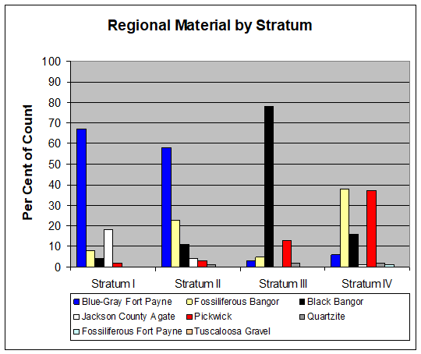
Figure A.2. Regionally available lithic material by stratum.
Figure A.3. Regionally available lithic material used for tool production.

Figure A.4. Blue Gray Bangor chert by stratum.

Figure A.5. Other Bangor chert by stratum.
Figure A.6. Other fossiliferous Bangor chert by stratum.

Figure A.7. Blue-Gray Fort Payne chert by stratum.

Figure A.8. Fossiliferous Bangor chert by stratum.

Figure A.9. Black Bangor chert by stratum.

Table A.5. Distribution of sandstone and soapstone sherds from general excavations.
STRATUM | SANDSTONE |  | SOAPSTONE
STRATUM | COUNT | PER CENT | COUNT | PER CENT
I | 0 | 0 | 16 | 12.03
II | 18 | 24.66 | 60 | 45.11
III | 3 | 4.11 | 29 | 21.81
IV | 50 | 68.49 | 28 | 21.05
V | 2 | 2.74 | 0 | 0
TOTAL | 73 | 100.00 | 133 | 100.00

Figure A.10. Percentage of sandstone and soapstone sherds from general excavations by stratum.

APPENDIX B. FEATURE DATA

Table B.1. Summary information on features.
FEATURE | BLOCK | UNIT(S) | POINT OF OBSERVATION | L x W x D (cm) | FEATURE TYPE | COMMENTS
1 | 1 | N5034E5130 | Stratum II, Level 1, 41 cmbd | 20 x 15 x 4 | Bone concentration | No diagnostics.
2 | 1 | N5020E5130 | Stratum I, Level 5, 49 cmbd | 48 x 46 x 11 | Historic post hole | Brick, historic ceramics, metal, prehistoric ceramics.
3 | 1 | N5038E5130 | Stratum II, Level 2, 48 cmbd | 35 x 34 x 42 | Historic post hole | Historic ceramics, glass, metal, prehistoric ceramics, lithics.
4 | 1 | N5040E5130 | Stratum II, Level 2, 47 cmbd | 16 x 11 x 5 | Historic post hole | No diagnostics.
5 | 1 | N5028E5128-5130 | Stratum II, Level 1, 31 cmbd | 57 x 43 x 42 | Historic post hole | Brick, whiteware, metal, prehistoric ceramics, lithics.
6 | 1 | N5026E5130 | Stratum I, Level 2, 33 cmbd | 42 x 35 x 10 | Historic post hole | Asphalt, brick, glass, metal, lithics.
7 | 1 | N5026-5028E5130 | Stratum I, Level 2, 33 cmbd | 107 x 62 x 42 | Two historic post holes | Brick, slag, glass, metal, prehistoric ceramics, lithics.
8 | 1 | N5026E5130 | Stratum I, Level 2, 40 cmbd | - | - | Exposed top of Stratum II
9 | 1 | N5044E5130 | Stratum II, Level 1, 69 cmbd | 40 x 24 x 27 | Historic post hole | Sherdlet.
10 | 1 | N5044E5130 | Stratum II, Level 1, 51 cmbd | >12 x >30 x 49 | Historic post hole | Extended into N5042E5130. Cedar post fragments, metal, prehistoric ceramics.
11 | 1 | N5020E5130 | Stratum III, Level 1, 60 cmbd | 150 x 48 x 12 | Historic trench | Brick, glass, metal.
12 | 1 | N5020E5130 | Stratum III, Level 1, 61 cmbd | >14 x >9 x 14 | Post hole? | Extended into N5018E5130. No diagnostics.
13 | 1 | N5020E1300 | Stratum III, Level 1, 61 cmbd | >60 x >10 x 18 | Historic trench? | Extended into N5018E5128-5130, N5020E130. Historic ceramics, prehistoric ceramics, lithics.
14 | 1 | N5034E5130 | Stratum II, Level 2, 50 cmbd | 102 x 65 x 43 | Pit | Greeneville cluster; sand, limestone, and grog tempered sherds.
15 | 1 | N5030E5130 | Stratum II, Level 3, 54 cmbd | 32 x 23 x 13 | Post hole or root | Intruded by Feature 22. No diagnostics.
16 | 1 | N5030E5130 | Stratum II, Level 3, 52 cmbd | 15 x 14 x 8 | Post hole or root | No diagnostics.
17 | 1 | N5030E5130 | Stratum II, Level 3, 60 cmbd | 14 x 13 x 15 | Post hole or root | No diagnostics.
18 | 1 | N5030E5130 | Stratum II, Level 3, 58 cmbd | 23 x 13 x 5 | Post hole or root | No diagnostics.
19 | 1 | N5030E5130 | Stratum II, Level 3, 58 cmbd | 16 x 15 x 16 | Post hole or root | No diagnostics.
20 | 1 | N5030E5130 | Stratum II, Level 3, 59 cmbd | 12 x 11 7 | Post hole? | No diagnostics.
21 | 1 | N5030E5130 | Stratum II, Level 3, 54 cmbd | 25 x 19 x 17 | Post hole or root | Watts Bar Fabric Marked.
22 | 1 | N5030E5130 | Stratum II, Level 3, 55 cmbd | 14 x 13 x 7 | Post hole or root | Intruded into Feature 15. No diagnostics.
23 | 1 | N5030E5130 | Stratum II, Level 3, 52 cmbd | 89 x 76 x 17 | Fire pit | Watts Bar Fabric Marked.
24 | 1 | N5022E5130 | Stratum II, Level 2, 52 cmbd | >16 x >6 x 21 | Post hole | Extended into N5022E5128. No diagnostics.
25 | 1 | N5022E5130 | Stratum II, Level 2, 52 cmbd | >169 x 80 x 154 | Phase II Backhoe Trench 8 | Extended into N5022E5132. Asphalt, brick, glass, whiteware, metal, prehistoric lithics and ceramics.
Table B.1. Summary information on features (continued).
FEATURE | BLOCK | UNIT(S) | POINT OF OBSERVATION | L x W x D (cm) | FEATURE TYPE | COMMENTS
26 | 1 | N5044E5130 | Stratum III, Level 1, 117 cmbd | 65 x >45 x ? | Hearth | Extended into N5044E5128. Intruded into Feature 41. No diagnostics.
27 | - | - | - | - | Voided in field
28 | - | - | - | - | Voided in field
29 | 1 | N5048E5130 | Stratum II, Level 5, 111 cmbd | 26 x 26 x 17 | Cache of preforms | Motley.
30 | 1 | N5048E5128-5130,  N5046E5128-5130 | Stratum II, Level 5, 110 cmbd | 260 x 158 x 14 | Rock cluster | Intruded by Features 174, 203, and 246. Features 199 and 200 were beneath Feature 30. Feature 170 is likely a continuation of Feature 30. Intrusive historic material. Limestone, Little Bear Creek, Motley, Mulberry Creek Plain.
31 | 1 | N5048E5130 | Stratum II, Level 5, 112 cmbd | 19 x >8 x 16 | Stain with charcoal | Extended into N5046E5130. No diagnostics.
32 | 1 | N5044E5130 | Stratum III, Level 2, 124 cmbd | 128 x 80 x 23 | Clay hearth basin | Stained soil and charcoal extend into N5042E5130-5132, N5044E3132. Feature 37 was a second clay basin within this area. Features 32 and 37 are associated with Feature 107, a living surface. Intrusive historic material, Flint Creek.
33 | 1 | N5026E5130 | Stratum II, Level 3, 56 cmbd | 36 x 30 x 34 | Motted and stained soil | Eroded limestone tempered sherds
34 | 1 | N5022E5130 | Stratum III, Level 1, 62 cmbd | 62 x 58 x 9 | Historic pit | Brick, whiteware, glass, metal, sherdlet.
35 | 1 | N5036E5128 | Stratum II, Level 1, 39 cmbd | 40 x 18 x 21 | Cluster of ceramics and lithics | No evidence of a pit. Limestone tempered sherds.
36 | 1 | N5026E5130 | Stratum IIb, Level 1, 69 cmbd | 34 x 29 x 15 | Historic post hole or root | Intruded into Feature 79. No diagnostics.
37 | 1 | N5044E5132 | Stratum IIa, Level 2, 113 cmbd | 173 x 139 x 38 | Clay hearth basin | Stained soil and charcoal extend into N5042E5130-5132, N5044E3132. Feature 32 was a second clay basin within this area. Features 32 and 37 are associated with Feature 107, a living surface. Intrusive historic material, Limestone.
38 | 1 | N5030E5130 | Stratum II, Level 4, 71 cmbd | 20 x 20 x 5 | Post hole or root | No diagnostics.
39 | 1 | N5034E5130 | Stratum II, Level 3, 72 cmbd | 33 x 17 x 27 | Root | Mulberry Creek Plain.
40 | 1 | N5044E5130 | Stratum III, Level 3, 137 cmbd | 12 x 12 x ? | Post hole | No diagnostics.
41 | 1 | N5044E5128-5130, N5042E5128-5130 | Stratum IIa, Level 1, 104 cmbd | 216 x 140 x 52 | Hearth | Intruded by Feature 26. Metal, chipped stone.
42 | 1 | N5022E5130 | Stratum IIc, Level 1, 101 cmbd | 75 x 23 x 89 | Root | No diagnostics.
43 | 1 | N5022E5130 | Stratum IIc, Level 2, 101 cmbd | 35 x 28 x 10 | Root? | Extended into N5022E5134. No diagnostics.
Table B.1. Summary information on features (continued).
FEATURE | BLOCK | UNIT(S) | POINT OF OBSERVATION | L x W x D (cm) | FEATURE TYPE | COMMENTS
44 | 1 | N5034E5130 | Stratum IIa, Level 2, 76 cmbd | 23 x 15 x 34 | Post hole | Sherdlets.
45 | 1 | N5034E5128-5130 | Stratum IIa, Level 2, 71 cmbd | 40 x 16 x 63 | Root | Brick, limestone tempered sherds.
46 | 1 | N5048E5130 | Stratum II, Level 4, 121 cmbd | 58 x 54 x 14 | Pit? | Most of Feature <5 cm deep. Chipped stone.
47 | 1 | N5038E5130 | Stratum IV, Level 1, 103 cmbd | 126 x >84 x 12 | Hearth with intrusive root | Intruded by Phase II Backhoe Trench 7. No diagnostics.
48 | 1 | N5032E5130 | Stratum II, Level 1, 36 cmbd | 17 x 16 x 30 | Historic post hole | Glass, metal, chipped stone.
49 | 1 | N5044E5130 | Stratum IV, Level 4, 167 cmbd | 22 x 21 x 7 | Post hole | No diagnostics.
50 | 1 | N5022-5024E5130 | Stratum IV, Level 1, 120 cmbd | 101 x 46 x 13 | Hearth | Limestone, sherdlet.
51 | 1 | N5042E5130 | Stratum II, Level 4, 92 cmbd | 26 x 25 x 26 | Small pit or post hole | Brick, sherdlets.
52 | 1 | N5032E5130 | Stratum II, Level 3, 56 cmbd | 23 x 19 x 7 | Pit | Mulberry Creek Plain.
53 | 1 | N5028E5116 | Stratum II, Level 3, 53 cmbd | 18 x 17 x 20 | Post hole? | No diagnostics.
54 | 1 | N5028E5116 | Stratum IIa, Level 1, 55 cmbd | 13 x 10 x 10 | Post hole | Intruded into Feature 55. No diagnostics.
55 | 1 | N5028E5116 | Stratum IIa, Level 1, 58 cmbd | >200 x >30 x 9 | Burned surface or prepared floor | Extended into N5030E5115, N5028E5114, N5026E5114. Intruded by Feature 54. No diagnostics.
56 | 1 | N5048E5130 | Stratum IV, Level 1, 131 cmbd | 36 x 22 x 5 | Hearth | No diagnostics.
57 | 1 | N5042E5130 | Stratum II, Level 4, 93 cmbd | 20 x 15 x 10 | Root? | No diagnostics.
58 | 1 | N5042E5130 | Stratum II, Level 5, 103 cmbd | 20 x 14 x 13 | Post hole? | No diagnostics.
59 | 1 | N5032E5128 | Stratum II, Level 3, 66 cmbd | 20 x 18 x 7 | Post hole | Sherdlets.
60 | 1 | N5032E5130 | Stratum II, Level 3, 65 cmbd | 21 x 12 x 29 | Post hole | Sherdlets.
61 | 1 | N5032E5130 | Stratum II, Level 3, 67 cmbd | 41 x 36 x 17 | Post hole | Flint Creek.
62 | 1 | N5048E5130 | Stratum IV, Level 1, 131 cmbd | 48 x 43 x 6 | Hearth | No diagnostics.
63 | 1 | N5046E5130 | Stratum IV, Level 1, 122 cmbd | 64 x 60 x 30 | Pit | Sherdlet.
64 | 1 | N5028E5130 | Stratum II, Level 2, 42 cmbd | 24 x 12 x 8 | Shell cluster | No diagnostics.
65 | 1 | N5028E5130 | Stratum II, Level 2, 44 cmbd | 28 x 24 x 11 | Rock cluster | Sherdlets.
66 | 1 | N5042E5130 | Stratum III, Level 2, 115 cmbd | 45 x 43 x 3 | Hearth | Brick.
67 | 1 | N5028E5130 | Stratum II, Level 2, 42 cmbd | 25 x 21 x 14 | Rock cluster | No diagnostics.
68 | 1 | N5028E5130 | Stratum II, level 2, 52 cmbd | 59 x 55 x 15 | Pit | Brick, chipped stone.
69 | 1 | N5022E5130 | Stratum V, Level 3, 149 cmbd | 15 x 14 x 8 | Post hole | No diagnostics.
Table B.1. Summary information on features (continued).
FEATURE | BLOCK | UNIT(S) | POINT OF OBSERVATION | L x W x D (cm) | FEATURE TYPE | COMMENTS
70 | 1 | N5034E5128,  N5032E5128-5130,  N5030E5128-5132,  N5028E5128-5132,  N5026E5128-5132,  N5024E5128-5132,  N5020-5022E5128 | Stratum II, Level 1, 54 cmbd | >1410 x >600 x 38 (maximum observed thickness) | Prepared clay floor or mound | Intruded by Features 36, 89, 101, 120 (Burial 2), 121-123, 125, 126 (Burial 3), 143-144, 146, 156, 158, 160, 162-166, 168, and 186, 210-217, and 246. Contained a variety of intrusive historic materials. Flint Creek, Limestone, limestone tempered sherds.
71 | - | - | - | - | - | Part of Feature 107.
72 | 1 | N5028E5130 | Stratum II, Level 3, 62 cmbd | 10 x 10 x 8 | Post hole | Mulberry Creek Plain.
73 | 1 | N5028E5130 | Stratum II, Level 3, 61 cmbd | 40 x 38 x 19 | Post hole | Wheeler Plain.
74 | 1 | N5028E5130 | Stratum II, Level 3, 59 cmbd | 30 x 20 x 37 | Post hole | Sherdlet.
75 | 1 | N5028E5130 | Stratum II, Level 3, 56 cmbd | 21 x 19 x 8 | Rock cluster | No diagnostics.
76 | 1 | N5028E5130 | Stratum II, Level 3, 61 cmbd | 28 x 23 x 32 | Post hole | Chipped stone.
77 | 1 | N5028E5130 | Stratum II, Level 3, 61 cmbd | 20 x 18 x 22 | Post hole | No diagnostics.
78 | 1 | N5048E5130 | Stratum IV, Level 3, 148 cmbd | 32 x 31 x 15 | Post hole | Whiteware.
79 | 1 | N5024E5130 | Stratum II, Level 2, 59 cmbd | 49 x 43 x 14 | Historic post hole | Historic ceramics, glass, metal, Mulberry Creek Plain.
80 | 1 | N5024E5130 | Stratum II, Level 2, 57 cmbd | 63 x 53 x 11 | Historic post hole | Glass, wood, metal, eroded limestone tempered sherds.
81 | 1 | N5044E5130 | Stratum V, Level 6, 229 cmbd | 16 x 14 x 66 | Stain (root?) | No diagnostics.
82 | 1 | N5028E5130 | Stratum II, Level 4, 53 cmbd | 18 x >6 x 12 | Historic post hole | Extended into N5028E5128. No diagnostics
83 | 1 | N5048E5130 | Stratum IVa, Level 2, 167 cmbd | 16 x 15 x 13 | Post hole? | No diagnostics.
84 | 1 | N5048E5130 | Stratum IVa, Level 2, 170 cmbd | 12 x 10 x 9 | Post hole? | No diagnostics.
85 | 1 | N5048E5130 | Stratum IVa, Level 2, 171 cmbd | 18 x 16 x 8 | Post hole | No diagnostics.
86 | 1 | N5048E5130 | Stratum IVa, Level 2, 169 cmbd | 11 x 10 x 8 | Post hole | No diagnostics.
87 | 1 | N5048E5130 | Stratum III, Level 3, 172 cmbd | 16 x 16 x 7 | Post hole | No diagnostics.
88 | 1 | N5048E5130 | Stratum III, Level 3, 172 cmbd | 14 x 11 x 9 | Post hole | No diagnostics.
89 | 1 | N5028E5130 | Stratum II, Level 4, 58 cmbd | 17 x 14 x 7 | Post hole | Intruded into Feature 70. No diagnostics.
90 | 1 | N5028E5116 | Stratum IV, Level 1, 112 cmbd | >70 x 68 x 7 | Hearth | Extended into N5028E5118. No diagnostics.
91 | 1 | N5046E5130 | Stratum Ia, Level 1, 74 cmbd | >64 x >57 x 7 | Historic post hole | Extended into N5044E5130-5132,  N5046E5132. No diagnostics.
92 | 1 | N5028E5116 | Stratum IV, Level 1, 115 cmbd | 44 x 44 x 8 | Hearth | No diagnostics.
93 | 1 | N5028E5116 | Stratum IV, Level 1, 112 cmbd | 32 x 14 x 21 | Hearth | No diagnostics.
94 | 1 | N5028E5116 | Stratum IV, Level 1, 112 cmbd | >27 x >23 x 5 | Hearth | Extended into N5026E5118-5120, N5028E5118. No diagnostics.
Table B.1. Summary information on features (continued).
FEATURE | BLOCK | UNIT(S) | POINT OF OBSERVATION | L x W x D (cm) | FEATURE TYPE | COMMENTS
95 | 1 | N5020E5130 | Stratum IIIa, Level 2, 111 cmbd | 64 x 28 x 11 | Clay lens | Originally thought to be a hearth, may be a remnant of Feature 70. No diagnostics.
96 | - | - | - | - | - | Part of Feature 107. No diagnostics.
97 | 1 | N5028E5116 | Stratum IVa, Level 2, 137 cmbd | 17 x 10 x 12 | Post hole | No diagnostics.
98 | 1 | N5028E5116 | Stratum IVa, Level 2, 136 cmbd | 20 x 16 x 20 | Post hole | No diagnostics.
99 | 1 | N5028E5116 | Stratum IVa, Level 2, 136 cmbd | 24 x 12 x 5 | Root | No diagnostics.
100 | 1 | N5042E5130 | Stratum IVa, Level 1, 141 cmbd | >14 x >13 x 4 | Post hole | Observed in east profile of unit. No diagnostics.
101 | 1 | N5024E5132 | Stratum II, Level 2, 77 cmbd | >200 x >74 x 153 | Historic trench | Extended into N5026E5132-5134,  N5024E5134, N5022E1532-1534. Intruded into Feature 70. Whiteware, glass, metal, eroded limestone tempered sherds.
102 | 1 | N5042E5130 | Stratum IVa, Level 2, 149 cmbd | 39 x 34 x 30 | Post hole? | No diagnostics.
103 | 1 | N5042E5130 | Stratum IVa, Level 2, 151 cmbd | 32 x 26 x 21 | Post hole? | No diagnostics.
104 | 1 | N5038E5128 | Stratum Ia, Level 1, 36 cmbd | >130 x >118 x 19 | Historic refuse pit | Extended into N5038E126,  N5040E5126-5128. Brick, coke, historic ceramics, glass, metal, sand tempered and limestone tempered sherds.
105 | 1 | N5036-5038E5128 | Stratum Ia, Level 1, 38 cmbd | 46 x 44 x 39 | Historic post hole or pit | Brick, coke, historic ceramics, glass, metal, limestone tempered sherds.
106 | 1 | N5030E5130 | Stratum IVa, Level 1, 127 cmbd | 9 x 9 x 5 | Burned post | Extended into N5028E5130
107 | 1 | N5042E5128,  N5042E5132,  N5040E5128-5132,  N5038E5128 | Stratum IIIa, Level 2, 101 cmbd | >445 x >307 x 19 | Living surface | Extended into N5038E5130 and N5042E5130. Features 71 and 96 were determined to be parts of Feature 107. Features 32, 37, and 262 are associated hearths. Historic trench cuts into Feature 107 along eastern and southern edges. Intrusive historic material, Greeneville cluster.
108 | - | - | - | - | Voided in field
109 | 1 | N5034E5128 | Stratum IIa, Level 2, 61 cmbd | 26 x 19 x 9 | Post hole or root | No diagnostics.
110 | 1 | N5034E5128 | Stratum IIa, Level 2, 62 cmbd | 23 x 13 x 8 | Post hole? | Glass.
111 | 1 | N5034E5128 | Stratum IIa, Level 2, 64 cmbd | 20 x 20 x 6 | Post hole or root | No diagnostics.
112 | - | - | - | - | Voided in field
113 | 1 | N5020E5128 | Stratum I, Level 1, 40 cmbd | >200 x >70 x 36 | Old test trench | Extended into N5020E5124, N5020E5130, N5018E5124-5130. Asphalt brick, whiteware, glass, metal, Mulberry Creek Plain.
Table B.1. Summary information on features (continued).
FEATURE | BLOCK | UNIT(S) | POINT OF OBSERVATION | L x W x D (cm) | FEATURE TYPE | COMMENTS
114 | - | - | - | - | Voided in field
115 | 1 | N5036E5128 | Stratum IIa, Level 1, 65 cmbd | 38 x 18 x 8 | Root | Brick, Baldwin Plain.
116 | 1 | N5044E5128 | Stratum Ia, Level 2, 65 cmbd | 25 x 21 x 6 | Historic post hole | Whiteware, eroded limestone tempered sherds
117 | 1 | N5030E5128 | Stratum II, Level 2, 55 cmbd | 20 x 17 x 19 | Post hole | No diagnostics.
118 | 1 | N5030E5128 | Stratum II, Level 2, 55 cmbd | 39 x 38 x 12 | Basin shaped pit | No diagnostics.
119 | 1 | N5030E5128 | Stratum II, Level 2, 55 cmbd | 26 x 25 x 28 | Root | Limestone tempered sherds.
120 | 1 | N5030E5128 | Stratum II, Level 2, 55 cmbd | 62 x 42 x 17 | Burial 2 | Partial excavation only. Intruded Feature 70. No diagnostics.
121 | 1 | N5030E5128 | Stratum II, Level 2, 54 cmbd | 26 x 25 x 16 | Post hole? | Intruded into Feature 70. No diagnostics.
122 | 1 | N5020E5128 | Stratum II, Level 2, 53 cmbd | 23 x 23 x 16 | Post hole? | Bisected only. Intruded into Feature 70. No diagnostics.
123 | 1 | N5030E5128 | Stratum II, Level 2, 54 cmbd | 21 x 19 x 18 | Post hole? | Intruded into Feature 70. No diagnostics.
124 | 1 | N5030E5128 | Stratum II, Level 2, 55 cmbd | 39 x 25 x 13 | Root? | Mulberry Creek Plain
125 | 1 | N5030E5128 | Stratum II, Level 2, 54 cmbd | 24 x 23 x 26 | Post hole or root | Intruded into Feature 70. No diagnostics.
126 | 1 | N5030E5128 | Stratum II, Level 2, 53 cmbd | >54 x 40 x 6 | Burial 3 | Partial excavation only. Intruded Feature 70. No diagnostics.
127 | 1 | N5030E5128 | Stratum II, Level 2, 53 cmbd | 18 x 15 x 10 | Post hole? | No diagnostics.
128 | 1 | N5030-5032E5128 | Stratum II, Level 2, 54 cmbd | 21 x 16 x 15 | Post hole? | No diagnostics.
129 | 1 | N5044E5128 | Stratum II, Level 1, 64 cmbd | 37 x 25 x 11 | Historic post hole | Mulberry Creek Plain.
130 | 1 | N5020E5128 | Stratum II, Level 1, 47 cmbd | 48 x 47 x 12 | Pit | Sherdlet.
131 | 1 | N5028E5132 | Stratum IIa, Level 1, 56 cmbd | 30 x 20 x 12 | Post hole | No diagnostics.
132 | 1 | N5028E5132 | Stratum IIa, Level 1, 61 cmbd | 25 x 20 x 18 | Historic post hole | Cedar post fragments, Mulberry Creek Plain.
133 | 1 | N5028E5132 | Stratum IIa, Level 1, 62 cmbd | 15 x 12 x 9 | Post hole | No diagnostics.
134 | 1 | N5042E5128 | Stratum Ia, Level 1, 41 cmbd | 31 x 29 x 25 | Historic post hole | Brick, historic ceramics, glass, metal, prehistoric ceramics.
135 | 1 | N5040E5128 | Stratum II, Level 2, 44 cmbd | 43 x 43 x 34 | Historic post hole | Historic ceramics, glass, metal, prehistoric lithics and ceramics.
136 | 1 | N5024E5128 | Stratum IIa, Level 2, 43 cmbd | 36 x 29 x 22 | Historic post hole | Brick, historic ceramics, metal, prehistoric lithics and ceramics.
137 | 1 | N5028E5116 | Stratum IVa, Level 5, 166 cmbd | 20 x 17 x 4 | Cache of cores | No diagnostics.
138 | 1 | N5032E5128 | Stratum II, Level 1, 43 cmbd | 108 x 75 x 21 | Burial 1 | Intruded by Feature 369. No diagnostics.
139 | 1 | N5042E5128 | Stratum Ia, Level 1, 39 cmbd | 46 x 30 x 34 | Historic post hole | Whiteware, glass, metal, prehistoric ceramics.
140 | 1 | N5044E5128 | Stratum II, Level 1, 68 cmbd | 37 x 32 x 12 | Small pit or post hole | Sherdlets.
141 | 1 | N5022E5128 | Stratum II, Level 1, 33 cmbd | 39 x 33 x 6 | Historic post hole | Brick, whiteware, metal.
Table B.1. Summary information on features (continued).
FEATURE | BLOCK | UNIT(S) | POINT OF OBSERVATION | L x W x D (cm) | FEATURE TYPE | COMMENTS
142 | 1 | N5030E5132 | Stratum III, Level 1, 70 cmbd | 28 x 27 x 17 | Cluster of shells | No diagnostics.
143 | 1 | N5024E5128 | Stratum IIa, Level 3, 57 cmbd | 17 x 15 x 25 | Post hole? | Intruded into Feature 70. No diagnostics.
144 | 1 | N5024E5128 | Stratum IIa, Level 2, 60 cmbd | 20 x 20 29 | Post hole? | Intruded into Feature 70. No diagnostics.
145 | 1 | N5024E5128 | Stratum IIa, Level 3, 56 cmbd | 22 x 20 x 13 | Post hole? | No diagnostics.
146 | 1 | N5024E5128 | Stratum IIa, Level 3, 59 cmbd | 22 x 20 x 27 | Post hole? | Intruded into Feature 70. No diagnostics.
147 | 1 | N5024E5128 | Stratum IIa, Level 3, 58 cmbd | 22 x 20 x 21 | Post hole? | Sherdlet.
148 | 1 | N5046E5130 | Stratum IV, Level 1, 121 cmbd | >74 x >60 x 12 | Soil stain | Extended into N5046E128, N5046E5128-5130. Thought to be a pit when first detected. No diagnostics.
149 | 1 | N5040E5128 | Stratum II, Level 2, 56 cmbd | 28 x 28 x 6 | Historic post hole | Whiteware, metal, prehistoric lithics and ceramics.
150 | 1 | N5022E5128 | Stratum II, Level 2, 45 cmbd | 24 x 15 x 7 | Post hole or root | No diagnostics.
151 | 1 | N5022E5128 | Stratum II, Level 2, 45 cmbd | 33 x 30 x 9 | Post hole? | No diagnostics.
152 | 1 | N5022E5128 | Stratum II, Level 2, 45 cmbd | 26 x 22 x ? | Root | Shallow, irregular, no profile drawn. No diagnostics.
153 | 1 | N5022E5128 | Stratum II, Level 2, 45 cmbd | 21 x 17 x ? | Root | Shallow, irregular, no profile drawn. No diagnostics.
154 | 1 | N5020E5128 | Stratum III, Level 3, 67 cmbd | 23 x >8 x ? | Root | Extended into N5020E5128. Shallow, irregular, no profile drawn. No diagnostics.
155 | 1 | N5020E5128 | Stratum III, Level 3, 67 cmbd | 20 x 18 x ? | Root | Shallow, irregular, no profile drawn. No diagnostics.
156 | 1 | N5026E5132 | Stratum II, Level 1, 69 cmbd | 44 x 22 x 25 | Historic post hole | Intruded into Feather 70 and a historic trench. Brick, historic ceramics, cedar post fragments, glass, metal, prehistoric lithics and ceramics.
157 | 1 | N5042E5128 | Stratum II, Level 1, 53 cmbd | 50 x 34 x 15 | Cluster of FCR | No evidence of a pit or hearth. No diagnostics.
158 | 1 | N5028E5128 | Stratum IIa, Level 1, 53 cmbd | 30 x 25 x 19 | Historic post hole? | Extended into N5026E128. Intruded into Feature 70. No diagnostics.
159 | 1 | N5028E5128 | Stratum IIa, Level 1, 53 cmbd | 28 x 16 x 10 | Post hole or root | No diagnostics.
160 | 1 | N5028E5128 | Stratum IIa, Level 1, 51 cmbd | 21 x 20 x 10 | Post hole? | Intruded into Feature 70. Brick.
161 | 1 | N5028E5128 | Stratum IIa, Level 1, 51 cmbd | 22 x 15 x 18 | Post hole? | No diagnostics.
162 | 1 | N5028E5128 | Stratum IIa, Level 1, 51 cmbd | 22 x 15 x 13 | Post hole? | Intruded into Feature 70. No diagnostics.
163 | 1 | N5028E5128 | Stratum IIa, Level 1, 51 cmbd | 24 x 13 x 13 | Post hole? | Intruded into Feature 70. Mulberry Creek Plain.
164 | 1 | N5028E5128 | Stratum IIa, Level 1, 51 cmbd | 22 x 19 x 16 | Post hole? | Intruded into Feature 70. No diagnostics.
Table B.1. Summary information on features (continued).
FEATURE | BLOCK | UNIT(S) | POINT OF OBSERVATION | L x W x D (cm) | FEATURE TYPE | COMMENTS
165 | 1 | N5028E5128 | Stratum IIa. Level 1, 51 cmbd | 19 x 17 x 15 | Post hole? | Intruded into Feature 70. Mulberry Creek Plain.
166 | 1 | N5028E5128 | Stratum IIa, Level 1, 51 cmbd | 21 x 21 x 17 | Post hole? | Intruded into Feature 70. No diagnostics.
167 | 1 | N5046E5128 | Stratum Ia, Level 1, 65 cmbd | 24 x 23 x 16 | Historic post hole | Glass, sherdlet.
168 | 1 | N5028E5128 | Stratum IIa, Level 1, 51 cmbd | 28 x 25 x 16 | Cluster of rocks | Intruded into Feature 70. Wade.
169 | 1 | N5028E5128 | Stratum IIa, Level 1, 51 cmbd | 12 x 10 x 12 | Root | No diagnostics.
170 | 1 | N5048E5128 | Stratum IIa, Level 1, 100 cmbd | >200 x >110 x ? | Cluster of rocks | Probably a continuation of Feature 30. Glass, lithics.
171 | 1 | N5034E5128 | Stratum IIa, Level 2, 65 cmbd | 20 x 20 x 18 | Post hole? | Brick.
172 | 1 | N5022E5128 | Stratum IIa, Level 1, 54 cmbd | 16 x 15 x 34 | Root | No diagnostics.
173 | 1 | N5046E5130 | Stratum IV, Level 2, 141 cmbd | 24 x 12 x 13 | Root | No diagnostics.
174 | 1 | N5048E5128 | Stratum IIa, Level 1, 115 cmbd | 25 x 13 x 8 | Root | Intrudes into Feature 30. No diagnostics.
175 | 1 | N5022E5128 | Stratum IIa, Level 1, 55 cmbd | 18 x 17 x 14 | Root | No diagnostics.
176 | 1 | N5022E5128 | Stratum IIa, Level 1, 55 cmbd | 14 x 12 x ? | Root | Irregular, no profile drawn. Features 176-180 are probably all one root system. No diagnostics.
177 | 1 | N5022E5128 | Stratum IIa, Level 1, 55 cmbd | 12 x 9 x ? | Root | Irregular, no profile drawn. Features 177-180 are probably all one root system. Long Branch Fabric Marked.
178 | 1 | N5022E5128 | Stratum IIa, Level 1, 55 cmbd | 19 x 10 x ? | Root | Very shallow, no profile drawn. Features 177-180 are probably all one root system. No diagnostics.
179 | 1 | N5022E5128 | Stratum IIa, Level 1, 57 cmbd | 70 x 37 x ? | Root | Irregular, no profile drawn. Features 177-180 are probably all one root system. Mississippi Plain, limestone tempered sherds.
180 | 1 | N5022E5128 | Stratum IIa, Level 1, 56 cmbd | 46 x 33 x ? | Root | Irregular, no profile drawn. Features 177-180 are probably all one root system. No diagnostics.
181 | - | - | - | - | Voided in field | No diagnostics.
182 | 1 | N5042E5128 | Stratum IIa, Level 1, 83 cmbd | 15 x 14 x 5 | Root? | No diagnostics.
183 | 1 | N5040E5128 | Stratum III, Level 2, 82 cmbd | 11 x 12 x 19 | Post hole or root | No diagnostics.
184 | 1 | N5040E5128 | Stratum III, Level 2, 79 cmbd | 8 x 8 x 12 | Post hole? | No diagnostics.
185 | 1 | N5026E5132 | Stratum IIa, Level 1, 67 cmbd | 10 x 24 x 11 | Historic post hole? | No diagnostics.
186 | 1 | N5028E5128 | Stratum IIa, Level 1, 57 cmbd | 20 x 19 x 10 | Cluster of rocks | Intruded into Feature 70. No diagnostics.
187 | 1 | N5022E5128 | Stratum III, Level 1, 63 cmbd | 8 x 5 x 10 | Root | No diagnostics.
188 | 2 | N5016E5152 | Stratum Ia, Level 2, 33 cmbd | 12 x 11 x 13 | Historic post hole | Metal.
Table B.1. Summary information on features (continued).
FEATURE | BLOCK | UNIT(S) | POINT OF OBSERVATION | L x W x D (cm) | FEATURE TYPE | COMMENTS
189 | 1 | N5034E5128 | Stratum IIIb, Level 1, 77 cmbd | >90 x 70 x 14 | Dog burial | Extended into N5036E5128. No diagnostics.
190 | 2 | N5018E5152-5154 | Stratum Ia, Level 1, 31 cmbd | 59 x 39 x 21 | Historic post hole | Brick, metal, Mulberry Creek Plain.
191 | 2 | N5018E5152-5154 | Stratum Ia, Level 1, 35 cmbd | 62 x 56 x 32 | Historic post hole | Cedar post fragments, metal, limestone tempered sherds.
192 | 2 | N5018E5152-5154 | Stratum Ia, Level 1, 32 cmbd | 60 x 50 x 30 | Historic post hole | Coke, slag, remnant of square cedar post, metal, prehistoric lithics and ceramics.
193 | 2 | N5018E5152 | Stratum II, Level 2, 40 cmbd | 51 x 46 x 10 | Historic post hole | Brick, eroded limestone tempered sherds.
194 | 2 | N5018E5152 | Stratum II, Level 2, 40 cmbd | 27 x 23 x 10 | Historic post hole | Brick.
195 | 2 | N5020E5152 | Stratum Ia, Level 1, 43 cmbd | >200 x >130 x ? | Historic post hole and scatter | Extended into N5018E5152-5124, N5151E5022, N50225122-5124. Large scatter of coal and limestone ca. 5 cm thick. Included a historic trench and post hole which were mapped but not separately excavated. Brick, whiteware, metal, prehistoric ceramics.
196 | - | - | - | - | Voided in field
197 | 1 | N5042E5132 | Stratum III, Level 1, 143 cmbd | 68 x 40 x 8 cmbd | Root? | Brick.
198 | 1 | N5042E5128 | Stratum IIIb, Level 1, ? | 60 x 35 x ? | Hearth? | Area of red clay. Thought to extend into N5040E5128, but did not. Top elevation and profile were, therefore, not recorded. No diagnostics.
199 | 1 | N5048E5128 | Stratum IV, Level 2, 133 cmbd | 43 x 34 x 13 | Root? | Intruded into Feature 232. Below Feature 30. No diagnostics.
200 | 1 | N5048E5128 | Stratum IV, Level 2, 130 cmbd | 32 x 21 x 6 | Post hole? | No diagnostics.
201 | 2 | N5018E5152 | Stratum II, level 2, 60 cmbd | 23 x 20 x 28 | Post hole | Brick, limestone tempered sherds.
202 | 2 | N5018E5150-5154  N5016E5152 | Stratum III, Level 2, 73 cmbd | 282 x >250 x 19 | Shell midden | Extended into N5020E5150. Intruded by Features 223 and 224. Brick, coke, metal, prehistoric lithics and ceramics.
203 | 1 | N5046E5128 | Stratum IVa, Level 1, 107 cmbd | 66 x 58 x 46 | Pit | Intruded into Feature 30. FCR in bottom of pit, Sherdlets.
204 | 1 | N5048E5128 | Stratum IVa, Level 1, 141 cmbd | 27 x 20 x 6 | Stain | Area of charcoal and small amount of fired clay, slightly darker than surrounding soil. No diagnostics.
205 | 1 | N5048E5128 | Stratum IVa, Level 1, 141 cmbd | 49 x 48 x 17 | Hearth | No diagnostics.
206 | 1 | N5040E5128 | Stratum IIIb, Level 2, 102 cmbd | 60 x >50 x 12 | Hearth? | Extended into N5042E5128. No diagnostics.
207 | 1 | N5040E5128 | Stratum IIIb, Level 2, 102 cmbd | 30 x 27 x 10 | Post hole or root | No diagnostics.
208 | 1 | N5026E5128 | Stratum IIa, Level 1, 49 cmbd | 56 x 44 x 11 | Cluster of FCR | Cotaco Creek.
Table B.1. Summary information on features (continued).
FEATURE | BLOCK | UNIT(S) | POINT OF OBSERVATION | L x W x D (cm) | FEATURE TYPE | COMMENTS
209 | 1 | N5042E5128 | Stratum IIIb, Level 1, 98 cmbd | 71 x >37 x 4 | Stain | Probably not a feature, just a slight soil variation. Chipped stone.
210 | 1 | N5026E5128 | Stratum IIa, Level 1, 54 cmbd | 18 x 15 x 17 | Post hole | Intruded into Feature 70. No diagnostics.
211 | 1 | N5026E5128 | Stratum IIa, Level 1, 52 cmbd | 20 x 18 x 8 | Post hole | Intruded into Feature 70. No diagnostics.
212 | 1 | N5026E5128 | Stratum IIa, Level 1, 52 cmbd | 22 x 21 x 18 | Post hole | Intruded into Feature 70. No diagnostics.
213 | 1 | N5026E5128 | Stratum IIa, Level 1, 54 cmbd | 20 x 18 x 14 | Post hole | Intruded into Feature 70. No diagnostics.
214 | 1 | N5026E5128 | Stratum IIa, Level 1, 58 cmbd | 13 x 13 x 30 | Post hole | Intruded into Feature 70. No diagnostics.
215 | 1 | N5026E5128 | Stratum IIa, Level 1, 57 cmbd | 32 x 18 x 8 | Small pit | Intruded into Feature 70. No diagnostics.
216 | 1 | N5022E5128 | Stratum III, Level 4, 85 cmbd | 15 x 14 x ? | Root | Intruded into Feature 70. Profile not recorded. No diagnostics.
217 | 1 | N5022E5128 | Stratum III, Level 4, 94 cmbd | 15 x 14 x ? | Root | Intruded into Feature 70. Profile not recorded. No diagnostics.
218 | - | - | - |  | Voided in field
219 | 2 | N5014E5152 | Stratum II, Level 1, 52 cmbd | >74 x >72 x 21 | Hearth | Extended into N5016E5152-5154, N5014E5154. Sherdlets.
220 | 1 | N5038E5128 | Stratum IIIb, Level 1, 72 cmbd | 21 x 20 x 7 | Post hole | No diagnostics.
221 | 1 | N5038E5128 | Stratum IIIb, Level 1, 72 cmbd | 39 x 30 x 16 | Post hole | No diagnostics.
222 | 1 | N5038E5128 | Stratum III, Level 1, 72 cmbd | 30 x 20 x 12 | Post hole | Sherdlet.
223 | 2 | N5018E5152 | Stratum III, Level 1, 79 cmbd | 22 x 18 x 13 | Post hole | Intruded into Feature 202. No diagnostics.
224 | 2 | N5018E5152 | Stratum III, Level 1, 73 cmbd | 17 x 16 x 23 | Post hole | Intruded into Feature 202. No diagnostics.
225 | 1 | N5038E5128 | Stratum IIIb, Level 1, 73 cmbd | 20 x 19 x 10 | Post hole | No diagnostics.
226 | 1 | N5040E5128 | Stratum IIIb, Level 2, 90 cmbd | 52 x >30 x 13 | Hearth | Extended into N5042E5128. No diagnostics.
227 | 2 | N5014E5152 | Stratum II, Level 1, 57 cmbd | 42 x 42 x 17 | Post hole | Limestone tempered sherds.
228 | 2 | N5018E5152 | Stratum III, Level 2, 76 cmbd | 18 x >11 x 10 | Post hole | Extended into N5016E5152. No diagnostics.
229 | 2 | N5018E5152 | Stratum III, Level 2, cmbd | 25 x >18 x 11 | Post hole | Extended into N5016E5152. No diagnostics.
230 | 2 | N5018E5152 | Stratum III, Level 2, 79 cmbd | 18 x >9 x 8 | Post hole | Extended into N5016E5152. No diagnostics.
231 | 2 | N5018E5152 | Stratum III, Level 2, 80 cmbd | 18 x 15 x 22 | Post hole | No diagnostics.
232 | 1 | N5048E5128 | Stratum V, Level 1, 152 cmbd | 47 x 36 x 14 | Hearth? | Intruded by Feature 199. No diagnostics.
233 | 2 | N5014E5152 | Stratum II, Level 1, 53 cmbd | 10 x >10 x 6 | Post hole? | No diagnostics.
234 | 1 | N5048E5128 | Stratum V, Level 1, 151 cmbd | 28 x >21 x 15 | Hearth ? | Extended into N5048E5130. No diagnostics.
235 | 2 | N5014E5154 | Stratum Ia, Level 1, 29 cmbd | 71 x >51 x 39 | Historic post hole | Brick, cedar post fragments, whiteware, metal, limestone tempered sherds.
236 | 2 | N5014E5152 | Stratum II, Level 1, 60 cmbd | 37 x 35 x 18 | Post hole | Limestone tempered sherds.
Table B.1. Summary information on features (continued).
FEATURE | BLOCK | UNIT(S) | POINT OF OBSERVATION | L x W x D (cm) | FEATURE TYPE | COMMENTS
237 | 1 | N5048E5128 | Stratum V, Level 1, 142 cmbd | 64 x >42 x 9 | Hearth? | Extended into N5050E5128. No diagnostics.
238 | 2 | N5016E5152-5144 | Stratum Ia, Level 2, 43 cmbd | 48 x 44 x 29 | Historic post hole | Glass, metal prehistoric ceramics.
239 | 2 | N5016E5152-5144 | Stratum Ia, Level 2, 43 cmbd | 54 x 48 x 39 | Historic post hole | Intruded into Feature 357 (Burial 4). Historic ceramics, glass, metal, prehistoric ceramics.
240 | 2 | N5014E5154 | Stratum Ia, Level 2, 42 cmbd | 72 x 61 x 30 | Historic post hole | Coke, slag, glass, metal, prehistoric ceramics.
241 | 2 | N5014E5152-5154, N5016E5152-5156,  N5018E5152-5156 | Stratum IIIy, Level 2, 100 cmbd | >600 x >600 x 40 (maximum thickness) | Shell midden | Extended into N5012E5152-5156, N5014E5156, N5018E5156. Intruded into Feature 315. Brick, metal, Cotaco Creek, Flint Creek, Little Bear Creek, Wade, Kirk Corner Notched, Long Branch Fabric Marked.
242 | 2 | N5018E5154-5156  N5016E5154-5156 | Stratum Ia, Level 1, 34 cmbs | 68 x 68 x 39 | Historic post hole | Glass, metal, prehistoric ceramics and lithics
243 | 2 | N5018E5154 | Stratum Ia, Level 1, 45 cmbd | 46 x 40 x 21 | Historic post hole | Salt glazed coarse earthenware, prehistoric ceramics and lithics.
244 | 2 | N5018E5154-5156  N5016E5154-5156 | Stratum Ia, Level 1, 41 cmbd | 66 x 63 x 9 | Burned surface | Sherdlet.
245 | 1 | N5038E5128 | Stratum IIIb, Level 2, 94 cmbd | 10 x 10 x 6 | Concentration of flakes | No diagnostics.
246 | 1 | N5044E5128 | Stratum IV, Level 1, 119 cmbd | 22 x 14 x 2 | Cache of preforms | Intruded into Feature 30. No diagnostics.
247 | 2 | N5016E5154 | Stratum II, Level 1, 48 cmbd | 44 x 43 x 13 | Hearth? | No diagnostics.
248 | 2 | N5016E5154 | Stratum II, Level 1, 27 cmbd | 49 x >18 x 33 | Historic post hole | Extended into N5016E5156. Metal, sherdlets.
249 | 2 | N5016E5154 | Stratum II, Level 1, 41 cmbd | 28 x 28 x 14 | Historic post hole | Extended 4-5 cm into N5014E5154 but was not recognized in that unit. Eroded limestone tempered sherd.
250 | 1 | N5038E5128 | Stratum IIIb, Level 3, 90 cmbd | 36 x 32 x 23 | Hearth | No diagnostics.
251 | 2 | N5020E5150-5152 N5018E5150-5152 | Stratum IV, Level 1, 110 cmbd | 115 x 105 x 78 | Fire pit | Metal. Limestone tempered sherd, chipped stone.
252 | 1 | N5036E5128 | Stratum IV, Level 1, 118 cmbd | - | - | Remnant of Stratum IV. No diagnostics.
253 | 1 | N5036E5128 | Stratum IVa, Level 2, 131 cmbd | 18 x 16 x 4 | Burned root | No diagnostics.
254 | 1 | N5042E5128 | Stratum IV, Level 1, 117 cmbd | 24 x 24 x 22 | Post hole | No diagnostics.
255 | 2 | N5046E5128 | Stratum IV, Level 2, 124 cmbd | 12 x 12 x 7 | Burned root | No diagnostics.
256 | 1 | N5040E5128 | Stratum IV, Level 1, 115 cmbd | 20 x 14 x 5 | Cluster of debitage | No diagnostics.
257 | 1 | N5040E5128 | Stratum IVz, Level 1, 115 cmbd | 122 x 12 x ? | Root | No profile drawn. No diagnostics.
258 | 2 | N5016E5154 | Stratum IIa, Level 1, 63 cmbd | 18 x 16 x 10 | Post hole | No diagnostics.
259 | 2 | N5016E5154 | Stratum IIa, Level 1, 63 cmbd | 38 x 24 x 28 | Small pit or post hole | Limestone tempered sherds.
260 | 1 | N5040E5128 | Stratum IV, Level 1, 112 cmbd | >95 x 97 x 115 | Fired clay hearth | No diagnostics.
Table B.1. Summary information on features (continued).
FEATURE | BLOCK | UNIT(S) | POINT OF OBSERVATION | L x W x D (cm) | FEATURE TYPE | COMMENTS
261 | 1 | N5044E5128 | Stratum IVa. Level 2, 133 cmbd | 25 x 22 x 10 | Root | No diagnostics.
262 | 1 | N5040E5130 | Stratum IV, Level 2, 127 cmbd | 56 x 53 x 17 | Hearth | Included within Feature 107. No diagnostics.
263 | 1 | N5038E5128 | Stratum IV, Level 1, 119 cmbd | 30 x 29 x 8 | Post hole? | No diagnostics.
264 | 1 | N5040E5128 | Stratum IVz, Level 2, 123 cmbd | 27 x 17 x 5 | Root | No diagnostics.
265 | 1 | N5020E5130-5132 | Stratum IVa, Level 1, 128 cmbd | 42 x 39 x 15 | Possible burned mat or basket | No diagnostics.
266 | 1 | N5042E5128 | Stratum IVa, Level 2, 138 cmbd | 12 x 12 x 11 | Post hole | No diagnostics.
267 | 1 | N5042E5128 | Stratum IVa, Level 2, 138 cmbd | 12 x 12 x 9 | Post hole | No diagnostics.
268 | 1 | N5042E5128 | Stratum IVa, Level 2, 138 cmbd | 12 x 12 x 9 | Post hole | No diagnostics.
269 | 1 | N5040E5130 | Stratum IVa, Level 1, 140 cmbd | 9 x 8 x 9 | Post hole | Mulberry Creek Plain.
270 | 1 | N5040E5130 | Stratum IVa, Level 1, 135 cmbd | 11 x 10 x 15 | Post hole? | No diagnostics.
271 | 2 | N5018E5152 | Stratum IV, Level 5, 144 cmbd | 10 x 9 x 2 | Cluster of charcoal | No diagnostics.
272 | 1 | N5040E5132 | Stratum IVa, Level 3, 162 cmbd | 8 x 7 x 11 | Small root | Very faint. No diagnostics.
273 | 2 | N5018E5154 | Stratum IIa, Level 1, 62 cmbd | 28 x 27 x 35 | Post hole | Limestone tempered sherds.
274 | 2 | N5018E5154 | Stratum IIa, Level 1, 60 cmbd | 28 x 26 x 34 | Post hole | Chipped stone.
275 | 2 | N5018E5154 | Stratum IIa, Level 1, 61 cmbd | 25 x 23 x 15 | Post hole | No diagnostics.
276 | 2 | N5018E5154 | Stratum IIa, Level 1, 61 cmbd | 25 x 22 x 11 | Post hole | Long Branch Fabric Marked.
277 | 2 | N5018E5154 | Stratum IIa, Level 1, 61 cmbd | 26 x 26 x 11 | Post hole | Baldwin Plain
278 | - | - | - | - | Voided in field
279 | 1 | N5042E5128 | Stratum IVa, Level 4, 151 cmbd | 20 x 16 x 20 | Post hole | No diagnostics.
280 | 1 | N5020E5128 | Stratum IIIc, Level 2, 113 cmbd | 10 x 10 x 14 | Root | Sherdlet.
281 | 1 | N5040E5130 | Stratum IVa, Level 2, 161 cmbd | 10 x 10 x 5 | Root | No diagnostics.
282 | 1 | N5040E5128 | Stratum IVa, Level 3, 138 cmbd | 24 x 22 x 28 | Post hole | No diagnostics.
283 | 1 | N5040E5128 | Stratum IVa, Level 3, 146 cmbd | 20 x 20 x 15 | Post hole | No diagnostics.
284 | - | - | - | - | Voided in field
285 | 1 | N5024E5128 | Stratum IV, Level 1, 114 cmbd | 19 x 17 x 16 | Post hole | Flint Creek.
286 | 1 | N5020E5128 | Stratum IV, Level 1, 118 cmbd | 34 x 32 x 5 | Post hole | No diagnostics.
287 | 1 | N5026E5128 | Stratum IIa, Level 2, ? | 14 x 8 x ? | Root | Depth and profile not recorded. No diagnostics.
288 | 2 | N5020E5154 | Stratum II, Level 2, 54 cmbd | 20 x 15 x 15 | Post hole | Alexander Pinched.
289 | 2 | N5020E5154-5156 | Stratum IIa, Level 1, 58 cmbd | 60 x 48 x 33 | Post hole | Mulberry Creek Plain.
290 | 2 | N5020E5154 | Stratum II, Level 2, 55 cmbd | 20 x 19 x 20 | Post hole | No diagnostics.
291 | 2 | N5020E5154 | Stratum II, Level 2, 56 cmbd | 22 x 22 x 21 | Post hole | Sherdlets.
292 | 2 | N5020E5154 | Stratum II, Level 2, 57 cmbd | 24 x 21 x 29 | Post hole | No diagnostics.
Table B.1. Summary information on features (continued).
FEATURE | BLOCK | UNIT(S) | POINT OF OBSERVATION | L x W x D (cm) | FEATURE TYPE | COMMENTS
293 | 2 | N5020E5154 | Stratum II, Level 2, 58 cmbd | >8 x >5 x 13 | Post hole | Extended into N5022E5154. No diagnostics.
294 | 2 | N5020E5154 | Stratum II, Level 2, 57 cmbd | 23 x 21 x 14 | Post hole | No diagnostics.
295 | 2 | N5018E5154 | Stratum III, Level 1, 75 cmbd | 13 x 13 x 11 | Post hole | No diagnostics.
296 | 2 | N5018E5154 | Stratum III, Level 1, 77 cmbd | 13 x 9 x 15 | Post hole | No diagnostics.
297 | 2 | N5018E5154 | Stratum III, Level 1, 76 cmbd | 12 x 11 x 12 | Post hole or root | Sherdlets.
298 | 2 | N5018E5154 | Stratum III, Level 1, 82 cmbd | 12 x >9 x 10 | Post hole | Extended into N5020E5154. No diagnostics.
299 | 2 | N5022-5024E5152 | Stratum Ia, Level 1, 33 cmbd | 100 x 68 x 46 | Historic trench | Brick, slag, cedar post fragments, whiteware, glass, metal, prehistoric ceramics and lithics.
300 | 2 | N5024E5154 | Stratum Ia, Level 1, 33 cmbd | 65 x 57 x 43 | Historic post hole | Brick, coke, glass, metal.
301 | 1 | N5024E5130 | Stratum IV, Level 1, 118 cmbd | 9 x 9 x 9 | Post hole or root | No diagnostics.
302 | - | - | - | - | Voided in field | No diagnostics.
303 | 2 | N5018E5154 | Stratum IIIz, Level 1, 89 cmbd | 17 x 17 x 9 | Post hole | No diagnostics.
304 | 2 | N5020E5154 | Stratum II, Level 2, 55 cmbd | 14 x 10 x 7 | Root | No diagnostics.
305 | 2 | N5024E5152 | Stratum IIa, Level 2, 59 cmbd | >36 x >33 x 10 | Post hole or pit | Extended into N5022E5120-5122, N5024E5120. No diagnostics.
306 | 1 | N5020E5128 | Stratum IVa, Level 2, 143 cmbd | 20 x 16 x 6 | Post hole | No diagnostics.
307 | 1 | N5020E5128 | Stratum IVa, Level 2, 147 cmbd | 13 x 11 x 7 | Post hole | No diagnostics.
308 | 1 | N5020E5128 | Stratum IVa, Level 2, 148 cmbd | 13 x 12 6 | Post hole or root | Ground stone.
309 | 2 | N5024E5154 | Stratum IIa, Level 1, 58 cmbd | >72 x >40 x 10 | Historic pit | Extended into N5024E5156. No diagnostics.
310 | 2 | N5022E5154 | Stratum Ia, Level 1, 22 cmbd | >80 x 71 x 54 | Historic pit | Extended into N5020E5154. Intruded by Feature 311. Brick, coke, slag, whiteware, glass, metal, prehistoric ceramics and lithics.
311 | 2 | N5022E5154 | Stratum Ia, Level 1, 23 cmbd | >100 x >90 x 9 | Historic pit | Extended into N5020E5154. Intruded into Feature 310. Asphalt, brick, concrete, historic ceramics, glass, metal, prehistoric ceramics and lithics.
312 | 2 | N5022E5154 | Stratum Ia, Level 1, 28 cmbd | 105 x >55 x 8 | Historic pit | Extended into N5022E5152. Glass, metal, prehistoric ceramics.
313 | 2 | N5018E5154 | Stratum IVz, Level 1, 106 cmbd | >40 x 38 x 17 | Cluster of rocks | Extended into N5120E5154. Chipped stone.
314 | 2 | N5020E5154 | Stratum III, Level 2, 73 cmbd | 34 x 22 x 8 | Hearth? | Semicircular cluster of rocks with charcoal. No diagnostics.
315 | 2 | N5022E5156, N5020E5154-5156, N5018E5154-5156,  N5016E5156 | Stratum IVy, Level 2, 115 cmbd | >700 x >360 x 10 (maximum thickness) | Charcoal lens with scattered fired clay | Intruded by Features 241, 388, 384, 387, and 388. Brick, Limestone, Wade, limestone tempered sherds.
316 | 2 | N5020E5154 | Stratum IIIc, Level 1, 104 cmbd | 53 x 44 x 13 | Rock cluster | No diagnostics.
Table B.1. Summary information on features (continued).
FEATURE | BLOCK | UNIT(S) | POINT OF OBSERVATION | L x W x D (cm) | FEATURE TYPE | COMMENTS
317 | 1 | N5026E5128 | Stratum IIa, Level 2, 137 cmbd | 57 x 34 x 14 | Concentration of charcoal | No diagnostics.
318 | 2 | N5020E5154 | Stratum IV, Level 1, 121 cmbd | 34 x 32 x 3 | Charcoal stain | No diagnostics.
319 | 2 | N5018E5154 | Stratum V, Level 1, 145 cmbd | 14 x 10 x 8 | Cluster of rocks | No diagnostics.
320 | 2 | N5020-5022E5154 | Stratum IV, Level 1, 116 cmbd | 96 x 92 x 45 | Hearth | No diagnostics.
321 | 1 | N5026E5132 | Stratum IIa, Level 2, 143 cmbd | 28 x >12 x 8 | Post hole or root | Extended into N5026E5134. No diagnostics.
322 | 2 | N5018E5156 | Stratum Ia, Level 1, 33 cmbd | 53 x 39 x 22 | Historic post hole | Metal, prehistoric ceramics.
323 | 2 | N5024E5156 | Stratum Ia, Level 1, 30 cmbd | 46 x 40 x 22 | Historic post hole | Alkaline glazed coarse earthenware, metal, prehistoric ceramics.
324 | 2 | N5024E5156 | Stratum Ia, Level 2, 27 cmbd | 100 x 65 x 44 | Historic pit | Glass, metal, prehistoric ceramics.
325 | 2 | N5022E5152 | Stratum II, Level 1, 49 cmbd | 31 x 28 x 6 | Post hole or root | No diagnostics.
326 | 2 | N5018E5156 | Stratum II, Level 1, 32 cmbd | 23 x 21 x 6 | Concentration of flakes | Long Branch Fabric Marked.
327 | 2 | N5022E5152 | Stratum II, Level 1, 49 cmbd | 102 x >82 x 11 | Shallow pit with hearth | Extended into N5022E5150. Brick, Baldwin Plain.
328 | 2 | N5020E5156 | Stratum Ia, Level 1, 27 cmbd | 54 x 40 x 26 | Historic post hole | Mortar, metal, prehistoric ceramics.
329 | 2 | N5022E5154 | Stratum IIa, Level 1, 57 cmbd | 11 x 10 x 11 | Post hole | No diagnostics.
330 | 2 | N5022E5154 | Stratum IIa, Level 1, 59 cmbd | 21 x 17 x 15 | Post hole | No diagnostics.
331 | 2 | N5022E5154 | Stratum III, Level 1, 65 cmbd | 16 x 16 x 13 | Post hole | No diagnostics.
332 | 2 | N5022E5152 | Stratum IIa, Level 1, 63 cmbd | 24 x 23 x 23 | Post hole | Long Branch Fabric Marked.
333 | 2 | N5022E5152 | Stratum IIa, Level 1, 63 cmbd | 37 x >26 x 12 | Post hole? | Extended into N5022E1554. Baldwin Plain, eroded limestone tempered sherds.
334 | 2 | N5022E5152 | Stratum IIa, Level 1, 67 cmbd | 18 x >15 x 8 | Root | Extended into N5022E5150. Intruded into Feature 348. No diagnostics.
335 | 2 | N5022E5152 | Stratum IIa, Level 1, 65 cmbd | 52 x >20 x 34 | Pit | Extended into N5022E5150. Eroded limestone tempered sherd.
336 | 2 | N5020E5156 | Stratum IIa, Level 1, 58 cmbd | >83 x 66 x 28 | Pit | Extended a few cm into N5020E5158. Intruded into Feature 348. Brick, Cotaco Creek, Wheeler Plain, limestone tempered sherds.
337 | 2 | N5018E5156 | Stratum IIa, Level 1, 58 cmbd | 20 x 20 x 8 | Post hole | Long Branch Fabric Marked.
338 | 2 | N5018E5156 | Stratum IIa, Level 1, 58 cmbd | 20 x 17 x 13 | Post hole | Eroded limestone tempered sherd.
339 | 2 | N5018E5156 | Stratum IIa, Level 1, 58 cmbd | 9 x 8 x 6 | Root | No diagnostics.
340 | 2 | N5018E5156 | Stratum IIa, Level 1, 58 cmbd | 19 x 19 x 28 | Post hole | Intruded into Feature 348. No diagnostics.
341 | 2 | N5022E5152 | Stratum III, Level 1, 77 cmbd | 16 x >12 x 12 | Post hole | Extended into N5022E5154. No diagnostics.
342 | 2 | N5020E5156 | Stratum IIa, Level 1, 57 cmbd | 16 x 14 x 14 | Post hole | Whiteware.
343 | 2 | N5020E5156 | Stratum IIa, Level 1, 57 cmbd | 18 x 17 x 16 | Post hole | No diagnostics.
Table B.1. Summary information on features (continued).
FEATURE | BLOCK | UNIT(S) | POINT OF OBSERVATION | L x W x D (cm) | FEATURE TYPE | COMMENTS
344 | 2 | N5020E5156 | Stratum IIa, Level 1, 55 cmbd | 69 x 44 x 33 | Pit | Baldwin Plain, limestone tempered sherds.
345 | 2 | N5022-5024E5156 | Stratum IIa, Level 1, 42 cmbd | 50 x 26 x 35 | Post hole? | Baldwin Plain, limestone tempered sherds.
346 | 2 | N5020E5156 | Stratum IIa, Level 1, 58 cmbd | 15 x 14 x 5 | Post hole | No diagnostics.
347 | 1 | N5028E5132 | Stratum IV, Level 1, 127 cmbd | 122 x 88 x 14 | Hearth | Chipped stone.
348 | 2 | N5018-5022E5156 | Stratum III, Level 1, 63 cmbd | 354 x >98 x 21 (maximum observed) | Shell midden | Extended into N5018-5022E5158. Intruded by Features 334, 336, 340, 352-356. Asphalt, brick, glass, metal, Wade, Mulberry Creek Plain.
349 | 2 | N5024E5156 | Stratum III, Level 2, 73 cmbd | 24 x 23 x 6 | Post hole? | No diagnostics.
350 | 1 | N5014E5100.5 | Stratum II, Level 1, 61 cmbd | >82 x >61 x 21 | Fire pit | Extended slightly beyond east and south borders of fractional unit. Brick, glass, chipped stone.
351 | 2 | N5020-5022E5148 | Stratum II, Level 1, 51 cmbd | 71 x 46 x 16 | Hearth? | Alexander Incised, limestone tempered sherds.
352 | 2 | N5018E5156 | Stratum III, Level 2, 63 cmbd | 17 x 14 x 18 | Post hole | Intruded into Feature 348. No diagnostics.
353 | 2 | N5018E5156 | Stratum III, Level 2, 63 cmbd | 12 x 12 x 21 | Post hole | Intruded into Feature 348. No diagnostics.
354 | 2 | N5018E5156 | Stratum III, Level 2, 63 cmbd | 16 x 12 x 12 | Post hole | Intruded into Feature 348. No diagnostics.
355 | 2 | N5018E5156 | Stratum III, Level 2, 63 cmbd | 12 x 12 z 15 | Post hole | Intruded into Feature 348. No diagnostics.
356 | 2 | N5018E5156 | Stratum III, Level 2, 63 cmbd | 16 x 14 x 18 | Post hole | Intruded into Feature 348. No diagnostics.
357 | 2 | N5016E5152 | Stratum Ia, Level 3, 51 cmbd | >92 x 75 x 14 | Burial 4 | Intruded into Feature 348. Intruded by Feature 239. Extended into N5016E5154 but was not observed in that unit. Disturbed and poorly preserved. No diagnostics.
358 | 2 | N5016E5154-5156 N5014E5154-5156 | Stratum II, Level 1, 42 cmbd | 74 x 50 x 20 | Burial 5 | No diagnostics.
359 | 2 | N5022E5152 | Stratum IV, Level 1, 116 cmbd | 28 x 22 x 6 | Post hole | No diagnostics.
360 | 2 | N5018E5150 | Stratum II, Level 1, 37 cmbd | 31 x 29 x 25 | Historic post hole | Dimensional lumber fragments, whiteware, glass, metal, sherdlets.
361 | 1 | N5028E5130 | Stratum IVz, Level 2, 101 cmbd | 17 x 14 x 21 | Post hole | Fill appears to be clay from Feature 70. No diagnostics.
362 | 1 | N5014E5100.5 | Stratum IV, Level 3, 84 cmbd | >94 x >50 x 48 | Shell midden | Extends west and south of fractional unit. Removed in disturbed northern portion of unit. Brick, slag, mortar, metal, limestone tempered sherds.
363 | 1 | N5028E5130 | Stratum IVz, Level 2, 101 cmbd | 22 x 9 x 14 | Root | No diagnostics.
364 | 2 | N5020E5156 | Stratum IIIz, Level 1, 89 cmbd | >92 x >70 x 11 | Hearth | Lined with fired clay. Chipped stone.
Table B.1. Summary information on features (continued).
FEATURE | BLOCK | UNIT(S) | POINT OF OBSERVATION | L x W x D (cm) | FEATURE TYPE | COMMENTS
365 | 2 | N5016E5150-5152 | Stratum IIa, Level 1, 51 cmbd | 80 x 64 x 29 | Burial 6 | Brick, Baldwin Plain.
366 | 2 | N5018E5150 | Stratum IIa, Level 1, 49 cmbd | 84 x >60 x 15 | Pit | Extended into N5018E5152.Chipped stone.
367 | 2 | N5022E5148 | Stratum IVy, Level 2, 116 cmbd | 30 x 23 x 13 | Post hole | No diagnostics.
368 | 1 | N5032E5128 | Stratum II, Level 1, 55 cmbd | 22 x 20 x ca. 21 | Post hole | Sherdlet.
369 | 1 | N5032E5128 | Stratum II, Level 1, 67 cmbd | 16 x 15 x 6 | Post hole | Intruded into Feature 138 (Burial 1). No diagnostics.
370 | 2 | N5018E5156 | Stratum IIIx, Level 1, 109 cmbd | 40 x 30 x 7 | Concentration of shell | No diagnostics.
371 | 2 | N5022E5156 | Stratum III, Level 1, 60 cmbd | 118 x >63 x 23 | Pit? | Extended into N5022E5158. Dark, charcoal-rich soil with large FCR. Watts Bar Fabric Marked, Long Branch Fabric Marked, eroded limestone tempered sherd.
372 | 2 | N5020-5022E5150 | Stratum IIa, Level 1, 47 cmbd | 58 x >44 x 48 | Pit | Extended into N5020-5022E5152. Rectanguloid with flat bottom. Greeneville cluster, limestone tempered sherds.
373 | 2 | N5022E5150 | Stratum IIa, Level 1, 48 cmbd | 22 x >15 x 25 | Post hole | Extended into N5022E5152. Chipped stone.
374 | 2 | N5018E5150 | Stratum III, Level 2, 64 cmbd | 20 x 18 x 22 | Post hole? | Sherdlet.
375 | 2 | N5020-5022E5156 | Stratum IV, Level 1, 123 cmbd | 98 x 86 x 16 | Hearth | No diagnostics.
376 | 2 | N5020E5148 | Stratum II, Level 1, 28 cmbd | >118 x 60 x 6 | Hearth | Extended into N5022E5148. Metal, limestone tempered sherds.
377 | 2 | N5016E5156 | Stratum Ia, Level 1, 27 cmbd | 86 x >42 x 44 | Historic post hole | Extended into N5016E5154. Coke, slag, glass, metal, limestone tempered sherds.
378 | 2 | N5014-5016E5154 | Stratum III, Level 1, 93 cmbd | >106 x 106 x 85 | Pit | Extended into N5014-5016E5156. Metal, chipped stone.
379 | 2 | N5020E5150 | Stratum II, Level 1, 26 cmbd | >26 x >18 >32 | Historic post hole | Extended into N5022E5150. Asphalt, whiteware, glass, metal, sherdlet.
380 | 2 | N5016E5150 | Stratum II, Level 2, 45 cmbd | 83 x 43 x 10 | Burial 7 | No evidence of a pit. Very poorly preserved. Asphalt, brick, Greeneville cluster, Baldwin Plain, Long Branch Fabric Marked.
381 | 1 | N5014E5100.5 | Stratum I, Level 9, 109 cmbd | 28 x >18 x 93 | Historic post hole | Extended beyond partial unit. Contained metal anchor rod. Brick, concrete, glass, sherdlets.
382 | - | - | - | - | Voided in field
383 | 2 | N5018E5156 | Stratum IVx, Level 1, 123 cmbd | 14 x 14 x 8 | Post hole | Intruded into Feature 315. No diagnostics.
384 | 2 | N5018E5156 | Stratum IVx, Level 1, 120 cmbd | 19 x 16 x 8 cmbd | Post hole | Intruded into Feature 315. No diagnostics.
385 | 2 | N5014E5156 | Stratum II, Level 1, 41 cmbd | 71 x 47 x 34 | Historic post hole | Salt glazed coarse earthenware, glass, metal, sand tempered check stamped, limestone tempered sherds.
Table B.1. Summary information on features (continued).
FEATURE | BLOCK | UNIT(S) | POINT OF OBSERVATION | L x W x D (cm) | FEATURE TYPE | COMMENTS
386 | 2 | N5014E5156 | Stratum II, Level 1, 46 cmbd | 30 x 15 x 5 | Historic post hole | No diagnostics.
387 | 2 | N5018E5156 | Stratum IVx, Level 1, 120 cmbd | 23 x >10 x 7 | Post hole | Extended into N5020E5156. Intruded into Feature 315. No diagnostics.
388 | 2 | N5018E5156 | Stratum IVx, Level 1, 120 cmbd | 65 x 63 x 13 | Fire pit | Intruded into Feature 315. No diagnostics.
389 | 2 | N5014E5156 | Stratum II, Level 1, ? | ? | Burial 8 | No diagnostics.
390 | 2 | N5016E5150 | Stratum II, Level 2, 39 cmbd | 20 x >13 x 19 | Historic post hole | Coke, slag, glass, metal.
391 | 2 | N5014E5156 | Stratum II, Level 1, ? | ? | Burial 9 | Flint Creek.
392 | 1 | N5014E5100.5 | Stratum I, Surface | >120 x >100 x 148 | WPA trench | Covered the entire north half of this partial unit. Brick, concrete, whiteware, glass, metal, prehistoric ceramics and lithics.
393 | 2 | N5016E5156 | Stratum II, Level 1, 43 cmbd | 54 x 27 x 21 | Burned root? | Mulberry Creek Plain.
394 | 2 | N5016E5156 | Stratum II, Level 1, 44 cmbd | 80 x 70 x 15 | Hearth | Brick, sherdlet.
395 | 2 | N5014E5156 | Stratum II, Level 1, ? | ? | Burial 10 | No diagnostics.
396 | 2 | N5020E5150 | Stratum IIa, Level 1, 55 cmbd | >110 x >68 x 9 | Pit | Extended into N5020E5152. Baldwin Plain, limestone tempered sherds.
397 | 2 | N5016E5150 | Stratum III, Level 2, 68 cmbd | 36 x 23 x 8 | Burned root | No diagnostics.
398 | 2 | N5014E5156 | Stratum IIa, Level 1, 65 cmbd | 21 x 20 x 17 | Post hole? | No diagnostics.
399 | 2 | N5014-5016E5156 | Stratum II, Level 1, 44 cmbd | 106 x >44 x 29 | Pit | Extended into N5014-5016E5158. Brick, Baldwin Plain, limestone tempered sherds.
400 | 1 | N5032E5128 | Stratum IV, Level 1, 118 cmbd | 45 x 40 x 11 | Hearth | No diagnostics.
401 | 1 | N5032E5128 | Stratum IV, Level 1, 92 cmbd | 70 x 40 x 7 | Hearth | No diagnostics.
402 | 2 | N5016E5152 | Stratum III, Level 1, 67 cmbd | 17 x 17 x 14 | Post hole | No diagnostics.
403 | 2 | N5016E5152 | Stratum III, Level 1, 68 cmbd | 15 x 15 x 8 | Post hole | No diagnostics.
404 | 2 | N5016E5150 | Stratum III, Level 2, 66 cmbd | 52 x 50 x 17 | Shell midden | No diagnostics.
405 | 2 | N5016E5152 | Stratum III, Level 2, 72 cmbd | 16 x15 x 11 | Post hole | No diagnostics.
406 | 2 | N5020-5022E5150 | Stratum IVy, Level 1, 113 cmbd | 128 x >114 x 11 | Clay hearth | Brick.
407 | 2 | N5014E5156 | Stratum II, Level 1, ? | ? | Burial 11 | No diagnostics.
408 | 2 | N5016E5150-5152 | Stratum IV, Level 1, 103 cmbd | 292 x >200 x 29 | Charcoal and fired clay concentration | Extended into N5018E5150-5152 and N5014E5150-5152. Brick, metal, Flint Creek, Gary, Limestone, Wade, Mulberry Creek Plain.
409 | 2 | N5016E5156 | Stratum IIIz, Level 1, 92 cmbd | 100 x 70 x 10 | Hearth | No diagnostics.
410 | 2 | N5014E5154 | Stratum IV, Level 1, ? | 125 x 50 x 20 | Pit | Last day of project, partial excavation. No diagnostics.
411 | 2 | N5016E5156 | Stratum IIIxy, Level 3, 117 cmbd | 99 x 48 x 34 | Pit | No diagnostics.

APPENDIX C: GEOARCHAEOLOGICAL ANALYSIS

This appendix is the detailed geoarchaeological report by Sarah C. Sherwood (2011) of the Whitesburg Bridge site. It was originally incorporated into the site report (Gage 2011) and is presented here for the sole purpose of providing information on the geomorphological analysis of the site and specifically the micromorphological study of Feature 70, the earthen mound. Dr. Sherwood graciously provided permission for it to be included as an appendix.

To cite Sherwood’s (2011) report:
Sherwood, Sarah C.
2011 Geoarchaeological Evaluation. In Archaeological Excavations at the Whitesburg Bridge Site (1Ma10) Madison County, Alabama, edited by Matthew D. Gage, pp. 25–55. Report submitted to the Alabama Department of Transportation by The University of Alabama, Office of Archaeological Research. Report of Investigations 81. The University of Alabama, Moundville.

GEOARCHAEOLOGICAL EVALUATION

Sarah C. Sherwood

INTRODUCTION

This study examines the geoarchaeological context of the Whitesburg Bridge site (1Ma10), located approximately 3 km south of Huntsville in Madison County, Alabama (Figure C.1). For nearly a hundred years various archaeological excavations have revealed a shell midden with additional deposits that include Late Archaic, Gulf Formational, Woodland, and Mississippian components (Meeks 2002; Moore 1915; Shaw 2000; Spry and Hollis 1998; Webb 1939; Webb and DeJarnette 1948c). The most significant of these excavations was undertaken in 1939 and 1940 by the Tennessee Valley Authority lead by archaeologists Hugh Capps and H. Summerfield Day using WPA labor as part of the Guntersville basin archaeological survey (Webb and DeJarnette 1948c). The geoarchaeological study reported here is part of the most recent salvage excavations on an intact portion of the site to be directly impacted by bridge pier construction for U.S. 231 over the Tennessee River. The Office of Archaeological Research (OAR) of the University of Alabama Museums, was contracted by the Alabama Department of Transportation to carry out the data recovery. Sarah C. Sherwood of the Department of Anthropology, Archaeological Research Laboratory (ARL) at the University of Tennessee served as the consulting Geoarchaeologist.

The initial phase of the geoarchaeological field assessment was carried out during the site testing with two trips in November and December of 1999. The bulk of the geoarchaeological fieldwork was carried out in June and August of 2002 during the mitigation. The purpose of the geoarchaeology during the testing phase was to determine the potential for deeply buried archaeological deposits and to describe the profiles revealed in backhoe trenches. Detailed descriptions and preliminary interpretations were provided to the project director following those visits and are incorporated into the archaeological testing report by Meeks (2002). The data from samples gathered during the testing phase are incorporated into this report along with the geoarchaeological results from the final data recovery. The geoarchaeological study conducted during the OAR data recovery was designed to contribute to the reconstruction of the site formation processes and the determination of artifact integrity at a local scale.

LOCAL GEOLOGY AND SOILS

The Whitesburg Bridge site is located on the north bank of the Tennessee River on the edge of the Eastern Highland Rim section of the Interior Low Plateaus. This section of the Tennessee River valley is underlain by the Tuscumbia formation, a massive fossiliferous cherty limestone located across much of northern Alabama and entrenched by the Tennessee River (Figure C.1). East of the project area are dissected remnants of the Cumberland Plateau. Green Mountain, immediately east of the project area, is part of these remnant uplands and consists of horizontally bedded Pennsylvanian and Mississippian age rocks. Based on Malmberg and Sanford (1963) the sequence from top to bottom includes:

Pottsville formation (medium to coarse-grained sandstone with some shale and coal beds near the base of the formation),
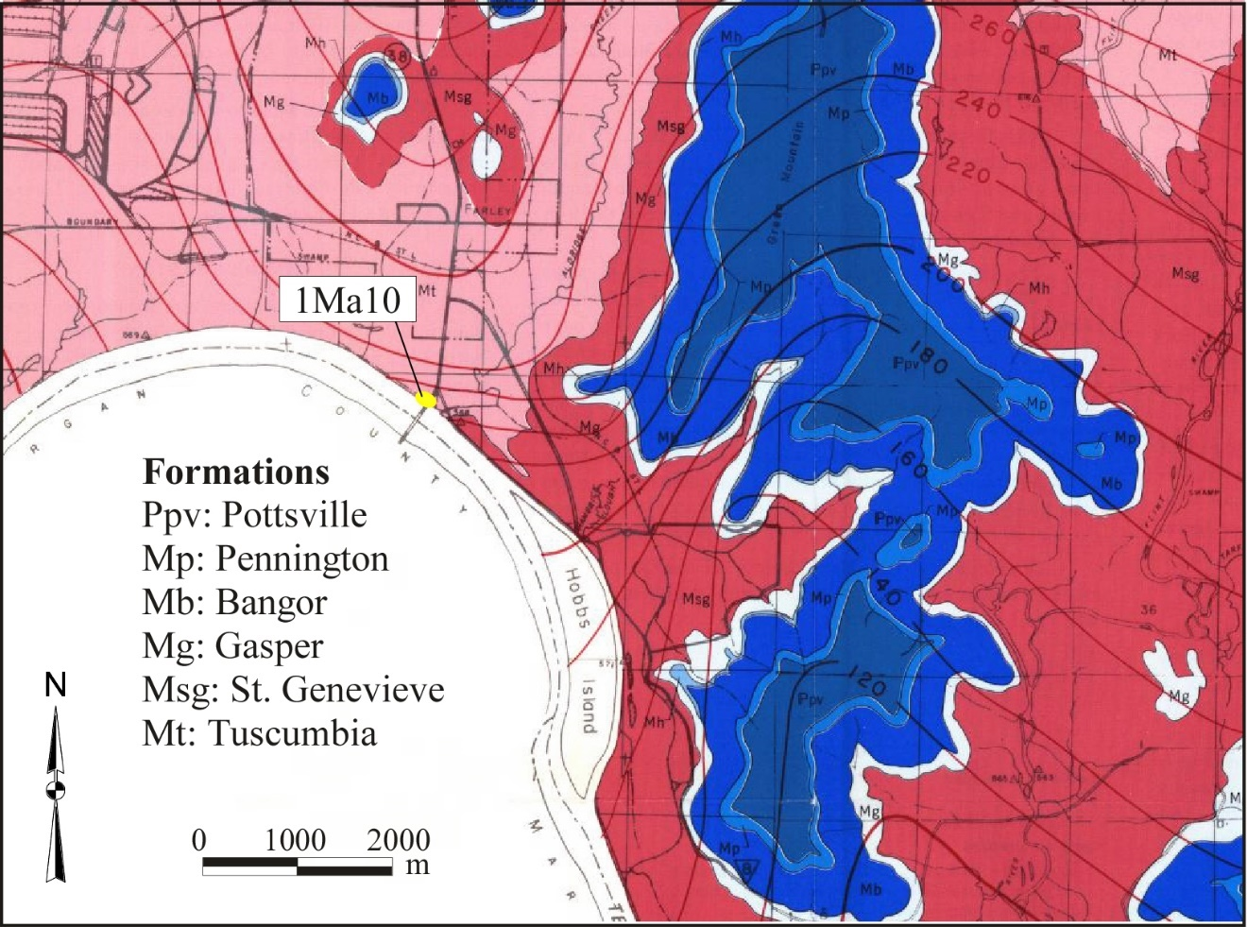
Figure C.1. Geology of the project area (from Malmberg and Sanford [1963]).

Pennington formation (variably colored shale with a few shaly limestone beds),

Bangor formation (massive, crystalline, oolitic limestone, with limited dolomitic limestone and shaly beds limited to the upper part),

Gasper formation (argillaceous, crystalline, abundantly fossiliferous limestone with some shaly zones),

St. Genevieve limestone (oolitic thick-bedded limestone),

Tuscumbia limestone (partly oolitic, fine to very coarse grained bioclastic limestone).

The site is located on the first terrace on the outside of a well developed meander approximately 1500 m below Hobbs Island. The shape of the river and the ridge and swale sequence clearly expressed on the south (opposite) side of the channel, suggest a low prograding terrace system.

Based on the 1947 Soil Survey of Madison County (Swenson et al. 1958) there are two soil types in the vicinity of the site (Figure C.2). The Huntington series represents the levee and the Egam series covers the back end of the levee. The Huntington series consists of very deep, well 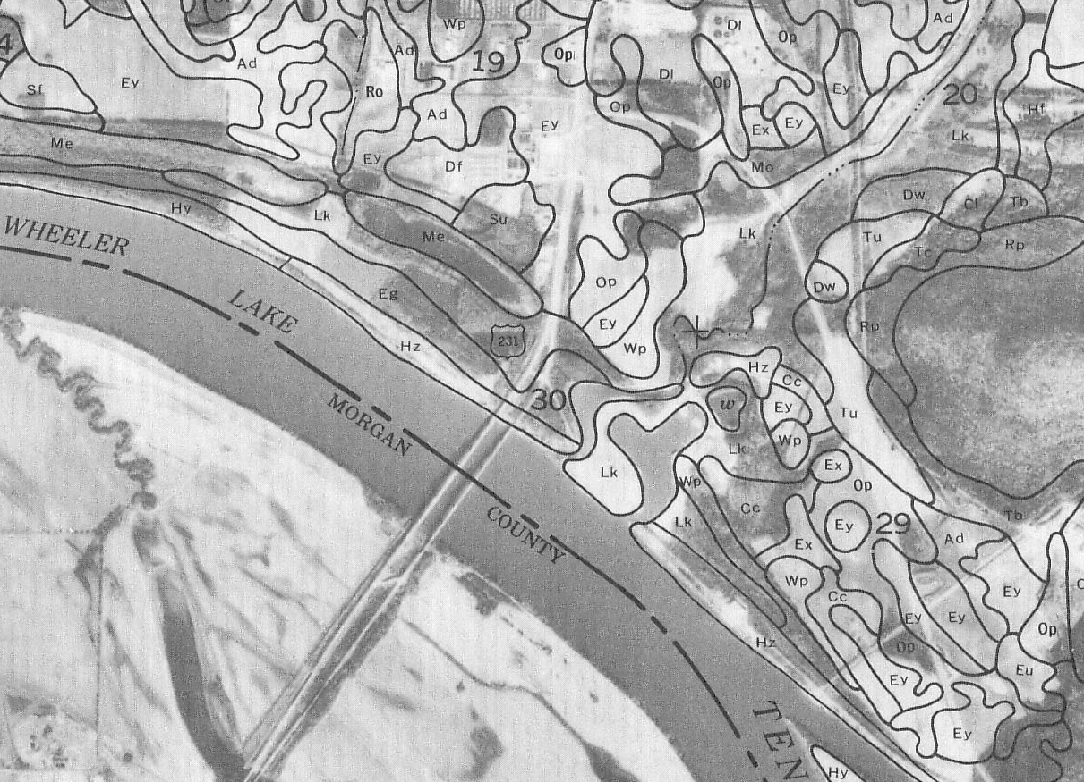Figure C.2. Detail from Madison County, Alabama soil survey (from Swenson et al. 1958).

drained alluvial silt loams with a typical pedon of Ap-Bw1-Bw2-C (NRCS 1999; Swenson et al. 1958). This series is taxonomically classified as a fine-silty, mixed, active mesic Fluventic Hapludoll. This young floodplain soil is identified by a mollic epipedon indicating it has a thick dark surface horizon(s) and a high base saturation. As a result of the elevated lake levels there is a high probability that much of this soil series is inundated or has been eroded due to wave action. The Egam series most likely represents what remains of the levee and is mapped as a very deep, well to moderately drained clayey alluvium with a typical pedon of Ap-A-Bw1-Bw2-Bw3. This series is classified as a fine, mixed, active, thermic Cumulic Hapludoll.

The Egam series is also classified with a mollic epipedon but one that is deeper due to the frequent influx of organic rich sediments. The Lindside series is mapped immediately to the north and probably represents the northern boundary of the site between the levee and the rise to the second terrace. This series is considered very deep, moderately well drained, formed in alluvium washed mainly from lime influenced soils on uplands. This series is a fine-silty, mixed, active, mesic Fluvaquentic Eutrudent with a typical pedon of Ap-BA-Bw-BC-C silt loams. These soils are often wet and show almost no soil development as Entisols. In the immediate vicinity of the project area today there is little that remains of the series due to historic clay quarrying activity and drainage realignment.

METHODS

Geoarchaeological analysis of the Whitesburg Bridge site (1Ma10) is based on field observation, physical and chemical analyses from bulk samples and the semi-quantitative and qualitative analysis of in situ micromorphology block samples. It is important to remember that field observation is at the center of any geoarchaeological analysis. Beyond the basic description this is also the point where the interrelationships between landform, soil, vegetation, drainage, and post-depositional processes can be observed and recorded. The two sampling approaches compliment one another as thin section analysis reveals relationships not preserved in bulk samples, and bulk samples can address general quantitative issues more efficiently than in thin section (Courty et al. 1989; Farrand 2001). Profiles were described in the field using standard sedimentological and pedological nomenclature including color, texture, structure, clasts (coarse fraction), boundaries, and pedogenic and sedimentological features. These descriptors provide criteria used to infer the conditions of a sediment or development of a soil (Soil Survey Division Staff 1993).

Bulk Samples

Bulk sampling involved the removal of approximately 200 g of sediment into Hubco sample bags. These samples were collected at 20 cm intervals within horizons from exposed profiles. During the Phase II investigations, five vertical profile sequences were collected including a control profile and four backhoe trenches. A total of 64 samples were collected. From these, 46 were selected for laboratory analysis representing three different contexts: the control profile, the lower reaches of Trench 4 and Trench 7 (including the extension). During the mitigation, bulk samples correlating with the block samples were collected in order to provide additional material for ancillary analyses if needed.

Following field collection, the bulk samples were removed to Middle Tennessee State University where they were dried and temporarily curated until they were transferred in 2002 to the Archaeological Research Laboratory (ARL) at the University of Tennessee. The samples selected for analysis underwent physical and chemical analyses. The chemical analysis included the percent organic matter and the physical analyses consisted of grain size distribution with determinations of sand, silt, and clay. These analyses were performed by the Milwaukee Soil Laboratory, under the direction of Mary Jo Schabel, in affiliation with the Soils and Physical Geography Laboratory at the University of Wisconsin, Milwaukee.

The percent organic matter was determined using the Walkley-Black method (Nelson and Sommers 1983). Organic matter (or organic carbon) can suggest the presence of a buried surface (Stein 1992b). Organic carbon, representative of surface organic-rich mineral soils, can remain for long periods of time following burial. The grain size distribution or sediment texture can suggest a change in sedimentation possibly indicating the presence of a paleosol (buried soil). In the case of anthropogenic sediments, grain size and type can be an indication of specific activities or changes in activities. Grain size analyses were performed using the pipette method (Black 1965). The data are reported and graphed by grain size dividing the sediment into percent sand, silt, and clay fractions. The sand fraction is sediment >50μ, the silt fraction measures 50μ - 2μ, and the clay is less than 2μ.

Micromorphology Block Samples

Following the preliminary review of the bulk sample data collected during the Phase II it was determined that focusing the Phase III analyses on micromorphology would be the most informative course. Micromorphological analysis is used to identify the sediment constituents and their fabric arrangement, which implicates the source, transport mechanism, and post-depositional alteration (Courty et al. 1989; Fitzpatrick 1993; Stoops 2003). This technique is based on the petrographic analysis of in situ sediments in thin section. Pedofeatures indicating soil formation are also evident using this technique. The presence of soil formation is indicative of stable surfaces, which may have supported human activity or indicated a change in the local sedimentation rate. The main advantage to this technique is the identification of subtle features such as the segregation of grain sizes or mineralogical differences that appear at too fine a resolution to be revealed in the more traditional bulk sampling techniques. These subtle changes may help make the important distinction between processes of bioturbation versus sedimentation, central in the explication of the processes of site formation.

Micromorphological analyses was carried out by Sarah C. Sherwood at the ARL. Sample impregnations and thin sections were generated by Spectrum Petrographics in Winston, Oregon under the direction of Michael DePanger. Micromorphological analysis requires the careful removal of in situ oriented blocks of sediment, usually measuring at least 10 cm square. These samples were impregnated under vacuum using polyester resin, monostyrene, and methethel ketone peroxide (MEKP). Allowed to cure (harden), samples then were cut and polished using standard geological rock saw equipment, then ground down into 30 micron thick large format (51 mm by 75 mm) thin sections.

Thirty-five thin sections were examined from Blocks 1 and 2. In general these thin sections represent all of the primary strata as well as several features. Prior to analysis each thin section was scanned using a transparency adapter on a Microtek ScanMaker5 flatbed scanner. This image serves as a record of the thin section and provides a basic image to guide the microscopic analysis. These images accompany the microstratigraphic descriptions provided in Appendix A. Thin sections were studied using a Nikon E600 POL microscope equipped with plane polarized (ppl), cross-polarized light (xpl). Oblique incident light (oil) was created using a dual gooseneck fiber optic light source. Magnifications used in the analysis ranged from 20x to 100x. Observations are reported using the descriptive terminology of Courty et al. (1989) (emphasizing archaeological stratigraphy), and general soil terminology for thin sections initially proposed in Bullock et al. (1985) which has been updated by Stoops (2003). Photomicrographs were collected and processed using a Polaroid Digital Microscope Camera and the corresponding DMC Direct software. Wherever photomicrographs are presented in the text, two images are provided of the same view. The left image is plane polarized light (ppl) and the right image is cross-polarized light (xpl).

RESULTS

The geoarchaeological fieldwork centered on three aspects of the project. The description and interpretation of a control profile, interpretation of test trenches during the Phase II investigations, described in Meeks (2002), and finally description and interpretation of the major profiles exposed near the completion of Blocks 1 and 2 of the Phase III data recovery.

Control Profile

The importance of collecting data from a control profile cannot be overemphasized. Control profiles can be difficult to place as they should be situated near the archaeological site in question and in a similar geomorphic position, but contain no artifacts or obvious cultural deposits (Stein 2001). Control profiles provide a base line of sorts, providing the depositional history of the landform minus input by humans, allowing the influence of people on the archaeological site to be more easily distinguished.

The control profile selected for this project was located on the north bank approximately 300 m downriver from the Whitesburg Bridge site. We were not able to identify an exposure on the bank that did not contain some archaeological evidence. In this case there were a few artifacts, however there were no obvious archaeological deposits (shell midden, features, etc.) suggesting that the artifacts represent only stable prehistoric surfaces and not cumulative archaeological deposits. A fresh exposure was created and the exposed cut bank was described and sampled. This profile is situated on the same first terrace/levee as the site. Figure C.3 describes the strata observed in the profile and illustrates the samples locations. These sample numbers are correlated with the data in Appendix A, Tables C.1-C.3). The texture differences were evident in the field with the surface weathering where layers with the finer grains protruded from the exposure (Figure C.4). Perhaps the most informative data collected were radiocarbon dates derived from humate samples from the profile (Meeks 2002).

The texture (percent sand, silt, and clay) and percent organic carbon (OC%) indicate a young pedo-sedimentary environment composed predominately of sandy loam/loam and clay loam textured soils (Figure C.5). Based on the position and the micaceous nature of the parent material, the source is Tennessee River alluvium (Collins et al. 1994; Sherwood 2001). The percentages of the finer grain sizes, i. e. silt and clay, mirror each other in increases and decreases, further supporting a consistent parent material, just varying energies.

The sandy loam to loam tends to correlate with the C or weak CB horizons and is interpreted as overbank deposition. The finer textured clay loam strata represent stable surfaces where organic matter is occasionally higher (Appendix A, Tables C.2-C.3) or it is higher at the transitions between the surface and the underlying parent material. These data may be the result of the pedogenic, downward migration of the material from the surface or of plant growth. Clay in general is highest at the contact between the extant surface and the underlying parent material. This is probably the result of decreasing energy at the end of the flood event that produced the massive deposit resulting in slack water and the settling of fine particles. Organics are generally moderate to high in the locally mapped Huntington soils and typical in Fluventic Hapludolls (Swenson et al. 1958). There were no clay coatings observed in the field suggesting the clay is sedimentary and not pedogenic, further supporting the young age of these soils.

Supporting the results of the physical and chemical analyses and the young age of the soils are the radiocarbon dates derived from the humate samples. The dates derived from horizons 2Ab, 3Ab and 4Ab produced dates of 1100 cal AD, 1440 cal B.C., and 2200 cal B.C. respectively (Figure C.4). Although it would even be even more informative to have the sample from 5Ab dating this sequence of late Holocene sedimentation, the upper four dates clearly identify this landform as geomorphologically young with an average sedimentation rate estimated at 0.12 cm/yr. This levee was actively aggrading throughout the latter part of the Holocene with people residing on the first terrace during periods of stability. Other studies from Hobbs Island and down river at the Redstone Arsenal (Kocis and Sherwood 2006) indicate that the levee did not start forming until the mid Holocene.

Phase III Data Recovery

The geoarchaeological investigation during the final data recovery phase of the project focused on the profiles revealed in two block excavations. Block 1 was a roughly 30 m long by 4 m to 6 m wide trench and Block 2 consisted of a roughly 8 m by 12 m square with an irregular western boundary. The profiles were drawn and described in the field by the OAR excavation crew with additional descriptive notations made during my visits. The focus of this study is based on the western profile of Block 1 (E5128) that represents the non shell midden portion of the site and contains the large red clay deposit (Feature 70), and Block 2 with a complex series of archaeological deposits that included shell middens and features.

Block 1

The E5128 profile trends 30 m north–south, and begins approximately 24 m from the current river bank. Eleven primary lithostratigraphic units were identified in the profiles with additional localized substrata. Stratum V marked the base of the excavation which went to a depth of 140 cmbs. Strata IV and IVa were located above this stratum with IVa representing the transition to Stratum V. Stratum IVz was identified overlying Stratum IV. Stratum IVz and the overlying Zones A, B, and C are grouped together as Feature 70. This designation centered on massive prepared red clay deposits that covered an area approximately 14 m wide (Figure C.6). Strata IIIa, IIIb, and IIIc and variations of these units were located at the same elevation as Feature 70, lapping up around the edges of the red surface. Stratum II and its associated subzones overlie Feature 70 and the subsequent Strata III units (Figure C.7). This Block 1 sequence is overlain by Stratum I related to the historic occupation of the site. Three micromorphology sample columns from Block 1 were examined.

The primary geoarchaeological question in Block 1 concerned the anthropogenic nature and construction of Feature 70, discussed in the following section. Is the feature technically a mound? Is the red clay prepared surface placed upon cumulative midden deposits, overbank flood deposits, or an intentionally built up surface (hence a mound)? Radiocarbon dates and diagnostic artifacts in the excavation placed Feature 70 in the Late Archaic, between roughly 4500 and 3500 years ago, a time when the construction of mounds was rare, if not altogether absent in this portion of the Midsouth.

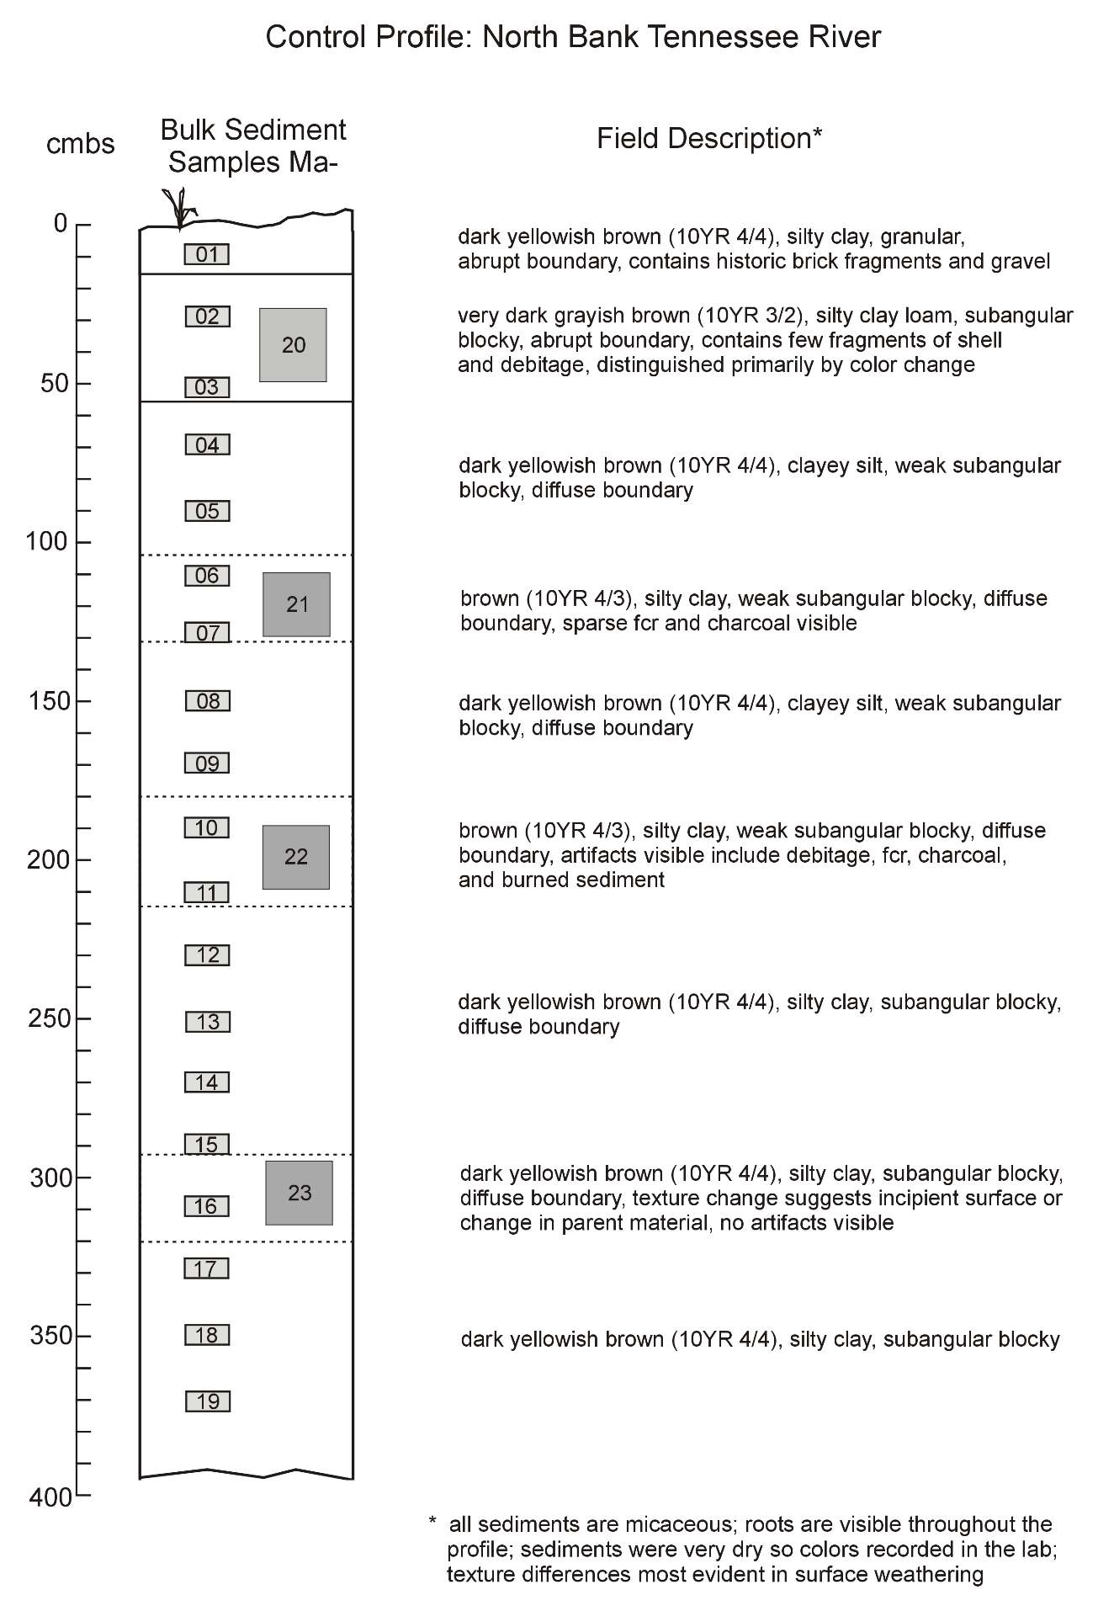Figure C.3. Note: All column samples are prefixed by MA-.
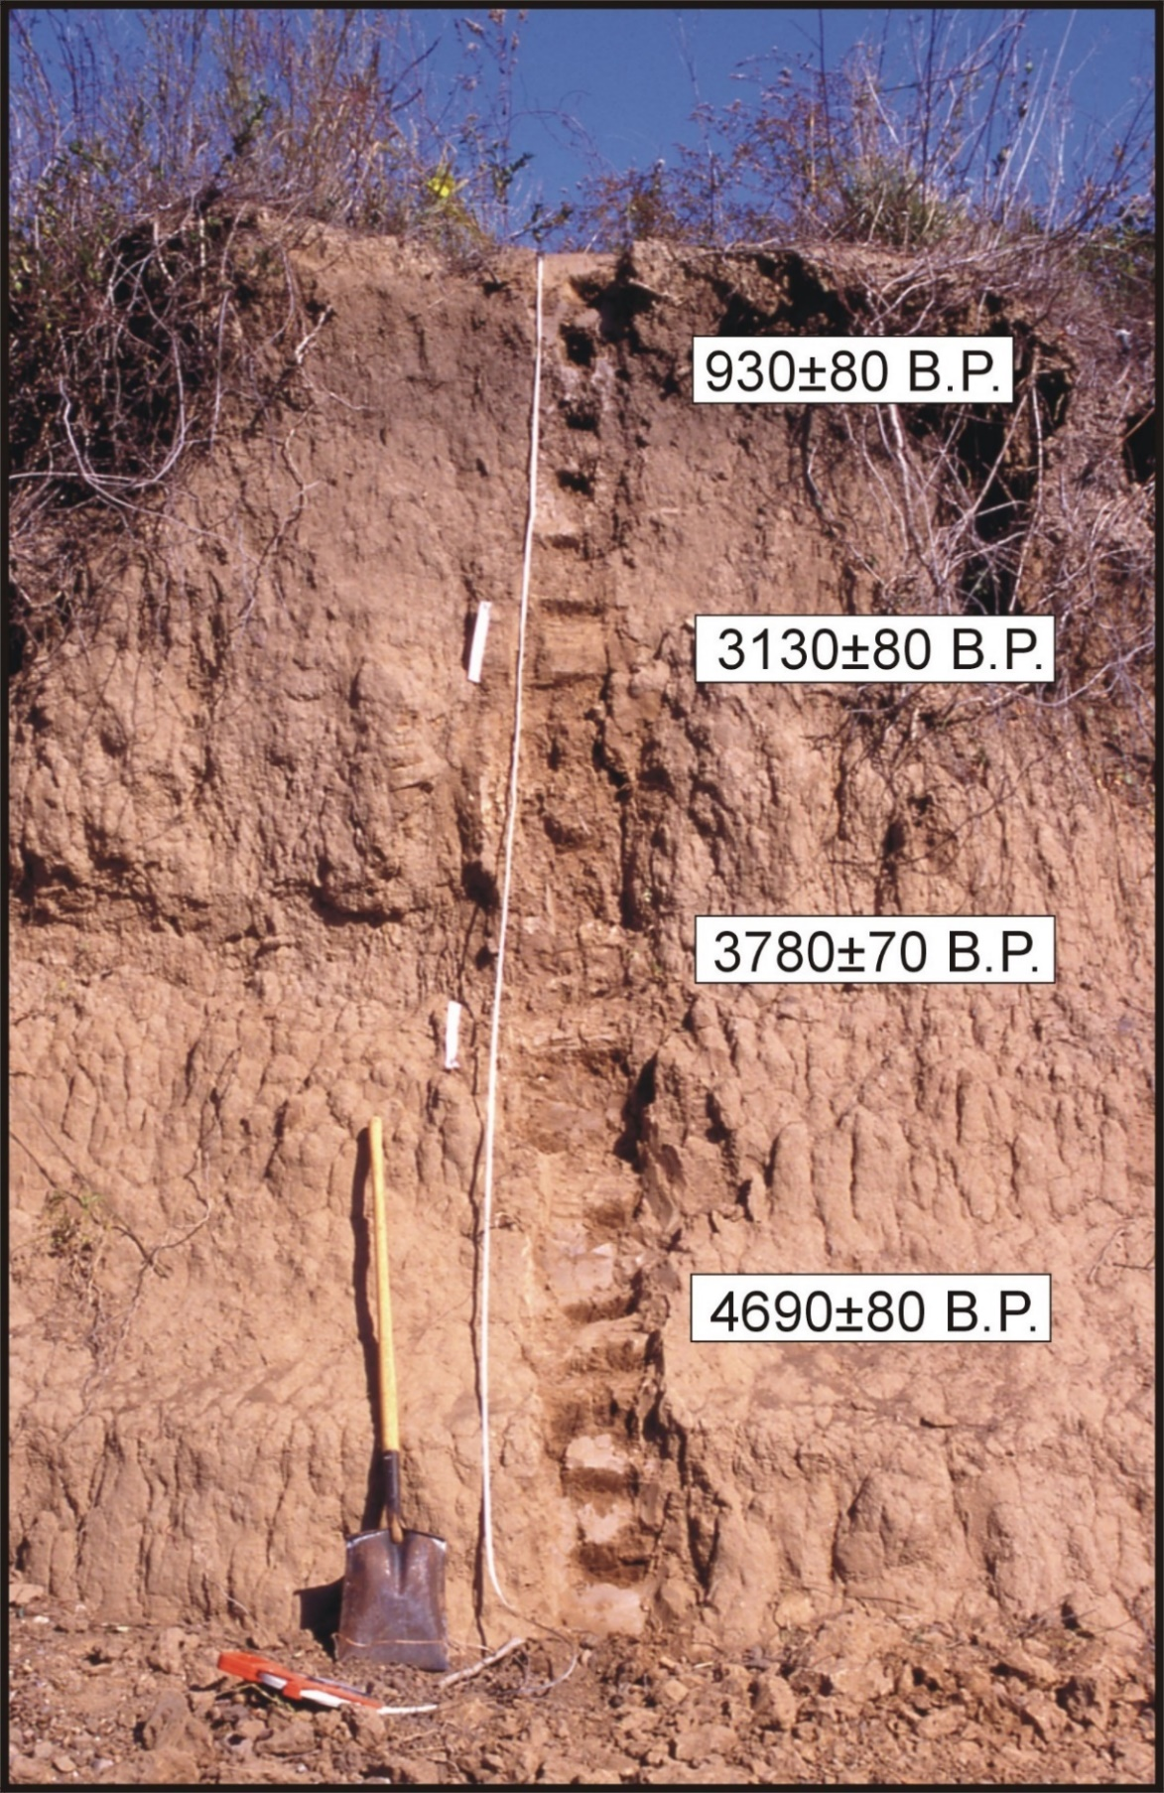
Figure C.4. Radiocarbon dates in relation to their location in the control profile. (Modified from Kocis and Sherwood [2006]).
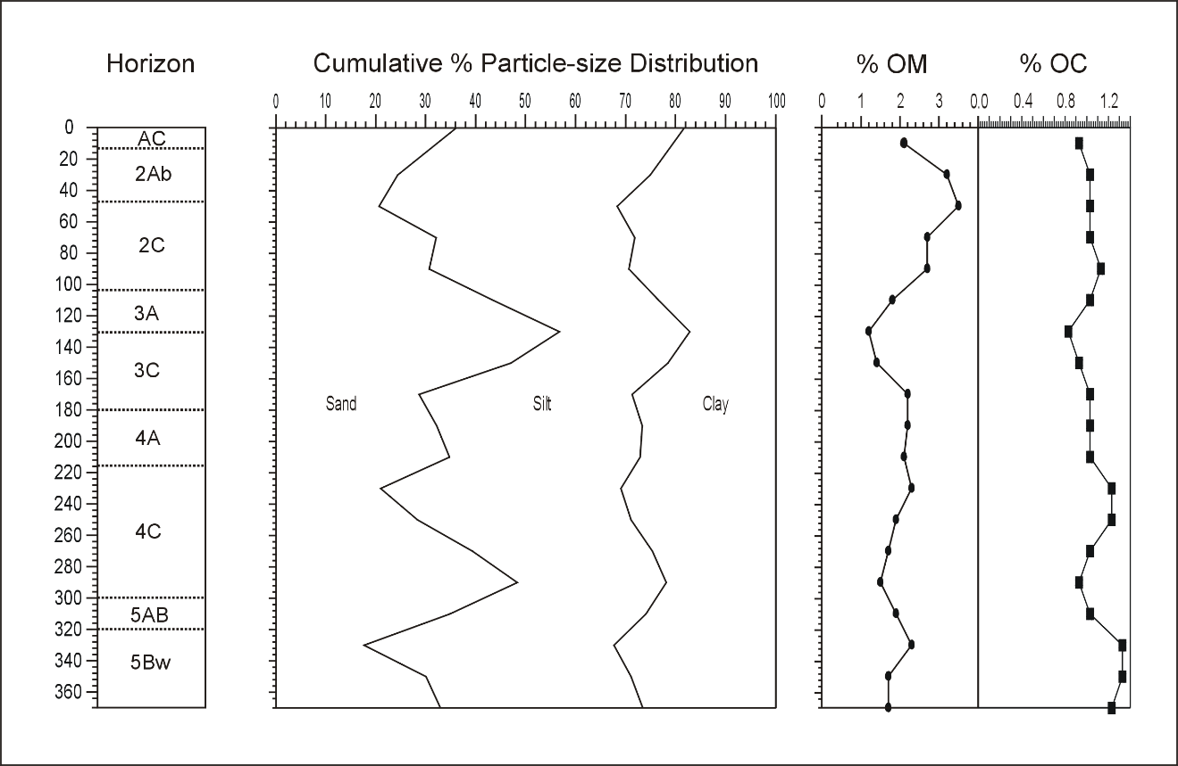
Figure C.5. Control profile cumulative per cent particle-size distribution, per cent organic matter (%OM), and per cent organic carbon (%OC).

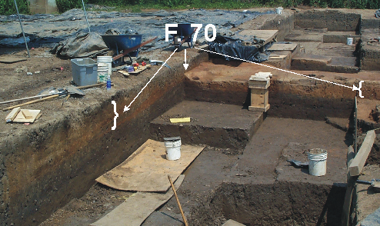
Figure C.6. Block 1 excavation in progress showing portions of Feature 70.

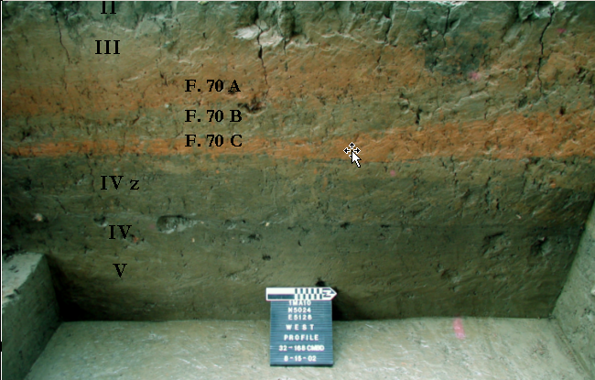
Figure C.7. West profile of Block 1, E5128, view to west showing the red strata of Feature 70.

Stratum V. Stratum V marks the base of the site stratigraphy across Blocks 1 and 2, the intact B horizon or subsoil developed in an alluvial parent material. This horizon consists of brown (7.5YR 4/3) micaceous fine silty clay loam with relatively well developed structure and minor redoximorphic features indicating the periodic effects of groundwater (Figure C.8).

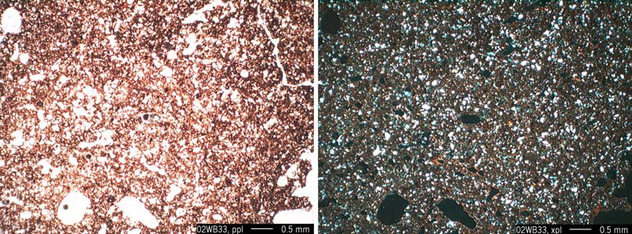
Figure C.8. Photomicrograph of typical Stratum V silt loam matrix. Sample 02WB33.

Stratum IV. Stratum IV is relatively homogeneous dark grayish brown (5YR 3/2) silty clay loam (Figure C.9). Stratum IVa marked the transitional boundary between Stratum IV and V (two soil horizons). This stratum was composed of a mottled gradual transition primarily from bioturbation. In thin section, Stratum IVa relative to IV above, has reduced pore space but an increased number of pores. These smaller vughs appear to relate to increased bioturbation (Figure
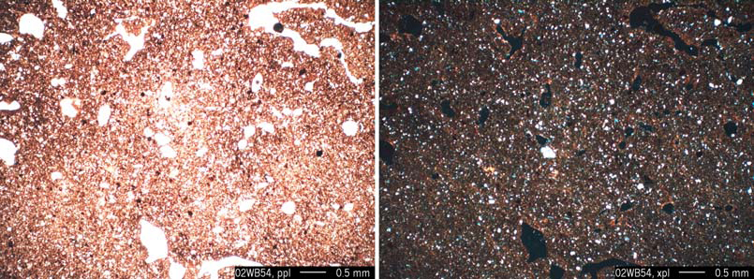
Figure C.9. Photomicrograph of typical Stratum IV silty clay loam matrix. Sample 02WB54.

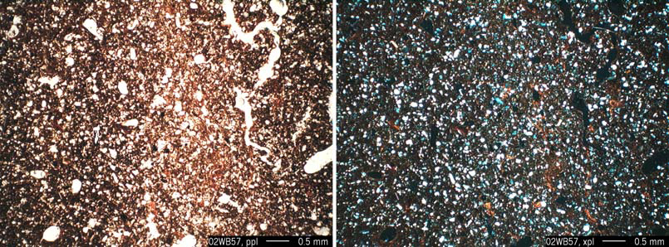
Figure C.10. Photomicrograph of Stratum IVa with increased vughs due to bioturbation.

C.10). In addition, Stratum IVa also contains increased clay coatings (Figure C.11), more like that of Stratum V, illustrating the microfabric and clay illuviation of the Bt horizon below.

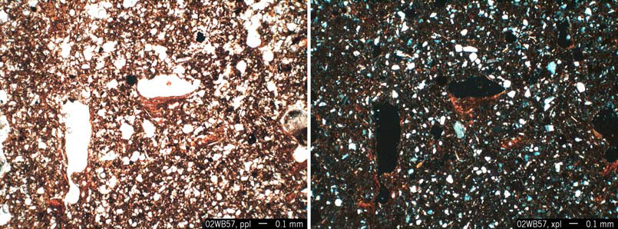
Figure C.11. Photomicrograph of clay coatings in Stratum IVa. Sample 02WB57.

Stratum IV is interpreted as a buried cumulative surface with significant input from anthropogenic activities. The artifacts include bone, FCR, charcoal, fragments of burned clay, and diagnostic Wade and McIntyre projectile points, typical of the regional Late Archaic. The matrix includes microartifacts suggestive of a cumulative midden-like surface (Figures C.12-C.13). This zone also includes intrusive features such as small pits and hearths but there were no ceramics or shell. Feature 50, a large burned surface with abundant burned bone, exemplifies the types of activities taking place across Stratum IV (Figure C.14). In thin section the matrix of Stratum IV reveals a granostriated b-fabric, which is the result of pressure creating compression in the soil material (Figure C.15). This micro-fabric can sometimes relate to shrink-swell soils but this is highly unlikely in a buried surface horizon derived from Tennessee River alluvium. It is more likely the result of loading from above, the added weight of Feature 70 and other strata burying this surface. Moving to the south, away from Feature 70, the microfabric appears less compressed with greater pore space and sparse microartifacts in the form of microdebitage and variably sized charcoal (Figure C.16).

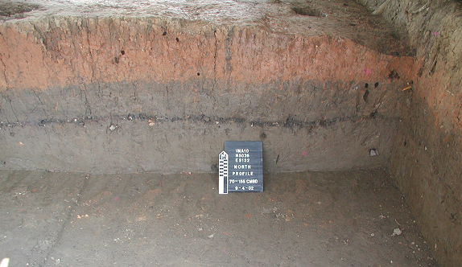
Figure C.12. North profile of N5026E5132 showing concentrated artifacts and charcoal in Stratum IV, below Stratum IVz.

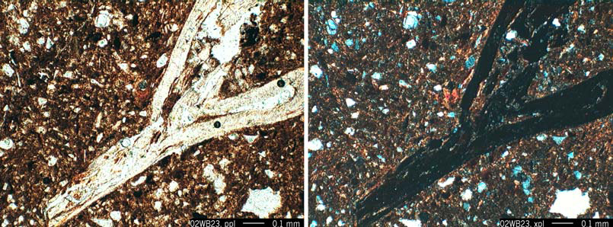
Figure C.13. Photomicrograph of Stratum IV, note fish bone in center of image. Sample 02WB23.

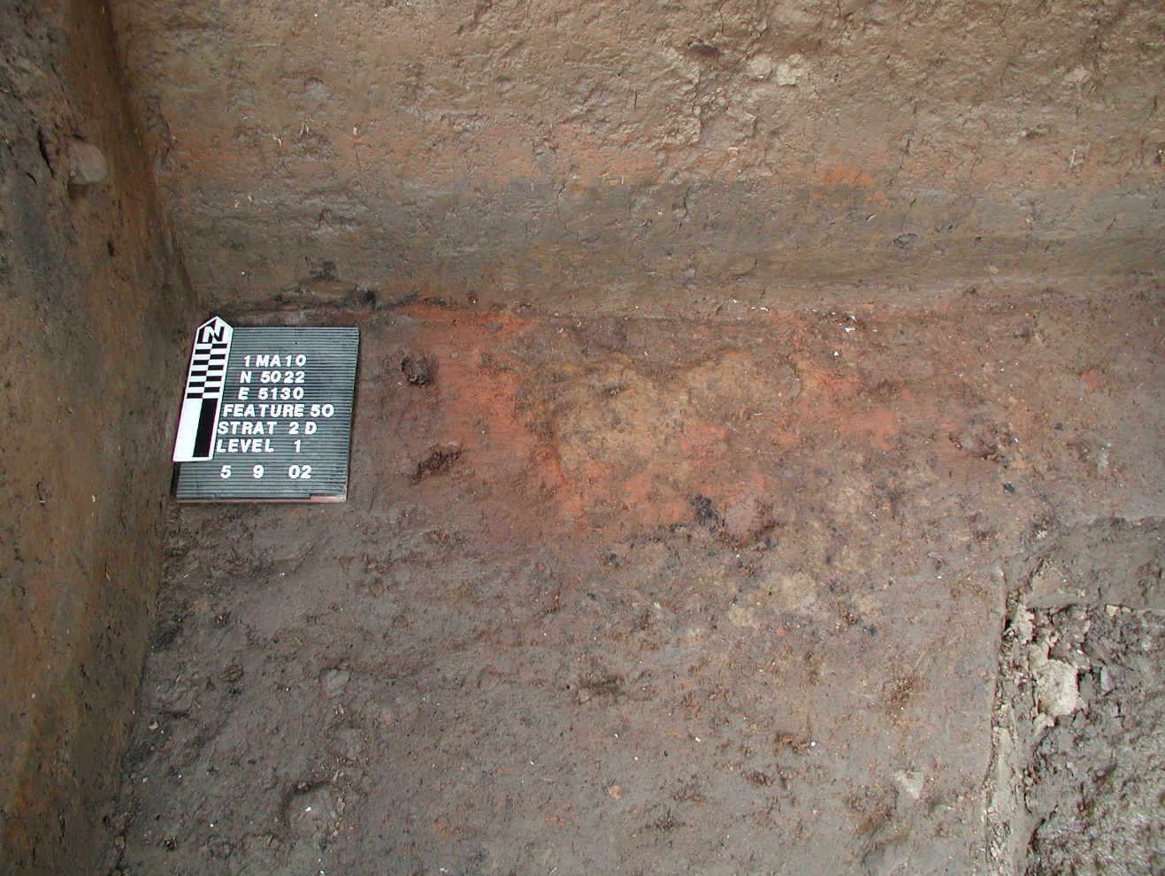
Figure C.14. Feature 50, a burned surface on Stratum IV. Phase II Backhoe Trench 8 is visible in the lower right.
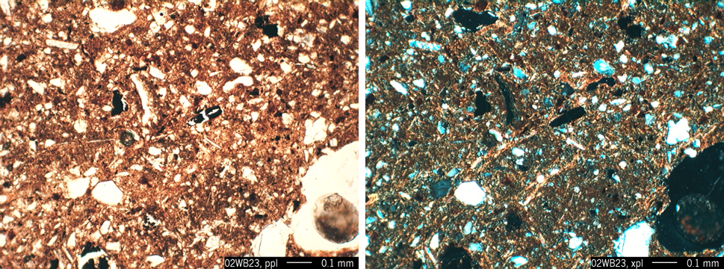
Figure C.15. Photomicrograph of granostriated b-fabric surrounding ancient fecal pellets. The b-fabric is clearly visible as bright clay domains under cross-polarized light in the right hand image. Sample 02WB23.

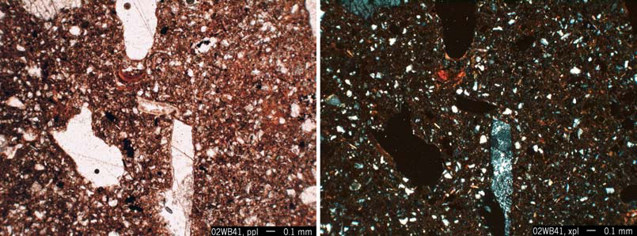
Figure C.16. Photomicrograph of Stratum IV, note vertically oriented chert microdebitage in lower center. Voids appearing as large masses, white in plane polarized light (left) and black in cross-polarized light (right), represent increased vughs. Sample 02WB41.

Relative to Stratum IVz, lying above, the Stratum IV samples reveal a more homogeneous matrix, lacking the disruption features described below. In addition the Stratum IV and IVa microfabric is less chaotic, with more consistent distribution of the matrix (Figure C.17).

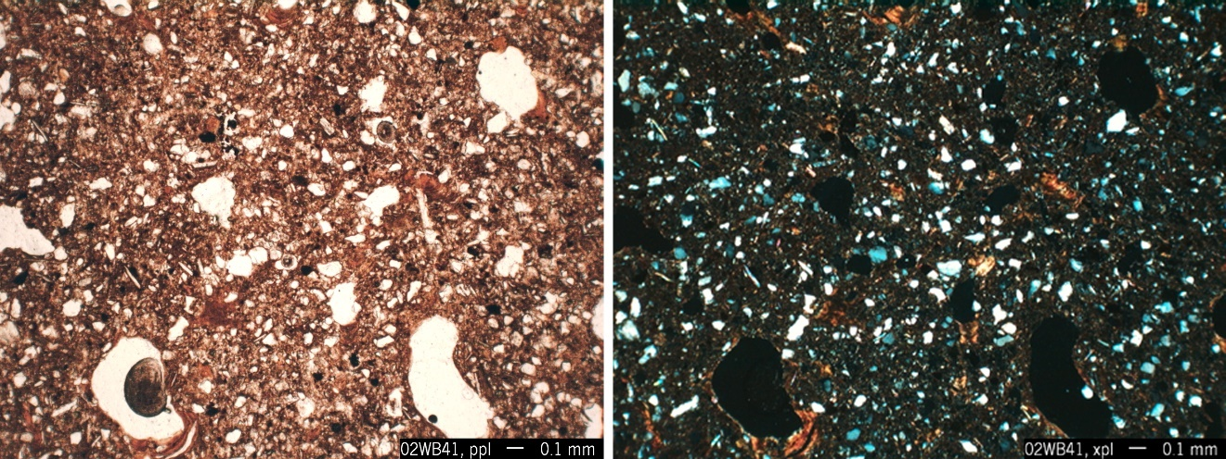
Figure C.17. Photomicrograph of Stratum IV fabric illustrating the generally homogeneous silty clay loam matrix. Sample 02WB41.

Feature 70. Feature 70 spans several strata including Stratum IVz and Feature 70, Zones A, B and C (herein referred to as Zones A, B, and C). As noted above, one of the primary geoarchaeological questions on the site was if these zones were laid on top of another cumulative horizon, Stratum IV, or if this stratum consisted of natural overbank deposition. In profile, Stratum IVz appeared to be highly variable in composition, thinning to the north until it pinched out around N5042 and to the south around N5018, along the N-S axis of Block 1, which cross-cuts Feature 70. Colors and textures varied by localized concentrations that were visible in the profile, but not so well expressed that they stood out as distinct basket loading in the profile (Figure C.7).

By basket loading I am referring to the colloquial term used to refer to distinctly different deposits with abrupt boundaries that are composed of volumes roughly equal to what we image one person might carry in a basket. These distinct deposits are often relatively uniform in size and vary slightly in material, suggesting different source areas where the soils material was collected. Examples of basket loading are well documented throughout the excavation reports that cover Mississippian platform mounds and many Mississippian plazas, as well as numerous Woodland and Late Archaic earthworks. So while there was variability in the Stratum IVz profiles observed in the field, it was not as well expressed as in classic basket loading. Consequently the question remained, did Stratum IVz represent a human constructed platform for Feature 70 or was the observed variability due to natural processes?

The variability in Stratum IVz suggests that the layer is indeed composed of multiple deposits by people. This variable composition is demonstrated in detailed field observations and several of the thin sections. Some of the best evidence lies in the presence of abrupt boundaries between two variably textured concentrations of soil material in Stratum IVz (Figure C.7). Also noted are compound pedofeatures, clay coatings followed by infilling from variably textured alluvium. Figure C.18 illustrates a complex history that includes relocation of original material evidenced in the embedding of clay coatings in the matrix. Numerous channels are also infilled with the more coarse alluvium and clay papules, suggesting the influx of a more coarse deposit above, mixed into this zone, most likely through bioturbation mixing two side by side deposits derived from different sources (Figure C.19). Illuvial clay pedofeatures embedded in the matrix with nearby voids free of clay coatings suggest that this material was collected from deep within a well developed profile (Bt horizon) and deposited in bulk at this location (Figure C.18). Subsequent soil formation (e.g. plant growth and soil fauna activity) created new void structures that are comparatively underdeveloped or show no signs of illuvial clay accumulation (Figures C.20-C.21). Finally, highly localized concentrations of Fe/Mn concretions also suggest variable parent materials.

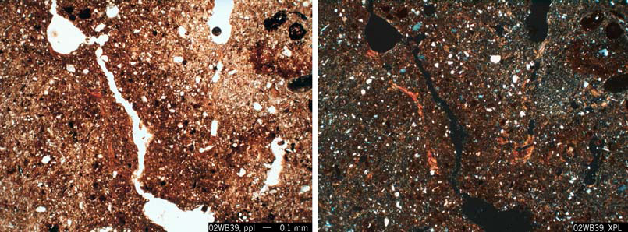
Figure C.18. Photomicrograph of Stratum IVz illustrating two different textures of soil material adjacent to one another with clay infilled cracks derived from the source area. Sample 02WB39.

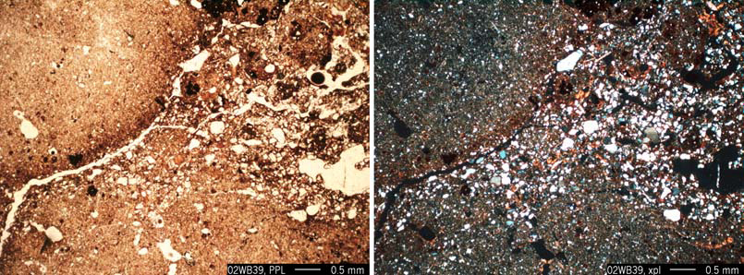
Figure C.19. Photomicrograph of a silty clay matrix with a crack or channel infilled with coarse alluvial soil material. Sample 02WB39.

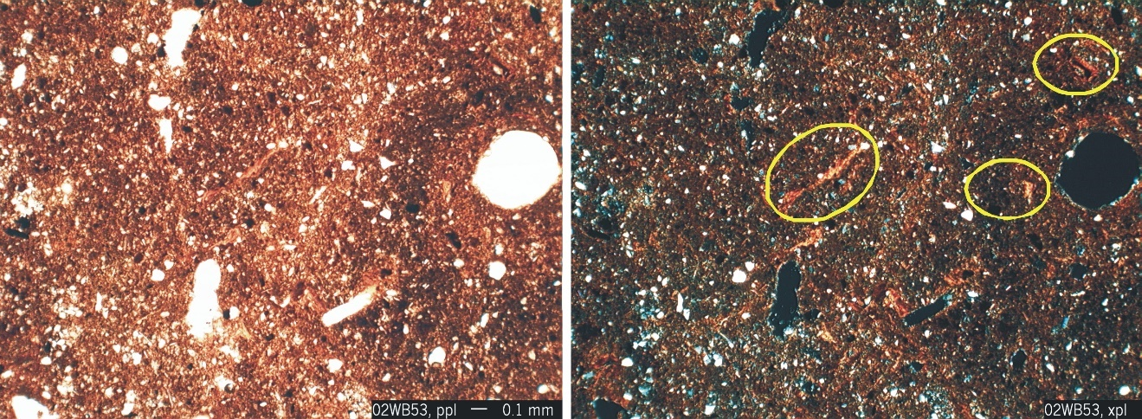
Figure C.20. Photomicrograph of Stratum IVz illustrating papules (fragments of illuvial clay coatings) mixed into the matrix with more recent voids with no clay coatings. Examples of the papules are circled in yellow in the cross-polarized light image (right). Sample 02WB53.

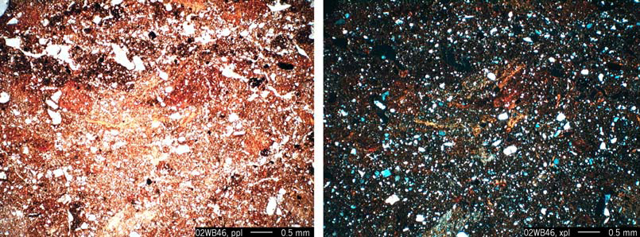
Figure C.21. Photomicrograph of Stratum IVz illustrating papules (fragments of illuvial clay coatings) concentrated in the matrix with more recent voids with no clay coatings. Papules are bright yellow and red in the plane polarized light image (left). Sample 02WB46.

The upper and lower boundaries of Stratum IVz are both abrupt, suggesting a rapid accumulation and burial. The lower boundary indicates that Stratum IVz is generally composed of finer grained material, however due to the variation in the deposits making up this layer, the texture varies. For example, in Figure C.22 and Appendix A, Sample 02WB54 more coarse grained silt overlies Stratum IV which is markedly different with fine material below. The boundary between Stratum IVz and Stratum IV below is abrupt and irregular. Below the south end of Feature 70, in Stratum IVz, the microscopic examination of the thin sections revealed a mixed chaotic microfabric predominantly composed of pure clasts of well sorted silt. These clasts were relatively compact resulting in an overall dense zone, markedly different in terms of compaction, to the zones composing the heart of Stratum IVz (Figure C.23). The differences between these two sample areas, as also seen in Appendix A, Samples 02WB40 and 02WB48, indicate an abrupt shift as this location changed from habitation or food processing to the influx of variable soil material, presumably to prepare the surface for Feature 70. In addition, the variability across Stratum IVz relates to loading from different source areas. Based on the reduced artifact content between Strata IVz and IV, the source area(s) were located some distance away from the habitation area. Otherwise cultural debris would have been incorporated into the deposits composing Stratum IVz.

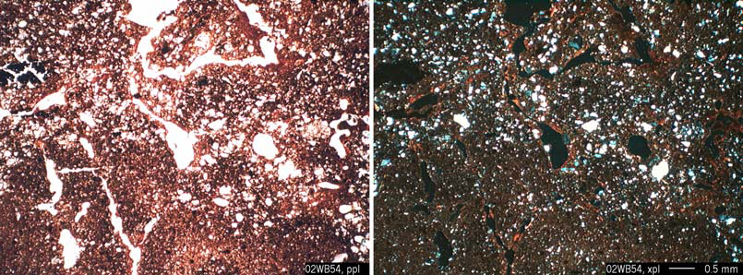
Figure C.22. Photomicrograph of the abrupt Stratum IVz/IV boundary. The lower material is generally composed of a fine grained silt to silty clay material with a more coarse deposit making up part of Stratum IVz. Sample 02WB54.

The upper boundary of Stratum IVz, beneath Zone C, is abrupt, lacking any evidence, either in the field or in thin section, of a stable surface or buried A. This further suggests that Stratum IVz was indeed constructed just prior to Feature 70, without a period of abandonment or accumulation before the red clay was laid down.

The depositional events making up the strata discussed so far were all derived from soil material formed in Tennessee River alluvium, but in the case of some of the localized deposits composing Stratum IVz, some of the material appears to be well sorted silt, possibly originally derived from an eolian source. Ultimately, there is enough variability to indicate the layer is made up of soil material from different locations as well as different horizons.


Figure C.23. Photomicrograph of the abrupt Stratum IVz/IV boundary. The lower material is coarser than the dense silty clay of Stratum IVz above. Sample 02WB40.

The most obvious distinction of Feature 70 is its color. In the field Zones A and C in particular appear to be composed of relatively consistent red or yellowish red (5YR 4/6) silty clay to clay (Figure C.7). The microscopic examination of these sediments indicates mixed subsoil material as well as diagnostic pedofeatures related to well-developed and weathered B horizons. The red color is derived from both embedded reworked fragments (sand and silt-size) and in situ birefringent clay coatings consistently observed in the thin sections (Figure C.24). Such highly birefringent clay coatings form along voids in B horizons where illuviated clay precipitates and coats the voids. Only through disruption due to roots or burrowing insects will these features be broken and reworked in old, weathered soil. Such disturbances are few due to their depth, below the active root zones and beyond the nutrients soil fauna are interested in. In the case of Zones A and C, angular fragments are embedded in the matrix (Figures C.24-C.25). The disturbance and re-deposition of these papules creates reddening of the soil material when these clays are liberated back into the system (Figure C.26). To a lesser extent localized aggregates/clasts of variable soils suggest that other soil materials were also incorporated to create Feature 70 (Figure C.27).

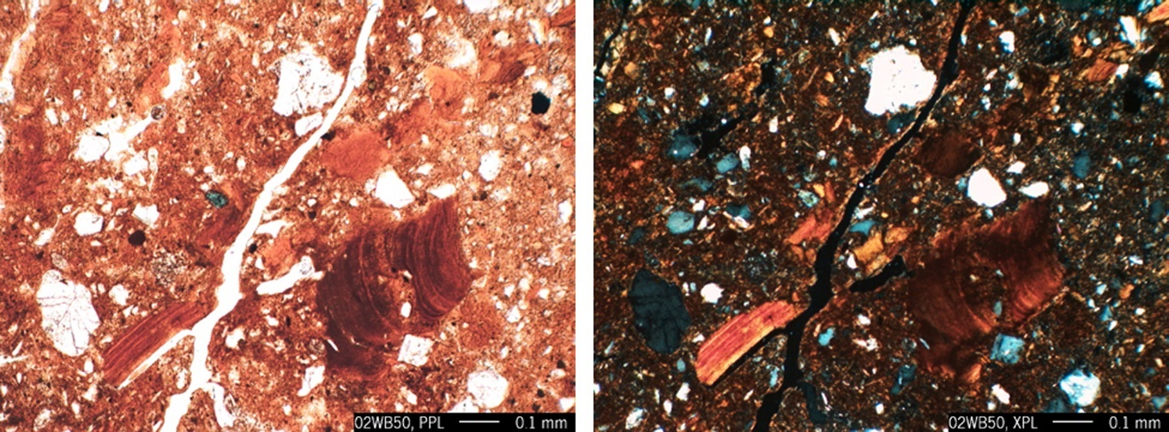
Figure C.24. Photomicrograph of the embedded papules (laminated birefringent clay coating fragments) in Zone C. Sample 02WB50.

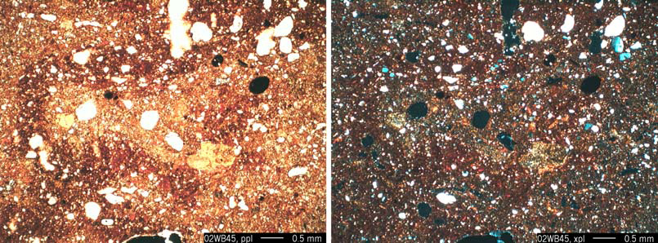
Figure C.25. Photomicrograph of a concentration of embedded papules in Zone C, contributing to the red color. Sample 02WB45.

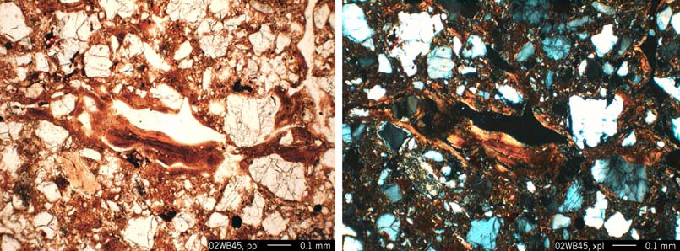
Figure C.26. Photomicrograph of a localized active clay coating. Sample 02WB45.

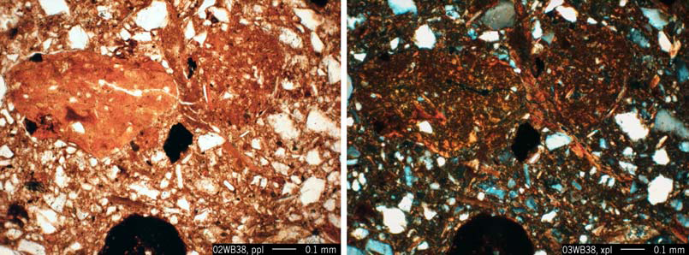
Figure C.27. Photomicrograph of rounded clay aggregates in a silty clay loam matrix. Sample 02WB38.

Though Zones C and A appear similar in the field there are some distinctive micromorphological differences. Clearly different soil materials, with abrupt boundaries in between, are suggested with different fabrics, colors, pedofeatures, and amounts of organic matter expressed. Zone C contains few Fe/Mn concentrations and few concentrations of silt and sand size clay coating clasts (papules) relative to Zone A (Figure C.28).

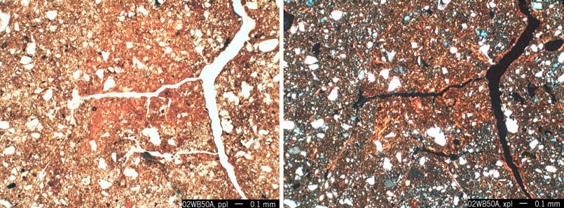
Figure C.28. Photomicrograph representative of the Zone A matrix to be compared to Zone C (Figures C.25-C.26). Sample 02WB50A.

Zone B appears in the field as a brown (7.5YR 4/4) silty clay loam, distinctly different from and unconformably contacting Zones A and C. The relatively dark color is due to increased organic matter, charcoal, and the absence, relative to Zones A and C, of Bt soil material in the zone (Figure 15). This dark band extended down the south slope of Zone C, pinching out around grid N5021. Red sediment transported from the red zones above and below by localized bioturbation, is clearly evident in the field profile (Figure C.29). In thin section, coarse charcoal fragments in the matrix were fragmented in place, many contained clay coatings associated with planar voids (recent breaks) (Figure C.30). Given the abrupt boundaries of the zone and the absence of in situ pedogenic features, Zone B is interpreted as mixed soil/midden material that either accumulated here, on top of Zone C, or mixed soil/midden material that was transported to this location in bulk. As clayey Zone A was deposited on the top of Zone B, the clay was liberated back into the system with the disturbance of the Zone A parent material. Some of the clay accumulated in the voids in Zone B, further supported by the dominance of dusty clay coatings (Figure C.31).

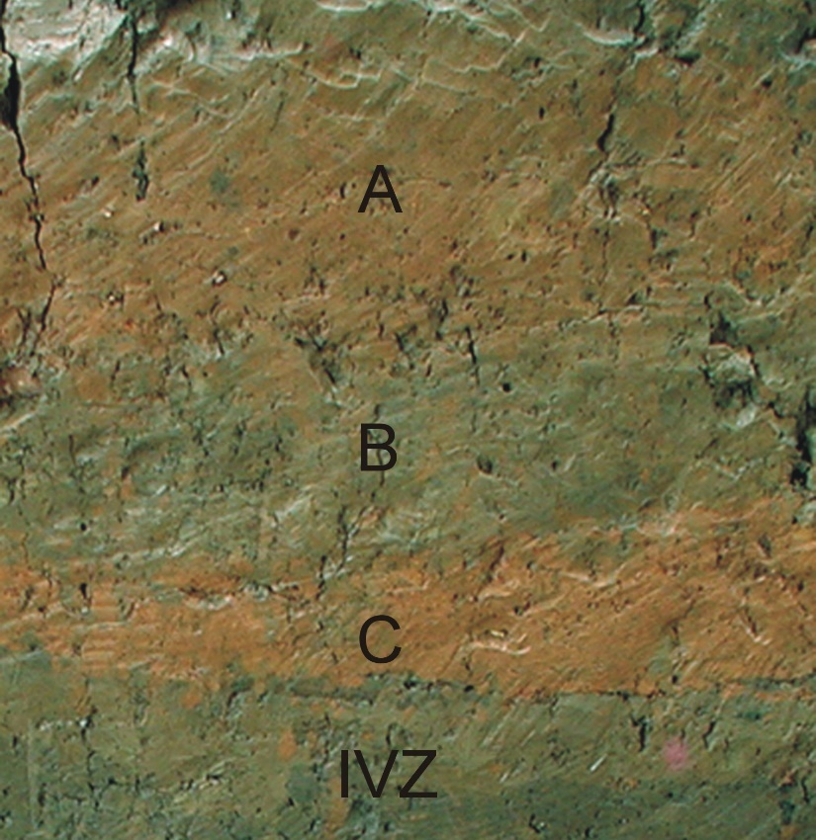
Figure C.29. Detail of profile E5128 (Figure C.7) showing Zone B with intermixed red silty clay due to bioturbation.

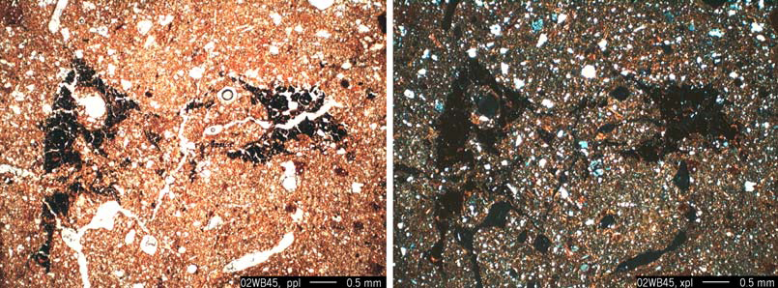
Figure C.30. Photomicrograph illustrating charcoal fragments embedded and broken in place in the Zone B matrix. Sample 02WB45.

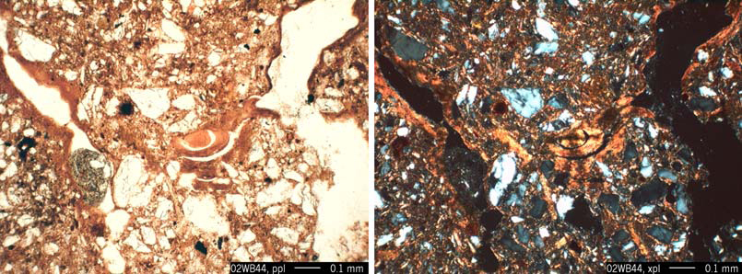
Figure C.31. Photomicrograph illustrating dusty and birefringent clay coatings accumulating in the upper portion of Zone B. Sample 02WB44.

Block 2

In Block 2 only the south end of the excavation was complete during the geoarchaeological fieldwork. Therefore sampling focused in this area, specifically N5018 E5152 along the south profile (Figure C.32). This profile incorporates a complex series of zones including localized dense shell deposits not observed in the sampled areas of Block 1.

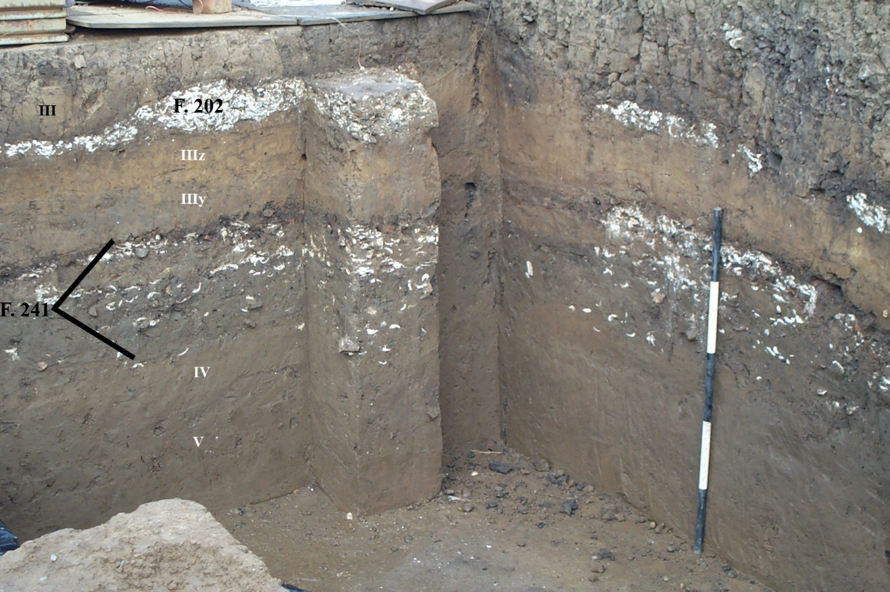
Figure C.32. Block 2, N5018E5152 south and west profiles with main strata labeled, also shows the micromorphology column.
The area examined begins at the base of the profile. The base of the profile contains subsoil which is designated as Stratum V across the site (Figure C.32). This horizon may or may not directly correlate with the Stratum V from Block I, however they both represent the culturally sterile portion of the soil profile. Above Stratum V, a series of localized deposits were identified as Feature 241. This feature primarily consisted of a cumulic shell deposit containing burned and unburned freshwater mussels. In Figure C.32 it is clear that the feature is really a series of isolated deposits that in the south profile are divided by a non shell bearing deposit. This portion of the feature, measuring ca. 20 cm thick, overlay Stratum IV and is considered an “extension of Feature 241”. This layer is made up of homogeneous silt loam containing charcoal, dispersed shell, bone, and fire cracked rock (Appendix A, Sample 02WB31). Overlying Feature 241 are three linear homogeneous deposits beginning with Stratum IIIx abruptly overlying the portion of Feature 241 referred to as Stratum IIIw. Stratum IIIy abruptly overlies Stratum IIIx. Stratum IIIz abruptly and unconformably overlies Stratum IIIy (Figure C.32). Feature 202 lies immediately above Stratum IIIz and consists of localized shell deposits that were truncated prior to or with the deposition of Stratum III. The overlying Strata II, IIa, and III are linked to the historic occupation of the site and were not examined in thin section.

Stratum V. Stratum V marks the base of the excavation in Block 2. The intact B horizon or subsoil developed in an alluvial parent material. This horizon consists of brown (7.5YR 4/3) micaceous fine silty clay loam with relatively well developed structure and minor redoximorphic features indicating the periodic effects of groundwater.

Stratum IV. Stratum IV consists of dark reddish brown (5YR 3/2) silt loam. This horizon appears to be the result of overbank deposition that has been reworked by the same phase of human activity that resulted in the accumulation of Feature 241. The layer is irregular in thickness and it contains micro and macroartifacts probably derived from Feature 241 including FCR and shell. The material was probably reworked into the layer by trampling and bioturbation and as a result has been significantly weathered (Figures C.33-C.34). The matrix of Stratum IV, however, remained significantly different from that of the “feature” above. The upper portion of Stratum IV contains charcoal, dispersed shell, bone, and fire cracked rock (Appendix A, Sample 02WB31) as well as increased pedofeatures such as dusty clay coatings suggesting the disturbance of the surface above (Figure C.35).

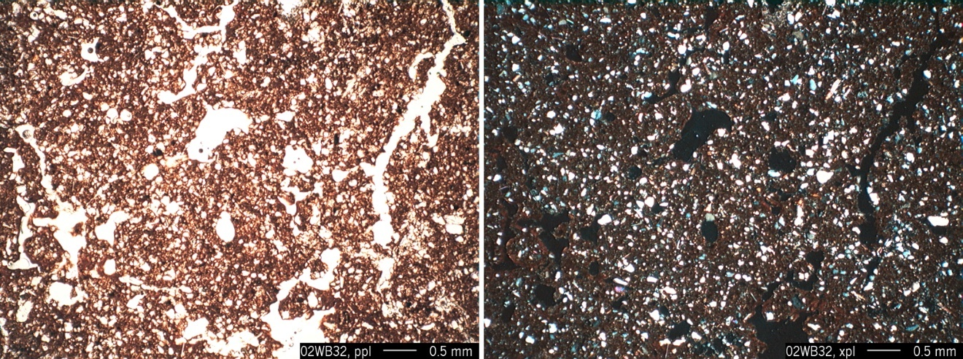
Figure C.33. Photomicrograph illustrating the homogeneous dense silty clay loam of Stratum IV with a bioturbated microstructure. Sample 02WB32.
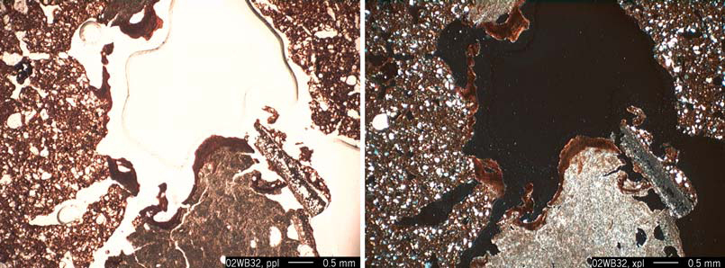
Figure C.34. Photomicrograph illustrating dusty clay coating a large void with two types of partially decalcified shell at the bottom of the image. Sample 02WB32.

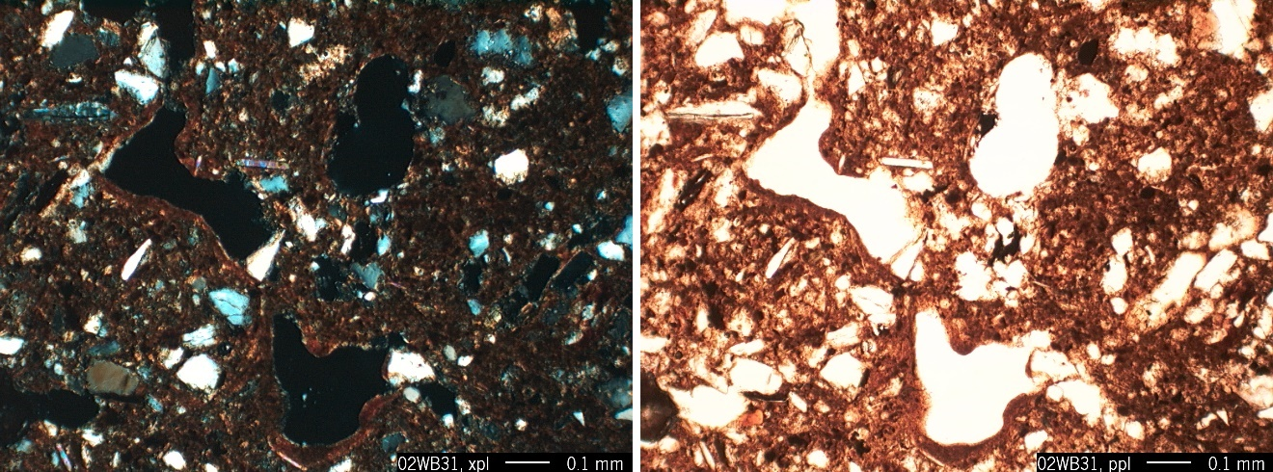
Figure C.35. Photomicrograph illustrating dusty clay coatings in voids in the upper portion of Stratum IV. Sample 02WB31.

Feature 241. As noted above, this feature is actually a complex of intermingled separate deposits including shell dumps, FCR, and burned sediment and charcoal that may be more akin to a midden. Feature 251 represents one of two large earth oven features that are intrusive pits initially created during the accumulation of Feature 241 (Figure C.36). The matrix of Feature 241 is variable and mixed but primarily composed of dark grayish brown (10YR 3/2) silty clay loam. Most of the artifacts appear to be the result of burning, either in situ or as fireplace dumps. This is further suggested by the presence of variably sized burned soil/sediment clasts distributed throughout the matrix, such as shown in Figure C.37. Post depositional processes include extensive bioturbation with the infilling of channels with fecal pellets and the overall aggregated microfabric and the decalcification of shell (Figure C.38) as well as the precipitation of calcite that has been liberated with the weathering of the shell and redeposited elsewhere in the matrix (Figure C.39).

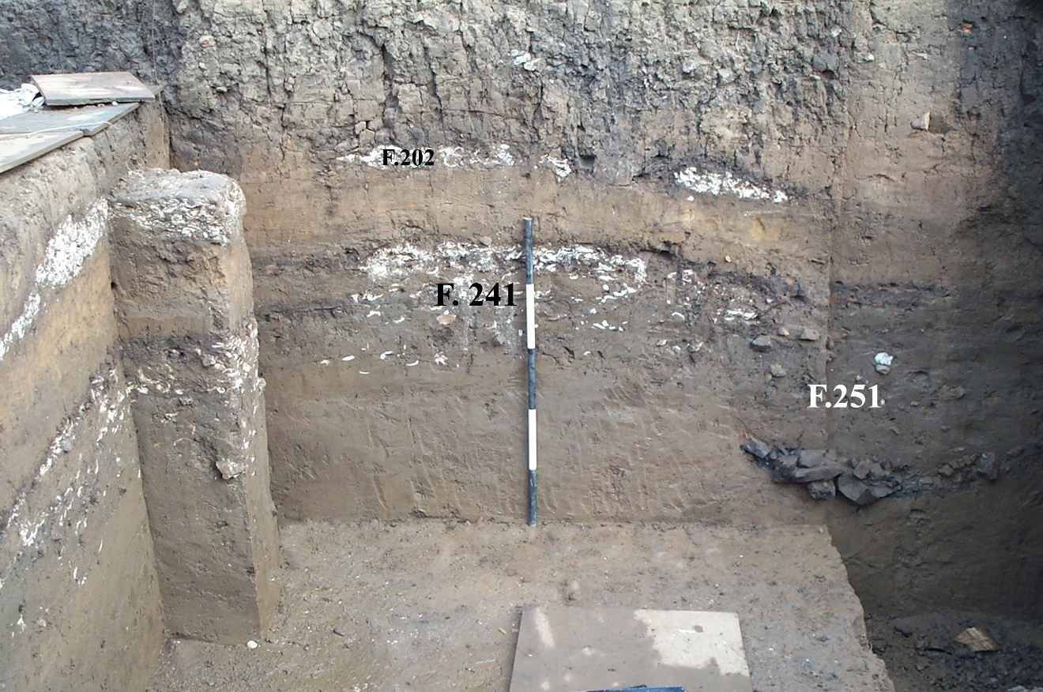
Figure C.36. Block 2, N5018E5152, west profile with the features labeled.

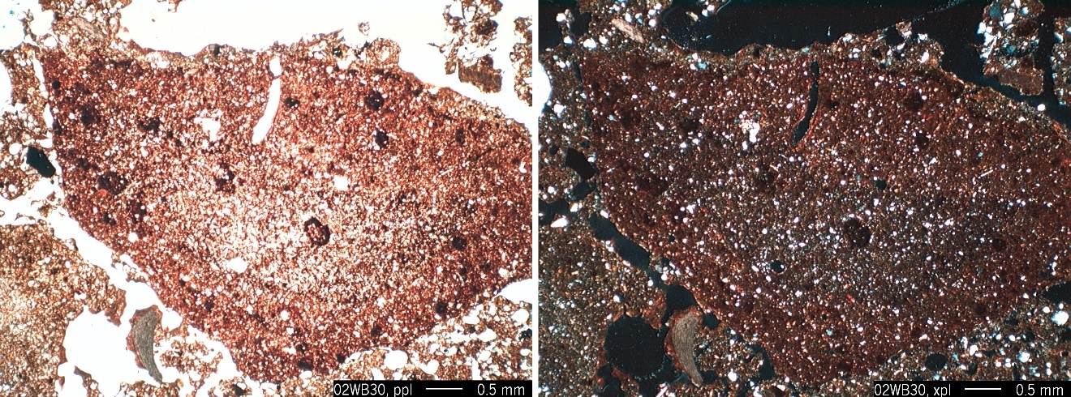
Figure C.37. Photomicrograph of burned soil clast in the matrix of Feature 241. Sample 02WB31.

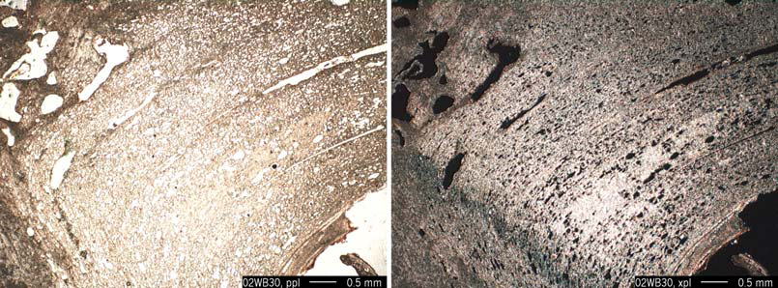
Figure C.38. Photomicrograph illustrating decalcification of shell in progress in Feature 241. Sample 02WB30.

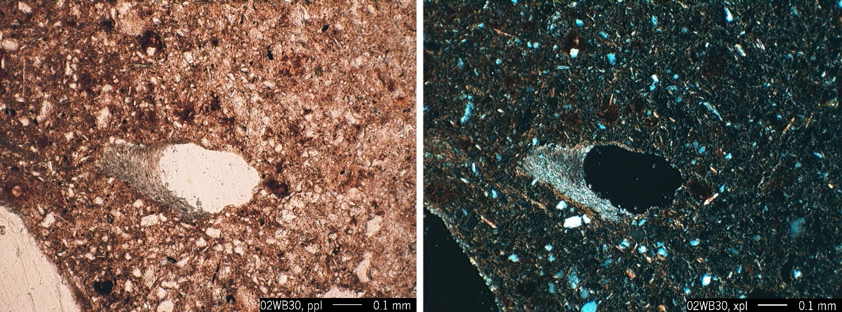
Figure C.39. Photomicrograph of calcite coating a void. Sample 02WB30.

In the field profile a well defined lens of burned soil, charcoal, and FCR caps Feature 241 (Figures C.32, C.36). This ca. 5 cm zone, referred to as Stratum IIIw may represent the last phase of burning to occur in this area of the site. Though thin, the lens is laterally extensive and consistent, covering an area greater than 2 m. The shell concentrations of Feature 241 are localized but Zone IIIw does not appear to correlate with these concentrations but instead covers them. According to radiocarbon results, Features 241 and 251 date to the Late Archaic around 3380 cal BP.

Stratum IIIy. Stratum IIIy was composed of brown (10YR 4/3) silty clay loam and abruptly overlay Feature 241. Vertical cracks attest to the potential for shrink-swell and the significantly finer grained texture relative to the deposits above and below. Along the upper boundary, though abrupt, localized mixing due to bioturbation is visible with infilled channels and rounded aggregates of the loamy sand to sandy loam from Stratum IIIz above (Figure C.40).

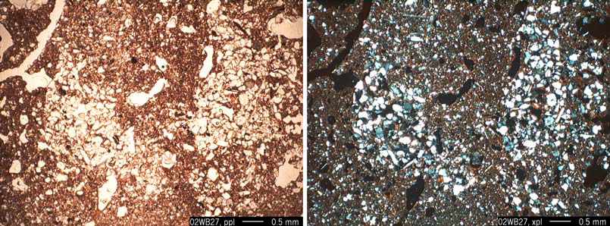
Figure C.40. Photomicrograph showing infilled channel and rounded aggregates suggestive of bioturbation mixing loamy sand from Stratum IIIz into the finer underlying matrix of Stratum IIIy. Sample 02WB27.

Stratum IIIz. Stratum IIIz was significantly more coarse grained than the underlying Stratum IIIy. The layer is described as a dark yellowish brown (10YR 4/4) sandy loam. Dusty clay coatings in the matrix suggest periodic saturation and or ground disturbance above (Figure C.41). With the level of historic activity that disrupted the upper profile and periodic flooding and heavy rainfall, this is not unusual and potentially not archaeologically significant.

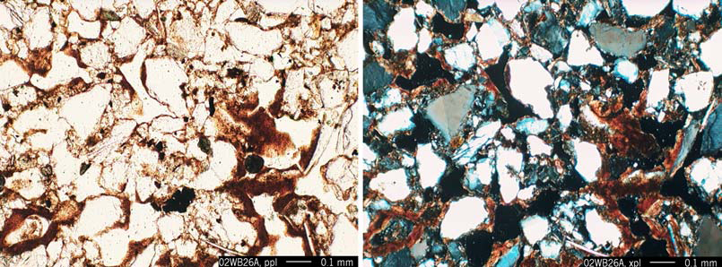
Figure C.41. Photomicrograph of dusty clay coating voids in the sandy loam matrix of Stratum IIIz. Sample 02WB26A.

In the field, rip-up clasts from the finer Stratum IIIy were identified along the lower boundary (Appendix A, Sample 02WB27). The coarse texture and the elevated energy suggested in the rip-up clasts indicate flood deposition. This stratum in Block 2 probably correlates with Stratum IIIc from Block 1 based on the texture and the presence of rip-up clasts at the base of IIIc as well. This overbank deposition appears to have occurred following the Late Archaic occupation of the site. Based on diagnostic artifacts above and below the layer we can safely bracket the stratum between 2000 and 3000 BP.

Feature 202. This feature is similar to Feature 241 in that it represents a lateral accumulation of variable concentrations of mixed shell and soil matrix. This lateral accumulation is the result of multiple dumping episodes. The shell is highly fragmented and more concentrated than that of Feature 241. The matrix includes highly calcareous silt loam (Figure C.42). This localized impregnation of the matrix results when carbonate is liberated, probably derived from the breakdown of shell and other calcareous anthropogenic sediments, but note there is no clear evidence for wood ash, and then precipitates in areas that are over saturated or where root activity results in the degassing of CO₂. The matrix also includes rounded aggregates of non calcareous silty clay. At the base of the feature, overlying Stratum IIIz, the shell is larger, more complete, and the matrix is composed of variable aggregates including red silty clay clasts of well developed soil material (Bt horizon) (Figure C.43). The variable vertical size distribution of the shell suggests that activities associated with Stratum II above and/or trampling impacted the upper portions of the shell in Feature 202.

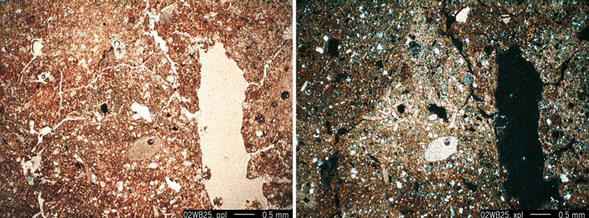
Figure C.42. Photomicrographs illustrating concentrations of calcareous silt loam adjacent to a large channel void. Sample 02WB25.

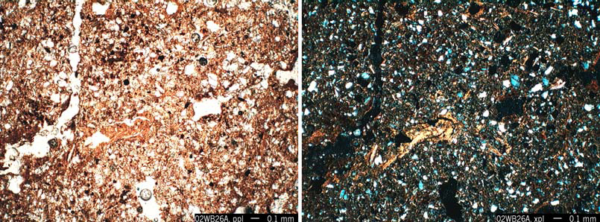
Figure C.43. Photomicrograph representing a close up of the red silty clay clasts of well developed soil material incorporated into Feature 202. Sample 02WB26A.

The degree to which the material is mixed, e.g. calcareous and noncalcareous soil material and clasts of Bt horizon material, suggests that this is an area where trash accumulated, derived from activities that took place elsewhere. This is further supported by the abrupt contact between Stratum IIIz and the overlying Feature 202 illustrated at the macro-scale (Appendix A, Sample 02WB26A) and at the micro-scale (Figure C.44). This is a different scenario than that suggested by Feature 241 below. Those deposits include intact burning lenses that suggest in situ activities.

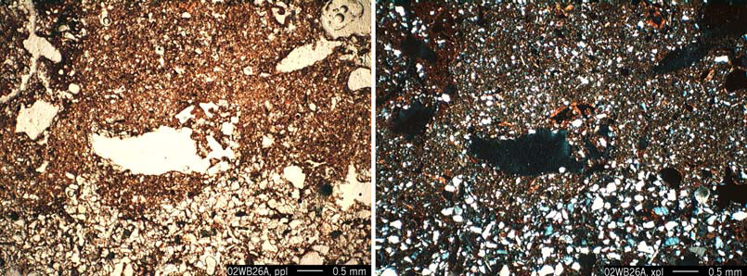
Figure C.44. Photomicrograph of the abrupt contact between the base of Feature 241 and the underlying Stratum IIIz. Sample 02WB26A.

DISCUSSION AND CONCLUSIONS

The geoarchaeological study conducted during the Phase III data recovery at the Whitesburg Bridge site focused on the local site stratigraphy and the depositional history of the particular profiles examined. A regional geomorphic context can be interpreted as well based on the Phase II results and the recent geoarchaeological studies conducted in the vicinity by the Archaeological Research Laboratory at the University of Tennessee.

Immediately downstream from 1Ma10, two cores were analyzed at the Redstone Arsenal at 1Ma141 and 1Ma285 (Kocis and Sherwood 2006). These analyses reveal channel deposits below 480 cmbs, that when correlated with the 1Ma10 Phase II results in Trench 7 suggest a date of over 6000 years ago. These results, in combination with the radiocarbon dates derived from the control profile indicate that the low terrace where 1Ma10 lies did not begin to form and stabilize until the mid Holocene. With the southward migration of the main channel of the Tennessee River, overbank deposition slowed and the low terrace became relatively stable with Late Archaic residents intensively occupying the area between 3200 and 3400 cal BP.

Recent preliminary research on Hobbs Island, immediately upstream from the Whitesburg Bridge site, provided three radiocarbon dates. These dates suggest that Hobbs Island also formed through Holocene overbank deposition, but that an older buried surface identified in the current cut bank (300 cmbs) dates to roughly 8200 cal BP. (Kocis and Sherwood 2006). These results indicate that there was an older stable surface in the vicinity of Hobbs Island (possibly an island as well) when the river channel, or some portion thereof, occupied the channel further to the north.

The location of 1Ma10 would have offered immediate access to rich upland resources on the northern side of the valley, where several smaller spring fed tributaries originate. Low areas seasonally inundated with slack or backswamps were located between the uplands and the aggrading levee. These backswamps and the main river channel provided immediate access to variable riverine resources such as fish, shellfish, waterfowl, and wetland and weedy plants. These rich environments would have offered diverse plant and animal resources to the inhabitants of the Whitesburg Bridge site.

Based on the stratigraphy observed at 1Ma10 and in the control profile to the west, the levee continued to aggrade with a generally low sedimentation rate from periodic overbank deposition but remained relatively stable for occupation up to the twentieth century. With the construction of Wheeler Dam and the associated erosion, significant loss of this mid Holocene levee has had a direct impact on the archaeological deposits at the Whitesburg Bridge site, the Hobbs Island site, and other sites in the levee on this stretch of the river.

The most specific question directed at the on-site strata dealt with Feature 70 in Block 1. Therefore the geoarchaeological analyses in Block 1 targeted both the general depositional history of the area as well as the specific nature of Stratum IVz, if this thick layer beneath Feature 70’s Zones A, B and C, represented the intentional deposition of soil material in preparation for the red clay surface above. Figure C.45 illustrates the stratigraphy in the north profile of Block 1, cross cutting Feature 70. This vertically exaggerated view demonstrates the mounded effect of the Feature 70 stratigraphy relative to the surrounding surface. The macro- and microscopic examination of these strata clearly document the intentional deposition of variable soil materials to prepare a surface, raising the elevation to place the red clay. Zones A and C in Feature 70 came from a source area deep in the terrace behind the site where ancient Ultisol and Alfisol argillic horizons were specifically sought, excavated, and brought to the site. The reason for this selection of the red clay and the function of the mounded surface it created, be it aesthetic, ritual, practical, or some combination of these reasons, can only be hypothesized at this point. Unfortunately traces that might have revealed the use of this red surface have been mostly removed, truncated with historic activities and the Woodland and Mississippian occupations at the site. The feature can, however, be confidently interpreted as a Late Archaic earthwork or mound.

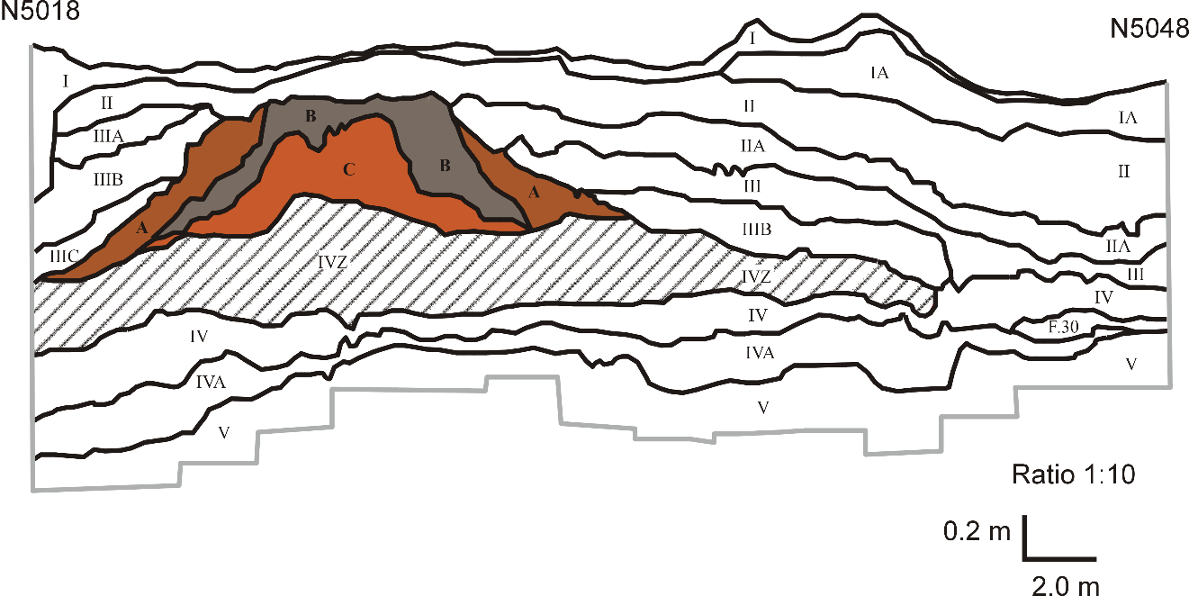
Figure C.45. Vertically exaggerated profile of Block 1, E5128, west profile, emphasizing Feature 70.

GEOARCHAEOLOGICAL DATA

THIN SECTIONS

Format Example. Details on the information recorded are presented in the Methods section of Chapter IV.

Sample: # | Provenience
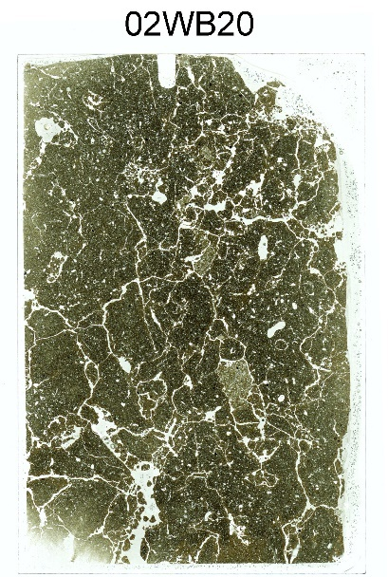  Thin section Macroscan 7.5 x 5 cm  Photomicrographs:  Image File Name (Sample-image #): description | Thin Section Description:  italicized notes offering specific information about the sample sometimes included  related distribution:  sorting:  Fine Fraction:  Silt:  Distribution:  Sand:  Distribution:  Gravel:  Aggregates:  Voids:  Post Depositional Features:
Figure C.46. Format example for thin section slide descriptions.

Sample: 02WB20 | Block 1, N5047.60 E5130  Stratum II, 35 cmbs
Photomicrographs:  02WB20-01: aggregated microstructure with coarse grained aggregate in center | Thin Section Description:  related distribution: close porphyric  sorting: bimodal moderately sorted sand w/ moderately sorted silt  Fine Fraction: Color: dark brown, b-fabric: crystallite  Contains: frequent organic matter  Silt: 50% (quartz, mica, feldspar, pyroxene, miscellaneous heavy minerals, charcoal)  Distribution: random  Sand: 5-10% fine to medium (quartz, chert, quartzite, feldspar, pyroxene, epidote, miscellaneous heavy minerals, concretions, charcoal)  Distribution: random  Gravel: none  Aggregates: few rounded and subangular of more coarse grained material (probably derived from Stratum IIa below). Worm casts of matrix in channels  Voids: common channel, vughs, chamber, packing, planar  Post Depositional Features: Very few localized thin dusty clay coatings, few Fe/Mn concentrations and nodules, localized infillings (bioturbation), few root fragments
Figure C.47. Sample: 02WB20.

Sample: 02WB21 | Block 1, N5047.60 E5130  Stratum IIa, 53 cmbs
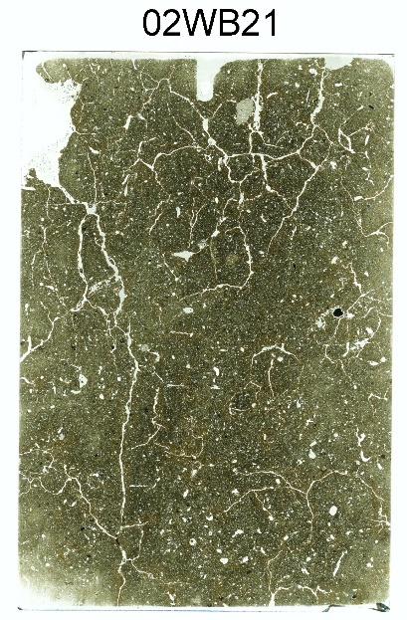  Photomicrographs:  02WB21-01: disrupted dusty clay coatings | Thin Section Description:  related distribution: close porphyric  sorting: bimodal unsorted sand w/ moderately sorted silt  Fine Fraction: Color: dark brown, b-fabric: crystallite  Contains: common organic matter  Silt: 50% (quartz, mica, feldspar, pyroxene, miscellaneous heavy minerals, charcoal) (very few clay fragments)  Distribution: random  Sand: 10% (quartz, chert, quartzite, feldspar, concretions, charcoal), very few papules  Distribution: random  Gravel: 1 weathered fossiliferous limestone grain <1cm  Aggregates: few rounded and subangular of more coarse grained material. Fecal pellets in channels  Voids: common channel, vughs, chamber, planar  Post Depositional Features: Few localized dusty clay coatings and infillings increasing towards the base of the thin section where material from Stratum III mixing in, few Fe/Mn concentrations and nodules.
Figure C.48. Sample 02WB21.
Sample: 02WB22 | Block 1, N5047.60 E5130  contact between Strata IIa and III, 63 cmbs
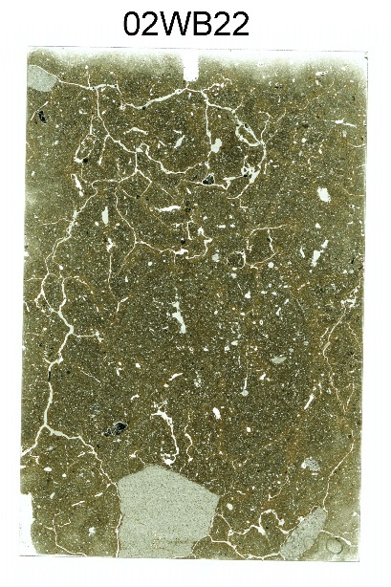  Photomicrographs:  02WB22-01: disrupted dusty clay coatings | - Description focuses on the lower portion of the thin section, Stratum III. The contact between Strata IIa and III is clear.  Thin Section Description:  related distribution: close porphyric  sorting: bimodal unsorted sand w/ moderately sorted silt  Fine Fraction:  Color: red-brown, b-fabric: speckled, granostriated and monostriated  Silt: 50% (quartz, mica, feldspar, pyroxene, miscellaneous heavy minerals, charcoal) (very few clay fragments)  Distribution: random  Sand: 10% (quartz, chert, quartzite, feldspar, mica [larger particles than usual], concretions, charcoal)  Distribution: random  Gravel: very few subangular to angular sandstone fragments (.5 – 2.5 cm), FCR  Aggregates: not clear if large (~1 cm) subangular aggregates of Stratum II material (higher OM) or if there are quasicoatings.  Voids: few to common channel, vughs, chamber, planar (decrease relative to Strata II and IIa.  Post Depositional Features: Common to frequent clay coatings and infillings few Fe/Mn concentrations and nodules  Notes: Slightly more diverse mineralogy than the other samples in this profile.
Figure C.49. Sample 02WB22.

Sample: 02WB23 | Block 1, N5047.60 E5130  Contact between Strata III and IV, 78 cmbs
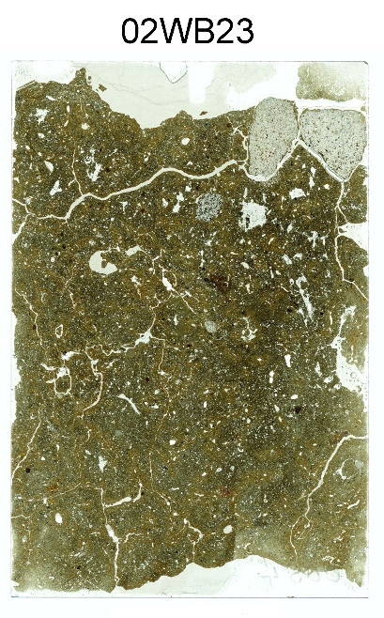  Photomicrographs:  02WB23-01: granostriations around old fecal pellets  02WB23-02: microartifact -bone fragment | - Description focuses on the lower portion of the thin section, Stratum IV. The contact between Strata III and IV is clear and abrupt.  Thin Section Description:  related distribution: close porphyric  sorting: bimodal unsorted sand w/ moderately sorted silt  Fine Fraction:  Color: brown, b-fabric: speckled, granostriated (see photomicrograph) and monostriated  Silt: 50% (quartz, mica, feldspar, pyroxene, miscellaneous heavy minerals, charcoal)  Distribution: random  Sand: 10% (quartz, chert, mica, quartzite, feldspar, concretions, charcoal, miscellaneous heavy minerals, bone [see image])  Distribution: random  Gravel:: none  Aggregates: few fine silty clay aggregates, may be part of reworked infillings.  Voids: few to common channel, vughs, chamber, planar (decrease relative to Strata II and IIa.  Post Depositional Features:  Common well developed clay coatings and infillings, few Fe/Mn concentrations and nodules  Notes:.
Figure C.50. Sample 02WB23.

Sample: 02WB24 | Block 1, N5047.60 E5130  Stratum V, 105 cmbs
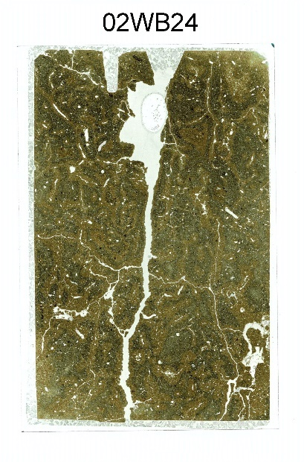  Photomicrographs:  02WB24-01: dusty clay coatings | Thin Section Description:  related distribution: close porphyric  sorting: bimodal unsorted fine sand w/ moderately sorted silt  Fine Fraction:  Color: brown, b-fabric: speckled, well developed granostriated and monostriated  Silt: 50% (quartz, mica, feldspar, pyroxene, miscellaneous heavy minerals, charcoal)  Distribution: random  Sand: <5% fine sand (quartz, chert, mica, quartzite, feldspar, concretions, charcoal, miscellaneous heavy minerals)  Distribution: random  Gravel: none  Aggregates: none  Voids: few to common channel, vughs, chamber, and planar  Post Depositional Features: Common well developed clay coatings and infillings, common dusty clay coatings overlying clay coatings [see photomicrograph WB24-01], common Fe/Mn concentrations and nodules (<0.5 mm)  Notes: much finer grained relative to Strata III and IV above
Figure C.51. Sample 02WB24.

Sample: 02WB25 | Block 2, N5016.20 E5153  Feature 202, 68 cmbs
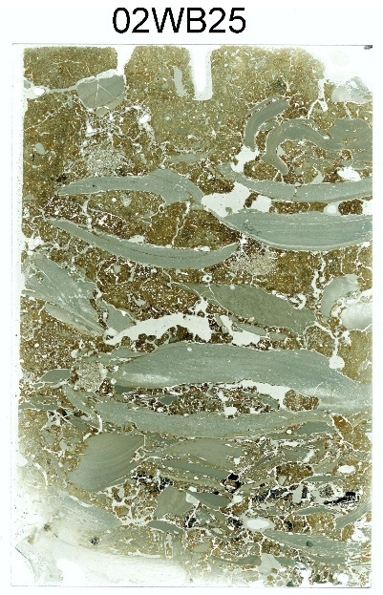  Photomicrographs:  02WB25-01: red aggregates and charcoal mixed among shell with clay coats  02WB25-02: calcareous sediment at the top of the thin section  02WB25-03: sand aggregate (Stratum IIIz material) among shell | Upper portion of the thin section consists of highly calcareous silt loam (derived from breakdown of burned shell but no clear evidence for wood ash), containing rounded aggregates of non calcareous silty clay [see image 92WB25-02]. This material does not contain large shell fragments and abruptly overlies shell and red silty clay aggregates described for the bulk of the thin section.  Thin Section Description:  related distribution: gefuric  sorting: unsorted fine sand w/ moderately sorted silt, unsorted shell  Fine Fraction:  Color: brown, b-fabric: speckled  Silt: 30% (quartz, mica, feldspar, pyroxene, miscellaneous heavy minerals, charcoal)  Distribution: random  Sand: 10% sand (quartz, chert, mica, quartzite, feldspar, concretions, charcoal, miscellaneous heavy minerals)  Distribution: random  Gravel: ~50% shell  Aggregates: mixture of aggregates, among the shell there are red silt loam aggregates with well developed clay coatings; few irregular loamy sand aggregates among the shell (Stratum IIIz)  Voids: common packing, few chambers and vughs  Post Depositional Features: rare decalcification, frequent clay coatings in voids in shell but may have been transported that way.
Figure C.52. Sample 02WB25.

Sample: 02WB26A | Block 2, N5016.20 E5153  contact between base of Feature 202 and Stratum IIIz, 75 cmbs
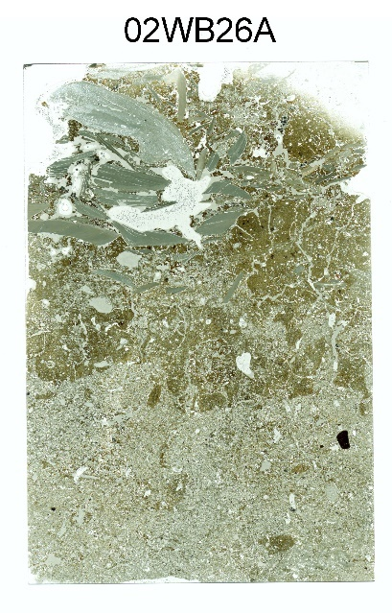  Photomicrographs:  02WB26A-01: Contact between the base of Feature 202 and Stratum IIIz  02WB26A-02: matrix from base of Feature 202  02WB26A-03: Stratum IIIz, sandy matrix  02WB26A-04: dusty clay coatings in Stratum IIIz | - Description divided into two sections. Upper thin section - the base of Feature 202, below the shell concentration and Lower thin section - Stratum IIIz. The contact between Feature 202 and Stratum IIIz is clear and abrupt (see image 02WB26A-01).  - Base of Feature 202  Thin Section Description:  related distribution: lose porphyric, aggregated microfabric  sorting: bimodal unsorted fine sand w/ moderately sorted silt  Fine Fraction:  Color: reddish brown, b-fabric: speckled, well developed granostriated and monostriated  Silt to fine Sand: 5-10% (quartz, mica, feldspar, pyroxene, miscellaneous heavy minerals, papules, shell)  Distribution: random  Gravel: large (<3 cm) fragments of shell related to the concentration above the base of feature with smaller (<1 cm) shell fragments at base  - Aggregates: microfabric is generally aggregated  Voids: few vugh, chamber, vesicular shaped voids relating to plucking of larger grains during the grinding process  Coatings: Common well developed clay coatings and infillings, few Fe/Mn concentrations and nodules (<0.5 mm) (these are not post depositional as they were transported with the material.)  Post Depositional Features: none observed  - Stratum IIIz  Thin Section Description:  related distribution: enaulic to loose porphyric, gefuric  sorting: moderately sand w/ moderately sorted silt  Fine Fraction:  Color: brown, b-fabric: speckled, localized granostriated  Silt: 40% (quartz, mica, feldspar, pyroxene, miscellaneous heavy minerals, charcoal)  Distribution: random  Sand: 40-50% medium sand (quartz, chert, mica (some coarse), quartzite, feldspar, concretions, miscellaneous heavy minerals, papules), subrounded to subangular.  Distribution: random  - Aggregates: few rounded micaceous silty clay (possibly bioturbated material from the base of Feature 202.  Voids: few vugh, spongy and packing  Post Depositional Features: Common dusty clay coatings
Figure C.53. Sample 02WB26A.

Sample: 02WB27 | Block 2, N5016.20 E5153  Base of Stratum IIIz, contact with IIIy, 91 cmbs
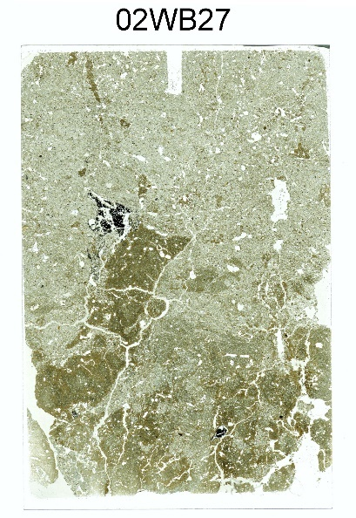  Photomicrographs:  02WB27-01: typical loamy sand matrix of Stratum IIIz  02WB27-02: clay hypocoating in Stratum IIIy  02WB27-03: infilled channel and rounded aggregates suggestive of bioturbation/alluvial activity introducing loamy sand from Stratum IIIz into the fine underlying Stratum IIIy matrix | - Description divided into two sections. The base of Stratum IIIz (upper thin section), below the shell concentration(fea. 202) and the abrupt irregular boundary with Stratum IIIy (lower thin section). The upper boundary of IIIy appears to be truncated with large rip-up clasts visible (angular clasts of IIIy sediment extending up into the IIIz matrix).  - Stratum IIIz  Thin Section Description:  related distribution: enaulic and gefuric  sorting: moderately sorted sand and silt  Fine Fraction:  Color: brown, b-fabric: speckled, localized granostriated (?)  Silt: 40% (quartz, mica, feldspar, pyroxene, miscellaneous heavy minerals, charcoal)  Distribution: random  Sand: 40-50% medium sand (quartz, mica (some coarse), quartzite, feldspar, chert, miscellaneous heavy minerals, papules), subrounded to subangular.  Gravel: one charcoal fragment just above the contact (structure present, may be identifiable)  - Aggregates: few rounded micaceous silty clay aggregates (possibly bioturbated material from the base of Feature 202.  Voids: few vugh, spongy and packing  Post Depositional Features: Common dusty clay coatings  - Stratum IIIy  Thin Section Description:  related distribution: close porphyric  sorting: unsorted sand and moderately well sorted silt  Fine Fraction:  Color: medium brown, b-fabric: speckled, localized granostriated  Silt: 60% (quartz, mica, feldspar, pyroxene, miscellaneous heavy minerals, charcoal)  Distribution: random  Sand: 5% sand (quartz, mica (some coarse), quartzite, feldspar, chert, miscellaneous heavy minerals, papules); very few charcoal, one bone fragment  Distribution: random  Gravel: none  - Aggregates: few rounded loamy sand aggregates  - Voids: few to frequent vugh, spongy, planar and channel  Post Depositional Features: few dusty clay coatings, few clay hypocoatings (image 02WB27-02); few oxidized redox concentrations/nodules, sand size
Figure C.54. Sample 02WB27.

Sample: 02WB28 | Block 2, N5016.20 E5153  Stratum IIIy, 96 cmbs
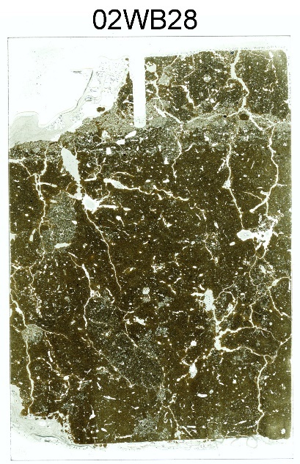  Photomicrographs:  02WB28-01: rounded aggregate derived from Stratum IIIz in the Stratum IIIy matrix  02WB28-02: typical Stratum IIIy matrix, note the redox concentrations and the absence of clay coating the void | - Upper portion of thin section depicts bioturbated mixed matrix similar to Stratum IIIy sample above (02WB27). This section represents more “pure” silty clay sample of Stratum IIIy  - Stratum IIIy  Thin Section Description:  related distribution: close porphyric, gefuric and chitonic  sorting: unsorted sand and gravel, moderately well sorted silt  Fine Fraction:  Color: medium brown, b-fabric: speckled, granostriated and cross striated  Silt: 60% (quartz, mica, feldspar, pyroxene, miscellaneous heavy minerals, charcoal)  Distribution: random  Sand: 2% sand (quartz, mica (some coarse), quartzite, feldspar, chert, miscellaneous heavy minerals) Remainder limited to infillings and aggregates (see below)  Distribution: random  Gravel: none  - Aggregates: abundant rounded loamy sand aggregates (02WB28-01) and infillings, interpreted as bioturbated material from Stratum IIIz above  Voids: few to frequent vugh, spongy and channel  Post Depositional Features: few clay coatings, occasional clay infillings and papules, few clay hypocoatings [image 02WB27-02]; many redox concentrations/nodules, sand size
Figure C.55. Sample 02WB28.

Sample: 02WB29 | Block 2, N5016.20 E5153  Stratum IIIw/Feature 241 contact, 102 cmbs
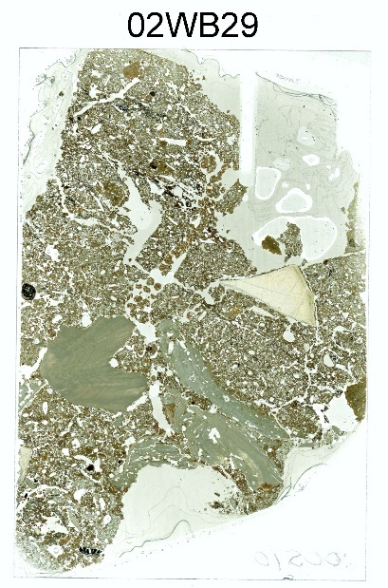  Photomicrographs:  02WB29-01: matrix with shell, chert flake in center | - Description focused on Stratum IIIw (Feature 241 described below with 02WB30)  Thin Section Description:  related distribution: lose porphyric, gefuric, aggregated microfabric  sorting: bimodal unsorted sand w/ moderately sorted silt  Fine Fraction:  Color: dark reddish brown, b-fabric: speckled, chaotic mixed matrix.  Silt: 50% (quartz, mica, feldspar, pyroxene, miscellaneous heavy minerals, papules)  Distribution: random  Sand: 10% (quartz, feldspar, chert, fossiliferous limestone, papules, sandstone, miscellaneous heavy minerals). Microartifacts include: common shell; few charcoal; very few chert flakes, and bone)  Gravel: 10% (shell and two chert flakes)  Distribution: random  - Aggregates: microfabric is aggregated with localized sand concentrations. Fecal pellets infill large channel (earth worm)  Voids: few vugh, chamber, (note: vesicular shaped voids relating to plucking of larger grains during the grinding process)  Post Depositional Features: Common to dominant thin clay coatings [dark, partially organic see image 02WB29-02]; few Fe/Mn concentrations and nodules (<0.5 mm) (these are probably not post depositional as they were transported with the material.)
Figure C.56. Sample 02WB29.

Sample: 02WB30 | Block 2, N5016.20 E5153  base of Feature 241, 109 - 120 cmbd
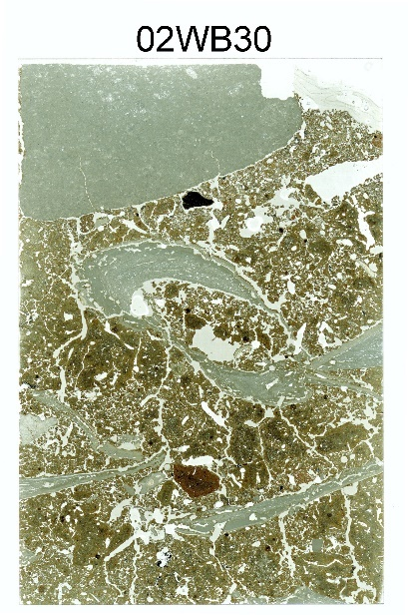  Photomicrographs:  02WB30-01: view of calcite/carbonate coating  02WB30-02: detail of partially decalcified shell  02WB30-03: burned aggregate of red silty clay soil  02WB30-04: small biological aggregate (mite?), note the calcite coatings along the packing voids | Thin Section Description:  related distribution: lose porphyric, gefuric, chitonic aggregated microfabric  sorting: bimodal unsorted sand w/ moderately sorted silt  Fine Fraction:  Color: dark reddish brown, b-fabric: speckled, chaotic mixed matrix.  Silt: 50% (quartz, mica, feldspar, pyroxene, calcite, miscellaneous heavy minerals, papules, shell)  Distribution: random  Sand: 10% (quartz, feldspar, chert, fossiliferous limestone, papules, sandstone, miscellaneous heavy minerals). Microartifacts include: common shell; few charcoal; very few chert flakes, and bone)  Gravel: 10% (shell and two chert flakes)  Distribution: random  - Aggregates: microfabric is aggregated with localized sand concentrations. Fecal pellets infill large channel (earth worm and smaller)  Voids: few vugh, chamber, planar, packing (note: vesicular shaped voids relating to plucking of larger grains during the grinding process)  Post Depositional Features: Common to dominant thin clay coatings; few carbonate silt coatings, few Fe/Mn concentrations and nodules (<0.5 mm) (these are not post depositional as they were transported with the material.)
Figure C.57. Sample 02WB30.

Sample: 02WB31 | Block 2, N5016.20 E5153  Top of Stratum IV, 136-145 cmbd
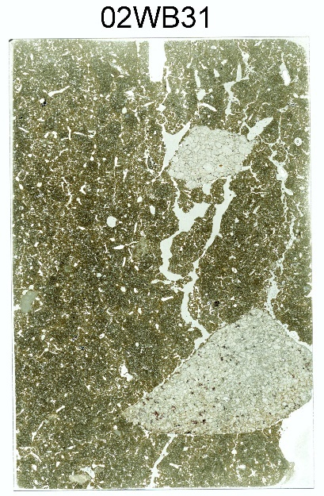  Photomicrographs:  02WB31-01: typical matrix  02WB31-02: example of the few dusty clay coatings | Large subrounded FCR collected in sample. Few shell and FCR randomly distributed in Stratum IV.  - Stratum IV  Thin Section Description:  related distribution: close porphyric  sorting: moderately sorted fine and medium sand, unsorted coarse sand and gravel, well sorted silt  Fine Fraction:  Color: medium brown, b-fabric: speckled, granostriated  Silt: 60% (quartz, mica, feldspar, pyroxene, miscellaneous heavy minerals, charcoal)  Distribution: random  Sand: 10 - 20% sand (quartz, feldspar, mica, chert, quartzite, carbonate rocks, miscellaneous heavy minerals), very few microartifacts ( bone) few charcoal fragments  Distribution: random  Gravel: 5% (1 sandstone fragment, 1 quartzite fragment). FCR  Distribution: random  Voids: few vugh, packing, spongy, channels  Post Depositional Features: few clay coatings, dusty clay coatings, and hypocoatings [image 02WB31-02].
Figure C.58. Sample 02WB31.

Sample: 02WB32 | Block 2, N5016.20 E5153  Base of Stratum IV, 148-157 cmbd
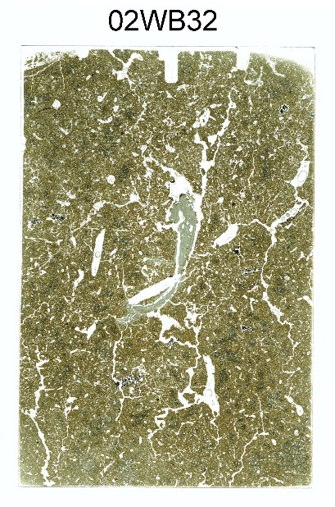  Photomicrographs:  02WB32-01: typical matrix  02WB32-02: dusty clay coating on void and weathered shell | Thin Section Description:  related distribution: close porphyric  sorting: moderately sorted fine and medium sand, unsorted coarse sand and gravel, well sorted silt  Fine Fraction:  Color: medium brown, b-fabric: speckled, granostriated  Silt: 60% (quartz, mica, feldspar, pyroxene, miscellaneous heavy minerals, charcoal)  Distribution: random  Sand: 10 - 20% sand (quartz, feldspar, mica, chert, quartzite, carbonate rocks, miscellaneous heavy minerals), few microartifacts, charcoal, shell fragments  Distribution: random  Gravel: 1% (1 weathered shell fragment)  Distribution: random  Voids: few vugh, packing, spongy, channels  Post Depositional Features: common clay coatings, dusty clay coatings [image 02WB32-02]. and hypocoatings
Figure C.59. Sample 02WB32.

Sample: 02WB33 | Block 2, N5016.20 E5153  Base of Stratum V in excavation profile, 163-172 cmbd
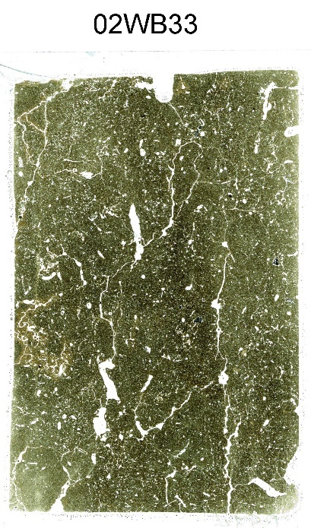  Photomicrographs:  02WB33-01: typical matrix | Thin Section Description:  Related distribution: close porphyric  Sorting: bimodal moderately sorted sand w/ well-sorted silt  Fine Fraction:  Color: brown, b-fabric: speckled  Contains: organic matter, dusty clay  Silt: 70% (quartz, mica, feldspar, pyroxene, miscellaneous heavy minerals, charcoal, few papules, glauconitic fragment)  Distribution: random  Sand: 1% fine sand (quartz, mica, feldspar)  Distribution: random  Gravel: none  Aggregates: none  Voids: common vugh, packing and channel  Post Depositional Features: Common clay coatings, few dusty clay coatings, few fine Fe/Mn concentrations and nodules
Figure C.60. Sample 02WB33.

Sample: 02WB36 | Block 1, N5020.55 E5126  Stratum IIIb, base of “sandy alluvium” above Feature 70, 40 cmbs
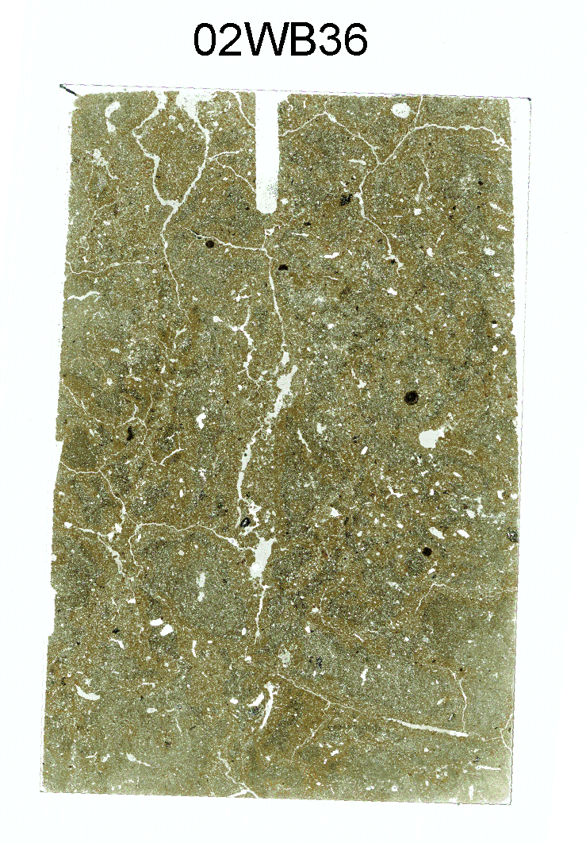  Photomicrographs:  02WB36-01: typical matrix | Thin Section Description:  related distribution: close porphyric  sorting: bimodal moderately sorted sand w/ well-sorted silt  Fine Fraction:  Color: brown, b-fabric: speckled  Contains: organic matter, dusty clay  Silt: 50% (quartz, mica, feldspar, pyroxene, miscellaneous heavy minerals, charcoal)  Distribution: random  Sand: 40% (quartz, mica, papules, chert, feldspar, pyroxene, epidote, miscellaneous heavy minerals, concretions, charcoal, bone)  Distribution: random  Gravel: none  Aggregates: none  Voids: common channel, vughs, chamber  Post Depositional Features: Localized clay coatings, few Fe/Mn concentrations and nodules, wetting fronts on ped faces (probably due to long term profile exposure), localized dusty silty clay infilling, localized bioturbation
Figure C.61. Sample 02WB36.

Sample: 02WB37 | Block 1, N5020.55 E5126  Base of Stratum IIIc/contact with Feature 70, 50 cmbs
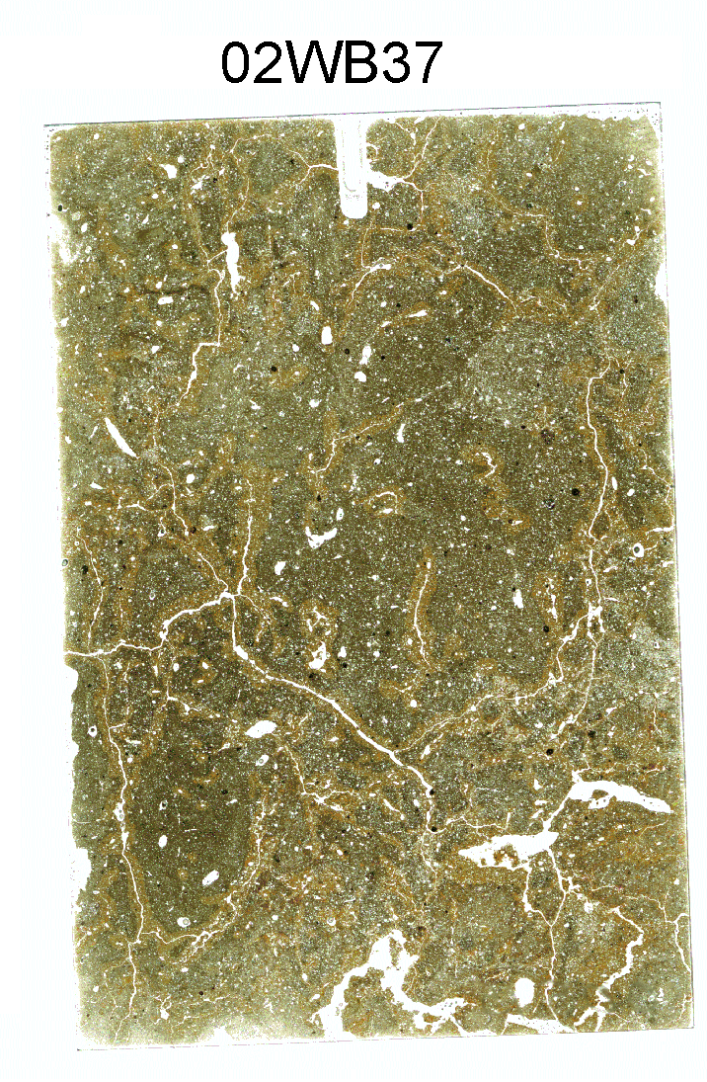  Photomicrographs:  02WB37-01: clay coatings and papule fragments in matrix  02WB37-02 – Stratum IIIc, rip-up clast in matrix | This description focuses on Stratum IIIc with notes on the contact with the top of Feature 70. which appears clear but irregular in thin section  Thin Section Description:  related distribution: close porphyric  sorting: bimodal moderately sorted sand w/ well-sorted silt  Fine Fraction:  Color: brown, b-fabric: crystallitic w/ some grano-striation  Contains: organic matter, clay (common fragments)  Silt: 60% (quartz, mica, clay fragments, feldspar, pyroxene, miscellaneous heavy minerals, charcoal)  Distribution: random  Sand: 20% (quartz, mica, clay fragments, chert, feldspar, pyroxene, epidote, miscellaneous heavy minerals, charcoal)  Distribution: random  Gravel: none  Aggregates: fine silt rip-up clasts incorporated into matrix  Voids: common planar, channel, vughs, chamber  Post Depositional Features: Common void clay coatings, Few Fe/Mn concentrations and nodules, wetting fronts along planar voids (ped faces from long term excavation profile), common bioturbation (at Feature 70 contact)  Notes: The contact with Feature 70 contains variably sized clasts of red silty clay. Much of the red color due to silt and sand size clay coating clasts. Increased voids
Figure C.62. Sample 02WB37.

Sample: 02WB38 | Block 1, N5020.55 E5126  base of Feature 70, contact with top of Stratum IVz, 63-73 cmbs
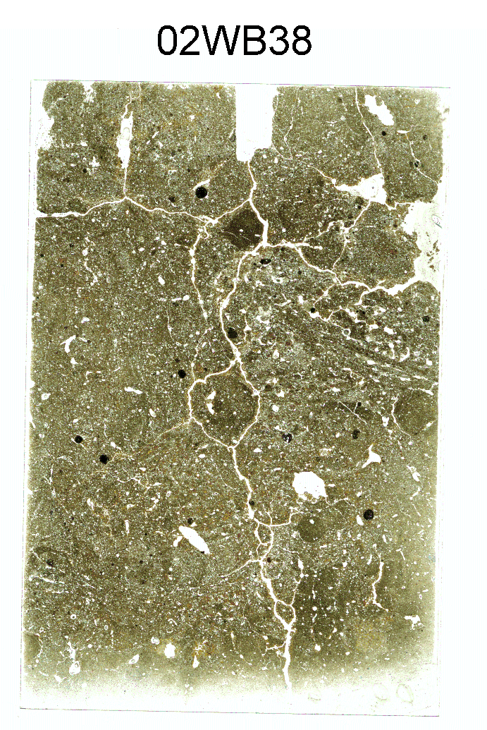  Photomicrographs:  02WB38-01: in situ and reworked clay coatings, and Fe/Mn nodules in matrix  02WB38-2: detail image of reworked clay coatings/clasts | Thin Section Description:  related distribution: close porphyric  sorting: bimodal moderately sorted sand w/ well-sorted silt  Fine Fraction:  Color: reddish brown, b-fabric: crystallitic w/ granostriated  Contains: organic matter, clay (dusty clay and many fragments - papules)  Silt: 50% (quartz, mica, clay fragments, feldspar, pyroxene, miscellaneous heavy minerals)  Distribution: random  Sand: 30% (quartz, mica, clay fragments, chert, feldspar, pyroxene, epidote, miscellaneous heavy minerals, charcoal)  Distribution: random  Gravel: none  Aggregates: mixed soil aggregates, variable sizes  Voids: common channel, vughs; few packing, planar,  Post Depositional Features: common clay coatings, common reworked clay coating clasts (papules) (sand and silt size), few Fe/Mn concentrations and nodules, no roots  Notes: Base of thin section reveals clear, irregular contact with well sorted alluvial silt and the absence of reworked clay coatings.
Figure C.63. Sample 02WB38.

Sample: 02WB39 | Block 1, N5020.55 E5126  Stratum IVz, 74-84 cmbs
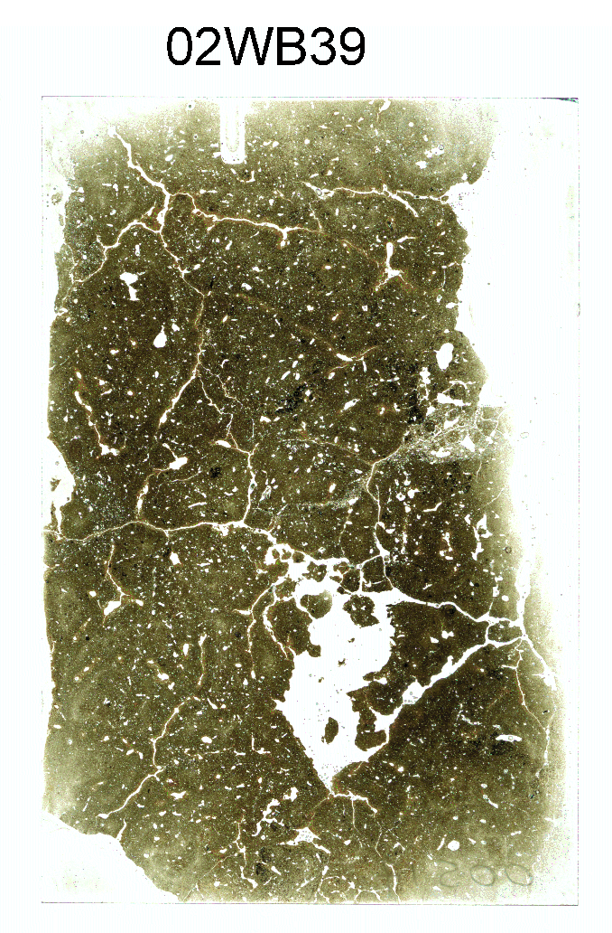  Photomicrographs:  02WB39-01: fine matrix with clay coatings in voids  02WB39-02: granostriated microfabric, clay infilling, coating vughs  02WB39-03: compound pedofeature including clay coatings in channel; infilled vugh, and Fe/Mn hypocoating  02WB39-04: silty clay matrix (Fe/Mn hypocoating) with localized concentrations of more coarse material containing papules | Thin Section Description:  related distribution: close porphyric, granostriated dense  sorting: well-sorted silt  Fine Fraction:  Color: dark brown, b-fabric: crystallitic w/ granostriation  Contains: clay, organic matter  Silt: 70% (quartz, mica, papules, feldspar, pyroxene, miscellaneous heavy minerals)  Distribution: random  Sand: 3% (quartz, chert, feldspar, miscellaneous heavy minerals, few charcoal)  Distribution: random  Gravel: none  Aggregates: none  Voids: common planar; few vughs, packing  Post Depositional Features: common dusty clay coatings, few Fe/Mn hypo-coatings, nodules, channels infilled with more coarse alluvium (most likely from Feature 70 above), no roots
Figure C.64. Sample 02WB39.

Sample: 02WB40 | Block 1, N5020.55 E5126  Stratum IVz, base of thin section contains contact with top of Stratum IV, 89-100 cmbs
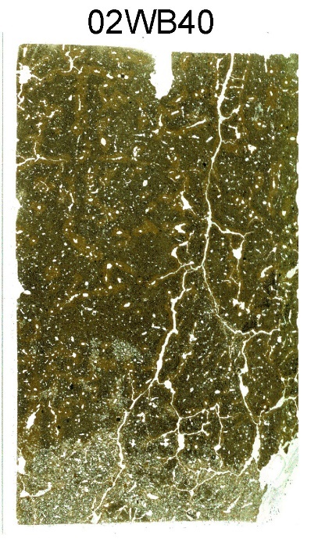  Photomicrographs:  02WB40-01: contact between Strata IVz and IV | Strata IVz/IV contact is clear and abrupt[image 02WB40-01]  Thin Section Description:  related distribution: close porphyric, granostriation dense  sorting: well-sorted silt  Fine Fraction:  Color: dark brown, b-fabric: crystallitic w/ granostriation  Contains: clay and organic matter  Silt: 70% (quartz, mica, clay fragments, feldspar, pyroxene, miscellaneous heavy minerals)  Distribution: random  Sand: 3% (quartz, chert, feldspar, miscellaneous heavy minerals, few charcoal)  Distribution: random  Gravel: none  Aggregates: none  Voids: common channels; few planar, vughs, packing  Post Depositional Features: common dusty clay coatings, few Fe/Mn hypo-coatings, nodules, no roots
Figure C.65. Sample 02WB40.

Sample: 02WB41 | Block 1, N5020.55 E5126  Stratum IV, 100-107 cmbs
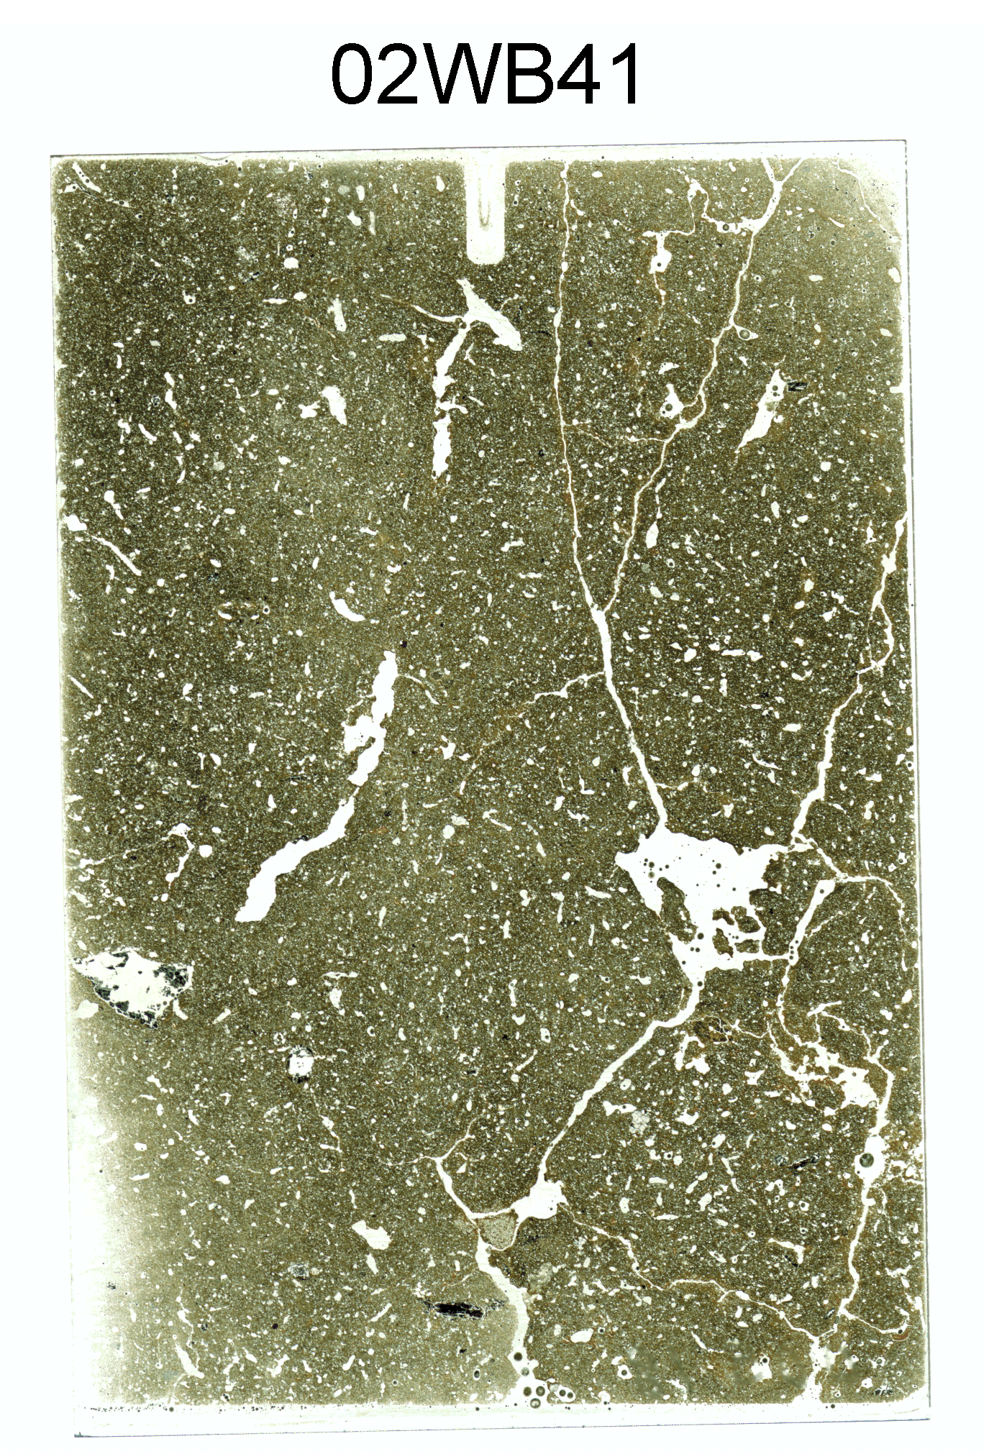  Photomicrographs:  02WB41-01: clay coatings in vughs and papules in matrix  02WB41-02: microdebitage | Thin Section Description:  Related distribution: close porphyric with granostriations  Sorting: bimodal moderately sorted sand w/ well-sorted silt  Fine Fraction:  Color: brown, b-fabric: speckled  Contains: organic matter, dusty clay, charcoal  Silt: 60% (quartz, mica, feldspar, pyroxene, miscellaneous heavy minerals, charcoal)  Distribution: random  Sand: 30% (quartz, mica, clay fragments, chert, feldspar, pyroxene, epidote, miscellaneous heavy minerals, concretions, charcoal (variable sizes, microdebitage, 1 sandstone fragment)  Distribution: random  Gravel: 2 charcoal fragments  Aggregates: aggregated microfabric indicative of bioturbation  Voids: common vugh, packing and channel, few chamber  Post Depositional Features: Common clay coatings, few Fe/Mn nodules
Figure C.66. Sample 02WB41.

Sample: 02WB42 | Block 1, N5020.55 E5126  Stratum IVa, 120-128 cmbs
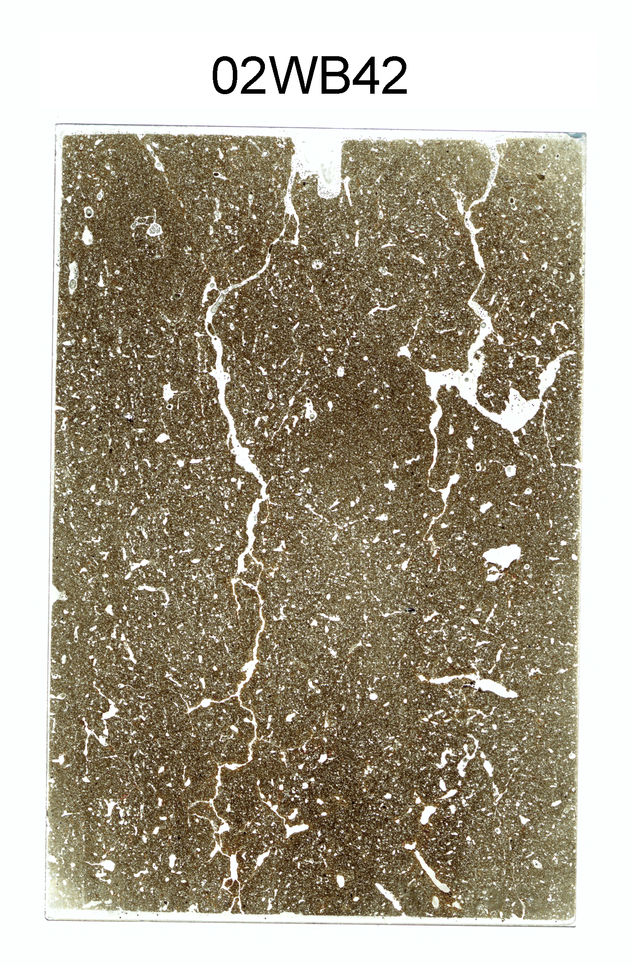  Photomicrographs:  02WB42-01: clay coatings | Thin Section Description:  Related distribution: close porphyric with localized granostriations  Sorting: bimodal moderately sorted sand w/ well-sorted silt  Fine Fraction:  Color: brown, b-fabric: crystallitic with localized stipple-speckled  Contains: organic matter, dusty clay, charcoal  Silt: 40% (quartz, mica, feldspar, pyroxene, miscellaneous heavy minerals, charcoal)  Distribution: random  Sand: 30-40% very fine sand (quartz, mica, clay fragments, chert, feldspar, pyroxene, miscellaneous heavy minerals, concretions, charcoal)  Distribution: random  Gravel: none  Aggregates: limited aggregated microfabric, evidence for fecal pellets suggestive of bioturbation  Voids: common vugh, channel, few chamber  Post Depositional Features: Common clay coatings (few completely infilled), but also common voids with no illuvial clay accumulation at all; few Fe/Mn nodules.
Figure C.67. Sample 02WB42.

Sample: 02WB43 | Block 1, N5023.10 E5126  upper Feature 70, Zone A, 30 cmbs
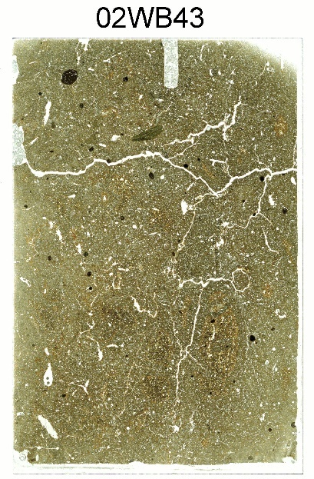  Photomicrographs:  02WB43-01: embedded clay coatings and papule fragments  02WB43-02: embedded clay coatings and papule fragments  02WB43-03: embedded clay coatings and papule fragments, note absence of any clay coating associated with existing voids | Thin Section Description:  related distribution: close porphyric  sorting: bimodal poorly sorted sand w/ well-sorted silt  Fine Fraction:  Color: reddish brown, b-fabric: crystallitic w/ some granostriation  Contains: organic matter, clay (common fragments)  Silt: 60% (quartz, mica, papules, feldspar, pyroxene, miscellaneous heavy minerals, charcoal)  Distribution: random  Sand: 10% (quartz, mica, papules, chert, feldspar, pyroxene, epidote, miscellaneous heavy minerals, charcoal)  Distribution: random  Gravel: none  Aggregates: none  Voids: common planar, channel, vughs  Post Depositional Features: Common clay coatings in ~50% of the voids, Few Fe/Mn concentrations and nodules (varying sizes, largest 2.5 mm), wetting fronts along planar voids (ped faces exposed in excavation)
Figure C.68. Sample 02WB43.

Sample: 02WB44 | Block 1, N5023.10 E5126  Feature 70, Zone A, base of thin section includes the contact with Zone B, 40 cmbs
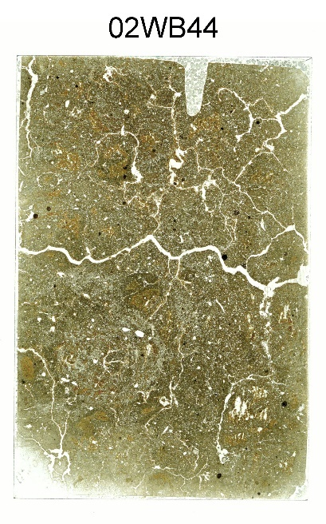  Photomicrographs:  02WB44-01: fine grained aggregate mixed into silt loam matrix  02WB44-02: along Feature 70 A/B contact, fragmented clay coatings mixed into matrix  02WB44-03: Feature 70 Zone B, fragmented clay coatings mixed into matrix along with “recent” dusty clay coats | Zone A/B boundary is clear but irregular with large aggregates.  - Zone A  Thin Section Description:  related distribution: close porphyric  sorting: bimodal moderately sorted sand w/ well-sorted silt  Fine Fraction:  Color: brown and reddish brown, b-fabric: crystallitic w/ some granostriation  Contains: organic matter, clay (common fragments)  Silt: 30-60% (varies due to mixed parent materials) (quartz, mica, papules, feldspar, pyroxene, miscellaneous heavy minerals, charcoal) clasts of various grain sizes of visible in the thin section scan shown here.  Distribution: random  Sand: 10-30% (varies due to mixed parent materials) (quartz, mica, papules, chert, feldspar, pyroxene, epidote, miscellaneous heavy minerals, charcoal)  Distribution: random  Gravel: none  Aggregates: mixed materials resulting in chaotic fabric variably sized clasts or aggregates from different source areas, larger along boundary  Voids: common planar, channel, vughs  Post Depositional Features: Common clay coatings in ~50% of the voids, common Fe/Mn concentrations and nodules (varying sizes, most round, largest 2.5 mm), wetting fronts along planar voids (ped faces from excavation profiles)  - Zone B – for detailed description of Zone B see Sample 02WB45  Notes: more compact and fine grained relative to Zone A.
Figure C.69. Sample 02WB44.

Sample: 02WB45 | Block 1, N5023.10 E5126  Feature 70, Zone B, base of thin section includes the contact with Zone C, 56 cmbs
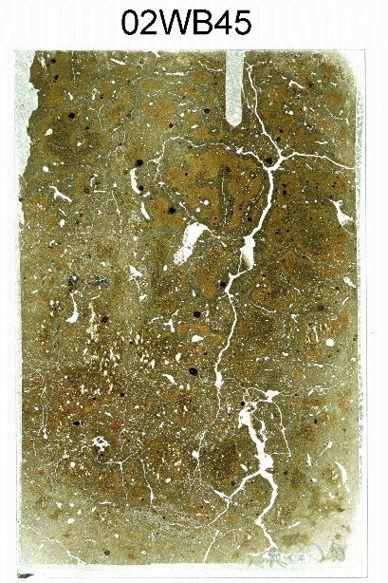  Photomicrographs:  02WB45-01: angular charcoal in Zone B  02WB45-02: typical groundmass, note reticulate and granostriated b-fabric  02WB45-03: Zone C, mixture of birefringent and dusty clay coatings  02WB45-04: Zone B, clay intercalations  02WB45-05: Zone C, composite of birefringent and dusty clay coating associated with interconnected planar/channel void | - Zone B  Thin Section Description:  related distribution: close porphyric  sorting: bimodal moderately sorted sand w/ well-sorted silt  Fine Fraction:  Color: brown and reddish brown, b-fabric: reticulate and granostriated  Contains: patchy organic matter between peds or aggregates relative to Zones A and C, increase in clay  Silt: 20% (quartz, mica, clay fragments, feldspar, pyroxene, miscellaneous heavy minerals, charcoal)  Distribution: random  Sand: 3% (quartz, mica, clay fragments, chert, feldspar, pyroxene, miscellaneous heavy minerals, charcoal), few localized concentrations of sand  Distribution: random  Gravel: very few angular charcoal fragments, highly fragmented with coatings in cracks (image 02WB45-01)  Aggregates: large rounded red sediment clasts  Voids: common planar, channel, vughs (increase relative to Zone A in the amount of those with coatings)  Post Depositional Features: Common clay coatings in >60% of the voids, many are dusty clay coatings, few clay intercalations, common Fe/Mn concentrations and nodules (varying sizes, largest 2.5 mm), wetting fronts along planar voids (ped faces in excavation profile)  - Zone C – for detailed description of Zone C see Sample 02WB46  Notes: frequent clay coating fragments, more dense and numerous than Zone B.
Figure C.70. Sample 02WB45.

Sample: 02WB46 | Block 1, N5023.10 E5126  Feature 70, Zone C/Stratum IVz contact, 72 cmbs
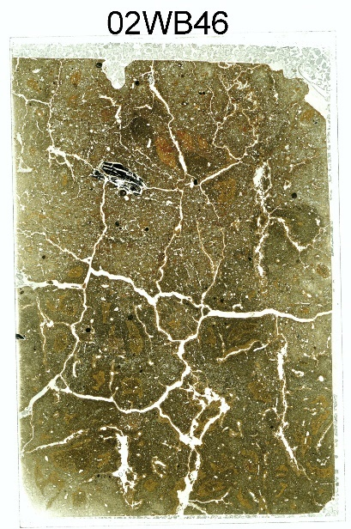  Photomicrographs:  .  02WB46-01: mixed soil material in Zone C immediately above C/Stratum IVz contact  02WB46-02: mixed soil material in Zone C including sand size papules | - Zone C  Thin Section Description:  related distribution: close porphyric  sorting: bimodal moderately sorted sand w/ well-sorted silt  Fine Fraction:  Color: brown, b-fabric: crystallitic  Contains: increase in patchy organic matter relative to Zone A, increase in clay  Silt: 30% (quartz, mica, clay fragments, feldspar, pyroxene, miscellaneous heavy minerals, charcoal)  Distribution: random  Sand: 20% (quartz, mica, variable sizes of papules, chert, feldspar, pyroxene, miscellaneous heavy minerals, charcoal)  Distribution: random  Gravel: 1 charcoal fragment (~1 cm)  Aggregates: variable size ranges (visible along boundary)  Voids: common planar, channel, vughs  Post Depositional Features: Common clay coatings in >60% of the voids, several are dusty clay coatings, Few Fe/Mn concentrations and nodules (varying sizes), wetting fronts along planar voids (ped faces from excavation profile)  Notes: Concentrations of silt and sand size clay coating clasts. Coatings in half of the planar voids  - Stratum IVz, – for detailed description of Stratum IVz, see Sample 02WB47  Notes: more dense silt, fewer voids (mostly vesicles and planar), very few clay coatings along voids but few infillings. Reticulate and granostriated bfabric. Relative to Zone C above very few fragments of clay coatings.
Figure C.71. Sample 02WB46.

Sample: 02WB47 | Block 1, N5023.10 E5126  Stratum IVz, contact with Stratum IV, 70 - 78 cmbs
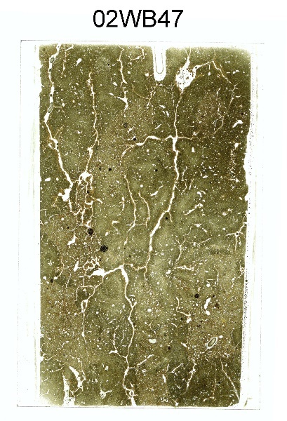  Photomicrographs:  02WB47-01: fine grained silty clay w/ clay coatings and more coarse and organic soil material with unsorted sand “welded” together  02WB47-02: mixed soil materials | - Stratum IVz  This thin section includes at least two different deposits that are intermixed. Dense silty clay and a coarse silt loam (nearly identical to the base of the thin section in Sample 02WB46. Both have Tennessee River alluvium signatures.  Thin Section Description:  related distribution: close porphyric  sorting: bimodal unsorted sand w/ well-sorted silt  Fine Fraction:  Color: light yellowish brown, b-fabric: reticulate and granostriated bfabric  Silt: 30% (predominantly quartz, mica, , feldspar, pyroxene, miscellaneous heavy minerals, charcoal)  Distribution: random  Sand: 2% (quartz, chert, feldspar, miscellaneous heavy minerals)  Distribution: random  Gravel: none  Aggregates: coarse material aggregates from adjacent deposits  Voids: common planar, channel, vughs  Post Depositional Features: Common dusty clay coatings in >30% of the voids, some include silt; few fine Fe/Mn concentrations and nodules (few coarse sand size), wetting fronts along planar voids (ped faces in excavation profile)
Figure C.72. Sample 02WB47.

Sample: 02WB48 | Block 1, N5023.10 E5126  Stratum IVz/IV contact, 83 - 92 cmbs
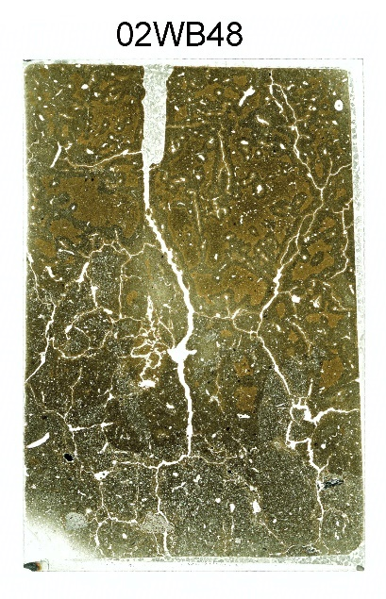  Photomicrographs:  2WB48-01: contact between finer upper deposit (Stratum IVz) and more coarse lower deposit (Stratum IV) (note charcoal fragment at the contact)  02WB48-02: Stratum IV, with charcoal and sandstone fragment  02WB48-03: Stratum IVz matrix  02WB48-04: abrupt Stratum IVz/Stratum IV contact, note localized concentration of silt associated with charcoal fragment | This thin section includes one example of source material in Stratum IVz at the base of the zone. The description focuses on the upper deposit in the thin section (Stratum IVz). The boundary is abrupt and irregular.  - Stratum IVz  Thin Section Description:  Related distribution: close porphyric  Sorting: bimodal moderately sorted sand w/ well-sorted silt  Fine Fraction:  Color: brown, b-fabric: mixed  Contains: few clasts/aggregates of dense silty clay  Silt: 30% (quartz, mica, papules, feldspar, pyroxene, miscellaneous heavy minerals, charcoal)  Distribution: random  Sand: 20% (quartz, mica, papules, chert, feldspar, pyroxene, miscellaneous heavy minerals, charcoal)  Distribution: random  Gravel: none  Aggregates: variable sizes (visible along boundary)  Voids: common planar, channel, vughs  Post Depositional Features: Common clay coatings in >60% of the voids, many are dusty clay coatings, Few Fe/Mn concentrations and nodules (varying sizes), wetting fronts along planar voids (ped faces in excavation profile), no roots  - Stratum IV (base of thin section)  Notes: there is an abrupt irregular (due to bioturbation) boundary marking the shift from more coarse grained silt loam to the overlying dense silty clay (IVz). This lower deposit contains more organic matter and microartifacts including bone fragments, charcoal (3 pebble size fragments), and sandstone fragments (not present in the samples observed in the upper portions of this profile), clay coatings present in voids – note absence of disrupted coatings or fragments
Figure C.73. Sample 02WB48.

Sample: 02WB50A | Block 1, N5025.5 E5128  Feature 70, Zone C, 40 cmbs
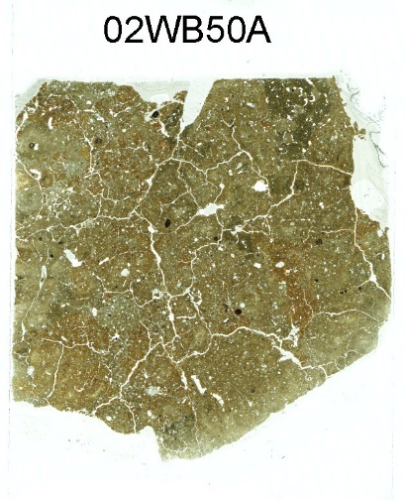  Photomicrographs:  02WB50A-01: typical mixed fabric  02WB50A-02: localized area of disturbed and fragmented clay coatings  02WB50A-03: expanded view of 02, localized area of disturbed and fragmented clay coatings  02WB50A-04: localized area of Bt material, note aggregates surrounded by clay coatings.  02WB50A-05: close up of out of context fragmented clay coatings | - Zone C  Thin Section Description:  related distribution: close porphyric  sorting: bimodal poorly sorted sand w/ well-sorted silt  Fine Fraction:  Color: brown and red, b-fabric: crystallitic w/ some granostriation, depends on the material being observed, thin section as a whole – mixed/convoluted  Contains: organic matter, clay (common fragments/papules)  Silt: 60% (quartz, mica, clay fragments, feldspar, pyroxene, miscellaneous heavy minerals, charcoal)  Distribution: random  Sand: 20% (quartz, mica, papules, quartzite, chert, feldspar, pyroxene, miscellaneous heavy minerals, charcoal)  Distribution: random  Gravel: none  Aggregates: biological aggregates well expressed in localized areas of Bt soil material (image 02WB50A-04), best observed at 40x.  Voids: common vughs, planar, channel  Post Depositional Features: Common dusty clay coatings and clay coatings in ~50% of the voids, Few Fe/Mn concentrations and nodules (varying sizes)
Figure C.74. Sample 02WB50A.

Sample: 02WB51 | Block 1, N5025.5 E5128  Zone C/Stratum IVz contact, immediately below Feature 70, 49 cmbs
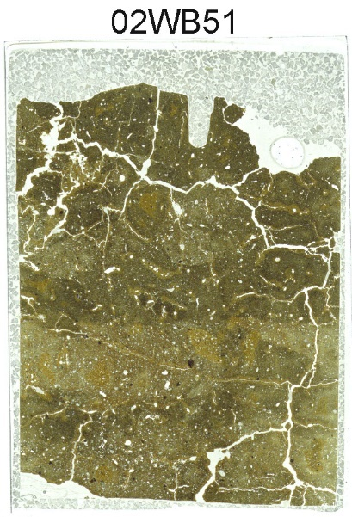  Photomicrographs:  02WB51-01: (Zone C) clast of red Bt material.  02WB51-02: contact between Zone C and Stratum IVz, oriented tip right. | - Zone C  Same description as 02WB50A above. Clear, abrupt contact between the base of Feature 70 (Zone C) and the Stratum IV material below.  - Stratum IVz  This zone is composed of at least two different deposits that are intermixed. Dense silty clay and a coarse silt loam (nearly identical to the base of the thin section in Sample 02WB46).  - Thin Section Description:  related distribution: close porphyric  sorting: bimodal unsorted sand w/ well-sorted silt  Fine Fraction:  Color: light yellowish brown and red, b-fabric: crystallitic  Silt: 40% (predominantly quartz, mica, feldspar, pyroxene, miscellaneous heavy minerals, charcoal)  Distribution: random  Sand: 20% (quartz, chert, feldspar, miscellaneous heavy minerals)  Distribution: random  Gravel: none  Aggregates: few from variable sources  Voids: common planar, channel, vughs  Post Depositional Features: Common clay coatings in ~20% of the voids, some include silt, Few fine Fe/Mn concentrations and nodules, wetting fronts along planar voids (ped faces in excavation profile), 1 root fragment  Notes: Concentrated red silty clay loam with abundant clay coating (Bt material) along the contact – could possible be a surface? (best viewed at low magnification or no magnification) but more likely a “pure” angular clast from the source area, clear shift in the size of the parent material.
Figure C.75. Sample 02WB51.

Sample: 02WB52 | Block 1, N5025.5 E5128  Stratum IVz, 59 cmbs
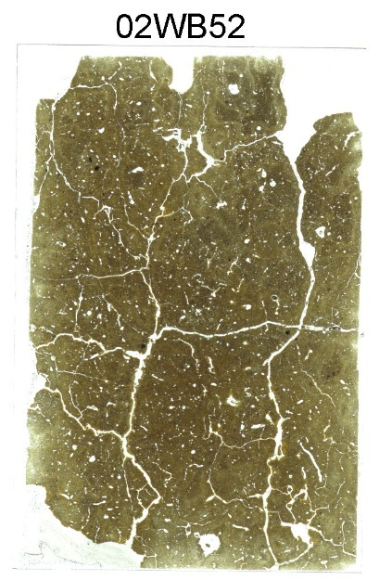  Photomicrographs:  .  02WB52-01: quasicoating and hypocoating associated with ped faces/planar voids in silty clay matrix | - Stratum IVz  This thin section is relatively homogeneous compared to other thin samples collected in Stratum IVz.  Thin Section Description:  related distribution: close porphyric  sorting: bimodal unsorted sand w/ well-sorted silt  Fine Fraction:  Color: light yellowish brown, b-fabric: reticulate  Silt: 30% (predominantly quartz, mica, , feldspar, pyroxene, miscellaneous heavy minerals, charcoal)  Distribution: random  Sand: 2% (quartz, chert, feldspar, miscellaneous heavy minerals, charcoal)  Distribution: random  Gravel: none  Aggregates: coarse material aggregates from adjacent deposits  Voids: common planar, channel, vughs  Post Depositional Features: Common clay coatings in >10% of the voids, some include silt, abundant fine Fe/Mn concentrations occasional fine nodules, wetting fronts along planar voids (ped faces in excavation profiles)/quasicoatings, clay hypocoatings
Figure C.76. Sample 02WB52.

Sample: 02WB53 | Block 1, N5025.5 E5128  Stratum IVz, 68 cmbs
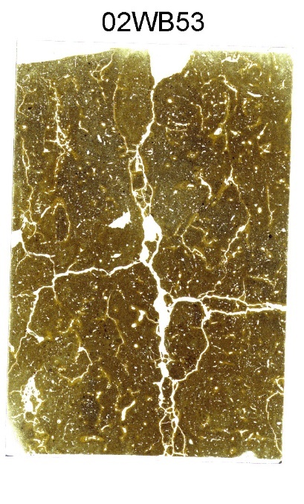  Photomicrographs:  02WB53-01: domains of clay in the matrix and clay hypocoatings but note absence of illuvial clay coating the voids.  02WB53-02: domains of clay and clay coating fragments and intercalations in the matrix and clay hypocoatings but note absence of illuvial clay coating the voids. | - Stratum IVz  This thin section is relatively homogeneous compared to other thin samples collected in Stratum IVz.  Thin Section Description:  related distribution: close porphyric  sorting: bimodal unsorted sand w/ well-sorted silt  Fine Fraction:  Color: light yellowish brown, b-fabric: reticulate  Silt: 30% (quartz, mica, feldspar, pyroxene, miscellaneous heavy minerals, charcoal)  Distribution: random  Sand: 2% (quartz, chert, feldspar, miscellaneous heavy minerals, charcoal)  Distribution: random  Gravel: none  Aggregates: none  Voids: common planar, channel, vughs, possible vesicles  Post Depositional Features: Clay coatings in only 5-10% of the voids. Abundant fine Fe/Mn concentrations occasional fine nodules, , abundant clay hypocoatings, common clay intercalations wetting fronts along planar voids (ped faces from excavation profiles)/quasicoatings
Figure C.77. Sample 02WB53.

Sample: 02WB54 | Block 1, N5025.5 E5128  Base of Stratum IVz/Stratum IV, 78-84 cmbs
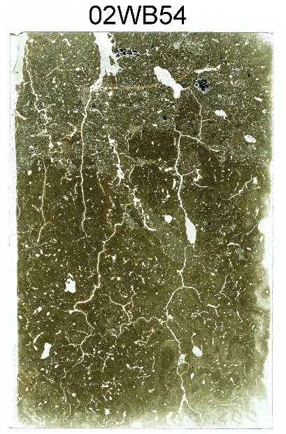  Photomicrographs:  02WB54-01: Stratum IVz (top) and IV (bottom) boundary, with clay coatings.  02WB54-02: disrupted clay that has formed coatings (with OM coatings) in Stratum IVz, just above contact with Stratum IV  02WB54-03: close up of02WB54-02  02WB54-04: Stratum IVz (top) and IV (bottom) boundary, note charcoal fragment. (left side - top of image)  02WB54-05: typical Stratum IV matrix | - Sample marks the boundary between Stratum IVz (beneath Feature 70) and underlying soil (Stratum IV) Boundary is irregular and abrupt  - Stratum IVz  Thin Section Description:  related distribution: close porphyric  sorting: bimodal unsorted sand w/ moderately to poorly sorted silt  Fine Fraction:  Color: light yellowish brown, b-fabric: reticulate  Silt: 30% (predominantly quartz, mica, , feldspar, pyroxene, miscellaneous heavy minerals, charcoal)  Distribution: random  Sand: 5% (quartz, chert, feldspar, sandstone, miscellaneous heavy minerals); frequent charcoal  Distribution: random  Gravel: none  Aggregates: broken (angular and subrounded) matrix, could be considered aggregates (02WB54-02)  Voids: common planar, channel, vughs, possible vesicles  Post Depositional Features: Highly localized dense, multiple typic clay coatings in 5-10% of the voids. Abundant fine Fe/Mn concentrations occasional fine nodules, , abundant clay hypocoatings, wetting fronts along planar voids (ped faces in profile exposures)/quasicoatings  - Stratum IV  Thin Section Description:  related distribution: close porphyric  sorting: bimodal moderately sand w/ well-sorted silt  Fine Fraction:  Color: light yellowish brown, b-fabric: reticulate striated and unstriated, homogeneous  Silt: 20% (predominantly quartz, mica, feldspar, pyroxene, miscellaneous heavy minerals)  Distribution: random  Sand: 3% fine sand (quartz, chert, feldspar, miscellaneous heavy minerals, 1 charcoal fragment)  Distribution: random  Gravel: none  Aggregates: angular clasts of Stratum IVz sediments (various sizes)  Voids: common planar, channel, vughs, few possible vesicles  Post Depositional Features: Clay coatings in >20% of the voids. Abundant fine Fe/Mn concentrations occasional fine nodules
Figure C.78. Sample 02WB54.

Sample: 02WB55 | Block 1, N5025.5 E5128  Base of Stratum IV, 92 cmbs
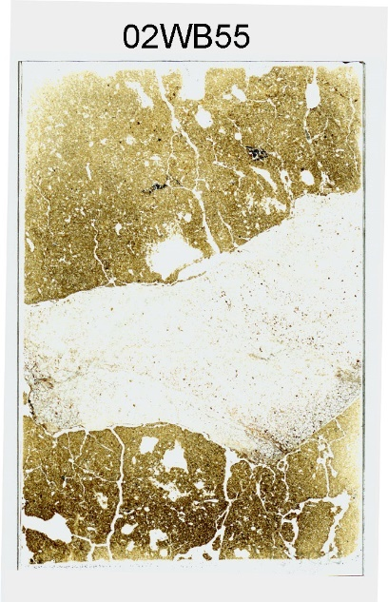  Photomicrographs:  02WB55-01: typical IV matrix | - Stratum IV  Thin Section Description:  related distribution: close porphyric  sorting: bimodal unsorted sand w/ well-sorted silt  Fine Fraction:  Color: light yellowish brown, b-fabric: reticulate striated and unstriated  Silt: 30% (predominantly quartz, mica, feldspar, pyroxene, miscellaneous heavy minerals).  Distribution: random  Sand: 10% fine sand (quartz, chert, feldspar, miscellaneous heavy minerals, charcoal)  Distribution: random  Gravel: 1 large piece of veined quartzite that extends across the sample. Probably (FCR)  Aggregates: none  Voids: common planar, channel, vughs  Post Depositional Features: Clay coatings in 10-20% of the voids. Abundant fine Fe/Mn concentrations occasional fine nodules
Figure C.79. Sample 02WB55.

Sample: 02WB56 | Block 1, N5025.5 E5128  Base of Stratum V in excavation profile, 110 cmbs
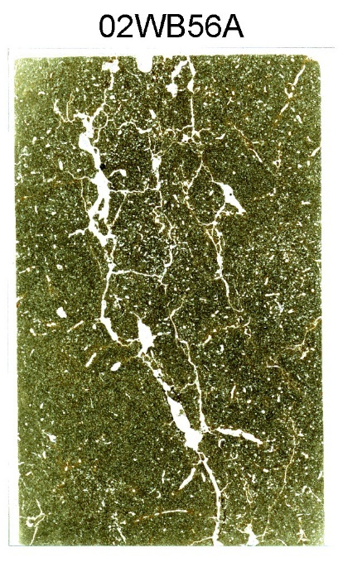  Photomicrographs:  02WB57-01: example of typical fabric/matrix | Thin Section Description:  Related distribution: close porphyric  Sorting: bimodal moderately sorted sand w/ well-sorted silt  Fine Fraction:  Color: brown, b-fabric: speckled  Contains: organic matter, dusty clay  Silt: 70% (quartz, mica, feldspar, pyroxene, miscellaneous heavy minerals, charcoal)  Distribution: random  Sand: 5% fine sand (quartz, mica, chert, feldspar, pyroxene, miscellaneous heavy minerals, quartzite)  Distribution: random  Gravel: none  Aggregates: none  Voids: common vugh, packing and channel  Post Depositional Features: Common to frequent clay coatings, few fine Fe/Mn concentrations and nodules, no roots
Figure C.80. Sample 02WB56.

Sample: 02WB57 | Block 1, N5023.10 E5126  Stratum IVa, 100-105 cmbs
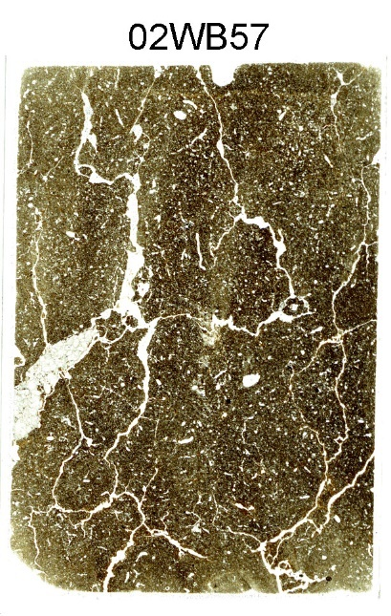  Photomicrographs:  02WB57-01: example of typical fabric  02WB57-02: clay coatings  02WB57-03: chert flake (~.4 mm) probably microartifact | Thin Section Description:  Related distribution: close porphyric  Sorting: bimodal moderately sorted sand w/ well-sorted silt  Fine Fraction:  Color: brown, b-fabric: crystallitic with localized stipple-speckled  Contains: organic matter, dusty clay, charcoal  Silt: 60% (quartz, mica, feldspar, pyroxene, miscellaneous heavy minerals, charcoal & organic matter)  Distribution: random  Sand: 10% very fine (quartz, mica, chert, feldspar, pyroxene, quartzite, miscellaneous heavy minerals, concretions, charcoal and organic matter), > med sand, few mica, 1 sandstone fragment., “battered” charcoal, one microdebitage (chert flake 05WB57-03)  Distribution : random  Gravel: 1% (1 elongated subangular quartzite fragment)  Aggregates: none  Voids: common vugh, channel, few chamber  Post Depositional Features: Common clay coatings (few completely infilled) and hypocoatings, few Fe/Mn nodules, bioturbation
Figure C.81. Sample 02WB57.

Table C.1. Geoarchaeological bulk sample log.
SAMPLE | TYPE | PROVENIENCE | DEPTH (cmbs) | REPRESENTS
Ma-01* | Sediment | Control Profile | 10 | 0-20 cmbs
Ma-02* | Sediment | Control Profile | 30 | 20-40 cmbs
Ma-03* | Sediment | Control Profile | 50 | 40-60 cmbs
Ma-04* | Sediment | Control Profile | 70 | 60-80 cmbs
Ma-05* | Sediment | Control Profile | 90 | 80-100 cmbs
Ma-06* | Sediment | Control Profile | 110 | 100-120 cmbs
Ma-07* | Sediment | Control Profile | 130 | 120-140 cmbs
Ma-08* | Sediment | Control Profile | 150 | 140-160 cmbs
Ma-09* | Sediment | Control Profile | 170 | 160-180 cmbs
Ma-10* | Sediment | Control Profile | 190 | 180-200 cmbs
Ma-11* | Sediment | Control Profile | 210 | 200-220 cmbs
Ma-12* | Sediment | Control Profile | 230 | 220-240 cmbs
Ma-13* | Sediment | Control Profile | 250 | 240-260 cmbs
Ma-14* | Sediment | Control Profile | 270 | 260-280 cmbs
Ma-15* | Sediment | Control Profile | 290 | 280-300 cmbs
Ma-16* | Sediment | Control Profile | 310 | 300-320 cmbs
Ma-17* | Sediment | Control Profile | 330 | 320-340 cmbs
Ma-18* | Sediment | Control Profile | 350 | 340-360 cmbs
Ma-19* | Sediment | Control Profile | 370 | 360-380 cmbs
Ma-20 | Humate Date | Control Profile | 30-50 | Upper Cultural Deposit
Ma-21 | Humate Date | Control Profile | 110-130 | Buried Surface w/Artifacts
Ma-22 | Humate Date | Control Profile | 190-210 | Buried Surface w/Artifacts
Ma-23 | Humate Date | Control Profile | 290-310 | Possible Incipient Surface
Ma-24* | Sediment | Trench 4 | 90 | Stratum IIb
Ma-25* | Sediment | Trench 4 | 125 | Stratum IIc
Ma-26* | Sediment | Trench 4 | 155 | Stratum IIIb
Ma-27* | Sediment | Trench 4 | 180 | Stratum IV
Ma-28* | Sediment | Trench 4 | 205 | Stratum IV
Ma-29 | Sediment | Trench 3 | 60 | Stratum IIb
Ma-30 | Sediment | Trench 3 | 80 | Strata IIc/IIIb (Upper)
Ma-31 | Sediment | Trench 3 | 105 | Stratum IIIb (Lower)
Ma-32 | Sediment | Trench 3 | 130 | Stratum IV
Ma-33 | Sediment | Trench 3 | 160 | Stratum IV
Ma-34 | Sediment | Trench 2 | 35 | Stratum IId
Ma-35 | Sediment | Trench 2 | 50 | Stratum IId
Ma-36 | Sediment | Trench 2 | 70 | Stratum IIIb
Ma-37 | Sediment | Trench 2 | 90 | Stratum IIIb
Ma-38 | Sediment | Trench 2 | 120 | Strata IIIb/IV
Ma-39 | Sediment | Trench 2 | 140 | Stratum IV
Ma-40 | Sediment | Trench 2 | 160 | Stratum IV
Ma-43* | Sediment | Trench 7 | 100 | Stratum IIIb
Ma-44* | Sediment | Trench 7 | 120 | Stratum IIIb
Ma-45* | Sediment | Trench 7 | 140 | Strata IIIb/IV
Ma-46* | Sediment | Trench 7 | 160 | Stratum IV
Ma-47* | Sediment | Trench 7 | 180 | Stratum IV
Ma-48* | Sediment | Trench 7 | 200 | Stratum IV
Ma-50 | Sediment | Trench 7 | 240 | Stratum V
* Sample analyzed for Phase II investigations
Table C.1. Geoarchaeological bulk sample log (continued).
SAMPLE | TYPE | PROVENIENCE | DEPTH (cmbs) | REPRESENTS
Ma-51 | Sediment | Trench 7 | 260 | Stratum V
Ma-52 | Sediment | Trench 7 | 280 | Stratum V
Ma-53 | Sediment | Trench 7 | 300 | Stratum V
Ma-54 | Sediment | Trench 7 | 320 | Stratum V
Ma-55 | Sediment | Trench 7 Extension | 400 | Stratum IIa
Ma-56 | Sediment | Trench 7 Extension | 420 | Stratum V
Ma-57 | Sediment | Trench 7 Extension | 440 | Stratum V
Ma-58 | Sediment | Trench 7 Extension | 460 | Stratum V
Ma-59 | Sediment | Trench 7 Extension | 480 | Stratum V
Ma-60 | Sediment | Trench 7 Extension | 500 | Stratum V
Ma-61 | Sediment | Trench 7 Extension | 520 | Stratum Va
Ma-62 | Sediment | Trench 7 Extension | 540 | Stratum VI
Ma-63 | Sediment | Trench 7 Extension | 560 | Stratum VI
Ma-64 | Sediment | Trench 7 Extension | 580 | Stratum VI
* Sample analyzed for Phase II investigations

Table C.2. Particle size analysis results.
LAB  ID | SAMPLE  ID | % SAND  (>50µ) | % SILT  (50µ-2µ) | % CLAY  (< 2µ)
1 | Ma-01 | 34.9 | 46.0 | 19.1
2 | Ma-02 | 24.4 | 50.5 | 25.1
3 | Ma-03 | 20.7 | 47.6 | 31.8
4 | Ma-04 | 32.1 | 39.7 | 28.2
5 | Ma-05 | 30.7 | 40.0 | 29.3
5 Duplicate | Ma-05 | 29.6 | 41.2 | 29.2
6 | Ma-06 | 43.5 | 33.2 | 23.4
7 | Ma-07 | 56.8 | 26.0 | 17.2
8 | Ma-08 | 47.1 | 31.4 | 21.5
9 | Ma-09 | 28.7 | 42.6 | 28.7
10 | Ma-10 | 32.2 | 41.1 | 26.7
11 | Ma-11 | 34.8 | 38.1 | 27.1
12 | Ma-12 | 21.0 | 48.1 | 30.8
13 | Ma-13 | 28.4 | 42.7 | 29.0
14 | Ma-14 | 39.4 | 36.0 | 24.5
15 | Ma-15 | 48.3 | 29.9 | 21.8
15 Duplicate | Ma-15 | 49.6 | 28.8 | 21.6
16 | Ma-16 | 34.9 | 39.2 | 25.9
17 | Ma-17 | 17.7 | 50.0 | 32.2
18 | Ma-18 | 30.1 | 41.0 | 28.9
19 | Ma-19 | 33.0 | 40.5 | 26.5
20 | Ma-24 | 27.1 | 40.5 | 32.5
21 | Ma-25 | 5.3 | 50.4 | 44.3
22 | Ma-26 | 21.6 | 44.5 | 33.9
23 | Ma-27 | 18.5 | 48.7 | 32.8
24 | Ma-28 | 11.9 | 52.3 | 35.8
25 | Ma-43 | 14.2 | 44.4 | 41.5
26 | Ma-44 | 8.7 | 52.0 | 39.3
26 Duplicate | Ma-44 | 8.3 | 52.3 | 39.4
27 | Ma-45 | 6.2 | 52.4 | 41.3
28 | Ma-46 | 7.0 | 53.9 | 39.1
29 | Ma-47 | 4.6 | 54.8 | 40.6
30 | Ma-48 | 4.8 | 55.1 | 40.1
31 | Ma-49 | 12.1 | 52.3 | 35.6
32 | Ma-50 | 22.8 | 47.0 | 30.2
33 | Ma-51 | 30.8 | 42.3 | 26.9
34 | Ma-52 | 19.7 | 48.4 | 31.9
34 Duplicate | Ma-52 | 19.6 | 48.6 | 31.8
35 | Ma-53 | 27.6 | 42.9 | 29.5
36 | Ma-54 | 38.3 | 38.1 | 23.6
37 | Ma-55 | 25.9 | 45.2 | 28.9
38 | Ma-56 | 32.2 | 42.2 | 25.6
39 | Ma-57 | 31.5 | 43.2 | 25.3
40 | Ma-58 | 24.9 | 47.8 | 27.3
Table C.2. Particle size analysis results (continued).
LAB  ID | SAMPLE  ID | % SAND  (>50µ) | % SILT  (50µ-2µ) | % CLAY  (< 2µ)
41 | Ma-59 | 23.4 | 47.6 | 29.0
42 | Ma-60 | 28.2 | 45.0 | 26.8
43 | Ma-61 | 29.2 | 43.5 | 27.3
44 | Ma-62 | 30.2 | 42.4 | 27.4
44 Duplicate | Ma-62 | 30.3 | 42.4 | 27.3
45 | Ma-63 | 27.8 | 42.9 | 29.3
46 | Ma-64 | 44.0 | 32.9 | 23.1

Table C.3. Organic carbon and carbonate analyses results.
LAB  ID | SAMPLE  ID | % ORGANIC MATTER | CARBONATE  %
1 | Ma-01 | 2.1 | 0.9
2 | Ma-02 | 3.2 | 1.0
2 Duplicate | Ma-02 | 3.4 | 1.0
3 | Ma-03 | 3.5 | 1.0
4 | Ma-04 | 2.7 | 1.0
5 | Ma-05 | 2.7 | 1.1
6 | Ma-06 | 1.8 | 1.0
7 | Ma-07 | 1.2 | 0.8
8 | Ma-08 | 1.4 | 0.9
9 | Ma-09 | 2.2 | 1.0
10 | Ma-10 | 2.2 | 1.0
11 | Ma-11 | 2.1 | 1.0
12 | Ma-12 | 2.3 | 1.2
12 Duplicate | Ma-12 | 2.1 | 1.3
13 | Ma-13 | 1.9 | 1.2
14 | Ma-14 | 1.7 | 1.0
15 | Ma-15 | 1.5 | 0.9
16 | Ma-16 | 1.9 | 1.0
17 | Ma-17 | 2.3 | 1.3
18 | Ma-18 | 1.7 | 1.3
19 | Ma-19 | 1.7 | 1.2
20 | Ma-24 | 1.7 | 1.3
21 | Ma-25 | 3.2 | 1.6
22 | Ma-26 | 3.5 | 1.3
22 Duplicate | Ma-26 | 3.6 | 1.3
23 | Ma-27 | 2.6 | 1.2
24 | Ma-28 | 2.6 | 1.4
25 | Ma-43 | 2.8 | 1.6
26 | Ma-44 | 3.0 | 1.5
27 | Ma-45 | 2.8 | 1.5
28 | Ma-46 | 2.4 | 1.5
29 | Ma-47 | 2.6 | 1.5
30 | Ma-48 | 2.7 | 1.5
31 | Ma-49 | 2.3 | 1.4
32 | Ma-50 | 2.1 | 1.3
32 Duplicate | Ma-50 | 2.0 | 1.3
33 | Ma-51 | 1.7 | 1.2
34 | Ma-52 | 1.9 | 1.4
35 | Ma-53 | 1.8 | 1.3
36 | Ma-54 | 1.5 | 1.1
37 | Ma-55 | 2.2 | 1.3
38 | Ma-56 | 1.8 | 1.2
39 | Ma-57 | 1.7 | 1.2
40 | Ma-58 | 1.8 | 1.3
Table C.3. Organic carbon and carbonate analyses results (continued).
LAB  ID | SAMPLE  ID | % ORGANIC MATTER | CARBONATE  %
41 | Ma-59 | 1.9 | 1.3
42 | Ma-60 | 1.8 | 1.2
42 Duplicate | Ma-60 | 1.9 | 1.2
43 | Ma-61 | 2.0 | 1.2
44 | Ma-62 | 2.2 | 1.2
45 | Ma-63 | 2.2 | 1.2
46 | Ma-64 | 1.6 | 1.0

                - Vita
Matthew D. Gage grew up in Wilton, New Hampshire. After attending Bishop Guertin High School he entered the University of New Hampshire where he received his Bachelor of Arts in Anthropology in 1994. He began a three year period of work in the field of archaeology and was accepted to The University of Alabama in 1997 where he began his graduate studies focusing on the archaeology of southeastern North America. Gage received his Master of Arts in Anthropology in 2000 and also received awards for Excellence in Research by a Master’s student from both the College of Arts and Sciences and the University for his work on the Mississippian earthen structures of Alabama. After working for The University of Alabama for another four years, he entered the graduate program at the University of Tennessee in Knoxville in 2004. He focused on pre-contact hunter-gatherer communities and settlement patterns in the Southeast. While working full time for the University of Tennessee, he completed his course work as well as a five year study for the Tennessee Valley Authority documenting 1,600 archaeological sites and site erosion in 7 states on 11 reservoirs. In 2011, Gage was chosen to serve as the Director of The University of Alabama, Office of Archaeological Research. After a 12 year hiatus, he was readmitted to the University of Tennessee in 2023 and earned his Doctor of Philosophy in Anthropology in August of 2025.

Chenopodiaceae as included herein is based on the analysis reported in Roberts (2011; Roberts and Gage 2003). Chenopodiaceae is no longer considered a family and it and Amaranthaceae are recognized as forming a monophyletic group (Ameraranthaceae sensu lato)( Sally Horn personal communication 2025; Xu et al. 2024;).
All dates were calibrated using OxCal v4.4 Bronk Ramsey (2021) and the IntCAL20 calibration database (Reimer et al. 2020).
Centimeters below datum (cmbd)
Wilson Dam had already been constructed and was providing power generation for the region as early as 1924. Intended to provide power to the Nitrate Plants 1 and 2, built in Sheffield and Muscle Shoals, the dam created a reservoir covering 15,500 acres and stretching more than 15.4 river miles upstream to the base of Wheeler Dam. No archaeological surveys were conducted prior to inundation. The loss of this in-formation served as one of the catalysts for interested parties who pushed for the river basin surveys of the remaining Tennessee River reservoirs.
Prior to 1939 the Works Projects Administration was known as the Works Progress Administration. In an effort to ameliorate the effects of the great depression and extensive unemployment, the administration of President Franklin D. Roosevelt developed the Federal Emergency Relief Administration in 1933, followed later in the year by the Civil Works Administration, and the Works Progress Administration in 1935 (Johnson 1993; Lyon 1996).
Carr et al. (2012) includes an excellent discussion in the introduction to their edited volume on contemporary lithic analysis. They discuss many of the pitfalls of trends in analytical techniques and the continued employment of a cultural-historical approach to understanding lithic technologies.
The data for archaeological site distribution is derived from the Alabama Online Cultural Resources Database maintained at The University of Alabama, Alabama Museum of Natural History, Office of Archaeological Research, Moundville.
The Alabama State Site File may contain sampling bias attributable to the surveying methodologies and diagnostic artifact identification. See Meeks (2003:1) for a discussion of the possible concerns and utility of site file data in observing general trends in land-use patterns.
The use of “phase” here is in keeping with its reference in much of the regional literature (Faulkner and McCollough 1974). Given their duration and areal extent, the Ledbetter and Wade continuums may be considered more in keeping with “cultures” as defined by Gordon P. Willey and Philip Phillips (1958) or a “horizon” (see Jenkins and Krause 1986 and Futato 1983a). Walthall (1980) refers to the Lauderdale culture as encompassing the components herein identified as Ledbetter and Wade phases.
The Wade phase discussed herein is likely contemporaneous with the Perry phase to the west (Walthall 1980: Futato 1983b).
Two hundred eighty-three archaeological sites lie within the 30 km radius. Because of the scale necessary to show the entire area and sites and because many of these sites are within close proximity to one another, they overlap on the map and appear as fewer than 283 dots.
Ninety-nine archaeological sites lie within the 30 km radius. Because of the scale necessary to show the entire area and sites, and because many of these sites are within close proximity to one another, they overlap on the map and appear as fewer than 99 dots.
Data derived from Kelly 1995:112-115 and excludes both those groups with no information and those where the information is either greater than or less than the given value. Of the 93 groups identified by Kelly, only 50 were used. The total number of residential moves was 809.
See Finn and Goldman-Finn 1997 for a discussion of possible association with the Poverty Point exchange network.
Dates are plotted using OxCal v4.4.4 Bronk Ramsey (2021); r5 Atmospheric data from Reimer et al. (2020)

