Pathway to Blue Hydrogen: Converting Methane to Hydrogen via Auto-Thermal Reforming Process

CBE 488: Senior Design
Kate Blankenship, Kaitlin Ly, Victoria Rogers
May 10, 2025

Table of Contents
Letter of Transmittal 3
Abstract 3
Introduction 4
Block Flow Diagram 6
Process Flow Diagram 8
Process Description 8
Material and Energy Balances and Utility Requirements 12
Equipment List 14
Process Cost Analysis 15
Economic Analysis (Kaitlin) 21
Safety, Health, and Environmental Considerations 22
Conclusions and Recommendations (Kaitlin) 22
Acknowledgements 23
Bibliography 23
Appendix A: FMEA 24
Appendix B: Sample Calculations 25
Individual contributions 28

Letter of Transmittal
In this project overview, a proposed design for the production of gray hydrogen is discussed. The purpose of this project is to offer a viable alternative to carbon-emitting fuel sources by reviewing an efficient, cost-effective hydrogen production plant. The design stems from operating specifications given in the 2024-2025 AIChE Student Design Competition problem statement.
Aspen Plus and toPSAil simulation software were used to meet these specifications and design the process. The chemistry and thermodynamics of each reaction in the system were taken into consideration when designing their respective unit operation. Additionally, heat integration was an important factor in the process’s overall efficiency, as seen below. The economics of the project are reviewed as well as an estimated timeline of profitability.
Process improvements are also included, for example the incorporation of carbon capture and storage step after the Pressure Swing Adsorption section. This would allow for a reduced carbon footprint and activation of tax benefits, both helping the sustainability of the process.
Safety and environmental considerations are also considered, as the system works with flammable gases at high pressures. Actionable steps are incorporated into the plant operations to minimize the risks associated with the process.

Abstract
To help meet growing demands for hydrogen as a fuel source, a hydrogen production plant was designed to make 250 MMscfd of gray hydrogen per year in the Gulf Coast region of the United States. The plant utilizes an auto-thermal reforming process to produce hydrogen from natural gas and also consists of other unit processes to reduce impurities, minimize byproducts, and separate out the product. The plant is estimated to cost around $740MM in capital and $460MM/yr in yearly expenses, but it is also expected to make $1/kg of hydrogen produced at a 99.9% purity, resulting in a yearly profit of $189MM/yr.

Introduction
As companies and policies trend towards cleaner environmental policies–ones requiring lesser greenhouse gas emissions–the production and utilization of hydrogen become increasingly important in this energy transition. Hydrogen has a number of uses within industrial processes including as rocket fuel, within fuel cells for electricity generation, and in supplementing power supply for power plants (U.S. EIA, 2024). Hydrogen can be used in a number of renewable energy processes as a clean energy carrier to store and transport energy.

Production of Gray Hydrogen
95% of hydrogen today, called “gray” hydrogen–is produced through fossil fuels through natural gas reforming by producing hydrogen through thermal processes like steam-methane reformation (SMR) (U.S. DOE, 2025). Steam-methane reforming requires high temperature steam at high pressures with a catalyst to produce hydrogen, carbon monoxide and small amounts of carbon dioxide.

$CH_{4}+ H_{2}O → CO + 3H_{2}$ 1. Steam-methane reforming reaction

After this, a water-gas shift reaction between the carbon monoxide and the steam occurs, where a catalyst is added to the mentioned reactants to produce hydrogen as well as more carbon dioxide byproduct.
$CO + H_{2}O ⇄ CO_{2}+ H_{2}$ 2. Water-gas shift reaction

To separate the hydrogen from this, pressure-swing adsorption (PSA) is used to remove any impurities and CO2 from the system. To create hydrogen from this process, approximately 7 kg of carbon dioxide is generated for every 1 kg of desirable hydrogen produced. This accounts for almost 3% of the global industrial sector's CO2 emissions (Dincer, 2015).

Production of Blue Hydrogen
The process for producing blue hydrogen is similar to the process for the production of gray hydrogen; however the greenhouse gas emissions are substantially lowered by carbon capture and sequestration (CCS). CCS is the process of capturing and storing the carbon dioxide produced from an industrial process to be transported and permanently stored within geologic formations deep underground or biologically sequestered within parts of the carbon cycle into living plant tissues (U.S. DOE, 2025).

To produce blue hydrogen, several steps, similar to gray hydrogen production are taken. First, pretreatment is done to the natural gas feed to eliminate undesirable impurities. Because natural gas is not composed solely of methane, other hydrocarbons such as ethane have to be converted to carbon monoxide and hydrogen before the process can begin; because of this, a pretreatment step is necessary.
$C_{n}H_{m}+ nH_{2}O →nCO + (n+\frac{1}{2}m)H_{2}$ 3. Pre-Reforming reaction
Before natural gas is reformed into blue hydrogen, additional heat must be generated as the reforming reaction is endothermic and to prevent the buildup of carbonized coke on the autothermal reactor catalyst. A partial oxidation of methane occurs before autothermal reforming.
$CH_{4}+2O_{2}→CO_{2}+2H_{2}O$ 4. Partial Oxidation reaction

After required heat is generated, the methane is sent to an Auto-Thermal Reformer (ATR) where the products are similar to SMR; however, ATR uses purified oxygen in the place of air for combustion as a heat source to make steam.
$CH_{4}+ H_{2}O →3H_{2}+CO$ 5. Autothermal Reforming reaction 1
$CH_{4}+ {2H}_{2}O →4H_{2}+CO_{2}$ 6. Autothermal Reforming reaction 2

A water-gas shift (WGS) reaction is done following this process to ultimately yield hydrogen product. To separate the H₂ from undesired byproducts (unreacted methane, water, carbon monoxide and carbon dioxide) PSA is utilized. The remaining gas, “tail gas”, is processed to recover 70% of CO₂. The carbon dioxide is compressed to pipeline injection pressures and is then either shipped to third-party pipelines for sequestration or sold into markets provided that industry specifications are met.

Block Flow Diagram
The Block Flow Diagram (BFD) for this process was given by the AIChE problem statement with specified unit ops and parameters for the process. The given process is illustrated in Figure 1 below.
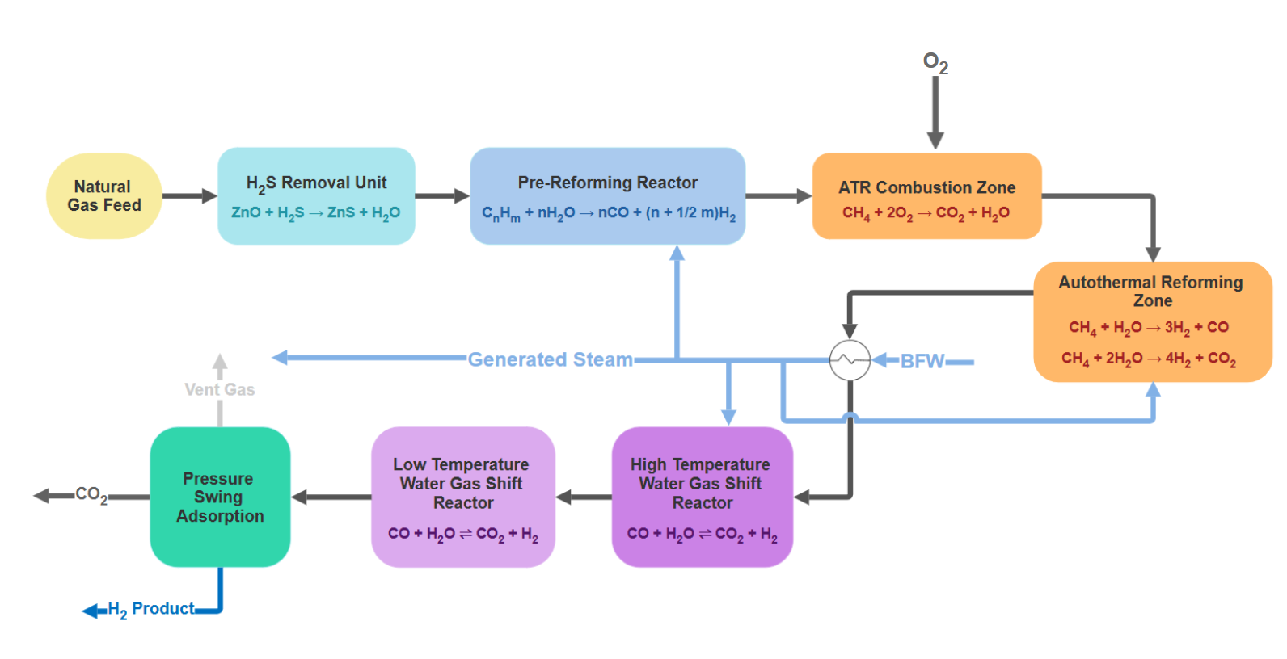
Figure 1. Block flow diagram of the hydrogen production process.

Process Flow Diagram
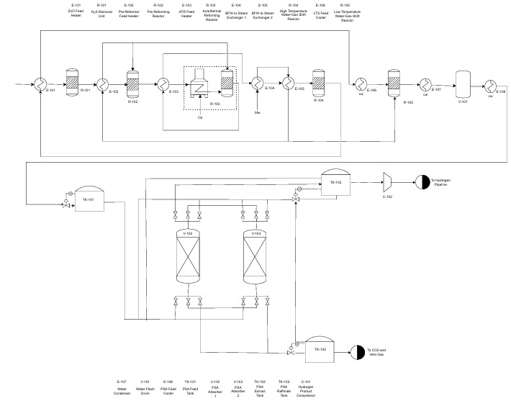
Figure 2. Process flow diagram of hydrogen production process.

Process Description
Process Assumptions
For the pre-PSA portion of the project, Aspen Plus was used to simulate the various process conditions. Although some parameters were given by the AIChe problem statement–see Table 1 below–additional assumptions were made for simulation modelling.
Table 1. Given Process Parameters.
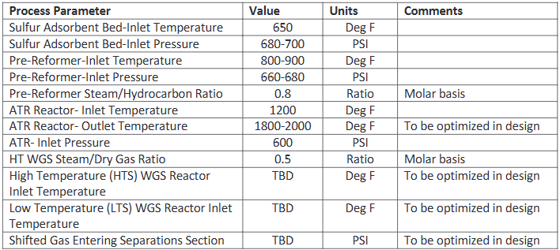

To simulate the designed process, Aspen Plus’s PENG-ROB thermodynamic package was used. PENG-ROB utilizes the Peng-Robinson equation of state to predict the behavior of several fluids, including hydrocarbons. PENG-ROB was used in several different hydrogen processes as determined by a literature review and would effectively model our hydrogen production system (Phan, 2022).
Because the system utilizes gas-to-gas heat exchangers, an iterative process was used to determine an appropriate overall coefficient of heat transfer, U, for the process through Aspen’s Heat Exchanger Design and Rating (EDR) feature. Heat exchangers were rigorously modelled through the Shell & Tube EDR until an exchanger with no significant vibrational issues was generated. The given U value was rounded to the tens place and used for the heat exchanger.
All fixed bed pressure drops were determined by the Ergun equation using reasonable assumptions as needed with a sample calculation available in Appendix B.1. For all reactors, a residence time of 0.0170 hr, or 1 minute, was assumed based on literature review (Bustamente, 2004; Dunker, 2006). For all vessels, a safety factor of 1.15 was taken to determine the design pressure. An extra 200°F was added to equipment temperature specifications when designing to account for a reasonable safety factor.
Sulfur-Removing Unit
The raw natural gas feed stream includes 3 ppm H₂S that is a poison to the ATR catalyst. To remove this impurity, the raw feed was sent to a ZnO unit where the sulfur is removed via the following reaction:
$ZnO+H_{2}S → ZnS+H_{2}O$ 7. ZnO Unit reaction
The sulfur-removing unit was not modelled as part of the Aspen, although it was accounted for in all other aspects of the project.
Pre-Reforming Reactor
The pre-reforming reactor converts the higher hydrocarbon, ethane, into carbon monoxide and hydrogen as seen in Equation 3, as a pre-treatment step before methane is sent to an auto-thermal reformer. The temperature of the inlet stream of the pre-reformer is 735°F with a pressure drop calculated by the Ergun equation (see Appendix B.1 for a sample calculation) to be less than 1 psi.
Auto-Thermal Reactor
The Auto-thermal reactor (ATR) consists of two “zones,” the combustion zone and the reforming zone. In the combustion zone, the now-purified methane stream is combusted with oxygen to follow equation 4, above. The purpose of this zone is two-fold. First, it generates CO₂ and steam. The steam is then used as a reactant in the following reforming reactions. Second, the exothermic combustion reaction generates enough heat to support the endothermic reforming reactions, which cool the feed stream by roughly1000℉. The reforming zone includes equations 5 and 6, above, producing the majority of the hydrogen that will be sold to consumers. Because these reactions are endothermic, the ATR outlet stream is reduced to around 2000℉. This outlet is important to use for steam generation from the Boiler Feed Water (BFW) and for heat integration for other process streams that need heating. The ATR outlet stream must be cooled from 2000℉ to 840℉ before it enters the Water Gas Shift system.
Water Gas Shift Reactors
The Water Gas Shift (WGS) section of the process includes the High Temperature Shift (HTS) and Low Temperature Shift (LTS) reactors. The purpose of this section is to minimize the amount of CO in the system by favoring the forward reaction of Equation 2, above, which is exothermic. The HTS unit usually operates in a range from 650-750℉; this higher temperature increases the kinetics of the forward reaction, driving the production of CO₂ and H₂O. However, the simulation HTS inlet is at 840°F. At this higher temperature, the expected conversion of CO is still observed. The costs associated with operating at this higher temperature is offset by the fact that an additional exchanger and cooling water to reduce the temperature is not used. The LTS favors the thermodynamics of the forward reaction by operating at a lower temperature, around 360℉. To model this system in Aspen, two plug flow reactors were used. Both forward and reverse reaction kinetics were found from literature searches and used in the model (Smith, 2010; Bustamente, 2004). Initially, the CO conversion out of the HTS was an order of magnitude more than what could reasonably be expected from literature values. To more closely match the expected literature CO conversion in the HTS, the activation energy of the forward reaction was decreased by a factor of 10. Additional steam was input into the HTS to achieve a steam:dry gas ratio of 0.5.
Flash Unit
To remove the water prior to entry into the Pressure Swing Adsorption section, the temperature of the LTS exit stream was cooled to around 150℉ and then sent to a flash unit. Here the water, as a liquid, was separated from the H₂, CO₂, and residual CO and methane (all gases).
Pressure Swing Adsorption
Pressure swing adsorption takes place using a two-vessel bed to separate and purify the hydrogen product from the CO₂ vent gas. This is done by raising the pressure to allow the CO₂ and other trace gases (CO and CH₄) to adsorb into the Zeolite 13X molecular sieve, then lowering the pressure to allow desorption and extraction of the vent gases. A six-step cycle was used with a high pressure feed, depressurization, low pressure purge, repressurization, and two pressure equalization steps. The vessel operates at a constant temperature of 298 K, high pressure of 15 bar, and a low pressure of 1 bar. This was done to meet a hydrogen product purity of 99.9% and recovery of at least 85%.
Compressor
Two compressors are normally necessary for the PSA process–an initial compressor to drive the pressure for the feed tank and a second compressor to send the purified hydrogen product to a buyer via a pipeline. However, because the pressure of the post-flash stream is higher than what is necessary for the first PSA adsorbent bed, a compressor here is not needed. A margin of error has been left for the pressure in the PSA system in case the estimates for pressure drop across the pre-PSA system are too small.
The purified hydrogen product from the PSA is to be sent to a buyer via a pipeline. The specification for injection into the pipeline is that the hydrogen needs to be at 900 psi. The compressor at the end of the process increases the pressure of the hydrogen from 250 psi to its specified pressure into the pipeline.

Material and Energy Balances and Utility Requirements
Material Balance
The material balance for the process is very long. The full material balance can be found in the CBE488_Sizing_Costing_Econ Excel sheet in the ‘Material Balance’ tab.
A high level mass balance of the process from the Aspen file (pre-PSA process) is given as:
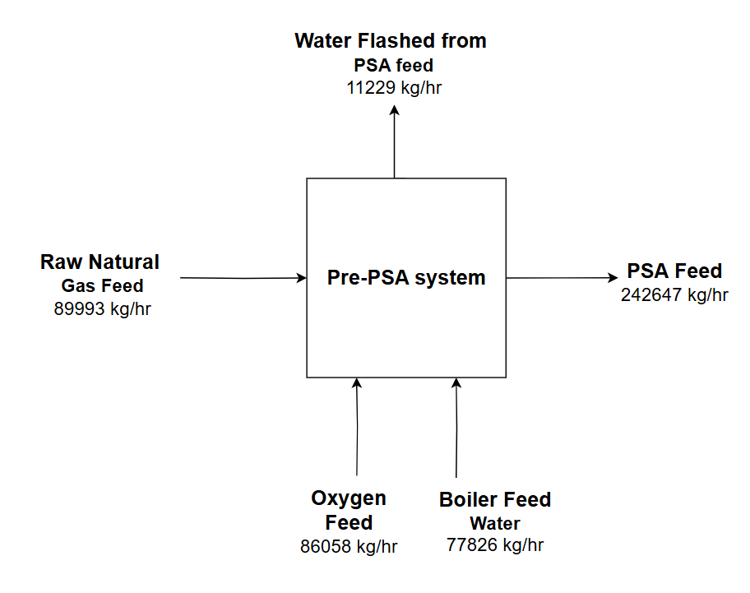
Figure 3. Overview of pre-PSA Mass Balance
The pre-PSA system is balanced as seen by the diagram above. All mass that entered the system was accounted for leaving.
Heat Balance
The overall heat balance for the process is shown below in Figure 4. The heat balance can also be found in the CBE488_Sizing_Costing_Econ Excel sheet in the ‘Heat Balance’ tab.
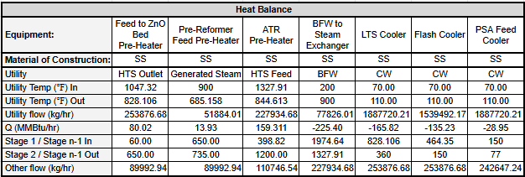
Figure 4. Overall Heat Balance

Equipment List
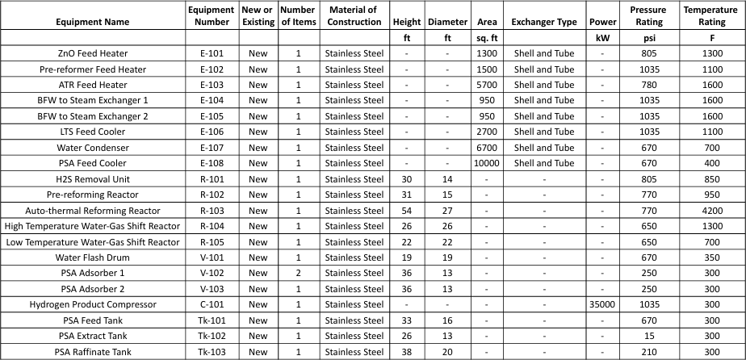
Figure 5. Equipment list for the hydrogen plant.
Above is the proposed list of equipment pieces needed for the hydrogen production plant. As per the problem statement, none of the equipment were spared since they all cost above $100,000. There was one spare adsorber bed incorporated for the PSA section, however, as it would be important to always have at least two beds in operation in the event that one goes down. Due to the presence of CO₂ in the system, it was decided that all equipment pieces should be made of stainless steel to resist corrosion. Equipment sizes are as determined with calculations in Appendix B. The pressure and temperature ratings incorporate a safety factor to help ensure safe operation of the plant. Each pressure included a factor of 1.15x the designed operating pressure in the models. Each temperature was rated 200°F above what the specified operating temperature would be.

Process Cost Analysis
To determine the viability of the proposed hydrogen plant, it was necessary to conduct a preliminary cost and profitability analysis. After designing the plant in the simulation software, the set material flow rates, temperature and pressure specifications, and heating and cooling needs could be used to size the process equipment. Once sized, the purchasing cost of the equipment can be estimated, then scaled to the year of construction of the plant.
Unit Operation Sizing
A sample sizing calculation for each unit operation is available in Appendix B.
Unit Operation Costing
The sizing done was then used to calculate the cost for each piece of equipment. Costing curves and empirical equations from Analysis, Synthesis, and Design of Chemical Processes were used to calculate the bare module cost for each piece of equipment. A CEPCI of 798.8 was used for the current year, compared against a CEPCI of 397 as the initial reference. The total bare module cost was calculated by taking the sum of all equipment costs, which was calculated to be $504MM. A given fee factor of 3% of the total module cost and a contingency factor of 20% of the total module cost were used to get the total module cost, C_{tm} of $622MM. The OSBL cost is given to be 10% of the total module cost which yields an OSBL of $62MM. The Fixed Capital Investment, not including land or working capital, (FCI_{L}) is calculated as the sum of the total module cost and the OBSL cost to be $684MM. The detailed calculations can be found in the CBE488_Sizing_Costing_Econ excel sheet.
Utility Costing
The cost of utilities were given for the process and summarized in Table 2 below.
Table 2: Given utility costs for hydrogen production
Utility | Cost | Unit
Boiler Feed Water (BFW) | $3.50 | $/1000 gal
Cooling Water (CW) | $0.20 | $/1000 gal
Oxygen | $34 | $/tonne

The total flows of each utility were tabulated and the cost of each utility per year was calculated. The sum of the utilities per year equaled the total utility cost for the plant. The total flow rates and costs for these utilities are summarized in Table 3. The calculations are also available in the CBE488_Sizing_Costing_Econ Excel sheet.
Table 3: Total Utility Flow and Cost
Item | Total value
BFW usage | 186,637 (1000 gal/operating year)
CW usage | 8,342,861 (1000 gal/operating year)
Oxygen usage | 722,885 (tonne/operating year)
BFW utility cost | $653,231.23 ($/operating year)
CW utility cost | $1,668,572.13 ($/operating year)
Oxygen utility cost | $24,578,079 ($/operating year)
Operating year utility total | $26,899,882.49

Raw Material Costing
The cost of raw materials, C_{rm}, for this process is exclusively the cost of natural gas as the feedstock for the hydrogen production process. The cost of natural gas was not given as part of the problem statement, thus was calculated through a series of assumptions. The industrial cost of natural gas is tracked by the U.S. Energy Information Administration for each state and can be given in a variety of data ranges (U.S. EIA, 2025). Because the project is assumed to take place on the Gulf Coast, monthly data of natural gas’s industrial price was taken for states that reside on the Gulf Coast (i.e. Alabama, Florida, Louisiana, Mississippi, and Texas) from January 2022 to February 2025. A three year average was taken to yield $0.0055 per cubic foot of industrial natural gas. The detailed calculation for this can be found in the ‘Costing Assumptions’ tab of the CBE488_Sizing_Costing_Econ excel sheet. The cost of natural gas was calculated as follows:
$C_{RM} = (\$0.0055/ft^{3})*(Natural gas used)$
$C_{RM} = (\$0.0055/ft^{3})*(109.8* 10^{6} ft^{3}/day)*(350 day/op.year)$
$C_{RM}= \$211,478,480 /opera$$ting yea$r
Operating Labor Costing
The cost of operating labor is given by the equation
$N_{OL} = (6.29 + 31.7P^{2} + 0.23N_{np})^{0.5}$
Where 𝑁_{𝑂𝐿} is the number of operators required per shift, 𝑃 is the number of process steps
requiring the handling of particulates, and 𝑁_{𝑛𝑝} is the sum of the total number of compressors, towers, reactors, heaters, and heat exchangers used in the process. Since there are no steps that involve the handling of particulates, P is equal to zero. The value of N_{np} is 14 (7 heat exchangers, 2 compressors, and 5 reactors).
$N_{OL} = (6.29 + 31.7P^{2} + 0.23*(14))^{0.5}=3.08$
This is the number of operators required per shift. For a plant operating with three shifts per day,
a total of 4.5 operators must be hired for each operator that is needed in the plant at any given
time. The total number of operators required can then be calculated as:
$N = 3.08 operators/shift * 4.5 = 14 operators$
Rounding up to the nearest whole number yields 14 operators needed per year. The assumed operator salary was $62,400 a year–based on an hourly wage of $30, a 40 hour work week and 52 paid weeks per year. To yield the annual cost of labor, C_{OL}, the number of operators is multiplied by the operator salary and a given benefits factor of 1.5x the operator wage.
$C_{OL}=(number of operators)*(annual salary) * 1.5 = 14 * \$62,400 *1.5$
$C_{OL}=\$1,310,400$
Land Cost
The cost of land was to be estimated for the project. In order to estimate this, the cost of land for states on the Gulf Coast (Alabama, Florida, Louisiana, Mississippi, and Texas) per acre was calculated and averaged (LandSearch, 2025). A table of the land costs are given below in Table 4.
Table 4: Land Cost Values on the Gulf Coast
Location | Cost ($/Acre)
Alabama | $21,433
Florida | $94,517
Louisiana | $18,309
Mississippi | $10,264
Texas | $18,593
Overall Average Land Cost | $32,625.20

To estimate the cost of acreage for a hydrogen production plant, a recent article describing a new construction hydrogen plant in Texas was used (Strupp, 2022). The acreage given in the article was 540 acres which was taken to be the land estimate for the project.
The cost of land was calculated to be
$Land value= (total acreage)*(\$ land /acre) = (540 acres)*(\$32,625.20)$
The land value was rounded to the millions place to yield
$Land value= \$18,000,000$
Revenue
The selling price of hydrogen was given in the problem statement to be sold at “2x its fuel value” (AIChE, 2025). A series of calculations were done in order to determine this value. The fuel heating value of methane and hydrogen were found through the World Nuclear Association (World Nuclear Association, 2020). The values are presented in Table 5 below.
Table 5: Fuel Heating Values of Methane and Hydrogen
Component | Heating value (units)
Methane | 55 (MJ/kg)
Methane | 0.05214 (MMBtu/kg)
Hydrogen | 142 (MJ/kg)
Hydrogen | 0.134616 (MMBtu/kg)

To determine the cost of methane fuel, the Henry Hub Natural Gas Spot Price from the U.S. Energy Information Administration data was used (U.S EIA, 2025).A three-year average was taken from daily natural gas prices per MMBtu to yield $2.83 per MMBtu, with the detailed calculation available in the ‘Costing Assumptions’ tab of the CBE488_Sizing_Costing_Econ excel sheet. This was then converted to cost per kilogram to yield $0.15/kg of CH₄. The equivalent mass of hydrogen necessary to generate the same MMBtu as one kilogram of methane was calculated as below:
$Equivalent mass of H_{2}= (0.0521 MMBtu/ kg CH_{4})/(0.135 MMBtu/kg H_{2})$
$Equivalent mass of H_{2}= 0.39 kg H_{2}/kg CH_{4}$
Since the problem statement denotes that the revenue is two times the fuel value, the fuel value of methane is multiplied by two.
$Revenue of CH_{4}= 2* \$0.15/kg CH_{4}= \$0.30/kg CH_{4}$
The equivalent mass of H₂ is then used to determine the revenue for H₂ product.
$H_{2} revenue =\$0.30/kg CH_{4}/ (0.39 kg H_{2}/kg CH_{4}) =\$0.76/kg H_{2}$
The selling cost of H2 was then rounded to $1.00 per kilogram of hydrogen.
The sum of all the equipment costs, and including land and working capital, is the Fixed Capital Investment (FCI) and for this project was determined to be $740MM. Once the plant is built, the costs to operate it also need to be considered. These costs make up the Cost of Manufacturing without Depreciation (COMd). Included are the cost of raw materials, cost of purchased utility, cost of operators, and cost of catalysts. The COMd for this design was determined to be $460MM/yr.
The cost of utilities and catalysts were given in the problem statement, but the cost of raw materials and the salaries of the operators were estimated by finding reasonable values for these parameters in the Gulf Coast Region, where the plant will be located. All calculations can be found within the CBE488_Sizing_Costing_Econ Excel sheet.

Economic Analysis
Once all equipment, labor, and operating costs were calculated, a profit analysis was done to estimate the profitability and viability of the project entirety. This brought together all costs over a 20-year project life, including ISBL, OSBL, utilities, operating labor, waste treatment, raw materials, and put these against revenue generated from selling the hydrogen product. A discount rate of 15% and MACRS depreciation method were used throughout this analysis. A discounted cash flow diagram without tax benefits, shown in Figure 6, was generated, showing a net present value of approximately $1.2 billion in debt. However, if tax benefits are taken into account (Figure 7), then that net present value increases to about $200 million in debt at the end of the project life. This would occur if blue hydrogen is being sold rather than grey hydrogen, and the tax credit would allow an additional potential amount of $3/kg of hydrogen, greatly increasing revenue from $188 million to $566 million. While the project is still in debt at year 20, the trend is upwards climbing compared to the discounted cash flow diagram without the tax benefits. While this project did not allow for the designing of carbon capture and sequestration within the allotted time, it should still be considered in the economic analysis to determine the amount of potential revenue that would be coming in.
The internal rate of return, also known as the discounted cash flow rate of return, was calculated, which tells the discount rate needed to bring the net present value to zero at the end of the project life. This value was determined to be 7.18%, with tax benefits, using Goal Seek to vary the discount rate to obtain the desired net present value. While a higher internal rate of return is generally viewed as more desirable since this means the project receives greater return on investments, this project was expected to be a costly process due to the amount of equipment involved, the large scale, and amount of energy involved. Without the tax credit, however, there is not an internal rate of return value that could bring the net present value up to zero because of its constant downwards trend. Because of this, it is clear that carbon capture and sequestration is necessary to make this process profitable, although profits do not start until after year 20.
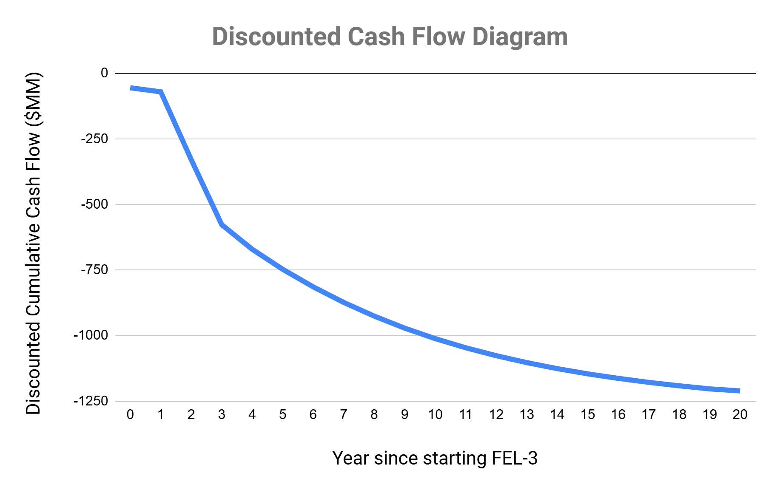
Figure 6. Profitability Analysis Over a 20-Year Period (Without Tax Benefits)

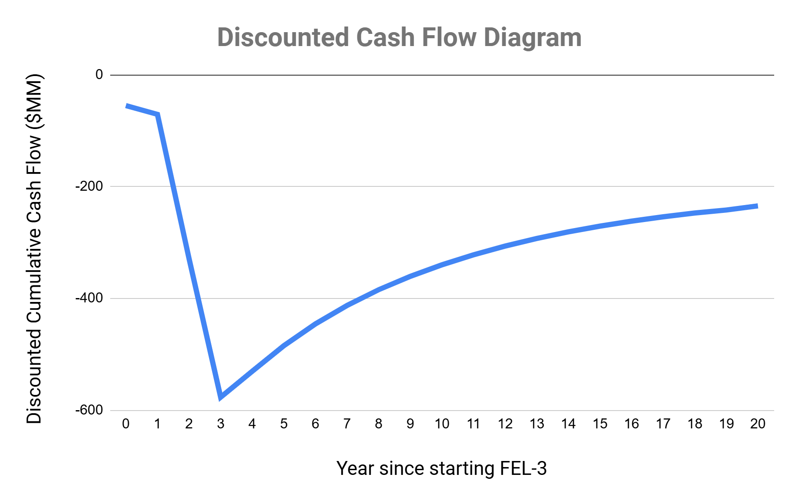
Figure 7. Profitability Analysis Over a 20-Year Period (With Estimated Tax Benefits of up to $3/kg H₂ Included)

Safety, Health, and Environmental Considerations
The design plant involves the use of flammable gases at high pressure. Leaks of these gases throughout the process could cause asphyxiation due to the displacement of oxygen or lead to ignition if the gases come in contact with an ignition source. To mitigate risk of asphyxiation, a ventilation system will be put in place in the plant. Periodic testing will be performed to ensure the gases being vented (either from emergency ventilation or from normal end-of-process vent gases) do not exceed limits set by environmental agencies, such as the EPA. Personal as well as permanent gas monitors stationed throughout the plant will be used to monitor any gas leaks and help indicate if any rise above the exposure limit, based on the gas’ SDSs. Additional safety considerations can be found in the Failure Mode and Effects Analysis (FMEA).

Conclusions & Recommendations
A process was designed to meet increased demands for clean hydrogen fuel through the use of an autothermal reforming reactor, water-gas shift reactors, and pressure-swing adsorption. Due to time constraints, grey hydrogen was produced as opposed to blue hydrogen, leading to designs of carbon capture and sequestration to be omitted and carbon dioxide to be vented out into the atmosphere after PSA. Aspen process simulator was used to design the pre-PSA process, while toPSAil was used for designing the pressure swing adsorption. Multiple design optimization techniques were utilized to balance heat integration and steam generation and optimize hydrogen output. A PSA process was then designed through inputting Aspen parameters and optimizing hydrogen purity through varying cycle steps, step times, and flow rates. In doing so, a purity of 99.9% hydrogen purity was achieved with a recovery of over 85%. Taking into account all plant and operating costs, a fixed capital investment of approximately $685 million was calculated, with revenue coming in at about $189 million a year without the carbon capture tax credit of $3/kg of hydrogen. This brought the net present value of the project to rest at -$1.2 billion, although this value becomes -$200 million with the tax credit with the potential of generating profit. Ultimately, adding carbon capture and sequestration would aid in the overall operating and plant costs and generate greater revenue. This would allow the process to be much more profitable and reach the intended goal of meeting clean fuel demands.
Additional improvements to the process could be the implementation of checks to determine if the model is in line with similar physical systems. For instance, the residence time of the gas streams through each reactor was estimated to be approximately 1 minute, which seems reasonable based on literature values (Bustamente, 2004; Dunker, 2006). However, there is limited literature overviewing the residence time in a system as large as the proposed design. Residence time affects the calculations for vessel sizing, which in turn influences cost, so it is important to verify the assumed resilience time is reasonable.
There may also be improvements in the pressure swing adsorption, such as adding additional steps to increase purity and, thus, revenue. This may include a rinse step or co-depressurization that would allow for better extraction of the vent gases. The current process also used only two vessel beds that operated on an opposite schedule for continuous product flow. However, if more vessel beds were added, such as four, more pressure equalization steps could be added and allow for a more efficient separation of the product. These are potential recommendations that could enhance the efficiency of the process and make the operating costs cheaper.

Acknowledgements
We would like to thank Dr. Sankar Raghavan, Dr. Paul Fanning, and Dr. Taehun Kim for their help and guidance throughout this project. We would also like to thank the University of Tennessee Chemical and Biomolecular Engineering Department.

Bibliography
American Institute of Chemical Engineers (AIChE). 2024-2025 Student Design Competition Problem Statement: Blue Hydrogen to Improve the Atmosphere (BIA).
Bustamente, F., et al. High-temperature kinetics of the homogenous reverse water-gas shift reaction. AIChE Journal, 2004, 50 (5) 1028-1041. https://doi.org/10.1002/aic.10099.
Dincer, I., & Al-Zareer, M. Methane Steam Reforming - an overview. Renewable Sustainable Energy Rev., 2015. https://www.sciencedirect.com/topics/engineering/methane-steam-reforming.
Dunker, A., et al. Production of hydrogen by thermal decomposition of methane in a fluidized-bed reactor- Effects of catalyst, temperature, and residence time. Int. J. Hydrogen Energy, 2006, 31 (4) 473-484. https://doi.org/10.1016/j.ijhydene.2005.04.023.
LandSearch. Price of land per acre. https://www.landsearch.com/price. Accessed 2025.
Phan, T. S., et al. Hydrogen production from biogas: Process optimization using ASPEN Plus. Int. J. Hydrogen Energy, 2022, 47 (100) 42027-42039. https://doi.org/10.1016/j.ijhydene.2022.01.100.
Smith RJ, et al. A Review of the Water Gas Shift Reaction Kinetics. Int. J. Chem. Reactor Eng, Vol. 8, 2010. https://www.degruyter.com/document/doi/10.2202/1542-6580.2238/html.
Strupp, J. Texas clean energy megaprojects get underway. Utility Dive, 2022. https://www.utilitydive.com/news/texas-clean-energy-bechtel-solar-hydrogen-construction/638739/.
Turton, R.; Shaeiwitz, J.; Bhattacharyya, D.; Whiting, W. Analysis, Synthesis, and Design of Chemical Processes, 5th ed.; Prentice Hall: Boston, 2018.
U.S. Department of Energy (DOE). DOE Explains… Carbon Sequestration. Accessed May 2025. https://www.energy.gov/science/doe-explainscarbon-sequestration.
U.S. Department of Energy (DOE). Hydrogen Production: Natural Gas Reforming. Accessed May 2025. https://www.energy.gov/eere/fuelcells/hydrogen-production-natural-gas-reforming.
U.S. Energy Information Administration (EIA). Henry Hub Natural Gas Spot Price. Updated May 2025. https://www.eia.gov/dnav/ng/hist/rngwhhdD.htm.
U.S. Energy Information Administration (EIA). Natural Gas Prices. Updated April 2025. https://www.eia.gov/dnav/ng/ng_pri_sum_a_EPG0_PIN_DMcf_m.htm.
U.S. Energy Information Administration (EIA). Use of hydrogen. Updated June, 2024. https://www.eia.gov/energyexplained/hydrogen/use-of-hydrogen.php.
World Nuclear Association. Heat Values of Various Fuels. Updated November 2020. https://world-nuclear.org/information-library/facts-and-figures/heat-values-of-various-fuels.

Appendix A: FMEA
The safety FMEA is attached separately, but below is a chart overviewing how the Risk Priority Number (RPN) was assigned to each failure mode:

Table A1. FMEA assignment table for RPN values.
Failure Mode Attribute | Hazard Rating | RPN Value
Severity | Somewhat unlikely to cause harm to health or the environment | 1-3
Severity | Somewhat likely to cause harm to health or the environment | 4-7
Severity | Extremely likely to cause harm to health or the environment | 8-10
Occurrence | Somewhat unlikely to occur | 1-3
Occurrence | Somewhat likely to occur | 4-7
Occurrence | Extremely likely to occur | 8-10
Detection | Mostly detectable | 1-3
Detection | Somewhat undetectable | 4-7
Detection | Extremely undetectable | 8-10

Appendix B: Sample Calculations
Appendix B.1. - Ergun Equation Sample Calculation
The Ergun equation is given by:
$Δp = 150\frac{μL}{{D_{p}}^{2}}*\frac{(1-ε)^{2}}{ε^{3}}v_{s}+1.75\frac{Lρ}{D_{p}}\frac{(1-ε)}{ε^{3}}v_{s}\left|v_{s}\right|$ Eqn. 7
Where $Δp$is the pressure drop across the bed, L length of the bed, $D_{p}$ is the equivalent spherical diameter of the packing, $ρ$ is the density of the fluid, $μ$ is the dynamic viscosity of the fluid, $v_{s}$ is the superficial velocity, $ε$ is the porosity of the bed

All calculations are given in the CBE488_Sizing_Costing_Econ Excel sheet. A sample calculation for the pre-reforming reactor is given below:

Table B.1: Variables for Pre-Reforming Reactor
Variable | Value (units)
L, length of bed | 31 (m)
$D_{p}$, catalyst diameter | 0.001 (m)
$ρ$, fluid density | 13.8 (kg/m³)
$μ$, dynamic viscosity | 0.0000258 (kg/m/s)
$v_{s}$, superficial velocity | 0.01631 (m/s)
$ε$, porosity | 0.5

$Δp = 150\frac{(0.0000258 kg/m/s)(31 m)}{{(0.001 m)}^{2}}*\frac{(1-0.5)^{2}}{{0.5}^{3}}(0.01631 m/s)+1.75\frac{(31 m)(13.8 kg/m^{3})}{(0.001 m)}\frac{(1-0.5)}{{0.5}^{3}}(0.01631 m/s)\left|(0.01631 m/s)\right|$
$Δp = 4710.41 Pa = 0.683 psi$

Appendix B.2 - Sample Calculation for Sizing of a Heat Exchanger
The method of sizing was done based on CBE480 methodology and costing was done via costing equations given in the Analysis, Synthesis, and Design of Chemical Processes textbook (Turton, 2018).
All calculations are given in the CBE488_Sizing_Costing_Econ Excel sheet in the ‘Equipment Sizing’ tab. A sample calculation for the Feed to ZnO Bed Pre-heater exchanger is given below.
Table B.2: Variables for Heat Exchanger Sizing
Variable | Value (units)
T_hot,inlet | 1047.32 (deg F)
T_hot,outlet | 828.106 (deg F)
T_cold,inlet | 60 (deg F)
T_cold,outlet | 650 (deg F)
Q | 80.02 (MMBtu/hr)
U | 110 (BTU/(hr*ft²/deg F)
The log mean temperature difference, LMTD, is given by:
$ΔT_{lm}=[(T_{h,in}-T_{C,out})-(T_{h,out}-T_{c,in})]/(ln(\frac{T_{h,in}-T_{c,out}}{T_{h,out}-T_{c,in}}))$ Equation 8
Thus:
$ΔT_{lm}=[(1047.32 deg F-650 deg F)-(828.12 deg F-60 deg F)]/(ln(\frac{1047.32 deg F-650 deg F}{828.12 deg F-60 deg F}))$
$ΔT_{lm}=562.49$ deg F
Rearranging the equation to solve for heat exchanger area gives:
$A = Q/(T_{lm}*U) = (80.02*10^{6}Btu/hr)/((562.49 deg F)*(100 BTU/(hr*ft^{2}*deg F))$
$A =1293.28 ft^{2} = 120.15 m^{2}$
Appendix B.3 - Sample Calculation for Sizing of a Compressor
Costing for a compressor is based on the fluid power of the compressor. A sample for the compressor fluid power is given as:
$Fluid power (W) = mass flow rate (kg/s) * enthalpy (J/kg)$
An example of compressor sizing for the H2 Product compressor is:
$Fluid power (W) =6.97 kg/s * 4937447.144 J/kg$
$Fluid power =34424458.46 W = 34424.45846 kW$
Appendix B.4 - Sample Calculation for Sizing of a Reactor
A sample calculation for the Auto-thermal reforming reactor is given below. The reactor is split into a combustion chamber, sized as a traditional reactor, and a reforming zone, sized based on given parameters by the AICHe problem statement.
Table B.3. Sample calculation parameters for a reactor.
Variable | Value (Units)
Total mass flow rate | 502510 (lb/hr)
Residence time | 0.0170 (hr)
Mass density | 0.62 (lb/ft³)

To determine the size, the above variables as well as a safety factor of 1.2 were used. The volume equation below was used:
$Volume = (mass flow rate)*(residence time)/(mass density)*safety factor$
$Volume = 502510 lb/hr*0.0170 hr/0.62 lb/ft^{3}*1.2$
$Volume = 16436.9 ft^{3}$
The reforming zone was given to be 0.25x the volume of the combustion zone, so for that portion of the ATR, sizing was done with the equation below:
$Reforming volume = 0.25*(combustion zone volume)=0.25 * 16436.8 ft^{3}$
$Reforming volume =4109.2 ft^{3}$
Appendix B.5 - Sample Calculation for Sizing of PSA Vessel
The sizing of the PSA vessel beds are dependent on the amount of molecular sieve being used. Calculations for the Zeolite 13X molecular sieve is shown below:
$Total Adsorbed {CO}_{2} Needed=n*cycle time$
$Total Adsorbed {CO}_{2} Needed=\frac{4696.82 kmol}{hr}*0.126 hr$
$Total Adsorbed {CO}_{2} Needed=593.6 kmol=593,626 mol$

$Amount of Zeolite 13X Needed=\frac{Total Adsorbed CO_{2} Needed}{Adsorption Capacity}$
$Amount of Zeolite 13X Needed=\frac{593626 mol}{6.23 mol/kg}$
$Amount of Zeolite 13X Needed CO_{2} Adsorption=95,285 kg$

Table 2. Amount of Zeolite 13X Needed for All Components
Component | Molar Flow, n (kmol/hr) | Amount of Zeolite 13X (kg)
H₂ | 13,944.1 | 0
CO | 107.731 | 4,364
CH₄ | 78.8239 | 2,568
CO₂ | 4,696.82 | 95,285

$→ Total amount of Zeolite 13X needed=102,216 kg$
$→ Given safety factor of 1.2:$
$⇒Total amount of Zeolite 13X needed=122,660 kg$

Using this value, the vessels could then be sized by doing the following:

$V=\frac{Zeolite mass}{bulk density}$
$V=\frac{61330 kg}{650 kg/m^{3}}$
$V=81.08 m^{3}$ → multiply by 20%
=> $V=97.3 m^{3}$

$* Assume h:d ratio of 3:1$
$V=πr^{2}h$
$V=\frac{πd^{2}}{4}(3d)$
$97.3 m^{3}=\frac{3πd^{3}}{4}$
$d=3.46 m, h=10.37 m$ → round up
$d=4 m, h=11 m$

Appendix B.6 - Sample Calculation for Sizing of Tank
Raffinate, extract, and feed tank sizes were determined using the vessel size, with tank sizes being 1-3 times larger than the vessel. These values were altered to optimize purity of the PSA output.
Raffinate Tank (3x):
$V=292 m^{3}$
$292 m^{3}=\frac{3πd^{3}}{4}$
$d=5.7 m, h = 11.4 m$ → round up
$d=6 m, h = 11.45 m$

Individual contributions
Kate: I wrote the Introduction, made the BFD and the pre-PSA portion of the PFD, Material and Heat Balances, the Process Cost Analysis section from Unit Operation Sizing through Revenue, as well as Appendix B.1-B.4.
Victoria: I wrote the letter of transmittal, abstract, safety, and Appendix A sections. I also contributed to the PFD, equipment list, process description, process cost analysis, and finding literature sources.
Kaitlin: I contributed to the economic analysis, process descriptions, process cost analysis, appendix B.4, B.5, B.6, and conclusions and recommendations.

