Enhancing Child Digital Dietary Self-Monitoring Via Positive Reinforcement:
Proof-of-Concept Trial

A Dissertation Presented for the
Doctor of Philosophy
Degree
The University of Tennessee, Knoxville

Lauren Griffiths León
May 2025

For my husband and son, who provided light and warmth even when I only saw clouds.
ACKNOWLEDGEMENTS
I would like to express my deep gratitude to my dissertation chair and major advisor, Dr. Hollie Raynor, for her support, guidance, and dedication throughout this process. Her mentorship has been instrumental in shaping my research skills and academic growth, and I am incredibly grateful for the time and effort she has invested in me.
I am also sincerely thankful to Dr. Elizabeth Anderson Steeves for sharing her expertise in nutrition behavior, offering valuable insights that strengthened my research. To Dr. Tammy Wyatt, I appreciate your guidance in developing health technology, which played a critical role in shaping my work. Additionally, a special thank you to Dr. Jeffrey Reinbolt for his support in coding and developing the web application, which was invaluable in bringing this project to life.
I also extend my appreciation to John Wiley & Sons for granting permission to reproduce “Figure 4 Self-Determination Theory” from Cook and Artino’s 2016 review of motivational theories in this dissertation.
Finally, I would like to extend my appreciation to my family, friends, and colleagues who provided encouragement and support along the way. This journey would not have been possible without all of you.

ABSTRACT
Background
Dietary self-monitoring (DSM) is an essential behavior change strategy used in pediatric nutrition intervention, but adherence is poor. One strategy for improving DSM is positive reinforcement (PR).
Purpose
To examine the usability, acceptability, and preliminary efficacy of a digital DSM log implementing two PR strategies, caregiver praise and gamification, to improve child DSM.
Methods
The study consisted of two phases: formative testing and a subsequent proof-of-concept trial. Children 8-12 years and their adult caregivers were eligible to participate. For formative testing, families (n = 5) attended a single in-person session to provide feedback on function and design. For the proof-of-concept trial, a 2x2 factorial design was used to test the effects of assignment to caregiver praise and/or gamification on DSM frequency (number of days with tracking) and timing (proportion of items logged on day of intake and number of logging sessions). Effects on intrinsic motivation were also examined. For the proof-of-concept trial, families (n = 19) were randomly assigned to BASIC, PRAISE, GAME, or PRAISE+GAME condition. Children tracked their intake of fruits, vegetables, sweet and salty snack foods, and sugar-sweetened beverages for 4 weeks.
Results
Formative results indicated the log was generally acceptable, and minor changes were made based on qualitative analysis. For the proof-of-concept trial, participants tracked on 23.6 ± 4.6 of 28 days, recorded 69.3% ± 45.1% of items on the day of intake, and completed 23.1 ± 8.2 logging sessions. Analysis revealed that gamification was significantly better implemented than caregiver praise. Caregivers assigned to praise responded to praise check-ins on 12.2 ± 5.8 of 28 days, whereas children assigned to gamification received ≥1 point on 20.8 ± 12.3 of 28 days. No significant effects of PR assignment on DSM frequency, DSM timing, or intrinsic motivation were found. However, gamification exhibited medium to large effect sizes on DSM frequency and intrinsic motivation.
Discussion
Gamification, which relies on automation to provide immediate, consistent, and convenient PR may provide unique advantages for reinforcing child behaviors compared to praise, which relies on caregiver implementation. Future research should examine reinforcement of DSM in intervention settings to determine effects on treatment outcomes.

TABLE OF CONTENTS
PART I. LITERATURE REVIEW 1
Overview of the Problem 2
Introduction to Self-Monitoring in Children 2
Self-Monitoring and Reactivity 4
The Importance of Dietary Self-Monitoring in Children 6
Dietary Self-Monitoring in Nutrition Interventions for Children 6
The Role of Technology in Dietary Self-Monitoring 12
Strategies to Increase Behavior: Positive Reinforcement 14
Praise as Positive Reinforcement 18
Introduction to Praise 18
Research on the Effects of Praise on Child Behaviors 18
Effective Praise 19
Praise and Motivation 20
Gamification as Positive Reinforcement 24
Introduction to Gamification 24
Designing Effective Gamification 26
Gamification in Health and Wellness Technologies 27
Gamification to Improve Child Self-Monitoring Behaviors 30
Gamification and Motivation 36
Late Childhood as a Target for Intervention 39
Summary 39
PART II. MANUSCRIPT 41
Background 42
Phase I: Formative Testing 46
Methods 46
Results 53
Discussion 59
Phase II: Proof-Of-Concept Trial 64
Methods 64
Results 81
Discussion 98
General Discussion 114
Strengths and Limitations 116
Future Research 116
Conclusions 118
REFERENCES 119
APPENDICES 140
APPENDIX A: Formative Study Consent and Assent Forms 140
APPENDIX B: Formative Study Testing Session Materials 146
APPENDIX C: Proof-of-Concept Trial Consent and Assent Forms 153
APPENDIX D: Proof-of-Concept Trial Family Training Materials 160
VITA 169

LIST OF TABLES
Table 1. Study characteristics and dietary self-monitoring outcomes for nutrition interventions
among children................................................................................................................................ 9
Table 2. A priori codes and definitions for qualitative analysis of transcripts produced from
think-aloud procedures.................................................................................................................. 52
Table 3. Results of the usability and acceptability survey............................................................ 60
Table 4. Food groups targeted for dietary self-monitoring........................................................... 65
Table 5. The four study conditions of the 2x2 factorial design..................................................... 66
Table 6. Point system for GAME and PRAISE+GAME conditions............................................. 71
Table 7. Proof-of-concept trial sample characteristics by group................................................... 84
Table 8. Dietary self-monitoring outcomes by positive reinforcement status for the overall
period............................................................................................................................................. 87
Table 9. Dietary self-monitoring outcomes by positive reinforcement status by week................ 90
Table 10. Mean scores for intrinsic motivation, child motivation to eat healthfully, and dietary
intake at follow-up, adjusting for baseline scores......................................................................... 92
Table 11. Responses to usability and acceptability survey by condition...................................... 97
Table 12. Responses to reminders survey, overall and by group.................................................. 99
LIST OF FIGURES
Figure 1. Illustration of the three-term contingency from behavioral theory consisting of
stimulus, response, and consequence............................................................................................ 17
Figure 2. Conceptual model from Cook and Artino’s 2016 review of motivational theories....... 21
Figure 3. Formative study flow..................................................................................................... 49
Figure 4. Example images of the dietary self-monitoring log as viewed from a mobile device... 70
Figure 5. Proof-of-concept study flow.......................................................................................... 72
Figure 6. Participant flowchart...................................................................................................... 82
Figure 7. Average days per week on which dose of caregiver praise and gamification was
received......................................................................................................................................... 86
Figure 8. Interactive effect of caregiver praise and gamification on dietary self-monitoring
frequency....................................................................................................................................... 88
Figure 9. Engagement in dietary self-monitoring behaviors across the 4-week self-monitoring
period............................................................................................................................................. 89
Figure 10. Interactive effect of caregiver praise and time on dietary self-monitoring
frequency....................................................................................................................................... 91
Figure 11. Main effects of positive reinforcement on Intrinsic Motivation Inventory
subdomains.................................................................................................................................... 94
Figure 12. Interactive effect of caregiver praise and gamification on perceived choice............... 96

PART I. LITERATURE REVIEW

Overview of the Problem
Dietary self-monitoring (DSM) is an essential behavior change strategy and is a cornerstone of nutrition interventions for children.¹⁻⁷ More complete DSM offers increases individuals’ awareness of their dietary intake in relation to their goals in real time, allowing them to make connections between their dietary choices and weight. It also provides important dietary information to practitioners who can then provide personalized feedback for behavior change.^{8,9} These characteristics of DSM are what are hypothesized to enhance intervention outcomes.⁴⁻⁷ Despite these benefits, engagement in DSM is poor among children and adolescents, and strategies to improve DSM behavior are needed.⁴⁻⁷

Introduction to Self-Monitoring in Children
Self-monitoring is the systematic self-assessment and recording of one’s own behavior.¹⁰ The process consists of two stages. First, an individual must notice that they have engaged in the target behavior, and second, they must self-record the occurrence in some way.¹¹
Self-monitoring has become a cornerstone of behavioral treatments due to its effectiveness as a cognitive behavior modification strategy.^{12,13} Cognitive behavior modification is the process of modifying an overt behavior through the manipulation of covert behaviors. Covert behaviors include thoughts, feelings, and other mental processes, while overt behaviors are those that are observable to an outsider. Self-monitoring can influence changes in covert motivational factors, which leads to changes in the overt behavior. It is an effective treatment tool because it allows for self-evaluation of the targeted behavior, while reminding the individual of the consequences that are associated with engaging in the targeted behavior.¹⁴ Several additional advantages of the self-monitoring process have been noted: 1) it implicitly suggests that an individual has control over the targeted behavior, 2) it provides ongoing and immediate feedback on the targeted behavior, and 3) it may provide a more comprehensive and detailed record of the targeted behavior than can be obtained via other methods of assessment.¹⁵ It is also hypothesized that the act of self-monitoring may result in implicit goal-setting due to its self-evaluative nature.¹⁶ Additionally, when self-monitoring is used in behavioral interventions, it provides important information to interventionists who can provide tailored feedback on an individual’s behaviors for the purposes of behavior modification.¹⁷
Early research on self-monitoring in children was studied in academic settings, typically among children with intellectual and developmental disabilities, to assess on-task behavior, academic productivity, and academic accuracy.^{12,18-20} In children with learning disabilities, autism, and attention disorders, self-monitoring has been shown to improve on-task time and productivity related to academic activities.^{12,18-20} These early experiments used a variety of self-monitoring methods and devices, including basic pen-and-paper methods, audible tones, and wrist counters.
Self-monitoring now has diverse applications within child health fields. It is commonly used in the treatment and management of child mental health conditions, such as the self-monitoring of mood, anxiety, emotions, behaviors, and other symptoms in children and adolescents with a variety of psychological disorders.²¹ Additionally, it is essential that children with diabetes self-monitor blood glucose levels either actively using blood glucose meters or passively via continuous glucose monitoring devices to achieve healthy glycemic control, and improved blood glucose monitoring is associated with improved disease management.²² Furthermore, self-monitoring is frequently used for to support change in lifestyle behaviors related to child weight status (i.e., diet and physical activity).^{4-7,23}
Ganz and colleagues outlined the steps for successful self-monitoring in children.²⁴ First, a target behavior is chosen. Then, the advantages of self-monitoring are discussed with the child, including how the targeted behavior has helped others, any benefits that may be gained, and any reinforcement that may be received. Next, a method for measuring the targeted behavior is identified. The method of self-monitoring chosen should be appropriate for the child’s age and ability. After the method is chosen, the child should be trained to engage in self-monitoring using role playing and modeling, as appropriate. After the child begins to self-monitor, oversight is provided to ensure initial accuracy. As the child becomes proficient in self-monitoring, monitoring checks are faded out until they occur only periodically. It has been hypothesized that all steps of the self-monitoring process—clinician instruction, training, the self-monitoring tool or device, feedback from others, the occurrence of the targeted behavior, and the act of recording—may act as cues for the external consequences of engaging in the targeted behavior.^{14,25}

Self-Monitoring and Reactivity
Self-monitoring can be used in all stages of assessment: diagnostic assessment, functional assessment, and treatment evaluation.²⁶ However, the act of self-monitoring alone may produce changes in the target behavior, a phenomenon known as reactivity, making it inappropriate for assessment in some circumstances.¹⁰
The tendency of self-monitoring to result in reactivity is an important factor in its use as a behavioral change tool. Generally speaking, reactivity occurs in a beneficial direction, i.e., desired behaviors are increased and less desirable behaviors are decreased.²⁵ In other words, behaviors perceived to be negative by the individual (i.e., negatively valenced behaviors) tend to diminish when self-monitored, while those that are perceived to be positive (i.e., positively valenced behaviors) tend to increase. The magnitude and direction of reactivity may be affected by several factors (many of which overlap with factors that affect accuracy), including:^{10,14}
- Valence of the targeted behavior. Self-monitoring of positively valenced behaviors may have stronger reactive effects than self-monitoring of negatively valenced behaviors.
- The presence or nature of the recording device. The more “obtrusive” or noticeable the recording device, the stronger its effect on reactivity may be.
- Motivation. There may be differences in reactivity based on an individual’s initial motivation to change the targeted behavior, with more highly motivated people experiencing larger reactivity effects.
- Concurrent behavioral strategies. Reactivity may increase when additional behavioral strategies are paired with self-monitoring, including goal setting, reinforcement, and feedback.
- Timing. More immediate self-recording may lead to larger improvements in behavior.
- The nature of the targeted behaviors. Recording different behaviors may lead to different directions of reactivity. For example, a study by McFall showed that adults who monitored urges to smoke reduced smoking behavior, while adults that were asked to monitor actual occurrences of smoking increased smoking behavior.²⁷
- The number of targeted behaviors. If multiple behaviors are recorded, reactivity may decrease as the effects are diffused across the behaviors.
- Schedule of self-monitoring. More frequent recording of targeted behavior may result in increased reactive effects.
When self-monitoring is implemented as a behavior change strategy within treatment, these factors should be carefully considered for maximizing the therapeutic effect. Broadly speaking, the accuracy of self-monitoring does not appear to be related to the magnitude of reactivity experienced.¹⁴ In other words, individuals with even poor accuracy may still experience improvements in the targeted behavior simply due to engaging in the process of self-monitoring. Several studies provide support for the reactive effects of self-monitoring, even when self-recorders demonstrate lower levels of accuracy compared to external observation.²⁸⁻³¹ This tendency of self-monitoring to influence positive behavior change, even in the absence of accuracy, further supports its use as a therapeutic tool.

The Importance of Dietary Self-Monitoring in Children
There are many circumstances in which a child might benefit from engaging in DSM. For instance, children and families may set diet-related health goals with health care providers or dietitians, such as increasing fruit and vegetable intake, eating more iron-rich foods, or improving overall diet quality. In such cases, DSM allows children, their families, and their health providers to determine whether goals are being met and presents opportunities for providers to give feedback on dietary changes. In some cases, children, families, and/or their health care providers may simply desire to know if a child is meeting dietary guidelines or other recommendations.
Additionally, DSM is essential for the management of chronic diseases, such as diabetes, and may also be helpful for identifying problematic foods for conditions such as irritable bowel syndrome. However, one of the most common contexts for child DSM is within childhood obesity prevention and treatment.^{1-7,32}

Dietary Self-Monitoring in Nutrition Interventions for Children
DSM is used to promote health and prevent disease among healthy children, as well as within the context of pediatric obesity treatment.¹⁻⁷ For example, school-based programs have used DSM for obesity prevention and supporting healthy lifestyle choices among elementary students among high schoolers. ¹⁻³ Furthermore, current evidence-based recommendations for the treatment of childhood overweight and obesity call for family-based interventions that teach behavioral strategies, such as self-monitoring.⁹ Additionally, for both children and adults, DSM is associated with improved weight outcomes.^{4-7,32,33} Thus, DSM is an essential tool for both disease prevention in healthy pediatric populations, as well as treatment of chronic conditions such as obesity. Despite its importance and association with improved outcomes, previous research indicates that DSM adherence is poor.⁴⁻⁷
Currently there is no standard way to define “completeness” of DSM.³⁴ The number of studies reporting on DSM outcomes is relatively small, particularly in children, and nearly all of them come from the obesity intervention literature. One school-based study reported that enrolled high schoolers completed self-monitoring assessments an average of 5.26 times over the 8-12 lessons.³ However, the program targeted both nutrition and physical activity, and details related to the self-monitoring assessments were not provided. Thus, understanding adherence to DSM in the study is difficult.
More commonly, DSM outcomes are reported in obesity treatment studies. In adult obesity care research, participants are commonly instructed to record all food and beverage intake, and researchers have suggested various minimum thresholds for DSM adherence at which participants are more likely to see health benefits, including recording all foods eaten on at least 75% of days, self-monitoring on at least 3 days per week, or increasing the number of days with at least 2 eating occasions recorded.³⁵⁻³⁷
In childhood obesity treatment, part of the challenge in defining DSM adherence may be a consequence of the differing dietary goals, as there is large in variation in dietary intervention targets.³⁸ Some interventions have prescribed dietary goals focused solely on food groups (e.g., <3 servings of sugar-sweetened beverages per week, ≥5 portions of fruits and vegetables per day).³⁹⁻⁴¹ In such cases, self-monitoring of targeted food groups alone would be appropriate. Other interventions have prescribed more structured goals, such as daily calorie goals.⁴²⁻⁴⁴ In these situations, tracking of all foods and beverages plus calories would be appropriate. Thus, the best method for operationalizing and measuring DSM adherence for predicting intervention outcomes is unclear and may look different based on the dietary prescription provided by the intervention.
Four secondary analyses (Table 1) have examined DSM engagement, defined in different ways, during childhood obesity treatment.⁴⁻⁷ Two interventions prescribed daily calorie goals plus goals related to the Traffic Light Diet,^{4,5} while dietary goals were not reported in the other two studies.^{6,7} In all interventions, participants were instructed to self-monitor intake of all foods and beverages consumed each day. The method of recording (e.g., pen and paper, digital) was not reported.
One of the four studies examined DSM in children aged 7-12 years (n=153) who were prescribed goals for calories and RED foods (i.e., high energy-dense foods).⁴ DSM adherence was operationalized as recording competency (calculated from 6 compliance variables) and compliance (i.e., tracking ≥5 foods/drinks in a day). Across the 20-week intervention, average recording competency was only 13.3 ± 10.2 out of a possible 25, and the average number of days with compliant recording was only 70.2 ± 25.9 out of a possible 140 days. A similar study enrolled adolescents aged 12-16 years (n=20) into a 12-week intervention that prescribed goals for calories, as well as RED and GREEN foods (i.e., low energy-dense, high nutrient-dense foods).⁵ Only 20% of participants completed any DSM on ≥75% of treatment days, while
Table 1. Study characteristics and dietary self-monitoring outcomes for nutrition interventions among children
Author, Year | Sample Size / Age | Intervention Length | Dietary Goals | DSM Variables Examined | DSM Adherence Outcomes
Germann, 2007 | N = 228  13.2 ± 2.2 yrs | 6 mos | • None described | • Frequency number of days/wk any food/drink tracked | • Mo 1  • 20% did not self-monitor at all  • 36% averaged <3.5 days/wk with tracking (Low Monitors)  • Mo 3  • 62% were Low Monitors  • Mo 6  • 75% were Low Monitors
Kirschenbaum, 2005 | N = 61  13.0 ± 2.4 yrs | 1 yr commitment encouraged | • None described | • Frequency number of days/wk any food/drink tracked | • Mo 1  • 28% did not self-monitor at all  • 44% averaged 0.5-3.5 days/wk with tracking (Low Monitors)  • Mo 3  • 70% were Low Monitors
Mockus, 2011 | N = 153  7-12 yrs | 20 wks | • 1100-1300 kcal/day  • ≤15 REDª foods/wk | • Recording competency calculated from 6 compliance variables  • Compliance ≥5 foods/drinks tracked in a day | • Average recording competency = 13.3 ± 10.2 out of possible 25  • Average number of days with compliant recording = 70.2 ± 25.9 out of possible 140 days
Saelens, 2003 | N = 20  12-16 yrs | 12 wks | • 1200-1500 kcal/day  • ≥40 GREEN^{b} food servings/wk  • ≤15 REDª food servings/wk | • Days recorded number of days with any food/drink tracked  • Recording sufficiency ≥5 food/drink items tracked in a day  • Amounts recorded proportion of foods/drinks recorded with amount or servings  • Kcals recorded proportion of foods/drinks recorded with amount or servings  • Kcals summed number of days for which kcals were summed | • 20% completed some DSM ≥75% of treatment days  • >50% completed some DSM on <25% of treatment days  • Mean number of days recorded = 34.9 ± 32.7 out of possible 98 days  • Mean fractions on days for which some DSM occurred:  • Recording sufficiency = 0.75 ± 0.26  • Amount recorded = 0.81 ± 0.23  • Kcals recorded = 0.74 ± 0.32  • Kcals summed = 0.58 ± 0.40
ª RED food is a term used in traffic light diets to describe less healthy (high-calorie, low-nutrient density) food choices
^{b} GREEN food is a term used in traffic light diets to describe healthier (low-calorie, high-nutrient density) foods choices
Abbreviations: kcal = kilocalories; mo = month; wk = week; yr = year

more than half of participants completed DSM on <25% of treatment days. The mean number of
days with any items recorded was only 34.9 ± 32.7 out of a possible 98 days. For days on which any DSM occurred, the mean fraction of recording sufficiency (i.e., days with ≥5 foods/drinks tracked in a day) was 0.75 ± 0.26.
Dietary goals were not reported for the final two studies, both of which included samples from FitMatters, a multidisciplinary weight control program.^{6,7} For these studies, DSM adherence was operationalized as frequency, or the number of days per week on which any food or drink was tracked. In one study, 28% of participants (13.0 ± 2.4 years; n = 61) did not self-monitor in the first month of intervention, and another 44% were considered low monitors (averaged 0.5-3.5 days/week with tracking).⁶ The percentage of Low Monitors increased to 70% in month 3. In the second study, participants (13.2 ± 2.2 years; n = 228) were enrolled in a 6-month intervention.⁷ One-fifth did not complete any DSM in the first month of intervention, and 36% were considered Low Monitors. In month 3, 62% of participants were considered Low Monitors, while 75% of participants were considered Low Monitors during month 6.
These studies illustrate two major points. First, engagement in DSM, no matter how it is defined, is generally poor in children and adolescents. The completeness of DSM is important, as more dietary information permits interventionists to provide better feedback on eating behaviors and allows participants to make connections between their eating patterns and weight over time. It is for these reasons DSM is hypothesized to improve weight outcomes. Importantly, no studies reported on the timing of when DSM occurred, e.g., whether food and drink were tracked on the day of intake. This is important as DSM is believed to be most helpful if it occurs on the day on day of consumption, due to the immediacy of self-monitoring.⁴⁵
Second, better engagement in DSM is consistently associated with improved weight outcomes in children and adolescents participating in obesity treatment.^{4-7,32,33} One limitation is that these studies were secondary analyses of intervention program data, and self-monitoring was not the independent variable. No studies were identified that compared interventions with and without DSM. Thus, it is possible that DSM does not cause improved outcomes and that, instead, some other factor underlies the relationship between self-monitoring and weight change. However, the tendency of self-monitoring to increase self-awareness of behaviors and lead to positive, reactive changes lends solid theoretical support to the idea that engaging in DSM positively influences weight outcomes.²⁵
Additionally, there is some empirical support for the hypothesis that engaging in DSM leads to improved weight outcomes. A study of adults (n = 56) who were enrolled in a long-term behavioral treatment program examined the relationship between DSM and weight change by intervention week.⁴⁶ Researchers found that regardless of whether individuals were classified as low or high monitors, participants lost significantly more weight during weeks with their best DSM (i.e., most consistent and complete) compared to weeks with their worst DSM. Additionally, in one RCT adults were randomized to complete DSM via either traditional paper methods or using a personal digital assistant (PDA).⁴⁷ Participants in the PDA group had better DSM and improved weight outcomes compared to the traditional group. Since both groups were instructed to self-monitor in the same way besides paper versus digital, the study suggests that approaches that improve DSM behaviors may subsequently result in improved outcomes.
In conclusion, DSM is widely used within child-focused nutrition interventions both for supporting healthy lifestyles among healthy pediatric populations, as well as for the treatment of overweight and obesity. Few studies have reported DSM outcomes for children, and those that have reported these data have typically examined DSM within the context of childhood obesity treatment. Results from these intervention studies suggest that adherence to DSM is poor in pediatric populations but is consistently associated with improved weight outcomes. Thus, strategies to enhance DSM in pediatric populations participating in nutrition intervention is warranted.

The Role of Technology in Dietary Self-Monitoring
With the rising popularity of health technologies, it is no surprise that DSM has evolved over time. Traditionally, DSM was completed using pen-and-paper methods.^{48,49} In recent years, mobile technologies have offered more sophisticated methods of diet tracking.⁵⁰ In the commercial realm, an entire digital wellness industry has emerged, with a strong focus on helping adults implement and maintain healthy lifestyle behaviors. Dozens of diet smartphone applications (or apps) are now available (e.g., MyFitnessPal, Cronometer) that allow users to record daily dietary intake by searching large databases of foods and beverages with extensive nutrient information. ^{50,51} Other types of DSM apps allow users to simply take photographs of their foods and beverages as the primary method of tracking (e.g., Ate).⁵²
These web- and mobile-based methods of DSM can be completed quickly and in real-time, while potentially reducing burden. For example, self-monitoring of daily calorie intake via pen and paper requires an individual to manually look up, calculate, and record calories. In mobile apps, users simply select the closest food or beverage match from the database, and nutrient information automatically populates the digital diary. DSM technologies have also been developed specifically for children and adolescents. Kurbo by Weight Watchers, a mobile app–based health coaching and behavior change program for children, allowed users to log daily dietary intake based on a traffic light system (i.e., foods were categorized as green, yellow, or red depending on their relative healthfulness).⁵³ However, it has since been discontinued.
It is currently unclear whether technology-based DSM methods improve adherence or outcomes in adults.³² One study (n = 210) examined the effects of self-monitoring diet and physical activity using a personal digital assistant (PDA), with or without tailored feedback, versus using paper records.⁴⁷ DSM adherence, calculated as a binary variable based on whether recorded calories were ≥50% of their weekly calorie goal, was about 45-60% higher in the two PDA groups compared to the paper records group over the 6 months of intervention. Additionally, more PDA participants achieved ≥5% weight loss, had greater decreases in waist circumference, and had greater reductions in energy and saturated fat intake compared to the paper records group. A separate 4-week dietary intervention trial (n = 174) also found improved adherence to the prescribed intervention diet in participants that utilized PDA-based DSM vs paper records; however, DSM adherence outcomes specifically were not described.⁵⁴ Thus, while PDAs have fallen out of fashion in recent years, several studies examining digital versus paper DSM methods find that DSM adherence when using mobile devices is as good or better than paper records and may be more acceptable to users. ^{47-49,54}
On the other hand, research examining digital DSM versus traditional methods in children is scarce. One small study in adolescents utilizing a multiple baseline design found that all three of the enrolled participants substantially improved engagement with DSM after switching from paper diaries to using a personal electronic device to complete recording.⁵⁵ However, the small sample size limits interpretation, and no other studies using child samples that explored digital- versus paper-based methods were identified.
Given that adherence to DSM is poor in children and adolescents enrolled in obesity treatment, consideration of how technology can be utilized to increase engagement in this important behavior is warranted. In the future, more automated approaches to DSM may be available (e.g., bite counters, images with automatic coding of intake).^{56,57} However, these technologies are not yet sufficiently developed for widespread use. One potentially feasible mechanism for enhancing DSM in children is the use of positive reinforcement when self-monitoring occurs. Positive reinforcement is already commonly utilized in childhood interventions; however, technology may offer a unique platform for putting positive reinforcement strategies into place.

Strategies to Increase Behavior: Positive Reinforcement
Positive reinforcement occurs when a stimulus (or reward) is presented after a desired behavior is performed to increase the likelihood of that behavior occurring again. Positive reinforcement has been recognized as an effective strategy for behavior modification in children for many decades.⁴⁵ The concept of positive reinforcement comes from behavioral science theory, which views behaviors as resulting from interactions between an individual and their environment. The work of B. F. Skinner on operant conditioning helped to establish the field of behavior analysis.⁵⁸ Operant behaviors (or behaviors within an individual’s control) consist of three parts (three-term contingency): antecedent, response, and consequence. Antecedents (i.e., environmental stimuli and contexts) and consequences combine to produce behavior. Within this context, positive reinforcers are one type of consequence that can be used to increase the likelihood that a desired behavior will occur again.
There are several types of positive reinforcement.^{59,60} Natural reinforcement occurs when a behavior naturally results in a desirable outcome that reinforces the behavior. For example, a child who is struggling to reach a desired toy says “help,” and an adult provides the toy. The access to the toy is naturally reinforcing and encourages the child to ask for help in similar situations in the future. Tangible reinforcement occurs when a desirable item is provided following a behavior that is not necessarily related to the behavior. For example, a child who correctly answers a question in class is provided a piece of candy. Token reinforcement occurs when the reinforcer that is provided can be exchanged for something of value. For example, a child receives points for completing chores at home, and these points are exchanged for a reward. Social reinforcement occurs when social rewards are provided following a behavior. For example, a child receives praise or a kind smile from a parent after engaging in desirable behavior. Additionally, reinforcement can be categorized in two ways: unconditioned or conditioned.⁴⁵ Unconditioned reinforcers strengthen behaviors without special training and are typically related to basic physical needs. For example, drinking water when experiencing thirst is reinforcing. In contrast, conditioned reinforcers require the pairing of a non-reinforcer with an already established reinforcer. A good example is the provision of tokens (not inherently reinforcing) which can be redeemed for a prize or activity the child already finds reinforcing.
Favell lists factors associated with the effectiveness of positive reinforcement to modify a behavior, including:⁴⁵
- Immediacy. One of the most important factors is immediacy. The reinforcer should be provided as closely to the occurrence of the targeted behavior as possible.
- Contingency. Provision of the reinforcer is contingent upon engaging in the targeted behavior. If the child does not perform the targeted behavior, the reinforcer is not provided.
- Convenience. The reinforcer must be convenient for the deliverer to provide. This is also linked to the factors of immediacy and contingency.
- Number of different reinforcers provided. In general, the more reinforcers provided after a child engages in the targeted behavior, the greater the impact on the behavior.
- Deprivation. The reinforcer can be withheld for a period so that it remains reinforcing, and the child’s desire for it is not already satiated when it is provided again.
- Size of the reinforcement. The reinforcer must be large enough for the child to find it reinforcing, while not being so large that the child’s interest is satiated for overly long.
- Consistency. When a behavior is first being established using positive reinforcement, consistency is a key factor. At the beginning, a positive reinforcer should be provided for every instance of the targeted behavior if possible. As the behavior becomes more frequent and established, the reinforcer can be provided in decreasing frequency over time.
For conditioned positive reinforcement specifically, Favell describes several additional factors:⁴⁵
- Number of pairings. The greater number of pairings to the established reinforcer, the more effective the conditioned reinforcer will be.
- Potency of the established reinforcer. The more potent the established reinforcer on which the conditioned reinforcer is paired, the greater the potential effect on behavior.
- Time between conditioned reinforcer and backup. Similarly, the established reinforcer should be provided immediately following the non-reinforcing stimulus, so that the pairing is clear to the child.
- Frequency of re-pairing. The conditioned reinforcer may, at intervals, need to be re-paired with the established reinforcer to maintain its effectiveness.
To improve child engagement in DSM, positive reinforcement, such as caregiver praise and gamification, could be provided after self-monitoring behaviors occur (Figure 1). Caregiver praise is often emphasized within behavior change interventions, and if self-monitoring is completed using technology, token reinforcement can occur via gamification. Further discussion of how these positive reinforcement strategies have been implemented to childhood behavioral interventions is below.

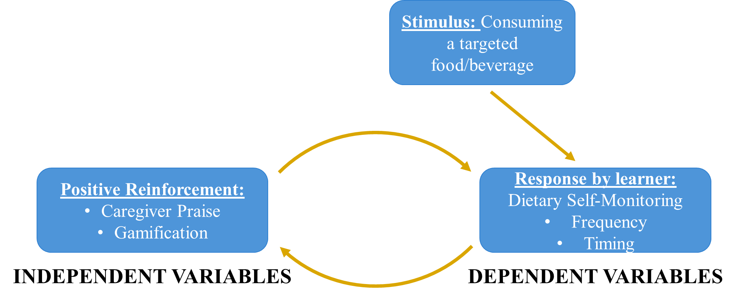 FIGURE 1. Illustration of the three-term contingency from behavioral theory consisting of stimulus, response, and consequence. In this study, the stimulus included foods and beverages from the targeted food groups, the response was subsequent DSM, and reinforcement included the two positive reinforcement strategies: caregiver praise and gamification.

Praise as Positive Reinforcement

Introduction to Praise
Praise has long been recognized as a valuable form of positive reinforcement for shaping behaviors in children.^{61,62} Kanouse et al defined praise as “positive evaluations made by a person of another’s products, performances, or attributes, where the evaluator presumes the validity of the standards on which the evaluation is based.”⁶³ Delin and Baumeister expanded this definition to include that praise is provided within the context of interpersonal communication, making it an inherently social act.⁶⁴ The underlying assumption is that praise signifies social acceptance and that social acceptance is reinforcing⁶⁵; thus, praise is classified as a social reinforcer.⁶² Praise can be provided verbally (e.g., saying “good job” or “well done”) or nonverbally (e.g., hugs, pats, smiles). One obvious advantage of praise is that it is free and does not require tokens, rewards, or other types of technology to implement.

Research on the Effects of Praise on Child Behaviors
Similar to the positive reinforcement literature in general, much of the research on the use of praise as a reinforcer has focused on academic tasks and performance and has been conducted among children with autism spectrum disorders, other developmental disabilities, or who were identified as being “noncompliant.”⁶⁴ However, few studies have examined the effects of praise in isolation. A 2012 review of praise, nonverbal reinforcement, and reprimand examined experimental, naturalistic, and training studies conducted with children ages 1.5-11 years.⁶⁶ In experimental studies in non-clinical populations, praise and nonverbal reinforcement were generally related to improved compliance.
Additionally, caregiver praise is also a fundamental component of parent training programs,^{61,65,67} and it is a frequently employed behavioral strategy in family-based treatment programs.^{38,68,69} For example, several studies have evaluated the Incredible Years parent training program, which emphasizes praise and positive attention, along with limit setting and non-violent discipline strategies (e.g., time-out, ignoring).^{67,70,71} While the training program covers a suite of positive parenting techniques in addition to praise, research shows that the program has positive effects on child compliance in younger children ages 2-7 years.

Effective Praise
As one researcher noted, just because praise can act as a reinforcer does not mean that it will in all situations.⁶¹ The nature of praise appears to be an important factor in how effective it will be in shaping child behavior. Brophy, in a review focused on teacher praise, provided a useful list of 12 guidelines for the effective use of praise as social reinforcement.⁶¹ These guidelines suggest that effective praise should:
- Be contingent upon the occurrence of desired behaviors, just like all forms of effective positive reinforcement.
- Offer specificity. Verbal praise should make clear to children what has been accomplished.
- Show signs of credibility (e.g., spontaneity, variety) and suggest that clear attention has been paid to the accomplishment.
- Be provided as a reward for meeting specified goals or criteria.
- Convey information about children’s competence or the value of what they have accomplished.
- Increase children’s appreciation for their own behavior while encouraging problem-solving.
- Build upon children’s prior accomplishments as context for the provided praise.
- Be given in response to effortful or noteworthy tasks or behaviors.
- Attribute children’s success to their abilities and effort to reinforce that success can happen again in the future.
- Foster children’s belief that they engage in the task or behavior because they enjoy it or want to develop skills.
- Focus children’s attention on their own positive behavior.
- Foster children’s own appreciation and desire for the task or behavior after it is completed.
These guidelines emphasize positive social interactions and the provision of contingent, specific, and credible praise that focuses on building the child’s sense of mastery and enjoyment.

Praise and Motivation
Ryan and Deci’s self-determination theory provides a framework for understanding the relationship between praise and motivation.⁷² Self-determination theory proposes all individuals have three basic psychological needs: competence, relatedness, and autonomy. Competence (or mastery) refers to feeling effective at engaging in a behavior. Relatedness refers to feeling a sense of connection or belonging to others. Autonomy refers to the feeling that one is acting out of a sense of their own volition and has the opportunity to control their behaviors. Importantly, self-determination theory is concerned the quality of motivation rather than just quantity. Motivation may be either intrinsic or extrinsic. In intrinsic motivation, an individual engages in a behavior because of genuine interest, personal curiosity, and a desire for personal growth. In contrast, extrinsic motivation is driven by external factors (e.g., tangible rewards).
Cook and Artino developed a conceptual model of motivation based on self-determination theory.⁷³ As shown in Figure 2, motivation exists on a continuum from the most
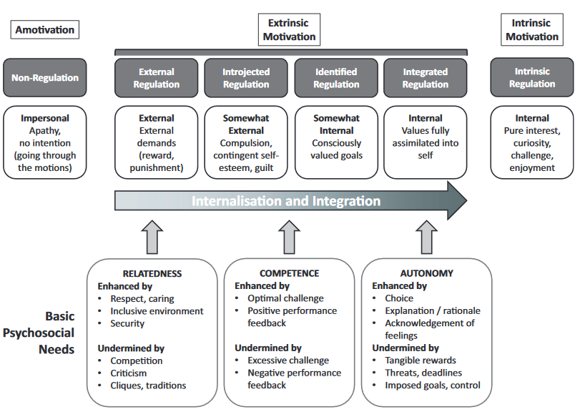
FIGURE 2. Conceptual model from Cook and Artino’s 2016 review of motivational theories.⁷³ The figure illustrates the continuum of motivation from complete amotivation to perform a behavior through the various stages of extrinsic motivation to fully internalized intrinsic motivation.

extreme form of extrinsic motivation, external regulation—where engagement in a behavior depends entirely on environmental factors (e.g., rewards and punishment) with no internalization of the behavior's value—to intrinsic motivation, where engagement is driven entirely by internal factors—when the value of the behavior is fully internalized and integrated into one's sense of self. The more the three basic needs of competence, relatedness, and autonomy are met, the more likely a behavior will be intrinsically valued and motivated.
Verbal rewards, such as praise, consistently appear to enhance intrinsic motivation.⁷⁴ One of the seminal early studies on this topic, conducted by Deci, found that young adults provided with verbal praise for their performance on a puzzle game engaged with the puzzle for significantly longer during free periods compared to participants who did not receive praise.⁷⁵ The choice to engage with the puzzle during free periods indicates higher intrinsic motivation, as participants continued the behavior in the absence of external reinforcement. Similarly, a meta-analysis of verbal rewards (praise and positive feedback) found that, compared to no verbal rewards, both children’s and adults’ intrinsic motivation increased significantly as measured by time on task and attitude, while tangible rewards were shown to decrease intrinsic motivation as measured by time on task.⁷⁶
In a review of the effects of praise on intrinsic motivation in children, Henderlong and Good described four attributes of praise that enhance motivation and perseverance in the recipient.⁷⁷ Intrinsically motivating praise should 1) imply that success results from “controllable, malleable forces” (e.g., strategy); 2) reduce feelings of being controlled by external forces, while encouraging autonomy; 3) build a sense of competence; and 4) provide “specific, accurate information” about the child’s performance.⁷⁷ These attributes map neatly onto the constructs of self-determination theory, thus illustrating how well-constructed praise can increase intrinsic motivation by enhancing autonomy and competence. Additionally, because praise is a social act, it may also enhance feelings of relatedness.
In general, process praise is believed to be more beneficial for building a child’s intrinsic motivation and self-efficacy.^{77,78} Process praise (e.g., “What a thoughtful way to complete that task!”) emphasizes the controllable, adaptable parts of a child’s performance (e.g., the strategy used) and tends to encourage enjoyment and persistence.⁷⁷ Soenens and Vansteenkiste examined praise through the lens of self-determination theory.⁷⁹ When praise is high in informational value (i.e., it conveys information about an individual’s strengths and opportunities for growth), the recipient may feel an increased sense of competence and confidence in handling similar situations in the future. However, when praise is high in evaluative value (i.e., reinforcing external expectations or standards), it can undermine autonomy by making the individual feel pressured or manipulated into meeting those external standards.
A pair of studies, one in fourth and fifth graders (n = 93) and one in preschool children (n = 76), illustrate these concepts well.⁸⁰ Both studies examined the effects of three types of praise (person, product, and process) on children’s motivation to engage in puzzle games (tangrams and jigsaw puzzles). All three types of praise demonstrated beneficial effects on child motivation; however, the effect was much stronger for product and process praise. Additionally, results suggested that “person” praise (i.e., praise that focuses on attributes of the child rather than the process she is engaged in or the product she produces) may have undermined motivation in some children. Product and process praise relay information about what and how a task was accomplished, while person praise emphasizes nonmalleable personal characteristics.
Still, the research on praise is complex. Its effectiveness may also be influenced by a child’s individual characteristics or other contextual factors. If children perceive praise as intended to manipulate behavior, or if they perceive the praise as exaggerated or inflated, it may be less effective.^{79,81,82} For example, research also suggests that the magnitude of praise (modest vs inflated) may affect behaviors differently in children with differing levels of self-esteem. Inflated praise (e.g., “you did extremely well”) may increase avoidance of challenging tasks in children with low self-esteem, suggesting decreased motivation to engage in those activities.⁸³ On the other hand, modest caregiver praise (e.g., “you did well”) may encourage motor exploration in children with low self-esteem but discourage it in children with high self-esteem.⁸⁴ Thus, tailoring praise so that it supports feelings of autonomy, competence, and relatedness given a child’s unique traits may be important.
In conclusion, praise is well-established as an effective social reinforcer. When delivered in an informational way that emphasizes the process for performing a task, it can enhance intrinsic motivation by increasing feelings of competence and autonomy. If the praise is perceived as inauthentic or exaggerated, it may conversely undermine motivation.

Gamification as Positive Reinforcement

Introduction to Gamification
Gamification has been defined as the “use of game design elements in non-game contexts” and encompasses the interplay of game mechanics and game dynamics. ⁸⁵⁻⁸⁹ Game components act as positive reinforcers to increase engagement with an app, device, or system. Frequently, digital points are exchanged for rewards, such badges or “leveling up,” and therefore can be conceptualized as a form of a digital token economy. Token reinforcement describes the process of awarding tokens that can be exchanged for an item or activity that a child finds reinforcing. These rewards may act as positive reinforcers that increase the likelihood that the individual will engage in the desired behaviors again. When gamification is implemented within a digital system, it has advantages that make it a potentially potent tool for behavior change. The reinforcement is provided immediately, contingently, and consistently as an inherent feature of the system’s programming.
Gamification is a relatively new area of research that emerged around 2010.⁹⁰ Walz and Deterding suggest that the growing popularity of pervasive games—or games in which the game experience extends into the real world (e.g., location-based augmented reality)—in the early 2000s was a harbinger of the gamification explosion to come.⁹¹ Gamification began in industry and advertising, arguably with the launch of foursquare in 2009 which acted as an early blueprint for the movement.⁹¹ foursquare, a social location-based service that allows users to check-in at real-world venues, utilizes a number of game components, such as points, badges, and leaderboards. Points, levels, and leaderboards have been deemed the “heart” of gamified systems and have been described as essential components of gamification.⁹² Other common game components include achievements, avatars, badges, boss fights, collections, combat, content unlocking, gifting, quests, social graphs, teams, and virtual goods.⁸⁹ Gamification now extends into nearly all realms of life, with most gamified systems using some version of points, badges, and leaderboards.^{91,93}
One useful framework for understanding gamification is to view it as a hierarchy of game design elements: dynamics, mechanics, and components.⁸⁹ Highest in the hierarchy (the top of the pyramid) is dynamics, which are big-picture user experiential and emotional outcomes (e.g., having fun, game progression).^{87,89} Next is game mechanics, sometimes known as motivational affordances, which include the processes that drive action and engagement with the gamified system (e.g., rewards as a means of progression).^{87,89} Lowest in the hierarchy (the base of the pyramid) are game components, which are the specific manifestations of mechanics and dynamics (e.g., levels and points as rewards that progress the game).⁸⁹ If game mechanics and dynamics are used in the right combination, the expectation is that enjoyment and, thus, engagement will increase.^{86,87} Put simply, gamification provides the opportunity to make a non-game experience more fun with the aim to increase an individual’s motivation to engage.⁸⁶

Designing Effective Gamification
One factor that distinguishes gamification from simply a game is that the primary goal of a gamified process is to affect behavior, rather than to entertain.⁹⁴ Some researchers have suggested gamification is overhyped, predicting that the majority of gamified applications are doomed to fail due to “shallow implementations” of gamification mechanics.^{95,96} Two requirements for gamified software have been suggested: 1) it must be well-designed and function as intended and 2) it must facilitate engagement in a way that encourages the desired behaviors or behavioral change.⁹⁴ The creation of ineffective gamification systems developed by individual gamification experts “in a vacuum” has also been criticized, citing a need of multidisciplinary knowledge when developing effective gamification.⁹⁴
Other gamification experts also emphasize the need for deep understanding of behavioral and psychological theories.^{86,97} Using a design science research approach, Morschheuser et al. developed 13 design principles for gamified software through systematic review of the literature.⁹⁴ The principles focus on user needs and the need for careful consideration of human psychology and behavior in the design process. Other experts have similarly emphasized the need to have a clear goals from the outset of development and to carefully consider the target users and their traits (e.g., age, gender, culture, personality).⁹⁸ Krath and von Korflesch also conducted a systematic review to identify design principles for gamification in the published literature.⁹⁹ A total of 63 principles. The authors distilled these principles into a framework for intervention design that considers the contextual factors (location, users, etc.), user-oriented principles (i.e., individual and social behavior principles), and system-oriented principles (i.e., hedonic experience principles). The framework provides a useful overview of how the identified gamification design principles sit within the greater context of the overall purpose of the system.
Though not specific to the design of gamification, principles from User Centered Design (UCD) philosophies are also relevant. UCD emphasizes user involvement in some or all parts of the design process and focuses on the usability of design as perceived by the user.¹⁰⁰ The concept of UCD was developed by Norman who offered four recommendations for design.¹⁰¹ The design should:
- Make it clear what actions are possible at any given moment.
- Make concepts and actions clearly visible, e.g., the system’s conceptual model, alternative actions, and results of actions.
- Make evaluation of the system’s current state simple.
- Follow natural paths between the user’s intentions and the required actions, between the user’s actions and the subsequent results, and between visible information and evaluation of the system’s current state.
In other words, the system design should make clear what options are available to users at a given moment, as well as the results of acting within the system. Like the other design principles described, UCD focuses on user experience.

Gamification in Health and Wellness Technologies
The gamification market in the United States is already estimated to be in the billions of dollars,¹⁰² and empirical research is only beginning to catch up to its use in the commercial realm. With the rise in noncommunicable lifestyle diseases, gamification has also become increasingly utilized in health-related contexts to influence behavior and increase engagement.^{85,103,104} The health and wellness industry has focused on the gamification of self-monitoring and analysis of health-related behaviors and body states (mental and physical).
Most of the popular health and wellness apps available commercially already implement game mechanics. MyFitnessPal, one of the most popular weight loss and fitness apps, offers immediate feedback and shareable results. Physical activity apps also heavily integrate gamification design components into user experience. For example, Nike+ allows users to collect “NikeFuel points” that can unluck achievements and can be shared socially. Perhaps one of the most creative applications of gamification is found in Zombies, Run!, a running app that narrates an apocalyptic storyline during your run. Thus, as the number of mobile/wearable technologies and health apps have increased, so has the use of gamification.
A 2016 review by Johnson et al. found generally positive effects of gamification on health and well-being (n = 22; positive effects for 59% of the included studies).⁹⁰ No studies reported purely negative effects. The authors also identified several “promises of gamification” related to health and well-being:
- Gamified health systems may increase intrinsic motivation. (Motivation and gamification are described in more detail later.)
- Gamification is broadly accessible via mobile health (mHealth) technologies and can be used with wearable sensors.
- Gamification design tends to have broad appeal with a wide variety of audiences.
- Gamification can be broadly applied to many health risks and health conditions (e.g., physical activity, diet, weight loss, medication adherence, mental health).
- Retrofitting or enhancing existing health systems can have cost-benefit efficiency.
- Gamification can easily fit into everyday life given the ubiquity of mobile phones and wearable sensors already on the market.
- Gamified systems can also support well-being through basic psychological needs fulfillment, social engagement, and feelings of accomplishment.
Gamified technologies related to health, wellness, and healthcare are diverse. Garret et al. identified 14 elements of gamification in healthcare-specific studies that used gamification:⁸⁸
- Social interaction. Users can interact or collaborate with one another in some way.
- Personalization. Users can create an avatar or virtual representation of themselves.
- Adaptive game mechanics. The application can adapt to user input and performance.
- Global timer mechanics. User-triggered events are implemented.
- Appointment dynamics. Users must complete a task within a certain timeframe.
- Points. Users are awarded points or virtual currency for completing tasks.
- Badges/medals. Users are awarded badges/medals for completing tasks.
- Levels. Users can “level up” in some way.
- Story/narrative. A narrative or storyline was implemented within the gamification.
- Reward system. Users can exchange their points or virtual currency for something of value, either online or offline.
- Immediate feedback. Users are provided immediate feedback after completing tasks.
- Progress status. Users can check their progress.
- Shareable results. Users can share their progress on their personal social media accounts.
- Leaderboards. Users can display progress to others on a leaderboard.
Unfortunately, little research exists on the effects of specific game mechanics on desired behavior changes, particularly in children.¹⁰⁵ Furthermore, few empirical studies have directly compared game mechanics or tested game mechanics in isolation. Many existing studies failed to include a non-gamified control or to use high-quality methodology like randomized trials. Additionally, game mechanics are often tested in “packages,” and much of the research on gamification within child-specific health contexts describes the development and pilot testing (but not effectiveness) of novel technologies. Current research on gamification is described in the following section.

Gamification to Improve Child Self-Monitoring Behaviors
Gamification as a strategy to improve user engagement in self-monitoring aligns with the service marketing perspective of gamification, which views value as co-created by the user.¹⁰⁶ Huotari and Hamari defined gamification as the “process of enhancing a service with affordances for gameful experiences in or order to support user’s overall value creation.”¹⁰⁶ In other words, a service does not have inherent value on its own without the user; value is experienced and determined by the user. This definition provides a helpful framework for integrating gamification into health interventions. For example, the process of self-monitoring can be interpreted similarly to a service in that there is no tangible product, and the value of self-monitoring is determined by the individual who engages in it. Thus, gamification may be used to enhance an existing intervention strategy (self-monitoring) to increase the value an individual experiences regarding self-monitoring. Empirical research investigating gamification as a strategy to improve self-monitoring in children is presented below.

Blood glucose monitoring
Blood glucose monitoring is one of the most explored areas related to the gamification of self-monitoring in children; however, well-designed evaluation studies are limited.¹⁰⁷ Three studies were identified that reported on blood glucose self-monitoring outcomes.
One prospective randomized clinical trial tested a diabetes management system among insulin-treated children and adolescents (n = 40) ages 8-18 years with type 1 or type 2 diabetes.¹⁰⁸ Each participant was provided a blood glucose monitor and a personal digital assistant (PDA) with data management software. For the gamified condition, participants’ PDAs also included the DiaBetNet game. After three blood glucose results were entered, the game would display a graph showing the day’s prior glucose levels, insulin doses, and carbohydrate intake. Participants would then attempt to predict what their upcoming blood glucose reading would be. A fixed number of points were awarded for blood glucose reading predictions with additional points awarded for accuracy of prediction. Children in the DiaBetNet condition had significantly higher levels of blood glucose monitoring compared to the non-game group. A total of 78% of DiaBetNet participants checked their blood glucose levels four or more times per day compared to 68% in control participants. Total transmitted blood glucose values were 1,662 for DiaBetNet participants and 1,471 for control participants. During the 4-week trial, the frequency of hyperglycemia was significantly lower in the DiaBetNet group compared to the control group.
An initial pilot study (n = 20) of an app called bant conducted in adolescents ages 12-16 years with type 1 diabetes explored whether bant could improve frequency of blood glucose monitoring.¹⁰⁹ A small adapter that plugged into the blood glucose monitor allowed for wireless transfer of readings to the mobile app via Bluetooth. The app included two gamification features: an algorithm-driven rewards system that allocated points for adhering to best-practice guidelines for blood glucose monitoring and a social networking component. Participants would “level-up” each time they earned 200 points, and points could be redeemed for real-world prizes (Apple iTunes and App Store purchases). Baseline use of blood glucometers was established by extraction of data from the participant’s personal device at the time of recruitment. Compared to baseline, the average number of daily blood glucose measurements was increased by 50% (2.4 readings to 3.6 readings per day, p = 0.006) from baseline to 12-week follow up, respectively. No control group was included for comparison.
After the pilot, the app was updated based on qualitative evaluation and tested again in a 12-month randomized controlled trial.¹¹⁰ The bant reward system was updated to award points for taking up to 5 blood glucose readings in a day, getting readings in the targeted range, avoiding readings outside the targeted range, and resolving any identified 3-day trends. Participants could still redeem points for real-world prizes, and a private social media community was also created to allow communication among participants. However, in the RCT no differences in self-monitoring or clinical outcomes were identified between bant group and usual care control group.
Several other studies were identified that focused on gamified self-monitoring systems for children and adolescents with diabetes; however, self-monitoring outcomes were not explicitly reported. These technologies utilized points,^{111,112} leaderboards,¹¹¹ levels,¹¹² mini-games,¹¹² integration with commercial gaming systems (e.g., Nintendo®),¹¹² badges,¹¹³ and social media.¹¹³ These systems were generally well accepted.^{112,113} However, one system, which included many additional features such as a virtual coach and ability to integrate sensors, was deemed overly complex by participants, and the system was not used as frequently as expected by the researchers.¹¹¹
Blood glucose monitoring is the only health realm in which the effect of gamification has been explicitly tested on child self-monitoring behaviors, and studies are limited. However, preliminary evidence suggests that gamification improves child engagement in blood glucose monitoring and may enhance health outcomes.

Lung function self-monitoring
No gamification studies were identified in which outcomes for self-monitoring of lung functions were reported. However, two small studies presented the development and acceptability of lung function monitoring systems using spirometry for disease management in children with asthma¹¹⁴ and cystic fibrosis.¹¹⁵ An asthma self-care system called InSpire utilized a compact mobile phone spirometry device that incorporated spirometry games and a reward system based on consistent lung function assessments.¹¹⁴ For the spirometry game, users played a character known as Azmo the Dragon and completed spirometry maneuvers to breathe fire to defeat his enemies. The app also utilized global timer mechanics; completing spirometry maneuvers within certain timeframes was highly rewarded. After a single testing session, the majority of sampled children (n = 9, ages 7-14 years) indicated that they would prefer to use InSpire over the spirometer alone.
In a separate study, children (n = 5, ages 10-14 years) with cystic fibrosis were provided a spirometer connected to a laptop computer.¹¹⁵ There was an optional gamified component that manipulated a cartoon boat race corresponding to three consecutive blows. Authors reported the feature was only selected by younger participants. Additional details were not reported regarding the gamified portion of the system.
Taken together, these studies suggest that integration of gamification into lung function self-monitoring is acceptable and well-liked by children; however, it is unclear whether gamification would enhance self-monitoring of this health metric.

Physical activity self-monitoring
Like the asthma research, no gamification studies were identified in which self-monitoring outcomes related to physical activity were reported. One study of children 8-13 years (n = 54) allocated participants into either the game or feedback group, and both groups were provided with wrist activity trackers.¹¹⁶ In the second week of the study, game group participants were provided an iPhone with the app MobileKids Monster Manor. Activity data from the wrist tracker was transmitted to the phone and converted into points that granted the user playtime in the game. Feedback group, on the other hand, received quantitative physical activity feedback via an online software called Tractivity beginning in the second week of intervention. No information was provided on how frequently participants self-monitored their activity. Physical activity levels did not differ between groups during intervention.
A separate study described the development and acceptability of a gamified physical activity monitoring app, e-Gibalec, for children ages 10-13 years that used physical activity data captured by the child’s smartphone.¹¹⁷ Children who used the app were assigned a default animal avatar that provided guidance and motivational messages and exhibited different emotions based on the child’s progress toward goals. The home screen also showed status bars that indicated progress towards daily activity goals. Engagement in physical activity was rewarded with virtual coins, with a special reward provided when the daily physical activity goal was achieved. In cases where the phone was not carried during a bout of physical activity, a parent or physical education teacher could manually add rewards via a web application. The main objective of the study was to evaluate the accuracy of using the mobile phone algorithms to calculate physical activity levels compared to other accelerometry devices. However, researchers did complete a subjective evaluation with children (n = 10) ages 10-12 years after two weeks of use. Children reported relatively high levels of satisfaction (out of possible 5: 4.1 overall, 4.4 for attractiveness of avatars, 3.9 for usefulness of challenges, and 4.0 for motivation for sports).
Neither of these studies reported on self-monitoring outcomes explicitly. The first study did not find differences in levels of physical activity between groups.¹¹⁶ However, physical activity was passively recorded by wrist trackers, and it was unclear what degree of self-monitoring each group engaged in. The second study evaluated a rather sophisticated gamified system for physical activity self-monitoring, but no control group was included in the design.¹¹⁷ However, qualitative analysis suggested high levels of acceptability and satisfaction.

Dietary self-monitoring
No studies have examined how gamification can improve DSM in children, but a small number of studies have integrated gamification into DSM applications without reporting on DSM outcomes explicitly. One 6-week RCT was identified that investigated the effect of gamification on number of sessions (i.e., periods wherein the user interacted with the app) with a DSM app.¹¹⁸ Adult participants elected one child or grandchild (n = 14) ages 12-20 years to complete DSM on their behalf using a digital food and beverage tracking app. The basic logbook app allowed for recording of dietary intake, while the gamified version included leaderboards, badges, and achievements that unlocked features of a virtual garden and a virtual fish tank. Dyads assigned to the gamified app completed significantly more sessions than dyads assigned to the non-gamified app (log means of 0.46 vs 0.20). However, sessions simply indicated interactions with the app and did not necessarily represent improved DSM behavior. No outcomes for DSM variables (e.g., frequency or sufficiency) were reported.
A separate study examined how gamification of DSM affected diet in tenth graders (n=87) ages 15-16 years enrolled in a 9-week health education course.¹¹⁹ Results suggested improved dietary intake in the gamified log condition vs control. Again, however, no outcomes for DSM variables were reported.
Like the research on self-monitoring of lung function and physical activity, gamified DSM studies did not report on DSM outcomes explicitly. Both studies suggested that gamification of DSM has the potential to improve dietary intake. However, without knowledge of potentially different levels of DSM between the groups, it is impossible to draw this conclusion with any certainty. Additionally, one study instructed children to engage in DSM on behalf of an adult caregiver, making interpretation difficult.

Summary
In conclusion, the research on the gamification of self-monitoring systems for children is limited. Only studies examining blood glucose monitoring reported on self-monitoring outcomes explicitly. Additionally, gamified systems were examined as integrated “packages,” meaning individual game components were not isolated. Thus, it was impossible to determine which game components might drive the observed effects. Thus, well-designed studies that include DSM as primary outcomes and test gamification components in isolation and combination are needed.

Gamification and Motivation
Historically, social psychologists have believed that external rewards undermine intrinsic motivation.⁷⁵ For example, a review of previous meta-analyses by Deci, Koesthcner, and Ryan observed that, “In general, the most consistent finding was that task-contingent tangible rewards (i.e., those given for either engaging in or completing a task) were detrimental to intrinsic motivation.”⁷⁴ Other researchers disagree that there are “pervasive negative effects” of external rewards on motivation and posit that rewards offered for low-interest free-choice tasks actually enhance intrinsic motivation.¹²⁰
Gamification elements like points, levels, and leaderboards offer task-contingent rewards for engaging in desired behaviors. However, like other external rewards, the circumstances in which gamification may contribute to or undermine intrinsic motivation are nuanced and complex. Some researchers have suggested that the reason game experiences increase motivation and positively affect behavior is that they satisfy the intrinsic needs described in self-determination theory (competence, relatedness, autonomy).^{121,122} Many gamification studies cite self-determination theory as the framework underpinning why gamification increase motivations to engage in health behaviors.⁸⁶ However, games are not equivalent to gamified systems, and critics have suggested that gamification, which frequently provide extrinsic motivation in the form of points, badges, etc., may undermine intrinsic motivation.⁹⁷
To date, research on gamification and motivation has largely been conducted in the fields of workplace performance^{123,124} and academic learning.¹²⁵⁻¹²⁷ This section focuses on research from the field of academic learning, as participants tended to be children and adolescents rather than adults in the workplace. Several reviews of gamified learning environments have been conducted, with mixed conclusions about the impact of gamification on intrinsic motivation. Some researchers have argued that, in accordance with self-determination theory, as gamification increases extrinsic rewards, it conversely causes intrinsic motivation to decrease, resulting in less interest in academic work.¹²⁷ Thus, gamification may only increase intrinsic motivation levels when a task is considered boring and may undermine intrinsic motivation when a task is inherently interesting.¹²⁷
Conversely, others have argued that gamification, provided in the right way and within the right context, can meet basic psychological needs and improve intrinsic motivation.^{125,128} Two meta-analyses concluded there was an overall positive effect of gamified learning on intrinsic motivation.^{125,126} One of the studies, which included 35 gamified education interventions, found that reward combinations for level of performance achieved (rather than simple task completion participation) had the largest effect size of the types of contingencies examined.¹²⁵ The authors suggested this finding may be explained by how rewards based on performance affect learners’ perceptions of competence. However, the study also noted that gamified interventions that were short (1 to 3 months) had larger effect sizes, while gamified interventions that lasted a semester or longer had negligible or negative effects on intrinsic motivation. Short-term curiosity or novelty effect may explain this inconsistency in outcomes.¹²⁹
In conclusion, the effect of gamification on intrinsic motivation appears to be contingent upon the game components employed and the context in which they are implemented.¹³⁰ In situations in which gamification facilitates the basic psychological needs of autonomy, competence, and relatedness, intrinsic motivation is likely to be enhanced.^{130,131} When an activity is inherently interesting, there is a peril that the introduction of extrinsic rewards via gamification could undermine existing intrinsic motivation.¹²⁷ However, external rewards offered for low-interest free-choice tasks actually enhance intrinsic motivation.¹²⁰ Thus, the quality of the activity or behavior targeted for gamification should be carefully considered (e.g., whether it is inherently interesting or inherently boring), and game elements that work to facilitate rather than undermine autonomy, competence, and relatedness should be selected.

Late Childhood as a Target for Intervention
Late childhood, between the ages of 8 and 12 years, is an optimal time to implement interventions that use positive social reinforcement (e.g., praise) from caregivers. During this developmental period, children exhibit higher sensitivity to adults’ evaluations of themselves and their actions.¹³² As they transition into adolescence, adolescents experience a growing need for autonomy, and the influence of caregivers decreases while the influence of peers increases.^{133,134} Consequently, positive social reinforcers from caregivers, such as praise, may become less effective as children age into adolescents. Additionally, there is a large body of evidence suggesting that gamified technologies can improve engagement and motivation in elementary school-aged children.¹³⁵ Finally, beginning around the age of 8 years, children’s ability to self-report dietary intake rapidly increases, and thus they can be more active participants in self-monitoring in ways that younger children cannot.¹³⁶ Therefore, targeting children aged 8 to 12 for a study examining the effects of caregiver praise and gamification is both practical and developmentally appropriate.

Summary
DSM is an essential behavior change strategy and is a cornerstone of nutrition interventions for children. Self-monitoring increases an individual’s awareness of recorded behavior, allowing for self-evaluation and modification of behavior. DSM, in particular, is a cornerstone of behavioral interventions for the prevention and treatment of overweight and obesity and related comorbidities. However, adherence is low in children and adolescents. Positive reinforcement in the forms of caregiver praise and gamification provide opportunities to improve child engagement in DSM. Caregiver praise is a potentially powerful social reinforcer for modifying child behaviors and can be used to reinforce the DSM behavior in children. As a social reinforcer, praise has the potential to increase intrinsic motivation and, therefore, support maintenance of DSM behaviors over time. Additionally, gamification research has shown limited but promising results in child self-monitoring contexts. However, researchers currently debate whether gamification, which provides external rewards, may undermine intrinsic motivation and increase extrinsic motivation instead. Additionally, it is currently unclear how different positive reinforcement strategies in isolation and combination should be implemented to optimally enhance child DSM. Thus, a study that examines the effect of different positive reinforcement approaches (e.g., caregiver praise and gamification) on child DSM behaviors, while exploring potential underlying mechanisms (e.g., intrinsic motivation) is warranted.

PART II. MANUSCRIPT

Background
Dietary self-monitoring (DSM) is an essential behavior change strategy and is a cornerstone of nutrition interventions for children.¹⁻⁷ More complete DSM increases individuals’ awareness of their dietary intake in relation to their dietary goals in real time, allowing them to make connections between their dietary choices and health.^{8,9} Additionally, the act of self-monitoring frequently produces changes in the tracked behavior, a phenomenon known as reactivity.¹⁰ The tendency of self-monitoring to result in reactivity in behavior change in a beneficial direction is an important factor in its use as a behavioral change tool.²⁵ These characteristics of DSM are what are hypothesized to improve nutrition choices and enhance weight outcomes.⁴⁻⁷ However, previous studies indicate that DSM adherence is poor among children and adolescents.⁴⁻⁷ Thus, studies investigating how to enhance engagement in this crucial behavior change strategy are warranted.
With the rise of health technologies, it is no surprise that DSM has evolved over time. Traditionally, DSM was completed using pen-and-paper methods.^{48,49} In recent years, mobile technologies provide numerous options for digital diet tracking.⁵⁰ In the commercial realm, an entire digital wellness industry has emerged, with a strong focus on helping adults implement and maintain healthy lifestyle changes. Dozens of diet smartphone applications (or apps) are now available.⁵⁰⁻⁵² These web-based methods of DSM can be completed quickly, in real-time, while potentially reducing burden.^{48,49} Thus, examining how web-based DSM can be enhanced to improve engagement in children is a promising area of research.
One potential strategy for improving DSM is through positive reinforcement. Positive reinforcement occurs when a stimulus (or reward) is presented after a desired behavior is performed to increase the likelihood of that behavior occurring again.⁵⁸ It has been recognized as an effective strategy for behavior modification in children for many decades.⁴⁵ There are several types of positive reinforcers.^{59,60} Two common types used within child-focused interventions to support improved outcomes are social reinforcers and token reinforcers.^{59,60} Social reinforcement occurs when social rewards are provided following a behavior. For example, a child may receive a kind smile from a parent after engaging in positive behavior. Token reinforcement occurs when the reinforcer that is provided can be exchanged for something of value. For example, a child may receive points for completing chores at home, and these points may be exchanged for a reward.
A frequently targeted social reinforcer is caregiver praise. Praise acts as a form of social reinforcement because it is as a social reward following a desired behavior.⁶² The underlying assumption is that praise signifies social acceptance and that social acceptance is reinforcing.⁶⁵ Praise has long been recognized as valuable for shaping behaviors in children.^{61,62} Caregiver praise is a fundamental component of parent training programs^{61,65,67} and is a frequently employed behavioral strategy in family-based treatment programs.^{38,68,69} Furthermore, caregiver praise may be important for maintenance of outcomes after completion of family-based behavioral treatment programs.¹³⁷ Thus, the utility of caregiver praise for enhancing DSM behaviors specifically should be explored.
Gamification has been defined as “use of game design elements in non-game contexts.”⁸⁵⁻⁸⁹ Points, levels, and leaderboards have been deemed the “heart” of gamified systems and have been described as essential components of gamification.⁹² Digital points can be exchanged for rewards, such as badges, or “leveling up,” and therefore can be conceptualized as a form of token reinforcement. Blood glucose monitoring is one of the most explored areas in which the gamification of self-monitoring systems for children is used. However, well-designed evaluation studies are limited.¹⁰⁷ Some,^{108,109} but not all,¹¹⁰ studies that utilized gamified blood glucose monitoring systems among children and adolescents with diabetes found evidence of improved self-monitoring. Given these promising findings, research on how gamification can be integrated into DSM to enhance child outcomes should also be explored.
The extent to which a child chooses to engage in a behavior, such as DSM, may be explained by motivational factors. Self-determination theory (SDT) provides a framework for understanding the relationship between reinforcement and motivation.⁷² SDT views all individuals as having three basic psychological needs: competence, relatedness, and autonomy. Competence (or mastery) refers to feeling effective at engaging in a behavior. Relatedness refers to feeling a sense of connection or belonging to others. Autonomy refers to feeling that one is acting out of a sense of their own volition and can control their own behaviors. Importantly, SDT is concerned not only with the quantity of motivation but also with its quality. Motivation may be either intrinsic or extrinsic. In intrinsic motivation, an individual engages in a behavior because of genuine interest, personal curiosity, and a desire for personal growth. In contrast, extrinsic motivation involves external factors driving engagement in a behavior. Identifying strategies that support children’s intrinsic motivation to engage in DSM could enhance outcomes. Praise (specifically process praise) is generally believed to be beneficial for building a child’s intrinsic motivation and self-efficacy, as it can enhance feelings of competence and relatedness.^{77,78} Research on how gamification affects intrinsic motivation is mixed.¹²⁵⁻¹²⁸ However, emerging evidence suggests that when gamification is provided in the right way within the right context, it too can meet basic psychological needs and improve intrinsic motivation.^{125,128}
At this time, no studies have focused on how to improve DSM behaviors in children or examined the unique needs of this population to engage in this important behavioral strategy. Furthermore, there is a scarcity of research examining how positive reinforcement, such as caregiver praise and gamification, could affect child DSM adherence. Only a small number of studies have examined how gamification can improve blood glucose self-monitoring behaviors,¹⁰⁸⁻¹¹⁰ and no studies were identified that investigated how praise might be used to enhance self-monitoring outcomes in children. Furthermore, no studies have attempted to identify the underlying mechanism (e.g., intrinsic motivation) that might explain the relationship between positive reinforcement interventions and enhanced self-monitoring outcomes. Thus, this study aimed to:
Aim 1: Examine the usability of a DSM log that uses positive reinforcement (caregiver praise and gamification) among children 8-12 years and their adult caregivers.
Aim 2: Examine the acceptability of a DSM log that uses positive reinforcement (caregiver praise and gamification) among children 8-12 years and their adult caregivers.
Aim 3: Conduct a proof-of-concept trial that examines the effects of positive reinforcement on child DSM behaviors.
Exploratory Aim: Examine differences in children’s intrinsic motivation.
The study consisted of two phases: a formative usability and acceptability testing phase and a subsequent proof-of-concept trial. Aims 1 and 2 were addressed during the formative testing phase and results informed modifications to the DSM log design prior to the proof-of-concept trial, which addressed Aim 3 and the Exploratory Aim.
For the proof-of-concept trial, it was hypothesized that 1) children assigned to caregiver praise would have better overall DSM behaviors than children not assigned to receive caregiver praise and 2) children assigned to gamification would have better overall DSM behaviors than children not assigned to gamification. Additionally, it was hypothesized that children assigned to caregiver praise would report greater increases in intrinsic motivation than children not assigned to caregiver praise.
This investigation addresses gaps in understanding how DSM behaviors can be improved in children by examining the effects of two positive reinforcement strategies in isolation and through interaction. Additionally, it examines intrinsic motivation as the potential underlying mechanism that explains the relationships between caregiver praise and gamification and DSM behaviors in children.

Phase I: Formative Testing

Methods

Study Design and Primary Outcomes
Formative procedures consisted of a single in-person usability and acceptability testing session in the Healthy Eating and Activity Laboratory (HEAL) at the University of Tennessee, Knoxville (UTK). A laptop with a beta version of the web-based DSM log was used during the appointment. The log included four features: the ability to log foods and beverages, a “help me” feature (which described the food groups that would be targeted in the proof-of-concept trial, with a description of serving sizes), a button to mark logging complete for the day, and a caregiver check-in feature (which allowed caregivers to indicate they have reviewed their child’s DSM for that day). Gamification was not yet integrated into the log during beta testing. Thus, a printed handout with virtual pet design along with a verbal description of how gamification would function in the final version of the log was provided for feedback. The primary outcomes were the usability and acceptability of the beta log as reported by children and their caregivers.

Participants
Recruitment occurred from August through November of 2023. Children aged 8-12 years, with an adult caregiver willing to participate, were eligible for the study. Child-caregiver dyads had to live in the greater Knoxville area and be able to communicate and read in English. Children had to be able to read at a third grade reading level or above, as reported by an adult caregiver, and were excluded if they had any major psychiatric disorders or organic brain syndromes. The study protocol was approved by the Institutional Review Board at the University of Tennessee, Knoxville (UTK IRB-22-07259-XP).
Families were recruited from a list of potential participants generated from the Families Becoming Healthy Together (FBHT) Program (PI: Hollie Raynor, PhD; UTK IRB-18-04910-XP), a family-based lifestyle intervention study conducted at HEAL. First, FBHT families who were finished with active intervention, had a child within the eligible age range, and had completed 18-month follow-up measures were contacted. Additionally, a question was added to the FBHT phone screening to determine if ineligible or uninterested families were willing to provide permission to be contacted about the current study. Any families who indicated “yes” to this question were contacted. Finally, families who enrolled in the current study were encouraged to provide information to other families who may also be interested. Families who agreed were provided with copies of the recruitment flyer to distribute. All recruitment materials included the laboratory phone number and email, as well as a QR code that linked to a Qualtrics collected caregiver contact information and permission to contact.
Study staff contacted potentially eligible families to complete a phone screening. During the phone screening, researchers provided an overview of the study and asked eligibility screening questions. Eligible families were invited to complete a single in-person session at HEAL and were emailed a copy of the consent form to review prior to the session. The session began with an orientation that included a detailed overview of the study, after which written informed consent and assent were collected.

Flow of Session
Study materials are included in Appendices A & B, and formative study flow for the formative phase is illustrated in Figure 3. Two study staff were present during testing sessions, an interviewer (the doctoral candidate) and a second observer (trained graduate or undergraduate student). The interviewer interacted with the family, providing instructions and prompts, while the second observer took notes on nonverbal responses (e.g., body language or facial expressions that indicated emotions such as boredom, frustration, confusion) during all testing activities other than survey administration. All testing sessions were audio recorded using Zoom with the camera off.
After consent and assent were collected, the interviewer provided an overview of the purpose of the DSM log and its basic features to both the child and caregiver. Participants were informed that their opinions and feelings about the log were important, whether positive or negative, and that there were no right or wrong responses. After this introduction, the caregiver was asked to wait in a separate room while the child tested the DSM log with researcher staff. Children were separated from caregivers to prevent caregivers from influencing the child’s interaction with the log or making remarks that might alter the child’s perception or experience. A concurrent think-aloud protocol was implemented with the child to help identify problems with design and acceptability. Think-aloud protocols have been shown to be effective for usability testing in children.¹³⁸
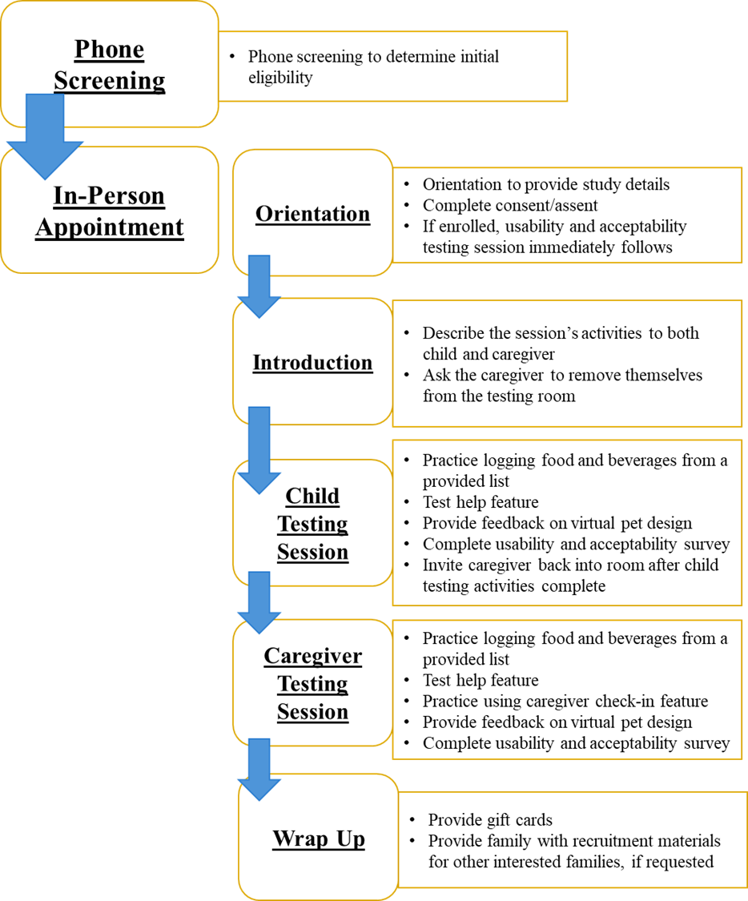

FIGURE 3. Formative study flow. Participants completed eligibility screening by phone and were then invited to a single in-person study session.

First, children were provided with a standardized list of foods and beverages with amounts to practice logging in the DSM log. The logging feature allowed users to record food and drinks consumed using three fields: “food or drink description,” “amount,” and “servings.”
In addition to thinking aloud, children were asked to mention anything they experienced that related to the following questions: 1) “Did you need help completing the task?” and 2) “What, if anything, happened that you did not expect or want?”¹³⁸ These questions were printed on a piece of paper and placed next to the child. The interviewer prompted the child to keep talking or to remember the questions if they fell silent.
Next, study staff asked children to identify what food group specific foods and beverages belonged to and what the appropriate serving size was by navigating through the “help me” feature. The help feature allowed users to look up serving sizes for items from food groups that would be targeted in the proof-of-concept trial (i.e., fruits, vegetables, sweet and salty snack foods, and sugar-sweetened beverages). For fruits, vegetables, and snack foods, help pages displayed tables listing commonly consumed foods and drinks with serving sizes in alphabetical order. Given that all sugar-sweetened beverages have the same serving size, the help page displayed a graphic of a bottle, can, and cup along with written text describing a serving as 8 fluid ounces. During help feature testing, the children were asked to keep the same two think-aloud questions in mind. The interviewer recorded which food groups and servings sizes the children identified correctly.
Finally, a printout of the virtual pet that would be included in the final version of the log showing all 12 levels of its evolution was provided for child feedback (Appendix B-6). After describing how the virtual pet would function in the DSM log (i.e., leveling up with points over time), research staff asked the child three questions: (1) What do you like about this pet? (2) What do you not like about this pet? and (3) Would you want to use the log more to help your pet grow over time?
Finally, the children were asked to complete a short usability and acceptability survey.¹³⁹
After completing the survey, the caregivers were asked to return to the room. A parallel procedure (concurrent think-aloud activities and usability and acceptability survey) was conducted with adult caregivers. In addition to testing the logging and “help me” features and providing feedback on the virtual pet, caregivers were also asked to practice completing a caregiver check-in. Finally, the caregiver was asked to complete a short usability and acceptability survey like the one administered to the child.
At the completion of the session, the family received two $10 gift cards (one for the child and one for the caregiver).

Measures
Think-aloud activities. Think-aloud activities were conducted to provide qualitative data related to child and caregiver experiences of usability and acceptability. Testing sessions were audio recorded using Zoom (with the camera off) and were transcribed using Zoom's transcription feature.
Usability and acceptability survey. A survey was adapted from the usability and acceptability satisfaction questionnaire implemented in Marsac et al that asked about visual appeal, function, and comprehensibility.¹³⁹ Though not validated, the original survey provided a framework for adapting simple, straightforward questions related to usability and acceptability appropriate for the formative testing phase.

Data Analysis
For qualitative analysis, the auto-transcription feature of Zoom was used to generate initial transcripts from the think-aloud portions of the session. All automated transcripts were reviewed for accuracy and revised as needed by the doctoral candidate through concurrent comparison with the audio recordings.

Table 2. A priori codes and definitions for qualitative analysis of transcripts produced from think-aloud procedures

CODES | DEFINITIONS
Usability  Burden  Confusion and needing help  Ease of use  Limitations and suggestions | Comments related to a feature being burdensome, e.g., taking too much time, being redundant, being “clunky”  Comments related to a feature being confusing, i.e., the user is unsure how to proceed or needs help to use it  Comments related to a certain feature being easy to use  Comments related to things the user wishes were present, as well as suggestions for addressing the limitation
Acceptability  Design and Appearance, Negative  Design and Appearance, Positive  Motivation | Negative comments about the visual design or appearance (color scheme, layout, etc.); this does NOT include comments on functionality  Positive comments about the visual design or appearance (color scheme, layout, etc.); this does NOT include comments on functionality  Comments related to a user’s motivation to use the DSM log

Two staff (doctoral candidate and a graduate student) independently coded each transcript to identify comments related to the usability and acceptability using a priori codes (Table 2). These codes were provided to the second coder, along with a training video, prior to beginning the coding process. NVivo 14 (Lumivero, Denver, CO) was used to code transcripts and compare inter-coder responses. After independent review, all coding was combined into a single project in NVivo so that agreements and disagreements could be identified. The two coders then met to reconcile disagreements and finalize codes. Percent agreement was calculated as the total number of agreements divided by the total number of agreements plus disagreements. If a majority (3 of 5) of children or caregivers reported the same usability or acceptability issue, changes to this feature were made prior to the proof-of-concept trial.
For quantitative analysis, descriptive statistics were used to determine the percentage of correct responses provided during help feature testing. Additionally, frequency of responses for each item on the usability and acceptability satisfaction questionnaire was calculated.

Results

Child and Caregiver Demographics
In total, 5 children and their caregivers participated in testing sessions. The sample included 2 female and 3 male children; all caregivers were female. The average age of child participants was 10.4 ± 1.5 years of age.

Qualitative Evaluation (Think-Aloud Procedure)

Usability: Burden
When testing the logging feature, both caregivers and children mentioned inefficient navigation between log features, such as needing extra clicks or having to navigate through unnecessary pages.

Example 1
Caregiver 1: It would be helpful, I feel like, if it went back to instead of like home every time like it automatically went back to log a food or beverage, and then you have the option to click home, or maybe home or continue. That way you're not constantly having to go back in and go back to that home page.

Example 2
Child 5, 12 years old: Maybe, this is just my opinion here, but like with the log, button, it might be more convenient just to like immediate like after you log it just for to immediately come back to the [home page].
Additionally, a couple of children made comments related to the time burden related to finding a food or beverage in the help feature.

Example 3
Child 1, 11 years old: Vegetables. Takes forever.

Usability: Confusion and Needing Help
When testing the logging feature, caregivers expressed concern that children in the targeted age range might find the logging fields (i.e., item description, amount, and servings) confusing, specifically which information should be entered in which field. Furthermore, most of the children expressed that calculating or inputting the amount of food or beverage consumed might be challenging. In particular, families expressed that children in the targeted age range might feel confused about how to use units and how to figure out serving sizes. Almost all caregivers mentioned that children might struggle with entering fractions.

Example 1
Caregiver 3: Like I said, if it were him, I think deciding which goes in which [input field], I think, he would, but I think you know, especially he's on the younger end of your range, so I think once he got used to it, he could do it. It would maybe take him a little bit of time.

Example 2
Child 5, 12 years old: So that was confusing too, like the ounce, and maybe like more distinguish between the amount and servings.
Caregiver 1: Yeah, I keep wanting to put words in where there's the amount. Instead of just the number one like with the chips, I put in “one bag.” Like the brownies, I'm wanting to put “one package.” I don't know.

Example 3
Caregiver 2: My only thought is putting in the one and a half, would they know to put the half? Or would they put 1.5?
In addition to the noted time burden related to the help feature, several comments indicated participant confusion and needing help. The help feature consisted of four webpages, one for each targeted food group. The fruit, vegetable, and snack food pages each included tables of common foods in alphabetical order along with their serving sizes. In contrast, the sugar-sweetened beverage page relied on a visual graphic illustrating what a serving size looks like for common containers (e.g., can of soda). The majority of both children and caregivers felt the inconsistency of presenting the graphic on the sugar-sweetened beverage help page versus the tables on the other help pages was confusing. Additionally, when testing the help feature, several children needed help finding a food or drink in the lists.

Example 1
Child 2, 10 years old: The thing I have to say about this is the [sugar-sweetened beverage] pictures kind of confuse me a little.

Example 2
Child 1, 11 years old: Can’t find the broccoli, finding the broccoli.
Interviewer: You need help finding the broccoli?
Child 1: Yes, I can’t find the broccoli.

Usability: Ease of Use
Despite expressing some confusion and needing help with logging, a majority of children and caregivers made comments related to the ease of using the logging feature.

Example 1
Child 2, 10 years old: Quite easy to use. Quite easy to use.

Example 2
Child 5, 12 years old: Yeah, after a couple of times I think people will get the hang of doing it. It just takes a while to learn like anything.

Example 3
Interviewer: Any part of this we feel like [Child] would need help with?
Caregiver 2: No, I think she would get it.

Usability: Limitations and Suggestions
Additionally, four caregivers suggested features to customize the pet based on the children’s preferences.

Example 1
Caregiver 2: Do we have any choices of other animals? Could they be a dinosaur if it's a guy or can it, if you give it multiple animals like, if you want to grow butterfly, or you know not just a cat.

Example 2
Caregiver 5: Yeah, like, I mean, there could be different pets. But there could be like maybe little things that I could add to my pet or feed my pet, you know. Take care of my pet, trim my pet. Things like that might be cool.

Acceptability: Design and Appearance, Positive
Most children made positive comments related to the general design and appearance of the virtual pet and its different stages of evolution. Several participants compared the design to other popular character they already liked.

Example 1
Child 1, 11 years old: It's a cat. Adorable.

Example 2
Caregiver 1: So this one where it involves a pet that you can kind of, you know, watch develop, I think that’s more universal.

Example 3
Child 2, 10 years old: Looks like a Pokémon. And it’s kind of like little pets on certain little games, like mobile games, or Prodigy, a math game. It's kinda like you get the pet, and then it evolves to final form. I like how it's like that, very appealing to children it seems.

Example 4
Interviewer: What do you like about this pet?
Child 5, 12 years old: That it's a cat and a lion and an alien.
Interviewer: Okay, you like that. Anything else that you like?
Child: That it looks cute.

Acceptability: Design and Appearance, Negative
No negative comments were made about any singular feature of the design or appearance by a majority of children or caregivers.

Acceptability: Motivation
When asked whether they/their child would want to use the log more to help the pet grow over time, all children and caregivers responded affirmatively.

Example 1
Caregiver 1: I like that it starts as an egg and goes all the way up to like a full-grown pet. Like I feel like that's gonna motivate the child to go on there, log their foods, because they're gonna want to see their pet grow. It reminds me a lot of like, you know, when I was younger Tamagotchis and trying to keep your little Tamagotchi alive. I like, I like that it's very Pokémon-like, because I feel like that's gonna appeal to a lot of kids. But then, on the other end of it, it's very just, it's cute, which, if so, if a child, maybe not into Pokémon, because it's such a cute little pet I think that that's gonna appeal to the other kids.

Example 2
Caregiver 3: I like that it grows and it's a slow growth, so that they're more apt to log to get into out here.

Example 3
Caregiver 4: I like that here's a reward. He would like this. He would like to try to get the to the [final level]. He's very competitive. He would like to get to that, I think.

Quantitative Evaluation (Questionnaires)

Help Feature Questionnaire
During the think-aloud procedure, participants were asked by the interviewer to use the help feature to identify the food group and servings sizes of 8 pre-selected food and beverage items. Children identified the correct food group 100% of the time and the correct serving size 87.5% of the time. Caregivers identified the correct food group 100% of the time and the correct serving size 97.5% of the time. This suggests that both child and caregivers were able to use the help feature correctly to a high degree.

Usability and Acceptability Satisfaction Questionnaire
Results for the usability and acceptability survey are presented in Table 3. In general, children and caregivers responded positively to log design, appearance, and function. Consistent with comments made during the think-aloud procedures, a majority of children rated the log as “somewhat” rather than “very” easy to use, while all caregivers rated it as “very easy” to use. Furthermore, two children and two caregivers rated the help feature as “somewhat confusing,” which was reflected in comments made related to the sugar-sweetened beverage graphic, as well as burden related to finding foods/beverages in the help feature tables.

Discussion
In Phase I of this study, formative testing was conducted with a small number of children and their caregivers to determine the initial usability and acceptability of the beta version of a web-based DSM log designed to incorporate positive reinforcement (caregiver praise and gamification) to improve child DSM behaviors. Results from Phase I informed improvements to the log prior to the Phase II proof-of-concept trial.

Table 3. Results of the usability and acceptability survey
SURVEY ITEM | Child  n (%) | Parent  n (%)
The tool is easy to use  Very easy  Somewhat easy  Not at all easy | 2 (40%)  3 (60%)  0 (0%) | 5 (100%)  0 (0%)  0 (0%)
I would use the tool again  Yes  No  Maybe / I’m not sure | 4 (80%)  0 (0%)  1 (20%) | 5 (100%)  0 (0%)  0 (0%)
Logging foods and drinks is confusing  Very confusing  Somewhat confusing  Not at all confusing | 0 (0%)  3 (60%)  2 (40%) | 0 (0%)  2 (40%)  3 (60%)
Using the “help me” feature is confusing  Very confusing  Somewhat confusing  Not at all confusing | 0 (0%)  2 (40%)  3 (60%) | 0 (0%)  2 (40%)  3 (60%)
The “help me” feature had too many words  Yes  No  Maybe / I’m not sure | 2 (40%)  1 (20%)  2 (40%) | 0 (0%)  5 (100%)  0 (0%)
Using the caregiver check-in feature is confusing  Very confusing  Somewhat confusing  Not at all confusing | NA  NA  NA | 0 (0%)  0 (0%)  5 (100%)
The tool is fun to use / My child would enjoy using this tool  A lot  Somewhat  Not at all | 2 (40%)  3 (60%)  0 (0%) | 3 (60%)  2 (40%)  0 (0%)
I like the appearance of the tool  A lot  Somewhat  Not at all | 3 (60%)  2 (40%)  0 (0%) | 3 (60%)  2 (40%)  0 (0%)
I like the things the tool can do  A lot  Somewhat  Not at all | 4 (80%)  1 (20%)  0 (0%) | 5 (100%)  0 (0%)  0 (0%)
I like / my child would like the virtual pet the tool will use  A lot  Somewhat  Not at all | 5 (100%)  0 (0%)  0 (0%) | 4 (80%)  1 (20%)  0 (0%)
I would recommend this too to other kids / families  Yes  No  Maybe / I’m not sure | 4 (80%)  0 (0%)  1 (20%) | 5 (100%)  0 (0%)  0 (0%)

In general, the beta web-based DSM log was well received. Both children and caregivers reported that the log was relatively easy to use, and all participants except for one child indicated that they would use the log again. Families indicated that they felt the log would be fun or enjoyable for children to use. Furthermore, the appearance was generally well accepted, and no negative comments about general design or appearance were made.
Some areas for improvement were identified. First, navigation between features in the beta log was generally deemed cumbersome and burdensome. To address the burden related to
clunky navigation, additional navigation buttons were added to the log prior to the proof-of-concept trial to ensure users could more quickly access the pages and features they desired.
Additionally, multiple children and caregivers found the help feature “somewhat confusing,” and all but one child indicated that the help feature might or did have too many words (no caregivers reported feeling this way). Two children also made comments related to the time burden of finding a food or beverage in the help feature. One clear issue identified with the feature was the inconsistency of the presentation of information between the sugar-sweetened beverage page and the help pages for the other food groups. The sugar-sweetened beverage illustration caused confusion for multiple children and caregivers, and this confusion helped to explain the negative responses on the usability and acceptability satisfaction questionnaire. Thus, the graphic was removed and replaced with a serving size table consistent with those on the other help pages prior to the proof-of-concept trial. Additionally, to address the burden of time and the confusion related to finding items on the help pages, families in the proof-of-concept trial were shown how to use keyword search to look for specific items.
The domain that perhaps caused the greatest amount of confusion or needing help was the act of logging. Caregivers expressed concerns that children in the targeted age range might struggle to understand, determine, and input the correct item descriptions, amounts, and servings for consumed foods/beverages. Similarly, most children expressed that process was challenging. Units, serving sizes, and fractions were all frequently mentioned as potentially tricky elements of DSM. This finding is not completely unexpected, however. DSM requires a basic level of nutrition literacy, as well as basic math skills (for calculating serving sizes and amounts) and an understanding of units (e.g., grams, fluid ounces, etc.). Some children may not yet have acquired the skills necessary to complete the tasks of DSM with ease or without caregiver support. Research suggests that around age 8 years is when children are first beginning to be able to self-report dietary intake reliably.¹³⁶ Additionally, a study of children 7-12 years enrolled in a 20-week behavioral weight intervention examined children’s DSM recording compliance. Researchers found that average recording competency, which was calculated from 6 compliance variables, was only 13.3 ± 10.2 out of possible 25. Additionally, the average number of days with compliant recording, defined as logging ≥5 foods/drinks in a day, was achieved on only half of intervention days on average. Thus, DSM appears to have some general challenges for children in the targeted age group. To address these challenges in the proof-of-concept trial, more intensive training (including in-depth instructions for each field and a practice session with research staff) was provided to families at their baseline appointment. Additionally, caregivers were encouraged to answer any questions their children had during the active DSM period.
Finally, participants felt that children would like the virtual pet “a lot.” Child participants used words such as “adorable” and “cute” to describe the pet, and multiple children and caregivers mentioned that its design and function reminded them of other popular games (e.g., Pokémon, Tamagotchi, and Prodigy, an educational math game). Additionally, when asked whether they/their child would want to use the log more to help the pet grow over time, all children and caregivers responded affirmatively.
Some caregivers mentioned potential reasons why their child would find the virtual pet motivating including its cute appearance, the rewarding nature progression of the pet’s evolution over time and the challenge to achieve the final level of evolution. While the virtual pet was largely praised, most caregivers also suggested enhancements that would allow options to customize or interact with the virtual pet (e.g., choose type of pet, feed the pet, etc.). However, the design of sophisticated customization capabilities was outside the scope of the current project. (Additional discussion of how virtual pets may increase feelings of relatedness and improve intrinsic motivation is provided in the discussion section for Phase II of the study.) No other areas were identified for improvement for the virtual pet feature design or log function.
In summary, the beta log was well-accepted and well-liked. In particular, the virtual pet received substantial positive feedback on its design and appearance, as well as its potential ability to motivate children to engage in DSM. Some minor usability issues regarding website navigation and the presentation of the help feature were addressed prior to implementation of the proof-of-concept trial. Additionally, challenges inherent to the DSM process among children in the targeted age group were identified that were not related to the design of the log itself. These challenges were related to children’s numeracy and nutrition literacy. To help address some of these issues in the subsequent proof-of-concept trial, families were provided with more intensive training on how to understand and complete these elements of DSM, including a practice session with research.

Phase II: Proof-Of-Concept Trial

Methods

Study Design and Primary Outcomes
All study materials, including consent, assent, questionnaires, and participant training materials, are presented in Appendices C & D.
Results from formative testing were used to finalize the version of the web-based DSM log used in the proof-of-concept trial. The DSM log was a mobile-optimized website, rather than an app, so that device operating system would not be a limitation of use. Families were therefore able to access the DSM log from a computer, smartphone, or other internet-enabled device. All DSM logs included four basic features: 1) ability to log targeted food groups, 2) ability to indicate logging is complete for the day, 3) access to a help feature that provided guidance on serving sizes, and 4) a caregiver check-in feature (visible only from the caregiver URL). Children were instructed to self-monitor their daily intake of the following food groups: fruits, vegetables, sweet and salty snack foods, and sugar-sweetened beverages (SSBs) for 4 weeks (Table 4). DSM focused on these food groups because they have an established influence on health. Fruit and vegetable consumption is associated with decreased risk of chronic disease,¹⁴⁰⁻¹⁴² and reduced consumption of energy-dense foods like sweet and salty snacks and SSBs is recommended for weight loss in children.¹⁴³ Additionally, these food groups are frequently targeted in childhood obesity treatment and prevention are easily understood by young children.^{38,143}
Using a 2x2 factorial design, child-caregiver dyads were randomly assigned to 1 of 4 conditions: BASIC, PRAISE, GAME, or PRAISE+GAME (Table 5). Each family was provided with two unique URLs each with the appropriate features turned on (i.e., caregiver praise check-
Table 4. Food groups targeted for dietary self-monitoring
Targeted Food Group | Examples of Foods to Track
Fruits | - Apples  - Bananas  - Grapes  - Fruit smoothies  - Fruit juice
Vegetables | - Carrots  - Leafy greens  - Broccoli  - Mixed dishes with vegetables
Sweet & Salty Snack Foods | - Chips  - Cheese puffs  - Cookies  - Frozen treats  - Sweetened cereals
Sugar-Sweetened Beverages | - Soda  - Energy drinks  - Lemonade  - Chocolate milk  - Sweetened fruit juices

Table 5. The four study conditions of the 2x2 factorial design
CONDITIONS | GAMIFICATION | CAREGIVER PRAISE
BASIC | Off | Off
PRAISE | Off | On
GAME | On | Off
PRAISE+GAME | On | On

in and/or virtual pet)., one for the child to access their DSM log and one for the caregiver to review their child’s log and complete check-ins.
While DSM is frequently implemented within treatment, children in the proposed study engaged in DSM without a concurrent intervention to tightly control the influence of the independent variables on DSM behaviors only (as compared to having all adult caregivers learning how to praise or having caregivers focus their praise on achieving dietary goals, which are both standard components of family-based, childhood obesity interventions). Thus, caregivers randomized to PRAISE or PRAISE+GAME conditions were instructed on praise and were instructed to only praise on one behavior (DSM), as there were no intervention goals.
At the end of the 4-week DSM period, families who completed follow-up assessments received two $25 gift cards, one for the child and one for the caregiver, and were provided access to a short online behavioral nutrition education program (additional details in Flow of Sessions).
The primary DSM outcomes were frequency (i.e., number of days any food/beverage item was tracked and/or logging was marked complete) and timing (i.e., the proportion of foods logged on the day of intake and the number of logging sessions each day). On days in which no targeted food group was consumed, children were instructed to still mark logging as complete for the day. Indicating logging was complete in the absence of any tracked foods was considered a “tracked” day. Pre-post changes in intrinsic motivation, child motivation to eat healthfully, and dietary intake were also examined.

Participants
Children ages 8-12 years at or above a healthy weight [defined as body mass index (BMI)-for-age ≥ 5th percentile] who reported consuming foods/beverages from ≥2 targeted food groups (i.e., fruits, vegetables, sweet and salty snack foods, and sugar-sweetened beverages) on ≥3 days/week each and who had an adult caregiver ≥18 years of age willing to participate were eligible for enrollment. Families were excluded if the child was already self-monitoring their diet or had major psychiatric diseases or organic brain syndromes, or if the family did not live in the greater Knoxville area or speak English. Additionally, families were required to have reliable access to the internet via phone, computer, or other device that the child was able and permitted to operate. Families completed a phone screening to determine initial eligibility and were then invited to an orientation to learn more about the study during which written informed consent and assent was obtained. Ethical approval was received from the UTK Institutional Review Board (UTK IRB-23-07903-XP). This study was registered with ClinicalTrials.gov (identifier: NCT06193967).
Recruitment occurred from February through October of 2024. As with the Phase I study, FBHT families who were finished with active intervention, had a child within the eligible age range, and had completed 18-month follow-up measures were contacted. Additionally, although FBHT recruitment had closed the year prior, the list of FBHT families who had screened ineligible but had agreed to be contacted for the present study was retained, and these families were contacted for the Phase II trial. Other recruitment strategies included internal campus mailings to faculty and staff across UTK, as well as in-person tabling at community events and after-school programs. Additionally, recruitment flyers were posted in public spaces in the Knoxville area (e.g., libraries, toy stores), and the study was advertised on social media platforms. All study advertisements included a QR code (paper flyers) or link (social media ads) to a Qualtrics form that collected contact information and obtained permission to contact.
As this was a proof-of-concept trial examining preliminary efficacy, targeted enrollment was 40 families (10 families per group). Previous research suggests that small sample sizes are appropriate for initial testing of novel health technologies.¹⁴⁴⁻¹⁴⁶

Dietary Self-Monitoring Log
Figure 4 displays example images of the DSM log as viewed from a mobile device.

BASIC group
DSM logs for the BASIC group included four features: 1) the ability to log a food or beverage with amount and servings, 2) the ability to mark logging complete for the day, 3) a help feature with information on servings sizes for the targeted food groups, and 4) a check-in that allowed caregivers to indicate they had reviewed their child’s log that day. Caregivers were provided with a separate URL that allowed them to view their child’s logging and complete check-ins. To help children get started, caregivers were instructed to sit with their child for the first 3 days of tracking to help with logging.

PRAISE group
In addition to the procedures described for BASIC group, caregivers of families assigned to the PRAISE group were asked to provide praise to their child for engaging in DSM over the 4 weeks. During their first study visit, caregivers were provided a brief training (see Flow of
Sessions) on how to provide process praise, a type of praise that emphasizes effort over outcomes or character traits. This type of praise has been shown to support intrinsic motivation in children.⁸⁰ Additionally, when caregivers in this group completed check-ins, an additional item was present to indicate whether praise was provided that day (Figure 4c).

a. 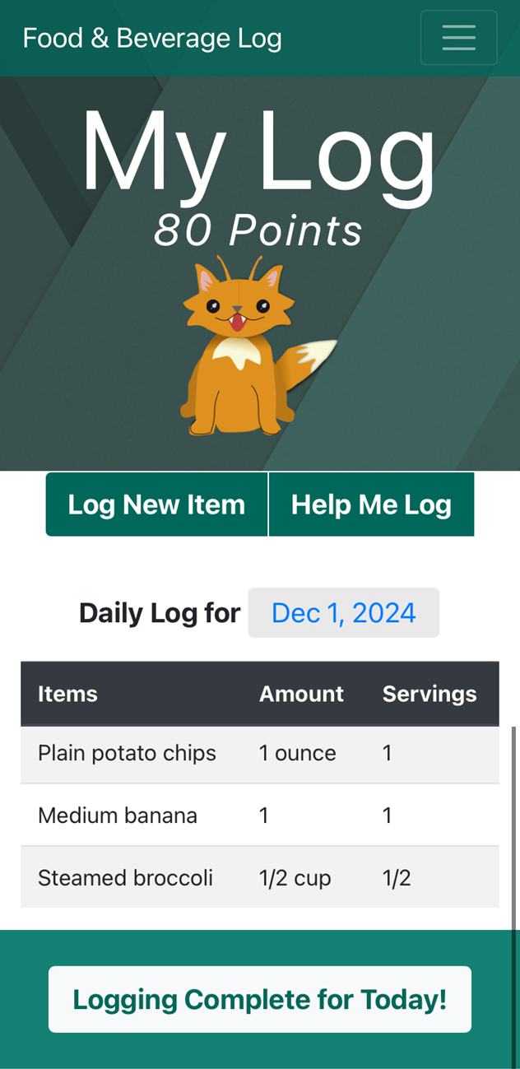 b. 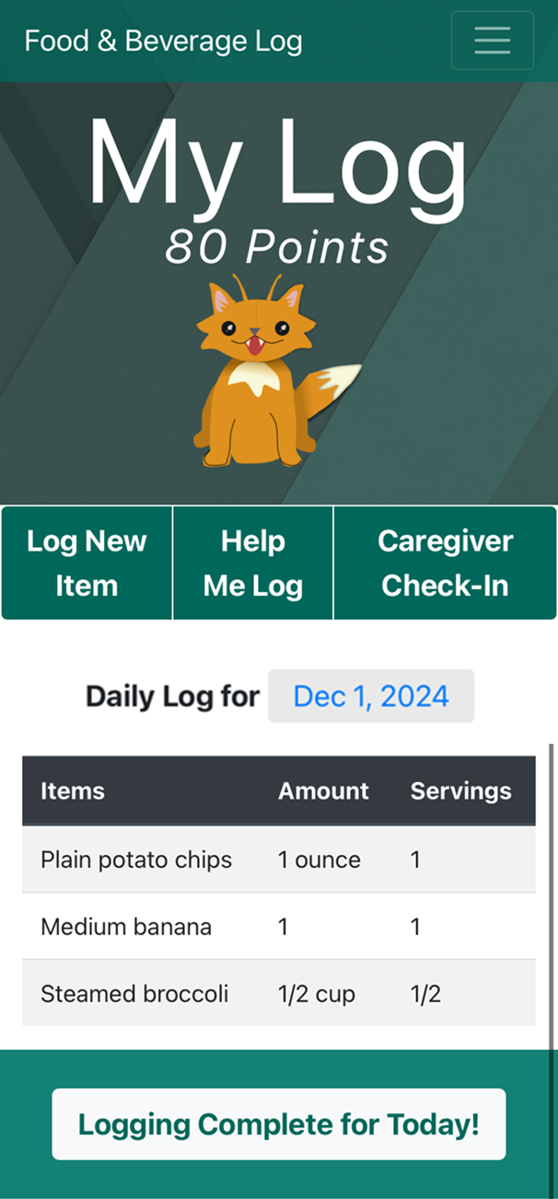 c. 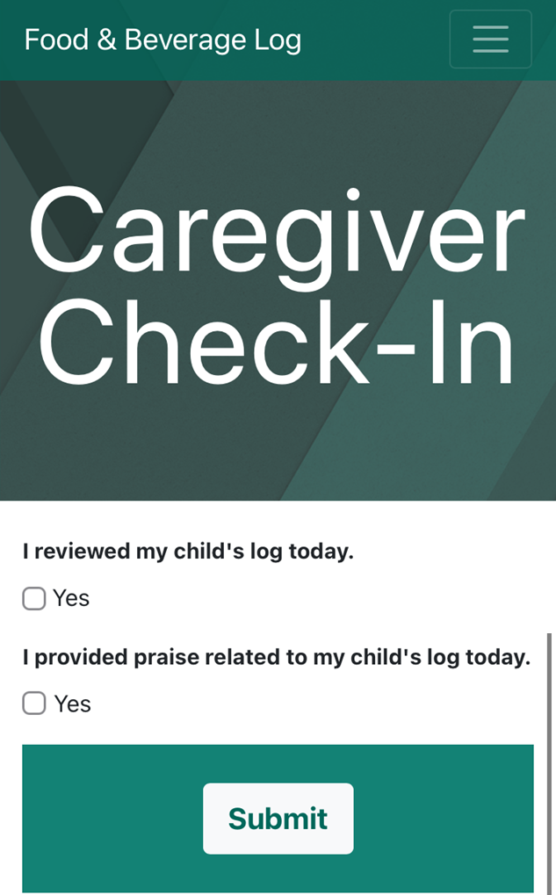 d. 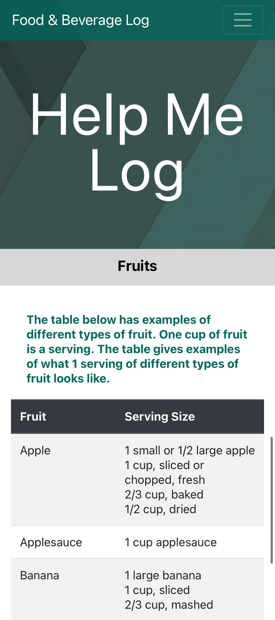
Figure 4. Example images of the dietary self-monitoring log as viewed from a mobile device. a. An example of a child’s DSM log with gamification. At the top, points are displayed above the virtual pet. Below the pet, options to log an item or access the help feature are available. The date is shown for the displayed day of logging and can be changed to view alternative days. At the bottom, a button to mark logging complete for the day is included. b. An example of what the same child’s caregiver would see when accessing the caregiver URL. The caregiver URL also includes a button to complete the caregiver check-in. c. An example of the caregiver check-in with praise check-in. d. An example of the Fruits page for within the help feature.

GAME group
In addition to the procedures described for BASIC group, the logs of children in the GAME group integrated three game mechanics: points, levels, and a virtual pet. The virtual pet had 12 levels of evolution (Appendix B-6), with each level requiring more points to achieve than the previous level (e.g., 2 points for level 2, 4 points for level 3, 8 points for level 4, etc.). The twelfth and final level was achieved after accruing 111 points. Points were earned for logging food or drink, marking logging complete for the day, and logging two days in a row (Table 6). Virtual pets have previously shown the potential to improve weight-related behaviors in children in other contexts.¹⁴⁷⁻¹⁴⁹

PRAISE+GAME group
For families assigned to the PRAISE+GAME group, procedures included all of those described above for BASIC, PRAISE, and GAME groups. In other words, caregivers in this group provided process praise to their child for engaging in DSM, and the child’s log included the gamified virtual pet and point system.

Table 6. Point system for GAME and PRAISE+GAME conditions
DSM Behaviors That Earn Points | Points Awarded
Logging any food or beverage | 1 point per item
Indicating logging is complete for the day | 1 point
Logging multiple days consecutively | 1 bonus point per consecutive day

Flow of Sessions
Study flow for the proof-of-concept trial is outlined in Figure 5. After an initial phone screening to determine eligibility, interested families were invited to attend an in-person
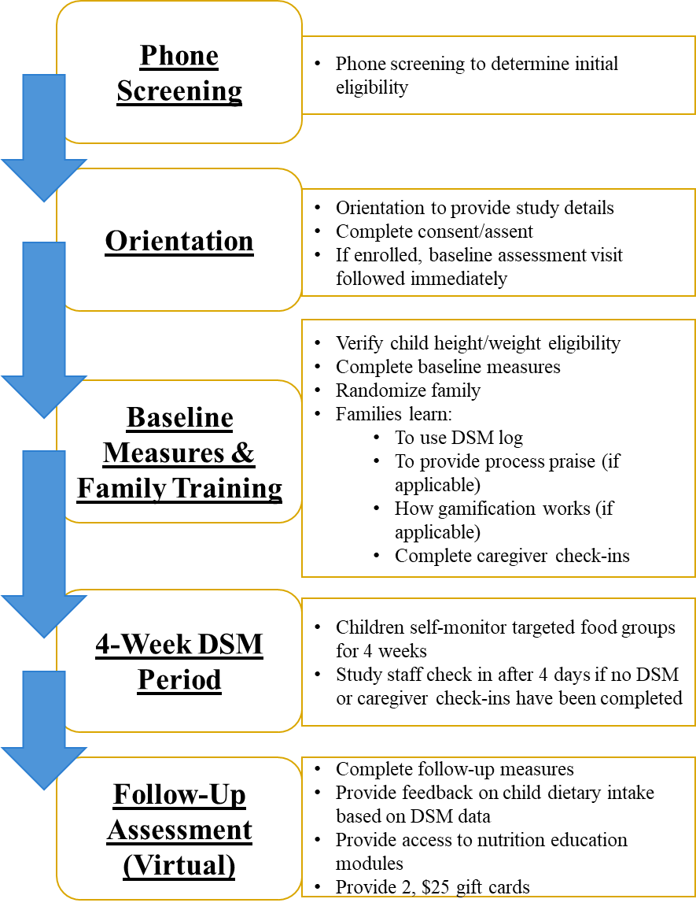
Figure 5. Proof-of-concept study flow

orientation at UTK HEAL to learn more about the study. For families who agreed to participate, caregivers provided informed consent, children provided assent, and baseline assessment measures were collected (see Measures). For random assignment, a random number generator was used to produce sets of four unique integers, each having a value between 1 and 4. These integers corresponded to the four study groups: BASIC, PRAISE, GAME, or PRAISE+GAME.
Immediately after baseline measures were completed, families were told their assigned condition and received brief training on using the log. All families were provided with information on the benefits of DSM and the relationships of the four targeted food groups with child health. Families were also informed that the child’s DSM records over the next 4 weeks would be used to provide individualized recommendations to the family at their follow-up visit,
at which time they would receive access to a short online behavioral nutrition education program (described below).
Each family was provided with access to a log that matched group assignment, and children were asked to complete DSM for 4 weeks. Few studies have reported on short-term DSM adherence. However, two study that reported DSM adherence in the first month of treatment found that between 20-28% of participants in early adolescence did not complete any DSM in month 1 of intervention, and another 36-44% averaged <3.5 days per week.^{6,7} This low adherence was found despite being enrolled in concurrent obesity treatment program. Thus, 4 weeks were expected to be appropriate for detecting differences in DSM behavior by group.
The DSM period began the day after the family’s baseline assessment. Caregivers were instructed to review their child’s DSM and complete a caregiver check-in each day. Additionally, to get children started, all caregivers were instructed to sit with their child each day for the first 3 days of the DSM period to help their child log any items consumed from targeted food groups. If no logging was completed within the first four days of a family’s DSM period, the protocol dictated that a research assistant to reach out to the caregiver to solve problems and provide support. However, this step was not necessary as all participants completed tracking within the first 3 days of their DSM periods.
At the end of the 4-week DSM period, families attended a virtual appointment to complete follow-up measures. To provide individualized feedback to families, tracking from days on which tracking was marked as complete was entered into the Nutrition Data System for Research (NDSR, version 2022; Nutrition Coordinating Center [NCC], University of Minnesota, Minneapolis, MN, USA) software to determine servings of fruits and vegetables consumed and intake of added sugars and saturated fats from sugar-sweetened beverages and sweet and salty snack foods. These values were entered into a template feedback sheet that compared the child’s intake to the recommendations in the Dietary Guidelines for Americans 2020-2025.
Families were also provided access to a short online behavioral nutrition education program that consisted of four video modules with the following topics: 1) dietary guidelines recommendations and basic nutrition information, 2) establishing a healthy home environment, 3) positive reinforcement of healthy behaviors, and 4) pre-planning and problem solving.
Family DSM Training
Materials from the family training are included in Appendix D. At the in-person appointment, families completed a DSM practice session under observation of research staff. The family’s personal DSM was used; therefore, praise and gamification features related to the family’s assigned condition were included. The family practiced logging foods and beverages from a standard list and were then instructed to mark logging as complete for the day. Research staff answered any questions the family had and explained how to use the “Help Me Log” feature (Figure 4d). Caregivers were also shown how to complete the caregiver check-in feature (Figure 4c).
For families randomized to caregiver praise, caregivers also provided process praise to their child during the DSM practice session so that research staff could observe and provide feedback. Prior to the practice session, caregivers were provided brief training on providing on process praise. A description of process praise was provided, including a list of examples, and caregivers completed a brief “quiz” in which they attempted to identify process praise statements. Caregivers were also encouraged to avoid negative reinforcement (e.g., nagging). If the caregiver noticed the child not using the DSM log, they were encouraged to engage in problem solving and preplanning, rather than nagging, to support their child. If the caregiver noticed the child engaging in undesirable behaviors (e.g., recording unhealthy foods), they were encouraged to ignore rather than criticize. Additionally, caregivers were encouraged to provide praise as close to the occurrence of the behavior as possible to increase its effectiveness. For PRAISE conditions, completion of the caregiver check-ins included an additional item related to whether praise had been provided (Figure 4c).
For families randomized to gamification, children and caregivers observed how points were accrued during the DSM practice session. Prior to the practice session, research staff explained how points were earned and how points helped to “level up” the virtual pet (Figure 4a). Points were accrued and represented in the DSM log in real time so that children were immediately rewarded for engaging in DSM behaviors.

Measures

Sample characteristics (baseline only)
Demographics. Demographic information included child and caregiver age, race, ethnicity and gender; caregiver marital status, education level, and employment status; and household income.
Child height and weight. Child height and weight were collected to confirm study eligibility, and body mass index (BMI) z-score was calculated based on sex and age.
Parenting style. Previous research has associated parenting style with intrinsic motivation in children.¹⁵⁰ To determine parenting style, caregivers completed the previously-validated Parenting Styles and Dimensions Questionnaire (PSDQ)-Short Version.^{151,152} The PDSQ-Short Version is a 32-item questionnaire that uses a 5-point Likert scale (never to always) to provide scores for three parenting style factors: authoritativeness, authoritarianism, and permissiveness.

Adherence and dose (during 4-week DSM period)
Caregiver check-ins. To determine the extent to which caregivers adhered to instructions to review their child’s log each day, the number of days on which caregivers marked “yes” for the item “I reviewed my child's log today” was recorded.
Caregiver praise. To examine whether the caregiver praise manipulation was successfully implemented, the number of days on which caregivers marked “yes” for the item “I provided praise related to my child's log today” was recorded.
Gamification. To examine whether the gamification manipulation was successfully implemented, the number of days on which children received ≥1 point was calculated.

Primary measures: DSM behaviors (during 4-week DSM period)
Foods, beverages, and serving sizes entered in the DSM logs automatically populated a web-based spreadsheet that collected participant identification number, date and time of entry, food/beverage name, amount, and serving size. This spreadsheet was exported to Microsoft Excel, and data management and analysis was conducted in SAS Enterprise Guide 8.3.
DSM frequency. Frequency was operationalized as the number of days with any tracking. A day was counted as “tracked” if any food or beverage was logged on that day or, if no food or beverage is logged, the “Logging Complete” button was clicked.
DSM timing. Timing was the proportion of days on which food/beverage items were tracked on the day of intake, as well as the average number of logging sessions per day. Sessions were considered as distinct logging events if they occurred >15 minutes apart.

Secondary measures (baseline and follow-up)
Child intrinsic motivation. Gamification and caregiver praise may differentially affect child motivation to engage in DSM. The Task Evaluation Questionnaire of the Intrinsic Motivation Inventory (IMI) was administered to determine whether differences in pre-post changes in child intrinsic motivation were present.^{153,154} The questionnaire consists of 22 items and uses a 5-point Likert scale (not at all true to very true) to assess four subdomains: interest/enjoyment, perceived choice, perceived competence, and pressure/tension. At baseline, the IMI was administered after the child practiced using DSM with the research assistant so that they had familiarity with the activity before completing the scale.
The IMI is a multidimensional tool designed to assess participants' subjective experiences related to a specific activity in experimental settings. Though originally developed for use in adult populations,¹⁵⁵ the IMI has also been used in numerous research areas with child participants, including first language, mathematics, sport activities, and learning, and has been shown to be a valid measure in children 9 years and older.¹⁵⁶⁻¹⁵⁹
Child motivation to change eating behaviors. Child motivation to change eating habits was measured, as this may influence engagement in DSM. Children were asked to complete the 8-item diet subscale of the Motivation to Exercise and Diet Questionnaire—Adapted for Children (MED-C), which is based on self-determination theory.¹⁶⁰ The MED-C diet subscale utilizes a 5-point Likert scale (never to always) and includes 5 items related to motivation and 3 items related to self-determination theory basic needs (autonomy, competence, relatedness). The validity of the questionnaire has been successfully tested in children aged 7 to 11 years.¹⁶⁰
Child dietary intake. The act of self-monitoring a behavior may result in reactivity, or improvements in the monitored behavior, in the absence of other intervention.¹⁰ Thus, child dietary intake was also assessed at baseline and follow-up using the Block Kids Food Screener (NutritionQuest, Berkeley, California). The instrument asks about intake in the “last week” and focuses on take of fruit, fruit juices, vegetables, potatoes (including French fries), whole grains, animal-based proteins, dairy, legumes, saturated fat, added sugars (in sweetened cereals, SSBs), glycemic load and glycemic index. It takes approximately 10-12 minutes to complete and has been found to be a valid tool for assessing dietary intake in children and adolescents.¹⁶¹
An initial analysis of food screener responses was provided NutritionQuest (i.e., cup equivalents, grams consumed, kilocalories consumed). To align with the food groups self-monitored by children in the current study, the following variables were used: cup equivalents of fruits, cup equivalents of vegetables not including potatoes, cup equivalents of potatoes, and kilocalories for sugar-sweetened beverages. Additionally, to examine outcomes for sweet & salty snack foods, a summative variable was created from the grams of popcorn, snack chips like potato chips, ice cream, and candy/candy bars consumed.

Usability and acceptability (follow-up only)
Child/Caregiver usability and acceptability survey. The survey used in the formative phase was also administered at follow-up to capture families’ experiences with the DSM log. As previously described in the formative section, the survey was developed based on the usability and acceptability survey items described by Marsac et al in their feasibility testing of a web-based application that included gamification and targeted children between ages 8-12 years.¹³⁹ Though not validated, the original survey provided a framework for adapting simple, straightforward questions related to usability and acceptability.

Statistical Analysis
Differences in baseline characteristics by group were assessed using appropriate statistical tests based on the type and distribution of the data. Categorical variables were compared using Fisher’s exact test to account for cell counts <5. Continuous variables were first tested for normality using the Shapiro-Wilk test. If normally distributed, they were analyzed using one-way analysis of variance (ANOVA). If non-normally distributed, the Kruskal-Wallis test was used instead.
Data were analyzed using SAS Enterprise Guide 8.3 (SAS Institute Inc., Cary, NC, USA). Summary statistics were used to describe sample characteristics. All participants participated in DSM and fully completed measures at baseline and follow-up; thus, intent-to-treat analysis and handling of missing data were not necessary.
To examine implementation of the independent variables, linear mixed-factor ANOVA was used with a between-subject factor of positive reinforcement (caregiver praise and gamification), a within-subject factor of time (week), and a dependent variable of dose received. Dose was defined as the mean number of days per week on which caregivers responded affirmatively to praise check-ins and the mean number of days on which ≥1 point was gained per week were calculated for families assigned to caregiver praise and gamification, respectively.
To determine the main effects of positive reinforcement on DSM behavior, a 2x2 factorial ANOVA was conducted with gamification and caregiver praise assignment as the independent variables and a dependent variable of DSM behavior (frequency or timing). A gamification*caregiver praise interaction term was also included in the model to test for interactive effects. For DSM frequency, absence/presence of DSM was coded as ‘0’ or ‘1’ for each day, with ‘0’ representing no food or beverage tracked AND tracking not marked as complete for the day and ‘1’ representing ≥1 food or beverage tracked AND/OR tracking marked as complete for the day. Therefore, the possible range for overall DSM frequency for the 4-week period ranged from 0 (no DSM any day) to 28 (DSM on all days). The possible range for DSM frequency by week ranged from 0 to 7. DSM timing was calculated two ways: 1) the mean number of DSM logging sessions per day (must be >15 minutes apart to be considered distinct sessions) and 2) the proportion of food or beverage items tracked on the day of intake (i.e., the number of food or beverage items tracked on the day of intake divided by the total number of food or beverage items tracked).
To examine how DSM changes over time, linear mixed-factor ANOVA was used with between-subject factors of praise and gamification assignment, a within-subject factor of time (week), and a dependent variable of DSM behavior (frequency or timing). Additionally, graphical representations of daily DSM frequency and timing by group were plotted to help visualize trends over time.
To determine the main effects of positive reinforcement on motivation, a 2x2 factorial ANCOVA was conducted with gamification and caregiver praise assignment as the independent variables, a dependent variable of intrinsic motivation at follow-up, and a covariate of intrinsic motivation at baseline. A gamification*caregiver praise interaction term was also included in the model to test for interactive effects. This statistical procedure was repeated with the other secondary measures of child motivation to change eating behaviors and child dietary intake, with follow-up measures as the dependent variable and baseline measures as covariate.
A standard alpha level of ≥ 0.05 was used to determine statistical significance. Tukey's adjustment was applied for post-hoc pairwise comparisons. Given that group sizes were unequal, marginal means (calculated as Least Squares Means in SAS) are presented in the results section and figures so that the reported values align with the respective statistical models used for hypothesis testing.
Effect sizes were calculated using partial omega-squared ($ω_{p}^{2}=\frac{{SS}_{effect}​-({df}_{effect} × {MS}_{error})}{{SS}_{effect}+{SS}_{error}+{MS}_{error}} )​$. Omega-squared is a more conservative measure appropriate for studies with small sample sizes that utilize ANOVA,¹⁶² and partial omega-squared, in particular, is most appropriate for multi-factor designs because it examines the proportion of variance in the dependent variable that is uniquely attributed to each independent variable or interaction, while controlling for other factors in the model.¹⁶³ Thresholds for small, medium, and large effects were defined as 0.01, 0.06 and 0.14, respectively, as previously defined by Cohen.¹⁶⁴

Results

Child and Caregiver Demographics
Figure 6 presents the flow diagram for participant enrollment, allocation, and follow-up. A total of 19 child-caregiver dyads enrolled in the study. Baseline characteristics by group are

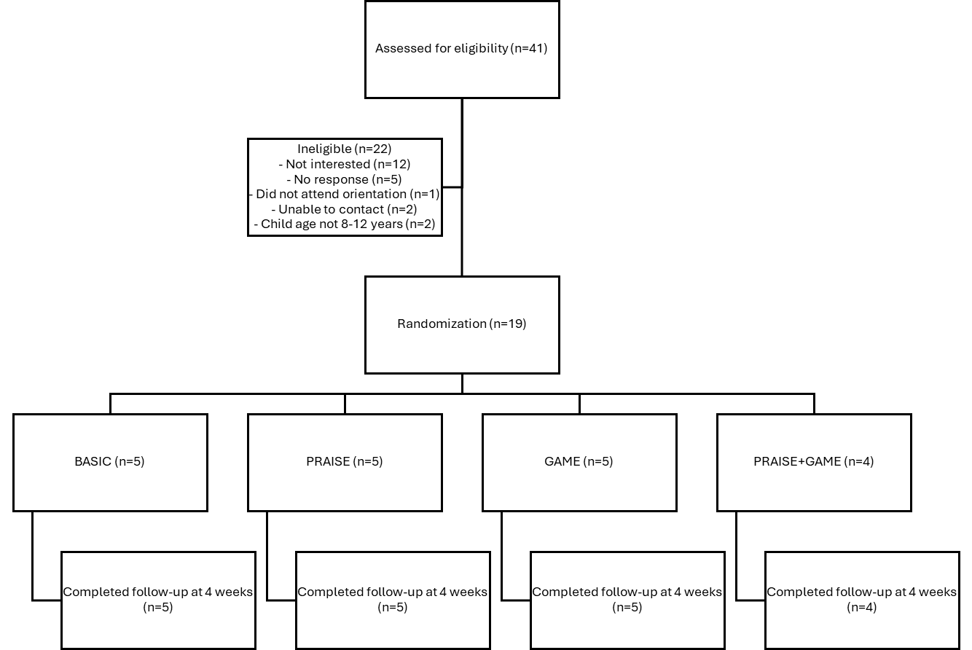

Figure 6. Participant flowchart.

presented in Table 7. Children were aged 9.6 ± 1.3 years and were 58% female, 5% Hispanic or Latino, and 74% white. Children had an average BMI percentile of 60.6 ± 30.8. Caregivers were aged 42.8 ± 4.9 years and were 79% female, 0% Hispanic or Latino, and 79% white. Caregivers were predominantly married (89%), had attended college for 4 or more years (89%), and reported household income at or above $100,000 per year (84%). Average caregiver scores (out of possible 5) on the Parent Styles and Dimensions Questionnaire were 4.1 ± 0.3 for the authoritative parenting style domain, 1.6 ± 0.3 for the authoritarian parenting style domain, and 2.2 ± 0.6 for the permissive parenting style domain. There were no differences between groups for any baseline characteristic.

Adherence and Dose
Caregivers completed check-ins on an average of 13.1 ± 7.6 out of a possible 28 days. There were no differences in the number of caregiver check-ins completed by assignment to caregiver praise [t(17) = 0.06, p = 0.95] or gamification [t(17) = -0.56, p = 0.58].
Caregivers assigned to praise responded affirmatively to praise check-ins on an average of 12.2 ± 5.8 out of a possible 28 days. Children assigned to gamification received ≥1 point on an average of 20.8 ± 12.3 out of a possible 28 days and earned an average of 188.8 ± 67.8 points
during the DSM period. Out of the 9 children assigned to gamification, 7 achieved the maximum virtual pet level of 12, with the 2 remaining children achieving levels 10 and 11.
There was a main effect of positive reinforcement (i.e., caregiver praise or points), such
that receipt of gamification was significantly higher across the 4-week DSM compared to caregiver praise [mean of 5.2 ± 0.4 days per week versus 3.3 ± 0.4 days per week, F(1,3) = 29.17, p = 0.01]. Additionally, there was a main effect of time on positive reinforcement F(3,39)
Table 7. Proof-of-concept trial sample characteristics by group
VARIABLE | BASIC  (n=5) | PRAISE  (n=5) | GAME  (n=5) | PRAISE+GAME  (n=4) | p-value
Child age, M ± SD | 8.8 ± 0.8 | 9.2 ± 1.1 | 10.8 ± 1.3 | 9.3 ± 1.3 | ns
Child sex, n (%)¹  Female  Male | 4 (80%)  1 (20%) | 2 (40%)  3 (60%) | 3 (60%)  2 (40%) | 2 (50%)  2 (50%) | ns
Child ethnicity, n (%)  Hispanic or Latino  Not Hispanic or Latino | 1 (20%)  4 (80%) | 0 (0%)  5 (100%) | 0 (0%)  5 (100%) | 0 (0%)  4 (100%) | ns
Child race, n (%)  White  Black or African American  Asian  More than one race | 4 (80%)  0 (0%)  0 (0%)  1 (20%) | 3 (60%)  0 (0%)  1 (20%)  1 (20%) | 5 (100%)  0 (0%)  0 (0%)  0 (0%) | 2 (40%)  1 (20%)  0 (0%)  1 (20%) | ns
Child BMI %ile, M ± SD | 37.0 ± 17.8 | 76.8 ± 30.9 | 68.6 ± 33.7 | 60.0 ± 31.8 | ns
Caregiver age, M ± SD | 43.0 ± 2.6 | 43.0 ± 7.1 | 44.0 ± 3.6 | 41.0 ± 6.7 | ns
Caregiver sex, n (%)¹  Female  Male | 3 (60%)  2 (40%) | 3 (60%)  2 (40%) | 5 (100%)  0 (0%) | 4 (100%)  0 (0%) | ns
Caregiver ethnicity, n (%)  Hispanic or Latino  Not Hispanic or Latino | 0 (0%)  19 (100%) | 0 (0%)  19 (100%) | 0 (0%)  19 (100%) | 0 (0%)  19 (100%) | ns
Caregiver race, n (%)  White  Black or African American  Asian  More than one race | 5 (100%)  0 (0%)  0 (0%)  0 (0%) | 3 (60%)  0 (0%)  1 (20%)  1 (20%) | 5 (100%)  0 (0%)  0 (0%)  0 (0%) | 2 (40%)  1 (20%)  0 (0%)  1 (20%) | ns
Caregiver marital status, n (%)  Married  Divorced  Widowed  Separated  Never married  Member of an unmarried couple  Refused to answer | 5 (100%)  0 (0%)  0 (0%)  0 (0%)  0 (0%)  0 (0%)  0 (0%) | 5 (100%)  0 (0%)  0 (0%)  0 (0%)  0 (0%)  0 (0%)  0 (0%) | 4 (80%)  0 (0%)  0 (0%)  0 (0%)  1 (20%)  0 (0%)  0 (0%) | 3 (75%)  0 (0%)  0 (0%)  0 (0%)  0 (0%)  0 (0%)  1 (25%) | ns
Caregiver education level, n (%)  Never attended school or only attended kindergarten  Grades 1 through 8 (elementary)  Grades 9 through 11 (some high school)  Grade 12 or GED (high school graduate)  College 1 year to 3 years (some college or technical school)  College 4 years or more (college graduate) | 0 (0%)  0 (0%)  0 (0%)  0 (0%)  0 (0%)  5 (100%) | 0 (0%)  0 (0%)  0 (0%)  1 (20%)  0 (0%)  4 (80%) | 0 (0%)  0 (0%)  0 (0%)  0 (0%)  1 (20%)  4 (80%) | 0 (0%)  0 (0%)  0 (0%)  0 (0%)  0 (0%)  4 (100%) | ns
Table 7. Continued
Household income, n (%)  Less than $10,000  $10,000 to $19,999  $20,000 to $29,999  $30,000 to $39,999  $40,000 to $49,999  $50,000 to $59,999  $60,000 to $69,999  $70,000 to $79,999  $80,000 to $89,999  $90,000 to $99,999  $100,000 to $149,999  $150,000 or more | 0 (0%)  0 (0%)  0 (0%)  0 (0%)  0 (0%)  0 (0%)  0 (0%)  0 (0%)  0 (0%)  0 (0%)  0 (0%)  5 (100%) | 0 (0%)  0 (0%)  0 (0%)  0 (0%)  0 (0%)  0 (0%)  1 (20%)  0 (0%)  0 (0%)  0 (0%)  1 (20%)  3 (60%) | 0 (0%)  0 (0%)  1 (20%)  0 (0%)  0 (0%)  0 (0%)  0 (0%)  0 (0%)  0 (0%)  0 (0%)  1 (20%)  3 (60%) | 0 (0%)  0 (0%)  0 (0%)  0 (0%)  0 (0%)  0 (0%)  0 (0%)  1 (25%)  0 (0%)  0 (0%)  2 (50%)  1 (25%) | ns
Caregiver PSDQ scores, M ± SD (possible range: 1 to 5)  Authoritative domain  Authoritarian domain  Permissive domain | 4.1 ± 0.1  1.5 ± 0.2  2.0 ± 0.6 | 4.2 ± 0.5  1.5 ± 0.3  2.1 ± 0.7 | 4.1 ± 0.2  1.8 ± 0.3  2.6 ± 0.7 | 4.2 ± 0.3  1.7 ± 0.5  2.0 ± 0.3 | ns
¹ All participants reported the matching responses for sex and gender.
Abbreviations: BMI = body mass index; M ± SD = Mean ± standard deviation; ns = non-significant; PSDQ = Parenting Styles and Dimensions Questionnaire

= 14.67, p < 0.0001], with dose of both caregiver praise and gamification decreasing over time (Figure 7).

Dietary Self-Monitoring Behaviors
On average, participants recorded food and beverage items for 23.6 ± 4.6 out of a possible 28 days, tracked 69.3% ± 45.1% of items on the day of intake, and completed 23.1 ± 8.2 logging sessions. Factorial ANOVA testing revealed no significant main or interactive effects of
positive reinforcement on number of days tracked [overall model: F(3,15) = 1.75 p = 0.20], proportion of items tracked on the day of intake [overall model: F(3,15) = 0.42, p = 0.74], or number of logging sessions [overall model: F(3,15) = 0.27, p = 0.85]. Table 8 presents marginal means for DSM measures by caregiver praise and gamification level.
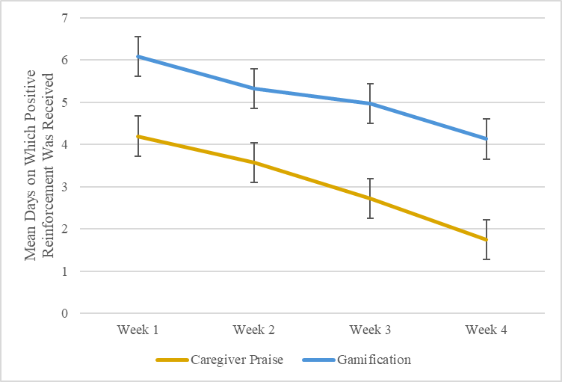
Figure 7. Average days per week on which dose of caregiver praise and gamification was received. Figure presents marginal means and standard error.

Table 8. Dietary self-monitoring outcomes by positive reinforcement status for the overall period
MEASURE | CAREGIVER PRAISE |  |  | GAMIFICATION |  |  | Caregiver Praise x Gamification
MEASURE | No  (n = 10) | Yes  (n = 9) | Main Effect | No  (n = 10) | Yes  (n = 9) | Main Effect | Caregiver Praise x Gamification
Average number of days with tracking, M ± SE (possible range: 0 to 28) | 23.0 ± 1.4 | 24.3 ± 1.4 | ns | 22.0 ± 1.3 | 25.3 ± 1.4 | ns | ns
Average proportion of items tracked on same day as intake, M ± SE (possible range: 0 to 1) | 0.73 ± 0.05 | 0.69 ± 0.06 | ns | 0.70 ± 0.05 | 0.73 ± 0.06 | ns | ns
Average number of logging sessions, M ± SE | 24.6 ± 2.8 | 21.5 ± 2.9 | ns | 22.4 ± 2.8 | 23.7 ± 2.9 | ns | ns
Abbreviations: M ± SE = marginal mean ± standard error; ns = not significant

Partial omega-squared effect sizes were calculated using marginal means for DSM outcomes, after adjusting for all other factors in the model. Gamification ($ω_{p}^{2}$ = 0.09) and the caregiver praise x gamification interaction ($ω_{p}^{2}$ = 0.05; Figure 8) exhibited medium and small effect sizes on DSM frequency, respectively. Effect sizes did not exceed the small effect size threshold for any other main effect or interaction for DSM variable.
DSM behaviors decreased over time (Figure 9; Table 9). Linear mixed factor ANOVA testing revealed a significant effect of time on average number of days with tracking [F(3,48) = 6.15, p = 0.001], proportion of items tracked on day of intake [F(3,43) = 4.03, p = 0.01], and number of logging sessions [F(3,48) = 31.7, p < 0.0001]. There was also a significant interactive effect of caregiver praise and time on average number of logging sessions [F(3,48) = 5.97, p =

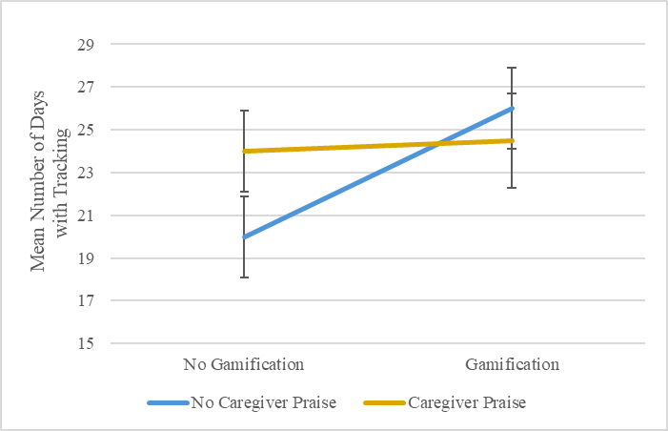
Figure 8. Interactive effect of caregiver praise and gamification on dietary self-monitoring frequency. Figure presents marginal means and standard error.

a,b
b
a,b
a
a
c
a,b
a,b
a
c
ba
a,b
a. 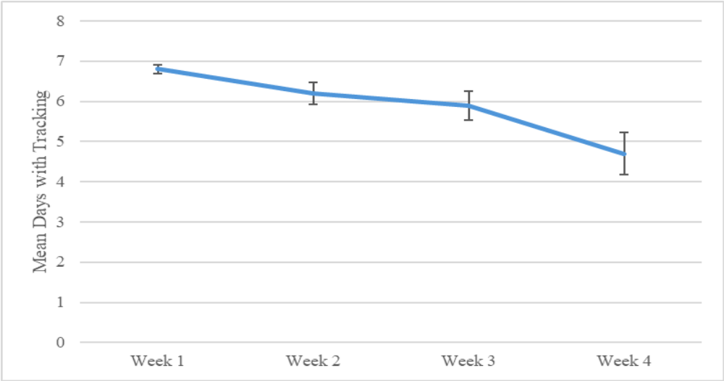
b. 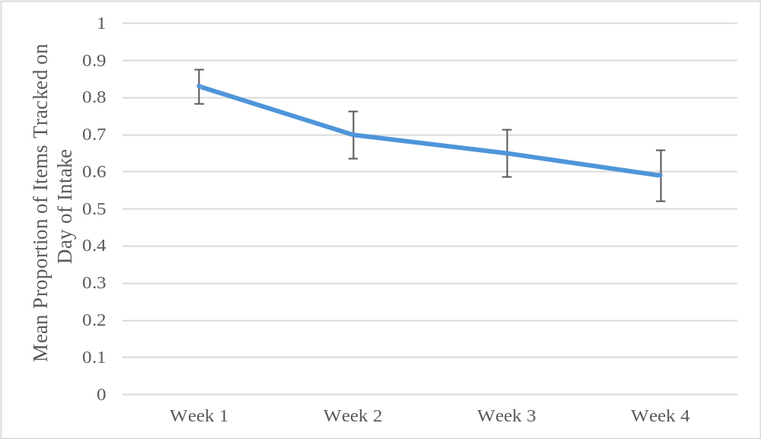
c. 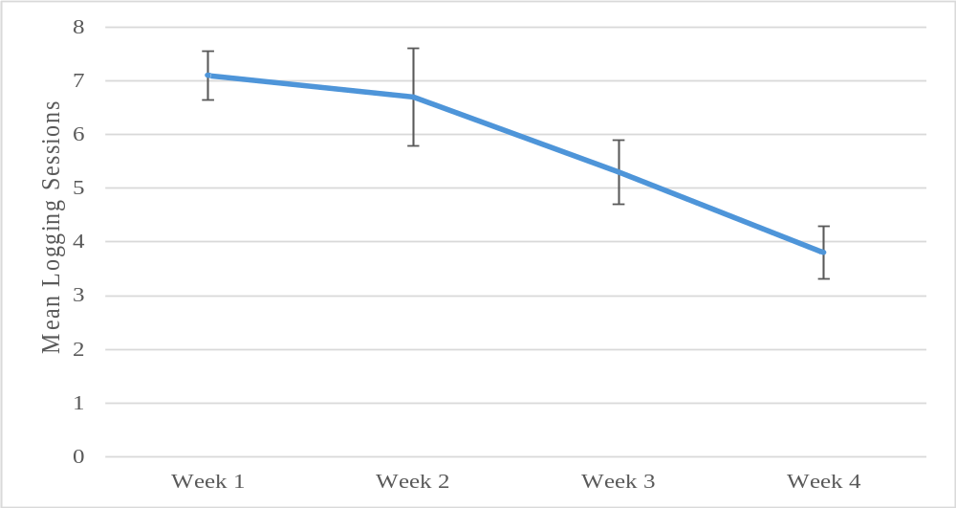
Figure 9. Engagement in dietary self-monitoring behaviors across the 4-week self-monitoring period. Points with different superscripts indicate a significant difference (p < 0.05) between weeks. Figure presents marginal means and standard error.
Table 9. Dietary self-monitoring outcomes by positive reinforcement assignment by week
MEASURE | CAREGIVER PRAISE |  | GAMIFICATION |  | Time Main Effect | Praise x Time | Gamification x Time
MEASURE | No  (n = 10) | Yes  (n = 9) | No  (n = 10) | Yes  (n = 9) | Time Main Effect | Praise x Time | Gamification x Time
Average number of days with tracking, M ± SE (possible range: 0 to 7)  Week 1  Week 2  Week 3  Week 4 | 6.8 ± 0.1  6.0 ± 0.4  5.4 ± 0.5  4.8 ± 0.7 | 6.8 ± 0.1  6.5 ± 0.4  6.5 ± 0.5  4.6 ± 0.8 | 6.7 ± 0.1  5.9 ± 0.4  5.4 ± 0.5  4.0 ± 0.7 | 6.9 ± 0.1  6.6 ± 0.4  6.5 ± 0.5  5.4 ± 0.8 | p < 0.001 | ns | ns
Average proportion of items tracked on same day as intake, M ± SE (possible range: 0 to 1)  Week 1  Week 2  Week 3  Week 4 | 0.84 ± 0.06  0.71 ± 0.09  0.69 ± 0.09  0.67 ± 0.12 | 0.82 ± 0.07  0.68 ± 0.09  0.61 ± 0.09  0.52 ± 0.13 | 0.82 ± 0.06  0.68 ± 0.09  0.64 ± 0.09  0.59 ± 0.12 | 0.84 ± 0.07  0.71 ± 0.09  0.66 ± 0.09  0.59 ± 0.13 | p = 0.01 | ns | ns
Average number of logging sessions, M ± SE  Week 1  Week 2  Week 3  Week 4 | 7.0 ± 0.6  8.1 ± 1.2  5.0 ± 0.8  4.5 ± 0.7 | 7.2 ± 0.7  5.2 ± 1.3  5.6 ± 0.9  3.3 ± 0.7 | 7.1 ± 0.6  7.2 ± 1.2  5.0 ± 0.8  3.1 ± 0.7 | 7.1 ± 0.7  6.1 ± 1.3  5.6 ± 0.9  4.7 ± 0.7 | p < 0.0001 | p = 0.002 | ns
Abbreviations: M ± SE = marginal mean ± standard error; ns = not significant

0.001] (Figure 10). Both levels of caregiver praise had negative slopes for the average number of logging sessions across the four weeks. However, the slope magnitude for children assigned to caregiver praise was greater than the magnitude for children not assigned to caregiver praise (b = -1.13 versus b = -0.62, respectively).

Secondary Measures
Table 10 presents scores for intrinsic motivation subdomains, child motivation to change eating behaviors, and dietary intake at follow-up by positive reinforcement level.

Intrinsic Motivation
There were no significant main or interactive effects of positive reinforcement on the IMI subdomains of interest/enjoyment [overall model: F(4,14) = 2.29, p = 0.11], perceived

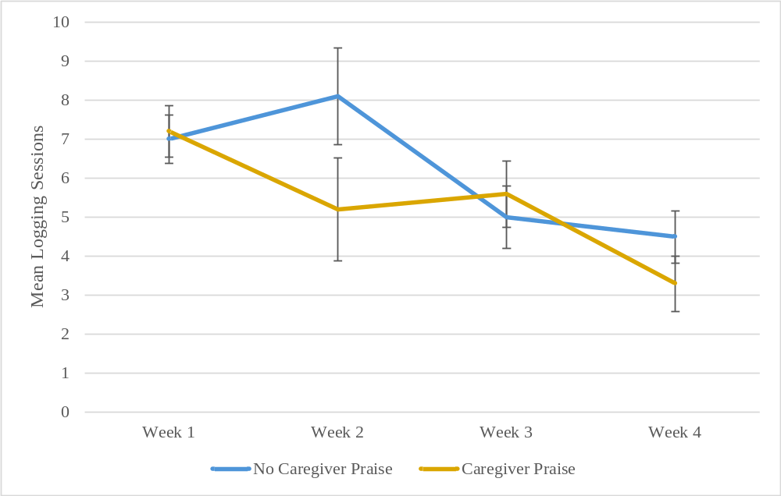

Figure 10. Interactive effect of caregiver praise and time on dietary self-monitoring frequency. Figure presents marginal means and standard error.
Table 10. Marginal mean scores for intrinsic motivation, child motivation to eat healthfully, and dietary intake at follow-up, adjusting for baseline scores
MEASURE | CAREGIVER PRAISE |  |  | GAMIFICATION |  |  | Caregiver Praise x Gamification Interactive Effect
MEASURE | No  (n = 10) | Yes  (n = 9) | Main Effect | No  (n = 10) | Yes  (n = 9) | Main Effect | Caregiver Praise x Gamification Interactive Effect
Intrinsic motivation subscales, M ± SE (possible range: 1 to 7)  Interest/enjoyment  Perceived competence  Perceived choice  Pressure/tension | 4.7 ± 0.6  5.4 ± 0.4  4.8 ± 0.4  1.8 ± 0.3 | 3.9 ± 0.6  4.7 ± 0.5  5.5 ± 0.4  2.5 ± 0.3 | ns  ns  ns  ns | 3.3 ± 0.6  4.4 ± 0.4  5.4 ± 0.4  1.9 ± 0.3 | 5.2 ± 0.6  5.6 ± 0.4  4.8 ± 0.4  2.4 ± 0.3 | ns  ns  ns  ns | ns  ns  ns  ns
Child motivation to eat healthfully, M ± SE (possible range: 0 to 32) | 30.9 ± 0.7 | 30.4 ± 0.8 | ns | 30.1 ± 0.7 | 31.2 ± 0.8 | ns | ns
Dietary intake, M ± SE  Fruit (CE)  Vegetables, excluding potatoes (CE)  Potatoes (CE)  Sweet & salty snack foods (g)  Sugar-sweetened beverages (kcal) | 1.2 ± 0.2  0.6 ± 0.1  0.2 ± 0.04  36.5 ± 7.9  28.1 ± 7.8 | 0.9 ± 0.2  0.6 ± 0.1  0.2 ± 0.04  46.5 ± 8.4  26.0 ± 8.2 | ns  ns  ns  ns  ns | 0.9 ± 0.2  0.4 ± 0.1  0.1 ± 0.03  38.3 ± 8.0  33.2 ± 7.7 | 1.2 ± 0.2  0.8 ± 0.1  0.3 ± 0.04  44.7 ± 8.5  20.9 ± 8.2 | ns  p = 0.03  p = 0.02  ns  ns | ns  ns  ns  ns  ns
Abbreviations: CE = cup equivalents; kcal = kilocalories; M ± SE = marginal mean ± standard error; ns = not significant

competence [overall model: F(4,14) = 6.26, p = 0.004], perceived choice [overall model: F(4,14) = 4.10, p = 0.02], or pressure/tension [overall model: F(4,14) = 1.94, p =
0.16] after controlling for baseline scores.
Partial omega-squared effect sizes were calculated using means of IMI subdomains, after adjusting for all other factors in the model (Figure 11). Praise exhibited a medium effect size for pressure/tension ($ω_{p}^{2}$ = 0.10). Assignment to gamification exhibited large effects for interest/enjoyment ($ω_{p}^{2}$ = 0.16) and perceived competence ($ω_{p}^{2}$ = 0.16), as well as a medium effect for pressure tension ($ω_{p}^{2}$ = 0.06). The praise x gamification interaction exhibited a small effect size for perceived choice ($ω_{p}^{2}$ = 0.02) (Figure 12). Effect sizes did not reach the small effect size threshold for any other main effect or interaction for either DSM timing variable.

Child Motivation to Change Eating Behaviors
The overall mean score on the MED-C was 30.6 ± 3.7 out of a possible 32. No significant main or interactive effects were found.

Child Dietary Intake
There was a significant main effect of assignment to gamification on consumption of vegetables excluding potatoes [no gamification: 0.42 ± 0.10 cup equivalents, gamification: 0.75 ± 0.10 cup equivalents, F(1,14) = 5.49, p = 0.03] and consumption of potatoes [no gamification: 0.13 ± 0.03 cup equivalents, gamification: 0.28 ± 0.04 cup equivalents, F(1,14) = 7.21, p = 0.02]. No other significant main or interactive effects were found.

Usability and Acceptability
Table 11 presents participant responses to the Usability and Acceptability Survey by group. Overall, the majority of children (79%) and caregivers (53%) reported that the log was very easy to use. Most children and caregivers reported that it was not at all confusing to use
- 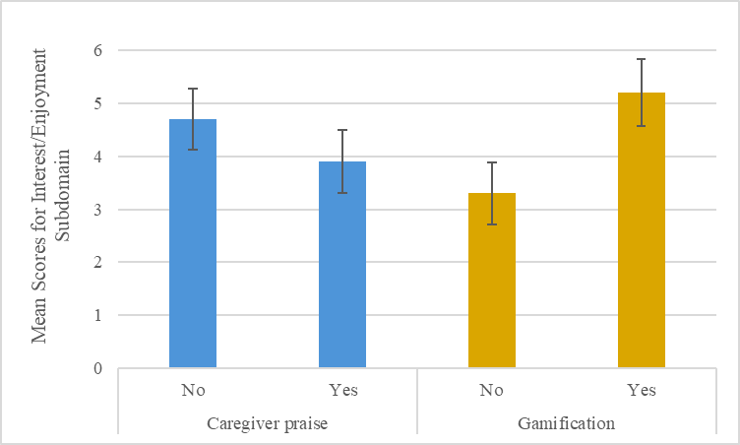

- 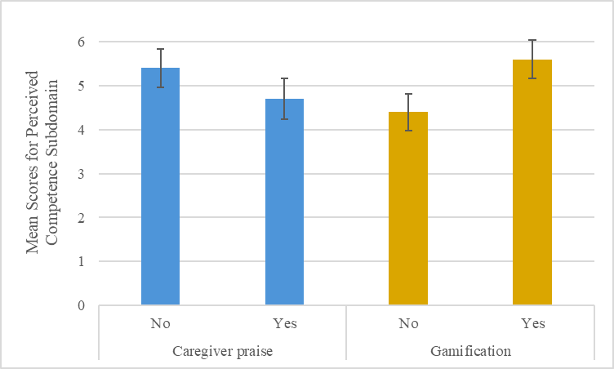
Figure 11. Main effects of positive reinforcement on the Intrinsic Motivation Inventory subdomains. Figure presents marginal means and standard error.

- 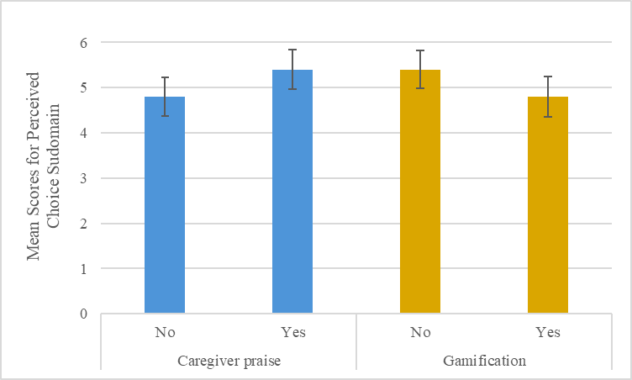
- 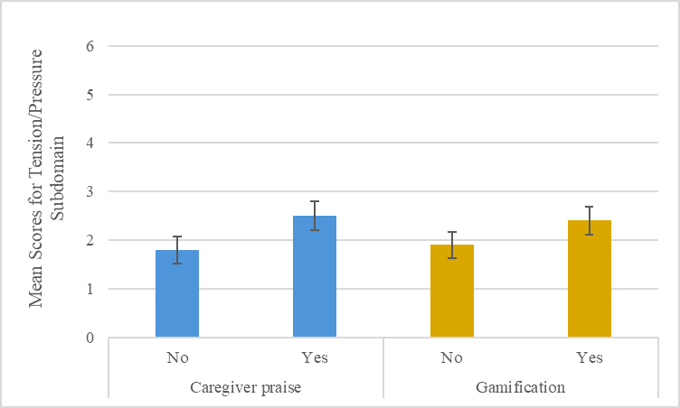
Figure 11. Continued.
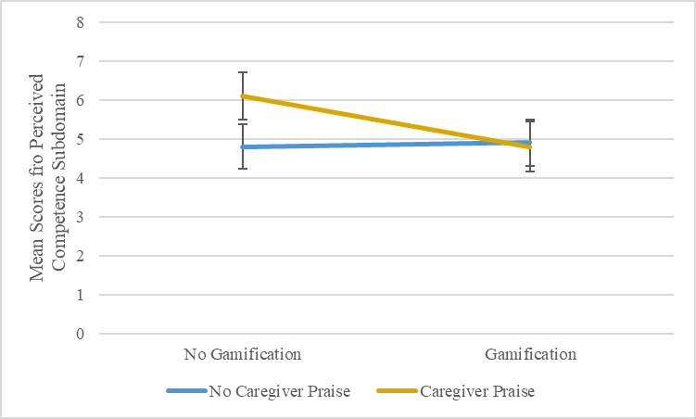

Figure 12. Interactive effect of caregiver praise and gamification on perceived choice. Figure presents marginal means and standard error.

Table 11. Responses to usability and acceptability survey by condition

SURVEY ITEM | BASIC  (n=5)  Child / Caregiver | PRAISE  (n=5)  Child / Caregiver | GAME  (n=5)  Child / Caregiver | GAME+PRAISE  (n=4)  Child / Caregiver
The log was easy to use.  Very easy  Somewhat easy  Not at all easy | 5 (100%) / 0 (0%)  0 (0%) / 5 (100%)  0 (0%) / 0 (0%) | 3 (60%) / 2 (40%)  2 (40%) / 3 (60%)  0 (0%) / 0 (0%) | 5 (100%) / 5 (100%)  0 (0%) / 0 (0%)  0 (0%) / 0 (0%) | 2 (50%) / 3 (75%)  2 (50%) / 1 (25%)  0 (0%) / 0 (0%)
Logging foods and drinks was confusing.  Very confusing  Somewhat confusing  Not at all confusing | 0 (0%) / 0 (0%)  2 (40%) / 0 (0%)  3 (60%) / 5 (100%) | 2 (40%) / 0 (0%)  2 (40%) / 2 (40%)  1 (20%) / 3 (60%) | 0 (0%) / 0 (0%)  0 (0%) / 0 (0%)  5 (100%) / 5 (100%) | 1 (25%) / 0 (0%)  2 (50%) / 1 (25%)  1 (25%) / 3 (75%)
Using the “help me” feature was confusing.  Very confusing  Somewhat confusing  Not at all confusing | 0 (0%) / 0 (0%)  2 (40%) / 0 (0%)  3 (60%) / 5 (100%) | 1 (20%) / 0 (0%)  0 (0%) / 0 (0%)  4 (80%) / 5 (100%) | 0 (0%) / 0 (0%)  0 (0%) / 0 (0%)  5 (100%) / 5 (100%) | 1 (25%) / 0 (0%)  1 (25%) / 0 (0%)  2 (50%) / 4 (100%)
The “help me” feature had too many words.  Yes  No  Maybe / I’m not sure | 1 (20%) / 0 (0%)  2 (40%) / 3 (60%)  2 (40%) / 2 (40%) | 0 (0%) / 0 (0%)  3 (60%) / 3 (60%)  2 (40%) / 2 (40%) | 0 (0%) / 0 (0%)  4 (80%) / 4 (80%)  1 (20%) / 1 (20%) | 1 (25%) / 0 (0%)  1 (25%) / 2 (50%)  2 (50%) / 2 (50%)
Using the caregiver check-in feature was confusing.¹  Very confusing  Somewhat confusing  Not at all confusing | NA / 0 (0%)  NA / 1 (20%)  NA / 4 (80%) | NA / 0 (0%)  NA / 0 (0%)  NA / 5 (100%) | NA / 0 (0%)  NA / 2 (40%)  NA / 3 (60%) | NA / 0 (0%)  NA / 0 (0%)  NA / 4 (100%)
The log was fun to use.²  A lot of fun  Somewhat fun  Not at all fun | 1 (20%) / NA  2 (40%) / NA  2 (40%) / NA | 1 (20%) / NA  2 (40%) / NA  2 (40%) / NA | 3 (60%) / NA  2 (40%) / NA  0 (0%) / NA | 2 (50%) / NA  1 (25%) / NA  1 (25%) / NA
My child enjoyed using this log.¹  A lot  Somewhat  Not at all | NA / 0 (0%)  NA / 3 (60%)  NA / 2 (40%) | NA / 1 (20%)  NA / 1 (20%)  NA / 3 (60%) | NA / 1 (20%)  NA / 4 (80%)  NA / 0 (0%) | NA / 2 (50%)  NA / 1 (25%)  NA / 1 (25%)
I liked the appearance of the log.  A lot  Somewhat  Not at all | 2 (40%) / 0 (0%)  3 (60%) / 4 (80%)  0 (0%) / 1 (20%) | 1 (20%) / 0 (0%)  1 (20%) / 3 (60%)  3 (60%) / 2 (40%) | 3 (60%) / 2 (40%)  2 (40%) / 3 (60%)  0 (0%) / 0 (0%) | 3 (75%) / 2 (50%)  1(25%) / 2 (50%)  0 (0%) / 0 (0%)
I would recommend this log to other kids / families.  Yes  No  Maybe / I’m not sure | 1 (20%) / 1 (20%)  1 (20%) / 1 (20%)  3 (60%) / 3 (60%) | 2 (40%) / 1 (20%)  1 (20%) / 0 (0%)  2 (40%) / 4 (80%) | 5 (100%) / 3 (60%)  0 (0%) / 0 (0%)  0 (0%) / 2 (0%) | 1(25%) / 2 (50%)  1 (25%) / 0 (0%)  2 (50%) / 2 (50%)
I would use the log again.  Yes  No  Maybe / I’m not sure | 1 (20%) / 1 (20%)  0 (0%) / 1 (20%)  4 (80%) / 3 (60%) | 2 (40%) / 1 (20%)  2 (40%) / 1 (20%)  1 (20%) / 3 (60%) | 2 (40%) / 3 (60%)  0 (0%) / 0 (0%)  3 (60%) / 2 (40%) | 3 (75%) / 2 (50%)  1 (25%) / 0 (0%)  0 (0%) / 2 (50%)
¹ Item administered to caregivers only.
² Item administered to children only.

the log (53% and 84%, respectively) or help feature (74% and 100%, respectively). Thirty-seven percent of children and caregivers each said that the help feature maybe had too many words. Most caregivers (84%) indicated that the caregiver check-in feature was not at all confusing. Almost three-quarters (74%) of children indicated that the log was somewhat or a lot of fun to use, and 68% of caregivers indicated that their child enjoyed using the log somewhat or a lot. Eighty-four percent of children and caregivers each indicated they like the appearance of the log somewhat or a lot. A total of 47% of children and 37% of caregivers said they would recommend the log to other kids/families, and 42% of children and 37% of caregivers indicated that they would use the log again.

Caregiver Reminders
Table 12 presents participant responses to the Caregiver Reminders Survey. Overall, 63% of children indicated that their caregiver provided a reminder to log about once a day or
more. More than two-thirds of children (67%) reported that receiving caregiver reminders to log was somewhat or very annoying, while 83% indicated that receiving reminders from caregivers was helpful. Similarly, 69% of caregivers indicated that they reminded their child to log about once a day or more. Less than half of caregivers (48%) reported that providing reminders was somewhat or very annoying, and almost all caregivers (95%) indicated that providing reminders to their child was helpful.

Discussion
In Phase II of this study, a proof-of-concept trial was conducted using the modified web- based DSM log to test the effects of positive reinforcement on child DSM behaviors. Differences in children’s intrinsic motivation were also explored.

Table 12. Responses to reminders survey, overall and by group
SURVEY ITEM | BASIC  (n=5) |  | PRAISE  (n=5) |  | GAME  (n=5) |  | PRAISE+  GAME  (n=4)
Child Survey
How often did your parent remind you to log your food and drinks in the last month?  Multiple times a day  About once a day  A few times a week  Once a week or less  Never (skip questions 2 and 3) | 1 (20%)  1 (20%)  2 (40%)  1 (20%)  0 (0%) | 1 (20%)  2 (40%)  1 (20%)  0 (0%)  1 (20%) |  | 0 (0%)  3 (60%)  2 (40%)  0 (0%)  0 (0%) |  | 2 (50%)  2 (50%)  0 (0%)  0 (0%)  0 (0%)
It was annoying when my parent reminded me to track my food and drinks.  Very true  Somewhat true  Not at all true | 2 (40%)  2 (40%)  1 (20%) | 1 (25%)  2 (50%)  1 (25%) |  | 0 (0%)  3 (60%)  2 (40%) |  | 0 (0%)  2 (50%)  2 (50%)
It was helpful when my parent reminded me to track my food and drinks.  Very true  Somewhat true  Not at all true | 1 (20%)  2 (40%)  2 (40%) | 1 (25%)  3 (75%)  0 (0%) |  | 2 (40%)  3 (60%)  0 (0%) |  | 0 (0%)  3 (75%)  1 (25%)
Caregiver Survey
How often did you remind your child to log food and drinks in the last month?  Multiple times a day  About once a day  A few times a week  Once a week or less  Never (skip questions 2 and 3) | 1 (20%)  3 (60%)  1 (20%)  0 (0%)  0 (0%) | 0 (0%)  3 (60%)  2 (40%)  0 (0%)  0 (0%) |  | 0 (0%)  4 (80%)  1 (20%)  0 (0%)  0 (0%) |  | 1 (25%)  1 (25%)  2 (50%)  0 (0%)  0 (0%)
It was annoying when I reminded my child to track food and drinks.  Very true  Somewhat true  Not at all true | 2 (40%)  2 (40%)  1 (20%) | 0 (0%)  2 (40%)  3 (60%) |  | 1 (20%)  1 (20%)  3 (60%) |  | 0 (0%)  1 (25%)  3 (75%)
It was helpful when I reminded my child to track food and drinks.  Very true  Somewhat true  Not at all true | 1 (20%)  3 (60%)  1 (20%) | 4 (80%)  1 (20%)  0 (0 %) |  | 4 (80%)  1 (20%)  0 (0%) |  | 2 (50%)  2 (50%)  0 (0%)

Implementation of Caregiver Praise versus Gamification as Positive Reinforcement
Implementation of positive reinforcement differed significantly by type. Children assigned to gamification received a high, consistent dose of gamified positive reinforcement across the 4-week DSM period. In contrast, implementation of caregiver praise was much poorer. During week 1, children assigned to gamification received at least one point on approximately 6 out of 7 days, while caregivers assigned to praise completed praise check-ins on approximately 4 out of 7 days. By the final week of the DSM period, children assigned to gamification received at least one point on approximately 4 out of 7 days, while caregivers assigned to praise completed praise check-ins on fewer than 2 out of 7 days on average.
Phase I formative testing of caregiver praise protocols was limited prior to the proof-of-concept trial and only included caregiver appraisal of the usability and acceptability of the check-in feature. In retrospect, additional formative investigation into caregivers’ perceptions and understanding of process praise may have aided its implementation in the subsequent trial. As mentioned, caregivers completed praise check-ins on less than half of the intended days during the proof-of-concept trial, indicating that they may have encountered barriers to providing daily process praise. However, it remains unclear whether the challenges were related to providing praise or simply completing the check-in in a timely manner. Still, this discrepancy in implementation of caregiver praise and gamification warrants examination of the unique characteristics of both types of positive reinforcement.
The manner in which positive reinforcement is implemented is strongly related to its success in establishing a behavior.^{45,61} Perhaps the most important factor in a reinforcer’s effectiveness is the immediacy with which it is provided after a desired behavior occurs.⁴⁵ An advantage of gamification is that provision of the reinforcement is automated, and thus it is delivered immediately after the behavior occurs by design. This automation tightly pairs the reinforcement with the behavior, increasing the likelihood that the behavior will occur again. For example, in the current study, a point was awarded immediately after a food or beverage was logged, and the virtual pet evolved to a new level immediately after a point threshold was exceeded. In contrast, the immediacy of caregiver praise depends on a number of factors and is itself reliant on human behavior. To provide immediacy, the caregiver must be present with the child at the time of the behavior, must notice the behavior has occurred, and subsequently must provide the praise in a timely manner.
A second important factor is consistency.⁴⁵ As with immediacy, the automated reinforcement provided via gamification ensures high levels of consistency. Caregivers may struggle to provide praise in a manner as consistent as automation given competing demands on attention, as well as the inability to be present with their child for all occurrences of the behavior.
Finally, convenience is also considered critical.⁴⁵ The reinforcer must be convenient for the deliverer to provide. A gamified system experiences no inconvenience in implementing its gamified mechanics, and gamification already fits conveniently into daily life given the ubiquity of mobile phones and other electronic devices.⁹⁰ However, caregivers who already have many other demands on their time and attention may find praise at times inconvenient to provide, reducing the likelihood that it will be offered immediately and consistently.
Thus, while caregiver praise and gamification both may act as effective positive reinforcers, gamification potentially offers unique advantages through automation. This may be particularly true over time as positive reinforcers that are reliant on human behavior (e.g., caregiver praise) may diminish. Still, further research is needed to examine the effects of social reinforcement (e.g., praise), which is based around human interaction and connection, versus gamified reinforcement, which relies on digital automation, on child behaviors in the long term.

Child DSM Behaviors over Time
There was a significant effect of time on DSM behaviors, with both DSM frequency and timing decreasing significantly over the 4-week DSM period. In general, participants engaged in unexpectedly high levels of DSM frequency compared to previous research, which indicates that approximately half of children may engage in little to no DSM, at least during obesity treatment.⁵⁻⁷ Additionally, about two-thirds of logged items were recorded on the day of intake, and participants completed slightly less than one logging session per day on average. As no other studies have reported on DSM timing in children, it is unclear whether these outcomes are more optimal than expected.
One factor that makes it challenging to contextualize the frequency outcomes from this study in comparison to previous research is the lack of a standard definition of DSM “completeness.”³⁴ In the current study, DSM frequency was defined as number of days with any tracking. Two previous studies of participants in early adolescence who were enrolled in behavioral weight interventions also examined whether any tracking on a given day.^{6,7} In these studies, 20% and 28% of participants, respectively, did not complete any DSM during the first month of the program.^{6,7} Furthermore, 35% and 44% of participants, respectively, were classified as “low monitors” (i.e., less than 3.5 days of tracking per week) during the first month of the program. By comparison, all but two participants in the current study had at least some tracking during all 4 weeks (one participant did not track during week 4 and one participant did not track during weeks 3 and 4). Additionally, all participants regardless of assigned positive reinforcement levels tracked nearly every day on average during the first two weeks of the DSM period. Even in the fourth and final week, all participants tracked an average of more than 4 days per week. Thus, DSM adherence in the current study appears to greatly exceed levels reported in previous research.
It is unclear why participants in the current investigation engaged in such high levels of DSM frequency. One potential explanation is that families in this study were not enrolled in concurrent intervention. In the absence of other intervention goals, children did not have to split their focus between DSM and other behaviors. Additionally, children were only asked to self-monitor four food groups (fruits, vegetables, sweet and salty snack foods, and sugar-sweetened beverages). As previously mentioned, past studies reporting DSM outcomes in children implemented self-monitoring within the context of obesity treatment. The two studies with reported dietary intervention goals included calorie goals. To monitor daily caloric intake, participants were likely asked to track all foods and beverages consumed, including calorie information. This method of DSM would necessarily be more time-consuming and burdensome and therefore may explain some of the reduced engagement compared to outcomes seen in the current study. Furthermore, participants were predominantly from higher income households and the majority of enrolled caregivers were recruited from within the UTK system. Such families may not be representative of the general population, and individuals who are employed at a university may value research more highly and engage at more optimal levels.
DSM timing, operationalized as 1) the proportion of items logged on the day of intake and 2) the number of logging sessions, was also examined. As with frequency, the measures of timing steadily declined across the 4-week period. The proportion of items tracked on the day of intake declined from 83% to 63% from week 1 to week 4. Additionally, participants completed slightly more than one logging session per day (7.1 sessions across the week) during week 1 compared to week 4 during which participants completed only 3.9 logging sessions across the week. Overall, participants frequently completed only 2 or fewer logging sessions per day with an average of only 70% of items tracked on the day of intake. Timing of DSM is important because reducing the time between intake and recording decreases the chance that errors will be made due to recall bias, a common issue encountered in dietary recall.^{165,166}
Four studies have previously reported on DSM adherence in children and adolescents.⁴⁻⁷ However, non-digital methods of tracking prevent feasible collection of information related to timing of DSM, and none of these studies reported on any timing-related variables. Although the specific tracking method (paper vs. digital) was not described, the lack of specification suggests participants likely used traditional pen-and-paper methods. As a result, the present findings on DSM timing cannot be directly compared to prior literature.

The Effects of Praise on DSM and Intrinsic Motivation
It was hypothesized that children assigned to receive caregiver praise would have better overall DSM behaviors than children not receiving caregiver praise; however, no main effect of assignment to caregiver praise on DSM frequency or timing was found. There was a significant interaction of assignment to caregiver praise and time on the average number of logging sessions. Although logging sessions decreased over time for both groups, the decline was steeper among children assigned to receive caregiver praise. Additionally, no main effects were found for assignment to caregiver praise on the subdomains of intrinsic motivation.
Praise has long been recognized as a form of positive reinforcement that is valuable for shaping behaviors in children.^{61,62} However, few studies have examined the effects of praise on children’s behaviors in isolation. A 2012 review of praise, nonverbal reinforcement, and reprimand examined experimental, naturalistic, and training studies conducted with children ages 1.5-11 years.⁶⁶ In experimental studies in non-clinical populations, praise and nonverbal reinforcement were generally related to improved compliance, suggesting that praise has the potential to strengthen desired behaviors in child. Caregiver praise is already a frequently implemented strategy within family-based lifestyle interventions.^{38,68,69} In general, process praise is believed to be beneficial to building a child’s intrinsic motivation and self-efficacy.⁷⁸ However, research on how praise affects children’s behavior is complex.
In this study, caregivers were instructed to provide daily process praise related to their child’s DSM. However, no differences in any IMI subdomain were found between levels of caregiver praise. One potential explanation is that praise was not provided at the appropriate frequency. On average caregivers completed praise check-ins on less than half of the 28 DSM days (mean = 13.1 ± 7.6 days), which could indicate that children received insufficient dose of praise to be effective. Additionally, completion of caregiver praise check-ins lessened substantially over time (60% completed during week 1 versus 25% completed in week 4), indicating that caregivers provided less praise as the DSM period progressed. Thus, child engagement in DSM may have diminished as the social reinforcement of caregiver praise also diminished.
Additionally, if children perceive praise as intended to manipulate behavior, or if they perceive the praise as exaggerated or inflated, it may also be less effective.^{79,81,82} For example, Brummelman et al found that among children with low self-esteem, inflated praise increased their avoidance of challenging tasks, suggesting decreased motivation to engage in those activities.⁸³
Finally, even though caregivers received brief training on process praise at their baseline appointment (that included correctly identifying process praise statements and practicing providing process praise during practice), it is possible that adherence to providing the proper type of praise was low in the natural setting. Parents were not required to record the praise statements they provided to their children, which limits the ability to draw conclusions about adherence to instructions for providing process praise. If parents accidentally provided person praise (e.g., “you are so smart”), this may have unintentionally decreased intrinsic motivation.⁸⁰

The Effects of Gamification on DSM and Intrinsic Motivation
It was hypothesized that children receiving gamification would have better overall DSM behaviors than children not receiving gamification. However, similarly to caregiver praise, no main effect of gamification on DSM frequency or timing was found. Additionally, no main effects were found for gamification on subdomains of intrinsic motivation. However, dose of gamification received was significantly higher than caregiver praise across the 4-week DSM period.
While prior studies have shown that gamification may improve self-monitoring behaviors related to blood glucose tracking, evidence specific to DSM behaviors remains limited. Two small studies of gamified blood glucose monitoring systems that awarded points for tracking blood glucose have been shown to improve both self-monitoring and related health outcomes.^{108,109} while one study of a similar gamified system found no effect on self-monitoring or health outcomes.¹¹⁰ Two studies were identified that integrated gamification into child-focused DSM applications; however, outcomes for DSM behaviors were not specifically reported.^{118,119} One 6-week RCT instructed adult participants to elect one child or grandchild (n = 14) ages 12-20 years to complete DSM on their behalf.¹¹⁸ The effect of gamification on number of user sessions (i.e., periods wherein the user interacted with the app) for a DSM app was examined. Dyads assigned to the gamified app completed significantly more sessions than dyads assigned to the non-gamified app. However, the app also included features not related to DSM (e.g., a virtual garden); thus, sessions did not necessarily indicate DSM was occurring, only that children were engaging with the app in some way. A separate study examined how gamification of DSM affected diet in tenth graders (n=87) ages 15-16 years enrolled in a 9-week health education course.¹¹⁹ Results suggested improved dietary intake in the gamified log condition vs control. Again, however, no DSM outcomes were reported. Thus, the current study fills a gap in the literature on how gamification may affect DSM specifically.
Research on the effects of gamification on intrinsic motivation is mixed.¹²⁵⁻¹²⁸ Gamification elements like points, levels, and leaderboards offer task-contingent rewards for engaging in desired behaviors. Like other external rewards, the instances in which gamification may contribute to or undermine intrinsic motivation are nuanced and complex. Much research on gamification and motivation has been conducted in the field of academic learning. Several reviews on gamified learning environments have been conducted, with mixed conclusions about the impact of gamification on intrinsic motivation.¹²⁵⁻¹²⁸ Some researchers have argued that, in accordance with self-determination theory, as gamification increases extrinsic rewards it conversely causes intrinsic motivation to decrease, resulting in less interest in academic work.¹²⁷ Thus, gamification may only increase intrinsic motivation levels when a task is considered boring and may undermine intrinsic motivation when a task is inherently interesting.¹²⁷
Conversely, others have argued that gamification, provided in the right way within the right context, can meet basic psychological needs and improve intrinsic motivation.^{125,128} Two meta-analyses concluded there was an overall positive effect of gamified learning on intrinsic motivation.^{125,126} One of the studies, which included 35 gamified education interventions, found that reward combinations for level of performance achieved (rather than simple task completion participation) had the largest effect size of the types of contingencies examined.¹²⁵
The current study implemented gamification in the form of points, levels, and a virtual pet. Points were not contingent on level of performance achieved but were instead awarded simply for consistent engagement; however, large effect sizes of gamification on intrinsic motivation were still found. Furthermore, participants were not enrolled in any concurrent intervention and, thus, DSM was completed in isolation of any potentially motivating context (e.g., desire to be healthy). Under these circumstances, DSM may not have been an inherently interesting activity for the participants, and thus, gamification may have helped to move children’s motivation along the spectrum from amotivation toward intrinsic motivation.^{73,127}
Additionally, the use of a virtual pet as a specific gamification approach may also impact intrinsic motivation outcomes. There is some evidence that virtual agents may increase feelings of relatedness. In a 72-hour field study in children of a similar age range (n = 67; 9-13 years), participants engaged with a virtual dog at a digital kiosk to set physical activity goals for the day.¹⁶⁷ The virtual dog either did (points condition) or did not (no-points condition) award points for meeting self-set physical activity goals for the day. Researchers found that children in the points condition reported marginally higher (p = 0.06) perceptions relatedness than those in the no-points condition. This suggests that a virtual agent that provides external rewards may increase feelings of relatedness, which in turn, per the constructs of self-determination theory, may improve intrinsic motivation. Similarly, a separate study in young adult women who cared for a virtual dog for 3 weeks found notable feelings of relatedness and ownership toward the virtual pet.¹⁶⁸ Still, more research is needed to understand the impact of virtual pets on intrinsic motivation.
Though no significant effects of praise on DSM behaviors were identified, a potentially meaningful effect size of gamification were found for DSM frequency. As effect size is calculated independently of sample size, large effect sizes may still provide valuable insight into clinical relevance even when statistical significance is not achieved.^{169,170} Gamification exhibited a positive, medium effect ($ω_{p}^{2}$ = 0.09) on the average number of days with tracking, with participants assigned to gamification tracked an average of 3.3 more days during the 4-week DSM period compared to participants who were not assigned to gamification (F test not significant). Additionally, post-hoc analyses indicated that an actual power of only 42% was achieved for gamification, which had the largest effect size. An estimated sample of 52 participants (26 per group) would have been required to achieve the standard 80% power for the gamification main effect (calculated using G*Power version 3.1.9.7¹⁷¹). Additionally, though the main effects were not significant, there were positive, large effect sizes of gamification on the IMI subdomains of interest/enjoyment ($ω_{p}^{2}$ = 0.16) and perceived competence ($ω_{p}^{2}$ = 0.16). Nevertheless, the lack of power means the implications of the calculated effect sizes should be interpreted with caution, and the generalizability of the findings is limited.
Finally, children responded well to the virtual pet design in formative testing, and caregivers expressed expectations that such a gamification feature would enhance their child’s motivation to engage with the system. In contrast, findings from the proof-of-concept trial did not reveal any significant main effects of gamification on DSM behaviors or intrinsic motivation, though the calculated effect sizes were medium to large. Additionally, 40% of children not assigned to gamification rated the log as not at all fun to use at the end of the proof-of-concept trial compared to just 11% of children who were assigned to gamification. This suggests that children whose logs included the points, levels, and virtual pet features did experience greater enjoyment when using the log, though this did not result in statistically significant outcomes.

Reactivity of Dietary Intake to Self-Monitoring
It is well-established that the act of self-monitoring itself may produce changes in the target behavior (a phenomenon known as reactivity), and that generally, reactivity occurs in a beneficial direction.^{10,25} Previous research that reactive changes to an individual’s diet may also occur in response to dietary self-monitoring.^{172,173}
In the current study, children assigned to gamification consumed more vegetables and potatoes at follow-up compared to children not assigned to gamification, after adjusting for baseline levels of intake. No differences were seen based on assignment to caregiver praise. Though the higher DSM frequency observed among children assigned to gamification compared to children not assigned to gamification did not reach statistical significance, there was still a notable effect size. This, along with the superior implementation of gamification compared to caregiver praise, may help to explain why reactive changes only occurred among children assigned to gamification in this study.

Usability and Acceptability of the Log
In general, the log was well received in the proof-of-concept trial. Participants felt the log was easy to use and did not report high levels of confusion. Nearly three quarters of children indicated that the log was at least somewhat fun to use, and about two thirds of caregivers felt their child at least somewhat enjoyed using the log.
Despite this positive feedback, less than half of children and caregivers indicated that they would be willing to use the log again or would recommend it to others. However, this may be attributed to the fact that the log was used without any concurrent intervention or dietary goals. Thus, families may not have felt that using the log to track food and beverages in isolation of a broader context was valuable. These responses contrast with those of the five families enrolled in the formative study, all of whom indicated they would use the log again. Three of those families were FBHT completers and two had screened ineligible for FBHT. Thus formative participants, who had either undergone or sought obesity treatment, may have inherently valued DSM to a greater degree, potentially explaining the discrepancy in responses between the two phases of the study.
No previous studies were identified that examined the usability and acceptability of DSM logs that used caregiver praise or gamification as positive reinforcement strategies. However, gamified systems for self-monitoring of other health behaviors have also been well-received among children and adolescents, such as gamified lung function and physical activity self-monitoring systems.¹¹⁴⁻¹¹⁷ Strategies that improve satisfaction with the process of DSM may be important as children may find tracking their foods and beverages to be burdensome and difficult to remember.¹⁷⁴
For example, a notable theme identified in both child and caregiver feedback during formative testing was concern about the potential confusion children might feel when trying to log foods or beverages with serving sizes and amounts. To address this, structured training on how to use the logging feature was provided during the training session of proof-of-concept trial baseline visits. Still, about half of the children indicated that logging foods and drinks was somewhat to very confusing at the end of the trial, suggesting that tracking in this manner is a difficult skill to master for children aged 8-12 years. It is only beginning around the age of 8 years that children’s ability to self-report dietary intake rapidly increases, which means that DSM may still be challenging for children at the lower end of the enrolled age range.¹³⁶ Thus, younger children may require increased assistance from an adult or caregiver to engage in DSM at optimal levels.

Strengths and Limitations
This trial tested two positive reinforcement strategies (caregiver praise and gamification) in a novel way to examine their potential to improve DSM behaviors in children using a web-based log. The use of a 2x2 factorial design allowed for the isolation of the effects and interactions of positive reinforcement on DSM. Importantly, a potential underlying mechanism (intrinsic motivation) that might explain why positive reinforcement affects DSM was also investigated. Additionally, DSM was prescribed without a concurrent intervention to tightly control the influence of the independent variables on DSM behaviors only.
Furthermore, the decision to compare caregiver praise and gamification allowed for examination of two positive reinforcement strategies with differing characteristics. Caregiver praise is a well-studied strategy that has been used for decades to encouraging desired behavior in children. However, it is reliant on human behavior and is therefore subject to the related limitations. Gamification of a digital system to influence child behavior, on the other hand, is a newer area of positive reinforcement research. Its automation provides immediate, consistent, and convenient implementation of positive reinforcement following behavior. Thus, this study was able to examine how two unique approaches to positive reinforcement, one social and one automated, affected DSM behaviors in children.
This is also the first study to examine timing of DSM behaviors in children and adolescents. The use of a web-based DSM log allowed for the automated recording of timestamps that could be compared against the day on which the item was reported as consumed.
The limitations of the study include the small sample size. Despite the medium effect size of assignment to gamification on DSM frequency ($ω_{p}^{2}$ = 0.09), no significant main effect was detected. Post hoc analyses indicate that the study had a power of only 42% to detect this effect. The discrepancy in implementation of the two types of positive reinforcement may help to explain why a medium effect size was found for assignment to gamification while no notable effect size was found for assignment to caregiver praise. Another limitation was the high engagement in DSM that was maintained even to the end of the 4-week DSM period. A longer tracking period may have permitted time for more dramatic diminishment in DSM behaviors, allowing differences between groups to be detected. Additionally, the number of children who achieved the maximum level of evolution for their virtual pet was not ideal. Preferably, only a handful of children would have reached the maximum level, given that motivation may change once the final level is reached. Despite this, gamification remained in place even after achieving the maximum level, as points were still accrued and displayed in the log after achievement. Increasing the point thresholds for achieving each level or adding additional levels to the virtual pet’s stages of evolution may have allowed for more variation in the final level achieved. Furthermore, caregivers were not required to record the praise statements they provided to their children, which prohibits examination of whether caregivers were appropriately providing process praise statements according to study procedures. Finally, the sample was not diverse and included predominantly white children from high income families, limiting the generalizability of findings.

Conclusions
In the current investigation, the effects of two positive reinforcement strategies—caregiver praise and gamification—on child DSM behavior were evaluated using a web-based log. No statistically significant effects of caregiver praise or gamification on DSM or intrinsic motivation were found. Despite this, the calculated effect size of gamification on DSM frequency was medium, and the calculated effect sizes of gamification on intrinsic motivation were large. Additionally, the automated nature of gamification resulted in more consistent implementation compared to caregiver praise, which diminished substantially over time.
Overall, this study suggests that children and their families are willing to engage in DSM at high levels when using a web-based DSM log. Additionally, integrating positive reinforcement into the DSM process appears feasible, and neither caregiver praise nor gamification appears to negatively impact intrinsic motivation in children. In fact, the automation of gamification may provide additional advantages as a positive reinforcement strategy, as it ensures reinforcement for behavior is offered immediately, consistently, and conveniently without relying on human behavior. Considerations for future research are detailed in depth in the General Discussion section below.

General Discussion
Testing from both phases of the current investigation suggest that a web-based DSM log that integrates caregiver praise and gamification is generally acceptable to children aged 8-12 years and their caregivers. Additionally, this study shows that children are willing to engage in DSM at high levels when logging via web-based log. While it is not entirely clear why participants engaged in an unusually high frequency of logging, research in adults that suggests that users may find digital forms of DSM less burdensome and more acceptable than traditional pen-and-paper methods.^{48,49} Previous research reporting on poorer DSM outcomes in children did not appear to use digital methods of self-monitoring. ⁴⁻⁷ Therefore, the web-based log may have been more acceptable to children and led to improved DSM behaviors.
Despite these outcomes, less than half of children and caregivers indicated that they would be willing to use the log again. As previously discussed, DSM was prescribed in the absence of any other intervention in this study. Tracking foods and beverages in this decontextualized manner may not have felt as valuable to families as it would during intervention or treatment. Thus, future research should examine whether intent to use increases in contexts that may be feel meaningful to children and families.
Importantly, neither caregiver praise nor gamification appear to reduce children’s intrinsic motivation to engage in DSM. Process praise is already believed to support intrinsic motivation in children.^{77,78} However, the research on gamification is mixed.¹²⁵⁻¹²⁸ This study adds to the growing body of literature that suggests that gamification that supports basic psychosocial needs can also support intrinsic motivation.^{125,128}
Furthermore, gamification had better implementation across the 4-week DSM period compared to caregiver praise. Gamification relies on automated mechanics within a digital system, and thus by its nature provides reinforcement that is immediate, consistent, and convenient. These characteristics are believed to be the most important for ensuring a positive reinforcer is effective at supporting a desired behavior.⁴⁵ In contrast, rates of caregiver praise decreased much more substantially over the DSM period, as implementation was dependent on the caregiver. At least per caregiver self-report, children were receiving relatively small doses of praise by the end of the four weeks. Additionally, while not directly measured, there are obvious additional challenges to caregiver praise being provided with the same immediacy, consistency and convenience as the automation of gamification. Thus, while both strategies may play an important role in child behavior and intrinsic motivation, gamification offers some unique advantages that cannot be as effectively provided by caregivers.

Strengths and Limitations
Strengths of the current study include initial usability and acceptability testing prior to implementation of the subsequent trial, examination of two positive reinforcement strategies with distinct advantages, and exploration of a potential underlying mechanism of intrinsic motivation. However, the sample size for both studies was small, limiting generalizability and reducing statistical power to detect effects. Additionally, more robust formative testing may have benefited the subsequent proof-of-concept trial. As previously mentioned, a deeper investigation of process praise with caregivers may have resulted in improved protocols for implementing caregiver praise in the trial. Furthermore, an additional round of formative testing that piloted the log over time (rather than a single session) may have been beneficial for two reasons: 1) to identify whether the DSM period should have been extended to allow for greater extinction of behaviors and 2) to determine optimal point thresholds for levels so that fewer children would reach the maximum level of the virtual pet too quickly. Finally, it is unclear why the majority of participants in the proof-of-concept did not indicate they would want to use the log again, despite high participation in DSM. Further investigation of the log’s acceptability in other contexts (e.g., treatment) is warranted.

Future Research
The Phase II proof-of-concept trial identified medium to large effect sizes of gamificaiton on children's DSM frequency and intrinsic motivation. However, the sample size was small, and the study was substantially underpowered. Future studies should include larger samples to help determine whether true effects of positive reinforcement are present.
Additionally, caregivers in the trial were instructed to provide daily process praise to their children for engaging in DSM. Despite a large body of literature supporting the motivational benefits of process praise, no effect on children’s intrinsic motivation was observed. Future research should examine how praise can be implemented most effectively, considering factors such as type, frequency, and context, and how caregiver adherence to praise protocols can be better supported and monitored. Such studies would help clarify whether structured caregiver praise interventions can enhance both child tracking and intrinsic motivation.
Similarly, future research should also examine how to optimally implement gamification. The current study employed points, levels, and a virtual pet, but there are numerous other gamification elements and combinations that warrant investigation.
Furthermore, understanding how different positive reinforcement approaches interact, whether synergistically or in opposition, will be crucial for developing strategies that support high levels of DSM and intrinsic motivation in children. Modern study designs such as multiphase optimization strategy (MOST) trials may offer efficient ways of determining what positive reinforcement strategies and in what combinations are most effective for enhancing child DSM.
Likewise, longer study durations are also needed to examine differences over time. In this 4-week study, participants maintained unexpectedly high rates of DSM. Longer DSM periods would allow for observation of more pronounced extinction of DSM behaviors and clarify whether gamification effects diminish as its novelty wears off.
Finally, one of the most common reasons children engage in DSM is as a behavior change strategy within nutrition interventions. Positive reinforcement strategies, such as caregiver praise and gamification, should be tested explicitly within such programs to assess their impact on DSM behaviors and health outcomes. Prior research suggests that higher DSM levels are associated with improved weight loss, underscoring the importance of refining strategies to support high levels of DSM.

Conclusions
Strategies to improve DSM, a foundational behavior change strategy in nutrition interventions, in children are needed. Positive reinforcement, such as caregiver praise and gamification, offers promising options to achieve this. Results from this two-phase study suggest that a web-based DSM log that integrates caregiver praise and gamification as positive reinforcement is generally perceived as usable and acceptable to children aged 8-12 years and their caregivers. Although no significant effects of positive reinforcement were found, medium to large effect sizes of positive reinforcement on DSM behaviors and intrinsic motivation warrant further investigation in future research. Additionally, gamification was identified as a strategy that can provide immediate, consistent, and convenient reinforcement for engaging in a desired behavior. Future research should the effects of positive reinforcmenet on digital DSM within larger, more diverse samples and should test whether these positive reinforcement strategies lead to better outcomes within behavioral interventions such as childhood obestiy treatment.

REFERENCES
1. Chen S, Dzewaltowski DA, Rosenkranz RR, et al. Feasibility study of the SWITCH implementation process for enhancing school wellness. BMC Public Health. 2018;18:1-11.
2. Jones M, Taylor Lynch K, Kass AE, et al. Healthy weight regulation and eating disorder prevention in high school students: a universal and targeted web-based intervention. J Med Internet Res. 2014;16(2):e57. doi:10.2196/jmir.2995
3. Whittemore R, Jeon S, Grey M. An Internet obesity prevention program for adolescents. J Adolesc Health. 2013;52(4):439-447. doi:10.1016/j.jadohealth.2012.07.014
4. Mockus DS, Macera CA, Wingard DL, Peddecord M, Thomas RG, Wilfley DE. Dietary self-monitoring and its impact on weight loss in overweight children. Int J Pediatr Obes. 2011;6(3-4):197-205.
5. Saelens BE, McGrath AM. Self-monitoring adherence and adolescent weight control efficacy. Child Health Care. 2003;32(2):137-152.
6. Kirschenbaum DS, Germann JN, Rich BH. Treatment of morbid obesity in low-income adolescents: effects of parental self-monitoring. Obesity Research. 2005;13(9):1527-1529. doi:10.1038/oby.2005.187
7. Germann JN, Kirschenbaum DS, Rich BH. Child and parental self-monitoring as determinants of success in the treatment of morbid obesity in low-income minority children. J Pediatr Psychol. 2007;32(1):111-121.
8. Dalle Grave R, Centis E, Marzocchi R, El Ghoch M, Marchesini G. Major factors for facilitating change in behavioral strategies to reduce obesity. Psychol Res Behav Manag. 2013;6:101-10. doi:10.2147/PRBM.S40460
9. Llabre MM, Bennett G, Brantley PJ, et al. Clinical practice guideline for multicomponent behavioral treatment of obesity and overweight in children and adolescents: current state of the evidence and research needs from the Guideline Development Panel (GDP) for obesity treatment of the American Psychological Association (APA). 2018.
10. McFall RM. Chapter 8: Self-monitoring. In: Stuart RB, ed. Behavioral Self-Management: Strategies, Techniques and Outcomes. Brunner/Mazel; 1977:196-214.
11. Nelson RO. Assessment and therapeutic functions of self-monitoring. Prog Behav Modif. Elsevier; 1977:263-308.
12. Hallahan DP, Sapona R. Self-monitoring of attention with learning-disabled children: past research and current issues. J Learn Disabil. 1983;16(10):616-620.
13. Peterson L, Tremblay G. Self-monitoring in behavioral medicine: children. Psychol Assess. 1999;11(4):458-465. doi:10.1037/1040-3590.11.4.458
14. Shapiro ES, Cole CL. Self-monitoring. In: Ollendick TH, Hersen M, eds. Handbook of Child and Adolescent Assessment. Allyn & Bacon; 1993:124-139.
15. Bornstein P, Hamilton S, Bornstein M. Self-monitoring procedures. In: Ciminero AR, Calhoun KS, Adams HE, eds. Handbook of Behavioral Assessment. 2 ed. John Wiley & Sons; 1986:176-222.
16. Sagotsky G, Patterson CJ, Lepper MR. Training children's self-control: a field experiment in self-monitoring and goal-setting in the classroom. J Exp Child Psychol. 1978;25(2):242-253.
17. Bauer S, de Niet J, Timman R, Kordy H. Enhancement of care through self-monitoring and tailored feedback via text messaging and their use in the treatment of childhood overweight. Patient Educ Couns. 2010;79(3):315-319. doi:10.1016/j.pec.2010.03.014
18. Harris KR. Self‐monitoring of attentional behavior versus self‐monitoring of productivity: effects on on‐task behavior and academic response rate among learning disabled children. J Appl Behav Anal. 1986;19(4):417-423.
19. Holifield C, Goodman J, Hazelkorn M, Heflin LJ. Using self-monitoring to increase attending to task and academic accuracy in children with autism. Focus Autism Other Dev Disabl. 2010;25(4):230-238.
20. Mathes MY, Bender WN. The effects of self-monitoring on children with attention-deficit/hyperactivity disorder who are receiving pharmacological interventions. Remedial and Special Education. 1997;18(2):121-128.
21. Melbye S, Kessing LV, Bardram JE, Faurholt-Jepsen M. Smartphone-based self-monitoring, treatment, and automatically generated data in children, adolescents, and young adults with psychiatric disorders: systematic review. Review. JMIR Ment Health. 2020;7(10):e17453. doi:10.2196/17453
22. Patton SR, Clements MA. Continuous glucose monitoring versus self-monitoring of blood glucose in children with type 1 diabetes- are there pros and cons for both? US Endocrinol. 2012;8(1):27-29.
23. McLoughlin GM, Rosenkranz RR, Lee JA, et al. The importance of self-monitoring for behavior change in youth: findings from the SWITCH(®) School Wellness Feasibility Study. International Journal of Environmental Research and Public Health. 2019;16(20):3806. doi:10.3390/ijerph16203806
24. Ganz JB. Self-monitoring across age and ability levels: teaching students to implement their own positive behavioral interventions. Preventing School Failure: Alternative Education for Children and Youth. 2008;53(1):39-48.
25. Nelson RO, Hayes SC. Theoretical explanations for reactivity in self-monitoring. Behav Modif. 1981;5(1):3-14. doi:10.1177/014544558151001
26. Korotitsch WJ, Nelson-Gray RO. An overview of self-monitoring research in assessment and treatment. Psychol Assess. 1999;11(4):415-425.
27. McFall RM. Effects of self-monitoring on normal smoking behavior. J Consult Clin Psychol. 1970;35(2):135-142.
28. Broden M, Hall RV, Mitts B. The effect of self‐recording on the classroom behavior of two eighth‐grade students. J Appl Behav Anal. 1971;4(3):191-199.
29. Hayes SC, Cavior N. Multiple tracking and the reactivity of self-monitoring: I. Negative behaviors. Behav Ther. 1977;8(5):819-831.
30. Herbert EW, Baer DM. Training parents as behavior modifiers: self‐recording of contingent attention. J Appl Behav Anal. 1972;5(2):139-149.
31. Lipinski DP, Black JL, Nelson RO, Ciminero AR. Influence of motivational variables on the reactivity and reliability of self-recording. J Consult Clin Psychol. 1975;43(5):637-646.
32. Burke LE, Wang J, Sevick MA. Self-monitoring in weight loss: a systematic review of the literature. J Am Diet Assoc. 2011;111(1):92-102.
33. Harvey J, Krukowski R, Priest J, West D. Log often, lose more: electronic dietary self‐monitoring for weight loss. Obesity. 2019;27(3):380-384.
34. Payne JE, Turk MT, Kalarchian MA, Pellegrini CA. Defining adherence to dietary self-monitoring using a mobile app: a narrative review. J Acad Nutr Diet. 2018;118(11):2094-2119. doi:https://doi.org/10.1016/j.jand.2018.05.011
35. Boutelle KN, Kirschenbaum DS. Further support for consistent self‐monitoring as a vital component of successful weight control. Obesity research. 1998;6(3):219-224.
36. Arroyo KM, Carpenter CA, Krukowski RA, Ross KM. Identification of minimum thresholds for dietary self-monitoring to promote weight-loss maintenance. Obesity. 2024;32(4):655-659. doi:https://doi.org/10.1002/oby.23994
37. Turner-McGrievy GM, Dunn CG, Wilcox S, et al. Defining adherence to mobile dietary self-monitoring and assessing tracking over time: tracking at least two eating occasions per day is best marker of adherence within two different mobile health randomized weight loss interventions. J Acad Nutr Diet. 2019;119(9):1516-1524. doi:https://doi.org/10.1016/j.jand.2019.03.012
38. Griffiths LA, Douglas SM, Raynor HA. The role of structure in dietary approaches for the treatment of pediatric overweight and obesity: a critical review. Obes Rev. 2021;22(9):e13266.
39. Looney SM, Raynor HA. Examining the effect of three low-intensity pediatric obesity interventions: a pilot randomized controlled trial. Article. Clin Pediatr (Phila). 2014;53(14):1367-1374. doi:10.1177/0009922814541803
40. Raynor HA, Osterholt KM, Hart CN, Jelalian E, Vivier P, Wing RR. Efficacy of US paediatric obesity primary care guidelines: two randomized trials. Article. Pediatr Obes. 2012;7(1):28-38. doi:10.1111/j.2047-6310.2011.00005.x
41. Benestad B, Lekhal S, Smastuen MC, et al. Camp-based family treatment of childhood obesity: randomised controlled trial. Arch Dis Child. 2017;102(4):303-310. doi:10.1136/archdischild-2015-309813
42. Jelalian E, Lloyd-Richardson EE, Mehlenbeck RS, et al. Behavioral weight control treatment with supervised exercise or peer-enhanced adventure for overweight adolescents. J Pediatr. 2010;157(6):923-928 e1. doi:10.1016/j.jpeds.2010.05.047
43. Jensen ME, Gibson PG, Collins CE, Hilton JM, Wood LG. Diet-induced weight loss in obese children with asthma: a randomized controlled trial. Clinical and Experimental Allergy. 2013;43(7):775-784. doi:10.1111/cea.12115
44. Stark LJ, Clifford LM, Towner EK, et al. A pilot randomized controlled trial of a behavioral family-based intervention with and without home visits to decrease obesity in preschoolers. J Pediatr Psychol. 2014;39(9):1001-1012. doi:10.1093/jpepsy/jsu059
45. Favell JE. The power of positive reinforcement: a handbook of behavior modification. Charles C Thomas; 1977.
46. Baker RC, Kirschenbaum DS. Self-monitoring may be necessary for successful weight control. Behav Ther. 1993;24(3):377-394. doi:10.1016/S0005-7894(05)80212-6
47. Burke LE, Conroy MB, Sereika SM, et al. The effect of electronic self-monitoring on weight loss and dietary intake: a randomized behavioral weight loss trial. Obesity. 2011;19(2):338-344. doi:10.1038/oby.2010.208
48. Wharton CM, Johnston CS, Cunningham BK, Sterner D. Dietary self-monitoring, but not dietary quality, improves with use of smartphone app technology in an 8-week weight loss trial. J Nutr Educ Behav. 2014;46(5):440-444. doi:10.1016/j.jneb.2014.04.291
49. Hutchesson MJ, Rollo ME, Callister R, Collins CE. Self-monitoring of dietary intake by young women: online food records completed on computer or smartphone are as accurate as paper-based food records but more acceptable. J Acad Nutr Diet. 2015;115(1):87-94. doi:10.1016/j.jand.2014.07.036
50. Bardus M, van Beurden SB, Smith JR, Abraham C. A review and content analysis of engagement, functionality, aesthetics, information quality, and change techniques in the most popular commercial apps for weight management. International Journal of Behavioral Nutrition and Physical Activity. 2016;13(1):35. doi:10.1186/s12966-016-0359-9
51. Ferrara G, Kim J, Lin S, Hua J, Seto E. A focused review of smartphone diet-tracking apps: usability, functionality, coherence with behavior change theory, and comparative validity of nutrient intake and energy estimates. JMIR mHealth and uHealth. 2019;7(5):e9232.
52. Hales S, Dunn C, Wilcox S, Turner-McGrievy GM. Is a picture worth a thousand words? Few evidence-based features of dietary interventions included in photo diet tracking mobile apps for weight loss. J Diabetes Sci Technol. 2016;10(6):1399-1405.
53. Cueto V, Wang CJ, Sanders LM. Impact of a mobile app–based health coaching and behavior change program on participant engagement and weight status of overweight and obese children: retrospective cohort study. JMIR Mhealth Uhealth. 2019;7(11):e14458. doi:10.2196/14458
54. Beasley JM, Riley WT, Davis A, Singh J. Evaluation of a PDA-based dietary assessment and intervention program: a randomized controlled trial. J Am Coll Nutr. 2008;27(2):280-286.
55. Cushing CC, Jensen CD, Steele RG. An evaluation of a personal electronic device to enhance self-monitoring adherence in a pediatric weight management program using a multiple baseline design. J Pediatr Psychol. 2011;36(3):301-307.
56. Chao AM, Quigley KM, Wadden TA. The Behavioral Treatment of Obesity. Clinical Obesity in Adults and Children. 2022:249-261.
57. Dodd CT, Adam MT, Stewart SJ, Windus JL, Rollo ME. Design of a semi-automated system for dietary assessment of image-voice food records. IEEE Access. 2024;12:179823-179838. doi:10.1109/ACCESS.2024.3505199
58. Skinner BF. Science and human behavior. Simon and Schuster; 1965.
59. Brown RA. Interaction effects of social and tangible reinforcement. J Exp Child Psychol. 1971;12(3):289-303.
60. Ferster CB, Simons J. Behavior therapy with children. The Psychological Record. 1966;16(1):65-71.
61. Brophy J. Teacher praise: a functional analysis. Review of Educational Research. 1981;51(1):5-32.
62. Forness SR. The reinforcement hierarchy. Psychol Sch. 1973;10(2):168-177.
63. Kanouse DE, Gumpert P, Canavan-Gumpert D. The semantics of praise. New Directions in Attribution Research. 1981;3:97-115.
64. Delin CR, Baumeister RF. Praise: more than just social reinforcement. J Theory Soc Behav. 1994;24(3):219-241.
65. Filcheck HA, McNeil CB, Herschell AD. Types of verbal feedback that affect compliance and general behavior in disruptive and typical children. Child study journal. 2001;31(4):225-249.
66. Owen DJ, Slep AMS, Heyman RE. The effect of praise, positive nonverbal response, reprimand, and negative nonverbal response on child compliance: a systematic review. Clin Child Fam Psychol Rev. 2012;15(4):364-385. doi:10.1007/s10567-012-0120-0
67. McGilloway S, Mhaille GN, Bywater T, et al. A parenting intervention for childhood behavioral problems: a randomized controlled trial in disadvantaged community-based settings. J Consult Clin Psychol. 2012;80(1):116.
68. Henggeler SW, Sheidow AJ. Empirically supported family‐based treatments for conduct disorder and delinquency in adolescents. J Marital Fam Ther. 2012;38(1):30-58.
69. Freeman JB, Garcia AM. Family based treatment for young children with OCD: therapist guide. Oxford University Press; 2008.
70. McIntyre LL. Adapting Webster‐Stratton's incredible years parent training for children with developmental delay: findings from a treatment group only study. Journal of Intellectual Disability Research. 2008;52(12):1176-1192.
71. Webster-Stratton C. Preventing conduct problems in Head Start children: strengthening parenting competencies. J Consult Clin Psychol. 1998;66(5):715.
72. Ryan RM, Deci EL. Self-determination theory and the facilitation of intrinsic motivation, social development, and well-being. Am Psychol. 2000;55(1):68.
73. Cook D, Artino A. Motivation to learn: an overview of contemporary theories. Med Educ. 2016;50:997-1014. doi:10.1111/medu.13074
74. Deci EL, Koestner R, Ryan RM. A meta-analytic review of experiments examining the effects of extrinsic rewards on intrinsic motivation. Psychol Bull. 1999;125(6):627-668. doi:http://dx.doi.org/10.1037/0033-2909.125.6.627
75. Deci EL. Effects of externally mediated rewards on intrinsic motivation. J Pers Soc Psychol. 1971;18(1):105.
76. Cameron J, Pierce WD. Reinforcement, reward, and intrinsic motivation: a meta-analysis. Review of Educational research. 1994;64(3):363-423.
77. Corpus JH, Good K. The effects of praise on children’s intrinsic motivation revisited. Psychological perspectives on praise. Routledge; 2020:39-46.
78. Karadeniz G. The concept of parental praise in parenting. Psikiyatride Güncel Yaklaşımlar. 2023;15(4):722-732.
79. Soenens B, Vansteenkiste M. Understanding the complexity of praise through the lens of self-determination theory. Psychological Perspectives on Praise. 2020:27-35.
80. Henderlong Corpus J, Lepper MR. The effects of person versus performance praise on children’s motivation: gender and age as moderating factors. Educational psychology. 2007;27(4):487-508.
81. Brummelman E, Crocker J, Bushman BJ. The praise paradox: When and why praise backfires in children with low self‐esteem. Child Development Perspectives. 2016;10(2):111-115.
82. Brummelman E, Nelemans SA, Thomaes S, Orobio de Castro B. When parents’ praise inflates, children's self‐esteem deflates. Child Dev. 2017;88(6):1799-1809.
83. Brummelman E, Thomaes S, Castro B, Overbeek G, Bushman B. "That's not just beautiful-that's incredibly beautiful!" The adverse impact of inflated praise on children with low self-esteem. Psychol Sci. 2014;25(3):728-735. doi:10.1177/0956797613514251
84. Brummelman E, Grapsas S, van der Kooij K. Parental praise and children’s exploration: a virtual reality experiment. Sci Rep. 2022;12(1):4967. doi:10.1038/s41598-022-08226-9
85. Deterding S, Dixon D, Khaled R, Nacke L. From game design elements to gamefulness: defining" gamification". presented at: Proceedings of the 15th International Academic MindTrek Conference: Envisioning Future Media Environments; 2011;
86. Rigby CS. Gamification and motivation. In: Walz SP, Deterding S, eds. The Gameful World: Approaches, Issues, Applications. 2015:113-138.
87. Thiebes S, Lins S, Basten D. Gamifying information systems-a synthesis of gamification mechanics and dynamics. presented at: ECIS 2014 Proceedings - 22nd European Conference on Information Systems; 2014; Tel Aviv.
88. Garett R, Young SD. Health care gamification: a study of game mechanics and elements. Technology, Knowledge and Learning. 2019;24(3):341-353.
89. Werbach K, Hunter D. The gamification toolkit: dynamics, mechanics, and components for the win. 1st ed. Wharton School Press; 2015.
90. Johnson D, Deterding S, Kuhn K-A, Staneva A, Stoyanov S, Hides L. Gamification for health and wellbeing: a systematic review of the literature. Internet Interventions. 2016;6:89-106.
91. Walz SP, Deterding S. An introduction to the gameful world. In: Walz SP, Deterding S, eds. The Gameful World: Approaches, Issues, Applications. 2015:1-13.
92. Zichermann G, Cunningham C. Gamification by design: implementing game mechanics in web and mobile apps. O'Reilly Media, Inc.; 2011.
93. Hamari J, Koivisto J, Sarsa H. Does gamification work?--a literature review of empirical studies on gamification. IEEE; 2014:3025-3034.
94. Morschheuser B, Hassan L, Werder K, Hamari J. How to design gamification? A method for engineering gamified software. Information and Software Technology. 2018;95:219-237.
95. Kuo I. Gartner: 80% of poorly designed gamification initiatives still on track to fail by 2014. Gamification Co. Accessed April 5, 2022. https://www.gamification.co/2013/12/18/gartner-bad-gamification-initiatives-still-fail-2014/
96. Gopaladesikan S. Following gamification through gartner’s hype cycle. Accessed April 5, 2022. https://www.gamification.co/2012/12/11/following-gamification-through-gartners-hype-cycle/
97. Linehan C, Kirman B, Roche B. Gamification as behavioral psychology. The Gameful world: Approaches, Issues, Applications. MIT Press; 2015:81-105.
98. Kim B. Designing gamification in the right way. Libr Technol Rep. 2015;51(2):29-35.
99. Krath J, von Korflesch HF. Designing gamification and persuasive systems: a systematic literature review. CEUR-WS. org Aachen, Germany; 2021:100-109.
100. Abras C, Maloney-Krichmar D, Preece J. User-centered design. Bainbridge, W Encyclopedia of Human-Computer Interaction Thousand Oaks: Sage Publications. 2004;37(4):445-456.
101. Norman DA. The psychology of everyday things. Basic books; 1988.
102. Meloni W, Gruener W. Gamification in 2012: market update, consumer and enterprise market trends. Gaming Business Review, M2 Research. 2012;
103. Munson S, Poole E, Perry DB, Peyton T. Gamification and health. In: Walz SP, Deterding S, eds. The Gameful World: Approaches, issues and applications. 2014:597-624.
104. Forouzanfar MH, Afshin A, Alexander LT, et al. Global, regional, and national comparative risk assessment of 79 behavioural, environmental and occupational, and metabolic risks or clusters of risks, 1990–2015: a systematic analysis for the Global Burden of Disease Study 2015. The Lancet. 2016;388(10053):1659-1724.
105. Lewis ZH, Swartz MC, Lyons EJ. What's the point?: a review of reward systems implemented in gamification interventions. Games Health J. 2016;5(2):93-9. doi:10.1089/g4h.2015.0078
106. Huotari K, Hamari J. A definition for gamification: anchoring gamification in the service marketing literature. Electronic Markets. 2017;27(1):21-31.
107. Sheehy S, Cohen G, R Owen K. Self-management of diabetes in children and young adults using technology and smartphone applications. Curr Diabetes Rev. 2014;10(5):298-301.
108. Kumar VS, Wentzell KJ, Mikkelsen T, Pentland A, Laffel LM. The DAILY (Daily Automated Intensive Log for Youth) trial: a wireless, portable system to improve adherence and glycemic control in youth with diabetes. Diabetes Technol Ther. 2004;6(4):445-453.
109. Cafazzo JA, Casselman M, Hamming N, Katzman DK, Palmert MR. Design of an mHealth app for the self-management of adolescent type 1 diabetes: a pilot study. J Med Internet Res. 2012;14(3):e70.
110. Goyal S, Nunn CA, Rotondi M, et al. A mobile app for the self-management of type 1 diabetes among adolescents: a randomized controlled trial. JMIR mHealth and uHealth. 2017;5(6):e82-e82. doi:10.2196/mhealth.7336
111. Klaassen R, Bul K, Op den Akker R, Van der Burg GJ, Kato PM, Di Bitonto P. Design and evaluation of a pervasive coaching and gamification platform for young diabetes patients. Sensors. 2018;18(2):402.
112. Klingensmith GJ, Aisenberg J, Kaufman F, et al. Evaluation of a combined blood glucose monitoring and gaming system (Didget®) for motivation in children, adolescents, and young adults with type 1 diabetes. Pediatr Diabetes. 2013;14(5):350-357.
113. Padman R, Jaladi S, Kim S, et al. An evaluation framework and a pilot study of a mobile platform for diabetes self-management: insights from pediatric users. MEDINFO 2013. IOS Press; 2013:333-337.
114. Elias P, Rajan NO, McArthur K, Dacso CC. InSpire to promote lung assessment in youth: evolving the self-management paradigms of young people with asthma. Medicine 20. 2013;2(1)
115. Magrabi F, Lovell NH, Henry RL, Celler BG. Designing home telecare: a case study in monitoring cystic fibrosis. Telemed J E Health. 2005;11(6):707-719.
116. Garde A, Umedaly A, Abulnaga SM, et al. Assessment of a mobile game (“MobileKids Monster Manor”) to promote physical activity among children. Games for health journal. 2015;4(2):149-158.
117. Cvetković B, Janko V, Gradišek A, Luštrek M, Kajtna T, Štrumbelj B. Mobile application to stimulate physical activity in schoolchildren. IEEE; 2016:206-209.
118. Katule N, Rivett U, Densmore M. A family health app: engaging children to manage wellness of adults. 2016:1-10.
119. Yang Y-TC, Wang C-J, Tsai M-F, Wang J-S. Technology-enhanced game-based team learning for improving intake of food groups and nutritional elements. Computers & Education. 2015;88:143-159.
120. Cameron J, Banko KM, Pierce WD. Pervasive negative effects of rewards on intrinsic motivation: The myth continues. The Behavior Analyst. 2001;24(1):1-44.
121. Mills DJ, Milyavskaya M, Mettler J, Heath NL. Exploring the pull and push underlying problem video game use: a Self-Determination Theory approach. Pers Individ Dif. 2018;135:176-181.
122. Ryan RM, Rigby CS, Przybylski A. The motivational pull of video games: a self-determination theory approach. Motiv Emotion. 2006;30(4):344-360.
123. Perryer C, Celestine NA, Scott-Ladd B, Leighton C. Enhancing workplace motivation through gamification: transferrable lessons from pedagogy. Int J Manag Educ. 2016;14(3):327-335.
124. Mekler ED, Brühlmann F, Opwis K, Tuch AN. Do points, levels and leaderboards harm intrinsic motivation? An empirical analysis of common gamification elements. presented at: Proceedings of the First International Conference on gameful design, research, and applications; 2013;
125. Li L, Hew K, Du J. Gamification enhances student intrinsic motivation, perceptions of autonomy and relatedness, but minimal impact on competency: a meta-analysis and systematic review. Educational technology research and development. 2024;72doi:10.1007/s11423-023-10337-7
126. Sailer M, Homner L. The gamification of learning: a meta-analysis. Educ Psychol Rev. 2020;32(1):77-112.
127. Faiella F, Ricciardi M. Gamification and learning: a review of issues and research. Journal of e-learning and knowledge society. 2015;11(3)
128. Luarn P, Chen C-C, Chiu Y-P. Enhancing intrinsic learning motivation through gamification: a self-determination theory perspective. Int J Inf Learn Technol. 2023;40(5):413-424.
129. Tsay CHH, Kofinas AK, Trivedi SK, Yang Y. Overcoming the novelty effect in online gamified learning systems: an empirical evaluation of student engagement and performance. J Comput Assisted Learn. 2020;36(2):128-146.
130. Dahlstrøm C. Impacts of gamification on intrinsic motivation. Education and Humanities Research. 2012:1-11.
131. Xi N, Hamari J. Does gamification satisfy needs? A study on the relationship between gamification features and intrinsic need satisfaction. International Journal of Information Management. 2019;46:210-221. doi:https://doi.org/10.1016/j.ijinfomgt.2018.12.002
132. Harter S, Bukowski W. Developmental differences in self-representations during childhood. Chapter 2: The construction of the self: Developmental and sociocultural foundations. 2nd ed. Guilford Press; 2012.
133. Steinberg L. We know some things: parent–adolescent relationships in retrospect and prospect. J Res Adolesc. 2001;11(1):1-19.
134. Steinberg L, Silverberg SB. The vicissitudes of autonomy in early adolescence. Child Dev. 1986:841-851.
135. Semartiana N, Putri A, Rosmansyah Y. A systematic literature review of gamification for children: game elements, purposes, and technologies. International Conference on Information Science and Technology Innovation (ICoSTEC). 2022;1:72-76. doi:10.35842/icostec.v1i1.12
136. Livingstone MB, Robson PJ. Measurement of dietary intake in children. Proc Nutr Soc. 2000;59(2):279-93. doi:10.1017/s0029665100000318
137. Epstein LH, McCurley J, Wing RR, Valoski A. Five-year follow-up of family-based behavioral treatments for childhood obesity. J Consult Clin Psychol. 1990;58(5):661.
138. Donker A, Markopoulos P. A comparison of think-aloud, questionnaires and interviews for testing usability with children. People and Computers XVI - Memorable Yet Invisible. Springer; 2002:305-316.
139. Marsac ML, Winston FK, Hildenbrand AK, et al. Systematic, theoretically-grounded development and feasibility testing of an innovative, preventive web-based game for children exposed to acute trauma. Clin Pract Pediatr Psychol. 2015;3(1):12-24. doi:10.1037/cpp0000080
140. Rimm EB, Ascherio A, Giovannucci E, Spiegelman D, Stampfer MJ, Willett WC. Vegetable, fruit, and cereal fiber intake and risk of coronary heart disease among men. JAMA. 1996;275(6):447-451.
141. Tavani A, La Vecchia C. Fruit and vegetable consumption and cancer risk in a Mediterranean population. The American Journal of Clinical Nutrition. 1995;61(6):1374S-1377S.
142. Willett WC. Diet and health: what should we eat? Science. 1994;264(5158):532-537.
143. Barlow SE. Expert committee recommendations regarding the prevention, assessment, and treatment of child and adolescent overweight and obesity: summary report. Pediatrics. 2007;120(Supplement 4):S164-S192.
144. Burns MN, Begale M, Duffecy J, et al. Harnessing context sensing to develop a mobile intervention for depression. Original Paper. J Med Internet Res. 2011;13(3):e55. doi:10.2196/jmir.1838
145. Dallery J, Cassidy RN, Raiff BR. Single-case experimental designs to evaluate novel technology-based health interventions. Tutorial. J Med Internet Res. 2013;15(2):e22. doi:10.2196/jmir.2227
146. Rabbi M, Pfammatter A, Zhang M, Spring B, Choudhury T. Automated personalized feedback for physical activity and dietary behavior change with mobile phones: a randomized controlled trial on adults. JMIR mHealth and uHealth. 2015;3(2):e4160.
147. Ahn SJ, Johnsen K, Moore J, Brown S, Biersmith M, Ball C. Using virtual pets to increase fruit and vegetable consumption in children: a technology-assisted social cognitive theory approach. Cyberpsychology, Behavior, and Social Networking. 2016;19(2):86-92.
148. Byrne S, Gay G, Pollack J, et al. Caring for mobile phone-based virtual pets can influence youth eating behaviors. Journal of Children and Media. 2012;6(1):83-99.
149. Johnsen K, Ahn SJ, Moore J, et al. Mixed reality virtual pets to reduce childhood obesity. IEEE Transactions on Visualization and Computer Graphics. 2014;20(4):523-530.
150. Rivers J, Mullis AK, Fortner LA, Mullis RL. Relationships between parenting styles and the academic performance of adolescents. J Fam Soc Work. 2012;15(3):202-216.
151. Robinson C, Mandleco B, Roper S, Hart C. The Parenting Styles and Dimensions Questionnaire (PSDQ). Handbook of Family Measurement Techniques. 2001;3:319-321.
152. Olivari MG, Tagliabue S, Confalonieri E. Parenting style and dimensions questionnaire: a review of reliability and validity. Marriage & Family Review. 2013;49(6):465-490.
153. Ryan RM, Mims V, Koestner R. Relation of reward contingency and interpersonal context to intrinsic motivation: a review and test using cognitive evaluation theory. J Pers Soc Psychol. 1983;45(4):736.
154. Ryan RM. Control and information in the intrapersonal sphere: an extension of cognitive evaluation theory. J Pers Soc Psychol. 1982;43(3):450.
155. McAuley E, Duncan T, Tammen VV. Psychometric properties of the Intrinsic Motivation Inventory in a competitive sport setting: A confirmatory factor analysis. Res Q Exerc Sport. 1989;60(1):48-58.
156. Monteiro V, Mata L, Peixoto F. Intrinsic motivation inventory: psychometric properties in the context of first language and mathematics learning. Psicologia: Reflexão e Crítica. 2015;28(3):434-443.
157. Jiang S, Wong GKW. Assessing primary school students' intrinsic motivation of computational thinking. presented at: 2017 IEEE 6th International Conference on Teaching, Assessment, and Learning for Engineering (TALE); 12-14 Dec. 2017 2017;
158. Barić R, Cecić Erpič S, Babić V. Intrinsic motivation and goal orientation in track-and-field children. Kinesiology. 2002;34(1.):50-60.
159. Ostrow KS, Heffernan NT. Testing the validity and reliability of intrinsic motivation inventory subscales within ASSISTments. Springer; 2018:381-394.
160. Pietrabissa G, Rossi A, Borrello M, et al. Development and validation of a self-determination theory-based measure of motivation to exercise and diet in children. Front Psychol. 2020;11:1299.
161. Hunsberger M, O'Malley J, Block T, Norris JC. Relative validation of Block Kids Food Screener for dietary assessment in children and adolescents. Matern Child Nutr. 2012;11(2):260-70. doi:10.1111/j.1740-8709.2012.00446.x
162. Levine TR, Hullett CR. Eta squared, partial eta squared, and misreporting of effect size in communication research. Human Communication Research. 2002;28(4):612-625.
163. Keppel G. Design and analysis: a researcher's handbook. 2nd ed. Prentice-Hall; 1982.
164. Cohen J. Statistical power analysis for the behavioral sciences. 2nd ed. Lawrence Erlbaum Associates; 1988.
165. Forrestal SG. Energy intake misreporting among children and adolescents: a literature review. Matern Child Nutr. 2011;7(2):112-127.
166. Baxter SD, Hardin JW, Royer JA, Guinn CH, Smith AF. Insight into the origins of intrusions (reports of uneaten food items) in children's dietary recalls, based on data from a validation study of reporting accuracy over multiple recalls and school foodservice production records. J Am Diet Assoc. 2008;108(8):1305-1314.
167. Ahn SJ, Johnsen K, Ball C. Points-based reward systems in gamification impact children’s physical activity strategies and psychological needs. Health Educ Behav. 2019;46(3):417-425.
168. Poretski L, Arazy O, Lanir J, Shahar S, Nov O. Virtual objects in the physical world: Relatedness and psychological ownership in augmented reality. presented at: Proceedings of the 2019 CHI Conference on Human Factors in Computing Systems; 2019;
169. Sullivan GM, Feinn R. Using effect size-or why the p value is not enough. J Grad Med Educ. 2012;4(3):279-82. doi:10.4300/jgme-d-12-00156.1
170. Aarts S, van den Akker M, Winkens B. The importance of effect sizes. European Journal of General Practice. 2014;20(1):61-64. doi:10.3109/13814788.2013.818655
171. Faul F, Erdfelder E, Buchner A, Lang A-G. Statistical power analyses using G*Power 3.1: tests for correlation and regression analyses. Behav Res Methods. 2009;41(4):1149-1160. doi:10.3758/BRM.41.4.1149
172. Romanczyk RG. Self-monitoring in the treatment of obesity: parameters of reactivity. Behav Ther. 1974;5(4):531-540. doi:https://doi.org/10.1016/S0005-7894(74)80043-2
173. O'Neil PM. Assessing dietary intake in the management of obesity. Obesity research. 2001;9:361S-366S.
174. Lee JE, Song S, Ahn JS, Kim Y, Lee JE. Use of a mobile application for self-monitoring dietary intake: feasibility test and an intervention study. Nutrients. 2017;9(7)doi:10.3390/nu9070748

APPENDICES

APPENDIX A: Formative Study Consent and Assent Forms
A-1. Formative study consent form.
Consent for Research Participation
Research Study Title: Testing a Digital Dietary Self-Monitoring Tool for Children
Researcher(s): Lauren Griffiths, MPH, Department of Nutrition, University of Tennessee, Knoxville
Hollie Raynor, PhD, Department of Nutrition, University of Tennessee, Knoxville

Why am I being asked to be in this research study?
We are asking you to be in this research study because you have a child between the ages of 8-12 years of age.

What is this research study about?
The purpose of the research study is to test the initial usability and acceptability of a beta digital dietary self-monitoring tool among children 8-12 years of age and their caregivers. Results from this formative study will inform design changes to the tool prior to use in a larger trial.

Who is conducting this research study?
This study is being conducted by researchers at the University of Tennessee, Knoxville.

How long will I be in the research study?
If you agree to be in the study, your participation will last for 1.5 hours. This includes a single session with your child at the University of Tennessee, Knoxville.

What will happen if I say “Yes, I want to be in this research study”?
If you agree to be in this study, you and your child will provide feedback on the usability and acceptability of a beta digital dietary self-monitoring tool. The tool will include three basic features: the ability to log foods/beverages, a “help me” feature that describes the food groups and servings sizes, and a caregiver check-in feature that allows parents to indicate they have reviewed their child's dietary self-monitoring that day. The final tool will also include a virtual pet that evolves over time as foods/beverages are logged.
During your session, two study staff will be present: an interviewer and a second observer. The interviewer will lead the session and provide instructions and prompts, and the second observer will take notes. Testing sessions will be audio recorded.
You and your child will begin in the same room. To start the session, the interviewer will provide an overview of the digital dietary self-monitoring tool and its basic features. After this introduction, you will be asked to wait in a separate room while your child tests the tool with study staff. Caregivers will be asked to wait in a separate room to prevent their presence from influencing their child’s experience or responses. During your child’s testing session, he or she will be asked to complete several activities while “thinking aloud” about what they are thinking and feeling. First, your child will be provided a list of foods and beverages to practice logging in the tool. Next, the interviewer will ask your child to identify to which food groups and serving sizes for example foods/beverages by navigating through the “help me” feature. Your child will also be shown images of a virtual pet to provide feedback. At the end of this portion of the session, your child will be asked to complete a short usability and acceptability survey.
After your child completes the survey, you will be asked to return to the room. You will complete a similar set of activities as your child while “thinking aloud.” Like your child, you will practice logging foods and beverages in the tool, use the “help me” feature to identify food groups and serving sizes, and provide feedback on the images of the virtual pet. Additionally, you will also be asked to practice completing a caregiver check-in to provide feedback on this feature. At the end of this portion of the session, you will complete a short usability and acceptability survey like the one your child completed.

What happens if I say “No, I do not want to be in this research study”?
Being in this study is up to you. You can say no now or leave the study later. Either way, your decision will not affect your relationship with the researchers or the University of Tennessee.

What happens if I say “Yes” but change my mind later?
Even if you decide to be in the study now, you can change your mind and stop at any time.
If you decide to stop before the study is completed, any of your information already collected for the research study will be returned to you, if you request it.

Are there any possible risks to me?
It is possible that someone could find out you were in this study or see your study information, but we believe this risk is small because of the procedures we use to protect your information. These procedures are described later in this form.
Possible risks include that you or your child may feel discomfort engaging in research activities while you are in separate rooms.

Are there any benefits to being in this research study?
We do not expect you to benefit from being in this study. Your participation may help us to learn more about how to improve engagement in dietary self-monitoring among children. We hope the knowledge gained from this study will benefit others in the future.

Who can see or use the information collected for this research study?
We will protect the confidentiality of your information by removing any identifying information that would connect you to your data and responses. If information from this study is published or presented at scientific meetings, your name and other personal information will not be used.
Audio files of sessions will contain no identifying information and will be destroyed within two years of study completion.
If information from this study is published or presented at scientific meetings, your name and other personal information will not be used.
We will make every effort to prevent anyone who is not on the research team from knowing that you gave us information or what information came from you. Although it is unlikely, there are times when others may need to see the information we collect about you. These include:
- People at the University of Tennessee, Knoxville who oversee research to make sure it is conducted properly.
- Government agencies (such as the Office for Human Research Protections in the U.S. Department of Health and Human Services), and others responsible for watching over the safety, effectiveness, and conduct of the research.
- If a law or court requires us to share the information, we would have to follow that law or final court ruling.

What will happen to my information after this study is over?
We will keep your information to use for future research. Your name and other information that can directly identify you will be kept secure and stored separately from your research data collected as part of the study
We may share your research data with other researchers without asking for your consent again, but it will not contain information that could directly identify you.

Will I be paid for being in this research study?
Families will receive two $10 Walmart gift cards after completing the testing session.

What else do I need to know?
About 10 families will take part in this study.
The University of Tennessee does not automatically pay for medical claims or give other compensation for injuries or other problems.

Who can answer my questions about this research study?
If you have questions or concerns about this study, or have experienced a research related problem or injury, contact the researchers, Lauren Griffiths at 865-974-0752 or lgriff31@vols.utk.edu or Hollie Raynor at 865-974-9126, ext. 1 or hraynor@utk.edu.
For questions or concerns about your rights or to speak with someone other than the research team about the study, please contact:
Institutional Review Board
The University of Tennessee, Knoxville
1534 White Avenue
Blount Hall, Room 408
Knoxville, TN 37996-1529
Phone: 865-974-7697
Email: utkirb@utk.edu

STATEMENT OF CONSENT
I have read this form and the research study has been explained to me. I have been given the chance to ask questions and my questions have been answered. If I have more questions, I have been told who to contact. By signing this document, I am agreeing to be in this study. I will receive a copy of this document after I sign it.

Name of Adult Participant Signature of Adult Participant Date

Researcher Signature (to be completed at time of informed consent)
I have explained the study to the participant and answered all of his/her questions. I believe that he/she understands the information described in this consent form and freely consents to be in the study.

Name of Research Team Member Signature of Research Team Member Date

A-2. Formative study assent form.
ASSENT TO PARTICIPATE IN RESEARCH

- My name is _______________________.

- We are asking you to take part in a research study because we are trying to make a digital tool to help children keep track of their foods and drinks.

- If you agree to be in this study, you and your mom or dad will attend one meeting with us at the University of Tennessee. The meeting will take about 1.5 hours. During that time, we will ask you and your mom or dad to give us your thoughts and opinions about a digital tool for tracking foods and drinks. For the first half of the visit, we will ask your mom or dad to sit in a separate room. While your mom or dad waits in a separate room, we will ask you to practice using the digital tool while “thinking aloud” about what you are experiencing and feeling. You will also fill out one short survey asking about your overall feelings for the tool. This part of the session should take no more than 45 minutes. After that, your mom or dad will come back to the room you are in, and he or she will practice using the digital tool her- or himself just like you did.

- Some risks of this study include that you may feel uncomfortable being a separate room from your mom or dad. It is also possible that someone could find out you were in this study or see your study information. We believe this risk is small because we take careful steps to make sure this doesn’t happen.

- We don’t expect you to benefit directly from being in this study. Even if you don’t benefit from being in the study, you being in the study will help us learn more about how to help children like you track their foods and drinks better.

- Please talk this over with the person who takes care of you, like your mom or dad, before you decide whether to participate. We will also ask your parents to give their permission for you to take part in this study. But even if your parents say “yes” you can still decide not to do this.

- If you don’t want to be in this study, you don’t have to participate. Remember, being in this study is up to you and no one will be upset if you don’t want to participate or even if you change your mind later and want to stop.

- You can ask any questions that you have about the study. If you have a question later that you didn’t think of now, you can call me at 865-974-0752 or ask me next time.

- Signing your name at the bottom means that you agree to be in this study. You and your parents will be given a copy of this form after you have signed it.

______________________________ ______________________
Name of Subject Date

APPENDIX B: Formative Study Testing Session Materials
B-1. Printed handout provided to child during think-aloud procedure.

CHILD
Remember to keep talking! Think about these questions as you use the tool:

- Do you need help completing the task?

- What, if anything, happened that you did not expect or want?

B-2. Printed handout provided to caregiver during think-aloud procedure.

PARENT
Remember to keep talking! Think about these questions as you use the tool:

- Would your child need help completing the task?

- What, if anything, happened that you did not expect or want?

B-3. List of foods and drinks to log during logging practice session for both children and adults.

List of Foods & Drinks to Log

Please log each of the following foods and drinks into the dietary self-monitoring tool. For each item, please also log the amount and number of servings.

Example: 1 medium apple, which is about 1 serving
The food would be “medium apple”
The amount would be “1”
And the servings would be “1”

- 1 can of Coke, which is 1 ½ servings
- 20 baby carrots, which is about 2 servings
- 1 oz bag of lay’s chips, which is 1 serving
- 1 package of cosmic brownies, which is 1 serving
- 2 pouches of Capri Sun, which is 2 servings
- ½ medium banana, which is about ½ of a serving
- 1 cup of vanilla ice cream, which is 1 1/3 servings
- 15 Cheez-its, which is about ½ of a serving
- 1 cup of grapes, which is 1 serving
- 2 cups of salad greens, which is 1 serving

B-4. Help feature testing sheet for children.

Help Feature Testing
CHILD
I am going to say the names of some things you might eat or drink. Using the help feature we discussed, I would like you to tell me which food group it belongs to and what you think a serving size would be. This activity will help us understand if our help feature is easy to use.
- Grapes (Key: Fruits; 1 cup or 22 seedless grapes)
  - Identified food group correctly? € YES € NO
  - Identified servings size correctly? € YES € NO
- Dr. Pepper (Key: Sugar-sweetened beverages; 8 fl oz)
  - Identified food group correctly? € YES € NO
  - Identified servings size correctly? € YES € NO
- Lettuce (Key: Vegetables; 2 cups)
  - Identified food group correctly? € YES € NO
  - Identified servings size correctly? € YES € NO
- Brownies (Key: Sweet and salty snack foods; 2-inch square)
  - Identified food group correctly? € YES € NO
  - Identified servings size correctly? € YES € NO
- Apples (Key: Fruits; 1 small or ½ large apple)
  - Identified food group correctly? € YES € NO
  - Identified servings size correctly? € YES € NO
- Broccoli (Key: Vegetables; 1 cup)
  - Identified food group correctly? € YES € NO
  - Identified servings size correctly? € YES € NO
- Cheez-its (Key: Sweet and salty snack foods; 1 oz)
  - Identified food group correctly? € YES € NO
  - Identified servings size correctly? € YES € NO
- Fruit punch (Key: Sugar-sweetened beverages; 8 fl oz)
  - Identified food group correctly? € YES € NO
  - Identified servings size correctly? € YES € NO

B-5. Help feature testing sheet for caregivers.

Help Feature Testing
PARENT
I am going to say the names of some things your child might eat or drink. Using the help feature we discussed, I would like you to tell me which food group you think it belongs to and what you think a serving size would be. This activity will help us understand if our help feature is easy to use.
- Grapes (Key: Fruits; 1 cup or 22 seedless grapes)
  - Identified food group correctly? € YES € NO
  - Identified servings size correctly? € YES € NO
- Dr. Pepper (Key: Sugar-sweetened beverages; 8 fl oz)
  - Identified food group correctly? € YES € NO
  - Identified servings size correctly? € YES € NO
- Lettuce (Key: Vegetables; 2 cups)
  - Identified food group correctly? € YES € NO
  - Identified servings size correctly? € YES € NO
- Brownies (Key: Sweet and salty snack foods; 2-inch square)
  - Identified food group correctly? € YES € NO
  - Identified servings size correctly? € YES € NO
- Apples (Key: Fruits; 1 small or ½ large apple)
  - Identified food group correctly? € YES € NO
  - Identified servings size correctly? € YES € NO
- Broccoli (Key: Vegetables; 1 cup)
  - Identified food group correctly? € YES € NO
  - Identified servings size correctly? € YES € NO
- Cheez-its (Key: Sweet and salty snack foods; 1 oz)
  - Identified food group correctly? € YES € NO
  - Identified servings size correctly? € YES € NO
- Fruit punch (Key: Sugar-sweetened beverages; 8 fl oz)
  - Identified food group correctly? € YES € NO
  - Identified servings size correctly? € YES € NO

B-6. Handout of virtual pet stages of evolution provided to children and caregivers for feedback.
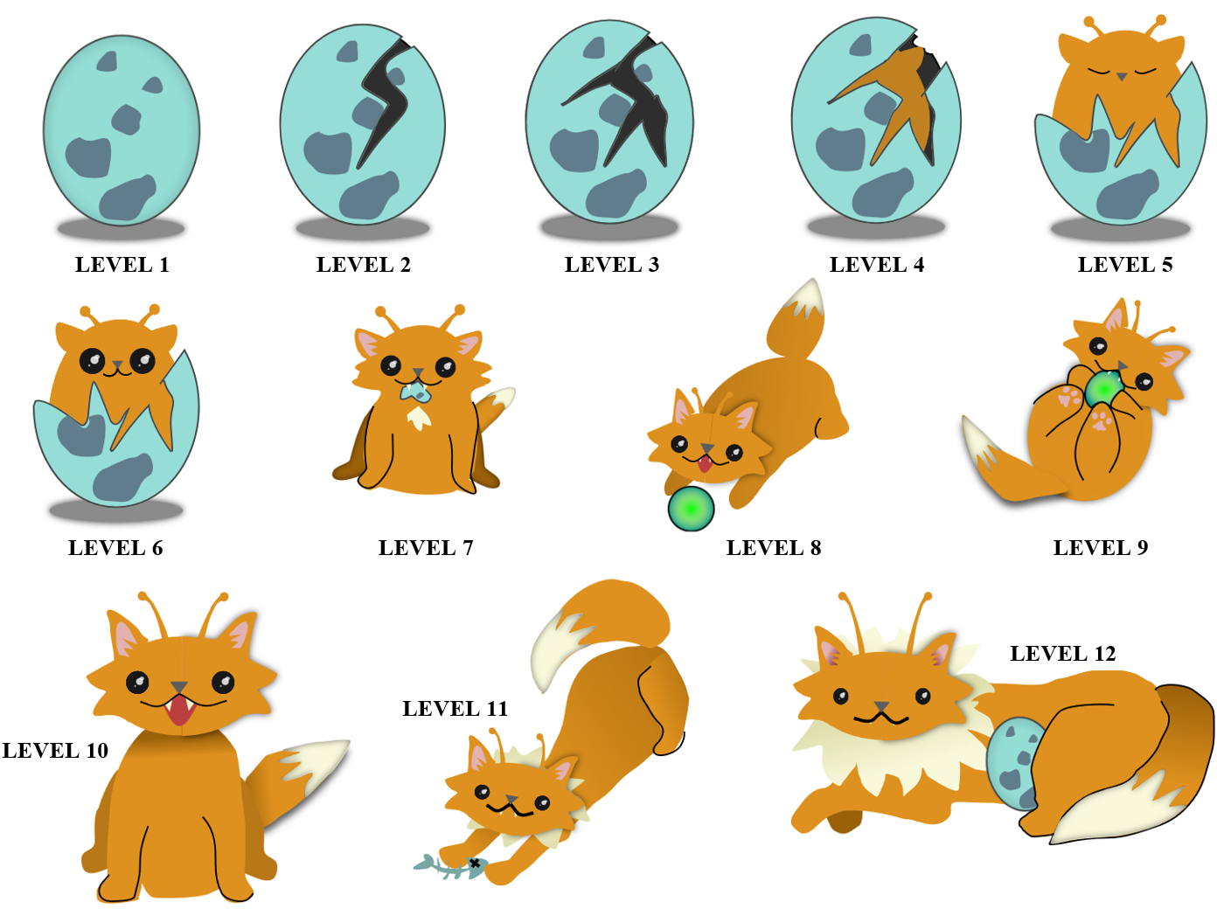

APPENDIX C: Proof-of-Concept Trial Consent and Assent Forms

C-1. Proof-of-concept trial consent form.
Consent for Research Participation
Research Study Title: Enhancing child digital dietary self-monitoring: Proof-of-concept trial
Researcher(s): Lauren Griffiths, MPH, Department of Nutrition, University of Tennessee, Knoxville
Hollie Raynor, PhD, Department of Nutrition, University of Tennessee, Knoxville

Why am I being asked to be in this research study?
We are asking you to be in this research study because you have a child between 8-12 years.

What is this research study about?
The purpose of the research study is to test the usability, acceptability, and preliminary efficacy of a digital dietary self-monitoring (DSM) log that has been created for children. The log uses positive reinforcement strategies that may improve children’s DSM.

How long will I be in the research study?
If you agree to be in the study, your participation will last for approximately 5 weeks and will involve two study visits (one in-person and one virtually) and up to one additional phone call.

What will happen if I say “Yes, I want to be in this research study”?
If you agree to be in this study, your family will be asked to attend two study visits, one in-person visit before you get started and one virtual visit after the 4 weeks of DSM is over. During your first visit, which will take place at the Healthy Eating and Activity Laboratory at the University of Tennessee (UT), you will be asked to complete some questionnaires about your family’s demographics and your parenting style, and your child will be asked to complete some questionnaires about their motivation to engage in DSM, their motivation to eat healthfully, and their dietary intake. We will also measure your child’s height and weight.
Once these measures are complete, you will be told to which study group you have been randomly assigned, and your family will receive brief training on how to use the features of a web-based DSM log. Your family will be randomly assigned to one of the following groups: Standard Group (standard DSM log), Praise Group (DSM log with caregiver praise), Game Group (DSM log with gamification), or Praise+Game Group (DSM log with caregiver praise and gamification).
If your family is assigned to Standard Group, your child will be asked to track their intake of fruits, vegetables, sweet and salty snack foods, and sugary drinks in the web-based DSM log for 4 weeks. Your child will be provided with a personal URL to access their log, which can be accessed from any internet-capable device (computer, phone, etc.). You will be asked to review your child’s log each day and complete a caregiver check-in. You will receive a separate URL that allows you to view your child’s log and complete check ins. To help get your child started, you will be instructed to sit with your child for the first 3 days of tracking to help with logging. If no logging or caregiver check ins have been completed within the first 4 days of your family’s DSM period, a research assistant will reach out to you to problem solve and provide support.
If your family is assigned to the Praise or Praise+Game Group, you will also be asked to provide praise to your child for engaging in DSM over the 4 weeks. During your first study visit, you will be provided with brief training on how to provide a type of praise called process praise. Additionally, when you complete caregiver check-ins in the DSM log, you will receive a prompt to also complete a praise check-in. If no praise check-ins are completed within the first 4 days of the DSM period, a research assistant will reach out to you to problem solve and provide support.
If your family is assigned to the Game or Praise+Game Group, your child’s log will also include a virtual pet that evolves over time as your child uses the log. During your first visit, research staff will explain how points are accrued when using the log. As your child earns points, the pet will level up and grow over time.
During the week following your child’s 4-week DSM period, you will be asked to attend a virtual visit to complete follow-up measures. During this visit, your child will again be asked to complete questionnaires about their motivation to engage in DSM, their motivation to eat healthfully, and their dietary intake. Additionally, you and your child will complete a short usability and acceptability survey to capture your experiences using the DSM log. During this visit, your family will also receive feedback on your child’s dietary intake based on their DSM log. Days for which tracking was marked as completed will be used to calculate your child’s daily servings of fruits and vegetables and daily intake of added sugars and saturated fats from sugar-sweetened beverages and sweet and salty snack foods. You will receive feedback that compares your child’s intake to the recommendations in the Dietary Guidelines for Americans 2020-2025. Additionally, your family will be provided access to a short online behavioral nutrition education program that will consist of four short modules covering basic nutrition and behavioral change strategies.

What happens if I say “No, I do not want to be in this research study”?
Being in this study is up to you. You can say no now or leave the study later. Either way, your decision won’t affect your relationship with the researchers or the University of Tennessee.
Instead of participating in the study, possible options available to you include talking to your child’s primary care provider about ways to improve your child’s diet.

What happens if I say “Yes” but change my mind later?
Even if you decide to be in the study now, you can change your mind and stop at any time.
If you decide to stop before the study is completed, please contact Lauren Griffiths (email: lgriff31@vols.utk.edu, phone: 865-974-0752) and let her know that you would no longer like to participate. Any information already collected for the research will be returned to you, if you request it. If you do not request for your data to be returned to you, any data already collected will be kept and used for analysis.

Are there any possible risks to me?
It is possible that someone could find out you were in this study or see your study information, but we believe this risk is small because of the procedures we use to protect your information. These procedures are described later in this form.
Dietary self-monitoring may increase your awareness of eating behaviors in your child that do not match current recommendations. Additionally, feedback received at the end of the study may not accurately reflect your child’s nutrition status if self-monitoring is very inaccurate and/or insufficient.

Are there any benefits to being in this research study?
We do not expect you to directly benefit from being in this study. Your participation may help us to learn more about helping children engage in DSM. We hope the knowledge gained from this study will benefit others in the future.

Who can see or use the information collected for this research study?
We will protect the confidentiality of your information by removing any identifying information that would connect you to your data and responses. Your paper data will be stored in locked filing cabinets in private laboratory spaces, and any documents with identifying information (like this consent form) will be stored separately from your research data so that it cannot be connected to you. Data collected electronically will be collected using REDCap, a secure web platform. DSM data entered into your child’s log will be stored in a UT-affiliated Google Drive, for which data is encrypted at rest, on the server, and in transit. Any other digital data that is created will be stored on UTK’s secure servers.
If information from this study is published or presented at scientific meetings, your name and other personal information will not be used.
We will make every effort to prevent anyone who is not on the research team from knowing that you gave us information or what information came from you. Although it is unlikely, there are times when others may need to see the information we collect about you. These include:
- People at the University of Tennessee, Knoxville (UTK) who oversee research to make sure it is conducted properly.
- Government agencies (such as the Office for Human Research Protections in the U.S. Department of Health and Human Services), and others responsible for watching over the safety, effectiveness, and conduct of the research.
- If a law or court requires us to share the information, we would have to follow that law or final court ruling.
- Business offices at the University of Tennessee, Knoxville may be given name and address to issue your payment and report tax information.
- A description of this study will be posted on a public website, http://ClinicalTrials.gov, and summary results of this study will be posted on this website at the conclusion of the research. No information that can identify you will be posted.

What will happen to my information after this study is over?
We may keep your information to use for future research. Your name and other information that can directly identify you will be kept secure and stored separately from your research data collected as part of the study.
We may share your research data with other researchers without asking for your consent again, but it will not contain information that could directly identify you.

Will I be paid for being in this research study?
You will receive two $25 gift cards to Walmart, one for you and one for your child, after completing measures at your final study visit. These will be mailed to you upon completion of your visit.

Will it cost me anything to be in this research study?
If you agree to be in this study, the only potential costs to you will be any charges you may incur related to data usage on mobile devices.

What else do I need to know?
We may need to stop your participation in the study without your consent. If your child’s DSM log is not used (self-monitoring or check-ins) within the first 4 days of the DSM period, a research assistant will reach out to you to problem solve and provide support. We will attempt to contact you 3 times. If we are unable to reach you after 3 contact attempts, you will be removed from the study.
If we learn about any new information that may change your mind about being in the study, we will tell you. If that happens, you may be asked to sign a new consent form.

Who can answer my questions about this research study?
If you have questions or concerns about this study, or have experienced a research related problem or injury, contact the researchers, Lauren Griffiths, lgriff31@vols.utk.edu, 865-974-0752 or her advisor Dr. Hollie Raynor, hraynor@utk.edu, 865-974-9126, ext. 1.
For questions or concerns about your rights or to speak with someone other than the research team about the study, please contact:
Institutional Review Board
The University of Tennessee, Knoxville
2240 Sutherland Ave., Suite 2
Knoxville, TN 37919
Email: utkirb@utk.edu
Phone: 865-974-7697

STATEMENT OF CONSENT
I have read this form and the research study has been explained to me. I have been given the chance to ask questions and my questions have been answered. If I have more questions, I have been told who to contact. By signing this document, I am agreeing to be in this study. I will receive a copy of this document after I sign it.

Name of Adult Participant Signature of Adult Participant Date

Researcher Signature (to be completed at time of informed consent)
I have explained the study to the participant and answered all of his/her questions. I believe that he/she understands the information described in this consent form and freely consents to be in the study.

Name of Research Team Member Signature of Research Team Member Date
C-2. Proof-of-concept trial assent form.
ASSENT TO PARTICIPATE IN RESEARCH
Enhancing child digital dietary self-monitoring: Proof-of-concept trial

- My name is _____________.
- We are asking you to take part in a research study because we want to learn more about how to help children ages 8-12 years eat healthy.
- If you agree to be in this study, you will track certain foods and drinks you have each day over the next 4 weeks. You will use a website to do this on a phone, tablet, or computer. You will track any fruits, vegetables, sweet and salty snack foods, and sugary drinks you have, and your parent will look at what you log each day. You and your parent will also have two visits with people from the University of Tennessee. The first one, which will happen today, will be in-person. At this visit, we will measure your height and weight. You will also fill out some questionnaires about the food and drinks you have been eating, as well as your motivation to track your food and drinks and to eat healthy foods. After these measures are completed, you will learn how to use your online log. Your next visit with us will happen about 5 weeks later, and it will be virtual on Zoom. You will complete the same questionnaires again, as well as a short survey asking about your thoughts and feelings related to the log. You and your parent will each get a $25 gift card to Walmart after your second visit.
- The risks of being in this study are small. You may feel annoyed at having to track your food and drinks each day. It is also possible that someone may find out you were in the study, but we do a lot to make sure that won’t happen.
- We do not expect you to directly benefit from being in this study, but your participation will help us learn more about how to help kids like you track their food and drinks better.
- Please talk this over with your parent before you decide whether or not to participate. We will also ask your parent to give their permission for you to take part in this study, but even if your parent says “yes,” you can still decide not to do this.
- If you don’t want to be in this study, you don’t have to participate. Remember, being in this study is up to you and no one will be upset if you don’t want to participate or even if you change your mind later and want to stop.
- You can ask any questions that you have about the study. If you have a question later that you didn’t think of now, you can contact Hollie Raynor (phone: 865-974-9126, ext. 1, email: hraynor@utk.edu) or ask me next time.
- Signing your name at the bottom means that you agree to be in this study. You and your parents will be given a copy of this form after you have signed it.
______________________________________________ _____________________
Name of Subject Date

APPENDIX D: Proof-of-Concept Trial Family Training Materials

D-1. Handout describing the foods and beverages to log during the dietary self-monitoring period.
WHAT FOODS SHOULD I LOG?

Food Group | DO Log
FRUITS  (fresh, canned, or frozen) | Apples, applesauce, bananas, grapes, oranges, mixed fruit cups, pineapple, avocado, berries, fruit smoothies, cooked and sweetened fruit like in desserts, jams and jellies, etc.
VEGETABLES  (fresh, canned, or frozen) | Broccoli, lettuce, tomato, cucumber, carrots, mushrooms, spinach, celery, bell pepper, beans, peas, lentils, potatoes, mixed dishes with vegetables like vegetable soup or vegetable stir fry, fried vegetables like onion rings or French fries, etc.
SWEET AND SALTY SNACK FOODS | Sweet: Cookies, donuts, brownies, muffins, pastries, ice cream, candies, chocolates, etc.  Salty: Pretzels, popcorn, corn chips, tortilla chips, potato chips, cheese puffs or cheese doodles, crackers, etc.
SUGARY DRINKS | Soda, fruit juice, hot chocolate, chocolate milk, strawberry milk, lemonade, fruit punch, etc.  DON’T LOG: Diet drinks, flavored seltzers
The table below describes the four food groups you will log over the next 4 weeks.
Why should I track my food and drinks?
Tracking your food and drinks is called dietary self-monitoring. When we track out behaviors, it make us more aware of our habits, both healthy and unhealthy! When we are more aware of our habits, we are able to make healthier choices over time.
Why am I logging these food groups?
These four food groups are important because they influence health. Eating fruits and vegetables is associated with decreased risk of chronic disease, and eating less high-calorie, low-nutrient foods like sweet and salty snacks and sugary drinks is recommended to achieve healthy weight in children.
What will my logging tell me?
At the end of the study, your family will receive individualized feedback on your child’s nutrition. Days with logging marked as complete will be used to develop this feedback, so don’t forget to hit the button at the end of the day! The feedback you receive will tell you:
- Average servings of fruit per day
- Average servings of vegetables per day
- Percent of calories from saturated fats from sweet and salty snack foods each day
- Percent of added sugars from sweet and salty snack foods and sugary drinks each day
These values will be compared to the recommendations in the Dietary Guidelines for Americans for your child’s age.
D-2. Handout describing how to provide process praise (provided to caregivers in PRAISE and PRAISE+GAME groups only.)

PROVIDING PRAISE

Positive reinforcement is when something is provided after a behavior that makes the behavior more likely to occur again. Praise is a great way to provide positive reinforcement to your child! Over the next 4 weeks, you will be asked to provide daily praise to your child related to their logging. When you complete the caregiver check in each day, you will also be prompted to indicate whether you provided praise to your child.

What Kind of Praise Should I Provide?
When praise values the effort or process, it helps children understand why they are succeeding and can help improve motivation. For this study, try to offer praise that identifies a desired logging behavior and pairs it with a praise statement. Here are some examples to help you.

Dietary self-monitoring behaviors you might praise: | Example praise statements:
- Logging a food or drink | - “Wow!”
- Logging multiple days in a row | - “Great job!” or “Great work!”
- Remembering to log without reminders | - “I’m really proud of you.”
- Correctly identifying that a food or drink should be logged because it is in one of the targeted food groups | - “I’m so impressed!”  - “You rock!”

Can you identify the examples of this type of praise in the list below? Remember, praise should pair a dietary self-monitoring behavior with a praise statement!
- “You remembered to log the juice box you had at lunch today. I’m so impressed!”
- “You tracked in your log for three straight days. That is so awesome!”
- “Look at your log today. You must be so healthy!”
- “You figured out that an avocado was a fruit that you needed to log. That’s so cool!”
- “You are so smart for using your log!”
- “You have been so consistent using your log. I’m proud of you!”

If your child eats or drinks a food you don’t want them to, just ignore it! This encourages your child to be honest about their intake and helps ensure logging is as accurate as possible. At the end of the study, you will receive access to behavioral nutrition advice that provides tips and strategies for improving your child’s diet.
D-3. Handout describing how gamification mechanics of the virtual pet worked (provided to GAME and PRAISE+GAME groups only).

MEET YOUR NEW PET

Your log includes a virtual pet that will grow and evolve as you use your log over the next 4 weeks! Your pet is in its egg to start, but as you use the log, it will begin to hatch. To help your pet hatch and grow, you need points. You will get a point each time you:
- Log a food or drink
- Mark logging complete for the day
- Bonus point: Logging two days in a row!

There are 12 levels before your pet reaches its final stage. The table below shows how many points you need for each level. It takes more points to move up each time!

LEVEL 1
LEVEL | TOTAL POINTS
1 | 0
2 | 1
3 | 3
4 | 7
5 | 13
6 | 21
7 | 31
8 | 43
9 | 57
10 | 73
11 | 91
12 | 111

D-4. Handout provided to families with instructions for using the logging feature and a logging practice session.
INSTRUCTIONS FOR LOGGING FOOD AND DRINKS

Your family will log your child’s intake of fruits, vegetables, sweet & salty snack foods, and sugary drinks for 4 weeks.
START DATE: _________________ END DATE: _________________
Child’s DSM Log URL: ______________________________________________________________

To log a new food or drink, click the “Log New Food Item.” You will have the option to enter:
- Food or drink description
This is where you describe the type of food or drink you had. The more descriptive you are the better (don’t worry about spelling!). For example:
“McDonald’s apple pie” is better than just “apple pie”
“nacho cheese Doritos” is better than just “chips”
- Amount
This is where you describe the amount you ate. You can do this in a few ways:
- You may be able to count the food if it is something like grapes or chips. You could say “15” grapes or “10” chips.
- You may be able to put the weight if it comes in a bag or package with a nutrition label. You could say “1 oz” of chips or “28 grams” of cereal.
- You may be able to describe the volume of the food, as if you measured it with measuring cups. You could say “1 cup” of juice or “1/2 cup” of blackberries.
The Food Amounts Booklet can help you estimate servings!
- Servings
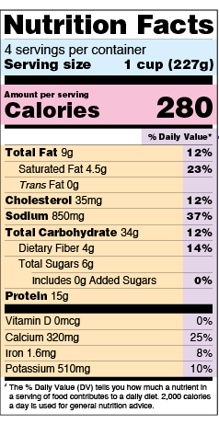
Servings are a way to think about the portion a person usually eats or drinks. Some food groups have specific servings sizes. For example, 3 oz of meat or seafood is a serving, and 1 cup of vegetables is a serving. Other foods may have a nutrition label that tells you the servings size. The log’s help feature can help you figure out serving sizes, too!

An example of a nutrition facts label is found to the right. The blue section shows where you can find serving size and number of servings per container. If you eat more or less than one serving, you can calculate how much you ate using this formula:

Amount eaten ÷ Amount in serving = Servings eaten
Tips:
Let’s practice together!
EXAMPLE 1:
Let’s say you ate some Lay’s potato chips. It was one of the small bags like in a vending machine. You ate all of it. You look at the nutrition facts label. It says one bag is 1 ounce, and 1 ounce is a serving. Here’s how you would log it:
Food or Drink Description: Lay’s chips
Amount: 1 ounce
Servings: 1
EXAMPLE 2:
Let’s say you ate two chocolate chip cookies at a party. You use your Food Amounts Booklet to estimate the cookies were about 2 inches across. You use your help feature to find that a 2.5-inch cookie is a serving. Here’s how you would log it:
Food or Drink Description: 2 inch chocolate chip cookies
Amount: 2
Servings: about 2
EXAMPLE 3:
Let’s say you ate 20 hard salted pretzels from a large bag. You look at the nutrition facts label to see that 10 pretzels are a serving. You take the amount eaten (20 pretzels) divided by the amount in a serving (10 pretzels) to figure out servings eaten (2). Here’s how you would log it:
Food or Drink Description: hard salted pretzels
Amount: 20
Servings: 2

Great work!!! Now let’s mark logging as complete for the day.
- Ask mom or dad whenever you need help! It is okay for your parents to help you log food or drinks.
- Use the help feature to figure out what a serving size is if you don’t know or if there is no nutrition facts label.
- Your best guess is okay! Use your Food Amounts Booklet to help you figure out how much you ate of something.
- Put both the amount and servings eaten when you can, but always put at least one or the other!
- Don’t forget to mark logging complete at the end of the day!

D-5. Handout with instructions for using the caregiver check-in (version provided to BASIC and GAME groups).

USING THE CAREGIVER CHECK IN

As caregiver, you will be given a separate URL that can be used to review your child’s log and complete caregiver check ins. We ask that you do not share this link with your child.
Each day, you should review your child’s log to see the fruits, vegetables, sweet and salty snack foods, and sugary drinks they have tracked. This will help you be more aware of your child’s eating habits. It is also a good time to ask questions and probe whether any food or drinks were missed. If you identify a food or drink your child did not log, you can enter it together!
Some examples of good questions to ask your child are:
- Did you have any juice or chocolate milk with lunch at school?
- Did you have any snacks at school and/or when you got home?
- What sides did you have at lunch? Did you have any fruits or vegetables?
If your child eats or drinks a food you don’t want them to, it’s best to treat the behavior neutrally or ignore it while logging. This encourages your child to be honest about their intake and helps ensure logging is as accurate as possible! At the end of the study, you will receive access to a short online behavioral nutrition education program that provides tips and strategies for improving your child’s diet.
After you are done checking in with your child, you should click the “Caregiver Check In” button to indicate that you have reviewed the child’s log for the day. If your child does not plan to have any more food or drinks, it may also be a good time to mark logging complete for the day.

What if my child isn’t logging?
If your child isn’t logging, try to problem solve ways to increase their tracking. Decreasing barriers or setting up cues to remember to track can be helpful strategies. For example, maybe your child sets an alarm for a certain time each evening to remind them to track. Or, maybe you both decide on a consistent time you can look at the log together (like dinner time). For times when your child doesn’t log, try to avoid nagging or punishment. Instead, rely on problem solving and planning to support them!

D-5. Handout with instructions for using the caregiver check-in (version provided to PRAISE and PRAISE+GAME groups).

USING THE CAREGIVER CHECK IN
(Praise Groups)

As caregiver, you will be given a separate URL that can be used to review your child’s log and complete caregiver check ins. We ask that you do not share this link with your child.
Each day, you should review your child’s log to see the fruits, vegetables, sweet and salty snack foods, and sugary drinks they have tracked. This will help you be more aware of your child’s eating habits. It is also a good time to ask questions and probe whether any food or drinks were missed. If you identify a food or drink your child did not log, you can enter it together!
Some examples of good questions to ask your child are:
- Did you have any juice or chocolate milk with lunch at school?
- Did you have any snacks at school and/or when you got home?
- What sides did you have at lunch? Did you have any fruits or vegetables?
Reviewing your child’s log is also a great time to find something to praise! However, if your child eats or drinks a food you don’t want them to, it’s best to treat the behavior neutrally or ignore it while logging. This encourages your child to be honest about their intake and helps ensure logging is as accurate as possible! At the end of the study, you will receive access to a short online behavioral nutrition education program that provides tips and strategies for improving your child’s diet.
After you are done checking in with your child, you should click the “Caregiver Check In” button to indicate that you have reviewed the child’s log for the day. You will also be prompted to indicate whether you provided praise to your child that day. If your child does not plan to have any more food or drinks, it may also be a good time to mark logging complete for the day.

What if my child isn’t logging?
If your child isn’t logging, try to problem solve ways to increase their tracking. Decreasing barriers or setting up cues to remember to track can be helpful strategies. For example, maybe your child sets an alarm for a certain time each evening to remind them to track. Or, maybe you both decide on a consistent time you can look at the log together (like dinner time). For times when your child doesn’t log, try to avoid nagging or punishment. Instead, rely on problem solving and planning to support them. And when they do log, remember to praise, praise, praise!

D-6. Handout with instructions for accessing the caregiver’s URL.

ACCESSING THE DSM LOG AS CAREGIVER

You are being provided a separate URL to access your child’s log. The link below will allow you to view your child’s entries, but it will also allow you to complete caregiver check-ins. This feature is not available in your child’s link. Please do not share your link with your child.

Caregiver DSM URL:

_________________________________________________________

VITA
A south Louisiana native, Lauren Griffiths León received a Bachelor of Arts degree the Louisiana State University in 2012. Following graduation, she became increasingly interested in nutrition and its relationship with health. She applied to graduate school the following year and completed a Master of Public Health in Behavioral and Community Health Sciences at the Louisiana State University Health Sciences Center – New Orleans in 2015. During her master’s program, she began working in the field of behavioral lifestyle interventions for adolescents and families. After graduation, she continued to work at the university, first as a Research Associate then as an Instructor, on various nutrition-focused research projects and community programs. After several years in the professional world, she decided to get back to her roots in research and pursue a Doctor of Philosophy degree in Nutrition at the University of Tennessee, Knoxville. She is deeply grateful for the support from her husband, for the love of her child, and for the ongoing encouragement from friends and family. Laissez les bons temps rouler.

