Evaluation of Traits Associated with Breeding for Improved Biomass and Ethanol Yield in Switchgrass

A Dissertation Presented for the
Doctor of Philosophy
Degree
The University of Tennessee, Knoxville

Virginia Roseanna Sykes
December 2014

Copyright © 2014 by Virginia Roseanna Sykes
All rights reserved.

DEDICATION
This dissertation is dedicated to my husband, Mike, who has seen me through eight years in grad school, including two M.S. degrees and one Ph.D. He has patiently helped me water plants on weekends, pulled senescing grass tissue out of pots late into the night, listened to me practice countless talks for seminars and conferences, and kept me from starving as a I studied for prelims, yelled at SAS, made endless tables and graphs, and wrote for hours at a time. Thank you for your patience, support, and love.

ACKNOWLEDGMENTS
I express my appreciation to the following:
To my parents, Ginger Williams and Ben Sykes, and to my grandmother, Emily Williams, for their love and support.
To my major professor, Dr. Fred Allen, for giving me the opportunity to participate in the state variety trials program, both as a graduate student and as a research associate, and for his many hours of encouragement and assistance in planning and executing this research, reviewing this manuscript, and teaching me more than I ever thought I would know about agronomic crops.
To the members of my graduate committee, Dr. Arnold Saxton, Dr. Dennis West, Dr. Hem Bhandari, Dr. Mark Windham, and Dr. Robert Mee, for their many hours of assistance in analyzing this research and in reviewing this manuscript.
To Richard Johnson, Eifion Hughes, Ali DeSantis, Matthew Bobbit, Victoria Knapp, Jennifer Lane, Douglas Renfro, Alex Bosnjak, Andrea Menendez, Karah Renfro, and Jonathan Allen for their friendship, support, and tolerance of all things switchgrass.
To the UT Department of Plant Sciences and the UT Agricultural Experiment Stations for their financial support and facilities to conduct this research.
To the farm crew, Bennie Nuchols, Jason Guinn, Walt Hitch, Derick Hopkins, Charles Summey, Brad Reagan, and Vasilj Bobrek, thank you for all your help. I could not have done it without you. I promise, this really is the last year of switchgrass harvest.

ABSTRACT
Switchgrass (Panicum virgatum L.) is a perennial, warm season grass that can be used as a biofuel. A greater understanding of the relationship of biomass yield and ethanol yield with disease susceptibility and morphological traits, estimation of the underlying genetic parameters of these traits, and the efficacy of selection at different maturity and under different production conditions could help breeders more effectively develop improved biofuel switchgrass cultivars. To examine these issues, three studies were performed. The first examined switchgrass leaves exhibiting low, medium, and high severity of infection from the pathogen Puccinia emaculata, one of the causal pathogens of the disease rust. Results indicate rust severity may negatively impact ethanol yield in biofuels switchgrass with predicted ethanol yield reductions of 10% to 34% in leaves exhibiting medium rust severity and 21% to 51% in leaves exhibiting high rust severity. The second study analyzed a diallel of eight parents selected from the cultivars ‘Alamo’, ‘Kanlow’, and ‘Miami’. Correlations of morphological traits to biomass yield indicate a high biomass yielding ideotype of a tall plant with a high number of thick tillers, wide leaves, and an open canopy density. Traits with moderate correlations to biomass yield showed significant, but weak, negative correlations to ethanol yield. Significant SCA effects, maternal effects, and high parent heterosis were found within all traits. Selection during the establishment year did not differ significantly from selection in subsequent years. The third study used the same diallel populations but compared evaluations under space planted conditions to simulated swards. Evaluation under sward conditions differed from evaluation under space planted conditions for estimates of mean production performance, characterization of morphological traits, estimates of genetic parameters, identification of high GCA and SCA in populations, and identification of potential maternal effects or high parent heterosis. If sward conditions are more representative of production conditions, evaluation under space planted conditions could lead to assessment and selection of plants that are less than optimal in production conditions. Results from these three studies should help breeders identify more efficient and effective methods for improving biofuel switchgrass cultivars.

PREFACE
Switchgrass is a warm season perennial grass, native to North American prairie lands (Newell and Eberhart, 1961). It is important both as a forage crop and, more recently, as a biofuel crop. While progress has been made on breeding switchgrass as a forage crop, the ideal composition of traits for switchgrass used as a biofuel crop, the genetic parameters associated with those traits, and the inter-relationships between traits when evaluated at different maturity levels or under different planting conditions are still undefined.
In both forage switchgrass and biofuel switchgrass, total yield consists of two components. In forage switchgrass, these are forage yield and quality. In biofuel switchgrass, these components are biomass yield and ethanol yield. While numerous studies have examined the inter-relationship of morphological traits with forage/biomass yield or forage quality, the inter-relationship of these traits with ethanol yield has not yet been examined. Establishing a high ethanol yielding ideotype could greatly enhance the efficacy of the selection process when breeding biofuel switchgrass.
Examination of the relationship between morphological traits in plants at different maturity levels or grown under differing conditions could further enhance the efficacy of selection. Switchgrass plants are large, can be difficult to establish, and take approximately three years to reach maximum biomass yield (Garland, 2008). Examining the relationship between morphological and yield traits at different maturity stages could provide a basis for a high throughput screening process through juvenile selection in the greenhouse or selection prior to reaching maximum biomass yield.
The inter-relationship among traits may be affected, however, by differing production conditions. While switchgrass breeding studies are typically evaluated in space planted nurseries, switchgrass production is under sward conditions. Planting density may alter plant morphology and, in turn, affect trait associations with biomass or ethanol yield. Identifying the optimal composition of traits for switchgrass used as a biofuel crop, the genetic parameters associated with those traits, and the inter-relationships between traits when evaluated at different maturity levels or under different planting conditions could greatly enhance current breeding efforts to improve switchgrass as a biofuel crop.

TABLE OF CONTENTS
INTRODUCTION 1
Switchgrass Production, Genetics, and Structure 1
Switchgrass Disease 3
Quantitative Genetics 4
Yield 5
Quality Correlations 7
Potential Traits of Interest in Biofuel Switchgrass 9
Potential Genetic Parameters of Interest 11
Juvenile Selection 12
Planting Density 13
Objectives 15
CHAPTER 1 - REDUCTION OF PREDICTED ETHANOL YIELD FROM SWITCHGRASS INFECTED WITH PUCCINIA EMACULATA 16
Abstract 17
Introduction 18
Materials and Methods 19
Plant Material 19
Pathogen Isolation and Identification 20
Ethanol Fermentation 21
NIRS Analysis 22
Statistical Analysis 23
Results and Discussion 24
Conclusion 28
Appendix I 29
CHAPTER 2 - DIALLEL ANALYSIS TO ASSESS QUANTITATIVE GENETICS OF BIOFUEL PRODUCTION TRAITS IN SWITCHGRASS 34
Abstract 35
Introduction 36
Materials and Methods 41
Parent Material 41
Breeding Methods and Greenhouse Maintenance 42
Juvenile Evaluation 43
Field Evaluation 44
Statistical Analysis 46
Results and Discussion 49
Means of Measured Traits by Location and Year 49
Correlations of Biomass and Ethanol Yield with Morphological Traits 52
Variance Components of Measured Traits 55
Heritability of Measured Traits 56
General and Specific Combining Ability and Maternal Effects of Measured Traits 59
Heterosis of Measured Traits 63
Early Selection for Biomass Yield and Ethanol Yield 68
Conclusion 70
Appendix II 74
CHAPTER 3 - COMPARISON OF SPACE AND SWARD PLANTED SWITCHGRASS FOR ESTIMATES OF GENETIC PARAMETERS AND RANKING OF BIOMASS AND PREDICTED ETHANOL YIELD 104
Abstract 105
Introduction 106
Materials and Methods 108
Breeding Methods and Greenhouse Maintenance 109
Field Evaluation 111
Statistical Analysis 112
Results and Discussion 116
Means of Measured Traits 116
Between Nursery Correlations of Measured Traits 118
Within Nursery Correlations of Biomass Yield and Predicted Ethanol Yield with Morphological Traits 118
Variance Components of Biomass Yield and Predicted Ethanol Yield 119
Heterosis of Biomass Yield and Predicted Ethanol Yield 123
Selections for Biomass Yield and Predicted Ethanol Yield 124
Conclusion 126
Appendix III 128
CONCLUSION 145
Reduction of Predicted Ethanol Yield from Switchgrass Infected with Puccinia emaculata 145
Diallel Analysis to Assess Quantitative Genetics of Biofuel Production Traits in Switchgrass 146
Comparison of Space and Sward Planted Switchgrass for Estimates of Genetic Parameters and Ranking of Biomass and Predicted Ethanol Yield 151
REFERENCES 157
VITA 170

LIST OF TABLES
Table 1-1. Means, R², and p values of compositional elements measured using near-infrared spectroscopy that exhibited significant association with rust severity (P < 0.05). Means are given for categories of low, medium and high rust severity. 33
Table 2-1: Within year Pearson correlation coefficients between measured phenotypic traits and biomass yield and predicted ethanol yield of F1 populations of lowland switchgrass derived from an eight parent diallel cross. Dark grey shading indicates strong correlations while light grey shading indicates moderate correlations. 78
Table 2-2: Pearson correlation coefficients between traits measured at the juvenile stage (8 weeks post emergence) and during the fall of the establishment year (2012) with biomass and predicted ethanol yield in the second year (2013). Dark grey shading indicates strong correlations while light grey shading indicates moderate correlations. 79
Table 2-3: Variance components of F1 populations derived from a diallel cross of eight parents were calculated using ANOVA for the traits biomass yield and predicted ethanol yield (A), fall height, spring height, and tiller number (B), tiller diameter, leaf width, and canopy density (C), and rust severity (D). Variance estimates from the ANOVA model and the percentage that effect contributes to the overall phenotypic variance is listed for each effect in the model. Effects with variance estimates of zero are excluded from the table. Asterisks indicate variance that is significantly different from zero based on Wald’s test (* P < 0.05, **P < 0.01, ***P < 0.001 respectively). 80
Table 2-4: Estimated additive, dominance, and phenotypic variance components and calculated narrow sense heritability (h²_{i}) and broad sense heritability (H²_{i}) estimates of the F1 population derived from the diallel cross of eight parents were calculated using ANOVA estimates of GCA and SCA for the traits biomass yield, predicted ethanol yield, and fall height in 2012, 2013, and combined over both years and for the traits spring height, tiller number, and tiller diameter (A.) and leaf width, canopy density, and rust severity (B.) in 2013, 2014, and combined over both years. 84
Table 3-1. Pearson correlation coefficients between space planted and sward planted nurseries for traits evaluated in 2012 and 2013 in F1 populations of lowland switchgrass derived from an eight parent diallel cross. Dark grey shading indicates strong correlations while light grey shading indicates moderate correlations. 131
Table 3-2. Pearson correlation coefficients of biomass yield and predicted ethanol yield with all measured traits within space planted and sward planted nurseries of F1 populations of lowland switchgrass derived from an eight parent diallel cross for traits evaluated in 2012 and 2013. 132
Table 3-3: Variance components of the F1 population derived from the diallel cross of eight parents calculated using ANOVA for biomass yield and predicted ethanol yield in space planted (HSP) and sward planted (HSW) nurseries. Variance estimates and the percentage each term contributes to the phenotypic variance are listed. Calculated values for additive, dominance, and phenotypic variance and narrow sense heritability (h²_{i}) and broad sense heritability (H²_{i}) are also listed. Asterisks indicate variance that is significantly different from zero based on Wald’s test (* P < 0.05, **P < 0.01, ***P < 0.001 respectively). 133
Table 3-4. Estimates of general combining ability (GCA) of eight lowland switchgrass parents based on evaluation of F1 populations derived from a full diallel cross evaluated across two years in both space planted (HSP) and sward planted (HSW) nurseries. Traits evaluated include biomass yield and predicted ethanol yield. 134

LIST OF FIGURES
Figure 1-1. Switchgrass leaves, viewed under two light conditions, expressing low disease symptoms - no sporulation and little to no chlorosis or necrosis (A, B), medium disease symptoms - light to medium sporulation, medium chlorosis and necrosis, minor tip dieback on some leaves (C, D), and high disease symptoms - heavy sporulation, chlorosis, and necrosis, tip dieback present but not exceeding 25% of the leaf area (E, F). 29
Figure 1-2. Magnification (4.5x) of pustules erupting through switchgrass cell membrane (A) and magnification (20x) of urediniospores (B) and teliospores (C) from cultures isolated from field grown switchgrass naturally infected with Puccinia emaculata. 30
Figure 1-3. Ethanol yield (mg g⁻¹) by disease level (low, medium, and high) for switchgrass leaves collected from Knoxville, TN in 2010 and subjected to simultaneous saccharification and fermentation (SSF). Ethanol yields were averaged across cultivar since cultivar and cultivar by disease interaction were not significant. Means followed the same letter do not differ significantly at α = 0.05. 31
Figure 1-4. Predicted ethanol yield (mg g⁻¹) by disease level (low, medium, and high) for switchgrass leaves collected from Knoxville, TN and Crossville, TN in 2012 and analyzed using near-infrared spectroscopy (NIRS). Predicted ethanol yields were averaged across cultivar since cultivar and cultivar by disease interaction were not significant. Means followed the same letter do not differ significantly at α = 0.05. 32
Figure 2-1: Means by location and year of F1 populations of lowland switchgrass derived from an eight parent diallel cross evaluated at two locations, the Holston unit of the East TN Research and Education Center in Knoxville, TN (HSP) and the Plateau Research and Education Center in Crossville, TN (CSP). Traits evaluated include biomass yield (A), predicted ethanol yield (B), and fall height (C) in 2012 and 2013 and spring height (D), tiller number (E), tiller diameter (F), leaf width (G), canopy density (H), plant color (I), and leaf angle (J) in 2013 and 2014. Rust severity was evaluated in Oct. 2012 (K) and Aug. 2013 (L). Means were separated using Tukey’s HSD. Means followed by the same letter do not differ significantly (α = 0.05). 75
Figure 2-2. Estimates of general combining ability (GCA) of eight lowland switchgrass parents based on evaluation of F1 populations derived from a full diallel cross. Traits evaluated include biomass yield (A), predicted ethanol yield (B), fall height (C), spring height (D), tiller number (E), tiller diameter (F), leaf width (G), canopy density (H), and rust severity in Oct. 2012 (I) and Aug. 2013 (J). Rust severity GCA values are shown for each year due to differences in seasonal timing of ratings. For all other traits, GCA values are given for the population mean combined across year and location. The population mean for each trait is indicated in the title for the y-axis. GCA values on the y-axis indicate deviation from that mean. Asterisks indicate GCA values that differ significantly from zero (* P < 0.05, **P < 0.01, ***P < 0.001 respectively). 86
Figure 2-3. Estimates of specific combining ability (SCA) of eight lowland switchgrass parents based on evaluation of F1 populations derived from a full diallel cross. Traits evaluated include biomass yield (A-B), predicted ethanol yield (C-D), fall height (E), spring height (F), tiller number (G), tiller diameter (H), leaf width (I), canopy density (J), and rust severity in Oct. 2012 (K) and Aug. 2013 (L). Biomass yield and predicted ethanol yield values are shown for 2012 and 2013 because of a significant SCA by year interaction effect in the model. Rust severity SCA values are shown for each year due to differences in seasonal timing of ratings. For the remaining traits, the mean SCA value across both years and locations is shown. The population mean is listed in the title for the x-axis. SCA values along the x-axis indicate deviation from that mean. Each cross is listed on the y axis of the graph. A cross is the first occurrence of a parental combination. The SCA value for that cross is represented by a grey diamond. The reciprocal of that cross is represented by a black circle. The line connecting these two values shows the mean maternal effect, i.e. the mean difference in trait value between the cross and its reciprocal. Significant maternal effects are indicated by an asterisk to the left of the cross on the y axis. Significant SCA values are indicated by an asterisk to right or left of the SCA data point (* P < 0.05, **P < 0.01, ***P < 0.001 respectively). 89
Figure 2-4. Box plots by year of F1 populations exhibiting high parent heterosis for predicted ethanol yield (A-B) and fall height (C-D) in 2012 and 2013 and spring height (E-F), tiller number (G-H), tiller diameter (I-J), and leaf width (K-L) in 2013 and 2014. Whiskers indicate data within 1.5 times the inter-quartile range of the box edge. Mild outliers (data points within 1.5 and 3 times the inter-quartile range of the box edge) are indicated by a grey circle and severe outliers (data points greater than 3 times the inter-quartile range of the box edge) are indicated by a black diamond. Populations not exhibiting high parent heterosis in either evaluation year are excluded from each figure. Populations exhibiting high parent heterosis only in one year are indicated as “NS” in the opposing year. 95
Figure 2-5: Means of F1 populations by parental line for biomass yield (g) at 8 weeks (A) and at harvest in 2012 (B) and 2013 (C). Means of F1 populations by parental lines for predicted ethanol yield (mg g⁻¹) in 2012 and 2013 (D) Populations are ordered from lowest to highest based on ranking of 2013 biomass or ethanol yields. Means were separated within years using Tukey’s HSD (P < 0.05). 102
Figure 2-6: The top 30% of progeny were selected within each year. Selections were then matched to the value from evaluation at maturity in 2013. The graphs below compare the means between each set of selections at maturity for biomass yield (g plant⁻¹) (A.) and predicted ethanol yield (mg g⁻¹) (B.). Both means and standard errors for each set of selections are indicated. Means were separated using Tukey’s HSD (P < 0.05). 103
Figure 3-1: Means by year and location for traits evaluated in F1 populations of lowland switchgrass derived from an eight parent diallel cross evaluated in a space planted (HSP) and sward planted (HSW) nursery. Traits include biomass yield (A), predicted ethanol yield (B), tiller number (C), tiller diameter (D), and leaf width (E). Means were separated using Tukey’s HSD. Means followed by the same letter do not differ significantly (p < 0.05). 129
Figure 3-2. Specific combining ability (SCA) values for biomass yield (A-D) and predicted ethanol yield (E-H) for space planted (HSP) and sward planted (HSW) F1 populations in 2012 and 2013. Each cross is listed on the y axis of the graph. A cross is the first occurrence of a parental combination. The SCA value for that cross is represented by a grey diamond. The reciprocal of that cross is represented by a black circle. The line connecting these two values shows the mean maternal effect, i.e. the mean difference in trait value between the cross and its reciprocal. Significant maternal effects are indicated by an asterisk to the left of the cross on the y axis. Significant SCA values are indicated by an asterisk to right or left of the SCA data point (* P < 0.05, **P < 0.01, ***P < 0.001 respectively). 135
Figure 3-3. Box plots by year of F1 populations exhibiting high parent heterosis for biomass yield (A-D) and predicted ethanol yield (E-H) for space planted (HSP) and sward planted (HSW) nurseries in 2012 and 2013. Whiskers indicate data within 1.5 times the inter-quartile range of the box edge. Mild outliers (data points within 1.5 and 3 times the inter-quartile range of the box edge) are indicated by a grey circle and severe outliers (data points greater than 3 times the inter-quartile range of the box edge) are indicated by a black diamond. Populations not exhibiting high parent heterosis in either evaluation year are excluded from each figure. Populations exhibiting high parent heterosis only in one year are indicated as “NS” in the opposing year. Ethanol yield for the space planted nursery is excluded since no significant high parent heterosis was observed in either year. 140
Figure 3-4: The top 30% of progeny were selected within each nursery (space planted (HSP) and sward planted (HSW)) and within each year (2012, 2013). Selections were then matched to the value from evaluation at maturity under sward planted conditions in 2013. The graphs below compare the mean of each set of selections at maturity for biomass yield (g plant⁻¹) (dark grey bars) and predicted ethanol yield (mg g⁻¹) (light grey bars). Both means and standard errors for each set of selections are indicated. Means were separated using Tukey’s HSD. Within a trait, means followed by the same letter do not differ at an alpha level of 0.05. 144

INTRODUCTION

Switchgrass Production, Genetics, and Structure
Switchgrass has been developed as both a forage and lignocellulosic herbaceous energy crop. Switchgrass was chosen as a forage crop because of its high yield, perennial nature, adaptability to varied environmental conditions, and rapid growth during hot weather when cool season forage crops are less active (Newell and Eberhart, 1961). Switchgrass can withstand cooler temperatures compared to other warm season grasses and it is easily propagated by seed. Many of the traits that make switchgrass desirable as a forage crop have also generated interest in its potential as a biofuel crop. In 1991, under the Bioenergy Feedstock Development Program (BFDF), switchgrass was chosen as a model lignocellulosic herbaceous energy crop (McLaughlin and Kszos, 2005). Switchgrass breeding has generally focused on improving biomass or forage yield and quality.
Switchgrass is primarily allogamous with self-fertilization rates of approximately 1-2% (McMillan and Weiler, 1959; Nielson, 1944; Taliaferro et al., 1996; Taliaferro and Hopkins, 1996). Since switchgrass is largely self-incompatible, breeding efforts have focused on developing improved populations and synthetic cultivars. Plants are polyploid with the majority of cultivars being either tetraploid or octaploid (Hopkins et al., 1996; Nielson, 1944). Ploidy levels are largely incompatible with crossing rates of less than 0.5% (Taliaferro et al., 1996; Taliaferro and Hopkins, 1996). Two distinct switchgrass ecotypes exist, lowland and upland (Brunken and Estes, 1975; Porter, 1966). Lowland plants are tetraploids that are tall, thick-stemmed, vigorous, and adapted to wetter conditions (Barnett and Carver, 1967). Upland types are shorter, thinner-stemmed, adapted to drier conditions, and are either tetraploid or octaploid, with the majority being octaploid.
Switchgrass is highly competitive with a production life of 10-20 years (Garland, 2008). Average expected yield in Tennessee is 13.45-17.93 Mg ha⁻¹ (6-8 tons acre ⁻¹), with yields of approximately 30%, 70%, and 100% of maximum production in the first three years after establishment respectively. Average biomass yields using currently available cultivars are expected to produce between 3000 and 5000 L ethanol ha⁻¹ (Keshwani and Cheng, 2009). Currently, most biofuel ethanol is starch or sugar-derived; however, this type of production may negatively impact food supplies. Crops, such as switchgrass, offer an alternative ethanol production source through fermentation of cellulosic material (McLaughlin and Kszos, 2005). Cellulosic ethanol is derived from the plant cell wall, which functions as a barrier to pathogens and insects and provides structural integrity to the plant (Carpita and McCann, 2002). Cell walls consist of a primary cell wall and a secondary cell wall. The basic primary cell wall structure is composed of a cellulose scaffold that is cross-linked by glycans embedded in a pectin matrix (Type I walls) or glucoronoarabinoxylan without pectin or other structural proteins (Type II walls). Polysaccharides, including cellulose, hemicellulose, and pectin, are also contained in the cell wall and are formed from varying sugar combinations ultimately derived from glucose. The secondary plant wall is composed of cellulose and hemicellulose embedded in lignin, which provides the necessary rigidity for structural integrity. The strong links between lignin and cellulose or hemicellulose require extreme heat or chemical treatment to break down and provide access to the fermentable polysaccharides. Fermentation of these sugars results in the production of ethanol.

Switchgrass Disease
The impact of reduced lignin or increased ethanol production potential on general plant endurance when faced with biotic stresses is largely unknown. Likewise, the impact of these stresses on ethanol production potential is unknown. Switchgrass was chosen as an ideal herbaceous energy crop, in part, for its production ability under management systems with limited inputs (McLaughlin and Kszos, 2005). Few reports of switchgrass disease exist prior to the advent of its use as a biofuel crop; however, concern over potentially significant disease problems resulting from increased acreage and production in monoculture have led to further examination of switchgrass pathogen susceptibility.
A number of diseases to which switchgrass is susceptible have been identified. The most frequently cited of these are anthracnose (Colletotrichum navitas (Crouch et al., 2009), previously Colletotrichum graminocola (Ces) G.W. Wills (Gravert and Munkvold, 2002; Li et al., 2009; Sanderson, 2008; Sprague, 1950)), Bipolaris species (Bipolaris sorokiniana (Sacc.) Shoemaker, previously Helminthosporium sativum, (Farr et al., 1995; Gravert and Munkvold, 2002; Krupinsky et al., 2004; Zeiders, 1984) B. oryzae (Krupinsky et al., 2004), B. zeae (Krupinsky et al., 2004)), smut (Tilletia maclaganii (Berk.) G.P. Clinton (Gravert and Munkvold, 2002; Gravert et al., 2000; Stueville et al., 2001) Thomsen, 2008)), and rust (Puccinia emaculata Schwein (Zale, 2008, Cornelius et al, 1941, Gravert, 2002, Tiffany, 1990, Hopkins, 1995), P. virgata Ellis & Everh., P. graminis Pers:Pers (Gilman and Archer 1929, Cummins 1971, Tiffany and Knaphus 1985, Farr et al. 1995) and Uromyces graminicola (Cornelius and Johnston, 1941)).
Of these pathogens, rust is one of the most frequently reported in terms of high prevalence. In Arkansas reports were made of lesions covering 25-100% of leaves on ‘Alamo’ and the breeding line OSU-NSL 2001-1 (Hirsch, 2008). Four improved populations evaluated at two locations in South Dakota also showed high and variable rust susceptibility ranging from 3.2 to 8 on a scale of 0 (highly resistant) to 9 (highly susceptible) (Gustafson, 2003). In a study by Hopkins et al. (1995) rust (P. graminas) was the predominant disease on twenty-three switchgrass accessions evaluated across 3 locations (NE, IA, and IN) in 1991 and 1992. At the location exhibiting the greatest amount of rust symptoms, average disease incidence was 32%.
While a pathogenic relationship between rust and switchgrass clearly exists, the impact of this pathogen on yield is still somewhat unclear. Weak, but significant, correlations between disease and biomass yield have been reported by Hopkins et al. (1995) in observations of twenty-three switchgrass accessions in NE, IA, and IN (r = -0.12, P < 0.05) and by Sykes (unpublished) in observations of a lowland half-sib population in TN (r = -0.15, P < 0.05). In both studies, while rust was the dominant pathogen observed, other diseases were also present in disease ratings. While rust infection may have only a minor effect on biomass yield, a potential concern with biofuels switchgrass is the effect infection might have on ethanol yield.

Quantitative Genetics
Switchgrass breeding programs have focused primarily on improving forage/biomass yield and quality. In order to develop an ideal selection type, assessments have been made of the relationship between biomass yield or quality and numerous morphological traits including, but not limited to, plant height, tiller number, leaf blade width, leaf blade length, stem width, seed weight, disease, and seed mass per panicle (Bhandari et al., 2010; Boe, 2007; Das et al., 2004; Newell and Eberhart, 1961; Smart et al., 2004; Talbert et al., 1983). These correlations aid in the selection process by identifying associated traits that can be measured earlier or more easily than the trait of interest. Heritability values for many of these traits have also been calculated, giving breeders an estimate of the potential efficacy of selection for improving a particular trait of interest (Hopkins et al., 1993; Newell and Eberhart, 1961; Rose et al., 2007; Talbert et al., 1983). Much of this research has focused on switchgrass used as a forage crop. While both forage and biofuel uses may benefit from improvement to certain traits, such as biomass yield, additional traits, such as ethanol production potential and lignin content, may also be desirable when breeding specifically for biofuel use. This section will briefly review past research on genetic parameters associated with switchgrass traits and address potential traits of interest in breeding switchgrass as a biofuel.

Yield
Heritability estimates for yield are relatively low and vary by population. Published narrow sense heritability values calculated using parent progeny regression range from 0.12 to 0.29 in lowland populations, 0.22 to 0.47 in upland populations, and 0.05 to 0.52 in populations not classified as lowland or upland (Bhandari et al., 2010; Hopkins et al., 1993; Rose et al., 2007; Talbert et al., 1983). Various morphological traits have been correlated to yield, with tillering and height being most highly correlated.
Tillering was reported as one of the traits with the highest significant correlation to biomass yield in combined data on a lowland and two upland half-sib nurseries each grown at two locations in Oklahoma (r = 0.60,0.68) (Das et al., 2004) and on a separate study of a lowland half-sib nursery also grown in Oklahoma (r = 0.73) (Bhandari et al., 2010). Results have varied in determining the significance of the relationship between tiller thickness and biomass yield, with a significant correlation (r = 0.38) reported by Bhandari et al. (2010) and a non-significant correlation (r = 0.27) reported by Das et al (2004). Boe et al. (2007) examined the relationship of tillering and biomass yield in further detail by measuring multiple tillering characteristics in two upland populations, ‘Summer’ and ‘Sunburst’, under sward conditions. In this study, the number of tillers m⁻² (r = 0.28), the number of reproductive tillers m⁻² (r = 0.88), and the mass tiller⁻¹ (r = 0.67) all had a significant linear relationship with biomass yield. These results suggest yield can be improved through selection for both increased tiller size and tiller mass. However, these traits may be inversely related. In a study by Smart et al. (2004), switchgrass plants divergently bred for tiller number showed a significant increase in yield per tiller in the low tillering population compared to the high tillering population but no significant difference in total yield per plant between the two populations. Based on these results, selecting for high tillering alone may unintentionally result in carbon reallocation into additional, smaller tillers, rather than an overall carbon increase. Narrow sense heritability estimates for tillering ability, stem thickness, and plant spread have been calculated using parent-progeny regression as 0.48 (± 0.12), 0.27 (± 0.08), and 0.65 (±0.14), respectively, in a lowland half-sib population (Bhandari et al., 2010).
Height has also been shown to have a high correlation to biomass yield. Newell and Eberhart (1961) reported significant correlations of height with biomass yield (r = 0.39) for a population described only as medium-tall, blue green. Results from a study by Talbert et al. (1983) introduced the possibility of using height as an early selection criteria prior to anthesis with findings of significant, and relatively consistent, correlations between height and biomass yield when height was measured in late April (r = 0.69), May (r = 0.67), or June (r = 0.65) on a lowland half-sib nursery. (Talbert et al., 1983). Narrow sense heritability estimates for height calculated using parent-progeny regression range from 0.47 (± 0.14) in lowland populations and 0.63 (± 0.14) to 1.41 (± 0.43) in populations not classified as lowland or upland.
Correlations and heritability values have also been reported for the following traits that show significant, though smaller, correlations to biomass yield: in lowland populations, maturity (r = 0.33, h² = 0.91), percent nitrogen measured in May, June, and July (r = 0.52, 0.67, 0.44, h² = 0.73, 0.78, 0.71) (Talbert et al., 1983), and, in a medium-tall, blue green population, height of leaves (r = 0.38, h²=1.37 (±0.24)), seed quality (r = -0.35, h² = 0.47 (±0.15)), and seed yield (r = 0.31, h² = 0.65 (±0.23)) (Newell and Eberhart, 1961). Traits reported as having non-significant correlations with biomass yield include stem width (r = 0.27), node number per tiller (r = 0.29), leaf blade width (r = 0.45), and leaf blade length (r = 0.45) reported by Das et al. (2004), and heading (r = 0.29), days to flowering (r = 0.29, h² = 0.66), plant spread (r = 0.01), and spring regrowth (r = -0.18) reported by Bhandari et al.(2010).

Quality Correlations
Forage quality is second only to forage yield in terms of importance when breeding forage switchgrass. While this factor in itself may be insignificant for biomass switchgrass, potential correlations between forage quality and ethanol production potential, along with the potential for farmers to grow a single cultivar with two possible markets, make forage quality an important consideration factor. Forage quality can be measured in a number of ways with the most common being in-vitro dry matter digestibility (IVDMD), a positive measure of forage quality, and neutral detergent fiber (NDF) or acid detergent fiber (ADF), negative measures of forage quality. Dry matter digestibility (DMD) is the proportion of dry matter that is digested by an animal and can be calculated either directly in vitro (IVDMD) or as a function of ADF (%DDM = 88.9 - [0.779 × %ADF) (Saha et al., 2010). NDF, which is a measurement of both soluble cell wall components (hemicellulose) and insoluble cell wall components (cellulose, lignin, fiber-bound N, and heat damaged N) while ADF is a measure of insoluble cell wall components only (Saha et al., 2010). Since these cell wall components directly affect the availability of digestible sugars for ethanol fermentation, these measurements may also be valuable measurements for plant ethanol potential. Measurements of biofuel switchgrass ethanol production potential may be made using simultaneous saccharification and fermentation (SSF) (Dowe and MCMillan, 2001) or near-infrared reflectance spectroscopy (NIRS) (Vogel et al., 2011). SSF procedures, while more exact than NIRS, are time consuming and labor intensive, both characteristics that have prevented the use of SSF for ethanol quantifications in large scale breeding programs. NIRS calibrations for ethanol have been recently published allowing for an accurate, reliable, high-throughput, non-destructive, and relatively inexpensive method for evaluating switchgrass ethanol production potential.
Plant maturity is a trait that has also been shown to affect switchgrass quality. As plants mature, positive measures of forage quality, such as IVDMD and protein, decrease, while negative measures of quality, such as NDF, lignin, and silica, increase (Casler and Vogel, 1999). In turn, switchgrass quality may impact other desirable factors, including yield and response to abiotic or biotic stressors. In the lowland half-sib population studied by Talbert et al. (1983) and in the upland populations studied by Hopkins (1993), dry weight showed no significant correlations with IVDMD, though a significant slight positive correlation (r = 0.1) was observed by Hopkins (1993) in an upland population selected for high IVDM. While selection for high IVDMD appears to have only a slight positive effect on biomass yield, selection for low NDF has been shown to reduce biomass yield in smooth bromegrass and reed canarygrass (Casler, 1998). Selection for low NDF in switchgrass may result in a similar biomass yield reduction. IVDMD heritability values reported by Hopkins et al. (1993) for an upland populations grown in Nebraska were 0.4 (± 0.48) in an unselected population, and 0.68 (± 0.28) in a population selected for high IVDMD.
Results from the studies reviewed in this section suggest an ideotype for biofuel switchgrass would be a later maturing, tall plant with a dense, high number of thick, heavy tillers, high IVDMD, and low NDF. Further research that would be of particular interest in developing biofuel switchgrass include identification of correlations, genetic parameters, and plant morphology associated with ethanol production potential and/or lignin content.

Potential Traits of Interest in Biofuel Switchgrass
Biomass yield and ethanol production potential are both essential components of total yield in switchgrass varieties intended for biofuel production. Lignin, a component affecting ethanol production potential, is a complex of phenylpropanoid groups that covalently links with plant carbohydrates, making these carbohydrates less accessible, thus reducing ethanol conversion efficiency. Because of the difficulty in screening large amounts of plant material for ethanol production potential or lignin content, these characteristics have been largely neglected in breeding studies in favor of breeding for higher biomass yield or quality attributes. Recent publication of near infrared reflectance spectroscopy (NIRS) calibrations for ethanol yield, now allow for rapid assessment of these traits (Vogel et al., 2011). Publication of these calibrations permits assessments of ethanol production potential and lignin content heritability values and potential heterosis. Further questions of interest include the relatedness of ethanol production potential and lignin content to morphological traits, disease resistance, plant vigor, and biomass yield.
Mann et al. (2009) found that switchgrass from the cultivar ‘Alamo’ had significantly higher lignin content in stems compared to leaves. Since lignin is a major restriction in the enzymatic efficiency of currently proposed processes for converting biofuels into ethanol, a reduction in the overall proportion of the plant that is lignified, breeding for a leafier plant, could result in higher conversion efficiency. However, the decreased weight of leaf portions compared to stem portions may cause a reduction in overall biomass yield in plants that are bred for increased leafiness. This was observed by Kephart et al. (1989) in selections for increased whole plant forage quality in alfalfa where increasing forage quality resulted in an increased leaf to stem ratio which, in turn, decreased yield. The potential for altering both overall lignin content and yield through manipulation of the leaf to stem ratio makes this trait one of potential interest in biofuel switchgrass breeding; however, further examination of the relationships between leaf to stem ratio, yield, and ethanol production potential is needed to establish how these components interact and to determine the ideal composition that will optimize both yield and ethanol production potential.
Other morphological traits may also be of interest in selecting for either biomass yield or ethanol production potential. While many studies have examined morphological traits associated with biomass yield and quality, the relationship between these traits and ethanol production potential has not been examined. Because of this, it is unclear whether the current high yielding ideotype would still be considered superior when considering both components of biofuel yield: biomass yield and ethanol production potential. Examining the relationship of ethanol production potential with morphological traits such as tiller density, tiller thickness, height, leaf to stem ratio, and maturity could assist breeders in the selection process by identifying which characteristics are linked to both biomass yield and ethanol production potential and determining which components are most likely to maximize total biofuel yield.

Potential Genetic Parameters of Interest
Heterosis, maternal effects, and general and specific combining ability in switchgrass are areas in which relatively little research has been performed but for which information would be beneficial in selecting parents to use in the development of hybrids or synthetic populations. Heterosis, or hybrid vigor, has been observed in switchgrass populations. Vogel (2008) found high parent heterosis for biomass yield of 30%-38% in crosses of Kanlow and Summer cultivars evaluated under sward conditions. However, a study of the same population under space planted conditions by Martinez-Reyna (2008) found only mid-parent heterosis. Maternal effects, traits which are linked to nuclear factors found in the cytoplasm, have also been identified in switchgrass. Martinez-Reyna (2008) identified maternal effects for switchgrass seed weight, with seed from the ‘Kanlow’ x ‘Summer’ crosses having a significantly greater weight than seed from the ‘Summer’ x ‘Kanlow’ crosses. A full diallel crossing system, in which every parent is crossed with every other parent, including reciprocal crosses, allows for evaluation of both maternal effects and general and specific combining ability of parent plants (Griffing, 1956). General combining ability is defined as the average performance of a line in a hybrid combination while specific combining ability is defined as the performance of specific combinations in relation to the average performance of the lines involved. These values allow breeders to predict hybrid and synthetic variety performance. A diallel system may also be used to estimate variance components of the population. For a tetraploid plant, such as switchgrass, estimates of σ²_{A} (population additive genetic variance) and σ²_{D} (population dominance genetic variance) for the sample can be calculated using the following formulas (Wricke and Weber, 1986):
s²_{A} = 4s²_{gca} – 2/3s²_{sca}
s²_{D} = 6s²_{sca}.
Knowledge of maternal effects and specific and general combining ability of parent plants would provide breeders greater directions when selecting parents for the development of improved synthetic populations or hybrids. Further evaluations of heterosis and maternal effects would also be beneficial in evaluating potential for improving ethanol production potential, as well as other morphological traits of interest, including tiller number, tiller width, tiller weight, and plant height.

Juvenile Selection
Switchgrass is slow to establish, taking approximately three years to reach full biomass yield potential (Garland, 2008). High correlations between biomass yield of plants that have reached full biomass yield potential and morphological or yield traits that can be evaluated prior to this period would allow for more efficient selection in breeding improved switchgrass. Even greater savings of time and space could be achieved if traits with high correlations to yield could be assessed in switchgrass at seedling stages. In switchgrass, seedling selection for tillering was effective at increasing the mean yield tiller⁻¹ in mature plants, though no significant difference in yield plant⁻¹ was observed (Smart et al., 2004). Significant correlations of morphological and yield traits between juvenile and mature plants have been observed in Italian ryegrass (Lolium multiflorum Lam.) and perennial rygrass (Lolium perenne L.) with measurements of leaf length, leaf width, tiller number, and tiller weight (Edwards and Cooper, 1963) and in tall fescue with selection for yield tiller⁻¹ and leaf expansion rate (Jones et al., 1979).

Planting Density
Most switchgrass evaluations are performed on plants grown in space planted nurseries; however, switchgrass is produced under sward conditions. This discrepancy in evaluation and selection planting conditions versus production planting conditions may lead to less effective or ineffective selection due to differences in plant performance under varying degrees of competition. In switchgrass, this has been observed in evaluations of heterosis, while in tall fescue grown for forage, this been observed in selections for yield and nutritional quality. When evaluating ‘Kanlow’ (lowland) and ‘Summer’ (upland), Vogel et al. (2008) found high parent heterosis for yield between these two groups when evaluating switchgrass planted in simulated sward conditions. However, high parent heterosis for yield was not observed between these two groups when evaluated in space-planted conditions (Martinez-Reyna and Vogel, 2008). In tall fescue, values of yield, crude protein, NDF, and IVDMD were significantly different between plants evaluated in sward versus space-planted conditions, with sward plants having higher yield but lower nutritional quality (Waldron, 2008). While heritability values were similar under both conditions, family ranks were inconsistent. Similar inconsistencies have been observed in other species including white clover (Trifolium repens L.) (Atwood and Garber, 1942), Kentucky bluegrass (Poa pratensis L.) (Ahlgren et al., 1945; Kramer, 1947), orchardgrass (Knight, 1960; Oldemeyer and Hanson, 1955), perennial ryegrass (Hayward and Vivero, 1984; Lazenby and Rogers, 1964; Lazenby and Rogers, 1965; Samuel et al., 1970), timothy (Phleum pratense L.)(Nissen, 1960), smooth bromegrass (Bromus inermis Leyss.) (Carpenter and Casler, 1990; Grissom and Kalton, 1956), crested wheatgrass (Agropyron cristatum (L.) Gaertn.) (Assay and Johnson, 1997), and alfalfa (Medicago sativa L.)(Annicchiarico, 2006; Assay et al., 1999). In contrast, research with perennial ryegrass evaluated in both space planted and sward conditions showed performance under spaced conditions to be an effective indicator of sward performance (Copeman and Swift, 1966; Humphreys, 1989; Lazenby, 1957).
The perceived advantage of certain traits to improved performance may also be skewed when these observations are made under unrealistic production conditions. Several studies of switchgrass under space planted conditions have observed high correlations of tillering with yield (Bhandari et al., 2010; Das et al., 2004). Under sward conditions, yield tiller⁻¹ as opposed to yield plant⁻¹ may be more relevant to overall yield, as was observed by Zarrough et al. (1983) in work with tall fescue. This increase in yield may be at the cost of reduced quality as greater amounts of lignin and other components may be necessary to maintain the structural integrity of larger plants (Christensen et al., 1984). In order to assess the true value of certain traits in improving both switchgrass biomass yield and biomass quality, it is necessary to establish the relationship between evaluations observed under space-planted versus the more realistic sward planted conditions. Determining the relationship between these two conditions could lead to better choices of predicative traits and more effective methods of selection in developing improved biofuels switchgrass varieties.
Knowledge of the genetic parameters associated with traits beneficial to switchgrass used as a biofuel, awareness of the relationship between juvenile trait expression and trait expression of mature field grown plants, and awareness of the relationship between trait expression under sward conditions used during production and space-planted conditions typically used for trait evaluations are all areas in which a broader understanding could greatly improve the efficiency of breeding for improved biofuels switchgrass.

Objectives
The objectives of this dissertation research are to determine: (1) the effect of rust severity on switchgrass ethanol yield, (2) genetic parameters, including correlations, heritability, heterosis, maternal effects, and general and specific combining ability of switchgrass traits that may be beneficial to its use as a lignocellulosic feedstock, (3) correspondence between juvenile and mature traits in switchgrass for the purpose of early selection, and (4) interrelationships among traits of interest in switchgrass evaluated under space planted versus sward conditions.

CHAPTER 1 - REDUCTION OF PREDICTED ETHANOL YIELD FROM SWITCHGRASS INFECTED WITH PUCCINIA EMACULATA

Abstract
Switchgrass (Panicum virgatum) is an important potential biofuel crop thought to have low disease susceptibility. As switchgrass production becomes more prevalent, monoculture and the close proximity of production fields may increase the spread and severity of diseases such as rust (Puccinia emaculata). The objective of this research is to examine the impact of rust on predicted ethanol yield in switchgrass. In 2010 and 2012, naturally infected leaves from field-grown ‘Alamo’ and ‘Kanlow’ in Knoxville, TN (2010, 2012) and Crossville, TN (2012) were visually categorized as low, medium, or high disease based on degree of chlorosis, necrosis, and sporulation. Rust was isolated from each disease range to confirm infection. Samples from 2010 were acid/heat pretreated and subjected to two runs of simultaneous saccharification and fermentation with Saccharomyces cerevisiae D₅A (SSF) to measure ethanol yield. NIRS was used to estimate predicted ethanol yield for 2012 samples. SSF and NIRS data were analyzed separately using ANOVA in SAS. Disease level was significant for both models (SSF: p = 0.005, NIRS: p = 0.0002). Compared to low disease, SSF samples showed reductions in ethanol of 34% for medium disease and 52% for high disease while NIRS samples showed smaller reductions of 10% for medium disease and 21% for high disease. Results indicate switchgrass rust will likely negatively impact ethanol yield in switchgrass grown as a biofuel crop.

Introduction
Switchgrass is a high yielding, perennial grass, native to North America that has received increased interest for its potential as a bioenergy crop. Switchgrass was chosen as an ideal herbaceous energy crop, in part, for its production ability under management systems with limited inputs (McLaughlin and Kszos, 2005). While few reports of switchgrass disease exist prior to the advent of its use as a biofuel crop, concern over potentially significant disease problems resulting from increased acreage and production in monoculture have led to further examination of switchgrass pathogen susceptibility and the impact of that susceptibility on biomass yield and predicted ethanol yield.
Over forty-two fungal species have been identified as occurring on switchgrass (Gravert and Munkvold, 2002). However, most reports of switchgrass disease are reports of incidence alone with limited information on economic impact. Rust is one of the most frequently cited switchgrass disease in terms of prevalence. A number of causal agents have been identified for switchgrass rust, including Puccinia emaculata Schwein (Cornelius and Johnston, 1941; Gravert and Munkvold, 2002; Hopkins et al., 1995; Zale et al., 2008), P. virgata Ellis & Everh., P. graminis Pers:Pers (Cummins, 1971; Farr et al., 1995; Gilman and Archer, 1929; Tiffany and Knaphus, 1985), and Uromyces graminicola (Cornelius and Johnston, 1941). The probable motility of this disease with the introduction of increased monoculture production and the high damage observed in rusts associated with other important agronomic crops make this disease a potential economic concern for switchgrass production.
While a pathogenic relationship between rust and switchgrass clearly exists, impact on yield is still somewhat unclear. Weak, but significant, correlations between disease and biomass yield have been reported by Hopkins et al. (1995) in observations of twenty-three switchgrass accessions in NE, IA, and IN (r = -0.12, P < 0.05) and by Sykes (unpublished) in observations of a lowland half-sib population in TN (r = -0.15, P < 0.05). In both studies, while rust was the predominant pathogen observed, other diseases were also present in disease ratings.
Although the impact on biomass yield from rust appears minor, these studies do not examine the impact of these infections on ethanol production potential. As a biofuel crop, two components contribute to total biofuel yield: biomass and the ethanol production potential of that biomass. While a pathogen infection may not cause significant loss in biomass, the potential reduction in the quality of that biomass and the resulting reduction in ethanol production potential may lead to a loss in total biofuels yield that is unaccounted for. Further examination of the interaction of a pathogen infection on the ethanol production potential of switchgrass is essential to understanding the true potential threat these pathogens impose in switchgrass production systems. The objective of this research is to examine the impact of rust severity on predicted ethanol yield from switchgrass.

Materials and Methods

Plant Material
On 27 August 2010, switchgrass leaves, ranging in level of rust severity, were collected from ten plants of ‘Alamo’ and ten plants of ‘Kanlow’ grown in a space planted nursery at the Holston Unit of the University of Tennessee, East Tennessee Research and Education Center in Knoxville, TN (35º58’11.3”N 83º51’08.7”W, soil type: Shady-Whitewell complex). This was repeated on 1 August 2012 with samples collected again from the space planted nursery in Knoxville, TN and also from swards of Alamo and Kanlow grown in Crossville, TN (36º00’49.7”N 85º07’57.7”W, soil type: Lonewood loam). Leaves were classified by disease range and aggregated into a single sample per disease range.
Three disease ranges (low, medium, and high) were collected from each plant. Low disease leaves were classified as having no sporulation and little to no visible chlorosis or necrosis (Figure 1-1 A, B) (All tables and figures are located in Appendix I). Medium disease leaves were classified as having light to medium sporulation, heavy chlorosis, some necrosis with minor tip dieback present on some leaves (Figure 1-1 C, D). High disease leaves were classified as having heavy sporulation and heavy necrosis with tip dieback present but not exceeding 25% of the total leaf area (Figure 1-1 E, F). Leaves with symptoms indicative of infection by other pathogens were excluded. After collection, leaves were placed in mesh bags and dried in an oven at 45 °C for 48 hrs. Dried leaves were then ground to pass through a 1 mm mesh using a Cyclone grinder.

Pathogen Isolation and Identification
Prior to drying, P. emaculata was isolated from a sample of leaves within each disease stage to confirm infection. The pathogen was isolated by touching a sterile scalpel blade to a single pustule on an infected leaf and then touching the scalpel blade to a drop of distilled water on a cut leaf of Alamo switchgrass. Cultures were maintained on fresh Alamo leaves placed on moistened filter paper within a petri dish sealed with parafilm. Naturally infected leaves and cultured isolates were examined visually under a microscope to classify morphology of urediniospores and teliospores.

Ethanol Fermentation
Material collected in 2010 were subjected to ethanol fermentation using simultaneous saccharification and fermentation (SSF) as described by Dowe and MCMillan (2001) preceded by pretreatment as described by Fu et al. (2011). Pretreatment followed by ethanol fermentation was considered a single run and two runs were performed per set of material. In addition, ethanol fermentations contained 3 technical replications per treatment within each run.
To pretreat material, a 9/10 ratio of 0.5% H₂SO₄ to ground biomass was added to 8 g of ground biomass in a Pyrex bottle and allowed to stand at room temperature overnight (~18 hours). The solution was then centrifuged at 7000 rpm for 20 minutes in a 50 mL disposable centrifuge tube in a Sorvall Legend XTR (Thermo Scientific) centrifuge. The dilute acid solution was poured off and the remaining biomass solid was divided into two metal reactors, each holding around 2.5 g dry biomass. Reactors were heated in boiling water for two minutes, placed in a sand bath set at 160°C for seven minutes, then quenched in an ice bath for two minutes. Biomass from each reactor was washed with 25 ml of distilled water followed by a second wash of 225 ml distilled water.
Pretreatment was followed by SSF. A 0.4 g sample of dried, pretreated biomass was added to a sealed 70 mL reusable BBL Septi-Chek bottle. S. cerevisiae D5A was grown in YEPD broth to provide fermentation inoculum at 1.5% v/v. Biomass and water were added to bottles and autoclaved for 30 minutes on a liquid cycle. Upon cooling, SBH, enzymes, yeast cells, and water in amounts required to reach a 5% loading, were added as the medium for S. cerevisiae fermentation. Additionally, 50 µg/mL streptomycin was added to each bottle. Bottles were sealed, weighed to the nearest 10 mg, and placed in a New Brunswick C24 shaker (New Brunswick Instrument Company, New Brunswick, NJ) at 36°C and 150rpm. At 14, 24, 36, 60, 132, 204, and 300 hours after inoculation, bottles were vented with a sterile needle to release CO2 and then weighed. After the final weighing period, samples were centrifuged at 13,000 rpm for 20 minutes and the supernatant was filtered through a 0.22 µm syringe tip filter (Fisher Scientific, Atlanta, GA). An HPLC system with a Biorad Aminex HPX-87H 300 x 7.8 mm column was used to measure ethanol (mg g⁻¹ dry biomass).

NIRS Analysis
Because of the time and expense of the SSF procedures described above, 2012 samples were analyzed using near-infrared reflectance spectroscopy (NIRS). Samples were analyzed using a FOSS NIRSystems 4500 Feed & Forage Analyzer (FOSS Analytical, Hilleroed, Denmark). WINSI II software, supplied by Infrasoft International LLC (State College, PA) was used for NIRS analysis. A global H statistical test in the WINSI II program was used to check the fit of the spectral profile of the calibration set to the current data (Murray and Cowe, 2004) Although Vogel et al. (2011) developed NIRS calibrations specifically for estimating ethanol production from switchgrass, the samples from this rust severity experiment were not within the spectral profile of the calibration set for estimating ethanol yield, possibly due to the diseased nature of the material. All samples did fit the 2013 mixed hay equation (H < 3.0) published by the NIRS Consortium (Hillsboro, WI). Using this equation, values were obtained for protein, acid detergent fiber (ADF), neutral detergent fiber (NDF), lignin, ash, digestible neutral detergent fiber at 48 hours (dNDF48), digestible neutral detergent fiber at 30 hours (dNDF30), neutral detergent fiber digestibility at 48 hours (NDFD48), sugars, fructan, magnesium and calcium. These values are reported on a dry matter (DM) basis. Values obtained for NDF and NDFD48 were inserted into the regression equation developed by Lorenz et al. (2009) to estimate predicted ethanol yield from SSF. Since the published regression equation was developed for corn stover and not switchgrass, samples from 2010 that were subjected to SSF were also analyzed using NIRS. Estimates of predicted ethanol yield using the equation developed by Lorenz et al. (2009) were compared to the average ethanol yield across the two SSF runs to determine whether this equation was appropriate for estimating predicted ethanol yield on the 2012 sample set. The resulting regression equation was significant (P = 0.002), with the NIRS estimated predicted ethanol yields explaining 97.5% of the variation in average SSF ethanol yield, indicating this equation would be a good estimate by which the 2012 samples could be evaluated for predicted ethanol yield. Percent cellulose was calculated as ADF minus lignin. Percent hemicellulose was calculated as NDF minus ADF.

Statistical Analysis
Data were analyzed by year since different analytical methods were used to assess predicted ethanol yield in 2010 (SSF) compared to 2012 (NIRS). Within each year, a mixed model ANOVA (α = 0.05) was run in SAS (v. 9.3, Cary, NC). In the SSF model, run was considered random and represents technical replication of each experimental unit. The NIRS model was designed as a split-plot, replicated by location, and did not contain technical replication. In the NIRS model, location and cultivar*location were considered random. The SSF and NIRS models are described below:
SSF: Y_{ijk} = µ + disease_{i} + cultivar_{j} + run_{k} + disease*cultivar_{ij} + error_{ijk}.
where Y_{ijk} is the predicted ethanol yield in the experimental unit from the ith disease level, jth cultivar, and kth run, the overall mean is µ, disease_{i} is the ith disease level (high, medium or low), cultivar_{j} is the jth cultivar (Alamo, Kanlow), run_{k} is the kth run (Run1, Run2), disease*cultivar_{ij} is the interaction of the ith disease level and jth cultivar, and error_{ijk} is the experimental error from the ith disease level, jth cultivar, and kth run.
NIRS: Y_{ijk} = µ + disease_{i} + cultivar_{j} + location_{k} + disease*cultivar_{ij} + cultivar*location_{ik} + error_{ijk}
where all effects are as described above with exception to run which is replaced by the effect location and the addition of the cultivar*location term which accounts for the error term for the main plot, cultivar, in the split-plot design. Means within significant effects were separated using Student’s t-test for tests of two means and Tukey’s HSD for tests of three means.
NIRS was performed on samples from both years and this combined data set was used to assess the relationship between disease and various compositional elements. NIRS data for compositional elements were analyzed using an ANOVA (α = 0.05) in SAS with disease level as the independent variable and each compositional element as the dependent variable within respective models. Within significant models, means were separated using Tukey’s HSD.

Results and Discussion
Puccinia emaculata was successfully isolated from medium and high disease leaves, but not from low disease leaves. Symptoms presented as yellow flecking that progressed into orange pustules containing urediniospores erupting through the epidermis (Figure 1-2 A). Urediniospores were dark brown, broadly ellipsoid, and, on average, 23 µm in diameter (n=20, s=1.7) (Figure 1-2 B). Teliospores were light brown, rounded above and narrowed below with a slight constriction at the septum and a brown pedicel approximately one times the length of the spore (Figure 1-2 C). The pathogen causing rust disease symptoms was identified as Puccinia emaculata based on host plant and morphology of urediniospores and teliospores as described by Arthur (1934).
Within the 2010 model (SSF), disease level (P < 0.001) was significant. Predicted ethanol yield from medium disease samples ($\overline{x}$ _{DM-10} = 50 mg/g) and high disease samples ($\overline{x}$ _{DH-10.} = 37 mg/g) were significantly lower than predicted ethanol yield from low disease samples ($\overline{x}$ _{DL-10}. = 76 mg/g) (Figure 1-3). Compared to predicted ethanol yield from low disease samples, medium disease samples had a 34% reduction in predicted ethanol yield and high disease samples had a 52% reduction in predicted ethanol yield. Cultivar was not significant and there was no significant interaction between cultivar and disease.
Within the 2012 model (NIRS), disease level (P < 0.001) was significant. Predicted ethanol yield from medium disease samples ($\overline{x}$ _{DM-12} = 72 mg/g) and high disease samples ($\overline{x}$ _{DH-12.} = 63 mg/g) were significantly lower than predicted ethanol yield from low disease samples ($\overline{x}$ _{DL-12}. = 80 mg/g) (Figure 1-4). Compared to predicted ethanol yield from low disease samples, medium disease samples had a 10% reduction in predicted ethanol yield and high disease samples had a 21% reduction in predicted ethanol yield. Cultivar was not significant and there was no significant interaction between cultivar and disease.
Compositional elements that differed significantly by disease level included dry matter (R² = 0.71, P = 0.0002), cellulose (R² = 0.63, p = 0.001), hemicellulose (R² = 0.44, p = 0.018), dNDF48 (R² = 0.78, p < 0.0001), NDFD48 (R² = 0.66, p = 0.001), ADF (R² = 0.62, p = 0.001), ash (R² = 0.55, p = 0.004), fat (R² = 0.48, p = 0.008), magnesium (R² = 0.68, p = 0.0003), and calcium (R² = 0.87, p < 0.001) (Table 1-1). Models were not significant for the following dependent variables: protein, NDF, lignin, sugars, fructan, potassium, and phosphorus.
Results from this study indicate a significant reduction in predicted ethanol yield from switchgrass infected with P. emaculata. Reductions in predicted ethanol yield may be due to a number of factors shown to be associated with fungal infections. These factors can be divided into two categories, reduction in availability of digestible plant material and reduction in digestibility of that material.
Previous studies have shown associations of rust with reduced digestibility associated with an increase in fibrous, indigestible cell wall components such as cellulose and lignin. In forage, ADF refers to the amount of cellulose and lignin in a plant while NDF refers to the amount of hemicellulose, cellulose, and lignin. Wilson et al. (1991) showed that infections of Puccinia substriata Ellis and Barth. var. indica Ramachar and Cummins reduced digestibility of pearl millet (Pennisetum glaucum (L.) R. Br. K. Schum.). Likewise, in studies of southern corn rust severity (P. polysora Underw.) in corn (Zea mays L.) Queiroz et al. (2012) reported an increase in NDF and a decrease of up to 16% digestibility in corn with high rust severity and Johnson et al. (1997) reported an increase in dry matter, NDF, and ADF, and a decrease in dry matter digestibility in corn exhibiting rust symptoms.
We observed an increase in percent cellulose and a decrease in percent hemicellulose as disease level increased. As Puccinia spp. infect, they degrade plant cell walls, converting sugars to alcohols that can then be utilized by the fungus (Manners, 1982). These alcohols are then used to fuel growth of fungal structures, with the major structural components of the cell walls within Puccinia spp. composed of β-1,3-glucans and chitin (Bartnicki-Garcia, 1968). The degradation of plant cell walls and/or the associated increase in fungal structures may be a contributing factor to the respective decrease in hemicellulose and increase in cellulose.
The composition of digestible components may be further altered by plant defense responses to pathogen infection. Cellulose may increase during infection through encasement of the haustoria with cellulose and callose during both hypersensitive (HR) reactions in resistant genotypes and in advanced stages of rust severity infection in susceptible genotypes (Silva et al., 1999). Further plant defense responses include a mechanical strengthening of cell walls. A study by Hammerschmidt (1984) implicated the deposition of “stress lignin” as a potential culprit responsible for reduced digestibility in plants infected with fungal pathogens. Although “stress lignin” is well documented as a stress response which plants deploy when invaded by fungal pathogens (Karkonen and Koutaniemi, 2010; Liu et al., 2007; Ride, 1978; Zhang et al., 2007), we did not observe any significant differences in lignin among the three rust severity levels tested.
The resulting change in relative composition of cellulose and hemicellulose within plants infected with P. emaculata may have contributed to the observed reduction in predicted ethanol yield. The crystalline cellulose structure requires harsher conditions to release glucose, resulting in conversion efficiencies of around 50-60% (McParland et al., 1982; Vogel et al., 2011; Wright, 1983). In contrast, the amorphous structure of hemicellulose allows for far more efficient conversion, with sugar recovery rates of 80-90% (Torget et al., 1990; Vogel et al., 2011).​
In addition to reducing the fermentable portions of the plant cell walls, pathogen infection may also increase elements that are inhibitory to the fermentation process. In our study, disease had a significant effect on percent calcium. An increase in cytoplasmic calcium has been associated with the hypersensitive response of plants to various pathogens (Liu et al., 2010; Xu and Heath, 1998). As Ca²⁺ levels increase, fermentation may be inhibited. Chotineeranat et al. (2010) reported a significant inhibitory effect on ethanol fermentation performance of Saccharomyces cerevisiae in biofuel molasses. At concentrations of 0.72% w/v of Ca²⁺, predicted ethanol yields decreased by 14-15% compared to the control at 0% w/v of Ca²⁺.

Conclusion
A very clear trend of reduced predicted ethanol yield in switchgrass exhibiting rust symptoms was observed with reductions of 10-34% in plants with medium disease severity and reductions of 21-52% in plants with high disease severity. No other studies to date have examined the effect of pathogen infection on ethanol yield in switchgrass; however, these results are similar to reductions in digestibility observed in forage crops infected with Puccinia spp. While the exact mechanisms by which P. emaculata reduces predicted ethanol yield are still speculative, the altered cell wall composition and cellular components within infected switchgrass suggest losses may be due to a reduction in available digestible material and/or a reduction in the digestibility of that material. Results from this study suggest that biofuel production facilities may incur a hidden loss in ethanol yield when purchasing switchgrass that exhibits rust symptoms. Further studies of biomass yield loss associated with switchgrass rust, the cost and effectiveness of disease control measures, and breeding efforts to produce cultivars with reduced disease susceptibility would provide producers with more information and options for effectively managing this potentially important disease.

Appendix I
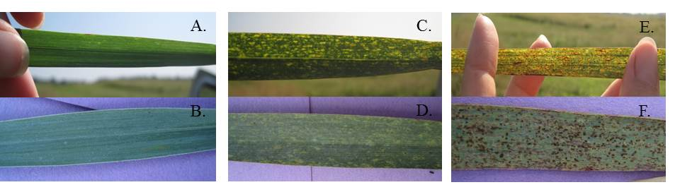

Figure 1-1. Switchgrass leaves, viewed under two light conditions, expressing low disease symptoms - no sporulation and little to no chlorosis or necrosis (A, B), medium disease symptoms - light to medium sporulation, medium chlorosis and necrosis, minor tip dieback on some leaves (C, D), and high disease symptoms - heavy sporulation, chlorosis, and necrosis, tip dieback present but not exceeding 25% of the leaf area (E, F).

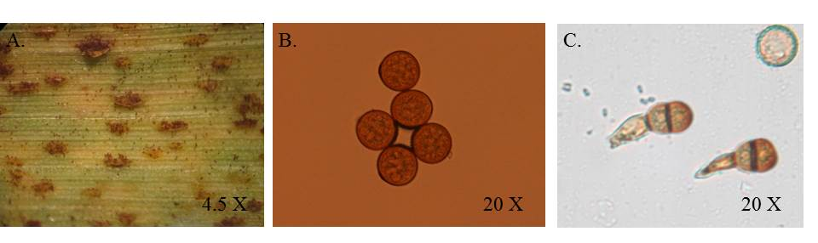

Figure 1-2. Magnification (4.5x) of pustules erupting through switchgrass cell membrane (A) and magnification (20x) of urediniospores (B) and teliospores (C) from cultures isolated from field grown switchgrass naturally infected with Puccinia emaculata.

Figure 1-3. Ethanol yield (mg g⁻¹) by disease level (low, medium, and high) for switchgrass leaves collected from Knoxville, TN in 2010 and subjected to simultaneous saccharification and fermentation (SSF). Ethanol yields were averaged across cultivar since cultivar and cultivar by disease interaction were not significant. Means followed the same letter do not differ significantly at α = 0.05.

Figure 1-4. Predicted ethanol yield (mg g⁻¹) by disease level (low, medium, and high) for switchgrass leaves collected from Knoxville, TN and Crossville, TN in 2012 and analyzed using near-infrared spectroscopy (NIRS). Predicted ethanol yields were averaged across cultivar since cultivar and cultivar by disease interaction were not significant. Means followed the same letter do not differ significantly at α = 0.05.

Table 1-1. Means, R², and p values of compositional elements measured using near-infrared spectroscopy that exhibited significant association with rust severity (P < 0.05). Means are given for categories of low, medium and high rust severity.

Component | Mean Component Value by Disease Level |  |  |  |  |  | R² | p-value
 | Low |  | Medium |  | High
DM | 93.90 | A† | 93.41 | A | 92.61 | B | 0.71 | 0.0002
Cellulose | 30.48 | B | 31.66 | B | 33.46 | A | 0.63 | 0.0010
Hemicellulose | 27.69 | A | 25.87 | AB | 23.35 | B | 0.44 | 0.0183
dNDF48 | 33.06 | A | 29.50 | B | 27.32 | C | 0.78 | <0.0001
NDFD48 | 54.53 | A | 49.28 | B | 46.15 | B | 0.66 | 0.0005
ADF | 36.06 | A | 33.07 | B | 34.09 | B | 0.62 | 0.0013
Ash | 5.17 | B | 6.36 | AB | 7.63 | A | 0.55 | 0.0036
Fat | 2.18 | B | 2.42 | AB | 2.52 | A | 0.48 | 0.0108
Mg | 0.21 | B | 0.27 | B | 0.33 | A | 0.68 | 0.0003
Ca | 0.41 | C | 0.53 | B | 0.62 | A | 0.87 | <0.0001
† Means were separated using Tukey’s HSD. Means followed by the same letter do not differ significantly at p < 0.05

CHAPTER 2 - DIALLEL ANALYSIS TO ASSESS QUANTITATIVE GENETICS OF BIOFUEL PRODUCTION TRAITS IN SWITCHGRASS

Abstract
Switchgrass (Panicum virgatum L.) is a perennial, warm season grass that can be used as a biofuel. A greater understanding of the underlying genetic parameters of biomass yield and ethanol yield in switchgrass could help breeders more effectively develop improved biofuel switchgrass cultivars. Eight parents, representative of the varieties ‘Kanlow’, ‘Alamo’, and ‘Miami’ were crossed in a diallel design. Greenhouse started seedlings were planted at Knoxville, TN and Crossville, TN in single plant plots in a RCB design with four blocks and twenty replications per cross. Plants were evaluated for biomass at 8 weeks post-emergence. After transfer to the field, plants were evaluated for height, rust severity, biomass yield, and predicted ethanol yield in the fall of the first and second year and for height, tiller number, tiller diameter, leaf width, plant color, and canopy density in the spring of the second and third year. Calculated values included correlations between morphological traits and biomass or predicted ethanol yield, estimates of additive and dominance genetic variance components, heritability, general and specific combining ability, maternal effects, and heterosis, and evaluation of early selection potential for biomass and predicted ethanol yield in lowland switchgrass. Correlations of morphological traits to biomass yield indicated an ideotype of a tall plant with a high number of thick tillers, wide leaves, and an open canopy density. Traits with moderate correlations to biomass yield showed significant, but weak, negative correlations to predicted ethanol yield. Heritability values were low (0.13-0.21) with dominance variation predominant for biomass yield, predicted ethanol yield, fall height, canopy density, and tiller number and were higher (0.22-0.50) with additive variation predominant for spring height, plant color, leaf angle, and rust severity. Based on GCA values, A1 and A10 had the highest potential as parents for improving biomass yield. Significant SCA effects, maternal effects, and high parent heterosis were found within all traits. Results for selection prior to achieving full biomass potential indicate selection during the establishment year may be as effective as selection in the second year. Results from this study should help breeders identify more efficient and effective methods for improving biofuel switchgrass cultivars.

Introduction
Switchgrass is a warm season perennial grass, native to North American prairie lands (Newell and Eberhart, 1961). It is important both as a forage crop and, more recently, as a biofuel crop. While progress has been made on breeding switchgrass as a forage crop, the ideal composition of traits for switchgrass used as a biofuel crop and the genetic parameters associated with those traits are still largely undefined.
Switchgrass breeding programs have focused primarily on improving forage/biomass yield and forage quality. Heritability estimates for biomass yield are relatively low and vary by population. Published narrow sense heritability values for biomass yield, calculated using parent progeny regression, range from 0.12 to 0.29 in lowland populations, 0.22 to 0.47 in upland populations, and 0.05 to 0.52 in populations not classified as lowland or upland (Bhandari et al., 2010; Hopkins et al., 1993; Rose et al., 2007; Talbert et al., 1983). In order to develop an ideal selection type, assessments have been made of the relationship between biomass yield and/or forage quality and numerous morphological traits including, but not limited to, plant height, tiller number, leaf blade width, leaf blade length, stem width, seed weight, disease, and seed mass per panicle (Bhandari et al., 2010; Boe, 2007; Das et al., 2004; Newell and Eberhart, 1961; Smart et al., 2004; Talbert et al., 1983). These correlations aid in the selection process by identifying associated traits and allowing for selection of traits that can be measured earlier or more easily than the trait of interest.
Reports of significant correlations between yield and varying morphological traits include correlations of yield with tillering (r = 0.60 to 0.73) (Bhandari et al., 2010; Das et al., 2004), height (r = 0.39 to 0.69) (Newell and Eberhart, 1961; Talbert et al., 1983), number of tillers m⁻² (r = 0.08) (Boe, 2007), number of reproductive tillers m⁻² (r = 0.77) (Boe, 2007), and mass tiller⁻¹ (r = 0.45) (Boe, 2007). Results have varied in determining the significance of the relationship between tiller thickness and biomass yield, with a significant correlation (r = 0.38) reported by Bhandari et al. (2010) and a non-significant correlation (r = 0.27) reported by Das et al (2004). The following heritability estimates have also been reported for these traits: tillering (h² = 0.48) (Bhandari et al., 2010), height (h² = 0.63 to 1.41) (Newell and Eberhart, 1961), and tiller thickness (h² = 0.27) (Bhandari et al., 2010). Based on these results, an ideal ideotype for high biomass yield would be a tall plant with numerous, thick, reproductive tillers.
Additional traits with significant, though smaller, correlations to biomass yield include maturity (r = 0.33) and percent nitrogen (r = 0.44 to 0.67) (Talbert et al., 1983) in lowland populations and height of leaves (r = 0.38), seed quality (r = -0.35) and seed yield (r = 0.31) in a population defined only as a medium-tall, blue green (Newell and Eberhart, 1961). Traits reported as having non-significant correlations with biomass yield include stem width, node number per tiller, leaf blade width, and leaf blade length reported by Das et al. (2004) and heading, days to flowering, plant spread, and spring regrowth reported by Bhandari et al. (2010).
Biomass yield and ethanol yield are both essential components of total yield in switchgrass varieties intended for biofuel production. Measurements of biomass switchgrass quality can include direct assessment of ethanol production potential through simultaneous saccharification and fermentation (SSF) or indirect assessment of ethanol production potential through assessment of structural cell wall components such as lignin which can reduce carbohydrate accessibility during fermentation (Dowe and MCMillan, 2001). Because of the difficulty in screening large amounts of plant material for ethanol production potential or lignin content, these characteristics have been largely neglected in breeding studies in favor of breeding for higher biomass yield or easily measured quality attributes. Recent publication of near infrared reflectance spectroscopy (NIRS) calibrations for predicted ethanol yield, now allow for rapid estimations of these traits (Vogel et al., 2011). Publication of these calibrations permits large scale evaluations of ethanol production which, in turn, provides information on the variability of this trait in switchgrass populations and allows for identification of high ethanol yielding plant material and identification of potential heterotic groups. Further questions of interest include the relatedness of ethanol production potential to morphological traits, disease resistance, and biomass yield.
Other morphological traits may also be of interest in selecting for either biomass yield or predicted ethanol yield. While many studies have examined morphological traits associated with biomass yield and forage quality, the relationship between these morphological traits and ethanol production potential has not been examined. Because of this, it is unclear whether the current high yielding ideotype would still be considered superior when considering both components of biofuels yield: biomass yield and ethanol production potential. Examining the relationship of ethanol production potential with morphological traits such as tiller number, tiller thickness, leaf width, and height could assist breeders in the selection process by identifying which characteristics are linked to both biomass yield and ethanol production potential and determining which components are most likely to maximize total biofuel yield.
Heterosis, maternal effects, and general and specific combining ability in switchgrass are areas in which relatively little research has been performed but for which information would be beneficial in selecting parents to use in the development of hybrids or synthetic populations. Heterosis, or hybrid vigor, has been observed in switchgrass populations. Vogel (2008) found high parent heterosis for biomass yield of 30% to 38% in crosses of ‘Kanlow’ and ‘Summer’ cultivars evaluated under sward conditions. However, a study of the same population under space planted conditions by Martinez-Reyna (2008) found only mid-parent heterosis. Maternal effects, traits which are linked to nuclear factors found in the cytoplasm, have also been identified in switchgrass. Martinez-Reyna (2008) identified maternal effects for switchgrass seed weight, with seed from the cross of Kanlow x Summer having a significantly greater weight than seed from the reciprocal cross, Summer x Kanlow. A full diallel crossing system, in which every parent is crossed with every other parent, including reciprocal crosses, allows for evaluation of both maternal effects and general and specific combining ability of parent plants (Griffing, 1956). General combining ability is defined as the average performance of a line in a hybrid combination while specific combining ability is defined as the performance of specific combinations in relation to the average performance of the lines involved. These values allow breeders to predict hybrid and synthetic variety performance. A diallel system may also be used to estimate variance components of the population. For a tetraploid plant, such as lowland switchgrass, σ²_{A} and σ²_{D} can be estimated using the following formulas (Wricke and Weber, 1986):
σ²_{A} = 4σ²_{gca} – 2/3 σ ²_{sca}
σ²_{D} = 6 σ ²_{sca}.
In addition to determining genetic variance components for various traits that may be important to switchgrass, determining the efficacy of early selection in switchgrass could greatly aid the breeding process. Selecting for improved switchgrass for biofuels can be time consuming since switchgrass takes approximately three years to reach full biomass yield potential (Garland, 2008). The selection process could be hastened by making selections prior to plants achieving full biomass yield potential, however, the efficacy of early selection for biomass yield or ethanol yield in switchgrass has not yet been fully examined.
Evaluations of switchgrass at a juvenile seedling stage, either in a greenhouse or in the field, could result in huge savings of time, space, labor, and money. In switchgrass, seedling selection for tillering was effective at increasing the mean yield tiller⁻¹ in mature plants, though no significant difference in yield plant⁻¹ was observed (Smart et al., 2004). In other forage grasses, juvenile seedling selections have shown correlations to mature plant traits in Italian ryegrass (Lolium multiflorum Lam.) and perennial rygrass (Lolium perenne L.) for measurements of leaf length, leaf width, tiller number, and tiller weight (Edwards and Cooper, 1963) and in tall fescue with selection for yield tiller⁻¹ and leaf expansion rate (Jones et al., 1979).
While many studies have shown that biomass yield in first year switchgrass is very poor and not representative of biomass yield in second or third year evaluations, no studies to date have examined whether selections for high biomass or high ethanol yield are effective prior to switchgrass reaching full biomass yield potential. While the space savings would not be as great as selection at juvenile stages, selection in the first or second year of establishment could still result in significant savings in time, money, and labor. Traits of interest in early selection include biomass yield, ethanol yield, and various morphological traits that may be associated with biomass or ethanol yield.
Knowledge of maternal effects, general and specific combining ability, and heterosis potential of parent material provides breeders greater directions when selecting parents for the development of improved synthetic populations or hybrids. Information on the heritability of various morphological traits, correlations between morphological traits and biomass and predicted ethanol yield, and early selection potential within lowland switchgrass populations can also further aid breeders in choosing more effective and efficient breeding methods for improving switchgrass as a biofuel crop. The objective of this research is to calculate trait correlations, additive and dominance genetic variance components, heritability, general and specific combining ability, maternal effects, heterosis, and early selection potential of morphological traits and biomass and predicted ethanol yield in lowland switchgrass.

Materials and Methods

Parent Material
Eight switchgrass parents were chosen based on 2010 field evaluations of either the plant itself or its progeny at the Plant Science Unit and Holston Unit of the East Tennessee Research and Education Center (ETREC) in Knoxville, TN (35º58’11.3”N 83º51’08.7”W, soil type: Shady-Whitewell complex). Plants were chosen with divergence for the following traits of interest: tiller count, stem size, leaf width, leaf plant color, leaf orientation, and height and were considered a random sample representative of Alamo and Kanlow populations. Alamo is a cultivar collected in Texas in 1977 and Kanlow is a cultivar developed in Kansas and released in 1963 (USDA National Plant Germplasm System). These two cultivars are the most commonly grown cultivars in the state of TN, with Alamo being the predominant of the two (Garland, 2008). Five selections from Alamo were included, three of which were selected from populations of the cultivar Alamo (A1, A10, AS), and two of which are genotypes selected from PI 607837, which is an accession derived from the cultivar Alamo for low crown node placement in relation to the soil surface (T1, T4) (Tischler et al., 2001). A genotype selected from the accession Miami (M; PI 421901), an accession collected from wild material in Florida, was also included as a parent.

Breeding Methods and Greenhouse Maintenance
In January 2011, parent plants were divided into eight clonal propagules and transplanted from the field to 7.6 liter pots. Four pots of each clone were placed in both a glass house at the University of Tennessee in Knoxville, TN and a shade house at the East Tennessee Research and Education Center in Knoxville, TN. Slow release 13-13-13 fertilizer (OsmocoteTM) at a rate of 50 kg ha⁻¹ of nitrogen was added to pots during transplanting. Plants were then maintained using a monthly application of a fast release 20-20-20 fertilizer at a rate of 97.07 kg ha⁻¹ of nitrogen. When plants reached the reproductive stage, they were crossed in a diallel design, including reciprocal crosses. Crosses were made by combining a single reproductive tiller from each of the two crossing parents in a 17 x 16 x 12 x 39 cm paper pollination bag (MIDCO Enterprises, St. Louis) to maintain isolated pollination. Tillers and bags were supported by bamboo stakes and bags were lightly shaken approximately every 2 days to promote pollen distribution. Tillers were placed in bags when stigmas were visible on flowers at the tip of the panicle; however, flowers with visible stigmas were removed prior to bagging. When all stigmas on a panicle appeared desiccated, panicles were separately bagged for the duration of seed ripening.
To break dormancy, seed collected from each cross were pretreated using methods described by Haynes et al. (1997) with modified timing of H₂O washes. Seeds were submerged in 5.25% NaOCL for 15 minutes followed by two 20 minutes washes in deionized H₂O. Seeds were then germinated in petri dishes between two layers of germination paper soaked to saturation in 0.2% KNO₃ and wet chilled at 4 C for 2 weeks. Seeds were dusted with Captan (cis-N-[(trichloromethyl) thio-4-cyclohexene-1,2-dicarboximide]) and sown in D40L deepots with a 6.35 cm in diameter and 25.4 cm depth (Stuewe & Sons, Corvallis, OR) filled with Fafard Growing Mix 2 (Conrad Fafard, Inc., Agawam, MA) topped with a layer of Fafard Super-Fine Germinating Mix (Conrad Fafard, Inc., Agawam, MA). Twenty seedlings were randomly selected from within each cross for evaluation, 36 seedlings from within each cross were randomly selected to provide borders for sward plots, and 304 seedlings were randomly selected from among all crosses to serve as border plants in space planted nurseries.

Juvenile Evaluation
Eight weeks after emergence, seedlings were evaluated for the following morphological traits: plant height, leaf angle, plant color, tiller number, stem diameter, leaf width, and biomass yield. Plant height was measured in cm. Leaf angle was evaluated visually using a 1-5 scale with 1 indicating prostrate leaves and 5 indicating upright leaves. Plant color was evaluated visually using a 1-3 scale with 1 indicating medium green and 3 indicating blue. For plants with multiple tillers, the average stem diameter, leaf width, stem weight, and leaf to stem ratio for all tillers was recorded. Stem diameter and leaf width were measured to the nearest 0.5 mm using calipers. Stem diameter was measured 5 cm from the base of each tiller. Leaf width was measured for each tiller on the first fully emerged leaf from the top at the widest portion of the leaf, approximately 2.5 cm from the stem. Tillers were harvested 5 cm from the base and weighed.
After seedlings were evaluated and had tillered sufficiently, each seedling was divided into two clonal propagules. Single tiller pieces were removed and potted from each parent plant to produce 40 clonal propagules of each parent plant, 20 per location. Seedlings were maintained in the greenhouse until June 2012 when they were transplanted to two field locations, the East Tennessee Research and Education Center in Knoxville, TN (June 21-23, 2012) (35º58’11.3”N 83º51’08.7”W, soil type: Shady-Whitewell complex) and the Plateau Research and Education Center (June 26, 2012) in Crossville, TN (36º00’49.7”N 85º07’57.7”W, soil type: Lonewood loam). Nitrogen was applied yearly prior to green-up at a rate of 67 kg ha⁻¹. Within each location, 20 seedlings per cross and twenty propagules from each of the eight parent plants were planted in a randomized complete block design divided into four blocks to account for field variation. Clonal propagules were used to replicate F1 plants across the two locations. Plants were spaced on 1 m centers.

Field Evaluation
Plants were evaluated for the following traits: height, tiller number, stem diameter, leaf width, leaf angle, plant color, canopy density, rust severity, biomass yield, and predicted ethanol yield. All traits were assessed in the spring (May-June) of each year except biomass yield and predicted ethanol yield, which were evaluated at harvest in the fall (October-November). Rust severity was evaluated in October of 2012 and in August of 2013. Rust severity was rated on a one to nine scale with one indicating no visible symptoms and nine indicating abundant sporulation as described by Gustafson et al. (2003). Plant height (cm) was measured in the spring and fall. Spring traits were not evaluated during the first year due to transplanting. Two tillers, of a maturity average to that of the plant being evaluated, were randomly selected for stem and leaf measurements and an average was calculated for each. Stem width (mm) was measured directly above the lowest node using calipers. Leaf width (mm) was measured on the fully emerged leaf directly above the bottommost node at the widest portion of the leaf, approximately 8 cm from the stem using calipers. Leaf angle was evaluated visually using a 1-5 scale with 1 indicating prostrate leaves, leaves at a 135° angle or greater relative to the stem, and 5 indicating upright leaves, leaves at a 45º angle or less relative to the stem. Plant color was evaluated on a 1-3 scale with 1 indicating medium green and 3 indicating blue. Canopy density was evaluated on a 1-5 scale with one indicating a dense canopy and five indicating an open canopy. Biomass yield was measured by harvesting plants individually with a sickle bar mower set to cut at approximately 15 cm from the soil surface and weighing the harvested bundle. Immediately after weighing, a 20 tiller sample was taken from each plant. Each sample was weighed, dried in an oven at 65 ºC for at least 48 to 72 hrs., and weighed again to obtain percent moisture. This value was used to adjust yield values to an equivalent dry weight. Dried material was ground using a Wiley Mill (Thomas Scientific, Swedesboro, NJ) to pass a 1 mm mesh screen. Samples were analyzed using a FOSS NIRSystems 4500 Feed & Forage Analyzer (FOSS Analytical, Hilleroed, Denmark). WINSI II software, supplied by Infrasoft International LLC (State College, PA) was used for NIRS analysis. A global H statistical test in the WINSI II program was used to check the fit of the spectral profile of the calibration set to the current data (Murray and Cowe, 2004) Although Vogel et al. (2011) developed NIRS calibrations specifically for estimating ethanol production from switchgrass, the samples from this experiment were not within the spectral profile of the calibration set for estimating ethanol yield. All samples did fit the 2013 mixed hay equation (H < 3.0) published by the NIRS Consortium (Hillsboro, WI). Values obtained for neutral detergent fiber (NDF) and neutral detergent fiber digestibility at 48 hours (NDFD48) were inserted into the regression equation developed by Lorenz et al. (2009) to estimate ethanol yield from SSF. This equation was developed to estimate ethanol yield from SSF using corn stover; however, in previous studies on switchgrass, NIRS estimated ethanol yields explained 97.5% of the variation in average SSF ethanol yield (Sykes, unpublished data).

Statistical Analysis
All data were analyzed using SAS vs. 9.3 (SAS Institute, Cary, NC). Parent plants were excluded from all analyses except for evaluation of heterosis. Greenhouse evaluation data were used in correlations and evaluation of early selection, but were excluded from all other analyses since greenhouse evaluations were done prior to clonal division and thus did not contain the replication and blocking of plants evaluated under field conditions.
Pearson correlation coefficients were calculated between each measured trait and biomass yield and predicted ethanol yield respectively for each year using individual data points from each plant. Estimates of general combining ability (GCA) and specific combining ability (SCA) were determined using analyses of variance of the following mixed model:
Y_{ijlmno} = µ + G_{k} [= G_{i} + G_{j}] + S_{ij} + T_{l} + L_{m} + B(L)_{n(m)} + TL_{lm} + B(TL)_{n(lm)} + GT_{kl} + GL_{km} + GTL_{klm} + B(GL)_{n(km)} + B(GTL)_{n(klm)} + ST_{ijl} + SL_{ijm} + STL_{ijlm} + B(SL)_{n(ijm)} + B(STL)_{n(ijlm)} + e_{o(ijlmn)}
where:
Y_{ijlmno} | = observed value of a given trait for the oth replication within the nth block within the mth location within the lth year of the combination of the ith male parent and jth female parent
µ | = overall population mean of a given trait
G_{i} | = effect of the ith male parent, i = 1 to 8
G_{j} | = effect of the jth female parent, j = 1 to 8
G_{k} | = Since parents plants can be used as both male and female parents, GCA was modeled using a multimember effect in PROC GLIMMIX to combine male (G_{i}) and female (G_{j}) effects into a single GCA estimate for each parental line, G_{k} = G_{i} + G_{j}
S_{ij} | = effect of the interaction of male parent i and female parent j where parental order is retained and selfs are excluded, ij = (8)(8-1) = 56
T_{l} | =effect of year l, l = 2012, 2013
L_{m} | = effect of location m, m = 1 to 2
B(L)_{n(m)} | = effect of block n within location m, n = 1 to 4
TL_{lm} | = interaction effect between year l and location m
B(TL)_{n(lm)} | = interaction effect between block n within location m by year l
GT_{kl} | = interaction effect between GCA k and year l
GL_{km} | = interaction effect between GCA k and location m
GTL_{klm} | = interaction effect between GCA k, year l, and location m
B(GL)_{n(km)} | = interaction effect between block n within location m and GCA k
B(GTL)_{n(klm)} | = interaction effect between block n within location m, GCA k, and year l
ST_{ijl} | = interaction effect between SCA ij and year l
SL_{ijm} | = interaction effect between SCA ij and location m
STL_{ijlm} | = interaction effect between SCA ij , year l, and location m
B(SL)_{n(ijm)} | = interaction effect between block n within location m and SCA ij
B(STL)_{n(ijlm)} | = interaction effect between block n within location m, SCA ij, and year l
E_{o(ijlmn)} | = experimental error or residual

Griffing’s mixed model A analysis was used, in which GCA and SCA are considered random while location, year, and block are considered fixed effects (Griffing, 1956). Doing so allowed for extrapolation of results to the population at large rather than the specific parents selected. To determine maternal effects, a separate model was analyzed that included all effects listed above but in which SCA was divided into an SCA effect and reciprocal SCA effect by identifying each combination of parents in the SCA effect and using a multiplier of 1 or -1 to distinguish crosses and reciprocals.
Genetic variance components for a tetraploid were estimated using the following formula (Wricke and Weber, 1986):
σ²_{A} = 4s²_{gca} – 2/3 σ ²_{sca}
σ²_{D} = 6 σ ²_{sca}.
Narrow-sense heritability (h²) was estimated using the following formula:
h² = σ²_{A}/ σ²_{P}
where σ²_{P} = the sum of additive, dominance, and residual variance components.
Broad-sense heritability (H²) was estimated using the following formula:
H² = (σ²_{A+} σ²_{D})/ σ²_{P}
To determine high parent heterosis, parents and progeny were included in the data set. High parent heterosis was calculated for all quantitative data including biomass yield, predicted ethanol yield, plant height (fall and spring), tiller number, tiller diameter, and leaf width. High-parent heterosis, defined as progeny performance relative to high parent plant performance, was calculated for each trait using the following formula:
High parent heterosis = Hybrid mean – High parent mean (Martinez-Reyna and Vogel, 2008)
Using this formula allowed for heterosis to be analyzed using mean separation statistics. Data were analyzed with the GLIMMIX procedure in SAS using the same model defined above but with GCA and SCA specified as fixed effects and the remaining effects specified as random.
To evaluate the efficacy of early selection, the top yielding 30% of lines and crosses were selected within each year and matched to corresponding second year biomass and predicted ethanol yield values to compare the performance at maturity of each set of selections: juvenile (YJ), first year (Y1), and second year (Y2). Performance of each selected set was compared using ANOVA with means separated using Tukey’s HSD.

Results and Discussion

Means of Measured Traits by Location and Year
  - Biomass Yield
Mean biomass yield across F1 populations differed significantly by year (P < 0.001) but not by location (Figure 2-1 A) (All tables and figures are located in Appendix II). Mean biomass in 2012 was 95 g plant⁻¹ while mean biomass in 2013 was much higher at 1061 g plant⁻¹. Values ranged from 0.1 to 690 g plant⁻¹ in 2012 to 2.7 to 5139 g plant⁻¹ in 2013.
Unlike biomass yield, mean predicted ethanol yield across F1 populations did not differ significantly by either location or year (Figure 2-1 B). Values ranged from 37 to 95 mg g⁻¹. This range is a little wider than that observed by Sarath et al. (2011) who examined ethanol yield in octaploid switchgrass genotypes divergently bred for ruminant digestibility genotypes (48.6 to 72.4 mg g⁻¹).
  - Morphological Traits
Mean fall height and mean spring height for F1 populations differed significantly by year (P < 0.001) and by location (P < 0.05) with a significant year by location interaction (P < 0.05) (Figure 2-1 C). F1 populations were significantly taller in the fall of 2013 (x̅₂₀₁₃ = 200 cm) compared to the fall of 2012 (x̅₂₀₁₂ = 114 cm). While no differences were observed between locations in 2013, in 2012, plants at the Knoxville location were 10 cm taller on average compared to the Crossville location. In 2012, fall height ranged from 2.54 to 208 cm, while in 2013, fall height ranged from 24 to 302 cm. For spring height, the Knoxville location had taller plants compared to the Crossville location in both 2012 and 2013 (Figure 2-1 D). Plants were also shorter in 2014 (x̅₂₀₁₄ = 107 cm) compared to 2013 (x̅₂₀₁₃ = 136 cm). Spring heights were measured two weeks earlier in 2013 compared to 2014; however, earlier season warm temperatures in 2013 are likely the cause of the difference in height between years. The Crossville location is typically 16 ºC cooler than the Knoxville location which may have led to an earlier spring green up at the Knoxville location. This difference in location was less prevalent in fall height since plants at each location had a full growing season to achieve maximum height prior to senescence and harvest. Spring height ranged from 7.6 to 246 cm in 2013 and 28 to 180 cm in 2013.
Mean tiller number also showed significant differences in year (P < 0.01) but not in location (Figure 2-1 E). However, a significant year x location interaction was observed (P < 0.05). Mean tiller number in 2013 was 35 tillers plant⁻¹ and by 2014 was nearly triple that at 104 tillers plant⁻¹. The significant interaction in year x location was due to a significantly higher tiller number at the Crossville location in 2013 with the opposite occurring in 2014. In 2013, tiller number ranged from 1 to 263 tiller plant⁻¹, while in 2014, tiller number ranged from 1 to 394 tiller plant⁻¹.
Only locations differed significantly for mean tiller diameter (P < 0.001) (Figure 2-1 F). The Crossville location had thicker tillers (x̅ = 6.7) compared to the Knoxville location (x̅ = 6.2). The range of tiller diameter was 1.4 to 14.7 mm at the Crossville location and 0.8 to 12.6 mm at the Knoxville location.
Mean leaf width differed by location (P < 0.001) and by year (P < 0.001) and a significant year x location interaction was observed (P < 0.05) (Figure 2-1 G). Leaf widths were slightly wider at the Crossville location (x̅ = 12.4 mm) compared to the Knoxville location (x̅ = 11.9 mm) in 2013. However, the two locations did not differ significantly in 2014, with a mean leaf width of 14.5. In 2013, leaf widths ranged from 3 to 21.5 mm. The range in 2014 was similar but with a slightly higher minimum and maximum of 5.8 to 23.3 mm, respectively.
Qualitative data collected included ratings for the traits canopy density, plant color, leaf angle, and rust severity. For all of these traits, the range of values observed encompassed the entire spectrum of the rating scale, from 1-5 for canopy density, indicating dense to open canopies, 1-3 for plant color, indicating medium green to blue plant color, 1-5 for leaf angle, indicating prostrate to upright leaves, and 1-9 for rust severity, indicating no disease symptoms to heavy sporulation and chlorosis. For the trait canopy density, a significant year effect was observed (P < 0.01) while no differences in location were observed. Plants had significantly denser canopies in 2013 with the canopies becoming more open as plants grew larger in 2014, mainly due to a substantial amount of lodging. Plant color showed significant year x location interaction (P < 0.05) with plants showing no significant difference in plant color across locations in 2013 while plants were significantly bluer at the Knoxville location compared to the Crossville location in 2014. Leaf angle did not show significant year or location effects.
Because rust severity ratings were taken during different points in the growing season in 2012 compared to 2013, these data were analyzed separately. Location was not significantly different in 2012 ratings, while locations did differ significantly in 2013 (P < 0.05) (Figure 2-1 K-L). Mean rust severity was higher from the October 2012 ratings (x̅ = 5.4) compared to the August 2013 ratings (x̅ = 4.2). This was expected since the disease had more time to progress during the growing season. In 2013, the Knoxville location had significantly lower rust severity (x̅ = 3.8) compared to the Crossville location (x̅ = 4.5). In 2012, rust severity ranged from 1 to 9 on a 1 to 9 scale. In 2013, rust severity ranged from 1 to 8 on a 1 to 9 scale. While plants in 2012 that were rated as a 9 were not completely killed by the pathogen, the extent of damage due to the pathogen appeared to cause early senescence in some plants. These plants were given a rating of 9. Because of the difficulty in distinguishing rust severity from early senescence, plants were rated earlier in the season in succeeding years.

Correlations of Biomass and Ethanol Yield with Morphological Traits
For correlations measured within each year, fall height (2012: r = 0.73, 2013: r = 0.70) and tiller number (r = 0.78) were significantly strongly correlated to biomass yield while spring height (r = 0.58), canopy density (r = 0.43), and leaf width (r = 0.41) were significantly moderately correlated to biomass yield (Table 2-1). These results are consistent with correlation values reported in other studies of lowland switchgrass (Bhandari et al., 2010; Boe, 2007; Das et al., 2004; Talbert et al., 1983). In this study, tiller diameter also showed a significant moderate correlation to biomass yield (r = 0.58) which was higher than results reported by Das et al. (2004) (r = 0.27) and by Bhandari et al. (2010) (r = 0.38), but close to values reported by Bhandari et al. (2011) (r = 0.52). Based on these values, an ideotype for high biomass switchgrass would be a plant that is tall with a high number of thick tillers, wide leaves, and an open canopy density. Although fall height is more highly correlated with biomass yield (r = 0.70 to 0.73), explaining approximately 50% of the variation in biomass yield, evaluation of spring height is only slightly lower (r = 0.58), explaining 34% of the variation in biomass yield, and would allow for early selection prior to flowering. Tiller counts, while highly correlated to yield, are not efficient for large scale evaluations. A visual evaluation of tillering, as described by Bhandari et al. (2010) would likely be more efficient, although, perhaps, not as predictive.
Predicted ethanol yield was significantly moderately negatively correlated with fall height (2012: r = -0.55, 2013: r = -0.32) and with biomass yield (2012: r = -0.36, 2013: r = -0.27) (Table 2-1). Significant weak negative correlations were observed between predicted ethanol yield and spring height (r = -0.20), tiller number (r = -0.19), tiller diameter (r = -0.28), and leaf width (r = -0.20). While no studies to date have examined the correlation between biomass yield and predicted ethanol yield in switchgrass, a few have examined the correlation between biomass yield and quality traits, in vitro dry matter digestibility (IVDMD), lignin, acid detergent fiber (ADF), and neutral detergent fiber (NDF). While lignin has been identified as a hindrance to the fermentation process for converting biomass into ethanol (Anderson and Akin, 2008; Dien et al., 2009; Dien et al., 2006; Fu et al., 2011; Shen et al., 2009), estimates of IVDMD have been shown to be a good indicator of ethanol yield (Sarath et al., 2011). A study by Butkute et al. (2013) found positive correlations of r = 0.52 between dry matter yield and lignin and r = 0.78 between dry matter yield and NDF. Vogel et al. (2013) found selection for high IVDMD resulted in a 10% decrease in biomass yield. As IVDMD increased, less digestible components such as ADF and NDF decreased. As plants grow larger, a stronger cellular support system is required to maintain structure. Since structural components, such as lignin, can limit the conversion of biomass to ethanol, a positive correlation of lignin with biomass yield observed in other studies and the equivalent negative correlation of predicted ethanol yield with biomass yield observed in this study is not unexpected. Additionally, the largest correlation between predicted ethanol yield and a morphological trait was with tiller diameter (r = -0.28). Again, this is not unexpected since stems in switchgrass are more lignified than other plant components (Mann, 2009). These results indicate breeding for morphology associated with higher biomass yield may negatively impact predicted ethanol yield. However, since predicted ethanol yield is reported in mg g⁻¹ DM, a slight reduction in predicted ethanol yield in higher biomass yielding plants would in all probability not result in an overall reduction of predicted ethanol yield on a per plant basis. For example, of the F1 populations analyzed for both biomass yield (g plant⁻¹) and ethanol yield (mg g⁻¹), the highest biomass yielding cross was T1xM (biomass yield: 1707 g plant⁻¹, ethanol yield: 67 mg g⁻¹) while the highest ethanol yielding cross was A10xK3 (biomass yield: 1028 g plant-1, ethanol yield: 70 mg g⁻¹). In terms of overall ethanol yield per plant, the T1xM cross, which had a lower ethanol production potential, would still result in higher ethanol yield per plant (114 g plant⁻¹) compared to the A10xK3 cross (72 g plant⁻¹), which had a higher ethanol production potential but lower biomass yield.
Juvenile evaluations showed significant but very low correlations of tiller diameter (r = 0.08) and leaf width (r = 0.10) with 2013 biomass yield (Table 2-2). Surprisingly, juvenile evaluations of height (r = 0.16), tiller number (r = 0.17), and biomass yield (r = 0.18) had small but significant positive correlations to 2013 predicted ethanol yield. In the within year correlations, these traits all had negative correlations to predicted ethanol yield (Table 2-1). Correlation coefficients of traits evaluated in the fall of the establishment year to second year biomass and predicted ethanol yield were similar to correlation coefficients of traits evaluated in the second year with second year biomass and predicted ethanol yield (Table 2-1). Correlations of establishment year yields to second year biomass yields were moderately high (r = 0.67), while correlations of establishment year predicted ethanol yield to second year predicted ethanol yield was moderate but lower (r = 0.31). Fall height and biomass yield in the establishment year were more highly correlated to second year biomass yield (Table 2-2) than any of the traits measured in the spring of the second year, with exception to tiller number (Table 2-1). These results indicate that, although establishment year biomass yield is not equivalent to maximum biomass yield potential in switchgrass, selection based on establishment year biomass yield and height in a space planted nursery may be effective at increasing biomass yield in plants selected prior to reaching maximum biomass yields.

Variance Components of Measured Traits
The total genetic variance was divided into two components, general combining ability (GCA) and specific combining ability (SCA) with the relative importance of these components presented for the traits biomass yield, predicted ethanol yield, fall height, spring height, tiller number, tiller diameter, leaf width, and canopy density within years and across years (Table 2-3). Rust severity was evaluated at different stages of maturity in 2012 versus 2013, so data for this trait are presented by year and not as a combined analysis (Table 2-3). The percentage of total variation attributed to genotype by environmental variation, including interactions of GCA or SCA with location, block within location, or year, is also listed. Effects with zero variance are not listed due to space constraints. Traits that did not show moderate to high correlations to biomass yield, including plant color and leaf angle, were excluded from further analyses.
All of the traits examined showed significant interaction of SCA with block within location, indicating blocking was necessary to account for environmental variation in the field (Table 2-3). None of the traits showed significant interaction of GCA or SCA with location. Interaction of GCA with year was observed for the traits biomass yield and predicted ethanol yield (Table 2-3 A). The interaction of GCA with year for biomass yield was expected since switchgrass does not reach maximum biomass yield potential until the third year of production (Garland, 2008). For this reason, interpretation of results for biomass yield and predicted ethanol yield will be separated by year. For both biomass yield and predicted ethanol yield, GCA was not significant but significant SCA variation was observed, indicating significant dominance genetic variance for these traits. For biomass yield, SCA accounted for 7% of the genetic variance in 2012 and 10% of the genetic variance in 2013. For predicted ethanol yield, SCA accounted for 7% of the genetic variance in 2012 and 5% of the genetic variance in 2013.
The remaining traits did not have significant genotype by year and/or location variation (Table 2-3 B-D). Significant genetic variation due to GCA was observed in Spring Height (14%), Plant color (19%), Leaf Angle (16%), and Tiller Diameter (12%). Significant genetic variation due to SCA was observed in Fall Height (8%), Spring Height (7%), Plant color (3%), Canopy density (5%), Leaf Angle (5%), Tiller Number (8%), Tiller Diameter (5%), Leaf width (5%), Rust severity Aug. (6%), Rust severity Oct. (7%).

Heritability of Measured Traits
Estimates of additive and dominance variation based on GCA and SCA values from the analysis of variance model and estimates of narrow and broad sense heritability, based on values for additive and dominance variation, are presented in Table 2-4. Biomass yield and predicted ethanol yield were again interpreted separately by year due to the significant variation in SCA by year. Heritability estimates for biomass yield were fairly consistent across years with broad sense heritability estimates of 0.42 in 2012 and 0.50 in 2013 and narrow sense heritability estimates of 0.13 in 2012 and 0.15 in 2013 (Table 2-4 A). These values are similar to those reported in previous studies of lowland switchgrass (Bhandari et al., 2010; Rose et al., 2007; Talbert et al., 1983). Because biomass yield differs so greatly between the establishment year and succeeding years, the combined heritability values were very low with a narrow sense heritability estimate of 0.07 and a broad sense heritability estimate of 0.19. However, the proportion of additive to dominance variation remained consistent across years. This indicates heritability values may be more appropriate if interpreted by year, for example, the heritability value of first year biomass as the fraction of phenotypic variation that can be attributed to genetic variation in first year biomass yields and the heritability value of second year biomass as the fraction of phenotypic variation that can be attributed to genetic variation in second year biomass yields. Removing the genotype by environmental interaction associated with year would result in an over-estimation of heritability. Examination of heritability estimates in the third year would provide greater clarity to this situation as biomass yields should be more similar between second and third year switchgrass plants that are space planted. In both years for the biomass yield trait, dominance variation accounted for the majority of genetic variation, with an additive to dominance ratio of 0.44.
For predicted ethanol yield, broad sense heritability estimates were similar across years, with values of 0.45 in 2012 and 0.52 in 2013; however, narrow sense heritability was almost doubled in 2013 compared to 2012, with estimates of 0.18 in 2012 and 0.34 in 2013 (Table 2-4 A). This inconsistency was due to the relative proportion of additive and dominance variation in predicted ethanol yield across years. In 2013, additive variation accounted for a higher portion of the genetic variation while in 2012 dominance variation accounted for the majority of the genetic variation. Mean predicted ethanol yield across locations and years were very similar. Because of this and the flip-flopping of the relative proportion of additive and dominance variation, the heritability estimates from the combined year’s analysis are likely to be the most accurate for use in future breeding endeavors. A third year of analysis may also better explain the pattern observed. The heritability estimates for predicted ethanol yield combined across both years were very low, with a narrow sense heritability of 0.04 and a broad sense heritability of 0.16.
For the remaining traits, most had similar broad sense heritability values, ranging from 0.43 to 0.58 (Table 2-4 A-B). The exceptions to this were canopy density, which had a lower broad sense heritability of 0.34, and rust severity Oct., which had a higher broad sense heritability of 0.70. Narrow sense heritability ranged from 0.13 to 0.21 in traits where dominance variation accounted for a greater portion of the total genetic variation, including fall height, canopy density, and tiller number. Within these traits, the ratio of additive to dominance variation was smallest for canopy density (0.3), was higher for tiller number (0.5), and was the highest in fall height (0.7). In traits where additive variation accounted for a greater portion of the total genetic variation, narrow sense heritability ranged from 0.22 to 0.50. These traits included spring height, leaf width, rust severity Aug., rust severity Oct., and tiller diameter. Within traits where dominance variation was higher than additive variation, the ratio of additive to dominance variation was a little over 1 for leaf width, increased to 1.5 and 1.6 in spring height and rust severity Oct. respectively, and was highest for tiller diameter (1.9), and rust severity Aug. (2.6).

General and Specific Combining Ability and Maternal Effects of Measured Traits
None of the evaluated traits had significant (P < 0.05) interaction between general combining ability (GCA) and year or location (Table 2-3); therefore, GCA values are presented combined across years and locations (Figure 2-2). No significant GCA values were observed for biomass yield or predicted ethanol yield, indicating the variation in GCA did not differ significantly from zero. For biomass yield, four of the five Alamo parental lines, A1, A10, T1, and T4, had positive GCA values (Figure 2-2 A). Only two parental lines, K3 and T1, had positive GCA values for predicted ethanol yield (Figure 2-2 B). Although T1 was the only parental line with positive GCA values for both biomass yield and predicted ethanol yield, the GCA value for biomass yield indicated only a 1 g plant⁻¹ deviation from the population mean compared to the other three positive GCA values, which ranged from 44 g plant⁻¹ to 47 g plant⁻¹.
In both fall height and spring height, the Alamo parental line, A1 had a significant positive GCA (Figure 2-2 C-D). For the trait tiller number, no significant positive GCA values were identified; however, A1, A10, T1, T4, and K3 had positive GCA values (Figure 2-2 E). Only two parental lines, A1 and K2, had significant positive GCA values, indicating thicker tillers compared to the population mean (Figure 2-2 F). For the trait leaf width, the A10 and M parental lines had significant positive GCA values, indicating wider leaves compared to the population mean (Figure 2-2 G). No significant GCA values were observed within lines for the trait canopy density (Figure 2-2 H). For this trait, the Alamo parental lines, A10, T1, and T4, had positive GCA values, indicating canopies tended to be more open, while the Alamo parental line, A1, both Kanlow parental lines, and the Miami parental line had negative GCA values, indicating these lines tended to have denser canopies. For rust severity, two parental lines showed consistently low significant GCA values, indicating less rust severity compared to the population mean, across both rating dates, A1 and M (Figure 2-2 I-J). Interestingly, these lines were also lines identified as having positive GCA values for leaf width, although only the M parental line exhibited a significant positive GCA for leaf width.
Across traits, the A1 and A10 parental lines were the most promising, with A1 exhibiting positive GCA values for biomass yield, fall height, spring height, tiller number, tiller diameter, and leaf width and negative GCA values for rust severity. This line did have a negative GCA value for predicted ethanol yield, however. The A10 line also had positive GCA values for biomass yield, fall height, spring height, tiller number, leaf width, and canopy density. While it had a GCA value of 0 mg g⁻¹ for predicted ethanol yield, it did have positive, though not significant, GCA values for rust severity, indicating higher than average rust severity on progeny within this line. The Alamo line, T4, also showed promise with positive GCA values for biomass yield, fall height, tiller number and canopy density. Predicted ethanol yield was not evaluated for this line due to time constraints.
Significant maternal effects (P < 0.05) were observed for each trait, therefore, SCA and heterosis results are reported for each cross and it’s reciprocal separately (Figure 2-3). Biomass yield and predicted ethanol yield values are shown for 2012 and 2013 because of a significant SCA by year interaction effect in the model (Table 2-3 A). For the remaining traits, the mean SCA value across both years is shown (Figure 2-3).
In 2012, biomass yield had seven significant (P < 0.05) SCA values (Figure 2-3 A). The population mean was 95 g plant⁻¹. Crosses with significant positive SCA values included A10xAS (36 g plant⁻¹), K2xT1 (33 g plant⁻¹), K3xT4 (40 g plant⁻¹), A10xM (47 g plant⁻¹), and T1xM (74 g plant⁻¹). In 2012, biomass yield had five combinations with significant maternal effects (Figure 2-3 A). Within combinations identified as significant, the difference between cross and reciprocal ranged from 24 g plant⁻¹ to 52 g plant⁻¹, with an average difference of 36 g plant⁻¹.
In 2013, biomass yield had six significant SCA values (Figure 2-3 B). Four of these crosses were also significant in 2012. Crosses with significant SCA values included K2xT1 (437 g plant⁻¹), K3xT4 (588 g plant⁻¹), and T1xM (273 g plant⁻¹). In 2013, four of the five combinations from 2012, and an additional three combinations were identified as having significant maternal effects (Figure 2-3 B). Within combinations identified as significant, the difference between cross and reciprocal ranged from 202 g plant⁻¹ to 371 g plant⁻¹, with an average difference of 271 g plant⁻¹.
Reciprocal effects for biomass yield in lowland switchgrass were also reported by Bhandari et al. (2014), with an average maternal effect between 500 and 8400 g plant⁻¹. These values are much higher than the average reciprocal effects reported above. The study by Bhandari et al. examined mean biomass across second and third year evaluations, while this study used first and second year biomass data which could explain the observed difference in magnitude. A similar proportion of combinations exhibiting reciprocal effects for biomass yield were found in both studies.
For predicted ethanol yield, one cross in 2012 and one cross in 2013 were identified with significant (P < 0.05) SCA values (Figure 2-3 A-B). The crosses identified as significant were not consistent across years and both SCA values were negative. In 2012, two combinations were identified as having significant maternal effect, A10/K3 and K3/M. In 2013, no significant maternal effects were observed.
Within fall height, 11 crosses were identified with significant (P < 0.05) SCA values (Figure 2-3 E). Of these, six were positive SCA values, including A10xAS (14.9 cm), A1xK3 (14.6 cm), K3xT4 (15.6 cm), K2xT1 (13.6 cm), A10xM (13.5 cm) and T1xM (18.5 cm). Twelve combinations were identified as having significant maternal effects (Figure 2-3 E). Within combinations identified as significant, the difference between cross and reciprocal ranged from 5.8 to 18.8 cm, with an average difference of 11.9 cm.
Spring height had a similar number of significant (P < 0.05) SCA values with nine crosses identified (Figure 2-3 F). Of these, seven were the same as crosses identified for the trait fall height. Five crosses had positive SCA values, including A10xAS (10.5 cm), T1xAS (10.1 cm), A1xK3 (10.8 cm), K3xT4 (10.4 cm), and T1xM (9.4 cm). Twelve combinations were identified as having significant maternal effects, with 10 of those combinations matching combinations identified within fall height (Figure 2-3 F). Within combinations identified as significant, the difference between cross and reciprocal ranged from 3.8 cm. to 14.5 cm, with an average difference of 7.4 cm.
For tiller number, seven crosses were identified with significant SCA values, all of which were Alamo by Kanlow combinations, including K2xT1 (25 tillers), K3xAS (21 tillers), and K3xT4 (36 tillers) (Figure 2-3 G). Eleven combinations were identified as having significant maternal effects (Figure 2-3 G). Within combinations identified as significant, the difference between cross and reciprocal ranged from 8 to 29 tillers plant⁻¹ with an average difference of 16 tiller plant⁻¹.
The SCA values for tiller diameter were significant (P < 0.05) for seven crosses (Figure 2-3 H). Four of these had positive SCA values, including three Alamo by Kanlow combinations, A1xK2 (0.4 mm), K2xA1 (0.4 mm), and K2xT4 (0.6 mm), and one Alamo by Miami combination, T1xM (0.4 mm). Eight combinations were identified as having significant maternal effects (Figure 2-3 H). The difference between cross and reciprocal ranged from 0.2 to 0.4 mm tiller⁻¹ with an average difference of 0.3 mm tiller⁻¹ among crosses identified as significant.
Four crosses were identified with significant (P < 0.05) SCA values for leaf width (Figure 2-3 I). Two crosses had positive SCA values, both of which were combinations of Alamo and Miami, including A10xM (0.9 mm) and T1xM (0.7 mm). Five combinations were identified as having significant maternal effects (Figure 2-3 I). Within combinations identified as significant, the difference between cross and reciprocal ranged from 0.3 mm leaf⁻¹ to 0.9 mm leaf⁻¹ with an average difference of 0.5 mm leaf⁻¹.
For the trait biomass, along with traits correlated to biomass, including height, tiller number, tiller diameter, and leaf width, significant maternal effects were identified in combination with significant positive SCA values. These results differ from those found by Bhandari et al. (2011) in which lowland switchgrass crosses exhibiting significant maternal effects were also associated with poor GCA and SCA values. For biomass yield and height, the crosses T1xM, K2xT1, A10xM, and A10xAS all had significant maternal effects and significant positive SCA values. Across all traits except predicted ethanol yield, the cross T1xM had a significant positive SCA value and showed a significant maternal effect. This cross did have a positive, though not significant, SCA value for predicted ethanol yield as well.

Heterosis of Measured Traits
Because of poor biomass yield performance of the parent clonal propagules at both locations, heterosis values are likely biased for this trait and are excluded from this dissertation. Poor parent performance was also observed for some of the traits correlated to biomass yield, including fall and spring height and tiller number, although not the extent observed for the trait biomass yield. These traits are included in the analysis for heterosis but the reader is advised to consider the potential bias of heterosis estimates for these traits. Ethanol yield, tiller diameter, and leaf width values did not appear to be affected by the poor establishment and parent values were similar to those observed in F1 populations.
In 2012, no crosses exhibited significant high parent heterosis for predicted ethanol yield (Figure 2-4 A). In 2013, four crosses exhibited significant (P < 0.05) high parent heterosis, two Alamo by Kanlow combinations and two Alamo by Miami combinations (Figure 2-4 B). Out of the total number of combinations of each cultivar for predicted ethanol yield, these represent 17% of Alamo by Alamo combinations and 33% of Alamo by Miami combinations.
For the trait fall height, 19 crosses exhibited significant (P < 0.05) high parent heterosis in 2012 (Figure 2-4 C). Of these crosses, 10 were Alamo by Alamo combinations, five were Alamo by Kanlow combinations, and four were Alamo by Miami combinations. These represent 50% of Alamo by Alamo combinations, 25% of Alamo by Kanlow combinations, and 40% of Alamo by Miami combinations. In 2013, 31 crosses exhibited significant high parent heterosis for fall height (Figure 2-4 D). Of these crosses, 13 were Alamo by Alamo combinations, 11 were Alamo by Kanlow combinations, six were Alamo by Miami combinations, and one was a Kanlow by Miami combination. These represent 65% of Alamo by Alamo combinations, 55% of Alamo by Kanlow combinations, 60% of Alamo by Miami combinations, and 25% of Kanlow by Miami combinations. Eighteen of the crosses showed significant high parent heterosis for fall height in both 2012 and 2013. Of these 18 crosses, nine were Alamo by Alamo combinations, five were Alamo by Kanlow combinations, and four were Alamo by Miami combinations. These represent 45%, 25%, and 40% of Alamo by Alamo combinations, Alamo by Kanlow combinations, and Alamo by Miami combinations, respectively.
Twenty-four crosses exhibited significant (P < 0.05) high parent heterosis for spring height in 2013 (Figure 2-4 E). Of these crosses, 12 were Alamo by Alamo combinations, eight were Alamo by Kanlow combinations, and four were Alamo by Miami combinations. These represent 60% of Alamo by Alamo combinations, 40% of Alamo by Kanlow combinations, and 40% of Alamo by Miami combinations. In 2014, only seven crosses exhibited significant high parent heterosis for spring height (Figure 2-4 F). Of these crosses, six were Alamo by Kanlow combinations and one was an Alamo by Miami combination. These represent 30% of Alamo by Alamo combinations and 10% of Alamo by Miami combinations. Six of the crosses showed significant high parent heterosis for spring height in both 2013 and 2014. Five were Alamo by Alamo combinations and one was Alamo by Miami representing 25% of Alamo by Alamo combinations and 10% of Alamo by Miami combinations. Twenty crosses exhibited high parent heterosis for both fall and spring height.
For the trait tiller number, 40 crosses exhibited significant (P < 0.05) high parent heterosis in 2013 (Figure 2-4 G). Of these crosses, 18 were Alamo by Alamo combinations, 17 were Alamo by Kanlow combinations, and 5 were Alamo by Miami combinations. Out of the total number of combinations of each cultivar, these represent 90% of Alamo by Alamo combinations, 85% of Alamo by Kanlow combinations, and 50% of Alamo by Miami combinations. In 2014, 36 crosses exhibited significant high parent heterosis (Figure 2-4 H). Of these crosses, 16 were Alamo by Alamo combinations, 16 were Alamo by Kanlow combinations and four were Alamo by Miami combinations. Out of the total number of combinations of each cultivar, these represent 80% of Alamo by Alamo combinations, 80% of Alamo by Kanlow combinations, and 40% of Alamo by Miami combinations. The 36 crosses identified in 2014 were significant for high parent heterosis in both years.
Significant (P < 0.05) high parent heterosis was observed in 12 crosses for the trait tiller diameter in 2013 (Figure 2-4 I). Of these crosses, seven were Alamo by Alamo combinations, three were Alamo by Kanlow combinations, and two were Alamo by Miami combinations. Out of the total number of combinations of each cultivar, these represent 35% of Alamo by Alamo combinations, 15% of Alamo by Kanlow combinations, and 20% of Alamo by Miami combinations. However, in 2014, only three crosses exhibited significant high parent heterosis. Of these crosses, one was an Alamo by Alamo combination, one was an Alamo by Kanlow combinations and one was an Alamo by Miami combination. Out of the total number of combinations of each cultivar, these represent 5% of Alamo by Alamo combinations, 5% of Alamo by Kanlow combinations, and 10% of Alamo by Miami combinations. The three crosses identified in 2013 were significant for high parent heterosis across both years (Figure 2-4 I-J).
Eleven crosses exhibited significant (P < 0.05) high parent heterosis in 2012 for leaf width (Figure 2-4 K). Of these crosses, five were Alamo by Alamo combinations, four were Alamo by Kanlow combinations, one was a Kanlow by Kanlow combination, and one was an Alamo by Miami combination. Out of the total number of combinations of each cultivar, these represent 25% of Alamo by Alamo combinations, 20% of Alamo by Kanlow combinations, 50% of Kanlow by Kanlow combinations, and 10% of Alamo by Miami combinations. In 2014, only four crosses exhibited significant high parent heterosis. Of these crosses, one was an Alamo by Alamo combination and three were Alamo by Miami combinations. Out of the total number of combinations of each cultivar, these represent 5% of Alamo by Alamo combinations and 30% of Alamo by Miami combinations. Across both years, only one cross, an Alamo by Miami combination, exhibited high parent heterosis.
For the majority of traits analyzed, in proportion to the number of each combinations evaluated, Alamo by Alamo, Alamo by Kanlow, and Alamo by Miami combinations had the most crosses exhibiting high parent heterosis. Based on RAPD marker work done by Gunter et al. (1996), the genetic similarity within the cultivar Alamo is 0.7617 and the genetic similarity within the cultivar Kanlow is 0.8785. The similarity between the cultivar Alamo and the cultivar Kanlow is 0.7512. The concordance in genetic similarity values within Alamo and between Alamo and Kanlow could explain the similarity in proportional numbers of crosses found exhibiting high parent heterosis for the various traits evaluated. Significant mid-parent and high-parent heterosis has been reported in combinations of upland and lowland switchgrass (Casler and Vogel, 2014; Martinez-Reyna and Vogel, 2008). While it has been suggested that the most obvious heterotic groups are geographically separated populations or separated subspecies, such as upland and lowland populations of switchgrass, the large amount of genetic diversity that remains within cultivars of lowland switchgrass appears to indicate that heterotic groups might be found within these cultivars as well (Brummer, 1999). The magnitude of dominance variation previously described in these results also supports this idea.
Only one combination of Kanlow by Kanlow was found to have high parent heterosis, and this was for leaf width. From the results observed here, it appears as though Kanlow by Kanlow combinations may have low heterotic potential due to the higher within cultivar similarity; however, further examination of a larger number of genotypes would be necessary before stating anything conclusive. Only two Kanlow by Kanlow combinations were evaluated while 20 combinations each of Alamo by Alamo and Alamo by Kanlow were evaluated. Proportionally, the number of Alamo by Miami combinations exhibiting high parent heterosis was similar to numbers observed for Alamo by Alamo combinations and Alamo by Kanlow combinations for all traits except tiller number and leaf width. For these traits, the proportional number of heterotic combinations found was about half as many as the other two combinations. None of the Kanlow by Miami combinations exhibited high parent heterosis. These results suggest the genetic similarity between Alamo and Miami may be lower than that between Kanlow and Miami and that the cultivar Miami may offer genetic variation that will allow for exploitation of heterotic potential when combined with genotypes from within the cultivar Alamo.

Early Selection for Biomass Yield and Ethanol Yield
The top yielding 30% of F1 populations by parental line and by cross were selected within each year and matched to corresponding second year (2013) biomass and ethanol values to compare the performance at maturity of each set of selections: juvenile (8 week), first year (2012), and second year (2013). Biomass yield differed significantly (P < 0.05) by selection year (Juvenile = 0.38 g plant⁻¹, first year = 95 g plant⁻¹, second year = 1059 g plant⁻¹). Ethanol did not differ significantly by year (x̅ = 64mg g⁻¹) (data not shown). Biomass and ethanol parental line selections in the first and second year were identical (Figure 2-5 B- C). Biomass line selections at the juvenile stage were the opposite of first and second year selections, with high biomass selections from the first and second year corresponding to low biomass in juvenile selections (Figure 2-5 A). Biomass yield and predicted ethanol yield in the second year did not differ among crosses selected in the first and second year (Figure 2-6). Of the top 30% of crosses selected in the first year, 70% of those crosses remained in the top 30% of crosses selected in the second year for biomass yield, while only 30% of those crosses remained in the top 30% of crosses selected in the second year for ethanol yield. Only 29% of the crosses selected at the juvenile stage were in the top 30% of crosses for 2013 biomass yield. For early selections, an increase in standard deviation was observed in both biomass and predicted ethanol yield selections (Biomass yield: juvenile (8 weeks): s = 412, first year (2012): s = 198, second year (2013): s = 128, Predicted ethanol yield: 2012 s = 2.9, 2013 s = 1.2). Results from this study suggest that selection at a juvenile stage is not effective at identifying high biomass yielding F1 populations with significantly lower mean biomass yield in mature biomass yield from selections made at this stage compared to selections made at later stages of development. Results do indicate that selection of F1 populations during the establishment year is consistent with selections in the second year and that selections made during the establishment year do not differ significantly for biomass yield from selections made during the second year. The high consistency between selections made in the first and second year for both parental lines and from F1 populations also supports these observations.
Although mean ethanol yield did not differ between first and second year selections, a large number of F1 populations were discarded in the first year selections that were included in the second year selections. Because years did not differ significantly for mean predicted ethanol yield (Table 2-1 B), but a significant SCA by year interaction was observed (Table 2-3 A), a more appropriate evaluation of predicted ethanol yield may be to examine performance averaged across multiple years rather than making selections based on performance in a single year.
In previous studies of early selection in switchgrass, the efficacy of early selection for tiller number in switchgrass at a juvenile stage was also not effective at improving traits under field conditions (Smart, 2003a, 2003b). A study by Casler (2003) did examine rankings in second year harvest and the subsequent three harvests and found no difference in ranking for switchgrass planted in drill plots. No other studies to date of switchgrass have compared the ranking of selections in the establishment year to selections at later dates. Results from this study suggest that selections for biomass yield could be made in the establishment year resulting in savings of time, labor, and space in switchgrass breeding endeavors.

Conclusion
Mean biomass yield and canopy showed significant (P < 0.05) differences by year, mean tiller diameter and rust severity 2013 showed significant differences between locations, and fall height, spring height, and leaf width showed significant interaction between year and location. Ethanol yield did not differ significantly by year or location. The F1 populations exhibited a wide range of variation for all traits examined with a range of 0.1 to 5138 g plant⁻¹ for biomass yield, 37.3 to 94.8 mg g⁻¹ for predicted ethanol yield, 2.5 to 302 cm for fall height, 7.6 to 246 cm for spring height, 1 to 394 for tiller number, 0.8 to 14.7 mm for tiller diameter, 3.0 to 23.3 for leaf width, and the full scale of each qualitative scale, including 1 to 9 for rust severity, 1 to 5 for canopy density, 1 to 3 for plant color, and 1 to 5 for leaf angle.
Correlations of morphological traits to biomass yield indicated a high biomass yielding ideotype of a tall plant with a high number of thick tillers, wide leaves, and an open canopy density. Traits with the highest correlations to biomass year in the second year included fall height and biomass yield in the establishment year and tiller number and height in the spring of the second year. These results indicate selection in the establishment year would be effective. Morphological traits that had significant high positive correlations to biomass yield had significant weak negative correlations to predicted ethanol yield, indicating it may be difficult to improve both traits simultaneously.
In the variance component model, GCA was not significant for biomass yield, predicted ethanol yield, fall height, tiller number, leaf width, or canopy density, indicating the variance contributed by these lines did not differ from zero. Specific combining ability was significant, indicating a high amount of dominance variation relative to additive variation for the genes controlling these traits. This indicates hybrid development may be more effective at improving these traits as opposed to current breeding methods of recurrent selection to develop improved open-pollinated populations and synthetics. Significant GCA and SCA effects were shown for spring height, plant color, leaf angle, and tiller diameter. For these traits, additive variation accounted for a larger proportion of the total genetic variation, indicating current methods of cultivar development will be effective. The significant amount of dominance genetic variation for these traits indicates hybrid development would also be effective. Narrow sense heritability values for biomass yield were low, which was expected based on results from previous studies. For traits where dominance variation accounted for a greater portion of the total genetic variation, including predicted ethanol yield, fall height, canopy density, and tiller number, narrow sense heritability values were low, ranging from 0.13 to 0.21. For traits where additive variation accounted for a greater portion of the total genetic variation, including spring height, plant color, leaf angle, rust severity Aug., rust severity Oct., and tiller diameter, narrow sense heritability values were higher, ranging from 0.22 to 0.50. The ratio of additive to dominance variation varied widely across traits indicating methods of cultivar improvement may be tailored specifically to the traits a breeder wishes to focus on improving.
Based on results for GCA values, across traits, the A1 and A10 parental lines were the most promising, with A1 exhibiting positive GCA values for biomass yield, fall height, spring height, tiller number, tiller diameter, and leaf width and negative GCA values for rust severity. This line did have a negative GCA value for predicted ethanol yield, however. The A10 parental line also had positive GCA values for biomass yield, fall height, spring height, tiller number, leaf width, and canopy density. While it had a GCA value of 0 for predicted ethanol yield, it did have significant positive GCA values for rust severity in Aug. 2013, indicating higher than average rust severity on F1 populations within this parental line. The Alamo parental line, T4, also showed promise with positive GCA values for biomass yield, fall height, tiller number and canopy density. Predicted ethanol yield was not evaluated for this line. Significant positive SCA values were identified for each trait evaluated, except predicted ethanol yield, for which only a negative SCA value was identified. Significant maternal effects were also identified. For biomass yield and height, the crosses T1xM, K2xT1, A10xM, and A10xAS all had significant maternal effects and significant positive SCA values. Across all traits except predicted ethanol yield, the cross T1xM had a significant positive SCA value and showed a significant maternal effect, with T1 as the female resulting in the highest SCA value. Although not exhibiting a significant positive SCA value, this cross did have a positive SCA value for predicted ethanol yield as well. These results are important for identifying favorable nuclear genes and parents ideal for seed production.
Within each trait evaluated, crosses were identified exhibiting high parent heterosis. Crosses exhibiting high parent heterosis across both years of evaluations included 25 out of 56 crosses for biomass yield, 18 crosses for fall height, six crosses for spring height, three crosses for tiller diameter, 36 crosses for tiller number, and one cross for leaf width. For the majority of traits analyzed, in proportion to the number of each combinations evaluated, Alamo by Alamo, Alamo by Kanlow, and Alamo by Miami combinations had the most crosses exhibiting high parent heterosis. These results suggest that the diversity within the cultivar Alamo and between the cultivars Alamo and Kanlow and Alamo and Miami may be sufficient to exploit for use in developing high yielding hybrid cultivars.
Examination of early selection potential for biomass yield and predicted ethanol yield indicated juvenile selection at 8 weeks was not effective at selecting high biomass F1 populations or crosses, however, selection in 2012, the establishment year was effective at selecting high biomass and high predicted ethanol yielding F1 populations and crosses selected in the establishment year did not differ significantly in second year yield from crosses selected in the second year. 70% of the crosses selected for biomass yield in the first year matched crosses selected in the second year, however, only 30% of crosses selected for predicted ethanol yield remained the same in selection from the first and second year. These results again indicate selection in the establishment year for biomass yield may be effective while selections for ethanol yield may be more effective when evaluated across multiple years. Selections for biomass yield in the establishment year could result in savings of time, labor, and space in switchgrass breeding endeavors.
Overall, the results from this study provide switchgrass breeders with information that can make breeding efforts more efficient. Identifying traits that are highly correlated to the primary traits of interest, biomass yield and predicted ethanol yield, helps breeders identify indirect selectors for these traits. Calculating the proportion of additive and dominance variation for various traits allows breeders to identify the method of cultivar development that will most effectively exploit the predominant type of genetic variation for that trait. These results also identify parents with high general combining ability, crosses with high specific combining ability, and crosses for which maternal effects or heterosis might be exploited. Finally, identifying the efficacy of early selection can help save breeders’ time, labor, and space when developing improved switchgrass cultivars.

Appendix II

Figure 2-1: Means by location and year of F1 populations of lowland switchgrass derived from an eight parent diallel cross evaluated at two locations, the Holston unit of the East TN Research and Education Center in Knoxville, TN (HSP) and the Plateau Research and Education Center in Crossville, TN (CSP). Traits evaluated include biomass yield (A), predicted ethanol yield (B), and fall height (C) in 2012 and 2013 and spring height (D), tiller number (E), tiller diameter (F), leaf width (G), canopy density (H), plant color (I), and leaf angle (J) in 2013 and 2014. Rust severity was evaluated in Oct. 2012 (K) and Aug. 2013 (L). Means were separated using Tukey’s HSD. Means followed by the same letter do not differ significantly (α = 0.05).

Figure 2-1 A. Figure 2-1 B.

Figure 2-1 C. Figure 2-1 D.

Figure 2-1 E. Figure 2-1 F.

Figure 2-1 G. Figure 2-1 H.

Figure 2-1 I. Figure 2-1 J.

Figure 2-1 K. Figure 2-1 L.

Table 2-1: Within year Pearson correlation coefficients between measured phenotypic traits and biomass yield and predicted ethanol yield of F1 populations of lowland switchgrass derived from an eight parent diallel cross. Dark grey shading indicates strong correlations while light grey shading indicates moderate correlations.
 | Biomass Yield  (g plant⁻¹) |  |  |  | Predicted Ethanol Yield (mg g⁻¹)
 | 2012 |  | 2013 |  | 2012 |  | 2013
Rust Severity Aug. 2012† |  |  | 0.12 | *** |  |  | -0.12 | ***
Rust Severity Oct. 2013† | -0.27 | *** |  |  | -0.01
Height Fall (in) | 0.73 | *** | 0.70 | *** | -0.55 | *** | -0.32 | ***
Height Spring (in) |  |  | 0.58 | *** |  |  | -0.20 | ***
Plant Color‡ |  |  | 0.03 |  |  |  | 0.00
Canopy density§ |  |  | 0.43 | *** |  |  | -0.04
Leaf Angle ¶ |  |  | -0.08 | *** |  |  | 0.00
Tiller Number |  |  | 0.78 | *** |  |  | -0.19 | ***
Tiller Diameter (mm) |  |  | 0.57 | *** |  |  | -0.28 | ***
Leaf Width (mm) |  |  | 0.41 | *** |  |  | -0.20 | ***
Biomass Yield (g plant⁻¹) |  |  |  |  | -0.36 | *** | -0.27 | ***
Ethanol Yield (mg g⁻¹) | -0.36 | *** | -0.27 | ***
* P < 0.05, **P < 0.01, ***P < 0.001 respectively
† = Rating scale of 1-9 with 1 indicating symptomless and 9 indicating severe disease severity
‡ = Rating scale of 1-3, with 1 indicating medium green and 3 indicating blue plant color
§ = Rating scale of 1-5, with 1 indicating a dense canopy density and 5 indicating an open canopy density
¶ = Rating scale of 1-5, with 1 indicating leaves less than 45° angle from stem, 5 indicating leaves with greater than 135° angle from stem

Table 2-2: Pearson correlation coefficients between traits measured at the juvenile stage (8 weeks post emergence) and during the fall of the establishment year (2012) with biomass and predicted ethanol yield in the second year (2013). Dark grey shading indicates strong correlations while light grey shading indicates moderate correlations.
 | Biomass Yield  (g plant⁻¹) |  | Predicted Ethanol Yield (mg g⁻¹)
 | 2013 |  | 2013
Juvenile (8 weeks)
Spring Height (cm) | 0.04 |  | 0.16 | ***
Plant Color† | 0.04 |  | -0.13 | ***
Leaf Angle‡ | -0.02 |  | -0.01
Tiller Number | 0.01 |  | 0.17 | ***
Tiller Diameter (mm) | 0.08 | *** | 0.00
Leaf Width (mm) | 0.10 | *** | 0.00
Biomass Yield (g plant⁻¹) | -0.02 |  | 0.18 | ***
First Year (2012)
Rust Severity Oct. 2012§ | -0.25 | *** | 0.03
Fall Height (cm) | 0.59 | *** | -0.28 | ***
Biomass Yield (g plant⁻¹) | 0.67 | *** | -0.20 | ***
Ethanol Yield (mg g⁻¹) | -0.25 | *** | 0.31 | ***
* P < 0.05, **P < 0.01, ***P < 0.001 respectively
† = Rating scale of 1-3, with 1 indicating medium green and 3 indicating blue plant color
‡ = Rating scale of 1-5, with 1 indicating leaves less than 45° angle from stem, 5 indicating leaves with greater than 135° angle from stem
§ = Rating scale of 1-9 with 1 indicating symptomless and 9 indicating severe disease severity

Table 2-3: Variance components of F1 populations derived from a diallel cross of eight parents were calculated using ANOVA for the traits biomass yield and predicted ethanol yield (A), fall height, spring height, and tiller number (B), tiller diameter, leaf width, and canopy density (C), and rust severity (D). Variance estimates from the ANOVA model and the percentage that effect contributes to the overall phenotypic variance is listed for each effect in the model. Effects with variance estimates of zero are excluded from the table. Asterisks indicate variance that is significantly different from zero based on Wald’s test (* P < 0.05, **P < 0.01, ***P < 0.001 respectively).
Table 2-3 A.
 | Biomass Yield
Source of Variation | 2012 |  |  |  |  | 2013 |  |  |  |  |  | Combined
GCA | 348 |  |  | 4% |  | 36441 |  |  |  | 5% |  | 5734 |  |  | 2%
SCA | 715 | *** |  | 7% |  | 75145 |  | *** |  | 10% |  | 7367 |  |  | 2%
GCA*Year |  |  |  |  |  |  |  |  |  |  |  | 13648 |  |  | 4%
SCA*Year |  |  |  |  |  |  |  |  |  |  |  | 30428 |  | *** | 8%
SCA*Block(Location) | 0 |  |  | 0% |  | 13999 |  |  |  | 2% |  | 10023 |  | ** | 3%
Residual | 8490 | *** |  | 89% |  | 640991 |  | *** |  | 84% |  | 308101 |  | *** | 82%
 | Predicted Ethanol Yield
Source of Variation | 2012 |  |  |  |  |  | 2013 |  |  |  |  |  | Combined
GCA | 2.9 |  |  |  | 6% |  | 3.0 |  |  |  | 14% |  | 0.2 |  | 1%
SCA | 3.5 |  | ** |  | 7% |  | 1.1 |  | ** |  | 5% |  | 0.7 |  | 2%
GCA*Year |  |  |  |  |  |  |  |  |  |  |  |  | 3.5 |  | 10%
GCA*Location | 0.4 |  |  |  | 1% |  | 0.1 |  |  |  | 0% |  | 0.0 |  | 0%
GCA*Block(Location) | 0.3 |  |  |  | 1% |  | 0.0 |  |  |  | 0% |  | 0.1 |  | 0%
GCA*Location*Year |  |  |  |  |  |  |  |  |  |  |  |  | 0.2 |  | 1%
SCA*Year |  |  |  |  |  |  |  |  |  |  |  |  | 1.2 | * | 3%
SCA*Block(Location) | 0.3 |  |  |  | 1% |  | 0.0 |  |  |  | 0% |  | 1.2 | * | 3%
Residual | 42.2 |  | *** |  | 85% |  | 17.8 |  | *** |  | 81% |  | 28.9 | *** | 80%
* P < 0.05, **P < 0.01, ***P < 0.001 respectively

Table 2-3, continued.
Table 2-3 B.
 | Fall Height
Source of Variation | 2012 |  |  |  |  |  | 2013 |  |  |  |  |  |  |  |  | Combined
GCA | 14 |  |  | 5% |  |  | 22 |  |  | * |  |  | 10% |  |  | 18 |  |  |  |  |  | 7%
SCA | 23 | *** |  | 8% |  |  | 21 |  |  | *** |  |  | 10% |  |  | 20 |  |  | *** |  |  | 8%
GCA*Year |  |  |  |  |  |  |  |  |  |  |  |  |  |  |  | 2 |  |  |  |  |  | 1%
SCA*Block(Location) | 1 |  |  | 0% |  |  | 2 |  |  |  |  |  | 1% |  |  | 18 |  |  | *** |  |  | 7%
Residual | 256 | *** |  | 87% |  |  | 168 |  |  | *** |  |  | 79% |  |  | 199 |  |  | *** |  |  | 78%
 | Spring Height
Source of Variation | 2013 |  |  |  |  |  |  | 2014 |  |  |  |  |  |  |  |  | Combined
GCA | 27 | * |  |  | 14% |  |  | 12 |  |  | * |  |  | 21% |  |  | 18 | * |  |  | 14%
SCA | 14 | *** |  |  | 7% |  |  | 5 |  |  | *** |  |  | 8% |  |  | 9 | *** |  |  | 7%
GCA*Year |  |  |  |  |  |  |  |  |  |  |  |  |  |  |  |  | 1 |  |  |  | 1%
GCA*Location | 1 |  |  |  | 1% |  |  | 0 |  |  |  |  |  | 1% |  |  | 0 |  |  |  | 0%
GCA*Block(Location) | 0 |  |  |  | 0% |  |  | 0 |  |  |  |  |  | 0% |  |  | 0 |  |  |  | 0%
SCA*Year |  |  |  |  |  |  |  |  |  |  |  |  |  |  |  |  | 1 |  |  |  | 1%
SCA*Block(Location) | 0 |  |  |  | 0% |  |  | 0 |  |  |  |  |  | 0% |  |  | 7 | *** |  |  | 5%
Residual | 156 | *** |  |  | 78% |  |  | 40 |  |  | *** |  |  | 70% |  |  | 93 | *** |  |  | 72%
 | Tiller Number
Source of Variation | 2013 |  |  |  |  | 2014 |  |  |  |  |  |  |  |  | Combined
GCA | 87 |  | 4% |  |  | 241 |  |  |  |  |  | 5% |  |  | 147 |  |  |  |  |  |  | 5%
SCA | 130 | *** | 7% |  |  | 388 |  |  | *** |  |  | 9% |  |  | 258 |  |  |  |  | *** |  | 8%
GCA*Year |  |  |  |  |  |  |  |  |  |  |  |  |  |  | 19 |  |  |  |  |  |  | 1%
GCA*Location | 2 |  | 0% |  |  | 17 |  |  |  |  |  | 0% |  |  | 2 |  |  |  |  |  |  | 0%
GCA*Block(Location) | 0 |  | 0% |  |  | 15 |  |  |  |  |  | 0% |  |  | 5 |  |  |  |  |  |  | 0%
GCA*Location*Year |  |  |  |  |  |  |  |  |  |  |  |  |  |  | 2 |  |  |  |  |  |  | 0%
SCA*Block(Location) | 20 |  | 1% |  |  | 0 |  |  |  |  |  | 0% |  |  | 253 |  |  |  |  | *** |  | 8%
Residual | 1704 | *** | 88% |  |  | 3843 |  |  | *** |  |  | 85% |  |  | 2564 |  |  |  |  | *** |  | 79%
* P < 0.05, **P < 0.01, ***P < 0.001 respectively

Table 2-3, continued
Table 2-3 C.
 | Tiller Diameter
Source of Variation | 2013 |  |  | 2014 |  |  | Combined
GCA | 0.27 | * | 10% | 0.35 | * | 15% | 0.30 | * | 12%
SCA | 0.13 | ** | 5% | 0.11 | *** | 5% | 0.12 | *** | 5%
GCA*Location | 0.01 |  | 0% | 0.02 |  | 1% | 0.00 |  | 0%
GCA*Block(Location) | 0.00 |  | 0% | 0.00 |  | 0% | 0.00 |  | 0%
GCA*Location*Year |  |  |  |  |  |  | 0.02 |  | 1%
SCA*Block(Location) | 0.00 |  | 0% | 0.00 |  | 0% | 0.08 | *** | 3%
Residual | 2.38 | *** | 85% | 1.83 | *** | 79% | 2.03 | *** | 80%
 | Leaf Width
Source of Variation | 2013 |  |  | 2014 |  |  | Combined
GCA | 0.35 | * | 7% | 0.49 | * | 9% | 0.37 |  | 7%
SCA | 0.26 | ** | 5% | 0.36 | *** | 7% | 0.27 | *** | 5%
GCA*Year |  |  |  |  |  |  | 0.05 |  | 1%
SCA*Year |  |  |  |  |  |  | 0.03 |  | 1%
SCA*Block(Location) | 0.03 |  | 1% | 0.00 |  | 0% | 0.20 | *** | 4%
Residual | 4.62 | *** | 88% | 4.54 | *** | 84% | 4.42 | *** | 83%
 | Canopy Density
Source of Variation | 2013 |  |  | 2014 |  |  | Combined
GCA | 0.03 |  | 3% | 0.04 |  | 5% | 0.03 |  | 3%
SCA | 0.03 | ** | 3% | 0.05 | ** | 6% | 0.04 | ** | 5%
GCA*Year |  |  |  |  |  |  | 0.01 |  | 1%
GCA*Location | 0.01 |  | 1% | 0.01 |  | 1% | 0.00 |  | 1%
GCA*Block(Location) | 0.00 |  | 0% | 0.01 |  | 1% | 0.00 |  | 0%
SCA*Block(Location) | 0.00 |  | 0% | 0.02 |  | 3% | 0.06 | *** | 6%
Residual | 0.84 | *** | 93% | 0.80 | *** | 85% | 0.78 | *** | 84%
* P < 0.05, **P < 0.01, ***P < 0.001 respectively

Table 2-3, continued
Table 2-3 E.
 | Rust Severity
Source of Variation | Oct. 2012† |  |  | Aug. 2013†
GCA | 1.37 | * | 26% | 0.43 | * | 13%
SCA | 0.37 | *** | 7% | 0.20 | *** | 6%
GCA*Location | 0.01 |  | 0% | 0.02 |  | 1%
SCA*Block(Location) | 0.05 |  | 1% | 0.00 |  | 0%
Residual | 3.46 | *** | 66% | 2.56 | *** | 79%
† = Due to seasonal variation in rating dates, analyses were not combined across years
* P < 0.05, **P < 0.01, ***P < 0.001 respectively

Table 2-4: Estimated additive, dominance, and phenotypic variance components and calculated narrow sense heritability (h²_{i}) and broad sense heritability (H²_{i}) estimates of the F1 population derived from the diallel cross of eight parents were calculated using ANOVA estimates of GCA and SCA for the traits biomass yield, predicted ethanol yield, and fall height in 2012, 2013, and combined over both years and for the traits spring height, tiller number, and tiller diameter (A.) and leaf width, canopy density, and rust severity (B.) in 2013, 2014, and combined over both years.
Table 2-4 A.
 | Biomass Yield |  |  | Predicted Ethanol Yield |  |  | Fall Height
Estimate | 2012 | 2013 | Combined | 2012 | 2013 | Combined | 2012 | 2013 | Combined
σ²_{A} | 1867 | 195860 | 27846 | 14 | 13 | 1 | 71 | 101 | 86
σ²_{D} | 4288 | 450868 | 44205 | 21 | 7 | 4 | 140 | 124 | 119
σ²_{P} | 14645 | 1287719 | 380152 | 77 | 37 | 35 | 467 | 393 | 404
h²_{i} | 0.13 | 0.15 | 0.07 | 0.18 | 0.34 | 0.04 | 0.15 | 0.26 | 0.21
H²_{i} | 0.42 | 0.50 | 0.19 | 0.45 | 0.52 | 0.16 | 0.45 | 0.57 | 0.51
 | Spring Height |  |  | Tiller Number |  |  | Tiller Diameter
Estimate | 2013 | 2014 | Combined | 2013 | 2014 | Combined | 2013 | 2014 | Combined
σ²_{A} | 118 | 51 | 78 | 434 | 1224 | 759 | 1.2 | 1.5 | 1.3
σ²_{D} | 83 | 29 | 51 | 779 | 2327 | 1546 | 0.8 | 0.7 | 0.7
σ²_{P} | 358 | 120 | 221 | 2917 | 7395 | 4869 | 4.3 | 4.0 | 4.0
h²_{i} | 0.33 | 0.42 | 0.35 | 0.15 | 0.17 | 0.16 | 0.27 | 0.37 | 0.32
H²_{i} | 0.56 | 0.66 | 0.58 | 0.42 | 0.48 | 0.47 | 0.45 | 0.54 | 0.50

Table 2-4, continued
Table 2-4 B.
 | Leaf Width |  |  | Canopy Density |  |  | Rust Severity
Estimate | 2013 | 2014 | Combined | 2013 | 2014 | Combined | Oct. 2012 | Aug. 2013
σ²_{A} | 1.6 | 2.2 | 1.67 | 0.1 | 0.2 | 0.1 | 5.7 | 1.9
σ²_{D} | 1.5 | 2.2 | 1.62 | 0.2 | 0.3 | 0.3 | 2.2 | 1.2
σ²_{P} | 7.8 | 8.9 | 7.71 | 1.2 | 1.3 | 1.2 | 11.4 | 5.6
h²_{i} | 0.20 | 0.25 | 0.22 | 0.12 | 0.16 | 0.13 | 0.50 | 0.33
H²_{i} | 0.40 | 0.49 | 0.43 | 0.27 | 0.40 | 0.34 | 0.70 | 0.55

Figure 2-2. Estimates of general combining ability (GCA) of eight lowland switchgrass parents based on evaluation of F1 populations derived from a full diallel cross. Traits evaluated include biomass yield (A), predicted ethanol yield (B), fall height (C), spring height (D), tiller number (E), tiller diameter (F), leaf width (G), canopy density (H), and rust severity in Oct. 2012 (I) and Aug. 2013 (J). Rust severity GCA values are shown for each year due to differences in seasonal timing of ratings. For all other traits, GCA values are given for the population mean combined across year and location. The population mean for each trait is indicated in the title for the y-axis. GCA values on the y-axis indicate deviation from that mean. Asterisks indicate GCA values that differ significantly from zero (* P < 0.05, **P < 0.01, ***P < 0.001 respectively).

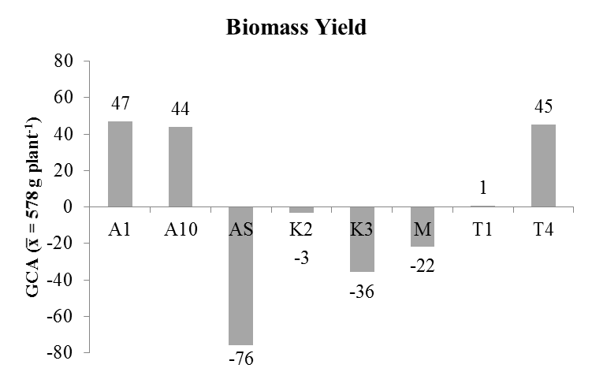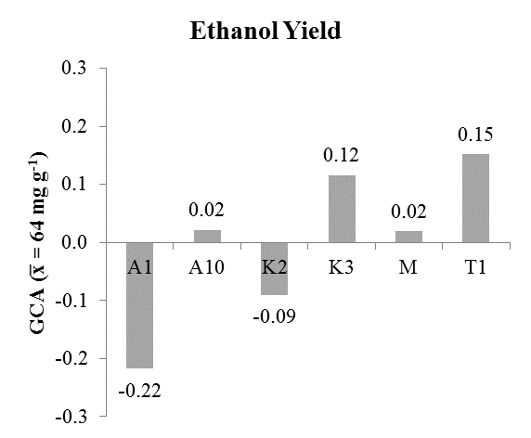
Figure 2-2 A. Figure 2-2 B.

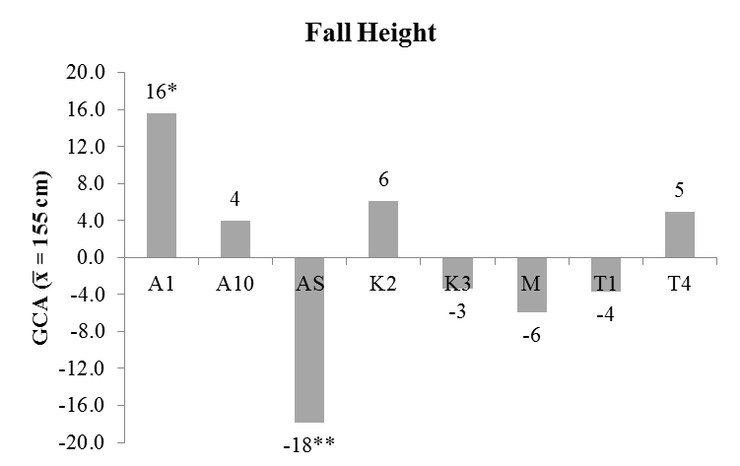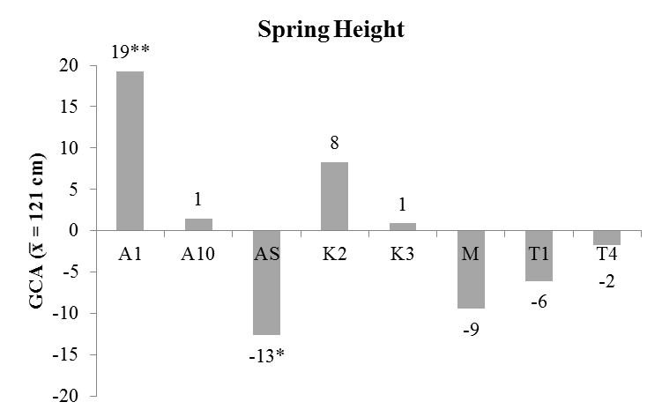
Figure 2-2 C. Figure 2-2 D.

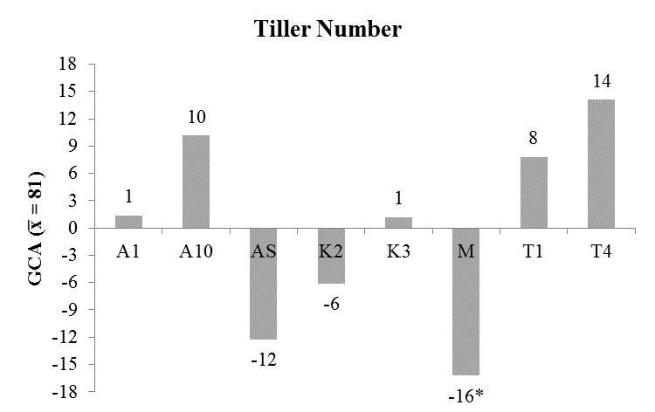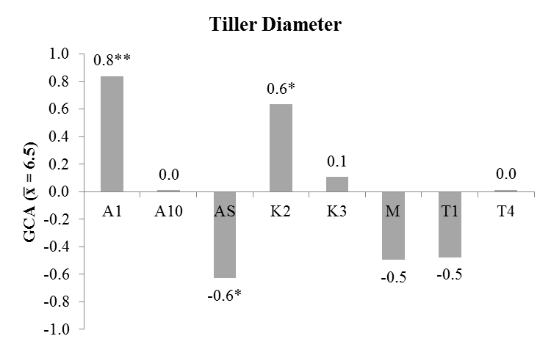
Figure 2-2 E. Figure 2-2 F.

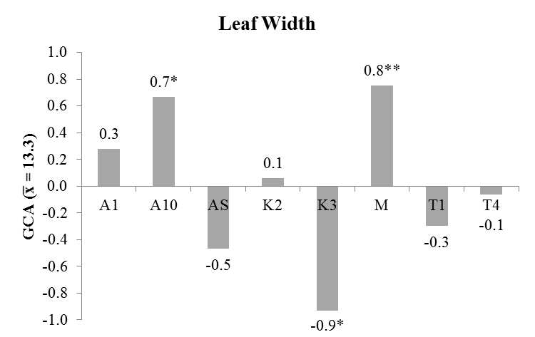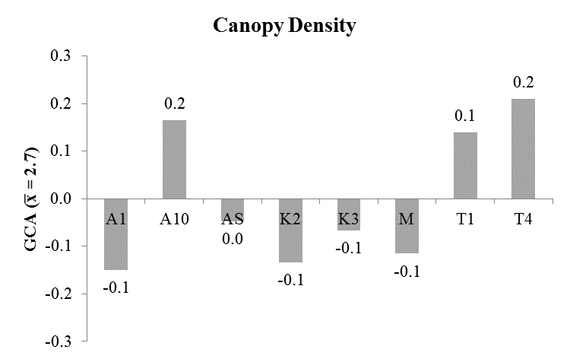
Figure 2-2 G. Figure 2-2 H.

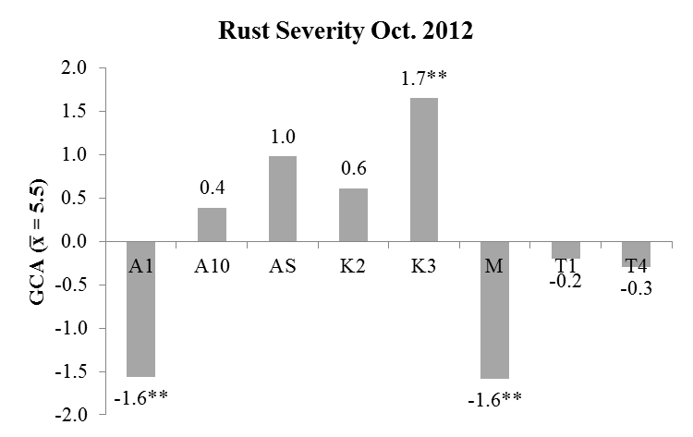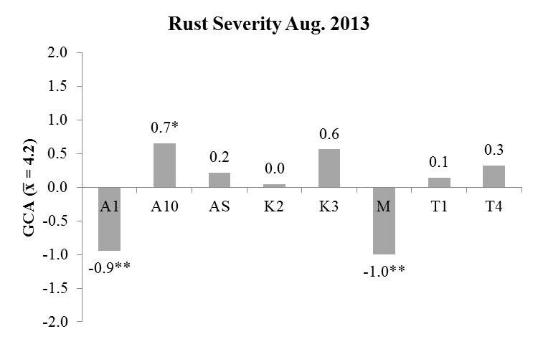
Figure 2-2 I. Figure 2-2 J.

Figure 2-3. Estimates of specific combining ability (SCA) of eight lowland switchgrass parents based on evaluation of F1 populations derived from a full diallel cross. Traits evaluated include biomass yield (A-B), predicted ethanol yield (C-D), fall height (E), spring height (F), tiller number (G), tiller diameter (H), leaf width (I), canopy density (J), and rust severity in Oct. 2012 (K) and Aug. 2013 (L). Biomass yield and predicted ethanol yield values are shown for 2012 and 2013 because of a significant SCA by year interaction effect in the model. Rust severity SCA values are shown for each year due to differences in seasonal timing of ratings. For the remaining traits, the mean SCA value across both years and locations is shown. The population mean is listed in the title for the x-axis. SCA values along the x-axis indicate deviation from that mean. Each cross is listed on the y axis of the graph. A cross is the first occurrence of a parental combination. The SCA value for that cross is represented by a grey diamond. The reciprocal of that cross is represented by a black circle. The line connecting these two values shows the mean maternal effect, i.e. the mean difference in trait value between the cross and its reciprocal. Significant maternal effects are indicated by an asterisk to the left of the cross on the y axis. Significant SCA values are indicated by an asterisk to right or left of the SCA data point (* P < 0.05, **P < 0.01, ***P < 0.001 respectively).

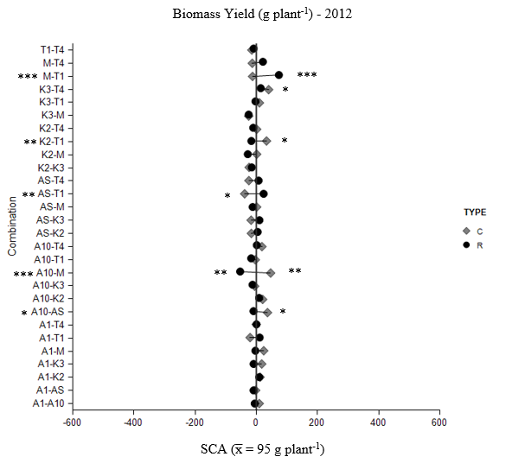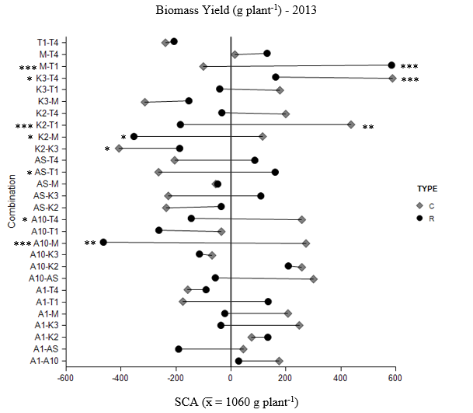

Figure 2-3 A. Figure 2-3 B.

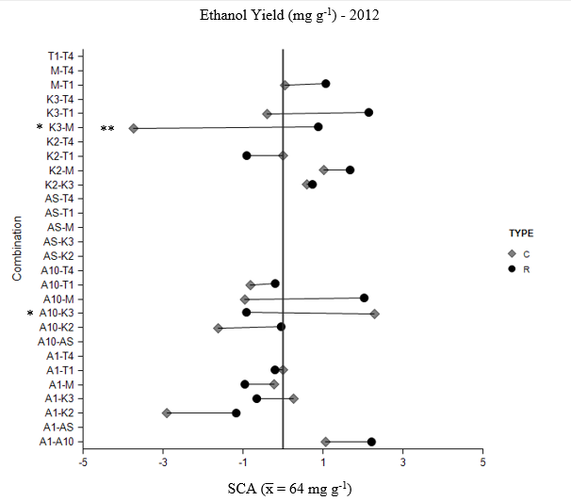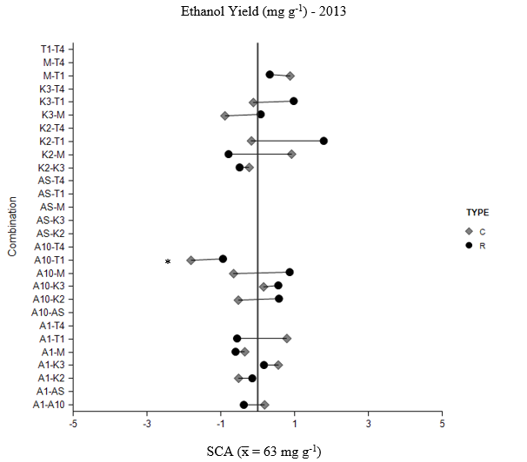
Figure 2-3 C. Figure 2-3 D.
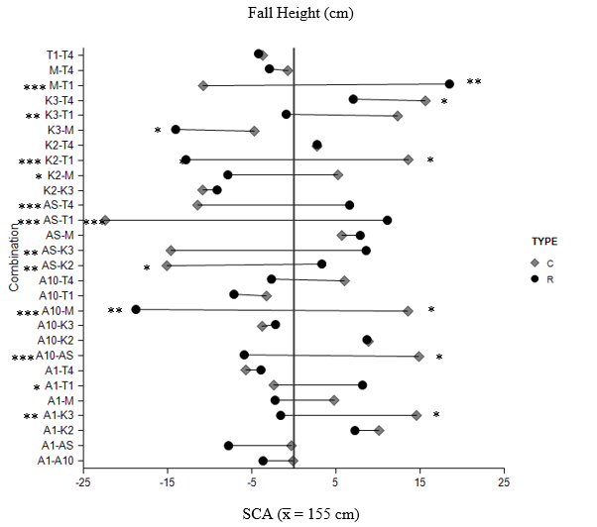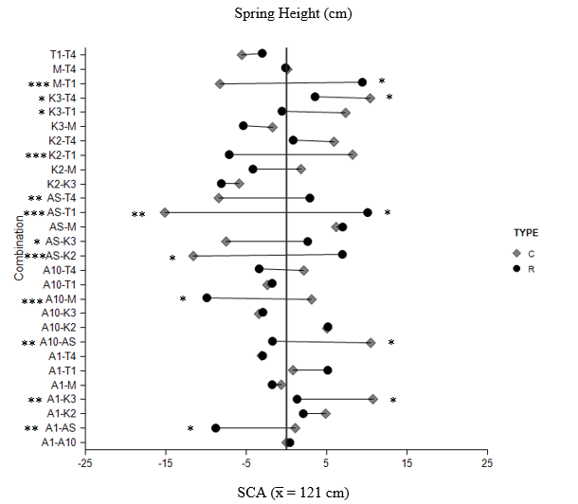
Figure 2-3 E. Figure 2-3 F.
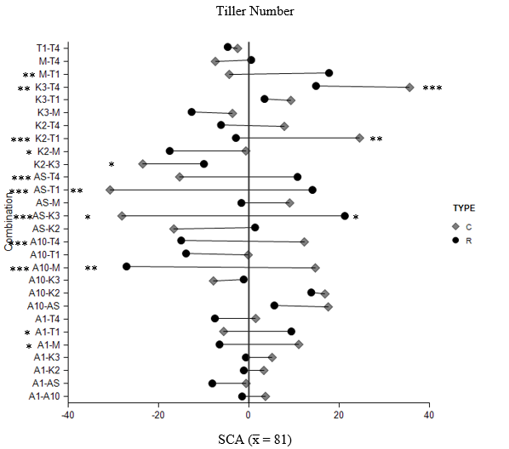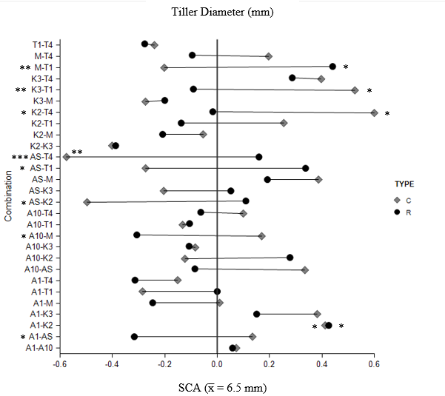
Figure 2-3 G. Figure 2-3 H.

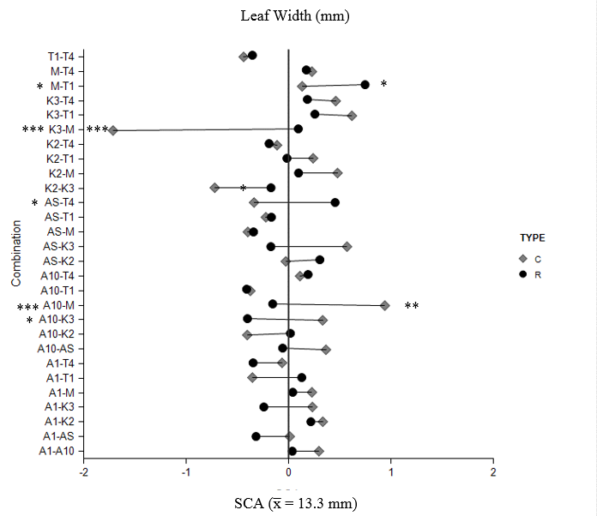
Figure 2-3 I.

Figure 2-4. Box plots by year of F1 populations exhibiting high parent heterosis for predicted ethanol yield (A-B) and fall height (C-D) in 2012 and 2013 and spring height (E-F), tiller number (G-H), tiller diameter (I-J), and leaf width (K-L) in 2013 and 2014. Whiskers indicate data within 1.5 times the inter-quartile range of the box edge. Mild outliers (data points within 1.5 and 3 times the inter-quartile range of the box edge) are indicated by a grey circle and severe outliers (data points greater than 3 times the inter-quartile range of the box edge) are indicated by a black diamond. Populations not exhibiting high parent heterosis in either evaluation year are excluded from each figure. Populations exhibiting high parent heterosis only in one year are indicated as “NS” in the opposing year.

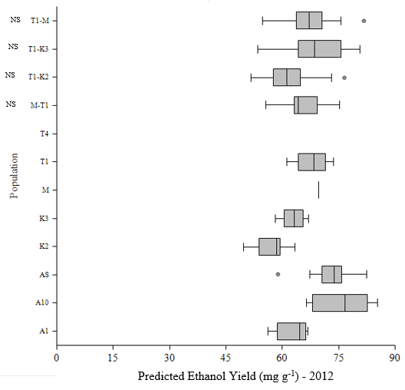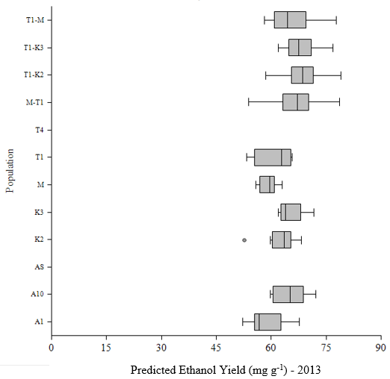

Figure 2-4 A Figure 2-4 B

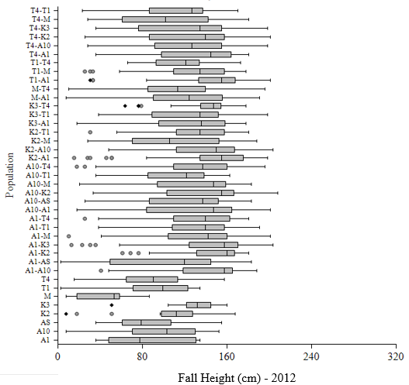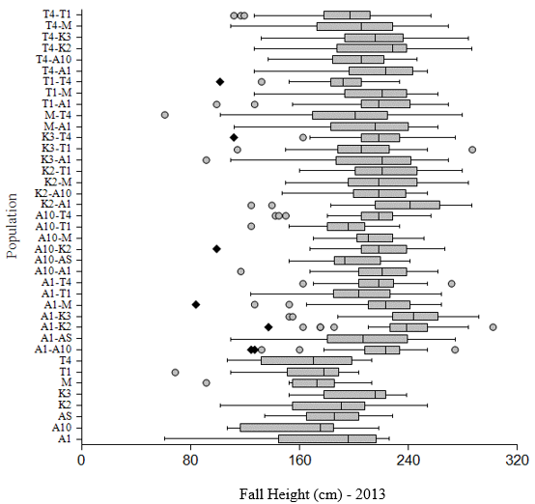

Figure 2-4 C Figure 2-4 D

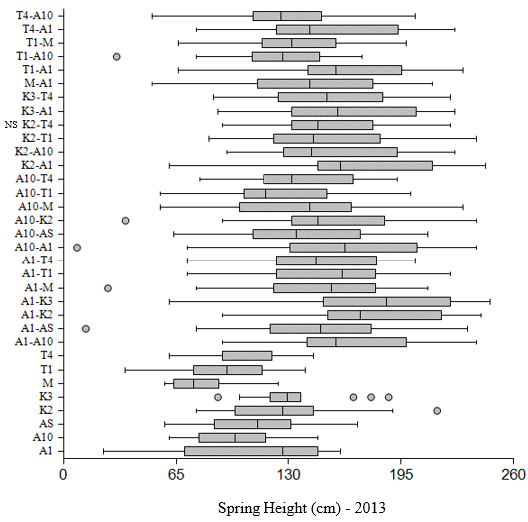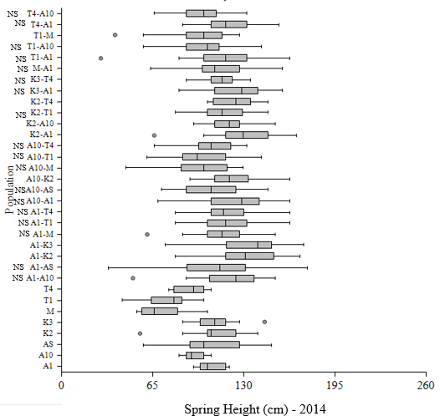

Figure 2-4 E Figure 2-4 F

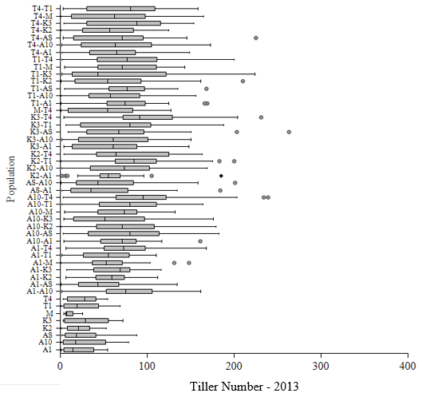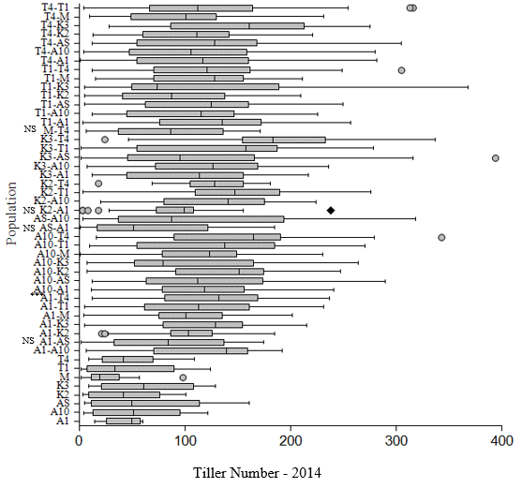

Figure 2-4 G Figure 2-4 H

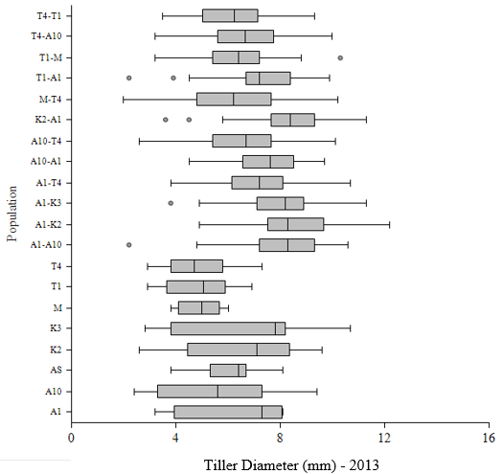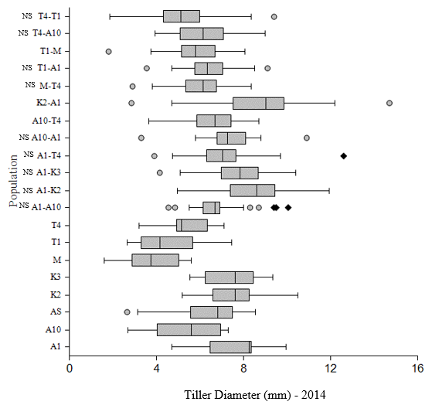

Figure 2-4 I Figure 2-4 J

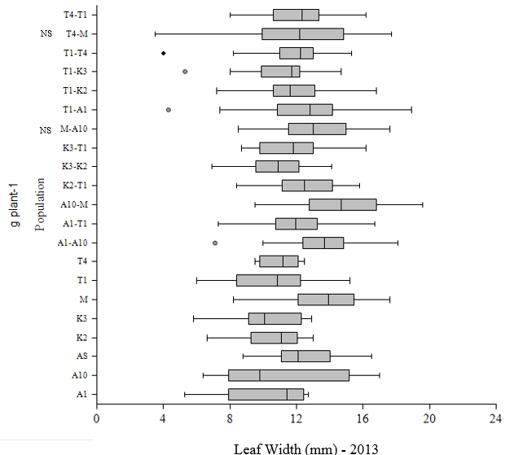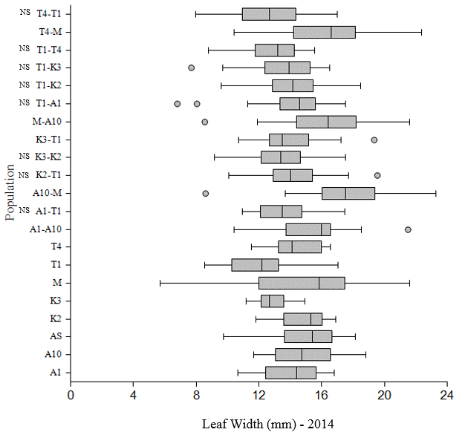

Figure 2-4 K Figure 2-4 L

A. B.

C. D.

Figure 2-5: Means of F1 populations by parental line for biomass yield (g) at 8 weeks (A) and at harvest in 2012 (B) and 2013 (C). Means of F1 populations by parental lines for predicted ethanol yield (mg g⁻¹) in 2012 and 2013 (D) Populations are ordered from lowest to highest based on ranking of 2013 biomass or ethanol yields. Means were separated within years using Tukey’s HSD (P < 0.05).
A. B.

Figure 2-6: The top 30% of progeny were selected within each year. Selections were then matched to the value from evaluation at maturity in 2013. The graphs below compare the means between each set of selections at maturity for biomass yield (g plant⁻¹) (A.) and predicted ethanol yield (mg g⁻¹) (B.). Both means and standard errors for each set of selections are indicated. Means were separated using Tukey’s HSD (P < 0.05).

CHAPTER 3 - COMPARISON OF SPACE AND SWARD PLANTED SWITCHGRASS FOR ESTIMATES OF GENETIC PARAMETERS AND RANKING OF BIOMASS AND PREDICTED ETHANOL YIELD

Abstract
Switchgrass (Panicum virgatum L.) is an important potential biofuel crop. Switchgrass breeding nurseries are typically space-planted; however, production is in dense swards. This disconnect may impact selection. The objectives of this research are to compare space- and sward-planted switchgrass biomass and predicted ethanol yield for i.) correlations of morphological traits within and between nurseries, ii.) estimates of general and specific combining ability (GCA, SCA), heritability, and heterosis, iii.) efficacy of selection under space planted conditions. Eight parents selected from the varieties Kanlow (2 selections), Alamo (4 selections) and Miami (1 selection) were crossed in a complete diallel design. In 2012, F1 populations were divided into two clonal propagules and planted in adjacent nurseries in Knoxville, TN. Clonal propagules of each parent line were also placed in both nurseries. Each nursery was arranged in a randomized complete block design containing 20 replications of each cross. The space-planted nursery (HSP) consisted of single-plant plots on 1 m centers. The sward-planted nursery (HSW) consisted of plots of 4x7 plants on .33 m centers with 1 m alleys. Spring evaluations (2013, 2014) included height, tiller number, tiller diameter, leaf width, leaf angle, and plant color. Fall evaluations (2012, 2013) included rust severity, height, biomass yield, and predicted ethanol yield. Significant correlations between nurseries were observed with moderate to strong correlations for all traits. GCA was not significant in either nursery for biomass or ethanol yield. For biomass yield, SCA was significant in HSW but not in HSP. Significant SCA was observed for ethanol yield only in HSP. Heritability estimates for biomass yield were similar between nurseries (HSP: h²=0.05, H²=0.19; HSW: h²=0.02, H²=0.17) while heritability estimated for predicted ethanol yield were less similar (HSP: h²=0.02, H²=0.23; HSW: h²=0.10, H²=0.30). Significant high parent heterosis for biomass yield was observed in both nurseries, but for ethanol yield, was only observed in HSP. Comparing F1 populations selected within each year and nursery for high biomass yield, 12% of selections from HSP 2012, 18% of selections from HSP 2013, and 41% of selections from HSW 2012 matched crosses selected in the 2013 sward planted nursery. Selections were more similar for predicted ethanol yield with 44% of selections from HSP 2012, 44% of selections from HSP 2013, and 65% of selections from HSW 2012 matching crosses selected for high predicted ethanol yield in the 2013 sward planted nursery. Results indicate selection in an evaluation environment different from the production environment may impact estimates of genetic parameters and selection and rate of crop improvement.

Introduction
Switchgrass is a warm season perennial grass, native to North American prairie lands (Newell and Eberhart, 1961). Like most grasses, switchgrass is grown in a sward, an uninterrupted expanse of grass, rather than in rows or as single plants. For breeding purposes, switchgrass evaluations are typically performed on single plants grown at a distance large enough to allow a breeder to walk through the nursery and evaluate each individual plant. These nurseries are referred to as space planted nurseries. The discrepancy in evaluation and selection planting conditions versus production planting conditions may lead to less effective or ineffective selection due to differences in plant performance under varying degrees of competition. In switchgrass, this has only been examined for differences in heterosis; however, differences between space and sward planted evaluations have been noted for a large number of grass and forage species.
When evaluating hybrids created from genotypes within the lowland switchgrass cultivar ‘Kanlow’ and the upland switchgrass cultivar ‘Summer’, Vogel and Mitchell (2008) found high parent heterosis for yield when evaluating switchgrass planted in simulated sward conditions. When these same hybrids were evaluated under space-planted conditions, high parent heterosis for yield was not observed (Martinez-Reyna and Vogel, 2008). Differences between space and sward planted evaluations have also been reported in tall fescue, Festuca arundinacea Schreb.. In tall fescue, values of yield, crude protein, NDF, and IVDMD were significantly different between plants evaluated in sward versus space-planted conditions, with sward plants having higher yield but lower nutritional quality (Waldron et al., 2008). While heritability values were similar under both conditions, family ranks were inconsistent. Similar inconsistencies have been observed in other species including white clover (Trifolium repens L.)(Atwood and Garber, 1942), Kentucky bluegrass (Poa pratensis L.) (Ahlgren et al., 1945; Kramer, 1947), orchardgrass (Dactylis glomerata) (Knight, 1960; Oldemeyer and Hanson, 1955), perennial ryegrass (Lolium perenne) (Hayward and Vivero, 1984; Lazenby and Rogers, 1964; Lazenby and Rogers, 1965; Samuel et al., 1970); timothy (Phleum pratense L.) (Nissen, 1960); smooth bromegrass (Bromus inermis Leyss.) (Carpenter and Casler, 1990; Grissom and Kalton, 1956), crested wheatgrass (Agropyron cristatum (L.) Gaertn.) (Assay and Johnson, 1997), and alfalfa (Medicago sativa L.) (Annicchiarico, 2006; Assay et al., 1999). While the majority of research points to major inconsistencies in evaluations under space versus sward conditions, a few studies involving perennial ryegrass have shown performance under spaced conditions to be an effective indicator of sward performance (Copeman and Swift, 1966; Humphreys, 1989; Lazenby, 1957). While heterosis has been examined in switchgrass, how other genetic parameters might be influenced by differing evaluation and production conditions is still unknown.
The perceived advantage of certain traits as indirect selectors of biomass yield or other valuable traits may also be skewed when these observations are made under unrealistic production conditions. Several studies of switchgrass under space planted conditions have found high correlations of tillering with biomass yield (Bhandari et al., 2010; Das et al., 2004). Conversely, in tall fescue under sward conditions, yield tiller⁻¹ as opposed to yield plant⁻¹ was found to be more relevant to overall yield (Zarrough et al., 1983). In order to assess the true value of certain traits as indirect selection tools for improving switchgrass biomass yield and predicted ethanol yield, it is essential to examine the relationship between evaluations observed under space-planted compared to the more realistic sward planted conditions.
Determining the relationship between estimates of various genetic parameters and the effectiveness of selection under space planted conditions could aid breeders in developing more effective breeding methods for switchgrass cultivar improvement. The objectives of this research are to compare space- and sward-planted switchgrass biomass and predicted ethanol yield for i.) correlations of morphological traits within and between nurseries, ii.) estimates of general and specific combining ability (GCA, SCA), heritability, and heterosis, and iii.) efficacy of selection under space planted conditions.

Materials and Methods
Eight switchgrass parents were chosen based on 2010 field evaluations of either the plant itself or its progeny at the Plant Science Unit and Holston Unit of the East Tennessee Research and Education Center (ETREC) in Knoxville, TN. Plants were chosen with divergence for the following traits of interest: tiller count, stem diameter, leaf width, plant color, leaf angle, and height and were considered a random sample representative of ‘Alamo’ and ‘Kanlow’ populations. Alamo is a cultivar collected in Texas in 1977 and Kanlow is a cultivar developed in Kansas and released in 1963 (USDA National Plant Germplasm System). These two cultivars are the most commonly grown cultivars in the state of TN, with Alamo being the predominant of the two (Garland, 2008). Five selections from Alamo were included, three of which were selected directly from populations of the cultivar Alamo (A1, A10, AS), and two of which are genotypes selected from PI 607837, which is an accession derived from the cultivar Alamo for low crown node placement in relation to the soil surface (T1, T4) (Tischler et al., 2001). A genotype selected from ‘Miami’ (M; PI 421901), an accession collected from wild material in Florida, was also included as a parent.

Breeding Methods and Greenhouse Maintenance
In January 2011, parent plants were divided into eight clonal propagules and transplanted from the field to 7.6 liter pots. Four pots of each clone were placed in both a glass house at the University of Tennessee in Knoxville, TN and a shade house at the East Tennessee Research and Education Center in Knoxville, TN. Slow release 13-13-13 fertilizer (OsmocoteTM) at a rate of 50 kg ha⁻¹ of nitrogen was added to pots during transplanting. Plants were then maintained using a monthly application of a fast release 20-20-20 fertilizer at a rate of 97.07 kg ha⁻¹ of nitrogen. When plants reached the reproductive stage, they were crossed in a diallel design which included reciprocal crosses. Crosses were made by combining a single reproductive tiller from each of the two crossing parents in a 17 x 16 x 12 x 39 cm paper pollination bag (large tassel bag, MIDCO Enterprises, St. Louis) to maintain isolated pollination. Tillers and bags were supported by bamboo stakes and bags were lightly shaken approximately every 2 days to promote pollen distribution. Tillers were placed in bags when stigmas were visible on flowers at the tip of the panicle; however, flowers with visible stigmas were removed prior to bagging. When all stigmas on a panicle appeared desiccated, panicles were separately bagged for the duration of seed ripening.
To break dormancy, seed collected from each cross were pretreated using methods described by Haynes et al. (1997) with modified timing of H₂O washes. Seeds were submerged in 5.25% NaOCl for 15 min. followed by two 20 min. washes in deionized H₂O. Seeds were then germinated in petri dishes between two layers of germination paper soaked to saturation in 0.2% KNO₃ and then wet chilled at 4 ºC for 2 weeks. Seeds were dusted with Captan (cis-N-[(trichloromethyl) thio-4-cyclohexene-1,2-dicarboximide]) and sown in D40L deepots (Stuewe & Sons, Corvallis, OR) with a 6.35 cm in diameter and 25.4 cm depth filled with Fafard Growing Mix 2 (Conrad Fafard, Inc., Agawam, MA) topped with a layer of Fafard Super-Fine Germinating Mix (Conrad Fafard, Inc., Agawam, MA). Twenty seedlings were randomly selected from within each cross for evaluation, 36 seedlings from within each cross were randomly selected to provide borders for sward plots, and 304 seedlings were randomly selected from among all crosses to serve as border plants in space planted nurseries. Seedlings were maintained in the greenhouse until late June of 2012 when they were transplanted to two adjacent field locations at the Holston Unit of the East Tennessee Research and Education Center in Knoxville, TN (35º58’11.3”N 83º51’08.7”W, soil type: Shady-Whitewell complex. Clonal propagules were used to replicate F1 plants across the two nurseries. The space planted nursery contained 20 seedlings per cross and twenty clonal propagules from each of the eight parent plants planted in a randomized complete block design divided into four blocks to account for field variation. Plants were spaced on 1 m centers. The sward planted nursery was also designed as a randomized complete block with two blocks. Sward plots were composed of 28 plants from a single cross in a 4 x 7 arrangement with plants placed on 0.3 m centers (Vogel and Mitchell, 2008). Sward plots were spaced on 1.9 m centers. Sward borders were not evaluated, allowing for 10 evaluated plants per sward plot. Parent plants were also included in synthesized swards with evaluated plants consisting of 4 clonal propagules surrounded by a border of unevaluated plants. Nitrogen was applied yearly prior to green-up at a rate of 67 kg ha⁻¹.

Field Evaluation
Plants were evaluated for the following traits: height, tiller number, stem diameter, leaf width, leaf angle, plant color, canopy density, rust severity, biomass yield, and predicted ethanol yield. All traits were assessed in the spring (May-June) of each year except biomass yield and predicted ethanol yield, which were evaluated at harvest in the fall (October-November). Rust severity was rated in June and October of 2012 and in August and October of 2013. Rust severity was rated on a one to nine scale with one indicating no visible symptoms and nine indicating abundant sporulation as described by Gustafson et al. (2003). Plant height (cm) was measured in the spring and fall. Spring traits were not evaluated during the first year due to transplanting. Two tillers of a maturity average to that of the plant being evaluated were randomly selected for stem and leaf measurements and an average was calculated for each plant. Stem width (mm) was measured directly above the lowest node using calipers. Leaf width (mm) was measured using calipers on the fully emerged leaf directly above the bottommost node at the widest portion of the leaf, approximately 7.5 cm from the stem. Leaf angle was evaluated visually using a 1-5 scale with 1 indicating prostrate leaves, leaves at a 135° angle or greater relative to the stem, and 5 indicating upright leaves, leaves at a 45° angle or less relative to the stem. Plant color was evaluated on a 1-3 scale with 1 indicating medium green and 3 indicating blue. Canopy density was evaluated on a 1-5 scale with one indicating a dense canopy and five indicating an open canopy. Biomass yield was measured by harvesting plants individually with a sickle bar mower set to cut approximately 15 cm above the soil surface and weighing the harvested bundle. Immediately after weighing, a 20 tiller sample was taken from each plant, weighed, dried in an oven at 65 ºC for 72 hours, and weighed again to obtain percent moisture. This value was used to calculate dry matter (DM) yield. Dried material was then ground using a Wiley Mill (Thomas Scientific, Swedesboro, NJ) to pass a 1 mm mesh screen. Samples were analyzed using a FOSS NIRSystems 4500 Feed & Forage Analyzer (FOSS Analytical, Hilleroed, Denmark). WINSI II software (Infrasoft International LLC, State College, PA) was used for NIRS analysis. A global H statistical test in the WINSI II program was used to check the fit of the spectral profile of the calibration set to the current data (Murray and Cowe, 2004). Although Vogel et al. (2011) developed NIRS calibrations specifically for estimating ethanol production from switchgrass, the samples from this experiment were not within the spectral profile of the calibration set for estimating predicted ethanol yield. All samples did fit the 2013 mixed hay equation (H<3.0) published by the NIRS Consortium (Hillsboro, WI). Values obtained for neutral detergent fiber (NDF) and neutral detergent fiber digestibility at 48 hours (NDFD48) were inserted into the regression equation developed by Lorenz et al. (2009) to estimate predicted ethanol yield from SSF. This equation was developed to estimate predicted ethanol yield of corn stover extracted using simultaneous saccharification and fermentation (SSF) methods. In previous studies on switchgrass, NIRS estimated predicted ethanol yields explained 97.5% of the variation in average SSF derived ethanol yield indicating this equation was also a good fit for predicting ethanol yield of switchgrass (Sykes, unpublished data).

Statistical Analysis
Statistical analyses were conducted using SAS vs. 9.3 (SAS Institute, Cary, NC). Parent plants were excluded from all analyses except for evaluations of heterosis. Pearson correlation coefficients were calculated between each measured trait and biomass yield and predicted ethanol yield respectively within each year using individual data points from each plant. Estimates of general combining ability (GCA) and specific combining ability (SCA) were determined using analyses of variance of the following mixed model:
Y_{ijlmno} = µ + G_{k} [= G_{i} + G_{j}] + S_{ij} + T_{l} + L_{m} + B(L)_{n(m)} + TL_{lm} + B(TL)_{n(lm)} + GT_{kl} + GL_{km} + GTL_{klm} + B(GL)_{n(km)} + B(GTL)_{n(klm)} + ST_{ijl} + SL_{ijm} + STL_{ijlm} + B(SL)_{n(ijm)} + B(STL)_{n(ijlm)} + e_{o(ijlmn)}
where:
Y_{ijlmno} | = observed value of a given trait for the oth replication within the nth block within the mth location within the lth year of the combination of the ith male parent and jth female parent
µ | = overall population mean of a given trait
G_{i} | = effect of the ith male parent, i = 1 to 8
G_{j} | = effect of the jth female parent, j = 1 to 8
G_{k} | = Since parents plants can be used as both male and female parents, GCA was modeled using a multimember effect in PROC GLIMMIX to combine male (G_{i}) and female (G_{j}) effects into a single GCA estimate for each parental line, G_{k} = G_{i} + G_{j}
S_{ij} | = effect of the interaction of male parent i and female parent j where parental order is retained and selfs are excluded, ij = (8)(8-1) = 56
T_{l} | =effect of year l, l = 2012, 2013
L_{m} | = effect of location m, m = 1 to 2
B(L)_{n(m)} | = effect of block n within location m, n = 1 to 4
TL_{lm} | = interaction effect between year l and location m
B(TL)_{n(lm)} | = interaction effect between block n within location m by year l
GT_{kl} | = interaction effect between GCA k and year l
GL_{km} | = interaction effect between GCA k and location m
GTL_{klm} | = interaction effect between GCA k, year l, and location m
B(GL)_{n(km)} | = interaction effect between block n within location m and GCA k
B(GTL)_{n(klm)} | = interaction effect between block n within location m, GCA k, and year l
ST_{ijl} | = interaction effect between SCA ij and year l
SL_{ijm} | = interaction effect between SCA ij and location m
STL_{ijlm} | = interaction effect between SCA ij , year l, and location m
B(SL)_{n(ijm)} | = interaction effect between block n within location m and SCA ij
B(STL)_{n(ijlm)} | = interaction effect between block n within location m, SCA ij, and year l
E_{o(ijlmn)} | = experimental error or residual

Griffing’s mixed model A analysis was used in which GCA and SCA are considered random while location, year, and block are considered fixed (Griffing, 1956). Doing so allows for extrapolation of results to the population at large rather than the specific parents selected. Location was excluded from the model for calculations of GCA and SCA for each nursery but was added to the model to determine mean trait differences between the two nurseries and years. To determine maternal effects, a separate model was analyzed that included all effects listed above but in which SCA was divided into an SCA effect and reciprocal SCA effect by identifying each combination of parents in the SCA effect and using a multiplier of 1 or -1 to distinguish crosses and reciprocals.
Genetic variance components for a tetraploid were estimated using the following formula (Wricke and Weber, 1986):
σ²_{A} = 4s²_{gca} – 2/3 σ ²_{sca}
σ²_{D} = 6 σ ²_{sca}.
Narrow-sense heritability (h²) was estimated using the following formula:
h² = σ²_{A}/ σ²_{P}
where σ²_{P} = the sum of additive, dominance, and residual variance components.
Broad-sense heritability (H²) was estimated using the following formula:
H² = (σ²_{A+} σ²_{D})/ σ²_{P}
High parent heterosis was calculated for all quantitative traits including biomass yield, predicted ethanol yield, plant height (fall and spring), tiller number, tiller diameter, and leaf width. High-parent heterosis, defined as progeny performance relative to the high parent performance, was calculated for each trait using the following formula:
High parent heterosis = Hybrid mean – High parent mean (Martinez-Reyna and Vogel, 2008)
Using this formula allowed for heterosis to be analyzed using mean separation statistics. Data were analyzed with the GLIMMIX procedure in SAS using the same model defined above but with GCA and SCA specified as fixed effects and the remaining effects specified as random.
To evaluate the efficacy of selection within a space planted nursery, the top yielding 30% of lines and crosses were selected within each year and matched to corresponding sward planted biomass and ethanol values to compare the theoretical performance under production conditions of each set of selections: space planted and sward planted. Performance of each selection set was compared using ANOVA with means separated using Tukey’s HSD. The percentage of crosses that were the same between the 2013 sward planted selection set and all other years and locations was also calculated.

Results and Discussion

Means of Measured Traits
Mean biomass yield (g plant⁻¹) showed significant interaction between location and year (P < 0.001) (Figure 3-1 A) (All tables and figures are located in Appendix III). Mean biomass yield in the space planted nursery did not differ significantly (P < 0.05) from mean biomass yield in the sward planted nursery in 2012. However, in the second year of evaluation, the space planted nursery showed a ten-fold increase in biomass yield while the sward planted nursery showed only a four-fold increase.
Mean predicted ethanol yield (mg g⁻¹) also showed significant interaction between location and year (P < 0.001) (Figure 3-1 B). The space planted nursery had a higher mean predicted ethanol yield (x̅ = 65 mg g⁻¹) compared to the sward planted nursery (x̅ = 60 mg g⁻¹) in 2012, but the mean predicted ethanol yield did not differ significantly between the two nurseries in 2013.
The lower biomass and ethanol values observed in the sward planted nurseries may have been related to the differences in morphological traits between the two nurseries. F1 populations within the sward planted nursery had fewer tillers, smaller diameter tillers, and narrower leaves than F1 populations within the space planted nursery (Figure 3-1 C-E). The differences in these morphological traits became more pronounced in the second year as competition increased in the sward planted plots. In both nurseries, tiller number increased in the second year, with a two-fold increase observed in the space planted nursery and approximately a one and a half-fold increase observed in the sward planted nursery (Figure 3-1 C). In both nurseries, tiller diameter decreased as tiller number increased (Figure 3-1 D). This reduction in tiller diameter was more pronounced in the sward planted nursery, likely due to increased competition. In both nurseries, leaf width increased in the second year; however, in the space planted nursery this increase was larger (Figure 3-1 E).
While these differences in morphological traits can help explain some of the reduction in biomass yield in the sward planted compared to the space planted nursery, the reduction in predicted ethanol yield in the sward planted nursery is more unusual. Ethanol was measured on a mg g⁻¹ DM basis, so that predicted ethanol yield and biomass yield could be evaluated independently. Numerous studies have reported lignin as a hindrance to ethanol production potential (Anderson and Akin, 2008; Dien et al., 2009; Dien et al., 2006; Fu et al., 2011; Shen et al., 2009). Plants in the sward planted nursery were smaller, with narrow leaves and stems. Smaller plants tend to be less lignified than larger plants which require greater structural integrity so predicted ethanol yield was expected to be higher in sward planted evaluations compared to space planted evaluations rather than the lower values that were observed. The relative leaf to stem proportions of plants within the sward planted nursery may be a factor to consider in future research. As plants are placed in more competitive conditions, the proportion of leaves to stems may decrease (Poorter et al., 2012). Unpublished research by DeSantis (personal communication) found that switchgrass leaves have higher predicted ethanol yield than stems. If competition decreases the leaf to stem ratio, it could also result in a lower whole plant predicted ethanol yield, as was observed in the sward planted nursery.

Between Nursery Correlations of Measured Traits
Correlations between space planted and sward planted values for evaluated traits were moderate to high (r = 0.39 to 0.72) (Table 3-1). Predicted ethanol yield showed a consistently high correlation between the two nurseries in both 2012 (r = 0.71) and in 2013 (r = 0.72). Biomass yield had a moderately high correlation in 2012 (r = 0.58); however, that correlation decreased in 2013 (r = 0.39), likely due to the increasing difference in competition between the two nurseries.

Within Nursery Correlations of Biomass Yield and Predicted Ethanol Yield with Morphological Traits
Correlations within nurseries of morphological traits to biomass yield or predicted ethanol yield can indicate which traits might be best used for indirect selection for biomass or predicted ethanol yield prior to reproductive maturity. In the space planted nursery, more traits could be evaluated due to the ease of access to the plant material. In the sward planted nursery, only certain traits could be evaluated due to difficulties in distinguishing one plant from another within the simulated swards. For this reason, fall and spring height, which were highly correlated to biomass yield, and canopy density which was moderately correlated to biomass yield in the space planted nurseries, could not be measured on sward planted plots (Table 3-2). This could be somewhat alleviated by taking measurements of simulated sward plots as a whole; however, in doing so, the variability within a cross would not be assessed. Sward planted configurations may also hinder evaluation of other important traits, such as disease susceptibility. In the space planted nursery rust severity was negatively correlated to yield (r = -0.31), which may indicate the potential importance of screening for resistance to this disease. Rust has also been shown to negatively impact ethanol yield, which further supports the importance of evaluating this trait (Sykes, 2014). In a sward planted selection nursery, this information would be difficult to obtain. Correlations of tiller number and tiller diameter with biomass yield were similar in both nurseries, although correlations within the sward planted nurseries tended to be lower. The correlation between leaf width and biomass yield was much lower in the sward planted nursery (r = 0.20) compared to the space planted nursery (r = 0.45). Traits with the highest correlations to biomass yield were height, tiller number and tiller diameter in both years and both nurseries, which correspond to results observed in other studies of lowland switchgrass (Bhandari et al., 2010; Boe, 2007; Das et al., 2004; Talbert et al., 1983).
In the space planted nursery, fall and spring height, biomass yield, and tiller diameter all showed moderate negative correlations to predicted ethanol yield (Table 3-2). In the sward planted nursery, negative correlations were also observed between predicted ethanol yield and biomass yield and tiller diameter; however, these correlations coefficients were of a smaller magnitude. These results indicate that a high yielding switchgrass ideotype for biomass yield is not the same as a high yielding switchgrass ideotype for predicted ethanol yield.

Variance Components of Biomass Yield and Predicted Ethanol Yield
General combining ability was not significant in either nursery for biomass yield or predicted ethanol yield (Table 3-3). For biomass yield, SCA was significant within the sward planted nursery but there was a significant SCA by year interaction within the space planted nursery (Table 3-3). For predicted ethanol yield, a significant SCA effect was observed in the space planted nursery but not in the sward planted nursery (Table 3-3). Additive and dominance estimates were similar between space and sward planted nurseries for biomass yield, with dominance variation contributing a higher proportion of genetic variation (Table 3-3). Likewise, heritability values were similar between the two nurseries, with narrow sense heritability estimates of 0.05 and 0.02 for space and sward planted nurseries respectively and broad sense heritability estimates of 0.19 and 0.17 for space and sward planted nurseries respectively (Table 3-3). For predicted ethanol yield, estimates of dominance variation were similar between the two nurseries, but the space planted nursery underestimated additive variation compared to the sward planted nursery (Table 3-3). For this reason, heritability estimates were more dissimilar, especially for narrow sense heritability, with narrow sense heritability estimates of 0.02 and 0.10 for space and sward planted nurseries respectively (Table 3-3). The broad sense heritability estimates were 0.23 and 0.30 for space and sward planted nurseries respectively. While the relative proportions of additive and dominance variation estimates are similar between the two nurseries, the under-estimation of additive variation when evaluating predicted ethanol yield in space planted nurseries could hurt breeding efforts by providing breeders with incorrect information when developing breeding methods for improving predicted ethanol yield in switchgrass.
The direction of GCA estimates for biomass yield were fairly consistent across years within the space planted nursery, with A1, A10, T1, and T4 parental lines showing positive GCA values in both years and in the combined years analysis (Table 3-4). In the sward planted nursery, all GCA values were zero in the first year of evaluation (Table 3-4). This lack of variation is likely due to slower establishment rates in this nursery compared to the space planted nursery. In the second year of evaluation, 2013, with exception to the progeny line T4, GCA direction was exactly the opposite of GCA direction for the parental lines evaluated in the space planted nursery (Table 3-4). In the sward planted nursery, AS, K2, K3, and T4 showed positive GCA values in 2013, while A1, A10, T1, and M had negative GCA values (Table 3-4). These results indicate the parental lines selected from a space planted nursery may not be the best selections to produce progeny with superior biomass yield under production conditions. This could be a serious hindrance to developing switchgrass cultivars with improved biomass yield. Again, data from the 2014 harvest should provide greater clarity on this issue.
This was less of an issue in GCA selections for predicted ethanol yield. In both nurseries and across both years, M and T1 parental lines had positive GCA values for predicted ethanol yield (Table 3-4). The space planted nursery also identified the progeny line K3 as having a positive GCA and in 2012 showed A10 as having a significant positive GCA value but in 2013 showed A10 as having a significant negative GCA value. GCA values for predicted ethanol yield in the sward planted nursery were more consistent, with K3 showing zero or negative values in both years and A10 showing a consistent positive GCA across both years. These results indicate that while space planted evaluations may be consistent with production conditions on selection of some high biomass yielding lines, space planted evaluations of predicted ethanol yield appear to be less consistent across years and may select some lines and miss others when estimating positive GCA.
Evaluations of SCA within the space planted nursery found three crosses with significant positive SCA in 2012, T1xM, A10xM, and A10xAS, and two crosses with significant positive SCA in 2013, K3xT4 and A10xM (Figure 3-2 A). Looking at the direction of the SCA values within each year and across years for biomass yield in the space planted nursery, 23 out of the 56 crosses exhibited positive SCA across both years. Four crosses exhibited positive SCA only in one year. Significant maternal effects were observed in both years. In 2012, combinations of M/T1, K2/T1, AS/T1, A10/M, and A10/AS had significant maternal effects. In 2013, only the combination A10/M had a significant maternal effect (Figure 3-2 C). In combinations containing A10, the cross with A10 as the maternal parent had a higher SCA compared to the reciprocal cross. In crosses containing T1, two of the crosses with T1 as the maternal parent had higher SCA compared to the reciprocal but one cross with T1 as the paternal parent had a higher SCA compared to the reciprocal.
Evaluations of biomass yield SCA within the sward planted nursery found no crosses with significant SCA or significant maternal effect in either year (Figure 3-2 B, D). Looking at the direction of the SCA values within each year and across years for biomass yield in the sward planted nursery, 15 out of the 56 crosses exhibited positive SCA across both years. Nineteen crosses exhibited positive SCA only in one year. In the combined analysis across years, 10 crosses had positive SCA values in both the space and sward planted nursery. Of the remaining 32 crosses with a positive SCA value in either the space planted or sward planted nursery, the direction of the SCA value disagreed between the nurseries. Although SCA values appear to be more consistent across years within the space planted nurseries, these results, along with the results observed for direction of GCA effects, indicate the selections identified as high yielding for biomass yield in the space planted nurseries may not be the highest yielding selections under production conditions.
For predicted ethanol yield, a significant SCA effect was observed in the sward planted nursery for the cross K3xM in 2012 (Figure 3-3 F). No other significant SCA effects or maternal effects were observed in either nursery across either year (Figure 3-3 E-H). Looking at the direction of the SCA values within each year and across years for ethanol yield in the space planted nursery, eight out of the 30 crosses exhibited positive SCA across both years. Thirteen crosses exhibited positive SCA only in one year. Within the sward planted nursery, eight out of the 30 crosses exhibited positive SCA across both years. Seven crosses exhibited positive SCA only in one year. Within the combined analysis across years, nine crosses were selected with positive SCA in both the space and sward planted nursery. Of the remaining nine crosses selected in either nursery, the direction of the SCA effect disagreed between the nurseries. While differences between the two nurseries in SCA values for predicted ethanol yield appear to be less drastic compared to differences in SCA values for biomass yield, evaluation under space planted conditions would have resulted in the selection of crosses that exhibited negative SCA and discarding of crosses that exhibited positive SCA under simulated production conditions.

Heterosis of Biomass Yield and Predicted Ethanol Yield
Significant (P < 0.05) high parent heterosis for biomass yield was observed in both space and sward planted nurseries (Figure 3-3). Within the space planted nursery, 32 crosses in 2012 and 15 crosses in 2013 were identified as exhibiting significant high parent heterosis (Figure 3-3 A-B). Of these crosses, 12 exhibited significant high parent heterosis across both years. Within the sward planted nursery, 12 crosses in 2012 and 2 crosses in 2013 were identified as exhibiting significant high parent heterosis (Figure 3-3 C-D). Of these crosses, two exhibited significant high parent heterosis across both years. These results are dissimilar to those reported by Martinez-Reyna and Vogel (2008) and Vogel and Mitchell (2008). In these studies, combinations of the lowland switchgrass cultivar Kanlow and the upland switchgrass cultivar Summer exhibited significant high parent heterosis in sward planted conditions but not in space planted conditions. The poor performance of the parent plants in both the space and sward planted nurseries in our study could be contributing to inflated numbers of crosses exhibiting high parent heterosis.
Unlike biomass yield, mean predicted ethanol yield of parental clones and progeny plants were similar within each location. In the space planted nursery, only two crosses were identified as exhibiting significant high parent heterosis, T1xK2 and T1xM (Figure 3-3 F). These crosses only exhibited high parent heterosis in 2013. Within the sward planted nursery, no crosses exhibited significant high parent heterosis. The lack of high parent heterosis for predicted ethanol yield could be due to the lack of variation in predicted ethanol yield observed in the progeny and parents evaluated or it may indicate the parents evaluated do not represent different heterotic groups for this trait. Few studies have examined the variation in predicted ethanol yield in switchgrass populations thus far. Breeders would benefit from a greater understanding of the variation in this trait and the identification of potential heterotic groups.

Selections for Biomass Yield and Predicted Ethanol Yield
The top 30% of crosses for biomass yield and predicted ethanol yield were selected from within each year within each nursery. These selections were matched to corresponding values for biomass or predicted ethanol yield in sward planted switchgrass in 2013, under the assumption that this would be a good predictor of how selections would perform under second year production conditions. Comparing the F1 populations selected within each year and nursery for high biomass yield, 12% of selections from the 2012 space planted nursery, 18% of selections from the 2013 space planted nursery, and 41% of selections from the 2012 sward planted nursery matched crosses selected in the 2013 sward planted nursery. Selections were more similar for selections of high predicted ethanol yield with 44% of selections from the 2012 space planted nursery, 44% of selections from the 2013 space planted nursery, and 65% of selections from the 2012 sward planted nursery matching crosses selected for high ethanol yield in the 2013 sward planted nursery. Comparing selections from within each year and nursery, mean predicted production biomass yield did not differ significantly (P < 0.05) between selections from the 2013 space planted nursery, 2012 sward planted nursery, and 2013 sward planted nursery (Figure 3-4). Mean biomass yield from crosses selected from the 2012 space planted nursery had lower mean predicted production biomass yield compared to the 2013 sward planted selections, but did not differ significantly from the mean predicted production biomass yield of 2013 space planted selections or 2012 sward planted selections. Ranking of mean predicted production biomass yield from lowest to highest was 2012 space planted selections (x̅ = 282 g plant⁻¹), 2013 space planted selections (x̅ = 354 g plant⁻¹), 2012 sward planted selections (x̅ = 432 g plant⁻¹), and 2013 sward planted selections (x̅ = 490 g plant⁻¹). While mean predicted production biomass yield did not differ significantly between selections from the 2012 space planted nursery, 2012 sward planted nursery, and 2013 sward planted nursery, these losses are estimated on a per plant basis. These losses are compounded if calculated on a per hectare basis. Assuming a good stand of approximately one plant per 0.3 m², compared to sward planted selections in the second year, 2013, losses would amount to 6,243 kg ha⁻¹ in 2012 sward planted selections, 14,639 kg ha⁻¹ in 2013 space planted selections, and 22,389 kg ha⁻¹ in 2012 space planted selections. Such losses may be deemed too high by breeders trying to produce improved switchgrass cultivars and by producers trying to maximize biomass yield in production fields.
For predicted ethanol yield, no significant differences were observed between mean predicted ethanol yield in selections from either year or nursery. These results suggest, not only that predicted ethanol yield selections can be effectively made in either type of nursery, but that early selection during the establishment year also results in effective selections. These results may differ in populations where predicted ethanol yield is more variable.

Conclusion
Overall, results from this study suggest evaluation under simulated production, or sward, conditions differ from evaluation under space planted conditions for estimates of mean production performance and characterization of morphological traits, estimates of genetic parameters, identification of high GCA and SCA in populations, and identification of potential maternal effects or high parent heterosis. If sward conditions are more representative of potential production conditions, evaluation under space planted conditions could lead to inaccurate assessment of plant performance, parental line and F1 population selection, and estimation of genetic parameters. In terms of selection, mean predicted production biomass yield and predicted ethanol yield did not differ significantly in selections from second year space planted populations from either first year or second year sward planted populations. This indicates selection under these conditions may be as effective at improving both biomass and predicted ethanol yield as selection under sward planted conditions. Although these means did not differ, less than 18% of selections for biomass yield and only 44% of selections for predicted ethanol yield were the same between the space and sward planted nurseries. If sward conditions are more representative of how plants will perform under production conditions, evaluations under space planted conditions could cause breeders to discard potentially valuable material. Correlations between space and sward planted nurseries were significant and ranged from moderate to high, however, additional traits that can serve as indirect selection for yield were more easily assessed under space planted conditions, including height and canopy density. Although no significant difference was seen in the mean predicted production biomass yield in space planted selections in the second year, selection under these conditions did result in lower mean predicted production biomass yield of approximately 14,639 kg ha⁻¹. The extent of these losses may not be something breeders or producers will tolerate.

Appendix III

Figure 3-1: Means by year and location for traits evaluated in F1 populations of lowland switchgrass derived from an eight parent diallel cross evaluated in a space planted (HSP) and sward planted (HSW) nursery. Traits include biomass yield (A), predicted ethanol yield (B), tiller number (C), tiller diameter (D), and leaf width (E). Means were separated using Tukey’s HSD. Means followed by the same letter do not differ significantly (p < 0.05).

Figure 3-1 A Figure 3-1 B

Figure 3-1 C Figure 3-1 D

Figure 3-1 E
Table 3-1. Pearson correlation coefficients between space planted and sward planted nurseries for traits evaluated in 2012 and 2013 in F1 populations of lowland switchgrass derived from an eight parent diallel cross. Dark grey shading indicates strong correlations while light grey shading indicates moderate correlations.
Space vs sward
Year/Trait | Correlation Coef.
2012/2013
Biomass Yield (g plant⁻¹) 2012 | 0.58 | ***
Biomass Yield (g plant⁻¹) 2013 | 0.39 | ***
Predicted Ethanol Yield  (mg g⁻¹) 2012 | 0.71 | ***
Predicted Ethanol Yield  (mg g⁻¹) 2012 | 0.72 | ***
2013
Tiller Number | 0.65 | ***
Tiller Diameter (mm) | 0.71 | ***
Leaf Width (mm) | 0.69 | ***
* P < 0.05, **P < 0.01, ***P < 0.001, respectively

Table 3-2. Pearson correlation coefficients of biomass yield and predicted ethanol yield with all measured traits within space planted and sward planted nurseries of F1 populations of lowland switchgrass derived from an eight parent diallel cross for traits evaluated in 2012 and 2013.
 | Biomass Yield (g plant⁻¹) |  |  |  |  |  |  | Ethanol Yield (mg g⁻¹)
Trait/Year | Space Planted |  |  | Sward Planted |  |  |  | Space Planted |  |  | Sward Planted
2012/2013
Rust Oct. 2012† | -0.31 | *** |  |  |  |  |  | -0.04
Rust Aug. 2013† | 0.16 | *** |  |  |  |  |  | -0.19 | ***
Fall Height (cm) 2012 | 0.75 | *** |  |  |  |  |  | -0.56 | ***
Fall Height (cm) 2013 | 0.73 | *** |  |  |  |  |  | -0.34 | ***
Biomass Yield  (g plant⁻¹) 2012 |  |  |  |  |  |  |  | -0.34 | *** |  | -0.24 |  | *
Biomass Yield  (g plant⁻¹) 2013 |  |  |  |  |  |  |  | -0.30 | *** |  | -0.09
Predicted Ethanol Yield  (mg g⁻¹) 2012 | -0.34 | *** |  | -0.24 |  | *
Predicted Ethanol Yield  (mg g⁻¹) 2013 | -0.30 | *** |  | -0.09
2013
Spring Height (cm) | 0.70 | *** |  |  |  |  |  | -0.37 | ***
Plant Color‡ | -0.03 |  |  |  |  |  |  | 0.00
Canopy§ | 0.44 | *** |  |  |  |  |  | 0.00
Leaf Angle ¶ | -0.08 |  |  |  |  |  |  | -0.03
Tiller Number | 0.82 | *** |  | 0.74 |  | *** |  | -0.21 | *** |  | -0.10
Tiller Diameter (mm) | 0.58 | *** |  | 0.49 |  | *** |  | -0.30 | *** |  | -0.21 |  | ***
Leaf width (mm) | 0.45 | *** |  | 0.20 |  | *** |  | -0.19 | *** |  | 0.00
† = Rating scale of 1-9 with 1 indicating symptomless and 9 indicating severe disease severity
‡ = Rating scale of 1-3, with 1 indicating medium green and 3 indicating blue plant color
§ = Rating scale of 1-5, with 1 indicating a dense canopy and 5 indicating an open canopy
¶ = Rating scale of 1-5, with 1 indicating leaves less than 45° angle from stem, 5 indicating leaves with greater than 135° angle from stem
* P < 0.05, **P < 0.01, ***P < 0.001 respectively

Table 3-3: Variance components of the F1 population derived from the diallel cross of eight parents calculated using ANOVA for biomass yield and predicted ethanol yield in space planted (HSP) and sward planted (HSW) nurseries. Variance estimates and the percentage each term contributes to the phenotypic variance are listed. Calculated values for additive, dominance, and phenotypic variance and narrow sense heritability (h²_{i}) and broad sense heritability (H²_{i}) are also listed. Asterisks indicate variance that is significantly different from zero based on Wald’s test (* P < 0.05, **P < 0.01, ***P < 0.001 respectively).
 | Biomass Yield |  |  |  |  |  | Predicted Ethanol Yield
Source of Variation | HSP |  |  | HSW |  |  | HSP |  |  | HSW
GCA | 3787 |  | 1% | 0 |  | 0% | 0.0 |  | 0% | 0.8 |  | 2%
SCA | 9473 |  | 2% | 1177 | * | 3% | 1.3 | * | 4% | 1.5 |  | 4%
GCA*Block | 0 |  | 0% | 251 |  | 1% | 0.2 |  | 1% | 0.5 |  | 1%
GCA*Year | 12949 |  | 3% | 520 |  | 1% | 5.0 |  | 14% | 0.5 |  | 2%
GCA *Year*Block | 0 |  | 0% | 813 |  | 2% | 0.0 |  | 0% | 0.0 |  | 0%
SCA *Block | 14665 | ** | 4% | 66 |  | 0% | 0.2 |  | 1% | 0.5 |  | 1%
SCA *Year | 25169 | ** | 6% | 325 |  | 1% | 0.0 |  | 0% | 0.1 |  | 0%
SCA *Year*Block | 0 |  | 0% | 0 |  | 0% | 0.0 |  | 0% | 0.0 | *** | 0%
Error | 325764 | *** | 83% | 37918 | *** | 92% | 30.0 | *** | 82% | 29.2 | *** | 88%
σ²_{A} | 21465 |  | 5% | 785 |  | 2% | 1 |  | 2% | 4 |  | 10%
σ²_{D} | 56836 |  | 14% | 7062 |  | 15% | 8 |  | 20% | 9 |  | 21%
σ²_{P} | 404065 |  |  | 45765 |  |  | 39 |  |  | 42
h²_{i} | 0.05 |  |  | 0.02 |  |  | 0.02 |  |  | 0.10
H²_{i} | 0.19 |  |  | 0.17 |  |  | 0.23 |  |  | 0.30
* P < 0.05, **P < 0.01, ***P < 0.001, respectively

Table 3-4. Estimates of general combining ability (GCA) of eight lowland switchgrass parents based on evaluation of F1 populations derived from a full diallel cross evaluated across two years in both space planted (HSP) and sward planted (HSW) nurseries. Traits evaluated include biomass yield and predicted ethanol yield.
 | Biomass Yield (g plant⁻¹)
Progeny | HSP |  |  |  |  |  |  |  |  |  |  |  | HSW
Line | 2012 |  |  | 2013 |  |  |  |  | Combined |  |  |  | 2012 |  |  | 2013 |  |  |  | Combined
A1 | 17 |  |  | 141 |  |  |  |  | 29 |  |  |  | 0 |  |  | -22 |  |  |  | 0
A10 | 20 |  |  | 160 |  |  |  |  | 33 |  |  |  | 0 |  |  | -32 |  |  |  | 0
AS | -25 |  |  | -263 |  |  | * |  | -54 |  |  |  | 0 |  |  | 18 |  |  |  | 0
K2 | -16 |  |  | -20 |  |  |  |  | -6 |  |  |  | 0 |  |  | 35 |  |  |  | 0
K3 | -26 |  |  | -152 |  |  |  |  | -33 |  |  |  | 0 |  |  | 6 |  |  |  | 0
M | 2 |  |  | -56 |  |  |  |  | -10 |  |  |  | 0 |  |  | -2 |  |  |  | 0
T1 | 8 |  |  | 3 |  |  |  |  | 2 |  |  |  | 0 |  |  | -19 |  |  |  | 0
T4 | 19 |  |  | 187 |  |  |  |  | 38 |  |  |  | 0 |  |  | 16 |  |  |  | 0
 | Predicted Ethanol Yield (mg g⁻¹)
Progeny | HSP |  |  |  |  |  |  |  |  |  | HSW
Line | 2012 |  |  |  | 2013 |  |  | Combined |  |  | 2012 |  |  |  | 2013 |  |  |  | Combined
A1 | -2.6 |  |  |  | -1.9 |  |  | 0.0 |  |  | -0.5 |  |  |  | -1.4 |  |  |  | -0.7
A10 | 3.7 | * |  |  | -2.4 | * |  | 0.0 |  |  | 0.4 |  |  |  | 0.4 |  |  |  | 0.3
K2 | -2.7 |  |  |  | 0.1 |  |  | 0.0 |  |  | -1.7 |  |  |  | -0.3 |  |  |  | -0.7
K3 | 0.2 |  |  |  | 1.9 |  |  | 0.0 |  |  | -0.1 |  |  |  | 0.0 |  |  |  | 0.0
M | 0.5 |  |  |  | 0.3 |  |  | 0.0 |  |  | 0.5 |  |  |  | 0.8 |  |  |  | 0.5
T1 | 0.9 |  |  |  | 2.1 |  |  | 0.0 |  |  | 1.5 |  |  |  | 0.5 |  |  |  | 0.7
* P < 0.05, **P < 0.01, ***P < 0.001 respectively

Figure 3-2. Specific combining ability (SCA) values for biomass yield (A-D) and predicted ethanol yield (E-H) for space planted (HSP) and sward planted (HSW) F1 populations in 2012 and 2013. Each cross is listed on the y axis of the graph. A cross is the first occurrence of a parental combination. The SCA value for that cross is represented by a grey diamond. The reciprocal of that cross is represented by a black circle. The line connecting these two values shows the mean maternal effect, i.e. the mean difference in trait value between the cross and its reciprocal. Significant maternal effects are indicated by an asterisk to the left of the cross on the y axis. Significant SCA values are indicated by an asterisk to right or left of the SCA data point (* P < 0.05, **P < 0.01, ***P < 0.001 respectively).

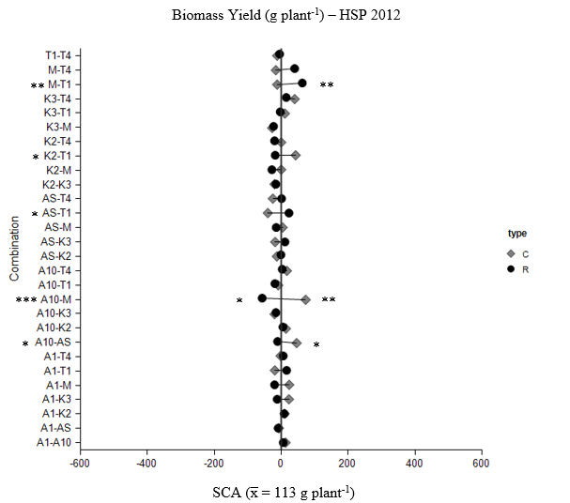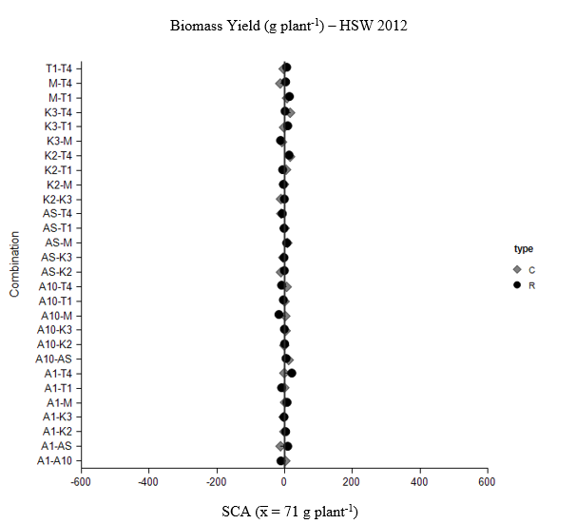
Figure 3-2 A. Figure 3-2 B.

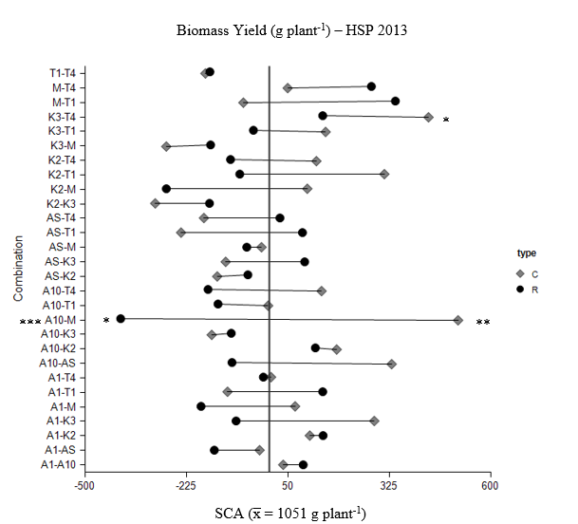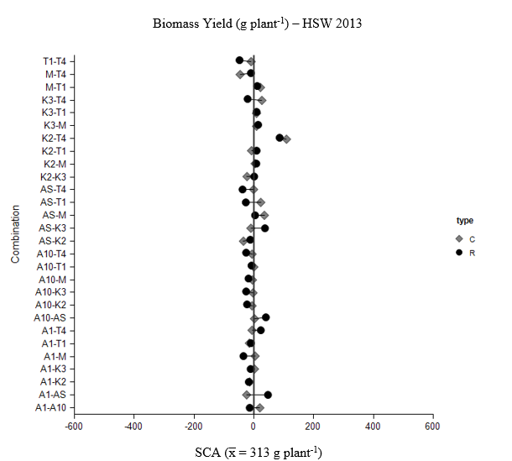
Figure 3-2 C. Figure 3-2 D.

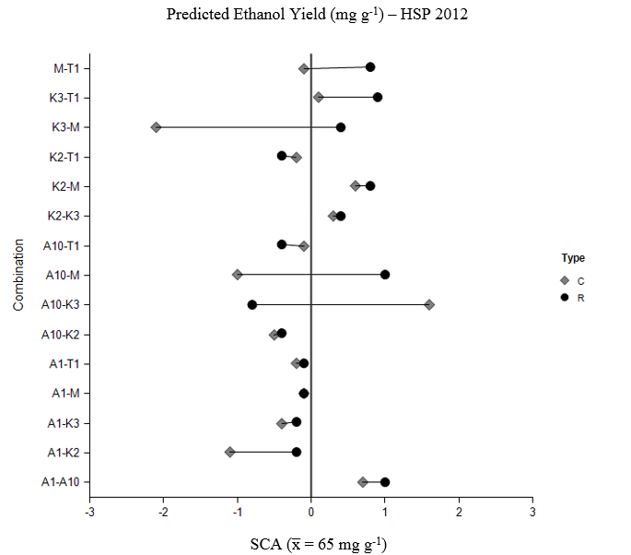 3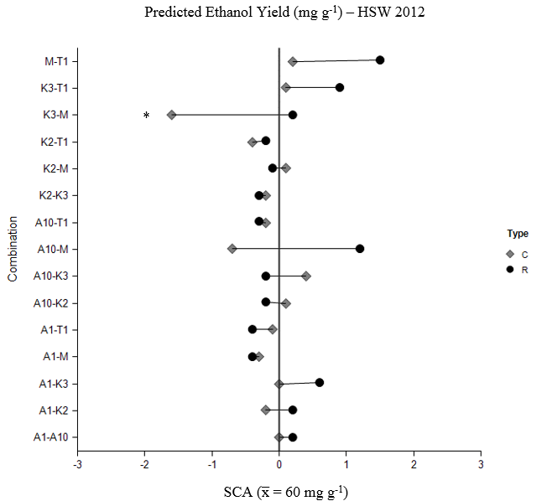
Figure 3-2 E. Figure 3-2 F.
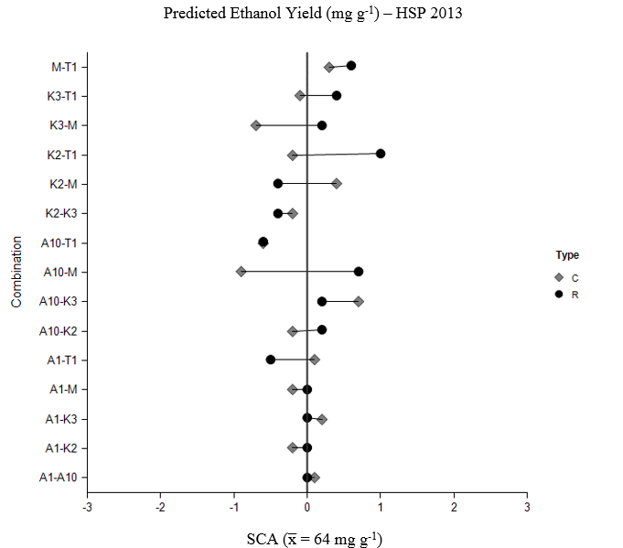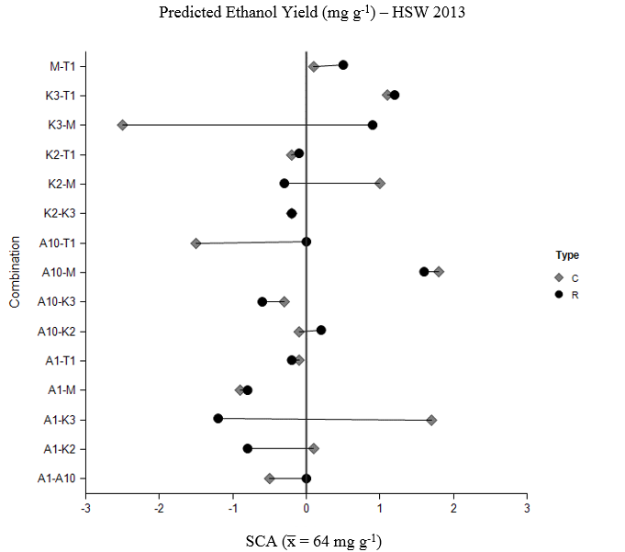
Figure 3-2 G. Figure 3-2 H.

Figure 3-3. Box plots by year of F1 populations exhibiting high parent heterosis for biomass yield (A-D) and predicted ethanol yield (E-H) for space planted (HSP) and sward planted (HSW) nurseries in 2012 and 2013. Whiskers indicate data within 1.5 times the inter-quartile range of the box edge. Mild outliers (data points within 1.5 and 3 times the inter-quartile range of the box edge) are indicated by a grey circle and severe outliers (data points greater than 3 times the inter-quartile range of the box edge) are indicated by a black diamond. Populations not exhibiting high parent heterosis in either evaluation year are excluded from each figure. Populations exhibiting high parent heterosis only in one year are indicated as “NS” in the opposing year. Ethanol yield for the space planted nursery is excluded since no significant high parent heterosis was observed in either year.

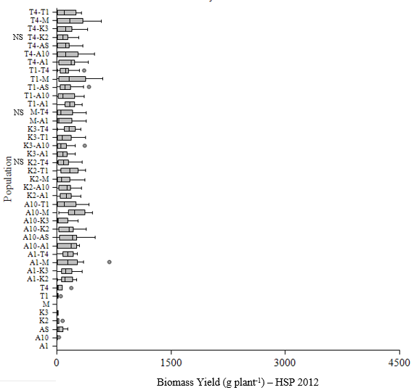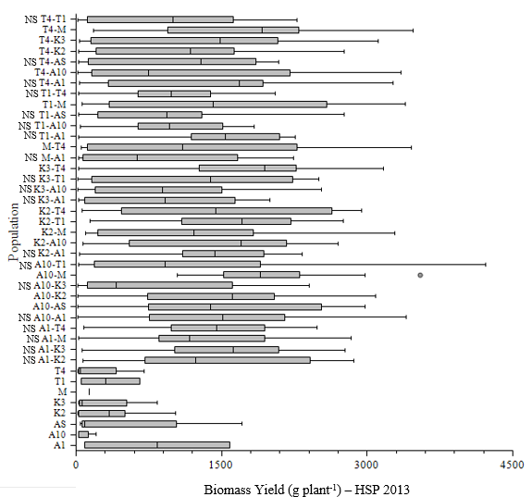

Figure 3-3 A. Figure 3-3 B.
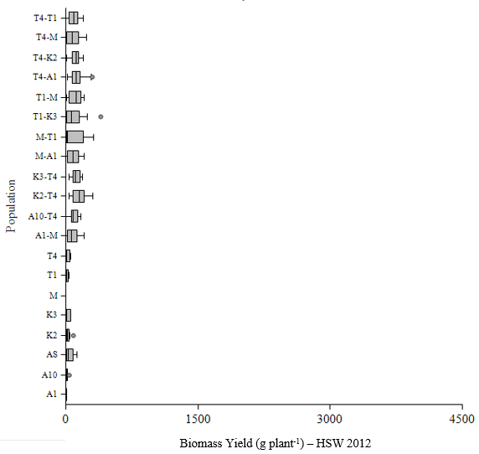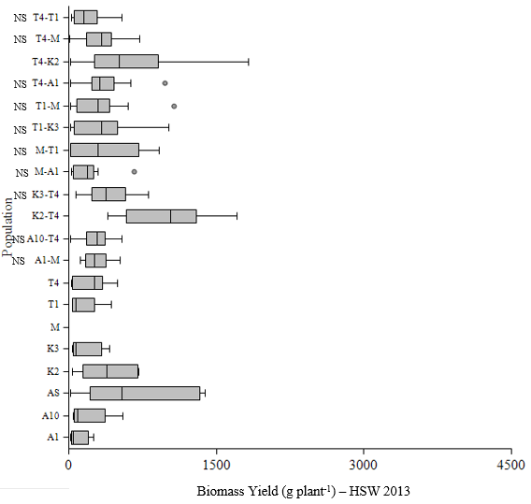

Figure 3-3 C. Figure 3-3 D.
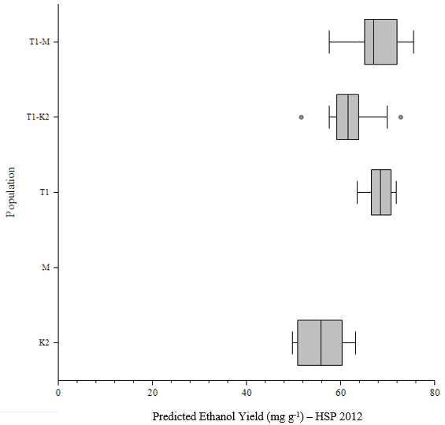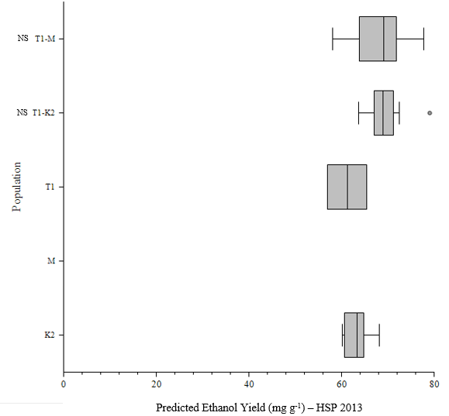

Figure 3-3 E. Figure 3-3 F.

Figure 3-4: The top 30% of progeny were selected within each nursery (space planted (HSP) and sward planted (HSW)) and within each year (2012, 2013). Selections were then matched to the value from evaluation at maturity under sward planted conditions in 2013. The graphs below compare the mean of each set of selections at maturity for biomass yield (g plant⁻¹) (dark grey bars) and predicted ethanol yield (mg g⁻¹) (light grey bars). Both means and standard errors for each set of selections are indicated. Means were separated using Tukey’s HSD. Within a trait, means followed by the same letter do not differ at an alpha level of 0.05.

CONCLUSION
Switchgrass is an important crop, both as a forage crop and as a potential biofuel crop. While progress has been made on breeding switchgrass as a forage crop, the ideal composition of traits for switchgrass used as a biofuel crop, the genetic parameters associated with those traits, and the inter-relationships between traits when evaluated at different maturity levels or under different planting conditions are still undefined. The objective of this study was to provide a more thorough understanding of these areas. To do so, three studies were performed: i.) Reduction of predicted ethanol yield from switchgrass infected with Puccinia emaculata, ii.) Diallel analysis to assess quantitative genetic of biofuel production traits in switchgrass, and ii.) Comparison of space and sward planted switchgrass for estimates of genetic parameters and ranking of biomass and predicted ethanol yield.

Reduction of Predicted Ethanol Yield from Switchgrass Infected with Puccinia emaculata
While few reports of switchgrass disease exist prior to the advent of its use as a biofuel crop, concern over potentially significant disease problems resulting from increased acreage and production in monoculture have led to further examination of switchgrass pathogen susceptibility and the impact of that susceptibility on biomass yield and predicted ethanol yield. The objective of this research is to examine the impact of rust severity infection on predicted ethanol yield in switchgrass.
In 2010 and 2012, naturally infected leaves from field-grown ‘Alamo’ and ‘Kanlow’ in Knoxville, TN (2010, 2012) and Crossville, TN (2012) were visually categorized as low, medium, or high disease based on degree of chlorosis, necrosis, and sporulation. Rust severity was isolated from each disease range to confirm infection. Samples from 2010 were acid/heat pretreated and subjected to two runs of simultaneous saccharification and fermentation with Saccharomyces cerevisiae D₅A (SSF) to measure predicted ethanol yield. NIRS was used to estimate ethanol yield for 2012 samples. SSF and NIRS data were analyzed separately using ANOVA in SAS 9.3.
A very clear trend of reduced predicted ethanol yield in rust severity infected switchgrass was observed with reductions of 10-34% in plants with medium disease and reductions of 21-52% in plants with high disease. No other studies to date have examined the effect of pathogen infection on predicted ethanol yield in switchgrass; however, these results are similar to reductions in digestibility observed in forage crops infected with Puccinia spp. While the exact mechanisms by which rust severity reduces predicted ethanol yield are still speculative, the altered cell wall composition and cellular components within infected switchgrass suggest losses may be due to a reduction in available digestible material and/or a reduction in the digestibility of that material. Results from this study suggest that biofuel production facilities may incur a hidden loss in ethanol yield when purchasing switchgrass that exhibiting rust symptoms. Further studies of biomass yield loss associated with rust severity, the cost and effectiveness of disease control measures, and breeding efforts to produce cultivars with reduced disease susceptibility would provide producers with more information and options for effectively managing this potentially important disease.

Diallel Analysis to Assess Quantitative Genetics of Biofuel Production Traits in Switchgrass
In both forage switchgrass and biofuel switchgrass, total yield consists of two components. In forage switchgrass, these are forage yield and quality. In biofuel switchgrass, these components are biomass yield and ethanol yield. While numerous studies have examined the inter-relationship of morphological traits with biomass yield or quality, the inter-relationship of these traits with ethanol yield has not yet been examined. Establishing a high ethanol yielding ideotype could greatly enhance the efficacy of the selection process when breeding biofuel switchgrass. In addition to knowing the relationship between various traits, a more thorough understanding of the underlying genetic variance components and heritability of those traits and the potential presence of heterotic or maternal effects could further aid breeders in developing more efficient and effective methods of breeding improved cultivars.
Examination of the relationship between morphological traits in plants at different maturity levels could also enhance the efficacy of selection. Switchgrass plants are large, can be difficult to establish, and take approximately 3 years to reach maximum yield capacity Examining the relationship between morphological and yield traits through different maturity stages could provide a basis for a high throughput screening process, through juvenile selection in the greenhouse, selection prior to reproductive maturity, or selection prior to reaching full biomass potential. The objective of this research is to evaluate trait correlations, additive and dominance genetic variance components, heritability, general and specific combining ability, maternal effects, heterosis, and early selection potential of morphological and compositional traits in lowland switchgrass.
Eight parents, representative of the varieties ‘Kanlow’, ‘Alamo’, and ‘Miami’, were crossed in a full diallel design including reciprocals but excluding selfs. Selections included two Kanlow genotypes (K2, K3), five Alamo genotypes (A1, A10, AS, T1, T4), and one Miami genotype (M). Greenhouse started seedlings were planted at Knoxville, TN and Crossville, TN in single plant plots in a RCB design with four blocks and twenty replications per cross. Plants were spaced on 1 m squares. Plants were evaluated for biomass at 8 weeks post-emergence. After transfer to the field, plants were evaluated for height, rust severity, biomass, and ethanol in the fall of the first and second year and for height, tiller number, tiller diameter, leaf width, plant color, and canopy density in the spring of the second and third year. Calculated values included correlations between morphological traits and biomass and predicted ethanol yield, estimates of additive and dominance genetic variance components, heritability, general and specific combining ability, maternal effects, and heterosis, and evaluation of early selection potential for biomass and predicted ethanol yield in lowland switchgrass.
Correlations of morphological traits to biomass yield indicated an ideal ideotype of a tall plant with a high number of thick tillers, wide leaves, and an open canopy density. Traits with the highest correlations to biomass year in the second year included fall height and biomass yield in the establishment year and tiller number and height in the spring of the second year. These results indicate early selection would be effective. Morphological traits that had high positive correlations to biomass yield had weak negative correlations to predicted ethanol yield, indicating improvement of both traits simultaneously may be difficult.
In the variance component model, GCA was not significant for biomass yield, predicted ethanol yield, fall height, tiller number, leaf width, or canopy density, but SCA was significant, indicating a high amount of dominance variation relative to additive variation for the genes controlling these traits. This indicates hybrid development may be more effective at improving these traits as opposed to current breeding methods of recurrent selection to develop improved open-pollinated populations and synthetics. Significant GCA and SCA effects were shown for spring height, plant color, leaf angle, and tiller diameter. For these traits, additive variation accounted for a larger proportion of the total genetic variation, indicating current methods of cultivar development should be effective. The significant amount of dominance genetic variation for these traits indicates hybrid development would also be effective. Narrow sense heritability values for biomass yield were low, which was expected based on results from previous studies. For traits where dominance variation accounted for a greater portion of the total genetic variation, including predicted ethanol yield, fall height, canopy density, and tiller number, narrow sense heritability values were low, ranging from 0.13 to 0.21. For traits where additive variation accounted for a greater portion of the total genetic variation, including spring height, plant color, leaf angle, rust severity Aug., rust severity Oct., and tiller diameter, narrow sense heritability values were higher, ranging from 0.22 to 0.50.
Based on results for GCA values, across traits, the A1 and A10 lines, both derived from Alamo genotypes, were the most promising, with A1 exhibiting positive GCA values for biomass yield, fall height, spring height, tiller number, tiller diameter, and leaf width and negative GCA values for rust severity. This line did have a negative GCA value for predicted ethanol yield. The A10 line also had positive GCA values for biomass yield, fall height, spring height, tiller number, leaf width, and canopy density. While it had a GCA value of 0 for predicted ethanol yield, it did have positive GCA values for rust severity, indicating higher than average rust severity on progeny within this line. The Alamo line, T4, also showed promise exhibiting positive GCA values for biomass yield, fall height, tiller number and canopy density. Predicted ethanol yield was not evaluated for this line. Significant positive SCA values were identified for each trait evaluated, except predicted ethanol yield, for which only a significant negative SCA value was identified. Significant maternal effects were also identified. For biomass yield and height, the crosses T1xM, K2xT1, A10xM, and A10xAS all had significant maternal effects and significant positive SCA values. Across all traits, except predicted ethanol yield, the cross T1xM had a significant positive SCA value and exhibited a significant maternal effect. Although not exhibiting a significant positive SCA value, this cross did have a positive SCA value for predicted ethanol yield as well. These results are important for identifying favorable nuclear genes and parents ideal for seed production.
Within each trait evaluated, crosses were identified exhibiting high parent heterosis. Crosses exhibiting high parent heterosis across both years of evaluations included 25 crosses for biomass yield, 18 crosses for fall height, six crosses for spring height, three crosses for tiller diameter, 36 crosses for tiller number, and one cross for leaf width. For the majority of traits analyzed, in proportion to the number of each combination evaluated, Alamo by Alamo, Alamo by Kanlow, and Alamo by Miami combinations had the most crosses exhibiting high parent heterosis. These results suggest that the diversity within the cultivar Alamo and between the cultivars Alamo and Kanlow and Alamo and Miami may be sufficient to exploit in developing high biomass yielding hybrid cultivars.
Examination of early selection potential for biomass yield and predicted ethanol yield indicated juvenile selection at 8 weeks was not effective at selecting high biomass F1 populations or crosses; however, selection in 2012, the establishment year, was effective at selecting high biomass and high predicted ethanol yielding F1 populations. Crosses selected in the establishment year did not differ significantly in second year yield from crosses selected in the second year. Results from this study suggest that selections for biomass yield and predicted ethanol yield could be made in the establishment year resulting in savings of time, labor, and space in switchgrass breeding endeavors.
Overall, the results from this study provide switchgrass breeders with information that can make breeding efforts more efficient by identifying traits that are highly correlated to the primary traits of interest, biomass yield and predicted ethanol yield, by calculating the proportion of additive and dominance variation for various traits so that breeders can identify the method of cultivar development that will be most effectively exploit the predominant type of genetic variation for that trait, by identifying parents with high general combining ability, crosses with high specific combining ability, and crosses for which maternal effects or heterosis might be exploited, and, finally, by identifying the efficacy of early selection in order to save breeders time, labor, and space when developing improved switchgrass cultivars.

Comparison of Space and Sward Planted Switchgrass for Estimates of Genetic Parameters and Ranking of Biomass and Predicted Ethanol Yield
Switchgrass breeding nurseries are typically space-planted; however, production is in dense swards. This disconnect may impact selection. The objectives of this research are to compare space- and sward-planted switchgrass biomass and predicted ethanol yield for i.) correlations between morphological traits, ii.) estimates of general and specific combining ability (GCA, SCA) and heritability, and iii.) rankings among crosses.
Eight parents selected from the varieties ‘Kanlow’ (2 selections), ‘Alamo’ (4 selections) and ‘Miami’ (1 selection) were crossed in a complete diallel design. In 2012, F1 populations were divided into two clonal propagules and planted in adjacent nurseries in Knoxville, TN. Clonal propagules of each parent line were also placed in both nurseries. Each nursery was arranged in a randomized complete block design containing twenty replications of each cross. The space-planted nursery (HSP) consisted of single-plant plots on 1 m centers. The sward-planted nursery (HSW) consisted of plots of 4x7 plants on 0.33 m centers with 1 m alleys. Spring evaluations (2013) included height, tiller number, tiller diameter, leaf width, leaf angle, and plant color. Fall evaluations (2012, 2013) included rust severity, height and biomass yield. Predicted ethanol yield (2013) was evaluated using NIR. Data were analyzed in SAS.

Mean biomass yield and morphological traits correlated to biomass, including tiller number, tiller diameter, and leaf width, were lower in the sward planted nursery compared to the space planted nursery, likely due to the increased competition in the swards compared to space planted conditions. For biomass yield, in terms of ranking, three of the top four F1 populations selected for mean biomass yield did not differ between nurseries in the establishment year, 2012. As plants increased in size and competition increased in the sward planted nursery, rankings differed to a larger extent, with three of the top four F1 populations selected for biomass yield from the sward planted nursery corresponding to three of the lowest biomass yielding F1 populations in the space planted nursery. Mean predicted ethanol yield also differed significantly between space and sward planted nurseries; however, rankings were more similar between the two nurseries. These results indicate that as competition increases, performance and ranking for biomass yield will likely differ between space planted evaluation conditions and actual production conditions. This could result in selection of plants that have superior performance under space planted evaluation conditions, but which do poorly under production conditions. Since switchgrass takes three years to reach maximum yields, a third year of evaluation would help to better evaluate these results. Performance and ranking of predicted ethanol yield for F1 populations were similar across both nurseries, indicating this trait may be evaluated under either condition; however, this could be due to a lack of variability in predicted ethanol yield within the populations examined.
Correlations of evaluated traits between space and sward planted nurseries were moderate to high, ranging from r = 0.39 to r = 0.72. Predicted ethanol yield showed a consistently high correlation between the two nurseries in both 2012 (r = 0.71) and in 2013 (r = 0.72). Biomass yield had a moderately high correlation in 2012 (r = 0.58), however, that correlation decreased in 2013 (r = 0.39), likely due to the increasing difference in competition between the two nurseries. Of the traits evaluated in both nurseries, including tiller diameter, tiller number, and leaf width, correlations of these traits to biomass yield and to predicted ethanol yield were similar, although correlations tended to be lower in sward planted evaluations. Correlation coefficients of evaluated traits to biomass yield were similar to those observed in other studies of lowland switchgrass, indicating these traits are useful as indirect selectors for biomass yield. Significant correlations between evaluated traits and predicted ethanol yield were low to moderate and negative. This may indicate potential difficulties in breeding plants with high biomass yield and high predicted ethanol yield. Because of the difficulty in accessing individual plants in the sward planted nursery, other potential traits of interest that were shown to be moderately to highly correlated with biomass yield in the space planted nursery, including fall height, spring height, and canopy density, could not be evaluated in the sward planted nursery. The inability to evaluate these traits and other important traits, such as disease susceptibility, are drawbacks to evaluations under sward planted conditions.
Estimates of additive and dominance variance and narrow and broad sense heritability for biomass yield were similar between space and sward planted evaluations. However, space planted nurseries under-estimated additive variation in predicted ethanol yield. For this reason, heritability values, both broad and narrow sense, were underestimated in space planted evaluations for predicted ethanol yield. Under-estimation of additive variation when evaluating predicted ethanol yield in space planted nurseries could hurt breeding efforts by providing breeders with incorrect information when developing breeding methods for improving ethanol yield in switchgrass.
General combining ability was not significant in either nursery or either year. Specific combining ability was significant for biomass yield in the sward planted nursery and for predicted ethanol yield in the space planted nursery. General combining ability of space planted F1 populations were consistent in terms of direction across both years, with exception to the progeny line M. The sward planted F1 populations did not exhibit any variation in GCA in the first year; however, in the second year F1 populations with positive GCA values were F1 populations that had negative GCA values in the space planted nursery. These results indicate the high biomass yielding lines selected from a space planted nursery may not be the same as those that would produce the highest biomass under production conditions. Since GCA values were not significantly different from zero, further analysis would be required to better clarify this. Ethanol GCA values for the space planted nursery tended to vary more across years compared to sward planted values. Two out of four F1 populations had positive GCA values in both nurseries. As with biomass yield, this could indicate a possible hindrance in cultivar improvement as some of the F1 populations that had positive GCA values under simulated production conditions were rejected in the space planted evaluation, while other lines that had negative GCA values under simulated production conditions were selected as superior in the space planted evaluation. Specific combining ability also showed variation in direction between the space and sward planted evaluations. Although SCA selections appear to be more consistent across years within the space planted nurseries, these results, along with the results observed for direction of GCA effects, indicate the selections identified as high yielding for biomass yield in the space planted nurseries may not be the highest yielding selections under production conditions.
Space planted nurseries also identified maternal effects and heterosis for predicted ethanol yield, which was not identified in sward planted nurseries, and also identified a much larger number of crosses exhibiting high parent heterosis for biomass yield compared to the number of crosses identified in the sward planted nursery. These differences could cause problems when breeders try to exploit potential maternal effects and heterosis as these may exist only under evaluations conditions and not under actual production conditions.
Finally, comparing selections under space planted evaluation conditions and simulated production, or sward planted, conditions identifies a possible loss in potential biomass yield gained through selection. Selections did not differ for mean predicted production biomass yield between 2013 space planted selections, 2012 sward planted selections, and 2013 sward planted selections. These results indicate that, while selection of specific crosses or F1 populations may differ between the two nurseries, the mean predicted production biomass yield does not differ. Thus, selection in second year evaluation nurseries for biomass yield or in first year selections from sward planted evaluation nurseries for biomass yield may be effective. While mean predicted production biomass yield did not differ significantly, selections from space planted nurseries could still result in loss of potential yield. Assuming a good stand of approximately one plant per 0.3 m², compared to sward planted selections in the second year, 2013, losses would amount to 6,243 kg ha⁻¹ in 2012 sward planted selections, 14,639 kg ha⁻¹ in 2013 space planted selections, and 22,389 kg ha⁻¹ in 2012 space planted selections. Such losses may be deemed too high by breeders trying to produce improved switchgrass cultivars and by producers trying to maximize biomass yield in production fields. Unlike biomass yield, predicted ethanol yield selections did not differ significantly by nursery or by year indicating early selection and selection under either condition would be effective.
Overall, results from this study suggest evaluation under simulated production, or sward, conditions differ from evaluation under space planted conditions for estimates of mean production performance and characterization of morphological traits, estimates of genetic parameters, identification of high GCA and SCA in populations, and identification of potential maternal effects or high parent heterosis. If sward conditions are more representative of potential production conditions, evaluation under space planted conditions could lead to inaccurate assessment of plant performance, parental line and F1 population selection, and estimation of genetic parameters. In terms of selection, mean predicted production biomass yield and predicted ethanol yield did not differ significantly in selections from second year space planted populations from either first year or second year sward planted populations. This indicates selection under these conditions may be as effective at improving both biomass and predicted ethanol yield as selection under sward planted conditions. Although these means did not differ, less than 18% of selections for biomass yield and only 44% of selections for predicted ethanol yield were the same between the space and sward planted nurseries. If sward conditions are more representative of how plants will perform under production conditions, evaluations under space planted conditions could cause breeders to discard potentially valuable material. Correlations between space and sward planted nurseries were significant and ranged from moderate to high, however, additional traits that can serve as indirect selector for yield were more easily assessed under space planted conditions, including height and canopy density. Although no significant difference was seen in the mean predicted production biomass yield in space planted selections in the second year, selection under these conditions did result in lower mean predicted production biomass yield of approximately 14,639 kg ha⁻¹. The extent of these losses may not be something breeders or producers will tolerate.

REFERENCES

SAS 9.3 TS Level 1M2. SAS Inst., Cary, NC.
Ahlgren, H.L., D.C. Smith and E.L. Nielsen. 1945. Behavior of various selections of Kentucky bluegrass, Poa pratensis L. when grown as spaced plants and in mass seedings. Agron. J. 37: 268-281.
Anderson, W.F. and D.E. Akin. 2008. Structural and chemical properties of grass lignocelluloses related to conversion for biofuels. J. Ind. Microbiol. Biotechnol. 35: 355-366.
Annicchiarico, P. 2006. Prediction of indirect selection for seed and forage yield of lucerne based on evaluation under spaced planting. Plant Breed. 125: 641-643.
Arthur, J.C. 1934. Manual of rusts in United States and CanadaThe Science Press Printing Co., Lancaster, PA.
Assay, K.H. and D.A. Johnson. 1997. Genotype by competition level interactions in crested wheatgrass (Agropyron desertorum Poaceae: Triticeae). . Int. J. Plant Sci. 158: 851-855.
Assay, K.H., D.A. Johnson and M.D. Rumbaugh. 1999. Genotype by competition level interactions in alfalfa (Medicago sativa L.). Int. J. Plant Sci. 160: 129-134.
Atwood, S.S. and R.J. Garber. 1942. The evaluation of individual plants of white clover for yielding ability in association with bluegrass. Agron. J. 34: 1-6.
Barnett, F.L. and R.F. Carver. 1967. Meiosis and pollen stainability in switchgrass, Panicum virgatum L. . Crop Science 7: 301-304.
Bartnicki-Garcia, S. 1968. Cell wall chemistry, morphogenesis, and taxonomy of fungi. Annu. Rev. Microbiol. 22: 87-108.
Bhandari, H.S., M.C. Saha, V.A. Fasoula and J.H. Bouton. 2011. Estimation of genetic parameters for biomass yield in lowland switchgrass (Panicum virgatum L.). Crop Sci. 51: 1525-1533.
Bhandari, H.S., M.C. Saha, P.N. Mascia, V.A. Fasoula and J.H. Bouton. 2010. Variation among half-sib families and heritability for biomass yield and other traits in lowland switchgrass (Panicum virgatum L.). Crop Sci. 50: 2355-2363.
Bhandari, H.S., S.L. Webb, J.H. Bouton and M.C. Saha. 2014. Reciprocal effects for biomass yield in lowland switchgrass. Crop Sci. 54: 955-962.
Boe, A. 2007. Variation between two switchgrass cultivars for components of vegetative and seed biomass. Crop Sci. 47: 636-642.
Brummer, E.C. 1999. Capturing heterosis in forage crop cultivar development. Crop Sci. 39: 943-954.
Brunken, J.N. and J.R. Estes. 1975. Cytological and morphological variation in Panicum virgatum L. Southwest Nat. 19: 379-385.
Butkute, B., N. Lemeziene, J. Ceseviciene, Z. Liatukas and G. Dabkeviciene. 2013. Carbohydrate and lignin partitioning in switchgrass (Panicum virgatum L.) biomass as a bioenergy feedstock. Zemdirbyste-Agriculture 100: 251-260.
Carpenter, J.A. and M. Casler. 1990. Divergent phenotypic selection response in smooth bromegrass for forage yield and nutritive value. Crop Sci. 30: 17-22.
Carpita, N. and M. McCann. 2002. Biochemistry and Molecular Biology of Plants. John Wiley & Sons, New Jersey.
Casler, M.D. 1998. Breeding for improved forage quality: potentials and problems. Proc. XVIII Intl. Grassl. Congr.
Casler, M.D. and K.P. Vogel. 1999. Breeding for increased forage nutritional value. Crop Sci. 39: 12-20.
Casler, M.D. and K.P. Vogel. 2014. Selection for biomass yield in upland, lowland, and hybrid switchgrass. Crop Sci. 54: 626-636.
Chotineeranat, S., R. Wansuksri, K. Piyachomkwan, P. Chatakanonda, P. Weerathaworn and K. Sriroth. 2010. Effect of calcium ions on ethanol production from molasses by Saccharomyces cerevisiae. Sugar Tech 12: 120-124.
Christensen, D.W., D.D. Stuthman and A.W. Hovin. 1984. Associations among morphological and digestibility characters in reed canarygrass. Crop Sci. 24: 675-678.
Copeman, G.J.F. and G. Swift. 1966. The value of spaced plants in assessing the yield potential of herbage varieties at varying nitrogen levels. Proc. Int. Grassl. Congr., 10th, Helsinki. Valtioneuvoston Kirjapaino, Helsinki.
Cornelius, D.R. and C.O. Johnston. 1941. Differences in plant type and reaction to rust among several collections of Panicum virgatum. Agron. J. 33: 115-124.
Crouch, J.A., L.A. Beirn, L.M. Cortese, S.A. Bonos and B.B. Clarke. 2009. Anthracnose disease of switchgrass caused by the novel fungal species Colletotrichum navitas. Mycol. Res. doi:10.1016/jmycres.2009.09.010.
Cummins, G.B. 1971. The rust fungi of cereals, grasses, and bamboos, Springer-Verlag, NY.
Das, M.K., R.G. Fuentes and C.M. Taliaferro. 2004. Genetic variability and trait relationships in switchgrass. Crop Sci. 44: 443-448.
Dien, B., G. Sarath, J. Pedersen, S. Sattler, H. Chen, D. Funnell-Harris, et al. 2009. Improved sugar conversion and ethanol yield for forage sorghum (Sorghum bicolor L. Moench) lines with reduced lignin contents. Bioenerg. Res. 2: 153-164.
Dien, B.S., H.-J.G. June, K.P. Vogel, M.D. Casler, J.F.S. Lamb, L. Iten, et al. 2006. Chemical composition and response to dilute-acid pretreatment and enzymatic saccharification of alfalfa, reed canarygrass, and switchgrass. Biomass and Bioenergy 30: 880-891.
Dowe, N. and J. MCMillan. 2001. SSF Experimental Protocols - Lignocellulosic Biomass Hydrolysis and Fermentation. Laboratory Analytical Procedure. National Renewable Energy Laboratory.
Edwards, K.J.R. and J.P. Cooper. 1963. The genetic control of leaf development in Lolium. II. Response to selection. Heredity 18: 307-317.
Farr, D.E., G.F. Bills, G.P. Chamuris and A.Y. Rossman. 1995. Fungi on Plants and Plant Products in the United States. APS Press St. Paul, MN.
Fu, C., J.R. Mielenz, X. Xiao, Y. Ge, C.Y. Hamilton, M. Rodriguez, et al. 2011. Genetic manipulation of lignin reduces recalcitrance and improves ethanol production from switchgrass. PNAS 108: 3803-3808.
Garland, C.D. 2008. Growing and harvesting switchgrass for ethanol production in Tennessee. UT Biofuels Initiative - SP701-A-5M-5/08. UT Extension, Knoxville, TN.
Gilman, J.C. and W.A. Archer. 1929. The fungi of Iowa parasitic on plants. Iowa State College Journal of Science 3: 299-507.
Gravert, C.E. and G.P. Munkvold. 2002. Fungi and diseases associated with cultivated switchgrass in Iowa. J. Iowa Acad. Sci. 109: 30-34.
Gravert, C.E., L.H. Tiffany and G.P. Munkvold. 2000. Outbreak of smut caused by Tilletia maclagani on cultivated switchgrass in Iowa. Plant Dis. 84: 596.
Griffing, B. 1956. Concept of general and specific combining ability in relation to diallel crossing systems. Austr. J. Biol. Sci. 9: 463-493.
Grissom, D.B. and R.R. Kalton. 1956. Inheritance of combining ability for forage traits in bromegrass (Bromus inermis Leyss). Agron. J. 48: 289-293.
Gunter, L.E., G.A. Tuskan and S.D. Wullschleger. 1996. Diversity among populations of switchgrass based on RAPD markers. Crop Sci. 36: 1017-1022.
Gustafson, D.M., A. Boe and Y. Jin. 2003. Genetic variation for Puccinia emaculata infection in switchgrass. Crop Sci. 43: 755-759.
Hammerschmidt, R. 1984. Rapid deposition of lignin in potato tuber tissue as a response to non-pathogenic fungi on potato. Physiol. Plant Pathol. 24: 33-42.
Haynes, J.G., W.G. Pill and T.A. Evans. 1997. Seed treatments improve the germination and seedling emergence of switchgrass (Panicum virgatum L.). HortScience 32: 1222-1226.
Hayward, M.D. and J.L. Vivero. 1984. Selection for yield in Lolium perenne: II. Performance of spaced plant selections under competitive conditions. Euphytica 33: 787-800.
Hopkins, A.A., C.M. Taliaferro, C.D. Murphy and D. Christian. 1996. Chromsome number and nuclear DNA content of several switchgrass populations. Crop Science 36: 1192-1195.
Hopkins, A.A., K.P. Vogel and K.J. Moore. 1993. Predicted and realized gains from selection for in vitro dry matter digestibility and forage yield in switchgrass. Crop Sci. 33: 253-258.
Hopkins, A.A., K.P. Vogel, K.J. Moore, K.D. Johnson and I.T. Carlson. 1995. Genotypic variability and genotype x environment interactions among switchgrass accessions from the Midwestern USA. Crop Sci. 35: 565-571.
Humphreys, M.O. 1989. Water-soluble carbohydrates in perennial rygrass breeding: III. Relationships with herbage production, digestibility and crude protein content. Grass Forage Sci. 44: 430.
Johnson, J.C., R.N. Gates, G.L. Newton, J.P. Wilson, L.D. Chandler and P.R. Utley. 1997. Yield, composition, and in vitro digestibility of temperate and tropical corn hybrids grown as silage crops planted in summer. J. Dairy Sci. 80: 550-557.
Jones, R.J., C.J. Nelson and D.A. Sleper. 1979. Seedling selection for morphological characters associated with yield of tall fescue. Crop Sci. 19: 631-634.
Karkonen, A. and S. Koutaniemi. 2010. Lignin biosynthesis studies in plant tissue cultures. J. Integr. Plant Biol. 52: 176-185.
Kephart, K.D., D.R. Buxton and R.R. Hill Jr. 1989. Morphology of alfalfa divergently selected for herbage lignin concentration. Crop Sci. 29: 778-782.
Keshwani, D.R. and J.J. Cheng. 2009. Switchgrass for bioethanol and other value-added applications: a review. Bioresource Technology 100: 1515-1523.
Knight, R. 1960. The growth of cocksfoot (Dactylis glomerata L.) under spaced plant and sward conditions. Aust. J. Agric. Res. 11: 457-472.
Kramer, H. 1947. Morphological and agronomic variation in Poa pratensis L. relative to chromosome numbers. Agron. J. 39: 181-191.
Krupinsky, J.M., J.D. Berdahl, C.L. Schoch and A.Y. Rossman. 2004. Leaf spot on switchgrass (Panicum virgatum), symptoms of a new disease caused by Bipolaris oryzae. Can. J. Plant Pathol. 26: 371-378.
Lazenby, A. 1957. The problem of assessing strains: A study in grass-breeding technique. J. Agric. Sci. 48: 294-304.
Lazenby, A. and H.H. Rogers. 1964. Selection criteria in grass breeding: II. Effect, on Lolium perenne, of difference in population density, variety, and available moisture. J. Agric. Sci. 62: 285-298.
Lazenby, A. and H.H. Rogers. 1965. Selection criteria in grass breeding: V. Performance of Lolium perenne genotypes grown at different nitrogen levels and spacings. J. Agric. Sci. 65: 79-89.
Li, Y., M. Windham, R. Trigiano, P. Wadl, K. Moulton, A. Windham, et al. 2009. Anthracnose: a new disease of switchgrass. Phytopathology 99: S72.
Liu, G., C.Y. Hou and D.M. Wang. 2010. Calcium influx is required for the initiation of the hypersensitive response of Triticum aestivum to Puccinia recondite f.sp. tritici. Physiol. Mol. Plant Pathol. 74: 267-273. doi:10.1016/j.pmpp.2010.04.002.
Liu, X.Y., J.Y. Jin, P. He, W. Gao and L. W.J. 2007. Effect of potassium chloride on lignin metabolism and its relation to resistance of corn to stalk rot. Sci. Agric. Sin. 40: 2780-2787.
Lorenz, A.J., R.P. Anex, A. Isci, J.G. Coors, N. de Leon and P.J. Weimer. 2009. Forage quality and composition measurements as predictors of ethanol yield from maize (Zea mays L.) stover. Biotechnology for Biofuels 2. doi:10.1186/1754-6834-2-5.
Mann, D.G.J., N. Labbe, R.W. Sykes, K. Gracom, L. Kline, I.M. Swamidoss, et al. 2009. Rapid Assessment of Lignin Content and Structure in Switchgrass (Panicum virgatum L.) Grown Under Different Environmental Conditions. Bioenerg. Res. 2: 246-256. doi:10.1007/s12155-009-9054-x.
Manners, M. 1982. Pathways of glucose assimilation in Puccinia-graminis. J. Gen. Microbiol. 128: 2621-2630.
Martinez-Reyna, J.M. and K.P. Vogel. 2008. Heterosis in switchgrass: Spaced plants. Crop Sci. 48: 1312-1320.
McLaughlin, S.B. and L.A. Kszos. 2005. Development of switchgrass (Panicum virgatum) as a bioenergy feedstock in the United States. Biomass and Bioenergy 28: 515-535.
McMillan, C. and J. Weiler. 1959. Cytogeography of Panicum virgatum in central North America. Am J Bot 78: 183-188.
McParland, J.J., H.E. Grethlein and A.O. Converse. 1982. Kinetics of acid hydrolysis of corn stover. Solar Energy 28: 55-63.
Murray, I. and I. Cowe. 2004. Sample preparation. Near-Infrared Spectroscopy in Agriculture. Near Infrared Spectroscopy: 75-112.
Newell, L.C. and S.A. Eberhart. 1961. Clone and progeny evaluation in the improvement of switchgrass, Panicum virgatum L. Crop Sci. 1: 117-121.
Newell, L.C. and S.A. Eberhart. 1961. Clone and progeny evaluation in the improvement of switchgrass, Panicum virgatum L. Crop Science 1: 117-121.
Nielson, E.L. 1944. Analysis of variation in Panicum virgatum. J. Agric. Res. 69: 327-353.
Nissen, O. 1960. Testing hay varieties of grasses as spaced plants, in a pure stand or in a mixture with a legume. Proc. Int. Grassl. Congr., 8th Reading, UK. Alden Press, Oxford, UK.
Oldemeyer, D.L. and A.A. Hanson. 1955. Evaluation of combining ability in orchardgrass Dactylis glomerata L. . Agron. J. 47: 158-162.
Poorter, H., K.J. Niklas, P.B. Reich, J. Oleksyn and P. Poot. 2012. Biomass allocation to leaves, stems and roots: meta-analyses of interspecific variation and environmental control. New Phytol. 193: 30-50.
Porter, C.L.J. 1966. An analysis of variation between upland and lowland switchgrass, Panicum virgatum L., in central Oklahoma. Ecology 48: 980-992.
Queiroz, O.C.M., S.C. Kim and A.T. Adesogan. 2012. Effect of treatment with a mixture of bacteria and fibrolytic enzymes on the quality and safety of corn silage infested with different levels of rust. J. Dairy Sci. 95: 5285-5291.
Ride, J.P. 1978. The role of cell wall alterations in resistance to fungi. Ann. Appl. Biol. 89: 302-305.
Rose, L.W., M.K. Das, R.G. Fuentes and C.M. Taliaferro. 2007. Effects of high- vs. low-yield environments on selection for increased biomass yield in switchgrass. Euphytica 156: 407-415.
Saha, U., L. Sonon, D. Hancock, N. Hill, L. Stewart, G. Heusner, et al. 2010. Common terms used in animal feeding and nutrition. B1367.
Samuel, C.J.A., J. Hill, E.L. Breese and A. Davies. 1970. Assessing and predicting environmental response in Lolium perenne. J. Agric. Sci. 75: 1-9.
Sanderson, M.A. 2008. Upland switcghrass yield, nutritive value, and soil carbon changes under grazing and clipping. Agron. J. 100: 510-516.
Sarath, G., B. Dien, A.J. Saathoff, K.P. Vogel, R.B. Mitchell and H. Chen. 2011. Ethanol yields and cell wall properties in divergently bred switchgrass genotypes. Bioresource Technology 102: 9579-9585.
Shen, H., C. Fu, X. Xiao, T. Ray, Y. Tang, Z. Wang, et al. 2009. Developmental control of lignificantion in stems of lowland switchgrass variety Alamo and the effects on saccharification efficiency. Bioenerg. Res. 2: 233-245.
Silva, M.C., M. Nicole, L. Rijo, J.P. Geiger and C.J. Rodrigues. 1999. Cytochemical aspects of the plant-rust fungus interface during the compatible interaction Coffeea Arabica (cv. caturra) - Hemileia Vastarix (Race III). Int. J. Plant Sci. 160: 79-91.
Smart, A.J., L.E. Moser and K.P. Vogel. 2004. Morphological characteristics of big bluestem and switchgrass plants divergently selected for seedling tiller number. Crop Sci. 44: 607-613.
Sprague, R. 1950. Diseases of Cereals and Grasses in North AmericaRonald Press.
Stueville, D.L., R.L. Wynia and J.M. Row. 2001. Reaction of switchgrass cultivars to seed smut caused by Tilletia maclaganii doi:P-2002-0025-NCA.
Talbert, L.E., D.H. Timothy, J.C. Burns, J.O. Rawlings and R.H. Moll. 1983. Estimates of genetic parameters in switchgrass. Crop Sci. 23: 725-728.
Taliaferro, C.M., A.A. Hokins, M.P. Anderson and J.A. Anderson. 1996. Breeding and genetic studies in bermudagras and switchgrass. Proceedings of the 52nd Southern Pasture & Forage Crop Improvement Conference, Oklahoma City. March 30 - April 2.
Taliaferro, C.M. and A.A. Hopkins. 1996. Breeding characteristics and improvement potentials of switchgrass. Proceedings of the Third Liquid Fuel Conference: Liquid Fuels and Industrial Products from Renewable Resources, Nashville. 15-17 Sept.
Tiffany, L.H. and G. Knaphus. 1985. The rust fungi (Uredinales) of the Loess Hills region of Iowa. Journ. Iowa Acad. Sci. 92: 186-188.
Tischler, C.R., H.W. Elberson, M.A. Hussey, W.R. Ocumpaugh, R.L. Reed and M.A. Sanderson. 2001. TEM-SLC and TEM-SEC switchgrass germplasm. Crop Sci. 41: 1654.
Torget, R., P. Werdene, M. Himmel and K. Grohmann. 1990. Dilute acid pretreatment of short rotation woody and herbaceous crops. Appl. Biochem. Biotechnol. 24-25: 115.
Vogel, K.P., B.S. Dien, H.G. Jung, M.D. Casler, S.D. Masterson and R.B. Mitchell. 2011. Quantifying actual and theoretical ethanol yields for switchgrass strains using NIRS analyses. Bioenerg. Res. 4: 96-110.
Vogel, K.P. and R.B. Mitchell. 2008. Heterosis in switchgrass: Biomass yield in swards. Crop Sci. 48: 2159-2164.
Waldron, B.L., J.G. Robins, M.D. Peel and K.B. Jensen. 2008. Predicted efficiency of spaced-plant selection to indirectly improve tall fescue sward yield and quality. Crop Sci. 48: 443.
Wilson, J.P., R.N. Gates and W.W. Hanna. 1991. Effect of rust on yield and digestibility of pearl millet forage. Phytopathology 81: 233-236.
Wricke, G. and W.E. Weber. 1986. Quantitative Genetics and Selection in Plant Breeding. Walter de Gruyter, New York.
Wright, J.D. 1983. High-temperature acid hydrolysis of cellulose for alcohol fuel production. Solar Energy Research Institute, Report Number SERI/TR-231-1714, DE83009109, Golden Colorado.
Xu, H. and M.C. Heath. 1998. Role of calcium in signal transduction during the hypersensitive response caused by basidiospore-derived infection of the cowpea rust fungus. Plant Cell 10: 585-597.
Zale, J., L. Freshour, S. Agarwal, J. Sorochan, B.H. Ownley, K.D. Gwinn, et al. 2008. First report of rust on switchgrass (Panicum virgatum) caused by Puccinia emaculata in Tennessee. Plant Disease 92: 1710-1710. doi:10.1094/pdis-92-12-1710b.
Zarrough, K.M., C.J. Nelson and J.H. Coutts. 1983. Relationship between tillering and forage yield of tall fescue. I. Yield. Crop Sci. 23: 333-337.
Zeiders, K.E. 1984. Helminthosporium spot blotch of switchgrass in Pennsylvania. Plant Dis. 68: 120-122.
Zhang, S.H., Q. Yang and R.C. Ma. 2007. Erwinia carotovora spp. Carotovora infection induced "defense lignin" accumulation and lignin biosynthetic gene expression in chinese cabbage (Brassica rapa L. spp pekinensis). J. Integr. Plant Biol. 49: 993-1002.

VITA
Virginia Sykes was born in Mobile, Alabama in 1984. She earned her Doctor of Philosophy in Plants, Soils, and Insects with a concentration in plant breeding and her Master of Science in Statistics from the University of Tennessee in December, 2014. Prior to this, she attended Virginia Tech where she earned a Master of Science in Life Science with a concentration in Plant Pathology and a Bachelor of Science in Business with a concentration in Marketing Management.
During her time in graduate school, Virginia has been very active in various agricultural societies, including the American Phytopathological Society, the American Society of Agronomy, the National Association of Plant Breeders, and Gamma Sigma Delta Agricultural Honor Society. She has presented her M.S. and Ph.D. research at nationally recognized plant science conferences through poster and oral presentations and has won 1st and 2nd place prizes in the American Society of Agronomy graduate student oral presentation competition. She has had the opportunity to give a number of extension presentations at the Virginia Turfgrass Council annual meeting, the Mid-Atlantic Horticulture Short Course, and at both the Virginia Tech campus and Hampton Roads and Suffolk Extension Centers.
As the research associate for the University of Tennessee State Variety Trials for Corn, Corn Silage, Soybeans, and Wheat, Virginia has had the opportunity to interact with growers throughout the state of TN. She has helped manage the day to day operations of the variety trials program and has provided crucial data on variety performance to growers through the preparation and distribution of extension publications. Virginia hopes to remain active in the field of plant sciences and continue to make meaningful advances in plant breeding.

