Characterization of Key Odorants in Cumberland Rosemary, Conradina verticillata

A Thesis Presented for the

Master of Science

Degree

The University of Tennessee, Knoxville

Claire Mackenzie Gorman

May 2023

Copyright © 2023 by Claire Mackenzie Gorman
All rights reserved.

ACKNOWLEDGEMENTS

I would like to acknowledge my advisor, Dr. John P. Munafo Jr., for giving me this opportunity to study flavor chemistry in his lab. I would also like to express my gratitude to my committee members, Dr. Vermont Dia and Dr. David Golden, for their time, guidance, and support in the completion of my project.
I would like to thank Dr. Melissa Dein for her constant support and input throughout the entirety of this study. Furthermore, I want to extend thanks to Dr. Philipus Pangloli for his availability and knowledge on the instruments used in this work.
To my mom and sister who encouraged me to pursue my goals, I would like to express my deepest appreciation for their motivation, patience, and empathy. Thank you to my grandparents for their ongoing support, emotionally and financially. Finally, a special thanks to my closest friends for their emotional support and willingness to always have my back because this would not have been possible without them.
This work was supported by the United States Department of Agriculture National Institute of Food and Agriculture Hatch project np. 1016031

ABSTRACT

Conradina verticillata Jennison, commonly known as Cumberland Rosemary, is a threatened plant from the mint family Lamiaceae. This species is a flowering, perennial shrub found in only a few counties of Kentucky and Tennessee. Cumberland Rosemary possesses a unique aroma profile; however, the odorants responsible for its aroma have not been previously identified. In this study, a total of 32 odorants were identified in Cumberland Rosemary using gas chromatography-olfactometry (GC-O) and gas chromatography-mass spectrometry (GC-MS). Odorant flavor dilution (FD) factors were determined through the application of aroma extract dilution analysis (AEDA). Seven odorants with FD factors ≥ [greater than or equal to] 64 were quantitated by stable isotope dilution assays (SIDA), and their odor activity values (OAV) were calculated. Odorants with OAV ≥ [greater than or equal to] 1 included 1-octen-3-one (earthy-mushroom, OAV 2900000), 1,8-cineole (eucalyptus, OAV 510000), borneol (earthy, OAV 10000), bornyl acetate (earthy-fruity, OAV 3700), eugenol (spicy, OAV 2200), menthone (mint, OAV 130), and camphor (herbaceous, OAV 72). Sensory analysis confirmed that an odor simulation model, based on the quantitative data, was a close match to the aroma of the plant. Omission studies determined the key odorants within Cumberland Rosemary’s distinct aroma profile. The stereochemistry of selected odorants was also determined by chiral chromatography. These selected chiral odorants included, α-pinene (70% (R)-(+) to 30% (S)-(−)), 1-octen-3-ol (>99% (R)-(−)), menthone (>99% (2S,5R)-(−)), camphor (>99% (R)-(+)), linalool (97% (R)-(−) to 3% (S)-(+)) borneol (57% (1S,2R,4S)-(−) to 43% (1R,2S,4R)-(+)) and carvone (48% (S)-(+) to 52% (R)-(−)). This study established a foundation for future research on the aroma chemistry of C. verticillata and the other 6 members of the Conradina genus.

TABLE OF CONTENTS
CHAPTER 1. INTRODUCTION 1
CHAPTER 2. LITERATURE REVIEW 4
2.1. Botany. 5
2.2. Geographical Distribution, Habitat, and Threatened Status. 10
2.3. Chemistry and Bioactivity. 12
CHAPTER 3. MATERIALS AND METHODS 15
3.1. Plant Material. 16
3.2. Reference Odorants and Other Chemicals. 16
3.2.1. Chemicals. 16
3.2.2. Reference Odorants. 16
3.3. Isotopically Labeled Odorants. 17
3.4. Synthesis of bornyl acetate-(²H₃); (²H₃)-14. 17
3.5. Synthesis of borneol-(²H₂); (²H₂)-22. 18
3.6. Isolation of Volatiles. 18
3.7. Aroma Extraction Dilution Analysis (AEDA). 21
3.8. Gas Chromatography-Olfactometry (GC−O). 21
3.9. Stable Isotope Dilution Assays (SIDA). 22
3.10. Quantitation of Camphor. 25
3.11. Odor Threshold Determination. 25
3.12. Cold On-Column Inlet – Gas Chromatography – Mass Spectrometry System (COC-GC-MS). 25
3.13. Retention Indices (RIs) 25
3.14. Solid Phase Extraction (SPE) Fractionation of Volatiles. 26
3.15. Isolation of α-cadinol. 27
3.16. Chiral Chromatography 27
3.17.Sensory Analysis 28
3.17.1. Free choice profiling. 28
3.17.2. Odor simulation model. 28
3.17.3. Quantitative Olfactory-Profile Analysis. 29
3.18. Omission Experiments. 29
CHAPTER 4. RESULTS AND DISCUSSION 30
4.1. Odor Attributes of Conradina verticillata Plant. 31
4.2. Identification of Odorants. 31
4.3. Quantitation of Odorants and Determination of OAVs. 36
4.4. Sensory Evaluation of the C. verticillata Odor Simulation Model. 38
4.5. Omission Studies. 41
4.6. Enantiomeric Proportions of Chiral Odorants. 41
CHAPTER 5. CONCLUSION 46
LIST OF REFERENCES 48
APPENDIX 54
VITA 62

LIST OF TABLES

Table 1. Species of the Conradina genus.² 6
Table 2. Labeled Standards and Selected Ions for SIDA 24
Table 3. Odor Descriptors of C. verticillata Determined by Free Choice Profiling. 32
Table 4. Volatile Odorants Identified in Conradina verticillata. 35
Table 5. Concentrations, Odor Thresholds, and Odor Activity Values (OAV) of Odorants in C. verticillata. 39
Table 6. Omission Tests Applied to the C. verticillata Odor Simulation Model 42
Table 7. Ratios of Select Enantiomeric Odorants Present in C. verticillata. 43

LIST OF FIGURES

Figure 1. Conradina verticillata acquired from Overhill Gardens (Vonore, TN). 7
Figure 2. Dried Conradina verticillata branches with leaves. 8
Figure 3. Flowering Conradina verticillata. 9
Figure 4. Geographical distribution of Conradina species in the United States.² 11
Figure 5. Mass spectrum of A) bornyl acetate (14) and B) (²H₃)-bornyl acetate. 19
Figure 6. Mass spectrum of A) borneol (22) and B) (²H₂)-borneol. 20
Figure 7 Solvent Assisted Flavor Evaporation (SAFE) apparatus 23
Figure 8. Flavor dilution chromatogram of odorants identified in C. verticillata. Numbers indicate odorants with FD factor≥ 16. 33
Figure 9. Chemical structures of odorants identified in C. verticillata with FD factor ≥ 16. 34
Figure 10. Overlaid TIC chromatogram of α-cadinol from the highest vacuum distillate of Pinus sylvestris oil (blue trace) and C. verticillata (black trace). The arrow indicates α-cadinol present in the fractionated C. verticillata sample. 37
Figure 11. Olfactory character of C. verticillata plant material and C. verticillata odor simulation model. 40
Figure 12. Chemical structures of chiral odorants characterized in C. verticillata. 44
Figure 13. Mass Spectrum of A) 1,8-cineole (6) and B) (²H₆)-1,8-cineole. 55
Figure 14. Mass Spectrum of A) 1-octen-3-one (8) and B) (²H₃)-1-octen-3-one. 56
Figure 15. Mass Spectrum of A) menthone (10) and B) (²H₈)-menthone. 57
Figure 16. Mass Spectrum of A) bornyl acetate (14) and B) (²H₃)-bornyl acetate. 58
Figure 17. Mass Spectrum of A) borneol (22) and B) (²H₂)-borneol. 59
Figure 18. Mass Spectrum of A) eugenol (30) and B) (²H₃)-eugenol. 60

CHAPTER 1. INTRODUCTION

Conradina verticillata Jennison, a narrowleaf perennial in the family Lamiaceae, is a wild shrub native to the Cumberland Plateau of the American Southeast. This shrub, commonly known as Cumberland Rosemary,¹ has been placed on the federally threatened list of species since 1991. However, the showy purple flowers and pleasant aroma also make it a popular garden ornamental. C. verticillata's odor is described as comparable to that of culinary Rosemary, Rosmarinus officinalis, with subtle nuances of eucalyptus, pine, and spice attributes. This pleasant aroma suggests potentials for the use of C. verticillata's essential oil in culinary or topical applications, though the key odorants responsible for the aroma have not yet been investigated.
The first objective of this study was to isolate and identify the odorants present in the aerial parts of Cumberland Rosemary. The volatiles were isolated using solvent-assisted flavor evaporation (SAFE), followed by aroma extract dilution analysis (AEDA). SAFE uses high vacuum distillation to gently separate the volatiles from the non-volatiles in the plant material extract. AEDA was then employed to detect the aroma-active volatiles in the plant material and assign each odorant a flavor dilution (FD) factor. To achieve this, serial dilutions of the volatile isolate were prepared, and each dilution was analyzed by gas chromatography-olfactometry (GC-O) until odorants were no longer perceivable in the dilutions.
The second objective was to quantitate the odorants that are critical to the aroma, namely the odorants with FD > 64 and selected odorants, as well as calculate their odor activity values (OAVs, ratio of concentration to odor threshold). To quantitate the odorants, stable isotope dilution assays (SIDAs) were employed. Deuterium labelled isotope analogous were used as internal standards for each odorant in the SIDAs. The isotopes were added at known concentrations to the dried plant material preceding extraction, distillation, and analysis. Gas chromatography-mass spectrometry (GC-MS) was used to analyze the concentration of each odorant in the plant by means of ion ratios between the odorants and the isotopes.
The third objective was to construct an odor simulation model based on the quantitative data, then confirm its similarity to the dried plant material by comparing them sensorily. First, free choice profiling was employed to establish the odor descriptors that would be used for sensory analysis of the C. verticillata odor. Then, quantitative olfactory profile analysis was used to compare the intensities of the odor descriptors between the odor simulation model and the plant material to further validate the quantitative results.
The fourth objective was to determine the key odorants critical to Cumberland Rosemary’s distinct aroma profile by conducting omission experiments. Omission models were prepared for each odorant with an OAV ≥ 1. The models were prepared with the omission of only one odorant each, then they were individually compared to two full odor simulation models (no odorants omitted) using a triangle test.
The fifth objective was to determine the enantiomeric ratios of the selected chiral odorants in C. verticillata by using chiral gas chromatography-mass spectrometry. The enantiomeric proportions were compared to those found in other plant species, which provided a better understanding into the biosynthetic pathways that conduce in producing the odorants in C. verticillata.
This study provided the first comprehensive evaluation of odor-active compounds present in Conradina verticillata. Therefore, this work provides a foundation for future research into this and other species of the Conradina genus. As a result, this new knowledge can provide opportunities to utilize this threatened plant for commercial applications and potentially move it off the list of federally threatened species.

CHAPTER 2. LITERATURE REVIEW

2.1. Botany.
Conradina is a genus of approximately six different species in the mint family, Lamiaceae, which belongs to a clade of New World Mentheae.^{2, 3} There are potentially nine species, but only six species have been accepted into the Plant List Database (Conradina canescens A. Gray, C. cygniflora C. E. Edwards, Judd, Ionta & Herring, C. etonia Kral & McCartney, C. glabra Shinners, C. grandiflora Small, C. verticillata Jennison), while three are considered synonyms (C. puberula Small, C. montana Small, C. brevifolia Shinners).⁴ The genus was discovered in 1870 by Asa Grey, who named it after Solomon White Conrad, an American botanist.⁵ Asa Grey is also known as “The Father of American Botany” because his extensive work to unify the taxonomic knowledge of plants in North America totaled to more than any other botanist during his time.⁶ The Conradina genus is comprised of compact, evergreen, perennial shrubs with long branches.² The leaves are characterized as having a pleasant aroma and needle-like shape.² The genus is also distinguishable by the very dense hairs on the narrow leaves of the shrub, the sharply bent corolla tube of their flowers, and its minty aroma.^{7, 8} The flowers of the plant can grow either solitarily, or a few in a group in axillary cymes.² They have a two-lipped calyx with two long, slender lobes on the lower lip, and three short, wide lobes on the upper lip.⁹ The corolla is white to purple and two-lipped, with three lobes that are dotted white on the lower lip and a straight, slightly concaved upper lip.⁹ However, each Conradina species has additional morphological characteristics that help to differentiate them (Table 1).²
The species of interest for this study is Conradina verticillata, commonly referred to as Cumberland Rosemary.¹ At maturity, C. verticillata reaches a height of 1-2 feet, and its reclining
branches, covered in stiff needles, release a fragrant aroma (Figure 1, Figure 2). The flowers of C. verticillata bloom in lavender clusters during May and June (Figure 3).

Table 1. Species of the Conradina genus.²
Species | Morphological Characteristics
C. canescens | Small shrub, up to 1 m high. Leaves are 7 to 20 mm long, mostly longer than the internodes. Leaf blades are pubescent on both sides. One to three flowers per axil, lower corolla-lip 8–10-mm long; lateral lobes longer than wide. Calyx-tube hirsute or villiou-hirsute.
C. brevifolia | Small shrub, up to 1 m high. Leaves are short fleshy 6.0 to 8.2 mm long, mostly shorter than the internodes, covered with short downy hairs and many tiny glands on the upper side. One to six lavender flowers per axil.
C. etonia | Straight slender shrub, about 1.5 m high. Leaves have hairy, veiny, glandular blades 1.5–3 cm long and 3–9 mm wide with tightly rolled edges. Three to seven flowers per axil. Pink to lavender in color with darker dotted lower petal.
C. glabra | Small shrub, about 80 cm high but some individuals reach up to 2 m. Leaves are opposite, up to 1.5 cm long, hairless on the upper surface. Two to three flowers per axil. Corolla is 1.5–2 cm long, white to pale lavender in color with a band of purple dots on the lower lip.
C. grandiflora | Erect shrub, 1.5–2.0 m high, with hairy branches and twigs. Leaves are hairy, glandular, up to 1.5 cm long. Year-round hairy lavender flowers with darker lavender spots, lower lip is 12–15 mm long with lateral lobes longer than wide. This species has the largest flowers of genus Conradina.
C. verticillata | Erect shrub, 0.5 m high with reclining branches. Leaves are about 2.5 cm long, very narrow, and arranged in tight bunches that appear as whorls around the stems. Flowers are 2.5 cm long, purple to white and borne in leaf-like clusters of bracts at the ends of the stems.
C. montana | Short shrub less than 0.5 m high with diffuse branches. Leaves are narrowly linear, 5–16 mm long. Leaf blades are glabrous on the upper surface. Minute flowers with corolla 3.5–4 mm long. Calyx-tube hirsutulous.
C. puberula | Short shrub of about 0.5 m high with numerous slender branches. Leaves are narrowly linear but strongly revolute and clavate, 12–20 mm long. Calyx-tube minutely canescent, 5–7 mm long. Flowers appear in racemes of 2–6 per axil, with corolla 4–5 mm long.
C. cygniflora | Virgate shrub up to 1 m high, branches are erect to spreading, internodes 5–43 mm long. Leaves persistent, appearing fascicled- verticillate; narrowly obovate, 9–33 mm long. The abaxial leaf surface is densely-covered by simple unicellular hairs. Cymes carry 1–5 subsessile flowers, densely pubescent, 1.3–12.5 mm long. Large calyx of 8.5–11 mm long; densely covered with simple hairs, upper lip upcurved, 3.6–4.4 mm long, lower lip 4.3–5.5 mm long. Corolla strongly bilabiate, 20–29 mm long, lavender, shading to white in throat, with purple spots; abaxial surface of upper lip darker lavender.

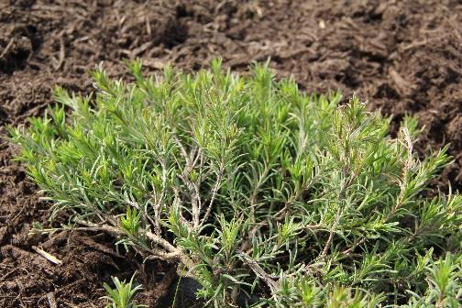
Figure 1. Conradina verticillata acquired from Overhill Gardens (Vonore, TN).
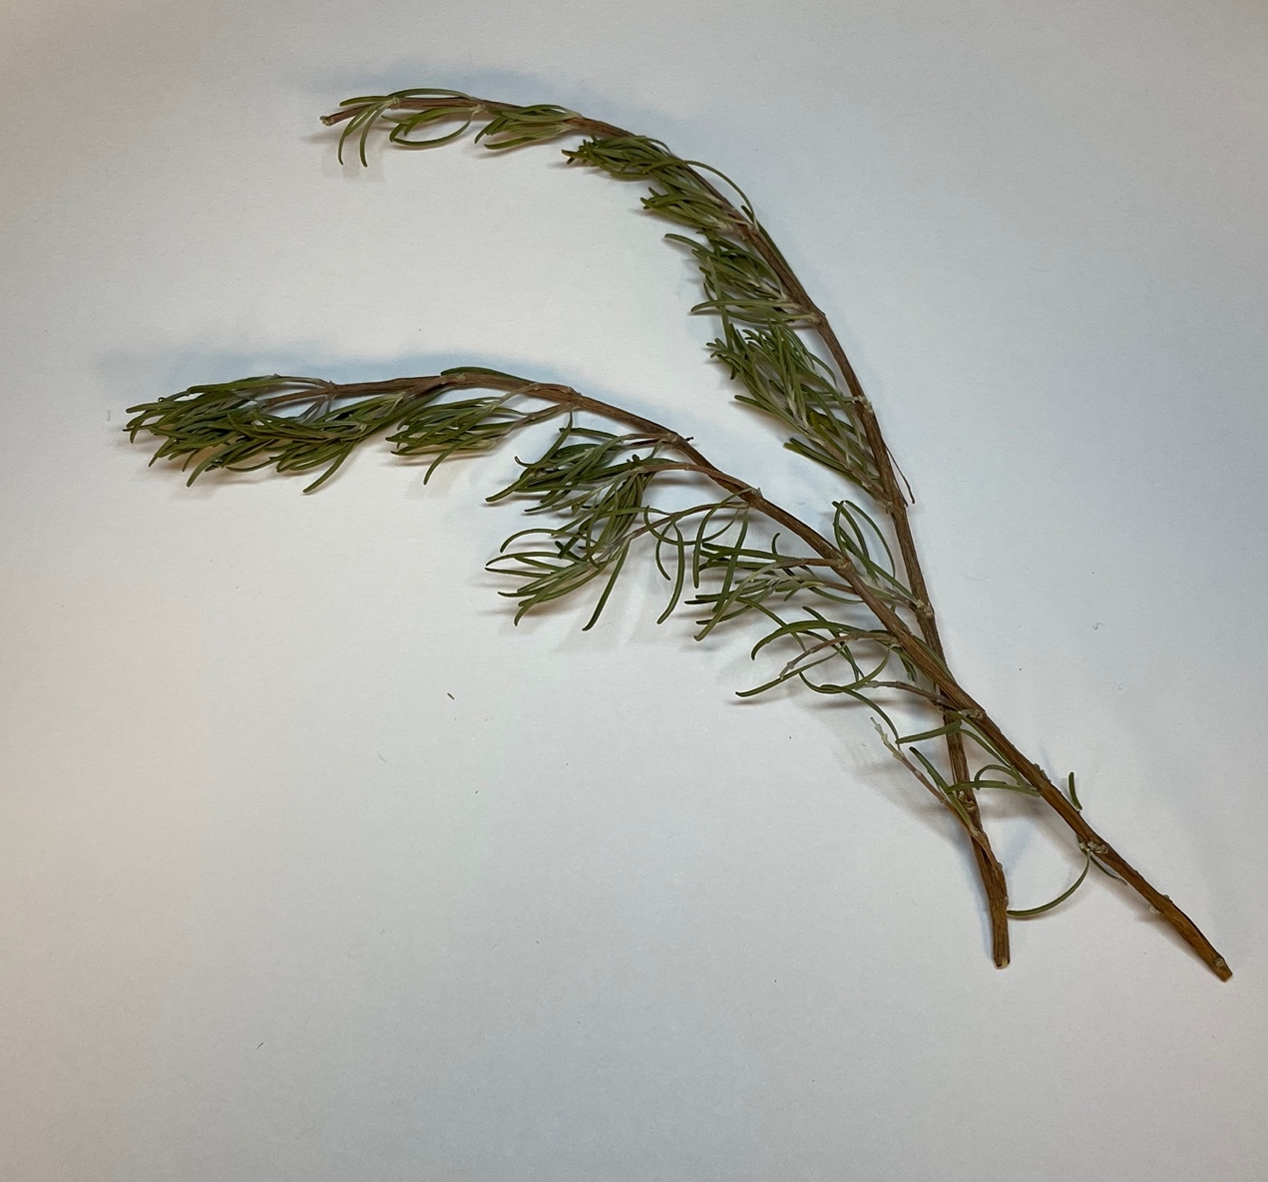
Figure 2. Dried Conradina verticillata branches with leaves.
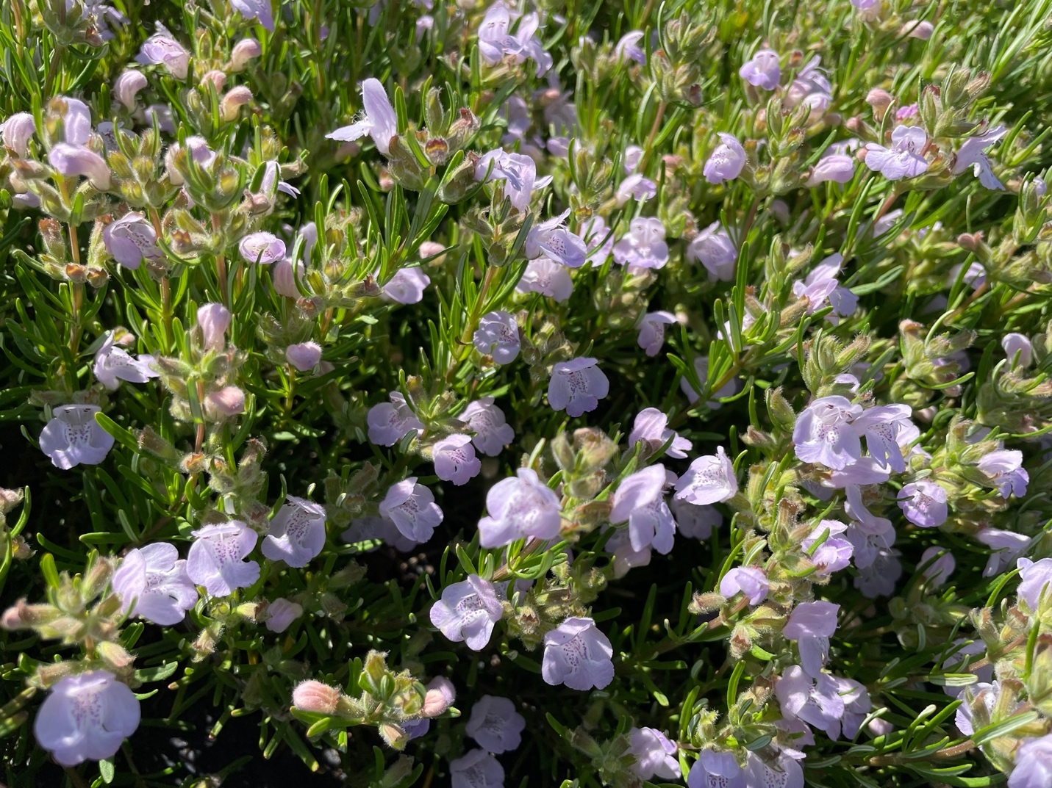
Figure 3. Flowering Conradina verticillata.

2.2. Geographical Distribution, Habitat, and Threatened Status.
Conradina can grow in many different environments, but grows especially well in low moisture habitats with sandy soils that drain easily.² Five of the species are endemic to southern Mississippi, southern Alabama, and Florida (Figure 4).^{7, 10} These species are usually referred to as wild rosemary or false rosemary.¹¹
Only one species, C. verticillata, is endemic to northern central Tennessee (TN) and southern Kentucky (KY).¹² This species was first discovered in the Cumberland River watershed in 1933.¹ Currently, it can be found in a total of six counties, which include McCreary, KY, Cumberland, TN, Fentress, TN, Morgan, TN, Scott, TN, and White, TN.^{1, 13} Conradina verticillata thrives in a variety of habitats ranging from boulder and cobble to sand and gravel bars.¹⁴ However, the shrubs prefer to grow in full sun to slightly shaded regions and along sandy riverbanks in flood-prone areas.¹² The shrub is difficult to find in its native region due to habitat loss, caused primarily by dam construction, water quality degradation, and subsequent augmentation of river flow.^{2, 5} Conradina verticillata is also the only triploid (n=3) plant in this genus; this characteristic is proposed to contribute to a decreased ability to reproduce and germinate.² Cold stratification is required to germinate the fresh seeds of C. verticillata because they are physiologically dormant.¹⁵ This species also encounters competition and shading from large trees. This combination of factors led to C. verticillata being placed on the federally threatened list of species in 1991.¹³ Additionally, there are other Conradina species on the United States Fish and Wildlife Service (USFWS) federal list of endangered species (C. brevifolia, C. etonia, C. glabra) or considered candidates for the list (C. grandiflora, C. cygniflora) because of habitat destruction from residential, commercial, or
agriculture land conservations.^{5, 10} C. verticillata is still considered a threatened species, but fortunately, it can be easily propagated.
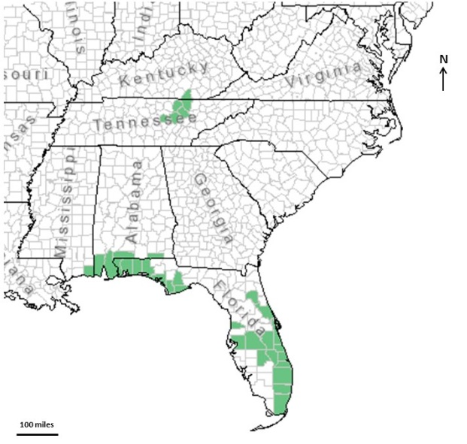
Figure 4. Geographical distribution of Conradina species in the United States.²

2.3. Chemistry and Bioactivity.
Only a few investigations have been reported on this genus, focusing mainly on field observations and phylogenetic studies.^{2, 16} As such, there is limited information regarding essential oils from the Conradina spp.. A few studies have demonstrated that they contain terpenes, terpenic aldehydes and ketones, and terpenic alcohols.^{17, 18} Conclusions mostly indicate that the terpenes are allelopathic and can potentially repel insects.¹⁸⁻²⁰ The common components found in C. canescens, C. brevifolia, C. glabra and C. verticillata include: 1,8-cineole, camphor, α-pinene, β-pinene, β-myrcene, borneol, sabinene, camphene, and β-caryophyllene.²
In 1993, a study was done on Conradina canescens, its allelopathic compounds and their efficacy in preventing wildfires in sandhill grasses of Florida.²⁰ Allelopathy is the process when one plant hinders the germination and growth of another through chemical interactions.² The allelopathic compounds present in C. canescens were believed to hinder the germination of surrounding grasses, as a result, the fire-prone sand hills were more protected.² Therefore, C. canescens may be important to maintaining a healthy ecosystem. The chemical analysis in this study showed the presence of 1,8-cineole, camphor, borneol, myrtenal, myrtenol, α-terpineol, carveol, and carvone.²⁰ This preliminary work elucidated some components in C. canescens, but it did not quantitate them.
In 2007, a study done on Conradina etonia gave insight into its compounds and their potential uses as an insect repellant.¹⁸ In recent years, due to the safe, effective, and environmentally friendly properties, nature-derived insect repellants have increasingly gained attention, thus leading to more exploration of new natural products to be utilized as repellants.¹⁸ Many species in the mint family, Lamiaceae, have compounds that have demonstrated the ability to repel insects.¹⁸ A gentle extraction method was used on the samples of C. etonia.¹⁸ The extraction analysis identified terpenes, terpenic alcohols, ketones, and aldehydes.¹⁸
In 2015, a study was done on the bioactive components Conradina canescens. The essential oil was analyzed, and the major compounds reported were 1,8-cineole, camphor, myrtenal, myrtenyl acetate, myrtenol, α-pinene, and p-cymene.¹⁷ However, the methods used in this study found the essential oil to be inactive in antimicrobial and cytotoxic activity screenings.¹⁷
Another study was conducted on Conradina canescens in 2015, which specifically focused on the chloroform extract of its leaves.¹¹ This gave insight into the biological activities of the non-volatile compounds such as ursolic acid, betulin, myrtenic acid, oleanolic acid, β-amyrin, and n-tetracosane.¹¹ Ursolic acid and betulin have both shown cytotoxic, antiviral, anti-inflammatory, and antimicrobial activities.¹¹ Ursolic acid also had anti-mutagenic, insecticidal, antidiabetogenic, and anti-invasive activities, while betulin also demonstrated anti-HIV, antimalarial, and hepatoprotective activities.¹¹ This study specifically showed that ursolic acid and betulin had significant cytotoxic effects against certain breast cancer and bladder cancer cell lines.¹¹ It also demonstrated the antifungal activity of myrtenic acid, as well as the antimicrobial activity of n-tetracosane.¹¹
In 2022, research was conducted on the potential for species of the Lamiaceae family to be used as natural herbicides. Natural herbicides are an attractive alternative due to the increasing resistance of plants to synthetic herbicides, which is becoming a challenge in agriculture around the world.²¹ Lamiaceae was chosen for this study because it is known for its pharmacological and toxicological properties.²¹ Therefore, with more research, Conradina spp. could possibly be used as alternatives to synthetic herbicides.
The essential oil of C. verticillata was previously investigated, although only major components were reported, which included 1,8-cineole and camphor.²² However, no further investigations have been reported regarding the biosynthetic pathways of the odorants present, nor the roles they might play in the biology of the plant. Furthermore, no studies have comprehensively evaluated the aroma chemistry of C. verticillata.

CHAPTER 3. MATERIALS AND METHODS

3.1. Plant Material.
Conradina verticillata plants were purchased from the Overhill Gardens (Vonore, TN) in May of 2018 and reared on the University of Tennessee Knoxville campus. The plants were grown in a Venlo style greenhouse (945 ft²) in ambient light conditions with supplemental lighting totaling 12 hours. per day. Plants were grown in 1-gallon pots and watered 3 times a week for 15 min (10 mL/min) at a temperature of 25 °C ± 3. The plants were treated bi-weekly with 20−20−20 water soluble fertilizer (Southern Ag, Rubonia, FL). Once the C. verticillata shrubs reached maturity (18 in), the leaves and stems were harvested and air-dried at 20 °C for 7 days in a food dehydrator (Cabela’s, Sidney, NE) until a moisture content of 5-7% was reached. Once dried, the plant material was stored in sealed glass jars with a desiccant (3 g) for analysis.

3.2. Reference Odorants and Other Chemicals.
3.2.1. Chemicals.
The solvents were freshly distilled prior to use. Chromatographic grade solvents including unstabilized diethyl ether from Honeywell Burdick & Jackson (Muskegon, MI) and HPLC grade pentane from MilliporeSigma (St. Louis, MO) were used in the study. A hydrocarbon standard of n-alkanes was prepared in pentane. It was prepared by combining a mixture of n-alkanes C9−C18 from Phenomenex (Torrance, CA) with individual n-alkanes C19−C26 that were each purchased from MilliporeSigma (St. Louis, MO). Fisher Scientiﬁc, (Waltham, MA) was the source of anhydrous Na₂SO₄. The desiccant used was purchased from Fisher Scientiﬁc (Fair Lawn, NJ).

3.2.2. Reference Odorants.
Reference odorants were acquired from commercial suppliers when obtainable. They were used for either analytical or sensory standards. The odorants 1, 3, 4, 6, 8-20, 24-31 were purchased from MilliporeSigma (St. Louis, MO), and 2, 5, 7, 21, 22 were from Vigon International, Inc. (East Stroudsburg, PA). 23 was purchased from Penta International Corp (Livingston, NJ). To isolate α-cadinol (32), Pinus sylvestris essential oil was purchased from Mountain Rose Herbs (Eugene, OR). For the quantitative olfactory-proﬁle analysis, reference odorants were purchased from Millipore-Sigma (St. Louis, MO). The standards, (1S)-(−)-α-pinene, (S)-1-octen-3-ol, (1S,4R)-p-menthan-3-one, (R)-(−)-linalool, (1R)-(+)-camphor, (−)-borneol, and (+)-carvone for the chiral chromatography analysis were obtained from Millipore-Sigma (St. Louis, MO).

3.3. Isotopically Labeled Odorants.
When available, isotopically labeled standards (²H) were purchased from aromaLAB (Planegg, Germany), these included (²H₆)-6, (²H₃)-8, (²H₈)-10, (²H₃)-30. Before performing SIDA, each labeled standard was prepared in freshly distilled diethyl ether or pentane at concentrations determined gas chromatography-flame ionization detection (GC-FID) using calibration equations generated from corresponding isotopically unmodified analytical standards.

3.4. Synthesis of bornyl acetate-(²H₃); (²H₃)-14.
To synthesize bornyl acetate-(²H₃), borneol (1.95 mmol, 0.301 g) was dissolved in anhydrous pyridine (5 mL) and reacted with acetic anhydride-(²H₆) (0.0049 mmol, 500 µL) and (dimethylamino)pyridine (0.065 mmol, 8 mg). The reaction was performed under inert atmosphere using dry N₂. The mixture was reacted with stirring at 0°C for 1 hr. Then, the reaction was quenched by adding crushed ice. The pH was adjusted to 2 using HCl (2 mol/L), and then the aqueous was extracted with pentane (3 x 20 mL). The organic phases were combined, washed with saturated NaHCO₃ (25 mL), and then washed with saturated NaCl solution (25 mL). Next, the organic phase was dried with anhydrous Na₂SO₄ and purified by high vacuum distillation (0.1 Pa). The concentration of (²H₃)-14 was determined by GC-FID using an external calibration curve prepared from bornyl acetate (Figure 5).

3.5. Synthesis of borneol-(²H₂); (²H₂)-22.
Borneol-(²H₂) was synthesized by the reduction of camphor. Methanol-(²H₄) (10.0 mL) and camphor (1.32 mmol, 0.201 g) were combined in a round-bottom flask. Sodium borodeuteride (3.2 mmol, 0.134 g) was slowly added to the mixture and stirred and then purged with dry N₂. After the solution refluxed for 30 min, crushed ice, prepared from D₂O (25 mL), was added to stop the reaction. Then, the sample was filtered under vacuum, and a white solid was collected. Pentane was used to dissolve the solid. Then the mixture was dried over anhydrous Na₂SO₄ and purified by high vacuum distillation (0.1 Pa). The final concentration of (²H₂)-22 was determined by GC-FID using an external calibration generated from borneol (Figure 6).

3.6. Isolation of Volatiles.
Dried stems and leaves of C. verticillata (200 mg) were ground with a Krups coffee grinder (Millville, NJ) and added to a 250 mL centrifuge tube with 50 mL of diethyl ether. The tube was manually shaken for 5 min and then centrifuged for 10 min at 3124-g on a Marshall Scientific Sorvall RC-5B centrifuge (Hampton, NH). Then, the supernatant was collected and a second extraction with 50 mL ether was performed on the pellet. Once centrifuged, the organic phases were combined (~100 mL; total) then subjected to solvent assisted flavor evaporation (SAFE) (Figure 7). The operating parameters of the distillation system included a vacuum pressure of 0.1 Pa and a temperature of 41 °C. The distillate was filtered through anhydrous Na₂SO₄, and then concentrated on a Vigreux column (50 × cm) at 43 °C to 2 mL and then condensed under a gentle stream of N₂ to reach a final volume of 200 μL.

m/z
60
80
100
120
140
160
180
200
0
1600
3200
95.1
121.1
67.0
154.1
196.2
x10²
A
Abundance
60
80
100
120
140
160
180
200
m/z
0
1200
2400
95.1
121.1
67.1
155.1
199.2
x10³
B
Abundance
Figure 5. Mass spectrum of A) bornyl acetate (14) and B) (²H₃)-bornyl acetate.

60
80
100
120
140
0
35000
70000
m/z
95.1
67.1
139.1
121.1
x10²
A
Abundance
60
80
100
120
140
0
1200
2400
m/z
95.1
140.1
67.1
122.1
x10²
B
Abundance
Figure 6. Mass spectrum of A) borneol (22) and B) (²H₂)-borneol.

3.7. Aroma Extraction Dilution Analysis (AEDA).
To identify the odorants that contributed to the aroma of C. verticillata, AEDA of the SAFE distillate was performed. The distillate was successively diluted from 1:2, 1:4, 1:8, through 1:1024 with ethyl ether. Then, gas chromatography−olfactometry (GC−O) was used to evaluate each of the serial dilutions and assign a FD factor to each odorant detected. On the GC-O, the samples were analyzed from the most concentrated to the most diluted samples. Two panelists trained in conducting GC-O analysis were used to record the odor quality and lowest dilution on a flatbed chart recorder (Renesse Supplies B.V., Monster, Netherlands) when each odor was perceived from the sniffing port.

3.8. Gas Chromatography-Olfactometry (GC−O).
The gas chromatography−olfactometry (GC−O) analysis was conducted on an Agilent 7820A GC system from Agilent Technologies (Santa Clara, CA) with a flame ionization detector (FID). The carrier gas was helium flowing at a rate of 1.5 mL/min. The volatile isolate was injected (1 µL) using a 5 μL syringe (Agilent Technologies) into the inlet of either a Zebron ZB-FFAP GC capillary column from Phenomenex (Torrance, CA) or a DB-5 capillary column from Agilent Technologies, both at 30 m in length, 0.32 mm in o.d., and 0.25 µm in film thickness. The oven temperature started at 35 °C, was held for 1 min, then increased by 6 °C/min to 60 °C, then at the same gradient, increased to the final temperature of 240 °C, and held for 10 min. The sample effluent was separated by a Y-shaped splitter that equally portioned the sample effluent by volume (1:1), and the sample was carried through two transfer lines of deactivated fused silica (0.18 mm o.d.). A portion of the effluent traveled to a ﬂame-ionization detector (FID) which was heated to 250 °C and was connected to an analog chart recorder. The other half was passed through a custom-made aluminum cone sniffing port (80 mm length × 25 mm o.d.). The sniffing port was also maintained at 250 °C. The FID gas flow and composition were hydrogen gas (40 mL/min), air (450 mL/min), and makeup gas (45 mL/min). When an odor was perceived from the sniffing port, the retention time and odor character were noted on the flatbed chart recorder. This procedure was performed for the entire chromatographic separation.

3.9. Stable Isotope Dilution Assays (SIDA).
To quantitate the concentrations of selected odorants from C. verticillata, stable isotope dilution assays (SIDA) were employed. Internal standards consisting of isotopically labeled (²H or ¹³C) analogues for each of the selected odorants were prepared at known concentrations in either distilled pentane or diethyl ether. By using external calibration equations (as described above), the GC-FID confirmed the concentrations of the working isotope solutions. The odorants, isotopically labeled standards, and their response factors (RF) are provided in Table 2. Dried plant material (200 mg) was ground, mixed with freshly distilled ether, (50 mL) and labeled odorants (50 μL – 200 μL) were added volumetrically to this solution prior to extraction. After shaking the centrifuge tube by hand for 5 min, it was centrifuged at (3124-g) for 10 min. The organic phase was the decanted and a second extraction (50 mL) was repeated on the residue, as described above. The organic phases were pooled together (~100 mL; total) once centrifuged. It was then subjected to SAFE, as described above, then the supernatant was filtered through anhydrous Na₂SO₄, and condensed to (2 mL). The concentrated SAFE isolate (1 μL) was then analyzed by a GC-MS system using a cold on-column inlet, as detailed below.

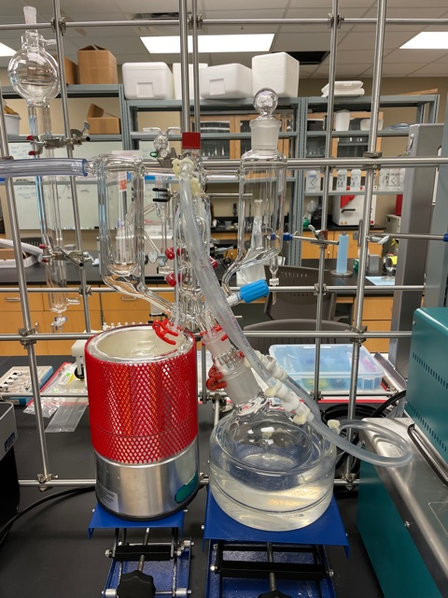
Figure 7 Solvent Assisted Flavor Evaporation (SAFE) apparatus
Table 2. Labeled Standards and Selected Ions for SIDA
no. | odorant | ion (m/z) | labeled standard | ion (m/z) | RF
6 | 1,8-cineole | 154 | (²H₆)-1,8-cineole | 160 | 1.05
8 | 1-octen-3-one | 70 | (²H₃)-1-octen-3-one | 73 | 0.90
10 | menthone | 154 | (²H₈)-menthone | 162 | 0.68
11 | camphor | 152 | (²H₈)-menthone | 162 | 0.82
14 | bornyl acetate | 196 | (²H₃)-bornyl acetate | 199 | 0.94
22 | borneol | 121 | (²H₂)-borneol | 122 | 1.12
30 | eugenol | 164 | (²H₃)-eugenol | 167 | 0.84

3.10. Quantitation of Camphor.
No labeled standard (¹³C- or ²H-labeled) was available for camphor so this odorant was quantitated using (²H₈)-menthone as an internal standard following the quantitation method
described above. A response factor was calculated for camphor which was (m/z 152/162, RF 0.82).

3.11. Odor Threshold Determination.
The odor thresholds for the following odorants in water 6²³, 8²⁴, 10²³, 11²⁵, 14²⁵, 22²⁵, and 30²⁵ were identified from the literature.

3.12. Cold On-Column Inlet – Gas Chromatography – Mass Spectrometry System (COC-GC-MS).
A 7820A GC system coupled with a 5977B mass spectrometry detector (Agilent Technologies, Santa Clara, CA) was used to evaluate the volatile isolates. A cold on-column inlet was tailored to the GC-MS system. The volatile isolates were injected at a volume of 1 μL onto either a Zebron ZB-FFAP or DB-5 GC capillary column (both 30 m × 0.25 mm o.d. × 0.25 μm ﬁlm thickness) purchased from Phenomenex (Torrance, CA). Helium was the carrier gas, ﬂowing at a rate of 1 mL/min. The temperature regiment started with an oven temperature of 35 °C and was held for 1 min, then increased at 6 °C/ min to reach 60 °C. A second ramp of 6 °C/min reached the final temperature of 250 °C which was held for 5 min. The electron-ionization mode was 70 eV, and the MS source and MS quadrupole were maintained at 230 ºC and 150 °C, respectively, and the detector scan range was m/z 50-450.

3.13. Retention Indices (RIs)
Retention Indices (RIs) were calculated for each odorant to assist in identification. This was accomplished by analyzing a standard mixture of n-alkane hydrocarbons (C-9 to C-26) that were run on both the GC-O and COC-GC-MS. The following equation was used to calculate the retention indices:
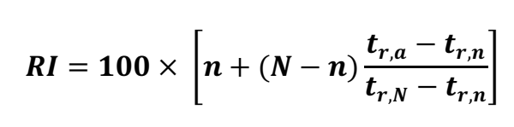
In this equation, n is the number of carbons in the alkane that elutes directly before the analyte, N is the number of carbons in the alkane that elutes after the analyte of interest while, t_{r,a} is the retention time of the analyte of interest, and the retention times of alkane N and n are t_{r,N} and t_{r,n} respectively.

3.14. Solid Phase Extraction (SPE) Fractionation of Volatiles.
To fractionate the volatile isolate, solid-phase extraction (SPE) was employed. SPE was used to reduce the coelution of peaks when analyzing by GC-MS because it separates classes of odorants based on polarity. The dried plant material (200 mg) was extracted with distilled pentane (50 mL) and subjected to a SAFE distillation and concentrated to ∼200 μL, as described above. A SPE manifold was used operating under a vacuum of 10^{–6} mPa, with a silica SPE cartridge (Strata SI-1 Silica, 55 μm, 70 Å; 2 g per 12 mL) from Phenomenex (Torrance, CA). The cartridge was washed with 10 mL of pentane, 5 mL of ether, and 5 mL of pentane. The volatile isolate was then loaded (1 mL) onto the cartridge and eluted using the following mobile phases: Fraction 1, (F1), pentane (100%); Fraction 2 (F2), pentane/ether (98/2, v/v), Fraction 3 (F3), pentane/ether (95/5, v/v); Fraction 4 (F4), pentane/ether (90/10, v/v); Fraction 5 (F5), pentane/ether (50/50, v/v); and Fraction 6 (F6), ether (100%). The six fractions were condensed to 200 μL under gentle stream of N₂, and analyzed using a GC-MS.

3.15. Isolation of α-cadinol.
The odorant, α-cadinol (32) was not commercially available. Therefore, it was isolated in-house from Pinus sylvestris essential oil. The essential oil (500 mg) was subjected to high-vacuum SAFE distillation. The distillate was condensed to 2 mL, and a portion of the resulting distillate (200 μL) was fractionated over a SPE cartridge (Strata SI-1 Silica, 55 μm, 70 Å; 2 g per 12 mL) from Phenomenex (Torrance, CA), that was conditioned as described above. After loading the sample, the cartridge was washed with pentane/ether (5 mL x 3; 90/10, v/v) and then eluted with 5 mL pentane/ether (50/50, v/v). The eluted fraction (SPE fraction 6) contained odorant 32 and was analyzed using GC-MS and GC-O employing both Zebron ZB-FFAP and DB-5 GC columns.

3.16. Chiral Chromatography
A 7820A GC system coupled to a 5977B mass spectrometry detector (Agilent Technologies, Santa Clara, CA) and equipped with a Rt-βDEXsm capillary column (30 m × 0.25 mm i.d. × 0.25 μm ﬁlm thickness) from Restek (Bellefonte, PA). The chiral column was used to separate selected odorant enantiomers including α-pinene (1), 1-octen-3-ol (9), menthone (10), camphor (11), linalool (13), borneol (23), and carvone (24). The carrier gas was helium, flowing at a rate of 1 mL/min. The volatile isolate was prepared as described above and injected (1 μL) onto the column at a starting oven temperature of 40 °C and held for 1 min. Three consecutive temperature ramps followed, beginning with a 5 °C/min increase to 120 °C, then an increase of 3 °C/min reaching 135 °C, and finally an increase of 5 °C/min to reach 230 °C which was held for 5 min. The MS was operated in EI mode under the same parameters described above. A second method was applied to separate the enantiomers of 1-octen-3-ol as described previously.²³ Briefly, the flow rate was maintained at 5 mL/min and the sample injected on-column at a starting temperature of 40 °C. After 1 min, the temperature was increased at 0.5 °C/min to 100 °C, followed by an increase of 5 °C/min to 150 °C, and a final ramp at 10 °C/min to reach 230 °C. The final temperature was held for 5 min.

3.17.Sensory Analysis

3.17.1. Free choice profiling.
Free-choice profiling was used to select the descriptors to evaluate in the quantitative olfactory-profile analysis. The dried plant material was ground (1 g) and placed in a 20 mL scintillation vial and capped. A panel of six trained panelists (1 male, 5 females; ages 20-45) evaluated the sample and reported their odor impression using their own lexicon. The descriptors were collected, and the most reported descriptors guided the selection of corresponding odorant standards for the quantitative olfactory-profile analysis. The descriptors and corresponding reference odorants were as follows: 1,8-cineole (eucalyptus), guaiol (woody), (Z)-3-hexenal (green), 1-octen-3-one (earthy-mushroom), α-thujone (herbaceous), α-pinene (piney), eugenol (spicy).

3.17.2. Odor simulation model.
To prepare the odor simulation model, all the odorants with OAVs ≥1 were included in a 1:1 mixture of ethanol and water. The odors were then added into microcrystalline cellulose to create the odor model (100 mg odor/ 900 mg microcrystalline cellulose) which contained the odorants at their concentrations determined by SIDA. Both the odor simulation model and ground, dried C. verticillata (1 g) were individually placed in 20 mL scintillation vials wrapped in aluminum foil. All the odorant reference standards were prepared at a concentration of 100 times their odor detection threshold in water. The odor simulation model and C. verticillata were then subjected to quantitative olfactory-profile analysis.

3.17.3. Quantitative Olfactory-Profile Analysis.
Trained panelists (1 male, 5 females; ages 20-45) with no known olfactory impairments conducted the quantitative olfactory-profile analysis. Panelists orthonasally evaluated each of the 7 sensory reference odorants and the ground plant in glass scintillation vials (20 mL). They then rated the odor intensities of each descriptor for both the odor simulation model and plant material. The ratings were on a scale ranging from 0 to 3 with 0.5 increments, where 0 = not observable, 1 = weakly observable, 2 = moderately observable, and 3 = strongly observable. The evaluations were done in at least triplicate. The results of the olfactory evaluation were first averaged across panelists using Microsoft Excel Version16.21 for Office 360 (Microsoft Corporation, Redman, WA). Then, the results were analyzed using a one-way analysis of variance (ANOVA) at a signiﬁcance level of 0.05 using JMP Pro 16.0 software from the SAS Institute (Cary, NC).

3.18. Omission Experiments.
Omission experiments were performed to identify which odorants are key to the aroma of C. verticillata. Seven odor simulation models were made as described above except one odorant was omitted. Two full odor simulation models (no odorants omitted) and one omission model (a single odorant omitted) were presented to panelists (n=18). Using a triangle test method, panelists orthonasally assessed each model. The results were statistically analyzed using the Sensory Analysis Methodology for Triangle Tests protocol.²⁶

CHAPTER 4. RESULTS AND DISCUSSION

4.1. Odor Attributes of Conradina verticillata Plant.
To determine the odor characteristics of C. verticillata, free-choice profiling was employed. Dried leaves of C. verticillata were placed into vials and presented to trained panelists (1 male, 5 females; ages 20-45) for orthonasal evaluation. The panelists smelled the material and noted olfactory perceptions in their own lexicon. The panelists' responses were recorded, and some descriptors included pine, earth, spice, clove, mushroom, green, wood, eucalyptus, herbaceous, mint, and solvent. The most reported descriptors were then selected, and reference standards chosen to represent the descriptors for quantitative olfactory-proﬁle analysis. The selected descriptors and respective reference odorants were eucalyptus (1,8-cineole), woody (guaiol), green ((Z)-3-hexenal), earthy-mushroom (1-octen-3-one), herbaceous (α-thujone), piney (α-pinene), and spicy (eugenol) (Table 3).

4.2. Identification of Odorants.
To identify the odorants potentially contributing to the odor of C. verticillata, a solvent extract of dried plant material was subjected to SAFE, and the volatile isolate and serial dilutions of the isolate were analyzed by GC-O. The identity of the odorants was confirmed by the comparison of their odor qualities, mass spectra, and retention times with authentic standards. Overall, 32 odorants were identified, with seven having FD factors ≥ 64 (Figure 8, Figure 9, and Table 4). The odorants with the highest FD factor of 256 were 1,8-cineole (6, eucalyptus) and eugenol (30, clove). 6 has previously been identified in Conradina spp. such as C. canescens, C. brevifolia, C. glabra, and C. verticillata.² In addition, 10 has been found in C. canescens in trace amounts.¹⁷ The odorants with a FD factor of 64 included 1-octen-3-one (8, earthy-mushroom), menthone (10, mint), camphor (11, herbaceous), borneol acetate (14, earthy-fruity), and borneol (22, earthy). Furthermore, odorants with an FD factor of 16 included (2E)-non-2-enal (12, fatty),
Table 3. Odor Descriptors of C. verticillata Determined by Free Choice Profiling.
odor description of C. verticillata
Strong eucalyptus odor with herbaceous and pine notes. Some mushroom, wood, green, and earth notes with a hint of spice.
selected odor descriptors | selected odorant
eucalyptus | 1,8-cineole
woody | guaiol
green | (Z)-3-hexenal
earthy, mushroom | 1-octen-3-one
herbaceous | α-thujone
piney | α-pinene
spicy | eugenol

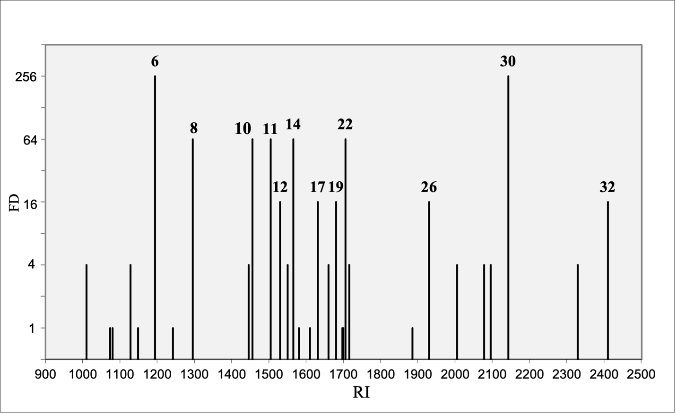
Figure 8. Flavor dilution chromatogram of odorants identified in C. verticillata. Numbers indicate odorants with FD factor≥ 16.

Figure 9. Chemical structures of odorants identified in C. verticillata with FD factor ≥ 16.

Table 4. Volatile Odorants Identified in Conradina verticillata.
no.ª | odorant^{b} | odor quality^{c} | RI^{d} on |  | FD factor^{e} | fraction^{f}
no.ª | odorant^{b} | odor quality^{c} | FFAP | DB-5 | FD factor^{e}
1 | α-pinene | pine | 1010 | 930 | 4 | F1
2 | camphene | terpeny | 1073 | 950 | 1
3 | ß-pinene | pine | 1080 | 981 | 1
4 | myrcene | terpeny | 1128 | 990 | 4 | F1
5 | α-terpinene | terpeny | 1148 | 1012 | 1
6 | 1,8-cineole | eucalyptus | 1194 | 1014 | 256 | F4
7 | γ-terpinene | terpeny | 1242 | 1059 | 1
8 | 1-octen-3-one | earthy- mushroom | 1295 | 975 | 64 | F5
9 | 1-octen-3-ol | mushroom | 1445 | 991 | 4 | F6
10 | menthone | mint | 1455 | 1155 | 64
11 | camphor | camphorous | 1504 | 1143 | 64
12 | (2E)-non-2-enal | fatty | 1530 | 1161 | 16 | F5
13 | linalool | floral, citrus | 1550 | 1101 | 4 | F5
14 | bornyl acetate | earthy, fruity | 1565 | 1283 | 64
15 | (2E,6Z)-nona-2,6-dienal | cucumber | 1580 | 1150 | 1 | F5
16 | butanoic acid | sweaty | 1610 | 820 | 1
17 | pinocarveol | mint | 1631 | 1182 | 16
18 | 2- and 3-methylbutanoic acid | sweaty, rancid | 1660 | 885 | 4
19 | isoborneol | earthy | 1680 | 1160 | 16
20 | (2E,4E)-nona-2,4-dienal | fatty | 1697 | 1212 | 1
21 | α-terpineol | terpeny | 1699 | 1192 | 1
22 | borneol | earthy | 1705 | 1168 | 64
23 | 3-methylnonane-2,4-dione | hay | 1715 | 1246 | 4
24 | carvone | mint | 1715 | 1243 | 4
25 | geraniol | floral | 1885 | 1257 | 1
26 | β-ionone | violet | 1930 | 1492 | 16
27 | trans-4,5-epoxy-(E)-2-decenal^{g} | metallic | 2005 | 1380 | 4
28 | trans-4,5-epoxy-(E)-2-undecenal^{g} | metallic | 2095 | 1485 | 4
29 | p-cresol | barnyard | 2077 | 1072 | 4
30 | eugenol | clove | 2142 | 1359 | 256 | F5
31 | isoeugenol | clove | 2329 | 1451 | 4
32 | α-cadinol | woody | 2410 | 1650 | 16
ª Odorants numbered by their retention time on a FFAP column. ^{b} Identified by comparing retention indices on an FFAP column, mass spectra, odor quality, and intensity, in comparison to data from authentic reference standards. ^{c} Odor quality as perceived during GC-O. ^{d} Linear retention index. ^{e} Flavor dilution factor. ^{f} SPE fraction in which the odorant was identified; where SPE fractions are not listed, odorants were identified in the unfractionated SAFE isolate. ^{g} Mass spectra could not be obtained in the SAFE isolates. Identification was based on the remaining criteria as indicated above.
pinocarveol (17, mint), isoborneol (19, earthy), β-ionone (26, violet), and α-cadinol (32, woody). There were also other odorants identified with an FD factor ≥ 1 (Table 4).
One odorant (32) with FD factor of 16 posed an identification challenge. 32 had a woody aroma character when perceived at the sniffing port. The retention index (RI) was 2410 on a FFAP column and 1650 on a DB-5 column. No clear MS signal was obtainable due to interference with coeluting volatiles, so the odorant was not identifiable in the SAFE isolate. Based on the RIs and aroma character, 32 was tentatively identified as α-cadinol. To verify the odorant’s identity, a SAFE isolate was prepared in pentane. Then, the isolate was fractionated by SPE. This step was taken to separate interfering volatiles, and a MS signal was obtained. Since a reference standard was not commercially available, α-cadinol was purified in-house from Pinus sylvestris essential oil. It was then evaluated by GC−O and equated to the MS signal produced from the SPE fraction of the volatile isolate (Figure 10). The combination of RIs, MS spectra, and aroma character confirmed the identity of 32 as α-cadinol in the C. verticillata sample; although, it had a low FD factor of 16.

4.3. Quantitation of Odorants and Determination of OAVs.
To determine the concentration of odorants perceived by AEDA, SIDA was used to quantitate those with FD factors ≥ 64. Seven odorants were quantitated from C. verticillata. Those with the two highest concentrations were 1,8-cineole (6) at 2020 mg/kg and borneol (22) at 146 mg/kg. In addition to 6 being previously identified in some Conradina spp., it has also been identified in Eucalyptus globulus, Rosmarinus officinalis, and Salvia officinalis.²⁷ 22 has been identified in many plants of the families Lamiaceae, Dipterocarpaceae, Valerianaceae, and
Abundance
20.40
20.60
20.80
21.00
21.20
21.40
21.60
21.80
22.00
0
12000
24000
Time (minutes)
Figure 10. Overlaid TIC chromatogram of α-cadinol from the highest vacuum distillate of Pinus sylvestris oil (blue trace) and C. verticillata (black trace). The arrow indicates α-cadinol present in the fractionated C. verticillata sample.

Asteraceae.²⁸ Odor activity values were calculated (compound concentration/odor threshold) for the C. verticillata plant. The OAV calculations indicated seven odorants with OAV ≥1 (Table 5). The odorants with the highest OAVs were 1-octen-3-one (8, OAV 2900000) and 1,8-cineole (6, OAV 510000), with earthy-mushroom, and eucalyptus characteristics. Compound 8 has been identified at relatively low levels in some genera of the Lamiaceae family including Mentha, Pycnanthemum, Salvia and Meehania.^{23-25, 29} For example, in Meehinina cordata, its concentration was notably lower ( 45.5 μg/kg) than in C. verticillata.²³ Other odorants with OAV ≥1 included borneol (22, OAV 10000), bornyl acetate (14, OAV 3700), eugenol (30, OAV 2200), menthone (10, OAV 130), and camphor (11, OAV 72). The results of the OAV calculations showed all seven odorants had an OAV >1, suggesting that all the quantitated odorants may contribute to the odor of C. verticillata.

4.4. Sensory Evaluation of the C. verticillata Odor Simulation Model.
To perform odor simulation experiments, a simulation model was prepared by combining all seven odorants with OAVs ≥1 in a 1:1 mixture of ethanol and water. The odor was then added into microcrystalline cellulose to create the odor simulation model (100 mg odor/ 900 mg microcrystalline cellulose) which contained the odorants at their concentrations determined in the plant. This matrix was chosen to represent the aroma release consistent with the plant material. The original plant material (1 g) was then compared to the odor simulation model by quantitative olfactory-profile analysis (Figure 11). Using statistical analyses, it was shown that no significant differences between the plant and odor simulation model at a significance level of 0.05 existed.

Table 5. Concentrations, Odor Thresholds, and Odor Activity Values (OAV) of Odorants in C. verticillata.

no. |  | odorant |  | odor quality | conc. (𝜇g/kg) | odor threshold in water (𝜇g/L) | OAV
8 |  | 1-octen-3-one²⁴ |  | earthy, mushroom | 46600 | 0.016 | 2900000
6 | 1,8-cineole²³ |  | eucalyptus |  | 2020000 | 4.0 | 510000
22 | borneol²⁵ |  | earthy |  | 146000 | 14 | 10000
14 |  | bornyl acetate²⁵ |  | earthy, fruity | 44900 | 12 | 3700
30 |  | eugenol²⁵ |  | clove | 3870 | 1.8 | 2200
10 |  | menthone²³ |  | mint | 63700 | 480 | 130
11 |  | camphor²⁵ |  | herbaceous | 79400 | 1100 | 72

Figure 11. Olfactory character of C. verticillata plant material and C. verticillata odor simulation model.

4.5. Omission Studies.
Omission experiments were performed to determine which of the seven odorants (with OAV ≥1) were key contributors to the odor of C. verticillata. Several omission models were prepared, with each model having one odorant excluded. Using a triangle test format, the full odor model (no odorants omitted) and an omission model (a single odorant omitted) were orthonasally assessed by panelists (1 male, 5 females; ages 20-45). Panelists could only detect the omission of three individual odorants (Table 6). The omission of 1,8-cineole (6) and 1-octen-3-one (8), with a eucalyptus and earthy-mushroom character, respectively, were detected (p <0.001). With 6 and 8 having the second and first highest OAVs, respectively, the detection of each omission can be related to it being a key odorant in the plant. Compound 6, commonly known as eucalyptol, is the major component in eucalyptus essential oils.³⁰ Odorant 8 has been described as mushroom, metallic, rust, and others but most commonly characterized as mushroom.³¹ When eugenol (30), with a spicy character, was absent, the omission was detected (p <0.001) by panelists. A model with the three significant odorants, (6), (8), and (30), was prepared and compared to the full odor model, and panelist could not detect a difference at p >0.05. Overall, these omission experiments imply that the odorants with eucalyptus, earthy-mushroom, and spicy characteristics are key contributors to the odor of C. verticillata.

4.6. Enantiomeric Proportions of Chiral Odorants.
Next, the chirality of selected odorants identified from C. verticillata was determined. Several studies have shown that an odorant’s chirality can affect its perceived odor.³² Chiral chromatography was used to examine seven odorants, including: α-pinene (1), 1-octen-3-ol (9), menthone (10), camphor (11), linalool (13), borneol (22), and carvone (24) (Table 7 and Figure 12). Odorant 1 was identified as present at 70% (R)-(+) and was not previously reported in C.
Table 6. Omission Tests Applied to the C. verticillata Odor Simulation Model

test | odorant omittedª | significance level
1 | 1,8-cineole | ++
2 | 1-octen-3-one | ++
3 | menthone | −
4 | camphor | −
5 | bornyl acetate | −
6 | borneol | −
7 | eugenol | ++
a Statistical significance denoted as follows: 0.01 ≥ p > 0.001, ++ and p > 0.05 not significant (−).

Table 7. Ratios of Select Enantiomeric Odorants Present in C. verticillata.

no. | odorant | FEEª | percent FEE^{b} | SEE^{c} | percent SEE^{b} | Fraction^{d}
1 | 𝛼-pinene | (R)-(+) | 70% | (S)-(−) | 30% | F1
9 | 1-octen-3-ol | (R)-(−) | >99% | (S)-(+) |  | F5
10 | menthone | (2S,5R)-(−) | >99% | (2R,5S)-(+) |  | F3
11 | camphor | (R)-(+) | >99% | (S)-(−) |  | F5
13 | linalool | (R)-(−) | 97% | (S)-(+) | 3% | F5
22 | borneol | (1S,2R,4S)-( −) | 57% | (1R,2S,4R)-(+) | 43% | F5
24 | carvone | (S)-(+) | 48% | (R)-(−) | 52% | F6
ªFirst eluting enantiomer. ^{b}Ratio of peak areas from extracted ion chromatograms. ^{c}Second eluting enantiomer. ^{d}SPE fraction compounds were detected.

Figure 12. Chemical structures of chiral odorants characterized in C. verticillata.

verticillata but in the essential oil of Conradina canescent.¹⁸ Studies have reported different enantiomeric compositions of 1 in species such as pine trees (Pinaceae) and domesticated Rosemary (Rosmarinus officinalis (L.)).^{33, 34} The enantiomeric composition of 1 in R. officinalis ranged from 15/85 (−)/(+) to 8/92 depending on the plant’s geographic origin. While 9 and 11 were predominantly (>99%) the enantiomers (R)-(−) and (R)-(+), respectively. This is the first study to identify 9 in Conradina. Odorant 11 was previously reported in the essential oil of C. verticillata, but the chirality was not evaluated.¹⁷ 11 was identified in R. officinalis and reported to be 60% (R)-(+) and 40% (S)-(−).³⁴ In the present study, 13 was identified as 97% (R)-(−) with 3% of the enantiomer (S)-(+) and is the first known report of the odorant in Conradina. Further, the ratio reported here was consistent with an evaluation of 13 enantiomers in R. officinalis.^{35, 36} Odorant 22 was detected as a scalemic mixture of 57% of the enantiomer (1S,2R,4S)-(−) to 43% (1R,2S,4R)-(+) which is different than the 90% to 10% reported in R. officinalis.³⁶ Finally, 24 had an enantiomeric ratio of 48% (S)-(+) to 52% (R)-(−). No previous reports have identified 24 or its enantiomers in C. verticillata.

CHAPTER 5. CONCLUSION

This study provides the first full characterization of the key odorants present in C. verticillata. Thirty-two odorants were identified as aroma-active in C. verticillata. Odorants with the highest FD factors included eugenol (30, FD 256), 1,8-cineole (6, FD 256), 1-octen-3-one (8, FD 64), borneol (22, FD 64), bornyl acetate (14, FD 64), menthone (10, FD 64), and camphor (11, FD 64). Based on the quantitative results, odorants with OAVs ≥1 included 1-octen-3-one (8, earthy-mushroom), 1,8-cineole (6, eucalyptus), borneol (22, earthy), bornyl acetate (14, earthy-fruity), eugenol (30, spicy), menthone (10, mint), and camphor (11, herbaceous). Quantitative olfactory-profile analysis revealed that an odor simulation model prepared by combining the odorants with OAVs ≥1 in a microcrystalline cellulose matrix was a close match to the aroma of C. verticillata. Through omission experiments, it was determined that 1-octen-3-one (8), 1,8-cineole (6), and eugenol (30) were key odorants and play essential roles in the aroma character of C. verticillata.
The chirality of select odorants was evaluated, and 1-octen-3-ol (9, >99% (R)-(−)), menthone (10, >99% (2S,5R)-(−)), camphor (11, >99% (R)-(+)), and linalool (13, 97% (R)-(−) to 3% (S)-(+)) were predominantly single enantiomers. Furthermore, chiral analysis revealed that α-pinene (1, 70% (R)-(+) to 30% (S)-(−)) and borneol (22, 57% (1S,2R,4S)-(−) to 43% (1R,2S,4R)-(+)) occurred as scalemic mixtures and carvone (24, 48% (S)-(+) to 52% (R)-(−)) occurred as almost a racemic mixture.
Overall, the combined data from this report comprise the first full characterization of the aroma chemistry of C. verticillata and provide a foundation for future research into the variation of aroma chemistry of different selections of C. verticillata, as well as the other species in the genus Conradina.

LIST OF REFERENCES

(1) Schmalzer, P. A.; Patrick, T. S.; DeSelm, H. Vascular flora of the Obed Wild and Scenic River, Tennessee. Castanea 1985, 71-88.
(2) Dosoky, N. S.; Setzer, W. N. The Genus Conradina (Lamiaceae): A Review. Plants 2018, 7 (1), 19.
(3) Trusty, J. L.; Olmstead, R. G.; Bogler, D. J.; Santos-Guerra, A.; Francisco-Ortega, J. Using Molecular Data to Test a Biogeographic Connection of the Macaronesian Genus <span class="genus-species">Bystropogon</span> (Lamiaceae) to the New World: A Case of Conflicting Phylogenies. Systematic Botany 2004, 29 (3), 702-715, 714.
(4) The Plant List. 2013. http://www.theplantlist.org/ (accessed March 26, 2023).
(5) U.S. Fish and Wildlife Service, U. Endangered and Threatened Wildlife and plants: Endangered orthreatened status for five Florida plants. USFWS Fed. Regist. Rules Regul 1993, 58, 37432–37443.
(6) Britannica, T. E. o. E. Asa Gray. Encyclopedia Britannica 2023.
(7) Gray, T. C. A. Monograph of the Genus Conradina. Vanderbilt University: Nashville, TN, USA 1965.
(8) Shinners, L. H. Synopsis of Conradina (Labiatae). Sida 1962, 1, 84-88.
(9) Cai, Z.-M.; Peng, J.-Q.; Chen, Y.; Tao, L.; Zhang, Y.-Y.; Fu, L.-Y.; Long, Q.-D.; Shen, X.-C. 1,8-Cineole: a review of source, biological activities, and application. Journal of Asian Natural Products Research 2021, 23 (10), 938-954. DOI: 10.1080/10286020.2020.1839432.
(10) Kral, R. M., R.B. . A new species of Conradina (Lamiaceae) from northeastern peninsular Florida. Sida 1991, 14, 391–398.
(11) Dosoky, N. S.; Moriarity, D. M.; Setzer, W. N. Phytochemical and biological investigations of Conradina canescens. Natural product communications 2016, 11 (1), 1934578X1601100109.
(12) Jennison, H. A new species of Conradina from Tennessee. J. Elisha Mitchell Sci. Soc. 1933, 48 (2), 268-269.
(13) U.S. Fish and Wildlife Service, U. Endangered and Threatened Wildlife and plants: Conradina verticillata (Cumberland rosemary) determined to be threatened. USFWS Fed. Regist. Rules Regul 1991, 56, 60937-60941.
(14) U.S. Fish and Wildlife Service, U. Recovery Plan for Nineteen Central Florida Scrub and High Pineland Plants (Revised). USFWS: Atlanta, GA, USA 1996.
(15) Albrecht, M. A. Seed germination ecology of three imperiled plants of rock outcrops in the southeastern United States1, 2. The Journal of the Torrey Botanical Society 2012, 139 (1), 86-95.
(16) Edwards, C. E.; Soltis, D. E.; Soltis, P. S. Molecular phylogeny of Conradina and other scrub mints (Lamiaceae) from the southeastern USA: evidence for hybridization in Pleistocene refugia? Syst. Bot. 2006, 31 (1), 193-207.
(17) Dosoky, N. S.; Stewart, C. D.; Setzer, W. N. Identification of essential oil components from Conradina canescens. Am. J. Essent. Oils Nat. Prod 2014, 2, 24-28.
(18) Quinn, B. P.; Bernier, U. R.; Booth, M. M. Identification of compounds from Etonia rosemary (Conradina etonia). J. Chromatogr. A 2007, 1160 (1-2), 306-310.
(19) Williamson, G. B.; Fischer, N. H.; Richardson, D. R.; de la Peña, A. Chemical inhibition of fire-prone grasses by fire-sensitive shrub,Conradina canescens. Journal of chemical ecology. 1989, 15 (5), 1567-1577. DOI: 10.1007/bf01012384.
(20) Fischer, N. H.; Williamson, G. B.; Weidenhamer, J. D.; Richardson, D. R. In search of allelopathy in the Florida scrub: The role of terpenoids. Journal of chemical ecology. 1994, 20 (6), 1355-1380. DOI: 10.1007/bf02059812.
(21) Islam, A. K. M. M.; Suttiyut, T.; Anwar, M. P.; Juraimi, A. S.; Kato-Noguchi, H. Allelopathic Properties of Lamiaceae Species: Prospects and Challenges to Use in Agriculture. Plants (Basel) 2022, 11 (11), 1478. DOI: 10.3390/plants11111478.
(22) Peterson, C. L. Analysis of the essential oils, leaf ultrastructure, and the in vitro growth response of the mint genus Conradina. Florida Institute of Technology, 1998.
(23) Dein, M.; Munafo, J. P. Characterization of Key Odorants in Hoary Mountain Mint, Pycnanthemum incanum. J. Agric. Food Chem 2019, 67 (9), 2589-2597. DOI: 10.1021/acs.jafc.8b06803.
(24) Dein, M.; Wickramasinghe, P. C. K.; Munafo, J. P. Characterization of Key Odorants in Meehan’s Mint, Meehania cordata. J. Agric. Food Chem 2020. DOI: 10.1021/acs.jafc.9b06729.
(25) Jonas, M.; Schieberle, P. Characterization of the key aroma compounds in fresh leaves of garden sage (Salvia officinalis L.) by means of the sensomics approach: influence of drying and storage and comparison with commercial dried sage. Journal of Agricultural and Food Chemistry 2021, 69 (17), 5113-5124.
(26) (ISO), I. O. f. S. Sensory Analysis-Methodology-Triangle Test; 2004.
(27) Aprotosoaie, A. C.; Luca, V. S.; Trifan, A.; Miron, A. Chapter 7 - Antigenotoxic Potential of Some Dietary Non-phenolic Phytochemicals. In Studies in Natural Products Chemistry, Atta ur, R. Ed.; Vol. 60; Elsevier, 2019; pp 223-297.
(28) Tabanca, N.; Kirimer, N.; Demirci, B.; Demirci, F.; Başer, K. H. Composition and antimicrobial activity of the essential oils of Micromeria cristata subsp. phrygia and the enantiomeric distribution of borneol. J Agric Food Chem 2001, 49 (9), 4300-4303. DOI: 10.1021/jf0105034 From NLM.
(29) Kelley, L. E.; Cadwallader, K. R. Identification and quantitation of potent odorants in spearmint oils. Journal of agricultural and food chemistry 2017, 66 (10), 2414-2421. Dein, M.; Munafo Jr, J. P. Characterization of Odorants in Southern Mountain Mint, Pycnanthemum pycnanthemoides. Journal of Agricultural and Food Chemistry 2022.
(30) Poitou, X.; Thibon, C.; Darriet, P. 1,8-Cineole in French Red Wines: Evidence for a Contribution Related to Its Various Origins. Journal of Agricultural and Food Chemistry 2017, 65 (2), 383-393. DOI: 10.1021/acs.jafc.6b03042.
(31) Lubran, M. B.; Lawless, H. T.; Lavin, E.; Acree, T. E. Identification of Metallic-Smelling 1-Octen-3-one and 1-Nonen-3-one from Solutions of Ferrous Sulfate. Journal of Agricultural and Food Chemistry 2005, 53 (21), 8325-8327. DOI: 10.1021/jf0511594.
(32) Zawirska-Wojtasiak, R. Chirality and the nature of food authenticity of aroma. Acta Sci. Pol. Technol. Aliment. 2006, 5 (1), 21-36.
(33) Borg Karlson, A.; Persson, M.; Christiansson, Å.; Fäldt, J.; Långström, B.; Li, L.; Liu, H.; Zhou, N.; Lieutier, F. Relative amounts and enantiomeric compositions of monoterpene hydrocarbons in Pinus yunnanensis Fr. and Pinus sylvestris L. Colloques de l'INRA 1999.
(34) Coleman, W. M., III; Lawrence, B. M. Examination of the Enantiomeric Distribution of Certain Monoterpene Hydrocarbons in Selected Essential Oils by Automated Solid-Phase Microextraction—Chiral Gas Chromatography—Mass Selective Detection. J. Chromatogr. Sci. 2000, 38 (3), 95-99. DOI: 10.1093/chromsci/38.3.95 (acccessed 5/19/2020).
(35) Zawirska-Wojtasiak, R.; Wąsowicz, E. GC analysis of rosemary aroma isolated traditionally by distillation and by SPME. J. Essen Oil Res 2009, 21 (1), 8-15.
(36) Satyal, P.; Jones, T. H.; Lopez, E. M.; McFeeters, R. L.; Ali, N. A. A.; Mansi, I.; Al-kaf, A. G.; Setzer, W. N. Chemotypic characterization and biological activity of Rosmarinus officinalis. Foods 2017, 6 (3), 20.

APPENDIX

100
200
300
0
4
8

m/z
Abundance
81.1
108.1
154.2
55.0
1 x 10⁵
A
160.2
100
200
300
0
25
50
m/z
Abundance
113.1
81.0
142.1
1 x 10⁵
B

Figure 13. Mass Spectrum of A) 1,8-cineole (6) and B) (²H₆)-1,8-cineole.
100
200
300
0
2
4
m/z
Abundance
70.0
97.1
1 x 10⁵
A
m/z
Abundance
73.0
1 x 10⁵
100
200
300
0
25
50
100.0
B

Figure 14. Mass Spectrum of A) 1-octen-3-one (8) and B) (²H₃)-1-octen-3-one.

100
200
300
0
6
12
m/z
Abundance
112.1
69.1
139.1
154.1
1 x 10⁴
A
100
200
300
0
2
4
m/z
Abundance
115.1
144.1
162.2
70.1
89.1
1 x 10⁵

B

Figure 15. Mass Spectrum of A) menthone (10) and B) (²H₈)-menthone.

m/z
100
200
300
0
15
30
Abundance
95.1
121.0
55.0
154.2
196.3
A
1 x 10³
100
200
300
0
12
24
m/z
Abundance
95.1
121.1
67.1
155.1
199.2
1 x 10⁵
B

Figure 16. Mass Spectrum of A) bornyl acetate (14) and B) (²H₃)-bornyl acetate.

100
200
300
0
3
6
m/z
Abundance
95.1
67.0
121.1
1 x 10⁶
A
100
200
300
0
1
2
3
m/z
Abundance
95.1
122.1
67.1
1 x 10⁵

B

Figure 17. Mass Spectrum of A) borneol (22) and B) (²H₂)-borneol.
100
200
300
0
1
2
m/z
Abundance
60.1
87.1
135.9
164.9
108.0
A
1 x 10⁴
100
200
300
0
4
8
m/z
Abundance
167.1
149.1
131.0
103.0
77.0
55.0
1 x 10⁶

B

Figure 18. Mass Spectrum of A) eugenol (30) and B) (²H₃)-eugenol.
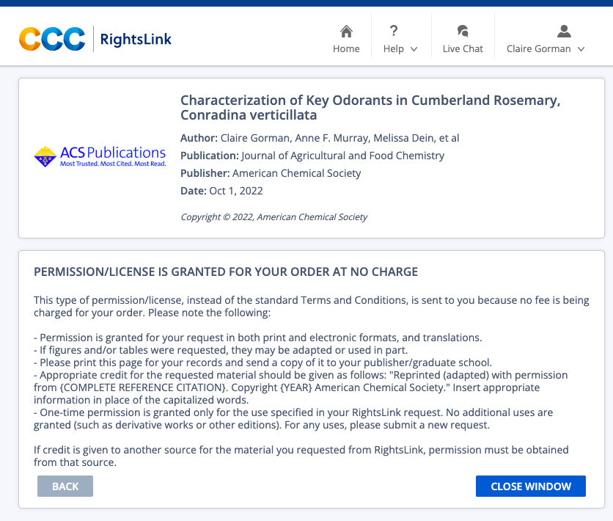

VITA
Claire was born in Knoxville, Tennessee and raised in Tullahoma, Tennessee. She attended high school at Tullahoma High School and graduated in 2017. She completed her undergraduate education at the University of Tennessee, Knoxville, and graduated with a Bachelor of Science in Food Science in May 2021. She then went on to pursue a Master of Science in Food Science with a concentration in flavor chemistry at the University of Tennessee.

