STUDYING THE TEST-VOLUME EFFECTS ON THE FATIGUE BEHAVIOR OF BULK-METALLIC GLASSES

A Thesis Presented for
the Master of Science Degree,
The University of Tennessee, Knoxville

Qingming Feng
May 2012

DEDICATION
This dissertation is dedicated to my parents, Taixiang Feng and Yincui Gao, my brother and sister-in-law, Qingyou Feng and Jingjing Cheng, my sister and brother-in-law, Meizhen Feng and Jingpang Li, for their love, encouragement, and support.

ACKNOWLEDGEMENTS
I would like to express my deep gratitude to my advisor, Dr. Peter K. Liaw, for his guidance and support throughout my graduate studies. I gratefully acknowledge Dr. Yanfei Gao, and Dr. Wei He for serving on my thesis committee. Special thanks should be given to Dr. Gongyao Wang and Mr. Douglas E. Fielden for their generous support and encouragement. Thanks to Dr. John Dunlap and Gregory Jones for helping me on the operation of SEM. I also would like to thank Mr. Andrew Chuang, Mr. Wei Wu, Ms. Lu Huang, Dr. Feng Jiang, Dr. Zhenke Teng, Mr. Xie Xie, Mr. Zhinan An, Mr. Wei Guo, Mr. Haolin Jia, Mr. Bilin Chen, Mr. Zhi Tang, Mr. Zhiqian Sun and other group members for their help in research and daily life.
The present work is supported by the National Science Foundation (NSF), the Combined Research-Curriculum Development (CRCD) Program, under EEC-9527527 and EEC-0203415, the Integrative Graduate Education and Research Training (IGERT) Program, under DGE-9987548, the international Materials Institutes (IMI) Program, under DMR-0231320, the Major Research Instrumentation (MRI) Program, under DMR-0421219, the Division of Civil, Mechanical, Manufacture, and Innovation Program, Under CMMI-0900271, and the Materials Network Program, Under DMR-0909037, with Ms. M. Poats, and Drs. C. V. Hartesveldt, D. Dutta, P. W. Jennings, L. S. Goldberg, L. Clesceri, C. Huber, C. E. Bouldin, Dr. C. V. Cooper, and Dr. A. Ardell as contact monitors.

Abstract
As a potential structural material, performance of Bulk Metallic Glasses (BMGs) under cyclic loading is critical in application. Among the mechanical properties of metallic glasses, the fatigue behavior received less attention and is not well understood. BMGs exhibit significant size effects on the mechanical behavior under monotonic loading, such as compression, tension, and bending. At the same time, different test-volume could lead to a distinct difference on the mechanical behavior of BMGs.
The fatigue behavior of Zr_{52.5}Cu_{17.9}Ni_{14.6}Al_{10.0}Ti_{5.0} (at %) BMG alloy (Vitreloy 105) with different sizes has been investigated. The results indicate a size effect for fatigue behavior. The fatigue endurance increases with the increasing specimen thickness. Shear band spacing between was measured, and the apparent fracture toughness was calculated, both of them scale with the sample thickness. We suggest that this trend can be attributed to the reduced plasticity of the large-size sample, which highly localized in shear bands. Reduced shear bands provide some benefit to the fatigue initiation process.
Four-point bending and three-point bending fatigue tests were conducted on Iron (Fe)-based bulk-metallic glasses (BMGs): Fe₄₁Co₇Cr₁₅Mo₁₄C₁₅B₆Y₂ (atomic percent, at%). The experiments were performed using an servo-hydraulic machine at a freuency of 10 Hz, with a R ratio (R = σ_{min}./σ_{max}., where σ_{min}. and σ_{max}. are the applied minimum and maximum stresses, respectively) of 0.1. The test environment is air. From the result of the fatigue test, under the four-point-bending fatigue test, the fatigue endurance limits of Fe₄₁Co₇Cr₁₅Mo₁₄C₁₅B₆Y₂ is approximately 450 MPa. However, there is a significant difference between the fatigue endurance limit of Fe₄₁Co₇Cr₁₅Mo₁₄C₁₅B₆Y₂ under three-point-bending and four-point-bending tests. Fatigue behavior exhibits test-volume effects, the fatigue endurance limit increases with decreasing test-volume. Following the completion of fatigue tests, the samples were examined by scanning-electron microscopy (SEM) to identify the fatigue and fracture mechanism. The fatigue-fracture morphology indicated that Fe₄₁Co₇Cr₁₅Mo₁₄C₁₅B₆Y₂ has a significantly brittle fracture mode.

Table of Contents
CHAPTER I 1
Literature Review 1
1.1 Introduction 1
1.2 Bulk Metallic Glasses Formation 3
1.3 Fatigue Behavior 8
1.3.1 Definitions 9
1.3.2 Fatigue Testing 10
1.3.3 Fatigue-Failure Mechanism 11
1.3.4 Factors Affecting Fatigue Behavior 13
CHAPTER II 20
Size Effects on the Fatigue behavior of Zr-based Vitreloy 105 Bulk Metallic Glass 20
2.1 Introduction 20
2.2 Experimental Procedures 21
2.3 Results 23
2.3.1 HEXRD results of the Zr_{52.5}Cu_{17.9}Ni_{14.6}Al_{10.0}Ti_{5.0} alloy 23
2.3.2 Fatigue endurance limit and fatigue life 24
2.3.3 Fracture morphology 26
2.4 Discussion 30
2.5 Conclusion 39
CHAPTER III 41
Fatigue Behavior of Fe₄₁Co₇Cr₁₅Mo₁₄C₁₅B₆Y₂ Metallic Glasses under Three-Point bend and Four-Point Bend 41
3.1 Introduction 41
3.2 Experimental Procedures 42
3.3 Results and Discussion 44
3.3.1 X-ray result of Fe₄₁Co₇Cr₁₅Mo₁₄C₁₅B₆Y₂ 44
3.3.2 Fatigue-endurance limit 45
3.3.3 Fracture morphology 47
3.3.4 Stress distribution in three-point bend and four-point bend setup 50
3.4 Conclusions 52
CHAPTER IV 55
GENERAL CONCLUSIONS AND FUTURE PERSPECTIVES 55

LIST OF TABLE
Table 2.1 Linear fitting parameters (Y = A + BX) of shear band spacing and apparent fracture toughness on the tensile surface. 33

LISTS OF FIGURES
Figure 1.1 Schematics Of (A) Crystalline, (B) Polycrystalline And (C) Amorphous Structure [1]. 2
Figure 1.2 Critical Casting Thickness For Glass Formation As A Function Of The Year The Corresponding Alloy Has Been Discovered [6]. 3
Figure 1.3 Typical Dsc Curves For Bmgs Showing The Definitions Of Characteristic Temperatures Tg, Tx And Tl Measured Upon Reheating. 4
Figure 1.4 Relation Among The Critical Cooling Rate For Glass Formation (Rc), Maximum Thickness For Glass Formation (Tmax) And Reduced Glass Transition Temperature (Tg/Tl) For Metallic Glasses [8]. 5
Figure 1.5 Relationship Between Rc, Tmax And The Temperature Interval Of The Supercooled Liquid Region Between Tg And Tx, (Δtx=Tx−Tg) For Bulk Amorphous Alloys [9]. 6
Figure 1.6 Correlation Between The Critical Cooling Rate And The Parameter Γ For Typical Metallic Glasses [12]. 7
Figure 1.7 Attainable Maximum Size Zmax As A Function Of The Γ Parameter For Bmgs[12]. 7
Figure 1.8 Typical Strengths And Elastic Limits For Various Materials. Metallic Glasses Are Unique [1]. 9
Figure 1.9 Specimen Geometry And Grips For Tension-Tension Fatigue Testing [18]. 10
Figure 1.10 Schematic Illustration Of The Fatigue-Crack Propagation In Bmgs [24]. 13
Figure 1.11 The Effect Of Frequency On The Fatigue Behavior Of （Zr55al10ni5cu30）99y1. 16
Figure 1.12 Comparison Of The Fatigue Behavior Of Bmg-11 Specimens With Various Finishes [31]. 17
Figure 2.1 Fixtures For The Four-Point-Bend Fatigue Test. 23
Figure 2.2 The Hexrd Curve For The Zr52.5cu17.9ni14.6al10.0ti5.0 Bmg Sample. 24
Figure 2.3 The Applied Maximum Stress Versus Cycles To Failure Curves For Vit-105 With Three Different Size Samples Under Four-Point-Bending Load. 25
Figure 2.4 (A) Three-Point-Bend Setup, (B) Schematic Of A Fracture Surface And (C) Crack Initiated From The Corner Of The 2.0 × 2.0 Sample, When Σmax = 750 Mpa. 27
Figure 2.5 A Fatigue Crack On The Tension Surface 28
Figure 2.6 (A) Sem Fractographs Show The Typical Fracture Surface, The Arrow Indicates The Growth Direction, (B) Transition Region From Crack Growth Region To Fast Crack Region, (C) Fast Crack Region With Vein Pattern, And (D) Melting Region With Droplets. 29
Figure 2.7 Figure 2.7 (A) Crack Initiate From Porosity, The Red Box In (A) Was Magnified In (B). Crack Initiate From Inhomogeneous Part, The Red Box In (C) Is Corresponding To (D). 30
Figure 2.8 Figure 2.8 A Proposed Fatigue Crack-Initiation Mechanism: (A) Formation Of Shear Band; (B) Formation Of Shear-Off Step; And (C) Microcrack Initiation. 31
Figure 2.9 Shear Bands Around The Crack-Growth On The Tension Surface. 32
Figure 2.10 Modeling Predictions Based On Lefm Carried Out By Wang Et Al [22]. Showing Agreement With The Current Experiment Results [Figure 2.9] 32
Figure 2.11 The Shear Band Spacing Plotted With A Function Of Sample Thickness. 35
Figure 2.12 The Apparent Fracture Toughness Plotted With A Function Of Sample Thickness. 38
Figure 3.1 Fixtures For The Four-Point-Bend And Three-Point-Bend Fatigue Test. 44
Figure 3.2 Xrd Pattern Of The As-Cast Fe41co7cr15mo14c15b6y2 Bmg. 44
Figure 3.3 The Applied Maximum Stress Versus Cycles To Failure (S-N) Curves For Both Three-Point Band And Four-Point Bend Conditions. R Ratio Was 0.1 And Frequency Was 10 Hz In Air. 45
Figure 3.4 Comparisons Of Fatigue Behavior For Different Bmgs. 47
Figure 3.5 Overall Fatigue Fracture Surface Of Fe41co7cr15mo14c15b6y2, And (E) Tensile Surface. 49
Figure 3.6 Compression Stress–Strain Curve Of Fe41co7cr15mo14c15b6y2 Amorphous Alloy. 50
Figure 3.7 Transverse Force And Moment For The Two Bending Setups. 51
Figure 3.8 Distinct Defects Are Distributed Homogenelously On The Fracture Surface And Tensile Surface, Such As The Oxide Inclusions And Porosities. 52

CHAPTER I

Literature Review

1.1 Introduction
The conventional metallic materials have been studied and used by human beings for several thousand years in extremely wide fields. They have crystalline structure with period atomic arrangement on a long range scale when the metallic liquid with temperature above melting is solidified at slow cooling rate (~ 1 K/s) Fig. 1.1(a) [1]. At the same time, some defects also are introduced, such as dislocation, grain boundary, and precipitation et al. These defects bring negative effects on the materials’ property. Because dislocations can move at low stress, they may prevent the crystalline materials from achieving theoretical strength [1]. The motion of dislocations allows slip–plastic deformation to occur Grain boundaries and precipitates, which act as local electrochemically active sites, can reduce the corrosion resistance. However, these limits were broke through when first amorphous alloy was synthesized by Duwez’s group [2]. The amorphous Au₇₅Si₂₅ alloy was prepared by rapid quenching the metallic liquid at a very high cooling rate up to 10⁶ K/s. The required extremely high cooling rate resulting amorphous alloys were usually limited to small size (0.02mm ~ 0.1mm). In the amorphous alloy, there are no dislocation and grain boundaries due to the randomly packed atoms Fig. 1.1(c). From then on, a significant amount of studies on the rapid solidification techniques, formation, structure and property have been carried out.
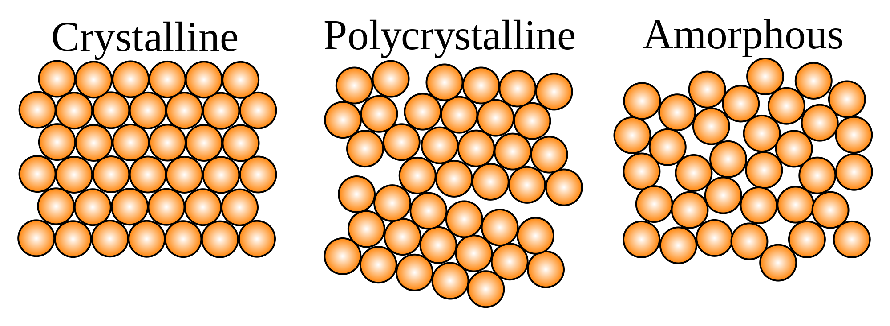
Figure 1.1 Schematics of (a) crystalline, (b) polycrystalline and (c) amorphous structure [1].
In the 1960s, amorphous alloys of Pd-Si-Au, Pd-Si-Cu and Pd-Si-Ag were developed by Chen and Turnbull [3], amorphous Pd-Si-Au alloy could be synthesized with the diameter of up to 1mm that could be considered to be a bulk metallic glass (BMG). Then, systematic studies on Pd-based alloys were performed. Amorphous alloy with diameter of up to 3mm was successfully made by quenching the melt, contained in a drawn fused quartz capillary, into water [4]. The synthesis of amorphous alloy of Pd₄₀Ni₄₀P₂₀ with diameter of up to 5mm was reported by Turnbull et al. in the early 1980s. In 1984, Turnbull group extended the critical casting thickness to 1 cm by processing the Pd-Ni-P melt in a boron oxide flux. From the late 1980s, multicomponent alloy systems with lower critical cooling rate and bigger thickness were reported by Inoue et al. In 1992, the first commercial BMG, Zr_{41.2}Cu_{12.5}NI₁₀Ti_{13.8}Be_{22.5}, known as VITRELOY 1 (Vit 1), was developed by Johnson and Peker [5]. Over last two decades, the critical casting thickness increased by more than three orders of magnitude as shown in fig. 1.2 [6]. To date, more than one thousand different BMGs were reported. The research on BMGs is growing on the basis of science and engineering interests.
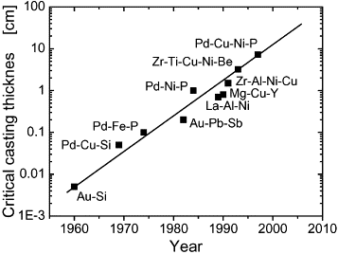
Figure 1.2 Critical casting thickness for glass formation as a function of the year the corresponding alloy has been discovered [6].

1.2 Bulk Metallic Glasses Formation
A number of BMGs have been successfully developed and commercialized for engineering application. However, one of the largest stumbling blocks for their use is still the low glass forming ability (GFA). There are two important indicators of GFA are critical cooling rate ( Rc), the minimum cooling rate required to form a glass, and critical dimension, the maximum dimension or thickness to form a glass under a certain cooling rate. Due to the Rc is difficult to measure experimentally, the simple and reliable criteria for glass formation is needed to established, and many efforts have been made.
Reduced glass-transition temperature, T_{rg} , was reported by Turnbull [7] to predict the GFA. T_{rg} = T_{g}/T_{m} or T_{rg} = T_{g}/T_{l,} where T_{g} means glass-transition temperature, T_{m} means the melting temperature, and T_{l} means liquid temperature. Typical DSC curve of BMGs is showed in Fig. 1.3.
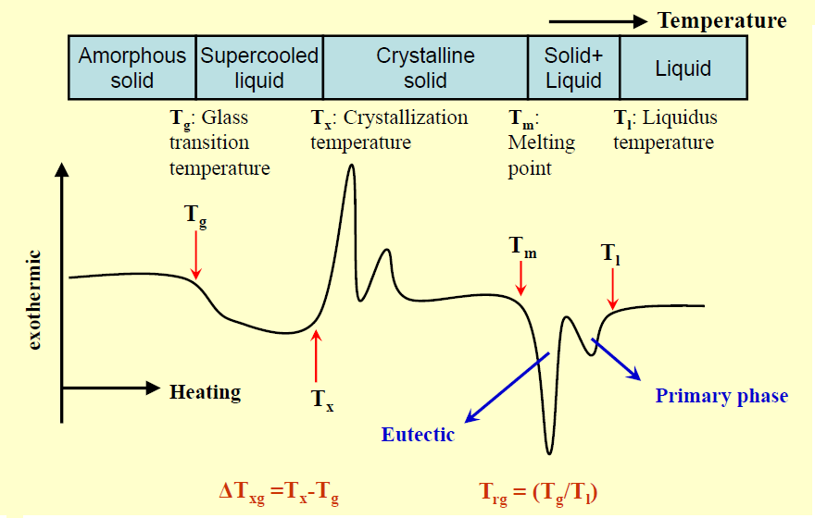
Figure 1.3 Typical DSC curves for BMGs showing the definitions of characteristic temperatures T_{g}, T_{x} and T_{l} measured upon reheating.
The T_{rg} increases with decreasing interval between T_{g} and T_{m}, the probability of being able to cool through the interval between T_{g} and T_{m} without crystallization is enhanced. This criterion shows a good correlation with GFA, as shown in Fig. 1.4 [8].
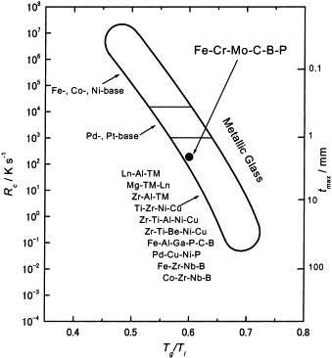
Figure 1.4 Relation among the critical cooling rate for glass formation (R_{c}), maximum thickness for glass formation (t_{max}) and reduced glass transition temperature (T_{g}/T_{l}) for metallic glasses [8].
Since the late 1980s, a new GFA indicator, i.e., the supercooled liquid region ∆T_{xg} has been proposed by Inoue, ∆T_{xg} = T_{x} -T_{g}, where T_{x} means crystallization temperature, Tg means glass-transition temperature. This parameter indicates that the larger the accessible supercooled liquid region is, the greater GFA is. Fig .1.5 shows the relationship among Rc, Tmax, and ∆T_{xg} for BMGs [9].
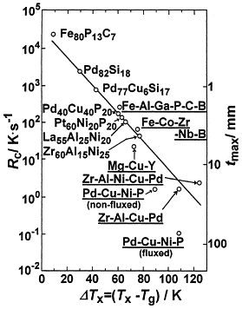
Figure 1.5 Relationship between Rc, tmax and the temperature interval of the supercooled liquid region between Tg and Tx, (ΔTx=Tx−Tg) for bulk amorphous alloys [9].
Although both T_{rg} and ∆T_{xg} were commonly used as the GFA indicators, they did show contrasting trend in many BMGs system [10]. Therefore, a better and reliable criterion is urgently needed to reflect the GFA of BMGs. Lu and Liu proposed a new indicator γ, which can be expressed as [11, 12].
$$γ∝T_{x}\left[\frac{1}{2\left(T_{g}+T_{l}\right)}\right]∝\frac{T_{x}}{T_{g}+T_{l}}$$
GFA includes two important components: liquid phase stability and resistance to crystallization. The higher $γ$is, the higher T_{x} is, and the lower $T_{g}+T_{l}$ is, higher T_{x} means higher resistance to crystallization, and lower T_{g} and T_{l} means lower stability at metastable state and equilibrium state, respectively, therefore, resulting goof GFA. The critical cooling rate, R_{c} and critical thickness t _{max} correlates $γ$ well for typical BMGs, as shown in Fig.1. 6 and Fig. 1.7 [12].
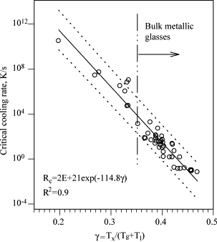
Figure 1.6 Correlation between the critical cooling rate and the parameter γ for typical metallic glasses [12].
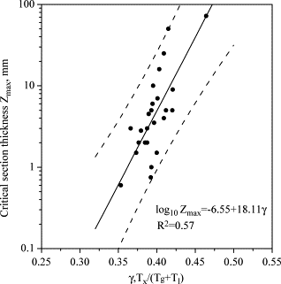
Figure 1.7 Attainable maximum size Z_{max} as a function of the γ parameter for BMGs[12].
Experimental date strongly support that $γ$is effective in predicting the GFA of various glass-forming systems. $γ$ can be treated as a tool useful for searching for high GFA alloys, however, $γ$ parameter is not applicable directly for alloy design. Developing a practical criterion related only to fundamental properties is necessary. Three empirical rules for developing amorphous alloy were proposed by Inoue and widely accepted [13]:
(1) multicomponent alloy systems consisting of more than three kinds of elements;
(2) significant atomic size mismatch above 12% among main constituent elements;and
(3) suitable negative heats of mixing among their main constituent elements.
These rules are useful for selecting alloying elements but not good for determining alloy compositions. At the same time, the effect of minor alloying addition has been investigated, which can provide benefits to destabilizing single-phase crystalline phase during cooling from liquids, due to the large atomic mismatch and low solid solubility [14-16].
Successful development of rapid solidification techniques and theory of GFA makes it is possible that the sample is larger enough for different mechanical test.

1.3 Fatigue Behavior
Due to the unique amorphous structure, BMGs exhibit excellent properties, such as high strength, large elastic limits, high toughness, low coefficient of friction, good wear and corrosion resistance, good soft magnetic, and almost perfect as-cast surfaces. They are typically much stronger and tougher than conventional crystalline metal counterparts and ceramics (see fig. 1.8).The mechanical behavior of BMGs under monotonic loading has been studied relatively more, however, the mechanical behavior under cyclic loading is still not well known. As a potential structural engineering material, the research on the performance under cyclic loading is quite important, which accounts for approximately 90% of all failures resulting from mechanical causes.
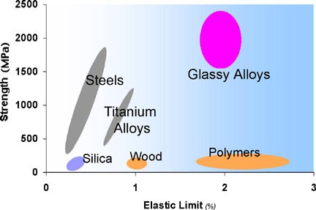
Figure 1.8 Typical strengths and elastic limits for various materials. Metallic glasses are unique [1].

1.3.1 Definitions
Fatigue is the progressive and localized structural damage that occurs when a material is subjected to repeated, cyclic, or fluctuating loading. The nominal maximum stress values are less than the ultimate tensile stress limit, and may be below the yield stress limit of the material.
Historically, most attention has focused on situations that required more than 10⁴ cycles to failure where stress is low, plastic deformation is small, and the deformation is primarily elastic, this is called High-cycle fatigue (HCF) [17]. While, in Low-cycle fatigue (LCF), the stress is high enough for plastic deformation.

1.3.2 Fatigue Testing
In general, uniaxial tension-tension, compression-compression fatigue test, four-point bending and three-point bending test are conducted on BMGs. For tension-tension fatigue test, button-head fatigue specimen with a small radial sharp notch is usually used, as shown in Fig. 1.9 [18].

Figure 1.9 Specimen geometry and grips for tension-tension fatigue testing [18].
For rectangular beams, four-point bending and three-point bending fatigue test method are usually performed. The stress can be expressed as:
$$σ=\frac{3P\left(S_{o}-S_{i}\right)}{2bh^{2}}$$
where P: the applied load
S_{i}:the inner span
S_{o}: the outer span
b: the specimen thickness
h: the specimen height
S_{i} = 0 for three-point bending
Before the fatigue test, the specimen is polished using 1200 grit paper to minimize the surface effects. The fatigue dates are usually presented as stress versus number of cycles to failure (S-N), where stress can be maximum applied stress, applied stress range or stress amplitude.

1.3.3 Fatigue-Failure Mechanism

1.3.3.1 Crack Initiation
Fatigue failure mechanisms of crystalline metals have been investigated well, slip bands (SBs)sn grain boundaries (GBs) and deformation bans (DBs) are generally the preferential sites for fatigue-crack nucleation. However, due to the amorphous structure, there are no crystal defects inside BMGs; the fatigue-failure mechanism of BMGs is totally different from that of crystalline materials. The basic mechanism is not well understood. Nevertheless, the presence of shear bands, which is a plastic flow in a small region, is considered to the main reason of the deformation of BMGs [19-21]. For the BMGs with distinct defects, the crack could initiate around these defects due to the raised stress concentration.
According to the free-volume theory, there are large amount of free volumes inside BMGs. Small shear band will form at some local sites due to the movement of free volumes under the work of resolved normal and shear stress under the cyclic loading. The viscosity of shear bands decreases with the increasing free-volume during fatigue test. With the continued cyclic loading, the gradual weakening, dilation, tearing, and the final opening of the shear band will result in the formation of fatigue microcrack. Therefore, the nucleation of fatigue-crack can be attributed to the weakness of the shear bands. For rectangular beams, the corner is the preferential site of fatigue-crack nucleation due to the bigger stress concentration. And for bending condition, because of the tensile strength is lower than compression strength, the fatigue-crack could initiate from the corner in the tensile surface. It is important to future study and theoretically models the fatigue mechanisms in BMGs.

1.3.3.2 Crack Propagation
Under tension-tension and bending fatigue test, the fracture surface is basically perpendicular to the loading direction. Crack growth can be caused by cyclic loading, which called fatigue-crack growth. According to the observation of the fracture surface via SEM, the fatigue-crack growth region usually demonstrates the distinct striations [22]. A high-magnification picture from the crack-propagation region suggests that each striation is associated with the growth of the crack during some loading cycles. One possible mechanism is proposed by Wang et al [23]. to explain the fatigue-crack-propagation behavior, they indicated that when a fatigue-crack initiates in BMGs, fatigue crack will propagate in a direction perpendicular to the tension-stress direction. A plastic zone produces ahead of the crack tip, which contains many shear bands, as schematically shown in Fig. 10.The fatigue-crack growth prefers the shear bands at the crack tip since these shear bands become weaker than the bulk. In general, the crack may propagate for several cycles along one shear band, then, change to another shear band. Thus, a coarse striation forms, as indicated in Fig. 1.10. The Fatigue life of BMGs can be accounted for by considering only the growth of fatigue cracks [24]. Therefore, understanding the mechanisms and behavior of fatigue-crack propagation is very important.
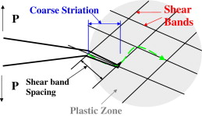
Figure 1.10 Schematic illustration of the fatigue-crack propagation in BMGs [24].

1.3.4 Factors Affecting Fatigue Behavior
Fatigue behavior of BMGs was not investigated extensively, and the fatigue-fracture mechanism is not well understood. Meanwhile, the limited research on the fatigue behavior indicates that BMGs exhibit wide range of fatigue lives and limits (8% ~ 50% of the ultimate tensile strength) [19]. The difference in results can be attributed to the difference in test parameters, as we discuss below.

1.3.4.1 Effect of Preparation condition
Specimen fabricated by injection casting method exhibit a wide range of compressive strengths range (1 Gpa ~ 4 GPa). Meanwhile, samples from suction casting technique shows a narrow compressive strength range (4.0 GPa ~ 4.4 GPa) [25]. This situation can be attributed to the reduced sample defects in the form of porosity and internal cracks, which can be act as the nucleation site of fatigue site. Thus, the higher fatigue endurance limit of the specimen prepared through suction casting technique can be expected.

1.3.4.2 Effect of Composition
Chemical composition is an important factor that affects the fatigue performance. For example, the addition of B, C, and Mo leads to an improvement of microhardness and strength, which may provide some benefits to the fatigue-crack initiation [26]. The addition of Ni enhances the formation of oxidization film on the fatigue-fracture surface, which may retard the fatigue-crack propagation [27]. In addition, the different composition can result in different free-volume duo to the different atomic size. Yokoyama et al [28] indicates that there is a good linear relationship between the fatigue limits of Zr-Cu-Al-Pd BMGs and the volume change, which is probably corresponding to the excessive free-volume. Therefore, the improvement on the fatigue endurance limit can be achieved through changing chemical composition.

1.3.4.3 Effect of Temperature
The performance of engineering materials is temperature dependent. For metals, the increasing temperature may result in the reduction on the tensile strength, yield strength, and elasticity modulus. This phenomenon is associated with changes in the atomic diffusion, grain growth, and softening. Deibler et al. [29]29] indicated that mechanical behavior of Mg₈₅Ca₅Cu₁₀ is dependent on temperature, the viscosity and fracture surface features reveal that as viscosity in the glass increases, fracture surface features decrease in size. Research related to the effect of temperature on the fatigue behavior is limited, more studies are required to understand the effect of the temperature on the fatigue performance.

1.3.4.4 Effect of Frequency
The comparison of fatigue behavior of（Zr₅₅Al₁₀Ni₅Cu₃₀）99Y₁ at different test frequency was carried out by the author. It indicates that test frequency has a significant effect on the fatigue performance of BMGs, as shown in Fig. 1.11. The specimen exhibits lower fatigue endurance limit and short fatigue life when it subject to higher test frequency. In general, the time for residual gas to adsorb on the exposed fatigue-crack surface increase with decreasing test frequency, this trend can lead to a reduction of the fatigue life. The high frequency (1000Hz) fatigue of Co-26Cr-9Ni (wt. %) alloy was carried out by [30]. They indicated that the temperature increase during fatigue test, and equilibrium temperature at 1000Hz was considerably higher than that for 20 Hz. Future research is required to understand the dominant factor which affects the fatigue performance, the heat introduce during fatigue test or the time to for residual gas adsorb on the exposed fracture-crack surface.
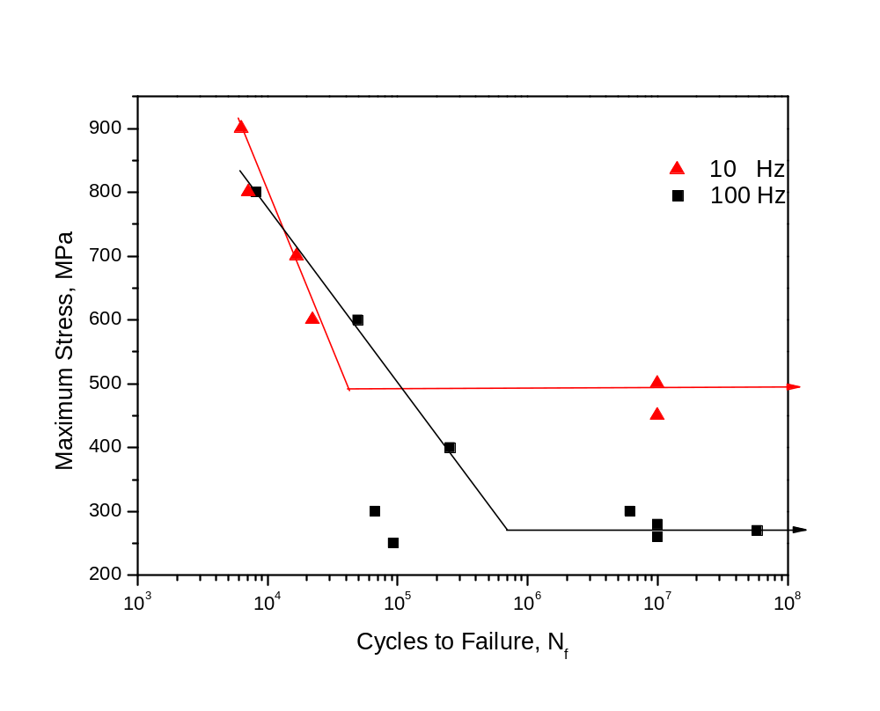
Figure 1.11 The effect of frequency on the fatigue behavior of （Zr₅₅Al₁₀Ni₅Cu₃₀）₉₉Y₁.

1.3.4.5 Effect of Surface Finish
In general, fatigue crack mostly like to initiate from corner of the specimen during the fatigue test due to the stress concentration, as the same time, the distinct defects also can act as the site of crack nucleation, such as the porosities, impurity inclusion and obvious surface scratch due to the raised stress concentration. So the surface condition is important for fatigue-crack nucleation. Peter et al. reported BMGs seem to be highly sensitive to the surface finish with regard to fatigue endurance limit [31], as shown in Fig. 12. The fatigue endurance limit decreases with the increasing average surface roughness. The fatigue endurance limit decreases from ~900 MPa to 400 MPa when the average surface roughness increased from 0.16 μm (1,200 grit) to 0.67 μm (180 grit).
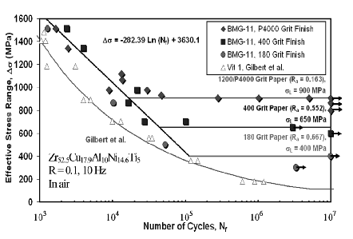
Figure 1.12 Comparison of the fatigue behavior of BMG-11 specimens with various finishes [31].
References
1. http://en.wikipedia.org/wiki/Crystal.
2. Klement, W., R.H. Willens, and P. Duwez, Non-Crystalline Structure in Solidified Gold-Silicon Alloys. Nature, 1960. 187(4740): p. 869-870.
3. Chen, H.S. and D. Turnbull, Formation, Stability and Structure of Palladium-Silicon Based Alloy Glasses. Acta Metallurgica, 1969. 17(8): p. 1021-&.
4. Chen, H.S., Thermodynamic Considerations on Formation and Stability of Metallic Glasses. Acta Metallurgica, 1974. 22(12): p. 1505-1511.
5. Peker, A. and W.L. Johnson, A Highly Processable Metallic-Glass - Zr41.2ti13.8cu12.5ni10.0be22.5. Applied Physics Letters, 1993. 63(17): p. 2342-2344.
6. Loffler, J.F., Bulk metallic glasses (vol 11, pg 529, 2003). Intermetallics, 2003. 11(10): p. 979-979.
7. Turnbull, D., Metastable Structures in Metallurgy. Metallurgical Transactions B-Process Metallurgy, 1981. 12(2): p. 217-230.
8. Pang, S.J., et al., Synthesis of Fe-Cr-Mo-C-B-P bulk metallic glasses with high corrosion resistance. Acta Materialia, 2002. 50(3): p. 489-497.
9. Inoue, A., Stabilization of metallic supercooled liquid and bulk amorphous alloys. Acta Materialia, 2000. 48(1): p. 279-306.
10. Waniuk, T.A., J. Schroers, and W.L. Johnson, Critical cooling rate and thermal stability of Zr-Ti-Cu-Ni-Be alloys. Applied Physics Letters, 2001. 78(9): p. 1213-1215.
11. Lu, Z.P. and C.T. Liu, A new glass-forming ability criterion for bulk metallic glasses. Acta Materialia, 2002. 50(13): p. 3501-3512.
12. Lu, Z.P. and C.T. Liu, A new approach to understanding and measuring glass formation in bulk amorphous materials. Intermetallics, 2004. 12(10-11): p. 1035-1043.
13. Inoue, A., HIGH-STRENGTH BULK AMORPHOUS-ALLOYS WITH LOW CRITICAL COOLING RATES. Materials Transactions Jim, 1995. 36(7): p. 866-875.
14. Chang, H.W., et al., Glass formability and soft magnetic properties of bulk Y-Fe-B-Ti metals. Journal of Alloys and Compounds, 2008. 462(1-2): p. 68-72.
15. Chang, H.W., et al., Soft magnetic properties and glass formability of Y-Fe-B-M bulk metals (M=Al, Hf, Nb, Ta, and Ti). Journal of Alloys and Compounds, 2009. 472(1-2): p. 166-170.
16. Guo, S.F., L. Liu, and X. Lin, Formation of magnetic Fe-based bulk metallic glass under low vacuum. Journal of Alloys and Compounds, 2009. 478(1-2): p. 226-228.
17. Bolotin, V.V., mechanics of Fatigue. 1996, New York: CRC.
18. Peter, W.H., et al., Fatigue behavior of Zr52.5Al10Ti5Cu17.9Ni14.6 bulk metallic glass. Intermetallics, 2002. 10(11-12): p. 1125-1129.
19. Wang, G.Y., et al., Fatigue behavior of bulk-metallic glasses. Intermetallics, 2004. 12(7-9): p. 885-892.
20. Wang, G.Y., et al., Influence of air and vacuum environment on fatigue behavior of Zr-based bulk metallic glasses. Journal of Alloys and Compounds, 2007. 434: p. 68-70.
21. Yang, B., et al., Dynamic evolution of nanoscale shear bands in a bulk-metallic glass. Applied Physics Letters, 2005. 86(14).
22. Wang, G.Y., et al., Fatigue behavior of Zr-based bulk-metallic glasses. Materials Science and Engineering a-Structural Materials Properties Microstructure and Processing, 2008. 494(1-2): p. 314-323.
23. G. Y. Wang, P.K.L., Y. Yokoyama, Inoue. A, Evolution of shear bands and fatigue striations in bulk metallic glass during fatigue. Intermetallics, 2012. 23: p. 96.
24. Schuh, C.A., T.C. Hufnagel, and U. Ramamurty, Overview No.144 - Mechanical behavior of amorphous alloys. Acta Materialia, 2007. 55(12): p. 4067-4109.
25. Qiao, D.C., et al., Fatigue behavior of an Fe48Cr15Mo14Er2C15B6 amorphous steel. Journal of Materials Research, 2007. 22(2): p. 544-550.
26. Zhang, Z.F., J. Eckert, and L. Schultz, Tensile and fatigue fracture mechanisms of a Zr-based bulk metallic glass. Journal of Materials Research, 2003. 18(2): p. 456-465.
27. Yokoyama, Y., K. Fukaura, and A. Inoue, Effect of Ni addition on fatigue properties of bulk glassy Zr50Cu40Al10 alloys. Materials Transactions, 2004. 45(5): p. 1672-1678.
28. Yokoyama, Y., et al., Fatigue-strength enhancement of cast Zr50Cu40Al10 glassy alloys. Materials Transactions, 2006. 47(5): p. 1286-1293.
29. Deibler, L.A. and J.J. Lewandowski, Effects of changes in strain rate and test temperature on Mg(85)Ca(5)Cu(10) metallic glass ribbons. Materials Science and Engineering a-Structural Materials Properties Microstructure and Processing, 2010. 527(9): p. 2214-2221.
30. Jiang, L., et al., High-frequency metal fatigue: the high-cycle fatigue behavior of ULTIMET (R) alloy. Materials Science and Engineering a-Structural Materials Properties Microstructure and Processing, 2001. 314(1-2): p. 162-175.
31. Peter, W.H., Fatigue Behavior of A Zirconium-Based Bulk Metallics Glass. 2005.

CHAPTER II

Size Effects on the Fatigue behavior of Zr-based Vitreloy 105 Bulk Metallic Glass

2.1 Introduction
Bulk-Metallic glasses (BMGs) have been continually investigated during the past decades as new emerging engineering material with many desirable and unique properties including high strength, good hardness, good wear resistance, and high corrosion resistance that can be produced in near net shape components[1-4]. However, applications of BMGs are limited by the brittleness due to amorphous structure. They lack ductility, particularly under uniaxial tension or compression. Recent years, experiments have shown that testing sample sizes and aspect ratios (AR) have significant effect on the mechanical behavior of Zr-, Ti-, and Co-based BMGs and their composites [5-8]. Samples exhibited a ductile deformation behavior with small AR, while samples with AR in excess of 1.5:1 cannot. Similarly, thin films, wires or ribbons of metallic glasses show large plasticity while thicker plates fail catastrophically under bending. Katuya et al. [9] and Inoue et al. [10, 11] found that metallic glasses exhibited significant bend ductility only if the sample dimension is below a critical value, suggesting a size effect for bend ductility. Metallic glasses are significantly different from crystalline materials it has been recognized that the mechanism of inelastic deformation in metallic glasses is through the formation of shear bands, plastic deformation is accommodated through the generation of multiple shear bands [12-14]. Since they lack grain boundaries and any repeating periodic arrangement, crystal characteristics (e.g., dislocations and grain boundaries) are not present in metallic glasses.
As a potential structural material, performance under cyclic loading is critical in application. Among the mechanical properties of metallic glasses, the fatigue behavior received less attention and is not well understood. Complicating the situation are discrepancies in the result from the limited various research on the fatigue behavior, which may be due to differences in specimen geometry and preparation [3]. Conner et al. [15] carried out a series of experiments in which the effect of sample size on both the shear band spacing and the bend ductility of amorphous plates, ribbons, and wires was investigated. They argue that the shear displacements in the shear band scale with the shear band length and plate thickness, which causes cracks to be initiated in thicker plates at smaller bending strain. This lead to fracture bending strains decrease markedly with increasing plate thickness. However the effect of sample size on the fatigue behavior under cyclic bending load was not studied until relatively recently.
In the section, we study the effect of samples size on the fatigue behavior of Zr_{52.5}Cu_{17.9}Ni_{14.6}Al_{10.0}Ti_{5.0} (atomic percent, at %) BMG alloy (Vitreloy 105) under four-point-bending fatigue tests. The applied stress versus fatigue-cycle-life (S versus N) curve is presented. A mechanistic understanding of fatigue and fracture mechanisms of different size is investigated.

2.2 Experimental Procedures
Zr-based BMG alloy ingots with a nominal composition of Zr_{52.5}Cu_{17.9}Ni_{14.6}Al_{10.0}Ti_{5.0} (at %), commonly known as Vitreloy 105 (Vit 105), were prepared from a mixture of these elements with elemental purities ranging from 99.5% to 99.99%. Are-melt suck-casting technique was employed to fabricate the alloys. Each alloy button was melted and flipped multiple times to promote homogeneity in a Ti-gettered argon atmosphere. The alloy button was then suck-cast into a water-cooled to produce a rectangular beam with the geometry of 3 × 3 × 50mm. Then an electric discharge machining (EDM) method was employed to cut these ingots into 2 × 2 × 25mm and 1 × 1 × 25mm for fatigue test. Each side of the samples was polished to a 1200 SiC grit using a polishing fixture (South Bay Technologies, San Clemente, CA) to ensure the sides were parallel and perpendicular.
The four-point-bend tests were used to study the fatigue behavior. The geometry of the fixture is shown in Fig. 2.1. The distances of the inner and outer pins are 5 mm and 15 mm, respectively. A computer-controlled INSTRON E1000 electrodynamic test instrument was used for fatigue experiments at room temperature. The specimens were tested at various stress ranges with an R ratio (R = σ_{min}./σ_{max}., where σ_{min}. and σ_{max}. are the applied minimum and maximum stresses, respectively) of 0.1, under a load controlled mode, using a sinusoidal waveform at a frequency of 10 Hz [16]. Testing was conducted until the sample failed or until the pre-defined runout of 1 × 10⁷ cycles was attained. To obtain the stress versus fatigue cycle curve, the following equation was used to convert the load into the stress.

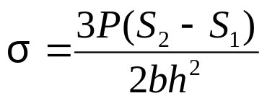 , (1)
P: the applied load
S₁:the inner span
S₂: the outer span
b: the specimen thickness
h: the specimen height
Upon failure, specimens were removed to observe the fracture surfaces using a Leo (LEO Electron Microscopy Ltd., Oberkochen, Germany) 1526 scanning-electron microscopy (SEM) to identify fracture mechanisms. The high-energy x-ray diffraction (HEXRD) measurements were performed to check the amorphous structure of the samples.

Figure 2.1 Fixtures for the four-point-bend fatigue test.

2.3 Results

2.3.1 HEXRD results of the Zr_{52.5}Cu_{17.9}Ni_{14.6}Al_{10.0}Ti_{5.0} alloy
The HEXRD was employed to confirm the amorphous structure of samples before the fatigue test. The HEXRD pattern mainly consists of a broad peak (Fig. 2.2). There are no peaks of any crystalline phases were found, indicating that the present alloy is fully amorphous structure.
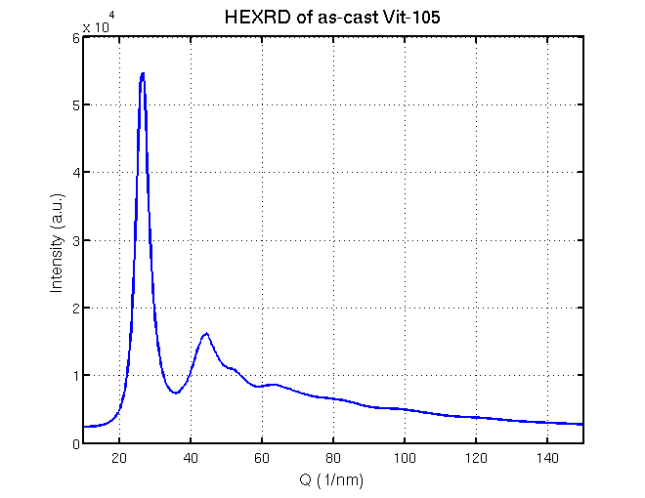
Figure 2.2 The HEXRD curve for the Zr_{52.5}Cu_{17.9}Ni_{14.6}Al_{10.0}Ti_{5.0} BMG sample.

2.3.2 Fatigue endurance limit and fatigue life
The four-point bend fatigue results of Vit-105 at different size are showed in Fig. 3. According to the results, larger samples exhibits higher fatigue endurance limit. The fatigue-endurance limit of 2.0 × 2.0 mm, in terms of the maximum stress, was determined to be approximately 700 MPa, while the fatigue endurance limit of 1.0×1.0 mm samples is approximately 600 Mpa. The fatigue results of 3.5×3.5 mm Vit-105 samples under four-point bending were investigated by [17], the samples were tested in air, with R = 0.1 and a frequency of 10 Hz, the four-point-bend fixture was designed wtith inner (S_{i}) and outer (S_{o}) spans of 5 mm and 20 mm, respectively. The 3.5 × 3.5 mm samples exhibits higher fatigue endurance limit of approximately 940 Mpa. At a given stress level, the fatigue life of small samples is shorter than that of larger samples, although the fatigue results of small samples are significantly scattering. The relation between σ_{max} and N_{f} can be described by regression analysis which only the date points above the endurance limits are included:
σ_{max} ＝ －61.7 log(N_{f}) + 1186.6, for 3.5×3.5 mm samples (2)
σ_{max} ＝ －152.1 log(N_{f}) + 1436.5, for 2.0×2.0 mm samples (3)
σ_{max} ＝ －164.5 log(N_{f}) + 1441.0, for 3.5×3.5 mm samples (4)
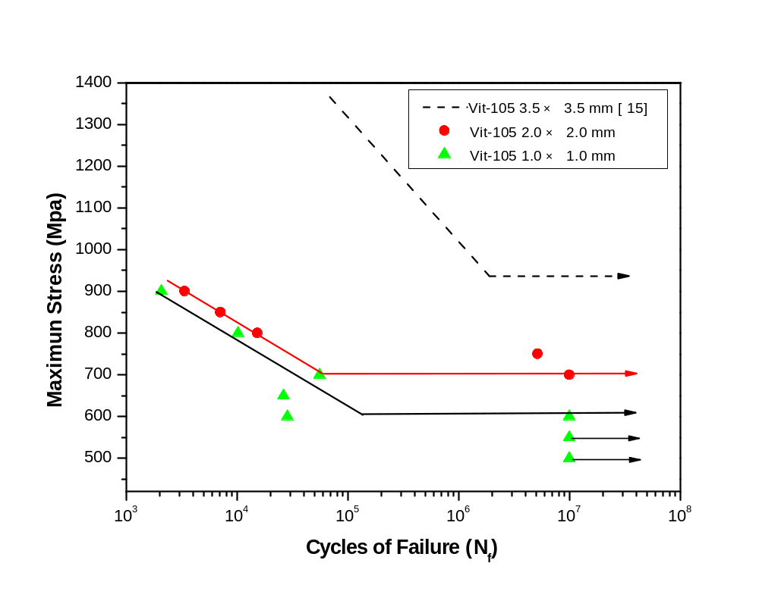
Figure 2.3 The applied maximum stress versus cycles to failure curves for Vit-105 with three different size samples under four-point-bending load.

2.3.3 Fracture morphology
Wang et al. [18]found that there are two types of failure modes under four-point-bending loading for small size BMGs during the fatigue test, flexural and fracture failure. In the current experiment, only the fracture failure mode was found, all the samples were broke to two pieces along the primary fatigue cracks.

During the four-point-bending fatigue test, the bottom surface experienced elongation, while the top surface experienced compression. Most of the samples appeared to failure due to the fracture initiated on the corner of the sample on the bottom side indicated in Fig. 4. Based on the observation of the fracture surface, the fracture mechanism is discussed in the later part. At the onset of the crack, the primary shear band exhibits an angle of approximately 45°with respect to the applied load direction Fig. 2.5. This phenomenon reveals that the shear band first formed due to the stress concentration on the corner of the sample. For the majority of the samples, the shear band zone can be observed on the bottom surface close to the fracture surface, while the observations of top surface which experienced compressive load did not reveal the formation of any shear bands.

Figure 2.4 (a) Three-point-bend setup, (b) schematic of a fracture surface and (c) crack initiated from the corner of the 2.0 × 2.0 sample, when σmax = 750 Mpa.

Figure 2.5 A fatigue crack on the tension surface.
In general, the fracture surface is perpendicular to loading direction. Post-test SEM fractography demonstrated that the whole fracture surface consisted of four main regions regardless of sample size Fig. 2.6(a): the crack initiation site, relatively flat crack growth region with striation Fig. 2.6(b), a fast fracture region with vein pattern which occupy more than half fracture area Fig. 2.6(c), melting region in which droplets appear Fig. 2.6(d), this feature is typically observed in BMGs. It can be found that the crack initiated in the tension side of sample, this is because the stress is symmetrical along the neutral axis of the specimen under four-point-bending fatigue test. Moreover the tensile strength is lower than compression strength. Meanwhile, because of the more stress concentration in the corner, the crack initiate from the corner of tension surface. After the crack was formed, under the cyclic loading, the striation can be observed due to the blunting and re-sharpening of crack tip along with the propagation of crack. When the growth region overall a critical value, the specimen failed, final fracture event occurs with several ms. The released elastic energy result in a significant increase of specimen temperature, which melt the sample, so the droplets can be observed [16, 19].
In several tests, the interior initiation sites were observed in Fig. 2.7. Obvious defects such as the porosity, oxidation, crystallization and inhomogeneity can act as the initiation site of the crack due to the weakness.

(a) (b)
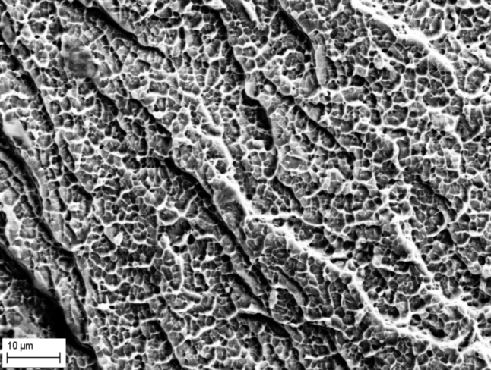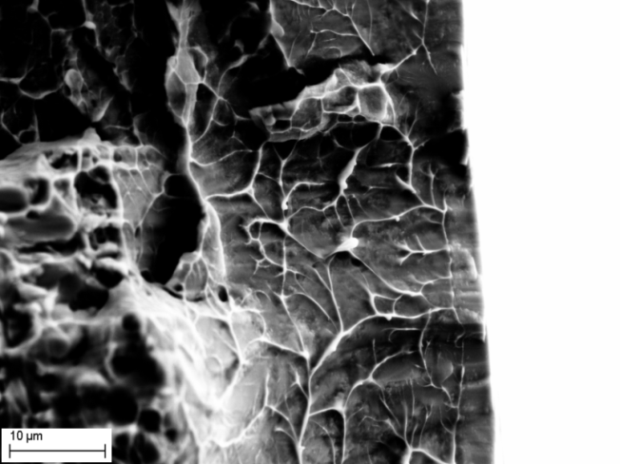
(c) (d)
Figure 2.6 (a) SEM fractographs show the typical fracture surface, the arrow indicates the growth direction, (b) transition region from crack growth region to fast crack region, (c) fast crack region with vein pattern, and (d) melting region with droplets.
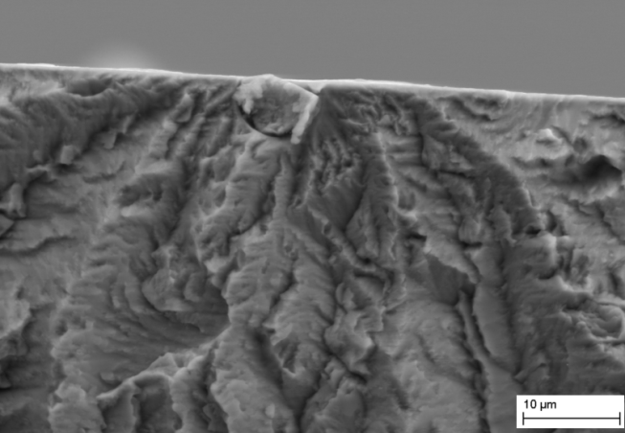
(a) (b)
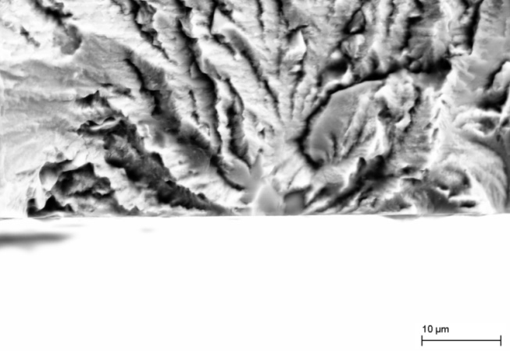
(c) (d)
Figure 2.7 (a) Crack initiate from porosity, the red box in (a) was magnified in (b). crack initiate from inhomogeneous part, the red box in (c) is corresponding to (d).

2.4 Discussion
Fatigue fracture mechanisms of crystalline materials have been widely studied and well understood. In general, slip bands, grain boundaries, and deformation bands are thought to the preferential sites for the nucleation of fatigue cracks. However, due to the amorphous structure, the mechanisms of fatigue fracture in BMGs are still not well known. The widely accepted point is that the deformation mechanism of BMGs is attributed to the presence of shear bands, which are tiny plastic flows in small area, plastic deformation in metallic glasses is highly localized in shear bands [20, 21]. A fatigue crack mechanism based on the shear bands is proposed as Fig. 2.8 shows [16]. It is suggested that during cyclic loading, some shear bands produced on the outer surface of the amorphous structure. With further cyclic deformation, some of the shear bands result in the formation of shear-off steps [Fig. 2.8(b)]. The nucleation of fatigue cracks could be associated with the shear-off steps due to the weakness of the shear bands and shear-off steps.

Figure 2.8 A proposed fatigue crack-initiation mechanism: (a) formation of shear band; (b) formation of shear-off step; and (c) microcrack initiation.
The fatigue cracks propagate along one shear bands in the crack path, then change to another shear band after several cycles Fig. 2.9. The experiment and simulation based on LEFM about fatigue initiation and propagation in BMGs were carried out by Wang et al. [22] fig. 2.10. It shows agreement with the current experiment.

Figure 2.9 Shear bands around the crack-growth on the tension surface.

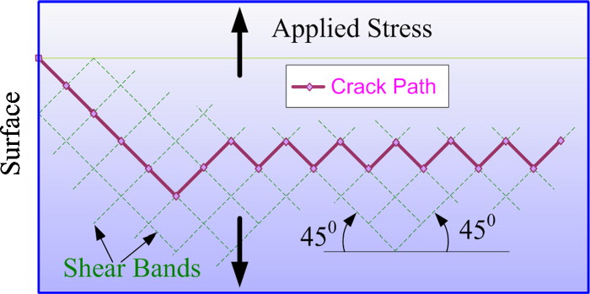
Figure 2.10 Modeling predictions based on LEFM carried out by Wang et al [22]. Showing agreement with the current experiment results [Figure 2.9].
The primary and secondary shear bands distribute very regularly around the fatigue-crack-propagation region and the shear band spacing were measure carefully in different size samples. Both primary and secondary shear band spacing increases significantly with the increasing sample thickness (Fig. 2.11). Here the average shear band spacing is measured via SEM. The date of primary and secondary shear band spacing is fitted by a linear relationship, respectively. The fitted results are listed in Table I.
Table 1 2.1 Linear fitting parameters (Y = A + BX) of shear band spacing and apparent fracture toughness on the tensile surface.
 | A | B | R²
Primary Shear Band Spacing | -52.75633 | 42.77587 | 0.926
Secondary Shear Band Spacing | -86.13917 | 94.48875 | 0.98394
Apparent Fracture Toughness | 6.89589 | 5.2311 | 0.92846

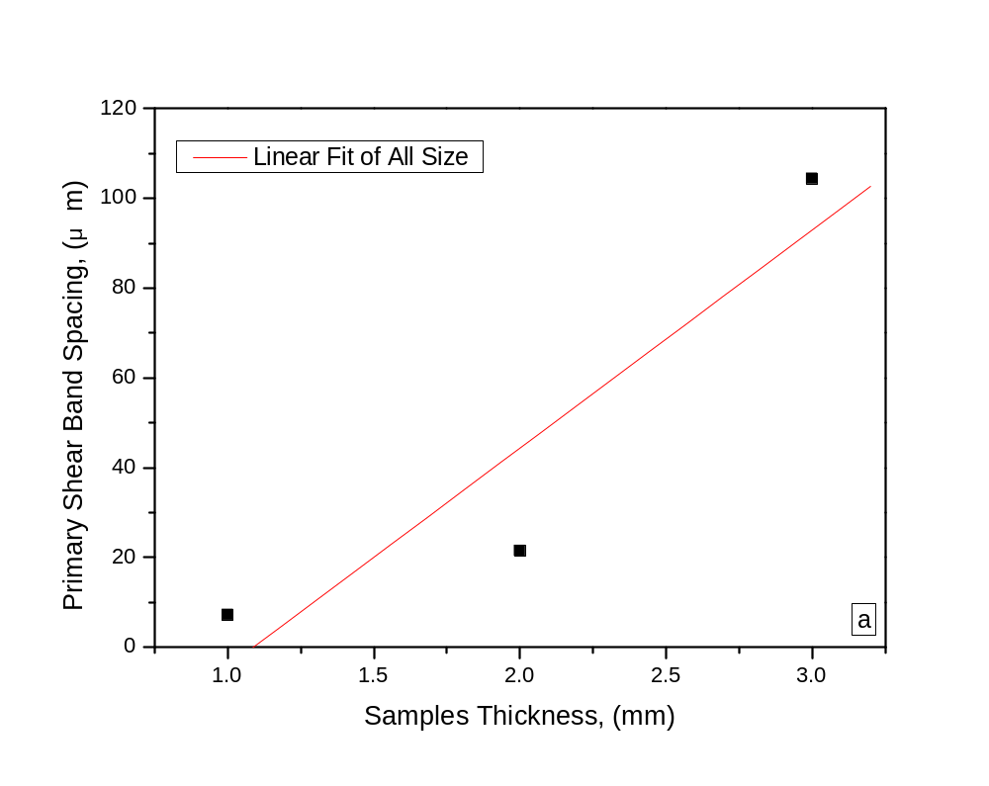

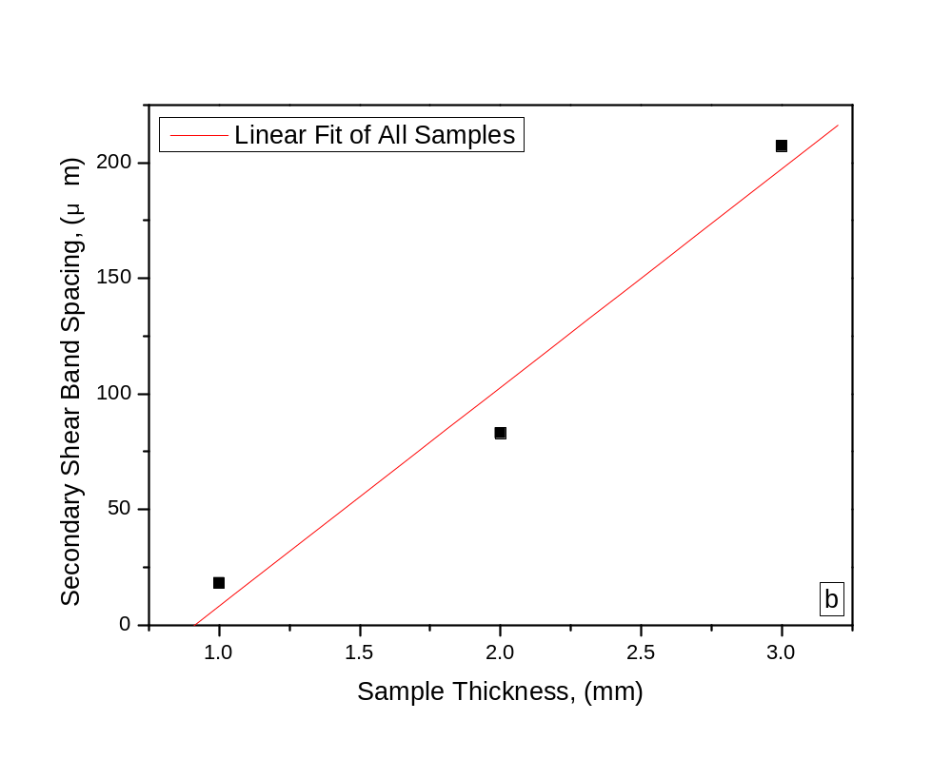
Figure 2.11 The shear band spacing plotted with a function of sample thickness.
Referring to the development of shear band spacing in metallic glasses under bending by Conner et al. [15], the shear band spacing in bending is expected to scale with thickness of sample for symmetric bending:
$λ=\frac{1-2ν}{1-ν}{(1-\frac{k_{y}}{k})}^{2}h$, (5)
Where 𝜆 is the shear band spacing, 𝜈 is Poisson’s ratio, the curvature k =1/R_{n}, the bend radius at neutral axis, k_{y} is the curvature at the yield surface, and h is the distance from the neutral axis or centroid of the sample.
It is demonstrated that bend ductility increases significantly with decreasing thickness [15]. Metallic glasses subjected to bending exhibit plastic deformation behavior due to the accumulation of multiple shear bands. During bending fatigue experiments, small size samples possess higher ductility; they are easier to form shears bands and gradually degrade when the shear bands form. When the maximum stress reaches the fatigue-endurance limit, shear bands transform to cracks and ultimately lead to fracture. While larger sample is harder to form shear bands due to the decreased ductility. Reduced shear bands may provide some benefit to the fatigue initiation process. The stress required for crack nucleation and extension in larger sample is higher, so the fatigue-endurance limit is higher, as observed in the current experiments.
The apparent fracture toughness in tensile surface for different sample mentioned above was estimated by Newman’s stress intensity factor equation for a corner crack [23]:
K = H_{c}S_{b}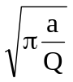F_{c}(,,,φ) (A1)
Q = 1 + 1.464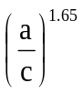 (A2)
F_{c} = 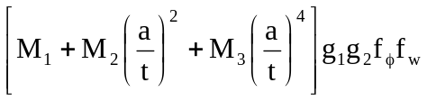 (A3)
M₁ = 1.08 - 0.03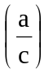 (A4)
M₂ = -0.44 + 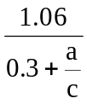 (A5)
M₃ = -0.5 + 0.25 + 14.8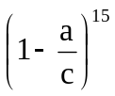 (A6)
g₁ = 1 + 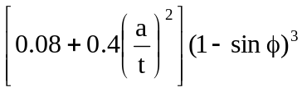 (A7)
g₂ = 1 + 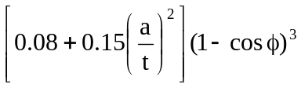 (A8)
f_{φ} = 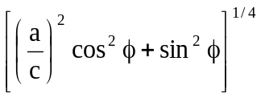 (A9)
f_{w} = 1 - 0.2λ + 9.4λ² - 19.4λ³ + 27.1λ⁴ (A10)
λ = 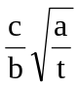 (A11)
H_{c} = H₁ + (H₂ - H₁) sin^{p}φ (A12)
p = 0.2 + 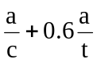 (A13)
H₁ = 1 - 0.34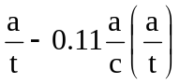 (A14)
H₂ = 1 + G₂₁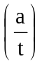 + G₂₂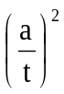 (A15)
G₂₁ = -1.22 - 0.12 (A16)
G₂₂ = 0.64 - 1.05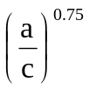+ 0.47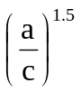 (A17)
where
S_{b} is the bending stress, 3M/bt².
a is the crack depth.
b is the specimen width.
c is the crack length.
M is the applied bending moment.
t is the specimen thickness.
φ is the parametric angle of an ellipse, deg.
The estimated apparent fracture toughness, K_{IC}, for samples with t = 0.91 mm, t = 2.09 mm, and t = 3.05 mm is 12.718 MPa∙m^{1/2}, 15.194 MPa∙m^{1/2}, and 23.953 MPa∙m^{1/2}, respectively, as shown in fig. 2.12. The date of apparent fracture toughness is fitted by a linear relationship; the fitted results are listed in Table I. Apparent fracture toughness increases significantly with increasing sample thickness. Fracture toughness is a property which describes the ability of a material containing a crack to resist fracture. In current experiments, the larger sample shows higher fracture toughness. Fatigue life time mainly includes crack nucleation and growth of fatigue crack. At a given stress, the nucleation of crack for smaller sample is more easier and takes shorter time, meanwhile, due to the lower apparent fracture toughness, crack propagates in higher rate. So at a given stress, the larger sample has longer fatigue life.

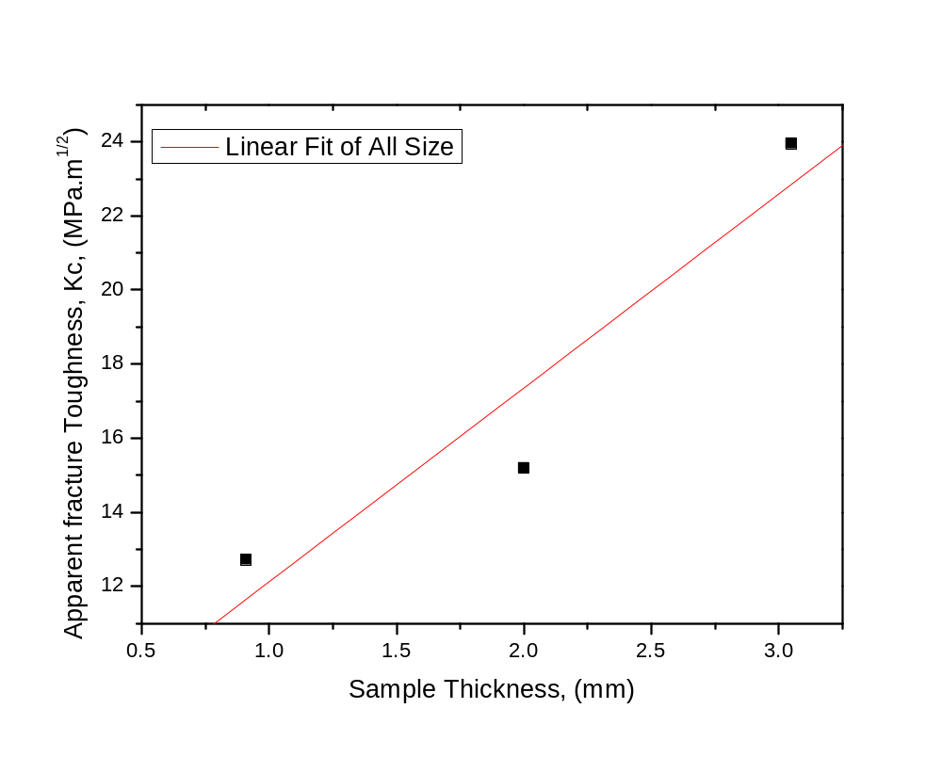
Figure 2.12 The apparent fracture toughness plotted with a function of sample thickness.

2.5 Conclusion
A direct comparison of fatigue behavior of Zr_{52.5}Cu_{17.9}Ni_{14.6}Al_{10.0}Ti_{5.0} (at %) at different size was conducted using materials that were fabricated and tested in same procedure and condition. It is found that BMGs exhibit size effect on fatigue behavior. The small-size sample shows lower fatigue endurance limit, at a given stress, the fatigue life is shorter than that of large-size sample. This trend can be attributed to the reduced plasticity of the large-size sample, which highly localized in shear bands. Reduced shear bands provide some benefit to the fatigue initiation process. Due to improved plasticity of the small-size sample, the easily formed shear bands gradually degrade its strength. In addition, the primary, secondary shear band spacing and apparent fracture toughness scale with the thickness of sample.
References
1. Miller, M.K, Liaw, P.K.ed. Bulk Metallic Glasses. 2007, Springer: New York.
2. Inoue, A. and A. Takeuchi, Recent development and application products of bulk glassy alloys. Acta Materialia, 2011. 59(6): p. 2243-2267.
3. Schuh, C.A., T.C. Hufnagel, and U. Ramamurty, Overview No.144 - Mechanical behavior of amorphous alloys. Acta Materialia, 2007. 55(12): p. 4067-4109.
4. Inoue, A., T. Zhang, and T. Masumoto, Production of Amorphous Cylinder and Sheet of La55al25ni20 Alloy by a Metallic Mold Casting Method. Materials Transactions Jim, 1990. 31(5): p. 425-428.
5. Bruck, H.A., et al., Quasi-Static Constitutive Behavior of Zr41.25ti13.75ni10cu12.5be22.5 Bulk Amorphous-Alloys. Scripta Metallurgica Et Materialia, 1994. 30(4): p. 429-434.
6. Zhang, Z.F., et al., Effect of aspect ratio on the compressive deformation and fracture behaviour of Zr-based bulk metallic glass. Philosophical Magazine Letters, 2005. 85(10): p. 513-521.
7. Bei, H., S. Xie, and E.P. George, Softening caused by profuse shear banding in a bulk metallic glass. Physical Review Letters, 2006. 96(10).
8. Wu, F.F., Z.F. Zhang, and S.X. Mao, Compressive properties of bulk metallic glass with small aspect ratio. Journal of Materials Research, 2007. 22(2): p. 501-507.
9. Yokoyama, Y., et al., Enhancement of ductility and plasticity of Zr55Cu30Al10Ni5 bulk glassy alloy by cold rolling. Materials Transactions, 2001. 42(4): p. 623-632.
10. Inoue, A., et al., Preparation of Amorphous Fe-Si-B and Co-Si-B Alloy Wires by a Melt Extraction Method and Their Mechanical and Magnetic-Properties. Materials Transactions Jim, 1995. 36(7): p. 802-809.
11. Katuya, A., A. Inoue, and K. Amiya, Production of Ni-Si-B amorphous alloy wires by melt extraction and their thermal and mechanical properties. International Journal of Rapid Solidification, 1996. 9(2): p. 137-158.
12. Johnson, W.L., Bulk glass-forming metallic alloys: Science and technology. Mrs Bulletin, 1999. 24(10): p. 42-56.
13. Pekarskaya, E., C.P. Kim, and W.L. Johnson, In situ transmission electron microscopy studies of shear bands in a bulk metallic glass based composite. Journal of Materials Research, 2001. 16(9): p. 2513-2518.
14. Conner, R.D., et al., Shear band spacing under bending of Zr-based metallic glass plates. Acta Materialia, 2004. 52(8): p. 2429-2434.
15. Conner, R.D., et al., Shear bands and cracking of metallic glass plates in bending. Journal of Applied Physics, 2003. 94(2): p. 904-911.
16. Wang, G.Y., et al., Fatigue behavior of bulk-metallic glasses. Intermetallics, 2004. 12(7-9): p. 885-892.
17. Morrison, M.L., et al., Four-point-bending-fatigue behavior of the Zr-based Vitreloy 105 bulk metallic glass. Materials Science and Engineering a-Structural Materials Properties Microstructure and Processing, 2007. 467(1-2): p. 190-197.
18. Wang, G.Y., et al., Size effects on the fatigue behavior of bulk metallic glasses. Journal of Applied Physics, 2011. 110(11).
19. Wang, G.Y., et al., Fatigue behavior of Zr-Ti-Ni-Cu-Be bulk-metallic glasses. Intermetallics, 2005. 13(3-4): p. 429-435.
20. Yang, B., et al., Dynamic evolution of nanoscale shear bands in a bulk-metallic glass. Applied Physics Letters, 2005. 86(14).
21. Yang, B., et al., Localized heating and fracture criterion for bulk metallic glasses. Journal of Materials Research, 2006. 21(4): p. 915-922.
22. Wang, G.Y., et al., Fatigue initiation and propagation behavior in bulk-metallic glasses under a bending load. Journal of Applied Physics, 2010. 108(11).
23. Memorandum, N.T., Stress-intenstiy factor equations for cracks in three-dimensional finite bodies subjected to tension and bending loads. 1984.

CHAPTER III

Fatigue Behavior of Fe₄₁Co₇Cr₁₅Mo₁₄C₁₅B₆Y₂ Metallic Glasses under Three-Point bend and Four-Point Bend

3.1 Introduction
Iron (Fe)-based bulk metallic glasses (BMGs) have received a significant amount of attention after the first ferromagnetic Fe–(Al, Ga)-metalloid bulk glassy alloy was synthesized since 1995 [1]. Due to the homogeneous amorphous structure, which lack micro structural features, such as precipitates and grain boundaries, Fe-based BMGs enjoy many interesting properties including superior wear resistance, good corrosion resistance, good glass-forming ability, rather low cost, and excellent soft magnetic property. Soft magnetic Fe-based glassy alloys in the Fe–Cr–P–C–B–Si system have been commercialized under the name “Liqualloy” [2]. It has been demonstrated that alloying minor alloy additions is very effective in the design of BMGS with super glass forming ability (GFA). Small atoms (such as B & Si with atomic radius < 0.12 nm) and large atoms (such as Y & Sc with atomic radius > 0.16 nm) are most effective in increasing GFA [3-6]. Gu et al. reported that the amorphous alloy Fe₄₁Co₇Cr₁₅Mo₁₄C₁₅B₆Y₂ exhibits excellent GFA [7]; its critical diameter can reach up to 16mm, which make it possible to study the mechanical properties.
There are two types of fracture modes of BMGs under deformation: ductile fracture, such as Zr-based [8, 9], Pt-based [10], and Cu-based BMGs [11]; brittle fracture, such as Fe-based [12] and Mg-based BMGs [13]. Compared to Zr-based BMGs, the mechanical behavior of Fe-based BMGs has received less attention due to the brittleness. Fe-based BMGs possess commercial and structural application potential. However, little date exits on the fracture behavior under cyclic loading. In general, fatigue accounts for approximately 90 percent of all service failure due to mechanical damages [14]. If the amorphous alloy Fe₄₁Co₇Cr₁₅Mo₁₄C₁₅B₆Y₂ has excellent fatigue performance, it can be a strong candidate for structural material. Investigation on the fatigue behavior of BMGs indicates the wide range of fatigue endurance limit and life time, there are many factors can be contributed to the difference. Such as environment, cyclic loading frequency, temperature, composition, and test method [15]. However, it is not well known that which one is the dominant.
The purpose of this article is study the fatigue behavior of Fe₄₁Co₇Cr₁₅Mo₁₄C₁₅B₆Y₂ under including four-point bending and three-point bending, the stress versus fatigue-cycle-life (S versus V) curve is investigated. A mechanism understanding of fatigue behavior of Fe₄₁Co₇Cr₁₅Mo₁₄C₁₅B₆Y₂ is presented, and the effect of test method on the fatigue behavior is also proposed.

3.2 Experimental Procedures
Amorphous alloy with composition of Fe₄₁Co₇Cr₁₅Mo₁₄C₁₅B₆Y₂ (at %) were made by arc melting the industrial pure Fe, FeB alloy with a purity of 99 wt pct and pure Co, Cr, Mo, Y, and C (purity < 99.9 wt pct) in a Ti-gettered argon atmosphere and drop casting the liquid alloy. Square-shaped glassy samples with dimension of 3mm × 3mm × 25mm were prepared through the copper-mold-casting method.
The four-point-bend and three-point-bend tests were used to study the fatigue behavior. The geometry of the fixture is shown in Fig. 3.1. The distances of the inner and outer pins are 10 mm and 20 mm, respectively. For three-point-bending, the span of inner pins is zero. A computer-controlled MTS servo-dynamic test instrument was used for fatigue experiments at room temperature. The specimens, polished to 1200 grit, were tested at various stress ranges with an R ratio (R = σmin./σmax., where σmin. and σmax. are the applied minimum and maximum stresses, respectively) of 0.1, under a load controlled mode, using a sinusoidal waveform at a frequency of 10 Hz. To obtain the stress versus fatigue cycle curve, the following equation was used to convert the load into the stress.

(1)
P: the applied load
S₁:the inner span
S₂: the outer span
b: the specimen thickness
h: the specimen height

Upon failure, specimens were removed to observe the fracture surfaces using a Leo (LEO Electron Microscopy Ltd., Oberkochen, Germany) 1526 scanning-electron microscopy (SEM) to identify fracture mechanisms.

Figure 3.1 Fixtures for the four-point-bend and three-point-bend fatigue test.

3.3 Results and Discussion

3.3.1 X-ray result of Fe₄₁Co₇Cr₁₅Mo₁₄C₁₅B₆Y₂
Although no X-ray diffraction work was done in this study, Fan et al. [16] did perform XRD work on this material as shown in Fig. 3.2. XRD pattern of the Fe₄₁Co₇Cr₁₅Mo₁₄C₁₅B₆Y₂ alloy, showing the typical broad peak around 2θ from 35 deg to 50 deg with no evidence of any crystalline Bragg peaks, which indicates that the alloy prepared is amorphous in nature.

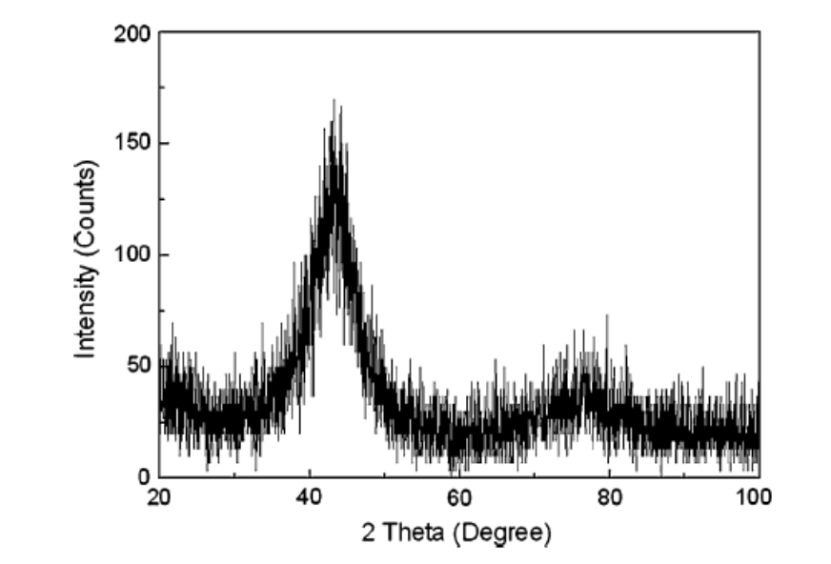
Figure 3.2 XRD pattern of the as-cast Fe₄₁Co₇Cr₁₅Mo₁₄C₁₅B₆Y₂ BMG.

3.3.2 Fatigue-endurance limit
The number of cycles of failure, N_{f}, measures as a function of the maximum stress, for each material and each set up are presented in Fig. 3.3. These tests resulted in a large amount of scatter at most stress level. However, for all stress levels tested, the fatigue endurance limit for three point bend condition tend to be higher than that for four point bend condition. The fatigue endurance limit for three point bend condition, in terms of the maximum stress, was determined to be approximately 650 MPa, while the fatigue endurance limit for four point bend condition was determined to be approximately 450MPa. After fatigue test, it was found that the samples were broke into several small and sharp pieces.
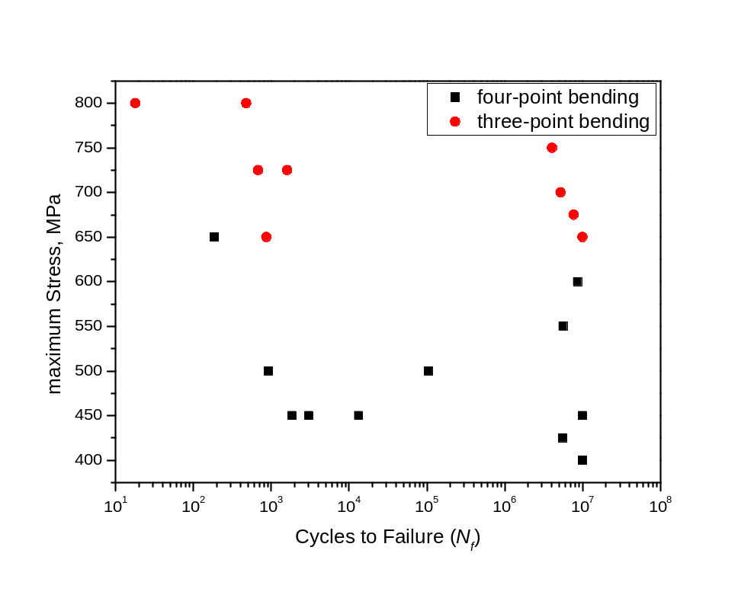
Figure 3.3 The applied maximum stress versus cycles to failure (S-N) curves for both three-point band and four-point bend conditions. R ratio was 0.1 and frequency was 10 Hz in air.
Within Fig. 3.4, the fatigue results determined by others were plotted for comparison. The fatigue endurance limit of present alloy for four point bend condition, in term of maximum, is comparable with (Zr₅₅Al₁₀Ni₅Cu₃₀)₉₉Y₁ [17] (~ 450 Mpa), and is lower than that of Zr_{52.5}Cu_{17.9}Ni_{14.6}Al_{10.0}Ti_{5.0} [18] (~ 945 MPa), high-nitrogen steel [19] (~ 680 MPa) and Fe₄₈Cr₁₅Mo₁₄Er₂C₁₅B₆ [20] (~ 758 MPa). However, the fatigue endurance limit is well above that of Al 6082 T5 alloy [21] (~ 150 MPa) and (Cu₆₀Zr₃₀Ti₁₀)₉₉Sn₁ [22] (~ 400 MPa).There are many factors can be attributed to the difference in fatigue endurance limit among BMGs. First, chemical compositions have significant effect on the fatigue behavior. The improvement of microhardness and strength can be achieved by addition of B, C, and Mo, which may provide some benefits to the fatigue-crack initiation [23]. The addition of Ni enhances the formation of oxidization film on the fatigue-fracture surface, which may retard the fatigue-crack propagation [24]. Second, materials preparation procedure also plays an important role on the fatigue behavior of BMGs. In general, the alloys from suction-cast method exhibit higher fatigue endurance limit due to the reduced sample defects, such as porosities, which usually was thought to be the fatigue-crack initiation site. The materials investigated in the current experiment were fabricated from drop casting method. Third, fatigue behavior exhibits size effects [25], the fatigue endurance limit increases with the increasing sample thickness. Larger samples tend to have higher fatigue endurance limit due to the reduced plasticity, which retards the formation of shear bands. During the comparison in Fig. 3.4, the sample thickness shows a wide range from 2.0 mm to 3.5 mm. Forth, the difference during test procedure also contribute a lot to the difference, such as the test frequency, setup dimension, and test volume, because bigger test volume contains more defects and free volume, which usually contribute to the nucleation of fatigue crack, and the detailed discussion is showed in following part.
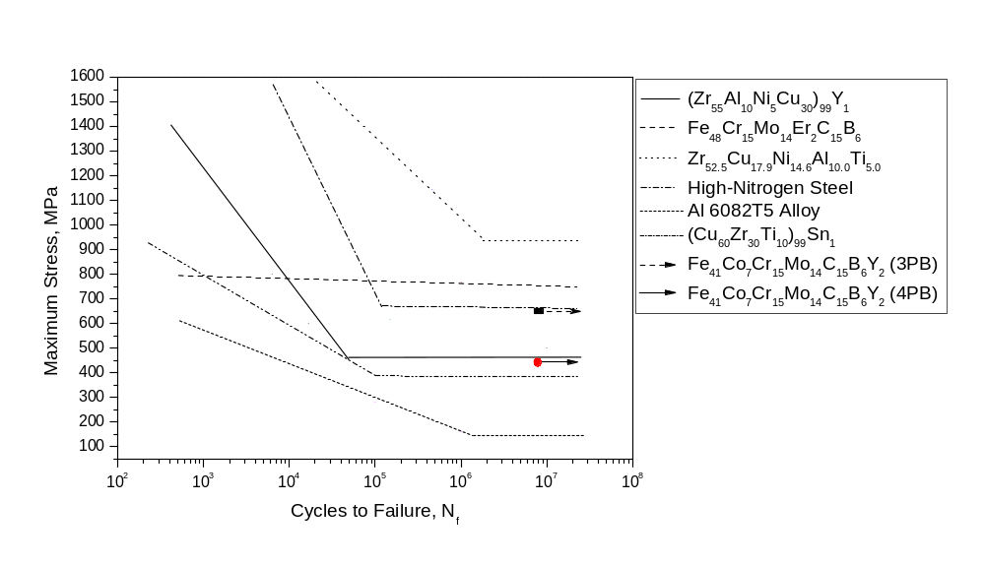Figure 3.4 Comparisons of fatigue behavior for different BMGs.

3.3.3 Fracture morphology
The fatigue fracture behavior of Zr-based BMGs have been investigated well compared to Fe-based BMGs, it exhibits ductile fracture model. The presence of shear bands in tensile surface is contributed to the fatigue crack initiation and propagation. Shear band is plastic flow in a small area, and may result in shear-off steps under cyclic loading, because of the weakness and raised stress concentration around them, micro-crack can be formed under future cyclic loading. However, Fe₄₁Co₇Cr₁₅Mo₁₄C₁₅B₆Y₂ is brittle metallic glass; it is very difficult to find the shear band in tensile surface as shown in Fig. 3.5 (e).
Figure 3.5 shows an overall fatigue fracture surface of a specimen tested under four point bend condition at σ_{max} = 800 MPa, it exhibit significantly different feature with ductile BMGs. It is difficult to identify the initiation site. For rectangular samples, corner in the tensile surface is the preferred fatigue-crack nucleation site. The strength under tension is lower than that under compression, at the same time; stress concentration is higher around corner. So fatigue crack initiates in the corner on tensile surface more easily. Sometimes, fatigue crack will initiate form defects site, such as the porosity, oxidation and impurity due to the higher stress concentration and more free volume around them. Mirror and hackle region can be observed on the fracture surface of current material, this is the typical fracture feature of the brittle metallic glasses. In addition, there is no striation on the fracture surface, which results from the blunting and resharping of the crack tip. Fig.6 shows the typical compressive stress-strain curve of the as-cast Fe₄₁Co₇Cr₁₅Mo₁₄C₁₅B₆Y₂ alloy performed by Chen et al [26]. The amorphous alloy exhibits an average elastic strain to fracture of 1.5% with no plastic strain prior to failure, and manifests a typical “fragmentation fratcure”, which was reported in other brittle BMGs [27]. The crack propagates rapidly after its formation due to the brittleness. There is no resharping and blunting of crack tips, so no striation is formed. Meanwhile, because of too little stored energy, there is no vein pattern can be observed, which is very common on the fatigue fracture surface from ductile BMGs. It demonstrates that no significant occurring at the final fracture.
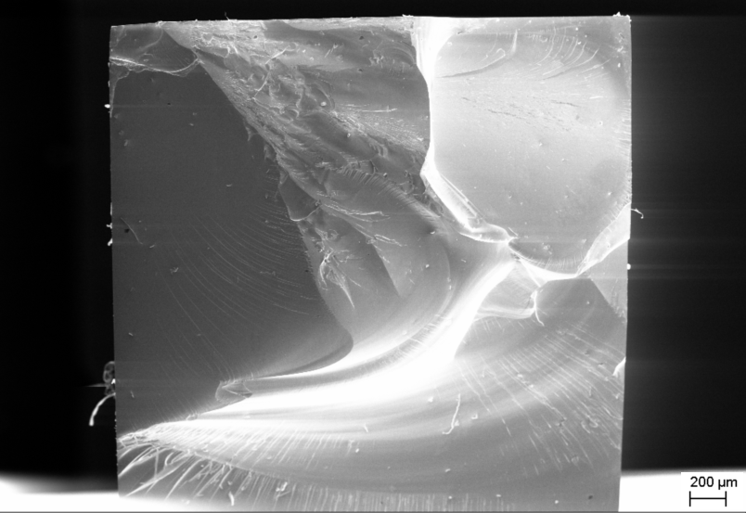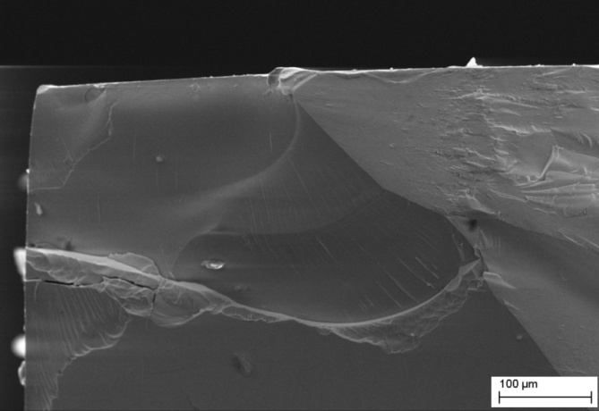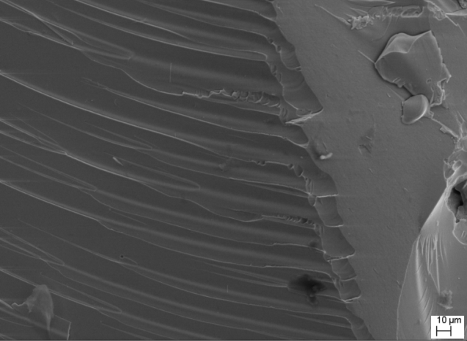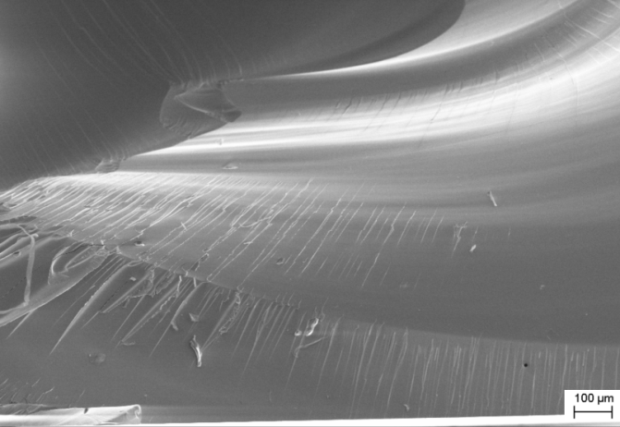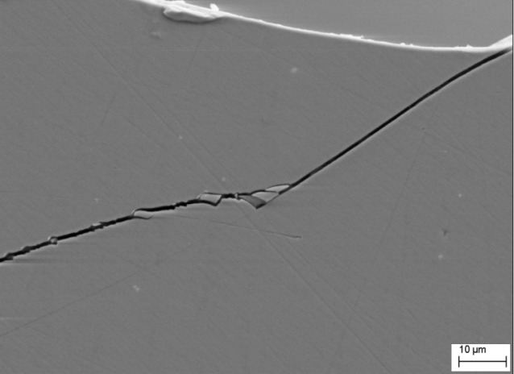
e
d
c
b
a
Figure 3.5 Overall fatigue fracture surface of Fe₄₁Co₇Cr₁₅Mo₁₄C₁₅B₆Y₂, and (e) tensile surface.
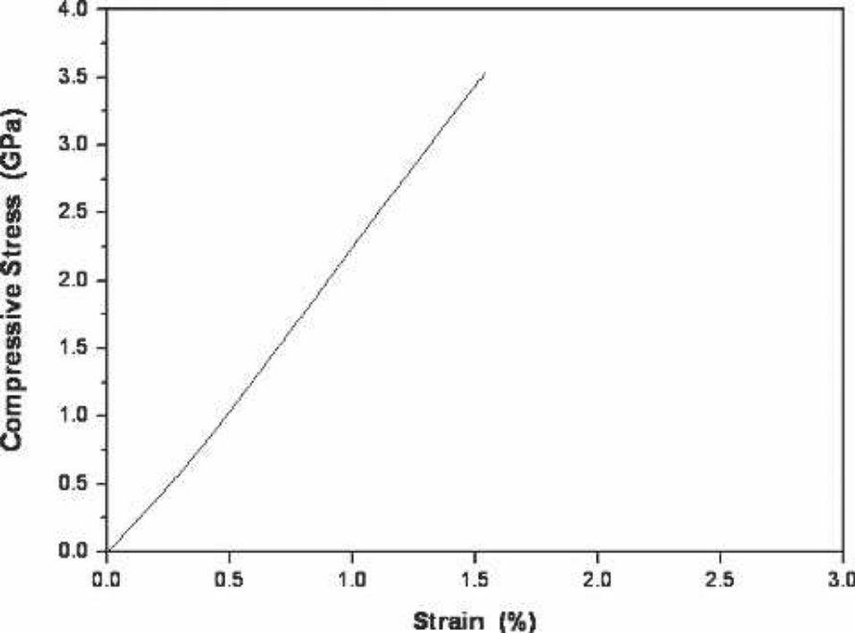
Figure 3.6 Compression stress–strain curve of Fe₄₁Co₇Cr₁₅Mo₁₄C₁₅B₆Y₂ amorphous alloy.

3.3.4 Stress distribution in three-point bend and four-point bend setup
The fatigue endurance limit was found to be lower for four-point bend condition at all stress level tested. This difference is attributed to the stress distribution in different setup. The loading condition in both three-point bend and four-point bend condition are shown in Fig. 3.10. For three-point bend condition, in every section of the beam, there is a transverse force,
$\left|V\right|=\frac{F}{2}$ , (2)

resulting in an interlaminar shear tension, which can cause delamination. The moment is linear up until the centre. The stress for three-point bend and four-point bend is given by
$σ_{x}=\frac{My}{I_{z}}$, (3)

where I is the moment of interia, y is the distance from the neutral axis. M is the moment. So the maximum is only experienced at the center of the beam on the outset tensile surface. In four-point bend setup, there is a section of the beam in which the moment is constant and with no transverse force. This section is experienced only to normal stress. Consequently, the volume of material expiring maximum is expected much greater for four-point bend condition.

Figure 3.7 Transverse force and moment for the two bending setups.
The weibull equation describes the fracture probability P_{f} as a function of a given uniaxial stress σ in the form of [3, 28, 29]:
$p_{f}=1-\exp{[-V{\left(\frac{σ-σ_{u}}{σ_{o}}\right)}^{m}]}$, (4)
where σ _{o} is scaling parameter, m is the Weibull modulus and V is the volume of the tested sample. The parameter σ _{u} denotes the stress at which there is a zero failure probability, which is usually taken to be zero. It demonstrates that the P_{f} scales with the volume of tested sample, P_{f} increases with the increasing tested volume.
According to fatigue fracture mechanism of BMGs, the cracks could initiate from the distinct casting defects because of the raised stress concentration around these sites. The fatigue performance is sensitive to structural defects [30]. Fig. 3.11 shows the defects distribution on the sample tensile surface and fracture surface. We assume the defects distribute homogeneously. The greater the test-volume is, the more the defects it involved, the easier the cracks to form, so the smaller the fatigue endurance limit will be. The idea seems to be consistent with the current experiment. Accordingly, compared to three-point bend condition, it is likely that fatigue endurance limit for four-point bend condition is lower due to the bigger test-volume.

Figure 3.8 Distinct defects are distributed homogenelously on the fracture surface and tensile surface, such as the oxide inclusions and porosities.

3.4 Conclusions
A direct comparison of fatigue behavior of Fe₄₁Co₇Cr₁₅Mo₁₄C₁₅B₆Y₂ under three-point bend and four-point bend condition was conducted, The Fe-based amorphous alloy exhibits higher fatigue endurance for three-point bend condition, in term of maximum stress, is approximately 650 MPa, while the fatigue endurance limit for four-point bend condition is approximately 450 MPa. The fatigue behavior of BMGs is sensitive to structural defects, and exhibits test-volume effects. The fatigue endurance limit increases with the decreasing test-volume. The current material exhibits typically brittle fracture model, no striations and vein pattern were observed on the fracture surface, which can be commonly found on the Zr-based and other ductile BMGs. Fatigue damage in the form of cracks initiates from stress concentrators. Fe₄₁Co₇Cr₁₅Mo₁₄C₁₅B₆Y₂ could be a potential candidate as a structural material if the fabrication process could be improved.
References
1. Inoue, A., Y. Shinohara, and J.S. Gook, Thermal and magnetic properties of bulk Fe-based glassy alloys prepared by copper mold casting. Materials Transactions Jim, 1995. 36(12): p. 1427-1433.
2. http://www.alps.com/products/e/npv_product/090311_HMFTW/HMFTW-E.HTML.
3. Lee, C.J., J.C. Huang, and T.G. Nieh, Sample size effect and microcompression of Mg65Cu25Gd10 metallic glass. Applied Physics Letters, 2007. 91(16).
4. Chang, H.W., et al., Glass formability and soft magnetic properties of bulk Y-Fe-B-Ti metals. Journal of Alloys and Compounds, 2008. 462(1-2): p. 68-72.
5. Chang, H.W., et al., Soft magnetic properties and glass formability of Y-Fe-B-M bulk metals (M=Al, Hf, Nb, Ta, and Ti). Journal of Alloys and Compounds, 2009. 472(1-2): p. 166-170.
6. Guo, S.F., L. Liu, and X. Lin, Formation of magnetic Fe-based bulk metallic glass under low vacuum. Journal of Alloys and Compounds, 2009. 478(1-2): p. 226-228.
7. Gu, X.J., et al., Critical Poisson's ratio for plasticity in Fe-Mo-C-B-Ln bulk amorphous steel. Applied Physics Letters, 2006. 88(21).
8. Wang, G.Y., et al., Fatigue behavior and fracture morphology of Zr50Al10Cu40 and Zr50Al10Cu30Ni10 bulk-metallic glasses. Intermetallics, 2004. 12(10-11): p. 1219-1227.
9. Wang, G.Y., et al., Fatigue behavior of bulk-metallic glasses. Intermetallics, 2004. 12(7-9): p. 885-892.
10. Schroers, J. and W.L. Johnson, Ductile bulk metallic glass. Physical Review Letters, 2004. 93(25).
11. Inoue, A., et al., High-strength Cu-based bulk glassy alloys in Cu-Zr-Ti and Cu-Hf-Ti ternary systems. Acta Materialia, 2001. 49(14): p. 2645-2652.
12. Chen, Q.J., et al., Enhanced glass forming ability of Fe-Co-Zr-Mo-W-B alloys with Ni addition. Materials Science and Engineering a-Structural Materials Properties Microstructure and Processing, 2005. 402(1-2): p. 188-192.
13. Xi, X.K., et al., Fracture of brittle metallic glasses: Brittleness or plasticity. Physical Review Letters, 2005. 94(12).
14. Hess, P.A., B.C. Menzel, and R.H. Dauskardt, Fatigue damage in bulk metallic glass II: Experiments. Scripta Materialia, 2006. 54(3): p. 355-361.
15. Miller, M.K., ed. Bulk Metallic Glasses. 2007, Springer: New York.
16. Fan, H.B., et al., Corrosion Behavior of Fe(41)Co(7)Cr(15)Mo(14)C(15)B(6)Y(2) Bulk Metallic Glass in Sulfuric Acid Solutions. Metallurgical and Materials Transactions a-Physical Metallurgy and Materials Science, 2011. 42A(6): p. 1524-1533.
17. Huang, L., et al., Corrosion-fatigue study of a Zr-based bulk-metallic glass in a physiologically relevant environment. Journal of Alloys and Compounds, 2010. 504: p. S159-S162.
18. Morrison, M.L., et al., Four-point-bending-fatigue behavior of the Zr-based Vitreloy 105 bulk metallic glass. Materials Science and Engineering a-Structural Materials Properties Microstructure and Processing, 2007. 467(1-2): p. 190-197.
19. Heitkemper, M., et al., Fatigue and fracture behaviour of a laser surface heat treated martensitic high-nitrogen tool steel. International Journal of Fatigue, 2003. 25(2): p. 101-106.
20. Qiao, D.C., et al., Fatigue behavior of an Fe48Cr15Mo14Er2C15B6 amorphous steel. Journal of Materials Research, 2007. 22(2): p. 544-550.
21. Benedetti, M., et al., Bending fatigue behaviour of differently shot peened Al 6082 T5 alloy. International Journal of Fatigue, 2004. 26(8): p. 889-897.
22. Freels, M., et al., Stress-life fatigue behavior and fracture-surface morphology of a Cu-based bulk-metallic glass. Journal of Materials Research, 2007. 22(2): p. 374-381.
23. Zhang, Z.F., J. Eckert, and L. Schultz, Tensile and fatigue fracture mechanisms of a Zr-based bulk metallic glass. Journal of Materials Research, 2003. 18(2): p. 456-465.
24. Yokoyama, Y., K. Fukaura, and A. Inoue, Effect of Ni addition on fatigue properties of bulk glassy Zr50Cu40Al10 alloys. Materials Transactions, 2004. 45(5): p. 1672-1678.
25. Wang, G.Y., et al., Size effects on the fatigue behavior of bulk metallic glasses. Journal of Applied Physics, 2011. 110(11).
26. Chen, Q.J., et al., Mechanical performance and fracture behavior of Fe41Co7Cr15Mo14Y2C15B6 bulk metallic glass. Journal of Materials Research, 2007. 22(2): p. 358-363.
27. Zhang, Z.F., et al., Shear fracture and fragmentation mechanisms of bulk metallic glasses. Philosophical Magazine Letters, 2006. 86(10): p. 643-650.
28. Wu, W.F., Y. Li, and C.A. Schuh, Strength, plasticity and brittleness of bulk metallic glasses under compression: statistical and geometric effects. Philosophical Magazine, 2008. 88(1): p. 71-89.
29. Zhao, Y.Y., E. Ma, and J. Xu, Reliability of compressive fracture strength of Mg-Zn-Ca bulk metallic glasses: Flaw sensitivity and Weibull statistics. Scripta Materialia, 2008. 58(6): p. 496-499.
30. Wang, G.Y., et al., Fatigue behavior of Zr-Ti-Ni-Cu-Be bulk-metallic glasses. Intermetallics, 2005. 13(3-4): p. 429-435.

CHAPTER IV

GENERAL CONCLUSIONS AND FUTURE PERSPECTIVES
This thesis investigated the effect of specimen size and test-volume on the fatigue behavior of BMGs. An obvious fatigue behavior difference was observed from both size effects and test-volume effect, and the mechanism is proposed.
A direct comparison of fatigue behavior of Zr_{52.5}Cu_{17.9}Ni_{14.6}Al_{10.0}Ti_{5.0} (at %) at different size was conducted using materials that were fabricated and tested in same procedure and condition. It is found that BMGs exhibit size effect on fatigue behavior. The small-size sample shows lower fatigue endurance limit, at a given stress, the fatigue life is shorter than that of large-size sample. This trend can be attributed to the reduced plasticity of the large-size sample, which highly localized in shear bands. Reduced shear bands provide some benefit to the fatigue initiation process. Due to improved plasticity of the small-size sample, the easily formed shear bands gradually degrade its strength. In addition, the primary, secondary shear band spacing and apparent fracture toughness scale with the thickness of sample.
A direct comparison of fatigue behavior of Fe₄₁Co₇Cr₁₅Mo₁₄C₁₅B₆Y₂ under three-point bend and four-point bend condition was conducted, The Fe-based amorphous alloy exhibits higher fatigue endurance for three-point bend condition, in term of maximum stress, is approximately 650 MPa, while the fatigue endurance limit for four-point bend condition is approximately 450 MPa. The fatigue behavior of BMGs is sensitive to structural defects, and exhibits test-volume effects. The fatigue endurance limit increases with the decreasing test-volume. The current material exhibits typically brittle fracture model, no striations and vein pattern were observed on the fracture surface, which can be commonly found on the Zr-based and other ductile BMGs. Fatigue damage in the form of cracks initiates from stress concentrators. Fe₄₁Co₇Cr₁₅Mo₁₄C₁₅B₆Y₂ could be a potential candidate as a structural material if the fabrication process could be improved.
Despite the numerous mechanical behaviors have been performed, the fatigue behavior of BMGs is still poorly understood. The fundamental origins of fatigue in BMGs are not clear. A study to understand the fundamental origins of fatigue can enhance the fatigue resistance through controlling them. The characteristic of formation of shear bands in BMGs under cyclic loading remain largely a topic of speculation, thus how shear band initiate should be investigated.

VITA
Qingming Feng was born in Xiaoyi, Shanxi Province, China on June 28, 1983. He received his bachelor’s degree in Metallurgical Science and Engineering from Central South University in July 2006. He continued his graduate study in Metallurgical Science and Engineering in Central South University and obtained M.S. in June 2009. In August of 2009, he entered University of Tennessee, Knoxville in Materials Science and Engineering department. He received his Master degree in May of 2012.

