Implementation of an Educational Guide to Improve ICU Delirium Awareness and Detection

Samantha L. Payne
Department of Nursing: The University of Tennessee, Knoxville
NURS 634: DNP Project Defense
Dr. Samereh Abdoli
March 2022

Table of Contents
Abstract 4
I. INTRODUCTION 5
Clinical Significance 6
Purpose 9
Figure 1: Project Purpose 9
PICOT Development 9
EBP Process Model 10
II. EVIDENCE 12
Literature Search Strategy 12
Figure 2: Combined PRISMA Flow Diagram for Education and Delirium Screening Literature Search 13
Critical Appraisal of Literature 13
Synthesis of Evidence 14
Significant Findings 14
Table 1: Synthesis of Literature Review (PICOT Question) 17
Table 2: Synthesis of Literature Review (Delirium Screening) 18
Clinical Expertise 18
Patient Values and Preferences 19
Recommendations for Practice 20
Table 3: Recommendation(s) for Practice Change 23
Table 4: Strength of Recommendation(s) 24
III. METHODOLOGY 24
Setting 24
Participants 25
Facility Needs Assessment 25
Figure 3: SWOT Analysis 28
Project Stakeholders 28
Table 5: Stakeholders, Responsibilities, & Affiliated Institutions 30
Barriers 30
Table 6: Barriers for Implementation 32
Facilitators 32
Table 7: Facilitators for Implementation 33
Project Plan 34
Figure 4: Iowa Model of Evidence Based Practic 37
Implementation Process 37
Table 8: Plan for Project Implementation via the Iowa Model Revised: Evidence-based Practice to Promote Excellence in Health Care 40
Ethical Considerations 41
IV. OUTCOMES 41
Outcome Measures 41
Table 9: Evaluation Plan 43
Table 10: Sensitivity and Specificity of CAM-ICU 44
Data Collection and Security 44
Data Analysis 44
Results 45
Table 11. Demographic Characteristics of Participants 46
Table 12: Frequencies of Immediate and 1-Month Post-Tests 48
Significance and Implication 48
V. REFERENCES 53
Appendix A: The Iowa Model 62
Appendix B: Evaluation Tables (PICOT) 63
Appendix C: Evaluation Tables for Delirium Screening 70
Appendix D: Johns Hopkins Nursing Evidence-Based Practice Appendix H 72
Appendix E: Pre-, Post-Test 75
Appendix F: Education Program 79

Abstract
Intensive care unit (ICU) delirium is a prevalent condition that can occur in up to 80% of critical care patients. It can increase hospital length of stay, morbidity rates, and recovery time. It can also demand higher costs for care and long-term effects on the patient. A good practice statement, issued by the Society of Critical Care Medicine, acknowledges the importance of delirium awareness (Devlin, 2018). For ICU nurses, educational approaches of ICU delirium have shown significant increases in delirium awareness and detection. The purpose of this project was to determine if an evidenced-based education program on delirium would improve awareness of ICU nurses in a setting that does not currently monitor delirium. (Vanderbilt University Medical Center, 2016).
Participating nurses at a level III trauma center in Knoxville, Tennessee, received an online delirium education module, which included ICU delirium definition, etiology, risk factors, and how to screen delirium with the Confusion Assessment Method for the ICU (CAM-ICU) tool (Vanderbilt University Medical Center, 2016). They were then tested on the material immediately following the education bundle and then 1-month later. Data was analyzed with a paired sample T test and descriptive statistics using SPSS software. Results of the pre-test were undetermined due to technical difficulties. There was no significant change found from immediate post-test to the 1-month post-test, indicating an adequate retainment of knowledge.
Keywords: ICU delirium, nurse education, education program, nurse training, delirium screening, CAM-ICU

Implementation of an Educational Guide to Improve ICU Delirium Awareness and Detection

I. INTRODUCTION

Delirium is a significant and common condition in hospitalized patients, particularly those in the intensive care unit (ICU). Delirium, according to the American Psychological Association is “a disturbed mental state in which attention cannot be sustained, the environment is misperceived, and the stream of thought is disordered” (APA, 2018). Evidence suggests that delirium is a highly prevalent, yet under-diagnosed condition in the critical care setting. A systematic review reported that anywhere from 20% to 84% of ICU patients will acquire ICU delirium (Herling et al., 2018). Khan et al (2021) stated that 50% - 80% of mechanically ventilated patients will have delirium at least one day during their ICU stay.
ICU delirium is associated with increased weaning times off mechanical ventilation, increased hospital and ICU length of stay, increased mortality, and increased costs (Herling et al., 2018). It is estimated that the United States (U.S.) yearly cost of delirium is anywhere from $38 - $152 billion (Leslie et al, 2008). Evidence suggests an overall risk ratio of 2.19 for death in delirious patients, higher illness severity, and longer ICU stay compared to non-delirious patients with a higher illness severity in those with delirium (Salluh et al., 2015).
Current guidelines by the Society of Critical Care have recommended that all critically ill patients should be regularly assessed for delirium (Devlin et al, 2018). However, ICU delirium screening and education is not common. Cruz et al (2018) reported that “unrecognized delirium” was estimated to be about 60%. This is unchanged from 2000, when the rates of unrecognition was 55% - 70% (Hutsey & Palmer, 2000; Inouye et al., 2001). At an 18 bed ICU in Knoxville, Tennessee, delirium screening currently does not exist on a formal basis. Nurses are not trained, nor required to document delirium assessments. The providers in this setting do not generally make delirium diagnoses. For delirious patients, the current practice consists of the nurse notifying the physician if the patient is behaving to the point where their safety is at risk. Generally, this action leads to a patient specific treatment that may differ depending on the provider. Sometimes there is no intervention, and the patient is left in a delirious state. This inconsistency in assessment and intervention has cause for concern when looking at the literature for delirium consequences as discussed previously. The purpose of this project was to provide an evidence-based educational program on ICU delirium screening and management to the ICU nurses to improve delirium awareness and detection.
The project site was a level III trauma center, in the single intensive care unit. Nurses work in 12-hour shifts and generally work in a 1:2, 1:3 ratio of nurses to patients. There is a wide-range of bachelor-level and associate-level nurses, as well as various levels of experience. Unit-based education for the nurses was conducted through online webinar trainings. Education fell on the ICU manager because the unit-based educator role was vacant.

Clinical Significance

The prevalence and incidence of delirium is increasing in the U.S. as hospitals begin to implement delirium screening tools. Incidence of ICU delirium varies between 25%-50% (Cherak et al., 2020; Krewulak et al., 2018; Van Den Boogaard et al., 2012). Delirious patients have longer hospital admissions, higher prevalence of treatment noncompliance, and death compared to non-delirious patients (Van Den Boogaard et al., 2012). Three studies found significant increased length of stay and mortality rates when delirium was present (Thomason et al., 2005; Tomasi et al., 2011; Salluh et al., 2015). A separate study evaluated the effect of assessment of delirium on length of stay and found a significant decrease of length of stay when a delirium assessment tool was implemented (Trogrlic et al., 2015).
The pathophysiology of delirium is multifactorial, and severity of illness is wide-ranging. Critical illness induces acute stress symptoms, which includes fluctuations of serum glucose, hypoxia, release of inflammatory mediators, and organ dysfunction (Davydow et al., 2013). A critical illness combined with environmental factors such as sleep deprivation, polypharmacy, and restraint use has found to increase delirium risk by 450% (Inouye et al., 2013). Abnormal laboratory values alone increased delirium anywhere from 40%-500%. Higher levels of inflammatory markers, and an astrocyte and glial cell activator are associated with longer duration, higher severity of delirium, and increased rate of mortality (Khan et al., 2021).
ICU delirium also impacts long term patient’s outcomes (Herling et al., 2019). Evidence suggests a longer duration of delirium in the ICU is associated with a decline in patients’ ADL function for one year (Brummel et al., 2015). It is also an independent predictor of long-term cognitive impairment within a population of ICU patients (Girard et al., 2010). Different studies suggest an increased 6-month mortality of 34% and 41.2% after discharge in ICU delirious patients compared to non-delirious patients (Salluh, 2015). Delirium also has been estimated to cause long-term cognitive impairment in 70% of patients one year after having delirium (Kotfis et al., 2018).
ICU delirium is a costly healthcare burden. Evidence suggests an average of $18,000 direct cost related to increased resource utilization due to delirium over a 30-day period for one person (Vasilevskis, 2018). Absence of delirium for a single day, when not accounting for mortality costs, would lead to a savings of about $440 each day for each person. However, according to Leslie et al (2008) costs associated with delirium are much higher, with a range of $16,000 to $64,000 per each delirious patient.
Delirium screening is the first step in delirium management. The Society of Critical Care Medicine issued a good practice statement on delirium screening in their PADIS (pain, agitation, delirium, immobility, sleep disruption) guidelines in 2018 (Devlin et al.). The PADIS guidelines are evidenced-based recommendations for practice that are commonly utilized in ICU settings. The recent report declared that screening patients for delirium “far outweighs any potential downsides” (Devlin et al., 2018, p e844). They claim either the CAM-ICU or the ICDSC are both evidence-based and quality screening tools that should be utilized by bedside nurses and doctors.
The PADIS guidelines have influenced the development of various intervention strategies. The ABCDEF bundle, for instance, has been a highly regarded, evidence-based multicomponent guide for ICU care (Marra et al., 2017). This bundle addresses six different areas: pain, breathing trials (mechanically ventilated patients), sedation, delirium, mobility, and family engagement. For the delirium section, the focus is on screening, preventing, and management. A systematic review found that delirium was significantly decreased (69% to 31% delirium reduction) with the implementation of the ABCDEF bundle (Krewulak et al., 2018). This project concentrated on the screening process, which is the imperative first step in delirium management and prevention.

Purpose
The main purpose of this project was to educate nurses on delirium screening and management. In a hospital with no current delirium protocol, education may help to develop a foundation of practice. Providing resources and education can allow nurses to become comfortable with delirium screening and contribute to its management.

Figure 1: Project Purpose

PICOT Development

ICU delirium management begins with a comprehensive training module (Critical Illness, August 2016). A literature review to better understand nursing education will help guide delirium training and evaluate the effectiveness of nursing education. For this project, the population of interest was bedside nurses that are in the ICU setting. Bedside nurses have the unique position to monitor delirium continuously as they are in constant direct contact with their patients. With ever-changing conditions of ICU patients, their role is crucial to delirium monitoring and management.
The outcomes for the project were focused on the impact of an online education module on bedside ICU nurses. The project aimed to determine if educating bedside nurses on delirium screening and management, can lead to increased awareness and ability for delirium detection. This project PICOT question therefore was: “how does ICU delirium education compared to no education affect ICU nurses’ delirium awareness and detection?”

EBP Process Model
The Iowa Model of Evidence-Based Practice has assisted in many hospital organizations worldwide in practice change (Iowa Model Collaborative, 2017). The purpose of the Iowa Model is to allow opportunities for best practice to be adapted into a healthcare organization. Its popularity amongst various organizations is partly due to ease of use and adaptability to any organization. The model is in the format of a flow diagram with feedback loops to ensure each step of the process is appropriately completed. If a step in the process cannot be completed, the organization is then to move back through the feedback loop and work through it again.
The first step of the model is trigger identification, or determining the problem (Iowa Model Collaborative, 2017). Many stakeholders look at HCAHPS (Hospital Consumer Assessment of Healthcare Providers and Systems) scores or Leapfrog analysis for this (Centers for Medicare & Medicaid, 2020; Leapfrog Group, 2020). If they see areas that need work, for example “falls”, they identify this as the ‘trigger’. Triggers can be from: a patient problem (i.e., safety), current national initiatives or guidelines that are not being properly followed, specific data findings (i.e. HCAHPS), or accrediting agency regulations. In the case of this project, the trigger is delirium guidelines that are not being met (Titler et al., 2001).
The next step of the Iowa Model is to state the question or purpose, determine the priority level, and then form a team to work on the project. The “team” consisted of myself, the project chair at the University of Tennessee, and a nurse leader on the unit. The purpose, as stated before, was to educate nurses on delirium screening and management.
An important step in the process is to ‘assemble, appraise, and synthesize body of evidence’ (Titler et al., 2001). The literature review section was to determine if there are specific delirium screening recommendations, as well as how to best educate nurses on delirium. A full appraisal of the literature occurred, which gave weight to each resource evaluated.
If there is enough quality evidence, the next step is to proceed to the designing of practice change. This part of the process is reliant on proper planning to perform a successful practice change. The Iowa Model explains in this section that there should be baseline data collected. It is also a time to run a ‘pilot project’ to determine if the practice change will have a positive effect. Due to COVID-19 restrictions, implementation of delirium in practice was not feasible. Instead, a pilot program included case scenarios with the delirium-educated nurses.
The last steps of the Iowa Model are to ‘integrate and sustain the practice change’ and then share results. Installation of a delirium assessment tool as a formal change on the unit would determine the long-term success of this project. A policy change and unit-wide education can help implement delirium screening into a sustainable practice. The model can be found in Appendix A.

II. EVIDENCE

Literature Search Strategy

The literature search included Cochrane, CINAHL, and PubMed to 1) identify the effects of an educational module, and to find 2) an evidence-based screening tool for ICU delirium. The first search included search terms (“ICU delirium” OR “ICU psychosis” OR “intensive care unit delirium”) AND (“nursing education” OR “nurse education”). The limiters applied for CINAHL and PubMed were “peer-reviewed”, “English language”, “full text”, and “publication date 2016 – 2021”. The only limiter applied for the Cochrane database was “Cochrane Reviews”.
The initial result to identify an evidence-based ICU delirium education program was 98 articles (Cochrane n=7, CINAHL n=16, PubMed n=75). Titles not relevant to the PICOT question or covering wider-ranged topics were eliminated. The total number of articles were limited down to 21 after title review (n=63) and duplicate removal (n=14). The abstracts were evaluated and compared to the PICOT question, resulting in 10 remaining articles for full-text review. Out of these articles, 7 were relevant to the project focus, and therefore used for the critical appraisal and synthesis process.
A secondary search was to find an evidence-based delirium screening tool. The initial search terms included (“ICU delirium” OR “ICU psychosis”) AND (“assessment”). The limiters applied for PubMed and CINAHL were “peer-reviewed”, “English language”, “full text”, “published date from 2010 to 2019”, “all adult age group”. The only limiter applied for the Cochrane database was “Cochrane Reviews”.
This initial search resulted in 96 articles (Cochrane n=11, CINAHL n=75, PubMed n=10). After review of the titles and elimination of duplicate articles, there were a total of 28 articles. Evaluation of the abstracts further narrowed the articles down to 8, in which 2 were determined to be relevant to the project after review of the content. These final 2 articles were used for critical appraisal and synthesis. The following PRISMA flow diagram summarizes the combined literature review strategy.

Figure 2: Combined PRISMA Flow Diagram for Education and Delirium Screening Literature Search
Records identified through database searching (delirium screening, education)
(Cochrane n=18), (CINAHL n=91), (PubMed n=85)
Screening
Identification
Records after title review; duplicates removed
(n = 49)
Records excluded
(n = 145)
Full-text articles assessed for eligibility
(n = 18)
Full-text articles excluded, with reasons
(n = 9)
6 were excluded based on their irrelevance to the screening tool; they were focused on pharmacological interventions on delirium treatment and weaning off ventilators. 3 articles were excluded due to relevance to PICOT question.

Eligibility
Studies included for critical appraisal
(n = 9)
Included
Studies included in synthesis of literature
(n = 9)
Records after abstract review
(n = 18)

Critical Appraisal of Literature
The Johns Hopkins Nursing Evidence-Based Practice (JHNEBP) appraisal tool was used in the literature appraisal process for this project (Johns Hopkins, n.d.). There was a total of 9 articles used for this project proposal. All articles used were graded at an ‘A’ or ‘B’, indicating their quality as ‘high’ or ‘good’. There was one article that met the standards for an ‘A’ grading and seven articles that met the standards for a ‘B’ rating. The articles that met the lower ‘B’ grading were due to lower sample sizes and/or missing information such as research design, methods, or outcomes. Appendix B includes the evaluation tables for the articles focused on ICU delirium and nursing education. Appendix C includes the evaluation tables for the delirium screening tool articles.
The Society of Critical Care Medicine established the practice guidelines for prevention and management of key, intensive care consequences such as delirium (Devlin et al., 2018); however, guidelines such as these are extensive and go beyond the goals of this project. Therefore, no guidelines have been appraised for this project. It is important to note that intensive care providers should familiarize themselves with the PADIS guidelines. The project site will benefit receiving these guidelines once delirium screening is established.

Synthesis of Evidence

Significant Findings
The first section of the literature review was conducted to determine if an educational program will impact nurse awareness and detection of ICU delirium. Most of the studies evaluated were in a pre- and post-test format to understand if there was a change in either knowledge of delirium or delirium detection through a screening tool (Trogrlic et al., 2020; DeForge et al., 2020; Ramoo et al., 2018; Blevins & DeGennaro, 2018; Smith et al., 2017; Mistraletti et al., 2017). Speigelberg et al. (2020) did not evaluate knowledge directly, but instead looked at improved rates of high-risk medication use, which was significantly reduced after delirium education. Five of the six studies that evaluated knowledge scores found either statistical or clinical significance in improved delirium knowledge after an educational program was implemented (Trogrlic et al., 2020; DeForge et al., 2020; Ramoo et al., 2018; Blevins & DeGennaro, 2018; Mistraletti et al., 2017).
Three studies evaluated delirium screening after an educational program. Delirium screening is important to detect delirium (Vanderbilt University Medical Center, n.d.). All studies found significant improvement in delirium screening after education had been given (Trogrlic et al., 2020; Speigelberg et al., 2020; Mistraletti et al., 2017). None of the studies used the same education format, but still produced results supporting education to increase delirium detection. Therefore, education alone can help to improve screening and detection, in addition to knowledge. It should be noted that no studies evaluated screening use past 6 months, however.
Two studies evaluated delirium detection rates, or accurate delirium detection by nurses after an education program (DeForge et al., 2020; Mistraletti et al., 2017). DeForge et al. (2020) did not find any significant changes in accurate delirium detection after an education intervention, whereas Mistraletti et al. (2017) found significant improvement in delirium detection rates and accuracy of CAM-ICU utilization after their educational program.
It is important to note that all studies used various educational formats and therefore may have impacted their results accordingly. For future practice, it would be beneficial to evaluate delirium educational methods to determine which is the most effective. Additionally, these studies evaluated knowledge through different tools, and only some were validated. In summary, the studies had correlating, significant findings that supported a recommendation for practice change. Table 1 summarizes this synthesis.
A second section of the literature review aimed to determine the most evidence-supported delirium screening tool. Two studies evaluated different screening tools (Gusmao-Flores et al., 2012; Tomasi et al., 2011). Primary delirium assessment tools determined are the Confusion Assessment Method for the Intensive Care Unit (CAM-ICU) and the Intensive Care Delirium Screening Checklist (ICDSC). The gold standard used for comparison include the Diagnostic and Statistical Manual of Mental Disorders (DSM-IV) criteria for delirium (Gusmao-Flores et al., 2012; Tomasi et al., 2011).
The evidence that was appraised for delirium screening tools had findings that were consistent with each other. Gusmao-Flores et al. (2012) and Tomasi et al. (2011) evaluated sensitivity and specificity of each screening tool (the CAM-ICU and the ICDSC). The control, or gold standard was the DSM-IV criteria for delirium. Both studies found relatively high sensitivities (80% and 95%) for the CAM-ICU, as well as the ICDSC (74% and 99%). They also had high specificities, as shown in Table 2.
The literature review helped to identify two validated screening tools that are readily accessible and reliable. When implementing a delirium assessment tool, the CAM-ICU or ICDSC should be considered. Table 2 summarizes this synthesis.

Table 1: Synthesis of Literature Review (PICOT Question)

 | Trogrlic et al., 2020 | DeForge et al., 2020 | Speigelberg et al., 2020 | Ramoo et al., 2018 | Blevins & DeGennaro, 2018 | Smith et al., 2017 | Mistraletti et al., 2017
Delirium knowledge post-intervention | ↑ ^{c} | ≠  ↑^{s*} | ∅ | ↑^{s} | ↑^{s} | ≠ | ↑^{s}
Delirium screening adherence | ↑ ^{c} | ∅ | ↑ ^{c} | ∅ | ∅ | ∅ | ↑^{s}
Delirium Detection | ∅ | ≠ | ∅ | ∅ | ∅ | ∅ | ↑^{s}
Sample size | 4449 adult ICU patients, 490 healthcare professionals | 75 ICU RNs, 1020 patients (pre-intervention), 951 (post-intervention) | 59 ICU nurses, 463 patients | 61 ICU nurses | 34 ICU nurses | 34 ICU nurses | 374 doctors and nurses. 117 completed intervention. 210 returned questionnaires
Level of Evidence | Quantitative: II  Qualitative: III | II | II | II | II | II | I
Quality of Evidence | B | B | B | B | B | B | B
Additional information | Quasi-experimental design | Significant decrease in inappropriate “unable to assess” ratings on CAM-ICU after education intervention (p<0.01) | Significant decrease (<0.001) in high-risk medications after delirium education | Majority of nurses felt that the CAM-ICU was useful and helped them better understand delirium | Delirium screening was performed correctly by 79% of nurses after education | Confidence by nurses on their knowledge of assessment and management was significant (p<0.001) | RCT study
Legend: ↓=decrease (from pre-evaluation); ↑=increase (from pre-evaluation); ∅=not discussed in study; ≠ = no change or significant difference; s=statistical significance; c=clinical significance; RCT=Randomized controlled trial; CAM-ICU=Confusion Assessment Method for the Intensive Care Unit; ICU=Intensive care unit

*DeForge et al. (2020) had no significant findings of improved accuracy of delirium detection after education intervention. However, they did find a statistically significant (<0.01) improvement in accurately documented “unable to assess” ratings after the education intervention.

Table 2: Synthesis of Literature Review (Delirium Screening)

Outcome | Gusmao-Flores et al., (2012) | Tomasi et al., (2011)
Sensitivity | CAM-ICU 80%  ICDSC 74% | CAM-ICU 95%  ICDSC 99%
Specificity | CAM-ICU 95.9%  ICDSC 81.9% | CAM-ICU 89%-93%  ICDSC 64%
Sample Size | 1,330 participants | 162  participants
Level of Evidence | III | II
Quality of Evidence | B | A
Additional information | Found that the CAM-ICU and ICDSC were both valid tools for detecting delirium | ICDSC lacks specificity. CAM-ICU reliable and valid tool that takes less time to administer.
Legend: CAM-ICU = Confusion Assessment Method for the Intensive Care Unit; ICDSC = Intensive Care Delirium Screening Checklist

Clinical Expertise
The current procedure at the project site for implementation and evaluation of evidence-based practice was limited to administrative members such as the CNO, nurse educator, physicians, and unit managers. Bedside nurses were not actively empowered to engage in their own evaluation of evidence-based practice, despite being required to comply with administrative protocols and policies. However, it has been defined by leaders in nursing, that nurses should be active participants in evidence-based practice and professional development (Brown, 2020).
The American Association of Colleges of Nursing (AACN) (2021), the leader in nursing academia and accreditation, explains the scope of the registered nurse to include engagement of evidence-based practices. This subject is a requirement by the AACN in all baccalaureate curriculum in order to qualify for program accreditation. However, studies have shown that nurses are not proficient in evaluating and applying evidence-based practices (Brown, 2020). Many barriers exist, such as lack of time, mentorship, resource availability, and organizational support. Despite these barriers, nurses’ expressed interest in participating in evidence-based practice (Majid et al., 2011). This project allowed engagement of the provided evidence-based material at all levels of the organization, encouraging leadership and scholarship of bedside nurses. This project could potentially set a precedent at the project site for educational leadership.
The guidelines established by the Society of Critical Care Medicine are also important components of patient care (Devlin et al., 2018). Although this appraisal process did not evaluate the PADIS guidelines, it is imperative to discuss the delirium findings. The document outlining these guidelines recommended that “critically ill adults should be regularly assessed for delirium using a valid tool” (Devlin et al., 2018, p. e843). The authors explained the difficulties of attributing delirium monitoring to effects of length of stay or mortality as most studies are also looking at preventative strategies at the same time. However, as discussed in the guideline document, “the potential benefits of delirium monitoring far outweigh any potential downsides” (Devlin et al., 2018, p. e844).

Patient Values and Preferences
Patient-centered care remains an important goal to achieve when developing new policies and procedures in any healthcare institution. Following IHI’s Triple Aims, for example, will ensure that the patient’s preferences and values are taken into consideration as healthcare optimization occurs (IHI, 2020). Patient involvement is key, as delirium is highly reliant on environmental and cognitive input (Park & Lee, 2019). For example, sleep preferences such as use of sound machines, pillow amount and quality, and lighting can help to deter sleep disruption if implemented into their care. Patients and family members should be encouraged to share these preferences in the admission period. Due to COVID-19 restrictions, patient involvement was not a part of this project, but consideration of these practices needs to be included when implementing delirium monitoring protocols.
Patient preference can be assessed through a few standard questions in the admission process, as well as each time delirium is assessed. The following questions are examples: What is your normal bedtime routine and how do you normally sleep? Is there anything that your family can bring in that will make you feel more comfortable while you are here? Are you currently feeling any pain or anxiety? If the patient is unable to answer, these questions can be deferred to the family. It is important that the healthcare team allows patient involvement because it will contribute to their recovery and allow for optimal patient experience.

Recommendations for Practice
This project’s focus was to determine if education would improve delirium detection and awareness of ICU nurses. The literature review produced significant findings that support a recommendation for practice change. Six of the seven studies reviewed and appraised produced evidence that indicate a need for an educational program to improve delirium knowledge, screening tool adherence, and delirium management (Trogrlic et al., 2020; DeForge et al., 2020; Speigelberg et al., 2020; Ramoo et al., 2018; Blevins & DeGennaro, 2018; Mistraletti et al., 2017). Four studies produced statistical significance in delirium awareness and knowledge, whereas one found clinical significance. Only one other study that evaluated this outcome found no significant findings. Despite testing and educational format variability, the consistency of results is a positive indication that delirium education in general is impactful.
All articles cited for this initial review were B-rated quality, and the consistency of findings supported a recommendation for practice change. However, due to the congruent B rankings, it was recommended that a pilot program be conducted prior to practice change. Therefore, following the Iowa Model of EBP, this project implementation served as the pilot program to determine feasibility of formal practice change. Recommendations for practice change and strength of recommendations can be found in Tables 3 and 4 on the following pages.
Delirium guidelines for clinical practice have been created by a distinguished, reputable organization: the Society of Critical Care Medicine (Devlin, 2018). What is known as the PADIS guidelines, has allowed various intensive care providers to understand important critical care characteristics, as well as provide evidence-based recommendations. From this project’s literature review, similar practice recommendations were found. The first recommendation was that a delirium screening tool should be used in the intensive care setting for adult populations (Trogrlic et al., 2015; Salluh et al., 2015; Thomason et al., 2005; Tomasi et al., 2011). Using the JHNEBP Appendix H rating tool, the strength of this recommendation was considered “good and consistent evidence” and sufficient for practice change (Johns Hopkins, n.d.). This worksheet is shown in Appendix D.
The second recommendation is to use the CAM-ICU as a primary delirium tool and that it should be used across all adult ICU settings (Gusmao-Flores et al., 2012; Tomasi et al., 2011). Although the ICDSC was also a reputable screening tool, the CAM-ICU has been most used and most studied. The remaining part of the recommendation was that this screening tool should be used at least once per day for each ICU patient until they are discharged or transferred out of the unit. The evidence for this recommendation was considered “strong, compelling evidence” when graded by the JHNEBP Synthesis Process and Recommendations Tool (Johns Hopkins, 2018). Table 3 summarizes these recommendations.

Table 3: Recommendation(s) for Practice Change
Recommendation | References in Support of Recommendation | Rationale | Level of Evidence  (JHNEBP Appendix E) | Quality Rating (JHNEBP Appendix E)
1. An educational program is recommended for nursing staff in the ICU setting to improve delirium knowledge, screening adherence, and detection. | Trogrlic et al., 2020 | An education program improved delirium screening adherence and delirium knowledge scores (clinically significant findings). | II (quantitative)  III (qualitative) | B
 | DeForge et al., 2020 | Significant decline in inappropriate “unable to assess” documentation after delirium education provided. | II | B
 | Speigelberg et al., 2020 | High-risk medication use decreased after education on delirium administered. Number of CAM-ICU assessments by nurses increased as well. | II | B
 | Ramoo et al., 2018 | Significant improvement in delirium knowledge scores after education program. | II | B
 | Blevins & DeGennaro, 2018 | Delirium information, risk factor, and screening tool knowledge scores improved after implementation of education program. CAM-ICU was performed correctly more often after education. | II | B
 | Smith et al., 2017 | Nurses has significantly improved confidence of detecting and managing delirium after a training program. | II | B
 | Mistraletti et al., 2018 | Increased use of delirium screening tools (including CAM-ICU) occurred after online education modules. Delirium knowledge and CAM-ICU accuracy improved after education. | I | B
2. The CAM-ICU is an appropriate ICU delirium screening tool and should be used in critical care settings by nurses and physicians, as DSM-IV assessment criteria is not practical in this setting. | Gusmao-Flores et al., 2012 | CAM-ICU was found to have high sensitivity and specificity in comparison to the DSM-IV criteria, which is the gold standard. | III | B
 | Tomasi et al., 2011 | Both CAM-ICU and ICDSC were found to have high sensitivities in assessing delirium. They are both also very easily available and doable for healthcare team members not trained in DSM-IV assessment criteria. | II | A

Table 4: Strength of Recommendation(s)

Recommendation | Strength of Evidence for Recommendation: JHNEBP Appendix H | References in Support of Recommendation
1. An educational program is recommended for nursing staff in the ICU setting to improve delirium knowledge, screening adherence, and detection. | The literature review produced significant findings that an educational program in various forms is indicative for practice change and is graded as “good and consistent evidence”. A pilot program should be considered prior to formal practice change. | Trogrlic et al., 2020; DeForge et al., 2020; Speigelberg et al., 2020; Ramoo et al., 2018; Blevins & DeGennaro, 2018; Smith et al., 2017; Mistraletti et al., 2017
2. The CAM-ICU is an appropriate ICU delirium screening tool and should be used in critical care settings by nurses and physicians as a replacement of the DSM-IV assessment criteria. It should be completed at least once per day for each ICU patient until they are discharged or transferred out of the unit. | The evidence supporting this recommendation is also appropriate for practice change and is graded as “strong, compelling evidence” as the sensitivities proven for this tool are consecutively high across studies. | Gusmao-Flores et al., 2012; Tomasi et al., 2011

III. METHODOLOGY

Setting
The site for this project was conducted at a level III trauma center in Knoxville, Tennessee. The setting was the general intensive care unit (ICU), which has expanded from 9 to 18 beds in the last two years. The patient demographics were wide-ranging as the unit provides various services and stands as the main unit that manages critically ill patients for the hospital. Patients range in age but were mostly over the age of 18. Occasionally, a patient younger gets admitted to this ICU and will most oftentimes get transferred to a children’s hospital as warranted.
Diagnoses of these patients were also diverse as the unit accommodates for all critical care patients in the hospital. Severe sepsis, heart failure, acute respiratory distress, myocardial infarction, stroke, and drug overdose are just some examples of the patients that were seen in this unit. This hospital allows for cardiothoracic surgery, which enables complex open-heart surgeries that are oftentimes transferred to the intensive care unit for monitoring. There is also a bariatric surgery, gastrointestinal surgery, and neurosurgery abilities, in which complications of these surgeries are observed and treated in the ICU. Delirium was not regularly monitored in this unit.

Participants
The participants in this project were the nurses that work at the bedside in the ICU. This consisted of both night and dayshift registered nurses. Nurses typically had one to three critically ill patients during their shift. The demographics of these nurses were diverse in age, gender, and professional experience. There were 48 registered nurses currently employed for the ICU. There was a mix of bachelor-level nurses and associate-level nurses. The requirements to participate in this project were:
- Active registered nurse in the state of Tennessee and employed at project site
- Willing to take pre-, post- and follow-up assessments of educational program, commitment of 2-3 hours
- Must be 18 years or older
The goal sample size, as determined by the power analysis in PASS, was to have 20 eligible nurses participate in the education program with the corresponding pre- and post-assessment, however all eligible nurses were invited to partake.

Facility Needs Assessment
The current PADIS document by the Society of Critical Care Medicine outlines the benefits over risks of ICU delirium monitoring (Devlin et al., 2018). The project site did not have any delirium protocols in place, including a screening tool or management strategies. There was also no ICU delirium education provided to the nursing staff. Currently, all unit education is provided through online webinars and flyers, without consistent assessment of learning. This project was to determine if an education program with a pre-test, post-test format can improve delirium awareness and detection by the nursing staff. It can also serve to help guide future education campaigns on this unit.
A SWOT (strength, weakness, opportunity, threat) analysis was conducted to determine feasibility of the project (Moran et al., 2020). The unit had both substantial strengths and weaknesses. A promising strength was the new leadership role of the project site liaison, and her motivation to encourage an improved unit culture. The barriers determined during the SWOT analysis were primarily related to change resistance.
The hospital has made a lot of improvements in the last few years. The recent expansion from a 9 bed ICU to an 18 bed ICU was to accommodate for the increasing patient admissions and cardiothoracic surgeries. Along with this expansion, the hospital has within the last year upgraded its trauma level to a level III from a level IV. This can also increase resource allotment, staff recruitment, and patient care abilities.
In addition to the hospital growth, the hospital has improved the valuable HCAHPS (Hospital Consumer Assessment of Healthcare Providers and Systems) scores (Centers for Medicare & Medicaid Services, 2020). This means that patients are having good experiences, which encourages increased Medicare and Medicaid benefits to the hospital. It also increases patient trust and desire to utilize this hospital.
A second rating system, Leapfrog, is a reputable organization designed to grade hospitals based on a variety of quality measures (Leapfrog, 2021). The Leapfrog score for this hospital was recently graded at the highest level (A) for 2021. Hospitals with an “A” rating have met exemplary standards on most of the quality measures.
One significant weakness identified was the low rate of evidence-based practice implementation into hospital policy. Various protocols were outdated and there was not an efficient process in place for upgrading policies to support new guidelines. New leadership has recently been established in the ICU with plans for improved process changes.
Another barrier found during the SWOT analysis included limited resource access. The hospital had less capital than larger hospitals. Fortunately, the implementation of an education plan was relatively low to no cost. The use of a free online software for the pre- and post-test, as well as the freely available didactic training were used to avoid cost issues. The complete SWOT analysis can be found in Figure 3 on the following page.

Figure 3: SWOT Analysis
INTERNAL FACTORS
STRENGTHS (+) | WEAKNESSES (-)
- Up to quality standards and have met requirements per Joint Commission  - Improving HCAHP, Leapfrog scores  - Recent expansion of ICU from 9 beds to 18 beds  - Recent certification as a Level III trauma center  - Facility educator on-site Monday through Friday  - New, motivated ICU manager that is also agreeable to serving as primary project stakeholder | - No significant nursing certifications nor goals for advancement – associate RNs not encouraged to gain higher level of education  - Little effort in implementing new evidence-based practices into hospital policy  - Staff retention is low due to poor management and staffing ratios, including the frequent turnover of the ICU manager
EXTERNAL FACTORS
OPPORTUNITIES (+) | THREATS (-)
- Reputable within the community. Large company that has various facilities throughout the area that provide quality care to patients.  - Recent transition to Cerner– allows for more efficient care and communication between healthcare team members  - Larger intensive care unit and higher level of trauma certification may encourage administrators to improve education and training for staff | - Continually competing with other hospital organizations such as Covenant Health and UTMC, whom have highly regarded reputations in the community.  - A for-profit hospital - requires more cash flow and less government support.  - Growth in hospital bed size and trauma level needs to be met with appropriate policy change and training of staff. Change faces resistance (i.e., by staff)

Project Stakeholders
The project involved key stakeholders to successfully implement this project. The primary project lead was this DNP student and had guidance from her project chair. She was responsible for managing and overseeing all aspects of the project, including the planning, literature review, communication, implementation, data collection and evaluation. As the primary project manager, she was also charged with disseminating the information, presenting it to the University’s chair members, as well as developing a long-term plan for the unit.
There are other key stakeholders at the project site, as summarized in Table 5. The ICU nurse manager was the project site liaison, as she had the most insight into the unit’s administrative processes, policy creation, and communication with the medical directors.
The providers that were encouraged to participate were the ICU intensivist (critical care providers), and members of the internal medicine team. Having the intensivist team on board with the project encouraged nursing staff to follow through with delirium education and therefore move the culture to a long-lasting change. Providing them with evidence, newly established guidelines, and methods to implement management of delirium helped encourage unit cohesion and agreement.
Lastly, the IT department and biostatistician at the university helped in technical management. The IT department was a helpful resource to troubleshoot any virtual, Zoom meetings and presentations, and Qualtrix. The biostatistician provided consultation on data analysis and software.

Table 5: Stakeholders, Responsibilities, & Affiliated Institutions
Stakeholder | Project Responsibilities | Institution
DNP Student | Project leader  Data collection, analysis, and dissemination | University of Tennessee
Project Chair | Mentor DNP student during the project | University of Tennessee
ICU Nurse Manager | Supervision of project and liaison between student and administrators | Project Site
CNO | Oversight of project; approval of project activities | Project Site
Nursing Staff | Project participants | Project Site
IT Department | Resource for Qualtrix | University of Tennessee
Biostatistician | Data analysis | University of Tennessee

Barriers
Barriers to project implementation have been evaluated and summarized in Table 6. The primary barrier to implementation was the COVID-19 restrictions for both the University and the project site. Due to pandemic guidelines, both institutions have new policies to safeguard against the spread of COVID-19. To accommodate for this, the DNP project sought virtual opportunities when appropriate. The educational program designed for this project was adapted to be accessible to participants in a format that deters grouping together. It also allowed for a sufficient time period for participants to access education and assessments.
An organizational barrier was the weighted importance of this project to administrators. ICU delirium has not been a priority in the past, and therefore was difficult for higher administration to understand the value. For example, the chief nursing officer (CNO) did not have the capacity to investigate specific unit protocols as he oversaw all nursing departments. However, to allow the project to occur, he needed to evaluate the project logistics and approve it for implementation. Collaboration with the nursing manager helped to mitigate this barrier, as she was able to participate in the discussion and promotion.
Social influences included nurses and providers. Nurses and providers were working tirelessly to meet the demands of the high patient census. On the downhill of the pandemic, many healthcare workers are burnt-out and exhausted. It was difficult to present a new concept such as delirium monitoring when it may not seem an important topic to those that this project is designed for. Other barriers for implementation are summarized in Table 6 on the following page.

Table 6: Barriers for Implementation
Category | Stakeholder | Description of Barrier | Barrier Mitigation
Organizational Influences | CNO | Delirium isn’t considered a priority for the CNO, especially when it will be designated to a single unit. No unit-based educator for ICU. | Team-up with nurse manager to help create awareness and need for delirium tool. Have a meeting with CNO and nurse manager to create a long-term plan.
 | ICU Nurse Manager | No consistent nurse-lead education programs. | Discuss with nurse manager education approaches suitable to the unit and staff.
Social Influences | Nursing staff | Delirium can be considered difficult to assess or not considered important; adds to nursing workload. No time for further education. | Collaborate with the manager to determine best education methods. Provide ample time to allow nurses to access information and not feel overwhelmed
 | Providers | Delirium may be interpreted and treated differently as they may not be familiar with its presentation | Meet with intensivist and hospitalist director to provide education and discuss project details. Involve them with discussion of protocol
Technology Influences | IT Department/  Cerner | DNP Student and participants not trained in Qualtrix, may need assistance in use. | DNP student to Zoom with IT to go over Qualtrix prior to implementation. Go over basic troubleshooting.
Knowledge and Application | Providers | Delirium unknown or misunderstood | Provide evidence-based practice education toolkits to providers and discuss implementation of a protocol
 | Nurses | Delirium unknown or misunderstood | Provide easy-to-access, understand educational program

Facilitators
The stakeholders also have facilitating capabilities that helped in the success of this project. At the organizational level, the CNO and nurse manager lead staff and providers with new practice guidelines. The CNO and nurse manager helped to adapt the delirium education to meet the goals and mission of the hospital. The DNP student provided the appropriate literature to the necessary parties, as well as the delirium assessment tool to use. Having a meeting with key stakeholders helped mitigate any concerns or questions about the project, allowing everyone to work cohesively.
It is likely most nurses recognize the symptoms of delirium but are un-equipped to properly care for the patient with current guideline recommendations. Therefore, nurses may have been interested to learn about delirium, as it could help better care for their patients. Education will allow better responses to their patients because they will know early warning signs and symptoms, as well as learn the preventable risk factors. As discussed in the literature review, learning about delirium can significantly improve a nurse’s confidence in assessment and management of these patients (Speigelberg et al., 2020; Smith et al., 2017). The following table (table 7) summarizes the facilitators.

Table 7: Facilitators for Implementation
Category | Stakeholder | Description of Facilitator | Facilitator Assistance
Organizational Influences | CNO and Nurse Manager | Able to instill protocols and education resources for staff | Provide current PAD guidelines and delirium recommendations
 | Intensivist and providers | Encourage delirium screening and education. Begin evaluation of delirium protocol for ICU. | Provide current PAD guidelines and delirium recommendations
Social Influences | Nursing staff | Nurses may believe that delirium has been a patient safety concern that needs to be addressed | Provide education, as well as encourage open discussion and questions
 | Nurse Manager | Can create education plans for the staff | Provide literature and project implementation plan. Assist with creating education plan
Technology | IT Technician | Qualtrix resource | Request Qualtrix training as able or resource
Knowledge and Application | Providers | Able to encourage practice change by incorporating delirium management into their patient plans of care | Provide PAD guidelines and encourage delirium management
 | Nurses | Have extensive knowledge and ideas on caring for patients and their safety | Encourage discussion of ideas with new manager

Project Plan
The Iowa Model was the process model used for this project. This model encourages the use of evidence-based practice while also being customizable to the specific organization. Its readability and applicability are its sellable features, as it is organized into a flow diagram with feedback loops. For this project, the Iowa Model has been adapted to the project site. Table 9 summarizes the project implementation plan, as well as the estimated time period for each step. The total project was expected to be completed over the course of 12 months.
The first step in the Iowa Model was to identify triggers that are specific to the organization (Iowa Model Collaborative, 2017). The unit was deficient in promoting evidence-based practice, and educational programs were not encouraged to the nursing staff. Delirium awareness and detection were also not being practiced at the project site, despite guideline recommendations (Devlin et al., 2018). Therefore, the trigger identified was an education deficit in the setting of delirium guideline non-compliance by nursing staff.
The second step was to determine the project’s purpose and if it was a priority. The purpose of this project was to determine if an education module on delirium would create a significant change in delirium awareness and detection of the nursing staff. This is a priority because it can influence a delirium protocol and promote a long-standing practice of delirium monitoring. The third step was to identify these stakeholders, which are summarized in Table 5.
The fourth step was to conduct a literature review around the stated process, as well as appraise all the evidence found. The literature review was discussed in section II. The recommendations from the literature review are supportive of a delirium education module for nurses. The results of the literature review were used to inform stakeholders of the importance of this project.
The next step was to design the practice change. An education module has been modified from the CAM-ICU training module that was created by Vanderbilt University Medical Center (2016). The original training module is a 32-page document that covers delirium definition, etiology, frequently asked questions, and an in-depth CAM-ICU instruction guide. The education module provided to participants consisted of 13 total pages from this training module, with a primary focus on the delirium information, and how to utilize the CAM-ICU. Pages that were excluded included reference pages, material requests, and descriptions of rare exceptions. The training module also provided four case scenarios. Two of these were used in the pre- and post-tests, and the other two were used as practice in the education module.
The CAM-ICU is a screening tool that is broken down into easy, well-defined steps. The tool itself is provided and can be found in the education module, in Appendix E. For this project, the knowledge of delirium and on how to use the CAM-ICU is the focus, and not the implementation of the tool. CAM-ICU, as discussed in the literature review section, has high specificity and sensitivity, and therefore is supported as evidence-based practice (Gusmao-Flores et al., 2012). This is demonstrated in Table 10.
The education intervention was intended to be a four-phase pre-test, post-test design. Participants were asked to complete the pre-test (phase I), education (phase II), immediate post-test (phase III), and 1-month post-test (phase IV) at the project site location. All four phases of the intervention were conducted through Qualtrix. The pre-, post-test, and education program are provided in Appendix E. The education plan was adapted to meet COVID-19 guidelines.
The pre- and post-tests included the Delirium Care Knowledge Quiz (Ho et al., 2020). The Delirium Care Knowledge Quiz was created by a group of researchers and published in the journal Nursing in Critical Care (Ho et. al, 2020). The test was a 16 question, multiple-choice assessment that covered both delirium and the CAM-ICU. The authors determined that the overall internal consistency (KR-20) was 0.854, demonstrating reliability. The authors also determined the test was valid (communality value was 0.653 and >0.4 for all questions). Two of the 16 questions were optional to the test and were not relevant to this project, and therefore were not included for the pre- and post-tests.
The project proposal presentation occurred before implementation. The presentation for the project chair and project site liaison was conducted via Zoom. The project was not determined to need IRB approval per the University of Tennessee, as it did not meet the definition of research as defined by federal regulations. Prior to implementation, all administrative approval at the project site was met.
The sixth step was implementation. This included the four-phase education intervention discussed in the next section. Education was provided through online format to comply with COVID-19 restrictions. The program was self-paced with no time limit, but participants were asked to complete the first three phases sequentially on the same day. The participant was not able to re-access phase material once they had completed it. The implementation period was estimated to occur over two months.
The final step was to analyze the data and disseminate the results. This step would also include defending the project to the appropriate project chairs at the university. The findings will also be presented to the project site, and steps to incorporate sustainability of the project will be discussed with the ICU manager and other key stakeholders. This step will take approximately two months. Figure 3 summarizes this process. Table 8 explains the timeline.
Figure 4: Iowa Model of Evidence Based Practice

Implementation Process
The intervention period for this project occurred at the project site over two months. The project participant needs were announced by the charge nurse daily, during huddle for one week. The DNP student was on-site throughout this time to enroll participants. Emails and phone numbers of participants were kept securely and confidentially. Participant volunteers met criteria listed in the Methodology section. Participants were awarded facility provided “Tennova Bucks” when they completed all phases of the project.
Participants were then given instructions on how to access Qualtrix, the format of the education plan, DNP student contact info, and deadline to complete. Participants were instructed to complete the first three phases in one sitting but were able to complete at any time during the designated two-week period. The fourth phase occurred over one month after the first three phases. Two computers in the ICU were available for participant use and were available 24/7 during entirety of project implementation period.
The education plan involved four phases for each participant. The first phase was the pre-test. Demographic data and background information was to be evaluated within the pre-test. Demographics included age, gender, education level, shift (day or night), and ICU experience. There were also questions on previous delirium assessment experience. The pre-test also had the modified Delirium Care Knowledge quiz with the additional case scenarios from the CAM-ICU training module. The participants completed the pre-test in a single sitting and would not have access to pre-test answers and questions upon completion.
The second phase was the education module. This was available through Qualtrix after the participant completed the pre-test. The education module covered delirium material from the CAM-ICU training module, as discussed earlier. Topics included delirium definition, etiology and risk factors, frequently asked questions, and an instruction guide on how to use the CAM-ICU. There were additional practice case scenarios in the education module. It was estimated to take approximately two hours for the participant to review the material. The participant did not have access to the education once they had completed it in Qualtrix. The education module is provided in Appendix F.
The third phase was the post-test and occurred immediately upon completion of the education module; the participant was asked to complete this test in the same sitting as the pre-test and education. The test was the same as the pretest and included both demographics and knowledge questions. Once the post-test was completed, the participant was able to log-out of Qualtrix.
The fourth and final phase was the 1-month post-test. The participant was asked to return to Qualtrix for a final test via a separate link. This test was the same as the pre-and post-tests, as it included the demographic data in addition to the knowledge questions. Once the participant completed the test, they were able to log out of Qualtrix and were finished with the study. The DNP student submitted reminders via text when the participant was due to complete the fourth phase.

Table 8: Plan for Project Implementation via the Iowa Model Revised: Evidence-based Practice to Promote Excellence in Health Care
 |  | Month | 1 | 2 | 3 | 4 | 5 | 6 | 7 | 8 | 9 | 10 | 11 | 12
Iowa Model: Evidence-based Practice Guidelines | Corresponding Project Actions | Stakeholder Roles
Identify Triggering Issues | Evaluate project site HCAHPS and Leapfrog analysis, as well as any other hospital measures that the hospital or ICU uses. Identify current project site delirium practices | DNPS – responsible for reading data and evaluating triggers  ICU Manager and CNO – provides necessary hospital data that is available to the student
State the Purpose | Determine if ICU delirium monitoring is a priority for the unit. Complete needs assessment/SWOT analysis | DNPS and ICU Manager- Complete needs assessment and discuss goals for the unit
Form a Team | Identify project stakeholders | DNPS and project chair- discuss important stakeholders necessary for project
Assemble, Appraise, Synthesize Body of Evidence | Perform literature review and appraise research using the JHNEBP Appendix E. | DNPS alongside mentorship of project chair will perform literature review. This will then be presented to the ICU manager and intensive care providers.
Design the Practice Change | Development of education program and determine outcome measure tool (pre-, post-test). Defense of project proposal. | DNPS – develop implementation plan  Intensive care provider – review of delirium findings, guidelines  ICU Manager, alongside DNPS, will educate and inform staff of project and staff participation needs  DNPS will present project to ICU manager and project chair via zoom.  IRB approval will be determined.
Integrate and Sustain the Practice Change | Implementation of education tools, as well as pre- and post- assessments. Continue to use feedback loops to engage staff | ICU Manager – Oversight of implementation  DNPS - Responsible in implementation, data collection  Nursing staff- participate in project implementation as primary subjects
Disseminate Results | Analyze and present findings to key hospital stakeholders and provide evidence-based practice literature on delirium prevention and treatment protocols. Develop final DNP project presentation and defend to project chair. | DNPS- analyzes and reports findings to hospital stakeholders (i.e. ICU manager, CNO, and intensive care provider). Will develop final DNP project presentation and report to university stakeholders.  ICU Manager- evaluates findings, evidence and determine need for protocol change
DNPS- Doctorate of Nursing Practice Student; ICU- Intensive Care Unit; HCAHPS- Hospital Consumer Assessment of Healthcare Providers and Systems; CNO- Chief Nursing Officer; JHNEBP- Johns Hopkins Nursing Evidence-based Practice; EHR- Electronic health record

Ethical Considerations
All humans that participate in this project were formally protected by the process following the Institutional Review Board (IRB) at the University of Tennessee, Knoxville. To meet these requirements, participants were treated respectfully and provided anonymity. Participant information was not included in any aspect of this paper, nor will it be included during the dissemination process. Demographic information was non-specific to individuals. This project has considerable low risk for human subjects, therefore informed consent was not required.

IV. OUTCOMES

Outcome Measures
The importance of this project was to educate ICU nurses on delirium screening and management. The project evaluation period included an extensive review of the data collected. The primary outcome to be evaluated was the difference in delirium knowledge based off pre- and post- test results, by staff after review of an education program. The goal was to see a statistically significant difference (p<0.05) in delirium knowledge immediately and 1-month after an education program. A sample size of 20 participants was aimed for results to be significant. The sample size was determined by the power analysis in PASS. The outcome measures are demonstrated in Table 9 on the following page.
Secondary data analysis included evaluation of demographics to see if there was any correlation across the participant’s characteristics. This would include differences in education level, gender, or ICU experience. We also looked to see if there were any differences between day shift and night shift participants. The demographic information was to be incorporated into the pre- and post-tests.

Table 9: Evaluation Plan
Variable Name | Variable Code | Variable Description | Data Source | Possible Range of Values | Level of Measurement | Time Frame for collection
Sex | GEN | Gender as defined by participant | Pre-T/Post-T/MPST | 1 = female  2 = male  3 = other | Nominal | 6 months
Age | AGE | Age as determined by participant | Pre-T/Post-T/MPST | # | Ratio | 6 weeks
Education level | EDU | Associates, BSN, Masters, Doctorate | Pre-T/Post-T/MPST | 1 = Associates  2 = BSN  3 = Masters  4 = Doctorate  5 = Other | Nominal | 6 weeks
ICU Experience | EXP | Years of ICU experience (at or outside of project site) | Pre-T/Post-T/MPST | # | Ratio | 6 weeks
Primary Shift Worked | SHFT | Night or day shift is primary shift worked | Pre-T/Post-T/MPST | 1 = Night shift  2 = Day shift | Ratio | 6 weeks
Screening tool use | TOOL | Prior use of a delirium screening tool | Pre-T/Post-T/MPST | 1 = yes  2 = no | Ratio | 6 weeks
Positive for delirium | POS | Identified pt as delirium previously | Pre-T/Post-T/MPST | 1 = yes  2 = no | Ratio | 6 weeks
Pre-test results | PRE | Pre-test score out of 16 | Pre-T | #/16 | Ratio | 2 weeks
Immediate Post-test results | PST | Post-test score out of 16 | Post-T | #/16 | Ratio | 2 weeks
1 Month post-test | PSTT | 1 Month post-test score out of 16 | MPST | #/16 | Ratio | 4 weeks
Pre-T = Pre-test; Post-T = Post-test; MPST = 1-month post-test; ICU=Intensive Care Unit; BSN = Bachelor of Science in Nursing; Pt = patient

Table 10: Sensitivity and Specificity of CAM-ICU
Citation | Outcome Measures | Sensitivity | Specificity
Gusmao-Flores et al., 2012 | CAM-ICU delirium identification vs. DSM-IV delirium criteria | 80% | 95.9%
Inouye et al., 1990 | CAM-ICU delirium compared to DSM-IV delirium | Site 1: 100%  Site 2: 94% | Site 1: 95%  Site 2: 90%

Data Collection and Security
The data collection process occurred at baseline with the pre-test, and after the education program immediately and one month later. The variables as outlined in Table 9 were reviewed by the results provided in Qualtrix. Unfortunately, pre-test data was not stored in Qualtrix, limiting this project to immediate post-test and 1-month post-test data only. All other data collected was stored and saved in a document on a locked computer that is kept by the DNP student. Qualtrix allowed for the statistician, project chair, and DNP student to access data directly with the University of Tennessee’s two-step verification process for login. All participants were allowed anonymity when accessing the Qualtrix pre-test, post-test, and education program. No other personal information besides what has been stated previously will be required. There was no patient involvement in this project.

Data Analysis
The data analysis occurred after data collection with SPSS. Data analysis included evaluation of outcomes previously mentioned. The primary outcome was to see if there was a significant difference in correct number of answers provided from the pre-test to the post-test, and then if participants were able to retain the knowledge 1-month after the education. This was done with a paired sample T-test based from data provided from Qualtrix. Unfortunately, due to technical difficulties, the pre-test results were not retained in Qualtrix. Therefore, the only data analyzed was from the immediate post-test and 1-month post-test results.
Demographics included were years of ICU experience, gender, shift designation, academic level, and age of participant. These were examined with descriptive statistics. All other categorical data were analyzed as frequencies.

Results
The total amount of participants to complete the education bundle, immediate post-test, and 1-month post-test was 16. The demographics were widespread. Descriptive statistics were used to evaluate demographics. Ages ranged from 21 to 52 years old. Most participants were in the age range of 31-40 years old. Figure 5 summarizes the age ranges of the participants. Nursing education consisted of primarily of associate-level nurses (60%). Years of ICU experience ranged from less than 1 year to 23 years. There were more day shift nurses (70%) who participated than night shift nurses (30%). 70% of participants were female and the remainder 30% were male.
Participants were then asked about their delirium assessment experience. 60% of participants reported having previously used a delirium assessment tool, although it was not clarified which assessment tool was used. This is also true for their experience in identifying a patient as being positive for delirium, which was answered “yes” by 85% of participants. Table 11 summarizes the demographic findings.

Table 11. Demographic Characteristics of Participants
Demographic Characteristic | Findings
ICU Experience | <1 year to 23 years
Previous ICU Delirium Experience | Previous delirium assessment tool use:  Yes 60%  No/Unsure 40%  Identified as delirium in a patient:  Yes 85%  No/Unsure 15%
Nursing Education Level | Associates 60%  Bachelor of Science 35%  Masters 5%
Shift Worked | Day 70%  Night 30%
Gender | Male 30%  Female 70%

The knowledge questions adapted from the Delirium Care Knowledge Quiz and two case studies were then evaluated with a paired sample T test and descriptive statistics. Unfortunately, the data from the pre-test was not retained in Qualtrix, therefore no paired sample T test could be ran from pre-test to post-test. The mean average test scores from the immediate post-test to the 1-month follow-up did not reveal statistically significant results. The total average correct answers for the post-test were 12.1 out of a total 16 (75% correct), with the 1-month post-test test averages of 11.5 (72% correct) (p=0.095). There was a 3% decline in correct answers from the immediate post-test to the 1-month post-test, however this was not statistically significant.
Four questions of the knowledge portion had high levels of variability in answers selected by the participants in both the immediate post-test and 1-month post-test. These questions are found in Appendix E and are numbers 1, 2, 13, and 14. The first two are related to delirium onset, and then signs and symptoms of delirium. 90% of respondents were correct in question 1 on the immediate post-test, but only 75% put the correct answer 1 month later. The second question interestingly had an increase in correct responses from immediate post-test to 1-month post-test, going from 60% correct to 75% correct. Table 12 on the following page summarizes these results.
The third and fourth questions of interest (#13 and #14) were related to the CAM-ICU. For both questions in the immediate post-test, 50% of participants answered correctly. The 1-month post-test resulted in a decrease from 50% to 31% correct for question 13. There was a drop from 50% to 25% of correct responses for question 14.
The case studies had a high number of correct responses. The correct responses for the immediate post-test were 89% (case study #1) and 100% (case study #2). The 1-month follow-up test had 88% of participants answer correctly for the first case study and 94% for the second case study. There was a drop of 6%, or 1 participant that did not get the case study correct 1-month post education that had previously answered this question correctly in the immediate post-test. Table 12 on the following page summarizes these results.
Independent t-tests were used to evaluate certain group characteristics. There was no statistically significant difference between night shift and day shift participants. There were also no statistically significant findings across age ranges or ICU experience. There were, however, significant findings between associate-level RNs and bachelor/masters-level RNs in the 1-month post-test. The results showed that associate-level nurses had more correct answers than their bachelor- and masters-level counterparts (p=0.022). The immediate post-test did not show any significant difference in correct answers between these groups.

Table 12: Frequencies of Immediate and 1-Month Post-Tests

Question # | Immediate Post-test (% of participants with correct answer) | 1-Month Post-test (% of participants with correct answer) | Comparison (from immediate post to 1-month post-test)
1 | 90% | 75% | ↓
2 | 60% | 75% | ↑
3 | 95% | 94% | ↓
4 | 90% | 88% | ↓
5 | 95% | 88% | ↓
6 | 100% | 100% | =
7 | 100% | 100% | =
8 | 95% | 94% | ↓
9 | 100% | 100% | =
10 | 100% | 88% | ↓
11 | 100% | 100% | =
12 | 100% | 88% | ↓
13 | 50% | 31% | ↓
14 | 50% | 25% | ↓
Case Study 1 | 89% | 88% | ↓
Case study 2 | 100% | 94% | ↓

Significance and Implication
This project’s goal was to improve delirium awareness and detection through an educational module to ICU nurses. The primary outcome measure was severely impacted with the loss of pre-test data, however there were still significant findings and useful information that was obtained with the immediate post-test and 1-month follow-up tests. The results of the paired sample T test, when comparing the immediate post-test to the 1-month post-test showed that there was not a statistically significant change in the number of correct answers. Even though the score were averaged to be 75% (post-test) and 72% (1-month post-test), the consistency in results implies a retainment of knowledge over the one-month period. In addition to having a pre-test component, it would be beneficial to see a longer period in between the immediate post-test and follow-up test to better gage knowledge retainment.
Three questions had a significant drop in scores from the post-test to the 1-month post-test. Two of them were specifically targeted towards CAM-ICU and had low initial scoring (50% on the immediate post-test) and then both dropped down over 20% for the 1-month post-test. These were the only two questions about the CAM-ICU in the Delirium Care Knowledge Quiz. Although participants scored well in the case studies using the CAM-ICU, these two knowledge questions indicate a need for further investigation. Future studies will need to evaluate the education content and the question structure to ensure adequate understanding by participants.
The case studies had high score rates for both the immediate post-test and 1-month post-test. The results indicate that participants were able to retain their ability to use the tool over the 1-month time period. This is promising for future implications because it supports the use of education for CAM-ICU training. The case study testing format alone supports a more interactive testing style; a better response rate may occur when people are allowed to walk through realistic scenarios and apply knowledge.
Interestingly, the only statistically significant findings were between the Associate-level and Bachelor/Masters-level registered nurses. Despite having more formal education, the Associate-level nurses had better scores in the 1-month post-test than the Bachelor or Masters-level nurses. This indicates that the Associate-level nurses were able to retain knowledge from one test to the other better than the other, more formally educated nurses. Based off these findings, it can be interpreted that Associate-level nurses are just as, if not more, able to retain information than a formally educated registered nurse. However, it should be noted that there were more Associate-level nurses in this project than Bachelor or Masters-level nurses, and the small sample size should not be indicative of the knowledge of all associate or higher-level RNs.
The results of this project were restricted with the loss of the pre-test data but are still informative and helpful in guiding future projects on this subject. The initial literature review and recommendations for practice are still applicable with the findings of this project. This includes the need for education to improve delirium awareness and detection, as well as the use of an evidence-based screening tool such as the CAM-ICU. 40% of participants had no history of prior use of a screening tool but were able to successfully identify delirium using the CAM-ICU via a case study, after an education bundle was provided. This helps to support the need for delirium training when considering the implementation of the screening tool.
The literature review also provided evidence to support delirium education as the downsides of education are lower than any potential gain. Except for time constraints, participants in this study had no known consequences in completing the education and testing but instead, had the likely gain in knowledge and awareness of delirium as a result.
Limitations
There were limitations to this project. The greatest limitation was the loss of the pre-test data, which deterred the understanding of knowledge gain with the implementation of the education program. However, as discussed, there were still beneficial aspects to this project. The consistency in knowledge retainment over the 1-month period indicates that the education did provide sustainable learning. Obtaining pre-test and a longer post-test period would be helpful to understand the impact of the education bundle and should be considered for future studies.
A second limitation was the small sample size of 16. The ability to apply significance has greatly decreased with the smaller sample size, however there was an adequate mix of demographics that helped to understand participant characteristics and differences. It would be beneficial for future studies to include a larger sample size. It would also be helpful to further investigate the difference in knowledge retainment between Associate-level and Bachelor/Masters-level nurses in future studies, to see if the findings are different or consistent with the findings of this project.
The education method is also a limitation to this study as there was no comparative education method used to determine if one method was better than the other. In the literature review, various methods have been used for delirium educational purposes with little focus on individual method efficacy. For future practice, it would be beneficial to evaluate multiple education methods to determine the most effective format. The case studies in this project had a good response rate, which could support a more interactive, scenario-based learning format.
Dissemination Plan
This project, adapted to the Iowa Model of Evidence-based Practice, has been instituted as a pilot program to determine if the education module would improve ICU delirium and awareness. The medical charting system used at the project site, Cerner, includes CAM-ICU data entry. Plans for dissemination include enacting this Cerner feature and implementing it into charting requirements for ICU nurses. Further discussion and buy-in will need to occur with providers and administration for this to occur. The development of a recorded PowerPoint presentation will be completed by this DNP student and submitted to the Chief Nursing Officer (CNO), as well as the current ICU director. Encouraging ICU delirium monitoring and establishing a screening protocol will help care for patients who are at risk or have developed this condition. Nurses can be more comfortable taking care of these types of patients once they’ve received training, and evidence-based practices such as the ABCDEF bundle can begin to be introduced.
The second part of the dissemination plan is to submit a manuscript to a peer-reviewed journal. The journal of interest is Critical Care Nurse (CCN), which is a bimonthly, peer-reviewed journal that is published by the American Association of Critical-Care Nurses (AACN). This is a well-respected journal in the critical care nursing community and their mission is congruent with this project.

The literature review revealed extensive evidence on the poor outcomes of delirium, as well as the various methods to manage it. Encouraging evidence-based practices such as delirium monitoring will hopefully set precedent for further education programs. Introducing a reliable, valid tool such as the CAM-ICU to this project site allows providers and nursing staff to begin a process change of delirium awareness. The project was unable to determine if there was a difference in knowledge after the implementation of an education bundle, however other important findings were presented in the results. Promoting an environment of evidence-based practice engagement was an incidental, yet positive outcome to this project. Demonstrating leadership, scholarship, and professionalism to the project site nurses was an invaluable experience.

V. REFERENCES
APA (2018). APA Dictionary of Psychology. https://dictionary.apa.org/delirium
Blevins, C.S., & DeGennaro, R. (2018). Educational intervention to improve delirium
recognition by nurses. American Journal of Critical Care 27(4), 270-280. https://doi.org/10.4037/ajcc2018851
Brown, R. (2020). Empowering nurses with an online roadmap for evidence-based practice.
Journal of Librarianship 20(4), 309-322. https://doi.org/http://dx.doi.org.utk.idm.oclc.org/10.1080/15323269.2020.1819748
Brummel, N.E., Jackson, J.C., Pandharipande, P.P., Thompson, J.L., Shintani, A.K., Dittus, R.S.,
Bernard, G.R., Ely, E.W., & Girard, T.D. (2014). Delirium in the intensive care unit and subsequent long-term disability among survivors of mechanical ventilation. Critical Care Medicine 42(2), 369-377. https://doi.org/10.1097/CCM.0b013e3182a645bd
Centers for Medicare & Medicaid Services. (2020). HCAHPS: Patients’ perspectives of care
survey. https://www.cms.gov/Medicare/Quality-Initiatives-Patient-Assessment-Instruments/HospitalQualityInits/HospitalHCAHPS
Cherak, S.J., Soo, A., Brown, K.N., Ely, E.W., Setlfox, H.T., & Fiest, K.M. (2020).
Development and validation of delirium prediction model for critically ill adults parameterized to ICU admission acuity. PLOS One. https://doi.org/10.1371/journal.pone.0237639

Cruz, M., Fan, J., Yennu, S., Tanco, K., Shin, S., Wu, J., Liu, D., & Bruera, E. (2015). The
frequency of missed delirium in patients referred to palliative care in a comprehensive cancer center. Support Care Cancer 23(8), 2427-2433. https://doi.org//10.1007/s00520-015-2610-3
Davydow, D. S., Zatzick, D., Hough, C. L., & Katon, W. J. (2013). In-hospital acute stress
symptoms are associated with impairment in cognition 1 year after intensive care unit admission. Annals of the American Thoracic Society 10(5) https://doi.org/10.1513/AnnalsATS.201303-060OC
DeForge, C. E., Yip, N. H., Dzierba, A. L., Ryan, P. G., & Larson, E. L. (2020). Evaluation of an
educational intervention utilizing nurse “champions” and nurses’ documentation of intensive care unit delirium. Dimensions of Critical Care Nursing 39(3), 155-162. https://doi.org/10.1097/DCC.0000000000000416
Devlin et al. (2018). Clinical practice guidelines for the prevention and management of pain,
agitation/sedation, delirium, immobility, and sleep disruption in adult patients in the ICU. Critical Care Medicine 46(9), e825-e873. https://doi.org/10.1097/CCM.0000000000003299
Ely, E.W., Gautam, S., Margolin, R., Francis, J., May, L., Speroff, T., Truman, B., Dittus, R.,
Bernard, R., & Inouye, S.K. (2001). The impact of delirium in the intensive care unit on hospital length of stay. Intensive Care Medicine 27(12), 1892-1900. https://doi.org/ 10.1007/s00134-001-1132-2
Inouye, S.K., Foreman, M.D., Mion, L.C., Katz, K.H., & Cooney, L.M. (2001). Nurses’
recognition of delirium and its symptoms: Comparison of nurse and researcher ratings. Arch Intern Med 161(20), 2467-2473. https://doi.org/10.1001/archinte.161.20.2467
Inouye, S. K., Westendorp, R. G. J., & Saczynski, J. S. (2013). Delirium in elderly people.
Lancet 383(9920), 911–922. https://doi.org/10.1016/S0140-6736(13)60688-1
Iowa Model Collaborative. (2017). Iowa model of evidence-based practice: Revisions and
validation. Worldviews on Evidence-Based Nursing, 14(3), 175-182.
https://doi.org/10.1111/wvn.12223
Herling, S.F., Greve, I.E., Vasilevskis, E.E., Egerod, I., Bekker Mortensen, C., Moller, A., M.,
Svenningsen, H., & Thomsen, T. (2019). Interventions for preventing intensive care unit
delirium in adults. Cochrane Database of Systematic Reviews. https://doi-org.utk.idm.oclc.org/10.1002/14651858.CD009783.pub2
Ho, M., Traynor, V., Chen, K., Montayre, J., Lin, Y., & Chang, H. (2020). Delirium care
knowledge in critical care nurses: A multiple-choice question-based quiz. Nursing in Critical Care 26(11), 190-200. https://doi.org/10.1111/nicc.12608
Hustey F, Meldon S, Palmer R. (2000). Prevalence and documentation of impaired mental status
in elderly emergency department patients. Acad Emerge Med 7(10), 1166–1166. https://pubmed.ncbi.nlm.nih.gov/11015259
Girard, T.D., Jackson, J.C., Pandharipande, P.P., Pun, B.T., Thompson, J.L., Shintani, A.K.,
Gordon, S.M., Canonico, A.E., Dittus, R.S., Bernard, G.R., & Ely, E.W. (2010). Delirium as a predictor of long-term cognitive impairment in survivors of critical illness. Critical Care Medicine 38(7), 1513-1520. https://doi.org/10.1097/CCM.0b013e3181e47be1
Gusmao-Flores, D., Salluh, J., Chalhub, R.A., & Quarantini, L.C. (2012). The confusion
assessment method for the intensive care unit (CAM-ICU) and intensive care delirium screening checklist (ICDSC) for the diagnosis of delirium: A systematic review and meta-analysis of clinical studies. Critical Care 16(4). https://doi.org/10.1186/cc11407
Cherak, S.J., Soo, A., Brown, K.N., Ely, E.W., Setlfox, H.T., & Fiest, K.M. (2020).
Development and validation of delirium prediction model for critically ill adults parameterized to ICU admission acuity. PLOS One. https://doi.org/10.1371/journal.pone.0237639
IHI. (2020). The IHI triple aim.
http://www.ihi.org/Engage/Initiatives/TripleAim/Pages/default.aspx
Inouye, S.K., van Dyck, C.H., Alessi, C.A., Balkin, S., Siegal, A.P., & Horwitz, R.I. (1990).
Clarifying confusion: The confusion assessment method. A new method for detection of delirium. Ann Intern Med 113(12), 941-948. https://doi.org/10.7326/0003.4819.113.12.941
Iowa Model Collaborative. (2017). Iowa model of evidence-based practice: Revisions and
validation. Worldviews on evidence-based nursing 14(3), 175-182. https://doi.org/10.1111/wvn.12223
Johns Hopkins. (n.d.). Johns Hopkins nursing evidence-based practice: Appendix H: Synthesis
process and recommendations tool. https://utk.instructure.com/courses/95207/files/4709856/download?wrap=1
Khan, B.A., Perkins, A. J., Prasad, N. K., Shekhar, A., Campbell, N.L., Gao, S., Wang, S., Khan,
S.H., Marcantonio, E.R., Twigg, H.L., & Boustani, M.A. (2021). Biomarkers of delirium duration and delirium severity in the ICU. Critical Care Medicine 48(3), 353-361. https://doi.org/10.1097/CCM.0000000000004139
Kofis, K., Marra, A., & Wesley, E. (2018). ICU delirium: A diagnostic and therapeutic challenge
in the intensive care unit. Anaesthesiology Intensive Therapy 50(2), 160-167.
https://doi.org/10.5603/AIT.a2018.0011

Krewulak, K., Stelfox, H. T., Leigh, J.P., Wesley, E.E., & Fiest, K. M. (2018). Incidence and
prevalence of delirium subtypes in an adult ICU: A systematic review and meta-analysis. Critical Care Medicine 46(12), 2029 – 2035. https://doi.org/10.1097/CCM.0000000000003402
The Leapfrog Group. (2020). Hospital safety group.
https://www.hospitalsafetygrade.org/h/turkey-creek-medical-center?findBy=hospital&hospital=Turkey+Creek+Medical+Center&rPos=166&rSort=grade
Leslie, D. L., Marcantonio, E.R., Zhang, Y., Leo-Summers, L., & Inouye, S. K. (2008). One-year
health care costs associated with delirium in the elderly. Arch Intern Medicine 168(1),
27-32. https://doi.org/10.1001/archinternmed.2007.4
Maldonado, J.R. (2008). Delirium in the acute care setting: Characteristics, diagnosis, and
treatment. Critical Care Clinics 24(4), 657-722. https://doi.org/10.1016/j.ccc.2008.05.008
Majid, S., Foo, S., Luyt, B., Zhang, X., Theng, Y. L., Chang, Y. K., & Mokhtar, I. A. (2011).
Adopting evidence-based practice in clinical decision making: Nurses’ perceptions, knowledge, and barriers. Journal of the Medical Library Association 99(3), 229-236. https://doi.org/10.3163/1536-5050.99.3.010
Marra, A., Ely, E.W., Pandharipande, P. P., & Patel, M. B. (2017). The ABCDEF bundle in
critical care. Crit Care Clin 33(2), 225-243. https://doi.org/10.1016/j.ccc.2016.12.005

Milbrandt, E., Deppen, S., Harrison, A.S., Speroff, T., Stiles, R., Truman, B., Bernard, G.,
Dittus, R., & Ely, E. (2004). Costs associated with delirium in mechanically ventilated patients. Critical Care Medicine 32(4), 955-962. https://doi.org/10.1097/01.CCM.0000119429.16055.92
Mistraletti, G., Umberllo, M., Anania, S., Andrighi, E., Di Carlo, A., Martinetti, F., Barello, S.,
Sabbatini, G., Formenti, P., Maraffi, T., Marrazzo, F., Palo, A., Bellani, G., Russo, R., Francesconi, S., Valdambrini, F., Cigada, M., Riccardi, F., Moja, E. A., & Iapichino, G. (2017). Neurological assessment with validated tools in general ICU: Multicenter, randomized, before and after, pragmatic study to evaluate the effectiveness of an e-learning platform for continuous medical education. Minerva Anestesiologica 83(2), 145-154. https://doi.org/10.23736/S0375-9393.16.11103-4
Moran, K., Burson, R., & Conrad, D. (2020). The doctor of nursing practice project: A
framework for success. Jones & Bartlett Learning, LLC.
Ramoo, V., Abu, H., Rai, V., Singh, S. K., Baharudin, A. A., Danaee, M., & Thinagaran, R. R.
(2018). Educational intervention on delirium assessment using confusion assessment method-ICU (CAM-ICU) in a general intensive care unit. Journal of Clinical Nursing 27(21), 4028-4039. https://doi.org/10.1111/jocn.14525
Park, S.Y., & Lee, H.B. (2019). Prevention and management of delirium in critically ill adult
patients in the intensive care unit: A review based on the 2018 PADIS guidelines. Acute and Critical Care 34(2), 117-125. https://doi.org/10.4266/acc.2019.00451
Salluh, J.F., Wang, H., Schneider, E.B., Nagaraja, N., Yenokyn, G., Damluji, A., Serafim, R.B.,
& Stevens, R.D. (2015). Outcome of delirium in critically ill patients: Systematic review
and meta-analysis. The BMJ (350). https://doi.org/10.1136/bmj.h2538
Smith, J., Aman, N., Schneiderhahn, M. E., Edelman, R., & Ercole, P. M. (2017). Assessment of
delirium in intensive care unit patients: Educational strategies. Journal of Continuing Education in Nursing 48(5), 239-244. https://doi.org/10.3928/00220124-20170418-09
Spiegelberg, J., Song, H., Pun, B., Webb, P., & Boehm, L. M. (2020). Early identification of
delirium in intensive care unit patients: Improving the quality of care. Critical Care Nurse 40(2), 33-43. https://doi.org/10.4037/ccn2020706
Thomason, J.W., Shintani, A., Peterson, J.F., Pun, B.T., Jackson, J.C., & Ely, E.W. (2005).
Intensive care unit delirium is an independent predictor of longer hospital stay: A prospective analysis of 261 non-ventilated patients. Critical Care 9(4), 375-381. https://doi.org/10.1186/cc3729
Titler, M.G., Kleiber, C., Steelman, V.J., Rakel, B.A., Budreau, G., Everett, L.Q., Buckwalter,
K.C., Tripp-Reimer, T., & Goode, C.J. (2001). The Iowa model of evidence-based practice to promote quality care. Critical Care Nursing Clinics of North America 13(4), 497-509. https://doi.org/10.1186/cc3729
Tomasi, C.D., Grandi, C., Salluh, J., Soares, M., Giombelli, V.R., Cascaes, S., Macedo, R.C., de
Souza Constantino, L., Biff, D., Ritter, C., & Dal Pizzol, F. (2011). Comparison of CAM-ICU and ICDSC for the detection of delirium in critically ill patients focusing on relevant clinical outcomes. Journal of Critical Care 27(2), 212-7. https://doi.org/10.1016/j.jcrc.2011.05.015
Trogrlic, Z., van der Jagt, M., van Achterberg, T., Ponssen, H., Schoonderbeek, J., Schreiner, F.,
Verbrugge, S., Dijkstra, A., Bakker, J., & Ista, E. (2020). Prospective multicentre multifaceted before-after implementation study of ICU delirium guidelines: A process evaluation. BMJ Open Quality 9(3). https://doi.org/doi:10.1136/bmjoq-2019-000871
Trogrlic, Z., van der Jagt, M., Bakker, J., Balas, M.C., Ely, E.W., van der Voort, P.H.J., & Ista,
E. (2015). A systematic review of implementation strategies for assessment, prevention, and management of ICU delirium and their effect on clinical outcomes. Critical Care 19(1). https://doi.org/10.1186/s13054-015-0886-9
U.S. Department of Health & Human Services. (2017). HIPAA for professionals.
https://www.hhs.gov/hipaa/for-professionals/index.html
van den Boogaard, M., Schoonhoven, L., van der Hoeven, J.G., van Achterberg, T., & Pickkers,
P. (2012). Incidence and short-term consequences of delirium in critically ill patients: A prospective observational cohort study. International Journal of Nursing Studies 49(7), 775-83. https://doi.org/10.1016/j.ijnurstu.2011.11.016
Vanderbilt University Medical Center (2012). Monitoring delirium in the ICU. Critical
illness, brain dysfunction, and survivorship center. https://www.icudelirium.org/medical-professionals/delirium/monitoring-delirium-in-the-icu
Vanderbilt University Medical Center (2016, August). CAM-ICU training module. Critical
illness, brain dysfunction, and survivorship center. https://uploads-ssl.webflow.com/5b0849daec50243a0a1e5e0c/5bad3d28b04cd592318f45cc_The-Complete-CAM-ICU-training-manual-2016-08-31_Final.pdf
Vasilevskis, E.E., Rameela, C., Holtze, C., Graves, J., Speroff, T., Girard, T.D., Patel, M.B.,
Hughes, C.G., Cao, A., Pandharipande, P.P., & Ely, E.W. (2018). The cost of ICU delirium and coma in the intensive care unit patient. Medical Care 56(10), 890-897. https://doi.org/10.1097/MLR.0000000000000975

Williams, B., Perillo, S., & Brown, T. (2015). What are the factors of organizational culture in
healthcare settings that act as barriers to the implementation of evidence-based practice: A scoping review. Nurse Education Today 35(2015), e34-e41 http://dx.doi.org/10.1016/j.nedt.2014.11.012

Appendix A: The Iowa Model

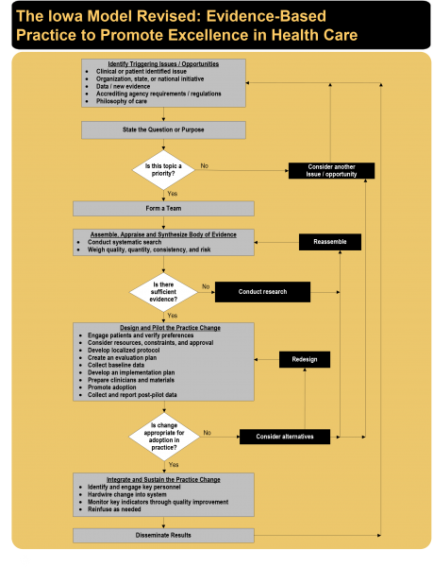
Iowa Model Collaborative. (2017). Iowa model of evidence-based practice: Revisions and validation. Worldviews on Evidence-Based Nursing, 14(3), 175-182. doi:10.1111/wvn.12223

Appendix B: Evaluation Tables (PICOT)
Article Citation | Conceptual Framework and Purpose | Design/Method | Sample/ Setting | Major Variables Studied (and  Their Definitions) | Measurement | Data Analysis | Findings | Appraisal: Worth to  Practice
Trogrlic et al., 2020 | Theoretical framework: Implementation Model of Change of Grol and Wensing  Purpose was to measure adherence to delirium guidelines of healthcare staff after an implementation program | Mixed-methods process evaluation of a multi-centre prospective pre-post implementation study (quasi-experimental)  Interventions included delirium screening, prevention, and management strategies. Healthcare professionals evaluated pre- and post- implementation of these strategies  E-learning webinar and in-class lessons were provided as education at phase II and III, as well as audits and feedback  Level, grade of evidence  Quantitative: II, B  Qualitative: III, B | Setting: 5 ICUs (separate hospitals)  Participants: 4449 adult ICU patients (assessed for delirium), 81 physicians, 409 nurses | IV: Education on delirium screening tool, prevention and management strategies  DV: Adherence rates to delirium guidelines. Beliefs, attitudes, and knowledge were assessed pre- and post- implementation of healthcare professionals qualitatively and quantitively | Likert scale used pre- and post- intervention to assess nurses’ perceptions and attitudes  Performance indicators (PIs) were evaluated in four phases throughout the study. Knowledge tests were conducted pre- and post- interventions. | Quantitative data: t-test and one-way analysis of variance used to evaluate pre- and post- tests differences in delirium knowledge. Weighted frequencies and proportions of total ICU patient days were used for adherence to the seven PIs over the four phases | Adherence to delirium screening: improved by 57%  Implementation strategies improved by: 18% (avoiding benzodiazepine use), 17% (performing physical therapy), and 13% (mobilizing patient)  Delirium knowledge scores improved from 62.9 (SD=13.3) to 65.1 (SD=13.1) | Strength: Large sample size. Covers many variables in regards to delirium. Findings showed improvement of knowledge and adherence to delirium guidelines with use of education, and it is sustainable at 6 months.  Limitations: Does not provide statistical significance information nor data analysis tool. Study is a secondary analysis from a larger study.

Appendix B continued
Article Citation | Conceptual Framework and Purpose | Design/Method | Sample/ Setting | Major Variables Studied (and  Their Definitions) | Measurement | Data Analysis | Findings | Appraisal: Worth to  Practice
DeForge et al., 2020 | Purpose: 1) Assess accuracy of CAM-ICU documentation of RNs before and after education; 2) Assess for improvement in “unable to assess (UTA)” documentation; 3) Assess rates of delirium detection | Quasi-experimental design; pre-test, post-test  Educational campaign in 3 phases (2 didactic and 1 hands-on training sessions) - educated on CAM-ICU and how to conduct it at bedside.  RN documentation of CAM-ICU features and their delirium findings (positive or negative) were compared to CAM-ICU algorithm (as applied by researchers from nursing data) to determine accuracy. Complete pre- and post- education  Level, grade of evidence: II, B | Setting: 24-bed medical ICU (MICU) at an urban teaching hospital  Participants: 75 RNs, 1020 patients (pre-intervention), 951 (post-intervention)  Total CAM-ICU RN assessments: 10,736 (pre-education) and 11,068 (post-education) | IV: Delirium educational campaign by “champion nurses”  DVs: Inappropriate “unable to assess” ratings, delirium documentation accuracy, prevalence of detected delirium | RN-documented four components of CAM-ICU (collected via charting system), as well as the RN’s finding of delirium, measured against the expert delirium RN’s comparison finding | χ2 Analysis to compare proportion of correct documentation on RN CAM-ICU assessments and frequency (pre- and post- education) | Accuracy (agreement between RN and algorithm determination) on positive delirium improved from 38% (pre-education) to 44% (post-education) (p=0.2); on negative for delirium improved from 84% (pre-) to 87% (post-)  Decline in inappropriate UTA assessment from 42% (pre-) to 37% (post-education) (p<0.01)  Overall, not a statistical significant improvement from pre- to post- education on accuracy on CAM-ICU documentation by RN compared to algorithm (p=0.054) | Strengths: Incorporated “nurse champions” to help encourage leadership and mentorship within the nursing staff to help promote delirium monitoring compliance. Education helped to deter inappropriate UTA assessments.  Limitations: Limited to single ICU. RNs in this unit already had been utilizing CAM-ICU prior to education and therefore set higher baseline scores. Only assessed documentation and not actual RN physical assessment of delirium.

Appendix B continued

Article Citation | Conceptual Framework and Purpose | Design/Method | Sample/ Setting | Major Variables Studied (and  Their Definitions) | Measurement | Data Analysis | Findings | Appraisal: Worth to  Practice
Spiegelberg et al., 2020 | Theoretical framework: Iowa Model of Evidence-based Practice  Purpose: Improve nurse compliance and knowledge of delirium and how to use CAM-ICU. Authors also wanted to see if education intervention would help to decrease high-risk medication (HRM) use (psych medications for agitation), and hospital length of stay | Pre- and post-test design  Two phase study: 1) baseline data collection; 2) Education (via voice over presentation, hands-on training, and teach-back methods to nursing staff), then CAM-ICU implementation and evaluation  Survey conducted pre- and post-education to nurses on perceptions and knowledge of delirium  Level, grade of evidence: II B | Setting: 16-bed MICU in urban, academic level II trauma hospital  Sample: 59 nurses, 463 patients | IV: CAM-ICU and delirium education  DV: HRM use, length of hospital stay, CAM-ICU documentation prevalence | EHR chart review of studied patients recorded HRM use, length of stay, and CAM-ICU documentation  CAM-ICU used for delirium assessment  ANA Delirium Work Group survey to evaluate nurse knowledge and perceptions (pre- and post-education) | QI charts, version 2.0, Process Improvement Products was used to evaluate HRM use and LOS. Calculated statistics through a mixed regression model and χ2 tests (SAS 9.4)  2-tailed t-test to identify survey responses (p<0.05) | HRM use decreased from 4.73% (pre-education) to 2.99% (post-education) (p<0.001). In turn, each additional HRM used increased LOS by 0.13 days (p<0.001)  CAM-ICU completion rate was 83% (from 0%), 6 weeks after initial implementation  Survey responses: 87% nurses believed CAM-ICU appropriately identified delirium. 14 of 15 nurses reported increased confidence in identifying delirium after education | Strengths: Education plan alone allowed for decrease in HRM use, and in turn decreased LOS, although delirium risk did not impact LOS. Nurse champion used as well to help promote and mentor fellow nurses. High completion rate of CAM-ICU following education. Spot-checks were conducted to assess CAM-ICU competency throughout implementation.  Limitations: Small sample size with low survey responses on second phase (15 of 59). No reported results on knowledge or competency findings

Appendix B continued

Article Citation | Conceptual Framework and Purpose | Design/Method | Sample/ Setting | Major Variables Studied (and  Their Definitions) | Measurement | Data Analysis | Findings | Appraisal: Worth to  Practice
Ramoo et al., 2018 | Purpose: To determine if there is a difference in delirium knowledge of ICU nurses after implementation of an educational program, as well as to see the perceptions on usefulness and barriers of an ICU delirium assessment tool | Pre- and post-test design  A self-administered survey given pre- and post-education intervention. Assessed delirium and CAM-ICU perceptions, knowledge, and demographics  Education sessions conducted in-person by the researcher over 5 week period. Included videos, case scenarios, and discussions from Vanderbilt training manual.  Level, grade of evidence: II B | Setting: 23-bed general adult ICU of teaching hospital in Malaysia  Sample: 61 nurses | IV: Delirium educational session  DVs: Nurse knowledge score, nurse perception on usefulness of CAM-ICU | Questionnaire by Devlin et al. (2008) was used for section testing knowledge of delirium and CAM-ICU (intra-rater reliability: 86%) (Cronbach’s alpha 0.904). Consisted of 10 multiple-choice questions and 8 statements with Yes/no/unsure options  Section on nurses’ perception of delirium and usefulness of CAM-ICU was adapted from Pun et al. (2005) and consisted of Likert scale | SPSS v22.0 used for analysis. Descriptive and inferential statistics used. Univariate analysis used to assess the differences in knowledge levels and perceptions based off demographics | Knowledge scores, when adjusted for age and experience of the nurse, significantly improved after education sessions (p<0.01)  Majority of nurses (72%) felt that the CAM-ICU is a useful tool, and 78% felt that their knowledge of delirium has increased with use of the CAM-ICU | Strength: Results acknowledge impact of education for newly practicing ICU nurses. This study also provided evidence that the CAM-ICU is perceived as a useful tool by bedside nurses and that it helps them to better understand delirium.  Limitations: Small sample size. Does not assess nurse’s ability to perform CAM-ICU assessment, nor determine if delirium detection or tool adherence has improved. No data of patient involvement.

Appendix B continued

Article Citation | Conceptual Framework and Purpose | Design/ Method | Sample/ Setting | Major Variables Studied (and  Their Definitions) | Measurement | Data Analysis | Findings | Appraisal: Worth to  Practice
Blevins & DeGennaro., 2018 | Purpose: Determine if an educational intervention will impact nurses’ knowledge of delirium, delirium risk factors, and CAM-ICU utilization. | Pre- and post-test design  36-item test covering general delirium information, screening tools, and delirium risk factors given prior to and after an education program.  Education consisted of: delirium survivor video, didactic content, case-studies (using CAM-ICU), and teach-back demonstration of the CAM-ICU at patient bedside  Level, grade of evidence: II B | Setting: 28-bed MICU in a teaching hospital on the East Coast of the U.S.  Sample: 34 nurses of 106 participated | IV: Delirium education program and CAM-ICU demonstration  DV: Nurses’ knowledge of delirium, tools, and CAM-ICU | Pre-, post-test was adapted from the Delirium Knowledge Assessment (NDKA)  CAM-ICU was used for delirium screening tool | SPSS v24 used to analyze mean and median values. Paired sample t test was used to determine differences in pre- and post-test scores (p<0.05) | Improvement in scores from pre- to post- test was statistically significant (p<0.05) overall  CAM-ICU was performed correctly by 79% of nurses post-education | Strengths: Significant findings of improved knowledge scores indicates importance of an education program. Helps to validate ease of use of CAM-ICU by amount of nurses shown capable of performing correctly.  Limitations: Small sample size. CAM-ICU screening ability of the nurses was not assessed prior to education and therefore no comparison of pre-and post-education data was evaluated. No data to determine if educational improvement affected delirium prevalence or adherence of nurses to screening for delirium.

Appendix B continued

Article Citation | Conceptual Framework and Purpose | Design/ Method | Sample/ Setting | Major Variables Studied (and  Their Definitions) | Measurement | Data Analysis | Findings | Appraisal: Worth to  Practice
Smith et al., 2017 | Theoretical framework: American Association of Critical Care Nurses Synergy Model for Patient Care and Bandura’s theory of self-efficacy  Purpose: Assess critical care nurses’ knowledge of delirium and confidence of assessment after a multimodal education strategy | Pre- and post-test design  An online learning module that focused on signs/symptoms of delirium, how to assess delirium using the CAM-ICU, and strategies for early management. Two simulation scenarios were also included. A test was given before and after education session.  The knowledge and confidence tests were given pre-education, immediately post-education, then 6 weeks later  Level, grade of evidence: II B | Setting: Adult medical-surgical ICU in a community medical center  Sample: 34 ICU nurses | IV: Online education module and in-person scenarios  DV: Knowledge of delirium; nurses’ self-confidence in delirium screening and management | The Demographic Tool was used to collect general participant characteristics  The Knowledge of Delirium tool is a 10-item multiple choice test that assesses knowledge of risk factors, signs/symptoms, consequences, and management of delirium. It was developed by the investigator.  The Confidence Scale was adapted. It is a Likert scale created by Grundy et al. (1993) and evaluates confidence of physical assessment.  CAM-ICU was used as delirium screening tool | SPSS v21.0 used for data analysis. Alpha was preset to 5% for all significance testing.  McNemar tests were used to determine changes in Knowledge of Delirium items and Confidence Scale items | No statistical significance was found in knowledge of delirium scores from pre- to post-test  There was statistical significance for increased confidence of the nurses in detecting and managing delirium (p<0.001) | Strength: Nurses are more confident in delirium assessment and management after educational scenarios and online learnings.  Limitations: Small sample size. Knowledge of Delirium tool is not validated.

Appendix B continued

Article Citation | Conceptual Framework and Purpose | Design/  Method | Sample/  Setting | Major Variables Studied (and  Their Definitions) | Measurement | Data Analysis | Findings | Appraisal: Worth to  Practice
Mistraletti et al., 2017 | Purpose: To evaluate effectiveness of an e-learning program for ICU physician and nursing staff. | RCT design: two groups randomly assigned (hospitals separated into groups) to control or intervention. Control group would then become an intervention group after initial intervention group completed.  Baseline survey conducted on each group. Pre-training survey administered prior to intervention. Then three online courses offered to intervention group, with topic of delirium included. Post-training test administered to this group at same time as pre-training test to control group, to compare results. Control group then got to partake in training and was tested after.  Level, grade of evidence: I B | Setting: 8 ICUs in area of Milan, Italy  Sample: 374 doctors and nurses. Only 117 participants completed all three courses. 210 collected questionnaires post-intervention | IV: Three online courses  DV: Prevalence of pain, delirium, agitation assessments. Secondary variables: prevalence of validated screening tools, perception of difficulties/ workload, length of ICU stay | Validated tools assessed: Verbal Numeric Rating (VNR), Behavioral Pain Scale (BPS), Richmond Agitation-Sedation Scale (RASS), CAM-ICU, Intensive Care Delirium Screening Checklist (ICDSC)  Investigator-made questionnaire on participant perceptions | STATA 12 used for statistical analysis  Prevalence of neurological assessments determined with non-parametric test: Wilcoxon rank-sum test or Friedman’s multiple comparison test.  Questionnaire results were analyzed using non-parametric tests for paired data, then student’s t-test. | Use of validated delirium assessment tools was higher in intervention group (78.6%) compared to control group (0%) (p<0.01)  From questionnaire: Increased use of CAM-ICU from pre-intervention (40.2%) to post-intervention (70.8%) (p<0.01). Knowledge of delirium definition improved from 64.9% to 82.7% (p<0.01) after training  Improved CAM-ICU accuracy was also significant (p<0.01) after training. | Strengths: RCT allowed for control and intervention groups for comparison. Moderate sample size with multiple setting locations. Various outcomes measured with statistical significance  Limitations: Unknown validation or general information on outcome measures, including pre- and post-tests and surveys. Mild inconsistency in results: 0% reported validated delirium tool use versus 40.2% CAM-ICU use (pre-intervention).

Appendix C: Evaluation Tables for Delirium Screening

Citation Author/  Year | Conceptual Framework and Purpose | Design/  Method | Sample/  Setting | Major Variables Studied | Measurement | Data Analysis | Findings | Appraisal: Worth to Practice
Gusmao-Flores et al., (2012) | Purpose of the study was to provide a systematic review of pooled studies that presented data on the CAM-ICU and ICDSC for the diagnosis of delirium in critically sick patients  Meta-analysis completed  No theoretical framework defined | Systematic review with a meta-analysis  Database search in MEDLINE, SciELO, CINAHL, and EMBASE  Only included articles that used the DSM-IV criteria for delirium as the comparison variable | Total sample size was 1360 over 13 separate studies  9 of the studies were focused on CAM-ICU  Remaining 4 focused on ICDSC  All of the studies were completed in the ICU setting, with population consisting only of critically ill adults | IVs were CAM-ICU and ICDSC  Outcomes measured were the presence of delirium, which was also determined by the DSM-IV criteria (the gold standard) | Assessment tools for the study was the CAM-ICU and the ICDSC  The purpose of this study was to evaluate how well the CAM-ICU and ICDSC compared to the DSM-IV criteria of delirium | Data analysis software used was the STATA v. 9.0 and MetaDISC to analyze the data in a meta-analysis  Evaluated the sensitivities and specificities  Authors were able to conclude that the CAM-ICU was clinically appropriate for implementation for ICU delirium assessment | CAM-ICU: specificity (80%) and sensitivity (95.9%)  ICDSC: specificity (74%) and sensitivity (81.9%)  Per criteria, these suggest that the CAM-ICU is “not only adequate for screening but also a good confirmatory diagnostic tool for delirium in critically ill patients” (Gusmao-Flores et al., 2012, p. 8). | The high specificity and sensitivity confidence intervals are significant  Having a tool such as this would be more practical than the DSM-IV because it can be used by other healthcare personnel (i.e. nurses, physicians)  Patients with delirium can be more readily assessed and therefore treated  Limitations include little information on each studies’ design, methods, measurement tools and analysis, limitations on these individual studies, and their comparisons amongst subgroups of delirium

Appendix C continued
Citation Author/  Year |  | Conceptual Framework and Purpose |  | Design/  Method |  | Sample/  Setting | Major Variables Studied |  | Measurement |  | Data Analysis |  | Findings |  | Appraisal: Worth to Practice
Tomasi et al., (2011) | Purpose of this study was to compare the results and assessments of the CAM-ICU and ICDSC, as well as the clinical outcomes following these patients  No conceptual framework identified |  | Prospective cohort study conducted at a single University hospital  Delirium was assessed in patients admitted to the ICU with both the CAM-ICU and ICDSC twice a day over admission period  In addition, a single investigator completed the assessment twice a day based off chart information |  | Total sample size after meeting inclusion criteria: 162  Study requirements: ICU admission greater than or equal to 24 hours, 18 years or older, RASS score greater than -4 |  |  | Independent variable: delirium, determined by either CAM-ICU or ICDSC  Outcomes assessed: hospital length of stay, mortality rate |  | Assessment of delirium determined by both CAM-ICU or ICDSC  Each assessment was completed twice a day by the primary nurse taking care of the patient |  | Software used: SPSS (version 12.0)  Continuous variables with normal distribution were reported as mean and standard deviation  P-value of <0.05 was set as statistically significant |  | CAM-ICU detected delirium in 26.5% of patients; ICDSC detected delirium in 34.6% of patients  Agreement between both tools was made in 147 of the 162 patients  Statistical significance was found in delirium (by both assessment tools) and length of hospital stay (p<0.001) and hospital mortality (p=0.047)  Diagnosis of delirium by CAM-ICU more often detected patients with higher mortality than ICDSC did |  | Delirium diagnosis by CAM-ICU was more in tuned to higher mortality than when using the ICDSC and should therefore be considered as a first-line assessment tool  Limitations: Single-center study with lower levels of delirium; no assessment of long-term effects; gold standard was not used (i.e. DSM-IV)

Appendix D: Johns Hopkins Nursing Evidence-Based Practice Appendix H
Category (Level Type) | Total Number of Sources/ Level | Overall Quality Rating | Synthesis of Findings  Evidence That Answers the EBP Question
Level I  ■ Experimental study  ■ Randomized controlled trial (RCT)  ■ Systematic review of RCTs with or without meta-analysis  ■ Explanatory mixed method design that includes only a Level I quaNtitative study | 1 | B | RCT study design. Results indicated that there is a significant improvement in delirium assessment ability (i.e. using CAM-ICU), delirium detection, and improved use of screening after participants were educated on delirium.
Level II  ■ Quasi-experimental studies  ■ Systematic review of a combination of RCTs and quasi-experimental studies, or quasi-experimental studies only, with or without meta-analysis  ■ Explanatory mixed method design that includes only a Level II quaNtitative study | 1 (delirium screening)  6 (education programs) | A  B | CAM-ICU and ICDSC are both suitable tools to be used at the bedside to assess for delirium.  Education on delirium and screening tools significantly impacts adherence to screening, knowledge of delirium, and confidence. Education on the CAM-ICU has shown improved utilization and accuracy in comparison to no education.
Level III  ■ Nonexperimental study  ■ Systematic review of a combination of RCTs, quasi-experimental and nonexperimental studies, or nonexperimental studies only, with or without meta- analysis  ■ QuaLitative study or meta- synthesis  ■ Exploratory, convergent, or multiphasic mixed-methods studies  ■ Explanatory mixed method design that includes only a level III QuaNtitative study | 1 | B | The CAM-ICU is an appropriate tool to use by healthcare providers in comparison to the DSM-IV, which is the gold standard.

Appendix D Continued
Based on your synthesis, which of the following four pathways to translation represents the overall strength of the evidence?
Category (Level Type) | Total Number of Sources/ Level | Overall Quality Rating | Synthesis of Findings  Evidence That Answers the EBP Question
Level IV  ■ Opinions of respected authorities and/or reports of nationally recognized expert committees or consensus panels based on scientific evidence | 0 | N/A | N/A
Level V  ■ Evidence obtained from literature or integrative reviews, quality improvement, program evaluation, financial evaluation, or case reports  ■ Opinion of nationally recognized expert(s) based on experiential evidence | 0 | N/A | N/A

- Strong, compelling evidence, consistent results: Solid indication for a practice change is indicated.
X Good and consistent evidence: Consider pilot of change or further investigation.
- Good but conflicting evidence: No indication for practice change; consider further investigation for new evidence or develop a research study.
- Little or no evidence: No indication for practice change; consider further investigation for new evidence, develop a research study, or discontinue project.
If you selected either the first option or the second option, continue. If not, STOP—translation is not indicated.

Appendix D Continued

Recommendations based on evidence synthesis and selected translation pathway

Delirium does seem to correlate with increased length of hospital stay and should therefore be part of the care plan for ICU patients. Using a tool such as the ICDSC or CAM-ICU are appropriate for bedside evaluation of delirium.

Education in various formats can significantly improve delirium knowledge, screening adherence, and promote confidence in nursing staff. Providing training on CAM-ICU use is imperative to the accuracy and adherence at which nurses can assess delirium if using this tool.
Consider the following as you examine fit:
Are the recommendations:
■■ Compatible with the unit/departmental/organizational cultural values or norms?
■■ Consistent with unit/departmental/organizational assumptions, structures, attitudes, beliefs, and/or practices?
■■ Consistent with the unit/departmental/organizational priorities?

Consider the following questions as you examine feasibility:
■■ Can we do what they did in our work environment?
■■ Are the following supports available?
- Resources
- Funding
- Approval from administration and clinical leaders
- Stakeholder support
■■ Is it likely that the recommendations can be implemented within the unit/department/ organization?

Appendix E: Pre-, Post-Test

Demographics and Background Information
- Gender (male/female/other)
- Age (type in number)
- Education level (associate, BSN, masters, doctorate)
- ICU experience (type in number)
- Primary shift worked (night/day)
- Have you ever used a delirium assessment tool before? (yes/no)
- Have you identified a patient as being positive for delirium? (yes/no)

Knowledge Questions
Please select only ONE best or likely answer for each question:

1. Delirium develops ....
□ Suddenly, over hours to days
□ Moderately, lasting for months
□ Slowly and insidiously over months
□ In line with the ageing process

2. Key signs and symptoms of delirium in hospitalized patients include:
□ Loss of long term memory and cognition
□ Wandering and antisocial behavior
□ Sudden changes in level of alertness and orientation
□ Gradual disorientation to surroundings

3. The age group most at risk of developing delirium is ....
□ Children under 12 years
□ Adolescents 13 to 18 years
□ Adults 19 to 59 years
□ The older person >65 years

4. Which of the following group of patients is at greatest risk of developing delirium?
□ 82-year-old man with a pre-existing diagnosis of dementia
□ 50-year-old with Type 2 diabetes, hypercholesterolemia, and obesity
□ 20-year-old athletic, fit, student nurse
□ 60-year-old man with central obesity

5. Which of the following patients may develop delirium?
□ A person undergoing alcohol withdrawal and detoxification
□ A pediatric patient who is febrile
□ A person with dementia admitted to hospital for ‘unexplained weight loss”
□ None of the above
□ All of the above

6. Delirium is caused by ....
□ A complex interaction of multiple factors
□ The normal ageing process
□ Plaque like deposits in the brain
□ Ischemic attacks on the brain

Appendix E Continued

7. If identified early enough and appropriate measures are taken, then the signs and symptoms of delirium
□ Yes, usually can be reversed
□ No, it is not reversible

8. Which sub-type of delirium presents with lethargy and reduced motor behaviors?
□ Hypoactive type
□ Hyperactive type
□ Dementia
□ Sundowners

9. Which of the following place the older patient at greater risk of developing delirium?
□ Multiple etiology
□ Use of multiple medications
□ Alterations in sensory acuity
□ All of the above

10. Delirium can worsen the functional state of patients with dementia?
□ True
□ False

11. Which of the following predisposing factors are linked to delirium?
□ Age >65 and sensory impairment
□ Dehydration and dementia
□ Substance use (including alcohol) and chronic illness
□ None of the above
□ All of the above

12. Precipitating factors for delirium include which of the following?
□ Infection and severe acute illness
□ Changes to electrolytes and oxygenation
□ Surgery and invasive procedures, such as urinary catheterization
□ All of the above

13. Which of the following features is NOT included in CAM-ICU?
□ Acute change or fluctuating course of mental status
□ Acute memory loss
□ Inattention
□ Disorganized Thinking

14. Delirium positively presented if one of the four features is positive in the CAM-ICU assessment.
□ True
□ False

Case Study 1&2 Answers
- Positive
- Negative

Appendix E Continued

Case Studies to be included in pre- and post-test:

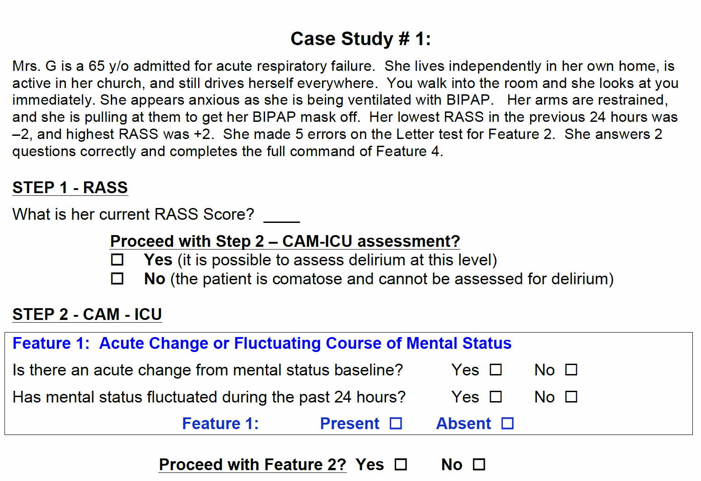
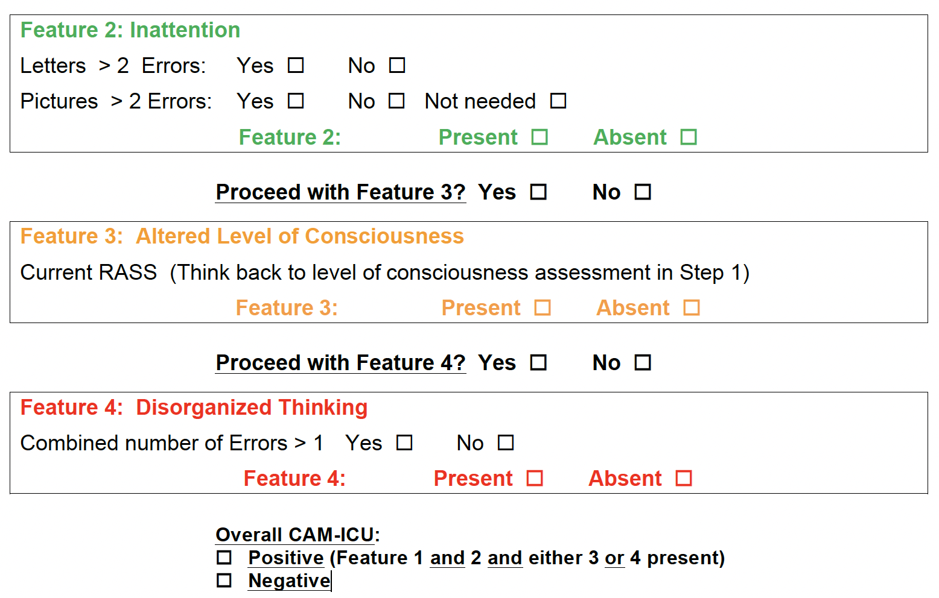
Appendix E Continued

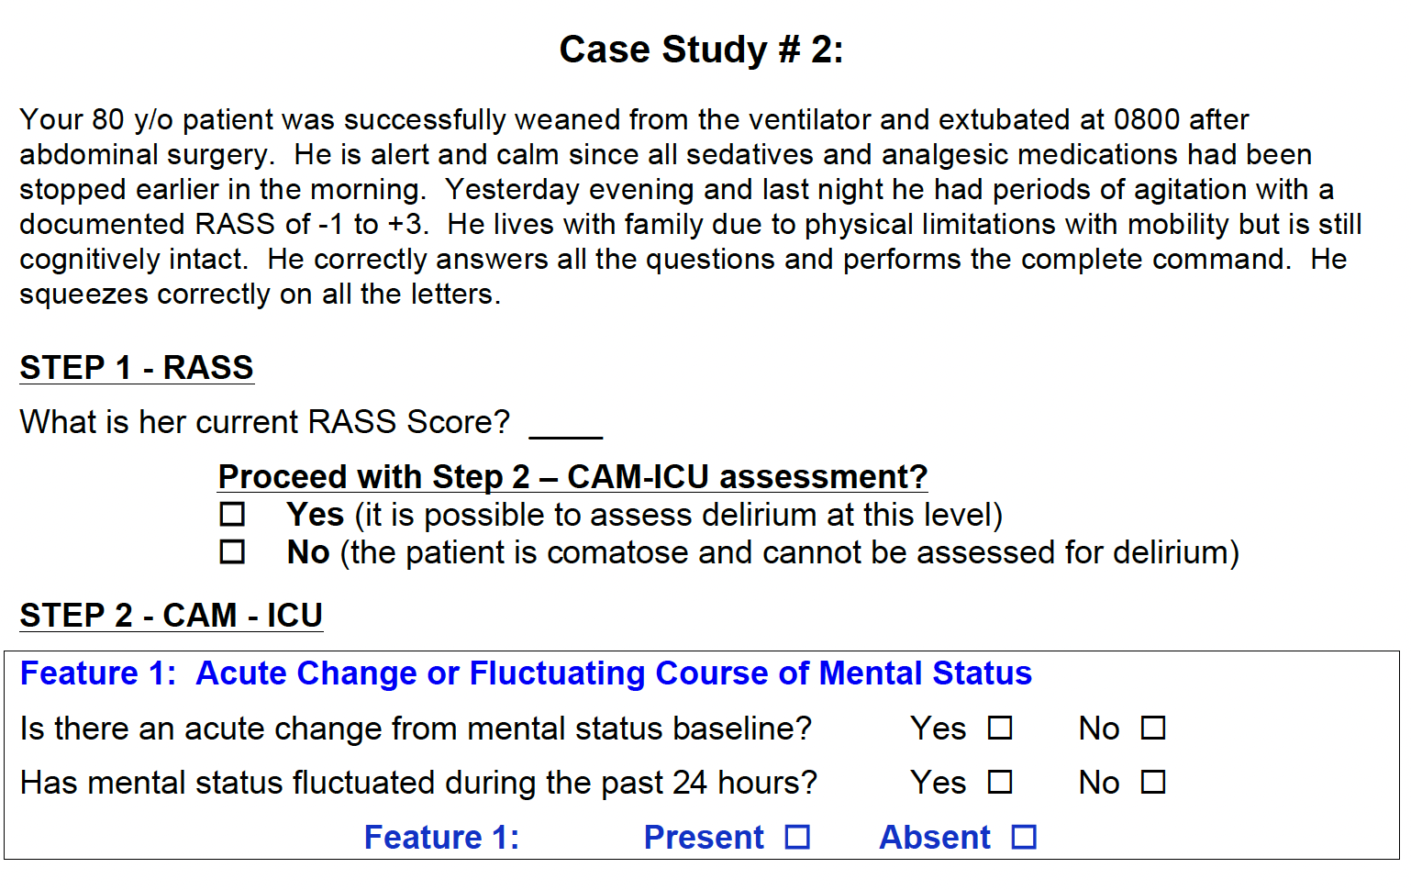
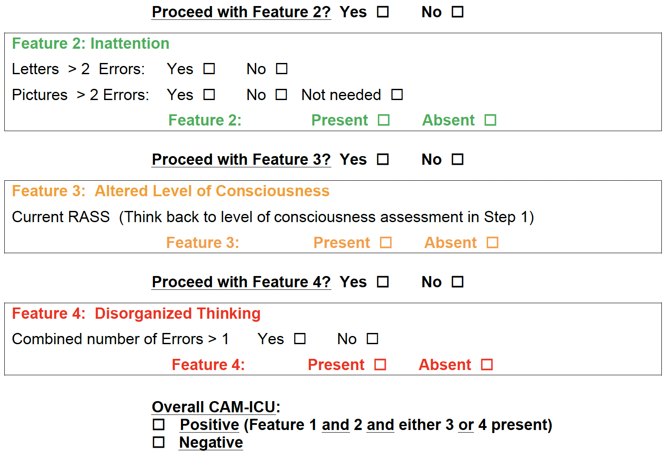

Appendix F: Education Program

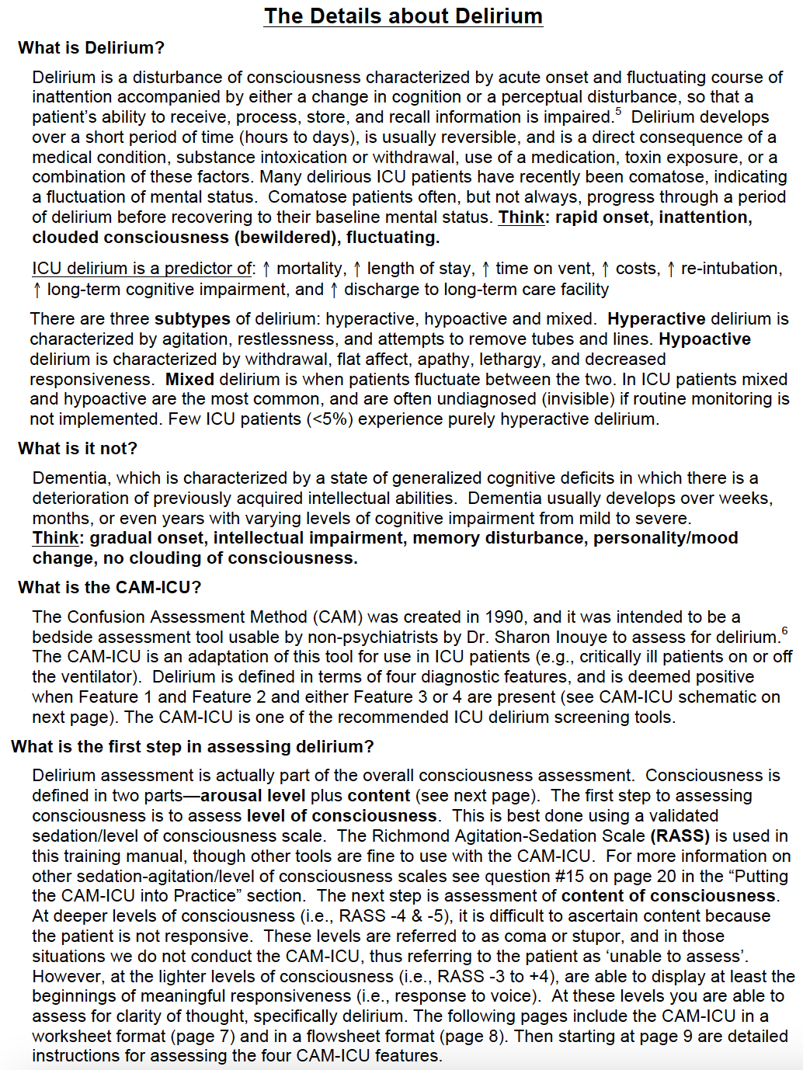

Appendix F Continued
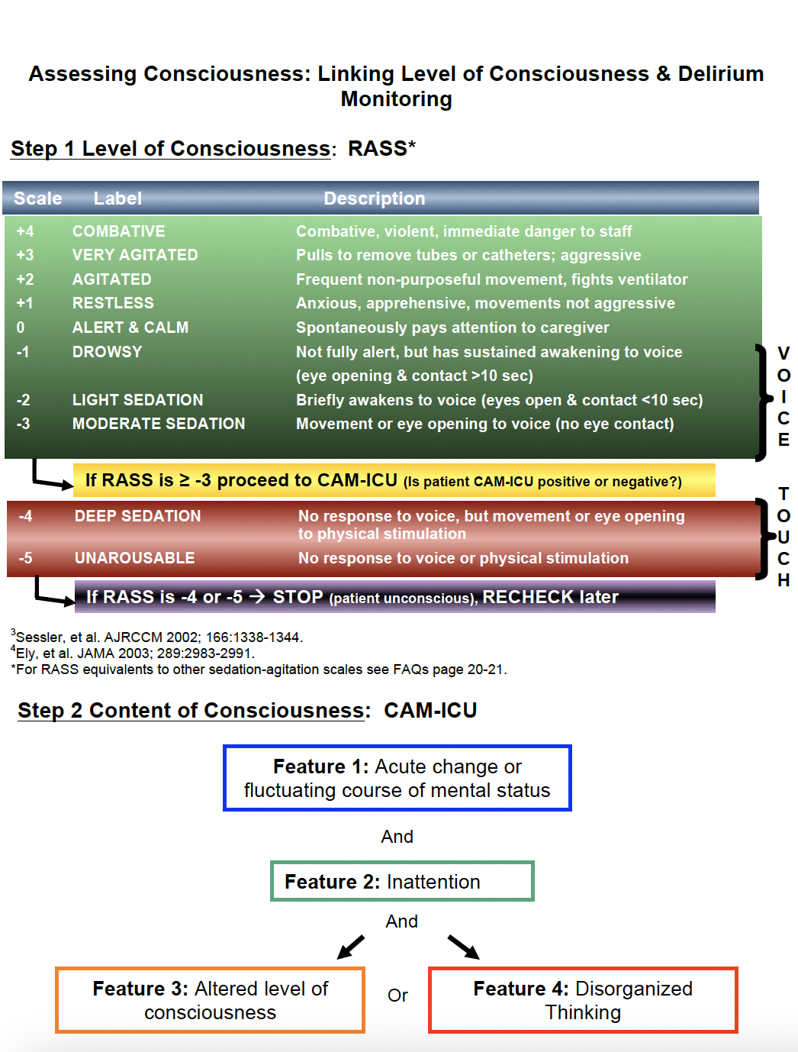

Appendix F Continued

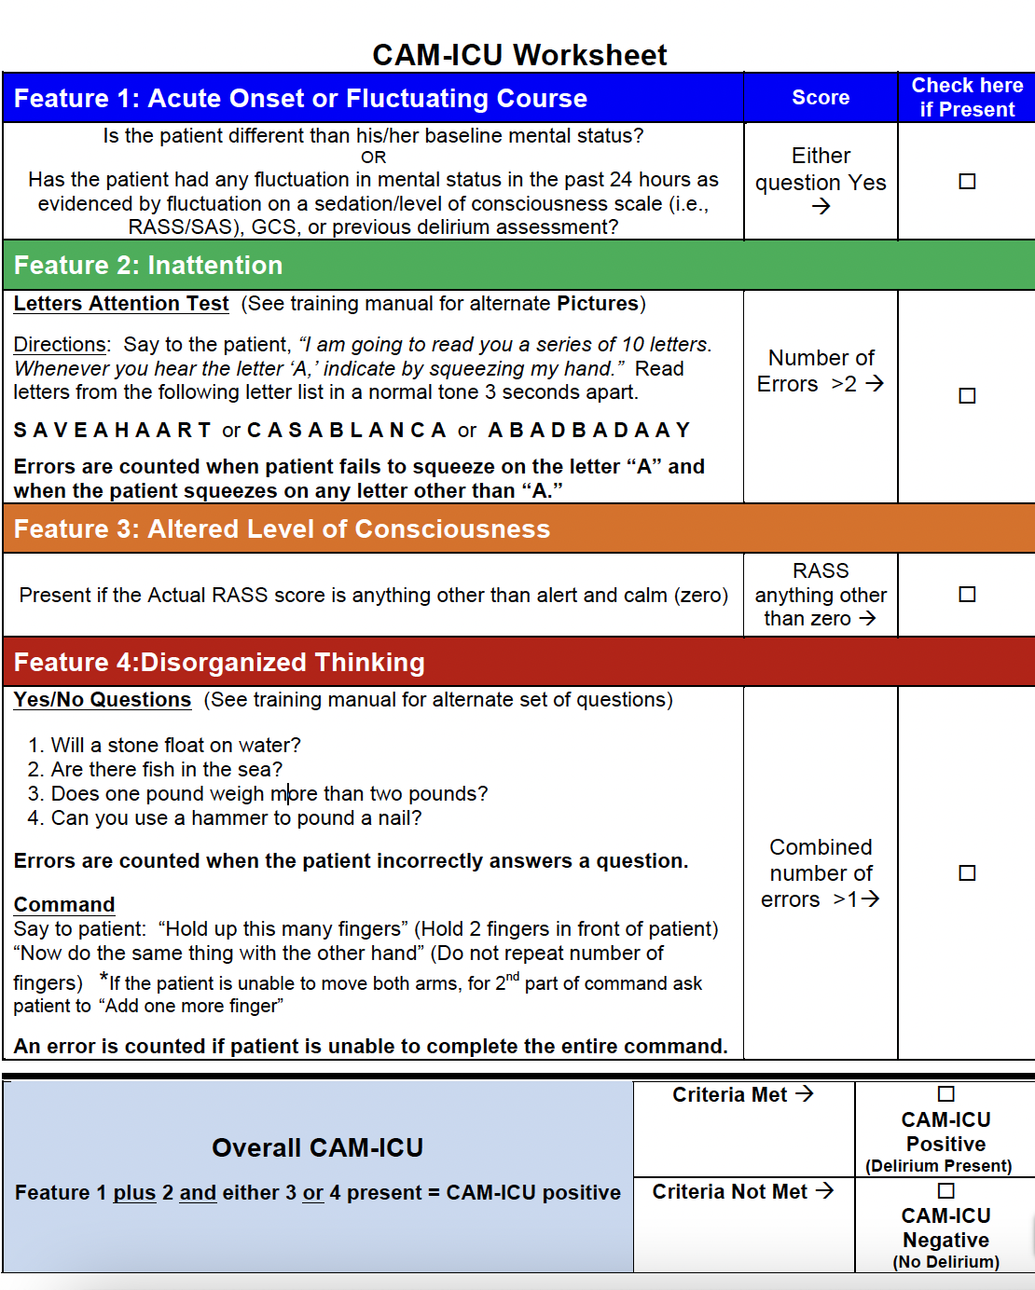

Appendix F Continued

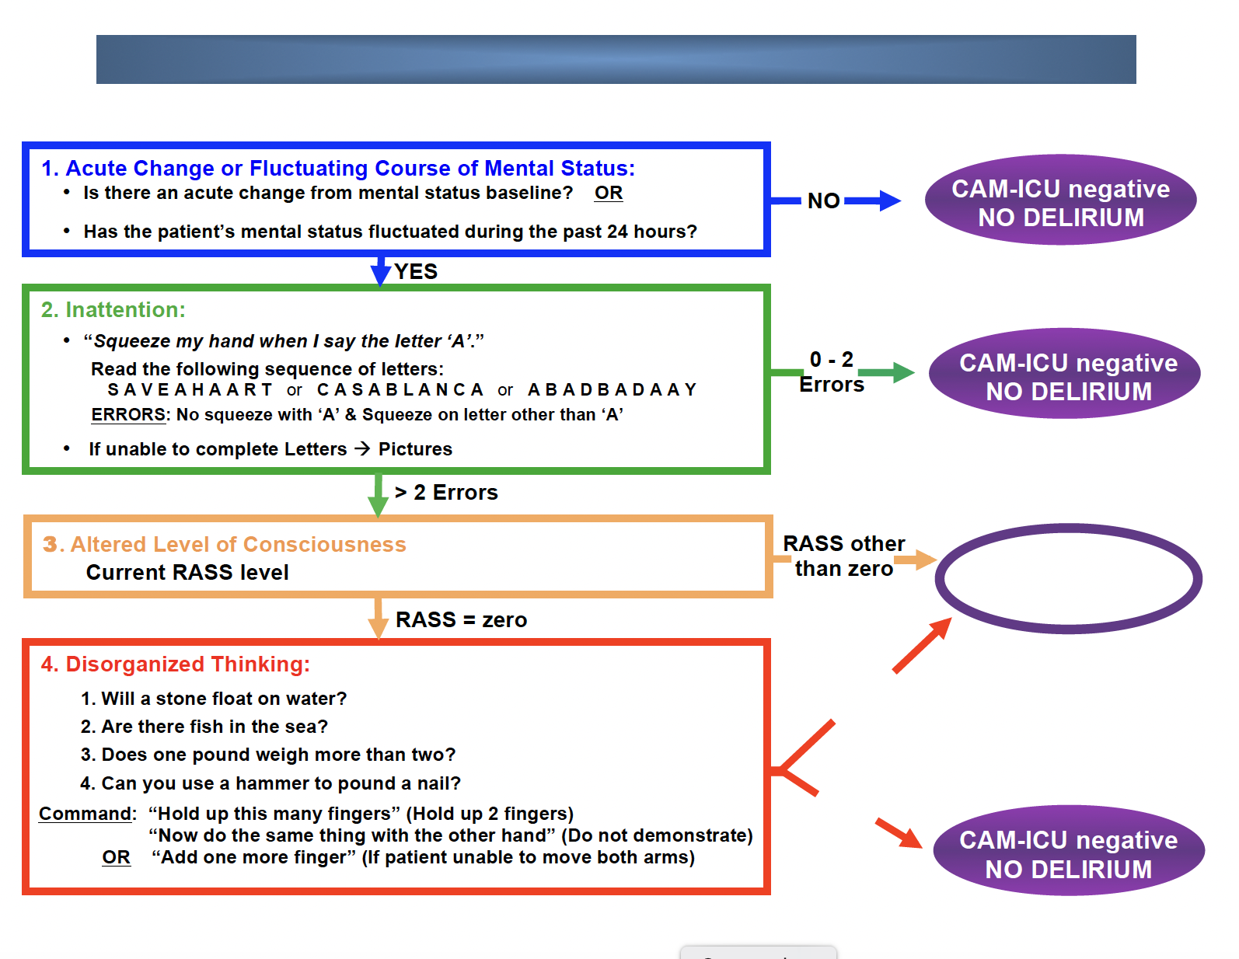

Appendix F Continued

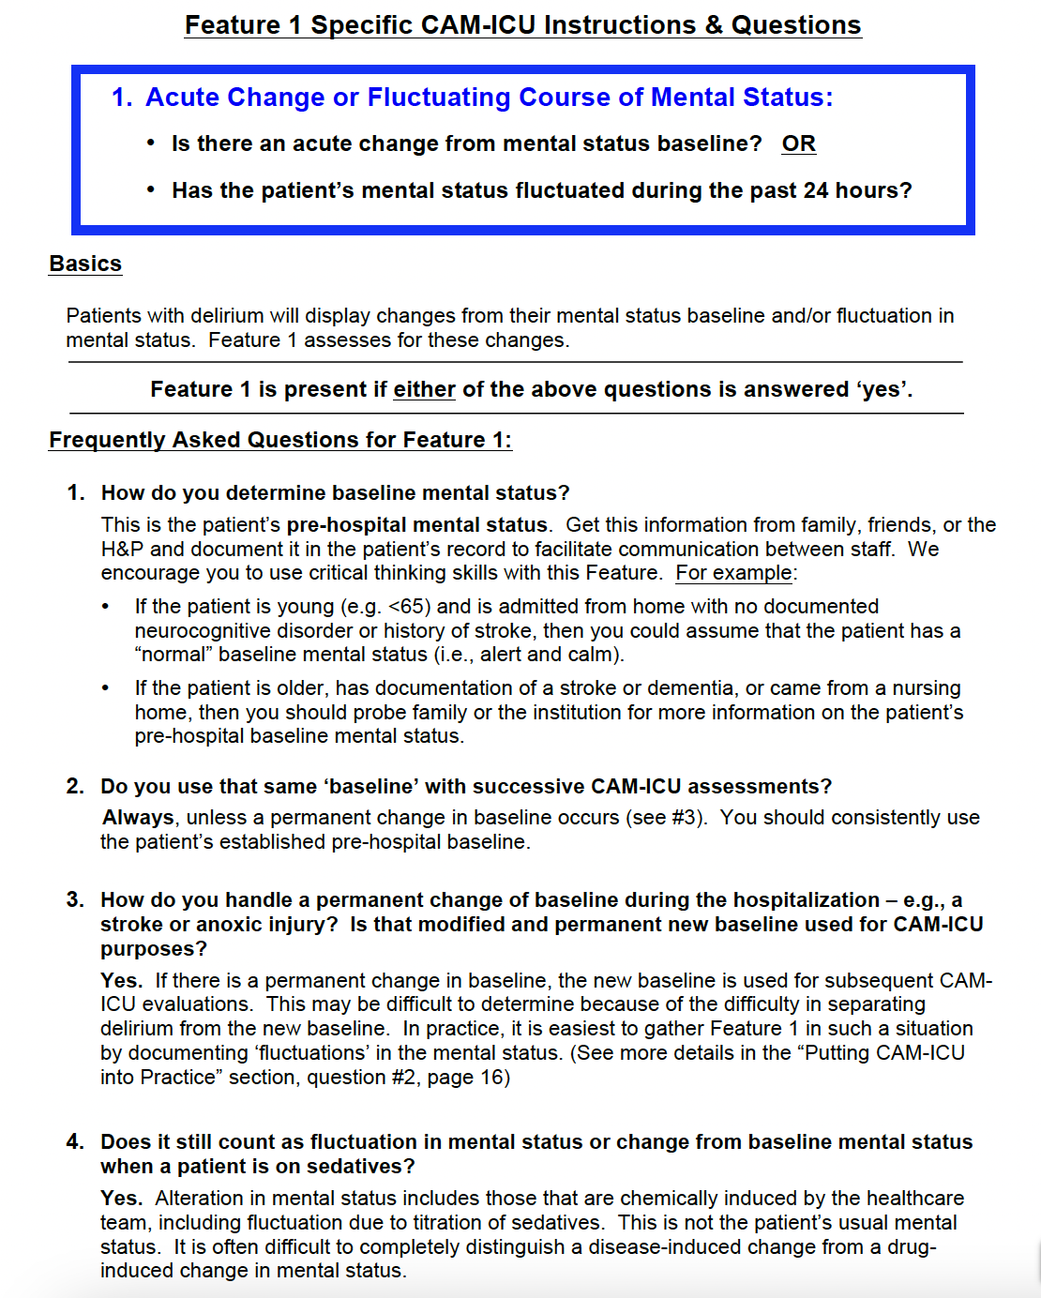

Appendix F Continued

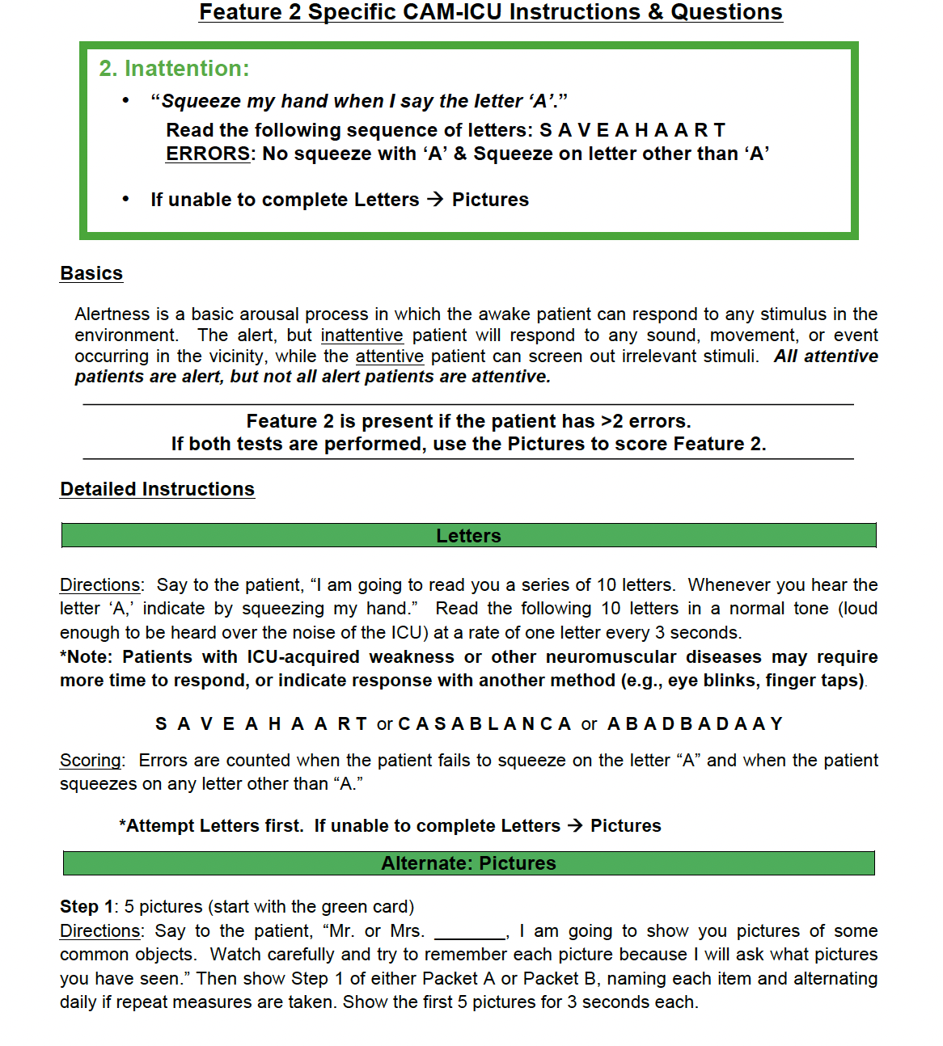

Appendix F Continued

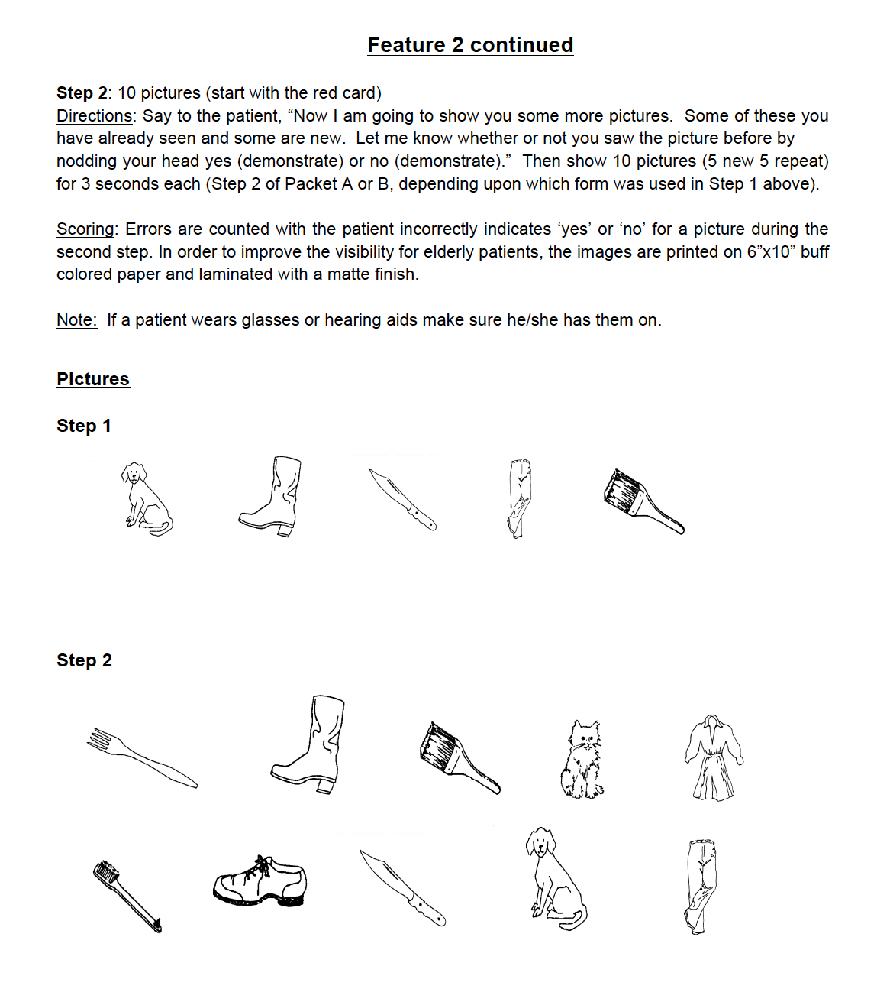

Appendix F Continued

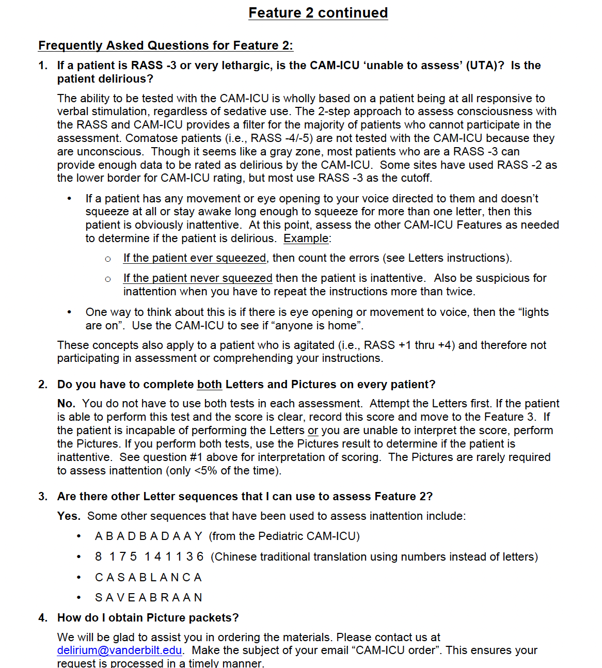

Appendix F Continued

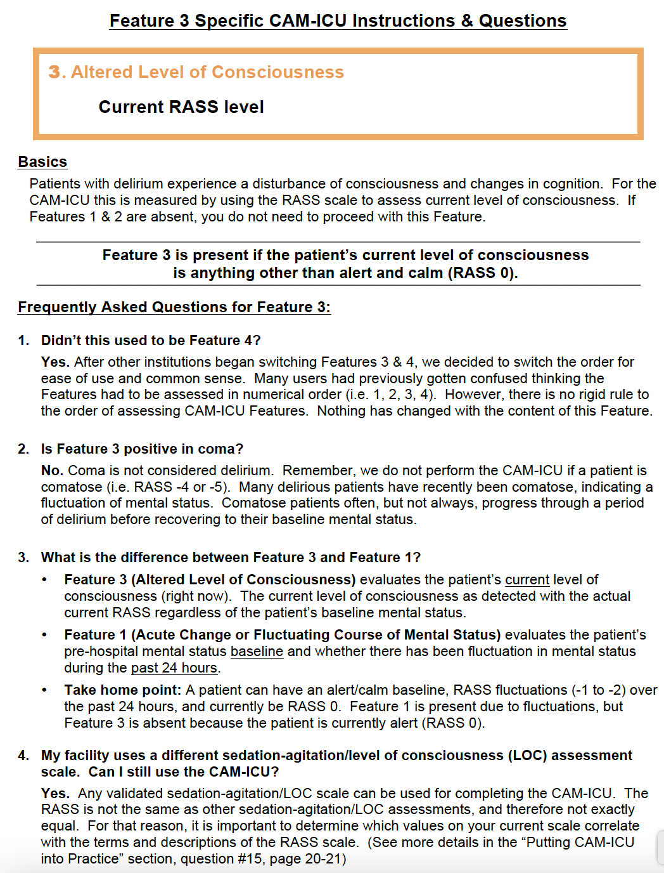

Appendix F Continued
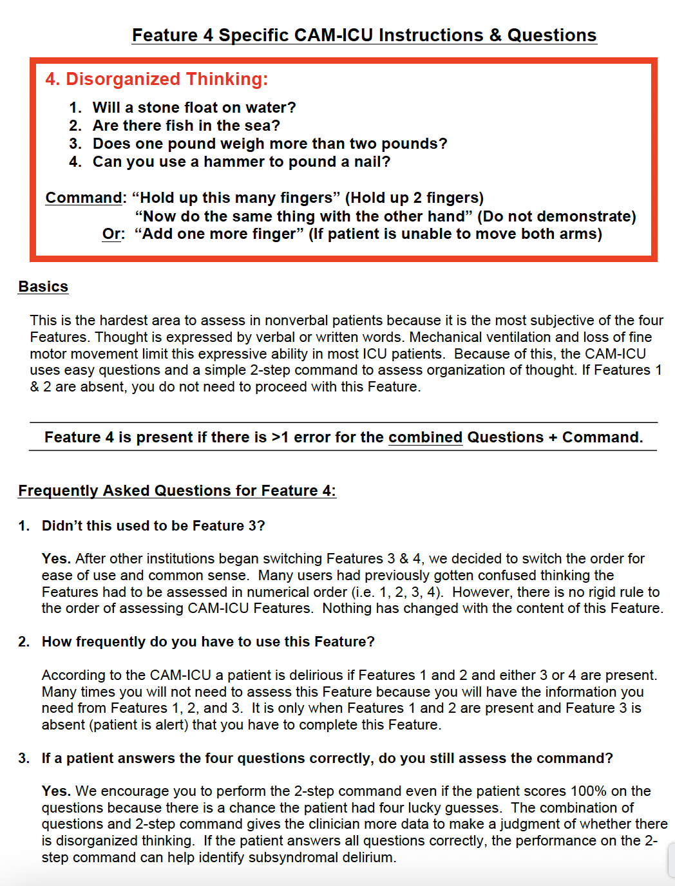
Appendix F Continued

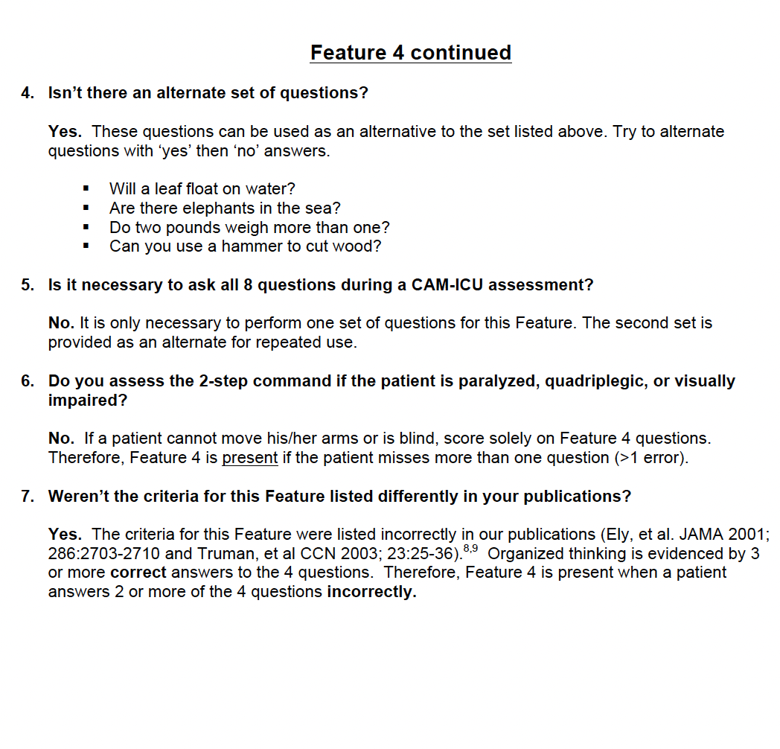

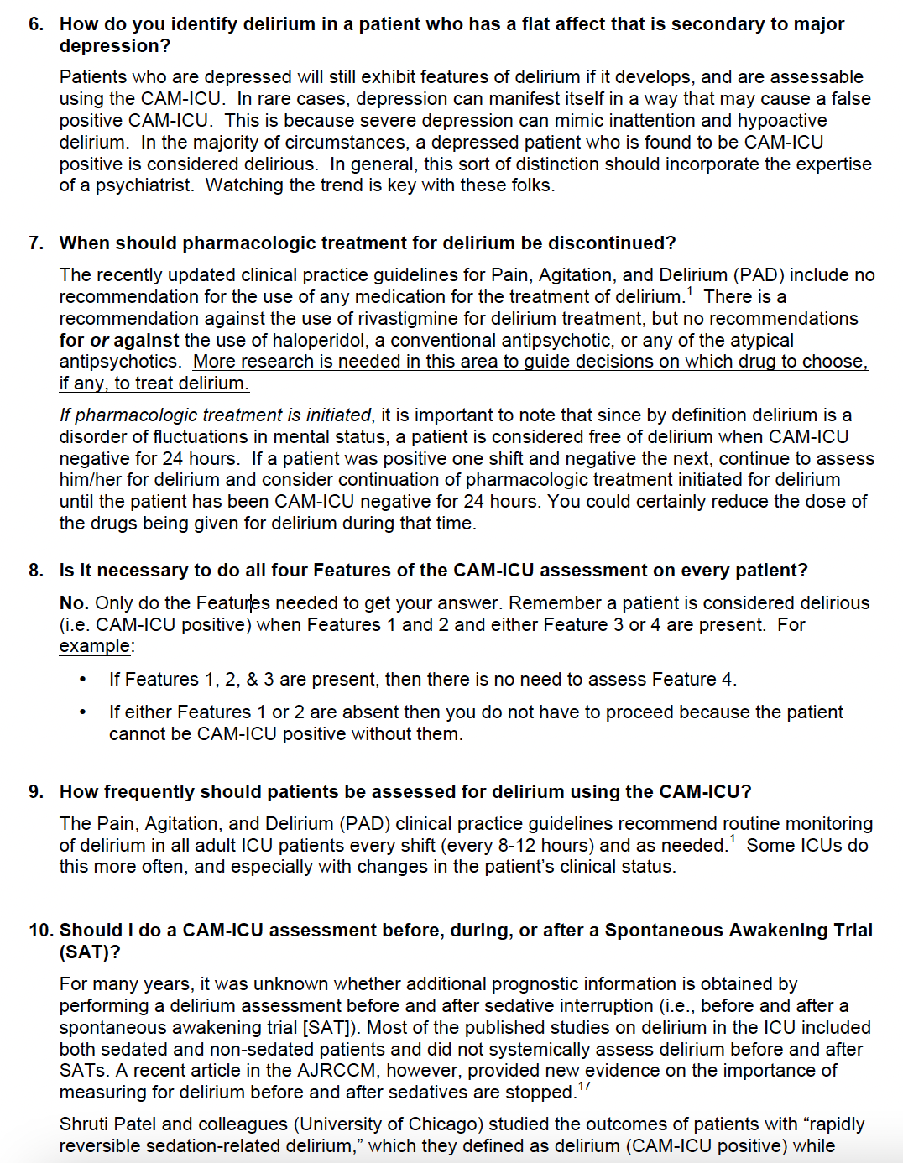

Appendix F Continued

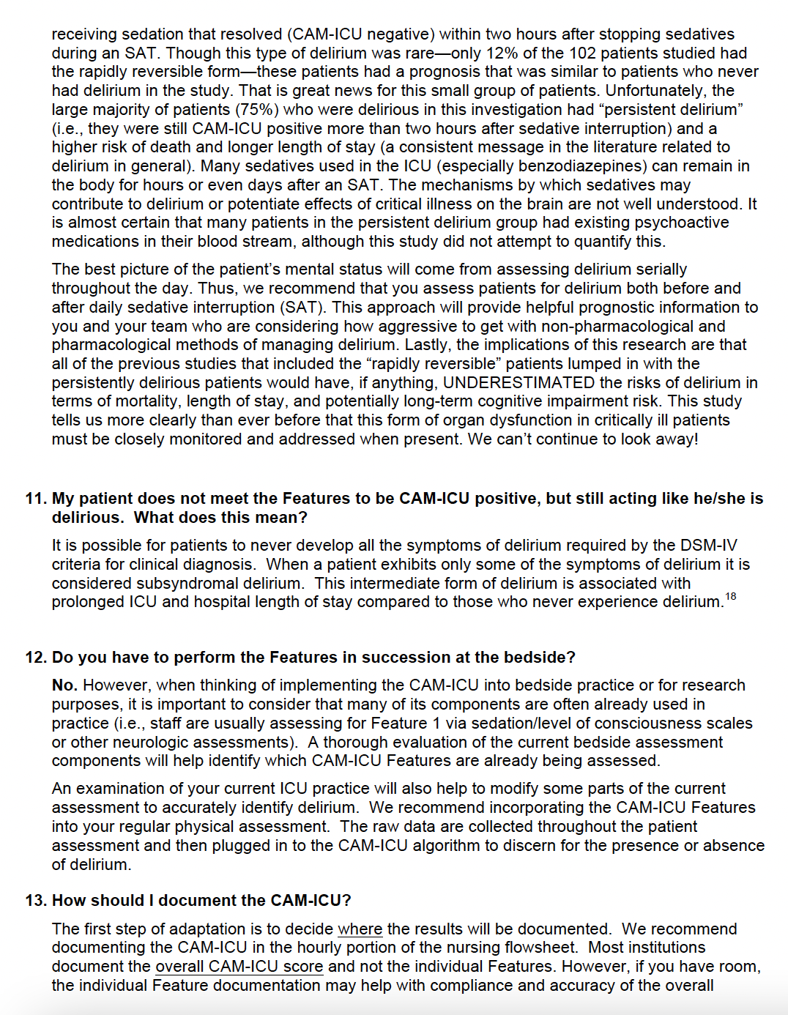
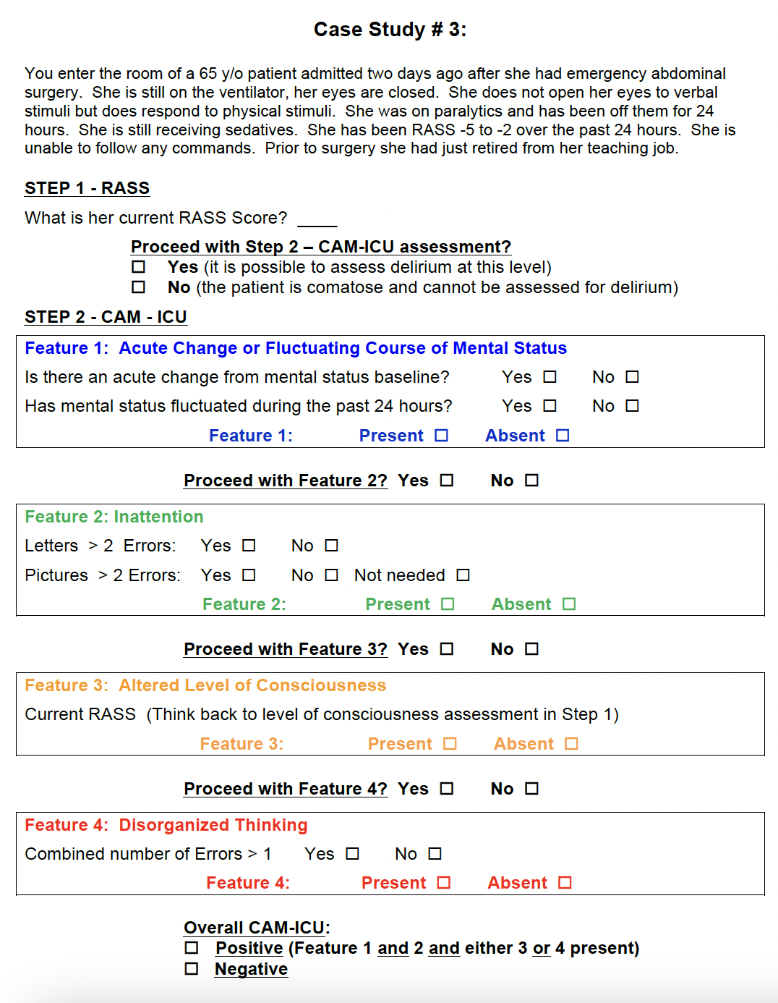
Appendix F Continued

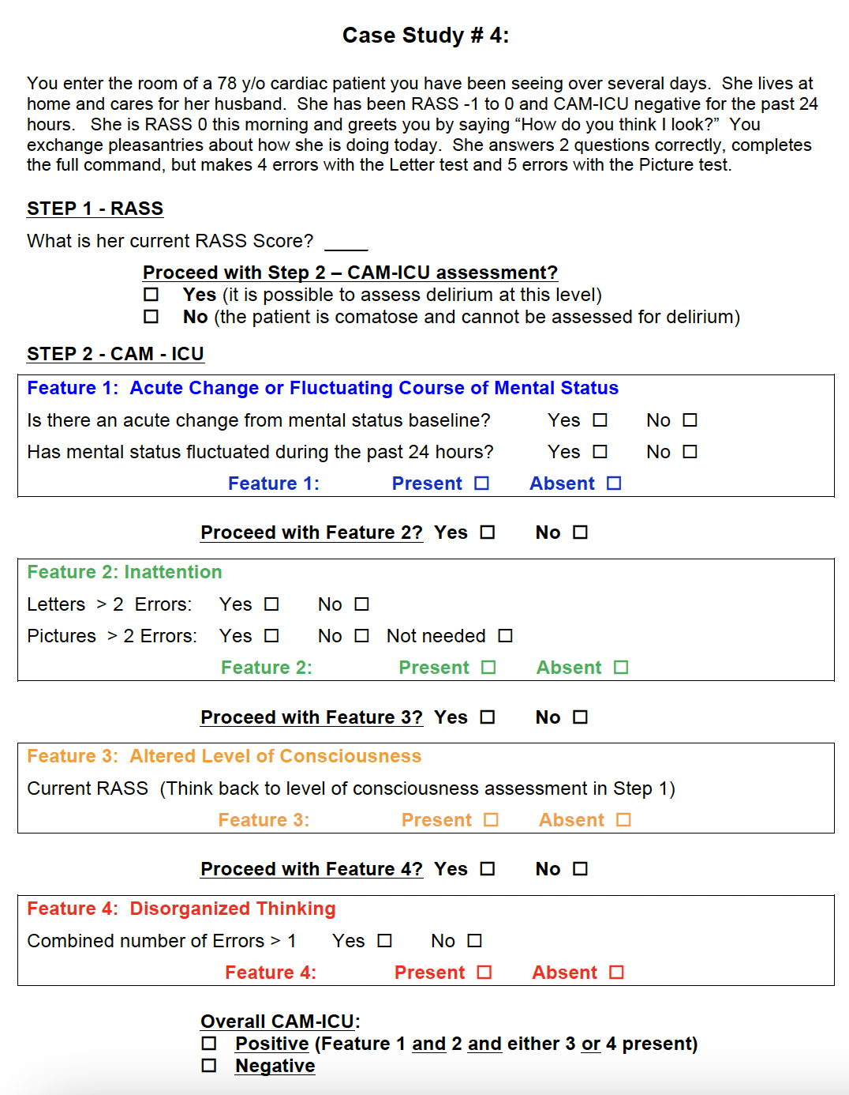

Appendix F Continued
