Accurate Simulation of Reads and Improved Strategies for Abundance Estimation Supporting Reduced Representation Sequencing for Metagenomics

A Dissertation Presented for the
Doctor of Philosophy
Degree
The University of Tennessee, Knoxville

Ryan Douglas Kuster
December 2022

Dedication
I would like to dedicate this work to Hayley, Ezra, and Autumn. You are my world.
Acknowledgements
First and foremost, I would like to thank Dr. Margaret Staton for providing me with support and direction during the many challenges encountered in the writing of this manuscript. I would also like to thank Dr. Deborah Smith and Dr. Olav Rueppell for their generosity in introducing me to the world of graduate research. Thanks to Erika, Matt, Stefan, Tara, and Brandon for keeping me grounded during the most absurd moments in my journey. Finally, thanks to the caring and genuine people I encountered in the department of Entomology and Plant Pathology.
Abstract
Next generation sequencing has impacted all areas of biology by providing affordable investigations into some of the most complex processes underpinning life. With its ubiquitous application, there is still benefit in considering the nuances of the technology and its downstream analysis. Sequencing libraries produced by fragmenting DNA with restriction enzyme digests limit the scope of sequencing to a reduced set of genomic loci, allowing for deeper sequencing of those regions at a reduced cost per sample. These sequencing libraries have been used to determine genetic markers within populations of closely related individuals due to their sensitivity and preservation within populations. A lesser-studied application of enzyme digested DNA samples is for profiling metagenomes as an alternative to marker gene or random whole genome sequencing. Unlike classic approaches to microbial profiling, reduced metagenome sequencing introduces novel challenges to taxonomic assignment as well as relative abundance estimates. Through the development and application of novel simulation software, I investigate the possible strengths and weaknesses of applying this technique to complex microbial communities and find alternative strategies for handling the data produced by this promising application.

Table of Contents
Introduction 1
Chapter 1: Literature Review 3
Illumina library prep and features of short reads 4
Illumina data and its characteristics 4
Meaning and variation in Q scores 6
Reduced Representation Sequencing 6
Profiling approaches in metagenomics 8
The challenges of assignment 10
Reduced Metagenome Sequencing 12
Metagenome simulation 16
Simulating reduced metagenomes 17
Abundance estimation in reduced metagenomic libraries 19
The challenges of quantification 19
Sources of Variation in Metagenomic Experimental Design 23
Chapter 2: Challenges in adapter removal, demultiplexing, and trimming 26
Abstract 27
Introduction 28
Materials and Methods 30
DNA samples and NGS library preparation protocol 30
ngsComposer modular and standalone tools 32
Comparing Performance of Motif and Threshold Filtering 34
Filtering Methods 35
Collapsing Unique Reads 35
Calculating Empirical Base-Calling Error Rates in Barcode Sequences 35
Validating software performance using simulated reads 36
Results 36
Library design and empirical Q score assessment 36
Evaluating read populations using expected motifs 40
Improved adapter detection using barcode-specific search schema 43
Validating software performance using simulated reads 45
Implementation 47
Discussion 47
Chapter 3: Reduced metagenomics profiling and simulation 51
Abstract 52
Introduction 53
Methods and Analysis 54
Software Overview 54
Software Benchmarking 58
Results 60
Comparing Kraken2/Bracken profiles of real and simulated mock communities 63
Performance of software 63
Discussion 66
Chapter 4: Abundance estimation in reduced metagenomics libraries 69
1. Introduction 70
2. Methods and Analyses 73
3. Results 77
4. Discussion 84
Chapter 5: Conclusion 89
References 93
Appendix 105
Vita 125

List of Tables
Table 1. Efficacy of filtering methods using an unbiased estimate, read compression 42
Table 2. Comparison of adapter removal tools on simulated NGS reads 46
Table 3. Performance of simulations using various parameter settings using a metagenome of hypothetical gut microbial taxa 65
Table 4. Combinations and expected characteristics of the restriction enzymes selected for double digests in HELIUS-inspired RMS simulations 76

List of Figures
Figure 1. Flowchart of the ngsComposer tools implemented in pipeline mode 33
Figure 2. QC plot highlighting impact of adapter removal parameters implemented in ngsComposer 38
Figure 3. Benchmarking next-generation sequence read demultiplexing tools 39
Figure 4. Quality scores from 4 Illumina platforms measured within barcode regions of reads 41
Figure 5. Sample results using Q score threshold-filtering and motif-based filtering 44
Figure 6. Distribution of reduced metagenome sequencing (RMS) fragment lengths (bp) 57
Figure 7. Pearson correlation coefficient of metagenome-wide, position-specific read depth for each of three replicates of real and simulated mock community sequencing 61
Figure 8. Spearman correlation coefficient of metagenome-wide, position-specific read depth for each of three replicates of real and simulated mock community sequencing 62
Figure 9. Kraken2/Bracken percent abundance profiles based on read assignments of real and simulated mock community sequencing 64
Figure 10. Visual representation of read depths originating from hypothetical taxa x, y, and z present in a 1:2:1 ratio 75
Figure 11. Comparisons of ground truth relative abundance vs. results obtained using taxonomic ratio approach, mean depth, and median depths 78
Figure 12. The relationship between the input simulated reads target and the percent of taxa identified across 4 combinations of restriction enzyme double digests 79
Figure 13. Comparison of performance of multiple reduced representation metagenomic sequencing efforts simulated at 10⁷ target reads 81
Figure 14. Comparisons of ground truth relative abundance vs. results obtained using taxonomic ratio approach, mean depth, and median depths for 567 taxa 82
Figure 15. Comparisons of ground truth vs. results obtained using taxonomic ratio approach, mean depth, and median depths by mapping simulated reads naively 83
Figure 16. Comparisons of ground truth vs. results obtained using taxonomic ratio approach, mean depth, and median depths by mapping simulated reads naively to a fully inclusive, pre-made Kraken2 database (‘PlusPFP’) before fragment recreation 8

Introduction

In under two decades, short read, massively parallel DNA sequencing has revolutionized the biological sciences. With sweeping adoption, this “next generation sequencing” has become the versatile multitool for asking questions ranging from evolutionary systematics to gene expression and annotation to microbial community function. It is pervasive in nearly every area of study immediately adjacent to genetics. While the sequencing technology remains largely identical in many of these experiments, the sequencing library preparation as well as the downstream computational analyses vary drastically. Living up to its name, next generation sequencing has delineated a distinct new era of discovery. Despite its rapid advancement and widespread use, unintended sequence artifacts may arise from nuances in the data production. These artifacts may stem from changes in the sequencing hardware, library preparation at the bench, downstream analytical tools selected, or more likely, a cumulative compounding of these factors. Even as technologies advance and third generation long-read sequencing advances mitigate the shortcomings of short-reads, short read technologies remain less expensive, more accurate, and more scalable to large biological problems. Further, entire existing databases of knowledge have been built by short-reads and these will likely remain in use for the foreseeable future.

In this dissertation, I review the characteristics of Illumina next generation sequencing (NGS) and consider advances in library preparation protocols, flow cell technologies, and computational quality filtering. In order to emphasize the importance of these seemingly routine aspects of NGS, an in-depth evaluation of a promising molecular approach, reduced metagenomic sequencing, serves to synthesize the cumulative effect of noise and bias that may creep into analyses through multiple steps of sequence production. Through the use of novel simulation software development, I aim to produce a set of ground truth datasets to measure these potential sources of error.

Main questions:
- Can known subsequences in the adapter regions of Illumina short reads be used to empirically validate per-base quality scores?
- Can restriction enzyme motifs in reduced representation sequencing protocols be used to improve sequence filtering?
- Is mean or median read depth per locus from reduced metagenomic sequencing (RMS) an accurate approximation for the true relative abundance?
- What effects do size selection and sequencing effort have on the resulting fragments and the interpretation of profiling results for RMS data?

Main hypotheses:
- Filtering for next-generation sequencing reads containing expected sequence motifs will improve upon the accuracy of sequences filtered using Phred-like Q score filtering alone.
- Simulating genome digests can improve the accuracy of modeling relative abundance and provide a useful ground truth metric for evaluating the appropriateness of downstream analyses.
- Simulation can improve modeling by capturing the degree to which profiling accuracy is impacted by nuanced library characteristics such as biases introduced by restriction enzyme choice, size selection, genome size, and PCR fragment length bias.

Chapter 1: Literature Review

Illumina library prep and features of short reads
DNA sequencing has matured greatly in the past two decades and has found its way to every corner of biological analysis. The era of so-called “third generation” sequencing using long read, full-length molecule sequencing is on the rise, yet short read sequencing continues to thrive, and the approaches and hardware constraints of short reads are an intrinsic part of the most well-supported software in bioinformatics.

Illumina data and its characteristics

Part of what makes short read sequencing so widely applicable is the large number of reads produced and the array of customizable library preparations available. Illumina, the dominant short read instrument company, offers a wide selection of sequencing instruments that scale in price and data generation, suitable for individual labs or high throughput core facilities. Combinations of sequencing instruments and library preparation approaches provide different read lengths, read counts, and quality metrics. Illumina sequencing proceeds through a number of preparatory steps prior to sequencing (Bentley et al., 2008). A first step is the fragmentation of larger DNA or RNA molecules to an appropriate length; fragments that are too long will not have proper binding and amplification on the flow cell, the physical interface between hardware and molecular constructs. Fragmentation can be performed using physical methods of shearing such as sonication or cleaving enzymes, or by using complementary binding oligos such as random hexamers or targeted probes such as primers that subset for regions of interest. The next prerequisite of sequencing is the ligation of flanking adapter sequences on both ends of every fragment. The adapter contains a terminal sequence that binds complementary to a lawn of oligos on the flow cell and another sequence that serves as a site for primer binding, immediately adjacent to the biologically relevant information. Loading of the prepared library onto the instrument proceeds by flooding the flow cell with these adapter-bound fragments. Polymerase chain reaction proceeds along the surface of the flow cell creating many copies of the original molecule in a densely packed space or “cluster”, creating a stronger signal-to-noise ratio in subsequent steps. The actual production of short read sequence data relies on a process known as sequencing by synthesis (SBS). In SBS, the bridge-amplified clusters, starting in single stranded form, are washed with a set of fluorophore-bound dNTPs that extend from an initiating primer. Upon each wash, polymerase incorporation of dNTP adds to the 3’ end of this new strand complementary to the template at each cluster. Successful incorporation of a single modified dNTP temporarily prevents further synthesis of the strand allowing for an image of the entire flow cell to be captured. Each dNTP emits a specific light emission spectra that is recorded across all positions across the flow cell, and the clusters provide improved signal for capturing which base was incorporated (Goodwin et al., 2016). If paired end sequencing is performed, the synthesized bases from the forward strand are washed away and the opposite end of the template molecule is sequenced producing a two sets of sequenced bases that were synthesized in the physical direction of their corresponding pair and whose 3’ ends may partially or completely overlap with one another.

The number of cycles of base incorporation in these SBS reactions determine the length of sequences produced, and reads are commonly in the range of 50 to 300 base pairs (bp), depending on the hardware and run settings selected. The main limitation to sequence read length is the accumulation of “phasing” errors where too few or too many nucleotides are incorporated into a growing read, which increases with length (Fuller et al., 2009). The decision in which sequencing platform to use depends largely on the budget and intended application. Analyses desiring greater coverage or resolution may opt for longer reads. Another platform dependent variable is the number of total reads, or clusters, that can be captured in a given run. For example, comparative analyses of a limited set of targets within a genome or transcriptome may attain suitable read counts from the Illumina MiSeq, which produces tens of millions of reads. By comparison, full genome sequencing and assembly may require advanced Illumina platforms such as the NovaSeq 6000 S4 flow cell, which is capable of producing billions of reads. Maximum read throughput is determined by the hardware optics which must discern the fluorescent signals from individual clusters and process large quantities of signal data in real time (Fuller et al., 2009). The percent of sequenced loci along the full length of a genome is often referred to as “read coverage”, while the number of reads sequenced at a fixed locus is referred to as “read depth”. Ultimately, each sequencing run is only capable of producing a finite number of reads, and disregarding some platform biases, the read coverage and depth will be a function of the starting DNA quality and quantity, the genomic library preparation protocol, and the number of flow cell clusters.

Meaning and variation in Q scores

Advances in short read sequencing platforms have required several overhauls in the way data is collected and processed, and so too has the interpretation of that data. Phred-like Q scores are produced alongside each sequenced base providing an estimate of the accuracy of each base call (Cock et al., 2010). Although each instrument is calibrated to capture the rate of miscall, the reporting of the Q scores has changed over time to accommodate the increased volume of sequencing output. Short read sequencers have moved from 4-channel dye chemistry in fluorescent dNTPs to 2-channel chemistry to reduce processing time. In doing so, technical irregularities arose between platforms such as GC bias, ability to sequence low-diversity libraries, and biases in substitution patterns (Minoche et al., 2011; Schirmer et al., 2015). The information communicated through a Q score does not capture these differences. Q scores are therefore not directly transferable when comparing between sequencing platforms, creating a murky interpretation for data preprocessing.

Many attempts to define the short-read filtering norms have been suggested, and there is generally a lack of consensus. In applications where read depth is highly sensitive, such as differential gene expression, strictly filtering data may significantly alter gene expression patterns (Williams et al., 2016). SNP-calling accuracy may be improved by gentle trimming applications by lowering the rate of false alternative alleles, but the actual quality thresholds may vary depending on the library (Del Fabbro et al., 2013). Ultimately, there is no gold standard to trimming, filtering, adapter-removal, and demultiplexing, and the attempt to do so is complicated by advances in short read sequencing technologies.

Reduced Representation Sequencing

REs have been used to survey loci for many years in RFLP and AFLP genotyping, but these techniques do not yield sequence-based markers (Botstein et al., 1980; Vos et al., 1995). In 2008, Baird et al. developed a molecular protocol called restriction-site associated DNA (RAD) that allowed for deeper sequencing at a limited but repeatable set of loci within a given genome. In this technique, genomic DNA is digested with a single restriction enzyme and the single-stranded overhangs of the resulting digest fragments are ligated to complementary adapters. This was the first study to demonstrate RAD marker usage on Illumina data and the authors found over 13,000 polymorphic markers using less than half of a flow cell (Baird et al., 2008). The RAD protocol is flexible as the choice of restriction enzyme will ultimately determine the number of markers produced. The protocol shaped the process of genotyping by sequencing (GBS) and variations of the technique have remained a staple of genotyping efforts. In 2012, Peterson et al. introduced double digest RADseq (ddRADseq), a natural extension of the reduced representation sequencing (RRS) protocol that includes a combination of restriction enzymes (RE). Fewer loci are selected by retaining only fragments with two different flanking RE motifs in the final library. This greatly increases the depth per locus and allows greater control in producing fragments within a desired size range without the need to randomly shear fragments (Peterson et al., 2012).

The primary advantage of RRS protocols is that they provide greater depth per locus and more samples per sequencing run, thus reducing cost per individual. Also, unlike gene-based markers, RADseq and ddRADseq loci are expected to occur in both coding and non-coding regions. The goal of RRS projects will determine the required density of loci (Andrews et al., 2016). For example, association mapping will require markers to be more frequent than a population diversity study (Peterson et al., 2012). There are many nuanced characteristics of RRS based approaches, and the specific protocol selected depends on the goal of the experimental goals. To increase the coverage and thus the genetic variation detected, a restriction enzyme with a more common cut site may be selected and/or longer sequence reads can be produced. Also, some RAD protocols yield fragments that may extend in both the forward and reverse template directions away from a shared cut site, increasing genomic coverage. Longer fragments may help discern differences between closely related samples and can also help with paralogous regions of the genome.

RRS protocols also have specific complications that must be dealt with during data analysis. A characteristic that is unique to the RADseq family of approaches is “allelic dropout”, which occurs when a sequenced individual lacks an expected RE motif at a locus, causing a lack of sequencing coverage in that region (Andrews et al., 2016). This can create complications in determining read depth and in some cases the feature must be imputed for individuals who miss the allele entirely, affecting the accuracy of genotyping. Further, allelic dropout may occur in regions of the genome that are mutating at a faster rate, leading to predictions that underestimate diversity. Another complication of RRS libraries is the inherent variation in length. The length of the DNA fragment prior to library preparation is determined by the proximity of restriction enzyme cut sites. Thus bias in sequencing due to fragment length yields bias in read coverage for a specific genomic region. Put another way, a genomic region that yields a larger fragment will generally have less depth of coverage than a region that yields a shorter fragment. Fragment length is more influential than GC bias in PCR amplification (Davey et al., 2013).

Profiling approaches in metagenomics

The approach of metagenomics aims to describe the constituent genetic components within a sampled community, usually microbes, by DNA sequencing. Often the goal is to describe patterns of host or community-driven influence. Describing, or “profiling”, assemblages of microbial networks has critical applications in a wide array of fields, particularly for biomedical and agricultural applications. Broadly, metagenomics aims to find overall patterns of taxonomic or functional diversity within and between samples, often of varying treatment or disease states. Specific approaches may focus on identifying community members associated with an observed trait, either host-driven selection or a host-trait associated with its microbiome. Metatranscriptomics, focused on sequencing RNA from communities, may assist in narrowing relevant metabolomic pathways associated with certain organisms, and many approaches seek to describe interactions between community members and gene function. Functional analyses have many direct applications (Prakash and Taylor, 2012). In these experimental goals, it is necessary to both accurately assign mixed sequences to members of the underlying community and to quantify the contribution of each.

Metagenomics as a field of study grew to prominence during a Renaissance of technological advancements in both molecular synthesis and computational modeling. As a result, there are many different methods of sampling, extracting, sequencing, and analyzing metagenomic data. The task of investigating microbial communities is limited to curated catalogs of known, described organisms. The earliest efforts to isolate environmental bacteria in pure culture has been estimated to capture approximately one percent of the microbial community, and taxa identified were often biased towards those that performed well in cell culture (Riesenfeld et al., 2004; Tringe and Rubin, 2005). The process of differentiating and identifying individual taxa using selective media at the bench-top is akin to the careful probing for conserved genes or mapping to nucleotide sequences in a database: resolving closely related organisms requires more and more information about the organism to achieve accurate identification. Metagenomics relies on a priori knowledge of the organisms present in a sample, and even with exponential advances in curation efforts, no database can be expected to be comprehensive or purely representative of the underlying ecological diversity that truly exists in the world.

One of the most widely adopted approaches to microbiome profiling is the use of marker genes. In this approach, targeted primers or probes are developed to amplify a select set of genomic loci that encompass regions of high sequence variability. The most common target of bacteria is the 16S ribosomal RNA gene present in prokaryotes (Pace et al., 1986). The 16S rRNA gene is a highly conserved sequence present in all bacteria and retains conserved flanking primer sites. For fungi, the internal transcribed spacer (ITS) is a targeted set of sequences between the eukaryotic 18S and 28S ribosomal RNA genes (White et al., 1990; Seifert, 2009). Ideally, these target sequences contain high enough nucleotide diversity to identify organisms within a sample with high precision and allow for complete taxonomic separation in the event of closely-related species or strains present in the same sample. Pace et al. 1985 paved the way for 16S sequencing, and now there are millions of databased 16S sequences. Databases of rRNA reference sequences are necessary to assign each read to a taxonomic origin, and consideration to the copy number present in each organism is crucial for estimating taxonomic composition of a sample.

Computational analyses of 16S and ITS marker gene data requires filtering and normalization before attempting to classify and score the individuals constituting the overall sample. The software Mothur, Qiime, and DADA2 have been widely adopted for their ease of use and streamlined analysis of large-scale data that includes quality filtering, normalization, clustering into operational taxonomic units (OTUs) or amplicon sequence variants (ASVs), and taxonomic classification. Mothur, Qiime, phyloseq, and others offer subsequent statistical analyses of diversity and richness, distance estimation, and differential abundance (Schloss et al., 2009; Caporaso et al., 2010; Callahan et al., 2016, 2).

Advances in sequencing have expanded the horizon of metagenomics, and high-throughput sequencing approaches are now able to sample from the total DNA content present in a sample. Whole Genome Sequencing (WGS) workflows randomly shear the genomes present in a sample into short sequence fragments less than 1,000 base pairs (bp), typically in the range of 300bp to 500bp. These reads are then assembled into larger, contiguous sequences which are used for taxonomic identification and clustering. The WGS approach achieves the highest possible taxonomic resolution but at the cost of losing out on the per-organism sequencing depth found in marker gene approaches. As a result, samples surveyed using WGS can more clearly yield species and strain classification. Further, this approach better captures organisms across the entire tree of life, including the often-overlooked archaea and viruses, which can contribute to the overall characteristics of a metagenome (Klingenberg et al., 2013). Drawbacks include much increased cost per sample and increased complexity in data analysis.

The challenges of assignment

A key step in metagenomic data analysis is to attempt to taxonomically classify each sequence read or assembled sequence contig in a sample. While the methodologies vary between the marker gene and WGS approaches, the general goal is to describe the distribution of taxa in a sample with the greatest degree of certainty possible. Given the targeted nature of marker gene approaches, there have been recent attempts to retitle these approaches as “metataxonomics”, as the only molecules amplified and sequenced are those directly associated with the targeted primers (Marchesi and Ravel, 2015; Breitwieser et al., 2019).

One of the major sources of data loss when profiling randomly sheared WGS fragments is that reference databases are often lacking in lesser-studied, rare organisms and many reads will not map to any known taxa. A prevalent approach to overcome unmapped reads is to first de novo assemble reads into longer consensus sequences referred to as “contigs”, thus creating a sample- or experiment-specific database of genomes and genome fragments. Assembly methods can provide a high-level summary of the community members present, although it may lack the ability to quantitatively describe a community in the manner that other applications attempt to (Breitwieser et al., 2019). One of the difficulties introduced by assembly methods is a reduced ability to quantify the individual taxa as a compositional whole (Quince et al., 2017).

Approaches to WGS assembly are variable and many involve binning sequences prior to assembly. In many cases when a sequence cannot be assigned to a specific taxon, it is clustered with other sequences with the closest sequence similarity. In unsupervised approaches, a database may not be utilized for classification whatsoever and reads are “binned” together into clusters based on nucleotide composition only. Most unsupervised tools utilize k-mer frequency for clustering reads. The size of k-mer has implications on the outcome of such analyses, with various tools basing their models, in part, on the selection of long or short k-mers, or a combination of the two (Soueidan and Nikolski, 2015). Machine learning classification is a promising area of research for this problem, but it can be difficult to apply to metagenomics because of the high number of features presented by complex consortia of species (Ching et al., 2018).

The addition of read coverage was demonstrated to improve clustering precision and recall on simulated communities when compared with comparable binning software. One binning software, CONCOCT, was developed to utilize sequence content as well as coverage when assigning contigs to clusters. The additional information provided by the sequencing depth was even able to parse additional strains not previously assigned in the community mixture (Alneberg et al., 2014). Other attempts have been made to improve binning accuracy by pooling between separate metagenomes (Baran and Halperin, 2012). This approach might help distinguish between species within a single sample by the increased signal produced by repeatedly measuring read abundance, particularly in those species with low abundances. This ‘co-abundance’ modeling has also been applied to gene groups to profile community dynamics across hundreds of samples (Nielsen et al., 2014). Although unsupervised methods lack taxonomic identifications, this simple analysis supports the notion that read coverage may provide additional resolution when differentiating between species with similar nucleotide content. Current analyses regularly employ both supervised and unsupervised machine learning algorithms to cluster reads based on similar k-mer composition and/or abundance profiles (Soueidan and Nikolski, 2015). Clustering reads by informative nucleotide motifs can reduce the hypothesis space and reduce computation time prior to downstream steps. Read assembly can be performed to achieve similar results. By aligning sequences or contigs to existing databases, taxonomic assignment can be applied to these clustered reads at the family, genus, species, or even strain level. Once community parameters have been selected and data has been appropriately preprocessed, community models can be formed to capture the ecological relationships of the tallied organisms. The models can vary from pairwise co-occurrence to dynamic network models, each having its own major pros and cons (Faust and Raes, 2012).

Reduced Metagenome Sequencing

Although widely used in GBS approaches, reduced representation restriction-site associated DNA (RADseq) has only recently been applied to the production of metagenomic libraries, with varying degrees of success (Liu et al., 2017; Hess et al., 2020). In 2017, Liu et al. profiled 3 stool libraries each using traditional WGS approaches alongside a new methodology, coined “reduced metagenome sequencing” (RMS) (Liu et al., 2017). Samples were double digested using NlaIII and HpyCH4IV and sequenced on Illumina HiSeq 2500 rapid run. After profiling using MetaPhlAn, hierarchical clustering of shotgun sequencing samples yielded similar Manhattan distance to RMS results, and the authors reported GC bias was not a strong influence on species abundance.

In 2018, Ravi et al. sequenced mock communities to compare RMS vs. traditional metagenomic profiling approaches with 16S marker genes(Ravi et al., 2018). Quantification of the mock community reads was performed against the known reference genomes and was approximately linear with the expected concentrations. The results indicated a strong bias against GC content; however, this is not necessarily the result of PCR amplification bias and is inherent to the use of MseI and EcoRI restriction enzymes which both contain AT-rich recognition motifs. Ravi et al also assessed 17 pairs of mother-infant fecal samples for a naturally occurring set of communities with unknown quantities. These RMS specimen reads were assembled into contigs, and the pooled collection served as a reference to which all specimen RMS samples could be mapped for quantification. In the mother-infant samples the comparison of RMS to 16S profiling showed comparable tendencies in PCA coordination with high resolution in the infant samples. The RMS data had rather poor classification resolution in the mother samples (<5% of reads assigned). This was an important first study in trying to validate the use of RMS vs. 16S and discrepancies in the effectiveness of the RMS technique were attributed to a lack of database accuracy or a lack of read depth.

Continuing the work of investigating the effectiveness of RMS, Hess et al. 2020 compared the quantification of RMS prepared libraries from sheep rumen microbiomes with those prepared using 16S. They determined that RMS libraries capture 0.5 to 1% of the genome and therefore enable identification of a wider array of organisms as they are not limited by target-specificity of gene primers. Samples were prepared in two groups using digests of either PstI or ApeKI chosen from in silico digests. After sequencing, reads were searched using BLASTN against the Hungate1000 Collection and against GenBank using unique 65bp ‘tags’ from the first positions of the reads. The two libraries produced using PstI (CTGCA/G) and ApeKI (G/CWGC) produced highly similar relative abundance ratios. This result supports the promising ability of the RMS technique to yield reliable quantification even when motif recognition sequences differ in length and GC content and produce entirely unique sets of fragmented genomic DNA.

Snipen et al. 2021 sequenced mock community samples and compared the profiling similarities between simulated WGS and simulated RMS libraries of the same source genomes and abundances. Simulated RMS data was created using a variable composition of genomes drawn randomly across 25 mock libraries, each containing 100 specimens. To compare the profiling results with those produced by WGS, randomly sheared reads were also simulated using ART for the shotgun library. Critically, this analysis acknowledges ‘fragment bias’, concerning the genome-specific fragment length distribution that will occur with RMS, and also ‘length bias’ from PCR preference for shorter fragments. The authors applied a Loess smoother to normalize read counts of overabundant fragments within the context of the overall fragment length distribution. Additionally, the authors found results were least influenced by fragment length bias when using fragments in the range of 30 bp to 500 bp. This approach to normalization works particularly well when applied to the mock communities (BEI HM-782D) used in the study as confirmation.

Overall, prior work confirms that the targeted fragments produced by enzymatic shearing in RMS function as hundreds of individual markers within each taxon’s genome and allow for species and even strain-level assignment not always possible in amplicon sequencing. An advantage of RMS is that the loci sampled frequently fall in intergenic regions, which are less conserved across species, enabling more precise taxonomic classification. RMS approaches allow more samples to be combined into a single sequencing run, which also results in greater per organism read-depth. Additionally, using a reduced set of sequences needs less computational resources than WGS approaches (Anyansi et al., 2020).

In spite of the possible benefits, concerns with RMS’s ability to accurately quantify microbes linger. A major caveat to the RMS approach is that the GC content of a given community member as well as its genome size are observed to affect the number of fragments that will ultimately yield the size-selected library of reads (Hess et al., 2020). Bacterial genomes reduced using typical RMS protocols may target approximately 100 to 1,000 loci in the size selection range. For example, digests using EcoRI and MseI will produce less than 200 fragments per Mbp in Bifidobacterium longum versus Lactobacillus gasseri which may produce over 500 fragments per Mbp (Snipen et al., 2021). This will alter the number of reads obtained even if the microbes are in equivalent abundance in the sample. Enzyme digestion efficiency may also impact the number of sequenced sites, and may be affected by enzyme concentration, digestion reaction time, enzyme substrate availability, sample purity, and other environmental conditions of the reaction such as pH and temperature (Albertsen et al., 1989; Restriction Enzyme Troubleshooting Guide | NEB). Further, PCR bias is expected to vary within the non-uniform fragments produced by RMS. In addition to GC content, template length has been shown to influence the number of copies produced in PCR, preferentially yielding shorter fragments and underrepresenting long fragments (Walsh et al., 1992; Dabney and Meyer, 2012; DaCosta and Sorenson, 2014).

Despite these biases, RMS data analysis usually proceeds similarly to WGS approaches.
With the increasing demand for strain-level detection in metagenomic studies, the field of metagenomics has recently migrated more towards WGS approaches, resulting in myriad analytical approaches that often lack community consensus (Nayfach and Pollard, 2016; Knight et al., 2018). After assigning millions of RMS sequences with an identified taxonomic identifier in a database, the abundance of each taxon is calculated. Some of these loci will be unique to a strain, while many may be shared at the genus level or higher. In WGS abundance profiling of metagenomes, numerous studies report the relative abundance of a given taxon under the assumption that the percentage of read counts can serve as a proxy for the underlying percentage of that organism in the overall community assemblage (Sun et al., 2021). However, the scale of microbial genome sizes can vary by an order of magnitude, resulting in “genome length bias” that must be accounted for by normalization in order to compare identified reads in the same ratios as their cellular counterparts (Beszteri et al., 2010; Nayfach and Pollard, 2015; Kerepesi and Grolmusz, 2016). Some analytical software packages successfully utilize genome size adjusted read depth to estimate the composition of a community; however, there is no standard in the research community (Sankar et al., 2016; Anyansi et al., 2020). Widely adopted WGS software packages that handle relative abundance using read coverage are limited, but the MetaPhlAn software uses a database of marker-genes and uses the corresponding reads mapping to these loci to calculate abundance. Notably, this approach does not account for reads in non-genic regions, which leaves many sequences unaccounted for. Common challenges when attempting to use read depth for quantification are the presence of very rare community members or uneven or limited sequencing depths across the genomes present (Weiss et al., 2017).

While WGS software sometimes includes built-in abundance normalization procedures, RMS yields distinct patterns of marker distribution across genomes that are not able to be determined by genome length alone. Existing metagenomic profiling software packages hold promise for analysis of RMS data, but they aren’t designed to handle the nuances and normalization challenges presented by RMS, and the best methods for that task are yet to be fully explored.

Metagenome simulation

One of the inherent limitations to understanding the performance of any metagenomic profiling approach is the lack of a ground truth. Software can be benchmarked against either a “golden standard” dataset (e.g. a very well-annotated and robustly sequenced sample or population) or against synthetic, i.e. computationally simulated, data (Schmeing and Robinson, 2021). Simulation offers the ability to explore a large problem space over many iterations without the cost of performing the myriad experiments. As a result, simulation is often a necessary intermediate that provides perspective on which aspects of a methodology excel or fail. Short-read simulation is not a new endeavor in itself, and many existing simulation software packages have been developed in the past decade (Huang et al., 2012; Gourle et al., 2019). Each existing tool has its own intentional applications, and a limited subset of simulators are designed for producing metagenomics communities. These simulators allow users to define a mock community by providing input genomes and relative abundances, then simulate the short read data, including sequences and error profiles, that would be produced by metagenomic WGS.

One of the first metagenome simulation tools, MetaSim, was published in 2008 by Richter et al. (Richter et al., 2008). MetaSim takes input genome sequences and abundance profiles and calculates relative copy number before drawing reads from a uniform or defined normal distribution of lengths. Error modeling is defined with a positional error profile or including transitions and transversions. In 2014, the better emulation for artificial reads (BEAR) software was released as a general short read simulator focused on creating metagenomic sequences with highly trained error models (Johnson et al., 2014). BEAR uses the software DRISEE to first bin reads with identical prefixes and calculates the insertion/deletion/transition/transversion rates based on potential kmer issues or the scores associated. Other simulators, such as GemSim, align the training fastq input reads against a known reference genome to generate an empirical error profile (McElroy et al., 2012).

The Critical Assessment of Metagenome Interpretation (CAMI) is a community-driven challenge that has benchmarked the progress of the field of metagenomic software since 2017 (Sczyrba et al., 2017). The software CAMISIM produces highly-controlled simulations of WGS metagenomic samples, creating a community ground truth for comparatively evaluating accuracy in assembly, genome binning, and taxonomic profiling of new and existing tools (Fritz et al., 2019). Depending on the application, this software relies on existing simulators such as ART, wgsim, NanoSim, or PBsim to create simulated libraries of the input .BIOM or custom community file. CAMISIM allows community genome abundance distributions or it can de novo sample profiles from within a set selection of taxa (at any input OTU level). The read count is adjusted per-taxon based on the size of the taxon’s genome size.

More recently, the software M&Ms was used to rapidly produce marker gene profiles of metagenomes. M&Ms randomly introduces point mutations along 16s rDNA sequences given a pool of references to simulate diversity. The software uses a species abundance distribution from real-life ecological parameters to generate abundance profiles for communities (García-García et al., 2022).

In many of the existing metagenomic simulators, two key steps are not discussed in depth: first, the process of compositionally splitting partitioning the total reads from the input genomes based on the user-defined between the input abundances, and second, e tables is not discussed in depth, nor is the simulation of variable DNA fragment size selection that occurs in the routing preparation of sequencing libraries.

Simulating reduced metagenomes

While several RADseq simulators exist, few are directly suited for producing RMS communities of known taxonomic abundance or the novel, emergent features that may be inherent to this type of data. One of the earliest attempts to simulate RMS found a high variance between the loci produced between simulated and empirical data, a result the authors attributed to differences between the simulation and the library preparation of the RADseq data (Grewe et al., 2017).

The most relevant tool, microRMS, is a simulator useful for direct implementation of the COLS abundance estimation described previously by Snipen et al. 2021. This software is designed for downstream analytics of existing sequence read data, and isn’t intended for exploratory analyses of the influences of library preparation such as size selection, variable digest, and total read production. The only ddRADseq simulation tool to allow custom simulation of fragment distribution, ddRAGE, doesn’t generate sequence fragments and requires a user-provided, pre-fragmented genome file (Timm et al., 2018). One of the most highly customizable “out-of-the-box” tools, ddRADseqTools, doesn’t provide user control of partial enzyme digest, size-selection distribution, or per-taxa read proportions (Mora-Márquez et al., 2017). The remainder of existing ddRAD simulations tools are highly specialized towards population genetics studies, and the features necessary to evaluate metagenomic assemblages and the factors that are likely to affect those aren’t currently available or easily implemented.

More generally, simulation tools typically lack user-defined input of custom adapters containing subsequences such as barcodes as well as complementary sticky ends which are found in real RMS data. Real data also reflects a non normal distribution of fragment sizes going into library preparation. Common size selection techniques such as bead purification or gel extraction, can’t perfectly isolate the fragment size range of interest, and it is documented that there will be defined deviations in fragment length around these desired size ranges (Home | Sage Science, 2011; Beckman Coulter Life Sciences). Sage Science documentation for the gel-mediated size selection Pippin platform suggests that for a 2% gel targeting fragments of 100bp to 600bp we can expect a coefficient of variation (CV) of 8%. The CV, also called the relative standard deviation, is the ratio of the standard deviation to the mean. As a result of this fragment length variation, it’s not uncommon for short sequencing fragments to lead to partial or whole sequencing of the ligated adapters. Therefore, simulation tools should consider the inclusion of adapter contamination, custom barcodes, and a more realistic size selection distribution.

Abundance estimation in reduced metagenomic libraries

A common pitfall for all strain level profiling is the handling of reads originating from regions of low variability between taxa. These reads will map equally well to multiple genomes, providing additional challenges in interpreting read depth (Fischer et al., 2017). In Snipen et al. 2021, the authors approach abundance estimation by developing a novel quantification algorithm called constrained ordinary least squares (COLS) in which all possible fragment clusters are stored in a sparse matrix with the associated count per genome. When samples contain closely related individual taxa, many fragments will map equally well to multiple genomes. COLS aims to deconvolute reads that multiply map across taxa by rescaling the counts of these reads. This approach relies on accurate a priori knowledge of reference genomes, but it is an important approach to overcoming some of the challenges presented by shared homology in reduced metagenomic fragments. In a sense, estimating depth with RMS data may be akin to RNASeq analysis, which must account for non-normality of gene expression patterns based on variable transcript lengths (Soneson et al., 2015).

The challenges of quantification

Venter et al. 2004 was the first ever shotgun sequencing of a metagenome using Sanger sequencing of amplified molecules. One of the first metagenomic assignment softwares, MEGAN, was written to assign reads by mapping contigs to the NCBI database. Reads were then assigned as close to the “leaves'' of a tree as possible using the lowest common ancestor binning. MEGAN introduced thresholds for sequence matches to the database as well as minimum reads required to call a taxon as being present. Critically, the total assigned read count was used as a measure of abundance. The authors of MEGAN acknowledged that species-level identification benefits from the resolution provided by random reads as opposed to phylogenetic markers, but also that the gain in resolution came at the computational cost of comparing sequence identity with ever-growing sequence databases (Huson et al., 2007). Unlike marker gene approaches, the added resolution of WGS profiling may be the only way to discern between pathogenic and non-pathogenic strains, as this cannot be inferred by the similarity of a select few genes.

In 2016, Kerepesi and Grolmusz acknowledged a conspicuous bias in the way many of the existing WGS profiling softwares quantify abundance within metagenomes. The authors note that larger genomes will produce a greater number of reads, and using raw read count produces “genome length bias”. This work used a highly simple in silico community of only three members and showed higher performance in quantification accuracy with the use of a marker-gene based profiler AMPHORA2 compared with profilers that equate read count to genome composition such as MG-RAST and MEGAN. In their 2021 review, “Challenges in benchmarking metagenomic profilers”, Sun et al. single out the continuing genome length bias, with raw read count commonly reported as relative abundance of community members. These “sequence abundance” measures fail to describe the “taxonomic abundance” of mock communities as reliably as DNA-to-marker metrics, such as MetaPhlAn (Sun et al., 2021). On average, Bracken and Kraken2 performed well on a mock community of two bacterial genomes when comparing sequence abundance, while MetaPhlAn2 and mOTUs2 were very accurate when comparing taxonomic abundance. Sun et al. also point out that abundance data is compositional in nature, i.e. data of relative proportions, not absolute quantities. They highlight the importance of choosing a meaningful distance metric for comparing compositional data between results and a known ground truth. They found that even though the robust Aitchison distance (rAD) is a compositionally aware metric of dissimilarity (unlike L1 (Manhattan distance), L2 (Euclidean), Bray-Curtis or Jensen-Shannon), multiple dissimilarity metrics perform well for comparing either sequence or taxonomic abundance to the ground truths except for Euclidean distance. A modified rAD analysis was performed to account for sparse taxa.

In their benchmarking review of metagenomic profiling tools, Anyansi et al. 2020 emphasize the difficulty of strain-level identification and quantification when profiling closely related taxa. Many tools will determine an arbitrary minimum coverage for a taxon to be considered present. This coverage must be high enough to confidently differentiate spurious differences at the strain level that may arise from sequencing (Anyansi et al., 2020). Further, the inclusion of closely related strains within the database used for alignment will produce many false positives using WGS data. One possible way of mitigating this issue is to rely on databases of annotated marker genes. This approach allows quantification of reads in terms of read depth mapping to the reference hit; however, this approach will struggle to differentiate between closely related strains due to the evolutionary conservation of these highly annotated genes (Anyansi et al., 2020). Another concern with the marker gene approach is that it fails to utilize a large portion of data that maps to other genomic regions, thus potentially missing more rare community members may lack the necessary read depth to detect rare community members. As a result, many WGS alignment approaches use full sequence alignments and quantify using the relative abundance of reads mapped out of total reads. Programs such as CONCOCT and Bayesian identification of bacterial strains from sequencing data (BIB) are sensitive to coverage in assigning contigs, increasing accuracy when compared with existing assignment approaches (Alneberg et al., 2014; Sankar et al., 2016).

Fischer et al. 2017 developed the software Ditasic to produce estimates of differential abundances for each taxa even in the case of multi-mapping. This tool allows reads to map to multiple genomes and multi-mapping within a single genome is only counted as one position. This software novelly applies the use of simulation to resolve reads shared between multiple genomes by creating a similarity matrix between all ambiguous genomes to see where they are expected to overlap (Fischer et al., 2017). Following OTU/ASV taxonomic assignment, the read counts of each marker gene are summarized using an abundance table with expected taxonomic units defining each row and the surveyed genes and their corresponding counts in each column (Pérez-Cobas et al., 2020).

A concern specific to the WGS approach arises from having multiple closely-related species present together in the same sample. Conserved regions of the genome may be indiscernible between species and may even lead to the assembly of chimeric contigs, when assembly is employed. Large numbers of chimeric assemblies may also arise in de Bruijn graphs stemming from sequencing errors (Fritz et al., 2019). For classifiers that assign raw reads to taxonomic hits, such as Kraken, one approach to solving multiply-mapping hits is to optionally classify the read to the tree node that represents the common homology of the multiple branching hits (Wood and Salzberg, 2014). Regrettably, this way of handling reads may suffer from several shortcomings. The first is the unevenly distributed frequency of nearly identical genomes in the ever-growing sequence databases, with the strains of some species appearing numerous times and therefore generating numerous hits in the classification software. Additionally, user entries in such numerous databases may categorize two closely related strains as separate species as phylogeny continues to change and update over time. Both of these issues may erroneously lead to reads being counted as separate community members or default to classifying at the level of lowest common ancestor (LCA), missing out on impactful relationships in the data (Lu et al., 2017). The tool Bracken reclassifies group membership of reads to a desired taxonomic level by calculating the posterior probability of a read belonging to a given genome being classified at that level. This algorithm redistributes the set of reads across the possible set of taxa hits such that reads at LCA nodes are re-assigned to the species or specified level of interest.

After metagenomic profiling and per-taxa read count estimates are calculated, there are still non-trivial components to consider in order to meaningfully infer relationships within the data. When reads map to multiple taxa, common responses for software are to either wholly dismiss the read or to count the read multiple times, both of which fail to capture the underlying composition of sequence origins. Several softwares, such as Centrifuge and Bayesian identification of bacteria (BIB), are sensitive to reads assigned to multiple organisms and attempt to reweight them appropriately (Kim et al., 2016; Sankar et al., 2016).

Sample profiling is the first step in metagenomic analysis, but arguably is purely descriptive without a measure of taxonomic abundance. By nature, metagenomic data are compositional because the counts of taxonomic reads per sample are constrained by the number of reads sequenced, an effect which has been observed in RNAseq experiments (Soneson and Delorenzi, 2013). Therefore, the individual organisms that comprise a sample occur in a finite space where each taxon is a mutually exclusive probabilistic event represented by positive values summing to one, a sample space referred to as the simplex (Aitchison, 1982). As compositional data, the inclusion of certain taxa will by default exclude others, thereby breaking the assumption of independence necessary for many statistical approaches. Further, raw taxonomic counts can’t be directly compared across sequencing efforts in any meaningful fashion. Even relative data can’t be meaningfully compared across samples using standard correlation measures, as the data don’t fall into a Euclidean space (Aitchison et al., 2000; Quinn et al., 2018). In order to compare compositional data they must first be converted to units of absolute abundance by transformation or applying additional information about the data itself (Lovell et al., 2015). The underlying principle is that if individual components of positive relative vectors are proportional from one sample to another, they will remain proportional when converted to absolute abundances, albeit on a different scale. Gloor et al. 2017 specifically criticize the state of compositional data handling in the realm of metagenomics (Gloor et al., 2017). Specifically, they argue that the read capacity of Illumina instruments imposes a major limitation in inferring the true, underlying composition of the metagenome across multiple samples. This artificial limit to reads affects the degree to which microbial community members are represented. The authors argue that the log-ratio approach is desirable because it overcomes issues of sparsity and unevenly abundant features across samples that affect downstream ordination and clustering analyses.

Sources of Variation in Metagenomic Experimental Design

The many steps of library preparation can incrementally affect the interpretation of metagenomic profiling (Jones et al., 2015). The presence of PCR introduces sequencing error and biased read duplication (Probst et al., 2015). Non-uniform fragmentation and size selection of reads prior to sequence can lead to poor clustering on the flow cell. Additionally, it is possible for whole genome amplification steps to introduce stochastic effects on profiling and the use of hexamer primers in tagmentation is hypothesized to result in a lack of amplification in GC-rich organisms affecting entire phyla such as Alpha- and Beta-proteobacteria (Probst et al., 2015). Nayfach and Pollard acknowledge these concerns citing multiple studies on read length and GC content bias but argue that variability introduced by library preparation is not likely to be as influential as biological replicates, which can vary widely in functional profiling (Nayfach and Pollard, 2016). Although PCR duplicates occur in any PCR step prior to library sequencing, are more difficult to detect in RRS datasets. In random shearing it is possible to detect duplicates because there is a lower probability that the input genome will be sheared multiple times at the exact same start and stop site. This is not so with RRS fragments, which by nature of the technology will frequently begin and end at the same locus. RRS reads may also suffer from GC bias in amplification as well as read length bias (Tringe and Rubin, 2005; Mastretta-Yanes et al., 2015). The uneven distribution of fragment lengths per genome in a microbial community may be affected by the actual length of the reads and their ability to represent longer fragments (Wommack K. Eric et al., 2008).

Sample collection and storage, lysis and extraction strategies, and contamination by host or other DNAs can create artificial variances in microbial communities comparable to biological variation (Quince et al., 2017). In a meta-analysis, it was discovered that 16S communities from global human studies grouped well on factors such as geography and age, but within these groups the effect of the study was often more influential than even case-control comparisons (Lozupone et al., 2013). Yuan et al. compared 6 DNA extraction methods on artificially controlled microbial communities and found significant protocol differences in Euclidean distances between observed and expected community structures (Yuan et al., 2012). Other studies have demonstrated strong biases in taxonomic identification in 16S libraries based on the choice of extraction kit (Kennedy et al., 2014). The inclusion of bead-lysing and even the size of bead may contribute to the extraction efficiency (Yuan et al., 2012). Lysis techniques are known to influence the abundance profiles of gram-positive bacteria, which tend to be underrepresented due to the recalcitrant cell wall (Frostegard et al., 1999). Critically, sequencing coverage and capture of low-abundance community members is impacted by the choice of sequencing platform, with lower throughput instruments such as Illumina MiSeq having a lower sequencing depth per species (Quince et al., 2017).

Each of the current metagenomic profiling approaches exists as a sequence of defined stages between sample DNA collection and computational profiling, each with the potential for influencing profiling accuracy. The community adoption of marker gene and WGS approaches has provided a broader understanding of the limitations that may be imposed at each of these stages. In this context, the behavior of RMS profiling is still largely unknown. Several of the library preparatory steps involved in RMS are distinct from existing approaches, and while RRS is a widely adopted approach in genomics, it was not initially created for metagenomics. Given the success of GBS applications of RRS and the limited literature on the promises of RMS, there remains a need to observe the behavior of RMS under many conditions and develop methods to account for the potential limitations it introduces.

Chapter 2: Challenges in adapter removal, demultiplexing, and trimming
A version of this chapter was originally published by Kuster et al.:

Kuster, Ryan D., G. Craig Yencho, and Bode A. Olukolu. "ngsComposer: an automated pipeline for empirically based NGS data quality filtering." Briefings in bioinformatics 22.5 (2021): bbab092.

The sections of this publication have been modified for uniformity of the present
work and the figure and table numbers have been changed to reflect chronological numbering
within this dissertation.

Abstract
Next-Generation Sequencing (NGS) enables massively parallel acquisition of large-scale -omics data; however, objective data quality filtering parameters are lacking. Although a useful metric, evidence reveals that platform-generated Phred values overestimate per-base quality scores. We have developed novel and empirically based algorithms that streamline NGS data quality filtering. The pipeline leverages known sequence motifs to enable empirical estimation of error rates, detection of erroneous base calls, and removal of contaminating adapter sequence. The performance of motif-based error detection and quality filtering were further validated with read compression rates as an unbiased metric. Elevated error rates at read ends, where known motifs lie, tracked with propagation of erroneous base calls. Barcode swapping, an inherent problem with pooled libraries, was also effectively mitigated. The ngsComposer pipeline is suitable for various NGS protocols and platforms due to the universal concepts on which the algorithms are based.

Keywords: quality score; demultiplexing; buffer sequence; qRRS (quantitative Reduced Representation Sequencing); short-read pre-processing, OmeSeq.

Key Points
- The filtering pipeline, ngsComposer, automates and simplifies NGS data preprocessing while effectively mitigating barcode swapping during demultiplexing.
- Phred-like Q scores remain a useful benchmark for filtering, but empirical evidence presented here reveal they tend to be overinflated.
- The use of an empirically based approach that employs known motifs for error detection and filtering yields high-quality sequence reads not detected with Q scores alone.
- An objective compression rate metric, presented here, provides a sensitive and unbiased method for estimating error rates within NGS data.
- The pipeline also features an adapter removal tool that is robust for deeply embedded contaminating adapter sequences existing within the context of base calling errors and strings of A and G artifacts.

Introduction
With over a decade of mainstream use in biological research, Next-Generation Sequencing (NGS) is a widely applicable technology. Nevertheless, ambiguity regarding best practices in data preprocessing and quality control remains (Del Fabbro et al., 2013; Liao et al., 2017). Illumina short-read sequencing, the predominantly used platform due to its affordability and high yield, is considered the gold standard for NGS data quality. The sequence reads are often used for error correction of long reads derived from other NGS platforms such as PacBio and Nanopore (Dohm et al., 2020). However, Illumina short reads regularly contain sequencing errors that can significantly impact inferences (Glenn, 2011; Goodwin et al., 2016). Instrument-derived metrics for evaluating base calling accuracy vary across platforms and analytical thresholds are often subjective. Similarly, elevated error rates at read ends or equipment-generated artifacts (e.g. strings of A or G bases) are not always accounted for (Schirmer et al., 2016). Even at low error rates, applications such as variant calling, de novo genome and transcript assembly, and microbial strain-level profiling are sensitive to sequencing errors (Fujimoto et al., 2010; Bokulich et al., 2013). For example, infrequent errors are misconstrued as minor alleles during variant calling and can result in false positives and false negatives during microbiome strain-level identification, an analysis that is based on exact sequence matching. Quality-trimming of reads has been reported to have a profound impact on sequence assembly, SNP-calling, and gene expression (Del Fabbro et al., 2013).

Drawing biologically accurate inferences from NGS data requires high-quality sequence reads and each dataset requires ad hoc filtering based on desired application and library preparation technique. Trimming, demultiplexing, adapter removal, quality threshold filtering, artifact removal, and error-correction are common pre-processing steps (Minoche et al., 2011). Multiple tools exist for each of these steps, each with its own parameters as well as limitations. For example, demultiplexing tools often lack the ability to accurately assign barcodes to pooled samples (Fadrosh et al., 2014). Some of these tools lack the ability to handle variable length barcodes, and misassignment of sample identities due to barcode swapping is an unresolved problem acknowledged by both independent research laboratories and Illumina (Kircher et al., 2011; Herten et al., 2015). Adapter removal algorithms vary in sensitivity and searching for variable barcodes in highly multiplexed libraries can be tedious. Error-correction methods assume a high-degree of sequencing depth (Yang et al., 2013). Overall, with each tool, the number of individual parameters and the optimal sequential order of their application can have significant impact on type I (false positive) and II (false negative) error rates.

Quality scores (Q scores) are a valuable metric for selecting high-quality reads. ASCII-encoded Q scores report the per-base probability of miscall based on optical fluorescence profiles measured as Q = -10log₁₀(probability)(Ewing and Green, 1998). Typically, reads are processed based on Q scores to avoid inclusion of erroneously called bases. Over time, changes in Illumina sequencing platforms have modified the interpretation of Q scores and consequently altered the practicality and uniformity of their filtering performance (Minoche et al., 2011; Shin and Park, 2016). As the capacity to generate more sequence reads in a single sequencing run, newer platforms now bin Q scores for practical reasons such as reducing data storage footprint and allowing for realistic data transfer and processing time of ensuing data. The latest Illumina platform (NovaSeq 6000) has superior sequencing quality and yield but only adopts 4 out of the standard 41 Phred quality scores for binning. In addition to instrumentation, Q scores are largely influenced by sample and library preparation (Fuller et al., 2009; Krueger et al., 2011; Pfeiffer et al., 2018). Here, independent of library preparation methods, we investigate the ability to empirically improve quality filtering by using known sequence motifs to parse reads. We propose a universal set of best practices for empirical quality filtering, and introduce ngsComposer, a user-directed, fully automated, and modular (walkthrough and walkaway mode) pipeline that prioritizes best practices.

There is a community need for standardized practices in performing data preprocessing that makes few assumptions of Q scores, and instead relies on knowledge of library preparation and read sequence composition. We present metrics that highlight the efficacy of filtering reads using known sequence motifs coupled with, and in contrast with, Q score filtering. NGS reads from multiple Illumina platforms were measured for alignment accuracy and the fate of these reads under different filtering schemes, including optimal order of tools, was evaluated. Furthermore, we developed a fully automated pipeline that handles highly multiplexed data and allows for motif detection as a means of error/adapter detection and removal.

Materials and Methods

DNA samples and NGS library preparation protocol
Materials: The MiSeq Nano 150-PE and NovaSeq SP 150-PE datasets were derived from the quantitative reduced representation sequencing (OmeSeq/qRRS) of a diverse population of 16 hexaploid sweetpotato MDP accessions. These accessions include NASPOT 10 (Kabode), SPK004 (Kakamega), NASPOT7, NASPOT 5/58, NASPOT 11, New Kawogo, Magabali, Wagabolige, NASPOT 5, NASPOT 1, Ejumula, NK259L, Dimbuka-Bukulula, Resisto, Mugande, and Haurmeyano. The HiSeq 2500 high output (150-PE) and rapid run (250-PE) datasets were derived from the whole genome sequencing of a temperate-adapted sweetpotato cultivar (Beauregard) and tropical-adapted sweetpotato accession (Tanzania). DNA was extracted from young leaf tissue based on a modified CTAB DNA extraction method. The quality of the DNA samples resuspended in 1X TE buffer was determined on a 0.7 % agarose gel to ensure high molecular weight (HMW) DNA. HMW DNA samples were quantified and normalized to 20 ng/ul using PicoGreen assay, diluting with molecular grade water. All subsequent reactions were performed in NEB CutSmart buffer and all the enzymes used are compatible with this buffer.
OmeSeq/qRRS library: HMW DNA was sequentially double digested with NsiI-HF and NlaIII. After digestion with Nsi-HF, 96 forward (P1) barcoded adapters were incorporated into genomic fragments by using the isothermal strand displacement activity of the Bst 2.0 warmstart polymerase. Subsequent digestion with NlaIII followed and the 96 reverse (P2) barcoded adapters were incorporated using Bst 2.0 warmstart polymerase. All combinations of the barcoded adapters, resulting in 9216-plex (96 x 96 dual barcoded), were used to ensure nucleotide diversity along entire length of fragments. Although 9,216-plex is always achieved, barcoded adapters were pooled before use depending on the number of samples. Consequently, when samples are less than 9,216, each sample is dual indexed multiple times. The variable length barcodes ensure nucleotide diversity at the non-variable restriction sites. Aliquots of samples are pooled into a single tube, cleaned and concentrated using Ampure magbeads, and then size selected with BluePippin for fragments between 300-600 bp (construct containing genomic insert and adapters). Using the high-fidelity NEB Phusion polymerase, a PCR amplification was performed at 12 cycles in order to incorporate sequences that bind DNA probes on Illumina flow cells. Libraries were diluted to 10 nmol/l for sequencing on each of the Illumina sequencing platforms. To provide quality control, libraries are evaluated on the Tapestation automated electrophoresis at each step after samples are pooled.
OmeSeq/WGS library: Using AluI and HaeIII, a partial digest was performed on the HMW DNA in order to enriched for 250-600 bp fragments (peak intensity at 450 bp). The blunt ends of the WGS samples were A-tailed with Klenow fragment exo-. Similar to the qRRS protocol, the 96 forward (P1) and 96 reverse (P2) barcoded adapters with T overhangs and that are complementary to the A overhang of the A-tailed genomic fragments were ligated to the genomic fragments using T4 DNA ligase. The samples were pooled, cleaned and concentrated using Ampure magbeads, and then a secondary digest was performed to eliminate all possible chimeric fragments. The restriction site at the adapter-genomic fragment conjunction are destroyed (adapters are designed so that restriction sites are not re-constituted), so the desired adapter-genomic fragment constructs remain intact. This design was also implemented for the OmeSeq/qRRS adapters. Size selection, quantitative PCR amplification, quality controls, and dilution for sequencing are performed as described for the qRRS protocol

ngsComposer modular and standalone tools
The ngsComposer tools are available for standalone use or can be called in order as an automated pipeline using the composer.py (Figure 1).
crinoid.py: Crinoid provides summary statistics on Q score and nucleotide distribution. Read and quality score lines of a fastq file are traversed k bases at a time. Each unique sequence of bases or ASCII scores are stored as a dictionary key. The total number of encounters with that sequence are stored in a list corresponding with the k walk position along the read. After all reads have been summarized, the positional information in the dictionary is converted to a matrix of 5 x n for nucleotides and 41 x n for Q scores, where n is maximum read length.
scallop.py: Scallop is a simple read trimmer and end-trimming tool. Fixed read positions at the front (-f) or back (-b) of the read are provided for manual trimming of reads. Users may also opt for quality-based end-trimming using a sliding window approach. In this setting, a window of fixed size (-w) walks base-by-base from 3’ to 5’ until the window contains only bases consisting of a given end-trimming Q score (-e) or higher.
anemone.py: Anemone demultiplexes single or paired-end reads using a tab-separated matrix of barcode and sample names. Reads are first examined for exact matches against the expected set of forward barcodes. To avoid possible I/O limitations of simultaneous file accession, the corresponding reverse reads are assigned in a separate pass. Although this creates some redundancy in processing, it allows for extreme flexibility in R1/R2 barcoding combinations (e.g. 96 forward and 96 reverse barcoded libraries produced by omeSeq protocol yield 9216 paired output files, 9216 unpaired R1 output files, and 9216 unpaired R2 output files). Reads that are not assigned with exact matches (Hamming distance = 0) are optionally subject to further passes through a lenient barcode search with greater leniency in Hamming distance, or mismatch (-m). In the instance that multiple barcodes match the queried read, the read is kept as an unknown to avoid sample misassignment.

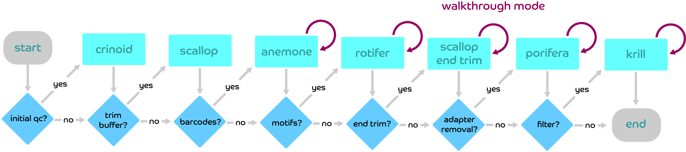
Figure 1. Flowchart of the ngsComposer tools implemented in pipeline mode. Every project directory contains a ‘conf.py’ configuration file that directs the decision at each branch. The optional ‘walkthrough mode’ allows the user to pass new arguments for each tool’s parameters and creates updated Q score summary plots concurrently.
rotifer.py: User-defined lists of sequences are used to search the start of forward and reverse reads for expected motifs. Motifs corresponding to the forward (-m1) and reverse (-m2) reads are expected in the beginning region of reads due to library construction using restriction enzymes and/or A-tailing of blunt ends. Reads failing to contain these motifs are assumed to begin with sequencing error. Paired end reads that both pass this test are kept as paired reads, while single ends that pass but that are missing their pair are outputted with a “se.” prefix.
porifera.py: A newline separated list of expected adapters (-a1) is provided by the user, optionally containing expected buffer sequences, barcode sequences, and known sequence motifs. Adapters are split into substrings of size k (-k) and each is stored in a dictionary of sequence and distance from the adapter start index. All k-mers of distance 0 are scanned for matches within the read, followed by k-mers of distance k, then 2k, and so on. This search process is repeated next with k-mers of distance 1, k + 1, and repeats for rounds (-r) or until all k-mers are exhausted. K-mer matches pointing to the same start index are assessed per-read until a set of matching positions (-m) is reached or the adapter is assumed not to be present. An optional mode (-t) allows for a modified Smith-Waterman local alignment to be performed with t base overlap to qualify as a hit.
krill.py: Integer values for desired Q score (-q) and percent read composition (-p) are provided by the user for threshold filtering. ASCII characters at and above q are stored as a list of passing scores. For each read, a failing number of bases is determined by (100-p)*read length. Fastq Q scores are then tested 3’ to 5’ for membership in the pass list. If the non-passing characters exceed the failing number of bases, the read is rejected.

Comparing Performance of Motif and Threshold Filtering
For each of the datasets tested (MiSeq Nano, HiSeq 2500 high output 2x125, HiSeq 2500 rapid run 2x250, NovaSeq 6000), reads were first trimmed to remove buffer sequences (6bp) and demultiplexed with 1 mismatch using anemone.py. Reads were used as the basis for downstream analysis of motif-detection and threshold filtering tools, as they are expected to begin with the RE digest motif immediately following the barcode sequence.

Filtering Methods
Filtering was performed using threshold-filtering (krill.py) and motif-filtering (rotifer.py). Under threshold filtering, only reads consisting 90 percent of above of Q scores 30 or higher were considered as passing filtering. Motif filtering was performed in a library-specific manner. The HiSeq 2500 datasets were blunt-end fragmented using AluI/HaeIII, followed by A-tailing and adapter ligation. Only HiSeq reads beginning with the sequences “TCC” and “TCT” were considered passing. The MiSeq and NovaSeq datasets were prepared using the Omeseq/qRRS protocol that fragmented the genome with NsiI/NlaIII restriction enzymes. R1 reads in these libraries contained a “TGCAT” motif and R2 reads contained a “CATG” motif. For each dataset, reads were first processed using threshold- and motif-filtering tools with failed reads written separately to file. For each of these output files, all passing and failing reads were processed again using the corresponding tool to be compared. For example, reads passing and failing the krill.py threshold filtering steps were then motif-filtered using rotifer.py, producing four final output files representing all combinations of pass and fail for combinations of the first and second tool.

Collapsing Unique Reads
After demultiplexing using variable length barcodes, reads within each library were end-trimmed to identical length before filtering to facilitate unbiased read comparisons downstream. After filtering methods were applied, all sequences were extracted from the fastq output using ‘sed’ commands. An awk command was then applied to sequence files to collapse identical reads while retaining the frequency of the unique reads. The ratio of collapsed reads to the total number of reads was calculated per-file.

Calculating Empirical Base-Calling Error Rates in Barcode Sequences
All forward (R1) reads from the MiSeq, HiSeq 2500 Rapid Run, HiSeq 2500 High Output, and NovaSeq 6000 datasets were subjected to multiple rounds of demultiplexing using the ngsComposer tool anemone.py. After first demultiplexing perfect matches, the unassigned reads were subsequently demultiplexed with a Hamming distance of 1. This process was repeated with unknown reads, increasing the mismatch value at each step until reads could no longer be identified having exceeded their inherent minimum Levenshtein distance of 3 (https://github.com/roy-ht/editdistance). For each step, the reads in the resulting output files were compared base-by-base to their corresponding barcode sequence. On a per-position basis, the probability of error was calculated as the number of bases in that position that did not match the assigned barcode divided by the total number of reads assessed at that level of mismatch and fewer. The ASCII-encoded Q scores were counted and grouped in the same manner.

Validating software performance using simulated reads
A set of 998,611 reads were simulated using the first chromosome of the Ipomoea batatas assembly (NCBI GenBank assembly accession: GCA_002525835.2). Simulation of restriction enzyme fragmentation was performed using NsiI and NlaIII, and each fragment was concatenated with variable length adapters containing variable length barcodes (simulating the OmeSeq/qRRS library preparation method). Resulting fragments were drawn randomly from a normal distribution with a mean read length of 400bp and a standard deviation of 100bp. The unmutated reads were saved separately alongside the known adapter position, if present. Multiple adapter trimming tools were compared with ngsComposer. A minimum adapter overlap value of length 12 was used as this was found to avoid an overabundance of misassignments and allowed a better unbiased comparison of tools. The standalone version of porifera used adapter validation by supplying the NsiI and NlaIII sequences and was compared with a pipeline instance of the tool that automatically reduces the search space on a per sample basis.

Results

Library design and empirical Q score assessment
To assess the effectiveness of Q scores compared to motif-detection as a filtering parameter, NGS data from sweetpotato (Ipomoea batatas) accessions and cultivars were considered from multiple Illumina platforms, each with distinct profiles. Fastq files originating from various Illumina platforms (i.e. Miseq, HiSeq 2500 Rapid Run, HiSeq 2500 High Output, and NovaSeq 6000) represent a variety of read length, dye chemistry, and levels of Q score binning (Supplementary Figures 1-4). All DNA libraries were prepared using custom-designed adapters and enzyme fragmentation. Each of the adapter pairs of the dual-barcoded datasets include a 6 bp buffer sequence region upstream of the barcode sequence, 7-10 bp variable length barcode sequence, and a 3-5 bp motif complementary to each of the two restriction cut sites in the insert DNA (Figure 2a). For the whole genome sequencing libraries, a T motif after the barcode is complementary to the A overhang on genomic fragments following A-tailing of blunt ends. By using adapters that contain a fixed-length and high-diversity “buffer sequence” region (as implemented in the OmeSeq protocol), the sequencing-by-synthesis reaction is allowed to stabilize before base-calling in the barcode regions begins. This has a protective effect on the barcode sequences used to determine sample identity, as the initial bases in a sequencing-by-synthesis reaction tend to harbor lower Q scores or elevated base calling error (Figure 2b, Supplementary Figures 1-4)(Kircher et al., 2011; Mitra et al., 2015). Fixed-length end-trimming was performed by ‘scallop.py’ in this buffer region before demultiplexing.

Variable length barcodes with a minimum Levenshtein/edit distance of 3 were implemented to reduce platform-derived phasing error (Krueger et al., 2011; Herten et al., 2015). Using variable length barcodes is also very important for achieving high nucleotide diversity in libraries fragmented with restriction enzymes or that were A-tailed, since the sequence motif region of fragments inherently lack the nucleotide diversity required for optimal run performance and generation of high-quality reads. The tool ‘anemone.py’ was used to demultiplex the libraries using a dual-indexed barcoding scheme, which is known to improve assignment accuracy (Kircher et al., 2011). Anemone.py prevents sample misassignment in the event that multiple barcodes have equal Hamming distance from a given read. Reads that align to multiple barcodes remain unassigned. Misassignment can be found in several widely used demultiplexing tools, which apply sample identities preferentially to the first indexed barcode when “nesting” occurs (Figure 3).

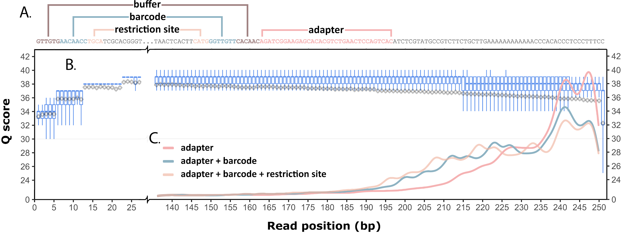
Figure 2. QC plot highlighting impact of adapter removal parameters implemented in ngsComposer. (A) Diagram of adapter-contaminated read displaying buffer region, barcode, and restriction sites, as well as the corresponding reverse-complement adapter regions. (B) Boxplots show the tendency towards lower Q scores at 5` and 3’ ends. Gray diamonds and lines show the mean Q score and standard deviation per position. C. Read length density after adapter removal using ngsComposer pipeline. Adapter only (red), adapter through barcode (blue), and adapter through restriction site (yellow) each show different performance in adapter detection.
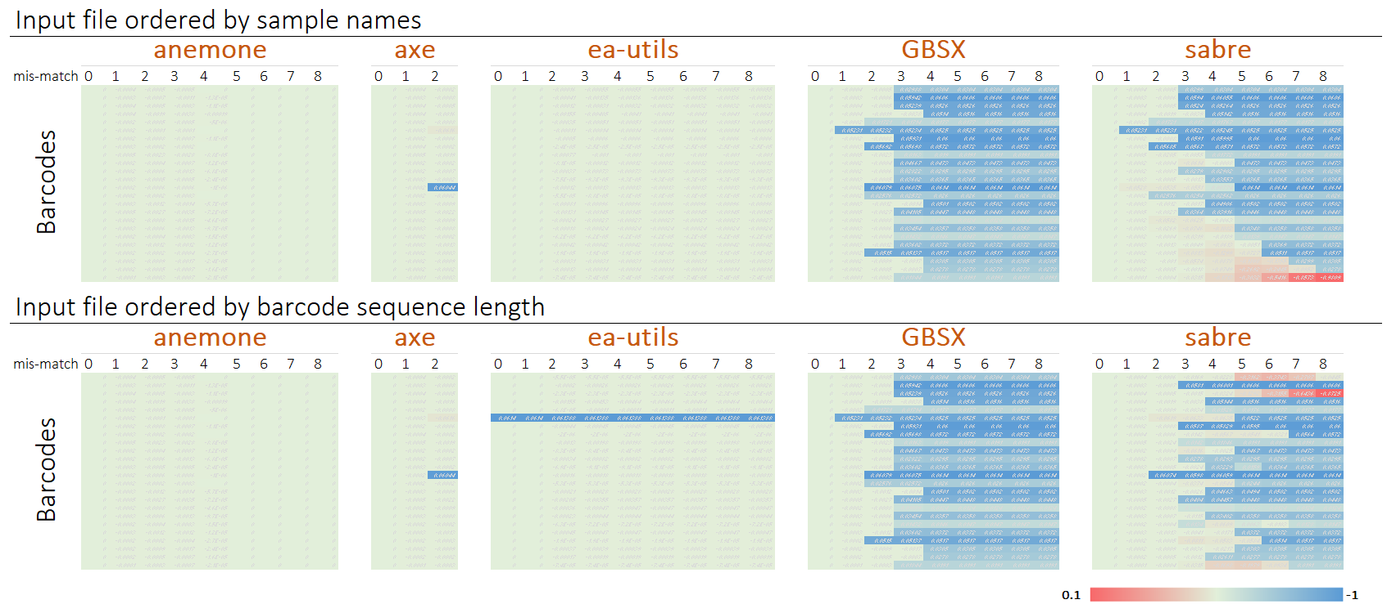
Figure 3. Benchmarking next-generation sequence read demultiplexing tools. Several tools are influenced by the order (top and bottom panel) of barcodes when searching for potential matches (ea-utils and sabre). In some instances, tools preferentially reassign reads to a different sample as mismatch is increased across columns from left to right. Values within the heat map indicate the degree of deviation computed as the proportion of mis-assigned reads at mismatch > 0 relative to assignment at a mismatch = 0, which is specified within each tool. The midpoint, green, indicates zero deviation.

Taking advantage of anemone.py’s false positive sensitivity, we tested the sequencing accuracy of barcode regions by demultiplexing at increasing values of hamming distances. The per-base error rate was calculated alongside the reported instrument-derived per-base Q scores (Figure 4). Empirically calculated miscall probabilities were lower than those produced by the sequencing hardware with quality score mean differences across platforms ranging between 7.81 and 18.7 (Figure 4, Supplementary Table 1). These corresponds to approximately 6 to 74 times increased probability of miscall. These results agree with previous attempts to empirically validate Q scores by alignment to known reference genomes (Dohm et al., 2008; Hillier et al., 2008; Beltman et al., 2016; Manley et al., 2016) as well as to barcoding region.

Evaluating read populations using expected motifs
After barcode removal, we used the presence of error-free restriction enzyme site motifs as an early indicator of read reliability (motif-based error detection and filtering). Reads with error in the motifs were observed to also contain higher error rates along the entire length of the read when compared with the intact motifs (Table 1, Supplementary Figures 1-4). Reads filtered sequentially using classic Q score-dependent threshold-filtering followed by motif-filtering produced populations of passing and failing reads, which were then used to evaluate the performance of both approaches. We expect a high false negative rate for stringent Q score threshold filtering and a high false positive rate for relaxed Q score threshold filtering. Since the threshold is subjective, there is currently no objective setting for the optimal threshold to minimize these false positive and false negative rates.
Read compression was applied to the results of filtering as an unbiased determinant of base calling accuracy. Read depth refers to the frequency of reads aligning uniquely to a given reference locus. The restriction enzyme-based quantitative reduced representation sequencing (qRRS) libraries examined in this study consist of numerous, identical fragments of DNA that align flush and perfectly overlap the other allelic sequences originating from the same locus and across samples. Collapsing instances of identical sequence reads within NGS datasets, termed the compression rate, was used as a proxy for unbiased error rate estimates.

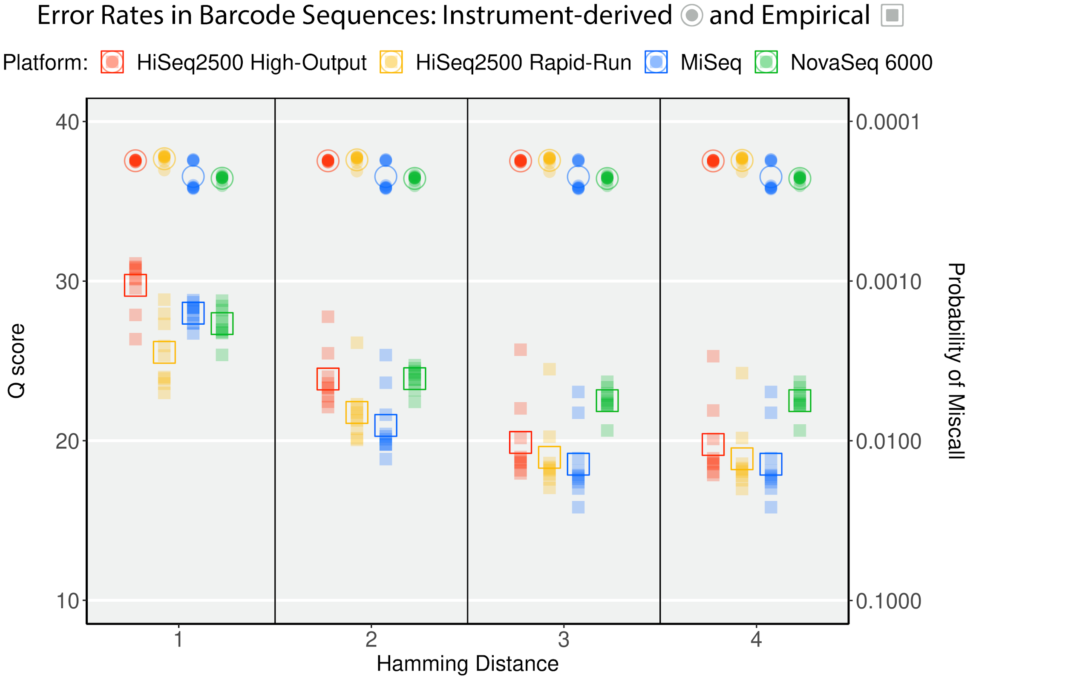
Figure 4. Quality scores from 4 Illumina platforms measured within barcode regions of reads. The empirical rate of base-calling errors (squares) were sequentially calculated using increasing Hamming distance in the ngsComposer demultiplexing tool, anemone. The Q scores for these bases reported by Illumina software reveal underestimation of base-calling error. Open shapes indicate the mean Q scores, while solid shapes indicate Q scores for individual base positions along the barcode region.
Table 1. Efficacy of filtering methods using an unbiased estimate, read compression.
Illumina  Platform | Filtering  Method(s) | Δ compression¹ (R1) |  | Failed  (%)² | Δ compression¹ (R2) |  | Failed  (%)²
Illumina  Platform | Filtering  Method(s) | Pass | Fail | Failed  (%)² | Pass | Fail | Failed  (%)²
MiSeq | Q30/P90 | 3.42 | -9.3 | 12.33 | 4.54 | -10.27 | 16.1
MiSeq | motif | 2.48 | -5.06/-4.9* | 7.55 | 0.88 | -3.03/-2.7* | 2.75
MiSeq | Q30/P90 + motif | 6.06 | -4.14 | 18.92 | 5.29 | -0.7 | 17.99
HiSeq 2500  (Rapid Run) | Q30/P90 | 11.08 | -40.29 | 21.16 | 23.74 | -24.36 | 47.63
HiSeq 2500  (Rapid Run) | motif | 0.72 | -36.63/-32.4* | 1.06 | 1.98 | -21.69/-19.2* | 4.78
HiSeq 2500  (Rapid Run) | Q30/P90 + motif | 11.58 | -20.24 | 21.73 | 25.22 | -8.74 | 49
HiSeq 2500  (High Output) | Q30/P90 | 5.07 | -17.09 | 22.06 | 4.4 | -24.93 | 14.65
HiSeq 2500  (High Output) | motif | 0.45 | -30.56/-26.0* | 1.08 | 0.73 | -41.08/-36.4* | 1.08
HiSeq 2500  (High Output) | Q30/P90 + motif | 5.46 | -20.51 | 22.53 | 4.68 | -11.84 | 15.1
NovaSeq  6000 | Q30/P90 | 7.25 | -35.9 | 16.3 | 10.63 | -33.8 | 23.12
NovaSeq  6000 | motif | 1.6 | -8.03/-6.6* | 8 | 2.89 | -2.24/-0.7* | 21.65
NovaSeq  6000 | Q30/P90 + motif | 8.59 | 1.75 | 22.71 | 12.43 | 12.23 | 38.52
Note: ¹ Δ Compression: change in compression rates of filtered reads were normalized against randomly subsampled raw data. ² The percentage of raw reads that did not pass the given filtering technique. * Compression rates in reads failing presence of motif were recalculated using only the non-motif portion of the read.
The compression rate value approximates the average read depth across the genome i.e. number of times an allele was sequenced. High error rates will increase the generation of new novel reads and consequently lower compression rates. The compression rate was found to be a more sensitive metric for error rate estimation compared to using a reference genome, where alignment scores (e.g. E-value) are sensitive to sequence length and other parameters in the alignment algorithm (Mitchell et al., 2020).

The motif-based filtering approach complemented the Q score threshold-filtering approach. In all datasets analyzed across all NGS sequencing platforms in this study, the highest compression was achieved when both filtering approaches were applied (Figure 5). Read sequences failing these filtering approaches consisted of more unique/singleton reads due to increased error rates and consequently had a negative change in compression when normalized against random sampling of the unfiltered dataset to account for the effect of reduced sample size. These patterns persisted in the failed reads even when limiting the scope to the body of the read while excluding the motif region, further validating that a failure to sequence the motif accurately will lead to miscall within the rest of the read (Table 1). Motif-filtering improvement of compression was found to be most effective in the MiSeq dataset (2.48% improvement alone, 6.06% improvement combined with threshold of q30 at 90%). In some instances, the improvement was marginal (0.45% improvement in HiSeq 2500 high output), however, the number of reads removed using motif-filtering was much lower than with threshold filtering (Table 1). It is also worth noting that the OmeSeq protocol produced raw sequence reads with high-quality, hence, we would typically expect significantly higher improvement with data derived from most library preparation protocols. The subset of reads removed by the two filtering methods had little overlap as each appeared to target nearly distinct reads within the overall dataset.

Improved adapter detection using barcode-specific search schema
Adapter removal is an important step in many NGS libraries and detection can be improved using expected motifs.

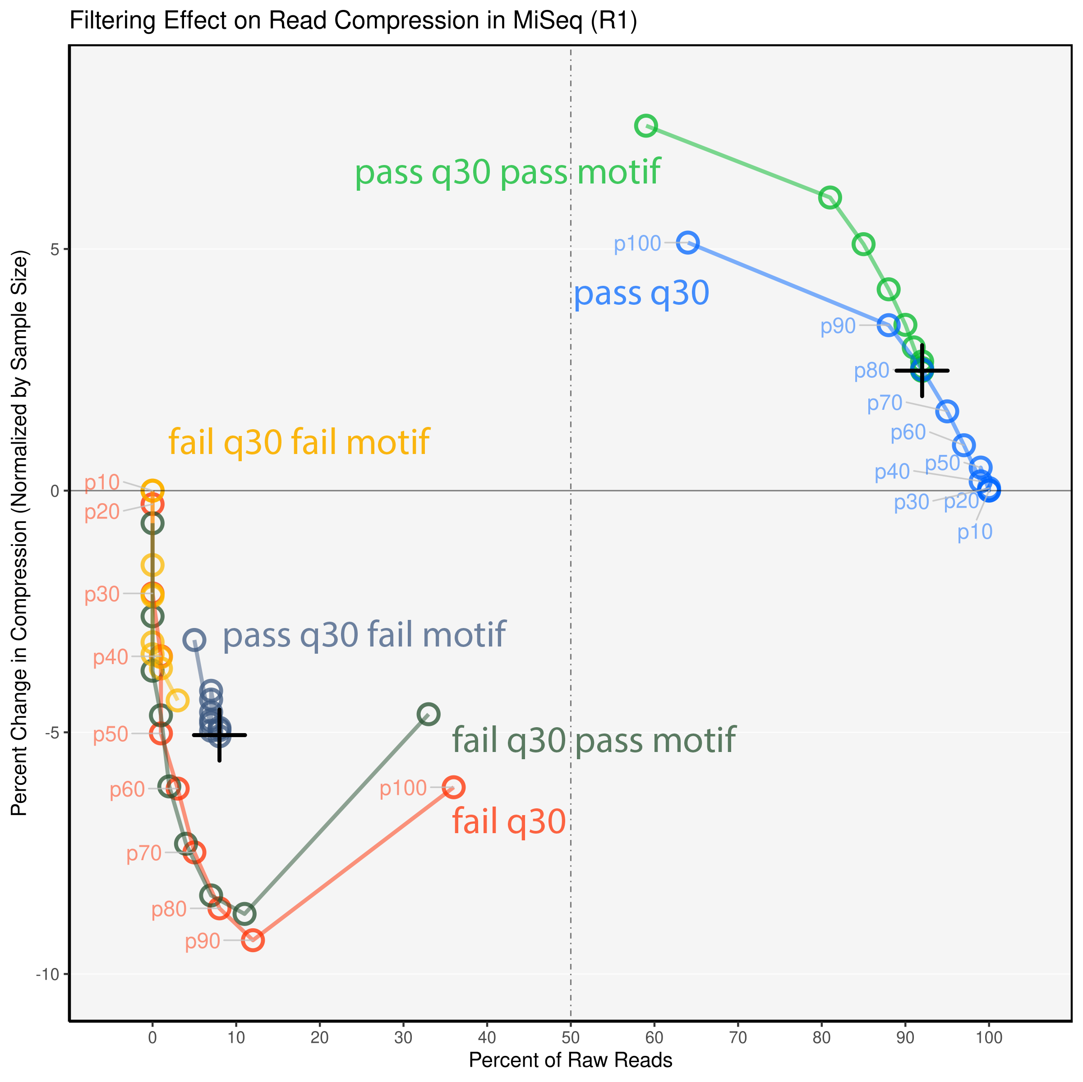
Figure 5. Sample results using Q score threshold-filtering and motif-based filtering. The difference in read compression between the subsetted filtered reads was normalized against compression of MiSeq-derived raw data of the same sample size. Reads passing both tools have the highest compression values indicating a reduction in sequencing error. Both filtering methods detect erroneous reads that are non-overlapping, hence underscoring the need of both strategies.
Adapter sequences including barcode and restriction site motifs are expected to increase adapter detection sensitivity as these sequences are further upstream of the characteristic 3’ drop in sequence quality (Dohm et al., 2008; Cox et al., 2010). Herten et al. 2015 showed the inclusion of restriction motifs improved adapter detection. Here, the tool porifera.py has been developed to k-mer walk through a list of adapters (i.e. combination of adapter, buffer sequences, barcode sequences, and known motifs) and search a user-defined number of rounds (or default) until aligned k-mers point to the same start index or a read is deemed to be adapter-free. The k-mer approach avoids local alignment issues encountered when a string of “A” or “G” sequencing artifacts appear in the instance of a deeply embedded adapter. The ngsComposer pipeline narrows the adapter search space by only attempting to align reads with their associated adapters which contain sample-specific barcodes. Adapters including barcodes and barcodes with restriction sites detected reads at a higher frequency and removed non-genomic DNA (Figure 2c).

Validating software performance using simulated reads
Simulation of Illumina reads allowed for testing the performance of the motif based NGS filtering approach highlighted in the ngsComposer pipeline and tools. We confirmed our findings that a motif-based filtering approach is useful for NGS data filtering, as shown in both real and simulated data (Supplementary Figure 5-6). We also confirmed the obvious benefit to including barcodes, a contaminating non-genomic sequence, in the adapter searching step (Table 2, Supplementary Figure 7-8). Overall, the false positive rates were similar across all tools except for AdapterRemoval, which had very high false positive rates. While including the barcodes as part of the contaminating adapter sequence should be considered best practice for multiplexed libraries, we evaluated a naïve approach that only uses the Illumina adapter sequence. While using a single adapter sequence also produced low false positives, it led to about twice as much false negative rate (i.e. reduced detection of adapters in reads). The false negative rates were similar across all tools tested, with Cutadapt and AdapterRemoval performing slightly better but typically at the expense of elevated false positive rates. The ngsComposer pipeline leverages speed and accuracy by only searching for those adapters containing the unique barcodes associated with the appropriate sample (Table 2).
Table 2. Comparison of adapter removal tools on simulated NGS reads. Filtering settings includes using Illumina adapters without (single adapter) and with barcode sequences (96 barcoded adapters) as contaminating sequences.
Approach | Tools | Read | False negatives (%) | False positives (reads) | Total user time (seconds)
Single adapter | AdapterRemoval | R1 | 29.4 | 3044 | 13.0
Single adapter | AdapterRemoval | R2 | 29.5 | 3075 | 13.0
Single adapter | Cutadapt | R1 | 28.6 | 0 | 24.9
Single adapter | Cutadapt | R2 | 28.9 | 0 | 24.9
Single adapter | Porifera (standalone) | R1 | 30.0 | 2 | 29.2
Single adapter | Porifera (standalone) | R2 | 30.5 | 1 | 29.2
Single adapter | Skewer | R1 | 29.5 | 0 | 24.5
Single adapter | Skewer | R2 | 29.7 | 0 | 24.5
96 barcoded adapters | AdapterRemoval | R1 | 11.7 | 161932 | 571.7
96 barcoded adapters | AdapterRemoval | R2 | 11.3 | 160429 | 571.7
96 barcoded adapters | Cutadapt | R1 | 12.5 | 644 | 2699.4
96 barcoded adapters | Cutadapt | R2 | 12.7 | 689 | 2699.4
96 barcoded adapters | Porifera (standalone) | R1 | 15.2 | 63 | 543.1
96 barcoded adapters | Porifera (standalone) | R2 | 16.3 | 4 | 543.1
96 barcoded adapters | Porifera (ngsComposer) | R1 | 14.1 | 4 | 79.4*
96 barcoded adapters | Porifera (ngsComposer) | R2 | 14.5 | 2 | 79.4*
96 barcoded adapters | Skewer | R1 | 13.5 | 5 | 3050.7
96 barcoded adapters | Skewer | R2 | 13.6 | 107 | 3050.7
*Simultaneous run time for R1 and R2 (as part of ngsComposer pipeline)
Note: Analysis of simulated data for all tools were performed on a MacBook Air (8 GB 3733 MHz LPDDR4X, 1.1 GHz Quad-Core Intel Core i5) using a single thread.

In pipeline mode, porifera is 7 to 38 times faster compared to other tools tested. In standalone mode, the speed is similar to AdapterRemoval and 5 to 5.6 times faster than Cutadapt and Skewer, respectively (Table 2).

Implementation
The software, ngsComposer, is designed with simplified user input at every critical step in data filtering. Any of the provided tools may be run individually or as an automated pipeline. In pipeline mode, users have the option to see read summaries and qc plots and re-define variables on the fly as a part of “walkthrough” mode. Multiple libraries from different sequencing runs may be combined for preprocessing, each with its own set of barcodes and associated unique sample IDs. In pipeline mode, paired end reads are automatically recognized and pairing preserved throughout. Reads that become unmated due to removal of paired R1 or R2 reads are retained in all subsequent steps in a single end reads directory.

Discussion
Filtering NGS data is a routine procedure intended to retrieve sequence reads with minimal base calling error, as well as identification and removal of low-quality base calls by trimming reads at the 5` and 3` ends. Traditionally, Q scores are the exclusive determinant of the reliability of sequencing certainty. While Q scores are useful as a filtering metric, there is mounting evidence and suggesting that Q scores should not be taken at face value and can have variable interpretations across NGS platforms. The higher empirical estimates of error rates in the barcode and restriction site regions described here imply that Q scores may not match the expected logarithmic Phred base-calling error probability. Some SNP calling and filtering approaches have opted to ignore Q scores altogether due to a biasing tendency against SNPs on distal ends of reads (Glaubitz et al., 2014). Only a few efforts exist that attempt to determine read accuracy with certainty and independent of platform-derived quality scores. Alignment to reference assemblies is possible with smaller genomes but may vary based on reference assembly and the significance of single base mutations may not be captured by alignment scoring penalties alone. Studies reveal that accuracy of various error correction algorithms differed considerably across all types of data set (Mitchell et al., 2020).
Our pipeline works off the assumption that reads containing high-quality base calls in expected sequence (barcodes, restriction site, and A-tailed reads) near the 5’ end will contain higher quality base-calling across the entire read length and will contain fewer erroneous base calls internal to the read body. This assumption was confirmed by elevated error rates in entire read length whenever there was base calling error in the motif. Emphasizing motif-filtering retains reliable high-quality base-calls required for applications such as variant calling, strain-level microbiome profiling, and de novo assembly of genomes and transcriptomes. Motif-detection is independent of platform and encompasses some of the errors that might be detected in other filtering approaches.

To provide additional validation for the efficacy of motif-based filtering, we used the read compression rates to confirm that errors in motif region are often tied to additional error elsewhere in the body of the read. Read compression is an unbiased measure of sequencing accuracy. Lower compression rates indicate that at least one base miscall or indel has occurred in the read. An increase in read compression indicates that filtering has recovered high-quality reads and eliminated unique reads derived from erroneous base calls that would normally reduce compression. Not surprisingly, read reliability was most improved by implementing empirical motif-detection alongside machine-generated Q score threshold-filtering. In combination with the motif-based approach, Q score filtering thresholds can be relaxed to reduce false negative rates without the consequence of increasing false positive rates. While subsets of reads filtered by motif-presence always had an improvement in read compression, these reads were often classified independently from reads containing high Q score composition. This underscores the sensitivity of motif-based filtering and utility for identifying false negatives associated with Q score-based filtering. Motif inclusion has been a previously subtle feature investigated by Herten et al.(Herten et al., 2015). It has the potential to bypass platform and even sequencing run variation. It is possible that strict motif-filtering and the compression rate analysis reported here could have applications in reviving the wealth of previously published sequencing data.
The ngsComposer software is a fastq preprocessing pipeline designed for straightforward and repeatable results that extend the power of Q score-based filtering. As revealed by the datasets generated with the OmeSeq protocol, reported here, consideration of assay design during library preparation can improve overall sequencing reaction quality and features in library constructs can provide information and quality control that can enhance data preprocessing. Furthermore, ngsComposer provides researchers with a practical framework to reliably handle multi-sample projects with complex barcoding schema and organizing paired-end data from their raw to analysis-ready state.

Data availability
All raw NGS data used for this study will be publicly available on the NCBI SRA database. Software used is available at https://github.com/ryandkuster/ngsComposer and all analytical steps are available at https://github.com/ryandkuster/ngsComposer_analysis.

Conflict of interest
The authors declare that the research was conducted in the absence of any commercial or financial relationships that could be construed as a potential conflict of interest.

Author Contributions
Ryan Kuster wrote and edited the manuscript. Study conceived and designed by Bode Olukolu and Ryan Kuster. Laboratory work and NGS Library preparation by Ryan Kuster and Bode Olukolu. Software created by Ryan Kuster and Bode Olukolu. Data analysis was performed by Ryan Kuster and Bode Olukolu. Reagents and materials contributed by Bode Olukolu and Craig Yencho. Paper reviewed and edited by Bode Olukolu and Craig Yencho.

Acknowledgement
We thank Robert Mwanga at The International Potato Center for providing sweetpotato MDP accessions used in this study; the Genomic Sciences Lab at NC State University (David Baltzegar, Hannah Jones, and Kristen Fowler) for performing library preparations and next-generation sequencing; and researchers at UTK (Olukolu lab: Tara Rickman, Alison Adams, Brandon Kristy; Staton lab: Jiali Yu), NCSU (Yencho lab: Mohamed Somo Ibrahim; Fernandez lab: Jose Chacon Jimenez; Gould lab: Jennifer Baltzegar; Brown-Guedira lab: Brian Ward), and UARK (Worthington lab: Mitchell Armour) for beta-testing the ngsComposer software.

Funding
This work was supported by a Bill and Melinda Gates Foundation grant (grant ID OPP1052983 and OPP1213329) and The Illumina Agricultural Greater Good Initiative grant.

Chapter 3: Reduced metagenomics profiling and simulation
A version of this chapter is in preparation for submission by Kuster et al.:

Readsynth: short-read simulation for consideration of composition-biases in reduced metagenome sequencing approaches

Ryan Kuster¹*, Margaret Staton¹
1 Department of Entomology and Plant Pathology, University of Tennessee, Knoxville
* corresponding author

Abstract

The application of reduced metagenomic approaches holds promise as a middle ground between targeted amplicon sequencing and whole metagenome sequencing approaches, but has not been widely adopted as a technique. A major barrier to adoption is the lack of existing profiling software built to handle characteristic features of these novel approaches. Reduced metagenome sequencing (RMS) produces unique patterns of fragmentation per-genome that are sensitive to restriction enzyme choice, and the non-uniform size selection of these fragments may complicate normalization and abundance estimates. Readsynth has been developed to approach these challenges and provides users the ability to simulate metagenomic sequencing that models fragment length distributions, enzyme cut efficiency, and relative abundance. Here we simulate existing RMS and iso-length data to benchmark the software’s performance and assess the influence of multiple library preparation and sequencing steps on downstream analytical results. Simulating microbial communities based on total read count allows users to better understand how much each community member will be represented as a part of the overall composition of mixed, complex communities.

Introduction

Reduced metagenomics sequencing promises a non-traditional metagenome profiling approach that captures the strengths of amplicon and whole genome sequencing, but it currently lacks community adoption. Reduced metagenome sequencing (RMS), first coined by Liu et al. 2017, is the application of reduced-representation sequencing (RRS) to metagenomic libraries (Liu et al., 2017). This pioneering approach compared metagenomic profiling of human samples using RMS and the traditional whole genome approach. Similar microbial profiles were obtained, and no concerns of bias towards organisms with high GC content were detected. Three further studies have shown the potential for RMS to yield similar results or even outperform the traditional 16S and whole genome sequencing approaches (Ravi et al., 2018; Hess et al., 2020; Snipen et al., 2021). The targeted fragments produced by enzymatic shearing function as hundreds of markers within each bacterial genome and allow for species and even strain-level identification not found in amplicon sequencing alone.

Although traditional approaches of amplicon and whole genome sequencing (WGS) can be effective for studying community structure, they exist on extreme ends of sequencing efforts and the benefits of each may exist in a middle ground. The conserved gene regions used in amplicon sequencing, often the 16S or ITS gene, create bias towards some community members due to the primers selected, and in many cases, these targets lack the resolution to consistently identify one species or strain from another (Goodrich et al., 2014). WGS increases resolution, but is comparatively very expensive for deep sampling of rare taxa and creates the task of assigning a substantial number of overlapping reads that may originate from closely related taxa. Parallel to the field of metagenomics, the fields of genetic trait analysis and population genetics have implemented genotyping-by-sequencing (GBS) approaches to great success. Often, GBS reduces a genome into sampled DNA fragments by using one or more restriction enzymes (Elshire et al., 2011). These subsetted fragments represent predictable, targeted loci within a genome. RRS increases per-locus sequencing depth for these fragments and allows for more samples to be analyzed in the same sequencing run, improving sequencing accuracy and lowering the per-sample cost of sequencing (Miller et al., 2007; Baird et al., 2008; Peterson et al., 2012). These loci encompass nucleotide variations that serve as reliable genetic markers. Surprisingly, the field of metagenomics has only recently started to explore the possible benefits of using reduced representation sequencing.

In spite of the potential benefits of RMS, the ability of this approach to accurately quantify at the species and strain level has not been applied at scale, possibly hindering adoption by metagenomics researchers. A major caveat to the RMS approach is that specific restriction enzyme motifs will be enriched in a taxa-dependent manner (Ravi et al., 2018). This effect, in conjunction with genome size and enzyme cut efficiency, affects the number of fragments per taxa that will ultimately appear in the size-selected library of reads. Further, given that enzyme digestion activity can produce variation in read depths, normalizing the variable read depths that map to a single organism is a task that existing metagenome profiling software aren’t designed to handle. The pool of enzyme digested fragments available for size selection is highly variable in length with RMS, and the selected range may impact the taxa included in the final sequencing library. Capturing these nuances is a necessary step in applying RMS strategies, therefore, we introduce the software readsynth as a simulation aid to researchers in considering these promising alternative approaches to sequencing metagenomes. Readsynth accepts a user-defined microbiome community composition in the form of reference genomes and their relative abundances as well as experimental parameters. The software efficiently simulates reduced sequencing efforts over any metagenomic composition and quickly outputs millions of paired-end sequencing reads that accurately represent the expected per-fragment composition. This software can quickly advance RMS approaches by enabling scientists to determine the best library protocol or downstream metagenomics analyses to most accurately capture the input composition of their specific microbiome target communities.

Methods and Analysis

Software Overview
Readsynth was developed to simulate Illumina short read libraries to assess the compositional abundance of highly complex communities under multiple reduced sequencing conditions. Readsynth is a command line software package written in Python and C++ that uses commonly maintained statistical packages and consists of a digestion, size-selection, and read-writing stages. The software was written to be highly customizable across three categories: (1) microbial community composition, defined by input genomes and their relative abundance; (2) experimental parameters, including reduced library approach, enzyme digestion rates, expected fragment length distributions, and custom adapter design, and (3) sequencing parameters, such as total read number, read length, and base quality value profiles.

Digestion:
Readsynth first reads each input genome individually to capture the set of possible fragments and calculate the probability of each sequence fragment surviving to the final library. Bases in reference sequences containing ambiguous IUPAC characters are converted to “N”s during the simulated digestion process, as the source character cannot be known with any certainty and the fastq format only accepts “ACGTN”(Cock et al., 2010; FASTQ files explained). Overlap-tolerant regex searches are performed to exhaustively detect all possible cleavage sites and define fragments within the expected size-selection distribution.

Fragments resulting from any combination of palindromic restriction enzyme motifs are modeled probabilistically to account for partial enzyme digestion. The probability of a fragment remaining at the end of digestion is calculated based on the probability of an enzyme cut producing the necessary forward and reverse adapter-boundary sites, adjusted accordingly for fragments harboring internal cut sites.

$$Pr(fragment) =c^{2}{(1-c)}^{i}$$

The per-fragment probability is determined by the probability of enzyme cleavage (c) occurring at both ends of a sequence. Sequences that harbor greater numbers of internal cut sites (i) are less frequently represented as a sequenced read. The probabilities for each fragment length are then summed, approximating the expected fragments given a single genome copy for each genome in consideration.

Another promising application in reduced metagenomics, iso-length sequencing, has been modeled in readsynth (Sun et al., 2022). Fragments resulting from type IIB restriction enzymes stem from a single cleaving event and require a separate model due to the mutual exclusion of their resulting, identical length fragments.

$$Pr(fragment) = \frac{\sum_{i=1}^{n}{}I(a_{i} ∈ A)}{n}$$

Regions of isolength fragments that overlap are evaluated for all possible, mutually exclusive fragment events (A) and the probability of a given fragment is determined by the rate of events including that fragment (a).

Size selection:
To simulate size selection, each fragment’s post-digestion probability is adjusted based on multiple additional factors affecting its representation. First, the expected fragment counts for each genome are scaled by their proportional abundance, as defined in the abundance table. The combined distribution of digested fragment lengths for all input genomes then undergoes size selection. By default, users may supply distributions of fragment lengths using either a) a Gaussian distribution of fragment lengths or b) a custom json dictionary of desired fragment length keys with corresponding count values. For the first approach, the intersection between the Gaussian distribution and the existing digestion distribution defines the size selection distribution. A defined fragment length x represents this intersection point, and the average digested fragment count at x is divided by the probability density function, scaling the Guassian distribution into counts. The minimum value of the two distributions is used at each fragment length to produce an estimated read count (Figure 6). This approach simulates the size variability expected in gel-based narrow and broad range selection techniques while preventing artificial inflation of reads in lower abundance than produced by the Gaussian curve (Peterson et al., 2012). To simulate the hardware-imposed limitation on the composition of metagenomic fragments, the input read number (n) is divided evenly amongst the resulting size-selected distribution of the digested metagenome.

A
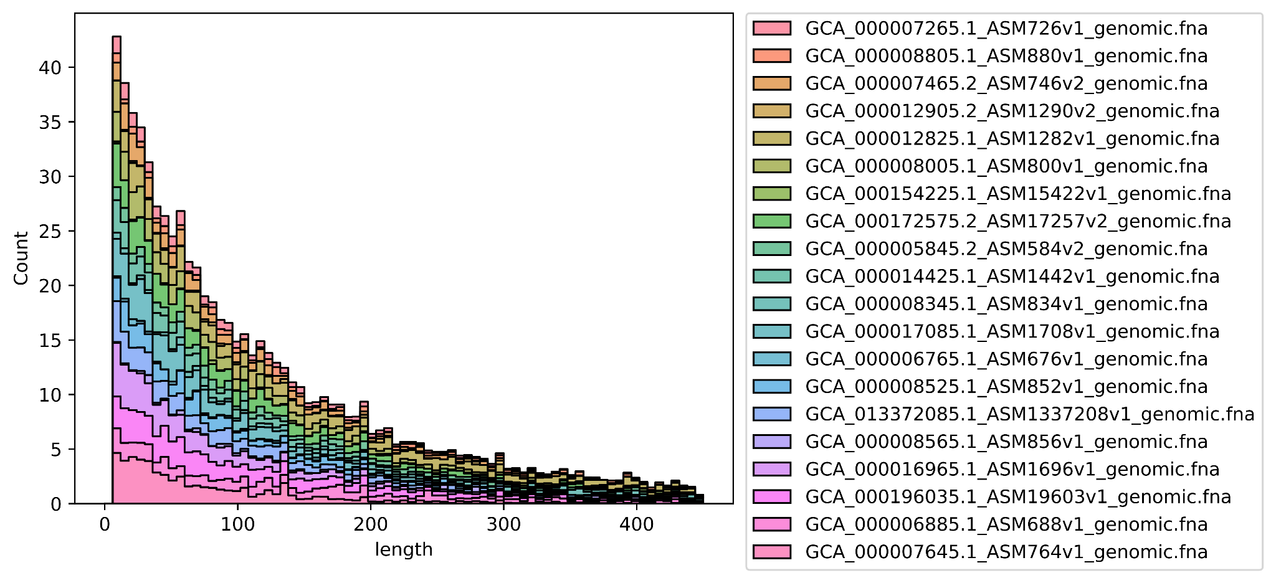
B
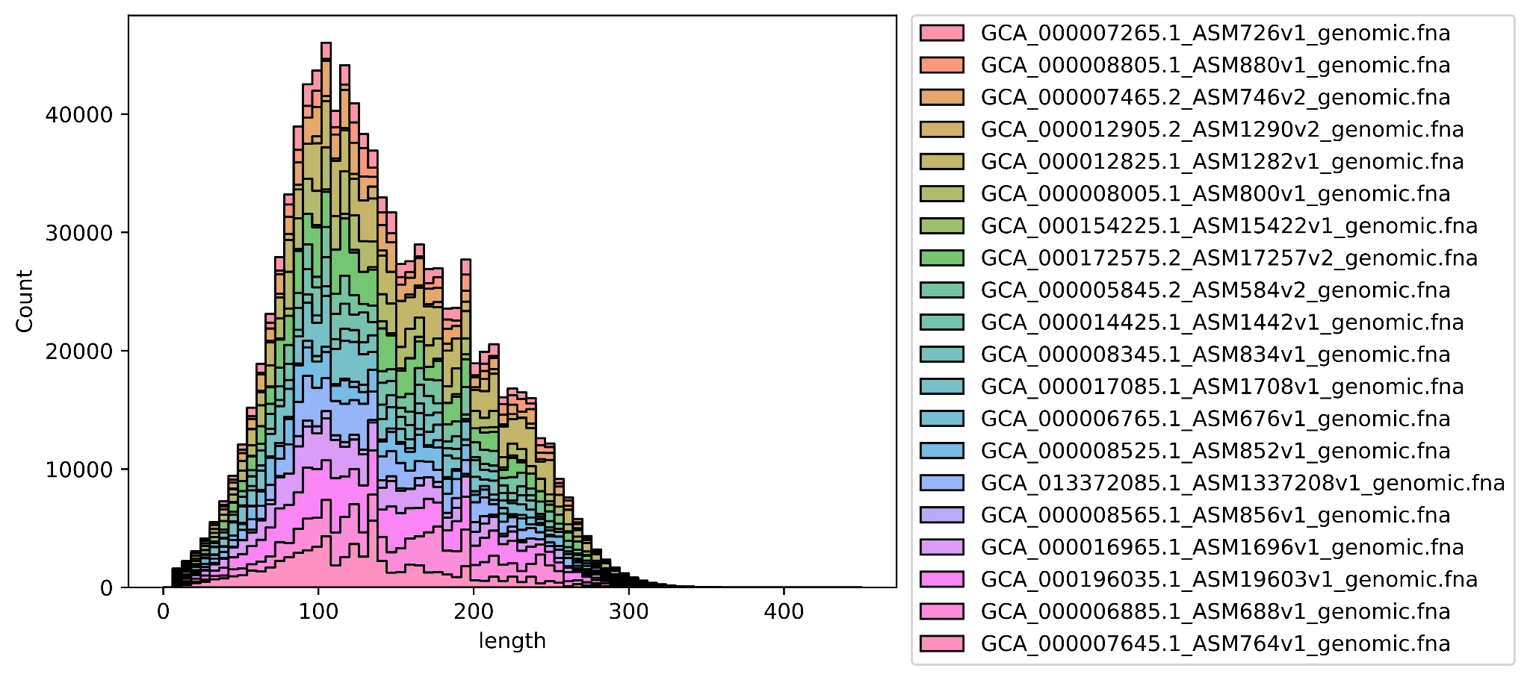
Figure 6. Distribution of reduced metagenome sequencing (RMS) fragment lengths (bp) A - after simulated enzyme fragmentation, counts represent expected fragment frequency with 1X genome coverage; B - final read counts of size-selected fragments from the intersection of a Gaussian normal (𝜇: 150bp, 𝜎: 50) and A, scaled to the count at length 100bp from A. Bar colors indicate individual bacterial genomes present in the simulated community.
Read-writing:
Existing simulation approaches often derive error models by aligning real sequence data against a known reference genome (Yu et al., 2020). Although empirical error models using alignment should provide the most informative simulation of kmer biases and indel occurrences, it may not be possible to know a priori the behavior of a sequencing run. This process is complex, and the accuracy of base calls in the event that a queried read maps to paralogous loci or the reference consists of slight genetic variants relative to the query (Anyansi et al., 2020). Readsynth applies a straightforward substitution error model to every read using randomly sampled Q scores from any existing fastq file, with several publicly available profiles to select from. Applying the probability of miscall at each position using existing Q scores, even at a low sampling rate, represents overall patterns in error across read-lengths while faithfully capturing empirical errors in a position-specific manner (Supplementary Figures 9 - 11). Inclusion of fragments that are shorter than the simulated read length resulted in expected adapter contamination in data output (Supplementary Figure 12), and users may provide any number of custom-designed adapters with specific overhangs.

Software Benchmarking

In order to benchmark the simulation accuracy of the full, abundance-based metagenomes, we use existing RMS data as a ground truth. The loci-specific enrichment of reads as well as the similarity in taxonomic profiles between real and simulated reads are used as performance metrics of simulation accuracy. Two previously sequenced mock community data sets produced with reduced metagenome sequencing approaches were considered. These communities used standardized concentrations of each community member, making them ideal for comparison with simulated reads. The first dataset from Snipen et al. 2021 used a Human Microbiome Project mock community of 20 bacterial strains (BEI HM-782D) and digested using the restriction enzymes EcoRI and MseI. To simulate the abundance of each taxon, the input abundance table used the reciprocal of the ribosomal copy number determined from the ribosomal RNA operon copy number database (Stoddard et al., 2015). The second dataset from Sun et al. 2022 used a separate community of 20 bacterial strains (ATCC MSA-1002), which was assumed to have even genomic copy number. This dataset was created using the type IIB restriction enzyme BcgI which produces short fragments with no length variation.

Extracting sequencing features from real and simulated mock communities
Sequence reads from the existing mock communities were adapter trimmed using Cutadapt 4.1 (Martin, 2011). Reads were then mapped against each of the community member reference genomes using BWA MEM (Burrows Wheeler Aligner 0.7.17)(Li and Durbin, 2010). Samtools 1.15.1 was used to select only paired end reads with the appropriate orientation. The Samtools stats and depth commands were used to summarize the read lengths as well as the per-position depth of all aligned reads (Danecek et al., 2021). Using positional information from these reads, a custom fragment length distribution was estimated for use in simulation. The count ratio of fully digested fragments to the larger fragments immediately encompassing them (r) was used to estimate the cut efficiency (c) of enzyme digestion as follows:

$$c=\frac{(r-1)}{r}$$

Only fragment lengths in the range of 100bp to 450bp were used to estimate cut efficiency, as these were observed to be less constrained by size selection and therefore more reliable in preserving true read ratios (Supplementary Figure 13).

Aligning community mixtures of many taxa against individual reference genomes in BWA MEM returned many reads that aligned to multiple genomes (Supplementary Figure 14). Further, variability between the published reference sequence and the real sequence data resulted in the rare presence of RMS fragments not reproducible in simulation. In order to make meaningful comparisons between the real and simulated data, custom Python scripts were used to extract only those reads mapping uniquely to the motif sites present in the reference genomes.

For each real sequencing effort, simulation was performed using fragment size distribution, enzyme cut efficiency, and Q score profile derived from the real data sets. Although we expect these derived inputs to most closely resemble the real data, additional simulations were run to test the importance of fragment size distribution and enzyme cut efficiency. Three fragment length distributions were considered to measure the impact of size selection. The first was created using the exact fragment counts extracted as a custom .json file from the extracted sequence alignments. The second simulated size selection using the mean and standard deviation from the samtools summary statistics to define the distribution shape. The third size selection distribution used identical standard deviation values, but with the mean fragment size increased by 100bp.

BWA MEM and Samtools were again used to map simulated reads to the reference genomes and the read depth at every expected fragment position was counted. Cumulative read depth across every position in the mock community was compared between real and simulated sequences using both Pearson and Spearman correlation.

Results

Pearson correlation captured the degree to which the read depth per position was linearly related and was sensitive for comparing fragment depths. This metric was also affected by noise in the data, as can be seen by variation within the replicates of the real sequencing datasets. The simulation that produced the highest read depth correlation coefficients between 0.76 to 0.79 used exact fragment counts from the real dataset (Figure 7 group A). Using a normal distribution produced coefficients between 0.71 and 0.76 (groups B, D, E), suggesting the real data was approximated by applying the normal distribution approach. The distribution with mean fragment lengths shifted only 100bp longer affected read depth considerably with coefficients of 0.67 to 0.7 across replications (Figure 7 group C). By comparison, Spearman correlation captured a monotonic relationship, and therefore was sensitive to differences in fragment presence or absence. The reads simulated using 100 percent enzyme cut efficiency corresponded closely with the real data (Figure 8 group E; r=0.92 to 0.94), comparable to the covariance measured between replicates of the real data. Simulation with a lower enzyme cut efficiency of 80 percent produced lower correlation with the real data, possibly resulting from increased novel loci surviving the fragmentation process (Figure 8 group D, r=0.66 to 0.68).
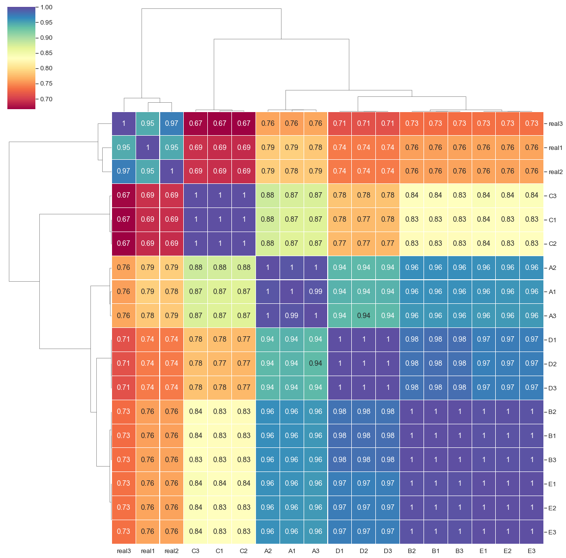
Figure 7. Pearson correlation coefficient of metagenome-wide, position-specific read depth for each of three replicates of real and simulated mock community sequencing. Real1-3 are the depth correlations of the real sequencing data replicates. Mapped read depth correlations from readsynth simulations are shown in A-E:
A - custom (.json) dictionary of fragment lengths derived from real sequence data and cut efficiency derived from real sequence data;
B - normal distribution of fragment lengths and cut efficiency derived from real sequence data;
C - normal distribution of fragment lengths with fragment mean increased by 100bp and cut efficiency derived from real sequence data;
D - normal distribution of fragment lengths and cut efficiency reduced to 0.8;
E - normal distribution of fragment lengths and cut efficiency increased to 1.
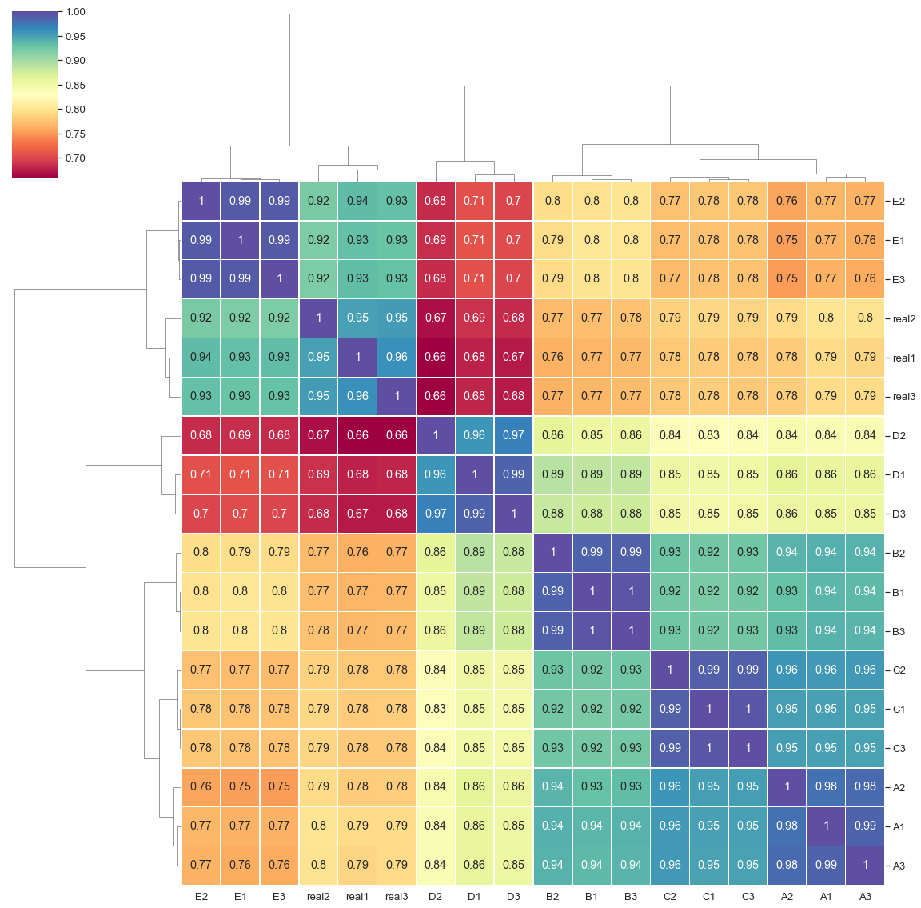
Figure 8. Spearman correlation coefficient of metagenome-wide, position-specific read depth for each of three replicates of real and simulated mock community sequencing. Real1-3 are the depth correlations of the real sequencing data replicates. Mapped read depth correlations from readsynth simulations are shown in A-E:
A - custom (.json) dictionary of fragment lengths derived from real sequence data and cut efficiency derived from real sequence data;
B - normal distribution of fragment lengths and cut efficiency derived from real sequence data;
C - normal distribution of fragment lengths with fragment mean increased by 100bp and cut efficiency derived from real sequence data;
D - normal distribution of fragment lengths and cut efficiency reduced to 0.8;
E - normal distribution of fragment lengths and cut efficiency increased to 1.
Simulations of the iso-length dataset produced lower Pearson correlation (r=0.56) but higher Spearman correlation (r=0.97) (Supplementary Figure 15). The use of type IIB enzymes avoids variability in fragment length, but there may be other sources of bias in the data that are not readily captured by simulation.

Comparing Kraken2/Bracken profiles of real and simulated mock communities

The adapter-trimmed reads from the previously described mock community sequencing efforts were profiled using custom databases with Kraken2 2.1.2 and Bracken 2.7 (Lu et al., 2017; Wood et al., 2019). Raw reads mapping to each species-level identification was used as a metric of performance between the real and simulated reads. Generally, simulations captured trends in the distribution of real sequence data with notable community changes in the simulations with increased fragment size selection and decreased cut efficiency (Figure 9, groups C and D).

Performance of software
A hypothetical gut microbiome was established to assess the performance of readsynth on larger metagenomic communities. Sequence reads from human gut samples (Liu et al. 2017) were assigned using the Kraken2 “PlusPFP” (Standard plus protozoa, fungi & plant) database (2022/06/07) and all species level taxonomic identifiers were used to simulate a hypothetical microbial community. The newest, complete genome assemblies were downloaded and simulated under various input settings (Table 3). Simulations were performed using a single core on a AMD EPYC 7F72 24-Core Processor (x86_64, 3028.149MHz) with wall clock time reported. The cumulative size of the metagenome reference sequences influenced the time to simulate, but choice of enzymes had the largest impact on time and performance. Frequent, 4-base cutters produced many potential fragments to process, and use of less frequent motifs performed more efficiently.
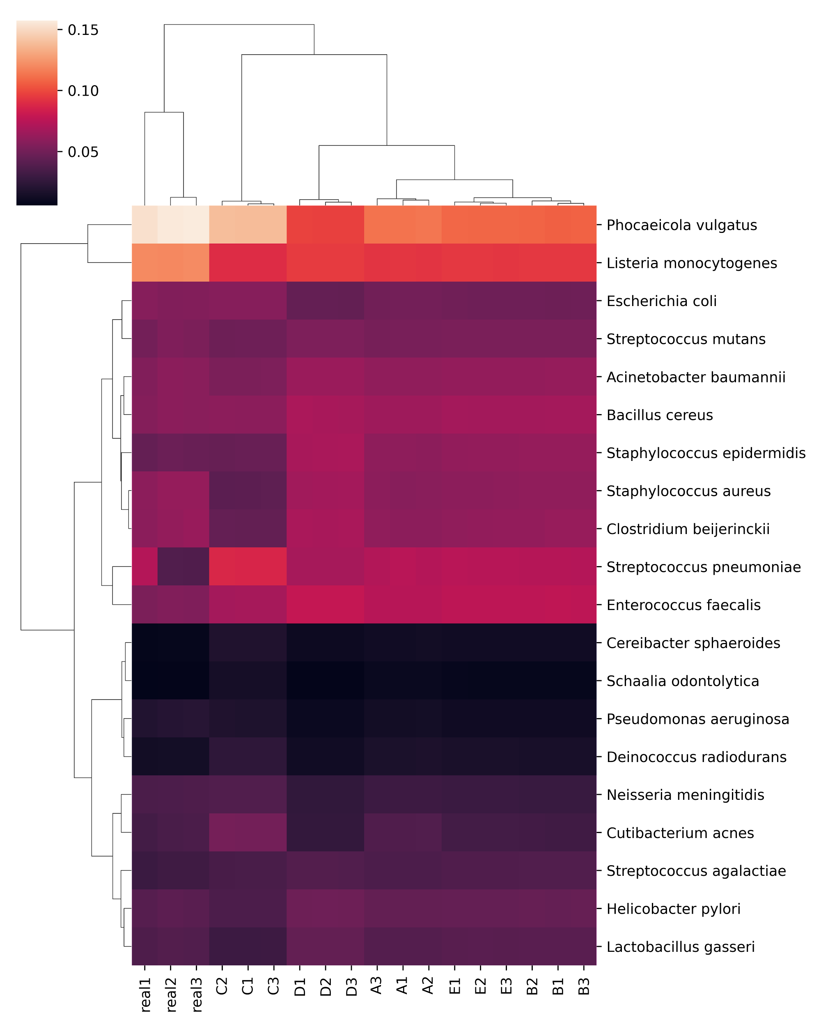
Figure 9. Kraken2/Bracken percent abundance profiles based on read assignments of real and simulated mock community sequencing. Real1-3 are the relative abundances of mapped reads per species produced from the real sequencing data. Mapped read depth correlations from readsynth simulations are shown in A-E: A - custom (.json) dictionary of fragment lengths; B - normal distribution and cut rate; C - normal distribution and cut rate with fragment mean increased by 100bp; D - normal distribution and cut rate with cut rate reduced to 0.8; E - normal distribution and cut rate with cut rate increased to 1. All fragment distributions and cut rates estimated from real sequence data unless specified.

Table 3. Performance of simulations using various parameter settings using a metagenome of hypothetical gut microbial taxa.
number of genomes | metagenome size (Gb) | number of reads (n) | motif1 (m1) | motif2 (m2) | cut rate (c) | max. length (bp) | error profile | time
*692 | 5.846 | 3,321,470 | CATG/ | A/CGT | 1 | 1,006 | - | 204m36.979s
691 | 2.582 | 3,196,330 | CATG/ | A/CGT | 1 | 1,006 | - | 111m59.763s
691 | 2.582 | 49,541,809 | CATG/ | A/CGT | 1 | 1,006 | - | 113m37.994s
691 | 2.582 | 50,339,998 | CATG/ | A/CGT | 0.8 | 600 | - | 65m5.266s
691 | 2.582 | 49,819,185 | CATG/ | A/CGT | 1 | 600 | - | 54m34.212s
691 | 2.582 | 49,819,185 | CATG/ | A/CGT | 1 | 600 | novaseq | 75m2.522s
691 | 2.582 | 49,993,869 | G/AATTC | A/CCGGT | 1 | 1,006 | - | 16m22.367s
691 | 2.582 | 49,996,665 | G/AATTC | A/CCGGT | 0.8 | 600 | - | 13m8.017s
691 | 2.582 | 49,999,426 | G/AATTC | A/CCGGT | 1 | 600 | - | 11m50.082s
691 | 2.582 | 49,999,426 | G/AATTC | A/CCGGT | 1 | 600 | miseq | 28m38.893s
*metagenome includes host human genome reference

Discussion

Readsynth simulations of RMS mock communities produced realistic taxonomic distributions of genomic fragments. The output read profiles corresponded closely to those found in the limited RMS mock community sequences that exist. Each taxon present in the simulated RMS mock community produces a unique digest profile at varying relative abundance, and readsynth simulations faithfully captured these influential patterns in read depth across all combined loci in the metagenome.

Unlike WGS, fragment length is a critical aspect of RMS that is tied to the enzymes employed and the makeup of the digested genomic templates. As a result, it is imperative that simulation efforts accurately capture the size selection window. Few existing read simulation software allow for a custom fragment length distribution, and to our knowledge readsynth is the first to simulate reduced metagenomic fragment lengths using the intersection of digest distribution and size selection distribution while scaling each genome to a defined relative abundance. The use of a custom distribution of fragment lengths extracted from real sequence data produced the most reliable read depth simulation, and overlaying a normal distribution on the fragment distribution performed with similar accurately.

Readsynth simulations also demonstrate the potential influence that library preparation can have on the findings of a given study. The fragment origin and read depth were sensitive to even minor differences in simulated library parameters, particularly size selection and enzyme efficiency. Varying the size selection of fragments may result in changes to the taxonomic composition of raw reads that compose the final library. This size selection bias influences estimates of relative abundance in simulated reads (Figure 9). For example, increasing the mean of the size selection distribution by 100bp caused the reads belonging to Phocaeicola vulgatus to increase relative to the other taxa in the simulated datasets. P. vulgatus has a large, AT-rich genome relative to other members of the mock community, and modifying the size selection window allows more fragments of this species to be included relative to the members with smaller genomes (Supplementary Figure 16). Similarly, reads assigned to Staphylococcus epidermidis are found to increase in abundance when enzyme digestion is incomplete. S. epidermidis contains many EcoRI and MseI recognition sites, resulting in short reads in the range of approximately 6 to 30 bp. By relaxing cut efficiency, longer reads within the size window are able to survive to the read sequencing step.

Due to the nature of compositionality, slight shifts in taxonomic contributions will alter the abundance of all members of the community, and readsynth is designed to capture this nuance (Aitchison, 1982). All sequencing datasets have subtle biases outside of size selection and enzyme activity that cannot easily be modeled when no ground truth is available, as in most real-life applications. Pearson and Spearman correlations of positional read depth highlighted that stochasticity found in real data cannot always be captured in simulation, and iso-length data produced high variability in read depth even without the bias introduced by size selection. Previous profiling efforts of the iso-length data produced variable abundance estimates across sample replicates that varied only by sample DNA concentration, so the source of the bias isn’t immediately transparent (Sun et al., 2022). Finally, it should be noted that some compositional variability is to be expected even in highly standardized mock communities.

Attempts here to estimate restriction enzyme cut efficiency work as expected on simulated data, but extracting these values from real sequence data did not perform as accurately as the assumption of complete enzyme digestion. This discrepancy may stem from size selection constraint, as the fragments required to calculate these rare instances often exist in the extremes of the fragment length distribution.

Library preparation and sequencing are complex processes that can introduce biases and their finer details are largely unobservable. The average user may have very little data on which to train their simulation, and readsynth has been designed for this use case. Several existing short read simulators are designed to capture detailed error profiles trained on existing alignments, and do so admirably (Richter et al., 2008; Huang et al., 2012; Gourle et al., 2019; Yu et al., 2020). However, this requires existing data that already closely resembles the desired metagenomic library to be sequenced. Readsynth focuses on capturing the relative abundance of community members after size-selecting from a mixed distribution of fragments that originate from each taxa in a highly individual manner. Quickly producing this information can allow for the best library approach and/or downstream tool to be determined in advance.

Data availability
github/ryandkuster/readsynth_analysis

Chapter 4: Abundance estimation in reduced metagenomics libraries
A version of this chapter is in preparation for submission by Kuster et al.:

Exploring the influence of library preparation on fragments from reduced metagenomic communities

Ryan Kuster¹*, Margaret Staton¹
1 Department of Entomology and Plant Pathology, University of Tennessee, Knoxville
* corresponding author

1. Introduction

Since its first application, reduced metagenomic sequencing (RMS) has remained a niche approach to profiling microbial communities. It offers some of the same advantages of marker gene approaches by targeting a subset of genomic regions while also increasing the taxonomic resolution of resulting data, similarly to whole genome sequencing (WGS). RMS is the application of reduced representation sequencing (RRS) library protocols onto samples of mixed genomic assemblages. The limited studies piloting the RMS approach have adopted steps modified from the original ddRADseq protocol (Peterson et al., 2012). Fragments are produced by a combination of both a frequent and infrequent restriction enzyme digest reaction, and complementary adapters are ligated without further random shearing of the fragments. Unlike the original application of reduced representation sequencing for genotyping by sequencing (GBS), which pools together barcoded samples from individuals, RMS creates fragments from many unknown source genomes into a single pooled sequencing run. Early studies into RMS have shown comparable and potentially superior performance to 16S and WGS profiling methodologies (Liu et al., 2017; Ravi et al., 2018; Hess et al., 2020; Snipen et al., 2021). Five years since it was coined by Liu et al., RMS has not gained community traction, and unlike existing profiling techniques, there is a lack of implemented software designed to handle the nuances of this approach.

Analysis of RMS data must handle the two initial steps of most microbiome studies: taxonomic classification and relative abundance estimation, also referred to as quantification. First, millions of RMS sequences are assigned to an identified taxonomic reference genome in a database through sequence alignment. Next, the abundance of each taxon is calculated, and may be assessed at different taxonomic levels from strain to class. Individual bacterial genomes reduced using typical RMS protocols may yield reads from hundreds to several thousand loci (Snipen et al., 2021). Some of these loci will be unique to a strain, while many may be shared at the genus level or higher. One of the main difficulties in adopting RMS is that the technique introduces multiple sources of variability that are expected to affect abundance profiling, but they have not been fully investigated or resolved through development of RMS-specific data analysis approaches.

Biological sources of variability include the genome size, which can range over an order of magnitude in bacteria, and the varying degrees of sequence conservation among closely related microbes (Ochman and Caro-Quintero, 2016). For example, the genomic locations that yield reduced-representation fragments may be variable even among closely related individuals, as a single base mutation altering the site of a restriction enzyme recognition motif can lead to “allelic dropout” (Andrews et al., 2016). The degree to which this variation affects taxonomic identification and determination of relative abundance of community members has not been studied deeply. Critical to understanding the application of RMS, it is necessary to account for variability in fragments resulting from the enzymatic fragmentation. Every community member comprising the metagenomic sample will yield a unique distribution of fragment lengths.

There are also technical sources of bias that can compound the variability within these taxa-specific markers. Often, sequencing library protocols require both PCR amplification and fragment size selection steps at least once. Both steps will affect the probability of a given DNA fragment surviving into the final sequencing reaction in a size-dependent manner, and multiple studies have shown support for PCR biases dependent on template length (Davey et al., 2013; DaCosta and Sorenson, 2014). Given the variability in GC content across fragments, there is also the potential for some fragments to preferentially amplify (Silverman et al., 2021). Multiple assessments of ddRADseq libraries have found GC bias to be present, but it is not known to what extent this will influence RMS profiles (Davey et al., 2013; Liu et al., 2017; Snipen et al., 2021). Gel or bead mediated size selection is a critical step in RRS library design that helps to remove adapter dimers and optimize flow cell performance, and so remains an unavoidable library preparation step in most cases. An alternative RRS approach using isolength (type IIB) restriction enzymes has been proposed as a potential solution to this issue of variable fragment length (Sun et al., 2022). Using a single enzyme that produces constant fragment lengths frequently across the genome may create detailed fingerprints of genomic communities without size selection steps, assuming adapter dimers can be reduced.

Interestingly, in the case of fragment lengths, bias is occurring due to biology of the individual community members being sampled (restriction enzyme choice and genome composition) and the technical library preparation (size selection and PCR amplification). These factors prevent the total numbers of reads mapped to reference genomes from being directly used for calculating relative abundance. Our proposed solution is to consider the fragment counts comprising every single fragment length in the total distribution of fragments. Within the context of a single fragment length, barring the presence of bias from nucleotide content, the ratio of taxon A and taxon B should remain constant between all fragment lengths where both taxa are present. It should be expected that each fragment length will not contain all taxa present in the community, however the ratio between any two taxa can be expected to hold.

In this study, both real and simulated RMS libraries are investigated to understand the influence of non-uniform fragment sizes and possible molecular and computational considerations that might be used to overcome these biases. We first investigate a novel quantification approach using real and simulated datasets mapped under ideal conditions with known reference genomes comprising the community. Libraries are simulated using variations in restriction enzymes, total read count, and size selection range. Upon finding the library conditions that produce the best resolution, we consider the ability of these approaches when the search space includes a full database of all available reference genomes.

2. Methods and Analyses

Simulations of RMS sequencing reads were informed by a previously sequenced mock community and two complex gut metagenomic communities based on sequencing efforts from complex microbial samples. Three replicated mock community sequences prepared with RMS using EcoRI and MseI in Snipen et al. 2021 (SRR10199716, SRR10199724, and SRR10199725) were used as a baseline to quantify taxonomic abundances from a mixture of 20 bacterial taxa (Snipen et al., 2021). Taxa were assumed to be approximately equimolar in ribosomal operon count as described in the product specifications (BEI HM-782D). A single human stool sample (SRR5298272) prepared with RMS using NlaIII and HpyCH4IV was used to establish a microbial community for simulation (Liu et al., 2017). These biological sample reads were assigned putative taxonomic labels using Kraken2 and Bracken (database ‘PlusPFP’ June 2022) and resulting taxonomic identification numbers were used to download representative genomes from each of the 691 non-host hits (Lu et al., 2017; Wood et al., 2019). Finally, the OTU profile resulting from gut samples from 2,084 individuals from the Healthy Life in an Urban Setting (HELIUS) study served as a basis for simulating microbial communities with authentic taxonomic abundances (Deschasaux et al., 2018). Of the 744 OTUs, 610 unique RefSeq genome references from the genus and species level served as the basis for simulation. When multiple OTUs from the same genus level were encountered, species from this genus were chosen based on assembly quality only, allowing highly similar taxa within the same community to be simulated. All simulations were performed using the software readsynth (0.1.0; commit 88d8bb1).

Paired end reads from each of the real and simulated datasets were adapter-trimmed using Cutadapt (4.1) and then mapped using bwa-mem (Burrows Wheeler Aligner 0.7.17) to a combined reference genome concatenated from all known members in the metagenome (Li and Durbin, 2010; Martin, 2011). Only reads mapping in the expected orientation were kept using Samtools (1.15.1) (Danecek et al., 2021). Mapped reads with a MAPQ score of zero were removed to avoid reads that map closely to multiple reference genomes. Custom Python scripts (available at github.com/ryandkuster/metagenome_abundances) were used to recreate the original genomic fragments corresponding with each read pair based on the simulated start and end positions for each fragment produced in simulation. Only those fragments harboring no internal cut sites were kept as incomplete digests are expected to unpredictably affect quantification and we assumed these fragments to be rare. The observed count and corresponding taxonomic assignment were stored for each fragment.

Fragments were analyzed individually across the range of observed fragment lengths. Within each discrete fragment length, the ratios of the observed counts between all taxa present were calculated. The ratio was calculated iteratively by dividing the individual fragment count by the average fragment count for each of the other taxa (Figure 10). These taxonomic ratios were then averaged over all fragments to produce an n x n matrix of all n taxa. Because many taxonomic ratios were missing, all columns in the taxonomic ratio matrix were scaled to the taxon with the greatest number of relationships to all other taxa. The row average of this scaled matrix was used to predict relative taxonomic abundance for all taxa.

The metagenomes based on HELIUS communities were simulated using RMS approaches using a series of increasing total read counts (1x10⁵, 1x10⁶, 1x10⁷, and 1x10⁸ paired end reads) and four combinations of restriction enzyme double digests. The combinations of restriction enzymes selected (EcoRI/AgeI, EcoRI/MseI, HhaI/AgeI, and HhaI/MseI) were chosen for the diversity of the cut site frequency and GC content of the recognition motifs (Table 4).

Practical application of metagenomics profiling must assign taxonomic labels to reads using the most comprehensive database available, thus we assess the performance of RMS data when the reference database is not curated to only those references in the ground truth set. Reads were simulated using taxa from the Liu et al. RMS dataset, and each taxon was set to have equal representation in terms of relative abundance. Simulated reads were again queried against the Kraken2 ‘PlusPFP’ database and assigned using Bracken. Reference genomes from the taxa predicted by Bracken were concatenated and used to map and recreate fragments. The source reference genome of each simulated read was known, however, we wanted to see if mapping and recreating fragments using an inclusive database would produce taxa count and abundance comparable with the input 691 taxa simulated at even relative abundance.
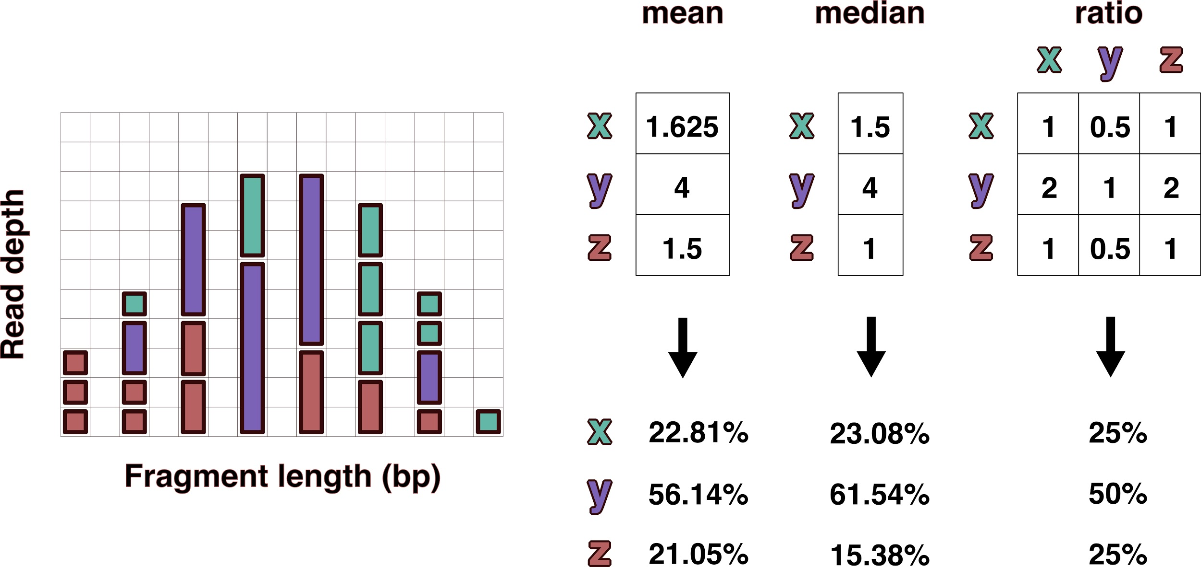
Figure 10. Visual representation of read depths originating from hypothetical taxa x, y, and z present in a 1:2:1 ratio. The left distribution shows fragments resulting from reduced sequencing under size selection or PCR fragment length biases. The differences in relative abundance estimates produced using mean and median read depths is compared with the taxonomic ratio approach introduced here. The ratio table on the right displays the averaged pairwise read depth ratios calculated individually within each fragment length. Even assuming no bias within each fragment length, the mean and median read depth estimates produce relative abundances that don’t account for variance in the size distribution, which is often not normal or uniform.

Table 4. Combinations and expected characteristics of the restriction enzymes selected for double digests in HELIUS-inspired RMS simulations.
Forward | Reverse | Frequency | GC content
EcoRI (G/AATTC) | AgeI (A/CCGGT) | rare - rare | even
EcoRI (G/AATTC) | MseI (T/TAA) | rare - common | GC poor
HhaI (GCG/C) | AgeI (A/CCGGT) | common - rare | GC rich
HhaI (GCG/C) | MseI (T/TAA) | common - common | even

3. Results

Profiling accuracy from the real and simulated Snipen et al. data were assessed using the taxonomic ratio approach, avoiding normalization across the fragment length distribution and instead measuring the relationships in read depth ratio between the taxa present at a given length. On average, using ratios produced relative abundance estimates similar to those produced using either the median or mean read depths with Pearson correlation to the ground truth relative abundances ranging between 0.809 and 0.852 across the three replicates (Figure 11). Independent from the quantitative metric used, estimates of relative abundance across the three replicates show consistent, taxa-specific patterns of over- and underabundance in several of the 20 mock community members (Supplementary Figure 17). These differences may be the result of sequence-specific amplification biases or slight deviations from the reported proportions expected from the mock community standard.

Data simulated from the 610 HELIUS gut microbial taxa were used to assess differences in profiling performance under varying library preparation conditions. Most notably, we see a strong interaction between the characteristics of restriction enzymes selected and the total number of reads simulated. Use of two frequent restriction enzymes, HhaI and MseI, each with 4bp recognition motifs, required 100 million reads in order to detect >90% of the input taxa. Interestingly, the use of two infrequent restriction enzymes, EcoRI and AgeI, was able to identify a higher percentage of taxa at lower read numbers relative to the other treatments (Figure 12). At 10 million reads, the combination of EcoRI and MseI captured 96.1% of taxa.

Most of the simulated datasets performed moderately well at 10 million reads, and this was used as the basis for additional simulations. Two additional datasets were simulated with EcoRI and MseI using 10 million reads, but modifying the mean of the fragment length distribution either down or up by 100bp. A final dataset was simulated using the type IIb restriction enzyme BcgI to investigate the merits of using fragments with constant length (Sun et al., 2022).
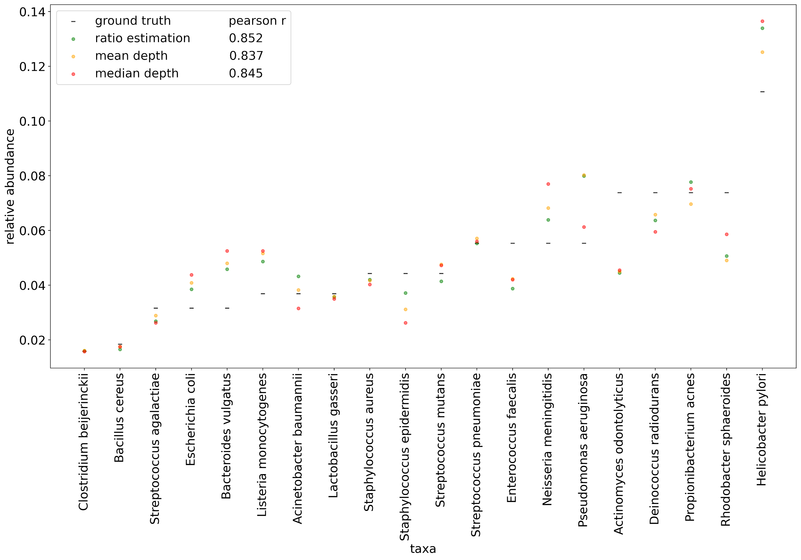
Figure 11. Comparisons of ground truth relative abundance vs. results obtained using taxonomic ratio approach, mean depth, and median depths for SRR10199716 replicate of the Snipen et al. 2021 mock community sequences.

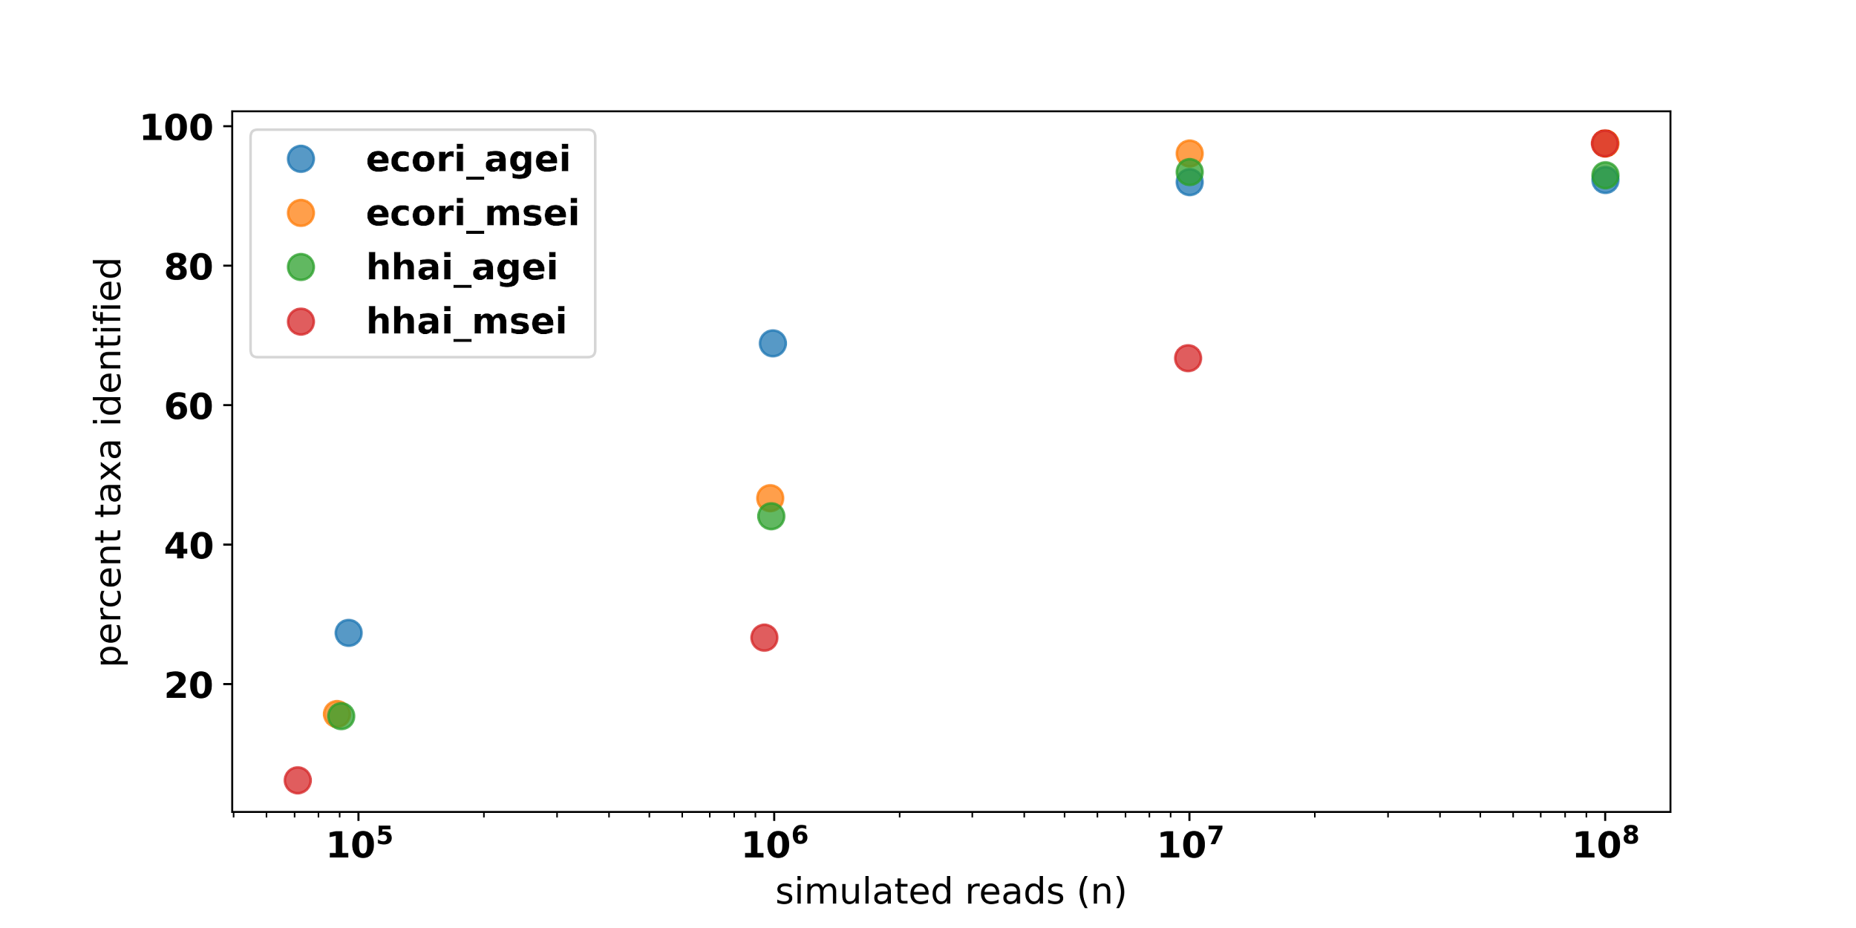
Figure 12. The relationship between the input simulated reads target and the percent of taxa identified across 4 combinations of restriction enzyme double digests. Of the expected 610 unique taxa, many are not captured at lower levels of coverage. Combination of rare cutters (EcoRI and AgeI) performed better at these lower levels of coverage.
Lowering the mean fragment size for the EcoRI/MseI simulations by 100bp reduced the number of identifiable taxa to 89%, and an increase by 100bp marginally improved this result to 96.7%. Simulating BcgI fragmentation of the HELIUS data returned only 56.1% of the 610 taxa, compared with the 66.7% of taxa identified by HhaI/MseI at the same read count (Figure 13). Across all simulations using 10 million reads, many reads were discarded due to the multi-mapping criterion described in the methods. At least 34% of reads were removed at this level, with over half of reads being removed in the BcgI profiling effort.

Again applying the taxonomic ratio approach to estimating relative abundances, reads simulated from the HELIUS data captured several general trends not captured with the mock community analysis. Across all simulated HELIUS datasets, taxonomic ratio estimates of relative abundance outperformed the mean and median read depth in every instance (Supplementary Table 2). In some extreme cases, relying on the mean and median depths fall far from the target relative abundances (Figure 14).

In order to compare the profiling performance of RMS reads when mapping to a known set of reference genomes and a fully inclusive database, 691 taxa based on the Liu et al. dataset were simulated with even abundance. Unlike the HELIUS results, aligning these reads to the known set of references was able to uniquely identify every input genome (Figure 15). The same simulated reads were then assigned to the ‘PlusPFP’ premade database using Kraken2 and Bracken. This database contains all bacterial, archaeal, plasmid, human, protozoan, plant, and fungal RefSeq references, and the resulting number of taxonomic hits was inflated from 691 to 1,534 total taxa. The reference genomes from these putative taxa were then used for alignment and fragment recreation in place of the curated, known reference approach described above. Upon selecting reads whose source fragments aligned to the expected cut positions and removing multi mapped reads, the pool of quality hits was reduced to 749 taxa, more comparable to the 691 taxa input into the simulated library.
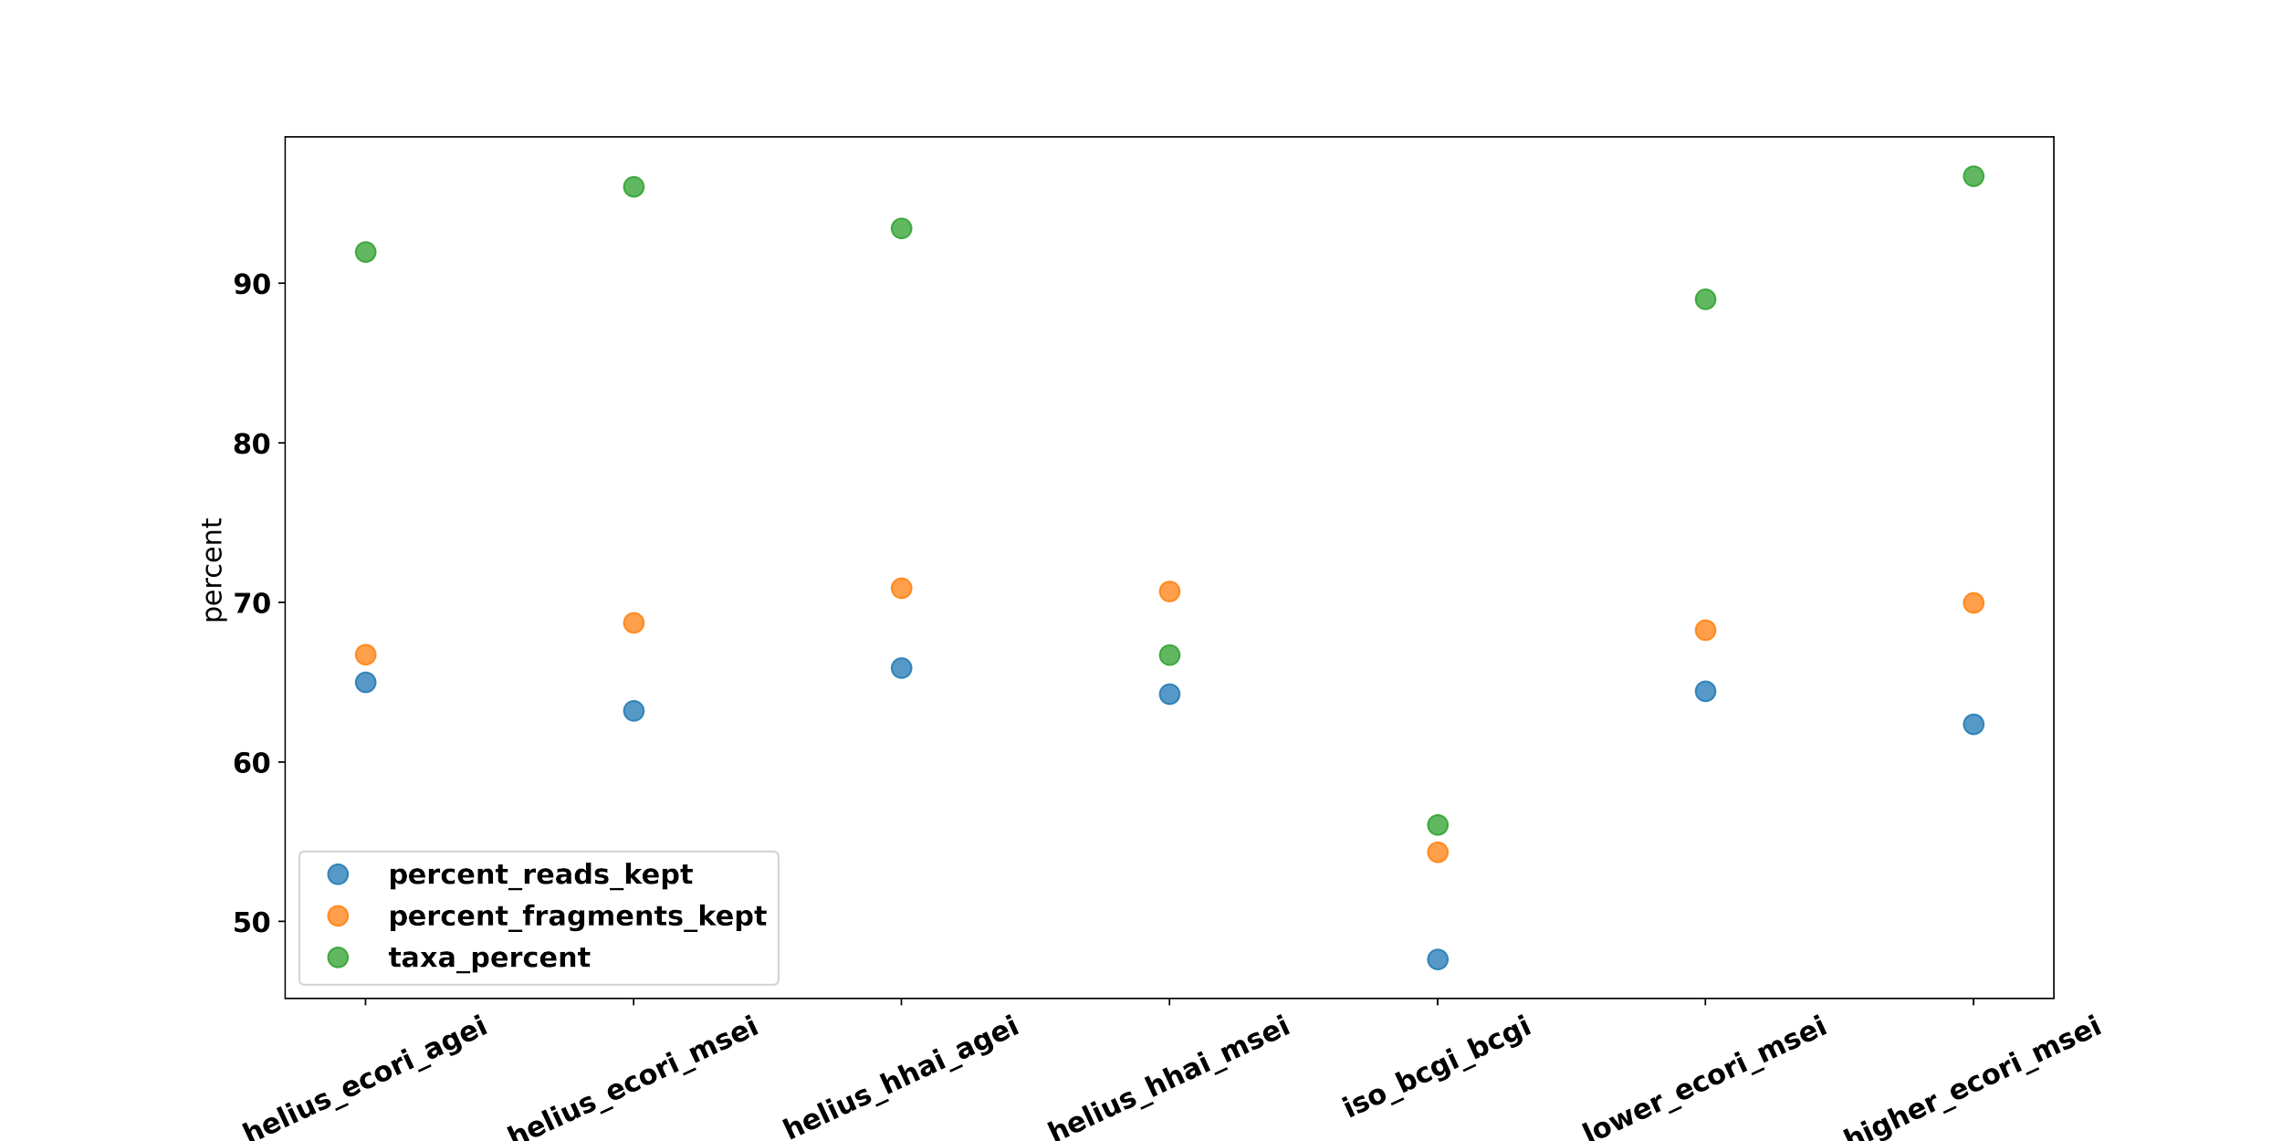
Figure 13. Comparison of performance of multiple reduced representation metagenomic sequencing efforts simulated at 10⁷ target reads based on the same HELIUS community composition. The percent of identifiable taxa (“taxa_percent”) is lowest in the libraries simulated using either the combination of HhaI/MseI or the type IIb restriction enzyme BcgI. The percent of expected, unique fragments (“percent_fragments_kept”) that are retained after BWA mapping unique reads by these methods is comparable in all but the BcgI library (iso_bcgi_bcgi). Datasets were also simulated using mean fragment lengths lowered by 100bp (lower_ecori_msei) or increased by 100bp (higher_ecori_msei) relative to the baseline values used for the other double digestion simulations.
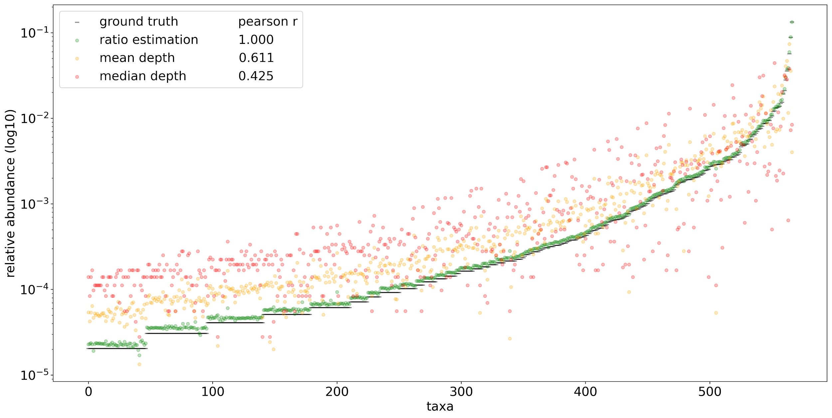
Figure 14. Comparisons of ground truth relative abundance (black) vs. results obtained using taxonomic ratio approach (green), mean depth (yellow), and median depth (red) for 567 taxa returned using HELIUS simulated reads digested with HhaI and AgeI using 1x10⁸ total reads.
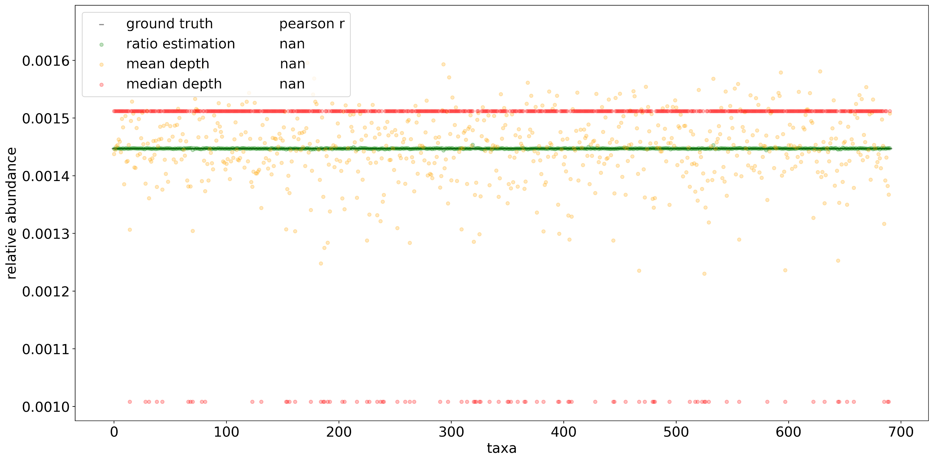
Figure 15. Comparisons of ground truth vs. results obtained using taxonomic ratio approach, mean depth, and median depths by mapping simulated reads to the known set of community reference genomes before fragment recreation. Reads from 691 taxa were simulated based on the metagenomic taxa from Liu et al. 2017 sequence SRR5298272 using even representation. In silico reference genomes were digested with NlaIII and HpyCH4IV producing ~3.3x10⁶ total reads.
Of the 10,050,095 reads simulated, 9,430,661 (93.8%) were able to map precisely to fragments expected in 749 of the 1,534 taxa from the Kraken2/Bracken profile. Visual inspection of the recreated fragment length distribution captured the expected profile (Supplementary Figure 18). Taxonomic ratio estimates from this reconstructed set of discernable fragments produced nearly even estimates of relative abundance. Some of the estimates of taxonomic abundance using fixed-length taxonomic ratios have much lower than even representation, but these results further support the fallibility of using mean and median read depths to estimate abundances using RMS (Figure 16).

4. Discussion

We found that using the relative frequencies of reads within each fragment length appears to be a more stable metric than either mean and median depth in the datasets examined here. Using median depth performs very poorly in some cases, often because RMS fragments are not unimodally distributed within an individual genome. Removal of multi-mapped reads may compound this effect by leaving only a small number of reads representing a genome, and these reads may exist in regions of the fragment length distribution that are influenced by size-selection and PCR length biases. In order for RMS approaches to overcome the confounding influence of variable fragment lengths, it is a necessary prerequisite to first recreate fragments in order to know fragment lengths. Fortunately, if a reference genome assembly is reliable enough to produce a strong hit to RMS reads, it should be able to provide a framework for simulating the expected fragments so long as the cut sites are preserved.

Fragments will often be shared between highly related genomes, and many identical fragments may need to be removed to proceed. In some instances, this process may limit a genome with hundreds of potential fragments down to very few, because any given fragment must remain unique in the presence of all other closely related genomes using the approach described here.
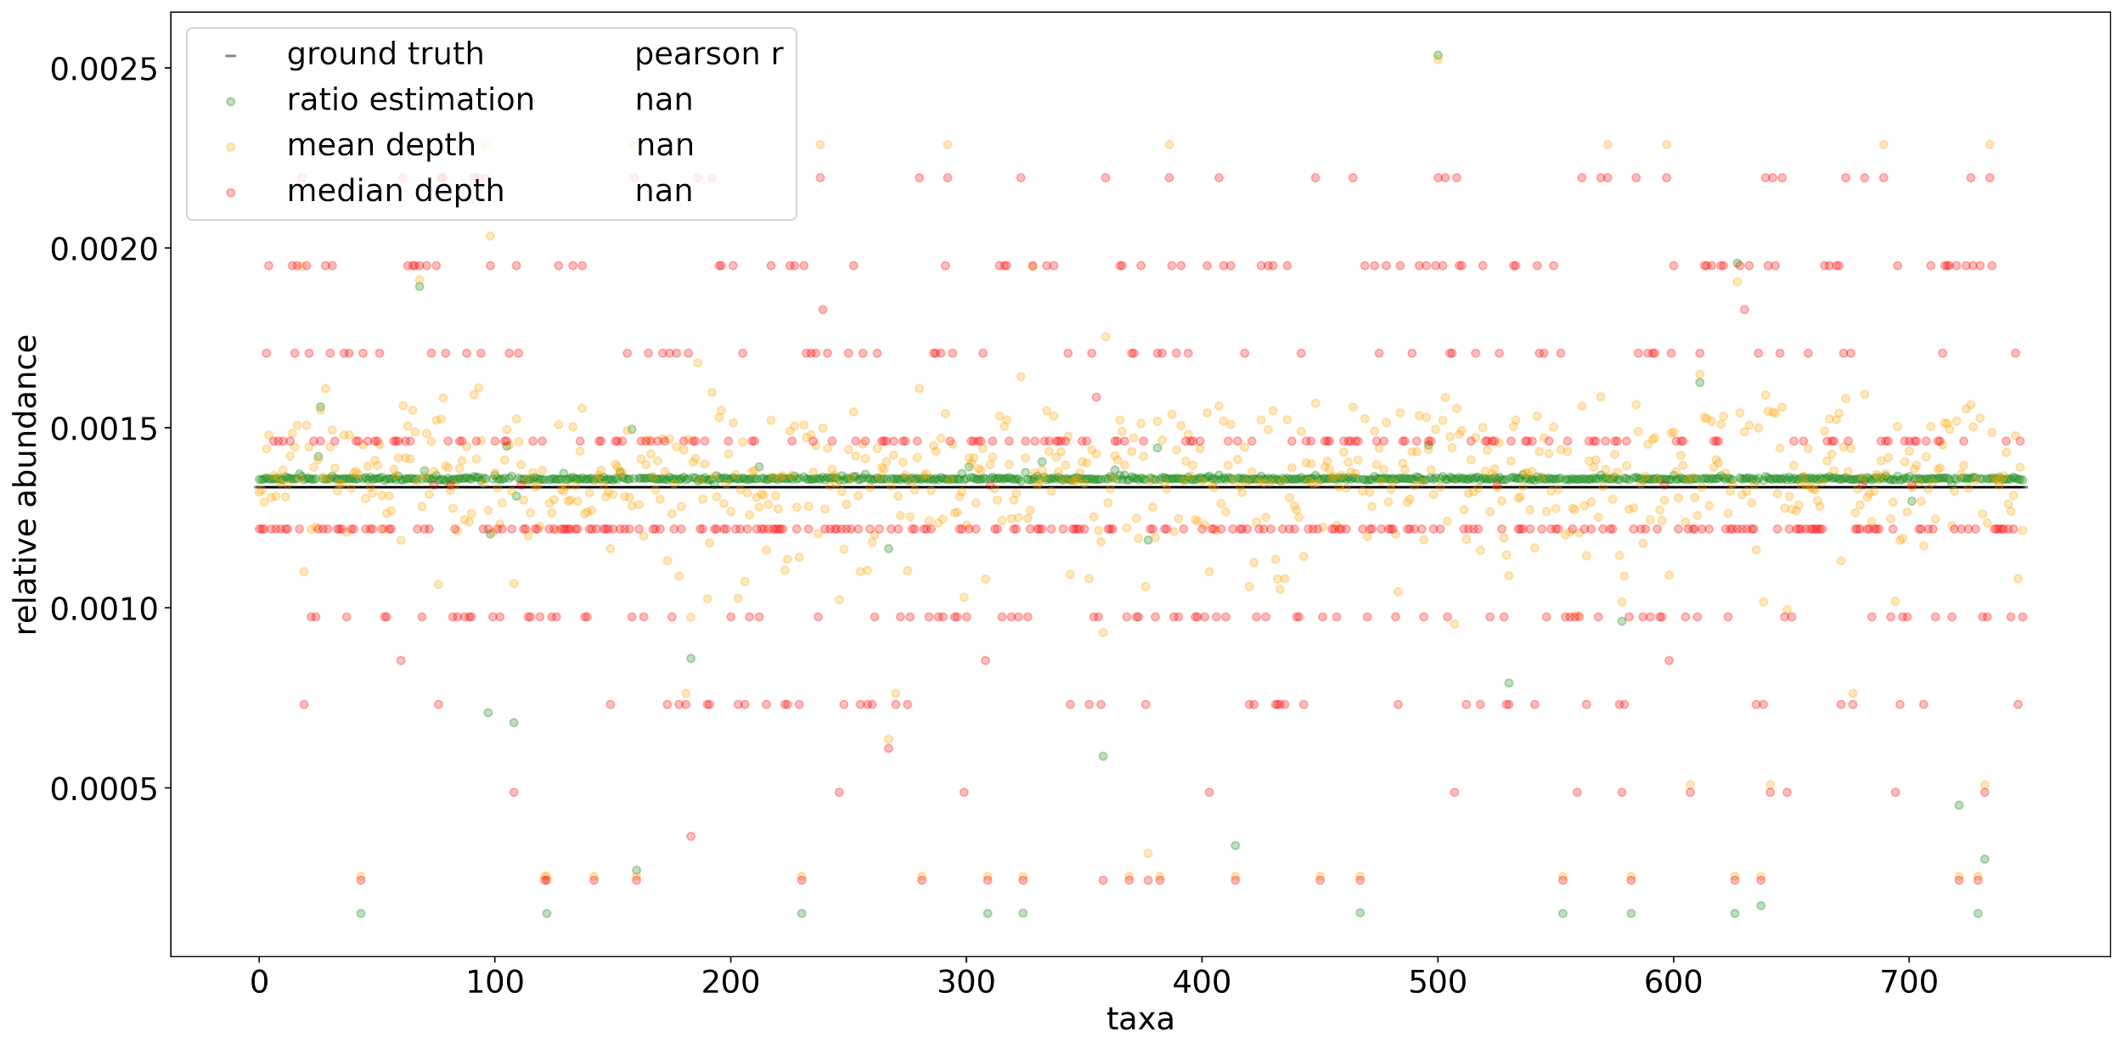

Figure 16. Comparisons of ground truth vs. results obtained using taxonomic ratio approach, mean depth, and median depths by mapping simulated reads naively to a fully inclusive, pre-made Kraken2 database (‘PlusPFP’) before fragment recreation. A total of 749 taxa were returned using this approach. Reads from 691 taxa were simulated based on the metagenomic taxa from Liu et al. 2017 sequence SRR5298272 using even representation. In silico reference genomes were digested with NlaIII and HpyCH4IV producing ~3.3x10⁶ total reads.
Fragments that are constrained through size selection or other fragment length preferential selection processes will occur less frequently and therefore using read depth alone is not a reliable proxy for abundance. Further, based on the unique profile of fragments resulting from choice of restriction enzyme, some taxa may only be present in the extremes of the fragment length distribution, therefore estimating their abundance will under-represent their contribution to the overall mixture.

Simulated assessments of RMS’s capability to capture rare taxa suggest that it may be possible, but is highly dependent on the way a library is prepared. The restriction enzymes selected and the way the resulting fragments are represented within a finite set of reads may determine which taxa produce enough signal to be counted. Fragmenting a set of highly diverse genomes with a frequent cutting enzyme may produce hundreds of thousands or even millions of potential fragments, but when these reads are distributed between taxa whose relative abundances differ by orders of magnitude, the signal for rare taxa is completely lost. Additionally, it is likely that enzyme digests that produce shorter fragments will produce more multi-mapping collisions, as the shorter read lengths reduce mapping confidence. Here we found that digests using HhaI/AgeI or the BcgI isolength enzyme produced the greatest number of potential fragments, but few were actually informative. This mapping based phenomenon may also explain the success of rare cutters, which captured a greater percent of the taxa present using a fraction of the overall fragments as the frequent cutters.

There is a fine balance between using rare and common cutters. Genome size bias in metagenomics has already been reported as a potential source of concern for its influence on sampling probabilities (Beszteri et al., 2010). A persisting concern with the RMS approach is the variable representation of a given genome based on the rate of motif occurrence, where some genomes will produce many more fragments even when adjusted for genome size. Highly specialized genomes are known to be reduced as a result of niche specialization, potentially making detection of influential pathogens or symbionts more difficult (Andersson and Kurland, 1998; Ravi et al., 2018).

In the case of common cutters, this characteristic may lead to an overabundance of fragments originating from only a few genomes that cumulatively overshadow the presence of other community members. Employing rare cutters may prevent these taxa from dominating the read library, but this approach introduces several concerns. First, rare cutters produce very few fragments per genome and may fail to produce fragments in the size range needed to represent a taxon. The fewer fragments produced from a genome increases the event of fragments being identical between taxa. Second, rare cutters tend to skew fragment length distributions to include longer sequences. This may lead to inconsistencies in read depth within a single taxon because bead purification, size selection, and PCR length biases do not represent all fragment lengths uniformly. It is possible that increasing the size selection range could improve resolution. Finally, increasing total read count may allow for greater resolution when many fragments are produced, but using upwards of 100 million reads per sample to capture rare taxa may reduce the cost benefits of RRS. It is recommended to consider each community’s complexity when considering the necessary read coverage, as has been similarly proposed for WGS profiling (Rodriguez-R and Konstantinidis, 2014).

The development of ddRADseq for GBS is based around comparing conserved regions of the genome between closely related species. With RMS, conservation between these fragments may be to the detriment when trying to parse the individual members of a complex community. The taxonomic ratio methodology described here does not rely on normalization, but it is also not designed to handle redundancies in multi-mapping fragments, as evidenced by the set of unidentified taxa in the HELIUS study. Eliminating fragments based on similarity may ultimately eliminate all useful, identifying markers if multiple, nearly identical strains are present. Retaining these fragments requires a means of identifying distinct taxa when aligning against a fully inclusive database of potential matches, and the results may be highly dependent on the database as well as the behavior of the aligning tool used (Anyansi et al., 2020).

Here, we demonstrate that mapping RMS reads to a broad database produced fragment distributions and taxa counts that were surprisingly similar to the ground truth, continuing to show promise for future applications. The ability to resolve and quantify reads from RMS is dependent on library preparation, particularly enzyme choice, read count, and size selection. Finally, software designed to handle RMS data should be sensitive to resolving multi-mapping conflicts while accounting for the influence of non-uniform distributions of fragment lengths.

Chapter 5: Conclusion
As we enter the third generation of sequencing, we build upon a vast expanse of existing short read data with seemingly endless nuances and tangent applications to investigate. Contemplating the interplay between molecular and computational techniques may uncover some of these short read nuances and will help to navigate future sequencing technologies as they come to prominence. Here, I considered the existing standards for filtering NGS data and applications using NGS short reads that might prove economically viable even as new sequencing platforms evolve. Through the development of ngcComposer and readsynth, I show support for tools that consider the downstream implications of molecular library preparation. Simulation is a meaningful way to measure the behavior of bioinformatics tools, but its utility hinges on its ability to faithfully capture features found in real sequencing data. The applications of short reads are highly variable. Often the impacts of library prep are overlooked in the production of bioinformatics tools, and more tools need to be considerate of these possible nuances. The rate at which sequencing technologies advance makes it a constant challenge to capture many of these effects.

Historically, filtering has been thought to be a critical step in data pre-processing. Although trimming is considered routine, recent studies highlight that it does not guarantee quality results (Del Fabbro et al., 2013). Genome assembly performs similarly using raw or trimmed reads (Yang et al., 2019). It is possible that trimming RNA-Seq data detrimentally alters the gene expression profiles (Williams et al., 2016). Using restriction enzyme motifs and successful barcode demultiplexing is an intuitive and unbiased way to improve sequence quality that retains the majority of reads without reliance on an arbitrary threshold that may differ across sequencing platforms.

Restriction enzyme digests of metagenomic communities produce unpredictable fragment length distributions that can't be readily modeled assuming features of an underlying distribution. Therefore, calculating relative proportions in the context of a mixture of individuals prepared this way is a challenge that has not been properly addressed to account for the influences of library preparation. The fixed-length taxonomic proportions methodology proposed here may benefit efforts in metagenomic quantification when fragment or target length differs between organisms. It may also have useful applications outside of metagenomics where fragment size bias affects abundance estimates using read depth, such as genotyping approaches using reduced representation sequencing.

The possibility of RMS becoming a prevailing technique in profiling metagenomic communities remains ambiguous. RMS may provide a fast and affordable profiling technique for communities that are relatively simple in structure. It may also be fast and economical in instances where detecting rare taxa is not critical. Recent advances in long-read sequencing show performance in metagenomics profiling that surpass WGS profiling recall (Pearman et al., 2020). In spite of advances in both long and short read sequencing platforms, it is often time-consuming and expensive to process many samples, and niche applications for RMS will undoubtedly improve throughput.

One of the largest obstacles preventing community use of RMS is the lack of bioinformatic tools developed to handle the data it produces, and applying existing profiling tools will not work out of the box. When two closely related taxa exist within a community, it becomes difficult to estimate the relative abundance of each using the RMS approach. This is because the majority of fragments originating from both organisms will be identical and only a small fraction of loci will be uniquely informative to a taxon. In instances when only a small number of fragments may be used for quantification, abundance estimates using read depths may be sensitive to per-fragment biases originating from size-selection or PCR.

There is still experimental validation to bolster greater community support for RMS. Further work benchmarking the performance of RMS versus WGS libraries in complex communities would be highly beneficial. Specifically, it would be informative to know the sensitivity of both approaches in detecting rare taxa at varying levels of read throughput. Does RMS provide advantages in resolution when using fewer total reads? If so, at what read count density do the profiling results of RMS and WGS libraries converge? Are some taxa consistently absent in either approach? Knowing the behavior of RMS under these conditions would aid in arguing its economical merits and would also provide context for its reliability as a WGS alternative.

In short read applications such as RMS, where existing short read approaches are being used in novel ways, it may be difficult to gain traction because the features of the data are so understudied for the intended application. Spending money to develop new experimental techniques can be a highly risky endeavor, and it also requires the time and energy to produce an ad hoc tool necessary to analyze this new form of data. In instances such as these, simulation can be incredibly useful in order to predict and overcome artifacts from library prep that could not be intended or otherwise measured without a ground truth. While simulation can not be expected to capture all the nuances of real sequencing data, it can help find the edge cases where existing tools might fail to perform as intended. Using a set of largely pre-existing bioinformatics tools, our assessments here of simulated RMS data may be successful in some instances and very underpowered in others. Both developers and users of new tools should be cognizant of the intersection between sample preparation and downstream analytical tools selected.

References
Aitchison, J. (1982). The Statistical Analysis of Compositional Data. J. R. Stat. Soc. Ser. B Methodol. 44, 139–160. doi: 10.1111/j.2517-6161.1982.tb01195.x.
Aitchison, J., Barceló-Vidal, C., Martín-Fernández, J. A., and Pawlowsky-Glahn, V. (2000). Logratio Analysis and Compositional Distance. Math. Geol. 32, 271–275. doi: 10.1023/A:1007529726302.
Albertsen, H. M., Le Paslier, D., Abderrahim, H., Dausset, J., Cann, H., and Cohen, D. (1989). Improved control of partial DNA restriction enzyme digest in agarose using limiting concentrations of Mg++. Nucleic Acids Res. 17, 808. doi: 10.1093/nar/17.2.808.
Alneberg, J., Bjarnason, B. S., de Bruijn, I., Schirmer, M., Quick, J., Ijaz, U. Z., et al. (2014). Binning metagenomic contigs by coverage and composition. Nat. Methods 11, 1144–1146. doi: 10.1038/nmeth.3103.
Andersson, S. G. E., and Kurland, C. G. (1998). Reductive evolution of resident genomes. Trends Microbiol. 6, 263–268. doi: 10.1016/S0966-842X(98)01312-2.
Andrews, K. R., Good, J. M., Miller, M. R., Luikart, G., and Hohenlohe, P. A. (2016). Harnessing the power of RADseq for ecological and evolutionary genomics. Nat. Rev. Genet. 17, 81–92. doi: 10.1038/nrg.2015.28.
Anyansi, C., Straub, T. J., Manson, A. L., Earl, A. M., and Abeel, T. (2020). Computational Methods for Strain-Level Microbial Detection in Colony and Metagenome Sequencing Data. Front. Microbiol. 11, 17. doi: 10.3389/fmicb.2020.01925.
Baird, N. A., Etter, P. D., Atwood, T. S., Currey, M. C., Shiver, A. L., Lewis, Z. A., et al. (2008). Rapid SNP Discovery and Genetic Mapping Using Sequenced RAD Markers. Plos One 3, 7. doi: 10.1371/journal.pone.0003376.
Baran, Y., and Halperin, E. (2012). Joint Analysis of Multiple Metagenomic Samples. Plos Comput. Biol. 8, 11. doi: 10.1371/journal.pcbi.1002373.
Beckman Coulter Life Sciences Available at: https://www.beckman.com/ [Accessed October 11, 2022].
Beltman, J. B., Urbanus, J., Velds, A., van Rooij, N., Rohr, J. C., Naik, S. H., et al. (2016). Reproducibility of Illumina platform deep sequencing errors allows accurate determination of DNA barcodes in cells. BMC Bioinformatics 17, 16. doi: 10.1186/s12859-016-0999-4.
Bentley, D. R., Balasubramanian, S., Swerdlow, H. P., Smith, G. P., Milton, J., Brown, C. G., et al. (2008). Accurate whole human genome sequencing using reversible terminator chemistry. Nature 456, 53–59. doi: 10.1038/nature07517.
Beszteri, B., Temperton, B., Frickenhaus, S., and Giovannoni, S. J. (2010). Average genome size: a potential source of bias in comparative metagenomics. ISME J. 4, 1075–1077. doi: 10.1038/ismej.2010.29.
Bokulich, N. A., Subramanian, S., Faith, J. J., Gevers, D., Gordon, J. I., Knight, R., et al. (2013). Quality-filtering vastly improves diversity estimates from Illumina amplicon sequencing. Nat. Methods 10, 57-U11. doi: 10.1038/nmeth.2276.
Botstein, D., White, R. L., Skolnick, M., and Davis, R. W. (1980). Construction of a genetic linkage map in man using restriction fragment length polymorphisms. Am. J. Hum. Genet. 32, 314–331.
Breitwieser, F. P., Lu, J., and Salzberg, S. L. (2019). A review of methods and databases for metagenomic classification and assembly. Brief. Bioinform. 20, 1125–1139. doi: 10.1093/bib/bbx120.
Callahan, B. J., McMurdie, P. J., Rosen, M. J., Han, A. W., Johnson, A. J. A., and Holmes, S. P. (2016). DADA2: High-resolution sample inference from Illumina amplicon data. Nat. Methods 13, 581–583. doi: 10.1038/nmeth.3869.
Caporaso, J. G., Kuczynski, J., Stombaugh, J., Bittinger, K., Bushman, F. D., Costello, E. K., et al. (2010). QIIME allows analysis of high-throughput community sequencing data. Nat. Methods 7, 335–336. doi: 10.1038/nmeth.f.303.
Ching, T., Himmelstein, D. S., Beaulieu-Jones, B. K., Kalinin, A. A., Do, B. T., Way, G. P., et al. (2018). Opportunities and obstacles for deep learning in biology and medicine. J. R. Soc. Interface 15, 47. doi: 10.1098/rsif.2017.0387.
Cock, P. J. A., Fields, C. J., Goto, N., Heuer, M. L., and Rice, P. M. (2010). The Sanger FASTQ file format for sequences with quality scores, and the Solexa/Illumina FASTQ variants. Nucleic Acids Res. 38, 1767–1771. doi: 10.1093/nar/gkp1137.
Cox, M. P., Peterson, D. A., and Biggs, P. J. (2010). SolexaQA: At-a-glance quality assessment of Illumina second-generation sequencing data. BMC Bioinformatics 11, 6. doi: 10.1186/1471-2105-11-485.
Dabney, J., and Meyer, M. (2012). Length and GC-biases during sequencing library amplification: A comparison of various polymerase-buffer systems with ancient and modern DNA sequencing libraries. Biotechniques 52, 87-+. doi: 10.2144/000113809.
DaCosta, J. M., and Sorenson, M. D. (2014). Amplification Biases and Consistent Recovery of Loci in a Double-Digest RAD-seq Protocol. Plos One 9, 14. doi: 10.1371/journal.pone.0106713.
Danecek, P., Bonfield, J. K., Liddle, J., Marshall, J., Ohan, V., Pollard, M. O., et al. (2021). Twelve years of SAMtools and BCFtools. GigaScience 10, giab008. doi: 10.1093/gigascience/giab008.
Davey, J. W., Cezard, T., Fuentes-Utrilla, P., Eland, C., Gharbi, K., and Blaxter, M. L. (2013). Special features of RAD Sequencing data: implications for genotyping. Mol. Ecol. 22, 3151–3164. doi: 10.1111/mec.12084.
Del Fabbro, C., Scalabrin, S., Morgante, M., and Giorgi, F. M. (2013). An Extensive Evaluation of Read Trimming Effects on Illumina NGS Data Analysis. Plos One 8, 13. doi: 10.1371/journal.pone.0085024.
Deschasaux, M., Bouter, K. E., Prodan, A., Levin, E., Groen, A. K., Herrema, H., et al. (2018). Depicting the composition of gut microbiota in a population with varied ethnic origins but shared geography. Nat. Med. 24, 1526–1531. doi: 10.1038/s41591-018-0160-1.
Dohm, J. C., Lottaz, C., Borodina, T., and Himmelbauer, H. (2008). Substantial biases in ultra-short read data sets from high-throughput DNA sequencing. Nucleic Acids Res. 36, 10. doi: 10.1093/nar/gkn425.
Dohm, J. C., Peters, P., Stralis-Pavese, N., and Himmelbauer, H. (2020). Benchmarking of long-read correction methods. NAR Genomics Bioinforma. 2. doi: 10.1093/nargab/lqaa037.
Elshire, R. J., Glaubitz, J. C., Sun, Q., Poland, J. A., Kawamoto, K., Buckler, E. S., et al. (2011). A Robust, Simple Genotyping-by-Sequencing (GBS) Approach for High Diversity Species. Plos One 6, 10. doi: 10.1371/journal.pone.0019379.
Ewing, B., and Green, P. (1998). Base-calling of automated sequencer traces using phred. II. Error probabilities. Genome Res. 8, 186–194. doi: 10.1101/gr.8.3.186.
Fadrosh, D. W., Ma, B., Gajer, P., Sengamalay, N., Ott, S., Brotman, R. M., et al. (2014). An improved dual-indexing approach for multiplexed 16S rRNA gene sequencing on the Illumina MiSeq platform. Microbiome 2, 7. doi: 10.1186/2049-2618-2-6.
FASTQ files explained Available at: https://support.illumina.com/bulletins/2016/04/fastq-files-explained.html [Accessed March 15, 2022].
Faust, K., and Raes, J. (2012). Microbial interactions: from networks to models. Nat. Rev. Microbiol. 10, 538–550. doi: 10.1038/nrmicro2832.
Fischer, M., Strauch, B., and Renard, B. Y. (2017). Abundance estimation and differential testing on strain level in metagenomics data. Bioinformatics 33, I124–I132. doi: 10.1093/bioinformatics/btx237.
Fritz, A., Hofmann, P., Majda, S., Dahms, E., Droge, J., Fiedler, J., et al. (2019). CAMISIM: simulating metagenomes and microbial communities. Microbiome 7, 12. doi: 10.1186/s40168-019-0633-6.
Frostegard, A., Courtois, S., Ramisse, V., Clerc, S., Bernillon, D., Le Gall, F., et al. (1999). Quantification of bias related to the extraction of DNA directly from soils. Appl. Environ. Microbiol. 65, 5409–5420.
Fujimoto, A., Nakagawa, H., Hosono, N., Nakano, K., Abe, T., Boroevich, K. A., et al. (2010). Whole-genome sequencing and comprehensive variant analysis of a Japanese individual using massively parallel sequencing. Nat. Genet. 42, 931-U39. doi: 10.1038/ng.691.
Fuller, C. W., Middendorf, L. R., Benner, S. A., Church, G. M., Harris, T., Huang, X. H., et al. (2009). The challenges of sequencing by synthesis. Nat. Biotechnol. 27, 1013–1023. doi: 10.1038/nbt.1585.
García-García, N., Tamames, J., and Puente-Sánchez, F. (2022). M&Ms: a versatile software for building microbial mock communities. Bioinformatics. doi: 10.1093/bioinformatics/btab882.
Glaubitz, J. C., Casstevens, T. M., Lu, F., Harriman, J., Elshire, R. J., Sun, Q., et al. (2014). TASSEL-GBS: A High Capacity Genotyping by Sequencing Analysis Pipeline. Plos One 9, 11. doi: 10.1371/journal.pone.0090346.
Glenn, T. C. (2011). Field guide to next-generation DNA sequencers. Mol. Ecol. Resour. 11, 759–769. doi: 10.1111/j.1755-0998.2011.03024.x.
Gloor, G. B., Macklaim, J. M., Pawlowsky-Glahn, V., and Egozcue, J. J. (2017). Microbiome Datasets Are Compositional: And This Is Not Optional. Front. Microbiol. 8, 6. doi: 10.3389/fmicb.2017.02224.
Goodrich, J. K., Di Rienzi, S. C., Poole, A. C., Koren, O., Walters, W. A., Caporaso, J. G., et al. (2014). Conducting a Microbiome Study. Cell 158, 250–262. doi: 10.1016/j.cell.2014.06.037.
Goodwin, S., McPherson, J. D., and McCombie, W. R. (2016). Coming of age: ten years of next-generation sequencing technologies. Nat. Rev. Genet. 17, 333–351. doi: 10.1038/nrg.2016.49.
Gourle, H., Karlsson-Lindsjo, O., Hayer, J., and Bongcam-Rudloff, E. (2019). Simulating Illumina metagenomic data with InSilicoSeq. Bioinformatics 35, 521–522. doi: 10.1093/bioinformatics/bty630.
Grewe, F., Huang, J.-P., Leavitt, S. D., and Lumbsch, H. T. (2017). Reference-based RADseq resolves robust relationships among closely related species of lichen-forming fungi using metagenomic DNA. Sci. Rep. 7, 9884. doi: 10.1038/s41598-017-09906-7.
Herten, K., Hestand, M. S., Vermeesch, J. R., and Van Houdt, J. K. J. (2015). GBSX: a toolkit for experimental design and demultiplexing genotyping by sequencing experiments. BMC Bioinformatics 16, 6. doi: 10.1186/s12859-015-0514-3.
Hess, M. K., Rowe, S. J., Van Stijn, T. C., Henry, H. M., Hickey, S. M., Brauning, R., et al. (2020). A restriction enzyme reduced representation sequencing approach for low-cost, high-throughput metagenome profiling. Plos One 15, 18. doi: 10.1371/journal.pone.0219882.
Hillier, L. W., Marth, G. T., Quinlan, A. R., Dooling, D., Fewell, G., Barnett, D., et al. (2008). Whole-genome sequencing and variant discovery in C-elegans. Nat. Methods 5, 183–188. doi: 10.1038/nmeth.1179.
Home | Sage Science (2011). Available at: https://sagescience.com/ [Accessed October 11, 2022].
Huang, W. C., Li, L. P., Myers, J. R., and Marth, G. T. (2012). ART: a next-generation sequencing read simulator. Bioinformatics 28, 593–594. doi: 10.1093/bioinformatics/btr708.
Huson, D. H., Auch, A. F., Qi, J., and Schuster, S. C. (2007). MEGAN analysis of metagenomic data. Genome Res. 17, 377–386. doi: 10.1101/gr.5969107.
Johnson, S., Trost, B., Long, J. R., Pittet, V., and Kusalik, A. (2014). A better sequence-read simulator program for metagenomics. BMC Bioinformatics 15, 10. doi: 10.1186/1471-2105-15-s9-s14.
Jones, M. B., Highlander, S. K., Anderson, E. L., Li, W. Z., Dayrit, M., Klitgord, N., et al. (2015). Library preparation methodology can influence genomic and functional predictions in human microbiome research. Proc. Natl. Acad. Sci. U. S. A. 112, 14024–14029. doi: 10.1073/pnas.1519288112.
Kennedy, N. A., Walker, A. W., Berry, S. H., Duncan, S. H., Farquarson, F. M., Louis, P., et al. (2014). The Impact of Different DNA Extraction Kits and Laboratories upon the Assessment of Human Gut Microbiota Composition by 16S rRNA Gene Sequencing. Plos One 9, 9. doi: 10.1371/journal.pone.0088982.
Kerepesi, C., and Grolmusz, V. (2016). Evaluating the Quantitative Capabilities of Metagenomic Analysis Software. Curr. Microbiol. 72, 612–616. doi: 10.1007/s00284-016-0991-2.
Kim, D., Song, L., Breitwieser, F. P., and Salzberg, S. L. (2016). Centrifuge: rapid and sensitive classification of metagenomic sequences. Genome Res. 26, 1721–1729. doi: 10.1101/gr.210641.116.
Kircher, M., Heyn, P., and Kelso, J. (2011). Addressing challenges in the production and analysis of illumina sequencing data. Bmc Genomics 12, 14. doi: 10.1186/1471-2164-12-382.
Klingenberg, H., Aßhauer, K. P., Lingner, T., and Meinicke, P. (2013). Protein signature-based estimation of metagenomic abundances including all domains of life and viruses. Bioinformatics 29, 973–980. doi: 10.1093/bioinformatics/btt077.
Knight, R., Vrbanac, A., Taylor, B. C., Aksenov, A., Callewaert, C., Debelius, J., et al. (2018). Best practices for analysing microbiomes. Nat. Rev. Microbiol. 16, 410–422. doi: 10.1038/s41579-018-0029-9.
Krueger, F., Andrews, S. R., and Osborne, C. S. (2011). Large Scale Loss of Data in Low-Diversity Illumina Sequencing Libraries Can Be Recovered by Deferred Cluster Calling. Plos One 6, 7. doi: 10.1371/journal.pone.0016607.
Li, H., and Durbin, R. (2010). Fast and accurate long-read alignment with Burrows-Wheeler transform. Bioinforma. Oxf. Engl. 26, 589–595. doi: 10.1093/bioinformatics/btp698.
Liao, P., Satten, G. A., and Hu, Y. (2017). PhredEM: a phred‐score‐informed genotype‐calling approach for next‐generation sequencing studies. Genet. Epidemiol. 41, 375–387. doi: 10.1002/gepi.22048.
Liu, M., Worden, P., Monahan, L. G., DeMaere, M. Z., Burke, C. M., Djordjevic, S. P., et al. (2017). Evaluation of ddRAD seq for reduced representation metagenome sequencing. Peerj 5, 9. doi: 10.7717/peerj.3837.
Lovell, D., Pawlowsky-Glahn, V., Egozcue, J. J., Marguerat, S., and Bahler, J. (2015). Proportionality: A Valid Alternative to Correlation for Relative Data. Plos Comput. Biol. 11, 12. doi: 10.1371/journal.pcbi.1004075.
Lozupone, C. A., Stombaugh, J., Gonzalez, A., Ackermann, G., Wendel, D., Vázquez-Baeza, Y., et al. (2013). Meta-analyses of studies of the human microbiota. Genome Res. 23, 1704–1714. doi: 10.1101/gr.151803.112.
Lu, J., Breitwieser, F. P., Thielen, P., and Salzberg, S. L. (2017). Bracken: estimating species abundance in metagenomics data. Peerj Comput. Sci., 17. doi: 10.7717/peerj-cs.104.
Manley, L. J., Ma, D., and Levine, S. S. (2016). Monitoring Error Rates In Illumina Sequencing. J. Biomol. Tech. 27, 125–128. doi: 10.7171/jbt.16-2704-002.
Marchesi, J. R., and Ravel, J. (2015). The vocabulary of microbiome research: a proposal. Microbiome 3, 31. doi: 10.1186/s40168-015-0094-5.
Martin, M. (2011). Cutadapt removes adapter sequences from high-throughput sequencing reads. EMBnetjournal Vol 17 No 1 Gener. Seq. Data Anal. doi: 10.14806/ej.17.1.200.
Mastretta-Yanes, A., Arrigo, N., Alvarez, N., Jorgensen, T. H., Piñero, D., and Emerson, B. C. (2015). Restriction site-associated DNA sequencing, genotyping error estimation and de novo assembly optimization for population genetic inference. Mol. Ecol. Resour. 15, 28–41. doi: 10.1111/1755-0998.12291.
McElroy, K. E., Luciani, F., and Thomas, T. (2012). GemSIM: general, error-model based simulator of next-generation sequencing data. BMC Genomics 13, 74. doi: 10.1186/1471-2164-13-74.
Miller, M. R., Dunham, J. P., Amores, A., Cresko, W. A., and Johnson, E. A. (2007). Rapid and cost-effective polymorphism identification and genotyping using restriction site associated DNA (RAD) markers. Genome Res. 17, 240–248. doi: 10.1101/gr.5681207.
Minoche, A. E., Dohm, J. C., and Himmelbauer, H. (2011). Evaluation of genomic high-throughput sequencing data generated on Illumina HiSeq and Genome Analyzer systems. Genome Biol. 12, 15. doi: 10.1186/gb-2011-12-11-r112.
Mitchell, K., Brito, J. J., Mandric, I., Wu, Q. Z., Knyazev, S., Chang, S., et al. (2020). Benchmarking of computational error-correction methods for next-generation sequencing data. Genome Biol. 21, 13. doi: 10.1186/s13059-020-01988-3.
Mitra, A., Skrzypczak, M., Ginalski, K., and Rowicka, M. (2015). Strategies for Achieving High Sequencing Accuracy for Low Diversity Samples and Avoiding Sample Bleeding Using Illumina Platform. Plos One 10, 21. doi: 10.1371/journal.pone.0120520.
Mora-Márquez, F., García-Olivares, V., Emerson, B. C., and López de Heredia, U. (2017). ddradseqtools: a software package for in silico simulation and testing of double-digest RADseq experiments. Mol. Ecol. Resour. 17, 230–246. doi: 10.1111/1755-0998.12550.
Nayfach, S., and Pollard, K. S. (2015). Average genome size estimation improves comparative metagenomics and sheds light on the functional ecology of the human microbiome. Genome Biol. 16, 18. doi: 10.1186/s13059-015-0611-7.
Nayfach, S., and Pollard, K. S. (2016). Toward Accurate and Quantitative Comparative Metagenomics. Cell 166, 1103–1116. doi: 10.1016/j.cell.2016.08.007.
Nielsen, H. B., Almeida, M., Juncker, A. S., Rasmussen, S., Li, J. H., Sunagawa, S., et al. (2014). Identification and assembly of genomes and genetic elements in complex metagenomic samples without using reference genomes. Nat. Biotechnol. 32, 822–828. doi: 10.1038/nbt.2939.
Ochman, H., and Caro-Quintero, A. (2016). “Genome Size and Structure, Bacterial,” in Encyclopedia of Evolutionary Biology, ed. R. M. Kliman (Oxford: Academic Press), 179–185. doi: 10.1016/B978-0-12-800049-6.00235-3.
Pace, N. R., Stahl, D. A., Lane, D. J., and Olsen, G. J. (1986). “The Analysis of Natural Microbial Populations by Ribosomal RNA Sequences,” in Advances in Microbial Ecology, ed. K. C. Marshall (Boston, MA: Springer US), 1–55. doi: 10.1007/978-1-4757-0611-6_1.
Pearman, W. S., Freed, N. E., and Silander, O. K. (2020). Testing the advantages and disadvantages of short- and long- read eukaryotic metagenomics using simulated reads. BMC Bioinformatics 21, 220. doi: 10.1186/s12859-020-3528-4.
Pérez-Cobas, A. E., Gomez-Valero, L., and Buchrieser, C. (2020). Metagenomic approaches in microbial ecology: an update on whole-genome and marker gene sequencing analyses. Microb. Genomics 6. doi: 10.1099/mgen.0.000409.
Peterson, B. K., Weber, J. N., Kay, E. H., Fisher, H. S., and Hoekstra, H. E. (2012). Double Digest RADseq: An Inexpensive Method for De Novo SNP Discovery and Genotyping in Model and Non-Model Species. Plos One 7, 11. doi: 10.1371/journal.pone.0037135.
Pfeiffer, F., Grober, C., Blank, M., Handler, K., Beyer, M., Schultze, J. L., et al. (2018). Systematic evaluation of error rates and causes in short samples in next-generation sequencing. Sci. Rep. 8, 14. doi: 10.1038/s41598-018-29325-6.
Prakash, T., and Taylor, T. D. (2012). Functional assignment of metagenomic data: challenges and applications. Brief. Bioinform. 13, 711–727. doi: 10.1093/bib/bbs033.
Probst, A. J., Weinmaier, T., DeSantis, T. Z., Domingo, J. W. S., and Ashbolt, N. (2015). New Perspectives on Microbial Community Distortion after Whole-Genome Amplification. Plos One 10, 16. doi: 10.1371/journal.pone.0124158.
Quince, C., Walker, A. W., Simpson, J. T., Loman, N. J., and Segata, N. (2017). Shotgun metagenomics, from sampling to analysis. Nat. Biotechnol. 35, 833–844. doi: 10.1038/nbt.3935.
Quinn, T. P., Erb, I., Richardson, M. F., and Crowley, T. M. (2018). Understanding sequencing data as compositions: an outlook and review. Bioinformatics 34, 2870–2878. doi: 10.1093/bioinformatics/bty175.
Ravi, A., Avershina, E., Angell, I. L., Ludvigsen, J., Manohar, P., Padmanaban, S., et al. (2018). Comparison of reduced metagenome and 16S rRNA gene sequencing for determination of genetic diversity and mother-child overlap of the gut associated microbiota. J. Microbiol. Methods 149, 44–52. doi: 10.1016/j.mimet.2018.02.016.
Restriction Enzyme Troubleshooting Guide | NEB Available at: https://www.neb.com/tools-and-resources/troubleshooting-guides/restriction-enzyme-troubleshooting-guide [Accessed November 7, 2022].
Richter, D. C., Ott, F., Auch, A. F., Schmid, R., and Huson, D. H. (2008). MetaSim-A Sequencing Simulator for Genomics and Metagenomics. Plos One 3, 12. doi: 10.1371/journal.pone.0003373.
Riesenfeld, C. S., Schloss, P. D., and Handelsman, J. (2004). Metagenomics: Genomic analysis of microbial communities. Annu. Rev. Genet. 38, 525–552. doi: 10.1146/annurev.genet.38.072902.091216.
Rodriguez-R, L. M., and Konstantinidis, K. T. (2014). Estimating coverage in metagenomic data sets and why it matters. ISME J. 8, 2349–2351. doi: 10.1038/ismej.2014.76.
Sankar, A., Malone, B., Bayliss, S. C., Pascoe, B., Méric, G., Hitchings, M. D., et al. (2016). Bayesian identification of bacterial strains from sequencing data. Microb. Genomics 2, e000075–e000075. doi: 10.1099/mgen.0.000075.
Schirmer, M., D’Amore, R., Ijaz, U. Z., Hall, N., and Quince, C. (2016). Illumina error profiles: resolving fine-scale variation in metagenomic sequencing data. BMC Bioinformatics 17, 15. doi: 10.1186/s12859-016-0976-y.
Schirmer, M., Ijaz, U. Z., D’Amore, R., Hall, N., Sloan, W. T., and Quince, C. (2015). Insight into biases and sequencing errors for amplicon sequencing with the Illumina MiSeq platform. Nucleic Acids Res. 43, 16. doi: 10.1093/nar/gku1341.
Schloss, P. D., Westcott, S. L., Ryabin, T., Hall, J. R., Hartmann, M., Hollister, E. B., et al. (2009). Introducing mothur: Open-Source, Platform-Independent, Community-Supported Software for Describing and Comparing Microbial Communities. Appl. Environ. Microbiol. 75, 7537–7541. doi: 10.1128/aem.01541-09.
Schmeing, S., and Robinson, M. D. (2021). ReSeq simulates realistic Illumina high-throughput sequencing data. Genome Biol. 22, 37. doi: 10.1186/s13059-021-02265-7.
Sczyrba, A., Hofmann, P., Belmann, P., Koslicki, D., Janssen, S., Droge, J., et al. (2017). Critical Assessment of Metagenome Interpretation-a benchmark of metagenomics software. Nat. Methods 14, 1063-+. doi: 10.1038/nmeth.4458.
Seifert, K. A. (2009). Progress towards DNA barcoding of fungi. Mol. Ecol. Resour. 9, 83–89. doi: 10.1111/j.1755-0998.2009.02635.x.
Shin, S., and Park, J. (2016). Characterization of sequence-specific errors in various next-generation sequencing systems. Mol. Biosyst. 12, 914–922. doi: 10.1039/c5mb00750j.
Silverman, J. D., Bloom, R. J., Jiang, S., Durand, H. K., Dallow, E., Mukherjee, S., et al. (2021). Measuring and mitigating PCR bias in microbiota datasets. Plos Comput. Biol. 17, 17. doi: 10.1371/journal.pcbi.1009113.
Snipen, L., Angell, I. L., Rognes, T., and Rudi, K. (2021). Reduced metagenome sequencing for strain-resolution taxonomic profiles. Microbiome 9, 19. doi: 10.1186/s40168-021-01019-8.
Soneson, C., and Delorenzi, M. (2013). A comparison of methods for differential expression analysis of RNA-seq data. BMC Bioinformatics 14, 91. doi: 10.1186/1471-2105-14-91.
Soneson, C., Love, M. I., and Robinson, M. D. (2015). Differential analyses for RNA-seq: transcript-level estimates improve gene-level inferences. F1000Research 4, 1521–1521. doi: 10.12688/f1000research.7563.2.
Soueidan, H., and Nikolski, M. (2015). Machine learning for metagenomics: methods and tools. ArXiv Genomics.
Stoddard, S. F., Smith, B. J., Hein, R., Roller, B. R. K., and Schmidt, T. M. (2015). rrnDB: improved tools for interpreting rRNA gene abundance in bacteria and archaea and a new foundation for future development. Nucleic Acids Res. 43, D593–D598. doi: 10.1093/nar/gku1201.
Sun, Z., Huang, S., Zhang, M., Zhu, Q. Y., Haiminen, N., Carrieri, A. P., et al. (2021). Challenges in benchmarking metagenomic profilers. Nat. Methods 18, 618-+. doi: 10.1038/s41592-021-01141-3.
Sun, Z., Huang, S., Zhu, P., Tzehau, L., Zhao, H., Lv, J., et al. (2022). Species-resolved sequencing of low-biomass or degraded microbiomes using 2bRAD-M. Genome Biol. 23, 36. doi: 10.1186/s13059-021-02576-9.
Timm, H., Weigand, H., Weiss, M., Leese, F., and Rahmann, S. (2018). DDRAGE: A data set generator to evaluate ddRADseq analysis software. Mol. Ecol. Resour. 18, 681–690. doi: 10.1111/1755-0998.12743.
Tringe, S. G., and Rubin, E. M. (2005). Metagenomics: DNA sequencing of environmental samples. Nat. Rev. Genet. 6, 805–814. doi: 10.1038/nrg1709.
Vos, P., Hogers, R., Bleeker, M., Reijans, M., van de Lee, T., Hornes, M., et al. (1995). AFLP: a new technique for DNA fingerprinting. Nucleic Acids Res. 23, 4407–4414. doi: 10.1093/nar/23.21.4407.
Walsh, P. S., Erlich, H. A., and Higuchi, R. (1992). Preferential PCR amplification of alleles: mechanisms and solutions. PCR Methods Appl. 1, 241–250. doi: 10.1101/gr.1.4.241.
Weiss, S., Xu, Z. Z., Peddada, S., Amir, A., Bittinger, K., Gonzalez, A., et al. (2017). Normalization and microbial differential abundance strategies depend upon data characteristics. Microbiome 5, 18. doi: 10.1186/s40168-017-0237-y.
White, T. J., Bruns, T., Lee, S., and Taylor, J. (1990). Amplification and direct sequencing of fungal ribosomal RNA genes for phylogenetics. PCR Protoc. Guide Methods Appl. 18, 315–322.
Williams, C. R., Baccarella, A., Parrish, J. Z., and Kim, C. C. (2016). Trimming of sequence reads alters RNA-Seq gene expression estimates. BMC Bioinformatics 17, 103. doi: 10.1186/s12859-016-0956-2.
Wommack K. Eric, Bhavsar Jaysheel, and Ravel Jacques (2008). Metagenomics: Read Length Matters. Appl. Environ. Microbiol. 74, 1453–1463. doi: 10.1128/AEM.02181-07.
Wood, D. E., Lu, J., and Langmead, B. (2019). Improved metagenomic analysis with Kraken 2. Genome Biol. 20, 13. doi: 10.1186/s13059-019-1891-0.
Wood, D. E., and Salzberg, S. L. (2014). Kraken: ultrafast metagenomic sequence classification using exact alignments. Genome Biol. 15, R46. doi: 10.1186/gb-2014-15-3-r46.
Yang, S.-F., Lu, C.-W., Yao, C.-T., and Hung, C.-M. (2019). To Trim or Not to Trim: Effects of Read Trimming on the De Novo Genome Assembly of a Widespread East Asian Passerine, the Rufous-Capped Babbler (Cyanoderma ruficeps Blyth). Genes 10. doi: 10.3390/genes10100737.
Yang, X., Chockalingam, S. P., and Aluru, S. (2013). A survey of error-correction methods for next-generation sequencing. Brief. Bioinform. 14, 56–66. doi: 10.1093/bib/bbs015.
Yu, Z. H., Du, F., Ban, R. J., and Zhang, Y. W. (2020). SimuSCoP: reliably simulate Illumina sequencing data based on position and context dependent profiles. BMC Bioinformatics 21, 18. doi: 10.1186/s12859-020-03665-5.
Yuan, S. Q., Cohen, D. B., Ravel, J., Abdo, Z., and Forney, L. J. (2012). Evaluation of Methods for the Extraction and Purification of DNA from the Human Microbiome. Plos One 7, 10. doi: 10.1371/journal.pone.0033865.

Appendix
Supplementary Tables and Figures

Table S1: Comparison of empirical and instrument-derived error rates.
Dataset | Hamming Distance | Mean Q score | Mean empirical score | Q score difference | Fold change in error rate
HiSeq2500 High-Output | 1 | 37.54 | 29.74 | 7.81 | 6.03
HiSeq2500 High-Output | 2 | 37.54 | 23.87 | 13.67 | 23.29
HiSeq2500 High-Output | 3 | 37.53 | 19.89 | 17.64 | 58.06
HiSeq2500 High-Output | 4 | 37.53 | 19.76 | 17.77 | 59.83
HiSeq2500 Rapid-Run | 1 | 37.67 | 25.54 | 12.13 | 16.33
HiSeq2500 Rapid-Run | 2 | 37.60 | 21.77 | 15.83 | 38.29
HiSeq2500 Rapid-Run | 3 | 37.57 | 18.96 | 18.61 | 72.58
HiSeq2500 Rapid-Run | 4 | 37.57 | 18.87 | 18.70 | 74.10
MiSeq | 1 | 36.55 | 27.99 | 8.56 | 7.18
MiSeq | 2 | 36.55 | 20.96 | 15.59 | 36.26
MiSeq | 3 | 36.54 | 18.53 | 18.01 | 63.22
MiSeq | 4 | 36.54 | 18.53 | 18.01 | 63.25
NovaSeq 6000 | 1 | 36.45 | 27.34 | 9.11 | 8.14
NovaSeq 6000 | 2 | 36.43 | 23.89 | 12.54 | 17.97
NovaSeq 6000 | 3 | 36.43 | 22.51 | 13.92 | 24.65
NovaSeq 6000 | 4 | 36.43 | 22.51 | 13.92 | 24.66

Table S2. Profiling results of reads simulated from HELIUS metagenomic community using various restriction enzymes, read count, and size selection. The reported Pearson correlation coefficients (r) for the taxonomic ratio, mean, and median estimates of relative abundance are reported when available.
Simulation Settings |  |  |  |  | Percent Recovery |  |  | Pearson r vs. Ground Truth
RE1 | RE2 | Mean | Reads | Fragments | Reads | Fragments | Taxa | Ratio | Mean | Median
ecori | agei | 406 | 1.E+05 | 22,100 | 68.97% | 69.78% | 27.38% | 1.00 | 0.87 | 0.89
ecori | msei | 406 | 1.E+05 | 35,552 | 64.12% | 70.48% | 15.74% | 1.00 | 0.98 | 0.91
hhai | agei | 406 | 1.E+05 | 33,578 | 67.51% | 73.46% | 15.41% | 1.00 | 0.99 | 0.84
hhai | msei | 406 | 1.E+05 | 39,373 | 61.09% | 71.30% | 6.23% | 0.99 | 0.99 | 0.98
ecori | agei | 406 | 1.E+06 | 55,577 | 68.96% | 70.09% | 68.85% | 1.00 | 0.91 | 0.95
ecori | msei | 406 | 1.E+06 | 113,506 | 64.69% | 70.72% | 46.72% | 1.00 | 0.96 | 0.85
hhai | agei | 406 | 1.E+06 | 99,462 | 67.75% | 72.41% | 44.10% | 1.00 | 0.87 | 0.75
hhai | msei | 406 | 1.E+06 | 199,827 | 64.25% | 72.75% | 26.72% | 1.00 | 0.90 | 0.74
ecori | agei | 406 | 1.E+07 | 96,354 | 65.01% | 66.74% | 91.97% | 1.00 | 0.66 | 0.52
ecori | msei | 306 | 1.E+07 | 342,408 | 64.44% | 68.27% | 89.02% | 1.00 | 0.99 | 0.90
ecori | msei | 406 | 1.E+07 | 267,416 | 63.21% | 68.73% | 96.07% | 1.00 | 0.92 | 0.59
ecori | msei | 506 | 1.E+07 | 204,873 | 62.38% | 69.98% | 96.72% | 1.00 | 0.89 | 0.46
hhai | agei | 406 | 1.E+07 | 222,889 | 65.88% | 70.89% | 93.44% | 1.00 | 0.78 | 0.64
hhai | msei | 406 | 1.E+07 | 548,629 | 64.27% | 70.68% | 66.72% | 1.00 | 0.92 | 0.48
ecori | agei | 406 | 1.E+08 | 121,592 | 60.56% | 62.13% | 92.30% | 1.00 | 0.93 | 0.68
ecori | msei | 406 | 1.E+08 | 402,706 | 61.90% | 65.47% | 97.54% | 1.00 | 0.95 | 0.39
hhai | agei | 406 | 1.E+08 | 329,159 | 57.15% | 67.56% | 92.95% | 1.00 | 0.61 | 0.43
hhai | msei | 406 | 1.E+08 | 1,132,631 | 60.30% | 68.03% | 97.54% | 1.00 | 0.98 | 0.68
bcgi | bcgi | 34 | 1.E+07 | 532,599 | 47.63% | 54.35% | 56.07% | NA | 1.00 | 1.00

MiSeq (R1) – raw MiSeq (R2) – raw
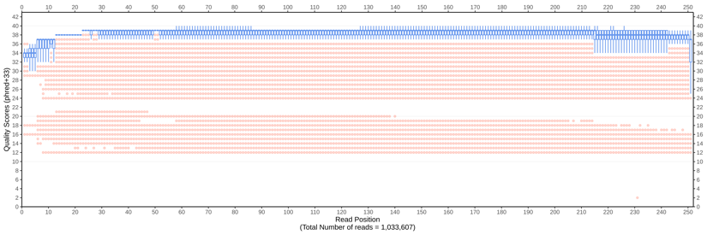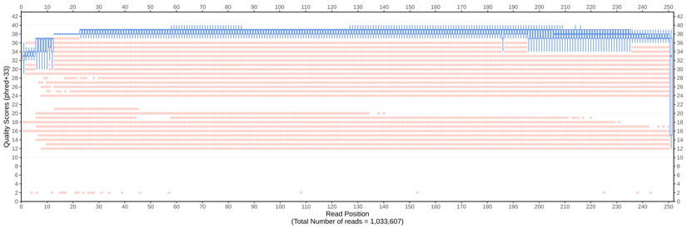
MiSeq (R1) – demultiplexed MiSeq (R2) – demultiplexed
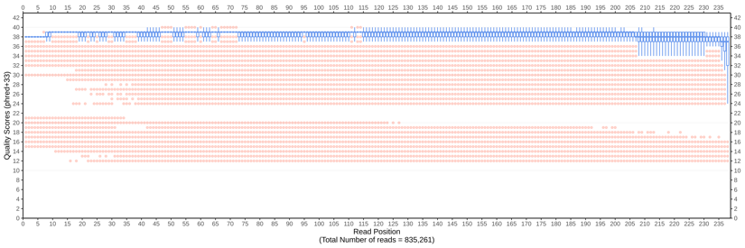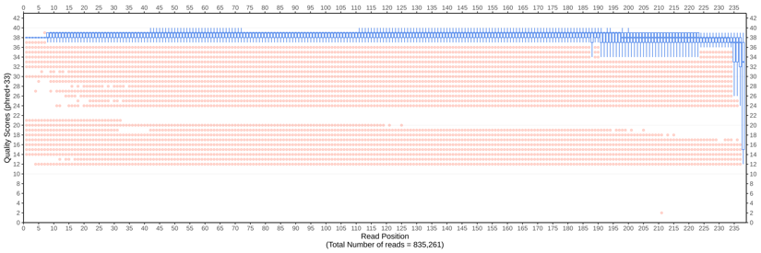
MiSeq (R1) – motif-filtered MiSeq (R2) – motif-filtered
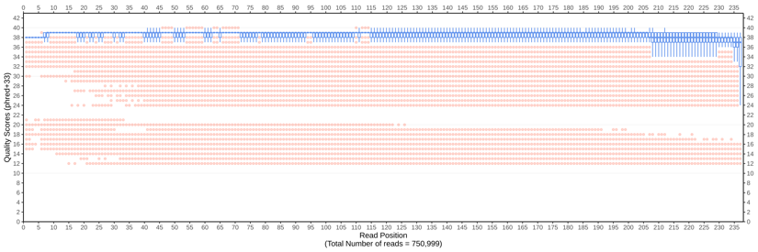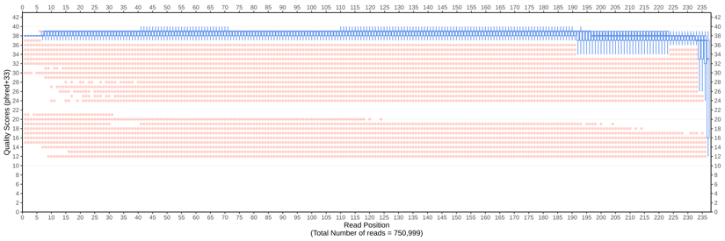
MiSeq (R1) – end-trimmed MiSeq (R2) – end-trimmed
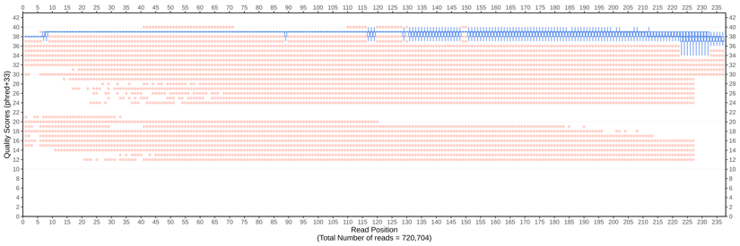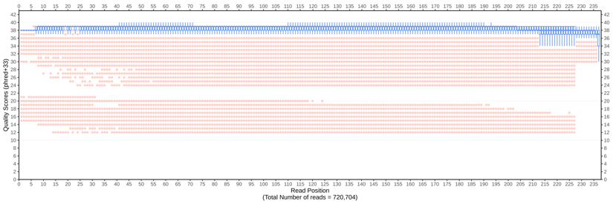
MiSeq (R1) – adapted MiSeq (R2) – adapted
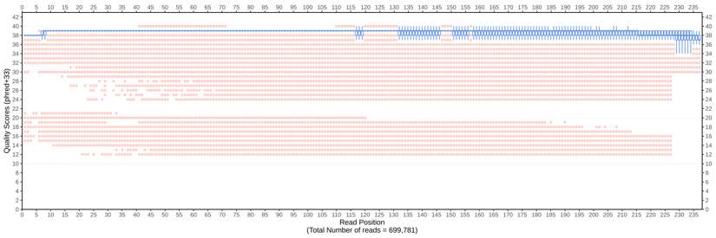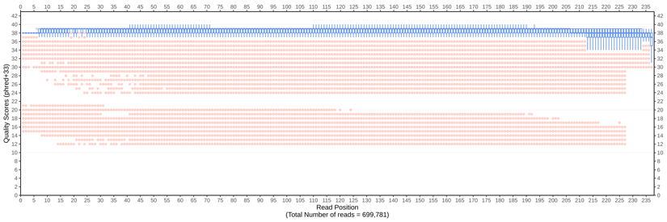
MiSeq (R1) – threshold-filtered MiSeq (R2) – threshold-filtered
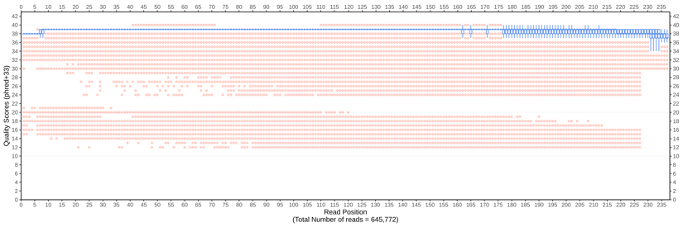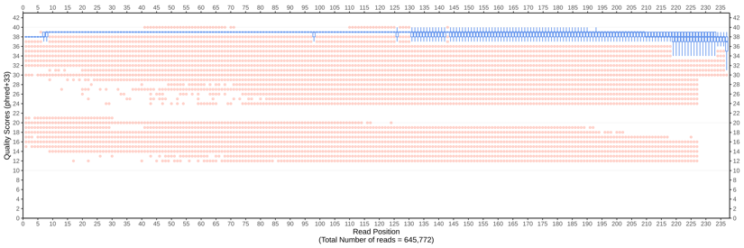
Figure S1. Summary (boxplot) of quality scores (Q score) of Miseq Nano paired end reads at each step of the ngsComposer pipeline. Demultiplexing was performed with a maximum mismatch of 1, while the Q score threshold filtering only allowed for reads with at least 90 % of bases in read having a minimum Q score of 30. Red dots indicate outliers.

HiSeq 2500 high output (R1) – raw HiSeq 2500 high output (R2) – raw
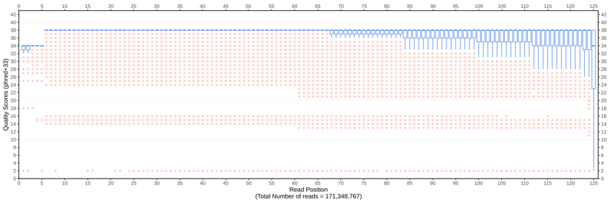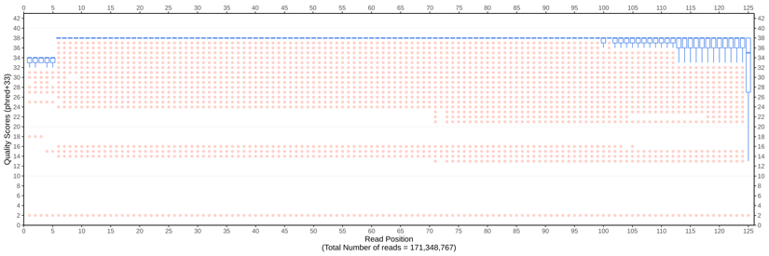
HiSeq 2500 high output (R1) – demultiplexed HiSeq 2500 high output (R2) – demultiplexed
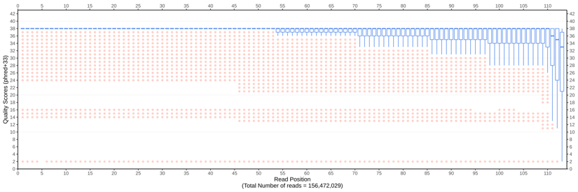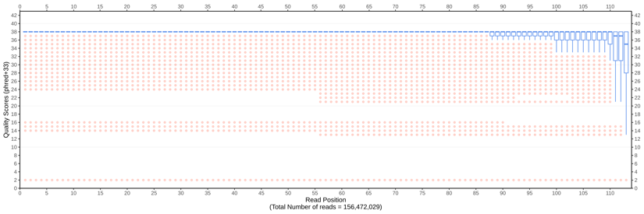
HiSeq 2500 high output (R1) – motif-filtered HiSeq 2500 high output (R2) – motif-filtered
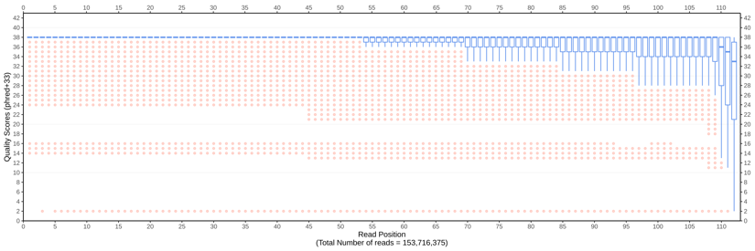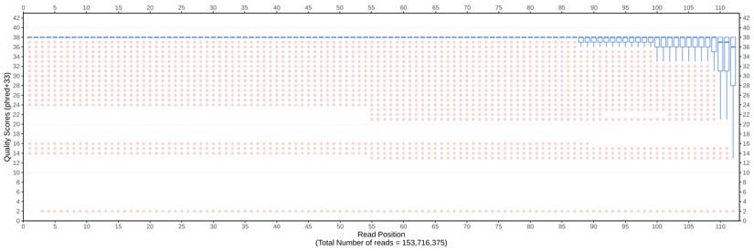
HiSeq 2500 high output (R1) – end-trimmed HiSeq 2500 high output (R2) – end-trimmed
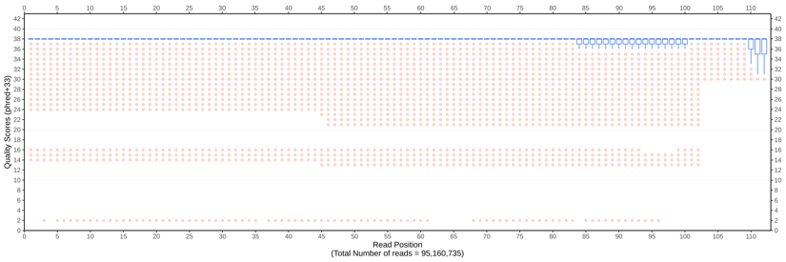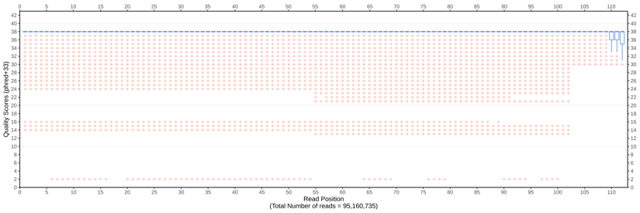
HiSeq 2500 high output (R1) – adapted HiSeq 2500 high output (R2) – adapted
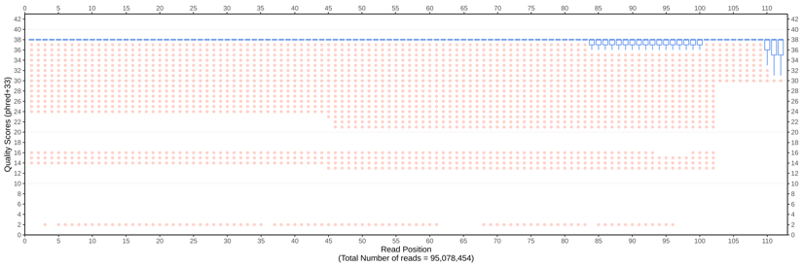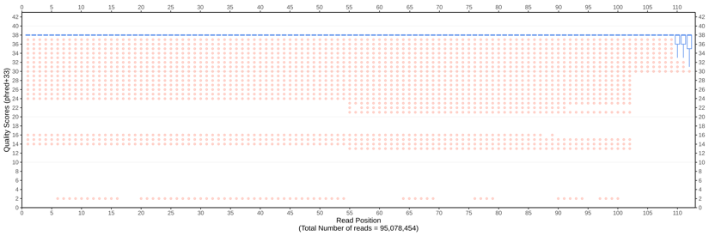
HiSeq 2500 high output (R1) – threshold-filtered HiSeq 2500 high output (R2) – threshold-filtered
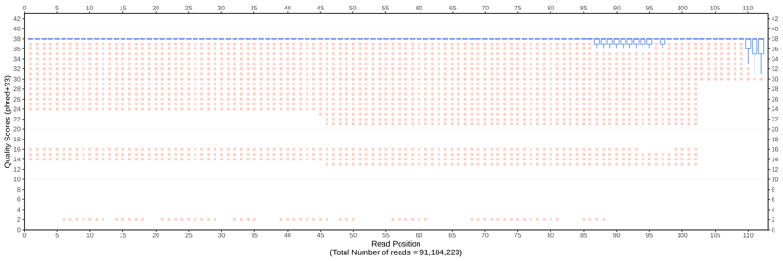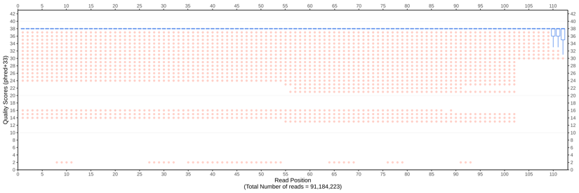
Figure S2. Summary (boxplot) of quality scores (Q score) of HiSeq 2500 high output paired end reads at each step of the ngsComposer pipeline. Demultiplexing was performed with a maximum mismatch of 1, while the Q score threshold filtering only allowed for reads with at least 90 % of bases in read having a minimum Q score of 30. Red dots indicate outliers.

HiSeq 2500 rapid run (R1) – raw HiSeq 2500 rapid run (R2) – raw
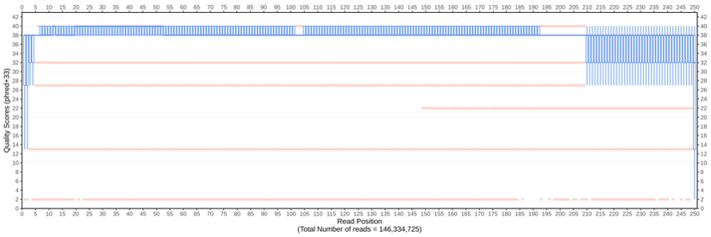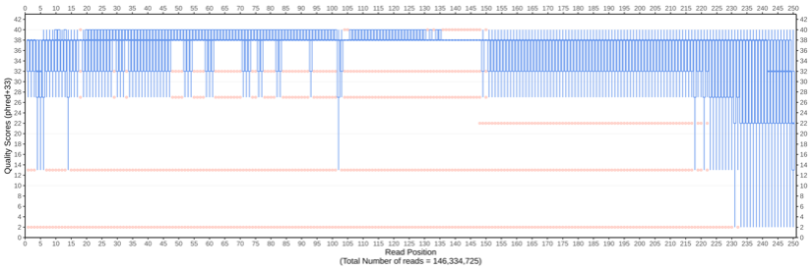
HiSeq 2500 rapid run (R1) – demultiplexed HiSeq 2500 rapid run (R2) – demultiplexed
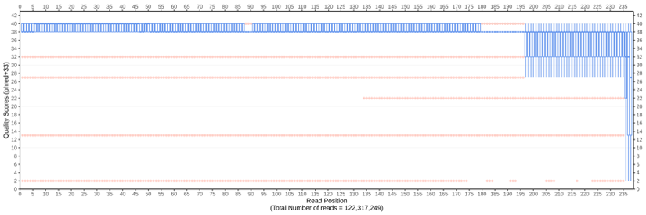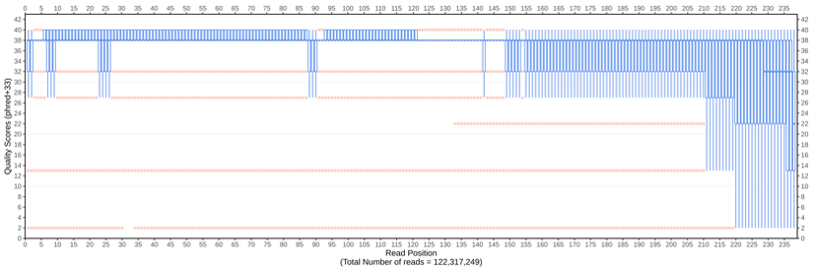
HiSeq 2500 rapid run (R1) – motif-filtered HiSeq 2500 rapid run (R2) – motif-filtered
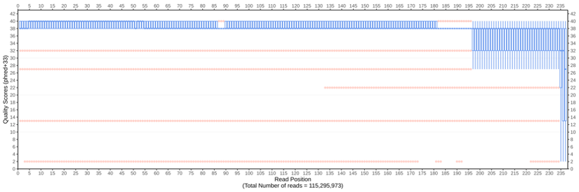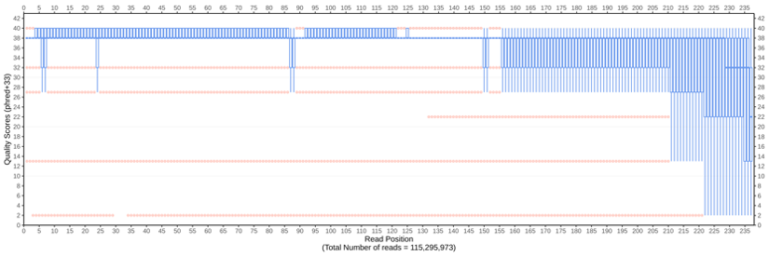
HiSeq 2500 rapid run (R1) – end-trimmed HiSeq 2500 rapid run (R2) – end-trimmed
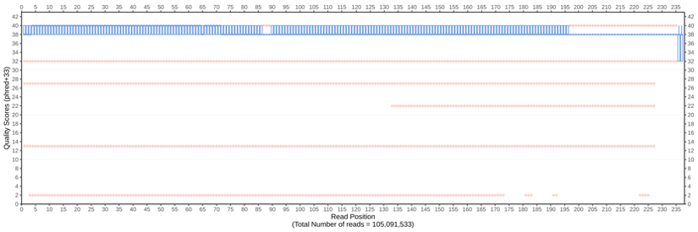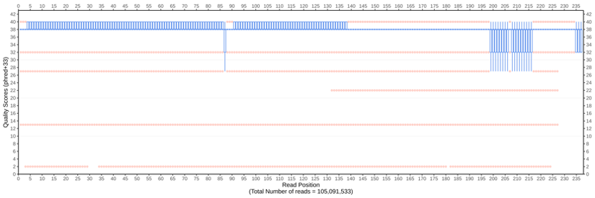
HiSeq 2500 rapid run (R1) – adapted HiSeq 2500 rapid run (R2) – adapted
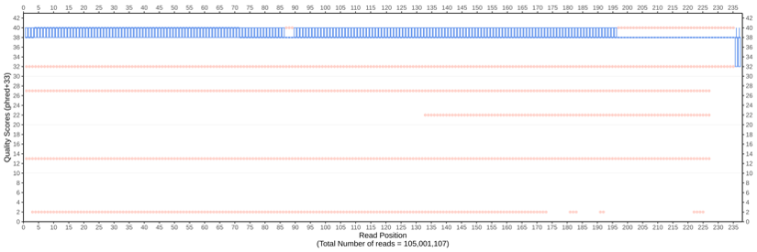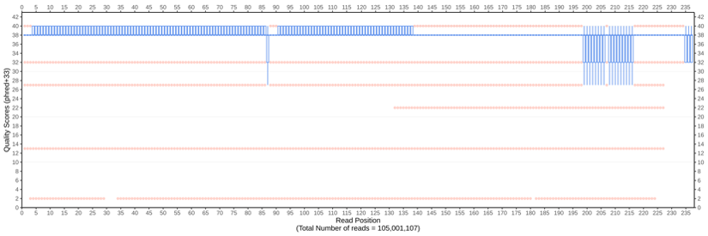
HiSeq 2500 rapid run (R1) – threshold-filtered HiSeq 2500 rapid run (R2) – threshold-filtered
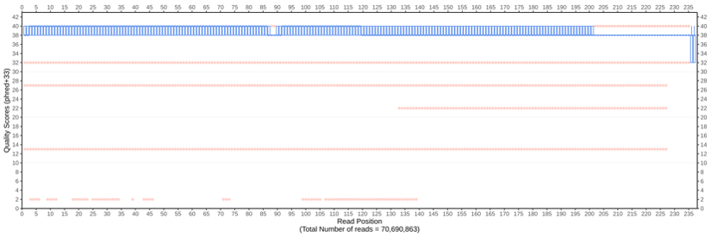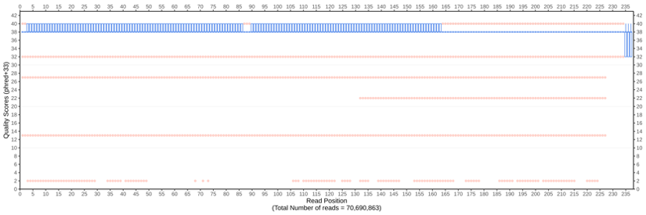
Figure S3. Summary (boxplot) of quality scores (Q score) of HiSeq 2500 rapid run paired end reads at each step of the ngsComposer pipeline. Demultiplexing was performed with a maximum mismatch of 1, while the Q score threshold filtering only allowed for reads with at least 90 % of bases in read having a minimum Q score of 30. Red dots indicate outliers.

NovaSeq (R1) – raw NovaSeq (R2) – raw
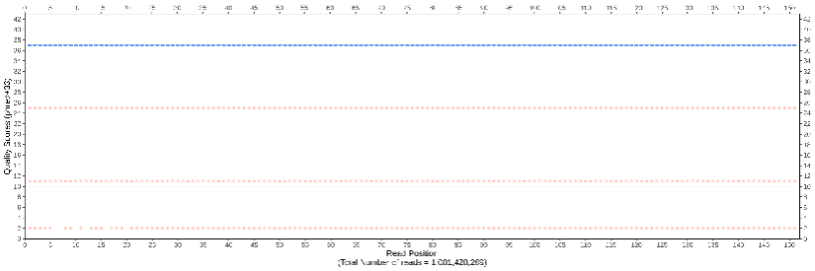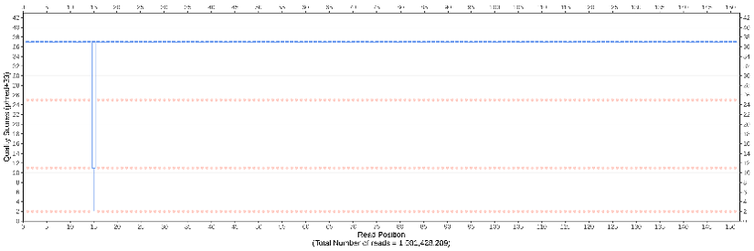
NovaSeq (R1) – demultiplexed NovaSeq (R2) – demultiplexed
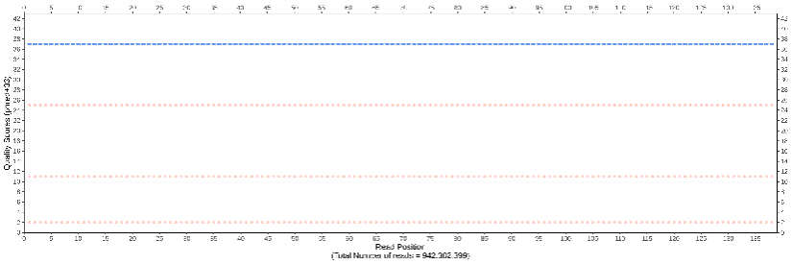
NovaSeq (R1) – motif-filtered NovaSeq (R2) – motif-filtered
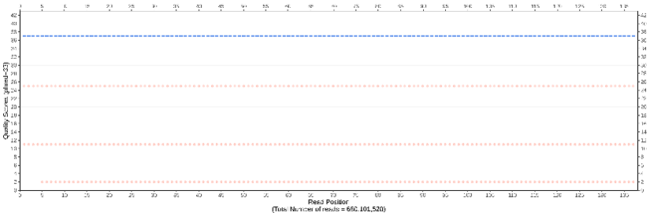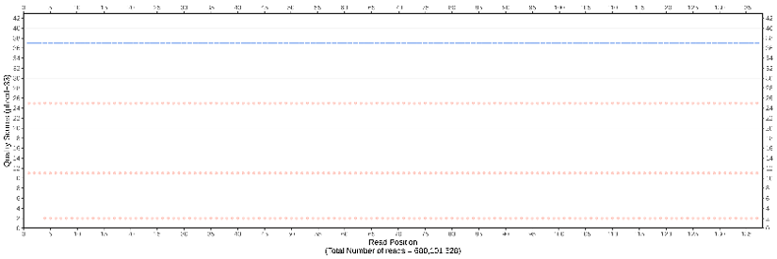
NovaSeq (R1) – end-trimmed NovaSeq (R2) – end-trimmed
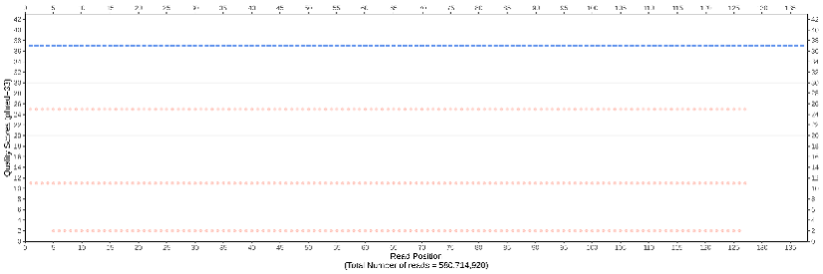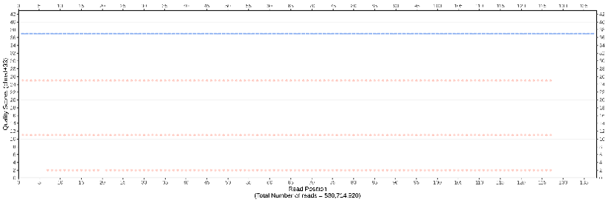
NovaSeq (R1) – adapted NovaSeq (R2) – adapted
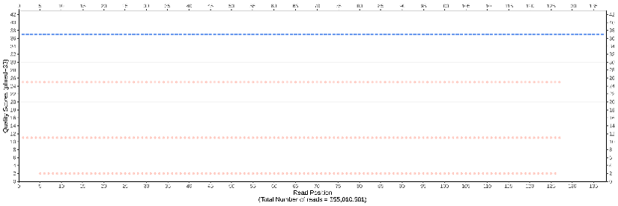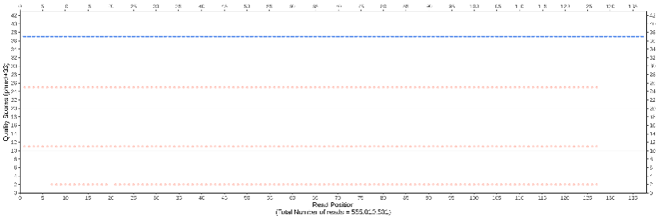
NovaSeq (R1) – threshold-filtered NovaSeq (R2) – threshold-filtered
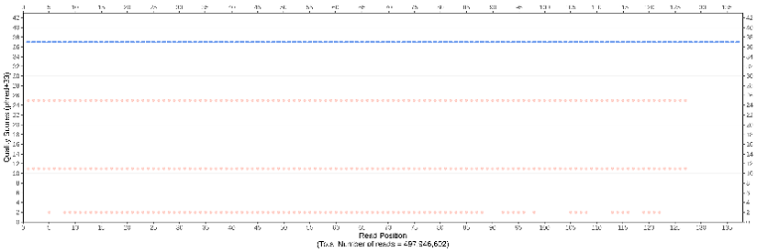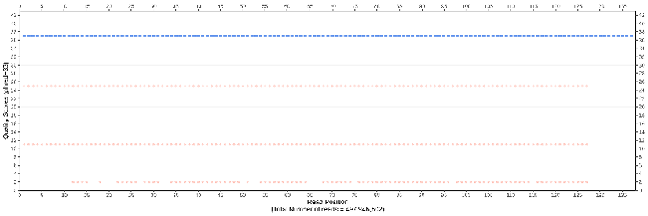
Figure S4. Summary (boxplot) of quality scores (Q score) of NovaSeq 6000 paired end reads at each step of the ngsComposer pipeline. Demultiplexing was performed with a maximum mismatch of 1, while the Q score threshold filtering only allowed for reads with at least 90 % of bases in read having a minimum Q score of 30. Red dots indicate outliers.
A.
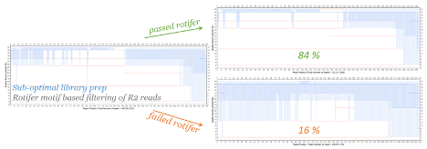
B.
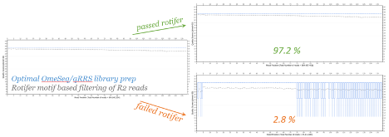
Figure S5. QC plots of low-quality (A: HiSeq 2500 rapid run) and high-quality (B: NovaSeq 6000 SP) sequence dataset of R2 reads. Motif-based error detection and removal algorithm implemented in rotifer (a tool in the ngsComposer pipeline). Reads that fail filtering by rotifer (i.e. using the restriction site motif at beginning of each read) revealed propagation of base calling error along the entire length of reads.
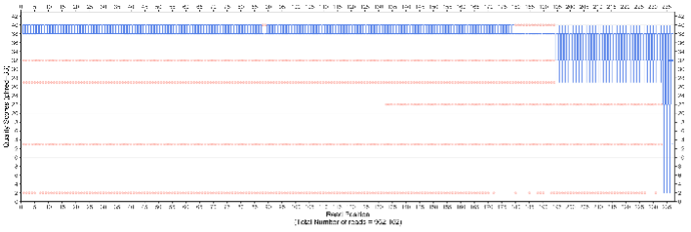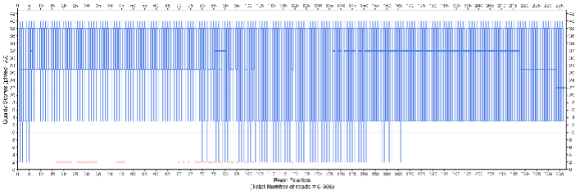
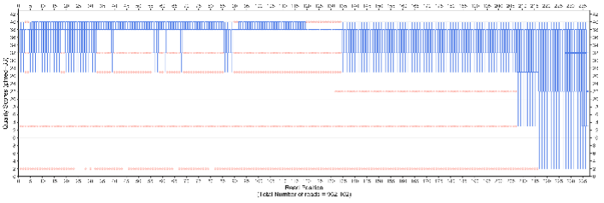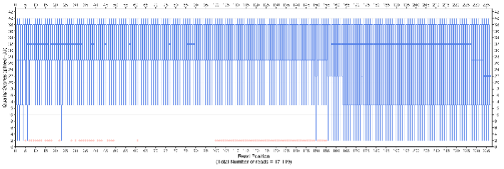
Figure S6. Summary (boxplot) of quality scores (Q score) of simulated HiSeq 2500 rapid run paired end reads comparing the reads before and after motif-filtering (rotifer). QC profile of reads that fail motif-filtering (mutated restriction enzyme site sequence) are confirmed to contain low Q scores propagated along the entire length of reads (QC plots on left).
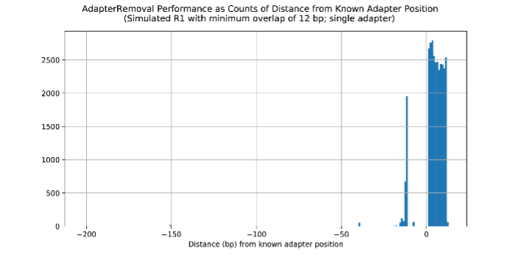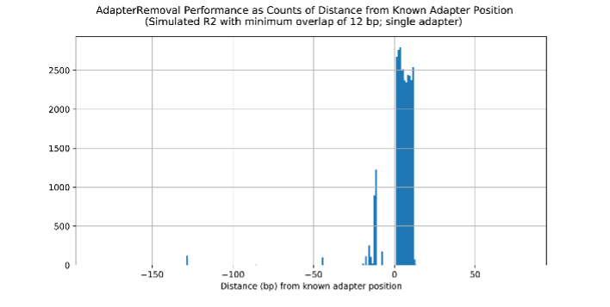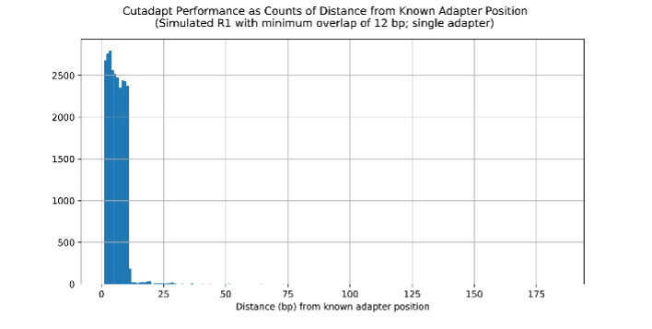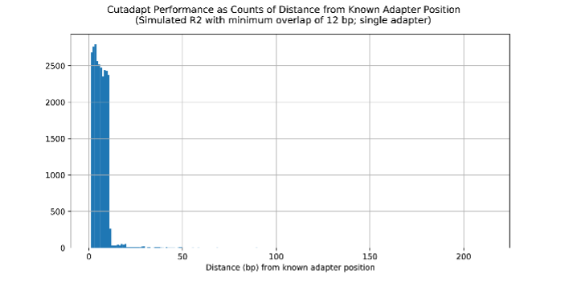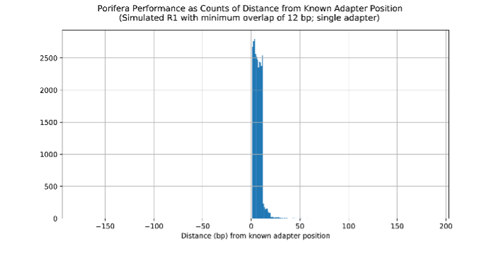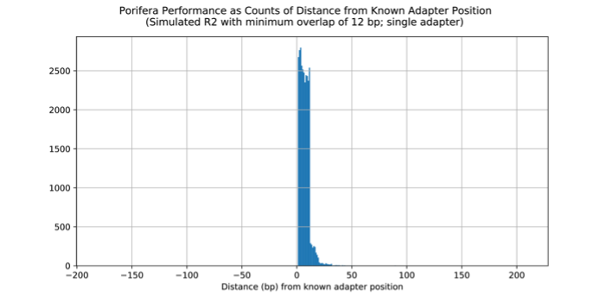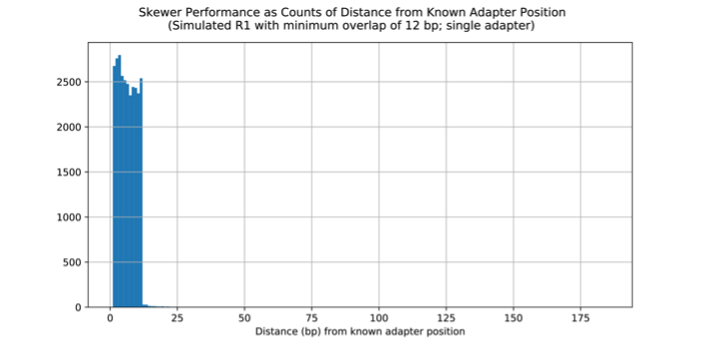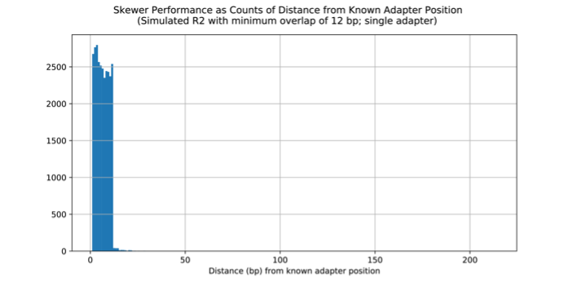
Figure S7. Distribution of distances from known adapter position in base pairs (bp) across several common adapter trimming tools using a single, common adapter on the R1and R2 reads of simulated Hiseq 2500 rapid run data. Negative distances are false positives that remove too many bases whereas positive distances are missed adapter regions.
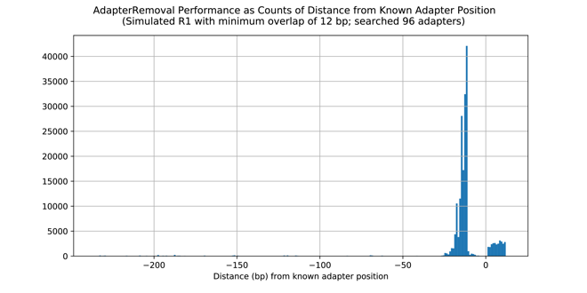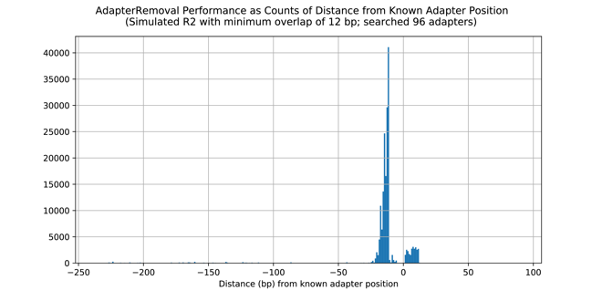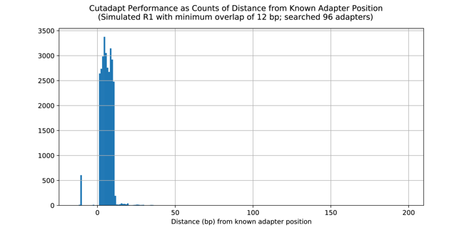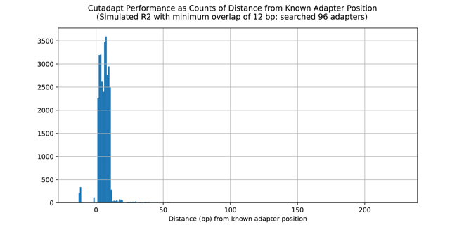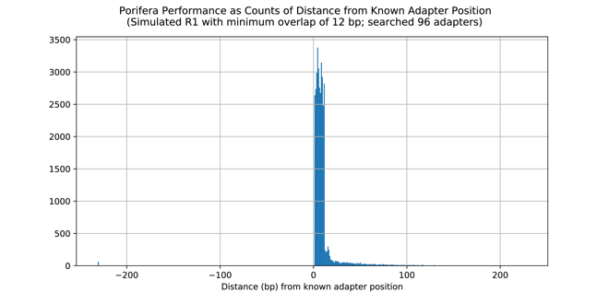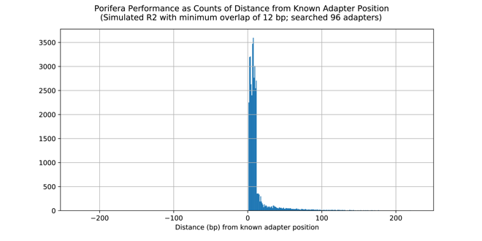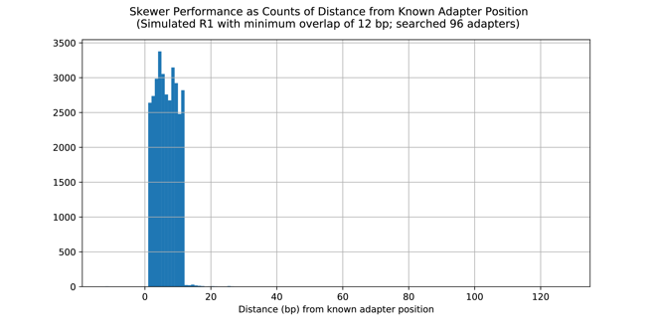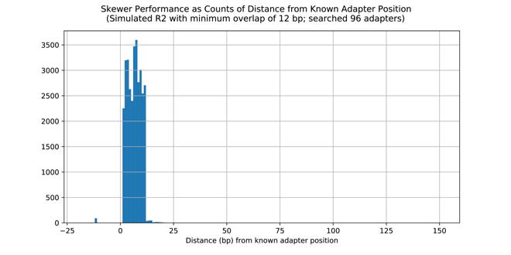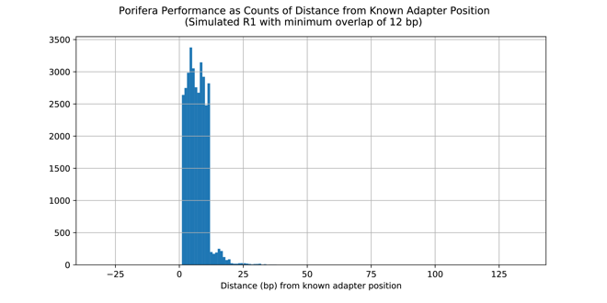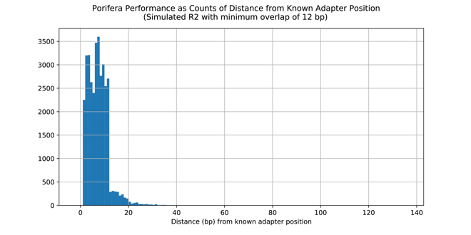
Figure S8. Distribution of distances from known adapter position in base pairs (bp) across several common adapter trimming tools using a 96 variable length barcoded adapters on the R1and R2 reads of simulated Hiseq 2500 rapid run data. Negative distances are false positives that remove too many bases whereas positive distances are missed adapter regions. Performance of porifera in shown in standalone (A) and in the ngsComposer pipeline mode (B).
A B
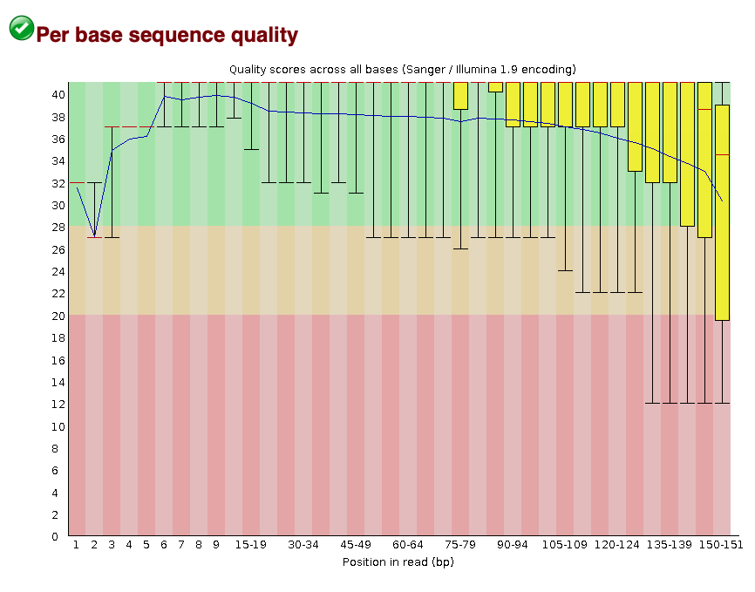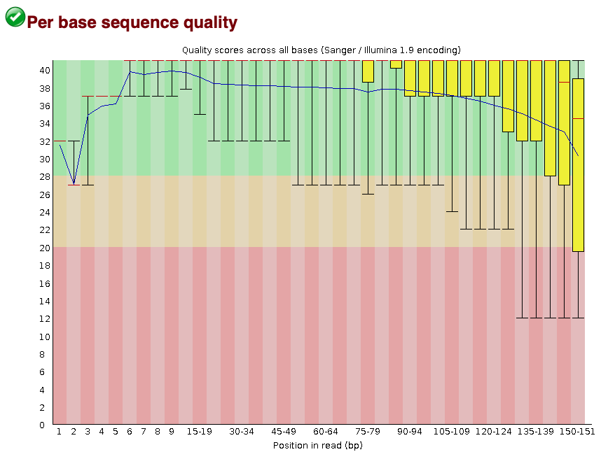
Figure S9. Fastqc sequence quality scores for simulated reduced metagenome sequencing (RMS) reads (A) and the real reads the simulations were derived from (B).
A B
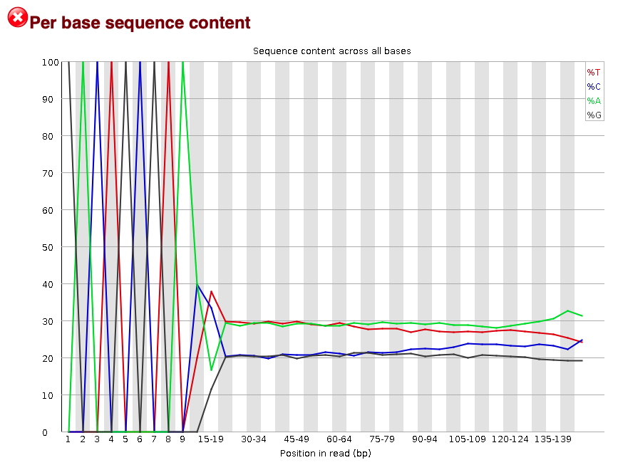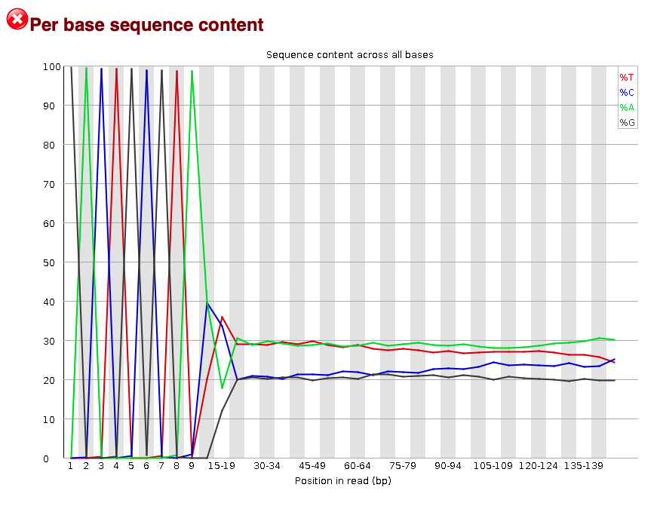
Figure S10. Fastqc sequence content for simulated reduced metagenome sequencing (RMS) reads (A) and the real reads the simulations were derived from (B).

A B
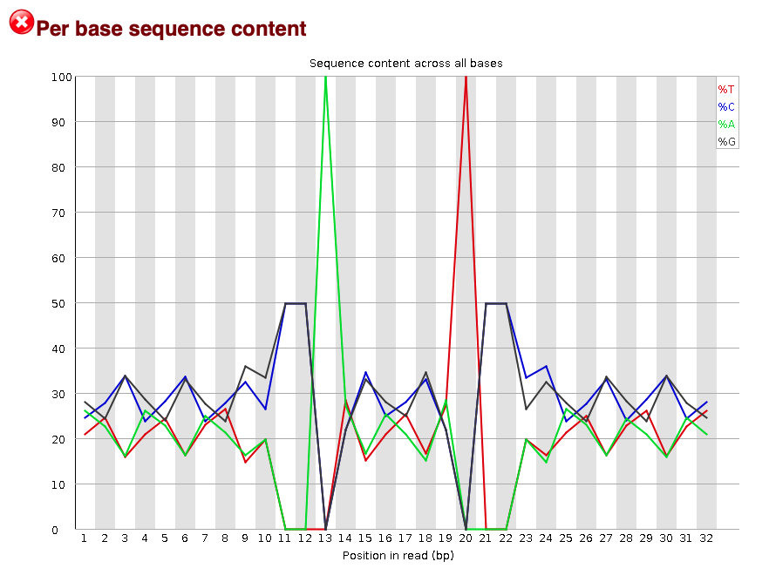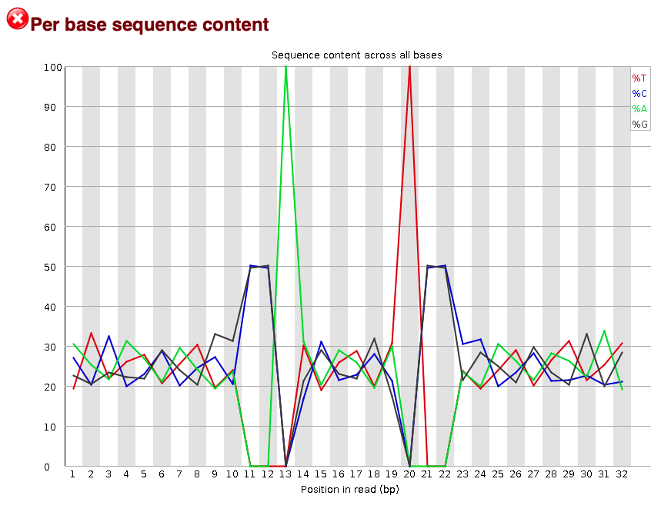
Figure S11. Fastqc sequence content for simulated iso-length sequence reads (A) and the real reads the simulations were derived from (B).
A
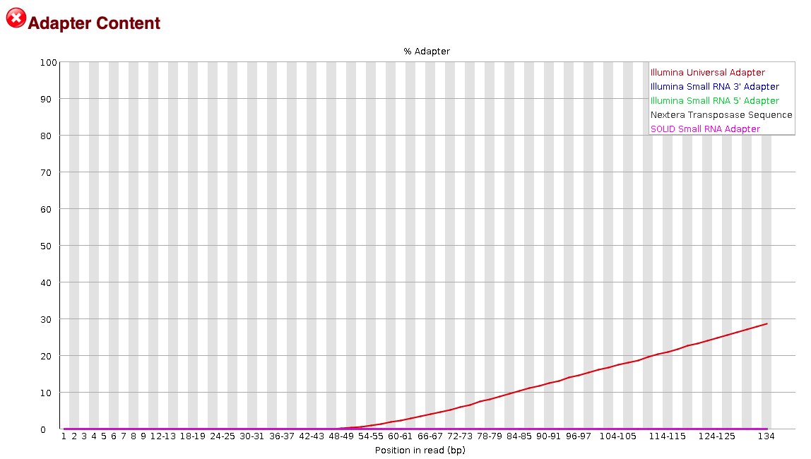
B
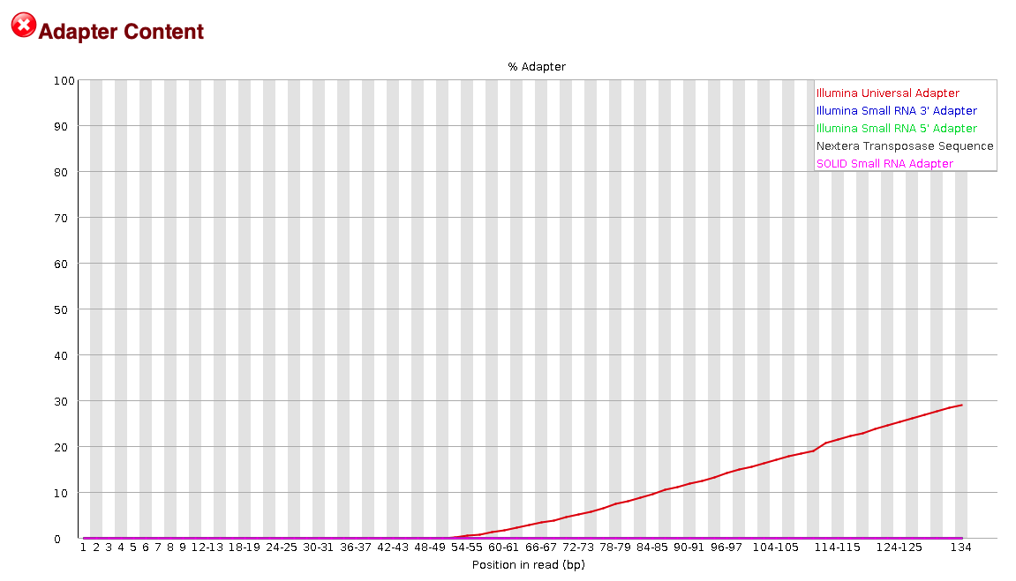
Figure S12. Fastqc adapter content for simulated reduced metagenome sequencing (RMS) reads (A) and the real reads the simulations were derived from (B).

A
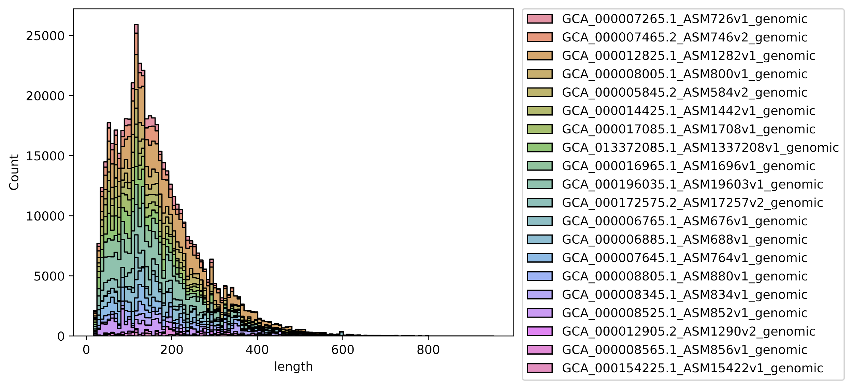
B
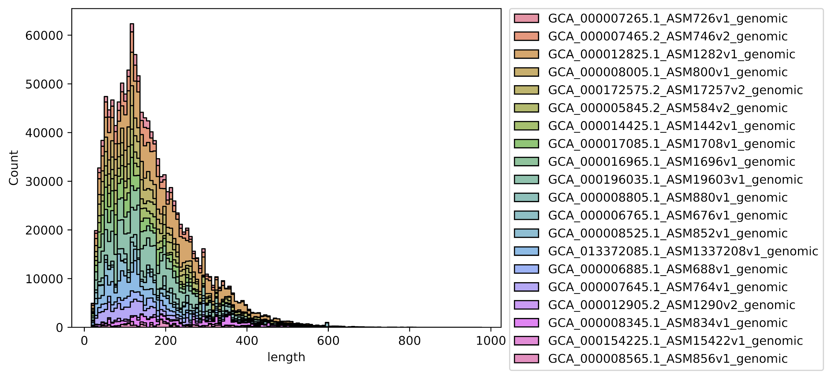
C
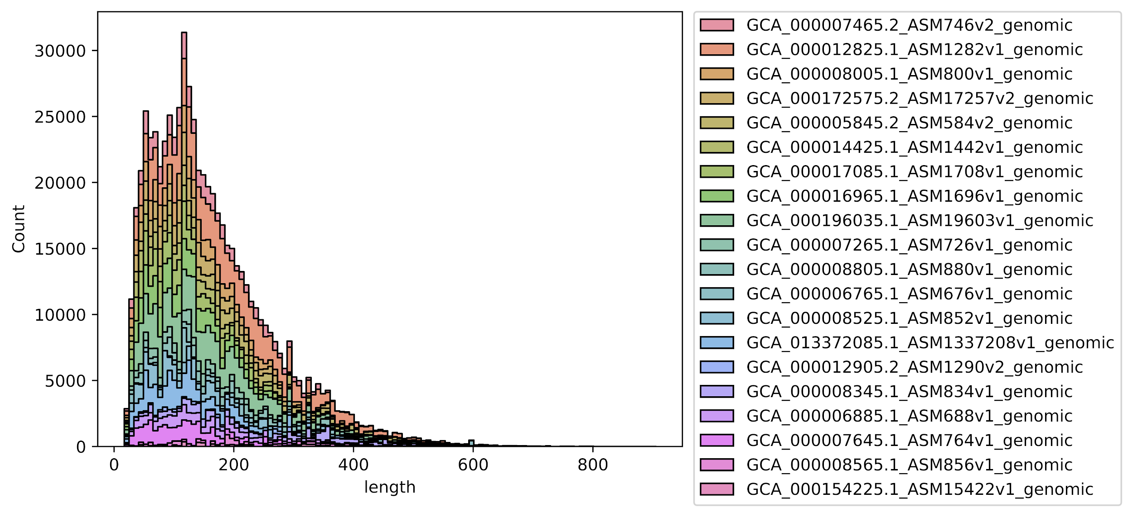
Figure S13. Fragment distribution recreation from BWA MEM mapped reads from three replicates (A-C) of existing reduced metagenome sequencing (RMS) reads of a known mock community.

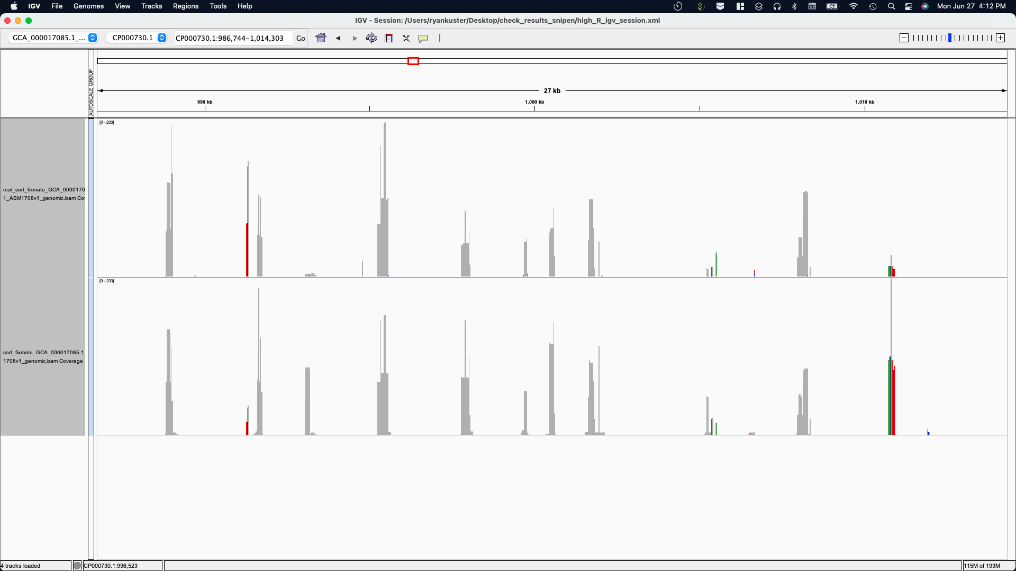
Figure S14. Example IGV visualization of BWA MEM aligned read depth comparison (autoscaled). The top and bottom tracks are the real and simulated reads, respectively. Aligned reads with non-gray bars likely correspond with sequences aligned from similar taxa in the mock community or erroneous alignment.
A
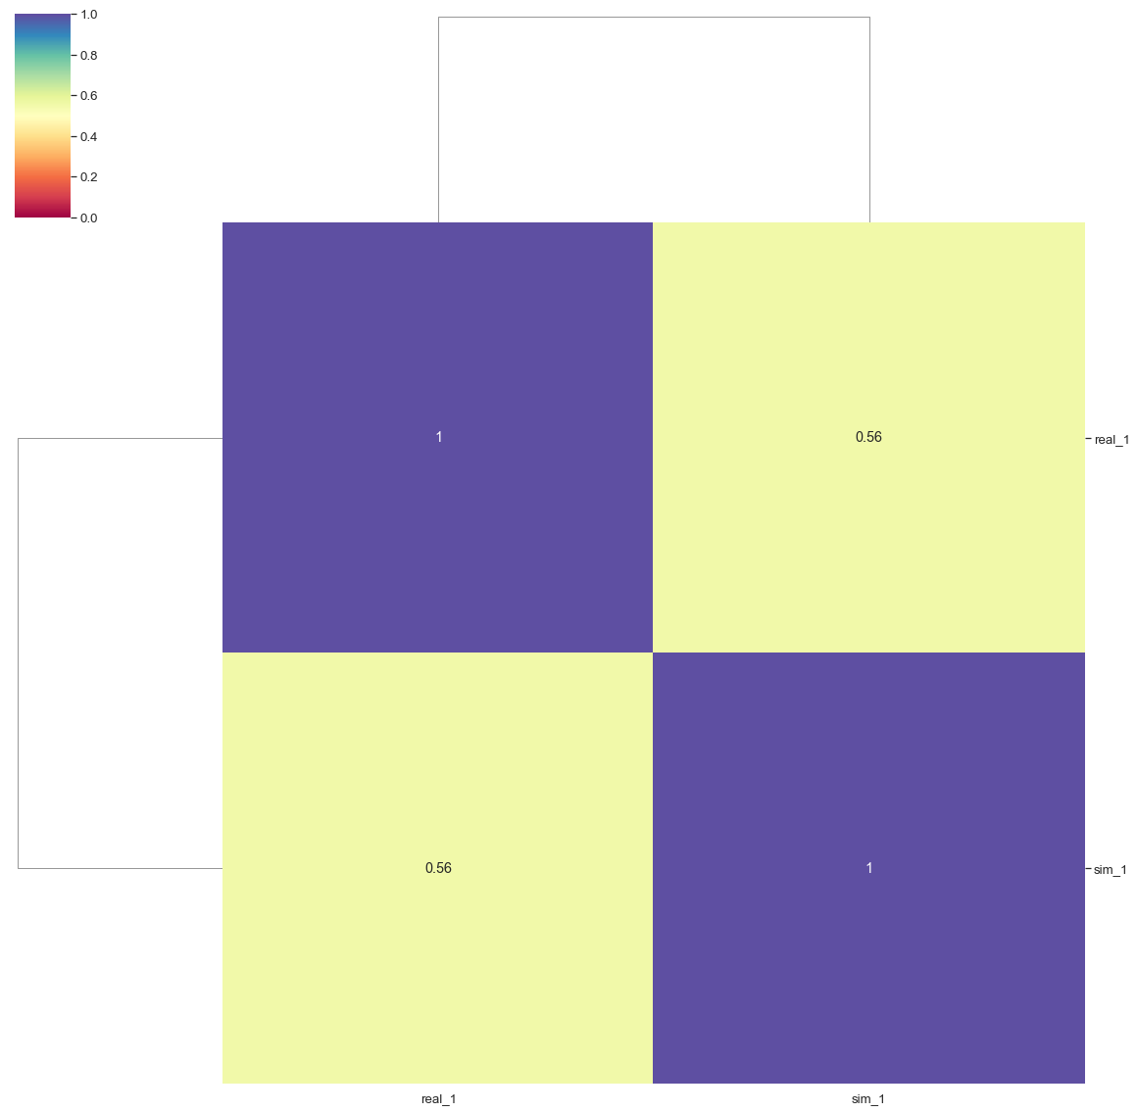
B
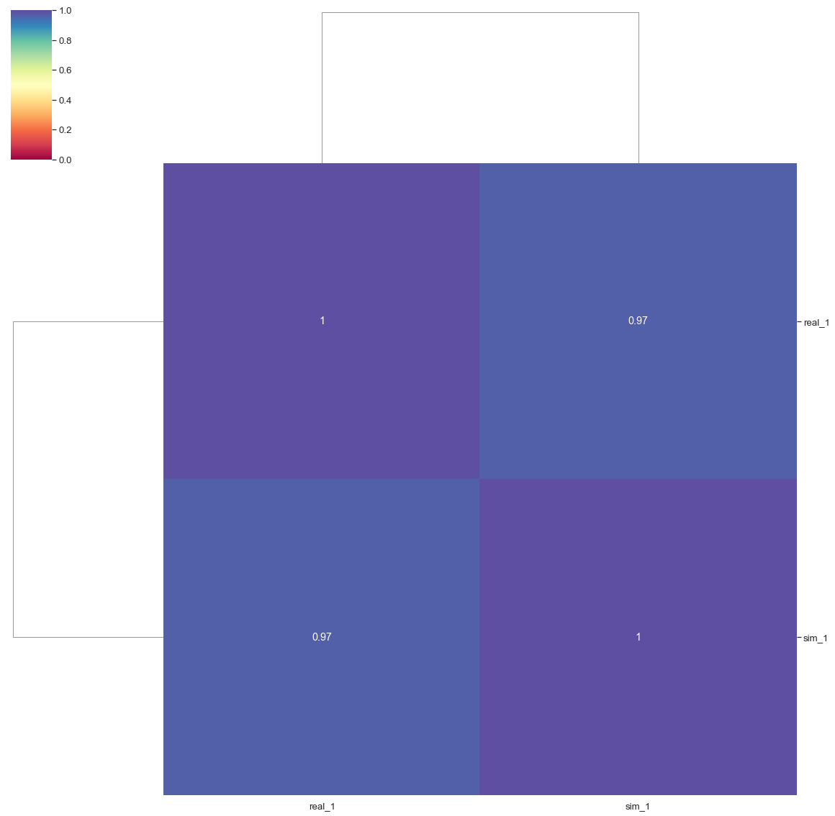
Figure S15. A: Pearson correlation of real and simulated iso-length mock communities and B: Spearman correlation of real and simulated iso-length mock communities.
A
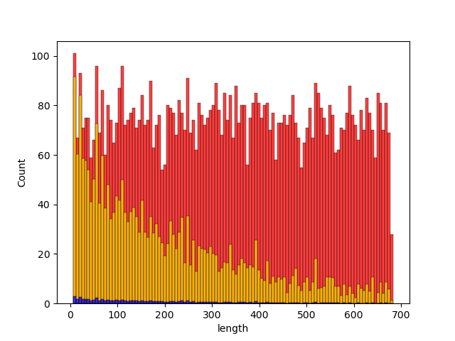
B
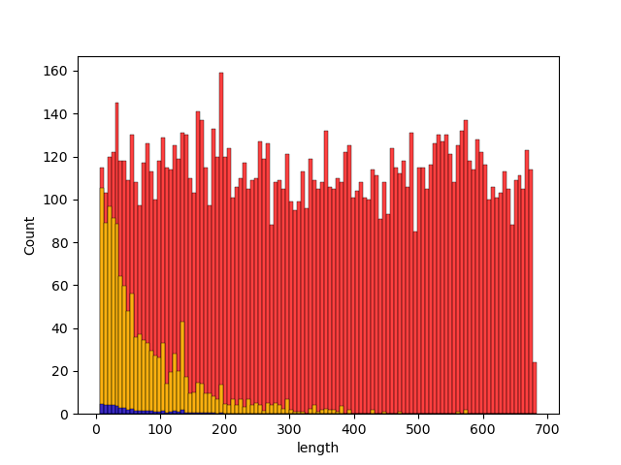
Figure S16. Simulated expected fragment length distribution of A: Phocaeicola vulgatus, and B: Staphylococcus epidermidis using identical library preparation and 1X genome copy number. Red bars represent the possible fragments in the size range while yellow fragments are the estimated frequency of fragments based on enzyme cut efficiency. These counts are then scaled based on the defined relative abundance (blue).
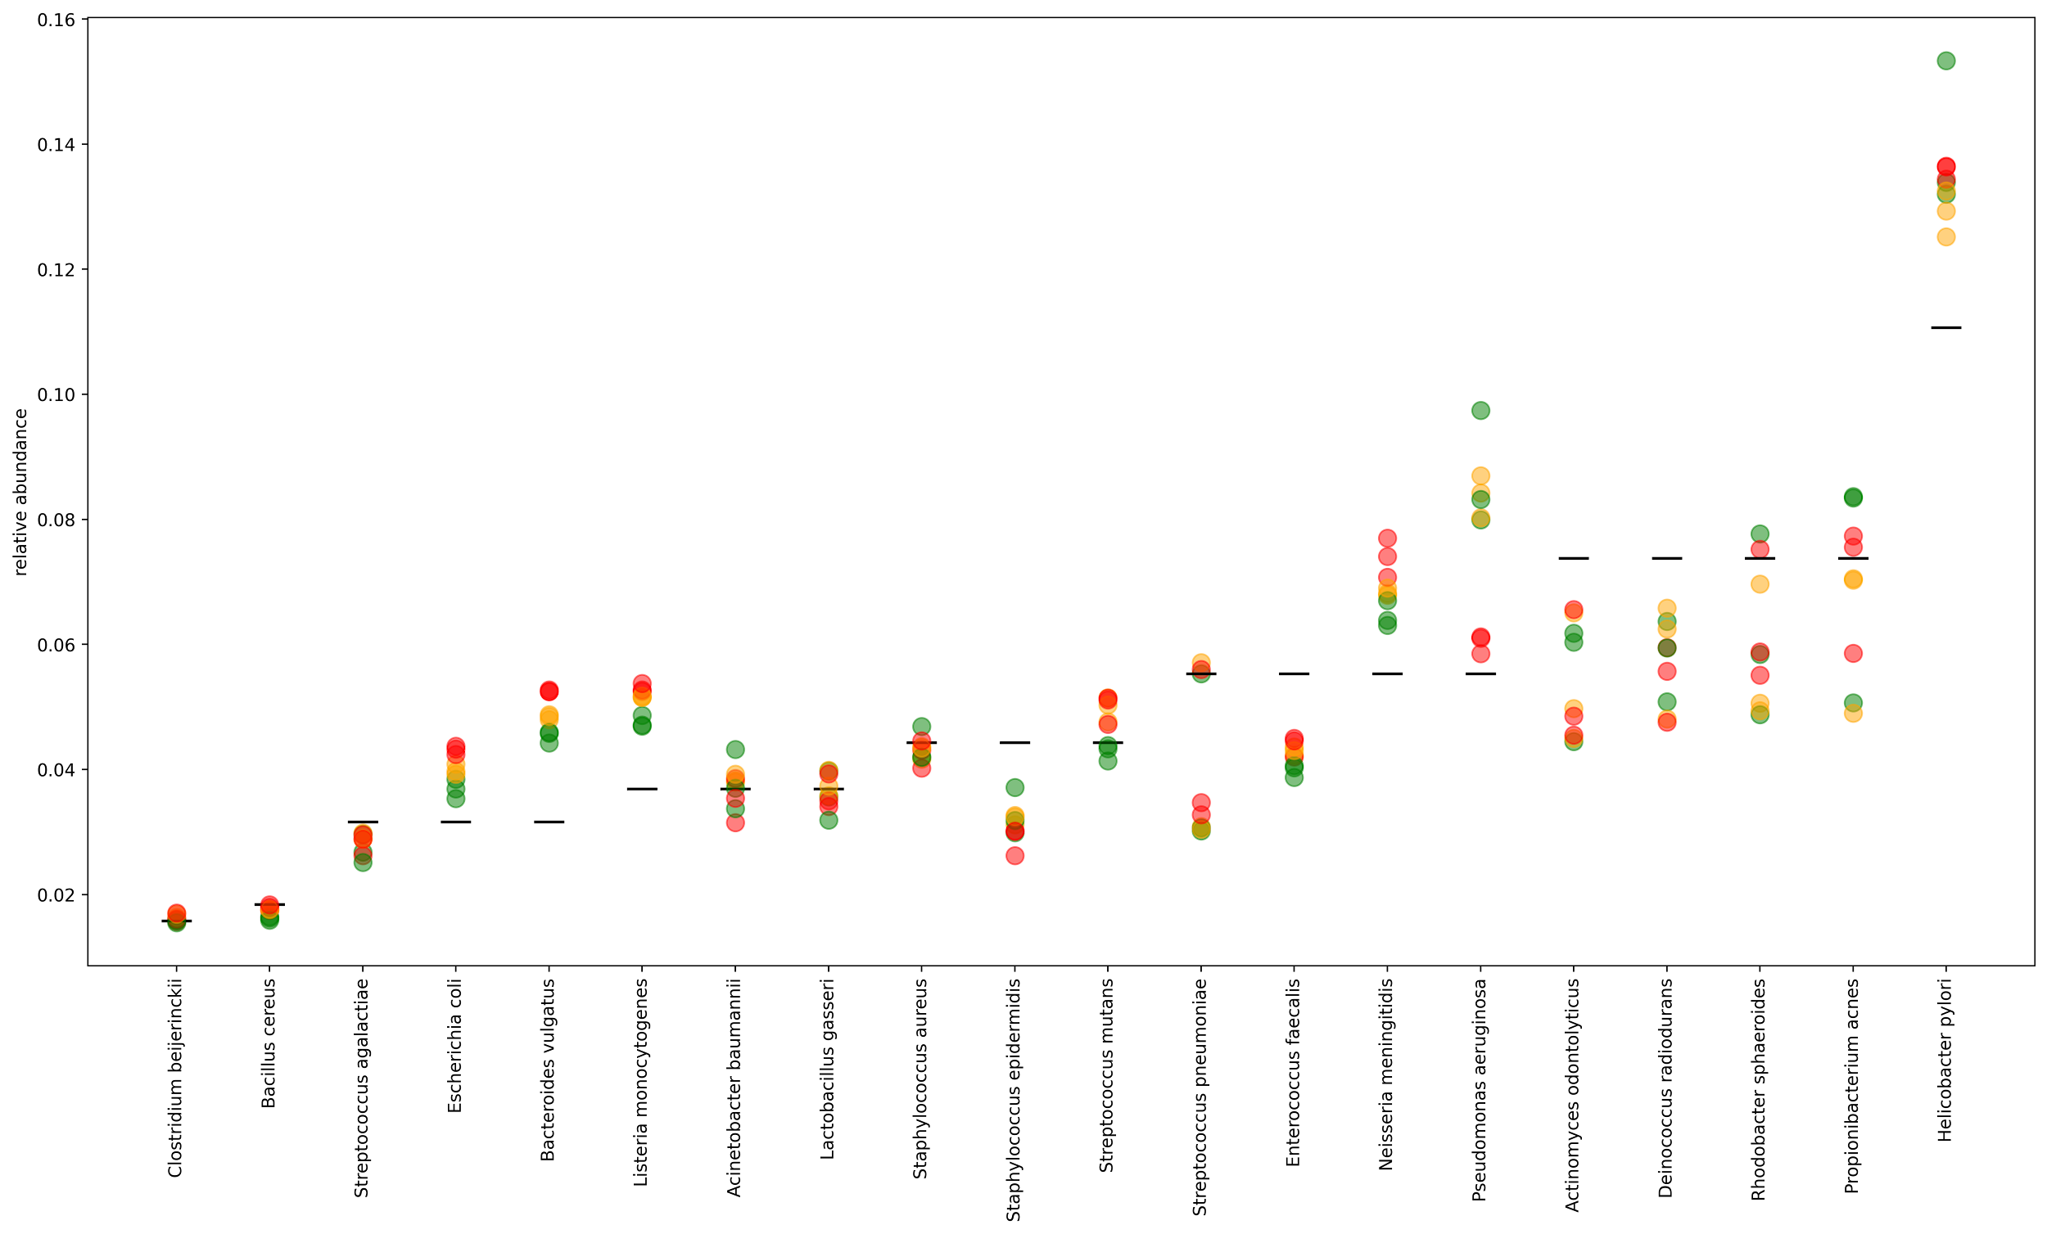
Figure S17. Relative abundance comparisons between multiple prediction metrics and the ground truth over three replicates of Snipen et al. RMS mock community reads after fragment reconstruction. Estimates of relative abundance show consistent patterns of over-and underabundance in a taxa-dependent manner in some of the 20 mock community members using the ratio (green), mean (yellow), and median (red) metrics for estimation.
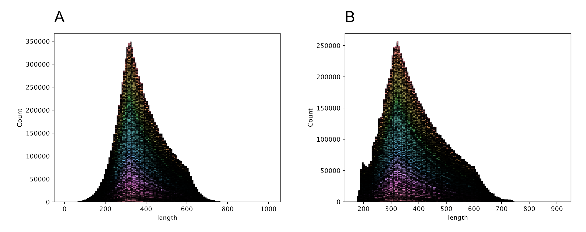
Figure S18. Visual comparison of the fragment lengths from simulated Liu et al. data from the A) expected, known distribution and the B) recreated distribution mapped using a fully-inclusive ‘PlusPFP’ Kraken2 database (93.8% of simulated reads mapped).

Vita
Ryan grew up in De Soto, KS where he enjoyed spending time outdoors with his family and friends. Ryan attended the University of Kansas in Lawrence, KS from 2005 to 2009 where he received his B.S. in Ecology and Evolutionary Biology. During this period, Ryan worked with Dr. Deborah Smith and Dr. Mark Holder investigating phylogenetic inference of Chelicerata using molecular and morphological features. While participating in a 2009 summer REU in Greensboro, NC, Ryan worked with Dr. Olav Rueppell researching honey bee worker behavior and mortality with the presence and absence of the queen. Ryan continued in the lab of Dr. Rueppell and in 2012 earned his M.S. in Biology at the University of North Carolina at Greensboro researching honey bee immune gene responses to Varroa mite infestation. Ryan has since worked as a research technician at the UNC Nutrition Research Institute and a Lab Coordinator and educator at Roane State Community College. In 2018 Ryan joined the Department of Entomology and Plant Pathology at the University of Tennessee working as both a Lab Manager and Graduate Research Assistant.

