University of Tennessee- Knoxville
College of Business Administration
University Honors Thesis – UNHO 498

Alternative Revenues: A Quantitative Study on In-App Purchases

John Qiu
Advisor: Dr. Kelly Hewett
Spring 2014

Table of Contents:
- Abstract & Acknowledgements ………………………………………………… 2
- Introduction ………………………………………………… 3
In-App Purchases in Practice
- Hypothesis Development ………………………………………………… 7
Experience Goods
Network Effects
Price Positioning
- Data ………………………………………………… 11
Measures
- Hypothesis Testing ………………………………………………… 14
Results
- Discussion ………………………………………………… 17
Contributions
Directions for Future Research
- References Cited ………………………………………………… 22

Acknowledgements:
The author wishes to sincerely thank Dr. Kelly Hewett as for serving as Advisor on this project. The time and expertise she contributed to the completion of this Honors Thesis project has been tremendously helpful, and author wishes to express his utmost appreciation.
The author would also like to thank the University of Tennessee and the Chancellor’s Honors Program for the education received, as well as the opportunity to write this thesis.

- ABSTRACT
In app purchases are a recently popularized pricing strategy defined as financial transactions that occur in the context of smartphone app, and they have played a key role in the growth of the smartphone app market. Such a development has reflected advancement in how consumers perceive software as products, but it remains unclear to what extent the strategy sustainable. The author examines the literature behind the theories of experience products, networks effects, and price positioning strategies to establish a theoretical foundation for explaining the success of in-app purchases. The results obtained from using data from both Google’s Play Store and Apple’s App Store suggest that in app purchases can allow an app to generate revenue long beyond the initial release.

- INTRODUCTION
When new developments in business emerge from conception to implementation, one can rely on the marketing and strategy academic literature to provide not just context for the observations but the potential trajectories for the developments. In the recent mobile economy, one particularly disruptive innovation has been the implementation of in-app purchases as a way to monetize digital products. Though there are currently few academic publications on the immediate topic of in-app purchases, one can interpret the new phenomenon as natural advancements in pricing strategy, enabled by the new sales channel of digital distribution technology.
Fundamentally a pricing model, in-app purchases or “IAPs” are defined as financial transactions that occur within a specific computer or mobile program or application (app). IAPs are most influential in the smartphone apps market, and can occur in both paid and free apps. The apps which utilize IAPs range from productivity software with purchasable features, to games where a customer can pay for additional play time or the ability to skip difficult portions. Of importance is that any subscription-based payment, such as membership to a service, is not considered an IAP, as a defining characteristic is that IAP features are rarely advertised and are never part of a customer’s initial product offering. Most IAPs are only offered a la carte, and often IAPs have no programed limit to how many times a customer can repeat a transaction, and therefore how much they can spend on a single app (Tottman 2014). The most prominent demonstration for potential profitability is the mobile puzzle game “Candy Crush Saga”, which in October 2013 was estimated to earn an average of over $600,000 in daily revenue for its developer, King Digital Entertainment or “King”, solely through in-app purchases (Thomas 2013). Though success for King seemed realized as it achieved an IPO valuation of 7.08 billion dollars on March 26th 2014, the share price fell over fifteen percent by the end of the day; this was attributed to both the shares being overpriced, as well as the financial analysts holding serious doubts regarding long term profitability (Nayak 2014). In a broader sense, King seemed to only mimic a similar meteoric rise and fall by the app developer Zynga which also made its revenues primarily through IAPs. Zynga’s December 2011 IPO was valued at an eerily similar 7 billion dollars, only to have shares fall five percent by the end of the day (Pepitone 2011); at the start of 2014, worth just over a third of its IPO price due to sharply fallen revenues resulting from chronic customer disinterest (Garden 2014). Since the subject business model’s long term feasibility lies in question, one can look at the current state of the mobile app market and ask the question: how does the implementation of IAPs positively affect the persistence of financial success of an app?

In-App Purchases in Practice
Though all apps with IAPs have wildly varying implementations, Candy Crush uses most of the standard conventions, which perhaps explains its tremendous success. Candy Crush is a tile matching puzzle game that is played primarily on smartphones. Players earn points by matching tiles of candy in a limited number of turns or in a limited amount of time. If a player earns enough points to meet a “target score”, they are allowed to progress to the next level. Initially the game is quite easy as target scores are low and the gameplay is simple. Through completing levels, players unlock additional levels that gradually introduce new tiles and become more challenging. See Figure 1 for an illustration of such differences. This model is successful because game mechanic of matching candy tiles is entertaining and consistent throughout the entire game, but variation is added to keep the player interested and challenged.
As players progress to later levels, the player gradually is given the option to use IAPs to upgrade their experiences. For example, if a player fails to meet the target score in a level, instead of being forced to restart, they have the option to continue the level by paying $.99. If the player chooses to restart, they will lose a life and if they have no lives, they must either wait a period of time, ask a friend to give one of their lives, or purchase additional lives. Furthermore, the player can purchase in-game items to make the game easier, for example by modifying tiles in a beneficial manner. Finally, after level 35, players have to either pay .99 cents or ask their Facebook friends for difficult to earn “tickets” every fifteen levels to progress. These all can be seen in figure 2. It is important to note that the player is not even offered an IAP until after a couple of levels, due to their ease. Allowing the player to first enjoy the game and learn how to play before even considering monetization is perhaps a subtle and effective way to direct the player’s attention on the initial enjoyment of the game.

FIGURE 1: Early Stage vs Advanced Stage
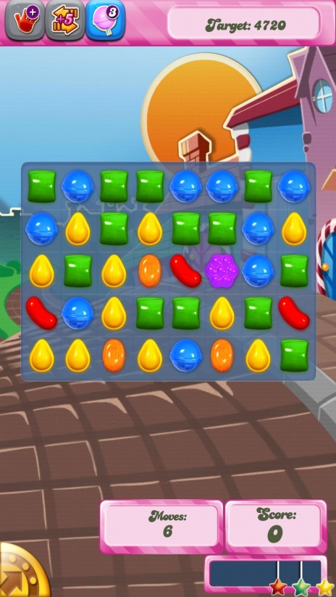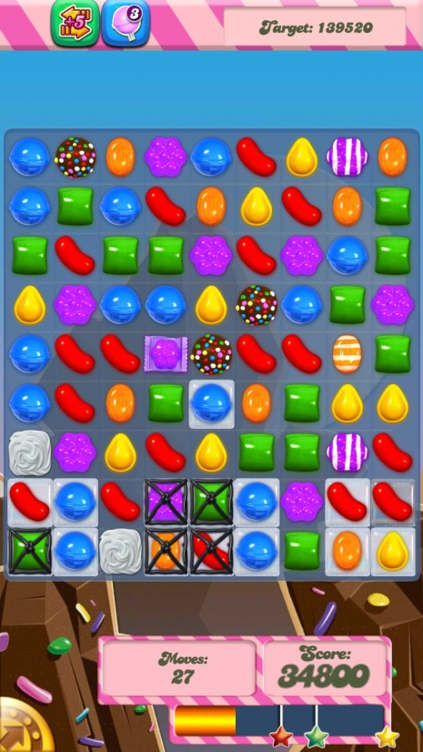
Above are screenshots of standard gameplay. The left screenshot is from an initial level, and the right screenshot is from a much later advanced stage. The target score is located in the top right corner of each screenshot. Note the higher target score and greater complexity in the right screenshot compared to the left.

FIGURE 2: In-App Purchases
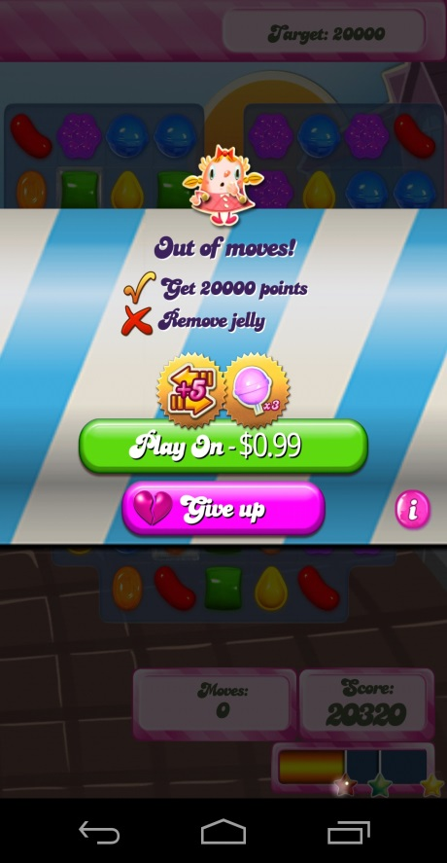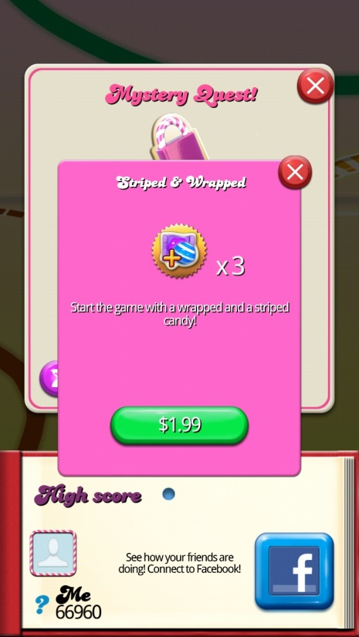
The left side is a screenshot after the player no longer has any available moves to finish the level. The Right side is an in-game item that the player can use to increase their chance of success in a level.


If a player fails a level, they lose a “life.” When they no longer have any lives, they are presented this IAP.
- HYPOTHESIS DEVELOPMENT

Experience Goods
“Experience goods” or “information goods” are defined as products whose characteristics are difficult to observe prior to purchase (Klein 1998). Traditionally, software had been seen as a prototypical experience good since the valuable characteristics of quality or ease of use are often qualitative yet strongly determine the value of a product. Historically, the culture of software development emerged in highly technical fields like computational statistics, physics, and mathematics, which cared little for ease of use and served little beyond highly specialized military and academic purposes. Recently, the set of valuable characteristics in has expanded to make software mainstream in an attempt to be more profitable. Yet, there is no way to objectively and systematically assess the quality of a software product. One successful solution used frequently by traditional computer software is to offer a version of the product with either basic functionality or normal functionality for a limited period of time. This model was called “shareware,” (Wang and Zhang 2009) and research has suggested that shareware effectively reduces customer uncertainty in the face of experience goods (Takeyama 1994), and secondly, that sampling of digital goods is a way of signaling a high quality product (Gaudeul 2010). Either effects result in the reduction of a potential customer’s search costs. One caveat is that firms with valuable brands are much less likely to develop and distribute shareware, explained as fear of devaluing their brand through over usage (Hui, Yoo et al. 2008). A free app that earns revenue primarily on IAPs is basically using the shareware strategy, but when this strategy is utilized by too many firms and simply too many competing apps are on the market, until only the most endorsed apps have any significant recognition. Newly developed and unknown apps can suffer an attention-based form of the recurring “Tragedy of the Commons,” (Huberman, M. et al. 2014). The uncertainty of experience products results in the customer spending large resources to search for and acquire information valuable in aiding a purchase decision. The high cost of searching makes customers particularly easy to be influence by others who have information (Belderbos, Olffen et al. 2011), especially by friends or other individuals within the customer’s close social network (Goel and Goldstein 2014). To investigate further, a discussion on network effects is necessary.

Network Effects
“Network effects” are defined as effects whose magnitude depends on the number of people that are experiencing the same effect (Arthur 1990). The concept is rather intimately associated with advancements in technology, as the first arguments resembling network effects rose from the development of the telephone in 1908 (Shapiro and Katz 1986); it was then observed that as more people own a telephone, a single telephone’s value grows exponentially, since it can be used to communicate with more people. When buying experience goods, the large search costs can be erased by lead simply accepting the advice of others. As more people have information regarding a product, the number of people immediately connected via social network to someone who can provide information grows exponentially (Dou, Niculescu et al. 2013) though, there is no intrinsic requirement that such information be accurate. Almost all apps have a convenient “share” function for the purposes of propagating the network, but with IAPs, expanding market share is no longer the only positive result of network effects, but also creating additional value of a product. Celebrities have used social media, such as Twitter to show their usage of IAPs Candy Crush, which encouraged their fans to use IAPs as well (Stever and Lawson 2013); a similar value-creating moment can occur when a friend or someone else in a customer’s close social network uses IAPs (Goel and Goldstein 2014). Since often times IAPs are seen as investments in a product or app, they have the potential to create strong customer lock-in, as losing the investment can be seen as a large switching cost (Goel and Goldstein 2014). Though network effects can be powerful in growing a customer base rapidly, keeping those customers is in no way assured. In particular, researches whom studied software sales found that if upgrade costs are too high, then despite high switching costs, customers can flee a product en masse (Arnold, Fang et al. 2010). An explanation is that sharp increases in prices had turned costumer expectations of product acceptability into fear of having to pay high prices in the future, and perhaps feeling treated unfairly (Martins and Monroe 1994). Customer expectations are never completely opaque, especially with the countless channels for voicing opinions on the internet, so perhaps consideration is the only necessary preventative action. In spite of this potential issue, and despite the evidenced capability for massive earnings, it is unclear if the model is sustainable for a longer period of time. In light of the subtle yet compounding network effects, we posit the following:

H₁: The presence of IAPs in a mobile application is positively associated with the persistence of financial success for that application.

Price Positioning
A particularly important interaction between a product’s price and the customer’s expectation is the theory of price positioning. Price positioning is the strategy of identifying and targeting a specific customer audience by using price to differentiate that audience (Sunmee and Mattila 2009). The classic example of this strategy is pricing a product higher to create the perception of value. For Price Positioning to be successful, comparisons to another product is necessary for the customer to have a reference for whether something indeed priced higher or lower (Gneezy, Gneezy et al. 2014). In the app market, IAPs are seen and advertised as a way to instantly upgrade to a premium product, so the effects of positioning is always present. Often, the apps come with intentional obstructions and inconveniences, such as long and arbitrary wait times between plays in games to ensure not just that the premium product exists, but that the value is highly apparent to the customer. Furthermore, almost all the upgrades in IAPs are temporary; there is literally no limit to how much a single user can spend in a single app. This is a mechanism for establishing price differentiation, and its effectiveness is demonstrated in March 2014, when it was estimated in the average free app with IAPs, over half of the revenue came from just .15% of the customers (Takahashi 2014). It seems that customers appear to value IAPs despite their ephemeral nature; framing theory explains that such acceptance is because the customer never viewed this transaction as permanent and is therefore not subject to feelings of loss. In contrast, in following a traditional model of pricing, Paid apps maintain the traditional assumptions of ownership and durability, and they usually offer a shareware version anyways. By framing theory, one could if paid apps were to change their pricing model to IAP only, then to the previous owners of the app, the presence of a new unownable premium product and the removal of the price for the original product would result in a perceived loss for the original customers, thus losing the app its most invested patrons. Thus:

H₂: The event of a paid application switching to an IAP pricing model is negatively associated to persistence of financial success for the application

- DATA
The data collected to test our hypothesis comes from Distimo App Analytics, a mobile market research firm that compiles and maintains a database on the most successful apps for each major mobile platform. For our study, we used data collected daily in the US app market between the dates of January 1, 2013 and December 31st, 2013 the data comes from the platform holders themselves, which make available charts that list the most popular free apps, paid apps, as well as the day’s top grossing apps for each geographic market. Using a freely available interface provided by the platform holders, Distimo is also able to collect data on the apps themselves, including if the app utilizes IAPs, app prices (though not IAP prices), app category, and important dates like app release dates and dates for previous major updates for those apps.
According to comScore, another mobile market research firm, Google’s Android and Apple’s iOS platform accounted for 51.8 percent and 40.6 percent of the US smartphone market by December 2013(Lella 2014). Accordingly, we chose to use daily top app data for the US Android and iOS Mobile platforms. The data was retrieved from Distimo’s website, and was arranged into a local MySQL database to provide further analytical capabilities for the dataset.
The charts which are useful to our study are the platform-wide top free and paid apps list and the top grossing apps list. Mobile apps are grouped as either free or paid based on whether there is an initial cost to downloading and installing the app. For both Google and Apple, the top free and paid apps list use a weighted scoring system which factor in daily measures of app installations, app uninstallations, app usage occurrences and app usage durations to determine the popularity of an app on a platform (Reyburn 2013) (Cutler 2011). The number of positions recorded by the charts varies depending on both platform and date of the chart, as over time both platforms increased their positions tracked. To accommodate this, we opted to use only the top 100 positions for each of the charts. The exact scoring formula is not public information for either platform and this is done to hinder the efforts of some mobile app promotional agencies that offer digital rewards for smartphone users who install and keep apps they would otherwise be completely unconcerned about in (Cutler 2011).Since making users interact with apps they have no interest in have a direct cost to those promotional agencies, a hidden scoring formula prevents those firms from accurately value the most important measures of app popularity: installation base, usage, and time on the device (Cutler 2011). The hidden scoring has been essential for minimizing the effects of promotional agencies and allows the top free and paid apps to serve as an accurate gauge of authentic app popularity. Manipulating the top grossing apps chart not is so easy due to the cost, as it scores apps by the daily revenue generated either through IAPs or direct purchases (Reyburn 2013). Therefore, the top grossing chart is solid measure for relative financial performance, despite not knowing the nominal daily revenues of the apps. From this chart data we measured characteristics for each unique app that appeared at least once on the top grossing chart.

Measures
Financial Success Persistence Score. This value represents the ability of an app to maintain high levels of revenue relative to other all of the other concurrently available apps on the relative platform. We counted the number of times an app appeared in the top 100 grossing apps for any single day and then applied a logarithmic transformation to make the data more suitable for linear regression. Since the maximum count of appearances is 730 since some apps appeared on both google and apple, and values for this score range between 0 and 6.593
Free App Popularity/Paid App Popularity These two values represent the popularity level of an app measured by persistence on the most popular free or paid apps top 100 chart. Since neither Google nor Apple publish the specific details on the scoring (in particular, weights for the and since we are interested in measures over a longer period of time, we use a count for the number of times an app appeared on the top 100 free apps list or top 100 paid apps list. Since many apps only appear on either the top free or the top paid apps and because we intend to do a logarithmic to make the data more suitable for linear regression, apps that receive a count of zero will be set as one prior to the logarithmic transformation. The possible values range from 0 and 6.593.
Indicator variables: Paid to Free Transition: this indicator variable records whether or not such an app removed its paid price and uses only IAPs to generate revenue. In App Purchases: observes whether or not the apps provide opportunities for the user to engage in these transactions.
Our control variables are Platform Variables: indicates whether or not the app is on the Android platform (OS_{a} ) and/or the iOS platform (OS_{i}). In this study, there are effectively three groups of apps: common, exclusive Android, and exclusive iOS. These groups are necessary to control for the different levels of network effects experienced by the two groups. Without these control variables, one risks under-representing the popularity of a platform exclusive app or over-representing the popularity score of common platform app.

- HYPOTHESIS TESTING
We estimated the model with ordinary least squares (OLS) regression. As stated previously, logarithmic transformations were performed on all the non-dummy indicators. The model estimated is as follows:
Where:
FP = Financial Success Persistence Score
AP_{f} = Free App Popularity
AP_{p} = Paid App Popularity
I = IAP Availability
OS_{i} = Availability on iOS
OS_{a =} Availability on Android
PTF = Paid to Free Transition
Table 1 summarizes the variables and shows the correlations for the variables used. The Adjusted R-square of the model was .27; Table 2 shows the regression output and contains the OLS coefficient estimations.

TABLE 1: Correlational Matrix and Descriptive Statistics
 | FP | AP_{f} | AP_{p} | I | OS_{i} | OS_{a} | PTF
FP | 1.0000
AP_{f} | 0.4476 | 1.0000
AP_{p} | -0.2071 | -0.5201 | 1.0000
I | 0.2997 | 0.4235 | -0.4232 | 1.0000
OS_{i} | -0.1916 | -0.1092 | 0.2122 | -0.0893 | 1.0000
OS_{a} | 0.2890 | 0.3440 | -0.0434 | 0.1593 | -0.5657 | 1.0000
PTF | -0.0949 | 0.1378 | 0.3572 | -0.0692 | 0.1501 | 0.0269 | 1.0000
M | 3.011127 | 1.79328 | 1.70052 | .7495826 | .7829716 | .4641068 | .0751252
SD | 1.818398 | 1.810877 | 2.142759 | .4336155 | .4125666 | .4991268 | .2638136

TABLE 2
Dependent Variable: Financial Persistence Score
Variables | OLS Estimate | SE
AP_{f} | .1861308 | (.0442742) *
AP_{p} | .6214759 | (.16804)*
I (H₁) | -.4955712 | (.200161)*
OS_{i} | .1628001 | (.1757844)*
OS_{a} | -1.491751 | (.2842184)
PTF (H₂) | 1.750936 | (.2420766)*
*p<.05

Results:
Our estimation provided support for both our hypothesis. H₁, which proposed that IAPs had a positive effect on the persistence of financial success, was found to have a significant positive effect on the persistence. H₂ also found support in the data, which showed that transitioning from paid to free with IAPs had a strong negative association with persistence of financial success. We discuss the results and their implications in the next sections.

6. DISCUSSION
TABLE 3
The 2013 Most Persistent High-Revenue Apps
Rank | App Name | Persistence Score
1 | Slotomania – FREE Slots | 6.593
2 | The Sims FreePlay | 6.592
3 | Candy Crush Saga | 6.590
4 | MARVEL War of Heroes | 6.588
5 | Subway Surfers | 6.576
6 | The Simpsons: Tapped Out | 6.538
7 | Megapolis | 6.506
8 | Texas Poker | 6.458
9 | CSR Racing | 6.430
10 | Bejeweled Blitz | 6.389
11 | Tap Paradise Cove | 6.385
12 | Real Racing 3 | 6.375
13 | Marvel Comics | 6.373
14 | Jurassic Park Builder | 6.370
15 | Bingo Bash - Free Bingo Casino | 6.244
16 | Bubble Witch Saga | 6.223
17 | Hill Climb Racing | 6.178
18 | Slots - Pharaoh's Way | 6.165
19 | Clash of Clans | 6.109
20 | Plague Inc. | 6.105

Only the 20th most persistent app was a paid app, though all the top 20 used IAPs.

IAP does seem to have a strong positive effect on persistence. As shown on table 3, the 19 apps with the highest persistence score are all free apps with IAP, though even the paid app had IAPs, suggesting that the pricing strategy can be used effectively by a wider selection of apps. Also suggested is that the strongly negative FTP coefficient gives support to the notion that transferring apps suffer from negative framing effects. An alternative explanation could be that developers choose to make apps free because of poor performance, but the strength of the negative correlation with financial success persistence implies that the strategy change is highly disruptive to revenue.

Contributions
The app marketplace will only become more competitive as time progresses and even more apps are developed. It has been commonly observed frequently that the app market is profitable, but sustainability is now the vital question, and when the excitement of rapid growth fades away, the legitimacy of the IAP pricing model depends upon the acceptance of long term investors that place a premium of predictability over explosive and volatile growth. Unlike the many journal and newspaper articles who have written excitedly about the admittedly large numbers, we are one of the first to consider persistence as factor of primary interest. It is demonstrated that IAPs are viable for a longer term, but our study suggest they must correspond to the customer’s expectation.
This study emphasizes the necessity of IAPs with persistence of success, which means effectively implies that customers are willing to pay more to enjoy the premium product longer. Furthermore, this study suggests that the previous shareware model for software is the most successful long term strategy for maximizing revenues compared to the pricing strategies revolving around ownership that are not native for software.
One insight for app developers and executives for software firms is that IAPs may be a way to not only maintain the value of a product over time but conversely, to grow it. Many firms had in the past, suffered from the infamous “long tail” of large initial revenues that drop off over a period of time as customers have their demands fulfilled (Brynjolfsson, Hu et al. 2011). This research has shown that alternative models for revenues beyond the long tail exist, and by utilizing the fundamental modularity of software products, firms can efficiently develop upgrades or add-ons to their previous products that provide value to the customers that the firm had already served. Through the principles of network effects and price differentiation, firms can indeed reverse the assumptions of declining revenues over time, so long as customers perceive the additions as valuable and fairly priced.

Limitations and Directions for Future Research
The main limitation of that the study attempts to measure the ability of an app to generate revenue over a longer period, which in this case was only one year, which allowed us to treat the data as cross sectional. In the future, using panel data recorded over a year would be beneficial, since such data would help establish some sort of limit to how long apps could be successful with IAPs, and autocorrelation has powerful interpretation, where as we determined that strong financial app performance was not limited to a single year.
One particular missed opportunity for the main platform holders is to have some well-defined app classification system categories, how they are there is no universally consistent assigning system app category. Currently, apps are categories by developer selection, but with more than 20 categories on both iOS and Android, it can be unclear how an app should be classified, and often, an app appearing on both platforms would classified as two different conflicting category, making the current classification system basically meaningless. Having a well-defined system of classification would not only benefit academics who are interested in what type of apps perform well financially, but it would reduce search costs for high quality apps, which in turn would allow for types of apps other than games to have the highest financial success duration score. The games category are the most unambiguous categories of apps, and while entertainment has traditionally had extremely price insensitive customers (Clausen 2004), perhaps these lower search costs from being the only app category universally understood is why games seem to have such higher financial success duration scores.
Another potential space for improvement is to utilize an app’s user rating score as a measurement for the quality of an app’s IAP implementation. Some apps, including Candy Crush, have been criticized for being abusive in their usage of IAPs (Thomas 2013), but an abusive enterprise can still be profitable, and it is simply unclear if some notion of customer fairness plays a part in revenues.
Additionally, it would be most beneficial if future studies of IAPs could find a classification scheme for different types of IAPs, since the current definition is so broad – it only indicates the existence of any sort of financial transaction during usage of an app. However, there may not yet exist any truly common structures of IAPs, or having broad classifications for IAP schemes would not be useful, as the goal of maximizing the value of an app for an individual may only be solvable at an implementation level, rather than at a conceptual level.
Finally, more data should collected with respect to apps that switch pricing models to determine the long term effect that changing the revenue model would have on the long term profitability. We found that change was related to lower durations of success, but it is unclear if this is because of the change itself or that the app was already in a lower performing position, and the app required more time for customers to adjust to the new IAPs pricing model. This question is particularly important, since it pertains heavily to our still unestablished conceptions of digital ownership. The data suggests that our perceptions of ownership are dependent on the original presentation of the product, and that ownership is not necessary for customers to appreciate the value of a product, which is maybe not such a foreign concept, as many industries are based off non-durable products.
Regardless, such widespread adoption and has made it clear that IAPs have become a part of the mainstream, and the patronage enjoyed by such IAPs have shown that the model can be successful, although the more nuanced aspects are not nearly as well understood as the ability to generate revenue. Regardless, it will be interesting to observe how IAPs further develop and bring prosperity and value to all the relevant parties.

REFERENCES CITED
Arnold, T. J., et al. (2010). "The effects of customer acquisition and retention orientations on a firm’s radical and incremental innovation performance." Journal of the Academy of Marketing Science 39(2): 234-251.

Arthur, W. B. (1990). "Positive Feedbacks in the Economy." Scientific American 262: 92-99.

Belderbos, R., et al. (2011). "Generic and specific social learning mechanisms in foreign entry location choice." Strategic Management Journal 32(12): 1309-1330.

Brynjolfsson, E., et al. (2011). "Goodbye Pareto Principle, Hello Long Tail: The Effect of Search Costs on the Concentration of Product Sales." Management Science.

Clausen, G. (2004). Price Sensitivity for Electronic Entertainment, Universal-Publishers.

Cutler, K.-M. (2011). "Apple May Have Tweaked App Store Ranking Algorithm, Making Downloads Matter Less." Inside Mobile Apps.

Dou, Y., et al. (2013). "Engineering Optimal Network Effects via Social Media Features and Seeding in Markets for Digital Goods and Services." Informations System Research 24(1): 164-185.

Garden, A. (2014). Zynga Announces First Quarter 2014 Financial Results.

Gaudeul, A. (2010). "Software marketing on the Internet: the use of samples and repositories." Economics of Innovation and New Technology 19(3): 259-281.

Gneezy, A., et al. (2014). "A Reference-Dependent Model of the Price- Quality Heuristic." Journal of Marketing Research 51(2): 153-164.

Goel, S. and D. G. Goldstein (2014). "Predicting Individual Behavior with Social Networks." Marketing Science 33(1): 82-93.

Huberman, B. A., et al. (2014). "Crowdsourcing, Attention, and Productivity." Journal of Information Science 35(6): 758-765.

Hui, W., et al. (2008). "Economics of Shareware: How do uncertainty and piracy affect shareware quality and brand premium?" Decision Support Systems 44(3): 580-594.

Klein, L. R. (1998). "Evalutating the Potential Media Through a New Lense: Search Verse Experience Goods." Journal of Business Research 41(3): 195.

Lella, A. (2014). comScore Reports December 2013 U.S. Smartphone Subscriber Market Share. Insights. A. Lella. Reston, VA.

Martins, M. and K. B. Monroe (1994). "Perceived Price Fairness: A New Look at an Old Construct." Advances in Consumer Research 21(1): 75-78.

Nayak, M. (2014) Candy Crush Maker King Ditial Shares Sour in Market Debut. Reuters

Pepitone (2011) Zynga Shares Close Bellow IPO Price. CNN Money

Reyburn, S. (2013) Google discloses how search for Google Play works for the first time; 12 percent of DAU search for apps daily. Inside Mobile Apps

Shapiro, C. and M. L. Katz (1986). "Technology Adoptation in the Presence of Network Externalities." Journal of Political Economy 94: 822-841.

Stever, G. S. and K. Lawson (2013). "Twitter as a Way for Celebrities to Communicate with Fans: Implications for the Study of Parasocial Interaction." North American Journal of Psychology 15(2): 339-354.

Sunmee, C. and A. S. Mattila (2009). "Percieved Fairness of Price Differences Across Channels: The Moderating Role of Price Frame and Norm Perceptions " Journal of Marketing Theory & Practice 17(1): 37-47.

Takahashi, D. (2014) Only .15 Percent of Mobile Gamers Account for 50 Percent of All In-Game Revenue. GamesBeat

Takeyama, L. (1994). "The Shareware Industry: Some Stylized Facts and Estimates of Rates of Return." Economics of Innovation and New Technology 3(2): 161-174.

Thomas, J. (2013). Candy Crush Brings In $633,000 Per Day, Analysis Finds. Huffington Post, TheHuffingtonPost.com, Inc.

Tottman, P. (2014). Google sued for not shielding children from in-app purchases. Mobile Entertainment, Intent Media.

Wang, C. A. and X. M. Zhang (2009). "Sampling of Information Goods." Decision Support Systems 48(1): 14-22.

