THE POLICY OF PRESERVATION: A CONTINENT ON THE BRINK OF UNANIMITY

BY:
MATTHEW B. REECER

THESIS PROJECT
Submitted in partial requirements for the Chancellor’s Honors
Program and the degree of
Bachelor of Arts in Political Science and Global Studies in the
College of Arts and Sciences at the
University of Tennessee-Knoxville, 2014

Knoxville, Tennessee

Advisor:
Dr. Wonjae Hwang

ABSTRACT: In recent years, nationalist parties and national-oriented legislation has increased across the European arena. This research concerns the economic, political, and cultural undercurrents that have been affecting this increase. By cultivating a single European culture, the E.U. can strengthen its place in the global economy, as well as develop its related domestic policies. The research also identifies a correlation between the economic and cultural facets of the conception of the European Union since the end of the World Wars, and analyzes how to manipulate this correlation to better legislate and apply the empirical data across the modern system. One example of this can be applied to the labor movement within Europe, which triggers this dichotomous relationship between E.U.’s economic status and its cultural identifiers.

TABLE OF CONTENTS

- Introduction………………………………………………………………………………………….. 4
- Establishing a New Regional Order: The Creation of the E.U.…………............... 5
- Cultural Intentions: The Formation of a Single Euro Culture……………………. 7
- Culture as the Key Ingredient to Regional Economic Integration……………… 10
- A Rise in Nationalism: The E.U.’s Changing Political Front………........................ 13
- Promoting Cultural Globalization: An End All Solution…………………………….. 16
- Islamic Intolerance in Europe: France’s Banning of the Hijab............................. 18
- The Spoken Past: Ireland’s Preservation of the Gaelic Language………………. 20
- Every Nation for Itself: Economic Nationalism…………………….............................. 21
- Cultivating a Single Culture: What is Next for the E.U.?…………………….............. 23
- The Labor Movement: The Negative Impact of E.U. Immigration Laws………. 27
- Works Cited……………………………………………………………………………………………. 31

The Policy of Preservation: A Continent on the Brink of Unanimity
George Washington once stated, “Some day, following the example of the United States of America, there will be a United States of Europe” (Washington). While this prophesy from America’s founding president has not entirely come true, the creation of the modern form of the European Union in 1993 has pulled its 28 member nations into a bond that has forever changed the outlook of the European arena (“The History of the E.U.,” 2013). Originally established with the enactment of the Maastricht Treaty, the E.U. was intended to strengthen the economic standing of its partner nations in an attempt to restore the once economic prowess of the region before the two world wars. Though the E.U. still acts as an overarching economic monitor of the European nations, it has become somewhat of a political and cultural machine as well. Within its borders, citizens of the E.U. member nations are now considered citizens of the E.U.; meaning that they each have the ability to flow freely among its borders, bringing along with them their native culture, tongue, and political ideas. While this method of acting as a single economic, cultural, and political force has allowed the E.U. to increasingly maintain its place in the international realm since the end of World War II, many political scientists have begun to analyze the effects that this entity has and will have on the history of all of Europe. Through the notion of modern political enactments, including the rise in nationalist parties among major European nations and the passage of discriminatory legislation, it has become apparent that the continent is currently in the midst of an attempt to preserve its more traditional cultural structure. Whether it comes from the French’s attempt to ban the public wearing of Islamic hijabs, or Ireland’s attempt to preserve its fading Gaelic language with the implementation of marketing and education reform laws, it is clear that a vast majority of the E.U.’s member states are currently combating the very idea of globalization.

Establishing a New Regional Order: The Creation of the E.U.
Since the European Union’s creation following the end of the Second World War, the underlying purpose of the Union has been to establish a continual peace throughout the region based on a shared identity and values. While every member nation of the E.U. does not share identical political, social, economic, and cultural beliefs, they are willing to compromise in an effort to effectively maintain peace throughout the region for the sake of European stability in the international arena. The original concept of the E.U. was based on an economic solution by the French Foreign Minister Robert Schuman, who proposed that the creation of the European Coal and Steel Community[ECSC] in 1951 would economically interlink Western European nations in such a way that going to war would cause such a heightened negative impact that war would be economically illogical (Vanthoor, 1999). Schuman’s approach to economic integration of a region as a means to prevent war laid the foundation for what would become one of the greatest regional unions in the 21st century. In 1957, similar economic-oriented institutions were dually created to further Shubert’s original concept, those being the European Economic Community[EEC] and the European Atomic Energy Community[EURATOM] (Vanthoor, 1999). This was a new step in the direction towards economic integration into a regional market, in which these organizations created from the Treaty of Rome began to establish a common market through trade barrier reform (Vanthoor, 1999).
The next step of the process of the creation of a more powerful and interconnected regional union occurred in 1967, when all three of the previously mentioned institutions were combined to create the European Commission, Council, and Parliament (Vanthoor, 1999). In the next few decades, the majority of the major economies of Western Europe joined this single body of institutions, commonly known as the European Community, such as Spain, Portugal, Ireland, the United Kingdom, Denmark, and Greece. In 1986, one of the greatest steps occurred that has forever changed the face of the European economic structure. The Single European Act was signed and created a single regional market, allowing for the free flow of capital, goods, services, and even people throughout the member states within Europe (Vanthoor, 1999). This new dynamic allowed for an even deeper seeded economic integration to occur within the region, in which the question of internal war was no longer even on the minds of the member nations. Therefore, the original concept of the founders of these institutions, being to economically interlink these nations to prevent war as the risk of economic instability was heightened through such, was reached by a far greater measure than ever conceived. The modern version of the European Union was officially established in 1992 with The Treaty of Maastricht. The Treaty and creation of the Union has helped to facilitate a greater flow of goods, people, capital, and services between its borders (Vanthoor, 1999). However, there remains a great deal of administrative conflict and policies to be finely tuned to allow for an even greater transfer of regional resources. One such example that will be further examined in this essay is the cultural conflict that arises when an influx of Polish immigrants, for example, move into a major city in Ireland, diluting the job market for thousands of struggling Irishmen. With this flow of people comes new political, social, and cultural beliefs. Therefore, the underlying issue that has stemmed from the initial idea of an interlinked European economy of Schubert and other founders are the side effects that arise through this interconnection. However, it can be claimed that the opportunity costs that surface from an integrated European economy far outweighs any hybrid culture that develops or similar issues. With the onset of a more organized and stable Union, the Euro Zone was created that made way for a single European currency to be circulated throughout the member nations. These changes, as well as a proposed European Constitution that would combine the shared ideologies and values of the members, were the contemporary steps necessary to propel the Union into the coming decades. The failed Constitution was later replaced in 2007 by the Treaty of Lisbon, which established similar structural changes that the Constitution outlined, such as the creation of a permanent European Council president (Europa, 2013). Now that the E.U. has reached a new stage of economic stability and been able to develop such facets of the regional economy as the Euro currency, it can now turn to implementing policies that focus on the previously mentioned issues that have arisen from the integration of Europe’s states into a singular economic system. While many cultural and social approaches have been examined in the past by legislators in the Union and the member nations’ parliaments, a true emphasis can now be placed on the issues that will be discussed at further length in this essay.
Cultural Intentions: The Formation of a Single Euro Culture
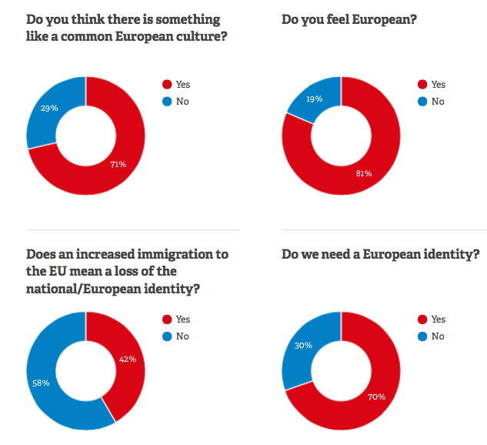
“The Community shall contribute to the flowering of the cultures of the Member States, while respecting their national and regional diversity and at the same time bringing the common cultural heritage to the fore,” reads the first section of Article 128 of the Maastricht Treaty of 1992 (Treaty on European Union, 1992). Although an organization through a series of varying treaties and institutional formations had been in existence since the end of the Second World War, the Maastricht Treaty acted to formally create the federation known as the European Union. The Treaty outlined key values and market ideas for the continent, as well as established the Euro as a single form of currency for the E.U.’s member states. The Treaty also, as revealed above, established the dichotomous relationship between the cultural values of a single European society and that of national and regional cultures. In terms of policy implications, this dichotomy has proven to be one of the most complex issues for the Union in the 21st century following the most recent financial crisis in Europe. The founders of the European Union realized that to maintain a stable federation of member states, a single identity would have to be created through a series of policies that established singular symbols and a representation of the cosmopolitan idea of what it means to be European versus solely German or Swiss. Through this policy, a single currency with regional identifiers was created, as well as a European flag, motto, and anthem (Europa, 2013). These symbols have allowed the continent to unite and see the gradual formation of a single European identity for citizens of the E.U. However, the true question is how deeply founded do the social implications reach into the minds of ordinary European citizens? After the end of the World Wars, any questioned individual in a European state would first and foremost identify himself or herself as their national identity before even considering himself or herself European as well. Since the creation and stabilization of the European Union in recent decades, an increasing amount of Europeans view themselves as just that, European in identity. Therefore, while the original concept of what culture meant for Europeans was truly national and regional in form and the thought of an overarching continental identity was not conceivable, it has now become a real world outcome of the Union’s cultural approach. The graphs, as pictured here, outline a recent survey that approximately 4,000 Europeans participated in following their attendance at an exhibit that discusses European identity and culture (Umlauf). These graphs help to illustrate the idea that a change in perception is occurring for the majority of Europeans, in which they at least feel that they do have some sense of European identity in the modern globalized world. In the survey, 71 percent of those surveyed said that they do think that there is something like a “common European culture” (Umlauf). This statistic denotes a great change in terms of how Europeans view culture in the 21st century versus their perception of self-identity during and post World War era. While it can be claimed that there was a sense of each national identity belonging to the continent of Europe and a regional awareness to some extent in the early 1900s, there was no sense of one claiming European identity or heritage abroad. However, the creation of the E.U.’s founding institutions and ultimately the European Union itself have acted to facilitate the idea of a singular European culture with a unified idea of what it means to be a European citizen.

Culture as the Key Ingredient to Regional Economic Integration
What came first in Europe, economic integration or a realization of the importance of a regional culture? When the founders of the European Union first began implementing policies from the European Council as to how the institution should develop Europe, there was little talk of culture and an emphasis was put on creating a single market. The original concept was that, “socio-political integration would proceed as a by-product of economic integration” (Shore, 2000). The founders assumed that as each member state was integrated into the regional and global economy through the creation of a single European market, the cultural, social, and political facets of Europe would gradually integrate as well. It was quickly realized, however, that this was not necessarily the case. From the 1950s through the 1970s in Europe, a theory of neofunctionalism reigned supreme. This theory focused on the idea that as one area was integrated, a spill-over effect would occur that would create a harmonization pressure on the other areas to integrate as well (Shore, 2000). While this theory can be efficiently applied to various facets of economics and business thought, it did little for the various cultures of Europe that remained steadfast in their differentiation. It was argued, however, that to create a stable singular economic market in Europe, the people of Europe must be united in ideology to some extent to truly stabilize the process. By realizing such, a ‘Declaration on the European Identity’ was signed in 1973 to raise widespread awareness of what it meant to be European (Shore, 2000). This was the first vital step in the process of creating the modern idea of a European citizen, who shares the same rights with different national citizens across the entire continent. After the signing of this declaration, certain policies that created symbolic images began to be implemented in the region. These included the creation of a flag, a logo for the Council of Europe, a single passport, driving licenses, car plates, and an anthem. Other initiatives included hosting European competitions that allowed each nation to compete on a regional scale, bringing together each nation while simultaneously allowing them to show their national pride (Shore, 2000). These initiatives, many legislators hope, will strengthen the common idea of what it means to be European, as well as developing the pride one has for the entire European Union as a political, economic, and cultural machine.
As the E.U. was attempting to create a competitive single market, it was eventually realized that the weakness of this attempt lied in the lack of the commonality that Europeans feel as citizens of the E.U. In the late 1990s, the London Henley Centre released research that revealed that, “the weakness of our collective European identity is both a source and a symptom of a deeper commercial malfunctioning…and the absence of political and social solidarity could undermine Europe’s efforts to remain globally competitive” (Shore, 2000). This denotes the idea that without a parallelization of the social, cultural, economic, and political facets of the European Union, no single entity will be able to reach its full potential of growth and long-term stability. Rather than one of these entities being a by-product of another, each is dependent on the others stability and growth rate. If Europe’s market becomes fully integrated and strengthened through its development of self-identity, in which the cultural emphasis can strengthen the vitality of the European market, then it will better flourish in the global market (Shore, 2000). As other markets, such as the Eastern Asian and American markets, begin to grow and continue to stabilize in the 21st century, the European market must fully access its market strengths to be able to remain competitive. The importance of this new-found cultural emphasis as a part of the economic integration process can be noted in one of the E.U. founding members stances, in which he noted at the end of his life that, “if we were to do it all over again, we would start with culture” (Shore, 2000). His stance reveals the importance of Europe building a foundation of regional identity, in which a single market can then efficiently developed from this original formation. This theory also puts into question the recent rise in nationalism, in which it can be seen through recent political patterns that nationalist parties are increasing the amount of seats that they hold in member states’ parliaments and bodies of government. It could be claimed that if the cultural approach to economic integration was first accessed, rather than vice versa, these nationalist parties would not have the necessary political footing to develop and grow within these internal governments. If a European identity had been formed and been naturalized by the domestic power structures of each nation, then once the E.U. attempted to implement such cultural policies, the shock factor would be removed and the strength of these parties minimized. However, in the modern system, nations are viewing these unification attempts as an infringement upon their cultural diversity and even weakening their home economies. One look back at the financial crisis of Greece or Spain puts into question the true loyalty that the member nations currently hold for one another. Without a stronger cultural foundation to support economic integration, these attempts have failed and a true feeling of community support for their sister nations has been weakened. It will take a new approach by E.U. legislators, as well as on the national ends, of realigning these nations and making a point of how a dichotomous, co-dependent relationship can flourish. There is a current sense of the national identity as being ‘natural’ and any greater European identity as somehow infringing on the rights of one’s natural national identity. This, however, is false. It has been proven throughout thousands of years of history that humans can culturally have dual identities. One can consider himself American, as well as a Tennessean. There are varied scales of identity and thus an emphasis on the development of this dual identity for Europeans needs to be further realized. Once a European considers himself a citizen of the E.U., and simultaneously a citizen of his or her nation, the E.U. as a whole will be strengthened. While the statistics previously discussed reveal that this dual identity is present and growing, it has not reached the height that it needs for a more stable economy. With the current immigration laws of the E.U., in which E.U. citizens can freely move and work among member states, a reevaluation of how to deal with the growing concern of the labor movement needs to be reached.

The Rise in Nationalism: The E.U.’s Changing Political Front
Since the economic downturn of the entire region, the E.U. has been pulling out all of its tricks to attempt to rapidly recover in a world that is passing by. While the majority of its nations have recovered to an extent, many Europeans are beginning to view the needs of the nation in greater terms than that of the Union as a whole. A recent article in the Washington Post described this process as one in which, “Europe is experiencing a renationalization of political life, with countries clawing back the sovereignty they once willingly sacrificed in pursuit of a collective ideal” (Kupchan, 2010). Many nations are currently assessing their national political agendas far over that of the entire continent. Germany’s Parliament passed legislation in the previous years that enables the decision of the national government to take precedence over that of the E.U.’s legislative rulings. This provides a clear example of the instinctive nature that many of these nations are reverting back to, in that they are no longer seeing themselves as member states and citizens of the E.U. These parties are now viewing themselves as the original states that confounded the individualistic nature of the world wars, rather than a coexistent body that is leading Europe towards economic and political growth. Numerous E.U. member states have continuously fought the onset of increased political power and control by the body. This came to a head in 2005, when both France and the Netherlands rejected a treaty that would grant the E.U. military and taxation control (Kupchan, 2010). European states, however, did find a commonality in the subsequent treaty, the Lisbon Treaty, that focused less on the explicit powers that were being relieved of the member states and was more so a treaty aligning the economic interests of the members.
Across Europe’s political front, nationalist parties are gaining previously unheard of amounts of seats in national governments. One such example is found in Hungary, whereas their Jobbik Party gained 47 seats in the 2010 election, previously holding zero seats in the election of past years. Among these parties a term has become prevalent known as Europhobia. This term embodies the very idea that these nationalist parties on the rise throughout much of Europe are using to gain footing in a once devastated region by the very political parties that are on the incline. The citizens of the E.U. fear that they are becoming that very thing, a member of an entire political and economic entity that has no real interest in their personalized needs. It is this fear of becoming simply a number in a global oriented machine that has sparked a desire to enable far-right parties to take a rise to act as a defense against the increased control of the Union. Recent statistics show that on average, only those over the age of 55 view the E.U. as an enabler and protectorate of peace (Kupchan, 2010). This generational gap has created a vast distaste for the current structure, because those in power see a lack of fear for bloodshed and dismay across the European arena, as those of the older generation witnessed for themselves first hand. The economic downturn of 2008 and the years to follow have also crept in the minds of those weary of the power and purpose of the European Union, in which the welfare state has taken an incredible beating. With the ability of E.U. citizens to freely move about, finding work among other member states, an anxiety for the maintenance of one’s own nation has become prevalent. These nationalist parties note that these foreign workers are “crushing the welfare state and earning wages, while natives find themselves jobless” (Kupchan, 2010). One of the members of the E.U. Parliament made a reference to their simply trying to buy enough time for new leaders to emerge to take the reigns of the body to attempt to preserve what it once was. This internal view of an entity that once united an entire continent speaks wonders for the state that the European Union has reached, in that it fears it is on the very brink of collapse. Therefore, this fall in power of the postwar uniting force that once was the E.U. has now become a bed that fosters a forced, all-encompassing legislation. This has created a bed for nationalist parties to take full possession of power in major nations, France, Hungary, Germany, and Great Britain all being prime examples. The parties rely on the fear instilled in the people by these very forces that lead them to believe that they are losing their national rights and freedoms. One can only hope that if and when the time comes that an economic, political, and cultural entity such as the European Union no longer finds a place in the European arena, the amount of advancement that these nationalist parties have taken in Europe’s political front is still manageable.

Promoting Cultural Globalization: An End All Solution
Throughout the enactment of the European Union for the past few decades, the process of globalization has taken full effect in the majority of Europe and primarily in Western Europe. The structure of the E.U. allows for the free movement of “people, capital, goods, and ideas within its borders” (“Human Development Report,” 2004). This constant flow of human capital, primarily, has created the most apparent and visible strain on the political structure of the member states of the European Union in recent decades. With the ever-increasing presence of international populations in the individual European states, a necessity for a multicultural policy of inclusion has also established itself. With these policies of full inclusion of a multitude of varying ethnicities and peoples, what has become known as cultural exclusion has also taken root. The “Human Development Report” of 2004, however, has outlined a solution to the development of such strategies of multiculturalism that deals with the maintenance of preexisting cultures and makes way for the development of European culture as a whole. The four parameters that the report outlines as informants to E.U. policy regarding cultural preservation are as follows: defending tradition can hold back human development, respecting difference and diversity is essential, diversity thrives in a globally interdependent world when people have multiple and complementary identities and belong not only to a local community and a country but also to humanity at large, and addressing imbalances in economic and political power helps to forestall threats to the cultures of poorer and weaker communities (“Human Development Report,” 2004). In alignment with these overarching guidelines, a policy of preservation for those cultures that are fading in the presence of an overarching Euro-centric culture must focus on the adaptation to this new environment of sorts. The Report argues that rather than fearing for a loss of culture, it has been proven through history and political analysis that humans can have a multitude of identities that build upon one another. This would, therefore, make one imagine an idealistic Europe in which an average citizen would see himself or herself as say both an Irishman and European.
However, in practicality the rise in nationalist parties portrays a different image of the average citizen of say Germany and his or her view on the entity known as the European Union. It can be claimed that the ordinary individual sees the E.U. as an entity that intrudes on their once glorious culture of unique stature in a continent full of national oriented states that each gained its unique nature by the very quality of individuality of its culture. The E.U. is now the body that creates unilateral law and economic reform, instituting policy that crushes the very thing that separated Germany from Britain from France. A fear of the people for the loss of their once divinely unique culture and individuality is the very thing that has nourished the seed of nationalist party growth around the continent. This fear is two fold though, one side fearing the continuance of the current entity of the E.U. and its overarching policy that will create a single European culture and citizen of sorts; and the other, a fear of the foreign international that is eerily rising in power and global stature. This dual fear is sparked by the economic and political growth of both the East and Middle Eastern regions. The Arab nations have used their natural resources to make a play for the international stage, while China has shown the quickest increase in GDP and economic growth the global economy has seen in decades. Therefore, the presence of both of these foreign sources to the European Union has created another undercurrent of fear and intolerance for the looming economic and political threat that both of these present for Europeans. This fear has thus created the ability of nations, such as France and Germany, to begin to institute a series of laws, followed by strict implementation, that targets those beacons of foreign presence across the European stage.

Islamic Intolerance in Europe: The Banning of the Hijab
In the fall of 2010, the French Parliament passed a law that would ban the wearing of primarily religious head coverings. While the law does not explicitly mention the Islamic faith, it is well known amongst the French to whom this bill is targeted. The ban has said to affect thousands of Muslim women who wear a hijab, the traditional Islamic head covering, or a burqa, if it covers the entire face. The main argument presented by the senators in favor of such legislation argued that the sort of head covering often seen on Islamic women, however all faiths and organizations do apply, hinders self-expression and individual freedom. Regarding the amount of extreme terrorism throughout much of Western Europe, the argument of the covering as a security threat was also presented during the hearings on the bill (News Wire, 2010). In an attempt to implement the ban on those still devout to their traditional Islamic garb, a fine for a women continuing to wear the head covering of 150 Euros has been installed, as well as a fine of 30,000 Euros for any man found guilty of enforcing his wife or children to continue wearing the hijab (News Wire, 2010). While this law seems logical to the majority of French citizens, the bill originally earning an outstanding 246 votes of aye against only a single naye, the legislation has caused an outcry of rallying in opposition of such a law across some of Europe and the Middle East. President Barack Obama and Islamist militant Ayman al-Zawahiri have both made public announcements stating their respective parties disagreement with the new ban on Islamic head coverings and even criticizing it as “an insult to Muslims” (News Wire, 2010).
While international critics have vocalized their disapproval of the direction that France as a nation is heading towards its outlook on the Muslim world and their place in French society, some French Muslims have spoken up about their understanding of the context of such a bill. Jaferi, a 34 year old French Muslim woman, publicly stated, “If France wants to preserve its beautiful ancient culture from the threat of the dual-identity of immigrants, then the government has a right to do so” (Saba, 2011). Therefore, it seems that even those on the affected side have at least a general understanding of the root of such a law. The gray area, though, comes in terms of the origin of the actual wearing of a burqa or a hijab. The act of wearing a head covering is viewed by many as more of a cultural signifier, rather than a solely Muslim form of piety. The Quran itself makes no actual reference or states in law that a woman of Islamic faith must wear either a full body or head covering (Saba, 2011). Thus, the question as to the predisposed purpose of such a law in French society remains. Did France’s Parliament overwhelmingly support this legislation based on the ever-present fear of extreme terrorism and security threats, or rather because these women represent the dual fear that is present and continuing to increase in much of Europe. These women, those who continue to wear a hijab or burqa, act as beacons of change for the citizens of France. They symbolize a very real and present force of globalized immigration and a movement of cultures, in which this Arab symbol of traditional Islam is now present in growing numbers throughout France’s major metropolitan areas. This law, therefore, plays a major part in the rise of nationalism; in that, the French and other major nations in the E.U. are on a path of preventative nature to attempt to ensure that their traditional cultures are preserved in a time of increased change and cultural development. It appears that the French are not afraid of the security threat that they often claim these women represent, they are more so afraid of the change in France’s society that they represent. Islamic women in France have thus become, not pillars of faith and devotion for the on looking French eye, but rather, a pillar of cultural change and Arab presence in the once ‘culturally pure’ society.

The Spoken Past: Ireland’s Preservation of Gaelic
If one will spend any amount of time in the Emerald Isle, he or she will quickly find that the majority of Irish citizens do not speak the traditional language of Ireland, Gaelic. Those few that do speak Gaelic were originally from a remote village in Ireland that had preserved the language since its original time of popularity in the small island. This, however, has become a major target of interest for Irish legislators. Following the lines of attempting to preserve the fading aspects of traditional Western cultures throughout much of Europe, Ireland has passed legislation dictating the new relevance of the traditional Irish language of Gaelic. The series of Gaelic oriented laws passed in 2005 by the Irish legislature include the following enactments: a law enforcing a change in the legal names of over 2,300 towns and villages to traditional Gaelic names; a mandatory display of all public or state owned signage, such as on bus stops or street names, to read in both English and the traditional Gaelic name; and the teaching of Gaelic beginning in primary school up through Ireland’s equivalent of high school (“Ireland speaks up,” 2005). This enforced learning of the traditional language has overall received a well reception by the Irish people. Many see this as a revitalization of their near dead language, in which many of the youth are enthralled by the idea of being bilingual from an early age. However, there still lies a major discrepancy between the teaching of Gaelic and the actual practice of Gaelic. While the vast majority of Parliament members in Ireland are pro-Gaelic and continue to be advocates of the previously passed legislation, only one percent of parliamentary debates are held in Gaelic (“Ireland speaks up,” 2005). This discrepancy on the part of the lawmakers themselves reveals that, although many are intrigued by the teaching of the language as something new and vital to Ireland’s history, it is merely history itself. Even though Gaelic is being forced upon the average man, who was raised speaking English and continues to do so, the dual language is merely a cultural tie and continues to stand second hand to the presence of English in the once Gaelic region. This arises the question to the Westernization of the island, in which the past presence of Great Britain during England’s rule of Ireland has left a stain of vitality for the language among many. Learning the language allows the Irish to feel a tie to the past; however in full practice, they are still entirely dependent on the use of English. The heavy economic tie of Ireland to America and its continued dependence on Great Britain for exports and academic wealth will continue to put a strain on the nation’s ability to revert back to their traditional Gaelic tongue. The passage of this legislation has thus become an attempt to simply preserve what is nearly lost, rather than revert back to the common, everyday use of an old world language in the modern, globalized world that Ireland now finds itself.

Every Nation for Itself: Economic Nationalism
Since the onset of the economic crash of the Western world in the mid 2000s, many European nations have begun to rethink the economic support that their membership in the European Union provides. This once strengthened entity that provided economic stability after the woes of the Second World War, has suffered its largest test of efficiency to date. Following the G20 Summit in 2009, the member nations vowed, “to fight protectionism and develop new international regulations to oversee the financial markets” (Steinberg, 2009). While this was the original point of attempting to preserve the region as a whole with the creation of the E.U., in practice the majority of major economic member nations of the E.U. began to implement strict nationalist measures after the 2009 Summit to ensure their own economic survival. Each nation, say Germany or Great Britain, continue to prioritize the needs of their own nation over that of the continent, even with the persistent attempt of the E.U. to structure each nation as a part of a whole. With the previous financial order weakened because of the economic ties instituted by the E.U., larger nations, such as Germany and France, have been consulting one another to make a play for the leading financial leaders in Europe (Steinberg, 2009). If this play for power in a previously united continent continues, the E.U. is far closer to an all-encompassing collapse than anyone foresaw. Another strain on the implicit economic power of the Union was created with the near collapse of both Greece and Spain. Primarily in the Greek economic demise, a proposed bailout was questioned by many of Greece’s sister states. Germany even considered removing all ties related to the bailout in an attempt to distant itself from the failing state.
As the economic recession in Europe continued to test alliances, the majority of nations began to weigh the cost and benefit of continuing its membership in a supposed entity that enables economic protectionism. This culminated with the enactment of protectionist policies for companies located specifically within the nation in question. Throughout Europe, slogans began to appear such as, “British jobs for British workers” (Steinberg, 2009). Unions in each of the varied nation states have vowed to back the withdrawal of jobs in partner states to enable the increase in domestic job growth. What does this mean for the future of the E.U.? Steinberg claims that, “this rise in ‘beggar-thy-neighbor’ economic nationalism is the surest sign of the decay of the capitalist system in Europe” (Steinberg, 2009). Although one would question the entire collapse of the capitalist structure currently in place throughout the Western world, the continental strain that the recession has created on European nations does put the E.U. at risk for dismantling. Even if the E.U. continues to maintain its current amount of 28 member states, the economic strength of the entity will most likely never fully recover. The trust of the economic welfare of the entire continent bestowed upon the European Union will also never recover. The greater portion of member states that reverted back to the nationalist pleas of the past in dealing with the economic strains of the region have continued to preserve their own economies in the modern time of instability, rather than relieving each nation’s future on any overarching organization. The fear of being pulled into another economic or financial collapse because of the nation’s membership in the E.U. will far outweigh any future obligations Europeans feel toward the well being of the continent as a whole.

Cultivating a Single Culture: What Is Next for the E.U.
Within the E.U.’s attempt to cultivate a single culture and instill the image of a united continent on the brink of collapse, several aspects of culture have been examined and further studied to better identify the real world solution for integrating those factors into a united region. Scholars of the European Union have often made reference to the idea that the overarching issue with the unification of the region is the internal barrier that one often installs in comparing nations. Artwork, language, or any cultural aspect is never seen singularly as European, but on the contrary as Italian, French, or Spanish. Since the creation of the E.U., the agenda of the entity has been more so focused on political and economic goals. This lack of attendance to the cultural state of the continent has made for an environment in which any talk of a modern singular culture in Europe is seen as invasive and foreign in nature. However, when attempting to solve this issue of how to fully penetrate a mixture of societies still viewed as independent and insular, another problem arises with the E.U.’s predetermined definition of European culture. The ambiguous definition laid out in the founding document, The Maastricht Treaty, reads, “Language, literature, performing arts, visual arts, architecture, crafts, the cinema and broadcasting are all part of Europe’s cultural diversity. Although belonging to a specific country or region, they represent part of Europe’s common cultural heritage. The aim of the European Union is double: to preserve and support this diversity and to help make it accessible to others” (Coudenys, 2007). However, when it comes to the realities of the current state of the European Union, the dual task of attempting to preserve diversity among the member nations and secondly, to create a universal culture that is more so easily accessible across the international arena becomes quite challenging. In an attempt to complete the daunting task of reassigning the value and outlook of a diverse culture of many within an overarching, singular culture, the E.U. has identified a few areas that must be targeted to change this perception of what European culture is and the future it holds in Europe.
The first targeted aspect of culture is that of the European languages. Vast in original number and dialects, the amount of spoken European languages has dwindled in recent years. However, the significance that a nation or region’s language holds to its State and people remains great. In the formation of many modern nation-states throughout the European continent, authorities established set languages to fit “the organizational needs of the State” (Coudenys, 2007). Therefore, one’s ability to speak the dominant language of the State, in essence, put that select person in the majority and those who fell short and were predisposed regarding a varied form or different language were considered the minority and lesser in stature. “Language and the State, thus, became two sides of the same coin” and those who fell short of the official language were “condemned as the national minority” (Coudenys, 2007). This innate connection between one’s nationalist pride and the spoken language associated with the said State has allowed for any forced transition from a diversity of spoken languages to a unified European language to be difficult to impossible to separate the two spheres of importance for the majority of Europeans. When analyzing the solutions to this issue of diversified language in a continent that is on the prolonged path towards a more unified cultural structure, it becomes apparent that the majority of proposed solutions are not probable in their implementation and final affect on the continent. If a single form of language was selected for use, such as English or Spanish, those not on the selected path would be thrust into a transitional phase of attempting to learn a new language and converting all major aspects of their society into the chosen language. Another option, allowing for a multitude of languages to continue to coexist somewhat simultaneously across the continent will also fail the E.U. in its attempt to cultivate a united European culture. Therefore, the only plausible solution for this complex language based issue of the Union is to cut all known ties with the solution revolving around a linguistic oriented solution to Europe’s cultural ambiguity.
What’s next for the European Union then in terms of its cultural transition in a globalized world? The first aspect to note relating to the Union’s ability to grow as an entity and create a strengthened alliance in an increasingly polarized world of power struggle is the lack of State formation in the E.U. With the E.U.’s disinterest in signing a formal constitution, the cultural and political policies of the member nations will continue to fall in line with the state’s supremacy in any significant policy decision-making process (Coudenys, 2007). In doing so, each independent state will inevitably continue to favor only itself and the nation’s individualized interests in terms of economic, political, and cultural interests rather than the whole of Europe. European culture itself will remain in a transient state, allowing for each varied national culture to develop based solely on the factors affecting the nation at any one point. While this is not ideal for the complex unification agenda of the European Union, many political scientists in the field of international relations have claimed that a unified region will occur spontaneously. This is likely to occur, not necessarily spontaneously in the scheme of things, but rather, because of the external push that the Middle East and Asia will put on the region and global order. As nations view these regions and the immigrants associated with those in question in a polarized light, alienating and attempting to preserve their culture against the threat of change, a breakdown in power will occur and leave the region alienated all together. The only possibility of Europe acting as a key player in the power struggle on the horizon regarding the Far East and the hegemonic American state is its unification and ability to act as a single entity in all its forms. Unless Europe begins to act as a single global unit, fused in its economic, political, and cultural polices continent wide, the region will fall along the shadows of the emerging international hard hitters in the power play to come.

The Labor Movement: The Negative Impact of E.U. Immigration Laws
As stated in Article 45 of the European Union’s Treaty on the Functioning of the European Union, and further defined through case law from the Court of Justice, European citizens have the ability to: “search for a job in another E.U. country, work in another E.U. country without a work permit, reside there for that purpose, remain in that country even after their work has finished, and enjoy equal treatment with nationals in access to employment, working conditions, and other social and tax advantages” (Europa, 2013). Therefore, as outlined above, once a nation becomes a full-fledged member of the Union, it opens up its doors to the continual flow not only of goods, services, and capital, but people as well. While this would appear to be one of the advantages of joining the E.U., it has opened up a new facet of issues for policy makers within the Union. Without limiting the amount of people who migrate into a nation, the labor market can easily be flooded with immigrants who threaten the workforce stability of nationals who seek gainful employment within their home country. Another increasing issue dependent on work migration comes with the flow of cultural indicators that these groups carry with them. In one sense, they provide new skilled labor to those job markets that are weakened by economic factors and benefit from this new pool of workers. However, it can also be argued that this inflow of human capital brings about cultural side effects that deteriorate the dominant national culture within the nation in question. Depending on the level of immigration, a hybrid culture could even form, as seen throughout history such as with the Moorish influence in southern Spain. While this research is not attempting to argue that cultural hybridization is a negative aspect of this migrant influx, it does note the legislative repercussions that it creates. One such example elaborated on in another subsection concerns the Islamic tradition of women wearing a hijab. Because of the arrival of a growing Muslim population within nations such as France, public policies have begun to be implemented to attempt to combat this infringement upon French culture. Another conclusion can be made as to the fear of the foreigner, in which it is not necessarily directly linked to a cultural fear, but rather that of an economic based fear. These groups could potentially see the regional immigrants as economically threatening, in which they risk providing a cheaper source of labor for the domestic companies. Therefore, it can be claimed that another dichotomous relationship has formed that denotes a dual-fear for those who attempt to propel nationalistic policies in their domestic nations. This fear could be equally based on a threat of employment and a new weight put on the welfare system, as well as a cultural threat, in that the once symbolic national culture is being infringed upon by a regional or hybrid cultural identity.
In terms of the amount of immigration, Spain proves to be an interesting example. In the late 1990s, as well as the early 2000s, Spain saw some of the highest levels of labor immigration it had seen for decades. The values now reach somewhere between 1.5-2.0 percent of the entire population being from this migration movement (Ortega). This is an outstanding percentage of the population, which has harsh implications on the welfare system in Spain, as well as the wages of national domestic workers. Below are two graphs that present empirical data from the 2003 census in Europe that reveals the immigration trends throughout Europe in comparison to previous years. The data was collected and correlated by Eurostat from the NewCronos database (Ortega). Both graphs represent the influx of foreign immigrants originating from the change in immigration policy by the European Union. It also presents data to show that the domestic population growth is struggling to compete with this inflow of human capital on their domestic markets.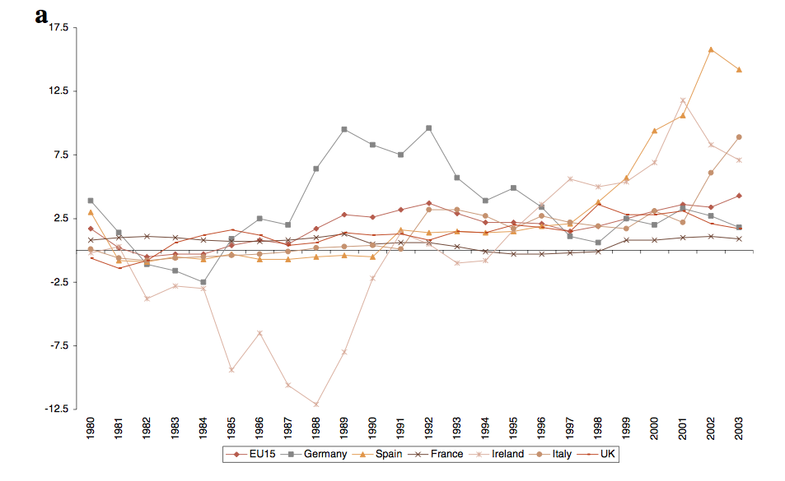
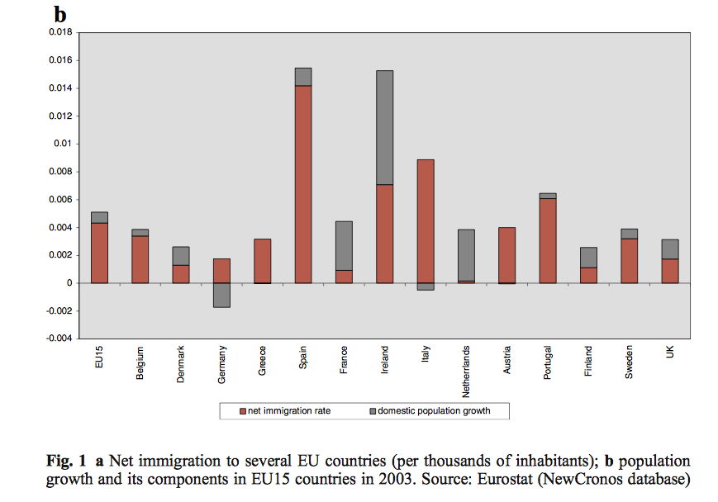
Whether this continual flow of people throughout European borders is negative or positive on the local economies and cultural identities are still in question, however it is evident that an increased rate of labor immigration is occurring. It must be the goal of the Union to attempt to implement policies that help to grasp and at least partially control this level of immigration. While a single, strong market in Europe has been the goal of the E.U. since its original conception, a study and analysis of the effects of such must be further analyzed. With this research, a better understanding of the correlation between culture and the European economy can be derived. As mentioned before, this correlation will also help to better understand and control the changing parallels of the modern political and social trends that are innately tied to the cultural and economic trends currently occurring in Europe.

Works Cited
Coudenys, W. (2007). Frontiers and limits of European culture.
George Washington. BrainyQuote.com. Web site: http://www.brainyquote.com/quotes/quotes/g/georgewash387134.html
Ireland speaks up loudly for Gaelic. (2005, March 29). The New York Times. Retrieved from http://www.nytimes.com/2005/03/28/world/europe/28iht-irish.html?_r=0
Kupchan, C. A. (2010, August 29). As nationalism rises, will the European union fall? Washington Post. Retrieved from http://www.cfr.org/world/nationalism-rises-european-union-fall/p22856
News Wire. (2010, Sept. 15). Parliament approves ban on full veil in public. Retrieved from http://www.france24.com/en/20100914-french-parliament-approves-ban-full-veil-public-senate-law-fine-sarkozy-islam
Ortega, A. C. The Effect Of Immigration On The Labor Market Performance Of Native-born Workers: Some Evidence For Spain. Journal of Population Economics, 627-648.
Shore, C. (2000). Building Europe: the cultural politics of European integration. London: Routledge.
Steinberg, S. (2009). Economic nationalism on the rise in Europe. World Socialist Web Site, Retrieved from http://www.wsws.org/en/articles/2009/08/pers-a15.html
The history of the European Union. Employment, Social Affairs, and Inclusion. (2013). Retrieved from http://europa.eu/about-eu/eu-history/index_en.htm
Treaty on European Union [TEU, Maastricht Treaty], Feb. 7, 1992, 1992 O.J. (C191) 1; 31 I.L.M. 253 (1992)

Umlauf, J. (n.d.). United States of Europe: A Traveling exhibition about European identity and today's Europe. . Retrieved , from http://www.go-use.eu/en/participate/statistics.html
United Nations, Human Development Report. (2004). Globalization and cultural choice (Chapter 5). Retrieved from website: http://hdr.undp.org/en/media/hdr04_chapter_5.pdf
Vanthoor, W. F. (1999). A chronological history of the European Union 1946-1998. Cheltenham, UK: Edward Elgar Publishing.

