Optical Sensors for the Analysis of Alcohols in Fuels

A Thesis Presented for the
Master of Science
Degree
The University of Tennessee, Knoxville

Kendhl Kate Witt
May 2016
Dedication

This thesis is dedicated to my fiancé, family, and friends, who have supported me throughout my time at the University of Tennessee, Knoxville. Their support and guidance has been invaluable and encouraging. Without them this accomplishment would not have been made possible.

Acknowledgements

Many people have helped me throughout my time here at the University of Tennessee, Knoxville. I would like to thank Dr. Zi-Ling Xue for his encouragement and advice throughout my graduate career. His knowledge of chemistry is impressive and he has been a great teacher who I have learned a lot from. As an advisor, Dr. Xue has been encouraging and helpful, and I greatly appreciate all that he has done for me. I would also like to thank Dr. Frank Vogt, who has guided me throughout my undergraduate and graduate studies. He provided me with my first laboratory job, and I will always value my time spent in his research group. Without Dr. Vogt, I would not have been inspired to continue my chemistry education through graduate school. I would also like to thank Drs. Michael Kilbey and Bin Zhao for helpful discussions and suggestions relating to polymer chemistry, which has been very beneficial. I also had the pleasure to be a teaching assistant for general chemistry with Dr. Kilbey, where I was inspired by his desire to teach. I would also like to thank all of my professors I have taken classes with throughout my graduate career. I have learned so much and am grateful for this opportunity.

In addition, I would like to thank Dr. Michael Cheng from Chevron, who helped fund my research and provided helpful guidance. I would also like to thank Dr. Nghia Chiem for his support through helpful discussions relating to research patents and quality control considerations.

I would also like to thank my mentor in Dr. Xue’s research group, Dr. Jonathan Fong, who helped guide me through beginning my research project and graduate career. Jonathan has been a fantastic mentor and great friend throughout the time we both spent in Dr. Xue’s research group. I would also like to thank my colleagues in Dr. Xue’s analytical lab, Roberto Federico Perez, Sam Rosolina, and Thomas Carpenter. They all are amazing analytical chemists and it has been a pleasure to work with them. They are also some of the most supportive and kind-hearted people I have ever met, and I am grateful to call them my colleagues and friends. Working with them has been inspiring and enjoyable, and it will be hard to find colleagues I enjoy working with as much as I do with them. I would also like to thank Dr. Jie Guo, who I have learned so much from in her time in our research lab. It has truly been a pleasure to get to know her. Additionally I would like to thank Dr. Adam Lamb, Shelby Stavretis, Tabitha Cook, Seth Hunter, and Duncan Moseley in Dr. Xue’s inorganic lab. They are all great inorganic chemists and I am inspired by their knowledge and passion for research. I am grateful to have them as colleagues and friends, and I appreciate all they have done for me.

Finally, I would like to thank my family and friends who have constantly encouraged me throughout my undergraduate and graduate studies. My mom, dad, and stepdad have been incredibly helpful by supporting me, emotionally and financially. My mom has provided me invaluable advice and guidance, always encouraging me to keep my head up even when it has been most difficult. My dad has been a constant source of advice that helped me believe anything is possible if I set my mind to it. My stepdad has been a source of inspiration to pursue higher education and has been a great motivator. I also want to thank my little sister, Hallie Brannick, who inspires me to stay young at heart and not take life too seriously. In addition, I would like to thank my grandparents for their support. They are always there for me no matter what, and I will always treasure the time we spend together. They have all constantly inspired me to be myself and do my best, and I am beyond grateful for their invaluable guidance. Last, but certainly not least, I would like to thank my amazing fiancé, Eddie Seabright, who has constantly been there for me throughout graduate school. He has been a great source of inspiration and guidance, and without him this accomplishment would not have been made possible. He has helped me tremendously throughout some of the hardest times that I have ever experienced, providing me with a different perspective and a good laugh to cheer me up.

Abstract

This thesis reports the development of optical sensors to analyze alcohols in fuel samples. One optical sensor enables the analysis of phenol in aviation fuels and cellulosic biofuels. It is critical to monitor the concentration of phenols in fuels because they increase the presence of solid oxidative deposits and lower the thermal stability of fuels. Preliminary studies of another optical sensor have been conducted to detect ethanol in E10 gasoline samples. Gasoline containing ethanol is widely available and used, but the exact percentage of ethanol is not specified and varies between samples and regions. Higher concentrations of ethanol in gasoline can cause damage to vehicle parts and engines, especially in older vehicles. Therefore, it is desirable to develop a sensor that can quickly and easily determine the percentage of ethanol in gasoline. It is imperative for on-site, portable, inexpensive, and easy-to-use technologies for monitoring phenol and ethanol in fuel samples.

The optical sensors reported herein use a solvatochromic dye, Nile Blue Chloride, which is embedded within a polymer thin film. Many polymer thin films have been studied and are detailed in this research thesis. The polymer is dissolved in tetrahydrofuran through sonication and mixed with the dye. The polymer and dye mixture is spin-cast onto a glass substrate, resulting in an optical sensor. The solvatochromic dye in the optical sensors displays a color change upon a change in the microenvironment, including solvent polarity. Upon exposure to phenol or ethanol, the optical sensor exhibits a color change from purple to blue. This observation is due to the tetrahydrofuran molecules being replaced by phenol or ethanol molecules, thus creating a new microenvironment around the dye molecules. This change is monitored visually and with an ultraviolet-visible spectrometer to determine the concentration of phenol or ethanol.

Table of Contents
Page
I. Introduction and Background..........................................................................................1
  - Biofuels…………………………………………………………………………………………………….1
1.1.1 First-Generation—Bio-ethanol…………………………………………….…………....1
1.1.2 Second -Generation--Cellulosic Biofuel……………………………………………....2
  - Aviation Fuel……………………………………………………………………………………….…....3
1.3 Alcohols in Fuels……………………………………………………………………………………….5
1.3.1 Phenol and Phenolic Compounds…………………………………………………….5
1.3.2 Ethanol…………………………………………………………………………………………..6
1.4 Methods to Analyze Alcohols in Fuels…………………………………………………………7
1.4.1 Analysis of Phenol and Phenolic Compounds……………………………………7
1.4.2 Analysis of Ethanol………………………………………………………………………….8
1.5 Solvatochromism………………………………………………………………………………………8
1.5.1 Nile Blue Chloride (NBC)………………………………………………………………....9
1.6 Polymer Thin Films……………………………………………………………………………….…10
1.6.1 Properties and Development of Optical Sensors……………………………..10
1.6.2 Ethyl Cellulose (EC)………………………………………………………………………10
1.6.3 Poly(methylmethacrylate) (PMMA)……………………………………………….11
1.6.4 Poly(acrylonitrile-co-butadiene) (PAB)………………………………………….11
1.7 Ultraviolet-Visible Absorption Spectroscopy…………………………………………….12
1.8 Overview of Thesis…………………………………………………………………………………..13

II. Experimental…………………………………………………………………………………………...15
2.1 Materials and Instrumentation…………………………………………………………………15
2.2 Preparation of Optical Sensors and Solutions……………………………………………15
2.2.1 Optical Sensors……………………………………………………………………………..15
2.2.2 Phenol Solutions…………………………………………………………………………...17
2.2.3 Ethanol Solutions………………………………………………………………………….21
2.2.4 Exposure of Sensors to Solutions…………………………………………………...21
2.3 Analysis of Sensors………………………………………………………………………………….22
2.3.1 UV-Visible Spectroscopic Analysis…………………………………………………22
2.3.2 Data Processing…………………………………………………………………………....23

III. Results……………………………………………………………………………………………………...24
3.1 Phenol Analysis……………………………………………………………………………………….24
3.1.1 Sensors Made with Ethyl Cellulose (EC)…………………………………………24
3.1.2 Sensors Made with Poly(methylmethacrylate) (PMMA)………………….26
3.1.3 Sensors Made with Poly(acrylonitrile-co-butadiene) (PAB)…………….28
3.1.4 Sensors Made with Poly(acrylonitrile-co-butadiene) (PAB) Blended with Polystyrene (PS)……………………………………………………………………31
3.1.5 Discussion on Phenol Analysis……………………………………………………….33
3.2 Ethanol Analysis……………………………………………………………………………………...35
3.2.1 Polymers Tested…………………………………………………………………………...35
3.2.2 Tests with Different Ethyl Cellulose (EC) Samples…………………………..36
3.2.3 Sensors Made with Ethyl Cellulose (EC)…………………………………………37
3.2.4 Sensors Made with Poly(acrylonitrile-co-butadiene) (PAB)…………….38
3.2.5 Discussion on Ethanol Analysis……………………………………………………...40

IV. Concluding Remarks…………………………………………………………………………….42
4.1 Applications and Advantages of the Optical Sensors………………………………….42
4.2 Recommendations for Future Studies……………………………………………………….42
4.2.1 Phenol Analysis…………………………………………………………………………….42
4.2.2 Ethanol Analysis…………………………………………………………………………...44
4.3 Summary of the Thesis…………………………..………………………………………………..45

References…………………………………………………………………………………………………….48
Vita………………………………………………………………………………………………………………….53
List of Tables
Page
Table 1. Preparation of polymer matrices through dissolving in THF…………………..17
Table 2. Preparation of polymer blends through dissolving in THF……………………...17
Table 3. Phenolic stock solutions [3% (v/v)] prepared in 100 mL kerosene………...18
Table 4. Serial dilutions from 3% (v/v) stock solutions to obtain 20 mL sample volumes……………………………………………………………………………………………………………..19
Table 5. Phenolic stock solutions [1% (m/m)] prepared in 100 mL kerosene………19
Table 6. Serial dilutions from 1% (m/m) stock solutions to obtain 20 mL sample volumes……………………………………………………………………………………………………………..20
Table 7. Standard addition with anhydrous ethanol to E10 gasoline to obtain
10 mL sample volumes……………………………….………………………………………………………21

List of Figures
Page
Figure 1. Crude oil distillation tower from www.bbc.co.uk……………………………………4
Figure 2. Structure of Nile Blue Chloride (NBC)…………………………………………………….9
Figure 3. Structure of Ethyl Cellulose (EC)………………………………………………………….10
Figure 4. Structure of Poly(methyl methacrylate) (PMMA)………………………………….11
Figure 5. Structure of Poly(acrylonitrile-co-butadiene) (PAB)……………………………..12
Figure 6. Schematic detailing how the optical sensors detect phenol and ethanol...14
Figure 7. Sensors made with EC. (Left) Exposed to kerosene only. (Right) Exposed to 30,000 ppm (v/v) phenol………………………………………………………………………………..24
Figure 8. (Top) Spectra of sensors made with EC exposed to 0-40,000 ppm (v/v) phenol (λ_{max} = 640 nm). (Bottom) Calibration plot yielding line of best fit with R² = 0.991…………………………………………………………………………..………………………………25
Figure 9. Sensors made with PMMA. (Left) Exposed to kerosene only. (Right) Exposed to 30,000 ppm (v/v) phenol………………………………………………………………….26
Figure 10. (Top) Spectra of sensors made with PMMA exposed to 0-30,000 ppm (v/v) phenol (λ_{max} = 630 nm). (Bottom) Calibration plot yielding line of best fit with R² = 0.966…………………………………………………………………………………………………………..27
Figure 11. Sensors made with PAB. (Left) Exposed to kerosene only. (Right) Exposed to 10,000 ppm (v/v) phenol………………………………………………………………….28
Figure 12. (Top) Spectra of sensors made with PAB exposed to 0-1000 ppm (v/v) phenol (λ_{max} =640nm)………………...………………………………………………………………………29
Figure 13. Calibration plot from quadruplicate trial with one-hour exposure. Line of best fit yields R² = 0.949……………………………………………………………………………………..30
Figure 14. Calibration plot from triplicate trial with exposure of one hour…….…….30
Figure 15. Spectra of sensors made with PAB/PS (85:15 wt%) exposed to 0-5,000 ppm phenol (λ_{max} 640 = nm)……………………………………………………………………………….31
Figure 16. Spectra zoomed-in on low concentrations of phenol, 100-500 ppm…….32
Figure 17. Calibration plot of spectra displayed in Figure 13. Line of best fit yields R² = 0.991…………………………………………………………………………………………………………..32
Figure 18. Sensors made with EC. (Left) Unexposed sensor. (Right) Exposed to E10 gasoline……………………………………………………………………………………………………………..37
Figure 19. Sensors made with EC exposed to solutions of 10-12% ethanol in gasoline……………………………………………………………………………………………………………..38
Figure 20. Sensors made with PAB. (Left) Unexposed sensor. (Right) Exposed to E10 gasoline………………………………………………………………………………………………………39
Figure 21. Spectra of sensors made with PAB exposed to E10 gasoline………………..39
Figure 22. Spectra of sensors made with PAB exposed to solutions of 10-12% ethanol in gasoline……………………………………………………………………………………………..40

Nomenclature and Abbreviations

A absorbance
b pathlength
c concentration
cP centipoise (unit of dynamic viscosity)
°C degrees Celsius
ε molar absorptivity
E10 gasoline with up to 10% ethanol
EC ethyl cellulose
EtOH ethanol
HOMO highest occupied molecular orbital
I radiation through sample
I₀ incident radiation
λ wavelength of visible light
λ_{max} maximum wavelength of visible light
LUMO lowest unoccupied molecular orbital
m/m mass by mass
mg milligram
mL milliliter
μL microliter
NBC Nile Blue chloride
nm nanomenter
% percentage
PAB poly(acrylonitrile-co-butadiene)
PhOH phenol
PMMA poly(methyl methacrylate)
ppm parts per million
PS polystyrene
R² square of correlation coefficient
rpm revolutions per minutes
T transmission
THF tetrahydrofuran
UV-Vis ultraviolet-visible
v/v volume by volume
wt% weight percent

I. Introduction and Background

  - Biofuels
    - First-Generation—Bio-ethanol
Biofuels are a large area of focus in modern society as alternative and renewable fuels that allows for decreased dependence on crude oil. There are three generations of biofuels that differ in starting materials and production of the final products.¹ The first-generation biofuels are produced from edible plant material, including corn and sugar.¹ Biofuels, such as bio-ethanol and biodiesel, are often mixed with gasoline to provide higher quality fuels.¹⁻⁴

The production of bio-ethanol involves fermentation of sugars or starches into ethanol by a sequence of reactions in the absence of oxygen. Production from starches requires the conversion of starches into simple sugar molecules, such as dextrose, through enzyme catalysis.¹ Regardless of the specific starting materials, yeast is added in order to prompt fermentation and yield ethanol and carbon dioxide.¹ The production requires distillation of liquid ethanol from the solid mash. This step is accomplished by a continuous flow multi-column distillation setup, which separates the high purity (~96%) ethanol from the residue solids.¹ The ethanol product is then dehydrated to remove any residual water present, resulting in 100% pure ethanol.¹ The ethanol from the fermentation steps has a variety of potential uses after production, such as alcoholic beverages or laboratory grade ethanol. If the ethanol is not used in alcoholic beverages, it is denatured with benzene or a small amount of gasoline to make it unfit for consumption.⁵ It is often mixed with gasoline to yield bio-ethanol fuel, which is commercially available as an alternative to pure gasoline.¹⁻⁷

1.1.2 Second-Generation—Cellulosic Biofuel
The second-generation biofuels are produced from lignocellulosic biomass, such as switchgrass, bark, tree leaves, and other plant material.^{1,8-11} Production of cellulosic biofuels involves pyrolysis to decompose organic materials at high temperatures in the absence of oxygen.^{1,8-11} There are three main subclasses of pyrolysis, which are conventional, fast, and flash processes. These subclasses differ depending on the operating conditions of the pyrolysis process.¹ Fast pyrolysis is typically used to thermally degrade lignocellulosic biomass, which takes place at high temperatures around 400-600°C.¹ Thermal degradation involves decomposing biomass into its main components, which are cellulose, hemicellulose, and
lignin.^{1,8-11} Pyrolysis produces solid, liquid, and gaseous products with percentages ranging from 13-25%, 60-70%, and 13-25%, respectively.¹ The percentage of each product depends on the biomass and its composition, which varies between samples.^{1,8-11} The liquid product is pyrolysis oil, or bio-oil, which is viscous, unstable, acidic, and possesses high oxygen levels ranging from 20 to 50 wt%.^{1,8-11}

Due to the nature of the resulting pyrolysis oils, further treatment is required to make them usable fuel products.^{1,8-11} This is accomplished through hydrotreating, which is often difficult due to the complexity of bio-oils.^{1,8-11} Hydrotreating involves catalytic hydrodeoxygenation (HDO), hydrodesulfurization (HDS), and hydrodenitrogenation (HDN) to remove oxygen, sulfur, and nitrogen containing species, respectively, in the pyrolysis oil.^{1,11} Hydrogenation is also involved in hydrotreating bio-oils in order to promote saturation of double bonds, specifically carbonyl groups, and aromatic rings.^{1,11} The catalysts are typically molybdenum-based sulfides though noble metals have been utilized recently, including as ruthenium, palladium, platinum, and rhodium.¹¹ Noble metal catalysts have peaked interest because they yield higher percentages of usable fuel products.¹¹ The resulting products are saturated hydrocarbons with low oxygen contents that can be used as alternative fuels.^{1,8-11}

1.2 Aviation Fuels
Aviation fuels are produced from crude oil, or liquid petroleum, that is processed in an oil refinery. The production process involves heating crude oil at a high temperature and pressure, which allows for the liquid petroleum to boil and enter the vapor phase.¹²⁻¹⁷ The vapors produced enter a fractional distillation column, which separates the components based upon their respective boiling points. The distillation takes place by allowing the vapors to rise up the column and cool in order to condense to a liquid.¹²⁻¹⁷ Condensation from the vapor phase to the liquid phase occurs once the column temperature is equal to the boiling point of that specific component. Once the vapors have condensed, the individual fractions exit the distillation column and are treated in order to obtain the desired fuel products. The fractional distillation column, Figure 1, details the separation of petroleum components based upon boiling points, which in turn separates hydrocarbon based on their lengths.¹²⁻¹⁷ Longer chain hydrocarbons have higher boiling points and condense at lower points in the distillation column. Shorter hydrocarbons, which have lower boiling points, condense at higher points in the distillation column.
After the fractions are separated, the products are then treated in order to remove impurities and introduce additives to obtain desired properties for their respective uses.¹²⁻¹⁷ Components that boil around 150-250 °C are kerosene fractions, which yield aviation fuel through upgrading by hydrotreatment to obtain desired fuel properties.¹²⁻¹⁷

The most common types of aviation fuel are kerosene and wide-cut type, which differ in hydrocarbon chain lengths.^{12,18} Kerosene type is made of hydrocarbons with eight to sixteen carbons comprising mostly of alkanes and cycloalkanes.^{12,18} Specific kerosene type jet fuels include Jet A and Jet A-1. Jet A has a freezing point of -40 °C and is the most used jet fuel in the United States.^{12,18} Jet A-1 has a freezing point of -47 °C and is widely used in other countries.^{12,18} Wide cut jet fuel, also known as naptha type jet fuel, constitutes a wider range of hydrocarbon chain lengths, typically five to fifteen carbons.^{12,18} The most common type of wide-

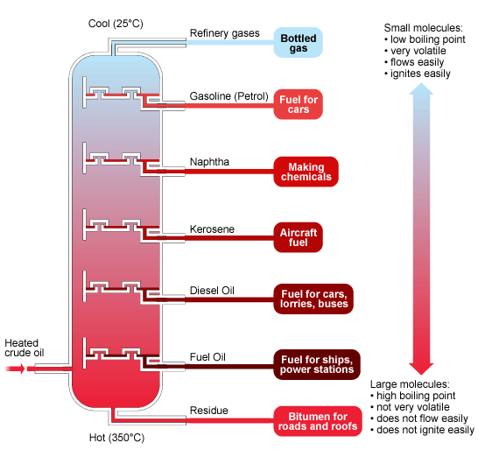
Figure 1. Crude oil distillation tower from www.bbc.co.uk.

cut jet fuel is Jet B. Jet B has a freezing point of -60°C and is specifically used to enhance engine performance in cold climates.^{12,18} Due to its lower freezing point than Jet A types, Jet B is commonly used in military planes and during long international trips.¹²

1.3 Alcohols in Fuels
1.3.1 Phenol and Phenolic Compounds
Phenol is a volatile crystalline solid that is mildly acidic.¹⁹⁻²³ It was first extracted from coal tar and is now produced from petroleum. Phenolic compounds have a ubiquitous presence in the environment. They are used often in industry as a precursor to make many products, such as plastics, pharmaceuticals, cosmetics, hair colorants, fibers, and cleaning products.¹⁹⁻²³ Phenols can also be found in many food and beverage items, such as whiskey and wine.²⁴⁻²⁸ Additionally, phenolic compounds can be used in medicines as antiseptics or anesthetics.¹⁹⁻²³ Despite its ubiquitous presence, exposure to phenols can cause adverse health effects.²⁰⁻²³ Many health effects result from inhalation and skin exposure to phenols, which can lead to respiratory irritation, liver damage, headaches, muscle tremors, skin burns, damage to organs, paralysis, and even death.²⁰⁻²³ Due to the extreme danger of phenol exposure many health agencies, such as the Occupational Safety and Health Administration, have set a limit of an average of 5 ppm phenol exposure over an 8 hour work day.²⁰⁻²³

Phenolic compounds are acidic, corrosive, and intrusive polar species often found at high concentrations in fuels.²⁹⁻³³ Typically, phenolic compounds are found in jet fuel at trace concentrations ranging from 100 to 1,000 ppm.³⁴⁻³⁶ In cellulose-based biofuels, the concentration of phenolic species is much higher, ranging from 1,000 to 100,000 ppm.^{9,30-33} The presence of polar species, such as phenols, indoles, and anilines, leads to desired properties of the fuels, including increased lubricity and combustion efficiency.^{12,30-33} However, the presence of polar species in fuels also leads to undesired properties, including decreased thermal and storage stabilities of the fuels.³⁰⁻³³ The presence of phenol is shown to create oxidative deposits on the surface of tank vessels carrying fuel samples, leading to decreased thermal stability.^{12,30-34} The solid deposits readily form in fuels at elevated temperatures and increase proportionally to the concentration of phenols present. Build-up of oxidative deposits on jet fuel tanks can clog the system and ultimately impair the aircraft.^{8,12} Therefore, the detection and quantification of phenolic compounds in fuels is critical.

1.3.2 Ethanol
Ethanol is a corrosive and volatile liquid alcohol, which is a liquid at room temperature. It has a variety of uses, such as alcoholic beverages, disinfectants, and recently as fuel when blended with gasoline. Gasoline blended with ethanol, often bio-ethanol, is commercially available across much of the world as an alternative fuel.¹⁻⁷ It has many advantages, such as being more environmentally friendly through improved fuel combustion to reduce carbon monoxide and carbon dioxide emissions.¹⁻⁷ In addition, it reduces the dependence on imported crude oil and petroleum products. Ethanol-gasoline is a higher quality fuel than traditional gasoline due to a higher octane number.¹⁻⁴ A higher octane number, or rating, details a higher percentage of isooctane present, which reduces engine knocking and indicates a better quality fuel.¹⁻⁴

Due to its many advantages, ethanol-gasoline is widely used and replaces much of the availability of pure gasoline. The Environmental Protection Agency in the United States allows up to 10% (v/v) of ethanol in commercially available gasoline products, which can be used in any vehicles.¹⁻⁷ The exact amount of ethanol varies between regions and it is not entirely clear on how much ethanol is present in a gasoline sample. In the United States, gasoline containing up to 15% (v/v) ethanol is allowed only in approved vehicle models and gasoline containing up to 85% (v/v) ethanol is only allowed in flexible fuel vehicles, FFVs.^{3,7}
Despite the many advantages of gasoline blended with ethanol, it does present some drawbacks. The heat of combustion of ethanol is less than octane.³ Therefore, it possesses less energy than traditional gasoline.³ When gasoline contains high percentages of ethanol, it can cause damage to vehicle engines and parts due to the corrosive nature of ethanol.³⁸ Beyond potentially reducing engine lifetimes, another disadvantage of gasoline blended with ethanol is that it can cause engine stalling.³⁸ This explains why some vehicle models older than 2001 should not contain gasoline possessing above 15% ethanol. Ethanol in gasoline also allows for water absorption in the fuel. If enough water is present and bound to the ethanol molecules, it will sink to the bottom of the fuel tank and can cause decreased fuel quality and poor engine performance.^{2,38} The use of fuel containing ethanol has been shown to reduce carbon monoxide and carbon dioxide emissions, but it has also been shown to increase formaldehyde and nitrogen oxide gas emissions.^{3,6} Due to disadvantages and uncertainty in precise ethanol percentages in gasoline, it is extremely important to quantify ethanol in gasoline.

1.4 Methods to Analyze Alcohols in Fuels
1.4.1 Analysis of Phenol and Phenolic Compounds
There are many traditional methods to detect and quantify polar species, such as phenolic compounds, in fuel samples. These techniques require bulky instrumentation that is often expensive and time consuming. For the detection of polar species in fuel samples, mass spectrometry (MS) is typically used and coupled with multidimensional gas chromatography (MDGC), electrospray ionization (ESI), or high performance liquid chromatography (HPLC).³⁵⁻³⁷ However, solid phase extraction is necessary to separate the polar components in fuels from the nonpolar components before analysis.³⁵⁻³⁷

Many optical methods have been used to detect phenolic compounds. One research group developed a paper-based bioassay sensor to detect phenolic compounds by using alternating layers of chitosan and tyrosinase enzymes on filter paper.³⁹ Upon exposure to phenol, the sensor color changes from white to reddish brown.³⁹ Another optical technique to detect phenol in solution is based upon the reaction with 4-aminoantipyrine in the presence of potassium hexacyanoferrate, which also yields a reddish brown color.⁴⁰ These two examples, as well as other optical methods to detect phenol, focus upon the detection of phenol in water samples, such as industrial wastewater.³⁹⁻⁴¹

1.4.2 Analysis of Ethanol
For the detection of ethanol in gasoline, typical methods employ two-dimensional GC or HPLC coupled with mass spectrometry (MS).⁴²⁻⁴⁵ Other techniques involve the use of infrared spectroscopy (IR) and near-IR spectroscopy.⁴⁶⁻⁴⁷ In addition, Raman spectroscopy has been utilized to detect and quantify ethanol concentration in gasoline samples by the use of fiber optic sensors.⁴⁸⁻⁴⁹

1.5 Solvatochromism
Solvatochromism is the ability of a substance to undergo a color change depending on a change in solvent polarity.⁵⁰⁻⁵⁶ Solvent polarity can be described as the overall solvation capability, which relates to solvent-solvent interactions. Solvent polarities can be altered by changing solvent type or pH, which involves an overall change in the microenvironment.⁵⁰⁻⁵⁶ These interactions are influenced by chemical equilibrium, reaction rates, and light absorption. Upon a change in solvent polarity, a solvatochromic molecule or dye changes color, which corresponds to a change in position and sometimes intensity of UV-visible absorption bands.⁵⁰⁻⁵⁶ The shifts in positions are due to electronic transitions, and can relate to either positive or negative solvatochromism.⁵⁶ Positive solvatochromism displays a bathochromic shift, or red shift, as solvent polarity increases.⁵⁶ Negative solvatochromism is accompanied by a hypsochromic shift, or blue shift, as the solvent polarity increases.⁵⁶ The sign of solvatochromism, positive or negative, depends on the change in the dipole moment between the ground and excited state of the solvatochromic molecule.⁵⁶ When the dye absorbs light, an electron transfers from the highest occupied molecular orbital (HOMO) to the lowest unoccupied molecular orbital (LUMO), which induces charge transfer and electron delocalization.⁵⁶ Solvatochromic dyes can be used to probe solvent polarity by monitoring UV-visible spectra. A peak shift is observed when solvent polarity changes, which allows for the quantitative determination of analytes.⁵⁶

1.5.1 Nile Blue Chloride (NBC)
Nile blue is a solvatochromic dye that has many uses, such as a dye stain to differentiate neutral lipids from acidic lipids in the body. It has also been used to stain and visually detect DNA in gel electrophoresis. Nile Blue is often present with an anion, typically chloride or perchlorate, and therefore possesses a positive and negative charge.⁵⁶ The dye used in this research is Nile Blue chloride (NBC), which has an overall neutral charge due its dipolar nature.^{50,52-56} NBC possesses a highly conjugated system and the molecule has the ability to form hydrogen bonds.^{50,52-56} It displays positive solvatochromism, which means that a less polar ground state transitions to a more polar excited state. When the dye absorbs light, an electron is transferred from the highest occupied molecular orbital (HOMO) to the lowest unoccupied molecular orbital (LUMO).^{50,52-56} This induces a charge transfer, or charge delocalization, from the negative end of the molecule to the positive
end.^{50,52-56}

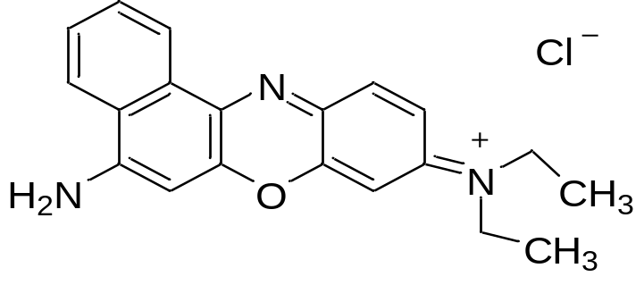
Figure 2. Structure of Nile Blue Chloride (NBC).

1.6 Polymer Thin Films
1.6.1 Properties and Development of Optical Sensors
There are various methods of coating polymer thin films on substrates to be used as optical sensors. The main methods are spin-coating, drop-coating, or dip-coating to obtain thin films. Spin coating is the preferred method for obtaining uniform thin films on flat substrates.⁵⁷⁻⁵⁹ This is accomplished by rotating the substrate at a specific angular velocity to spread the polymer solution through centrifugal force.⁵⁷⁻⁵⁹ Spin coating also allows for evaporation of volatile solvents from polymer solutions, which can create voids in the structure.⁵⁷⁻⁵⁹

1.6.2 Ethyl Cellulose (EC)
Ethyl cellulose is a natural and thermoplastic polymer produced from cellulose, which is the most abundant polymer on the Earth.⁶⁰⁻⁶² Cellulose is extracted from plant material, such as wood, cotton, or hemp.⁶⁰⁻⁶² It is converted to alkali cellulose and reacted with ethyl chloride to yield EC.⁶⁰⁻⁶² Since it is a natural polymer, the properties of EC, such as viscosity and ethoxyl content, vary between samples. EC used in the developed optical sensors has an ethoxyl content of about 50%, which means that half of the R groups are ethyl (CH₂CH₃) groups and the other half are hydroxide (OH) groups. The viscosity of the EC polymer used in this research was around 100 cP, but other viscosities and ethoxyl contents were also explored specifically in the sensors to detect ethanol.

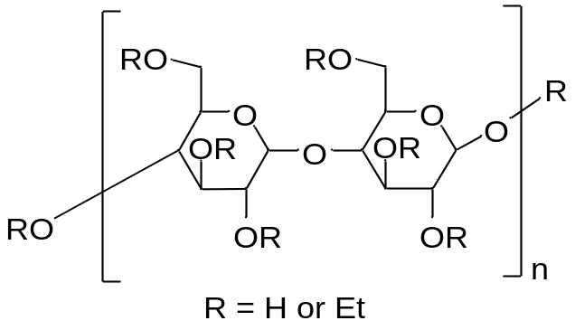
Figure 3. Structure of ethyl cellulose (EC).
1.6.3 Poly(methyl methacrylate) (PMMA)
Poly(methyl methacrylate) is an amorphous synthetic thermoplastic polymer. It is easily produced through free radical polymerization of the monomer, methyl methacrylate.⁵⁷ It is a transparent acrylic glass, most commonly known as plexiglass. It possesses a high glass transition temperature of 105°C, indicating little free volume within the linear structure of the polymer.⁵⁷ PMMA has good impact strength, weatherability, and mechanical properties.⁵⁷ It also has great optical properties such as high transparency, high light transmission, and high scratch resistance, which makes it a good candidate in optical sensors.⁵⁷ It has various uses and is commonly found in display signs, electronics, automotive parts, and lenses.

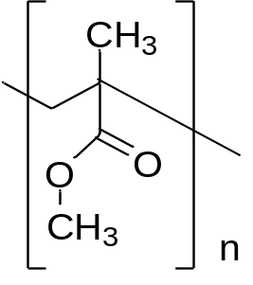

Figure 4. Structure of poly(methyl methacrylate) (PMMA).

1.6.4 Poly(acrylonitrile-co-butadiene) (PAB)
Poly(acrylonitrile-co-butadiene) is a synthetic co-polymer consisting of acrylonitrile and butadiene polymer units. Properties of PAB vary depending on the percentage of acrylonitrile in the polymer sample. The PAB sample used in the research to develop optical sensors has an acrylonitrile content of 38%. It is commonly known as Buna N rubber, and it has many uses including in nitrile gloves, footwear, and O-rings.⁵⁷ It possesses lots of free volume within the structure due to a low glass transition temperature of -30.0 °C.^{41,57} It is also an elastomer that is resistant to oil and petroleum solvents.⁵⁷ This particular polymer, PAB, possesses ideal properties for detecting phenol in a thin film, such as low compactness and a polar cyano functional group that attracts phenols.⁴¹

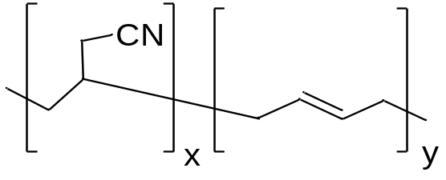
Figure 5. Structure of poly(acrylonitrile-co-butadiene) (PAB).

1.7 Ultraviolet-Visible Absorption Spectroscopy
Ultraviolet-visible absorption spectroscopy (UV-visible) has been employed to analyze the optical sensors developed in this thesis. It operates by allowing incident radiation from a light source to pass through the sample, which absorbs some of the radiated light.⁶³⁻⁶⁴ Upon absorption, energy is transferred to the sample, which allows for an electronic transition from the ground state to the excited state of the absorbing species.⁶³⁻⁶⁴ The energy transferred corresponds to the difference in energy between the ground state and excited state of the molecule. The energy transferred comprises of three different types of energy, which are vibrational, rotational, and electronic energy.⁶³⁻⁶⁴ An absorption band in a spectrum corresponds to the energy of the molecule upon absorption at a specific wavelength.⁶³⁻⁶⁴ This absorption band is typically observed as one smooth peak due to various rotational levels within each vibrational state.⁶³⁻⁶⁴

The fraction of light that passes through the sample is analyzed through Eq. 1.1 to determine the absorbance of light of the molecule.⁶³⁻⁶⁴ In Eq. 1.1, A is the absorbance, T is transmittance of light, I₀ is incident radiation, and I is the radiation after passing through the sample. Beer’s law, Eq. 1.2, details that absorbance of light is directly proportional to the concentration of the absorbing species, or analyte.⁶³⁻⁶⁴ In Eq. 1.2 ε is molar absorptivity (M⁻¹ cm⁻¹), b is the path length of the cuvette (cm), and c is the concentration of the analyte (M).⁶³⁻⁶⁴

A = -log T= log (I₀/I) Eq. 1.1
A = ε b c Eq. 1.2

The use of UV-visible spectroscopy enables analysis of optical sensors exposed to varying concentrations of the target analytes. Through use of Beer’s law, the absorbance obtained from the UV-visible spectrometer was graphed against the concentration of the analyte to obtain a calibration plot. Valuable information was gathered from the calibration plots with error bars, which details the variability of collected data. Specifically, figures of merit such as sensitivity, limits of detection, and limits of quantification were determined through calibration plots containing error bars.

1.8 Overview of Thesis
This research describes the preparation and use of optical sensors to detect phenol and ethanol in aviation fuels and cellulosic biofuels. The optical sensors use a solvatochromic dye, NBC, embedded in a polymer matrix, which is then spin-cast into a thin film on a glass substrate. The polymers tested are ethyl cellulose (EC), poly(methyl methacrylate) (PMMA), poly(acrylonitrile-co-butadiene) (PAB), and polymer blends containing PAB. The optimized optical sensor for phenol detection utilizes a 85:15 wt% blend of PAB and polystyrene (PS), respectively, in the polymer thin film. Preliminary studies of the sensors for ethanol detection have been conducted. However, the optical sensor has not been optimized for ethanol analysis.

To make the sensors, a polymer is dissolved in tetrahydrofuran (THF) to create a matrix, mixed with a solvatochromic dye, NBC, and spin-cast into a thin film. The optical sensor changes color from purple to blue upon exposure to phenol or ethanol, exhibiting a bathrochromic shift as the solvent polarity increases. Figure 6 displays a schematic detailing how the optical sensors detect phenols. This can also be applied to the detection of ethanol, by replacing the phenol molecules in the schematic with ethanol molecules. NBC molecules are originally surrounded by THF molecules.¹³ Upon exposure to phenol or ethanol, the analyte molecules replace the THF molecules, which is visualized by a color change from purple to blue.

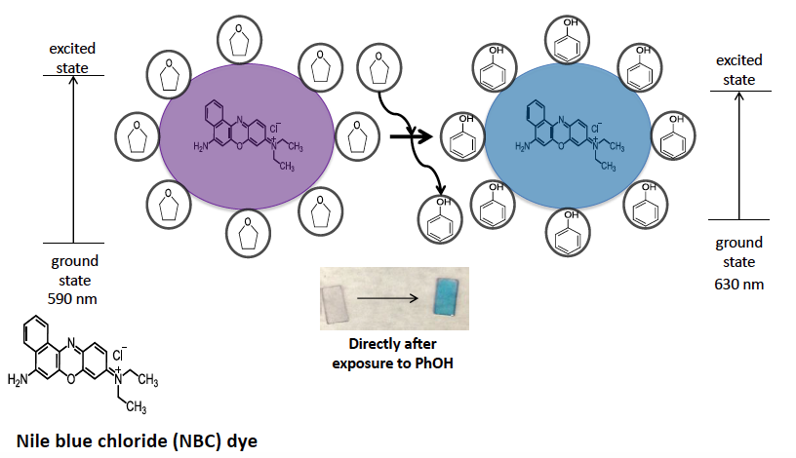
Figure 6. Schematic detailing how the optical sensors detect phenol.

Ideally, the optical sensing method described is capable of detecting phenol and ethanol in fuel samples using a portable UV-visible spectrometer. The developed optical sensor would provide an opportunity for on-site detection and quantification of phenol in cellulosic biofuel and aviation fuel, as well as ethanol in gasoline. Traditional methods to detect phenol and ethanol in fuels requires bulky, expensive, and complicated instrumentation, which involves off-site analysis in a laboratory. The optical sensors in this research provide capabilities for on-site analysis, as well as relatively inexpensive and simple instrumentation.

II. Experimental Methods and Instrumentation

2.1 Materials and Instrumentation
Ethyl cellulose (EC, 49% ethoxy content) was purchased from MP Biomedicals and poly(methyl methacrylate) (PMMA) was purchased from Sigma Aldrich. Polystyrene (PS) and poly(acrylonitrile-co-butadiene) (PAB, 38% acrylonitrile content) were purchased from Scientific Polymer Products. Phenol, 4-ethylphenol, p-cresol, 2,4,6-trimethylphenol, and 2,4-ditert-butylphenol were all purchased from Acros Organics. Nile Blue Chloride (NBC, 85%) was purchased from Sigma Aldrich. Tetrahydrofuran (THF) was purchased from Fisher Scientific. Microscope slides, purchased from Fisher Scientific, were cut, cleaned with Kimwipes, and used as glass substrates. E10 gasoline was purchased on April 30th, 2015, from Sunoco gas station on Ebenezer Road, Knoxville, Tennessee. Anhydrous 200 proof ethanol (EtOH, 99.9%) was purchased from Decon Laboratories.

A Branson 2510 sonicator was used to dissolve the polymers in THF to create polymer matrices. A custom-made spin coater was used to coat the glass slides with the polymer and dye solution. An Agilent 8453 UV-Visible spectrometer was used to analyze the sensors by their absorbance spectra. The spectrometer uses two light sources, a deuterium and tungsten lamp. Two quartz cuvettes, one with a 1 mm and the other with a 1 cm pathlength, were used to hold the sensor upright while acquiring spectra from the UV-visible spectrometer.

2.2 Preparation of Optical Sensors and Solutions
2.2.1 Optical Sensors
In general, all sensors were prepared by dissolving a polymer in THF. This was accomplished through sonication for several hours to create a polymer solution, which was then mixed with NBC. The polymer solution was mixed with the dye and stirred for several hours and then spin-cast onto a glass substrate. Depending on the specific polymer, the preparation varied slightly.

Optical sensors made with EC were prepared by dissolving 0.86 g of EC in THF through sonication. The resulting matrix was mixed with NBC by the following formulation: 2.0 g of polymer solution and 3.5 mg of NBC. Then, 65 μL of the resulting solution was spin-coated on a 1cm x 2 cm glass substrate. Sensors made with PMMA were prepared similarly, with the exception of using 6.5 mg of NBC.

Optical sensors made with PAB were prepared by dissolving 0.575 g of PAB in THF through sonication. The resulting solution was mixed with NBC by the following formulation: 2 g of polymer solution and 6.5 mg of NBC. Then, 65 μL of the resulting solution was spin-coated on a 1 cm x 1 cm glass substrate.

Optical sensors made with a blend of PAB and PS were prepared in a variety of blend percentages, including 95:5, 90:10, 85:15 wt%, respectively. The optimized polymer blend of 85:15 wt% was prepared by dissolving 0.48875 g of PAB and 0.08625 g of PS in 10 mL of THF. The steps following sonication were prepared exactly as the sensors made with PAB only.

A glass substrate was secured onto a custom-made spin coater with double-sided tape. The dimensions of the glass substrates were 1 x 2 cm with EC and PMMA sensors. The dimensions were later reduced to 1 cm x 1 cm glass substrates for PMMA, PAB, and PAB blend sensors. Then, 65 μL of the polymer and dye solution was pipetted on the glass slide and spin-coated at 3280 rpm for 30 seconds. The substrate was then removed from the spin coater and ready for exposure. However, one additional preparation step is needed with the PAB blended with PS. After the preparation, the PAB-PS blend sensors were immersed into cyclohexane for several minutes to selectively extract PS from the film.

Table 1. Preparation of polymer solutions by dissolution in THF
Polymer Thin Film | Mass of Polymer (g) | Amount of THF (mL)
EC | 0.860 | 15
PMMA | 0.860 | 10
PAB | 0.575 | 10

Table 2. Preparation of polymer blends by dissolution in THF
Blend Ratio of PAB:PS (wt%) | Mass of PAB (g) | Mass of PS (g)
95:5 | 0.54625 | 0.02875
90:10 | 0.51750 | 0.05750
85:15 | 0.48875 | 0.08625

2.2.2 Phenol Solutions
Fuel-containing phenol solutions were prepared by mixing various concentrations of phenol with kerosene in 20 mL sample volumes. The phenol concentrations were obtained by performing serial dilutions from 30,000 ppm (v/v) phenol stock solutions, detailed in Table 3. The preparation of phenol solutions, displayed in Table 4, details solutions prepared with unsubstituted phenol only and solutions prepared with a mixture of alkyl-substituted phenols. The resulting solutions tested ranges from 25 ppm to 30,000 ppm phenol in kerosene to obtain 20 mL sample volumes. As focus was shifted to lower phenol concentrations, 10,000 ppm (m/m) stock solutions of phenol, displayed in Table 5, were used in serial dilutions in kerosene to obtain 20 mL sample volumes. The preparation of phenol solutions, displayed in Table 6, details solutions prepared with unsubstituted phenol only and solutions prepared with a mixture of alkyl-substituted phenols.

A mixture of different alkyl-substituted phenols was also prepared, using phenol, p-cresol, 4-ethylphenol, 2,4,6-trimethylphenol, and 2,4-ditertbutylphenol. These solutions were prepared by initially making a 30,000 ppm stock solution for each individual phenolic compound. Serial dilutions were then performed to dilute and mix the different alkyl-substituted phenols. Table 4 details the preparation of these phenol solutions containing five alkyl-substituted phenols from 30,000 ppm stock solutions, ignoring the amount of phenol column, which was used when preparing solutions of unsubstituted phenol only. As focus was shifted towards lower concentrations of phenols, 10,000 ppm stock solutions were prepared for each phenol. The stock solutions were then used in serial dilutions in kerosene to obtain 20 mL sample volumes. Table 6 details the preparation of the phenol solutions containing five different alkyl-substituted phenols from 10,000 ppm stock solutions, ignoring the amount of phenol column, which is used when preparing solutions of the unsubstituted phenol only.

Table 3. Phenolic stock solutions [3% (v/v)] prepared in 100 mL kerosene
Phenolic Compound | Mass Weighed for a 3% (v/v) Stock Solution (g)
Phenol | 3.213
P-cresol | 3.102
4-Ethylphenol | 3.033
2,4,6-Trimethylphenol | 3.139
2,4-Ditertbutylphenol | 2.662

Table 4. Serial dilutions from 3% (v/v) stock solutions to obtain 20 mL sample volumes
Concentration of phenol (ppm) | Amount of phenol (mL) | Amount of each phenolic compound (mL) | Amount of kerosene (mL)
30,000 | 20.00 | 4.000 | 0
25,000 | 16.66 | 3.333 | 3.333
20,000 | 13.33 | 2.666 | 6.666
15,000 | 10.00 | 2.000 | 10.00
10,000 | 6.666 | 1.333 | 13.33
5,000 | 3.333 | 0.666 | 16.66
3,000 | 2.000 | 0.400 | 18.00
2,500 | 1.666 | 0.333 | 18.33
1,000 | 0.666 | 0.133 | 19.33
500 | 0.333 | 0.066 | 19.66

Table 5. Phenolic stock solutions [1% (m/m)] prepared in 100 mL kerosene
Phenolic Compound | Mass Weighed for a 1% (m/m) Stock Solution (g)
Phenol | 0.787
P-cresol | 0.787
4-Ethylphenol | 0.787
2,4,6-Trimethylphenol | 0.787
2,4-Ditertbutylphenol | 0.787

Table 6. Serial dilutions from 1% (m/m) stock solutions to obtain 20 mL sample volumes
Concentration of phenol (ppm) | Amount of phenol (mL) | Amount of each phenolic compound (mL) | Amount of kerosene (mL)
5,000 | 10.00 | 2.00 | 10.00
3,000 | 6.000 | 1.200 | 14.00
1,000 | 2.000 | 0.400 | 18.00
850 | 1.700 | 0.340 | 18.30
700 | 1.400 | 0.280 | 18.60
550 | 1.100 | 0.220 | 18.90
500 | 1.000 | 0.200 | 19.00
400 | 0.800 | 0.160 | 19.20
250 | 0.500 | 0.100 | 19.50
100 | 0.200 | 0.040 | 19.80

2.2.3 Ethanol Solutions
Ethanol solutions were prepared through standard addition of anhydrous ethanol to E10 gasoline. The exact percentage of ethanol in E10 gasoline is uncertain, and is advertised as containing up to 10% ethanol. Therefore, it was assumed that the gasoline contained roughly 10% ethanol by volume. The sample that contained 10% ethanol by volume was purely E10 gasoline and had no additional anhydrous ethanol. The other samples were prepared through standard addition of small amounts of anhydrous ethanol in E10 gasoline to obtain roughly 10 mL sample volumes for each solution. This involved using 10 mL of E10 in each ethanol solution and adding a small amount of ethanol to obtain varying percentages of ethanol in gasoline, as detailed in Table 7.

Table 7. Standard addition with anhydrous ethanol to E10 gasoline to obtain 10 mL sample volumes
% Ethanol in Solutions | E10 (mL) | Ethanol Added (μL)
10.0 | 10 | 0
10.5 | 10 | 50
11.0 | 10 | 100
11.5 | 10 | 150
12.0 | 10 | 200
12.5 | 10 | 250

2.2.4 Exposure of Sensors to Solutions
For phenol analysis, optical sensors were immersed for 1 hour into solutions of kerosene as a reference and kerosene solutions containing phenol. Stir bars placed in the vials containing the solutions allowed stirring to take place during exposure. After exposure, all sensors were removed from the solutions and placed onto weighing paper until analysis. For sensors made with EC and PMMA thin films, the sensors were allowed to dry before analysis with the UV-visible spectrometer. Sensors made with PAB and PAB blends were analyzed with the UV-visible spectrometer in solution and immediately after exposure.

For ethanol analysis, an unexposed sensor was used as the reference. Sensors exposed to ethanol in E10 solutions were immersed for 1 hour. After exposure, the sensors were removed from the solutions and placed on weighing paper until dried. Once the sensors were dry, the films were analyzed by UV-Visible spectroscopy.

2.3 Analysis of Sensors
2.3.1 UV-Visible Spectroscopic Analysis
Spectra were collected for each sensor by use of the Agilent UV-visible spectrometer. First, a reference was established by using a sensor that had been exposed to kerosene only for phenol analysis or unexposed for ethanol analysis. This was accomplished by placing the reference sensor in a cuvette with the thin film on the sensor facing forward. This procedure was repeated for sensors that had been exposed to kerosene solutions containing phenol to create a calibration curve. The sensors were placed in the cuvette and spectra were collected using the UV-visible spectrometer. This was repeated each time the concentration of phenol in kerosene was increased. Spectra were collected at four different regions on each sensor and averaged in order to get a representative spectrum for each sensor. Sensors made with EC and PMMA thin films were analyzed with quartz cuvette with a 1 mm path length. Sensors made with PAB were analyzed in solution using a quartz cuvette with a 1 cm path length. In the latter case, the sensor was placed upright in the quartz cuvette and then 1.6 mL of the kerosene solution was pipetted into the cuvette. The cuvette was then placed in a cuvette holder and secured in the UV-visible spectrometer so that the laser light could pass directly through the sensor.

2.3.2 Data Processing
After data was collected by the UV-visible spectrometer, analysis was conducted using a variety of graphing softwares. Excel was used to average the four spectra obtained from each optical sensor. Once an average spectrum was collected for each sensor, Origin software was utilized to obtain a baseline-corrected spectrum. The baseline-corrected spectrum was then plotted and analyzed to obtain the absorbance reading for each sensor. Calibration curves were plotted for each trial to determine trends in the collected data. The processed data, including final spectra and calibration plots, were graphed using Sigma Plot software.

III. Results and Discussion

3.1 Analysis of Phenol
3.1.1 Sensors Made with Ethyl Cellulose (EC)
The first optical sensors tested were made with EC thin films to test phenol concentrations ranging from 500 to 40,000 ppm. As the phenol concentration increased, the intensity of the blue color and absorbance value at the maximum wavelength of 640 nm also increased. The sensors made with EC worked well at high concentrations of phenol. Sensors that were exposed to 2,000 ppm phenol and above appeared visually blue and able to be analyzed by the UV-visible spectrometer. However, this sensor was not able to detect phenol below 2,000 ppm, visually or spectroscopically. Figure 7 displays the visual response of the sensors when exposed to kerosene only and 30,000 ppm phenol, respectively. Figure 8 displays spectra and calibration obtained from exposing the sensors to varying phenol concentrations. This sensor was also tested for its ability to detect five different alkyl-substituted phenols in kerosene, which responds similarly to the detection of phenol alone. The results suggest that phenol was the only phenolic compound in the mixture that preferentially entered the film.

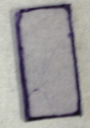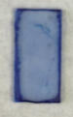
Figure 7. Sensors made with EC. (Left) Exposed to kerosene only. (Right) Exposed to 30,000 ppm (v/v) phenol.

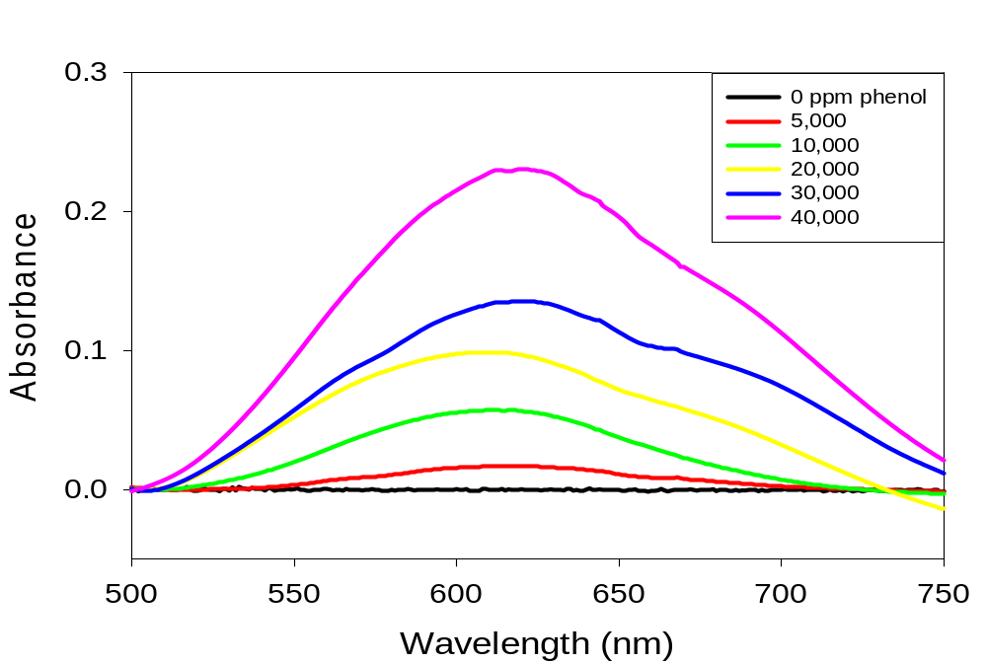
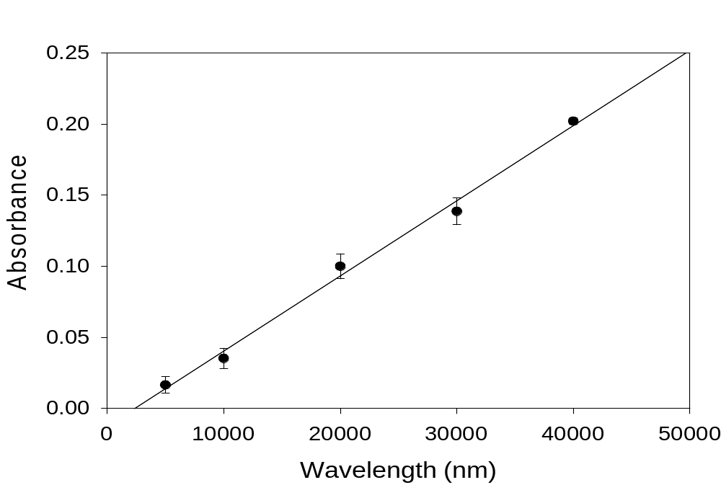

Figure 8. (Top) Spectra for sensors made with EC exposed to 0-40,000 ppm (v/v) phenol (λ_{max} = 640 nm). (Bottom) Calibration plot showing the line of best fit with
R² = 0.994.
3.1.2 Sensors Made with Poly(methyl methacrylate) (PMMA)
Other optical sensors for phenol analysis used PMMA thin films and tested phenol concentrations ranging from 500 to 30,000 ppm. As the concentration of phenol increased, the intensity of the blue color and absorbance value at the maximum wavelength of 630 nm also increased. The PMMA-based sensors proved to have higher sensitivity than the sensors made from EC thin films and worked well at high concentrations of phenol. This enabled the detection of 1,500 ppm phenol and above. However these sensors were not able to detect phenol below 1,500 ppm, visually or spectroscopically. Figure 9 shows the response of the sensors when exposed to kerosene only and 30,000 ppm phenol. Figure 10 displays spectra and calibration acquired from exposing sensors to varying phenol concentrations. The sensors made with PMMA were also tested for their ability to detect five different alkyl-substituted phenols in kerosene, which responded similarly to the detection of phenol alone. This suggests that phenol was the only phenolic compound in the mixture that preferentially entered the film.

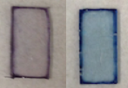
Figure 9. Sensors made with PMMA. (Left) Exposed to kerosene only. (Right) Exposed to 30,000 ppm (v/v) phenol.

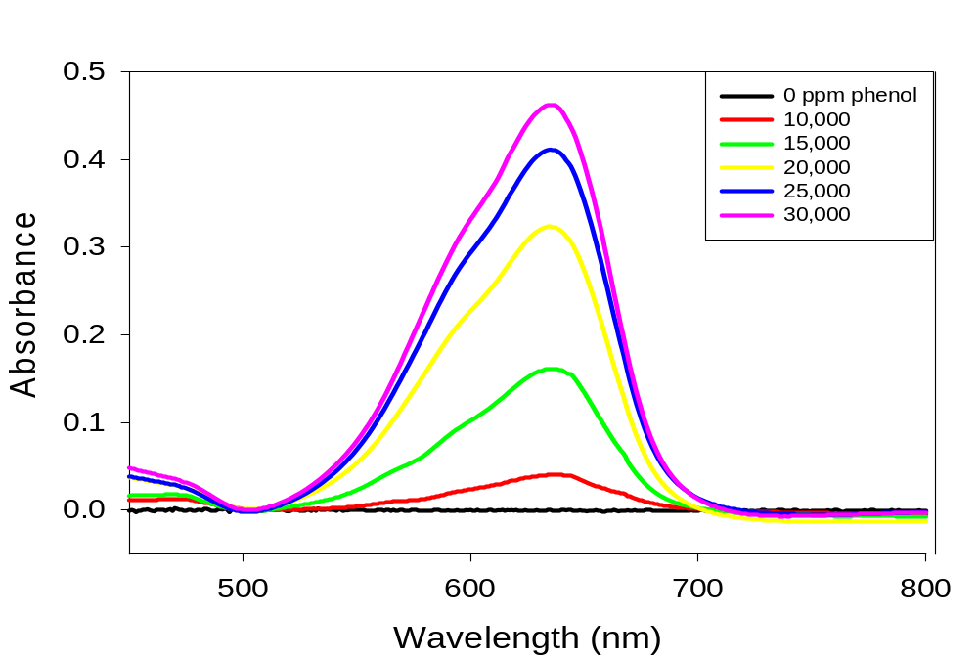
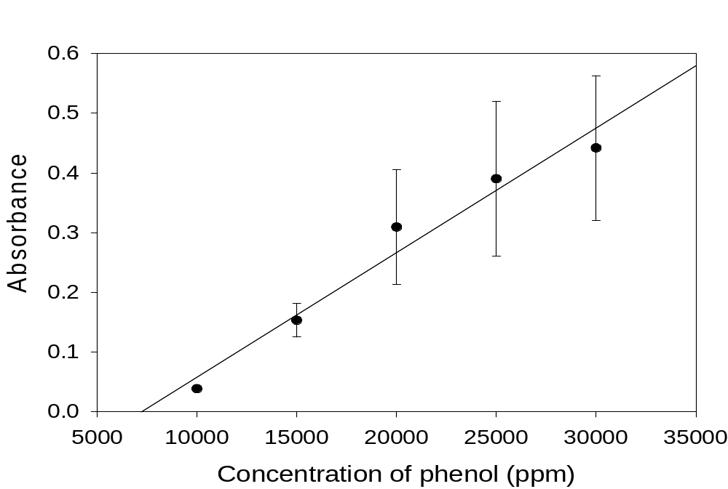

Figure 10. (Top) Spectra for sensors made with PMMA exposed to 0-30,000 ppm (v/v) phenol (λ_{max} = 630 nm). (Bottom) Calibration plot showing the line of best fit with R² = 0.966.
3.1.3 Sensors Made with Poly(acrylonitrile-co-butadiene) (PAB)
Sensors prepared from PAB thin films provide much higher sensitivity than sensors prepared from EC or PMMA films. These sensors responded to phenol concentrations ranging from 100 to 4,000 ppm. As the concentration of phenol increased, the absorbance peak at the maximum wavelength of 640 nm and color intensity also increased. These sensors allowed for the detection and quantification of phenol below 1,000 ppm. They did not visually display an intense blue color below 1,000 ppm phenol. However, the UV-visible spectrometer was able to detect a peak responding to concentrations below 1,000 ppm phenol. Figure 11 shows the color change of the sensors upon exposure to 10,000 ppm phenol. These sensors were not able to detect phenol below 100 ppm.

Exposure time was increased and the sensors were immersed in the solution overnight, about 17 hours, to observe changes in sensitivity with longer exposure times. Figure 12 displays spectra obtained from a trial where sensors were exposed overnight. All other trials were completed with exposure time of one hour. A calibration plot was obtained for a quadruplicate trial, seen in Figure 13, containing error bars that enabled the calculation of limits of detection and quantification of 112 ppm and 374 ppm, respectively. Figure 14 displays a calibration plot obtained from a triplicate trial. The calibration plot displays nonlinear behavior, due to experimental error during the exposure and analysis. Error bars were calculated, which also enabled the calculation of limits of detection and quantification of 142 ppm and 474 ppm, respectively.

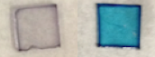
Figure 11. Sensors made with PAB. (Left) Exposed to kerosene only. (Right) Exposed to 10,000 ppm (v/v) phenol.
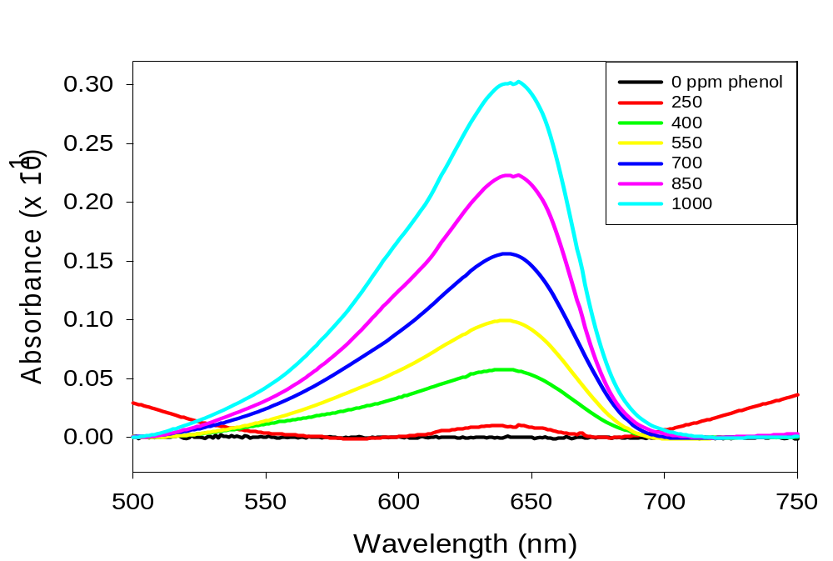
Figure 12. Spectra of sensors made with PAB exposed overnight to 0-1000 ppm (v/v) phenol (λ_{max} 640 = nm).

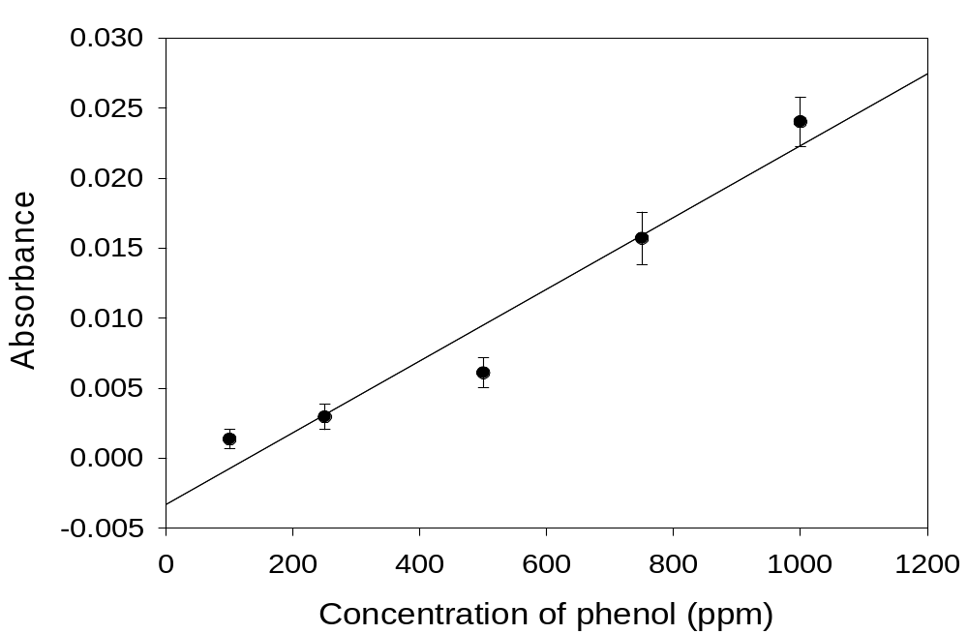
Figure 13. Calibration plot from a quadruplicate trial with one-hour exposure. Line of best fit yields R² = 0.949.

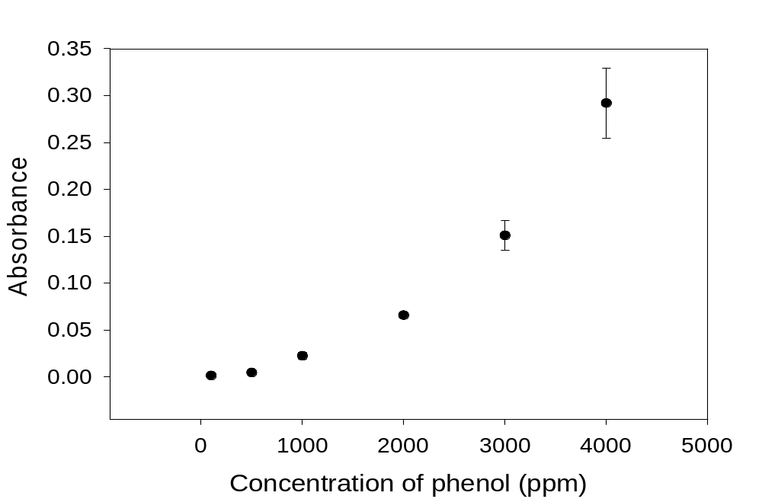
Figure 14. Calibration plot from a triplicate trial with one-hour exposure.
3.1.4 Sensors Made with Poly(acrylonitrile-co-butadiene) (PAB) Blended with Polystyrene (PS)
The optimized optical sensors developed in this section are produced from a polymer blend of PAB and PS at 85:15 wt% ratio, respectively. The polymer-blend-based sensor tested phenol concentrations in kerosene ranging from 25 to 5,000 ppm. Spectra acquired from the UV-visible spectrometer, displayed in Figure 15, showed that as the concentration of phenol increased, the absorbance at the maximum wavelength of 640 nm also increased. This polymer blend enabled the detection of a small peak for 100 ppm phenol, shown in Figure 16, which is a zoomed-in image of the spectra in Figure 15. The peak is broad and not high above the background, indicating a low signal-to-noise ratio, but it was the first time a 100 ppm phenol peak was observable. Figure 17 displays a calibration plot from the spectra obtained, which details a linear relationship between increasing phenol concentrations and absorbance values.
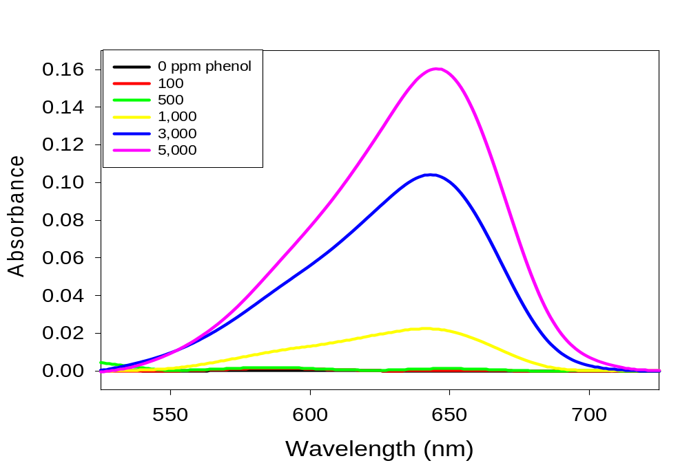
Figure 15. Spectra of sensors made with PAB/PS (85:15 wt%) exposed to 0-5,000 ppm phenol (λ_{max} 640 = nm).

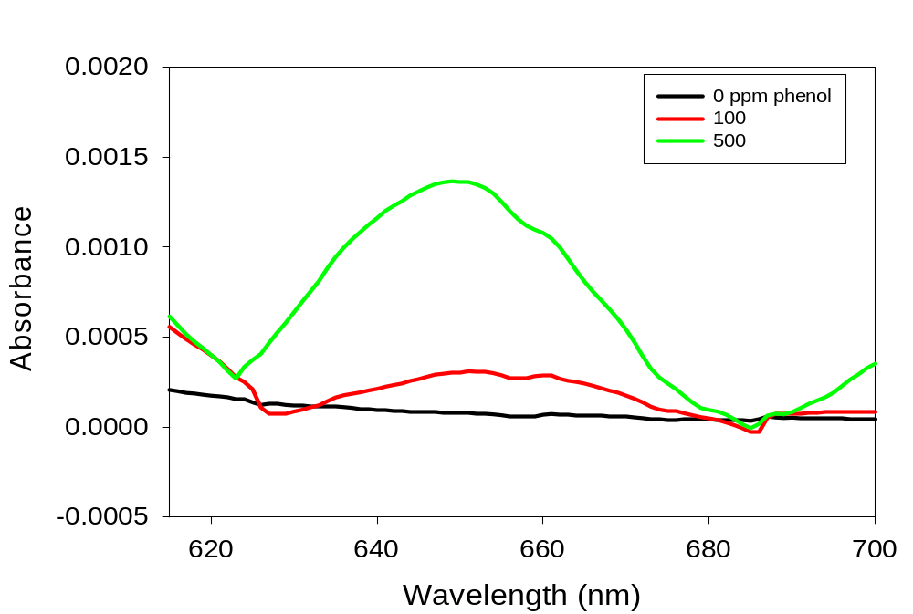
Figure 16. Zoomed-in spectra of low concentrations of phenol, 100 and 500 ppm.

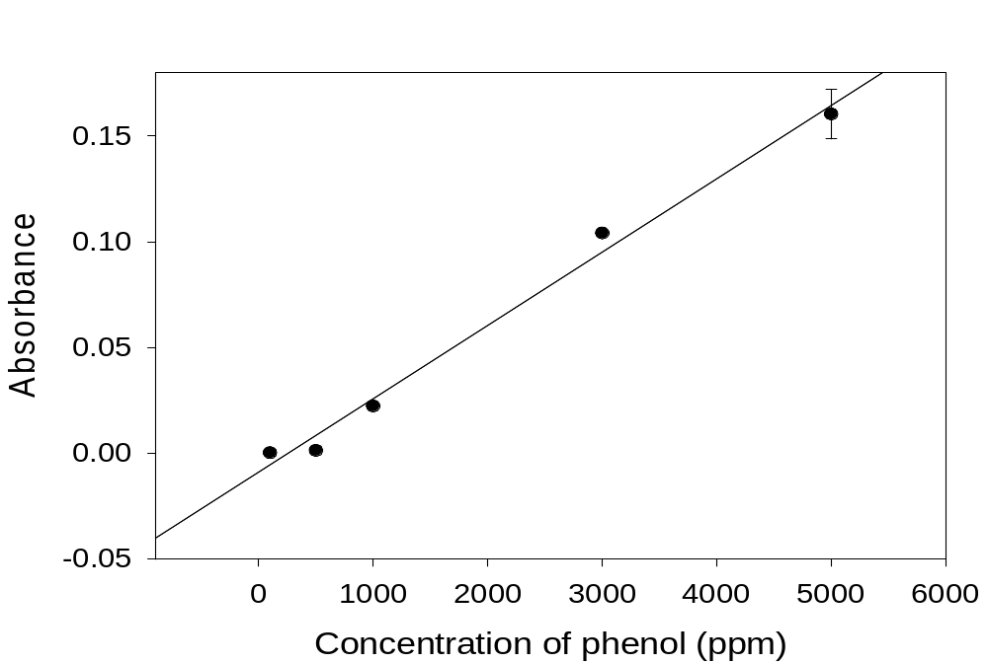
Figure 17. Calibration plot for spectra displayed in Figure 15 showing the line of best fit with R² = 0.991.
3.1.5 Discussion on Phenol Analysis
The first optical sensors detailed in this research were made with EC thin films containing NBC dye to detect phenol. These sensors performed best with high phenol concentrations, ranging from 1,000 to 40,000 ppm (v/v). However, these sensors did not perform well at low concentrations of phenol. This could be due to the ~50% ethoxyl content of the commercial EC sample, indicating the other half of the R groups are hydroxide (OH) groups. The hydroxide groups present in the polymer may interfere with the detection of the hydroxide group on phenol, leading to decreased sensitivity in analyzing low concentrations of phenol.

Other polymers were then studied, which led to testing PMMA-based optical sensors. Optical sensors made with PMMA thin films also operated well at high concentrations of phenol ranging from 1,000 to 30,000 ppm (v/v). These sensors provided better sensitivity than the EC sensors, but were not capable of detecting low concentrations of phenol.

Other polymers were then investigated, which led to testing PAB-based optical sensors. The optical sensors made with PAB provided much higher sensitivity than sensors made with EC and PMMA. The enhanced sensitivity can be attributed to the increased free volume in the polymer compared to the other polymers tested. PAB has more free volume due to its low glass transition temperature, and it also possesses a polar cyano group. Due to these properties, phenol molecules are allowed to enter the film with more ease. These sensors turned bright blue upon exposure to phenol solutions. However, the bright blue color faded after the sensors were allowed to dry, suggesting the evaporation of phenol from the film. Therefore, analysis of the sensors with the UV-visible spectrometer was conducted in solution in order to prevent the fading of the blue color. Optical sensors made with PAB operated well at low concentrations of phenol ranging from 250 to 4,000 ppm (v/v). Overnight exposure enabled lower detection of phenol, due to more time for phenol to diffuse into the sensors. However, overnight exposure was impractical for the on-site application of the sensors, so exposure times of one hour continued to be the focus.

Polymer blends with PAB were then explored in order to further increase the sensitivity and analyze phenol at even lower concentrations. The idea for the exploration of polymer blends was prompted by the fact that the films may achieve increased porosity, which would allow for phenol to more easily enter the film. Several polymer blends with PAB were tested, including polyvinyl chloride (PVC), polyethylene oxide (PEO), and PS. PAB blended with PS performed the best among the polymer blends tested. Several blend ratios of PAB and PS also were tested, including 95:5 wt%, 90:10 wt%, 85:15 wt%, respectively. The blend with PS operates on the principle of selectively extracting PS out of the film with cyclohexane. Once PS is extracted, there are voids in the film, which lowers the kinetic barrier, allowing phenol to more easily enter the film and access the dye molecules. The 85:15 wt% blend ratio of PAB and PS was found to perform the best, which can be attributed to a larger amount of PS present in the matrix than in the other blend ratios. A larger percentage of PS increases the total entropy of the optical sensor system and also allows for larger and more numerous voids upon selective extraction with cyclohexane. The increased entropy, or randomness, of the system provides a higher drive for phenol to diffuse into the film.

Changing the polymer thin film composition of the optical sensors was investigated in order to obtain sensors with better sensitivity in phenol analysis. Several measures that altered the preparation and exposure of the optical sensors were also explored in hopes of enhancing the sensitivity. This included increasing the dye content from 3.5 mg to 6.5 mg NBC to provide more dye molecules for phenol molecules to surround, and thus increase the sensitivity. However, the increase in dye content did not show a significant difference in sensitivity of the optical sensors. In addition, the glass substrate size was changed from 1 cm x 2 cm to 1 cm x 1 cm squares in order to provide a smaller area for the phenol molecules to concentrate on the optical sensors. Also, stir bars were placed in the solutions and stirring took place during exposure of the sensors to the phenol solutions. This step was added in order to increase the movement and probability of the phenol molecules to easily access the NBC molecules in the sensors.

The optimized optical sensors prepared from EC, PMMA, PAB, and PAB blended with PS were able to detect the unsubstituted phenol molecule. Unsubstituted phenol was used as a representative compound for the target compound class of phenolic compounds in fuels. These optical sensors were also tested in their ability to analyze a mixture of five phenolic compounds, including phenol, p-cresol, 4-ethylphenol, 2,4-ditertbutylphenol, and 3,5-dimethylphenol. The optical sensors responded to mixtures of phenolic compounds, however with a significant decrease in sensitivity. It was later determined upon exposure of the optical sensors to 10,000 ppm of each individual phenolic compound, that the sensors were primarily responding to the unsubstituted phenol. These tests were conducted by a preliminary visual response by the naked eye from spot tests of the different alkyl-phenol stock solutions onto individual sensors. The sensor exposed to the unsubstituted phenol immediately color changed from purple to bright blue upon exposure. However, the sensors exposed to the other phenolic compounds did not immediately change color, indicating a slower response. After several hours, the sensor exposed to p-cresol changed color from purple to a very light blue as judged by the naked eye, indicating a small response to p-cresol. After several hours, the sensors exposed to 4-ethylphenol, 2,4-ditertbutyl-phenol, and 3,5-dimethylphenol did not exhibit any visual color change from purple to blue by the naked eye.

3.2 Ethanol Analysis
3.2.1 Polymers Tested
The detection of ethanol through use of the optical sensors has been studied. Many polymer thin films were tested in their ability to detect ethanol in gasoline. These polymers included PAB, PAB blended with PS at 95:5 wt% and 85:15 wt%, PAB blended with polyvinyl chloride (PVC) 85:15 wt%, PMMA, and many EC samples. However, many of the optical sensors did not provide a distinct color change from purple to blue upon exposure to ethanol. The sensors that did not provide much color change in E10 were PAB/PS, and PAB/PVC. Focus was shifted to sensors that displayed some color change, which included PAB, PMMA, and EC. Sensors made with EC provided the most distinct color change. Sensors made with PMMA provided a slight color change upon exposure to E10, but not very distinguishable. Sensors made with PAB and EC were further investigated because they provided a more distinct color change from purple to blue upon exposure to E10. The EC sample from MP Biomedicals worked well in optical sensors for the detection of ethanol in E10, providing a distinct color change from purple to blue upon exposure. However, other EC samples tested did not yield the same results. This section details the issues with EC samples and results obtained from recent tests of the optical sensors to detect ethanol in gasoline samples.

3.2.2 Tests with Different Ethyl Cellulose (EC) Samples
Sensors developed from EC thin films were determined to be the best to detect ethanol in E10 gasoline. A vibrant color change was noticeable, from purple to blue, upon exposure to gasoline containing ethanol. However, only one EC sample, the sample purchased from MP Biomedicals, worked under these conditions. The EC sample purchased from MP Biomedicals had been completely used and the company no longer carried it. Other EC samples with similar viscosities and ethoxyl contents, obtained from Ashland Chemical, Dow Chemical, TCI Chemicals, Sigma-Aldrich, and Scientific Polymer Products were also tested. However, all other EC samples dissolved in E10 samples, which allowed the dye to leach into the solution. The optical sensors that used EC from MP Biomedicals did not dissolve in E10 gasoline after several hours, while the other ethyl cellulose samples dissolved in E10 gasoline almost immediately. The EC sample that most closely resembled the sample obtained from MP Biomedicals was the sample from TCI Chemicals. The sample from TCI Chemicals took about 45 minutes to dissolve in E10, while all other EC samples dissolved completely in E10 within 5 minutes. Other optical sensors that use EC exhibited similar issues. The EC sample from MP Biomedicals was the only sample that seemed to work well in all developed optical sensors of the research group. Polymer characterization techniques, such as thermogravimetric analysis (TGA), differential scanning calorimetry (DSC), and gel permeation chromatography (GPC) were utilized to compare EC obtained from TCI Chemicals and MP Biomedicals.

3.2.3 Sensors Made with Ethyl Cellulose (EC)
Optical sensors made with EC thin films were then explored in determining the capability to detect ethanol in E10 gasoline samples. Sensors were exposed to increasing concentrations of ethanol in gasoline by spiking E10 gasoline with ethanol using the standard addition method. Figure 18 displays an unexposed sensor and a sensor exposed to E10 gasoline. These sensors tested increasing ethanol concentrations from 10% to 12% ethanol in gasoline. Visually, a distinct gradient from purple to blue was observed after exposure to solutions with increasing concentrations of ethanol. Spectroscopically, one trial displayed a nonlinear increase in absorbance at the maximum wavelength of 610 nm as the concentration of ethanol increased, seen in Figure 19. This relationship was not reproduced because the EC sample obtained from MP Biomedicals had been used.

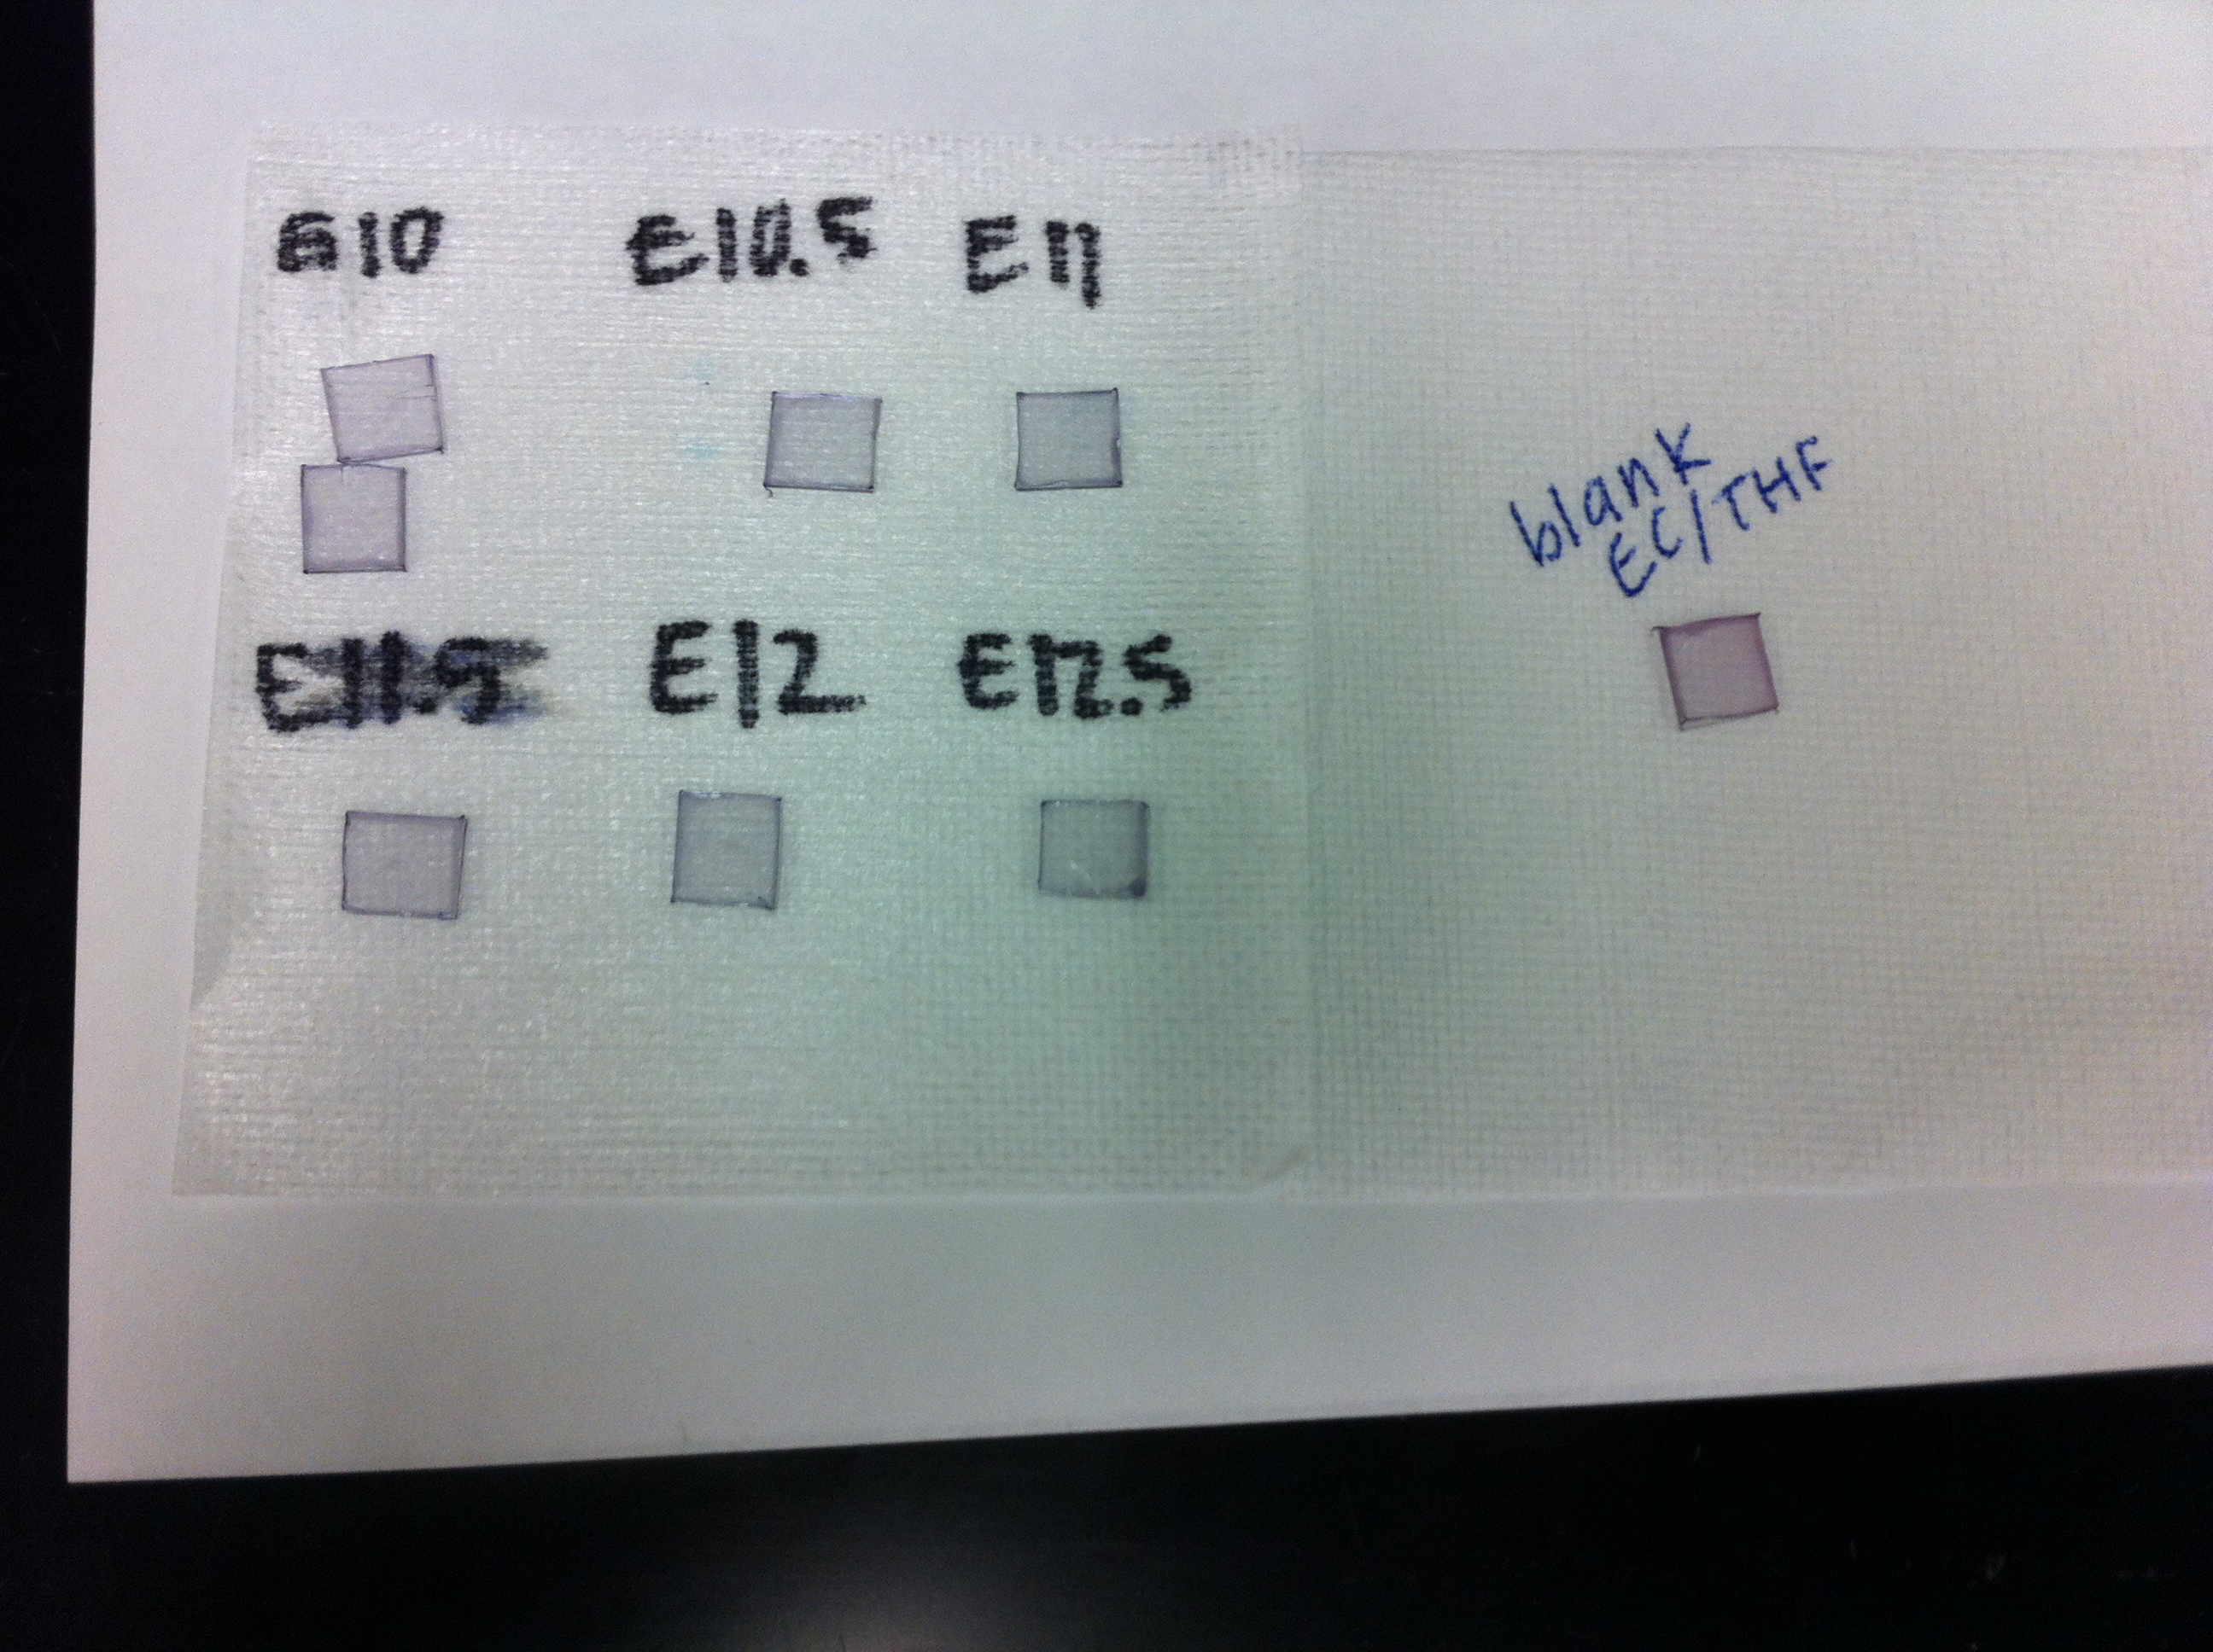
Figure 18. Sensors made with EC. (Left) Unexposed sensor. (Right) Exposed to E10 gasoline.

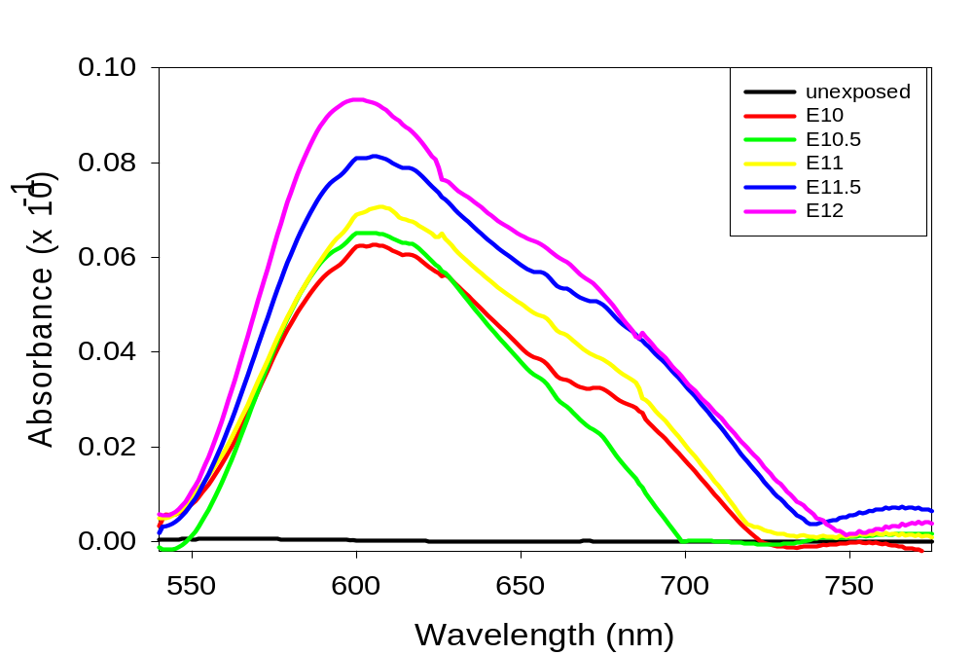
Figure 19. Sensors made with EC exposed to solutions of 10-12% ethanol in gasoline (λ_{max} 610 = nm).

3.2.4 Sensors Made with Poly(acrylonitrile-co-butadiene) (PAB)
Optical sensors made from PAB thin films were tested to analyze ethanol in E10 gasoline samples. Sensors were exposed to increasing concentrations of ethanol in gasoline by spiking E10 with ethanol through the standard addition method. Figure 20 displays an unexposed sensor and a sensor exposed to E10 gasoline. Spectra of two sensors exposed to E10 gasoline is displayed in Figure 21.These sensors tested 10% to 12% ethanol in gasoline. Visually, the optical sensors changed color from purple to blue upon exposure to increasing concentrations of ethanol, and a slight gradient in color of the sensors was observed. Spectroscopically, one trial detailed a linear relationship between increasing ethanol concentration and absorbance, shown in Figure 22. This linear relationship was only observed once and could not be reproduced. However, each trial displayed a qualitative color change from purple to blue with a slight gradient in color.
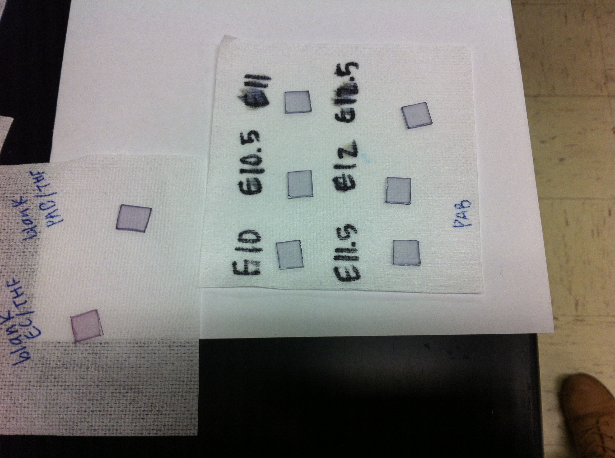
Figure 20. Sensors made with PAB. (Left) Unexposed sensor. (Right) Exposed to E10 gasoline.

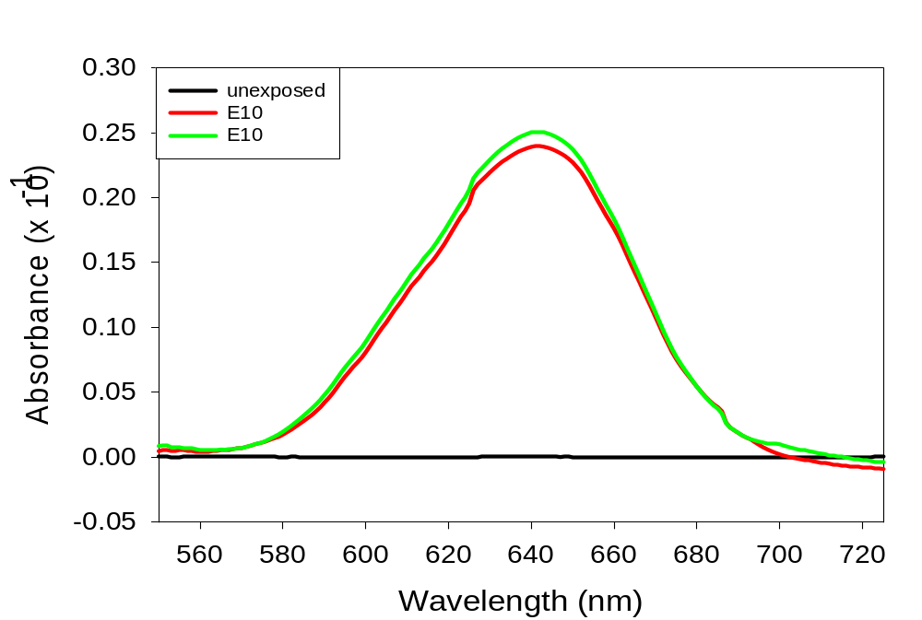
Figure 21. Spectra of sensors made with PAB exposed to E10 gasoline.

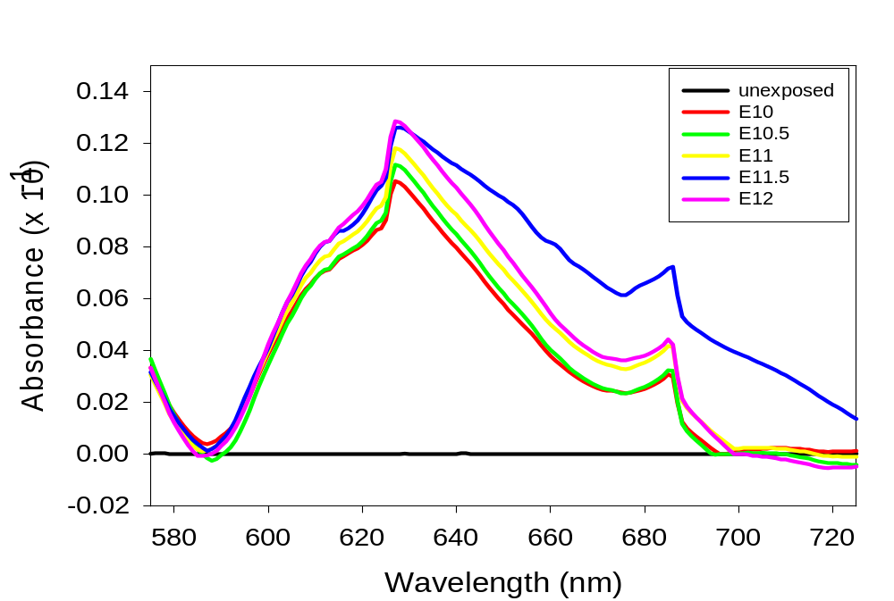
Figure 22. Spectra of sensors made with PAB exposed to solutions of 10-12% ethanol in gasoline.

3.2.5 Discussion on Ethanol Analysis
The development of optical sensors presented in this section to detect ethanol in E10 gasoline is preliminary and exploratory at this time. Research has been conducted to see if the developed optical sensors respond to ethanol, specifically in E10 gasoline samples. Many optical sensors with different polymer thin films have been tested for this investigation, such as EC, PMMA, PAB, and PAB blended with PS. Upon exposure to ethanol, each optical sensor visually displayed a color change from purple to blue. All of the polymer thin films tested dissolved upon exposure to 100% ethanol. However, upon exposure to ethanol in E10 gasoline for one hour, some of the polymer thin films dissolved and the dye leached into the solutions.

Optical sensors made with EC from MP Biomedicals did not display film dissolution or dye leaching, but all EC samples tested from other suppliers did. Polymer characterization experiments were conducted to help explain why the EC from MP Biomedicals works the best, but no clear conclusion has been found. Experiments were carried out to determine specific differences between the EC samples from MP Biomedicals and TCI Chemicals. The GPC analysis detailed the molecular weight of both samples, which was 189 x 10³ g/mol for MP Biomedicals and 209 x 10³ g/mol for TCI Chemicals. This details a significant difference in molecular weight between the two EC samples. It is believed that, since EC is a natural polymer, it often possesses different properties since it is from different sources. EC is prepared from starting materials containing cellulose, such as wood, cotton, and other plant materials. Depending on the starting materials, many different characteristics can be observed even if the viscosities and ethoxyl contents are similar.

IV. Concluding Remarks

4.1 Applications and Advantages of the Optical Sensors
Current methods to analyze alcohols in fuels, such as ethanol and phenol, are performed through a variety of instrumentations. The most common methods used are HPLC coupled with GC and MS. Other methods typically used involve MD-GC coupled with MS, such as 2D GC-MS. In MD-GC analyses, two GC columns are used to enhance the separation of the complex components of fuel samples, providing better resolution. These methods provide low detection limits and allow for identification and quantification of specific species present in fuel samples. However, there are some drawbacks in these methods, including bulky and expensive instrumentation and the requirement of samples to be sent off-site for analysis. The optical sensors detailed in this thesis offer many advantages to the currently approved testing methods. The most important advantage is that it allows on-site analysis of phenol and ethanol in various fuels. On-site analysis involves recording the response with a portable UV-visible spectrometer, which is relatively simple to use. It also provides a cheaper alternative method to analyze phenol and ethanol in fuels. Ultimately, this technology will allow for simple, cheap, and on-site analysis of phenol and ethanol in various fuel samples.

4.2 Recommendations for Future Studies
4.2.1 Phenol Analysis
Complete optimization of the presented optical sensors to detect phenolic compounds in fuels is necessary. Initially, studies should be conducted to enable the detection of substituted phenolic compounds. The majority of phenols present in fuels have bulky substituent groups attached to the phenolic structure. It is important that the sensor responds to all phenolic compounds to determine the risk of the fuel. The optimized optical sensors to detect phenol, PAB blended with PS at 85:15 wt%, does not respond as well to substituted phenolic compounds compared to unsubstituted phenol. In order to achieve the detection of substituted phenolic compounds, larger voids must be present in the film structure in order to allow bulkier phenols to enter the film with more ease. This could be accomplished by increasing the concentration of PS in the polymer matrix with PAB. An increased concentration of polystyrene will allow for larger and more numerous voids in the film structure upon selective extraction of PS. It will be necessary for the film structure to possess voids large enough to allow bulky alkyl-substituted phenols to diffuse into the film.

Exploration of ways to decrease exposure time of one hour should also be conducted for further optimization. The exposure time of one hour is advantageous compared to other methods that require samples to be sent to off-site laboratories with instrumentation to perform fuel analysis. However, an exposure time of one hour is not ideal for rapid, on-site detection. Methods that should be explored to decrease exposure time involve improving or altering the kinetics of the system. This can be accomplished by investigation into decreasing the film thickness, which would allow for faster diffusion of phenol into the film.

It is also essential to determine the accurate surface morphology of the optical sensors. Specifically, the optical sensors made with PAB blend thin films should be investigated. The surface characterization of these films will provide information about the homogeneity of the sensors. It is fundamentally important to investigate phase separation and structure of the films made with PAB blended with PS before and after selective extraction of PS. In addition, surface morphology of the developed optical sensors is critical for better understanding of the diffusion process. Irregular surfaces of the films could disrupt the diffusion of phenol into the film. Obtaining SEM images would allow for the film surfaces to be probed further.

Studies of potential interferences are also needed to complete optimization of the presented optical sensors. This is necessary to determine if other polar species present in fuel will affect the ability of the sensors to detect phenol. Studies should focus on interferences with anilines and indoles, which are nitrogen- containing compounds present in fuels that also lead to decreased fuel stability. It will be critical to develop a mathematical model that incorporates all absorbing species in fuel samples as unknown parameters. This will be accomplished by obtaining large numbers of spectra to observe trends present in the response by computational modeling. This will involve partial least-squares analysis, which will improve the extraction of qualitative information from the collected UV-visible spectra. The model should include parameters for all possible cross-sensitivities present in fuels, which will allow for differentiation of the target analyte from other interfering species. Application of the calibration model to the data collected will allow for more accurate predictions of phenol concentrations present in fuel samples.

An imperative study that should be conducted is testing the optical sensors in real world samples, including jet fuel and cellulosic-based biofuel samples. In addition, spectra collected with a portable UV-visible spectrometer and the desktop Agilent UV-visible spectrometer should be compared. Data analysis should be conducted for both, which will provide an insight into the capabilities of on-site detection with the portable UV-visible spectrometer.

4.2.2 Ethanol Analysis
The detection of ethanol in gasoline has been a recent and exploratory research project. Due to the nature of where the project currently stands, many studies will be required to optimize optical sensors that detect ethanol. The data presented in this research should be collected additional times in order to detail reproducibility of the data collected. However, the sensors tested made from EC and PAB may not be the best choice of polymers for this project. Other polymer thin films should be investigated and explored for their ability to detect ethanol in gasoline. Focus should be placed on synthetic polymers, rather than natural polymers that have differences in their properties between samples. In the research conducted for this experiment so far, many polymers that have been tested will dissolve in ethanol, gasoline, or both. Therefore, focus should also be placed upon investigation of polymers that do not dissolve in ethanol and gasoline. Specifically, sensors prepared from PMMA thin films showed a faint color change from purple to blue upon exposure to ethanol in gasoline and did not dissolve. Dye leaching was also not observed upon exposure of PMMA sensors in E10 gasoline. Therefore, further investigations should focus on PMMA thin films to detect ethanol in gasoline.

In addition, the optical sensors should be tested multiple times with gasoline containing ethanol solutions. This will require many trials where spectra are collected and a reproducible trend is observed. Trials in triplicate are needed in order to obtain spectra with error bars, limits of detection, and limits of quantification. Optimized optical sensors should be able to detect ethanol in gasoline with a large linear dynamic range. This is important because ethanol is present in gasoline ranging from up to 10% to 85%, depending on the fuel sample. Therefore, the ideal optical sensor should be able to detect ethanol concentrations from 5% to 90%. A large dynamic range in the detection of ethanol will require many studies to investigate how this may be attained. Specific studies that can aid in this investigation are altering the exposure time of the sensors and the composition of the polymer thin film. Decreasing the exposure time of the sensors will also be important in enabling the detection of ethanol in gasoline more applicable for on-site situations.

4.3 Summary of the Thesis
The research presented here details the development of optical sensors that analyzes alcohols in fuel samples. One optical sensor provides the analysis of phenol in aviation fuel and cellulose-based biofuel. Another optical sensor has been developed for ethanol analysis in gasoline. Both optical sensors presented here operate on the basis that an observable color change from purple to blue develops upon exposure to phenol or ethanol. The color change is observed because a solvatochromic dye, NBC, is embedded within a polymer matrix, which is spin-cast into a thin film on a glass substrate creating an optical sensor. The solvatochromic dye embedded within the optical sensors responds to the microenvironment that directly surrounds the dye molecules. Upon an increase in solvent polarity, NBC exhibits positive solvatochromism, or a bathochromic shift, which is accompanied by a color change in the optical sensors from purple to blue.

The optical sensors have great potential for on-site analysis of alcohols, specifically phenol and ethanol, in fuels. The optimized optical sensors that detect phenol are prepared by spin casting thin films with an 85:15 wt% blend ratio of PAB and PS. PS is selectively extracted out of the film with cyclohexane, which creates numerous large voids within the film structure. This enabled the detection of phenol down to 100 ppm phenol. The developed technology could be applied to detecting phenol present in aviation fuel samples. Other optical sensors have been developed to detect phenol, such as sensors made with EC and PMMA thin films. Both sensors enabled the detection of high concentrations of phenol, up to 40,000 ppm. However, these sensors do not detect phenol below 1,000 ppm. These sensors can be applied to fuel samples that possess higher concentrations of phenol, such as cellulosic-based biofuels.

More recently, prepared optical sensors have been investigated in their ability to detect ethanol in E10 gasoline samples. This part of the research is exploratory in nature. Ethanol does respond to optical sensors possessing NBC, similar to phenol. Many polymer thin films have been tested for their capabilities to detect ethanol in gasoline, but further research is needed to determine the polymer that works best. EC and PAB have shown promise in the ability to detect ethanol, but still possess drawbacks. None of the optical sensors tested have been optimized to enable better analysis of ethanol. The EC thin film sensors enabled the analysis of ethanol, but only with EC from MP Biomedicals. Sensors prepared from PAB thin films also enabled the detection of ethanol in gasoline, but with low sensitivity and no distinct color change gradient from purple to blue. Additional studies will be imperative to further the detection of ethanol in E10 gasoline.

The optical sensors detailed in this research present an opportunity for a new technology to be applied to fuel analysis. This technology will enable on-site analysis that is portable, simple to use, and relatively cheap compared to traditional methods to analyze fuel. Specifically, this technology will allow for the detection of phenol in aviation fuel and cellulosic biofuel. It is imperative to monitor phenol concentrations in aviation fuel and cellulosic biofuel due to adverse effects it may have on the fuel, including the build-up of oxidative deposits, which increase as the concentration of phenol increases. The presence of solid deposits in fuel decreases the thermal stability of the fuel and can ultimately clog fuel tanks in aircrafts and vehicles, potentially causing devastating effects.

It is also necessary to monitor ethanol concentrations in gasoline samples for a variety of reasons. Gasoline blended with ethanol is widely available and used, which allows for decreased dependence on crude oil and is beneficial to the environment when compared to traditional gasoline. However, gasoline blended with ethanol also possesses some drawbacks including the lack of precision of ethanol concentrations in specific E10 samples. E10 gasoline may contain up to 10% ethanol by volume, but the exact percentage is not well known and varies between regions and samples where it is purchased. Additionally, larger concentrations of ethanol in gasoline can be harmful to some vehicle engines and other parts, especially in older vehicles. Due to the lack of knowledge on exact ethanol percentages in gasoline and harmful effects it can cause on specific vehicles, a portable and simple method to detect ethanol concentrations in gasoline is desired.

List of References

1. Naik, S. N.; Goud, V. V.; Rout, P. K.; Dalai, A. K. Renewable and Sustainable Energy Reviews 2010, 14, 578-597.
2. Hansen, A. C.; Zhang, Q.; Lyne, P. W. Bioresource Technology 2005, 96, 277-285.
3. Anderson, J. E.; DiCicco, D. M.; Ginder, J. M.; Kramer, U.; Leone, T. G.; Raney-Pablo, H. E.; Wallington, T. J. Fuel 2012, 97, 585-594.
4. Costa, R. C.; Sodre, J. R. Fuel 2010, 89, 287-293.
5. National Renewable Energy Laboratory. Ethanol Blended Fuels. 1-61.
6. Gaffney, J. S.; Marley, N. A.; Martin, R. S.; Dixon, R. W.; Reyes, L. G.; Popp, C. J. Environ. Sci. Technol. 1997, 31, 3053-3061.
7. Renewable Fuels Association. Fuel Ethanol: Industry Guidelines, Specifications, and Procedures 2010, 1-41.
8. Ingram, L.; Mohan, D.; Bricka, M.; Steele, P.; Strobel, D.; Crocker, D.; Mitchell, B.; Mohammad, J.; Cantrell, K.; Pittman, C. U. Energy & Fuels 2008, 22, 614-625.
9. Czernik, S.; Bridgwater, A. V. Energy & Fuels 2004, 18, 590-598.
10. Christensen, E. C.; Chupka, G. M,; Luecke, J.; Smurthwaite, T.; Alleman, T. L.; Iisa, K.; Franz, J. A.; Elliot, D. C.; McCormick, R. L. Energy & Fuels 2011, 25, 5462-5471.
11. Wang, H.; Male, J.; Wang, Y. ACS Catal. 2013, 1047-1070.
12. Chevron Corporation, Aviation Fuels Technical Review 2006, 1-96.
13. White, R. D.; Drug and Chemical Toxicology 1999, 22, 143-153.
14. Occupational Safety and Health Administration. Technical Manual: Petroleum Refining Process, Section IV: Chapter 2.
15. Gary, J. H.; Handwerk, G. E.; Kaiser, M. J. Petroleum Refining: Technology & Economics, 5th ed. Marcel- Decker, Inc.,2007.
16. Fahim, M. A.; Al-Sahhaf, T. A.; Elkilani, A. Fundamentals of Petroleum Refining, Elsevier, 2010.
17. Speight, J. G. The Chemistry and Technology of Petroleum, 4th ed. CRC Press, 2006.
19. Gross, K. C.; Seybold, P. G. International Journal of Quantum Chemistry, 2001, 85, 569-579.
18. Kaplan, I. R.; Galperin, Y.; Lu, S. T.; Lee, R. P. Organic Geochemistry, 1997, 27, 289-317.
20. Young, J. A. Journal of Chemical Education, 2007, 84, 759.
21. Occupational Safety and Health Adminstration. Occupational Health Guideline for Phenol, 1978.
22. U.S. Department of Health and Human Services. Toxicology Profile for Phenol, 2008.
23. U.S. Environmental Protection Agency. Health and Environmental Effects Profile for Phenol, 1987.
24. Bauer, K.; Garbe, D.; Suburg, H. Common Fragrance and Flavor Materials: Preparation, Properties and Uses, 3rd ed, Wiley-Vch, 1997
25. Duthie, G. G.; Gardner, P. T.; Morrice, P. C.; Jenkinson, A. M.; McPHail, D. B.; Steele, G. M. European Journal of Clinical Nutrition, 1998, 733-736.
26. Vinson, J. A.; Su, X.; Zubik, L.; Bose, P. Journal of Agricultural Food Chemistry, 2001, 49, 5315-5312.
27. Vinson, J. A.; Su, X.; Zubik, L.; Bose, P. Journal of Agricultural Food Chemistry, 1998, 46, 3630-3634.
28. Richter, E. K.; Kohling, R.; Rodwell, P. Analytix: Flavor Analysis of Alcoholic Beverages, 2014, 5, 1-23.
29. Oasmaa, A.; Elliot, D. C.; Korhonen, J. Energy & Fuels 2010, 24, 6548-6554.
30. Christensen, E. D.; Chupka, G. M.; Luecke, J.; Smurthwaite, T.; Alleman, T. L.; Iisa, K.; Franz, J. A.; Elliot, D. C.; McCormick, R. L. Energy & Fuels 2011, 25, 5462-5471.
31. Christensen, E. D. et al. Energy & Fuels 2013, 58, 85-86.
32. DeWitt, M. J.; West, Z. J.; Zabarnick, S.; Shafer, L. M.; Striebich, R. C.; Higgins, A. Edwards, T. Energy & Fuels 2014, 28, 3693-3703.
33. Link, D. D.; Baltrus, J. P.; Zandhuis, P.; Hreha, D. C. Energy & Fuels 2005, 19, 1693-1698.
34. Sergeyeva, T. A.; Gorbach, L. A.; Slinchenko, O. A.; Goncharova, L. A.; Piletska, O. V.; Brovko, O. O.; Sergeeva, L. M.; Elska, G. V. Material Science Engineering 2010, 30, 431-436.
35. Adams, R. K.; Zabarnick, S.; Striebich, R. C.; Johnson, D. W. Energy & Fuels 2013, 27, 2390-2398.
36. Balster, L. M.; Zabarnick, S.; Striebich, R. C.; Shafer, L. M.; West, Z. J. Energy & Fuels 2006, 20, 2564-2571.
37. Striebich, R.C.; Contreras, J.; Balster, L. M.; West, Z.J.; Shafer, L. M.; Zabarnick, S. Energy Fuels 2009, 23, 5474-5482.
38. Westerholm, R.; Rehnlund, B.; Egeback, K. E.l Henke, M. Blending of Ethanol in Gasoline for Spark Ignition Engines. 2005, 1-133.
39. Alkasir, R. S. J.; Ornatska, M.; Andreescu, S. Analytical Chemistry 2012, 84, 9729-9737.
40. Youseffi, S. M.; Shemiran, F. Desalination and Water Treatment 2015, 53, 752-759.
41. Yang, J.; Cheng, M.L. Analyst 2001, 126, 881–886.
42. Pedroso, M. P.; Fonseca de Godoy, L. A.; Ferreira, R. J. P.; Augusto, F. Journal of Chromatography A 2008, 1201, 176-182.
43. Kanat’eva, A. Y.; Dianov, M. E.; Kurganov, A. A. Petroleum Chemistry 2012, 52, 356-361.
44. Genereux, A.; Head, J. Concordia College Journal of Analytical Chemistry 2011, 2, 36-43.
45. Kaminski, M.; Kartanowicz, R.; Przyjazny, A. Journal of Chromatograph A 2004, 1029, 77-85.
46. Conklin, A.; Goldcamp, M. J.; Barrett, J. Journal of Chemical Education 2014, 91, 889-891.
47. Balabin, R. M.; Syunyaev, R. Z.; Karpov, S. A. Energy & Fuels 2007, 21, 2460-2465.
48. Ye, Q.; Xu, Q.; Yu, Y.; Qu, R.; Fang, Z. Optics Communications 2009, 282, 3785-3788.
49. Khijwania, S. K.; Tiwari, V. S.; Yeuh, F. Y.; Singh, J. P. Sensors and Actuators B 2007, 125, 563-568.
50. Fong, J.K. Xue, Z. L. Chemical Communications 2013, 49, 9015-9017.
51. El Seoud, O. A.; Loffredo, C.; Galgano, P. D.; Sato, B. M.; Reichardt, C. Journal of Chemical Education 2011, 88, 1293-1297.
52. Basu, S.; Panigrahi, S.; Praharaj, S.; Ghosh, S. K.; Pande, S.; Jana, S.; Pal, T. Journal of Physical Chemistry 2007, 111, 578-583.
53. Galgano, P. D.; Loffredo, C.; Sato, B. M.; Reichardt, C.; El Seoud, O. A. Chemistry Education Research & Practice 2012, 13, 147-153.
54. Reichardt, C. Chemical Reviews 1994, 94, 2319-2358.
55. Machado, C. Journal of Chemical Education 2001, 78, 649-651.
56. Reichardt, C.; Welton, T. Solvents and Solvent Effects in Organic Chemistry, 4th ed. Wiley-VCH 2011.
57. Seymour, R.; Carraher, C. E. Polymer Chemistry, 4th ed. Marcel Dekker, Inc. 1996.
58. Karimi, M. Mass Transfer in Chemical Engineering Processes: Diffusion in Polymer Solids and Solutions 2011.
59. Mohr, G. J.; Baldini, F. Optical Chemical Sensors 2006, 297-321.
60. Dow Chemical Company. Ethocel: Ethylcellulose Polymers Technical Handbook 2005.
61. Ashland Chemical Company. Aqualon Ethylcellulose Physical and Chemical Properties 2002.
62. Haas, H. C.; Farney, L.; Valle, C. Journal of Colloidal Science 1952, 7, 584-599.
63. Skoog, D. A.; Holler, F. J.; Nieman, T. A. Principles of Instrumental Analysis, 5th ed. Brooks Cole, 1998.
64. Harris, D. C.; Lucy, C. A. Quantitative Chemical Analysis, 7th ed. W. H. Freeman & Company, 2007.

Vita

Kendhl Kate Witt was born on May 21st, 1991 in Knoxville, Tennessee. She lived in Knoxville, Tennessee until she was 10 years old and then moved to Nashville, Tennessee. Kendhl attended high school at St. Cecilia Academy, where her high school chemistry teacher inspired her to pursue her chemistry education. She graduated with her Bachelor of Science degree in Chemistry at the University of Tennessee, Knoxville, in the summer of 2013. While pursuing her Bachelor’s degree, she worked in Dr. Frank Vogt’s research lab where she was inspired to continue her chemistry education through graduate school. Kendhl began her graduate studies at the University of Tennessee, Knoxville, in August of 2013. She joined Dr. Zi-Ling Xue’s research group in December 2013, where she began research on optical sensors. She defended her thesis in December 2015 and received her Master’s degree in the spring of 2016.

