“NATURE NEVER FORMED SUCH AN ADVANTAGEOUS PLACE:”
MOUNTAIN LOGISTICS AND WARFARE IN THE TRANS-APPALACHIAN SOUTH,
1756-1776

A Thesis Presented for the
Master of Arts
Degree
The University of Tennessee, Knoxville

Stuart Vanderkooi
May 2025

DISCLAIMER

The views expressed in this thesis are those of the author and do not reflect the official policy or position of the United States Army, Department of Defense, or the U.S. Government.

ABSTRACT

This thesis will examine two significant periods of conflict in between the Cherokee and Euro-American military forces in the trans-Appalachian South. The first period is a series of three punitive campaigns launched by the British against the Cherokee from 1759 to 1761. The second period concerns near-simultaneous punitive campaigns launched by the newly independent colonies of Georgia, South Carolina, North Carolina, and Virginia against the Cherokee in 1776. It examines several aspects of these conflicts. First, the impact of the mountain environment, an unrestrained culture of war, and the objectives on the nature of the battles. Second, it analyzes the adaptation of logistics to the trans-Appalachian environment. Lastly, it examines the tactical adaptations of the Cherokee, British, and South Carolinians in three battles.

TABLE OF CONTENTS
Introduction 1
Chapter 1 Mountain Environment, Unrestrained Warfare, and Objectives 21
Chapter 2 Logistical Challenges and Methods in Mountain Fighting 42
Chapter 3 Tactical Adaptation to Mountain Fighting 57
Conclusion 82
Bibliography 85
Vita 95

LIST OF FIGURES
Figure 1. The Nantahala Mountains 4
Figure 2. John Stuart's Map, showing 1st and 2nd Battles of Echoe …...16
Figure 3. American Chestnut Tree 26
Figure 4. Powder Horn Commemorating Grant Expedtion 27
Figure 5. Defile and Half Moon Formation 60
Figure 6. Appalachian Mountain Laurel 65
Figure 7. Stockbridge Militiaman 69
Figure 8. Battle of the Black Hole Historic Marker 81

INTRODUCTION
“[N]ature never formed such an advantageous place for our enemies” were the words one South Carolina militiaman used to describe a Cherokee ambush in a narrow mountain pass in the mountains of western North Carolina, marveling that “considering the multitudes of enemies, and an admirable place they had to fire on us…we were not almost all killed.” Records of this battle, fought on September 19, 1776, refer to the narrow pass as either the “Black Hole” or the “Dark Hole,” depending on the source. Steep mountains surrounded the trading path on all sides, except the entrance. The path generally followed the valley creek, until it rose up out of the hollow to meet the gap in the peaks above. The constricting nature of this terrain spread any attacking force into a long, snakelike column, making them vulnerable to attacks from the front and sides. Cherokee fighters shot musket balls and arrows from the high ground on either side of the defile while using large hardwood trees as cover. In some parts of the pass, the walls were so steep that they could only be climbed with extreme difficulty, and the trapped militia found themselves looking and shooting up, rather than out, at their attackers. The South Carolinians were not destroyed, however, and instead made a series of counter attacks to survive the engagement. The campaign journal attributes their survival to “the hand of Providence” describing the engagement “as a miracle.” These references to the divine were part of the religious language of the time but also indicated that the militia perceived themselves at a tactical disadvantage. The mountains formed a formidable obstacle, and Cherokee warriors used it to their advantage. The Battle of the Black Hole rarely appears in Revolutionary War history as a decisive battle but was significant enough that both the Ross and Fairies diaries of the campaign mention it in lengthy detail.
Even today, visitors to the Blue Ridge Mountains of Tennessee, North Carolina, and northern Georgia, especially traveling by foot, will find the ruggedness of the mountain slopes striking. Steep valleys give way to fast flowing rivers and thick vegetation covers every hillside. In terms of military mobility, U.S. Army doctrine classifies this as severely restricted terrain. The highest peaks of the Smoky Mountains rise six thousand feet out of the Tennessee River Valley, giving them a topographic relief similar to the Colorado Front Range. Higher still are the Appalachians of North Carolina. This region formed the historic territory of the Cherokee people, and the Eastern Band of Cherokee Indians maintains sovereignty over territory there today. Euro-American settlers and traders often wrote of both the ruggedness and beauty of the landscape. Before the American Revolution, one such trader, James Adair, remarked that “from the historical descriptions of the Alps, and a personal view of the Cheerake[sic] Mountains—I conclude that the Alps of Italy are much inferior to several of the Cheerake mountains, both in height and rockiness.” Adair was not the only one to compare the southern Appalachians to the European Alps. During a 1761 campaign against the Cherokee, Lieutenant Colonel James Grant, the expedition commander, declared that “our march was much worse than the passage of the Alps, which [Grant] had seen.” Any analysis of military action in these mountains must seriously consider the effects of the terrain and environment on human action (see Figure 1).
The first time I hunted around the Joyce-Kilmer Slickrock Wilderness, I found myself completely alone and spent days climbing steep, rocky hills covered in mountain laurel. As my appreciation for the landscape grew, so did my interest in the Cherokee and Revolutionary War history of the area. As a U.S. Army officer, I wondered how eighteenth-century troops overcame the environmental and logistical challenges of fighting in the mountains. After spending time researching and writing, I decided to see the ground, or at least part of it for myself. In my opinion, the most thorough way to examine terrain is to travel over it on foot, so I ran from the Rabun Gap near Dillard, Georgia to Franklin, North Carolina and back. This approximately twenty-mile route paralleling the Little Tennessee River saw some of the most intense fighting in Cherokee territory. A mix of paved and dirt roads, small farms, and U.S. Forest Service sites
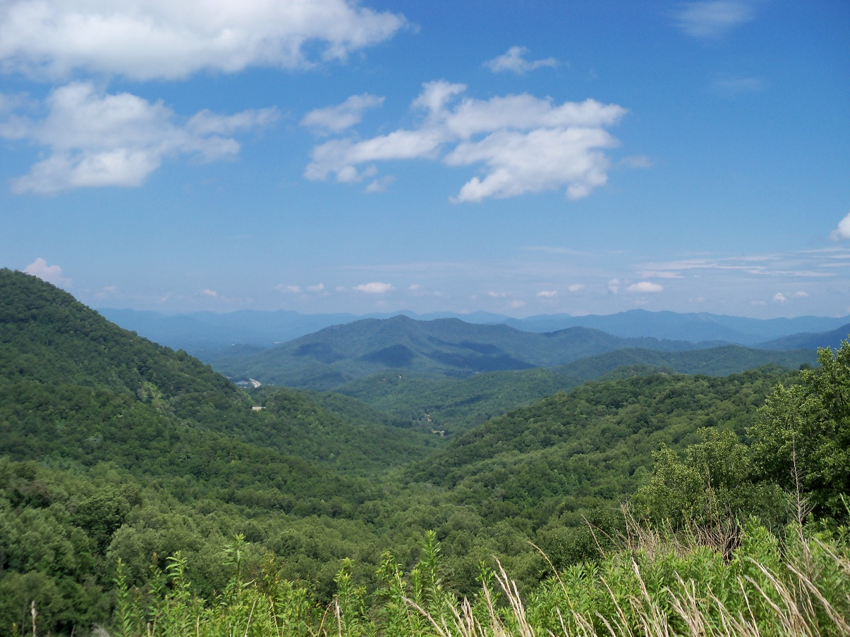
Figure 1. A view of the Nantahala Mountains west of modern-day Franklin, North Carolina. The Battle of the Black Hole took place in similar terrain. Photograph courtesy of Alexius Horatius.

characterize the modern landscape, but the general topography and lay of the land remains similar enough to the eighteenth century. Along this route I passed the sites of the First and Second Battle of Echoe, only a few miles apart. Both locations were places where Cherokee military forces, led by the Great Warrior of Chota Oconostota, ambushed invading armies in defense of their homes. The first time, in 1760, the Cherokee won decisively. The second time, in 1761, they caused damage, but not enough to prevent the destruction of eighteen of their towns. A decade and a half later, in 1776, despite having a distinct advantage in surprise and terrain, Cherokee forces did not defeat Carolinian militia at a similar ambush at the Black Hole. With similar force ratios, in similar terrain, I wondered what factors created a different outcome.
This thesis will examine military aspects of two significant periods of conflict in between the Cherokee and Euro-American military forces in the trans-Appalachian South. The first period was a series of three punitive campaigns launched by the British against the Cherokee from 1759 to 1761. These expeditions were part of a larger, escalating series of violent and retributory acts that historians refer to as the Anglo-Cherokee War. This war occurred within the context of the much larger Seven Years War that began in 1754. In the North American theatre, this conflict was the French and Indian War. The second period of conflict concerns near-simultaneous punitive campaigns launched by the newly formed colonies of Georgia, South Carolina, North Carolina, and Virginia against the Cherokee in 1776. These campaigns occurred in the opening years of the American Revolution, but they too were an escalation of a series of violent interactions between the Cherokee and white settlers along the interior borders of each colony. Some histories refer to this conflict as ‘The Cherokee War of 1776,” while others call it as “The Whig-Cherokee War.” To maintain consistency and distinguish between combatants, I will use the names “Anglo-Cherokee War” and “Whig-Cherokee War.”
I combine both “traditional” and “new” military history but will use more of the former. This thesis does not ignore environment and culture despite its traditional military analysis and leaves the door open to future research in any one of these areas. Social and cultural histories focusing on race, gender, and identity abound in modern studies of Indigenous-settler interactions, and they are important. Using military history to better understand why conflicts result in certain outcomes is also important. Cherokee military action at First and Second Battles of Echoe had a direct impact on the invading British armies, and it is fair to assume without the battles, the British would have caused far greater destruction in the Cherokee homeland. Therefore, understanding the dimensions of the battle itself is important to explain the outcome of the war, hence the need for a more traditional military history.
I agree most with the assessment of military historian Robert Citino, who observed that in the case of “old” and “new” military history, “it is time to drop the distinctions altogether, and to describe military history today as a discipline with a strong interest in social and cultural analysis, but with an equally immovable commitment to its battlefield and campaign tradition.” Discussions of tactical and logistical actions are central to my research question, but I do not dismiss the importance of other factors. The environment, especially mountainous terrain, played a critical role in shaping the culture of trans-Appalachian peoples and how they engaged in warfare. The mountainous environment is the common thread linking the components of my argument. Cultural factors were also crucial elements in determining how and why each side fought. The Cherokee were masters of fighting and sustaining themselves in mountainous, wooded landscapes thanks to a cultural emphasis on hunting, long range raiding, and ambush style warfare. Compared to Cherokee warriors, most Euro-American settlers and soldiers in 1759 were amateurs in fighting in this terrain. During the southern campaigns of the French and Indian War, the mountains and the Cherokee taught many of them hard lessons that they applied to battlefield success in 1776.
Historiography
Several works of historical scholarship cover the southern Appalachians in the American Revolution and Indigenous-settler violence, including studies of Cherokee and Euro-American conflict in the eighteenth century. Perhaps the most extensive, covering both the Anglo-Cherokee War and the Whig-Cherokee War, is Thomas Hatley’s The Dividing Paths: Cherokees and South Carolinians through the Era of Revolution. He details the interactions between colonial South Carolina and the Cherokee nation in the eighteenth century. Hatley points out differences in culture, such as views about gender relationships and familial dependency, as significant differences between the Cherokee and colonial South Carolina, despite cooperation through trade and cultural exchange. By the beginning of the American Revolution, the two societies grew apart and chose different paths, but still had a profound effect on the other.
One of the best histories of British-Cherokee interactions during the French and Indian War written largely through the Cherokee perspective remains David Corkran’s The Cherokee Frontier: Conflict and Survival, 1740-62. Corkran covers the Anglo-Cherokee War in detail, with extensive research into the causes of the war, as well as a thorough treatment of internal Cherokee politics. He draws from colonial archives and newspapers from across the Eastern United States and demonstrates the complex and decentralized nature of Cherokee politics, as well as their ability to influence the politics of the colonial powers. Both Corkran and Hatley explain the context of Cherokee-settler warfare in terms of geopolitics and colonization, with less focus on traditional military matters. Cherokee culture is central to their narrative, although Hatley provides a good deal more analysis.
Richard Blackmon’s Dark and Bloody Ground: The American Revolution Along the Southern Frontier picks up where Corkran left off, in 1763. Of all three works, his contains the most discussion of military matters, but only focused on the Whig-Cherokee War and the continued resistance of Dragging Canoe and the Chickamaugas, who broke away from Cherokees who made peace with Virginia and the Carolinas in 1777. Blackmon’s analysis of Cherokee operations and tactics deserves very little critique. His contention that the Cherokee operation of ambush and retreat to mountain refuges reflected a change in Native American warfare builds on Wayne E. Lee’s discussion of Cherokee military adaptation after the Tuscarora War of 1715. He rightly points out the supremacy of the defile as terrain “that forces formations into disjointed groups lacking cohesion and making them susceptible to ambush at any moment.” To Blackmon’s analysis I would add that tactical preparation like the use of Indigenous scouts, use of flanking maneuvers, and a Cherokee ammunition shortage helped the militia avoid a defeat. I also see more connections between the Anglo-Cherokee War and the Whig-Cherokee War than previous scholarship implies.
Other historical works important to this topic consider Native American and settler “ways of war.” Patrick M. Malone’s The Skulking Way of War: Technology and Tactics Among the New England Indians laid out an initial framework for understanding Native American warfighting methods in the Northeastern woodlands, highlighting weapons development, raiding, and ambush tactics. These actions make up the “skulking way” of war, which borrows from contemporary language. More recent scholarship challenges Malone’s argument that European contact “introduced unrestrained, total warfare and a well-developed technology for conducting it” and, thus, provides an updated argument. Wayne E. Lee’s The Cutting-Off Way: Indigenous Warfare in Eastern North America makes this critique and provides the definitive update to Malone’s framework. As a general rule, Native American military forces “cut off” their enemies with repeated raids and ambushes in order to make a certain area unlivable, “cutting” their adversaries off from kin. Importantly, Lee defines the cutting-off way as an operational, rather than tactical framework. The operation of cutting off an enemy force, village, or entire Nation followed the same general pattern, even if the tactical actions used to achieve the cutting-off differed significantly.
The Cutting Off Way is foundational to understanding how Cherokee military forces and war chiefs conceptualized warfare in the larger context of eighteenth-century Native American culture, so it deserves additional discussion here. Lee offers the “cutting-off way” as an alternative framework to Malone’s “skulking way” thesis. Lee uses evidence from Eastern Woodland Indigenous societies to show how raiding parties would travel long distances to the periphery of enemy territory to attack outlying settlements, kill opposing warriors, and take captives. The best attacks were the ones that inflicted maximum loss to the enemy, gained scalps or captives, at the cost of little or no casualties to the Cherokee war party. Warriors traveled hundreds of miles on foot and by river, utilizing their own systems of logistics centered on subsistence. Lee also argues that Cherokee expeditionary logistics were well suited to the trans-Appalachian environment, thanks to a rich cultural heritage of hunting and warfighting in that terrain. Cherokee attacks during the Anglo-Cherokee War and the Cherokee War of 1776 fit the cutting-off paradigm well—most of their offensive action focused on isolated homesteads, frontier settlements, and remote forts.
David Silverman’s Thundersticks: Firearms and the Violent Transformation of Native America deserves mention as it deals with technology in Native American warfare—specifically how guns and the gun trade changed Native ways of war. Historians continue to debate the degree to which this change occurred, and whether that change was just an adaptation of a new weapon into a preexisting cultural framework for warmaking, or if it created something entirely new, but it is undeniable that most Native Americans, including the Cherokee, had a strong preference for firearms as the primary tool of war after being introduced to them. Native warriors quickly learned to use firearms and realized that although they were slow to load, harder to maintain, and less accurate than a bow and arrow, even the most primitive musket produced a devastating wound that incapacitated both game and enemies. Game hit by arrows often ran for some distance before expiring depending on which organs were hit, requiring time-consuming tracking. In combat, nimble enemies could sometimes dodge arrows fired from long range. Native healers were adept at repairing most arrow wounds, but found the shattered bones and infection created by a musket ball much harder to treat. The musket ball could not be dodged, usually left a lethal wound, and was not prone to bouncing and deflecting off foliage like an arrow. These sorts of wounds were critical for the Cherokee to inflict on invading armies, as dozens of badly wounded men could halt an expedition dead in its tracks. The musket was well suited for the heavy foliage of the trans-Appalachian region, which could deflect arrows and allow warriors to get close enough to their target to have a good degree of accuracy. Until the widespread introduction of rifled weapons, smoothbore guns did not completely replace the bow and arrow, nor did they greatly increase the ranges at which battles were fought; however, they did significantly increase the reliable killing power of a hunter-warrior.
Access to guns and ammunition was a vital strategic consideration for Native Americans, and Silverman shows how they kept several lines of supply open to various sources of guns and ammunition, especially the ever-important gunpowder. Thanks to this planning and inability of any one European power to completely dominate the North American continent, Indigenous peoples like the Cherokee could typically get the arms they needed from one colonial power or another, even if one tried to cut off their supply. In addition, they could usually obtain arms through illicit trade by traders willing to risk punishment to make a handsome profit. By 1770, however, the British had come to be the dominant European power in Eastern North America, having supplanted the Dutch, the Spanish, and the French. This meant that the Cherokee had fewer options should the British decide to cut off ammunition supplies.
Cherokee-Settler Conflict 1759-1776
A brief narrative of the Anglo-Cherokee War from 1759-1761 and the Whig-Cherokee War of 1776 is necessary to better orient the reader with the context of the following analysis. After several years of fighting together in the French and Indian War, the British and Cherokee found themselves embroiled in a three-year conflict in the Southern theater. A series of atrocities and miscommunications caused a breakdown in relations between the two, and each sought revenge. The British did a poor job in maintaining good relationships with their Indian allies in the Ohio campaign, especially the Cherokee. James Adair writes of “several companies of the Cheerake” who, after suffering “unjust suspicion,” and being “half starved” in the British camp, decided to return to their homes after campaigning in the Ohio Valley in 1758. They viewed themselves as free men not under the command of any British officer. Each was also aware of the need to hunt for their families and communities, which they could not do while on campaign. On their journey home, German settlers in Virginia attacked them, claiming that they mistook the Cherokee party for different “Indians” that had been raiding Virginia homesteads. Forty Cherokee warriors were brutally murdered and scalped while the rest escaped to tell of the violence upon their return home. At least two other incidents of murder committed by Virginians against the Cherokee happened around the same time, further enflaming tensions in the Southeast and creating calls for blood revenge by the families of the murdered individuals. These massacres angered the kin of the slain Cherokee, especially because their murderers were supposedly allies.
Shortly after the murders, another incident occurred at Fort Prince George in South Carolina, involving “three light-headed, disorderly young officers” who “forcibly violated” Cherokee women while the women’s husbands were gone hunting. In retaliation for these atrocities, the victims’ kin made attacks to avenge their dead. Tom Hatley observes that “when the war came, Cherokee actions reflected not only the strict price—life for life—called for by Cherokee notions of justice, but also a deepening estrangement from their neighbors.” They killed several Carolinians near the border in retaliation.
Feuding escalated to full warfare in 1759, with the British sending a punitive campaign against the Cherokee led by South Carolinian Governor William Henry Lyttleton. Lyttleton only succeeded in moving his army to Fort Prince George and spreading a worsening case of smallpox to the nearby Cherokee town of Keowee. While at Fort Prince George, Lyttleton negotiated with Cherokee headman Attakullakulla, known to the British as the “Little Carpenter” for his short stature and diplomatic prowess. Lyttleton wanted the Cherokee to deliver twenty-four of their men “to be put to death, or disposed of as I think fit” as payment for the killing of several white settlers, to which Oconostota or Attakullakulla (the record does not indicate specifically which headman) replied that those responsible for the murders had fled “over the hills.” Lyttleton took several Cherokee prisoners as collateral for the actual murderers, left them under guard at Fort Prince George, and called off the campaign the day after Christmas in 1759, as smallpox and measles swept through his army.
In February of 1760 members of the Fort Price George garrison murdered the Cherokee prisoners, including several headmen. In retaliation, the Cherokee attacked several border settlements, burned homesteads, killed or captured their occupants, and laid siege to Fort Loudon. The British constructed Fort Loudon in 1757 at the Cherokee Overhill Town’s request, before Anglo-Cherokee relations turned to war. Fort Loudon lies on the western side of the Blue Ridge Mountains, on the Little Tennessee River and near the Cherokee principal council fire of Chota. Any attempt to relieve the garrison would require an army to either cross the Appalachians from South Carolina or to make the long journey overland from Florida or Alabama to the Tennessee River.
After victories against the French in the Ohio Valley, British Commander in Chief of North America, Jeffery Amherst, had enough troops to spare to order a punitive campaign in retaliation for the Cherokee offensives. He dispatched Lieutenant Colonel Archibald Montgomery with battalions from the Royal Scots and several companies of light Infantry and grenadiers, totaling 1,312 men from the British Army. More provincial troops and Native allies joined them in South Carolina, including almost 300 rangers and fifty Catawbas. After gathering supplies Montgomery set out for the Lower Towns in early June of 1760. There, he burned houses and crops, hoping to get the Cherokee to sue for peace.
Oconostota and hundreds of Cherokee warriors, however, were not ready to make a treaty. Anticipating Montgomery’s next move to the Middle Towns, they laid an ambush for his army near a place called Tessuntee Old Town, south of Echoe (also spelled Etchoee). Here, a series of hills and a steep mountain form a natural defile, which the Cherokee used to gain the high ground on both sides of the British column. As British regulars moved through the defile, the Cherokee fired into their line, causing immediate casualties. Total casualties for the British and the provincials were almost one hundred, including 17 killed. They burned the buildings at Echoe and then Montgomery decided that he could not continue deeper into the mountains with wounded men to care for. He cut his losses and returned to Fort Prince George.
The Cherokee had successfully defended the Middle Towns from the British, at the cost of the Lower Towns and dozens of lives. Fort Loudon and its garrison fell two months later. The British returned to punish the Cherokee the following year. Lieutenant Colonel James Grant had been Montgomery’s second-in-command on the failed campaign against the Cherokee in 1760, and Grant would lead his own attempt in 1761. Oconostota again laid an ambush for the British in the hills along the Little Tennessee, this time a few miles southeast of where they attacked the 1760 expedition (Figure 2). In a defile formed by the Little Tennessee river and hills running off the banks, Grant’s army fought the Cherokee for hours. The Cherokee nearly succeeded again in destroying Grant’s supply train. The British took casualties, but this time they did not turn around at Echoe but instead burned and pillaged the Middle Towns, crossed the Cowee
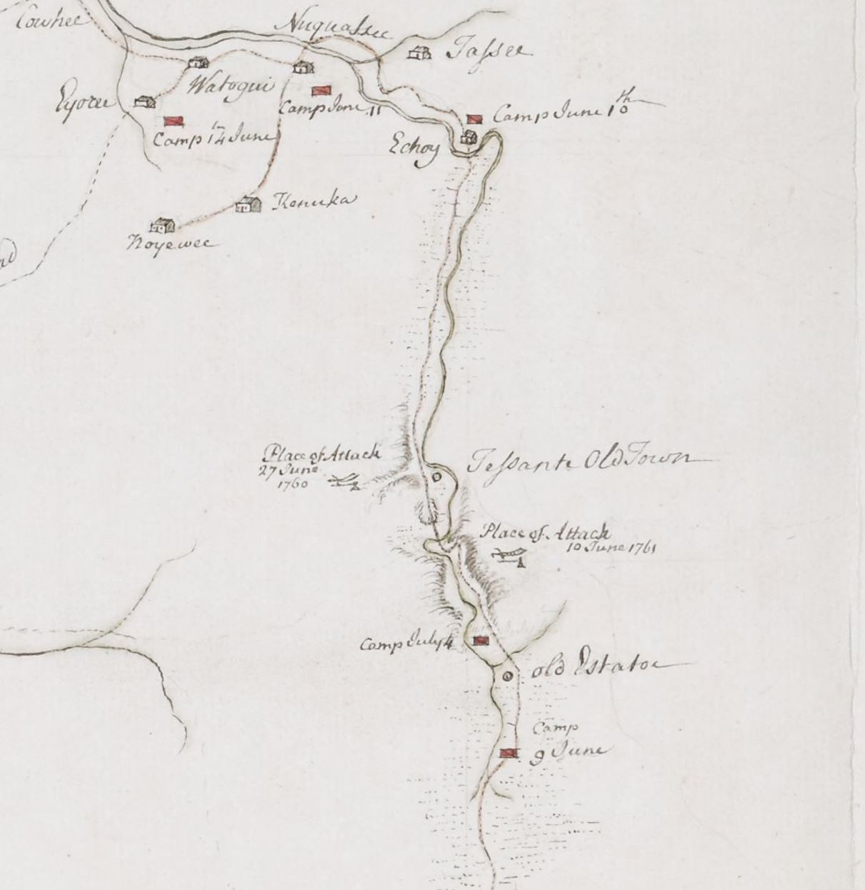
Figure 2: A portion of John Stuart’s map of Cherokee country, showing some of the Middle Towns, army camps, and the locations of the First and Second Battles of Echoe. Image courtesy of the British Library.

Mountains and burned several Out Towns. The Valley and Overhill Towns survived, but the Cherokee paid a much steeper price in 1761, and many suffered a terrible winter after losing their homes and food stores. Attakullakulla and other Cherokee headmen negotiated a peace with Grant in September of 1761. Oconostota was notably absent from the proceedings.
A decade and a half later, tensions rose again along the borders of the Carolinas between settlers and the Cherokee. Several settler communities, most infamously the one at Watauga, encroached on Cherokee hunting lands and threatened the peace. At Sycamore Shoals in 1775, North Carolinian land speculators led by judge Richard Henderson organized a meeting with Cherokee leaders, who represented their communities. Henderson used various falsehoods and misrepresentations to gain “title” to various Cherokee lands. Cherokee leaders were split between old and young over whether to make war, with the older faction endeavoring to ensure peace through land cessions, having seen the destructive power of European armies. Months later, in the spring and summer of 1776 the younger Cherokee, led by Attakullakulla’s son Tsi-yu Gansi-ni, or Dragging Canoe, made war against the Watauga settlement and many other homesteads. Fear and raiding once again gripped the Carolina border. The Cherokee offensive incensed the Counsels of Safety in South Carolina, North Carolina, and Virginia, who quickly put together punitive expeditions. The Whigs were particularly aggrieved that the Cherokee attacked them in the midst of a Revolution against King George III, and many believed that the King’s Indian Superintendents had coordinated the attack against the newly declared independent colonies. At this time, the Superintendents were John Stuart and his deputies Henry Stuart and Alexander Cameron, all who had regular contact with Cherokee leaders and communities. Hery was also John Stuart’s brother. In response to the Cherokee attacks, several hundred men from Georgia, and thousands of militia in South and North Carolina and Virginia, volunteered or where called up to fight the Cherokee.
Major Andrew Williamson, a veteran of the Grant campaign, led the expedition from South Carolina. He quickly received a promotion to Colonel to avoid ruffling the feathers of other militia Colonels who grumbled about being led by a Major. Williamson followed the trail of James Grant, expecting an attack in the Echoe passes. No attack materialized there, however, and the Cherokee had abandoned the Middle Towns. Williamson was trying to link up with the North Carolina Army, led by Brigadier General Griffith Rutherford. Rutherford passed through the Middle Towns on his way to Valley Towns, and narrowly avoided an ambush in the Black Hole, west of Echoe. Williamson’s force, however, took a different path to the Valley Towns than Rutherford. On September 19, 1776 the South Carolina militia ran directly into a well-constructed ambush led once again by Oconostota, in some of the most rugged mountain terrain in the trans-Appalachian region. Despite these advantages and after hours of hard fighting, estimates of dead on the militia side were well below those lost in the Grant campaign. While damaging, Williamson’s losses were not significant enough to stop the South Carolinians from linking up with Rutherford’s army and continuing their march of devastation deeper into Cherokee territory.
Scale, Logistics, and Tactics

The Cherokee were much more effective against the British than the Whigs. While Grant’s 1761 campaign caused a great deal of destruction to the Cherokee Lower and Middle Towns, none of the three British campaigns crossed the Appalachian Mountains, relieved the garrison at Fort Loudon, or destroyed any of the Overhill Towns. The Overhill Towns were the center of Cherokee power in the region at this time because of their naturally defensible position, strategic access to the Tennessee watershed, and they included the culturally important town of Chota. This is not to say that the Cherokee did not suffer greatly from the British onslaught. They did. But strategically speaking, they were able to resist the British invasion and retain most of their territory. Fifteen years later, the Whig defeat of the Cherokee at the Black Hole resulted in devastating population and territorial loss at the hands of three militia armies. The Carolinian militia and the Cherokee fought on much of the same terrain with several of the same people as the British campaigns. So, what changed between 1759 and 1776?
First, the scale of the Whig response in 1776 caused by fear of “Indian” raiding and broader Revolutionary sentiment resulted in campaigns that were larger and better coordinated than that of the British. These fears were not simple bigotry; at this point in history the Cherokee were still one of the largest and most capable military forces in Eastern North America. However, ammunition shortages in 1776 severely hindered Cherokee’s ability to stage an effective defense using their usual methods of ambush and finding security in the mountains. Logistical challenges caused by the broader American Revolution prevented the Cherokee from obtaining adequate materiel from the British, especially gunpowder. Without adequate ammunition, they could not inflict enough casualties to cause invading armies to abandon their campaigns, no matter how well laid the ambushes were. Finally, the Carolinian militia army that invaded in 1776 benefited from an extended period of tactical adaptation gained by militiamen and their officers in the British campaigns.
The following chapters broaden and explain the three parts of my argument, all relating in part to the mountain environment. Chapter I deals with the environmental, cultural, and contextual factors that impacted how both sides would conduct military actions. The second chapter examines the logistical challenges imposed by the trans-Appalachian terrain, and how these challenges impacted the outcome of Euro-American campaigns and Cherokee attempts to stop them. It claims that a Cherokee ammunition shortage was a key factor in limiting their effectiveness at the Battle of the Black Hole, and to a lesser extent at the Second Battle of Echoe, despite holding a solid advantage in terrain. The final chapter explains the tactical practices and adaptations employed in the largest military engagements of these wars and tries to show how the factors discussed in the previous two chapters manifested on the battlefield.

CHAPTER I

MOUNTAIN ENVIRONMENT, UNRESTRAINED WARFARE, AND OBJECTIVES

Factors outside of the battlefield influence the experience of soldiers and non-combatants in war. Military history should incorporate as many of those factors as possible while not losing sight of the actual battles when they matter. Besides “drums and trumpets,” social and cultural elements are worthy of inquiry. This chapter takes three elements—the mountain environment, the unrestrained nature of Native-settler warfare, and the stated or implied objectives of the combatants—and discusses how each one effected the nature of the Anglo and Whig-Cherokee Wars.
Mountain Environment
The Appalachian Mountains form a natural barrier to East-West travel starting in northern Georgia and extending into New England. The mountains reach their greatest elevations in the Cherokee homeland, where the third highest peak in the range recently gained recognition from the U.S. Board of Geographic Names as “Kuwohi,” which means “mulberry place” in the Cherokee language. The Appalachians have served as political and geographic boundaries for centuries. The Royal Proclamation of 1763 used these mountains to delineate the line beyond which American colonists could no longer settle, in hopes of preventing further conflict with Native Americans in the region. Over the following decade, hundreds of settlers ignored the Proclamation Line and encroached on Cherokee hunting grounds, which Cherokee chiefs The Raven and Corn Tassel argued as one of their chief grievances against their white enemies during negotiations in 1777.
In the latter half of the eighteenth century, the Cherokee controlled most of the trans-Appalachian South and claimed an even larger area of hunting ground that reached into most of modern-day Kentucky. Besides forming the bulk of their territory and hunting grounds, the mountains were important to Cherokee culture. A Cherokee cosmogenic myth, recorded by anthropologist James Mooney, tells how they were formed:
He [the Great Buzzard] flew all over the earth, low down near the ground, and it was still soft. When he reached the Cherokee country, he was very tired, and his wings began to flap and strike the ground, and wherever they struck the earth there was a valley, and where they turned up again there was mountains. When the animals above saw this, they were afraid that the whole world would be mountains, so they called him back, but the Cherokee country remains full of mountains to this day.

Almost all eighteenth-century Cherokee towns lay along the rivers and valleys interspersed among the steep hills, giving them access to transportation, food sources, and water for cleaning and bathing. Historians generally group these towns into three or four distinct groups: the Overhill, Middle, Lower, and Valley Towns, as named by European contemporaries. Some works also include the Out Towns as a fifth group. Recent historical scholarship of the Cherokee and other Southeastern Indigenous peoples argues that most eighteenth-century Cherokee people identified more with their town or region rather than a singular nation. Each town cluster had its own clan ties and tribal council, who acted independently of the other towns when necessary. Sometimes they disagreed when to go to war or when to make peace. For instance, during the 1760 siege of Fort Loudon, representatives from the Overhill towns relayed to the garrison that they still had “much friendship for the English, that they were strangers to the intentions and outrages of the Lower Cherokees, and had refused to receive a Red Hatchet and Scalp sent to them from thence.”
At the time of the French and Indian War, the Cherokee controlled one of the most strategically important locations in eastern North America. This area included the headwaters and a large part of the Tennessee and Cumberland River systems, which, besides the Ohio, are the only major East-West river systems naturally leading out of the Appalachians to the Mississippi River. Cherokee hunting grounds covered most of the trans-Appalachian South and extended into modern-day Kentucky, giving them access to a lucrative trade in animal skins. The Great Indian War Path ran directly through the Overhill settlements, placing them squarely between the large Northern confederacies like the Haudenosaunee and Southern nations like the Creek, Choctaw, and Chickasaw. Due to their strategic location, Kristopher Ray argues that maintaining an alliance with the Cherokee was a key part of any attempt for Britain and France to expand their imperial ambitions beyond the Appalachian Mountains. There were few trafficable passes for large wagons or carts to cross the mountains, such as the Cumberland Gap, and the Cherokee controlled these passes, making them a key component to enabling or preventing westward settlement.
In addition to its strategic geography, the trans-Appalachian region had important smaller scale military features determined by its environment. Vegetation and the change in topography determined how far a shooter could see and how far his musket ball could travel before it impacted a tree, rock, or hillside. Several writers of South Carolina history detail the extensive line of sight provided by the old growth forests. Writing in 1855, Dr. John H. Logan claimed that compared to his time, “the upper country of South Carolina presents a very different aspect from that of the same territory in the middle of the eighteenth century.” According to him, “the trees were generally larger, and stood so wide apart that a deer or a buffalo could be easily seen at a long distance—there being nothing to obstruct the view but the rolling surface,” and “on the elevated hill-tops the strolling hunter often took his stand, to sweep, at a single view, a large extent of country.” J.B.O. Landrum, writing in 1897, asserted that “[u]p to the breaking out of the Revolutionary war, the woodlands in the upper portion of South Carolina were carpeted with grass.” These claims warrant more investigation, and we should note that Logan was referring to the ruin of the Carolina landscape “under the iron tread of what is called a progressive civilization. British regulars and militia soldiers recalled thick, twisted underbrush that hid their enemies and formed impenetrable thickets, not the romantic-sounding open grasslands. Perhaps these writers made their observations in different seasons. A more likely explanation is that they recorded what they remembered most.
In a much more recent environmental history, Donald E. Davis argues that traders and Whig soldiers made a path for over twenty-five thousand white settlers to change the environment of the upper Tennessee watershed after the American Revolution. These were likely the changes lamented by Logan and Landrum. However, prior to this large influx of white settlement, Davis says that other than Cherokee settlements in valleys, “a large portion of the southern Appalachians remained a contiguous stand of mature old-growth timber.” Some of the largest trees in the forest were American chestnuts and poplars (Figure 3).
Soldiers in the British and Whig punitive campaigns against the Cherokee mention the forest grass, but in a slightly different context. While the grass provided a longer field of vision and fire to a man standing, it was also long enough to conceal a man laying down. In a depiction of the 1761 Second Battle of Echoe, a powder horn carved to commemorate the expedition shows a Cherokee warrior lying in tall grass, holding his musket (Figure 4). Another warrior stands behind him, shooting from behind the cover of a tree. During the 1776 Battle of the Black Hole, Frank Ross tells of “the advantage they [the Cherokee] had of us, on account of the situation of the mountain they were on, and likewise the grass being so admirably long, that they always had the first shot.”
One remarkable description of the landscape around the Wayah Gap, the probable location of the Battle of the Black Hole, comes from William Bartram. Bartram was a naturalist
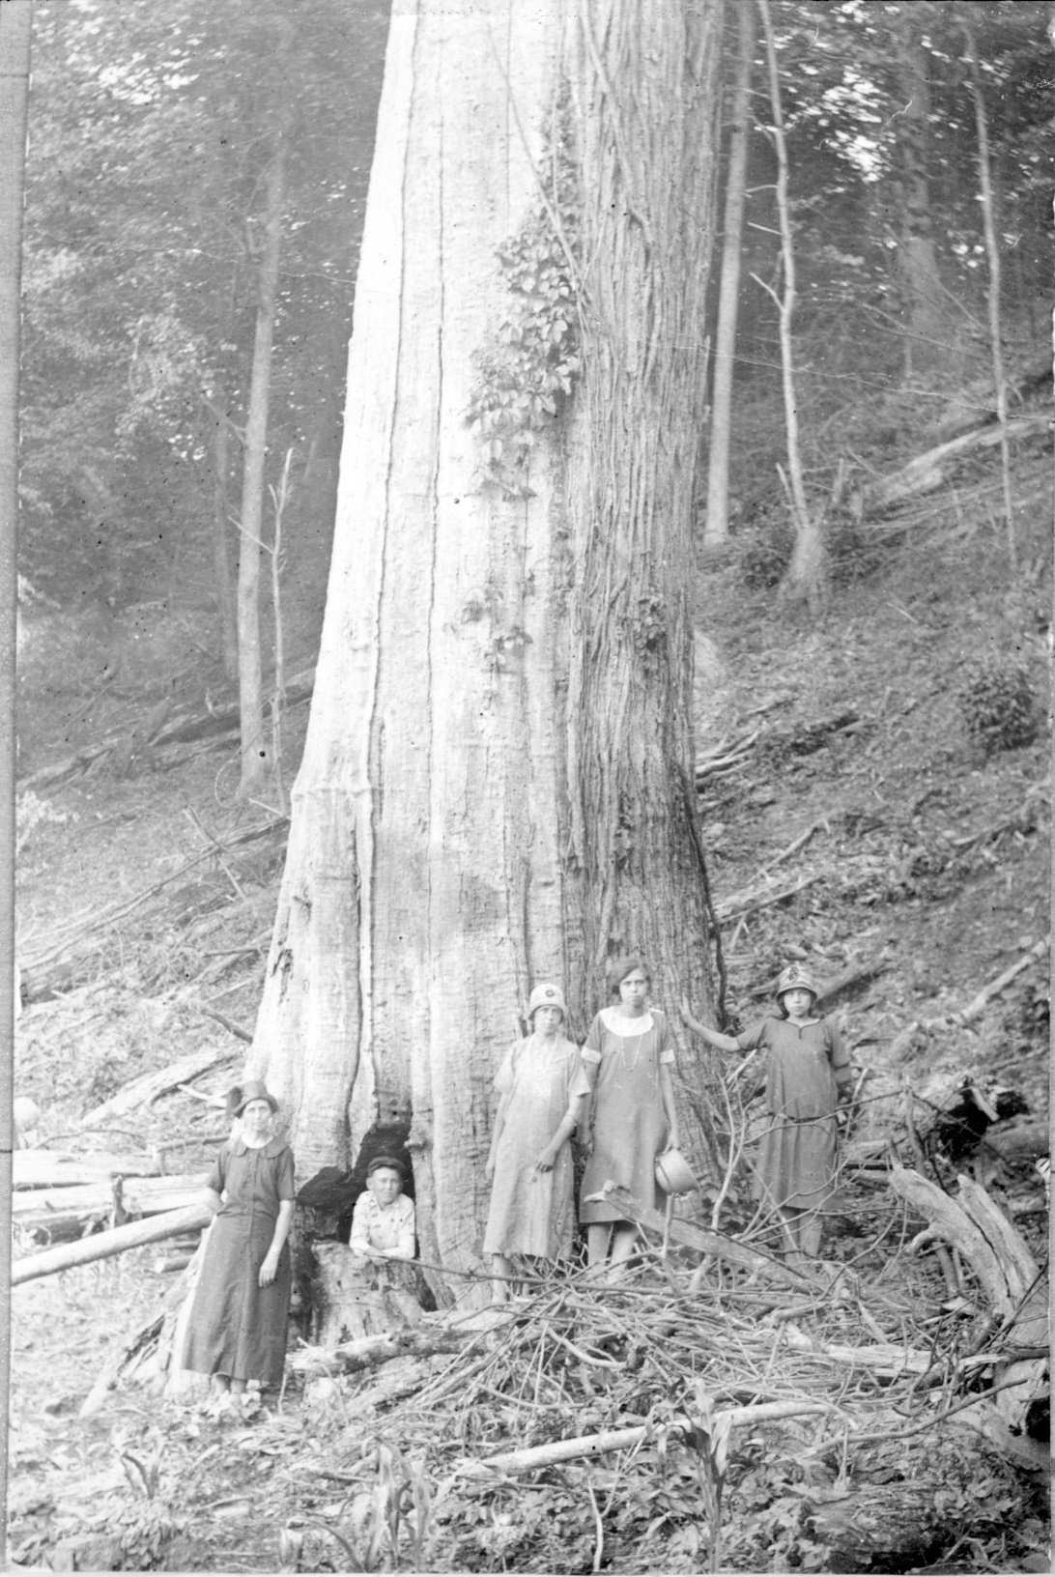
Figure 3: This photograph of an American chestnut tree in the Great Smoky Mountains National Park shows the size of some of the larger species of tree in the southern Appalachians. Photograph courtesy of the Great Smoky Mountains National Park through the Open Parks Network.
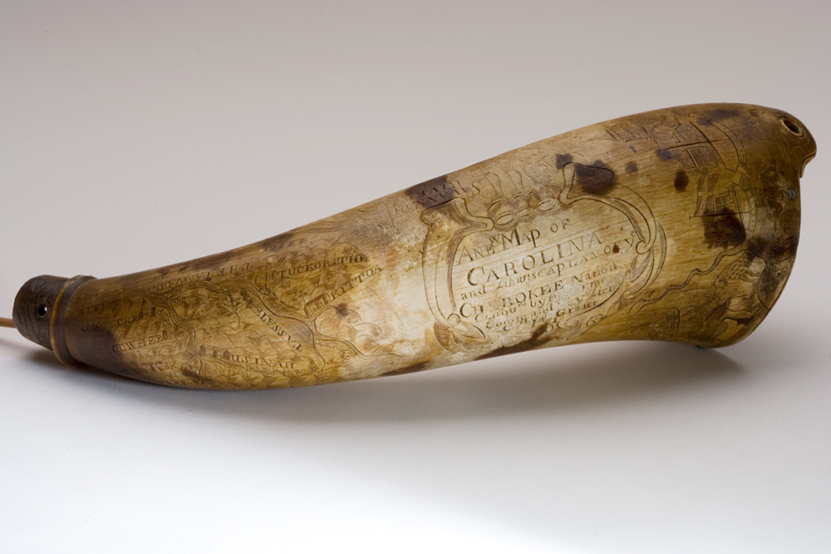
Figure 4: A powder horn commemorating the Grant expedition, carved in the scrimshaw style. It shows a map of Cherokee territory, the expedition’s march route, along with scenes of Charleston and the Second Battle of Echoe. Image courtesy of the Museum of the Cherokee People.

who made several journeys around the Southeast, including a trip to the Cherokee Overhill Towns in 1775, one year before the Anglo-Cherokee War. Bartram’s descriptions of the landscape have a romantic and poetic quality, but his route over the Nantahala mountains put him so close to the Black Hole, temporally and geographically, that it is worth mentioning here. For context, the Nantahala mountains are some of the largest in North Carolina, and they separate the Middle Towns from the Valley Towns. The modern Bartram trail follows the Burningtown Gap, five miles north of the Wayah Gap, but there is some speculation that Bartram’s route actually took him through the Wayah Gap. Regardless, both routes were topographically very similar, each following a draw of the mountain peak Wayah Bald:
After a gentle descent I entered on an extreme stony narrow vale, through which coasted swiftly a large creek, twelve or fifteen yards wide, roaring over a rocky bed, which I crossed with difficulty and danger…the vale gradually terminated, being shut up by stupendous rocky hills on each side, leaving a very narrow gap or defile, towards which my road led me, ascending the steep sides of the mountains, when, after rising several wearisome ascents, and finding myself over heated and tired, I halted at a little grassy lawn…”

This description indicates the added obstacle of a swift-flowing creek, the steepness of the valley walls, and the physical stamina required to cross the numerous sub-ranges of the Nantahalas.
While terrain had an impact on military actions, like flanking and ambushing, it could also have a psychological effect on the soldiers who had to fight in it. Names like the “Black Hole” or the “Dark Hole” give the place an eerie quality, where little light penetrates the forest canopy, or where the mountains are arrayed in such a fashion as to prevent sunlight from hitting the valley floor. Laurel thickets, which can cover entire mountainsides, had a lot to do with the lack of sunlight, as anyone who has gotten caught in one of them can relate to. Christopher French’s Journal indicates the darkening effect of the forest, and the constant fear of ambush:
After our halt we march’d again through the strongest country ever I saw, anything we had yet pass’d being nothing to comparison with this. It began by descending Stickowe Mountain which was so very steep & made so slippery by some Rain which fell, that it was nearly as difficult to get down as up, from here our March was, either through deep Vallies, (render'd in some places almost dark by Trees) or upon the sides of immense Mountains with steep precipices on one side, & the remaining part of the mountain a great height above, & the path so narrow as to render it very Dangerous to a Traveller who has nothing to consult but his Safety, whereas we expected to be attack'd every minute.

These detailed descriptions of the terrain and environment begin to reveal some of the opportunities and difficulties presented to a military force trying to gain a tactical advantage.
Engagements with the enemy were not the only means of death for soldiers. Disease also was a threat. The first expedition against the Cherokee, under the command of South Carolina Governor William Lyttleton, only made it as far as Fort Prince George and the Lower Towns due primarily to an outbreak of smallpox and measles. The South Carolina Gazette reported that “the dread of the small pox coming into camp became so very great that three fourths or more of the army seemed ready to desert on that account.” Lyttleton tried to save face by taking Cherokee prisoners, but their murders in the following month led directly to the Cherokee offensive. His failed expedition did little more than escalate the war and spread smallpox to the town of Keowee. Weather, inadequate clothing or lack of supplies could kill as easily as disease. On the return of the Rutherford expedition from the Valley Towns, William Lenior reported that “great numbers of men died from exposure, privation and fatigue.” Friendly fire and other accidents also occurred. An accidental discharge of a Lieutenant’s rifle killed Captain William Knox of the Rutherford expedition “as they were in pursuit of a party of Cherokee Indians.” Another man, Jonathan Huff, was “accidently shott in crossing of a Creeke he Expired immediately.”
Unrestrained Warfare
Discussions about the experience of war should include the effects on non-combatants, especially in a war as replete with violence and atrocity as the Anglo and Whig-Cherokee Wars. The level of violence and lack of restraint that characterized both Cherokee wars was typical of the brutality exercised in other wars against Native Americans. When compared to their ongoing war against the British, however, Whig conduct towards the Cherokee (and Loyalists) did not have much ‘gentlemanly’ restraint. As Wayne E. Lee has argued, Euro-Americans fought with more restraint against those who they perceived as “brothers” than those they perceived, or deliberately labeled, as “barbarians.” As violence towards non-military targets is less restrained, it becomes more “frightful.” Many historical works discuss the role of race in violent wartime conduct against Native Americans, and the Anglo and Whig-Cherokee Wars were no exceptions. However, Native Americans and whites fought on both sides of the Anglo and Whig-Cherokee Wars. It was rare for Euro-American armies in the eighteenth century to campaign against Indigenous people without joining forces with other Native allies willing to fight on the Euro-American side. In South Carolina, Catawba warriors had a reputation as excellent fighters and they performed critical roles, especially as scouts, in both the British and Whig expeditions. By one account, thirty-three Catawba accompanied the South Carolinian expedition in 1776 and were critical in discovering the ambush at the Black Hole. Creeks and Chickasaws occasionally joined with the British against the Cherokee when the alliance suited them, as inter-Native conflict in eastern North America existed long before the Europeans made war on them. Whites too fought on the Cherokee side, especially when the American Revolution pitted Loyalists against Whigs throughout the Southern backcountry. Several reports of the Cherokee raids that prompted the British and Whig expeditions record “white Indians” who “painted” themselves to appear like the Cherokee.
In Lee’s framework, the variables of capacity, control, calculation, and culture help explain how some wars became more frightful than others. Euro-American colonists had genuine fears of Indian attacks, especially those who had decided to settle close to Cherokee territory in western Virginia and the Carolinas, but these cases often were sensationalized. Isolated “frontier” homesteads were easy targets for the Cherokee cutting-off style of warfare, and women and children were often victims of these attacks. There was a longstanding cultural basis for Native raiding and taking captives, but it is important to note that in the Eastern Woodlands, there was little evidence that Indigenous warriors ever conducted sexual violence against their enemies. In contrast, sexual violence against Cherokee women at Fort Prince George in South Carolina was the final straw in pushing Anglo-Cherokee relations to war in 1759.
Other instances of frightful violence are too numerous to retell here, but several of the worst cases demonstrate the brutality that occurred in settler wars against the Cherokee. Raymond Demere, commander of the British garrison at Fort Loudon, relayed a particularly violent case near Tellico in 1757, where a man named the Thigh stabbed a pregnant Englishwoman several times, scalped her, and cut open her belly to take out “a poor infant Creature.” The woman had been on the road for six months and was traveling to Fort Loudon to be with her husband. Atrocities against women and children, even when embellished, stuck in the minds of soldiers who would later fight the Cherokee and be the basis for retributory violence. After the surrender of Fort Loudon in 1760, Overhill Cherokee scalped Captain Demere while alive and forced him to get up and dance before he died. Demere knew many of the Overhill Cherokee by name and had lived with them for years before the war. When the Cherokee offensive began early in 1760 following the murder of several Cherokee prisoners, the South Carolina Gazette reported the weekly deaths or capture of men, women and children in the western settlements. In one attack known as the Long Cane Massacre, one hundred Cherokee attacked the fleeing settlers of the Long Cane settlement, killing twenty-three and capturing seventeen more, including women and children.
There was no less brutality inflicted and tolerated on the British or Whig side. In 1761, at the Cherokee Out Town of Tessante, Christopher French reported that “our [Catawba] Indians kill'd another old Cherokee, run a large stick down his Throat, stuck an Arrow into each of his sides, one into this Neck & left a Tomahak sticking in his Head.” During a skirmish in the Lower Towns in 1776, Frank Ross recorded that a “stout Indian” fought in hand-to-hand combat with a “sturdy young white man.” After breaking the thick wooden stocks of their muskets on each other’s bodies, “the cracker [white man] had his thumbs instantly in the fellow’s eyes, who roared and cried ‘Canaly,’ ‘Enough’ in English.” The white man cursed him and replied that “you can never have enough while you are ‘alive.’ He then threw him [the Cherokee man] down, set his foot upon his head, and scalped him alive; then took up one of the broken guns and knocked out his brains.” Ross then remarked that it would have been “fun” if the man could have been sent home without his scalp “to tell his countrymen how he had been treated.” These sorts of atrocities and violent behavior only engendered more of its kind during future conflicts. Cherokee offensive action was often in response to murder of their kin or outrages like the rapes at Fort Prince George. Whites conducted and excused violence against Cherokee by citing previous instances of Cherokee violence, real or embellished. The Cherokee and the Euro-Americans had two distinct cultural frameworks of allowable behavior in wartime, and the dissonance between the two could often lead to misunderstanding and atrocity.
Some historians have called white-Indian wars “total warfare,” but this too is misleading, as it describes an unachievable extreme. In order for a war to be “total” a society must completely mobilize all its resources towards the conduct of the war. As Wayne E. Lee cautions, “rarely is war truly unrestrained, fought without let or hindrance. In some ways, that fact is the simple result of capacity. Rarely indeed are all the resources of a society committed to destruction.” Instead, it is better to see the Cherokee wars as having the potential for frightful violence, but to also understand that instances of restraint occurred, especially during peace negotiations when each side was trying to restore a sense of normal relations and restart trade. Although several men of the Fort Loudon garrison were scalped and killed after the surrender, the Overhill Cherokee let many of the inhabitants go back to South Carolina, including women and children. When a 1761 treaty article required the Cherokee to select four of their countrymen for execution in order to restore peace following the Anglo-Cherokee War, Attakullakulla told James Grant that “they were by no means inclined to kill the four People requir’d of them.” Grant conceded this point to Attakullkulla and they made peace without further executions.
Failing to stop a punitive expedition had devastating consequences for the Cherokee. In 1761, British Lieutenant Colonel James Grant’s army survived an ambush laid by warriors from the Middle and Valley Towns. The Cherokee defenders ran short of ammunition before they could inflict enough damage on Grant’s army and withdrew to avoid excessive losses. Grant’s army then, in the words of Lieutenant Colonel Henry Laurens, “penetrated their Country, burned upward of 800 [houses] in 15 Towns in a circuit of 150 Miles, and plucked up at lea[st] 1,500 Acres of Corn, Beans, [and] Mellons.” Survivors fled across the mountains to the Valley and Overhill Towns. The timing of this organized destruction in the month of July meant that new crops would be difficult to plant before winter. Overcrowding in the surviving towns taxed food supplies and spaces for shelter. A Cherokee delegation, escorted by Henry Laurens and Captain William Moultrie, left Keowee on September 3, 1761, and made a peace treaty with the Colonial government on 22 September in Charleston. Still, the Cherokee recovered and did not suffer a significant population loss, which, above all else, would have spelled disaster. They resisted three British campaigns aimed at the destruction of their homeland. In a way, Christopher Gadsden was correct when he observed in 1762 that “The situation the colonel has reduced us to with the Indians, will be shewn to be very shameful and precarious; and that he may be sent to us perhaps a third time to compleat his work, the consequence of which will be pointed at.” The third time would indeed come in 1776, but “completing the work” of the Anglo-Cherokee War was based on the faulty notion that destructive punishment resulted in peace. Dragging Canoe’s words at Sycamore Shoals describing the ground as “dark and bloody” were correct.

Operational and Strategic Objectives
Strategic context lends additional clarity to the interpretation of military action. The Cherokee decision to resort to violence came from cultural beliefs about making war. Archeologists debate the particulars, but there is strong evidence that organized warfare long predated European contact. Going to fight required consent of the community and involved an extensive ceremonial preparation. According to David Silverman, Native Americans went to war for “the defense or expansion of territory; the seizure of captives for enslavement and adoption; the negotiation of tributary relationships between communities; the revenge of insults; the protection of kin from outside aggressors; and the plunder of enemy wealth.” Wayne E. Lee adds “individual desires for revenge that spiral into a broader conflict, communal desires to resist enslavement, long-standing group enmities that sustain a blood feud cycle, a desire to access trade goods, war for captives for internal labor…and finally, to maintain a reputation for being able to strike back.” In the case of the Anglo and Whig-Cherokee wars, protection of kin, revenge of insults, and a spiraling revenge cycle were the most important reasons for going to war, and once armies began invading their territory, defense of their towns became the primary objective.
Cherokee attacks along the Carolina-Cherokee territorial border fit well with the cutting-off way of war: repeated raids on isolated groups to make a certain area unlivable. Attakullakulla and Oconostota had spent more than enough time fighting with the British and Carolinians to know that after a few raids, an army would come to their territory to exact revenge and force a treaty. However, settler armies had vulnerabilities that could force them to turn around, as the Battle of the Monongahela so clearly demonstrated. The coordinated ambush at Echoe demonstrates that Cherokee morale remained high even after the British burnt the Lower Towns. The Lower Towns were a trade-off for space and time; the further into the mountains that the British marched, the further they extended their supply lines, exposed themselves to environmental hazards, and the more unfavorable the terrain became to the invaders.
Several sources document the British and Carolinian strategic objectives. These consist of two related goals: punishment and security. Colonial governments sought to punish the Cherokee for actions they believed to be outrages. These outrages included raids against outlying settlements, killing of women and children, and breaking previous “treaties.” In a 1760 letter to Colonel Montgomery, Jeffery Amherst, Commander in Chief of British forces in North America, observed that “the only method of treating Indians” and “insuring peace and quiet to His Majesty’s Subjects” was to show them “that We can lay waste their Towns, and destroy Everything they have, kill as many of them as We think proper, and Shew mercy to Others.” He charged Montgomery to punish the Cherokee and to “Insure from any further Outrages from these Villains” before making peace. The punitive campaign was designed to inflict suffering on a populace by destroying food stores, houses, and killing or capturing inhabitants. This sort of destruction created refugees, who fled to unharmed towns, where they strained food supplies and housing. Once the campaign inflicted “proper” punishment, the army would make a treaty that involved additional executions, land cessations, or both. The Montgomery campaign had the additional objective of relieving Fort Loudon, but it failed to reach the Valley Towns, much less the Overhills.
Fifteen years after the Anglo-Cherokee War, the rhetoric surrounding punitive campaigns had not changed much, despite the British and Cherokee alliance against the former colonies. William Henry Drayton, a member of South Carolina’s delegation to the Continental Congress, gave explicit instructions to Francis Salvador, a well-known member of Major Andrew Williamson’s Campaign:
[i]t is expected you make smooth work as you go—that is, you cut up every Indian corn-field, and burn every Indian town—and that every Indian taken shall be the slave and property of the taker; that the nation be extirpated, and the lands become the property of the public. For my part, I shall never give my voice for a peace with the Cherokee Nation upon any other terms than their removal beyond the mountains.

Andrew Williamson, writing to William Henry Drayton, expressed that he desired to “put the Cherokees in such a condition as will deter any other nation, or tribes of Indians, disturbing the quiet of Virginia, North Carolina, Georgia, or this province, for some time to come.” It seems his views were aligned with the objectives laid out by South Carolina government.
Security was the desired result of punishment, or at least the Southern colonial governments thought so. Williamson’s goal of deterrence against “disturbing the quiet” and Amherst’s orders to “Insure from any further Outrages” were desires for security guarantees. Considering the constant low intensity conflict between settlers and the Cherokee between 1756 and 1794, this was hardly successful. Even after the destructive campaigns of the Whig-Cherokee War, settlers and speculators like John Sevier continued the invasion of Cherokee lands in Tennessee. Sevier used the pretense of “security” to conduct offensive warfare against the Creek and Cherokee, despite losing the support of the United States government who did not want to cause further Native-settler conflict in the Southeast. Dragging Canoe and the Chickamaugas continued to resist the United States well into the 1790s.
Wartime sentiment caused by the ongoing global wars also played a role in shaping Cherokee-settler conflict. The Anglo-Cherokee War began during the multi-continental Seven Years’ War, and the Whig-Cherokee War broke out during the second year of the American Revolution. Broader war presented an opportunity to the Cherokee to strike a distracted enemy. In both cases, that notion had the opposite effect. Thomas Jefferson leveled the charge that “He [King George III]…has endeavoured to bring on the inhabitants of our frontiers, the merciless Indian Savages, whose known rule of warfare, is an undistinguished destruction of all ages, sexes and conditions” as the final grievance in the Declaration of Independence, no doubt in part referencing the Cherokee offensive. One month later, Jefferson ended a letter to Speaker of the Virginia Legislature, Edmund Pendleton, with the hope that “the Cherokees will now be driven beyond the Missisipi [sic] & that this in future will be declared to the Indians the invariable consequence of their beginning a war.” Jefferson expressed further concern about a multi-front war: “our contest with Britain is too serious & too great to permit any possibility of avocation from the Indians. This then is the reason for driving them off, and our Southern colonies are happily rid of every other enemy and may exert their whole force in that quarter.” By “every other enemy” he referred to the South Carolinian repulse of the British invasion fleet at Sullivan’s Island on June 28, 1776 which delayed the conquest of Charleston until 1780.
In the summer of 1776, finding soldiers for the militia in Southern colonies was not difficult, evidenced by number of volunteers for the Cherokee expedition. On August 2, 1776, a copy of the Declaration of Independence reached Williamson’s South Carolina militia at their camp near Eighteen-Mile Creek. An officer read the Declaration to the gathered soldiers, “at the conclusion of which there was much firing of arms and rejoicing.” The degree to which the British coordinated their June attack on Charleston with the Cherokee offensive is the subject of historical debate, but many Carolinians believed that to be the case. They blamed British Indian Superintendents John Stuart and Alexander Cameron in this regard. A letter from Henry Laurens to John Laurens took this view, citing intercepted letters as evidence of “new attempts by John Stuart Henry Stuart Alexr. Cameron and other Ministerial Agents to stir up the Savage Indians to attack our Western frontier.” By blaming the British for the Cherokee attack, the Whigs could turn their revolutionary fury against the Cherokee as a common enemy in their war for liberty.
The problem with these views is that they disregard the Cherokee in determining their own military strategy, and they assume too much British influence over when the Cherokee made war. The Cherokee had made very clear in the early part of the French and Indian War, when they were still aligned with the British, that they fought not simply at the King’s pleasure but that they required payment if they were to leave their families. By fighting against the King’s enemies, they forewent the ability to hunt for food and or engage in the fur trade. The Cherokee were strategic practitioners of war and evaluated the utility of military action considering shifting power balances between the European colonial nations. War was not always in their interest and caused divisions among their people. Wars were costly in terms of population loss and destruction of crops but maintaining sovereignty over their territory and honoring cultural obligations of blood revenge were also important. The decisions to go to war and make peace, in both the 1760s and in 1776, were primarily their own.

CHAPTER II

LOGISTICAL CHALLENGES AND METHODS IN MOUNTAIN FIGHTING

Successful logistics could be the deciding factor between a failed or successful campaign in the eighteenth century. In the trans-Appalachian South, this depended heavily on water or overland supply routes. Supplying a European-style army in this period usually took two forms or a combination of both: bringing in provisions from an external logistics hub or local requisition and foraging during the course of the war. During the French and Indian War, the British were reliant on their colonial subjects to provide some of the provisions necessary to sustain their campaigns. Individual soldiers and their officers usually sourced their own food and transportation from local requisition, while arms and ammunition had to come from a larger logistics hub. Smaller expeditions consisting of a few hundred men could forage and hunt while on the move, but this was an unreliable method, and soldiers could go days without eating. Larger armies with thousands of men relied on baggage trains of oxen, horses, and wagons to carry their food. Often, “beef on the hoof,” or live cattle herds, accompanied the army to provide fresh meat. Commanders, or their quartermasters, could choose the best method based on the expected route, duration of the campaign, and funds available to procure supplies. Whichever method chosen, it became more difficult to sustain an army the further it traveled from its base of supply, and more so if the expedition faced rough, mountainous terrain.
In contrast, Cherokee logistics were not nearly as tied to bases of supply as Euro-Americans and were well adapted to sustaining themselves in the mountain environment. Warfare and hunting were similar in many respects, and hunting while at war was a method of supply. Warriors carried provisions for themselves, made by women ahead of their expedition. These usually consisted of dried corn meal or corn cakes. As Wayne E. Lee observes, Eastern Native American “logistical systems lacked the capacity to sustain wars that would take and hold territory.” As a result, raids and ambushes were the preferred method of waging war, with the option of disengagement kept open. Firearms were the preferred weapon by the time of the Ango-Cherokee War, but Cherokee men also used the bow and tomahawk as necessary. Firearms required trade or gifts from Euro-Americans, which meant they had to maintain strategic supply lines to prepare for war and hunting. In addition, these logistical methods, combined with the natural constraints of the mountain terrain, limited their ability to sustain wars with the British and the Whigs.
Expeditionary Logistics: Procurement and Raiding
As previously stated, larger armies could not rely only on forage and hunting to sustain themselves. They required at least some preparation for a prolonged expedition, which could last months at a time. Muster roles from the 1759 Lyttleton expedition include a “list of carts, geers [gear]…impressed for the use of Colo. Powell on the late expedition against the Cherokees” which shows the equipment procured or taken from citizens to support the expedition. Officers from Colonel George G. Powell’s battalion took thirteen carts and several harnesses with at least an intention of returning them to their owners after the conclusion of the expedition. They also impressed thirty-two horses for the battalion, minus one horse belonging to a Henry Story who “stray’d home presently and the man agreed to take him without any charge.”
As Montgomery’s second in command, James Grant wrote to General Jeffery Amherst in 1760 to describe the expedition’s difficulty in procuring carriages. For this difficulty they owed thanks to the preceding Lyttleton expedition, which failed to pay any of the citizens of Charleston from whom they had procured a cart. As a result, “nobody chose to provide Waggons upon any terms.” The army commissaries then resorted to sending dispatches with advance payments to procure wagons from outside of the city, which had the desired effect. Wagons seemed necessary to Grant at first, but eventually Montgomery’s army switched to horseback supply only when their wagons could go no further. Wagons had a great deal of difficult crossing the steep banks of many of the rivers leading into the mountains, and this delayed the army by as much as a day or more. When the Grant expedition crossed the Stickowee Mountains, Christopher French wrote that the path became “so narrow as to render it vary Dangerous to a Traveller who has nothing to consult but his Safety, whereas we expected to be attack’d every minute.” Wagons on this path or the many others like it would have been impossible.
Euro-American armies raided and stole provisions from Cherokee towns as another method to sustain themselves besides carrying supplies. Joseph Knox, part of the Rutherford expedition, reported on his pension application that his duty was to forage for beef cattle. In their campaign journals and reports, Soldiers and officers devoted a good amount of writing describing Cherokee towns and the types of crops therein. One author alone mentions “corn and peach trees, apples trees” in Tomassee, “corn, potatoes, peas & beans” in Nowewee, and “great crops of corn, and indeed almost all sorts of serviceable fruits” in Tellico. A substantial amount of the entries in the journals of the Grant, Williamson, and Rutherford campaign also describe the destruction caused to these crops, in a clear ploy to deprive the Cherokee of food supplies. This indicates that the authors, and therefore soldiers, spent much of their time in Cherokee fields cutting or burning crops. Pension records rarely mention battles other than the Black Hole, but they do describe a great deal of destruction to towns and food stores.
Militiamen were not the only ones ruining Cherokee crops and fields. The thousands of horses, cattle, and several wagons that accompanied the expeditions took a heavy toll on each town they encamped in, showing the passive destruction inflicted by an army on the move. In his pension record, Colonel James Martin of the Guilford County Militia Regiment recalled that “Our Commissary had about 3,000 beeves [cattle] and as many horses loaded with sacks of flour, and where we encamped one night the beeves destroyed the whole of it, even to the stumps, and destroyed the grass to the bare ground.” Cattle did plenty of damage to Cherokee hunting land and fields before the war, and cattle damage was one of the chief grievances caused by illegal settlement in Cherokee land. Horses too were used on at least one occasion to destroy a corn field. In this way, the British and Whigs used Cherokee crops and stored food to sustain themselves and then they denied its use to the Cherokee by destroying it.

Expeditionary Logistics: Extemporaneous Methods
Virginia ranger officer William Preston’s 1756 journal of a campaign in western Virginia against the Shawnee provides several insights into the difficulties of sustaining a backcountry campaign through extemporaneous means, even for seasoned volunteers. It also provides a source on Cherokee warriors on an expedition just before the Anglo-Cherokee War. One hundred and thirty Cherokee warriors accompanied the expedition, led by war chief Ostenaco. The notes of Lyman Draper, a nineteenth-century historian, detail that Ostenaco was known as “the mankiller,” which “was the highest honorary title among the Cherokees, conferred as the reward of uncommon valor.” Three weeks into the campaign, their beef supply was exhausted, and the expedition had to hunt for food. “A few bears were killed,” Preston writes, but this was not enough to sustain all the rangers and their Cherokee allies. For the next month, Preston’s entries overwhelmingly discuss the lack of rations and his men’s attempts to hunt elk, bear, and buffalo. Even when a scouting party returned and reported that fifteen miles upriver “that were the game ever so plenty,” the men “said it was utterly impossible to support 340 men by it.” The Virginians were not as proficient at hunting on the expedition as their Native allies.
The expedition had to conduct multiple river crossings, made more difficult by the high waters and scarce rations. Rivers in mountainous terrain are typically fast-flowing, cold, and have steep banks, presenting a formidable obstacle. Preston writes that to traverse the river and lessen the time-consuming and dangerous river crossings, the “Cherokees proposed to make bark canoes to. [sic] carry themselves down the river, which was immediately put in practice.” The Virginians spent two days building a larger canoe to carry ammunition. While riverine travel was often the preferred mode of transport on large North American waterways, like the Ohio and Tennessee, doing so in the mountains was much more challenging. Even with canoes, the expedition had to portage often to avoid rapid water, sometimes over the top of mountains. Horses could not board the small canoes and had to find their own passage through the rugged terrain. A few days after building the canoes, two of the Virginians’ watercraft sank, where “several things of value were lost, particularly five or six fine guns” along with their tents. Choosing between marching or paddling as mode of transport for a mountain expedition required a deliberate assessment of the risk versus reward of each.
Mountain fighting required logistical adaptation. Larger forces were usually confined to established roads, which meant that a defender could always anticipate their route. If no road existed, then the army had to slowly cut their way through the wilderness, which meant slow progress and vulnerability to attack while they worked. Heavy rainfall slowed Grant’s army, but they improvised log bridges, rafts, and ferries to carry their wagons across, indicating the engineering capability of the army.Standardization of supplies was not the norm in the British colonies, and when certain items were not available, improvisation occurred. Soldiers in the Montgomery expedition made bags to carry flour out of their wagon covers and tents, and pack saddles out of bear skins. Montgomery left tents and baggage behind at Keowee before marching deeper into Cherokee territory to lighten the army’s load over the mountains.
The Cherokee had a well-adapted system of logistics developed over hundreds of years of hunting and long-range raiding. Cherokee war parties traveled on foot and by canoe over vast distances of the American continent, and doing so required a large caloric intake. Hunting on the move was the most important means of sustainment, but warriors almost always supplemented hunting by carrying some sort of ration to sustain them, such as ground corn or dried meat, caching supplies along the route, or using the hospitality of local neutral tribes. Sometimes women accompanied war parties to perform logistical roles. Cherokee warriors required food and ammunition to sustain themselves during military actions, and their absence from their communities created an added logistical need: when they were engaged in a war, they were rarely able to hunt for their families. Women did much of the agricultural labor in their communities, but hunting was an important component of sustenance for Cherokee communities. This challenge is one reason that Native Americans had difficulty sustaining extended wars. One way around this problem was for Cherokee warriors to receive goods from Europeans in exchange for their military service. John Stuart, the southern British Superintendent for Indian Affairs, told Lord George Germain that “both nations [Creek and Cherokee] depend upon me for supplies as they cannot hunt.”

Water and Overland Communication Routes in the Trans-Appalachian South
The Cherokee used an extensive system of land and water routes to trade, conduct diplomacy, and to carry out warfare. One of the best available studies of overland Cherokee communication routes in the trans-Appalachian region is William E. Myer’s Indian Trails of the Southeast. Myer’s map of the Southeastern Trail System shows three distinct trails crossing the Southern Appalachians from Tennessee to South Carolina. The southernmost was the Unicoi Turnpike, used by British forces in the supply and maintenance of Fort Loudon. References to artillery at the fort indicate the Unicoi Turnpike supported heavier logistics like cannon and ball. This makes sense, given that the following two routes traverse some of the highest peaks in the Appalachians. The middle route, following the Little Tennessee River through the mountains, became known to Euro-Americans as the Rutherford Trace after the War of 1776. Finally, the Tuckaleechee and Southeastern Trail took a north to south route perpendicular to the Rutherford Trace from the French Broad River to Keowee and Fort Prince George. The British campaigns to attack the Cherokee Middle Towns used this trail, as did Andrew Williamson in 1776. Several significant battles took place along this route, including both Battles of Echoe and the Battle of the Black Hole.
The Southern Appalachians span a vast territory, and there would seem to be countless ways for people to traverse between settlements. However, travelers generally stuck to known trails, including the ones above, depending on where they wanted to go and who they wanted to see, or avoid. Crossing the mountains could be a dangerous proposition depending on diplomatic relations at the time. In 1775, William Bartram went to the Overhill Towns “against the advice of the traders; the Overhill Indians being in an ill humour with the whites, in consequence of some late skirmishes between them and the frontier Virginians.” Along the way, he had an unexpected meeting with Attakullakulla after descending the Nantahala Mountains. Attakullakulla asked Bartram if he was coming from Charleston, “and if John Stewart [Stuart] was well, saying that he was going to see him.” What seems a chance encounter illustrates the de facto, or ubiquitous, nature of the trails. Besides forming supply routes across the Appalachians, these trails presented Euro-American armies with their only feasible path of invasion. As a result, with only minimal scouting, the Cherokee could forecast the route of any invading army and lay an ambush at a time and place almost entirely of their choosing. In one exception, they seem to have laid the 1776 Black Hole ambush in anticipation of Griffith Rutherford’s North Carolinian army taking the Wayah Gap over the Nantahala Mountains to the Valley Towns, but Rutherford took a more southern route via Hiawassee. Three days later, the South Carolinian army, trying to link up with Rutherford, took the Wayah Gap road directly into the Cherokee ambush.
Euro-American logistical methods for large armies restricted them to only the most well-worn trails, and even these required repairs at some points. When Lyttleton’s army reached Turkey Creek in western South Carolina on December 1, 1759, they found the roads in such disrepair that “they were obliged to work on them, and could proceed no further.” Road repair only delayed them for a day, but shows that even on the well-worn route between Fort Prince George and Charleston, a large army could not rely on roads. As they approached the mountains, the trails became much more precarious for cumbersome supply trains.
Rivers were also critical communication routes for the Cherokee. The Tennessee River was a strategic waterway that led all the way to the Mississippi River. It gave the Cherokee an east-west route to access the North American interior, as well as a shorter North-South route in Eastern Tennessee for communications with the Chickasaw and Choctaw to the south. The Tennessee was especially important for the Cherokee during the War of 1776, as it was the main supply route for ammunition and other goods from the British. The outbreak of hostilities with the Carolinas effectively sealed off the east from any trade, so goods for the Cherokee had to go the long way around the Southern Appalachians. British ammunition shipments to the Cherokee landed in St. Augustine, where they either went north over land or to Mobile on the water and up a path to the Tennessee River before arriving in the Overhill Towns.
Ammunition Shortages in the Cherokee War of 1776
Prior to the outbreak of war, the Cherokee received ammunition through traders and in shipments from the colonial governments, especially Georgia and the Carolinas. Once hostilities commenced, ammunition had to come from the British in Florida through a longer route. Ammunition arrived in St. Augustine, a loyalist haven early in the Revolutionary War, and then porters transported it to Western Florida. Once there, the ammunition would go through Creek or Chickasaw territory. Both nations had not always been friends or allies of the Cherokee and had ammunition needs of their own for war and hunting. While the Cherokee could produce their own musket balls out of reusable lead and molds, no available evidence indicates that they could produce their own gunpowder in the quantity needed for war and hunting. This constraint necessitated imports from either the colonies or from Britain and ideally both in the case of an embargo.
Early indications of ammunition shortage come from Loyalist skirmishes on the Carolina border. In November of 1775, before the outbreak of the Whig-Cherokee War, the South Carolina Council of Safety sent a shipment of 1,000 pounds of gunpowder and 2,000 pounds of lead to the Cherokee for use in hunting and defense against the Choctaw. However, Loyalists seized this shipment, intending to use it for themselves. Andrew Williamson, a Major at the time, was able to get some of it back, but it is likely that the shipment never made it to the Cherokee at all. In a later episode, Reverend James Creswell expressed that “providentially for us, their arms were scarce,” referring not to Cherokee warriors, but to disaffected whites at Fort Ninety-Six who “were, by compact, to assist the savages to ruin the country.” Recovery of this critical arms shipment helped the Whigs immensely.
British records detail one of the few shipments of ammunition to reach the Cherokee in 1776 via the Florida-Tennessee River route, demonstrating the importance of this supply line to the Cherokee and the difficulty of getting ammunition to the Cherokee during the American Revolution. Henry Stuart was the British deputy superintendent for Southern Indian Affairs and the brother of British Indian Superintendent John Stuart. Henry attempted to deliver a large shipment of ammunition to the Creek and Cherokee in the summer of 1776. His letter to his brother describes the difficulty he faced in this endeavor, as he arrived in Cherokee territory with only a portion of the ammunition intended for them. High waters prevented Henry from securing horses from the Creeks to move the ammunition north through their territory in northern Florida to Georgia. Additionally, he “understood that there were then parties of Choctaws out against the Creeks and I thought that carrying ammunition at this time to the Creeks was attended with some danger,” so he instead loaded it on a sloop and sailed to Mobile. From there, unfavorable winds prevented further transport by ship, so he proceeded over land with “thirty horseload of ammunition” through Chickasaw territory, reaching the Cherokee via the Tennessee River as many of their warriors were preparing to carry out attacks against white settlements in their territory. Cherokee headmen came to see Henry Stuart, and he informed them that he “had brought them a small supply of ammunition to relieve their present necessities and to enable them to hunt and to supply their families” but “it was too little to divide among the different parts of the nation.” Some had been lost along the way, but he made clear his intentions to return with more. If Henry Stuart did indeed return with more ammunition, it was too late to impact the Cherokee’s defense of the mountain passes against Williamson and Rutherford’s invading armies.
Henry Stuart had met Cherokee war chief Dragging Canoe in Mobile during the summer journey, and again when he reached the Tennessee River. Dragging Canoe expressed concern about the stoppage of ammunition supplies from the colonies and wanted to know more about “the cause of the present quarrel and disorders.” The lack of ammunition was apparently dire enough to compel Dragging Canoe to travel all the way to Mobile in the middle of preparations to make war on the Carolinas and Virginia. It is unlikely that more ammunition reached Oconostota before 19 September when he and his warriors attacked Williamson’s militia at the Black Hole. Alexander Cameron, hiding under Cherokee protection in the town of Toqua from the Patriot militias and vengeful Wataugan settlers, also mentioned the need for ammunition in a letter to John Stuart four days after the battle at the Black Hole. “If you do not mean to throw away your children of this nation altogether, sir, they will require to be supplied with as much more ammunition as was sent them last,” he wrote, clearly concerned about the future of both the Cherokee Nation and their alliance with the British. The survivors of the Middle and Valley Towns need ammunition to hunt and survive the winter. The combined Whig militias had destroyed their food stores and standing corn.
In a letter to John Stuart from David Taitt, the Deputy Superintendent to the Creek Nation, Taitt details his own shortage of ammunition and plans for resupply. He reported that “Mr. Brown has no bullets along with his powder, I have at his request sent nine packhorses for 1400 weight of bullets as he informed me that you promised to assist him with some powder and bullets.” Taitt had difficulty hiring horses because of both the heat and because the traders used them more frequently at the end of the fall season. Rather than going to Mobile, as Henry Stuart did, Taitt recommended that supply shipments either go by horse from the mouth of the Escambia River, in modern northwest Florida, or as far up the river as a boat could get and then travel overland through the Upper Creek territory to Chota in the Overhill Towns. He also warned that “it is impossible for boats to come up this river in the fall of the year, as the river at that season is generally very low and there is several shoals in it which reach quite across.” Creek trade good shortages are relevant to the Cherokee supply problem because it relates the difficulty the British had in the summer of 1776 in supplying their other Native allies with ammunition, and because supply routes to the Cherokees would usually pass through Creek territory when not under threat from Choctaw war parties.
Two weeks before Taitt’s letter, on June 27th, 1776, the Creeks indicated to Andrew Williamson via white traders that “they will suffer no ammunition to be carried through their nation for the Cherokees.” This news either was false, had not made it to David Taitt, or the traders did not speak for the whole Creek Confederacy. Regardless, Henry Stuart’s shipment went through Chickasaw territory, and only one more shipment of ammunition reached the Cherokee in November. By this time, the ammunition was far too late for use in defense against the Whigs and could only sustain their hunters through the winter.
More evidence for ammunition shortage comes from the Battle of the Black Hole itself. The low casualty numbers on the militia side, despite their desperate situation, could be the result of Cherokee ammunition shortage. Casualty figures for the militia range from thirteen to sixty killed, and similar figures of wounded. Regardless of the actual figure, the casualties on the militia side were far lower when compared to either the Battles of Echoe or the Monongahela. One would expect a higher casualty rate given the Cherokee’s dominant terrain, tree cover, and element of surprise. A few days after the Battle of the Black Hole, Andrew Williamson received intelligence from a Cherokee woman taken prisoner that Oconostota meant to attack him again as he crossed the Little Tennessee River, but that attack never materialized. If the Overhills had no ammunition after ambushing Williamson at the Black Hole, then setting another ambush would not have been worth a deadly battle. Without direct confirmation from a Cherokee source, we cannot be certain that ammunition shortage had a major impact on the Cherokee’s ability to stage a major defensive action in 1776. However, the circumstantial evidence detailed above at least makes this a strong possibility.

CHAPTER III

TACTICAL ADAPTATION TO MOUNTAIN FIGHTING

This chapter focuses on the tactical level of war, meaning how soldiers and warriors planned and executed actions on and leading up to battle. This is meant to delimit the scope of the analysis, not to make an anachronistic claim that eighteenth century fighters thought about the levels of war in the same way that modern militaries do. The battles that follow were not preordained and as their varied outcomes show, they had a direct impact on whether the combatants accomplished their stated or implied objectives. For that reason, it is useful to know the ways that the combatants on both sides tried to obtain battlefield success. These “ways” are tactics.
The punitive campaigns of the 1760s and 1776 from South Carolina followed a general pattern. An army would form in the coastal colonies and provision itself as best it could. In the case of the Montgomery and Grant expeditions, most of the troops came via ship from other parts of the North American theater. In Williamson and Rutherford’s army, the bulk of soldiers were militiamen recruited by county. Native allies joined the armies enroute. Their first leg of the march through South Carolina was to Fort Prince George in the Lower Towns, across the river from the Cherokee town of Keowee. After the army departed Fort Prince George, the terrain changed. Hills, fields, and forest turned into steep mountains with immense trees and narrow roads. At this point, the militia knew an ambush could come at any point. They took the road to the Middle Towns, then to the Valley Towns, and tried to reach the Overhill Towns, although none of them did. When they came to a Cherokee town, they killed or captured the inhabitants, looted and burned the buildings, and destroyed the crops where they stood or where they lay stored.
Cherokee defensive operations also had a general pattern. In one form, they used small attacks by two or more warriors to attack and kill stragglers, foragers, or supply animals. These attacks could happen whenever the opportunity presented itself. In another form of defense, once a war Chief (in these cases, Oconostota) gained the approval of one or more towns to form a defense, he found suitable terrain and waited until the invading army passed through to ambush them. Years of experience fighting with and against Europeans taught the Cherokee how to march, fight, and supply themselves in defensive operations. The warriors in the ambush attempted to inflict as much damage as possible while incurring minimal casualties themselves. They did not need to completely destroy the invaders, only kill or wound enough of them to make venturing further into the mountains untenable.
Cherokee Defensive Tactics in Mountain Terrain: First Battle of Echoe, June 27, 1760
An ambush uses surprise and concentrated fire to overwhelm an enemy force, usually in terrain that gives the ambushers favorable fields of fire. The most suitable type of terrain for an ambush is in a defile. A defile is a military term for a constriction of terrain that necessitates anyone moving through it to form into a narrow line. Topographic features like a gorge, valley, or saddle have this effect, but anything that forms a natural boundary on two sides, such as a river and a thicket, can be a defile. Defiles are ubiquitous in the Appalachian Mountains, and when combined with the cover provided by large hardwood trees, they form advantageous places to set an ambush on anyone attempting to move through them. Centuries of erosion created narrow, steep channels through the mountains, making natural constriction points and funnels. The effect is to force a body of soldiers into a narrow formation, sometimes only wide enough for one or two men. The defining feature of a defile is that if the column is attacked while passing through it, soldiers cannot easily maneuver to the front of the column because of the restricting terrain, meaning that even a smaller force can bring more firepower to bear on an isolated section of a larger force (Figure 5). In the late eighteenth century, when combat effectiveness depended on a force’s ability to mass musket fire, this became even more critical. On contemporary European battlefields, deploying formations from columns into line could take hours. Drill practice tried to speed up this process. Troops in a mountain ambush had no such time.
While the Cherokee had used fortification as a defensive measure in the past, they learned an important lesson firsthand from the successful siege of the Tuscarora Fort Neoheroka by South Carolinians in 1713. European armies, when equipped with artillery and given enough time, were quite good at besieging fortifications. The Cherokee lacked defensive artillery within forts that prevented the positioning of siege works. They could use artillery—they planned to take the cannon from Fort Loudon and use it on Fort Prince George—but lacked the infrastructure and supply base to upkeep it. Slow, cumbersome artillery trains did not fit the cutting-off way of war. The alternative to static fortification was the ambush. Upon learning of
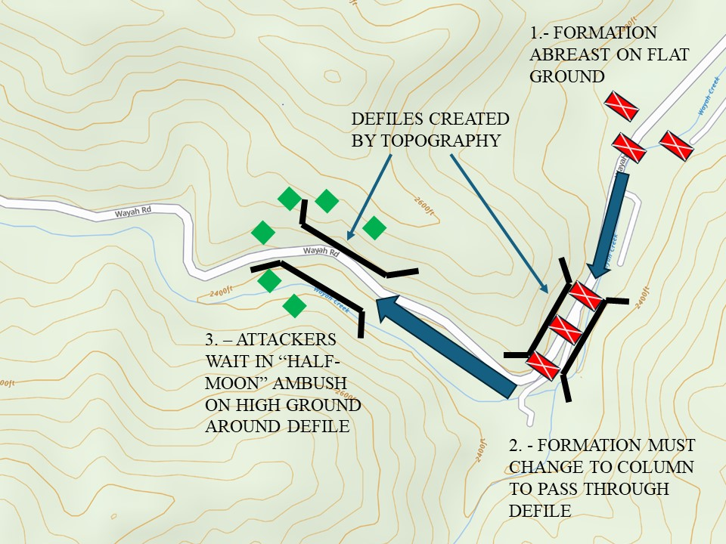
Figure 5. An example of two defiles created by topographic relief and their effect on a marching army along the Wayah Road, North Carolina, near the likely site of the Battle of the Black Hole. This graphic is meant only to show a defile and hypothetical array of forces and does not accurately represent the disposition of forces in any specific battle. Image created by the author. Topographic map courtesy of the onX Hunt Webmap Application.

an approaching Euro-American army, the Cherokee left their towns for protection in the mountains and gathered hundreds of warriors to conduct an ambush.As previously stated, the few roads and passes meant that the Cherokee knew exactly where the invaders would come from. Each Cherokee war encampment had scouts, and the warriors designated “the Raven” and “the Owl” went ahead of the war party to locate the enemy and signal the attack. While waiting in ambush, the Cherokee were well supplied and waited for days at a time, as evidenced by equipment found by the militia when warriors were forced to flee quickly.
Wooded, mountainous terrain was particularly suited to a tactic known as the “half-moon” ambush. In the essential study of this technique, Leroy V. Eid argues that the “political will” of the village and tribe “was carried out by disciplined common soldiers led by capable officers. As a result, late eighteenth-century Indian battlefield maneuvering revealed a sophisticated use of flanking movements proceeding from a half-moon starting position.” The half-moon refers to the shape of the warrior’s formation (again, see Figure 5). Eid describes how Native warriors moved further onto enemy flanks “by going swiftly from tree to tree.” The large trees of the Appalachian Mountains were especially well suited for this as they provided excellent cover and could hide an entire man behind them. Eventually the goal was to reach the baggage train in the rear of the formation, which Wayne E. Lee points out as a tactical adaptation to the vulnerability of European armies. By arraying themselves around a singular part of the enemy column, the warriors could concentrate fire on an isolated section of troops, pinning them in place. This helped them mass firepower for increased lethality, and kept the enemy focused on the front rather than their vulnerable rear. A whistle blast or gunshot was the signal to attack. Henry Laurens, a member of the Grant campaign, recalled “a great number” of Cherokee warriors on either flank and was “sure the odds was twenty to one in their favour.” The Cherokee did not, in fact, outnumber the British, but may have appeared so by arraying themselves in a half-moon around one point of the column.
The ambush battle worked famously well for the French and their Native allies in 1755 at the Battle of the Monongahela. This battle was the culmination of the Braddock expedition, which saw British General Edward Braddock lead a campaign into the Ohio Valley to capture the French Fort Duquesne. On the morning of 9 July 1755, an offensive force consisting of 108 French marines, 146 Canadian militia, and approximately 650 Native warriors from a multitude of nations assembled near the Fort Duquesne. A full account of this battle is beyond the scope of this thesis, but suffice it to say that the Native-French ambush destroyed roughly two-thirds of the invading English army and forced them to turn back, saving Fort Duquesne from capture. Preston demonstrates that one of Braddock’s most fateful mistakes was a failure to use the long-range reconnaissance normally provided by Indigenous allies familiar with the local area, which likely would have warned him of the French decision to ambush before he could lay siege.
The news of Braddock’s defeat at the hands of the French and their Indigenous allies quickly reached the Cherokee. James Beamer, a self-described “Trader in the Cherokee Country” who lived among them for “upwards of Five and Thirty Years,” recounted a delegation of “northern Indians” visiting the Cherokee only months after the Battle of the Monogahela. They “came in to invite the Cherokees to join them telling them that now they had entirely defeated the English Army killed the General (Braddock) and destroyed most them and the few that were left alive, where fled down to the Salt water, and if they would join them they would drive them into it and clear the Country of them everywhere.” Clearly there was confidence among the “northern Indians” after their victory, and they demonstrated that large British armies could be soundly beaten.
Oconostota put the ambush into practice against Colonel Archibald Montgomery’s army on June 27, 1760. He assembled a force from Middle, Lower, and Overhill Towns to make a stand in a defile six miles south of the town of Echoe. The defile he chose, as described by one source, was “a plain covered with wood and brush, so thick, that one could scarce see three yards distance, with an ugly muddy river, defended by steep clay banks running thro’ the middle of it, overlooked on one side by a high mountain, and on the other, by hilly uneven ground.” Another described the area as a swamp. Mountain laurel and rhododendron thickets could get as large as
trees and spread twisted branches over a large area (Figure 6). Oconostota arrayed his forces on either side of the defile. Early in the day, Montgomery deployed an advance party of rangers under Captain Morrison, designed to give warning of an attack. Cherokee warriors, concealed in the thickets covering the plain, poured fire into the advance party, killing Captain Morrison. The rangers fell back and ran into light infantry and grenadiers rushing forward to assist them. The Cherokee held their fire, allowing the rest of the British troops to enter the kill zone. A running battle ensued, with Cherokee warriors running around the column, shooting at the tartaned Scotts of the Highland Regiment in the plain. Grant and Montgomery each formed their battalions, attempting to advance and fire into the thickets. Each time they unleashed a volley, however, the Cherokee moved to different cover. The British soldiers believed they were driving the Cherokee off the high ground, but more than likely the Cherokee were in a deliberate cycle of fire-and-retreat, covering one another as they moved and reloaded. They had no reason to stand and absorb British fire when they could string out the column and fire at targets of opportunity.
A lull in the fighting allowed the British to cross the river in a single-file line, making for Echoe. However, Oconostota was only waiting for them to pass so he could attack the rear of the column. He and his warriors went around the British and fired into their backs, until a platoon could reform and assist. Cherokee gunmen sniped at the British all along their six-mile march to Echoe. Two more large attacks occurred before Montgomery reached the town. He himself was hit twice, but by spent musket balls. The army made camp in Echoe in the shape of a square to
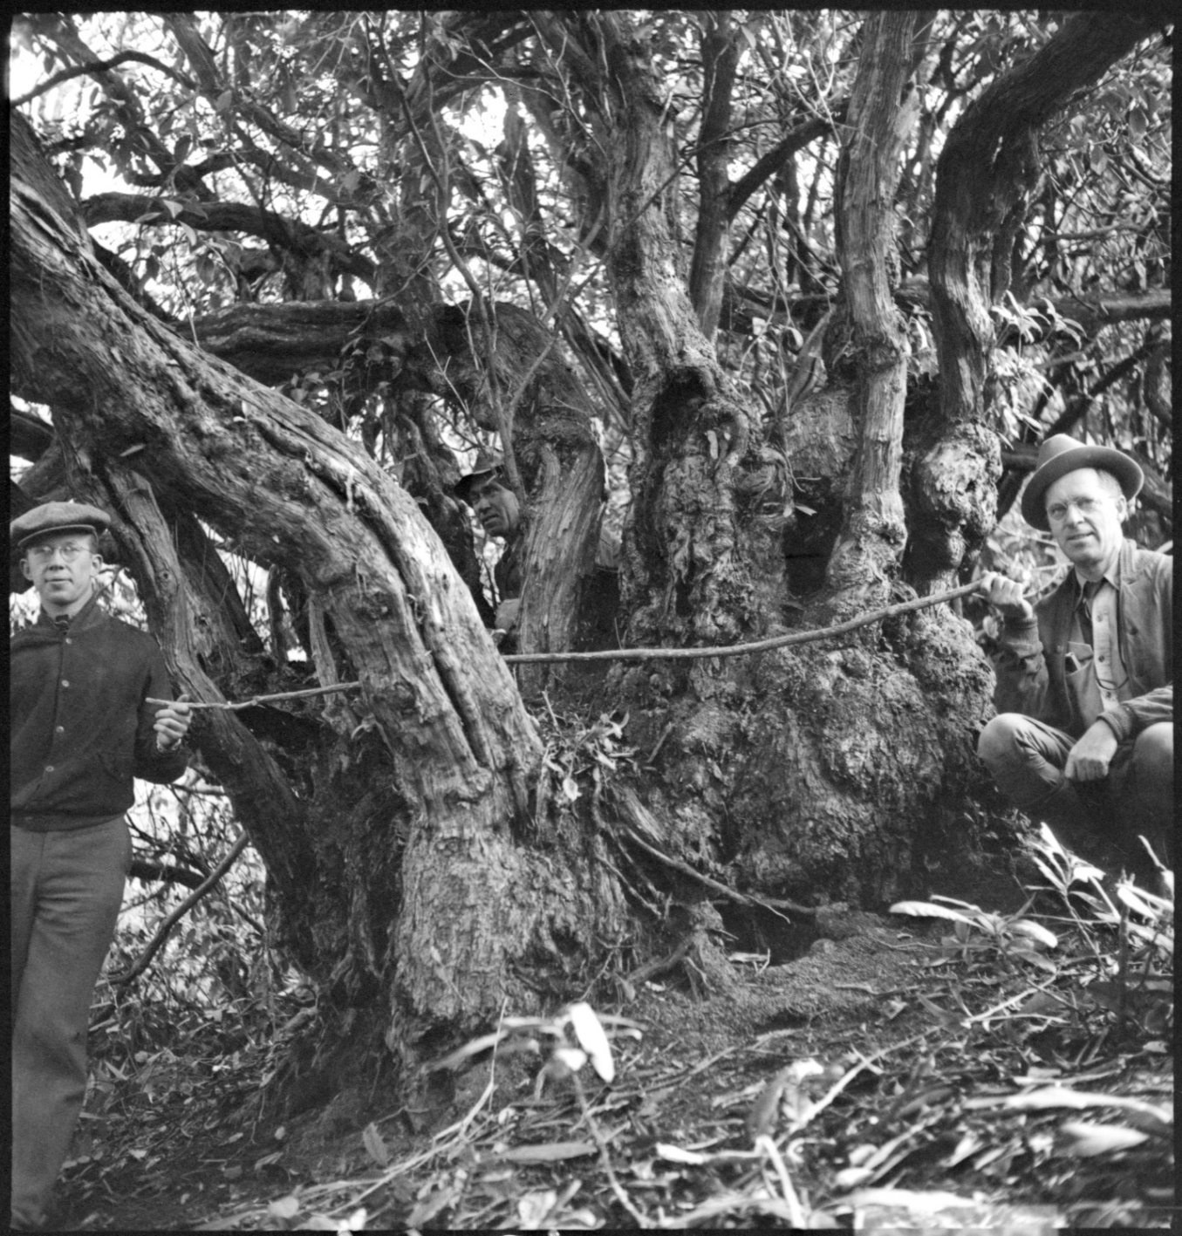 Figure 6: Photograph of a world record sized mountain laurel in the Great Smoky Mountains from 1936 showing its thick, twisting branches which form into thickets. Photograph courtesy of the Great Smoky Mountains National Park through the Open Parks Network.

defend against further attacks. No sooner had they deployed than a report came that the baggage train was under furious attack. Montgomery dispatched Captain Sinclair with 200 regulars to assist the baggage guard, and after heavy fighting, the Cherokee disengaged.
British and colonial sources, including Montgomery himself, were eager to declare victory at Echoe, simply because the Cherokee had left the field after inflicting significant casualties. What the British did not understand, or did not want to admit, was that Oconostota’s disengagement from the battle was well aligned with the Cherokee way of war. Preservation of population was always a concern, and fighting bloody “last stand” battles might have sounded heroic to a European but made little sense to a Cherokee. Every warrior that survived the battle could continue to harass the British along their entire route through the mountains. The locked doors and empty houses in Echoe indicate that the Cherokee fully expected the British to occupy their town, a trade they were willing to make if they could fight another day.
In the total engagement, the Cherokee killed at least fourteen men and wounded fifty-five more, including five officers. Even more importantly they caused considerable damage to the British supplies. In the confusion of battle, the baggage train lost equipment and horses when they mistook a fording place in the river. Without supplies, and with many wounded, hopes of relieving the Fort Loudon garrison were far away. The soldiers need only look up to see that mountains surrounded them, telling of more difficult terrain and enemy attacks. Montgomery had two options: abandon his wounded and risk more ambushes or abandon the campaign and return to Charleston. He chose the latter. Not everyone agreed that he had achieved success. His decision to leave the baggage train in the midst of battle is puzzling. William Bull, the Lieutenant Governor of South Carolina, complained that “the Cherokee war was rather inflamed than extinguished by [Montgomery’s] vigorous attack upon, his devastations of, and early retreat from their Towns.” Bull pointed out that Fort Loudon despaired for relief, Fort Prince George would likely be abandoned, and Virginia would reconsider sending their reinforcements. Fort Loudon did fall, and the South Carolina Gazette became more critical of Montgomery with every issue. General Amherst blamed the Cherokee for “repeated enormous outrages,” and ordered Lieutenant Colonel James Grant to undertake another punitive expedition.

Countering the Ambush: Second Battle of Echoe, June 10, 1761
Grant’s expedition was similar in size and composition to Montgomery’s, consisting of both British regulars and provincial troops, and it proceeded along a similar path in the summer of 1761. His army penetrated farther into Cherokee territory and was much more destructive. Oconostota led another defensive campaign against him, and given the Cherokee success against Montgomery, changed little in their strategy. It is therefore more useful to talk about specific adaptations made by the Grant campaign from the experience gained in the previous year and compare the Second Battle of Echoe to the First. His improved use of flank guards, better protection for the baggage trains, and the rate of march all contributed to tactical success.
Grant knew the challenges of an expedition firsthand and prepared. While in Charleston, the army witnessed Creek, Catawba, Choctaw, and Chickasaw delegations come to Charleston to conduct diplomacy, indicating that at least some of their nations would not assist the Cherokee. The men under his command spent the winter months in the Charlestown barracks making trouble in town, preparing supplies, and drilling daily. Even after departing Charlestown, training continued. Fifteen minutes after reveille, Grant’s regulars and provincials formed up under arms for daily drill to accustom the troops “to rise early, and dress quick, and will be necessary, when we get near the Enemy, that being the Time they would choose to surprize us.” When the army stopped security was still a concern. They camped in a square every night they were not behind a stockade. Allied Native Americans joined the expedition as the “Indian Corps.” They were eighteen Catawbas, nine Chickasaws, six Mohawks, and fifteen Stockbridge Indians, some of whom had served with Robert Rogers, a famous ranger in the northern campaigns (Figure 7). Some of the Indian Corps prepared for war by going away
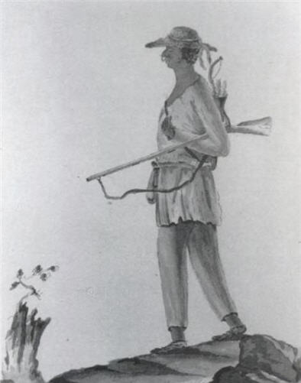
Figure 7: A Stockbridge “Indian,” as drawn by a Hessian soldier in 1778. Image courtesy of the public domain.

from the camp and then returning with a red war tomahawk. Christopher French recorded that they “dance’d the War Dance, and one of them observed that Silver Heels |Arrosa| a Senika Mohawk Indian who came with us from [New] York was a looker on, desir’d he would dance which, after some difficulty acc[out] of his not being understood by them, he did.” Five days later, the entire Indian Corps engaged in a ceremonial war dance.
Grant placed a heavy emphasis on a quick marching speed. He was trying to “get as near the Indian towns as possible before the Cherokees could have time to inform a body to oppose us,” believing they were short on ammunition. As the army drew closer to the Middle Towns, memories of the ambush near Echoe in the prior year were on the mind of many. Grant knew an ambush was coming and prepared accordingly. An effective way to avoid defeat in an ambush is to detect it before it is sprung. The basic method of doing this in eighteenth-century North America was to project security in front and to the sides of the main body of troops. In other words, a small element, such as a platoon, would walk a few hundred meters to the side and in front of the main body to detect an ambush before the whole army fell into the kill zone. These were known as “flankers.” British troops were aware of the benefits of this practice, especially as they gained experience in North American wilderness campaigns. David Preston argues that Braddock had not failed to secure his flanks or deploy an advance guard at the Battle of the Monongahela, but he did alienate his Native American allies to such a degree that he lacked long range reconnaissance.
Grant positioned the Indian Corps ahead of his advance party on either flank, forming a V-shaped guard in front of him. He anticipated an attack on his supply train and reinforced the baggage guard with an additional 120 troops, placing flankers out around the rear. When a small Cherokee war party took shots at the wagons while they broke camp at first light, Grant added another fifty provincial soldiers to the baggage guard. Five miles south of where the 1760 battle occurred, Oconostota had set another ambush in a defile formed by mountains on the British right, and the Little Tennessee River on the left. The Indian Corps discovered the ambush set on the east side of the defile. The ensuing gunfire signaled the entire Cherokee force to attack, which they did by shooting into the British column from the mountain. Grant knew he was in a bad position and could not form his troops in the narrow pass, so he ordered them to push through the defile under fire and on to a more open plain on the river.
A half mile north of where the Indian Corps discovered the ambush, the army confronted another obstacle: the river itself. The path led across a ford, and a hill stood on the opposite bank. Grant sent his light infantry across the river to secure this hill and hold it to allow the rest of the army to cross. The light infantry suited this task well because they were accustomed to using covered positions and loose order to avoid being cut down as they climbed. Each time the Cherokee attempted to get close to the river to fire at the crossing troops, the light infantry returned fire. Lieutenant Colonel Henry Laurens, describing the battle, observed that the Cherokee fired on the British column “from the Tops and Brows of Hills upon our right [East] and across the River Cowhih [Cowee] on our left.” The battle lasted for six and a half hours, and it took the army the remainer of the day to load their wounded and march to Echoe.
Casualty figures vary by source but were approximately twelve killed and another fifty wounded. Prisoners interrogated after the battle claimed that there were over 1200 Cherokee “Gun Men” present, indicating that the Cherokee deployed roughly half of their full fighting strength to stop Grant’s army. The terrain was even more to the Cherokee advantage, so the intelligence Grant received that they were low on ammunition and the speed at which he moved his army into their territory may have had the desired effect for the British. While dozens of wounded had doomed the Montgomery campaign, Grant was better prepared. He carefully moved his wounded men to Cowee, about ten miles north of Echoe using litters and horses. There, Grant split his forces and left the wounded, the baggage trains, the horses and cattle, and a guard force of 1,000 troops “upon very advantageous ground.” This enabled the remainder of the army to proceed, unencumbered, over the Stickowee Mountains with four days’ supply to attack and destroy the out towns.
Some of the provincial troops did not see the campaign as a success and criticized the destruction caused to the Cherokee towns while they were trying to make peace. Battles over Grant’s leadership of the 1761 campaign raged in the broadsheets of the South Carolina Gazette a year after the expedition ended. Francis Marion, who garnered fame in the American Revolution as the “Swamp Fox,” expressed strong feelings against the “cruel work” of the soldiers ordered to burn Cherokee cabins and cut down fields of corn. “I saw everywhere around the footsteps of the little Indian children,” he recalled. “’Who did this?’ they will ask their mothers, and the reply will be, ‘The white people did it, —the Christians did it!’” Heavier critique of Colonel Grant himself came from Christopher Gadsden, who wrote letters under the pen name of “Philopatrios.” According to Gadsden, Grant rather than Montgomery “had the principal direction of the campaign in 1760,” but that he “remedied none of the matters he complained of in his first campaign.” These failures, according to Gadsden were not doing more to relieve the garrison at Fort Loudon or “gloriously and effectually finishing the war with the Cherokees.” Strategically and ethically, Gadsden had a point. The British army had not reached the Valley or Overhill Towns. The Cherokee suffered from the destruction caused to their other towns, but they would recover in the coming years. Tactically speaking, however, Gadsden was incorrect; Grant had made adjustments that improved the army’s ability to fight in the mountains.
Overcoming the Defile: The Battle of the Black Hole, September 19, 1776
When the South Carolina militiamen moved through the Echoe Pass on 17 September 1776, they were mindful that they stood on the same ground where Oconostota struck at the men of Montgomery and Grant’s expeditions a decade and a half earlier. Veterans of both expeditions were among Williamson’s militia, including Williamson himself, and new recruits had certainly heard of the earlier battle. Arthur Fairies recounted that “we expected to have an engagement with our enemies, being so advantageous for them, being the spot where they repulsed General Grant the last war,” but the army marched through the pass with no incident, making camp at near Echoe. Oconostota had decided to attack Williamson in a different place. He understood that the militia would be most alert as they moved through the Echoe Pass, expecting an attack, so he chose another place to retain a better level of surprise. Grant’s preparedness in 1761 indicated that the Cherokee’s enemies were adapting. Contemporary manuals of arms indicated that the colonies were thinking seriously about training their militias for fighting on the American continent.
Oconostota’s attack came two days later, on 19 September 1776, at the Black Hole location described in the introduction of this thesis. This battle was the largest of the campaign and it presented the Cherokee with the best opportunity to stop Williamson’s army, especially if they could inflict enough casualties on the army and its supplies. Oconostota knew that another militia army from North Carolina was also in the mountains, so he needed to attack the South Carolinian forces before they linked up with the North Carolina militia army and doubled their size. The Black Hole was on the most common route to the Valley Towns, which were the Whig’s next target, so Oconostota set his ambush there. His force consisted of the warriors of the Overhill Towns with some survivors from the Middle Towns.
The Cherokee attack was not a complete surprise. Based on experience, Williamson knew that an ambush would be waiting for him somewhere in the mountains and used a modified march formation to negotiate the dangerous terrain. Captain Frank Ross led the advance party, which consisted of roughly one hundred soldiers and Catawba scouts. There were two less Catawba scouts present that day, however, because two days earlier they assisted Andrew Pickens and “a force of light infantry” to locate Brigadier General Griffith Rutherford and his North Carolina militia. On either side of the South Carolinian center were the Regiments of Colonel Thomas Sumter on the right and Colonel Samuel Hammond on the left, who formed the wings and performed the “flanker” role. Among the main force was the regiment of Colonel Thomas Neel, who moved up to assist the right flank once the engagement began.
While such a formation would have been easy to execute in an open field or on a parade ground, maintaining it in the steep defile of the Black Hole would have been incredibly difficult, especially for the wings. While Captain Ross and the advance guard could maintain separation between them and the main body on the valley path, getting Sumter and Hammond’s regiments on either side of them in anything other than a single-file line would have been extremely slow or near impossible in the Black Hole, given the prevalence of undergrowth and the steep sides of the mountains. Additionally, the soldiers of the main body were not as alert as those of the wings and the advance guard, given the days of tedious marching and the relative sense of security provided by being in the middle of a formation. The baggage train was slow-moving and conspicuous in the steep terrain.
Based on the accounts of the battle, the militia had some warning or at least suspicion that they might be walking into an ambush. Cherokee scouts were watching them and providing a clear picture to Oconostota about the timing and movement of the militia. At 10:30 in the morning, a Catawba scout discovered the tracks of the Cherokee scouts in the valley. Alerted to these “fresh signs,” Captain Ross “had a mind to halt, until the two wings, that is, Colonel Sumpter [sic] and Colonel Hammon’s [regiments] would come up even with him.” By halting, Ross wanted to let the slow moving ‘flankers’ on either side of the main body catch up with him, thereby discovering any would-be ambushers on the hills above him before he was enveloped. It was too late, however, as the wings were having difficulty keeping pace. The Cherokee had already surrounded the advance guard when a member of the right wing, either Lieutenant Hampton or one of his soldiers “espied Indians behind a tree.” Someone fired, prompting the Cherokee to empty their rifles into the advance guard.
This volume of fire caused immediate casualties in Ross’s men and drove them into a panicked retreat. They fell back towards the main body, while the wings continued to advance towards the Cherokee. Cherokee warriors were simultaneously moving above the retreating advance guard from tree to tree, firing as they went. They knew that they had to keep moving along the militia’s flanks to get at their primary objective: the baggage trains. Williamson, upon hearing of the engagement of his advance guard, was confronted by the decision of whether to immediately reinforce the men under fire to his front, or to reinforce the baggage train, which he knew the Cherokee would target. He decided to do both, as he had enough men, and ordered Colonel Sumter’s regiment to occupy a mountain on the right and thereby “hinder our enemies from coming round on our baggage and provisions.”
The decisive point of the battle varies by account. According to Ross and Fairies, the determination of the militia combined with the quick thinking of their officers prevented disaster. Parts of the militia accounts written after the fact were embellished, especially when one reads the language used to describe individual action. As an example, Captain Ross (if he was indeed the author) wrote of himself that he acted “like a gentleman becoming his station, with all the intrepidity that nature ever endowed a hero with of this age.” This flattery had a purpose: dispatches and journals were published in newspapers and were read by superior officers who could make promotions.
Embellishments aside, the actions of Lieutenant Hampton were important to the battle’s outcome. Hampton realized that the only way out of the ambush was to get soldiers onto higher ground than the Cherokee. In doing so, they would outflank their attackers. At some point after discovering the ambush and moving past the retreating advance guard, Hampton led a group of twenty men up the steep slope on the Williamson’s right flank. Seeing their comrades advance up the hill into the teeth of the ambush, thirty more joined them, and this force charged up the hill at the Cherokee moving towards the rear of the militia army. Hampton ordered his men to advance under covering fire by calling out “’Loaded guns advance—empty guns, fall down and load.” Those with loaded guns advanced and provided covering fire for those loading, who then in turn could cover the next group needing to reload. This assault stopped the Cherokee from further surrounding the militia on the right, and the Cherokee on this side of the battlefield began to fall back.
The militia had a significant advantage in firepower in the form of six wall guns. These wall guns were enlarged muskets typically used on the walls of fortifications due to their heavier weight and longer range. They fired a larger musket ball than a typical musket that could shoot further and penetrate more cover—it was essentially a miniature cannon that gave the militia the ability to return fire against the Cherokee while remaining somewhat out of range. The long duration of the battle gave the militia time to deploy these weapons. Still, the Cherokee did not simply stand behind cover and trade volleys with the militia; warriors would alternate charges from the right and then from the left to keep up continuous pressure on the militia, with the goal to cause panic, allowing the Cherokee to cut off the retreating men and their baggage.
Every account of the battle describes its violence, both in the initial volume of fire, and the hand-to-hand combat that developed as guns emptied and each side tried to make the other flee through charges. A Cherokee warrior shot Captain Ross and ran up to him for his scalp, striking him with his rifle. Ross recovered from these strikes and overpowered his attacker, who he proceeded to scalp in return. Scalping occurred on both sides—the Cherokee took scalps off three of the dead militia. Others were speared and tomahawked to death. The night after the battle, a militia guard discovered a female Cherokee warrior with a bow, shot through the thigh and unable to flee the battlefield. If this account is true, her wound indicates she was on the battlefield, and her bow indicates she was a combatant. Cherokee women did sometimes accompany men to fight in logistical roles, but female warriors were uncommon. A community sending women to fight would indicate a serious need for additional warriors.
Casualty figures for the militia range from thirteen to sixty killed, and similar figures of wounded. Casualty numbers for the Cherokee are likewise varied by source, from less than ten found dead upon the battlefield to one hundred, although the latter seems like pure speculation given the militia’s knowledge of Cherokee custom to remove their dead and wounded from the battlefield. The Cherokee’s advantageous position combined with pauses in the action did give them additional time to remove casualties from where they fell, or for the wounded to move themselves to safety, before the militia could ascend the heights and find them. The most significant losses to the militia were that of several officers and a few of their invaluable Catawba scouts, who were in the advance guard that engaged in the heaviest fighting.
Regardless of the actual figure, the casualties on the militia side were far lower when compared to the engagements of the British at Monongahela and roughly equivalent to the Battles of Echoe. One would expect a higher casualty rate given the Cherokee’s dominant terrain, tree cover, and some element of surprise. Writing after the battle, Captain Ross too responded with surprise: “This engagement may be spoken of as a miracle, considering the multitudes of enemies, and an admirable place they had to fire on us, that we were not almost all killed” Miracles aside, a more likely explanation is the one I presented in the previous chapter: the Cherokee likely started the battle with less ammunition than would have been necessary to maintain the fire needed to cause more casualties among the militia.
A few days later, Colonel Williamson learned from a dying Cherokee woman that Oconostota would once again ambush his column while he crossed the Little Tennessee River. Williamson sent a large force to secure the opposite side of the crossing and allow the army to pass, which they did, unharmed. The woman may have given him faulty intelligence to try and delay him further. She may have told him what she believed true, hoping for his destruction. Oconostota may have planned another attack but called it off for want of ammunition. Regardless of the reason, no more major attacks occurred on either the South or North Carolina armies for the remainder of 1776. That meant that the Battle of the Black Hole was the last major military operation conducted against the Whig armies that year. Cherokee headmen made peace in 1777 with North Carolina and Virginia at the cost of a great deal of their land, although Dragging Canoe and the Chickamaugas resettled in the area around modern-day Chattanooga, Tennessee, to stage further resistance. Williamson made a separate treaty with representatives of the Lower and Middle Towns that forced them to acknowledge their defeat. Today, the probable sight of the Black Hole has a marker that carries the same rhetoric as the treaty. While technically true, it fails to fully convey the weight and character of this battle (Figure 8).
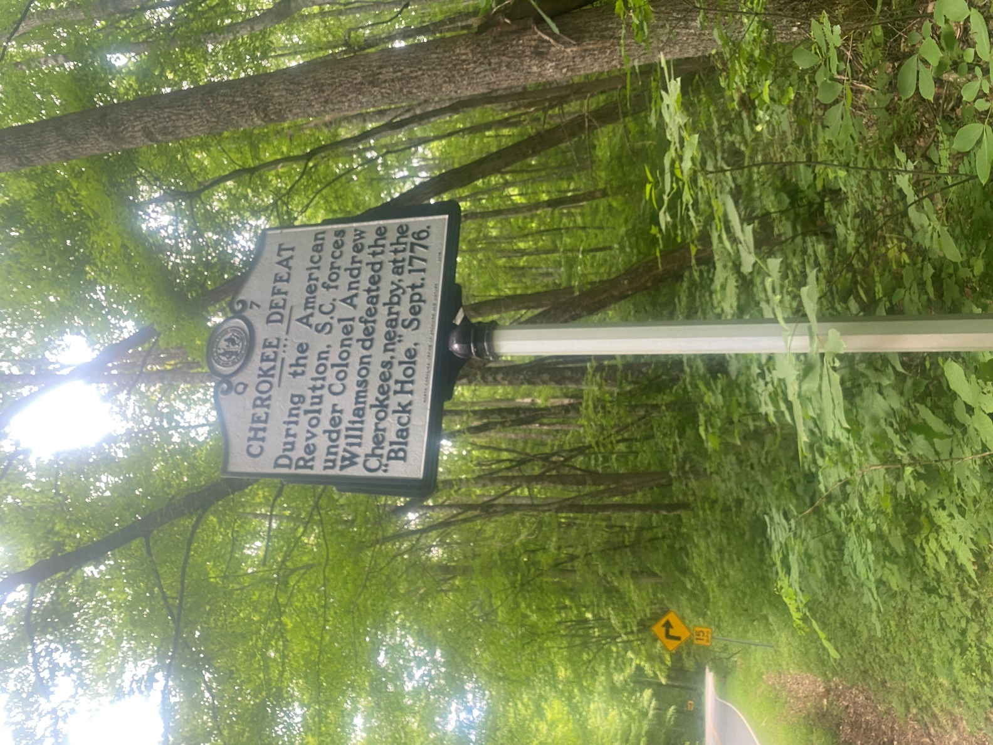
Figure 8: The historical marker of the Battle of the Black Hole sits about one mile east of the Wayah Gap saddle. While it marks a single point, the battlefield would have stretched for a much greater distance along the draw. Photograph courtesy of the author.

CONCLUSION
Other histories of this conflict document the destruction wrought by the armies of South Carolina, North Carolina, and Virginia. Every invasion of the Cherokee homeland from 1756-1776 resulted in progressively worse population displacement, death, and destruction of communities, homes, and agriculture. Someone might ask why studying the military effectiveness of armies displacing Indigenous populations is worthwhile. This is not a critique that the military historian should dismiss offhand. The value of studying Native-settler warfare in a traditional military sense is that it presents Native Americans as sophisticated practitioners of the military art. They could organize and conduct military operations in ways that were well adapted to their culture, terrain, and enemies. They had occasions of tremendous military success against Euro-American colonial powers. Even when settler armies defeated Native military forces, studying the battles conveys that Indigenous people were not simple victims of violence; in many cases they resisted in the best ways they knew how, including with organized military force. The Cherokees are no exception, and their military history is worth telling.
In writing this thesis I hope to convey some of the relevant features of warfare between the Cherokee, British, and Whigs between 1756 and 1776. The mountain environment had a tremendous impact of the on military operations in the trans-Appalachian South and is related to every other argument, some more profoundly than others. The belligerents not only had to contend with one another, but also with the thickly wooded mountain terrain of this theatre. A lack of restraint in the use of physical violence gave the conflict a dark, brutal nature. Any discussion of military science should not try to gloss over the cost of war. The context of ongoing larger events like the Seven Year’s War and the American Revolution directly impacted objectives that shaped how the wars were fought, what qualified as success, and under what conditions the belligerents made peace. Terrain determined supply routes. The Cherokee had well developed methods of logistics due to the cultural importance placed on hunting and long-range raiding. The Ango-Americans had experience with expeditionary logistics in the Eastern Woodlands, but they also showed adaptation to the specific challenges of the trans-Appalachian theatre. Finally, the Cherokee were tactically adapted to the mountain environment and the European way of war in 1760, but by 1776, the Whigs had learned through gradual experience how to win battles in the mountains. Tactical adaptation comes with one large caveat: ammunition shortage caused by theatre-wide war and tenuous supply lines severely impeded Cherokee defensive operations.
There are several opportunities for additional scholarship related to this thesis. The places I tried to incorporate an environmental lens, despite being an overarching theme, left out a great deal. An environmental history of Cherokee-settler warfare in the trans-Appalachian South is a compelling opportunity for a military historian. Next, the major battles of the Anglo-Cherokee War and the Whig-Cherokee War were concentrated and organized occurrences of violence designed to meet a political end. They were also part of a much longer cycle of Native-settler warfare in the early American Southeast, which is a hypothesis that historians could critically analyze. Finally, slaves and Native Americans other than the Cherokee consistently appear in the journals and newspapers of this conflict. By critically employing the archive as a starting point, there are many stories to tell outside of the normal sources. Two opportunities, based on my research in contemporary newspapers, are Catawba and Tuscarora scouts in the Anglo-American armies and the use of black enslaved messengers between outlying forts.

BIBLIOGRAPHY

Primary Sources:

“Declaration of Independence: A Transcription.” July 4, 1776. National Archives (U.S.A.).
“The Royal Proclamation of 1763 (1763).” In The Native American Experience, American Journey. Woodbridge, CT: Primary Source Media, 1999. Gale In Context: College.
Adair, James. History of the American Indians. ed. Samuel Cole Williams. Johnson City: The Watauga Press, 1930.
Bartram, William. The Travels of William Bartram. Edited by Francis Harper. Athens, Ga: University of Georgia Press, 1998.
Beamer, James. “Account of Trader James Beamer.” June 18, 1761. James Glen Papers, folder 4, page 1. South Carolina Historical Society, Charleston.
Boyd, Julian P., ed. The Papers of Thomas Jefferson. Vol. 1, 1760–1776. Princeton: Princeton University Press, 1950.
Davies, K.G., ed. Documents of the American Revolution (cited as DAR), 1770-1783. Vols. 11-13. Newbridge: Irish University Press, 1976.
Dells, William. “A Journal of the Motions of the Continental Army Commanded by the Honble. Griffith Rutherford Esqr. Brigadear Generall Against the Cherokee Indians.” 1776. Arthur Campbell Papers Mss., A C187, folder 26. The Filson Historical Society, Louisville, KY.
Draper, Lyman Copeland. The Lyman Copeland Draper Collection of Manuscripts. Wisconsin Historical Society. Series 1KK and 3VV. Microform, accessed at the East Tennessee Historical Society, McClung Collection, Knoxville, TN.
——— Manuscripts. Series U, vol. 21. Transcribed by the Pike County KY Historical Society. Wisconsin Historical Society, Madison.

Drayton, John. Memoirs of the American Revolution, From its Commencement to the Year 1776. Charleston, SC: Miller, 1821.
Ewald, Johann von. Diary of the American War: A Hessian Journal. Edited by Joseph P. Tustin. 2. pr. New Haven: Yale Univ. Pr, 1979.
French, Christopher. “Journal of an Expedition to South Carolina,” Journal of Cherokee Studies II, No. 3. (Summer, 1977): 275-302.
Gadsden, Christopher. Some Observations on the Two Campaigns Against the Cherokee Indians, in 1760 and 1761. In a Second Letter from Philopatrios. Charlestown: Printed and Sold by Peter Timothy, 1762.
Gentlemen’s Magazine. London, Issue XXX. (September, 1760).
Graves, Will. ed. “Fragment of a Daily Journal Kept by an Unidentified Officer Relating to the Cherokee Expedition of 1776.” Southern Campaigns of the American Revolution 2, no. 10.1 (October 2005): 34-36.
Gibbes, R. W., ed. Documentary History of the American Revolution: Consisting of Letters and Papers Relating to the Contest for Liberty, Chiefly in South Carolina, from Originals in the Possession of the Editor, and Other Sources. (cited as DHAR). New York: D. Appleton & Co.: 1857.
Grant, James. “Journal of Lieutenant-Colonel James Grant, Commanding an Expedition against the Cherokee Indians, June–July, 1761.” Florida Historical Society Quarterly 12, no. 1 (1933): 25–36.
Graves, Will. ed. “Arthur Fairies’ Journal of Expedition Against the Cherokee Indians from July 18th, to October 11th, 1776.” Southern Campaigns of the American Revolution 2, no. 10.1. (October 2005): 20-33.
Hamer, Phillip M., ed. “Documents: Correspondence of Henry Stuart and Alexander Cameron with the Wataugans.” The Mississippi Valley Historical Review 17, no. 3 (1930): 451–59.
Henderson, Archibald. “THE TREATY OF LONG ISLAND OF HOLSTON, JULY, 1777.” The North Carolina Historical Review 8, no. 1 (1931): 55–116.
King, Duane H. “A Powder Horn Commemorating the Grant Expedition Against the Cherokees.” Journal of Cherokee Studies 1, no. 1 (Summer 1976): 34–37.
Laurens, Henry. The Papers of Henry Laurens. Vol. 3, January 1, 1759–August 31, 1763. Edited by Philip M. Hamer. Columbia: University of South Carolina Press, 1972.
Lazenby, Mary E. Catawba Frontier, 1775–1781: Memories of Pensioners. Washington, DC: M. E. Lazenby, 1950.
Marion, Francis. “Sowing Tares of Hate.” Journal of Cherokee Studies 2, no. 3 (Summer 1977): 333.
Maryland Gazette Collection, 1728–1839. Annapolis: Maryland State Archives.
McDowell, William M., Jr., ed. Colonial Records of South Carolina Series 2: Documents Relating to Indian Affairs, 1754–1765. Columbia: South Carolina Department of Archives and History, 1970.
Monypenny, Alexander. “Diary.” Journal of Cherokee Studies 2, no. 3 (Summer 1977): 320–331.
——— “Order Book of the Grant Expedition.” Journal of Cherokee Studies 2, no. 3 (Summer 1977): 302–319.
Norton, John. The Journal of Major John Norton 1816, ed. Carl F. Klinck and James J. Talman. Toronto: The Champlain Society, 1970.
Pickering, Timothy. An Easy Plan of Discipline for a Militia. Salem, MA: Samuel and Ebenezer Hall, 1775.
Rockwell, E. F., ed. Frank Ross Diary, September 19, 1776, “Parallel and Combined Expeditions Against the Cherokee Indians in South and in North Carolina in 1776.” Historical Magazine and Notes and Queries, New Series, Vol. II (October 1867): 212-220.
Saunders, William L. ed., Colonial and State Records of North Carolina, Vols. 9-11. Raleigh, NC: Josephus Daniels, 1890.
South-Carolina Gazette (Charles Town, SC), 1759–1761.
“Treaty with the Cherokee; Treaty of Sycamore Shoals; a.k.a. Henderson’s Purchase.” Hawkins County Tennessee Deed Book, 147-150. Quoted in Dease, Jared. “Primary Source: The Transylvania Purchase and the Treaty of Sycamore Shoals, March 17, 1775,” Encyclopedia of North Carolina. Chapel Hill: University of North Carolina Press, 2006.
The National Archives (U.K.). Kew, England. Colonial Office Series 5: Colonial America.
Warren, Mary B., ed. South Carolina Newspapers: The South-Carolina Gazette 1760. Danielsville, GA: Heritage Papers, 1988.
Williamson, Andrew. “Andrew Williamson Collection,” January-December 1776, Robert W. Gibbes Collection of Revolutionary War Manuscripts (S213089), Series: S213089, Box: 5, Folder: 8. South Carolina Department of Archives and History. Columbia, SC.
Secondary Sources
Belloc, Hilaire. “The Geography of the War.” The Geographical Journal 45, no. 1 (1915): 3–4.
Blackhawk, Ned. Violence over the Land: Indians and Empires in the Early American West. Cambridge, MA: Harvard University Press, 2006.
Blackmon, Richard. Dark and Bloody Ground: The American Revolution along the Southern Frontier. Yardley, PA: Westholme Publishing, 2012.
Boulware, Tyler. Deconstructing the Cherokee Nation: Town, Region, and Nation among Eighteenth-Century Cherokees. Gainesville: University Press of Florida, 2011.
Burns, Alexander. Infantry in Battle, 1733–1783. Warwick, UK: Helion and Company, 2025.
Chet, Guy. Conquering the American Wilderness: The Triumph of European Warfare in Colonial Northeast. Amherst, Mass.: Univ. of Massachusetts Press, 2003.
Corkran, David H. The Cherokee Frontier: Conflict and Survival, 1740–62. Norman: University of Oklahoma Press, 1962.
Davis, Donald Edward. Where There Are Mountains: An Environmental History of the Southern Appalachians. Athens: University of Georgia Press, 2000.
Dean, Nadia. A Demand of Blood: The Cherokee War of 1776. Cherokee, NC: Valley River Press, n.d.
Dennis, Jeff. “Southern Campaigns against the Cherokees: A Brief Compilation.” Southern Campaigns of the American Revolution 2, no. 10.1 (October 2005): 16–20.
Dye, David H. War Paths, Peace Paths: An Archaeology of Cooperation and Conflict in Native Eastern North America. Issues in Eastern Woodlands Archaeology. Lanham, MD: AltaMira Press, 2009.
Eid, Leroy V. “A Kind of Running Fight: Indian Battlefield Tactics in the Late Eighteenth Century.” Western Pennsylvania Historical Magazine 71 (1988): 147–171.
Ethridge, Robbie F. From Chicaza to Chickasaw: The European Invasion and the Transformation of the Mississippian World, 1540 – 1715. Chapel Hill, NC: Univ. of North Carolina Press, 2013.
Evans, E. Raymond. “Notable Persons in Cherokee History: Dragging Canoe.” Journal of Cherokee Studies 2, no. 3 (Summer 1977): 275–302.
Gilbert, William Harlen. The Eastern Cherokees. Bureau of American Ethnology, Bulletin 133, Anthropological Paper, no. 23. Washington, DC: Government Printing Office, 1943.
Great Smoky Mountains National Park. “Kuwohi Name Restored to the Highest Peak in the Smokies.” Press release, Gatlinburg, TN, September 18, 2024.
Griffin, Patrick. American Leviathan: Empire, Nation, and Revolutionary Frontier. 1st paperback ed. New York: Hill and Wang, 2008.
Hatley, M. Thomas. The Dividing Paths: Cherokees and South Carolinians through the Era of Revolution. New York: Oxford University Press, 1993.
Herrera, Ricardo A. Feeding Washington’s Army: Surviving the Valley Forge Winter of 1778. Chapel Hill: University of North Carolina Press, 2022.
Huston, James A. Logistics of Liberty: American Services of Supply in the Revolutionary War and After. Newark: University of Delaware Press; London: Associated University Presses, 1991.
Kelly, James C. “Notable Persons in Cherokee History: Attakullakulla.” Journal of Cherokee Studies 3, no. 1 (Winter 1978): 2–34.
——— “Oconostota.” Journal of Cherokee Studies 3, no. 4 (Fall 1979): 221–38.
Kiesling, Eugenia C. ‘“Total War, Total Nonsense” or “The Military Historian’s Fetish,”’ in Michael S. Neiberg, ed. Arms and the Man: Military History Essays in Honor of Dennis Showalter. Leiden: Brill, 2011.
Landrum, J. B. O. Colonial and Revolutionary History of Upper South Carolina. Greenville, SC: Shannon & Co., Printers and Binders, 1897.
Lee, Wayne E. Barbarians and Brothers: Anglo-American Warfare, 1500–1865. New York: Oxford University Press, 2011.
———. “Fortify, Fight, or Flee: Tuscarora and Cherokee Defensive Warfare and Military Culture Adaptation.” The Journal of Military History 68, no. 3 (2004): 713–70.
———. “Mind and Matter—Cultural Analysis in American Military History: A Look at the State of the Field.” The Journal of American History 93, no. 4 (2007): 1116–42.
———. The Cutting-off Way: Indigenous Warfare in Eastern North America, 1500–1800. Chapel Hill: University of North Carolina Press, 2023.
Logan, John H. A History of the Upper Country of South Carolina from the Earliest Periods to the Close of the War of Independence. Vol. 1. Columbia, SC: P. B. Glass, 1859.
Lossing, Benson J. The Pictorial Field-Book of the Revolution. Vol. 2. New York: Harper and Brothers, 1852.
Magra, Christopher. “For the Common Defense: Settler Security and Statehood in the Revolutionary Southwest.” Forthcoming in The Journal of East Tennessee History. Knoxville, TN, 2025.
Malone, Patrick M. The Skulking Way of War: Technology and Tactics among the New England Indians. Johns Hopkins Paperbacks ed. Baltimore: Johns Hopkins University Press, 1993.
McCrady, Edward. The History of South Carolina in the Revolution, 1775–1780. New York: Russell & Russell, 1901.
Merrell, James Hart. The Indians’ New World: Catawbas and Their Neighbors from European Contact through the Era of Removal. 2nd ed. Chapel Hill: University of North Carolina Press, 2010.
Mooney, James, and George Ellison. James Mooney’s History, Myths, and Sacred Formulas of the Cherokees: Containing the Full Texts of Myths of the Cherokee (1900) and The Sacred Formulas of the Cherokees (1891) as Published by the Bureau of American Ethnology. Asheville, NC: Historical Images, 1992.
Myer, William E. Indian Trails of the Southeast. Nashville: Blue and Gray Press, 1971.
Nichols, John L. “Alexander Cameron, British Agent among the Cherokee, 1764-1781.” The South Carolina Historical Magazine 97, no. 2 (1996): 94–114.
O’Donnel, James H. Southern Indians in the American Revolution. Knoxville: University of Tennessee Press, 1973.
Parkinson, Robert G. Heart of American Darkness: Bewilderment and Horror on the Early Frontier. 1st ed. New York: W. W. Norton & Company, 2024.
Perdue, Theda. Cherokee Women: Gender and Culture Change, 1700–1835. Indians of the Southeast. Lincoln: University of Nebraska Press, 1999.
Preston, David L. Braddock’s Defeat: The Battle of the Monongahela and the Road to Revolution. Oxford: Oxford University Press, 2018.
Ray, Kristofer. Cherokee Power: Imperial and Indigenous Geopolitics in the Trans-Appalachian West, 1670–1774. Norman: University of Oklahoma Press, 2023.
Reynolds, William R. The Cherokee Struggle to Maintain Identity in the 17th and 18th Centuries. Jefferson, NC: McFarland & Company, 2015.
Saunt, Claudio. A New Order of Things: Property, Power, and the Transformation of the Creek Indians, 1733–1816. Cambridge Studies in North American Indian History. Cambridge: Cambridge University Press, 1999.
Showalter, Dennis E. “A Modest Plea for Drums and Trumpets.” Military Affairs 39, no. 2 (1975): 71–74.
Silverman, David J. Thundersticks: Firearms and the Violent Transformation of Native America. Cambridge, MA: Belknap Press of Harvard University Press, 2016.
Starkey, Armstrong. European and Native American Warfare, 1675 - 1815. (London: UCL Press, 1998).
U.S. Army. Army Techniques Publication ATP 2-01.3: Intelligence Preparation of the Operational Environment, Change 2, January 2024. Washington, DC: Department of the Army, 2024.
Vanderkooi, Stuart. “A Military Analysis of the Cherokee War of 1776 in South Carolina.” 2024. Unpublished.
——— “Historiography of Eastern Woodland Native American Warfare.” 2024. Unpublished
Waselkov, Gregory A., Peter H. Wood, and M. Thomas Hatley, eds. Powhatan’s Mantle: Indians in the Colonial Southeast. Rev. and exp. ed. Lincoln: University of Nebraska Press, 2006.
Images
Ewald, Johann Von. Stockbridge 1778. Drawing. Wikimedia Commons. Uploaded March 10, 2008. Accessed March 10, 2025. Public Domain. https://commons.wikimedia.org/wiki/File:Stockbridge_1778.jpg.
Horatius, Alexius. View from US Highway 64 Just West of Franklin, North Carolina, USA. Part of the Nantahala National Forest in the Appalachian Mountains. Photograph, July 6, 2011. Near Franklin, NC. Wikimedia Commons. Attribution-ShareAlike 3.0 Unported https://commons.wikimedia.org/wiki/File:Nantahala_Mtns_lookout.jpg.
Jim and Caroline Walker Shelton's Family Standing by Large Chestnut Tree below Tremont Falls, circa 1920. Photograph. Great Smoky Mountains National Park. Open Parks Network. Accessed March 10, 2025. https://openparksnetwork.org/single-item-view/?oid=OPN_NS:DFB75184C12A1D9DC7303EF1E0BDE91D.
Powder Horn showing map of Grant expedition against the Cherokees. 1761. Scrimshaw carving on horn. Museum of the Cherokee People, Cherokee, NC.
Shelton, Jim. Ivy Stalk, World's Record Mountain Laurel, Kalmia latifolia, Little River. Photograph. Great Smoky Mountains National Park. Open Parks Network. Accessed March 10, 2025. https://openparksnetwork.org/single-item-view/?oid=OPN_NS:32D0F45FDE2DD040B1C7803568D15DFA.
Stuart, John. SKETCH OF THE CHEROKEE COUNTRY And March of the Troops Under the Command of Luet. Col. Grant to the Middle & Back Settlements. 1761. Map, approx. 1:190,000. British Library Collection, London.
Topographic Images retrieved from onX Hunt Webmap Application. https://webmap.onxmaps.com/. Graphics added by author.

VITA
Stuart Thomas Vanderkooi graduated from the U.S. Military Academy at West Point in 2015, where he earned a B.S. in Military History. After commissioning as an officer in the U.S. Army, he served as a platoon leader and executive officer in the 4th Squadron, 10th U.S. Cavalry Regiment in Fort Carson, Colorado. He commanded a One Station Unit Training Troop in Fort Moore, Georgia, and a tank company in the 6th Squadron, 9th U.S. Cavalry Regiment in Fort Cavazos, Texas. He deployed on overseas missions three times; twice to Poland and once to Kuwait.

Frank Ross Diary, September 19, 1776, ed. E. F. Rockwell, “Parallel and Combined Expeditions Against the Cherokee Indians in South and in North Carolina in 1776,” Historical Magazine and Notes and Queries, New Series, Vol. II (October 1867). The Ross Diary, or Ross Pamphlet as it is referred to in some transcriptions, is attributed to Captain Frank Ross, who had a significant role in the Battle of the Black Hole, but could have been written by another member of the army. It also may have been a different version of the diary attributed to a soldier named Arthur Fairies because the Ross Diary shares many of the same entries with Fairies Diary but elaborates events in greater detail. In a transcription published by the Journal of the Southern Campaigns of the American Revolution, Will Graves refers to the Ross Diary as the “Watson Version,” in reference to Reverend S.L. Watson, who published the journal in the Yorkville Miscellany on Saturday, June 15, 1850. See Yorkville Miscellany, Saturday, June 15, 1850, within the Lyman Copeland Draper Manuscript Collection, Wisconsin Historical Society, Sumter Papers, 3VV162-175 and Will Graves, ed., “Arthur Fairies’ Journal of Expedition Against the Cherokee Indians from July 18th, to October 11th, 1776,” Southern Campaigns of the American Revolution 2, no. 10.1 (October 2005). The Ross Diary is the source of the quote in the title of this thesis.
The Faries Journal uses the name “Black Hole;” some letters in the Draper MSS use “Dark Hole” or “Dark Holes.” Faries Journal, 23; Draper MSS, 3VV129. Most current scholarship believes the most likely location of the Black Hole is in the Wayah Gap, about six miles east of modern-day Franklin, NC.
I have drawn some of the text in this thesis regarding historiography, the Battle of the Black Hole, and the Cherokee-Whig War of 1776 from my unpublished paper entitled “A Military Analysis of the Cherokee War of 1776 in South Carolina” (especially in the third chapter) and a historiographical essay entitled “Historiography of Eastern Woodland Native American Warfare.” I have added additional primary sources and edited where necessary. Both are used here with permission of the author.
A “defile” is a constriction in the terrain. Synonyms include choke point, constriction, passage, gap, or saddle. While it has fallen out of popular use—the modern military excepted—I choose the term “defile” because of its frequency in eighteenth-century sources and the military context of this thesis. For additional information, see Chapter III.
Frank Ross Diary, “Parallel and Combined Expeditions,” 217.
Army Techniques Publication 2-01.3 para. 4-46 provides the following definition: “Severely restricted terrain severely hinders or slows movement in combat formations unless some effort is made to enhance mobility, such as committing engineer assets to improving mobility or deviating from doctrinal tactics (moving in columns instead of line formations or at speeds much lower than those preferred). For example, severely restricted terrain for armored and mechanized forces is typically characterized by steep slopes and large or dense obstacle compositions with few bypasses.” U.S. Army, Army Techniques Publication ATP 2-01.3: Intelligence Preparation of the Operational Environment, Change 2, January 2024 (Washington, DC: Department of the Army, 2024), para. 4-46.
Adair, The History of the American Indians; Particularly Those Nations Adjoining to the Missisippi [Sic], East and West Florida, Georgia, South and North Carolina, and Virginia: Containing an Account of Their Origin, Language, Manners, ... With a New Map of the Country Referred to in the History, (London: Printed by Edward and Charles Dilly, 1775), 228. Adair admitted he had not been to the Alps, but his description of the Blue Ridge is instructive to their prominence.
Christopher French, “Journal of an Expedition to South Carolina,” 31 Aug and 21 Sep, in Journal of Cherokee Studies, Vol II, No. 3, Summer 1977, 288. Grant presumably saw the Alps when he fought with the British Army in the War of Austrian Succession two decades prior.
Alexius Horatius (username), View from US highway 64 just west of Franklin, North Carolina, USA. Part of the Nantahala National Forest in the Appalachian Mountains, July 6, 2011, Photograph, Near Franklin NC, retrieved from: https://commons.wikimedia.org/wiki/File:Nantahala_Mtns_lookout.jpg. Used under Creative Commons Attribution-ShareAlike 3.0 Unported (https://creativecommons.org/licenses/by-sa/3.0/). No changes made to original image.
Oconostota was a Great Warrior of Chota and a principle Cherokee war chief and Headman. He appears frequently in the military historical record of the Cherokee between 1760-1782 and orchestrated the Cherokee ambushes at Echoe and the Black Hole. As the Great Warrior of Chota, the Overhill Towns had chosen him to lead their warriors to battle. As a war leader, he did not “command” in the European sense but was entrusted by his community to lead in times of war. See James C. Kelly, “Oconostota” in Journal of Cherokee Studies, Vol III, No. 4, Fall 1979, 221-238.
For a distinction between the “traditional” and the “new,” see Wayne E. Lee, “Mind and Matter-Cultural Analysis in American Military History: A Look at the State of the Field,” The Journal of American History 93, no. 4 (2007): 1116–42.
Robert M. Citino, “Military Histories Old and New: A Reintroduction.” The American Historical Review 112, no. 4 (2007): 1070–90, 1089.
Some important histories include: Edward McCrady, The History of South Carolina in The Revolution 1775-1780 (New York: Russell & Russell, 1901); James H. O’Donnel, Southern Indians in the American Revolution (Knoxville: the University of Tennessee Press, 1973); Nadia Dean, A Demand of Blood: The Cherokee War of 1776 (Cherokee, NC: Valley River Press, 2012); William R. Reynolds, The Cherokee Struggle to Maintain Identity in the 17th and 18th Centuries (Jefferson, N.C: McFarland & Company, 2015).
M. Thomas Hatley, The Dividing Paths: Cherokees and South Carolinians through the Era of Revolution (New York: Oxford University Press, 1993).
David H. Corkran, The Cherokee Frontier: Conflict and Survival, 1740--62 (Norman: University of Oklahoma Press, 1962).
Richard Blackmon, Dark and Bloody Ground: The American Revolution along the Southern Frontier (Yardley, Pennsylvania: Westholme, 2012).
Ibid., esp. 89-93.
Wayne E. Lee, “Fortify, Fight, or Flee: Tuscarora and Cherokee Defensive Warfare and Military Culture Adaptation,” The Journal of Military History 68, no. 3 (2004): 713–70.
Blackmon, Dark and Bloody Ground, 91.
Patrick M. Malone, The Skulking Way of War: Technology and Tactics among the New England Indians, Johns Hopkins paperbacks ed (Baltimore: Johns Hopkins University Press, 1993), 1.
Wayne E. Lee, The Cutting-off Way: Indigenous Warfare in Eastern North America, 1500-1800 (Chapel Hill: The University of North Carolina Press, 2023).
Military science uses three different levels of war to describe military actions: tactical, operational, and strategic. Wayne E. Lee provides the following useful definitions: “It is common among military writers in the modern world to refer to different “levels” of war: tactical (how troops act in combat); operational (how forces are moved in space and time to gain an advantage at the moment of contact); and strategic (how leaders allocate resources and determine a target or targets that will lead to the submission or destruction of an enemy).” Lee, The Cutting-off Way, 13. In the context of Native American warfare, tactics would include actions like firing from behind trees, engaging from the high ground in a semi-circle formation, or laying siege to an enemy palisade. Operations would include war parties splitting up to attack several different villages, establishing base camps, and providing expeditionary logistics.
David J. Silverman, Thundersticks: Firearms and the Violent Transformation of Native America (Cambridge (Mass.): The Belknap Press of Harvard University Press, 2016).
A rifle has spiral-shaped channels in the barrel which impart a spin along the long axis of a bullet in flight, greatly increasing its range and accuracy. In contrast, a smoothbore musket or pistol had no channels, and a poorly fitted musket ball could veer off trajectory once it left the barrel of the weapon because of its instability. Rifles were present in America as early as the mid-eighteenth century, however they did not become widespread until about one hundred years later, Ibid.
Adair, History of the American Indians, 259-260.
Ibid.
Ibid., 261.
Hatley, The Dividing Paths, 107.
James C. Kelly, “Notable Persons in Cherokee History: Attakullakulla,” in Journal of Cherokee Studies, Vol III, No. 1, Winter 1978, 2-34.
South-Carolina Gazette, No. 1326 Jan 8 – 12, 1760 (Charlestown, SC).
Ibid. The S.C. Gazette published a day-by-day report of this campaign roughly a month after its ignominious conclusion.
Jeffery Amherst to William Pitt, Mar 2, 1760, Correspondence; The National Archives, Kew, CO 5/57 Part 2. (Hereafter CO)
Numbers of Rangers and Catawbas comes from estimates in Corkran, The Cherokee Frontier, 208.
The Maryland Gazette No. 796, Aug 7, 1760.
John Stuart, “SKETCH OF THE CHEROKEE COUNTRY And March of the Troops Under the Command of Luet. Col. Grant to the Middle & Back Settlements. 1761,” Map, Approx. 1:190,000, British Library Collection, Used under Creative Commons Attribution-NonCommercial-ShareAlike (https://creativecommons.org/licenses/by-nc-sa/4.0/). Image Cropped.
French, “Journal of an Expedition,” 292.
E. Raymond Evans, “Notable Persons in Cherokee History: Dragging Canoe,” in Journal of Cherokee Studies, Vol II, No. 3, Summer, 1977, 292.
Kristofer Ray, Cherokee Power: Imperial and Indigenous Geopolitics in the Trans-Appalachian West, 1670–1774 (University of Oklahoma Press, 2023), 1-2.
“Drums and Trumpets” refers to an article by Dennis Showalter reminding the military historian “of the dangers of straying too far from his roots.” Dennis E. Showalter, “A Modest Plea for Drums and Trumpets,” Military Affairs 39, no. 2 (1975): 71–74.
Great Smoky Mountains National Park, “Kuwohi name restored to the highest peak in the Smokies,” Press Release, Gatlinburg, TN: September 18, 2024.
The proclamation prevented colonial governors from issuing any further surveys or patents to any lands whose headwaters did not drain into the Atlantic Ocean. However, this hydrological divide does not perfectly follow the highest ranges of the Southern Appalachians, as the major watershed of the Little Tennessee River drains a significant portion of northern Georgia and Western North Carolina. The initial boundary continued to move West over the next decade as negotiations between the British and Cherokee continued. "The Royal Proclamation of 1763 (1763)." In The Native American Experience. American Journey. Woodbridge, CT: Primary Source Media, 1999. Gale In Context: College.
Archibald Henderson, “The Treaty of Long Island of Holston, July, 1777,” The North Carolina Historical Review 8, no. 1 (1931): esp. The Raven’s speech pp. 82-83.
James Mooney and George Ellison, James Mooney’s History, Myths, and Sacred Formulas of the Cherokees: Containing the Full Texts of Myths of the Cherokee (1900) and The Sacred Formulas of the Cherokees (1891) as Published by the Bureau of American Ethnology (Asheville, NC: Historical Images, 1992), 239.
For example, see Hatley, The Dividing Paths, 6.; and Corkran, The Cherokee Frontier: Conflict and Survival, 1740-62. Corkran groups the Valley Towns into the Middle Towns, but the Nantahala subrange separates the two drainages, making them distinct geographically. He also mentions the Out Towns as targets of the 1761 Grant Campaign.
Ray, Cherokee Power, 6. The Out Towns were a settlement cluster situated on the Tuckasegee and Oconaluftee Rivers northwest of the Middle Towns.
See Ray, Cherokee Power; Tyler Boulware, Deconstructing the Cherokee Nation: Town, Region, and Nation among Eighteenth-Century Cherokees (Gainesville: Univ. Press of Florida, 2011); and Claudio Saunt, A New Order of Things: Property, Power, and the Transformation of the Creek Indians, 1733-1816, Cambridge Studies in North American Indian History (Cambridge, U.K. ; New York: Cambridge University Press, 1999).
South Carolina Gazette, No. 1331 February 9 to 16, 1760.
Ray, Cherokee Power, esp. 4-9.
John H. Logan, A History of the Upper Country of South Carolina from the Earliest Periods to the Close of the War of Independence, vol. 1 (Columbia, S.C.: P.B. Glass, 1859), 1.
Ibid., 7.
J. B. O. Landrum, Colonial and Revolutionary History of Upper South Carolina (Greenville, SC: Shannon & Co., Printers and Binders, 1897), 2.
Donald Edward Davis, Where There Are Mountains: An Environmental History of the Southern Appalachians (Athens: University of Georgia Press, 2000), 97.
Ibid., 89.
Images and analysis of the horn available in Duane H. King, “A Powder Horn Commemorating the Grant Expedition Against the Cherokees,” in Journal of Cherokee Studies, Vol I, No. 1, Summer, 1976, 37.
Ross, “Parallel and Combined Expeditions,” 217.
“Jim and Caroline Walker Shelton's Family Standing by Large Chestnut Tree below Tremont Falls, circa 1920,” photograph, Great Smoky Mountains National Park, Open Parks Network, accessed March 10, 2025, https://openparksnetwork.org/single-item-view/?oid=OPN_NS:DFB75184C12A1D9DC7303EF1E0BDE91D.
Powder Horn showing map of Grant expedition against the Cherokees, 1761, Scrimshaw carving on horn, Museum of the Cherokee People, Cherokee, NC. Image used with permission.
William Bartram, The Travels of William Bartram, ed. Francis Harper (Athens, Ga: University of Georgia Press, 1998), 391. Harper’s commentary lays out the case for Wayah Gap being on Bartram’s route.
Bartram, The Travels of William Bartram, 228 [pp. 361 in original].
Ross Diary, “Parallel and Combined Expeditions,” 218.
French, “Journal of an Expedition to South Carolina,” 31 Aug and 21 Sep, in Journal of Cherokee Studies, Vol II, No. 3, Summer 1977, 288.
South Carolina Gazette, No. 1326, Jan. 8-12, 1760.
Ibid.
Lazenby, Catawba Frontier, 61.
Lazenby, Catawba Frontier, 55.
William Dells, “A Journal of the Motions of the Continental Army Commanded by the Honble. Griffith Rutherford Esqr. Brigadear Generall Against the Cherokee Indians,” Arthur Campbell Papers Mss., A C187, folder 26, The Filson Historical Society, entry for Sep. 2 1776. I owe thanks to Casey Price for informing me of this journal manuscript.
Wayne E. Lee, Barbarians and Brothers: Anglo-American Warfare, 1500-1865 (Oxford New York: Oxford University Press, 2011), esp. 169.
Ibid., 4.
For instance, Ned Blackhawk, Violence over the Land: Indians and Empires in the Early American West (Cambridge, Mass: Harvard University Press, 2006); Patrick Griffin, American Leviathan: Empire, Nation, and Revolutionary Frontier, (New York, NY: Hill and Wang, 2008); Robert G. Parkinson, Heart of American Darkness: Bewilderment and Horror on the Early Frontier (New York, NY: W. W. Norton & Company, 2024).
For a description of the Catawba’s reputation as military allies, see James Hart Merrell, The Indians’ New World: Catawbas and Their Neighbors from European Contact Through the Era of Removal (Chapel Hill: University of North Carolina Press, 2010), 119.
In his pension application, Matthew McPherson wrote that a “company of Catawba Indians” joined the Rutherford expedition. Pension Record of Matthew McPherson in Mary E. Lazenby, Catawba Frontier 1775-1781: Memories of Pensioners (Washington, D.C.: M. E. Lazenby, 1950), 81. William Dells recorded in his journal that thirty-three Catawba accompanied Williamson’s army. William Dells, “A Journal of the Motions,” Sep. 18 1776.
One example is found in a letter from Reverend James Creswell about an attack on Lindlay’s Fort in 1776, where ten of the “white Indians” were captured. James Creswell to William Henry Drayton, August 22, 1776, in Documentary History of the American Revolution, (hereafter DHAR), vol. 2 1776-1782 ed. R. W. Gibbes (New York: D. Appleton & CO., 1857): 30
Lee, The Cutting-off Way, 84.
Adair, History of the American Indians, 261.
Capt. Rayd. Demere to Governor Lyttleton, August 10, 1757, in Colonial Records of South Carolina Series 2: Documents Relating to Indian Affairs, 1754-1765, ed. William M. McDowell, Jr. (Columbia: South Carolina Department of Archives and History, 1970), 400.
Maryland Gazette, No. 809, Nov. 6, 1760.
South Carolina Gazette, No. 1330, Feb 2-9, 1760
French, “Journal of an Expedition to South Carolina,” 31 Aug and 21 Sep, in Journal of Cherokee Studies, Vol II, No. 3, Summer 1977, 289.
Ross, “Parallel and Combined Expeditions,” 215.
Ibid.
Malone, The Skulking Way of War. The concept of total war is controversial among military historians, despite its widespread use. Critics of the concept argue that because the label of ‘total’ literally means the complete mobilization of a people at war, it is fallacy to label any war as total. All wars are limited by something, such as culture, law, and individual beliefs of soldiers. It is perhaps better to talk about wars as more or less restrained. For an essay critiquing the use of the concept in military history, see Eugenia C. Kiesling, ‘“Total War, Total Nonsense” or “The Military Historian’s Fetish,”’ in Michael S. Neiberg, ed. Arms and the Man: Military History Essays in Honor of Dennis Showalter (Leiden: Brill, 2011).
Lee, Barbarians and Brothers, 10.
French, “Journal of an Expedition,” 292.
Henry Laurens to John Ettwein, 11 July 1761, The Papers of Henry Laurens. 3: Jan. 1, 1759 - Aug. 31, 1763, 1. ed (Columbia, SC: Univ. of South Carolina Pr, 1972), 75-76. The original letter was badly torn and contains some missing words.
“Preliminary Negotiations with the Cherokees,” in The Papers of Henry Laurens. 3.
Peter H. Wood, “The Changing Population of the Colonial South: An Overview by Race and Region, 1685-1790,” in Gregory A. Waselkov, Peter H. Wood, and Thomas Hatley, Powhatan’s Mantle: Indians in the Colonial Southeast (Lincoln: University of Nebraska press, 2006). Wood’s population figures for the Cherokee from 1760-1775 actually show an increase in population, although he posits that this may have been due to other refugees of white settlement being absorbed into the Cherokee tribes.
Christopher Gadsden, Some Observations on the Two Campaigns Against the Cherokee Indians, in 1760 and 1761. In a Second Letter from Philopatrios. (Charlestown: Printed and Sold by Peter Timothy, 1762), 8.
Evans, “Dragging Canoe,” 179.
“Strategic” here refers to the strategic level of war. Recall in the previously defined levels of war, strategy is “how leaders allocate resources and determine a target or targets that will lead to the submission or destruction of an enemy.” Lee, The Cutting-off Way, 13.
David H. Dye, War Paths, Peace Paths: An Archaeology of Cooperation and Conflict in Native Eastern North America, Issues in Eastern Woodlands Archaeology (Lanham, Md.: AltaMira Press, 2009), 175-177.
Adair, The History of the American Indians, 408-09.
Silverman, Thundersticks, 9.
Lee, The Cutting-off Way, 184.
Chapter III contains evidence of this assertion.
Jeffery Amherst to Archibald Montgomery, June 29, 1760, CO 5/59 Part 1
Ibid.
Christopher Gadsden criticized Grant and Montgomery for these failures. Gadsden, Some Observations on the Two Campaigns, 16.
William Henry Drayton to Francis Salvador, July 24, 1776, DHAR, vol. 2, 29.
Andrew Williamson to William Henry Drayton, August 22, 1776, DHAR, vol. 2, 29.
For a recent study of settler-Cherokee conflict and settler’s attempts to secure themselves from attacks by Native Americans after the American Revolution, see Christopher Magra, “For the Common Defense: Settler Security and Statehood in the Revolutionary Southwest,” forthcoming in The Journal of East Tennessee History, Knoxville, TN, 2025.
Blackmon, Dark and Bloody Ground. Blackmon documents the continued war with the Chickamauga Cherokee after the Treaty of the Long Island of the Holston in 1777.
Declaration of Independence: A Transcription, July 4, 1776, National Archives.
Thomas Jefferson to Edmund Pendleton, August 13, 1776, The Papers of Thomas Jefferson, vol. 1, 1760–1776, ed. Julian P. Boyd. Princeton: Princeton University Press, 1950, pp. 491–494.
Most North Carolina pension records consulted indicate that the veteran volunteered for the Cherokee expedition. Lazenby, Catawba Frontier.
Peter Chester to George Germain, Sep 1, 1776, in Documents of the American Revolution, 1770-1783, ed. K.G. Davies (Newbridge: Irish University Press, 1976), Vol. 13: 214-216. (Hereafter DAR)
The British certainly saw the utility of forcing the Whigs into a two-front war, but it appears that the Cherokee began their offensive early, despite British desires for them to wait. In a letter to George Germain, John Stuart reported that “I am sorry to be informed by him [Henry Stuart, his brother] that the Cherokees have fallen upon the back inhabitants of the provinces and committed great devastation, notwithstanding his and Mr Cameron’s utmost efforts to restrain them until they should be called upon to act in the execution of some well-concerted plan under such direction as might lead them against the enemies of government and save the innocent and defenceless [sic] from becoming the victims of their savage fury.” John Stuart to Lord George Germain, 23 Aug. 1776, DAR, 189.
Henry Laurens to John Laurens, 14 August 1761, The Papers of Henry Laurens vol. 11, 228-229. The letter in question might have been a forgery, as historians like Nadia Dean have pointed out. Cameron and Stuart maintained that they initially discouraged the Cherokee from attacking, fearing the Patriot response, but supported the Cherokee against the Whigs only after the Cherokee decided for themselves to make war.
Corkran, The Cherokee Frontier, 129.
During the Whig-Cherokee war in 1776, Alexander Cameron told John Stuart that “This nation [the Cherokee] are so divided at present that their resistance will not avail.” Alexander Cameron to John Stuart, 23 Sep. 1776, DAR, 229.
For a discussions of Colonial and Revolutionary American military logistics, see James A. Huston, Logistics of Liberty: American Services of Supply in the Revolutionary War and After (Newark : London ; Cranbury, NJ: University of Delaware Press ; Associated University Presses, 1991) and Ricardo A. Herrera, Feeding Washington’s Army: Surviving the Valley Forge Winter of 1778 (University of North Carolina Press, 2022).
Huston, Logistics of Liberty, 15.
The Rutherford expedition had over 3,000 cattle accompany them. Lazenby, Catawba Frontier, 73.
Eyewitness descriptions of Cherokee at war use hunting metaphors such as “prey” and “tracks.” Adair, History of the American Indians, 414. Major John Norton, based on personal observations of the Cherokee, sees a strong link between hunting and warfare. See John Norton, The Journal of Major John Norton, ed. Carl Klinck and James Talman (Toronto: The Champlain Society, 1970).
William Harlen Gilbert, The Eastern Cherokees, Bureau of American Ethnology. Bulletin 133. Anthropological Paper, No. 23. (Washington, D. C: Government Printing office, 1943), 351.
Lee, The Cutting-off Way, 68.
“Muster Rolls from Gov. Lyttleton’s Expedition Against the Cherokees,” compiled in Mary Bondurant Warren, ed. South Carolina Newspapers: The South-Carolina Gazette (Dainsville, GA: Heritage Papers, 1988), 78-79.
“Muster Rolls from Gov. Lyttleton’s Expedition Against the Cherokees,” 79.
James Grant to Jeffery Amherst, 17 Apr. 1760, CO 5/58 Part 1.
French, “Journal of an Expedition,” 278.
Ibid., 286.
Lazenby, Catawba Frontier, 57.
Fairies, “Journal of Expedition Against the Cherokee Indians,” 24.
Lazenby, Catawba Frontier.
Pension Record of James Martin in Mary E. Lazenby, Catawba Frontier 1775-1781: Memories of Pensioners (Washington, D.C.: M. E. Lazenby, 1950), 73.
For an example, see Oconostota’s reply to Waightstill Avery in Archibald Henderson, “THE TREATY OF LONG ISLAND OF HOLSTON, JULY, 1777,” The North Carolina Historical Review 8, no. 1 (1931): 83.
Dells, “A Journal of the Motions,” Sep. 7, 1776.
Rangers were a form of light infantry usually made up of frontiersmen that were favored by commanders for scouting and raiding. Ranger companies, such as the famous company led by British Major Robert Rogers, became famous during the French and Indian wars for their ability to conduct long-range raiding into French territory.
Lyman C. Draper Manuscripts, 21U, transcribed by the Pike County KY Historical Society.
Journal of William Preston, 9 February -13 March 1756, in the Lyman C. Draper Manuscripts, 21U, transcribed by the Pike County KY Historical Society.
Preston Journal, Draper Manuscripts, 21U.
Preston Journal, Draper Manuscripts, 21U.
Alexander Monypenny, “Diary,” in Journal of Cherokee Studies, Vol II, No. 3, Summer 1977, 320-331: 324-325.
Montgomery to Amherst, June 23, 1760, CO 5/59 Part 1.
Ibid.
For a detailed discussion of Native American Expeditionary Logistics, see Wayne E. Lee’s chapter on the subject, “The Indians Went Hunting,” in Lee, The Cutting Off Way, 35-69.
Helen Hornback Turner, “The Land and Water Communication Systems of the Southeastern Indians” in Gregory A. Waselkov, Peter H. Wood, and Thomas Hatley, Powhatan’s Mantle: Indians in the Colonial Southeast, (Lincoln: University of Nebraska press, 2006), 27-29.
Thomas Hatley, “Cherokee Women Farmers Hold Their Ground,” in Gregory A. Waselkov, Peter H. Wood, and Thomas Hatley, Powhatan’s Mantle: Indians in the Colonial Southeast, (Lincoln: University of Nebraska press, 2006), 27-29; Theda Perdue, Cherokee Women: Gender and Culture Change, 1700 - 1835 (Lincoln: Univ. of Nebraska Press, 1999).
John Stuart to Lord George Germain, 23 August 1776, DAR: 190.
William E. Myer, Indian Trails of the Southeast (Nashville: Blue and Gray Press, 1971). Originally published as part of the 42d Annual Report of the Bureau of American Ethnology, 1928. See also Tanner, “The Land and Water Communication Systems of the Southeastern Indians.”
Maryland Gazette, No. 810, Nov. 13 1760.
Myer, Indian Trails of the Southeast, 37-38.
Ibid., 259.
William Bartram, The Travels of William Bartram, 365.
Alexander Cameron to John Stuart, 23 Sep. 1776, DAR, 229; Lazenby, Catawba Frontier, 73-74.
South Carolina Gazette, No. 1326 Jan. 8 to 12, 1760.
David Taitt to John Stuart, 7 Jul., 1776, DAR, 161. Taitt is contemplating the best route to get ammunition to the Cherokee and his descriptions are instructive on this supply route.
Ibid., 192.
Silverman, Thundersticks, 31.
This episode is detailed in a series of letters: Andrew Williamson to Edward Wilkinson, Nov. 6 1775; Declaration by the Authority of Congress, Nov. 19, 1775, and Richard Richardson to Henry Laurens, Dec. 22, 1775, in DAR, 209-211;242-243.
James Creswell to William Henry Drayton, July 27, 1776, DHAR, vol. 2: 30-31.
Henry Stuart to John Stuart. 25 August 1776, Pensacola, DAR: 192.
Ibid.
Ibid., 194.
Henry Stuart refers to “Chiucanacina, a leader of the Cherokees.” ‘Chiucanacina’ is probably his spelling of Dragging Canoe’s name in the Cherokee language, ‘Tsi.yu Gansi.ni, but Stuart’s spelling does not occur in the other cited documents.
Henry Stuart to John Stuart, 25 August 1776, DAR: 191.
Alexander Cameron to John Stuart, 23 September 1776, Toqueh. DAR: 229-230.
David Taitt to John Stuart, Jul. 7 1776, DAR, 161.
Ibid.
Andrew Williamson to William Henry Drayton, June 27, 1776, DHAR, vol. 2: 23.
John Stuart to Lord George Germain, Nov. 24, 1776, DAR, 253.
Arthur Fairies and Captain Frank Ross record the militia casualties as 12 dead and 18 wounded. John Drayton cites the number as 14 dead, including one Catawba, and thirty-four wounded, including two Catawba. William Lenior, in a pension application, said “about fifteen of them killed.” Lazenby, Catawba Frontier, 61.
Ross Diary, “Parallel and Combined Expeditions,” 218.
For example, the pension records cited in this thesis come from Catawba County, North Carolina. Lazenby, Catawba Frontier.
Several examples of this are found in the campaign journals. In one example, Cherokee killed a soldier out gathering potatoes. Arthur Faries recorded that “He was shot dead on the ground, and one wounded in the arm; for the Indians take all such opportunities to kill & destroy by lurking by creeks & thickets, and shooting when no one thinks of it.” Arthur Faries, “Journal of Expedition Against the Cherokee Indians,” 25.
For an expanded definition, see Belloc Hilaire, “The Geography of the War,” The Geographical Journal 45, no. 1 (1915): 3-4.
Alexander Burns, Infantry in Battle, 1733-1783 (Warwick, England: Helion And Company, 2025), 50-51.
Wayne E. Lee details the siege and resulting adaptation in his chapter entitled “Fortify, Fight, or Flee,” in Lee, The Cutting-Off Way, 98-133.
Maryland Gazette, No. 810, Nov. 13 1760.
Topographic Image retrieved from onX Hunt Webmap Application, “Lat: 35.158216, Long: -83.52413,” accessed on May 1, 2024. Graphics added by author.
Ross’, Fairies’, and French’s campaign journals repeatedly record that many Cherokee towns were abandoned when they got to them.
Gilbert, The Eastern Cherokees, 353-54.
On their return to Fort Prince George, one of the Highlander flank guards in the Montgomery expedition discovered an ambush position and drove off the would-be ambushers. They left behind blankets, corn meal, a bag of musket balls, and thirty pounds of gunpowder. Maryland Gazette, No. 796, Aug. 7, 1760.
Leroy V. Eid, “A Kind of Running Fight: Indian Battlefield Tactics in the late Eighteenth Century,” Western Pennsylvania Historical Magazine 71 (1988), 148. For contemporary uses of the term ‘half-moon’ see John Norton, The Journal of Major John Norton 1816, ed. Carl F. Klinck and James J. Talman (Toronto: The Champlain Society, 1970), 21, and James Adair, History of the American Indians, ed. Samuel Cole Williams (Johnson City: The Watauga Press, 1930), 413.
Lee, The Cutting-off Way, 142-144.
James Adair writes of a “small whistle” as the auditory signal. At the Battle of the Black Hole, the first shot was allegedly fired by a militia captain who discovered the Cherokee waiting in ambush. On hearing this shot, the ambushers emptied their weapons on the column, starting the battle. Adair, History of the American Indians, 414; Ross, “Parallel and Combined Expeditions,” 217.
Henry Laurens to John Ettwein, Jul. 11, 1761, in The Papers of Henry Laurens vol. 3, 75.
For a full account of this battle, see David L. Preston, Braddock’s Defeat: The Battle of the Monongahela and the Road to Revolution (Oxford: Oxford University Press, 2018). According to Preston’s appendices, warriors from the following twenty Indigenous Nations and communities fought with the French at the Monongahela: the Osage, Odawas, Ojibwas, Sac, Fox, Potawatomi, Wyandot, Miani, Delaware, Shawnee, Iroquois, Seneca, Huron, Nipissing, Mississauga, Abenaki, Wôlinak, Oswegatchie Iroquois, Kahnawake Iroquois, and Kanesetake Iroquois. Preston uses accounts from the French side of the battle to construct a detailed account that centers actions of Native warriors as the central factor in the battle’s outcome. He dispels many of the myths surrounding the battle, such as that Braddock made no attempt to protect his flanks and corrects many geographical errors in previous accounts by studying the battlefield in person.
Preston, Braddock’s Defeat, 7-8.
Account of Trader James Beamer, June 18, 1761, James Glen Papers, Page 1, Folder 4. Columbia: University of South Carolina Library.
Ibid, Page 2, Folder 4.
Archibald Montgomery to Jeffery Amherst, Jul. 2 1760, CO 5/59 Part 1; Gentlemen’s Magazine and Historical Chronical, Vol. XXX, 1760, London 442; Maryland Gazette, Aug. 7, 1760; South Carolina Gazette, No. 1353, Jul. 5-12, 1760.
Norton described this process of cover and move while observing the Haudenosaunee fighting against the Chickasaw. Norton, The Journal of Major John Norton, 138.
Jim Shelton's Ivy Stalk, World's Record Mountain Laurel, Kalmia latifolia, Little River,” photograph, Great Smoky Mountains National Park, Open Parks Network, accessed March 10, 2025, https://openparksnetwork.org/single-item-view/?oid=OPN_NS:32D0F45FDE2DD040B1C7803568D15DFA.
Maryland Gazette, Aug. 7, 1760
South Carolina Gazette, No. 1353, Jul. 5-12, 1760.
Archibald Montgomery to Jeffery Amherst, Jul. 2 1760, CO 5/59 Part 1. Other accounts list higher figures but cite them as approximate.
Ibid.; Gentlemen’s Magazine and Historical Chronical, Vol. XXX, 1760, London, 442; Maryland Gazette, Aug. 7, 1760.
William Bull to the Lords Commissioners for Trade and Plantations, Jul, 20, 1760, CO 5/386.
The Gazette received and published the news of Fort Loudon’s capitulation on 16 August, and Captain Demere’s murder on 6 September. South Carolina Gazette, Nos. 1360 and 1363, Aug 16-Sep.13, 1760.
French, “Journal of an Expedition,” 276-277. Among these visits, French also recorded an unrelated, but humorous visit by “some Dutch people,” who were “confin’d to the Goal for the most extraordinary piece of Enthusiusm [sic] I ever heard of and which was as follows—one of them took it into his head to believe that he was God Almighty, or, at least equal to him, another said he was the Devil and desir’d he might be put to Death, which was accordingly executed, a third, the mad People siez’d and put between two feather Beds, and smother’d him’tho they only intended to warm him, saying he was come from the Moon and must, consequently, be very cold.”
Grant ordered that the two divisions of independants (those soldier not assigned to traditional regiments) “practice fireing by platoons with half Cartridges daily.” A half cartridge contained a small charge of powder and no ball and was meant to train the men to reload and fire in order. Alexander Monypenny, “Order Book of the Grant Expedition,” in Journal of Cherokee Studies, Vol II, No. 3, Summer 1977, 302-319: 311. Monypenny was the executive officer of the Grant expedition.
Ibid, 321.
French, “Journal of an Expedition,” var.
Monypenny, “Diary,” 326. Johann von Ewald, a Hessian soldier during the American Revolution, described the Stockbridge militiaman’s equipment in 1778: “Their costume was a shirt of coarse linen down to the knees, long trousers also of linen down to the feet, on which they wore shoes of deerskin, and the head was covered with a hat made of bast. Their weapons were a rifle or musket, a quiver with some twenty arrows, and a short battle-axe, which they know how to throw very skillfully. Through the nose and in the ears they wore rings, and on their heads only the hair of the crown remained standing in a circle the size of a dollar-piece, the remainder being shaved off bare. They pull out with pincers all the hairs of the beard, as well as those on all other parts of the body. Johann von Ewald, Diary of the American War: A Hessian Journal, ed. Joseph P. Tustin, (New Haven: Yale University Press, 1979), 145.
Ewald, Diary of the American War, 1778.
French, “Journal of an Expedition,” 279.
James Grant, “Journal of Lieutenant-Colonel James Grant, Commanding an Expedition against the Cherokee Indians, June-July, 1761,” Florida Historical Society Quarterly 12, no. 1 (1933): 25–36.
Preston, Braddock’s Defeat, 7.
Grant, “Journal,” 3-4.
Ibid.; Christopher French, “Journal of an Expedition,” 283.
Henry Laurens to John Ettwein, 11 July 1761, in The Papers of Henry Laurens, Vol. 3, 75.
Ibid. This estimate is based on the 2500-3000 warrior estimate in Corkran, The Cherokee Frontier: Conflict and Survival, 1740-62, p. 3.
Grant, “Journal,” 8.
Francis Marion, “Sowing Tares of Hate” in Journal of Cherokee Studies, Vol II, No. 3, Summer, 1977.
Gadsden, Some Observations on the Two Campaigns Against the Cherokee Indians, in 1760 and 1761. In a Second Letter from Philopatrios, 8, 13.
Andrew Williamson’s experience in the Grant campaign included scouting and providing supplies to the army. He supplied beef to the British expeditions and force for over a decade before the American Revolution, giving him experience in logistical operations. Maryland Gazette, August 14, 1760; South Carolina Gazette No. 1352, Jun 28 – Jul 5, 1760. Whether he actually was a part of the Montgomery expedition is not a certainty. Williamson’s alleged participation in the Montgomery campaign comes from a footnote in Benson J. Lossing, The Pictorial Field-Book of The Revolution, vol. 2 (New York: Harper and Brothers, 1852), 712. This note says that “it is believed that he attended Montgomery in his expedition against the Indians in 1760,” so his participation is questionable. Llewellyn Toulmin cites Lossing in his more recent article stating that Williamson was on the Montgomery expedition. See Llewellyn M. Toulmin. "Backcountry Warrior: Brig. Gen. Andrew Williamson," Journal of Backcountry Studies, Volume 7, Number 1 (Spring 2012). Toulmin notes that Williamson joined the Provincial Regiment of Foot on 22 September 1760, but this was after the Montgomery campaign. It is possible that he joined the campaign as an enlisted soldier and received his commission afterwards.
Ross, “Combined and Parallel Expeditions, 217.
While sources on this campaign do not indicate that Williamson or his army used a specific drill manual, there are contemporary examples of militia doctrine that were widely circulated. If Williamson had not read them, they at least reflected standing military wisdom of the time. Timothy Pickering’s 1775 An Easy Plan of Discipline for a Militia is one such manual. It contains no less than one hundred fifty pages of drill instructions, but offers some practical advice near the end. Contrary to many popular conceptions of 18th Century warfare, strict discipline and straight lines were made for training new recruits on the parade field and could be adjusted by experienced troops on the battlefield. Pickering knew that the terrain of America was much more forested than that of Europe, and that militiamen would rarely face the threat of cavalry charges. There is some instruction for how to form battle lines out of “Indian files,” which meant single file lines of soldiers, but Pickering assumed there would be a wide enough frontage for a company to reform on to engage an attacker. In the steep defiles of the Southern Appalachians, this was simply not the case. The road was so narrow that forming into line was often impracticable, and Soldiers formed small circles facing outward while the troops behind the engaged party would try to flank on either side. Perhaps the most relevant passages from Pickering’s manual come from his observations, where he describes the use of grenadiers and rangers: “the special business of rangers on a march would be, to guard the battalion against surprises, by advancing at some distance…from the front and flanks of the battalion, for discovering and defeating ambuscades, or holding them at bay till the battalion be ready to oppose them.” Timothy Pickering, An Easy Plan of Discipline For a Militia (Salem: Printed by Samuel and Ebenezer Hall, 1775), 141, 159-160.
A captured Cherokee woman relayed this information via an interpreter after the battle. Ross, “Parallel and Combined Expeditions,” 218-219.
Jeff Dennis, “Southern Campaigns against the Cherokees: A Brief Compilation” Southern Campaigns of the American Revolution 2, no. 10.1 (October 2005): 17. Rutherford was having difficulty navigating the terrain on account of lacking Indigenous scouts of his own, repeating the dangerous mistake of General Braddock. Pickens gave up two “pilots” to assist Rutherford before returning to Williamson; it is unlikely that Pickens made it back to Williamson before the ambush at the Black Hole.
Ross, “Combined and Parallel Expeditions,” 217.
South Carolina Governor John Drayton’s memoirs recall that for “many days, the army marched without any order of disposition, in case of attack; and scarcely was any regular guard in advance.” Sometimes the advance guard was just the first men marching in the main body. Drayton continues, describing the difficulty of placing flankers or an advance guard: “this, however, was in a great measure inducted, by the defiles and passes, which so often occurred; by which, together with the gorges of mountains, often cut by streams of water, there was too much danger and difficulty in advancing the front guard, at any distance from the main body; or, of pushing flanking parties and scouts, along the line of march.” John Drayton, Memoirs of the American Revolution, From Its Commencement to the Year 1776, Inclusive, vol. 2, (Carleston: A. E. Miller, 1821), 359.
Fairies, “Journal of an Expedition,” 30.
Ross, “Combined and Parallel Expeditions,” 217.
Drayton, Memoirs, 356.
Ross, “Combined and Parallel Expeditions,” 217.
Ibid.
Drayton, Memoirs, 257.
John McDowell to Lyman C. Draper, June 23, 1874, Draper MSS, 1KK86; William Dells, “A Journal of the Motions,” 6. The journal entry for Thursday, September 27, 1776 states that upon the meeting of the South and North Carolinian armies, the South Carolinians saluted Rutherford’s troops with “13 Swivell Guns in Honour of the 13 United Colonies.” These “swivell” guns may have been the wall guns described in the Draper manuscripts.
Ross, “Combined and Parallel Expeditions,” 218.
Fairies, “Journal of an Expedition,” 23.
Blackmon, Dark and Bloody Ground, 82.
I have attempted to verify this reference in the Draper MSS, but the relevant passage is illegible in the available copies.
For Native American women accompanying war parties in logistical roles, see Lee, The Cutting-Of Way, 53, 67.
Arthur Fairies and Captain Frank Ross record the militia casualties as 12 dead and 18 wounded. John Drayton cites the number as 14 dead, including one Catawba, and thirty-four wounded, including two Catawba.
“Williamson’s Cherokee Campaign, 1776,” Col. Samuel Hammond, Draper MSS, 3VV130.
Ross, “Combined and Parallel Expeditions,” 217.
Ibid., 219. This was a copy of Grant’s similar maneuver over the Little Tennessee in 1761.
See Archibald Henderson, “The Treaty of Long Island of Holston, July, 1777” for the transcription of both treaty proceedings.
Photograph taken by the author in the summer of 2024. The exact location of the Black Hole is unknown. Note the summer vegetation. This historical marker is overseen by the North Carolina Department of Archives and History.
This proposed study could add more military context to the excellent work done by Donald Davis in Where There Are Mountains.
One name appears over and over in the South Carolina Gazette from 1759 onwards: “Negro Abraham.” Abraham performed incredible journeys over the Appalachian Mountains to relay messages to outlying forts. He appeared to have a degree of immunity with the Cherokee. This story deserves more examination. See South Carolina Gazette, esp. issues from 1760 during the Siege of Fort Loudon.

