Student Choice-of-Text in an Upper Secondary Independent Reading Program: A Quasi-Experimental Study

A Dissertation Presented for the

Doctor of Philosophy

Degree

The University of Tennessee, Knoxville

Brian M. DeLoach

May 2023

DEDICATION

This study and this entire process is dedicated to my esteemed colleague, former Teacher-of-the-Year, and beloved wife. Your absolute commitment to excellence and discipline in all that you do has inspired me every step of the way. Your patience as I was gone twice-a-week or more till after midnight on those long drives to Knoxville from Cleveland to attend class after work, living there during the summers, missing each other, and promising you over the phone that it wouldn’t be like this forever—all those times were hard. I will always be thankful for your steadfastness during this strange and difficult season. Now, it is time for us to chase your dreams. Know that I will be there to support you as surely as you supported me for however long it takes.

ACKNOWLEDGEMENTS

I have been in school for twenty-nine years. From the age of five till whatever age I am when I present this document, I have been a student. Education has been the most consistent force in my life. I believe in education as the prevailing means of personal and collective empowerment. I believe this so much that I became a high school teacher, and I have taught public high school since 2011. The teachers who poured into me over those years—it is important that their names be part of this document because I am a product of their tutelage; they have brought me to this moment: my kindergarten teacher, Mrs. Huey, my first-grade teacher, Mrs. Whitt, my English teacher, who is now a principal, Mrs. Judy Brown, my math teachers, Mrs. Melanie Pruitt, Mrs. Lora Seeley, and Mrs. Luajean Bryan. To the mentor teachers also, who shepherded me during those first few precarious years: Mrs. Wanda Dent, whose humor sustained us every day at lunch, and Coach Brad Benefield, who was always a great teacher first and a great coach second; he gave me the best advice a new educator could ever receive: “Know your content; love your kids; the rest of this stuff will take care of itself.” I am also grateful to Susan Rodriguez who has been a tremendous help in this research. I wish also to thank the members of this committee who have agreed to serve. Committee service is often an unappreciated job at research universities, and your willingness to support me in this final stage is a sacrifice of time that I sincerely appreciate. I wish also to thank the faculty and staff in the Office of Information Technology. The statisticians in this office, such as Dr. Rochelle Butler and Dr. Christina Peterson, have been integral to the development of the methodology of this draft and several others over my years at UTK.
ABSTRACT
This study examined the effects of student choice-of-text and reading comprehension outcomes in a 12-week independent reading program in an upper-secondary school. Students aged 17-18 (N = 52) were divided into two groups with one receiving an assigned text of age-appropriate Lexile estimate and genre; the other group was given free choice-of-text from an appropriate Lexile level from a classroom library. This quasi-experimental study followed a pretest-posttest, one-way ANCOVA model with both groups receiving the Gates-MacGinitie Reading Test series before and after the intervention. Both groups made modest gains; however, the ANCOVA results revealed no statistically significant difference between the choice-of-text and No Choice-of-text groups (p =.262). Participant interviews of typical and non-typical cases are included. Recommendations for further research include a call for a readjustment of previously reported effect sizes upon which to build future studies in adolescent literacy.
Keywords: Adolescent Motivation to Read Profile (AMRP), Gates-MacGinitie Reading Test (GMRT), Sustained Silent Reading/Daily Independent Reading (SSR/DIR), Analysis of Covariance (ANCOVA), Reading Comprehension, Instructional Design Theory, Choice-of-Text, Secondary Education

TABLE OF CONTENTS
CHAPTER I: INTRODUCTION…..……………………………………………………...1
Background…………………………………………………………..…………..12
Statement of Problem…………………………………………………………….13
Purpose of the Study………………………………………………….………….16
Theoretical Framework……………………………………………………….….17
Research Questions………………………………………………………………19
Nature of the Study………………………………………………………..……..20
Summary………………………………………………………...……………….24
CHAPTER II: REVIEW OF LITERATURE……….…………………..……………….26
Historical Context of SSR/DIR…………………………………….…………….26
Psychology of Choice and Choice as Part of SSR/DIR.…………………………34
Previous Research on Choice-of-Text and Effect Size: A Missing Piece……….41
Cross-Context Rationale…………………………………………………………43
The History and Validity of the GMRT Measurement Tool…………………….45
Summary………………………………………………..………………………..51
CHAPTER III: METHODOLOGY.….………………………….………………………53
Tentative Semester Schedule and Weekly Same Schedule……………..…….…61
Assumptions for ANCOVA……………………………………………………...64
Limitations……………………………………………………………………….65
Summary……………………………………………………………………..…..67
CHAPTER IV: RESULTS...……………………………………………………..………69
The ANCOVA Assumptions and How Those Assumptions Were Met…....….…70 ANCOVA Results………………………………………………………………..73
Surveys………………………………………………………………………...…77
Student Interviews…………………………………………………………….…77
Summary…………………………………………………………………………86
CHAPTER V: DISCUSSION……………………………………………………………88
Bringing the Theoretical Framework to Fruition………….……………………..90
Recommendations for Future Studies……..……………………………………..91
Summary…………………………………………………………………………98
REFERENCES.………………………………………………………….……………..100
APPENDIX……………………………………………………………………………..110
VITA.…………………………………………………………………………………...166

LIST OF TABLES

Table 3.1: Tentative Semester Schedule……………………………………….….…….. 62

Table 4.1: Homogeneity of Regression Slopes Assumption Testing Output……….……75

Table 4.2: ANCOVA Results Output…………………………………………………….76

Table 5.1: Recruitment Strategy Chart………………………………………….………..97

LIST OF FIGURES
21
22
71
71
74
95
Figure 1.1: Guthrie and Humenick (2004) Effect Size Chart...………………………….
Figure 1.2: G*Power Output...…………………………………………………….…......
Figure 4.1: Histogram (Normality Testing)...……………………………………....……
Figure 4.2: Q-Q Plot (Normality Testing)...………………………………………....…..
Figure 4.3: Linearity Assumption Testing Output……...………………………...….…..
Figure 5.1 Suggested G*Power Output for Future Studies ………………………...…....

CHAPTER I: INTRODUCTION

Outside health and housing, encouraging a child to read and keeping them reading is arguably the single most important thing that can be done to influence positive outcomes in young people’s lives - socially, culturally, educationally, and economically.
-Ellard, Kelly, & McKerracher, 2012
When I first arrived at the University of Tennessee in 2017, I already had my research ambitions fixed and ready. However, in his introductory course, Dr. Cihak articulated, “You’re at the top of the research funnel. Give it time.” The wisdom of this professor proved prophetic because I initially intended to study the prevalence of post-apocalyptic themes in Young Adult Literature (YAL). In time, I realized that although it would have been an interesting pursuit, there was ultimately no authentic commitment to service in such a path. As an educator, one surely believes in the beauty of theory, and it is easy to be captivated by the literary classics like most other ELA teachers, but after over a decade in the classroom, teaching at every level of secondary from elite Dual-Enrollment seniors to wrangling RTI freshmen, the reflective educator is destined to be humbled, time and again, by the often-brutal pragmatism of the teaching profession.
I came to realize that I have been called to serve students, and therefore, any theory must ultimately distill and connect to praxis; the theory must inform the educator’s service to students. With this realization and the generous guidance of Ivey and Johnston (2013), Moss and Miller (2013), Kittle (2008), and Hruby et al. (2016), which Dr. Groenke provided to me in those first tenuous months, I came to abandon my original research interests. Instead, I chose to study the pedagogy of Independent Reading which will hereto forward be referred to as the synthesis term: “Sustained Silent Reading/Daily Independent Reading” (SSR/DIR). Many of the adherents of SSR/DIR espouse the practice as an educational panacea for all modern ELA problems, and their passion for the practice has only deepened since the 2000 National Reading Panel’s unfavorable report. Though there are certain nuances in SSR/DIR which will be defined later in this document, Fountas and Pinnell (2022) provide a concise summary of the term:
Each reader selects a book from a rich, well-organized collection of books in the classroom. Books are not organized by level in your classroom library but, rather, according to categories such as author, illustrator, theme, series, genre, etc. Students are free to choose any text for independent reading based on their personal interests, though you support learning how to make good choices through individual reading conferences and whole group mini lessons. Students share their thinking through discussion and writing, as you come alongside readers to support thinking through brief conferences. (para. 3)
Slowly, as a doctoral student and current secondary practitioner, I began to implement disjointed parts of SSR/DIR into my own classroom since district mandates meant that I could not implement the full vision as outlined by Fountas and Pinnell (2022), Miller and Moss (2013), or Miller (2007). I struggled with the district administration for books, classroom libraries, and, most of all, for time—time for selection of texts, time for conferencing, and most importantly, time for students to “drop everything and read.”
However, in a stroke of welcome synchronicity, my ELA department of 12 of the finest educators in the southeast took to implementing a version of SSR/DIR into their daily lesson plans in the 2018 school year, even going so far as to make it an official department policy for students to spend 10-15 minutes reading nearly every day. It became a valued part of the school’s ELA curriculum, and the teachers in the department became fixated on SSR/DIR research. As reflective practitioners, we exchanged books and research articles on the topic. We debated SSR/DIR theory over lunch and planning periods. We wrote grants for classroom libraries and hauled in books from our homes to supplement when the grants were not enough, and we fought the administration and its barrage of paid consultants who insisted on textbooks and “canned curriculum.”
In engaging in these debates, grants, research, and in digging deeper into the literature surrounding SSR/DIR as part of my formation at UTK, I shared with my colleagues what I was learning in my evening classes and from the independent readings assigned by my advisor and other professors. At the high school, my colleagues and I bickered and myth-busted over the best ways to support our students in their independent reading. For example, though it has become a standard practice, I argued that the teacher modeling reading during the scheduled reading time offered about the same benefit as students looking at a picture of a teacher reading, and the teacher should be coaching and conferencing during this time based on Miller and Moss’s (2013) research. My colleagues soundly rejected this practice at first because we as teachers often come to view our classroom practices as part of ourselves, and sometimes challenges to those practices can be taken personally. Eventually, they came around as the educators, including me, all delved into the research to continue refining our practice and developing grants for classroom libraries for the new freshmen and sophomore teachers.
Although our school district used a modified, supported model of SSR/DIR, I questioned if 15 minutes per day was enough; after engaging with the research around SSR/DIR, I came to view the practice as a foundational ELA pedagogy rather than the supplemental one as it has been implemented. Ivey and Johnston (2013) established an ELA classroom where SSR/DIR was not a supplementary feature but the entire focal point of the teacher’s pedagogy, and the reported benefits were vast—not only in reading comprehension as measured by state testing, but also in student socialization and general citizenship. Unfortunately, the current administration both locally and in most school districts nation-wide, does not allow for such a classroom as the one Ivey and Johnston (2013) created in their research; the National Reading Panel’s statements are still too fresh in the minds of standards writers, and the ELA teachers must piece together the time and resources, as Miller and Moss (2013) have suggested, to let kids read books but only in short 10-15 minute segments.
At times, special circumstances allow for a more complete implementation of the foundational SSR/DIR pedagogy at an individual level; sometimes students need a specialized curriculum—not just an IEP or ILP. Such was the case with one of my senior students, who will be known as “Jalen” to protect his identity. It was Jalen who sealed the lingering doubt I had over my research decision. Jalen was a challenging student from the outset. His discipline report, which stretched back to elementary school, told a story of perpetual conflict and, if the trend held, foreshadowed a difficult future after high school. Jalen mainly tried to sleep in class, and I had to wake him up a dozen times those first few days. Before beginning a disciplinary report or stepping up my own interventions with a phone call home or the dreaded office referral, I went to the other teachers in the building who’d had Jalen as a student in years past; this is a regular practice with students and teachers in this district. The professionals know the student, and they can tell their colleagues the things not written in the official reports—things that can sometimes make a difference. There were, admittedly, a few former teachers who said Jalen was a lost cause: one of the growing percentage who do not make it to graduation every year. However, one former teacher who’d had Jalen for U.S. History said, “Jalen is the smartest kid who will ever fail your class, but he’ll read everything you give him.” After talking it over with my trusted colleague and spouse, I decided the best thing for Jalen would be to administer the curriculum I'd been reading about for years at UTK.
I didn’t ask for permission to do this; I just did it. With both my wife and I being former English majors in our undergraduate programs, there was a home stockpile of nearly a thousand books ready to draw from. We went home and began to pick out relevant books from the shelves—books we thought might appeal to Jalen. The next day, in between a class break, I took Jalen to the library, laid all the books out on a table, and told him to choose. Afterwards, we began a one-on-one SSR/DIR course. Jalen would check in with me every day. On Fridays, we would meet in the library, drink coffee, and talk about the book Jalen was reading at the time.
I was still new at managing SSR/DIR effectively, and my version of the practice, admittedly, still lacked the highly supported structure scheme that will be discussed later, but the spirit of the thing was right. Sometimes Jalen would finish a book in two days; other times, he would get 30 pages into a novel and decide it wasn’t for him. Sometimes I would have to sell him on a book, but once Jalen committed, he would devour it. After three months of this, getting to know Jalen, and appreciating him as a reader with his own perspective and thoughtful insights, Covid swept through our nation and school system, and our district made the decision to freeze grades under all circumstances. We sent the students home, and I did not see Jalen again. It is regrettable that neither Jalen nor I had the opportunity to see the full fruition of all his reading and the weekly book talks, but although he was only a class of one, and we only had three months, this experience convinced me that SSR/DIR has the potential to be a foundational rather than a merely supplemental ELA pedagogy. SSR/DIR was what was left when I reached the bottom of Dr. Cihak’s “Research Funnel,” and I believe that within the study of literacy, investigating SSR/DIR will serve as the focus of my research and pedagogy now and for many years to come.
The research seems to support the belief in SSR/DIR despite the NRP’s (2000) recommendations. Krashen’s (2005) literature review found 51 published studies which concluded that students participating in SSR/DIR either outperformed or were equal to students enrolled in any other type of reading program. As a young teacher, I sincerely believed that by focusing on strictly the classics, refinement of a student’s heart, soul, and, hopefully, reading comprehension would inevitably follow. But now, after ten years of teaching public high school at every grade and intervention level, I realize how narrow-minded this very middle-class view was. It is critical to note that I still support the teaching of the classics and shared texts, but high interest, Young Adult Literature (YAL) which deals with all the trauma of being a teenager in America is what the students want to read—if at all. It is these disturbing books, as Ivey (2018) articulates, that resonate with teens in their most tumultuous years. I certainly believe that Homer’s epics and Shakespeare’s tragedies can still stir the essential nobility in the soul, and I pride myself as an educator in mining out the immediately relevant lessons in The Canterbury Tales or in Beowulf, but it is Laura Halse Anderson’s Winter Girls (2009) and the grimy window and mirror held up by Robert Cormier’s novels that resonates with these students in their formative years. It is in the unflinching view of the intersection of race, class, and tortured masculinity in Bissinger’s Friday Night Lights (1990) that challenges students most. Coming to SSR/DIR has been an epiphany of making teaching more student-focused and less about the educator’s literary preferences and eccentricities including my own.
In embracing the tradition, development, and implementation of SSR/DIR, I hope to join the cadre of researchers and educators who assist in the continual refinement of SSR/DIR through worthwhile contributions to the scholarly literature. There are, however, several assertions in the current state of the art which need citational authority or more rigorous studies to substantiate the positive outcomes of SSR/DIR, choice for example, as it applies to upper secondary students (juniors and seniors in the 16-19 year age range). There is even ambiguous terminology requiring continuous clarification in adolescent literacy (Fagella-Luby, Ware, & Capozzoli, 2009). By continually refining, revising, testing, and, when necessary, defending SSR/DIR to stakeholders, a more substantial and dynamic craft will continue to evolve. It is not that educators are grinding towards an ever more approximated postpositivist state of perfection, but rather educators living in an evolving world must continually adjust the pedagogy to evolve with the state of teenagers. It is in this spirit of “constant tinkering” and maybe even poking things which aren’t broke, that I seek to interrogate and hopefully refine the traditionally accepted and critical component of SSR/DIR: student choice-of-text.
I became fascinated with choice-of-text as a component of SSR/DIR after my comprehensive examinations were finished, and Dr. Botzakis suggested, in passing, the lack of research on choice. It gnawed at me for months. Like other educators, I never questioned the positive aspects of choice and assumed that choice-of-text is a critical and essential component of SSR/DIR because choice must be essentially good, and everyone must benefit from choice. Leading literacy researchers such as Allington (2011) conclude that student autonomy and choice are integral to favorable motivational outcomes as they relate to reading. However, in reflecting on choice as part of SSR/DIR and ELA in general, I began to have questions; though Allington (2011) and Krashen (2004) make a compelling case for choice, Allington’s (2011) book focuses solely on primary grades, and Krashen (2004) sets the limits of their meta-analysis at age 14. I began to wonder: “What about older students?”
Because of the lack of focus on older students in the research, I started to focus on high school juniors and seniors who are still being tested, still being placed in ELA courses, and have developed different cognitive/behavioral processes (Ramsey, 2020) than their younger counterparts. I began to wonder if the research had left these older adolescents behind in literacy proficiency research especially among historically disadvantaged populations. The implication from this research gap is that practitioners are to reasonably assume that what works for a seven-year-old first grade student will also work for a 17-year-old junior. The more important question is: “will the benefits of choice-of-text necessarily translate not just for motivation but for reading comprehension as measured by a normed tool?” That is—all or most of the research deals with younger adolescents and children in primary grades; is the pedagogy produced from this body of work translatable to an upper-secondary classroom? I began to question these assumptions. I also began to have questions about the essential inclusion of choice-of-text within SSR/DIR and the ELA curriculum in general and wondered if it is beneficial to society as a whole—especially in a post-algorithmic environment. For example, due to the rise of highly individualized targeted media based on algorithms, everyone’s Netflix, TikTok, and YouTube feed looks different, and I began to fear that we are running out of cultural touchstones. In other words, shared experiences and texts may be diminishing, and free choice, especially in the context of algorithms, may be contributing to this alarming trend.
As a multicultural school that embraces its multiculturalism, it is possible that there is a point in affirming and validating the lived experiences of our diverse perspectives and that seeking commonality and creating a shared culture reaches a point of diminishing return in a learning context. “Culture” in this study is defined as “[t]he sum of the available descriptions through which societies make sense of and reflect their common experiences” (Collons et al., 1996, p. 35). Though “cultural touchstones” is a deeply loaded term and begs the question: “who decides which works of literature or media should be cultural touchstones?” citizenship cannot be disconnected from culture which also is within the realm and mission of the public school system. This opens valid questions of considering whose culture is privileged in such curriculum decisions. This is an important question and may be the most important question to consider, but unbounded choice will continue to be exploited by corporate interests in the name of equity; I believe a level of limited, shared texts, agreed-upon by community stakeholders, may still have a place in education along with freely chosen books and media.
The other realization came when I discovered Vohs et al. (2008) who challenges the positive assumptions of choice and instead found another point of diminishing return where free choice was more exhausting than beneficial to the subjects of their study. The report was published in the Journal of Personality and Social Psychology and demonstrated an exhausting factor across a series of choice-based circumstances including selecting student courses, consumer choices, and even working math problems. Within SSR/DIR, specifically, even Donalyn Miller, a passionate advocate of choice-of-text as part of SSR/DIR, in her seminal work, The Book Whisperer (2011), requires her students to fulfill certain genre expectations as part of her class’s 40-book requirement for the year; in this way, free choice is limited, bounded, or at least framed to encourage a shared experience where, at least, everyone is reading the same genre at some point. This is a central strategy from Miller (2011) as it anticipates the potentially wearisome aspects of too-much-choice and holds a tacit implication that students ought to be stretched by certain mandates to read outside their comfort zone or default genre; this functions as a “stretch text” or “reach text” but the emphasis is on genre and not necessarily Lexile level. Even within choice-of-text, it seems that there are caveats Miller (2011) has identified. For example, there are two instances where Miller (2011) admits that there were students who outright refused to read anything outside their designated genre. Miller (2011) reports that she relented to their set ways, but these students represent a highly unique case which may need to be accounted for as a limitation in future studies.
In thinking about these factors taking place near a classroom library, I wanted to start this research journey with the most basic question before considering these larger questions of citizenship, philosophy, cultural touchstones, and choice: “Does choice-of-text necessarily make better comprehending readers as measured by a normed tool and within an upper-secondary SSR/DIR setting?” The answer to this question is the target of this limited, quasi-experimental study with full acknowledgment that the analysis to follow will not definitively answer, once-and-for-all if choice is or isn’t vital. However, such a study may influence other teachers and researchers to reconsider our default acceptance of the superiority of choice in a teenage population already bombarded with hyper-personalized media choices from corporate entities. If the analysis ultimately leads to statistical significance, with all other factors including effect size considered, then we will have begun to empirically substantiate what practitioners of SSR/ DIR have believed for decades and continue to support student autonomy within SSR/DIR. If the following analysis fails to reject the Null Hypothesis, specifically for older adolescents, SSR/DIR adherents may need to rethink their default reliance upon choice-of-text as an essential part of the pedagogy.

Background
Choice has dominated the educational debate since the 1950s following Brown v. Board of Education and Milton Freidman’s (1955) influential essay “The Role of Government in Education.” The emphasis on school choice, whether proffered in good faith or bad, has also influenced public education at the classroom level by emphasizing individualized instruction—not just student choice-of-school but student choice-of-text within that school. One can see this through the continual emphasis on the largely unsubstantiated (Pashler, McDaniel, Rohrer, & Bjork, 2008) learning-style teaching where tailor-made curriculum built from student-interest inventories is the basis for learning. Indeed, currently, choice-ideology permeates discussions of pedagogy. Whether for good or bad, if even such a binary description can be applied to a nation-wide institution of nearly 50 million students, choice is coming to manifest at every level of the school system. Likewise, within individual disciplines and even in mathematics pedagogy (Parker, Novak, & Bartell, 2017), choice pervades the discussion and is seen as an overwhelmingly positive component for student learning outcomes.
Choice, too, is a critical component of contemporary state-of-the-art SSR/DIR styles. NCTE (2019) states in its official position on independent reading that “[s]tudent choice in text is essential because it motivates, engages, and reaches a wide variety of readers” (p. 2). In its official statement, NCTE further maintains that student choice-of-text is essential in “fostering true engagement in the act of reading” (p. 4). However, as SSR/ DIR becomes more refined, there are certain qualifiers to the emphasis on choice: unlike the free, unrestricted reading time espoused by early SSR/DIR advocates, in the newer models, even the essential element of choice is regulated. For example, Miller and Moss (2013) encourage teachers to “teach and scaffold students’ appropriate book selection strategies” (p. 14), and Barshay (2020) argues that larger learning gains are associated with independent reading programs where teachers are highly involved in book selection. Though choice is a critical part of the current best practice SSR/DIR, the researchers are careful to insist on structuring choice with the use of interest surveys and by modeling self-selection techniques or by containing free choice-of-text to an intentionally selected classroom library thus accounting for Miller’s (2011) student who will read nothing but Warhammer 40k novels if permitted.
Statement of the Problem
Choice-of-text is considered a critical component of modern SSR/DIR practices in primary and secondary schools (Guthrie et al., 2007, Ivey & Johnston, 2013). The default inclusion of choice-of-text in modern SSR/DIR is an intuitive addition so long as the benefits of choice from our understanding of psychology translate to an SSR/DIR upper-secondary context. The effects of choice alone on reading achievement, however, have not been sufficiently questioned and investigated in the context of reading achievement at the upper-secondary level. Instead, most of the research is limited to students 8-14 years old. This limited body of research on choice-of-text and reading achievement with upper-secondary students, persists despite the latest information on U.S. reading achievement showing a decline in scores since 1992 when NCES began recording this data. Researchers such as Guthrie and Humenick (2004), in a massive meta-analysis of motivating factors on student reading from the 1970s onward, defined “student” as “learners ages 8-14” (p. 329) as if high school students’ reading ability was of no concern despite the reported downward trend. With most of the research focused on third through fifth grade students, it is puzzling that reading research is unconcerned with high school students despite the decline in literacy at the secondary level. This study first seeks to address this disparity and investigate choice-of-text in an SSR/DIR program with 17-18-year-olds who were not formally included in Guthrie and Humenick’s (2004) definition of “students” and so were therefore not included in their metanalysis of student choice-of-text efficacy. Even Guthrie and Humenick’s (2004) absolute conclusion about younger students is challenged by later researchers such as Sokal (2006) who found, when examining choice in Canadian fourth-grade males, that the treatment group who was given choice in reading materials scored significantly lower in reading achievement than the control group receiving mandated reading materials which challenges Guthrie and Humenick’s (2004) conclusions.
Glynn (2017) investigated “book talks” with engagement and motivation listed as the dependent variable. Glynn (2017) reported generally positive outcomes with students reporting more positive feelings when approaching books when given choice-of-text, but this study reported no reading achievement outcomes as measured by a normed tool. In the case of this study, the Gates-MacGinitie Reading Test (GMRT), which reports reading achievement in vocabulary and reading comprehension scores will be used to study the dependent variable of reading comprehension. While the issues of engagement and motivation are important within a holistic implementation of SSR/DIR, in Glynn’s (2017) study there was no attention paid to reading comprehension, and reading comprehension is the focus of this dissertation. Teaching citizenship, moral development, philosophic awakening, and how to be a good person are all the responsibilities of the English/Language Arts teacher. It is also the ELA teacher’s task to make sure the student can read well, and quantitative assessments do have a part to play in this, especially in how it may inform curricular and policy decisions. This study’s investigation of reading achievement outcomes and choice will lead to greater refinement of SSR/DIR to fully situate the nature of choice-of-text in modern independent reading models, especially when dealing with older adolescent students.
In summary of the problem: choice-of-text is included in modern, upper-secondary SSR/DIR programs without significant, quantitative research support. The conclusions drawn to justify such an implementation come from a meta-analysis of 8–14-year-olds, with either undivulged or highly variable means of measuring reading achievement. In other words, the metanalysis provided by Guthrie and Humenick (2004) draws conclusions and a final effect size of student choice-of-text (d = 1.2) from studies using unreported or highly varied measuring tools. Their reported effect size places choice-of-text as the seventh most effective educational intervention to date. John Hattie (2017) produced an effect size ranking based on 1,200 meta-analyses. He ranked 252 factors related to student achievement reported in Cohen’s D values; if Guthrie and Humenick’s (2004) (d = 1.2) conclusion is to be accepted, this would place student choice-of-text over almost every single intervention ever attempted in the history of educational research when placed into the context of Hattie’s (2017) list, and reading researchers ought to be skeptical of this value as it will lead to miniscule participant recruitment benchmarks and possibly a host of type II errors (Shreffler & Huecker, 2022) in future research because, as reading research moves forward, researchers will set their recruitment benchmarks based off of a highly exaggerated effect size.
Due to how Guthrie and Humenick (2004) frame their metanalysis, their extreme effect size may not apply to high school students, and, according to Sokal (2006), researchers are having issues substantiating this educational panacea if the (d = 1.2) effect size is to be accepted. In summary, the literature does not include secondary or upper-secondary students despite lagging achievement, the tools used in the metanalyses are varied and/or not normed, and the effect size reporting ventures into the realm of the absurd; this report demands replication. It is the goal of this study to either provide appropriate support in the case of a significant p-value with accompanying effect size or, in the case of an inconclusive or non-outcome, provide research which may allow a rethinking about how researchers and educators approach student choice-of-text within upper-secondary SSR/DIR.
Purpose of the Study
The purpose of this Quasi-Experimental study is to examine if there is evidence of a relationship between student choice-of-text [IV] and reading achievement [DV] as measured by the GMRT for upper-secondary students. More information on the GMRT is provided in the REVIEW OF LITERATURE chapter of this document as well as the specifics of how reading achievement is defined; in this study, reading achievement will primarily be measured by the GMRT as reading comprehension. The Adolescent Motivation to Read Profile Reading Survey (AMRP) (Pitcher et al., 2007) will also be administered during this study (see Appendix 3.2). Apart from correlation studies, the quantitative data on the relationship between choice and reading achievement outcomes within a modern SSR/DIR program are virtually non-existent at the upper-secondary level. The studies are very few and far between. Researchers and ELA practitioners instead apply attuned benefits of choice which may or may not apply in an upper secondary SSR/DIR context because these conclusions were made in a primary or middle school context. Further, Humenick and Guthrie’s (2004) gigantic effect size (d = 1.2) reported for student-choice-of-text needs some sort of substantiation at the secondary level with a normed tool; this is a secondary purpose of this study.
Theoretical Framework
The dissertation journey is not only to simulate the rigors of the publication process with its cycle of revisions and rejections, it should also serve as a capstone, culmination, and the synthesis of the University of Tennessee’s TPTE-Ph.D. process. With this sentiment in mind, I submit an overarching theoretical framework (TF) and a specific, sub-theoretical framework. I cannot, in good faith, submit a TF specific to this research endeavor without giving homage to the TF that has shaped me the most.
In Dr. Anthony Pellegrino’s course on TFs in 2017, the cohort was introduced to the big umbrella TFs (positivism, postpositivism, constructivism, transformative, and the pragmatic). Before delving into the literally hundreds of sub-category TFs associated with each, I, like most of my classmates, found myself gravitating towards the over-arching TFs during this class. Though I saw the parallels between the study of literary criticism and research frameworks, applying the same stance to research methods proved to be frustrating because, while a constructivist viewpoint with its many sub-lenses is dearly needed for approaching art and literature, it has some shortcomings when applied to the establishment of best practices in education.
Further, the relativism that results in the equal validation of each theory is as good as nihilism when considering educational interventions; some researchers even go as far as to say that studies with differing TFs cannot ever be compared validly or included in the same metanalysis. And so, through this course, I came to embrace a postpositivist framework and the idealistic belief in the ever-closer approximation of truth—an ill-fated pursuit of perfection but a worthwhile one, nonetheless. I do not believe, as many researchers do, that this puts me at odds with emancipatory frameworks; as Dr. Barbara Thayer-Bacon once proposed in class, “To believe in social justice, you have to believe in at least some truth.”
Within the postpositivist overarching framework, I have chosen to employ Instructional Design Theory to guide this study. Instructional Design Theory is a framework that offers clear guidance on how to better help students learn and develop (Reigeluth, 1999). The theory is rooted in all three of the basic learning theories (behaviorism, constructivism, and cognitivism) when it emerged as a viable framework in the 1970s. It is not to be confused with Learning Theory alone which describes how a learning event occurred; rather, Instructional Design Theory prescribes a way to better help students learn. This TF aligns more closely with my personal values and philosophy of education. Regardless of the outcome of this study, Instructional Design Theory will inform the DISCUSSION chapter.
This study seeks to clarify the conditions for optimal learning and codify these conditions (Choice or No Choice grouping) within a prescribed, optimal version of SSR/DIR to distill an eventual, approximated best practice. As Frey (2018) states:
[Instructional Design Theory] is goal oriented or instrumental: Its purpose is to offer the best-known methods of instruction to accomplish given goals under given conditions… Instructional Design Theory addresses the process of gathering information for making decisions about what the instruction should be like. This information includes information about the learners, what is to be learned, and constraints for the instruction. This theory involves analysis. (n.p.)
In this study, “given goals” to accomplish means increasing reading comprehension, and the analysis involved is ANCOVA. It is my intention to examine SSR/DIR in order to distill it into the best-known method to increase reading comprehension which is the chief defining term of achievement within this study. With the quantitative nature of this quasi-experimental study, statistical analysis will be required both at the beginning (G*Power) and end of this study (ANCOVA) with appropriate effect size reporting and post-experiment interviews drawn from the AMRP survey which contains interview protocols to further contextualize the data and report the perceptions of unique and typical cases.
Research Questions
R1: Is there a significant difference in reading achievement gains as defined by the GMRT between students who have received choice-of-text and those who have not within an upper-secondary SSR/DIR program?
Ho: There is no significant difference in GMRT reading scores between
students provided choice-of-text and students not provided choice-of-text in this study.
Ha: There is a significant difference in GMRT reading scores between students provided choice-of-text and students not provided choice-of-text in this study.
Nature of the Study
Exact details are given in the METHODOLOGY chapter; what follows is a brief overview. This study follows a pretest, posttest Analysis of Covariance (ANCOVA) model with the pretest GMRT score baseline entered as a covariate. Based on the review of literature and specifically Humenick and Guthrie’s (2004) metanalysis (see Figure 1.1) a large effect size (f = 0.4 equivalent in G*Power) was chosen, and a G*Power (ver. 3.1) analysis was conducted. Based on the a priori G*Power output, the number of participants was set at (N = 52) (See Figure 1.2). The simply “large” rather than “extra-large” effect size chosen was due to skepticism over the d = 1.2 initial claim and, more importantly, that inserting a Cohen’s f equivalent of (f = 0.6) into the G*Power software yields a total sample size of (N = 24). This sample size (N = 24) is not even enough to make up a full class in the state where the research site district is located and is, therefore, an unrealistic number of participants for a classroom teacher and contradicts the TF.
After UTK and school district IRB approval and the permission forms were signed and collected, the recruited participants (N = 52) were randomly assigned to choice-of-text and No Choice-of-text groups using a random number generator with participants’ coded identities. Students from both groups took the GMRT pretest
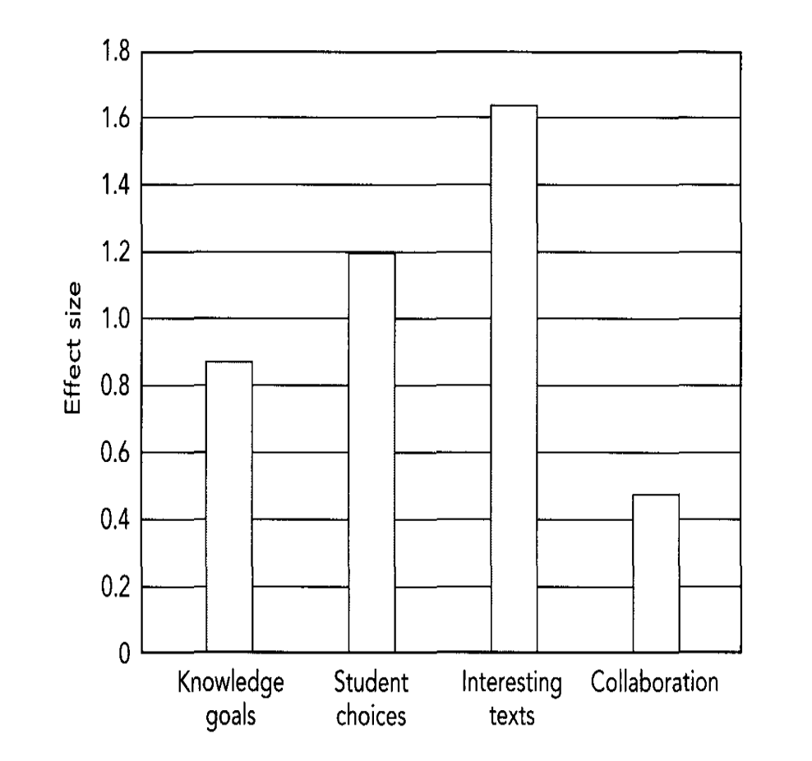Figure 1.1. Guthrie and Humenick (2004) Effect Size Chart

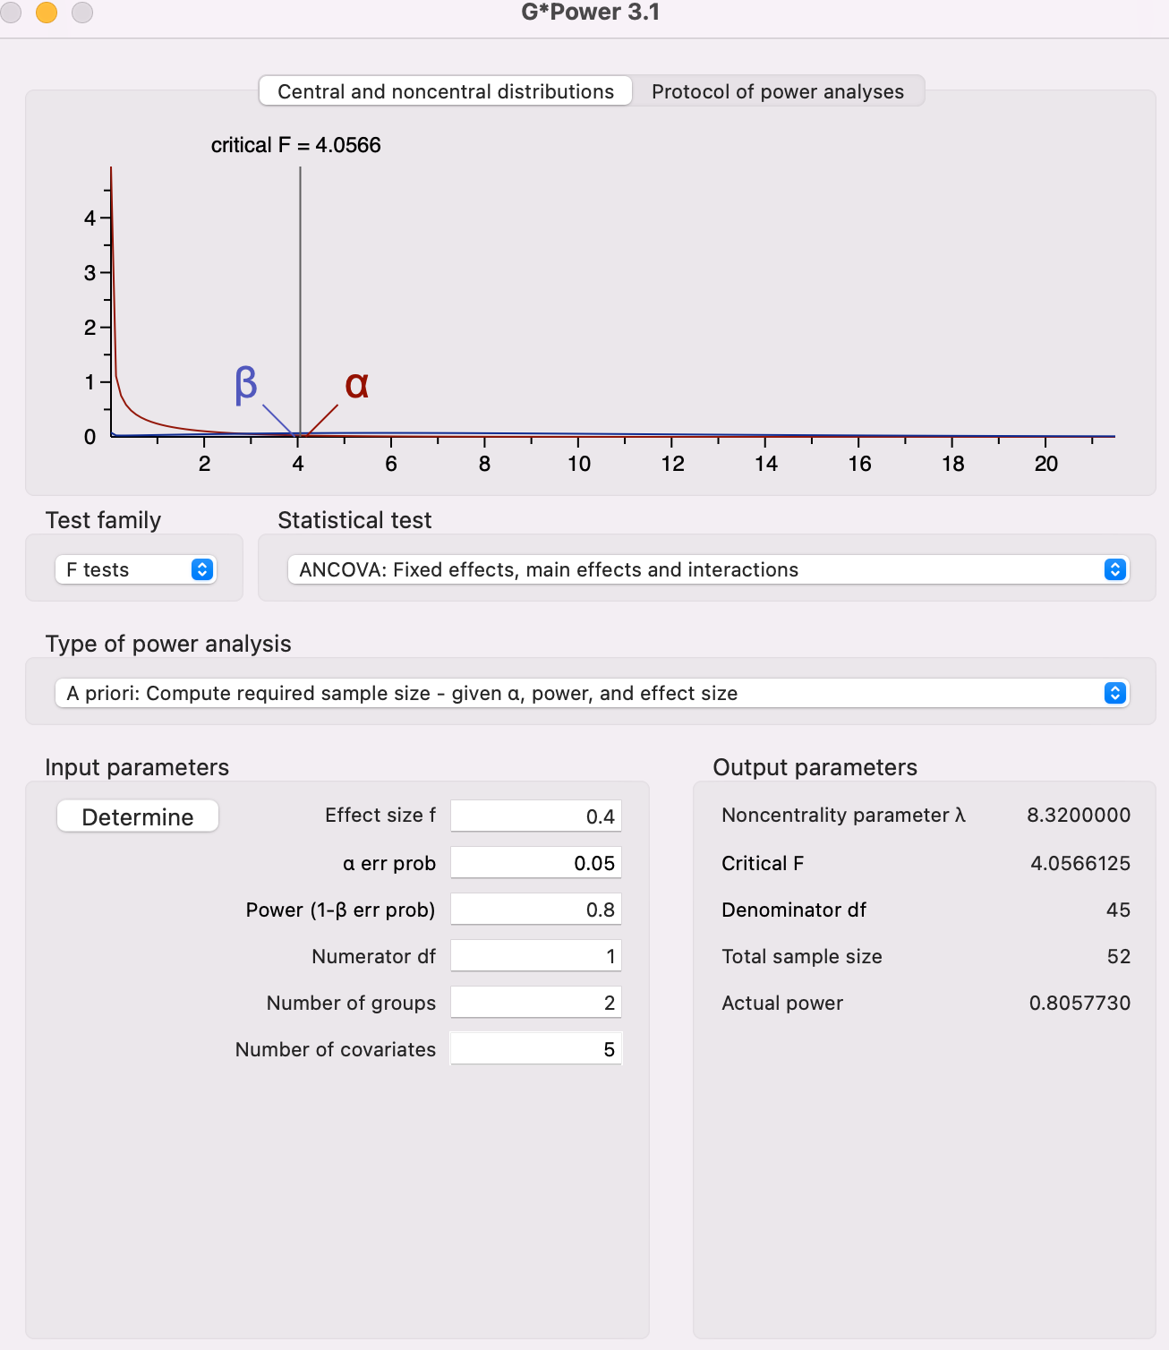
Figure 1.2. G*Power Output

to establish baseline covariate data. Books in the No Choice group were appropriate to interest and Lexile level based on estimated Lexile levels (Lexile, 2021) for the grade-level. A 12-week SSR/DIR course following Miller and Moss’s (2013) scaffolded curriculum was used excluding the choice component for the No Choice group. This is typical instruction for the research site as SSR/DIR has been the ELA department policy at the school since 2018. Prior to the 12 weeks, there was a student phase-in week when the school focuses on introduction to norms and policies; this week also had students finalizing their schedules and so rosters were somewhat fluid. I partnered with the research assistant to simultaneously begin presenting the research opportunity to potential participants, procuring consent from legal guardians, reviewing the standard course syllabus, reviewing the pacing guide, collecting baseline covariates, and administering the AMRP survey to gain a stronger profile of the students as readers. The research assistant delivered the GMRT pretest to the willing participants and communicated those scores to me for the purpose of normality testing and independent samples t-testing to ensure no severe assumption violations had occurred for the ANCOVA. These scores were communicated in such a way that I could not see what each participant had scored but only what group they belonged to. In this way, I was not able to unconsciously bias the 12-week intervention by knowing what any given participant scored on the GMRT pretest. The research assistant secured these scores until after the posttest had been administered. Once the pretests were collected, the scores analyzed for normality, and the subgroups checked for significant difference via t-testing, I delivered the Miller and Moss (2013) curriculum with fidelity to the Choice group and delivered the same curriculum to No Choice group excluding choice-of-text. This was a 12-week intervention. At the end of the 12 weeks, the GMRT posttest was administered to student-participants by the research assistant. I was not able to proctor the posttest myself as IRB was concerned with undue influence. After the GMRT posttest, a series of assumptions tests were performed on the scores; when those assumptions were met, an ANCOVA was conducted in SPSS, and a decision was made concerning the Null Hypothesis (Ho). Follow-up interviews were conducted for both typical and non-typical cases according to the data and were used to better inform the RESULTS and DISCUSSION chapters. These interviews were also conducted by the research assistant to mitigate undue influence from the PI.
Summary
This introductory chapter provided a summary of SSR/DIR as it will be defined in this study and how I arrived at this focus for a dissertation study. With choice-of-text serving as a critical component of modern SSR/DIR, I chose to question its significance in terms of reading achievement outcomes as media and education become more personalized through corporate algorithms. In the statement-of-problem section, the extremely high effect size of choice on reading achievement outcomes (d = 1.2) reported by Guthrie and Humenick’s (2004) metanalysis fails to define “student” past the age of 14 years old and reports the effect size without disclosing the measurement tools used in the various studies in their metanalysis. This study will investigate choice-of-text beyond 14 years old and will report the effect size by relying upon a normed, reliable, and valid measurement tool (GMRT). The theoretical framework of this study is Instructional Design Theory as this study seeks to clarify the conditions for optimal learning. The research questions have been stated with accompanying null and alternative hypotheses, and the G*Power output was provided to clarify the number of participants needed (N = 52) based on the effect size reported in the review of literature.

CHAPTER II: REVIEW OF LITERATURE
According to Moss (2021), “Today’s Independent Reading (IR) programs differ significantly from SSR and DEAR. Effective IR programs require active engagement, time, a broad range of leveled texts, talk around texts, and differentiated instruction. The benefits are well worth it: increased student achievement, motivation, and a love of reading” (n.p.). This chapter will summarize the literature discussing the history and manifestation of SSR/DIR as it will be used in this study. This chapter will also outline the argument among SSR/DIR supporters and detractors specifically in the aftermath of the National Reading Panel (2000). The theory around choice, in general, is discussed. After this baseline, choice will be investigated in the context of SSR/DIR. In the next section, the research gap outlined in the INTRODUCTION chapter from the Guthrie and Humenick’s (2004) study is expanded upon. The historic development of the GMRT to justify its use in this study will follow.
Historical Context SSR/DIR
As an institutionalized part of ELA education, SSR/DIR has been a constantly improving practice since its inception in the 1960s. Ironically, the current best-practice version of SSR/DIR is no longer silent nor independent (Parr & Maguiness, 2005). The noise is not a new development either; Manning and Manning (1984) began to note that reading scores increased slightly when peer discussion or teacher conferencing was added to traditional SSR/DIR implementation. The latest research in favor of SSR/DIR’s current implementation, as exemplified by Johnston and Ivey (2013), Atwood (2015), and possibly the most important for practitioners, Miller and Moss (2013), presents a social literacy community for teachers to strive for in their classrooms. These researcher-practitioners’ understanding of SSR/DIR, USSR, IR, R5, Million Minutes, or DEAR present a version of SSR/DIR that is rooted in the “Social Turn” conclusions (and resulting implications for practice) of literacy research as a sub-branch of situated cognition (Miller & Moss, 2013). It is this most current manifestation of SSR/DIR (the kind presented by Ivey and Johnston (2013) and Atwell (2015) very similar to the R5 model) that I will be referring to. However, in honor of previous research and the various acronyms to refer to this similar reading practice, one should note that “[i]ndependent reading is rarely defined (Knoester, 2008; Serravallo & Goldberg, 2007; Keene & Zimmerman, 1997; Fountas & Pinnell, 1996)” (qtd. in Knoester, 2010, p. 2). Krashen (2004) states, “It is important to note first that various scholars have defined independent reading somewhat differently.” Krashen (2004), for example, prefers the term “free voluntary reading.” Hughes-Hassell and Rodge (2007) use the term “leisure reading.” Anderson, et al. (1988) use the phrase “reading outside of school” and Manzo & Manzo (2000) prefer “recreational reading.”
For me to list my own preferred manifestation and accompanying pet-acronym is to discount the foundations laid by early researchers; though we’ve found more optimal ways and have begun to emphasize the social aspect of literacy from the Social Turn, it is unethical to dismiss these early efforts as “wrong” but rather evolving. In honor of these early researcher-practitioners, such as Lyman Hunt (1960), SSR/DIR will be the term used in this draft with the understanding that it incorporates the body of work from these early researchers. For this study, I attempted to replicate the version advocated by Miller and Moss (2013), as I believe it most faithfully accounts for the Social Turn and honors the previous research on situated cognition, structured choice, the benefits of quality YAL, and independent reading in general. It is not an exaggeration to say that those in favor of the SSR/DIR tend to think of it as the solution for ELA education. The Miller and Moss (2013) model will be outlined in detail in the METHODOLOGY chapter.
Teachers having books readily available in their classrooms leads to students reading more independently (Neuman, 1999; Capatano et al., 2009). Reading more independently positively impacts students’ overall critical thinking skills, reading ability, vocabulary, and standardized test scores (Reutzel & Juth, 2014). Reutzel, Fawson, and Smith (2008) report that SSR/DIR can improve oral reading accuracy, increase reading rate, improve reading expression, and increase reading comprehension. The firm of Houghton-Mifflin (2016) reports in their literature review that “research shows that independent reading libraries are particularly beneficial to children from low socioeconomic backgrounds” (p. 4). Miller (2010) reports that the daily routine of reading and having books readily available will quickly transform non-readers into readers whose reading confidence will improve, which will manifest in better classroom grades and higher test scores. Culinan (2000) concludes: “students who read independently become better readers, score higher on achievement tests in all subject areas, and have greater content knowledge than those who do not” (p. 2). Krashen (2004) conducted a meta-analysis examining comparisons of curriculum that stressed IR against programs emphasizing prescribed reading and determined that 51 of 54 studies showed that students in IR programs did as well or better on reading comprehension tests than students in traditional reading programs. Krashen (2004) ultimately concluded:
The relationship between reported free voluntary reading and literacy development is not large in every study, but it is remarkably consistent. Nearly every study that has examined this relationship has found a positive correlation, and it is present even when different tests, different methods of probing reading habits, and different definitions of free reading are used. (p. 11)
It is critical to remember that Krashen’s research, like Guthrie and Humenick’s (2004) likewise focuses on younger students in the literature review. Block and Mangieri (2002) reviewed two decades of research on recreational reading and found that:
students who engaged in recreational literacy activities during school read books outside of school more frequently. Additionally, even with only 15 minutes of in-school reading per day, students significantly increased their reading performance, with average and below-average readers experiencing the greatest gains. (p. 3)
Increased access to books as part of an SSR/DIR within an ELA curriculum is associated with improvements on formative assessments of reading proficiency, and increased student reading comprehension is associated with increased independent reading (Allington & McGill-Franzen et al., 2003 and 2010; Krashen, 2004 and 2011; Neuman & Celano, 2012). Allington (2002) reports that one of the major indicators of effective teaching in ELA was time spent on independent reading of self-selected books. Less effective teaching spent more time on packets, worksheets, and activities.
Calkins, Ehrenworth, and Lehman (2012) make the bold claim that every conceivable standardized test score would show marked improvement with implementation of SSR/DIR. I am conflicted about linking SSR/DIR to standardized test scores; it seems to go against the spirit of the thing, and I believe standardized tests are, at best, a necessary evil in primary and secondary education. But due to the theoretical framework and a desire to change the system from within, educator-researchers must be able to get their principals, superintendents, department chairs, and all the others who are beholden to the ACT/SAT machine to support them in implementing this method. Unfortunately, this is not a conversation they can have with these forces without mentioning an increase in standardized test scores. For example, it was only by linking SSR/DIR to improved test scores that the administration allowed the ELA department at the research site of this study to proceed in adopting the SSR/DIR policy, and I am confident this district’s circumstances are not unique. If Calkins et al. (2012) are correct, this will not be a major issue, and scores will show marked improvement in this study. Though teacher-researchers may be conflicted on standardized tests, at some point, they must negotiate with those in power who are not so conflicted, and under this TF the teacher-researcher must have a reliable tool of measurement. Within Instructional Design Theory, quantitative analysis is a component; therefore, a testing tool is appropriate. My circumstance is consistent with would-be SSR/DIR proponents at other schools as well.
According to Miller and Moss (2013), despite the incredible gains SSR/DIR is associated with, “many schools have dropped or decreased their attention to IR in favor of literacy instruction that they believe will raise test scores” (p. 12), but as Miller (2013) goes on to argue, “Ironically, [schools] have eliminated one of the most powerful ways to improve student achievement” (p. 12). Anderson, Wilson, and Fielding (1988) established a link between SSR/DIR and achievement by comparing two groups of fifth graders’ test scores (again, no upper-secondary). The group that read independently for an hour per day scored at the 98th percentile on the district’s standardized tests. Students who read 4.6 minutes per day, scored at the 50th percentile. Students who participated in no SSR/DIR scored in the second percentile. “Just read” seems to be the way forward; however, in 2000 the Report of the National Reading Panel (NRP) stated: “Literally hundreds of correlational studies find that the best readers read the most and poor readers read the least. Many correlational studies find that the more children read, the better their comprehension, vocabulary, and fluency, However, these findings are correlational in nature and correlation does not imply causation” (p. 3).
“Correlation does not imply causation” is an axiom hammered into students repeatedly in graduate school and in any statistics course; educators have heard the phrase employed for reasons of good faith and also for pure sophistry. When confronted with examples of spurious correlation such as the well-known ice cream sales and murder rates in America (Vigen, 2015), the phrase is of critical importance, but it is too often employed by pedants with a pet cause as justification to ignore a body of research. Concerning the NRP’s (2000) literature review, Harlaar et al. (2011) state:
Although longitudinal correlational studies cannot conclusively establish a causal link between two factors due to the much-cited third variable problem, they can provide information on temporal precedence, which is critical in determining the direction of influence (Bollen, 1989). Cunningham and Stanovich (1997) reported that first grade reading ability significantly predicted independent reading in Grade 11 independent of reading ability at Grade 11. (p. 2124)
The most complete rationale and encapsulation of why we believe in SSR/DIR is given by Miller (2013) who states:
Children learn to read by reading . . . It’s well known that in order to become thoughtful, strategic, proficient readers, children need to read. A lot. When children read extensively, they learn about themselves, other people, and the world; they learn that reading is something they can do that empowers them to control their lives, connect with each other, and make the world a better place. For children to develop the habits and identity of thoughtful, strategic, proficient readers, they need to practice and, to make their practice productive, they need the tools that we can provide through instruction. This extensive independent reading practice framed by instruction needs to happen in classrooms every day. (p. 2)
Choice-of-text is an integral part of all current manifestations of SSR/DIR. Miller and Anderson (2011) found that student choice-of-text in reading was associated with higher EOC scores than students who were not given choice in reading material in a middle school sample, but again this assertion, along with Harlaar et al. (2011), falls under the NRP’s category of “correlational” and is therefore dismissible research by the panel’s standards. This dismissal of correlational studies by the NRP’s standards is a sub-issue this quasi-experimental study seeks to address. Even so, the mandated readings were described by middle schoolers in a study by Guthrie, Klauda, and Morrison (2012) as “boring,” “irrelevant,” and “difficult to understand.” It also falls within Humenick and Guthrie’s narrow definition of “student” (8-14 years old).
The new, supported model of independent reading is indeed a cult of educators, and, despite NRP’s (2000) ruling, most of the published research does seem to support SSR/DIR advocates’ zeal, but SSR/DIR is not without its detractors in addition to the NRP’s (2000) critique; Tim Shanahan is a major force in public education and literacy studies; he led the research methodology on the NRP’s 2000 report. In addressing one of his critics, Shanahan summarizes the entirety of the SSR/DIR criticisms:
That good readers read more than poor readers is true but has no bearing on my response to the question. Correlation doesn’t prove causation. That good readers read more does not mean that it was reading more that made them good readers. Maybe good readers choose to read more because they can do it well. You are making a good argument for teaching everyone to read well, not for sending kids off to read on their own during the school day . . . You refer to the correlational studies that can’t answer the question, while ignoring the experimental ones that have directly tested your theory. Studies in which DEAR time is provided to some kids but not to others have not found much payoff—even when the non-readers were doing no more than random worksheets! You seem to be claiming that since reading on one’s own leads to improved achievement—then any and all approaches to encouraging reading must be effective. Following that logic, then telling kids to read on their own, buying books for them, rewarding them with pizzas, or employing electric cattle prods… all must work, too. Remember I wasn’t saying kids shouldn’t read, only that requiring “independent reading” during the school day has not been effective. Only one study bothered to check its impact on amount of reading, and it found that middle school kids read less as a result of the practice—since it reduced the amount of reading they did on their own. (qtd. in Refsnes, 2016)
Harlaar, Deater-Deckard, Thompson, DeThorne, and Petrill (2011) pose a foundational question of the value of SSR/DIR theorizing:
We cannot infer that independent reading leads to better reading from these studies because the causal arrow may point in the other direction: Better readers may simply choose to read more . . . The difficulties of disentangling cause and effect in cross-sectional data can be circumvented by training studies that seek to determine whether increasing levels of independent reading result in improvements in reading achievement, or vice versa. To date, the available evidence has been mixed. (p. 2124)
Psychology of Choice and Choice as Part of SSR/DIR
From a psychological standpoint, the benefits of choice, cognitively and otherwise, cannot be overstated according to the literature (Seligman, 1975; Deci & Ryan, 2000; Fischer & Boer, 2011; Bone et al., 2014). Choice is philosophically, historically, and even theologically interlinked with western enlightenment ideals of human freedom and autonomy and the self. Schwartz and Cheek (2016) state that “[i]t is commonly assumed in affluent, Western, democratic societies that by enhancing opportunities for choice, we enhance freedom and wellbeing, both by enabling people to get exactly what they want and by enabling people to express their identities” (p. 106). Allowing choice is also accepted as the most moral option. Schwartz and Cheek (2017) provide the following syllogism to explain the self-evidence of the morality of choice: “The more freedom people have, the more well-being they have. The more choice people have, the more freedom they have. Therefore, the more choice people have, the more well-being they have” (p. 106). From an ethical view, Schwartz and Cheek (2017) acknowledge the logic and superior morality of the previous syllogism; they associate an increase of choice with an increase in freedom, and any attempt to limit choice necessarily limits freedom in the “psychologic,” of choice—a term they coin for their paper. Shwartz and Cheek (2017) contend that:
Evidence has accumulated that a point can be reached at which added options reduce the likelihood that any will be chosen—that too much choice can paralyze rather than liberate. Thus where, whereas some choice is good—both to enhance freedom and to enable people to satisfy preferences when they make decisions—there can be too much of a good thing. The relationship between the number of options people face and well-being seems to be non-monotonic—an inverted U. (p. 107)
Fiske et al. (1998), and Miller (2003) provide a skeptic counter-narrative to the individualistic framework of choice. Beyond a mere critique of running out of the possibility of creating new cultural touchstones through corporate algorithm-fueled, hyper-individualized media, these researchers argue that eastern societies and even working-class Americans practice an interdependence that defines self in relation to others and may even lead to a stronger sense of self more than unbounded free choice.
Shwartz and Cheek (2017) argue that society must consider the aims of choice within specific contexts rather than adopting a too-western view of choice as an open-ended correlate of freedom and happiness with no point of diminishing return. If practicing choice in the public school system is critical for preparing students for freedom and citizenship, then it is beyond the scope of this study to investigate such a matter; rather, it is solely the purpose of this study to investigate choice within the specific context of reading achievement and be open to the possibility that this point of diminishing return may apply to an educational context as well.
Our modern manifestations of SSR/DIR with the centrality of choice may have more to do with upper-middle class western ideals of independent self-actualization than leading to greater reading achievement outcomes for the children of working-class families—the single study from Sokal (2010) not-withstanding. Again, this may not be ethically wrong, but it may not be the most beneficial model of SSR/DIR for crafting the self among working-class or immigrant children; Shwartz and Cheek (2017) contend: “under a conjoint model of agency, choice is less likely to be directly associated with freedom and well-being, and the lack of individual choice is not as threatening to autonomy or the self” (p. 112).
Guthrie and Humenick (2004) found that choice-of-text was associated with higher reading comprehension and even Allington and Gabriel (2012) state that the “research base on selected reading is robust and conclusive” (p. 10). When investigating this meta-analysis by Guthrie and Humenick (2004), however, their analysis only focused on students aged 8-14, even defining “student” as such in their meta-analysis (p. 329). Later studies on choice and text comprehension from Fraumeni-McBride (2017) also focus on elementary students and use a non-normed measuring tool. In the review of literature conducted for this document, it is almost as if high school students no longer exist and that reading and literacy are of no more concern once a student enters high school, and the conclusions drawn from studies concerning second-grade children must be consistent for 17-year-olds. Beyond the age limitations of the research focus, the dependent variables in Guthrie and Humenick’s (2004) study focused primarily on outcomes on motivation surveys, and reading achievement was an after-thought. Where choice was investigated with regards to reading achievement outcomes, Guthrie and Humenick (2004) do not clearly define the means or divulge the tools by which the series of reviewed researchers reported reading achievement outcomes. It was not specified either if choice took place within the context of an SSR/DIR program. Sokal (2010) also challenges the alleged consensus of the efficacy of choice variables in reading programs in both achievement and motivation. In her review of literature Sokal (2010) states:
Although some research supports the positive effects of choice on students’ enjoyment (Sweet, Guthrie & Ng, 1998) and efficiency of learning (Reynolds & Symons, 2001), studies fail to support positive cognitive effects associated with choice (Parker & Lepper, 1992; Schraw, Flowerday & Reisetter. 1998). Overall, according to Flowerday and Schraw (2000) and other researchers, having choices positively affects students’ affective responses to texts but has no effect on cognitive responses. Flowerday, Schraw, & Stevens (2004) contend that the research designs used to study the effects of choice have been confounded by the effects of interest. These authors believe that it is a reasonable conclusion that when readers are given choices in their reading materials, they tend to choose texts that interest them, findings that some researchers attribute to students’ opportunities for choice could, in reality, be the result of students’ interest in the texts they chose (Flowerday et al., 2004). Accordingly, they predict that providing children with a number of undesirable choices will do little to motivate them—a situation that challenges the claims of intrinsic value of choice to children’s reading motivation. (p. 118-119)
This literature review from Sokal (2010) and the response to it, again, focuses almost exclusively on primary grade students, and the theory of conflating interest with the intrinsic value of choice could be solved with interest surveys, studying interest trends, and then matching texts accordingly.
Guthrie (2004) also acknowledges that choice-of-text has different impacts on students from diverse cultural backgrounds. For example, Guthrie (2004) cites Iyengar and Lepper (1999) who found that white children benefited from choice-of-text; however, in terms of motivational outcomes, Asian children were most motivated when they were matched to a text. “It appears that the effect of choice on motivation is influenced by children’s beliefs and values, which are embedded within their cultural experience” (Iyengar & Lepper, 1999, p. 342). With schools’ rapidly increasing diversity, our default acceptance of choice may need to be reevaluated in terms of motivation and reading achievement outcomes among diverse students and even among the 8-14 aged children for which the question of choice is seemingly settled. The inclusion of choice-of-text in SSR/DIR may have more to do with the fundamental individualism of Western society (Cheek & Shwartz, 2017) rather than how choice relates explicitly to greater reading achievement for older adolescents.
Though not specifically related to reading, a closer investigation of the assumed default use of choice in SSR/DIR may not be beneficial to young adults, especially those struggling with reading, if we assume that the benefits of choice apply in general and to SSR/DIR students. For example, Reed et al. (2008) and Patall, Sylvester, and Han (2014) found that teenagers only wanted the ability to choose within contexts where they felt self-confident about their ability to make a successful choice. One can see how this could be an issue when implementing a choice centered SSR/DIR initiative with struggling students who lack confidence in themselves and their reading, especially among working-class, adolescent males. Reed et al. (2008) further found that subjects desired less choice when confronted with more important decisions and only desired more choices when considering casual, short-term decisions such as what type of jelly to put on toast. To achieve the level of engagement and motivation necessary for positive reading outcomes, Fisher and Ivey (2006) argue for “the importance of using interesting reading materials . . . Effective instruction for all adolescents focuses on their personal interests and incorporates diverse reading materials” (p. 183). The intuitive approach is to fulfil this mandate by allowing student choice-of-text, but if reading comprehension and achievement is the goal rather than western self-actualization, this same goal of providing engaging text can be attained by using normed or even popular interest surveys and their corresponding YAL flow charts such as the one found on Epic Reads which primarily uses visual cues to match a reader with a book based on their interests. In combining the appropriate Lexile level to the reader, choice is replaced with the far more intentional matching via interest survey.
To further complicate the research surrounding the supposedly conclusive efficacy of choice, Lemov, Driggs, and Woolway (2016), the authors of Reading Reconsidered, argue:
[t]here isn’t any substantial scientific evidence yet to suggest that choice reading improves reading proficiency—or even fosters a love of reading—according to some literary experts I talked to . . . student choice reading has been overhyped by schools and makes a couple of assumptions that don’t add up: First, that adolescents know enough about books to know what they like to read; and second, that there’s greater power in the freedom to ‘do your own thing’ rather than in developing a deep understanding of what you’re reading. Whether it’s Gabriel García Márquez, Toni Morrison, or Harper Lee, shared [mandated] reading can also improve equity by giving all students access to high-quality literature, Lemov says. He also emphasizes that it teaches students to engage in a balanced and civil discourse, asserting that ‘you can only really listen to someone else’s perspective on a story if you’re discussing a text that you have also read. (qtd. in Korbey, 2019, n.p.)
The point the authors raise is worth considering in the context of the future of our democracy and culture. Educators use analogies every day to explain concepts to their students seeking to ascertain their pre-existing funds of knowledge and connect these funds to new ideas. The issue I have noted over my years of teaching is that with individualized media and algorithms charting students’ tastes and curating media to consumers in a highly subjective manner, teachers are running out of shared texts and media to serve as reference points for explaining new ideas or at least getting students to understand old ones in a more meaningful way. This presents a complicated issue with regards to respecting multiculturalism. For example, most millennials’ parents watched the MASH finale—106 million or 45.3% of people in the U.S. in 1983 (Andrews, 2018). Now, a teacher is fortunate if they have three students in their classroom who have seen the same movie or show from 2022 even among modern choices. School, at some point, ought to aid in creating culture and finding just as many ways in which we are common as celebrating the ways in which we differ. Also from a citizenship standpoint, educators must consider the question: “Are we truly serving students’ life-long literacy needs by allowing them to only read what they want to read?”
Previous Research on Choice-of-Text and Effect Size: A Missing Piece
Defining effect size for this study has been difficult due to the conflicting literature related to choice-of-text in SSR/DIR. As the previous section indicates, both sides contend that the matter is settled, with some, such as Guthrie and Humenick (2004), maintaining that choice-of-text matters and that not only does it matter, but it also accounts for the seventh largest educational intervention in the history of educational research (d = 1.2) if choice-of-text is placed within Hattie’s (2017) ranking of educational interventions. Other researchers, meanwhile, such as Lemov et al. (2016) and Sokal (2010), argue that the results of choice-of-text experimental or quasi-experimental studies are few in number, mixed in results, and unconcerned with high school students.
Sokal (2010) investigated the outcomes of choice-of-text versus no choice-of-text in reading achievement and found that, indeed, the students given free choice of reading materials scored significantly higher (p. = .01) than the group who did not have choice of materials. However, this study only dealt with fourth-grade, Canadian males, and, perhaps most critically, Sokal (2010) fails to provide a competing effect size to Guthrie and Humenick’s (2004) massive (d = 1.2); in fact, Sokal (2010) does not provide an effect size at all in her study. This raises questions about both the sample selection (N = 62) and the real-world impact of choice. By failing to provide an effect size and focusing solely on p-values, Sokal (2010) has informed us that choice matters in her study (p = .01) but has not told us how much it matters. According to Ellis (2020), this represents a trend that has only recently begun to change among research journals; this dissertation focus on adolescents within an upper secondary SSR/DIR setting and provides an effect size to allow researchers and practitioners to see what potential applied efficacy could be despite the p-value. Ellis (2020) writes:
The estimation of p-values tends to be vague and speculative. In contrast, reporting the effect size facilitates the explicit interpretation of the substantive or practical significance of the result… In many disciplines there is an ongoing push towards relevance and engagement with stake-holders beyond the research community. If our research is to make sense to partitioners and non-specialists, we need to abandon the time-worn habit of drawing large conclusions from small p-values and engage directly with the evidence itself. We need to shift our focus from ‘did this test achieve statistical significance?’ to ‘how big is the effect size and what does it mean?’ (p. 15-16)
As a current educator with ten years’ experience, I like to assume that I know the thinking of my students, but I truly know the minds of my fellow educators, and Ellis’ (2020) summation of the state of research as it relates to effect size, p-values, and practitioners is a solid estimate of the teaching community’s view of the state of research. Effect-size reporting has the potential to change our consumption of the research as we move towards a more perfect praxis where results are not only statistically significant in terms of p-values, but also meaningful in terms of reported effect sizes.
Cross-Context Rational
Another rationale for the study and an oversight in the state of the research which prevents us from implementing the conclusions drawn from the fourth-grade study and Guthrie and Humenick’s (2004) research with students aged 8-14, is that we cannot assume what has been effective at the fourth-grade level will be just as effective at the upper-secondary level. There is a vast body of literature investigating the anatomical changes (including brain plasticity), related to cognition, motivation, and learning differences between children and adolescents (Lafon, Chasseigne & Mullet, 2004; Loschert, Harper, Hermann, & Waite, 2019). For example, Loschert et al. (2019) report:
Adolescents are in a stage of development during which the brain becomes more specialized and efficient. Learning experiences and environmental influences play key roles in this process. Learning and development are inextricably intertwined; these dual processes shape patterns of neural connections during adolescence. As the brain becomes more interconnected during adolescence, young people are increasingly able to engage in adult levels of complex cognition, such as abstract reasoning, future thinking, and social cognition. During adolescence, biological and environmental changes affect motivation and mindset. Because adolescents have an increased sensitivity to social evaluation, praising their learning process and successful strategies, not effort alone, can support development of a positive mindset and motivate them to learn. (p. 4)
Because of these justifications listed by Loschert et al. (2019), it is inappropriate to assume that what worked for fourth-graders in the Canadian study by Sokal (2010) and the 8-14-year-olds in Guthrie and Humenick’s (2004) meta-analysis will work for upper secondary students with their differences in development and motivations. The assumption that choice-of-text will have a positive benefit across age ranges is insufficiently substantiated, and more research is needed of at least a quasi-experimental nature.
In their meta-analysis, Guthrie and Humenick (2004) estimated an average effect size (d = 1.2, f = 0.6) for student choice-of-text and reading achievement—a gigantic effectiveness level for student outcomes, however, when putting this into dialogue with the much more recent Reading Reconsidered (Lemov et al., 2016), the almost panacea levels of effectiveness become questionable to dictate the G*Power analysis of this study and the corresponding number of participants required. This high level becomes even more dubious when considering the authors’ own admission that for certain, diverse populations, matching students to text was more effective than giving students choice. With respect to the diversity of the research site’s student population and the increasing diversity in general of this country’s population (Frey, 2020), the lack of data for effect size is secondary, and the lack of a reported, normed tool for measuring reading achievement in Guthrie and Humenick’s (2004) meta-analysis is most critical.
The History and Validity of the GMRT Measurement Tool
Due to Guthrie and Humenick’s (2004) inclusion of studies using a variety of tools for measuring reading achievement, there is a need for a highly normed and consistent tool. The GMRT fulfills this requirement. The GMRT was developed from the Gates Primary Reading Tests first implemented by Gates in 1926. These tests were reviewed and improved in 1956 with input from William H. MacGinitie. Currently, the GMRT is in its fourth edition, and it is authored by Walter H. MacGinitie, Ruth K. MacGinitie, Katherine Maria, Lois G. Dreyer and Kay E. Hughes (Lee, 2020).
Jongsma (1980) describes the GMRT as “a survey tests of general reading achievement” (p. 341). In his review (1989), Cooter states:
The [GMRT] may be used to measure some aspects of student reading progress and compare classes, schools, and school systems (Aaron and Gillespie, in press). Likewise, reading researchers may wish to use it as part of an overall assessment package when investigating innovative methods. (p. 656)
Investigating innovative methods in reading achievement intervention and SSR/DIR is exactly what I am seeking to do, and for over 40 years, this test has served as one way, among a series of evaluative methods, to assess if these innovative methods are significantly linked to higher reading achievement.
There is great flexibility with the GMRT. A classroom teacher may deliver it to his or her students as easily as any paper test. If a teacher has proctored an EOC before, they may just as easily proctor the GMRT. The directions are clear, and there are two options for processing the scores. An educator or district may choose to send the scores back to the publisher for a detailed report, or, as in my case, one can input the pre/post scores into SPSS to run the ANCOVA, and report significance, effect size, and other key outputs.
I also chose to use this test because of its reliability or the extent to which this tool produces consistent data. Cooter (1989) reports:
The [GMRT] went through a rigorous national standardization process. Normative scores were developed in 1987-88 with a sampling plan based on geographic region, family income, enrollment size, parents' years of schooling, and other factors… Vocabulary subtests [of alternate reliability] range from .88 to .91, and Comprehension subtests from .87 to .92. Total test reliabilities range from .93 to .95. (p. 657-658)
These figures are derived using the Kuder-Richardson 20 (KR-20) rank where zero is no reliability and one is perfect reliability similar to a Spearman Rho or Pearson Correlation Coefficient formula’s output, though a score of .70 is the base desirable outcome rather than .50. The total reliability of the GMRT’s KR-20 = .93-.95 and is almost perfect in terms of reliability—another reason to employ the tool.
Due to the National Reading Panel’s (2000) (i.e. Shanahan’s) dismissal of the hundreds of correlational studies as providing no evidence of a causal link between SSR/DIR and reading achievement, I have avoided these correlational formulas altogether (apart from correlating the AMRP survey to GMRT scores as a secondary objective) and chose only methods which seek to establish quasi-experimental arguments for causality derived and adapted from the medical model in this quasi experimental study. The prefix and caveat “quasi” is important because even the NRP must admit that the classroom is not a laboratory.
Curry (1989) approves the GMRT as well as stating that “[t]he challenging Vocabulary items beyond level 2 should clearly discriminate good from poor readers” (qtd. in Cooter & Curry, 1989, p. 257); since I focused on testing upper-level, secondary students, Curry’s reservations about sub-level 2 items do not apply. In keeping with the varied content I used to replicate Miller and Moss’s (2013) SSR/DIR model, the GMRT is most appropriate as Curry (1989) states that the “comprehension items appropriately tap both literal and inferential comprehension and draw from poetry, fiction, and nonfiction texts” (qtd. in Cooter & Curry, 1989, p. 257), but Curry (1989) cautions against over-interpretation of the results in keeping with a holistic evaluation of the individual student.
In terms of validity or if the GMRT is measuring what it claims to measure, Cooter (1989) critiques the early versions of the test, stating that evidence of validity has not been established. Early in the GMRT’s inception, though, Change and Brown (1983) found a high correlation between the GMRT and The Minnesota Reading Assessment in reading rate—the state standardized test used at the time. In more recent research on the GMRT’s validity, DiAntonio (2016) provided evidence of validity when the GMRT was administered simultaneously with the highly normed and valid New Jersey Assessment of Skills and Knowledge Language Arts Literacy (NJAS) to fourth, fifth, and sixth-grade students in Gloucester City School District over three consecutive years. DiAntonio (2016) found that the results of the experiment showed that prediction of student scores on the NJAS can be established with a high reliability by the scores achieved on the GMRT, and as students progressed through grades, the correlation grew stronger starting at r = .568 in fourth, r = .718 in fifth and finally r = .816 by sixth-grade between the two tests. Although, again, this investigation maintains the literacy trend of only investigating students in the lower grades, even though standardized testing of reading achievement is still mandated through junior year in the state where the research site is located, this is the best tool available at the time of this study and has been adapted for use at the junior/senior levels and beyond.
To put this in perspective, if a student scores “passing” or “proficient” on the NJAS, that student will score “one grade level above or higher” on the GMRT (DiAntonio, 2016, p. 35). Assuming this upward trend of stronger and stronger correlations between the GMRT and district and states’ own, normed tools holding steady, I have a great deal of confidence that the GMRT is measuring what it intends to measure, and the research from DiAntonio (2016) has addressed Cooter’s (1989) reservations.
Peer-review boards from a host of reputable journals are also permitting use of the GMRT as a reliable tool in literacy research. These include Reading Research Quarterly, Reading and Writing, The Journal of Educational Psychology, Exceptional Children, Scientific Studies of Reading, Educational Evaluation and Policy Analysis, The Journal of Educational Computing Research, International Journal of Disability, Development and Education, and The Journal of Learning Disabilities just to name a few; all these journals are publishing research that accepts the GMRT as a tool of measurement. By choosing the GMRT for a measuring tool, I can more readily place the results of this study within a wider applicability, context, and conversation with the body of literacy scholarship.
Other reputable scholars such as Jenkins and Jewel (1992) have relied upon the GMRT as a norming tool for their own tests of validity for emerging measurement tools, and though Cooter (1989) is generally critical, he does admit:
The test makers are also to be commended for the rigorous development of reliability and out-of-level norms, which help make the tests quite useful for various student populations. Likewise, the availability of many special services from the publisher regarding the scoring and interpretation of test results is impressive… [and] the Gates-MacGinitie seems adequate. If adopted as one part of an overall reading evaluation, it may prove to be very useful in a school setting. (p. 658)
The scalable nature of the test is convenient as well. Every level has a specifically designed test. The first two test levels are the Pre-Reading Level with Sub-Tests in Literacy Concepts, Oral-Language Concepts, Letter and Letter/Sound Correspondences, and Listening Comprehension. The other test is Beginning Reading and consists of Sub-Tests in Initial Consonants and Clusters, Final Consonants and Clusters, Vowels, and sight words. These first two exams are available as paper and pencil versions only and take between 75 and 100 minutes to complete (Golchtie, 2021).
Early Independent Reading tests 1 and 2 [sic] are employed to measure the level of early independent reading ability. Goltchie (2021) states, “This is the level at which they demonstrate fluent decoding and good comprehension without benefit of any teacher intervention. These levels generally coincide with students in first and second grade” (n.p.). Early Independent levels include a test of decoding, comprehension, and word knowledge. This test takes 55 minutes. Level 2 [sic] takes 75 minutes to complete (Goltchie, 2021).
Mature Reading Levels 3-10/12 [sic] specifically measure a student’s overall reading ability in grades 3 through 10/12 [sic]. It is divided into two parts that assess Vocabulary knowledge and Comprehension (Goltchie, 2021). My research involves this level of the GMRT as this study concerns twelfth-grade students, and there is some overlap in characteristics between this level and the Adult Reading (AR) Level test.
Lastly, the AR test is meant for colleges, trade schools, employers, GED, and Adult Education programs; this Level is intended to gauge the overall reading ability of an adult. The Mature Reading Levels 3-10/12 [sic] and the AR Level test each take 55 minutes to complete. Though the upper levels of the test can be delivered digitally, I do not trust something so expensive, time-consuming, and precious to the legendary inconsistency of public-school wireless internet, and so, my research assistant delivered this test with paper and pencil.
The popular sites and scholarly sources all agree on the convenience of the GMRT as a readily accessible tool that any classroom teacher can use to evaluate students as part of an individual or school-wide assessment. I am not solely using the GMRT for the ease of delivery, but also for the ease with which I can convince my colleagues to use it. This study seeks to not only generate data for the aggregate sum of research on SSR/DIR to be consumed by academics, but for the school, the district, and my fellow teachers who believe in SSR/DIR. No matter how effective, if the process is tedious, teachers will avoid it, and the GMRT appears to be simple; one sympathizes with the hour-long demographics process of in-school state-mandated ACTs before students may even begin the four-hour long test. It is little wonder why teachers would have an almost pathological aversion to any testing tool no matter how rich the data. On the other hand, the GMRT does not require any of the difficulties and tedium of an ACT/SAT demographics sheet.
Summary
This chapter discussed the history and current manifestation of SSR/DIR, the philosophy and psychology of choice, choice in education, and the complicated history of choice as part of SSR/DIR. Effect size of choice is discussed, and Guthrie and Humenick’s (2004) lack of inclusion of high school students is further examined. The history, development, reliability, and validity of the GMRT is provided.

CHAPTER III: METHODOLOGY
The study was conducted at a southeastern public high school. The school was designated as a Title I school with approximately 50% of students qualifying as economically disadvantaged. As one of the provisos in the approval process, the University of Tennessee’s Institutional Review Board requested that I not disclose specific racial demographic data as these could be used to identify the specific school and could constitute a breach of confidentiality and FERPA. Suffice to say that the school was highly diverse and economically disadvantaged, representing the schools most in need of focus in the region. The school practiced modified four-by-four block scheduling for full-credit courses. Where a four-by-four block schedule usually follows four, 90-minute blocks (Brown, 1998), the research site district had four 80-minute periods with a 25-minute “Climb” period which other districts would call “home room.” There was more time permitted between class changes as it was a larger campus with some students having to walk nearly a quarter of a mile between the 80-minute classes. It should be noted that the School Superintendents Association estimates that only 30% of the nation’s secondary schools practice block scheduling, and this offers a potential limitation for replication of this study (Rettig, 2019).
At the start of the 2022 school semester, grade-level 17-18-year-old students were randomly sorted into classes. According to the high school’s Head-of-Guidance, “Our software, PowerSchool™, randomly populates grade-level students into courses. In this way, we can’t pick and choose who goes where.” From there, for the first week, standard classroom operating procedures were be established. During this time, IRB-approved permission forms were given to students to procure both student and parental consent for minors to participate in the study (see Appendix 3.1 and Appendix 3.4). This form was created to fulfill the five requirements for informed consent published in the 2018 Federal Policy for the Protection of Human Subjects (CFR 46.116) and is modelled after the form available on UTK’s IRB page: https://irb.utk.edu/forms/. Students were motivated to participate by the PI reciprocating with gift cards to local cooperating businesses upon return of a signed consent form. Regardless of whether the student or parent wished to participate, the return of the form guaranteed that the student received a gift card. Since SSR/DIR was already part of the formal curriculum at this school, students or parents who did not wish to take part in this study still received the same SSR/DIR treatment as their peers, but they did not receive the GMRT, the AMRP, and their data was not included in the study.
Because the precedence in the literature reports an exceedingly large effect size, I framed the G*Power analysis to detect a large effect size so that at least a full class of students could take part in the study (f = 0.4 in G*Power ver. 3.1). This value corresponds to Cohen’s D large effect size (d = 0.8 at α = 0.05). Based on the G*Power analysis, I needed to recruit (N = 52) participants for this study from the randomly assigned students. Students’ names and other identifying information were coded and secured. For this study, the participants names were coded by allowing the participants to choose their pseudonyms in the interviews (Wiles & Allen, 2015). The data were stored on a password protected laptop with a lockout feature. At the conclusion of the study, digital copies of the data were purged from the laptop; there are printed copies of the data stored in a locked safe at my residence until three years after the conclusion of this study at which point the files will be destroyed. Only the dissertation committee, the research assistant, and I will have access to the data, however, due to FERPA, the dissertation committee was only permitted to view the coded names of participants. Students with IEPs and 504 plans specific to English were also included in this study as they are part of the typical classroom.
Before the students arrived, a YAL library of no less than 364 books was moved into the classroom space. The classroom teacher in this study had knowledge of each of these books per best practices of SSR/DIR; it is difficult to have meaningful, engaging conversations if the teacher does not have at least some knowledge of the student’s SSR/DIR text. A class library, instead of a centralized school library, is critical to modern SSR/DIR. Neuman (1999), and Kim (2003) both concluded that students read more in classrooms with libraries compared to those without. 364 is the number of books required in this study because Fountas (2018) suggests 300-600 books in the classroom for SSR/DIR, and the International Reading Association (1999) suggests seven books for every student. With the G*Power analysis dictating a participant requirement of (N = 52), this equals 364 books which lies within the IRA’s (1999) suggested range.
All books in the library were within the Lexile level of 90% of U.S. 12th grade students (11-CCR.1070L-1385L). After the appropriate number of students were recruited and their permission forms were signed and secured, their names were entered into Group Maker™, a random team generator app to assign to the “Choice” or “No Choice” group.” Typically, all students would take a genre interest survey which is standard practice in modern SSR/DIR, but doing so in this study would add “student interest” as another element which would complicate the analysis per Sokal (2010). However, since use of interest surveys is standard in modern SSR/DIR, yet will not be included in this study, it must be submitted as a limitation.
On the second day of the third week of the semester, The GMRT pretest was administered at the research site by a research assistant trained and certified by CITI; this individual’s CITI credentials have been submitted and approved by the IRB, and the Reliance Agreement has been submitted and approved. An Individual Investigator Agreement Form (IIAF) was also required as part of the IRB approval and is included with this document (see Appendix 3.6). The identifying markers of the GMRT pretest scores were secured and kept confidential from me (the PI) until after the 12-week SSR/DIR unit was completed and the GMRT posttest had been administered by the same research assistant. This individual has also been trained and certified by the state in standardized testing protocol and has served as a proctor many times. I trained this individual in methods of proctoring and collecting the GMRT. The current publisher of the GMRT makes these training materials available with the testing kit. The reason for the assistant keeping identifying markers confidential from the PI is so that the I would not be even unconsciously biased to give more effort and one-on-one time to specific students over others. Throughout the 12-week study, I had no idea who scored what on the GMRT pretest. Though the blinding of test scores does not represent a real-classroom situation, it had the potential to skew the study if unconscious bias was not controlled for. Only the unidentified pretest scores were communicated to me so that initial normality testing could be performed.
An informal survey was administered by the research assistant and recorded in the research journal to ascertain previous reading Lexile level. At the beginning of the 12-week study, students in the No Choice group were assigned an SSR/DIR book appropriate to their Lexile level, and students in the Choice group were allowed to choose their text. The Lexile of the books in the class library was ranked according to the Lexile Framework software from MetaMetrics, Inc. The justification for requiring appropriate Lexile levels comes from Perks (2010) who found that a “moderately strong relationship (r = .43) [existed] between the average challenge level of texts students reported reading [via Lexile] and reading growth over the duration of the study” (p. 102). Therefore, students were given the appropriate Lexile range of 11-CCR from 1070L which lies at the bottom of this band to 1385 which represents the upper “stretch” end of 11-CCR. As the books in the class library will exclusively lie within the 11-CCR band, this will not substantially affect the groups as it parallels normal classroom operations with a class library. The method of limited Lexile is also to account for the tendency of students to choose unchallenging texts during SSR/DIR (Krashen, 2004).
Miller (2009), as part of her emphasis on choice, also argues for students (like Jalen) being permitted to put down a book if it is not working for them. To accommodate this aspect of choice, the Choice group was allowed a one-week probationary period with any book they chose for the duration of the 12-week unit. Miller (2009) is aggressive in her prescription of number of books to be read by her students: 40 books in one academic year; this is based on 30 minutes of SSR/DIR per day as well as mandatory SSR/DIR whenever there are “early finishers” in her classroom. Miller’s (2011) book choices, as listed in the appendices of The Book Whisperer, are on the short side and below the estimated Lexile of upper secondary students; even so her calculations provide an estimate for setting an average number of books to be read during this unit. Hasbrouck and Tindal (2017) and Brysbaert (2019) estimate the average words per minute (WPM) of high schoolers aged 14-18 to be 200-300; the average novel ranges between 60,000 and 100,000 words based on advice from publishing agencies (Bingham, 2021) and my own experiences in the manuscript world with some agents being more hard-lined than others on page count. With this assumption of an average of 80,000, with some non-fiction in the classroom library under that number and some High Fantasy genre books a little over, there are 1,200 minutes available in a 12-week unit assuming we set our SSR/DIR at approximately 20 minutes per day, with the average length assumed; this allows for ~3.75 novels to be read during that time if students are reading between the 200-300 WPM.
This study will designate 20 minutes per day rather than the recommended 30 from Miller (2009). The reason for choosing this dosage comes from Lewis and Samuels (2005) who state that SSR/DIR teachers typically do approximately 20 minute per day, and, more importantly, especially for poorly performing readers, more time with independent reading may not lead to more or better reading comprehension. For example, Wu and Samuels (2004) in their paper presented at the annual IRA convention reported that they compared groups reading for 15 minute per day to groups reading 40 minutes per day. While the readers who were already good readers benefitted from the increased time, the struggling readers had even greater gains than the good readers from only 15 minutes of daily independent reading time. The good readers at the research site and in districts across America have already been sorted into DE and AP courses by the time of their junior or senior year. This study concerns grade-level students where the struggling readers reside. The research-backed time-per-day for this group to make gains is 15 minutes, but in terms of designating actual time, there needs to be a transitional interval; this is the rationale for the 20 minutes per day rather than the 15. Further, due to the chaotic nature of public schools including snow days, fire drills, school-wide assemblies, standardized EOC testing, and the usual interruptions that are a standard part of public education (and are noted in the daily research journal), I cut the 3.75 novel benchmark to simply three whole novels. The AMRP survey includes a standardized interview protocol and prompts which were used in the student interviews. UTK’s IRB required the research assistant, rather than the PI, to conduct the interviews over concerns of “undue influence.” The interviews were analyzed for context, thematic parallels, and observable trends and were included in the DISCUSSION chapter.
Following week 12, students took the GMRT posttest with the research assistant serving as proctor. Additional assumption testing took place once these posttests were scored. The data were entered into SPSS, and an ANCOVA, including the pretest as a baseline covariate, was performed with special emphasis on effect size. Based on the output, a decision was made concerning the null hypothesis (Ho). After the data were collected and analyzed, typical and non-typical cases were interviewed with the questions provided in the AMRP survey interview protocol (see Appendix 3.2).
The brand of SSR/DIR in this study was not as simple as allowing 15-20 minutes of unsupported student reading with the teacher merely modeling reading during that time. Instead, the daily curriculum came directly from Miller and Moss (2013) whose book No More Independent Reading Without Support represents a synthesis of best practices and served as the basis of this intervention; Miller and Moss (2013) give a highly supported model of SSR/DIR that is officially endorsed by NCATE and is state-of-the-art for this pedagogy. My goal was that everything that occurred in this study was to be intentional and based on the best practices of SSR/DIR established in Miller and Moss’s (2013) book. As Miller and Moss (2013) write: “DEAR and SSR by themselves aren’t enough. Research shows that independent reading must be accompanied by intentional instruction and conferencing to improve background knowledge, fluency, comprehension, motivation, and vocabulary . . . When we set children loose day after day with no focus or support, it can lead to fake reading and disengagement” (n.p.). Per their recommendations, the following tenets of SSR/DIR were observed for both the Choice and No Choice groups as part of the 12-week study except for the parts that required student choice-of-text for the No Choice group:
- A variety of genres are stored and displayed within designated levels of reading difficulty [11-CCR 900L-1385L].
- Teacher initiates brief, ~five-minute, individual student reading conferences (two-three per-day). During these conferences, students will perform read-alouds, book-talks, and set goals for future reading. Reis et al. (2008) found that individual conferences with students led to higher fluency scores. These informal interviews were recorded in the research journal.
- Students read aloud to the teacher, answer teacher questions, set personal goals for completing the reading of a book within a time frame, and complete one or more book projects. These included creation of posters, graphic organizers, written reactions, and reader-response notebooks
- Instruction on reading strategies
- Large- and small-group discussion around the texts students read. Saunders and Goldenburg (1999) found that “talk [both to teacher and peers] appears to play a fundamental role in text-based comprehension” (p. 761) and Nystrand (2006) found that peer discussion of texts improves scores.
These requirements listed in Moss and Miller’s (2013) design require high teacher engagement and support showing the evolving nature of SSR/DIR. As stated by Block et al. (2009), “It is the specific actions that teachers take to support students during silent reading periods that produce significant growth in students’ comprehension” (p. 278).
Tentative Semester Schedule and Weekly Sample Schedule
The macro-view of the scheduled curriculum was aligned to the district-approved pacing and is as follows (see Table 3.1). This can be adapted for Spring or Fall semester.
A weekly sample, wk. eight, Mar. 22-26, will be as follows:
Monday: Settle students, “Good Things” per district policy Students read for 15-20 minutes. “A Modest Proposal” by Jonathan Swift. Students delineate essay in groups.
Table 3.1. Tentative Semester Schedule
Week 1 | In-Service | Week 10 | Begin Research
 | Syllabus and Policies |  | Research/assign book presentation
 | Ice-Breakers |  | Research
 | Explanation of Study |  | Research
 | Permission Forms distributed |  | Research
Week 2 | College and Career Readiness Unit | Week 11 | Research
 | College and Career Readiness Unit |  | Research
 | College and Career Readiness Unit |  | Research
 | College and Career Readiness Unit |  | Research
 | Collect all permission forms by this day |  | Research
Week 3 | Give AMRP Survey and group students | Week 12 | Research
 | GMRT Pretest |  | Research
 | Assign Books/Choose Books; begin SSR |  | Research
 | Beowulf |  | Book Presentations
 | Beowulf |  | Book Presentations
Week 4 | Beowulf and Book Talks start (3-per day) | Week 13 | Graphic Novel
 | Beowulf |  | Graphic Novel
 | Beowulf |  | Graphic Novel
 | Beowulf |  | Graphic Novel
 | Beowulf |  | Graphic Novel
Week 5 | Canterbury Tales | Week 14 | Graphic Novel
 | Canterbury Tales |  | Graphic Novel
 | Canterbury Tales |  | Graphic Novel
 | Canterbury Tales |  | Graphic Novel
 | Canterbury Tales |  | GMRT Posttest
Week 6 | Macbeth second round of book talks begin with “read-alouds” | Week 15 | Begin student Interviews  and school-wide Testing Week (EOC and ACT)
 | Macbeth |  | Testing Week
 | Macbeth |  | Testing Week
 | Macbeth |  | Testing Week
 | Macbeth |  | Testing Week
Week 7 | Macbeth | Week 16 | Final Projects
 | Macbeth |  | Final Projects
 | Macbeth |  | Final Projects
 | Macbeth |  | Final Projects
 | Macbeth |  | Final Projects
Week 8 | Macbeth | Week 17 | Final Projects
 | Macbeth |  | Final Projects
 | Macbeth |  | EOY Presentations
 | Macbeth |  | EOY Presentations
 | Macbeth |  | EOY Presentations
Week 9 | Gulliver’s Travels Assign Book Reviews | Week 18 | Final Exams
 | Gulliver’s Travels |  | Final Exams
 | Gulliver’s Travels |  | Final Exams
 | Gulliver’s Travels |  | Winter Break
 | Gulliver’s Travels |  | Winter Break
Table 3.1 continued

While this occurs, meet with two-three students. Come back together as a class and share sustaining points of argument and closure. While this occurs, meet with two-three students. Come back together as a whole class and share sustaining points of argument and closure.
Tuesday: Settle students, “Good Things” per district policy Students read for 15-20 minutes. Examples of student and real-world satire are explored through SNL clips, Onion articles, and short story. Students will divide into their editing groups and create short, poetic satire (limerick, haiku) satire as part of the Gulliver’s Travels (1726) mini unit. While this group work is occurring, investigator will individually conference with two-three readers in the hall about reading goals and check-ins about their book.
Wednesday: Settle students, “Good Things” per district policy Students read for 15-20 minutes. Donne Poetry and begin Dead Poets Society (1989). Meet with two-three students for individual book conferences.
Thursday: Settle students, “Good Things” per district policy Students read for 15-20 minutes. Carpe Diem Poetry Analysis and Questions from textbook. Meet with two-three students for individual book conferences.
Friday: Good Things” per district policy Students read for 15-20 minutes. Finish Dead Poets Society (1989) and close with discussion on the arts in public high school and aesthetic life. Meet with two-three students for individual book conferences during film.
Assumptions for ANCOVA
Like all analyses, certain assumptions had to be met before loading the data into SPSS. The assumptions for One-Way ANCOVA are as listed below as well as contingency plans in case one or more of these assumptions were violated during this study. The RESULTS chapter will delve into these assumptions with accompanying SPSS outputs.
- Independent observations. Subjects were not placed into multiple groups simultaneously.
- Normality: In this case, the number of subjects (N = 52) well exceeded the number where checking for distribution was required (appx. N < 20), but the RESULTS chapter still includes initial normality testing on the pretest with posttest normality analysis.
- Homogeneity of Variance (Homoscedasticity): “the variance of the dependent variable must be equal over all subpopulations. This is only needed for sharply unequal sample sizes” (spss tutorials); since the sample sizes were equal, this assumption was met. In the case of massive attrition until such a sharp inequality occurs, another analysis will be performed. Quantitative figures were still included for this assumption in the RESULTS chapter.
- Linearity: assumption that the relationship between the dependent variable and each covariate is a generally straight line (see RESULTS chapter).
- Homogeneity of regression slopes: the b-coefficient(s) for the covariate(s) must be equal among all subpopulations (See RESULTS chapter).
Limitations
With regards to internal validity, Campbell and Stanley (1963) give eight major threats unique to educational research: History, Maturation, Testing, Instrumentation, Statistical Regression, Experimental Mortality, Differential Selection, and Selection-Maturation Interaction. The threats unique to this experiment are thus included with this limitations section:
- Testing: By the time of the GMRT posttest, the 52 participants were acclimated to the form and procedures of the GMRT by taking the pretest. Accordingly, this is submitted as a limitation. Though the pretest and posttest are completely different questions, participants will at least be familiar with the format of the GMRT.
- Mortality: Since Covid-19, there is always the instance that a resurgence could occur, and the school could shut down ending this project. There is also a possibility of loss of participants as this is an option offered for ethical reasons on the IRB-approved permission forms. However, barring these extreme circumstances, the research site’s graduation rate was 90% in 2019 and holds a slightly upward trend, and so I did not believe that there would be significant mortality in this group.
External validity threats for educational research design include reactive or interaction effects of testing, selection biases, reactive effects of experimental arrangements, treatment diffusion, and multiple treatment interference or, more commonly “treatment interference interaction.” The external validity threats submitted as limitations here are:
- The potential for multiple treatment interference; as described by Campbell and Stanley (1963), “Multiple treatment interreference, [is] likely to occur whenever multiple treatments are applied to the same respondents, because the effects of prior treatments are not usually erasable” (p. 6). Students in this study have all been given choice in reading materials from previous years in classrooms where some version of SSR/DIR was practiced. They have all been exposed to some version of SSR/DIR during their time at the research site as well. I submit this as a limitation to this study.
- The reactive effect of testing: Campbell and Stanley (1963) state that “a pretest might increase or decrease the respondent’s sensitivity or responsiveness to the experimental variable, and this makes the results obtained for a pretested population unrepresentative of the effects of the experimental variable for the unprotested universe from which the experimental respondents were selected” (p. 6). This quasi-experimental model is uniquely plagued by this possibility and is submitted as a limitation.
- Treatment diffusion: As part of the SSR/DIR focus, students in both groups will interact with each other. Controlling for this threat by conducting the study at different sites or asking students not to discuss the particulars of this study is not possible either because interaction is key in modern SSR/DIR and does not reflect normal classroom procedure.
The last major limitation is that interest surveys were not used in this study. Modern SSR/DIR includes genre interest surveys, but this study did not use them since this introduces a confounding variable which cannot be ethically controlled for.
Summary
This chapter provided a profile of the research site, the estimated demographics, IRB processes, schedule of the school, schedule of the study, method of sorting groups, IRB considerations, justification for ANCOVA, method of security for participants, and eventual disposal of data. Use of Lexile and a description of the pretest covariate was included, and the specifics of how the treatment and GMRT were delivered and analyzed were provided in this section. The method of SSR/DIR is detailed as well as a weekly schedule example for the 12-week treatment. Assumptions/limitations for ANCOVA were listed.

CHAPTER IV: RESULTS
During the recruitment process, it was noted that students designated as Black or African American or LatinX in district data were more hesitant to consent to take part in the research based on observable trends. For example, only 67% of the available students identified as Black or African American consented to be in the study; of the available LatinX pool of students, 79% consented to participate in the study. This is in sharp contrast to the 93% participation rate of available White students and the 100% participation rate of students designated as Asian. This phenomenon of reluctance of Black or African American populations to volunteer as research participants is in keeping with the research of Scharff et al. (2010) and must be submitted as a limitation to this study. Recommendations for this unique obstacle are included in the DISCUSSION chapter.
Students had four days to complete the personal assent and consent forms. Upon completion and return of these forms, the IRB-approved research assistant administered the GMRT pretest and secured the identities of the participants from me (the PI) to prevent potential bias during the intervention. Following the GMRT pretest, AMRP surveys were completed, collected, and secured. Participants were sorted into groups using a random number generator. An informal survey was conducted to ascertain whether students had been previously reading on-level. These reported book titles were analyzed for reading level using the Lexile™ hub to find out if subjects had been reading on-level before this study. The research assistant communicated the non-identifiable GMRT pretest scores to the PI for ANCOVA assumptions testing, normality testing, and t-testing to ascertain if there were significant differences between the Choice and No Choice groups as the random number generator had sorted them based on GMRT pretest scores. The t-tests were conducted to ensure the designated analysis would be appropriate.
The ANCOVA Assumptions and How Those Assumptions Were Met
- Independent observations: subjects were not placed in multiple groups simultaneously, and their scores were kept secured from each other
- Normality: Though not expressly required for ANCOVA with an (N = 52) sample, whole group normality testing with the Kolmogorov-Smirnov and Shapiro-Wilk tests of normality produced (p = .200) and (p = .227) respectively. These values indicate that the pretest GMRT distribution was not significantly different from a normal distribution. Further, the kurtosis statistic (-.394) and the skewness statistic (-.345) were both well within the ±1 threshold. The Histogram and Q-Q plot outputs were likewise reasonable (see Figures 4.1 and 4.2). Before proceeding with the three-month SSR/DIR intervention, an independent samples t-test was conducted to compare the GMRT pretest scores for the Choice and No Choice groups. There was no significant difference in mean scores for the Choice group (M = 73.5000, SD = 11.2045) and the No Choice group (M = 68.2308, SD = 11.4693; t(50) = 1.676, p = .100, two-tailed). The magnitude of differences in the means (mean difference = 5.2692, 95% CI [-1.0468, 11.5852]) was small (eta squared = .02). Though ANCOVA is considered robust against either a normality violation or a violation of homoscedasticity, it is not robust against both
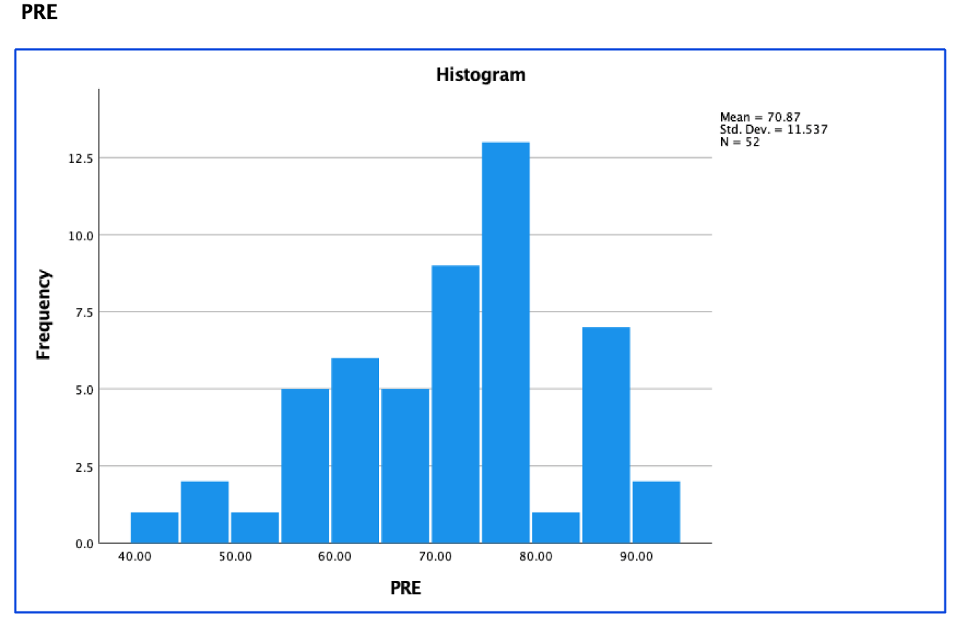
Figure 4.1. Histogram (Normality Testing)
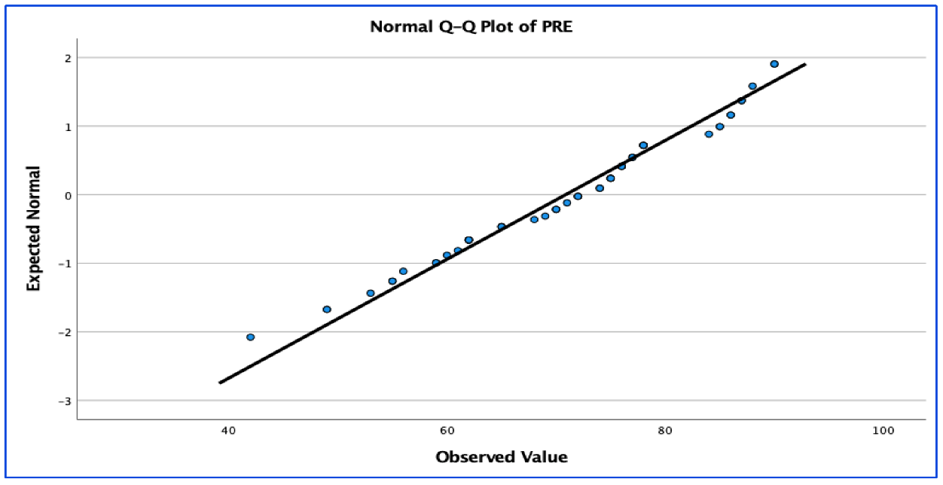
Figure 4.2. Q-Q Plot (Normality Testing)
simultaneously (Olejnik & Algina, 1984), so the due diligence process was included in this draft to show how both assumptions were accounted for and to
plan for any sampling issues leading to ANCOVA being an inappropriate analysis. Though not expressly required for this analysis assumption, I also conducted normality testing for the GMRT posttest and its standardized residuals (see Homoscedasticity for residuals). Kolmogorov-Smirnov and Shapiro-Wilk produced (p = .200) and (p = .367) respectively. Skewness statistic was (-.316) and kurtosis was (-.537). When separating the groups for normality testing of the pretest subgroups, the Choice group showed acceptable skewness (-.112) though the kurtosis statistic was admittedly high (-.1.091). The value did not exceed twice the value of the standard error (.887); more importantly, the Kolmogorov-Smirnov and Shapiro-Wilk normality tests produced statistically acceptable results (p = .200 and p = .168 respectively); the residuals were also normal. For the No Choice group: skewness (-.608), kurtosis (-.245), Kolmogorov-Smirnov (p = .163), and Shapiro-Wilk (p = .177). Q-Q plots, and histograms were acceptable. Based on these normality outputs and t-tests, I concluded that it was appropriate to proceed with the other assumptions.
- Homoscedasticity: equivalence of groups was maintained during this study—26 in the Choice group and 26 in the No Choice group. Levene’s Test of Equality of Error revealed (p = .803) for POST. Standardized residuals for POST for each group were normal: Choice (p = .588), No Choice (p = .379), and whole group (p = .644) according to Shapiro-Wilk testing. There were no residuals greater than +/-3 SD, and the scatterplot was visually inspected and found to be within reason.
- Linearity: see the scatterplot and matrix in Figure 4.3; this assumption was met.
- The homogeneity of regression slopes assumption for ANCOVA dictates that the b-coefficient for the covariate(s) must be equal among all subpopulations. Tests of Between-Subjects Effects in SPSS revealed F(1, 48) = 39.079, p = .385 for the “group * PRE” level (see SPSS output in Table 4.1).
ANCOVA Results
We failed to reject the Null Hypothesis (Ho), and we concluded that no statistically significant difference exists between reading achievement as measured by GMRT posttest scores between the Choice and No Choice groups: F(1, 49) = 1.285, p = .262, partial eta squared = .026 (See “group” level in Table 4.2). Partial eta squared showed a modest effect size despite the failure to reject the Null Hypothesis. No residual values exceeded +/- 3 SD. The ramifications of this result will be further examined in the DISCUSSION chapter. Beyond the hypothesis decision based on ANCOVA output, the most important occurrence to report is that students in the Choice and No Choice groups both averaged modest gains from pretest to posttest GMRT with the Choice group averaging a pre-post gain of 3.3462%. Among the Choice group, several participants, especially among the lower pretest GMRT scorers, achieved +0.5 SD gains or higher in the posttest or a one grade-level leap according to Petty’s (2022) explanation of SD in educational interventions. The No Choice group also benefitted, but to a lesser degree, with an average gain of 1.0384%. Though statistically non-significant based on the
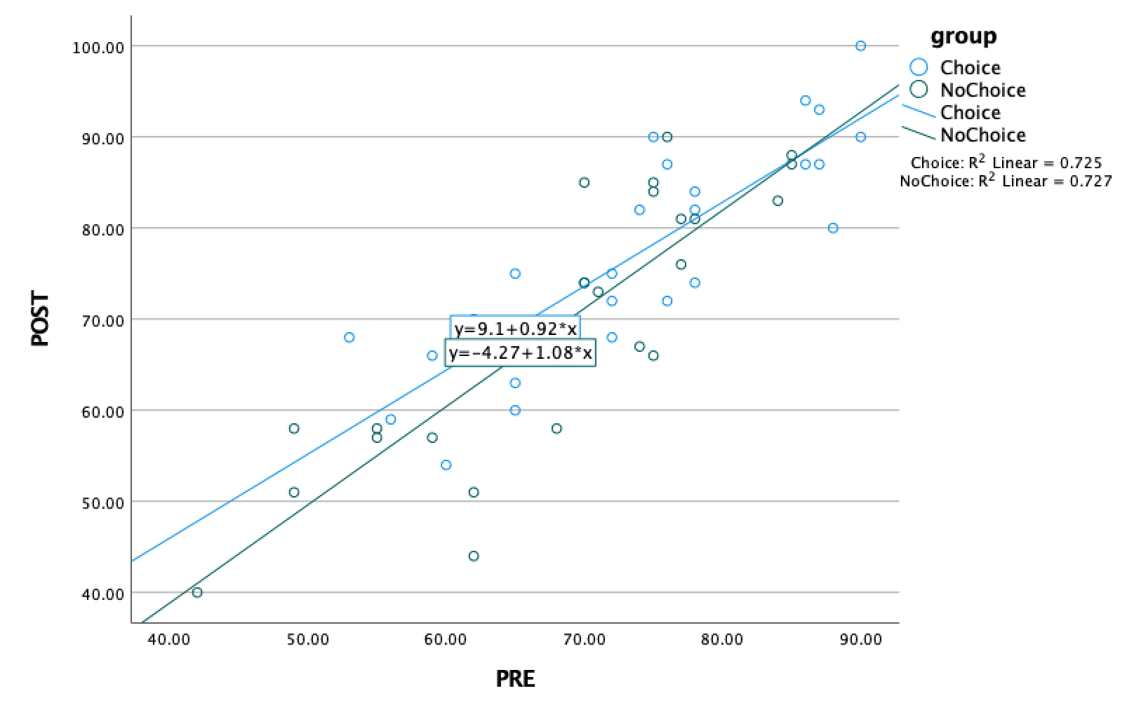

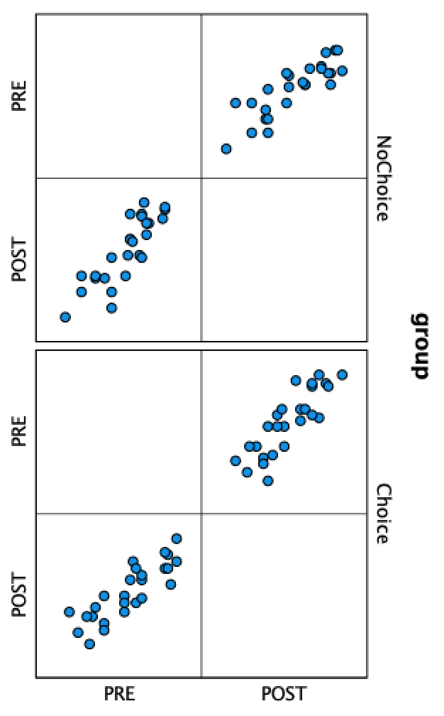
Figure 4.3. Linearity Assumption Testing Output
Table 4.1. Homogeneity of Regression Slopes Assumption Testing Output
Source | Type III Sum of Squares | df | Mean Square | F | Sig.
Corrected Model | 7233.077 | 3 | 2411.026 | 47.396 | <.001
Intercept | 7.251 | 1 | 7.251 | .143 | .707
group | 55.568 | 1 | 55.568 | 1.092 | .301
PRE | 6420.732 | 1 | 6420.732 | 126.219 | <.001
Group * PRE | 39.079 | 1 | 39.079 | .768 | .385
Error | 2441.750 | 48 | 50.870
Total | 287221.000 | 52
Corrected Total | 9674.827 | 51
R Squared = .748 (Adjusted Square = .732)

Table 4.2. ANCOVA Results Output
Source | Type III Sum of Squares | df | Mean Square | F | Sig. | Partial Eta Squared | Noncent Parameter | Observed Power
Corrected Model | 7193.997 | 2 | 3596.999 | 71.046 | <.001 | .744 | 142.092 | 1.000
Intercept | 5.399 | 1 | 5.399 | .107 | .745 | .002 | .107 | .062
PRE | 6447.670 | 1 | 6447.670 | 127.351 | <.001 | .722 | 127.351 | 1.000
group | 65.072 | 1 | 65.072 | 1.285 | .262 | .026 | 1.285 | .199
Error | 2480.830 | 49 | 50.629
Total | 287221.000 | 52
Corrected Total | 9674.827 | 51
R Squared = .744 (Adjusted R Squared = .733), alpha = .05.

parameters of this quasi-experiment, it is important to report that the students’ reading comprehension was positively impacted for most students based on the GMRT posttest regardless of group placement.
AMRP Surveys
The Likert style questions from the AMRP survey were quantified on a scale of one to four to give every survey a value per the scoring instructions included with this
tool. Parametric testing in the form of a Pearson Correlation Coefficient (r) was conducted to ascertain any relationship between the AMRP surveys and the GMRT posttest. Results indicated a medium yet still statistically significant positive correlation between the survey scores and GMRT posttest performance, r(50) = .310, p = .025. This modest, yet still statistically significant posttest value, should be considered in future studies. For future reference, the pretest GMRT correlation was reported at r(50) = .246, p = .079.
Student Interviews
In addition to the quantitative analysis, six student interviews were conducted by the assisting researcher following the AMRP Interview protocol included in this document (see Appendix 3.2). I was barred from conducted the interviews myself at the request of UTK’s IRB to dissuade the possibility of undue influence. The full transcripts of these six interviews are included in the Appendix section (see Appendix 4.1-4.6). Interview candidates are described as the following: a participant in the Choice group whose GMRT score increased from pretest to posttest (see Appendix 4.1), a participant in the Choice group whose GMRT score decreased from pretest to posttest (see Appendix 4.2), a participant in the Choice group whose GMRT score stayed the same from pretest to posttest (see Appendix 4.3), a participant in the No Choice group whose GMRT score increased from pretest to posttest (see Appendix 4.4), a participant in the No Choice group whose GMRT score decreased from pretest to posttest (see Appendix 4.5), and a participant in the No Choice group whose GMRT score stayed the same from pretest to posttest (see Appendix 4.6). The interview questions follow the interview protocol included with the AMRP survey (see Appendix 3.2).
I attempted an inductive, thematic analysis for the interviews. In this way, I was permitted to allow themes to emerge organically. It is critical to note that these interviews were conducted by the research assistant referenced in the reliance agreement in the appendix (see Appendix 3.6).. This third-party research assistant was necessary to comply with IRB approval because the IRB committee was concerned about undue influence (i.e. the interviewer could not be the same investigator as the PI delivering the intervention). In keeping with the letter and spirit of this requirement, I chose to not include statements that reference my own influence as the PI and teacher-of-record in this analysis. The reason for this redaction is that it could be argued that favorable statements towards the PI in these student interviews, despite the unaffiliated research assistant acting as the interviewer, could skew the answers as the participants knew that I would hear the recording of these interviews later. These statements are still included in the full transcripts in the appendix in case another researcher wishes to analyze them, but they remain outside of the thematic analysis. In addition, identifying information regarding the school district was redacted both from the thematic analysis and the included transcripts. The themes are examined, analyzed, and put into context in the following section which is organized by the AMRP Interview questions serving as level three headings. Not all questions are included in this analysis because certain questions did not prompt qualitatively significant parallel themes.
What Do You Think You Have to Learn to Be a Better Reader?
Participant “A” reported “Um, to practice like sit down and put a timer on and like to read on a constant speed you know if I can like without messing up, nothing, you know, if I can overcome that you know.” Participant “J” responded to the question:
Um, I definitely, reading, I learn patience because it’s something I’m not good at but with reading a book I have to have a lot of patience, you know, about the story line, even just sitting in my chair and reading a book sometimes it’s very like, I get antsy, you know, but I’ve learned how to like calm down and really like read and dig deep into the book.
Participant K responded: “Mmm, probably to make time for it in my day.” Participant CM responded: “Like to be better at reading? Um, just read more books, increase my understanding.” Participant G responded: “Um, just the curriculum, I guess, to like understand words and um, and like how the story goes along because if I’m reading a book and I’m like getting confused, and I can’t keep up with it, it’s less interesting.”
Participant IN responded:
I think I need to like be a better reader…I think I need to, like, learn the concept of reading. Like you can’t just read the book, and then it’s done, you have to know, like, the story behind it, you have to know what the author felt while writing it, so I feel like I…to be a better reader, I need to, like, you know, learn the concept of why they wrote it.
Of these six responses, three cited “time” or time-related words such as “to sit down” or “patience.” These words indicate the current premium on teenagers’ time and, if we are to accept the research on SSR/DIR efficacy in its best practice form outlined by Miller and Moss (2013), the time may need to be provided within the school day if it is unlikely to be provided elsewhere. Finding and making time, argues Donalyn Miller (2011), is the greatest obstacle to SSR/DIR implementation; the student-participants seem to support this argument. This parallel echoes Moss (2021) who insists on the importance of time in independent reading in schools.
Do You Share Any of the Following Reading Materials with Members of Your Family: Newspapers, Magazines, Religious Materials, or Games?
When prompted with question D4 from the interview protocol, participant “A” responded, “Mostly my mom…often.” Participant “J” responded:
Um, my grandfather is very, very interested in, I mean, honestly, anything in like news, anything politics, so, I mean, I always sit down and talk to him about it because I mean, you know, I’ll gladly talk to him about anything, so if it’s something he’s interested in I’ll sit there and listen, so he’ll pull out the newspaper, he’ll show me different things. I also come from a Christian household, so we have the Bible in our pockets very, very often so…
Participant “K” responded, “Uh, probably my dad… I think around lunch, or around the dinner table, we’ll talk about stuff that’s going on in the world and what we think about it… probably Sunday dinner so, once a week.” Participant “CM” responded, “Yeah I’ll send like, if I see a news article or something, I’ll send it to my family…pretty much every day I assume.” Participant “G” stated, “All of them” but said this practice of shared reading occurs “rarely.” Participant “IN” said, “my mom… pretty often because like we do it like every week or so.” The previous responses were surprising; all six participants interviewed stated that shared reading with family members was an occurrence in their homes, and all but one reported that this was a regular practice (every day to weekly).
Tell Me About the Most Interesting Story or Book You Have Read Recently
When prompted with question A1, only half of the participants (A, J, K) referenced the book they were reading or had read for the study. Though six interviews may be too small of a sample to report observable trends with high confidence, it is worth noting that, in a seeming contradiction, two of the three participants in the No Choice group referenced their SSR/DIR reading material, and only one in the Choice group referenced their SSR/DIR reading material. However, regardless of Choice or No Choice group assignment, the participants who referenced their SSR/DIR reading material averaged well over half SD ahead of their peers on the AMRP survey based on the Lickert questions (SD = 8.857). Though the correlation between GMRT posttest scores and the Lickert scores was modest, there may be indication that the survey can indicate not only motivation to read, in general, but engagement with the novel itself within an SSR/DIR program. However, this is a large observation from a small sample, and more research is needed to substantiate this theory.
Responses pertaining to interest in any of the participants’ respective novels within this SSR/DIR study or otherwise were as varied and diverse as the students in the sample. The research assistant followed the interview protocol with the provided probing questions. Participant “A” connected strongly with the novel he mentioned in response to question 1A because of his own immigrant journey. He connected with the story because he saw a part of himself and his community in the protagonist. In his own words, “A” states, “I feel like I’ve always talked about like how immigration started, how I connect with my people–my Hispanic culture–so I just felt like this is like somehow what I connect with it, and like we go through this every single day.”
Participant “J” resisted the narrative that social media is replacing the reading of books (Natanson, 2022) and mentions social media, not as a deterrent, but seemingly an outright inducement to independent reading. For example, in the interview from “J”:
RA: Awesome. Um, how did you know or find out about this book?
J: On social media. She’s all-over social media
RA: How did you, I think I already asked you this, but I’ll ask you again. How did you find out about these books?
J: Just like on social media, honestly, and my friends, we all read them so we all have just switched books here around, you know.
RA: Awesome! Tell me about your favorite author.
J: Definitely her, Colleen Hoover. She’s just great, I mean she’s the next big thing, she really is like all of her like TikTok and social media she is very talked about.
While it may be too optimistic to hope for co-existence between conventional novel reading and the era of social media, the statements from “J” indicate a glimmer of hope in that social media’s assumed destruction of literacy as it is conventionally and narrowly defined may be exaggerated.
Participant “K” had an unanticipated response. As a Choice group reader, this student claimed that, along with the well-crafted plot, the visuals on the book jacket were the most compelling elements for his engagement. In his own words:
RA: Mm huh. That’s good. Um, how did you know or find out about this book? You may have already mentioned that, but if you’ll say that again.
K: Yes ma’am. I found out or saw the book on the bookshelf and it stuck out to
me because on the spine of the book it has big, bright, red letters so I,
like, opened it. I was the first one up to go grab a book and, on the front, I saw
Leonardo DiCaprio.
RA: (laughs) Mm huh.
K: …and it’s like an instantly recognizable face and so that’s what made me decide to pick the book because there’s a movie, although I haven’t watched it, it’s based off the book.
Research seems to agree with participant “K.” The jacket design matters (Ubbiali, 2020). Even the color of the book matters (Suminas, 2017), and a recognizable celebrity gracing the cover of the novel might even help. Market research from Mind Stir Media Group (2022) indicates that associating a book in some way with a well-known celebrity boosts book demand. The visual potential for engagement ought to be considered by the SSR/DIR educator/researcher in choosing books to build a classroom library. Ubbiali (2020) notes that different editions of classic books are being produced with updated jackets to reflect modern, visual preferences.
“CM” reported an interest in the classics as a motivator. “G” closely paralleled “A” because his interest was so closely related to his experience in how he connected with the characters albeit in much lower stakes. In “G’s” own words:
G: Um, I read about overcoming adversity in a book like a dude got, a guy got injured and he had to overcome that to get ready for the season, which hit home to me because I got hurt last year during our season and I’ve been working my way to come back so it really helped me out.
RA: Yeah, you could really identify. Gotcha. Um, how did you know or find out about reading material on this?
G: Uh, about…?
RA: What you were just talking about.
G: Oh, uh, just reading the book and it kind of just hit home when I first like started reading it and like the quotes they were saying so it just helped me get through what I was going through.
RA: I gotcha. That makes sense. Um, why was reading this important to you?
G: Uh, because, kind of like I just said, it just helped me get through a tough time, I guess.
RA: Mm huh.
G: And it helped me realize that other people are going through the same stuff I
was going through.
The book “G” is referring to is Friday Night Lights (1990), a devastating work of non-fiction. As an athlete with dreams of a Division I future “G” lived some portion of the tragedy in this book because he too had suffered a season-ending injury like the character from the book.
“IN” responded that it was her social network of girlfriends who influenced her own reading interest as well as her professed identity as a girl which, again, supports the notion that readers are drawn to stories and subject matter they personally connect with. In “IN’s” own words:
IN: Oh, on the article. Um, my friend recommended me it because she wanted to know my opinion because she had a different opinion and so we had like this argument and I was like you can’t just, you know, give your opinion like that. You don’t know what the other person might say, and she was like yeah, that’s right but she was really confident about her and I was like I’m not going to back off because I know I’m right. Like whatever this is about we don’t know, we’re not in that situation.
RA: Uh huh.
IN: So, I found out through a friend.
RA: I gotcha. Ok. Why was reading this important to you?
IN: The article?
RA: Yes.
IN: Because it was, I don’t know, I’m a girl (quiet laugh).
RA: (laughs).
IN: So, it was kind of like feminine came in the way, but it was that story, I think it was about a girl and a guy and it was like about their in-personal things, and he was like blaming her for things and she took it and then it was like, you know, a girl can relate about another girl.
RA: Good. Who gets you really interested and excited about reading?
IN: Oh, my best friend. She loves reading and so she tells me the book she read and so makes me into reading, too. So, yeah.
Along with “J,” “IN” also made a case for the internet’s place in the future of reading:
RA: Ok. How do you find out about these books? Or how, how do you find about, how do you find out about books that you may be interested in?
IN: Um, I mean nowadays it’s just like online.
RA: Uh huh.
IN: So, I just like, go online and like search if I’m in the mood of reading I just search and there’s online books that I can read on my phone so I do that.
Summary
This chapter reported the anomalies I experienced while recruiting, how the assumptions for ANCOVA were met with accompanying figures, tables, residuals testing, and the actual results of the ANCOVA. A decision was made concerning the Null Hypotheses (Ho) based on the reported p-value. The correlational values between the AMRP survey on GMRT posttest and posttest scores were reported with a Pearson Correlation Coefficient. Types of interview cases were reported, thematically analyzed, and the full transcripts of the interviews were included with Appendix 4.1-4.6.

CHAPTER V: DISCUSSION
The Earl of Beaconsfield and former British Prime Minister Benjamin Disraeli once wrote: “There are three kinds of lies: lies, damned lies, and statistics.” This epigraph captures the sentiment I feel as I reluctantly reports these results because the emphasis on p-values does not encapsulate what happened in this classroom over these three months nor what would have occurred statistically with an even slightly lower effect size to dictate the number of participants in G*Power. Most importantly, the p-value doesn’t capture the 15 students who achieved gains of +0.5 SD or greater. Fagella-Luby, Ware, and Capozzoli (2009) state that “the field of adolescent literacy is replete with ambiguous terminology requiring clarification” (p. 455); if the results of this quasi-experiment are to be accepted, then reading researchers ought to add quantitative metrics to the list of ambiguities in need of clarification. Future researchers cannot have a G*Power analysis which dictates the number of participants based off the effect size reported by Guthrie and Humenick’s (2004) metanalysis, especially for upper secondary reading research. By modeling methodology of experiments off of their extravagant effect size (d = 1.2), which could not even be replicated with a merely “large” effect size dictating the number of participants in initial power testing, reading researchers may not be able to detect what, in actuality is certainly not the “silver bullet” promised by their metanalysis but may actually still be a worthwhile and effective intervention to increase reading comprehension.
The most substantial conclusion from this study—its contribution to the field—is that this study could not replicate significant results based on such a large effect size. For future research, SSR/DIR researchers should express caution and a healthy skepticism in accepting exaggerated effect sizes when constructing the methodology of their experiments, and should, instead, adopt a moderately balanced effect size to dictate their G*Power analyses. While not as exciting, and mired in a philosophy of incrementalism, this more sober approach is best. Again, please see Hattie’s (2017) ranking of educational interventions where “choice-of-text” would rank as the seventh highest educational intervention in the history of the study of educational interventions and related effect sizes. This quasi-experiment failed to replicate this assertion from Guthrie and Humenick (2004), and one can only wonder how many other studies could be failing to produce statistically significant results because the researchers are running studies using entirely insufficient sample sizes by looking for an effect size that is far too large based on their literature reviews. I recommend replication, or any foray into examining choice, with a more conservative effect size in the G*Power analysis such as the moderate (d = 0.5 or f = 0.25 for ver. 3.1 G*Power input) as even half SD is equivalent to an entire grade leap (Petty, 2022). In education, as with economics, it seems that researchers are looking for a windfall rather than responsible growth. One can only theorize as to how much false data has been produced based on the accepted effect size in the literature leading to absurdly miniscule samples and a host of type II errors. With the research on SSR/DIR and choice admittedly light, researchers should trend towards the middle in building their methodology for future studies rather than accepting the extremes of Guthrie and Humenick’s (2004) meta-analysis that, when placed into context, states that choice yields an effect size of over two grade-levels.
Bringing the Theoretical Framework to Fruition
Instructional Design Theory framework is designed to offer clear guidance on how to better help students learn and develop (Reigeluth, 1999). This framework further addresses the process of gathering information for making decisions about what instruction should be like. To fulfill this framework, the outline and results of this study were packaged in a video and presented to the deputy superintendent and curriculum czar of the district in which this study took place. The deputy superintendent requested this data presentation from me at the conclusion of the study. This same video was presented to the ELA department head of the research site to inform next year’s SSR/DIR practice and contribute to our collective research and conversations about reading as we seek to refine our pedagogy. This was done to provide a more complete picture of our practice and understanding of SSR/DIR, and I am confident that there will be future, non-university affiliated studies concerning SSR/DIR in this district. Based on this study, district administrators will have to decide if the modest eta squared effect size is worth pursuing. The only substantial difference in data between the presentation to the district official and to the UTK dissertation committee was that the district official received additional analysis on ACT data of individual students as it relates to this study. Unfortunately, I am not permitted to release that additional data to UTK as this portion consisted of analysis not approved by IRB and may constitute a FERPA violation. I hope that the stakeholders mentioned above will see that, regardless of group, students in the SSR/DIR study made gains in reading comprehension.

Recommendations for Future Studies
Concerning high-school students, it would be beneficial in future studies to create and norm a tool to see how hard participants tried on the tests. It may be that our data about reading comprehension is flawed for upper-secondary; perhaps literacy rates aren’t declining after 12 as NAEP reports. It may be that students are merely sick of being tested, especially when the tests upon which we measure their performance are not linked to any motivating factor when the adolescent has moved from the “wanting to please” psychological stage into a more disaffected stage where internal motivation becomes precarious. We cannot employ the same methods of evaluating reading comprehension lest we continue to collect this loaded data. For example, when the student-participant “G” interviewed as the “No Choice group: Decrease in Score from Pre to Post” case in Appendix 4.5 reported his previous SSR novel before this study, the title was of the highest text complexity of any of his peers regardless of treatment group. In book talks about his previous reading, he showed understanding of what he had read too. However, this participant showed a massive loss of nearly a full standard deviation from GMRT pretest to posttest.
Interpreting this phenomenon is difficult; it is possible that despite enrolling in this study, this participant saw the posttest as “just another standardized test,” and since this student had already been accepted into his first-choice university, he no longer saw the value in giving his full effort. For him, it was a low-stakes test, and low stakes testing comes with its own well-documented motivational issues (Wise & DeMars, 2005; Finn, 2015). If this theory is an accurate description, future researchers should consider this element in constructing their studies. At some point, at the higher level of secondary education, this may explain why SSR/DIR research is so concentrated in the elementary and early adolescent levels; those research tools employed in those studies may actually be measuring reading comprehension with student effort serving as a minor issue while at the upper-secondary levels, student effort may need to be measured as a major covariate in future research. Reading comprehension may not be in in crisis or even in an alarming downward trend as previous research suggests (Barshay, 2021). What researchers may be seeing is not a sudden drop in literacy but rather a sudden drop in engagement and motivation on the measuring tools (including surveys) which have been designed to measure reading comprehension of much younger students. It’s not that they can’t read; there is a disparity in the measurement based on “G’s” interview and previous reading level which illustrates this disparity. It may be that they are only exhausted from being tested instead of manifesting declining literacy. In short, I recommend that future researchers add a test-effort survey tool or outright increase the incentives if such a survey tool is unavailable; this will be a worthy covariate to include.
In addition, the survey tool used in this study must be updated for the 2020s student. For example, this study used the 2007 version of the Adolescent Motivation to Read Profile survey tool; in future research, the PI should consider using the newest version of this tool. As Malloy, Marinak, Gambrell, and Mazzoni state, “[T]he original MRP was developed in 1996, a revision that would reflect the cultural and linguistic changes that occurred in the ensuing decade was needed. For example, digital reading sources were not considered in the original version but now are explored in the revised conversational interview” (p. 274). The 2007 version of this tool was used, but the more recent model included from Malloy et al. (2013) will be a better measure of motivation for the modern student.
Recent research from Gneezy, List, Livingston, Qin, Sadoff, and Xu (2019) highlights the possible disparity between tested comprehension and actual comprehension. When incentives were introduced to a group of students on a basic standardized test (PISA), American students showed higher performance than the non-incentivized control group (p < 0.01). The incentives in this study were limited by my own finances. Future researchers may need to adjust the timing and level of incentive to achieve closer-to-accurate results. This suggestion of testing for motivation does not include the AMRP survey which gives a quantitative value, via Lickert Scale; rather, a future study should consider a motivation tool as it relates to the comprehension testing tool itself.
Further research should test for or, at least account for, the likelihood that literacy rates may not actually be declining but we are simply assuming that the older adolescent mind operates the same as the elementary mind and testing accordingly despite research insisting upon the changes in motivation essential in teenagers. Future research should ascertain testing attempt-level with a post-survey of some kind as a covariate—a “How hard did you try on this test?” survey. This could reduce the statistical noise and perhaps mitigate the possibility of false data en masse. There is a tempting trap for quantitative researchers to merely increase the participant sample of a study to achieve statistical significance, but this comes with a unique problem: Armstrong (2019) states, “if a result is statistically significant it is assumed to be clinically relevant. This assumption becomes less reliable as sample size increases as diminishing effect sizes become statistically significant” (p. 129). So, for me, there is a fine line to walk in designing studies, especially with many reviewers still solely emphasizing p-values (Ellis, 2020). It is important to note that in this study, the literature review effect size of (d = 1.2) or “extremely large” was already reduced to merely “large” during the G*Power to establish the appropriate number of participants, and still a significant result was not observed. I recommend that future researchers seeking to replicate this study or any study involving choice-of-text and reading comprehension set their effect size at (f = 0.25) in G*Power (ver. 3.1) and perform the study with 128 participants instead of (N = 56) (See Figure 5.1); by doing so, a balance is maintained between a manageable number of participants and a moderate effect size detection power test.
While not a recommendation per se, future researchers should be aware of current legislation concerning classroom libraries. While it did not directly affect this study in a meaningful way, legislation during the experiment dictated that novels in classroom libraries were to be scanned and deemed appropriate or inappropriate by the district’s media specialists. This policy did not go into effect during the school year in which the research took place, but future researchers seeking potential replication should be mindful of these new policies concerning classroom libraries. As books are challenged across the country, reading researchers will need to be shrewd in their book selections for class libraries and be prepared to defend these selections as they are scrutinized by community stakeholders of varying agendas.
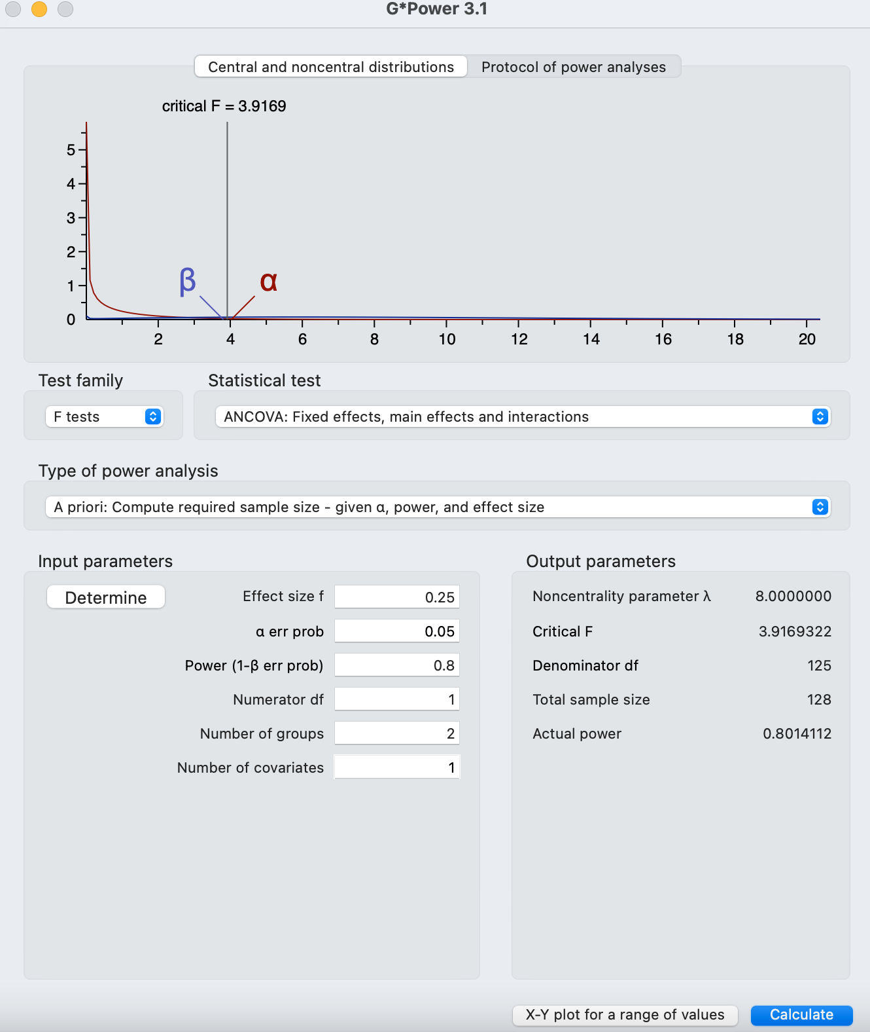
Figure 5.1. Suggested G*Power Output for Future Studies

In addition to fire alarms, tornado drills, and the Carnival excess of homecoming week, there were other confounding issues with this intervention. Not all students in this study met the three-whole-novels benchmark. Future studies should either emphasize time spent reading or control for this via a covariate. There are fast readers and slow readers, and future researchers ought to plan for these WPM disparities or include an additional tool to account for respective WPM of participants. There are many open-source tools to quickly and conveniently calculate student WPM, and adding such a measurement to a study would enrich the data.
The final recommendation for future replication concerns recruitment. As stated in the RESULTS chapter, the disparity in voluntary participation among Black/African American students is a consistent phenomenon according to Scharff et al. (2010). In this study, only 67% of the available students identified as Black or African American consented to participate compared to 79% of LatinX students, 93% participation rate of White students and 100% participation of the available students identifying as Asian. Research from the medical field provides suggestions on how to overcome this data-skewing phenomenon. Barret, Ingraham, Hawkins, and Moorman (2017) have created a chart for researchers to consider for overcoming the Black/African American recruitment disparity (see Table 5.1). While I performed the majority of these strategies, I did not perform all relevant strategies in the table (an irrelevant strategy would be “biospecimen collection). These strategies revolve around a relational framework, and it is understood that Black/African American students and their families would be skeptical of institutions and their representatives who have historically mistreated members of this community in
Table 5.1. Recruitment Strategy Chart
Barriers to recruitment | Strategies for improving minority participation
Fear, distrust, confidentiality, and privacy | Be transparent about the research process
Historical atrocities | Acknowledge past problems
Stigma associated with participating in research | Describe current safeguards to protect research participants
Peer and family concerns for the patient | Empower participants by letting them know that the decision to participate is theirs alone
Institutional sharing of personal data | Build rapport by conducting face-to-face interviews instead of phone interviews
Competing priorities and needs | Recognize the whole person. Respect other priorities in their life.
Socioeconomic stressors | Be flexible in scheduling and location of interviews
Family responsibilities | Create a resource book/directory to provide assistance with concerns raised during study participation
Protocol and system barriers | Allow protocol modifications (eg, shorter interviews or complete in more than one sitting)
Rigid or demanding research protocols | Offer alternatives for biospecimen collection
Clinic engagement as a barrier to recruitment | Develop and deepen relationships between clinic staff and research teams

research contexts and otherwise. It may be prudent for the teacher/recruiter to delay the recruitment process until a relationship of trust has been established with all students and especially Black/African American students instead of starting the semester with a recruitment process when the teacher is nothing but a stranger and agent of the institution with a spotted track record in the student’s mind. While this comes with its own unique set of limitations such as potential undue influence, it is most certainly outweighed by the potential to redress the 26% participation gap between Black/African American participants and their White peers. Pursuing the correction of this disparity is not merely an issue of methodology but also a matter of grave equity; future researchers in this realm should keep this issue in mind.
Summary
This study revealed several conclusions. The first of these conclusions is the quantitative decision that the ANCOVA failed to reject the Null Hypothesis. When put into context, this leads to two conclusions: that either there is indeed no statistical significance between choice-of-text and No Choice-of-text on reading achievement outcomes in this study or Humenick and Guthrie’s (2004, 2007, 2012) effect size assertion has been inflated and may be leading to a host of type II error pitfalls as researchers recruit too few participants based on their literature reviews during which they will inevitably come across the (d = 1.2) effect size. It is recommended that researchers set a moderate effect size for future recruitment in their a priori power analyses. Student interviews revealed factors of engagement and evolving literacy trends related to digital literacy as well as the need for a larger interview pool to justify observed trends in the thematic analysis. Most importantly, it is recommended that future researchers use the revised AMRP from Malloy et al. (2013). Using this revised tool will account for the emphasis on digital reading literacy and may lead to more accurate correlation statistics. The Theoretical Framework of Instructional Design Theory was manifested by sharing results with district stakeholders, conducting further analysis, and making recommendations for future research.

REFERENCES
Allen, R. E. S., & Wiles, J. L. (2015). A rose by any other name: Participants choosing research pseudonyms. Qualitative Research in Psychology, 13(2), 149–165. https://doi.org/10.1080/14780887.2015.1133746
Allington, R. L. (2002). What I've learned about effective reading instruction. Phi
Delta Kappan, 83(10), 740–747. https://doi.org/10.1177/003172170208301007

Allington, R., & Gabriel, R. (2012). Every Child, Every Day. Educational Leadership: Journal of the Department of Supervision and Curriculum Development, N.E.A, 69(6), 10–15.

Allington, R., & McGill-Franzen, A. (2003). Use Students’ Summer-Setback Months to Raise Minority Achievement. The Education Digest, 69(3), 19.

Anderson, L. H. (2010). Wintergirls. Giunti.

Anderson, R. C., Wilson, P. T., & Fielding, L. G. (1988). Growth in reading and how children spend their time outside of school. Reading Research Quarterly, 23(3), 285–303. https://doi.org/10.1598/rrq.23.3.2

Anderson, R. C., Wilson, P. T., & Fielding, L. G. (1988). Growth in reading and how children spend their time outside of school. Reading Research Quarterly, 23(3), 285–303. https://doi.org/10.1598/rrq.23.3.2

Andrews, T. M. (2021, October 25). 106 million people watched 'M.A.S.H.' finale 35 years ago. no scripted show since has come close. The Washington Post. Retrieved December 13, 2022, from https://www.washingtonpost.com/news/morning-mix/wp/2018/02/28/106-million-people-watched-mash-finale-35-years-ago-no-scripted-show-has-come-close-since/

Armstrong, RA. Is there a large sample size problem?.Ophthalmic Physiol Opt 2019; 39: 129– 130. https://doi.org/10.1111/opo.12618

Atwell, N. (2015). In the middle: A lifetime of learning about writing, reading, and adolescents. Heinemann.

Bandura, A. (1977). Social Learning theory. Prentice-Hall.

Barrett, N. J., Ingraham, K. L., Vann Hawkins, T., & Moorman, P. G. (2017). Engaging African Americans in Research: The Recruiter's Perspective. Ethnicity & Disease, 27(4), 453–462. https://doi.org/10.18865/ed.27.4.453

Barshay, J. (2021, May 17). Proof points: Why reading comprehension is deteriorating. The Hechinger Report. Retrieved December 8, 2022, from https://hechingerreport.org/proof-points-why-reading-comprehension-is-deteriorating/

Barshay, J. (2020, September 21). Four things you need to know about the new reading wars. The Hechinger Report. Retrieved November 12, 2021, from https://hechingerreport.org/four-things-you-need-to-know-about-the-new-reading-wars/.

Bingham, H. (2021, September 13). How many words in a novel? Jericho Writers. Retrieved November 12, 2021, from https://jerichowriters.com/average-novel-wordcount/.

Block, C. C., & Mangieri, J. N. (2002). Recreational Reading: 20 Years Later. Reading Teacher, 55(6), 572–580.

Bone, S. A., Christensen, G. L., & Williams, J. D. (2014). Rejected, shackled, and alone: The impact of systemic restricted choice on minority consumers' construction of self. Journal of Consumer Research, 41(2), 451–474. https://doi.org/10.1086/676689

Brown University. (1998). Block Scheduling: Innovations with Time. brown.edu. Retrieved November 12, 2021, from https://www.brown.edu/academics/education-alliance/sites/brown.edu.academics.education-alliance/files/publications/act_research.pdf.

Brysbaert, M. (2019). How many words do we read per minute? A review and meta-analysis of reading rate. Journal of Memory and Language, 109, 104047. https://doi.org/10.1016/j.jml.2019.104047

Calkins, L., Ehrenworth, M., & Lehman, C. (2012). Pathways to the common core: Accelerating achievement. Heinemann.

Campbell, D. T., & Stanley, J. C. (1963). Experimental and Quasi-Experimental Designs for Research. sfu.ca. Houghton Mifflin Company. Retrieved December 8, 2022, from https://www.sfu.ca/~palys/Campbell&Stanley-1959-Exptl&QuasiExptlDesignsForResearch.pdf.

Capatano, S., Fleming, J., & Elias, M. (2009). Building an Effective Classroom Library. Journal of Language and Literacy Education, 5(1), 59–73.

Collins, R. (1996). Media, culture and society: A critical reader. Sage.

Cooter, R. B., & Curry, S. (1989). Assessment: Gates-Macginitie Reading Tests, Third
Edition. The Reading Teacher, 43(3), 256-258. Retrieved October 30, 2020, from https://www.jstor.org/stable/20200351?seq=1#metadata_info_tab_contents.

Cullinan, B. E. (2000, November). Independent reading and school achievement - ala.org. ala.org. Retrieved November 12, 2021, from https://www.ala.org/aasl/sites/ala.org.aasl/files/content/aaslpubsandjournals/slr/vol3/SLMR_IndependentReading_V3.pdf.

Deci, L., & Ryan, R. (2000). Commentaries on "The 'what' and 'why' of goal pursuits: Human needs and the self-determination of behavior". Psychological Inquiry, 11(4), 269–318. https://doi.org/10.1207/s15327965pli1104_02

Diamond, P. J., & Onwuegbuzie, A. J. (2001). Factors Associated with Reading Achievement and Attitude among Elementary School-Aged Students. Research in Schools, 8(1), 1–11.

DiAntonio, S. (2008, May 5). A study of the predictive validity of the Gates-MacGinitie
Reading Test and the New Jersey Assessment of Skills and Knowledge at the 4th, 5th and 6th grade levels. Retrieved October 30, 2020, from https://rdw.rowan.edu/etd/715/

Ellard, R., Kelly, P., & Mckerracher, S. (2012). National Year of Reading: A year-long celebration and a lasting legacy. The Australian Library Journal, 61(4), 255–264. https://doi.org/10.1080/00049670.2012.10739059

Ellis, P. (2020). Madmethods 1-3: Effect Size Matters, statistical power trip & meta-analysis made easy. KINGSPRESS.

Faggella-Luby, M. N., Ware, S. M., & Capozzoli, A. (2009). Adolescent literacy—
Reviewing adolescent literacy reports: Key components and critical questions. Journal of Literacy Research, 41(4), 453–475. https://doi.org/10.1080/10862960903340199

Farino, T. "Literacy and Behavior in Early Childhood: Exploring the Factors that
Impact Achievement" (2010). Graduate Theses and Dissertations. https://scholarcommons.usf.edu/etd/1791

Finn, Bridgid. (2015). “Measuring Motivation in Low-Stakes Assessments.” Educational
Testing Service Research Report ETS RR-15-19.

Fischer, R., & Boer, D. (2011). Supplemental material for what is more important for national well-being: Money or autonomy? A meta-analysis of well-being, Burnout, and anxiety across 63 societies. Journal of Personality and Social Psychology, 101, 164–184. https://doi.org/10.1037/a0023663.supp

Fisher, D., & Ivey, G. (2006). Evaluating the interventions for struggling adolescent readers. Journal of Adolescent & Adult Literacy, 50(3), 180–189. https://doi.org/10.1598/jaal.50.3.2

Fiske, A. P., Kitayama, S., Markus, H. R., & Nisbett, R. E. (1998). The cultural matrix of social psychology. In The handbook of Social Psychology (4th ed., pp. 915–981). essay, McGraw Hill.

Fountas, I. (2018). Guiding readers and writers: Teaching comprehension, genre, and content literacy. (G. Pinnell, Ed.). HEINEMANN.

Fountas, I. and Pinnell, G. (2022). What is independent reading? Fountas & Pinnell Literacy™. Retrieved December 14, 2022, from https://fpblog.fountasandpinnell.com/what-is-independent-reading

Frey, B. (2018). The sage encyclopedia of educational research, measurement, and evaluation. SAGE reference.
Frey, W. H. (2020, March 9). The nation is diversifying even faster than predicted, according to new census data. The Brookings Institute. Retrieved April 11, 2022, from https://www.brookings.edu/research/new-census-data-shows-the-nation-is-diversifying-even-faster-than-predicted/
Friedman, M. (1955). The Role of Government in Education. Economics and The Public Interest.

Glynn, D. (2017). How Choice in Daily Independent Reading Affects Book Talks with Peers (dissertation). ProQuest Dissertations Publishing.

Gneezy, Uri, John A. List, Jeffrey A. Livingston, Xiangdong Qin, Sally Sadoff, and Yang Xu. (2019). "Measuring Success in Education: The Role of Effort on the Test Itself." American Economic Review: Insights, 1 (3): 291-308.DOI: 10.1257/aeri.20180633

Goltchie, P. (2021, April 18). What are the gates-macginitie reading tests? My Learning Springboard. Retrieved November 12, 2021, from https://mylearningspringboard.com/gates-macginitie-reading-test/.

Guthrie, J. T. (2004). Motivating Students to Read: Evidence for Classroom Practices that Increase Reading Motivation and Achievement. In N. M. Humenick (Ed.), The voice of evidence in reading research (pp. 329–354). essay, Paul H Brookes Publishing Co.

Guthrie, J. T., Hoa, A. L., Wigfield, A., Tonks, S. M., Humenick, N. M., & Littles, E. (2007). Reading motivation and reading comprehension growth in the later elementary years. Contemporary Educational Psychology, 32(3), 282–313. https://doi.org/10.1016/j.cedpsych.2006.05.004

Guthrie, J. T., Wigfield, A., & Klauda, S. L. (2012). Adolescents’ engagement in academic literacy. University of Maryland.

Hall, C., & Coles, M. (1997). Gendered readings: Helping boys develop as critical readers. Gender and Education, 9(1), 61–68. https://doi.org/10.1080/09540259721457

Harlaar, N., Deater-Deckard, K., Thompson, L. A., DeThorne, L. S., & Petrill, S. A. (2011). Associations between reading achievement and independent reading in early elementary school: A genetically informative cross-lagged study. Child Development, 82(6), 2123–2137. https://doi.org/10.1111/j.1467-8624.2011.01658.x

Hasbrouck, J., Tindal, G. (2017). An update to compiled ORF norms (Technical Report
No. 1702). Eugene, OR. Behavioral Research and Teaching, University of Oregon.

Hattie, J., & Waack, S. (2018, March 28). Hattie Effect Size List - 256 influences related to achievement. VISIBLE LEARNING. Retrieved November 16, 2021, from https://visible-learning.org/hattie-ranking-influences-effect-sizes-learning-achievement/.

Houghton-Mifflin Harcourt. (2016). The Value of Independent Reading: Analysis of Research. hmhco.com. Retrieved November 12, 2021.

Hruby, G. G., Burns, L. D., Botzakis, S., Groenke, S. L., Hall, L. A., Laughter, J., & Allington, R. L. (2016). The metatheoretical assumptions of literacy engagement. Review of Research in Education, 40(1), 588–643. https://doi.org/10.3102/0091732x16664311

Hughes-Hassell, S., & Rodge, P. (2007). The leisure reading habits of urban adolescents. Journal of Adolescent & Adult Literacy, 51(1), 22–33. https://doi.org/10.1598/jaal.51.1.3

Independent reading. NCTE. (2019). Retrieved November 12, 2021, from https://ncte.org/statement/independent-reading/.
Ivey, G., & Johnston, P. H. (2013). Engagement with young adult literature: Outcomes and processes. Reading Research Quarterly, 48(3), 255–275. https://doi.org/10.1002/rrq.46

Iyengar, S. S., & Lepper, M. R. (1999). Rethinking the value of choice: A cultural perspective on intrinsic motivation. Journal of Personality and Social Psychology, 76(3), 349–366. https://doi.org/10.1037/0022-3514.76.3.349

Jongsma, Eugene A. "Test Review: Gates-MacGinitie Reading Tests (Second Edition)."
Journal of Reading, vol. 23 (January 1980), pp. 340-45.

Kittle, P. (2008). Write beside them: Risk, voice, and clarity in high school writing.
Heinemann.

Knoester, M. (2010). Independent reading and the ‘social turn’: How adolescent reading habits and motivation relate to cultivating social relationships. Networks: An Online Journal for Teacher Research, 12(1), 332–332. https://doi.org/10.4148/2470-6353.1099

Korbey, H. (2019, July 9). The reading wars: Choice vs. Canon. Edutopia. Retrieved November 12, 2021, from https://www.edutopia.org/article/reading-wars-choice-vs-canon.

Krashen, S. (2004). The power of reading: Insights from the research. Portsmouth, NH: Heinemann.

Krashen, S. (2005). Is in-school free reading good for children? why the National Reading Panel Report is (still) wrong. Phi Delta Kappan, 86(6), 444–447. https://doi.org/10.1177/003172170508600607
Ladson-Billings, G. (2006). From the achievement gap to the education debt: Understanding achievement in U.S. schools. Educational Researcher, 35(7), 3–12. https://doi.org/10.3102/0013189x035007003
Lafon, P., Chasseigne, G., & Mullet, E. (2004). Functional learning among children, adolescents, and young adults. Journal of Experimental Child Psychology, 88(4), 334–347. https://doi.org/10.1016/j.jecp.2004.03.009

Lee, T. (2016, September 29). Explanation of the gates-macginitie reading test. Seattlepi.com. Retrieved November 12, 2021, from https://education.seattlepi.com/explanation-gatesmacginitie-reading-test-1650.html.

Lemov, D., Driggs, C., & Woolway, E. (2016). Reading reconsidered: A practical guide to rigorous literacy instruction. Jossey-Bass & Pfeiffer Imprints, Wiley.
Lexiles - Frequently Asked Questions. EBSCO CONNECT. (2021, May 10). Retrieved November 12, 2021, from https://connect.ebsco.com/s/article/Lexiles-Frequently-Asked-Questions?language=en_US.

Lewis, M., & Samuels, S. J. (2005). Read more—read better? A meta-analysis of the
literature on the relationship between exposure to reading and reading achievement. Minneapolis: University of Minnesota.

Loschert, K., Harper, R., & Hermann, H. (2019, September). What educators need to know about adolescent development. all4ed.org. Retrieved November 12, 2021, from https://all4ed.org/wp-content/uploads/2019/09/05-SAL-What-Educators-Need-to-Know-About-Adolescent-Development_FINAL.pdf.

Lynn, S. (2016). Texts and contexts: Writing about literature with critical theory. Pearson.

Malloy, J. A., Marinak, B. A., Gambrell, L. B., & Mazzoni, S. A. (2013). Assessing motivation to read. The Reading Teacher, 67(4), 273–282. https://doi.org/10.1002/trtr.1215

Manning, G. L., & Manning, M. (1984). What models of recreational reading make a difference? Reading World, 23(4), 375–380. https://doi.org/10.1080/19388078409557787

Manzo, A. V., & Manzo, U. C. (2000). Teaching children to be literate: A reflective approach. Delmar Pub.

Miller, D. (2013). No more independent reading without support. Heinemann.

Miller, D., & Anderson, J. (2011). The book whisperer: Awakening the inner reader in every child. Scholastic Inc.

Miller, J. G. (2003). Culture and agency: Implications for psychological theories of motivation and social development. In V. Murphy-Burman & J. J. Burman (Eds.), Cross-cultural differences in perspectives on the self (Vol. 49, pp. 59–99). essay, University of Nebraska Press.

Natanson, H. (2018, August 21). Study: Teens text and use social media instead of reading books. The Mercury News. Retrieved December 7, 2022, from https://www.mercurynews.com/2018/08/20/study-teens-text-and-use-social-media-instead-of-reading-books/

Neuman, S. B. (1999). Books make a difference: A study of access to literacy. Reading Research Quarterly, 34(3), 286–311. https://doi.org/10.1598/rrq.34.3.3

Neuman, S. B., & Celano, D. C. (2012). Worlds Apart: One City, Two Libraries, and Ten Years of Watching Inequality Grow. American Educator, 36(3), 13–19.

Nietzsche, F. W. (1872). The Birth of Tragedy. Maestro Reprints.

Nippold, M. A., Duthie, J. K., & Larsen, J. (2005). Literacy as a leisure activity. Language, Speech, and Hearing Services in Schools, 36(2), 93–102. https://doi.org/10.1044/0161-1461(2005/009)

Nystrand, M. (2006). Research on the Role of Classroom Discourse as It Affects Reading Comprehension. Research in the Teaching of English, 40(4), 392–412.

Olejnik, S. F., & Algina, J. (1984). Parametric Ancova and the rank transform Ancova when the data are conditionally non-normal and heteroscedastic. Journal of Educational Statistics, 9(2), 129–149. https://doi.org/10.2307/1164717

Parker, F., Novak, J., & Bartell, T. (2017). To engage students, give them meaningful choices in the classroom. Phi Delta Kappan, 99(2), 37–41. https://doi.org/10.1177/0031721717734188

Parr, J. M., & Maguiness, C. (2005). Removing the silent from SSR: Voluntary reading as Social Practice. Journal of Adolescent & Adult Literacy, 49(2), 98–107. https://doi.org/10.1598/jaal.49.2.2

Pashler, H., McDaniel, M., Rohrer, D., & Bjork, R. (2008). Learning styles. Psychological Science in the Public Interest, 9(3), 105–119. https://doi.org/10.1111/j.1539-6053.2009.01038.x

Patall, E. A., Sylvester, B. J., & Han, C.-woo. (2014). The role of competence in the effects of choice on motivation. Journal of Experimental Social Psychology, 50, 27–44. https://doi.org/10.1016/j.jesp.2013.09.002

Perks, K. "Moving beyond time and choice: Challenge, motivation and achievement
during independent reading in high school" (2010). Doctoral Dissertations. 602. https://scholars.unh.edu/dissertation/602

Reed, A. E., Mikels, J. A., & Simon, K. I. (2008). Older adults prefer less choice than young adults. Psychology and Aging, 23(3), 671–675. https://doi.org/10.1037/a0012772

Refsnes, H. (2016, October 10). An Argument about Independent Reading Time During the School Day | Shanahan on Literacy. Retrieved November 12, 2021, from https://shanahanonliteracy.com/blog/an-argument-about-independent-reading-time-during-the-school-day.

Reigeluth, C. M. (1999). What Is Instructional-Design Theory and How Is It Changing? Instructional Design Theories and Models (Vol. 2, pp. 5–29). essay, Lawrence Erlbaum Associates.

Reis, S. M., Eckert, R. D., McCoach, D. B., Jacobs, J. K., & Coyne, M. (2008). Using enrichment reading practices to increase reading fluency, comprehension, and attitudes. The Journal of Educational Research, 101(5), 299–315. https://doi.org/10.3200/joer.101.5.299-315

Rettig, M. D. (2019). The effects of Block Scheduling. AASA. Retrieved November 12, 2021, from https://www.aasa.org/schooladministratorarticle.aspx?id=14852.

Reutzel, D. R., Smith, J. A., & Fawson, P. C. (2005). An evaluation of two approaches for teaching reading comprehension strategies in the primary years using science information texts. Early Childhood Research Quarterly, 20(3), 276–305. https://doi.org/10.1016/j.ecresq.2005.07.002

Reutzel, R. D., & Juth, S. (2014). Supporting the Development of Silent Reading Fluency: An Evidence-Based Framework for the Intermediate Grades (3-6). International Electronic Journal of Elementary Education, 7(1), 27–46.

Saunders, W. M., & Goldenberg, C. (1999). The effects of instructional conversations and literature logs on the story comprehension and thematic understanding of English proficient and limited English proficient students. The Elementary School Journal, 99, 277–301. https://doi.org/10.1037/e303992003-001

Scharff, D. P., Mathews, K. J., Jackson, P., Hoffsuemmer, J., Martin, E., & Edwards, D. (2010). More than Tuskegee: understanding mistrust about research participation. Journal of health care for the poor and underserved, 21(3), 879–897. https://doi.org/10.1353/hpu.0.0323

Schwartz, B., & Cheek, N. N. (2017). Choice, freedom, and well-being: Considerations for public policy. Behavioral Public Policy, 1(1), 106–121. https://doi.org/10.1017/bpp.2016.4

Senate., Report of the National Reading Panel: Hearing before a subcommittee of the Committee on Appropriations, United States Senate, One Hundred Sixth congress, second session, special hearing, April 13, 2000, Washington, DC (2001). Washington, D.C.; U.S. G.P.O.
Shreffler J, Huecker MR. Type I and Type II Errors and Statistical Power. [Updated 2022 Mar 18]. In: StatPearls [Internet]. Treasure Island (FL): StatPearls Publishing; 2022 Jan-. Available from: https://www.ncbi.nlm.nih.gov/books/NBK557530/

Sokal, L. (2010). Long-term effects of male reading tutors, choice of text and computer-based text on boys’ reading achievement. Language and Literacy, 12(1), 116. https://doi.org/10.20360/g27p42

Šuminas, A. (2017). Choosing a book by its cover: Analysis of a reader’s choice. Journal of Documentation, 74(2), 430–446. https://doi.org/10.1108/jd-09-2016-0111

Tocqueville, A. de, Goldhammer, A., & Zunz, O. (2012). Democracy in America. Library of America Paperback Classics.

Ubbiali, Beatrice. (2020). WHY IS BOOK COVER DESIGN AS IMPORTANT AND RELEVANT AS EVER TODAY?.
Vigen, T. (2015). Spurious correlations. Hachette Books.
Vohs, K. D., Baumeister, R. F., Schmeichel, B. J., Twenge, J. M., Nelson, N. M., & Tice, D. M. (2008). Making choices impairs subsequent self-control: A limited-resource account of Decision Making, self-regulation, and active initiative. Journal of Personality and Social Psychology, 94(5), 883–898. https://doi.org/10.1037/0022-3514.94.5.883

Wise, Steven L., and Christine E. DeMars. (2005). “Low Examinee Effort in Low-Stakes Assessment: Problems and Potential Solutions.” Educational Assessment 10 (1): 1–17.

APPENDIX
3.1 Parent/Guardian Permission Form
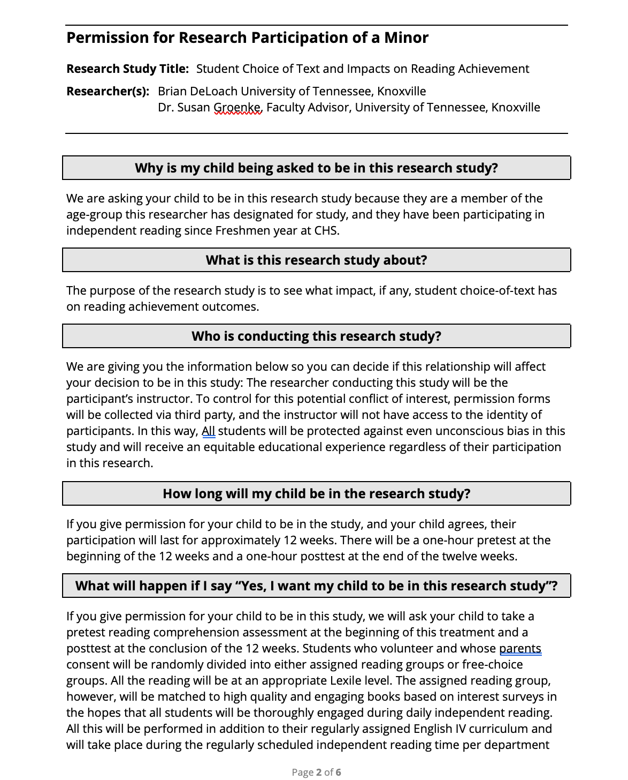
3.1 Parent/Guardian Permission Form (Continued)
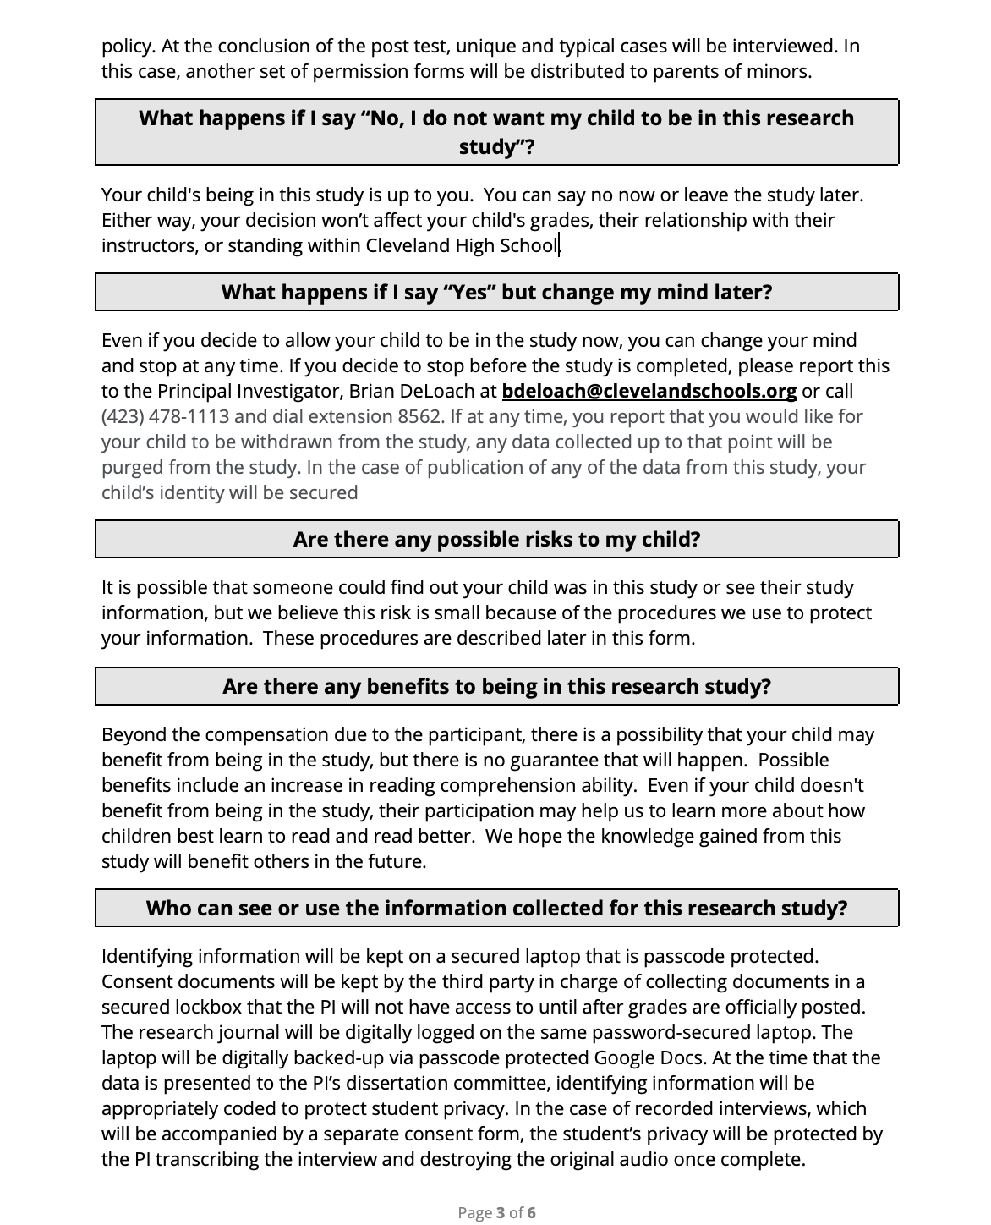
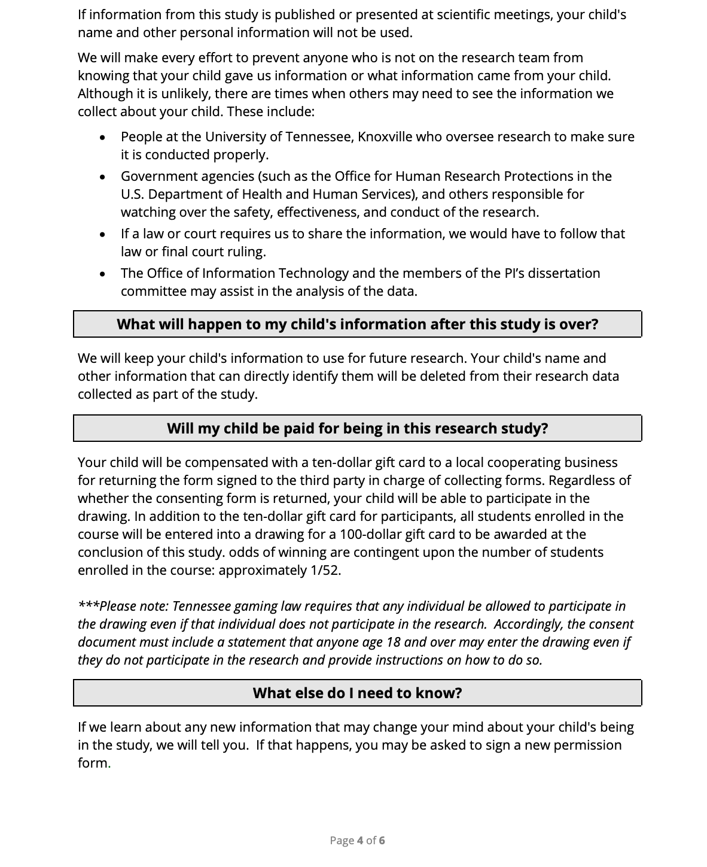
3.1 Parent/Guardian Permission Form (Continued)

3.1 Parent/Guardian Permission Form (Continued)
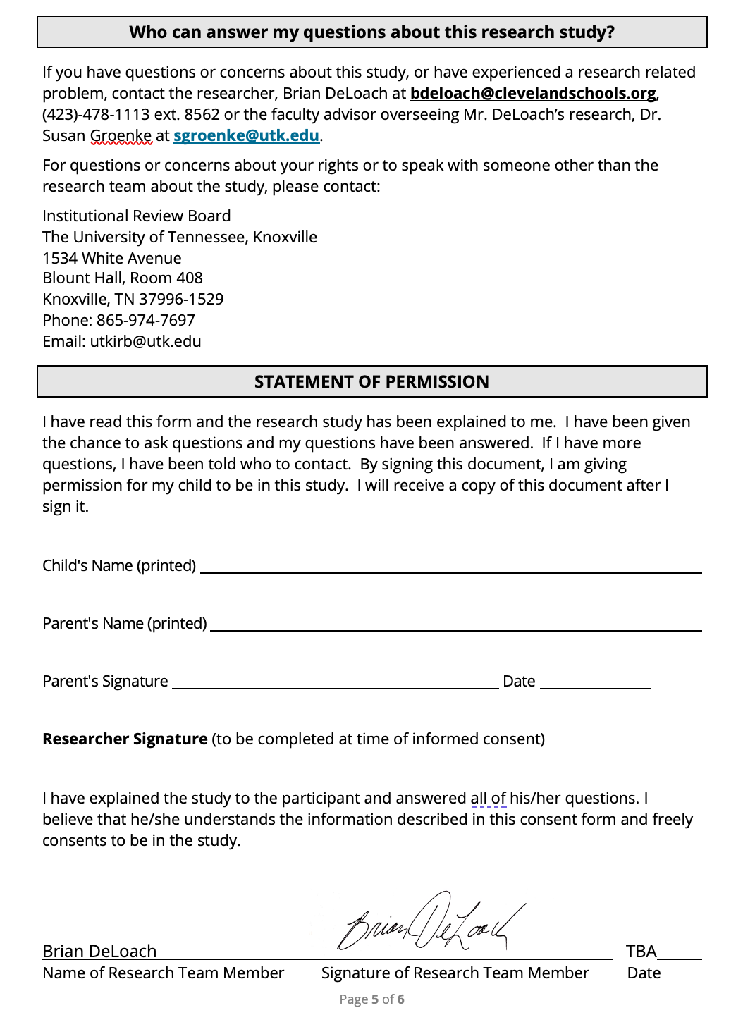
3.2 Adolescent Motivation to Read Profile Survey (AMRP)
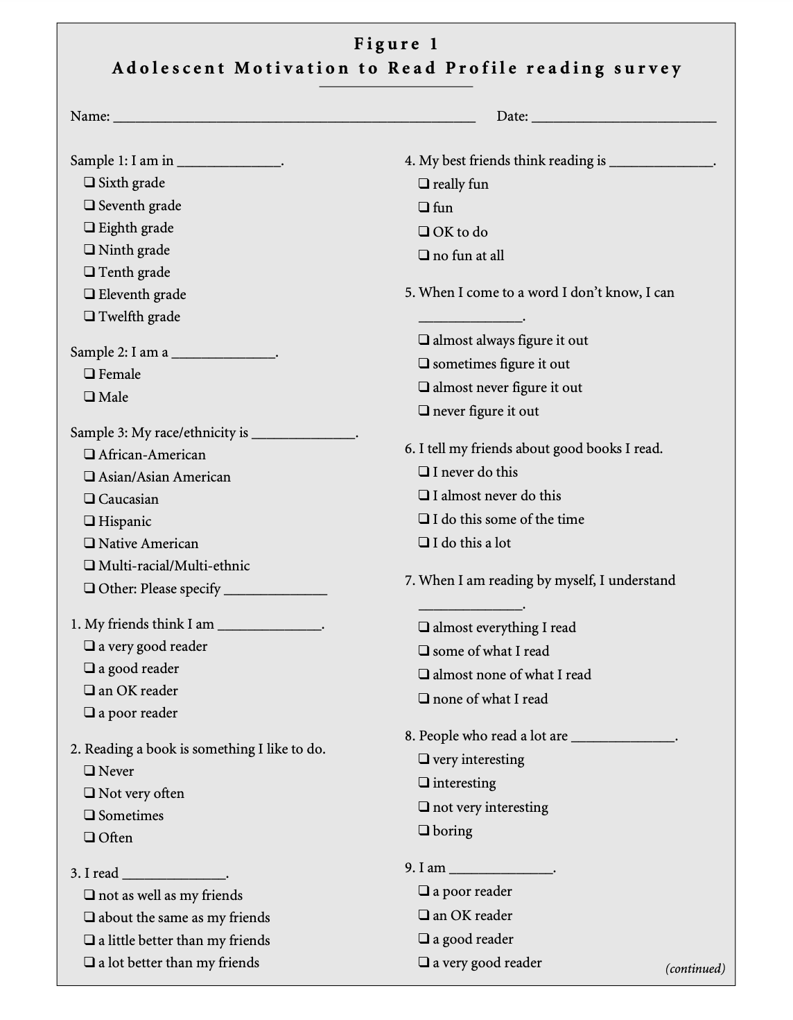

3.2 AMRP (Continued)
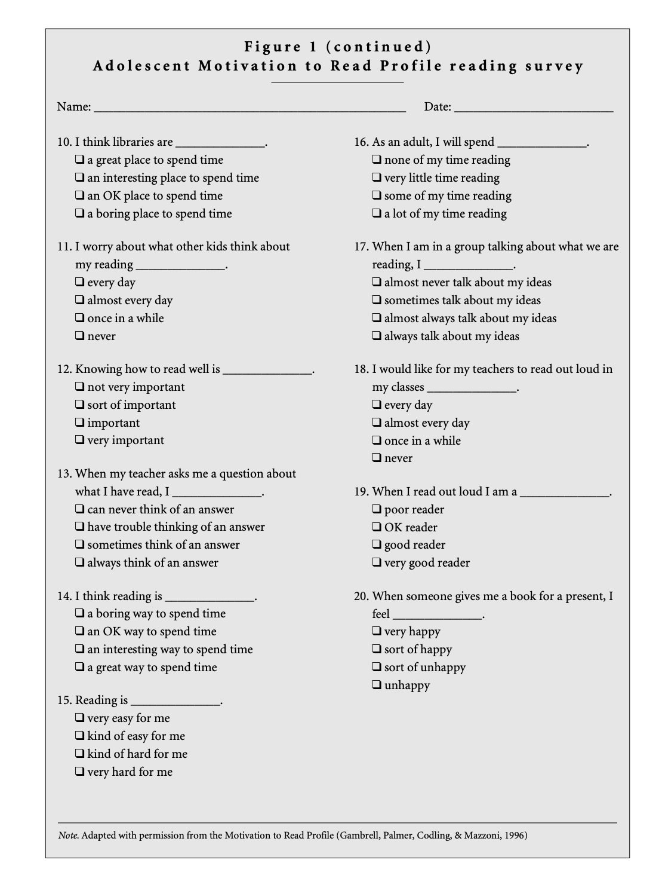
3.2 AMRP (Continued)
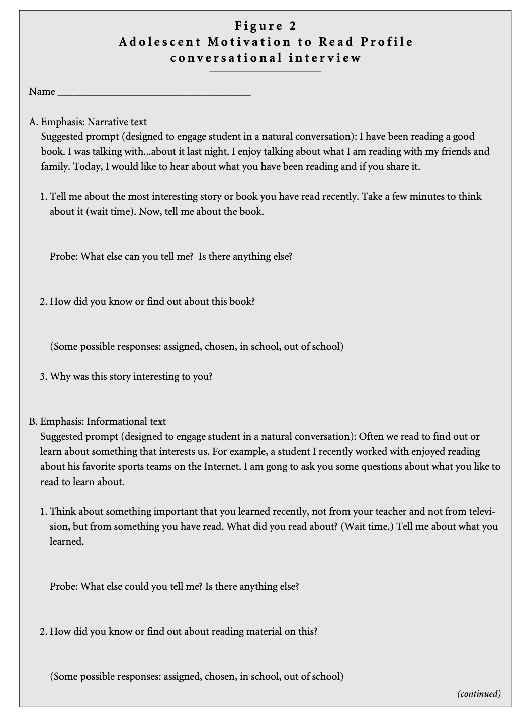

3.2 AMRP (Continued)
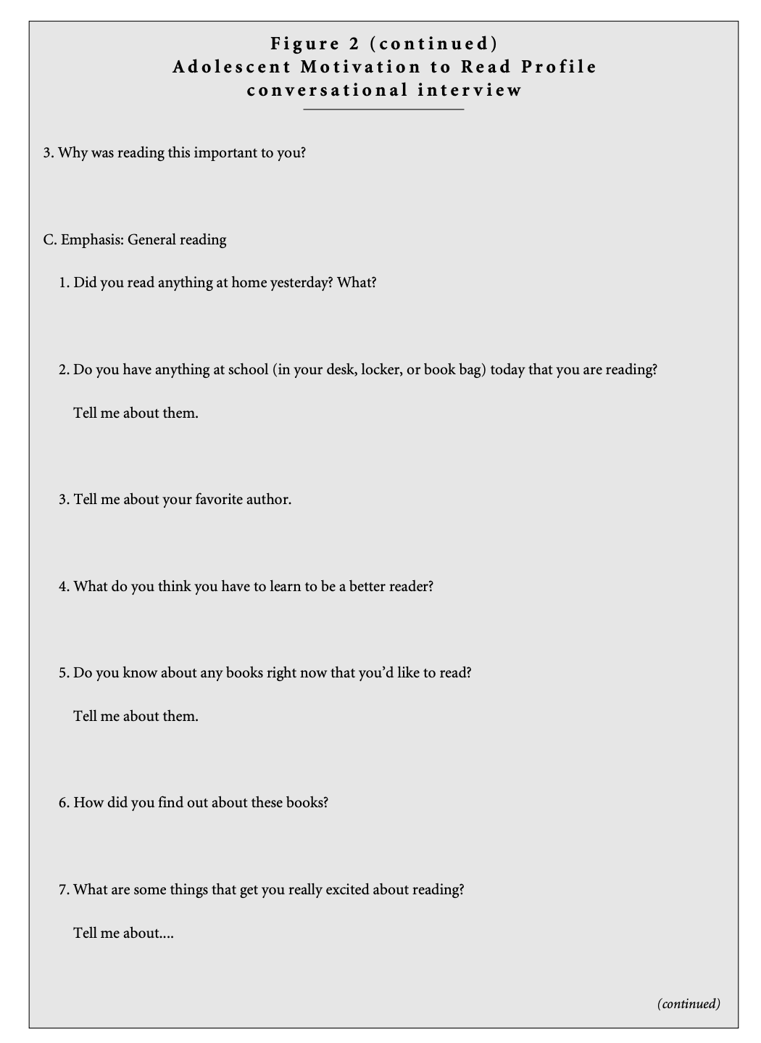
3.2 AMRP (Continued)
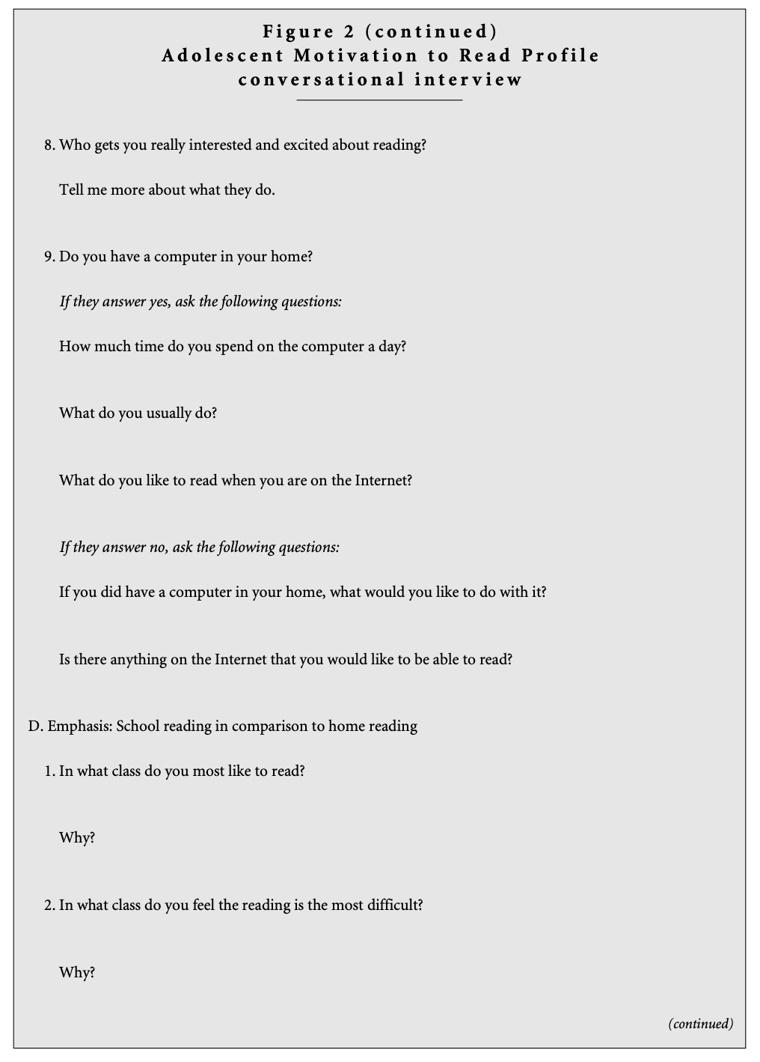
3.2 AMRP (Continued)
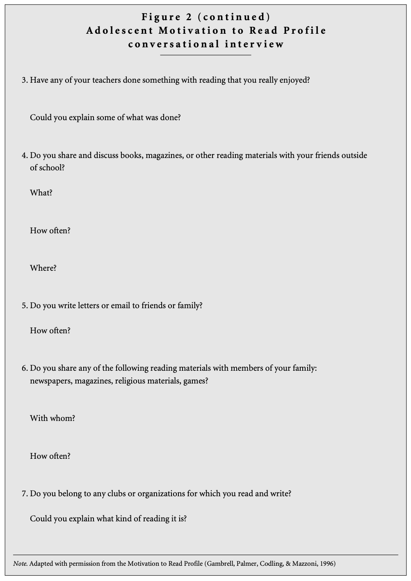
3.3 Post Experiment Interview Consent Form
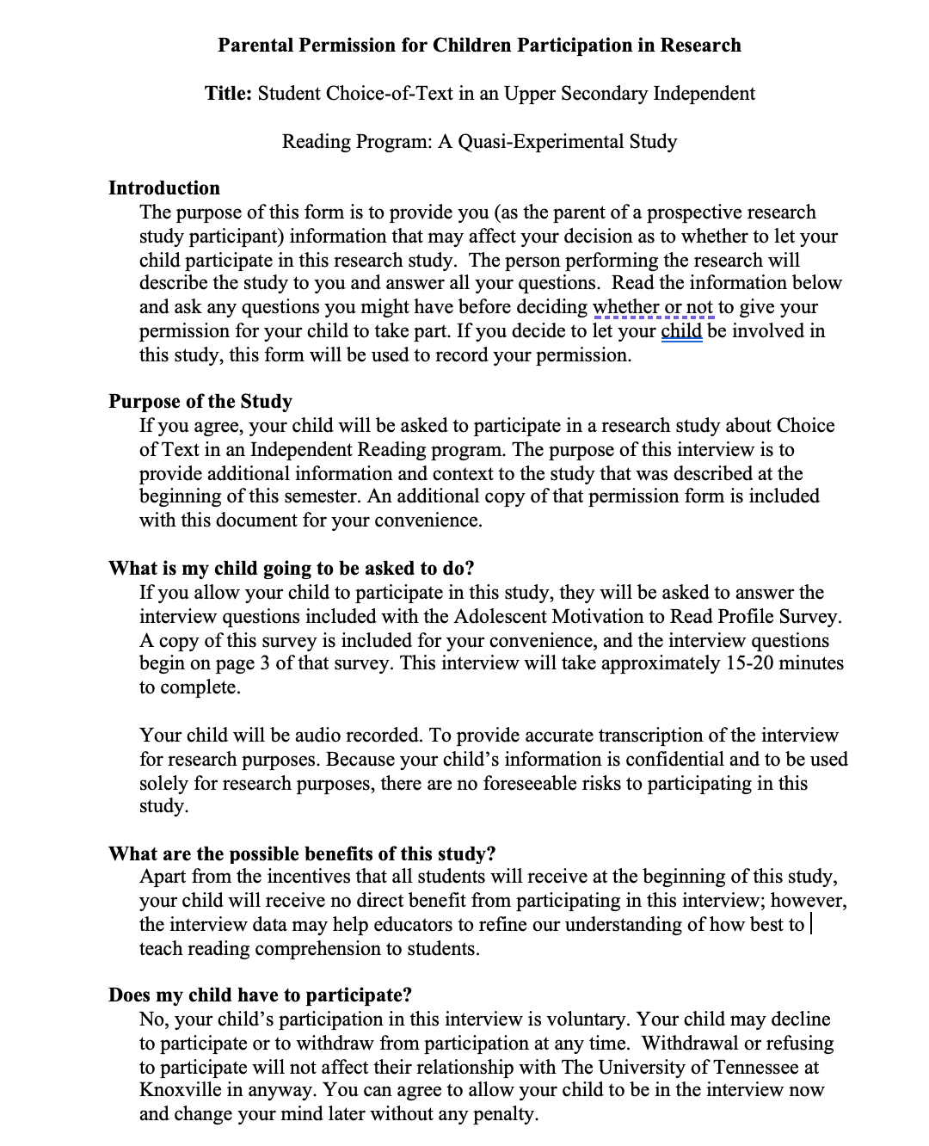
3.3 Post Experiment Interview Consent Form (Continued)
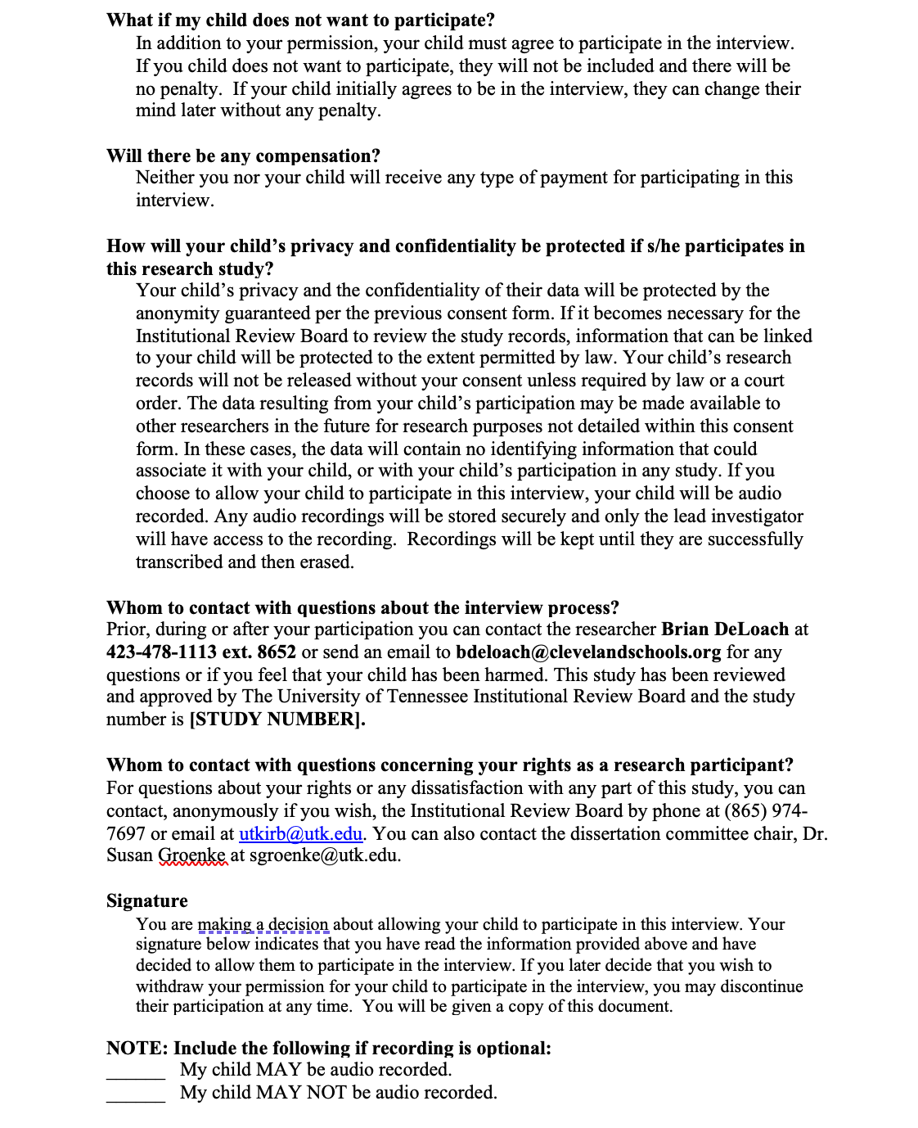
3.3 Post Experiment Interview Consent Form (Continued)
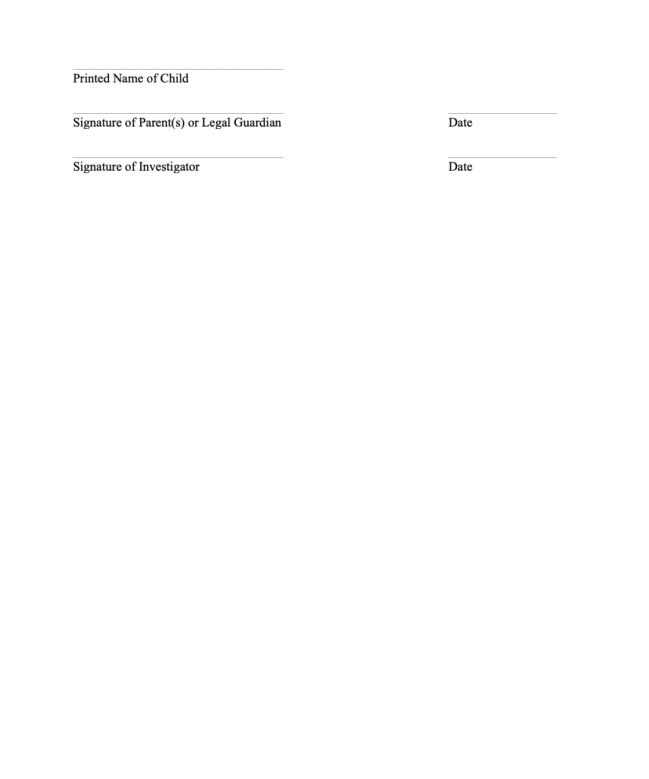

3.4 Individual Consent Form for Participants
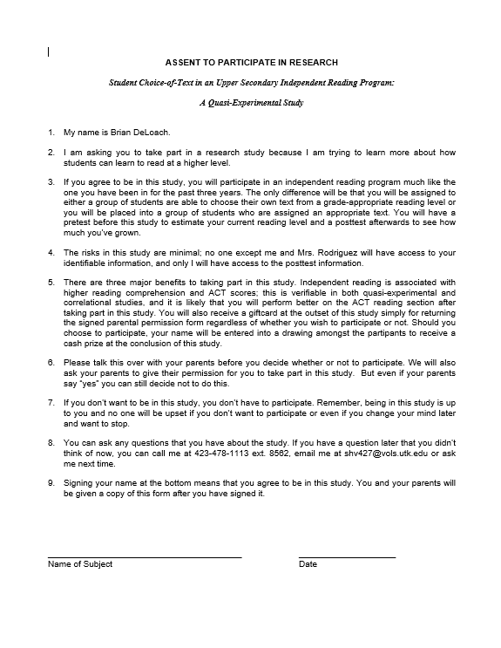

3.5 UTK IRB Approval Letter
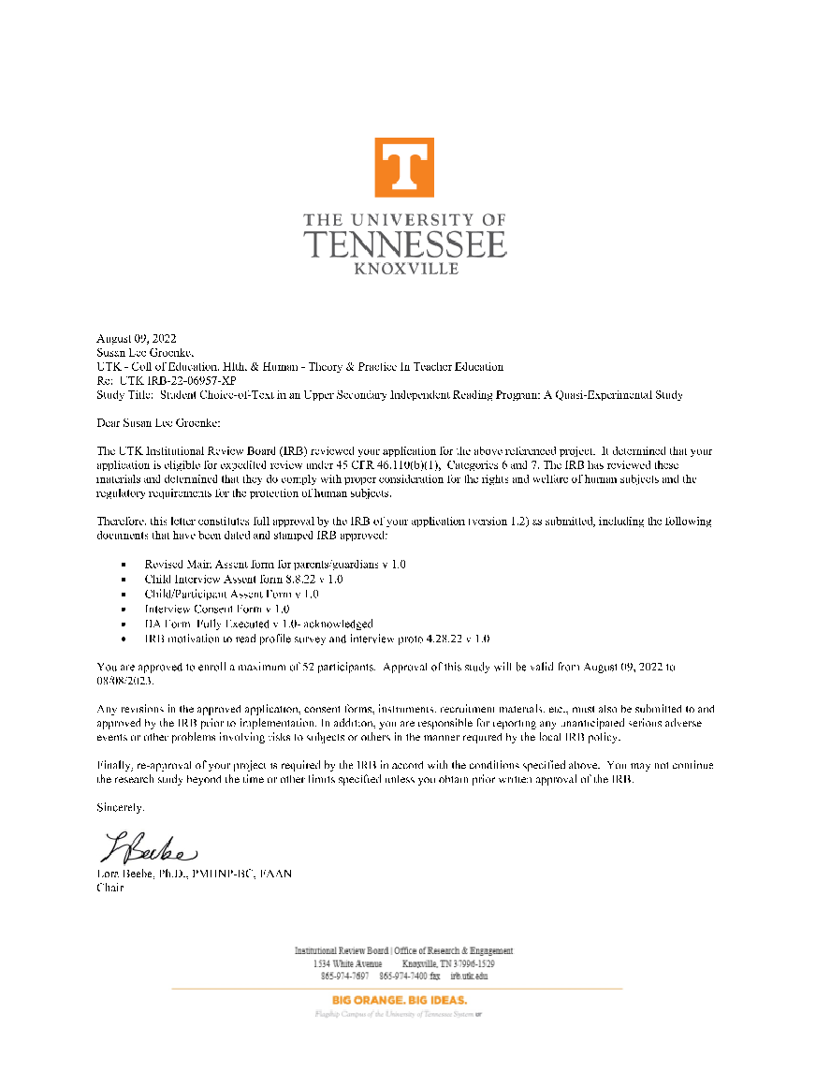
3.6 Official Individual Investigator Agreement Form

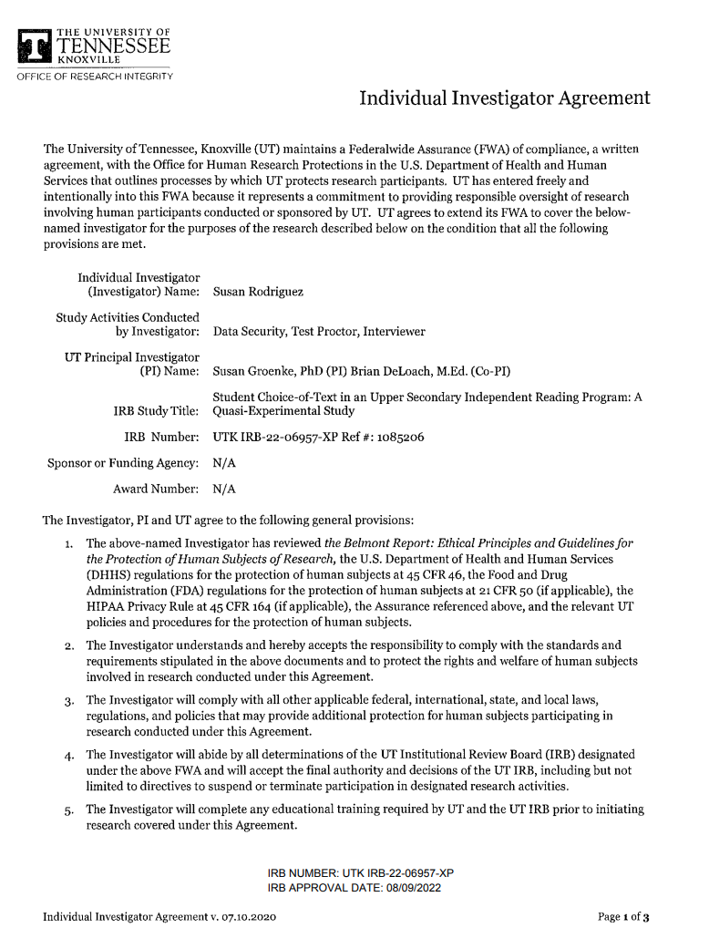
3.6 Official Individual Investigator Agreement Form (Continued)

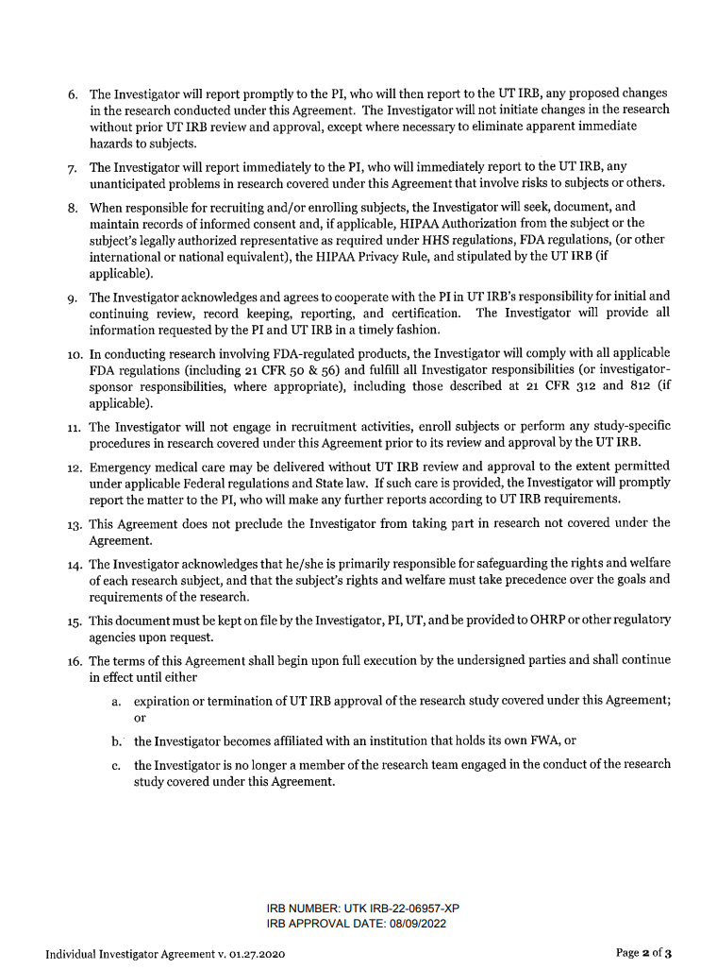
3.6 Official Individual Investigator Agreement Form (Continued)

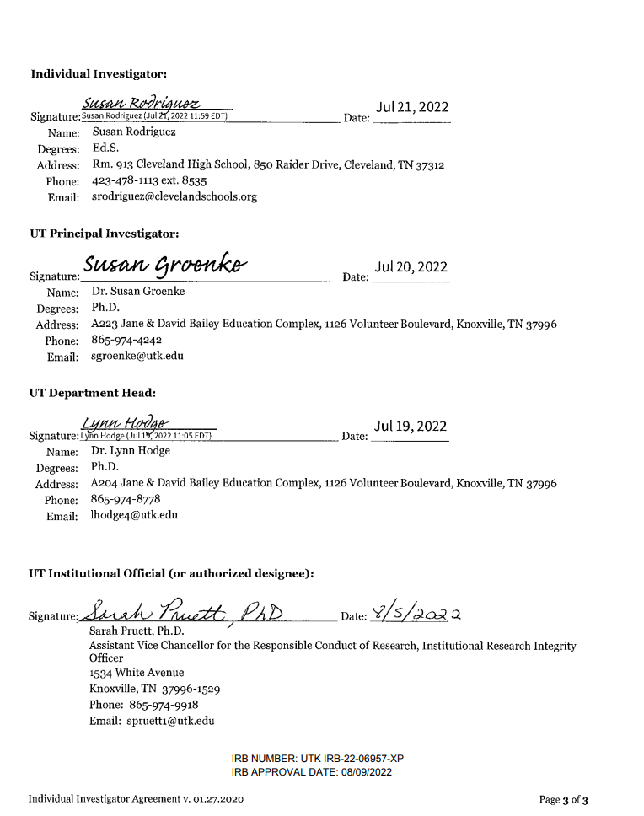
4.1 Full Transcript of Case: “Choice group: score increased from Pre to Post”

RA: Ok. Um, I have been reading a good book and I was talking about it with my
husband last night. I enjoy talking what I’m reading about with my
friends and family. Today, I would like to hear about what you have been reading
and if you’d share it. Uh, tell me about the most interesting story or
book you have read recently.
A: Um, can I say one that, it’s not recent, but it’s one that I enjoyed? It’s called
“Crossing the Wire”, by Will Hobbs. It’s an amazing book. It talks about a kid who
uh, looks into the future of helping his family in Mexico and then he crosses the
border out here into the United States and then he looks for a better future but in the
time that he‘s traveling to come over here he goes into some um, problems he
Runs…

RA: Mm huh.

A: …as an immigrant. And so hopping on trains, all the crazy stuff, running away from
the immigration status of the border that they have there so it’s a pretty good book.

RA: Awesome. Ok. Um, how did you know or find out about this book?
A: So, it was actually in my ESL room in sixth grade. It was a teacher, it was up in
Knoxville that we read it. I don’t know, I just fell in love with that book.

RA: That’s awesome. Uh, and why was this story interesting to you?

A: I feel like I’ve always talked about like how immigration started, how I connect with
my people, my Hispanic culture so I just felt like this is like somehow what I
connect with it and like we go through this every single day.

RA: Mm huh. I gotcha. You could identify with it.

A: Yeah.
RA: I gotcha. Ok. Often, we read to find out or learn about something that interests us.
For example, a student I recently worked with enjoyed reading about his favorite
sports team on the internet. I’m going to ask you some questions about what you
like to read to learn about. Think about something important that you learned
recently, not from your teacher and not from television, but from something you
have read. What did you read about?

A: Recently, um, was it asking about that book or can it be something else?
4.1 Full Transcript of Case: “Choice group: score increased from Pre to Post” (continued)
RA: Uh, yeah, something you like to learn about.
A: Ok, so it was this book, um, “A Long Way Gone”, I was doing a project for it and it
was um, it was about a kid who was stuck in the war pursuing his dreams of
becoming an artist. So I feel like what I learned from that is enjoy the moment that
you have now because you don’t know what you’re facing tomorrow.

RA: That’s right. That’s good. What else could you tell me? Is there anything else about
it?

A: About that book?

RA: Mm huh.

A: I mean, it’s really crazy how a kid at his age has to go through something like that
and face like a war that he’s not prepared for and seeing people die every day and
not know anything about your family for like about…that’s pretty sad.

RA: Yeah. That is. How did you know or find out about reading material on this? How
did you find out about that book?

A: How did I find out about that book, well, Mr. DeLoach told us, “Go pick a book”, and
at first, I was going to pick an Einstein book, but I was like not my interest and then I
saw that book and I was like you know what, I’ll just go ahead and give it a try.
RA: That’s good. Why was reading this important to you?

A: At first, I was like confused about what was going on in that story, but I started like
understanding the character and connecting with him. I feel like it is important to
realize like how I said, treasure what you have right now because you never know
what’s going to happen tomorrow.

RA: Ok. Did you read anything at home yesterday?

A: I did not.

RA: Ok. Tell me about your favorite author.

A: My favorite author is Will Hobbs.

4.1 Full Transcript of Case: “Choice group: score increased from Pre to Post” (continued)

RA: Tell me about him.

A: Uh, so, I just like how he, in his books, likes to go into details of every little stuff that
goes on in the story with the main characters, side characters, all the cool stuff.

RA: I gotcha. Um, tell, oh sorry. What do you think you have to learn to be
a better reader?

A: Um, to practice like sit down and put a timer on and like to read on a constant speed
you know if I can like without messing up, nothing, you know, if I can overcome that
you know.

RA: To get better. That’s good. Uh, do you know about any books right now that
you’d like to read?

A: Yes.

RA: Tell me about it.

A: “The Millionaire Next Door”.

RA: Yes! Tell me about that.
A: So, personal finance. So, apparently, it’s a really good book. Coach Turner told us
about it.
RA: Mm huh.
A: I want to learn more about it.

RA: My husband has read that book.

A: Yeah.

RA: Uh, how did you find out about these books?

A: These books, well, I got, about that personal finance?

RA: Yeah.

A: We talk about a lot of stuff in there. And also, I have second period Library so I just
4.1 Full Transcript of Case: “Choice group: score increased from Pre to Post” (continued)

take my time and like go through the books in there.

RA: That’s good. What are some things that get you really excited about reading?

A: If I see that I can connect with the title I don’t you know like “Crossing the Wire”
that’s like something I think like I really connected with that so…

RA: That’s good. Um, who gets you really interested and excited about reading?

A: Who?

RA: Mm huh.

A: I feel like myself. I don't’ really have anyone to like, I don’t know, but like myself,
I want to sit down and just relax and read a book.
RA: I gotcha. That’s good. Uh, do you have a computer in your home?

A: I do.

RA: Ok. And how much time do you spend on the computer a day?

A: A day? I feel like an hour or two.
RA: Outside of school?
A: Outside of school.

RA: I gotcha. What do you usually do when you’re on the computer?

A: I usually do edits. For like um, like I create the business cards for companies so
like I made a one for this person I was going to be a clown and they were
creating business so people would hire them and so I created the designs and
everything.
RA: Awesome! That’s good to know. Um, what do you like to read when you are on the
internet?

A: On the internet?
RA: Mm huh.
4.1 Full Transcript of Case: “Choice group: score increased from Pre to Post” (continued)
A: I like to read articles. It’s going to be sound crazy but about like, how should I say it,
like narcs, like what has happened in the past and what they did and like how they
got away with the stuff like that.
RA: Yeah. That’s interesting, yeah. Um, in what class do you most like to read?

A: In English.
RA: Ok, why?
A: Uh, English sets the vibe of like, of reading, mood, you know, and like theme, it’s
more relaxed sit down and read.

RA: That’s good. In what class do you feel the reading is the most difficult?

A: I’ll say gym.

RA: Gym? Why?
A: Because it’s really hard to concentrate. You’re going to sit there and read and you
have everything going on and it’s so loud in there like you wouldn’t be able to
concentrate.

RA: Yeah, that makes sense. Have any of your teachers done something with reading
that you really enjoyed?

A: I did.

RA: Ok. Tell me about it.

A: So like I said for that “Long Way Gone”, we had to create a project about it and it was
um, so a presentation had to be three minutes long and I decided to go all in about it
and I created like this Netflix theme. I gotta show it to you.

RA: Yeah. I’d be interested to see that. That’s awesome. Um, do you share and discuss
books, magazines or other reading materials with your friends outside of school?

A: I do not.

RA: Uh, do you write letters or emails to friends or family?
4.1 Full Transcript of Case: “Choice group: score increased from Pre to Post” (continued)
A: I don’t but I do, it’s like how girls have like their little diary?

RA: Yes.

A: I have mine, but like I usually write stuff about life.

RA: Mm huh.

A: I just write all that down and put it away.
RA: I gotcha. You write letters to yourself?

A: Yeah.

RA: That’s good. Uh, do you share any of the following reading materials with members
of your family: Newspapers, magazines, religious materials or games?

A: With my family?

RA: Mm huh.
A: Yes, I do.

RA: Ok, with who?

A: Mostly my mom.

RA: Ok. And how often do you think you do that?

A: Often, like if I find like something interesting, I’ll like I’m going to go ahead and tell
her. I would say like a lot.

RA: Uh, do you belong to any clubs or organizations for which you read and write?

A: I do not.

RA: That’s it.

4.2 Full Transcript of Case: “Choice group: Decrease in Score from Pre to Post”

RA: Ok. I have been reading a good book lately and I was talking about it with my
husband last night. I enjoy, er I enjoy talking what I’m reading about with my
friends and family. Today, I would like to hear about what you have been reading
and if you’d share it with others. Uh, tell me about the most interesting story or
book you have read recently.

J: Um, recently, I’ve really been into this author. Her name is Colleen Hoover and she’s
like the new big author between like a bunch of like girls and like I guess women all
around, but um I read one that was super interesting. It was about an author who was
faking like her own, she was in a coma, but she was faking it in order to like take
her son away from her husband. There were just a bunch of like twists and turns. It
was really interesting.

RA: Awesome. Um, how did you know or find out about this book?
J: On social media. She’s all-over social media.
RA: Uh, and why was this story uh, interesting to you?

J: Um, it was just, I love mystery stuff and this was very, very like mystery, but it wasn’t like scary at all.
RA: Uh huh.

J: And it had a bunch of like, I guess like twists and turns and like unexpected things
happened so I really that about it.

RA: Awesome! Ok. Think about something important that you learned recently, not from your teacher and not from television, but from something you’ve read. What did you read about?

J: Um, I learned about probably the importance of like telling the truth, and how you
never know who’s listening and you never know who’s reading and you never
know who’s around you so don’t, don’t lie. Always tell the truth.

RA: That’s good. Um, how did you know or find out about this, about that
reading material?

J: Um, one of the characters wrote something that she claimed to be a lie, but it
basically, was admitting to awful things she has done and, you know, throughout the
book everybody thought it was true. It turns out at the end of the book, she writes a
4.2 Full Transcript of Case: “Choice group: Decrease in Score from Pre to Post”
(continued)

different things that states how it wasn’t true, but we don’t know what to believe. If it
wasn’t true, don’t write it down. Those awful things were, you know, and it’s
supposed to be a story about her life so she wrote down all of these things that she
claimed to have happened in her life, but yet all of them claim to be a lie, but who
knows if they were actually a lie?

RA: I gotcha. Why was reading this important to you?

J: Um, reading this was important to me because, like I said, I, well I never really read
outside of school. I never did read up until I found this author and she’s like the first
author I think I’ve ever read multiple series in or multiple books, um, by a certain
person so just reading this, reading all of her books, honestly, I’m proud of myself
when I finish one because that’s not me to like finish a book.

RA: Yeah. That’s awesome! Um, did you read anything at home yesterday?

J: Um, no, but I did put a brand new one in my backpack so I plan to read it today.

RA: (Laughs) That’s my next question! Do you have anything at school in your desk,
locker or bookbag today that you are reading?

J: I do, I do.

RA: Awesome! Tell me about your favorite author.
J: Definitely her, Colleen Hoover. She’s just great, I mean she’s the next big thing,
she really is like all of her like Tic Tok and social media she is very talked about.

RA: That’s good. That’s awesome! Uh, what do you think you have to learn uh, to be
a better reader?

J: Um, I definitely, reading, I learn patience because it’s something I’m not good at but
with reading a book I have to have a lot of patience, you know, about the story line,
even just sitting in my chair and reading a book sometimes it’s very like, I get antsy,
you know, but I’ve learned how to like calm down and really like read and dig deep
into the book.

RA: That’s awesome! That’s so cool. Uh, do you know about any books right now that
you’d like to read?

J: Um, anything by Colleen Hoover honestly. I’m starting another one of hers and after
4.2 Full Transcript of Case: “Choice group: Decrease in Score from Pre to Post”
(continued)

this one, I’m sure I’ll read one called “November 9th”. I mean, there are just, there’s
so many still out there that I haven’t read that I can’t wait to read.

RA: Today’s November 9th. (laughs)

J: I know!

RA: How did you, I think I already asked you this, but I’ll ask you again. How did you
find out about these books?

J: Just like on social media, honestly, and my friends, we all read them so we all have
just switched books here around, you know.

RA: Yeah. That’s good. What are some things that get you really excited about reading?

J: Um, the story line and like seeing the new characters and how they develop and
what’s going to happen. That’s probably the most exciting part for me is like what’s
going to happen here, who’s going to, you know, like what’s going to happen, that’s
honestly my favorite part.

RA: The suspense.

J: The suspense! Yes, that’s the word I was looking for.

RA: Um, who gets you really interested and excited about reading?

J: Um, my brother, he’s always been a reader. I mean, my mom would have to buy him
series after series after series so he loved to read and he always told me, you know,
make sure reading, like it’s very important to exercise your brain all the time even in
summer, you know, so I’ve really actually taken that to heart, especially this year.

RA: That’s awesome! That’s good. Do you have a computer in your home?

J: I do.

RA: Ok. How much time do you spend on the computer a day?

J: Um, at school, I mean, we do all of our work on the computer so I’m on the computer
six out of the seven hours of the day.

RA: Wow.

4.2 Full Transcript of Case: “Choice group: Decrease in Score from Pre to Post”
(continued)

J: But at home, I don’t get on my computer unless there’s mandatory homework.

RA: I gotcha. Uh, when you’re on your computer, what do you do usually?
J: Just schoolwork.

RA: Ok. Uh, what do you like to read when you are on the internet?

J: Um, I really, I like news articles and true crime articles, anything like really
interesting, like true crime, interesting that’s happening in our world I like to read
about it.

RA: That’s good. Um, in what class do you most like to read and why?

J: Probably, I mean, we read in our Comp I class and that’s really interesting because
Mr. DeLoach always makes anything that we’re reading in the class like together
super interesting and like he ties it into like the modern day, ties it into like, you know,
just makes it so much easier to understand. So, I really like reading in his class.

RA: That’s awesome. In what class do you feel the reading is the most difficult and
why?

J: Um, well right now I only have my Comp I class. The readings aren’t difficult. I don’t
think that they’re, they’re difficult like wording and stuff like that, but when
I have a teacher like Mr. DeLoach who makes it super easy to understand so it’s not
hard to understand. If we didn’t have somebody to be, you know, kind of tearing it
apart for us and like relating it to us now, then I think it would be really difficult to read but I haven’t really had anything that was too difficult because of that.

RA: Awesome. He really breaks it down for you. That’s good. Have any of your
teachers done something with reading that you really enjoyed?
J: Um, let me think. Oh, last year, we did um, in my English III class, we read The
Crucible and that was very, very interesting, very interesting so um…

RA: What did you do in there that made it so interesting or that you liked about it?

J: We, wait, I don’t know if it was The Crucible, it was the um, The Salem Witch
Trials.

4.2 Full Transcript of Case: “Choice group: Decrease in Score from Pre to Post”
(continued)

RA: Mmm.

J: Not “The Crucible”, I was thinking of something else. “The Salem Witch Trials”, and
we played a bunch of games and like in that book they’re accusing different people
of being witches and stuff like that so we played a bunch of games that was like you
can trust me, but actually they were the witch. So, we played that a few times. It was
kind of interesting to see like who was telling the truth, who was lying so I like when
games are tied into it to like, yeah.

RA: Yeah. Um, do you share and discuss books, magazines or other reading materials
with your friends outside of school?

J: Yes. We are always switching books, especially by Colleen Hoover all the time, all the
time.

RA: How often would you say you do that?
J: Um, probably, in the summer it was like every three weeks we were switching books
but now that we’re all like busy and don’t have a lot of time to read um, every month
or so.

RA: Good, good. Uh, where do you typically do that? Do you get together?

J: Yeah, I mean, we’re with each other all the time so you know, we’ll just switch out
books when we see each other.

RA: Gotcha. Uh, do you write letters or emails to friends or family?

J: Um, I do.

RA: Ok. How often?

J: Um, I’m always in contact with my family. We’re really close and I always try to you
know, text them or talk to them any time I can.

RA: Gotcha. Uh, do you share any of the following reading materials with members of
your family: Newspapers, magazines, religious materials or games?

J: Yeah.

4.2 Full Transcript of Case: “Choice group: Decrease in Score from Pre to Post”
(continued)

RA: With who and how often?
J: Um, my grandfather is very, very interested in, I mean, honestly, anything in like
news, anything politics, so, I mean, I always sit down and talk to him about it because
I mean, you know, I’ll gladly talk to him about anything, so if it’s something he’s
interested in I’ll sit there and listen, so he’ll pull out the newspaper, he’ll show me
different things. I also come from a Christian household so we have the Bible in our
pockets very, very often so…

RA: That’s good.

J: Yeah.

RA: Um, do you belong to any clubs or organizations for which you read and write?

J: I do not.

RA: Ok. And that’s it. You can stop it.

4.3 Full Transcript of Case: “Choice group: score was unchanged from Pre to Post”

RA: Ok. Tell me about the most interesting story or book you have read recently. Take a
few minutes to think about it.
K: Probably the most interesting story I’ve read as of late was my independent reading
book, “Shutter Island”, because I really enjoyed it. It’s kind of like a thriller, it helps
you stay very engaged not knowing what going to happen or when it’s going to
happen or who the main character can trust and who he can’t and, in the end, you
find out that he can’t even trust himself because he thought he was investigating
this mental hospital when, in fact, he’s the main um, patient. They’re doing a study \
on him.

RA: Um, is there anything else?
K: Like another book, maybe?

RA: Uh, it can be or it can be more about that one.
K: Ok, another book that I’ve started reading is, uh, “The Book Thief”.

RA: Mm huh.

K: Mr. DeLoach, my teacher, he, uh, he gave it to me and I don’t like it as much as I
liked my “Shutter Island” book just because, like, it’s sad…

RA: Mm huh (laughs).

K: …and I don’t, I don’t rock with the sad books. I didn’t know it would be sad
whenever I picked it off the bookshelf and he, uh, lent it to me, but it’s sad.

RA: Mm huh. That’s good. Um, how did you know or find out about this book? You
may have already mentioned that, but if you’ll say that again.

K: Yes ma’am. I found out or saw the book on the bookshelf and it stuck out to
me because on the spine of the book it has big, bright, red letters so I,
like, opened it. I was the first one up to go grab a book and, on the front, I saw
Leonardo DiCaprio.

RA: (laughs) Mm huh.
K: …and it’s like an instantly recognizable face and so that’s what made me
decide to pick the book because there’s a movie, although I haven’t
watched it, it’s based off the book.
4.3 Full Transcript of Case: “Choice group: score was unchanged from Pre to Post” (continued)
RA: Ok. Why was this story interesting to you?

K: Uh, like I said, this story as a, very much so keeps you engaged because like
it is a thriller and like this whole time like you don’t know what’s happening to your
main characters. You’re kinda left in the dark just like the characters are from like
what’s going on really behind the scenes. And you see these two detectives try to
make their way through like, I don’t know, like clues and mysteries. So…

RA: Often we read to learn about something that interests us. For example, a student I
Recently worked with enjoyed reading about his favorite sports team/teams on the
internet. I’m going to ask you some questions about what you like to read to learn
about. Ok? The first one is, uh, think about something important that you’ve
learned recently, not from your teacher and not from television, but from something
you have read. What did you read about?

K: Let me think…I was probably reading about some history or, uh, something like that
because that’s what interests me and I think that’s the only thing outside of school
that I really like to focus on and study up and know more about.

RA: Gotcha. Uh, what else could you tell me? Is there anything else?

K: Uh, no ma’am, I don’t think so.
RA: Ok. How did you know or find out about reading material on this?
K: What did I find out, ma’am?

RA: How did you know or how did you find out about that?
K: Uh, is this in relation to the last question you asked?

RA: Yes, mm huh.

K: Alright, gotcha. I just, it popped up on my, like, recommended stuff.

RA: Mm huh. Perfect. Um, have any of your teachers done something with reading
that you really enjoyed?

K: Yeah, like we have at Cleveland, we all have independent reading time. All the
English teachers do it in the beginning of class and I think it’s a great way to start the
class. It becomes my favorite part of the morning just to sit down and read my book.
4.3 Full Transcript of Case: “Choice group: score was unchanged from Pre to Post” (continued)

It makes me excited to come back to school tomorrow.

RA: That’s awesome. Uh, do you share and discuss books, magazines or other reading
materials with your friends outside of school?
K: Uh, I mean in class I’ll ask my friend what she’s reading because after independent
reading time is done she’ll pick out another book and she’ll read it so we kinda
recommend things to each other to read.

RA: Ok. How often do you think, um, that happens?
K: Mmm, maybe once a month.

RA: Ok. Uh, do you write letters or email to friends or family?

K: Yes ma’am, I do write Christmas cards.
RA: Ok, so uh, would you say once a year or how often would you say?

K: Uh, Christmas cards, mmm, I think it’s probably like fifteen of them…probably
fifteen.

RA: Ok. Uh, do you share any of the following reading materials with members of your
Family: Newspapers, magazines, religious materials or games?

K: I mean, not usually ma’am, unless it’s a kind of uh, you know, conversation starter.
You know…

RA: Mm huh.

K: …how family does, asking about what’s in the news and what’s going on in the
world.
RA: Ok, and you said family. Do you want to specify with whom?

K: Uh, probably my dad.

RA: Ok.

K: I think around lunch, or around the dinner table we’ll talk about stuff that’s going on
in the world and what we think about it.
4.3 Full Transcript of Case: “Choice group: score was unchanged from Pre to Post” (continued)
RA: Ok. How often do you think that happens?
K: Uh, probably Sunday dinner so, once a week.

RA: Ok. Do you belong to any clubs or organizations for which you read and write?

K: Uh, no ma’am.

RA: Ok. Why was reading this important to you? I guess “this” would be what we
were just talking about.
K: Uh, the important modern-day things?

RA: Mm huh.

K: Oh, just staying up with what’s going on in the world because like we see the war in
Ukraine, I mean like, stuff affects us and you need to know what goes on
around the world, around the globe, it has an impact on our lives, gas prices.

RA: Very true. Uh, who gets you interested and excited about reading?

K: Who gets me really interested and excited?

RA: Mm huh.
K: Probably my awesome English teacher, Mr. DeLoach.

RA: (laughs) Ok, tell me more about what he does to get you excited.
K: He does, uh, he encourages us. Sometimes he’ll reward us with like, some
affirmations or something like that. He got me excited because he like gifted me a
book to read.

RA: Oh, that’s nice. Uh, do you have a computer in your home?

K: Yes ma’am.

RA: Ok. How much time do you spend on the computer a day?

K: Uh, probably ten minutes.

4.3 Full Transcript of Case: “Choice group: score was unchanged from Pre to Post” (continued)

RA: Ok. What do you usually do?

K: Uh, go through and help my little siblings get set up on their schoolwork or uh,
Accelerated Reading.

RA: Ok. What do you like to read when you are on the internet?

K: (Sighs) Like I said, probably stuff about history or modern day information or uh,
current events.

RA: Ok. Uh, in what class do you most like to read and why?

K: Uh, probably in my US History class or in my Government now. I don’t have US
History anymore, but that’s where I like to read because the material is very
interesting to me.

RA: Ok. In what class do you feel the reading is the most important and why?
K: Mmm, probably in English because it has to do with all of our assignments.

RA: (Laughs) Uh, why was reading this important to you?

K: Uh, reading this was important to me because uh, I just, it was very entertaining.

RA: Ok.

K: And I enjoyed the book a lot.

RA: Ok, gotcha. Uh, did you read anything at home yesterday?
K: I did not.

RA: Ok. Do you have anything at school in your desk, locker or bookbag today that you
are reading?
K: Yes ma’am.

RA: Ok. Tell me about it.

4.3 Full Transcript of Case: “Choice group: score was unchanged from Pre to Post” (continued)

K: Uh, right now, I’m still working on “The Book Thief” because like I said, Mr. DeLoach gifted it to me. I haven’t finished it because we have been doing our independent reading and that’s usually the time I’ll have to read throughout the day, so yeah, that’s what I’m reading right now.

RA: Awesome! Uh, tell me about your favorite author.

K: Uh, I don’t, I can’t name him by name, but whenever I was growing up there was this
book series I read called “The Ordinary Boys” series and it’s about some boy and
he's the only ordinary one in a town full of superheroes and that, yeah.
RA: Awesome! What do you think you have to learn to be a better reader?
K: Mmm, probably to make time for it in my day.

RA: That’s good.

K: Just so I’ll get it done.

RA: Mm huh. Do you know about any books right now that you would like to read?
K: (Sighs) Mmm, I’d probably like to start the “Harry Potter” series. That’s one I’ve
never read, although they’re good.

RA: Yeah, for sure. Um, how did you find out about these books?

K: Uh, the movies based off of the books.

RA: Ok. What are some things that get you really excited about reading?

K: Uh, you know, just like the climax, you know, it leaving you on like a cliffhanger and
being excited to go back and read some more the next day.

RA: Ok. Um, I’m going to repeat some of these questions. I think I went out of order so
um, you already answered it, um, but I’ll ask it again. Who gets you really
interested in reading and excited about reading?

K: Uh, probably my English teacher, Mr. DeLoach.

RA: Uh, do you have a computer in your home?

4.3 Full Transcript of Case: “Choice group: score was unchanged from Pre to Post” (continued)

K: Yes ma’am.
RA: Ok. Uh, how much time do you spend on the computer a day?
K: At most, ten minutes.
RA: And what do you usually do?
K: I set up Accelerated Reading for my little siblings.

RA: Ok. Um, what do you like to read when you’re on the internet?

K: Uh, probably the news, you know, what’s going on, current information, stuff like
that.

RA: Ok. Um, alright, I think that’s it.
K: Alright. Thank you, ma’am.
RA: Thank you.

4.4 Full Transcript of Case: “No Choice group: Increase in Score from Pre to Post”

RA: Ok. Tell me about the most interesting story or book you have read recently. You
can take a few minutes to think about it.

CM: Um, probably one I just read, Slaughterhouse Five.

RA: “The Slaughterhouse Five”? Um, what else can you tell me about the book? Is
there anything else about it?
CM: It was very strange. The writing was weird, which made it harder to read. I really
just didn’t know what was going on, so it made it interesting.
RA: Mm huh. How did you know or find out about this book?
CM: Mr. DeLoach put me on it.
RA: Why was this story interesting to you?
CM: I’ve never read another story like it. The writing is very interesting.
RA: Um, think about something important that you have learned recently, not from
your teacher, not from television, but from something you’ve read. What did you read about? Tell me about what you learned.

CM: Um, I forget who told me this, but it was about just… it’s unrelated
RA: Yeah. Um, how do you know or find out about reading materials on this?
CM: On the thing I just heard? I don’t know.

RA: You don’t know?
CM: I forgot who told me.
RA: Why was reading this important to you?
CM: Um, it really helped with what I was going through because I needed to stay
connected to my friends and just, I needed it when they said it.
RA: Hm huh. Um, did you read anything at home yesterday?

CM: No.
4.4 Full Transcript of Case: “No Choice group: Increase in Score from Pre to Post” (continued)
RA: Do you have anything at school like in your desk or locker or bookbag today that
you are reading about?

CM: No.

RA: Um, tell me about your favorite author.
CM: Um, probably C.S. Lewis because I used to read “Narnia” as a kid. I don’t know,
I just like him and his philosophy.

RA: What do you think you have to learn to be a better reader?

CM: Like to be better at reading? Um, just read more books, increase my
understanding.

RA: Do you know about any books right now that you’d like to read?

CM: Mmm, not really.
RA: How did um, what are some things that get you really excited about reading?
CM: If I know it’s like a good book, like if it’s considered a classic.

RA: Mm huh.

RA: Who gets you really interested and excited about reading?
CM: Mr. DeLoach, probably.

RA: What all do they do?
CM: Um, he can just hype me up about a book or like tell why it’s such a good book.

RA: Mm huh. Do you have a computer at your home?

CM: Yeah.

RA: How much time do you spend on the computer a day?

4.4 Full Transcript of Case: “No Choice group: Increase in Score from Pre to Post” (continued)

CM: At my home, not really any unless it’s homework, I guess.

RA: So, you usually do your homework?

CM: Yeah.

RA: What do you like to read when you are on the internet?

CM: Um, I read the like news articles sometimes or just about what’s going on in the
world.

RA: Mm huh. In what class do you like to read the most?
CM: English, probably.

RA: Why?

CM: Because it’s kind of built for reading and Mr. DeLoach is there and he knows a lot
about books and stuff.

RA: Mm huh. In what class do you feel reading is most difficult?

CM: Math.

RA: Math?
CM: It’s not really reading, but just the way the questions are worded and such.

RA: Mm huh. Have any of your teachers done something with reading that you really
enjoyed?

CM: Um, I mean, Mr. DeLoach, I like writing about things I’ve read and doing projects
basically.
RA: Do you share and discuss books, magazines or other reading materials
with your friends outside of school?

CM: Yes.

RA: What?
4.4 Full Transcript of Case: “No Choice group: Increase in Score from Pre to Post” (continued)
CM: At one of our red flag footballs, I tried to talk my friends into reading
it was really good.

RA: How often do you talk to them about this?

CM: A lot.

RA: Where do you guys talk about this?
CM: Just whenever we hang out.

RA: Do you write letters or emails to friends or family?
CM: Not really. I just text them.
RA: You just text them. How often?
CM: Pretty much every day.
RA: Do you share any of the following reading materials with members of
your family: Newspapers, magazines, religious materials, games?

CM: Yeah, I’ll send like, if I see a news article or something, I’ll send it to my family.
RA: Mm huh.
CM: If it’s interesting.

RA: How often?
CM: Pretty much every day, I assume.

RA: Do you belong to any clubs or organizations for which you read and write?

CM: No.

4.5 Full Transcript of Case: “No Choice group: Decrease in Score from Pre to Post”

RA: Ok. Um, I’ve been reading a good book lately and I was talking about it with my
husband last night. I enjoy talking what I’m reading about with my
friends and family. Today, I would like to hear about what you have been reading
and if you’d share it. So, tell me about the most interesting story or book you have
read recently.
G: Uh, the most interesting book I’ve read, I think, was last year in English class, I read
a documentary about like the history of SEC football, which I’m really interested in
so…

RA: Yeah!
G: I liked that book a lot.
RA: That’s awesome.
G: And the most recent book I’ve read was Friday Night Lights.
RA: Mm huh.
G: And uh, in Mr. DeLoach’s class right now, I just got through with that and it was
really good, too.
RA: Ok. Good! Um, how did you know or find out about this book?
G: Uh, the first one I just had at my house and I was always interested in like reading
it so I finally just took it to class because we had to.

RA: Yeah.
G: And that worked out well, and the second book, I was assigned, but it still ended up
working out.

RA: Good. Uh, and why was this story interesting to you?

G: Um, it was interesting because I’ve always been interested in sports and it’s just
something that I like and enjoy to read about so…
RA: Good. Think about something important that you learned recently, not from
your teacher and not from television, but from something you have read. What did
you read about?
4.5 Full Transcript of Case: “No Choice group: Decrease in Score from Pre to Post” (continued)
G: Um, I read about overcoming adversity in a book like a dude got, a guy got injured
and he had to overcome that to get ready for the season, which hit home to me
because I got hurt last year during our season and I’ve been working my way to
come back so it really helped me out.

RA: Yeah, you could really identify. Gotcha. Um, how did you know or find out about
reading material on this?
G: Uh, about…?
RA: What you were just talking about.
G: Oh, uh, just reading the book and it kind of just hit home when I first like started
reading it and like the quotes they were saying so it just helped me get through what
I was going through.

RA: I gotcha. That makes sense. Um, why was reading this important to you?
G: Uh, because, kind of like I just said, it just helped me get through a tough time, I
guess.

RA: Mm huh.
G: And it helped me realize that other people are going through the same stuff I
was going through.
RA: Yeah. That’s good. Um, did you read anything at home yesterday?
G: Yesterday, I don’t think so.
RA: Ok. Um, do you have anything at school in your desk, your locker or your backpack today that you are reading?

G: Currently, no, because we just finished the book and so, technically, no.

RA: Alright. Tell me about your favorite author.

G: Favorite author?

RA: Mm huh.
4.5 Full Transcript of Case: “No Choice group: Decrease in Score from Pre to Post” (continued)
G: That’s a good question. Uh, I don’t know if I really have a favorite author, but I
have a favorite like book series, I guess.
RA: Yeah.
G: I don’t know. Um, I liked reading the “Harry Potter” books when I was a kid like
middle school so I kind of like those.

RA: Yeah. Definitely. That’s a lot of people’s favorite. Uh, what do you think you have to learn to be a better reader?
G: Um, just the curriculum, I guess, to like understand words and um, and like how the
story goes along because if I’m reading a book and I’m like getting confused and I
can’t keep up with it, it’s less interesting.
RA: Sure.
G: So, if I understand like what it’s saying, I think it’s more beneficial, like I can actually
read the book and enjoy it.

RA: Yeah. Definitely. Um, do you know about any books right now
you’d like to read?

G: Mmm, don’t think so.

RA: Ok. Um, what are some things that get you really excited about reading?

G: Um, I get excited about just reading like in general like a website per say just like
an article. Like if something’s interesting to me I’ll…I love reading that type stuff,
but like a book, I would say, something that catches my eye I’m interested in, I’m
like, oh yeah, I want to read that.

RA: Yeah. That makes sense. Um, who gets you really interested and excited about
reading?

G: I think, I think my mom gets me excited about reading because she’s an English
teacher so it’s like…
RA: Awesome!

4.5 Full Transcript of Case: “No Choice group: Decrease in Score from Pre to Post” (continued)

G: So, if she like tells me to read something or if I don’t, even if I don’t want to read it
and I start reading it and I’m interested, then I enjoy it.

RA: Good. Alright, that’s good. Uh, do you have a computer in your home?

G: Yes.

RA: Ok. And how much time do you spend on a computer a day?

G: At school or just at home?

RA: You, you can comment on both.

G: Uh, ok, well at school I’m on it like almost 24/7, just because every class we use
them and when I get home, if I’m doing homework or even just my personal use. I’m
on it a good bit so I’d say…mmm…

RA: Most of the time at school?

G: Most of the time…

RA: Most of the time at school, but how many hours after school?
G: Mmm, probably like an hour and a half, not too much because I like getting off of it
a good bit.
RA: Yeah. Taking a break.
G: Yeah, just, a good amount of time though.

RA: Ok. What do you usually do when you’re on your computer?
G: Uh, looking up stuff like, like actually for example, yesterday I was Christmas
shopping on the computer for a good bit.
RA: That’s good.
G: And enter, um, researching something and if I’m, if I need to ask questions, it’s easier
to look up something. Stuff like that.

4.5 Full Transcript of Case: “No Choice group: Decrease in Score from Pre to Post” (continued)

RA: Awesome. Uh, what do you like to read when you are on the internet?

G: Uh, I like to read stuff about what I’m mainly interested in so I’m a big Tennessee
fan so I read a bunch of stuff like that.
RA: Yeah.

G: Like whoever they’re playing this week or just reading stuff, opinions on sports and
stuff. I love reading articles like that.
RA: That’s awesome. Um, in what class do you most like to read?
G: I would, I would say English just because you read the most in there and most of the stuff’s interesting and some of it’s not, but you just read a lot and it’s a lot easier to read in English I would say.

RA: I gotcha. In what class do you feel the reading is the most difficult?

G: It would definitely have to be a Science class for reading like a big paragraph or
something and trying to figure it out. It’s just a lot harder to read than would be just
a normal paragraph of something.

RA: I gotcha. Um, have any of your teachers done something with reading that you
really enjoyed?

G: Uh, I think, I think in Spanish class, actually, I think, it was beneficial to read like and
it was fun because I had Mr. Smith.
RA: Yeah.

G: And we would read like little things like a couple sentences here and there, but it
would be fun because we could read it with the class and understand what we’re
reading.

RA: Good. Can you tell me a little bit more about how you did that, what did you read in
groups? Did you read as a whole class?

G: Uh, both. We would read like, he would take volunteers, we’d read a couple
sentences and sometimes it would be funny because people struggled like
pronouncing it. It just put everybody in a good mood, and we enjoyed doing that.
4.5 Full Transcript of Case: “No Choice group: Decrease in Score from Pre to Post” (continued)
RA: That’s good. That’s good. Do you share and discuss books, magazines or
other reading materials with your friends outside of school?

G: I would say magazines, maybe, or like a website, but not really books.
RA: Ok. Um, how often would, do you think you do that?

G: I’d say rarely.
RA: Ok. And uh, when you do that, like where does that happen? Are you at home? Are
you, Is it in passing?

G: Uh…
RA: Is it at school?
G: Lunch table, maybe. Sometimes out of school, very rarely out of school.

RA: Ok. Ok. Do you share any of the following reading materials with members of
your family: Newspapers, magazines, religious materials or games?
(Announcement interruption). Sorry about that. I’ll ask you again. Um, do you share
and discuss books, magazines or other reading materials with your friends outside
of school? Oh, no, we did that one, right?
G: Yes.
RA: Sorry. Do you share any of the following reading materials with members of your
family: Newspapers, magazines, religious materials or games?

G: Uh, I would say all of them.
RA: Mm huh.
G: We share. Sometimes we talk about the newspaper, rarely magazines, uh, I don’t
know.
RA: Ok. And you said with your family typically?

G: Yeah.

4.5 Full Transcript of Case: “No Choice group: Decrease in Score from Pre to Post” (continued)

RA: How often do you think ya’ll do that?

G: Occasionally. I would say rarely, but it’s just like here and there. Yeah.
RA: Gotcha. Do you belong to any clubs or organizations for which you read and write?

G: No.

RA: Ok. Alright. That’s it.

4.6 Full Transcript of Case: “No Choice group: score unchanged from Pre to Post”

RA: Ok, alright, um, so I’ve been reading a good book. Um, I was talking about it, uh,
talking with my husband about it last night. I enjoy talking about what I’m reading
with my friends and family. Uh, today I’d like to hear about what you have been
reading and if you’d share it. So the first thing I’m going to ask you is tell me about
the most interesting story or book you have read recently. Take a few minutes to
think about it and then tell me about the book.

IN: Ok. Ok so, recently in English class I have read this book, The Devil in the White City and it’s really interesting. So far, I have read it because, um, it’s about like a serial killer.

RA: Uh huh.

IN: And it’s about, it happened in Chicago so it’s like a historical event and it
happened like eighteen or nineteen hundreds and it was about mainly…like
I like it because it was suspense, it was thriller, it was like you want to know who
killed all of them at this big event in front of everybody and not scared and his reason was he just killed them because he felt the need of it, because he wasn’t reaching success by um ar, ar, architect?

RA: Uh huh.

IN: So, he wanted to do that to make himself famous in this world and he felt like
everybody did bad deeds. Not all bad deeds are bad, some are for good reason.
That’s what his quote was in the book.

RA: Oh, wow! Ok. Um, is there anything else you want to tell me about it?

IN: Not so much, but in the starting, I was a little confused on who the main
person is. The main person was Burman, but he was a good person. He was not the villain, then throughout when I read it I found out who it was and it was kind of
shocking because you would not know because he’s not the main character, he’s not shown a lot, he’s just a side and it was like…because usually when you see movies or read books it’s like you always find the hero and then the villain and you know the story. In this one, the villain was like a side character. It was kind of like, hmmm, who did it? I was confused, I thought it might be the hero because of the way he was talking, and the people gave opinion about him. I did notes in my book.

RA: (Laughs). I love it! That’s awesome!

IN: Yeah.

RA: Ok. How did you know or find out about this book?
4.6 Full Transcript of Case: “No Choice group: score was unchanged” (continued)

IN: Uh, well, Mr. DeLoach, he gave me it because um, I recommended him this book.
He asked us what book we had read in the past in English class so um, I couldn’t
remember the name but I found out and I told him the name.

RA: I gotcha.

IN: And I think it’s Last Famous Words, I think that’s what it’s called. It’s a serial
killer, too, not as suspenseful, but it’s a really good book.

RA: I gotcha. Awesome! Um, why was the story interesting to you?

IN: Because I felt like a lot of people, like, have a different perspective about this book.
Some might think, oh…some might understand his point of view on why he killed
and understand what was his need and all. And some might be like no, he’s wrong
and all because, in that era, it was like good things, you’re still trying to build these
big new things to be like historical events and nobody thought he would do that, so
like to know his point of view and why he did that, it’s kind of interesting.

RA: That’s good. Ok. Often we read to find out or learn about something that interests
us. For example, a student I recently worked with enjoyed reading about his
favorite sports teams on the internet. I’m going to ask you some questions about
what you like to read to learn about, ok? So think about something important that
you learned recently not from your teacher and not from television but from
something you have read. What did you read about?

IN: Um, ok, so I read this article. It was about um, it was a real thing, it was about these
real popular people and it was like not everything you see is right. Sometimes you
have to know what will happen, you can’t just judge by what you see or what you
hear from other people.

RA: Sure.

IN: Because everyone has their own story. You have to know from the person about
what happened so I just learned not to like just come up with conclusion, like
actually find out, go in depth.

RA: Yeah. Is there anything else that you can tell me about it?

IN: Hmmm (quiet laugh).

RA: Ok. Uh, how did you know or find out about reading, uh, sorry, how did you know

4.6 Full Transcript of Case: “No Choice group: score was unchanged” (continued)

or find out about reading material on this?

IN: Um, I don’t know. I…

RA: How did you like come upon that?

IN: On the book?

RA: On that article?

IN: Oh, on the article. Um, my friend recommended me it because she wanted to know
my opinion because she had a different opinion and so we had like this argument
and I was like you can’t just, you know, give your opinion like that. You don’t know what the other person might say, and she was like yeah, that’s right but she
was really confident about her and I was like I’m not going to back off because
I know I’m right. Like whatever this is about we don’t know, we’re not in that
situation.

RA: Uh huh.

IN: So, I found out through a friend.

RA: I gotcha. Ok. Why was reading this important to you?

IN: The article?

RA: Yes.

IN: Because it was, I don’t know, I’m a girl (quiet laugh).

RA: (laughs).

IN: So, it was kind of like feminine came in the way, but it was that story, I think it was
about a girl and a guy and it was like about their in-personal things, and he was like
blaming her for things and she took it and then it was like, you know, a girl can relate
about another girl.

RA: Sure.

IN: So, I felt like I need to know what happened about that.

4.6 Full Transcript of Case: “No Choice group: score was unchanged” (continued)

RA: Yeah.

IN: So, I can give my view to other people because I don’t want to be like oh, no, I don’t
know, that’s wrong.

RA: Yeah.

IN: Because I want to know about it.

RA: Gotcha. That’s good. Alright, did you read anything at home yesterday? If so, what?

IN: No.

RA: Ok. Do you have anything at school, um, in your desk, locker or bookbag today that
you are reading?

IN: Not right now.

RA: Ok. Tell me about your favorite author.

IN: (laughs) Um, I don’t read much so I don’t have a favorite author.

RA: Ok.

IN: I just go upon on the book and the story.

RA: Ok. I gotcha. Alright, um, what do you think you have to learn to be a better reader?

IN: I think I need to like be a better rea…I think I need to like learn the concept of
reading. Like you can’t just read the book and then it’s done, you have to know like
the story behind it, you have to know what the author felt while writing it so I feel like I…to be a better reader I need to like you know learn the concept of why they wrote it.

RA: Ok. Uh, do you know about any books right now that you would like to read?

IN: No.

RA: Ok. How do you find out about these books? Or how, how do you find about, how
do you find out about books that you may be interested in?

4.6 Full Transcript of Case: “No Choice group: score was unchanged” (continued)

IN: Um, I mean nowadays it’s just like online.

RA: Uh huh.

IN: So, I just like go online and like search if I’m in the mood of reading I just search
and there’s online books that I can read on my phone so I do that.

RA: Ok.

IN: Uh huh.

RA: Um, what are some things that you get really excited about reading?

IN: Um, about reality.

RA: Ok.

IN: Ok.

RA: Good. Who gets you really interested and excited about reading?

IN: Oh, my best friend. She loves reading and so she tells me the book she read and so
makes me into reading, too. So, yeah.

RA: Ok. Um, do you have a computer in your home?

IN: Yeah.

RA: How much time do you spend on the computer a day?

IN: Um, not much. I only spend, I guess, an hour or two.

RA: Ok. What do you usually do?

IN: I do my, um, research that I can’t do on my school laptop.

RA: Ok.

IN: Because then they would know.

RA: Ok. (laughs). Do you want to elaborate on that?

4.6 Full Transcript of Case: “No Choice group: score was unchanged” (continued)

IN: Um, like…

RA: You don’t have to.

IN: Yeah, that’s ok.

RA: That’s fine. What do you like to read when you are on the internet?

IN: Um, I mainly read articles and about like new things coming out so I can like get to
find out about new things.

RA: Uh huh.

IN: To do online, I guess.

RA: Ok. Um, alright. In what class do you most like to read? And why?

IN: I like to read where, I like to read in a class where it’s quiet and warm and like
nobody’s talking, no distraction. It’s like the perfect mood around to like read.

RA: Uh huh. Is there a particular class, like subject, like a History class or an English
class?

IN: I like to read in English class.

RA: You do?

IN: Yeah.

RA: Why?

IN: Because English class is like, you know, it’s quiet because the environment
over there is like reading. It’s like you read and then you talk about your book and so
you get like different opinions like you know if I’m talking to a teacher about it, he’ll
tell me what he thought while he was reading the book so I can get a different
perspective. History, there’s not much to like read. We all have work to do in other
classes so we don’t get time to read.

RA: I gotcha. Ok. In what class do you feel the reading is the most difficult?

4.6 Full Transcript of Case: “No Choice group: score was unchanged” (continued)

IN: I think, I think English class.

RA: Ok. Why?

IN: Because it’s like sometimes you’re reading a book and you don’t have an
opinion, but like you know he wants, the teacher wants you to elaborate what
you’re reading through but that’s at some point in the book you’re confused, you
don’t know what the book is talking about so like it’s hard sometimes to elaborate.

RA: Ok. Um, have any of your teachers done something with reading that you really
enjoyed?

IN: In Criminal Justice we did something while reading where we had to like, you know,
find the criminals and you had to like learn about them and we had to write our
own story about the criminal and so I find interesting learning about it because you
find out what type of people are there in this world and you should be aware of.

RA: That’s awesome! Um, do you share and discuss books, magazines or other
reading materials with your friends outside of school?

IN: Yeah.

RA: Ok.

IN: I do.

RA: Ok. What? How often? Where?

IN: Um, it’s like if I find something interesting I would like to know what they’re
thinking about and then they could tell me. And then we just tell like that,
talking.

RA: Yeah. Discussion about it?

IN: Yeah, discussion.

RA: How often would you say that you do that?

IN: Pretty often, like maybe whenever we talk about it it’s like what do you think
about this? Oh, yeah! It’s like that.

4.6 Full Transcript of Case: “No Choice group: score was unchanged” (continued)

RA: Awesome! Ok. And where does this usually happen?

IN: Um, outside school, either on the phone or like sometimes at lunch it happens.

RA: Ok. Uh, do you write letters or emails to friends or family?

IN: Yes, I do.

RA: Ok. How often would you say you do that?

IN: Um, on special occasions.

RA: Ok. If you had to quantify that, how many times a month or year would you
say?

IN: Um, I think one each month because we have this like Indian thing for like
every month we have a festival so like we just contact each other throughout these
days.

RA: Ok. That’s awesome! Um, do you share any of the following reading materials with
members of your family: Do you share newspapers, magazines, religious materials,
games?

IN: Yeah. With my mom.

RA: Ok. Uh, and how often do you say, would you say you do that?

IN: Um, pretty often because like we do it like every week or so.

RA: Ok.

IN: Uh huh.

RA: That’s good. Do you belong to any clubs or organizations for which you read and
write?

IN: No.

RA: Ok. And that’s it.

VITA

Brian DeLoach has been a PhD student at the University of Tennessee since 2017. During that time, he has been published in Education Review and The Journal of Recreation, Education, and Outdoor Leadership. He has been a contributing author to Jane Morris’s Teacher Misery series as well as several other popular press publications focusing on education, philanthropy, and recreation. He has taught ELA at a public high school for ten years.

https://www.epicreads.com/blog/which-ya-book-should-you-read-this-summer/

