An Integrated IGBT Active Gate Driver with
Fast Feed-Forward Variable Current

A Thesis Presented for the
Master of Science
Degree
The University of Tennessee, Knoxville

Alexander Lee McHale
May 2016

Copyright © 2015 by Jane Doe
All rights reserved.

Acknowledgements

Thank you all for your help.
Abstract

This is a sample Word document that can be used as a template in formatting your thesis/dissertation. It must be 350 words or less, with no special characters.

If you use any special characters (including superscripts and subscripts) in your abstract, you must write out the term in plain English in square brackets immediately following the first use of the character. For example: H2O [water] and µ [micron]. This has nothing to do with how common the term is in your field of study-- our catalogers have to enter the abstract in our records using a plain text format that cannot accommodate the special characters, but has no problem with word substitutes.
Preface

This page is optional.
Table of Contents

Chapter 1 Introduction and Overview i
Introduction i
Motivation ii
Overview iii
Chapter 2 IGBT Switching Behavior and Control 1
Active Gate Driver Control 1
Turn-On Overcurrent 9
Turn-Off Overvoltage 15
Chapter 3 Design of the Dynamic Current Gate Driver 21
System Overview and Block Diagram 21
Comparators 26
Level Shifters 32
Analog Delay Block 40
Current Level Selection Logic 45
Current Drivers 49
System Testing and Performance 54
Chapter 4 Results and Discussion 61
Test Setup 61
Current Drive 70
Propagation Delay 75
Double Pulse Testing 83
Chapter 5 Conclusions and Future Work 87
List of References 90
Appendix 94

List of Tables

Table 1. Gate Driver Market Comparison 5
Table 2. Level Shifter Propagation Delays 34
Table 3. Current Level Selection Block Truth Table 42
Table 4. Topsim Current Driver Metrics 47
Table 5. Topsim Propagation Delays and Active States 62
Table 6. Experimental Current Driver Metrics 86

List of Figures

Figure 2.1 Example Gate Current Control Topologies 2
Figure 2.2 Proposed Gate Current Control Method 8
Figure 2.3 Common SMPS Subcircuits Considered 10
Figure 2.4 Generalized IGBT Turn On Switching Waveforms 12
Figure 2.5 IGBT Turn On Waveforms with Additional Gate Resistance 13
Figure 2.6 IGBT Module Parasitic Capacitances 15
Figure 2.7 Generalized IGBT Turn Off Switching Waveforms 17
Figure 2.8 IGBT Turn On Waveforms with Voltage Overshoot Compensation 18
Figure 3.9 Top Level Block Diagram 21
Figure 3.10 Comparator Schematic 26
Figure 3.11 Beta Multiplier Reference Circuit Diagram 27
Figure 3.12 Comparator Propagation Delay 29
Figure 3.13 Level-Up Shifter Schematic 32
Figure 3.14 Level-Down Shifter Schematic 32
Figure 3.15 Level-Down Shifter Propagation Delay 35
Figure 3.16 Level-Up Shifter Propagation Delay 35
Figure 3.17 Analog Delay Block Schematic 37
Figure 3.18 Analog Delay Block Delay Range 38
Figure 3.19 Analog Delay Block Transmission Gate Propagation Delay 39
Figure 3.20 Current Level Selection Block Example Gates 41
Figure 3.21 PMOS Current Driver Block Schematic 43
Figure 3.22 NMOS Current Driver Block Schematic 44
Figure 3.23 PMOS Current Driver Drive Current 45
Figure 3.24 NMOS Current Driver Current Drive 46
Figure 4.25 Test Board Current Source Schematic 50
Figure 4.26 Test Board Output Configuration 51
Figure 4.27 Test Double Switching Example Schematic 54
Figure 4.28 Double Pulse Testing Control Waveforms 56
Figure 4.29 PMOS Current Drive Waveform Overlay 58
Figure 4.30 Output Driver Current vs Output Voltage 60
Figure 4.31 Experimental Primary Current Driver Propagation Delay Waveform 62
Figure 4.32 Experimental Adjustable Delay of Feedback NMOS Current Drivers 65
Figure 4.33 Experimental Delay Range of Feedback PMOS Current Drivers 68
Figure 4.34 Experimental Delay Range of Feedback NMOS Current Drivers 69
Figure 4.35 Experimental Voltage Compensation Waveforms 70
Figure 4.36 Experimental Adjustable Delay Waveforms 71
Figure 4.37 Experimental Switching Waveforms driving 133nF Gate Capacitance 72
Figure A.38 Topsim Input Dynamic Signals 81
Figure A.39 Topsim Primary PMOS Propagation Delay 82
Figure A.40 Topsim Primary NMOS Propagation Delay 83
Figure A.41 Topsim Feedback PMOS Propagation Delay 84
Figure A.42 Topsim Feedback NMOS Propagation Delay 85
Figure A.43 Experimental Falling PWM edge Waveform 87
Figure A.44 Testing PCB 88

Chapter 1
Introduction and Overview

Introduction
After three decades of development, insulated gate bipolar transistor (IGBT) power semiconductors are frequently implemented in a wide variety of switching voltage source power electronic converters where they are typically driving a clamped inductive load [19], [20]. IGBTs are typically chosen over MOSFETs as they are available in high-voltage and high-current ratings, are capable of withstanding short-circuit current up to 10 µs which contributes to the reliability of the power system, and they are easily controlled by the gate signal. They are generally robust devices, however due to the nature of their applications they are vulnerable to fail, and it is estimated that around 38% of faults in industrial IM drivers are due to the failure of the power device [65], [66].
In addition, recent renewable energy applications have increased the demands on IGBTs, requiring higher voltage and current ratings, increased power density, faster switching speeds, better efficiencies, and increased reliability [17], [18], [21]. There is therefore an increasing demand for and interest in developing systems capable of mitigating IGBT failures, especially in high power or high efficiency systems where faults can be very costly. In extreme cases where reliability is an absolute necessity, systems may even incorporate material redundancy with dual packs of IGBT units [22]- [26]. For the most part, however, IGBT reliability is improved through intelligent design of the gate driver.
Conventional gate driver (CGD) circuits will typically design for reliability through the addition of a resistor in series between the gate driver and the IGBT gate. These resistors have the effect of reducing gate current and slowing switching waveforms, and are optimized to minimize switching losses and suppress crosstalk and electromagnetic interference while reducing the stresses on the IGBT during switching transients. However, fast switching transients reduce switching losses [27], and using series gate resistance effectively slows switching transients, reducing overall efficiency. Therefore, the design issues facing CGD design are at odds and very difficult to achieve simultaneously. Thus, active gate drive (AGD) circuits can be designed in order to more adequately achieve each of these goals [1], attaining reliability without sacrificing efficiency to the degree that CGD circuits do.

Motivation
Given the typical applications of IGBTs involves high power, design concerns such as component size and cost have been overshadowed by concerns of efficiency and reliability. As such, gate driver circuits have been designed with functionality as the primary concern, resulting in systems comprising many components with large footprints and cost. As increasingly high power systems emerge that are intended for commercial use such as electric vehicles or renewable energy systems, size and cost are becoming a greater concern. In this respect, simplicity in gate driver design can be a desirable trait such that cost and size may be reduced.
In most literature surrounding the subject of intelligent gate drive of IGBTs, systems proposed employ separate components for the gate current adjustments, resulting in entire systems requiring large amounts of board area. Current gate driver microchips on the market can include protections for fault scenarios, but require external components to modulate the gate current, also resulting in a larger overall footprint.
This thesis proposes integration of feed forward protection from voltage and current overshoot into an on-chip system such that a single microchip can independently and intelligently drive and protect an IGBT using voltage and current slope feedback, while requiring minimal external components.

Overview
This thesis presents an IGBT gate driver IC designed to achieve desired switching behavior of an IGBT module through modulation of the gate current. This includes protection from voltage and current overshoot when necessary while minimizing switching losses. Emphasis is placed on low propagation delay from detection of IGBT state to modulation of gate current.
In Chapter 2 state-of-the-art methods of controlling IGBT switching transients are first reviewed and a closed loop integrated IGBT gate driver with di/dt and dv/dt control is proposed. Thereafter common IGBT stressors are overviewed, and the solutions implemented by the proposed IC for these stressors are presented.
Chapter 3 provides an in-depth analysis of the topologies chosen in the IC from system level to block level. Subsequently, simulation results are presented and discussed.
Chapter 4 gives the measured results achieved from first-run silicon, along with the test setup used to acquire these results. Measured results are compared to theoretical and simulated results obtained in the previous chapter.
Chapter 5 provides conclusions from the work, detailing enhancements that could be applied to the IC. In addition, possible courses for future work are presented.

Chapter 2
IGBT Switching Behavior and Control

Active Gate Driver Control
The primary task of an IGBT active gate driver is to switch the device at a desired di/dt and dv/dt in order to keep the IGBT within the safe operating area (SOA). This is accomplished by influencing the gate current, similar to the use of a series gate resistor in a CGD. As opposed to with CGD circuits, additional functionality is typically added to reduce or remove the effect of the series gate resistance when not needed. Some of the ways this has been accomplished includes the use of switchable or adjustable gate resistors [12,37], current sources / sinks [28-34,35,36,38-44], or gate voltages [15]. All of these approaches provide variable gate current to ensure operation in the SOA by achieving desired voltage and current slopes. Illustrations of these control methods can be seen in Figure 2.1. In part (a) of Figure 2.1, switches would be opened or closed to change the series gate resistance of the current sinking or sourcing path, and thus reduce or increase the gate current. In part (b) the gate voltage can be continuously modulated by an external amplifier and variable voltage source. In part (c), gate current can be adjusted though the use of parallel current sources and sinks. This approach is most akin to the one shown in this thesis, however the current sources are external devices used in addition to the current drive provided by a CGD. Lastly, in part (d) current sources are used as opposed to switching the gate node to respective voltage rails [2]. This provides the gate current drive immunity to any effects from output devices leaving saturation or minimal inclusion of gate resistance. With the exception of the proposed IC, these systems are implemented as board level solutions, and thus can grow to be large depending on the type of IGBT being driven.
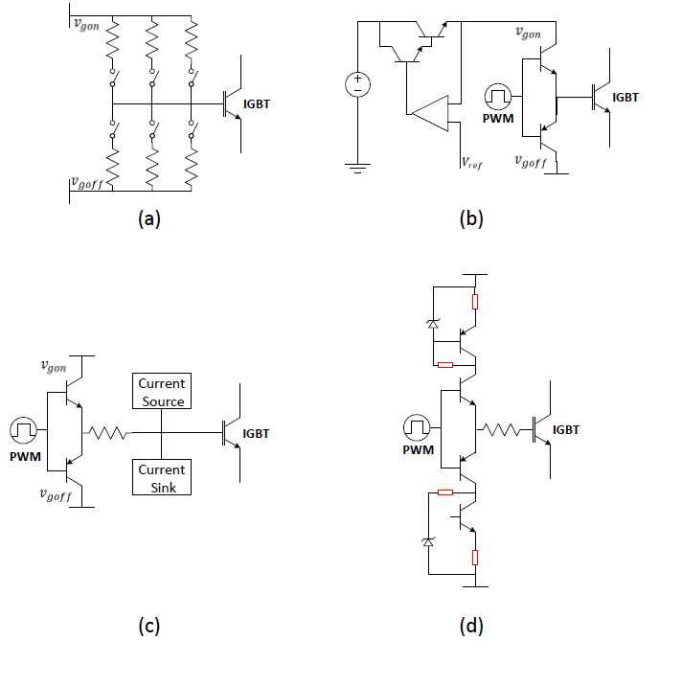
Figure 2.1 Example Gate Current Control Topologies

Additional features of active gate drivers including short circuit, overload, and desaturation protection have been extensively researched and developed, but will not be investigated in detail in this paper. As will be seen later, some IC gate drivers incorporate one or a few of these protections into their design, however they are most often designed off chip. Examples of these protections and their methodology can be seen in [45-51].
In order for active gate drivers to modulate the gate control signal and keep the IGBT in the SOA, they must receive feedback indicating the current state of the IGBT. This information can then be either processed by a digital control unit or be a part of an analog control loop. Digital control units presented in [52-56] offer sophisticated control of the $V_{GE}$, $V_{CE}$, and $I_{C}$of the IGBT by providing customized current profiles for each phase of the switching action. However digital processing requires A/D and D/A conversions with delays from 50ns up to 200ns in the signal paths. As such, solutions such as these are not feasible for switching transients faster than 2 µs, are expensive as the cost of the A/D and D/A converters is high, and are incapable of handling any significant change in system state between programmed switching operations.
As such, control methods using analog closed loop feedback of the di/dt and dv/dt signals [57-58] are often chosen for better analog control bandwidth due to passive measurement circuits, possession of simple control amplifier stages, and requirement of less board area as well as cheaper components than similar digital solutions. Feedback solutions such as these can use different combinations of feedback signals for protection. It has been shown that protection control can be accomplished using only di/dt feedback to protect during turn on and turn off [59-61], or di/dt feedback can be used for protection only during turn-on [62-63]. Alternately, only dv/dt feedback can be used for protection during turn-on [63], or separate solutions can be used for protection during both turn-on and turn-off using both di/dt and dv/dt [64].
However, as the protection capability of an active gate driver increases, so too does its complexity. Increasingly complex control methodologies require comprehensive systems comprised of multiple active components and controllers, as well as passive components for operation status detection and biasing of the active components. These additional components require board area, raise overall system cost, and introduce new failure modes of the gate driver itself. It is therefore sometimes desirable to keep the gate driver control method as simple as possible to not only reduce cost, but reduce the number of failure modes while retaining a high analog control bandwidth. Active gate driver IC microchips on the market now typically add to the necessary conventional gate driver functionality with a few protections such as Under Voltage Lockout (UVLO) or short circuit detection and/or protection. Only through the use of external components are protections such as those for overvoltage during turn-off and overcurrent during turn-on typically implemented. In Table 1.0 is a comparison of some of the gate driver ICs found on the market today, along with the gate driver presented in this thesis.

Table 1. Gate Driver Market Comparison
Gate Driver | Current Drive Sinking/Sourcing (A) | Max Output Voltage Swing (V) | Propagation Delay (ns) | Features and Notes
IX2204  EL7158  IGD508E  LM5114  Proposed IC | 4/2  12/12  15/15  7.6/1.3  2.5/2.5 | 35  12  40  44  20 | 70  22.5  100  12  23 | UVLO, SC detection  High Current  SC Detection & Protection  Low delay, UVLO  Low delay, Overvoltage & Overcurrent Protection

The gate drivers chosen for comparison in Table 1.0 were selected to show the tradeoff between the features of current drive, output voltage driving capability, propagation delay from an input signal to an output current, and additional control features. Going from the first to second IC shown, an increase in current drive and decrease of propagation delay is achieved, however the output voltage swing is much lower, and thus is best suited for MOSFET and not IGBT applications. Looking at the third gate driver shows that some intelligent features such as protection from short circuit of the IGBT sacrifices a large amount of propagation delay, and would thus not be well suited for high frequency applications. Finally, the fourth gate driver provides low propagation delay and large voltage swing, though it is optimized for low-side IGBT configuration, and as such has much larger sinking than sourcing capability. It should be noted again that none of the gate drivers except for the proposed IC provide any sort of dynamic current during nominal switching. Instead, gate drivers such as these will be used for conventional gate driver functionality with short circuit protection, along with external circuits designed for additional protection.
The gate driver proposed in this thesis consists of only one IC capable of directly driving the gate of an IGBT, receiving di/dt and dv/dt signal feedback to determine the switching state of the IGBT, and using this information to modulate current to the gate of the IGBT. The method of detecting di/dt and dv/dt feedback will not be discussed as cost and size minimization of these circuits is a separate issue, however different methods of detection can be seen in the cited literature. The intention of the proposed gate driver IC is to integrate IGBT protection functionality on-chip, in this case voltage and current overshoot mitigation of the IGBT by directly driving the IGBT and integrating the protection functionality into the gate driver IC. As can be noted from Table 1.0, this additional integrated functionality requires chip area and thus comes at the cost of output current drive capability. Therefore, the proposed IC is best suited for smaller IGBTs being used at higher frequencies.
The proposed driver mitigates IGBT faults in a manner similar to most AGD circuits, through the modulation of gate current during fast switching transients. The variable gate current provided by the IC is achieved through the use of parallel current sources and sinks. An illustration is shown in Figure 2.2. When it is desired to reduce gate current, feedback output drivers of the opposite type (i.e. NMOS/PMOS) are activated to sink or source some of the current that was previously being provided to the IGBT gate. Each of these output drivers consist of segmented blocks that are individually activated, sinking or sourcing 100 mA each. The Primary Drivers consist of 25 blocks, while the Feedback drivers consist of 30 blocks. This way, output current can be adjusted in 100 mA increments from 2.5 A to -500 mA to precisely control the speed with which the IGBT will switch.
The four possible states that the gate driver can assume are reflected in this figure. Looking at Figure 2.2, in part (a) and (b) the Primary drivers are enabled, functioning as a conventional gate driver sinking and sourcing current to the gate of the IGBT according to an input PWM signal. In part (c) and (d) the complementary Feedback Drivers what are activated by feedback di/dt and dv/dt signals are enabled. As there are more Feedback Drivers than Primary Drivers, the resultant current into the IGBT gate can be either positive or negative.
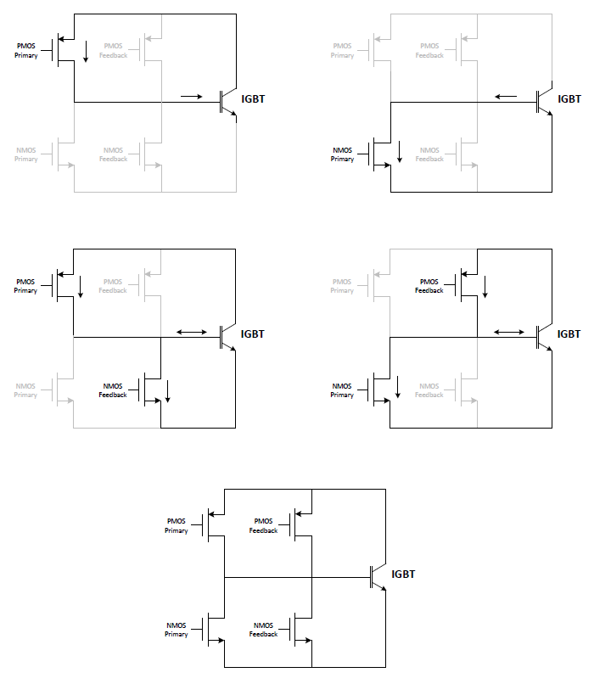
Figure 2.2 Proposed Gate Current Control Method

The gate driver is configurable such that the degree as well as timing of the gate signal modulation can be optimized for a particular IGBT or protection method. For example, the IC can be programmed to simply reduce gate current when the switching transient slopes are too high, effectively emulating a series gate resistor that is only present when needed. Alternately the gate driver could be programmed for fault protection by turning off very slowly or even turn back on during a short circuit scenario when the switch is already on. If desired multiple drivers could be placed in parallel to include both types of protection. Gate current levels as well as dynamic current adjustment levels are controlled by 20 input bits. These bits can be changed during testing of the IC and optimized for a particular IGBT. Once the desired current levels have been determined, these pins can simply be tied to the supply rail or GND in order to avoid the use of an external controller. In addition, adjustable analog delay is included to determine when the Feedback drivers are activated, for reasons discussed in the next sections.

Turn-On Overcurrent
The sub circuits in Figure 2.3 are found in many SMPS designs, and will be used to illustrate some of the issues encountered during switching transitions. Both Figures, while exhibiting different circuit states, will bear the same analysis. The switch in these figures may be any semiconductor power switch, however IGBT modules are considered. The diode in these sub circuits may be either a discrete diode or the intrinsic body diode, both of which will exhibit similar characteristics for the purposes of this discussion.
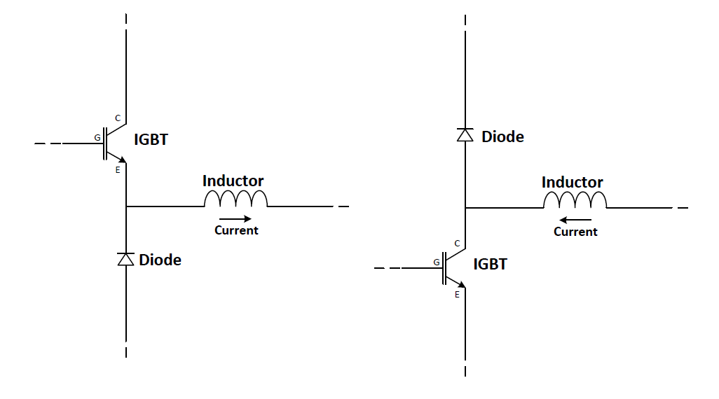
Figure 2.3 Common SMPS Sub circuits Considered

Prior to the IGBT switch turning on, the diode will be carrying the entirety of the inductor current while the switch has no current through it aside from parasitic currents. As the switch begins to turn on and increase its current, the diode current will decrease at a rate determined by its material properties. Note that according to Kirchhoff’s Current Law (KCL) the inductor current equals the sum of the switch current and the diode current. That is, the diode current is directly proportional to the switch current.
As the IGBT continues to turn on and conduct more current, the diode will reach zero current and subsequently pass into what is called reverse recovery mode. During this phase, the diode will conduct negative current as the diode returns from its forward bias state and is replacing the charge carriers intrinsic to the diode. Again, note that because the switch current and diode current are proportional, the switch will be providing the current for the diodes reverse recovery. Once the diode conducts enough
Figure 2.4 Generalized IGBT Turn On Switching Waveforms
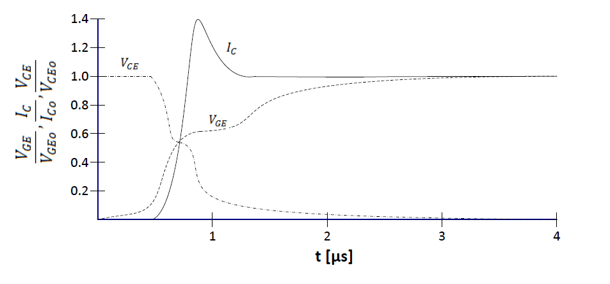
reverse current to reach its zero-bias width and the depletion region is able to expand beyond that width the current will begin to approach zero at exponentially decreasing rate. This negative current will then charge the diode capacitance, creating a voltage across the diode and reducing the voltage across the switch. It is not until that this point that the switch will appear to be turning on in the sense that the voltage across it is reducing.
If the diode does not complete its reverse recovery process before the IGBT begins to carry all of the inductor current, then the IGBT will be forced to conduct more than the steady state operational current, or that of the inductor. This can be seen in Figure 2.4, which depicts generalized IGBT turn on waveforms. The IGBT current will continue to increase its current as long as there is enough charge stored in the diode to support the rate of increase in current. After it has reached its maximum value, the diode's reverse current begins approaching zero. The IGBT current then reduces to carry only the inductor current as the it is no longer providing the current for the diode's reverse recovery.
During low load conditions, i.e. when the inductor current is low, there will be less stored charge in the diode when the IGBT begins to turn off. This means that the reverse voltage of the diode will increase more quickly as the effective capacitance of the diode is lowered and the diode voltage will snap back to zero current more quickly. When this occurs the switch node will experience ringing proportional to the amount of stray inductance and the level of current overshoot. If the ringing has too much amplitude the diode’s breakdown voltage will be exceeded and it will cross into avalanche, resulting in a failure of the component.
Current overshoot through the IGBT is mitigated by reducing the gate drive current through the use of a series gate resistance. This improves device reliability by effectively slowing the rate at which the IGBT turns on and increases current. As the switch current is directly correlated to the reverse recovery current, a lower current slope allows more time for the diode to receive the reverse recovery charge that it needs before the IGBT begins pulling all of the inductor current.
While the addition of gate resistance effectively increases the reliability of the IGBT by preventing current overshoot and diode overvoltage, it has the disadvantage of increasing switching time. This can be seen in Figure 2.5, which demonstrates switching waveforms at different gate resistances. In the figure the dotted line represents a generalized switching waveform with an increased gate resistance. While the current
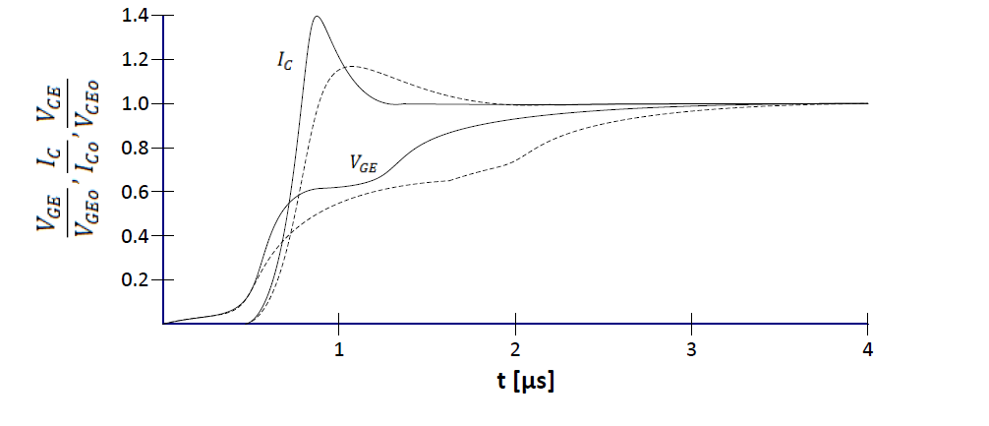
Figure 2.5 IGBT Turn On Waveforms with Additional Gate Resistance

overshoot is reduced, the overall time of the switching transition is increased. As increasing the switching time decreases efficiency, an optimization process is used to balance the reliability and efficiency of the design.
Often, the limiting factor in the design for reliability is the minimum load supported, as it is during this condition that the diode is most likely to break down due to low stored charge. Therefore, the series gate resistance is increased until an acceptable amount of ringing is seen at the switch node while supporting minimum load. This means that when the SMPS is supporting anything above minimum load, the switching response is overly damped, sacrificing efficiency at higher loads in order to satisfy reliability requirements, and effectively reducing overall switching efficiency.
Active gate drivers such as the one proposed in this thesis reduce gate current only when switching transients, in the case the current slope, are detected to be too large. This way, adjustable current drive can emulate the presence of a gate resistor by slowing the switching speed when needed, without unnecessarily slowing switching transitions when it is undesirable to do so, such as during heavy loads. Given the short timescale during which switching transitions occur, it is desirable to have minimal delay between detection of an overly large current slope, and reduction of gate current. In the proposed gate driver IC, integration of feedback mechanisms into the IC allows for fast adjustment of gate current as current modulation takes place within the microchip. Additionally, the proposed gate driver has the capability of adjusting the current slope threshold at which gate current is reduced, as well as the degree that the current is reduced. This flexibility can be used to optimize the gate driver for individual systems driving different IGBT modules. Therefore, the gate driver can be configured to emulate the desired series gate resistance, and only do so when an undesirably large current slope through the IGBT is detected.

Turn-Off Overvoltage
IGBTs possess parasitic capacitances between each of the three terminals, seen in Figure 2.6. These parasitic capacitances allow for a phenomenon known as the Miller-Effect. The Miller-effect is the feedback of the collector-emitter voltage Vce through the gate-collector capacitance $C_{GC}$.

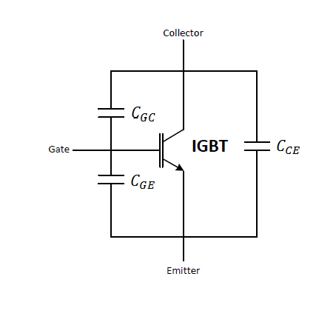
Figure 2.6 IGBT Module Parasitic Capacitances

Any change in the voltage across the capacitances in Figure 2.6 will result in a current, with the currents direction dependent on the polarity of the voltage change. It is also worth noting that the value of the gate-collector capacitance is not constant, but instead changes its value according to the collector-emitter voltage. This means that while turning on the IGBT, once the voltage across the collector-emitter nodes of the switch begins to fall, current that was previously charging the gate emitter capacitance and increasing the gate voltage will instead charge the gate-collector capacitance with no effect on the gate voltage. The gate-collector capacitance value is increased the most when the collector emitter voltage approaches zero, therefore even after the collector emitter voltage has come to a low value the gate-collector capacitance is increased greatly and continues to use up the entirety of gate current. Provided there is a constant current sourced into the gate of the IGBT by the gate driver, the gate voltage will be kept relatively constant while the gate collector capacitance is increasing and being charged. It is only once the current needed for charging the gate-collector capacitance becomes smaller than the bias current that the gate voltage begins to rise again. This phenomenon is known as the Miller plateau and can be observed in Figure 2.4 of the previous section.
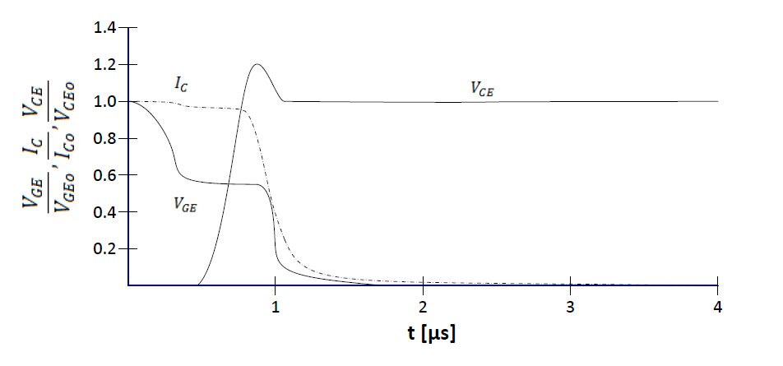
Conversely, when the switch is being turned off, seen in Figure 2.7, the Miller Effect will cause current to travel from the collector node into the gate as the collector-emitter voltage rises. However, in order for the collector-emitter voltage to rise, the gate voltage must be brought below the threshold value. Therefore, the gate voltage will first decrease at a rate determined by gate discharge current until the collector-emitter voltage begins to rise. Once the collector-emitter voltage begins to increase the gate-collector capacitance will decrease sharply. This decrease in gate-emitter capacitance will cause stored charge to increase the gate voltage, further preventing the gate from lowering its voltage and keeping it in the miller plateau. This charge that was previously stored in the gate collector capacitance will then need to be drained by the gate driver, consuming all of the gate current for a time. Once the gate-collector capacitance is fully discharged,
Figure 2.7 Generalized IGBT Turn Off Switching Waveforms
which occurs partly through the miller plateau, the collector emitter voltage begins to rise. The switch will stay within the miller plateau until the collector-emitter voltage roughly reaches the steady state operating voltage. Gate current will then be directly discharging the gate emitter capacitance, and the gate voltage will again decrease at a rate proportional to gate driver current.
During IGBT turn off, when collector emitter voltage reaches the switch node voltage, current through the IGBT begins to decrease. The slope of this current reacts with parasitic inductance to create an overvoltage across the IGBT. Inclusion of series gate resistance can slow the switching transients and reduce the current slope responsible for the voltage overshoot. Again, this comes at the cost of decreased switching efficiency. In addition, this current slope for IGBTs is sensitive to a desaturation of the semiconductor [41-43]. Lower gate current resultant of high series resistances can result in stored charge in the drift region of the IGBT being partly extracted, increasing the current slope through the IGBT, and actually increasing the overvoltage. Therefore, in some designs the issue may be faced where a series resistance of a certain value is needed for optimal turn-on of the IGBT, but results in increasing the voltage overshoot during turn-off. As such it is desirable to independently modulate the turn-off and turn-on waveforms rather than including a gate resistance that affects both.
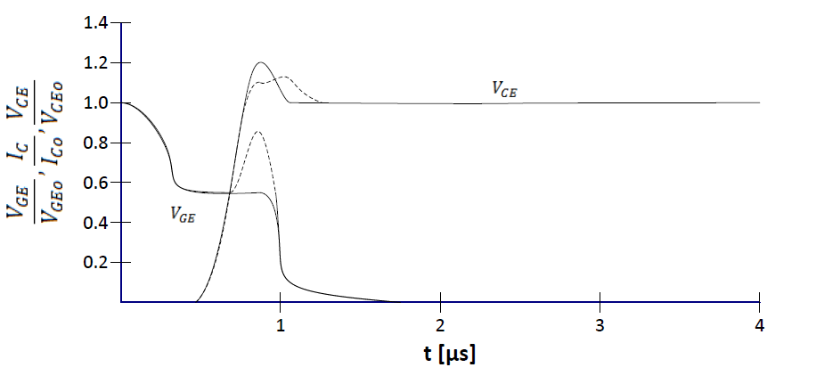
Figure 2.8 IGBT Turn On Waveforms with Voltage Overshoot Compensation

Instead of inclusion of a gate resistor, IGBT overvoltage encountered during turn off can be reduced using a different method. By temporarily modulating the gate voltage during the turn-off process when either the voltage across the IGBT is increasing of the current through the IGBT decreasing, the current slope that is responsible for the voltage overshoot can be reduced, effectively reducing the overvoltage [39]. The resulting waveform can be seen in Figure 2.8.
This type of compensation is implemented in the proposed IC by detecting the voltage and current slopes through the IGBT and modulating the gate current in order to maintain a gate emitter voltage that produces a current slope with the desired overshoot. Depending on the IGBT, switching frequency, and other parasitic inductances arising from layout of the entire system the voltage overshoot will have different magnitudes. For some applications simply reducing the gate current during the phase that the voltage across the collector and emitter of the IGBT is increasing will be enough to mitigate voltage overshoot. For other applications it may be needed to stop gate current altogether or even reverse current flow and turn the transistor back on during this phase. The proposed IGBT can be configured for either of these scenarios by modifying gate current in 100 mA increments, or even reversing gate current up to 500 mA if needed.

Chapter 3
Design of the Dynamic Current Gate Driver

System Overview and Block Diagram
The gate driver is designed with the following goals. It is to provide up to 2.5A of sinking or sourcing current dictated by a PWM signal. This current is to be adjustable in 100 mA increments, and provided from -5V to 15V. The gate driver is also designed to accept di/dt and dv/dt feedback, which is used to adjust the output current from ±2.5 A to ±500 mA, also in 100 mA increments. The gate driver is designed to have minimal propagation delay such that the di/dt and dv/dt signals influence the output current drive in as soon as possible. In addition, the delay of the di/dt and dv/dt signals may be adjusted through an input DC current signal. The block diagram for the system can be seen in Figure 3.9. There are four primary block types: Comparators, Analog Delay, Selection Logic, and Current Drivers.
While the IGBT gate sees voltages from -5V to 15V, these voltages will henceforth be referred to as 0 to 20V unless otherwise specified for ease of reference as this range more accurately decribes the gate drivers internal voltages.

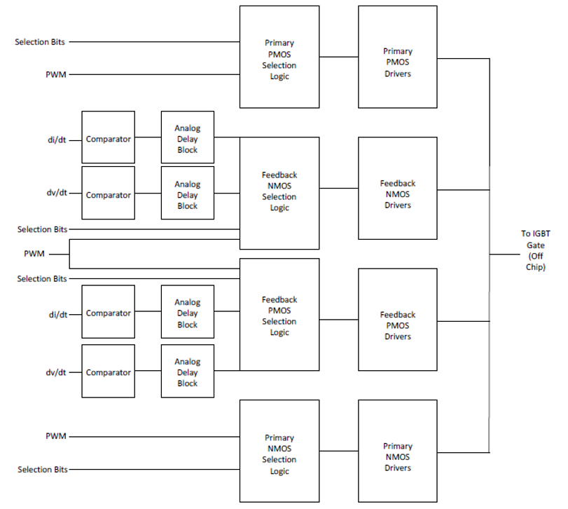

Figure 3.9 Top Level Block Diagram

The gate driver utilizes a push pull output stage configuration to provide both sinking and sourcing current drive. The Primary and Feedback PMOS Drivers will source current to charge the IGBT gate to 20V, while the Primary and Feedback NMOS Drivers will sink current to discharge the IGBT gate to 0V. The Primary Current Drivers, seen in the block diagram as the top and bottom signal paths, act as a conventional gate driver. That is, they will charge and discharge the gate of an IGBT to the supply rail with the same polarity as an input PWM signal. The Primary NMOS and PMOS Driver Blocks consist of 25 individual driver blocks in parallel, each sized to allow 100 mA of current.
Included before these driver blocks are Selection Logic blocks. These Selection Logic blocks receive a decimal value between 0 and 31 in the form of 5 separate binary bits that exist as 0V or 5V to convey a “0” or a “1”, respectively. This 5-bit number is decoded using logic gates, and the Selection Logic block then enables the decoded number of 100 mA Primary Current Driver blocks. This allows the adjustment of the Primary Current Driver output current from 0 A to 2.5 A in 100 mA increments. Individual selection bits are used for the PMOS and NMOS Current Drivers, allowing for separate current levels for sinking and sourcing.
These selection bits are static and not intended to be changed dynamically. They are included such that the gate driver can be optimized for different IGBT modules. Therefore, once the gate driver has been optimized for a particular configuration, these bits can be tied to the 5V supply rail or GND on the PCB, without the use of a controller.
As seen in the block diagram in Figure 3.9, the middle two signal paths are responsible for driving the Feedback NMOS and PMOS drivers, and provide additional functionality as compared to a standard gate driver. The Feedback Drivers are used to reduce the current provided by the Primary Drivers. That is, the Feedback NMOS drivers sink current sourced by the Primary PMOS drivers, and the Feedback PMOS Drivers source current to be sunk by the Primary NMOS drivers. This effectively reduces the final current that is sinked or sourced by the gate driver. Like the Primary Current Drivers, the Feedback Current drivers consist of individual 100 mA blocks in parallel which are controlled by preceding Selection Logic blocks. However, the Feedback Drivers consist of 30 instead of 25 driver blocks, sinking or sourcing up to 3.0 A. Therefore, if more Feedback Drivers are enabled than Primary Drivers of the opposite type, the gate driver will reverse current direction.
As an added functionality, if the propagation delay of the signals is too short and the Feedback Current Drivers are being activated prematurely, the Analog Delay block is included to tune exactly when the Feedback Drivers are enabled. This way, the feedback di/dt and dv/dt signals are used to determine when the IGBT is switching, and the Analog Delay block can be used to control precisely when current level is modulated. This delay is adjusted by sourcing a small DC current, creating a delay related to input current.
The comparators are used to receive the di/dt and dv/dt signals. The comparators receive an input voltage proportional to the di/dt and dv/dt of the IGBT provided from off-chip. By using a comparator, a threshold voltage can be set to dictate how high the di/dt and dv/dt signals must be to activate the Feedback Current Drivers. Once a di/dt or dv/dt signal is detected to be above the desired threshold, an output a digital logic signal is sent to enable to appropriate Feedback Current Driver.
The gate driver is capable of driving the IGBT gate to 15V or -5V. In order to accomplish this, the blocks within the IC must operate between different sets of rail voltages. The lowest voltage the IC sees must be the substrate voltage, therefore what is negative 5V to the IGBT is GND for the IC, what is GND to the IGBT is 5V to the IC, and so on. All signals passing through the chip are binary “high” or “low” signals. The devices in the process used to create this chip have a gate-oxide thickness that tolerates 7V of gate to source voltage, so transistor gates were designed to experience 5V of voltage swing. Therefore, each blocks' voltage rails are separated by 5V, and level shifters are utilized between blocks where necessary.
A major constraint of the system design was that the digital logic gates within the Selection Logic blocks could only exist between the 5V and GND rails of the IC. Because of this, positive di/dt or dv/dt signals that will exist between 5V and 10V relative to the IC have to be level shifted down to be passed into the Selection Logic block. Furthermore, as the PMOS drivers consist of transistors that will have a “high” voltage of 20V as seen by the IC, and their gates cannot experience more than 7V of voltage swing, the PMOS Driver blocks must exist between 15V and 20V relative to the IC. This requires that the signals be level shifted up from GND to 5V, up to 15V to 20V.
Circuits that have a low voltage rail of 5V or above require isolation to prevent device breakdown into the substrate. This includes Comparators that detect positive di/dt or dv/dt input signals, PMOS current drivers, and level shifters.

Comparators
The input comparators receive a voltage signal from off chip proportional to the di/dt and dv/dt across the IGBT collector and emitter terminals, and sense when these signals exceed a given threshold. A separate comparator is used for each signal, and both of the Feedback Current Driver signal paths have a pair of input comparators, resulting in 4 total comparators in the design. As the ground of the IGBT is 5V referenced to the gate driver, a zero reading for the di/dt and dv/dt signals will rest at 5V. When a positive di/dt or dv/dt is detected across the IGBT, the voltage will increase above 5V, and when a negative di/dt or dv/dt is detected the voltage will decrease below 5V. As such some comparators will exist between 0V and 5V while others will exist between 5 and 10V.
In a practical application of the proposed gate driver, the required inputs for the NMOS current drivers to be active are a negative dv/dt and a positive di/dt, therefore the comparator for dv/dt would exist between 0V and 5V while the di/dt comparator would exist between 5V and 10V. Conversely, for the PMOS drivers a positive dv/dt reading and negative di/dt reading are required, placing the dv/dt comparator between 5V and 10V and the di/dt comparator between 0V and 5V. For testing purposes as feedback signals were to be emulated, both the comparators for the PMOS Feedback current drivers were placed between 5V and 10V, and both the input comparators for the NMOS Feedback current drivers placed between 0V and 5V. The threshold that determines when each comparator trips is received from off-chip, resulting in a total of 4 threshold values.

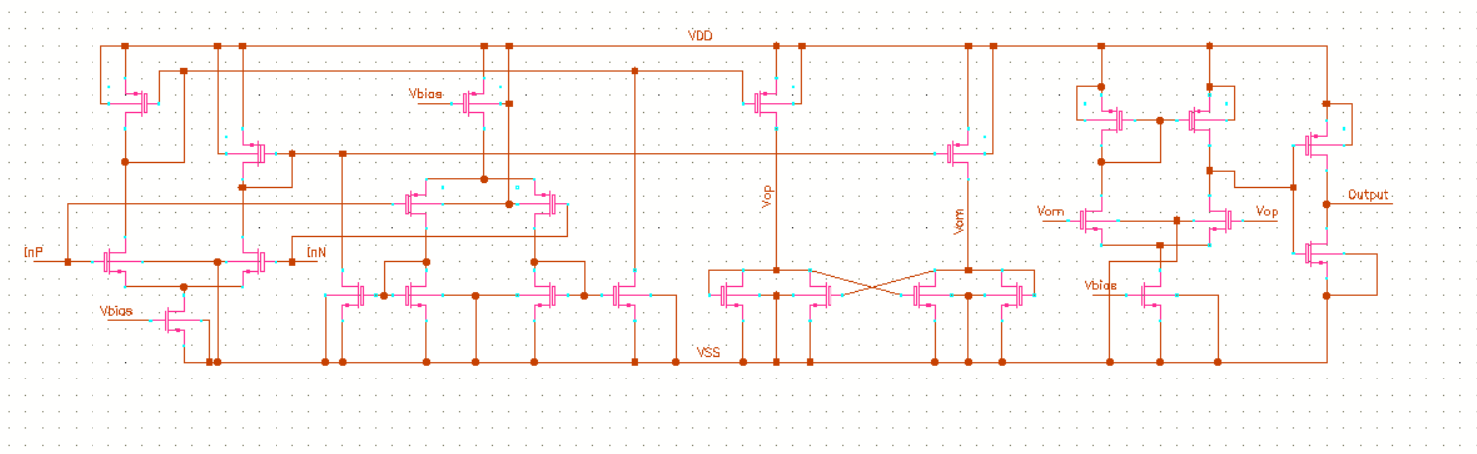
Figure 3.10 Comparator Schematic

In order to use the same comparator design for both positive and negative signal detection, a rail-to-rail input stage was implemented. This is because for the comparators existing between 0V and 5V, the input signal will rest on the higher supply rail and swing down when a negative di/dt or dv/dt is detected. On the other hand, for the comparators existing between 5V and 10V the input signal will rest on the lower supply rail and swing upwards when a positive di/dt or dv/dt is detected.
The comparators consist of three separate stages, seen in Figure 3.10. The first stage consists of complimentary PMOS and NMOS differential pairs in order to achieve the rail-to-rail functionality desired. The second stage consists of a positive feedback active load. This stage is responsible for receiving current mode signals from both the NMOS and PMOS input differential pairs, deciding which signal is larger through the use of positive feedback, and converting it into a differential voltage mode signal for use by the third stage. Subsequently, the third stage consists of a differential amplifier configured to amplify the differential voltage received from the second stage and output a single ended voltage signal to an output buffer.
The tail current sources are biased using two Beta Multiplier Reference (BMR) circuits. Due to the fact that the comparators exist between two different pairs of voltages, two BMR circuits exist that create the voltages of 7.5V and 2.5V. The schematic seen in Figure 3.11 is an example Beta Multiplier Reference circuit. The designed output voltage was set at midrail such that it could properly bias both NMOS and PMOS devices. Layout extracted simulations placed the resulting output voltage at 3.2V, which simulations showed to be acceptable. Examples and details of BMR circuit design can be seen in [44].

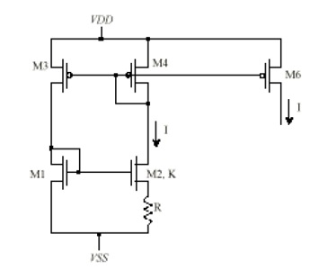

Figure 3.11 Beta Multiplier Reference Circuit Diagram

The most desirable metric of the comparator is minimum propagation delay, as will tend to be the case throughout the IC. For the first stage this required a large transconductance of the input differential pair, and thus large W/L ratios as well as biasing with large current. To accomplish this, the tail current transistors of the complimentary input pairs were sized in order to provide 4 mA of current, leaving 2 mA of current per differential branch.
For the second and third stages propagation delay was minimized by balancing the transistor W/L ratios with the surrounding stages. These stages must be large enough to quickly charge and discharge the gates of the subsequent stage, while also being as small as possible to be be charged and discharged by the previous stage as quickly as possible. For example, in the second stage, the positive feedback tied transistors should be relatively small such that they may change states and quickly determine which current is larger, while the tail current transistors feeding current to these transistors should be larger in order to ensure that enough current is available to charge and discharge the differential pair of the third stage as well as feed current to the positive feedback decision transistors. The third stage was designed in a similar fashion as the first stage, with a tail current transistor biased by the BMR and sized to pull 4 mA. The input differential pair transistors were sized again to minimize propagation delay, making them as large as the second stage was capable of quickly driving.
Figure 3.12 depicts the resulting propagation delay of the comparator when a square wave is input, with the comparison voltage set to mid rail. It can be observed that the rising edge and falling edge have slightly different propagation delays. While efforts were made during design of the comparator to have equal propagation delay for both edges, parasitics resulting from layout resulted in unequal delays. The resulting positive edge propagation delay is approximately 3 ns, while the falling edge propagation delay is 2 ns, resulting in a 1 ns difference in delay times.

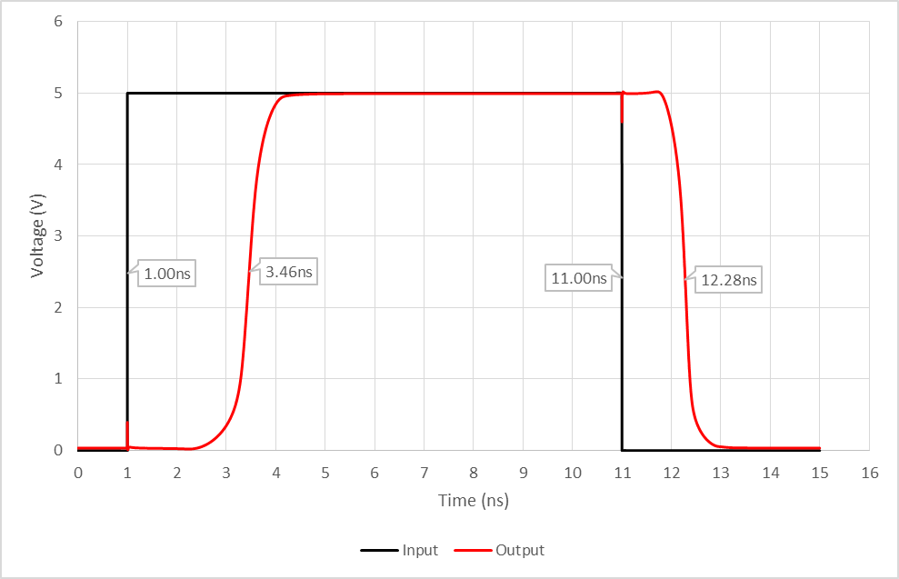

Figure 3.12 Comparator Propagation Delay

Level Shifters
Within the System Level Block Diagram seen in Figure 3.9 there are two points where the feedback signal must be level shifted. The first is after the comparators that feed into the PMOS Feedback Current Drivers. At this point, the signals must be shifted down from between 5V and 10V to between 0V and 5V. The second point is after the Feedback PMOS Selection logic block. At this point the signals are instead shifted up from 0V and 5V up to 15V and 20V. Unfortunately, both of these level shifters are within the signal path for the Feedback PMOS Current Drivers. As level shifters are the largest contributor to signal propagation delay, this means that the Feedback PMOS Driver signal path will be significantly slower than the Feedback NMOS signal path.
Two separate level shifters were designed in order to accommodate shifting both to a higher and to a lower voltage range. The same general topology was used for both; however, the entire topology was “flipped”, switching NMOS devices into PMOS devices and visa versa.
Within level shifters, there must be a node that is allowed to swing the full range of the input to output voltage. That is, this node must be capable of handling the highest and lowest voltages of the input and output signals without causing any devices to breakdown. This was accomplished in both devices through the use of Drain Extended MOSFET devices, or DEMOS transistors. While these transistors have similar gate oxide thickness and cannot handle any larger voltage differences between the gate and source, the drain of the device is extended in order to allow for larger voltages between the drain and all other ports of the device. For this IC, devices were chosen that are capable of handling up to 20V of voltage swing at the drain of the devices. In the topology chosen, both and N type DEMOS and a P type DEMOS have their drains tied together, thus allowing the node connecting them to make the full voltage swing.
With a node capable of handling the voltage swing, the task of translating the signal from high voltage to low voltage is still necessary, as the high voltage node itself is not tied to any gates and thus passive. Therefore, the topology in Figure 3.13 and 3.14 is chosen. Here, two input DEMOS devices are driven with complementary signals. Therefore, when the signal is high one branch will allow current while the other branch will not. When current is passing through one of the branches charge will accrue at source of the DEMOS, creating the voltage desired. However, this node is also connected to the the drain of a load transistor that is driven by the complementary branch. Therefore, if the complementary branch begins to provide current, it will turn on this load transistor, depleting the node that was previously being charged and changing the voltage, also changing the voltage on the source of the DEMOS in the other branch. Through this use of positive feedback between the two branches two nodes will be created that swing between the new higher or lower voltage rails, achieving the level shifting desired. A second stage is then included with a similar method of positive feedback in order to create a stage that exists solely between the desired voltage rails. This is necessary as the first positive feedback nodes may not always swing the between entirety of the new voltage rails, and it is desirable to output signals that have high and low values equal to those of the voltage rails.

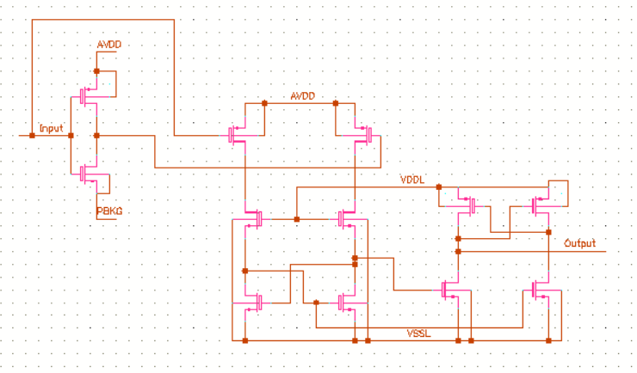
Figure 3.13 Level-Up Shifter Schematic

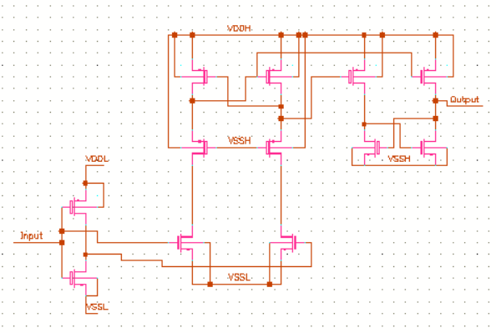

Figure 3.14 Level-Down Shifter Schematic

Propagation delay is the most desired metric again, and as was the case when designing for minimum propagation delay in the comparators, sizing of the transistors is done by stage by stage. Following the signals through the circuit, each transistor is sized to be small enough to minimize its gate capacitance and be quickly driven by the previous stage, while being large enough and having enough transconductance to provide the current necessary to quickly drive the subsequent stage. For the level shifters, this means that the first input DEMOS transistors were made as large as the inverter was capable of driving. The next complementary DEMOS pair that holds the high voltage nodes was similarly sized to be large enough such that their transconductance did not impede that switching of the positive feedback tied transistors. Note that this pair of DEMOS devices are of the opposite type of the preceding two DEMOS devices, and thus if they are P type must be proportionately larger to maintain a similar transconductance.
Next the positive feedback transistors were made relatively smaller. Even though their transconductance directly affects how quickly the feedback nodes collect or drain current, their drain to source capacitance holds the actual level shifted voltage, and determine the amount of current needed to change voltage. Finally, the output stage of the circuit is sized to be large enough to drive the subsequent stage, or the input inverter of the analog delay block.
The level shifters that translate signals to a higher voltage precede the PMOS current driver cells. As the output driver cells consist of large transistors, they will possess large gate capacitances that require higher current in order to quickly turn on and off. Therefore, the level shifter variant that translates signals upwards required a larger output stage than the level-down shifter.
Simulation results can be seen in Figures 3.15 and 3.16. Note that the level-up shifter results in a noninverting shifted waveform, while the level-down shifter results in an inverted waveform. This is due to the fact that the output of the two topologies is selected from two complementary and inverted nodes, which can be seen in Figures 3.13 and 3.14. Output nodes were selected in order to yield equal rising and falling edge propagation delays.
The Level-Up Shifter demonstrates significantly larger propagation delay than the Level-Down Shifter. This is due to the fact that the Level-Up Shifter is increasing the voltage rails of the signal by 15V as opposed to decreasing by 5V, and thus require more current and more time to accrue the charge necessary to build this difference in voltage. The simulated delays are recorded below in Table 2.

Table 2. Level Shifter Propagation Delays
 | Rising Edge Delay | Falling Edge Delay
Level-Up Shifter  Level-Down Shifter | 8.13 ns  3.37 ns | 9.29 ns  2.72 ns

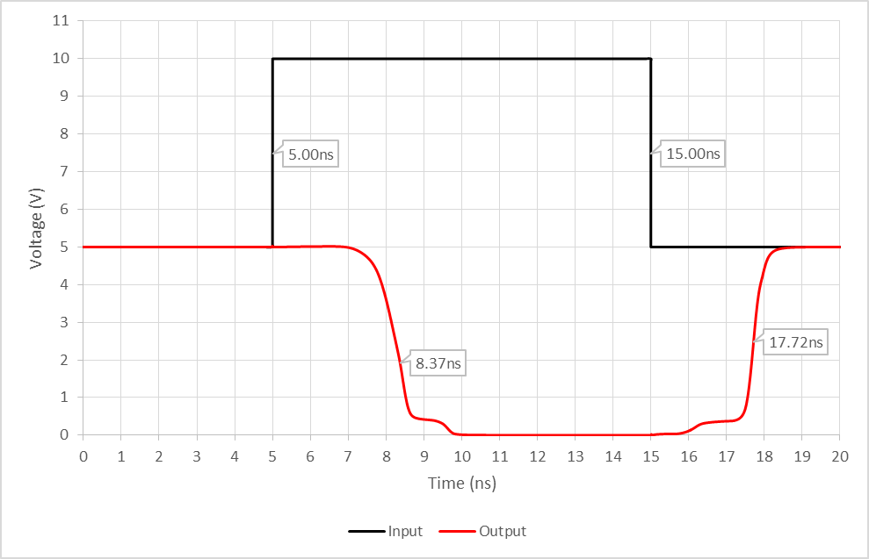
Figure 3.15 Level-Down Shifter Propagation Delay

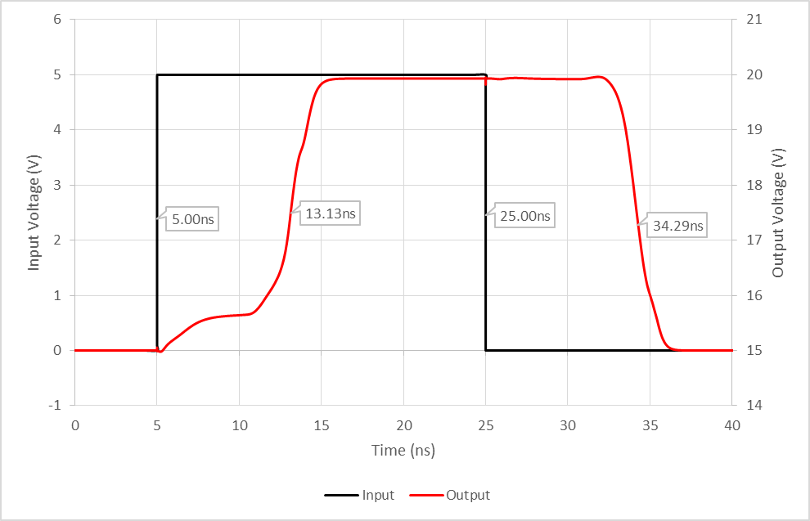
Figure 3.16 Level-Up Shifter Propagation Delay

Analog Delay Block
The analog delay blocks receive the di/dt and dv/dt signals from the comparators or level-down shifters. The purpose of the delay block is to introduce an adjustable delay between the input di/dt and dv/dt signals and the current driver blocks. This delay is essential for timing when exactly the Feedback Current Drivers are enabled. The delay block exists between the GND and 5V rails of the chip, and thus does not require any isolation. The blocks are intended adjust the delay of each signal individually.
The delay of each signal is determined by an input current sourced from off chip. In addition, each delay block has a bypass transmission gate that may be activated in the case that minimal delay is desired. These transmission gates are enabled by an off chip voltage of 5V. In total, there are 8 signals sourced from off chip to control the delay blocks, 4 current mode signals that determine the delay of the circuit, and 4 voltage signals that determine if a transmission gate is activated to bypass the delay block.
The topology used is what is referred to as a series of current starved inverters. This is shown in Figure 3.17 where the first two inverter stages source current into BJT devices. These BJT devices sink an amount of current equal to a current provided from off chip, and in turn determines the amount of current that flows through the first two inverter stages. The less current that each inverter stage is allowed by the BJT, the longer it takes to charge or discharge the subsequent stage, and thus a delay is introduced. This delay may be adjusted by changing the amount of current allowed through the BJT devices. Two current starved stages are necessary in order to ensure that the positive and

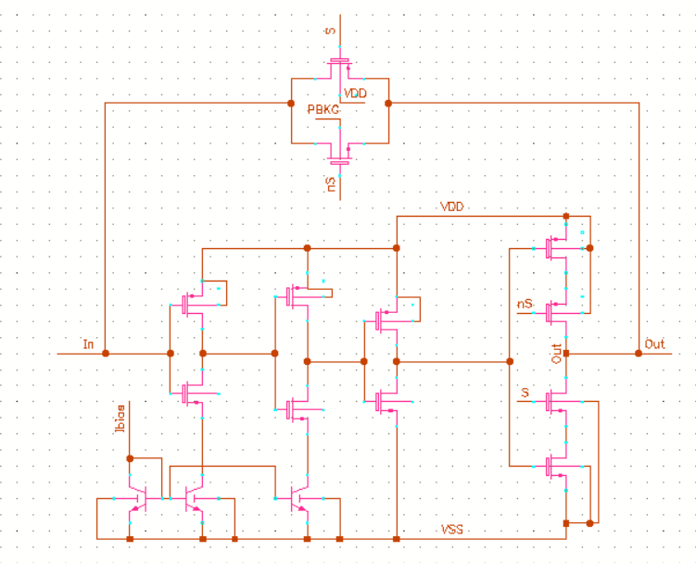
Figure 3.17 Analog Delay Block Schematic

negative edges of a square wave signal are equally delayed. Two additional inverter stages are also included. The third inverter stage is present to keep the number of inversions even, while the fourth inverter stage also includes blocking transistors that are turned off whenever the bypass transmission gate is active.
In order to size the current starved inverter stages it is necessary to know the desired range of delays as well as range of input currents used to set those delays. For this IC, a delay of 500 ns was to be achieved with an input current of 10 uA, and the minimal possible delay was to be approached with an input current of 100 uA. These ranges are set by the sizing of the current starved inverter stages. The larger they are, the more current drive is required to switch them and thus the more delay is introduced at low bias currents.
The amount of propagation delay introduced is not linearly related to the input current. Instead, it increases exponentially as the input current is reduced. Near this threshold, very minute changes in current will drastically influence the delay of the signal. To avoid requiring a precision current source, the first two inverter stages are properly sized to avoid uncontrollable propagation delay. The current mirroring BJT devices are all equally sized in order to deprive each stage of equal amounts of current. The final two stages are buffers, and were optimized for minimal delay.
The resulting range can be seen in Figure 3.18. Layout parasitics increased the delay produced by 10 uA from 500 ns to 600 ns. Additionally, Figure 3.20 depicts that the transmission gate introduces negligible delay.

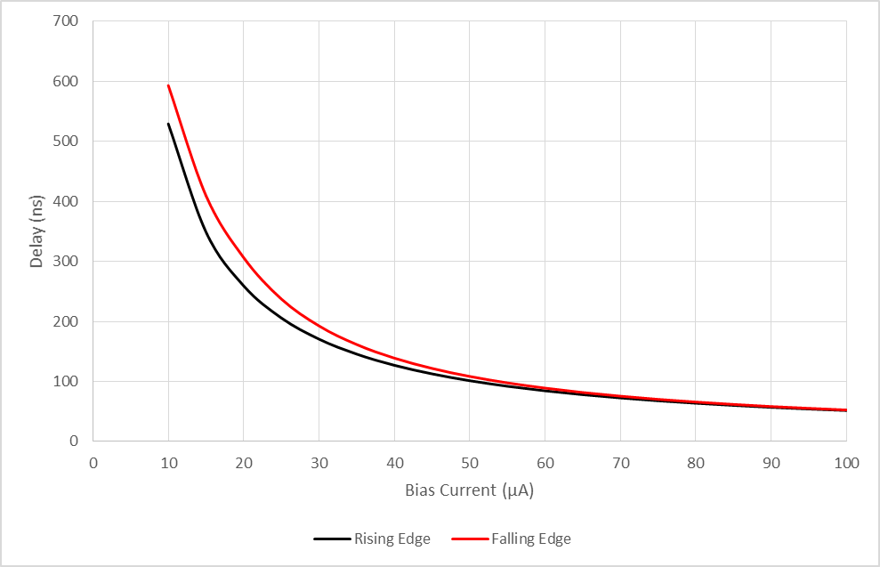

Figure 3.18 Analog Delay Block Delay Range
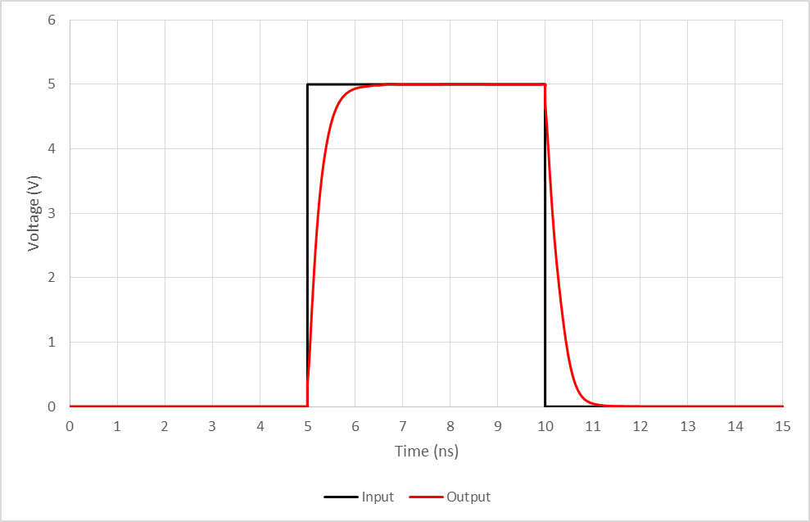
Figure 3.19 Analog Delay Block Transmission Gate Propagation Delay

Current Level Selection Logic
Each of the 4 current level selection blocks (Primary NMOS, Primary PMOS, Feedback NMOS, Feedback PMOS) are responsible for selecting the level of current to be driven by their corresponding set of output drivers. To make this decision, the Selection Blocks require 5 input binary selection bits and a PWM signal. The Selection Blocks for the Feedback current drivers also require the di/dt and dv/dt signals.
The PWM, di/dt, and dv/dt signals all determine when each respective Current Driver Block (NMOS/PMOS, Primary/Feedback) should be enabled. The resulting amount of current to be output is determined by 5 input selection bits. The input selection bits are interpreted as a binary number, and this number of current drivers are then activated. An input of “0 0 0 0 0” will provide no current, an input of “0 0 0 0 1” will provide 100 mA of current, an input of “0 0 0 1 0” will provide 200 mA, and so on.
As the current drivers consist of 100 mA blocks, the Selection Blocks possess one logic output for each 100 mA driver. Therefore, the Primary Selection Logic blocks have 25 total outputs, and the Feedback Selection Logic blocks have 30 total outputs, one to each current driver block. Each current driver block will have its own logic function to determine if it should be activated. The driver blocks are activated when the input selection value is equal to or greater than a certain number. For example, one driver may be active whenever the input value is 12 or greater, while another is active only when the input is 22 or greater. The resulting truth table can be seen in Table 3, where the selection bits are labelled as 0-4, with 0 being the LSB.
The logic functions in Table 3 responsible for interpreting the input selection bits are present in each of the four Current Level Selection blocks. As such it was designed as a standalone block to be reused in each of the four Selection blocks. While the input selection bits directly control the amount of output current, they are not intended for dynamic current adjustment in the manner discussed in Chapter 2. The dynamic current is provided by the Feedback Current Drivers. Therefore, the functions present in Table 3 are used as static logic outputs. These static logic outputs are used in conjunction with the dynamic signals, i.e. PWM di/dt and dv/dt, to determine when current driver blocks should be active. These dynamic signals are desired to have minimal propagation delay through the Current Level Selection blocks, and should therefore see as few logic gates as possible. Therefore, the dynamic signals are combined into one final logic gate with the resultant logic output from the static logic. This way dynamic signals only experience the delay from one logic gate. A couple example logic paths can be seen in Figure 3.20, where it can be seen that for the Primary Current Driver blocks the dynamic PWM signal only passes through one logic gate, and for the Feedback Current Driver blocks the dynamic PWM, di/dt, and dv/dt signals also see only one logic block.

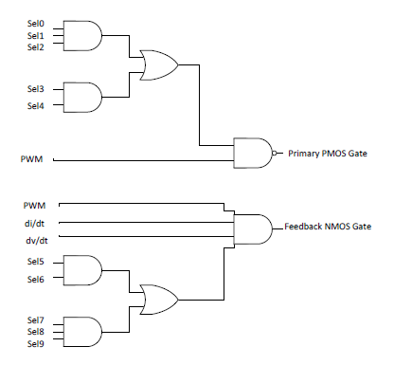

Figure 3.20 Current Level Selection Block Example Gates

Table 3. Current Level Selection Block Truth Table
Current Driver | Selection bits
1  2  3  4  5  6  7  8  9  10  11  12  13  14  15  16  17  18  19  20  21  22  23  24  25  26  27  28  29  30 | 0+1+2+3+4  1+2+3+4  0*1+2+3+4  2+3+4  0*2+3+1*2+4  2*1+3+4  2*1*0+3+4  3+4  3*(0+1+2)+4  3*(1+2)+4  3*(0*1+2)+4  3*2+4  3*2*0+3*2*1+4  3*2*1+4  0*1*2*3+4  4  4*(0+1+2+3)  4*(1+2+3)  4*(0*1+3+2)  4*(3+2)  4*(3+2*0+2*1)  4*(3+2*1)  4*(3+2*1*0)  4*3  4*3*0+4*3*1+4*3*2  4*3*1+4*3*2  4*3*2+4*3*1*0  4*3*2  4*3*2*1+4*3*2*0  4*3*2*1

Current Drivers
The schematics for the PMOS and NMOS output stages can be seen below in Figures 3.21 and 3.22, respectively. It can be seen that the PMOS output stage has one less buffer stage. This is due to the fact that a level shifter precedes each PMOS current driver block. The level shifters designed have a more proportional delay of the rising and falling edges when outputting an inverted signal. Therefore, with an extra inversion in the PMOS signal path one less buffer is used to retain an even number of inversions.
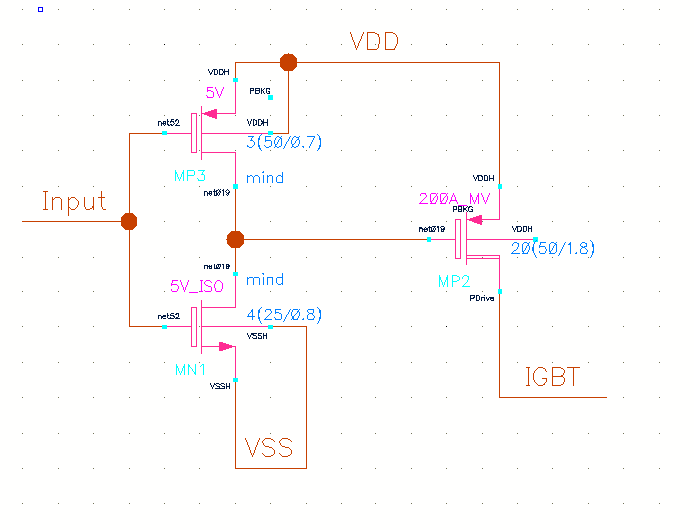
With the output transistor width dictated by the current driving capability, preceding buffer stages were included in order to properly drive the output transistor. The buffers preceding the output transistor have exponentially increasing widths in order to minimize propagation delay. For the PMOS current driver blocks seen in Figure 3.22 the output of the preceding level shifter was sized in order to properly drive the single buffer before the output transistor.

Figure 3.21 PMOS Current Driver Block Schematic

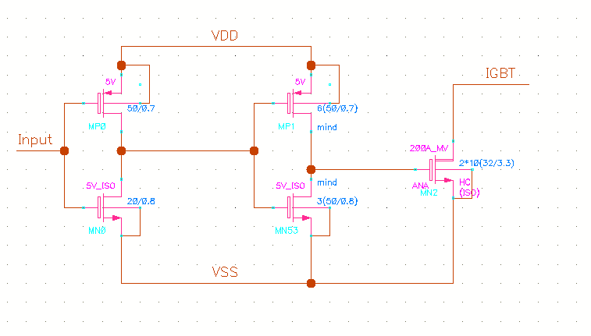
Figure 3.22 NMOS Current Driver Block Schematic

Figure 3.23 and 3.24 show the current drive of the PMOS and NMOS transistors over output voltage. It can be seen that the output current remains at or near 100 mA until the output voltage comes within 5 volts of the rail. This is to be expected because the transistors are leaving saturation as the drain to source voltage approaches zero volts. Figure 3.24 shows two separate curves for the NMOS current drivers. The black curve is the result of ideal simulation, where 100 mA is sourced, while the red curve is from simulations including extracted parasitics, and only sinks 75 mA of current. This occurred due to a redesign late in the design process. The output transistor was sized larger than the processes layout design rules allowed, and was split into two separate transistors of half width to satisfy the design rules. The two half width transistors did not output equivalent current, and the output driver cells had already been placed and could not be grown any larger without redesign of the majority of the IC. This was not an issue with the PMOS transistors, and thus layout parasitic extracted simulations of the PMOS current drivers yielded the expected 100 mA current drive.
The propagation delay of both current driver blocks was less than one nanosecond.

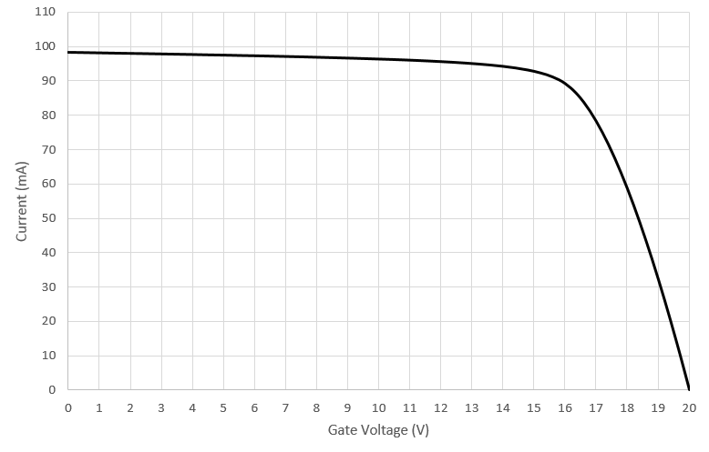

Figure 3.23 PMOS Current Driver Drive Current

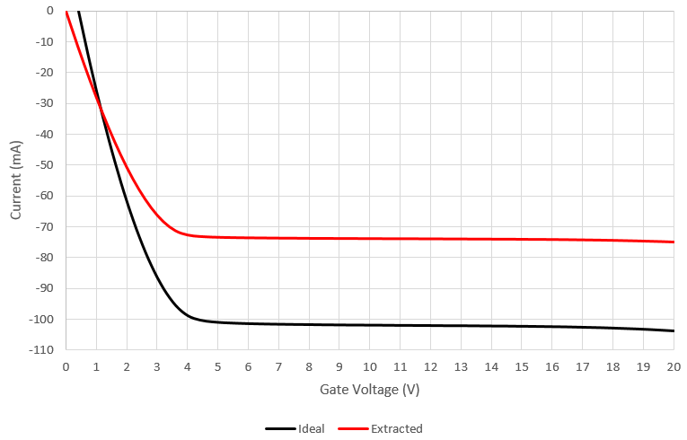
Figure 3.24 NMOS Current Driver Current Drive

System Testing and Performance
There are four different states that arise from the combination of the PWM, di/dt, and dv/dt signals. The Primary Current Drivers should be active during the correct PWM state, whereas the Feedback Current Drivers activate when the the correct di/dt and dv/dt inputs results in the comparator triggering, in conjunction with the proper PWM input. For example, the Feedback NMOS Current Drivers should be active while the Primary PMOS Current Drivers are active and the di/dt and dv/dt signals are low. The input di/dt and dv/dt signals were originally intended to be active high signals, however the pin assignment of the positive and negative input to the comparators was reversed, resulting in an active low signal. A table summarizing the propagation delay of each of the the signal paths as well as maximum current drive can be seen below as Table 4.
The simulation stimuli used to test overall functionality can be seen in the Appendix as Figure A.38. In it the PWM, di/dt and dv/dt signals are swept to cover all four states, ensuring that the correct current drivers are active and determining the overall propagation delay of each signal path. The resulting current drives can be seen in Appendix as Figures A.39 through A.42. It can be seen that the Feedback PMOS signal path has significantly more delay than the others. This was expected and is due to the fact that the signal must pass through both the Level-up and Level-down Shifters, which produce the largest delays of all blocks.

Table 4. Topsim Current Driver Metrics
Current Drivers | Activation  Delay (ns) | Deactivation  Delay (ns) | Max Current  Drive (A)
Primary PMOS  Primary NMOS  Feedback PMOS  Feedback NMOS | 10.27  3.81  25.65  5.78 | 11.38  2.68  23.63  7.3 | 2.41  1.85  2.89  2.22

Chapter 4
Results and Discussion

Test Setup
The test circuits as well as biasing and power supply connections necessary for testing the gate driver were assembled on a printed circuit board, shown in the Appendix as Figure A.44. The fabricated IC had 46 necessary pin connections, and was bonded to a package with 48 output pins. A custom chip mount was used that was capable of replacing the device under test (DUT) for testing of multiple chips.
Supply voltages of 0V, 5V, 10V, 15, and 20V were all needed to power the IC. Given the nature of the gate driver charging the IGBT gate from 0V to 20V, the traces connecting the 0V and 20V pads to power supplies were made wider in order to carry additional current, and were connected to the additional remaining 2 connection pins in order to reduce series resistance of the primary current path. The 5V, 10V, and 15V supply voltages are necessary given the nature of input signals being detected and the restrictions of devices used in fabrication. In future work, voltage reference circuits could be included in the gate driver to increase simplicity. Each supply voltage connection was connected to an array of capacitors to filter out a wide bandwidth of noise generated by the power supplies. This capacitor array was compromised of 100 µF, 1 µF, and 0.1 µF capacitors.
24 of the 46 pinouts consisted of logic bits that received either 0V or 5V inputs. These bits consisted of either static logic bits used to determine the level of output current, or decision bits that determined feedback signals should pass through the analog delay block or a bypass transmission gate. Neither of these types of bits are intended to be dynamic signals. As such dip switches were connected that could manually turn these bits on or off during testing.
In order to set the threshold value for the comparators, simple resistive dividers consisting of two tunable potentiometers were placed between the necessary voltage rails. This meant that for the input feedback signals determining the state of the Feedback NMOS Current Drivers, potentiometers were placed between 0V and 5V; and for the input feedback signals determining the state of the Feedback PMOS Current drivers, potentiometers were placed between 5V and 10V. By using potentiometers, the threshold voltage could be adjusted from rail to rail without replacing any components in order to test the input detection range of the comparators.
Input dynamic signals consisting of the di/dt and dv/dt signals along with the PWM signal were input onto the board using female SMA connectors. SMD footprints for 0 Ω resistors were included between the di/dt and dv/dt signal inputs if it was desired to reduce the number of input signals and thus waveform generators required.
Bias currents required by the analog delay blocks was supplied by iterations of the circuit seen in Figure 4.25. In it, an LM317 adjustable regulator is biased with a potentiometer such that the output voltage may be adjusted. This voltage is connected to the noninverting terminal of a LM741 op amp. This op amp will regulate the voltage across a variable resistor by modulating the current through a PNP type BJT. With this configuration the potentiometer biasing the LM317 can be used as a coarse current adjustment, while the potentiometer being driven by the LM741 and BJT transistor can
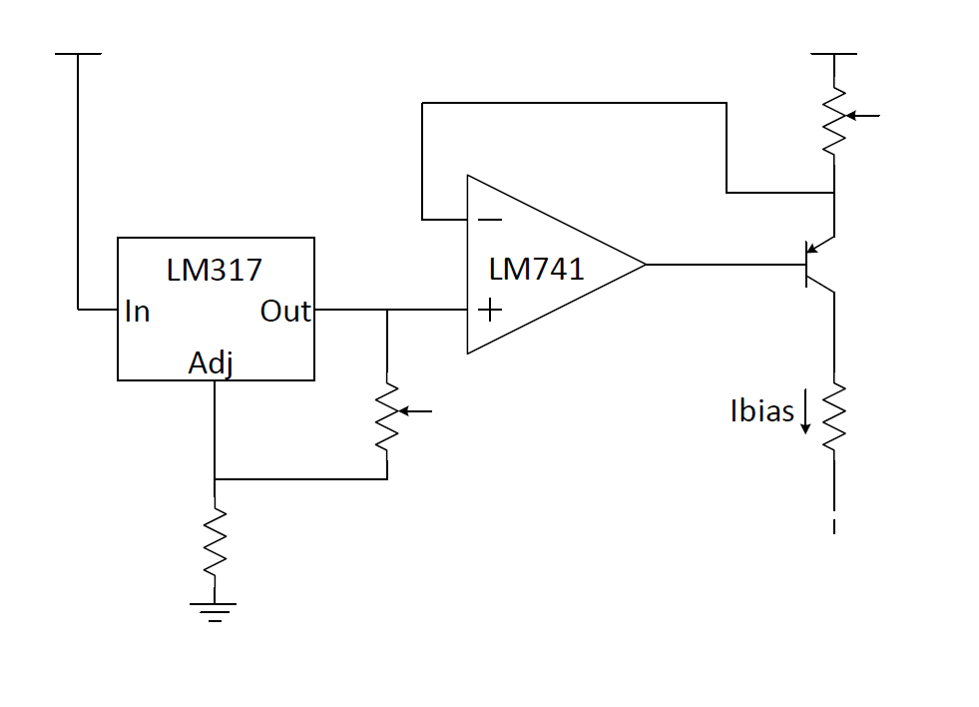
Figure 4.25 Test Board Current Source Schematic

function as a fine current adjustment. A 10 kΩ resistor is then placed between the collector of the BJT and the input of the IC such that the voltage across it may be measured to determine the input current. This is included rather than measuring the voltage across the potentiometer, as determining the current by measuring the potentiometer would require measurement of both its resistance and voltage, whereas with the static resistor only one measurement is necessary to determine the current. As there are 4 analog delay blocks, each with adjustable delay, there are a total of 4 current source circuits on the PCB.

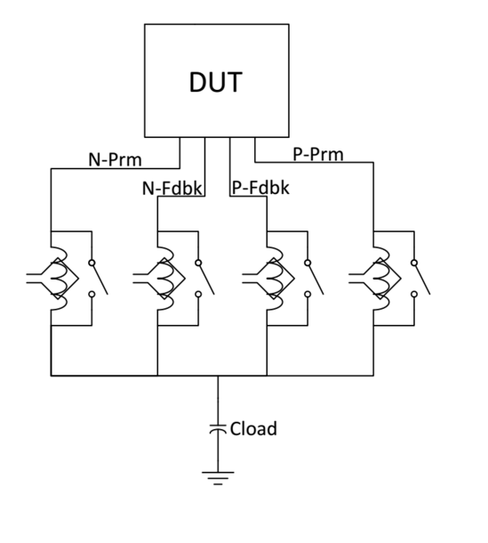
The output of the IC consisted of 4 separate pins. Rather than connecting the pins together, which would be in the best interest of reducing series resistance of the output current path, they were kept separate in order to allow for measuring the current drive of each current path individually. An illustration can be seen in Figure 4.26. Each of the output current paths may be connected onto the same node through the addition of a 0Ω resistor, represented by the switches in Figure 4.26. These resistors can be removed as needed in order to isolate certain output current paths. The final output node has through-hole connections for multiple capacitors, which can be sized as desired for different tests, as well as an extra connection that a wire may be bonded to. This wire can be used to tie the output node to an external source, such as a power supply or the gate of a transistor. This bond wire can also serve as a method for measuring total output current.

Figure 4.26 Test Board Output Configuration

Current levels were measured with a Hall effect current probe, represented by the inductor with an antenna around it in Figure 4.26. Hence, wires were bonded onto the board in order to allow for the clipping of the sensor around a wire. Each current path would be connected to the final output node either through one of these wires intended for current measuring, or the 0 Ohm resistor placed on the board. The output node was connected to a power supply unit to allow for current conduction at a set output node voltage. As the gate driver is not intended for continuous current conduction, very short pulses are applied to the input dynamic signals to keep average DC current through the IC small and avoid overheating. The output node voltage would be placed at a high voltage when current supplied by NMOS drivers was being measured, and placed at a low voltage when current provided by PMOS drivers was being measured.
When measuring current output with the Hall Effect current probe, only steady state currents were measured. The delay of the input signal to output current and rise time of the current signal was not considered in the test configuration that includes the additional wires used for current measurements. This is due to the fact that both of these parameters are highly dependent on the load driven by the IGBT, as well as parasitics of the current path. The parasitic inductance created by the wire used for measuring current is directly correlated to the rise time of the output current, and thus the two were never measured simultaneously. When conducting current drive tests, measurements were made when each current output was individually connected without any others, and again when all of then current paths were connected.
When propagation delay was measured the wires intended for use with the current probe were removed to eliminate any parasitics introduced by the wire. The output node was left open, representing only a very small capacitance. This way, the voltage of the output node will change abruptly once the current drivers are activated, allowing the use of a voltage probe as opposed to a current probe with limited bandwidth.
In this configuration, because the output node is left open two current paths of opposite type must be connected in order to change the voltage of the output node. For example, this means that when measuring the propagation delay of the Feedback PMOS signal path, the Primary NMOS drivers would also need to be activated to drain the output node of charge when the Feedback drivers were not active. Furthermore, there must be more active Feedback drivers than active Primary drivers in order to reverse net current provided by both Feedback and Primary drivers. This configuration would use a static PWM signal and a dynamic di/dt and dv/dt signal. By keeping the PWM signal static the Primary drivers of one type would stay active, and toggling the di/dt and dv/dt signals would toggle the active state of the Feedback drivers.
Once the general functionality of the IC was verified, it was then appropriate to drive a switching device. As the fabricated gate driver was capable of driving an output node up to 7.5V for reasons discussed later, a PHP3055E MOSFET was used. This was done by bonding a wire from the output node of the PCB to the power MOSFET. This bonding wire, however, consists of relatively large parasitic inductance which affects the rate at which the gate driver can increase or decrease current drive. While undesirable, the PCB was not designed for this purpose, and addition of this relatively large parasitic inductance was unavoidable.
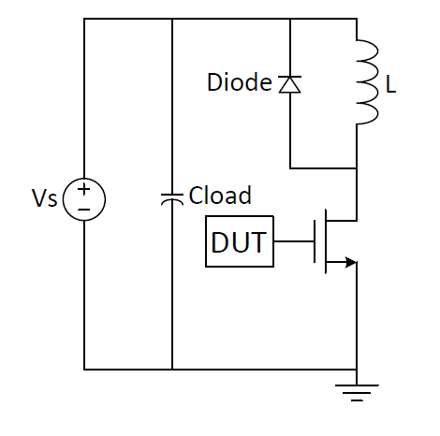
Thus, the output node was tied to the gate of the power MOSFET that was configured in a double pulse switching test circuit, seen in Figure 4.27. This circuit is intended to test the switching behavior of a device driven by the fabricated IC. A conventional double pulse test allows for current to build up through an inductor by leaving the switch on. Once the desired amount of current is achieved the switch is turned off. At this point the switch may be turned on then back off, emulating switching conditions seen by a switching transistor. Double pulse tests are known to result in waveforms representative of ones in an actual SMPS circuit [40]. In the circuit of Figure 4.27, a Shottky diode is used to reduce reverse recovery current, and a PHP3055E MOSFET is driven.
Figure 4.27 Test Double Switching Example Schematic
Once the double switching circuit was assembled, there were two tests that were performed. First, to test the ability of the gate driver to mitigate overvoltage during turn-off, the power MOSFET was input an emulated dv/dt signal that coincided with the actual dv/dt of the device. This is seen in Figure 4.28: where the green waveform is the $V_{GS}$ of the power MOSFET, the yellow waveform is the $V_{DS}$ of the power MOSFET, and the violet waveform was emulated by the waveorm generator to coincide with the actual dv/dt of the MOSFET. It can be noted that the emulated waveform does not also emulate the dv/dt seen after the Miller Plateau. While this is unrealistic, at this point the di/dt of the transistor would no longer be feeding an active signal to the gate driver, and as both dv/dt and di/dt are required to be active in order to activate the Feedback drivers, the Feedback drivers would not be active during this point. Thus the emulated Feedback signal is realistic in the sense that it reflects when the Feedback drivers would be fed an overall active signal.
The second type of test desired in the double switching configuration is testing of the current drive capability of the gate driver. The power MOSFET used is not very representative of an actual IGBT as it possesses only 4 nF of gate capacitance. Had the gate driver been capable of driving up to 20V, a CM200DY-12NF IGBT device was to be driven. Without the high voltage drive capability, however, the IGBT cannot be switched on, thus testing could not be performed. In order to emulate the gate capacitance of this IGBT, additional capacitance was added to the gate terminal of the power MOSFET. Given the CM200DY-12NF IGBT requires 1000 nC of charge to reach 20V, this charge could be emulated on the MOSFET with a total capacitance of 133 nF when driving up to
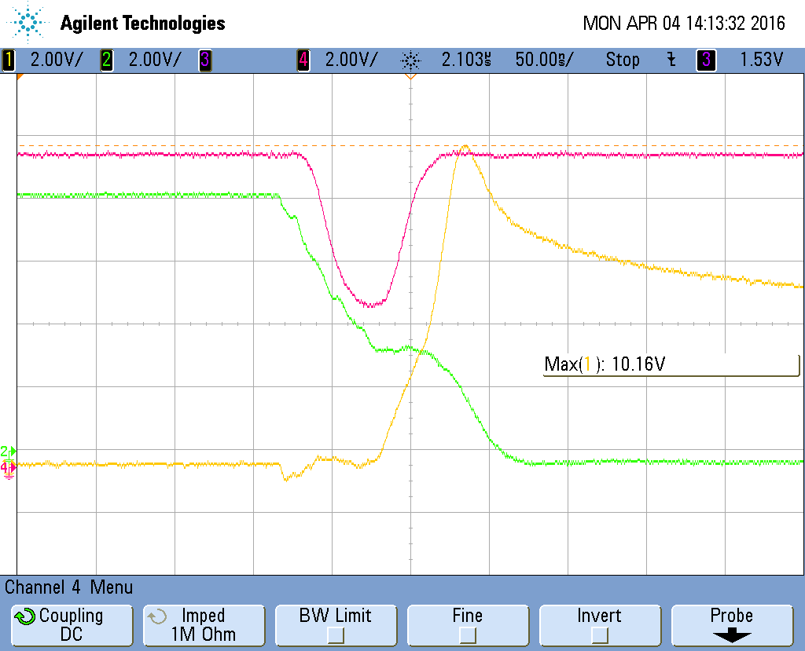
Figure 4.28 Double Pulse Testing Control Waveforms

7.5V. In this configuration, the same amount of total charge is delivered by the gate driver during a switching transient, giving a representative switching time that the gate driver could produce on a real IGBT.

Current Drive
An overlay of each of the output current levels for the Primary PMOS drivers can be seen below in Figure 2.3. The output current is in response to a 20 µs positive pulse of PWM signal. Note that the current probe used had an offset of 110 mA, as can bee seen by the fact that the current before the pulse is negative. It can thus ben observed that an output current of approximately 100 mA to 2.5 A is produced.
Discrete steps of 100 mA can be observed, however it can be seen that the 19th and 20th current drivers are activated simultaneously. This was a systematic issue seen in all fabricated chips, and is likely the result of a fault in the digital selection block. However, other current paths did not have this problem, thus it can be deduced that layout of the selection block for the Primary PMOS driver blocks, or possibly connections from the selection block to the current drivers themselves were responsible for the issue.
The numerical measured output current in each state can be seen in Appendix Table 6. Of the current driver paths, the Primary PMOS current blocks best resembled simulation results, outputting on average 100 mA per driver block enabled.
It should be noted at this point that the PMOS current drivers were supplying current from 7.5V, as opposed to the 20V intended in design. The fabricated IC was capable of driving the output only to 7.5V safely, likely due to an isolation issue in the layout. Due to the fact that the input comparators still existed between 5V and 10V without any breakdown issues it can thus be deduced that the error in layout was in either the level-up shifter or the PMOS drivers themselves. As a result, the 20V rail was left at 7.5V, and the 15V rail left at 0V.
Unlike the Primary PMOS Current Drivers, the Feedback PMOS drivers output an average of 38 mA per current driver. This average

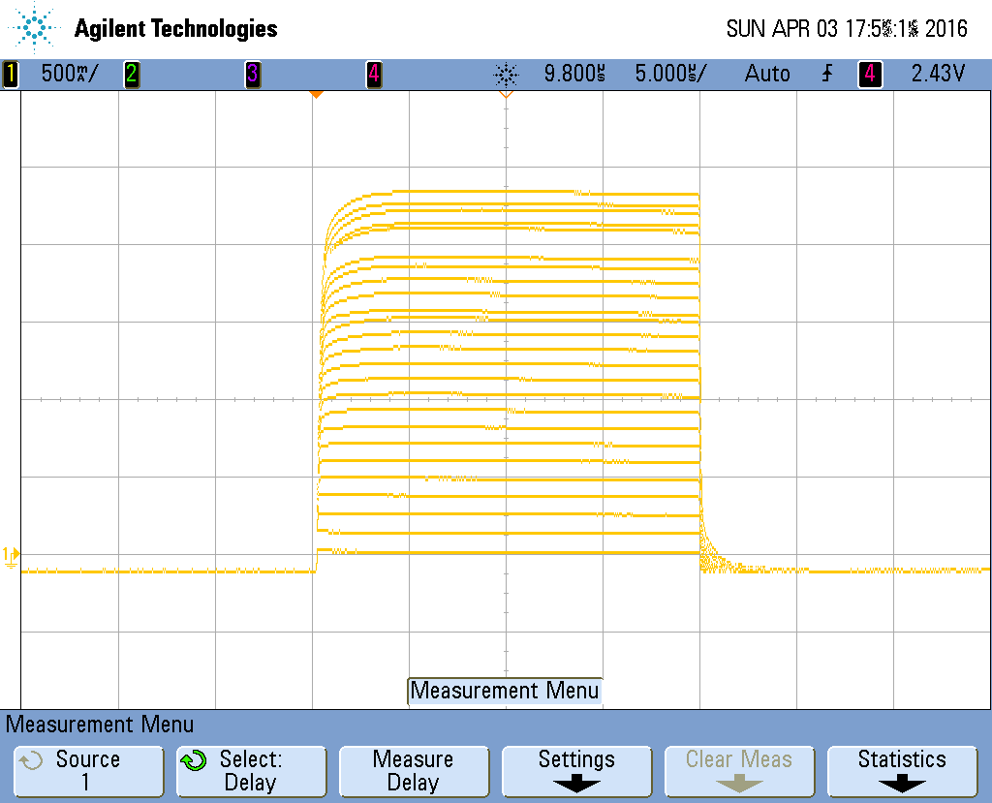
Figure 4.29 PMOS Current Drive Waveform Overlay

current level is not very indicative of the actual performance of the driver blocks for a couple of reasons. First, the Primary PMOS drivers consisted of the same current driver cells as well as level-up shifters as the Feedback drivers. This would indicate that the design of the level-up shifter and driver cells were not the cause of the problem. Second, as the timing of the Feedback PMOS drivers behaved as expected, the comparators and level-down shifters were operating correctly. This leaves the digital selection block as a likely cause of the inconsistent current levels. As can be seen in Appendix Table 6 which depicts the current levels at each configuration of selection bits, while the average drive of each current block is 38 mA, this is a due to the fact that some drivers fail to turn on, or otherwise don’t turn on completely. In the end, this can only be a result of the layout of the IC. Overall there is enough evidence to show that the design performed as expected and is capable of scaling up to a desired current.
Primary and Feedback NMOS current driver output can be seen in Appendix Table 6. The NMOS current driver outputs were very similar to simulation results. Due to the layout issue mentioned in Chapter 3, the NMOS drivers were simulated to output 75 mA. Experimental results placed the average current output per driver for Primary NMOS at 77 mA, and 83 mA for the Feedback NMOS output drivers. Neither of the NMOS driver paths had any issues with drivers activating simultaneously such as with the PMOS current drivers. This shows that the output driver cell approach is feasible, and can be designed to create the desired steps in output current.
Finally, the output current in relation to output voltage was also measured. This was done for both PMOS and NMOS channels, by connecting the output to a voltage source and allowing current to flow in response to pulses. As the current drivers were only driving from 0V to 7.5V, it was desirable to see just how much current drive was lost due to this. The results can be seen in Figure 4.30, where normalized currents are shown relative to the current drive provided at 7.5V of $V_{DS}$. In the figure, measured results are seen as bold lines, and coming closer to the voltage rail which it was being pulled to. In particular, the PMOS current drive appears to be more linear than simulation results, with no knee, indicating that it may have not reached maximum current drive. This could mean that the PMOS current drivers could actually provide
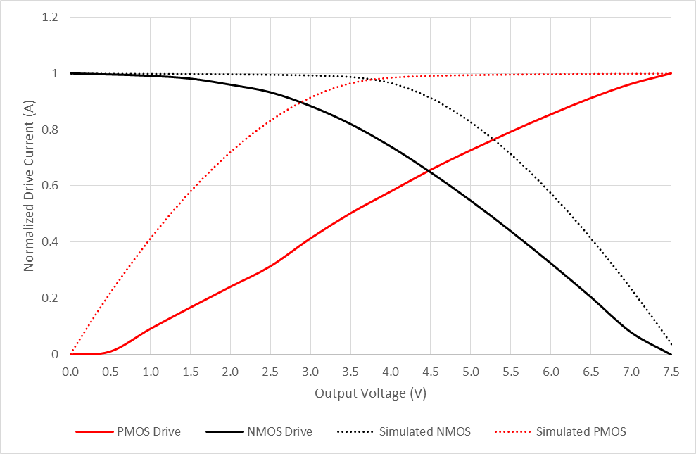
Figure 4.30 Output Driver Current vs Output Voltage

more than 100 mA of current per driver at voltages above 7.5V. However, as the PMOS drivers did output exactly the simulated amount of current drive, it is difficult to tell.

Propagation Delay
For the propagation delay tests it was desirable to observe the time between the rising edge of an input voltage signal, e.g. PWM for the Primary driver blocks and di/dt or dv/dt for the Feedback driver blocks, as well as the range and adjustability of the delay introduced by the analog delay block. While testing the delay of the Primary PMOS and NMOS current drivers, given the test setup discussed in the previous section both the Primary NMOS and PMOS drivers needed to be active to charge and discharge the output node. As such the output node would not build charge until both the PMOS drivers had deactivated, and the NMOS drivers had activated. Thus, the larger delay of the two Primary drivers was observed, as this would be the delay seen in any typical application.
An example waveform observing propagation delay can be seen in Figure 4.31. This figure shows the input PWM signal in violet, and the output node voltage in yellow. In the test setup discussed in the previous section for propagation delay it was mentioned that the output node was left open. As can be seen in Figure 4.31, the output node voltage rises very quickly given the small load capacitance. This allows for accurate measurement of the propagation delay, observed as 18.4 ns. The falling edge waveform, which can be seen in the Appendix as Figure A.43, yields a propagation delay of 20.2 ns. Additional waveform captures measuring delay can be seen in the Appendix as Figure A.39-A.42. Final results and comparison to simulation values can be seen in Table 5.0.
These delays, while larger than simulated results, are still relatively low compared to other gate drivers on the market. As gate drivers produced by the same company that fabricated the IC yield a minimum propagation delay of 12 ns, it is reasonable to conclude that optimization of the design could yield even smaller propagation delays. It should also be noted that it is unknown at what rise time and fall time input PWM signals are applied to test gate drivers on the market. As can be seen in Figure 4.31, a rise time of approximately 20ns is applied. Input signal rise time can impact propagation delay, and thus may be artificially inflating the observed propagation delay. Simulations were performed with a rise time of 1 ns, and produced delays of approximately 12 ns.
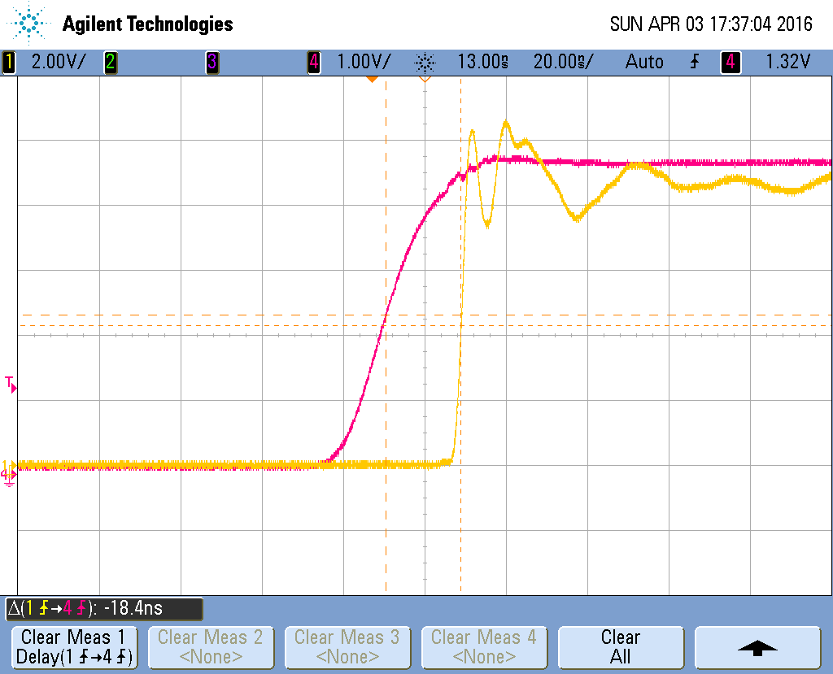
Figure 4.31 Experimental Primary Current Driver Propagation Delay Waveform

Table 5. Topsim Propagation Delays and Active States
 | Simulated (ns) | Experimental (ns) |  | Percent Increase (%)
Primary rising edge  Primary falling edge  Feedback PMOS activation  Feedback PMOS deactivation  Feedback NMOS deactivation  Feedback NMOS activation | 10.27  11.38  25.65  23.63  7.3  5.78 | 18.4  20.2  40  44  26  23 |  | 79  76  56  86  356  397

Given experimental results will typically fall behind simulation results, it is not surprising to see an increase in propagation delay, however an increase by a multiple of 1.5 places the test setup in question. As no waveform generators with faster than 20 ns of rise time were available, these propagation delays were the best observed.
Regarding mismatch between propagation delay of rising and falling waveforms, simulations showed that the falling edge had a 10.8 percent greater delay than the rising edge. Experimental results yielded a 9.7 percent increase in delay from rising to falling edge. These results are very similar, and suggest that the increase in delay was uniform between rising and falling edges. This also means that care must be taken in simulation to match rising and falling edge delay to the greatest degree possible. While in simulations the absolute difference in delays was as only 1.1 ns, the inflation of overall propagation delay increased this disparity to 1.8 ns.
Keep in mind that this is the propagation delay of the Primary gate driver portion of the IC, and as such can be compared to other conventional gate drivers. The Feedback gate driver signal path, however, requires additional circuitry and cannot be compared to most gate drivers found on the market today.
Given the adjustable delay of the Feedback driver signal path, measurement included testing of the analog delay block. The overlay of waveforms seen in Figure 4.38 demonstrates the variable delay of the PMOS Feedback signal path. The violet waveform is the input di/dt and dv/dt signal tied together, and the yellow waveform is the voltage of the open output node. The minimum delay observed occurs when the analog delay block is bypassed with a transmission gate, and is seen as the furthest left rising edge yellow
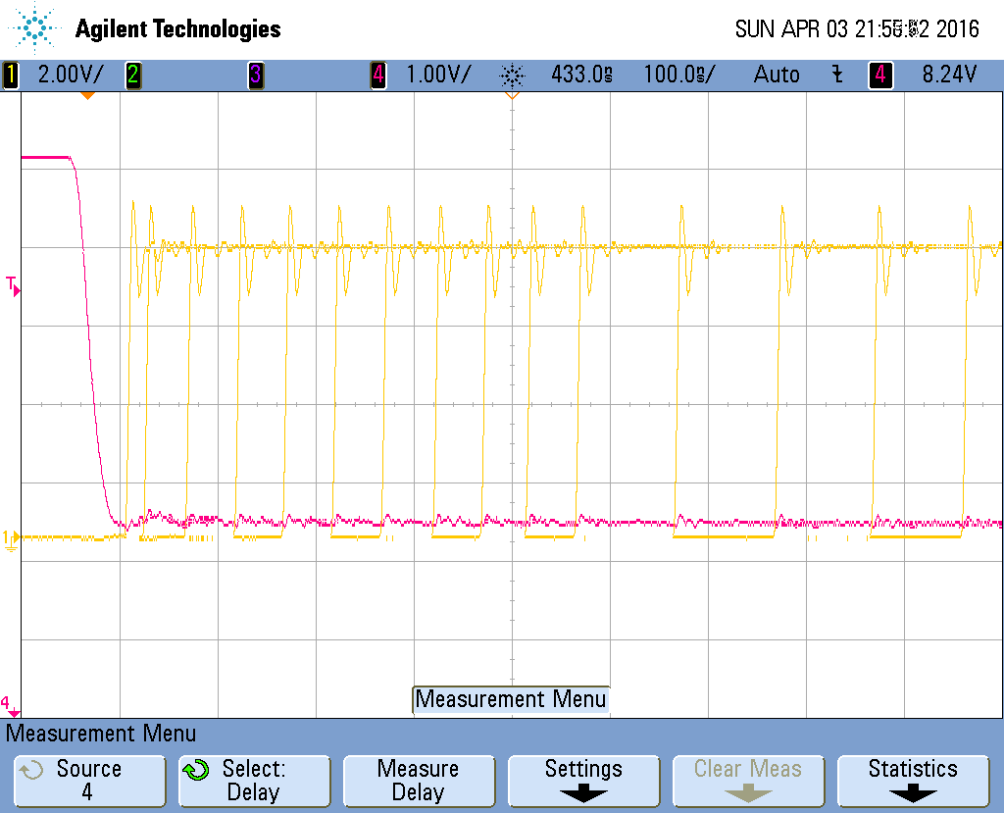
Figure 4.32 Experimental Adjustable Delay of Feedback NMOS Current Drivers

waveform. During testing the delay was tuned in 50 ns intervals and the input current recorded up to 500 ns of delay, then the step size was increased to 100 ns intervals. This test is repeated 4 times total, for the activation and deactivation times for both Feedback PMOS and Feedback NMOS signal paths.
Signal paths retained similar increases between simulated and experimental results in rising and falling edge propagation delays, however each signal path yielded different levels of increase, as can be seen in Table 5. This is mostly noted in the delay of the Feedback NMOS signal path, which increased propagation delay by a factor of nearly 4. This may be a result of the fact that simulated propagation delay of this signal path was very small to begin with, and the resultant delay of 23 and 26 ns are not large absolute values, but are large relative to the compared simulation results. However, the Feedback NMOS signal path was simulated to have less propagation delay than the Primary drivers, and in experimental results yielded a higher propagation delay. This means that blocks only present in the Feedback signal path were contributing more delay than expected. Given the topology of the NMOS signal path this means the input comparators are the only possible source of the additional delay, as the same digital selection blocks were used as in the Primary drivers.
As expected, the Feedback PMOS signal path exhibited the largest signal delay. This is likely a cause of the level-down shifter that had to be implemented after the input comparators. Comparing the delay between the Feedback PMOS and NMOS drivers, and considering the fact that the Feedback PMOS signal path has an additional level-down and level-up shifters, it can be stipulated that the level shifters contribute approximately 20 ns of delay time. Compared to the simulated 11 ns of delay time from both level shifters, this would mean an increase of 81%. This increase is very similar to increases in delays seen throughout the chip, further supporting this stipulation.
If you subtract the delay of the Primary drivers from the PMOS signal path, you would ostensibly get the propagation delay of the remaining blocks, the comparator and level-down shifter. Given the fact that the level down shifter is stipulated to have only increased by 81% to 6 ns, this would mean that the comparator will have contributed approximately 15 ns of delay, while having simulated a propagation delay of only 2 ns. This hypothesis is congruous with the fact that the Feedback NMOS signal path had unexpectedly high propagation delay, with the comparator as the main suspected source of this delay. While impossible to prove without probing inside of the chip itself, it is highly likely that the comparator contributed significantly higher propagation delay than simulations predicted.
Characterization of the analog delay block included testing the propagation delay at different input bias currents, and comparing with simulation results. Given the fact that there are no testing pins at nodes before and after the analog delay block, total delay of the signal path was measured and considered. Given the desired range of delay times was 1 µs or less, delay was tuned and then input current measured across the sense resistor described in the previous section. Probing the current through the sense resistor would have an affect on the delay of the circuit, as differences in current as small as 1 µA could significantly impact the induced delay of the delay block. Testing results are compiled in Figure 4.33 and 4.34. In Figure 4.33 the propagation delay of the PMOS Feedback signal path is varied, and in Figure 4.34 the propagation delay of the NMOS Feedback signal path is varied. Both waveforms have the rising edge, or delay time for activation as the black curve, and falling edge or delay time for deactivation as the red curve. For both the PMOS and NMOS signal paths the correct range and characteristics were achieved, with predictable increase in total propagation delay. Measurements were recorded up to 900 ns, as can be seen in each curve. Propagation delays of above 400 ns required less than 10 µA of current, and thus precise control of the delay in this range, while possible, would require precise control over a small amount of input current. Delays in the tens to couple hundreds of nanoseconds, however, can be easily tuned with between 10 and 100 µs. It may then be desirable to slightly increase the target range of the delay block by shrinking the current starved inverters. Delay was very stable, however, changing this range would be purely a tradeoff in quiescent current and difficulty in biasing with small currents. The simple test circuit used in the previous circuit had no problem keeping a stable current in these ranges, and could reliably produce delays up to 4 µs, though a delay this large would not typically be needed. Overall the analog delay block performed very similar to simulations, and achieved all of its design goals. The only improvements on design would be purely for ease of application.

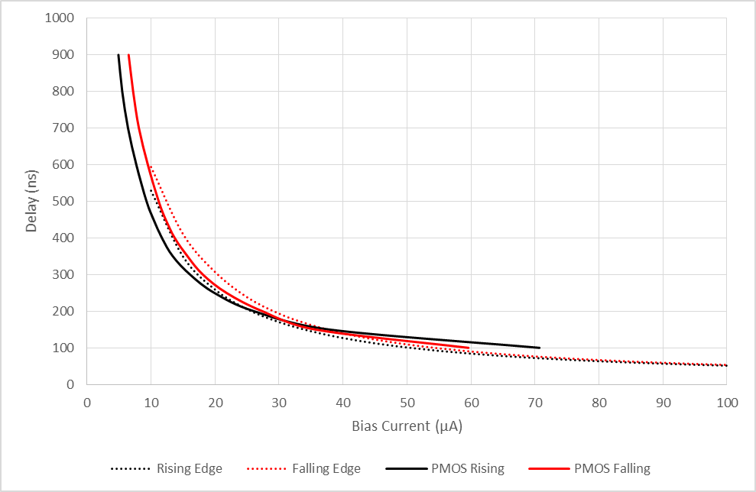

Figure 4.33 Experimental Delay Range of Feedback PMOS Current Drivers

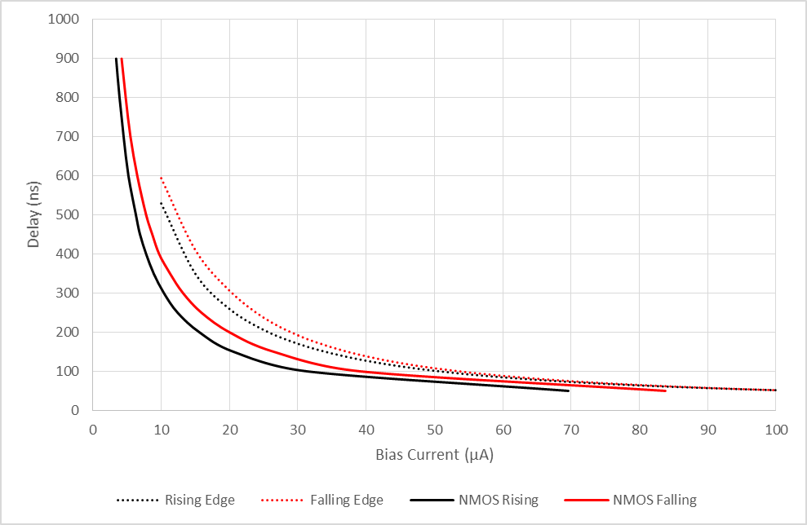
Figure 4.34 Experimental Delay Range of Feedback NMOS Current Drivers

Double Pulse Testing
The resulting waveforms from the first test setup designed to test protection functionality can be seen in Figure 4.35. Please refer to Figure 4.28 from the first section of this chapter in regards to stimuli used for this setup. In Figure 4.35, three separate waveform captures are presented. In the first, the turnoff transients of the MOSFET are observed where only 5 Primary gate drivers are active. In the second, 6 Feedback PMOS drivers are activated, and in conjunction with the emulated feedback signal, cause for current to be placed back into the gate of the power MOSFET near the end of the Miller plateau. This current injection results in a reduction of the maximum drain to source voltage from 10.16 V observed in the first waveform to 9.16 V. In the third waveform
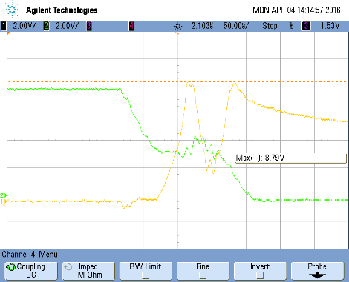
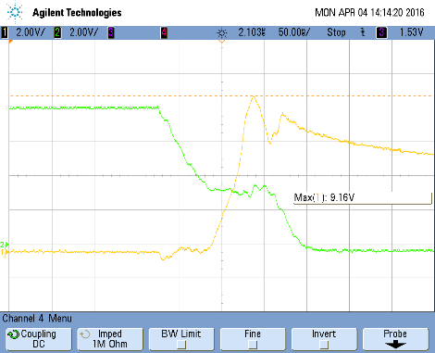
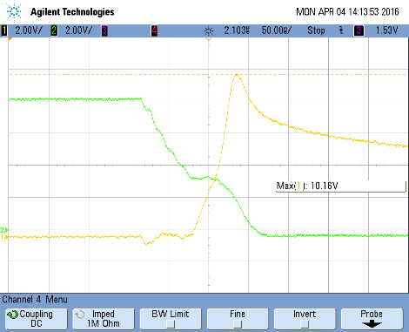
Figure 4.35 Experimental Voltage Compensation Waveforms

capture, 8 Feedback PMOS drivers are activated, further reducing the maximum voltage seen to 8.79 V. These waveforms together demonstrate the ability of the gate driver to vary gate current in response to feedback currents and effectively reduce voltage overshoot seen during turn-off. It should be noted, however, that this is performed on a very small gate capacitance of 4 nF presented by a MOSFET, and not the larger gate capacitance presented by an IGBT.
While still in this test configuration with no additional capacitance on the gate of the power MOSFET, control of the Feedback current in the time domain could be demonstrated. This can be seen in Figure 4.36. In it, the top violet waveform is the emulated di/dt waveform, the second purple waveform is the input PWM signal, third is the gate voltage, and fourth is the gate current. Between part (a) and (b), the analog delay is increased, and it can be seen that the voltage spike of the gate voltage is moved forward in the time domain. With this functionality present, it is possible to tune the exact time during which the gate current is reduced or reversed, in order to provide optimal protection from overvoltage during turn-off.
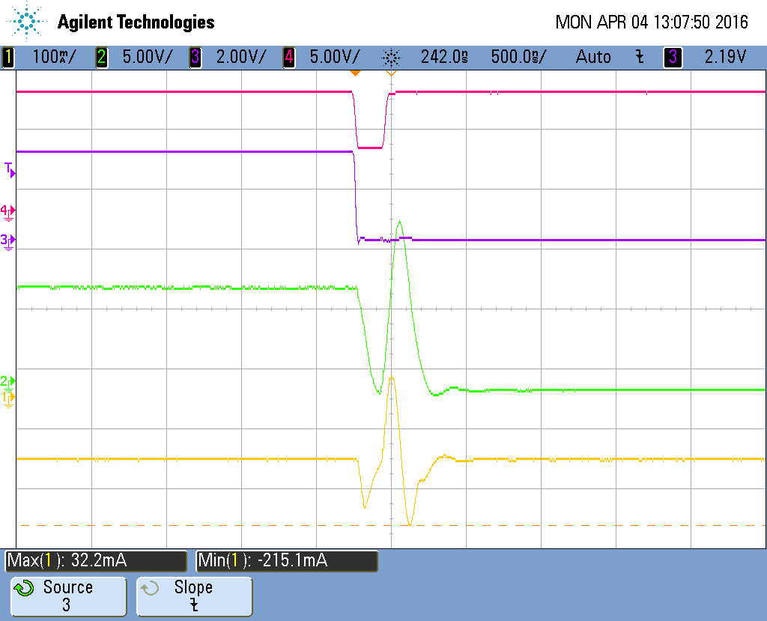
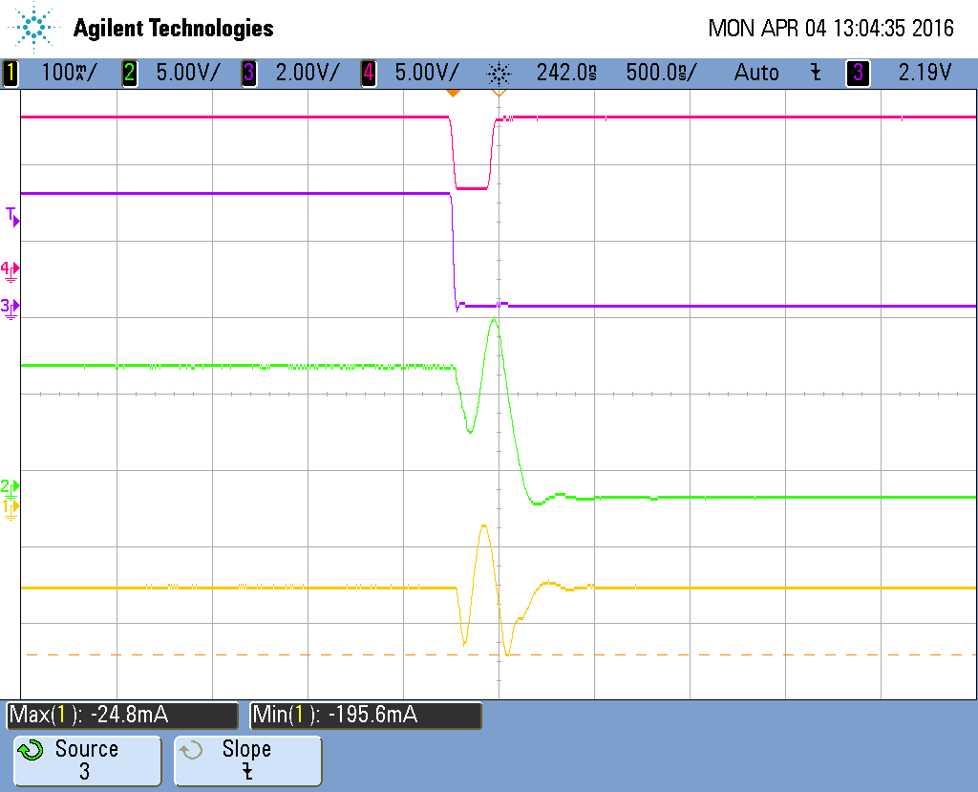
(a) (b)
Figure 4.36 Experimental Adjustable Delay Waveforms

Moving onto the second configuration, 133 nF of capacitance was added to the gate of the power MOSFET in order to represent the total gate charge necessary to turn on an example IGBT module. The MOSFET is then turned on and off in a double pulse test, seen in Figure 4.43. The resulting waveform has a rise time and fall time of less than 1 µs, which is a typical switching time for an IGBT. This shows that had the gate driver been capable of driving up to 20V, an IGBT likely could have been successfully switched at a reasonable speed and efficiency. It is also worth noting that because the gate driver only operated to 7.5V, the output driver devices leave saturation sooner, providing less than maximum current drive for a larger portion of the switching transient.

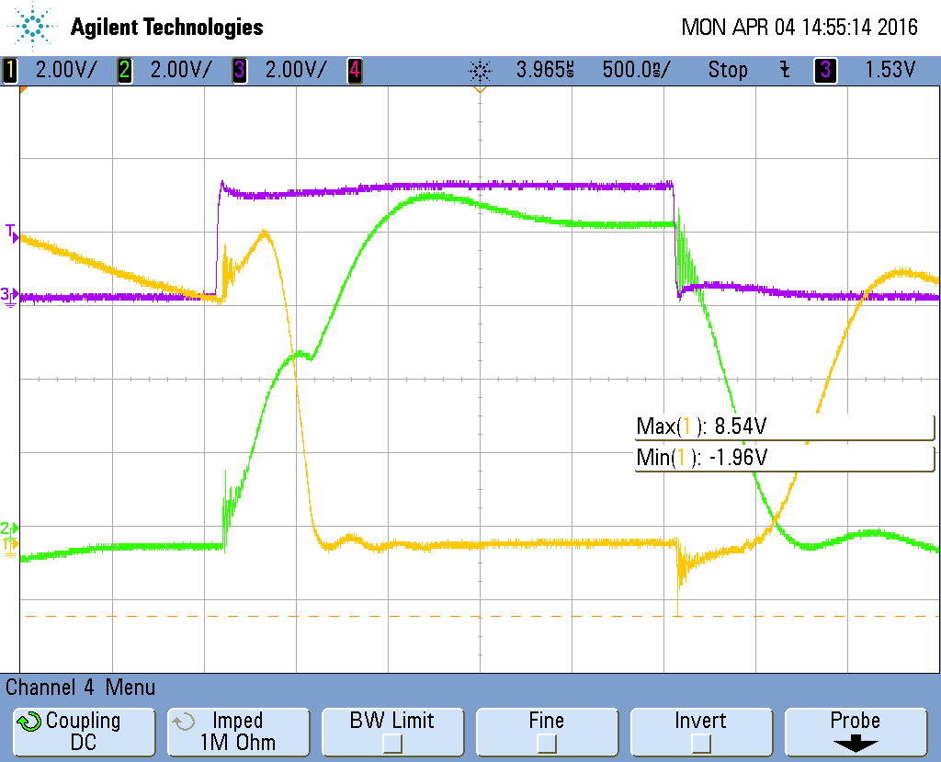

Figure 4.37 Experimental Switching Waveforms driving 133nF Gate Capacitance

Chapter 5
Conclusions and Future Work
In conclusion, the proposed gate driver is a viable alternative to large, area consuming active gate driver circuits. The tested IC was capable of performing feed-forward protection strategies in a timescale that is common for most switch mode power supply circuits. Variable gate current was achieved, resulting in a total of four separate output current levels that could be alternated between quickly using input dynamic signals. These output current levels could be adjusted as intended. Problems with the tested IC such as inability to drive to high voltages and low current drive from one signal path are likely related, and easily remediated through layout.
The proposed gate driver does not provide as much current as gate drivers on the market today, but this is due to the area of the chip being used for dynamic current adjustment. Were all output current drivers outfitted to function as a conventional gate driver, and the layout of the IC optimized the gate driver could have easily achieved and even exceeded current drive provided by other gate drivers on the market. The sacrifice of this gate current for protection functionality is congruous with tradeoffs seen throughout gate drivers on the market, especially given the low propagation delay of the IC.
As such, there is much that can be done given the results of this thesis. Were a new chip to be fabricated, many improvements could be made. Of course the high voltage issue should be fixed in order to properly drive an IGBT, which would ideally remediate the PMOS Feedback current drive issue. As the comparator is suspected to be the an unexpectedly large source of propagation delay, the design could be reinvestigated. Different level shifter topologies could be investigated to further reduce propagation delay. Layout of NMOS current drivers can be improved upon to achieve the desired 100 mA increments. Large amounts of area was left open on the IC as the number of drivers was limited by the number of selection bits, so output current could easily be increased by increasing the current step size.
Aside from improvements on the chosen topology of the gate driver, different topologies could be considered. Given it is uncommon to want to briefly turn the IGBT back off during turn-on transients, less Feedback NMOS drivers could be included, only including enough to slow the turn-on switching transient a reasonable amount, leaving this area open for additional Primary NMOS drivers.
Also given the Primary current drivers that make up a conventional gate driver will most often be used at maximum output current, larger steps in output current can be designed. Taking larger steps in output current would provide massive decrease in total area dedicated to output drivers, as well as require fewer input pins. This is because even though the output devices grow in size, less level shifter and buffers driving the output devices are required, and complexity of the digital selection logic is reduced.
Testing configurations of future gate driver ICs could be designed to minimize loop inductance to the gate of an IGBT, and this IGBT could be included in an entire SMPS circuit. From here the loop could be closed by detecting the di/dt and dv/dt of the IGBT and the gate driver could be tested in a closed loop circuit.
Overall, as a proof-of concept the tested IC shows that the chosen topology is functionally viable, and with layout area optimization as well as topology tuning, could produce a gate driver with impressive protection capabilities, current drive, and speed.

List of References

[1]H. Luo, F. Iannuzzo, P. Diaz Reigosa, F. Blaabjerg, W. Li and X. He, "Modern IGBT gate driving methods for enhancing reliability of high-power converters — An overview", Microelectronics Reliability, vol. 58, pp. 141-150, 2016.

[2] N. Ren, K. Sheng, J. Zhang and F. Peng, "Gate drive investigations of IGBT modules with SiC-Schottky freewheeling diodes," 2013 IEEE Energy Conversion Congress and Exposition, Denver, CO, 2013, pp. 2871-2876.

[3] Y. Lobsiger and J. W. Kolar, "Closed-loop IGBT gate drive featuring highly dynamic di/dt and dv/dt control," 2012 IEEE Energy Conversion Congress and Exposition (ECCE), Raleigh, NC, 2012, pp. 4754-4761.

[4] [5] S. Musumeci, A. Raciti, A. Testa, A. Galluzzo and M. Melito, "Switching-behavior improvement of insulated gate-controlled devices," in IEEE Transactions on Power Electronics, vol. 12, no. 4, pp. 645-653, Jul 1997.

[5][6] W. Eberle, Z. Zhang, Y. F. Liu and P. C. Sen, "A Current Source Gate Driver Achieving Switching Loss Savings and Gate Energy Recovery at 1-MHz," in IEEE Transactions on Power Electronics, vol. 23, no. 2, pp. 678-691, March 2008.

[6][7] B. Wittig and F. W. Fuchs, "Analysis and Comparison of Turn-off Active Gate Control Methods for Low-Voltage Power MOSFETs With High Current Ratings," in IEEE Transactions on Power Electronics, vol. 27, no. 3, pp. 1632-1640, March 2012.

[7][9] L. Dang, H. Kuhn and A. Mertens, "Digital adaptive driving strategies for high-voltage IGBTs," 2011 IEEE Energy Conversion Congress and Exposition, Phoenix, AZ, 2011, pp. 2993-2999.

[8][10] Z. Wang, X. Shi, L. M. Tolbert, F. (. Wang and B. J. Blalock, "A di/dt Feedback-Based Active Gate Driver for Smart Switching and Fast Overcurrent Protection of IGBT Modules," in IEEE Transactions on Power Electronics, vol. 29, no. 7, pp. 3720-3732, July 2014.

[9][11] Y. Lobsiger and J. W. Kolar, "Closed-Loop di/dt and dv/dt IGBT Gate Driver," in IEEE Transactions on Power Electronics, vol. 30, no. 6, pp. 3402-3417, June 2015.

[10][12] A. Shorten, W. T. Ng, M. Sasaki, T. Kawashima and H. Nishio, "A segmented gate driver IC for the reduction of IGBT collector current over-shoot at turn-on,"2013 25th International Symposium on Power Semiconductor Devices & IC's (ISPSD), Kanazawa, 2013, pp. 73-76.

[11][13] V. John, Bum-Seok Suh and T. A. Lipo, "High performance active gate drive for high power IGBTs," Industry Applications Conference, 1998. Thirty-Third IAS Annual Meeting. The 1998 IEEE, St. Louis, MO, USA, 1998, pp. 1519-1529 vol.2.

[12][14] H. Sawezyn, N. Idir and R. Bausiere, "Lowering the drawbacks of slowing down di/dt and dv/dt of insulated gate transistors," Power Electronics, Machines and Drives, 2002. International Conference on (Conf. Publ. No. 487), 2002, pp. 551-556.

[13][15] N. Idir, R. Bausiere, and J. J. Franchaud, “Active gate voltage control of turn-on di/dt and turn-off dv/dt in insulated gate transistors,” IEEE Trans. Power Electron., vol. 21, no. 4, pp. 849–855, Jul.
2006.

[14][16] B. Lu and S. Sharma, “A literature review of IGBT fault diagnostic and protection methods for power inverters,” IEEE Trans. Ind. Appl., vol. 45, no. 5, pp. 1770–1777, Sep./Oct. 2009.

[15][19] F. Blaabjerg, M. Liserre, K. Ma, Power electronics converters for wind turbinesystems, IEEE Trans. Ind. Appl. 48 (2) (Mar.–Apr. 2012) 708–719.

[16][20] S. Kouro, M. Malinowski, K. Gopakumar, J. Pou, L.G. Franquelo, B. Wu, J. Rodriguez, M.A. Perez, J.I. Leon, Recent advances and industrial applications of multilevel converters, IEEE Trans. Ind. Electron. 57 (8) (Aug. 2010) 2553–2580.

[17][21] H. Wang, M. Liserre, F. Blaabjerg, P. de Place Rimmen, J.B. Jacobsen, T. Kvisgaard, J. Landkildehus, Transitioning to physics-of-failure as a reliability driver in power electronics, IEEE J. Emerg. Sel. Top. Power Electron. 2 (1) (Mar. 2014) 97–114.

[18][27] L. Chen and F. Z. Peng, “Switching loss analysis of closed-loop gate drive,” in Proc. of the 25th Annual IEEE Applied Power Electronics Conf. and Exposition (APEC), Palm Springs, CA, USA, Feb. 2010, pp. 1119–1123.

[18][28] M. Cacciato, A. Consoli, G. Frascadore, A. Testa, G. Giannini, and R. Nisci, “Driving optimization of IGBT devices for traction applications,” presented at the 11th Eur.Conf. Power Electron. Appl., Dresden, Germany, 2005.

[19][29] S. Park and T. Jahns, “Flexible dv/dt and di/dt control method for insulated gate power switches,” IEEE Trans. Ind. Appl., vol. 39, no. 3, pp. 657–664, May/Jun. 2003.

[20][30] J. Kagerbauer and T. Jahns, “Development of an active dv/dt control algorithm for reducing inverter conducted EMI with minimal impact on switching losses,” in Proc. IEEE Power Electron. Spec. Conf., Orlando, FL, 2007, pp. 894–900.

[21][31] X. Zhou, Z. Liang, and A. Huang, “A high-dynamic range current source gate driver for switching-loss reduction of high-side switch in buck converter,” IEEE Trans. Power Electron., vol. 25, no. 6, pp. 1439–1443, Jun. 2010.

[22][32] M. Rose, J. Krupar, and H. Hauswald, “Adaptive dv/dt and di/dt control for isolated gate power devices,” in Proc. IEEE Energy Convers. Congr. Expo., Atlanta, GA, 2010, pp. 927–934.

[23][33] A. Galluzzo, M. Melito, G. Belverde, S. Musumeci, A. Raciti, and A. Testa, “Switching characteristic improvement of modern gate controlled devices,” in Proc. 5th Eur. Conf. Power Electron. Appl., Brighton, U.K., 1993, pp. 374–379.

[24][34] C. Licitra, S. Musumeci, A. Raciti, A. Galluzzo, R. Letor, and M. Melito, “A new driving circuit for IGBT devices,” IEEE Trans. Power Electron., vol. 10, no. 3, pp. 373–378, May 1995.

[25][35] A. Consoli, S. Musumeci, G. Oriti, and A. Testa, “An innovative EMI reduction design technique in power converters,” IEEE Trans. Electromagn. Compat., vol. 38, no. 4, pp. 567–575, Nov. 1996.

[26][38] S. Musumeci, A. Raciti, A. Testa, A. Galluzzo, and M. Melito, “A new adaptive driving technique for high current gate controlled devices,” in Proc. of the 9th Annual IEEE Applied Power Electronics Conf. and Exposition (APEC), Orlando, FL, USA, Feb. 1994, pp. 480–486.

[27][41]“ High-performance active gate drive for high-power IGBT’s,” IEEE Trans. Ind. Appl., vol. 35, no. 5, pp. 1108–1117, Sep./Oct. 1999.

[28][42] G. Schmitt, R. Kennel, and J. Holtz, “Voltage gradient limitation of IGBTs by optimised gate-current profiles,” in Proc. of the 39th Annual IEEE Power Electronics Specialists Conf. (PESC), Rhodes, Greece, Jun. 2008, pp. 3592–3596.

[29][45] T. Basler, J. Lutz, R. Jakob, T. Brückner, The influence of asymmetries on the parallel connection of IGBT chips under short-circuit condition, Proc. Proceedings of the EPE, Birmingham, 2011.

[30][46] A. Kopta, M. Rahimo, U. Schlapbach, N. Kaminski, D. Silber, Limitation of the shortcircuit ruggedness of high-voltage IGBTs, Proc. ISPSD 2009, pp. 33–36.

[31][47] T. Basler, R. Bhojani, J. Lutz, R. Jakob, Dynamic self-clamping at short-circuit turn-off of high-voltage IGBTs, Proc. ISPSD, Kanazawa 2013, pp. 277–280.

[32][48] T. Ohi, A. Iwata, K. Arai, Investigation of gate voltage oscillations in an IGBT module under short circuit conditions, Proc. IEEE PESC. Jun. 2002, pp. 1758–1763.

[33][49] P.D. Reigosa, R. Wu, F. Iannuzzo, F. Blaabjerg, Evidence of gate voltage oscillations during short circuit of commercial 1.7 kV/1 kA IGBT power modules, Proc. IEEE PCIM Europe 2015, pp. 916–923.

[34][51] I. Lizama, R. Alvarez, S. Bernet, M.Wagner, A new method for fast short circuit protection
of IGBTs, Proc. IECON 2014, pp. 1072–1076.

[35][52] H. Kuhn, T. K¨oneke, and A. Mertens, “Potential of digital gate units in high power applications,” in Proc. 13th Int. Conf. Power Electron. Motion Control, Poznan, Poland, Sep. 2008, pp. 1458–1464.

[36][55] K. Handt,H.K¨ohler,M.Hiller, and R. Sommer, “Fully digitally controlled gate drive unit for high power IGBTs,” in Proc. Power Convers. Intell. Motion Conf., Nuremberg, Germany, May 2012, pp. 478–485.

[37][56] M. Blank, T. Gl¨uck, A. Kugi, and H.-P. Kreuter, “Slew rate control strategies for smart power ICs based on iterative learning control,” in Proc. 29th IEEE Appl. Power Electron. Conf. Expo., Mar. 2014, pp. 2860–2866.

[38][65] B. Lu and S. Sharma, “A survey of IGBT fault diagnostic methods for three-phase power inverters,” in Proc. IEEE Int. Conf. Condition Monit. Diagnosis, Apr. 2008, pp. 756–763.

[39] Rusche, Lubke, and Munzer, “Switching Behavior and Optimal Driving of IGBT Modules” Application Note, pp5-6

[40] "J. B. Witcher, ¿¿¿Methodology for switching characterization of power devices and modules,¿¿¿ M.S. thesis, Dept. Electr. Eng., Virginia Tech., Blacksburg, VA, USA, 2002"

[41] M. Bohll¨ander, R. Bayerer, J. Lutz, and T. Raker, “Desaturated switching of trench - fieldstop IGBTs,” in Proc. Power Convers. Intell. Motion Conf., Nuremberg, Germany, May/Jun. 2006, pp. 37–42.

[42] R. Bayerer, “Switching behavior of power switches (IGBT, MOSFET),” in Proc. ECPE Workshop ‘Electron. Around Power Switch: Gate Drivers, Sensors Control’, Munich, Germany, Jun. 2011, pp. 23–25.

[43] R. Herzer, and A. Wintrich, “IGBT gate drive technologies – principles and applications,” in Proc. Tutorial Power Convers. Intell. Motion Conf., Nuremberg, Germany, May 2012, p. 105.

[44] Miser, Bradley David, "Design of a Wide-Swing Cascode Beta Multiplier Current Reference. " Master's Thesis, University of Tennessee, 2003.

Appendix

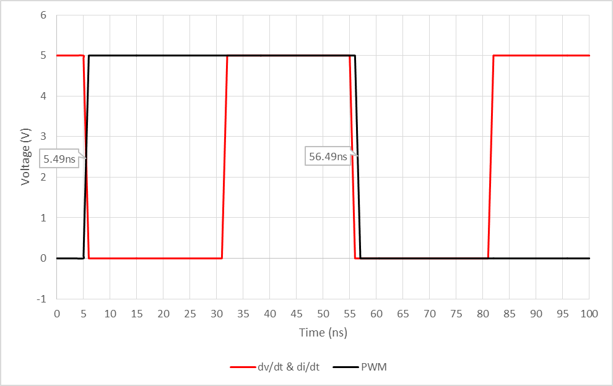

Figure A.38 Topsim Input Dynamic Signals

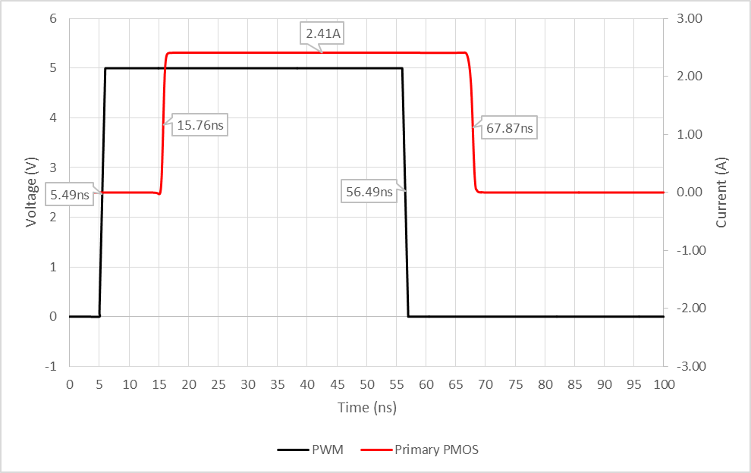

Figure A.39 Topsim Primary PMOS Propagation Delay

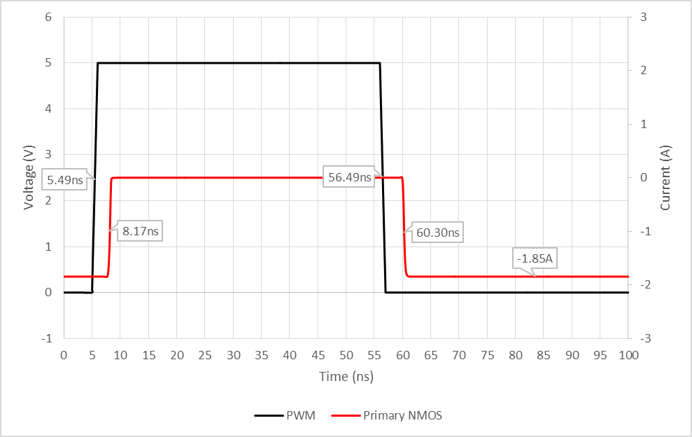

Figure A.40 Topsim Primary NMOS Propagation Delay

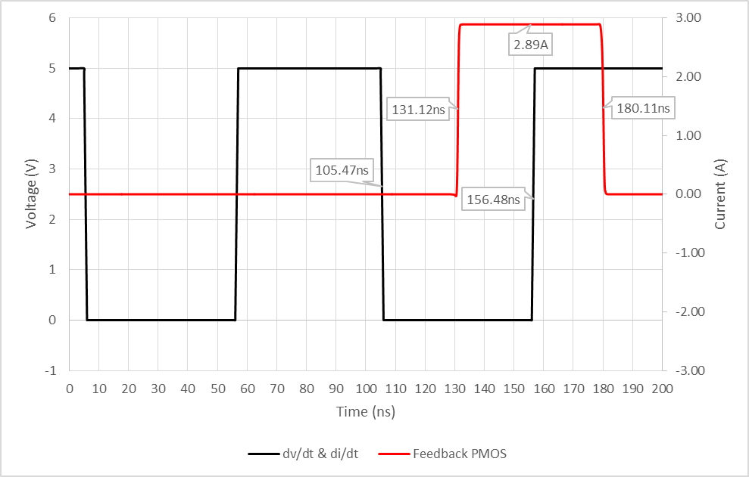

Figure A.41 Topsim Feedback PMOS Propagation Delay

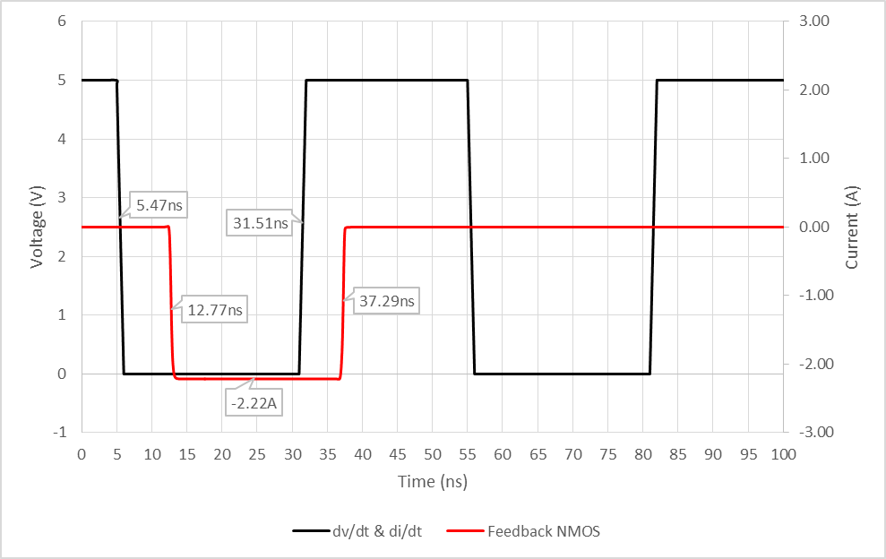

Figure A.42 Topsim Feedback NMOS Propagation Delay

Table 6. Experimental Current Driver Metrics

Active Drivers | NPrm | Nfdbk | PPrm | Pfdbk
1 | 0.094 | 0.157 | 0.071 | 0.05
2 | 0.201 | 0.261 | 0.192 | 0.17
3 | 0.298 | 0.35 | 0.314 | 0.23
4 | 0.39 | 0.449 | 0.426 | 0.23
5 | 0.479 | 0.541 | 0.484 | 0.33
6 | 0.567 | 0.633 | 0.542 | 0.39
7 | 0.656 | 0.719 | 0.651 | 0.47
8 | 0.735 | 0.807 | 0.753 | 0.53
9 | 0.816 | 0.896 | 0.858 | 0.58
10 | 0.895 | 0.981 | 0.951 | 0.61
11 | 0.974 | 1.066 | 1.048 | 0.67
12 | 1.054 | 1.149 | 1.14 | 0.75
13 | 1.127 | 1.23 | 1.228 | 0.78
14 | 1.1295 | 1.313 | 1.33 | 0.81
15 | 1.2815 | 1.394 | 1.49 | 0.89
16 | 1.3644 | 1.473 | 1.59 | 0.92
17 | 1.43 | 1.553 | 1.71 | 0.94
18 | 1.496 | 1.65 | 1.78 | 0.97
19 | 1.56 | 1.73 | 1.96 | 0.98
20 | 1.62 | 1.81 | 2.01 | 1.03
21 | 1.684 | 1.89 | 2.12 | 1.05
22 | 1.747 | 1.97 | 2.19 | 1.08
23 | 1.806 | 2.04 | 2.36 | 1.09
24 | 1.86 | 2.11 | 2.42 | 1.11
25 | 1.92 | 2.19 | 2.48 | 1.13
26 |  | 2.25 |  | 1.14
27 |  | 2.36 |  | 1.16
28 |  | 2.45 |  | 1.16
29 |  | 2.49 |  | 1.16
30 |  | 2.5 |  | 1.16
Avg Driver | 77mA | 83mA | 99mA | 38mA

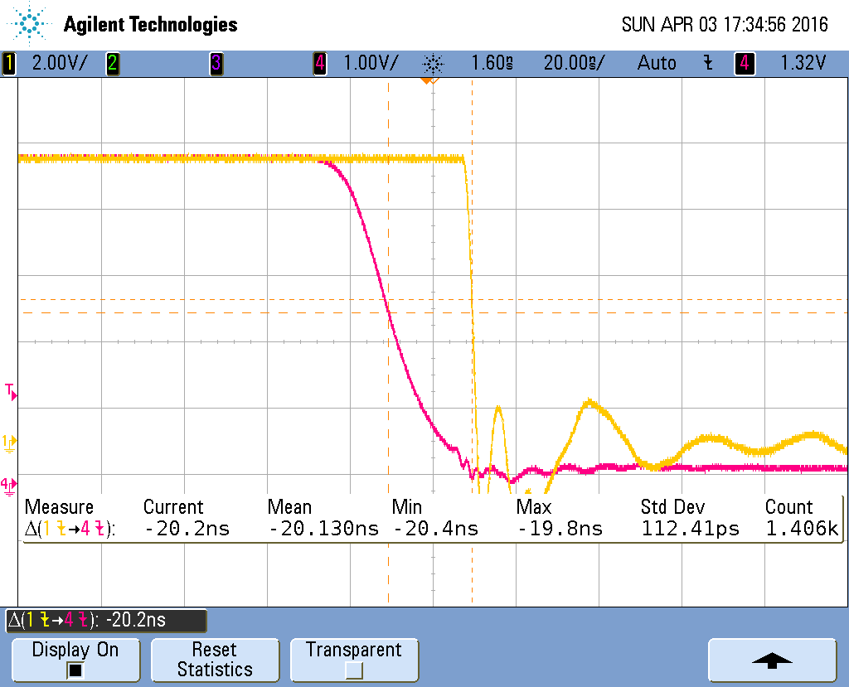

Figure A.43 Experimental Falling PWM edge Waveform

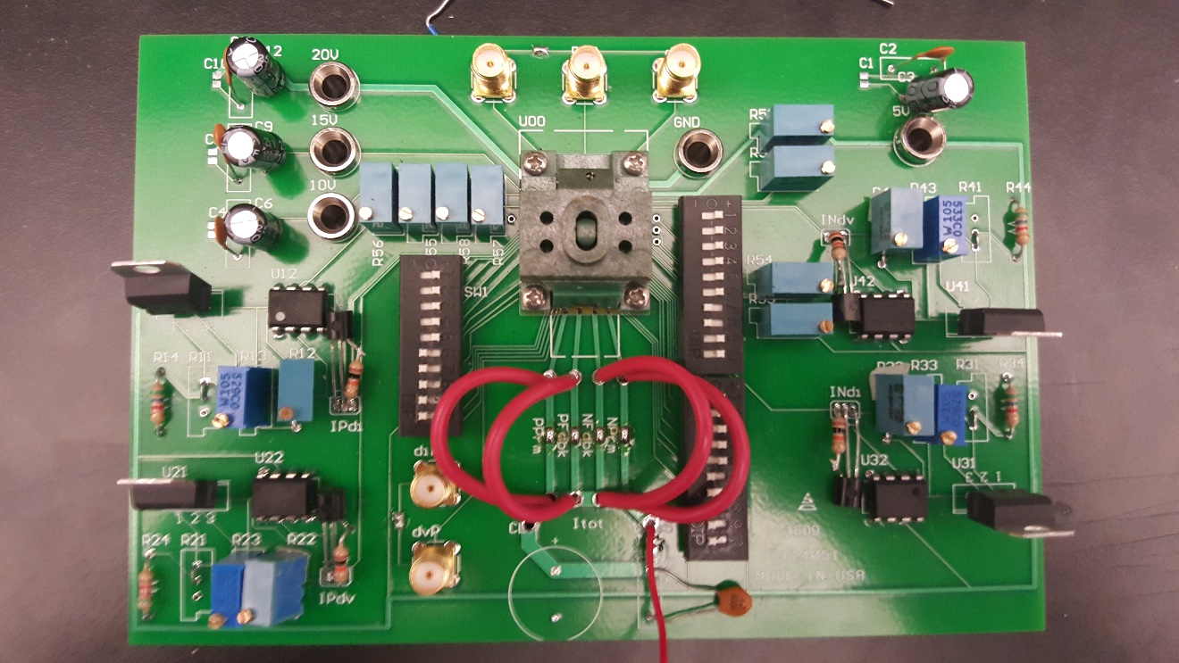

Figure A.44 Testing PCB

Vita
Jane X. Doe was born. She wrote a thesis. She graduated. She followed instructions and wrote her vita in third person and paragraph form (as opposed to a resume or CV), which made her thesis consultant very happy. This page is required.

