Chemico-physical interactions in metal halide perovskites

A Dissertation Presented for the

Doctor of Philosophy

Degree

The University of Tennessee, Knoxville

Yongtao Liu

December 2020

Copyright © 2020 by Yongtao Liu
All rights reserved.

DEDICATION

I dedicate this dissertation to my parents.

ACKNOWLEDGEMENTS

First of all, I would like to express my sincere gratitude to my PhD dissertation advisor Dr. Olga S. Ovchinnikova for her advice in my research. I could not finish this dissertation without her dedication. Most importantly, she provides me a lot of opportunity to train myself in different areas to be successful in my study and research.
I also would like to thank my advisor Prof. Bin Hu for mentoring me through graduate school and offering me the proper opportunity to conduct my research.
I also want to thank Dr. Sergei V. Kalinin for his advice in research, in particular, significant help on discussing results and revising manuscripts.
I also thank my graduate committee member, Dr. Philip D. Rack, for his insightful comments on my dissertation.
I also would like to show my gratitude to my team’s members at Oak Ridge National Lab, Dr. Anton V. Ievlev, Dr. Alex Belianinov, Dr. Matthias Lorenz, Dr. Songkil Kim, Dr. Nikolay Borodinov, Dr. Alison A Pawlicki; and lab’s members at the University of Tennessee Dr. Ahmadi Mahshid, Dr. Ting Wu, Dr. Shengbo Ma, Dr. Hengxing Xu, Miaosheng Wang, Yixuan Dou; and collaborators at Oak Ridge National Lab, Dr Liam Collins, Dr. Kai Xiao, Dr. Bobby G. Sumpter, Dr. Stephen Jesse, Dr. Jingsong Huang, Dr. Scott T. Retterer, Dr. Benjamin Doughty; and collaborator at Asylum Research an Oxford Instruments Company, Dr. Roger Proksch; and collaborator at Brookhaven National Laboratory, Dr. Mingxing Li for their help and friendship. I am particularly grateful to Dr. Anton V. Ievlev, Dr. Liam Collins, Dr. Roger Proskch, Dr. Ahmadi Mahshid for constructive suggestions and fruitful discussion.
Last but not least, I would like to thank my parents Yufeng Gong and Jian Liu, as well as other family members for their endless support and encouragement.

ABSTRACT

Metal halide perovskite (MHP) has attracted tremendous attention due to its success in optoelectronics, largely due to outstanding photovoltaic performance. A wide variety of characterization approaches have been used to explore the fundamentals behind the outstanding optoelectronic properties of MHP, which has yet to be unambiguously established despite considerable efforts to do so. Given the high ionic mobility in MHP, when physical phenomena are coupled with chemical changes, all behaviors will become very complex due to the strong ion migration. Therefore, chemico-physical interactions in MHP can no longer be ignored, which will be the focus of the researches in this thesis. First, the nature of the ferroic twin domain in CH₃NH₃PbI₃, a prototypical MHP, is revealed in Chapter 2. The study indicates the chemical and elastic inhomogeneity is the main origin of the twin domain contrast in piezoelectric force microscopy measurements, which has been widely attributed to ferroelectricity previously. Following on, the effects of the twin domain on the optoelectronic properties of CH₃NH₃PbI₃ are investigated in Chapter 3, revealing the effect of domains on light-matter interaction and the potential effect of domain walls on charge transport. Chapter 4 reports a series of studies about ion migration in MHP, including light-induced migration, electric-induced migration, migration of intrinsic ions and decomposition ions, and ion migration related charge dynamics and device operation. Chapter 5 presents studies regarding the interactions of ferroic, chemical, structural, and electronic properties of MHP. Finally, Chapter 6 summarizes the research results in this thesis and offers an outlook for future research.

TABLE OF CONTENTS
Chapter 1 Introduction 1
1.1 Metal Halide Perovskites 2
1.1.1 Development of MHP photovoltaics 2
1.1.2 Crystal structure of MHP 3
1.2 Phenomenal observations in MHP 4
1.2.1 current-voltage hysteresis 5
1.2.2 interfacial charge accumulation 5
1.2.3 ion migration in MHP 7
1.2.4 ferroic behavior of MHP 9
1.3 Thesis outline 12
Appendix 14
Chapter 2 Chemical and mechanical Nature of ferroelastic Twin domains in methylammonium lead iodide 23
2.1 Abstract 24
2.2 Introduction 25
2.3 Materials and Methods 27
2.3.1 Preparation of CH₃NH₃PbI₃ films 27
2.3.2 X-ray diffraction measurement 28
2.3.3 Atomic force microscopy (AFM) measurements 28
2.3.4 Nanoscale infrared spectroscopy (Nano IR) 29
2.3.5 Helium ion microscopy secondary ion mass spectrometry (HIM-SIMS) 29
2.3.6 Scanning electron microscopy (SEM) 29
2.3.7 Density functional theory (DFT) 29
2.4 Results and Disscussion 30
2.4.1 Crystallography of CH₃NH₃PbI₃ films 30
2.4.2 Observation of twin domains in CH₃NH₃PbI₃ films 31
2.4.3 Chemical property of twin domains in CH₃NH₃PbI₃ films 34
2.4.4 Correlation of strain and chemical distribution 35
2.4.5 Potential behavior and effect of the twin domain 35
2.5 Conclusion 36
Appendix 37
Chapter 3 The impacts of twin domains on the optoelectronic properties of methylammonium lead iodide 49
3.1 Abstract 50
3.2 Introduction 51
3.3 Materials and Methods 53
3.3.1 Preparation of CH₃NH₃PbI₃ films 53
3.3.2 Scanning electron microscopy (SEM) 54
3.3.3 Band-excitation piezoresponse force microscopy (BE-PFM) 54
3.3.4 Nanoscale infrared spectroscopy (Nano IR) 54
3.3.5 Polarization-resolved two-photon total internal reflection fluorescence microscopy (TIRFM) 55
3.3.6 X-ray diffraction (XRD) 55
3.3.7 Density Functional Theory (DFT) 56
3.3.8 Confocal photoluminescence microscopy (confocal-PL) 56
3.4 Results and Discussion 57
3.4.1 Transition dipole moment related to twin domains 57
3.4.2 Photoluminescence (PL) related to twin domains 58
3.4.2.1 Observation of twin domains in CH₃NH₃PbI₃-3 58
3.4.2.2 Photoluminescence (PL) behavior of the twin domain structure 59
3.4.2.3 Potential effect of domain walls in CH₃NH₃PbI₃ 61
3.4.3 Light-ferroic interaction in CH₃NH₃PbI₃ 62
3.4.3.1 Correlation of domains observed in different microscopies 62
3.4.3.2 Interaction between light and ferroic domain 63
3.4.3.3 Mechanism of light-ferroic interaction 64
3.4.3.4 Light-induced strain 65
3.4.3.5 Light-induced strain 66
3.5 Conclusion 67
Appendix 69
Chapter 4 Ion migration and its impact in operando devices 79
4.1 Abstract 80
4.2 Introduction 83
4.3 Materials and Methods 86
4.3.1 Preparation of CH₃NH₃PbX₃ (X = I or Br) films and lateral devices 86
4.3.2 Scanning electron microscope (SEM) 86
4.3.3 Time-of-flight secondary ion mass spectrometry (ToF-SIMS) 87
4.3.4 Machine learning analyses—Non-negative matrix fabrication (NMF) 87
4.3.5 Current-voltage characterization 88
4.3.6 Time-resolved Kelvin probe force microscopy (tr-KPFM) 88
4.4 Results and Discussion 88
4.4.1 Electric- and light- induced CH₃NH₃⁺ migration 88
4.4.2 Light effect on CH₃NH₃⁺ migration 90
4.4.3 Electric- and light- induced halide migration 91
4.4.4 Correlation between interfacial ion and charge dynamics 92
4.4.4.1 Hysteretic ion migration and ꝏ-shape charge accumulation under the application of electric field 92
4.4.4.2 Hysteretic CH₃NH₃⁺ and I⁻ migration after removing the applied electric field 93
4.4.4.3 Hysteretic migration of CH₃NH₃⁺ decomposition products 94
4.4.4.4 Hysteretic charge dynamics after removing the applied electric field 96
4.4.5 Illumination effect on ion migration and associated device operation 97
4.4.5.1 Illumination effect on hysteretic CH₃NH₃⁺ and I⁻ migration 97
4.4.5.2 Illumination-dependent current-voltage hysteresis 99
4.4.5.3 Correlation between CH₃NH₃⁺ migration and device operation 101
4.5 Conclusion 102
Appendix 104
Chapter 5 Interactions between chemical dynamics and ferroic behavior 144
5.1 Abstract 145
5.2 Introduction 146
5.3 Materials and Methods 148
5.3.1 Preparation of CH₃NH₃PbI₃ films 148
5.3.2 Scanning electron microscope (SEM) 148
5.3.3 Ab Initio Molecular Dynamics: 148
5.3.4 Time-of-flight secondary ion mass spectrometry (ToF-SIMS) 149
5.3.5 X-ray diffraction (XRD) 149
5.3.6 Scanning probe microscopy (SPM) 150
5.4 Results and Discussion 150
5.4.1 Ionic activity in the ferroic twin domain in CH₃NH₃PbI₃ 150
5.4.2 Coupled strain and chemical gradient in CH₃NH₃PbI₃ 153
5.4.2.1 Strain gradient 153
5.4.2.2 Chemical gradient 154
5.4.2.3 Chemical gradient 155
5.4.3 Potential and electric field changes due to chemical redistribution 155
5.4.4 Nanoscale strain-chemical gradient 156
5.4.5 Potential effect of the strain-chemical gradient 158
5.5 Conclusion 158
Appendix 160
Chapter 6 Conclusion and Outlook 172
References 176
Vita 208

LIST OF TABLES
Table 4-1. The assignment of interested peaks in the mass spectrum in Figure 4-18. The peaks potentially corresponding to the CH₃NH₃⁺ decomposition are yellow-highlighted. 122

LIST OF FIGURES
Figure 1-1. Plot of current highest confirmed efficiencies for silicon and perovskite photovoltaic cells that have efficiencies confirmed by independent, recognized test labs. The original data is from the Cell Efficiency Chart by National Renewable Energy Laboratory (NREL). 14
Figure 1-2. Timeline of research into the MHP solar cells. Weber for the first time synthesized CH₃NH₃PbX₃ (X = I, Br, or Cl) in 1978 (ref 3). Miyasaka and co-workers first reported MHP-based solar cells in 2009, the CH₃NH₃PbBr₃-based and the CH₃NH₃PbI₃-based solar cells exhibited PCE of 3.1% and 3.8%, respectively (ref 10). Park and co-workers and Snaith and co-workers reported solid-state MHP solar cells in 2012 almost simultaneously (ref 11& 12). This stimulated extensive research interests in MHP photovoltaics, leading to the PCE of single junction MHP solar cell exceeded 25 % in 2019 and the PCE of MHP/silicon tandem solar cell exceeded 29 % in 2020. 15
Figure 1-3. Crystal structure of metal halide perovskites. Adapted with permission from Ref 29. 16
Figure 1-4. Current–voltage hysteresis of a perovskite-based thin-film device, showing the effects of scan direction and scan rate on the current-voltage curves. Reproduced with permission from Ref 36. 17
Figure 1-5. a, the stacking structure of a prototypical planar structure MHP solar cell. b, photovoltaic processes occurred in a MHP solar cell. 18
Figure 1-6. a, Photoluminescence (PL) spectra of an MAPbBr_{1.2}I_{1.8} thin film over 45 s in 5 s increments under 457 nm, 15 mW cm⁻² light at 300 K. The inset shows the temperature dependence of initial PL growth rate. b, Top part shows XRD pattern of an MAPbBr_{1.8}I_{1.2} film before (black) and after (red) white-light soaking for 5 minutes at ∼50 mW cm⁻², and after 2 h in the dark (blue). Bottom part shows XRD pattern of an MAPbBr_{0.6}I_{2.4} film (green) is offset for comparison. Reproduced with permission form Ref 77. 19
Figure 1-7. P–E hysteresis loop of a CH₃NH₃PbI₃ film, which was attributed to ferroelectricity. Reproduced with permission from Ref 92. 20
Figure 1-8. a, Hysteretic charge density as measured on a CH₃NH₃PbI₃ thin film at 2 Hz. b, Frequency dependence of the hysteresis as a function of 1/f, the line is a linear fit to the data. Reproduced with permission from Ref 96. 20
Figure 1-9. PFM observation of twin domain modulated by external stress. PFM amplitude images of CH₃NH₃PbI₃ thin film. a, in pristine state, b, under tensile stress, and c, after relieving the stress. The arrow in (b) indicates the direction of the tensile stress. Adapted with permission from Ref 99. 21
Figure 1-10. The insensitivity of ferroelastic domains to the applied electric field. a, before applying electric bias. b, after applying a bias of 0.86 V·mm−1 for 1 min (in plane electric field). Scale bars, 2 mm. Reproduced with permission from Ref 99. 21
Figure 1-11. Tauc plot for the bulk of CH₃NH₃PbI₃ and multidomains corresponding to the supercells n×1×1, where n = 2, 8, 14, and 22, which corresponds to the domain width. The band gap of multidomains is smaller than the bulk and depends on the domain-width. Reproduced with permission from Ref 108. 22
Figure 2-1. XRD patterns of a, CH₃NH₃PbI₃-1 and b, CH₃NH₃PbI₃-2. Adapted with permission from Ref 120 and Ref 121. 37
Figure 2-2. Single frequency optical beam detector piezoresponse force microscopy. a, the frequency response of tip-sample system; b, topography; c, amplitude; and d, phase taken at drive frequency of 335 kHz. e, amplitude; and f, phase taken at drive frequency of 300 kHz. The resonance frequency is 340 kHz, as acquired from (a). The twinning contrast appears when drive frequency (335 kHz) close to the resonance frequency and disappears when drive frequency (300 kHz) far from the resonance frequency. Adapted with permission from Ref 120. 38
Figure 2-3. BE-PFM measurement. a, topography; b, amplitude; c, phase; and d, frequency images. The scale bar is 1 μm. Adapted with permission from Ref 120. 39
Figure 2-4. DART-PFM and IDS-PFM measurements of CH₃NH₃PbI₃-1. a, topography. b, c, d, DART-PFM amplitude, phase, and frequency images, respectively. e, f, IDS-PFM amplitude and phase images, respectively. Adapted with permission from Ref 121. 40
Figure 2-5. Band excitation frequency tracking. a, topography of measured area; b, band excitation piezoresponse force microscopy frequency image; c, band excitation contact resonance atomic force microscopy frequency image. The scale bar is 1 μm. Adapted with permission from Ref 120. 40
Figure 2-6. IDS-PFM taken at drive frequency of 335 kHz. a, d, top-view of images of laser spot locations, above illustrations (side view) of the expected mode shape of cantilever indicate the decoupling (a) and the coupling (d) of cantilever dynamics; b, e, amplitude images with LDV spot in the locations (a) and (d), respectively; c, f, phase images with LDV spot in the locations (a) and (d), respectively. The scale bar is 1μm. Adapted with permission from Ref 120. 41
Figure 2-7. IDS-PFM measurements taken at drive frequency of 300 kHz. a, d, two top-view of photographs of laser spot locations; b, e, amplitude images with IDS spot in the locations a and d, respectively; c, f, phase images with IDS spot in the locations a and d, respectively. The scale bar is 1 μm. The disappearance of twinning contrast indicates the crucial role of cantilever dynamic effect in twinning imaging. Adapted with permission from Ref 120. 42
Figure 2-8. DART-PFM and IDS-PFM studies of CH₃NH₃PbI₃-2. a, b, PFM amplitude and phase images, respectively. c, d, IDS-PFM amplitude and phase images, respectively. Adapted with permission from Ref 121. 43
Figure 2-9. SEM. a, top view SEM image of the CH₃NH₃PbI₃-1 film, the average domain widths are in the range of 100 nm – 400 nm; b, enlarged image of the marked area in (a). The scale bar is 3μm. Adapted with permission from Ref 120. 44
Figure 2-10. HIM-SIMS mass spectra, a strong signal of CH₃NH₃⁺ (m/z~32) is detected, however, the Pb⁺ ((m/z~207) signal is relatively very weak probably due to the weak ionization of lead. Adapted with permission from Ref 120. 45
Figure 2-11. HIM-SIMS chemical maps. a, d, simultaneously obtained CH₃NH₃⁺ and Pb⁺ distribution, respectively; b, c, enlarged images in the marked areas in (a). The scale bars in (a, d) and (b, c) are 2 μm and 0.5 μm, respectively. Adapted with permission from Ref 120. 46
Figure 2-12. Nano-IR chemical characterization. Simultaneously obtained a, topography; and b, CH₃NH₃⁺ chemical map irradiated with 1400 cm⁻¹ laser. The scale bars in is 0.5 μm. Adapted with permission from Ref 120. 47
Figure 2-13. Density functional theory model. a, elemental mean squared displacement (MSD) at T=300 K obtained from ab initio molecular dynamics simulation for a tetragonal model with 1% a, b biaxial strain. C, N, H, and I show some aggregation but Pb does not. This can be seen in the image (b) obtained from a snapshot at 2100 time steps, C, N, H, I, and Pb are green ball, blue ball, white ball, pink ball, and gold ball, respectively. Adapted with permission from Ref 120. 48
Figure 3-1. TIRFM. a, two-photon polarization map; b, enlarged image of the marked area in (a). The scale bars in (a) is 5 μm. Adapted with permission from Ref 120. 69
Figure 3-2. CH₃NH₃PbI₃-3 microcrystal exhibits twin domains. a, SEM micrograph of CH₃NH₃PbI₃ hexagon crystal, twin domains are visible in the crystal; b-d, BE-PFM results, height map (b), amplitude map (c), phase map (d), and resonance frequency map (e). Adapted with permission from Ref 158. 70
Figure 3-3. PL results. a, SEM micrograph and b, optical micrograph of a region showing twin domains; c, PL spectra of the positions in neighboring domains marked on (b). Adapted with permission from Ref 158. 71
Figure 3-4. Confocal PL results. a, SEM micrograph of a region showing twin domains; b-c, PL intensity map and PL lifetime map of the zoomed-in region marked on (b), respectively. Adapted with permission from Ref 158. 71
Figure 3-5. PL intensity vs. time diagram shows the detailed PL lifetime information of the sample. Adapted with permission from Ref 158. 72
Figure 3-6. Confocal PL study of another region. a, SEM micrograph, twin domains are indicated by arrows; b, PL intensity map and c, PL lifetime map of the zoomed-in region marked on (a). Adapted with permission from Ref 158. 72
Figure 3-7. Twin domain characterization combining multiple imaging techniques. a, Topography; b, BE-PFM frequency image; c, AFM-IR chemical (CH₃NH₃⁺) image; d, SEM image. Adapted with permission from Ref 159. 73
Figure 3-8. Light-induced strain evolution in the CH₃NH₃PbI₃ twin domains with CH₃NH₃⁺ segregation. a, c, Topography. b,d, resonance frequency images. (a) and (b) are acquired without 532 nm laser illumination. (c) and (d) are acquired with 532 nm laser illumination. e, Profile analyses corresponding to lines marked in (a) and (c). f, Profile analyses corresponding to lines marked in (b) and (d). Adapted with permission from Ref 159. 74
Figure 3-9. a, Schematic illustration of photo-generated carrier distributions in CH₃NH₃PbI₃ twin domains. b-d, a schematic to illustrate the DFT results. Both (c) the electron-rich model and (d) the hole-rich model show lattice expansion, the electron-rich model expands 0.45% and the hole-rich model expands 0.75%. Adapted with permission from Ref 159. 75
Figure 3-10. MD simulations of photo-induced mechanical response at 300 K. a) a tetragonal CH₃NH₃PbI₃ supercell model before introducing carrier-lattice interaction. b) an electron-rich supercell with electron-lattice interaction. c) a hole-rich supercell with hole-lattice interaction. Both electron-rich and hole-rich induce lattice expansion. Compared to the neutron supercell, I—I distances in the electron-rich supercell and the hole-rich supercell expand by 0.05 angstroms and 0.09 angstroms, respectively. These I—I distance changes finally cause lattice expansions of 0.45% and 0.75% in electron-rich and hole-rich supercells, respectively. Adapted with permission from Ref 159. 76
Figure 3-11. X-ray diffraction (XRD) reveals the lattice structure change of CH₃NH₃PbI₃-1 induced by photoexcitation. a, a full X-ray diffraction spectrum of CH₃NH₃PbI₃-1 from 10º-30º. b, XRD of CH₃NH₃PbI₃-1with/without 640 nm laser illumination. c, XRD diffraction of CH₃NH₃PbI₃-1 with/-out 785 nm laser illumination. d, XRD of CH₃NH₃PbI₃ with various intensity 640 nm laser illumination. The peaks in (b-d) correspond to (220) and/or (004) lattice planes of tetragonal CH₃NH₃PbI₃. The high intensity and the low intensity peaks are due to Cu Kα1 and Cu Kα2 radiation, respectively, which both originate from the same diffraction. Adapted with permission from Ref 159. 77
Figure 3-12. X-ray diffraction (XRD) reveals the lattice structure change of CH₃NH₃PbBr₃ induced by photoexcitation. a, XRD of CH₃NH₃PbBr₃ with/-out 640 nm laser illumination, the insert is a full XRD spectrum from 10º-40º. b, XRD of CH₃NH₃PbBr₃ with/without 488 nm laser illumination. The peaks in (a) and (b) correspond to the (002) lattice plane of pesudo-cubic CH₃NH₃PbBr₃. The high intensity and the low intensity peaks are due to Cu Kα1 and Cu Kα2 radiation, respectively, which both originate from the same diffraction. Adapted with permission from Ref 159. 78
Figure 4-1. SEM images of a, CH₃NH₃PbI₃ and b, CH₃NH₃PbBr₃ thin films with Au electrodes on sides. 104
Figure 4-2. Schematically shown how bias is applied in tr-ToF-SIMS measurement. a, Scheme of working principle of ToF-SIMS. b, a scheme shows how the electric bias was applied to the sample. c, a picture of the Au/CH₃NH₃PbI₃/Au devices. 105
Figure 4-3. Characterization of the intensities of white LED light and red laser used in tr-ToF-SIMS measurement by measuring the performance of a silicon solar under illumination of the white LED and the red laser. a, the current-voltage curves of the silicon solar cell under various intensity of sunlight illumination and the white LED light and the red laser. b, the Jsc of the silicon solar cells as a function of the sunlight intensity, which can be linearly fitted and the fitting results are also shown in (b). c, calculated intensities of the white LED and the red laser (represented by numbers of sun) according to the fitting result in (b). We would like to note that these calculated intensities are not accurate (in particular, the red laser) because of the wavelength mismatch between the white LED/the red laser and sunlight. 106
Figure 4-4. tr-ToF-SIMS results show the bias-induced and the light-induced CH₃NH₃⁺ redistribution in CH₃NH₃PbI₃. a, tr-ToF-SIMS results of CH₃NH₃⁺ migration in CH₃NH₃PbI₃; the X direction represents the position and the Y direction represents time as labeled. The real-time bias and light condition are labeled at the right side. b-c, representative profiles extracted from (a); (b) shows the light-induced changes in CH₃NH₃⁺ distribution and (c) shows the bias-induced changes in CH₃NH₃⁺ distribution. In (b-c), each profile corresponds to 1.8 s. 107
Figure 4-5. ToF-SIMS results of electric bias induced Pb²⁺ redistribution in CH₃NH₃PbI₃. a, Pb²⁺ distribution under 0 V bias. b, Pb²⁺ distribution under -6 V bias. No difference is observed between (a) and (b), suggesting no Pb²⁺ redistribution under bias. 108
Figure 4-6. tr-ToF-SIMS results show the bias-induced and the light-induced CH₃NH₃⁺ redistribution in CH₃NH₃PbBr₃. a, tr-ToF-SIMS results of CH₃NH₃⁺ migration in CH₃NH₃PbBr₃; the X direction represents the position and the Y direction represents time as labeled. The real-time bias and light condition are labeled at the right side. b-c, representative profiles extracted from (a); (b) shows the light-induced changes in CH₃NH₃⁺ distribution and (c) shows the bias-induced changes in CH₃NH₃⁺ distribution. In (b-c), each profile corresponds to 1.8 s. 109
Figure 4-7. Light-induced CH₃NH₃⁺ redistribution. a, concentration profiles of the light-induced CH₃NH₃⁺ redistribution in CH₃NH₃PbI₃; b, concentration profiles of the light-induced CH₃NH₃⁺ redistribution in CH₃NH₃PbBr₃. 110
Figure 4-8. tr-ToF-SIMS results show the effect of different light on the CH₃NH₃⁺ redistribution in CH₃NH₃PbBr₃. a, tr-ToF-SIMS results of CH₃NH₃⁺ migration in CH₃NH₃PbBr₃; the X direction represents the position and the Y direction represents time as labeled. The real-time bias and light condition are labeled at the right side. b-e, representative profiles extracted from (a) show the light effect on the CH₃NH₃⁺ distribution, the changes in light condition are labeled in (a) and (b-e). In (b-e), each profile corresponds to 1.8 s. 111
Figure 4-9. tr-ToF-SIMS results show the bias-induced and the light-induced I⁻ and Br⁻ redistribution in CH₃NH₃PbI₃ and CH₃NH₃PbBr₃, respectively. a, tr-ToF-SIMS results of I⁻ migration in CH₃NH₃PbI₃ and d, tr-ToF-SIMS results of Br⁻ migration in CH₃NH₃PbBr₃; the X direction represents the position and the Y direction represents time as labeled. The real-time bias and light condition are labeled at the right side. b-c, representative profiles extracted from (a); (b) shows the light-induced changes in I⁻ distribution and (c) shows the bias-induced changes in I⁻ distribution. e-f, representative profiles extracted from (d); (e) shows the light-induced changes in Br⁻ distribution and (f) shows the bias-induced changes in Br⁻ distribution. In (b-c) and (e-f), each profile corresponds to 1.8 s. 112
Figure 4-10. Light effect on halide migration. a, concentration profiles of the light-induced I⁻ redistribution in CH₃NH₃PbI₃; b, concentration profiles of the light-induced Br⁻ redistribution in CH₃NH₃PbBr₃. Each profile corresponds to 1.8 s. 113
Figure 4-11. a, a bipolar bias waveform applied during tr-ToF-SIMS measurement. b, tr-ToF-SIMS result of temporal CH₃NH₃⁺ distribution under the bipolar electric bias waveform shown in (a). c, d, CH₃NH₃⁺ density at the device interfaces (left interface and right interface, respectively) as a function of applied bias. 114
Figure 4-12. a, a bipolar bias waveform applied during the tr-KPFM measurement. b, c, Tr-KPFM results under the bipolar electric bias waveform shown in (a). b, time resolved contact potential difference (CPD) map. c, time resolved charge carrier density (CD) map. d, e, Charge carrier density (CD) at the device interfaces (left interface and right interface, respectively) as a function of applied bias. 115
Figure 4-13. The on-off field bipolar pulsed stepwise bias waveform applied, on-field and off-field conditions are indicated in the figure. 116
Figure 4-14. a, tr-ToF-SIMS map of CH₃NH₃⁺ distribution under the bipolar pulse waveform shown in Figure 4-13; b, c, the evolutions of the off-field CH₃NH₃⁺ density change at the left interface and the right interface, respectively, where the evolutions are extracted are marked in (a). 117
Figure 4-15. the off-field CH₃NH₃⁺ density at the device interfaces (a, left interface and b, right interface) as a function of the preceding bias. 118
Figure 4-16. Figure 4-16. a, tr-ToF-SIMS map of I⁻ distribution under the bipolar pulse waveform shown in Figure 4-13; b, c, the evolutions of the off-field I⁻ density change at the left interface and the right interface, respectively, where the evolutions are extracted are marked in (a). 119
Figure 4-17. the off-field I⁻ density at the device interfaces (a, left interface and b, right interface) as a function of the preceding bias. 120
Figure 4-18. Mass spectra in positive mode ToF-SIMS. a, a full mass spectrum of positive mode ToF-SIMS on CH₃NH₃PbI₃. b, enlarged mass spectrum from 35 amu to 75 amu in order to highlight a few interested peaks that do not correspond to CH₃NH₃⁺. Further analyses in Figure 4-19 indicate that these peaks correspond to CH₃NH₃⁺ decomposition. The assignment of the interested peaks is shown in Table 4-1. 121
Figure 4-19. High-spectral resolution mass spectra indicate that some peaks in Figure 4-18 correspond to CH₃NH₃⁺ decomposition products as labeled. 124
Figure 4-20. Thermodynamically and kinetically favored CH₃NH₃⁺ decomposition mechanism. a, a transition state mediated CH₃NH₃⁺ decomposition into CH₃ and NH₃. b, CH₃ and NH₃ further react with CH₃NH₃⁺ to form other decomposition products. c, a summary of the m/z of major decomposition products. 125
Figure 4-21. a, a schematic shows possible ions existing in CH₃NH₃PbI₃, black box shows intrinsic ions including CH₃NH₃⁺ and I⁻, green box shows CH₃NH₃⁺ decomposition products. b, NMF decomposition of the ToF-SIMS results, four components shown as mass spectrum indicate the m/z of ions presented in each component; according to Table S1, the component-3 represents the CH₃NH₃⁺ decomposition products very well. c-f, the evolutions of the NMF component 1-4, respectively, clear periodical behavior of component-3 is observed. g-h, the off-field component-3 (representing CH₃NH₃⁺ decomposition products) intensity at the device interfaces as a function of the preceding bias; (g) under dark condition and (h) under light condition. 126
Figure 4-22. The evolution of the component-3 intensity near the device Au/ CH₃NH₃PbI₃ interfaces. a, b, show the corresponding bias waveform and component-3 evolution, respectively. It is clear that the intensity of component-3 is stronger in 1st-3rd cycles (dark condition) than in 4th-6th cycles (light condition). 127
Figure 4-23. A comparison of the mass spectra under dark and light shows the peaks corresponding to the CH₃NH₃⁺ decomposition are stronger under dark, suggesting more significant CH₃NH₃⁺ decomposition under dark. 128
Figure 4-24. the application of the on-off field method in the tr-KPFM measurement. a, the bipolar pulsed bias waveform applied during tr-KPFM measurement. b-c, Tr-KPFM results under the bipolar pulsed bias waveform shown in (a), (b), time resolved contact potential difference (CPD) map; (c), time resolved charge carrier density (CD) map. d, e, the off-field charge carrier density (CD) at the device interfaces (left interface and right interface, respectively) as a function of the preceding bias. 129
Figure 4-25. Voltage-time (V-t) curve of the gradually increasing pulsed stepwise bias. Adapted with permission from Ref 193. 130
Figure 4-26. A tr-ToF-SIMS results showing temporal CH₃NH₃⁺ distribution during the application of a gradually increasing pulsed stepwise electric waveform. a, a full voltage-time (V-t) curve that applied during tr-ToF-SIMS measurement; b, obtained tr-ToF-SIMS results of temporal CH₃NH₃⁺ distribution. Here, the first half measurement was conducted under light-on condition and the second half measurement was conducted under light-off condition in order to study the light effect on ion migration. Adapted with permission from Ref 193. 131
Figure 4-27. Non-negative matrix factorization (NMF) analysis of the tr-ToF-SIMS result 4-26. a-e, the tr-ToF-SIMS result was spatially isolated into five endmembers, which represent CH₃NH₃⁺ distributed at the respective regions. The endmember in (c) that represents CH₃NH₃⁺ distributed at Au/CH₃NH₃PbI₃ interface is what we are interested in, which was named as endmember interface; f-j, the time evolution of the endmembers showing in (a-e), respectively. all evolutions are consistent with the applied electric waveform in Figure 4-26a. Adapted with permission from Ref 193. 132
Figure 4-28. Hysteretic ion migration. a, Voltage-time (V-t) curves of the gradually increasing pulsed stepwise bias that is applied to induce ion migration; b-f, the evolution of interface CH₃NH₃⁺ density as a function of voltage under light-on and light-off conditions. Adapted with permission from Ref 193. 133
Figure 4-29. A tr-ToF-SIMS result showing temporal I⁻ distribution during the application of a gradually increasing pulsed stepwise electric waveform. a, a full voltage-time (V-t) curve that applied during tr-ToF-SIMS measurement; b, obtained tr-ToF-SIMS results of temporal I⁻ distribution. Here, the first half measurement was conducted under light-on condition and the second half measurement was conducted under light-off condition in order to study the light effect on ion migration. Adapted with permission from Ref 193. 134
Figure 4-30. Non-negative matrix factorization (NMF) analysis of the tr-ToF-SIMS result in Figure 4-29. a-e, the tr-ToF-SIMS result was spatially isolated into six endmembers, which represent I⁻ distributed at the respective regions. The endmember in (d) that represents I⁻ distributed at Au/CH₃NH₃PbI₃ interface is what we are interested in, which was named as endmember interface; f-j, the time evolution of the endmembers showing in (a-e), respectively. Adapted with permission from Ref 193. 135
Figure 4-31. Hysteretic ion migration. a, Voltage-time (V-t) curves of the gradually increasing pulsed stepwise bias that is applied to induce ion migration; b-f, the evolution of interface I⁻ density as a function of voltage under light-on and light-off conditions. Adapted with permission from Ref 193. 136
Figure 4-32. Electric current study by applying a pulsed stepwise waveform bias. a, the voltage-time curve (V-t) of the pulsed stepwise waveform bias applied to study the evolution of electric current, the step duration is 9 s; b, the obtained current-time (I-t) curve under light-off condition; c, d, representative enlarged figures that show on-field current decay during application of 4 V and off-current current decay after application of 4 V, respectively; the inserts of (c-d) show the current evolution after the initial fast decay. Adapted with permission from Ref 193. 137
Figure 4-33. Representative exponential fitting of the fast decay of the currents upon application of the bias and after removal of the bias under light-off condition. a, b, exponential fitting of currents upon application of 4 V and -4 V, respectively. c, d, exponential fitting of currents after removal of 4 V and -4 V, respectively. All fittings are based the current during the first 200 ms. Adapted with permission from Ref 193. 138
Figure 4-34. Electric current study by applying a pulsed stepwise waveform bias. The voltage-time curve (V-t) of the pulsed stepwise waveform bias is shown in Figure 4-32a. a, the obtained current-time (I-t) curve under light-on condition; b, c, representative enlarged figures that show on-field current decay during application of 4 V and off-current current decay after application of 4 V, respectively; the inserts of (b-c) highlight the current evolution after the initial fast decay. Adapted with permission from Ref 193. 139
Figure 4-35. Representative exponential fitting of the fast decay of the currents upon application of the bias and after removal of the bias under light-on condition. a, b, exponential fitting of currents upon application of 4 V and -4 V, respectively. c, d, exponential fitting of currents after removal of 4 V and -4 V, respectively. All fittings are based the current during the first 200 ms. Adapted with permission from Ref 193. 140
Figure 4-36. Current-time (I-t) curves after electric poling. a, the off-field I-t curve under light-on condition along with the V-t curve. b, the plot of the spontaneous current under light-on condition as a function of the on-field bias. c, the off-field I-t curve under light-off condition along with the V-t curve. d, the plot of the spontaneous current under light-off condition as a function of the on-field bias. Adapted with permission from Ref 193. 141
Figure 4-37. Current behavior under light-on. a, I-t curve by 5 V poling for 9 s and relaxing for 200 s; the insert is a zoomed-in I-t curve to show the spontaneous current behavior. b, I-t curve by 3 V poling for 9 s and relaxing for 200 s; the insert is a zoomed-in I-t curve to show the spontaneous current behavior. Adapted with permission from Ref 193. 142
Figure 4-38. Current behavior under light-off. a, I-t curve by 5 V poling for 9 s and relaxing for 200 s; the insert is a zoomed-in I-t curve to show the spontaneous current behavior. b, I-t curve by 3 V poling for 9 s and relaxing for 200 s; the insert is a zoomed-in I-t curve to show the spontaneous current behavior. Adapted with permission from Ref 193. 143
Figure 5-1. BE-PFM measurements on CH₃NH₃PbI₃-1. a, topography; b, amplitude; c, phase; d, quality factor; e, frequency; f, zoomed-in topography area marked in (a) by a black square, where BE-cKPFM was performed. The scale bars are 2 μm (a) and 0.5 μm (f), respectively. Adapted with permission from Ref 176. 160
Figure 5-2. BE-cKPFM measurement on CH₃NH₃PbI₃-1. a, the schematic of tip bias waveform of BE-cKPFM measurement; b, c, the write steps and the read steps in this experiment, respectively. d, BE-cKPFM response as functions of read bias after different write bias pulses. Adapted with permission from Ref 176. 161
Figure 5-3. Responses of BE-cKPFM measurement. a, amplitude, b phase, and c, frequency as functions of write bias at different read steps (1.5 V, 0 V, -1.5 V). Adapted with permission from Ref 176. 162
Figure 5-4. BE-cKPFM response. a-d, maps of BE-cKPFM at several representative steps, corresponding steps are marked with red dots in Figure 5-2b and Figure 5-2c. a, b, read bias -1.5 V; c, d, read bias 1.5 V; a, c, write bias 3.5 V; b, d, write bias -3.5 V. e, f, enlarged images corresponding to the black square marked in (b), where the features of domains or grain boundary are observed, region 1 (marked by circles) and region 2 (marked by triangles) are twin domains, region 3 (marked by rhombi) and region 4 (marked by a box in (b)) are grain boundary and grain interior, respectively. g, frequency evolution of region 1 and region 2 as a function of write bias; h, frequency evolution and i, amplitude evolution of region 3 and region 4 as a function of write bias. Adapted with permission from Ref 176. 163
Figure 5-5. X-ray diffraction results. a, Grazing incidence X-ray diffractions at various temperatures with a grazing incidence angle of 5.5º; b, full X-ray diffraction spectra from 10º-30º at 25 ºC and 70 ºC; c, d, e, grazing incidence X-ray diffractions at 25 ºC with grazing incidence angles (GIAs) from 3. 0º to 5.5º; c, grazing incidence X-ray diffractions at 45 ºC with GIAs from 3.0º to 5.5º; e, Grazing incidence X-ray diffractions at 70 ºC with GIAs from 3.0º to 5.5º; The diffraction data in (b), (c), (e) were fitted with Gaussian distribution function, and the GIA of each data were labeled at the right side, detailed peak positions are extracted to show in Figure 5-6. Adapted with permission from Ref 241. 164
Figure 5-6. GIXRD peak positions. a, (110) and (002) peak position (2θ) changes of tetragonal CH₃NH₃PbI₃ with increasing grazing incidence angle and probe depth at 25 ºC, the decrease and the increase of 2θ indicate tensile and compressive lattice strains, respectively. b, (110) and (002) peak position (2θ) changes of tetragonal CH₃NH₃PbI₃ with increasing grazing incidence angle and probe depth at 45 ºC; c, (100) peak position (2θ) changes of cubic CH₃NH₃PbI₃ with increasing grazing incidence angle and probe depth at 70 ºC. The lattice strain gradient is observed at both 25 ºC and 45 ºC, however, the lattice strain is uniform at 70 ºC. Adapted with permission from Ref 241. 165
Figure 5-7. ToF-SIMS depth profiles of methylammonium, lead, and iodide. a, b, c, methylammonium, lead, and iodide depth profiles, respectively. Methylammonium distributes unevenly at 25 ºC and becomes even at elevated temperature. However, lead and iodide do not show obvious change with temperature increases. Adapted with permission from Ref 241. 166
Figure 5-8. DFT simulations of methylammonium distribution in the tetragonal CH₃NH₃PbI₃ show the average fraction of CH₃NH₃⁺ over time, the fraction of CH₃NH₃⁺ located in different regions within the system was monitored by taking a 5-layer slice through the entire model at femtosecond time steps. a, b, c, the average fraction of CH₃NH₃⁺ at 25 ºC; d, e, f, the average fraction of CH₃NH₃⁺ at 45 ºC; a, d, the average fraction of CH₃NH₃⁺ at the top surface; b, e, the average fraction of CH₃NH₃⁺ at the third layer; c, f, the average fraction of CH₃NH₃⁺ at the third layer. The fluctuation of methylammonium fraction in each panel is more likely CH₃NH₃⁺ rotation rather than translation. Adapted with permission from Ref 241. 167
Figure 5-9. a schematic illustration of couple strain and methylammonium distributions, where both strain and methylammonium show gradual distribution at 25 ºC and even distribution at 70 ºC. Adapted with permission from Ref 241. 168
Figure 5-10. Tr-KPFM and ToF-SIMS measurements. a, a schematic diagram of the lateral device (Au/CH₃NH₃PbI₃/Au) and the setup of tr-KPFM measurements; b, scanning electron microscopy image of the lateral device; c, the evolution of CPD under +5 V and -5 V bias poling at various temperatures; d, the evolution of CPD under +5 V and -5 V bias poling at various temperatures; the colorbar in the right-hand side of (c-d) shows the temporal color of each profile; e, a ToF-SIMS CH₃NH₃⁺ distribution map of the Au/CH₃NH₃PbI₃/Au device under +6 V bias poling; f, averaged profile across the whole map of (e), the profile direction is marked in (e). Adapted with permission from Ref 241. 169
Figure 5-11. BE-PFM shows the evolution of CH₃NH₃PbI₃ twin domains with temperature changes. a, b, BE-PFM amplitude and frequency images at 25 ºC, respectively. c, d, BE-PFM amplitude and frequency images at 70 ºC, respectively. Adapted with permission from Ref 241. 170
Figure 5-12. Illustration of strain-chemical gradient induced electric polarization and its effects on optoelectronic process in MHPs. a, BE-PFM shows ferroelastic twin domains evolution with temperature changes. a, twin domain structures and corresponding strain and chemical conditions at 25 ºC; b, twin domain structures and corresponding strain and chemical conditions at 70 ºC; c, electronic band structure of the strain-chemical gradient region and the impact of electric polarization on charge behavior. Adapted with permission from Ref 241. 171

Introduction

1.1 Metal Halide Perovskites
The past decade has witnessed the rapid development of metal halide perovskite (MHP) optoelectronics. The sunlight to electricity power conversion efficiency (PCE) of MHP based single junction solar cell has rocketed from 3.8%¹ in 2009 to 25.2% in 2019 (Figure 1-1),² which is comparable to other commercialized photovoltaic modules. The high PCE of MHP photovoltaics, together with their utilization of low cost, earth abundant, and solution synthesis process, leads this class of materials very promising for the future photovoltaic application.

1.1.1 Development of MHP photovoltaics
The researches into MHP are shown in Figure 1-2. The structural investigation of MHP can trace back to 1978,³ when Weber and co-workers characterized the crystal structure of CH₃NH₃PbX₃ (X = I, Br, or Cl). Later, in 1987,⁴ Weber and co-workers further studied the dynamics of organic cation CH₃NH₃⁺. Then, during 1990s, a series of works by Mitzi and co-workers showed the potential optoelectronic application of MHPs.⁵⁻⁹ Until 2009, Miyasaka and co-workers reported the first use of MHP in solar cells,¹⁰ resulting in PCE of 3.1% and 3.8% of CH₃NH₃PbBr₃-based and CH₃NH₃PbI₃-based solar cells, respectively. As of 2012, Park and co-workers adopted MHP in solid-state solar cells and obtained a PCE of 9.7%.¹¹ Almost at the same time, Snaith and co-workers achieved a PCE of 10.8%.¹² This stimulated extensive research interests in the following years, leading to rapid development of MHP optoelectronics including solar cells, light-emitting diodes, photodetectors, etc.¹³⁻¹⁵ The growth of the PCE of MHP solar cells is unprecedented, the single junction MHP solar cell achieved a record PCE of 25.5% in 2019, when it is ten years after the first use of MHP in photovoltaics; this record PCE (25.5%) is comparable to the highest PCE of other commercialized photovoltaic modules, such as silicon solar cell (Figure 1-1); however, silicon solar cell reached a similar PCE after ~40 years development, implying the enormous potential of MHP photovoltaics.
Owing to the fundamental Shockley-Queisser (SQ) limit for single junction solar cells (e.g. the SQ limit of a MHP with a bandgap of 1.6 eV is 30.5%^{16,17}), the research interest of MHP photovoltaics also extends to multi-junction solar cells,^{18,19} which comprises multiple photo-absorption layers with complementary absorption ranges, allowing to achieve a higher PCE than single junction solar cells. The continuously tunable bandgap of MHP offers great opportunities for multi-junction solar cells, allowing to obtain a PCE as high as 39%.²⁰ Recently, the MHP/silicon tandem solar cells have achieved very high performance,²¹⁻²⁵ with a record PCE of 29.1%.²
In spite of the remarkable achievement in efficiency of MHP solar cells, there remain many obstacles to commercialize this technology. It is necessary to understand the fundamental mechanisms driving the high efficiency and limiting the stability of MHP so as to make MHP for application and advance the design for next generation of materials.

1.1.2 Crystal structure of MHP
Perovskite is a class of materials have the same type of structure as CaTiO₃, which was named in honor of Lev A. Perovski.²⁶ ABX₃ is a general formula for perovskite, where A and B are cation, X is anion. The B-site cation is octahedrally coordinated by the X-site anion to form BX₆ octahedron, all BX₆ octahedra are corner-shared to form 3D network.^{27,28} For current photovoltaic interest (as shown in Figure 1-3²⁹), A-site cation is usually methylammonium (CH₃NH₃⁺ or MA), formamidinium (CH₂(NH₂)₂⁺ or FA), or cesium (Cs⁺), B-site cation is lead (Pb²⁺) or tin (Sn²⁺), X-site anion is halide including iodide (I⁻), bromide (Br⁻), chloride (Cl⁻). Accordingly, the photovoltaic perovskite is referred as metal halide perovskite (MHP) in this thesis.
The structural stability of perovskite can be deduced by a tolerance factor t:
$$t= \frac{R_{A}+ R_{X}}{\sqrt{2} (R_{B}+ R_{X})}$$
where R_{A}, R_{B}, and R_{X} are the ionic radii of A-site, B-site, and X-site ions, respectively. The perovskite is likely stabilized in cubic structure when t approaches 1, while the perovskite gives a less symmetric structure like tetragonal or orthorhombic with a smaller t value. t is generally in the range of 0.81-1.11 for MHP. The prototypical methylammonium lead iodide (CH₃NH₃PbI₃ or MAPbI₃) possesses a t value of ~0.83 (R_{A} = 0.18 nm, R_{B} = 0.119 nm, R_{X} = 0.220 nm), so it is stabilized in tetragonal structure at room temperature. While CH₃NH₃PbI₃ can transfer to cubic phase when temperature above 54 ºC and orthorhombic phase when temperature below -108 ºC. Currently, a remaining debate regarding CH₃NH₃PbI₃ is whether the tetragonal phase of CH₃NH₃PbI₃ is centrosymmetric or noncentrosymmetric,³⁰⁻³³ in other words, whether the CH₃NH₃PbI₃ is polar or non-polar at room temperature.³⁴ This raises another longstanding debate about the ferroelectric nature of CH₃NH₃PbI₃ at room temperature, which will be discussed later.

1.2 Phenomenal observations in MHP
During the investigation of MHP, a lot of puzzling phenomena have been observed, including current-voltage hysteresis in MHP solar cells, photoinduced phase segregation, ferroic behavior, bulk photovoltaic effect. These phenomena, on one hand, leads to controversies concerning their contribution to photovoltaic action of MHP; on the other hand, stimulate research interests into MHP-based functional devices other than solar cells.

1.2.1 current-voltage hysteresis
The current-voltage hysteresis in MHP solar cells was firth observed by Hoke and co-workers in 2013 at Materials Research Society (MRS) Fall meeting and stimulated many research interests,³⁵ which shows that the current-voltage curves of a MHP solar cell is dependent on the scan direction and the scan rate (as shown in Figure 1-4).³⁶ The current-voltage curves obtained by scanning from 0 V to forward bias and from forward bias to 0 V are different; similarly, the current-voltage curves differ due to different scan rates. Snaith and co-worker proposed three possible origins of the current-voltage hysteresis: (i) large density of defects and traps at interfaces, (ii) ferroelectric polarization of MHP, and (iii) ion migration in MHP.³⁷ These origins have been extensively investigated during the development of MHP solar cells, while the outcomes are controversial. Although a comprehensive interpretation of the current-voltage hysteresis remains missing to date, it is generally believed that (i) the interfacial defects, ions, and charge carriers accumulation, and (ii) the preconditioning (such as light soaking, electrical poling) of the solar cells prior to measuring current-voltage curves are important to the physical origin of current-voltage hysteresis.

1.2.2 interfacial charge accumulation
The operation of a solar cell necessarily includes light absorption (generation of charge carriers), charge carrier transport, and charge collection. These processes in a MHP solar cell are schematically shown in Figure 1-5. Figure 1-5a shows the stacking structure of a prototypical planar structure MHP solar cell, where two interfaces are formed between the perovskite layer and the charge transport layers (electron transport layer (ETL) and hole transport layer (HTL)). When the MHP solar cell is exposed to sunlight, the perovskite layer first absorbs light (photons) and hence produces charge carriers (free electrons and holes), which are driven by the built-in field and transport to ETL and HTL, respectively. Finally, electrons and holes transfer from the perovskite layer to ETL and HTL, then are collected by corresponding electrodes, respectively (as shown in Figure 1-5b).
In all these processes, the perovskite layer plays a key role in light absorption, charge generation, and charge transport. The outstanding photovoltaic performance of MHP solar cell is benefitted from the high absorption coefficient, low exciton binding energy, and long charge diffusion length. The high extinction coefficient of MHP (> 10⁴ cm⁻¹) allows efficient absorption of incident sunlight with a relative thin perovskite layer, as a consequence of shorter paths for charge transport and hence a reduction of possibility of recombination and energy loss. In addition, the long charge carrier diffusion length,³⁸⁻⁴² the long charge carrier lifetime,⁴³⁻⁴⁹ and balanced electrons and holes transport⁵⁰ in MHP insure the transport of both free electrons and holes to the ETL and HTL, respectively. Accordingly, charge carrier generation and transport are not the limiting factor for the performance of MHP solar cells. Therefore, charge carrier collection occurring at the interfaces between the perovskite layer and ETL or HTL are important to achieve high-efficient MHP solar cells, necessitating a good understanding regarding the charge dynamics near the interfaces in MHP solar cells.
As shown in Figure 1-5b, the band alignment at the contact is a main driving force for charge extraction in the operation of solar cells. However, the charge carrier accumulation in the transport layer (ETL or HTL) due to the inefficient charge transfer/extraction will strongly affect the band diagram and the internal electric field, the transient response of the electric field will further lead to the current-voltage hysteresis.⁵¹⁻⁵⁴ A number of investigations have revealed that the effective charge transfer/extraction at interfaces is the key to suppress the current-voltage hysteresis.^{55,56} Accordingly, the current-voltage hysteresis in MHP solar cells can be effectively suppressed by modifying the interfacial properties, such as exploring better performing transport layers,^{57,58} interface passivation,⁵⁹ inserting buffer layer,⁶⁰ and doping.⁶¹

1.2.3 ion migration in MHP
Ion migration is an important and elusive process in MHP, the effect of ion migration on the performance of MHP devices cannot be neglected. On one hand, ion migration is regarded to contribute to the current-voltage hysteresis⁶² and the poor stability^{63,64} in MHP devices, which are detrimental to the device performance; on the other hand, it was also suggested that mobile ions can passivate the defects in MHP, enhancing the device performance.
A model concerning the field-screening induced by ion migration was proposed to explain the current-voltage hysteresis in MHP photovoltaics,⁶⁵ where the mobile ions accumulated near the transport layers lead to self-doping and band bending, thus alter the charge collection. Since the accumulation of mobile ions depends on the scan rate, scan direction, preconditioning, etc., the performance of MHP solar cells is also affected by these factors, exhibiting as current-voltage hysteresis.⁶² Similar interpretation regarding charge accumulation also explain the switchable photovoltaic phenomenon.^{66,67}
The stability of MHP devices is also believed to associate with the ion migration.⁶⁸ During operation, the mobile ions in MHP accumulate and react with the interface, causing the changes in the energy landscape near the interface and finally MHP degradation and device failure.⁶⁹ This mechanism has been confirmed by several independent groups, which found the iodide (I⁻) migration causes deteriorate the device performance.⁷⁰⁻⁷⁴ Except for the intrinsic mobile ions in MHP, the extrinsic mobile ions from the electrodes, transport layers, and environment can also penetrate into the MHP and cause degradation.⁷⁴⁻⁷⁶
Unlike irreversible degradation induced by ion migration, the well-known “Hoke effect” induced by light-activated ion migration is reversible.⁷⁷ Hoke and co-workers discovered a new and low-energy photoluminescence (PL) peak induced by continuous illumination in mixed halide perovskite CH₃NH₃Pb(Br_{x}I_{1-x})₃, as shown in Figure 1-6a. Simultaneously, new peaks in X-ray diffraction measurement were also observed, as shown in Figure 1-6b, suggesting the appearance of new phase in the pristine mixed halide perovskite. While the MHP can recovery to the initial state when stored in dark, suggesting a reversible change induced by light illumination. This phenomenon has also been observed by others later.⁷⁸⁻⁸² They proposed that the light illumination induces ion migration, leading to phase segregation in the mixed halide perovskite and further resulting in iodide-rich and bromide-rich phase, as suggested by the XRD results. The new, low-energy PL peak originates from the iodide-rich perovskite. Since it is discovered by Hoke and co-workers, this phenomenon was named as “Hoke effect”.
Owing to the significance of ion migration in MHP, it deserves more investigations for the purpose of improving the device performance and stability and exploring new functionality of MHP related to ion migration. Up to date, it remains unclear what ions are moving in MHP. According to the simulation results,⁸³ which suggests that the activation energy of halide for the defect-mediated ion migration is lowest in MHP, most research interests have focused on the halide migration. In addition, numerous physical changes such as changes in surface potential,^{84,85} conductivity,⁸⁶ and PL⁸⁷ have been interpreted by considering halide migration. However, it is unknown whether or not other ions contribute to these phenomena. Therefore, future investigation concerning the behavior and the contribution of each specific mobile ions in MHP is critical to the development of MHP devices.

1.2.4 ferroic behavior of MHP
The ferroic property of MHP is a longstanding topic, focusing on whether or not the CH₃NH₃PbI₃ is ferroelectricity and the effect of ferroelectricity (if it is ferroelectricity) on the photovoltaic performance. As mentioned above, the tetragonal CH₃NH₃PbI₃ at room temperature could be polar (undetermined so far), so some proposed that the CH₃NH₃PbI₃ perovskite exhibits ferroelectric polarization at room temperature. The most discussed origin of the ferroelectric polarization in CH₃NH₃PbI₃ the molecular dipole of the A-site cation CH₃NH₃⁺. The re-orientation motion of CH₃NH₃⁺ not only changes the polarization of itself but also induces structural deformation that may also lead to a polarization, leading to a complex state regarding the polarization of CH₃NH₃PbI₃.²⁹ Accordingly, both ferroelectricity and antiferroelectricity of CH₃NH₃PbI₃ have been proposed.⁸⁸⁻⁹¹
In addition, differing from conventional oxide perovskites that has freezing ion at room temperature, CH₃NH₃PbI₃ contains a mass of mobile ions that could also induce a macroscopic polarization due to ion redistribution. Such a polarization originating from ion migration can either enhance the ferroelectric polarization (if exists in CH₃NH₃PbI₃) due to complementary effect or reduce the ferroelectric polarization due to screening effect, further complicating the investigation of ferroic behavior of CH₃NH₃PbI₃. Therefore, although a few investigations suggested that the polarization-electric field hysteresis (as shown in Figure 1-7) is the fingerprint of ferroelectricity of CH₃NH₃PbI₃,^{92,93} others also suggested that the polarization-electric field hysteresis in CH₃NH₃PbI₃ is not due to ferroelectricity⁹⁴⁻⁹⁶ but due to ion migration by investigating its frequency-dependent nature (as shown in Figure 1-8).⁹⁷ Moreover, the response of piezoresponse force microscopy (PFM, powerful tool for nanoscale ferroelectric study) was also suggested to be complicated by ion migration.⁹⁸ However, a precise understanding regarding the effect of ion migration on ferroelectricity of CH₃NH₃PbI₃ is still missing.
Besides ferroelectricity, the ferroelasticity of CH₃NH₃PbI₃ has also been investigated recently.^{99,100} The twin domain in CH₃NH₃PbI₃ was found to be altered by external stress,¹⁰¹ consistent with the behavior of the ferroelastic domains, as shown in Figure 1-9. Initially, in order to clarify the ferroelectric nature of this twin domain, researchers tried to switch it by applying an electric field normal to the sample surface, while no switchable behavior was observed.¹⁰² At that time, it was proposed that the twin domain might possess in-plane polarization that is difficult to be switched by out-of-plane electric field.¹⁰² Later, it was observed that in-plane electric field also did not switch the twin domain, as shown in Figure 1-10.¹⁰¹ However, the nature of this twin domain remains under debate as it is also suggested that the polarization in a semiconductor can probably not be switched.¹⁰³ Therefore, in regard of the ferroelectric property of this twin domain, the question becomes whether the twin domain is polar.
Furthermore, up to date, the effect of ion migration on the ferroelastic property of CH₃NH₃PbI₃ has not be considered. Ferroelasticity is a property associated with the strain condition of the material and ion migration can induce local strain change due to Vegard effect. Moreover, a few researches revealed that the local strain is closely tied with the charge dynamics.^{104,105} Therefore, the correlation of ion migration, strain, and ferroelasticity also deserves detailed investigation for the purpose of promoting the development of MHP optoelectronics.
Even if the ferroelectric nature of CH₃NH₃PbI₃ remains unclear, a number of theoretical studies have showed that the ferroelectricity (if exists in CH₃NH₃PbI₃) can significantly affect the optoelectronic properties and the photovoltaic performance of CH₃NH₃PbI₃.¹⁰⁶⁻¹¹⁰ It was revealed that the charge ferroelectric domain walls could reduce the electronic bandgap (as shown in Figure 1-11) and enhance the conductivity of CH₃NH₃PbI₃.¹¹¹⁻¹¹⁴ Also, the ferroelectric polarization can affect the charge distribution and suppress the recombination.^{115,116} Accordingly, ferroelectricity is beneficial for the photovoltaic action. In contrast, it was also found that ferroelectricity contributes to the current-voltage hysteresis and thus is detrimental.^{117,118} In addition, theoretical study revealed that ferroelastic domains can also enhance the charge separation,¹¹⁹ playing a similar role as ferroelectricity in the recombination. Therefore, both ferroelectricity and ferroelasticity are important for the optoelectronic properties of MHP.

1.3 Thesis outline
A major reason why above illustrated questions remain is due to the unknown chemical dynamics behind the physical phenomena of MHPs, which can result in various artifacts in physical characterizations and lead to limited understandings, even misunderstandings, of the fundamentals of MHPs. Therefore, this research will focus on the chemico-physical interactions—including ferroic behavior, ion migration, ferroic-ionic interactions—in MHPs and how they affect the optoelectronic performance of MHPs. The outline of this thesis is as follows.
Chapter 2 presents a study regarding the origin of the CH₃NH₃PbI₃ twin domain contrast in piezoelectric force microscopy (PFM), along with the chemical inhomogeneity tied to the twin domain structure. The nature of the twin domain is demonstrated in this Chapter.
Chapter 3 studies the effect of the twin domain structure on the local optoelectronic properties of CH₃NH₃PbI₃. The effect of the domains on the light-matter interaction and the potential effect of the domain walls on the charge dynamics are studied in this Chapter.
Chapter 4 reports a series of studies on the ion migration, as well as the effect of ion migration, in MHPs. Electric-induced and light-induced ion migrations are illustrated. In addition, the hysteretic migration behavior of a number of ions, along with the effects of ion migration on the device operation and charge dynamics, are discussed in this Chapter.
Chapter 5 presents the interactions among ferroic, chemical, structural, and electronic properties in MHPs, which shows the inevitable chemico-physical interactions in this class of materials, offering an approach to think and understand the fundamentals of MHPs.
Chapter 6 presents a summary of this thesis and an outlook for future research.

Appendix
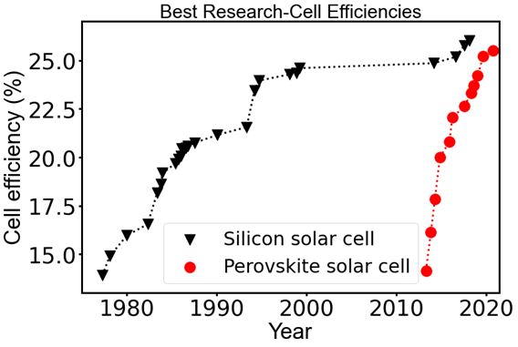
Figure 1-1. Plot of current highest confirmed efficiencies for silicon and perovskite photovoltaic cells that have efficiencies confirmed by independent, recognized test labs. The original data is from the Cell Efficiency Chart by National Renewable Energy Laboratory (NREL).

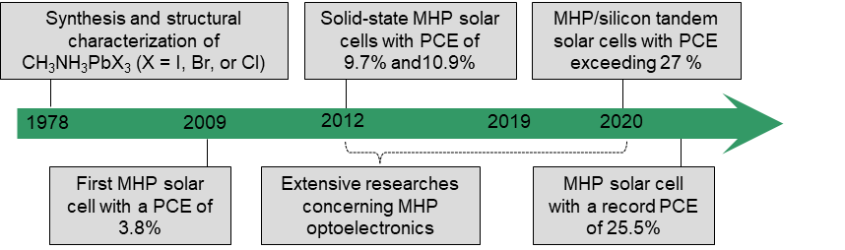
Figure 1-2. Timeline of research into the MHP solar cells. Weber for the first time synthesized CH₃NH₃PbX₃ (X = I, Br, or Cl) in 1978 (ref 3). Miyasaka and co-workers first reported MHP-based solar cells in 2009, the CH₃NH₃PbBr₃-based and the CH₃NH₃PbI₃-based solar cells exhibited PCE of 3.1% and 3.8%, respectively (ref 10). Park and co-workers and Snaith and co-workers reported solid-state MHP solar cells in 2012 almost simultaneously (ref 11& 12). This stimulated extensive research interests in MHP photovoltaics, leading to the PCE of single junction MHP solar cell exceeded 25 % in 2019 and the PCE of MHP/silicon tandem solar cell exceeded 29 % in 2020.

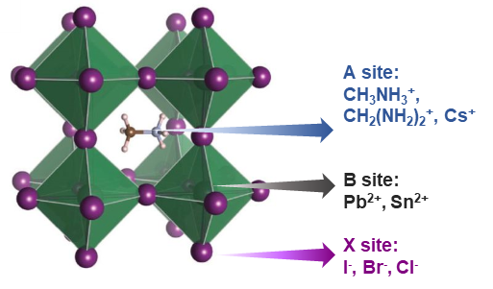
Figure 1-3. Crystal structure of metal halide perovskites. Adapted with permission from Ref 29.

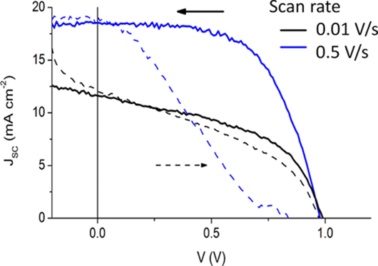
Figure 1-4. Current–voltage hysteresis of a perovskite-based thin-film device, showing the effects of scan direction and scan rate on the current-voltage curves. Reproduced with permission from Ref 36.

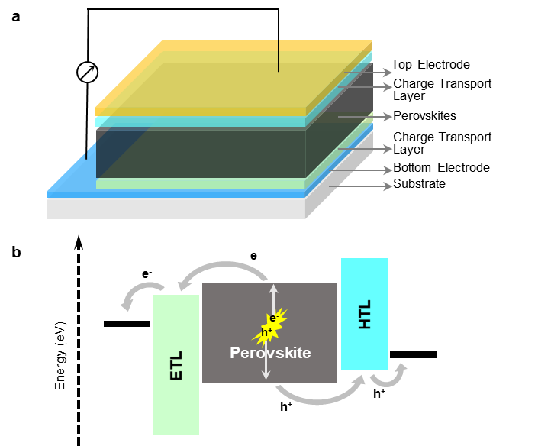
Figure 1-5. a, the stacking structure of a prototypical planar structure MHP solar cell. b, photovoltaic processes occurred in a MHP solar cell.

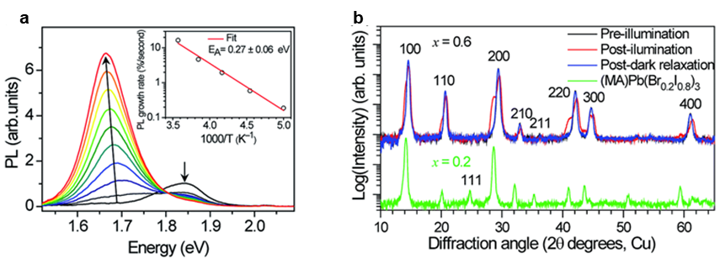
Figure 1-6. a, Photoluminescence (PL) spectra of an MAPbBr_{1.2}I_{1.8} thin film over 45 s in 5 s increments under 457 nm, 15 mW cm⁻² light at 300 K. The inset shows the temperature dependence of initial PL growth rate. b, Top part shows XRD pattern of an MAPbBr_{1.8}I_{1.2} film before (black) and after (red) white-light soaking for 5 minutes at ∼50 mW cm⁻², and after 2 h in the dark (blue). Bottom part shows XRD pattern of an MAPbBr_{0.6}I_{2.4} film (green) is offset for comparison. Reproduced with permission form Ref 77.

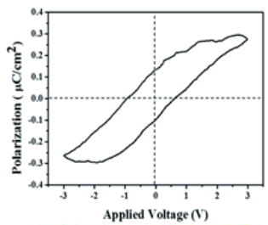
Figure 1-7. P–E hysteresis loop of a CH₃NH₃PbI₃ film, which was attributed to ferroelectricity. Reproduced with permission from Ref 92.

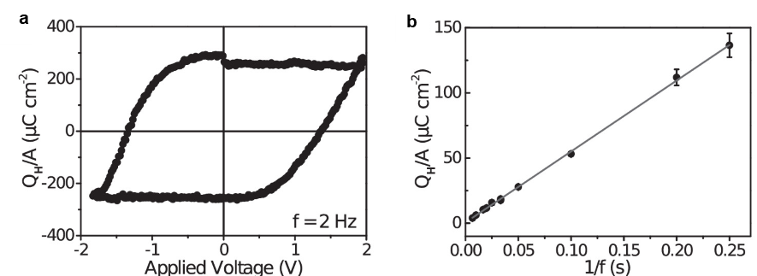
Figure 1-8. a, Hysteretic charge density as measured on a CH₃NH₃PbI₃ thin film at 2 Hz. b, Frequency dependence of the hysteresis as a function of 1/f, the line is a linear fit to the data. Reproduced with permission from Ref 96.

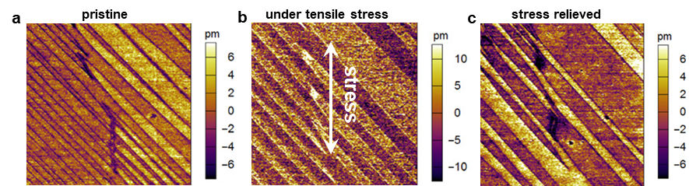
Figure 1-9. PFM observation of twin domain modulated by external stress. PFM amplitude images of CH₃NH₃PbI₃ thin film. a, in pristine state, b, under tensile stress, and c, after relieving the stress. The arrow in (b) indicates the direction of the tensile stress. Adapted with permission from Ref 99.

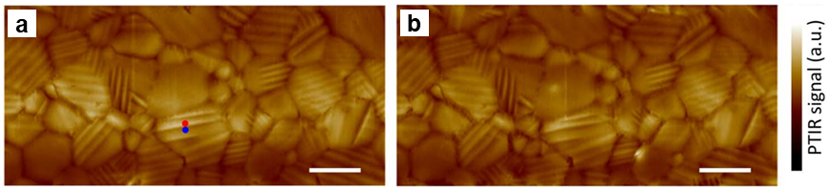
Figure 1-10. The insensitivity of ferroelastic domains to the applied electric field. a, before applying electric bias. b, after applying a bias of 0.86 V·mm−1 for 1 min (in plane electric field). Scale bars, 2 mm. Reproduced with permission from Ref 99.

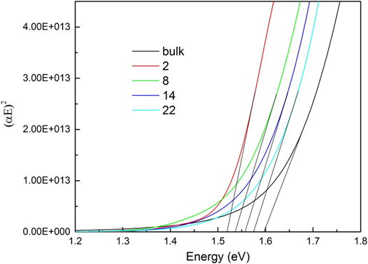
Figure 1-11. Tauc plot for the bulk of CH₃NH₃PbI₃ and multidomains corresponding to the supercells n×1×1, where n = 2, 8, 14, and 22, which corresponds to the domain width. The band gap of multidomains is smaller than the bulk and depends on the domain-width. Reproduced with permission from Ref 108.

Chemical and mechanical Nature of ferroelastic Twin domains in methylammonium lead iodide
A version of this chapter was originally published^{120,121} by Yongtao Liu, Liam Collins, Roger Proksch, Songkil Kim, Brianna R. Watson, Benjamin Doughty, Tessa R. Calhoun, Mahshid Ahmadi, Anton Ievlev, Stephen Jesse, Scott T. Retterer, Alex Belianinov, Kai Xiao, Jingsong Huang, Bobby G. Sumpter, Sergei V. Kalinin, Bin Hu, Olga S. Ovchinnikova:
[1] Liu, Y., Collins, L., Proksch, R., Kim, S., Watson, B. R., Doughty, B., Calhoun, T. R., Ahmadi, M., Ievlev, A., Jesse, S., Retterer, S. T., Belianinov, A., Xiao, K., Huang, J., Sumpter. B. G., Kalinin, S. V., Hu, B., Ovchinnikova, O. S., (2018). Chemical nature of ferroelastic twin domains in CH3NH3PbI3 perovskite. Nature materials, 17(11), 1013-1019.
[2] Liu, Y., Collins, L., Proksch, R., Kim, S., Watson, B. R., Doughty, B., Calhoun, T. R., Ahmadi, M., Ievlev, A., Jesse, S., Retterer, S. T., Belianinov, A., Xiao, K., Huang, J., Sumpter. B. G., Kalinin, S. V., Hu, B., Ovchinnikova, O. S., (2019). Reply to: On the ferroelectricity of CH3NH3PbI3 perovskites. Nature materials, 18(10), 1051-1053.

2.1 Abstract
The extraordinary photovoltaic performance achieved by MHPs has resulted in extensive efforts towards unraveling their properties. Recently, the observation of twin domain in CH₃NH₃PbI₃ has raised discussion concerning its ferroelectric and/or ferroelastic behavior, which are important to the optoelectronic properties of CH₃NH₃PbI₃. However, the origin of the twin domain contrast in PFM measurements and how the chemistry of the twin domain affects the photovoltaic action are still an enigma. Here, the precise mechanism behind the formation of the twin domains in CH₃NH₃PbI₃ was unveiled by direct visualization of physical and chemical properties. The results presented in this Chapter reveal the interplay between structural-chemical phenomena in CH₃NH₃PbI₃ and offer guidelines for interpreting the functional properties of related MHPs. These results answer key questions on the origins of the twin domain and unveil the role of chemistry in their observation. This Chapter is revised based on previously published results^{120,121} by [1] Liu, Y., Collins, L., Proksch, R., Kim, S., Watson, B. R., Doughty, B., Calhoun, T. R., Ahmadi, M., Ievlev, A., Jesse, S., Retterer, S. T., Belianinov, A., Xiao, K., Huang, J., Sumpter. B. G., Kalinin, S. V., Hu, B., Ovchinnikova, O. S., (2018). Chemical nature of ferroelastic twin domains in CH₃NH₃PbI₃ perovskite. Nature materials, 17(11), 1013-1019. [2] Liu, Y., Collins, L., Proksch, R., Kim, S., Watson, B. R., Doughty, B., Calhoun, T. R., Ahmadi, M., Ievlev, A., Jesse, S., Retterer, S. T., Belianinov, A., Xiao, K., Huang, J., Sumpter. B. G., Kalinin, S. V., Hu, B., Ovchinnikova, O. S., (2019). Reply to: On the ferroelectricity of CH₃NH₃PbI₃ perovskites. Nature materials, 18(10), 1051-1053.

2.2 Introduction
MHPs, such as the prototypical CH₃NH₃PbI₃, have shown great potential for optoelectronic applications.¹²²⁻¹²⁵ However, the intrinsic physical properties of this class of materials have not been fully uncovered and are critical to our understanding regarding their optoelectronic behaviors. Underlying many of the desirable optical properties in these materials is the potential role of ferroelectricity, which is suspected to dictate band alignment as well as the generation and transport of charge carriers.^{106,107,110} However, the presence of ferroelectricity in CH₃NH₃PbI₃ perovskites is hotly debated and has not been unambiguously measured. In part, this lack of clarity is related to the experimental challenges in attempting to separate ferroic behaviors from a mix of spatial, mechanical and chemical signals present in these perovskite films. Traditional ferroelectric measurements of polarization-electric field (P-E) behavior have indicated both ferroelectric¹²⁶ and non-ferroelectric behaviors^{127,128}, with the disparity in these measurements explained by ionic conductivity and dielectric relaxation; complicating the traditional ferroelectric measurements. Twin domain in CH₃NH₃PbI₃ has been observed by a variety of characterization techniques including piezoresponse force microscopy (PFM),^{99,100,129-131} transmission electron microscopy (TEM),¹³² and photothermal induced resonance (PTIR).⁹⁹ In particular PFM, sensitive to electromechanical material response, has widely used for studying the twin domain structure.^{99,100,129-131} At the same time, PFM measurements are known to be prone to artifacts, particularly prevalent for materials showing weak electromechanical responses, leading to PFM measurements being used to claim ferroelectricity in a variety of materials known to be non-ferroelectric.¹³³ In some cases, such troubling results can be traced to changes in topography, electrostatic contributions, local ion dynamics, and tip-sample contact stiffness which can result in misleading contrast. Often such studies would benefit from multimodal imaging techniques to identify and separate the various mechanisms at play. Notably, to our knowledge, all investigations of the twin domains in MAPbI₃ have been limited to studying ferroic properties, whereas, the chemical nature, which can also be expected to play an important role and is often reported in systems such as Cu-Ni¹³⁴ and BiSbTe¹³⁵ has largely been ignored. In ferroelectric and/or ferroelastic domains, the ion distribution can differ locally due to the variations in local defects densities and potentials.¹³⁶ Notably, this variation should lead to measurable differences in chemical composition of such twin domains.
In this Chapter, the twin domain in CH₃NH₃PbI₃ thin films was studied by using multiple functional and chemical imaging techniques. Advanced atomic force microscopy (AFM) results demonstrated that previously reported piezoelectric contrast is essentially mechanical in origin and not electromechanical, which shows significant elastic differences between the domains. These advanced AFM measurements were also extended to other CH₃NH₃PbI₃ showing a different out-of-plane crystallographic orientation. Helium ion microscopy secondary ion mass spectrometry (HIM-SIMS) and nanoscale infrared spectroscopy (Nano-IR) results showed chemical (i.e. CH₃NH₃⁺) segregation corresponding to the twin domain structure. Furthermore, density functional theory (DFT) calculations provide a mechanism connecting elastic strain, chemical segregation, and ferroelasticity in CH₃NH₃PbI₃. The potential effect of this twin domain on the optoelectronic action in CH₃NH₃PbI₃ is discussed at the end of this Chapter.

2.3 Materials and Methods

2.3.1 Preparation of CH₃NH₃PbI₃ films
In this Chapter, two CH₃NH₃PbI₃ films were used, which both are prepared on indium tin oxide coated glass (ITO-glass) substrates by spin-cast method. Two CH₃NH₃PbI₃ films are termed as CH₃NH₃PbI₃-1 and CH₃NH₃PbI₃-2 hereafter. The ITO-glass substrates were ultrasonically cleaned by deionized water, acetone, and isopropanol (IPA). The cleaned ITO-glass substrates were dried by N₂ treated with UVO prior to film spin cast.
The CH₃NH₃PbI₃-1 was fabricated by spin-casting hot PbI₂ solution (1.2 M in dimethylformamide (DMF)) at 6000 rpm for 30 s onto the ITO-glass and followed by spin-casting CH₃NH₃I solution (0.44 M in ethanol) at 6000 rpm for 30 s onto the cooled-down PbI₂ film; then, the obtained film was annealed at 100 ºC for two hours.
A layer of poly(3,4-ethylenedioxythiophene) polystyrene sulfonate (PEDOT:PSS) was spin-casted on the ITO-glass prior to fabricating the CH₃NH₃PbI₃-2. PEDOT:PSS was spin-casted at 4000 rmp for 40 s and annealed at 150 ºC for 15 min. The CH₃NH₃PbI₃-2 was synthesized by spin-casting a CH₃NH₃PbI₃ precursor with CH₃NH₃I (1 M) and PbI₂ (1 M) in mixed dimethyl sulfoxide (DMSO) and DMF (DMSO:DMF = 3:1). The as-casted CH₃NH₃PbI₃ film was annealed at 170-190 ºC until it fully converted to a dark perovskite.

2.3.2 X-ray diffraction measurement
X-ray diffraction measurement was performed on a Panalytical X’Pert MPD Pro diffractometer (45kV, 40mA) using Cu Kα1 radiation (λ = 0.154nm) with a step size of 0.016.

2.3.3 Atomic force microscopy (AFM) measurements
All AFM measurements were performed on commercial Cypher, Asylum Research and Oxford Instr. Company AFM system equipped with band excitation generator at room temperature using a Pt/Ir coated AFM tip (ElectriMulti75-G, Budget Sensors) with a nominal stiffness of ~3 N/m. The resonance frequency is around 300-400 kHz. The single frequency optical beam diffraction (OBD) piezoresponse force microscopy (PFM) measurements were conducted by applying an AC bias of 1.0-2.0 V. Band excitation PFM (BE-PFM) were performed by applying an AC bias of 1.0 V with a band width around 60-100 kHz. BE-AFM was performed by driving the cantilever and tip using a blue laser. Interferometric displacement sensor PFM (IDS-PFM) measurements were performed by applying an AC bias of 1.0-3.0 V, the IDS laser spot was positioned at different position to study the effect of cantilever dynamics.

2.3.4 Nanoscale infrared spectroscopy (Nano IR)
Nanoscale infrared spectroscopy (Nano IR) experiments were performed on ANASYS INSTRUMENTS including AFM-IR imaging in in contact mode. In Nano IR measurement, the sample was irradiated with an infrared laser to detect the absorption, an AFM probe detects the deflection of the tip due to thermal expansion, thereby providing a sub-diffraction limited chemical map. CH₃NH₃⁺ distribution image was recorded by illuminating the CH₃NH₃PbI₃ sample at 1400 cm⁻¹ (corresponding to methylammonium deformation¹³⁷) during scanning.

2.3.5 Helium ion microscopy secondary ion mass spectrometry (HIM-SIMS)
HIM-SIMS experiments were carried out on a Zeiss ORION Nanofab He⁺/Ne⁺ microscope with Ne⁺ beam, in positive mode, at 25 kV accelerating voltage with a beam current of 1.37 pA.

2.3.6 Scanning electron microscopy (SEM)
SEM measurements were performed on a Zeiss Merlin scanning electron microscope in the Inlens & Secondary electron (SE) mode with a gun voltage of 1.00 kV.

2.3.7 Density functional theory (DFT)
Molecular dynamics (MD) simulations based on density functional theory (DFT) were performed using the Vienna Ab Initio Simulation Package (VASP, 5.4.1)¹³⁸⁻¹⁴⁰ using the projector-augmented wave (PAW) method.^{141,142} The electron-ion interactions were described using standard PAW potentials, with valence electron configurations of 5d¹⁰6s²6p² for Pb, 5s²5p⁵ for I, 3s²3p⁵ for Cl, 2s²2p² for C, 2s²2p³ for N, and 1s¹ for H. To account for the weak van der Waals interactions, the vdW-DF method implemented by Dion et al. and modified by Klimes et al. was employed.^{143,144} To reduce the computational cost, the Brillouin-zone integrations were performed on a Γ-centered 1×1×1 k-point grid, the kinetic energy cutoff for plane waves was set to the default value of 400 eV, and the “normal” precision setting was adopted. The convergence criterion for the electronic self-consistent loop was set to 10⁻⁴ eV. The MD simulations were performed in a canonical NVT ensemble with the three lattice vectors constrained while all atoms were allowed to move. The temperature of the simulations was maintained by a Nose-Hoover thermostat at 300 K. Each simulation was carried out at a time step of 1 fs, with the velocities of all atoms initialized randomly according to the Maxwell-Boltzmann distribution. MD simulations for 2 picoseconds were used to thermalize the energy and then additional 25 picosecond MD simulations were evaluated to analyze the motion of the ions. Supercell models of low-energy stoichiometric (100) and two (110) surfaces (one that is flat and the other that is corrugated) containing five Pb layers¹⁴⁵ were constructed using the experimental X-ray structure of CH₃NH₃PbI₃ in a room-temperature tetragonal phase.³¹ Following full optimization of these models, the relative mobilities of the different ions were estimated by monitoring the mean square displacement (MSD) during MD simulations performed at room temperature.

2.4 Results and Disscussion

2.4.1 Crystallography of CH₃NH₃PbI₃ films
Figure 2-1 shows the XRD spectra of two CH₃NH₃PbI₃ films at room temperature. For CH₃NH₃PbI₃-1, five peaks between 10º and 30º (2θ) were observed, where the peaks corresponding to (002)/(110) and (004)/(220) orientations of the tetragonal CH₃NH₃PbI₃ show strongest intensity,³⁹ suggesting the out-of-plane crystallographic orientation of CH₃NH₃PbI₃-1 is dominated by (002)/(110) and (004)/(220). However, the CH₃NH₃PbI₃-2 shows a significantly different spectra, suggesting the crystallographic orientation of CH₃NH₃PbI₃-2 is different.

2.4.2 Observation of twin domains in CH₃NH₃PbI₃ films
The CH₃NH₃PbI₃-1 was first investigated. The twin domain structure was observed in both single frequency PFM (sf-PFM) and BE-PFM. Most previously reported PFM studies of the twin domain structure in CH₃NH₃PbI₃ utilized sf-PFM and applied the electrical excitation voltage close to the contact resonance frequency. Similarly, in this study, it is found that the twin domain contrast appears which set the AC signal close to the resonance frequency (within 5-15 kHz), as shown in Figure 2-2. However, this twin domain contrast disappears when the AC signal is far from the resonance frequency (>15 kHz). These results indicate that the resonant enhancement (AC signal close to the resonance frequency) is required to observe the twin domain contrast of CH₃NH₃PbI₃ in sf-PFM. Previous studies claimed that this requirement is due to weak piezoelectric coefficient (which originates from the electromechanical effect) of the materials under study.¹⁴⁶
However, performing sf-PFM measurements close to the resonance frequency leads to the sf-PFM results susceptible to misinterpretation. Shifts in resonance frequency can be easily mislabeled as a pure piezoelectric response in sf-PFM, while in reality they may originate from the coupling between the applied bias and mechanical properties of the sample through changes in the tip-sample contact stiffness. Thus, BE-PFM was carried out, which provides additional information on the cantilever dynamics via tracking the resonance frequency signal and simultaneously suppresses the topographic crosstalk. This offers a more complete picture of the tip-sample interactions^{147,148} that helps decipher the precise origin of the image contrast. Figure 2-3 shows the BE-PFM results that display identical twin domain structure as observed in sf-PFM (Figure 2-2). However, the contrast in the phase image is not is the typical contrast expected for ferroelectric domains in tetragonal systems, implicating the complex origin of the PFM signal. Moreover, the twin domain contrast also shows up in the frequency image (Figure 2-2d), indicating the variation in local elastic properties.¹⁴⁹ The BE-PFM results were also reproduced by DART-PFM (as shown in Figure 2-4), which is also a technique that can track resonance frequency.
To confirm the elastic variation between the twin domain, BE-AFM was further performed to measure local viscoelastic properties.^{127,149,150} BE-AFM can isolate electromechanical response from purely mechanical response since no electric voltage is applied to the cantilever-tip in BE-AFM measurements. Figure 2-5 shows the BE-AFM result along with an in-situ BE-PFM result, frequency images of BE-AFM and BE-PFM show the same twin domain contrast. While this contrast is not observed in topography (Figure 2-5a), indicating no topographic crosstalk during these measurements.
In order to isolate the mechanical response from the electromechanical response (such that to know whether there is piezoelectric and/or ferroelectric response in the domain contrast), an IDS-PFM detection system was employed. Compared to the optical beam deflection (OBD) detection system in traditional AFM, IDS can detect the precise tip-surface displacement (electromechanical response) in units of length and simultaneous exclude the effect of cantilever dynamics (resonance effects) if the IDS laser spot is positioned directly above tip.¹⁵¹ Then, if interested in, the cantilever dynamics can also be intentionally coupled if the IDS laser spot is moved away from the tip. Figure 2-6 shows the IDS-PFM results of two distinct scenarios. First, the laser spot is positioned above tip and the cantilever effect is excluded as shown in the schematic of an expected mode shape of the cantilever in Figure 2-6a. In this case, no domain contrast was observed in the amplitude and phase images (Figure 2-6b-c), indicating no detectable tip-sample displacement due to an electromechanical response. Second, the laser spot is moved away from the tip and the cantilever effect is included (as shown in Figure 2-6d). Interestingly, the twin domain is clearly visible in the amplitude and phase images in this condition, which is identical to the domain contrast in OBD-PFM shown in Figure 2-4 and Figure 2-5. These results suggest that the response in OBD-PFM (e.g. sf-PFM, BE-PFM) is dominated by mechanical properties rather than electromechanical properties. The crucial role of the local mechanical properties in the detected contrast in PFM is also confirmed by IDS-PFM measurements without using resonance enhancement, as shown in Figure 2-7, where no twin domain contrast is detected.
These measurements were also extended to study the CH₃NH₃PbI₃-2, results are shown in Figure 2-8, where the same phenomena are observed. This indicates the imaging mechanism in both CH₃NH₃PbI₃-1 and CH₃NH₃PbI₃-2 is the same, which is dominated by the local mechanical variation.

2.4.3 Chemical property of twin domains in CH₃NH₃PbI₃ films
CH₃NH₃PbI₃-1 was further used to perform additional measurements. The twin domain contrast was also observed in SEM, as shown in Figure 2-9. The SEM image shows the variable contrast grains exhibiting as either bright or dark grains. Zoomed-in SEM image shows the twin domain structure. The twin domain structure can be observed in both bright grains and dark grains. It is speculated that the contrast difference in SEM images is due to a difference in chemical composition.¹⁵² To confirm this speculation, HIM-SIMS was used to explore the chemical composition of the twin domain structure, HIM-SIMS combines high resolution imaging <0.25 nm of helium ion microscopy (HIM) with the chemical sensitivity of secondary ion mass spectrometry (SIMS) to detect ion distribution with a spatial resolutions of 15 nm.¹⁵³ Figure 2-10 shows the mass spectrum from positive mode HIM-SIMS, where peaks correspond to CH₃NH₃⁺ and Pb²⁺. The chemical images of CH₃NH₃⁺ and Pb⁺ are further shown in Figure 2-11. The contrast between grains is observed in the CH₃NH₃⁺ map (as shown in Figure 2-11a), consistent with the grain contrast in SEM image, suggesting variation in CH₃NH₃⁺ concentration among grains. In contrast, the Pb²⁺ is uniform over the field of view (as show in Figure 2-11b). The enlarged CH₃NH₃⁺ chemical images also show the twin domain structure (as shown in Figure 2-11c-d).
Nano-IR further confirmed the striped CH₃NH₃⁺ localization in the CH₃NH₃PbI₃-1. As shown in Figure 2-12, the CH₃NH₃⁺ chemical image clearly shows twin domain structure, suggesting the variation in CH₃NH₃⁺ concentration in such twin domain structure.

2.4.4 Correlation of strain and chemical distribution
Section 2.3.4 illustrated the CH₃NH₃⁺ segregation corresponding to the twin domain structure but uniform Pb²⁺ distribution over the film. It is worth noting that the activation energy of Pb²⁺ for migration is larger than CH₃NH₃⁺. Thus, it is reasonable that Pb²⁺ distributes uniformly if the CH₃NH₃⁺ segregation is due to migration driven by elastic strain (as a way to release the elastic energy),¹⁵⁴ since the elastic strain is probably sufficient to drive Pb²⁺ to move. To corroborate these results, density functional theory (DFT) molecular dynamics simulations were carried out to verify the CH₃NH₃⁺ motion driven by strain. DFT was performed in a slab model with a low-energy stoichiometric surface. As shown in Figure 2-13, the DFT results indicate that the motion of CH₃NH₃⁺ was enhanced under 1% bi-axial lattice strain (~2X compared to unstrained), as a consequence of the redistribution and alignment of CH₃NH₃⁺ and I⁻. However, the redistribution of Pb²⁺ was not observed for either strained or unstrained models. These results suggest the tied chemical distribution and strain in CH₃NH₃PbI₃, resulting in the periodically ordered CH₃NH₃⁺ segregation and elastic strain.

2.4.5 Potential behavior and effect of the twin domain
Even if the twin domain in CH₃NH₃PbI₃ is found under different strain conditions leading to the redistribution of mobile ions due to the Vegard effect and no detectable electromechanical (piezoelectric and ferroelectric) response, two points remain needing consideration at this moment. First, the possibility of a transition to “ferroelectric-like” phase due to chemical composition or strain change, while further investigation is needed to illustrate whether this transition is ferroelectric or strain induced birefringence and polar moment.^{155,156} Second, the twin domain is possibly ferroelectric-ferroelastic domains,¹⁵⁷ the strange behaviors are just due to different surface charges between domains and resultant ionic behavior, which also requires further investigation to clarify.
The twin domain exhibiting periodic difference in chemical composition and strain also offers new potential effects of this structure beyond ferroic effects. Different chemical composition can induce differences in local electronic band structure and conductivity, resulting in band bending at domain walls that can affect charge separation and transport and hence impact the photovoltaic performance of this material. The coupled chemical segregation and elastic energy provides a method to design and control nanoscale behavior in order to optimize the optoelectronic properties. These speculations requires more investigation concerning the local optoelectronic behavior related to the twin domain structure, which will be demonstrated in Chapter 3.

2.5 Conclusion
In conclusion, a systematic study of the twin domain in CH₃NH₃PbI₃ films is presented in this Chapter, demonstrating the elastic, chemical, and ferroic properties of the twin domain. These results suggest that the observation of the twin domain contrast in PFM is in fact due to the elastic variation between domains rather than ferroelectric or piezoelectric behavior. The coupling between chemical segregation and elastic energy is clearly illustrated, offering insight into controlling related behaviors. These results provide understandings regarding the fundamental behaviors of CH₃NH₃PbI₃ thin films exhibiting twin domain and new thinking of further investigations on this class of materials.

Appendix
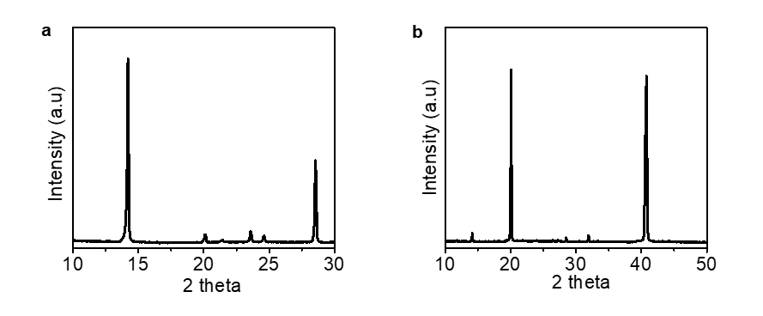
Figure 2-1. XRD patterns of a, CH₃NH₃PbI₃-1 and b, CH₃NH₃PbI₃-2. Adapted with permission from Ref 120 and Ref 121.

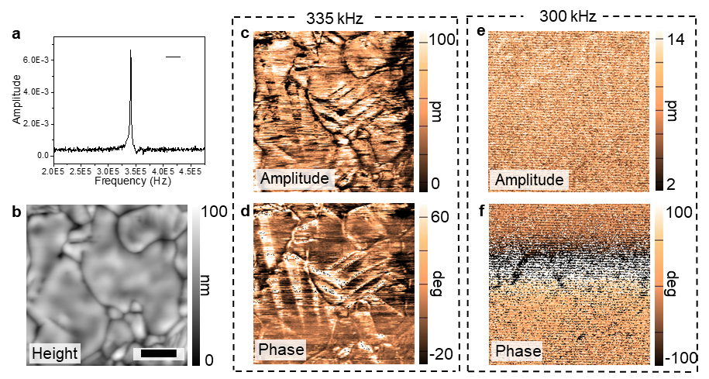
Figure 2-2. Single frequency optical beam detector piezoresponse force microscopy. a, the frequency response of tip-sample system; b, topography; c, amplitude; and d, phase taken at drive frequency of 335 kHz. e, amplitude; and f, phase taken at drive frequency of 300 kHz. The resonance frequency is 340 kHz, as acquired from (a). The twinning contrast appears when drive frequency (335 kHz) close to the resonance frequency and disappears when drive frequency (300 kHz) far from the resonance frequency. Adapted with permission from Ref 120.

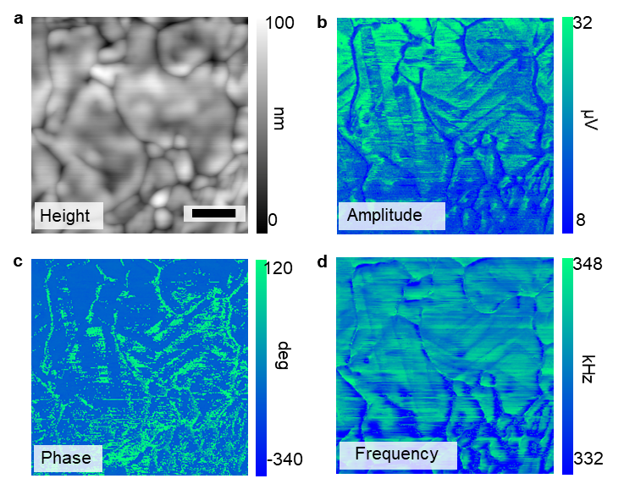
Figure 2-3. BE-PFM measurement. a, topography; b, amplitude; c, phase; and d, frequency images. The scale bar is 1 μm. Adapted with permission from Ref 120.

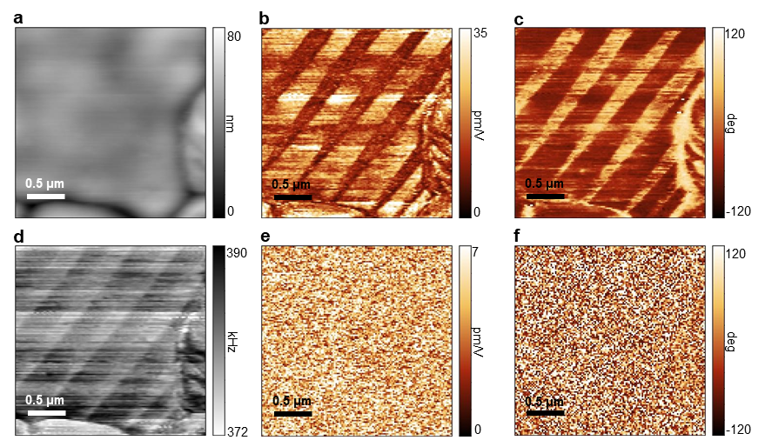
Figure 2-4. DART-PFM and IDS-PFM measurements of CH₃NH₃PbI₃-1. a, topography. b, c, d, DART-PFM amplitude, phase, and frequency images, respectively. e, f, IDS-PFM amplitude and phase images, respectively. Adapted with permission from Ref 121.

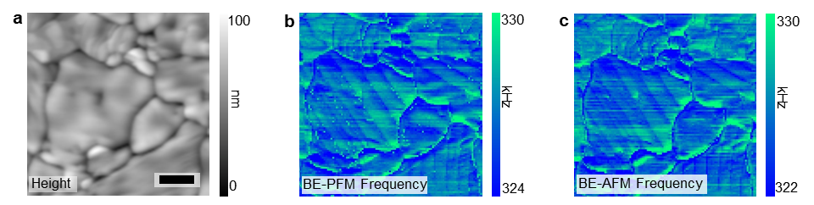
Figure 2-5. Band excitation frequency tracking. a, topography of measured area; b, band excitation piezoresponse force microscopy frequency image; c, band excitation contact resonance atomic force microscopy frequency image. The scale bar is 1 μm. Adapted with permission from Ref 120.
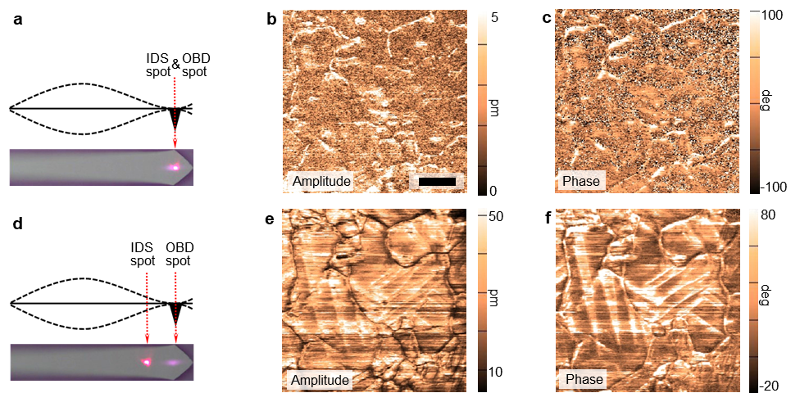
Figure 2-6. IDS-PFM taken at drive frequency of 335 kHz. a, d, top-view of images of laser spot locations, above illustrations (side view) of the expected mode shape of cantilever indicate the decoupling (a) and the coupling (d) of cantilever dynamics; b, e, amplitude images with LDV spot in the locations (a) and (d), respectively; c, f, phase images with LDV spot in the locations (a) and (d), respectively. The scale bar is 1μm. Adapted with permission from Ref 120.

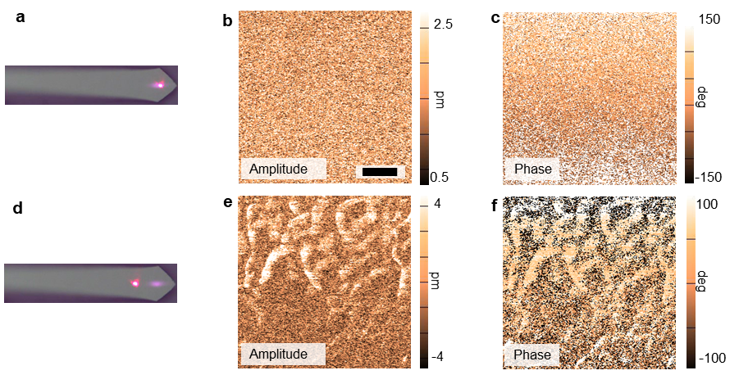
Figure 2-7. IDS-PFM measurements taken at drive frequency of 300 kHz. a, d, two top-view of photographs of laser spot locations; b, e, amplitude images with IDS spot in the locations a and d, respectively; c, f, phase images with IDS spot in the locations a and d, respectively. The scale bar is 1 μm. The disappearance of twinning contrast indicates the crucial role of cantilever dynamic effect in twinning imaging. Adapted with permission from Ref 120.

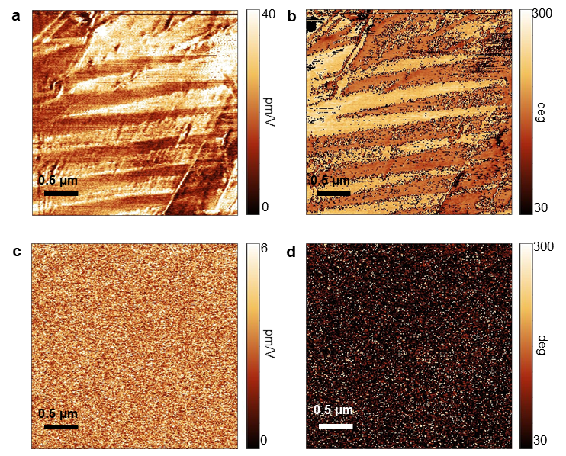
Figure 2-8. DART-PFM and IDS-PFM studies of CH₃NH₃PbI₃-2. a, b, PFM amplitude and phase images, respectively. c, d, IDS-PFM amplitude and phase images, respectively. Adapted with permission from Ref 121.

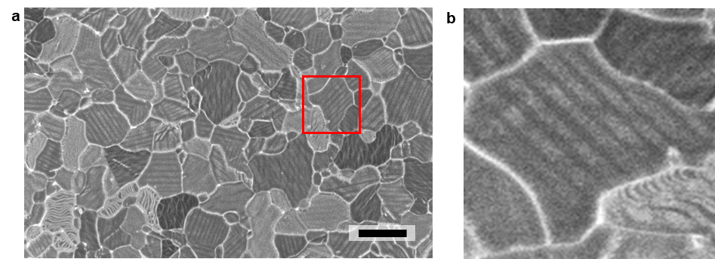
Figure 2-9. SEM. a, top view SEM image of the CH₃NH₃PbI₃-1 film, the average domain widths are in the range of 100 nm – 400 nm; b, enlarged image of the marked area in (a). The scale bar is 3μm. Adapted with permission from Ref 120.

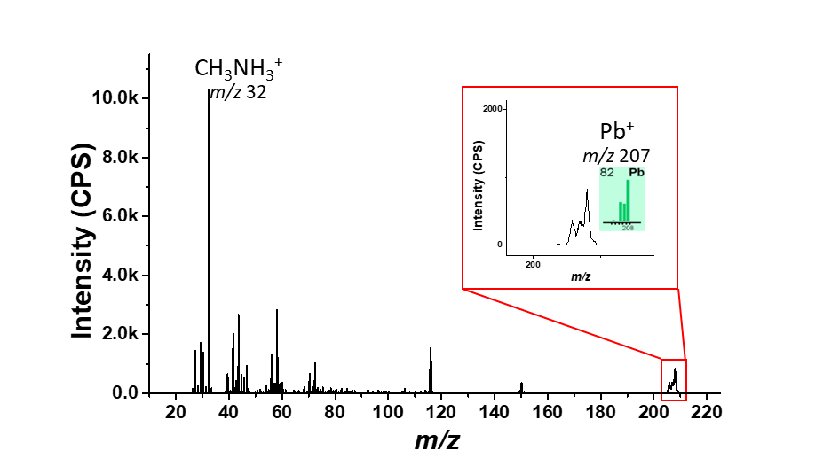
Figure 2-10. HIM-SIMS mass spectra, a strong signal of CH₃NH₃⁺ (m/z~32) is detected, however, the Pb⁺ ((m/z~207) signal is relatively very weak probably due to the weak ionization of lead. Adapted with permission from Ref 120.

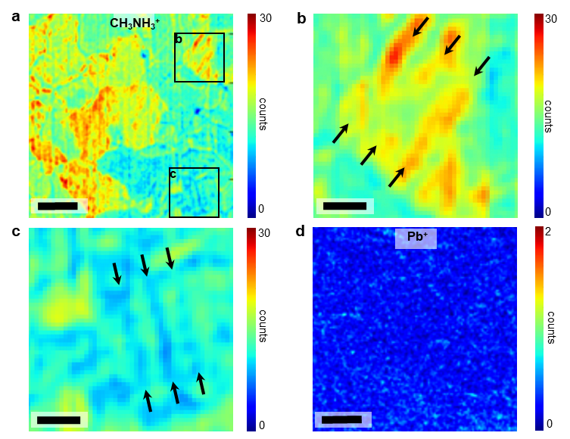
Figure 2-11. HIM-SIMS chemical maps. a, d, simultaneously obtained CH₃NH₃⁺ and Pb⁺ distribution, respectively; b, c, enlarged images in the marked areas in (a). The scale bars in (a, d) and (b, c) are 2 μm and 0.5 μm, respectively. Adapted with permission from Ref 120.

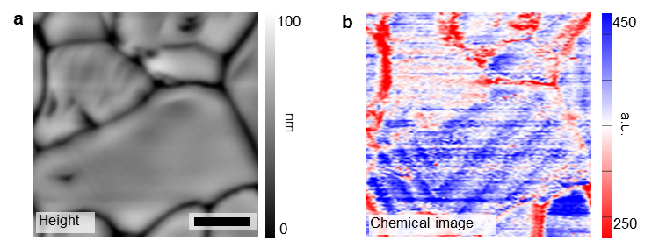
Figure 2-12. Nano-IR chemical characterization. Simultaneously obtained a, topography; and b, CH₃NH₃⁺ chemical map irradiated with 1400 cm⁻¹ laser. The scale bars in is 0.5 μm. Adapted with permission from Ref 120.

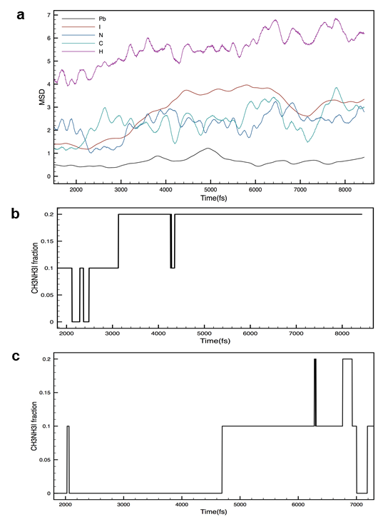
Figure 2-13. Density functional theory model. a, elemental mean squared displacement (MSD) at T=300 K obtained from ab initio molecular dynamics simulation for a tetragonal model with 1% a, b biaxial strain. C, N, H, and I show some aggregation but Pb does not. This can be seen in the image (b) obtained from a snapshot at 2100 time steps, C, N, H, I, and Pb are green ball, blue ball, white ball, pink ball, and gold ball, respectively. Adapted with permission from Ref 120.

The impacts of twin domains on the optoelectronic properties of methylammonium lead iodide
A version of this chapter was originally published^{120,158,159} by Yongtao Liu, Mingxing Li, Liam Collins, Anton Ievlev, Roger Proksch, Songkil Kim, Brianna R. Watson, Benjamin Doughty, Tessa R. Calhoun, Mahshid Ahmadi, Nikolay Borodinov, Jong K. Keum, Miaosheng Wang, Stephen Jesse, Scott T. Retterer, Alex Belianinov, Kai Xiao, Jingsong Huang, Bobby G. Sumpter, Sergei V. Kalinin, Bin Hu, Olga S. Ovchinnikova:
[1] Liu, Y., Li, M., Wang, M., Collins, L., Ievlev, A. V., Jesse, S., Xiao, K., Hu, B., Belianinov, A., Ovchinnikova, O. S. (2020). Twin domains modulate light-matter interactions in metal halide perovskites. APL Materials, 8(1), 011106.
[2] Liu, Y., Ievlev, A. V., Collins, L., Borodinov, N., Belianinov, A., Keum, J. K., Ahmadi, M., Jesse, S., Xiao, K., Huang, J., Sumpter, B. G., Hu, B., Kalinin, S. V., Ovchinnikova, O. S., (2019). Light‐Ferroic Interaction in Hybrid Organic–Inorganic Perovskites. Advanced Optical Materials, 7(23), 1901451.
[3] Liu, Y., Collins, L., Proksch, R., Kim, S., Watson, B. R., Doughty, B., Calhoun, T. R., Ahmadi, M., Ievlev, A., Jesse, S., Retterer, S. T., Belianinov, A., Xiao, K., Huang, J., Sumpter. B. G., Kalinin, S. V., Hu, B., Ovchinnikova, O. S., (2018). Chemical nature of ferroelastic twin domains in CH3NH3PbI3 perovskite. Nature materials, 17(11), 1013-1019.

3.1 Abstract
Nanostructures and local properties are critical to improve the performance of MHP optoelectronic devices. While investigations of grains and grain boundaries have significantly helped to improve the performance of MHP devices, very little is known about the effect of the ferroic twin domains and domain walls—which are analogy to grains and grain boundaries—on the properties of MHPs. Nonetheless, as illustrated in Chapter 1, theoretical predictions have shown that twin domains and domain walls can significantly affect the electronic properties and photovoltaic performance of MHPs. Currently, experimental observations regarding the effect of twin domains and domain walls are missing. This missing piece of the puzzle limits our understanding of MHPs photophysics. As a follow-up of the nature of the twin domain in CH₃NH₃PbI₃ (that was investigated in Chapter 2), in this Chapter, the impact of the twin domain on the optoelectronic properties of CH₃NH₃PbI₃ is investigated. Confocal photoluminescence (PL) studies of the twin domain illustrates that the twin domain has very little effect on the emission wavelength (PL peak position) and the PL decay dynamics, suggesting the benign effect of twin domains on optoelectronic processes in CH₃NH₃PbI₃. In contrast, the PL intensity is affected by the twin domain structure, suggesting that the twin domain may affect light-matter interaction in CH₃NH₃PbI₃ (such as light-absorption, light-trapping, and light-reemission). In addition, the difference in the interaction of the twin domain with light is also evidenced by polarization-resolved two-photon total internal reflection fluorescence microscopy (TIRFM) study. These results reveal the impact of twin domains on the photophysics of MHPs, which is critical to further developing MHPs based functional devices.

3.2 Introduction
The PCE of MHP solar cells is closely related to light absorption and charge dynamics such as charge carrier separation and transport, and recombination processes. Optoelectronic characterizations, e.g. photoluminescence (PL), are widely utilized to study the light-matter interactions and the charge dynamics in MHPs. High PL intensity and slower PL decay dynamics are generally taken as indicators of better optoelectronic performance.¹⁶⁰⁻¹⁶³ Nanostructures, like grains and grain boundaries, twin domains and domain walls, which are associated with local defect sites, have crucial effects on the performance of MHPs.¹⁶⁴⁻¹⁶⁶ Tremendous studies have demonstrated the importance of grains and grain boundaries in the overall optoelectronic properties of MHPs.^{165,167-170} It was revealed that the PL intensity and the lifetime varied between different grains and that the PL decayed faster at grain boundaries,¹⁶⁵ suggesting variations in the distribution of recombination center. Therefore, modifications of grains and grain boundaries in MHPs have effectively improved the performance of MHP solar cells.¹⁶⁶⁻¹⁷⁵ This suggests that local properties are crucial for MHP optoelectronic devices.
Recently, the observation of the twin domain structure in MHPs has raised discussion about its effects on the MHP photophysics. However, up to date, the research interest of the twin domain structure in MHPs has mostly focused on their ferroic behavior, the effects of the twin domain structure on the local optoelectronic properties of MHP are barely explored experimentally.^{99,100,120,129,176} As discussed in Chapter 1, numerous theoretical studies have illustrated that the twin domain and domain walls in MHPs have significant impacts on the optoelectronic behavior of MHPs, such as electronic bandgap,¹⁰⁶ charge separation,^{106,119} charge transport,¹⁰⁹ and photovoltaic performance.¹⁷⁷ Therefore, experimental studies of the effects of the twin domain in MHP are highly demanded.
In this Chapter, using multiple functional imaging techniques including scanning probe microscopy, scanning electron microscopy, and confocal PL microscopy, the local PL behavior relating to the twin domain structure is studied. It is found the region exhibiting the twin domain structure shows the uniform PL lifetime and the same wavelength of emitted light. In contrast, the PL intensity varies between neighboring domains. These observations suggest minor effect of the twin domain on the on the local electronic properties of CH₃NH₃PbI₃, the variation in PL intensity is probably because that the twin domain affects the light-matter interaction, such as light absorption, light trapping, etc. Furthermore, using polarization-resolved two-photon total internal reflection fluorescence microscopy (TIRFM), it is revealed that the variation in the orientation of optical transition dipole moments is tied to the twin domain structure.

3.3 Materials and Methods

3.3.1 Preparation of CH₃NH₃PbI₃ films
In this Chapter, two CH₃NH₃PbI₃ films were used. One of samples is the same to the sample CH₃NH₃PbI₃-1 used in Chapter-1, so we still term it as CH₃NH₃PbI₃-1 in this Chapter. The other one is termed as CH₃NH₃PbI₃-3. Both samples are prepared on indium tin oxide coated glass (ITO-glass) substrates, which were ultrasonically cleaned by deionized water, acetone, and isopropanol (IPA). The cleaned ITO-glass substrates were dried by N₂ and treated with UVO before spin-casting CH₃NH₃PbI₃.
The fabrication of CH₃NH₃PbI₃-1 is the same to that illustrated in Chapter 1. First, a hot PbI₂ solution (1.2 M in dimethylformamide (DMF)) was spin-casted at 6000 rpm for 30 s onto the ITO-glass and thermal annealed at 100 ºC for 1 min. Second, a CH₃NH₃I solution (0.44 M in ethanol) was spin-casted at 6000 rpm for 30 s onto the cooled-down PbI₂ fil. Third, the obtained film was annealed at 100 ºC for two hours until it converts to dark CH₃NH₃PbI₃.
The CH₃NH₃PbI₃-3 was synthesized by spin-casting a solution containing CH₃NH₃I (1 M) and PbI₂ (1 M) in mixed dimethyl sulfoxide (DMSO) and DMF (DMSO: DMF = 3:1). The as-casted film was annealed at 100-130 ºC until it fully converted to dark CH₃NH₃PbI₃.

3.3.2 Scanning electron microscopy (SEM)
The operation of SEM is similar to that in Chapter 1, which were performed on a Zeiss Merlin scanning electron microscope in the Inlens mode with a gun voltage of 1.00 kV.

3.3.3 Band-excitation piezoresponse force microscopy (BE-PFM)
BE-PFM measurement was performed at room temperature in ambient condition on either a commercial Cypher, Asylum Research and Oxford Instr. Company AFM system or an AFM-Raman system with a built-in laser. Both systems are equipped with band excitation generator. A Pt/Ir coated AFM tips (ElectriMulti75-G, Budget Sensors) with a nominal stiffness of 3 N/m was used. BE-PFM was performed by applying an AC bias of 1.0-3.0 V with a center frequency near the resonant frequency and a band width around 50-100 kHz to perturb the sample; amplitude, phase, and frequency signals were obtained via the Fourier transformation of the response of the cantilever measured by an external data acquisition system.

3.3.4 Nanoscale infrared spectroscopy (Nano IR)
The operation of Nano IR is same to that illustrated in Chapter 1, which was performed in ANASYS INSTRUMENTS including AFM-IR imaging in contact mode in nitrogen atmosphere. CH₃NH₃⁺ chemical image was recorded by exciting the CH₃NH₃PbI₃ sample with an infrared laser during scanning.

3.3.5 Polarization-resolved two-photon total internal reflection fluorescence microscopy (TIRFM)
TIRFM measurement was performed on an in-house developed custom two-photon total internal reflection fluorescence microscope. The excitation light (800 nm) was set to a known polarization with a Glan-Taylor polarizer and half-waveplate before being introduced into objective, the fluorescence signal below 725 nm was collected by the same objective and polarization resolved before being detected. The orientations of the electronic transition dipole moment can be calculated using the equation:
$$P=\frac{I_{⫽} - I_{⫠}}{I_{⫽}+ I_{⫠}}$$
where $I_{⫽}$is the fluorescence emission intensity measured using p-polarized light and $I_{⫠}$is the fluorescence emission intensity measured using s-polarized light. More details regarding TIRFM were described previously.¹⁷³

3.3.6 X-ray diffraction (XRD)
XRD was carried out in a Panalytical X’Pert MPD Pro diffractometer (45 kV, 40 mA) using Cu Kα radiation (Cu Kα1 with λ = 0.1541 nm and Cu Kα2 with λ = 0.1544 nm). The full diffraction spectra in the angular range 10º – 40º were performed with a step size of 0.0167º. The high-resolution spectra were recorded with a step size of 0.0042º. In the studies of the light-induced strain, the samples were illuminated by the specific laser for at least ~3 min before starting XRD measurement.

3.3.7 Density Functional Theory (DFT)
Molecular dynamics (MD) simulations based on density functional theory (DFT) were performed using the Vienna Ab Initio Simulation Package (VASP, 5.4.4) using the projector-augmented wave (PAW) method. The electron-ion interactions were described using standard PAW potentials, with valence electron configurations of 5d¹⁰6s²6p² for Pb, 5s²5p⁵ for I, 3s²3p⁵ for Cl, 2s²2p² for C, 2s²2p³ for N, and 1s¹ for H. To account for van der Waals interactions, the vdW-DF method implemented by Dion et al. and modified by Klimes et al. was employed. The Brillouin-zone integrations were performed on a Γ-centered 1×1×1 k-point grid and the kinetic energy cutoff for plane waves was set to 400 eV, and the “normal” precision setting was adopted. The convergence criterion for the electronic self-consistent loop was set to 10⁻⁴ eV. Supercell models of the low-energy stoichiometric (110) surface containing five Pb layers were constructed using the experimental X-ray structure of CH₃NH₃PbI₃ in a room-temperature tetragonal phase. Following full optimization of these models, the total number of electrons was modified to reflect a slightly electron-rich or hole rich case. MD simulations were then performed in a canonical NVT ensemble with the temperature of the simulations maintained by a Nose-Hoover thermostat at 300 K. A time step of 1 fs was used with the velocities of all atoms initialized randomly according to the Maxwell-Boltzmann distribution. MD simulations for at least 1 ns were evaluated to analyze the motion of the ions and overall changes in the lattice.

3.3.8 Confocal photoluminescence microscopy (confocal-PL)
The confocal PL measurements were carried out on an Olympus IX81 inverted microscope (0.50 NA 20× dry objective) using a 405 nm pulsed diode-pumped solid state laser at 5 MHz repetition rate, 10 nW average power at the sample. PL in the range from 532 nm to 800 nm was collected in the epi-illumination scheme, spectrally separated from the excitation laser light by a dichroic (Semrock, DiO-442), and spatially filtered by a 100 μm pinhole and then imaged onto a single photon counting avalanche photodiode (MPD Picoquant) coupled to a time-analyzer (PicoHarp 300, PicoQuant). The time resolution of confocal PL measurement is 60 ps. Data acquisition and data analysis were performed with the Symphotime 64 analysis software (Picoquant).

3.4 Results and Discussion

3.4.1 Transition dipole moment related to twin domains
To relate the discoveries of the elastic and the chemical variation in the twin domain in CH₃NH₃PbI₃-1 to the optical response, the TIRFM was carried out to study the optical transition dipole moment related to the crystallographic orientation and/or chemical composition.¹⁷⁸ In doing so, offer an understanding of the underlying photophysics and transport mechanisms related to the twin domain structure. Figure 3-1 shows results from TIRFM as two-photon polarization map. The color in Figure 3-1 represents the average relative orientation of the transition dipole moments. Alternating red/white stripes were observed in regions where the twin domain structure was observed in different measurements. This observation indicates the twin domain structure is related to the differences in the orientation of the transition dipole moments, consistent with the discoveries that the twin domain exhibiting a difference in crystallographic orientation¹⁷⁹ and chemical variation. These results show that the twin domain structure impacts the interaction of the CH₃NH₃PbI₃ with light which will significantly influence their applications for optoelectronic devices. As it is challenging to separate the contributions from the crystallographic orientation and the chemical composition to the changes in the transition dipole moment with TIRFM, quantifying the specific domain orientation angles is limited.

3.4.2 Photoluminescence (PL) related to twin domains
An original version of this section is previously published by Liu, Y., Li, M., Wang, M., Collins, L., Ievlev, A. V., Jesse, S., Xiao, K., Hu, B., Belianinov, A., Ovchinnikova, O. S. (2020). Twin domains modulate light-matter interactions in metal halide perovskites. APL Materials, 8(1), 011106.

3.4.2.1 Observation of twin domains in CH₃NH₃PbI₃-3
In order to investigate the correlation of the local photoluminescence behavior and the twin domain structure, CH₃NH₃PbI₃-3 with the twin domain structure several micrometers wide were synthesized, which allows to direct probe the PL of the twin domain by confocal PL microscopy. These samples were first examined by scanning electron microscopy, where the hexagonal CH₃NH₃PbI₃ crystals were observed, showing twin domain structures around several micrometers wide (as displayed in Figure 3-2a). These twin domains structures were also observed in BE-PFM, as shown in Figure 3-2b-e, which tracks resonance frequency offering the information of the local elastic properties.¹⁴⁸ BE-PFM amplitude, phase, and resonance frequency images (Figure 3-2c-e) show the same twin domain structure, indicative of the coupled amplitude/phase channels and resonance frequency channel, suggesting that the PFM measurement is impacted by the elastic variation of the twin domain structure.^{120,180} Noteworthy, when studying the twin domain structure in MHPs using single frequency PFM near resonance frequency,¹²⁰ the resonance frequency could couple with changes in local elastic property and results in amplitude and phase contrast in PFM measurement that can be misinterpreted as piezoelectric contrast,^{133,180} as illustrated in Chapter 1.

3.4.2.2 Photoluminescence (PL) behavior of the twin domain structure
Next, the local PL behavior was investigated by correlating SEM and PL spectroscopy. The twin domain structure was first located using SEM (Figure 3-3a), then a confocal Raman microscope equipped with a CCD detector was used to detect the PL spectrum from a microscale region. The visibility of the twin domain structure in the optical image (Figure 3-3b) enables precise locating the twin domain structure. The PL spectra from four different spots (spot size ~1 μm) in the different twin domains (marked in Figure 3-3b) are very similar, showing a <1nm variation in peak position. This suggests that the different twin domain has a similar bandgap as PL emission energy (or wavelength) is usually related to the electronic bandgap of the material.
Confocal PL intensity and PL lifetime measurements were further performed to study the effect of the twin domain structure on the PL behavior. Figure 3-4 shows the confocal PL results, where Figure 3-4a shows the twin domain structure and the region corresponding to the confocal PL results. Figure 3-4b shows the PL intensity map, which indicates a small variation in the PL intensity between the neighboring twin domain. Figure 3-4c shows a spatially resolved PL lifetime map from the same region, which indicates uniform PL decay dynamics, suggesting no detectable variation of PL decay dynamics between the neighboring twin domains. In addition, a PL intensity vs. time diagram is also shown in Figure 3-5, indicating the detailed lifetime information of this sample. Noteworthy, the striped variation in PL intensity map are consistent with the twin domain structure observed in SEM image here (Figure 3-4b vs Figure 3-4a).
In contrast, in another region, the twin domain in SEM image (Figure 3-6a) are different from the striped variation in PL intensity (Figure 3-6b). However, PL lifetime map (Figure 3-6c) still shows uniform decay dynamics in this region. Accordingly, it is speculated that there are at least two different kinds of twin domains here—one kind of domain observed in SEM (Figure 3-6a), which does not affect PL intensity; while the other kind of twin domain affect PL intensity, leading to the striped variation in PL intensity (as shown in Figure 3-6b). It should be noted that previous publication has already reported the coexistence of different twin domains in the same region,¹³⁰ consistent with this speculation. Therefore, it is reasonable to propose that different kinds of twin domains have various impact on the PL behavior of CH₃NH₃PbI₃, which probably depends on the domain configuration including crystallographic orientation, chemical composition, etc.
However, the twin domain structure only has an impact on the local PL intensity but not the PL lifetime, which both are generally related to the quality of the material. A high-quality material with a low density of nonradiative recombination center, e.g. defect sites, usually shows strong PL intensity and long PL lifetime. Accordingly, the striped variation in PL intensity is unlikely due to the difference in defect density as the PL lifetime in the same region is uniform. In addition, a difference in defect density may also lead to a shift in the PL emission wavelength, so the same PL spectra in the different twin domains further evidence that the defect density is not the origin of the striped PL intensity variation. Previous study has indicated that this twin domain has different crystallographic orientations,¹³² which can lead to anisotropic optical properties and consequently impact the light-matter interaction between the neighboring twin domains due to differences in light-absorption, light-transport, and light-trapping. As a consequence, the difference in light-matter interaction results in the different PL intensity between the neighboring twin domains. However, if this anisotropic optical behavior does not affect the defect density and the electronic properties, the PL lifetime and the PL emission wavelength will not be affected. According to this analysis, it is proposed that the twin domain structure is associated with a difference in light-matter interaction, leading to the PL intensity variation between the neighboring twin domains.
These results and analyses imply that the effect of the twin domain on the optoelectronic properties of CH₃NH₃PbI₃ is minor, which is unlikely a determining factor for the outstanding photovoltaic performance of CH₃NH₃PbI₃.

3.4.2.3 Potential effect of domain walls in CH₃NH₃PbI₃
Although it is demonstrated that twin domain has minor effect on the optoelectronic properties of CH₃NH₃PbI₃, most theoretical studies suggested that, it is the domain walls, not domains, that affect the optoelectronic properties of CH₃NH₃PbI₃.^{119,181,182} However, limited by the spatial resolution of PL microscope, it is challenging, even impossible, to directly study the effect of domain walls—usually have a size of <10 nm. Ferroelasticity can induce a different strain condition near the domain walls which is expected to have a different impact on optoelectronic properties.¹¹⁹ Accordingly, the effects of domain walls can be different the domains, further efforts are encouraged to further clarify relevant questions.

3.4.3 Light-ferroic interaction in CH₃NH₃PbI₃
Follow on the Section 3.4.2, it is worth further exploring the light-matter interaction in CH₃NH₃PbI₃, therefore, we study the interaction of light with the ferroic twin domain in CH₃NH₃PbI₃-1 in this Section. An original version of this Section was published by Liu, Y., Ievlev, A. V., Collins, L., Borodinov, N., Belianinov, A., Keum, J. K., Ahmadi, M., Jesse, S., Xiao, K., Huang, J., Sumpter, B. G., Hu, B., Kalinin, S. V., Ovchinnikova, O. S., (2019). Light‐Ferroic Interaction in Hybrid Organic–Inorganic Perovskites. Advanced Optical Materials, 7(23), 1901451.

3.4.3.1 Correlation of domains observed in different microscopies
Chapter 1 has shown that the twin domain in CH₃NH₃PbI₃ exhibits elastic variation^{120,183} and chemical segregation¹²⁰ between adjacent domains, while the detailed interplay between different behaviors, such as how chemical variation impacts elastic and electronic properties, is still missing. Thus, BE-PFM, AFM-IR,¹⁸⁴ and SEM measurements were performed at the same region in order to correlate the elastic variation, the chemical variation, and the local interaction of the material with electron. In addition, a topography image was also recorded simultaneously to ensure that the observed features are not due to topography crosstalk since all these techniques are surface sensitive. Figure 3-7 shows the topography image, BE-PFM frequency map, AFM-IR CH₃NH₃⁺ chemical map, and SEM micrography of the CH₃NH₃PbI₃ film, where the same twin domain is visible in all images (Figure 3-7b-d) except for the topography image (Figure 3-7a), indicating the observation of the twin domain is not due to topography crosstalk. As mentioned before, the observation of twin domains in BE-PFM frequency image (Figure 3-7b) suggests the variation in elastic property between the neighboring domains;¹⁴⁸ the observation of twin domains in AFM-IR chemical image (Figure 3-7c) indicates the variation in CH₃NH₃⁺ density between the neighboring domains. Moreover, the twin domain in SEM micrograph (Figure 3-7d) implies a difference in the interaction of the neighboring twin domain with the electron beam, which is probably due to the shift of local energy level induced by CH₃NH₃⁺ concentration difference as it was revealed that excess CH₃NH₃⁺ can cause an upshift of energy level of CH₃NH₃PbI₃.¹⁵²

3.4.3.2 Interaction between light and ferroic domain
Next, the interaction between the twin domain and light was investigated by an AFM/Raman system with a built-in optical system, The BE-PFM measurement was performed in this system with/without an illumination by a 532 nm laser, the topography and the resonance frequency images were obtained simultaneously, as shown in Figure 3-8. In Figure 3-8b, without the illumination by laser, the twin domain is visible in the resonance frequency image, consistent with previous observations, suggesting elastic variation between the neighboring twin domains. In contrast, under the illumination of the 532 nm laser (2 mW), the twin domain is invisible in the resonance frequency image, as shown in Figure 3-8d, suggesting that the variation in the elastic property between the neighboring twin domains is suppressed by light illumination. Simultaneously, the topography (Figure 3-8a and 3-8c) images with/without illumination show no obvious difference, suggesting that the observed changes in frequency image under illumination is not due to topography crosstalk. Profile analyses in Figure 3-8e and 3-8f also indicate no correlation between resonance frequency and topography. These results suggest the strain condition coupled with the twin domain is altered by light illumination in CH₃NH₃PbI₃.

3.4.3.3 Mechanism of light-ferroic interaction
The mechanism of the interaction between the light and the twin domain observed above was further investigated. Since the CH₃NH₃⁺ segregation can affect the electronic band gap that will further impact the transport and distribution of photogenerated charge carriers,¹⁸⁵ in addition, CH₃NH₃PbI₃ is an outstanding photovoltaic material generating tremendous charge carriers under illumination, the effect of photogenerated charge carriers on the light-ferroic interaction is mainly addressed. The difference in elastic property and chemical composition between the neighboring twin domain may cause preferential motion of photogenerated electrons and holes toward specific domains, respectively, forming electron-rich domain and hole-rich domain consequently, as schematically shown in Figure 3-9. The electrons and the holes further generate lattice strain in respective domains due to charge-lattice interaction,^{186,187} resulting in a change in local strain associated with the twin domain, which can suppress the original strain variation and lead to a disappearance of elastic variation between neighboring domains.
Density function theory (DFT) calculation was carried out to verify this hypothesis by performing simulations of the electron-rich domain and the hole-rich domain using models containing additional electrons or holes, respectively. The results of DFT-molecular dynamics (Figure 3-10) show that both the electron-rich and the hole-rich models lead to lattice expansion: ~0.45% for electron-rich and ~0.75% for hole-rich (as schematically illustrated in Figure 3-9). The different generated strain due to charge-lattice interaction can result in the suppression of the original strain differences in the twin domains, consistent with our observations in Figure 3-8, where the domain contrast is suppressed by illumination.

3.4.3.4 Light-induced strain
Light-induce strain was further studied by X-ray diffraction (XRD), evidencing the DFT simulations. A XRD spectrum between 10º to 30º (2θ) in Figure 3-11a suggests that the CH₃NH₃PbI₃-1 is stable at the tetragonal phase at room temperature.¹⁸⁸ High-resolution XRD measurement in the range of 28.4º-28.7º was performed to study the light-induced lattice strain, where the peak of (220)/(004) reflection is observed. In Figure 3-11b, a left shift of (220)/(004) reflection (toward low diffraction angle shift) is observed when illuminating the sample using a 640 nm laser, indicating a lattice expansion of CH₃NH₃PbI₃. This lattice expansion is reversible, the left shift recovers when the laser is turned off (Figure 3-11b). Since the photo energy of 640 nm laser (1.94 eV) is larger than the CH₃NH₃PbI₃ bandgap (~1.51 eV-1.58 eV), the extra photo energy can induce the thermal effect that change the lattice structure, an additional measurement with 785 nm laser illumination was performed to examine the thermal effect induced by extra photon energy. The photon energy of 785 nm laser (1.58 eV) was close to the CH₃NH₃PbI₃ bandgap (~1.51 eV-1.58 eV), so the thermal heating due to the extra photon energy is negligible in this case. Nonetheless, the lattice expansion is still observed (Figure 3-11c), suggesting that the lattice expansion is not induced by the thermal heating due to extra photo energy. This light-induced lattice expansion is consistent with the DFT simulation that shows lattice expansion in both electron-rich and hole-rich models.
The dependence of the lattice expansion on the laser intensity and wavelength was further studied to clarify the mechanism of light-induced lattice strain. If the light-induced lattice strain is indeed due to photogenerated charge carriers, the significance of the lattice expansion should depend on the laser intensity as the density of photogenerated charge carriers depends on the laser intensity. As shown in Figure 3-11d, the peak shift of the (220)/(004) reflection of CH₃NH₃PbI₃ increases with laser (640 nm laser) intensity increases, indicating that the lattice expansion indeed depends on the laser intensity. In contrast, no peak shift was observed when illuminating a CH₃NH₃PbBr₃ sample using the 640 nm laser, as shown in Figure 3-12a, while a peak shift to low angle was observed when illuminating the CH₃NH₃PbBr₃ sample by a 488 nm laser (Figure 3-12b). This is because the bandgap of CH₃NH₃PbBr₃ is 2.18-2.21 eV (correspond to the absorption edge of ~561-569 nm), no charge carrier was generated in CH₃NH₃PbBr₃ under 640 nm laser illumination. Thus, this observation is also consistent with the proposed mechanism that the photogenerated charge carriers are responsible for the light-induced lattice strain. In addition, no peak shift in CH₃NH₃PbBr₃ under 640 nm laser illumination suggests that the light-induced lattice expansion is not due to the light scattering induced heating effect.

3.4.3.5 Light-induced strain
The interaction of light with ferroic properties has been extensively discussed previously.¹⁸⁹⁻¹⁹² For example, ferroelectric depolarization field can induce surface charging and discharging effect, altering the surface potential of a ferroelectric material under light illumination.¹⁹⁰ Domain pinning can also be induced due to an electric field within the surface dielectric layer formed by the interaction between ferroelectric polarization charge and photoexcited charge.¹⁸⁹ In addition, photogenerated charge carriers coupled with the internal field can induce the motion of the domain walls in ferroic materials.^{191,192} All these phenomena are induced by the interaction between ferroic polarization and photogenerated charge carriers and occur at interfaces such as surface or domain walls. However, the phenomenon observed in CH₃NH₃PbI₃ is not limited at interfaces but extends to the bulk of the materials. Moreover, similar phenomenon observed in cubic CH₃NH₃PbBr₃ suggests that ferroic polarization is not the driving force, as ferroic (ferroelectric and ferroelastic) behaviors are not expected in a cubic phase material. Instead, the main driving force of this phenomenon is the interaction between photogenerated charge carrier and lattice. The softer structure of MHPs is probably the reason for the difference in light-ferroic interaction between MHPs and classical ferroic perovskite oxide, where a softer structure is more prone to be distorted by external stimuli.

3.5 Conclusion
In conclusion, the effect of the twin domain on the optoelectronic properties of CH₃NH₃PbI₃ was studied. It is first found that the twin domain is associated with the alignment of local optical transition dipole moment in CH₃NH₃PbI₃. Furthermore, the photoluminescence studies suggest that the twin domain only affects the local photoluminescence intensity but does not affect the photoluminescence lifetime and the photoluminescence emission wavelength, which suggests that the twin domain only has a minor impact on the photoluminescence behavior of CH₃NH₃PbI₃. By analyzing the photoluminescence results and considering the factors that can affect photoluminescence property, it is suggested that the twin domain impacts the local light-matter interactions (such as light-absorption and light-trapping) in CH₃NH₃PbI₃ and hence alters the photoluminescence intensity. In addition, it is revealed that light-induced screening effect can suppress the elastic variation between the twin domains due to the preferential photocarriers distribution induced by chemical variation and then the charge-lattice interaction induced strain. The discovered light-ferroic interaction here is a bulk effect, which extends the fundamental understanding of light-ferroic interactions that often occurs in the interfaces in classical ferroic materials. The discoveries in this Chapter are crucial for the development on photovoltaic and optical devices based on MHPs. In addition, it is expected that these discoveries can stimulate more exploration on the photophysics of the twin domain in MHPs.

Appendix

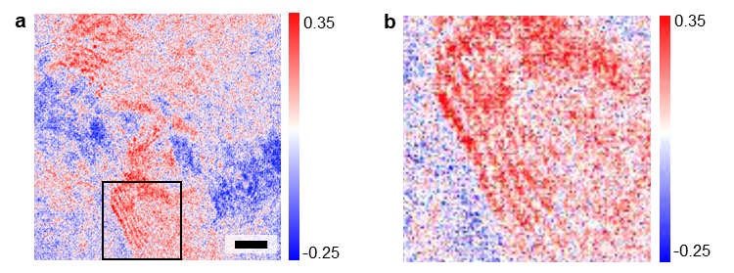
Figure 3-1. TIRFM. a, two-photon polarization map; b, enlarged image of the marked area in (a). The scale bars in (a) is 5 μm. Adapted with permission from Ref 120.

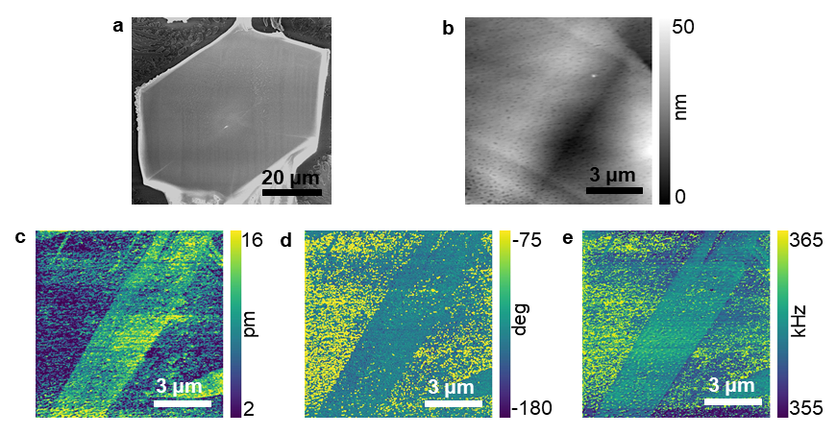
Figure 3-2. CH₃NH₃PbI₃-3 microcrystal exhibits twin domains. a, SEM micrograph of CH₃NH₃PbI₃ hexagon crystal, twin domains are visible in the crystal; b-d, BE-PFM results, height map (b), amplitude map (c), phase map (d), and resonance frequency map (e). Adapted with permission from Ref 158.

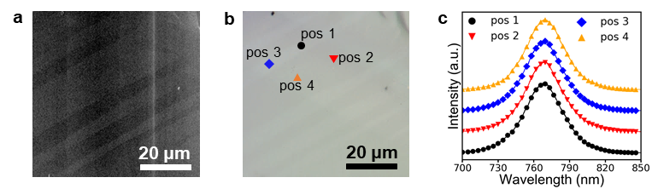
Figure 3-3. PL results. a, SEM micrograph and b, optical micrograph of a region showing twin domains; c, PL spectra of the positions in neighboring domains marked on (b). Adapted with permission from Ref 158.

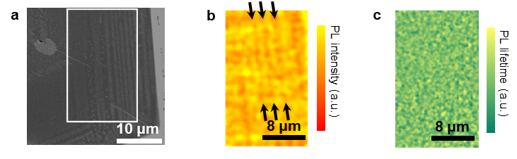
Figure 3-4. Confocal PL results. a, SEM micrograph of a region showing twin domains; b-c, PL intensity map and PL lifetime map of the zoomed-in region marked on (b), respectively. Adapted with permission from Ref 158.

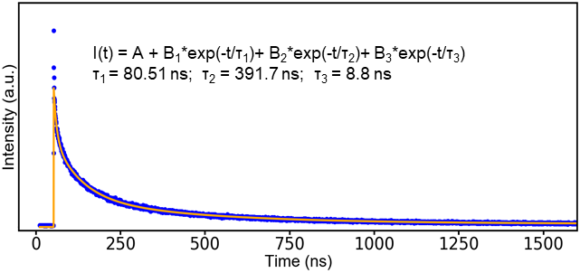
Figure 3-5. PL intensity vs. time diagram shows the detailed PL lifetime information of the sample. Adapted with permission from Ref 158.

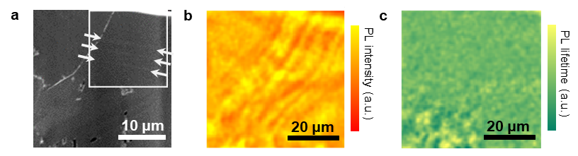
Figure 3-6. Confocal PL study of another region. a, SEM micrograph, twin domains are indicated by arrows; b, PL intensity map and c, PL lifetime map of the zoomed-in region marked on (a). Adapted with permission from Ref 158.

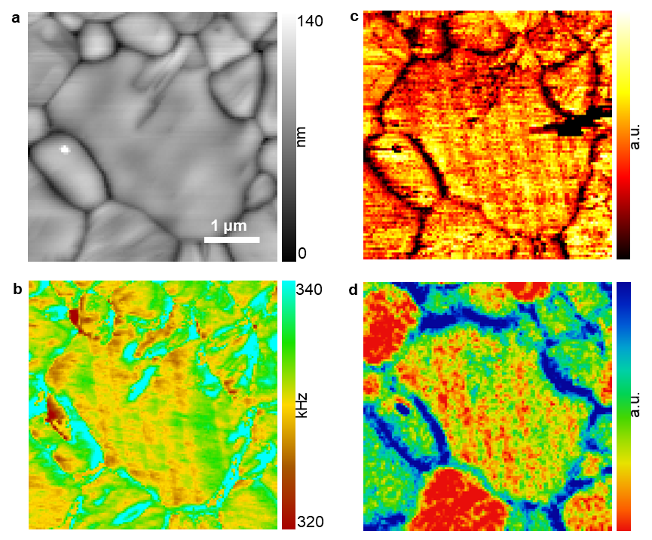
Figure 3-7. Twin domain characterization combining multiple imaging techniques. a, Topography; b, BE-PFM frequency image; c, AFM-IR chemical (CH₃NH₃⁺) image; d, SEM image. Adapted with permission from Ref 159.

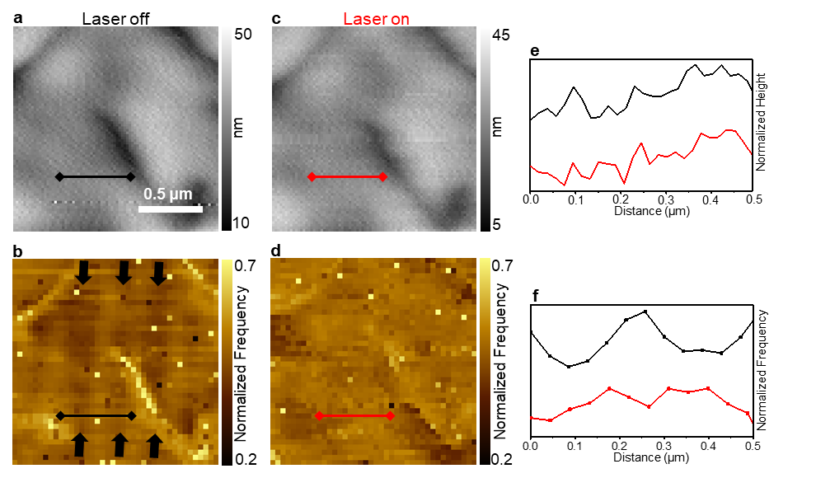
Figure 3-8. Light-induced strain evolution in the CH₃NH₃PbI₃ twin domains with CH₃NH₃⁺ segregation. a, c, Topography. b,d, resonance frequency images. (a) and (b) are acquired without 532 nm laser illumination. (c) and (d) are acquired with 532 nm laser illumination. e, Profile analyses corresponding to lines marked in (a) and (c). f, Profile analyses corresponding to lines marked in (b) and (d). Adapted with permission from Ref 159.

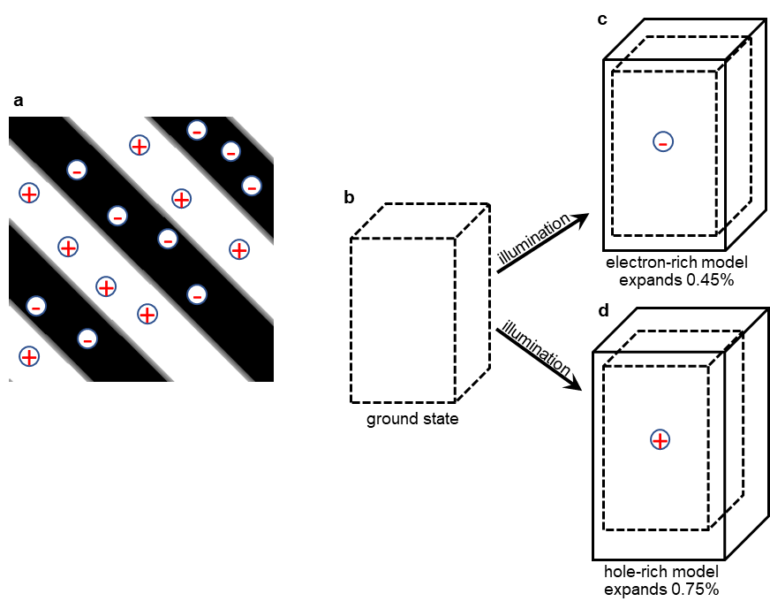
Figure 3-9. a, Schematic illustration of photo-generated carrier distributions in CH₃NH₃PbI₃ twin domains. b-d, a schematic to illustrate the DFT results. Both (c) the electron-rich model and (d) the hole-rich model show lattice expansion, the electron-rich model expands 0.45% and the hole-rich model expands 0.75%. Adapted with permission from Ref 159.

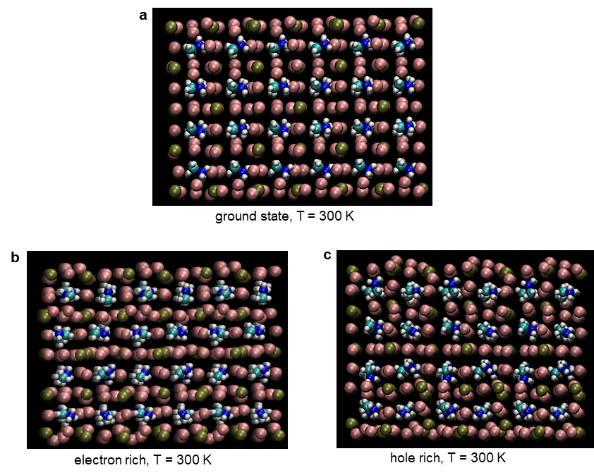
Figure 3-10. MD simulations of photo-induced mechanical response at 300 K. a) a tetragonal CH₃NH₃PbI₃ supercell model before introducing carrier-lattice interaction. b) an electron-rich supercell with electron-lattice interaction. c) a hole-rich supercell with hole-lattice interaction. Both electron-rich and hole-rich induce lattice expansion. Compared to the neutron supercell, I—I distances in the electron-rich supercell and the hole-rich supercell expand by 0.05 angstroms and 0.09 angstroms, respectively. These I—I distance changes finally cause lattice expansions of 0.45% and 0.75% in electron-rich and hole-rich supercells, respectively. Adapted with permission from Ref 159.

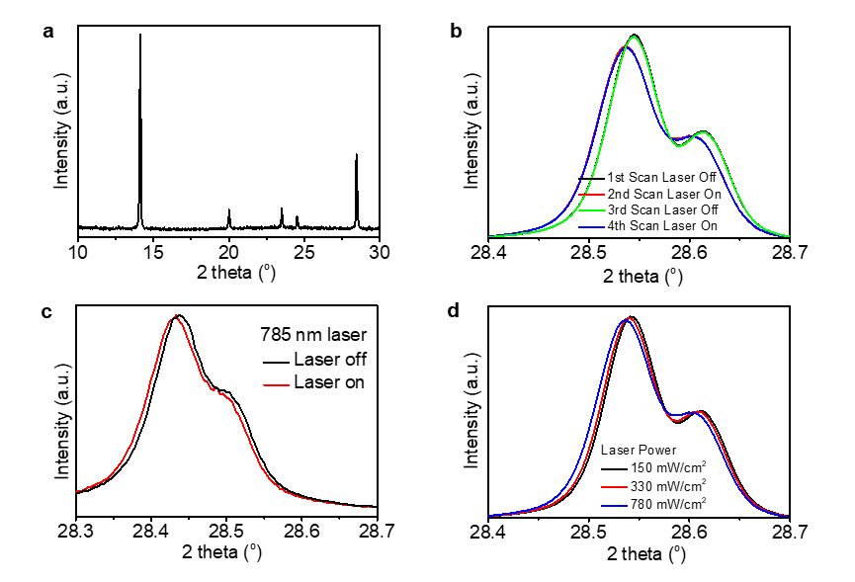
Figure 3-11. X-ray diffraction (XRD) reveals the lattice structure change of CH₃NH₃PbI₃-1 induced by photoexcitation. a, a full X-ray diffraction spectrum of CH₃NH₃PbI₃-1 from 10º-30º. b, XRD of CH₃NH₃PbI₃-1with/without 640 nm laser illumination. c, XRD diffraction of CH₃NH₃PbI₃-1 with/-out 785 nm laser illumination. d, XRD of CH₃NH₃PbI₃ with various intensity 640 nm laser illumination. The peaks in (b-d) correspond to (220) and/or (004) lattice planes of tetragonal CH₃NH₃PbI₃. The high intensity and the low intensity peaks are due to Cu Kα1 and Cu Kα2 radiation, respectively, which both originate from the same diffraction. Adapted with permission from Ref 159.

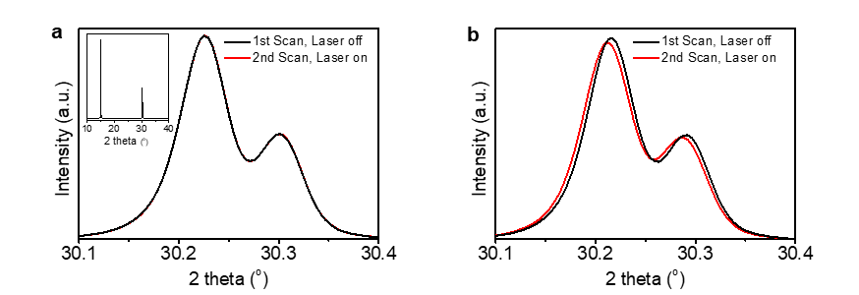
Figure 3-12. X-ray diffraction (XRD) reveals the lattice structure change of CH₃NH₃PbBr₃ induced by photoexcitation. a, XRD of CH₃NH₃PbBr₃ with/-out 640 nm laser illumination, the insert is a full XRD spectrum from 10º-40º. b, XRD of CH₃NH₃PbBr₃ with/without 488 nm laser illumination. The peaks in (a) and (b) correspond to the (002) lattice plane of pesudo-cubic CH₃NH₃PbBr₃. The high intensity and the low intensity peaks are due to Cu Kα1 and Cu Kα2 radiation, respectively, which both originate from the same diffraction. Adapted with permission from Ref 159.

Ion migration and its impact in operando devices
The results in this chapter were originally published¹⁹³ or submitted by Yongtao Liu, Anton V. Ievlev, Liam Collins, Nikolay Borodinov, Alex Belianinov, Matthias Lorenz, Stephen Jesse, Kai Xiao, Mahshid Ahmadi, Bin Hu, Sergei V. Kalinin, Olga S. Ovchinnikova:
[1] Liu, Y., Ievlev, I.V., Collins, L., Borodinov, N., Belianinov, A., Lorenz, M., Jesse, S., Xiao, K., Ahmadi, M., Hu, B., Kalinin, S. V., Ovchinnikova, O. S., (under review, 2020). Direct observation of photoinduced ion migration in lead halide perovskites.
[2] Liu, Y., Borodinov, N., Lorenz, M., Ahmadi, M., Kalinin, S. V., Ievlev, A., Ovchinnikova, O. S., (2020). Hysteretic Ion Migration and Remanent Field in Metal Halide Perovskites." Advanced Science 7.19: 2001176.
[3] Liu, Y., Borodinov, N., Collins, L., Ovchinnikova, O. S., Ievlev, I.V., (under review, 2020). Interfacial Ion and Charge Pile-Up in Metal Halide Perovskites

4.1 Abstract
Many phenomenal observations in MHPs are underpinned by the complex interactions between ion migration and electronic property. The accumulation of ions and associated charge carriers is critical to the performance of semiconductor devices. However, the understanding of ion migration is very limited, albeit conflicting data is available on ferroic behaviors, virtually nothing is known on the ionic dynamics in the operando MHPs devices. In particular, the debate regarding the correlation between ion migration, charge dynamics, and current-voltage hysteresis of MHPs devices has lasted for many years, the challenge in answering the related questions is the difficulty in directly uncovering the chemical dynamics, as well as identifying and separating the impact of specific ions on the device performance. In this Chapter, the behavior of ion migration in MHPs will be systematically studied, including electric-induced ion migration, photoinduced ion migration, and interfacial ion accumulation, as well as the current-voltage behavior, electric field distribution, and charge carrier accumulation associated with the ion migration. Not only the intrinsic composition ions (such as CH₃NH₃⁺, I⁻, Pb²⁺) but also the extrinsic ions (contamination, decomposition, etc) will be investigated. The ion migration is directly observed using a newly developed time-resolved time-of-flight secondary ion mass spectrum (tr-ToF-SIMS). It is revealed that the light illumination can directly drive CH₃NH₃⁺ motion in CH₃NH₃PbI₃ and CH₃NH₃PbBr₃, where the photoexcitation energy is critical to the light-induced CH₃NH₃⁺ motion, while no I⁻ and Br⁻ motion induced by light is observed. The accumulation of CH₃NH₃⁺ induced by electric poling can be suppressed by light illumination. In addition, both CH₃NH₃⁺ and I⁻ migration under bipolar electric bias waveform is hysteretic, where the CH₃NH₃⁺ hysteretic behavior is more illumination-dependent. Moreover, combining tr-ToF-SIMS with a machine learning approach, the migration behavior of a number of ions corresponding to the decomposition products of CH₃NH₃⁺ is also found to be hysteretic. Correlating the above observed ion migration with the current-voltage (I-V) characterization, it is unveiled that the electric-induced CH₃NH₃⁺ redistribution can induce a remanent current after the removal of the applied electric field under light illumination, while this remanent current is not observed under dark condition. This suggests that CH₃NH₃⁺ migration may contribute to the current-voltage hysteresis here as CH₃NH₃⁺ migration is also light-dependent. Using time-resolved Kelvin probe force microscopy (tr-KPFM), it unveils that the interaction between the interfacial ion distribution and the charge dynamics is complex under the application of electric bias because involvement of the injected charge carriers in the detected signal. Therefore, an on-off field method is further developed to exclude the effect of the injected charge carriers, allowing to unveil a straightforward correlation between interfacial ion accumulation and charge dynamics. These results suggest that there are a number of mobile ions in MHPs and their correlation with physical response is complex in some cases. However, indirect observations of ion migration (e.g. using KPFM, I-V, etc) often provide physical information associated with ion migration rather than direct chemical changes, therefore, careful and comprehensive consideration should be taken when interpreting these results. Overall, the results in this Chapter provide previously unknown knowledge that is critical to improving the performance of MHPs optoelectronics and developing new functional devices based on MHPs.
This Chapter is revised based on a published paper¹⁹³ and two manuscripts by [1] Liu, Y., Ievlev, I.V., Collins, L., Borodinov, N., Belianinov, A., Lorenz, M., Jesse, S., Xiao, K., Ahmadi, M., Hu, B., Kalinin, S. V., Ovchinnikova, O. S., (under review, 2020). Direct observation of photoinduced ion migration in lead halide perovskites. [2] Liu, Y., Borodinov, N., Lorenz, M., Ahmadi, M., Kalinin, S. V., Ievlev, A., Ovchinnikova, O. S., (2020). Hysteretic Ion Migration and Remanent Field in Metal Halide Perovskites." Advanced Science 7.19: 2001176. [3] Liu, Y., Borodinov, N., Collins, L., Ovchinnikova, O. S., Ievlev, I.V., (under review, 2020). Interfacial Ion and Charge Pile-Up in Metal Halide Perovskites.

4.2 Introduction
During the development of MHPs optoelectronics, it is well established that underlying chemical dynamics in this class of materials can induce many phenomena such as current-voltage hysteresis,¹⁹⁴ anomalous interfacial and bulk polarization,^{195,196} local doping,¹⁹⁷ phase segregation and structural changes,^{77,159,198-200} self-poling,²⁰¹ giant dielectric constant and capacitive effects,²⁰²⁻²⁰⁴ electrochemical degradation and low stability,^{205,206} photovoltaic switching,⁶⁷ and resistance-switching.²⁰⁷ However, how the underlying ion migration affects these properties is not fully understood yet, mainly due to the lack of direct observation of ion migration in operando condition in MHPs.
Mostly, ion migration in MHPs is probed either directly by photo­thermal induced resonance (PTIR),⁶⁷ X-ray photoemission spectroscopy (XPS), energy-dispersive X-ray spectroscopy, and time-of-flight secondary ion mass spectroscopy (ToF-SIMS).^{206,208-210} in the static regime or indirectly by photoluminescence (PL) mapping,^{211,212} scanning probe microscopy (SPM),^{84,85,176,213-217} and impedance spectroscopy.²¹⁸ However, MHP is an intricate ionic system including various mobile ionic species—including both intrinsic (e.g. organic cations and halide anions)^{68,211,212,219,220} and extrinsic (e.g. sodium, lithium, silver, gold, etc.)^{197,209,221,222} mobile ions—that can controversially affect the material properties,^{77,223-225} such as annihilating defects²¹² or in contrast creating recombination centers.^{68,211,226} This leads to superimposed mechanisms of the correlation between ion migration and physical properties of MHPs. Therefore, ion migration probed by indirect methods or in static regime loses the precise information about how ion migration impacts the device operation. In particular, in indirect measurements, it is challenging or even impossible to know which mobile species is main origin of a phenomenal observation as such an indirect observation can be induced by any ions. This leads to controversies of the origin of the physical phenomena concerning ion migration. Fox example, the changes in the electrostatic potential probed by Kelvin probe force microscopy (KPFM) are widely attributed to ion migration; however relating the observed electrostatic potential to the underlying ionic behavior is highly non-trivial because the detected signal is strongly affected by surface charge dynamics that can overwhelm the intrinsic bulk properties;²²⁷ moreover, the surface polarity can even be opposite to the bulk polarization due to screening effects.²²⁸⁻²³⁰ For MHPs that contain various mobile ions and inducible charge injection under certain conditions, the correlation between the physical response and the chemical dynamics can be more complicated, which necessitates a method to directly detect the ion migration in operando condition. Further correlating the directly observed ion migration with the physical response detected by functional techniques will provide a precise understanding regarding how ion migration affects the functionality of MHPs.
In this Chapter, using an in-house developed time-resolved time-of-flight secondary ion mass spectrometry (tr-ToF-SIMS), the time evolution of ion distribution in CH₃NH₃PbI₃ and CH₃NH₃PbBr₃ induced by electric field and light illumination is directly observed. It is observed that light illumination only induces an observable CH₃NH₃⁺ redistribution but does not affect the I⁻/Br⁻ distribution, the CH₃NH₃⁺ segregation driven by electric field is suppressed by light illumination. The photoexcitation is a prerequisite for the photoinduced CH₃NH₃⁺ migration in MHP. Under a bipolar electric bias waveform, both CH₃NH₃⁺ and I⁻ migrations show hysteresis, where the CH₃NH₃⁺ migration is more illumination-dependent showing larger loops under illumination. Using a machine learning approach—non-negative matrix factorization (NMF)—to analyze the tr-ToF-SIMS results, it is discovered that a group of ions corresponding to the decomposition of CH₃NH₃⁺ also shows hysteresis under bipolar electric bias.
To correlate these observations of ion migration with the physical responses, the current-voltage characterization (I-V) and the time-resolved Kelvin probe force microscopy (tr-KPFM) are performed to study I-V behavior, electric field changes, and charge dynamics. In I-V measurements, it is elucidated that the CH₃NH₃⁺ redistribution driven by electric field under illumination can leads to a remanent field after removing the applied electric bias, resulting in a spontaneous current that lasts at least 200 s. Moreover, the spontaneous current is dependent on preceding bias and shows hysteresis as well. In tr-KPFM measurement, it is found that the evolution of electric field is opposite to that of the CH₃NH₃⁺ migration. In addition, a complex correlation between the ion migration and charge dynamics under the application of electric bias is seen. Thus, an on-off field method is further utilized to exclude the charge injection due to the applied bias, then a straightforward correlation between ion migration and charge dynamics is revealed.
These results extend previous understandings about ion migration based on measurements in the indirect mode and/or in the static regime, pointing out the limitation of previous understandings about ion migration and associated phenomena in MHPs. These discoveries are expected to guide future studies about ion migration in MHPs and stimulate new research interest of MHPs-based optoelectronic and functional devices.

4.3 Materials and Methods

4.3.1 Preparation of CH₃NH₃PbX₃ (X = I or Br) films and lateral devices
In this Chapter, two CH₃NH₃PbI₃ samples (CH₃NH₃PbI₃-1 and CH₃NH₃PbI₃-3) and one CH₃NH₃PbBr₃ sample are used. The synthesis methods of CH₃NH₃PbI₃ samples are the same to previously illustrated. CH₃NH₃PbI₃-1 is synthesized by spin-casting hot PbI₂ solution (1.2 M in DMF) and CH₃NH₃I solution (0.44 M in ethanol) sequentially followed by thermal-annealing at 100 ºC for 2 hours. CH₃NH₃PbI₃-3 is synthesized by spin-casting the precursor containing 0.8 M Pb(CH₃COO)₂·3H₂O and 2.5 M CH₃NH₃I in DMF followed by thermal-annealing at 100 ºC for 30 min. CH₃NH₃PbBr₃ is synthesized by spin-casting the precursor containing 0.8 M Pb(CH₃COO)₂·3H₂O and 2.5 M CH₃NH₃Br in DMF followed by thermal-annealing at 100 ºC for 30 min. All perovskite syntheses are carried out in a N₂-filled glove box. For tr-KPFM measurements, three MHP films are synthesized on PEDOT:PSS to enhance the surface potential difference between light-on and light-off. The PEDOT:PSS solution is filtered by a 0.45 μm filter and then spin-casted onto the substrate, followed by thermal-annealing at 130-150 ºC for 10-30 min in ambient atmosphere. In order to fabricate lateral devices, the gold (Au) electrodes are deposited on the synthesized MHP films using an electron beam evaporator in a clean room, two SEM images of the fabricated lateral devices are shown in Figure 4-1.

4.3.2 Scanning electron microscope (SEM)
SEM measurements were carried out on a Zeiss Merlin scanning electron microscope in the Inlens mode with a gun voltage of 1.00 kV and a work distance of 5.0 mm.

4.3.3 Time-of-flight secondary ion mass spectrometry (ToF-SIMS)
ToF-SIMS measurements were performed using ToF-SIMS.5.NSC instrument (ION.TOF GmbH. Germany) in a vacuum level of 10⁻⁸ mbar. In positive ion mode, a Bi₃⁺ analysis beam (30k eV, pulse current ~0.5 nA, 100 ns) was used to scan a sample area of ~60 μm×60 µm (128 pixel×128 pixel) with random pattern, each scan equals to 1.8 s (time resolution of tr-ToF-SIMS in this mode), the total ion count of 100 scans is ~10⁶-10⁷. In negative ion mode, a Bi₃⁺⁺ analysis beam (60k eV, pulse current ~0.3 nA, 100 ns) was used to scan a sample area with random pattern, each scan equals to 1.8 s, the total ion count of 100 scans is ~10⁵. Prior to tr-ToF-SIMS measurement, an Oxygen gun (500 eV) was used to scan over the sample for a few seconds in order to remove the surface contamination. Bias voltages were applied externally using a Tektronix AFG1022 arbitrary function generator (Tektronix, Beaverton, OR). The setup of how to apply bias to the sample is shown in Figure 4-2. Light illumination was applied during ToF-SIMS measurements in order to study the light-effect on ion migration. Two illumination sources were used: one is a white light-emitting diode and the other is a red laser. The intensity of the illumination sources was characterized and shown in Figure 4-3.

4.3.4 Machine learning analyses—Non-negative matrix fabrication (NMF)
NMF is a classical form of the unsupervised unmixing machine learning approach. NMF data analysis was performed on a desk computer using Python 3.6 and scikit-learn 0.19.2 library, where the distribution profile $X_{i}$ is unmixed on a linear combination of endmembers $v_{j}$ and noise $N_{i}$:
$$X_{i}= \sum_{j}{A_{ij}v_{j}+ N_{i}}$$
endmembers are calculated by minimizing noise $N_{i}$ component, subject to $v_{i}≥0$, which means every endmember will be non-negative. More information regarding NMF and its application in material science can be found elsewhere.²³¹⁻²³³.

4.3.5 Current-voltage characterization
The current-voltage (I-V) measurements were carried out in the ToF-SIMS chamber by applying electric bias using Labview.

4.3.6 Time-resolved Kelvin probe force microscopy (tr-KPFM)
tr-KPFM were measured on a commercial Cypher, Asylum Research and Oxford Instr. Company AFM system using a Pt/Ir coated tip (ElectriMulti75-G, Budget Sensors, stiffness ~ 3N/m) in ambient atmosphere. The tr-KPFM detection of the contact potential difference (CPD) between the tip and the sample was done at a drive amplitude of 3 V and a scan rate of 0.8 Hz.

4.4 Results and Discussion

4.4.1 Electric- and light- induced CH₃NH₃⁺ migration
By cycling the Au/CH₃NH₃PbI₃/Au device with light illumination and electric bias during tr-ToF-SIMS measurements, the results of electric- and light- induced ion redistribution are obtained. Figure 4-4a shows the CH₃NH₃⁺ redistribution in CH₃NH₃PbI₃-1, showing that both light and bias induce the redistribution of CH₃NH₃⁺. The CH₃NH₃⁺ distribution between two Au electrode is broader under light-on conditions than that under light-off condition, suggesting that the light illumination induces CH₃NH₃⁺ migration towards the Au electrodes, as a consequence of a broader and more uniform distribution between two Au electrodes. Electric bias induces CH₃NH₃⁺ migration to the cathode (relatively negative electrode). Both electric- and light- induced CH₃NH₃ migration are reversible as observed in Figure 4-4a.
The ion concentration profiles were further extracted to understand the process of CH₃NH₃⁺ redistribution. Figure 4-4b-c display the representative profiles showing the light-induced CH₃NH₃⁺ migration and electric-induced CH₃NH₃⁺ migration, respectively, where these profiles were extracted are labeled in Figure 4-4a. Figure 4-4b shows the CH₃NH₃⁺ distribution under -6 V, it is shown a segregation of the CH₃NH₃⁺ near the right electrode (cathode) under light-off initially; then, a suppressed segregation of CH₃NH₃⁺ under light-on due to a decrease of CH₃NH₃⁺ concentration near the right electrode and an increase of CH₃NH₃⁺ concentration near the left electrode, suggesting light illumination drives CH₃NH₃⁺ migration and consequently suppresses the electric-induced CH₃NH₃⁺ segregation. Profiles in Figure 4-4c show the CH₃NH₃⁺ migration driven by electric bias, where the CH₃NH₃⁺ segregated near the cathode moves to the center when the electric bias is switched from -6 V to 0 V, indicating a relaxation of the electric-induced CH₃NH₃⁺ migration.
However, in the ToF-SIMS measurements, no redistribution of Pb²⁺ ion was observed, as shown in Figure 4-5. This is probably due to the higher activation energy for Pb²⁺ migration.¹⁵⁴
CH₃NH₃⁺ migration CH₃NH₃PbBr₃ was also studied by tr-ToF-SIMS, as shown in Figure 4-6, both electric- and light- induced CH₃NH₃⁺ migration was observed as well. Profiles representing the electric-induced CH₃NH₃⁺ migration and the light-induced CH₃NH₃⁺ migration are shown in Figure 4-6b and Figure 4-6c, respectively, which shown similar CH₃NH₃⁺ migration behavior as observed in CH₃NH₃PbI₃.

4.4.2 Light effect on CH₃NH₃⁺ migration
Then, the sole effect of light on the CH₃NH₃⁺ migration under 0 V was investigated. Figure 4-7a shows the tr-ToF-SIMS concentration profiles (extracted from Figure 4-4a) representing the light-induced CH₃NH₃⁺ migration in CH₃NH₃PbI₃. It is shown that the CH₃NH₃⁺ distributes uniformly between two Au electrodes initially under light-on, while CH₃NH₃⁺ concentration increases at the center and decreases near the electrodes when the light is turned off, as a consequence of a contraction of the CH₃NH₃⁺ distribution. Figure 4-7b (extracted from Figure 4-6a) shows the light-induced CH₃NH₃⁺ migration in CH₃NH₃PbBr₃. Similar to CH₃NH₃PbI₃ device, CH₃NH₃⁺ concentration in CH₃NH₃PbBr₃ device decreases near the electrodes and increases at the center when turning light off, as a consequence of a contraction of CH₃NH₃⁺ distribution. However, the light-induced CH₃NH₃⁺ migration is weaker in CH₃NH₃PbBr₃ than in CH₃NH₃PbI₃.
In above tr-ToF-SIMS measurements, a white LED light was used as the light source to explore the light effect on CH₃NH₃⁺ migration. In order to roughly study effect of wavelength on the light-induced CH₃NH₃⁺ migration, a red laser was further used as the light source in tr-ToF-SIMS measurements. No difference between the white LED light and the red laser was observed in CH₃NH₃PbI₃—both light sources show similar effect on the CH₃NH₃⁺ migration in CH₃NH₃PbI₃. In contrast, the effect of red laser on the CH₃NH₃⁺ migration in CH₃NH₃PbBr₃ is distinct to that of the white LED light—white LED light induces CH₃NH₃⁺ migration but the red laser does not induce CH₃NH₃⁺ migration in CH₃NH₃PbBr₃, as shown in Figure 4-8.
The wavelength of the white light and the red laser is around ~400 – 800 nm (corresponding to photon energy ~1.55 – 3.1 eV) and ~635 – 650 nm (corresponding to photon energy ~1.91 – 1.95 eV), respectively. The bandgaps of CH₃NH₃PbI₃ and CH₃NH₃PbBr₃ are ~1.51-1.58 eV and ~2.18-2.21 eV,^{38,234,235} respectively. Therefore, both the white LED light and the red laser can excite CH₃NH₃PbI₃ and hence exhibit similar effect on the CH₃NH₃⁺ migration in CH₃NH₃PbI₃. However, only the white LED light can excite CH₃NH₃PbBr₃, but the red laser cannot excite CH₃NH₃PbBr₃; thus, the red laser cannot induce CH₃NH₃⁺ migration in CH₃NH₃PbBr₃. Altogether, it suggests that the photoexcitation is critical to the light-induced CH₃NH₃⁺ redistribution in CH₃NH₃PbI₃ and CH₃NH₃PbBr₃, potentially as well as other MHPs containing CH₃NH₃⁺.

4.4.3 Electric- and light- induced halide migration
The I⁻ and Br⁻ migration in CH₃NH₃PbI₃ and CH₃NH₃PbBr₃ was also studied by tr-ToF-SIMS, as shown in Figure 4-9, weaker migration of I⁻ and Br⁻ than CH₃NH₃⁺ driven by electric bias is observed. Moreover, no light-induced I⁻/Br⁻ migration is observed, as shown in Figure 4-10, indicating that light illumination does not change I⁻/Br⁻ distribution. Many indirect phenomenal observations related to ion migration were attributed to the halide migration previously, while these direct observations indicate that CH₃NH₃⁺ migration is more significant than I⁻/Br⁻ migration, suggesting the importance of these results. These observations also implicate that CH₃NH₃⁺ migration potentially plays more significant role than I⁻/Br⁻ migration, which will be further investigated in the following section.

4.4.4 Correlation between interfacial ion and charge dynamics

4.4.4.1 Hysteretic ion migration and ꝏ-shape charge accumulation under the application of electric field
A bipolar triangular waveform electric bias (as shown in Figure 4-11a) was further applied to drive ion migration in Au/CH₃NH₃PbI₃/Au in order to get a more comprehensive understanding on the electric-induced ion migration. The tr-ToF-SIMS result of CH₃NH₃⁺ migration is shown Figure 4-11b, indicating that the CH₃NH₃⁺ density near the device interfaces (Au/CH₃NH₃PbI₃) shows periodical behavior, corresponding to the applied bias waveform. Therefore, the CH₃NH₃⁺ density near interfaces was further applied plotted as a function of the applied electric bias. As shown in Figure 4-10c-d, hysteresis loops are observed, indicating hysteretic changes in CH₃NH₃⁺ density near the device interfaces under the application of bipolar waveform bias.
A similar bipolar waveform electric bias (Figure 4-12a) was also applied during tr-KPFM measurement to investigate the charge dynamics. Figure 4-12b-c show the obtained time-resolved contact potential difference (CPD) and charge carrier density (CD), respectively, where the CD is the second derivative of CPD. The evolution of the CD near the device interfaces is plotted as a function of the applied bias (the CD under each step is averaged), as shown in Figure 4-12d-e, which show ꝏ-shape curves.
Here, the correlation between the CH₃NH₃⁺ migration and the charge dynamics is complex—the CH₃NH₃⁺ migration shows hysteresis and the charge density shows a ꝏ-shape behavior under similar electric bias waveform. It is speculated that this complex is originated from the side of charge dynamics, which includes both injected charge induced by applied bias and the charge induced by ion migration. Both the contributions of ion migration and injected charge are unknown. Further, ion redistribution near the Au/CH₃NH₃PbI₃ interfaces modifies the injection barrier, further complicating the condition. Therefore, the observed charge dynamics here do not directly correspond to the ion migration, hence exhibiting as a complex correlation.

4.4.4.2 Hysteretic CH₃NH₃⁺ and I⁻ migration after removing the applied electric field
To exclude the contribution of the injected charge in above measurements, an on-off field method was developed to detect the ion migration and the charge dynamic after removing the applied bias. The on-off field method is applying a pulsed stepwise bias (as shown in Figure 4-13) to the material to induce ion migration and charge dynamics, where the on-field signal is the signal under the application of electric bias and the off-field signal is the signal after removing the applied electric bias. Since ion migration is a slow process, electric-induced ion redistribution is expected to residue under the off-field condition. As for charge dynamics, the on-field signal includes both injected charges due to the applied bias and the charges induced by ion migration, however, the off-field signal is dominated by the charges induced by ion migration because no bias is applied. Therefore, using this on-off field method in tr-ToF-SIMS and tr-KPFM measurements can help to get a direct effect of ion migration on the charge dynamics.
This on-off field method was first used in tr-ToF-SIMS measurement, the tr-ToF-SIMS result of CH₃NH₃⁺ migration is shown in Figure 4-14a. The plots of the off-field CH₃NH₃⁺ density near the device interfaces (Figure 4-14b-c) are periodical, corresponding to the preceding bias, indicating the residue CH₃NH₃⁺ redistribution after removing the applied bias. Figure 4-15 shows the off-field CH₃NH₃⁺ density near the interfaces as a function of the preceding bias, which exhibits hysteretic behavior, similar to the observation in Figure 4-11.
The I⁻ migration was also investigated by the on-off field method and tr-ToF-SIMS, as shown in Figure 4-16. Similar to the behavior of CH₃NH₃⁺, the evolution of I⁻ density near the device interfaces as a function of the preceding bias also exhibits hysteresis, as shown in Figure 4-17.

4.4.4.3 Hysteretic migration of CH₃NH₃⁺ decomposition products
Hereto, CH₃NH₃⁺ and I⁻ migrations have been studied (note that Pb²⁺ migration is negligible as shown above), it is worth questioning if there are other mobile ions in CH₃NH₃PbI₃. In the mass spectrum obtained in positive mode ToF-SIMS measurement (shown in Figure 4-18), a great many peaks that are not CH₃NH₃⁺ are observed. Table 4-1 summarized the detected ions and fragment molecules in the mass spectrum. Detailed analyses in high spectral mode ToF-SIMS reveal that some peaks represent the CH₃NH₃⁺ decomposition products, as shown in Figure 4-19. Based on the observed decomposition products, a mechanism of the CH₃NH₃⁺ decomposition process is proposed, as shown in Figure 4-20.
The identification of CH₃NH₃⁺ decomposition products implying that these decomposition products are probably also a portion of mobile ions in CH₃NH₃PbI₃, as shown in Figure 4-21a. However, it is challenging to investigate the migration behavior of CH₃NH₃⁺ decomposition products because there are a great many peaks corresponding to the CH₃NH₃⁺ decomposition products as summarized in Table 4-1. Therefore, a machine learning data analysis method—non-negative matrix factorization (NMF)—was used to analyze the data by isolating the complex mass spectrum (Figure 4-18) into several subgroups by categorizing the migration behavior of every ions and species—the ions and species in each subgroup exhibit similar migration behavior. More details about the NMF method and its application in material science can be found elsewhere.²³⁶⁻²³⁹ When isolating the mass spectrum into four components using NMF (as shown in Figure 4-21b), a component spectrum (component-3) including all CH₃NH₃⁺ decomposition products was found. Thus, analyzing the migration behavior of the component-3—instead of analyzing each species corresponding to CH₃NH₃⁺ decomposition products—can offer an understanding about the behavior of all CH₃NH₃⁺ decomposition products.
It is worth noting that other three components are not of interest. First, component-1 still includes many ions and hence is without a clear physical mean. Second, component-2 and component-4 are very similar, showing a strong signal of Na⁺ (m/z ~22.99), which are potentially due to contamination because this signal (Na⁺) mainly distributes on the Au electrodes, as shown in Figure 4-21d and Figure 4-21f.
The light effect on the decomposition of CH₃NH₃⁺ was also investigated here, where the first half of tr-ToF-SIMS measurement was performed under light and the second half was performed under dark, as indicated in right hand side of Figure 4-21c-f. The component-3 at the device interfaces as a function of time shows that the intensity of the component-3 is stronger under dark, as shown in Figure 4-22, indicating that the decomposition of CH₃NH₃⁺ is more significant and/or the accumulation of the CH₃NH₃⁺ decomposition products near the interfaces is more significant. Mass spectra analysis evidences that the CH₃NH₃⁺ decomposition is indeed more significant under dark, as the peaks of CH₃NH₃⁺ decomposition products are stronger under dark, as shown in Figure 4-23. The more significant CH₃NH₃⁺ decomposition under dark is probably related to the charge localization in the lattice. The photoexcitation of CH₃NH₃PbI₃ occurs between the Pb(6s)-I(5p) state and Pb(6p) state,²⁴⁰ which changes the charge localization in between Pb and I. A transition state I--CH₃--NH₃ (as shown in Figure 4-20) is important to the thermodynamically and kinetically favored CH₃NH₃⁺ decomposition, so the change in the charge localization due to light condition affects the transition state I--CH₃--NH₃ and hence the CH₃NH₃⁺ decomposition.
The plot of the component-3 near the device interfaces as a function of the preceding bias also shows hysteresis loops, as shown in Figure 4-21g-h. Here, although a difference in the hysteresis loops between dark and light is observed, it is difficult to conclude how light illumination affects the migration of the component-3 (decomposition products of CH₃NH₃⁺); because the light condition also alters the CH₃NH₃ decomposition process and hence the amount of CH₃NH₃⁺ decomposition products in the CH₃NH₃PbI₃; accordingly, it is difficult to know whether the change in hysteresis loops is due to the change in the total amount of CH₃NH₃⁺ decomposition products or the change in the migration behavior of CH₃NH₃⁺ decomposition products. Nonetheless, these results indicate that the CH₃NH₃⁺ decomposition products also show hysteretic migration.

4.4.4.4 Hysteretic charge dynamics after removing the applied electric field
The on-off field method was also used in the tr-KPFM measurement, a shown in Figure 4-24. Figure 4-24b-c shows the tr-KPFM CPD and CD results. The off-field CD near the device interfaces was also plotted as a function of the preceding bias, as shown in Figure 4-24d-e, which show hysteresis loops. However, the behavior of the on-field CD is still similar to the previous observation, showing ꝏ-shape curves. This is because that the on-field condition also includes injected charges. Altogether, it indicates that the involvement of injected charges under the applied electric bias complicates the observation of the correlation between ion migration and associated charge dynamics, suggesting the necessity of excluding the effect of injected charges in order to investigate the effect of ion migration on charge dynamics. These also suggest the importance of a direct observation of mobile ions when we intend to interpret a physical phenomenon by ion migration. This can be achieved by analyzing the off-field signal—which show a straightforward correlation between ion migration and its effect on charge dynamics, that is, both show hysteretic behavior.

4.4.5 Illumination effect on ion migration and associated device operation

4.4.5.1 Illumination effect on hysteretic CH₃NH₃⁺ and I⁻ migration
Then, the light effect on the hysteretic CH₃NH₃⁺ and I⁻ migration is investigated by applying a gradually increasing pulsed stepwise electric bias waveform (as show in Figure 4-25a). Figure 4-26 shows a tr-ToF-SIMS CH₃NH₃⁺ result, where the first cycle is under light-on and the second cycle is under light-off (light source is the white LED). This tr-ToF-SIMS distribution image was spatially isolated by NMF method to separate the complicated processes (note that here is isolating spatially rather than isolating the mass spectrum). NMF decomposes this result into five endmembers (as shown in Figure 4-27), each endmember represents the CH₃NH₃⁺ distributed in the respective regions, including an endmember (Figure 4-27c) representing the CH₃NH₃⁺ distributed at Au/CH₃NH₃PbI₃ interfaces (which was named as endmember interface hereafter). Attempts of isolating the tr-ToF-SIMS result into 2-4 endmembers are less successful than isolating into 5-endmembers.
Figure 4-28 shows the off-field signal of the interface as a function of the preceding bias during each sub-period. Figure 4-28c-f show hysteresis loops, this indicates that hysteretic CH₃NH₃⁺ migration occurs when the amplitude of the bipolar electric waveform is equal or greater than 2 V (equivalent average electric field is 80 kV/m). It is seen that the hysteretic behavior is different under light-on and light-off conditions, where (1) CH₃NH₃⁺ signal is stronger under light-on, suggesting higher CH₃NH₃⁺ density near the device interfaces; and (2) hysteresis loops are larger (that is, larger loop area) under light-on.
Iodide (I⁻) migration was also studied. The tr-ToF-SIMS results and NMF analyses are shown in Figure 4-29 and Figure 4-30, respectively, where an endmember (Figure 4-28d) representing I⁻ distributed at the device interfaces was also observed (so it is named as interface). The plots of the off-field signal of the endmember interface as a function of the preceding bias also show hysteresis loops when the amplitude of the bias waveform is larger than 2 V, as shown in Figure 4-31. Different from the CH₃NH₃⁺ behavior, the difference of I⁻ migration hysteresis loops between light-on and light-off condition is smaller; in particular, there is almost no difference between light-on and light-off when the electric bias is equal or greater than 4 V. This indicates the light effect on the CH₃NH₃⁺ and I⁻ migration is different, light condition mainly alters the CH₃NH₃⁺ migration behavior rather than I⁻.

4.4.5.2 Illumination-dependent current-voltage hysteresis
To understand the effect of ion migration on the operation of the CH₃NH₃PbI₃ device, the current-voltage characterization was further performed by applying a pulsed stepwise electric waveform. Figure 4-32a and Figure 4-32b shows the applied bias (V-t curve) and the obtained current (I-t curve) curves under light-off condition, respectively. Under the application of biases (on-field signal), a sharp increase in electric current (Figure 4-32c) is observed, followed by a decay lasting tens to hundreds of milliseconds. After removing the biases (off-field signal), a sharp spike in current with opposite sign is observed (Figure 4-32d), followed by a decay lasting tens to hundreds of milliseconds. These current decays (on the timescale of from tens to hundreds of milliseconds) are unlikely due to ion migration because the ion migration is on the timescale of several seconds according to all above tr-ToF-SIMS results. Instead, it is found that these current decays are probably capacitive effect by exponential fitting using a modified capacitive current equation:
$I= I_{0}e^{-\frac{t}{RC}}+ I_{1}$
where I₀ is the starting current, RC together specifies the rate of charge/discharge of a capacitor (which is named as RC time constant), where R is the resistance of the circuit and C is the capacity of the device. Considering CH₃NH₃PbI₃ is a semiconductor, a stable current I₁ was introduced to represent the current due to the semiconducting nature of CH₃NH₃PbI₃. Fitting results (as shown in Figure 4-33) indicate that these current decays are consistent with exponential decay. Therefore, capacitive effect that occurs faster than ion migration is a more proper explanation for these current decays—under the application of biases, charge accumulates at the device interfaces to compensate the external electric field, resulting in a charging current; after removing the applied biases, a discharging current with opposite sign is induced by the dissipation of accumulated charges.
The current-voltage characterization is also performed under light-on condition, the result (I-t curve) is shown in Figure 4-34a. Similar to light-off condition, light-on electric current also shows a sharp increase of current (Figure 4-34b) under the applied biases and then a fast decay lasting tens to hundreds of milliseconds; after removing the applied biases, a sharp spike with opposite sign followed by a fast decay lasting tens to hundreds of milliseconds is observed (Figure 4-34c). These decays are also consistent with exponential decay (Figure 4-35), so they are also attributed to the capacitive effect.
Differently, under light-on condition, the on-field current slowly increases after the initial fast decay and the off-field current slowly decreases after the initial fast decay, as shown in the inserts of Figure 4-34b-c; while, under light-off condition, both on-field and off-field current reaches a stable value after the initial fast decay, as shown in the inserts of Figure 32c-d. The slow behavior of electric current under light-on condition is on the timescale of seconds, consistent with ion migration. Therefore, the slow behavior of electric current is attributed to ion migration. Note that this slow behavior is light-dependent (does not occur under light-off), consistent with the migration behavior of CH₃NH₃⁺ that is also light-dependent and shows stronger response under light-on, implying the behavior of electric current in this device is mainly affect by CH₃NH₃⁺ migration.
In addition, under light-on condition, the off-field current does not reach 0 A, maintaining a spontaneous current even if no bias is applied, as shown in the insert of Figure 4-34c. Moreover, this off-field spontaneous current is dependent on the preceding bias, as shown in Figure 4-36a. Therefore, this spontaneous was further plotted as a function of the preceding bias, as shown in Figure 4-36b, where a hysteresis loop is observed. While similar analyses on the I-t curve under light-off condition show negligible spontaneous current and hysteresis, as shown in Figure 4-36c-d.
Further experiments were carried out to evaluate how long this spontaneous current can last. As shown in Figure 4-37a, 5 V bias was applied for 9 s first, then the device was left to relax under 0 V for 200 s. The behavior of the electric current under the application of electric bias is the same to that previously observed. Interestingly, the off-field spontaneous current is still stable after 200 s relaxation, suggesting that the spontaneous current can last >200 s. Similar phenomena were also observed by applying 3 V bias, as shown in Figure 4-37b. However, when performing this measurement under light-off condition, the off-field current is almost zero, as shown in Figure 4-38a-b, suggesting no spontaneous current under light-off condition. This is also consistent with above observations.

4.4.5.3 Correlation between CH₃NH₃⁺ migration and device operation
According to the observations in Section 4.4.5.1 and Section 4.4.5.2, it is proposed that electric-induced CH₃NH₃⁺ redistribution partially persists after removing the applied biases under light-on condition, resulting in a remanent field that induces a spontaneous current in the device. The reason why I⁻ migration is not considered here is that the I⁻ migration behavior is the same under light-on and light-off, so the spontaneous current should also be observed under light-off condition if the I⁻ migration is responsible for it. In contrast, CH₃NH₃⁺ migration behavior is different under light-on and light-off; in particular, CH₃NH₃⁺ intensity at the interfaces is stronger under light-on and CH₃NH₃⁺ migration hysteresis loop is larger under light-on. All observed behavior of CH₃NH₃⁺ migration is consistent with the behavior of spontaneous current—that shows hysteresis and only appears under light-on. These implicate that, as for ion migration, the CH₃NH₃⁺ migration rather than the I⁻ migration more significantly affects the operation current of the device.

4.5 Conclusion
In this Chapter, the behavior of ion migration in MHPs, as well as its effects on charge carrier dynamics and device operation, is systematically studied using an in-house developed tr-ToF-SIMS in combination with other functional techniques. First, it is revealed that the light illumination can drives CH₃NH₃⁺ migration but not I⁻/Br⁻ migration, where the photon energy is critical to the light-induced CH₃NH₃⁺ migration—a light with sub-bandgap energy of the studied MHP does not induce CH₃NH₃⁺ migration. Under the application of electric bias, a segregation of CH₃NH₃⁺ was observed, while the light illumination can partially suppress this CH₃NH₃⁺ segregation. Second, electric-induced hysteretic migration of CH₃NH₃⁺, I⁻, and CH₃NH₃⁺ decomposition products is revealed. Even if the correlation between ion migration and charge dynamics is complex under the application of external electric field due to the involvement of injected charge carriers, an on-off field method was utilized to exclude the effect of injected charge. In doing so, a straightforward correlation between ion migration and associated charge dynamics is unveil, where both ion migration and charge density show hysteretic behavior. Third, it is found that CH₃NH₃⁺ migration hysteresis is more illumination-dependent than I⁻ migration hysteresis. The electric-induced CH₃NH₃⁺ migration under light-on condition can induce a remanent field lasting >200 s, which leads to a spontaneous current in the circuit even if no external bias is applied. Owing to the hysteretic migration behavior of CH₃NH₃⁺, the spontaneous current is also dependent on the preceding bias and shows hysteretic behavior, suggesting the contribution of CH₃NH₃⁺ on the current-voltage hysteresis in MHP-based devices. These results offer new and insightful information regarding the ion migration in MHPs, pointing out the limitation of previous understandings regarding ion migration. This piece of knowledge will help to improve the performance and operation stability of MHP-based optoelectronic devices and stimulate research interests of other MHP-based functional devices.

Appendix

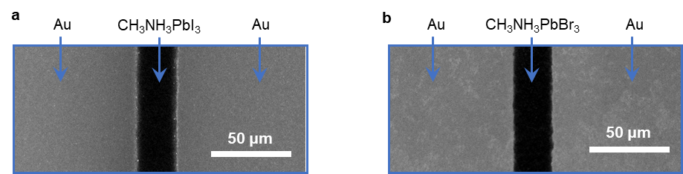
Figure 4-1. SEM images of a, CH₃NH₃PbI₃ and b, CH₃NH₃PbBr₃ thin films with Au electrodes on sides.

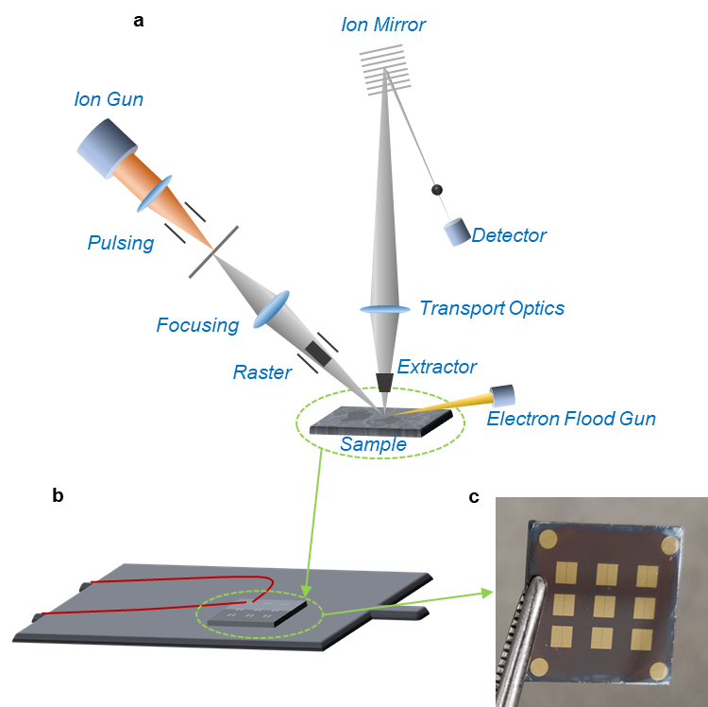
Figure 4-2. Schematically shown how bias is applied in tr-ToF-SIMS measurement. a, Scheme of working principle of ToF-SIMS. b, a scheme shows how the electric bias was applied to the sample. c, a picture of the Au/CH₃NH₃PbI₃/Au devices.

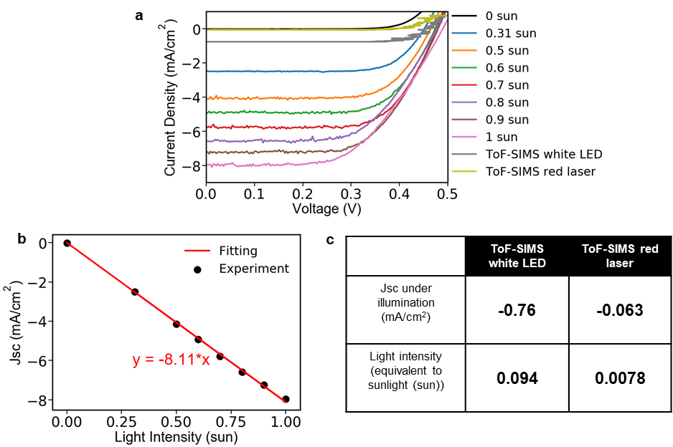
Figure 4-3. Characterization of the intensities of white LED light and red laser used in tr-ToF-SIMS measurement by measuring the performance of a silicon solar under illumination of the white LED and the red laser. a, the current-voltage curves of the silicon solar cell under various intensity of sunlight illumination and the white LED light and the red laser. b, the Jsc of the silicon solar cells as a function of the sunlight intensity, which can be linearly fitted and the fitting results are also shown in (b). c, calculated intensities of the white LED and the red laser (represented by numbers of sun) according to the fitting result in (b). We would like to note that these calculated intensities are not accurate (in particular, the red laser) because of the wavelength mismatch between the white LED/the red laser and sunlight.

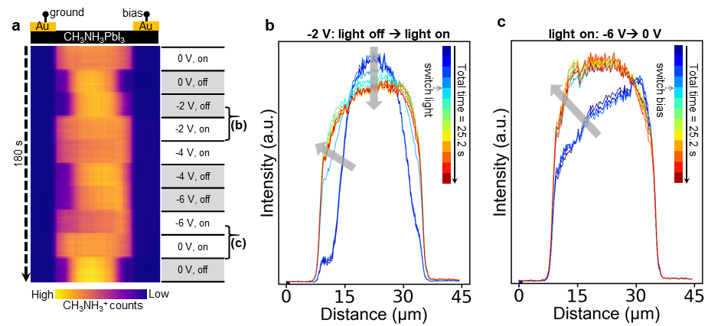
Figure 4-4. tr-ToF-SIMS results show the bias-induced and the light-induced CH₃NH₃⁺ redistribution in CH₃NH₃PbI₃. a, tr-ToF-SIMS results of CH₃NH₃⁺ migration in CH₃NH₃PbI₃; the X direction represents the position and the Y direction represents time as labeled. The real-time bias and light condition are labeled at the right side. b-c, representative profiles extracted from (a); (b) shows the light-induced changes in CH₃NH₃⁺ distribution and (c) shows the bias-induced changes in CH₃NH₃⁺ distribution. In (b-c), each profile corresponds to 1.8 s.

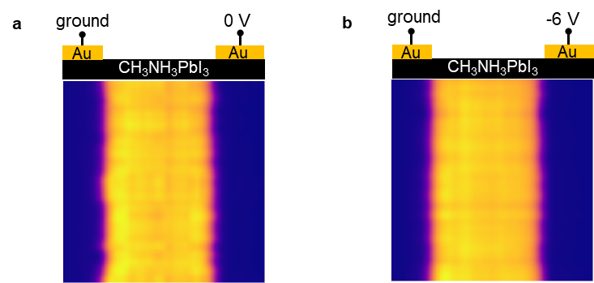
Figure 4-5. ToF-SIMS results of electric bias induced Pb²⁺ redistribution in CH₃NH₃PbI₃. a, Pb²⁺ distribution under 0 V bias. b, Pb²⁺ distribution under -6 V bias. No difference is observed between (a) and (b), suggesting no Pb²⁺ redistribution under bias.

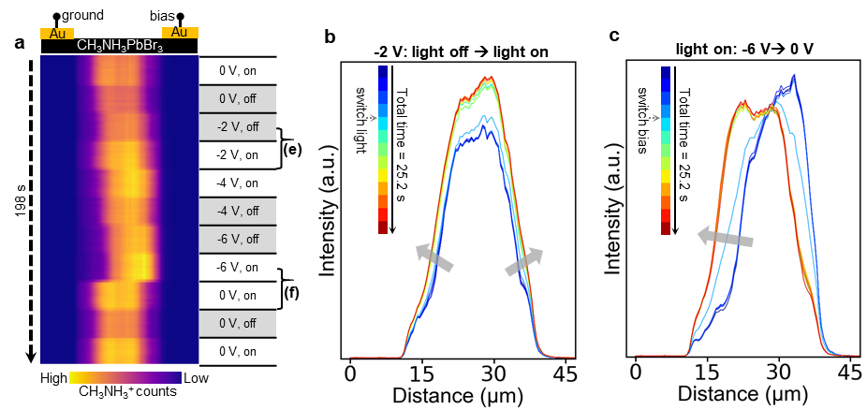
Figure 4-6. tr-ToF-SIMS results show the bias-induced and the light-induced CH₃NH₃⁺ redistribution in CH₃NH₃PbBr₃. a, tr-ToF-SIMS results of CH₃NH₃⁺ migration in CH₃NH₃PbBr₃; the X direction represents the position and the Y direction represents time as labeled. The real-time bias and light condition are labeled at the right side. b-c, representative profiles extracted from (a); (b) shows the light-induced changes in CH₃NH₃⁺ distribution and (c) shows the bias-induced changes in CH₃NH₃⁺ distribution. In (b-c), each profile corresponds to 1.8 s.

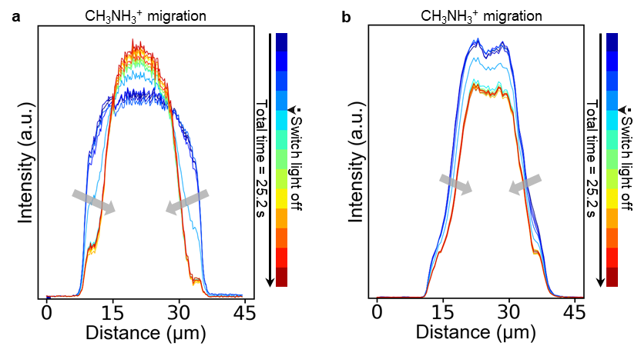
Figure 4-7. Light-induced CH₃NH₃⁺ redistribution. a, concentration profiles of the light-induced CH₃NH₃⁺ redistribution in CH₃NH₃PbI₃; b, concentration profiles of the light-induced CH₃NH₃⁺ redistribution in CH₃NH₃PbBr₃.

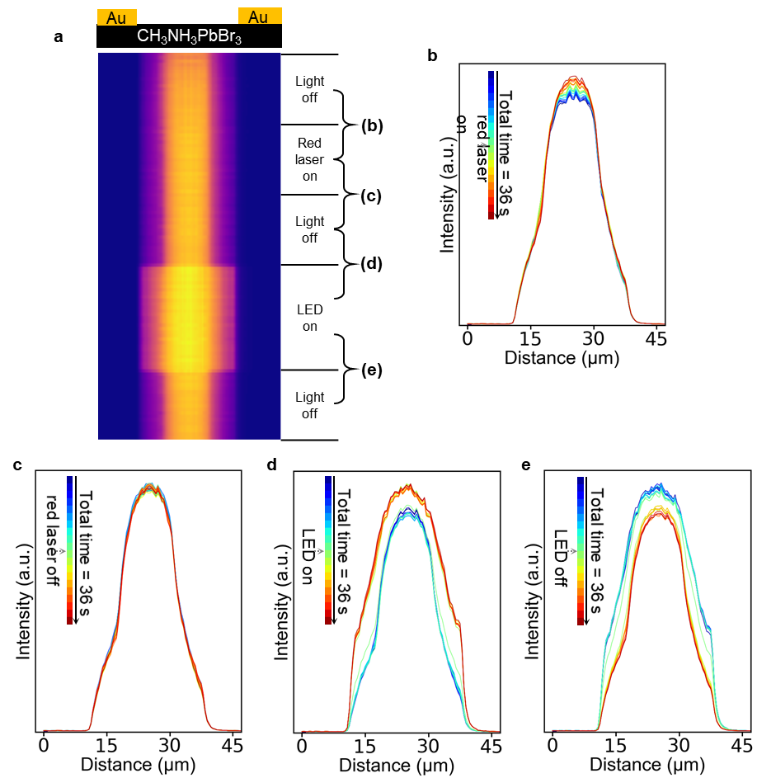
Figure 4-8. tr-ToF-SIMS results show the effect of different light on the CH₃NH₃⁺ redistribution in CH₃NH₃PbBr₃. a, tr-ToF-SIMS results of CH₃NH₃⁺ migration in CH₃NH₃PbBr₃; the X direction represents the position and the Y direction represents time as labeled. The real-time bias and light condition are labeled at the right side. b-e, representative profiles extracted from (a) show the light effect on the CH₃NH₃⁺ distribution, the changes in light condition are labeled in (a) and (b-e). In (b-e), each profile corresponds to 1.8 s.

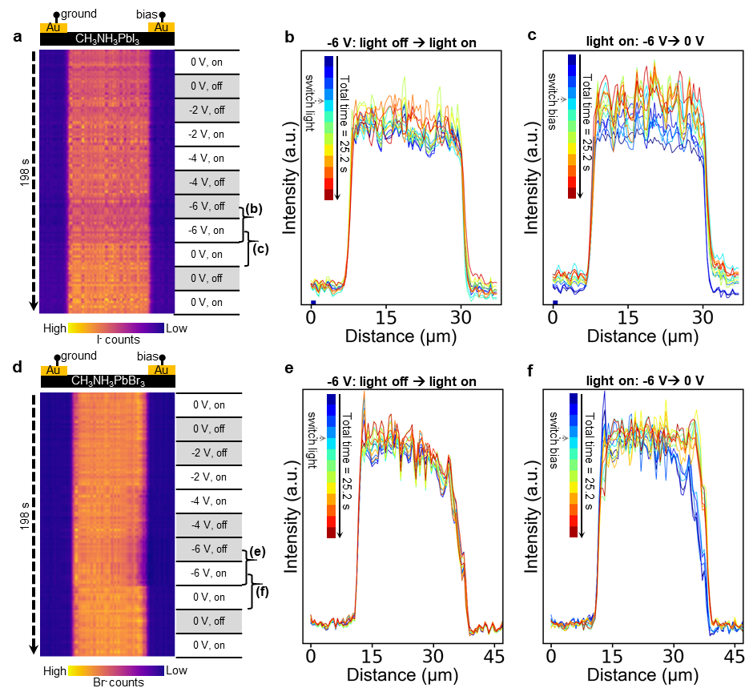
Figure 4-9. tr-ToF-SIMS results show the bias-induced and the light-induced I⁻ and Br⁻ redistribution in CH₃NH₃PbI₃ and CH₃NH₃PbBr₃, respectively. a, tr-ToF-SIMS results of I⁻ migration in CH₃NH₃PbI₃ and d, tr-ToF-SIMS results of Br⁻ migration in CH₃NH₃PbBr₃; the X direction represents the position and the Y direction represents time as labeled. The real-time bias and light condition are labeled at the right side. b-c, representative profiles extracted from (a); (b) shows the light-induced changes in I⁻ distribution and (c) shows the bias-induced changes in I⁻ distribution. e-f, representative profiles extracted from (d); (e) shows the light-induced changes in Br⁻ distribution and (f) shows the bias-induced changes in Br⁻ distribution. In (b-c) and (e-f), each profile corresponds to 1.8 s.

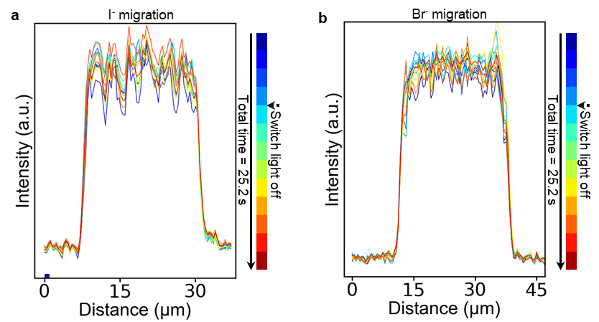
Figure 4-10. Light effect on halide migration. a, concentration profiles of the light-induced I⁻ redistribution in CH₃NH₃PbI₃; b, concentration profiles of the light-induced Br⁻ redistribution in CH₃NH₃PbBr₃. Each profile corresponds to 1.8 s.

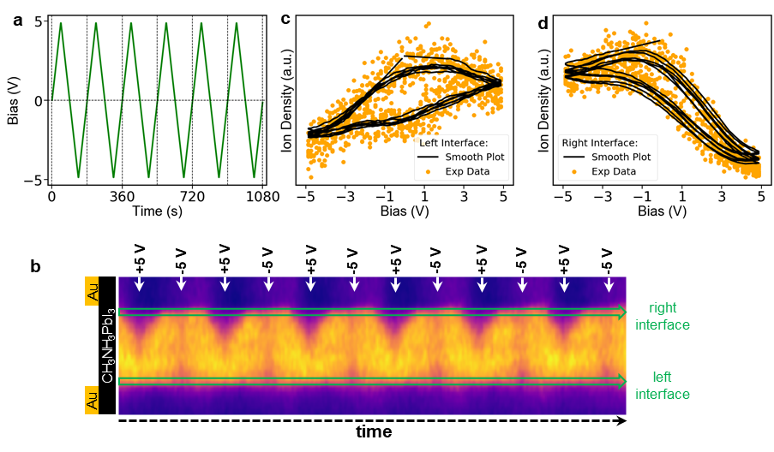
Figure 4-11. a, a bipolar bias waveform applied during tr-ToF-SIMS measurement. b, tr-ToF-SIMS result of temporal CH₃NH₃⁺ distribution under the bipolar electric bias waveform shown in (a). c, d, CH₃NH₃⁺ density at the device interfaces (left interface and right interface, respectively) as a function of applied bias.

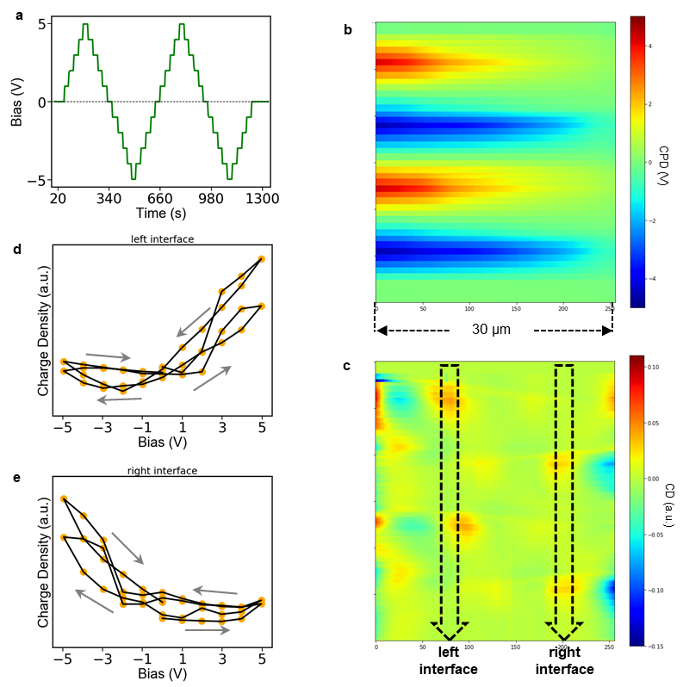
Figure 4-12. a, a bipolar bias waveform applied during the tr-KPFM measurement. b, c, Tr-KPFM results under the bipolar electric bias waveform shown in (a). b, time resolved contact potential difference (CPD) map. c, time resolved charge carrier density (CD) map. d, e, Charge carrier density (CD) at the device interfaces (left interface and right interface, respectively) as a function of applied bias.

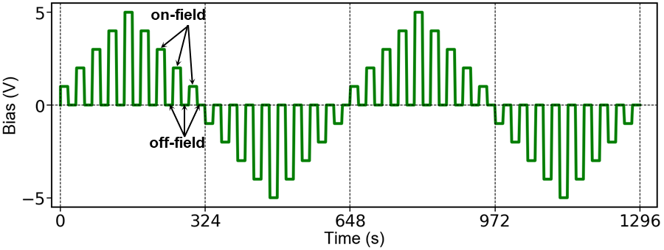
Figure 4-13. The on-off field bipolar pulsed stepwise bias waveform applied, on-field and off-field conditions are indicated in the figure.

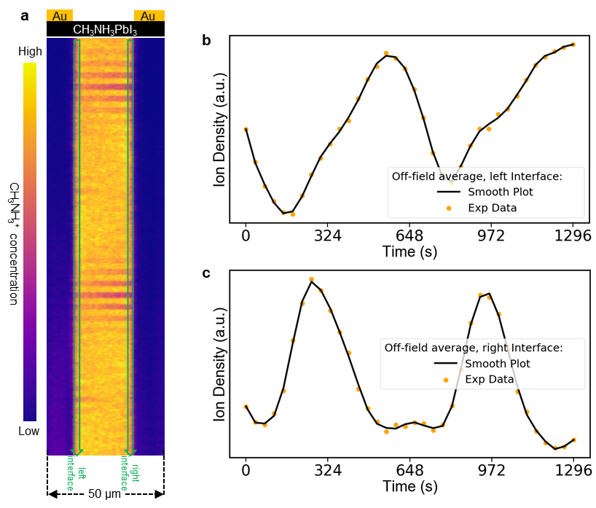
Figure 4-14. a, tr-ToF-SIMS map of CH₃NH₃⁺ distribution under the bipolar pulse waveform shown in Figure 4-13; b, c, the evolutions of the off-field CH₃NH₃⁺ density change at the left interface and the right interface, respectively, where the evolutions are extracted are marked in (a).

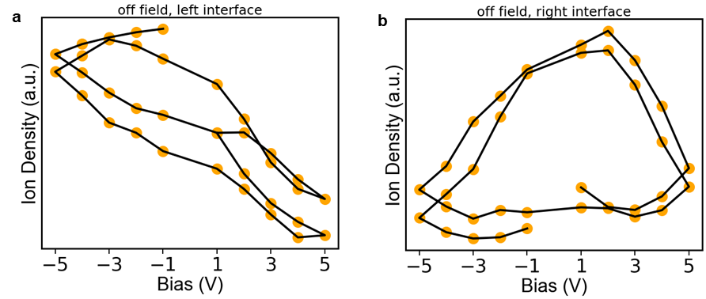
Figure 4-15. the off-field CH₃NH₃⁺ density at the device interfaces (a, left interface and b, right interface) as a function of the preceding bias.

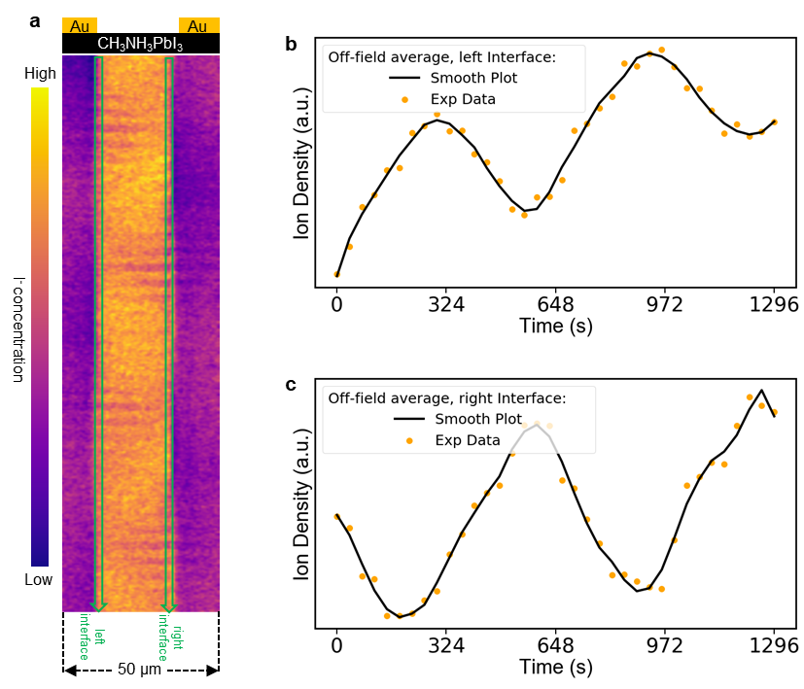
Figure 4-16. Figure 4-16. a, tr-ToF-SIMS map of I⁻ distribution under the bipolar pulse waveform shown in Figure 4-13; b, c, the evolutions of the off-field I⁻ density change at the left interface and the right interface, respectively, where the evolutions are extracted are marked in (a).

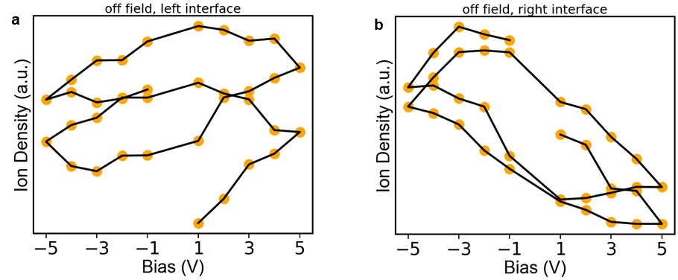
Figure 4-17. the off-field I⁻ density at the device interfaces (a, left interface and b, right interface) as a function of the preceding bias.

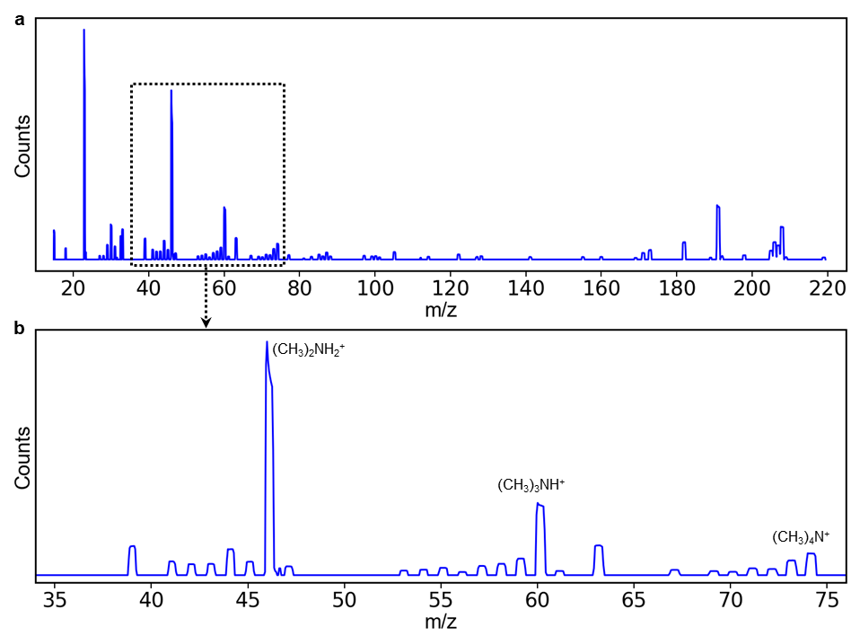
Figure 4-18. Mass spectra in positive mode ToF-SIMS. a, a full mass spectrum of positive mode ToF-SIMS on CH₃NH₃PbI₃. b, enlarged mass spectrum from 35 amu to 75 amu in order to highlight a few interested peaks that do not correspond to CH₃NH₃⁺. Further analyses in Figure 4-19 indicate that these peaks correspond to CH₃NH₃⁺ decomposition. The assignment of the interested peaks is shown in Table 4-1.

Table 4-1. The assignment of interested peaks in the mass spectrum in Figure 4-18. The peaks potentially corresponding to the CH₃NH₃⁺ decomposition are yellow-highlighted.
m/z | Detected ion | Fragment molecule
15.03 | CH₃⁺ | CH₃ fragment
18.04 | NH₄⁺ | NH₃ + H⁺
22.99 | Na⁺ | Na⁺
27.03 | CHN⁺ | CH₃NH₃⁺, or (CH₃)₂NH₂⁺, or (CH₃)₃NH⁺, or (CH₃)₄N⁺ fragment
28.03 | CH₂N⁺ | CH₃NH₃⁺, or (CH₃)₂NH₂⁺, or (CH₃)₃NH⁺, or (CH₃)₄N⁺ fragment
29.04 | CH₃N⁺ | CH₃NH₃⁺, or (CH₃)₂NH₂⁺, or (CH₃)₃NH⁺, or (CH₃)₄N⁺ fragment
30.05 | CH₄N⁺ | CH₃NH₃⁺, or (CH₃)₂NH₂⁺, or (CH₃)₃NH⁺, or (CH₃)₄N⁺ fragment
31.06 | CH₅N⁺ | CH₃NH₃⁺, or (CH₃)₂NH₂⁺, or (CH₃)₃NH⁺, or (CH₃)₄N⁺ fragment
33.06 | ¹³CH₆N⁺ | CH₃NH₃⁺ fragment
39.04 | C₂HN⁺ | (CH₃)₂NH₂⁺, or (CH₃)₃NH⁺, or (CH₃)₄N⁺ fragment
41.05 | C₂H₃N⁺ | (CH₃)₂NH₂⁺, or (CH₃)₃NH⁺, or (CH₃)₄N⁺ fragment
42.06 | C₂H₄N⁺ | (CH₃)₂NH₂⁺, or (CH₃)₃NH⁺, or (CH₃)₄N⁺ fragment
43.07 | C₂H₅N⁺ | (CH₃)₂NH₂⁺, or (CH₃)₃NH⁺, or (CH₃)₄N⁺ fragment
44.08 | C₂H₆N⁺ | (CH₃)₂NH₂⁺, or (CH₃)₃NH⁺, or (CH₃)₄N⁺ fragment
45.08 | C₂H₇N⁺ | (CH₃)₂NH₂⁺, or (CH₃)₃NH⁺, or (CH₃)₄N⁺ fragment
46.09 | C₂H₈N⁺ | (CH₃)₂NH₂⁺, or (CH₃)₃NH⁺, or (CH₃)₄N⁺ fragment
47.10 | C₂H₉N⁺ | (CH₃)₂NH₂⁺, or (CH₃)₃NH⁺, or (CH₃)₄N⁺ fragment
53.06 | C₃H₃N⁺ | (CH₃)₂NH₂⁺, or (CH₃)₃NH⁺, or (CH₃)₄N⁺ fragment
54.07 | C₃H₄N⁺ | (CH₃)₂NH₂⁺, or (CH₃)₃NH⁺, or (CH₃)₄N⁺ fragment
55.08 | C₃H₅N⁺ | (CH₃)₂NH₂⁺, or (CH₃)₃NH⁺, or (CH₃)₄N⁺ fragment
56.09 | C₃H₆N⁺ | (CH₃)₂NH₂⁺, or (CH₃)₃NH⁺, or (CH₃)₄N⁺ fragment
57.09 | C₃H₇N⁺ | (CH₃)₂NH₂⁺, or (CH₃)₃NH⁺, or (CH₃)₄N⁺ fragment
58.10 | C₃H₈N⁺ | (CH₃)₂NH₂⁺, or (CH₃)₃NH⁺, or (CH₃)₄N⁺ fragment
59.11 | C₃H₉N⁺ | (CH₃)₂NH₂⁺, or (CH₃)₃NH⁺, or (CH₃)₄N⁺ fragment
60.12 | C₃H₁₀N⁺ | (CH₃)₂NH₂⁺, or (CH₃)₃NH⁺, or (CH₃)₄N⁺ fragment
Table 4-1 continued.
m/z | Detected ion | Fragment molecule
61.13 | C₃H₁₁N⁺ | (CH₃)₂NH₂⁺, or (CH₃)₃NH⁺, or (CH₃)₄N⁺ fragment
63.14 | C₃H₁₃N⁺ | (CH₃)₂NH₂⁺, or (CH₃)₃NH⁺, or (CH₃)₄N⁺ fragment
67.09 | C₄H₅N⁺ | (CH₃)₂NH₂⁺, or (CH₃)₃NH⁺, or (CH₃)₄N⁺ fragment
69.10 | C₄H₇N⁺ | (CH₃)₂NH₂⁺, or (CH₃)₃NH⁺, or (CH₃)₄N⁺ fragment
70.11 | C₄H₈N⁺ | (CH₃)₂NH₂⁺, or (CH₃)₃NH⁺, or (CH₃)₄N⁺ fragment
71.12 | C₄H₉N⁺ | (CH₃)₂NH₂⁺, or (CH₃)₃NH⁺, or (CH₃)₄N⁺ fragment
72.13 | C₄H₁₀N⁺ | (CH₃)₂NH₂⁺, or (CH₃)₃NH⁺, or (CH₃)₄N⁺ fragment
73.14 | C₄H₁₁N⁺ | (CH₃)₂NH₂⁺, or (CH₃)₃NH⁺, or (CH₃)₄N⁺ fragment
74.14 | C₄H₁₂N⁺ | (CH₃)₂NH₂⁺, or (CH₃)₃NH⁺, or (CH₃)₄N⁺ fragment
77.17 | C₄H₁₅N⁺ | (CH₃)₂NH₂⁺, or (CH₃)₃NH⁺, or (CH₃)₄N⁺ fragment
140.93 | CH₂I⁺ | CH₃I fragment
173 | C₂H₈NI⁺ | (CH₃)₂NH₂I⁺ or (CH₃)₃NHI⁺ or (CH₃)₄NI⁺ fragment
181.98 | C₃H₅NI⁺ | (CH₃)₃NHI⁺ or (CH₃)₄NI⁺ fragment
198.03 | C₄H₉NI⁺ | (CH₃)₄NI⁺ fragment
206/207/208 | Pb⁺ | Pb

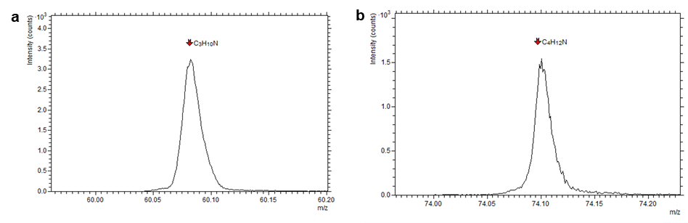
Figure 4-19. High-spectral resolution mass spectra indicate that some peaks in Figure 4-18 correspond to CH₃NH₃⁺ decomposition products as labeled.

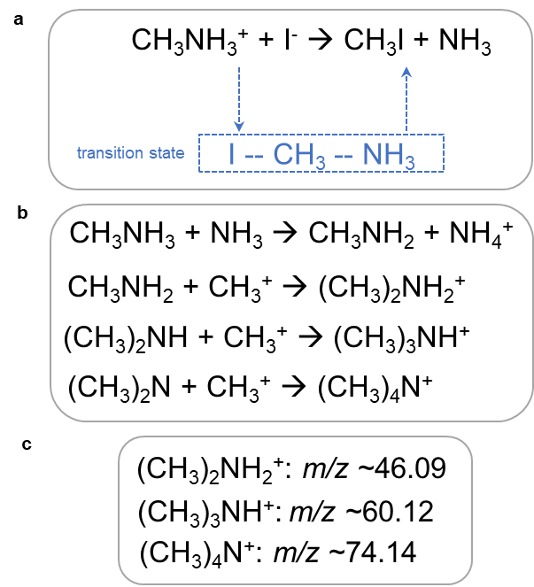
Figure 4-20. Thermodynamically and kinetically favored CH₃NH₃⁺ decomposition mechanism. a, a transition state mediated CH₃NH₃⁺ decomposition into CH₃ and NH₃. b, CH₃ and NH₃ further react with CH₃NH₃⁺ to form other decomposition products. c, a summary of the m/z of major decomposition products.

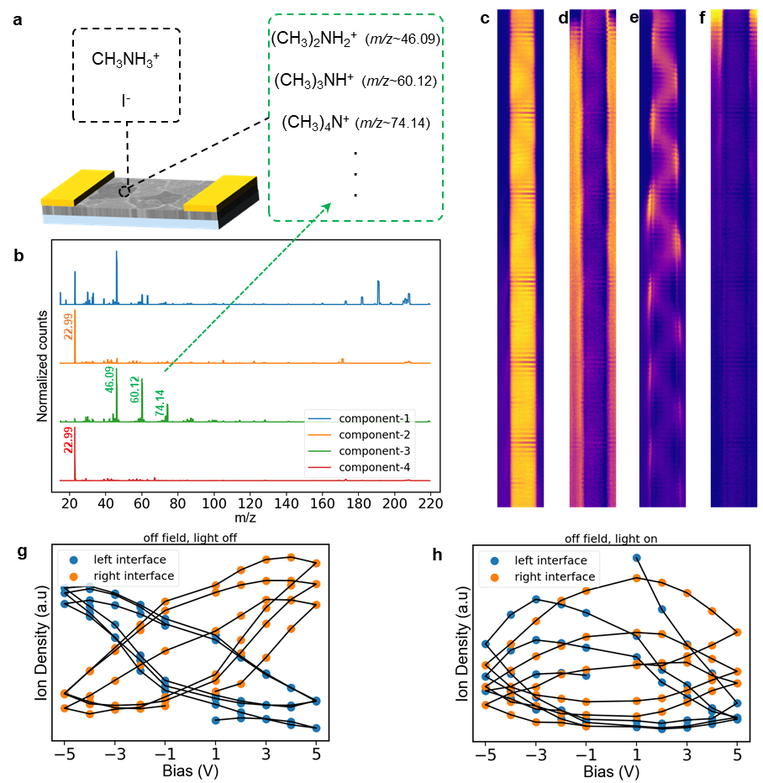
Figure 4-21. a, a schematic shows possible ions existing in CH₃NH₃PbI₃, black box shows intrinsic ions including CH₃NH₃⁺ and I⁻, green box shows CH₃NH₃⁺ decomposition products. b, NMF decomposition of the ToF-SIMS results, four components shown as mass spectrum indicate the m/z of ions presented in each component; according to Table S1, the component-3 represents the CH₃NH₃⁺ decomposition products very well. c-f, the evolutions of the NMF component 1-4, respectively, clear periodical behavior of component-3 is observed. g-h, the off-field component-3 (representing CH₃NH₃⁺ decomposition products) intensity at the device interfaces as a function of the preceding bias; (g) under dark condition and (h) under light condition.

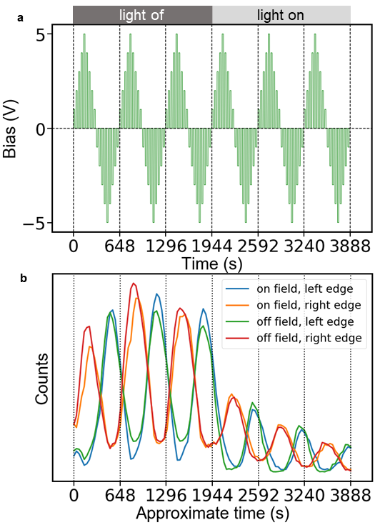
Figure 4-22. The evolution of the component-3 intensity near the device Au/ CH₃NH₃PbI₃ interfaces. a, b, show the corresponding bias waveform and component-3 evolution, respectively. It is clear that the intensity of component-3 is stronger in 1st-3rd cycles (dark condition) than in 4th-6th cycles (light condition).

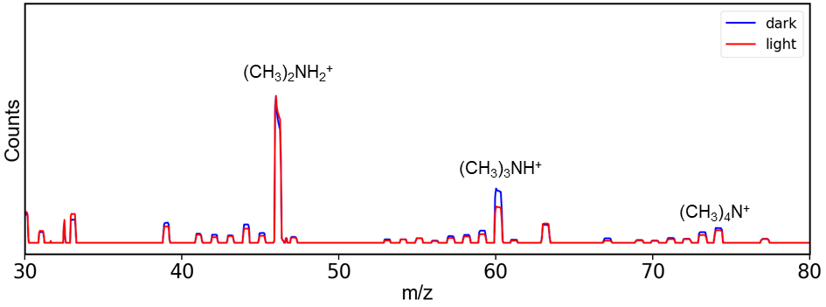
Figure 4-23. A comparison of the mass spectra under dark and light shows the peaks corresponding to the CH₃NH₃⁺ decomposition are stronger under dark, suggesting more significant CH₃NH₃⁺ decomposition under dark.

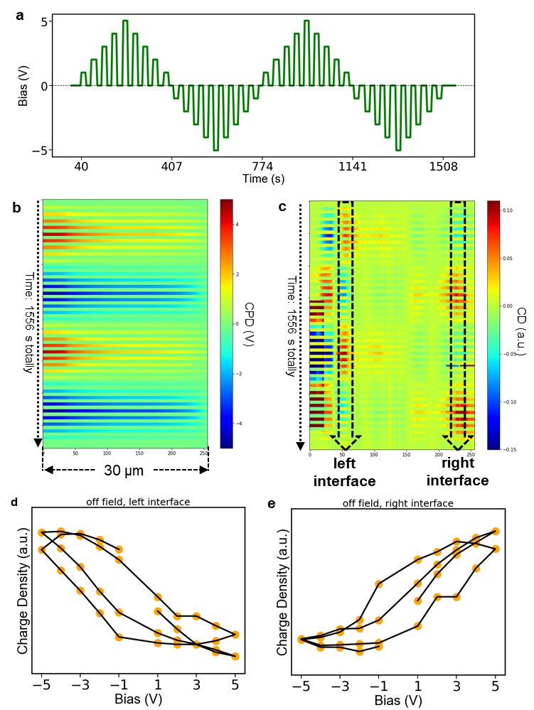
Figure 4-24. the application of the on-off field method in the tr-KPFM measurement. a, the bipolar pulsed bias waveform applied during tr-KPFM measurement. b-c, Tr-KPFM results under the bipolar pulsed bias waveform shown in (a), (b), time resolved contact potential difference (CPD) map; (c), time resolved charge carrier density (CD) map. d, e, the off-field charge carrier density (CD) at the device interfaces (left interface and right interface, respectively) as a function of the preceding bias.

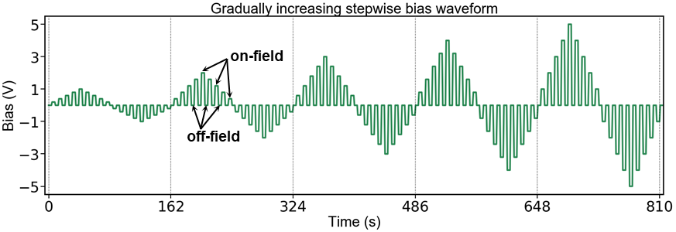
Figure 4-25. Voltage-time (V-t) curve of the gradually increasing pulsed stepwise bias. Adapted with permission from Ref 193.

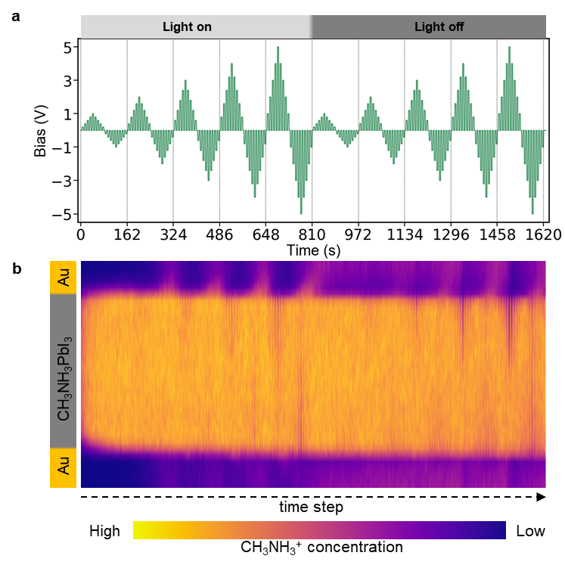
Figure 4-26. A tr-ToF-SIMS results showing temporal CH₃NH₃⁺ distribution during the application of a gradually increasing pulsed stepwise electric waveform. a, a full voltage-time (V-t) curve that applied during tr-ToF-SIMS measurement; b, obtained tr-ToF-SIMS results of temporal CH₃NH₃⁺ distribution. Here, the first half measurement was conducted under light-on condition and the second half measurement was conducted under light-off condition in order to study the light effect on ion migration. Adapted with permission from Ref 193.

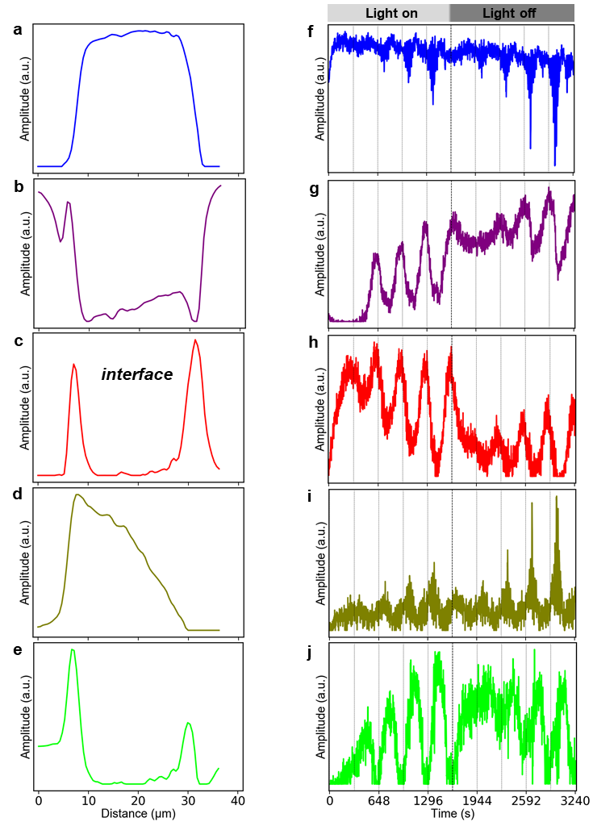
Figure 4-27. Non-negative matrix factorization (NMF) analysis of the tr-ToF-SIMS result 4-26. a-e, the tr-ToF-SIMS result was spatially isolated into five endmembers, which represent CH₃NH₃⁺ distributed at the respective regions. The endmember in (c) that represents CH₃NH₃⁺ distributed at Au/CH₃NH₃PbI₃ interface is what we are interested in, which was named as endmember interface; f-j, the time evolution of the endmembers showing in (a-e), respectively. all evolutions are consistent with the applied electric waveform in Figure 4-26a. Adapted with permission from Ref 193.

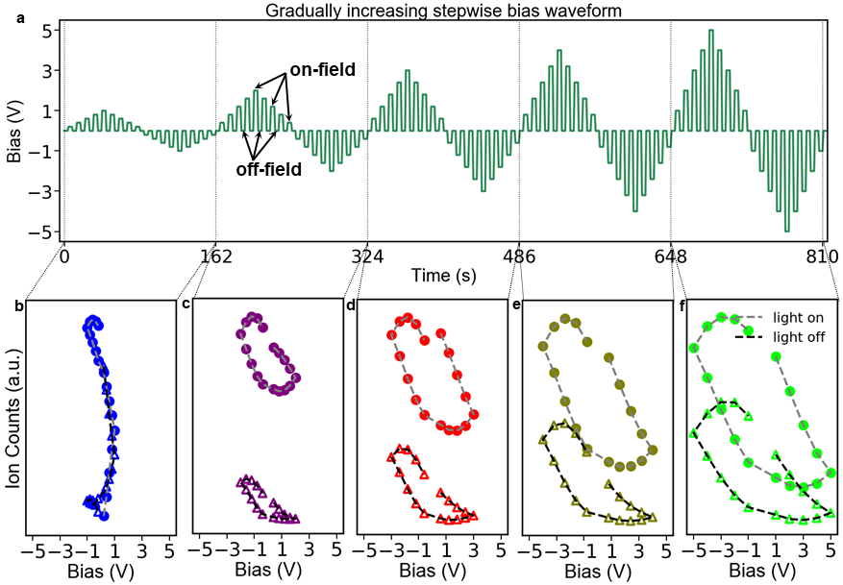
Figure 4-28. Hysteretic ion migration. a, Voltage-time (V-t) curves of the gradually increasing pulsed stepwise bias that is applied to induce ion migration; b-f, the evolution of interface CH₃NH₃⁺ density as a function of voltage under light-on and light-off conditions. Adapted with permission from Ref 193.

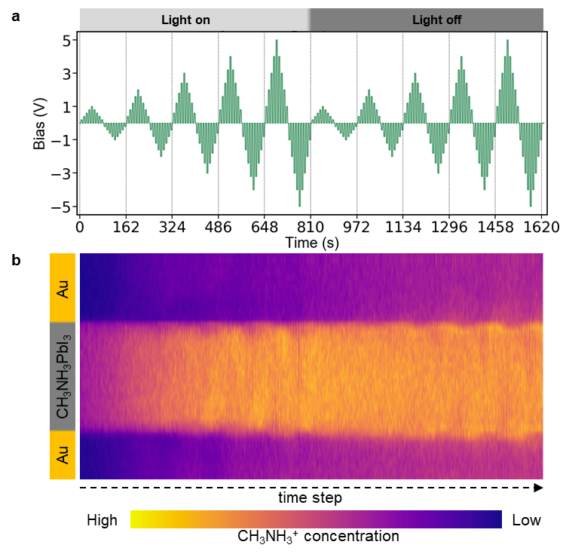
Figure 4-29. A tr-ToF-SIMS result showing temporal I⁻ distribution during the application of a gradually increasing pulsed stepwise electric waveform. a, a full voltage-time (V-t) curve that applied during tr-ToF-SIMS measurement; b, obtained tr-ToF-SIMS results of temporal I⁻ distribution. Here, the first half measurement was conducted under light-on condition and the second half measurement was conducted under light-off condition in order to study the light effect on ion migration. Adapted with permission from Ref 193.

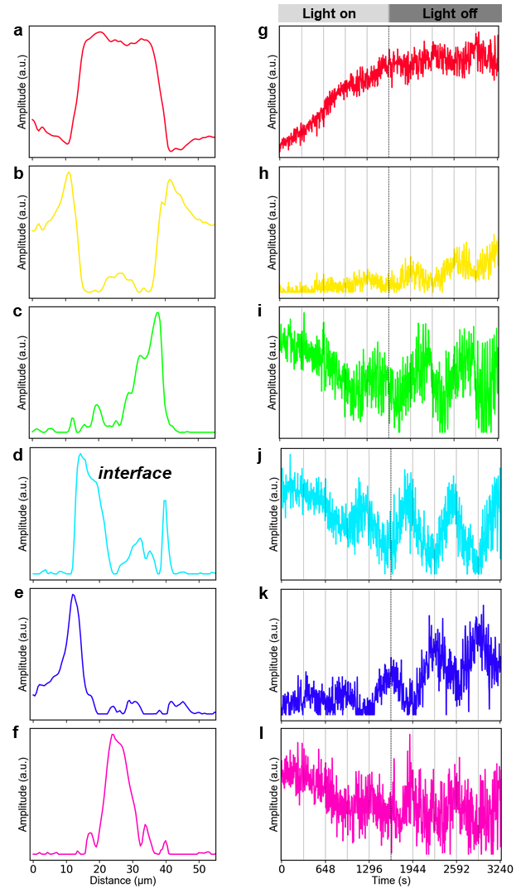
Figure 4-30. Non-negative matrix factorization (NMF) analysis of the tr-ToF-SIMS result in Figure 4-29. a-e, the tr-ToF-SIMS result was spatially isolated into six endmembers, which represent I⁻ distributed at the respective regions. The endmember in (d) that represents I⁻ distributed at Au/CH₃NH₃PbI₃ interface is what we are interested in, which was named as endmember interface; f-j, the time evolution of the endmembers showing in (a-e), respectively. Adapted with permission from Ref 193.

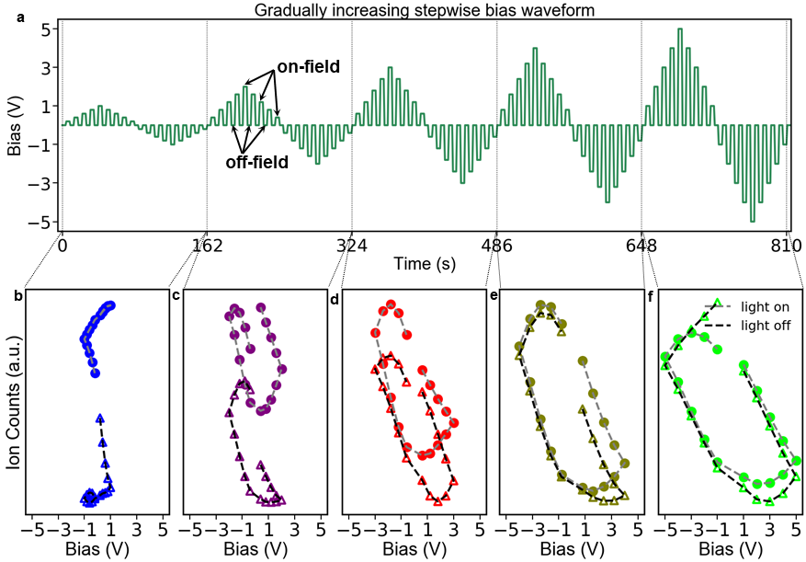
Figure 4-31. Hysteretic ion migration. a, Voltage-time (V-t) curves of the gradually increasing pulsed stepwise bias that is applied to induce ion migration; b-f, the evolution of interface I⁻ density as a function of voltage under light-on and light-off conditions. Adapted with permission from Ref 193.

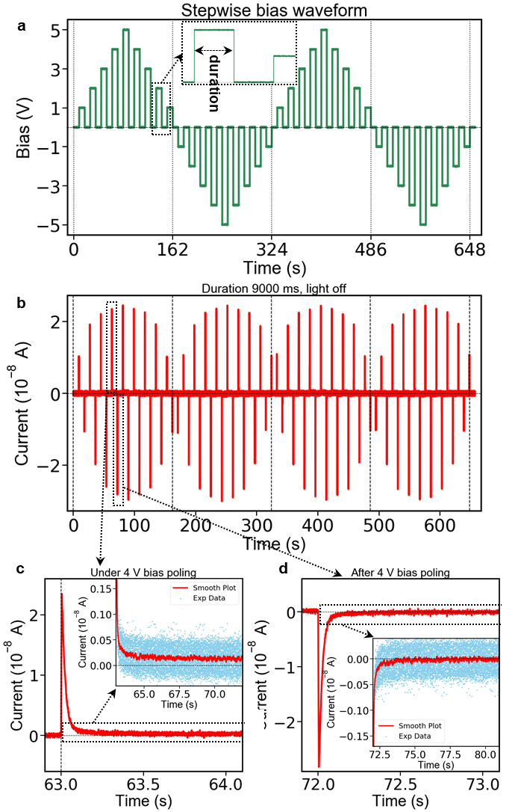
Figure 4-32. Electric current study by applying a pulsed stepwise waveform bias. a, the voltage-time curve (V-t) of the pulsed stepwise waveform bias applied to study the evolution of electric current, the step duration is 9 s; b, the obtained current-time (I-t) curve under light-off condition; c, d, representative enlarged figures that show on-field current decay during application of 4 V and off-current current decay after application of 4 V, respectively; the inserts of (c-d) show the current evolution after the initial fast decay. Adapted with permission from Ref 193.

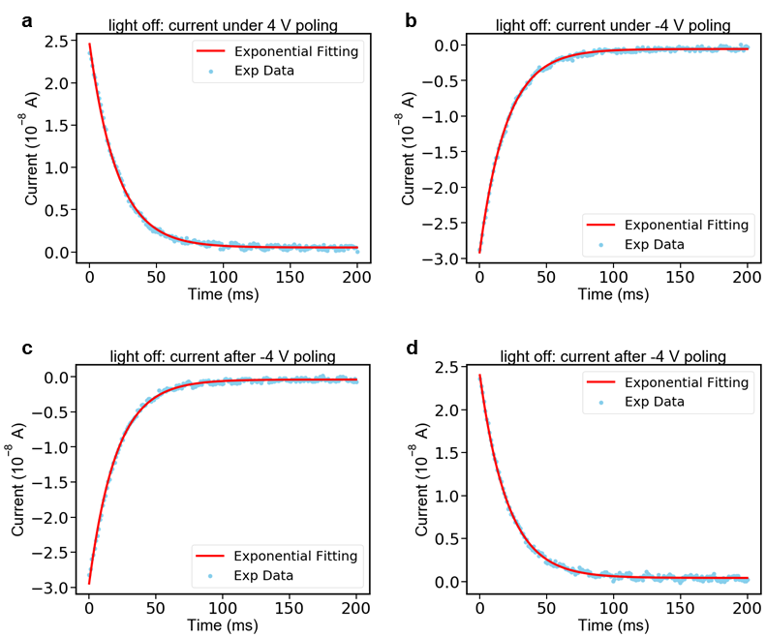
Figure 4-33. Representative exponential fitting of the fast decay of the currents upon application of the bias and after removal of the bias under light-off condition. a, b, exponential fitting of currents upon application of 4 V and -4 V, respectively. c, d, exponential fitting of currents after removal of 4 V and -4 V, respectively. All fittings are based the current during the first 200 ms. Adapted with permission from Ref 193.

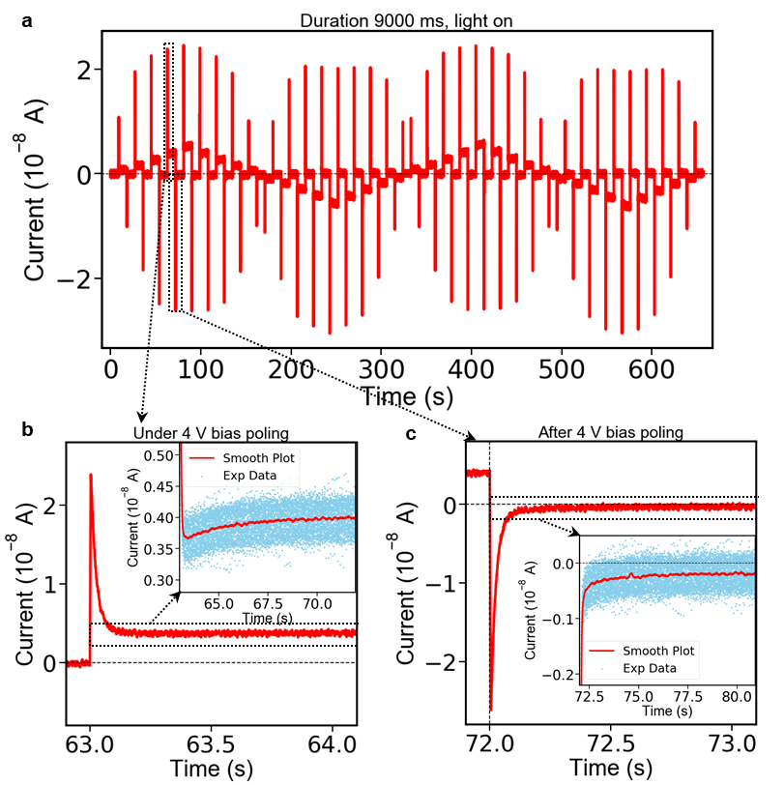
Figure 4-34. Electric current study by applying a pulsed stepwise waveform bias. The voltage-time curve (V-t) of the pulsed stepwise waveform bias is shown in Figure 4-32a. a, the obtained current-time (I-t) curve under light-on condition; b, c, representative enlarged figures that show on-field current decay during application of 4 V and off-current current decay after application of 4 V, respectively; the inserts of (b-c) highlight the current evolution after the initial fast decay. Adapted with permission from Ref 193.

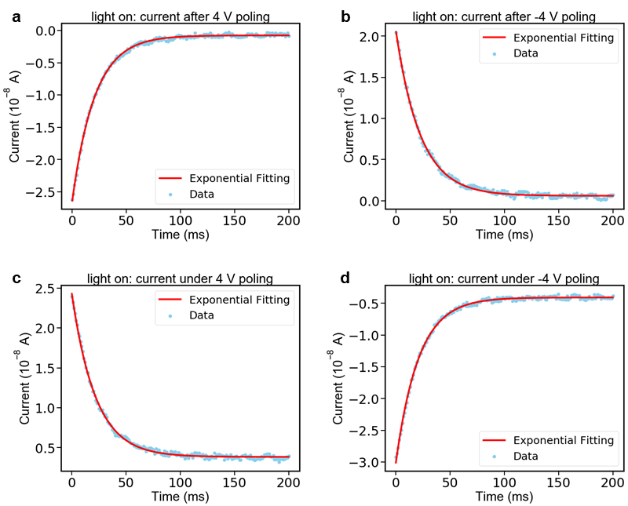
Figure 4-35. Representative exponential fitting of the fast decay of the currents upon application of the bias and after removal of the bias under light-on condition. a, b, exponential fitting of currents upon application of 4 V and -4 V, respectively. c, d, exponential fitting of currents after removal of 4 V and -4 V, respectively. All fittings are based the current during the first 200 ms. Adapted with permission from Ref 193.

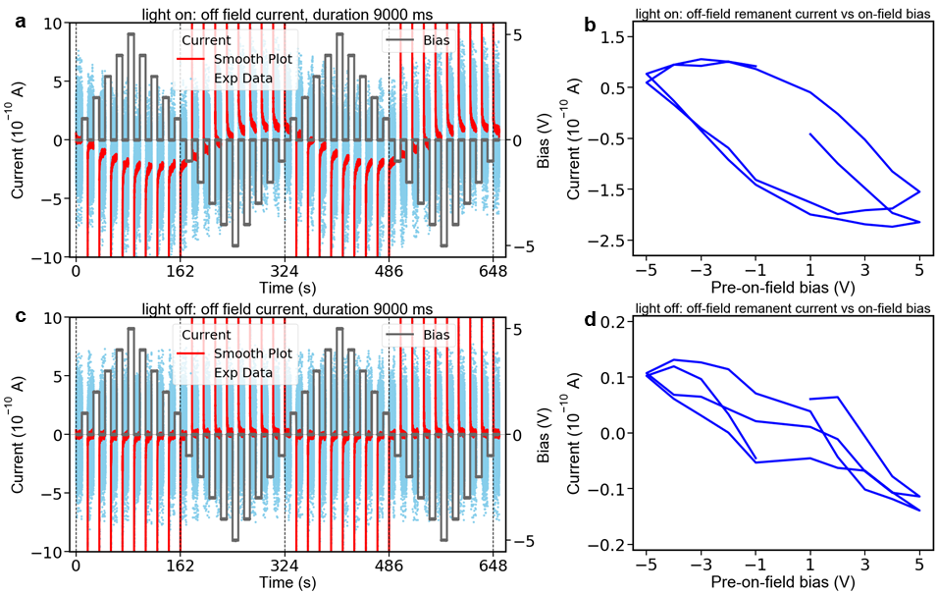
Figure 4-36. Current-time (I-t) curves after electric poling. a, the off-field I-t curve under light-on condition along with the V-t curve. b, the plot of the spontaneous current under light-on condition as a function of the on-field bias. c, the off-field I-t curve under light-off condition along with the V-t curve. d, the plot of the spontaneous current under light-off condition as a function of the on-field bias. Adapted with permission from Ref 193.

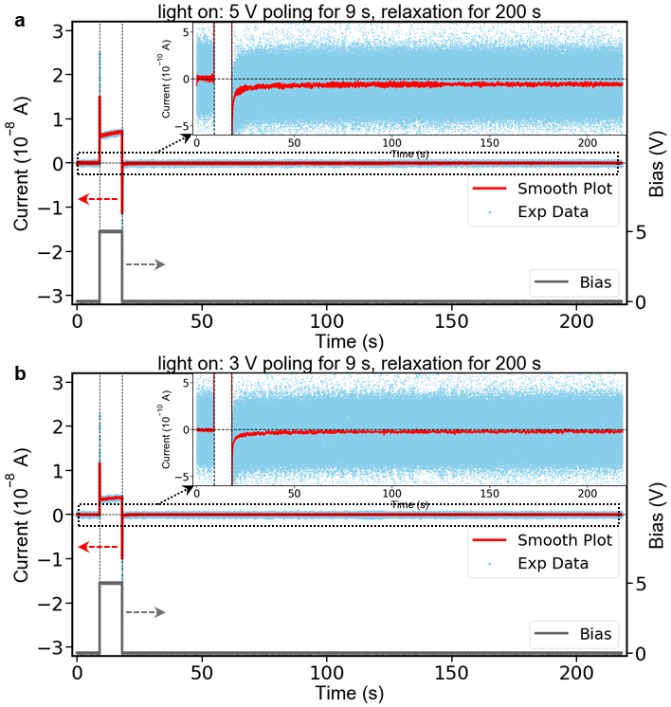
Figure 4-37. Current behavior under light-on. a, I-t curve by 5 V poling for 9 s and relaxing for 200 s; the insert is a zoomed-in I-t curve to show the spontaneous current behavior. b, I-t curve by 3 V poling for 9 s and relaxing for 200 s; the insert is a zoomed-in I-t curve to show the spontaneous current behavior. Adapted with permission from Ref 193.

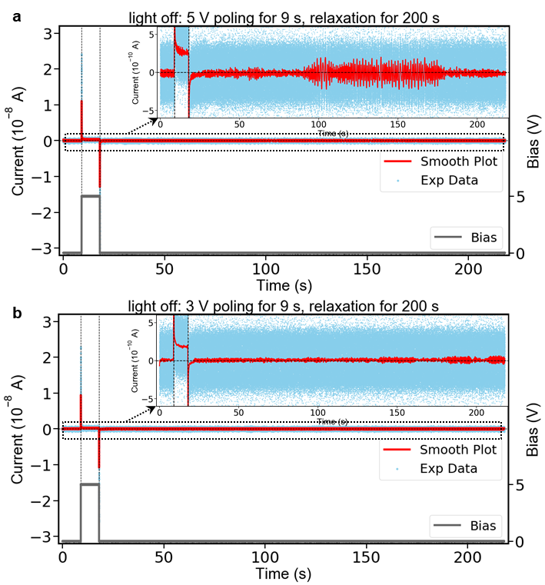
Figure 4-38. Current behavior under light-off. a, I-t curve by 5 V poling for 9 s and relaxing for 200 s; the insert is a zoomed-in I-t curve to show the spontaneous current behavior. b, I-t curve by 3 V poling for 9 s and relaxing for 200 s; the insert is a zoomed-in I-t curve to show the spontaneous current behavior. Adapted with permission from Ref 193.

Interactions between chemical dynamics and ferroic behavior

A version of this chapter was originally published^{176,241} by Yongtao Liu, Anton V. Ievlev, Liam Collins, Alex Belianinov, Jong K. Keum, Mahshid Ahmadi, Sabine M. Neumayer, Stephen Jesse, Scott T. Retterer, Kai Xiao, Jingsong Huang, Bobby G. Sumpter, Sergei V. Kalinin, Bin Hu, Olga S. Ovchinnikova:
[1] Liu, Y., Collins, L., Belianinov, A., Neumayer, S. M., Ievlev, A. V., Ahmadi, M., Xiao, K., Retterer, S. T., Jesse, S., Kalinin, S. V., Hu, B., Ovchinnikova, O. S., (2018). Dynamic behavior of CH3NH3PbI3 perovskite twin domains. Applied Physics Letters, 113(7), 072102.
[2] Liu, Y., Ievlev, A. V., Collins, L., Belianinov, A., Keum, J. K., Ahmadi, M., Jesse, S., Retterer, S. T., Xiao, K., Huang, J., Sumpter, B. G., Kalinin, S. V., Hu, B., Ovchinnikova, O. S., (2020). Strain–Chemical Gradient and Polarization in Metal Halide Perovskites. Advanced Electronic Materials, 1901235.

5.1 Abstract
In Chapter 2 and Chapter 3, the ferroic twin domain and its effects have been systematically discussed. Then, in Chapter 4, the ion migration and its effects have been investigated. Noteworthily, in Chapter 2, it is discovered that the chemical segregation is tightly tied with the ferroic twin domain in CH₃NH₃PbI₃, implying the interconnection between chemical and ferroic states in MHPs. Meanwhile, the coupling of ionic states and ferroelectricity and the interconnected nature of defect chemistry and ferroelasticity in classical ferroic materials have been tremendously discussed. Therefore, the interaction between ferroic and ionic activities in MHPs can no longer be ignored. In this Chapter, using multiple chemical and functional techniques, the electrochemical and electromechanical interaction in CH₃NH₃PbI₃ was studied. Dynamical mapping of the twin domain structure under electric bias shows the potential correlation between ferroic twin domain and ion migration. Structural and chemical investigations reveal coupled lattice strain and chemical distribution gradient, which can potentially induce an electric polarization that affects the optoelectronic actions in CH₃NH₃PbI₃. In-situ PFM study indicates that the ion distribution and the twin domain are inter-pinned during temperature changes. Altogether, these results unveil an electro-chemical-mechanical interaction in CH₃NH₃PbI₃.
This Chapter is revised based on two papers^{176,241} by [1] Liu, Y., Collins, L., Belianinov, A., Neumayer, S. M., Ievlev, A. V., Ahmadi, M., Xiao, K., Retterer, S. T., Jesse, S., Kalinin, S. V., Hu, B., Ovchinnikova, O. S., (2018). Dynamic behavior of CH3NH3PbI3 perovskite twin domains. Applied Physics Letters, 113(7), 072102. [2] Liu, Y., Ievlev, A. V., Collins, L., Belianinov, A., Keum, J. K., Ahmadi, M., Jesse, S., Retterer, S. T., Xiao, K., Huang, J., Sumpter, B. G., Kalinin, S. V., Hu, B., Ovchinnikova, O. S., (2020). Strain–Chemical Gradient and Polarization in Metal Halide Perovskites. Advanced Electronic Materials, 1901235.

5.2 Introduction
Recently, the twin domain structure in CH₃NH₃PbI₃ has been discovered, where the discussion regarding this domain structure mainly focuses on its ferroic nature.^{99,100,129-132,177,242} In this Thesis, Chapter 2 has discussed the ferroic nature of this twin domain structure and Chapter 3 has discussed its effects on optoelectronic properties of CH₃NH₃PbI₃. Noteworthily, in Chapter 2, chemical studies by nanoscale infrared spectroscopy (Nano IR) and helium ion microscopy secondary ion mass spectrometry (HIM-SIMS) show inhomogeneous ion distribution tied with this twin domain structure, which implicates potential different ionic activity associated with the ferroic twin domain. In Chapter 3, a screening effect of the ferroic twin domain due to chemical inhomogeneity related optoelectronic process was observed, also implying the interconnection between ferroic and ionic states in this material. In addition, in Chapter 4, the behavior of ion migration that is similar to ferroic behavior (e.g. ion migration hysteresis vs ferroelectric hysteresis) was shown. All these indicate the potential interaction between ferroic behavior and ionic behavior in MHPs, which cannot be ignored from now on. Furthermore, both ferroic behavior and ionic behavior result in electric polarization, which is generally believed to be critical to the charge recombination and device operation of MHPs.^{243,244} In this regard, understanding the ferroic-ionic interaction is also critical to improve the performance of MHP-based devices.
In this Chapter, using band excitation contact Kelvin probe force microscopy (BE-cKPFM) that is useful for differentiating ferroelectric switching and non-ferroelectric electromechanical/electrochemical effects,^{147,148} the ionic states of the twin domain in CH₃NH₃PbI₃ were explored. The BE-cKPFM results show no domain switching up to ±3.5 V applied voltage, while the ionic states are highly responsive to the applied bias. In addition, the twin domain structure impacts the significance of ion migration under applied bias. Accordingly, it is postulated that the dissimilarity in chemical and elastic states between neighboring twin domains leads to a confinement of ionic activity. A temperature-dependent strain gradient that is coupled with a chemical (CH₃NH₃⁺) distribution gradient over depth is further revealed in CH₃NH₃PbI₃ using XRD and ToF-SIMS. This strain-chemical gradient results in an electric polarization leading to changes in the potential electric field change in CH₃NH₃PbI₃. It is found that the variation in chemical and strain states between neighboring twin domains can exist in both tetragonal and cubic phase of CH₃NH₃PbI₃, implying that the strain-chemical gradient induced polarization can present near the domain walls in both tetragonal and cubic phase. Therefore, a mechanism of how this strain-chemical gradient and the resultant polarization impact optoelectronic properties of MHPs is proposed, which is expected to be useful for improving the performance of MHPs optoelectronic devices.

5.3 Materials and Methods

5.3.1 Preparation of CH₃NH₃PbI₃ films
The CH₃NH₃PbI₃ sample used in this Chapter is synthesized by spin-casting hot PbI₂ solution (1.2 M in DMF) followed by spin-casting CH₃NH₃I solution (0.44 M in ethanol), then the film was thermal-annealed at 100 ºC for 2 hours. The synthesis is carried out in a N₂-filled glove box.

5.3.2 Scanning electron microscope (SEM)
SEM measurements were carried out in the Inlens mode with a gun voltage of 1.00 kV on a Zeiss Merlin scanning electron microscope.

5.3.3 Ab Initio Molecular Dynamics:
Molecular dynamics (MD) simulations based on density functional theory (DFT) were performed using the Vienna Ab Initio Simulation Package (VASP, 5.4.4)¹³⁸⁻¹⁴⁰ with the projector-augmented wave (PAW) method^{141,142}. In these simulations, the electron-ion interactions were described using standard PAW potentials, with valence electron configurations of 5d¹⁰6s²6p² for Pb, 5s²5p⁵ for I, 3s²3p⁵ for Cl, 2s²2p² for C, 2s²2p³ for N, and 1s¹ for H. van der Waals interactions were included by using the vdW-DF method implemented by Dion et al. and modified by Klimes et al.^{143,144} A supercell model of the low-energy stoichiometric (110) surface containing five Pb layers was constructed based on the experimental X-ray structure of CH₃NH₃PbI₃ in the room-temperature tetragonal phase¹⁴⁵ Following full optimization MD simulations were performed in a canonical NVT ensemble with the temperature of the simulations maintained by a Nose-Hoover thermostat at 25 and 45 C. A time step of 1 fs was used with the velocities of all atoms initialized randomly according to the Maxwell-Boltzmann distribution. The dynamics was evaluated over at least 10 ns to determine the distributions of ions.

5.3.4 Time-of-flight secondary ion mass spectrometry (ToF-SIMS)
ToF-SIMS measurements were performed using ToF-SIMS.5.NSC instrument (ION.TOF GmbH. Germany). Bi₃⁺ ion beam with energy 30 keV and current of 30 nA was used as a primary beam for chemical imaging; Cs⁺ sputter source with current of 50 nA, energy of 1 keV was used for depth profiling. Measurements were performed in positive ion mode with spectra calibrated using the K⁺, Na⁺, CH₃⁺, and Pb⁺ peaks. Measurements were performed in non-interlaced mode, when each scan by Bi₃⁺ ion beam has been followed by sputtering with Cs⁺ beam over a 50 µm*50 µm area for 1 s.

5.3.5 X-ray diffraction (XRD)
XRD measurements were performed on a Panalytical X’Pert MPD Pro diffractometer (45kV, 40mA) using Cu Kα radiation (λ = 0.1542 nm) with a step size of 0.0167º. Grazing incidence 2θ scans were recorded for several incidence angles varying from 3.0º-5.5º.

5.3.6 Scanning probe microscopy (SPM)
SPM measurements were performed on a commercial Cypher, Asylum Research and Oxford Instr. Company AFM system equipped with band excitation generator using a Pt/Ir coated AFM tips (ElectriMulti75-G, Budget Sensors) with a nominal stiffness of 3 N/m. BE-PFM and BE-cKPFM measurements were performed by applying an AC bias of 1.0-3.0 V with center frequency of 300-400 kHz, band width of 60-100 kHz. The tr-KPFM measurements were performed at a drive amplitude of 3 V and a scan rate of 0.4 Hz. Data processing was done using custom written Python codes. The tr-KPFM records real-time changes in CPD by repeatedly scanning a single line across the gap between two electrodes. The sample is fixed on an environmental holder and bias voltages were applied step by step.

5.4 Results and Discussion

5.4.1 Ionic activity in the ferroic twin domain in CH₃NH₃PbI₃
5.4.1.1 Observation of twin domains using BE-PFM
BE-PFM can suppress topographic crosstalk and simultaneously provides the local resonance frequency and quality factor,^{147,148} which both are parameters about the cantilever.^{147,148,245} The information of the cantilever can offer insights into the changes in tip-sample contact stiffness, viscoelastic properties and/or energy dissipation during PFM measurements.^{147,149,246,247} Therefore, BE-PFM was first used to study the twin domain in CH₃NH₃PbI₃, the BE-PFM results are shown in Figure 5-1. The twin domain structure is clearly seen in amplitude, phase, frequency, and quality factor images. The identical domain structure in amplitude/phase and frequency/quality factor images indicates that the twin domain contrast in PFM originates from cantilever dynamics, and hence are likely non-ferroelectric. These results are consistent with the observations in Chapter 2. Contrast in frequency indicates that there are locally hard and soft regions corresponding to high and low frequency, respectively. This elastic variation is potentially related to a difference in crystallization, defect density, and chemical composition between adjacent domains.
5.4.1.2 Ionic response in the twin domain under applied voltage
A necessary property to prove ferroelectricity is the polarization switching by electric bias. Ferroelectric polarization switching is usually characterized by hysteresis loop measurements using switching spectroscopy (SS)-PFM. However, CH₃NH₃PbI₃ as an ionic conductor, ion migration can also induce hysteresis loop. To clarify whether there is polarization switching, the BE-cKPFM was used to study this twin domain structure. In BE-cKPFM measurements, a rectangular DC waveform of write bias is applied to induce material change and a subsequent series of small read bias is used to detect both on-field and off-field changes. Figure 5-2a shows a schematic of the BE-cKPFM bias waveform, where the write steps and the read steps are shown in Figure 5-2b and Figure 5-2c, respectively. BE-cKPFM off-field responses can differentiate the electrostatic effects and electromechanical effects, allowing users to investigate the ferroelectric polarization and ionic states. The BE-cKPFM was performed in a zoom-in region shown in Figure 5-1f, where twin domains are observed. Figure 5-2d shows the measured BE-cKPFM response, which is neither consistent with a ferroelectric response nor consistent with a electrostatic response.^{98,248}
Considering the complicated ionic activity in this material, this BE-cKPFM response is probably due to ion migration under the applied bias. Therefore, the amplitude, phase, and frequency responses are further analyzed detailly to get an understanding about the observed BE-cKPFM response. Figure 5-3 shows the amplitude, phase, and frequency responses at three representative read biases (1.5 V, 0 V, and -1.5 V), ferroelectric polarization here is refuted due to the absence of phase hysteresis loop and amplitude butterfly loop. The zigzag frequency response implies the local elastic change under applied bias, which induces a drift in the tip-sample contact stiffness.
Figure 5-4 further shows the BE-cKPFM results as spatial maps at the selected steps marked as red dots in Figure 5-2b-c, which corresponds to read biases -1.5 V and +1.5 V, respectively; and write biases +3.5 V and -3.5 V, respectively. Some stripes corresponding to the twin domain are observed in BE-cKPFM spatial maps, where the domain traces are highlighted by dashed lines. To compare the dynamic behaviors of adjacent twin domains, loops from selected locations in BE-cKPFM maps were plotted. Figure 5-4b was used as a model map to select pixels corresponding to domains because the domain features are clearly seen in this map. The pixels corresponding to grain boundary are also selected as a comparison. Enlarged images in Figure 5-4e-f show the selected pixels. The frequency loops in Figure 5-4g indicates the difference in resonance frequency between neighboring twin domains, suggesting a variation in elastic property between neighboring domains,²⁴⁹ consistent with previous results. Moreover, it is seen that the frequency is responsive to the applied bias; however, there is no contrast switch between domains. Since the observed contrast is due to elastic and chemical variation, the response to the applied bias is attributed to the change in tip-surface stiffness; therefore, the response should be related to local chemical changes, i.e. ion migration. According to this analysis, non-switching of frequency between neighboring domains indicates no ion exchange between neighboring domains in spite of ion migration under the applied bias, which implicates that the mobile ions are confined in the respective domains.
Similar analysis was also performed on the grain and grain boundaries, as shown Figure 5-4h. The contrast between grain and grain boundary is similar to that of twin domains, implying their similar origin regarding the variation in elastic and chemical properties.^{166,250,251} Previous work shows higher amplitude of grain boundary due to more significant ion migration,²⁵² while the amplitudes of the grain and grain boundary are almost the same in this measurement, as shown in Figure 5-4i. This is probably due to the presence of the twin domain in this sample, which significantly affects the ion migration within grain and hence leads to similar ion migration in grain and at grain boundary.

5.4.2 Coupled strain and chemical gradient in CH₃NH₃PbI₃

5.4.2.1 Strain gradient
The strain distribution over depth in the CH₃NH₃PbI₃ film was studied by grazing incidence XRD (GIXRD). The probe depth was changed by changing the grazing incidence angle,²⁵³ so the strain condition over the depth of the CH₃NH₃PbI₃ film was probed. Figure 5-5a shows GIXRD spectra with a grazing incidence angle of of 5.5º at various temperatures; at 25 ºC and 45 ºC, two peaks corresponding to the (002) and (110) reflections of CH₃NH₃PbI₃ tetragonal phase were identified, while only one peak corresponding to the cubic (100) reflection of was observed at 70 ºC.²⁵⁴ These observations suggest a phase transition from tetragonal to cubic when the temperature changes from 45 ºC to 70 ºC in this experiment, which is also evidenced by the disappearance of the tetragonal (211) reflection at 70 ºC in the full spectrum, as shown in Figure 5-5b.
Figure 5-5c-e shows the GIXRD spectra (grazing incidence angles changing from 3.0º to 5.5º) around 14º at various temperatures, where (110)/(002) and (100) reflections are observed. Figure 5-6a shows the peak positions of (110) and (002) reflections as a function of grazing incidence angles at 25 ºC, where the positions of both (110) reflection and (002) reflection gradually change with the grazing incidence angle changes. This indicates a strain gradient over depth. When temperature increases to 45 ºC, (110) and (002) peak positions gradually change with the grazing incidence angle changes, as shown in Figure 5-6b. When temperature further increases to 70 ºC (now it is in cubic phase), the (100) peak position keeps constant with the grazing incidence angle changes, as shown in Figure 5-6c, indicating that the strain gradient over depth disappears. These GIXRD results reveal a strain gradient over depth in the CH₃NH₃PbI₃ exists at 25 ºC and disappears at 70 ºC.

5.4.2.2 Chemical gradient
Meanwhile, ToF-SIMS was used to study the chemical distribution over depth in the CH₃NH₃PbI₃ film. Figure 5-7 shows the distribution of CH₃NH₃⁺, Pb²⁺, and I⁻ over depth. At 25 ºC, it is seen that all three ions show concentration gradient over depth. When increasing temperature to 45 ºC, the concentration gradient of CH₃NH₃⁺ over depth decreases. Further increasing temperature to 70 ºC, the CH₃NH₃⁺ distribution over depth becomes almost uniform, consistent with the decrease of strain gradient at 70 ºC. However, the distribution of Pb²⁺ and I⁻ show almost no change when increasing temperature, as shown in Figure 5-7b-c. These observations suggest that the strain gradient is tied to the CH₃NH₃⁺ distribution gradient in CH₃NH₃PbI₃. In addition, the observed CH₃NH₃⁺ distribution change is reversible, it backs to the original state when temperature decreases to 25 ºC, as shown in Figure 5-7a. The experimental observation of CH₃NH₃⁺ redistribution due to temperature change is consistent with ab initio molecular dynamics (AIMD) simulation, where the AIMD results are shown in Figure 5-8.

5.4.2.3 Chemical gradient
Figure 5-9 summarizes above observed results about strain and chemical distribution. At 25 ºC, both strain and chemical gradients are observed; both strain and chemical conditions change when temperature changes, suggesting that strain and chemical conditions are dynamically coupled, indicating a tied strain-chemical (CH₃NH₃⁺) gradient. This strain-chemical gradient implicates the presence of a macroscopic electric polarization in the CH₃NH₃PbI₃ film since the variation in strain and chemical condition can lead to changes in local space charge and hence result in an electric polarization.

5.4.3 Potential and electric field changes due to chemical redistribution
The tr-KPFM measurements were further performed to examine the potential and electric field change in a lateral device (Au/CH₃NH₃PbI₃/Au), in doing so, reveal the effect of strain-chemical gradient on the electric behavior of CH₃NH₃PbI₃. Figure 5-10a shows a schematic of the lateral device along with a SEM image of the device shown in Figure 5-10b. The lateral strain-chemical gradient was induced by applying electric biases (+5 V and -5 V) through electrodes to induce ion migration. Then, tr-KFPM measurement was performed to investigate the effect of the strain-chemical gradient.
Figure 5-10c and Figure 5-10d show the temporal evolution of contact potential difference (CPD) and electric field (EF) at various temperatures, respectively; where the colorbar at the right-hand side labels the time scales and applied voltages. Under a constant applied bias, EF decreases slowly (Figure 5-10d) at each different temperature, as indicated by the black arrows. This suggests that the applied is screened by the slow redistributing ions, indicating that redistributed ions generates an electric field opposite to the applied field. In addition, the detected EF maximum decreases with temperature increases (as indicated by the gray arrows), indicating a larger generated electric field (opposite to the applied field) due to redistributed ions, leading to a larger screening effect and hence smaller detected EF. It is expected that the electric-induced chemical gradient is more significant at higher temperature because of enhanced ion migration at higher temperatures. Therefore, tr-KPFM results in Figure 5-10d suggest that stronger strain-chemical gradient can generate larger electric field.
ToF-SIMS measurement was performed to verify the presence of a chemical-gradient under the applied bias, as shown in Figure 5-10e, where CH₃NH₃⁺ distribution gradient is seen under the applied bias. An average profile shown in Figure 5-10f also clearly indicates the CH₃NH₃⁺ concentration gradient.

5.4.4 Nanoscale strain-chemical gradient
The strain-chemical gradient will be more significant nanoscale level, such as ferroic domain walls. Chapter 2 reveals the variations in CH₃NH₃⁺ concentration and elasticity between adjacent ferroic twin domains in CH₃NH₃PbI₃; consequently, strain-chemical gradient is expected to present at domain walls. In order to know changes in the nanoscale strain-chemical gradient during temperature changes, the twin domain is studied using BE-PFM at different temperatures. Figure 5-11a-b show BE-PFM amplitude and resonance frequency images at 25 ºC, respectively, where twin domain is observed. The appearance of the domain contrast in resonance frequency image suggests the elastic variation between adjacent twin domains, implying strain-chemical gradient at domain walls. Figure 5-11c-d show BE-PFM amplitude and resonance frequency images at 70 ºC, respectively. It is seen that the brown domains in Figure 5-11c-d are narrower than those in Figure 5-11a-b, suggesting a domain change when temperature changes.
Noteworthily, as discussed before, the CH₃NH₃PbI₃ will transfer to cubic phase at 70 ºC; thus, ferroelastic domains should disappear at 70 ºC principally. Therefore, in principle, the domain contrast at 70 ºC is not dominated by ferroelasticity. Two possible reasons for the domain contrast at 70 ºC are proposed. First, the domain contrast is due to pure chemical variation. Second, the chemical and elastic inhomogeneity alters the phase transition temperature, so one domain is still at tetragonal phase at 70 ºC, as a result, the twin domain contrast is due to alternative cubic and tetragonal phases (that is, one domain is in cubic phase and the other one is in tetragonal phase). It is worth noting that previous work has revealed the existence of alternative cubic-tetragonal phase in CH₃NH₃PbI₃.²⁵⁵ Nonetheless, the chemical-strain variation between adjacent domains presents in each situation, so chemical-strain gradient at domain walls also presents. Therefore, these results suggest the presence of strain-chemical gradient in CH₃NH₃PbI₃ at various temperatures and phases.

5.4.5 Potential effect of the strain-chemical gradient
The twin domain evolution along with the strain-chemical condition at different temperatures is schematically illustrated in Figure 5-12. Figure 5-12a shows the cast at 25 ºC, where both domains exhibit similar size and a strain-chemical gradient presents at the domain walls. Then, at 70 ºC (as shown in Figure 5-12b), one domain (shown as the green domain) becomes narrower but the strain-chemical variation between adjacent domains and the strain-chemical gradient at domain walls remain. Since the size of domain walls is tiny (usually sub- 10 nm even sub- 1 nm), the strain-chemical gradient can be huge even if the strain-chemical difference between adjacent domains is small. Therefore, the effect of the strain-chemical gradient at domain walls can be very large. A mechanism of how strain-chemical gradient affects the optoelectronic properties of CH₃NH₃PbI₃ is proposed and shown in Figure 5-12c—because of strain-chemical gradient that can induce an electric polarization, which can facilitate the dissociation of the photogenerated electron-hole; as a consequence, the charge carrier recombination can be suppressed, which is beneficial for the photovoltaic action. Additionally, charge accumulation may enhance local conductivity, offering opportunities for new functionalities.

5.5 Conclusion
In conclusion, the twin domain associated with chemical variation in CH₃NH₃PbI₃ was analyzed using BE-cKPFM by dynamically mapping the evolution of twin domain under the applied electric field. Although the twin domain is not dominated by ferroelectricity, it is still highly responsive to the applied electric bias due to ion migration. BE-cKPFM maps under different applied voltages suggest that the twin domain can confine ion migration in CH₃NH₃PbI₃, demonstrating the potential effects of the twin domain pointing toward electric-induced changes in local chemical composition and defect density. A coupled strain-chemical gradient in CH₃NH₃PbI₃ film was further unveiled. The results presented here indicate that the strain-chemical gradient can induce an electric field. Furthermore, according to strain-chemical gradient related to ferroic domains, a mechanism of how the strain-chemical gradient can affect the optoelectronic properties of MHPs is proposed. These results providing insights into understanding ferroic-ionic interactions (more broadly, structural-chemical interactions) in MHPs that is critical to the development of MHP optoelectronics.

Appendix

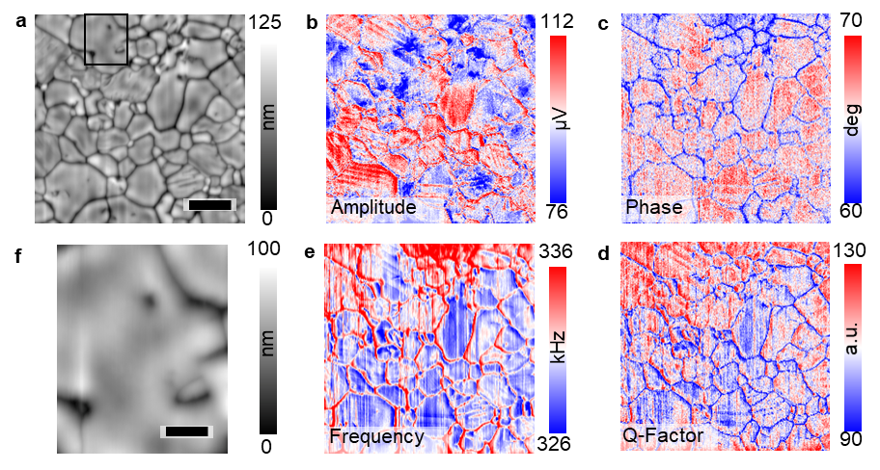
Figure 5-1. BE-PFM measurements on CH₃NH₃PbI₃-1. a, topography; b, amplitude; c, phase; d, quality factor; e, frequency; f, zoomed-in topography area marked in (a) by a black square, where BE-cKPFM was performed. The scale bars are 2 μm (a) and 0.5 μm (f), respectively. Adapted with permission from Ref 176.

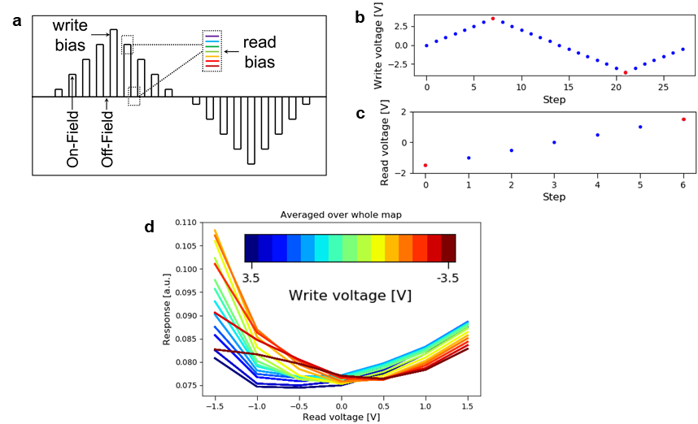
Figure 5-2. BE-cKPFM measurement on CH₃NH₃PbI₃-1. a, the schematic of tip bias waveform of BE-cKPFM measurement; b, c, the write steps and the read steps in this experiment, respectively. d, BE-cKPFM response as functions of read bias after different write bias pulses. Adapted with permission from Ref 176.

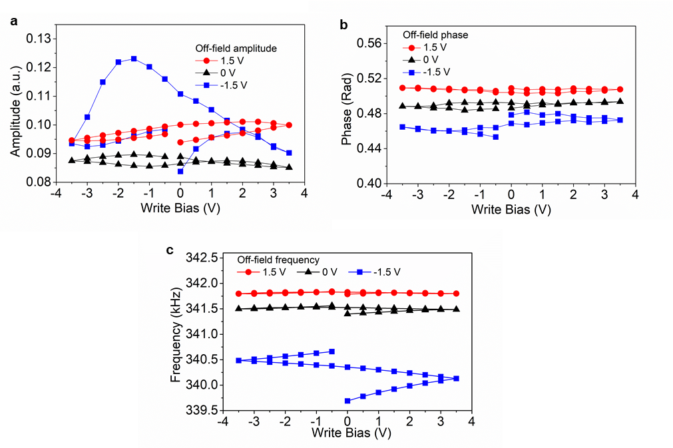
Figure 5-3. Responses of BE-cKPFM measurement. a, amplitude, b phase, and c, frequency as functions of write bias at different read steps (1.5 V, 0 V, -1.5 V). Adapted with permission from Ref 176.

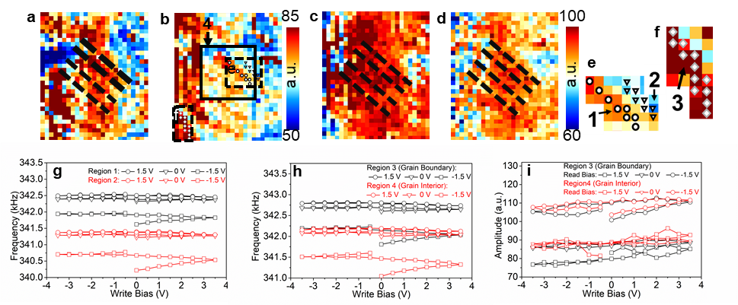
Figure 5-4. BE-cKPFM response. a-d, maps of BE-cKPFM at several representative steps, corresponding steps are marked with red dots in Figure 5-2b and Figure 5-2c. a, b, read bias -1.5 V; c, d, read bias 1.5 V; a, c, write bias 3.5 V; b, d, write bias -3.5 V. e, f, enlarged images corresponding to the black square marked in (b), where the features of domains or grain boundary are observed, region 1 (marked by circles) and region 2 (marked by triangles) are twin domains, region 3 (marked by rhombi) and region 4 (marked by a box in (b)) are grain boundary and grain interior, respectively. g, frequency evolution of region 1 and region 2 as a function of write bias; h, frequency evolution and i, amplitude evolution of region 3 and region 4 as a function of write bias. Adapted with permission from Ref 176.

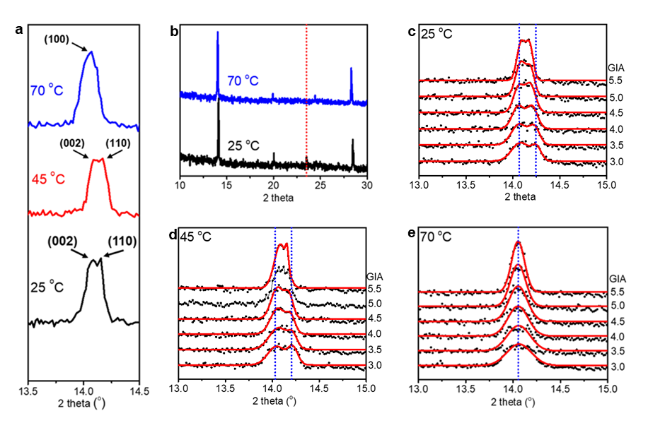
Figure 5-5. X-ray diffraction results. a, Grazing incidence X-ray diffractions at various temperatures with a grazing incidence angle of 5.5º; b, full X-ray diffraction spectra from 10º-30º at 25 ºC and 70 ºC; c, d, e, grazing incidence X-ray diffractions at 25 ºC with grazing incidence angles (GIAs) from 3. 0º to 5.5º; c, grazing incidence X-ray diffractions at 45 ºC with GIAs from 3.0º to 5.5º; e, Grazing incidence X-ray diffractions at 70 ºC with GIAs from 3.0º to 5.5º; The diffraction data in (b), (c), (e) were fitted with Gaussian distribution function, and the GIA of each data were labeled at the right side, detailed peak positions are extracted to show in Figure 5-6. Adapted with permission from Ref 241.

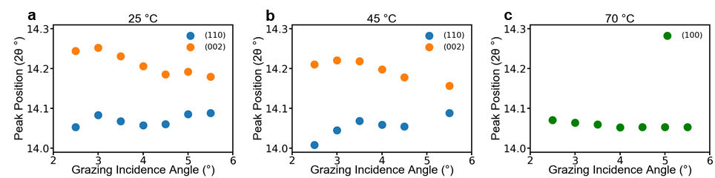
Figure 5-6. GIXRD peak positions. a, (110) and (002) peak position (2θ) changes of tetragonal CH₃NH₃PbI₃ with increasing grazing incidence angle and probe depth at 25 ºC, the decrease and the increase of 2θ indicate tensile and compressive lattice strains, respectively. b, (110) and (002) peak position (2θ) changes of tetragonal CH₃NH₃PbI₃ with increasing grazing incidence angle and probe depth at 45 ºC; c, (100) peak position (2θ) changes of cubic CH₃NH₃PbI₃ with increasing grazing incidence angle and probe depth at 70 ºC. The lattice strain gradient is observed at both 25 ºC and 45 ºC, however, the lattice strain is uniform at 70 ºC. Adapted with permission from Ref 241.

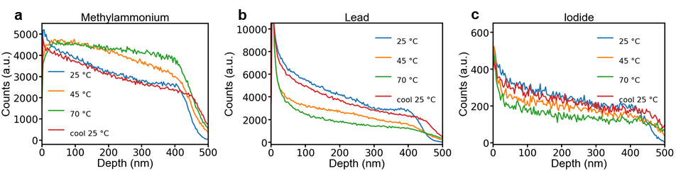
Figure 5-7. ToF-SIMS depth profiles of methylammonium, lead, and iodide. a, b, c, methylammonium, lead, and iodide depth profiles, respectively. Methylammonium distributes unevenly at 25 ºC and becomes even at elevated temperature. However, lead and iodide do not show obvious change with temperature increases. Adapted with permission from Ref 241.

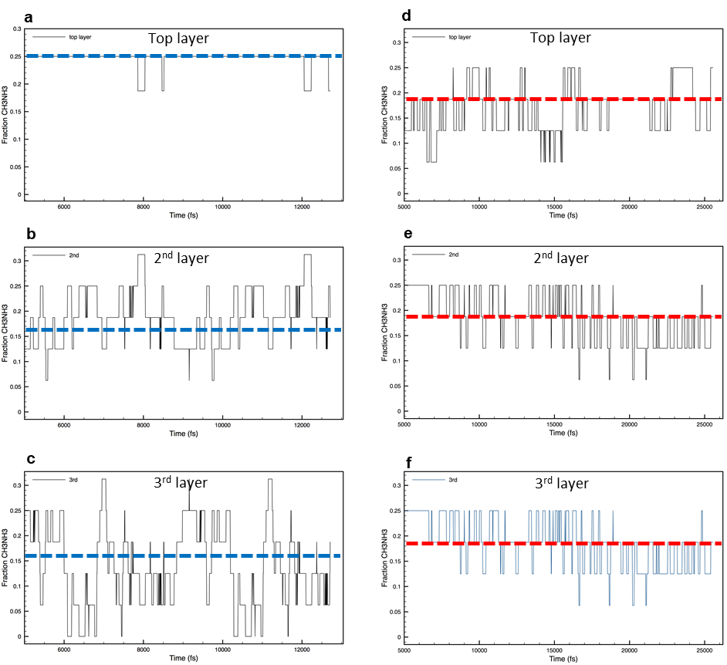
Figure 5-8. DFT simulations of methylammonium distribution in the tetragonal CH₃NH₃PbI₃ show the average fraction of CH₃NH₃⁺ over time, the fraction of CH₃NH₃⁺ located in different regions within the system was monitored by taking a 5-layer slice through the entire model at femtosecond time steps. a, b, c, the average fraction of CH₃NH₃⁺ at 25 ºC; d, e, f, the average fraction of CH₃NH₃⁺ at 45 ºC; a, d, the average fraction of CH₃NH₃⁺ at the top surface; b, e, the average fraction of CH₃NH₃⁺ at the third layer; c, f, the average fraction of CH₃NH₃⁺ at the third layer. The fluctuation of methylammonium fraction in each panel is more likely CH₃NH₃⁺ rotation rather than translation. Adapted with permission from Ref 241.

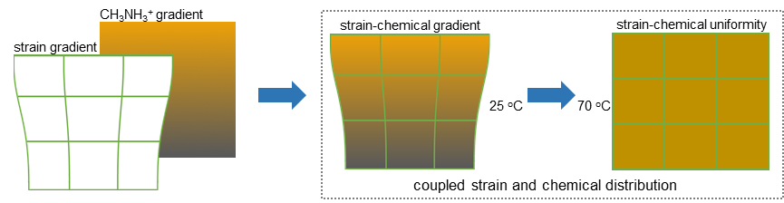
Figure 5-9. a schematic illustration of couple strain and methylammonium distributions, where both strain and methylammonium show gradual distribution at 25 ºC and even distribution at 70 ºC. Adapted with permission from Ref 241.

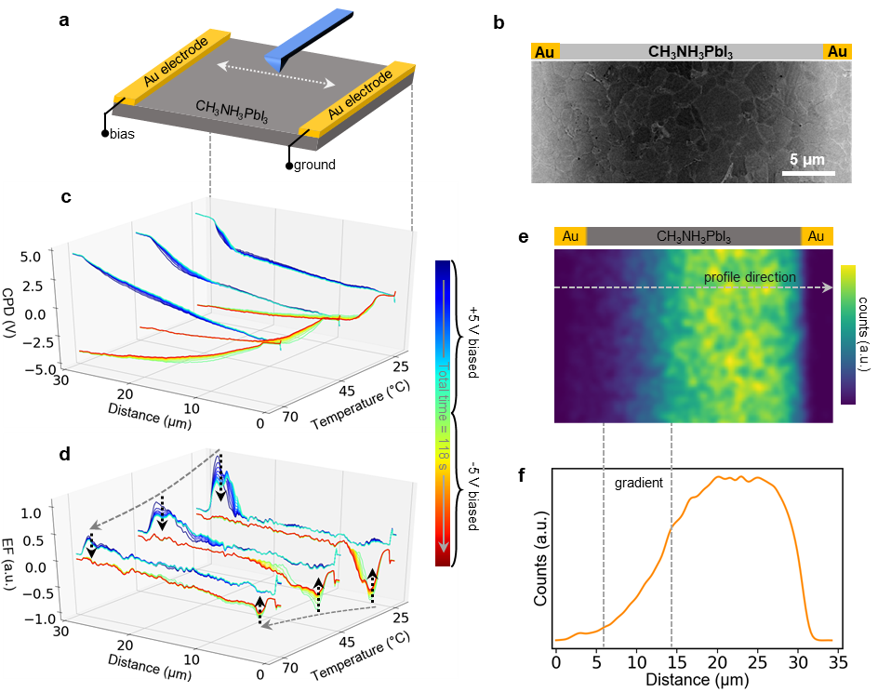
Figure 5-10. Tr-KPFM and ToF-SIMS measurements. a, a schematic diagram of the lateral device (Au/CH₃NH₃PbI₃/Au) and the setup of tr-KPFM measurements; b, scanning electron microscopy image of the lateral device; c, the evolution of CPD under +5 V and -5 V bias poling at various temperatures; d, the evolution of CPD under +5 V and -5 V bias poling at various temperatures; the colorbar in the right-hand side of (c-d) shows the temporal color of each profile; e, a ToF-SIMS CH₃NH₃⁺ distribution map of the Au/CH₃NH₃PbI₃/Au device under +6 V bias poling; f, averaged profile across the whole map of (e), the profile direction is marked in (e). Adapted with permission from Ref 241.

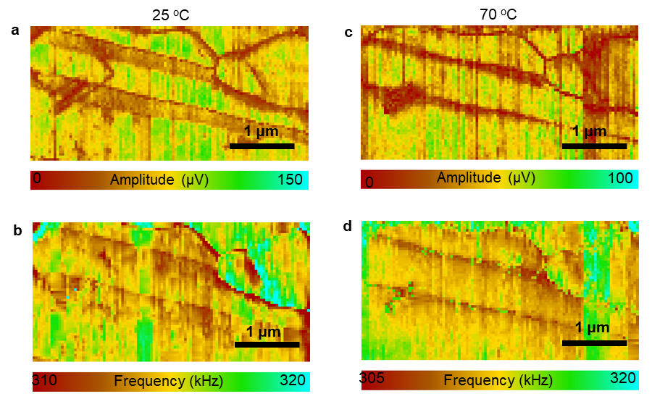
Figure 5-11. BE-PFM shows the evolution of CH₃NH₃PbI₃ twin domains with temperature changes. a, b, BE-PFM amplitude and frequency images at 25 ºC, respectively. c, d, BE-PFM amplitude and frequency images at 70 ºC, respectively. Adapted with permission from Ref 241.

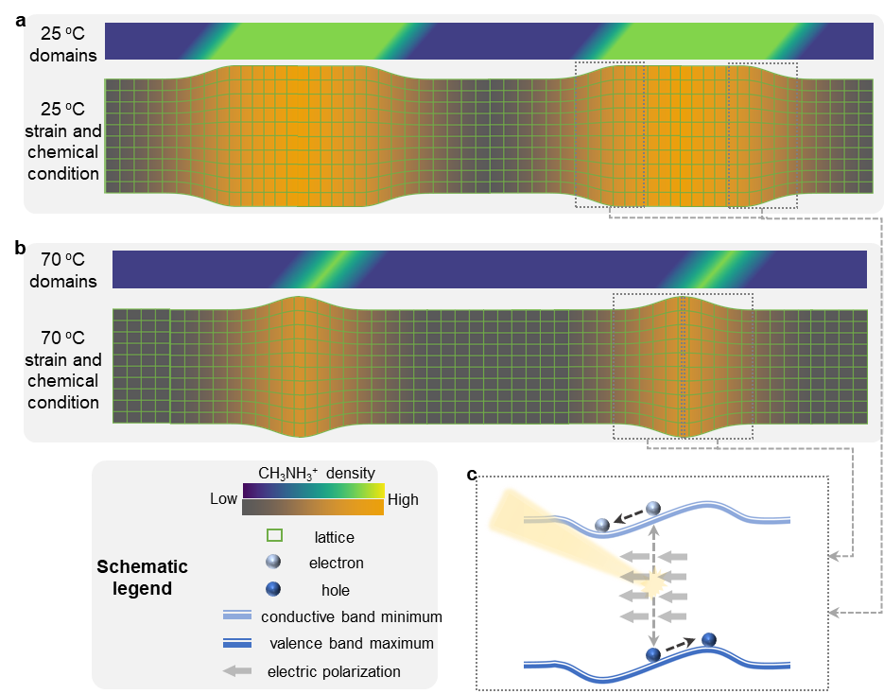
Figure 5-12. Illustration of strain-chemical gradient induced electric polarization and its effects on optoelectronic process in MHPs. a, BE-PFM shows ferroelastic twin domains evolution with temperature changes. a, twin domain structures and corresponding strain and chemical conditions at 25 ºC; b, twin domain structures and corresponding strain and chemical conditions at 70 ºC; c, electronic band structure of the strain-chemical gradient region and the impact of electric polarization on charge behavior. Adapted with permission from Ref 241.

Conclusion and Outlook

This thesis presents researches on the fundamental properties of MHPs, including ferroic, chemical, structural, and optoelectronic properties. Understanding these properties, as well as their interconnections, is critical to develop high performance optoelectronic devices based on MHPs.
The origin of the PFM domain contrast in CH₃NH₃PbI₃, which is closely related to the ferroic properties of CH₃NH₃PbI₃, was first studied. Using multiple PFM and atomic force microscopy (AFM) techniques with different emphases, it was found that the observed PFM domain contrast originates from the cantilever dynamics due to the change in local tip-sample stiffness rather than the tip displacement due to piezoelectricity and/or ferroelectricity. The twin domain exhibits a variation in elastic property between the adjacent domains. Further investigations using chemical imaging techniques, a variation in chemical composition between the adjacent domains was also discovered. Altogether, these results indicate the elastic and the chemical natures of the twin domain in CH₃NH₃PbI₃.
Following on, the effects of this twin domain on the optoelectronic property of CH₃NH₃PbI₃ was studied. Confocal PL studies revealed that the effect of this twin domain on the PL of CH₃NH₃PbI₃ is minor—only affects the PL intensity but does not affects the PL emission wavelength and lifetime. Accordingly, it was proposed that this twin domain impacts the local interaction of CH₃NH₃PbI₃ with light (e.g. light-absorption, light-trapping) and hence impacts the PL intensity. It was also found that this twin domain can alter the local optical transition dipole moment by TIRFM. In addition, a light screening effect on the twin domain was revealed based on experimental and theoretical results. Owing to the chemical and the elastic variations between adjacent domains—which may form a p-n junction around the domain walls and lead to photocarrier dissociation, the photogenerated electrons and holes may preferentially distribute in neighboring domains, respectively; which further leads to different lattice strain due to charge-lattice interaction and screen the original elastic variation between neighboring domains.
Next, ion migration in MHPs was systematically investigated via directly observing temporal local chemical changes using tr-ToF-SIMS. In combination with other functional characterization methods, the effect of ion migration on the functionality of MHPs was also studied simultaneously. Electric- and light- induced ion migration was first studied; first, it was found that CH₃NH₃⁺ migration is more significant than I⁻/Br⁻ migration, differing from the theory of defect-mediated ion migration that suggests that halides have lowest activation energy for migration in MHPs; second, light illumination only affects the distribution of CH₃NH₃⁺, no detectable change in I⁻/Br⁻ distribution induced by light was observed. In addition, both CH₃NH₃⁺ and I⁻ migration in CH₃NH₃PbI₃ are hysteretic under the bipolar electric waveform. Using machine learning approach, the migration behavior of the decomposition products of CH₃NH₃⁺ was also studied, which also show hysteretic migration. Combining these results with current-voltage characterization and tr-KPFM, it was revealed that the CH₃NH₃⁺ migration plays important roles in current-voltage hysteresis; the charge density directly related to mobile ions also shows hysteretic behavior, consistent with hysteretic ion migration, while if the injected charge due to the applied bias is involved, the whole correlation between ion migration and charge dynamics will be very complex.
Finally, the chemico-physical interactions including interactions of ferroic, chemical, structural, and optoelectronic properties in CH₃NH₃PbI₃ were studied. First, the twin domain was found to potentially confine the ion migration in CH₃NH₃PbI₃, which leads to highly responsive electromechanical/electrochemical signal in respective domains but no domain switching under the application of electric bias. Second, a tightly tied strain-chemical gradient was discovered, where the strain and the chemical distribution in CH₃NH₃PbI₃ are strongly coupled when temperature changes. This strain-chemical gradient can potentially induce an electric field that affects the optoelectronic behavior of CH₃NH₃PbI₃. Similar strain-chemical gradient can be very huge when it exists in nanoscale objects, e.g. twin domain walls, which can then have a more significant effect. Then, a mechanism of how the strain-chemical gradient in domain walls affects the optoelectronic action in CH₃NH₃PbI₃ was proposed.
Overall, the researches presented in thesis cover many fundamental aspects of MHPs, which are crucial for understanding the working mechanism and improving the performance of MHP optoelectronics. This thesis points out a main challenge in precisely interpreting the phenomenal observations in MHP and understanding the fundamentals behind them is the strong chemico-physical interactions in MHPs, where the unknown underlying chemical changes result in difficulty in understanding physical mechanisms. Some results in this thesis highlight the limitation of previous understandings on MHPs, which are expected to stimulate new thoughts and more researches on the related topics in future in order to further clarify the remaining questions.

References
1 Kojima, A., Teshima, K., Shirai, Y. & Miyasaka, T. Organometal halide perovskites as visible-light sensitizers for photovoltaic cells. Journal of the American Chemical Society 131, 6050-6051 (2009).
2 NREL: Best Research-Cell Efficiencies (2020). Available at https://www.nrel.gov/pv/assets/pdfs/best-research-cell-efficiencies.20200925.pdf (accessed Sep 2020).
3 Weber, D. CH3NH3PbX3, ein Pb (II)-system mit kubischer perowskitstruktur/CH3NH3PbX3, a Pb (II)-system with cubic perovskite structure. Zeitschrift für Naturforschung B 33, 1443-1445 (1978).
4 Poglitsch, A. & Weber, D. Dynamic disorder in methylammoniumtrihalogenoplumbates (II) observed by millimeter‐wave spectroscopy. The Journal of chemical physics 87, 6373-6378 (1987).
5 Mitzi, D. B., Feild, C., Harrison, W. & Guloy, A. Conducting tin halides with a layered organic-based perovskite structure. Nature 369, 467-469 (1994).
6 Mitzi, D., Wang, S., Feild, C., Chess, C. & Guloy, A. Conducting layered organic-inorganic halides containing< 110>-oriented perovskite sheets. Science 267, 1473-1476 (1995).
7 Mitzi, D. B., Feild, C., Schlesinger, Z. & Laibowitz, R. Transport, optical, and magnetic properties of the conducting halide perovskite CH3NH3SnI3. Journal of Solid State Chemistry 114, 159-163 (1995).
8 Kagan, C., Mitzi, D. & Dimitrakopoulos, C. Organic-inorganic hybrid materials as semiconducting channels in thin-film field-effect transistors. Science 286, 945-947 (1999).
9 Mitzi, D. B. Synthesis, structure, and properties of organic‐inorganic perovskites and related materials. Progress in inorganic chemistry, 1-121 (1999).
10 Kojima, A., Teshima, K., Shirai, Y. & Miyasaka, T. J. J. o. t. A. C. S. Organometal halide perovskites as visible-light sensitizers for photovoltaic cells. 131, 6050-6051 (2009).
11 Kim, H.-S. et al. Lead iodide perovskite sensitized all-solid-state submicron thin film mesoscopic solar cell with efficiency exceeding 9%. Scientific reports 2, 591 (2012).
12 Lee, M. M., Teuscher, J., Miyasaka, T., Murakami, T. N. & Snaith, H. J. Efficient hybrid solar cells based on meso-superstructured organometal halide perovskites. Science 338, 643-647 (2012).
13 Green, M. A., Ho-Baillie, A. & Snaith, H. J. The emergence of perovskite solar cells. Nature photonics 8, 506 (2014).
14 Brenner, T. M., Egger, D. A., Kronik, L., Hodes, G. & Cahen, D. Hybrid organic—inorganic perovskites: low-cost semiconductors with intriguing charge-transport properties. Nature Reviews Materials 1, 1-16 (2016).
15 Sutherland, B. R. & Sargent, E. H. Perovskite photonic sources. Nature Photonics 10, 295 (2016).
16 Park, N.-G. & Zhu, K. Scalable fabrication and coating methods for perovskite solar cells and solar modules. Nature Reviews Materials, 1-18 (2020).
17 Chen, J. & Park, N. G. Causes and solutions of recombination in perovskite solar cells. Advanced Materials 31, 1803019 (2019).
18 Hörantner, M. T. et al. The potential of multijunction perovskite solar cells. ACS Energy Letters 2, 2506-2513 (2017).
19 Leijtens, T., Bush, K. A., Prasanna, R. & McGehee, M. D. Opportunities and challenges for tandem solar cells using metal halide perovskite semiconductors. Nature Energy 3, 828-838 (2018).
20 Hörantner, M. T. et al. The potential of multijunction perovskite solar cells. 2, 2506-2513 (2017).
21 Hou, Y. et al. Efficient tandem solar cells with solution-processed perovskite on textured crystalline silicon. Science 367, 1135-1140 (2020).
22 Lamanna, E. et al. Mechanically Stacked, Two-Terminal Graphene-Based Perovskite/Silicon Tandem Solar Cell with Efficiency over 26%. Joule (2020).
23 Chen, B. et al. Blade-Coated Perovskites on Textured Silicon for 26%-Efficient Monolithic Perovskite/Silicon Tandem Solar Cells. Joule (2020).
24 Xu, J. et al. Triple-halide wide–band gap perovskites with suppressed phase segregation for efficient tandems. Science 367, 1097-1104 (2020).
25 Chen, B. et al. Enhanced optical path and electron diffusion length enable high-efficiency perovskite tandems. Nature Communications 11, 1-9 (2020).
26 Rose, G. Ueber einige neue Mineralien des Urals. Journal für praktische Chemie 19, 459-468 (1840).
27 Breternitz, J. & Schorr, S. What defines a perovskite? Advanced Energy Materials 8, 1802366 (2018).
28 Akkerman, Q. A. & Manna, L. What Defines a Halide Perovskite? ACS Energy Letters 5, 604-610 (2020).
29 Leguy, A. M. et al. The dynamics of methylammonium ions in hybrid organic–inorganic perovskite solar cells. Nature communications 6, 7124 (2015).
30 Weller, M. T., Weber, O. J., Henry, P. F., Di Pumpo, A. M. & Hansen, T. C. Complete structure and cation orientation in the perovskite photovoltaic methylammonium lead iodide between 100 and 352 K. Chemical Communications 51, 4180-4183 (2015).
31 Stoumpos, C. C., Malliakas, C. D. & Kanatzidis, M. G. Semiconducting tin and lead iodide perovskites with organic cations: phase transitions, high mobilities, and near-infrared photoluminescent properties. Inorganic chemistry 52, 9019-9038 (2013).
32 Fang, H. H. et al. Photophysics of organic–inorganic hybrid lead iodide perovskite single crystals. Advanced Functional Materials 25, 2378-2385 (2015).
33 Sharada, G. et al. Is CH 3 NH 3 PbI 3 Polar. J. Phys. Chem. Lett 7, 2412-2419 (2016).
34 Sharada, G. et al. Is CH 3 NH 3 PbI 3 Polar. 7, 2412-2419 (2016).
35 Lecture Y5.08 by Hoke, E.; et al. avaliable from http://www.mrs.org/fall2013-program-y/ (accessed March 2020).
36 Egger, D. A., Edri, E., Cahen, D. & Hodes, G. (ACS Publications, 2015).
37 Snaith, H. J. et al. Anomalous hysteresis in perovskite solar cells. The journal of physical chemistry letters 5, 1511-1515 (2014).
38 Shi, D. et al. Low trap-state density and long carrier diffusion in organolead trihalide perovskite single crystals. Science 347, 519-522 (2015).
39 Dong, Q. et al. Electron-hole diffusion lengths> 175 μm in solution-grown CH3NH3PbI3 single crystals. Science 347, 967-970 (2015).
40 Zhumekenov, A. A. et al. Formamidinium lead halide perovskite crystals with unprecedented long carrier dynamics and diffusion length. ACS Energy Letters 1, 32-37 (2016).
41 Stranks, S. D. et al. Electron-hole diffusion lengths exceeding 1 micrometer in an organometal trihalide perovskite absorber. Science 342, 341-344 (2013).
42 Johnston, M. B. & Herz, L. M. Hybrid perovskites for photovoltaics: charge-carrier recombination, diffusion, and radiative efficiencies. Accounts of chemical research 49, 146-154 (2016).
43 Saidaminov, M. I. et al. High-quality bulk hybrid perovskite single crystals within minutes by inverse temperature crystallization. Nature communications 6, 1-6 (2015).
44 Johnston, M. B. & Herz, L. M. J. A. o. c. r. Hybrid perovskites for photovoltaics: charge-carrier recombination, diffusion, and radiative efficiencies. 49, 146-154 (2016).
45 Chen, T. et al. Origin of long lifetime of band-edge charge carriers in organic–inorganic lead iodide perovskites. Proceedings of the National Academy of Sciences 114, 7519-7524 (2017).
46 Zheng, F., Tan, L. Z., Liu, S. & Rappe, A. M. Rashba spin–orbit coupling enhanced carrier lifetime in CH3NH3PbI3. Nano letters 15, 7794-7800 (2015).
47 Kong, L. et al. Simultaneous band-gap narrowing and carrier-lifetime prolongation of organic–inorganic trihalide perovskites. Proceedings of the National Academy of Sciences 113, 8910-8915 (2016).
48 Zhu, H. et al. Screening in crystalline liquids protects energetic carriers in hybrid perovskites. Science 353, 1409-1413 (2016).
49 Tong, J. et al. Carrier lifetimes of> 1 μs in Sn-Pb perovskites enable efficient all-perovskite tandem solar cells. Science 364, 475-479 (2019).
50 Xing, G. et al. Long-range balanced electron-and hole-transport lengths in organic-inorganic CH3NH3PbI3. Science 342, 344-347 (2013).
51 Seki, K. Equivalent circuit representation of hysteresis in solar cells that considers interface charge accumulation: Potential cause of hysteresis in perovskite solar cells. Applied Physics Letters 109, 033905 (2016).
52 Wu, B. et al. Charge accumulation and hysteresis in perovskite‐based solar cells: An electro‐optical analysis. Advanced Energy Materials 5, 1500829 (2015).
53 Weber, S. A. et al. How the formation of interfacial charge causes hysteresis in perovskite solar cells. Energy Environmental Science 11, 2404-2413 (2018).
54 Gottesman, R. et al. Dynamic phenomena at perovskite/electron-selective contact interface as interpreted from photovoltage decays. Chem 1, 776-789 (2016).
55 Tavakoli, M. M., Yadav, P., Tavakoli, R. & Kong, J. Surface Engineering of TiO2 ETL for Highly Efficient and Hysteresis‐Less Planar Perovskite Solar Cell (21.4%) with Enhanced Open‐Circuit Voltage and Stability. Advanced Energy Materials 8, 1800794 (2018).
56 Ravishankar, S. et al. Influence of charge transport layers on open-circuit voltage and hysteresis in perovskite solar cells. Joule 2, 788-798 (2018).
57 Wang, Y. C. et al. Efficient and Hysteresis‐Free Perovskite Solar Cells Based on a Solution Processable Polar Fullerene Electron Transport Layer. Advanced Energy Materials 7, 1701144 (2017).
58 Wessendorf, C. D., Hanisch, J., Müller, D. & Ahlswede, E. CdS as Electron Transport Layer for Low‐Hysteresis Perovskite Solar Cells. Solar RRL 2, 1800056 (2018).
59 Cao, J. et al. Efficient, Hysteresis‐Free, and Stable Perovskite Solar Cells with ZnO as Electron‐Transport Layer: Effect of Surface Passivation. Advanced Materials 30, 1705596 (2018).
60 Chen, C. et al. Effect of BCP buffer layer on eliminating charge accumulation for high performance of inverted perovskite solar cells. RSC advances 7, 35819-35826 (2017).
61 Yang, D. et al. High efficiency planar-type perovskite solar cells with negligible hysteresis using EDTA-complexed SnO 2. Nature communications 9, 1-11 (2018).
62 Gottesman, R. et al. Dynamic phenomena at perovskite/electron-selective contact interface as interpreted from photovoltage decays. 1, 776-789 (2016).
63 Miyano, K., Yanagida, M., Tripathi, N. & Shirai, Y. Hysteresis, stability, and ion migration in lead halide perovskite photovoltaics. The journal of physical chemistry letters 7, 2240-2245 (2016).
64 Cacovich, S. et al. Gold and iodine diffusion in large area perovskite solar cells under illumination. Nanoscale 9, 4700-4706 (2017).
65 Zhang, T., Hu, C. & Yang, S. Ion Migration: A “Double‐Edged Sword” for Halide‐Perovskite‐Based Electronic Devices. Small Methods, 1900552 (2019).
66 Zhao, Y. et al. Anomalously large interface charge in polarity-switchable photovoltaic devices: an indication of mobile ions in organic–inorganic halide perovskites. Energy Environmental Science 8, 1256-1260 (2015).
67 Yuan, Y. et al. Photovoltaic switching mechanism in lateral structure hybrid perovskite solar cells. Advanced Energy Materials 5, 1500615 (2015).
68 Yuan, H. et al. Degradation of methylammonium lead iodide perovskite structures through light and electron beam driven ion migration. The journal of physical chemistry letters 7, 561-566 (2016).
69 Zhang, T., Hu, C. & Yang, S. J. S. M. Ion Migration: A “Double‐Edged Sword” for Halide‐Perovskite‐Based Electronic Devices. 1900552 (2019).
70 Carrillo, J. et al. Ionic reactivity at contacts and aging of methylammonium lead triiodide perovskite solar cells. Advanced Energy Materials 6, 1502246 (2016).
71 Kato, Y. et al. Silver iodide formation in methyl ammonium lead iodide perovskite solar cells with silver top electrodes. Advanced Materials Interfaces 2, 1500195 (2015).
72 Besleaga, C. et al. Iodine migration and degradation of perovskite solar cells enhanced by metallic electrodes. The journal of physical chemistry letters 7, 5168-5175 (2016).
73 Zhang, T. et al. Profiling the organic cation-dependent degradation of organolead halide perovskite solar cells. Journal of Materials Chemistry A 5, 1103-1111 (2017).
74 Cacovich, S. et al. Gold and iodine diffusion in large area perovskite solar cells under illumination. 9, 4700-4706 (2017).
75 Domanski, K. et al. Not all that glitters is gold: metal-migration-induced degradation in perovskite solar cells. ACS nano 10, 6306-6314 (2016).
76 Li, Z. et al. Extrinsic ion migration in perovskite solar cells. Energy Environmental Science 10, 1234-1242 (2017).
77 Hoke, E. T. et al. Reversible photo-induced trap formation in mixed-halide hybrid perovskites for photovoltaics. Chemical Science 6, 613-617 (2015).
78 DeQuilettes, D. W. et al. Photo-induced halide redistribution in organic–inorganic perovskite films. Nature communications 7, 1-9 (2016).
79 Tang, X. et al. Local observation of phase segregation in mixed-halide perovskite. Nano letters 18, 2172-2178 (2018).
80 Draguta, S. et al. Rationalizing the light-induced phase separation of mixed halide organic–inorganic perovskites. Nature communications 8, 1-8 (2017).
81 Barker, A. J. et al. Defect-assisted photoinduced halide segregation in mixed-halide perovskite thin films. ACS Energy Letters 2, 1416-1424 (2017).
82 Vashishtha, P. & Halpert, J. E. Field-driven ion migration and color instability in red-emitting mixed halide perovskite nanocrystal light-emitting diodes. Chemistry of Materials 29, 5965-5973 (2017).
83 Eames, C. et al. Ionic transport in hybrid lead iodide perovskite solar cells. Nature communications 6, 1-8 (2015).
84 Yun, J. S. et al. Critical role of grain boundaries for ion migration in formamidinium and methylammonium lead halide perovskite solar cells. Advanced Energy Materials 6, 1600330 (2016).
85 Collins, L. et al. Time resolved surface photovoltage measurements using a big data capture approach to KPFM. Nanotechnology 29, 445703 (2018).
86 Shao, Y. et al. Grain boundary dominated ion migration in polycrystalline organic–inorganic halide perovskite films. Energy Environmental Science 9, 1752-1759 (2016).
87 Li, C., Guerrero, A., Huettner, S. & Bisquert, J. Unravelling the role of vacancies in lead halide perovskite through electrical switching of photoluminescence. Nature communications 9, 1-8 (2018).
88 Li, P.-F. et al. Unprecedented ferroelectric–antiferroelectric–paraelectric phase transitions discovered in an organic–inorganic hybrid perovskite. Journal of the American Chemical Society 139, 8752-8757 (2017).
89 Sewvandi, G. A., Kodera, K., Ma, H., Nakanishi, S. & Feng, Q. Antiferroelectric Nature of CH 3 NH 3 PbI 3− x Cl x Perovskite and Its Implication for Charge Separation in Perovskite Solar Cells. Scientific reports 6, 1-6 (2016).
90 Leguy, A. M. et al. The dynamics of methylammonium ions in hybrid organic–inorganic perovskite solar cells. 6, 1-11 (2015).
91 Sewvandi, G. A. et al. Antiferroelectric-to-ferroelectric switching in CH 3 NH 3 PbI 3 perovskite and its potential role in effective charge separation in perovskite solar cells. Physical Review Applied 6, 024007 (2016).
92 Kim, Y.-J. et al. Piezoelectric properties of CH 3 NH 3 PbI 3 perovskite thin films and their applications in piezoelectric generators. Journal of Materials Chemistry A 4, 756-763 (2016).
93 Wei, J. et al. Hysteresis analysis based on the ferroelectric effect in hybrid perovskite solar cells. The journal of physical chemistry letters 5, 3937-3945 (2014).
94 Fan, Z. et al. Ferroelectricity of CH3NH3PbI3 perovskite. The journal of physical chemistry letters 6, 1155-1161 (2015).
95 Coll, M. et al. Polarization switching and light-enhanced piezoelectricity in lead halide perovskites. The journal of physical chemistry letters 6, 1408-1413 (2015).
96 Beilsten-Edmands, J., Eperon, G., Johnson, R., Snaith, H. & Radaelli, P. Non-ferroelectric nature of the conductance hysteresis in CH3NH3PbI3 perovskite-based photovoltaic devices. Applied Physics Letters 106, 173502 (2015).
97 Beilsten-Edmands, J., Eperon, G., Johnson, R., Snaith, H. & Radaelli, P. J. A. P. L. Non-ferroelectric nature of the conductance hysteresis in CH3NH3PbI3 perovskite-based photovoltaic devices. 106, 173502 (2015).
98 Ahmadi, M. et al. Exploring anomalous polarization dynamics in organometallic halide perovskites. Advanced Materials 30, 1705298 (2018).
99 Strelcov, E. et al. CH3NH3PbI3 perovskites: Ferroelasticity revealed. Science advances 3, e1602165 (2017).
100 Hermes, I. M. et al. Ferroelastic fingerprints in methylammonium lead iodide perovskite. The Journal of Physical Chemistry C 120, 5724-5731 (2016).
101 Strelcov, E. et al. CH3NH3PbI3 perovskites: Ferroelasticity revealed. 3, e1602165 (2017).
102 Hermes, I. M. et al. Ferroelastic fingerprints in methylammonium lead iodide perovskite. 120, 5724-5731 (2016).
103 Huang, B. et al. Ferroic domains regulate photocurrent in single-crystalline CH 3 NH 3 PbI 3 films self-grown on FTO/TiO 2 substrate. npj Quantum Materials 3, 1-8 (2018).
104 Jariwala, S. et al. Local Crystal Misorientation Influences Non-radiative Recombination in Halide Perovskites. Joule 3, 3048-3060 (2019).
105 Jones, T. W. et al. Lattice strain causes non-radiative losses in halide perovskites. Energy Environmental Science 12, 596-606 (2019).
106 Liu, S. et al. Ferroelectric domain wall induced band gap reduction and charge separation in organometal halide perovskites. The journal of physical chemistry letters 6, 693-699 (2015).
107 Bi, F. et al. Enhanced photovoltaic properties induced by ferroelectric domain structures in organometallic halide perovskites. The Journal of Physical Chemistry C 121, 11151-11158 (2017).
108 Chen, L. et al. Tailoring properties of hybrid perovskites by domain-width engineering with charged walls. npj Computational Materials 4, 1-6 (2018).
109 Montero-Alejo, A. L., Menéndez-Proupin, E., Palacios, P., Wahnón, P. & Conesa, J. Ferroelectric Domains May Lead to Two-Dimensional Confinement of Holes, but not of Electrons, in CH3NH3PbI3 Perovskite. The Journal of Physical Chemistry C 121, 26698-26705 (2017).
110 Rashkeev, S. N., El-Mellouhi, F., Kais, S. & Alharbi, F. H. Domain walls conductivity in hybrid organometallic perovskites and their essential role in CH 3 NH 3 PbI 3 solar cell high performance. Scientific reports 5, 11467 (2015).
111 Liu, S. et al. Ferroelectric domain wall induced band gap reduction and charge separation in organometal halide perovskites. 6, 693-699 (2015).
112 Bi, F. et al. Enhanced photovoltaic properties induced by ferroelectric domain structures in organometallic halide perovskites. 121, 11151-11158 (2017).
113 Chen, L. et al. Tailoring properties of hybrid perovskites by domain-width engineering with charged walls. 4, 1-6 (2018).
114 Rashkeev, S. N., El-Mellouhi, F., Kais, S. & Alharbi, F. H. J. S. r. Domain walls conductivity in hybrid organometallic perovskites and their essential role in CH 3 NH 3 PbI 3 solar cell high performance. 5, 11467 (2015).
115 Montero-Alejo, A. L., Menéndez-Proupin, E., Palacios, P., Wahnón, P. & Conesa, J. J. T. J. o. P. C. C. Ferroelectric Domains May Lead to Two-Dimensional Confinement of Holes, but not of Electrons, in CH3NH3PbI3 Perovskite. 121, 26698-26705 (2017).
116 Yin, S., Gao, K., Xie, S. & Saxena, A. Effect of ferroelectricity on charge conduction in a PCBM/perovskite device structure. Organic Electronics 53, 96-100 (2018).
117 Ma, W. et al. Reducing Anomalous Hysteresis in Perovskite Solar Cells by Suppressing Interfacial Ferroelectric Order. ACS Applied Materials Interfaces (2020).
118 Frost, J. M., Butler, K. T. & Walsh, A. Molecular ferroelectric contributions to anomalous hysteresis in hybrid perovskite solar cells. Apl Materials 2, 081506 (2014).
119 Warwick, A. R., Íñiguez, J., Haynes, P. D. & Bristowe, N. C. First-Principles Study of Ferroelastic Twins in Halide Perovskites. The journal of physical chemistry letters 10, 1416-1421 (2019).
120 Liu, Y. et al. Chemical nature of ferroelastic twin domains in CH 3 NH 3 PbI 3 perovskite. Nature materials 17, 1013 (2018).
121 Liu, Y. et al. Reply to: On the ferroelectricity of CH 3 NH 3 PbI 3 perovskites. Nature materials 18, 1051-1053 (2019).
122 Burschka, J. et al. Sequential deposition as a route to high-performance perovskite-sensitized solar cells. Nature 499, 316 (2013).
123 Dong, R. et al. High‐Gain and Low‐Driving‐Voltage Photodetectors Based on Organolead Triiodide Perovskites. Advanced materials 27, 1912-1918 (2015).
124 Su, L. et al. Photoinduced enhancement of a triboelectric nanogenerator based on an organolead halide perovskite. Journal of Materials Chemistry C 4, 10395-10399 (2016).
125 Dou, L. et al. Solution-processed hybrid perovskite photodetectors with high detectivity. Nature communications 5, 5404 (2014).
126 Choi, K. J. et al. Enhancement of ferroelectricity in strained BaTiO3 thin films. Science 306, 1005-1009 (2004).
127 Li, Q. et al. Probing local bias-induced transitions using photothermal excitation contact resonance atomic force microscopy and voltage spectroscopy. ACS nano 9, 1848-1857 (2015).
128 Balke, N. et al. Exploring local electrostatic effects with scanning probe microscopy: implications for piezoresponse force microscopy and triboelectricity. ACS nano 8, 10229-10236 (2014).
129 Röhm, H., Leonhard, T., Hoffmann, M. J. & Colsmann, A. Ferroelectric domains in methylammonium lead iodide perovskite thin-films. Energy & Environmental Science 10, 950-955 (2017).
130 MacDonald, G. A. et al. Determination of the true lateral grain size in organic–inorganic halide perovskite thin films. ACS applied materials & interfaces 9, 33565-33570 (2017).
131 Huang, B. et al. Ferroic Domains of Alternating Polar and Nonpolar Orders Regulate Photocurrent in Single Crystalline CH3NH3PbI3 Films Self-grown on FTO/TiO2 Substrate. arXiv preprint arXiv:1801.08305 (2018).
132 Rothmann, M. U. et al. Direct observation of intrinsic twin domains in tetragonal CH 3 NH 3 PbI 3. Nature communications 8, 14547 (2017).
133 Vasudevan, R. K., Balke, N., Maksymovych, P., Jesse, S. & Kalinin, S. V. Ferroelectric or non-ferroelectric: Why so many materials exhibit “ferroelectricity” on the nanoscale. Applied Physics Reviews 4, 021302 (2017).
134 Mao, J. et al. High thermoelectric power factor in Cu–Ni alloy originate from potential barrier scattering of twin boundaries. Nano Energy 17, 279-289 (2015).
135 Xie, W., Tang, X., Yan, Y., Zhang, Q. & Tritt, T. M. High thermoelectric performance BiSbTe alloy with unique low-dimensional structure. Journal of Applied Physics 105, 113713 (2009).
136 Lee, K. & Baik, S. Ferroelastic domain structure and switching in epitaxial ferroelectric thin films. Annu. Rev. Mater. Res. 36, 81-116 (2006).
137 Glaser, T. et al. Infrared spectroscopic study of vibrational modes in methylammonium lead halide perovskites. The journal of physical chemistry letters 6, 2913-2918 (2015).
138 Kresse, G. & Hafner, J. Ab initio molecular dynamics for liquid metals. Physical Review B 47, 558 (1993).
139 Kresse, G. & Furthmüller, J. Efficiency of ab-initio total energy calculations for metals and semiconductors using a plane-wave basis set. Computational materials science 6, 15-50 (1996).
140 Kresse, G. & Joubert, D. From ultrasoft pseudopotentials to the projector augmented-wave method. Physical Review B 59, 1758 (1999).
141 Vanderbilt, D. Soft self-consistent pseudopotentials in a generalized eigenvalue formalism. Physical Review B 41, 7892 (1990).
142 Kresse, G. & Hafner, J. Norm-conserving and ultrasoft pseudopotentials for first-row and transition elements. Journal of Physics: Condensed Matter 6, 8245 (1994).
143 Klimeš, J., Bowler, D. R. & Michaelides, A. Van der Waals density functionals applied to solids. Physical Review B 83, 195131 (2011).
144 Dion, M., Rydberg, H., Schröder, E., Langreth, D. C. & Lundqvist, B. I. Van der Waals density functional for general geometries. Physical review letters 92, 246401 (2004).
145 Zhang, L. & Sit, P. H.-L. Ab initio study of interaction of water, hydroxyl radicals, and hydroxide ions with CH3NH3PbI3 and CH3NH3PbBr3 surfaces. The Journal of Physical Chemistry C 119, 22370-22378 (2015).
146 Jesse, S., Mirman, B. & Kalinin, S. V. Resonance enhancement in piezoresponse force microscopy: Mapping electromechanical activity, contact stiffness, and Q factor. Applied physics letters 89, 022906 (2006).
147 Jesse, S., Kalinin, S. V., Proksch, R., Baddorf, A. & Rodriguez, B. The band excitation method in scanning probe microscopy for rapid mapping of energy dissipation on the nanoscale. Nanotechnology 18, 435503 (2007).
148 Jesse, S. et al. Band excitation in scanning probe microscopy: recognition and functional imaging. Annual review of physical chemistry 65, 519-536 (2014).
149 Gannepalli, A., Yablon, D., Tsou, A. & Proksch, R. Mapping nanoscale elasticity and dissipation using dual frequency contact resonance AFM. Nanotechnology 22, 355705 (2011).
150 Collins, L. et al. Breaking the limits of structural and mechanical imaging of the heterogeneous structure of coal macerals. Nanotechnology 25, 435402 (2014).
151 Labuda, A. & Proksch, R. Quantitative measurements of electromechanical response with a combined optical beam and interferometric atomic force microscope. Applied Physics Letters 106, 253103 (2015).
152 Hawash, Z. et al. Interfacial modification of perovskite solar cells using an ultrathin MAI layer leads to enhanced energy level alignment, efficiencies, and reproducibility. The Journal of Physical Chemistry Letters 8, 3947-3953 (2017).
153 Belianinov, A. et al. Noble gas ion beams in materials science for future applications and devices. MRS Bulletin 42, 660-666 (2017).
154 Eames, C. et al. Ionic transport in hybrid lead iodide perovskite solar cells. Nature communications 6, 7497 (2015).
155 Ziębińska, A., Rytz, D., Szot, K., Górny, M. & Roleder, K. Birefringence above Tc in single crystals of barium titanate. Journal of Physics: Condensed Matter 20, 142202 (2008).
156 Banfi, G., Calvi, P. & Giulotto, E. Spontaneous and field-assisted transition in K 0.984 Li 0.016 TaO 3: The polar pattern by birefringence and second-harmonic generation. Physical Review B 51, 6231 (1995).
157 Hu, Y. H., Chan, H. M., Wen, Z. X. & Harmer, M. P. Scanning electron microscopy and transmission electron microscopy study of ferroelectric domains in doped BaTiO3. Journal of the American Ceramic Society 69, 594-602 (1986).
158 Liu, Y. et al. Twin domains modulate light-matter interactions in metal halide perovskites. APL Materials 8, 011106 (2020).
159 Liu, Y. et al. Light‐Ferroic Interaction in Hybrid Organic–Inorganic Perovskites. Advanced Optical Materials 7, 1901451 (2019).
160 Liu, T. et al. Cesium Halides-Assisted Crystal Growth of Perovskite Films for Efficient Planar Heterojunction Solar Cells. Chemistry of Materials 30, 5264-5271 (2018).
161 Xu, W., Zheng, L., Zhu, T., Liu, L. & Gong, X. Bulk Heterojunction Perovskite Solar Cells Incorporated with Zn2SnO4 Nanoparticles as the Electron Acceptors. ACS applied materials & interfaces (2019).
162 Zhou, T. et al. Highly Efficient and Stable Solar Cells Based on Crystalline Oriented 2D/3D Hybrid Perovskite. Advanced Materials, 1901242 (2019).
163 Lai, H. et al. Two-dimensional Ruddlesden–Popper perovskite with nanorod-like morphology for solar cells with efficiency exceeding 15%. Journal of the American Chemical Society 140, 11639-11646 (2018).
164 Grancini, G. et al. Role of microstructure in the electron–hole interaction of hybrid lead halide perovskites. Nature photonics 9, 695 (2015).
165 de Quilettes, D. W. et al. Impact of microstructure on local carrier lifetime in perovskite solar cells. Science 348, 683-686 (2015).
166 Son, D.-Y. et al. Self-formed grain boundary healing layer for highly efficient CH 3 NH 3 PbI 3 perovskite solar cells. Nature Energy 1, 16081 (2016).
167 Chiang, C.-H. & Wu, C.-G. Bulk heterojunction perovskite–PCBM solar cells with high fill factor. Nature Photonics 10, 196 (2016).
168 Sherkar, T. S. et al. Recombination in perovskite solar cells: significance of grain boundaries, interface traps, and defect ions. ACS energy letters 2, 1214-1222 (2017).
169 Lee, D. S. et al. Passivation of grain boundaries by phenethylammonium in formamidinium-methylammonium lead halide perovskite solar cells. ACS Energy Letters 3, 647-654 (2018).
170 Yun, J. S. et al. Benefit of grain boundaries in organic–inorganic halide planar perovskite solar cells. The journal of physical chemistry letters 6, 875-880 (2015).
171 Zong, Y. et al. Continuous grain-boundary functionalization for high-efficiency perovskite solar cells with exceptional stability. Chem 4, 1404-1415 (2018).
172 Doughty, B., Simpson, M. J., Yang, B., Xiao, K. & Ma, Y.-Z. Simplification of femtosecond transient absorption microscopy data from CH3NH3PbI3 perovskite thin films into decay associated amplitude maps. Nanotechnology 27, 114002 (2016).
173 Watson, B. R. et al. Elucidation of perovskite film micro-orientations using two-photon total internal reflectance fluorescence microscopy. The Journal of Physical Chemistry Letters 6, 3283-3288 (2015).
174 Simpson, M. J., Doughty, B., Yang, B., Xiao, K. & Ma, Y.-Z. Spatial localization of excitons and charge carriers in hybrid perovskite thin films. The journal of physical chemistry letters 6, 3041-3047 (2015).
175 Liu, C. et al. Grain boundary modification via F4TCNQ to reduce defects of perovskite solar cells with excellent device performance. ACS applied materials & interfaces 10, 1909-1916 (2018).
176 Liu, Y. et al. Dynamic behavior of CH3NH3PbI3 perovskite twin domains. Applied Physics Letters 113, 072102 (2018).
177 Rossi, D. et al. On the importance of ferroelectric domains for the performance of perovskite solar cells. Nano Energy 48, 20-26 (2018).
178 Täuber, D., Dobrovolsky, A., Camacho, R. & Scheblykin, I. G. Exploring the electronic band structure of organometal halide perovskite via photoluminescence anisotropy of individual nanocrystals. Nano letters 16, 5087-5094 (2016).
179 Rothmann, M. U. et al. Direct observation of intrinsic twin domains in tetragonal CH 3 NH 3 PbI 3. Nature communications 8, 1-8 (2017).
180 Collins, L., Liu, Y., Ovchinnikova, O. & Proksch, R. Quantitative Electromechanical Atomic Force Microscopy. ACS Nano 13, 8055-8066 (2019).
181 Chen, L. et al. Tailoring properties of hybrid perovskites by domain-width engineering with charged walls. npj Computational Materials 4, 75 (2018).
182 Sherkar, T. S. & Koster, L. J. A. Can ferroelectric polarization explain the high performance of hybrid halide perovskite solar cells? Physical Chemistry Chemical Physics 18, 331-338 (2016).
183 Collins, L., Liu, Y., Ovchinnikova, O. S. & Proksch, R. Quantitative Electromechanical Atomic Force Microscopy. ACS Nano, doi:10.1021/acsnano.9b02883 (2019).
184 Dazzi, A. & Prater, C. B. AFM-IR: Technology and Applications in Nanoscale Infrared Spectroscopy and Chemical Imaging. Chem Rev, doi:10.1021/acs.chemrev.6b00448 (2016).
185 Hawash, Z. et al. Interfacial modification of perovskite solar cells using an ultrathin MAI layer leads to enhanced energy level alignment, efficiencies, and reproducibility. 8, 3947-3953 (2017).
186 Miyata, K. et al. Large polarons in lead halide perovskites. Science advances 3, e1701217 (2017).
187 Neukirch, A. J. et al. Polaron stabilization by cooperative lattice distortion and cation rotations in hybrid perovskite materials. Nano letters 16, 3809-3816 (2016).
188 Dong, Q. et al. Electron-hole diffusion lengths> 175 μm in solution grown CH3NH3PbI3 single crystals. Science, aaa5760 (2015).
189 Gruverman, A., Rodriguez, B. J., Nemanich, R. & Kingon, A. Nanoscale observation of photoinduced domain pinning and investigation of imprint behavior in ferroelectric thin films. Journal of applied physics 92, 2734-2739 (2002).
190 Shao, R., Nikiforov, M. P. & Bonnell, D. A. Photoinduced charge dynamics on Ba Ti O 3 (001) surface characterized by scanning probe microscopy. Applied physics letters 89, 112904 (2006).
191 Rubio-Marcos, F., Del Campo, A., Marchet, P. & Fernández, J. F. Ferroelectric domain wall motion induced by polarized light. Nature communications 6, 6594 (2015).
192 Rubio-Marcos, F. et al. Reversible optical control of macroscopic polarization in ferroelectrics. Nature Photonics 12, 29 (2018).
193 Liu, Y. et al. Hysteretic Ion Migration and Remanent Field in Metal Halide Perovskites. Advanced Science 7, 2001176 (2020).
194 Zarazua, I., Bisquert, J. & Garcia-Belmonte, G. Light-induced space-charge accumulation zone as photovoltaic mechanism in perovskite solar cells. The journal of physical chemistry letters 7, 525-528 (2016).
195 Zhao, C. et al. Revealing underlying processes involved in light soaking effects and hysteresis phenomena in perovskite solar cells. Advanced Energy Materials 5, 1500279 (2015).
196 Ahmadi, M. et al. Spatially Resolved Carrier Dynamics at MAPbBr3 Single Crystal–Electrode Interface. ACS applied materials & interfaces 11, 41551-41560 (2019).
197 Wu, T. et al. Metal/Ion Interactions Induced p–i–n Junction in Methylammonium Lead Triiodide Perovskite Single Crystals. Journal of the American Chemical Society 139, 17285-17288 (2017).
198 Hsinhan Tsai, R. A., Jean-Christophe Blancon, Constantinos C. Stoumpos, Olivier Durand, Joseph W. Strzalka, Bo Chen, Rafael Verduzco, Pulickel M. Ajayan, Sergei Tretiak, Jacky Even, Muhammad Ashraf Alam, Mercouri G. Kanatzidis, Wanyi Nie, Aditya D. Mohite. Light-induced lattice expansion leads to high-efficiency perovskite solar cells. Science (2018).
199 Gottesman, R. et al. Photoinduced reversible structural transformations in free-standing CH3NH3PbI3 perovskite films. The journal of physical chemistry letters 6, 2332-2338 (2015).
200 Slotcavage, D. J., Karunadasa, H. I. & McGehee, M. D. Light-induced phase segregation in halide-perovskite absorbers. ACS Energy Letters 1, 1199-1205 (2016).
201 Deng, Y., Xiao, Z. & Huang, J. Light‐induced self‐poling effect on organometal trihalide perovskite solar cells for increased device efficiency and stability. Advanced Energy Materials 5, 1500721 (2015).
202 Chen, B. et al. Impact of capacitive effect and ion migration on the hysteretic behavior of perovskite solar cells. 6, 4693-4700 (2015).
203 Juarez-Perez, E. J. et al. Photoinduced giant dielectric constant in lead halide perovskite solar cells. 5, 2390-2394 (2014).
204 Juarez-Perez, E. J. et al. Photoinduced giant dielectric constant in lead halide perovskite solar cells. The journal of physical chemistry letters 5, 2390-2394 (2014).
205 Miyano, K., Yanagida, M., Tripathi, N. & Shirai, Y. J. T. j. o. p. c. l. Hysteresis, stability, and ion migration in lead halide perovskite photovoltaics. 7, 2240-2245 (2016).
206 Zhang, T. et al. Profiling the organic cation-dependent degradation of organolead halide perovskite solar cells. Journal of Materials Chemistry A 5, 1103-1111 (2017).
207 Tress, W. J. T. j. o. p. c. l. Metal Halide Perovskites as Mixed Electronic–Ionic Conductors: Challenges and Opportunities From Hysteresis to Memristivity. 8, 3106-3114 (2017).
208 Zhao, Y. et al. Mobile-ion-induced degradation of organic hole-selective layers in perovskite solar cells. The Journal of Physical Chemistry C 121, 14517-14523 (2017).
209 Li, Z. et al. Extrinsic ion migration in perovskite solar cells. Energy & Environmental Science 10, 1234-1242 (2017).
210 Li, C. et al. Iodine migration and its effect on hysteresis in perovskite solar cells. Advanced Materials 28, 2446-2454 (2016).
211 Li, C., Guerrero, A., Huettner, S. & Bisquert, J. Unravelling the role of vacancies in lead halide perovskite through electrical switching of photoluminescence. Nature communications 9, 5113 (2018).
212 DeQuilettes, D. W. et al. Photo-induced halide redistribution in organic–inorganic perovskite films. Nature communications 7, 11683 (2016).
213 Birkhold, S. T. et al. Interplay of mobile ions and injected carriers creates recombination centers in metal halide perovskites under bias. ACS Energy Letters 3, 1279-1286 (2018).
214 Giridharagopal, R. et al. Time-Resolved Electrical Scanning Probe Microscopy of Layered Perovskites Reveals Spatial Variations in Photoinduced Ionic and Electronic Carrier Motion. ACS nano (2019).
215 Collins, L. et al. Breaking the time barrier in Kelvin probe force microscopy: fast free force reconstruction using the G-Mode platform. ACS nano 11, 8717-8729 (2017).
216 Weber, S. A. et al. How the formation of interfacial charge causes hysteresis in perovskite solar cells. Energy & Environmental Science 11, 2404-2413 (2018).
217 Kim, D. et al. Light-and bias-induced structural variations in metal halide perovskites. Nature communications 10, 444 (2019).
218 Garcia-Belmonte, G. & Bisquert, J. Distinction between capacitive and noncapacitive hysteretic currents in operation and degradation of perovskite solar cells. ACS Energy Letters 1, 683-688 (2016).
219 Kim, S. et al. Relationship between ion migration and interfacial degradation of CH 3 NH 3 PbI 3 perovskite solar cells under thermal conditions. Scientific reports 7, 1200 (2017).
220 Domanski, K. et al. Migration of cations induces reversible performance losses over day/night cycling in perovskite solar cells. Energy & Environmental Science 10, 604-613 (2017).
221 Zhang, J. et al. Extrinsic movable ions in MAPbI3 modulate energy band alignment in perovskite solar cells. Advanced Energy Materials 8, 1701981 (2018).
222 Bi, C., Zheng, X., Chen, B., Wei, H. & Huang, J. Spontaneous passivation of hybrid perovskite by sodium ions from glass substrates: mysterious enhancement of device efficiency revealed. ACS Energy Letters 2, 1400-1406 (2017).
223 Mosconi, E. & De Angelis, F. Mobile ions in organohalide perovskites: interplay of electronic structure and dynamics. ACS Energy Letters 1, 182-188 (2016).
224 Hentz, O., Zhao, Z. & Gradecak, S. Impacts of ion segregation on local optical properties in mixed halide perovskite films. Nano letters 16, 1485-1490 (2016).
225 Yang, T. Y., Gregori, G., Pellet, N., Grätzel, M. & Maier, J. The significance of ion conduction in a hybrid organic–inorganic lead‐iodide‐based perovskite photosensitizer. Angewandte Chemie International Edition 54, 7905-7910 (2015).
226 Pockett, A. & Carnie, M. J. Ionic influences on recombination in perovskite solar cells. ACS Energy Letters 2, 1683-1689 (2017).
227 Ahmadi, M., Collins, L., Higgins, K., Lukosi, E. & Kalinin, S. V. Spatially resolved carrier dynamics at MAPbBr3 single crystal-electrode interface. submitted (2019).
228 Kalinin, S. V., Johnson, C. & Bonnell, D. A. Domain polarity and temperature induced potential inversion on the BaTiO 3 (100) surface. Journal of applied physics 91, 3816-3823 (2002).
229 Morozovska, A. N. et al. Effect of surface ionic screening on the polarization reversal scenario in ferroelectric thin films: Crossover from ferroionic to antiferroionic states. Physical Review B 96, 245405 (2017).
230 Morozovska, A. N., Eliseev, E. A., Morozovsky, N. V. & Kalinin, S. V. Ferroionic states in ferroelectric thin films. Physical Review B 95, 195413 (2017).
231 Lee, D. D. & Seung, H. S. Learning the parts of objects by non-negative matrix factorization. Nature 401, 788-791 (1999).
232 Kannan, R. et al. Deep data analysis via physically constrained linear unmixing: universal framework, domain examples, and a community-wide platform. Advanced structural and chemical imaging 4, 6 (2018).
233 Ziatdinov, M., Maksov, A. & Kalinin, S. V. in Materials Discovery and Design 103-128 (Springer, 2018).
234 Zhou, Y. et al. Giant photostriction in organic–inorganic lead halide perovskites. Nature communications 7, 11193 (2016).
235 Saidaminov, M. I. et al. High-quality bulk hybrid perovskite single crystals within minutes by inverse temperature crystallization. Nature communications 6, 7586 (2015).
236 Ziatdinov, M., Maksov, A., Kalinin, S. V. J. M. D., Science, D. B. M. o. D. & Learning, O. Deep Data Analytics in Structural and Functional Imaging of Nanoscale. 280, 103 (2018).
237 Kannan, R. et al. Deep data analysis via physically constrained linear unmixing: universal framework, domain examples, and a community-wide platform. 4, 6 (2018).
238 D Lee, D. J. N. Learning the parts of objects by non-negative matrix factorization. 401, 788-791 (1999).
239 Borodinov, N. et al. Application of pan-sharpening algorithm for correlative multimodal imaging using AFM-IR. 5, 1-9 (2019).
240 Filippetti, A. & Mattoni, A. J. P. R. B. Hybrid perovskites for photovoltaics: Insights from first principles. 89, 125203 (2014).
241 Liu, Y. et al. Strain–Chemical Gradient and Polarization in Metal Halide Perovskites. Advanced Electronic Materials 6, 1901235 (2020).
242 Vorpahl, S. M. et al. Orientation of ferroelectric domains and disappearance upon heating methylammonium lead triiodide perovskite from tetragonal to cubic phase. ACS Applied Energy Materials 1, 1534-1539 (2018).
243 Meloni, S. et al. Ionic polarization-induced current–voltage hysteresis in CH 3 NH 3 PbX 3 perovskite solar cells. Nature communications 7, 10334 (2016).
244 Wu, T. et al. Photoinduced bulk polarization and its effects on photovoltaic actions in perovskite solar cells. ACS nano 11, 11542-11549 (2017).
245 Salapaka, S. M. & Salapaka, M. V. Scanning probe microscopy. IEEE Control Systems 28, 65-83 (2008).
246 Killgore, J. P. et al. Viscoelastic property mapping with contact resonance force microscopy. Langmuir 27, 13983-13987 (2011).
247 Yuya, P., Hurley, D. & Turner, J. A. Contact-resonance atomic force microscopy for viscoelasticity. Journal of Applied Physics 104, 074916 (2008).
248 Balke, N. et al. Differentiating ferroelectric and nonferroelectric electromechanical effects with scanning probe microscopy. ACS nano 9, 6484-6492 (2015).
249 Rodriguez, B. J., Callahan, C., Kalinin, S. V. & Proksch, R. Dual-frequency resonance-tracking atomic force microscopy. Nanotechnology 18, 475504 (2007).
250 Long, R., Liu, J. & Prezhdo, O. V. Unravelling the effects of grain boundary and chemical doping on electron–hole recombination in CH3NH3PbI3 perovskite by time-domain atomistic simulation. Journal of the American Chemical Society 138, 3884-3890 (2016).
251 Al Mamun, A., Ava, T. T., Jeong, H. J., Jeong, M. S. & Namkoong, G. A deconvoluted PL approach to probe the charge carrier dynamics of the grain interior and grain boundary of a perovskite film for perovskite solar cell applications. Physical Chemistry Chemical Physics 19, 9143-9148 (2017).
252 Yang, B. et al. Enhancing Ion Migration in Grain Boundaries of Hybrid Organic–Inorganic Perovskites by Chlorine. Advanced Functional Materials 27 (2017).
253 Neerinck, D. & Vink, T. Depth profiling of thin ITO films by grazing incidence X-ray diffraction. Thin Solid Films 278, 12-17 (1996).
254 Luo, S. & Daoud, W. A. Crystal structure formation of CH3NH3PbI3-xClx perovskite. Materials 9, 123 (2016).
255 Kim, T. W. et al. Self‐Organized Superlattice and Phase Coexistence inside Thin Film Organometal Halide Perovskite. Advanced Materials 30, 1705230 (2018).

VITA
Yongtao Liu was born in Dunhuang City, Gansu Province, China in December, 1991. He received his B.S. degree in Materials Chemistry from School of Chemistry, Nankai University, Tianjin, China in 2014. In August 2016, he started his graduate study for Ph. D degree in the Department of Materials Science and Engineering at the University of Tennessee, Knoxville, Tennessee, USA. He has been working on metal halide perovskites synthesis and fundamentals regarding the chemical and the physical properties of metal halide perovskites. His thesis for Ph. D degree focuses on the chemico-physical interactions in metal halide perovskites.

