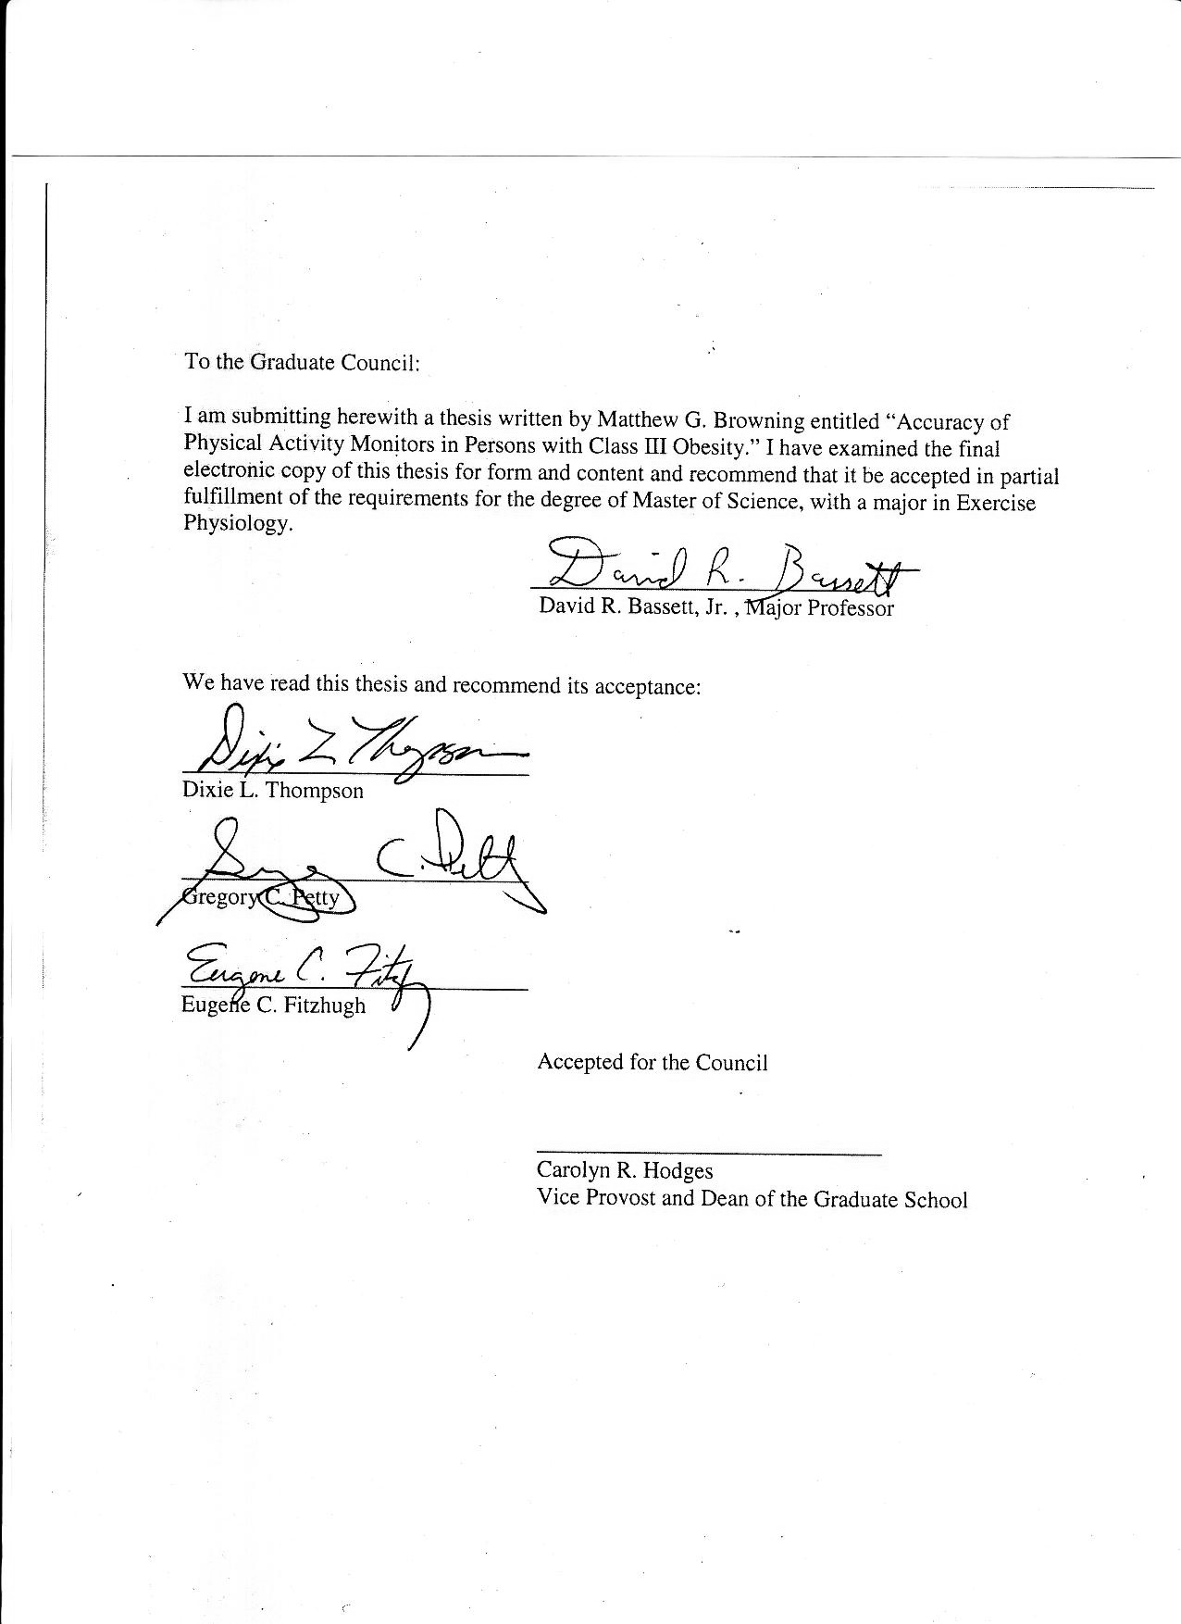

Accuracy of physical activity monitors in Persons with class III obesity

A Thesis Presented for the
Master of Science
Degree
The University of Tennessee, Knoxville

Matthew Gregory Browning
August 2012

ACKNOWLEDGEMENTS

I would like to thank my committee members for giving me the tools and support to conduct my own research. It is through each of their instruction that I have developed not only the fundamental knowledge but the passion necessary to become an independent researcher. My admiration of their collective professional achievements doubles as a motivator, in hopes of my one day becoming to a future graduate student what they are to me.

abstract

Background Small, wearable monitors are widely used to assess physical activity (PA) in obesity treatment programs ranging from lifestyle interventions to post-bariatric surgical programs. Although wearable monitors can overcome the recall biases often associated with self-reports, the accuracy of these devices may be impacted by anthropometric measures, mode of PA, and wear location. Thus, it is important to examine the accuracy of objective PA monitors during commonly performed activities such as walking.
Methods Fifteen individuals with class III obesity completed a self-paced 6-minute walk while wearing the StepWatch 3 (SW3), Omron, Digiwalker (DW), SenseWear Pro 2 Armband (SWA), and Fitbit objective PA monitors. Simultaneously, energy expenditure (EE) was measured using a portable indirect calorimeter. Height, weight, hip circumference, and waist circumference were also measured. Monitor values for step counts and Calories were compared to hand tally counts and indirect calorimetry (IC), respectively.
Results Step-counting percent errors (PE) were not significantly different among the SW3 (PE=0.56%), Omron (PE=5.53%), and Fitbit (PE=4.33%). The DW significantly undercounted steps by 28% (p=0.037). The SWA overestimated EE by 71.6% (p=0.003), while the Fitbit’s 10% overestimate did not differ significantly from IC (p=0.114).
Conclusion Objective monitors are useful for step counting and estimating energy expenditure, but consideration should be given to device accuracy when selecting evaluative tools for the bariatric population.

TABLE OF CONTENTS

CHAPTER 1 introduction 1
CHAPTER 2 review of the literature 4

INTRODUCTION 4
CLASS III OBESITY 4
PREVALENCE 5
COMORBIDITIES 6
HEALTHCARE COSTS 7
WEIGHT LOSS 8
RECOMMENDATIONS 9
CURRENT DIET 9
WEIGHT LOSS MAINTENANCE 10
REASONS FOR WEIGHT REGAIN 11
EFFECTIVE STRATEGIES 11
BARIATRIC SURGERY 12
OVERVIEW 12
PATIENT CHARACTERISTICS 13
OUTCOMES 14
RECOMMENDATIONS 16
COMPLIANCE 16
MET CONTROVERSY 18
PA & WEIGHT LOSS 19
PA & BARIATRIC SURGERY 20
BENEFITS BEYOND WEIGHT LOSS 21
WALKING FOR PHYSICAL ACTIVITY 22
PREVALENCE OF WALKING 23
RECOMMENDATIONS 23
CONSIDERATIONS FOR CLASS III OBESITY 24
WALKING SPEED 25
ADDITIONAL CONSIDERATIONS 26
METABOLIC COST OF WALKING 27
OBJECTIVE PHYSICAL ACTIVITY MONITORS 28
OBJECTIVE MONITORS VS. SELF-REPORTS 28
BENEFITS 30
SPRING-LEVERED PEDOMETERS 31
PIEZO-ELECTRIC PEDOMETERS 32
STEPWATCH 33
SENSEWEAR 33
SUMMARY 34
CHAPTER 3 Manuscript 36
INTRODUCTION 36
METHODS 38
Study Participants 38
Recruitment & Testing 38
Objective Physical Activity Monitors 39
Walking Bouts 39
Statistical Analysis 40
RESULTS 40
DISCUSSION 44
CONCLUSION 46
REFERENCES 48
APPENDICES 58
APPENDIX A 59
INFORMED CONSENT 59
APPENDIX B 63
INSTITUTIONAL REVIEW BOARD CONSENT 63
APPENDIX C 64
GRADUATE SCHOOL OF MEDICINE CONSENT 64
VITA 65

CHAPTER 1

INTRODUCTION
Increasing rates of obesity are being reported globally, with the sharpest rises in prevalence coming in the highest BMI categories [1]. These individuals, classified as having class III obesity, are also afflicted by a long list of chronic diseases associated with excessive adiposity [2-4]. Weight loss is capable of improving health [5], and bariatric surgery has previously been described as the most effective option for long-term weight loss in individuals with morbid obesity [6]. The outcomes of these surgical procedures are largely dependent on patient behavioral modifications [7], with those combining physical activity with dietary restrictions achieving the greatest weight loss [8]. Thus, participation in physical activity appears to be a necessity in improving both weight status and health in this population.
Persons with class III obesity, including those awaiting bariatric surgery, prefer walking over all other modes of physical activity [9, 10]. Objective monitors, such as pedometers and accelerometers, record step counts during walking. These devices offer clinicians a tool for assessing adherence to walking-based exercise prescriptions, while also allowing patients to self-monitor their own daily activity. In addition to recording steps, some monitors are able to estimate both daily and physical activity energy expenditure.
Pedometers and accelerometers are excellent tools for collecting data both in and out of the clinical setting. However, their accuracy may be compromised when worn by persons with class III obesity. Large waist circumference and slow walking speed negatively impact device accuracy during step counting [11], while speed and body composition regulate the metabolic cost of walking [12]. The ability to accurately relate step counts to walking energy expenditure would certainly aid in the prescription and monitoring of physical activity components of weight interventions. Therefore, determining the accuracy of step-counting devices in persons with class III obesity would benefit healthcare providers and patients alike.
While a number of objective monitors are capable of recording steps, newer technologies are being integrated into the assessment of PA. Spring-levered and piezo-electric pedometers rely on vertical accelerations at the hip to record steps. Accuracy of these devices is affected by physical characteristics of the wearer and walking speed [11, 13, 14]. In contrast, the ankle-worn StepWatch 3 Activity Monitor measures both vertical and horizontal accelerations and can record steps in a wide range of epochs. Due to its remarkable accuracy, it is considered the criterion for estimating steps in the free-living environment [15]. The SenseWear Pro 2 armband is worn on the right tricep and uses a dual-axis accelerometer and galvanic skin response, heat flux, and ambient temperature sensors to quantify PA [16]. This device has been used in several evaluative studies focusing on PA behaviors of bariatric patients [17-19]. The Fitbit is a relatively new objective monitor that records activity using a three-dimensional motion sensor similar to that of the Nintendo Wii. To our knowledge, no study has been published on the accuracy of this device in the severely obese.
By validating different objective physical activity monitors in persons with class III obesity, future researchers will be able to choose which device is best-suited for studies involving this population. With walking being the most widely prescribed form of physical activity in this population [20], accurate assessments of this activity are needed to determine the dose-response relationship between walking and health outcomes. Converting these step counts into estimates of energy expenditure would allow clinicians to quantify caloric expenditure during walking-based interventions. Therefore, the purposes of this study are to: 1) determine the accuracy of step counting devices when worn by individuals with class III obesity and 2) estimate the metabolic cost of persons with class III obesity while walking at self-selected speeds.
RESEARCH QUESTION: How accurate are the step counts and Calorie costs recorded by objective physical activity monitors when worn by individuals with class III obesity?
RESEARCH HYPOTHESIS: Accuracy will be compromised by class III obesity in all waist-mounted devices. Persons with class III obesity will walk at slower speeds than are commonly reported for normal weight individuals, but the metabolic cost of walking will be increased due to the extra body mass.

CHAPTER 2

REVIEW OF THE LITERATURE

INTRODUCTION
The prevalence of class III obesity in U.S. adults has risen from 0.9% between 1960 and 1962 to 6.2% between 2005 and 2006 [21]. This has led to an exponential increase in bariatric surgeries being performed [22]. Physical activity (PA) plays an important role in both maximizing post-surgical weight loss [8], while pre-operational PA is related to increased volume and intensity of post-surgical PA [23]. The American College of Sports Medicine (ACSM) suggests walking is the most appropriate form of exercise for individuals with class III obesity [20]. Consideration must be given when prescribing walking-based PA to this population, as the metabolic cost of walking increases with increasing body fatness [24]. Therefore, there is a specific need for accurate assessments of both the volume and metabolic cost of walking in individuals with class III obesity.

CLASS III OBESITY
The World Health Organization (WHO) [25] and the National Heart Lung and Blood Institute (NHLBI) [5] define obesity as having a body mass index (BMI) of at least 30 kg·m⁻². This condition is accompanied by severe health implications, evinced by the WHO’s recent declaration of obesity being one of the top five risk conditions in developed nations [26]. Variations in health risks can be attributed to the extent of an individual’s obesity [27-29], warranting further classification. The NHLBI and WHO established three classes of obesity based on BMI ranges. Class I and II obesity are defined as a BMI range of 30-34.99 kg·m⁻² and 35-39.99 kg·m⁻², respectively. An individual suffering from Class III obesity, interchangeably referred to as extreme [5], severe, and morbid obesity [30], is diagnosed as having a BMI of at least 40 kg·m⁻², or being 100 lbs. overweight for men or 80 lbs. overweight for women. Although the NHLBI and WHO classification charts end with class III obesity, the surgical literature often includes class IV and V obesity. Class IV, or super obesity, encompasses a BMI range of 50-59.9 kg·m⁻². Individuals with a BMI of 60 kg·m⁻² or greater are said to suffer from Class V, or super-super obesity [31].

PREVALENCE
While the prevalence of the obesity epidemic continues to increase globally [1], the steepest rises are reported in the highest BMI categories. Within the past twenty years, the worldwide prevalence of class III obesity has doubled [32]. Between 2000 and 2005, the number of persons in the US with a BMI ≥40 kg·m⁻² increased by 52% [33]. Perhaps more alarmingly, there was a 75% rise in reported BMI’s ≥50 kg·m⁻² during this same time period. As the heaviest individuals seem to only continue to gain weight, the 95th percentile of BMI’s has shifted to the right by 3.2 kg·m⁻² [34]. Over 5% of all Americans are now believed to suffer from class III obesity [33]. This would suggest that of approximately 300 million Americans, nearly 15 million are severely obese.
While, class III obesity appears to show no homogeneity in regards to age, race, or sex [35], certain groups may be more susceptible than others. The number of severely obese females doubles that of males [34], with the highest prevalence being reported for black women (15%) [32]. In terms of age, young adults are most affected by the rising rates of class III obesity. From age 18 to 35, the average weight gain is 30 pounds, and those who are already overweight experience the largest gains [36]. While these statistics are certainly cause for concern, the fact that they may fall short of actual values is most disturbing. Stommel and Schoenborn [37] found that only 72% of individuals with class III obesity actually reported having a BMI ≥40 kg·m⁻². Measured BMI was, on average, 2.12 kg·m⁻² higher when compared to self-reported values. If this underreporting was applied to the population, an additional 1.9% of Americans might suffer from class III obesity [37].

COMORBIDITIES
While extreme adiposity may be the visual marker of class III obesity, underlying health conditions, or comorbidities, may have the greatest impact on healthcare. The McGraw-Hill Concise Dictionary of Modern Medicine [38] defines comorbidity as “the simultaneous presence of 2+ morbid conditions or diseases in the same patient, which may complicate a patient's hospital stay”. The long list of comorbidities commonly associated with class III obesity includes: hypertension (HTN), type 2 diabetes mellitus (DM2), gastroesophageal reflux, depression, nonalcoholic fatty liver disease, obstructive sleep apnea (OSA), osteoarthritis, urinary stress incontinence, and breast, ovarian, gallbladder, and prostate cancers [2-4]. The most commonly reported comorbidity is HTN, with 52.3% of severely obese individuals having been diagnosed [27]. Bonfa et al. [39] report over 30% of class III obese persons suffer from depression, having a mental well-being comparable to cancer survivors and tetraplegics [40]. These high Beck Depression Inventory scores also coincided with poor perceptions of health-related quality of life but were unrelated to anthropometric measures, presence of diabetes, hypertension, osteoarthritis, or socioeconomic status [4]. Compared to normal weight individuals, severely obese persons are 5.1 times more likely to develop DM2 and 2.2 times more likely to be diagnosed with dyslipidemia [27]. Not surprisingly, 20.7% of all adults diagnosed with DM2 are also severely obese [41]. Excessive adiposity results in high intra-abdominal pressure and causes chronic hypoventilation [42], which could explain the high occurrence of pulmonary insufficiency in the severely obese [28].
In addition to these individual comorbidities, many severely obese individuals are also plagued by the metabolic syndrome. While it should be noted various medical societies have slightly different definitions , the American Heart Association (AHA) and NHLBI define the metabolic syndrome as a disease state in which an individual has three or more of the following risk factors for heart disease: waist circumference ≥ 40 inches for males or ≥ 35 inches for females, blood pressure > 130/85 mmHg, fasting triglyceride (TG) level > 150 mg/dl, fasting high-density lipoprotein (HDL) cholesterol level < 40 mg/dl for men or < 50 mg/dl for women, and fasting blood sugar > 100 mg/dl [43]. With increasing BMI comes a greater risk of being diagnosed with two or more of these comorbidities [29], supporting a prior report that up to 65.5% of severely obese individuals live with the metabolic syndrome [44]. In addition to the individual complications resulting from each risk factor, the condition as a whole is also associated with compromised health. For instance, presence of the metabolic syndrome is associated with a three-fold risk of cardiovascular morbidity [2].

HEALTHCARE COSTS
With this long list of associated diseases, it should be no surprise that severely obese individuals face a substantial financial burden. In 2002, normal weight individuals spent an average of $4,000 per annum on health care; severely obese individuals spent double this amount [45]. It is worthy to mention the vast majority of these costs are due to underlying diseases associated with obesity. Of the total health care costs related to obesity, 85% can be attributed to HTN, dyslipidemia, coronary heart disease, DM2, and stroke [46]. The gaps in healthcare expenditures are also noticeable between obesity classes. There was a $2,717 spending difference between women with class II and class III obesity, while the largest rise in costs for men was between classes I and II [45]. Rising healthcare spending is also associated with higher BMI in European countries. In the United Kingdom, there were significant differences between medication expenditures associated with class III obesity in comparison to both classes I and II [47]. To put these numbers into perspective, obese individuals (classes I,II, and III) spend 77% more on medications than persons of normal weight; there is only a 28% difference in medication costs between smokers and nonsmokers [48]. In addition to the exponentially higher costs of health care, productivity as an employee may also be affected by weight status. Individuals with class III obesity use twice as many sick days as the general population, while also drawing twice as frequent disability pension [49]. These statistics divulge the economic impact of class III obesity.

WEIGHT LOSS
The increasing prevalence of class III obesity cannot be blamed solely on a lack of desire to lose weight or prevent weight gain. In fact, the exact opposite may be true. A previous study reported up to 40% of women and 24% of men may be attempting to lose weight at any given time [50]. While the health benefits of weight loss are clear [46, 49, 51-53], often times weight loss efforts are ineffective in producing the necessary negative caloric balance. The reasons behind failed weight loss attempts are numerous. As health is only one determining factor in behavioral decision-making, this long-term outcome may be suppressed by more immediate factors. For instance, the cost of a healthy diet may exceed that of one comprised of energy-dense, processed foods. With an abundance of unhealthy and readily available fast food options and sedentary forms of electronic entertainment, today’s environment has become increasingly obesogenic. With the addition of time constraints due to demanding schedules, these environmental influences become even more exaggerated. Constant interaction with these negative stimuli mandates successful weight loss programs address both dietary and PA components [51].

RECOMMENDATIONS
According to the NHLBI [5], weight loss is indicated in all adults with a BMI ≥25 kg·m⁻², males with a waist circumference (WC) ≥ 102 cm, and females with a WC ≥ 88 cm. This same report suggests reducing energy intake by 500-1,000 kcal·d⁻¹, eliciting a minimum weight loss of 1 to 2 pounds per week. The American College of Sports Medicine (ACSM) advises striving for a 5% to 10% reduction in body weight over 3 to 6 months, while reducing dietary fat to <30% of total energy intake [20]. A more radical approach is through a very low calorie diet (VLCD), where daily energy intake is reduced to 800 kcal. Supplementing existing information on dietary modifications, the US Department of Health and Human Services (USDHHS) issued the 2008 Physical Activity Guidelines for Americans, where individuals seeking weight loss are encouraged to engage in 300 minutes of moderate-to-vigorous physical activity (MVPA) weekly [54]. The ACSM proposed similar guidelines, recommending 60 to 90 minutes of MVPA daily for weight loss and/or maintenance [20]. The USDHHS’s Dietary Guidelines for Americans, 2010 reiterates the importance of PA participation in achieving caloric balance and maintaining weight [55].

CURRENT DIET
When considering the elevated energy intake of class III obese persons, reductions in caloric intake must be a primary focus in producing a negative energy balance. In a study of 34 severely obese individuals, average reported caloric intake totaled 3,442 ± 814 kcal·d⁻¹; the average recommended caloric intake for their body size was 2,357 ± 511 kcal·d⁻¹ [56]. This difference results in a positive energy balance of over 1,000 kilocalories each day. These figures become even more alarming when considering bariatric patients are likely to underreport energy intake [57]. A similar study reported that class III obesity was associated with consuming 464 kcal·d⁻¹ than normal weight individuals [58]. This difference approximates the 500 kcal·d⁻¹ reduction recommended for weight loss.

WEIGHT LOSS MAINTENANCE
Obesity is now considered a chronic disease that requires long-term support for proper management [59]. While previous studies have shown diet and exercise to produce modest weight loss initially [60-62], long-term maintenance of this weight loss appears to present the biggest challenge. Wing and Hill [63] defined successful weight loss maintenance as “intentionally losing at least 10% of initial body weight and keeping it off for at least 1 year.” This 10% criterion is derived from numerous prior reports clearly documenting health benefits as a direct result of this percentage of weight loss [5]. Although this 10% reduction in body weight is unlikely to return an obese person to normal weight, it may still provide significant improvements in health. The famed Diabetes Prevention Program [64] proved even a 7% reduction in initial body weight through lifestyle changes can produce significantly greater reductions in risk of developing DM2 than pharmaceutical treatment. A similar study on Finnish subjects achieving an average 2-year weight loss of 3.5 kg reduced subjects’ risk of developing DM2 by 58% [53]. Oster et al. [46] report a 10% reduction in body weight may avert three years of HTN and approximately two years of DM2. This same 10% reduction in body weight was also predicted to decrease medical care costs by over $5,000. Urinary incontinence in women may also improve with modest 5-10% reductions in body weight [36]. At ten years of follow-up, this weight loss corresponds to significant improvements in health-related quality of life (HRQL) scores in the severely obese [65].

REASONS FOR WEIGHT REGAIN
Maintenance of this weight loss appears to pose the greatest challenge. Most individuals will regain 1/3 to 2/3 of the weight lost within the first year of starting a program [50]. Maclean et al. [66] report those unable to maintain weight loss had returned to their initial body weight by five years follow-up. Furthermore, these investigators found the rate of weight regain appeared to be at its highest immediately after cessation of the weight loss program [66]. One proposed explanation for this increase in body weight following weight reduction is a metabolic drive for excessive energy intake [66, 67]. In the weight-reduced state, carbohydrates (CHO) become the primary fuel, and fat oxidation appears to be suppressed [67]. This not only allows for greater deposition of fat into adipose tissue but may also trigger hunger signaling with depletion of CHO stores. Recommendations suggest keeping dietary fat below 30% of total caloric intake [20], potentially discouraging accumulation of adipose stores. It appears the best prevention of weight regain is life-long dedication to sustaining both reductions in caloric intake and improvements in PA participation.

EFFECTIVE STRATEGIES
Determining which approaches are most effective for continued weight control is of utmost importance in combatting weight regain. Established in 1994, the National Weight Control Registry (NWCR) is a database of individuals who have successfully preserved an average weight loss of 33 kg (72.6 lbs) for 5.7 years [68]. These individuals report utilizing a variety of strategies to fend off weight regain. The most commonly reported of these strategies are consumption of a low-calorie, low-fat diet, physical activity, and frequent self-weighing [69]. These individuals report a caloric intake just over 1,300 kcal/day and exercise energy expenditures sometimes exceeding 3,200 kcal/day [68].
Behavioral modifications have been shown to also produce encouraging results in persons with class III obesity. Unick et al. [52] report severely obese individuals in the Look AHEAD trial lost a greater percent of initial body weight than did overweight, class I, and class II obese individuals. Similarly, a 12-week intervention focusing on behavioral modifications produced an average 25% reduction in initial body weight in 1,100 severely obese patients [70]. Furthermore, these patients upheld 59% of this weight loss at the 72-week follow-up. Those who effectively maintain weight loss for two years reduce their odds of weight regain by nearly 50% [69]. However, meta-analysis of 29 behavioral interventions revealed just over a 3% reduction of initial body weight for all participants at 5-year follow-up [71].
To curb potential relapses, long-term contact with patients may be crucial in successful maintenance of weight loss. Perri et al. [72] found that patients who remained in contact with clinicians maintained significantly greater weight loss. Sustained contact may not be as challenging as it would seem, so long as continued clinical supervision is offered. When given the option, 87% of severely obese patients who had lost ≥ 100 lbs. during a weight loss intervention subsequently enrolled in an optional maintenance program [70]. This additional support after cessation of the structured program may be essential for long-term weight maintenance.

BARIATRIC SURGERY

OVERVIEW
Whereas behavioral modifications often elicit meager long-term weight loss outcomes, bariatric surgery has grown in popularity and is now considered the most effective long-term weight loss treatment [6]. Bariatric surgery entails a procedure or procedures that induce weight loss through limiting energy intake (restriction), reducing energy absorption (malabsorption), or both. In 1991, the National Institutes of Health (NIH) established the first guidelines for bariatric surgery, reserving its use for patients with a BMI ≥ 40 kg·m⁻² or ≥35 kg·m⁻² with high-risk comorbid conditions [73]. At the time these guidelines were published, less than 5,000 bariatric surgeries were performed annually; by 2009, this number increased to 220,000 [22]. The most commonly performed procedure is Roux-en-Y gastric bypass (RYGB) [2, 74]. RYGB combines restriction and malabsorption, reducing the stomach pouch to approximately 20 ml and bypassing the duodenum and a variable portion of the proximal jejunum [2]. Other common procedures include laparoscopic adjustable gastric banding (LAGB) and laproscopic sleeve gastrectomy (LSG). The latter is typically reserved for patients presenting with a BMI ≥ 60
kg·m⁻² or at a high risk for peri-operative morbidity and mortality [75]. The costs of these procedures and related medical care ranges from $20,000 to $50,000 [76]. In 2002, $948 million in healthcare spending was attributable to bariatric surgery [77].

PATIENT CHARACTERISTICS
Patient populations in studies involving bariatric surgery are characteristically similar to one another. Between 70% and 90% of persons presenting for weight loss surgery are women [7, 17, 78-81], and only about 10% of patients are nonwhite [7, 82, 83]. The onset of obesity normally occurs during early childhood [7], indicating the majority of these patients live with obesity for much of their lives. In addition, Bonfa et al. [39] report 27% of patients considering weight loss surgery had a family history of obesity. Over half of patients awaiting bariatric surgery suffer from two comorbidities, while 25% have been diagnosed with 3 or more [82]. The most commonly reported comorbidities are HTN (55.1%), OSA (48.9%), osteoarthritis (44.7%), and DM (33.2%) [7, 17]. These individuals suffer not only from physical and metabolic conditions, but also psychological disorders. Binge eating disorder [84] and depression [7] are two of the most prevalent psychological disorders clinicians must address during patient evaluations.

OUTCOMES
Although bariatric surgery produces significantly better long-term outcomes than conventional strategies [49, 85, 86], wide inter-individual and inter-procedural variation has been reported. In an effort to adjust for inter-individual differences in absolute body weight, weight loss outcomes are typically reported as the percentage of excess body weight lost (%EWL). Previous studies report greater weight loss outcomes from RYGB than LAGB [74, 79, 86-88]. These studies show RYGB results in ≥60% EWL, compared to <50% for LAGB. However, the %EWL 2- to 3-years post-operation has been shown to range from 24.9% to 92.1% [17]. Longer follow-up periods have exposed that even surgery cannot fully prevent weight regain. Between 3- and 5-years post-operation, approximately 20% of RYGB patients did not achieve 50% EWL [89]. Karlsson et al. [65] report patients who had undergone bariatric surgery had regained 1/3 of their initial weight loss by 6-year follow-up. In a study comparing the outcomes of short- and long-limb gastric bypass procedures, significant weight gain occurred in both surgical groups between 5- and 10-years follow-up [90]. In contrast, other studies have reported the ability of patients to sustain >50% EWL for over 15 years after the procedure [79, 88]. It is also worth mentioning that, out of 300 consecutive RYGB procedures, no patient gained weight postoperatively [7].
What factors affect post-surgical weight loss outcomes? Both pre- and post-operative patient characteristics and behaviors certainly play a crucial role. Most insurance companies require enrollment in a 6- to 12-month clinically supervised weight loss program prior to operation. This stipulation is to gauge patient adherence to medical staff instruction; pre-surgical weight loss is generally not mandatory [22]. Therefore, these programs may fail to evaluate the individual’s motivation to attempt pre-operational weight loss through prescribed lifestyle modifications. Higher initial BMI has been associated with a slower rate of weight loss and poorer %EWL. Individuals presenting with BMI’s ≥ 50 achieved a significantly lesser % EWL than those with BMI’s between 40 and 50 kg·m⁻² and regained 9% more of their pre-operative body weight at 6-year follow-up [91]. Approximately 70% of patients with a BMI >50 failed to achieve a BMI <35 at least 10 years after having undergone biliopancreatic diversion [92]. Despite these findings on the detrimental effect of a high pre-operational BMI on weight loss outcomes, the American Society for Metabolic and Bariatric Surgery (ASMBS) has recently published a position statement claiming a lack of evidence supporting the need for pre-surgical weight loss programs [93]. In a study determining predictors of post-surgical outcomes, initial BMI, level of education, presence of DM, PA participation, and post-operative appointment attendance explained 41% of the variability in weight loss following RYGB [7]. In this same study, patients with limited participation in PA achieved 17.2% less EWL than more active peers, whereas presence of DM2 hindered EWL by 6.2%. Following the post-surgical plateau in weight loss, Silver et al [94] identified current age, weight at age 21, initial BMI, and level of participation in PA as significant predictors of current BMI. In addition to patient behaviors and descriptors, surgeon experience has also been linked to post-operative weight loss outcomes [95]. While many factors appear to influence degree of weight loss achieved, the favorable effect of PA is evident.

PHYSICAL ACTIVITY
PA has been implicated as a vital component for successful weight loss and weight loss maintenance. It is also the only component of total energy expenditure that is modifiable from day to day [96]. The average caloric intake for 90% of 20- to 40-year-olds results in a positive energy balance of no more than 50 kcals·d⁻¹, but this small imbalance leads to an average weight gain of 1.8 to 2.0 lbs per year [97]. Minimal increases in daily PA could easily curb this trend toward weight gain. Participation in PA reduces the extent of dietary restrictions necessary to achieve a negative energy balance.

RECOMMENDATIONS
The USDHHS issued PA recommendations in the 2008 Physical Activity Guidelines for Americans [54]. The recommendations state that all should adults engage in 150 minutes of moderate-to-vigorous physical activity (MVPA) or 75 minutes of vigorous physical activity (VPA) each week, accumulated in bouts of at least 10 minutes. MVPA and VPA are expressed as multiples of resting energy expenditure (REE), or 1 metabolic equivalent (MET). MVPA is defined as any activity of 3.0-5.9 METs, and VPA entails all activities ≥ 6 METs. In other words, a 3.0-MET activity corresponds to a 3-fold increase in REE. At least 300 minutes of MVPA (150 min VPA) each week are recommended to induce weight loss [54]. In addition to this aerobic activity, resistance training at least twice each week is also recommended. A recent report has shown up to 50% of Americans fail to meet the recommendations for aerobic activity, and only 18.2% engage in the recommended volumes of both aerobic and resistance exercise [98].

COMPLIANCE
While a large percentage of the general population meets the national PA guidelines, severely obese individuals are much less active. Only 4.3% of class III obese adults reported engaging in moderate PA, compared to 18.1% and 35.5% of class I obese and normal weight individuals, respectively [27]. Using a multisensory armband to assess PA, Vanhecke et al. [99] showed severely obese persons spent 23 hours and 51.6 minutes per day in activities of <3 METs. The remaining 8.4 minutes were spent in moderate activity, with no individual spending any amount of time in VPA. The highest amount of activity recorded for any individual was 28 minutes per day, still falling short of the established recommendations.
Rates of physical inactivity appear to elevate in the highest BMI categories. Persons with a BMI ≥50 spend nearly an extra hour each day in sedentary behaviors than those with BMI’s ranging from 35 to 49.9 [19]. Both leisure-time and occupational levels of PA are significantly lower in women with class III obesity than normal weight women, while daily television viewing is significantly higher [42]. Only 4.5% of patients awaiting bariatric surgery meet the 150 min·wk⁻¹ of MVPA recommendation, while over 68% engage in no bouts of at least 10 minutes [80]. Additionally, only 14% of patients presenting for surgery have been in a PA program for at least 6 months [100]. This statistic alone conveys the lack of importance placed on PA in the required pre-operational weight loss programs. These percentages do appear to improve following surgery. Evans et al. [8] found 57.4% of patients self-reported engaging in ≥150 min·wk⁻¹ of MVPA one year after gastric bypass. However, after adjusting for the 10-minute bout criterion patients’ post-operative time in MVPA fell from an average of 212.8 min·wk⁻¹ to 49.3 min·wk⁻¹ [17]. While PA does appear to increase following surgery, post-operative noncompliance rates are higher for PA than all other prescribed behavioral changes [101]. Clearly, low rates of participation in PA are a concern in this rapidly growing population.

MET CONTROVERSY
Before blaming the rising rates of class III obesity on failure to meet existing PA guidelines, special consideration must first be given to how intensity of exercise is determined. As previously mentioned, the 2008 Physical Activity Guidelines for Americans [54] classify intensity of exercise using multiples of 1 MET, or an oxygen consumption of 3.5 ml·kg⁻¹·min⁻¹. This value was derived from a 70 kg, 40-year-old man [102], and the general population may have values significantly lower than the referent [103]. Use of this 1-MET value to quantify intensity of PA leads to misclassification of many activities, and the rate of misclassification may be highest in sedentary, obese individuals [104].
Adipose tissue is only about 25% as active as fat free mass [105], so excessive adiposity in the severely obese reduces resting metabolic rate (RMR) [106, 107]. The effect of adiposity on RMR can be partly attributable to a lower proportion of slow-twitch muscle fibers [108]. This smaller portion of oxidative muscle fibers helps explain the 45% lower mitochondrial respiratory capacity and decreased mitochondrial uncoupling in severely obese compared to normal weight individuals [109]. Where normal weight individuals release energy as heat, the impaired mitochondrial uncoupling accompanying class III obesity results in greater energy storage. Each of these factors contributes to the lower RMR associated with class III obesity.
As the level of obesity increases, the 1-MET value assigned to RMR becomes less applicable. Sleeping has previously been assigned a value of 0.9 METs [110]; the RMR of severely obese individuals may be lower than this [103]. A 3.0-MET activity (10.5 ml·kg⁻¹·min⁻¹) would, in turn, be more intense for a severely obese person with a low RMR than by a lean individual with a higher RMR.

PA & WEIGHT LOSS
Of persons seeking to lose weight or working to maintain weight loss, those utilizing both diet and exercise are most successful [111]. Following a VLCD, obese persons engaging in high levels of PA reduced weight by 17.5 kg, whereas the moderate exercisers lost 9.3 kg at 2- to 3-year follow-up [61]. Exercise has been proposed to enhance adherence to dietary restrictions [112], in turn, resulting in greater weight loss. The hypothalamic response to caloric restriction may be blunted through habitual PA, attenuating the desire to overfeed [66, 113]. Another study corroborates this theory by noting that no compensatory increase in caloric intake occurred following exercise [114]. Weight loss through caloric restriction alone may be detrimental to fat oxidation, as it has been found to decrease mitochondrial size [115]. PA was capable of increasing oxidative enzyme activity and mitochondrial volume, potentially overriding this disadvantageous effect of diet.
Fat-free mass (FFM) is the central determinant in RMR [116] and explains 69% of the variance in RMR of formerly obese individuals following weight loss [117]. Individuals engaging in PA following weight loss surgery gained 8% more FFM than did non-exercising peers [118]. The ability of PA to attenuate loss of FFM clearly demonstrates its impact on total energy expenditure.
In comparison to dietary therapy alone, the addition of PA increases weight loss outcomes through greater caloric expenditure. Severely obese adults who participated in a 12-month diet and exercise weight loss intervention lost significantly more weight than those following the same program but beginning PA at 6 months [119]. Exercise prescriptions of varying intensity and duration (vigorous intensity/high duration, moderate intensity/high duration, moderate intensity/moderate duration, and vigorous intensity/moderate duration) leading to weekly energy expenditures of 1,000 kcal and 2,000 kcal, combined with caloric restriction, produced no significant differences in weight loss between groups of obese, formerly sedentary women [120]. These results suggest the role of caloric expenditure resulting from PA, in terms of weight loss, supersedes that of intensity and duration. Persons with class III obesity may have difficulties engaging in high-intensity PA, so these results are particularly important for this population.
PA plays an important role in the maintenance of weight loss as well. Nearly 90% of NWCR participants reported combining diet and PA, while only 10% used diet alone [68]. In comparison to those who regained weight, successful maintainers expended approximately 2,000 kcal·wk⁻¹ more in PA [121]. Subsequent weight regain also varies when comparing diet and PA. Unlike weight regain following dietary-induced weight loss, weight regain after PA-induced weight loss is independent of the preceding weight reduction [122]. PA plays a critical role in both maximizing initial weight loss and maintaining that weight loss over time.

PA & BARIATRIC SURGERY
PA has also been shown to enhance the effects of weight loss surgery [7, 8, 17, 74, 123], while physical inactivity has been described as one of the two most detrimental factors to post-surgical weight loss outcomes [124]. Participation in pre-operational PA may also correlate with post-surgical weight loss. Those patients incapable of walking two city blocks lost 17.2% less excess body weight at 1-year follow-up [7]. In addition, becoming physically active before surgery may increase post-operational levels of PA and the intensity of this activity [23].
Following gastric bypass, patients who engaged in 150 min·wk⁻¹ of MVPA experienced significantly greater weight loss, reductions in BMI, %EWL, and total percentage of weight lost than those failing to meet PA recommendations [8]. As much as 35% of weight lost at 1-year post-operation is FFM, and this loss of FFM is directly correlated to the decrease in absolute RMR [125]. Individuals who reported engaging in post-operative PA significantly increased both FFM and percentage of fat mass lost in comparison to non-exercisers [118]. In a similar study, PA actually increased muscular strength following gastric bypass [126]. Non-exercising controls lost significant amounts of strength in their quadriceps (-16%), biceps (-36%), and triceps (-39%). Therefore, it appears PA increases surgically-induced weight loss through both increasing energy expenditure and retaining or increasing FFM. Though PA improves weight loss outcomes, there are currently no available guidelines on exercise following bariatric surgery.

BENEFITS BEYOND WEIGHT LOSS
Participation in PA has implications outside of increasing weight loss outcomes. Physically active obese individuals have lower risks of mortality and morbidity than physically inactive lean individuals, and physical inactivity is as strong a predictor of mortality as is obesity [127]. Obese adults who engaged in at least 2 hours of weekly PA reduced their risk of developing the metabolic syndrome by 19% [44], while accumulating 150 minutes of MVPA per week reduced the risk of developing glucose intolerance, dyslipidemia, and hypertension by 86% [128]. Meeting the 2008 PA guidelines is also associated with a reduced prevalence of the metabolic syndrome [129]. Aerobic capacity is linked to cardiovascular disease [130] and is improved with PA participation [131, 132]. This is particularly important in the severely obese, as their fitness levels are not significantly different than those of individuals diagnosed with heart failure [133]. After adjusting for cardiorespiratory fitness, neither obesity nor presence of metabolic syndrome are significantly related to risk of all-cause mortality [134]. A 1-MET increase in aerobic capacity has been associated with up to a 35% reduction in all-cause mortality [135] and a 5.4% reduction in healthcare costs [130]. Cardiorespiratory fitness is also inversely associated with surgical complications following gastric bypass [130]. Following bariatric surgery, cardiorespiratory fitness may decrease as a result of decreased FFM [125, 136] and reduced cardiovascular strain from the drastic weight reduction [137]. An exercise program would be necessary in both maintaining lean tissue and heart function, and has been shown to increase post-operative aerobic capacity by as much as 50% [138]. Bariatric surgery is probably incapable of improving cardiovascular function without accompanying exercise participation. In the absence of post-operative PA, weight loss surgery had no significant effect on resting heart rate (HR) or blood pressure [138]. Bariatric surgery does not typically impact high-density lipoprotein (HDL) cholesterol levels [79], but PA has been shown to improve HDL in obese individuals [139]. In comparison to non-exercisers, individuals participating in post-surgical PA improve health outcomes beyond weight loss alone.

WALKING FOR PHYSICAL ACTIVITY
The benefits of incorporating PA into any weight loss program are clear; the difficulty lies in developing approaches capable of arousing weight loss seekers to begin an exercise regimen. One of the most effective methods may be to encourage walking, particularly in persons with class III obesity [20]. The health benefits of walking are well documented [140-142], and most individuals walk to perform common tasks each day. Walking does not require an often expensive health club membership, carries a low risk for injury, and can be performed alone or with a group [132], making it one of the most convenient modes of PA. In addition to walking, the ACSM lists cycle ergometry as an appropriate form of exercise in the severely obese population [20]. However, the heart rate response relative to the oxygen requirement of cycling far exceeds that of walking [106]. In practical terms, an individual with class III obesity would be forced to cycle for a longer duration at a higher heart rate to attain an equal caloric expenditure to that of walking. Additionally, walking may alleviate some of the perceived barriers to PA reported by persons with class III obesity. While severely obese patients seeking weight loss treatment show a desire to become physically active [78, 138], concerns about wearing tight-fitting sports clothing and a lack of accommodating exercise equipment were common obstacles [143]. Walking appears to be a viable solution to alleviating these hindrances.

PREVALENCE OF WALKING
Walking seems to be the most appealing type of LTPA across BMI categories. A higher percentage of obese men (33.9%) walk for LTPA than overweight (30.0%) and normal weight (28.0%) peers, while the percentage of obese women (45.6%) reporting walking is comparable to those of overweight (49.1%) and normal weight (47.5%) groups [9]. Walking is also the most common type of PA reported by individuals seeking or maintaining weight loss. Of adults trying to lose weight, 37.7% of men and 52.5% of women incorporated walking into their weight loss strategies [144]. In a study evaluating exercise in patients awaiting bariatric surgery, 44% of reported PA came from walking [10]. Also an effective tool in maintaining weight loss, 76% of individuals enrolled in the NWCR reported walking for PA [68]. These data suggest walking may be the mode of exercise most prone to impact PA levels of the severely obese while also playing a critical role in weight loss maintenance.

RECOMMENDATIONS
Walking is believed to be the most successful tool for increasing PA, from a public health perspective [145]. This has led to an interest in establishing guidelines specific to walking. The 10,000 steps-per-day goal is perhaps the most recognizable guideline in place today and has been employed in numerous walking-based PA interventions [140, 146, 147]. Tudor-Locke and Bassett [148] proposed indices based on daily step counts for classifying PA levels. Individuals accumulating at least 10,000 steps each day were classified as active. This cut-off seems appropriate, as 73% of individuals meeting the 30 min·d⁻¹ guidelines also walked 10,000
steps·d⁻¹ [149]. In turn, sedentarism was defined as taking fewer than 5,000 daily steps.
Speed must also be considered when establishing walking recommendations. The 2008 Physical Activity Guidelines for Americans [54] suggest walking at least 3 mph for MVPA, while Ainsworth et al. [110] define “walking for exercise” as a speed of 5.6 km·h⁻¹ (3.48 mph). Stepping rate has also been used to quantify the intensity of walking. Taking 3,000 steps in thirty minutes has previously been proposed as a cut-point for MVPA [148, 150]. However, the current standardized intensities for walking do not consider individual differences in body size and may not be appropriate for use in exercise prescriptions across differing populations [110]. The applicability of these step goals to the severely obese population has yet to be determined.

CONSIDERATIONS FOR CLASS III OBESITY
Although walking is the most commonly reported form of PA in the severely obese, these individuals fall far short of reaching current recommendations. Using the cut-points proposed by Tudor-Locke and Bassett [148], 20% of patients awaiting bariatric surgery were sedentary, and 81% failed to accumulate 10,000 steps per day [10]. In this same study, BMI was inversely related to both daily steps and steps per minute during the most active 30 minutes of the day. Vanhecke et al. [99] found severely obese subjects took an average of only 3,763 steps each day.
Several factors explain the negative impact of class III obesity on daily step counts. A 10 kg·m⁻² increase in BMI was shown to coincide with over a 300% decrease in the likelihood of completing a 400 m walk [151]. Percent body fat is positively correlated with the amount of steps required to walk a given distance [149]. From this, those subjects with the highest levels of adiposity are not only taking an insufficient amount of steps each day but are also covering a shorter distance. Low daily step counts may be largely attributable to physical limitations associated with class III obesity. Walking one city block or up one flight of stairs may often induce dyspnea in this population [28]. Skin friction, foot, knee, and low back pain, and hip arthritis were all reported significantly more often by severely obese women after walking than by normal weight peers [42]. In a study of 2,458 patients awaiting bariatric surgery, 16% used an assistive device for walking and 64% experienced difficulties walking several blocks [151]. Interestingly, 41% of those reporting these difficulties did not have an objectively measured mobility deficit. This may suggest physical discomfort is viewed as a barrier to walking, even without a physician’s diagnosis. Whether the limitations to walking are real or perceived, class III obesity is clearly associated with a decrease in daily steps.

WALKING SPEED
Speed is a determinant of walking intensity, and self-selected walking speed significantly decreases as BMI and body weight increase [152]. Walking is believed to be most efficient in terms of energy expenditure at speeds around 3 mph [153], and, in a study of adults aged 20-79, only women over age 60 and men over age 70 were found to select comfortable walking speeds below this standard [154]. This is a considerably faster pace than is commonly observed for those with class III obesity. When asked to walk at a comfortable speed, severely obese women awaiting weight loss surgery were found to walk at 1.7 mph [155]. The slowest comfortable speed reported was a mere 0.81 mph, approximately ¼ the value corresponding to moderate-intensity PA [155].
Walking speed is also used in the clinical assessment of both functionality and fitness, commonly through use of the 6-minute walk test (6MWT). Previous studies have used the 6MWT to assess functional capacity in patients awaiting bariatric surgery [42, 156, 157]. Average pre-operative walking speeds ranged from 1.6 to 2.96 mph, with larger standard deviations as body weight increased [42]. The corresponding distances of these tests equals, on average, only 55% of the values attained by normal healthy adults [158]. A similar study by King et al. [151] found the average pre-operational walking speed to be 2.4 mph, but 24% of patients walked at speeds slower than 2.13 mph. Additionally, each 10 kg·m⁻² increase in BMI increased time taken to walk 400 m by 10% [151]. Furthermore, patients with an average BMI of 69
kg·m⁻² were previously found to be incapable of completing a 6-minute treadmill walk at 2 mph without developing metabolic acidosis or exceeding a respiratory exchange ratio (RER) of 1.0 [159]. Also worthy of mention considering its high prevalence in class III obesity, the preferred walking speed of 40- to 70-year-olds of varying weight statuses diagnosed with DM2 averaged only 2.05 mph [160].

ADDITIONAL CONSIDERATIONS
Class III obesity places considerably greater stress on the cardiovascular system. For instance, walking speeds between 2.8 to 3.3 mph require oxygen consumptions corresponding to as much as 75% of this population’s maximal aerobic capacity [106]. While this may limit the exercise capacity of severely obese individuals, walking at slow speeds may still provide significant health benefits. When “walking for pleasure,” obese individuals reached 70% of age-predicted maximal HR, as opposed to 59% in the normal weight group [161]. Similarly, Mattsson et al. [162] found walking at a self-selected, comfortable speed corresponded to 56% and 36% of peak aerobic capacity in obese and lean women, respectively. The clinical implication of these findings is emphasized when considering the obese groups attained these higher values while walking at significantly slower speeds. This suggests that walking speed may not be indicative of the relative effort of the activity, particularly when performed by severely obese individuals. Furthermore, even those individuals who walk at speeds below 2 mph have a 44% lower risk of developing heart disease than non-walkers [141]. Gallagher et al. [133] proposed that walking speeds as slow as 1 mph may be enough to improve cardiorespiratory fitness in severely obese persons. It can be gathered that this population is sure to benefit from walking, regardless of whether or not the recognized standards for speed are being met.

METABOLIC COST OF WALKING
The metabolic cost of walking is dependent upon several factors and can differ greatly between lean and obese individuals. Level of fitness, biomechanical efficiency, body composition, walking speed, and environment are all determinants of the energy expenditure (EE) during walking [12]. Body fatness is negatively correlated to walking efficiency [24]; the more body fat an individual carries, the greater the energy requirement of walking. For example, a 100-kg obese individual burns approximately twice as many calories as a normal weight person weighing 50-kg during a 1-mile walk [163]. Body weight has previously been shown to explain up to 92% of the variance in the metabolic cost of walking at a given speed [106], while Browning et al. [12] showed that body fat percentage accounts for 45% of these differences.
The interpretation of these and other studies is clear; adiposity has a considerable effect on walking EE. Faster walking speeds may have a greater effect on those with a high degree of body fat as a result of increased inertia, decreasing efficiency and, in turn, increasing EE [107, 164]. In a study comparing mass-specific gross EE during walking in lean and obese individuals [106], no significant differences were found at 2.2 mph. At 2.9 mph, EE was 13% higher in the obese group. While differences in EE may be negligible at slower speeds, the effect of obesity on relative intensity is more apparent. A speed of 1.55 mph corresponded to 58% and 34% of peak aerobic capacity in obese and lean individuals, respectively [165]. Differences in EE before and after weight loss also highlight the effects of body weight on the energy requirement of walking. Following extreme weight loss, the metabolic cost of walking is reduced beyond what would be expected from weight loss alone [166]. Proposed explanations for this inconsistency are biomechanical alterations and reduced thigh skin friction.
Net EE during walking has also been examined in lean and obese individuals. The net metabolic cost of walking is calculated by subtracting standing EE from EE during walking. Using net as opposed to gross values focuses solely on the metabolic cost of walking by eliminating inequalities in standing EE. After correcting for body mass, the metabolic cost of standing was 40% lower in obese than lean adults [167]. At 3 mph, gross and net EE were 27% and 31% higher in obese versus normal weight persons [96]. Net EE may be best-suited to determine the metabolic cost of the act of walking. However, gross EE is a more relevant measure when total caloric expenditure is of interest, such as in weight loss programs.

OBJECTIVE PHYSICAL ACTIVITY MONITORS
Many devices are now capable of objectively quantifying PA. Objective monitors have previously been used to establish thresholds for the classification of PA levels [148]. These devices have improved accuracy for assessing ambulatory activity and can be used to allow clinicians to assess adherence to exercise prescriptions.

OBJECTIVE MONITORS VS. SELF-REPORTS
Self-reported measures of PA are subject to recall bias, particularly when used in studies involving the clinically obese. Obese individuals claiming to be resistant to conventional weight loss treatment over-reported PA by 51 ± 75% [168]. According to Evans et al. [8] self-reported PA may poorly reflect actual participation following bariatric surgery, particularly in the first 3 months. They propose that during this time frame, exercise may be incapable of counteracting the metabolic changes occurring from such drastic reductions in energy intake. In other words, the dietary restrictions imposed following weight loss surgery may decrease the metabolic rate to an extent that cannot be fully compensated through PA. PA levels may be at their lowest in the weeks immediately following surgery, gradually increasing throughout follow-up. Therefore, PA at the time of the questionnaire may not represent that of the entire 3-month period.
The correlations between objective devices and subjective questionnaires differ among studies [169-171]. However, even a high correlation coefficient may simply denote agreement in the ranking of subjects by PA levels, rather than quantitative agreement [170]. In a pre-surgical evaluation of PA behaviors in bariatric patients, only 2-5% of the variance in objectively measured PA was explained by self-reports [10]. Even the International Physical Activity Questionnaire (IPAQ), having been validated in 12 countries, was only moderately correlated with accelerometry (r = 0.33) [172]. Furthermore, use of the IPAQ in bariatric patients has been shown to under-emphasize the relationship between abdominal obesity and PA [173].
With walking being the preferred type of PA for most individuals, accurate assessment of this behavior is a high priority. However, walking may be especially susceptible to the discrepancies between self-reports and objective measures. The Behavioral Risk Factor Surveillance System (BRFSS) fails to assess LTPA and walking separately, resulting in up to 5-fold underestimates in self-reported walking distance [170]. It is evident that PA should be assessed via objective monitoring, at least in combination with self-reports, whenever possible. In addition to providing more accurate data than self-reports, objective monitors are also capable of recording PA outside of the clinical setting.

BENEFITS
Objective PA monitors can also have a positive impact on outcomes of weight loss programs. It has been proposed that avoiding a change from group-based exercise programs to a post-intervention PA program relying solely on the individual improves the odds of behavioral maintenance [132]. Objective monitors allow the individual to record data on daily exercise, potentially creating a routine of self-monitoring. Poor PA participation following bariatric surgery has been attributed to a lack of immediate reinforcement [101]. The data displayed on the objective monitor can provide motivation to exercise after weight loss surgery. Many monitors are capable of storing several weeks’ worth of data, so medical staff may be able to reduce the frequency of post-operative appointments used to assess patient adherence to exercise prescriptions.
PA monitors can effectively increase PA and adherence to PA prescriptions [174-176], thereby improving health benefits. In comparison to subjects without an objective monitor, those given a pedometer during a walking intervention had significantly greater improvements in glucose tolerance [177]. Adults ages 65 and older increased daily step counts by 27% during a pedometer-driven walking intervention; these gains were lost after removing the devices [178]. Moreover, a recent review found that studies that used a pedometer, daily step goal, and PA log increased activity by an average of 2,500 steps per day [174].
Some PA monitors are also capable of estimating daily and exercise EE. These devices become particularly useful when assessing lifestyle changes in bariatric patients. Following surgery, these individuals experience declines in both resting [179] and walking EE [155]. Accurate estimates of EE would be a valuable resource in maximizing post-surgical weight loss. Quantification of PA potentially offers clinicians the opportunity to discern whether patients are complying with dietary and PA goals.

SPRING-LEVERED PEDOMETERS
Pedometers are devices capable of recording steps taken throughout the day. The simplest of these devices is the spring-levered pedometer. In order for a pedometer to accurately assess step counts, the device must be positioned vertically on the body. During walking, steps are recorded when vertical accelerations of the trunk cause the movement of a spring-suspended horizontal lever arm. Spring-levered pedometers are less accurate in counting steps of obese individuals in comparison to normal weight peers. Shepherd et al. [180] found strong positive correlations between pedometer error and BMI (r = 0.792) and body weight (r = 0.753). The Yamax SW-200 (Yamax Inc., Tokyo, Japan) undercounted the steps of persons weighing over 100 kg by 11-15% versus 3-7% in those under 100 kg [152]. Excessive adiposity at the waist may dampen these oscillations, and the force exerted on the lever arm may be insufficient to record the step [14]. Additionally, a large waist circumference (WC) may tilt the pedometer out of the vertical plane, decreasing movement of the lever arm required for step counting [13]. When held against the waist of an obese individual with an elastic undergarment, step-counting accuracy drastically improved [180].
Walking speed is inversely related with pedometer accuracy [13]. When considering self-selected walking speed decreases with increasing BMI [152], this effect is of particular importance in the evaluation of PA in the severely obese. At speeds of 80 m·min⁻¹ and slower, WC and BMI were inversely related to pedometer accuracy [14]. While speed and anthropometrics negatively affected device accuracy at slower speeds, pedometer tilt angle had the greatest effect across all speeds. Pedometer tilt angle is influenced by adiposity at the waist, and thus the accuracy of these devices in persons with class III obesity is decreased. As a result of differences in self-selected walking speed and tilt angle, the Digi-Walker SW-200 spring-levered pedometer may undercount steps in obese persons by twice as much as in normal weight individuals [11]. However, not all studies have corroborated these findings. At 2.0 and 2.5 mph, accuracy of the Yamax SW-200 was significantly affected by speed but not BMI [13].

PIEZO-ELECTRIC PEDOMETERS
Similar to spring-levered pedometers, most piezo-electric pedometers are also worn on the belt or waistband. During ambulation, a piezo-electric accelerometer records the vertical accelerations of the body, and these data are used to generate estimates of energy expenditure. Steps are recorded by counting the number of peaks or zero-crossings of the acceleration with respect to the time recording [14]. These devices are better-suited for obese individuals who usually walk at slower speeds [152]. Accuracy of the New Lifestyles NL-2000 piezo-electric pedometer was unaffected by BMI, WC, and pedometer tilt angle [14]. It must be noted that individuals incapable of walking at 4 mph were excluded from this study, and the average walking speeds of severely obese individuals fall short of this pace [151, 156, 158]. While BMI and slow step-rate percentage affected the Digi-Walker accuracy in free-living activity, the accuracy of the New Lifestyles device was dependent only on stepping rate [11]. The Omron HJ-720ITC (Omron Industries) records steps with an absolute error of less than 3% while walking at both predetermined and self-selected speeds[181]. The Omron is most accurate when worn in the pocket and recorded with 65% accuracy in obese persons over a 24-hour period [182]. Even when worn in the pocket, this device was more accurate than the waist-mounted Yamax. This may be another possible advantage as opposed to spring-levered devices, as a pocket pedometer is less reliant on positioning within the vertical plane to record steps. However, the Omron has a 4-second step filter, which leads to undercounting in the free-living environment [183].

STEPWATCH
During walking, more movement occurs at the ankle than at the hip [11]. The StepWatch is worn at the ankle and uses a dual-axis accelerometer to count steps. This device has been reported as more accurate than both spring-levered and piezo-electric pedometers at various speeds, including perfect accuracy in a small sample of severely obese persons [180]. It has since been used as a criterion pedometer [11, 182]. Where thresholds of 0.30-0.35g are necessary to record a step in most waist-mounted pedometers, ankle-mounted devices may be more sensitive [11]. Because it uses accelerometry to record steps, this device is also capable of recording minute-by-minute stepping rates [180]. This data can be stored for 24-hour periods over multiple days [11] and is transmitted to a personal computer via an infrared relay [180]. The StepWatch is also superior to both spring-levered and piezo-electric pedometers during stair climbing [180]. The StepWatch was previously been used in prediction equations to estimate walking EE, and approximately 66% of the variance in the metabolic cost of walking could be explained from StepWatch step counts [184].

SENSEWEAR
A newer device combines innovative technology, accelerometry, and proprietary prediction equations to analyze both total and daily PA. The SenseWearTM Armband (BodyMedia, Inc. Pittsburgh, PA) is worn on the upper right arm and is capable of counting steps, estimating EE, and determining intensity of PA over a 24-hour period for multiple days. Data are collected via a dual-axis accelerometer, galvanic skin response sensor, heat flux sensor, and an ambient temperature sensor [185]. PA measurements from this device were similar to those of a triaxial accelerometer in a study involving persons awaiting bariatric surgery [16].
Even with the advanced technology of this device, energy expenditure assessments appear far from perfect. When compared to doubly labeled water (DLW), the SenseWear armband (SWA) significantly underestimated daily EE by 117 kcal in healthy adults (BMI 18≤35) [18]. An intraclass correlation of 0.81 showed that, despite group differences, individual comparisons between SWA and DLW were similar. Its ability to discriminate between periods of rest and activity [149] has led to its use in the evaluation of sedentary behaviors in severely obese individuals [19]. In a study assessing SWA accuracy in obese individuals (BMI 42.3 ± 7.0), REE was underestimated by an average of 8.8% [186]. Conversely, SWA significantly overestimated EE during treadmill walking. Detecting changes in grade also appears to pose a problem when estimating EE. EE was significantly overestimated by 13-27% while walking without a grade, in contrast to 22% underestimations after adding a 5% grade [185]. These subjects were far leaner than persons with class III obesity, warranting similar studies in the class III obese population. Interventions may benefit from using this device to encourage patient self-monitoring, lowering the cost of care for both subjects and clinicians. Additionally, overweight and obese individuals reduced blood glucose when receiving group intervention with SWA and when receiving SWA alone [187], indicating use of this device may be capable of improving health even in the absence of a structured exercise program.

SUMMARY
Validating objective monitors in severely obese individuals is a crucial step in both determining volumes of PA necessary for maximizing weight loss and assessing adherence to exercise prescriptions. Determining which devices are most accurate when worn by these individuals will improve quantitative measures of PA in future studies involving the severely obese. Additionally, estimating the metabolic cost of walking in this population will allow clinicians to approximate caloric expenditure during walking-based interventions. These results could lead to the establishment of pre- and post-operative PA recommendations for obese patients, including those who will undergo bariatric surgery.

CHAPTER 3

MANUSCRIPT

INTRODUCTION
The prevalence of obesity continues to increase globally [1]. The highest rate of increase has been in class III, also known as morbid or severe, obesity [32-34]. Over the past twenty years, the worldwide prevalence of class III obesity has doubled [32]. Behavioral interventions are capable of reducing body weight in the severely obese [52], and those combining diet and exercise produce greater long-term results [111]. Bariatric surgery is now considered the most effective weight loss treatment for severely obese individuals [6], and participation in physical activity (PA) improves post-surgical weight loss outcomes [188]. Clearly, PA plays an integral role in both behavioral and surgical weight loss interventions.
Objective monitors record PA data in the free-living environment and have been shown to increase PA and adherence to PA prescriptions [174-176]. Objective monitoring is particularly valuable in individuals with class III obesity, as they tend to over-report PA participation [168]. Currently, only self-reported measures have been validated for assessing PA in the bariatric population [123]. However, only 2-5% of the variance in objectively measured pre-operative PA is explained by self-reports [10]. Walking comprises 44% of total PA prior to surgery coming from walking [10], and 76% of National Weight Control Registry participants report walking as a part of their strategy to maintain weight loss [68]. Thus, accurate assessment of this activity is necessary.
Pedometers and accelerometers are both capable of recording data during ambulatory activities. The simplest of these devices is the spring-levered pedometer. Worn at the waist, pedometers record steps when vertical accelerations of the trunk trigger the movement of a spring-suspended horizontal lever arm. However, the accuracy of spring-levered pedometers is reduced in obese individuals and with slow walking speeds [13, 152, 180]. Piezo-electric pedometers record vertical accelerations of the body during ambulation, and steps are recorded by counting the number of peaks or zero-crossings of the acceleration vs. time recording [14]. The accuracy of piezo-electric pedometers is not influenced by BMI [14], but is reduced at slower walking speeds [11].
Another step-counting device, the StepWatch 3 (Orthocare Innovations, Oklahoma City, OK) is worn at the ankle and uses a dual-axis accelerometer to count steps. This device is more accurate than spring-levered and piezo-electric pedometers and had near-perfect accuracy in a small sample of severely obese persons [180]. It has since been used as a criterion pedometer [11, 182].
Newer devices rely on advanced technology to more accurately quantify the intensity of free-living PA. The SenseWear Armband (BodyMedia, Inc. Pittsburgh, PA) is worn on the upper right arm and collects data via a dual-axis accelerometer and galvanic skin response, heat flux, and ambient temperature sensors [185]. Measured PA intensities from this device were similar to those from a waist-worn triaxial accelerometer in a study involving persons awaiting bariatric surgery [16]. The Fitbit (Fitbit Inc., San Francisco, CA) is a wearable PA monitor that records three-dimensional accelerations using an accelerometer. Both use proprietary algorithms involving pattern recognition to convert acceleration to energy expenditure (EE), but, to our knowledge, no study has been published on the accuracy of this device in individuals with severe obesity. Therefore, the aim of the current study was to determine the accuracy of objective physical activity monitors during walking in persons with class III obesity.

METHODS

Study Participants
Participants were 15 individuals between the ages of 19 and 61, who were patients in the Tennessee Weight Loss & Surgery Center (University of Tennessee Medical Center, Knoxville). No post-operative patients were included in this study.

Recruitment & Testing
Participants were recruited following medical staff presentations on weight loss surgery and during support group meetings that prospective surgery patients were required to visit. Recruitment flyers were also left with medical staff of the Weight Loss and Surgery Center. A short presentation was given describing the objectives of the study. Afterwards, individuals were given the opportunity to ask additional questions. All participants signed an informed consent form.
To be eligible for the study, participants had to be ≥18 years of age, diagnosed with class III obesity (BMI ≥40 kg·m⁻² or BMI ≥35 kg·m⁻² with medical comorbidities), and able to walk for six consecutive minutes without the use of an assistive device. Consent was received from the attending surgeon prior to beginning any testing. Individuals were deemed ineligible if they did not meet these criteria or if the physician knew of any other reasons contraindicating participation in the current study. The University of Tennessee Institutional Review Board and the University of Tennessee Graduate School of Medicine approved the protocol.
Testing was completed at the University of Tennessee Medical Center. To reduce subject burden, testing was scheduled during regularly scheduled hospital visits whenever possible. Inside the Weight Loss & Surgery Center, age, sex, height, weight, hip circumference (HC), and waist circumference (WC) were recorded. Walking bouts were completed in a hallway outside the Weight Loss & Surgery Center.

Objective Physical Activity Monitors
Participants wore shorts/pants with pockets and appropriate footwear for walking-based activities. Objective monitors were placed on various body locations in accordance with their respective manufacturers’ instructions. The Fitbit was worn on the right side of the waist. The SenseWear Pro 2 armband (SWA) (Software Version 7.0) was worn on the right tricep at the midpoint between the acromion and olecranon processes. The Omron HJ-720ITC pedometer (Omron Corporation, Kyoto, Japan) was worn in the pants pocket, while the Yamax SW-200 Digiwalker (DW) (Yamasa Corporation, Tokyo, Japan) was clipped to the left side of the waistband. The StepWatch 3 (SW3) (software version 6.0) was worn on the right ankle, just above the lateral malleolus.
As a criterion measure, steps were recorded via a hand tally counter by the principal investigator. Simultaneously, EE was measured by indirect calorimetry using the Oxycon Mobile portable metabolic system (Carefusion, San Diego, CA). This device was worn on a harness, with the facemask covering the nose and mouth. The Oxycon O₂ and CO₂ analyzers were calibrated using a reference gas tank (16.0% O₂ and 4.0% CO₂) and room air, and the ventilation flow meter was calibrated with a 3-L syringe.

Walking Bouts
Participants were instructed to walk in a flat hallway at a self-selected pace for six consecutive minutes. Investigators instructed participants to select a pace that would allow them to walk without stopping prior to the sixth minute.

Statistical Analysis
All statistical analyses were performed using SPSS version 19 for Windows (SPSS, Inc., Chicago, IL). Descriptive measures of interest were height, weight, BMI, WC, HC, waist-to-hip ratio, walking speed, and walking EE. Percent errors for step counts and energy expenditure estimates were used to evaluate monitor accuracy. For comparison purposes, a value of 0% error was assigned to the criterion measures. Repeated measures analysis of variance (ANOVA) was used to determine if monitors differed in percent error for step counts. Pairwise comparisons were used to determine between-monitor differences in step-counting percent error. A paired samples t-test was used to determine if monitors differed in estimating Calories. To determine the metabolic cost of walking during steady state oxygen consumption, the final 3 minutes of indirect calorimetry values during each walking bout were averaged. To calculate percent errors, the following equation was used:
% Error = [(Criterion value – Monitor value) / (Criterion value)] * 100%
One sample t-tests were used to examine accuracy. Pearson’s correlations were used to explore the relationship between height, weight, BMI, walking speed, WC, HC, and WHR and device accuracy for step counts and Caloric expenditure. All p values were 2-tailed and were deemed statistically significant if p≤0.05.

RESULTS
Physical characteristics of the participants are depicted in Table 1. All but one individual had a BMI ≥ 40 kg·m⁻², and 14 of the 15 participants were female. Indirect calorimetry measurements were not obtained on one individual who was tested after a 12-hour fast in an effort to ensure any potential discrepancies in metabolic measures did not influence our findings.
Step Counting
Figure 2 shows the results for step-counting percent errors. Repeated measures ANOVA found PE differed between devices [F(4,11)=4.447, p=0.022)]. Post-hoc comparisons showed that step-counting percent errors did not differ among the SW3, Omron, or Fitbit. The DW significantly differed from SW3 (p=0.035), Omron (p=0.008) and Fitbit (p=0.036) but not SWA (p=0.241). Step-counting percent error of the SWA was significantly greater than Omron (p=0.020) and marginally greater than Fitbit (p=0.068) and SW3 (p=0.078). One sample t-tests showed that the DW significantly under-counted steps by approximately 28% [t(14)=2.310, p=0.037)]. The SWA appeared to under-count steps by 12% [t(14)=1.844, p=0.086].
Energy Expenditure
The SWA and Fitbit provided data on EE. A paired samples t-test found a significant difference between monitors [t(13)=-4.053, p=0.001)]. A one sample t-test found that during a 6-minute walk SWA significantly overestimated Caloric expenditure by 71.6 ± 46.7% (p=0.003), while the Fitbit slightly overestimated EE by 10.02 ± 22.1% (p=0.114).
Table 1. Participant Characteristics
Physical characteristic | Mean (Standard Deviation) | Range
Age (years) | 40.1 (12.5) | 19-61
Weight (kg) | 131.9 (22.2) | 90.5-169.6
BMI (kg·m⁻²) | 47.0 (5.9) | 37-58.7
WC (cm) | 134.2 (23.2) | 99.1-182.9
HC (cm) | 145.1 (15.3) | 106.7-172.7
WHR | 0.92 (0.09) | 0.78-1.10
Walking EE (ml·kg⁻¹·min⁻¹) | 9.24 (2.15) | 5.33-12.93
Walking Distance (m) | 388.5 (105) | 143.6-535.5
Walking Speed (km·h⁻¹) | 3.89 (1.05) | 1.43-5.36
N=14 for walking EE.
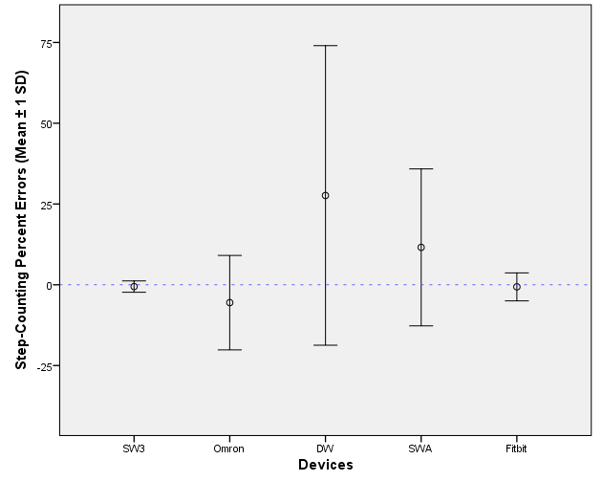
Figure 1. Percent errors in step counting during self-paced walking in adults with class II obesity. To evaluate device accuracy in relation to the hand tally criterion, mean percent errors were compared. All negative values reflect over-counting, and all positive values reflect undercounting.

Table 2. Actual steps recorded by hand tally counter and devices. Data are displayed as mean steps (standard deviation).
Hand Tally | SW3 | Omron | DW | SWA | Fitbit
616.3 (75.0) | 620.1 (79.3) | 645.8 (81.2) | 432.2 (273.1) | 537.5 (138.2) | 621.7 (89.8)

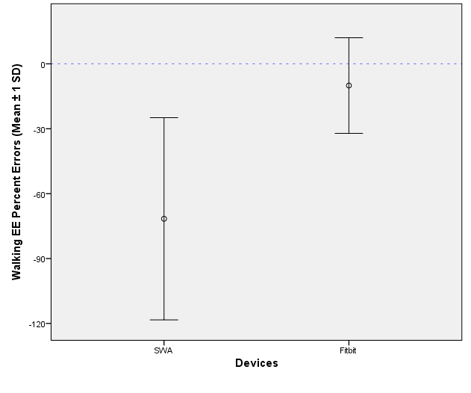
Figure 2. Percent errors in total EE of self-paced walking in adults with class III obesity. To evaluate device accuracy in relation to the indirect calorimetry criterion, mean percent errors were compared. All negative values reflect overestimates, and all positive values reflect underestimates.

Table 3. Actual Calories recorded by indirect calorimetry, SWA, and Fitbit. Data are displayed as mean Calories (standard deviation).
Oxycon Mobile | SWA | Fitbit
38.0 (8.94) | 62.87 (22.98) | 41.6 (12.47)

DISCUSSION
The prevalence of class III obesity has increased over the past 20 years. Thus, accurate assessment of this group’s PA behaviors is of utmost importance. In a study involving 86 gastric bypass patients, leisure-time walking was the most commonly reported form of PA both before and after surgery [189]. The effectiveness of step-based programs relies heavily on the accuracy of the step-counting device.
Of the five monitors tested in the current study, only DW step-count percent error differed significantly from zero. The SW3 produced the smallest margin of error, and no significant differences were observed among the SW3, Omron, and Fitbit. The SWA significantly overestimated the metabolic cost of walking, suggesting that the Fitbit may be a better tool for estimating walking EE in the bariatric population. In the present study, we observed that the spring-levered, waist-mounted DW undercounted steps by 28%. Past reports have also shown that the DW significantly undercounts steps in individuals with an elevated BMI [11, 14].
The placement of the SW3 on the ankle is likely responsible for its high degree of accuracy. In comparison to waist-mounted devices, ankle-mounted devices are less prone to error resulting from abdominal adiposity [190]. Slower walking speeds may not produce vertical accelerations at the hip capable of recording a step; the SW3 overcomes this obstacle by virtue of its placement on the ankle and also by responding to horizontal accelerations [15].
During the 6-minute bout, the SWA greatly overestimated the metabolic cost of walking. When obese individuals completed a 5-minute treadmill walk, SWA estimates of EE were significantly greater than measured values from indirect calorimetry [186]. The reason the SWA overestimates EE cannot be determined, but the SWA also overestimates the metabolic cost of walking in normal weight individuals, although to a lesser extent [185]. It should be noted, however, that the SWA is capable of accurately assessing 24-hour energy expenditure in healthy adults when compared with doubly labeled water [191]. The Fitbit only slightly overestimated EE during the walking bouts, and appears to be a better evaluative instrument for estimating Caloric expenditure during walking in patients who are severely obese. Interventionists should consider monitor accuracy when setting PA goals based on Caloric expenditure.
Previous studies have used predetermined walking speeds to assess step-counting accuracy [11, 13, 14]. We chose to attempt to evaluate the monitors at each participant’s self-selected walking speed, because obese individuals are likely to walk slower than their normal weight peers [192]. Our participants walked an average of 388.5 m in 6 minutes, or 3.89 km·h⁻¹. The average metabolic cost of walking of these individuals was 9.24 ± 2.15 ml·kg⁻¹·min⁻¹. These values are fairly similar to those of 57 obese women (BMI 37.1 ± 3.4 kg·m⁻²) reported by Mattson et al. [162]. In that study, the metabolic cost of walking was 11.1 ± 1.4 ml·kg⁻¹·min⁻¹ at an average self-selected speed of 4.25 km·h⁻¹. In comparison, normal weight women prefer walking speeds of about 5.3 km·h⁻¹ [193].
The 6-minute walk test (6MWT) is a clinical test commonly used to evaluate functional capacities of persons with low exercise capacity [194]. The 6MWT requires the participant to walk as far as possible during the 6-minute period, and walking speed may decrease during the latter minutes of the test [195]. Average 6MWT distances for persons awaiting bariatric surgery have ranged from 393 m to 475.7 m [156, 158, 196]. In contrast, our participants were asked to walk at a self-selected pace that could be maintained for the entirety of the bout. Similar to the current study’s methods, de Souza et al. [197] instructed individuals awaiting bariatric surgery to complete the 6MWT at their regular pace. In that study, the average pre-operative distance covered was 381.9 m (3.82 km·h⁻¹).
In addition to providing researchers with more accurate data, these devices can also be used by patients to self-monitor their PA levels during interventions. In a recent review, Bravata et al. [174] found the use of a pedometer, daily step goal, and PA log led to accumulation of an additional 2,500 steps·d⁻¹. Severely obese individuals given social support, a pedometer, and a walking diary increased daily steps by 47% over 18 weeks [198]. Though consistent self-monitoring of exercise participation has been associated with greater weight loss [199], Burke et al. [200] note the need for validating and strengthening self-monitoring techniques. Furthermore, a number of patients remain severely obese following bariatric surgery [90-92], meaning that both pre- and post-operative PA must be assessed using devices validated for use in the severely obese. Use of objective monitors has the potential to limit subject burden that often accompanies PA diaries. While time constraints may prevent an individual from immediately logging activities, many monitors are capable of recording real-time data and storing it for several weeks. This feature could potentially allow medical staff to reduce the frequency of post-operative appointments used to assess patient adherence to exercise prescriptions. Some monitors also display step counts and Calories, eliminating the need for uploading data in order to receive feedback.

CONCLUSION
Results of the current study suggest that the SW3, Omron, and Fitbit are all capable of accurately measuring step counts in individuals with class III obesity, but the DW is not. A new finding was that the Fitbit was far more accurate than the SWA for estimating Caloric expenditure. In conclusion, researchers aiming to assess PA in persons with class III obesity should consider device accuracy and subject burden.

REFERENCES

1. World Health Organization. Obesity. 2008 October 22, 2009; Available from: http://www.who.int/topics/obesity/en/.
2. Bennett, J.M., S. Mehta, and M. Rhodes, Surgery for morbid obesity. Postgrad Med J, 2007. 83(975): p. 8-15.
3. Buchwald, H., Obesity comorbidities, in Surgical management of obesity, H. Buchwald, G. Cowan, and W. Pories, Editors. 2007, Saunders Elsevier: Philadelphia.
4. Dixon, J.B., M.E. Dixon, and P.E. O'Brien, Depression in association with severe obesity: changes with weight loss. Arch Intern Med, 2003. 163(17): p. 2058-65.
5. National Heart Lung and Blood Institute, Clinical Guidelines on the Identification, Evaluation, and Treatment of Overweight and Obesity in Adults--The Evidence Report. National Institutes of Health. Obes Res, 1998. 6 Suppl 2: p. 51S-209S.
6. Maggard, M.A., et al., Meta-analysis: surgical treatment of obesity. Ann Intern Med, 2005. 142(7): p. 547-59.
7. Hatoum, I.J., et al., Capacity for physical activity predicts weight loss after Roux-en-Y gastric bypass. Obesity (Silver Spring), 2009. 17(1): p. 92-9.
8. Evans, R.K., et al., Participation in 150 min/wk of moderate or higher intensity physical activity yields greater weight loss after gastric bypass surgery. Surg Obes Relat Dis, 2007. 3(5): p. 526-30.
9. Simpson, M.E., et al., Walking trends among U.S. adults: the Behavioral Risk Factor Surveillance System, 1987-2000. Am J Prev Med, 2003. 25(2): p. 95-100.
10. King, W.C., et al., Physical activity levels of patients undergoing bariatric surgery in the Longitudinal Assessment of Bariatric Surgery study. Surg Obes Relat Dis, 2008. 4(6): p. 721-8.
11. Tyo, B.M., et al., Effects of body mass index and step rate on pedometer error in a free-living environment. Med Sci Sports Exerc, 2011. 43(2): p. 350-6.
12. Browning, R.C., et al., Effects of obesity and sex on the energetic cost and preferred speed of walking. J Appl Physiol, 2006. 100(2): p. 390-8.
13. Swartz, A.M., et al., Effects of body mass index on the accuracy of an electronic pedometer. Int J Sports Med, 2003. 24(8): p. 588-92.
14. Crouter, S.E., P.L. Schneider, and D.R. Bassett, Jr., Spring-levered versus piezo-electric pedometer accuracy in overweight and obese adults. Med Sci Sports Exerc, 2005. 37(10): p. 1673-9.
15. Karabulut, M., S.E. Crouter, and D.R. Bassett, Jr., Comparison of two waist-mounted and two ankle-mounted electronic pedometers. Eur J Appl Physiol, 2005. 95(4): p. 335-43.
16. Unick, J.L., et al., Comparison of Two Objective Monitors for Assessing Physical Activity and Sedentary Behaviors in Bariatric Surgery Patients. Obes Surg, 2011.
17. Josbeno, D.A., et al., Physical activity and physical function in individuals post-bariatric surgery. Obes Surg, 2011. 21(8): p. 1243-9.
18. St-Onge, M., et al., Evaluation of a portable device to measure daily energy expenditure in free-living adults. Am J Clin Nutr, 2007. 85(3): p. 742-9.
19. Bond, D.S., et al., Objective assessment of time spent being sedentary in bariatric surgery candidates. Obes Surg, 2011. 21(6): p. 811-4.
20. American Collge of Sports Medicine, AMERICAN COLLEGE OF SPORTS MEDICINE. ACSM's Guidelines for Exercise Testing and Prescription (8th ed.). 2010: Lippincott, Williams, & Wilkins.
21. National Center for Health Statistics, Prevalence of overweight, obesity and extreme obesity among adults: United States, trends 1976-80 through 2005-2006. 2008.
22. Peacock, J.C. and S.J. Zizzi, An Assessment of Patient Behavioral Requirements Pre- and Post-Surgery at Accredited Weight Loss Surgical Centers. Obes Surg, 2011.
23. King, W.C., et al., Pre- to postoperative changes in physical activity: report from the Longitudinal Assessment of Bariatric Surgery-2. Surg Obes Relat Dis, 2011.
24. Chen, K.Y., et al., Efficiency of walking and stepping: relationship to body fatness. Obes Res, 2004. 12(6): p. 982-9.
25. World Health Organization, Obesity: preventing and managing the global epidemic. Report of a WHO consultation. World Health Organ Tech Rep Ser, 2000. 894: p. i-xii, 1-253.
26. Information from the WHO is available online at www.who.int/nut/obs.htm.
27. Nguyen, N.T., et al., Association of hypertension, diabetes, dyslipidemia, and metabolic syndrome with obesity: findings from the National Health and Nutrition Examination Survey, 1999 to 2004. J Am Coll Surg, 2008. 207(6): p. 928-34.
28. Faintuch, J., et al., Pulmonary function and aerobic capacity in asymptomatic bariatric candidates with very severe morbid obesity. Rev Hosp Clin Fac Med Sao Paulo, 2004. 59(4): p. 181-6.
29. Must, A., et al., The disease burden associated with overweight and obesity. JAMA, 1999. 282(16): p. 1523-9.
30. Obesity: preventing and managing the global epidemic. Report of a WHO consultation. World Health Organ Tech Rep Ser, 2000. 894: p. i-xii, 1-253.
31. Leykin, Y., et al., Anesthetic Management of Morbidly Obese and Super-Morbidly Obese Patients Undergoing Bariatric Operations: Hospital Course and Outcomes. Obesity Surgery, 2006. 16: p. 1563-1569.
32. Deitel, M., Overweight and obesity worldwide now estimated to involve 1.7 billion people. Obes Surg, 2003. 13(3): p. 329-30.
33. Sturm, R., Increases in morbid obesity in the USA: 2000-2005. Public Health, 2007. 121(7): p. 492-6.
34. Freedman, D.S., et al., Trends and correlates of class 3 obesity in the United States from 1990 through 2000. JAMA, 2002. 288(14): p. 1758-61.
35. Lewis, C.E., et al., Weight gain continues in the 1990s: 10-year trends in weight and overweight from the CARDIA study. Coronary Artery Risk Development in Young Adults. Am J Epidemiol, 2000. 151(12): p. 1172-81.
36. Gokee-LaRose, J., Adult behavioral weight loss treatment. Med Health R I, 2009. 92(2): p. 50-2.
37. Stommel, M. and C.A. Schoenborn, Accuracy and usefulness of BMI measures based on self-reported weight and height: findings from the NHANES & NHIS 2001-2006. BMC Public Health, 2009. 9: p. 421.
38. in McGraw-Hill Concise Dictionary of Modern Medicine. 2002, The McGraw-Hill Companies, Inc.
39. Bonfa, F., et al., Exploratory evaluation of an obese population seeking bariatric surgery in an Italian public service. Eat Weight Disord, 2010. 15(3): p. e119-26.
40. Sullivan, M., et al., Swedish obese subjects (SOS)--an intervention study of obesity. Baseline evaluation of health and psychosocial functioning in the first 1743 subjects examined. Int J Obes Relat Metab Disord, 1993. 17(9): p. 503-12.
41. Kramer, H., et al., Increasing BMI and waist circumference and prevalence of obesity among adults with Type 2 diabetes: the National Health and Nutrition Examination Surveys. J Diabetes Complications, 2010. 24(6): p. 368-74.
42. Hulens, M., et al., Predictors of 6-minute walk test results in lean, obese and morbidly obese women. Scand J Med Sci Sports, 2003. 13(2): p. 98-105.
43. Grundy, S.M., et al., Diagnosis and management of the metabolic syndrome: an American Heart Association/National Heart, Lung, and Blood Institute Scientific Statement. Circulation, 2005. 112(17): p. 2735-52.
44. Marchesini, G., et al., The metabolic syndrome in treatment-seeking obese persons. Metabolism, 2004. 53(4): p. 435-40.
45. Andreyeva, T., R. Sturm, and J.S. Ringel, Moderate and severe obesity have large differences in health care costs. Obes Res, 2004. 12(12): p. 1936-43.
46. Oster, G., et al., Lifetime health and economic benefits of weight loss among obese persons. Am J Public Health, 1999. 89(10): p. 1536-42.
47. Influence of body mass index on prescribing costs and potential cost savings of a weight management programme in primary care. J Health Serv Res Policy, 2008. 13(3): p. 158-66.
48. Sturm, R., The effects of obesity, smoking, and drinking on medical problems and costs. Health Aff (Millwood), 2002. 21(2): p. 245-53.
49. Torgerson, J.S. and L. Sjostrom, The Swedish Obese Subjects (SOS) study--rationale and results. Int J Obes Relat Metab Disord, 2001. 25 Suppl 1: p. S2-4.
50. Methods for voluntary weight loss and control. NIH Technology Assessment Conference Panel. Consensus Development Conference, 30 March to 1 April 1992. Ann Intern Med, 1993. 119(7 Pt 2): p. 764-70.
51. Jakicic, J.M., et al., American College of Sports Medicine position stand. Appropriate intervention strategies for weight loss and prevention of weight regain for adults. Med Sci Sports Exerc, 2001. 33(12): p. 2145-56.
52. Unick, J.L., et al., Effectiveness of Lifestyle Interventions for Individuals With Severe Obesity and Type 2 Diabetes: Results from the Look AHEAD trial. Diabetes Care, 2011.
53. Tuomilehto, J., et al., Prevention of type 2 diabetes mellitus by changes in lifestyle among subjects with impaired glucose tolerance. N Engl J Med, 2001. 344(18): p. 1343-50.
54. US Department of Health and Human Services, 2008 Physical Activity Guidelines for Americans. 2008.
55. US Department of Health and Human Services, Dietary Guidelines for Americans, 2010. 2010.
56. Ricci, G., et al., Nutrient intake in Italian obese patients: relationships with insulin resistance and markers of non-alcoholic fatty liver disease. Nutrition, 2011. 27(6): p. 672-6.
57. Thomas, J.G., et al., Technology for behavioral assessment and intervention in bariatric surgery. Surg Obes Relat Dis, 2011. 7(4): p. 548-57.
58. Blackburn, G.L., S. Wollner, and S.B. Heymsfield, Lifestyle interventions for the treatment of class III obesity: a primary target for nutrition medicine in the obesity epidemic. Am J Clin Nutr, 2010. 91(1): p. 289S-292S.
59. Simpson, S.A., C. Shaw, and R. McNamara, What is the most effective way to maintain weight loss in adults? BMJ, 2011. 343: p. d8042.
60. Harris, M.B. and E.S. Hallbauer, Self-directed weight control through eating and exercise. Behav Res Ther, 1973. 11(4): p. 523-9.
61. Hartman, W.M., et al., Long-term maintenance of weight loss following supplemented fasting. Int J Eat Disord, 1993. 14(1): p. 87-93.
62. Pronk, N.P. and R.R. Wing, Physical activity and long-term maintenance of weight loss. Obes Res, 1994. 2(6): p. 587-99.
63. Wing, R.R. and J.O. Hill, Successful weight loss maintenance. Annu Rev Nutr, 2001. 21: p. 323-41.
64. Knowler, W.C., et al., Reduction in the incidence of type 2 diabetes with lifestyle intervention or metformin. N Engl J Med, 2002. 346(6): p. 393-403.
65. Karlsson, J., et al., Ten-year trends in health-related quality of life after surgical and conventional treatment for severe obesity: the SOS intervention study. Int J Obes (Lond), 2007. 31(8): p. 1248-61.
66. MacLean, P.S., et al., Regular exercise attenuates the metabolic drive to regain weight after long-term weight loss. Am J Physiol Regul Integr Comp Physiol, 2009. 297(3): p. R793-802.
67. Jackman, M.R., et al., Weight regain after sustained weight reduction is accompanied by suppressed oxidation of dietary fat and adipocyte hyperplasia. Am J Physiol Regul Integr Comp Physiol, 2008. 294(4): p. R1117-29.
68. Klem, M.L., et al., A descriptive study of individuals successful at long-term maintenance of substantial weight loss. Am J Clin Nutr, 1997. 66(2): p. 239-46.
69. Wing, R.R. and S. Phelan, Long-term weight loss maintenance. Am J Clin Nutr, 2005. 82(1 Suppl): p. 222S-225S.
70. Anderson, J.W., et al., Weight loss and long-term follow-up of severely obese individuals treated with an intense behavioral program. Int J Obes (Lond), 2007. 31(3): p. 488-93.
71. Anderson, J.W., et al., Long-term weight-loss maintenance: a meta-analysis of US studies. Am J Clin Nutr, 2001. 74(5): p. 579-84.
72. Perri, M.G., et al., Effects of peer support and therapist contact on long-term weight loss. J Consult Clin Psychol, 1987. 55(4): p. 615-7.
73. US Department of Health and Human Services, Gastrointestinal Surgery for Severe Obesity, in Consensus Development Conference Statement. 1991, National Institutes of Health.
74. Bond, D., et al., Bariatric surgery for severe obesity: the role of patient behavior. Med Health R I, 2009. 92(2): p. 58-60.
75. Magee, C.J., et al., Laparoscopic sleeve gastrectomy for high-risk patients: weight loss and comorbidity improvement--short-term results. Obes Surg, 2011. 21(5): p. 547-50.
76. Steinbrook, R., Surgery for severe obesity. N Engl J Med, 2004. 350(11): p. 1075-9.
77. Encinosa, W.E., et al., Healthcare utilization and outcomes after bariatric surgery. Med Care, 2006. 44(8): p. 706-12.
78. Bond, D.S., et al., Physical activity stage of readiness predicts moderate-vigorous physical activity participation among morbidly obese gastric bypass surgery candidates. Surg Obes Relat Dis, 2006. 2(2): p. 128-32.
79. Buchwald, H., et al., Bariatric surgery: a systematic review and meta-analysis. JAMA, 2004. 292(14): p. 1724-37.
80. Bond, D.S., et al., Objective quantification of physical activity in bariatric surgery candidates and normal-weight controls. Surg Obes Relat Dis, 2010. 6(1): p. 72-8.
81. Bond, D.S., et al., Becoming physically active after bariatric surgery is associated with improved weight loss and health-related quality of life. Obesity (Silver Spring), 2009. 17(1): p. 78-83.
82. Flum, D.R., et al., Perioperative safety in the longitudinal assessment of bariatric surgery. N Engl J Med, 2009. 361(5): p. 445-54.
83. Bond, D.S., et al., Weight-loss maintenance in successful weight losers: surgical vs non-surgical methods. Int J Obes (Lond), 2009. 33(1): p. 173-80.
84. Dymek-Valentine, M., R. Rienecke-Hoste, and J. Alverdy, Assessment of binge eating disorder in morbidly obese patients evaluated for gastric bypass: SCID versus QEWP-R. Eat Weight Disord, 2004. 9(3): p. 211-6.
85. Martins, C., et al., Bariatric surgery versus lifestyle interventions for morbid obesity--changes in body weight, risk factors and comorbidities at 1 year. Obes Surg, 2011. 21(7): p. 841-9.
86. Picot, J., et al., The clinical effectiveness and cost-effectiveness of bariatric (weight loss) surgery for obesity: a systematic review and economic evaluation. Health Technol Assess, 2009. 13(41): p. 1-190, 215-357, iii-iv.
87. Garb, J., et al., Bariatric surgery for the treatment of morbid obesity: a meta-analysis of weight loss outcomes for laparoscopic adjustable gastric banding and laparoscopic gastric bypass. Obes Surg, 2009. 19(10): p. 1447-55.
88. Pories, W.J., et al., Who would have thought it? An operation proves to be the most effective therapy for adult-onset diabetes mellitus. Ann Surg, 1995. 222(3): p. 339-50; discussion 350-2.
89. Wittgrove, A.C. and G.W. Clark, Laparoscopic gastric bypass, Roux-en-Y- 500 patients: technique and results, with 3-60 month follow-up. Obes Surg, 2000. 10(3): p. 233-9.
90. Christou, N.V., D. Look, and L.D. Maclean, Weight gain after short- and long-limb gastric bypass in patients followed for longer than 10 years. Ann Surg, 2006. 244(5): p. 734-40.
91. Bloomston, M., et al., Outcome following bariatric surgery in super versus morbidly obese patients: does weight matter? Obes Surg, 1997. 7(5): p. 414-9.
92. Biron, S., et al., Twenty years of biliopancreatic diversion: what is the goal of the surgery? Obes Surg, 2004. 14(2): p. 160-4.
93. American Society for Metabolic and Bariatric Surgery, ASMBS Position Statement on Preoperative Supervised Weight Loss Requirements. Surg Obes Relat Dis, 2011. 7(3): p. 257-260.
94. Silver, H.J., et al., Weight, dietary and physical activity behaviors two years after gastric bypass. Obes Surg, 2006. 16(7): p. 859-64.
95. Flanagan, L., Practical training of the bariatric surgeon, in Surgical management of obesity, H. Buchwald, G. Cowan, and W. Pories, Editors. 2007, Saunders Elsevier: Philadelphia.
96. LeCheminant, J.D., et al., Comparison of energy expenditure, economy, and pedometer counts between normal weight and overweight or obese women during a walking and jogging activity. Eur J Appl Physiol, 2009. 106(5): p. 675-82.
97. Hill, J.O., et al., Obesity and the environment: where do we go from here? Science, 2003. 299(5608): p. 853-5.
98. Carlson, S.A., et al., Trend and prevalence estimates based on the 2008 Physical Activity Guidelines for Americans. Am J Prev Med, 2010. 39(4): p. 305-13.
99. Vanhecke, T.E., et al., Cardiorespiratory fitness and sedentary lifestyle in the morbidly obese. Clin Cardiol, 2009. 32(3): p. 121-4.
100. Bond, D.S., et al., Physical activity and quality of life improvements before obesity surgery. Am J Health Behav, 2006. 30(4): p. 422-34.
101. Elkins, G., et al., Noncompliance with behavioral recommendations following bariatric surgery. Obes Surg, 2005. 15(4): p. 546-51.
102. Dill, D.B., The economy of muscular exercise. Phys Rev, 1936. 16: p. 263-291.
103. Byrne, N.M., et al., Metabolic equivalent: one size does not fit all. J Appl Physiol, 2005. 99(3): p. 1112-9.
104. Howley, E.T., Errors in MET estimates of physical activities using 3.5 ml.kg(1).min(1) as the baseline oxygen consumption. J Phys Act Health, 2011. 8(1): p. 141-2; author reply 143-4.
105. Garby, L., et al., Relation between energy expenditure and body composition in man: specific energy expenditure in vivo of fat and fat-free tissue. Eur J Clin Nutr, 1988. 42(4): p. 301-5.
106. Lafortuna, C.L., et al., The energetic and cardiovascular response to treadmill walking and cycle ergometer exercise in obese women. Eur J Appl Physiol, 2008. 103(6): p. 707-17.
107. Hulens, M., et al., Exercise capacity in lean versus obese women. Med Sci Sports Exerc, 2001. 11: p. 305-309.
108. Tanner, C.J., et al., Muscle fiber type is associated with obesity and weight loss. Am J Physiol Endocrinol Metab, 2002. 282(6): p. E1191-6.
109. Bakkman, L., et al., Reduced respiratory capacity in muscle mitochondria of obese subjects. Obes Facts, 2010. 3(6): p. 371-5.
110. Ainsworth, B.E., et al., Compendium of physical activities: an update of activity codes and MET intensities. Med Sci Sports Exerc, 2000. 32(9 Suppl): p. S498-504.
111. Curioni, C.C. and P.M. Lourenco, Long-term weight loss after diet and exercise: a systematic review. Int J Obes (Lond), 2005. 29(10): p. 1168-74.
112. Brownell, K., Exercise in the treatment of obesity, in Eating disorders and obesity: A comprehensive handbook, K. Brownell and C. Fairburn, Editors. 1995, Guilford Press: New York. p. 473-478.
113. Martins, C., L. Morgan, and H. Truby, A review of the effects of exercise on appetite regulation: an obesity perspective. Int J Obes (Lond), 2008. 32(9): p. 1337-47.
114. Woo, R., J.S. Garrow, and F.X. Pi-Sunyer, Effect of exercise on spontaneous calorie intake in obesity. Am J Clin Nutr, 1982. 36(3): p. 470-7.
115. Toledo, F.G., et al., Mitochondrial capacity in skeletal muscle is not stimulated by weight loss despite increases in insulin action and decreases in intramyocellular lipid content. Diabetes, 2008. 57(4): p. 987-94.
116. McArdle, W.D., F.I. Katch, and V.L. Katch, Exercise Physiology: Nutrition, Energy, and Human Performance. 7th Edition ed. 2009, Philadelphia, PA: Lippincott Wiliams & Wilkins.
117. Wyatt, H.R., et al., Resting energy expenditure in reduced-obese subjects in the National Weight Control Registry. Am J Clin Nutr, 1999. 69(6): p. 1189-93.
118. Metcalf, B., et al., Weight loss composition: the effects of exercise following obesity surgery as measured by bioelectrical impedance analysis. Obes Surg, 2005. 15(2): p. 183-6.
119. Goodpaster, B.H., et al., Effects of diet and physical activity interventions on weight loss and cardiometabolic risk factors in severely obese adults: a randomized trial. JAMA, 2010. 304(16): p. 1795-802.
120. Jakicic, J.M., et al., Effect of exercise duration and intensity on weight loss in overweight, sedentary women: a randomized trial. JAMA, 2003. 290(10): p. 1323-30.
121. McGuire, M.T., et al., Behavioral strategies of individuals who have maintained long-term weight losses. Obes Res, 1999. 7(4): p. 334-41.
122. Fogelholm, M. and K. Kukkonen-Harjula, Does physical activity prevent weight gain--a systematic review. Obes Rev, 2000. 1(2): p. 95-111.
123. Livhits, M., et al., Exercise following bariatric surgery: systematic review. Obes Surg, 2010. 20(5): p. 657-65.
124. Dixon, J.B., M.E. Dixon, and P.E. O'Brien, Pre-operative predictors of weight loss at 1-year after Lap-Band surgery. Obes Surg, 2001. 11(2): p. 200-7.
125. Carey, D.G., G.J. Pliego, and R.L. Raymond, Body composition and metabolic changes following bariatric surgery: effects on fat mass, lean mass and basal metabolic rate: six months to one-year follow-up. Obes Surg, 2006. 16(12): p. 1602-8.
126. Stegen, S., et al., Physical fitness in morbidly obese patients: effect of gastric bypass surgery and exercise training. Obes Surg, 2011. 21(1): p. 61-70.
127. Blair, S.N. and S. Brodney, Effects of physical inactivity and obesity on morbidity and mortality: current evidence and research issues. Med Sci Sports Exerc, 1999. 31(11 Suppl): p. S646-62.
128. Hayes, L., et al., Do obese but metabolically normal women differ in intra-abdominal fat and physical activity levels from those with the expected metabolic abnormalities? A cross-sectional study. BMC Public Health, 2010. 10: p. 723.
129. Church, T., Exercise in obesity, metabolic syndrome, and diabetes. Prog Cardiovasc Dis, 2011. 53(6): p. 412-8.
130. Franklin, B.A., Exercise capacity: a crystal ball in forecasting future health outcomes? Phys Sportsmed, 2009. 37(4): p. 154-6.
131. Jakicic, J.M., et al., Effects of intermittent exercise and use of home exercise equipment on adherence, weight loss, and fitness in overweight women: a randomized trial. JAMA, 1999. 282(16): p. 1554-60.
132. Perri, M.G., et al., Effects of group- versus home-based exercise in the treatment of obesity. J Consult Clin Psychol, 1997. 65(2): p. 278-85.
133. Gallagher, M.J., et al., Comparative impact of morbid obesity vs heart failure on cardiorespiratory fitness. Chest, 2005. 127(6): p. 2197-203.
134. Katzmarzyk, P.T., et al., Metabolic syndrome, obesity, and mortality: impact of cardiorespiratory fitness. Diabetes Care, 2005. 28(2): p. 391-7.
135. Myers, J., et al., Is new science driving practice improvements and better patient outcomes? Applications for cardiac rehabilitation. Clin Invest Med, 2008. 31(6): p. E400-7.
136. Goran, M., et al., Total body fat does not influence maximal aerobic capacity. Int J Obes Relat Metab Disord, 2000. 24(7): p. 841-8.
137. Seres, L., et al., Increased exercise capacity after surgically induced weight loss in morbid obesity. Obesity (Silver Spring), 2006. 14(2): p. 273-9.
138. de Souza, S.A., J. Faintuch, and A.F. Sant'anna, Effect of weight loss on aerobic capacity in patients with severe obesity before and after bariatric surgery. Obes Surg, 2010. 20(7): p. 871-5.
139. Wing, R.R., Long-term effects of a lifestyle intervention on weight and cardiovascular risk factors in individuals with type 2 diabetes mellitus: four-year results of the Look AHEAD trial. Arch Intern Med, 2010. 170(17): p. 1566-75.
140. Swartz, A.M., et al., Increasing daily walking improves glucose tolerance in overweight women. Prev Med, 2003. 37(4): p. 356-62.
141. Lee, I.M., et al., Physical activity and coronary heart disease in women: is "no pain, no gain" passe? JAMA, 2001. 285(11): p. 1447-54.
142. Paffenbarger, R.S., Jr., A.L. Wing, and R.T. Hyde, Physical activity as an index of heart attack risk in college alumni. Am J Epidemiol, 1978. 108(3): p. 161-75.
143. Wiklund, M., M.F. Olsen, and C. Willen, Physical activity as viewed by adults with severe obesity, awaiting gastric bypass surgery. Physiother Res Int, 2010.
144. Prevalence of leisure-time physical activity among overweight adults--United States, 1998. MMWR Morb Mortal Wkly Rep, 2000. 49(15): p. 326-30.
145. Poirier, P. and J.P. Despres, Exercise in weight management of obesity. Cardiol Clin, 2001. 19(3): p. 459-70.
146. Yamanouchi, K., et al., Daily walking combined with diet therapy is a useful means for obese NIDDM patients not only to reduce body weight but also to improve insulin sensitivity. Diabetes Care, 1995. 18(6): p. 775-8.
147. Schneider, P.L., et al., Effects of a 10,000 steps per day goal in overweight adults. Am J Health Promot, 2006. 21(2): p. 85-9.
148. Tudor-Locke, C. and D.R. Bassett, Jr., How many steps/day are enough? Preliminary pedometer indices for public health. Sports Med, 2004. 34(1): p. 1-8.
149. Welk, G.J., et al., The utility of the Digi-walker step counter to assess daily physical activity patterns. Med Sci Sports Exerc, 2000. 32(9 Suppl): p. S481-8.
150. Marshall, S.J., et al., Translating physical activity recommendations into a pedometer-based step goal: 3000 steps in 30 minutes. Am J Prev Med, 2009. 36(5): p. 410-5.
151. King, W.C., et al., Walking capacity of bariatric surgery candidates. Surg Obes Relat Dis, 2011.
152. Melanson, E.L., et al., Commercially available pedometers: considerations for accurate step counting. Prev Med, 2004. 39(2): p. 361-8.
153. Zarrugh, M.Y., F.N. Todd, and H.J. Ralston, Optimization of energy expenditure during level walking. Eur J Appl Physiol Occup Physiol, 1974. 33(4): p. 293-306.
154. Bohannon, R.W., Comfortable and maximum walking speed of adults aged 20-79 years: reference values and determinants. Age Ageing, 1997. 26(1): p. 15-9.
155. Ohrstrom, M., J. Hedenbro, and M. Ekelund, Energy expenditure during treadmill walking before and after vertical banded gastroplasty: a one-year follow-up study in 11 obese women. Eur J Surg, 2001. 167(11): p. 845-50.
156. Maniscalco, M., et al., Effect of bariatric surgery on the six-minute walk test in severe uncomplicated obesity. Obes Surg, 2006. 16(7): p. 836-41.
157. Mathier, M.A., J. Zhang, and R.C. Ramanathan, Dramatic functional improvement following bariatric surgery in a patient with pulmonary arterial hypertension and morbid obesity. Chest, 2008. 133(3): p. 789-92.
158. Tompkins, J., et al., Changes in functional walking distance and health-related quality of life after gastric bypass surgery. Phys Ther, 2008. 88(8): p. 928-35.
159. Zavala, D.C. and K.J. Printen, Basal and exercise tests on morbidly obese patients before and after gastric bypass. Surgery, 1984. 95(2): p. 221-9.
160. Johnson, S.T., et al., Measuring habitual walking speed of people with type 2 diabetes: are they meeting recommendations? Diabetes Care, 2005. 28(6): p. 1503-4.
161. Hills, A.P., et al., Validation of the intensity of walking for pleasure in obese adults. Prev Med, 2006. 42(1): p. 47-50.
162. Mattsson, E., U.E. Larsson, and S. Rossner, Is walking for exercise too exhausting for obese women? Int J Obes Relat Metab Disord, 1997. 21(5): p. 380-6.
163. Browning, R.C. and R. Kram, Pound for pound: Working out how obesity influences the energetics of walking. J Appl Physiol, 2009. 106(6): p. 1755-6.
164. Katch, V., et al., Oxygen uptake and energy output during walking of obese male and female adolescents. Am J Clin Nutr, 1988. 47(1): p. 26-32.
165. Seres, L., et al., [Cardiopulmonary function and exercise capacity in patients with morbid obesity]. Rev Esp Cardiol, 2003. 56(6): p. 594-600.
166. Foster, G.D., et al., The energy cost of walking before and after significant weight loss. Med Sci Sports Exerc, 1995. 27(6): p. 888-94.
167. Peyrot, N., et al., Do mechanical gait parameters explain the higher metabolic cost of walking in obese adolescents? J Appl Physiol, 2009. 106(6): p. 1763-70.
168. Lichtman, S.W., et al., Discrepancy between self-reported and actual caloric intake and exercise in obese subjects. N Engl J Med, 1992. 327(27): p. 1893-8.
169. Ainsworth, B.E., et al., Accuracy of the College Alumnus Physical Activity Questionnaire. J Clin Epidemiol, 1993. 46(12): p. 1403-11.
170. Bassett, D.R., Jr., A.L. Cureton, and B.E. Ainsworth, Measurement of daily walking distance-questionnaire versus pedometer. Med Sci Sports Exerc, 2000. 32(5): p. 1018-23.
171. Banda, J.A., et al., Comparing physical activity measures in a diverse group of midlife and older adults. Med Sci Sports Exerc, 2010. 42(12): p. 2251-7.
172. Craig, C.L., et al., International physical activity questionnaire: 12-country reliability and validity. Med Sci Sports Exerc, 2003. 35(8): p. 1381-95.
173. Tehard, B., et al., Comparison of two physical activity questionnaires in obese subjects: the NUGENOB study. Med Sci Sports Exerc, 2005. 37(9): p. 1535-41.
174. Bravata, D.M., et al., Using pedometers to increase physical activity and improve health: a systematic review. JAMA, 2007. 298(19): p. 2296-304.
175. Thomas, L. and M. Williams, Promoting physical activity in the workplace: using pedometers to increase daily activity levels. Health Promot J Austr, 2006. 17(2): p. 97-102.
176. Borg, J., D. Merom, and C. Rissel, Staff walking program: a quasi-experimental trial of maintenance newsletters to maintain walking following a pedometer program. Health Promot J Austr, 2010. 21(1): p. 26-32.
177. Yates, T., et al., Effectiveness of a pragmatic education program designed to promote walking activity in individuals with impaired glucose tolerance: a randomized controlled trial. Diabetes Care, 2009. 32(8): p. 1404-10.
178. Snyder, A., B. Colvin, and J.K. Gammack, Pedometer Use Increases Daily Steps and Functional Status in Older Adults. Journal of the American Medical Directors Association, 2010.
179. Das, S.K., et al., Long-term changes in energy expenditure and body composition after massive weight loss induced by gastric bypass surgery. Am J Clin Nutr, 2003. 78(1): p. 22-30.
180. Shepherd, E.F., et al., Step activity monitor: increased accuracy in quantifying ambulatory activity. J Orthop Res, 1999. 17(5): p. 703-8.
181. Holbrook, E.A., T.V. Barreira, and M. Kang, Validity and reliability of Omron pedometers for prescribed and self-paced walking. Med Sci Sports Exerc, 2009. 41(3): p. 670-4.
182. Silcott, N.A., et al., Evaluation of the Omron HJ-720ITC Pedometer under Free-Living Conditions. Med Sci Sports Exerc, 2011.
183. Silcott, N.A., et al., Evaluation of the Omron HJ-720ITC pedometer under free-living conditions. Med Sci Sports Exerc, 2011. 43(9): p. 1791-7.
184. Foster, R.C., et al., Precision and accuracy of an ankle-worn accelerometer-based pedometer in step counting and energy expenditure. Prev Med, 2005. 41(3-4): p. 778-83.
185. Fruin, M.L. and J.W. Rankin, Validity of a multi-sensor armband in estimating rest and exercise energy expenditure. Med Sci Sports Exerc, 2004. 36(6): p. 1063-9.
186. Papazoglou, D., et al., Evaluation of a multisensor armband in estimating energy expenditure in obese individuals. Obesity (Silver Spring), 2006. 14(12): p. 2217-23.
187. Sieverdes, J.C., et al., Cardiometabolic results from an armband-based weight loss trial. Diabetes Metab Syndr Obes, 2011. 4: p. 187-94.
188. Egberts, K., et al., Does exercise improve weight loss after bariatric surgery? A systematic review. Obes Surg, 2012. 22(2): p. 335-41.
189. Vatier, C., et al., Dynamic Relations Between Sedentary Behavior, Physical Activity, and Body Composition After Bariatric Surgery. Obes Surg, 2012.
190. Pomeroy, J., et al., Between-monitor differences in step counts are related to body size: implications for objective physical activity measurement. PLoS One, 2011. 6(4): p. e18942.
191. Johannsen, D.L., et al., Accuracy of armband monitors for measuring daily energy expenditure in healthy adults. Med Sci Sports Exerc, 2010. 42(11): p. 2134-40.
192. Malatesta, D., et al., Mechanical external work and recovery at preferred walking speed in obese subjects. Med Sci Sports Exerc, 2009. 41(2): p. 426-34.
193. Browning, R.C. and R. Kram, Energetic cost and preferred speed of walking in obese vs. normal weight women. Obes Res, 2005. 13(5): p. 891-9.
194. American Thoracic Society, ATS statement: guidelines for the six-minute walk test. Am J Respir Crit Care Med, 2002. 166(1): p. 111-7.
195. Simonsick, E.M., et al., Measuring fitness in healthy older adults: the Health ABC Long Distance Corridor Walk. J Am Geriatr Soc, 2001. 49(11): p. 1544-8.
196. Josbeno, D.A., et al., Physical activity and physical function changes in obese individuals after gastric bypass surgery. Surg Obes Relat Dis, 2010. 6(4): p. 361-6.
197. de Souza, S.A., et al., Six-minute walk test: functional capacity of severely obese before and after bariatric surgery. Surg Obes Relat Dis, 2009. 5(5): p. 540-3.
198. Hemmingsson, E., et al., Impact of social support intensity on walking in the severely obese: a randomized clinical trial. Obesity (Silver Spring), 2008. 16(6): p. 1308-13.
199. Carels, R.A., et al., The relationship between self-monitoring, outcome expectancies, difficulties with eating and exercise, and physical activity and weight loss treatment outcomes. Ann Behav Med, 2005. 30(3): p. 182-90.
200. Burke, L.E., J. Wang, and M.A. Sevick, Self-monitoring in weight loss: a systematic review of the literature. J Am Diet Assoc, 2011. 111(1): p. 92-102.

APPENDICES

APPENDIX A. INFORMED CONSENT 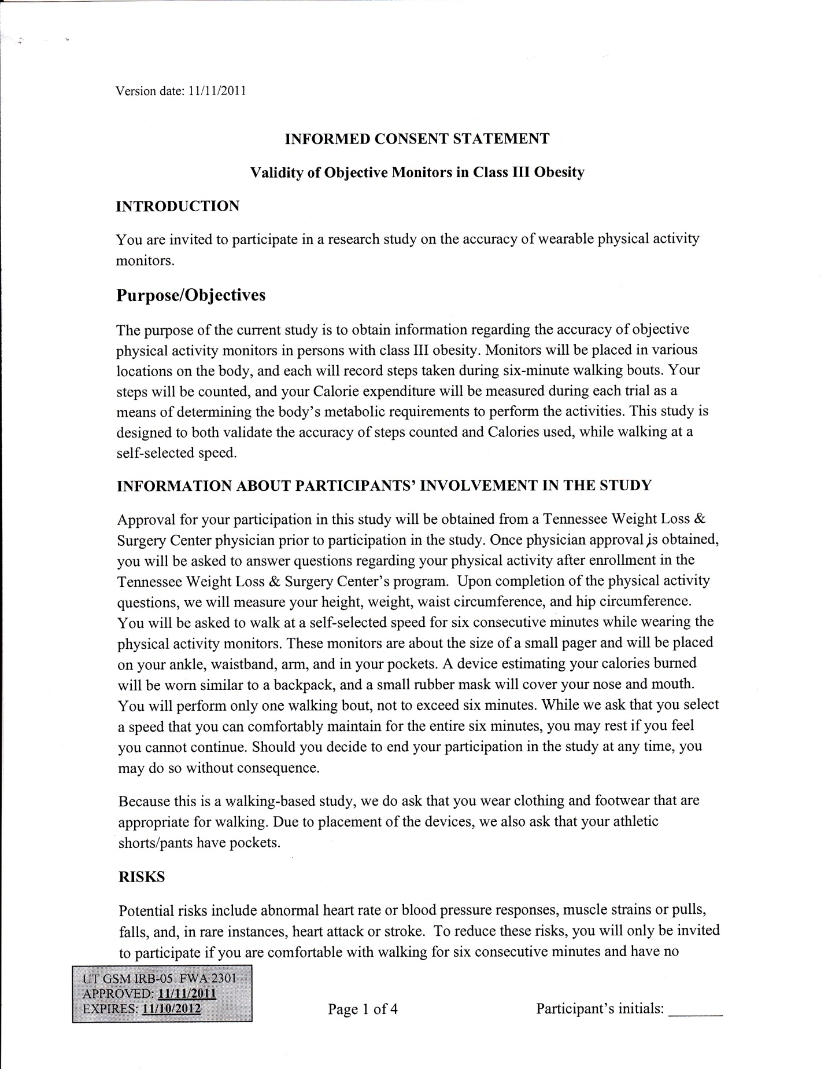


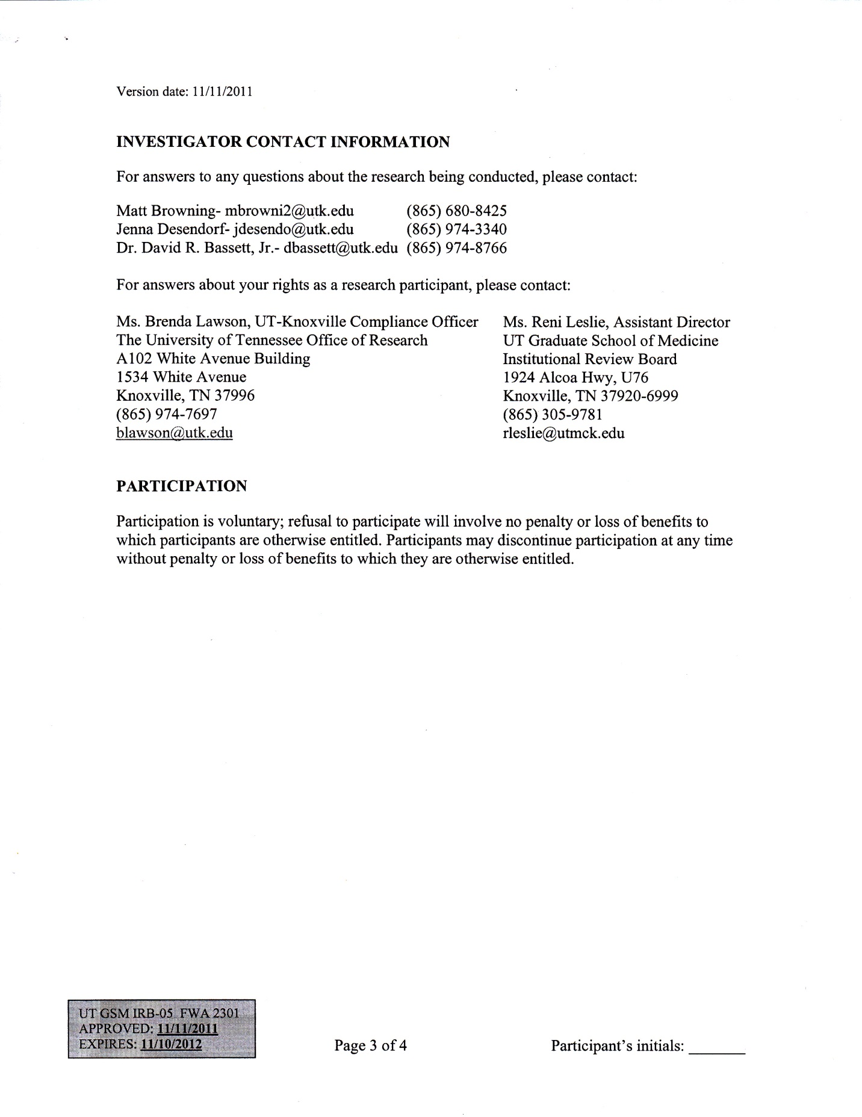


APPENDIX B. INSTITUTIONAL REVIEW BOARD CONSENT 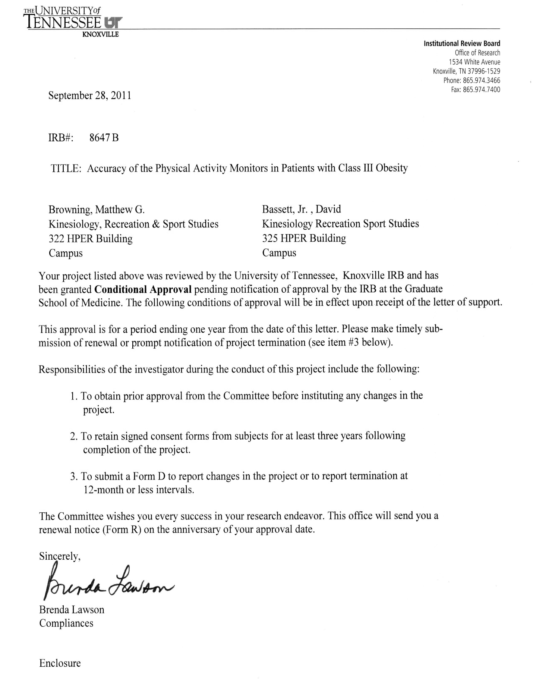

APPENDIX C. GRADUATE SCHOOL OF MEDICINE CONSENT
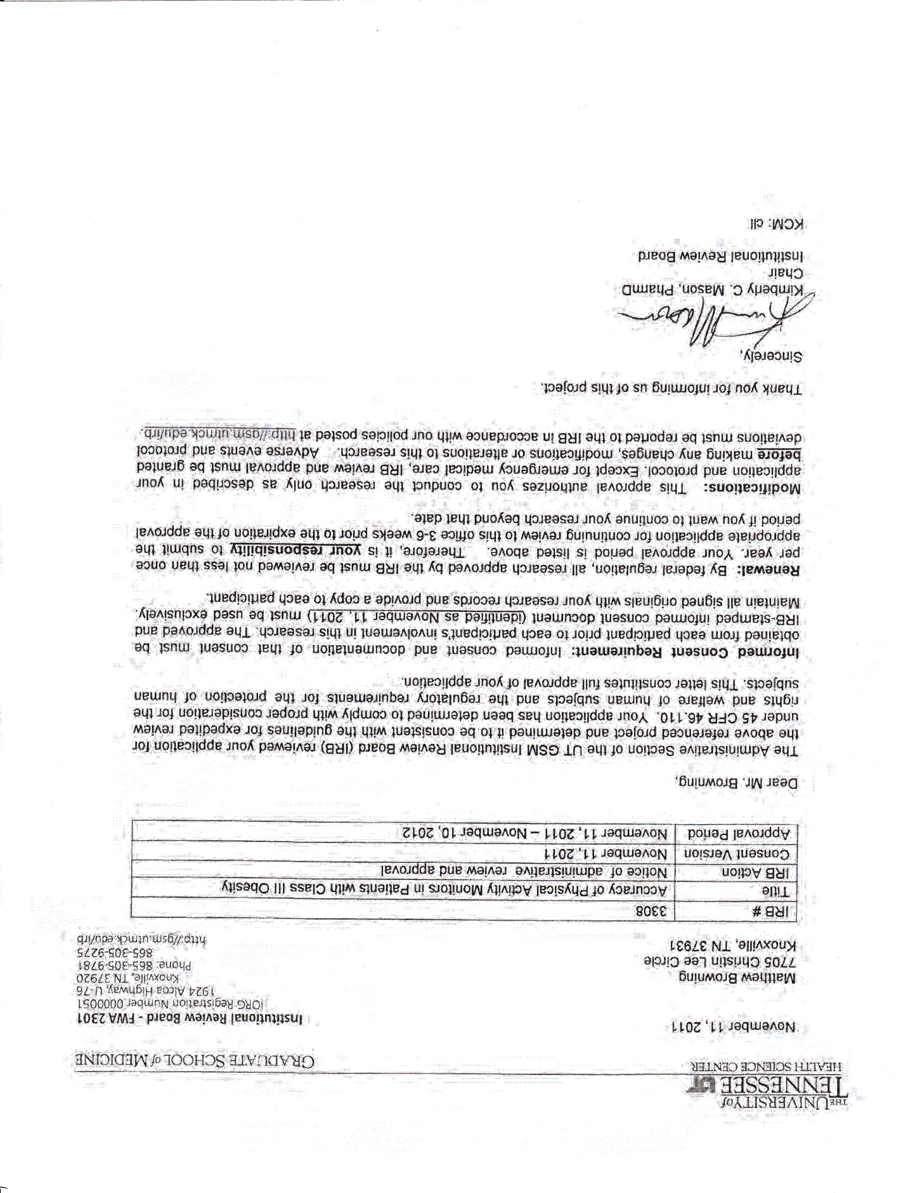

VITA

Matthew Gregory Browning was born on December 23rd, 1987 to Gregory and Denise Browning. In May of 2006, he graduated from Karns High School in Knoxville, Tennessee as a member of the National and French Honor Societies and two-sport varsity athlete. He began his undergraduate education at the University of Tennessee, Knoxville in the fall of 2006. He graduated from UTK in May of 2010 with a Bachelor of Science degree in Exercise Science. In August of 2012, he will graduate with a Master of Science degree in Kinesiology, with a concentration in exercise physiology and a graduate minor in epidemiology. Matt will continue his graduate education in the fall of 2012 as a doctoral candidate at Virginia Commonwealth University.

