All Acrylic Based Thermoplastic Elastomers: Design and Synthesis for Improved Mechanical Performance

A Thesis Presented for the

Doctor of Philosophy

Degree

The University of Tennessee, Knoxville

Wei Lu

May 2017

Copyright © 2017 by Wei Lu
All rights reserved.

DEDICATION

Even though this page is optional
I dedicate my work to you.

ACKNOWLEDGEMENTS

Thank you all for your help. However, this page is optional.

ABSTRACT

This is a sample Word document that can be used as a template in formatting your thesis/dissertation. It cannot exceed 350 words.

If you use any special characters (including superscripts and subscripts) in your abstract, you must write out the term in plain English in square brackets immediately following the first use of the character. For example: H2O [water] and µ [micron]. This has nothing to do with how common the term is in your field of study-- our catalogers have to enter the abstract in our records using a plain text format that cannot accommodate the special characters, but has no problem with word substitutes.

PREFACE

This page is optional.

TABLE OF CONTENTS

TABLE OF CONTENTS vii
LIST OF TABLES xi
LIST OF FIGURES xii
List of Schemes xviii
Chapter 1 Introduction: All Acrylic Based ThermoPlastic Elatomers 1
Abstract 2
1.1 Thermoplastic Elastomers 3
1.1.1 Mechanism of TPEs 3
1.1.2 Advantages & Disadvantages of TPEs 7
1.1.3 Classification of TPEs 7
1.1.4 Styrenic Thermoplastic Elastomers (SBCs) 8
1.2 All Acrylic Based TPEs 10
1.2.1 Entanglement Molecular Weight (M_{e}) 11
1.2.2 Synthesis and Properties on PMMA-b-PBA-b-PMMA Triblock Copolymer TPEs 16
1.2.3 Industrial application of acrylic based TPEs. 21
1.3 Approaches to Improve the Performance of TPEs 23
1.3.1 Compounding 23
1.3.2 Glass Transition Temperature 25
1.3.3 Complex Architectures 27
1.3.4 Introducing Other Driving Forces 41
1.4 Characterization Methods for TPE 44
1.4.1 Thermal Characterization 44
1.4.2 Phase separation Behavior 49
1.4.3 Stress-Strain Behavior 56
1.5 The Scope of this Thesis 63
References 66
Chapter 2 Poly(1-Adamantyl Acrylate)-Good Candidate For TPE With Distinct Thermal Properties 90
Abstract 91
2.1 Poly(1-adamantyl acrylate): Living Anionc Polymerization, Block Copolymerization, and thermal properties 93
2.1.1 Introduction 93
2.1.2 Experiment 98
2.1.3 Result and Discussion 104
2.1.4 Conclusion 120
2.2 Solution Properties, Unperturbed Dimension and Chain Flexibility of Poly(1-Adamantyl Acrylate) 121
2.2.1 Introduction 121
2.2.2 Experiment 123
2.2.3 Result and Discussion 124
2.2.4 Conclusion 135
2.2.1 Adamantyl containing polymers 136
2.2 Poly(1-adamantyl acrylate): Living Anionic Polymerization, Block Copolymerization, and Thermal Properties 136
2.3 Solution Properties and Chain Flexibility of Poly(1-Adamantyl Acrylate) 136
References 136
Chapter 3 All Acrylic-based Thermoplastic Elastomers with High Service Temperature and Distinct Mechanical Strength 153
Abstract 154
3.1 Introduction 155
3.2 Experiment 160
3.2 All acrylic triblock copolymer TPEs bearing different pendent groups 164
References 164
Chapter 4 N-isopropyl-4-vinylbenzylamine-Powerful tool to build architecture 171
Abstract 172
4.1 N-isopropyl-4-vinylbenzylamine 173
4.2 Synthesis of PVBA macromonomer 173
4.3 Triarm Star 173
4.4 Prospective of the use of PVBA 173
References 173
Chapter 5 All acrylic multigraft copolymer superelastomer 174
Abstract 175
5.1 Complex Architecture 176
5.1.1 Complex architectures 176
5.1.2 PI-g-PS 176
5.2 PBA-g-PMMA 176
References 176
Chapter 6 Other Driving Force Derived TPE 177
Abstract 178
6.1 Driving force 179
6.2 PBA-g-PAA 179
References 179
Appendix 181
Vita 182

LIST OF TABLES

Table 1-1. Average chain entanglement molecular weight (M_{e}) for polymers²³ 14
Table 2. Table title. 64
Table 3: This Is The Second Table 69

LIST OF FIGURES

Figure 1-1. (a) Equilibrium morphologies of AB diblock copolymers in bulk: S and S’= spheres, C and C’= cylinders, G and G’= gyroids, and L = lamellae. (b) Theoretical phase diagram of AB diblocks predicted by the self- consistent mean-ﬁeld theory, depending on volume fraction (f) of the blocks and the segregation parameter, χ N, where χ is the Flory–Huggins segment–segment interaction energy and N is the degree of polymerization; (c) Experimental phase portrait of polyisoprene-block-polystyrene copolymers, in which fA represents the volume fraction of polyisoprene, PL = perforated lamellae.⁷ 5
Figure 1-2. Illustration of morphology of ABA triblock copolymer under first elongation with the range of: (a) 150%, (b) 300%, (c) 500%. 6
Figure 1-3. (a) Approximate ranges of performance vs. cost for commercial TPEs.⁹ (b) Percent break-up by market segments in revenue in 2000. (Courtesy of Frost & Sullivan Market Insight) 8
Figure 1-4. (a) Stress-strain curves of SBS and SEBS; (b) Dynamic hysteresis as a function of butylene concentration in partially hydrogenated SBS. The concentration of butylene is proportional to the hydrogenation degree. ¹⁴ 10
Figure 1-5. Schematic representation of relaxation function G(t) for an amorphous 12
Figure 1-6. Ultimate tensile strength as a function of 1/ M_{e}. Where M: PMMA; I: Poly(isooctyl acrylate); nB: poly(n-butyl acrylate); nP: poly(n-propyl acrylate); E: poly(ethyl acrylate); S: PS; IB: poly(isobutylene); IP: polyisoprene.²⁴ 15
Figure 1-7. GPC curve of “KurarityTM” acrylic triblock colymer.³⁹ 20
Figure 1-8. Mechanical properties of PMMA-b-PBA-b-PMMA triblock copolymers: (a) Storage modulus as a function of temperature; (b) stress-strain curves. 21
Figure 1-9. Exemples for acrylic TPE in automotive application.⁴⁴ 22
Figure 1-10. Young’s modulus of (a) microsilica (□) and nanosilica (●) composites; (b) unmodified (○) and modified (●), wt% of silica composites virsus silica content. 24
Figure 1-11. Transmission electron micrograph of (a) neat SEBS copolymer; (b) SEBS gel with $ωoil$ 0.70. (9.3 wt% styrene). 25
Figure 1-12. The change of storage modulus of thermoplastic elastomers at various termperatures.¹⁰ 26
Figure 1-13. TEM images of PI₂PS sample having 0.44 vol fraction PS and forming hexagonally packed cylinders (confirmed by SAXS). (a) A slice perpendicular to the cylinders and, (b) a slice parallel to the cylinders. 28
Figure 1-14. Mechanical properties of PI-g-PS multigraft copolymers. (a) Influence of functionality on stress-strain behavior. (b) Comparison of tetrafunctional multigraft copolymers (MG) with commercial SIS-block copolymer (Kraton®) and star copolymer (Styroflex®). (c) Influence of number of branchpoints on the tensile strength. (d) Hysteresis curve of a tetrafunctional multigraft copolymer.⁸⁴ 40
Figure 1-15. Temperature variations of specific volume at T_{g} and T_{m.}⁴⁶ 45
Figure 1-16. Features of different DSC curves. 46
Figure 1-17. Illustration of the typical TMA curve.⁹⁷ 46
Figure 1-18. Modulus values changes with temperature and transitions in materials.⁹⁸ 47
Figure 1-19. The values of T_{g} and shapes of DSC thermograms for different pressure change-temperature change sequences.¹⁰⁰ 48
The use of thermal characterization can also give the circumstantial evaluation on the microphase separation behavior. With phase separated materials, two different transitions can observed.¹⁰¹ While, the phase blending materials only give one T_{g}. When compared to the homopolymers, the shift of T_{g}s can be used to qualitatively evaluate the miscibility of two domains. The larger the T_{g}s are shifted compared to those in homopolymers, the domains are more miscible with each other. 49
Figure 1-20. Stress-strain curves for SIS triblock copolymers. Sphere: wt% of PS 0.18, molecular weight 10-89-10. Cylinders: wt% of PS 0.30, molecular weight 14-66-14. Lamellae: wt% of PS 0.45, molecular weight 22-29-22.¹⁰² 50
Figure 1-21. Schematic operation of AFM.¹⁰³ 52
Figure 1-22 The components of a SAXS instrument.¹¹⁰ 53
Figure 1-23. Contrast mechanisms of TEM: a) for polymers with crystallinity or heavy element; b) for amorphous soft materials with small variations in density. ¹¹¹ 54
Figure 1-24. Illustration of stress-strain plots for (a) typical Hookean and non-Hookean materials, ¹¹² and (b) TPEs like SBS.¹¹³ 57
Figure 1-25. Schemes illustrating development of the tensile growth stress and strain hardening behavior with different strain rates. Arrows show the direction of increasing strain rates. 60
Figure 1-26. Stress-strain curves for Kraton 101 and Thermolastic 226 at -40, 0, 40 ºC.¹¹⁷ 61
$log⁡aT=logω1ω2=C1(T-Ts)C2+(T-Ts)$ 62
Where $aT$is the shift factor. $ω$ is the relaxation rate (time related), and T is the temperature. 62
62
Figure 1-27. Schematic representation of the dependence of stress-strain curves on strain rate and temperature. 62
Figure 1. Shapes. 191

List of Schemes

Scheme 1-1. Illustration of thermoplastic elastomers structures 4
Scheme 1-2. Initiators for the synthesis of PMMA-b-PBA-b-PMMA triblock copolymers via NMP. (a) SG-1; (b) SG1- based difunctional alkoxyamine (DIAMA). 17
Scheme 1-3. Anionic polymerization of PMMA-b-PtBA-b-PMMA. 19
Scheme 1-4. Illustration of polymer structures with different architectures 29
Scheme 1-5. Methodologies for the synthesis of graft copolymers: (a) graft from; (b) graft onto; (c) graft through. 33
Scheme 1-6. Example on the chain conformation of multigraft copolymers with microphase-separation state.⁷² 34
Scheme 1-7. Graft from methodology to make graft copolymer TPEs based on cellulose matrix through: (a) ATRP;⁶⁰ (b) ring opening polymerization. ⁷⁴ 36
Scheme 1-8. Methodologies for the synthesis of styrenic graft copolymers by anionic polymerization: (a) graft from; (b) graft onto; (c) graft through. 37
Scheme 1-9. Anionic polymerization of multigraft copolymer architectures with trifunctional (comb), tetrafunctional (centipede) and hexafunctional (barbwire) branch points.^{76,77} 38
Table 1. Anionic Polymerization of AdA Using Various Initiatorsª 105
Table 2. Diblock Copolymerization of AdA with MMA using DPMK/Et₂Zn in THF at -78 ºCª 115

Chapter 1 Introduction: All Acrylic Based ThermoPlastic Elatomers

Abstract

1.1 Thermoplastic Elastomers
Thermoplastic elastomers (TPEs), first announced by the Shell Chemical Company (USA) in 1965, have been widely used in industry with the market size 4.19 million tons in 2015 and set to reach $20.65 billion by 2023.¹ They refer to the polymer materials with both thermoplastic and elastomeric properties. When stretching, the relatively long flexible polymer chains allow for high deformation. Meanwhile, these chains are linked together to form the network that can retain the toughness of the material. Compared to the conventional chemically crosslinked rubbers (normally named as vulcanized rubbers), the junctions are physically formed that are reversible with certain process like the change of temperature, and dissolved or evaporated in certain solvent.

Mechanism of TPEs
The physical crosslinked network structure in TPEs is normally formed by the thermodynamic incompatibility between different domains: with the elastomeric chains as the matrix and plastic domains as the junctions, as illustrated in Scheme 1-1. The driving force of this behavior are usually (but not limited) as follows:
- Chain absorption due certain fillers;²
- Formation of crystallites;³
- Coalescence of ionic centers;⁴
- Coalescence of glassy blocks;⁵
- Microphase separation caused by other difference such as hydrogen bonding.⁶
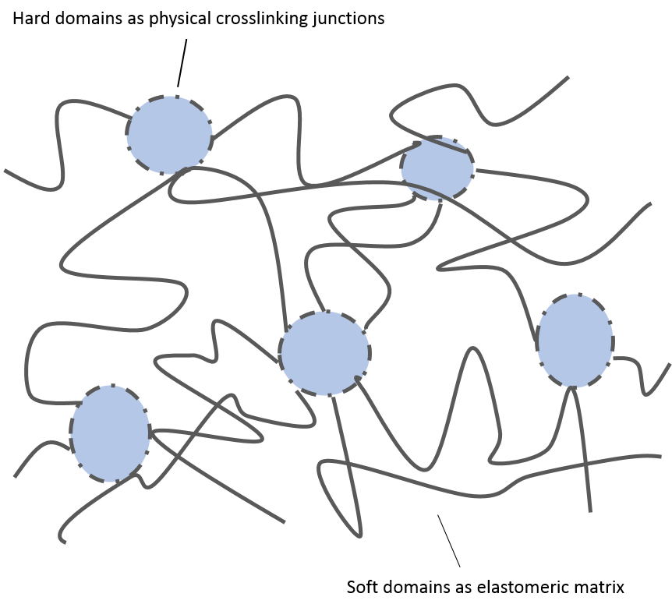
Scheme 1-1. Illustration of thermoplastic elastomers structures
Block copolymers or polymer blends are good candidates to make TPEs. The phase separation into soft matrix and hard domains arises can be evaluated by the Flory-Huggins interaction parameter χ and the degree of polymerization N. For instance, as shown in Figure 1-1, for diblock copolymer of polystyrene-block-polyisoprene, with either the increase of χ or N, more distinct microphase separation behavior can be observed.⁷ For the former parameter, the combination of components with highly different structures and the introduction of extra force like ionic charge and hydrogen bonding can contribute to the large χ; the role of the latter parameter indicates that segment with high molecular weight can lead to better phase separation behavior of TPEs.
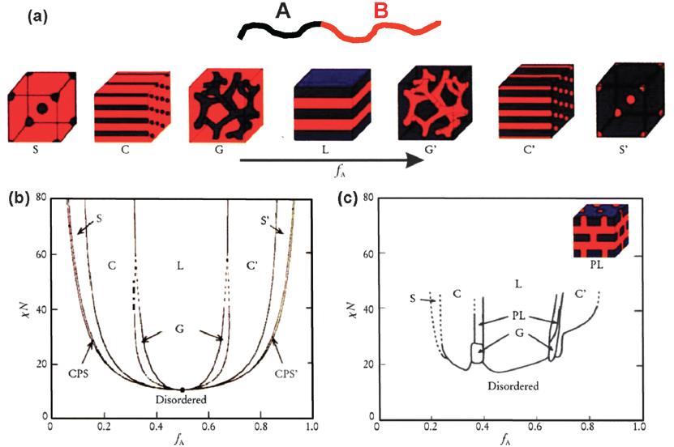
Figure 1-1. (a) Equilibrium morphologies of AB diblock copolymers in bulk: S and S’= spheres, C and C’= cylinders, G and G’= gyroids, and L = lamellae. (b) Theoretical phase diagram of AB diblocks predicted by the self- consistent mean-ﬁeld theory, depending on volume fraction (f) of the blocks and the segregation parameter, χ N, where χ is the Flory–Huggins segment–segment interaction energy and N is the degree of polymerization; (c) Experimental phase portrait of polyisoprene-block-polystyrene copolymers, in which fA represents the volume fraction of polyisoprene, PL = perforated lamellae.⁷

The molecular mechanism of the train stress behavior of ABA triblock copolymers were simulated by the combination of self-consistent field theory (SCF) and molecular dynamics (MD) simulation, as shown in Figure 1-2.⁸
- Strain up to 150%. Spherical morphology does not change under elongation and compression. The chain configuration can return to the initial state with no damage;
- Strain to 300%. Spherical morphology is majorly maintained with come domains broken. Thus the chain configuration is slightly changed;
- Strain to 500%. Most polymer chains are pulled out from the hard domains and the domains are broken under elongation. Thus the recovery behavior of the material is damaged.
Figure 1-2. Illustration of morphology of ABA triblock copolymer under first elongation with the range of: (a) 150%, (b) 300%, (c) 500%.

1.1.2 Advantages & Disadvantages of TPEs
As compared to the vulcanized rubbers, the physical crosslinking behavior make changes in behavior by heating or external force reversible. By this means, TPEs have various merits including recyclability, processability and low cost. Less energy is required to achieve control of product quality. In addition, TPEs also provide versatile dyeing options to the material.⁹
Meanwhile, the reversible melt-to-solid transition also lead to the sacrifices of some properties, like compression set, solvent resistance and resistance to deformation at high temperature, for which conventional thermoset rubbers normally have better performance.
Based on these pros and cons, TPEs are greatly used in the fields including automotive applications, foot wear, wire insulation, adhesives, polymer blending and food packaging.¹⁰

1.1.3 Classification of TPEs
Different types of thermoplastic elastomers have been developed, including: (1) styrenic block copolymers (SBCs), (2) polymer blends by dynamic vulcanization (TPVs), (3) polyolefin based thermoplastic elastomers (TPOs), (4) halogen-containing polyolefins, (4) thermoplastic polyurethane elastomers (TPUs), (6) polyamides based thermoplastic elastomers (COPA), (7) polyether ester elastomers (COPE), (8) ionomeric thermoplastic elastomer, etc.⁹ Except for TPVs, most TPEs are block copolymers. SBCs, halogen containing polyolefins are normally based on the great differences in glass transition temperature (T_{g}), while crystalline exists and aggregates together in other type of TPEs. The comparison of performances, costs and market share of different TPEs are shown in Figure 1-3.
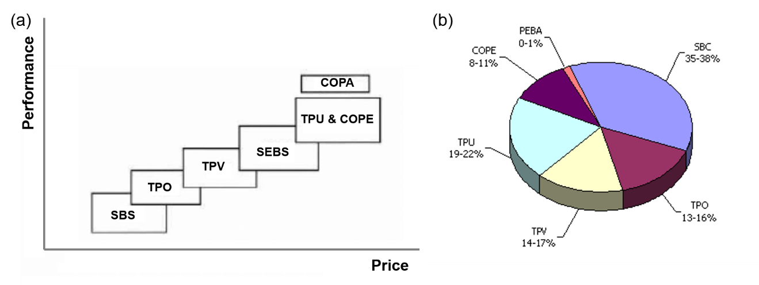
Figure 1-3. (a) Approximate ranges of performance vs. cost for commercial TPEs.⁹ (b) Percent break-up by market segments in revenue in 2000. (Courtesy of Frost & Sullivan Market Insight)

1.1.4 Styrenic Thermoplastic Elastomers (SBCs)
The market size of SBCs is dominated among TPEs and generated over $6 billion in revenue in 2015.^{1,11} They are typically based on the type A-B-A triblock copolymers where A is polystyrene (PS) (T_{g} ~ 100 ºC) and its derivatives as the hard domain, and B is polydiene like polybutadiene (PB) (T_{g} ~ -90 ºC) or polyisoprene (PI) (T_{g} ~ -56 ºC) as the elastomeric domain.⁹ The spherical morphology are typically formed and preferred by microphase separation to get good mechanical property.⁸ SBCs exhibit similar performance as vulcanized rubber at ambient temperature, with tensile strength in excess of 28 MPa, and elongation at break over 800%.¹²
The most conventional and classic SBCs are polystyrene-block-polybutadiene-block-polystyrene (SBS) and polystyrene-block-polyisoprene-block-polystyrene (SIS) triblock copolymers. However, the polydiene used as the soft domains contain unsaturated bonds that are vulnerable to oxidation and UV degradation. Thus, the life time and stability of the material are limited.
One solution to overcome the vulnerability of the unsaturated bonds is to change the medium block into saturated polymer chains. This can be attained by hydrogenation of existent PB or PI into poly(ethylene/butylene) (PEB) or poly(ethylene/propylene) (PEP) and the final SBCs are SEBS, or SEPS.¹³ The modification not only increases the material’s resistance to the attack of oxygen, ozone and UV , but also improve the processability and mechanical strength, as shown in Figure 1-4 (a). ¹⁴ Meanwhile, the hydrogenation make the crystallinity prominent, which affects the glass transition temperature, and dynamic hysteresis of the material. (Figure 1-4 (b)) Thus the hydrogenation degree need to be considered during this modification. Another approach to introduce other polyolefin to replace polydiene, such as polyisobutylene (PIB). The resulting triblock copolymer SIBS can be directly synthesized by living cationic polymerization.¹⁵
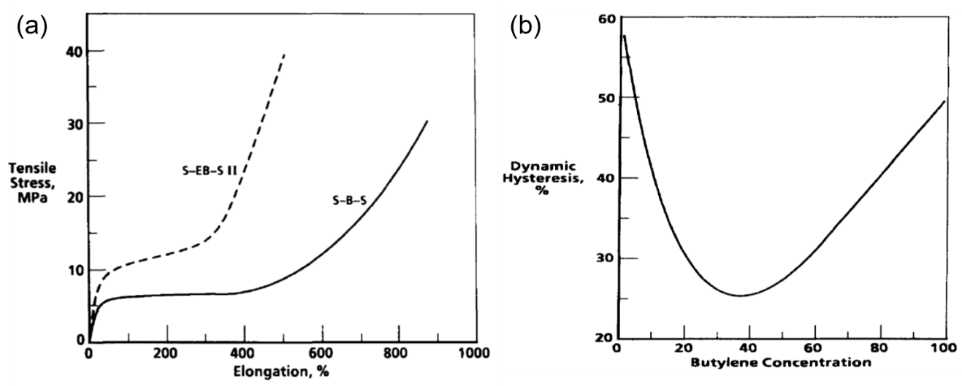
Figure 1-4. (a) Stress-strain curves of SBS and SEBS; (b) Dynamic hysteresis as a function of butylene concentration in partially hydrogenated SBS. The concentration of butylene is proportional to the hydrogenation degree. ¹⁴

1.2 All Acrylic Based TPEs
As mentioned above, the change of hard block from PS into sPMMA can greatly increase the UST.¹⁶ The study of acrylic based block copolymers offers a promising substitution to SBCs. In addition to using sPMMA as the replacement of PS, poly(n-butyl acrylate) (PBA) (T_{g} ~ -54 ºC, similar to PI) was demonstrated to be a good candidate as the soft domain to improve the chemical stability with the elimination of unsaturated bond.¹⁷ Moreover, as a big family with various pendent groups, a series of different poly(alkyl (meth)acrylate)s with different T_{g}s provide the tool box that can meet various requirement for the mechanical performances and applications, like poly(isobornyl methacrylate) (T_{g} ~ 200 ºC) as the glassy segment, and poly(2-ethylhexyl acrylate) (T_{g} ~ -65 ºC)¹⁸ or poly(isoctyl acrylate) (T_{g} ~ -50 ºC)¹⁹ as the elastomeric segment.

1.2.1 Entanglement Molecular Weight (M_{e})
Nevertheless, the mechanical performance of all acrylic TPEs as compared to SBCs is always “disappointing”, especially with much less elongation at break.²⁰ The much higher entanglement molecular weight (M_{e}) can help shed light on their poor mechanical properties. It is defined as the molecular weight between adjacent temporary entanglement point and can affect the molecular architecture of the polymers. Based on the equation below, M_{e} can be estimated by dynamic oscillatory measurements using rheometers, as shown in Figure 1-5.²¹
$M_{e}=K\frac{ρRT}{G_{N}^{0}}$ (1)
In which K is a constant with a value of 1 or 4/5, R is the universal gas constant, T is the temperature, and ρ is the polymer melt density.²²
Figure 1-5. Schematic representation of relaxation function G(t) for an amorphous polymer. The plateau modulus $G_{N}^{0}$ can be used for the calculation of M_{e.}²¹
The entanglement molecular weight is related by the power law to the packing length of the polymer species:
$M_{e}=n_{t}^{2}N_{a}ρp^{3}$ (2)
In which N_{a} is the Avogadro number, and p is the packing length.
The packing length p is analog to the molecular diameter of the repeat unit in the polymer chain. As shown in Equation (3), if the polymer chain is regarded to be composed of freely jointed rods, p is proportional to the ratio of the cross-sectional area to the length of each rod.
$p \sim \frac{h^{2}}{[C_{∞}l_{0}]}$ (3)
In which the product $C_{∞}l_{0}$ is the Kuhn step length and $h$ is the diameter. Thus, the smaller $h$ is with respect to the skinner the chain and the smaller p.²²
Compared to polydienes, the large side groups impart poly(meth)acrylates a large diameter. Thus the packng lengths are normally larger for acrylic polymers. As a result, the entanglement molecular weights of poly(meth)acrylates are large as compared to polydienes. Moreover, with the increase of the length of pendent groups, the increase of packing lengths leads to the further increase of M_{e,} as shown in Table 1-1.²³
The M_{e} of the soft blocks determine the elastomeric properties, while the M_{e} of the hard blocks is reported to have effect on the rheological behavior.¹⁹ Larger M_{e} can lead to the less entanglements in the polymer networks. Therefore, the mechanical strength and strain will be lower.

Table 1-1. Average chain entanglement molecular weight (M_{e}) for polymers²³
Polymer | $$M_{e}×{10}^{-3}$$  (g/mol)
Polyisoprene | 6.1
Polybutadiene | 1.7
Poly(ethylacryate) | 11
Poly(n-propylacrylate) | 16
Poly(n-butylacrylate) | 28
Poly(isooctylacrylate) | 59

The M_{e} influence on tensile strength is speculated to be expressed by the equation below:²⁴
$F=A+kf_{e}/M_{e}$ (4)
In which A is a constant related to the composition, k is a constant at constance copolymer composition, $f_{e}$ is the force shared by the slippage of one chain entanglement, and F is the ultimate tensile strength of the triblock copolymer.
As shown in Figure 1-6, with the decrease of M_{e,} higher mechanical strength can be attained.²⁴
Figure 1-6. Ultimate tensile strength as a function of 1/ M_{e}. Where M: PMMA; I: Poly(isooctyl acrylate); nB: poly(n-butyl acrylate); nP: poly(n-propyl acrylate); E: poly(ethyl acrylate); S: PS; IB: poly(isobutylene); IP: polyisoprene.²⁴
The Me influence on elongation can be reflected by the comparison between different TPEs composed of PS, PMMA, PB and poly(n-butyl acrylate) (PBA). The classic SBS can normally reach around 1000% elongation at break.¹² When the outer block is changed to PMMA, the elongation at break can also reach 1000%.¹⁶ Meanwhile, the switch of the soft domain from PB to PBA distinctly decreased the elongation at break. PS-b-PBA-b-PS exhibited the elongation less than 600% with similar molecular weight to SBS.¹⁷ PMMA-b-PBA-b-PMMA normally gives elongation at break around 500%.²³

1.2.2 Synthesis and Properties on PMMA-b-PBA-b-PMMA Triblock Copolymer TPEs
Conventional TPEs are based on ABA triblock copolymers, with the outer block as the hard domains and medium block as the soft domains. Similar to SBCs, all acrylic based TPEs follow the same principle. Various products of PMMA-b-PBA-b-PMMA triblock copolymers have been developed and commercialized, such as Nanostrength® from Arkema, and Kurarity® from Kuraray. For the synthesis of well-defined block copolymers, controlled polymerization is essential to keep the living property of built block and sequentially grow the other blocks.²⁵
Different methods of controlled radical polymerization have been utilized for the synthesis of PMMA-b-PBA-b-PMMA triblock copolymer TPEs. Although it also has good living properties, controlled radical polymerization does not have the ability to balance the 100% conversion and fully intact living properties. The normal approach to synthesize block copolymers via controlled radical polymerizations is to quench the reaction at certain conversion. After precipitation and purification, the resulting polymer with functional group— either as initiator or chain transfer agent— is used for the further synthesis of the second block.²⁶ It is difficult to guarantee the same chain length of the outer two blocks through the sequential, three-step polymerization. As a solution, difunctional initiator or chain transfer agent is used so that the two hard blocks can grow simultaneously. For instance, Atom transfer radical polymerization (ATRP) has been utilized for the production of PMMA-b-PBA-b-PMMA. The difunctional initiators attempted include 1,2-bis(bromoisobutyryloxy) ethane (bBr-iBE)¹⁸ and diethyl meso-2,5-dibromoadipate
(DEMDBA).²⁷
The exception is Arkema’s Nanostrength®,which is reported to synthesized through Nitrooxide-Mediated Polymerization (NMP) using BlocBuilder® alkoxyamine (SG-1) as the monofunctional initiator, the structure of which is as shown in Scheme 1-2 (a).²⁸ This initiator has advantages including excellent control of acrylates and methacrylates, fast reaction and no metal residue left in product. However, the more efficient and promising initiator to build symmetric triblock copolymers by NMP is the modified difunctional initiator from SG-1, structure as shown in Scheme 1-2 (b).²⁹
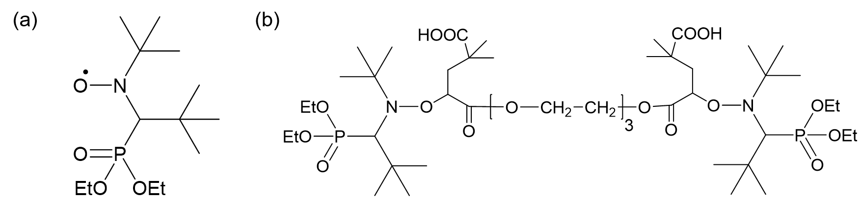
Scheme 1-2. Initiators for the synthesis of PMMA-b-PBA-b-PMMA triblock copolymers via NMP. (a) SG-1; (b) SG1- based difunctional alkoxyamine (DIAMA).
A better method to synthesize the ABA triblock copolymers is living anionic polymerization in virtue of its predictable molecular weights with narrow polydispersities (PDI), 100% conversion and superior living properties.^{30,31} Both sequential three-step reactions and polymerization initiated by difunctional initiators can produce triblock copolymers with symmetric composition.
Meanwhile, the living anionic polymerization of acrylates is challenging due to intrinsic side reactions including backbiting reactions of propagating enolate anonics and aggregations of active chain ends.³² Although many attempts have been tried, limited acrylate monomers have been reported successfully polymerized anionically with low PDI and predicted molecular weights, which contain bulky pendent groups to prevent the side reactions.³³⁻³⁵ Although PBA was also successfully synthesized with PDI of 1.30 by using tetrabutylammonium dimethyl malonate as the initiator, the living property is still limited.³⁶
The transalcoholysis reactions provide with the solution to the draw back for the direct anionic polymerization of n-butyl acrylate by the synthesis of poly(tert-butyl acrylate) (PtBA) first. Tong, j. D et al. reported the synthesis of PMMA-b-PtBA-b-PMMA by sequential anionic polymerization using sec-butyllithium/diphenylethylene/lithium chloride (sec-BuLi/DPE/LiCl) initiator system. The polymerization was performed in THF at -78 ºC, as shown in Scheme 1-3 (a).²³ Leclere, ph et al. synthesized the triblock copolymer by anionic polymerization using Lithium as the difunctional initiator so that the polymer chain can growth from the medium block (Scheme 1-3 (b)). Thereafter, the transalcoholysis can be performed by adding excess of n-butanol in the presence of p-toluenesulfonic acid (PTSA).³⁷
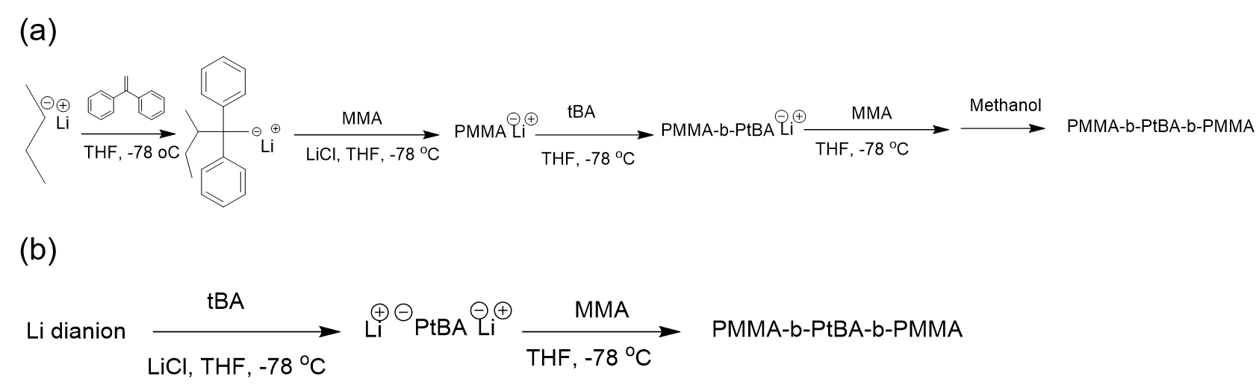
Scheme 1-3. Anionic polymerization of PMMA-b-PtBA-b-PMMA.
The obstacle for the industrialization of the anionic polymerization approaches are the complex post-modification operations and the critical condition required—THF solution at -78 ºC. Suprisingly, Kuraray Co. Ltd has developed a new anionic polymerization system using compounds composed of a Lewis base and di-phenoxyalkyl almuminum. (LA system). With this system, living polymerization of acrylates can be performed at roughly -10 ºC, and at roughly 50 ºC for methacrylates with no no sacrifice of living properties, even for the direct polymerization of nBA. Therefore, the PMMA-b-PBA-b-PMMA triblock copolymers can be synthesized directly with sequential addition of MMA, nBA, MMA monomers(GPC curves as shown in Figure 1-7).The mild temperature greatly decrease the energy consumption.^{38,39}
Figure 1-7. GPC curve of “KurarityTM” acrylic triblock colymer.³⁹
Although same composition can be made through both living radical polymerization and living anionic polymerization, the performances of the resulting materials can be different. J. D. Tong et al. synthesized the triblock copolymers by ATRP and anionic polymerization that gave the same molecular characteristics except for the PDI of PMMA blocks (broader for the ATRP samples). Similar separation behaviors were observed. However, part of the chains from ATRP did not participate in the network formation and lead to the low storage modulus and poor tensile properties, as shown in Figure 1-8. Hence, the low PDIs and well-defined structures make living anionic polymerization an ideal method for the synthesis of acrylic based TPEs.
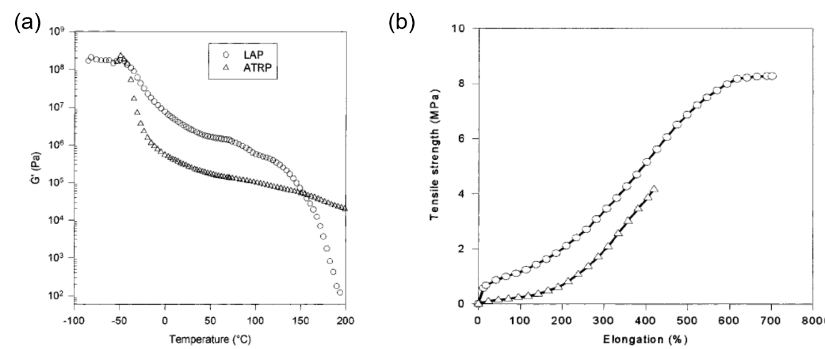
Figure 1-8. Mechanical properties of PMMA-b-PBA-b-PMMA triblock copolymers: (a) Storage modulus as a function of temperature; (b) stress-strain curves.

1.2.3 Industrial application of acrylic based TPEs.
Besides the flexible options and chemical stability of the resulting materials, all acrylic based TPEs have advantages over SBCs including optical transparency, versatility of adhesion, weatherability, oil resistance, printability, compatibility with fillers, abrasion resistance and low viscosity.^{39,40}
The introduction of polymethacrylates extends the application range of SBCs, such as the tougher in various fields.¹¹ PS-b-PB-b-PMMA have been effectively used as the tougher for both thermoplastic and thermosetting systems, such as poly(phenylene oxide), poly(vinylidene fluoride), and poly(vinyl chlroide), due to the polarity of PMMA that can increase the compatibility.¹¹ For the epoxy systems, the triblock copolymer also shows the ability to improve the toughness of the epoxy network by the formation of “spheres on spheres” morphology.⁴¹
Acrylic adhesives family is one of the most commonly used adhesives, especially when it is emphasized ideal for UV-curable materials that can be used in 3D printing.⁴² Acrylic adhesives can also improve aesthetics, bond to plastics and metals, and even bond between oily or contaminated surfaces, which make them also popularly applied in automobile and furniture industries.⁴³ For acrylic TPEs, the potential use in automotive can be instrument panel, dashboard skins, inner door grips, parking levers shift grips, steering wheel covers, assist grips, switches, etc.(Figure 1-9)⁴⁴
Figure 1-9. Exemples for acrylic TPE in automotive application.⁴⁴
The thermoplastic property make acrylic TPE good candidate for pressure sensitive adhesive application. The low temperature adhesiveness, good die-cut property and great holding power make it ideal as the removable and reusable adhesive. Moreover, with certain amount of tackifiers such as PBA oligomer, the tack properties can even be adjust as needed.⁴⁵

1.3 Approaches to Improve the Performance of TPEs

1.3.1 Compounding
In general, the thermal plastic elastomers can be used without any additives. However, many compounds have been used industry to fulfill different needs of the materials, including fillers, oils, plasticizers, resins, etc.⁹ The performance of the TPEs can be modified in this way. In principle, if the additive accumulates in the hard phase, the physical crosslinked junctions are reinforced so that the mechanical strength can be improved. If the additive is the polymeric material, its glass transition temperature should be higher than that of hard segments composing TPEs. If the additive accumulates in the elastomeric matrix, the resulting material can be softer and more flexible. In addition, different forces between the additives and the TPE components can lead to the enhancement of phase separation behavior, so that the mechanical performance can be totally improved.
Nanofillers have been studied on its effect on the mechanical properties of TPEs. The addition of fumed silica (SiO₂) to polyetherester elastomer has been approved effective to improve the modulus, elongation at break and creep resistance. The only concern for this observation is that the size and distribution of the silica need to be selected. For unmodified silica, the elongation can even be receded. The influence of microsilica is also more distinct than that of nanosilica filler, as shown in Figure 1-10.
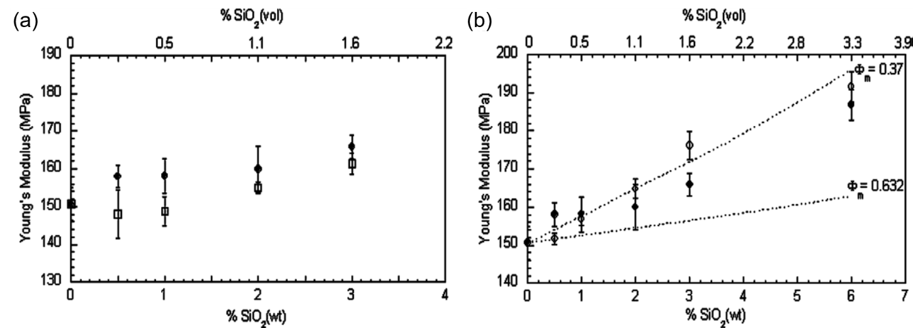
Figure 1-10. Young’s modulus of (a) microsilica (□) and nanosilica (●) composites; (b) unmodified (○) and modified (●), wt% of silica composites virsus silica content.
For acrylic based TPEs, the addition of PBA oligomer as the tackifier help to improve the tack property of PMMA-b-PBA-b-PMMA triblock copolymers. The addition does not change the T_{g} or modulus at low temperature, since the additive has the same structure as the soft domain. However, its accumulation in the soft regime make the material more elastic, and the cohesive strength is improved.⁴⁵
The phase separation behavior can also be adjusted by certain additives added to the TPEs. With a low-volatility, midblock-compatible mineral oil added, the thermoplastic elastomer gel composed of SEBS was reported to undergo great change in morphology, as shown in Figure 1-11. It is speculated that the self-association of the styrene endblocks due to thermodynamic incompatibility with the oil-rich matrix leads to the formation of spheroidal micelles.
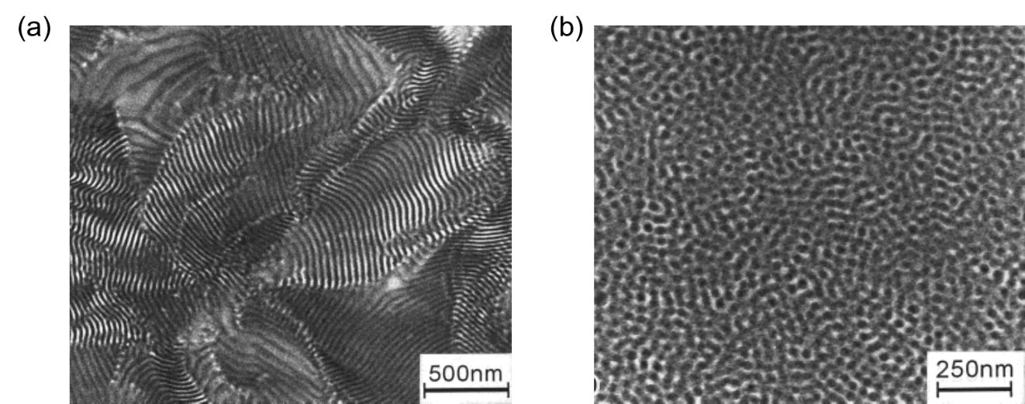
Figure 1-11. Transmission electron micrograph of (a) neat SEBS copolymer; (b) SEBS gel with $ω_{oil}$ 0.70. (9.3 wt% styrene).

1.3.2 Glass Transition Temperature
SBCs, halogen containing polyolefins are normally based on the great differences in glass transition temperatures (T_{g}). The comparison of T_{g} can give the evaluation on many different factors, including flexibility of the main chain, the functionality of side groups and end groups, the polymer tacticity, the chain microstructure, etc.⁴⁶ The great difference in T_{g} gives the trace of the thermodynamic incompatibility of different components that comprise the TPEs. With the increase of this difference, the phase separation separation behavior can normally be enhanced. Moreover, the upper service temperature (UST) is closely related with the T_{g} of the hard segments. As shown in Figure 1-12, when the temperature is between the T_{g}s of different segments, the modulus stays relatively constant and in a region defined as the “rubbery plateau.” When it is further increased to higher than the T_{g} of the hard segment, the modulus drops dramatically and the TPE becomes fluids.¹⁰ Thus to increase the UST of the material, the selection of hard segment with higher T_{g} is essential.
Figure 1-12. The change of storage modulus of thermoplastic elastomers at various termperatures.¹⁰
The typical T_{g} of PS is around 100 ºC. However, S-B-S shows a the upper service temperature (UST) limited to 60-70 ºC due to the partial miscibility of the styrene and butadiene blocks.⁴⁷
Based on the current S-B-S material, one approach to improve the UST is to fully hydrogenate the unsaturated bonds including the transition from polystyrene to poly(cyclohexylethylene), for which the T_{g} is around 145 ºC.^{48,49} Moreover, the crystallinity of poly(cyclohexylethylene)also counts for the enhancement of the UST. As a result, the resulting TPE gives the oder dis order transition temperature at around 170 ºC.
Several polystyrene derivatives with higher T_{g}s have been applied and exhibited great effect on the improvement of UST, such as poly(p-tertbutylstyrene) (T_{g}: ~130 ºC),⁵⁰ poly(α-methylstyrene) (T_{g}: ~173 ºC),⁵¹ and poly(1-adamantylstyrene) (T_{g}: ~203 ºC).⁵² Polymers with similar structures but higher T_{g} were also reported, such as polybenzofulvene (T_{g}: ~190 ºC).⁵³
As another approach, alkyl (meth)acrylates are also promising candidate to increase the UST. Jian M. Yu et at. reported the replacement of PS into syndiotactic PMMA (T_{g}: ~125 ºC) that distinctly increase the UST of SBS into 125 ºC⁵⁴. More interestingly, if highly isotactic PMMA (T_{g}: ~127 ºC) was used, they reported the resulting PMMA-b-PEB-b-PMMA with soft point as high as 173 ºC, which is even much higher the T_{g} of PMMA. The formation of semi-crystalline stereocomplexes caused by the isotactic PMMA, which reinforce the aggregation of hard segments, counted for this surprisingly high service temperature.

1.3.3 Complex Architectures
Compared to linear block copolymers, polymers with complex architectures have more advantages of 1) smaller hydrodynamic radii, lower melt and solution viscosities, 2) lower glass transition temperature, 3) lower crystallinity, and 4) higher solubility, which will endow them in many cases with improved rheological behavior (such as strain and hardening) and improved processability.⁵⁵ Furthermore, block copolymers with miktoarm star architectures and graft/multigraft architectures allow additional capacity to tune morphology and long range order.⁵⁶ It is reported that for PI₂PS miktoarm star copolymers the long range order in cylindrical morphologies could be exceptionally good (Figure 1-13) or very poor, depending on whether PI or PS constitutes the continuous phase ⁵⁶.
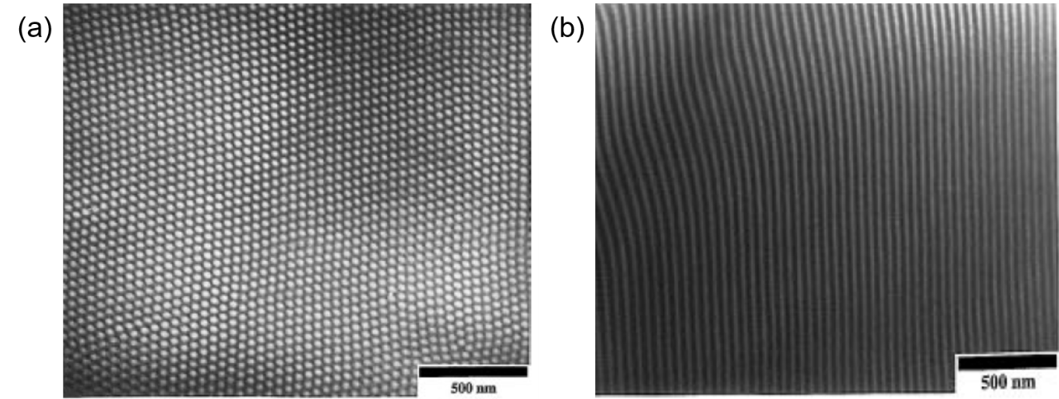
Figure 1-13. TEM images of PI₂PS sample having 0.44 vol fraction PS and forming hexagonally packed cylinders (confirmed by SAXS). (a) A slice perpendicular to the cylinders and, (b) a slice parallel to the cylinders.
Various polymer architectures (also termed as topologies) have been synthesized and studied, including linear, cyclic, star, graft (comb), multigraft, hyperbranched (dendrimer), network type structures (Scheme 1-4). Similar to that for block copolymer, “living”/controlled polymerizations provide powerful and ideal approaches to build complex architectures, such as living radical polymerization,⁵⁷ living anionic polymerization,⁵⁵ and living cationic polymerization.⁵⁸
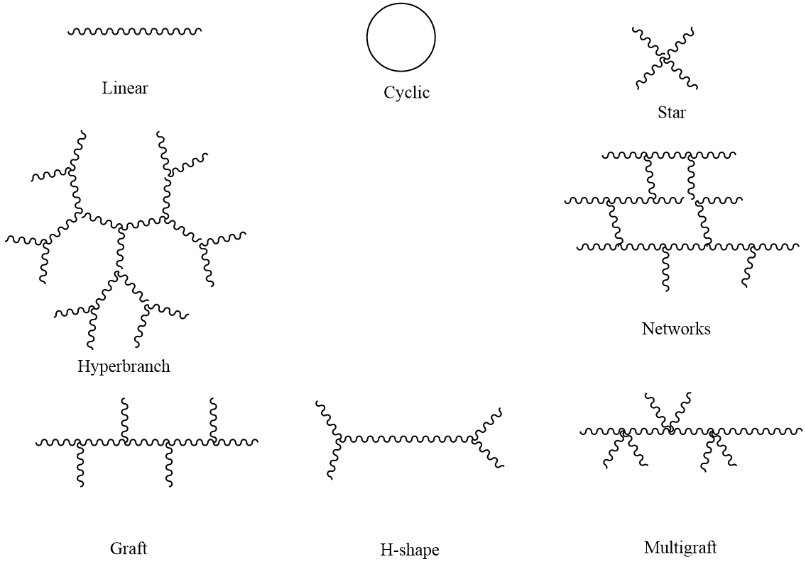
Scheme 1-4. Illustration of polymer structures with different architectures
For the application of TPEs, besides better ability to tune the phase separation behavior, the complex architecture can increase the density of hard segments outside the polymer structure, so that more entanglements between the hard domains can be formed. This improvement of entanglements can further enhance the physical crosslinking behavior of the material. As a result, the mechanical strength of TPEs with complex architectures are usually increased.
There are three common methodologies to build the star architecture: graft from the multifunctional initiators,^{59,60} graft to through coupling reactions with the functional cores, linking reactions by the use of linking agents.⁵⁵ The star shaped TPEs are usually composed of the soft domains as the inner block and hard domains as the outer block. The entanglements of hard segments are usually dramatically enhanced, even when compared to other architectures. The materials synthesized usually have great toughness, while the elongation can be either increased or sacrificed. Thus, the resulting materials are ideal for the use as the tougher to enhance the mechanical strength of conventional linear type TPEs.⁶¹
Analog to the linear SBCs, the star copolymers composed of PS and PB or PI have been greatly studied. Dair, Benita J et al. reported the formation of double gyroid morphology with the PI-b-PS star copolymers.⁶² As compared to the common morphologies formed in linear SBCs, such as sphere, cylindrical, and lamella structures, this 3-dimensionally interpenetrating periodic structure have superior properties to prevent the sliding of the junctions while the material is stretched. Thus, the resulting polymer exhibited considerably higher stresses for yield than classical SBCs. However, the strain was only 350% to 400%, which is much lower than the conventional SIS TPEs. In addition, asymmetric miktoarm PS-b-PI copolymers were also reported. Taking advantages of the star architecture, much less content of soft domains is necessary in the material. In other words, the resulting material can possess very high mechanical strength, but still have elastomeric property instead to too rigid.^{63,64}
The more distinct comparison between linear type TPEs and star type TPEs can be found from Tsuguto Imaeda and coworkers’ work on Poly(2-adamantyl vinyl ether)-b-poly(n-butyl vinyl ether) block copolymers, both linear type and star type were synthesized through living cationic polymerization. Both the tensile strength and elongation values for star type copolymers were greatly higher than for linear copolymers with similar composition.⁶⁵ Same performance on both the improvement of stress and elongation were also reported by Juhari, Azhar and coworkers on the study of poly(n-butyl acrylate)-b-poly(α-methylene-γ-butyrolactone) block copolymers.⁶⁶ Another key factor that influence the mechanical performance is the number of arms. By the comparison of poly (p-chlorostyrene)-b-poly(isobutylene) star block copolymers composed of triarms and octoarms, it was demonstrated that the increase of the arm numbers can help to increase the tensile strengths and moduli, although the elongation was decreased.⁶⁷
Accompany with the increase of mechanical strength, many attempts were also performed to improve the upper service temperature at the same time, such as using polyacrylonitrile (PAN, UST of resulting PBA-b-PAN star copolymer higher than 300 ºC).⁶⁸ The study on all acrylic star block copolymers were also reported. By using functionalized lignin as the ATRP initiator, the pentarm star of Lignin-g-P(MMA-co-BA) exhibited greatly enhanced mechanical strength, where MMA and nBA were randomly copolymerized as the soft segments and lignin was used as the hard segment.⁵⁹ However, another work producing triarm star composed of PBA-g-PMMA diblock copolymers only exhibited comparable mechanical performance as compared to the PMMA-b-PBA-b-PMMA triblock copolymers.⁶⁹ It is supposed that the instruction of lignin as the hard segment contributed to the superior stress in the former case.
Similar to the star architecture, hyperbranched copolymers were also attempted. Zhiyuan He and coworkers reported the one step production of random hyperbranched linear polyethylene, taking advantage of an α-diiminonickel complex precatalyst. The resulting polymer exhibited god elastomeric properties. Moreover, the elastomeric properties changed dramatically with the change of temperatures, due to different formation of crystallinities.⁷⁰ Hyperbranched PMMA-b-PB and PS-PI block copolymers were also reported.The macromonomers of PMMA-b-PB and PS-b-PI were synthesized through anionic polymerization first, followed by the Williamson etherification reactions to build the final hyperbranched architectures. The resulting materials exhibited higher mechanical strength but poorer elongation than that of linear TPEs. However, when used as additives in the conventional linear TPEs like Kraton® SIS liner block copolymer, they can considerably increase the strength and even elongation behavior of the materials.⁷¹ Moreover, the long range order is hard to be obtained in hyperbranched architecture.⁷¹ Thus, hyperbranched TPEs are also good candidates for the use as tougher to the conventional linear type TPEs, silimar to star-shaped TPEs.
The graft type architecture is more promising to be used neatly as the TPE, with both improvements in mechanical strength and elongation. Three common methodologies can be performed to build the graft architecture, including graft onto by the linking reactions, graft from by synthesized the main chain with initiation sites, and graft through by the copolymerization of monomer with macromonomers, as shown in Scheme 1-5.
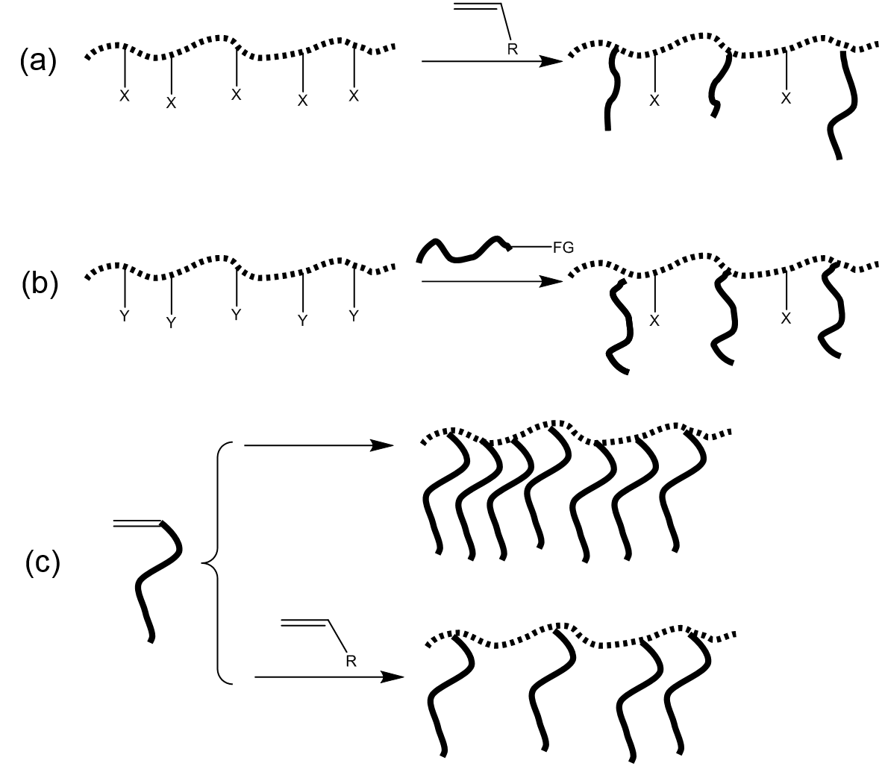
Scheme 1-5. Methodologies for the synthesis of graft copolymers: (a) graft from; (b) graft onto; (c) graft through.
For the use of TPEs, the graft copolymers are usually composed of the soft segment as the main chain, and hard segment as the side chains. Similar to the principle of star copolymers, the build of graft architecture can bring more entanglement between the hard segment. Thus the physical crosslinking behavior can be reinforced. (Scheme 1-6) Meanwhile, the soft segments can still have entanglements with each other rather than isolated by the outer block as the star architecture. The enhancement of physical crosslinking behavior also make it possible to reduce the content of the hard segments without any sacrifice on the mechanical strength. This increase of the soft segments ratio and their entanglents can help to improve the elongation of the resulting materials. As a result, the build of graft architecture offers an ideal method to improve both mechanical strength and elongation of TPEs.
Scheme 1-6. Example on the chain conformation of multigraft copolymers with microphase-separation state.⁷²
Suksawad, Patjaree and coworkers reported the introduction of graft architecture into nature rubber.⁷³ After deprotenization, some of the double bonds in nature rubber (DPNR) were attacked by ter-butyl hydroperoxide/tetraethylenepentamine to create the initiation sites so that styrene monomer can be polymerized thereinto. Through this approach, the grafing efficiency can be more than 90 mol%. The resulting DPNR-g-PS exhibited a stress 4 times higher and stress twice to unmodified nature rubber, which was similar to that for the crosslinked nature rubber.
Like the work above, the graft from methodology was also used for the development of many materials through living radical polymerization, living cationic polymerization or ring opening applications. Some nature polymers are “born” with the potential to build graft copolymer architectures, such as cellulose which contains a lot of hydroxy groups along the polymer chain. Feng Jiang and coworkers modified the hydroxyl groups with 2-bromoisobutyryl bromide so that the many initiator sites were formed for the ATRP of MMA/nBA mixtures. (Scheme 1-7(a)).⁶⁰ Jiuyang Zhang, Marc A. Hillmyer’s approach was more straightforward. The hydroxy group in hydroxypropyl methylcellulose (HPMC) as directly used as the initiation site for the ring opening polymerization of poly(β-methyl-δ-valerolactone)-b-poly(L-lactide) (PMVL-b-PLLA) (Scheme 1-7(b)).⁷⁴ Both approaches successfully use the cellulose as the matrix to build the graft copolymer TPEs.
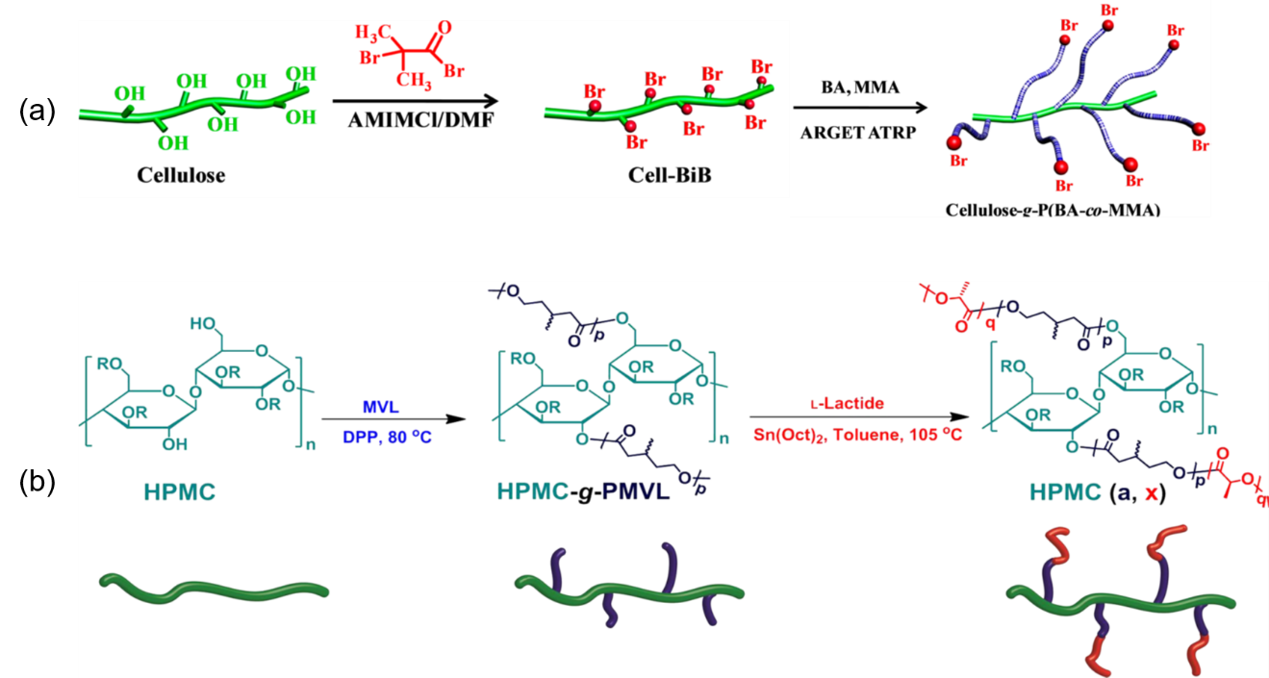
Scheme 1-7. Graft from methodology to make graft copolymer TPEs based on cellulose matrix through: (a) ATRP;⁶⁰ (b) ring opening polymerization. ⁷⁴
As one of the most classic TPEs, graft SBCs have been extensively studied. Graft from methodology was also attempted. Fonagy, Tamas and coworkers reported the synthesis of PIB-g-PS by ATRP. To introduce the initiation sites along the polymer main chain, isobutylene was polymerized with the addition of trace amount of 4-bromomethylstyrene, after which styrene was polymerized by ATRP using the bromomethyl group along the polymer main chain as the initiator.⁷⁵
Inspired by the traditional method to produce SIS triblock copolymer in industry, anionic polymerization has also been one of the most powerful approaches to make graft copolymers with well-defined structures, both for practical application and for the theoretical study. All three methodologies can be used to synthesize graft copolymers by anionic polymerization.As shown in Scheme 1-8, anionic sites can be create through metalation of the PI main chain, where styrene monomer can be polymerized anionically through graft from methodology (Scheme 1-8 (a)). PB can be chlorosilytated through hydrosilation chemistry, where the living PS chain can be graft onto the main chain by the coupling reaction (Scheme 1-8 (b)). The graft through methodology can be attained by the synthesis of PS macromonomer first, followed by the copolymerization with isoprene or butadiene monomers. (Scheme 1-8 (c)).⁷⁶
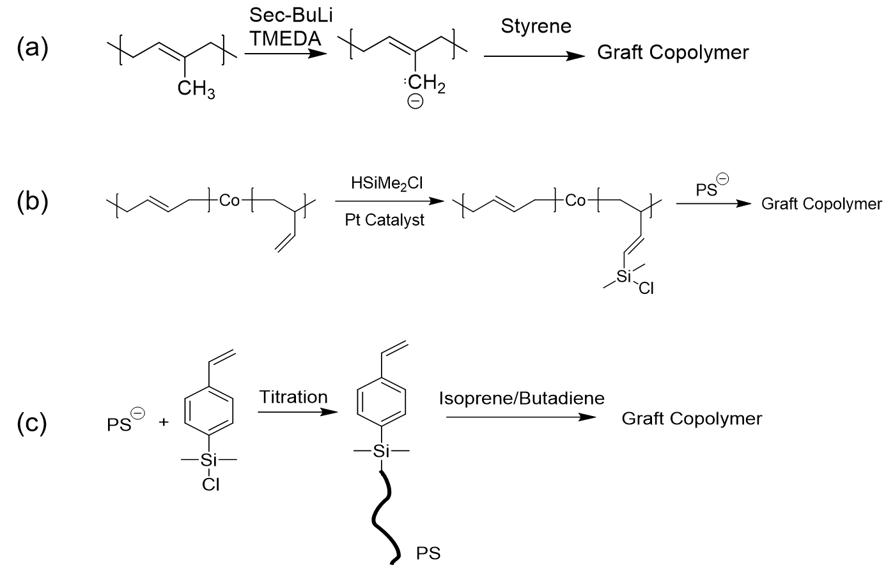
Scheme 1-8. Methodologies for the synthesis of styrenic graft copolymers by anionic polymerization: (a) graft from; (b) graft onto; (c) graft through.
Moreover, Mays, et al. reported the forth methodology to synthesize the graft copolymers by anionic polymerization, which is called polycondensation polymerizations.⁷⁶⁻⁷⁹ With this novel approach, not only the graft copolymers with trifunctional (comb), tetrafunctional (centipede), and hexafunctional (barbwire) branch points can be produced, the resulting polymers also possess strictly well-define, with both same length of side chains and soft segments between the junction points. (Scheme 1-9)
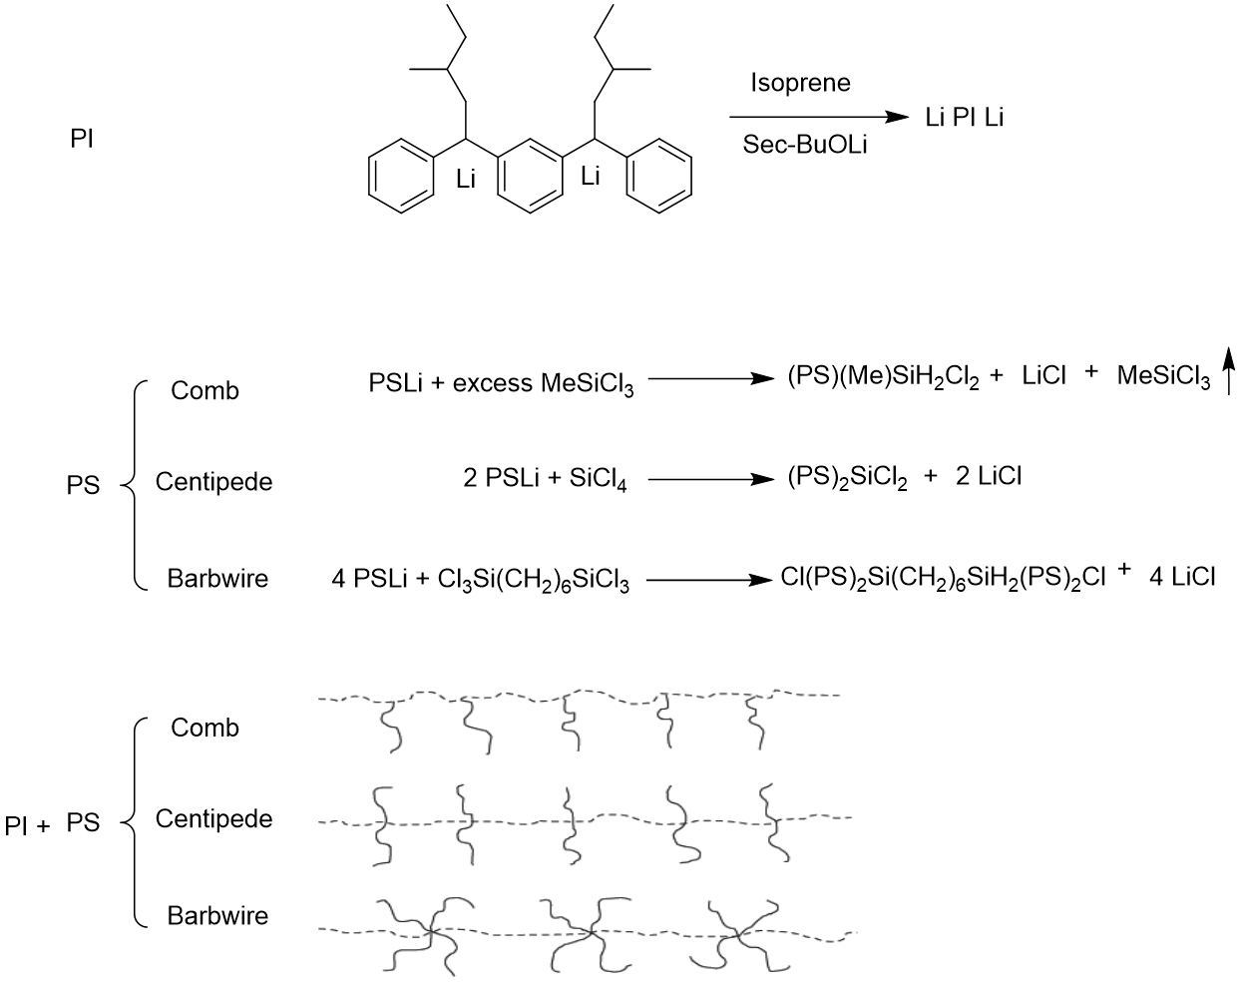
Scheme 1-9. Anionic polymerization of multigraft copolymer architectures with trifunctional (comb), tetrafunctional (centipede) and hexafunctional (barbwire) branch points.^{76,77}
With these well-defined graft copolymers, different aspects were studied on this type of architecture, including rheology,⁸⁰ morphology,⁷² deformation behavior,^{81,82} stress softeninig,⁸³ mechanical properties and hysteresis.⁸⁴
- Functionality. With the increase of functionality, the morphology changes from sphere (trifunctional) to cylinder (tetrafunctional) and lamellae (hexafunctional). Thus the mechanical properties also changes.⁷² Among them, the tetrafunctional multigraft copolymers exhibit the best combination of high mechanical strength and elongation.⁸⁴ (Figure 1-14 (a))
- The tetrafunctional multgraft copolymer shows a surprisingly high strain at break of about 1550%, which is far exceeding the values for commercial TPEs (Styroflex®: 620% due to the the star architecture; Kraton®: 1050%).⁸⁴ (Figure 1-14(b)) In this way, they name the material as “superelatomer” that can better identify it superior elongation property.⁸⁵
- Branch points. With the increase of branch points, more entanglements can be acquired. Thus the mechanical strength can be increased.⁸⁴ (Figure 1-14 (c))
- Hysteresis. The tetrafunctional multigraft copolymer can be deformed until 1400% and reveals a residual strain of only 40%. (Figure 1-14 (d)) This recovery behavior is also distinct as compared to commercial products.
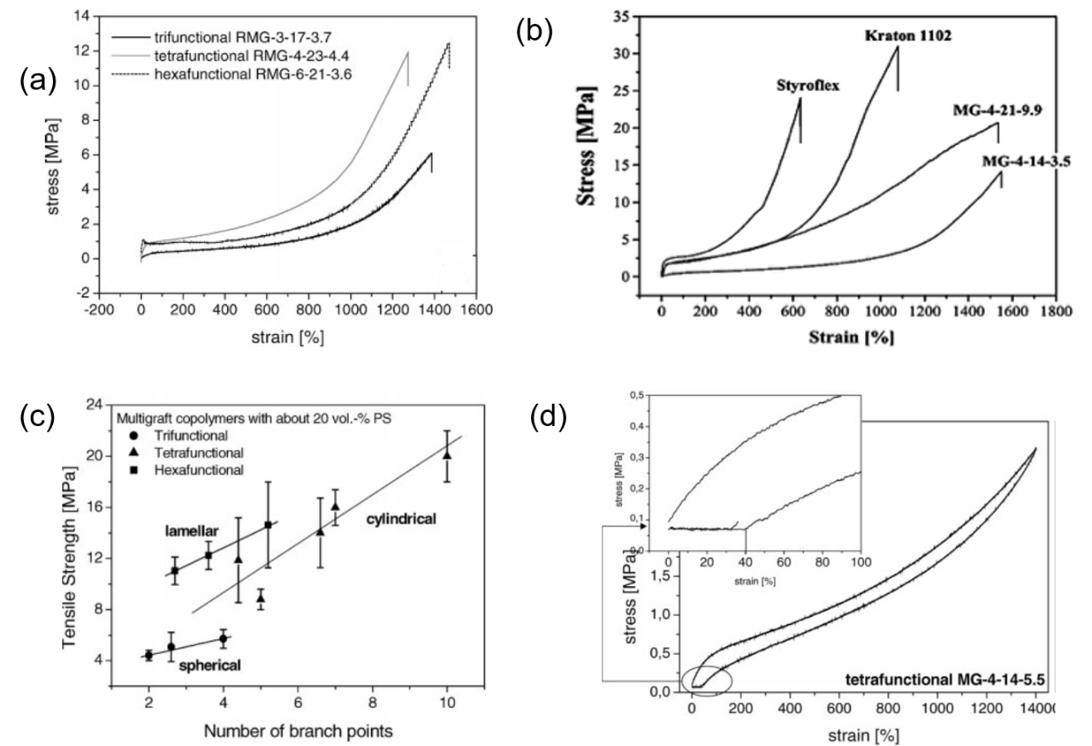
Figure 1-14. Mechanical properties of PI-g-PS multigraft copolymers. (a) Influence of functionality on stress-strain behavior. (b) Comparison of tetrafunctional multigraft copolymers (MG) with commercial SIS-block copolymer (Kraton®) and star copolymer (Styroflex®). (c) Influence of number of branchpoints on the tensile strength. (d) Hysteresis curve of a tetrafunctional multigraft copolymer.⁸⁴
If not strict to one polymerization method, the graft through methodology can give more versatile options on the synthesis of graft copolymers. Anionic polymerization can be used to make the macromonomer, followed by the copolymerization with the second monomer to build the final structure. Following this strategy, Schulz, G.O et al. synthesized the PBA-g-PS graft copolymer as early as 1982.⁸⁶ The PS macromonomer was synthesized through anionic polymerization, endcapped by ethylene oxide and coupled with methacryloyl chloride. Then the macromonomer was copolymerized with nBA monomer by free radical polymerization. Similarly, PBA-b-PS,⁸⁷ PI-g-PS,⁸⁸ PBA-g-PMMA⁸⁹ were synthesized by the anionic polymerization of the macromomers and emulsion polymerization of the final copolymers.
In the case of all acrylic TPEs. The PMMA macromonomer can be synthesized by group-transfer polymerization,⁹⁰ anionic polymerization,⁹¹ or free radical polymerization.⁹² The resulting graft copolymers exhibited comparable mechanical properties to the linear all acrylic TPEs.⁹¹

1.3.4 Introducing Other Driving Forces
Thermoplastic elastomers were born with the mission to imitate the behavior of vulcanized rubbers. It is critical of the physical crosslinking behavior to the final mechanical properties of the TPEs. By this means, the the introduction of other driving force between the association of hard domains can help to increase the microphase separation and physical crosslinking behavior, which can improve the mechanical properties of TPEs.
As mentioned in section 1.3.2, when isotactic PMMA was introduced, the crystallinity of the hard segment can contribute to the enhancement of the association force inside the hard segments, which in return, can greatly increase the UST even much higher than the T_{g} of the hard segments.⁵⁴
Analog to ionomeric thermoplastic elastomer, when ionic bond is added to the existing TPEs, the mechanical performance can be modified. Guilherme M.O. Barra and coworkers modified the commercial SEBS by partially sulfonation of the PS domain.⁹³ Unfortunately, with the increase of sunlfonation degree, the mechanical property was destroyed instead of increased. With the sulfonation degree at 8.4%, the tensile stress did not show great change, but the elongation decreased from 800.9% to 720.1%. the further increase of sulfonation degree made the material more brittle, so that less tensile stress and elongation at break was observed. On one hand, the strong ionic bond exists inside the polymer; on the other hand, the modification greatly increase the glass transition temperature of the hard segment. The strong effect on these two forces dramatically change the stiffness of the material. It is obvious that the modification increase the mechanical strength at the same strain, but the brittleness of the material make it impossible to observe the stress at the same value of elongation at break due to the loss of elastomeric property.
Hydrogen bonding is another potential force for the modification of TPEs. The study of hydrogen bonding mainly focuses on polymers like polyureas, polyurethanes, etc., which has very strong intermolecular interactions. Serge H. M. Sӧntjens et al. reported poly(propylene adipate) with a 2-ureido-4-[1H]-pyrimidinone (UPy) in the middle of the chain. Even only one unit of UPy can be the efficient hard segment that can physically crosslinked by the strongly dimerizing, for which the hydrogen bonds exist between the UPys.⁹⁴ Yulin Chen et al. reported the synthesis of PS-g-polyacrylate amide, for which the amide group can form the hydrogen bonding. Although the resulting polymer cannot be strictly defined as TPE due to the lack of soft domains, it also exhibited the improvement of toughness caused by the hydrogen bonding formation.⁶ In addition, this work give the hint that simply modification of the hard segment with the functional groups can help to tune the performance.
The use of (meth)acrylate acid can take advantage of both forces mentioned above. In the acidic or neutral condition, the hydrogen bonding can form between the carboxyl groups. While in the basic condition, the ionic bonds can form to improve the physical crosslinking between the polymer chains. With this principle, the carboxylic rubber composed of polybutadiene and poly(methacrylic acid) was reported.⁹⁵ With the treatment of NaOH, the tensile strength was increased from around 700 KPa to 12 MPa, while with the treatment of ZnO, the strength was even increased to 41 MPa, in virtue to the strong coordination between the carboxyl group with Zn. However, the elongation was sacrificed in this modification from 1600% to 900% (NaOH treatment), and 400% (ZnO treatment). In addition, the power of metal ligand interaction can be observed in this work.
In conclusion, many intermolecular interactions can be considered for the modification of TPEs. The rather strong interactions can normally dramatically increased the mechanical strength, but the elongation are normally decreased. Prudential thinking on the driving force selection and modification degree is essential to get the optimized performance. On the other hand, the strong interactions also potentially impart the self-healing properties of the materials, due to their reversible characteristics.⁶

1.4 Characterization Methods for TPE

1.4.1 Thermal Characterization
As the root cause of TPE’s mechanism, it is always critical to characterize the thermodynamic mismatch of different segments, no matter it is from the different of glass transition temperature or the existence of crystallinity. The thermal characterization offers a great approach to identify the mismatch. In addition, the evaluation of service temperatures is also essential through the thermal characterization. Herein, we will focus on the TPEs based on T_{g} difference, and briefly introduce three frequently used thermal characterization methods, including differential scanning calorimetry (DSC), thermomechanical analysis (TMA), and dynamic mechanical analysis (DMA).
In definition, glass transition is a transition from a liquid state to a solid state. It points out the sharp change of temperature dependence for many properties, including volume, entropy, elastic constants, etc. However, another transition termed as melting point, which is commonly observed in a crystalline polymer, is quite different to the glass transition. If a polymer has both the amorphous and crystalline domains, both the glass transition temperature (T_{g}) and melting point (T_{m}) can be observed. As shown in Figure 1-15, when a sample is heated, the change of specific volume at T_{g} is slow rather than a sharp change of slope at T_{m}.⁴⁶
Figure 1-15. Temperature variations of specific volume at T_{g} and T_{m.}⁴⁶
As a simple and yet powerful thermos analytical technique, DSC is widely used in various fields to identify the physical and chemical properties. At the sample is heated or cooled, the absorbed or released energy of the material is monitored, by the comparison with the standard. In this way, different DSC curves can be observed depending on the different transition types, as shown in Figure 1-16. The value of T_{g} is normally noted as the middle of the incline in the curve.
TMA is a measurement that study free volume change of a material under a constant load as a function of temperature. The phase change of the sample with an applied force, whether expansion or contraction, is monitored by the function of time or temperature. The plot of this change versus temperature can be obtained and give the information of the sample, such as T_{g}, the coefficient of thermal expansion, service temperature and Young’s modulus.⁹⁶
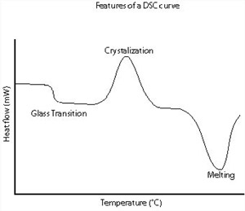
Figure 1-16. Features of different DSC curves.
The typical TMA curve is shown in Figure 1-17. The T_{g} corresponds to the expansion of the free volume allowing the great chain mobility above the transition. Similar to that in DSC, this transition is normally a slow change of the slope instead of the sharp curve. Thus the middle of the incline is also used as the value.
Figure 1-17. Illustration of the typical TMA curve.⁹⁷
DMA, also called as dynamic mechanical thermal analysis (DMTA), is a powerful technique that can be used to characterize the mechanical properties as a function of temperature, time, frequency, stress, atmosphere, etc. It measures the material’s response to a small deformation applied in a cyclic manner. Instead of the constant static force applied to the material in TMA, an oscillatory at a set frequency is normally used and many more parameters, such as stiffness a damping, can be reported.
Figure 1-18. Modulus values changes with temperature and transitions in materials.⁹⁸
In the case of temperature, the change of storage modulus (G’) can be illustrated in Figure 1-18.⁹⁸ At Deformation C, the glass transition happens, where the modulus of the material experiences a sharply drop from glassy state to the rubbery state.
Different characterization methods normally give different but similar T_{g} values. Meanwhile, the result can also be affected by many factors. First, it was reported that the heating and cooling rate $\left|q\right|$ can influence T_{g} following the relation below:⁹⁹ In other word, higher rate of temperature change can lead to the increase of T_{g.}

$\frac{d ln\left|q\right|}{d(1/{T_{g}})}=-Δh^{*}/R$ (5)
The increase of pressure also lead to the pressure can also increase the T_{g} of the polymer, as shown in Figure 1-19.¹⁰⁰
Figure 1-19. The values of T_{g} and shapes of DSC thermograms for different pressure change-temperature change sequences.¹⁰⁰
The use of thermal characterization can also give the circumstantial evaluation on the microphase separation behavior. With phase separated materials, two different transitions can observed.¹⁰¹ While, the phase blending materials only give one T_{g}. When compared to the homopolymers, the shift of T_{g}s can be used to qualitatively evaluate the miscibility of two domains. The larger the T_{g}s are shifted compared to those in homopolymers, the domains are more miscible with each other.

1.4.2 Phase separation Behavior
As discussed in Section 1.1.1, the visualization of the morphology from microphase separation can help to understand the relationship between physical crosslinking behavior and its influence on the mechanical property.
The morphology effect on the mechanical properties cannot be isolated from that of the ratio of the glassy domain, since these two factors always related. With different ratio of the glassy domains, different morphologies can be exhibited, and the mechanical properties can also be affected. For instance, with similar total molecular weight, the lamellae morphology shows much better stress and strained compared to cylindric and spherical morphologies (Figure 1-20).¹⁰² Among these, the cylinder morphology is most commonly seen in commercial products.(wt% of PS: 20 – 30).
Various techniques can be used to investigate the morphology of TPE, including atomic force microscopy (AFM), small angle X-ray scattering (SAXS), and transmission electron microscopy (TEM).

Figure 1-20. Stress-strain curves for SIS triblock copolymers. Sphere: wt% of PS 0.18, molecular weight 10-89-10. Cylinders: wt% of PS 0.30, molecular weight 14-66-14. Lamellae: wt% of PS 0.45, molecular weight 22-29-22.¹⁰²
Initially invented to observe surface structures at the atomic scale, the atomic force microscopy (AFM) has been a multifunctional technique suitable for characterization of topography, adhesion, mechanical, and other properties on scales from hundreds of microns to nanometers.¹⁰³ The schematic operation of AFM can be illustrated as Figure 1-21. There are two common modes for AFM: contact mode and tapping mode. For the former mode, the tip apex is in continuous contact with the surface when imaging is performed; for the latter case, the tip is in intermittent contact with the sample, and the probe is driven into an oscillation at its resonant frequency by a small piezoelectric element. Although the contact mode can give higher resolution and more quantitatively characterization, high tip-to-sample forces, especially the presence of lateral forces often caused mechanical deformation of the surface, which makes it not suitable for soft materials like polymers and biological samples. The tapping mode, on the other hand, have been greatly studied in these applications.^{104,105} Different images can be acquired from the tapping mode AFM, for which the mainly used are height images and phase images. The conventional height images are not necessarily reflecting the surface topography of the sample due to the large influence of tip-sample interactions. As a result, the roughness of the surface can usually produce “artifact phantom”.¹⁰⁶ Meanwhile, although this effect also exist in phase images, they are more sensitive to the viscoelasticity of the sample, which can be used for the detection of different regimes of the material. The quantitative study on the elasticity and viscoelasticity of the polymer sample using tapping mode AFM has been reported. With different stiffness of the polymer, the sharpness of the tip should be considered for the accurate observation.¹⁰⁷ For the micro-phase separated sample, the stiffness of the sample can cause the change on the phase angle of the probe oscillation: with the increase of the surface stiffness, the phase angle increases. In other words, the bright regions of the phase image represent the stiff domains, while the dark regions represent the soft domains.¹⁰⁸
Figure 1-21. Schematic operation of AFM.¹⁰³
Small-angle X-ray scattering (SAXS) is another technique that is commonly used to study the phase separation behavior of the block copolymer systems either in the solid state or in solution. Its resolution, ranging of 1-100 nm, are ideally fit for the domain size of the morphology formed.¹⁰⁹ Different information of the polymer samples, including radius of gyration, surface per volume, molecular weight, particle structure, polydispersity, morphology formed, and particle interactions can be acquired.¹¹⁰
Figure 1-22 The components of a SAXS instrument.¹¹⁰
The prototype of a SAXS instrument can be illustrated as Figure 1-22. Multiple SAXS peaks can be observed depending on the microdomain structure formed in block copolymers. By the calculation of specific spatical relationships, the type of the morphology can be determined. For instance, for lamellae, the ratio of the q values is 1, 2, 3,4,…; for cylinders, it will be $1, \sqrt{3}, \sqrt{4}, \sqrt{7},…$; for spheres in a body-centered cubic array, the ratio will be $1, \sqrt{2}, \sqrt{3}, \sqrt{4},…$. ¹⁰⁹ The lattice spacing of the microdomain can be calculated based on the equation below:
$$d=\frac{2π}{q_{min}}$$
Where $q_{min}$ is normally the q value of the first peak.
The transmission electron microscope (TEM) has been an essential and vital tool to study the morphology of polymers for decades. Two contrast mechanisms exist that produce the final image. For polymer with high crystallinity, crystal orientation, or density due to the presence of heavy elements. Bragg diffraction and Rutherford scattering can be induced, which can cause the relatively high angle-scattering of incident electrons, so that the crystallinity or heavy regions will be dark in a final image. (Figure 1-23 a) More commonly, in the case of amorphous materials, the rich valence electron structure can introduce spatial modulations in the phase or energy of an incident electrons. (Figure 1-23 b). ¹¹¹
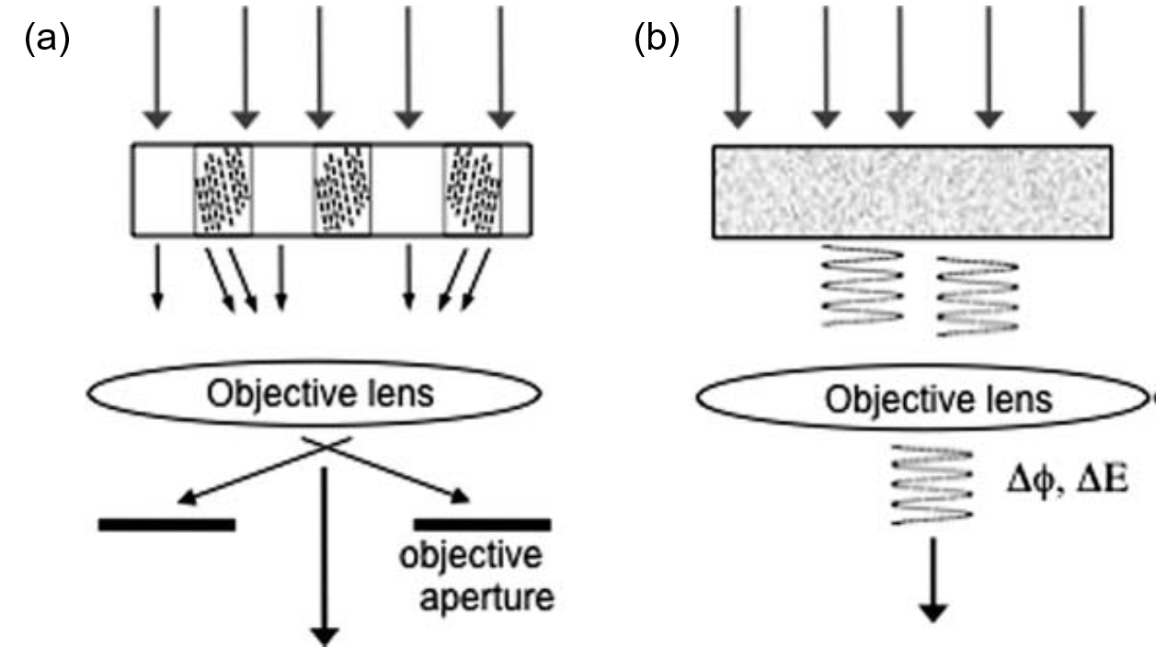
Figure 1-23. Contrast mechanisms of TEM: a) for polymers with crystallinity or heavy element; b) for amorphous soft materials with small variations in density. ¹¹¹
TEM is one of the most commonly used technique to investigate the phase separation behavior, with high resolution and direct observation on the formed morphology. However, to form the image with good contrast, complex sample preparation procedures are inevitable, like the microtome of the sample to very thin films and heavy element staining to induce contrast. Moreover, the strong incident ionizing radiation may also make damage to the specimen, particularly in unstained materials.
Similarly, AFM can also offer the direct observation of morphology. No expensive and complex sample preparation is needed. Far more complete information can be obtained from the cross-sectional samples, rather than the two-dimensional profiles in TEM. The other side of the coin of AFM is the limited size of the image, with only about $150×150$ micrometers, as compared to square millimeters for TEM. Besides, the scanning speed of an AFM is also much slower. The hysteresis of the piezoelectric materials and the interactions between the cantilever and the sample surface can also cause possible artificats, which needed the filtration and flattening of the image first.
SAXS, on the other hand, provides the indirect study on the phase separation behavior. Compared to TEM and AFM which normally study the local surface and details, global parameters and distribution. In situ transition can be studied during the measurement, and no destructive/artifacts is caused.
In summary, different characterization methods have their merits and drawbacks, which are complementary to get a profound study on the phase separation behavior. SAXS is necessary to obtain significant sampling and make quantitative statements, while TEM or AFM can give the direct observation on the shape of the morphologies.

1.4.3 Stress-Strain Behavior
One of the most commonly used and important standards on the performance of a TPE material is the stress-strain curve, which can be measured by the uniaxial tensile test of the sample in specific shape like a dog-bone. The comprehensive illustration on the stress-strain plot of the polymer materials is shown in Figure 1-24. For plastic materials that behaves elastically and recovers to its original dimensions with the applied force, Hook’s law of elasticity is followed as $F=-kx$, where $F$ is the restoring force, and $x$ is the displacement of the material. This type of Hookean materials show the stress-strain like that in Figure 1-24 (a). However, the curve only applied for very stiff materials like steels. For polymers, especially when they are elastomeric, the non-Hookean curve in Figure 1-24 (a) is more representative, where the stress in correspond to the strain is not linear. ¹¹² As the thermoplastic elastomers that have both stiff and elastomeric components, the stress-strain curve in Figure 1-24 (b) are more common, taking SBS as an example.¹¹³ With low strain, the sample is stretched and behave like plastic. The deformation is reversible and proportional to the stress, the tensile modulus at this linear region is called Young’s modulus (E), and can be expressed by $E=\frac{σ}{ε}$, where σ is the stress and ε is the strain. A rubbery plateau can be observed afterward, where the stress increases slightly or even keeps contant with the increase of stain until certain degree. When certain strain is reached, the crosslink junctions start to response to the stress. Thus strain hardening behavior make the stress increase extensively until the breaking point of the material.⁸
Figure 1-24. Illustration of stress-strain plots for (a) typical Hookean and non-Hookean materials, ¹¹² and (b) TPEs like SBS.¹¹³
The stiffness/elongation of the TPEs can be easily tuned by the composition between hard and soft segments. When the content of the hard segments is large enough, the elongation of the material can be greatly affected. The yield point can be observed, beyond which the deformation of the material l cannot return to its original shape and the recovery ability is permanently damaged. (Figure 1-24 (b), with styrene content as 80%, 65% and 53%). On the other hand, the strain hardening behavior cannot be observed if the content of the hard segments is too small. Thus, the mechanical strength of the material is limited. (Figure 1-24 (b), with styrene content as 13%).
Experimentally, the stress-strain curve can be influenced by the measuring conditions and sample preparation methods. The thermal history can influence the tensile strength of the sample, especially for the polymer with high hard segments. Instead of the annealing process, the fast cooling rate will lead to the inhomogeneous distribution of the material in the mold, and even bring micro ruptures, which was observed by viewing the polymer film with polarized light.¹¹⁴ As a result, the final stress and strain can be limited. On the contrary, this effect is not so distinct for the TPEs with low hard segment content. The soft matrix can easily flow and flexible that makes the resulting film homogenous. In addition, the size of the specimens tested can also affect the stress-strain behaviors. It was observed that the strength increased as the specimen size decreased. It is speculated that the smaller specimens have lower probability of having larger flaws.¹¹⁵ In summary, other than the inherent flaw that is inevitable and homogenously distributed, the mild and homogenous preparation of the measured samples, such as the annealing process and making specimens with no apparent flaws, can contribute to the premium and reliable stress-strain curves. It also needs to be noticed from the influence of thermal history and specimen size that measured stress-strain curves should always be accompanied by the detailed preparation methods. Various independent tests should be performed to get the reliable and consistent results.
In the case of mearing conditions, the stress-strain curve can be greatly influenced by both the temperature and strain rate. As illustrated in Figure 1-25a, the strain hardening cannot be observed in monodisperse polymer melts. However, as the polymer composed of different segments, this phenomenon is quite common, as discussed previously. Different types of strain hardening exist, including stress growth ending with breakup of a sample (Figure 1-25b), growth for which a second plateau is observed (Figure 1-25c), and behavior with a maxima in the tensile growth coefficient (Figure 1-25d).¹¹⁶ For any of these cases, with the low deformation rates, the viscous deformation prevail and very large stains are possible, even without showing the strain hardening behavior. When the deformation rates are increased, the competition between viscous flow and elastic deformation occurs and the final stresses are increased, with the loss of elongations.
Figure 1-25. Schemes illustrating development of the tensile growth stress and strain hardening behavior with different strain rates. Arrows show the direction of increasing strain rates.
The temperature influence on the stress-strain curve in a similar manner. As shown in Figure 1-26, two SBCS, Kraton 101 and Thermolastic 226 were tested at different temperatures. With lower temperature, higher stress was observed, with the loss of elongation.¹¹⁷ It is easy to understand that the lower temperature can normally make the polymer stiffer. Thus, the elongation of the sample was sacrificed, but the mechanical strength is reinforced. On the other hand, it has been discussed in Section 1.3, the rubbery plateau can be observed from DMA, where the storage modulus of TPEs do not have apparent change. When the measuring temperatures fall in the range of the rubbery plateau, the Young’s modulus observed will not change, and the influence of the temperature on the final mechanical property is also limited.

Figure 1-26. Stress-strain curves for Kraton 101 and Thermolastic 226 at -40, 0, 40 ºC.¹¹⁷
The similarity of the influences of strain rates and temperature have been summarized like the illustration in Figure 1-27.¹¹⁸ In brief, both the increase of strain rate and decrease of temperature can lead to higher stress and lower strain. This is a perfect example to reflect the time-temperature superposition, which is commonly used for analysis of viscoelastic properties of polymers. It can be illustrated by the Williams-Landel-Ferry (WLF) equation:¹¹⁹
$$log{⁡a}_{T}=\log\left(\frac{ω_{1}}{ω_{2}}\right)=\frac{C_{1}(T-T_{s})}{C_{2}+(T-T_{s})}$$
Where $a_{T}$is the shift factor. $ω$ is the relaxation rate (time related), and T is the temperature.
Figure 1-27. Schematic representation of the dependence of stress-strain curves on strain rate and temperature.

1.5 The Scope of this Thesis
With many advantages over the traditional styrenic based thermoplastic elastomers including chemical stability, optical transparency, versatility of adhesion, weatherability, oil resistance, printability, compatibility with fillers, abrasion resistance and low viscosity,^{39,40} all acrylic based thermoplastic elastomers (TPEs) are recognized as the promising candidate for the next generation of TPEs with advanced properties and performances. The work on this thesis will focus on the synthesis and characterization of different types of all acrylic based TPEs. Based on the discussion in Chapter 1, different methodologies will be applied to explore their influences on the mechanical performance of the materials synthesized, including the selection of monomers, the design of complex architectures and the introduction of extra driving forces.
Chapter 2 introduces the synthesis, characterization and solution properties of poly(1-adamantyl acrylate) (PAdA)—an kind of polyacrylate with high glass transition temperature and extraordinary thermal stability. Living anionic polymerization of acrylates is challenging due to intrinsic side reactions including backbiting reactions of propagating enolate anions and aggregation of active chain ends. In this chapter, the anionic polymerization of adamantyl acrylate monomer was investigated and resulting in the polymer products with predicted molecular weights, narrow PDIs, quantitative yields and distinct living property compared to other acrylate monomers. The PAdAA homopolymers exhibit a very high glass transition temperature (132.8 ºC) and outstanding thermal stability (Td: 376 ºC) as compared to other acrylic polymers such as poly(tert-butyl acrylate) and poly(methyl acrylate). Furthermore, the study on the solution properties of PAdA provides further understandings on the chain rigidity and the unperturbed dimensions of the polymer. The solubility power of PAdA in different solvents were also evaluated to explore the theta condition of the polymer solutions.
The distinct thermal properties and chain rigidity make PAdAA a promising candidate for acrylic based thermoplastic elastomers with high upper service temperature and enhanced mechanical strength. The investigation on this application is reported in Chapter 3. The all acrylic based triblock copolymers are compsed of PAdA as the hard segment and poly(tetrahydrofurfuryl acrylate) as the soft segment. The influence of molecular weight, ratios of each segment, phase separation behaviors on the final performance of the resulting TPEs are discussed in this chapter. After the optimization, the combination of these two acrylic based segments leads to the material with higher upper service temperature and better mechanical strength than the current commercial products.
In Chapter 4, the other useful strategy to improve the performance of TPEs is carried out, that is the design of complex structures. By using n-isopropyl-4-vinylbenzylamine (PVBA) as the initiator, the poly(methyl methacrylate) (PMMA) macromonomer is synthesized through living anionic polymerization. As compared to conventional approaches, the macromomer is synthesized in one batch with 100% conversion, short reaction time and much simpler operations. Thereafter, the graft copolymer of poly(n-butyl acrylate)-graft-poly(methyl methacrylate) (PBA-g-PMMA) is synthesized using graft through methodology by RAFT copolymerization of n-butyl acrylate monomer with the PMMA macromonomer. By the combination of large molecular weight beyond the entanglement molecular weight and improved phase separation behaviors, the resulting TPE exhibited impressive mechanical properties, especially with the elongation at break higher than 2000%. This make the material much superior to the current commercial acrylic based TPEs and even comparable to styrenic based multigraft copolymers.
The great improvement has not been ended. In chapter 5, further driving forces are introduced to the graft copolymers of poly(n-butyl acrylate)-g-poly(tert-butyl methacrylate) (PBA-g-PtBMA). The partially hydrolysis of PtBMA block into poly(methacrylic acid) (PMAA) introduces the hydrogen bonding in the hard segments. Great improvement on the mechanical strength can be observed by this modification. Furthermore, after the ionization of PMAA in the basic condition, the existence of ionic bond make if possible to increase the mechanical strength again. In addition, when metal ligand is introduced to the system, the coordination between PMMA and metal ion brings stronger driving force that improve the mechanical property of the TPE the third time.
Our comprehensive on the design of all acrylic based TPEs has not produced the “Terminator” of this application. In Chapter 6, other potential modifications on the further modification of this kind of materials are discussed. In addition, as a powerful initiator, the further possible uses of PVBA to build complex architectures have also been predicted.

References
(1) Thermoplastic Elastomers (TPE) Market Size By Product (Thermoplastic Polyurethanes [TPU], Styrenic Block Copolymers [SIS, SBS, SBC, HSBC], Thermoplastic Vulcanizates [TPV], Copolyester Elastomers [COPE], Thermoplastic Polyolefins [TPO]), By Application (Footwear, Automotive, Medical, Construction, Industrial, Advanced Materials, Electronics), Industry Analysis Report, Regional Outlook (U.S., Germany, UK, France, Italy, China, India, Japan, Brazil), Application Potential, Price Trend, Competitive Market Share & Forecast, 2016 - 2023. Global Market Insights 2016, 230.
(2) Aso, O.; Eguiazábal, J.; Nazabal, J. The influence of surface modification on the structure and properties of a nanosilica filled thermoplastic elastomer. Composites science and technology 2007, 67, 2854-2863.
(3) Lu, Q.-W.; Macosko, C. W. Comparing the compatibility of various functionalized polypropylenes with thermoplastic polyurethane (TPU). Polymer 2004, 45, 1981-1991.
(4) Kurian, T.; De, P. P.; Khastgir, D.; Tripathy, D. K.; De, S. K.; Peiffer, D. G. Reinforcement of EPDM-based ionic thermoplastic elastomer by carbon black. Polymer 1995, 36, 3875-3884.
(5) Holden, G. Styrenic thermoplastic elastomers. Rubber World(USA) 1993, 208, 25-30.
(6) Chen, Y.; Kushner, A. M.; Williams, G. A.; Guan, Z. Multiphase design of autonomic self-healing thermoplastic elastomers. Nat Chem 2012, 4, 467-472.
(7) Bates, F. S.; Fredrickson, G. Block copolymers-designer soft materials. Physics today 2000.
(8) Aoyagi, T.; Honda, T.; Doi, M. Microstructural study of mechanical properties of the ABA triblock copolymer using self-consistent field and molecular dynamics. The Journal of Chemical Physics 2002, 117, 8153-8161.
(9) Drobny, J. G.: Handbook of thermoplastic elastomers; Elsevier, 2014.
(10) Holden, G.: Thermoplastic Elastomers. In Kirk-Othmer Encyclopedia of Chemical Technology; John Wiley & Sons, Inc., 2000.
(11) Handlin, D. L.; Trenor, S.; Wright, K.: Applications of Thermoplastic Elastomers Based on Styrenic Block Copolymers. In Macromolecular Engineering; Wiley-VCH Verlag GmbH & Co. KGaA, 2007; pp 2001-2031.
(12) Bailey, J.; Bishop, E.; WR, H.; Holden, G.; Legge, N. THERMOPLASTIC ELASTOMERS-PHYSICAL PROPERTIES AND APPLICATIONS. Rubber Age 1966, 98, 69-&.
(13) Séguéla, R.; Prud'homme, J. Effects of Casting Solvents on Mechanical and Structural Properties of Polydiene-Hydrogenated Polystyrene-Polyisoprene-Polystyrene and Polystyrene-Polybutadiene-Polystyrene Block Copolymers. Macromolecules 1978, 11, 1007-1016.
(14) Legge, N. R. Thermoplastic Elastomers. Rubber Chemistry and Technology 1987, 60, 83-117.
(15) Kaszas, G.; Puskas, J. E.; Kennedy, J. P.; Hager, W. G. Polyisobutylene-containing block polymers by sequential monomer addition. II. Polystyrene–polyisobutylene–polystyrene triblock polymers: Synthesis, characterization, and physical properties. Journal of Polymer Science Part A: Polymer Chemistry 1991, 29, 427-435.
(16) Yu, Y.; Dubois, P.; Teyssié, P.; Jérôme, R. Difunctional Initiator Based on 1,3-Diisopropenylbenzene. 6. Synthesis of Methyl Methacrylate−Butadiene−Methyl Methacrylate Triblock Copolymers. Macromolecules 1997, 30, 4254-4261.
(17) Luo, Y.; Wang, X.; Zhu, Y.; Li, B.-G.; Zhu, S. Polystyrene-block-poly(n-butyl acrylate)-block-polystyrene Triblock Copolymer Thermoplastic Elastomer Synthesized via RAFT Emulsion Polymerization. Macromolecules 2010, 43, 7472-7481.
(18) Haloi, D. J.; Ata, S.; Singha, N. K.; Jehnichen, D.; Voit, B. Acrylic AB and ABA Block Copolymers Based on Poly(2-ethylhexyl acrylate) (PEHA) and Poly(methyl methacrylate) (PMMA) via ATRP. ACS Applied Materials & Interfaces 2012, 4, 4200-4207.
(19) Tong, J.-D.; Leclère, P.; Rasmont, A.; Brédas, J.-L.; Lazzaroni, R.; Jérôme, R. Morphology and rheology of poly (methyl methacrylate)-block-poly (isooctyl acrylate)-block-poly (methyl methacrylate) triblock copolymers, and potential as thermoplastic elastomers. Macromolecular Chemistry and Physics 2000, 201, 1250-1258.
(20) Yu, J. M.; Jérôme, R.; Overbergh, N.; Hammond, P. Triblock copolymer based thermoplastic elastomeric gels of a large service temperature range: preparation and characterization. Macromolecular Chemistry and Physics 1997, 198, 3719-3735.
(21) Eckstein, A.; Suhm, J.; Friedrich, C.; Maier, R. D.; Sassmannshausen, J.; Bochmann, M.; Mülhaupt, R. Determination of Plateau Moduli and Entanglement Molecular Weights of Isotactic, Syndiotactic, and Atactic Polypropylenes Synthesized with Metallocene Catalysts. Macromolecules 1998, 31, 1335-1340.
(22) Fetters, L. J.; Lohse, D. J.; Graessley, W. W. Chain dimensions and entanglement spacings in dense macromolecular systems. Journal of Polymer Science Part B: Polymer Physics 1999, 37, 1023-1033.
(23) Tong, J. D.; Leclère, P.; Doneux, C.; Brédas, J. L.; Lazzaroni, R.; Jérôme, R. Morphology and mechanical properties of poly(methylmethacrylate)-b-poly(alkylacrylate)-b-poly(methylmethacrylate). Polymer 2001, 42, 3503-3514.
(24) Tong, J.-D.; Jerôme, R. Dependence of the Ultimate Tensile Strength of Thermoplastic Elastomers of the Triblock Type on the Molecular Weight between Chain Entanglements of the Central Block. Macromolecules 2000, 33, 1479-1481.
(25) Hadjichristidis, N.; Pispas, S.; Floudas, G.: Block copolymers: synthetic strategies, physical properties, and applications; John Wiley & Sons, 2003.
(26) Matyjaszewski, K. Controlled radical polymerization. Current Opinion in Solid State and Materials Science 1996, 1, 769-776.
(27) Moineau, C.; Minet, M.; Teyssié, P.; Jérôme, R. Synthesis and Characterization of Poly(methyl methacrylate)-block-poly(n-butyl acrylate)-block-poly(methyl methacrylate) Copolymers by Two-Step Controlled Radical Polymerization (ATRP) Catalyzed by NiBr2(PPh3)2, 1. Macromolecules 1999, 32, 8277-8282.
(28) Jean-Marc Boutillier, J.-P. D., Mickael Havel, Raber Inoubli, Stephanie Magnet, Christian Laurichesse, and Daniel Lebouvier. Self-Assembling Acrylic Block Copolymers for Enhanced Adhesives Properties. ASI Adhesives & Sealants Industry, May 1 2013, 2013.
(29) Nicolas, J.; Charleux, B.; Guerret, O.; Magnet, S. Nitroxide-Mediated Controlled Free-Radical Emulsion Polymerization Using a Difunctional Water-Soluble Alkoxyamine Initiator. Toward the Control of Particle Size, Particle Size Distribution, and the Synthesis of Triblock Copolymers. Macromolecules 2005, 38, 9963-9973.
(30) Hadjichristidis, N.; Iatrou, H.; Pispas, S.; Pitsikalis, M. Anionic polymerization: High vacuum techniques. Journal of Polymer Science Part A: Polymer Chemistry 2000, 38, 3211-3234.
(31) Uhrig, D.; Mays, J. W. Experimental techniques in high-vacuum anionic polymerization. Journal of Polymer Science Part A: Polymer Chemistry 2005, 43, 6179-6222.
(32) Baskaran, D. Strategic developments in living anionic polymerization of alkyl (meth)acrylates. Progress in Polymer Science 2003, 28, 521-581.
(33) Ishizone, T.; Yoshimura, K.; Hirao, A.; Nakahama, S. Controlled Anionic Polymerization of tert-Butyl Acrylate with Diphenylmethyl Anions in the Presence of Dialkylzinc. Macromolecules 1998, 31, 8706-8712.
(34) Lu, W.; Huang, C.; Hong, K.; Kang, N.-G.; Mays, J. W. Poly(1-adamantyl acrylate): Living Anionic Polymerization, Block Copolymerization, and Thermal Properties. Macromolecules 2016, 49, 9406-9414.
(35) Wang, J. S.; Jerome, R.; Bayard, P.; Teyssie, P. Anionic Polymerization of Acrylic Monomers. 21. Anionic Sequential Polymerization of 2-Ethylhexyl Acrylate and Methyl Methacrylate. Macromolecules 1994, 27, 4908-4913.
(36) Raj, D. J. A.; Wadgaonkar, P. P.; Sivaram, S. Controlled synthesis of dicarboxyl-terminated poly (methyl acrylate) macromonomers using a new blocked carboxyl functional metal-free carbanionic initiator. Macromolecules 1992, 25, 2774-2776.
(37) Leclère, P.; Moineau, G.; Minet, M.; Dubois, P.; Jérôme, R.; Brédas, J. L.; Lazzaroni, R. Direct Observation of Microdomain Morphology in “All-Acrylic” Thermoplastic Elastomers Synthesized via Living Radical Polymerization. Langmuir 1999, 15, 3915-3919.
(38) Hamada, K.; Morishita, Y.; Kurihara, T.; Ishiura, K.: Methacrylate-Based Polymers for Industrial Uses. In Anionic Polymerization; Springer, 2015; pp 1011-1031.
(39) Oshita, S.; Chapman, B.; Hirata, K. Acrylic Block Copolymer for Adhesive Application. PSTC Tape Summit 2012 2012.
(40) MORISHITA, Y. Applications of Acrylic Thermoplastic Elastomer. Nippon Gomu Kyokaishi 2013, 86, 321-326.
(41) Ritzenthaler, S.; Court, F.; Girard-Reydet, E.; Leibler, L.; Pascault, J. P. ABC Triblock Copolymers/Epoxy−Diamine Blends. 2. Parameters Controlling the Morphologies and Properties. Macromolecules 2003, 36, 118-126.
(42) Masson, F.; Decker, C.; Andre, S.; Andrieu, X. UV-curable formulations for UV-transparent optical fiber coatings: I. Acrylic resins. Progress in Organic Coatings 2004, 49, 1-12.
(43) Mori, T.; Hatori, Y.; Nodera, T.; Kawai, H.: Soft blends of polyurethane and acrylic polymer; automobile interiors, furniture. Google Patents, 2005.
(44) Oertel, J.; Kishii, S.; Kilian, D.; Hamada, K.; Morishita, Y.; Kurihara, T.; Ito, T. Acrylic TPE approaching automotive.
(45) Nakamura, Y.; Adachi, M.; Tachibana, Y.; Sakai, Y.; Nakano, S.; Fujii, S.; Sasaki, M.; Urahama, Y. Tack and viscoelastic properties of an acrylic block copolymer/tackifier system. International Journal of Adhesion and Adhesives 2009, 29, 806-811.
(46) Hiemenz, P. C.; Lodge, T. P.: Polymer Chemistry, Second Edition; Taylor & Francis, 2007.
(47) Kraus, G.; Rollmann, K. W. Dynamic viscoelastic behavior of ABA block polymers and the nature of the domain boundary. Journal of Polymer Science: Polymer Physics Edition 1976, 14, 1133-1148.
(48) Alfonzo, C. G.; Fleury, G.; Chaffin, K. A.; Bates, F. S. Synthesis and Characterization of Elastomeric Heptablock Terpolymers Structured by Crystallization. Macromolecules 2010, 43, 5295-5305.
(49) Hucul, D. A.; Hahn, S. F. Catalytic Hydrogenation of Polystyrene. Advanced Materials 2000, 12, 1855-1858.
(50) Fetters, L. J.; Firer, E. M.; Dafauti, M. Synthesis and Properties of Block Copolymers. 4. Poly(p-tert-butylstyrene-diene-p-tert-butylstyrene) and Poly(p-tert-butylstyrene-isoprene-styrene). Macromolecules 1977, 10, 1200-1207.
(51) Fetters, L. J.; Morton, M. Synthesis and Properties of Block Polymers. I. Poly-α-methylstyrene-Polyisoprene-Poly-α-methylstyrene. Macromolecules 1969, 2, 453-458.
(52) Kobayashi, S.; Kataoka, H.; Ishizone, T.; Kato, T.; Ono, T.; Kobukata, S.; Ogi, H. Synthesis and Properties of New Thermoplastic Elastomers Containing Poly[4-(1-adamantyl)styrene] Hard Segments. Macromolecules 2008, 41, 5502-5508.
(53) Wang, W.; Schlegel, R.; White, B. T.; Williams, K.; Voyloy, D.; Steren, C. A.; Goodwin, A.; Coughlin, E. B.; Gido, S.; Beiner, M.; Hong, K.; Kang, N.-G.; Mays, J. High Temperature Thermoplastic Elastomers Synthesized by Living Anionic Polymerization in Hydrocarbon Solvent at Room Temperature. Macromolecules 2016, 49, 2646-2655.
(54) Yu, J. M.; Dubois, P.; Teyssié, P.; Jérôme, R. Syndiotactic Poly(methyl methacrylate) (sPMMA)−Polybutadiene (PBD)−sPMMA Triblock Copolymers: Synthesis, Morphology, and Mechanical Properties. Macromolecules 1996, 29, 6090-6099.
(55) Hadjichristidis, N.; Pitsikalis, M.; Pispas, S.; Iatrou, H. Polymers with Complex Architecture by Living Anionic Polymerization. Chemical Reviews 2001, 101, 3747-3792.
(56) Pochan, D. J.; Gido, S. P.; Pispas, S.; Mays, J. W.; Ryan, A. J.; Fairclough, J. P. A.; Hamley, I. W.; Terrill, N. J. Morphologies of Microphase-Separated A2B Simple Graft Copolymers. Macromolecules 1996, 29, 5091-5098.
(57) Braunecker, W. A.; Matyjaszewski, K. Controlled/living radical polymerization: Features, developments, and perspectives. Progress in Polymer Science 2007, 32, 93-146.
(58) Aoshima, S.; Yoshida, T.; Kanazawa, A.; Kanaoka, S. New stage in living cationic polymerization: An array of effective Lewis acid catalysts and fast living polymerization in seconds. Journal of Polymer Science Part A: Polymer Chemistry 2007, 45, 1801-1813.
(59) Yu, J.; Wang, J.; Wang, C.; Liu, Y.; Xu, Y.; Tang, C.; Chu, F. UV-Absorbent Lignin-Based Multi-Arm Star Thermoplastic Elastomers. Macromolecular Rapid Communications 2015, 36, 398-404.
(60) Jiang, F.; Wang, Z.; Qiao, Y.; Wang, Z.; Tang, C. A Novel Architecture toward Third-Generation Thermoplastic Elastomers by a Grafting Strategy. Macromolecules 2013, 46, 4772-4780.
(61) Knoll, K.; Nießner, N. In Tilte1998; Wiley Online Library.
(62) Dair, B. J.; Honeker, C. C.; Alward, D. B.; Avgeropoulos, A.; Hadjichristidis, N.; Fetters, L. J.; Capel, M.; Thomas, E. L. Mechanical Properties and Deformation Behavior of the Double Gyroid Phase in Unoriented Thermoplastic Elastomers. Macromolecules 1999, 32, 8145-8152.
(63) Michler, G. H.; Adhikari, R.; Lebek, W.; Goerlitz, S.; Weidisch, R.; Knoll, K. Morphology and micromechanical deformation behavior of styrene/butadiene-block copolymers. I. Toughening mechanisms in asymmetric star block copolymers. Journal of Applied Polymer Science 2002, 85, 683-700.
(64) Shi, W.; Lynd, N. A.; Montarnal, D.; Luo, Y.; Fredrickson, G. H.; Kramer, E. J.; Ntaras, C.; Avgeropoulos, A.; Hexemer, A. Toward Strong Thermoplastic Elastomers with Asymmetric Miktoarm Block Copolymer Architectures. Macromolecules 2014, 47, 2037-2043.
(65) Imaeda, T.; Hashimoto, T.; Irie, S.; Urushisaki, M.; Sakaguchi, T. Synthesis of ABA‐triblock and star‐diblock copolymers with poly (2‐adamantyl vinyl ether) and poly (n‐butyl vinyl ether) segments: New thermoplastic elastomers composed solely of poly (vinyl ether) backbones. Journal of Polymer Science Part A: Polymer Chemistry 2013, 51, 1796-1807.
(66) Juhari, A.; Mosnáček, J.; Yoon, J. A.; Nese, A.; Koynov, K.; Kowalewski, T.; Matyjaszewski, K. Star-like poly (n-butyl acrylate)-b-poly (α-methylene-γ-butyrolactone) block copolymers for high temperature thermoplastic elastomers applications. Polymer 2010, 51, 4806-4813.
(67) Jacob, S.; Kennedy, J. P. Synthesis and characterization of novel octa-arm star-block thermoplastic elastomers consisting of poly (p-chlorostyrene-b-isobutylene) arms radiating from a calix[8]arene core. Polymer Bulletin 1998, 41, 167-174.
(68) Dufour, B.; Tang, C.; Koynov, K.; Zhang, Y.; Pakula, T.; Matyjaszewski, K. Polar Three-Arm Star Block Copolymer Thermoplastic Elastomers Based on Polyacrylonitrile. Macromolecules 2008, 41, 2451-2458.
(69) Dufour, B.; Koynov, K.; Pakula, T.; Matyjaszewski, K. PBA–PMMA 3‐Arm Star Block Copolymer Thermoplastic Elastomers. Macromolecular Chemistry and Physics 2008, 209, 1686-1693.
(70) He, Z.; Liang, Y.; Yang, W.; Uchino, H.; Yu, J.; Sun, W.-H.; Han, C. C. Random hyperbranched linear polyethylene: One step production of thermoplastic elastomer. Polymer 2015, 56, 119-122.
(71) Hutchings, L. R.; Dodds, J. M.; Rees, D.; Kimani, S. M.; Wu, J. J.; Smith, E. HyperMacs to HyperBlocks: A Novel Class of Branched Thermoplastic Elastomer. Macromolecules 2009, 42, 8675-8687.
(72) Zhu, Y.; Burgaz, E.; Gido, S. P.; Staudinger, U.; Weidisch, R.; Uhrig, D.; Mays, J. W. Morphology and tensile properties of multigraft copolymers with regularly spaced tri-, tetra-, and hexafunctional junction points. Macromolecules 2006, 39, 4428-4436.
(73) Suksawad, P.; Yamamoto, Y.; Kawahara, S. Preparation of thermoplastic elastomer from natural rubber grafted with polystyrene. European Polymer Journal 2011, 47, 330-337.
(74) Zhang, J.; Li, T.; Mannion, A. M.; Schneiderman, D. K.; Hillmyer, M. A.; Bates, F. S. Tough and Sustainable Graft Block Copolymer Thermoplastics. ACS Macro Letters 2016, 5, 407-412.
(75) Fónagy, T.; Iván, B.; Szesztay, M. Polyisobutylene-graft-polystyrene by quasiliving atom transfer radical polymerization of styrene from poly(isobutylene-co-p-methylstyrene-co-p-bromomethylstyrene). Macromolecular Rapid Communications 1998, 19, 479-483.
(76) Uhrig, D.; Mays, J. Synthesis of well-defined multigraft copolymers. Polymer Chemistry 2011, 2, 69-76.
(77) Iatrou, H.; Mays, J. W.; Hadjichristidis, N. Regular comb polystyrenes and graft polyisoprene/polystyrene copolymers with double branches (“centipedes”). Quality of (1, 3-phenylene) bis (3-methyl-1-phenylpentylidene) dilithium initiator in the presence of polar additives. Macromolecules 1998, 31, 6697-6701.
(78) Mays, J. W.; Uhrig, D.; Gido, S.; Zhu, Y.; Weidisch, R.; Iatrou, H.; Hadjichristidis, N.; Hong, K.; Beyer, F.; Lach, R. In Tilte2004; Wiley Online Library.
(79) Uhrig, D.; Mays, J. W. Synthesis of combs, centipedes, and barbwires: poly (isoprene-graft-styrene) regular multigraft copolymers with trifunctional, tetrafunctional, and hexafunctional branch points. Macromolecules 2002, 35, 7182-7190.
(80) Mijović, J.; Sun, M.; Pejanović, S.; Mays, J. W. Effect of molecular architecture on dynamics of multigraft copolymers: combs, centipedes, and barbwires. Macromolecules 2003, 36, 7640-7651.
(81) Duan, Y.; Rettler, E.; Schneider, K.; Schlegel, R.; Thunga, M.; Weidisch, R.; Siesler, H. W.; Stamm, M.; Mays, J. W.; Hadjichristidis, N. Deformation behavior of sphere-forming trifunctional multigraft copolymer. Macromolecules 2008, 41, 4565-4568.
(82) Duan, Y.; Thunga, M.; Schlegel, R.; Schneider, K.; Rettler, E.; Weidisch, R.; Siesler, H. W.; Stamm, M.; Mays, J. W.; Hadjichristidis, N. Morphology and deformation mechanisms and tensile properties of tetrafunctional multigraft copolymers. Macromolecules 2009, 42, 4155-4164.
(83) Schlegel, R.; Wilkin, D.; Duan, Y.; Weidisch, R.; Heinrich, G.; Uhrig, D.; Mays, J.; Iatrou, H.; Hadjichristidis, N. Stress softening of multigraft copolymers. Polymer 2009, 50, 6297-6304.
(84) Staudinger, U.; Weidisch, R.; Zhu, Y.; Gido, S.; Uhrig, D.; Mays, J.; Iatrou, H.; Hadjichristidis, N. In Tilte2006; Wiley Online Library.
(85) Uhrig, D.; Schlegel, R.; Weidisch, R.; Mays, J. Multigraft copolymer superelastomers: Synthesis morphology, and properties. European Polymer Journal 2011, 47, 560-568.
(86) Schulz, G. O.; Milkovich, R. Graft polymers with macromonomers. I. Synthesis from methacrylate-terminated polystyrene. Journal of Applied Polymer Science 1982, 27, 4773-4786.
(87) Wang, W.; Wang, W.; Lu, X.; Bobade, S.; Chen, J.; Kang, N.-G.; Zhang, Q.; Mays, J. Synthesis and Characterization of Comb and Centipede Multigraft Copolymers PnBA-g-PS with High Molecular Weight Using Miniemulsion Polymerization. Macromolecules 2014, 47, 7284-7295.
(88) Wang, W.; Wang, W.; Li, H.; Lu, X.; Chen, J.; Kang, N.-G.; Zhang, Q.; Mays, J. Synthesis and Characterization of Graft Copolymers Poly(isoprene-g-styrene) of High Molecular Weight by a Combination of Anionic Polymerization and Emulsion Polymerization. Industrial & Engineering Chemistry Research 2015, 54, 1292-1300.
(89) Li, H.; Wang, W.; Li, C.; Tan, J.; Yin, D.; Zhang, H.; Zhang, B.; Yin, C.; Zhang, Q. Synthesis and characterization of brush-like multigraft copolymers PnBA-g-PMMA by a combination of emulsion AGET ATRP and emulsion polymerization. Journal of colloid and interface science 2015, 453, 226-236.
(90) Radke, W.; Roos, S.; Stein, H. M.; Müller, A. H. E. Acrylic thermoplastic elastomers and comb-shaped poly(methyl methacrylate) via the macromonomer technique. Macromolecular Symposia 1996, 101, 19-27.
(91) Goodwin, A.; Wang, W.; Kang, N.-G.; Wang, Y.; Hong, K.; Mays, J. All-Acrylic Multigraft Copolymers: Effect of Side Chain Molecular Weight and Volume Fraction on Mechanical Behavior. Industrial & Engineering Chemistry Research 2015, 54, 9566-9576.
(92) Roos, S. G.; Müller, A. H. E.; Matyjaszewski, K. Copolymerization of n-Butyl Acrylate with Methyl Methacrylate and PMMA Macromonomers: Comparison of Reactivity Ratios in Conventional and Atom Transfer Radical Copolymerization. Macromolecules 1999, 32, 8331-8335.
(93) Barra, G. M. O.; Jacques, L. B.; Oréfice, R. L.; Carneiro, J. R. G. Processing, characterization and properties of conducting polyaniline-sulfonated SEBS block copolymers. European Polymer Journal 2004, 40, 2017-2023.
(94) Söntjens, S. H. M.; Renken, R. A. E.; van Gemert, G. M. L.; Engels, T. A. P.; Bosman, A. W.; Janssen, H. M.; Govaert, L. E.; Baaijens, F. P. T. Thermoplastic Elastomers Based on Strong and Well-Defined Hydrogen-Bonding Interactions. Macromolecules 2008, 41, 5703-5708.
(95) Tobolsky, A. V.; Lyons, P.; Hata, N. Ionic clusters in high-strength carboxylic rubbers. Macromolecules 1968, 1, 515-519.
(96) Paroli, R. M.; Penn, J.: Measuring the glass transition temperature of EPDM roofing materials: comparison of DMA, TMA, and DSC techniques. In Assignment of the Glass Transition; ASTM International, 1994.
(97) Menard, K. P.: Thermomechanical Analysis Basics: Part 1 It’s All Free Volume. PerkinElmer.
(98) Li, L.: Dynamic mechanical analysis (DMA) basics and beyond. ParkinElmer Inc. 2000.
(99) Moynihan, C. T.; Easteal, A. J.; Wilder, J.; Tucker, J. Dependence of the glass transition temperature on heating and cooling rate. The journal of physical chemistry 1974, 78, 2673-2677.
(100) Atake, T.; Angell, C. A. Pressure dependence of the glass transition temperature in molecular liquids and plastic crystals. Journal of Physical Chemistry 1979, 83, 3218-3223.
(101) Campbell, D.; Pethrick, R. A.; White, J. R.: Polymer characterization: physical techniques; CRC press, 2000.
(102) Honeker, C. C.; Thomas, E. L. Impact of Morphological Orientation in Determining Mechanical Properties in Triblock Copolymer Systems. Chemistry of Materials 1996, 8, 1702-1714.
(103) Magonov, S. N.; Reneker, D. H. Characterization of polymer surfaces with atomic force microscopy. Annual Review of Materials Science 1997, 27, 175-222.
(104) Zhong, Q.; Inniss, D.; Kjoller, K.; Elings, V. Fractured polymer/silica fiber surface studied by tapping mode atomic force microscopy. Surface science 1993, 290, L688-L692.
(105) Tamayo, J.; García, R. Deformation, Contact Time, and Phase Contrast in Tapping Mode Scanning Force Microscopy. Langmuir 1996, 12, 4430-4435.
(106) Knoll, A.; Magerle, R.; Krausch, G. Tapping Mode Atomic Force Microscopy on Polymers: Where Is the True Sample Surface? Macromolecules 2001, 34, 4159-4165.
(107) Bar, G.; Brandsch, R.; Whangbo, M.-H. Effect of Viscoelastic Properties of Polymers on the Phase Shift in Tapping Mode Atomic Force Microscopy. Langmuir 1998, 14, 7343-7347.
(108) Magonov, S. N.; Elings, V.; Whangbo, M. H. Phase imaging and stiffness in tapping-mode atomic force microscopy. Surface Science 1997, 375, L385-L391.
(109) Chu, B.; Hsiao, B. S. Small-angle X-ray scattering of polymers. Chemical Reviews 2001, 101, 1727-1762.
(110) Schnablegger, H.; Singh, Y. A practical guide to SAXS. Anton Paar, Graz, Austria 2006.
(111) Libera, M. R.; Egerton, R. F. Advances in the Transmission Electron Microscopy of Polymers. Polymer Reviews 2010, 50, 321-339.
(112) Roberts, D. R. T.; Holder, S. J. Mechanochromic systems for the detection of stress, strain and deformation in polymeric materials. Journal of Materials Chemistry 2011, 21, 8256-8268.
(113) Holden, G.; Bishop, E. T.; Legge, N. R. Thermoplastic elastomers. Journal of Polymer Science Part C: Polymer Symposia 1969, 26, 37-57.
(114) Morton, M.; McGrath, J. E.; Juliano, P. C. In Tilte1969; Wiley Online Library.
(115) Odom, E. M.; Adams, D. F. Specimen size effect during tensile testing of an unreinforced polymer. Journal of Materials Science 1992, 27, 1767-1771.
(116) Malkin, A. Y.; Arinstein, A.; Kulichikhin, V. G. Polymer extension flows and instabilities. Progress in Polymer Science 2014, 39, 959-978.
(117) Smith, T. L.; Dickie, R. A. In Tilte1969; Wiley Online Library.
(118) Smith, T. L. Ultimate tensile properties of elastomers. I. Characterization by a time and temperature independent failure envelope. Journal of Polymer Science Part A: General Papers 1963, 1, 3597-3615.
(119) Dealy, J.; Plazek, D. Time-temperature superposition—a users guide. Rheol. Bull 2009, 78, 16-31.

Chapter 2 Poly(1-Adamantyl Acrylate)-Good Candidate For TPE With Distinct Thermal Properties

Abstract
Living anionic polymerization of acrylates is challenging due to intrinsic side reactions including backbiting reactions of propagating enolate anions and aggregation of active chain ends. In this study, the controlled synthesis of poly(1-adamatyl acrylate) (PAdA) was performed successfully for the first time via living anionic polymerization through investigation of the initiation systems of sec-butyllithium/diphenylethylene/lithium chloride (sec-BuLi/DPE/LiCl), diphenylmethyl potassium/diethyl zinc (DPMK/Et₂Zn), and sodium naphthalenide/dipenylethylene/diethyl zinc (Na-Naph/DPE/Et₂Zn) in tetrahydrofuran at -78 ºC using custom glass-blowing and high vacuum techniques. PAdA synthesized via anionic polymerization using DPMK with a large excess (more than 40-fold to DPMK) of Et₂Zn as the ligand exhibited predicted molecular weights from 4.3 to 71.8 kg/mol and polydispersity indices of around 1.10. In addition, the produced PAdAs exhibit a low level of isotactic content (mm triads of 2.1%). The block copolymers of AdA and methyl methacrylate (MMA) were obtained by sequential anionic polymerization, and the distinct living property of PAdA over other acrylates was demonstrated based on the observation that the resulting PAdA-b-PMMA block copolymers were formed with no residual PAdA homopolymer. The PAdA homopolymers exhibit a very high glass transition temperature (132.8 ºC) and outstanding thermal stability (T_{d}: 376 ºC) as compared to other acrylic polymers such as poly(tert-butyl acrylate) and poly(methyl acrylate). These merits make PAdA a promising candidate for acrylic based thermoplastic elastomers with high upper service temperature and enhanced mechanical strength.

2.1 Poly(1-adamantyl acrylate): Living Anionc Polymerization, Block Copolymerization, and thermal properties

2.1.1 Introduction
60 years has passed since Szwarc reported living anionic polymerization.¹ Even though many other so-called “living” polymerizations have been developed, including atom transfer radical polymerization (ATRP), reversible addition-fragmentation chain transfer (RAFT), “living” cationic polymerization and ring opening metathesis polymerization (ROMP),²⁻⁴ anionic polymerization has remained widely used in industrial and academic fields because of its superior living properties, quantitative conversions, and predictable molecular weights with narrow polydispersities (PDI) even at extremely high molecular weights. Various monomers, such as styrene and its derivatives, conjugated dienes, vinylpyridines, alkene oxides, have been controllably polymerized anionically.⁵
The anionic polymerization of methacrylate-based monomers including methyl methacrylate have also been reported.⁶ However, the anionic polymerization of acrylate-based monomers, especially acrylates with bulky alkyl substituents, is challenging because of side reactions such as nucleophilic attack of the carbanion either onto the monomer or the polymer chain (backbiting reaction), and the aggregation of the active chain ends with ester enolate structures.⁷
The anionic polymerization of alkyl methacrylates has been extensively reported, including the use of modified initiators,⁸ lower temperature,⁸ polar solvents,⁹ various additives,¹⁰ and different counter ions.¹¹ One of the most effective approaches so far is their polymerization initiated with bulky organolithium compounds, such as 1,1-diphenylhexyl lithium (DPHLi) in tetrahydrofuran (THF) at -78 ºC.¹² Lithium chloride is a commonly used additive to suppress backbiting reactions and reduce the PDI. For example, a 3-fold excess of LiCl to DPHLi is added typically to form the complex with carbanion chain ends.¹³ Interestingly, the combination of solvent polarity along with the amount of LiCl added was reported to affect the stereochemistry of poly(methyl methacrylate) (PMMA).¹⁴ It has been reported that the tacticity of poly(alkyl methacrylate) can also be tuned by changing the pendent group,¹⁵ initiator and additive used¹⁶⁻¹⁹. Another well-developed initiation system for alkyl methacrylate polymerization is diphenylmethyl potassium (DPMK) with diethyl zinc (Et₂Zn) as µ-type ligand, first reported by Nakahama et al.²⁰ This system forms a complex with carbanionic chain ends in THF at -78 ºC which effectively suppresses the backbiting reactions, and polymers with predicted molecular weight and narrow PDI (below 1.10) are obtained.
As compared to alkyl methacrylates, the anionic polymerization of alkyl acrylates is still limited. In addition to the intramolecular backbiting reaction similar to that with alkyl methacrylates, proton abstraction of the acidic α-hydrogen in the back bone provides an additional critical obstacle to their controlled polymerization.²¹ Teyssié et al. first reported the successful controlled copolymerization of MMA and tert-butyl acrylate (tBA) using the combination of α-methyl styrenyl lithium (α-MStLi), DPMK, DPMNa or DPMLi as the initiator with the addition of a large excess of LiCl (more than 10-fold) and produced well-defined block copolymers of PMMA-b-PtBA with expected molecular weights. ²² Thereafter, they reported a series of more favorable ligands- lithium alkoxide, e.g. lithium 2-(2-methoxyethoxy) ethoxide (LiOEEM), that can polymerize 2-ethylhexyl acrylate (P2EtHA) with PDI as low as 1.03.²³ However, homopolymer of P2EtHA always remained after synthesis of P2EtHA-b-PMMA, which suggests the polyacrylate chain ends were not completely “living”.
Nakahama and coworkers reported the anionic polymerization of N,N-dimethylacrylamide (DMAA) using the DPMK/Et₂Zn initiator system.²⁴ The polydispersity of the resulting polymer was broad (PDI ~1.28 even when 15-fold Et₂Zn to DPMK was applied), but the conversion was quantitative. Interestingly, they observed that PDMAA was highly syndiotactic when certain amount of Et₂Zn were used. PtBA was also synthesized with DPMK/Et₂Zn system.²⁵ The polymerization was completed within minutes, with 100% yield, controlled molecular weight and narrow PDI (< 1.1). However, an estimated 61% of the living chain ends were deactivated even only after 5 min. The resulting PtBA showed no stereoselectivity as in the case of PDMAA. The polymerizations of primary and secondary alkyl acrylates including butyl acrylate and ethyl acrylate were also attempted.²⁶ However, their successful polymerization has been rarely reported until now and it still remains as a challenge to control the PDI. Compared to the huge number of studies on alkyl methacrylates, new approaches to control the anionic polymerization of alkyl acrylates are required.
Herein, we report the anionic polymerization of 1-adamantyl acrylate (PAdA) using the DPMK/Et₂Zn initiation system. The pendent group, adamantane (tricycle[3.3.1.1]decane), is a symmetric tricyclic hydrocarbon with three fused chair-form cyclohexyl rings in a diamond lattice. Even compared to other bulky pendant groups such as benzene rings, adamantane shows a drastically impact on the physical and chemical properties, especially the glass transition temperature (T_{g}). The bulky adamantane moiety can also contribute to the decrease of chain mobility and increase of rotational barrier, which could further increase the T_{g} of the final polymer.²⁷⁻³⁰ In addition, adamantyl substituents have been reported to increase the decomposition temperature of polymers, e.g. poly(1-adamantyl methacrylate) exhibits a degradation temperature (T_{d}) ~300 ºC.³¹ We thus envision that PAdA is a promising candidate for acrylic based thermoplastic elastomers with high upper service temperatures and enhanced mechanical strength which may be synthesized by block copolymerization with polyacrylates having low T_{g}s such as poly(n-butyl acrylate).^{32,33} Another attractive property of adamantane is its strong host-guest inclusion complexation with β-cyclodextrin and Cucurbit[7]uril because of its size matching to their cavities.^{34,35} Such complexes have shown distinct self-healing behavior.^{36,37}
Even though AdA has been previously polymerized through radical polymerization,^{38,39} and anionic polymerizations of styrene⁴⁰ and methacrylate³¹ bearing 1-adamantyl pendent groups were also studied, the anionic synthesis of PAdA and its block copolymers has not been reported, mainly because of the inherent difficulty in the anionic polymerization of acrylates as discussed above. We expected that the bulky size of adamantane and its tertiary carbon connected with the ester group might make the anionic polymerization less problematic than that of PtBA. However, we found that the anionic polymerization of AdA was still not an easy task, requiring more carefully chosen reaction conditions as compared to that of PtBA, including a specific initiation system and a large excess of suitable additive.
In this study, the anionic polymerization of 1-adamantyl acrylate (AdA) was performed with sec-butyllithium/diphenylethylene/lithium chloride (sec-BuLi/DPE/LiCl), diphenylmethyl potassium/diethyl zinc (DPMK/Et₂Zn), and sodium naphthalenide/diphenylethylene/diethyl zinc (Na-Naph/DPE/Et₂Zn) initiator systems in THF at -78 ºC. These initiator systems have been generally applied for the anionic polymerization of (meth)acrylates.⁶ The living nature and reactivity of poly(1-adamantyl acrylate), and the block copolymerization of AdA with methyl methacrylate (MMA) were also studied. The resulting PAdA was characterized using nuclear magnetic resonance spectroscopy (NMR), gel permeation chromatography (GPC), thermogravimetric analysis (TGA), and differential scanning calorimetry (DSC).

2.1.2 Experiment
Materials. 1-adamantanol (Acros Organics, 99%), acryloyl chloride (Aldrich, 97%), triethylamine (Acros Organics, 99%), and ammonium chloride (Acros Organics, 99.5%) were used as received. Sec-butyllithium (sec-BuLi), 1,1-diphenylethylene (DPE, Acros Organics, 98%), THF (Fisher, GR grade) and methanol (Fisher, GR grade) were purified as previously described.⁴¹ Sodium naphthalenide (Naph-Na) was prepared using naphthalene and sodium metal in THF. Diphenylmethyl potassium (DPMK) was prepared according to previously reported work.⁴² LiCl (Alfa Aesar, 99.995%) was dried at 130 ºC for 2 days, ampulized and diluted in THF under high vacuum conditions, giving a concentration of 0.6 mmol/ml. Diethyl zinc was ampulized and diluted in THF under high vacuum condition, giving the concentration 1 mmol/ml. Methyl methacrylate (MMA, Aldrich, 99%) was passed through aluminum oxide (Acros Organics, basic) column to remove inhibitor, stirred for 24 h over anhydrous CaH₂ and distilled over CaH₂ and trioctylaluminum sequentially under reduced pressure. The resulting MMA was ampulized and diluted immediately with THF under high vacuum condition, giving a concentration of 0.83 mmol/ml. All ampules of the reactants, equipped with break seals were stored at -30 ºC. Tert-butyl acrylate (tBA, Sigma-Aldrich, 98%) and methyl acrylate (MA, Acros Organics, 99%) were used directly after passed through aluminum oxide (Acros Organics, basic) column to remove inhibitor. 2,2-Azobis-(isobutyronitrile) (AIBN, Sigma-Aldrich, 90%) was recrystallized before use and the S-1-dodecyl-S’-(α,α’-dimethyl-α’-acetic acid)trithiocarbonate chain transfer agent (CTA) was synthesized following the procedure previously published by Lai et al.⁴³ Copper(I) bromide (CuBr, Sigma-Aldrich, 99.9999%), Ethylene bis(2-bromoisobutyrate) (EBIB, Sigma-Aldrich, 97%), N,N,N’,N”,N”-pentamethyldiethylenetriamine (PMDETA, Sigma-Aldrich, 99%), Benzene (Sigma-Aldrich, ≥99.9%), Anisole (Acros Organics, 99%) were used as received.
Characterization. The molecular weights (MWs) of the polymers were measured using gel permeation chromatography (GPC) with the EcoSEC GPC system, which allows for the use of three semimicro GPC columns (2 Tosoh TSKgel SuperMultiporeHZ-M; 4.6x150 mm; 4 µm; and a TSKgel SuperMultiporeHZ-M guard.). RI detector with flow rate at 0.35 ml/min was utilized for MW estimation based on a PMMA standard curve ranging from 600 to 7,500,000 Daltons. The ¹H and ¹³C NMR spectra were measured with Varian VNMR 500 MHz, and using CDCl₃ as the solvent. Chemical shifts were referred to CDCl₃ solvent peak at 7.26 ppm for ¹H NMR spectra and 77.16 ppm for ¹³C NMR spectra. Thermal properties were characterized using thermogravimetric analysis (TGA, TA-50) and differential scanning calorimetry (DSC, TA2000) under nitrogen with a heating rate of 10 ºC/min.
Synthesis of 1-Adamantyl Acrylate (AdA). The monomer AdA was synthesized following the previously reported work.³⁸ (Scheme 1) Briefly, the procedure was as follows: 1-adamantanol (10.0 g, 65.7 mmol), triethylamine (33.2 g, 328.1 mmol) were dissolved in freshly dried THF (60 ml) and cooled to 0 ºC with an ice bath. The THF solution of acryloyl chloride (11.9 g, 131.5 mmol, 4.38 M) was added dropwise. The reaction solution was raised to room temperature and left stirring overnight. After the reaction was complete, the precipitated salt was filtered out. The solution mixture was extracted with saturated ammonium water solution until the aqueous layer became colorless. The collected organic layer was evaporated, mixed with large excess of silica gel, and purified using a flash column with n-hexane as the eluent. Colorless crystals were obtained after the evaporation of n-hexane. The resulting product was obtained with a yield of 59.2% and the chemical structure is shown in Scheme 1. ¹H NMR spectra (CDCl₃, 500 MHz), δ (ppm): 6.27 and 5.27 (d, 2H, -C=CH2), 6.04 (t, 1H, O=C-CH-C), 1.60-2.22 (15H, -CH2-CH-CH2- of 1-adamantyl pendent group).
For anionic polymerization, AdA was further freeze dried with benzene three times and directly flame sealed in an ampule equipped with a break-seal under high vacuum conditions. The purified monomer was diluted with anhydrous THF. The solution (0.81 mmol/ml) was stored at -30 ºC until polymerization.
Homopolymerization of AdA. All anionic polymerizations were carried out under high-vacuum conditions (10⁻⁶ mmHg) in a glass apparatus equipped with break-seals in the usual manner.^{41,44} The polymerization was performed in THF at -78 ºC. Initiator (DPHLi, DPMK or NaphNa/DPE), additive (LiCl or Et₂Zn), and monomer AdA were introduced sequentially via break-seals. Polymerization was terminated with degassed methanol at -78 ºC. To remove additives used during polymerization, the product was poured into acidified methanol with vigorous stirring. The precipitated polymer was filtered, rinsed with methanol, and vacuum dried overnight. The resulting polymer was characterized by GPC, ¹H and ¹³C NMR spectroscopies. ¹H NMR spectra (CDCl₃, 500 MHz), δ (ppm): 2.2- 2.3 (br, 1H, O=C-CH-C), 1.7– 1.9 (br, 2H, -C-CH2). ¹³C NMR spectra (CDCl₃, 500 MHz), δ (ppm): 173- 174.1 (C=O), 42.3, 41.4, 36.4, 34.5, 31.0.
Block copolymerization of AdA with MMA. The sequential anionic polymerization of AdA and MMA were carried out to synthesize block copolymers of poly(1-adamantyl acrylate)-b-poly(methyl methacrylate) (PAdA-b-PMMA). The solution was performed in THF at -78 ºC. DPMK/Et₂Zn, which was used for the homopolymerization of AdA, was introduced via break-seals. Depending on the sequence of the block composition, the two sequential orders of the first addition of AdA and second of MMA as well as the opposite sequential monomer addition was carried out. Aliquots of the first block were withdrawn to an attached receiver for characterization of the first block. Polymerizations were terminated with degassed methanol at -78 ºC. To remove additives used during polymerization, the product solution was poured into acidified methanol with vigorous stirring. The precipitated polymer was filtered, rinsed with methanol, and vacuum dried. The resulting polymer was characterized by GPC.
Homopolymerization of tBA. PtBA was polymerized through reversible addition–fragmentation chain transfer (RAFT) polymerization under high-vacuum conditions (10⁻⁶ mmHg) in a glass apparatus. After mixing CTA (0.1 M in benzene, 1.00ml), AIBN (0.1 M in benzene, 0.22 ml), tBA (10.00g) and Benzene (5.00 ml) in a vial, the solution was transferred to an ampule, which was degassed by three freeze-thaw-evacuate cycles. The ampule was flame sealed under vacuum and immersed in an oil bath at 75 ºC for 10 h. The polymerization was quenched with liquid nitrogen. The product solution was precipitated twice in large excess of methanol/H2O (60/40) with vigorous stirring and vacuum dried overnight. The resulting polymer was characterized by using gel permeation chromatography (GPC). Mn: 54.2 Kg/mol, PDI: 1.89, as shown in Figure S1.
Homopolymerization of MA. PMA was polymerized through atom-transfer radical-polymerization (ATRP) under high-vacuum conditions (10⁻⁶ mmHg) in a glass apparatus. EBIB (0.1 mmol), CuBr (0.1 mmol), MA (30 g), Anisole (100 ml) and PMDETA (0.1 mmol) were sequentially added to an ampule, which was degassed by three freeze-thaw-evacuate cycles. The ampule was flame sealed under vacuum and immersed in an oil bath at 85 ºC for 7 days. The polymerization was quenched with liquid nitrogen. The product solution was passed through aluminum oxide (Acros Organics, neutral) column to remove salt, precipitated twice in large excess of methanol and vacuum dried overnight. The resulting polymer was characterized by using gel permeation chromatography (GPC). Mn: 110.4 Kg/mol, PDI: 1.15, as shown in Figure S2.

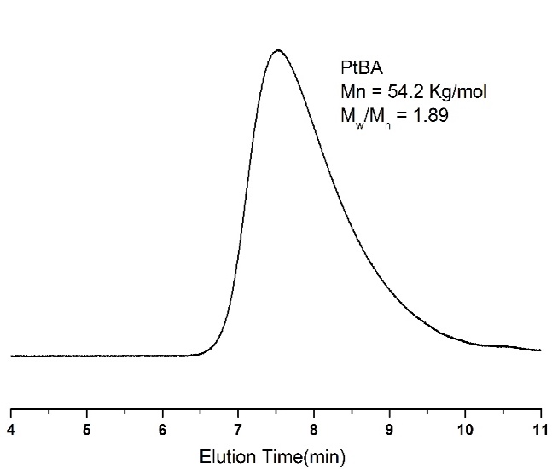
Figure S1. GPC profiles of PtBA by RAFT polymerization
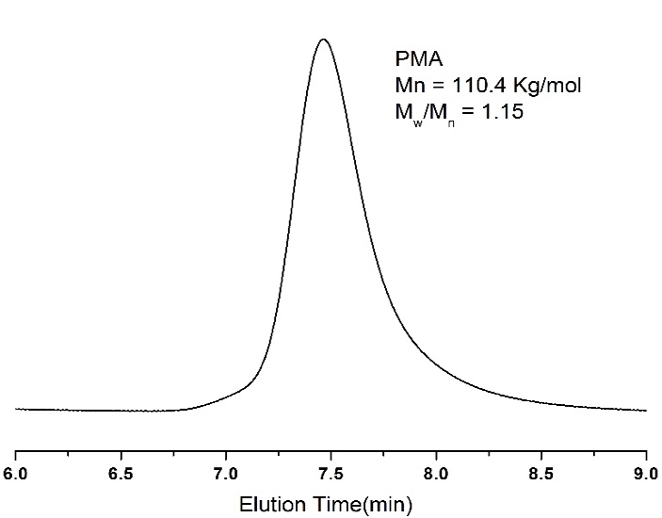
Figure S2. GPC profiles of PMA by ATRP

2.1.3 Result and Discussion
Effect of Initiators on Anionic Polymerization. The initiator systems of sec-BuLi/DPE/LiCl, DPMK/Et₂Zn and NaNaph/DPE/Et₂Zn have been generally applied for the anionic polymerization of (meth)acrylate.⁶ To optimize living anionic polymerization of AdA monomer, which was prepared as shown in Scheme 1, various initiator systems of sec-BuLi/DPE, NaphNa/DPE, and DPMK with LiCl and Et₂Zn were employed, as shown in Scheme 1 and Scheme S1 in Supporting Information. The detailed results of the polymerization are summarized in Table 1.
Scheme 1. Synthesis of 1-adamantyl acrylate (AdA)³⁸ and anionic polymerization of AdA initiated by DPMK or DPHLi in the presence of Et₂Zn or LiCl. Denote: TEA: triethylamine, DPMK: diphenylmethyl potassium, Et₂Zn: diethyl zinc, DPHLi: diphenylhexyl lithium, and LiCl: lithium chloride. M is Li or K metal.

Table 1. Anionic Polymerization of AdA Using Various Initiatorsª
runs | initiator/Additive  (mmol/mmol) | AdA  (mmol) | time  (min) | $$M_{n} (kg/mol)$$ |  | M_{w}/M_{n}^{b}
 |  |  |  | calcd^{c} | obsd | M_{w}/M_{n}^{b}
 | sec-BuLi/DPE/LiCl^{d}
01 | 0.10/0.20/1.00 | 4.85 | 30 | 10.0 | 13.0 | 1.83
 | NaphNa/DPE/ Et₂Zn^{e}
02^{f} | 0.04/2/1.00 | 2.42 | 30 | 25.0 | 94.3, 42.2 | 1.03, 1.10
03 | 0.04/0.20/1.6 | 2.42 | 5.0 | 25.0 | 55.7 | 1.86
 | DPMK/ Et₂Zn^{e}
04 | 0.05/0.75 | 1.21 | 30 | 5.0 | 104.3, 4.4 | 1.03, 1.21
05 | 0.05/1.00 | 1.21 | 30 | 5.0 | 4.3 | 1.37
06 | 0.05/2.00 | 1.21 | 30 | 5.0 | 4.5 | 1.09
07 | 0.05/2.00 | 1.21 | 60 | 5.0 | 4.3 | 1.10
08 | 0.05/2.00 | 1.21 | 5 | 5.0 | 4.8 | 1.19
09^{g} | 0.05/2.00 | 2.42 | <1 | 10.0 | 8.5 | 1.14
10 | 0.05/2.00 | 16.97 | 5 | 70.0 | 71.8 | 1.10

ªAll the polymerization showed quantitative yields. ^{b}Number-average molecular weight Mn (obsd) and PDI were measured by GPC calibration using a PMMA standard in THF as the eluent at 40 ºC ^{c}$M_{n}\left(calcd\right)=\frac{\left[AdA\right]}{\left[initiator\right]}×MW\left(AdA\right)×yield of polymerization (\%)$. ^{d}LiCl was applied as the additive for the anionic polymerization of AdA initiated by sec-BuLi/DPE. ^{e}Et₂Zn was applied as the additive for the anionic polymerization of AdA initiated by NaphNa/DPE and DPMK. ^{f}Bimodal peak was obtained in GPC curve. ^{g}The sample demonstrated Mn:8.5 kg/mol, PDI: 1.14 from GPC with refractive index (RI) detector based on PMMA standard and Mn: 9.1 kg/mol, PDI: 1.06 from GPC with a viscometer and multi-angle light scattering (MALLS) detectors.

For the anionic polymerization using sec-BuLi initiator, the combination of sec-BuLi/DPE was used to decrease the nucleophilicity, as previously reported with polymerization of (meth)acrylates.⁹ The polymeric solution changed from colorless to red once DPE was introduced to sec-BuLi solution in -78 ºC, indicating the formation of diphenylethyl anions. Sequentially, LiCl was used to form the complexation with living chain ends, which was reported to be helpful in suppressing the back-biting reaction and decreasing the propagation rate.⁴⁵ However, the polymerization of AdA using the initiation system of sec-BuLi/DPE/LiCl was poorly controlled and lead to a broad molecule weight distribution (PDI= 1.83) as described in Table 1 run 01 and Figure 1a (black line). Thus, another initiation system of NaphNa/DPE was used for the anionic polymerization to adjust the nucleophilicity to comparable with carbanion of (meth)acrylate, as reported in polymerization of (meth)acrylates.⁶ In the polymerization, the additive Et₂Zn was introduced with molar ratio of [NaphNa]₀/[Et₂Zn]₀ = 25 and 40 (Run02 and 03 in Table 1) to form the complex with living chain ends as well as the coordination bonding with the carbonyl group of AdA monomers to suppress the side reactions. However, the polymerization using NaphNa/DPE/Et₂Zn ([NaphNa]₀/[Et₂Zn]₀ = 25, Run02 in Table 1) produced bimodal molecular weight distributions as shown in Figure 1a (red line), that could be the heterogeneous growth of polymer chains from the difunctional initiation site formed by the radical coupling reaction.⁴⁶ With Na⁺ as the counter ion, the complexation formed between the enolate ion and the ligand is not strong enough to suppress the side reactions like backbiting reactions, inter-molecular polymer terminations, etc.⁶ The combination of these side reactions, as well as possible limitation in initiation efficiency, make the molecular weight produced higher than expected. Therefore, we carried out one more polymerization of AdA using NaphNa and Et₂Zn with the feeding ratio of 40-fold excess to overcome side reactions and to control anionic polymerization. Interestingly, the different concentration of NaphNa/DPE/Et₂Zn with [NaphNa]₀/[Et₂Zn]₀ = 40 (Run03 in Table 1) overwhelmed bimodal curve but exhibited 1.86 of very high PDI. (See Figure S5 in Supporting Information) Although the sodium cation is more favorable for the AdA polymerization generally, this initiation system was still not well controlled.
Alternatively, the anionic polymerization of AdA was performed by the initiation system of DPMK/Et₂Zn. The solution of DPMK in THF changed from red to orange immediately after Et₂Zn was introduced at -78 ºC, due to the complexation between the additive and diphenylmethyl anion. Once AdA was added, the solution became colorless or pale yellow, which is typical for living poly(meth)acrylates. With certain amount of Et₂Zn, PAdA was successfully obtained with target molecular weight and almost 100% yield, giving PDI lower than 1.1. (Table 1 Run 06 and Figure 1a, blue line). Similar results were also reported previously.^{47,48} An equilibrium of the ligand with enolate ion is presumably involved that endows K with a better ability to control the polymerization than Na and Li.⁴⁹ For alkali metals, the increase of size leads to higher polarizability of the carbanion with K⁺ than that with Na⁺ and Li⁺. The radii of K⁺, Na⁺, and Li⁺ were verified at 133, 95, and 60 pm, respectively.⁵⁰ Thus the complexation of K⁺ with the ligand is easier, which restricts the either intermolecular termination or intramolecular backbiting between carbanion and carbonyl group.

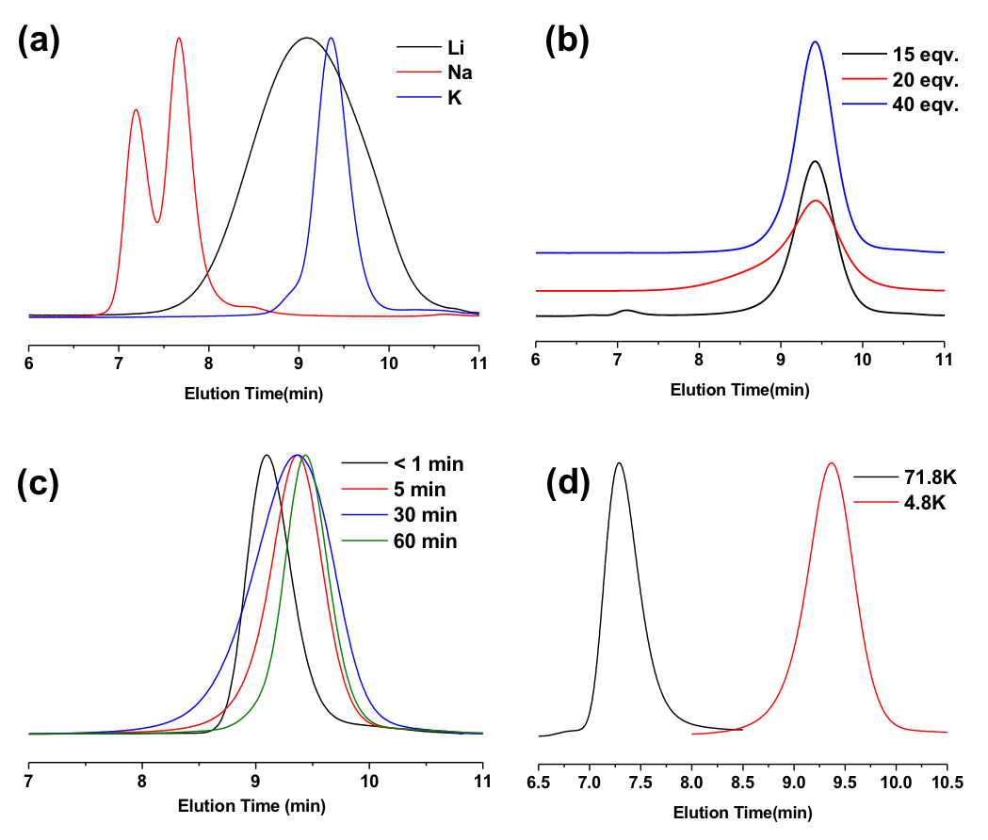
Figure 1. GPC profiles of PAdA synthesized by anionic polymerization with a) initiation system with different cations, results shown as Run 01, 02 and 06 in Table 1; b) different amount of Et₂Zn added, results shown as Run 04, 05 and 06 in Table 1; c) different reaction time, results shown as Run 06 to Run 09 in Table 1; d) wide molecular range, results shown as Run 08 and 10 in Table 1.

Effect of Additive/Initiator Ratio on Anionic Polymerization. The coordination of ligands with enolate ion pairs has been classified into µ-type ligands, σ-type ligands, and µ / σ -type dual ligands.⁵¹ As mentioned above, anionic polymerization of methyl methacrylate,²⁰ N,N-Dialkylacrylamides,²⁴ and tert-butyl acrylate²⁵ have been controlled well by the introduction of Et₂Zn. The strong electrostatic interactions lead to μ-type of complexation between potassium or sodium enolate and Et₂Zn. This complexation forms the steric hindrance that restrict the backbiting termination. On the other hand, the strong electrostatic interactions decrease the reactivity of living chain ends and suppresses its attack on carbonyl groups. As reported previously, for the anionic polymerization of MMA, only 3~10-fold excess of Et₂Zn/initiator is necessary to suppress the side reaction.²⁰ When Et₂Zn/initiator is higher than 11-folds, the polymerization of tBA could be well controlled.²⁵
As shown in Figure 1b, however, the previously used ratio of Et₂Zn/DPMK is not sufficient for the controlled polymerization of AdA. When Et₂Zn/DPMK was 15 folds, unexpected high molecular weight polymer was produced which might be caused by multi-coupling reactions. With a 20-fold excess of Et₂Zn, this side reaction was somewhat suppressed, which made the molecular weight lower. However, the side reaction still occurred to some extent and gave a broad shoulder in GPC profiles. The polymerization was controlled completely when a 40-fold excess of Et₂Zn/DPMK was used. As studied previously, 1-adamantyl group has a higher ability to pull the electrons away from the ester group than tert-butyl group.⁵² This enolate is more vulnerable to carbanion attack. More ligand is thus necessary to stabilize enolate and to suppress the side reaction.
Polymerization Kinetics and Molecular Weight Range. Compared to methacrylates, the anionic polymerization of acrylate monomers is much faster, e.g. the conversion of the anionic polymerization of tBA reached 100% within 1 minute.²⁵ Even though it is reported that the presence of additive can distinctly reduce the propagation rate,²⁰ and a large excess of Et₂Zn was used during the polymerization of AdA, the polymerizations undergoing 30 min and 60 min showed the same MWs as for the polymerization for 5 min. Even though the anionic polymerization was performed for less than 1 min, the well-defined PAdA was synthesized completely with quantitative yield, controlled Mn of 8.5K g/mol , and narrow PDI of 1.14 as shown in Table 1 run09 and Figure 1c blue line. The polymerization of AdA to high molecular weight also proceeded in 5min, giving the Mn 71.8 kg/mol with narrow polydispersity of 1.10 in Figure 1d and it is the highest Mw of PAdA polymer synthesized in this study.
Tacticity of PAdA. In general, the tacticity of a poly(alkyl methacrylate) is dictated by the size of the alkyl group.¹⁵ It can also be effectively tuned by changing initiator and/or ligand. Thus poly(alkyl methacrylate) with highly syndiotactic^{16,17} or isotactic^{18,19} structures could be obtained. Ligated anionic polymerization has been widely reported to influence tacticity of (metha)acrylate polymers. The formation of highly isotactic^{18,19} and highly syndiotactic^{16,17} structures have been achieved with the selection of different additives.
The tacticity of PAdA with Mn 71.8 kg/mol (Run 10 in Table 1) was determined by integration of the triad peaks of the carbonyl group in ¹³C NMR spectra as shown in Figure 2. The resonances at 174.1~173.7 ppm and 173.7~173.4 ppm were assigned to rr and mr triads, with the proportion of 76.8% and 21.1% respectively. The content of mm triad at 173.4~173.2 ppm was only 2.1%. As reported by S. Nakahama et. al, Et₂Zn also accounts for the increase of syndiotactic proportion of poly(N,N-dialkylacrylamides) synthesized via anionic polymerization. Even though they have different structures from (meth)acrylate, large excess Et₂Zn is used to coordinate with the propagating chain end to suppress the side reactions in the polymerization of both acrylamides and acrylates.²⁴ In addition, as the (meth)acrylate monomers, even though influence of Et₂Zn on tacticity was not observed in the polymerization of tBA,²⁵ it has been reported that the tacticity of a poly(alkyl methacrylate) is affected by the size of the alkyl group.¹⁵ Based on the works above, it is anticipated that the selectivity of tacticity found in the anionic polymerization of AdA could be attributed to both the ligand effect and the bulkiness of the pendent group.
Figure 2. ¹³C NMR spectra of the carbonyl carbons of the PAdA with Mn 71.8 kg/mol (Run 10 in Table 1) measured in CDCl₃.

Block Copolymerization of AdA with MMA. One of the merits of living anionic polymerization is easy preparation of well-defined block copolymers through the sequential addition of different monomers. Through the block copolymerization of AdA with MMA, we evaluated the living properties of PAdA, and the nucleophilicity of the living PAdA chain ends.
Block copolymerization was carried out in THF at -78 ºC using DPMK as the initiator and 40 equiv of Et₂Zn. For the synthesis of PMMA-b-PAdA, the first block was polymerized for 1 h, followed by the addition of AdA. The polymerization was quenched with degassed methanol after the propagation of PAdA for 10 min in THF at -78 ºC. For the synthesis of PAdA-b-PMMA, the first block of PAdA was carried out for 10 min, followed by the polymerization of MMA for 1 h. All the polymeric solutions were precipitated in a large excess of acidified methanol after termination of living polymer chains with methanol. This gave a direct indication of PAdA production, based on the fairly good solubility of PMMA in methanol. The details of the polymerization results are summarized in Table 2.

Table 2. Diblock Copolymerization of AdA with MMA using DPMK/Et₂Zn in THF at -78 ºCª
run | initiator  (mmol) | 1st monomer  (mmol) | 2nd monomer  (mmol) | time (min) | block copolymer (homopolymer)
 |  |  |  |  | $$M_{n} (kg/mol)$$ |  | Mw/Mn^{b}
 |  |  |  |  | calcd^{c} | obsd | Mw/Mn^{b}
11 | 0.02 | MMA, 2.00 | AdA, 2.42 | 60/10 | 25(10) | 25.1(8.5) | 1.09(1.05)
12 | 0.05 | AdA, 2.50 | MMA, 2.42 | 10/60 | 15(5) | 14.6(4.3) | 1.06(1.10)
ªThe polymerization was initiated by DPMK with Et₂Zn as the additive at concentration of [Et₂Zn]/[DPMK] = 40. All the polymerization demonstrated quantitative yields. ^{b}Mn (obsd) and M_{w}/M_{n} were measured by GPC calibration using a PMMA standard in THF as the eluent at 40 ºC. ^{c}$M_{n}\left(calcd\right)=\frac{\left[AdA\right]}{\left[initiator\right]}×MW\left(AdA\right)×yield of polymerization \left(\%\right)+\frac{\left[MMA\right]}{\left[initiator\right]}×MW\left(MMA\right)×yield of polymerization (\%)$.

Clear shifts were observed in the GPC profiles in both PMMA to PMMA-b-PAdA (Figure 3a) and PAdA to PAdA-b-PMMA (Figure 3b). Block copolymers were successfully synthesized by living anionic polymerization via both sequences, with 100% conversion of each monomer. It is thus demonstrated that the PAdA living chain end has similar nucleophilicity to that of PMMA
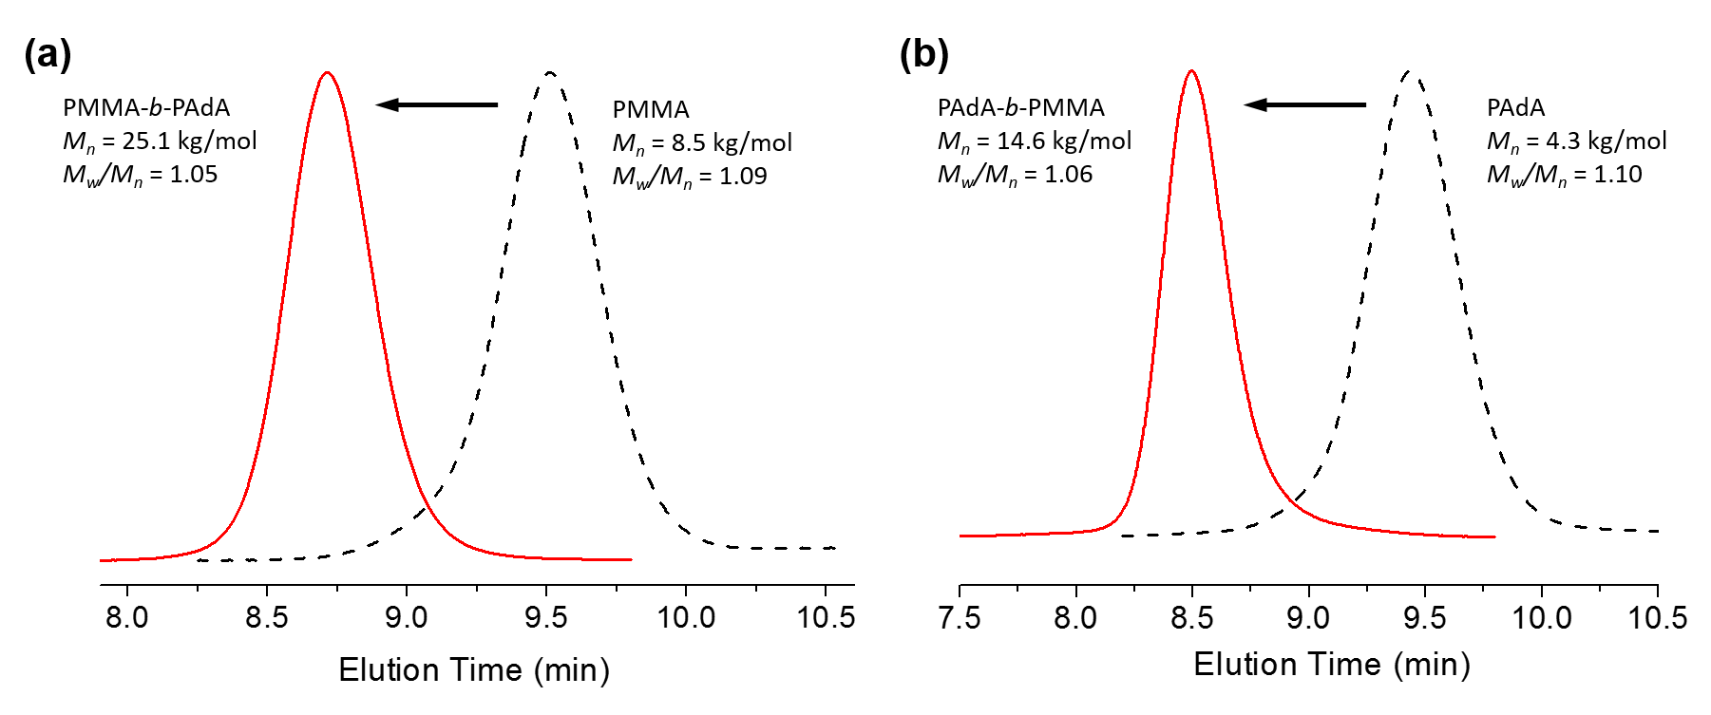
Figure 3. GPC profiles from a) PMMA homopolymer to PMMA-b-PAdA block copolymer, and b) PAdA homopolymer to PAdA-b-PMMA block copolymer.

For the synthesis of PAdA-b-PMMA, the diblock copolymer gave a clean unimodal molecular weight distribution and quite narrow polydispersity, as shown in Figure 3b. Accordingly, it was proven that living AdA initiates MMA completely with 100% conversion of PAdA. From this observation, it was surmised that living PAdA has a distinct 100% living property as compared to other acrylates like 2EtHA and tBA. For the anionic polymerization of tBA by Et₂Zn/DPMK, it was demonstrated that 61% of the living chains were deactivated in only 5min.²⁵ In addition, a trace of P2EtHA also existed in the GPC curve of diblock copolymer of P2EtHA-b-PMMA.²⁴ In the case of 1-adamantyl acrylate, the bulky side group contributes to the steric hindrance for backbiting termination, and the large excess of Et₂Zn also helps to stabilize the living chain ends.
Thermal Properties of PAdA. It has been reported that the bulky adamantane moiety can contribute to the decrease of chain mobility and increase of rotational barrier to backbone bond rotation upon incorporation, which further increase the T_{g} of the final polymer.²⁷ In addition, the enhancement of decomposition temperature of polymers by adamantane incorporation was also reported.³¹ To evaluate these effects on PAdA, DSC and TGA were used for the characterization of thermal properties. T_{g} of PAdA with Mw 71.8 kg/mol reached 133 ºC (Figure 4a), and is much higher than that of PMA (T_{g}: 8 ºC) and PtBA (T_{g}: 11 ºC). Compared to polymethacrylates, polyacrylates have greatly increased flexibility of the polymer backbone due to the absence of the α-methyl group so that polyacrylates have much lower T_{g}s than the corresponding polymethacrylates. The T_{g} of 133 ºC of PAdA is distinctively high and very unique, to the best of our knowledge, because it is rare to find polyacrylates with high T_{g}—the highest found from the literature is 94 ºC for poly(isobornyl acrylate), which also has a very bulky side group.⁵³ The unique T_{g} makes PAdA a promising candidate for use in acrylic based thermoplastic elastomers with high upper service temperature and enhanced mechanical strength by block copolymerization with acrylates with low T_{g}s such as poly(n-butyl acrylate).^{32,33}
The thermal behavior of PAdA synthesized by free radical polymerization and ATRP was studied previously.^{33,54} Compared to T_{g}s of 153 ºC and 145-151 ºC as they reported, the PAdA sample in this study is around 20 ºC lower (133 ºC). In addition, we measured T_{g} of another PAdA synthesized by reversible addition fragmentation chain transfer (RAFT) polymerization and obtained similar T_{g} as 134 ºC. In general, T_{g} correlated with molecular weight (MW) so that we measured Tg of PAdA with high MW of 71.8 kg/mol. However, the Tg of PAdA was not increased by increasing MW from 4.3 to 71.8 kg/mol. The effect of tacticity can also be disregarded, since the low isotactic content are normally expected to increase of T_{g}.⁵⁵ Based on the T_{g} ranges of PMMA from 105 ºC to 128 ºC, ADDIN EN.CITE it could be anticipated that the T_{g} deviation is caused by the difference in synthesis methods, instruments or the characterization parameters.
Figure 4b shows the TGA thermograms of a series of polyacrylates. Poly(methyl acrylate) (PMA) and PtBA were synthesized by radical polymerization, and the PAdA shown was polymerized anionically, as shown in Run 10 Table 1. As reported previously, the tert-butyl ester moiety of PtBA decomposed at 228 ºC to yield isobutene and poly(acrylic acid) (PAA). This can be confirmed by the weight ratio left after the first transition, with around 56% left, corresponding to the molecular weight ratio of PAA to PtBA. The weight loss afterward from 255 ºC to 445 ºC was attributed to the degradation of the PAA remaining. In contrast, PMA gave the degradation temperature (T_{d}) at 343 ºC (with 5% weight loss). The thermal stability of PMA is reasonable, since the degradation occurred with no decomposition of the side chain. Surprisingly, even containing the ester group connecting with a tertiary carbon like PtBA, PAdA showed a sufficiently high T_{d} of 376 ºC. The decomposition of the distorted bridgehead alkene, adamantane, is thermodynamically unfavorable,⁵⁶ thus leads to the outstanding thermal stability of PAdA.

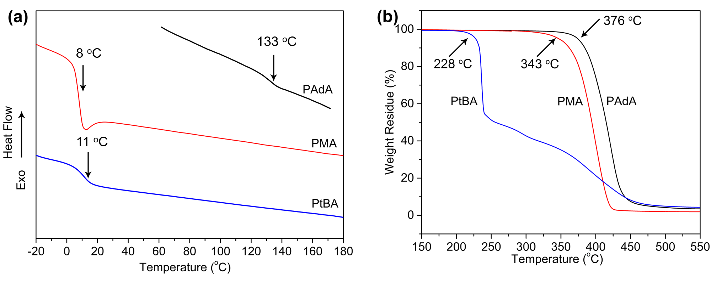
Figure 4. The thermal properties of polymers including PAdA with Mn 71.8 kg/mol, PtBA 54.2 kg/mol and PMA 110.4 kg/mol. (PtBA was polymerized by RAFT polymerization, and PMA was polymerized by ATRP, detailed polymerization conditions can be found in supporting information). a) DSC thermogram of polymers under nitrogen at a heating rate of 10 ºC min⁻¹; b) TGA thermograms of polymers under nitrogen at heating rate of 10 ºC min⁻¹.

2.1.4 Conclusion
The living anionic polymerization of 1-adamantyl acrylate (AdA) was successfully achieved for the first time using DPMK as an initiator, with a large excess of diethyl zinc (Et₂Zn) in THF at -78 ºC. Compared to other acrylates like tBA and 2EtHA, a lager excess (40-fold relative to DPMK) of Et₂Zn is required to control the polymerization. The polymerization was completed within 5 min, giving various molecular weight from 4.3 kg/mol to 71.8 kg/mol with PDIs lower than 1.1 and quantitative yields. The PAdA made exhibited a low level of isotactic content, attributing to the bulk pendent group and coordination complex between enolate and zinc cation. It was demonstrated that the living chain end of PAdA has comparable reactivity to that of PMMA via sequential block copolymerization. Moreover, the chain ends of PAdA showed distinct living properties superior to that of other acrylates which was used to build PAdA-b-PMMA with 100% incorporation of PAdA homopolymer. The homopolymer of PAdA exhibits outstanding thermal behavior with a much higher glass transition temperature (T_{g}: 133 ºC) and degradation temperature (T_{d}: 376 ºC) than other acrylic polymers such as poly(tert-butyl acrylate) and poly(methyl acrylate).

2.2 Solution Properties, Unperturbed Dimension and Chain Flexibility of Poly(1-Adamantyl Acrylate)

2.2.1 Introduction
Adamantane containing polymers have been extensively studied, such as the polymers of 1,3-adamantane,⁵⁷ styrene derivatives and (meth)acrylates with pendent group containing adamantane.^{31,38,58-60} Adamantane can form strong host-guest inclusion complexation with β-cyclodextrin and cucurbit[7]uril.^{34,35} These complexes have been used to design of materials for self-healing,⁶¹ drug delivery⁶² and molecular switch.⁶³ In addition, the structure of a symmetric tricyclic hydrocarbon with three fused chair-form cyclohexyl rings in a diamond lattice greatly increased the glass transition temperatures (T_{g}s) and degradation temperatures (T_{d}s) of these polymers, due to the decrease of chain mobility and an increase of rotational barrier of the backbone bond rotation upon the corporation.²⁷ For instance, we have previously reported poly(1-adamantyl acrylate) (PAdA) (Structure as shown in Scheme 1) synthesized by anionic polymerization with T_{g} of 133 ºC and T_{d} of 376 ºC, which are much higher as compared to other polyacrylates.⁵⁹

Scheme 1. Poly(1-adamantyl acrylate) (PAdA)
The outstanding glass transition temperature and thermal stability make PAdA a promising candidate for acrylic-based thermoplastic elastomers with high upper service temperature and enhanced mechanical strength. It has been reported that the decrease of chain mobility and an increase of rotational barrier to backbone rotation upon incorporation caused by the bulky adamantane moiety contribute to this extensive thermal behavior.²⁷ However, the quantitative evaluation on the stiffness of the polymer chain has not been studied.
Many series of polymers, such as polymethacrylates and polystyrene derivatives, have been discussed previously and showed the influence of the rigidity and the bulkiness of the side groups.⁶⁴⁻⁶⁶ While the general conformation of polyacrylates has not been reported, possibly due to the lack of enough study on various polymers. Herein, we report the dilute solution properties and conformational behaviors of PAdA in different solutions based on different techniques, including nuclear magnetic resonance spectroscopy (NMR), gel permeation chromatography (GPC) equipped with viscometer and multi-angle light scattering (MALLS) detectors, and multiangle laser light scattering.

2.2.2 Experiment
Sample preparation. Different samples of poly(1-adamantyl acrylate) (PAdA) were made by anionic polymerization as previously reported, ⁵⁹ in order to meet the requirements of polydispersity indices (PDIs) and tacticity. Thereinto the polymer produced by diphenylmethylpotassium/diethylzinc (DPMK/Et₂Zn) initiator system exhibited the low PDI as 1.10. The PAdA produced by sec-butyllithium/diphenylethylene/lithium chloride (sec-BuLi/DPE/LiCl) initiator system exhibited the rather broad PDI as 2.57. (Table 1)
Measurements. The tacticity of the polymers was investigated through molecular calculation based on ¹³C NMR spectra using a Varian VNMR 500 MHz and CDCl₃ as the solvent. Chemical shifts were referred to CDCl₃ solvent peak at 77.16 ppm.
The specific refractive index increment (dn/dc) of PAdA in tetrahydrofuran (THF) at 40 ºC was determined as 0.1227 mL/g, measured using Wyatt Technology Optlab rEX (690 nm). The molecular weights (MWs), intrinsic viscosities ([η]) were measured in THF at 40 ºC using Polymer Laboratories PL-120 GPC system equipped with four detectors of Polymer Laboratories refractometer, a Precision Detector PD 2040 (two angle static light scattering detector), a Precision Detector PD2000DLS (dynamic light scattering detector), and Viscotek 220 differential viscometer. The column set installed is the Polymer Laboratories PLgel; 7.5 × 300 mm; 10 μm; 500, 1 × 104, 1 × 106, and 1 × 107 Å.
Static light scattering (SLS) measurements with PAdA from Run 01 were performed on a commercial Brookhaven laser scattering spectrometer equipped with a λ = 637 nm laser. The angles from 30º to 100º with an interval of 5º were applied. The radius of gyration (R_{g}) was directly calculated by the Rayleigh-Gans-Debye equation from the software.

2.2.3 Result and Discussion
Tacticity and Other Sample Information of PAdA. The information of polymer samples is summarized in Table 1. The assignment of the triad peaks of the carbonyl carbons of PAdA is shown in Figure 1. The resonances at 174.2−173.8, 173.8−173.6 and 173.6−173.3 ppm were assigned to rr, mr and mm triads respectively. As discussed in previous work, the bulkiness of the pendent group and ligand effect, especially when a large excess of Et₂Zn was used, contribute to the low isotactic (mm) ratio.
Table 1. Molecular Characteristics of Poly(1-adamantyl acrylate)ª
runs | initiator system | $M_{n}$^{b} | M_{w}/M_{n} | triad ratio (mol%)^{c}
runs | initiator system | $$(kg/mol)$$ | M_{w}/M_{n} | mm | mr | rr
01 | DPMK/Et₂Zn | 174.8 | 1.01 | 2.1 | 21.1 | 76.8
02 | sec-BuLi/DPE/LiCl | 8.3 | 2.57 | 6.3 | 13.5 | 80.2
ªAll the polymers were synthesized by anionic polymerization as reported previously.⁵⁹ ^{b}Number-average molecular weight M_{n} and PDI were measured in THF at 40 ºC using Polymer Laboratories PL-120 GPC system, with dn/dc as 0.1227 mL/g. ^{c}Triad ratios were calculated based on the ¹³C NMR spectra using a Varian VNMR 500 MHz and CDCl₃ as the solvent.

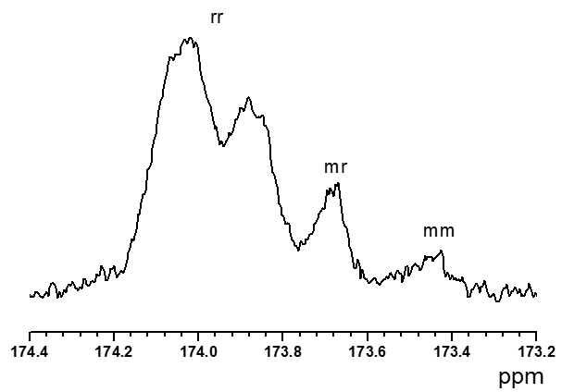
Figure 1. ¹³C NMR spectra of the carbonyl carbons of the PAdA with M_{n} 8.3 kg/mol (Run 02 in Table 1) measured in CDCl₃.
Based on the Rotational Isomeric State (RIS) theory, the unperturbed dimensions of the polymers can be influenced by their stereoregularity.⁶⁷ Although the influence is not universal for all kind of polymers either experimentally or theoretically,⁶⁸ its role on polymethacrylates are well studied, which can give us hints on polyacryates with similar structures.⁶⁹ The lower fraction of isotactic diads can lead to the limited intrinsic viscosities and smaller unperturbed dimensions. Thus the polymer chains are tend to be less flexible.
Intrinsic viscosities. Instead of the traditional separate measurements of molecular weights and intrinsic viscosities using narrowly dispersed polymer samples from solvent-nonsolvent fractionations, the development of instrumentation provides the convenient approach for establishing the molecular weight dependence of intrinsic viscosity by using GPC with both light scattering and viscosity detectors. Especially, when a multiple angle laser light scattering detector (MALLS) is used, the radius of gyration, as well as the molecular weight of each near-monodisperse eluting fractionation can be determined.⁷⁰
Both polymer samples from Run 01 and Run 02 in Table 1 were mixed together to ensure the wide measuring window of molecular weights and intrinsic viscosities. The GPC chromatograph tracing of PAdA in THF at 40 ºC is shown in Figure 2. From left to right, the peaks are light-scattering intensity, differential refractive index (DRI), and viscosity.
Figure 2. GPC chromatograph tracings for the polymer mixture of Run 01 and Run 02 in Table 1. From left to right the signals are from the light scattering detector, the refractometer, and the viscometer.
The results of molecular weight ($M_{w}$) and the pertinent intrinsic viscosity ([η]) of each near-monodisperse eluting fractionation are plotted, as shown in Figure 3. The Mark-Houwink equation was used to fit the data and can be expressed by
$\left[η\right]=7.0×{10}^{-5}{M_{w}}^{0.67}$ (1)
It is well known that the exponent coefficients, which is also called the Mark-Houwink coefficient, can be used to evaluate the solubility, chain flexibility, and temperature influence. The value of 0.5 means the theta condition. The coefficient of 0.67 indicates that the polymer has a flexible conformation in THF solution, and THF is the good solvent for PAdA.
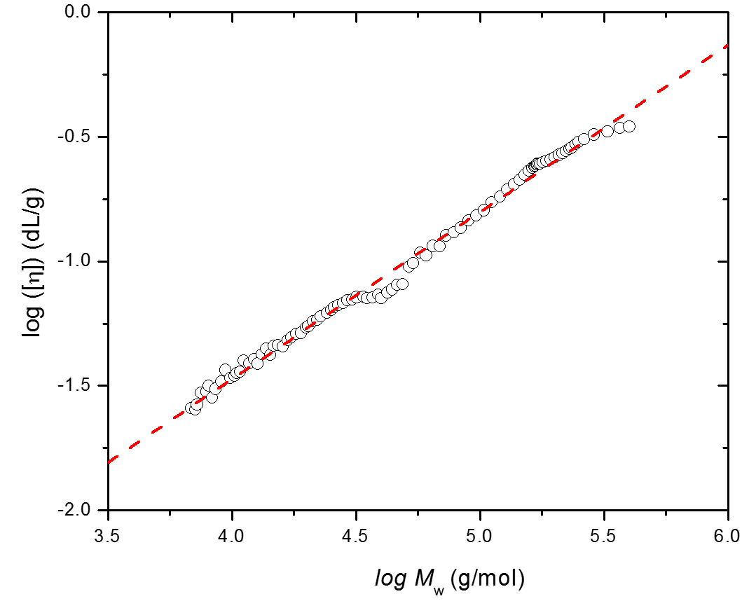
Figure 3. Relationships between log [η] and log M_{w} of PAdA in THF at 40 ºC.
The [η] of a wormlike chain is calculated for the touched-bead wormlike chain model based on the following equation:^{71,72}
$\left[η\right]=f(λL,λd)(λ^{3}M_{w})$ (2)
Where L, λ⁻¹, and d_{B} are the contour length, the Kuhn segment length, and the diameter of a bead, respectively. L is related to M_{w} by $L=M/M_{L}$, for which M_{L} is the molar mass per unit contour length of the polymer chain. For PAdA in THF, the M_{L} is 820 nm⁻¹ based on the molecular weight of the monomer unit of 206 g/mol. The persistence length of PAdA is 1.2 nm, which is comparable to that of poly(methyl methacrylate) (PMMA, persistence length ~2 nm)^{73,74} and polystyrene (PS, persistence length ~1.2 nm).⁷⁵ The diameter of a bead (dB) is 1.0 nm, which is also similar to that of PMMA (~0.8 nm) ^{22,23} and PS (~1.0 nm).⁷⁵ Even though the lack of α-methyl group makes the backbone of polyacrylates more flexible than those for polymethacrylates, the bulky adamantyl group greatly restrained the rotation of the polymer chains and lead to such a comparable size to PMMA and PS.
Further investigation of the unperturbed dimensions was performed based on the Burchard-Stockmayer-Fixman (B-S-F) extrapolation procedure for viscosity.^{76,77} The B-S-F relation can be expressed as the equation below:
$\frac{\left[η\right]}{M_{w}^{\frac{1}{2}}}=K_{θ}+0.51BϕM_{w}^{\frac{1}{2}}$ (3)
Where B is the function of Flory’s interaction parameter, polymer specific volume, molar volume of solvent and Avogadro’s number. Φ is the universal Flory constant ($2.5×{10}^{21}$). K_{θ} can be expressed by the Flory-Fox equation as below:⁶⁷
$K_{θ}=Φ_{0}{({〈R^{2}〉}_{0}/M_{w})}^{3/2}$ (4)
Even when theta condition cannot be met, the B-S-F relation can still be used to estimate the unperturbed dimensions of the polymer chain.
The other more commonly used term for the estimation of the unperturbed dimension, the characteristic ratio C∞ can be further calculated, which is defined by Flory as⁶⁷
$C_{∞}=\lim_{n→∞}\left[\frac{{〈r^{2}〉}_{0}}{nl^{2}}\right]={(\frac{K_{θ}}{Φ})}^{2/3}\frac{M_{b}}{l^{2}}$ (5)
Where n is the number of bonds in the backbone, l is the bond length ($l=0.153 nm$), M_{b} is the molecular mass per bond.

Figure 4. Burchard-Stockmayer-Fixman relation for PAdA in THF at 40 ºC.
The B-S-F plot is shown in Figure 4. It yields the $K_{θ}$ as the intercept of $2.9×{10}^{-4} dL/g$. The characteristic ratio C∞ is 10.4. The $K_{θ}$ and C∞ of several other reported poly(meth)acrylates are listed in Table 2. The unperturbed dimension in solution (C∞) and glass transition temperature (T_{g}) roughly follows similar principles. With the increase of chain stiffness, they both tend to increase.^{78,79} Among polyacrylates studied, the bulky and very rigid adamantyl group make PAdA the least flexible. Thus both its C∞ and T_{g} are extensively larger than those of poly(methyl acrylate) (PMA) and poly(tetrahydrofurfuryl acrylate) (PTHFA). However, although PMA is more compact that imparts it with a higher T_{g} than that of PTHFA. The bulky tetrehydrofurfurylmethylene group makes the unperturbed dimension of the latter larger. It needed to be noted that the reported value of C∞ is still inconsistent, ranging from 5.4 to 7.2 depending on different measuring systems and models applied.⁸⁰ The existence of methyl group greatly enhances the steric hindrance of the polymer chains in bulk, which causes the T_{g}s of polymethacrylates always larger than polyacrylates with the same pendant groups, this difference can also be observed in solution, from the comparison of the C∞ values between PAdA/PAdMA, PMA/PMMA and PTHF/PTHFMA. Meanwhile, the properties of PAdA, either in bulk or in solution, are outstanding and even superior to polymethacrylates like PMMA and PTHFMA, due to adamantane’s unique compact structure in a diamond lattice and bridged nature.
Table 2. Values of $K_{θ}$ and C∞ of Poly(meth)acrylates
Polymer | K_{θ} ($×$10⁴)  (dL/g) | C∞ | T_{g}  (ºC) | Ref.
PAdA | 2.9 | 10.4 | 133 | This work,⁵⁹
PMAª | 5.3 | 6.5 | 8 | ^{59,81}
PTHFA^{b} | 3.3 | 8.6 | -11 | ⁸²
PMMA | 4.8 | 7.3 | 105 | ⁸³
PTHFMA^{c} | 3.5 | 9.6 | 57 | ^{84,85}
PAdMA^{d} | 5.3 | 16.9 | 202 | ^{31,65}
ªPMA: poly(methayl acrylate); ^{b}PTHFA: poly(tetrahydrofurfuryl acrylate); ^{c}PTHFMA: poly(tetrahydrofurfuryl methacrylate); ^{d}PAdMA: poly(1-adamantyl methacrylate).
Light Scattering. The PAdA sample wit narrow PDI (Run 01 in Table 1) was to make the solutions for light scattering measurements. Different solvents were evaluated by making the Zimm plots using static light scattering at 30 ºC, based on the equation below.⁸⁶
$\frac{Kc}{R_{θ}}=\frac{1}{M_{w}}\left(1+\frac{1}{3}q^{2}R_{g}^{2}+…\right)+2A_{2}c$ (6)
Where K is the constant depending on the studied system, $R_{θ}$ is the Rayleigh ratio depending on the intensity of the light scattered, q is scattering wavevector, R_{g} is the root-mean-square z-average radium of radius of gyration, c is the concentration of the sample solution, A₂ is the second virial coefficient. The value of A₂ can be used to estimate the solution power of the solvent to the polymer, i.e. $A_{2}>0$ means it is the good solvent for the polymer; $A_{2}<0$ means it is the bad solvent for polymer; while $A_{2}=0$ means it is the theta solvent.
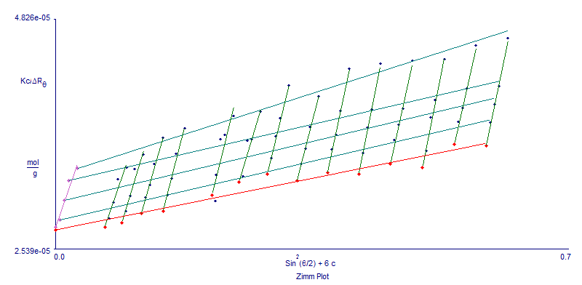
Figure 5. Zimm plot for PAdA in toluene at 30 ºC.
The typical Zimm plot is shown in Figure 5, using PAdA in toluene as an example. Based on the Equation 5, two extrapolations to zero scattering angle ($θ=0 or q=0$) and to zero concentration ($A_{2}c=0$) result in the production of 1/M_{w}. The slope of${\left(\frac{Kc}{R_{θ}}\right)}_{c→0}$vs $q^{2}$ corresponds to R_{g}, and the slope of ${(\frac{Kc}{R_{θ}})}_{q→0}$vs $c$ corresponds to $A_{2}$. The values of A₂ and R_{g} for the polymer in different solvents are summarized in Table 3. The A₂ of THF is rather small, with the order E⁻⁵, which is closer to the theta condition than other solvents studied. Consider that the increase of temperature can enhance the solubility of the polymer, this value of A₂ at 30 ºC, as well as the M-K coefficient of 0.67 in THF at 40 ºC, indicate that THF is a thermodynamically moderate solvent for PAdA. Several theta solvents of other poly(meth)acrylates and the molecules with similar structures were also evaluated, like hexane (for poly(tert-butyl acrylate at 24.2 ºC)),⁸⁷ and acetone (for poly(phenyl methacrylate at 25 ºC)).⁸³ With the increase of solution power, the polymer chain can be better expanded, thus the R_{g} is tend to increase. The exception of that in toluene and THF might be caused by the small experimental deviation. On the other hand, when the solubility is bad enough like that in 3-hexanone and hexane, the aggregation and even further precipitation occur that extensively increase the value of R_{g}. We can expect the in theta condition, the R_{g} of PAdA should range from 16.8 nm and 30.3 nm from our results.
Table 3. The Values of A₂ and R_{g} for PAdA in Different Solvents at 30 ºC.
Solvent | A₂ (X10⁴)  (cm³ mol g⁻²) | R_{g}  (nm)
THF | $$0.5±0.18$$ | $$60.2±2.7$$
Toluene | $$6.3±1.40$$ | $$43.2±2.0$$
Cyclohexanone | $$3.2±0.69$$ | $$52.0±1.6$$
Cyclopentanone | $$2.2±0.32$$ | $$30.3±1.2$$
3-Pentanone | $$-2.1±0.22$$ | $$16.8±4.9$$
3-Hexanone | $$-6.3±3.20$$ | $$122.0±51$$
Hexane | $$-138.0±12$$ | N/A
*Other solvents tested includes 1,4-dioxane (Partially soluble. For 3 mg/mL, cloudy point at around 45 ºC), methyl ethyl ketone (insoluble) and acetone (insoluble).

2.2.4 Conclusion
We report here the solution properties of poly(1-adamantyl acrylate) (PAdA) in multiple solvents derived from NMR, GPC with viscometer and MALLS detectors, and multiangle static light scattering. Among all the solvents evaluated, THF is the moderate solvent for PAdA, with Mark-Houwink coefficient of 0.67 at 40 ºC and A₂ as $5×{10}^{-5}$ cm³∙mol/g². The polymer chain has the comparable persistence length, diameter per bead to those of PMMA and PS. Its characteristic ratio (C∞) of 10.4 is even larger than PMMA. All these results indicate that PAdA is stiffer than common polyacrylates. Even lack of the α-methyl group that normally induce the steric hindrance for polymethacrylates, the bulky structure of three fused chair-form cyclohexyl rings in a diamond lattice and bridged nature of adamantyl pendant group make PAdA extraordinary rigid as an acrylic polymer. In addition, the second virial coefficient (A₂) of PAdA in different solvents have been studied, which can be the reference for further investigation on the theta condition of the polymer. The unperturbed radius of gyration were also expected to be ranging from 16.8 nm to 30.3 nm from the SLS study of these solvents.

References
(1) Szwarc, M. Living'Polymers. Nature 1956, 178, 1168-1169.
(2) Aoshima, S.; Kanaoka, S. A Renaissance in Living Cationic Polymerization. Chemical Reviews 2009, 109, 5245-5287.
(3) Bielawski, C. W.; Grubbs, R. H. Living ring-opening metathesis polymerization. Progress in Polymer Science 2007, 32, 1-29.
(4) Braunecker, W. A.; Matyjaszewski, K. Controlled/living radical polymerization: Features, developments, and perspectives. Progress in Polymer Science 2007, 32, 93-146.
(5) Hirao, A.; Loykulnant, S.; Ishizone, T. Recent advance in living anionic polymerization of functionalized styrene derivatives. Progress in polymer science 2002, 27, 1399-1471.
(6) Baskaran, D. Strategic developments in living anionic polymerization of alkyl (meth)acrylates. Progress in Polymer Science 2003, 28, 521-581.
(7) Baskaran, D.; Müller, A. H. E. Anionic vinyl polymerization—50 years after Michael Szwarc. Progress in Polymer Science 2007, 32, 173-219.
(8) Anderson, B. C.; Andrews, G. D.; Arthur, P.; Jacobson, H. W.; Melby, L. R.; Playtis, A. J.; Sharkey, W. H. Anionic polymerization of methacrylates. Novel functional polymers and copolymers. Macromolecules 1981, 14, 1599-1601.
(9) Varshney, S. K.; Hautekeer, J. P.; Fayt, R.; Jerome, R.; Teyssie, P. Anionic polymerization of (meth)acrylic monomers. 4. Effect of lithium salts as ligands on the "living" polymerization of methyl methacrylate using monofunctional initiators. Macromolecules 1990, 23, 2618-2622.
(10) Wang, J. S.; Jérôme, R. Mechanistic aspects of ‘ligated’anionic living polymerization (LAP): The case of (meth) acrylic ester monomers. Journal of Physical Organic Chemistry 1995, 8, 208-221.
(11) Ballard, D. G. H.; Bowles, R. J.; Haddleton, D. M.; Richards, S. N.; Sellens, R.; Twose, D. L. Controlled polymerization of methyl methacrylate using lithium aluminum alkyls. Macromolecules 1992, 25, 5907-5913.
(12) Allen, R.; Long, T.; McGrath, J. Preparation of high purity, anionic polymerization grade alkyl methacrylate monomers. Polymer Bulletin 1986, 15, 127-134.
(13) Fayt, R.; Forte, R.; Jacobs, C.; Jerome, R.; Ouhadi, T.; Teyssie, P.; Varshney, S. K. New initiator system for the living anionic polymerization of tert-alkyl acrylates. Macromolecules 1987, 20, 1442-1444.
(14) Wang, J. S.; Jerome, R.; Warin, R.; Teyssie, P. Anionic polymerization of (meth)acrylic monomers. 12. Effect of lithium chloride on the stereochemistry of the anionic polymerization of methyl methacrylate in THF and in a 9/1 toluene/THF mixture. Macromolecules 1993, 26, 5984-5990.
(15) Mays, J. W.; Hadjichristidis, N.; Lindner, J. Synthesis and unperturbed dimensions of poly (diphenylmethyl methacrylate). Journal of Polymer Science Part B: Polymer Physics 1990, 28, 1881-1889.
(16) Kitayama, T.; Shinozaki, T.; Masuda, E.; Yamamoto, M.; Hatada, K. Highly syndiotactic poly (methyl methacrylate) with narrow molecular weight distribution formed by tert-butyllithium-trialkylaluminium in toluene. Polymer Bulletin 1988, 20, 505-510.
(17) Kitayama, T.; Shinozaki, T.; Sakamoto, T.; Yamamoto, M.; Hatada, K. Living and highly syndiotactic polymerization of methyl methacrylate and other methacrylates by tert‐butyllithiumtrialkylaluminium in toluene. Die Makromolekulare Chemie 1989, 15, 167-185.
(18) Hatada, K.; Ute, K.; Tanaka, K.; Kitayama, T.; Okamoto, Y. Preparation of highly isotactic poly (methyl methacrylate) of low polydispersity. Polymer journal 1985, 17, 977-980.
(19) Zundel, T.; Teyssié, P.; Jérôme, R. New ligands for the living isotactic anionic polymerization of methyl methacrylate in toluene at 0° C. 1. Ligation of butyllithium by lithium silanolates. Macromolecules 1998, 31, 2433-2439.
(20) Ozaki, H.; Hirao, A.; Nakahama, S. Anionic polymerization of alkyl methacrylates in the presence of diethylzinc. Macromolecular Chemistry and Physics 1995, 196, 2099-2111.
(21) Davis, T. P.; Haddleton, D. M.; Richards, S. N. Controlled Polymerization of Acrylates and Methacrylates1. Journal of Macromolecular Science, Part C 1994, 34, 243-324.
(22) Varshney, S. K.; Jacobs, C.; Hautekeer, J. P.; Bayard, P.; Jerome, R.; Fayt, R.; Teyssie, P. Anionic polymerization of acrylic monomers. 6. Synthesis, characterization, and modification of poly(methyl methacrylate)-poly(tert-butyl acrylate) di- and triblock copolymers. Macromolecules 1991, 24, 4997-5000.
(23) Wang, J. S.; Jerome, R.; Bayard, P.; Teyssie, P. Anionic Polymerization of Acrylic Monomers. 21. Anionic Sequential Polymerization of 2-Ethylhexyl Acrylate and Methyl Methacrylate. Macromolecules 1994, 27, 4908-4913.
(24) Nakahama, S.; Kobayashi, M.; Ishizone, T.; Hirao, A.; Kobayashi, M. Polymerization of N,N-Dialkylacrylamides with Anionic Initiators Modified by Diethylzinc. Journal of Macromolecular Science, Part A 1997, 34, 1845-1855.
(25) Ishizone, T.; Yoshimura, K.; Hirao, A.; Nakahama, S. Controlled Anionic Polymerization of tert-Butyl Acrylate with Diphenylmethyl Anions in the Presence of Dialkylzinc. Macromolecules 1998, 31, 8706-8712.
(26) Nugay, N.; Nugay, T.; Jérôme, R.; Teyssié, P. Anionic polymerization of primary acrylates as promoted by lithium 2-(2-methoxyethoxy) ethoxide. Journal of Polymer Science Part A: Polymer Chemistry 1997, 35, 361-369.
(27) Acar, H. Y.; Jensen, J. J.; Thigpen, K.; McGowen, J. A.; Mathias, L. J. Evaluation of the Spacer Effect on Adamantane-Containing Vinyl Polymer Tg's. Macromolecules 2000, 33, 3855-3859.
(28) Cypcar, C. C.; Camelio, P.; Lazzeri, V.; Mathias, L. J.; Waegell, B. Prediction of the glass transition temperature of multicyclic and bulky substituted acrylate and methacrylate polymers using the energy, volume, mass (EVM) QSPR model. Macromolecules 1996, 29, 8954-8959.
(29) Mays, J. W.; Siakali-Kioulafa, E.; Hadjichristidis, N. Glass transition temperatures of polymethacrylates with alicyclic side groups. Macromolecules 1990, 23, 3530-3531.
(30) Ozaki, A.; Sumita, K.; Goto, K.; Matsumoto, A. Synthesis of Poly (decahydro-2-naphthyl methacrylate) s with Different Geometric Structures and Effects of Side-Group Dynamics on Polymer Properties Investigated by Thermal and Dynamic Mechanical Analyses and DFT Calculations. Macromolecules 2013, 46, 2941-2950.
(31) Ishizone, T.; Tajima, H.; Torimae, H.; Nakahama, S. Anionic Polymerizations of 1-Adamantyl Methacrylate and 3-Methacryloyloxy-1,1′-biadamantane. Macromolecular Chemistry and Physics 2002, 203, 2375-2384.
(32) Goodwin, A.; Wang, W.; Kang, N.-G.; Wang, Y.; Hong, K.; Mays, J. All-Acrylic Multigraft Copolymers: Effect of Side Chain Molecular Weight and Volume Fraction on Mechanical Behavior. Industrial & Engineering Chemistry Research 2015, 54, 9566-9576.
(33) Nakano, Y.; Sato, E.; Matsumoto, A. Synthesis and thermal, optical, and mechanical properties of sequence‐controlled poly (1‐adamantyl acrylate)‐block‐poly (n‐butyl acrylate) containing polar side group. Journal of Polymer Science Part A: Polymer Chemistry 2014, 52, 2899-2910.
(34) Eftink, M. R.; Andy, M. L.; Bystrom, K.; Perlmutter, H. D.; Kristol, D. S. Cyclodextrin inclusion complexes: studies of the variation in the size of alicyclic guests. Journal of the American Chemical Society 1989, 111, 6765-6772.
(35) Li, J.; Zhou, L.; Luo, Q.; Wang, Y.; Zhang, C.; Lu, W.; Xu, J.; Liu, J. Cucurbit[7]uril-Based Vesicles Formed by Self-assembly of Supramolecular Amphiphiles. Chinese Journal of Chemistry 2012, 30, 2085-2090.
(36) Kakuta, T.; Takashima, Y.; Harada, A. Highly Elastic Supramolecular Hydrogels Using Host–Guest Inclusion Complexes with Cyclodextrins. Macromolecules 2013, 46, 4575-4579.
(37) Li, L.; Guo, X.; Wang, J.; Liu, P.; Prud’homme, R. K.; May, B. L.; Lincoln, S. F. Polymer Networks Assembled by Host−Guest Inclusion between Adamantyl and β-Cyclodextrin Substituents on Poly(acrylic acid) in Aqueous Solution. Macromolecules 2008, 41, 8677-8681.
(38) Kavitha, A. A.; Singha, N. K. High temperature resistant tailor-made poly(meth)acrylates bearing adamantyl group via atom transfer radical polymerization. Journal of Polymer Science Part A: Polymer Chemistry 2008, 46, 7101-7113.
(39) Wang, K.; Cui, R.; Gu, J.; Yu, Q.; Ma, G.; Nie, J. Photopolymerization of 1‐adamantyl acrylate pohotoinitiated by free radical photoinitiators. Journal of Applied Polymer Science 2012, 123, 26-31.
(40) Kobayashi, S.; Matsuzawa, T.; Matsuoka, S.-i.; Tajima, H.; Ishizone, T. Living anionic polymerizations of 4-(1-adamantyl) styrene and 3-(4-vinylphenyl)-1, 1'-biadamantane. Macromolecules 2006, 39, 5979-5986.
(41) Uhrig, D.; Mays, J. W. Experimental techniques in high-vacuum anionic polymerization. Journal of Polymer Science Part A: Polymer Chemistry 2005, 43, 6179-6222.
(42) Candau, F.; Afchar-Taromi, F.; Rempp, P. Synthesis and characterization of polystyrene-poly(ethylene oxide) graft copolymers. Polymer 1977, 18, 1253-1257.
(43) Lai, J. T.; Filla, D.; Shea, R. Functional polymers from novel carboxyl-terminated trithiocarbonates as highly efficient RAFT agents. Macromolecules 2002, 35, 6754-6756.
(44) Hadjichristidis, N.; Iatrou, H.; Pispas, S.; Pitsikalis, M. Anionic polymerization: High vacuum techniques. Journal of Polymer Science Part A: Polymer Chemistry 2000, 38, 3211-3234.
(45) Janata, M.; Lochmann, L.; Müller, A. H. E. Mechanisms and kinetics of the anionic polymerization of acrylates, 3. Effect of lithium chloride and lithium tert-butoxide on the oligomerization of tert-butyl acrylate. Die Makromolekulare Chemie 1993, 194, 625-636.
(46) Cho, Y.-S.; Kim, S.-W.; Ihn, C.-S.; Lee, J.-S. Anionic polymerization of 4-(9-carbazolyl)methylstyrene. Polymer 2001, 42, 7611-7616.
(47) Kang, N.-G.; Changez, M.; Kim, M.-J.; Lee, J.-S. Effect of Biphenyl Spacers on the Anionic Polymerization of 2-(4′-Vinylbiphenyl-4-yl) pyridine. Macromolecules 2014, 47, 6706-6714.
(48) Lochmann, L.; Rodová, M.; Trekoval, J. Anionic polymerization of methacrylate esters initiated with esters of α-metallocarboxylic acids. Journal of Polymer Science: Polymer Chemistry Edition 1974, 12, 2091-2094.
(49) Welch, F. J. Polymerization of Styrene by n-Butyllithium. II. Effect of Lewis Acids and Bases1. Journal of the American Chemical Society 1960, 82, 6000-6005.
(50) Shannon, R. Revised effective ionic radii and systematic studies of interatomic distances in halides and chalcogenides. Acta Crystallographica Section A 1976, 32, 751-767.
(51) Wang, J.-S.; Jérôme, R.; Teyssieacute; Philippe. Mechanistic aspects of ‘ligated’ anionic living polymerization (LAP): The case of (meth)acrylic ester monomers. Journal of Physical Organic Chemistry 1995, 8, 208-221.
(52) Bentley, T. W.; Carter, G. E. The SN2-SN1 spectrum. 4. The SN2 (intermediate) mechanism for solvolyses of tert-butyl chloride: a revised Y scale of solvent ionizing power based on solvolyses of 1-adamantyl chloride. Journal of the American Chemical Society 1982, 104, 5741-5747.
(53) Wouters, D.; Van Camp, W.; Dervaux, B.; Du Prez, F. E.; Schubert, U. S. Morphological transition during the thermal deprotection of poly(isobornyl acrylate)-b-poly(1-ethoxyethyl acrylate). Soft Matter 2007, 3, 1537-1541.
(54) Matsumoto, A.; Tanaka, S.; Otsu, T. Synthesis and characterization of poly (1-adamantyl methacrylate): effects of the adamantyl group on radical polymerization kinetics and thermal properties of the polymer. Macromolecules 1991, 24, 4017-4024.
(55) Thompson, E. V. Dependence of the glass transition temperature of poly (methyl methacrylate) on tacticity and molecular weight. Journal of Polymer Science Part A‐2: Polymer Physics 1966, 4, 199-208.
(56) Gagosian, R. B.; Dalton, J. C.; Turro, N. J. Molecular photochemistry. XXXIII. Photochemistry of 1-adamantylacetone. Journal of the American Chemical Society 1970, 92, 4752-4754.
(57) Ishizone, T.; Matsuoka, S.-i.; Sakai, S.; Harada, W.; Tajima, H. Synthesis of poly (1, 3-adamantane) s by cationic ring-opening polymerization of 1, 3-dehydroadamantanes. Macromolecules 2004, 37, 7069-7071.
(58) Kobayashi, S.; Kataoka, H.; Ishizone, T.; Kato, T.; Ono, T.; Kobukata, S.; Ogi, H. Synthesis and Properties of New Thermoplastic Elastomers Containing Poly[4-(1-adamantyl)styrene] Hard Segments. Macromolecules 2008, 41, 5502-5508.
(59) Lu, W.; Huang, C.; Hong, K.; Kang, N.-G.; Mays, J. W. Poly(1-adamantyl acrylate): Living Anionic Polymerization, Block Copolymerization, and Thermal Properties. Macromolecules 2016, 49, 9406-9414.
(60) Mathias, L. J.; Jensen, J.; Thigpen, K.; McGowen, J.; McCormick, D.; Somlai, L. Copolymers of 4-adamantylphenyl methacrylate derivatives with methyl methacrylate and styrene. Polymer 2001, 42, 6527-6537.
(61) Kakuta, T.; Takashima, Y.; Nakahata, M.; Otsubo, M.; Yamaguchi, H.; Harada, A. Preorganized Hydrogel: Self-Healing Properties of Supramolecular Hydrogels Formed by Polymerization of Host–Guest-Monomers that Contain Cyclodextrins and Hydrophobic Guest Groups. Advanced Materials 2013, 25, 2849-2853.
(62) Versluis, F.; Tomatsu, I.; Kehr, S.; Fregonese, C.; Tepper, A. W. J. W.; Stuart, M. C. A.; Ravoo, B. J.; Koning, R. I.; Kros, A. Shape and Release Control of a Peptide Decorated Vesicle through pH Sensitive Orthogonal Supramolecular Interactions. Journal of the American Chemical Society 2009, 131, 13186-13187.
(63) Chakrabarti, S.; Mukhopadhyay, P.; Lin, S.; Isaacs, L. Reconfigurable Four-Component Molecular Switch Based on pH-Controlled Guest Swapping. Organic Letters 2007, 9, 2349-2352.
(64) Hadjichristidis, N.; Mays, J.; Ferry, W.; Fetters, L. J. Properties and chain flexibility of poly(dl-isobornyl methacrylate). Journal of Polymer Science: Polymer Physics Edition 1984, 22, 1745-1751.
(65) Matsumoto, A.; Tanaka, S.; Otsu, T. Local conformation of poly(1-adamantyl methacrylate) evaluated from intrinsic viscosity. Colloid and Polymer Science 1992, 270, 17-21.
(66) Mays, J. W.; Ferry, W. M.; Hadjichristidis, N.; Funk, W. G.; Fetters, L. J. Solution properties and chain flexibility of poly(p-tert-butylstyrene). Polymer 1986, 27, 129-132.
(67) Flory, P.; Volkenstein, M.: Statistical mechanics of chain molecules. Wiley Online Library, 1969.
(68) Jenkins, R.; Porter, R. S.: Unperturbed dimensions of stereoregular polymers. In Properties of Polymers; Springer, 1980; pp 1-20.
(69) Jenkins, R.; Porter, R. S. Measurement of the unperturbed dimensions of stereoregular poly(methyl methacrylate). Polymer 1982, 23, 105-111.
(70) Jackson, C.; Chen, Y. J.; Mays, J. W. Dilute solution properties of randomly branched poly (methyl methacrylate). Journal of applied polymer science 1996, 59, 179-188.
(71) Yamakawa, H.; Yoshizaki, T.: Helical wormlike chains in polymer solutions; Springer, 1997; Vol. 1.
(72) Yun, S. I.; Terao, K.; Hong, K.; Melnichenko, Y. B.; Wignall, G. D.; Britt, P. F.; Mays, J. W. Solution properties of 1, 3-cyclohexadiene polymers by laser light scattering and small-angle neutron scattering. Macromolecules 2006, 39, 897-899.
(73) Fujii, Y.; Tamai, Y.; Konishi, T.; Yamakawa, H. Intrinsic viscosity of oligo- and poly(methyl methacrylate)s. Macromolecules 1991, 24, 1608-1614.
(74) Yoshizaki, T.; Nitta, I.; Yamakawa, H. Transport coefficients of helical wormlike chains. 4. Intrinsic viscosity of the touched-bead model. Macromolecules 1988, 21, 165-171.
(75) Yamada, T.; Yoshizaki, T.; Yamakawa, H. Transport coefficients of helical wormlike chains. 5. Translational diffusion coefficient of the touched-bead model and its application to oligo- and polystyrenes. Macromolecules 1992, 25, 377-383.
(76) Burchard, V. W. ÜBer den einfluß der lösungsmittel auf die struktur linearer makromoleküle. I. Macromolecular Chemistry and Physics 1961, 50, 20-36.
(77) Stockmayer, W. H.; Fixman, M. On the estimation of unperturbed dimensions from intrinsic viscositiesxcin. Journal of Polymer Science Part C: Polymer Symposia 1963, 1, 137-141.
(78) Hooshmand-Mozaffar, F.; Hoseinalizadeh-Khorasani, M.; Huglin, M. B. Unperturbed dimensions of poly (phenyl acrylate). Polymer 1980, 21, 413-416.
(79) Xu, Z.; Hadjichristidis, N.; Fetters, L.; Mays, J.: Structure/chain-flexibility relationships of polymers. In Physical Properties of Polymers; Springer, 1995; pp 1-50.
(80) Matsuda, H.; Yamano, K.; Inagaki, H. Styrene-methyl acrylate copolymers and acrylate homopolymers in solution. Journal of Polymer Science Part A-2: Polymer Physics 1969, 7, 609-633.
(81) Takahashi, A. T. Kamei, and I. Kagawa. Nippon Kagaku Zasshi 1962, 83, 14.
(82) Zioga, A.; Ekizoglou, N.; Siakali-Kioulafa, E.; Hadjichristidis, N. Characteristic ratio of poly(tetrahydrofurfuryl acrylate) and poly(2-ethylbutyl acrylate). Journal of Polymer Science Part B: Polymer Physics 1997, 35, 1589-1592.
(83) Mays, J. W.; Hadjichristidis, N. Characteristic Ratios of Polymethacrylates. Journal of Macromolecular Science, Part C 1988, 28, 371-401.
(84) Zafar, M. M.; Mahmood, R. Viscosities of dilute solutions of poly (tetrahydrofurfuryl methacrylate). Macromolecular Chemistry and Physics 1974, 175, 903-912.
(85) Goh, S. H. Miscible blends of poly(tetrahydrofurfuryl methacrylate) with two hydroxyl-containing polymers. Polymer Bulletin 1987, 17, 221-224.
(86) Zimm, B. H. The scattering of light and the radial distribution function of high polymer solutions. The Journal of chemical physics 1948, 16, 1093-1099.
(87) Jerome, R.; Desreux, V. Hydrodynamic properties and unperturbed dimensions of polytert.butylacrylate in different solvents. European Polymer Journal 1970, 6, 411-421.

Chapter 3 All Acrylic-based Thermoplastic Elastomers with High Service Temperature and Distinct Mechanical Strength

Abstract
All acrylic based thermoplastic elastomers (TPEs) offer potential substitution to the widely-used styrenic TPEs. However, the high entanglement molecular weight (M_{e}) of polyacrylates lead to “disappointing” mechanical performance as compared to styrenic TPEs. In this study, the triblock copolymer composed of alkyl acrylates with different pendant groups and glass transition temperatures (T_{g}s), i.e. 1-adamatyl acrylate (AdA) and tetrahydrofurfuryl acrylate (THFA), was synthesized via reversible addition-fragmentation chain transfer (RAFT) polymerization. Thermal characterization of the resulting polymers were performed using differential scanning calorimetry (DSC) and exhibited the T_{g}s of both segments. The distinct phase separation behavior were demonstrated using atomic-force microscopy (AFM) and small angle X-ray scattering (SAXS). Dynamic mechanical analysis (DMA) showed the softening temperature of PAdA domain was 120 ºC, which is higher than that of both styrenic TPEs and commercial acrylic based TPEs with poly(methayl methacrylate) (PMMA) hard blocks. The tensile tests of XXXX exhibited the mechanical stress as , and strain as , which are superior to the convential all acrylic based TPEs composed of PMMA and poly(n-butyl acrylate) (PBA).

3.1 Introduction
Thermoplastic elastomers (TPEs), first announced by the Shell Chemical Company (USA) in 1965, has been widely used in industry with the market size 4.19 million tons in 2015 and set to reach $20.65 billion by 2023.¹ The merits, including recyclability, processability and low cost, make them preferable over conventional vulcanized rubbers in many fields like automotive applications, foot wear, wire insulation, adhesives, polymer blending and food packaging.² Different types of thermoplastic elastomers have been developed, including styrenic block copolymers (SBCs), polymer blends by dynamic vulcanization (TPVs), polyolefin based thermopolastic elastomers (TPOs), halogen-containing polyolefins, thermoplastic polyurethane elastomers (TPUs), polyamides based thermoplastic elastomers, polyether ester elastomers, ionomeric thermoplastic elastomer, etc.³ As compared to the vulcanized rubbers strengthened by chemical crosslinking reactions, microphase separation (or so called physical crosslinking) undergoes in TPEs attributing to the thermodynamic incompatibility between different components.² The incompatibility can be attained by the combination of elastomeric domains with either glassy domains (e.g. SBCs) or the crystalline domains (e.g. TPUs).⁴
The market size of SBCs is dominated among TPEs and generated over $6 billion in revenue in 2015.^{1,5} They are typically based on the type A-B-A triblock copolymers where A is polystyrene (PS) (T_{g} ~ 100 ºC) and its derivatives as the hard domain, and B is polydiene like polybutadiene (PB) (T_{g} ~ -90 ºC) or polyisoprene (PI) (T_{g} ~ -56 ºC) as the elastomeric domain.³ The spherical morphology are typically formed and preferred by microphase separation to get good mechanical property, which can change depending on the range of strain.⁶ SBCs exhibit similar performance as vulcanized rubber at ambient temperature, with tensile strength wll in excess of 28 MPa, and elongation at break over 800%.⁷ However, a typical polystyrene-block-polybutadiene-block-polystyrene (S-B-S) block copolymer shows a the upper service temperature (UST) limited to 60-70 ºC due to the partial miscibility of the styrene and butadiene blocks.⁸ Moreover, the soft domains of the styrenic TPE, which are normally the polymers of diene with unsaturated bonds, are vulnerable to oxidation and UV degradation.
Different attempts have been made to increase the UST by changing the glassy domain with higher glass transition temperature (T_{g}), such as poly(α-methylstyrene) (T_{g} ~ 173 ºC)⁹ and poly(tert-butylstyrene) (T_{g} ~ 130 ºC).¹⁰ Kobayashi, S. and coworkers reported the use of poly[4-(1-adamantyl)styrene] (PAdS) as the hard segment, which gave the UST 175-210 ºC. The introduction of adamantyl group extensively increase the T_{g} of the polymer to 232 ºC, which contributs to the distinctive service temperature increase.¹¹ Other than styrenic derivatives, monomers with similar structure but higher T_{g} have also been studied, such as benzofulvene (BF). The T_{g} above 190 ºC of the polymer endowed the PBF-b-PI-b-PBF triblock copolymer synthesized with a softening temperature around 145 ºC.
The chemical stability of SBCs have been improved by multiple routines. One of them is to selectively hydrogenate the unsaturated polydienes or replace them with saturated polyolefins, which leads to polystyrene-b-poly(isobutylene)-b-polystyrene (S-iB-S),¹² polystyrene-b-poly(ethylene-co-propylene)-b-polystyrene (S-EP-S) or polystyrene-b-poly(ethylene-co-butylene)-b-polystyrene (S-EB-S) triblock copolymers.² It needs to be notified that the modulus of the materials have some shift compared to those containing unsaturated dienes due to the change of entanglement molecule weight.⁴
The study on acrylic based block copolymers offers another promising solution to the issue. With similar T_{g}s, poly(methyl methacrylcate) (PMMA) (T_{g} ~ 105 ºC, similar to that of PS) was reported to be a good substitution as the hard domain, which was approved to retain similar mechanical properties but increase the UST by around 40 ºC due to less miscibility with PB.¹³ Similarly, poly(n-butyl acrylate) (PBA) (T_{g} ~ -54 ºC, similar to PI) was demonstrated to be a good candidate as the soft domain to improve the chemical stability with the elimination of unsaturated bond.¹⁴ Moreover, a series of different poly(alkyl (meth)acrylates) with different T_{g}s gives versatile options to further improve the mechanical performance, like poly(isobornyl methacrylate) (T_{g} ~ 200 ºC) as the glassy segment, and poly(2-ethylhexyl acrylate) (T_{g} ~ -65 ºC)¹⁵ or poly(isoctyl acrylate) (T_{g} ~ -50 ºC)¹⁶ as the elastomeric segment. In addition, all acrylic based TPEs, such as PMMA-b-PBA-b-PMMA (MBM) triblock copolymers, have advantages over SBCs including optical transparency, versatility of adhesion, weatherability and low viscosity.¹⁷
The synthesis of all acrylic TPEs requires specific polymerization method to build block copolymers. “living” polymerizations are great tools in this case, including anionic polymerizaiotn, cationic polymerization, group transfer polymerization, ring opening metathesis polymerization, and control radical polymerization.¹⁸ Anionic polymerization is preferred with outstanding living property, 100% conversion and short reaction time.¹⁹ Since it is still problematic on the anionic polymerization of BA controllably, MBA was synthesized by making the procurer of poly(methyl methacrylate)-b-poly(t-butyl acrylate)-b-poly(methyl methacrylate) (MtBM) first, followed by the transalcoholysis reaction that changed t-butyl units into n-butyl units.²⁰ However, the anionic polymerization of alkyl (meth)acrylates has critical requirement on the reaction condition including solvent polarity (tetrahydrofuran is usually preferred) and temperature (-78 ºC), which could greatly increase the cost of the material.²¹ The improvement was made by KURARAY Co. Ltd., by using compounds consisting of a Lewis base and bulky aluminum (LA system) to make it suitable for manufacture. ²² KURARITY™ (a product of MBM) is thus made by this method and works as an impact modifier, softening agent, fluidity modifier, or adhesion modifier. Control radical polymerization is also a popular method. Arkema’s Nanostrength® (a product of MBM) is made by Nitroxide-Mediated Polymerization (NMP) and based on BlocBuilder® alkoxyamine.²³ Atom transfer radical polymerization (ATRP)²⁴ and reversible addition fragmentation chain transfer (RAFT)²⁵ are also reported used to synthesize the acrylic triblock copolymers by using the difunctional initiator or chain transfer agent (CTA).
Herein, we report a new type of all-acrylic TPE composed of poly(1-adamantyl acrylate) (PAdA) and poly(tetrahydrofurfuryl acrylate) (PTHFA). PAdA was used as the glassy segment with T_{g} of around 133 ºC, which is extraordinary high for polyacrylates. Its distinct thermal property has been discussed in our previous publication, which can contribute to the decrease of chain mobility and increase of rotational barrier to backbone bond rotation upon incorporation.²⁶ PTHFA was used as the elastomeric domain, with T_{g} of around -13 ºC. We expected that the great difference in glass transition temperatures and the dipole moments of the pendent groups (Adamantane: 0.237 D,²⁷ and THF: 1.404 D²⁸) can lead to great thermodynamic mismatch and good phase separation behavior. Which will, in return, help to improve the mechanical property of the block copolymer synthesized.²⁹
The triblock copolymer of PAdA-b-PTHFA-b-PAdA was synthesized via RAFT polymerization using dibenzyl trithiocarbonate (DBTTC) as the difunctional chain transfer agent (CTA). This CTA has been gengerally applied for the polymerization of triblock copolymers of (meth)acrylates.³⁰ Triblock copolymers with different molecular weight and different ratios between hard and soft segments were produced. The resulting polymers were characterized using nuclear magnetic resonance spectroscopy (NMR) and gel permeation chromatography (GPC) to confirm the chemical structure and composition. The microphase separation behavior was studied via various methods including differential scanning calorimetry (DSC), atomic-force microscopy (AFM) and small angle X-ray scattering (SAXS). The mechanical properties and viselastic properties were characterized by dynamic mechanical analysis (DMA), rheology tests and tensile tests.

3.2 Experiment
Materials. The monomer of AdA was synthesized as reported in previous work.²⁶ Tetrahydrofurfuryl acrylate (TCI America, >98.0%) were used directly after passed through aluminum oxide (Acros Organics, basic) column to remove inhibitor. 2,2-Azobis-(isobutyronitrile) (AIBN, Sigma-Aldrich, 90%) was recrystallized before use and the dibenzyl trithiocarbonate (DBTTC) was synthesized following the procedure previously published.³¹ Benzene (Sigma-Aldrich, ≥99.9) was used as received. Both AIBN and DBTTC was dissolved in Benzene to make the stock solutions (0.1 mmol/ml) before use.
Preparation of PAdA macromolecular chain transfer agent (PAdA-CTA-PAdA). PAdA-CTA was polymerized through reversible addition–fragmentation chain transfer (RAFT) polymerization under high-vacuum conditions (10⁻⁶ mmHg) in a glass apparatus. AdA (24.2 mmol, ), AIBN, DBTTC, and benzene were mixed together in a vial. The solution was transferred to an ampule, which was degassed by three freeze-thaw-evacuate cycles. The ampule was flame sealed under vacuum and immersed in an oil bath at 70 ºC for certain time. The polymerization was quenched with liquid nitrogen. The product solution was precipitated in large excess of methanol with vigorous stirring and vacuum dried overnight.
Preparation of PAdA-b-PTHFA-b-PAdA triblock copolymers. PAdA-b-PTHFA-b-PAdA triblock copolymers were made by RAFT polymerization using PAdA-CTA as the macro chain transfer agent and AIBN as the initiator in benzene. All the polymerizations were carried out under high-vacuum conditions (10⁻⁶ mmHg) in a glass apparatus. THFA monomer, AIBN, AdA-CTA, and benzene were mixed together in a vial. The solution was transferred to an ampule, which was degassed by three freeze-thaw-evacuate cycles. The ampule was flame sealed under vacuum and immersed in an oil bath at 75 ºC. Different reaction time was performed to reach different target molecular weights. The polymerization was quenched with liquid nitrogen. The product solution was precipitated in large excess of methanol with vigorous stirring and vacuum dried overnight.
Chemical and thermal property characterization. The molecular weights (MWs) of the polymers were tested using gel permeation chromatography (GPC) with the EcoSEC GPC system, which allows for the use of three semimicro GPC columns (2 Tosoh TSKgel SuperMultiporeHZ-M; 4.6x150 mm; 4 µm; and a TSKgel SuperMultiporeHZ-M guard.). RI detector with flow rate at 0.35 ml/min was utilized for MW estimation based on the PMMA standard curve ranging from 600 to 7,500,000 daltons. The ¹H NMR spectra were measured with Varian VNMR 500 MHz, and using CDCl₃ as the solvent. Chemical shifts were referred to CDCl₃ solvent peak at 7.26 ppm. Thermal properties were characterized with differential scanning calorimetry (DSC, TA2000) under nitrogen with a heat rate of 10 ºC/min.
Phase separation behavior characterization. Morphological measurements were performed using atomic force microscopy (AFM) and small-angle X-ray scattering (SAXS).
To prepare samples for AFM measurement, a solution of 50 mg of polymer in 2ml of toluene was stirred overnight at room temperature. Silicon wafers were cleaned by soaking in deionized water, acetone and isopropanol for one hour in each solvent. Then, the polymer solution was spin-cast on the silicon wafer (1500 rpm for 30 s and 300 rpm for another 30 s). The resulting thin films were dried and annealed at 160 ºC for 2 days prior to the measurement. AFM images were collected on Asylum Research MFP3D with a multimode controller at room temperature in tapping mode with an Al reflex coated Si tip (radius 9±2 nm) at a line scanning frequency of 1 Hz.
Samples for SAXS were prepared was follows: A solution of 100 mg of polymer in 1 ml of toluene was stirred overnight at room temperature and casted into a 1 ml PTFE Griffin beaker and evaporated slowly over 7 days, resulting in film thicknesses of 0.5-1 mm. All dried samples were annealed at 160 ºC under vacuum (10⁻⁶ mmHg) before measurements. SAXS/WAXS experiments were conducted at 12-ID-B at Advanced Photon Source at Argonne National Laboratory. X-rays of wavelength λ= 0.89Å were used, and each measurement was performed at two different sample-to-detector distances to cover an q-range of 0.0026 < q < 4.4 Å⁻¹, where $q=\left(\frac{4π}{λ}\right)sin⁡(θ/2)$ is the magnitude of the scattering vector, and θ is the scattering angle.
Measurements of mechanical property. The characterization of mechanical properties of polymers included dynamic mechanical analysis and tensile tests. The samples tested were prepared as follows: A solution of 1.5 g of polymer in 20 ml of toluene was stirred overnight at room temperature and casted into a 30 ml PTFE Griffin beaker and evaporated slowly over 7 days, resulting in film thicknesses of 0.5-1 mm. Then the samples were dried for 5 days in a vacuum oven at room temperature.
Dynamic mechanical analysis was performed on a TA Instruments Q-800 dynamic mechanical analyzer equipped with a single cantilever clamp. The temperature ramp/frequency sweep experiments were run at 0.5 Hz over a temperature range of −50 to +200 °C. The tensile tests were carried out using …..
Rheology.

3.2 All acrylic triblock copolymer TPEs bearing different pendent groups

References
(1) Thermoplastic Elastomers (TPE) Market Size By Product (Thermoplastic Polyurethanes [TPU], Styrenic Block Copolymers [SIS, SBS, SBC, HSBC], Thermoplastic Vulcanizates [TPV], Copolyester Elastomers [COPE], Thermoplastic Polyolefins [TPO]), By Application (Footwear, Automotive, Medical, Construction, Industrial, Advanced Materials, Electronics), Industry Analysis Report, Regional Outlook (U.S., Germany, UK, France, Italy, China, India, Japan, Brazil), Application Potential, Price Trend, Competitive Market Share & Forecast, 2016 - 2023. Global Market Insights 2016, 230.
(2) Holden, G.: Thermoplastic Elastomers. In Kirk-Othmer Encyclopedia of Chemical Technology; John Wiley & Sons, Inc., 2000.
(3) Drobny, J. G.: Handbook of thermoplastic elastomers; Elsevier, 2014.
(4) Holden, G.; Bishop, E. T.; Legge, N. R. Thermoplastic elastomers. Journal of Polymer Science Part C: Polymer Symposia 1969, 26, 37-57.
(5) Handlin, D. L.; Trenor, S.; Wright, K.: Applications of Thermoplastic Elastomers Based on Styrenic Block Copolymers. In Macromolecular Engineering; Wiley-VCH Verlag GmbH & Co. KGaA, 2007; pp 2001-2031.
(6) Aoyagi, T.; Honda, T.; Doi, M. Microstructural study of mechanical properties of the ABA triblock copolymer using self-consistent field and molecular dynamics. The Journal of Chemical Physics 2002, 117, 8153-8161.
(7) Bailey, J.; Bishop, E.; WR, H.; Holden, G.; Legge, N. THERMOPLASTIC ELASTOMERS-PHYSICAL PROPERTIES AND APPLICATIONS. Rubber Age 1966, 98, 69-&.
(8) Kraus, G.; Rollmann, K. W. Dynamic viscoelastic behavior of ABA block polymers and the nature of the domain boundary. Journal of Polymer Science: Polymer Physics Edition 1976, 14, 1133-1148.
(9) Fetters, L. J.; Morton, M. Synthesis and Properties of Block Polymers. I. Poly-α-methylstyrene-Polyisoprene-Poly-α-methylstyrene. Macromolecules 1969, 2, 453-458.
(10) Fetters, L. J.; Firer, E. M.; Dafauti, M. Synthesis and Properties of Block Copolymers. 4. Poly(p-tert-butylstyrene-diene-p-tert-butylstyrene) and Poly(p-tert-butylstyrene-isoprene-styrene). Macromolecules 1977, 10, 1200-1207.
(11) Kobayashi, S.; Kataoka, H.; Ishizone, T.; Kato, T.; Ono, T.; Kobukata, S.; Ogi, H. Synthesis and Properties of New Thermoplastic Elastomers Containing Poly[4-(1-adamantyl)styrene] Hard Segments. Macromolecules 2008, 41, 5502-5508.
(12) Cao, X.; Faust, R. Polyisobutylene-Based Thermoplastic Elastomers. 5. Poly(styrene-b-isobutylene-b-styrene) Triblock Copolymers by Coupling of Living Poly(styrene-b-isobutylene) Diblock Copolymers. Macromolecules 1999, 32, 5487-5494.
(13) Yu, J. M.; Jérôme, R.; Overbergh, N.; Hammond, P. Triblock copolymer based thermoplastic elastomeric gels of a large service temperature range: preparation and characterization. Macromolecular Chemistry and Physics 1997, 198, 3719-3735.
(14) Luo, Y.; Wang, X.; Zhu, Y.; Li, B.-G.; Zhu, S. Polystyrene-block-poly(n-butyl acrylate)-block-polystyrene Triblock Copolymer Thermoplastic Elastomer Synthesized via RAFT Emulsion Polymerization. Macromolecules 2010, 43, 7472-7481.
(15) Haloi, D. J.; Ata, S.; Singha, N. K.; Jehnichen, D.; Voit, B. Acrylic AB and ABA Block Copolymers Based on Poly(2-ethylhexyl acrylate) (PEHA) and Poly(methyl methacrylate) (PMMA) via ATRP. ACS Applied Materials & Interfaces 2012, 4, 4200-4207.
(16) Tong, J.-D.; Leclère, P.; Rasmont, A.; Brédas, J.-L.; Lazzaroni, R.; Jérôme, R. Morphology and rheology of poly (methyl methacrylate)-block-poly (isooctyl acrylate)-block-poly (methyl methacrylate) triblock copolymers, and potential as thermoplastic elastomers. Macromolecular Chemistry and Physics 2000, 201, 1250-1258.
(17) Oshita, S.; Chapman, B.; Hirata, K. Acrylic Block Copolymer for Adhesive Application. PSTC Tape Summit 2012 2012.
(18) Hadjichristidis, N.; Pispas, S.; Floudas, G.: Block copolymers: synthetic strategies, physical properties, and applications; John Wiley & Sons, 2003.
(19) Hadjichristidis, N.; Iatrou, H.; Pispas, S.; Pitsikalis, M. Anionic polymerization: High vacuum techniques. Journal of Polymer Science Part A: Polymer Chemistry 2000, 38, 3211-3234.
(20) Tong, J. D.; Leclère, P.; Doneux, C.; Brédas, J. L.; Lazzaroni, R.; Jérôme, R. Morphology and mechanical properties of poly(methylmethacrylate)-b-poly(alkylacrylate)-b-poly(methylmethacrylate). Polymer 2001, 42, 3503-3514.
(21) Baskaran, D. Strategic developments in living anionic polymerization of alkyl (meth)acrylates. Progress in Polymer Science 2003, 28, 521-581.
(22) Hamada, K.; Morishita, Y.; Kurihara, T.; Ishiura, K.: Methacrylate-Based Polymers for Industrial Uses. In Anionic Polymerization; Springer, 2015; pp 1011-1031.
(23) Jean-Marc Boutillier, J.-P. D., Mickael Havel, Raber Inoubli, Stephanie Magnet, Christian Laurichesse, and Daniel Lebouvier. Self-Assembling Acrylic Block Copolymers for Enhanced Adhesives Properties. ASI Adhesives & Sealants Industry, May 1 2013, 2013.
(24) Moineau, C.; Minet, M.; Teyssié, P.; Jérôme, R. Synthesis and Characterization of Poly(methyl methacrylate)-block-poly(n-butyl acrylate)-block-poly(methyl methacrylate) Copolymers by Two-Step Controlled Radical Polymerization (ATRP) Catalyzed by NiBr2(PPh3)2, 1. Macromolecules 1999, 32, 8277-8282.
(25) Legge, T. M.; Slark, A. T.; Perrier, S. Novel Difunctional Reversible Addition Fragmentation Chain Transfer (RAFT) Agent for the Synthesis of Telechelic and ABA Triblock Methacrylate and Acrylate Copolymers. Macromolecules 2007, 40, 2318-2326.
(26) Lu, W.; Huang, C.; Hong, K.; Kang, N.-G.; Mays, J. W. Poly(1-adamantyl acrylate): Living Anionic Polymerization, Block Copolymerization, and Thermal Properties. Macromolecules 2016.
(27) Deady, L. W.; Kendall, M.; Topsom, R. D.; Jones, R. A. Y. The dipole moments of substituted adamantanes and the correlation of the dipole moments of aliphatic compounds with substituent constants. Journal of the Chemical Society, Perkin Transactions 2 1973, 416-420.
(28) Aminabhavi, T. M.; Gopalakrishna, B. Density, Viscosity, Refractive Index, and Speed of Sound in Aqueous Mixtures of N,N-Dimethylformamide, Dimethyl Sulfoxide, N,N-Dimethylacetamide, Acetonitrile, Ethylene Glycol, Diethylene Glycol, 1,4-Dioxane, Tetrahydrofuran, 2-Methoxyethanol, and 2-Ethoxyethanol at 298.15 K. Journal of Chemical & Engineering Data 1995, 40, 856-861.
(29) Jha, K. C.; Tsige, M. MOLECULAR MODELING OF THERMAL AND MECHANICAL PROPERTIES OF ELASTOMERS: A REVIEW. Rubber Chemistry and Technology 2013, 86, 401-422.
(30) Chen, S.; Binder, W. H. Controlled copolymerization of n-butyl acrylate with semifluorinated acrylates by RAFT polymerization. Polymer Chemistry 2015, 6, 448-458.
(31) Bai, R. K.; You, Y. Z.; Pan, C. Y. 60Co γ‐Irradiation‐Initiated “Living” Free‐Radical Polymerization in the Presence of Dibenzyl Trithiocarbonate. Macromolecular rapid communications 2001, 22, 315-319.

Chapter 4 N-isopropyl-4-vinylbenzylamine-Powerful tool to build architecture

Abstract

4.1 N-isopropyl-4-vinylbenzylamine

4.2 Synthesis of PVBA macromonomer

4.3 Triarm Star

4.4 Prospective of the use of PVBA

References

Chapter 5 All acrylic multigraft copolymer superelastomer

Abstract

5.1 Complex Architecture

5.1.1 Complex architectures

5.1.2 PI-g-PS

5.2 PBA-g-PMMA

References

Chapter 6 Other Driving Force Derived TPE

Abstract

6.1 Driving force

6.2 PBA-g-PAA

References

Chapter 7 Conclusions and Perspective

Vita

