Targeting Cancer: The pH-Responsive Binding and Insertion of Roxy7
BCMB 457: Honors Thesis
Kristen Booth
Spring 2016

Abstract:
The expression of the EphA2 tyrosine kinase receptor differs between normal and malignant cells, with many human carcinomas presenting an overexpression of EphA2 [1]. Normal expression of EphA2 results in tumor suppression, whereas overexpression promotes tumor progression by ligand-independent activation of EphA2 through the phosphorylation of S897 by Akt. However, by inducing EphA2 activation, Akt is inhibited, ultimately resulting in a decrease in the migration and invasiveness of cancer cells [2]. Here, we designed a peptide, Roxy7, to specifically target the transmembrane domain of EphA2 in cancer cells in a pH-dependent manner in order to induce clustering and therefore activation. Biophysical studies suggest that at pH 8 Roxy7 binds to the lipid membrane and, upon acidification, will insert as a transmembrane ɑ-helix. To determine the affinity of Roxy7 for lipid bilayers, we conjugated Roxy7 with nitrobenzoxadiole (NBD) and used an NBD binding assay to compare the fluorescence intensity of Roxy7 to the negative control peptide Roxy8 as both lipid concentration and pH varied. Our results indicate that Roxy7 partitions to lipid bilayers with greater affinity at acidic pH. Since the extracellular pH of tumors is known to be more acidic than healthy cells, our results suggest that Roxy7 is capable of targeting tumors and binding to the membrane of cancer cells.

Introduction:
Both normal and oncogenic development is partly regulated by Erythropoietin-producing hepatocellular (Eph) receptor tyrosine kinases and their associated ligands, called ephrins [1]. One member of this receptor family is EphA2, with its associated ligand ephrin-A1. EphA2 expression differs between normal and malignant cells, with many human carcinomas presenting with an overexpression of EphA2. In epithelial cells with regular levels of EphA2 expression, ligand-dependent activation of EphA2 leads to a reduction in the amount of extracellular matrix attachments, a decrease in cell migration, and inhibition of malignant growth through the inactivation of the Ras/ERK, RSK, and Akt pathways [2,3,4]. On the other hand, cancer cells with overexpression of EphA2 are often accompanied by the loss of ephrin-A1, and thus do not participate in this stable ligand-binding. Instead, these cancer cells can acquire ligand-independent pro-oncogenic functions by activating EphA2 through the phosphorylation of S897 by Akt or RSK [2,4].
We designed a peptide, Roxy7, to specifically target the transmembrane domain of EphA2 in cancer cells in a pH-dependent manner in order to induce clustering and activate ligand-dependent type signaling in EphA2. However, before we could move forward with the EphA2 effects, we needed to know if Roxy7 could target and bind to cancer cells. In this study, I sought to determine the insertion and the binding affinity of Roxy7. Circular dichroism was used to monitor insertion of Roxy7 into a lipid bilayer, and fluorimetry was employed to determine the binding affinity of Roxy7 through the use of an NBD binding assay. Studies suggest that at pH 8 Roxy7 binds to the lipid membrane and, upon acidification, inserts as a transmembrane ɑ-helix. Additionally, the results indicate that Roxy7 partitions to lipid bilayers with greater affinity at acidic pH. Since the extracellular pH of tumors is known to be more acidic than healthy cells, our results suggest that Roxy7 is capable of binding to the membrane of cancer cells.

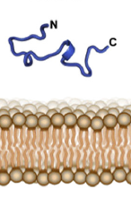
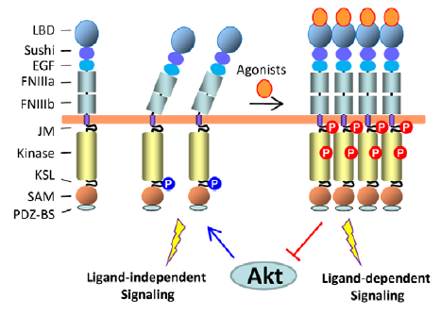
Increasing Acidity EphA2
Figure 2. The re-activation of ligand-dependent signaling inhibits Akt and ligand-independent signaling.
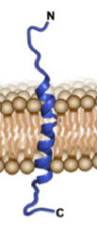

Figure1. The pH responsive insertion of the peptide as the environment acidifies.
Materials and Methods:
Circular Dichroism
Peptide stocks were made for both Roxy7 and Roxy8. Dried POPC lipid was resuspended in a 1 mM sodium phosphate buffer at neutral pH, and extruded using a 100 nm filter to make 100 nm large unimellar vesicles. A master mix was made containing the lipid, the peptide, and the 1 mM buffer at a neutral pH, and allowed to incubate for one hour. A lipid blank, a peptide blank, and a buffer blank were prepared in addition to the four samples (two at pH 4, two at pH 8). Samples consisted of the Master Mix, a 10 mM (Roxy8) or a 100mM buffer (Roxy7) at either pH4 or pH8, and water. Circular dichroism was performed at room temperature across the wavelength range from 260nm-190nm. Data was normalized to give ellipticity, and ellipticiy was plotted against wavelength to determine the secondary structure of the peptide.

Fluorimetry
Roxy7 and Roxy8 were conjugated with NBD at the N terminal by using NBD-X succimidyl ester, which specifically targets primary amines, and then lyophilized into aliquots. A dried POPC sample was resuspended in a 10 mM buffer at the pH for that experiment in order to make a 1mM POPC solution. The lipid solution was extruded using a 100 nm filter to make 100 nm large unimellar vesicles. The dried Roxy7-NBD or Roxy8-NBD was resuspended in 400 microliters of MiliQ water and quantified using a spectrophotometer and the Beer-Lambert Law.
The same buffer used for the lipid resuspension was used to prepare the samples. The final volume for the sample was 130 microliters. The final concentration of peptide in the sample was 1 micromolar. The lipid concentration in the sample ranged from 0 to 800 micromolar. Lipid blanks were prepared to match the lipid concentration in each sample. Fluorimetry was used to measure the fluorescence intensity across a 60 nm range (520nm-580nm). The maximum fluorescence intensity at 540nm for each sample was plotted versus the varying lipid concentration. The subsequent binding curve was fitted to the following equation, which gave the partition coefficient:
F₀ + F_{max} * [$\frac{Kp×x}{55.3+Kp×x}$]

Results:
Circular dichroism of Roxy7 suggests the formation of an ɑ-helix at acidic pH (Figure 3). This secondary structure is denoted by the negative minima at 208nm and 222nm. The similar structure of the peptide at both pH 8 and in buffer suggests that at a basic pH the peptide is in solution.

Figure 3. Circular dichroism of Roxy7 in POPC vesicles shows ɑ-helix formation in acidic conditions, denoted by the minima at 208 nm and 222 nm.

NBD binding assays across multiple pH values for both Roxy7 and its negative control, Roxy8, suggest greater binding for Roxy7 at acidic pH. Binding was assessed by comparing partition coefficient (Kp) values (Figure 4). In addition, the maximum fluorescent intensity of the pH 5 and pH 7 experiments were averaged, normalized, and then plotted against lipid concentration to further view the tighter binding of Roxy7 at lower pHs (Figure 5).
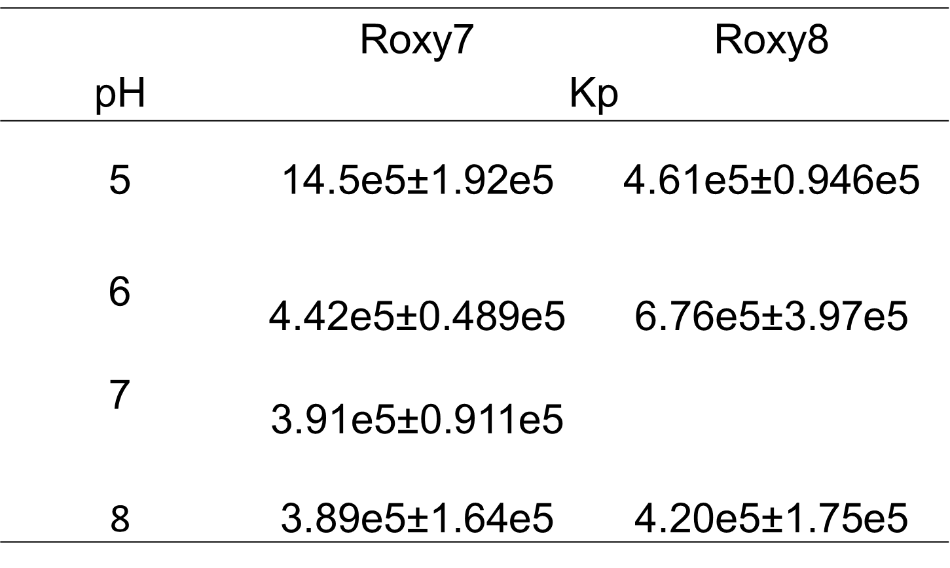

Figure 4.Comparison of partition coefficient (Kp) values for Roxy7 and Roxy8 at varying pH values. Suggests increased binding of Roxy 7 at lower pH values. Asterisk denotes n=1.
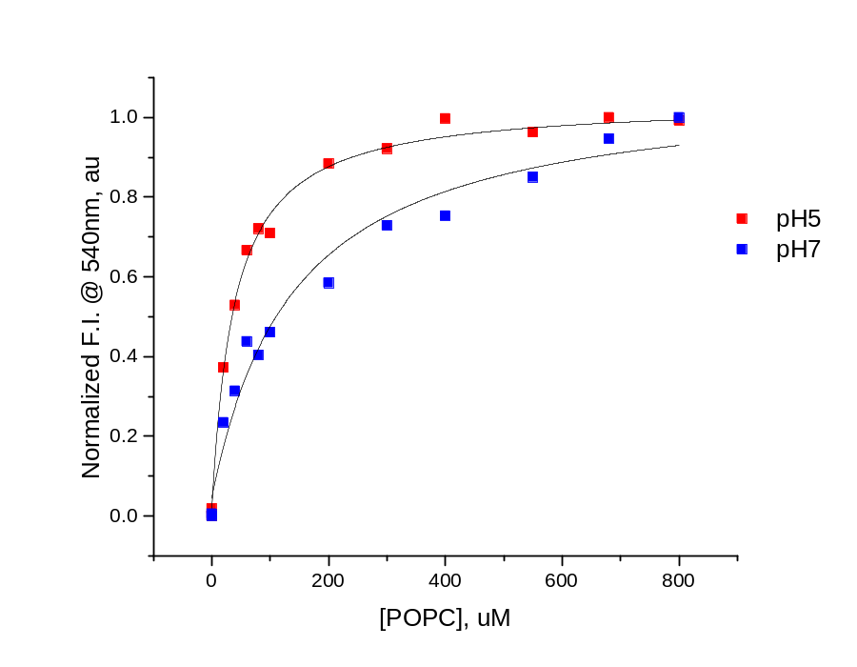
Figure 5.Overlay of average Roxy7-NBD binding assay at pH 5 (red) and pH 7 (blue) demonstrating tighter binding at lower pH.

Discussion and Conclusions:
The circular dichroism of Roxy7 suggests that the interaction of the peptide with POPC lipid vesicles is controlled by pH. This pH-responsive property suggests that the peptide could be used to target cancer cells because it would remain in solution until it reached an acidic environment. The CD spectra further suggests that in an acidic environment, Roxy7 would insert into a membrane as a transmembrane ɑ-helix, and thus could interact with and activate overexpressed EphA2.
In addition to the CD spectra of Roxy7, the NBD binding assays suggest that acidic environments also allow for tighter binding of the peptide to the membrane. The binding was assessed by the Kp value, which measures the partitioning of the peptide. If the peptide partitions more toward the lipid, the Kp value is high. If the peptide partitions more toward the solution, the Kp value is low. Figure 4 suggests that as the pH of the environment acidifies, the Kp value of Roxy7 increases, meaning the peptide is favoring the lipid membrane more than the solution and thus has tighter binding. Additionally, the binding curves represented in Figure 5 further collaborate these findings. The slope of the curve of the pH 5 experiments is steeper than that of the pH 7 experiments, illustrating a tighter binding at the lower pH.
Together, these experiments suggest that Roxy7 can be used to target cancer cell membranes, and that Roxy7 has a potential pH delivery property that can be useful for targeting tumor cells.

Acknowledgements:
Thank you to the Barrera Lab for their help and support. I want to acknowledge Justin Westerfield and Vanessa Nguyen for conjugations, and Jacob Gallaher and Forrest Davis for initial Roxy7-NBD pH8 and pH7 experiments.

References:
- Liu Y, Yu C, Qiu Y, Huang D, Zhou X, Zhang X, and Tian Y. (2012) Downregulation of EphA2 Expression Suppresses the Growth and Metastasis in Squamous-Cell Carcinoma of the Head and Neck In Vitro and In Vivo. J Cancer Res Clin Oncol 138:195-202. doi: 10.1007/s00432-011-1087-9

- Petty A, Myshkin E, Qin H, Guo H, Miao H, et al. (2012) A Small Molecule Agonist of EphA2 Receptor Tyrosine Kinase Inhibits Tumor Cell Migration In Vitro and Prostate Cancer Metastasis In Vivo. PLoS ONE 7(8): e42120. doi: 10.1371/jounal.pone.0042120

- Pratt R and Kinch M (2002). Activation of the EphA2 Tyrosine Kinase Stimulates the MAP/ERK Kinase Signaling Cascade. Oncogene 21:7690-7699. doi: 10.1038/sj.onc.1205758

- Arnato K, Wang S, Hastings A, Youngblood V, Santapuram P, Chen H, et al. (2014) Genetic and Pharmacologic Inhibition of EphA2 Promotes Apoptosis in NSCLC. J Clin Invest 124(5):2037-2049. doi: 10.1172/JCI72522

