Response of Inland Lakes to Climate Change across the Tibetan Plateau Investigated Using Landsat and ICESat Data

A Thesis Presented
for the Master of Science Degree
The University of Tennessee, Knoxville

Zewen Liu
August 2012

Copyright ©2012 by Zewen Liu

All rights reserved.

DEDICATION

This thesis is dedicated to my parents, Qiang Liu and Yuhui Liu, and my brother,
Zejian Liu, who is currently going through a tough time

ACKNOWLEDGEMENTS

I would like to thank my advisor, Dr. Yingkui Li, for his guidance, patience, and enthusiasm through my two-year study. Dr. Li brought me into the world of geography, and his passion for the research in the Tibetan Plateau is contagious. I am especially thankful for his dedication of nurturing me to be a scientific researcher; his advice and instructions helped me to keep in the right track of scientific research. To some degree, Dr. Li is not only my advisor, but also a mentor and very close friend.
Special thanks also go to Drs. Liem Tran and Carol Harden. During the last two years, they always offered me support and suggestions to improve my GIS skill and the understanding of physical geography research. They enlarged my knowledge in remote sensing, hydrology, and environmental change; and I’ve benefited from this knowledge when designing the model and interpreting the results of my thesis research.
I also would like to show my gratitude to my family and the friends in the Geography Department. I am grateful for the encouragement and support from my parents and brother; their love was extremely important for me to reach this point. Many thanks to Yanan Li, Ben Shultz, Chunhao Zhu, John Eads, Jesse Piburn, and Lucy Courtney for their advice on my thesis research and future career. They also accompanied me and brought happiness into my daily life, and it has been a special experience.

ABSTRACT

The Tibetan Plateau experienced tremendous climate change during the past four decades. Due to the large size, wide distribution of glacier and permafrost, and diverse landforms, different parts of the plateau may experience different patterns of climatic and cryospheric change. The changes of inland lakes within the plateau are important indicators of climate change as these lakes are fed by precipitation, permafrost degradation, and glacier melting that are all sensitive to climate change. To examine the spatial and temporal differences of lake variations across the Tibetan Plateau, Landsat images and ICESat/GLAS altimetry data were used to extract the changes in surface areas of 26 lakes selected from six different sub-regions during the 1970s-2010 and the changes in lake elevations of 16 lakes during 2003-2009. An automated model to extract lake surface area and elevation from Landsat and ICESat data is developed in this study to improve the efficiency of processing the large amount of satellite data.
By applying the automated model, the spatial and temporal changing patterns of selected 26 inland lakes across the Tibetan Plateau during the past four decades are revealed. Lakes from different parts of the Tibetan Plateau show different patterns of change. The lake expansion first started from the central Tibetan Plateau in the 1980s, then moved northward and northwestward; lakes in the northeastern and northwestern Tibetan Plateau experienced obvious expansion after the late 1990s, and this expansion is still continuing in the northern part, whereas the rapid lake expansion either slowed down or stopped in the central and southern parts of the plateau. The different patterns of lake change are caused by diverse climatic regimes and the pattern of the cryospheric distribution in the Tibetan Plateau. For the southern part, the changes in precipitation and temperature are the dominant factors controlling the lake changes; however, the cryospheric change caused by temperature increase is the most important factor influencing the lake fluctuations in the northern part. These patterns can provide insight into the mechanism of lake dynamics in response to climatic and cryospheric changes; and be applied to assess the potential impacts of climate change on water resources in the Tibetan Plateau.

TABLE OF CONTENTS
CHAPTER 1 INTRODUCTION 1
1.1 Background 1
1.2 Research Objectives 4
1.3 Significance 5
1.4 Organization of the Thesis 5
CHAPTER 2 LITERATURE REVIEW 6
2.1 Climate Changes in the Tibetan Plateau 6
2.2 Cryospheric Change 7
2.2 Lake Change Studies Using Remote Sensing 9
2.2.1 Lake Area Change Study Using Remote Sensing 9
2.2.2 Lake Elevation Change Study Using Remote Sensing 12
2.3 Lake Changes in the Tibetan Plateau 13
2.4 Potential Reasons for Lake Changes in the Tibetan Plateau 14
CHAPTER 3 RESEARCH AREA 16
3.1 Geologic Setting 16
3.2 Climate 17
3.3 Vegetation and Land Cover 18
3.4 Cryosphere 19
3.5 Study Site 19
3.5.1 Sub-Region A 22
3.5.2 Sub-Region B 23
3.5.3 Sub-Region C 24
3.5.5 Sub-Region D 25
3.5.5 Sub-Region E 26
3.5.6 Sub-Region F 27
CHAPTER 4 METHODOLOGY 29
4.1 Data Sources 31
4.1.1 Lake Area Data 31
4.1.2 Lake Elevation Data 33
4.2 Lake Surface Area Extraction 33
4.2.1 Lake Boundary Extraction 33
4.2.2 Consistency Check of Multi-temporal Lake Boundaries 37
4.2.3 Accuracy Assessment of the Extracted Lake Boundaries 40
4.3 Lake Elevation Extraction 43
4.4 Spatial and Temporal Patterns of Lake Changes 43
CHAPTER 5 RESULTS 45
5.1 Sub-Region A: the Northwestern Tibetan Plateau 45
5.1.1 Lake Area Change 45
5.1.2 Lake Elevation Change 48
5.2 Sub-Region B: the Central-northern Tibetan Plateau 50
5.2.1 Lake Area Change 50
5.2.2 Lake Elevation Change 52
5.3 Sub-Region C: the Northeastern Tibetan Plateau 53
5.3.1 Lake Area Change 53
5.3.2 Lake Elevation Change 56
5.4 Sub-Region D: the Southwestern Tibetan Plateau 59
5.4.1 Lake Area Change 59
5.4.2 Lake Elevation Change 61
5.5 Sub-Region E: the Central Tibetan Plateau 63
5.5.1 Lake Area Change 63
5.5.2 Lake Elevation Change 65
5.6 Sub-Region F: the Southern Tibetan Plateau 67
5.6.1 Lake Area Change 67
5.6.2 Lake Elevation Change 69
CHAPTER 6 DISCUSSION 71
6.1 Lake Area and Elevation Extraction Model 71
6.2 Spatial and Temporal Patterns of Lake Changes 72
6.3 Potential Causes for Different Lake Change Patterns 75
6.3.1 Climate Change 75
6.3.2 Cryosphere Distribution and Change 77
6.3.3 Lake Drainage Properties 79
6.3.4 Human Influences 79
CHAPTER 7 CONCLUSION 81
7.1 Major Conclusions 81
7.2 Limitations of this Study and Suggestions for Future Work 83
REFERENCES 85
APPENDIX 93
VITA 121

LIST OF TABLES
Table 3-1 Names, surface areas, elevations, and locations of the 26 selected lakes 20

Table 4-1 Spectral bands of MSS for Landsat and their applications in environmental research (USGS) 31
Table 4-2 Spectral bands of TM/ETM+ for Landsat and their applications in environmental research (USGS) 32
Table 4-3 Accuracy check result using Google Earth high resolution images for Laxiong Co, Jieze Chaka, and Daze Co. 41

LIST OF FIGURES
Figure 3-1 The location of the 26 selected lakes in the Tibetan Plateau. 21

Figure 4-1 The flowchart for lake surface area and elevation extraction.. 30
Figure 4-2 The lake boundary extraction model.. 35
Figure 4-3 The extracted lake area, lake area growth rate, and lake boundaries of Peigu Co (10/22/2009) using different threshold values. 36
Figure 4-4 The workflow of lake boundary consistency check model. 39
Figure 4-5 Example of consistency check result, Peng Co. 40
Figure 4-6 Model derived lake boundaries and Google Earth digitized lake boundaries for Laxiong Co (A), Jieze Chaka (B), and Daze Co (C). 42

Figure 5-1 The surface area of lakes in sub-region A during 1970s-2010.. 47
Figure 5-2 The surface area change rate of lakes in Region A during 1972-2010. 48
Figure 5-3 The surface elevation change of lakes in Region A during 2003-2009. 49
Figure 5-4 The surface area of lakes in sub-region B during 1970s-2010. 51
Figure 5-5 the surface area change rate of lakes in Region B during 1972-2010.. 52
Figure 5-6 The lake elevation change during 2003-2009, Gyado Lake. 53
Figure 5-7 The surface area of lakes in sub-region C during 1970s-2010.. 55
Figure 5-8 (A) The surface area change rate of lakes in Region C during 1972-2010. (B) the surface area change rate of the lakes in Region C during 1972-2010 except Duoge Co.. 56
Figure 5-9 The surface elevation change of lakes in Region C during 2003-2009.. 58
Figure 5-10 The surface area of lakes in sub-region D during 1970s-2010. 60
Figure 5-11 (A) The surface area change rate of lakes in Region D during 1972-2010. (B) the surface area change rate of the lakes in Region D during 1972-2010 except Cangmu Co.. 61
Figure 5-12 The surface elevation change of lakes in Region Dduring 2003-2009.. 62
Figure 5-13 The surface area of lakes in sub-region E during 1970s-2010. . 64
Figure 5-14 The surface area change rate of lakes in Region E during 1972-2010.. 65
Figure 5-15 The surface elevation change of lakes in Region E during 2003-2009.. 66
Figure 5-16 The surface area of lakes in sub-region F during 1970s-2010.. 68
Figure 5-17 The surface area change rate of lakes in Region F during 1972-2010.. 69
Figure 5-18 The surface elevation change of lakes in Region F during 2003-2009.. 70

CHAPTER 1
INTRODUCTION

1.1 Background
The recent global climate change is mainly characterized by increased temperature; and it has been accelerating over the last century, especially over the last 50 years. The rate of warming over the last 50 years is almost twice the rate over the last 100 years, and this trend is projected to continue in the 21st century (Trenberth et al., 2007). As the second largest component of the climate system regarding the heat capacity, the cryosphere is intricately linked to the surface energy/water budget, and reacts sensitively to climate change (Lemke et al., 2007). Abundant evidence indicates that most cryospheric components in polar and mountainous regions are undergoing significant changes in response to warming. For example, snow cover has decreased in many regions of the Northern Hemisphere, particularly in spring and summer; glacier melting, and permafrost degradation has been observed in high-altitude/latitude regions such as Siberia and the Tibetan Plateau (Rosenzweig et al., 2007).
Cryospheric change would have significant impact on the water resources as the cryosphere stores about 75% of the freshwater in the world (Lemke et al., 2007). The main components of the cryosphere are mountain glaciers and ice caps, floating ice shelves and continental ice sheets, seasonal snow cover, frozen ground, sea ice and lake and river ice (Rosenzweig et al., 2007). The observed hydrological effects of cryosphere reduction include modification of river regimes caused by enhanced glacial/snow melting and winter base flow (Rosenzweig et al., 2007). Many lakes /rivers draining glaciated regions are sustained by glacier melting during the summer season (Trenberth et al., 2007). In the short term, warming produces an enhanced spring-summer melting of glaciers, leading to increased river runoff and discharge peaks and an enhanced melting season; however, in the long term (decadal to century scale), glacier runoff is expected to decrease (Jansson et al., 2003).
Except for glacier melting and retreat, permafrost degradation also plays an important role in influencing the drainage systems and land surface characteristics through surface soil freezing and thawing (Lemke et al., 2007). Permafrost is the single largest component of the cryosphere in terms of areal extent. Degradation of seasonally frozen ground and permafrost results in increased importation of surface water (McNamara et al., 1999); as a result, the lake/river fed by permafrost would first experience temporary expansion due to the initial melting, followed by shrinkage due to draining within the permafrost. This trend has been identified in lakes of Alaska (Yoshikawa & Hinzman, 2003) and Siberia (Smith et al., 2005), and the results revealed that the lake expansion phase is especially obvious in continuous permafrost zones. Therefore, in regions where cryosphere are distributed, the lake/river discharge change would reflect the influence of climate change and its associated cryospheric change on the water resources of these regions.
The Tibetan Plateau, located in southwestern China, is the highest and most extensive plateau on Earth. Due to its high altitude (> 4000 m above sea level), cryosphere (glacier, permafrost, and snow cover) is widely distributed in the Tibetan Plateau: (1) the plateau contains the most extensive mountain glaciers in the world, with the area of 49,873 km², accounting for >80% of the glaciers in China (Zhang et al., 2011); and (2) about 67% of the plateau is covered by permafrost (Cheng & Wu, 2007). Due to its high altitude and wide distribution of glacier and permafrost, the Tibetan Plateau is sensitive to climate change and is also an ideal place to study global climate change because of the limited influences of human activities. A warming trend was observed in the Tibetan Plateau during the past half century with a much faster rate than the global average (Kang et al., 2010). Furthermore, a 4°C warming is predicted during the next 100 years (Trenberth et al., 2007), which makes this one of the most significantly warming areas around the globe (Wang, 2007). As a result of the observed warming, significant glacier retreat had been reported in the Tibetan Plateau during the last century (Ding et al., 2006). Widespread permafrost warming and thawing have also occurred in this region. Permafrost temperature increased about 0.2°C to 0.5°C from the 1970s to the 1990s across the Tibetan Plateau. The driving force for the permafrost degradation is the significant warming in cold seasons, while changes in snow depth play a minor role (Zhao et al., 2004).
Climate and cryospheric changes have significant impacts on water resources and the eco-environment of the Tibetan Plateau (Wang et al., 1996). In particular, by influencing the hydrological cycle, climate and cryospheric changes in the plateau have tremendous influences on the downstream rivers (Rosenzweig et al., 2007). The Tibetan Plateau provides water sources for many major Asian rivers, including the Indus, Ganges, Brahmaputra, Irrawaddy, Salween, Mekong, Yellow, and Yangtze. Discharges from these rivers sustain one quarter of the world’s population (Immerzeel et al., 2009). Therefore, investigating the impact of climate and cryospheric change on water resources is of great significance in this critical region.
Lakes, along with glaciers, permafrost, and rivers, are the major components of the water system in the Tibetan Plateau. More than 1500 lakes are distributed in this region, and their surface area accounts for about 50% of the total lake area in China (Wang & Dou, 1998). More than 60% of the drainage basins of Tibetan lakes are closed water systems without outflows. Melting glaciers, underground water, permafrost, and precipitation are considered as the main water sources for inland lakes (Wu & Zhu, 2008, Wang, 2007, Liu et al., 2009), while all these factors are influenced by climate change. Because of the arid climate in most places of the Tibetan Plateau, precipitation-generated runoff evaporates rapidly. As a result, the lake level is closely related to the meltwater flowing into the lake (Liu et al., 2009; Zhang et al., 2011). Due to their wide distribution, extreme sensibility to climate and cryospheric change, and limited human activities, changes to inland lakes on the Tibetan Plateau can be viewed as an ideal indicator of climate and cryospheric change. By monitoring the long-term inland lake change, the responses of these lakes to climate and cryospheric changes can be revealed and the impact of climate change on the water resources can be assessed.
Long-term hydrologic records are required to accurately monitor the lake change; however, most Tibetan lakes lack continuous hydrologic observation due to the harsh natural conditions. Remote sensing provides an alternative way to monitor lake changes during a given period. Measurement of trends in water storage in a lake involves two distinct perspectives: determinations of changes in the lake’s surface area and of changes in its water level. Passive, visible-infrared imaging systems have been used to delineate the lake extent, while passive microwave radiometers have been used to monitor lake level change (Chipman & Lillesand, 2006). By investigating the area and elevation change of different lakes from different parts of the Tibetan Plateau using remote sensing, the spatial and temporal patterns of lake changes across the plateau can be achieved, providing significant insights into the mechanism of lake dynamics in response to climatic and cryospheric change.

1.2 Research Objectives
The goal of this research is to examine the spatial and temporal differences of patterns of lake change in the past four decades across the Tibetan Plateau. Twenty-six lakes are selected from six sub-regions across the plateau to achieve this goal. Landsat and ICESat/GLAS data are used as the main data sources for lake surface area and lake elevation extraction. To accurately describe and compare lake change patterns, high temporal and spatial resolution of lake area and elevation change datasets are required. Therefore, large sets of remote sensing data need to be processed, so having an efficient way to automatically process these data with an acceptable accuracy is crucial. After the lake area and elevation change datasets are established, the changing patterns of different lakes can be identified. Lakes from different sub-regions may experience different patterns of change, and the causes for these changes are of great importance to understand the mechanism of lake change and evaluate the impact of future climate change on the water resources of the Tibetan Plateau.
The detailed objectives of this research are:
(1) to develop an automated model to extract the surface area and elevation of Tibetan lakes using Landsat and ICESat/GLAS data, and check the consistency of the extracted lake boundaries;
(2) to establish datasets of lake area change for 26 selected lakes across the Tibetan Plateau during the 1970s-2010 and lake elevation change for 16 Tibetan lakes during 2003-2009; and
(3) to investigate spatial and temporal changing patterns in surface area and elevation for these selected Tibetan lakes.

1.3 Significance
This study developed an automated model to extract high temporal resolution lake surface area and elevation using Landsat and ICESat/GLAS data. The developed method improves the efficiency of processing large data sets. This study also examines the spatial and temporal patterns of lake change across different parts of the Tibetan Plateau. The findings of this work provide significant insight into the interaction between climate change and lake dynamics. This study also provides a fundamental dataset for further studies in predicting future lake changes under the projected climate change scenarios, and assessing the climate impact on water resources in the Tibetan Plateau and surrounding regions.

1.4 Organization of the Thesis
This thesis is divided into seven chapters. Chapter One introduces the background and significance of the research, and explains the research questions and objectives. Chapter Two reviews the relevant literatures, including climate and cryospheric change, Tibetan lake change and other related topics. Chapter Three describes the study area. The climate, vegetation and land use of the Tibetan Plateau are described, followed by descriptions of the 26 selected inland lakes. Chapter Four illustrates the methods used to extract lake area and lake elevation from remote sensing data. Then, the results of lake area and lake elevation change are presented in Chapter Five. By analyzing the results of Chapter Five, different lake change patterns are discussed in Chapter Six. Finally, in Chapter Seven, the conclusion and future research direction are summarized and discussed.

CHAPTER 2
LITERATURE REVIEW

2.1 Climate Changes in the Tibetan Plateau
The climate of the Tibetan Plateau is influenced by the monsoon in summer and cold and dry westerly in the winter; therefore, the climate of the Tibetan Plateau is characterized by wet/humid summers and cold/dry winters (Kropacek et al., 2012). Based on the meteorological station data, reanalysis, and remote sensing data, the Tibetan Plateau has been experiencing significant climate change during the last several decades (Kang et al., 2010; Xu et al., 2008). The cryosphere is also undergoing rapid changes, including glacier retreat, snow cover change, and permafrost degradation (Kang et al., 2010; Li et al., 2008).
The main portion of the Tibetan Plateau has experienced significant warming since the mid-1950s (Niu et al., 2004). Observed evidence indicated that the surface temperature of the Tibetan Plateau increased about 1.8°C in the past 50 years (Wang et al., 2008). The temperature of the plateau was high in the early 1960s and decreased from the mid-1960s to the 1980s, then entered a sustained increase from the late 1980s (Kang et al., 2010). Moreover, the temperature increase is higher during the winter months (twice the rate of the annual average) (Liu & Chen, 2000). Basing on the observed data from 64 meteorological stations in the central and eastern Tibetan Plateau from 1961 to 2003, Duan et al. (2006) analyzed the spatial distribution of the linear variation rate (LVR) of annual mean temperature and revealed an obvious warming trend over most of the Central and Eastern Tibetan Plateau, with the largest increasing magnitude in the northern area. By analyzing meteorological data from 178 meteorological stations within and around the Tibetan Plateau during 1960-1990, Liu and Chen (2000) found that the warming rates are dependent on the elevations of the weather stations. Stations with high elevations tend to have higher warming rates. However, because of differences in data source selection, some studies also suggested no clear relationship between temperature increasing rates and elevations (Kang et al., 2010). Under the SERS A1B (a “middle of the road” estimate of future emission) scenario, a 4°C warming will likely occur during the next 100 years in the Tibetan Plateau (Trenberth, 2007), which is the world’s highest estimated warming in the middle troposphere around the globe (Wang, 2008).
Precipitation is disproportionately distributed in the Tibetan Plateau, and 60% to 90% of the precipitation falls between June and September (Xu et al., 2008). Spatially, precipitation gradually decreases from the southeast to the northwest, from > 700 mm/a to < 50 mm/a. In contrast to the continuous increase in temperature, the changes in precipitation across the Tibetan Plateau vary spatially with larger inter-annual variability (Kang et al., 2010). Over the past several decades, precipitation increased in most areas in the eastern and central plateau, but decreased in the southern and western regions (Xu et al., 2008).
Along with changes in temperature and precipitation, changes also occurred in other climatic variables, such as sunshine duration, evaporation and cloud cover. In the past decades, the average annual evaporation of the Tibetan Plateau decreased 2.0%, especially in winter and spring (Chen et al., 2006). During 1961-1998, sunshine duration increased in the middle and eastern portions of the plateau, but decreased in the southern regions. Since the mid-1980s, the plateau as a whole can be characterized by increased relative humidity and surface pressure, but decreased sunshine duration and total cloud cover (Niu et al., 2004).

2.2 Cryospheric Change
The cryosphere is essential for the energy and water cycle of Earth surface as it is an integral part of the global climate system. It is also considered as an indicator of climate change due to its sensitivity to the changes in temperature (Lemke et al., 2007; Li et al., 2008). The cryosphere in the Tibetan Plateau is mainly composed of mountain glaciers, altitudinal permafrost, seasonal frozen ground, and snow cover. As a result of climate change, rapid cryospheric changes, such as glacier retreat and permafrost degradation, were observed in the Tibetan Plateau during the past decades (Kang et al., 2010; Li et al., 2008).
More than 36,800 glaciers exist on the Tibetan Plateau, and most of these glaciers have retreated since the 1990s (Ding et al., 2006; Kang et al., 2010). In addition, many studies have reported accelerations in glacier retreat and increasingly negative mass balance of glaciers on the Tibetan Plateau in recent years. Glacier retreat is particularly apparent in the Himalayas and Qilian Mountains, with area shrinkages of 5-10% over the past 30 years; however, on the interior of the Tibetan Plateau, glaciers are relatively stable (Li et al., 2008). Glacier retreat is expected to have significant influence on water resources of the Tibetan Plateau, especially on the inland water systems: the runoff from glacier melting accounts for 24.3% of the annual discharges of inland rivers in the Tibetan Plateau (Li et al., 2008).
Permafrost degradation and increasing permafrost temperature have also been reported for the Tibetan Plateau. The permafrost in this region has been classified into three categories according to the percentage of area underlain by permafrost: predominantly continuous permafrost (70-90%), predominantly discontinuous island permafrost (30-70%), and sporadic island permafrost (<30%) (Cheng & Wu, 2007). The mean annual ground temperature of the island permafrost zone increased 0.2 - 0.5 °C from the 1970s to the 1990s, and its areal extent decreased 36% in the past 30 years (Kang et al., 2010); however, for the continuous permafrost zone in the Tibetan Plateau, the degradation is slower, with the mean annual ground temperature increase of 0.1 - 0.3 °C during the1970s-1990s (Li et al., 2008). In response to the increased ground temperature, the active layer thickness has increased up to 1.0 m along the Qinghai-Xizang Highway since the early 1980s (Zhao et al., 2004), the south lower limit of permafrost has moved 12 km northward, and the northern lower limit has moved 3 km southward (Li et al., 2008). It is expected that the basal thawing rate will accelerate over the whole plateau as the permafrost surface continues to warm (Lemke et al., 2007).
By influencing the hydrological cycle, climatic and cryospheric changes have significant influences on the water resources of the Tibetan Plateau and its downstream major Asian rivers (Rosenzweig et al., 2007). Warming leads to changes in the seasonality of river/lake inflows where much winter precipitation currently falls as snow (Barnett et al., 2005). According to the mass balance of glaciers, when the amount of melted water is greater than the volume of ice accumulation, the glacier will retreat, and its area will decrease. The increase of glacier melt water will result in the expansion of the lake area (Chen et al., 2007). Higher temperatures increase glacier melting. As these glaciers retreat due to global warming, river/lake inflows will increase in the short term, but the contribution of glacier melting will gradually decrease in the long term. Rapid thawing of permafrost and decrease in depths of frozen soils can also contribute the river/lake inflow increase in the short term; however, in the long term, the importation of water may decrease. As a result of the projected climate change, the Tibetan lakes/rivers may experience tremendous changes in the future. An investigation of the responses of Tibetan lakes to the climate change during the last 40 years would provide significant insight into future lake changes, and help to assess the potential impacts of climate change on water resources of the Tibetan Plateau and its surrounding areas.

2.2 Lake Change Studies Using Remote Sensing
Monitoring the status of lakes and calculating their water balances can be achieved with the help of satellite measurements such as precipitation from the Tropical Rainfall Measuring Mission (TRMM) satellite, lake elevation data from spaceborne altimetry, and lake area from missions such as Advanced Very High Resolution Radiometer (AVHRR), Landsat, and Moderate Resolution Imaging Spectroradiometer (MODIS) (Crétaux & Birkett, 2006). Lake change studies can be divided into two perspectives: lake area change and lake elevation change.

2.2.1 Lake Area Change Study Using Remote Sensing
Multiple data sources, including satellite images, aerial photos, and DEMs (Digital Elevation Models) have been used in detecting lake area changes (Chipman & Lillesand, 2007; Swenson & Wahr, 2009). The traditional method of lake boundary extraction is manual delineation, which is subjective and labor consuming (Bianduo et al., 2009; Riordan et al., 2006). In order to improve the efficiency of image processing, automated ways are developed. The main approaches for automated lake boundary extraction usually rely on density slicing using single or multiple bands and multi-spectral classiﬁcation. These approaches are primarily based on evaluating the spectral signature in the near and middle infrared portion of the electromagnetic spectrum because a water body absorbs almost all incident radiant ﬂux, while the land surface reﬂects significant amounts of near and middle infrared energy (Bagli & Soille, 2004). Roach & Verbyla (2011) compared three methods for lake classification using Landsat imagery in Alaska. The result of their study showed that, compared with the other two methods (classification trees and feature extraction), the single band density slicing was the best method for the lake classification due to its ease of application, consistency, sensitivity to water, and high accuracy.
Chipman & Lillesand (2007) developed an automated image-processing sequence to monitor the lake area and volume change of new lakes in southern Egypt and improved the accuracy of classification by calculating the sub-pixel fractional water coverage. They applied normalized difference water index (NDWI) instead of a single band for density slicing of a combination of multiple satellite remote-sensing platforms: MODIS and AVHRR images. Firstly, the NDWI was computed for each pixel as equation (1):
NDWI= (NIR-VIS) / (NIR+VIS) (1) where NIR=near-infrared spectral radiance, VIS=visible spectral radiance. A simple numerical threshold was used to create a first approximation of the land/water boundary, and the threshold value needs to be specified by the analyst. After the first step, a buffer zone was delineated around this boundary. Pixels falling outside the buffer zone were considered to represent either 100% water or 100% land (depending on which side of the boundary they were located on). Pixels within the buffer zone were considered to include a mixture of land and water. After that, spectral statistics from the imagery were calculated for the land and water classes, and used in a linear mixture model to compute the fractional coverage of water for each pixel in the buffer zone. After these three steps, the lake area can be determined.
This image-processing sequence involves use of the linear mixture model to estimate sub-pixel fraction coverage of water along lake shorelines. The fraction coverage index takes the differences between different images into consideration on a scene-by-scene basis. As the sample lakes in this study are all small lakes while the resolution of MODIS/AVHRR images is coarse, the sub-pixel fraction coverage of water is of great importance to calculate the lake area accurately; on the other hand, for large lakes with relative high resolution satellite images, the sub-pixel fractional water coverage is less important for lake area calculation, and the efficiency of classification can be improved when the sub-pixel fractional water coverage is not taken into consideration, especially when enormous high resolution images need to be processed. Furthermore, the value set for all images as the threshold to distinguish water and lands may cause some misclassification due to the different radiances in different images, and the changes in water property in different seasons.
Wu and Zhu (2008) extracted the lake and glacier boundaries of the Nam Co basin of the past 30 years and eliminated the error caused by seasonal change and classification uncertainty by introducing a classification scheme. Three single-digit values (9, 6, and 3) are assigned to three different landforms: non-glacier\lake area, glacier area, and lake area, respectively. Then, after the classification, each pixel obtains a new single-digit value. After multi-temporal classification is done, a new multi-digital value can be generated according to the time series. For example, if three images are classified, after the integration, one pixel may get a value of 399, this means this pixel turned from lake to other landforms during the first time interval; 993 means lake expansion during the second time interval. More importantly, this method can filter some noise generated during the classification due to the seasonal difference and difference in data sources, such as 696, indicating that some glacier area turned into non-glacier\lake area during the first interval and back to glacier area afterward, can be treated as noise.
This classification scheme improves the accuracy of classification by eliminating the misclassification caused by seasonal fluctuation; however, for lake boundary data with high temporal resolution, seasonal change is part of the lake change and the uncertainty of this scheme will increase as the temporal resolution increases. Similar to the method of Chipman and Lillesand (2007), prior knowledge is required to set the threshold value to extract the lake boundaries form satellite images. For relatively large lakes with high temporal/spatial resolution satellite images, especially when they experienced significant change during a certain period, the extracted lake changing pattern is less sensitive to image resolution and seasonal change; on the other hand, the threshold value set to separate water and land surface is of great importance to determine the lake area. For high temporal resolution lake boundary extraction, large data sets need to be processed; therefore, an efficient and consistent way to determine the threshold value is essential to conduct this type of study.

2.2.2 Lake Elevation Change Study Using Remote Sensing For lakes with no or sparse gauge measurements, satellite altimetry is an important and valuable data source for lake level change studies (Crétaux & Birkett, 2006; Kropacek et al., 2012). Satellite radar altimetry has been successfully applied in lake elevation studies. The main datasets for these studies included Topex/Poseidon, ERS-2, Jason-1 and ENVISAT. For example, water level change studies have been conducted for major water bodies including Amazon River, Central Asia lakes, Caspian Sea, Lake Chad, and Lake Victoria using spaceborne radar interferometers and altimetry data. According to the results of these previous studies, these datasets are within acceptable accuracy for lake level change studies (Swenson & Wahr, 2009; Crétaux & Birkett, 2006; Hall et al., 2011; Alsdorf et al., 2010).
Another data source for lake level change detection is Light Detection and Ranging (LiDAR), which is more accurate than satellite radar altimetry. The Geoscience Laser Altimeter System (GLAS) was successfully launched aboard the ICESat in 2003. GLAS is the first satellite laser-ranging instrument for continuous global observation, and the major mission of GLAS was measuring ice-sheet topography, cloud and atmospheric properties, and the height and thickness of cloud layers. It also provided global elevation measurement two or three times a year during 2003-2009. Some studies in east Africa, southern Egypt, and the Amazon have already shown that the vertical accuracy of GLAS is around 10 cm, which is suitable for lake change study (Chipman & Lillesand, 2007; Swenson & Wahr, 2009; Alsdorf et al., 2010). Using GLAS data as calibration, Chipman (2007) measured the volume change of one lake in southern Egypt during 2001-2007. The data sources of his research are the lake boundaries derived from the Landsat and MODIS images during this period and corresponding DEM data produced by Shuttle Radar Topography Mission (SRTM). As the lake was formed after the mission of SRTM, the DEM provides the original basin elevation before flooding. Thus, he calculated the depth of the lake after its formation. In this case, he obtained both surface elevation and depth change information by extracting the lake boundaries and overlaying them with the elevation data. The GLAS data were used to verify the results derived from SRTM. By analyzing the GLAS data of different periods, the changes in lake surface elevation and volume between two successive GLAS overpasses over the lake could be measured. This work indicated that the two datasets (GLAS and SRTM) used for measuring water level changes are consistent, and the GLAS can be used as the major data source for lake elevation studies around the globe.

2.3 Lake Changes in the Tibetan Plateau
Lakes in the Tibetan Plateau lack systematic observation due to harsh natural conditions. Remote sensing provides an alternative way to study lake changes (Wu & Zhu, 2008; Liu et al., 2009). Studies have been conducted on several major lakes in the Tibetan Plateau, such as Nam Co, Zigetang Co, and Selin Co, to analyze lake surface area changes. The results indicated that most lakes had expanded during the past decades, especially since the late 1990s (Wu & Zhu, 2008; Wang et al., 2007; Liu et al., 2009; Qiao et al., 2010). Wang et al. (2007) investigated three sub-regions of the Tibetan Plateau: Nam Co, Selin Co, and the headwater area of Yellow River to study the lake and glacier fluctuations. Most lakes in the central Tibetan Plateau continuously expanded after the 1960s, while their corresponding glaciers were all retreating. However, in the headwater area of Yellow River, the lakes were shrinking, probably due to human activities, increasing evaporation, and stable precipitation.
Although most Tibetan lakes were expanding due to accelerated glacier melting, some lakes in Tibetan Plateau experienced significant shrinkage within the last decades, such as Daze Co, Yangzhuoyong Co and Mapangyong Co (Qiao et al., 2010; Bian et al., 2009; Ye et al., 2008). These differences indicate that differences exist in crysopheric and climate change patterns across the Tibetan Plateau. Most previous lake surface area change studies focused on the central Tibetan Plateau, where some major lakes are located; however, detailed studies of the lakes distributed in the northern, southern and western Tibetan Plateau are still insufficient.
The lake elevation change study in the Tibetan Plateau is still insufficient, and most of these studies focused on the last decade. Kropacek et al. (2012) investigated the lake level change of Nam Co between the late 1990s and 2009 by integrating both satellite radar altimetry and ICESat/GLAS. The result indicates that the ICESat/GLAS is more precise than radar altimetry and can be used to validate the inter-annual lake level change trends. Zhang et al. (2011) examined the changes in lake surface elevation of 111 lakes across the whole plateau during 2003-2009 using GLAS data. According to their results, lake elevations in the Tibetan Plateau are mostly increasing primarily as a result of melting water from glaciers throughout lake basins, and this changing pattern is generally consistent with accelerated glacier melting throughout most of the plateau. However, lakes in the southern Tibetan Plateau show a different pattern (dropping lake level). The authors attribute this different pattern to the negative balance between precipitation and evaporation due to the decrease in precipitation (Bian et al., 2009).

2.4 Potential Reasons for Lake Changes in the Tibetan Plateau
Climate change has been considered the main cause of lake fluctuations in the past decades in the Tibetan Plateau. The interaction between precipitation, evaporation, glacier melting, and permafrost degradation determines the lake changing pattern (Wu & Zhu, 2008; Liu et al., 2009). For lakes in the southern Tibetan Plateau, such as Pumoyong Co and Yangzhuoyong Co, increased temperature and evaporation are considered the most important factors that contribute to the lake fluctuations (Bian et al., 2009; Ye et al., 2008). In most parts of the northern Tibetan Plateau, increased precipitation leads to increased cloud cover, decreased sunshine duration, increased humidity, and reduced evaporation (Wu & Zhu, 2008); all these changes lead to lake expansions in this area.
Glacier melting and permafrost degradation are also considered to be important factors that contribute to lake expansion. Increase in temperature leads to accelerated glacier melting and permafrost degradation, which are the main water sources for many Tibetan lakes. Changes in glacier extent lag behind climate changes by only a few years on the short, steep, and shallow glaciers of the mountainous regions, which undergo year-round ablation (Kaser et al., 2003). As for permafrost, different types of permafrost may cause different lake change patterns. According to the studies of Siberian lakes, lakes located in continuous permafrost zone experienced both lake number and lake area increase; while in the discontinuous permafrost zone, the trend is opposite (Smith et al., 2005). This difference may be a potential explanation for spatial differences of lake change patterns in the Tibetan Plateau.
Based on the data observed from meteorological stations, stream gauging stations, and satellite images, Liu et al. (2009) conducted a study to determine changing patterns during 1965-2005 for three lakes in the central Tibetan Plateau: Nam Co, Zigetang Co and Cona Lake. As a result of increased temperature, glacier melting and permafrost degradation were considered to be important contributors to the lake expansion. This conclusion is also supported by Bian et al. (2010). According to his research, Selin Co experienced tremendous expansion during 1975-2008, and accelerated glacier melting was the most important contributor to this expansion, while increased precipitation and decreased evaporation also contributed to this trend.
Previous studies have already provided some insights into the causes of the fluctuation of some specific lakes; however, as >1000 lakes are distributed across the plateau, and different lake basins have their specific topographic and climatic characteristics, the influence of these factors for different lakes is different. Furthermore, the same lake may respond differently to climate change during different periods. The establishment of a long-term lake change dataset for multiple lakes across the whole Tibetan Plateau may provide insight into the mechanism of the responses of Tibetan lakes to climate change.

CHAPTER 3

RESEARCH AREA
The Tibetan Plateau, also known as Qinghai-Xizang Plateau, is located in southwestern China. The name "Qinghai-Xizang Plateau" is derived from the fact that it mainly includes Xizang (Tibet) Autonomous Region to the south and Qinghai Province to the north (Wang, 1993). The Tibetan Plateau is bounded by the massive Himalayan Range to the south and southwest, the Karakoram Range to the west and northwest, the Kunlun Range to the north, and the Qilian Range to the northeast. The east and southeast of the plateau is generally confined by the Hengduan Range. Several important mountain ranges within the Tibetan Plateau include the Gangdis-Nyainqentanghla Range in southern Tibet and the Tanggula Range dividing the plateau into the southern and northern parts (Foggin, 2000). Except for all those mountain ranges, the Tibetan Plateau also boarders the Taklimakan and Gobi deserts to the north. The Tibetan Plateau is the highest, youngest and most extensive plateau on Earth, with an average elevation of more than 4000 m above sea level and an area of about 2,500,000 km². It has long been known as the roof of the world (Liu & Chen, 2000).

3.1 Geologic Setting
The Tibetan Plateau is an elevated landform produced by the collision between the Indian and Eurasian plates 40-60 million years ago (Chen, 2011; Klein, 2003). Although the tectonics and geological timescales of the events leading to the uplift are complicated and not thoroughly understood due to a lack of geologic research in the area until recent decades (Liu, 2009; Zheng et al., 2000), three basic stages of the uplift are generally agreed upon: (1) pre-collision phase (80-50 Ma), (2) collision-induced crustal thickening (50-25 Ma), and (3) late extension phase (25 Ma to present).
The Indian and Asian plates were separated by the Tethys Sea during the pre-collision phase (80-50 Ma). The Indian plate began advancing northward towards the Asian plate while marine sediment from the ocean floor was forced upwards as the two plates began to collide and the Tethys Sea began to close. During the collision stage (50-25 Ma), the marine sediments were pushed up between the two plates; as a result, the Himalayan Range was formed. Crustal shortening, due to compression, and crustal thickening, due to subduction and/or crustal injection also occurred during this stage. Strike-slip faulting occurred as the Indian plate continued on its north-northeastern path. In the third stage, 25 Ma to present, the plateau is experiencing an extension phase due to the pull of gravity (Liu, 2009). Various lines of evidence, including karst topography, flora and fauna, and pollen within lakes on the plateau, indicate that during the Pliocene, the area was tropical or subtropical, with an average altitude of about 1,000 m above sea level (Li et al., 1979; Wang, 1993). The plateau uplift started at the end of the Pliocene, especially rapid uplift occurred in the Late Pleistocene with rates of >10 mm yr⁻¹, and now the altitude of the Tibetan Plateau ranges from 4500 to 5000 m (Wang, 1993). Although the altitude is high, the interior region of the Tibetan Plateau is still a relatively flat place. On the plateau, relative relief is about 500 m, especially in the central part. In general, the plateau is characterized by hills, flats and inter-hill valleys, while rugged mountains can hardly be seen on it (Wang, 1993).

3.2 Climate
Climatic gradient in temperature and precipitation exists in the Tibetan Plateau as a result of tectonic setting and local topography (Liu, 2009). The Himalayas create a rain shadow blocking most of the moisture from entering the plateau (Liu, 2009). In general, temperature and precipitation decrease from the southeast to the northwest of the Tibetan Plateau (Klein, 2003). Most moisture enters the plateau from the Indian Ocean in the South with the Indian Monsoon during summer. As a result, the climate in the plateau is characterized by relatively wet and humid summers with cold and dry winters (Kang et al., 2010). Mean Annual Temperature (MAT) and Mean Annual Precipitation (MAP) vary broadly across the plateau and its surrounding regions. The climate in the south of the Himalayas is subtropical, with high MAT and the MAP of more than 1000 mm/year. Going farther north to the Tibetan Plateau, the MAP in central-south Tibet, such as Lhasa, is around 500 mm/year, while the MAT is roughly 7-8 °C. In the northwestern Tibetan Plateau, the MAP is only approximately 20-50 mm/year while the MAT is generally below 0°C (Liu, 2009; Wang & Dou, 1998; Zheng et al., 2000).
The Tibetan Plateau experienced tremendous climate change (warming) during the past decades, and warming is projected to continue in the future at a significant rate (Kang et al., 2010; Liu & Chen, 2000; Niu et al., 2004). As a whole, the plateau had undergone warming during the past three decades, especially in winter (Kang et al., 2010; Liu & Chen, 2000). The temperature increase of 0.3°C per decade is as much as twice the rate of global warming (Xu et al., 2008). This trend started first in the southeast of the plateau, and extended gradually to the whole of eastern and northern parts (Feng et al., 1998; Kang et al., 2010). As for the precipitation, the changing pattern varies spatially. Most regions are becoming wetter, especially in the eastern and central Tibetan Plateau, whereas the western Plateau is becoming drier (Lin & Zhao, 1996; Liu, 2009; Xu et al., 2008).

3.3 Vegetation and Land Cover
The Tibetan Plateau has a unique tundra vegetation type that shares the characteristics of both alpine and arctic tundra. Rangeland has been the main land use on the Tibetan Plateau for millennia (Klein, 2003). Currently about 70% of the plateau is rangeland (Miller, 1995). In most areas, the environment is favorable only to nomadic pastoralism. As a result, the Tibetan Plateau is primarily tundra, treeless landscape except the southeast river valley region, where an extensive forest ecosystem exists (Chang, 1981).
According to Xu (1959), the vegetation of the Tibetan Plateau falls into four categories: (1) mountain-tundra desert zone, (2) semi-arid steppe zone, (3) sub-mountain steppe zone, and (4) wet bog zone. The mountain-tundra desert zone, located at elevation above 4900 m, is characterized by cold and arid conditions, intense frost weathering, and eolian action. The weathering products of local bedrock are widely distributed, while soils are not well developed. A semi-arid steppe zone exists along river valleys, on floodplains, and on some gentle slopes above 4500 m. This zone is dominated by grasses and other herbs. A sub-mountain steppe zone includes river terraces, alluvial fans, and some gentle slopes. The wet bog zone consists of poorly drained areas where sedges dominate (Wang, 1993). The Tibetan Plateau is the origin for several alpine plant species (Li, 1995). The unique vegetation provides critical habitat to the rare ungulates of the Tibetan Plateau, which include wild yak, Tibetan gazelle, chiru, Tibetan argali, and kiang (Schaller, 1998).

3.4 Cryosphere
The Tibetan Plateau has the largest glacier and permafrost coverage outside the Polar Regions and is the source region of most of large rivers in Asia. It is widely recognized as the driving force for both regional environmental change and amplification of environmental changes on a global scale (Duan & Wu, 2006).
The Tibetan Plateau contains 36,800 glaciers, with a total glacial area of 49,873 km² and a total glacial volume of 4,561 km³ (Yao et al., 2004). The glaciers in the Tibetan Plateau are mainly located in mountain ranges such as the Himalayas, the Gangdis-Nyainqentanghla Range, the Tanggula Range, the south slope of the Kunlun Range, and the east ridge of the Karakoram Range. The Tibetan Plateau contains the largest permafrost region in the mid and low-latitudes. Continuous permafrost is mainly distributed in the northern Tibetan Plateau, while discontinuous, sporadic, and isolated permafrost are in the central and southern Tibetan Plateau. Seasonal permafrost mainly exists in the Brahmaputra River valley and other low-altitude areas (Zhang et al, 2011). Remote sensing and in situ observation indicate rapid cryospheric changes since the 1960s, with a 5.5% decline in glacier areas, larger inter-annual variation in snow depth with a small increasing trend, and significant permafrost degradation (Che et al., 2008; Li et al., 2008; Qin et al., 2006).

3.5 Study Sites
Thousands of lakes are distributed across the Tibetan Plateau, and 60% of them are inland drainages. According to statistics, 612 lakes have areas of over 1 km² and are mainly distributed between 4000 and 5000 m above sea level (Liu, 2009; Wang and
Table 3-1 Names, surface areas, elevations, and locations of the 26 selected lakes
Sub-Region | Lakes | Latitude(°) | Longitude(°) | Elevation(m) | Area(km²)
A | Jize Chaka | 33.9 | 80.9 | 4525 | 108.2
 | Lumajiangdong Co | 34.0 | 81.6 | 4812 | 369.5
 | Longmu Co | 34.6 | 80.4 | 5004 | 100.7
 | Ze Co | 34.2 | 79.8 | 5122 | 113.8
B | Buruo Co | 34.4 | 85.8 | 5166 | 90.1
 | Gyado Lake | 34.0 | 85.6 | 4880 | 39.1
 | Laxiong Co | 34.3 | 85.2 | 4885 | 57.7
C | Botao Lake | 34.0 | 89.0 | 4988 | 71.2
 | Duoge Coren | 34.5 | 89.0 | 4818 | 468.5
 | Keke Xili Lake | 35.6 | 91.0 | 4886 | 314.1
 | Kusai Lake | 35.7 | 92.8 | 4475 | 263.4
 | Lexie Wudan Lake | 35.7 | 90.2 | 4870 | 237.2
D | Anglaren Co | 31.6 | 83.0 | 4716 | 483.2
 | Cangmu Co | 32.1 | 83.5 | 4340 | 97.3
 | Renqing Xiubu Lake | 31.3 | 83.4 | 4760 | 185.9
E | Daze Co | 31.9 | 87.5 | 4465 | 248.2
 | Dong Co | 31.7 | 91.2 | 4551 | 148.4
 | Nam Co | 31.7 | 90.6 | 4724 | 1991
 | Peng Co | 31.5 | 91.0 | 4529 | 156.9
 | Qixiang Co | 32.5 | 90.0 | 4615 | 177.5
 | Selin Co | 31.8 | 89.0 | 4539 | 2242.4
 | Zigetang Co | 32.1 | 90.9 | 4568 | 211.8
F | Chen Co | 28.9 | 90.5 | 4431 | 40.6
 | Peigu Co | 28.9 | 85.6 | 4580 | 273.8
 | Pumoyong Co | 28.6 | 90.4 | 5013 | 289.5
 | Yangzhuoyong Co | 28.7 | 90.7 | 4442 | 595.3

Dou, 1998). I selected 26 lakes (Figure 3-1, Table 3-1) across the plateau to study the lake area change during 1972-2010. Sixteen of these twenty six lakes have GLAS data during 2003-2009, and the lake elevation change of these 16 lakes during 2003-2009 can be investigated. The 26 lakes are divided into different groups to compare their changing patterns. The principle of the sub-region division is based on geographical distribution of the lakes with the consideration of political boundaries. The Tibetan Plateau is composed of six districts and Lhasa, the Capital city of Tibet. The 26 lakes are located in four districts and the bordering region between Qinghai and Tibet. According to their
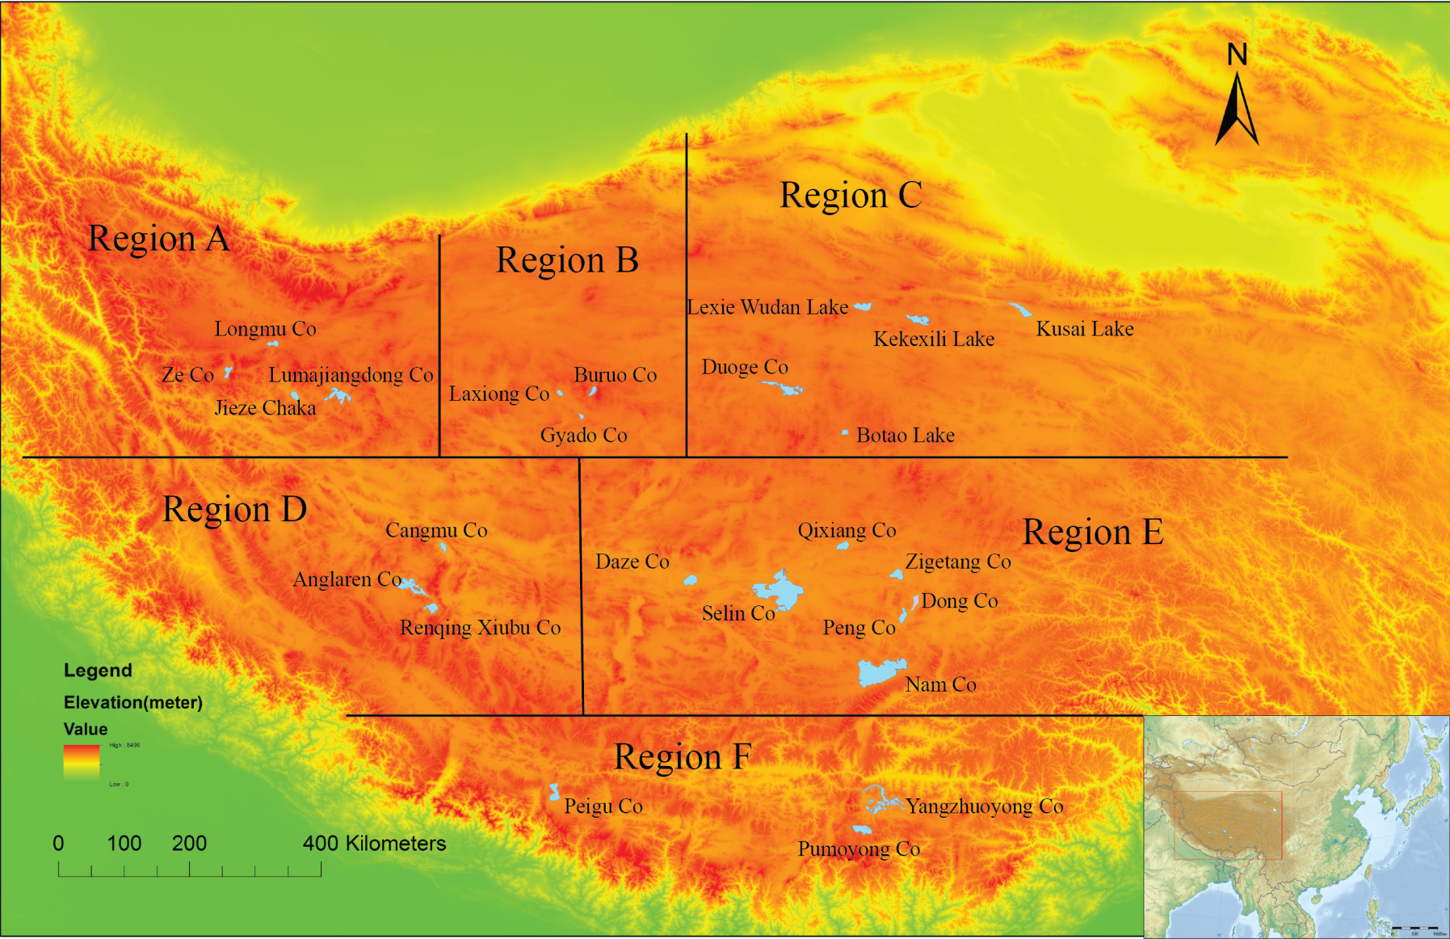
Figure 3-1 The location of the 26 selected lakes in the Tibetan Plateau. The 26 lakes are divided into 6 sub-regions according to their geographical locations
geographical locations, spatial clusters, and district boundaries, the 26 lakes are divided into six sub-regions with three to seven lakes in each sub-region.

3.5.1 Sub-Region A
Sub-egion A is the northwestern part of the Tibetan Plateau, generally a cold and arid area. Four major lakes within this region listed below have been chosen to illustrate the lake area and elevation changes during the past four decades. All four lakes are located in Ritu County, the northern part of Ali District, Tibet:
Jieze Chaka is an inland saline lake with an area of 108 km², length of 16.1 km and average width of 6.68 km. The size of the drainage area of Jieze Chaka is about 22 times of the lake area. Jieze Chaka is mainly fed by four rivers flowing into the northwestern part of the lake. The Jieze Chaka drainage area is in a typical Kunlun mountain-tundra desert climate regime. The annual average temperature ranges from -4.0 °C to -2.0 °C, while the average annual precipitation is around 75 mm (Wang & Dou, 1998).
Longmu Co has a surface area of around 100 km², and average depth of approximate 1 m. The size of the drainage basin of Longmu Co is about 570 km². With surface elevation of 5004 m, which is much higher than that of Jieze Chaka, the Longmu Co drainage area is extremely cold and arid. The annual average temperature of this drainage is around -8.0 °C, while the average annual precipitation is between 70 and 100 mm. Due to its high elevation, low precipitation, and small recharge coefficient (the ratio between lake area and drainage basin area), there is no surface inflow into this lake. It is mainly fed by underground water (Wang & Dou, 1998).
Lumajiangdong Co is the largest inland lake in this sub-region, with the surface area of around 370 km²; the lake drainage area is 9030 km². Lumajiangdong Co shares the similar climate regime with Jieze Chaka. The annual average temperature of this lake ranges from -4 to -2°C while the average annual precipitation is around 75 mm. Lumajiangdong Co is fed by two categories of water sources: the surface flow which enters the southeastern part of this lake, and the underground flow generated from snow melting (Wang & Dou, 1998).
Ze Co, with an area of 114 km², is located in an intermountain basin on south slope of the Karakoram Range. The annual average temperature of this lake is between -6 and -4 °C, while the average annual precipitation ranges from 50 to 75 mm. Surrounded by high mountains, glacier and snow cover are widely distributed in this area. The lake drainage area is around 1363 km², and around 10% of the drainage area is covered by glaciers and snow (Wang & Dou, 1998).

3.5.2 Sub-Region B
Sub-region B is defined as Nima County, western Naqu District, Tibet. The lakes within this region are mostly <100 km². Three lakes: Buruo Co, Laxiong Co, and Gyado Co have been selected; the drainages of these three lakes are adjacent to each other, sharing the similar climate regime and topography.
Buruo Co borders Purog Kangri Mountain (6436 m) and Zangse Gangri Mountain (6440 m) to the west and east, respectively, which makes its shore steeper than other lakes. The lake elevation is more than 5100 m and the surface area is around 90 km², while the lake drainage area is 550.5 km². The Buruo Co drainage is a typical mountain semi-arid steppe climate regime, with the annual average temperature between -6 and -4°C, and the average annual precipitation of around 200-300 mm (Wang & Dou, 1998).
The northern and southern parts of Gyado Co are connected with desert, while the eastern and western parts are mountains with relative relief between 200 and 500 m. The lake surface area is around 39 km², and the lake drainage area is 624 km². The annual average temperature of Gyado Co is similar to that of Buruo Co; however, Gyado Co is much drier, the average annual precipitation is between 100-150 mm (Wang & Dou, 1998).
Laxiong Co is surrounded by sandy saline-alkali ground from three sides, with exception of the western side, which are mountains. The lake surface area is around 58 km², and the lake drainage area is 670 km². Laxiong Co posses the similar annual average temperature and precipitation with Gyado Co as these two lakes are adjacent to each other and with similar surface elevation: 4885 and 4880 m, respectively (Wang & Dou, 1998).

3.5.3 Sub-Region C
Sub-region C is the northeastern Tibetan Plateau, which mainly includes the southwestern part of Qinghai Province. Duoge Co, although located in the northern Bange County, Naqu District, Tibet, is still included in this sub-region as its drainage covers the border between Tibet and Qinghai Province.
Botao Lake is located in Geermu, Qinghai Province, within an intermountain basin on the east part of the Qiangtang Plateau. This lake is surrounded by several high mountains with the elevation ranging from 5600 – 6500 m. The surface area of Botao Lake is around 71 km², while the size of the drainage basin is about 1860 km² and the lake surface elevation is about 5000 m. The Botao Co drainage area is cold and arid. The annual average temperature of this lake is around -6.0 °C, while the average annual precipitation is approximately 200 mm (Wang & Dou, 1998).
Duoge Co is located in the graben basin between two mountains. The surface area of Duoge Co is around 469 km², while the size of the drainage basin is about 6230 km². The Duoge Co drainage area shares the similar climate regime with the Botao Lake. Snow and glacier meltwater from the surrounding mountains is the major water source of this lake. There are 32 rivers and 60 springs within the drainage basin, and these rivers and springs are the major water sources of this lake (Wang & Dou, 1998).
Keke Xili Lake is located in Yushu, Qinghai Province. Similar to Duoge Co, the Keke Xili Lake is also located in the graben basin between two mountains: Kunlun Shan and Keke Xili Mountain. The surface area of this lake is 314 km², and its drainage basin area is 1570 km². Its drainage is still characterized as the mountain semi-arid steppe zone with annual average precipitation of 150-200 mm and annual average temperature of -4.0~-2.0 °C. Two rivers fed by glacier melting within its basin are the major water sources for Keke Xili Lake (Wang & Dou, 1998).
Kusai Lake is located in Yushu, Qinghai Province. The surface area of Kusai Lake is around 263 km² and the size of the drainage basin is about 3700 km². Among the 26 lakes, Kusai Lake is the eastern most one, with the annual average temperature of 0~2.0°C and annual average precipitation of 100~150 mm. Kusai River, which originates from Kunlun Shan is the major inflow water source for this lake. Several seasonal rivers also enter Kusai Lake (Wang & Dou, 1998).
Lexie Wudan Lake is located in Yushu, Qinghai Province. Similar to the Keke Xili Lake, the Lexie Wudan Lake also lies in the graben basin between Kunlun Shan and Keke Xili Mountain. This lake has a surface area of 237 km² and drainage basin size of 16,870 km². The climatic characteristic of its drainage is exactly like that of Keke Xili Lake. Lexie Wudan Lake is mainly fed by glacier/snow melting and springs within the drainage (Wang & Dou, 1998).

3.5.4 Sub-Region D
Sub-region D is defined as the southwestern Tibetan Plateau and includes the bordering area between the southern Ali District and northwestern Rikaze District. Three lakes are located within this area. Due to their short distances from each other, their climate conditions are also similar. Annual average temperatures of the three drainages are around 0~2°C and the annual average precipitations range from 100 to 150 mm (Wang & Dou, 1998).
Cangmu Co is located in Gaize County, Southern Ali District, Tibet. The lake surface area is around 97 km² and the drainage area is 2420 km². The maximum depth of this lake is around 6.3 m. Cangmu Co is mainly fed by two rivers which enter the southeast of the lake, and these two rivers have abundant glaciers and snow distribution in their headwaters (Wang & Dou, 1998).
Anglaren Co and Renqing Xiubu Co are both located in Longgeer County, the border between Southern Ali and Northern Rikaze District, Tibet. The two lakes lie in the graben basin of the north slope of Gandise Range, and the surface areas of the two lakes are 483 and 186 km², respectively. Both Anglaren Co and Renqing Xiubu Co are mainly fed by rivers originated from mountains in Gandise Range, and glacier/snow melting is the major water source for these two lakes (Wang & Dou, 1998).

3.5.5 Sub-Region E
Sub-region E is the central Tibetan Plateau, where several major Tibetan lakes are located, including Selin Co and Nam Co, the two largest lakes in Tibet. This region is generally defined as the southern part of Naqu District, Tibet. Seven lakes in this region have been selected to investigate their changing patterns.
Selin Co is currently the largest lake in Tibet, with a lake surface area of 2329 km² in 2010, followed by Nam Co, whose surface area was 2020 km² in 2009. The area of Selin Co drainage is 42,194 km² and the recharge coefficient of this lake is 18.1. The climate of the Selin Co drainage can be characterized as cold and arid (annual average temperature and precipitation are -0.3°C and 291 mm, respectively). Most of the precipitation occurs in summer, during June and September, accounting for 90% of the total precipitation. Selin Co is mainly fed by four major rivers, among which Zhajia Zangbu River, which originates from the Tangula Range, is the longest inland river in Tibet (Wang & Dou, 1998).
Compared with Selin Co, the drainage area of Nam Co is much smaller and has a recharge coefficient of only 4.4. The Nyainqentanghla Range, along the southeast shore of Nam Co, has a relative relief of 500~1500 m. This mountain range blocks a significant amount of moistures coming along the Indian Monsoon. As a result, the climate regime of the Nam Co drainage is between semi-humid and semi-arid. On the southern side of Nyainqentanghla Range, annual precipitation can reach as high as 487 mm, while on the northern side, the precipitation reduces to 300 mm. The annual average temperature of the Nam Co drainage is around -1.2 °C ~ 1.3°C (Wang & Dou, 1998).
Peng Co, Dong Co and Zigetang Co are all located in Anduo County, Naqu District, Tibet. These three lakes share the similar climate pattern. Annual precipitation of these lake drainages ranges from 300 to 400 mm, while the annual average temperatures are between -2 ~ -4°C. Zigetang Co, with the surface area of 212 km² is located on the intermountain basin of the south slope of the Tangula Range. There are hundreds of thermal springs along the west shore of Zigetang Co, which are important water sources for this lake. Both Peng Co and Dong Co lie on the intermountain basin of Nyainqentanghla Range, and saline-alkali soil is widely distributed within their basins (Wang & Dou, 1998).
Qixiang Co, similar to Zigetang Co, is located in Bange County and lies on the intermountain basin of the south slope of the Tangula Range. With the surface area of 177 km² and drainage area of 2,639 km², this lake is fed by both surface runoff and fountains along the shoreline of the lake (Wang & Dou, 1998).
Daze Co is the west most lake in this sub-region, and its climate regime is slightly different from the others. The annual average temperature is between 0 and 2 °C, while annual precipitation, as low as 200 mm, is much less than the other drainages in this sub-region. The surface area of Daze Co is 248 km², and its drainage area is 10,885 km², which makes the recharge coefficient of this lake >40. Daze Co is mainly fed by two rivers: Bocang Zangbu River and Naruoqu River (Wang & Dou, 1998).

3.5.6 Region F
Sub-region F includes the Shannan District and Rikaze District, Tibet, and can be generally defined as the southern Tibetan Plateau. Four lakes have been selected as sample lakes for this research. All four lakes lie on the intermountain basins of the north slope of the Himalayas; as a result, they are influenced by the humid and warm wind from the Indian Ocean and share similar climate conditions. The annual average temperature ranges from 2 to 6 °C and the annual precipitation between 300~400 mm (Wang & Dou, 1998).
Yangzhuoyong Co, Chen Co, and Pumoyong Co are all located in Langkazi County, Shannan District. Yangzhuoyong Co, 9 km to the north of Brahmaputra River, is the largest lake in this region, with the surface area of approximate 595 km² and drainage area of 5,422 km². This lake is mainly fed by six major inflow rivers. Chen Co is 4 km away from Yangzhuoyong Co, and with the lake surface area of only 40 km², it is mainly fed by Kalu Xiongqu River. Pumoyong Co, the second largest lake in this region, is an inland freshwater lake, connected with Yangzhuoyong Co through a river. Peigu Co is relatively far away from those three lakes and is located in Ricaze District, Tibet. The lake surface area and drainage area of Peigu Co are 274 km² and 1,980 km², respectively. As all these lakes lie in the graben basins of the Himalayas (Wang & Dou, 1998).

CHAPTER 4

METHODOLOGY
In this study, remote sensing data are used as the major data source to extract lake surface area and elevation. Figure 4-1 illustrates the procedures to process the multi-sources remote sensing data. A lake boundary extraction model, a consistency check model, and a GLAS calculation tool are developed using Python script and ArcGIS 10 to extract lake area and elevation datasets.
The lake boundary extraction model is used to process the Landsat images, and the output dataset is the initial surface area and lake boundaries for 26 lakes during the 1970s-2010. Then the consistency model is employed to check the consistency of the multi-date lake boundaries, and the inconsistency index can be calculated for each boundary. After this procedure, for those boundaries with high inconsistency indices, visual comparison with the multi-band composited Landsat images is conducted to manually revise and eliminate the misclassifications. After that, the multi-temporal surface area and lake boundary dataset for each lake are generated.
The lake elevation dataset is extracted from ICESat/GLAS. GLAS to Shapefile tool is used to convert the original GLAS text format file to an ArcGIS Shapefile. The GLAS dataset provides global elevation data from 2003 to 2009. As the lake area dataset can be achieved from the previous procedure, by intersecting the GLAS dataset with the lake area dataset, the lake elevation change dataset during 2003-2009 can be obtained. After the lake area dataset during the 1970s-2010 and lake elevation dataset during 2003-2009 are established for each lake, the changing patterns of these lakes can be identified and the spatial and temporal differences of lake change patterns can be presented.
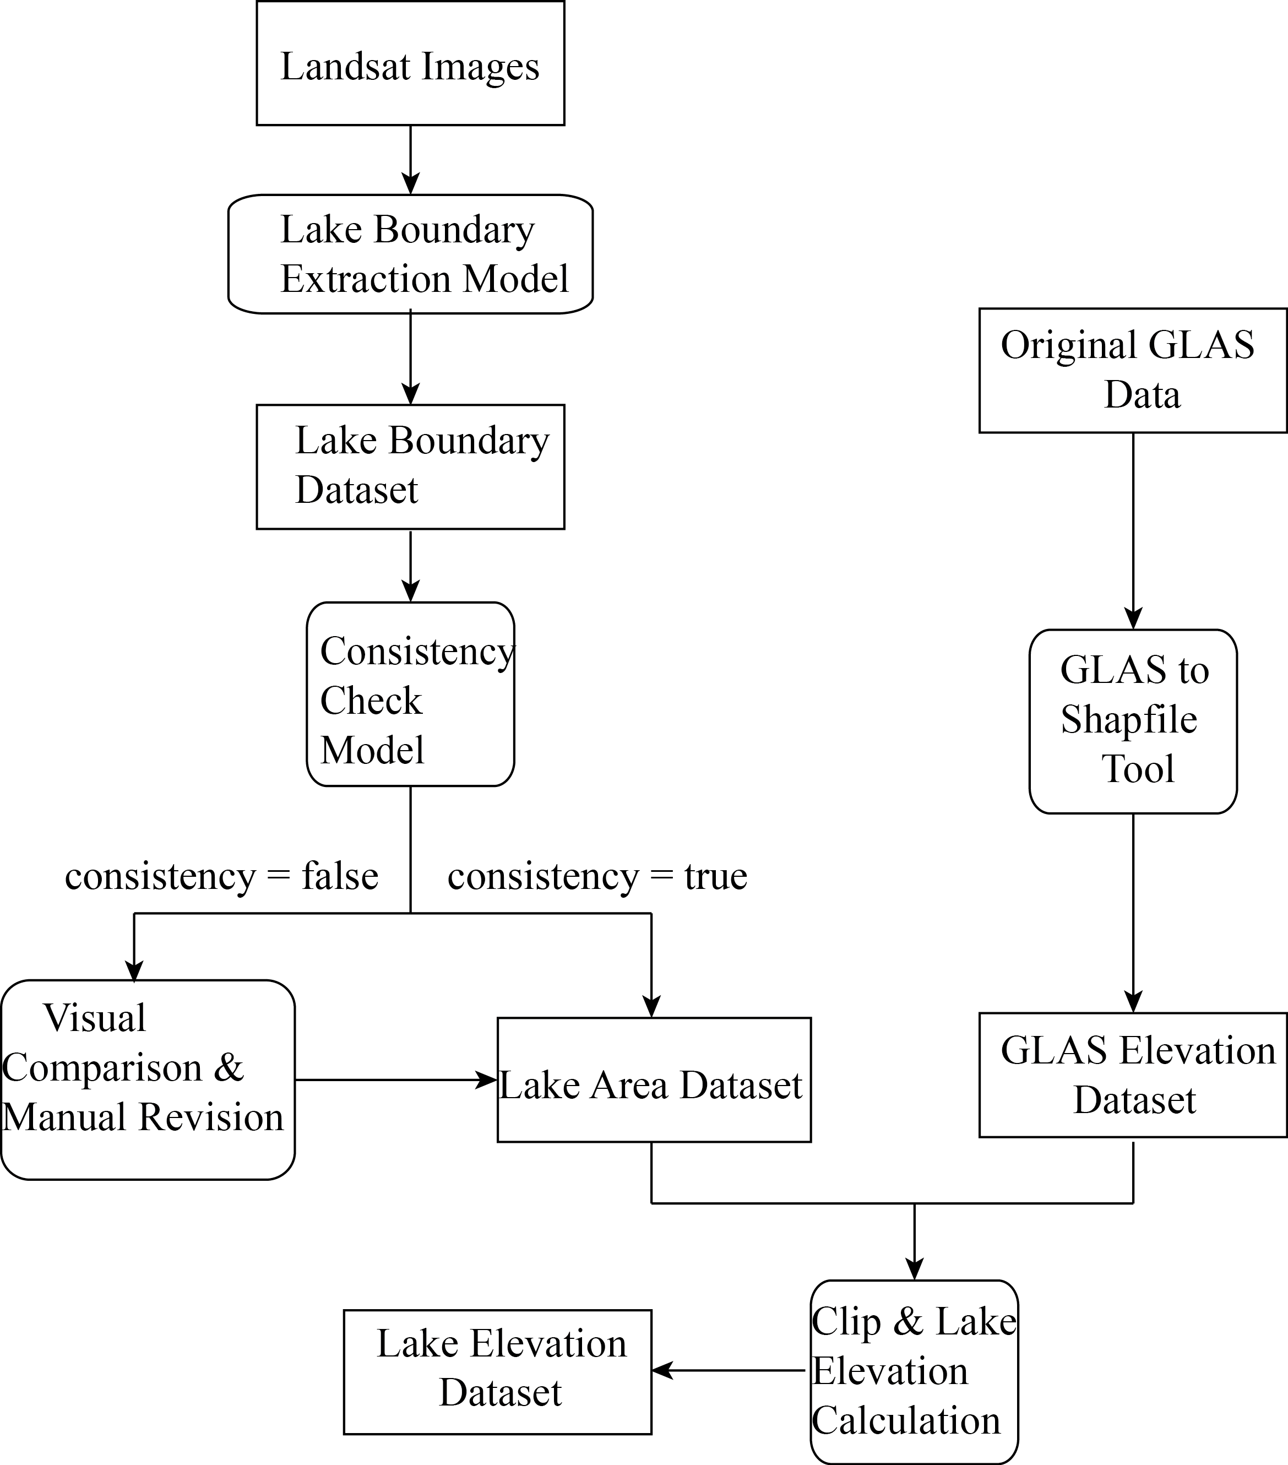
Figure 4-1 The flowchart for lake surface area and elevation extraction. The outputs of the work flow are two datasets: lake area dataset and lake elevation dataset. The lake elevation extraction is based on the extracted lake area dataset.

4.1 Data Sources

4.1.1 Lake Area Data
Landsat images are used as the main data source to extract lake surface areas. The Landsat project is a jointed mission of the U.S. Geological Survey (USGS) and the National Aeronautics and Space Administration (NASA). The Landsat satellites have been continuously providing images of Earth surface since 1972, when Landsat 1 was launched. Today, Landsat 5 (launched in 1984) and Landsat 7 (launched in 1999) are still working to provide hundreds of images of Earth surface each day. Different bands of the Landsat image can provide different information of the land surface. As a result, Landsat supports a wide range of applications in areas including agriculture, global climate change, land use/cover change, geology, ecology, hydrology, and geography.

Table 4-1 Spectral bands of MSS for Landsat and their applications in environmental research (from http://egsc.usgs.gov/isb/pubs/factsheets/fs02303.html)
Landsat 1, 2 & 3  Spectral Bands | Landsat 4 & 5  Spectral Bands | Use
Band 4 - green | Band 1 - green | Emphasizes sediment-laden water and delineates areas of shallow water.
Band 5 - red | Band 2 - red | Emphasizes cultural features.
Band 6 - near IR | Band 3 - near IR | Emphasizes vegetation boundary between land and water, and landforms.
Band 7 - near IR | Band 4 - near IR | Penetrates atmospheric haze best, emphasizes vegetation, boundary between land and water, and landforms.

Table 4-2 Spectral bands of TM/ETM+ for Landsat and their applications in environmental research (from http://egsc.usgs.gov/isb/pubs/factsheets/fs02303.html)
Spectral Bands |  | Use
1 | Blue-green | Useful for bathymetric mapping and distinguishing soil from vegetation and deciduous from coniferous vegetation.
2 | Green | Emphasizes peak vegetation, which is useful for assessing plant vigor.
3 | Red | Discriminates vegetation slopes.
4 | Reflected IR | Emphasizes biomass content and shorelines.
5 | Reflected IR | Discriminates moisture content of soil and vegetation; penetrates thin clouds.
6 | Thermal IR | Useful for thermal mapping and estimated soil moisture.
7 | Reflected IR | Useful for mapping hydrothermally altered rocks associated with mineral deposits.
8 | Panchromatic | Landsat 7(ETM+) carries a panchromatic band (visible through near infrared) with 15m resolution for "sharpening" of multispectral images.

The primary sensor onboard Landsat 1, 2, and 3 was the Multispectral Scanner (MSS), with an resolution of approximately 80 meters in four spectral bands ranging from the visible green to the near-infrared (IR) wavelengths (Table 4-1). The improved Thematic Mapper (TM) sensors onboard Landsat 4 and 5 were designed with several additional bands in the shortwave infrared (SWIR) spectrum (Table 4-2). The spatial resolution of TM images is 30 m except 120 m for the thermal-IR band (Band 6). Landsat 7 carries the Enhanced Thematic Mapper Plus (ETM+), with 30-m visible and IR bands, 60-m thermal band, and a 15-m panchromatic band. According to the information provided by Table 4-1 and Table 4-2, the near/ reflected IR bands can be used for shoreline extraction. USGS released all Landsat data to the general public through the USGS Global Visualization Viewer. The revisit time of Landsat is 16-18 days; about 15-40 images for each lake could be obtained for this study due to data quality issues caused by cloud cover and sensor response error.

4.1.2 Lake Elevation Data
The mission of ICESat (Ice, Cloud, and land Elevation Satellite) is designed primarily for measuring ice sheet mass balance in the Polar Regions. GLAS (the Geoscience Laser Altimeter System), launched aboard ICESat in 2003, provided global surface elevation data during 2003-2009, with three to four datasets each year (Schutz et al. 2005). GLAS includes laser altimeters operating at visible (532 nm, for the vertical distribution of clouds and aerosols) and near-infrared (1064 nm, for surface altimetry) wavelengths. Although the primary focus of GLAS is to measure ice-sheet topography and associated temporal changes, cloud and atmospheric properties, GLAS measurements have also been used in studying land topography, hydrology, and vegetation canopy heights, as operation of GLAS over land and water will provide along-track topography. The vertical accuracy of the GLAS data can reach decimeter level for relatively flat surfaces (Schutz et al., 2005; Carabajal & Harding, 2005), making it possible to be applied to monitor lake level changes in the Tibetan Plateau. The ICESat data are distributed by the National Snow and Ice Data Center (NSIDC). In this study, the ICESat/GLAS level 2 altimetry product (GLA14 Release-31) is used as the main data source to extract lake surface elevations.

4.2 Lake Surface Area Extraction

4.2.1 Lake Boundary Extraction
The water body extraction is based on the difference in spectral signature between water body and land in the near infrared wavelengths. Most radiation in band 6 for Landsat MSS and band 4 for Landsat TM/ETM+ images is absorbed by water. Therefore, water body in these bands has much lower reflection values (generally 5-50) than those of land surface. Thus, lake-boundary can be extracted using an optimal threshold value to separate water and land. Previous studies usually use an empirical value as the threshold for all the images. However, different lakes may have different water properties and the seasonal change can also influence the water property. Therefore, in response to water property change, the reflection values of different lakes or lakes in different seasons are different. Thus, the optimal threshold values for different images are different, and the classification based on a single empirical value for all images is not accurate enough, and may cause some misclassifications. In this study, a lake boundary extraction model (Figure 4-2) is developed to automatically determine the optimal threshold value for each image based on searching and testing a range of threshold values, and to extract the lake boundary/area using the selected optimal threshold value.
Most Tibetan lakes are surrounded by grassland and bare land, while some are connected to marshes. To acquire the optimal threshold value for lake-boundary extraction, a program is developed to examine a list of potential threshold values. After image reclassifications, a list of lake areas can be generated corresponding to different threshold values. As illustrated in Figure 4-3 (A), the extracted area increases continuously with increased threshold values. The lake area growth rate (ΔA_{k}) for a specific value is the increased lake surface area when using k as threshold compared with the extracted lake surface area using (k-1) as threshold. It’s defined as

ΔA_{k} = (A_{k} - A_{k-1})/1 (1)

where ΔA_{k} is the lake growth rate (km² per unit threshold value change), A_{k} is the lake surface area (km²) when the threshold value is k, and A_{k-1} is the lake surface area (km²) when the threshold value is k-1. The extracted area increases rapidly when the threshold value is small; as the value approaches the real threshold between the lake and the marsh/moist soil, the area growth rate will continuously decrease until it meets the minimum growth rate, and the lake area will stay stable. During this stage, most lake pixels have already been classified as lake except some pixels with shallow water, especially along the shoreline of the lake (Figure 4-3 (B)). When the value exceeds the true threshold between the lake and the marsh/moist soil, some marsh/moist soil will be misclassified as the lake (Figure 4-3 (B)), and the lake growth rate will significantly increase again (Figure 4-3 (A)). As the threshold value continuously increases, approaching the reflection value of the land, the growth rate will increase tremendously
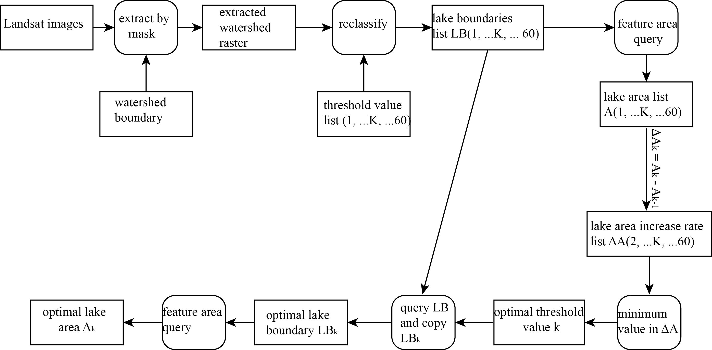
Figure 4-2 The lake boundary extraction model. The input of this model is Landsat images, and the output is the optimal threshold value to extract lake and the extracted lake boundary.

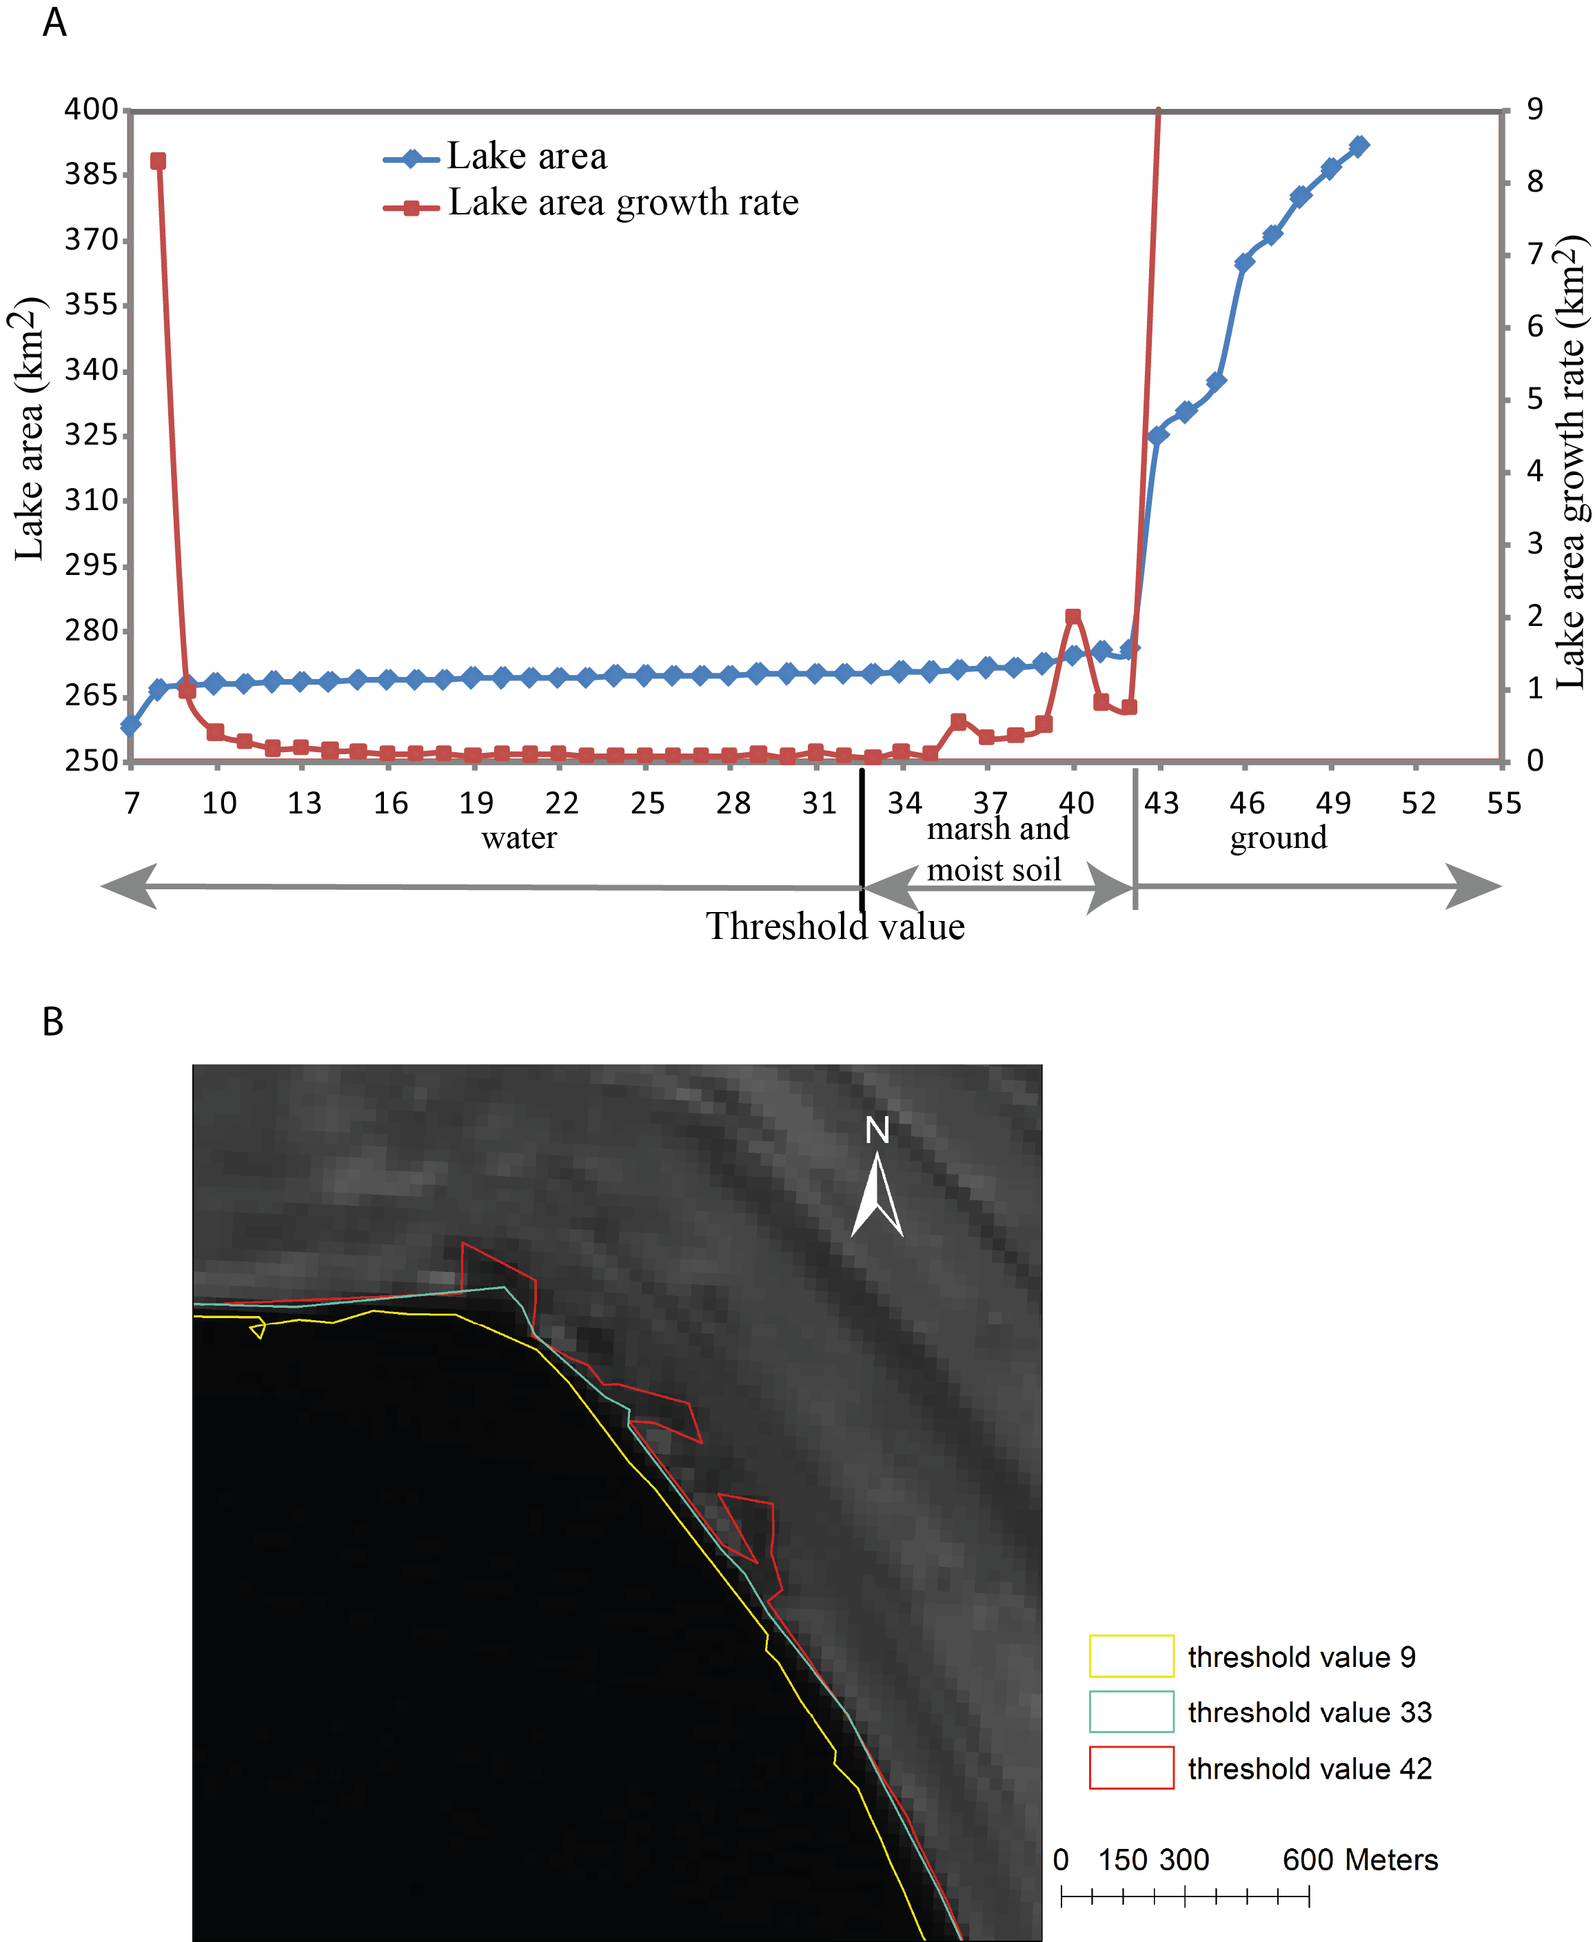

Figure 4-3 The extracted lake area, lake area growth rate, and lake boundaries of Peigu Co (10/22/2009) using different threshold values: (A) response of lake area and growth rate to threshold values. The blue points indicate extracted lake areas according to different threshold values; and the red points indicate the lake area growth rate for each threshold value. (B) The extracted lake boundaries in response to different threshold values. The boundary extracted from threshold value of 33 matches the best with the Landsat image.

because the land is started to be misclassified as the lake. Therefore, the value with the minimum growth rate will be chosen as the optimal threshold value to distinguish water body (lake) and non-water features.

4.2.2 Consistency Check of Multi-temporal Lake Boundaries
Even though the optimal threshold value is applied to extract the lake boundary, misclassifications may still exist among the boundaries extracted by the lake boundary extraction model due to the image quality and complication of landforms. Factors such as cloud cover, mountain shade, and inflow seasonal channels could affect the lake boundary extraction. The portion of lake covered by cloud would be misclassified as ground, while the mountain and cloud shades be classified as lakes; some inflow seasonal channels might be classified as parts of lakes in summer and fall, while the surface runoff of these channels almost disappears in winter and early spring. All these factors influence the accuracy of the classification, and misclassifications caused by these factors need to be detected and eliminated. As there are approximately 600 lake boundaries in the lake boundary dataset, it would be time consuming to check each boundary with initial imagery. An efficient way to detect the potentially misclassified boundaries is required. If the multi-temporal lake boundaries are correctly classified, different parts of the boundary of a specific lake should fluctuate simultaneously in terms of expansion/shrinkage within a certain period. However, the portions of the boundary affected by those factors mentioned above may cause the inconsistency of the lake expansion/shrinkage with other parts. For example, the portion affected by cloud cover may show apparent shrinkage compared to the lake boundary in another time slice, whereas other parts of the boundary show expansion. In this study, a consistency check model is designed to check the consistency of lake boundaries to identify potential misclassified boundaries caused by cloud cover, inflow channels, and/or snow and ice patches.
The workflow of the consistency check model is illustrated in Figure 4-4. The principle of the consistency check model is based on the assumption that the lake expansion/shrinkage should be consistent across different sections of the lake boundary within a short period. Therefore, if the extracted lake areas are correct, the intersection of two lake polygons in different time slices should be equal to the lake polygon that has a smaller area. The Figure 4-5 shows the examples of both consistent and inconsistent boundaries of Peng Co. In Figure 4-5(A), the lake boundary of 1999 is totally within the boundary of 2009, which indicates that the lake experienced expansion during these 10 years, and the two boundaries are consistent with each other. On the other hand, the lake boundaries of 1972 and 1999 are not consistent (Figure 4-5 (B)). For most parts of the lake, the boundary expanded during these 27 years except the northwestern corner of the lake. The lake boundary of 1972 intersects the extent of 1999 boundary in this area, indicating that either or both of the two boundaries are misclassified.
Based on the assumption that the lake expansion/shrinkage should be consistent across different parts of the lake within a short period, the following equation (1) is used to check the consistency of extracted lake boundaries from different time slices:

Intersection area (A_{x}, A_{y}) = min (A_{x}, A_{y}) (2)

where A_{x} and A_{y} are the lake surface areas at two time slices of x and y. The consistency check model compares each extracted lake boundary with all other boundaries to determine whether inconsistency exists; the number of inconsistency related to this lake boundary is counted as an error index. The lake boundary with highest error index is more likely to be misclassified and requires additional manual modification. Then, this boundary will be removed from the list, and the consistency check model will be applied to the rest of boundaries to find the next boundary with the highest error index. This procedure will be repeated until the error index for each of the remaining boundaries is 0. After the consistency check, a list of boundaries ranked by their error index can be generated. These boundaries are identified as potential misclassified boundaries. Afterward, these detected boundaries are visually compared with the multiple bands composited Landsat images to check whether cloud cover or inflow channels cause misclassifications. After the visual comparison, manual revision is conducted in ArcGIS 10 to eliminate these misclassifications.
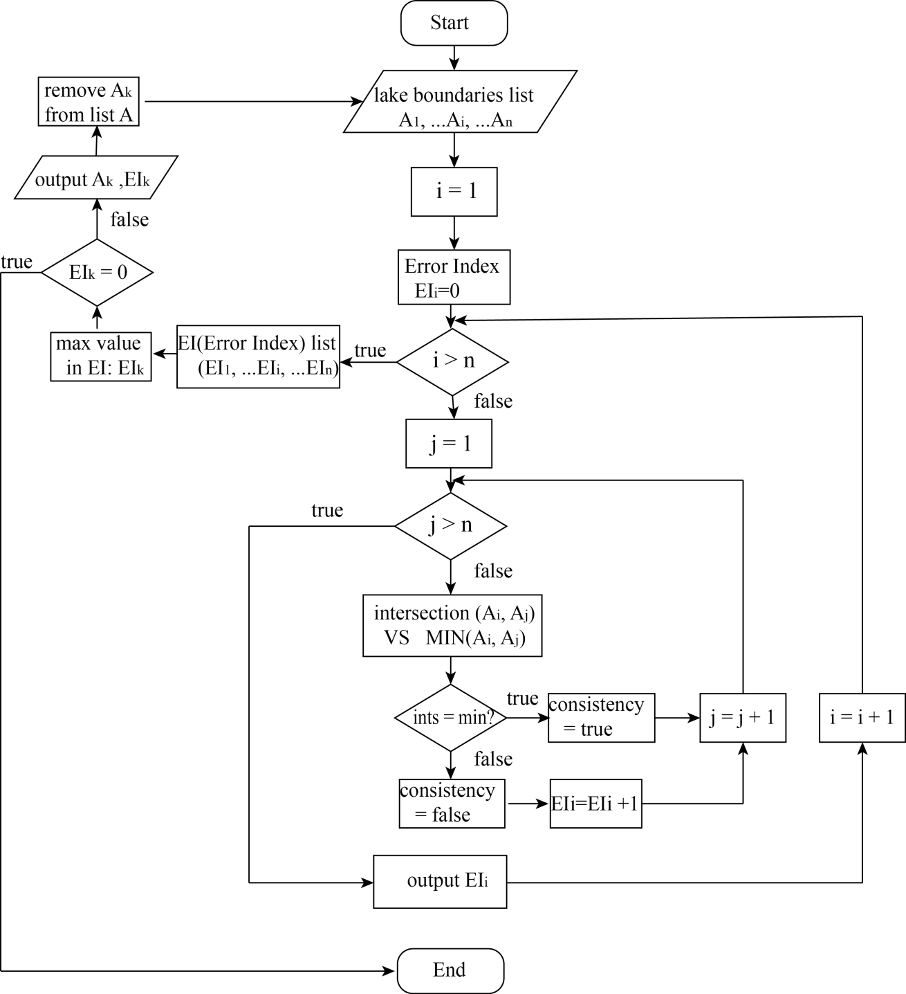
Figure 4-4 The workflow of lake boundary consistency check model.
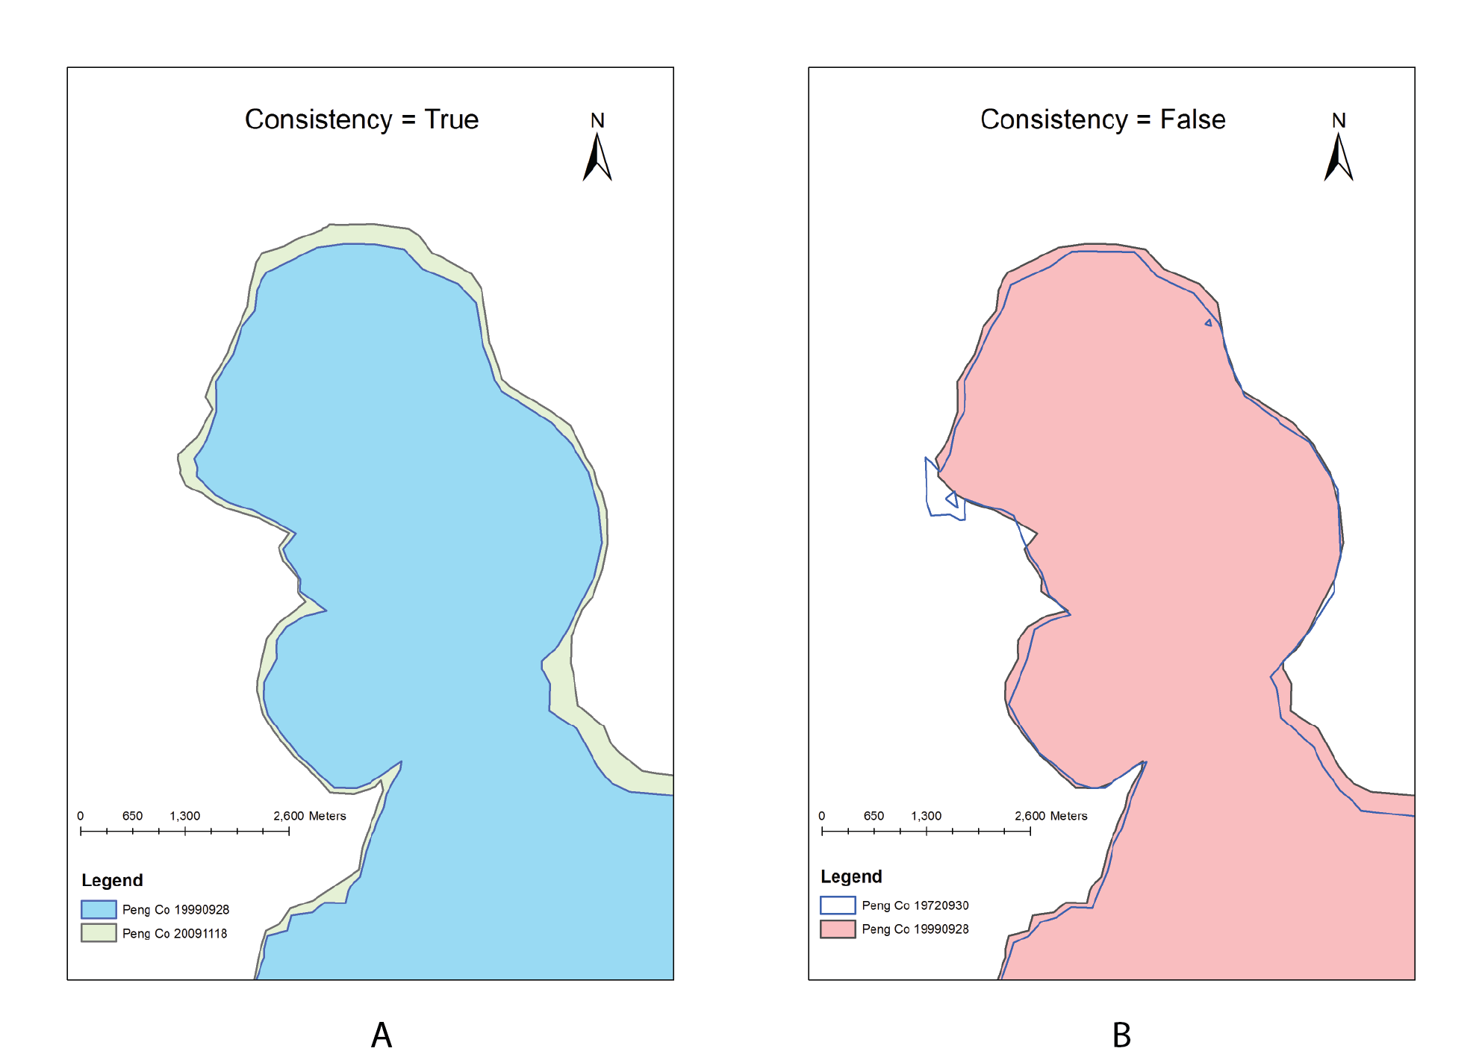
Figure 4-5 Example of consistency check result, Peng Co: (A) the consistency check result is true for Peng Co in 09/28/1999 and 11/18/2009 because the boundary of 09/28/1999 is totally within that of 2009-11-18. (B) The consistency check result of the lake boundaries in 09/30/1972 and 09/28/1999 is false because some parts (southeast) of the lake expanded while some parts (west) shrank.

4.2.3 Accuracy Assessment of the Extracted Lake Surface Area
The accuracy of extracted lake boundary is affected by the image resolutions. In this study, high resolution Google Earth images are used to evaluate the accuracy of the extracted lake boundary. Landsat MSS/TM images are with the resolution of 80 m and 30 m, respectively, whereas Google Earth images have higher resolution; for some regions, the resolution can reach 1 m. As investigating the lake area change is the major objective of this study and the lake surface area is relatively easier to quantify, the percentage error in lake surface area was used as the parameter to assess the accuracy of the extracted lake boundary. The percentage error in area estimation can be calculated as E_{a} = |A - A_{ge}| / A_{ge}×100%, where A is the model-extracted lake area, A_{ge} is the lake area digitized from Google Earth images. The Google Earth images are composed of satellite images taken in different times, and this is especially true for some large lakes; those lakes are mosaics of multi-temporal images. In order to accurately assess the extracted lake surface area, I chose small lake which is located within the coverage of a single satellite image. The date of the Google Earth image should also be close to that of the Landsat image. After some filtering, three lakes, Laxiong Co, Jieze Chaka, and Daze Co are chosen, and the lake areas derived from manually digitized Google Earth images are compared with the model-extracted lake areas of the similar time slice to assess the accuracy of the extracted lake surface area (Figure 4-6).
Table 4-3 illustrates the comparison between the model derived and Google Earth digitized surface areas of the three lakes. For Laxiong Co, the smallest lake among the three, the Google Earth image of June 3rd 2009 is compared with the Landsat image of Jun 23rd 2009. After the boundary delineation and lake surface area calculation, the percentage error between the areas of these two boundaries is 0.80%. The Google Earth image used for the lake boundary delineation of Jieze Chaka is Sept. 6th 2009, while the Landsat image of Oct 2nd 2009 is used for the lake boundary extraction model. The percentage error between the areas of these two boundaries is 0.59%. For Daze Co, the largest lake among the three, the percentage error is 0.28%, much lower than those of Laxiong Co and Jieze Chaka. According to the accuracy check results of those three lakes, the percentage error in lake surface area might be associated with lake sizes, and larger lakes seem to have smaller percentage errors. Laxiong Co is the third smallest lake among all selected lakes, and its percentage error in lake surface area is 0.80%, much larger than those of the other two lakes.

Table 4-3 Accuracy check results using Google Earth high resolution images for Laxiong Co, Jieze Chaka, and Daze Co.
Lake Name | Google Earth |  | Lake Boundary Extraction Model |  | Percentage Error
Lake Name | Image date | Lake area (km²) | Image date | Lake area (km²) | Percentage Error
Laxiong Co | 6/3/09 | 61.96 | 6/23/09 | 61.46 | 0.80%
Jieze Chaka | 9/6/09 | 110.92 | 10/2/09 | 111.57 | 0.59%
Daze Co | 8/27/09 | 290.18 | 8/28/09 | 289.37 | 0.28%
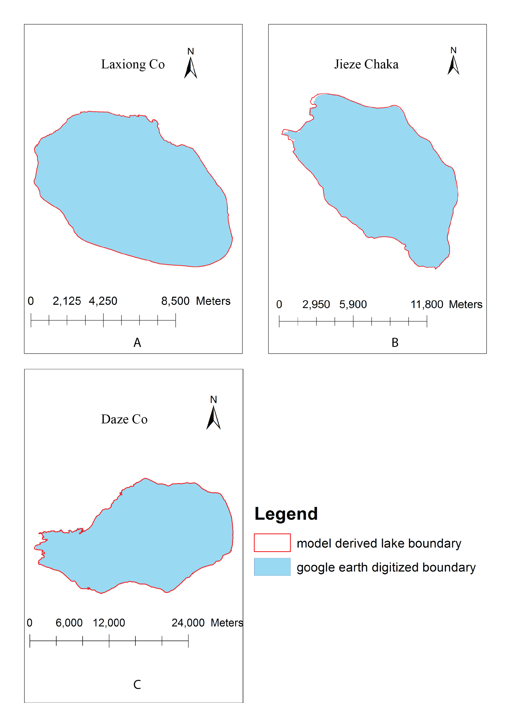 Figure 4-6 Model derived lake boundaries and Google Earth digitized lake boundaries for Laxiong Co (A), Jieze Chaka (B), and Daze Co (C). The red solid line represents the lake boundary extracted by the model and the blue area is the lake boundary delineated from Google Earth.

4.3 Lake Elevation Extraction
The ICESat/GLAS is the major dataset used in this section. As the GLAS data are distributed in form of text file, a GLAS to Shapefile tool is developed to convert the original text file into a point ArcGIS shapefile. First, the map projection system needs to be defined: the GLAS elevations are referenced to the Topex/Poseidon ellipsoid and EGM96 Geoid (Zhang et al., 2011). After defining the projection system, each record of the original GLAS file is added to the shapefile as a point. The GLAS files provide the complete information for each record including path number, date, time, latitude, longitude, ICESat_elevation_measured, and ICESat_geoid. Using these parameters, the GLAS elevation for a specific location can be calculated as:

ICESat_elevation = ICESat_elevation_measured - ICESat_geoid (3)

After converting the original GLAS data to ArcGIS shapefiles, the lake elevation can be extracted and calculated using ArcGIS tools. The lake elevation extraction is based on extracted lake boundaries. After extracting lake boundaries from Landsat images, the GLAS points which fall within the lake boundaries are extracted from the GLAS dataset (Figure 4-1). Then, statistical analysis is applied to examine the mean, range, and the standard deviation of all the footprints within a lake boundary. As the accuracy of GLAS data is around 10 cm in flat surfaces, the extreme high standard deviation is potentially caused by some outlier points, and these outliers should be removed. This procedure is repeated several times until the standard deviation is reduced to a reasonable level. After removing the outliers, the lake elevation at a particular time can be calculated by averaging all the remaining GLAS points. As the ICESat/GLAS provided global land elevation data during 2003-2009, the lake elevation change trend during these 7 years can be obtained.

4.4 Spatial and Temporal Patterns of Lake Changes
This study focuses on 26 lakes selected from six sub-regions across the Tibetan Plateau (Table3-1, Figure 3-1). The automated method discussed above is used to extract lake surface areas and elevations, and the final outputs are the lake area dataset (the 1970s-2010) and lake elevation dataset (2003-2009). After obtaining these datasets, the change patterns of the 26 lakes during different periods can be examined. The lake change patterns are compared and analyzed in two perspectives: temporal and spatial.
Firstly, the temporal changing patterns of different lakes are analyzed. The Tibetan Plateau experienced different climate change patterns during different decades, and inland lakes response sensitively to these changes. Therefore, the lake may experience different lake area/elevation changing patterns during different periods. According to previous studies, the Tibetan Plateau experienced obvious climatic “jumps” in the mid-1980s and the late 1990s; thus, the time range of lake change can be divided into three parts: pre-mid-1980s, the mid-1980s to the late1990s, and the late 1990s to 2010. Most Landsat images distribute during 1972-1976 and 1999-2010, so the lake changing information between the 1980s and the late 1990s is limited. By analyzing the lake change pattern during these time ranges, lake changes in response to climate change can be detected.
To obtain the spatial distribution of lake changes across the Tibetan Plateau, the lakes within the same sub-region are compared first to examine if they experienced similar changing patterns. Hypothetically, the lakes within the same sub-region should experience similar change patterns as they share a similar climatic regime and topographic conditions. Then, the lake change patterns of different sub-regions are compared to explore their similarities or differences. If spatial and temporal differences exist in different sub-regions, the potential causes for these differences will be analyzed by examining changes in climate variables and the distribution of glaciers and permafrost.

CHAPTER 5

RESULTS
By applying the lake area and elevation extraction models, two datasets, the lake area change during the1970s-2010 for 26 lakes and lake elevation change during 2003-2009 for 16 lakes with GLAS records, are obtained. According to the established two datasets, most lakes had expanded during these four decades, especially since the late 1990s, while the lakes in the southern parts had shrunk. Li et al. (2011) investigated eight typical inland lakes in the Tibetan Plateau and found that the lakes are with larger area in summer and fall; and the lake surface area fluctuation rate is < 2% within the same reason. Therefore, in this study, if the lake area change rate is within 2%, the lake was viewed as stable with regular fluctuation; however, lakes with change rates > 2% were considered to have experienced long-term expansion/shrinkage. The seasonal fluctuation is detected in some of the selected lakes, and it played minor role in influencing the long-term patterns of lake change. The lake elevation change during 2003-2009 is consistent with the lake surface area change during the same period. The change patterns of these lakes are illustrated below according to their locations.

5.1 Sub-Region A: the Northwestern Tibetan Plateau

5.1.1 Lake Area Change
Four lakes from the sub-region A, the northwestern Tibetan Plateau, experienced a similar pattern of change from the 1970s to 2010, according to the extracted datasets. As shown in Figure 5-1, lake areas were relatively stable with minor expansion before 1999 in all lakes except Ze Co. Ze Co experienced minor shrinkage within the 20 years. The exact lake changing patterns during the 1970s, 1980s and 1990s are still unknown due to the lack of Landsat data within these decades. After 1999, significant expansion occurred on all four lakes, ranging from 5% to 13% in 2010 compared to the lake area in the 1970s. Among these lakes, Lumajiangdong Co experienced the most significant expansion (13%). The seasonal change of these lakes can also be identified in Figure 5-1 after 1999, when the temporal resolution is high. The influence of seasonal fluctuations on general lake change patterns is minor compared with the rapid lake expansion. The expansions of these four lakes have continued through 2010 when the most recent images can be obtained.
Ze Co is the only one with available images during 1977-1998 (Figure 5-2), and it was stable during those 20 years. After 1999, like the other three lakes, Ze Co began to expand. As the other three lakes had no available data in 1998, and all these four lakes experienced similar change patterns after 1999, it is like that Jieze Chaka, Longmu Co, and Lumajiangdong Co were also stable before 1999, which is different from the trends shown in Figure 5-1 and 5-2. The potentially invalid conclusion is caused by limited data availability before 1999.

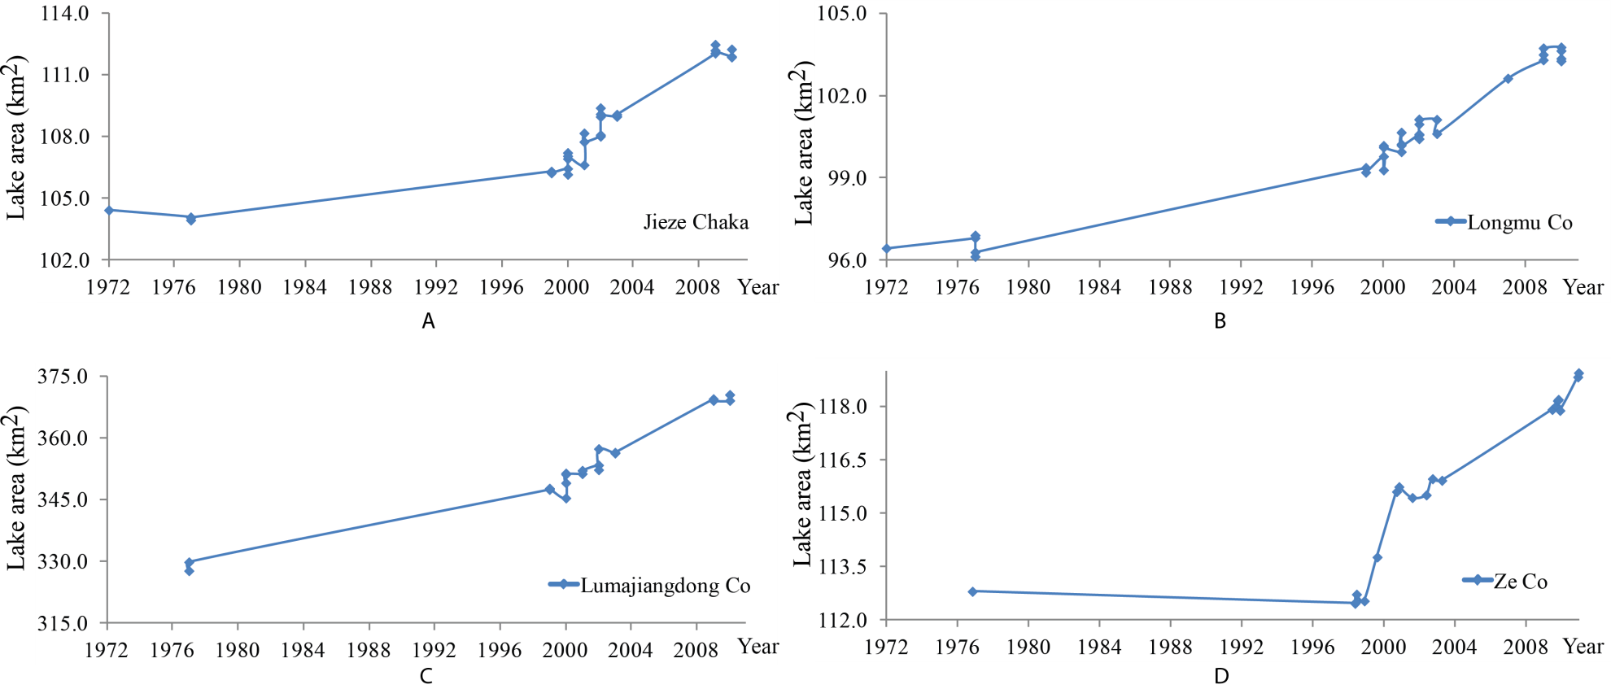
Figure 5-1 The surface area of lakes in the sub-region A during the 1970s-2010: (A) Jieze Chaka; (B) Longmu Co; (C) Lumajiangdong Co; and (D) Ze Co.
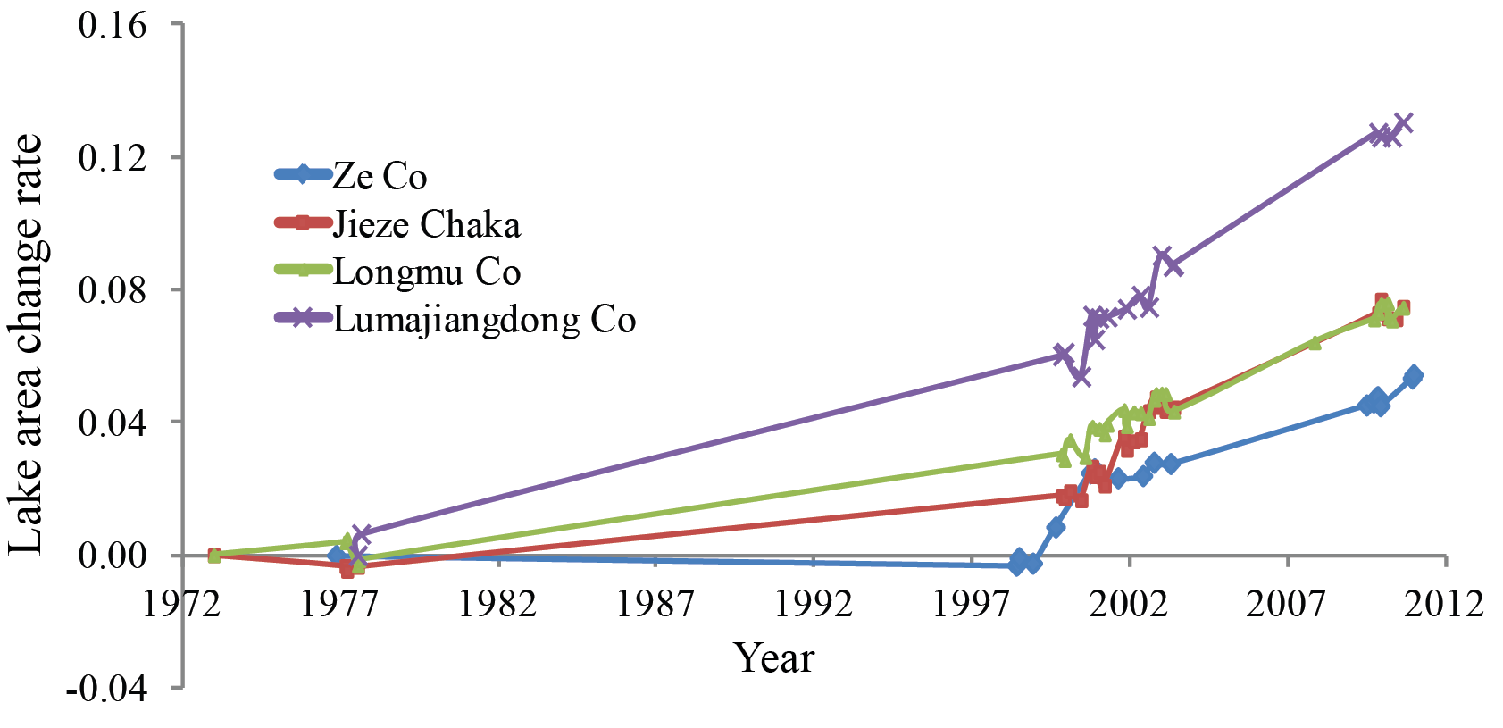Figure 5-2 The surface area change rate of lakes in the sub-region A during 1972-2010. The four lakes experienced a similar pattern of change during the whole period except 1977-1999, when the Ze Co was stable. This difference is potentially caused by the data availability of the other three lakes in 1998. It is likely that these four lakes were still stable before 1999, and began to expand after 1999.

5.1.2 Lake Elevation Change
Three lakes in this region have the GLAS record: Jieze Chaka, Lumajiangdong Co and Ze Co, and they shared similar pattern of lake elevation change during 2003-2009. Generally, all lakes experienced continuous lake elevation increase with minor seasonal fluctuations. Among these three lakes, Jieze Chaka had the most significant increase, with a 2.6-m increase within this period. However, when comparing the elevation change of the three lakes after 2004, it can be concluded that all three lakes experienced a similar extent of lake level increase. The low elevation in early 2003 contributes significantly to the 2.6 m increase of the lake level of Jieze Chaka.
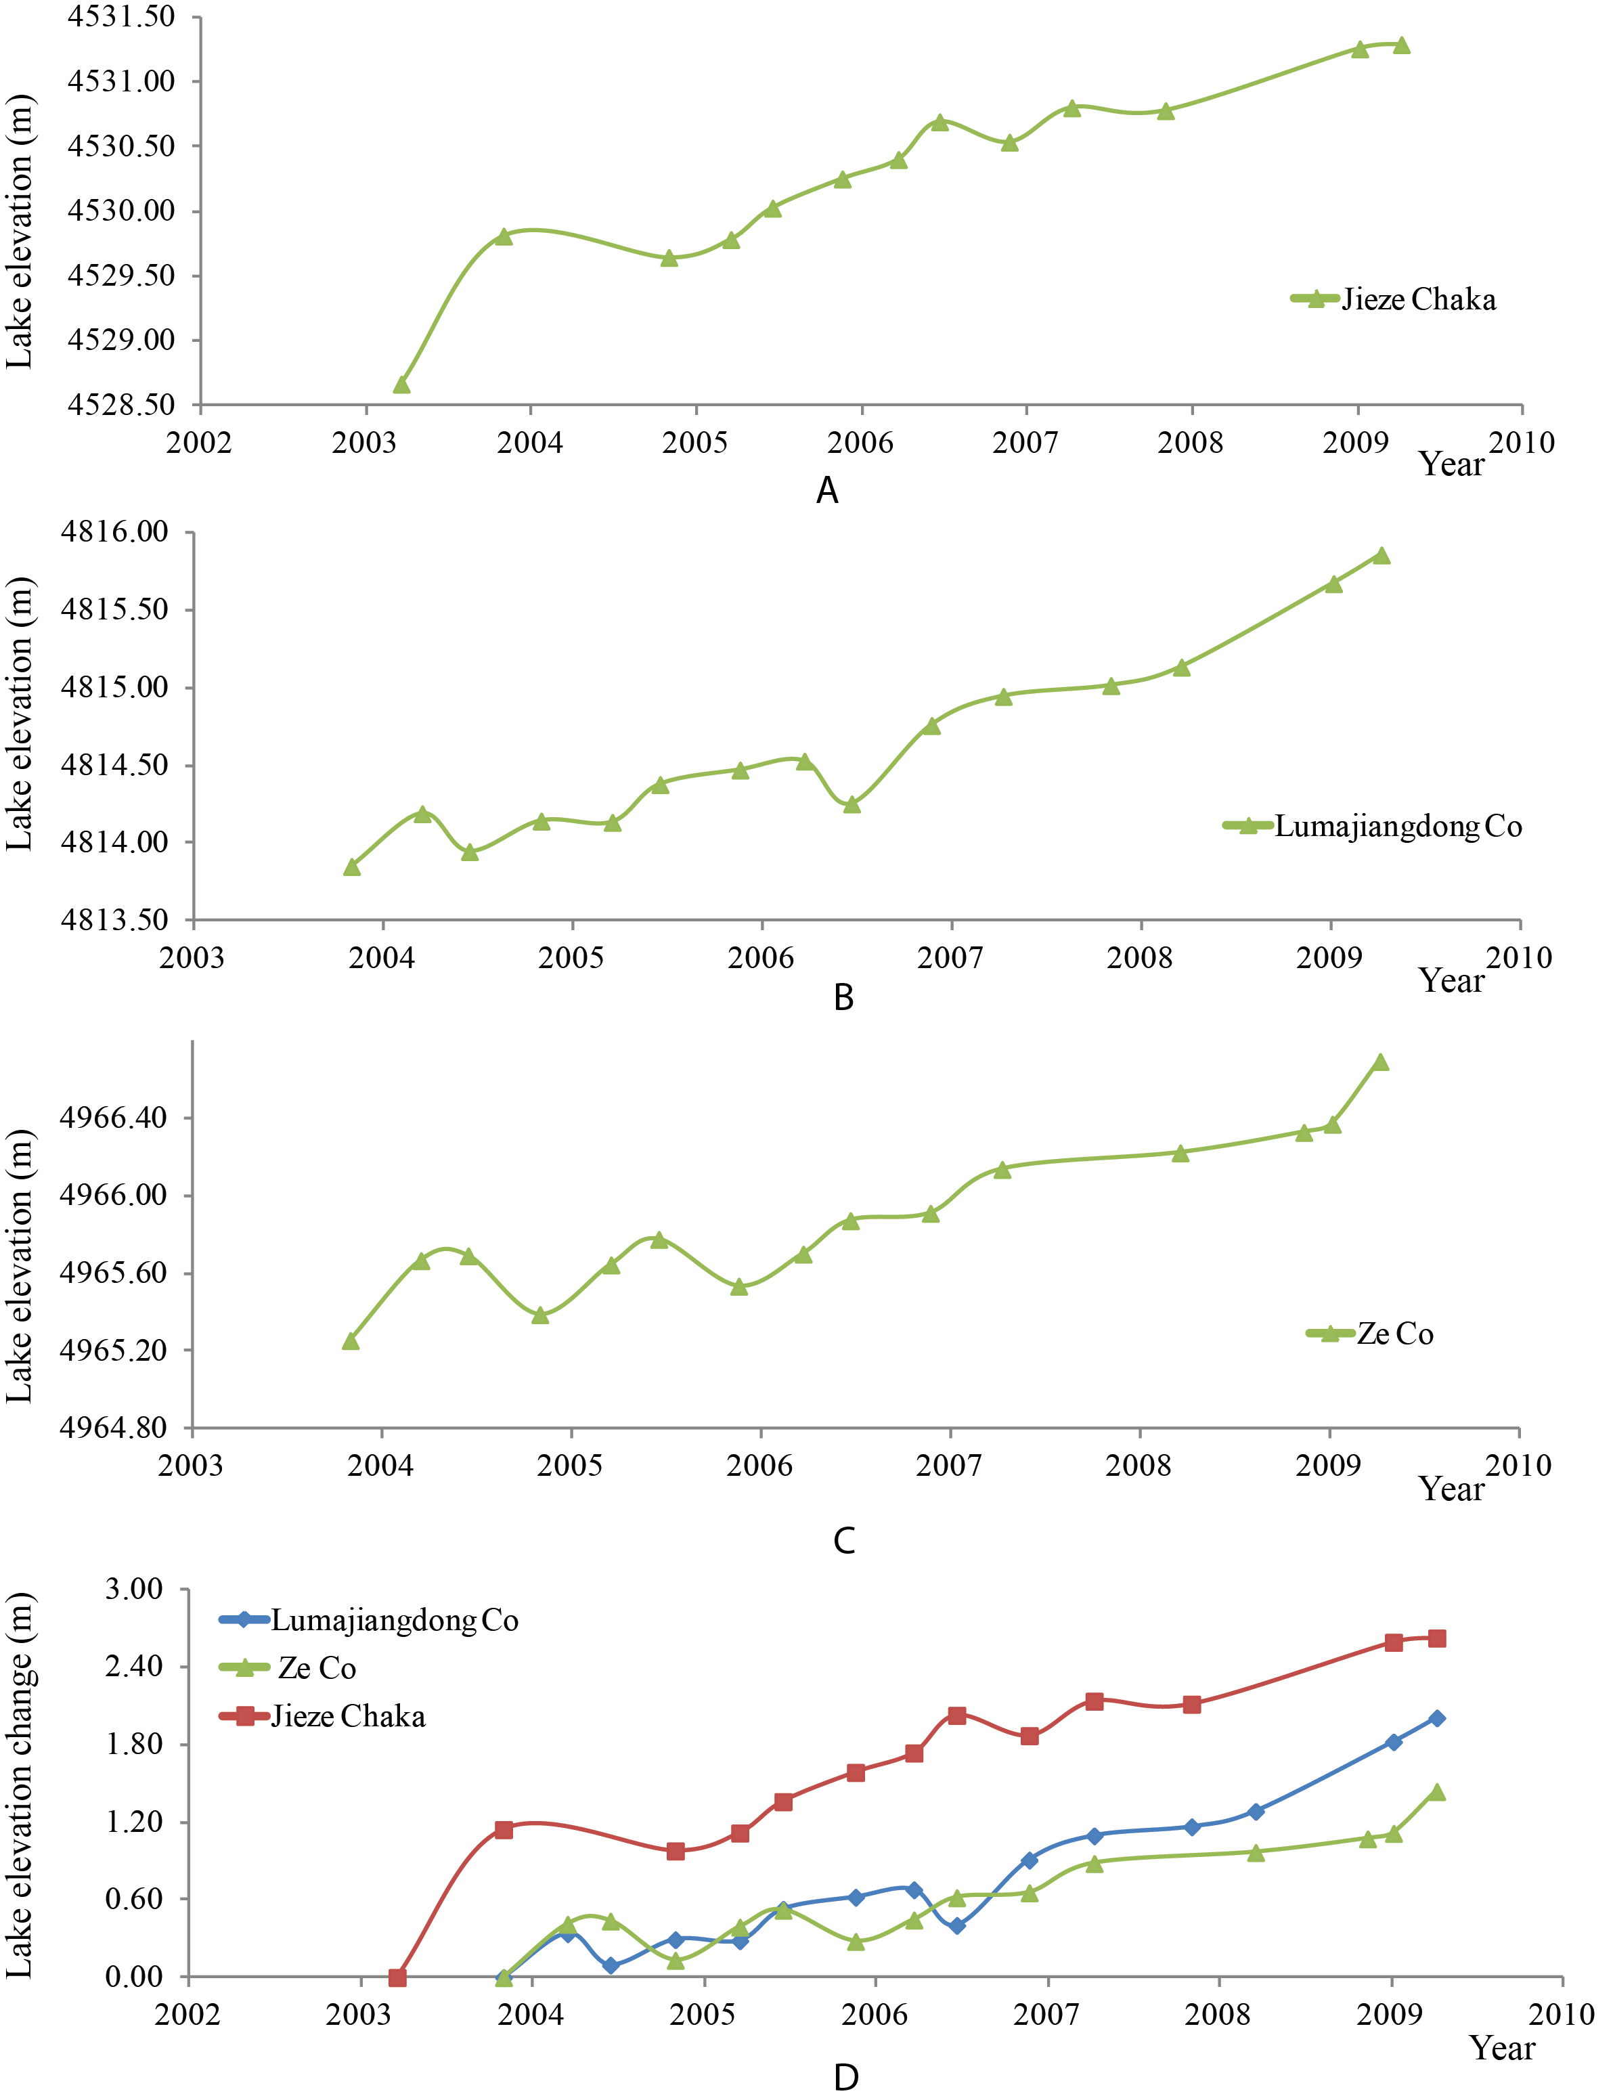
Figure 5-3 The surface elevation change of lakes in the sub-region A during 2003-2009. (A) Jieze Chaka; (B) Lumajiangdong Co; (C) Ze Co; and (D) the combined elevation change patterns for the three lakes during 2003-2009.

5.2 Sub-Region B: the Central-northern Tibetan Plateau

5.2.1 Lake Area Change
Only a few lakes are found in the central-northern Tibetan Plateau, and the lakes in this region are all relatively small. Three lakes, Gyado Co, Laxiong Co, and Buruo Co, selected in this study generally experienced a similar pattern of change during the past 40 years, with minor differences during 1988-1999. Before 1988, the areas of all three lakes were relatively stable. From 1988 to 1999, differences occurred among these lakes. Laxiong Co and Gyado Co shared a similar pattern of change within these 10 years; they both experienced minor shrinkage, and the lake shrinkage ratio is around 2%. In contrast, Buruo Co expanded 1.5% in this decade. However, the changing ratio of these three lakes were minor (<2%) during this period, and the lake change pattern can still be characterized as relatively stable. The three lakes began to share the similar changing pattern after 1999. They all experienced continuous expansion ranging from 4% to 8% until 2007. After 2007, the lake expansion slowed down and finally stopped. Although there are some seasonal fluctuations, the general trend of the surface area change of the three lakes is featured as relatively stable after 2007.
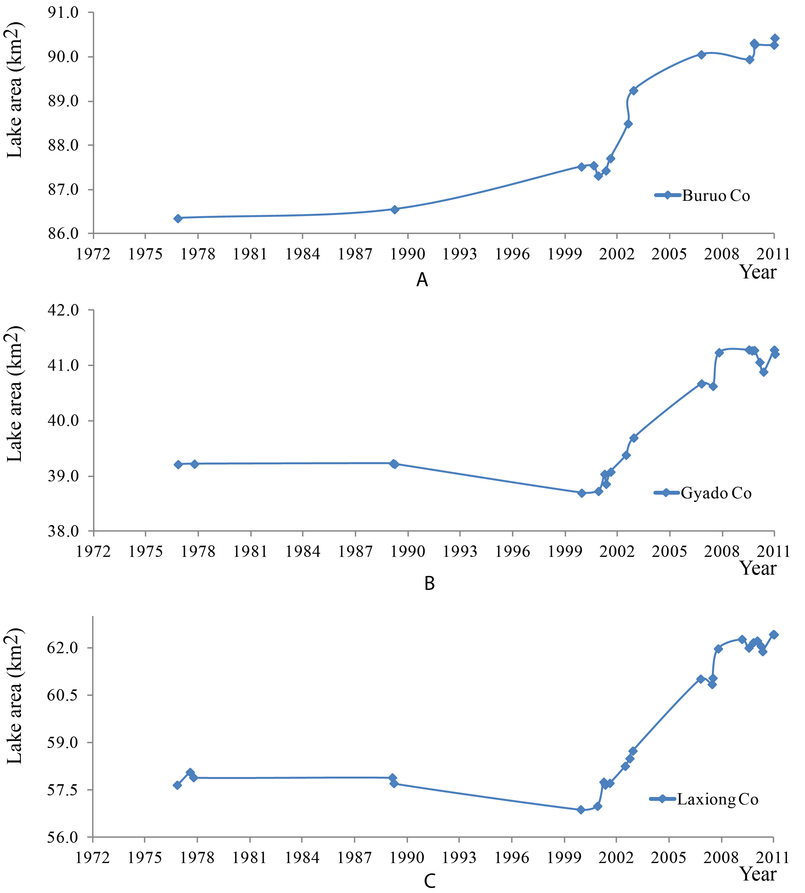
Figure 5-4 The surface area of lakes in the sub-region B during the 1970s-2010. (A) Buruo Co; (B) Gyado Co; and (C) Laxiong Co.

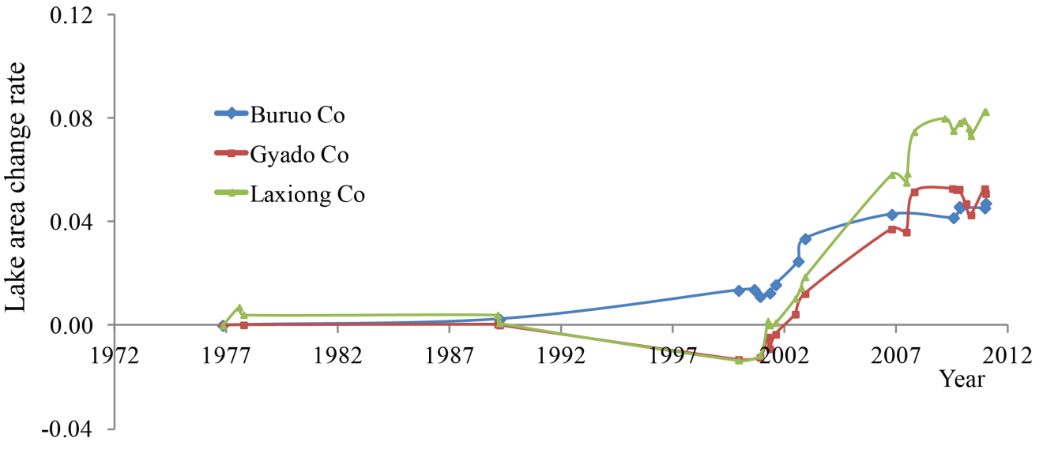Figure 5-5 the surface area change rate of lakes in the sub-region B during 1972-2010. The three lakes experienced a similar pattern of change during the whole period except 1987-1999, when Buruo Co was expanding while the other two lakes were slightly shrinking.

5.2.2 Lake Elevation Change
Gyado Co is the only lake in this region with the GLAS record. The GLAS result shows that the lake elevation increased continuously between 2003 and 2007, and the seasonal fluctuation is not obvious in this lake. The lake level of Gyado Co increased 1.5 m within these 4 years. Then, the lake elevation began to stay stable after 2007. When comparing with the surface area change of Gyado Co, we can identify the similar pattern with lake elevation change: after the continuous expansion during 1999-2007, the lake elevation/area of Gyado Co also became stable after 2007. The consistent results of the two datasets also confirm the fact that the lakes in this region stopped expanding in 2008.
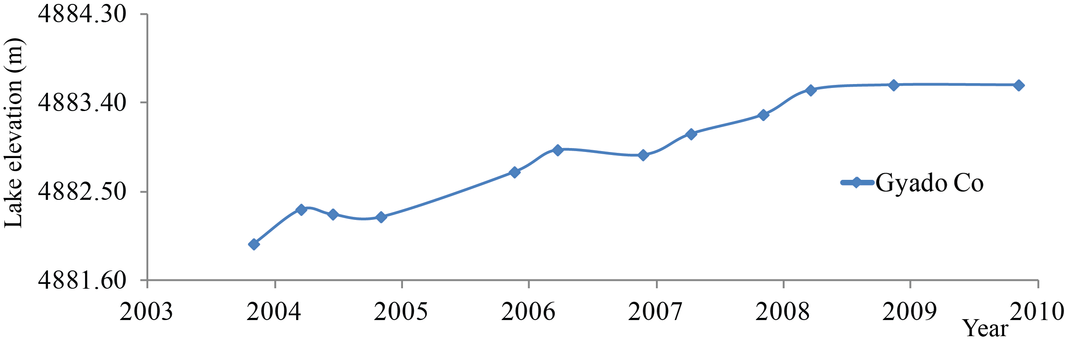
Figure 5-6 The lake elevation change of Gyado Co during 2003-2009.

5.3 Sub-Region C: the Northeastern Tibetan Plateau

5.3.1 Lake Area Change
Five lakes in the sub-region C, the northeastern Tibetan Plateau, experienced different changing patterns during 1972-2010 (Figure 5-7). Between 1972 and 1976, the changing patterns of these five lakes were similar with minor lake area increases, except Duoge Co that was decreased between 1976 and 1977. This change within a year may be caused by seasonal fluctuations. Due to the lack of data, the changing pattern of Lexie Wudan Lake during this period is not clear.
For the lakes with available data during 1977-1989, all of them were shrinking (Kekexili Lake, Kusai Lake, and Lexie Wudan Lake), with the ratio of around 5%. After that, these three lakes became stable until the late 1990s. No images are available for Botao Lake and Duoge Co during this period. Comparing the surface areas of these two lakes in 1976 and 1999 shows that they were generally stable within this period, but the detailed changing patterns are unknown.
After 1999, all five lakes experienced continuous expansion in the next 4 years. Among the five lakes, Duoge Co has the largest expansion ratio (29%). The major reason for this tremendous expansion is that several small lakes were merged into this lake. After 2003, four lakes were continuously experiencing rapid expansion but the surface area of Botao Co became stable with minor shrinkage.
When analyzing the changing pattern of those lakes in Figure 5-8(B), it can be clearly shown that Lexie Wudan Lake, Kusai Lake, and Keke Xili Lake share the similar changing pattern during 1972-2010, while Botao Lake has a different changing pattern. One potential reason is that Botao Lake is located near the southern boundary of this sub-region, and is relatively far away from the three lakes mentioned above. The climate and topographic regime of Botao Co drainage area may be different from those of the three lakes. As for Duoge Co, its surface area is largely influenced by the emerging small lakes. However, Duoge Co still experienced significant expansion for 5 years after the emergence in 2002. After 2007, it became stable. Similarly to Botao Lake, Duoge Co is also relatively far away from the other three lakes, which may be affected by different climate or cryospheric conditions.

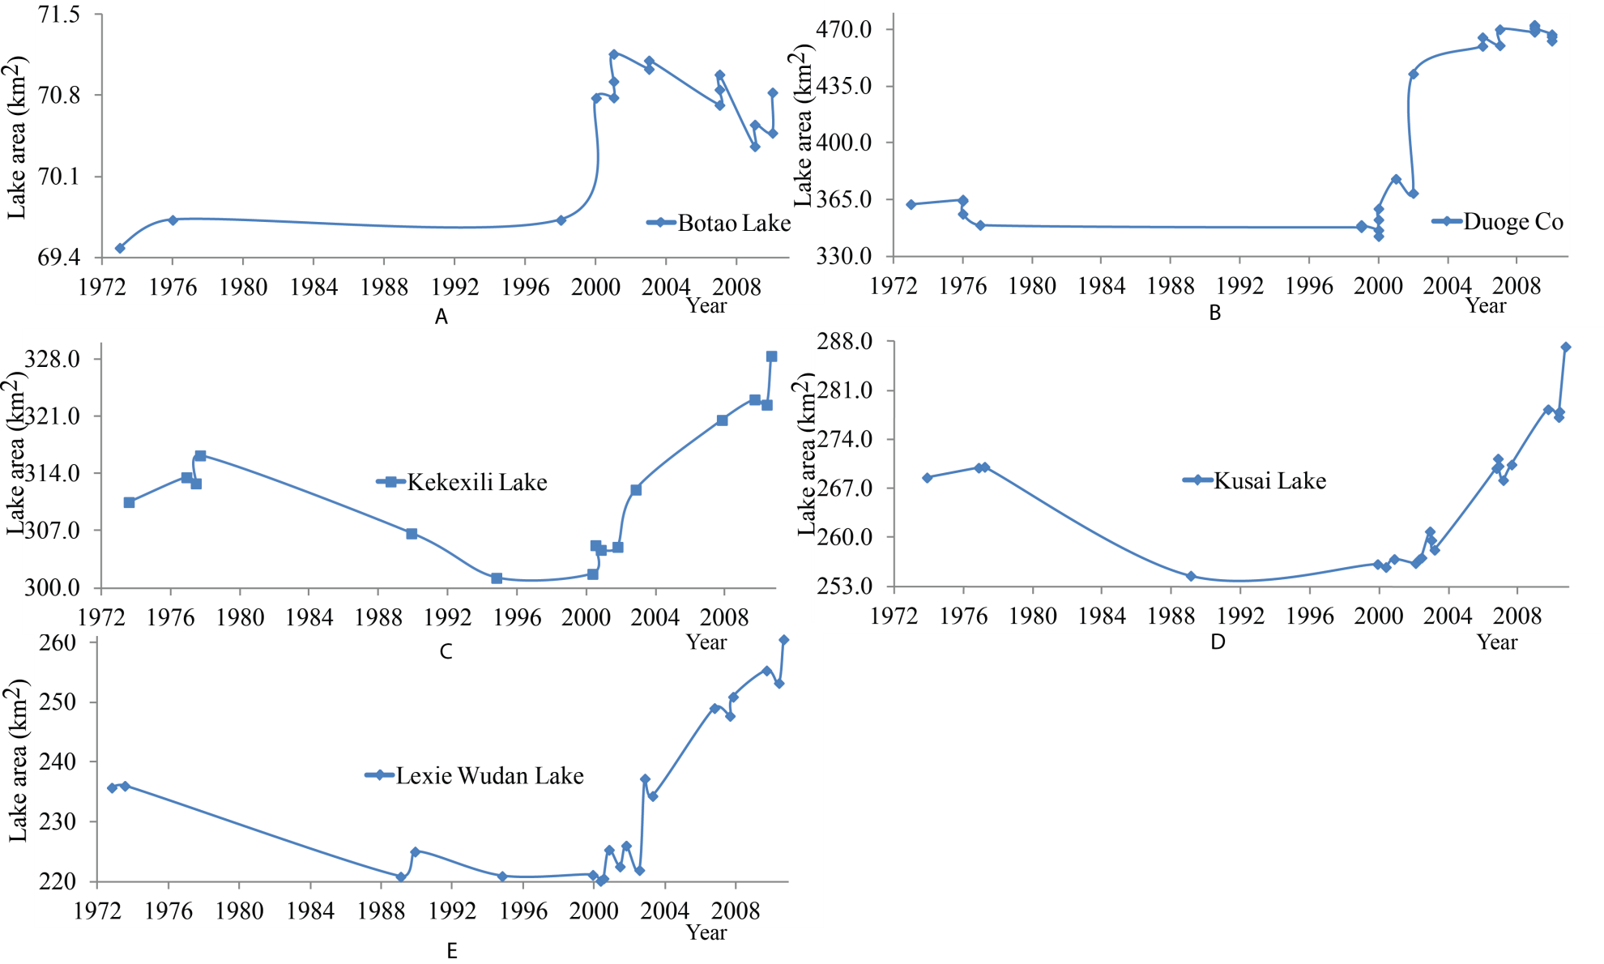Figure 5-7 The surface area of lakes in the sub-region C during the 1970s-2010. (A) Botao Lake; (B) Duoge Co; (C) Kekexili Lake; (D) Kusai Lake; and (E) Lexie Wudan Lake.
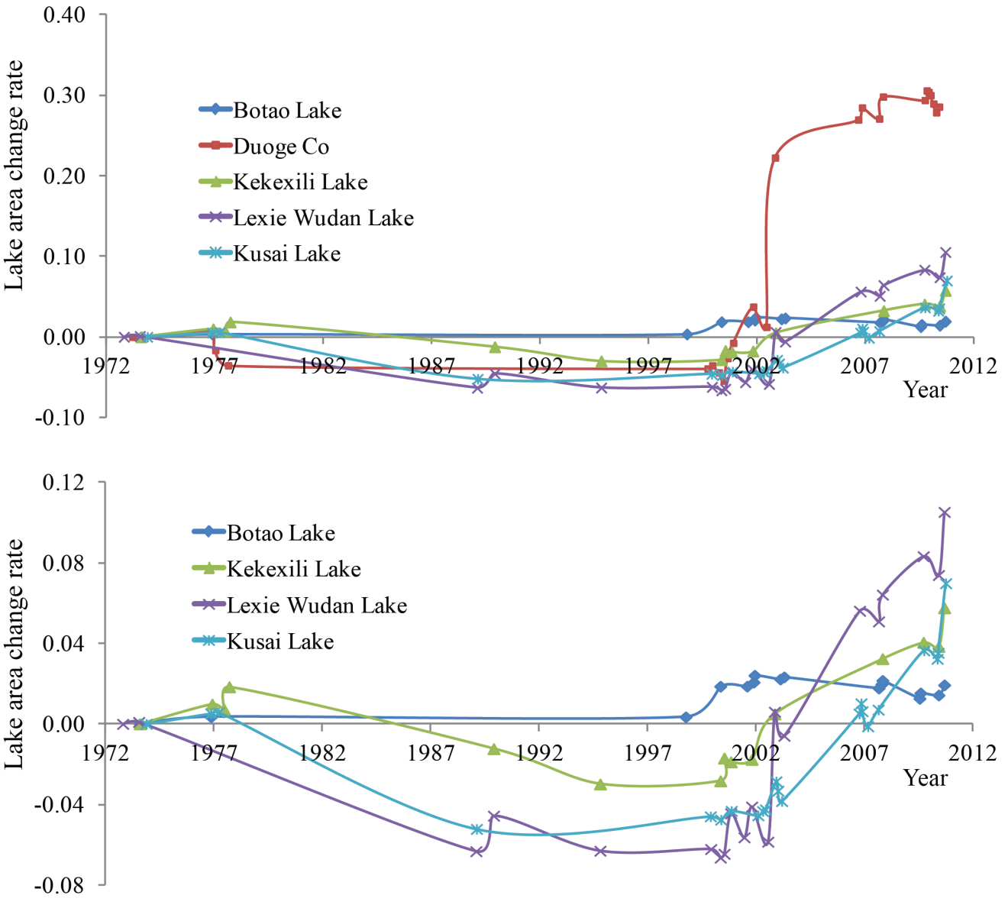
Figure 5-8 (A) The surface area change rate of lakes in the sub-region C during 1972-2010. Duoge Co experienced the most significant expansion after 1999 as a result of several lakes merging into it. (B) the surface area change rate of the lakes in the sub-region C during 1972-2010 except Duoge Co. Kekexili Lake, Kusai Lake, and Lexie Wudan Lake share the similar lake area change pattern during the whole period, whereas Botao lake has a different change pattern.

5.3.2 Lake Elevation Change
Three lakes in this region have GLAS records: Duoge Co, Keke Xili Lake and Lexie Wudan Lake. The lake area change analysis showed that these three lakes had similar pattern of areal change between 2003 and 2009. The same conclusion can also be drawn by analyzing the lake elevation change during these seven years (Figure 5-9). Generally, all these lakes experienced continuous lake elevation increase with minor seasonal fluctuations, especially Duoge Co and Lexie Wudan Lake with seasonal fluctuations of about 0.3 m. Among the three lakes, Keke Xili and Lexie Wudan have the similar extent of elevation increase (about 2 m) within this period, and this trend seems to continue after 2009. The lake level of Duoge Co is more influenced by seasonal changes, and the lake level increase began to slow down after 2007, a pattern that is consistent with the result derived from the lake surface area change analysis.
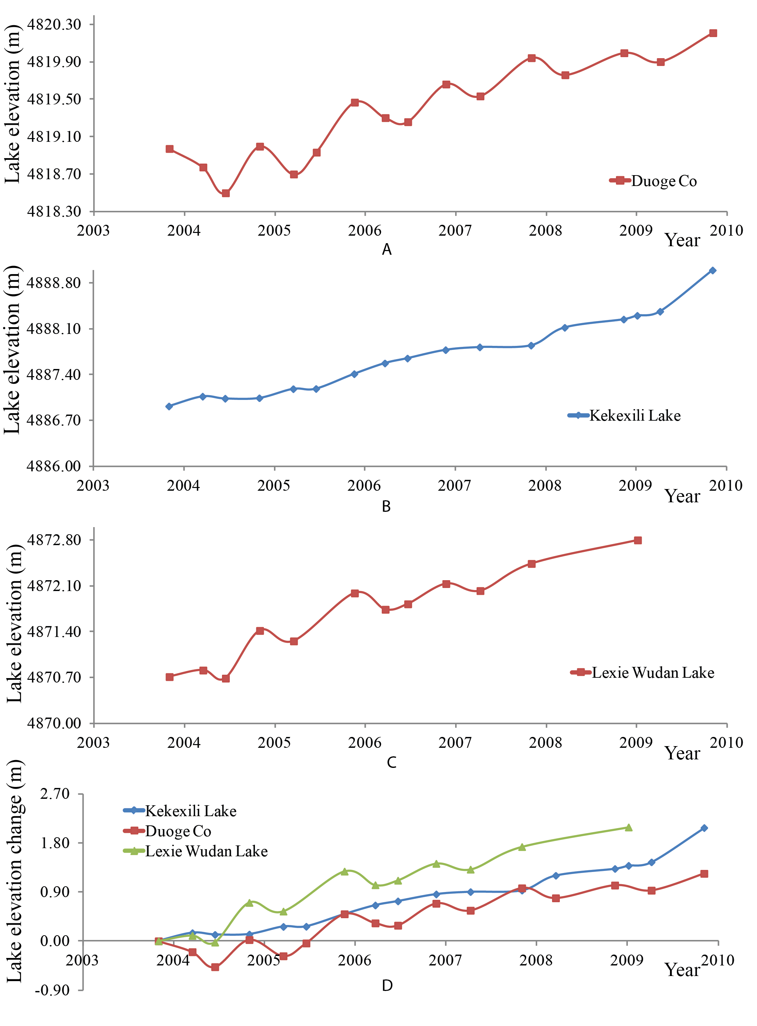Figure 5-9 The surface elevation change of lakes in the sub-region C during 2003-2009. (A) Duoge Co; (B) Kekexili Lake; (C) Lexie Wudan Lake; and (D) the combined elevation change patterns of these three lakes during 2003-2009.

5.4 Sub-Region D: the Southwestern Tibetan Plateau

5.4.1 Lake Area Change
Three lakes in sub-region D, Cangmu Co, Anglaren Co, and Renqing Xiubu Co, share the similar pattern of change; however, the extents of lake area changes were significantly different (Figure 5-10). During 1972-1976, generally all three lakes were stable with some minor shrinkage. The shrinkage ratios of Renqing Xiubu Co, Anglaren Co, and Cangmu Co were 0.2%, 0.3%, and 1.8%, respectively. The shrinkages of Renqing Xiubu Co and Anglaren Co were less than 1% and might have been caused by seasonal fluctuation. After 1976, these lakes began to expand until 1989. The expanding ratios of Renqing Xiubu Co and Anglaren Co were all <0.5%, which can be treated as stable during this period. As for Cangmu Co, the expansion rate was more than 10%. The 1990s was the only period during which these three lakes experienced different patterns of change. Anglaren Co experienced tremendous lake shrinkage, with a shrinkage ratio of 5.5%, while the lake surface areas of Renqing Xiubu Co and Cangmu Co were stable. After 1999, all three lakes continuously expanded and Cangmu Co experienced the most significant expansion. However, the lake expansions stopped in 2003. After 2003, the areas of all these lakes were relatively stable.
In summary, Renqing Xiubu Co and Anglaren Co had a similar pattern of change from 1972 to 2010 (Figure 5-11). They were generally stable with a low rate of change, probably reflecting the seasonal fluctuations. The changing extent of Cangmu Co is much larger, although its changing trend is similar to the other two lakes. One potential reason for this difference is its topographic condition. Cangmu Co has the largest recharge coefficient among these three lakes, and glaciers are widely distributed within its basin. All these factors may contribute to its larger extent of change.
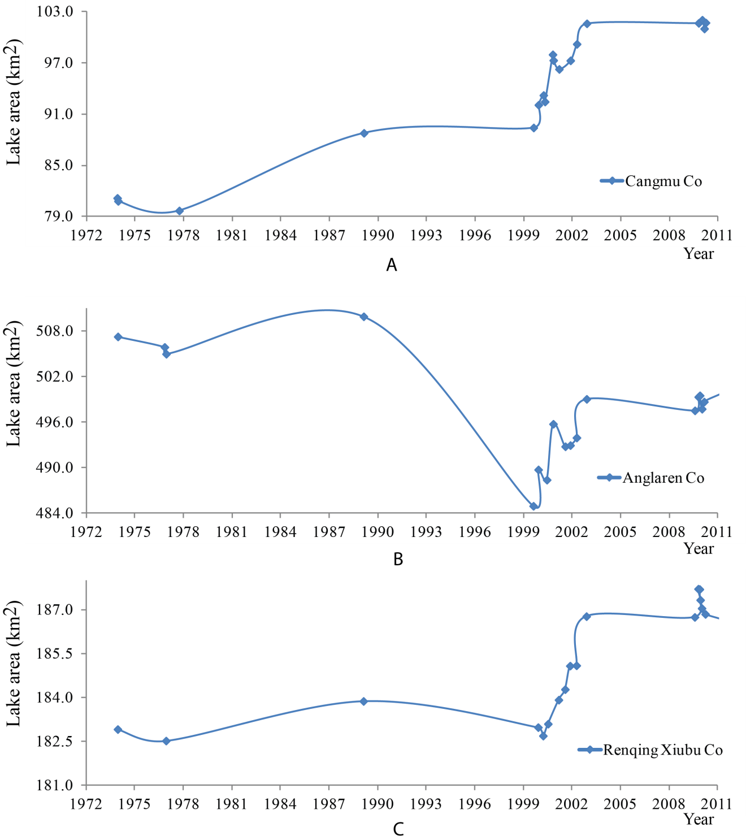
Figure 5-10 The surface area of lakes in sub-region D during the 1970s-2010. (A) Cangmu Co. (B) Anglaren Co. (C) Renqingxiubu Co.

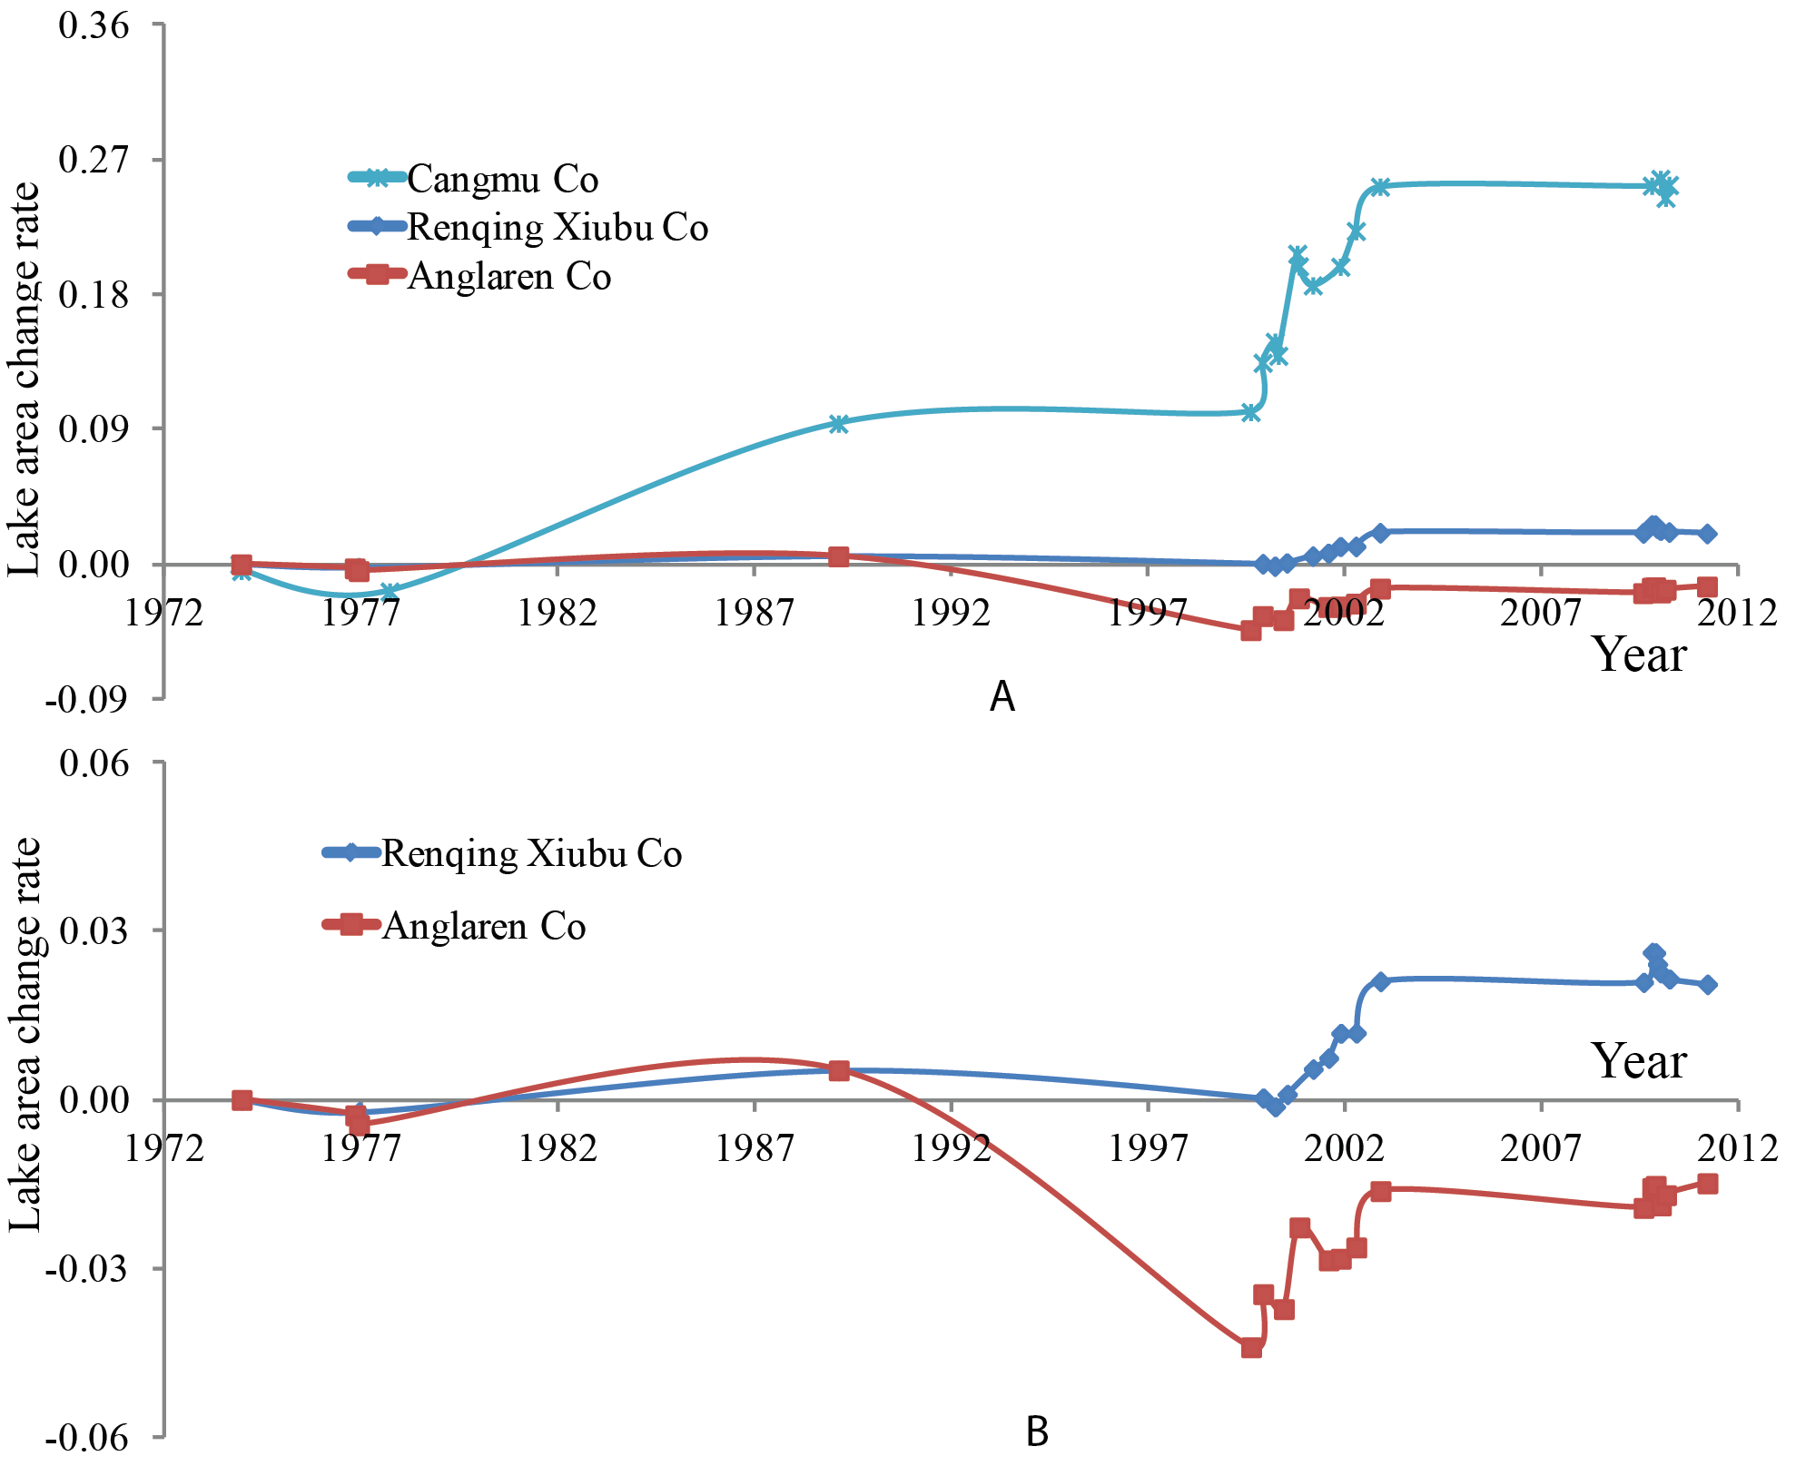
Figure 5-11 (A) The surface area change rate of lakes in sub-region D during 1972-2010. (B) The surface area change rate of the lakes in the sub-region D during 1972-2010 except Cangmu Co.

5.4.2 Lake Elevation Change
Anglaren Co and Renqing Xiubu Co have the GLAS record during 2003-2009. The lake area change analysis shows that these two lakes have a similar pattern of change, but the change extents have some differences. By analyzing the lake elevation change during 2003-2009, a similar conclusion can be drawn. Generally, these two lakes experienced similar lake elevation changes. From 2003 to 2005, minor decrease in lake elevation were observed; then the lake level stayed stable for the next 3 years, and an increase occurred after 2007. The water level fluctuations of these lakes during these 7 years were within 0.8 m, which is much smaller than that of lakes of other regions. These changes are potentially caused by seasonal change, and the elevations can be generally treated as stable. Thus, this trend of lake level change is consistent with the lake area change, which is stable during 2003-2009. Considering the accuracy of GLAS data and seasonal fluctuations, the southwestern Tibetan Plateau is a region with relatively small lake change during 2003-2009.
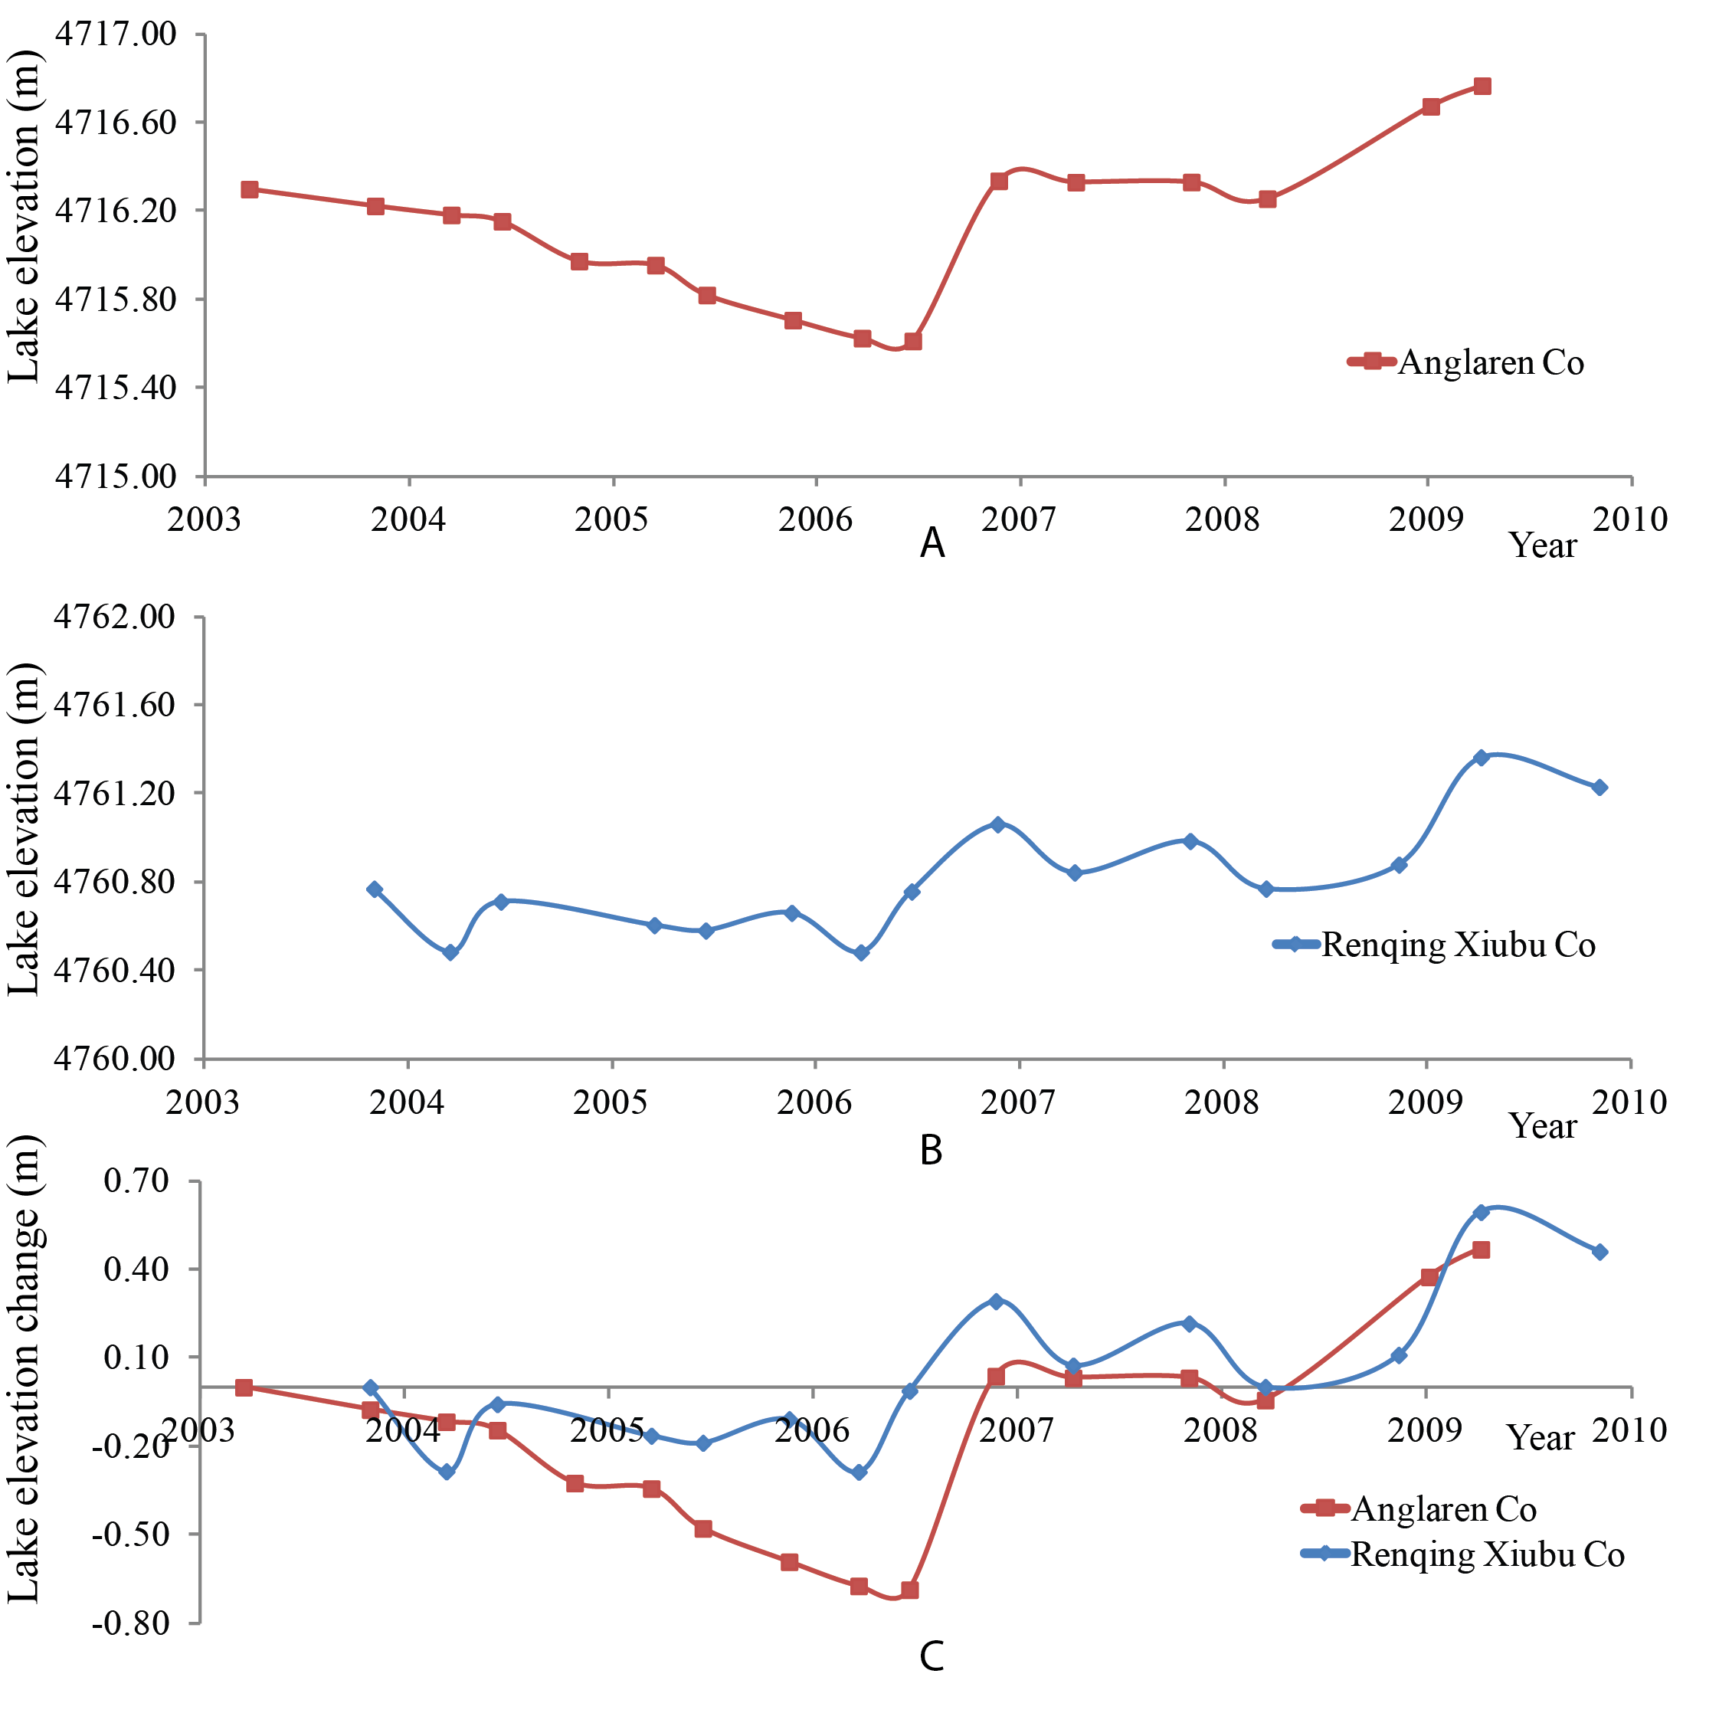
Figure 5-12 The surface elevation change of lakes in sub-region D During 2003-2009. (A) Anglaren Co; (B) Renqing Xiubu Co; and (C) the combined elevation change patterns for the two lakes during 2003-2009.

5.5 Sub-Region E: the Central Tibetan Plateau

5.5.1 Lake Area Change
Seven lakes from the sub-region E, the central Tibetan Plateau, share a similar pattern of change, especially after 1999. Due to the limited number of Landsat images in the 1970s, the detailed pattern of change during this period was not clear. According to the lakes with images in 1972 and 1976, these lakes were generally stable: Dong Co and Peng Co slightly decreased while Selin Co and Zigetang Co experienced minor expansion. From 1976-1989, except Qixiang Co, which has no available data during this period, all other six lakes experienced expansion, but the expansion rates were relatively small (<5%). After 1989, Daze Co stopped expanding and begun to shrink, with a shrinkage rate of 7% in the next 10 years. The other five lakes continue to expand after 1989, with similar expansion rates in 1976-1989 (5% to 10%). It seems that Daze Co is different from the other lakes in this region according to its changes before 1999. This difference may be caused by the fact that Daze Co is located in the western border of this sub-region, and its climate and cryospheric conditions may be different from those of the other lakes. The annual average precipitation of Daze Co is much lower than that of the other lakes (200 mm), and this lake drains a huge basin, which makes its recharge coefficient the largest among the 26 lakes (44.5).
After 1999, all of these lakes began to expand, with different expansion rates. Selin Co experienced the most expansion, and its surface area expanded >40% since 1972. This tremendous expansion is partially caused by a small lake merging into it in 2004. In addition, although all lakes were still expanding after 2005, the expansion rates were significantly slowing down.
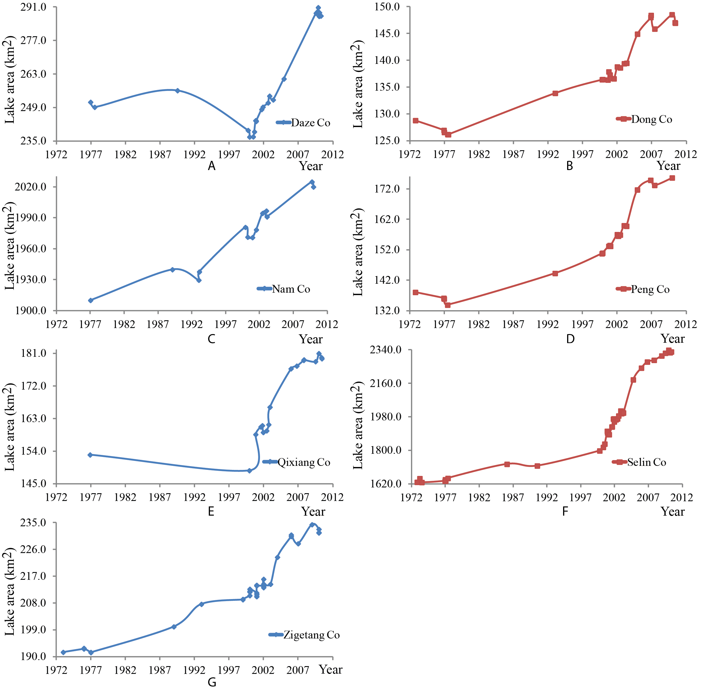
Figure 5-13 The surface area of lakes in sub-region E during the 1970s-2010. (A) Daze Co; (B) Dong Co; (C) Nam Co; (D) Peng Co; (E) Qixiang Co; (F) Selin Co; and (G) Zigetang Co.
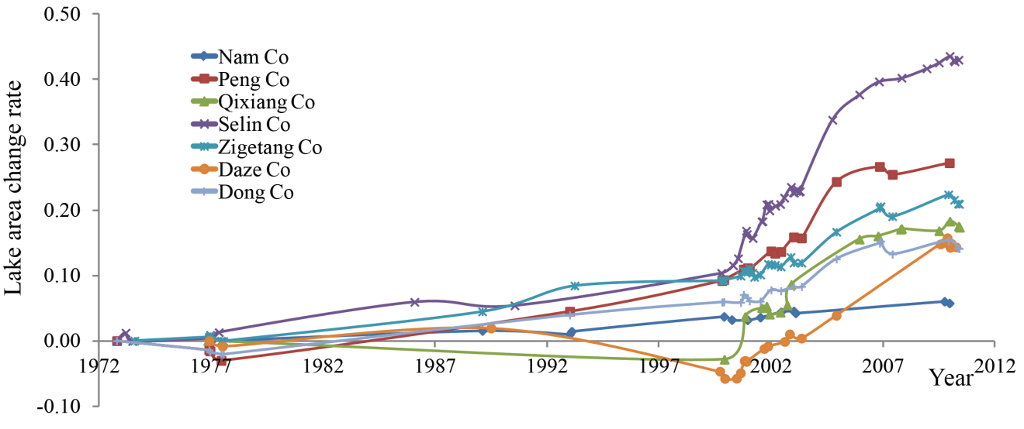
Figure 5-14 The surface area changing rate of lakes in the sub-region E during 1972-2010. The seven lakes experienced the similar changing pattern during the whole period except Daze Co.

5.5.2 Lake Elevation Change
Nam Co, Selin Co, Zigetang Co, and Qixiang Co have GLAS records in this region. By analyzing the lake elevation change of these four lakes during 2003-2009, the conclusion similar to that of lake area change analysis can be drawn. Generally, the four lakes experienced similar patterns of lake elevation change within the 7 years. All of these lakes experienced continuous lake elevation increase with some seasonal fluctuations. Selin Co has the most significant elevation increase (4.2 m within 7 years). The elevation changes also illustrated the similar trend represented by lake area changes. The lake expanded rapidly before 2005 but the rate began to slow down after that. Some lakes tended to become stable after 2009, such as Nam Co and Qixiang Co.
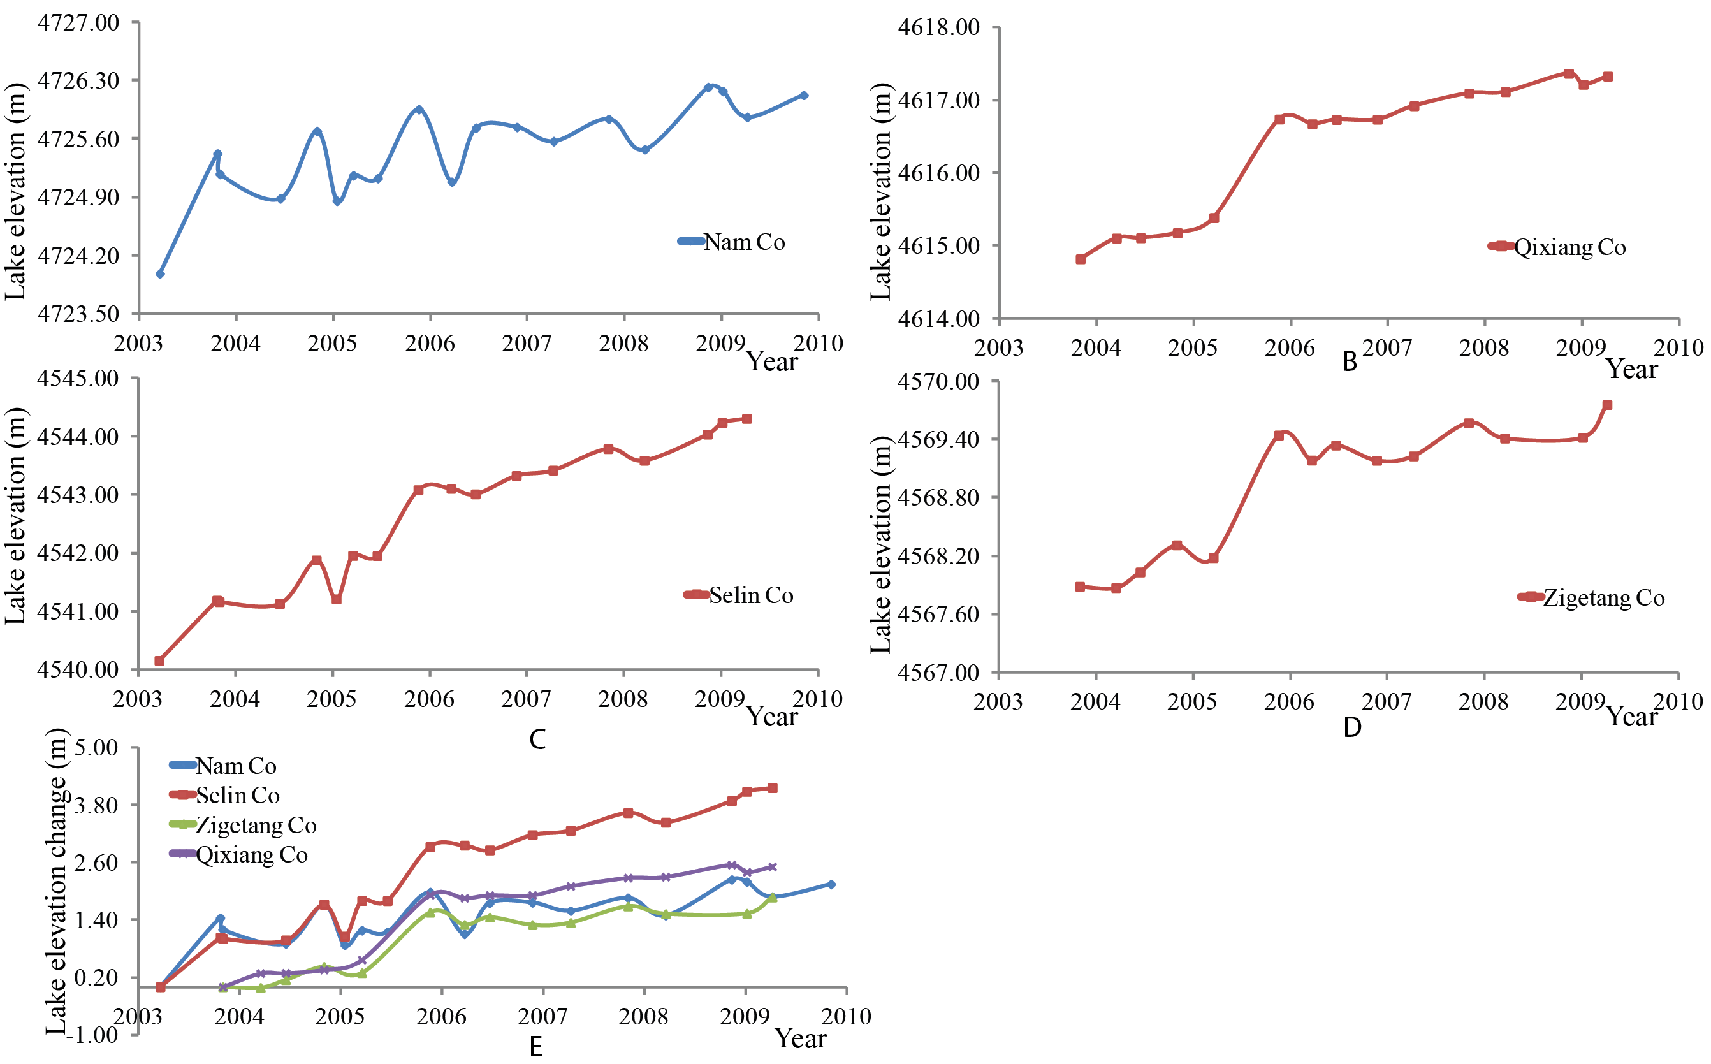
Figure 5-15 The surface elevation change of lakes in the sub-region E during 2003-2009: (A) Nam Co; (B) Qixaing Co; (C) Selin Co; (D) Zigetang Co; and (E) the combined elevation change patterns for the four lakes during 2003-2009.

5.6 Sub-Region F: the Southern Tibetan Plateau

5.6.1 Lake Area Change
Unlike the lakes from other regions, which share some similarities in lake dynamics, four selected lakes in the sub-region F demonstrated different patterns of change during the 1970s to 2010. Generally, Yangzhuoyong Co and Peigu Co experienced similar surface area change. They were mainly shrinking except for a short minor expansion phase during 1999-2003. However, the shrinkage of Yangzhuoyong Co is much larger than that of Peigu Co. It has shrunk about 15% since 1972.
Pumoyong Co is a fresh water lake connected with Yangzhuoyong Co through a river. As illustrated in Figure 5-16 (B), Pumoyong Co is highly influenced by seasonal fluctuations. The changing pattern of this lake during the 1970s-2010 can generally be characterized as stable, with some minor expansion during 1999-2003 followed by lake area decrease.
Chen Co is a small lake adjacent to Yangzhuoyong Co, the largest lake in the southern Tibetan Plateau. This lake experienced a pattern of change similar to that of Yangzhuoyong Co in the 1970s and after 1989. However, their patterns of change in the 1980s are totally different. They were both shrinking during 1972-1976. After that, Yangzhuoyong Co continued its shrinkage in the 1980s while Chen Co began to expand in 1976, and this expansion lasted until the late 1980s.
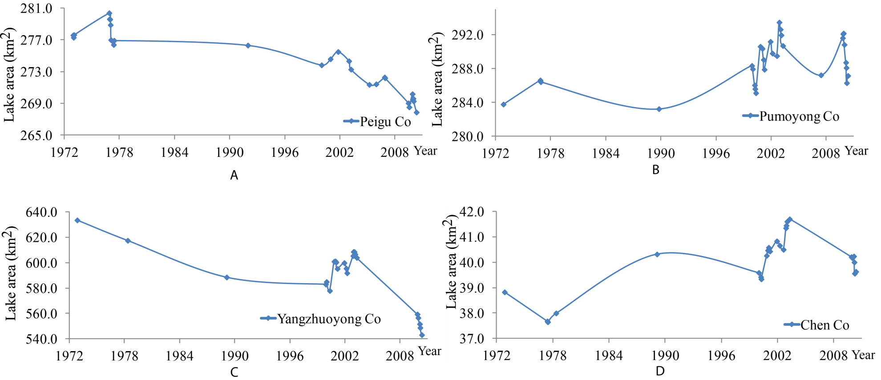
Figure 5-16 The surface area of lakes in the sub-region F during the 1970s-2010. (A) Peigu Co. (B) Pumoyong Co. (C) Yangzhuoyong Co. (D) Chen Co.

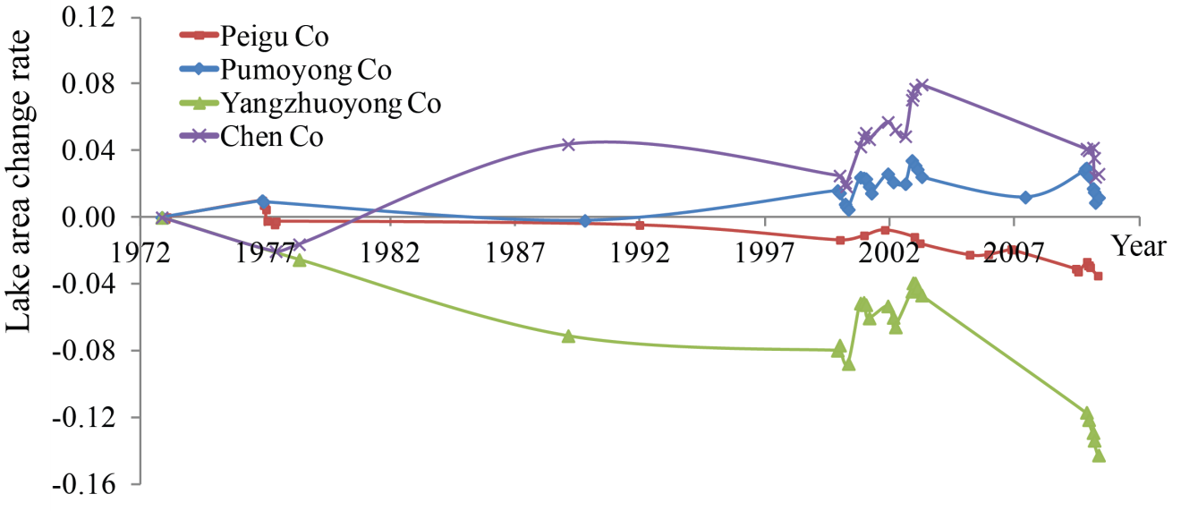
Figure 5-17 The surface area changing rate of lakes in the sub-region F during 1972-2010. The four lakes experienced different patterns of change in the 1970s, the 1980s, and the 1990s. After 1999, all these lakes experienced minor expansions followed by continuous shrinkage.

5.6.2 Lake Elevation Change
Three lakes, Peigu Co, Yangzhuoyong Co, and Pumoyong Co, have GLAS records during 2003-2009. All lakes experienced continuous lake elevation decrease within the 7 years with clear seasonal fluctuations, especially for Peigu Co and Pumoyong Co. Among the three lakes, Yangzhuoyong Co has the most significant elevation decrease (2.5 m), and this trend is consistent with the result derived from lake area change analysis.
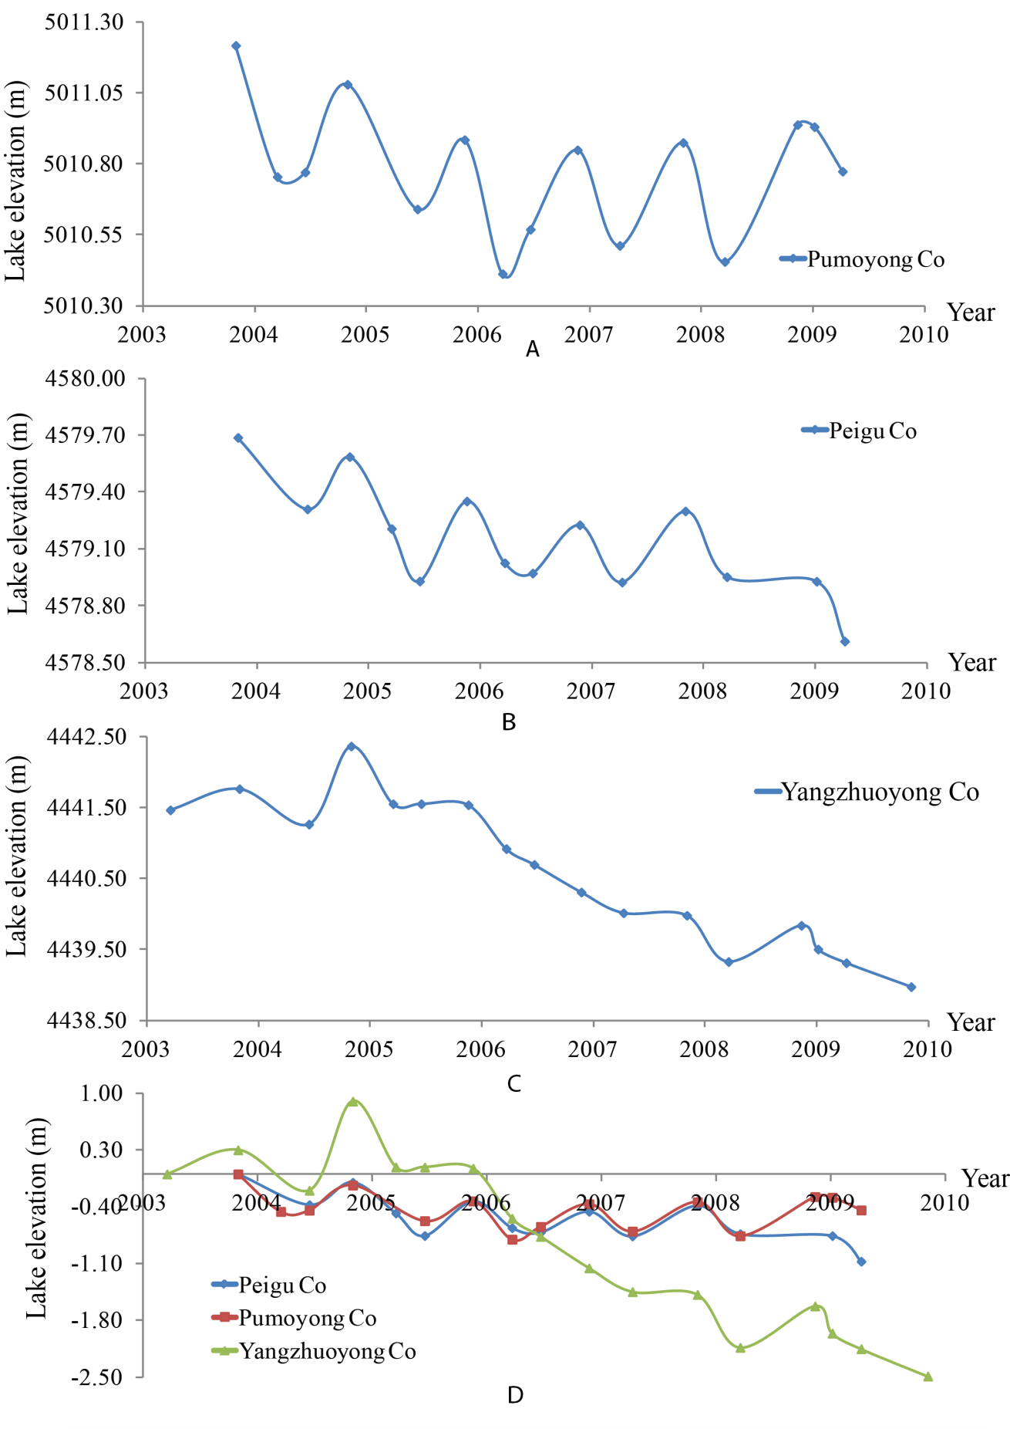Figure 5. 18 The surface elevation change of lakes in the sub-region F during 2003-2009: (A) Pumoyong Co; (B) Peigu Co; (C) Yangzhuoyong Co; and (D) the combined elevation change patterns for the three lakes during 2003-2009.

CHAPTER 6

DISCUSSION

6.1 Lake Area and Elevation Extraction Model
The developed lake boundary extraction model improves the efficiency of lake-boundary extraction compared with the traditional manual delineation method. Manually delineating lake boundaries from aerial photography and/or satellite imagery is relatively straightforward because of the distinct difference between water and land (Yoshikawa & Himnzman, 2003). However, it is subjective, time consuming, and labor intensive, especially when processing large amount of images. In this study, 26 lakes have been selected to delineate their lake boundaries during the past 40 years and 587 multi-temporal lake boundaries were extracted. It would have been very labor intensive using the manual delineation method. Density slicing using a threshold value to discriminate land and water from a single band image is a simple and efficient method for lake-boundary extraction (Roach, 2011). This method is automated in ArcGIS10 by examining a set of potential threshold values.
Density slicing of Landsat MSS band 6 and TM/ETM+ band 4 was applied in this model because water absorbs most of radiation of the near infrared spectrum compared with land surface, causing a strong contrast between land and water. For Tibetan lakes, the results indicate that the optimal threshold values are mostly between 20 and 40. Different threshold values would cause some uncertainties in lake-boundary extraction. If the threshold value is low, some lake pixels, especially the shallow water along the shoreline, may be misclassified as land. In contrast, if the threshold value is high, some marshes and moist soil may be classified as lakes. When testing different threshold values, the optimal threshold is the one between the reflection values of water and moist soil/marsh. At this point, all the water pixels have been classified as lake while the reflection value of marsh/moist soil is still higher than the threshold. Thus, when the lake area increase reaches the minimum rate, the threshold value can be treated as the optimal one.
The accuracy of the extracted lake surface area is assessed by comparing model-extracted lake areas with lake areas derived from manually delineated Google Earth high-resolution images at similar time slices. According to the accuracy assessment of three lakes, accuracy might be related to the lake area. Larger lakes tend to have higher accuracy. Laxiong Co, with the lake area of 60 km², is the third smallest lake among these 26 selected lakes, and it’s also the smallest one among the three selected lakes. However, its percentage error between model-extracted and manually digitized surface area was 0.8%, the largest among those of the three lakes.
The consistency check model is based on the assumption that the lake expansion/shrinkage should be consistent across different sections of the lake boundary within a short period. It is designed to guarantee that all boundaries derived from the lake boundary extraction model for a certain lake are consistent, so that the potential misclassification caused by cloud cover and inflow channels can be detected. The principle of the consistency check is to determine the consistency using the equation of Intersection area (A_{x}, A_{y}) = Min (A_{x}, A_{y}), where A_{x} and A_{y} are the lake surface areas at two time slices of x and y. In practical research, the consistency determination is not strictly based on this equation, as unavoidable interactions always exist between the boundaries, especially when the lakes were stable during a certain period. One potential reason for these interactions is the resolution of Landsat images. Considering the accuracy of the lake boundary extraction model, a control value of 0.5% was used in the consistency check. Therefore, the equation to determine the boundary consistency is:
(|Intersection area (A_{x}, A_{y}) - Min (A_{x}, A_{y})|/ Min (A_{x}, A_{y})) <0.5%
The boundaries will be treated as consistent if the value of the equation is true.

6.2 Spatial and Temporal Patterns of Lake Changes
The lakes from different parts of the Tibetan Plateau show different patterns of change during the past four decades. Some lakes within the same sub-region, such as the sub-region F, also show different patterns. Four lakes in this sub-region have different trends and magnitudes of change, especially before 2000. For some sub-regions, some lakes have different changing patterns while all the other lakes in the same sub-region share a similar pattern; for example, Buruo Co in the sub-region B and Daze Co in the sub-region E. These lakes are mainly located in the bordering area of the sub-region, which may possibly have a different climatic and cryospheric regime, compared to that of the other lakes. Patterns of lake change of different sub-regions can be generally divided into several stages during the past 40 years.
In the 1970s, the surface areas of most lakes were stable, with <3% fluctuations. The data used during this period are Landsat MSS images between 1972 and 1977, so lake area variations of the whole 1970s cannot be exactly investigated. However, lake change information during these five years still provides some insights into the changing pattern of lake areas in the 1970s. By analyzing the surface area of lakes with images during the five years (1972-1977), some spatial diversity of lake area change can be identified. For the lakes in the northern part of the plateau, namely sub-regions A, B, and C, the surface area fluctuation ratio are <1% except Duoge Co, which is located in the southern part of the sub-region C adjacent to the central Tibetan Plateau. It experienced around 4% shrinkage during the five years. More lake shrinkage occurred in the southern part of the Tibetan Plateau especially in the sub-region F. All of the lakes in the sub-region F were shrinking except Pumoyong Co. However, the shrinking magnitude during this period was small and seasonal changes may also play some roles. In summary, the trend of lake area change across the Tibetan Plateau during the 1970s can be characterized as stable with minor decrease in the southern part.
Landsat images are scarce in the 1980s. However, comparing the available data in the 1980s with the lake area in the 1970s and the 1990s, the rough trend of lake changes can still be identified. Especially, the lakes in sub-regions A and B were still stable in the 1980s, while the lakes from the northeastern Tibetan Plateau began to decrease with decrease ratios of approximate 5%. For the southern part, almost all of the lakes from the sub-region E expanded 5% to 10%, and lakes in the sub-region D also experienced expansion, where Cangmu Co had the largest increase rate (10%). The changing trends of the four lakes in the sub-region F are complicated and different from each other. Yangzhuoyong Co continued to decrease, Chen Co increased about 7%, and the other two lakes were relatively stable during 1978-1989. Although the exact lake-change trend during this decade cannot be achieved due to the data availability issue, combining the lake area data from the late 1970s and the early 1990s still reveals that relatively significant lake change was triggered in the 1980s, especially in the eastern, central, and southern parts of the plateau.
In the 1990s, most lakes in the sub-region E continued minor expansions, while the surface areas of most lakes in other sub-regions were relatively stable until the mid-1990s. However, some specific lakes showed different trends compared with the other lakes within the same region during this period, such as Anglaren Co in the sub-region D and Daze Co in the sub-region E. They both shrank about 6% during this decade.
All 26 lakes began significant expansions after the late 1990s, and this trend lasted until 2006 for most lakes. Generally, the lakes in the sub-region E experienced the most significant expansions among all the lakes (mostly >10%) followed by the lakes from the northern part of the plateau. The sub-region F, the southern Tibetan Plateau, experienced the least expansion, and all four lakes in this region stopped expansion in 2003, followed by a continuous shrinkage. Similar to the southern Tibetan Plateau, lakes from the sub-region D also stopped expansion in 2003, and all three lakes began to stay stable after that. The period of 1999-2006 seemed to be when Tibetan lakes experienced the most significant expansion during the last 40 years. The surface areas of most lakes increased >5% during this period. This trend is also supported by the GLAS elevation data during 2003-2009.
After 2006, the lake expansion rate in the sub-region E appears to have slowed down and lake areas tend to be stable. Similarly, the lakes in sub-regions B and D also stopped expansion in 2006, and lake areas began to stay stable, with some seasonal fluctuations. The only two regions in which lakes were still expanding after 2006 were the northwestern and northeastern Tibetan Plateau. The lake elevation data extracted from GLAS also support this trend.
In conclusion, the 26 lakes across the Tibetan Plateau were relatively stable in the 1970s. Lake expansions first occurred in the sub-region E, the central Tibetan Plateau, in the 1980s, followed by lakes from other regions by the end of the 1990s. This expansion trend lasted until 2006 (the lakes in the sub-region F stopped expansion and began to shrink in 2003). After 2006, the expansion rate of lakes in the central Tibetan Plateau appears to have slowed down and lakes in the southwestern Tibetan Plateau stopped expansion and reminded stable. However, the lakes in the northeastern and northwestern Tibetan Plateau were continuously expanding after 1999, and the trend seems to continue. These changing patterns indicate that time lags exist among different sub-regions in lake expansion. The lakes in the sub-region F, located in the southern part of the Tibetan Plateau, were generally shrinking in the past 40 years. The lake expansion first started from the central Tibetan Plateau in the 1980s, then moved northward and northwestward. Sub-regions A and C experienced tremendous lake expansion after the late 1990s, and this expansion is still continuing in the northern part, whereas the rapid lake expansion either slowed down or stopped in the central and southern part of the plateau.

6.3 Potential Causes for Different Lake Change Patterns
The dynamics of Tibetan lakes are affected by the interaction of a number of processes including climate change, cryospheric change, and human influences (Kropacek et al., 2012). Climatic factors play important roles in determining the lake level. As inland lakes in other regions of the world, precipitation and evaporation are important factors in the water balance of Tibetan lakes. Furthermore, cryosphere is widely distributed in this plateau; as a result, many Tibetan lakes are also influenced by the meltwater from glaciers, permafrost, and snow cover. Besides these natural processes, more and more human influences on the Tibetan Plateau have been reported (Wang et al., 1996; Zhang et al., 2011), especially through the construction of the Qinghai-Tibet Railway and hydropower stations. Other processes, like tectonic uplift or decreasing capacity of the basin due to sediment input, are likely to be negligible components in lake dynamics within decadal time scale (Kropacek et al., 2012). The effects of all these processes are integrated together to determine the lake dynamics of the Tibetan Plateau.

6.3.1 Climate Change
Climate change in the Tibetan Plateau has significant impact on the inland lake dynamics by influencing its water budget (IPCC, 2001). Most studies show that the general pattern of climate changes of the Tibetan Plateau during the past decades is characterized by increasing temperature and precipitation and decreased evaporation in most regions (Kang et al., 2010; Lin & Zhao, 1996; Liu & Chen, 2000). Two climatic “jumps”, rapid temperature/precipitation increase within a short period, occurred during the last four decades. One was in 1984 and the other was in 1998 (Niu et al., 2004). Some correlations are shown between the changes in lake area/elevation and climate parameters.
The first climatic jump occurred in 1984. The temperature of the Tibetan Plateau was high in the early 1960s and decreased from the mid-1960s to the 1980s. This climatic jump appeared as an increase in temperature, and the whole plateau has been experiencing a sustained warming since then. The warming, beginning in the 1980s, started first in the southeast of the Tibetan Plateau (Kang et al., 2010; Niu et al., 2004), followed by the Brahmaputra River drainage area in the southern Tibetan Plateau, and then the warming trend moved toward the northeast and southwest. The northwestern Tibetan Plateau was the last area to enter this warming period (Du et al., 2002). Most regions of the Tibetan Plateau experienced an increase in precipitation over the past decades, except the southern and western Tibetan Plateau and parts of Qinghai Province (Du et al., 2002, Kang et al., 2010). Corresponding to the climate change in the 1980s, the lakes from Qinghai (the sub-region C) and Brahmaputra River drainage area (the sub-region F) presented similar patterns of change in the 1980s, which is different from the lakes in the other sub-regions. Lakes in sub-regions C and F were all shrinking, while the lakes in other regions were either stable or experiencing minor expansion. This trend indicates that the interaction between precipitation and evaporation was the dominant factor determining the lake level in sub-regions C and F during the 1980s. Decreased precipitation is negative factor influencing the lake water balance, resulting in decreased lake water volume. Lakes from the sub-region E experienced minor expansion during this period, and this region was the first one to enter the lake expansion stage, while the lakes from other regions were not responding to climate change during the 1980s. It seems that the climate changes in those areas had not reached a certain stage to trigger the lake expansion.
The second climatic jump was in 1998, also characterized by increasing temperature and precipitation, especially in the central and eastern Tibetan Plateau (Niu et al., 2004). In contrast to the reaction to the climatic jump in 1984, almost all lakes experienced significant expansion as a result of the rapid temperature and precipitation increase in most regions of the Tibetan Plateau. The magnitude of expansion during this period was much greater than that of the 1980s. For example, Selin Co expanded >30% during 1999-2006. These eight years were the period when lakes from the sub-region E experienced the most rapid and significant expansion during the past four decades. After 2006, the lake expansion rate in this region began to slow down. For lakes from the northern regions, namely the sub-regions A, B, and C, although the precipitation either stayed stable or decreased during this period, the lakes still began to expand. The expansion rate in these regions ranged from 5% to 10% during these eight years (1999-2006). The significant temperature increase after 1998 triggered lake expansion across the whole plateau, and temperature seems to be the dominating influence on lake levels in the northern part of the plateau.

6.3.2 Cryosphere Distribution and Change
The cryosphere plays an important role in lake dynamics in the Tibetan Plateau (Chen et al., 2007; Liu et al., 2009). A large portion of precipitation-generated runoff evaporated rapidly in the Tibetan Plateau as a result of its arid climate. To maintain the water balance, melting water from glaciers and frozen ground is an important source of these lakes. The 26 lakes are fed by inflows in the form of underground water and surface runoff. The surface runoff is mainly generated by glacier/snow melting and precipitation, while the permafrost and snow cover melting water is the major contributor to the underground water (Kropacek et al., 2012, Liu et al., 2009).
Glaciers are widely distributed in almost all lake basins except Gyado Co, Zigetang Co, and Dong Co, and glacier melting is an important component of inflows for most of these lakes. The averaged annual temperature increased by 1.8 °C during 1960-2007 across the whole Tibetan Plateau (Kang et al., 2010). As a result, most glaciers in the Tibetan Plateau are retreating and the meltwater supply to the lakes is increasing (Chen et al., 2007). Meltwater inflow from the retreating glaciers is an important contribution to the positive water balance of the basin in the last decades (Kropacek et al., 2012). Many studies indicated that glacier area shrinkage has been accelerating in mountainous area recently, and this trend is especially significant in the Himalayas and Qilian Mountains, while glaciers in the interior of the Tibetan Plateau are relatively stable (Li et al., 2008). However, when analyzing pattern of lake change, the lakes fed by Himalayan glaciers (in the sub-region F) were actually shrinking during the last four decades. This discrepancy indicates that glacier melting is not the dominating factor to determine the lake changing patterns in the southern Tibetan Plateau.
Another important contributor to lake expansion is permafrost degradation that is also associated with the rise in temperature. Significant permafrost degradation has been observed in the Tibetan Plateau since the 1970s, characterized by shrinkage of the areal extent of permafrost, active layer thickening, and decreasing seasonal freezing ground depth. In the Tibetan Plateau, continuous permafrost is mainly distributed in the northern, island permafrost in the central Tibetan Plateau, and seasonal permafrost in the Brahmaputra River valley (Zhang et al., 2011). Permafrost degradation in the Tibetan Plateau first occurred in the island permafrost zone (Wang, 1993; Wang, 1996), coinciding with the fact that lakes on the central Tibetan Plateau, where major plateau island permafrost is distributed, were the first to start the expansion. This coincidence may indicate that permafrost degradation is an important contributor to the lake expansion in the central Tibetan Plateau. For the continuous permafrost region, even though it has been experiencing warming since the 1980s, the lake expansion started relatively later. The second climatic jump in 1998 triggered the lake expansion in this region. Permafrost degradation, together with glacier retreat, seems to be the major cause of the lake expansion in the northern part of the plateau, especially in the sub-region A: the northwestern Tibetan Plateau. During the last several decades, the northwestern Tibetan Plateau became a warmer and drier place. However, the lakes were still expanding after 1998, suggesting that glacier melting and permafrost degradation are the dominant factors to control the patterns of lake change in this region.
The influence of permafrost degradation on lake dynamics is a long-term continuum, and the response of lake level should be viewed dynamically. According to the studies in Siberia and Alaska, different trends have been observed on how permafrost degradation influences lake dynamics, and permafrost degradation has been associated with both decreases and increases in lake areas (Jorgenson & Osterkamp, 2005). Smith et al. (2005) explained this discrepancy using a conceptual model that initial permafrost degradation leads to development of thermokarst and lake expansion, followed by lake shrinkage as the permafrost degradation continues. The result of this research may also support this conceptual model as the lake expansion rate in the central Tibetan Plateau began to decrease in 2006 after the continuous expansion since the 1970s. It seems that the lakes in the northwestern and northeastern Tibetan Plateau are still experiencing the first stage (development of thermokarst and lake expansion), whereas the lakes in the central Tibetan Plateau are turning from the rapid expansion to the next stage. If this conceptual model is true, lake expansions in the central Tibetan Plateau will finally stop and turn to shrinkage in the future. In contrast, the expansion of lakes in the continuous permafrost zone of the northern plateau may continue and even accelerate in the future.

6.3.3 Lake Drainage Properties
Lake drainage properties, such as soil types, topography, and vegetation types, can also affect the response pattern of lakes to climate change. Differences in lake and drainage basin topography may differentially affect their susceptibility to lake area/elevation change. Lakes with larger drainage areas will possess a higher recharge coefficient (the ratio between lake area and drainage basin area); as a result, these lakes may receive more precipitation and snow/permafrost runoff. For example, Selin Co, with the recharge coefficient of 18.8, has the largest expansion ratio during the last four decades. Except for significant climate change in the past 40 years, its large basin size is also a potential reason to explain its tremendous expansion. As for the lakes with shallow basins, they have larger surface areas relative to water volumes, and their areas are more susceptible to climate-induced lake area shrinkage caused by increased evaporation and lake area expansion caused by increased infilling (Jorgenson & Shur, 2007). In this case, the lake elevation data should be combined with lake area information to investigate the magnitude of lake change. Soil and vegetation types, along with the topography, can also influence the infiltration property of the ground, and in turn have impact on the underground water, which is one of the major sources of the Tibetan lakes.

6.3.4 Human Influences
Most lakes in the Tibetan Plateau have limited human influences due to their harsh natural conditions and the fact that most of them are salt lakes that cannot be used for irrigating and drinking. However, with economic development, more land use/cover change on the plateau during the past 50 years occurred, including grassland degradation, urbanization, and desertification (Cui & Graf, 2009). Human activities have tremendous impact on these changes, especially through the construction of large projects. These changes not only affect the local environment and ecosystem, but also have significant influence on the water system. For example, Yangzhuoyong Co is the one with the most tremendous human influences.
Several hydropower projects along some lakes began to be constructed in the 1990s to support the socio-economic development, and these projects potentially have considerable influence on the water system of the Tibetan Plateau (Wang et al., 1996). Among all these projects, the Yangzhuoyong Co Pumped-storage Power Station (YCPPS), located between Brahmaputra River and Yangzhuoyong Co, has the biggest installed plant capacity. The construction project started in 1991 and began operating in 1997. The main purpose of the YCPPS is to use the 840 m elevation difference between Yangzhuoyong Co and Brahmaputra River to generate electricity. When the electrical demand is low, excess generated capacity is used to pump water into Yangzhuoyong Co. When the electrical demand is high, water is released back to Brahmaputra River through turbines to generate electricity. The YCPPS is a combination of pumped storage and conventional hydroelectric plant, which was designed to balance the functions of water storage and electricity generation in order to keep the lake level of Yangzhuoyong Co stable. However, with the economic development and utility improvement of the city of Lhasa, the demand for electricity increased tremendously, and the YCPPS is a major power provider for Lhasa. After 2004, due to the electricity shortage in Lhasa, the water storage function of this power station was weakened. More water flowed from Yangzhuoyong Co into Brahmaputra River, causing lake level to substantially decrease.

CHAPTER 7

CONCLUSION
The purpose of this study was to examine the changing patterns of different lakes across the Tibetan Plateau during the last four decades using Landsat and ICESat/GLAS data. Although some studies have investigated lake changes in the Tibetan Plateau, few works have been conducted to examine the spatial and temporal differences of lake changes across the whole plateau. In this study, 26 lakes from six sub-regions were selected, and an automated lake area/elevation extraction model was developed to extract the lake area/elevation change information from Landsat/ICESat data. By analyzing the extracted lake change information, the spatial and temporal differences of lake changes were identified, and the potential causes for lake changes were discussed. This chapter summarizes the major conclusions, discusses the limitations of this study, and provides some recommendations for future studies.

7.1 Major Conclusions
7.1.1 The automated lake area/elevation extraction model
The lake area extraction model was developed based on single band density slicing, the simplest method for lake extraction. The near-infrared band of Landsat images was used to extract lake boundaries. The model-extracted lake surface areas were compared with the lake areas delineated from Google Earth high-resolution images. The comparison indicated that this model is with high accuracy for lake surface area extraction, and model-extracted surface areas for larger lakes seem to have higher accuracy. This model improves the efficiency of processing large amount of images, especially when compared with the labor-intensive manual delineation method. The consistency check model was used to detect the misclassified boundaries potentially caused by cloud cover, mountain shade, and inflow channels. Lake elevation extraction was based on the lake boundary extraction, and accurately classified lake boundaries can help avoid potential outliers along the shoreline of the lake and improve lake elevation accuracy.
7.1.2 Spatial and temporal patterns of the Tibetan lakes change during the last four decades
The lakes from most parts of the Tibetan Plateau, except the sub-region F, experienced expansion during the last four decades. The lakes in the whole plateau were relatively stable in the 1970s, and some lakes started to expand in the mid-1980s. The sub-region E, the central Tibetan Plateau, was the first sub-region to enter the lake expansion stage and had the largest expansion magnitude. The most significant lake expansion period was from 1998 to 2006. After that, the lake expansion began to slow down in the central Tibetan Plateau and stopped in some regions (sub-regions B and D), and lakes in the southern Tibetan Plateau began to shrink after 2003. However, lakes in the northwestern and northeastern Tibetan Plateau are different. Lakes from these two sub-regions started to expand in the late 1990s, and their expanding trend still continued after 2006. The pattern of lake change during 2003-2009 can also be supported by the lake elevation data derived from ICESat/GLAS data. In general, the lake elevation change was consistent with the lake area change within these seven years. This work also suggested that lake change should be analyzed over a long term to fully capture the different changing stages in response to climate change. It is most likely that the record of lake change during the last four decades is still not long enough to capture different stages of lake dynamics comprehensively, but the existing 40-year data still indicate that the recent lake expansion had been moving from the south to north and the rapid lake expansion is likely to be followed by stability and even shrinkage.

7.1.3 The potential causes of lake change
Lakes from different parts of the Tibetan Plateau show different patterns of change during different periods. Due to the unique climate and landform characteristics of the Tibetan Plateau, the lake area/elevation is determined by several factors, including glacier melting, permafrost degradation, and the interaction between precipitation and evaporation. All these factors integrate together to determine the lake dynamics. However, the dominating factors may be different in different regions, and even the same region may have different dominating factors in different periods. For the lakes in the southern Tibetan Plateau, the dominant factor is the interaction between precipitation and evaporation. In this region, temperature was continuously increasing while the precipitation was relatively stable with minor decrease during the last decades. As a result, the meltwater from surrounding glaciers increased while the surface runoff generated by precipitation decreased. However, when these two effects synthesized together, the lakes were still shrinking, suggesting that the precipitation decrease is the dominant reason for lake shrinkage in this region.
In contrast to the lakes in the southern Tibetan Plateau, the lakes in the northwestern Tibetan Plateau have been experiencing expansion since 1998, and the dominant factors triggering this expansion seem to be temperature-increase-induced glacier melting and permafrost degradation. Climate change in this region is characterized by temperature increase and precipitation decrease during the last four decades. Lake levels were stable before the climatic jump in 1998. After 1998, a significant temperature increase occurred in this region and the lakes began to expand. In this case, lake changes in this region were mainly controlled by the glacier retreat and permafrost degradation caused by temperature increase.
As for the sub-regions C and E, both precipitation and temperature increased during the past decades, while the evaporation decreased (Kang et al., 2010; Niu et al., 2004; Wu et al., 2005). An increase in temperature accelerates glacier melting and permafrost degradation. Precipitation increase and evaporation decrease contribute to the increase of surface runoff. As a result, the two processes together can explain lake expansions in these regions during this period.

7.2 Limitations and Suggestions for Future Work
The dataset used for lake area extraction in this study is Landsat, which has provided multi-band images since 1972. However, some gaps exist in this dataset, especially between the late 1970s and the early 1990s. Very few images are available for each lake during this period. As a result, the lake-change trend during these 20 years cannot be completely identified, and that may potentially lead to invalid conclusions. The lake elevation information was derived from ICESat, which was launched in 2003 and finished its mission in 2009. Both spatial and temporal coverage of this dataset is low. It just provided two or three elevation datasets each year during 2003-2009, and the orbit of this satellite only covered a portion of the lakes in the Tibetan Plateau. To fix the issues caused by the limited data, other data sources should be considered to improve the future research. For example, aerial photographs from the 1970s and the 1990s can be used to fill the gap of Landsat images. Satellite radar altimetry datasets such as TOPEX/POSEIDON, ENVISAT, and Jason-1 can be used to study lake elevation change. Some of these datasets (such as TOPEX/POSEIDON) can provide global elevation data back to the 1990s, which would be important for the long-term study of lake change.
Except the data source issue, the model can also be improved by using NDWI (Normalized Difference Water Index) instead of the simple single band density slicing. The advantage of NDWI is that the misclassification caused by mountain and cloud shadows can be eliminated by synthesizing two bands with different wavelengths. In addition, this model was developed using Python script language in ArcGIS 10. The performance of the model could be improved using other languages.
Hydrologic models have the great potential to quantify the influence of climatic and cryospheric change on lake dynamics. To analyze the contribution of different factors using hydrologic models, detailed meteorological and hydrologic records are required. However, the density of meteorological stations in the Tibetan Plateau is low, especially in the western part, and the data availability is limited. Few hydrological stations are distributed in the Tibetan Plateau, and most of them are located in major water bodies like Nam Co, Yangzhuoyong Co, Lhasa River, and Brahmaputra River. Except for observed meteorological and hydrological records, remote sensing data, such as Global Land Data Assimilation System (GLDAS), Tropical Rainfall Measuring Mission (TRMM), and Gravity Recovery and Climate Experiment (GRACE), can also be used to get information associated with meteorological conditions, surface runoff, soil moisture, and the Earth's gravity fields. Quantification of the influences of climatic and cryospheric changes on Tibetan lake dynamics would help to better understand the mechanism of the hydrological change under the background of climate change on the Tibetan Plateau and predict changes in water resources in the future.

REFERENCES
Alsdorf, D., Han, S. C., Bates, P., & Melack, J., 2010. Seasonal water storage on the Amazon ﬂoodplain measured from satellites, Remote Sensing of Environment, 114, 2448–2456.
Alsforf, D., & Letterman, D., 2003. Tracking fresh water from space, Science, 301, 1491–1494.
Bagli, S., & Soille, P., Automatic delineation of shoreline and lake boundaries from Landsat satellite images, Proceedings of initial ECO-IMAGINE GI and GIS for integrated coastal management, Seville 13th–15th May 2004.
Barnett, T., Pierce, D., AchutaRao, K., Gleckler, P., Santer, B., Gregory, J., & Washington, W., 2005. Penetration of human-induced warming into the world's oceans, Science, 309 (5732), 284-287.
Bian, D., Bian, B., La, B., Wang, C., & Chen, T., 2010. The response of water level of Selin Co to climate change during 1975– 2008, Acta Geographica Sinica, 65(3), 313 − 319 (in Chinese with English abstract).
Bian, D., Du, J., Hu, J., Li, C., & Li, L., 2009. Response of the water level of the Yamzho Yumco to climate change during 1975—2006, Journal of Glaciology and Geocryology, 31(3), 404-409 (in Chinese with English abstract).
Bian, D., Li, L., Wang, W., & Zhaxiyangzong, 2009. The response of lake change to climate fluctuation in north Qinghai–Tibet Plateau in last 30 years, J. Geogr. Sci., 19, 131-142.
Carabajal, C., & Harding, D., 2005. ICESat validation of SRTM C-band digital elevation models, Geophysical Research Letters, 32, L22S01, doi:10.1029/2005GL023957.
Chang, D., 1981. The vegetation zonation of the Tibetan Plateau, Mountain Research and Development, 1(1): 29-48.
Che, T., Li, X., & Mool, P., 2005. Monitoring glaciers and associated glacial lakes on the east slope of Mount Xixiabangma from remote sensing images. Journal of Glaciology and Geocryology, 27(6): 810-805 (in Chinese with English abstract).
Chen, C., 2011. Continental lithosphere beneath the northern Grenville Province and the northeastern Tibetan Plateau. PhD dissertation, University of Houston. Ann Arbor: ProQuest/UMI. (Publication No. AAT 3492376.)
Chen, S., Liu, Y., & Thomas, A., 2006. Climatic change on the Tibetan Plateau, potential evapotranspiration trends from 1961-2000, Climate Change, 76 (3), 291-319.
Chen, X., Cui, P., Li, Y., Yang, Z., & Qi, Y., 2007. Changes in glacial lakes and glaciers of post-1986 in the Poiqu River basin, Nyalam, Xizang (Tibet), Geomorphology, 88, 298-311.
Cheng, G., & Wu, T., 2007. Responses of permafrost to climate change and their environmental significance, Qinghai-Tibet Plateau, Journal of Geophysical Research, 112, F02S03, doi:10.1029/2006JF000631.
Chipman, J., 2007. Satellite monitoring of hydrologic transformations in southern Egypt. Proceedings of the American Society for Photogrammetry and Remote Sensing (ASPRS), 7-11 May 2007, Tampa, Florida.
Chipman, J., & Lillesand, T., 2007. Satellite-based assessment of the dynamics of new lakes in southern Egypt, International Journal of Remote Sensing, 28, 4365-43279.
Crétaux, J., & Birkett, C., 2006. Lake studies from satellite radar altimetry, Internal Geophysics (Applied Geophysics), 338, 1098-1112.
Cui, X., & Graf, H., 2009. Recent land cover change on the Tibetan Plateau: a review, Climatic Change, 94, 47-61.
Ding, Y., Liu, S., Ye, B., & Zhao, L., 2006. Climatic implications on variations of lakes in the cold and arid regions of China during the recent 50 years, Journal of Glaciology and Geocryology, 28(5), 623-631 (in Chinese with English abstract).
Du, J., 2001. Change of temperature in Tibetan Plateau from 1961 to 2000, Acta Geographica Sinica, 56(6), 682-690.
Du. Z., Lin. Z., & Zhang. X., 2002. Progress in studies of Tibetan Plateau and global environmental change, Earth Science Frontiers (China University of Geosciences, Beijing), 9(1), 95-102 (in Chinese with English abstract).
Duan, A. & Wu, G., 2006. Change of cloud amount and the climate warming on the Tibetan Plateau, Geophysical Research Letters, 33, L22704, doi:10.1029/2006GL027946.
Duan, A., Wu, G., Zhang, Q., & Liu, Y., 2006. New proofs of the recent climate warming over the Tibetan Plateau as a result of the increasing greenhouse gases emissions, Chinese Science Bulletin, 51 (11), 1396-1400.
Feng, S., Tang, M., & Wang, D., 1998. The new evidence about the Qinghai-Tibetan Plateau is triggering region of climate change in China, China Science Bulletin, 43 (11), 633-636 (in Chinese).
Foggin, M., 2000. Biodiversity protection and the search for sustainability in Tibetan Plateau grassland (Qinghai, China). PhD dissertation, Arizona State University. Ann Arbor: ProQuest/UMI. (Publication No. AAT 9978460.)
Hall, A., Schumann, G., & Bamber, J., 2011. Tracking water level changes of the Amazon Basin with space-borne remote sensing and integration with large scalehydrodynamic modeling: A review, Physics and Chemistry of the Earth, 36(7-8), 223–231.
Immerzeel, W., van Beek, L., & Bierkens, M., 2010. Climate change will affect the Asian water towers, Science, 328, 1382-1385.
Immerzeel, W., Droogers, P. S., de Jong, M., & Bierkens, M., 2009. Large-scale monitoring of snow cover and runoff simulation in Himalayan river basins using remote sensing, Remote Sensing of Environment, 113, 40–49.
Jiang, H., & Wang, K., 2001. Analysis of the surface temperature on the Tibetan Plateau from satellite, Advances in Atmospheric Science, 18(6), 1215-1223.
Jansson, P., Hock, R., and Schneider, T., 2003. The concept of glacier storage: a review, J. Hydrol., 282, 116-129.
Jorgenson, M., & Osterkamp, T., 2005. Response of boreal ecosystems to varying modes of permafrost degradation, Canadian Journal of Forest Research, 35(9), 2100-2111.
Jorgenson, M., & Shur, Y., 2007. Evolution of lakes and b asins in n orthern Alaska and d iscussionof the thaw lake cycle, Journal of Geophysical Research, 112, F02S17, doi:10.1029/2006JF000531.
Kang, S., Xu, Y., You, Q., Flügel, W., Pepin, N., & Yao, T., 2010. Review of climate and cryospheric change in the Tibetan Plateau, Environmental Research Letters, 5, 015101, doi:10.1088/1748-9326/5/1/015101.
Klein, J., 2003. Climate warming and pastoral land use change: Implications for carbon cycling, biodiversity and rangeland quality on the Northeastern Tibetan Plateau. PhD dissertation, University of California, Berkeley. Ann Arbor: ProQuest/UMI. (Publication No. AAT 3121555.)
Kaser, G., Juen, I., Georges, C., Gomez, J., Tamayo, W., 2003. The impact of glaciers on the runoff and the reconstruction of mass balance history from hydrological data in the tropical Cordillera Blanca, Peru. J. Hydrol., 282, 130–144.
Kropacek. J., Braun, A., Kang, S., Feng, C., Ye, Q., & Hochschild, V., 2012. Analysis of lake level changes in Nam Co in central Tibet utilizing synergistic satellite altimetry and optical imagery, International Journal of Applied Earth Observation and Geoinformation, 17, 3-11.
Kundzewicz, Z.W., Mata, L.J., Arnell, N.W., Döll, P., Kabat, P., Jiménez, B., Miller, K.A., Oki, T., Sen, Z., & Shiklomanov, I.A., 2007: Freshwater resources and their management. Climate Change 2007: Impacts, Adaptation and Vulnerability. Contribution of Working Group II to the Fourth Assessment Report of the Intergovernmental Panel on Climate Change, Parry, M.L., Canziani, O.F., Palutikof, J.P., van der Linden, P.J., & Hanson, C.E., Eds. Cambridge University Press, Cambridge, UK, 173-210.
Lemke, P., Ren J., Alley, R.B., Allison, I., Carrasco J., Flato, G., Fujii, Y., Kaser, G., Mote, P., Thomas, R.H., & Zhang, T., 2007: Observations: Changes in Snow, Ice and Frozen Ground. In: Climate Change 2007: The Physical Science Basis. Contribution of Working Group I to the Fourth Assessment Report of the Intergovernmental Panel on Climate Change [Solomon, S., Qin, D., Manning, M., Chen, Z., Marquis, M., Averyt, K.B., Tignor, M., & Miller, H.L. (eds.)]. Cambridge University Press, Cambridge, United Kingdom and New York, NY, USA.
Li, B., 1995. Biodiversity of the Qinghai-Tibetan Plateau and its conservation. ICIMOD, Discussion Paper Series #MNR95/3, Kathmandu, Nepal.
Li, J., Sheng, Y., Luo, J., & Shen, Z.,2011. Remotely sensed mapping of inland lake area changes in the Tibetan Plateau, Journal of Lake Science, 23(3), 311-320 (in Chinese with English abstract).
Li, J., Wen, S., & Zhang, Q., 1979. A discussion on the period, amplitude, and type of the uplift of the Qinghai-Xizang Plateau, Scientia Scincia, 22 (11), 1314-1328 (in Chinese).
Li, S., Xu, L., Guo, Y., Qian, W., Zhang, G., & Li, C., 2007. Change of annual precipitation over Qinghai-Xizang Plateau and sub-regions in recent 34 years, Journal of Desert Research, 27(2), 307-314 (in Chinese with English abstract).
Li, X., Cheng, G., Jin, H., Kang, E., Che, T., Jin, R., Wu, L., Nan, Z., Wang, J., & Shen, Y., 2008, Cryospheric change in China, Global and Planetary Change 62, 210-218.
Liu, C., 2009. Remote analysis of Asian cold desert ecosystems: a case study of spatial and temporal trends in vegetation and snow cover in the Tibetan Plateau. PhD dissertation, University of Virginia. Ann Arbor: ProQuest/UMI. (Publication No. AAT 3364892.)
Liu, J., Wang, S., Yu, S., Yang, D., & Zhang, L., 2009. Climate warming and growth of high-elevation inland lakes on the Tibetan Plateau, Global and Planetary Change, 67, 209-217.
Liu, J., Kang, S., Gong, T., & Lu, A., 2010. Growth of a high-elevation large inland lake, associated with climate change and permafrost degradation in Tibet, Hydrol. Earth Syst. Sci., 14, 481-489.
Liu, X., & Chen, B., 2000. Climatic warming in the Tibetan Plateau during recent decades, International Journal of Climatology, 20, 1729–1742.
Lin, Z., Niu, F., Liu, H., & Lu, J., 2011. Hydrothermal processes of Alpine Tundra Lakes, Beiluhe Basin, Qinghai-Tibet Plateau, 2011. Cold Regions Science and Technology, 65, 446-455.
Lin, Z., & Zhao, X., 1996. Spatial characteristics of changes in temperature and precipitation of the Qinghai-Xizang (Tibet) Plateau, Sci. China Ser. D Earth Sci., 39, 442–448 (in Chinese with English abstract).
McNamara, J., Kane, D., & Hinzman, L., 1999. An analysis of an arctic channel network using a digital elevation model, Geomorphology, 29, 339-353.
Miller, D., 1995. Herds on the move: winds of change among pastoralists in the Himalayas and on the Tibetan plateau, International Centre for Integrated Mountain Development, Kathmandu, Nepal.
Morrill, C., 2004. The influence of Asian summer monsoon variability on the water balance of a Tibetan lake, Journal of Paleolimnology, 32, 273-286.
Niu, T., Chen, L., & Zhou, Z., 2004. The characteristics of climate change over the Tibetan Plateau in the last 40 years and the detection of climatic jumps, Advances in Atmospheric Sciences, 21(2), 193-203.
Pu, Z., Xu, L., & Salomonson, V., 2007. MODIS/Terra observed seasonal variations of snow cover over the Tibetan Plateau, Geophysical Research Letters, 34, L06706, doi:10.1029/2007GL029262, 2007.
Qiao, C., Luo, J., Sheng, Y., Shen, Z., Li, J., & Gao, L., 2010. Analysis on Lake Changes since Ancient and Modern Ages Using Remote Sensing in Dagze Co, Tibetan Plateau, Journal of Lake Science, 22(1), 99-102 (in Chinese with English abstract).
Qin, D., Liu, S., & Li, P., 2006. Snow cover distribution, variability, and response to climate change in Western China. J. Clim., 19, 1820–1833.
Rangwala, I., Miller, J., & Xu, M., 2009. Warming in the Tibetan Plateau: Possible influences of the changes in surface water vapor, Geophysical Research Letters, 36, L06703, doi: 10.1029/2009GL037245.
Riordan, B., Verbyla, D., & McGuire, D., 2006. Shrinking ponds in subarctic Alaska based on 1950-2002 remotely sensed images, 2006. Journal Of Geophysical Research, 111, G04002, doi:10.1029/2005JG000150.
Roach, J., 2011. Lake area change in Alaskan National Wildlife Refuges: Magnitude, mechanisms, and heterogeneity. PhD dissertation, University of Alaska, Fairbanks. Ann Arbor: ProQuest/UMI. (Publication No. AAT 3497722.)
Rosenzweig, C., Casassa, G., Karoly, D.J., Imeson, A., Liu, C., Menzel, A., Rawlins, S., Root, T.L., Seguin, B., & Tryjanowski, P., 2007: Assessment of observed changes and responses in natural and managed systems. Climate Change 2007: Impacts, Adaptation and Vulnerability. Contribution of Working Group II to the Fourth Assessment Report of the Intergovernmental Panel on Climate Change, Parry, M.L., Canziani, O.F., Palutikof, J.P., van der Linden, P.J. & Hanson, C.E., Eds., Cambridge University Press, Cambridge, UK, 79-131.
Schaller, G., 1998. Wildlife of the Tibetan steppe. Chicago: University of Chicago Press.
Schomacker, A., 2010. Expansion of ice-marginal lakes at the Vatnajökull ice cap, Iceland, from 1999 to 2009, Geomorphplogy, 119, 232-236.
Schutz, B. E., Zwally, H., Shuman, C., Hancock, D., & DiMarzio P., 2005. Overview of the ICESat Mission, Geophysical Research Letter, 32, L21S01, doi:10.1029/2005GL024009.
Shah, C., 2010. Assessment of high-latitude Arctic lake dynamics in representative areas on continuous permafrost. PhD dissertation, University of California, Los Angeles. Ann Arbor: ProQuest/UMI. (Publication No. AAT 3431830.)
Smith, L., Sheng, Y., MacDonald, G., & Hinzman, D., 2005. Disappearing Arctic lakes, Science, 308(5227), 1429.
Swenson, S. & Wahr, J., 2009. Monitoring the water balance of Lake Victoria, East Africa, from space, Journal of Hydrology, 370, 163-176.
Trenberth, K.E., Jones, P.D., Ambenje, P., Bojariu, R., Easterling, D., Klein Tank, A., Parker, D., Rahimzadeh, F., Renwick, J.A., Rusticucci, M., Soden, B., & Zhai, P., 2007: Observations: Surface and Atmospheric Climate Change. In: Climate Change 2007: The Physical Science Basis. Contribution of Working Group I to the Fourth Assessment Report of the Intergovernmental Panel on Climate Change [Solomon, S., Qin, D., Manning, M., Chen, Z., Marquis, M., Averyt, K.B., Tignor, M., & Miller, H.L. (eds.)]. Cambridge University Press, Cambridge, United Kingdom and New York, NY, USA.
Wang, B., 1993. Some aspects of plateau permafrost, Qinghai-Xizang (Tibet) Plateau, China, and a comparison with the Mackenzie Delta region, Canada. PhD dissertation, University of Ottawa. Ann Arbor: ProQuest/UMI.
Wang, B., Bao, Q., Hoskins, B., Wu, G., & Liu, Y., 2008. Tibetan Plateau warming and precipitation changes in East Asia, Geophysical Research Letters, 35, L14702, doi:10.1029/2008GL034330.
Wang, L., The study of typical glaciers and lakes fluctuations using remote sensing in Qinghai-Tibetan Plateau, Geoscience and Remote Sensing Symposium, IEEE (2007), 4526-4529.
Wang, S. & Dou, H., 1998: Lakes in China, Beijing, China: Science Press.
Wang, S., Zhao, X., & Guo, D., 1996. Response of permafrost to climate change in the Qinghai-Tibet Plateau, J. Glaciol. Geocryol., 18, 157-165 (in Chinese with English abstract).
West, J., 2007. Dynamics of thaw lakes in the present and in a warming climate. MA thesis, Dalhousie University. Ann Arbor: ProQuest/UMI.
Wu, Y., & Zhu, L., 2008. The response of lake-glacier variations to cimate change in Nam Co catchment, Central Tibetan Plateau, during 1970-2000, Journal of Geography Science, 18,177-189.
Xu, J., 1959. Physical geography of the Qinghai and Xizang (Tibet) (Vegetation of the plateau: 49-51), Beijing, China: Science Press.
Xu, Z., Gong, T., & Li, J., 2008. Decadal trend of climate in the Tibetan Plateau-regional temperature and precipitation, Hydrological Processes, 22, 3056-3065.
Yao, T., Wang, Y., Liu, S., Pu, J., & Shen, Y., 2004. Recent glacial retreat in high Asia in China and its impact on water resource in northwest China. Science in China Series D Earth Sciences, 47, 1065–1075.
Yao, Z., Li, W., Zhu, Y., Zhao, B., & Chen, Y., 2001. Remote sensing of precipitation on the Tibetan Plateau using the TRMM microwave imager, Journal of Applied Meteorology, 40(8), 1381-1392.
Ye, Q., Yao, T., Zheng, H., Zhang, X., 2008. Glacier and lake co-variations and their responses to climate change in the Mapam Yumco Basin on Tibet, Geographical Research, 27(5), 1178-1190 (in Chinese with English abstract).
Yoshikawa, K., & Hinzman, L., 2003. Shrinking thermokarst ponds and groundwater dynamics in discontinuous permafrost near Council, Alaska, Permafrost and Periglacial Processes, 14, 151-160.
You, Q., Kang, S., Li, C., Li, M., & Liu, J., 2007. Variation features of meteorological elements at Nam Co station, Tibetan Plateau, Meteorological Monthly, 33(3), 54-60 (in Chinese with English abstract).
Zhang, G., Xie, H., Kang, S., Yi, D., & Ackley, S., 2011. Monitoring lake level changes on the Tibetan Plateau using ICESat altimetry data (2003-2009), Remote Sensing of Environment, 115, 1733-1742.
Zhao, L., Ping, C., Yang, D., Cheng, G., Ding Y., & Liu, S., 2004.Changes of climate and seasonally frozen ground over the past 30 years in Qinghai-Xizang (Tibetan) Plateau, China, Global and Planetary Change, 43, 19-31.
Zheng, H., Powell, C., An, Z., Zhou, J., & Dong, G., 2000. Pliocene uplift of the northern Tibetan Plateau, Geology (Boulder), 28 (8), 715-718.

APPENDIX

Appendix A1: Surface Area Change of the Tibetan lakes in the sub-region A during the 1970s-2010

Surface area change of Jieze Chaka and Longmu Co
Date | Jieze Chaka  Lake Area (km²) | Date | Longmu Co  Lake Area (km²)
12/1/1972 | 104.4 | 12/1/1972 | 96.4
1/30/1977 | 104.1 | 1/30/1977 | 96.8
2/17/1977 | 103.9 | 2/17/1977 | 96.9
6/23/1977 | 104.1 | 6/23/1977 | 96.1
9/29/1999 | 106.3 | 7/11/1977 | 96.3
10/31/1999 | 106.2 | 9/29/1999 | 99.4
1/3/2000 | 106.4 | 10/31/1999 | 99.2
5/10/2000 | 106.2 | 1/3/2000 | 99.8
9/15/2000 | 107.2 | 6/27/2000 | 99.3
10/17/2000 | 106.9 | 9/15/2000 | 100.2
12/4/2000 | 107.1 | 12/4/2000 | 100.1
2/6/2001 | 106.6 | 2/6/2001 | 100.0
9/18/2001 | 108.2 | 3/10/2001 | 100.2
10/20/2001 | 107.7 | 9/18/2001 | 100.7
1/8/2002 | 108.0 | 10/20/2001 | 100.2
3/29/2002 | 108.1 | 1/8/2002 | 100.6
7/3/2002 | 109.0 | 3/29/2002 | 100.6
9/21/2002 | 109.4 | 7/3/2002 | 100.4
11/24/2002 | 109.1 | 9/5/2002 | 101.0
1/11/2003 | 109.0 | 9/21/2002 | 101.1
4/17/2003 | 109.1 | 11/24/2002 | 101.1
10/2/2009 | 112.0 | 1/11/2003 | 101.1
11/3/2009 | 112.5 | 4/17/2003 | 100.6
11/19/2009 | 112.2 | 9/27/2007 | 102.6
1/22/2010 | 111.9 | 8/15/2009 | 103.3
4/28/2010 | 111.9 | 10/2/2009 | 103.5
7/17/2010 | 112.2 | 11/3/2009 | 103.7
 |  | 1/22/2010 | 103.8
 |  | 2/7/2010 | 103.4
 |  | 3/11/2010 | 103.3
 |  | 7/17/2010 | 103.6

Surface area change of Lumajiangdong Co and Ze Co
Date | Lumajiangdong Co  Lake Area (km²) | Date | Ze Co  Lake Area (km²)
6/22/1977 | 327.7 | 10/14/1976 | 112.8
7/28/1977 | 329.8 | 4/18/1998 | 112.5
9/29/1999 | 347.5 | 5/4/1998 | 112.5
10/31/1999 | 347.7 | 5/20/1998 | 112.7
5/10/2000 | 345.4 | 10/27/1998 | 112.5
9/15/2000 | 351.4 | 7/18/1999 | 113.8
10/17/2000 | 349.1 | 8/21/2000 | 115.6
12/4/2000 | 351.2 | 10/8/2000 | 115.7
3/10/2001 | 351.3 | 7/7/2001 | 115.4
10/20/2001 | 352.1 | 4/21/2002 | 115.5
3/29/2002 | 353.4 | 8/27/2002 | 116.0
7/3/2002 | 352.2 | 3/7/2003 | 115.9
11/24/2002 | 357.3 | 5/18/2009 | 117.9
4/1/2003 | 356.3 | 8/6/2009 | 118.0
4/17/2003 | 356.4 | 9/7/2009 | 118.2
10/2/2009 | 369.5 | 9/23/2009 | 118.2
11/3/2009 | 369.1 | 10/25/2009 | 117.9
3/11/2010 | 369.1 | 10/28/2010 | 118.8
7/17/2010 | 370.5 | 11/13/2010 | 118.9

Appendix A2: Surface Area Change of the Tibetan lakes in the sub-region B during the 1970s-2010

Surface area change of Buruo Co, Gyado Co, and Laxiong Co
Date | Buruo Co  Lake Area (km²) | Date | Gyado Co  Lake Area (km²) | Date | Laxiong Co  Lake Area (km²)
10/11/1976 | 86.4 | 10/11/1976 | 39.2 | 10/11/1976 | 57.7
3/4/1989 | 86.6 | 9/18/1977 | 39.2 | 7/8/1977 | 58.1
11/11/1999 | 87.5 | 1/31/1989 | 39.2 | 9/18/1977 | 57.9
7/24/2000 | 87.5 | 3/4/1989 | 39.2 | 1/31/1989 | 57.9
10/28/2000 | 87.3 | 11/11/1999 | 38.7 | 3/4/1989 | 57.7
4/6/2001 | 87.4 | 10/28/2000 | 38.7 | 11/11/1999 | 56.9
7/11/2001 | 87.7 | 3/5/2001 | 39.0 | 10/28/2000 | 57.0
7/14/2002 | 88.5 | 4/6/2001 | 38.9 | 3/5/2001 | 57.8
11/3/2002 | 89.2 | 7/11/2001 | 39.1 | 4/6/2001 | 57.7
9/19/2006 | 90.1 | 5/27/2002 | 39.4 | 7/11/2001 | 57.7
6/23/2009 | 89.9 | 11/3/2002 | 39.7 | 5/27/2002 | 58.3
9/27/2009 | 90.3 | 9/19/2006 | 40.7 | 8/31/2002 | 58.5
10/13/2009 | 90.3 | 5/17/2007 | 40.6 | 11/3/2002 | 58.8
11/17/2010 | 90.3 | 9/22/2007 | 41.2 | 9/19/2006 | 61.0
12/3/2010 | 90.4 | 6/7/2009 | 41.3 | 5/17/2007 | 60.9
 |  | 8/10/2009 | 41.3 | 6/2/2007 | 61.1
 |  | 9/27/2009 | 41.3 | 9/22/2007 | 62.0
 |  | 1/17/2010 | 41.1 | 1/30/2009 | 62.3
 |  | 4/7/2010 | 40.9 | 6/23/2009 | 62.0
 |  | 11/17/2010 | 41.3 | 9/27/2009 | 62.2
 |  | 12/3/2010 | 41.2 | 12/16/2009 | 62.2
 |  |  |  | 3/6/2010 | 62.1
 |  |  |  | 4/7/2010 | 61.9
 |  |  |  | 11/17/2010 | 62.4
 |  |  |  | 12/3/2010 | 62.4

Appendix A3: Surface Area Change of the Tibetan lakes in the sub-region C during the 1970s-2010

Surface area change of Kekexili Lake, Botao Lake, and Lexie Wudan Lake
Date | Keke Xili  Lake Area (km²) | Date | Botao Lake  Lake Area (km²) | Date | Lexie Wudan  Lake Area (km²)
7/16/1973 | 310.5 | 7/16/1973 | 69.5 | 10/2/1972 | 235.7
11/12/1976 | 313.5 | 10/25/1976 | 69.7 | 6/28/1973 | 236.0
5/29/1977 | 312.8 | 9/8/1998 | 69.7 | 1/10/1989 | 220.8
8/27/1977 | 316.2 | 4/14/2000 | 70.8 | 11/2/1989 | 225.0
11/2/1989 | 306.7 | 7/6/2001 | 70.8 | 9/29/1994 | 220.9
9/29/1994 | 301.2 | 10/26/2001 | 70.9 | 11/6/1999 | 221.1
4/14/2000 | 301.7 | 11/11/2001 | 71.2 | 4/14/2000 | 220.1
6/17/2000 | 305.2 | 1/17/2003 | 71.0 | 6/17/2000 | 220.5
10/7/2000 | 304.6 | 3/22/2003 | 71.1 | 10/7/2000 | 225.3
9/24/2001 | 305.0 | 7/31/2007 | 70.7 | 5/19/2001 | 222.5
10/13/2002 | 312.0 | 9/17/2007 | 70.9 | 9/24/2001 | 226.0
10/3/2007 | 320.6 | 10/3/2007 | 71.0 | 6/23/2002 | 221.9
8/21/2009 | 323.1 | 6/18/2009 | 70.4 | 10/13/2002 | 237.2
5/4/2010 | 322.4 | 7/4/2009 | 70.5 | 3/22/2003 | 234.3
8/8/2010 | 328.4 | 5/4/2010 | 70.5 | 9/14/2006 | 249.0
 |  | 8/8/2010 | 70.8 | 7/31/2007 | 247.7
 |  |  |  | 10/3/2007 | 250.9
 |  |  |  | 8/21/2009 | 255.3
 |  |  |  | 5/4/2010 | 253.2
 |  |  |  | 8/8/2010 | 260.5

Surface area change of Kusai Lake and Duoge Co
Date | Kusai Lake  Lake Area (km²) | Date | Duoge Co  Lake Area (km²)
10/31/1973 | 268.5 | 2/23/1973 | 362.1
10/24/1976 | 269.9 | 11/13/1976 | 364.9
2/27/1977 | 270.1 | 12/1/1976 | 364.1
1/19/1989 | 254.5 | 12/19/1976 | 356.1
10/30/1999 | 256.2 | 7/23/1977 | 349.3
4/23/2000 | 255.8 | 8/25/1999 | 347.9
10/16/2000 | 256.9 | 11/13/1999 | 349.2
1/7/2002 | 256.3 | 3/4/2000 | 346.1
3/28/2002 | 256.9 | 5/23/2000 | 342.4
5/15/2002 | 257.1 | 7/26/2000 | 352.5
11/7/2002 | 260.9 | 10/30/2000 | 359.4
12/9/2002 | 259.6 | 10/1/2001 | 377.7
2/11/2003 | 258.2 | 5/13/2002 | 368.9
9/7/2006 | 269.9 | 10/4/2002 | 442.6
10/9/2006 | 271.3 | 8/4/2006 | 459.7
10/25/2006 | 270.2 | 10/7/2006 | 465.1
1/29/2007 | 268.2 | 7/22/2007 | 460.1
7/24/2007 | 270.4 | 9/24/2007 | 470.0
8/30/2009 | 278.3 | 8/28/2009 | 468.5
4/11/2010 | 277.2 | 9/29/2009 | 472.8
4/27/2010 | 278.0 | 10/31/2009 | 472.1
9/2/2010 | 287.3 | 12/2/2009 | 470.7
 |  | 1/19/2010 | 466.9
 |  | 3/8/2010 | 463.0
 |  | 4/25/2010 | 465.5

Appendix A4: Surface Area Change of the Tibetan lakes in the sub-region D during the 1970s-2010

Surface area change of Cangmu Co, Anglaren Co, and Renqing Xiubu Co
Date | Cangmu Co  Lake Area (km²) | Date | Anglaren Co  Lake Area (km²) | Date | Renqing Xiubu Co  Lake Area (km²)
11/6/1973 | 81.2 | 11/24/1973 | 507.3 | 11/24/1973 | 182.9
11/24/1973 | 80.8 | 10/12/1976 | 505.9 | 11/17/1976 | 182.5
9/1/1977 | 79.7 | 11/17/1976 | 505.0 | 1/22/1989 | 183.9
1/22/1989 | 88.8 | 1/22/1989 | 510.0 | 11/2/1999 | 183.0
7/13/1999 | 89.4 | 7/13/1999 | 485.0 | 2/22/2000 | 182.7
11/2/1999 | 92.1 | 11/2/1999 | 489.8 | 6/13/2000 | 183.1
2/22/2000 | 93.2 | 5/12/2000 | 488.4 | 2/8/2001 | 183.9
3/25/2000 | 92.5 | 10/3/2000 | 495.8 | 7/2/2001 | 184.3
9/17/2000 | 98.0 | 7/2/2001 | 492.8 | 10/22/2001 | 185.1
10/3/2000 | 97.3 | 10/22/2001 | 493.0 | 3/15/2002 | 185.1
2/8/2001 | 96.3 | 3/15/2002 | 494.0 | 10/25/2002 | 186.8
10/22/2001 | 97.3 | 10/25/2002 | 499.1 | 6/30/2009 | 186.8
3/15/2002 | 99.2 | 6/30/2009 | 497.6 | 9/18/2009 | 187.7
10/25/2002 | 101.6 | 9/18/2009 | 499.4 | 10/20/2009 | 187.7
9/18/2009 | 101.7 | 10/20/2009 | 499.5 | 11/5/2009 | 187.3
12/7/2009 | 102.0 | 12/7/2009 | 497.8 | 12/7/2009 | 187.1
1/24/2010 | 101.0 | 1/24/2010 | 498.7 | 2/25/2010 | 186.9
2/25/2010 | 101.7 | 2/12/2011 | 499.8 | 2/12/2011 | 186.7

Appendix A5: Surface Area Change of the Tibetan lakes in the sub-region E during the 1970s-2010

Surface area change of Daze Co and Dong Co
Date | Daze Co  Lake Area(km²) | Date | Dong Co  Lake Area (km²)
11/14/1976 | 251.2 | 9/30/1972 | 128.8
6/18/1977 | 249.1 | 11/11/1976 | 126.9
6/10/1989 | 256.1 | 11/29/1976 | 126.6
8/25/1999 | 239.5 | 5/28/1977 | 126.2
11/13/1999 | 236.7 | 7/3/1977 | 126.1
5/23/2000 | 236.8 | 12/13/1992 | 133.9
7/26/2000 | 238.9 | 9/28/1999 | 136.4
9/28/2000 | 243.5 | 10/30/1999 | 136.4
10/14/2000 | 243.6 | 7/28/2000 | 136.3
10/30/2000 | 243.3 | 9/14/2000 | 137.9
8/14/2001 | 248.2 | 11/17/2000 | 137.3
10/17/2001 | 249.2 | 12/19/2000 | 136.6
7/16/2002 | 250.9 | 6/13/2001 | 136.6
10/4/2002 | 253.8 | 12/6/2001 | 138.8
4/14/2003 | 252.2 | 5/15/2002 | 138.6
11/2/2004 | 261.0 | 12/9/2002 | 139.4
6/25/2009 | 288.4 | 4/16/2003 | 139.5
8/28/2009 | 289.0 | 11/4/2004 | 144.9
9/29/2009 | 289.2 | 10/9/2006 | 148.0
10/15/2009 | 290.8 | 10/25/2006 | 148.4
12/2/2009 | 287.1 | 5/5/2007 | 145.8
12/18/2009 | 288.7 | 11/2/2009 | 148.5
3/8/2010 | 287.3 | 4/11/2010 | 147.0
 |  | 4/27/2010 | 146.9

Surface area change of Peng Co, Qixiang Co, and Nam Co
Date | Peng Co  Lake Area (km²) | Date | Qixiang Co  Lake Area (km²) | Date | Nam Co  Lake Area (km²)
9/30/1972 | 138.0 | 10/25/1976 | 153.0 | 12/17/1976 | 1909.9
11/11/1976 | 136.1 | 11/6/1999 | 148.6 | 1/19/1989 | 1939.7
11/29/1976 | 135.9 | 10/7/2000 | 158.6 | 12/13/1992 | 1929.5
5/28/1977 | 133.9 | 7/6/2001 | 160.7 | 1/14/1993 | 1937.6
12/13/1992 | 144.3 | 9/24/2001 | 161.1 | 10/30/1999 | 1980.8
9/28/1999 | 150.7 | 11/11/2001 | 159.2 | 3/6/2000 | 1971.3
10/30/1999 | 150.9 | 5/6/2002 | 159.6 | 11/17/2000 | 1970.9
9/14/2000 | 153.2 | 8/26/2002 | 161.3 | 6/13/2001 | 1978.3
11/17/2000 | 153.4 | 10/29/2002 | 166.1 | 5/15/2002 | 1994.4
12/19/2000 | 153.2 | 11/14/2005 | 176.7 | 12/9/2002 | 1996.7
12/6/2001 | 157.0 | 9/14/2006 | 177.5 | 1/10/2003 | 1991.0
2/8/2002 | 156.5 | 9/17/2007 | 179.1 | 8/30/2009 | 2024.9
5/15/2002 | 156.9 | 10/3/2007 | 179.2 | 11/18/2009 | 2019.9
12/9/2002 | 159.9 | 6/2/2009 | 178.7
4/16/2003 | 159.7 | 11/25/2009 | 181.0
11/4/2004 | 171.7 | 4/18/2010 | 179.8
10/9/2006 | 174.8 | 5/4/2010 | 179.5
5/5/2007 | 173.2
11/18/2009 | 175.6

Surface area change of Selin Co and Zigetang Co
Selin Co Date | Selin Co Area (km²) | Selin Co Date | Selin Co Area (km²) | Zigetang Co Date | Zigetang Co Area (km²)
10/2/1972 | 1628.8 | 10/3/2007 | 2284.3 | 7/16/1973 | 191.5
2/23/1973 | 1648.7 | 11/14/2008 | 2307.7 | 11/11/1976 | 192.6
6/11/1973 | 1627.8 | 6/2/2009 | 2322.2 | 11/29/1976 | 192.6
11/13/1976 | 1635.0 | 11/25/2009 | 2338.6 | 11/30/1976 | 192.8
12/1/1976 | 1643.0 | 1/28/2010 | 2328.7 | 5/28/1977 | 191.5
12/19/1976 | 1635.8 | 2/13/2010 | 2325.1 | 7/3/1977 | 191.4
4/21/1977 | 1649.9 | 4/18/2010 | 2329.2 | 1/19/1989 | 200.0
1/10/1986 | 1725.5 |  |  | 3/3/1993 | 207.6
6/30/1990 | 1716.6 |  |  | 9/28/1999 | 209.1
9/19/1999 | 1797.5 |  |  | 10/30/1999 | 209.3
3/29/2000 | 1816.5 |  |  | 7/28/2000 | 210.5
6/17/2000 | 1834.2 |  |  | 9/14/2000 | 211.9
10/27/2000 | 1903.0 |  |  | 10/16/2000 | 211.8
11/8/2000 | 1894.3 |  |  | 11/17/2000 | 211.7
2/12/2001 | 1884.6 |  |  | 12/19/2000 | 212.7
7/6/2001 | 1926.0 |  |  | 2/5/2001 | 211.4
7/22/2001 | 1926.5 |  |  | 3/9/2001 | 210.2
9/24/2001 | 1968.5 |  |  | 6/13/2001 | 210.8
10/26/2001 | 1969.8 |  |  | 10/19/2001 | 214.0
11/11/2001 | 1953.3 |  |  | 12/6/2001 | 213.8
2/15/2002 | 1964.9 |  |  | 2/8/2002 | 213.7
5/6/2002 | 1969.3 |  |  | 5/15/2002 | 213.2
7/9/2002 | 1985.3 |  |  | 10/22/2002 | 216.0
10/29/2002 | 2012.1 |  |  | 12/9/2002 | 214.4
11/30/2002 | 1998.7 |  |  | 4/16/2003 | 214.3
12/16/2002 | 1997.8 |  |  | 11/4/2004 | 223.4
1/17/2003 | 2002.1 |  |  | 10/9/2006 | 230.4
2/2/2003 | 2006.6 |  |  | 10/25/2006 | 230.9
3/6/2003 | 2000.7 |  |  | 5/5/2007 | 227.9
3/22/2003 | 2001.3 |  |  | 11/2/2009 | 234.3
8/31/2004 | 2179.4 |  |  | 2/6/2010 | 232.8
11/14/2005 | 2242.4 |  |  | 4/11/2010 | 231.7
9/30/2006 | 2275.1 |  |  | 4/27/2010 | 231.6

Appendix A6: Surface Area Change of the Tibetan lakes in the sub-region F during the 1970s-2010

Surface area change of Peigu Co and Pumoyong Co
Date | Peigu Co  Lake Area (km²) | Date | Pumoyong Co  Lake Area (km²)
11/27/1972 | 277.6 | 10/18/1972 | 283.8
12/15/1972 | 277.3 | 10/24/1976 | 286.6
1/2/1973 | 277.6 | 11/11/1976 | 286.4
10/28/1976 | 280.4 | 9/19/1989 | 283.2
11/14/1976 | 279.6 | 10/30/1999 | 288.3
12/2/1976 | 279.6 | 12/1/1999 | 287.9
12/20/1976 | 278.9 | 2/19/2000 | 286.0
1/7/1977 | 277.0 | 3/6/2000 | 285.6
4/25/1977 | 276.4 | 4/7/2000 | 285.1
5/13/1977 | 276.9 | 9/30/2000 | 290.6
11/30/1991 | 276.3 | 11/17/2000 | 290.5
12/6/1999 | 273.8 | 12/19/2000 | 290.3
11/22/2000 | 274.6 | 2/5/2001 | 289.0
9/22/2001 | 275.5 | 3/9/2001 | 287.9
11/28/2002 | 274.3 | 11/4/2001 | 291.2
2/16/2003 | 273.3 | 1/23/2002 | 289.8
2/12/2005 | 271.4 | 7/18/2002 | 289.5
11/12/2005 | 271.4 | 10/22/2002 | 293.5
10/14/2006 | 272.3 | 12/9/2002 | 292.6
10/30/2006 | 272.2 | 1/10/2003 | 291.9
5/15/2009 | 269.0 | 3/15/2003 | 290.7
6/16/2009 | 268.5 | 5/5/2007 | 287.2
10/22/2009 | 270.2 | 9/15/2009 | 291.6
11/7/2009 | 269.5 | 10/1/2009 | 292.1
11/23/2009 | 269.6 | 10/17/2009 | 292.2
12/9/2009 | 269.3 | 11/18/2009 | 290.8
3/31/2010 | 267.9 | 1/21/2010 | 288.7
 |  | 2/6/2010 | 288.1
 |  | 2/22/2010 | 286.3
 |  | 4/11/2010 | 287.2

Surface area change of Yangzhuoyong Co and Chen Co
Date | Yangzhuoyong Co  Lake Area (km²) | Date | Chen Co  Lake Area (km²)
10/18/1972 | 633.5 | 10/18/1972 | 38.8
4/17/1978 | 617.4 | 5/10/1977 | 37.7
1/19/1989 | 588.5 | 5/28/1977 | 37.6
10/30/1999 | 583.0 | 4/17/1978 | 38.0
12/1/1999 | 584.9 | 1/19/1989 | 40.3
4/7/2000 | 577.9 | 12/1/1999 | 39.6
9/30/2000 | 600.9 | 2/19/2000 | 39.4
11/17/2000 | 601.2 | 3/6/2000 | 39.3
12/19/2000 | 600.3 | 9/30/2000 | 40.3
2/5/2001 | 595.3 | 11/17/2000 | 40.5
11/4/2001 | 599.8 | 12/19/2000 | 40.6
1/23/2002 | 595.5 | 2/5/2001 | 40.4
2/24/2002 | 591.8 | 11/4/2001 | 40.8
10/22/2002 | 605.4 | 2/24/2002 | 40.7
11/7/2002 | 608.6 | 7/18/2002 | 40.5
12/9/2002 | 608.5 | 10/22/2002 | 41.3
1/10/2003 | 606.7 | 11/7/2002 | 41.4
3/15/2003 | 603.9 | 12/9/2002 | 41.6
10/17/2009 | 559.4 | 3/15/2003 | 41.7
11/18/2009 | 556.6 | 10/17/2009 | 40.2
1/21/2010 | 551.7 | 11/18/2009 | 40.2
2/6/2010 | 548.8 | 1/21/2010 | 40.2
4/11/2010 | 543.2 | 2/6/2010 | 40.0
 |  | 2/22/2010 | 39.6
 |  | 4/11/2010 | 39.6

Appendix B1: Elevation Change of the Tibetan lakes in the sub-region A during 2003-2009

Lake elevation change of Jieze Chaka, Lumajiangdong Co, and Ze Co
Date | Jieze Chaka  Lake Elevation (m) | Date | Lumajiangdong Co  Lake Elevation (m) | Date | Ze Co  Lake Elevation (m)
2/20/2003 | 4529.37 | 10/4/2003 | 4814.55 | 10/4/2003 | 4965.95
10/4/2003 | 4530.51 | 2/17/2004 | 4814.89 | 2/17/2004 | 4966.37
10/3/2004 | 4530.35 | 5/18/2004 | 4814.65 | 5/18/2004 | 4966.39
2/17/2005 | 4530.48 | 10/3/2004 | 4814.84 | 10/3/2004 | 4966.09
5/20/2005 | 4530.73 | 2/17/2005 | 4814.83 | 2/17/2005 | 4966.34
10/21/2005 | 4530.95 | 5/20/2005 | 4815.08 | 5/20/2005 | 4966.48
2/22/2006 | 4531.10 | 10/21/2005 | 4815.17 | 10/21/2005 | 4966.23
5/24/2006 | 4531.39 | 2/22/2006 | 4815.23 | 2/22/2006 | 4966.40
10/25/2006 | 4531.24 | 5/24/2006 | 4814.95 | 5/24/2006 | 4966.57
3/12/2007 | 4531.50 | 10/25/2006 | 4815.46 | 10/25/2006 | 4966.61
10/5/2007 | 4531.48 | 3/12/2007 | 4815.64 | 3/12/2007 | 4966.84
12/7/2008 | 4531.96 | 10/5/2007 | 4815.71 | 2/18/2008 | 4966.92
3/9/2009 | 4531.99 | 2/18/2008 | 4815.83 | 10/13/2008 | 4967.03
 |  | 12/7/2008 | 4816.37 | 12/7/2008 | 4967.07
 |  | 3/9/2009 | 4816.56 | 3/9/2009 | 4967.39

Appendix B2: Elevation Change of the Tibetan lakes in the sub-region B during 2003-2009

Lake elevation change of Gyado Co
Date | Gyado Co  Lake Elevation (m)
10/4/2003 | 4882.67
2/17/2004 | 4883.02
5/18/2004 | 4882.97
10/3/2004 | 4882.94
10/21/2005 | 4883.40
2/22/2006 | 4883.62
10/25/2006 | 4883.57
3/12/2007 | 4883.78
10/5/2007 | 4883.98
2/18/2008 | 4884.23
10/13/2008 | 4884.28
10/7/2009 | 4884.28

Appendix B3: Elevation Change of the Tibetan lakes in the sub-region C during 2003-2009

Lake elevation change of Lexie Wudan Lake, Duoge Co, and Kekexili Lake
Date | Lexie Wudan  Lake Elevation (m) | Date | Duoge Co  Lake Elevation(m) | Date | Keke Xili  Lake Elevation (m)
10/4/2003 | 4871.41 | 10/4/2003 | 4819.67 | 10/4/2003 | 4887.62
2/17/2004 | 4871.51 | 2/17/2004 | 4819.47 | 2/17/2004 | 4887.77
5/18/2004 | 4871.39 | 5/18/2004 | 4819.20 | 5/18/2004 | 4887.74
10/3/2004 | 4872.12 | 10/3/2004 | 4819.70 | 10/3/2004 | 4887.74
2/17/2005 | 4871.96 | 2/17/2005 | 4819.40 | 2/17/2005 | 4887.88
10/21/2005 | 4872.69 | 5/20/2005 | 4819.63 | 5/20/2005 | 4887.88
2/22/2006 | 4872.44 | 10/21/2005 | 4820.17 | 10/21/2005 | 4888.11
5/24/2006 | 4872.52 | 2/22/2006 | 4820.00 | 2/22/2006 | 4888.27
10/25/2006 | 4872.83 | 5/24/2006 | 4819.96 | 5/24/2006 | 4888.35
3/12/2007 | 4872.72 | 10/25/2006 | 4820.36 | 10/25/2006 | 4888.48
10/5/2007 | 4873.14 | 3/12/2007 | 4820.23 | 3/12/2007 | 4888.52
12/7/2008 | 4873.50 | 10/5/2007 | 4820.64 | 10/5/2007 | 4888.55
 |  | 2/18/2008 | 4820.46 | 2/18/2008 | 4888.82
 |  | 10/13/2008 | 4820.69 | 10/13/2008 | 4888.94
 |  | 3/9/2009 | 4820.60 | 12/7/2008 | 4889.00
 |  | 10/7/2009 | 4820.91 | 3/9/2009 | 4889.06
 |  |  |  | 10/7/2009 | 4889.69

Appendix B4: Elevation Change of the Tibetan lakes in the sub-region D during 2003-2009

Lake elevation change of Anaglaren Co and Renqing Xiubu Co
Date | Anglaren Co  Lake Elevation (m) | Date | Renqing Xiubu Co  Lake Elevation (m)
2/20/2003 | 4717.00 | 10/4/2003 | 4761.47
10/4/2003 | 4716.92 | 2/17/2004 | 4761.18
2/17/2004 | 4716.88 | 5/18/2004 | 4761.41
5/18/2004 | 4716.85 | 2/17/2005 | 4761.31
10/3/2004 | 4716.67 | 5/20/2005 | 4761.28
2/17/2005 | 4716.65 | 10/21/2005 | 4761.36
5/20/2005 | 4716.52 | 2/22/2006 | 4761.18
10/21/2005 | 4716.41 | 5/24/2006 | 4761.46
2/22/2006 | 4716.32 | 10/25/2006 | 4761.76
5/24/2006 | 4716.31 | 3/12/2007 | 4761.54
10/25/2006 | 4717.04 | 10/5/2007 | 4761.69
3/12/2007 | 4717.03 | 2/18/2008 | 4761.47
10/5/2007 | 4717.03 | 10/13/2008 | 4761.58
2/18/2008 | 4716.95 | 3/9/2009 | 4762.06
12/7/2008 | 4717.37 | 10/7/2009 | 4761.93
3/9/2009 | 4717.47

Appendix B5: Elevation Change of the Tibetan lakes in the sub-region E during 2003-2009

Lake elevation change of Nam Co and Selin Co
Date | Nam Co  Lake Elevation (m) | Date | Selin Co  Lake Elevation (m)
2/20/2003 | 4723.98 | 2/20/2003 | 4540.15
9/25/2003 | 4725.42 | 9/25/2003 | 4541.19
10/4/2003 | 4725.18 | 10/4/2003 | 4541.16
5/18/2004 | 4724.88 | 5/18/2004 | 4541.13
10/3/2004 | 4725.69 | 10/3/2004 | 4541.88
12/17/2004 | 4724.85 | 12/17/2004 | 4541.21
2/17/2005 | 4725.16 | 2/17/2005 | 4541.95
5/20/2005 | 4725.12 | 5/20/2005 | 4541.95
10/21/2005 | 4725.95 | 10/21/2005 | 4543.08
2/22/2006 | 4725.08 | 2/22/2006 | 4543.11
5/24/2006 | 4725.73 | 5/24/2006 | 4543.01
10/25/2006 | 4725.74 | 10/25/2006 | 4543.33
3/12/2007 | 4725.57 | 3/12/2007 | 4543.42
10/5/2007 | 4725.84 | 10/5/2007 | 4543.79
2/18/2008 | 4725.47 | 2/18/2008 | 4543.59
10/13/2008 | 4726.22 | 10/13/2008 | 4544.04
12/7/2008 | 4726.17 | 12/7/2008 | 4544.23
3/9/2009 | 4725.86 | 3/9/2009 | 4544.31
10/7/2009 | 4726.12

Lake elevation change of Zigetang Co and Qixiang Co
Date | Zigetang Co  Lake Elevation (m) | Date | Qixiang Co  Lake Elevation (m)
10/4/2003 | 4568.58 | 10/4/2003 | 4615.51
2/17/2004 | 4568.57 | 2/17/2004 | 4615.80
5/18/2004 | 4568.73 | 5/18/2004 | 4615.81
10/3/2004 | 4569.01 | 10/3/2004 | 4615.87
2/17/2005 | 4568.88 | 2/17/2005 | 4616.08
10/21/2005 | 4570.14 | 10/21/2005 | 4617.33
2/22/2006 | 4569.88 | 2/22/2006 | 4617.37
5/24/2006 | 4570.04 | 5/24/2006 | 4617.43
10/25/2006 | 4569.88 | 10/25/2006 | 4617.43
3/12/2007 | 4569.93 | 3/12/2007 | 4617.62
10/5/2007 | 4570.27 | 10/5/2007 | 4617.79
2/18/2008 | 4570.11 | 2/18/2008 | 4617.81
12/7/2008 | 4570.12 | 10/13/2008 | 4618.06
3/9/2009 | 4570.45 | 12/7/2008 | 4617.91
 |  | 3/9/2009 | 4618.02

Appendix B6: Elevation Change of the Tibetan lakes in the sub-region F during 2003-2009

Lake elevation change of Peigu Co, Pumoyong Co, and Yangzhuoyong Co
Date | Peigu Co  Lake Elevation (m) | Date | Pumoyong Co  Lake Elevation (m) | Date | Yangzhuoyong Co  Lake Elevation (m)
10/4/2003 | 4580.39 | 10/4/2003 | 5011.92 | 2/20/2003 | 4442.16
5/18/2004 | 4580.01 | 2/17/2004 | 5011.65 | 10/4/2003 | 4442.46
10/3/2004 | 4580.29 | 5/18/2004 | 5011.47 | 5/18/2004 | 4441.96
2/17/2005 | 4579.91 | 10/3/2004 | 5011.78 | 10/3/2004 | 4443.06
5/20/2005 | 4579.63 | 5/20/2005 | 5011.34 | 2/17/2005 | 4442.25
10/21/2005 | 4580.05 | 10/21/2005 | 5011.58 | 5/20/2005 | 4442.25
2/22/2006 | 4579.72 | 2/22/2006 | 5011.11 | 10/21/2005 | 4442.23
5/24/2006 | 4579.67 | 5/24/2006 | 5011.27 | 2/22/2006 | 4441.62
10/25/2006 | 4579.93 | 10/25/2006 | 5011.55 | 5/24/2006 | 4441.39
3/12/2007 | 4579.62 | 3/12/2007 | 5011.21 | 10/25/2006 | 4441.00
10/5/2007 | 4580.00 | 10/5/2007 | 5011.57 | 3/12/2007 | 4440.71
2/18/2008 | 4579.65 | 2/18/2008 | 5011.16 | 10/5/2007 | 4440.68
12/7/2008 | 4579.63 | 10/13/2008 | 5011.64 | 2/18/2008 | 4440.03
3/9/2009 | 4579.31 | 12/7/2008 | 5011.63 | 10/13/2008 | 4440.54
 |  | 3/9/2009 | 5011.47 | 12/7/2008 | 4440.20
 |  |  |  | 3/9/2009 | 4440.01
 |  |  |  | 10/7/2009 | 4439.67

Appendix C1: Lake Boundary Extraction Model (Python script)
# ---------------------------------------------------------------------------
# Created on: 2012-02-13 23:25:36.00000
# Usage: lake boundary extraction
# Author: Zewen Liu, the University of Tennessee, Knoxville
# ---------------------------------------------------------------------------

# record the start time
from datetime import datetime
print "the start time is " + str(datetime.now())

import os
import arcpy
from arcpy import env
arcpy.CheckOutExtension("Spatial")
from arcpy.sa import *
import sys

arcpy.env.overwriteOutput = True

# Script arguments
arcpy.env.workspace = arcpy.GetParameterAsText(0) # workspace route, geodatabase
Input_Rasters = arcpy.GetParameterAsText(1) # raster dataset as input
Output_Geodatabase = arcpy.GetParameterAsText(2) # gdb to store the raster
trueboundary_route = arcpy.GetParameterAsText(3) # output gdb of the correctly classified boundaries
watershed = arcpy.GetParameterAsText(4) # watershed file of the target lake
txt_folder = arcpy.GetParameterAsText(5)# foler to store the text report
gdb_folder = arcpy.GetParameterAsText(6)# foler to store the multi-value boundaries for each time

control_area = 150000000 # control the minimum area of classified lakes

# split the input multiple values into a raster list
Input_Rasters_1 = Input_Rasters.replace('\'','')
Input_Raster_list = Input_Rasters_1.split(";")
for Input_Raster in Input_Raster_list:

# convert the raster to gdb
arcpy.RasterToGeodatabase_conversion(Input_Raster, Output_Geodatabase)
raster_basename = os.path.basename(Input_Raster)
raster_name = raster_basename[:-4]
Input_Raster_gdb = Output_Geodatabase + "\\" + raster_name

# Local variables: lake name and time
lake_name_time = "p" + str(Input_Raster_gdb[-12:-4])

# Local variables: gdb route for each time
gdb_name = lake_name_time + ".gdb"
CreateFileGDB_management(gdb_folder, lake_name_time)
gdb_route = gdb_folder + gdb_name

# Local variables: lake name and time
Output_lake_polygon = gdb_route + "\\" + lake_name_time
txt_route = txt_folder + "\\" + str(lake_name_time) + ".txt"
myfile = file(txt_route, 'w')

Input_false_raster_or_constant_value = "1"
Output_polygon_features = "Output_poly"
Output_Feature_Class = "Output_Feat"

# Process: Set Null
SetNull_1 = SetNull(Input_Raster_gdb, Input_Raster_gdb, "Value = 0")

arealist = []
area_change = []
print >> myfile, "threshold value, lake area, area growth"

j = 1
for i in range(j, 50):
list_index = i - j

# Process: Reclassify
Reclassification = RemapRange([[1, i, 1], [i, 256, 2]])
Reclassied = Reclassify(SetNull_1, "Value", Reclassification, "DATA")
print "reclassify is done"

# Process: Set Null (2)
SetNull_2 = SetNull(Reclassied, Input_false_raster_or_constant_value, "Value = 2")
print "set null 2 is done"

# Process: Raster to Polygon

arcpy.RasterToPolygon_conversion(SetNull_2, Output_polygon_features, "SIMPLIFY", "")
print "raster to polygon is done"

# Process: Calculate Areas

arcpy.CalculateAreas_stats(Output_polygon_features, Output_Feature_Class)
print "calculating area is done"

# Process: intersection
output_int = "output_int"
arcpy.Intersect_analysis ([watershed, Output_Feature_Class], output_int, "ALL", "", "")
print "intersection is done"

# determin whether sum or max
feature_area_list = []
sing_area_sum = 0
rows = arcpy.SearchCursor(output_int)
row = rows.next()
while row:
sing_area = row.F_AREA
feature_area_list.append(sing_area)
sing_area_sum = row.F_AREA + sing_area_sum
row = rows.next()
del row
del rows

if len(feature_area_list) == 0:
max_area = 0
else:
max_area = max(feature_area_list)

if max_area >= control_area:
classified_area = max_area
# Process: Select
Output_lake_polygon_i = Output_lake_polygon + "_" + str(i)
arcpy.Select_analysis(output_int, Output_lake_polygon_i, '"F_AREA" >= 150000000')
print "select is done"
if max_area < control_area:
classified_area = sing_area_sum
# Process: rename
Output_lake_polygon_i = Output_lake_polygon + "_" + str(i)
arcpy.Select_analysis(output_int, Output_lake_polygon_i, '"F_AREA" > 0')

# get the lake area list

arealist.append(classified_area)
print "arealist is created"
print arealist

# get the lake area change list
list_len = len(arealist)
if list_len == 1:
area_change_i = 0
if list_len > 1:
pre_ind = list_index - 1
print pre_ind
area_change_i = arealist[list_index] - arealist[pre_ind]
area_change.append(area_change_i)
print "area change list is created"
print area_change

# print the result to a .txt file
print >> myfile, str(i) + ", " + str(classified_area) + ", " + str(area_change_i)
print "loop based on value " + str(i) + " is done"
print ""

# find the threshold value with the minimum difference of area compared with the previous value
del area_change[0:10]
minchange = min(area_change)
minchangeIndex = area_change.index(minchange)
minchangeIndex_true = minchangeIndex + 10
print "optimal threshold value is " + str(minchangeIndex_true)
print >> myfile, "the minimum differences of extracted areas is between the threshold value of: " + \
str(j + minchangeIndex_true - 1) + " and " + str(j + minchangeIndex_true)

#copy the feature with min change rate to a new folder
originalFeature = Output_lake_polygon + "_" + str(minchangeIndex_true)
outFeatureClass = trueboundary_route + "\\" + lake_name_time
arcpy.CopyFeatures_management(originalFeature, outFeatureClass)

myfile.close()

# record the end time
from datetime import datetime
print "the end time is " + str(datetime.now())

Appendix C2: Consistency Check Model (Python script)
## this model is designed to check consistency
##detecte the misclassification of lake boundary
##Zewen Liu, Feb 7th, 2012

import arcpy
from arcpy import env
arcpy.CheckOutExtension("Spatial")
from arcpy.sa import *
import sys
from datetime import datetime

print "the start time is " + str(datetime.now())

arcpy.env.overwriteOutput = True

## the route for the input files, extracted lake boundaries
sourceWorkspace = "C:\\Users\\ZewenLiu\\Desktop\\python programing\\peng co\\Peng Co.gdb"

## the route to store the intersected feature class
targetWorkspace = "C:\\Users\\ZewenLiu\\Desktop\\python programing\\peng co\\Peng Co_int.gdb"

## generate the misclassification report
myfile = file("C:\\Users\\ZewenLiu\\Desktop\\python programing\\peng co\\misclassficatin report.txt", 'w')

# Get a list of all feature classes in the lake boundary folder
arcpy.env.workspace = sourceWorkspace
featureClassList = arcpy.ListFeatureClasses()
featureClassList.sort()
print featureClassList

## write the number of feature classes to the report
flag = 1
loopNum = 1
removelist = []
while (flag > 0):
featureNum = len(featureClassList)
misclNum = []
for i in range (0, featureNum):
misclNum.append(0)

for i in range (0, featureNum - 1):

## get the lake area information of featureClassList[i]
row_i = arcpy.SearchCursor(featureClassList[i])
row_i1 = row_i.next()
area_i = row_i1.Shape_Area

for j in range (i+1, featureNum):

## get the lake area information of featureClassList[j]
row_j = arcpy.SearchCursor(featureClassList[j])
row_j1 = row_j.next()
area_j = row_j1.Shape_Area

## do intersections
outputFeatureClass = targetWorkspace + "\\" + str(featureClassList[i]) + "_" + str(j)
arcpy.Intersect_analysis ([featureClassList[i], featureClassList[j]], outputFeatureClass, "ALL", "", "")

## get the lake area information of outputFeatureClass
row_int = arcpy.SearchCursor(outputFeatureClass)
row_int1 = row_int.next()
area_int = row_int1.Shape_Area

## calculate the rate of misclassification
## judge whether the feature is misclassified by setting a threshold in mis_rate
base_area = min(area_i, area_j)
mis_rate = (abs(base_area - area_int)/(area_int))
if mis_rate > 0.001:
misclNum[i] += 1
misclNum[j] += 1

print misclNum
maxerror = max(misclNum)
maxerrorIndex = misclNum.index(maxerror)#get index of this maximum error

removelist.append(featureClassList[maxerrorIndex])

if loopNum <> 1:
print >> myfile, "after removing the layers: " + str(removelist)

if maxerror > 0:
del featureClassList[maxerrorIndex]
print >> myfile, "the number of misclassifications based on " + str(featureClassList[maxerrorIndex]) + " is " + str(maxerror)
print >> myfile, ""

if len(featureClassList) < 2 or maxerror < 1:
flag = 0
print >> myfile, "all the misclassfied layers have been removed"
print "the loop " + str(loopNum) + " is done"

loopNum = loopNum + 1

print "there are " + str(loopNum) + " loops in total"
print "intersections and calculation well done"
print "the end time is " + str(datetime.now())
myfile.close()

Appendix C3: GLAS-Shapefile Tool (Python script)

## convert the text format GLAS data to .shp format
import sys, arcpy, os
from arcpy import env
arcpy.CheckOutExtension("Spatial")
from arcpy.sa import *
arcpy.env.overwriteOutput = True

try:
# Input point GLAS file
InputGlas = sys.argv[1]
# Output point FC
outPoint = sys.argv[2]

# Assign empty values to cursor and row objects
iCur, feat = None, None

# Create the output feature class
outPath, outFC = os.path.split(outPoint)
arcpy.CreateFeatureclass_management(outPath, outFC, "Point", "", "DISABLED", "DISABLED", "GEOGCS['GCS_WGS_1984',DATUM['D_WGS_1984',SPHEROID['WGS_1984',6378137.0,298.257223563]],PRIMEM['Greenwich',0.0],UNIT['Degree',0.0174532925199433]];IsHighPrecision", "", "0", "0", "0")

#Add Fields
arcpy.AddField_management (outPoint, "PointID", "LONG", "9", "", "", "", "NULLABLE", "NON_REQUIRED", "")
arcpy.AddField_management (outPoint, "TakenDate", "TEXT", "20", "", "", "", "NULLABLE", "NON_REQUIRED", "")
arcpy.AddField_management (outPoint, "TakenTime", "TEXT", "20", "", "", "", "NULLABLE", "NON_REQUIRED", "")
arcpy.AddField_management (outPoint, "Latitude", "DOUBLE", "", "", "", "", "NULLABLE", "NON_REQUIRED", "")
arcpy.AddField_management (outPoint, "Longtitude", "DOUBLE", "", "", "", "", "NULLABLE", "NON_REQUIRED", "")
arcpy.AddField_management (outPoint, "Elevation", "DOUBLE", "", "", "", "", "NULLABLE", "NON_REQUIRED", "")
arcpy.AddField_management (outPoint, "Elev_adj", "DOUBLE", "", "", "", "", "NULLABLE", "NON_REQUIRED", "")
arcpy.AddField_management (outPoint, "Elev_adjed", "DOUBLE", "", "", "", "", "NULLABLE", "NON_REQUIRED", "")

# Open an insert cursor for the new feature class
iCur = arcpy.InsertCursor(outPoint)
# Create a point object needed to create features
pnt = arcpy.CreateObject("Point")

#open the input text file for reading
file = open(InputGlas, 'r')

# read all the lines in the text file
i = 0
for line in file:
tmp = line.split()
pntid = tmp[0]
pntdate = tmp[1]
pnttime = tmp[2]
pntele = tmp[5]
x_coor = tmp[4]
y_coor = tmp[3]
eleadj = tmp[6]
#create point feature
feat = iCur.newRow()
pnt.X, pnt.Y = float(x_coor),float(y_coor)
feat.Shape = pnt
feat.setValue("PointID", long(pntid))
feat.setValue("TakenDate", pntdate)
feat.setValue("TakenTime", pnttime)
feat.setValue("Latitude", float(y_coor))
feat.setValue("Longtitude", float(x_coor))
feat.setValue("Elevation", float(pntele))
feat.setValue("Elev_adj", float(eleadj))
feat.setValue("Elev_adjed", (float(pntele)-float(eleadj)))
#add point feature
iCur.insertRow(feat)
i = i + 1

#Show how many points converted
arcpy.AddMessage ("Total Points converted: " + str(i))

# delete insert cursor and new row...
if iCur:
del iCur
if feat:
del feat
#close file
file.close()

except Exception, err:
print err.message

VITA
Zewen Liu was born and raised in Dongying, Shandong Province, China. In 2010, he graduated from China University of Mining and Technology with a Bachelor’s degree of engineering in land resources management. After graduation, Zewen was enrolled in the Master’s program of the Department of Geography, University of Tennessee at Knoxville, and he got his Master of Science degree in August 2012. Zewen is interested in the application of remote sensing and GIS in water resource and climate change study, and he will continue to be dedicated to this field in the future.

