Novel Single-Site Titanosilicates with Targeted Connectivity and Nuclearity of Titanium(IV):
Synthesis, Characterization and Catalytic Properties in Alkylphenol Oxidation

Nan Chen
Date
Copy right
Acknowledgement
Abstract
Titanosilicates are a family of porous materials that have shown excellent catalytic activity in olefin epoxidation and many other selective oxidation reactions. These materials have been extensively studied in the past few decades. One of the central questions in these investigations has been to define the catalytically active centers. The traditional synthesis of wet impregnation followed by calcination often produces more than one type of catalytic center within the same matrix, i.e. different coordination, connectivity and nuclearity. Each type potentially possesses unique catalytic activity. Co-existence of multiple catalytic centers makes it impossible to establish the relationship between the structure of titanium center and catalytic activity.
The goal of my research was to establish a structure-function relationship in titanosilicate materials through targeted synthesis of single-site nanostructured catalysts, in which titanium centers are isolated from one another while possessing the uniform structure. A building block synthetic methodology was utilized to prepare a series of catalysts, namely 2-connected (2C), 3-connected (3C), 4-connected (4C) and tetranuclear (Ti4) titanium catalysts. These materials were characterized in detail via gravimetric analysis, SSNMR, DRUV, IR, BET surface area and XAS (XANES and EXAFS) spectroscopies. Catalytic activity of each catalyst was examined in the oxidation of 2, 3, 6-trimethylphenol with aqueous hydrogen peroxide to give the corresponding benzoquinone. Under identical conditions, high to mediocre catalytic activity has been observed in a sequence of Ti4 > 2C > 3C ≈ 4C, in terms of both conversion and selectivity. All synthesized catalysts showed excellent stability and recyclability with aqueous hydrogen peroxide at elevated temperature. A structure-function relationship was therefore developed through targeted synthesis of novel single-site titanosilicate catalysts.
Keywords: single-site heterogeneous catalyst; titanosilicate; X-ray absorption spectroscopy; phenol oxidation; aqueous hydrogen peroxide
Table of Contents
Chapter I: Background of Single-Site Heterogeneous Catalysts 1
1.1 Introduction of Catalysts 1
1.1.1 What is catalyst? 1
1.1.3 Homogeneous catalysts 5
1.1.5 Preparation of heterogeneous catalysts 11
1.2.2 Introduction 20
1.2.3 Four principle categories and synthesis 21
1.3 Titanosilicate Catalysts 28
1.3.1 Development of titanosilicates 28
1.3.2 Titanium silicalite-1 (TS-1) 31
1.3.3 Mesoporous titanosilicate materials 39
1.4 Overview of Dissertation 43
1.4.1 Motivation and goals 43
1.4.2 Atomically dispersed and clustered Ti centers 45
1.4.3 Catalytic properties in phenol oxidation 46
Chapter II. General Synthesis & Characterization 47
2.1 Building Block Methodology 47
2.1.1 General methodology 47
2.1.2 Building block 50
2.1.4 Method of sequential additions 52
2.1.5 Gravimetric analysis 59
2.2.1 Introduction 62
2.2.2 DRUV Spectra and interpretation 63
2.2.3 Sample preparation & data collection 64
2.3.1 Introduction 66
2.3.3 General interpretation of XAS spectra 70
2.4 Other Characterization Techniques 78
2.4.1 ICP elemental analysis 78
2.4.2 Nitrogen adsorption/desorption (BET) 79
2.4.3 Vibrational spectroscopy 79
Chapter III. Synthesis and Primary Characterization of Atomically Dispersed Titanosilicate Catalysts 84
3.1 Synthesis and Preliminary Characterization 84
3.1.1 Titanium precursors 84
3.1.2 Synthesis & connectivity 85
3.1.3 Elemental analysis (ICP) 88
3.2.1 Sample preparation 91
3.2.2 Result and conclusion 91
3.3 Diffuse reflectance UV spectra 94
3.3.1 Sample preparation 94
3.3.2 Result and discussion 99
3.4 XANES & EXAFS 102
3.4.1 Sample preparation 102
3.4.2 XANES results 102
3.4.3 EXAFS results 109
1.4.2 After Passivation (sample 2, 5, 8) 116
3.5 Characterization of Ti-peroxide system 117
3.5.1 TS-1/peroxide system 117
3.5.2 DRUV spectra of peroxide samples 118
3.5.3 XAS results of peroxide samples 119
3.6 Summary 120
Chapter IV. Synthesis and Primary Characterization of Isolated Tetranuclear Titanosilicate Catalyst 121
4.1 Experimental 121
4.1.1 Titanium precursor 121
4.1.2 Synthesis of embedded polynuclear sites 121
4.2 Characterization of embedded tetranuclear titanium center 121
4.2.1 Gravimetric and elemental analysis 121
4.2.2 DRUV 121
4.2.3 IR 121
4.2.4 Raman 121
4.2.5 XANES 122
4.3 Conclusion and proposed structures of titanium sites 122
Chapter V. Secondary Characterization: Catalytic Properties in Alkylphenol Oxidation with Aqueous Hydrogen Peroxide 123
5.1 Background 123
5.1.1 Heterogeneous activation of aqueous hydrogen peroxide 123
5.1.2 Phenol oxidation with aqueous hydrogen peroxide 124
5.2 Experimental 124
5.2.1 Catalytic reaction condition 124
5.2.2 Methods of quantification 125
5.3 Evaluation of Catalytic Activity 125
5.3.1 Preparation of Ti-free blank and Ti catalysts 125
5.3.2 Conversion and selectivity 125
5.3.2 Stability and recyclability 127
5.3.3 Mechanistic study 129
5.3.4 Different catalytic mechanism 131
5.4 Summary 131
Chapter VI. Conclusion and Future work 132
6.1 Non-aqueous Synthesis of Titanosilicates 132
6.1.1 Precise structural control of catalytic sites 132
6.2 Framework versus Surface Titanium Sites 132
6.3 Mononuclear versus Polynuclear Titanium Sites 132
References 133
Vita 144

List of Figures
Figure 1. Catalyst creates alternative reaction pathways with lower activation barrier 1.1.2 Evaluation of catalysts 3
Scheme 1. Regio- or enantio-selectivity in epoxidation of allyl alcohol with Ti catalysts 5
Figure 2. Homogeneous catalysts in forms of discrete metal complexes 6
Figure 3. Catalytic cycle of alkene hydrogenation (M= metal; L_{n}= coordinating ligands)1.1.4 Heterogeneous catalysts 8
Figure 4. Hypothesized structures of isolated metal centers on a supporting matrix 10
Figure 5. Metal sites deposited on zeolite (ZSM-5) surface by different mechanisms.Deposition-precipitation 13
Figure 6. Sol-gel processing in the preparation of solid materials1.2 Single-Site Heterogeneous Catalysts (SSHCs) 19
Figure 7. Grafting titanium(IV) centers on silica MCM-41. 23
Figure 8. Localization of Ni(II)-O-Ni(II) and Ni(I) sites within the channel of zeolite. 23
Figure 9. Chiral Rh(I)-based cation tethered on silica surface through triflate counter ion 25
Figure 10. Rh(I)-based cation tethered on sulfonate-modified silica 26
Figure 11. Supercage structure in faujasite zeolites.Open-structure solid catalysts 27
Figure 12. Structures of dinuclear Ti sites proposed by previous studies 30
Figure 15. TS-1 catalyzed reactions graph 37
Figure 16. Higher coordination Ti centers in the system of TS-1/H₂O₂/H₂O 37
Figure 17. Influence of structure of reactants on reaction rate with TS-1 38
Figure 18. Examples of Ti-silsesquioxane 42
Figure 19. Titanium centers with different connectivity on silica matrices 45
Figure 20. Oxidation of 2, 3, 6-trimethylphenol (TMP) into 2, 3, 5-trimethyl-p-benzoquinone 46
Figure 21. Sequential additions in building block methodology 49
Figure 22. Illustration of [Si₈O₁₂] core structure of [Si₈O₁₂](OSnMe₃)₈ building block2.1.3 Linkers 51
Figure 23. Cross linking reactions between Ti(OiPr)_{4-x}Cl_{x} (x = 4, 3 or 2, top to bottom) and bb 55
Figure 24. Second crosslinking and passivation of 4C-, 3C- and 2C-Ti catalysts 57
Figure 25. Multiple reactions in the step of methanol passivation 57
Figure 26. 4C-, 3C- and 2C-Ti centers within the matrices 58
Figure 27. DRUV spectrum of TS-1, Ti-MCM-41 and amorphous TiO₂-SiO₂ 63
Figure 28. Diffuse reflection on the surface of sample powder2.3 X-ray Absorption Spectroscopy (XAS) 64
Figure 29. A core electron is excited by a X-ray photon of the proper energy 65
Figure 30. (A) Picture and schematic drawing of an EXAFS experimental setup. (B) Fluorescence sample geometry and detector. (Reprinted from Kelly et. al. ⁸⁶) 67
Figure 31. An example of X-ray absorption spectrum of NiO 68
Figure 32. (Top) Normalized XANES regions of 4-, 5- and 6-coordinated of Ti(IV) center in a series of metal oxide compounds; (Bottom) correlation between pre-edge feature and coordination of Ti center (Reprinted from Farges et al.⁸⁸) 72
Figure 33. (A) First (N₁) and second (N₂) shells around the absorber (N₀); (B) Single scattering paths labeled 1 (N₀-N₁-N₀) and 2 (N₀-N₂-N₀) and a triangular multiple scattering path labeled 3 (N₀-N₂-N₁-N₀) (Reprinted from Kelly et al.⁸⁶) 73
Figure 34. Best fit between experimental results and computed EXAFS employing the full multiple scattering method. (Reprinted from Thomas and Sanker ⁶⁶) 76
Figure 35. (a) IR spectra of outgassed think pellets of Ti-free silicalite (curve 1) and TS-1 with increasing Ti-content x (curve 2-5). The horizontal line represents the fwhm of the 960 cm-1 band for sample 2-5. (b) Intensity W of the 960 cm-1 IR band (normalized) as a function of TiO2 wt% (full squares), and corresponding Raman counts (open squares) (Reprinted from Ricchiardi et al.⁹⁶) 80
Figure 36. Raman incidence and three types of excitation of photons (Rayleigh, Stokes and Anti-Stokes scattering). 81
Figure 37. Overlaid ¹H NMR spectra of (blue) Ti(OiPr)₄, (red) Ti(OiPr)₂Cl₂, (green) Ti(OiPr)Cl₃ 84
Figure 38. NMR spectrum of the volatiles collected after each step of synthesis 85
Figure 39. Infrared spectra of 2C-Ti, 3C-Ti and 4C-Ti in comparison with Ti-free silicon platform 90
Figure 40. Full infrared spectra of 2C, 3C, 4C-Ti and Ti-free platform 91
Figure 41. Synthesis of 2C-Ti samples and proposed structures of Ti sites (sample 1, 2 and 3) 94
Figure 42. Synthesis of 3C-Ti samples and proposed structures of Ti sites (sample 4, 5 and 6) 95
Figure 43. Synthesis of 4C-Ti samples and proposed structures of Ti sites (sample 7, 8 and 9) 96
Figure 44. DRUV spectra of 2C, 3C and 4C-1 dose before (top) and after (bottom) correction 98
Figure 45. DRUV spectra of 2C-, 3C- and 4C-Ti catalysts after passivation (sample 2,4,6) 99
Figure 46. Stacked XANES region of sample 1-3 of 2C-1 dose, 2C-MeOH and 2C-H₂O₂) 104
Figure 47. Stacked pre-edge features of sample 1-3 of 2C-1 dose, 2C-MeOH and 2C-H₂O₂) 104
Figure 48. Stacked XANES region of sample 4-6 of 3C-1 dose, 3C-MeOH and 3C-H₂O₂) 105
Figure 49. Stacked pre-edge features of sample 4-6 of 3C-1 dose, 3C-MeOH and 3C-H₂O₂) 105
Figure 50. Stacked XANES region of sample 7-9 of 4C-1 dose, 4C-MeOH and 4C-H₂O₂ 106
Figure 51. Stacked pre-edge features of sample 7-9 of 4C-1 dose, 4C-MeOH and 4C-H₂O₂ 106
Figure 52. 2C-1 dose in χ(k) and k3-weighted R space functions with two structural models 109
Figure 53. 3C-1 dose in χ(k) and k3-weighted R space functions with two structural models 111
Figure 54. 4C-1 dose in χ(k) and k3-weighted R space functions with two structural models 113
Figure 55 115
Figure 56 116
Figure 57 117
Figure 58. Titanium center in TS-1 after exposed to aqueous hydrogen peroxide 118
Figure 59. 2C- 3C- and 4C-Ti after contact with aqueous H₂O₂ (sample 3,6,9) 119
Figure 60. 122
Figure 61 123
Figure 62. 123
Figure 63 123
Figure 64 123
Figure 65. Titanium center in TS-1 interacts with H₂O₂ during catalytic oxidation 125
Figure 66. Conversion vs. Time curve 127
Figure 67. Recyclability of 2C-Ti catalyst in terms of conversion and selectivity 129
Figure 68. NMR spectrum of hydrogen peroxide with chloroform as internal standard 131

List of Tables
Table 1. TS-1 synthetic methodologies and parameters vs. Final Si/Ti and morphology 35
Table 2. An example of the calculation of the connectivity 61
Table 3. Ratios of [Ti : bb] ; estimated vs. actual connectivity 87
Table 5. Elemental Analysis of 4C-Ti, 3C-Ti, and 2C-Ti passivated materials 89
Table 6. Elemental analysis in effect of methanol passivation 89
Table 7. DRUV and XAS sample list 94
Table 8. Ti K-edge parameters 102
Table 9. Structural parameters obtained from fits to 2C-1 dose 111
Table 10. Structural parameters obtained from fits to 3C-1 dose 113
Table 11. Structural parameters obtained from fits to 4C-1 dose 114
Table 12 116
Table 13 117
Table 14 118
Table 15 124
Table 16. Results of catalytic properties in oxidation of TMP to TMBQ 128
Table 17. Stability of titanium in building block supported matrices 130

Chapter I: Background of Single-Site Heterogeneous Catalysts

1.1 Introduction of Catalysts

1.1.1 What is catalyst?
Chemical transformations are essential to living organisms and manufacture of most fuels, plastics and pharmaceuticals. A chemical reaction must not only be thermodynamically favorable, but also occur at a sufficient rate, to be practically useful. Reaction rate relates closely with activation barrier, i.e. the higher activation barrier, the slower reaction rate.
One way to accelerate the rates is by elevating the temperature, which enhances the kinetic energy of the reactant molecules. But high temperatures can also bring many other problems that limit the feasibility of this approach. For example, side reactions and low selectivity, decomposition of reactants, reactions that are hard to control, uneconomic and finally the cost of energy.
Alternatively, catalysts provide a more economic and effective approach to increasing rates of reaction. Interaction between catalyst and reactant essentially alters the reaction pathway, leading to lower activation barriers (Figure 1) thereby increasing the reaction rate at lower temperature. Enzymes, the best catalysts evolved from nature, work effectively at ambient temperature. For example, nitrogenase is a family of enzymes that convert inert nitrogen (N₂) in atmosphere into ammonia (NH₃), avoiding a very high uncatalyzed activation barrier (E_{A} = 420 kJ･mol⁻¹).¹ The subtle structures and superior functions of enzymes have inspired many innovative researches in fields such as biocatalysis and organometallic chemistry.² Today, over 90% of the commercially produced chemical products worldwide depends on catalysts, equivalent to near one trillion USD in products annually. The demand for catalysts, covering almost every aspect of modern society, was valued at approximately 29.5 billion USD in 2010. These numbers are expected to grow rapidly and continuously.²
The growing chemical and materials markets demand not only larger scale production but, more importantly, catalysts with superior performance. Compared to biological catalysts, current synthetic analogues are quite primitive in terms of both structure and function, indicating the tremendous potential for the development of new and better catalysts. Take the same example of nitrogen fixation. Instead of the mild conditions needed for nitrogenase, severe conditions (720-820 K and 30-70 MPa) are required for the industrial equivalent. The catalyst used represents metallic iron with small additions of potassium oxide and alumina, which has undergone no fundamental changes since its invention in 1918.
It is clear that any improvements on catalytic performance can lead directly to lower cost of energy, raw materials and even reduced environmental impact. Strategic design, preparation and implement of catalysts is the way to accomplish these goals. Fundamentally, designing new and improved catalysts requires deep knowledge of structure and working mechanism of catalysts.

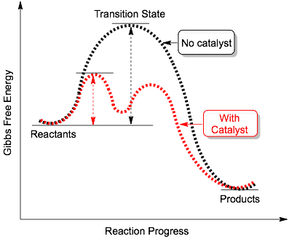Figure 1. Catalyst creates alternative reaction pathways with lower activation barrier
1.1.2 Evaluation of catalysts
Improving high catalytic performance is a major driving force in developing catalysts. Catalytic activity and selectivity are perhaps the most important properties of a catalyst. Catalytic activity may be quantitatively expressed as turnover number (TON) and turnover frequency (TOF). TON is defined as number of reactant molecules reacted per catalytic site. TOF is TON per unit time. (Equation 1-1 and 1-2) Initial TOF and average TOF are commonly used to characterize the speed of catalytic reaction.
Equation 1-1
Equation 1-2
The selectivity exhibited by a catalyst can also be of several different types, chemoselectivity, regioselectivity, enantioselectivity, etc. When more than one product is possible, design of optimal catalyst promotes the reaction with a strong preference toward a single desired product, enhancing the selectivity. Scheme 1 shows the epoxidation reaction between allyl alcohol and tert-butyl hydroperoxide (TBHP). The top reaction is an example of regioselectivity. Ti(IV) tetraisopropoxide and several titanosilicates ³⁻⁵ catalyze epoxidation of alkene rather than oxidation of the alcohol present. The product of glycidol contains two enantiomers. The bottom reaction of Scheme 1 illustrates the Sharpless asymmetric epoxidation catalysis. Enantioselective epoxidation can be achieved in high yield by using the Ti-tartrate system, i.e. Ti(OiPr)₄ with (+) or (-) dialkyl tartrate (DAT).
Recyclability of catalysts is another important aspect of a catalytic process. The first step in recycling a catalyst is to separate the catalyst from the reaction solution. Separation is usually much easier with heterogeneous than homogeneous catalysts, as will be discussed in section 1.1.3. Following separation, good stability and reusability are desired so that the catalyst may be recycled as many times as possible. Poor recyclability increases the cost particularly when expensive metals such as platinum and rhodium are involved.
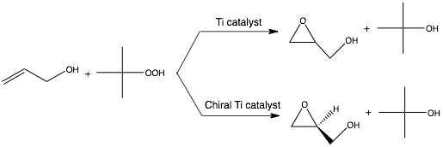
Scheme 1. Regio- or enantio-selectivity in epoxidation of allyl alcohol with Ti catalysts
Depending on the individual catalytic system, other factors such as macroscopic diffusion, susceptibility toward poisoning and catalyst life must also be taken into consideration. In heterogeneous catalysis, for example, the macrosopic size and shape of the catalyst particles is relevant for properties such as pressure drop, mechanical strength and attrition resistance. Mesoscopic properties such as specific surface area and porosity affect the intraparticle mass transfer of the catalysts. In summary, catalytic activity, selectivity, recyclability as well as other properties need to be carefully evaluated. These parameters are crucial in optimizing the catalyst and catalysis conditions, and in understanding the catalytic mechanism.

1.1.3 Homogeneous catalysts
A catalytic system is defined as homogeneous or heterogeneous catalysis based on the number of phases present. Homogeneous catalysis is a mono-phase process in which all reactants and catalysts are in the same phase, typically a liquid or gasses. These catalysts are soluble in the solution, and often take the forms of discrete metal complexes such as metallocene complexes, Cp₂MCl₂ (M = Ti, Zr, Hf). (left in Figure 2)
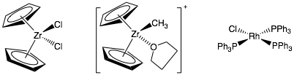Figure 2. Homogeneous catalysts in forms of discrete metal complexes
Homogeneous catalysts are generally molecular complexes composed of a metallic core (mono- or poly-nuclear) and coordinating ligands. The metallic core is frequently the site where the catalytic transformation takes place. As illustrated in Figure 3, a typical catalytic cycle involves a series of reactions, such as oxidative addition, reductive elimination, insertion, -elimination. The choice of ligands in a catalyst ensemble is also crucial in many ways, such as: (1) modulation of the electron density on the frontier atomic orbitals centered on the active atom(s) with LUMO and HOMO character; (2) control or preservation of the geometry of the site (in terms of structure, number, and location of the metal atoms and of coordinative vacancies) during the catalytic cycle; (3) cooperative activity in the diffusion of the reactants from and to the active center. The ease of synthesis and characterization makes it convenient to adjust the molecular structures and, what is more important, to understand the catalytic performance at a molecular level, i.e. kinetics and mechanisms of catalytic cycle, key intermediates, etc. for homogeneous catalysts.
Homogeneous catalysts dominate the production of many industrially valuable chemicals, such as acetic acid, alcohols, plastics, high-performance polymers, fine chemicals, and etc.. The production processes cover a variety of chemical reactions, such as carbonylation, hydrocarboxylation, hydroformylation and polymerization. The commercial success of homogeneous catalyst is associated with high selectivity that is available through optimized catalyst structure and catalysis process.
On the other hand, some disadvantages prevent homogeneous catalysts from broader application. The upper temperature limit for homogeneous catalysis is approximately 250 ℃ and is limited either by the boiling point of solvent or the thermal stability of catalyst. Therefore, homogeneous catalysts are rarely applied to high-temperature processes such as those involved in refining crude oil. Difficult recovery of catalysts and short catalyst life also add up the cost in practical applications for homogeneous catalysts.

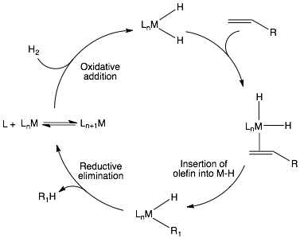Figure 3. Catalytic cycle of alkene hydrogenation (M= metal; L_{n}= coordinating ligands)
1.1.4 Heterogeneous catalysts
In heterogeneous catalysis, reactant and catalyst exists in different phases. Common combinations are: (1) solid catalysts + gas reactants; (2) solid catalysts + solution reactants; and (3) catalysts and reactants dissolved in immiscible solvents. A common form for heterogeneous catalysts is an insoluble solid support that has a large array of ions or atoms on the surfaces onto which catalytic active species such as metal-containing precursors are incorporated through various synthetic methods.
For heterogeneous catalysts, the microscopic length scale involves the composition of the supported particle, the surface structure of the supporting matrix and interaction between the two phases. All these factors determine the intrinsic activity and selectivity of the catalysts. As a matter of fact, most heterogeneous catalysts are characterized by a spectrum of supported catalyst species, the size of which can vary over a wide length range. Typically these sites include small crystallites of the precursor and nanoparticles which interact extensively with surface functionality. In a few cases large particles (>50 nm) are designed for better activity. For example, ethylene epoxidation calls for supported silver particle larger than 100 nm.⁶ A number of nano-scale (1~50 nm) supported particles have exhibited enhanced catalytic activity.^{7, 8} Titania supported gold particles with diameter between 2~3 nm exhibit superior catalytic activity in oxidation of CO to CO₂.⁷ Varying particle size of supported nickel changes the adsorption/dissociation energy for CO, and thereby affects the activity in Fischer-Tropsch synthesis of hydrocarbon from synthesis gas.⁸ These phenomena can be partially explained by changes in surface structure, electronic properties and interaction between supported phases and supports.⁹ Finally precursor molecules can adsorb individually, exchanging ligands with surface groups to form atomically dispersed active metal sites. Although many factors should be taken into account, theoretically, these atomically dispersed active centers share similar catalytic properties with their homogeneous analogue, which is drastically different from the bulk materials. In practice, the superior properties of atomically dispersed catalysts have been confirmed in some cases. The best example may be the isolated titanium(IV) centers in crystalline titanium silicalite-1 (TS-1) are responsible for a number of selective oxidation and solid-acid reactions.¹⁰ Even if only one surface species were to be present, heterogenous surface functionalities can lead to a distribution of active sites (Figure 4).
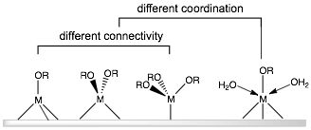Figure 4. Hypothesized structures of isolated metal centers on a supporting matrix
Heterogeneous catalysts exhibit a number of properties that are crucial in terms of large scale industrial production. The most important amongst others are the excellent thermal stability and easy recovery that requires no more than filtration or decantation, significantly lowering the cost in application. For these reasons heterogeneous catalysts have been widely employed in petrochemical industry, creating tremendous dollar value annually. Fundamental refining of crude oil almost entirely depends on heterogeneous catalysts. To convert heavier fractions in crude oil into high-octane gasoline, initial hydrodesulfurization employs alumina-supported cobalt molybdenum sulfide as the catalyst, followed by reformation process that involves acidified alumina-supported platinum and rhenium. Catalytic processes like these coverts 90% of the crude oil into various kinds of fuels. The final 10% provides raw materials for many downstream chemicals, in which heterogeneous catalysts also play an important role. Mixed metal oxides and rare earth exchanged aluminosilicates catalysts are commonly used in steam reforming and cracking reactions, producing synthesis gas (CO + H₂) and other small fragments of hydrocarbons.^{2, 9}
The catalytic activity and selectivity of heterogeneous catalysts relate closely to their intrinsic microscopic structure. The number of catalytic species on the supported phase, relative to total area of the supporting phase, needs to be small enough to ensure site isolation and avoid aggregation but at the same time high enough to exhibit high activity. However, even when starting with single type of catalytic precursor, most heterogeneous catalysts end up having multiple types of sites by the end of synthesis. Traditional synthetic methods for the preparation of heterogeneous catalysts often generate a number of inaccessible and/or inactive supported centers. It is generally believed that only a small percentage of the supported centers remain active after incorporation onto the surfaces of many supports. The density of active centers is thereby greatly diminished, in other words, lower catalytic activity per unit mass catalyst. Further, different types of centers, i.e. connectivity, coordination and nuclearity, may be present, each exhibits different energetics, activity and selectivity. The multisite nature of traditional catalysts has resulted in disadvantageous characteristics and catalytic properties. As a result, the catalytic activity and selectivity of heterogeneous catalysts is generally lower than that of its molecular homogeneous analogue.
The characterization of structures of heterogeneous catalysts is also challenging, which essentially limits the understanding and development of these materials. Standard techniques frequently fail to selectively characterize the catalytic centers within the broad matrix of sites present. Instead structural information, primarily about the catalytic centers, is usually collected through a combination of advanced spectroscopies and techniques. The lack of knowledge specific to the catalytic active centers makes it rather difficult to control and tailor their corresponding catalytic performances.
In terms of improving performance of heterogeneous catalysts, one of the central topics is to investigate the microscopic structure that is related to their catalytic behavior. Advances in characterization methods such as X-ray adsorption spectroscopy (XAS) and electronic microscopies (SEM, TEM) have contributed to an understanding of the structure-activity relationship at a molecular-level. On the other hand, new synthetic strategies are needed to target a specific structure and develop a clear correlation between that structure and desired catalytic performance.

1.1.5 Preparation of heterogeneous catalysts
Current progress in the development of heterogeneous catalysts depends, to a high degree, on the evolution of synthetic methods. The first solid catalysts were comprised of active metal catalyst phase and supports available from nature, for example, Bauxite (a type of aluminum ore) and “kieselguhr” (a natural silica support material).² Since then, various supported catalysts have been synthesized with increasingly better control of the structure, including particle size, dispersion, porosity, local coordination sphere around catalytic center and etc..⁹ In the catalyst manufacturing, the supporting phase is synthesized, shaped and subsequently loaded with active species. For the last couple decades, nanostructured carbon and silica materials have served as common supporting phases in a wide variety of new catalysts, such as carbon nanotubes, and mesoporous silicas MCM-41 and SBA-15.^{11, 12} Various methods of binding active metal to supports have been employed to control surface structures at certain stages of the synthesis, as is described in the following sections.
- Electrostatic adsorption and Ion exchange
The two methods, electrostatic adsorption (EA) and Ion exchange (IE), share similar reactants and comparable reaction conditions. In both methods, water-soluble metal salts are used as the precursors. Metal cations replace charge-compensating ions on the surface of supports, and afterwards counter ion byproducts and excess solution are washed away. These two methods are best demonstrated in the preparation of cation-exchanged zeolitic materials. Zeolites represent a family of three-dimensional microporous aluminosilicates with superior cation-exchange capacity. Distinct mechanisms are followed by IE and EA in the uptake of cations into silica supports. Ion exchange is a pH independent process, in which incorporated metal ions replace framework Al(III) in a stoichiometric fashion.¹³ In contrast, electrostatic adsorption is strongly pH dependent. The metal cations interact with the surface silanols (☰Si-OH) instead of the Lewis acidic sites, and the exchange capacity does not always match the stoichiometric ratio between proton and metal cation.^{13, 14} When both mechanisms occur simultaneously, zeolites are “over-exchanged” and two types of adsorbed metal species are formed (Figure 5).¹⁵ To obtain the uniformity of catalytic sites, the use of high Al content zeolite and acidic reaction conditions can inhibit the EA pathway to where it becomes negligible. However, it is worth mentioning that multiple types of catalytic sites are still likely to form, because of the varying local environments around framework Al(III) atoms where IE occurs.
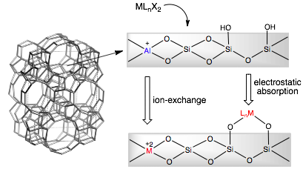Figure 5. Metal sites deposited on zeolite (ZSM-5) surface by different mechanisms.
Deposition-precipitation
Ever since being patented in 1943, deposition-precipitation (DP) has been applied as a generic method to obtain metals, metal oxides, metal sulfides or metal hydroxides as small particles onto a solid support. Soluble metal precursors are introduced into a suspension of a supporting material like silica, at the surface of which metal-containing precipitates formsexclusively.¹⁶ The presence of the support stabilizes the precipitate thermodynamically. Moreover, the interaction of precipitate with support lowers the surface free energy of small particles, which otherwise inhibits the precipitation.
The choice of method to bring about precipitation depends on the particular metal species and the type of support. One method involves increasing pH through the addition of an alkaline solution or the hydrolysis of urea. Hydroxyl ions then react with metal cations, forming metal hydroxide precipitates. (Equation 1-3 and 1-4) A second general method involves reduction of solvated metal ions to metal, metal oxide or hydroxide. A reducing agent such as formaldehyde is added to the suspension of silica supports and metal cations, causing deposition of small metal particles on the silica support. (Equation 1-5) With metals of multiple oxidation states, some studies reduced high valent metal with hydrazine and brought about deposition of metal oxide or hydroxide. (Equation 1-6) Lastly, catalytically active metals may be adsorbed onto the surface by removing stabilizing ligands through evaporation or oxidation. Ligands such as ammonia and ethylenediamine tetraacetic acid (EDTA) can stabilize metal cations through coordination and avoid aggregation. Removal of these ligands effectively initiate the deposition process.
Equation 1-3
Equation 1-4
Equation 1-5
Equation 1-6
Generally, DP generates thermally stable catalysts that have high metal loadings and relatively narrow particle-size distributionS. The highly reproducible procedures makes it one of the high-throughput methods in industry. On the other hand, it is difficult to control the rates of nucleation and precipitation that determine the deposited crystal size.
- Impregnation and drying
As the name indicates, two primary steps are involved in this approach to catalyst synthesis. The initial step is called impregnation, during which the precursor solution is introduced into the voids of the support where adsorption occurs. Afterward, a drying step is taken to eliminate the solvent. This synthetic method has been the favorite of the industry as well as at a laboratory scale, because of its convenient operation and complete deposition of the precursors.
Depending on the different procedures, some common types of impregnation are: (1) Dry or incipient wetness impregnation involving either a dried or water-vapor-treated support. The key is to control the volume of precursor solution to equal the pore volume of the support. (2) Wet impregnation: The support is filled with water, sometimes prior to which water-soluble gas like ammonia is used to replace the air inside the pores. The actual impregnation is carried out under diffusional conditions, when the water-filled support is immersed in an excess amount of precursor solution. (3) Two-solvent system: Based on dry impregnation, this method also benefits from using small amounts of precursor solution, but moreover, the reaction can be stirred in a liquid phase. The difference is made by suspending the hydrophilic support in an organic solvent before adding the aqueous precursor solution.
The main drawback of impregnation approaches to catalyst synthesis is the lack of control in the final distribution of the active phase which largely depends on the morphology and surface structures of the pre-made support. It is very difficult to achieve a homogeneous distribution especially when the industry prefers the supports in the form of extrudates or pellets rather than powders. Moreover, the drying step can change the deposited active sites in many ways. The temperature required for drying is up to the boiling point of the solvent, and in some cases lower for gentle drying. High temperature can cause thermal elimination of active species other than the solvent, or other detrimental chemical reactions to happen. Meanwhile, the speed of drying also plays a role in the final composition. It is known that instead of uniform composition, egg-yolk or egg-shell types of structures result from various conditions of impregnation and drying. ¹⁷
Sol-gel processing
All three methods above deal with the incorporation of catalytic active species onto the pre-made supporting materials. One unmentioned issue is to control the structure/texture of these supports critical to the catalytic properties. The sol-gel method has been successfully adapted to the preparation of xero- and aerogel materials. Porous materials such as silica and alumina are perfect candidates in terms of incorporating catalytic active species. Furthermore, sol-gel processing has also been used in synthesis of various catalysts, for example, mono- or multi-metallic monophasic oxides, and catalysts with adsorbed or entrapped active species. Figure 6 illustrates the general process of sol-gel method in preparing solid materials. It is featured by the formation of stable colloidal solution (sol), followed by anisotropic condensation of colloidal particles (micelles). During the step of gelation, polymeric chains in the form of (hydro) gels are formed by chemical bonding between functional groups at the surface. Finally, xerogels or aerogels with high porosity and surface area is produced depending on the drying method of choice. The condensation part of chemistry is traditionally accomplished by hydrolytic reactions, i.e. hydrolysis of hydrated metal ions or metal alkoxides.¹⁸ More recently, nonhydrolytic sol-gel processing has begun to develop, which is based on reactions such as esterification of metal chelate complexes¹⁹, and direct condensation between metal alkoxides and metal chlorides or acetates.^{20, 21}
- Hydrothermal synthesis
Hydrothermal synthesis is often combined with sol-gel, templating or other synthetic techniques to prepare crystalline materials like zeolites and some mixed-metal oxides. The method is characterized by the use of water and high temperature above 100 ℃ that enhances crystallization. The most well-known product by this method is the family of synthetic zeolite materials, each of which has distinct pore size, architecture and chemical composition. It is reported that over thirty elements can be incorporated with zeolites, potentially leading to a large number of catalysts.²² Initially a supersaturated solution is made with silica source (e.g. tetraethyl orthosilicate, TEOS) and alumina source (e.g. aluminum alkoxide) in the presence of structure directing agent (SDA) such as tetraalkylamines. Once the mixture forms a hydrogel or precipitate, the mineralizing agent (alkali salts, OH⁻, F⁻, etc.) is added as a catalyst to convert the gel/precipitate into what is referred to as the precursor species. Based on the classical crystallization theory, the precursors assemble into nuclei in the basic solution and subsequently grow into crystals over hours/days.²³ Preparation of some other crystalline oxide-based materials also involves hydrothermal treatment, for example, the titanium silicate (TiO₂-SiO₂) catalysts prepared by Corma et al..²⁴

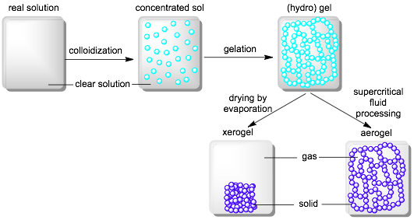Figure 6. Sol-gel processing in the preparation of solid materials
1.2 Single-Site Heterogeneous Catalysts (SSHCs)

1.2.2 Introduction
During the last two decades, strategically designed single-site heterogeneous catalysts (SSHCs) have attracted much attention in both academic and industrial research. It has been discovered that decreasing in particle size can lead to significant enhancement in catalytic activity. ^{7, 25, 26} This discovery directed researchers naturally to the design of molecular and atomic level catalytic centers. As mentioned previously, the inhomogeneity of catalytic centers is considered the main reason for low selectivity of heterogeneous catalysts. Therefore, a current goal in catalysis science is to have structurally identical catalytic centers on the supporting matrix, so that selectivity and recyclability can be achieved simultaneously. From the fundamental point of view, there are also further benefits associated with SSHCs. One major benefit would be the possible in-depth kinetic and mechanistic study of catalytic turnover, which is very difficult with traditional solid catalysts that contain a variety of sites. Further, the catalytic activity can be evaluated on a per site basis and compared with corresponding molecular analogues, which is essential in order to establish structure-function relationships and to direct the design and synthesis of new catalysts with enhanced performances.
J. M. Thomas et al.²⁷ suggests that “single site” in the context of heterogeneous catalysts should satisfy the following criteria, mainly focusing on the catalytic active centers: (1) Each active center is spatially isolated and does not cross-talk with one another in any forms; (2) Each has the same energy of interaction between it and a reactant; (3) Each may have one or more atoms, but all sites must be identical and have well-characterized structure.
According to most definition of single-site catalysts, enzymes are the true single-site catalysts. In this context, enzymes may be pictured as discrete nanoscale entities in a fluid phase like water. Their active center frequently consists of a metallic core surrounded by ligands that completely define the coordination sphere, which as a whole interacts with the small molecules in a single particular manner. In terms of synthetic heterogeneous catalysts, isolation of the sites remains a central concern, as most traditional synthetic methods do not address the problem of thermodynamically favorable aggregation of nanoscale particles.

1.2.3 Four principle categories and synthesis
Strategies have been developed over the years to synthesize numerous SSHCs, of which many have played an important role in academic researches as well as in industrial chemical processes. Four categories of SSHCs based on final forms of deposited catalytic species have been explicitly summarized by J. M. Thomas et al.²⁷ Despite many distinct types of catalytic species, the majority of SSHCs rely on the high-surface-area supports that are generally porous silica or metal oxides. Dozens of kinds of silicate materials have been synthesized since the early 1990s. Those are characterized by high surface area (up to 2500 m²/g), ordered mesoporous structures with tunable pore sizes (diameter of 2~50 nm) with uniform distributions. In addition, silanol (Si-OH) groups on their surfaces are reactive toward the metal precursors, as well as can be functionalized prior to deposition for various purposes.²⁸
The following section is a brief outline of some common synthetic methods in use for preparing single-site heterogeneous catalysts and representative examples.
- Isolated ions, atoms, molecular complexes anchored on high-area supports
Ions: Metallocene and metal alkoxysiloxy species, M[(OSi(OR)₃]_{n}, are perhaps the most common precursors in grafting transition-metal ions onto the silica surfaces. Covalent bonds form between the metallic center and residual pendent silanol groups, followed by calcination for removal of the organic groups on the metal precursor. Numerous supported metal centers, including Ti(IV) (Figure 7) ^{29, 30}, Mo(VI) ³¹⁻³³, Fe(III)³⁴, Cu(I)³⁵, Cr(VI) and VO(IV)³⁶, have been reported. While dispersed mononuclear sites are often desirable, polynuclear ones are likely to form in most syntheses. Generally, the amount of metal precursor needs to be small enough to ensure site isolation and avoid the formation of M-O-M bridges, which limits the loading of active components. Nickel-exchanged zeolite (ZSM-5) has been recently studied and proposed with two types of sites, Ni(II)-O-Ni(II) and Ni(I) (Figure 8). ³⁷ In this case, an initial step of reduction reaction is required to obtain uniformly Ni(I) sites.
Atoms: Single Pd atoms on the surface of thin film MgO has been synthesized by quadrupole mass-spectroscopy assisted chemical vapor deposition (CVD) and found to exhibit unique catalytic activity in cyclotrimerization of acetylene.³⁸
Molecular complexes: Supported molecular species instead of ions or atoms are desired when the metal precursor, usually catalytically active in the molecular form, has non-symmetric local environment that plays a role in the catalytic process. The molecular species can be grafted or tethered onto the surface of the supports. Some examples are microcrystalline 𝛼-TiCl₃ Ziegler-Natta catalysts (chloride ion vacancy), and sulfated alumina supported M(C₅Me₅)₂(CH₃)₂ (M = Zr or Th) and TiCp₂(CH₃)₂.³⁹ In any case, compared to the molecular precursors, similar or even better catalytic activity has been observed in the supported catalyst because of the effective site isolation and unchanged local environment around each metal center.
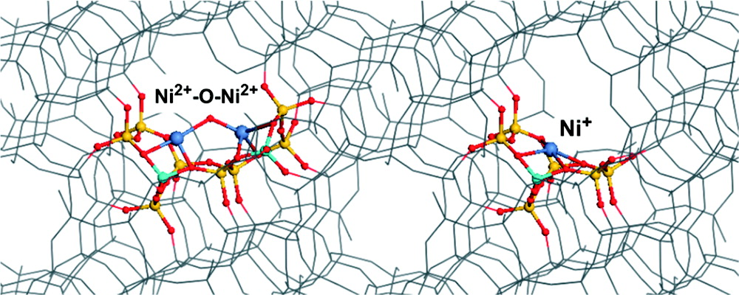
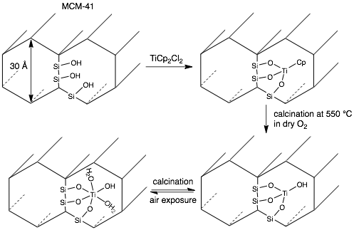Figure 7. Grafting titanium(IV) centers on silica MCM-41.

Figure 8. Localization of Ni(II)-O-Ni(II) and Ni(I) sites within the channel of zeolite.
[Ni (dark blue), Al (light blue), O (red), Si (yellow)]
Organometallic chiral catalysts
Organometallic chiral catalysts refer to those with constrained geometry, specifically the chiral or enantiomeric organic species tethered on concave silica supports (Figure 9).⁴⁰ Enhanced catalytic performance compared to the molecular species has been observed and explained by the confinement effect on the orientation of the reactant relative to the catalytic center.⁴¹ “Spacer” molecules such as tri-alkoxysilane, sulfonate and triflate (Figure 9 and 10) ^{40, 42} are also used to modify the silica surface. The surface silanols are passivated prior to the grafting of metal precursor. In this manner, the metal precursors are tethered only to the modified anchoring sites and kept from interactions with the silica surface or one another.
- Ship-in-bottle catalysts
As the name indicated, ship-in-bottle catalysts are encapsulated species inside the interconnected micropores of zeolites, without necessarily any interaction with the support surface.⁴³ The absence of covalent bonds between catalyst and support causes the least disruption to the catalytic center compared to grafting or tethering, which is crucial especially in the preparation of enantioselective catalysts.⁴³ More importantly, the metallic centers are effectively isolated within the pores, inhibiting deactivation due to dimerization or other side reactions.⁴⁴ Ship-in-bottle synthesis is also utilized to prepare immobilized enzymes, which exhibits excellent recyclability (>1000 cycles).⁴⁵
The internal voids within tridirectional zeolites such as faujasite X and Y are interconnected via smaller cavities (apertures) with a diameter of 3, 5, or 7 Å. (Figure 11) ⁴⁶ To encapsulate the active catalyst, the building blocks of the catalyst are dissolved in a proper solvent and diffuse into the zeolite pores by impregnation. The catalyst is then assembled within the pore, typically in the form of a metal complex that consists of a metal center and stabilizing ligands such as porphyrin or bipyridine. The size and bulk of the complex makes it impossible to diffuse out of the apertures. In catalytic reactions, these zeolite supercages exhibit shape-selectivity, i.e. only small enough reactants can diffuse through the apertures and approach the catalytic center.⁴⁷ The major drawback of the method is the difficulty in removing any unreacted species or byproducts during the formation of metal complexes, which could generate inactive catalytic sites.
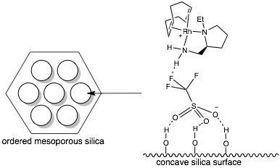Figure 9. Chiral Rh(I)-based cation tethered on silica surface through triflate counter ion

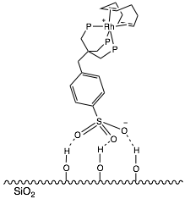Figure 10. Rh(I)-based cation tethered on sulfonate-modified silica

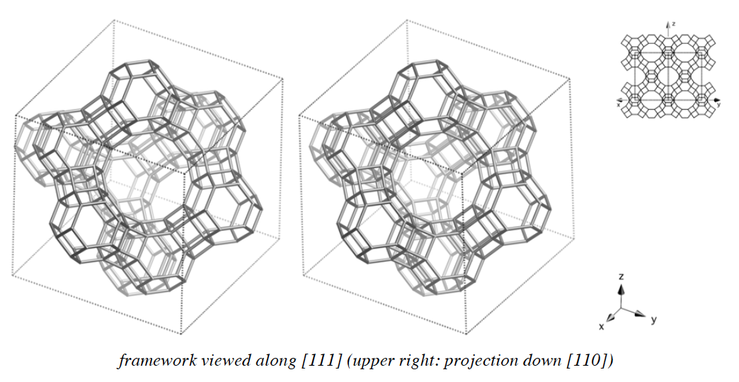Figure 11. Supercage structure in faujasite zeolites.
Open-structure solid catalysts
Open-structure aluminosilicates, aluminophosphates (AlPOs), framework-substituted silicates and MAlPOs (M = Mg, Co, Mn, Zn, etc.) are also representatives of uniform heterogeneous catalysts. A number of metal-substituted porous crystalline materials have been prepared mostly with ion exchange and impregnation syntheses. Highly dispersed atomic metal sites have exhibited unique catalytic activity and selectivity, compared to metal oligmers or bulk materials. After framework substitution, calcination is often involved to stabilize the crystalline structure, and the final products often show exceptional hydrothermal stability in catalysis. For example, the widely used selective oxidation catalyst titanium silicalite-1 (TS-1) is based on ZSM-5 silica framework, in which some tetrahedral Si are isomorphously replaced by Ti(IV) up to a limited percentage (~2.5 wt% Ti). More details concerning this catalyst are presented in section 1.3.2.

1.3 Titanosilicate Catalysts

1.3.1 Development of titanosilicates
Before titanosilicate catalysts, aluminosilicate zeolites exhibited shape-selectivity depending on the variety of available zeolitic lattices, and catalytic activity from the isolated Lewis acidic centers. The success of aluminosilicate brought some major breakthroughs in industrial chemical processing, and further inspired numerous investigations of transition metal cation (Ti⁴⁺, Fe³⁺, or V³⁺, etc.) substituted silicates. Atomically dispersed titanium(IV) centers in homogeneous catalysts like titanium tetra-isopropoxide show important catalytic activity distinct from that of bulk titania, for example, in polymerization and epoxidation of olefins.² But it has been found that aggregation of titanium molecular species causes fast deactivation of non-supported catalysts and limits their industrial application. Titanosilicates catalysts are intended to address the issue by immobilizing the [Ti(IV)O₄] units in an array of [SiO₄] silicates. Meanwhile, the ordered porous structure in titanosilicates functions as micro-channels that perform size-selectivity toward reactants and products.
The content of active sites (Ti wt% or titanium mol%) is an important parameter for titanosilicates. TS-1 contains up to ~2 wt% titanium but with a high cost of manufacture (over $100/kg)⁴⁸, which can only be justified by high-valued chemical products and good recyclability of the catalyst. A number of titanosilicates were prepared later through various ways and reportedly the titanium content reaches up to 30wt%.⁴⁹ The benefit from increasing titanium content is obvious as this increases the density of active centers which potentially translates into high catalytic rates for the catalyst. But high titanium content bring up other issues. Multiple types of titanium centers have been observed, when titanium centers aggregate and form catalytically inactive oligmer or crystalline titania. In some cases, these centers may also leach out of the matrix and into the solution. In such cases, it is critical to ensure true heterogeneous catalysis. In other words, the recyclability of such catalysts depends on the hydrothermal stability of titanium toward leaching especially with aqueous H₂O₂ in use so that active homogeneous species are not formed.
Porosity and surface area are also important properties of heterogeneous catalysts. In contrast to the significant progress made in scientific investigations, TS-1 has not been extensively used in industrial plants, notwithstanding its enormous potential as selective oxidation catalyst. As far as is currently known, the ammoximation of cyclohexanone, propylene epoxidation and phenol hydroxylation are the only industrial examples that utilize TS-1 as catalyst. One of the main reasons is the small pore size (5~6 Å) of the MFI lattice in TS-1. A large number of complex reactants, potentially oxidized into high-valued chemicals, are too large to enter the micropores of TS-1.
Later a variety of meso- and macroporous titanosilicates were synthesized, such as Ti-𝛽, Ti-MCM and Ti-SBA, so that a much broader spectrum of reactants are covered.⁵⁰ The titanium centers of these catalysts are not as well understood as of TS-1, and generally lower chemoselectivity is observed. With the advances made with in situ characterization techniques, significantly more information about the titanium centers has been obtained but still far from enough to unambiguously identify the active sites involved. It has not been possible to establish a well-defined structure-property relationship for titanosilicates catalysts. Tetrahedral Ti(IV) centers in Ti-MCM-41 suggested by spectroscopic evidence, however, shows distinctly different catalytic properties from supposedly the same catalytic centers in TS-1. Observations like this indicate that the catalytic activity depends on not only the state and total coordination number (CN) of Ti, but probably other factors that include: (1) the connectivity of the titanium ion to silicate matrix; (2) the influence of extra-framework Ti; (3) the influence of impurities; (4) the types of surface acidic sites; (5) the influence of surface hydrophobicity/hydrophilicity.
Not only atomic titanium centers, silica supported polynuclear Titanium centers with the substructure of Ti-O-Ti bridge(s) were also found to be active catalysts in a variety of reactions. Silica supported dinuclear titanium species (Figure 12, left) is an active catalyst in cyclohexene epoxidation with tert-butylhydroperoxide (TBHP) as the oxidant.⁵¹ Dinuclear (Figure 12, middle and right) and tetranuclear titanium clusters grafted on mesoporous silica have been prepared and exhibited high selectivity in catalyzing phenol oxidation with aqueous H₂O₂.⁵²
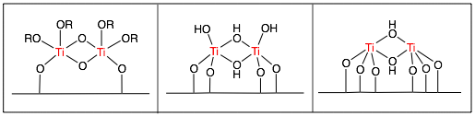Figure 12. Structures of dinuclear Ti sites proposed by previous studies
The structures of dinuclear titanium centers were hypothesized based on the surface density of hydroxy groups (OH/nm²) that is quantified before and after grafting with titanium precursors.^{51, 52} Nevertheless, it presents major difficulties in predicting the structure of active centers, partially because of the calcination at 500-1500 ℃ under oxygen flow prior to use.²¹ After all, the role of Ti-O-Ti bridge in titanosilicates has not yet been completely understood.
The knowledge about the active centers at the molecular level is far from adequate. The various titanosilicates as active catalysts, however, provide a basic picture, based on empirical knowledge, about the desirable physical and chemical properties of materials. Multiple factors need to be taken into consideration, for example, the uniform distribution of titanium centers in the matrix. Single-site heterogeneous catalysts combine the major advantages of homogeneous and heterogeneous catalysts, so that high activity and selectivity can be obtained with stable and recyclable solid catalysts. The choice of reactants to make these materials is related to the pore size of silicate framework that plays a role in catalytic selectivity of some titanosilicates. A wide range of titanium content is also desirable that maximizes the density of active centers, and potentially lower the cost especially in large scale production. To develop new catalysts that possess these qualities requires novel synthetic methodology in conjunction with advanced characteristic techniques, and fundamentally a good understanding of the catalysts and the working mechanisms.

1.3.2 Titanium silicalite-1 (TS-1)
In 1983, titanium silicalite-1 (TS-1) was discovered by Taramasso et al.⁵³ and has shown remarkable catalytic properties in a number of selective oxidation reactions. The isomorphous substitution of Ti(IV) in TS-1 is confirmed by a series of spectroscopies and other techniques, and possesses unique catalytic activity that is absent in bulk titania with 6-coordinated [Ti(IV)O₆] and bridging titanium centers [Ti-O-Ti].⁵⁴ Further, TS-1 exhibits good stability and catalytic efficiency when exposed to aqueous hydrogen peroxide (H₂O₂).
- Structures: active sites of Ti(IV) and hydrophobicity
As one of the milestones in the history of titanosilicate catalysts, the structure and catalytic property of TS-1 have been extensively studied. Isolated 4-coordinated Ti(IV) exist in TS-1 and are responsible for the catalytic activity in a variety of selective oxidation reactions.^{55, 56} The composition of TS-1 can be expressed in the formula of (TiO₂)_{x}(SiO₂)_{1-x} with the Ti/(Ti + Si) ≤ 2.5 atom%.^{48, 55}
X-ray diffraction (XRD) and neutron diffraction are powerful tools for determining the crystalline structures like TS-1. XRD is especially useful in defining the unit cell and lattice parameters. Below the upper limit for incorporation of titanium in TS-1, a linear dependence of lattice parameters and unit cell volume on the titanium content has been discovered, which clearly defines the upper limit of Ti(IV) insertion in the zeolite framework. XRD has also been used to define the crystalline structure to be the MFI type of zeolite. It is also crucial that MFI framework exhibits the flexibility, for example, for the reversible transformation between lattices of orthorhombic and monoclinic symmetry. This flexibility allows the framework to host much larger Ti(IV) ions (0.42 Å) than Si(IV) (0.26 Å), and is thought to allow Ti(IV) to change coordination numbers (4→6) and geometries (Td ⇌ Oh) while remaining associated with the silicate lattice. Because of the significant difference in the ionic radii of Ti(IV) and Si(IV), distorted pseudo-tetrahedral Ti(IV) centers are embedded in the framework of TS-1.⁵⁷ Further, neutron diffraction reveals that the Ti(IV) ions populate 3~5 different types of the 12 T sites within the MFI zeolite lattice (Figure 13).⁵⁸ However, the low concentration of titanium makes it challenging to determine the substitution sites, and different conclusions can be found from past studies.^{59, 60}
One of the key features of TS-1 is the superior stability against titanium leaching in aqueous H₂O₂, which is the main reason causing metal-silica catalysts to deactivate.⁶¹ The hydrolysis of Ti-O-Si bridge occurs inevitably in the presence of water and H₂O₂ at elevated temperature. In fact, mechanistic studies indicate that the breakage of Ti-O-Si is an essential step for initiating the catalytic cycle involving fully embedded [Ti(OSi)₄] units.⁵⁴ By the end of hydrolysis, 4-connected [Ti(OSi)₄] centers open up three coordination spheres and transform to 3-connected (tripodal) titanium units with several possible structures (Figure 14).⁵⁴ The open structure of 3-connected titanium center allows it to coordinate with small molecules (reactants) more readily. As the catalytic reaction goes on, titanium species are liable to be leached out due to the increasing degree of hydrolysis. Without the mechanism being completely understood, it is generally believed that the decrease in connectivity of titanium with silicate framework leads to elimination of Ti(IV) centers in the form of hydroxide, oxide or other molecular species.
The stability of TS-1 within aqueous environment is associated with the local structure around titanium center as well as the hydrophobic surface of catalyst. The titanium centers in TS-1 are incorporated through framework substitution and thereby possess the highest connectivity, whereas the surface-grafted titanium centers (connectivity <4) found in many other titanosilicates are more likely to be leached out. The hydrophobic surface also plays a role in stabilizing Ti. Due to the fact that both Ti(IV) and Si(IV) are tetravalent, Brønsted acidity is not anticipated from the substitution. This hypothesis is confirmed by the inactivity of well-synthesized TS-1 in Brønsted acid-catalyzed reaction in the absence of H₂O₂. As a result, the surface of TS-1 is highly hydrophobic and hinders water molecules from entering the pores where titanium centers locate. Further, hydrophobic reactants such as alkenes are preferentially adsorbed by TS-1. Therefore, hydrolysis of Ti-O-Si (Figure 14) that is essential to titanium leaching is much more oppressed in the case of TS-1 than the hydrophilic amorphous Ti-SiO₂.
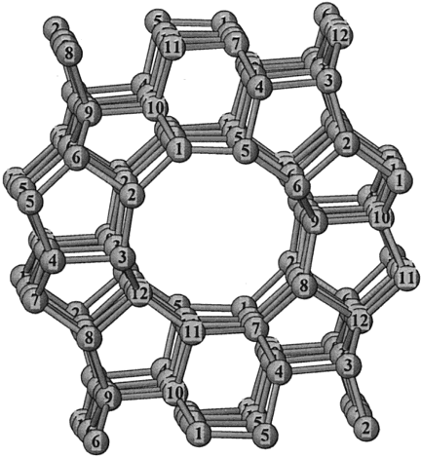Figure 13. The structure of orthorhombic form of silicalite-1 (MFI type) showing the 12 crystallographically distinct T sites (The oxygen atoms are omitted for clarity)
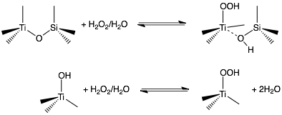Figure 14. Hydrolysis of [Ti(OSi)₄] in aqueous H₂O₂ (up) and conversion between 3-connected Ti-hydroxide and Ti-hydroperoxide (bottom)
- Synthesis
TS-1 has been synthesized mainly by wet impregnation method, however, over a dozen different versions have been reported that employ different titanium or Si precursors, structure-directing agents, gel compositions, sequence of additions, reaction temperatures and times, crystallization and calcination conditions, etc.. Table 1 summarizes some typical synthesis methodologies, which illustrates the impact from synthesis parameters on the final structure and composition of TS-1.
- Catalytic properties
Compared to most other titanosilicates, TS-1 has shown extraordinary hydrophobicity, and thus purely Brønsted acid-catalyzed reactions by TS-1 have not been observed. The superior catalytic activities originate mainly from the coordinatively unsaturated titanium ions (Lewis acidity of Ti). The hydrophobicity has been proven crucial to its excellent stability against aqueous environment, and more importantly its capability of activating H₂O₂ as the oxidant. Most metal-silicates, for example W(VI), V(V), Cr(III), and most Ti(IV)-silicates, deactivate quickly in the presence of water due to severe leaching of metal ions. Due to this fact, even though using H₂O₂ presents many benefits, for example, environmental friendly byproduct (water) and easy purification of the products, the application of H₂O₂ has been limited to oxide-based catalysts. More frequently, metal-silicate catalysts are used in conjunction with organic hydroperoxides such as tert-butyl hydroperoxide (TBHP). But higher cost is expected from (1) more expensive oxidants (ROOH vs. H₂O); and (2) more complex separation between desired products and byproducts (ROH vs. H₂O).
Table 1. TS-1 synthetic methodologies and parameters vs. Final Si/Ti and morphology
Synthesis methodology | Composition ^{a, b} | Temp  &  Time | Si/Ti | Crystalline size  &  morphology | Ref.
Hydrothermal synthesis  (mixed alkoxide) | TEOS  TEOT  TPAOH  base, distilled water | 448 K  6-30 d | 90-30 | parallelepipeds with round edges | ⁵³
Hydrothermal synthesis (dissolved Ti) | - Tetrapropylammonium peroxytitanate: TEOT in distilled water, aqueous H₂O₂ and aqueous TPAOH  - add colloidal silica and TPAOH | 278K | 90-30 | parallelepipeds with round edges | ⁵³
Wetness impregnation  (prehydrolysis) | - TEOS in dry iPrOH is hydrolyzed in aqueous TPAOH  - Ti(OBu)₄ as titanium source | 433 K  1-5 d | ≥10 | cuboid (< 1 𝜇m) | ¹⁰⁸
Growth from TS-1 seeds | TS-1 seeds  TPABr (structure-directing agent)  ammonia, water, amines | nr | nr | (100% crystallinity) | ¹⁰⁷
Sol-gel  (Template-impregnation) | - Obtain dried SiO₂-TiO₂ cogel  - Dry impregnation by adding aqueous TPAOH and heated in microwave  - Dry and then calcine the crystalline product | 823 K  5h  (calcine) | 50 | round shaped particles (~ 0.5 𝜇m) | ¹⁰⁶
ª Common components in wetness impregnation or hydrothermal synthesis include Si and titanium sources and structure-directing agent;
^{b} tetraethylorthosilicate (TEOS), tetraethyltitanate (TEOT), tetrapropylammonium hydroxide (TPAOH)
TS-1 is one of the few examples that utilizes H₂O₂ efficiently without undergoing significant leaching. In fact, a variety of epoxidation and oxidation reactions using aqueous H₂O₂ can be selectively catalyzed by TS-1 (Figure 15). ⁵⁴ Taking advantage of its single-site nature, some researchers have started investigating the reaction mechanisms and intermediates during the catalytic cycle. The initial step of activation of titanium center is illustrated in Figure 16. After TS-1 is exposed to aqueous H₂O₂, spectroscopic evidence agrees with higher-coordinated titanium centers, suggesting the formation of Ti-peroxo and Ti-hydroperoxo intermediates (Figure 16). ⁶² The coordination of titanium and peroxide reduces the electron density at the peroxide O-O bond and makes it more susceptible to attack by nucleophiles such as alkenes.
The activity in a specific reaction is closely associated with the pore size of MFI framework that favors smaller molecules and thereby has a major impact on the choice of reactants. Epoxidation of alkenes is one of the most studied TS-1-catalyzed reactions. With the small size of propene, the direct conversion to its epoxide with aqueous H₂O₂ can be obtained in near quantitative yields. The rate decreases with an increase in the chain length of the alkene molecule (1-hexene > 1-octene > 1-dodecene), which is mainly attributed to diffusion constraints. Generally, a large steric hindrance from the reactant or reactive functional group results in much slower reactions or inactivity. Therefore, for example, the reaction rate of epoxidation decreases in the sequence of 1-hexene > 2-hexene > 3-hexene. When multiple oxidizable functional groups coexist, such as diene or unsaturated alcohol, steric factor influence the selectivity by favoring the terminal double bond (non-substituted) that is sterically less hindered (figure 17).

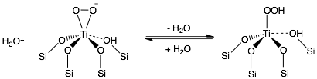Figure 15. TS-1 catalyzed reactions graph
Figure 16. Higher coordination Ti centers in the system of TS-1/H₂O₂/H₂O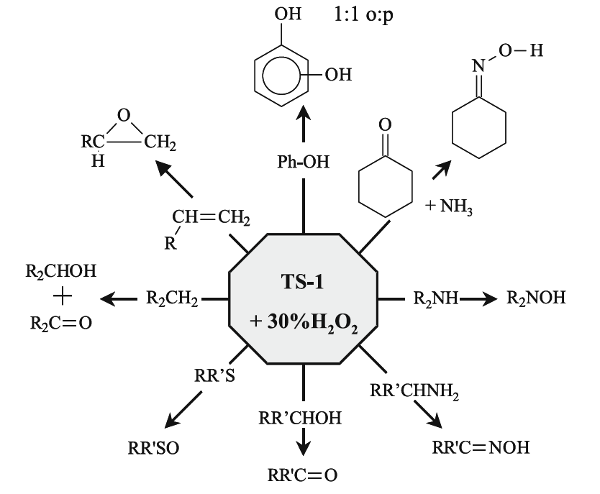

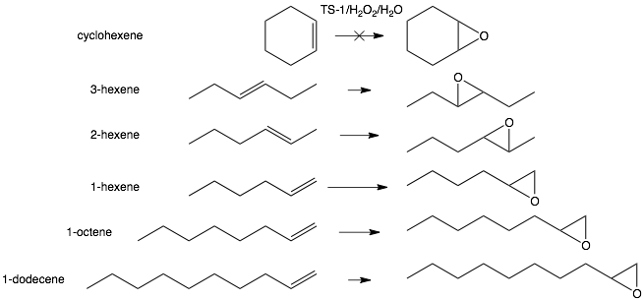
Figure 17. Influence of structure of reactants on reaction rate with TS-1
One of the major disadvantages of TS-1 is related with the small pores of MFI framework that excludes a number of potential reactants. For example, no significant conversion of cyclohexene is observed due to the large size of six-member ring, while the conversion of 1-hexene with a chain structure reaches nearly 100%. The requirements on the size of reactants significantly limits the use of TS-1 in industrial plants, because majority of high-valued chemical compounds are prepared with reactants of complex structures.
Moreover, the capacity of framework substituted titanium (active site) in TS-1 has an upper limit of approximately 2.5 wt%. Above the upper limit, the existence of non-framework titanium centers is confirmed by spectroscopies and the non-linear relation between unit cell parameters and titanium content. The non-framework titanium species such as crystalline titania or titanium oligmers with Ti-O-Ti bridge and/or high-coordinated titanium usually possess undesirable catalytic activity/inactivity, and therefore lower overall selectivity of the catalyst is observed as expected.

1.3.3 Mesoporous titanosilicate materials
There have been many attempts to synthesize titanosilicate molecular sieves with larger pore sizes to eliminate the steric constraints so that more complex molecules can be utilized to produce high-valued chemicals. Several tens of mesoporous silicates containing titanium ions in various structural and geometric locations have been synthesized and their chemical, physical and catalytic properties investigated. These molecular sieves are characteristic of uniform pore sizes (1.5 - 40 nm), large surface areas (up to 2500 m²/g) and tunable structures.⁶³
The construction of ordered porous materials depends on self-assembly in which (parts of) molecules spontaneously organize into structurally welk-defined aggregates. Noncovalent or weak interactions including van der Waals, electrostatic, and hydrophobic interactions, hydrogen and coordination bonds, and π-π stacking are involved in the self-assembling process. A number of different kinds of disorder on the atomic or molecular scale exist, but periodical mesoscopic morphology is displayed and most mesostructures belong to hexagonal and cubic phases. Two common pathways are utilized in the self-assembling synthesis: (1) the cooperative interaction between surfactants and silica sources to form mesostructures; (2) semiliquid-crystal template pathway. At the final stage of either pathway, organic surfactants or templates are to be removed by calcination, extraction, microwave digenstion or oxidative decomposition. Amongst the family of mesoporous titanosilicates, Ti-MCM-41, Ti-MCM-48 and Ti-SBA-15 have been extensively studied and therefore are taken as examples.
- Ti-MCM-41
Ti-MCM-41 is synthesized by hydrothermal and postsynthetic grafting techniques. Quaternary cationic surfactants C_{n}H_{2n+1}N(CH₃)₃X (n = 8-10, 12, 14, and 16; X = Cl and Br) were used as templates in the synthesis of MCM-41 mesoporous silica.⁶⁴ The average diameter of MCM-41 is ~4.0 nm that is characterized by XRD and TEM.⁶⁴ The pore channels are approximated as cylinders with the pore-wall thickness is estimated to be ~1 nm, and the surface area is generally higher than 1000 m²/g.^{64, 65}
Mainly two type of Ti-MCM-41 have been prepared through different synthetic methodologies, generating titanium centers of various locations and structures. The framework Ti-MCM-41 refers to the MCM-41 framework containing embedded titanium centers, during the synthesis of which the source of titanium such as Ti(OiPr)₄ is introduced simultaneously with Si source, typically Si(OEt)₄ or Si(OMe)₄. Usually only part of the titanium sites substitute in the Si framework and reside in the Si walls. In order to prepare titanium grafted onto the surface of MCM-41 (Ti↑MCM-41), MCM-41 silica is pre-made and subsequently titanium precursor such as titanocene is grafted on the silica surface.⁶⁶ Based on the characteristic evidence, it is proposed that after calcination most of titanium sites possess tripodal (3-connected) tetrahedral structure in comparison to the fully embedded sites (4-connected) in framework Ti-MCM-41.
- Ti-MCM-48
The pore diameter of MCM-48 is 2.4-2.7 nm, surface area 1000-1450 m²/g, pore volume 0.8-1.1 cm³/g.⁶⁷ Specific type of mesostructures including 2D (p6mm) or 3D (P6₃/mmc) hexagonal and cubic () can be attained by varying the packing parameters of surfactants, for example, g value that is defined by the total volume, hydrophilic headgroup area and kinetic tail length of surfactant molecules. The dry surface of pre-made MCM-48 framework is then grafted with titanium in the form of Ti(OiPr)₄. In direct synthesis of Ti-MCM-48, TEOS and Ti(OiPr)₄ are used as the sources of Si and Ti, respectively, and Gemini-type surfactants C₁₈₋₁₂₋₁₈ or cetyl-benzyl dimethylammonium chloride (CBDAC) are used as templates.⁶⁷
- Ti-SBA-15
SBA-15 belongs to 2D hexagonally mesostructured silica. It shares the same space group (p6mm) as the 2D hexagonal MCM-41, but larger pore size (~6.5-10 nm) and thicker pore-wall (3.1-4.8 nm) by hydrothermal synthesis. The uniform tubular channels of Ti-SBA-15 (surface area 600-900 m²/g, pore volume 0.6-1.3 cm³/g) can be prepared by direct and grafting methods by using triblock copolymers, poly(ethylene oxide)-poly(propylene oxide)-poly(ethylene oxide) in acidic medium. Synthesis of Ti-SBA-15 by incipient-wetness impregnation with Ti(OiPr)₄ has also been reported followed by calcination.⁶⁸ Titanosilicates prepared by varying synthetic methods and with choices of components differ to some extent in structural parameters and catalytic properties.
One of the reason for limited application of heterogeneous catalysts is the heterogeneity of active sites. In fact, it was confirmed with XAS that calcination can cause significant changes to grafted metal centers in coordination, connectivity to silica matrices and sometimes nuclearity.^{21, 33} For the purpose of this research, the majority of titanosilicates that are prepared by hydrothermal or grafting methods with calcination, fail as the objects of investigation due to the presence of multiple titanium sites of two categories, framework incorporated and extra-framework.
Single-site heterogeneous catalysts (SSHCs) of many structural and catalytic merits are the target candidates for the purposes of this research. As introduced above a few methodologies for preparation of SSHCs have been developed, but very few are successful in terms of targeting the local environment within and around the metal active centers. Currently, control of connectivity around a titanium center in a silicate matrix has only been achieved with homogeneous molecular species, i.e. Ti-silsesquioxane complexes. ⁶⁹ These silsesquioxane complexes serve as excellent molecular models for the active sites on the atomic level. Much useful information about the catalytic processes has been acquired through the studies particularly involving 1-, 2- or 3-connected atomic titanium center, titanium dimer and tetramer silsesquioxane species (Figure 18).⁷⁰ Under the catalytic conditions, these soluble complexes participate as homogeneous catalysts rather than heterogeneous ones. Recently it was reported that 3-connected Ti-silsesquioxane was deposited on polydimethylsiloxane (PDMS) membranes and characterized by DRUV, forming active catalysts for alkene epoxidation.⁷¹

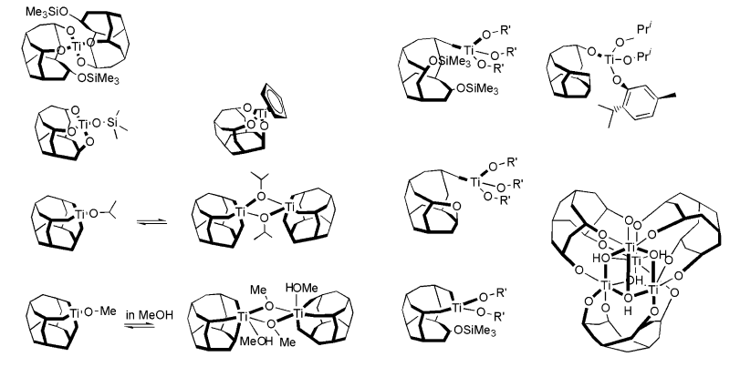
Figure 18. Examples of Ti-silsesquioxane

1.4 Overview of Dissertation

1.4.1 Motivation and goals
Titanosilicate catalysts have been studied intensively for over three decades and significant success has been attained in the synthesis of various kinds of titanosilicate. TS-1 was one of the first titanosilicates discovered with excellent catalytic properties, leading to extensive study on a family of titanosilicates. During the past couple decades, a number of mesoporous titanosilicates were synthesized by hydrothermal and wet impregnation. Many of these have been demonstrated to be active catalysts that are able to accommodate a number of complex reactants normally too bulky to enter the micropores such as those in TS-1. However, mesoporous titanosilicates such as Ti-MCM-41 and Ti-MCM-48, when compared with TS-1, show lower chemoselectivity and H₂O₂ efficiency in olefin epoxidation reactions.
The catalytic property of zeolite-based titanosilicate depends on the following factors: (1) the state and connectivity of titanium ions; (2) the presence and nature of extra-framework Ti; (3) the influence of impurities; (4) the types of surface acidic sites; (5) the surface hydrophobicity/hydrophilicity; (6) the crystal size.
TS-1 and Ti-MCM-41 have been intensively investigated and characterized amongst the family of titanosilicates. Theoretically and empirically the selectivity of catalyst depends to a high degree on the nature of the active sites. It is thus difficult to explain the drastically different selectivity between the two titanosilicate analogues, since in both frameworks Ti(IV) ions are isolated and in near tetrahedral locations. With limited knowledge about the catalyst structure, the major differences that exist are in the pore sizes and in the surface hydrophilicity/hydrophobicity. It has been proven that the surface hydrophilicity contributes to the instability of catalyst and quick decomposition of H₂O₂ relevant to inefficient utilization of H₂O₂ as the oxidant.⁷² With the help of modern techniques especially X-ray absorption spectroscopy the coordination and connectivity (framework coordination) of the active sites in titanosilicates can be characterized on the atomic level. It has been discovered that TS-1 contains mostly [Ti(OSi)₄] type centers, whereas most of titanium centers in Ti-MCM-41 are thought to be tripodally [Ti(OSi)₃(OH)] connected to the silicate support in near tetrahedral geometries. This suggests that the connectivity between titanium center and the silica support should play a key role in the catalytic property.
The goal of the research described here was to develop and apply a general methodology for targeted synthesis of single-site titanosilicate catalysts. Specifically we wished to develop a methodology that would lead to preparation of atomically dispersed, single-site catalysts in which the connectivity of the titanium atoms to the surrounding silicate support could be targeted and changed as desired.
Furthermore, each of the titanium atom sites in the matrix must also be kept isolated from all others as an inherent feature of the strategy and not utilize the compromise of low loading strategies to obtain isolated sites. The resulting materials must also be porous and exhibit high surface area and therefore high site density per unit volume or weight.
Finally, we also wanted to be able to incorporate single-site, site isolated, polynuclear titanium oxo catalyst sites, e.g. tetranuclear Ti4Ox sites, into these matrices analogous to atomically dispersed systems. With such single-site materials in hand we then sought to develop a well-defined structure-function relationship between titanium atoms with specific connectivities to the surrounding porous silicate matrix and their catalytic activity in the oxidation of phenols to benzoquinones with peroxide. The structure-function relationship should contribute to the fundamental understanding of catalytic processes in specific reactions. In order to observe the effects of varying structures of catalysts, but excluding the influence from other factors like hydrophilicity/hydrophobicity, the experimentation should be conducted on a family of catalysts that share the common mesostructure with the only variables being the local structure of active sites.
The strategy in this research is to design targeted single-site titanosilicate catalysts that exhibit (1) well-defined structure around every titanium center supported by multiple independent lines of characterization; (2) all titanium centers are isolated from one another; and (3) exhibit consistent mesostructures (porosity, hydrophilicity/hydrophobicity, etc.) within a family of catalysts. Practically, a building block (bb)-based synthetic approach is presented in conjunction with the structural characterization using advanced spectroscopies and techniques. Most importantly, the catalytic performances of these materials are evaluated in the selective oxidation of alkyl-substituted phenol to the corresponding benzoquinone. The catalytic properties of titanium active sites are demonstrated to be highly sensitive to the local structure (connectivity and nuclearity). XAS plays a crucial role in the investigation of both structure and catalytic intermediates. The relationship between structure and catalytic activity of the catalytic sites is helpful to direct future design of titanosilicates. The approach of structural control is applicable with other metal-silicate catalysts on a number of catalytic reactions.

1.4.2 Atomically dispersed and clustered Ti centers
A family of catalysts are prepared, each of which contains a specific type of titanium center, namely 2-connected (2C-Ti), 3-connected (3C-Ti) and 4-connected (4C-Ti) (Figure 19). The building block synthetic methodology guarantees the homogeneity of titanium centers (single-site) that is later confirmed by a number of independent lines of characterization.
In order to investigate the catalytic property of polynuclear titanium center, polynuclear complex, [Ti₄Cl₆(𝜇₂-O₂CPh)₆(𝜇₃-O)₂] ⁷³, that contains Ti-O-Ti substructure and chloride groups was taken as the titanium precursor and the similar bb synthetic methodology makes it possible to incorporate isolated the tetranuclear titanium clusters into a silicate bb matrix. Therefore, the catalytic properties of polynuclear species can be evaluated and compared with that of atomically dispersed titanium catalysts. The actual structure of polynuclear center will be 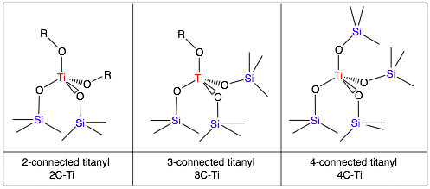proposed in chapter IV based on a variety of characterization data.
Figure 19. Titanium centers with different connectivity on silica matrices

1.4.3 Catalytic properties in phenol oxidation
Finally, the catalytic properties are of great interest, and are evaluated as secondary characterization of these single-site catalysts. The as-synthesized catalysts are applied to the alkyl-substituted phenol oxidation with aqueous H₂O₂, as shown in Figure 20. The desired product, 2, 3, 5-trimethyl-p-benzoquinone, is a high-value chemical and key intermediate for synthesizing Vitamin E. Although possessing large commercial potential, the knowledge about the catalytic mechanism of this reaction is very limited. Based on previous researches, some preliminary results have shown the difference in catalytic selectivity between mononuclear and polynuclear titanium centers.⁵² In this research, the structure-function relationship is established according to the catalytic performance of single-site catalysts. More importantly, to our knowledge, this is the first study reported on how connectivity around titanium center may influence the catalytic property of titanosilicate in phenol oxidation reaction, possibly following a 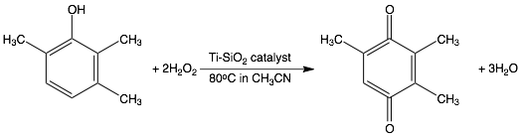free radical mechanism.

Figure 20. Oxidation of 2, 3, 6-trimethylphenol (TMP) into 2, 3, 5-trimethyl-p-benzoquinone

Stability and recyclability is of great importance to a true heterogeneous catalytic system.

Chapter II. General Synthesis & Characterization

2.1 Building Block Methodology

2.1.1 General methodology
Barnes et al. has developed the synthetic methodology for the preparation of a uniform distribution of isolated, identical metal sites within a silicate matrix.⁷⁴ The trimethyltin-functionalized silsesquioxane building block (bb), instead of small Si linkers (e.g. TEOS), is employed as the silicon source, and the active metal precursors are mono- or polynuclear metal complexes featured by reactive chloride groups. The crosslinking process is driven by the exothermal reaction between M-Cl (M = titanium or Si) and Si-O-SnMe₃ functionalities. The irreversible metathesis reaction forms Ti-O-Si or Si-O-Si linkages through which titanium centers are incorporated. As expected, the only byproduct is trimethyltin chloride (ClSnMe₃), which is directly related to the number of Ti-O-Si (connectivity) around titanium center, as described below in “gravimetric analysis”. Previously, this methodology, referred to as the method of sequential additions (MSA), has been successfully applied in preparing silicate bb supported single-site vanadium catalysts.⁷⁵ Targeted vanadium active centers were uniformly dispersed throughout the matrix as confirmed by a series of characterization including X-ray absorption spectroscopy (XAS) and ¹⁷O SSNMR.⁷⁵
As illustrated in Figure 21, two pathways are available that produce different locations of active sites by simply altering the sequence of reactions. The first pathway (top in Figure 21) is to synthesize “embedded” catalyst sites by introducing metal precursors in a limiting amount at the beginning of the synthesis. As a result, the metal center resides within the bb matrix, in other words, none of the chloride groups on the metal precursors should remain after incorporation. As the following step, the M-bb oligmers undergo further cross linking with inert linker, typically silicon tetrachloride (SiCl₄). Alternatively, as the bottom of Figure 21 shows, if to graft metal center on the surface of silica, the metal center must be introduced after the formation of silica matrix, so that metal center can only interact with the unreacted -SnMe₃ groups on the surface of material.
To serve the purpose of this particular research, the first pathway (“embedded” catalysts sites) is applied to preparing all materials throughout this research, because it is known that surface titanium species are vulnerable to aqueous environment and thus less ideal for the titled catalytic reaction. In order to target the structure of active centers, a family of titanium precursors are chosen, including mononuclear alkoxylated chlorotitanates TiCl_{x}(OR)_{4-x} (x = 2, 3 or 4), and a tetranuclear titanium cluster.

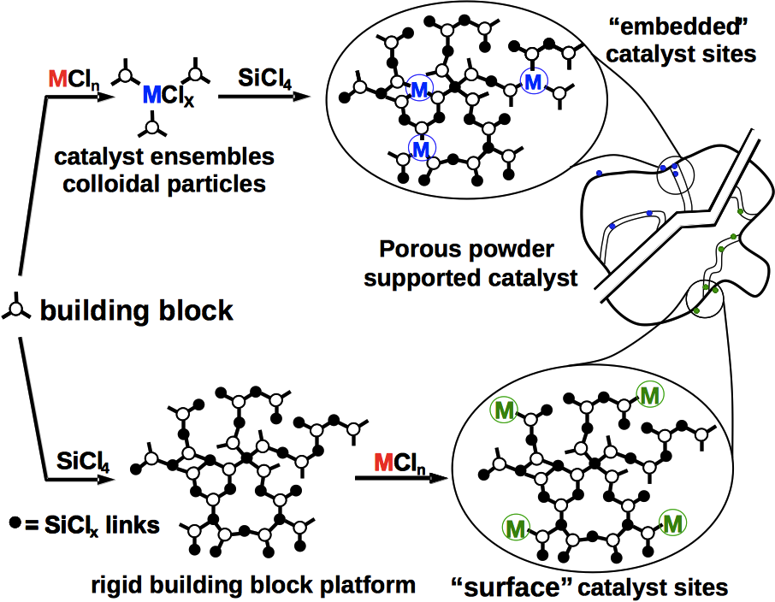Figure 21. Sequential additions in building block methodology

Following the two steps of crosslinking shown in Figure 21, the material is passivated with methanol, dried, and ready for use as the catalyst. The mesostructures of the final materials are closely related to the stoichiometric ratios in each step of synthesis as well as the passivation conditions. But typically, high surface area (200 - 500 m²/g) and meso-size pores (diameter ~20 Å) are obtained according to nitrogen adsorption/desorption analysis.
The entire preparation takes 4~5 days compared to 5~14 days of the conventional way that includes synthesis, crystallization and calcination prior to use. Due to the fact that no organic template is involved in this methodology, calcination is unnecessary, which benefits in many ways. It is ideal to avoid calcination that is likely to alter the nature of metal-to-silica connection. From the practical point of view, a more cost- and energy-efficient approach of preparing titanosilicate catalysts is presented.

2.1.2 Building block
The choice of building block (bb) is critical for the isolation and homogeneity of active metal centers. Mononuclear silicon compounds such as TEOS are used as the Si precursor by traditional impregnation synthesis, as a result, generating a variety of products such as [═Si(OTi)₂], [―Si(OTi)₃] and [Si(OTi)₄] units. These units may react intra- or inter-molecularly and form Ti-O-Ti linkages. When TEOS or other small Si molecules are employed, higher titanium content often leads to the formation of cluster and titania domains.^{49, 76} Thus, it is necessary to isolate titanium centers atomically, so as to prevent the formation of undesired polynuclear centers.
Building block plays a key role in this methodology. Octa(trimethyltin) silsesquioxane [Si₈O₂₀](SnMe₃)₈ has a cubic structure, of which the Si corners (indicated as blue atoms in Figure 22) are equivalent and provide one type of linking sites. Figure 22 illustrates the core of bb [Si₈O₂₀], and each corner of bb is functionalized with a trimethyltin group (-SnMe₃). The bb complex was prepared following the original synthesis by Feher.⁷⁷ Only one open site in the coordination sphere around silicon is available and all 8 silicon atoms of bb are equivalent. Trimethyltin group (-SnMe₃) bonded to the silicon corner reacts with high valent metal or silicon chlorides (Ti-Cl or Si-Cl), forming trimethyltin chloride (ClSnMe₃) and [☰Si_{bb}-O-M] linkage (in which Si_{bb} represents the corner silicon from bb, and M stands for titanium or Si).
The size (diameter ≥ 1nm) of the [Si₈O₂₀](OSnMe₃)₈ bb and its structural rigidity makes it impossible for titanium centers on different corners of bb to interact with one another. By choosing a nanometer-sized bb, titanium centers are effectively isolated from one another and polynuclear titanium center (Ti-O-Ti bridge) is highly unlikely when mononuclear titanium precursor is employed. In addition, bb shows good thermal stability when heated under vacuum at 400℃. No obvious change was observed in NMR, UV-Vis and Infrared spectroscopies.

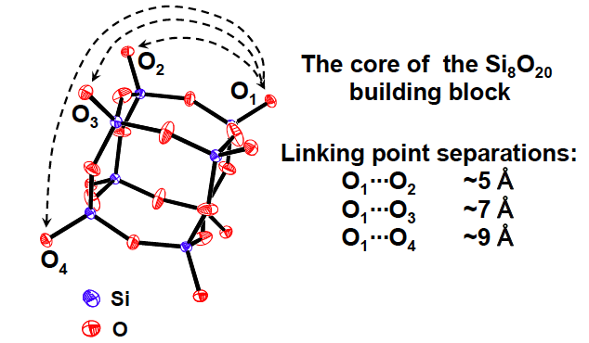Figure 22. Illustration of [Si₈O₁₂] core structure of [Si₈O₁₂](OSnMe₃)₈ building block
2.1.3 Linkers
Two categories of linkers are involved:
Metal precursors (active linkers): mononuclear titanium tetrachloride (TiCl₄), isopropoxy-trichloro-titanium [TiCl₃(OiPr)], diisopropoxy-dichloro-titanium [TiCl₂(OiPr)₂] and polynuclear [Ti₄Cl₆(𝜇₂-O₂CPh)₆(𝜇₃-O)₂]. These Ti-containing linkers are incorporated into the matrix as the titanium sources. titanium precursors with varying numbers of chloride groups and nuclearities are prepared, and transform into the targeted actie centers once embedded.
- Inert linker: silicon tetrachloride (SiCl₄)
Long-range structures are formed from connecting Ti-bb oligmers with inert silicon linkers. The further crosslinking serves to improve the stability of heterogeneous catalysts. Moreover, it creates the crucial meso-sized pores that serve as the diffusional channels and provide surface area on which adsorption/desorption of small molecules occur.
Titanium tetrachloride(TiCl₄, Aldrich, 99.9%), titanium tetraisopropoxide (Ti(OiPr)₄, Fischer Scientific, 98+%) and tetrachlorosilane (SiCl₄, Fischer Scientific, 99.5+%) were distilled and stored in Teflon sealed glass vessels under vacuum prior to use. Alkoxylated chlorotitanates, [TiCl₃(OiPr] and [TiCl₂(OiPr)₂], and [Ti₄Cl₆(𝜇₂-O₂CPh)₆(𝜇₃-O)₂] complex were prepared following the previously established procedures.^{73, 78} Details will be discussed in Chapter III and IV. All the linkers and silsesquioxane building block were characterized with NMR and IR, and the spectra collected were consistent with the original literature.

2.1.4 Method of sequential additions
Experimental: Toluene and hexanes were distilled, dried over Na/K alloy, and stored in a sealed glass vessel under vacuum. Volatile liquid reactants and organic solvents were vapor transferred upon use. Experiments with air-sensitive materials were performed with schlenk technique under high vacuum or in the nitrogen atmosphere glove box. Glassware was pre-treated with trimethylchlorosilane/triethylamine to remove any silanol on the surface, and then rinsed with de-ionized water and dried in the oven. The vaporizable components, such as the TiCl₄ precursor and the solvent of toluene, are added into the schlenk through vapor transfer at -78 °C (dry ice). Solid reactants such as alkoxylated chlorotitanates Ti(OR)_{4-x}Cl_{x} and silicate bb are added under nitrogen atmosphere in the glove box. The reaction schlenk is heated at 80 °C while stirring at 400 rpm for 24 hours. Under this condition, pale precipitate forms typically in 30 minutes out of a clear solution. Once after 24 hours of heating/stirring, the mixture of precipitates and clear solution is dried at 80 °C under vacuum for 18 hours to remove any volatiles components, including byproduct Me₃SnCl and toluene. After the first step of crosslinking, the residue appears an off-white solid.
Three major steps of sequential additions are involved in the synthesis of atomically dispersed titanium catalysts:
Step #1: To make 4-connected (4C) titanium catalyst, titanium tetrachloride (TiCl₄) is used to react with dehydrated bb in the solvent of toluene at 80 °C for 24 h. The stoichiometric ratio between titanium to bb is critical to the connectivity of titanium centers. Limiting amounts of titanium precursors ensures that the chloride groups (Ti-Cl) are completely reacted and replace with Ti-O-Si linkages, so that homogeneous [TiO₄] sites are embedded in the matrices.
As illustrated in Equation 2-1, a series of consecutive irreversible metathesis reactions occur involving the functional groups of chloride (―Cl) and trimethyltin (―SnMe₃) on the corner of bb, form Ti-O-Si linkages and the byproduct of trimethyltin chloride (Me₃SnCl). Notice 1:1 stoichiometric ratio between the moles of Me₃SnCl and [Ti-O-Si] linkages. Taking advantage of this, connectivity that is defined to be the number of Ti-O-Si linkage per titanium site will be 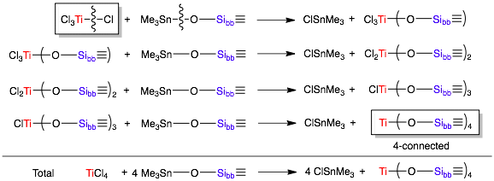quantified by the gravimetric measurement (in section 2.1.4).
Equation 2-1. Step by step metathesis reactions between TiCl₄ and bb
Following the same methodology, 2C- and 3C-Ti catalysts involve alkoxylated chlorotitanates, Ti(OiPr)_{4-x}Cl_{x} (x = 2 or 3), as the precursors. When titanium precursors are the limiting reactant, the reaction involving three types of mononuclear titanium compounds and bb are illustrated in Figure 23.

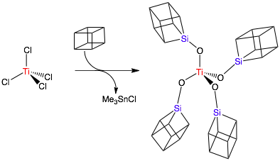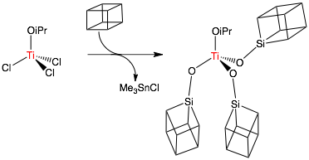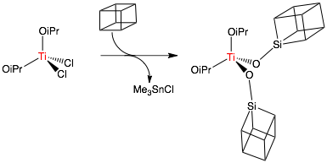Figure 23. Cross linking reactions between Ti(OiPr)_{4-x}Cl_{x} (x = 4, 3 or 2, top to bottom) and bb
Step #2: As shown in Figure 24, the second step of reaction involves silicon tetrachloride (SiCl₄, 99.8+%, Acros Organics) as the inert linker to build up the matrices with long-range structure. Two equivalents of SiCl₄ to the BB are vapor transferred into the original schlenk. Based on the gravimetric measurement, 2.0-2.5 out of 4 chlorides on each Si are reacted and replaced by Si-O-Si_{bb} linkage, i.e. 1.5-2.0 silyl chlorides are left per silicon. The reaction takes place in toluene at 80 °C with vigorous stirring for 48 h. A colorless gel forms near the surface of the solution upon completion of the reaction. Toluene and byproduct Me₃SnCl are then removed under vacuum at 80 °C. The residue appears to be an off-white loose powder.
Step #3: The materials are passivated with excess methanol (2 methanol : silyl chloride) in toluene as the solvent. The simple step of passivation serves two purposes: firstly to remove the remaining chloride, secondly the trimethyltin groups. The process, as illustrated in Figure 25, replaces Si-Cl with Si-OMe, and generates hydrochloric acid (HCl) that is ready to react with trimethyltin groups. Byproduct Me₃SnCl can then be removed by heating under vacuum. By the end of passivation, Si-Cl and Si-O-Sn groups in the matrices should be replaced by Si-OCH₃ and Si-OH, and therefore the final catalyst (as-synthesized catalyst) is air and moisture stable. When used in conjunction of aqueous H₂O₂, the only active species in the silica matrices should be the incorporated titanium centers. Virtually all tin (Sn) has been removed and the actual weight percentage (Sn wt%) is below 1.0% according to ICP elemental analysis.
Finally, these passivated catalysts are ready to be used in the oxidation reaction with aqueous H₂O₂. Structures of 4-connected (4C), 3-connected (3C) and 2-connected (2C) titanium sites are illustrated in Figure 26. The structure of tetranuclear titanium center will be proposed in Chpater IV based on the results of characterization.
A Ti-free platform is also prepared and characterized for comparison purposes, for example, with IR, DRUV and BET surface area. During step #1 in synthesis, titanium precursor is replaced with silicon tetrachloride (SiCl₄), followed by the normal synthetic procedures (Step 2 and passivation). The sample of Ti-free platform appears to be a white loose powder.
Figure 24. Second crosslinking and passivation of 4C-, 3C- and 2C-Ti catalysts
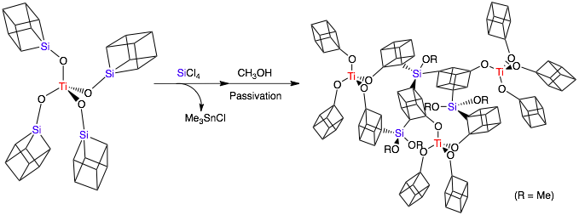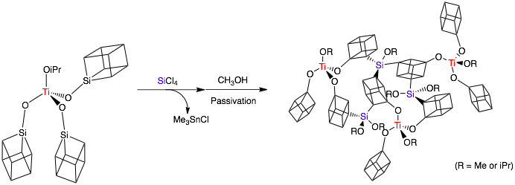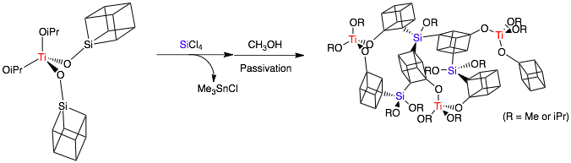
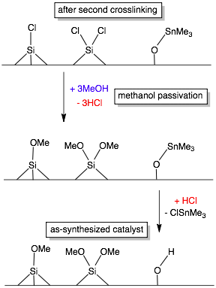Figure 25. Multiple reactions in the step of methanol passivation
Figure 26. 4C-, 3C- and 2C-Ti centers within the matrices

2.1.5 Gravimetric analysis
Connectivity of titanium center in a silica matrix is defined to be the number of Ti-O-Si linkages around the titanium center. Much effort has been devoted to prepare and characterize the isolated titanium centers that possess specific connectivity. But it has been challenging to characterize or confirm the local structures around titanium on the atomic level. In previous studies, the structures of dimeric titanium centers were hypothesized based on the weight change from the loss of surface hydroxy groups (-OH), according to thermogravimetric analysis (TGA).⁵¹ The varying amount of surface hydroxy is correlated to the process of titanium deposition, and thus used to prove or disprove the hypothesized structures of titanium centers.
Gravimetric analysis is used to characterize the local structure of titanium centers in this research, but in a more directly related way and on a larger mass scale (>300 mg). Because of the irreversible metathesis reactions and the formation of volatile byproduct (ClSnMe₃), the local connectivity around titanium center can be preliminarily characterized with the gravimetric measurements. The weight loss during the first crosslinking reaction is only associated with the removal of volatile trimethyltin chloride (ClSnMe₃). Therefore, by measuring the weight change 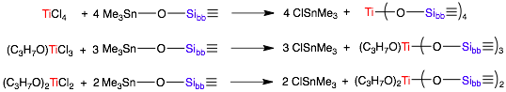before and after the reaction, mmol of ClSnMe₃ can be solved, and is equivalent to mmol of Ti-O-Si linkage, according to the reaction equation below.
Equation 2-2
According to these balanced equations, the number of [Ti-O-Si] and [ClSnMe₃] are equal and available through gravimetric measurements. Knowing the amount of titanium precursor and ClSnMe₃, the connectivity, defined as Ti-O-Si linkages per titanium site, can be obtained with equation 2-3. An example of the actual calculation is shown in Table 2.
Equation 2-3

Table 2. An example of the calculation of the connectivity
m | empty glassware + stir bar | 230.500 g
m(bb) | bb | 1.500 g (0.809 mmol)
m(Ti) | TiCl₄ | 0.077g (0.404 mmol)
m(total) ª | m + m(bb) + m(Ti precursor) | 232.077 g
m(after) ^{b} | m + m(bb) + m(Ti precursor) - m(ClSnMe₃) | 231.762 g
m(ClSnMe₃) ª | m(total) - m(after) | 0.315 g ClSnMe₃  (1.58 mmol)
connectivity | [ClSnMe₃] / [Ti] | 3.91
ª m(total) and m(ClSnMe₃) are the only masses obtained from calculation;
^{b} m(after) is measured by weight after the reaction when all volatiles have been removed (solvent and any byproduct)
2.2 Diffuse Reflectance UV-Visible Spectroscopy

2.2.1 Introduction
Diffuse reflectance UV-Visible (DRUV) spectroscopy has been widely used in characterizing the titanium centers in titanosilicates.^{54, 69, 79, 80} Absorption bands arise from ligand-to-metal charge transfer (LMCT), typically from ligand oxygen to an unoccupied d orbital of the central titanium ion (Ti⁴⁺O^{2–}→ Ti³⁺O–). The maximum position of the absorption band depends on the coordination and ligand environments of titanium center, and thus is often used to interpret the structure. According to the ligand field theory, LMCT between coordinating ligand (X = Si-O⁻, H-O⁻, R-O⁻, etc.) and empty d orbitals of Ti(IV) can be estimated from the optical electronegativities of X and Ti(IV) by the following equation^{81, 82}:
Equation 2-4

The coordination of titanium center has the major impact on the absorption. of tetrahedral and octahedral geometry are 1.85 and 2.05 respectively.⁸¹ LMCT of octahedral titanium is expected to absorb at a lower wavenumber compared to tetrahedral titanium center, which is consistent with the trend seen in most titanosilicates. Amorphous TiO₂-SiO₂ that contains primarily 6-coordinated titanium exhibits significant blue shift in the maximum of absorption band (~290 nm) compared to 4-coordinated titanium in TS-1 (~210 nm). Along with the change in coordination, the second coordinating sphere around titanium centers also changes from SiO⁻ to water or HO⁻, etc. According to some literature⁸², some arbitrary values of are Si-O⁻ (3.17), H-O⁻ (2.9), HOO⁻ (3.45), H₂O (3.5). Usually hydration of titanosilicate results in not only an increase in coordination of titanium (tetrahedral to octahedral) but also lower due to the change from Si-O⁻ to H-O⁻. The red shift in absorption band after hydration is a combined results of both effects.
The spectral differences among titanium ions in various environments can also be related to the different Ti-O-Si bond angles from different geometry.⁸³ When the geometry changes from O_{h} to T_{d}, the bond angle of Ti-O-Si increases, causing the hybridization of bridging oxygen around titanium center changes from sp³ to sp² and eventually sp that favors π electron donating. As a result, the non-bonding e orbital splits into bonding e_{π} and anti-bonding e_{π}*, and the latter becomes LUMO in T_{d} geometry with higher energy than that in O_{h}. Therefore, LMCT increases from O_{h} to T_{d} geometry, and the larger band gap is consistent with the blue shifts observed in DRUV absorption.
Quantum size effect also plays a role in DRUV spectra of titanosilicates. Red shifts of absorption edges are observed with high titanium content. In some cases, a separate titania phase appears and the wavelength of absorption is related to the particle size. In summary, a number of factors may play a role in the wavelength of absorption band, including coordination number of Ti, coordinating ligands, size of the titanium particle (quantum size effect), existence of nano-sized separate titania phase, etc.. The complex influences make it impossible to quantitatively calculate LMCT using equation # (page 51). After all, DRUV spectroscopy is very helpful to qualitatively interpreting the geometry and coordination of titanium centers.

2.2.2 DRUV Spectra and interpretation
Heterogeneous catalysts that have multiple types of titanium centers, as a result, exhibit overlapping absorption features. Spectral deconvolution is sometimes necessary to clarify the overlapping features. Different interpretations of the absorption features commonly exist due to the complex factors that affect the spectra as discussed above. Empirically isolated tetrahedral titanium centers [Ti(OSi)₄] or [Ti(OSi)₃(OH)] have an absorption feature centering below ~230 nm. Variation between 205-230 nm is observed with different types of matrix and connectivity, for example, ~210 nm for TS-1 and TS-2, ~220 nm for Ti-MCM-41 (Figure 27)⁸⁰, and 205-220 nm for Ti-beta(F). Structural Distortion from T_{d} geometry⁸⁴ and higher coordination number (CN) around titanium result in red shifts, for example, ~260 nm (5-coordinated Ti) or 270-290 nm (6-coordinated Ti).¹⁰ Large anatase particles is characteristic of an absorption maximum at ~330 nm, and rutile absorbs at the wavelength of ~400 nm. The empirical relationship between the structure of titanium center to the wavelength of absorption is very useful in characterizing the titanium species and identifying any changes in the coordination or ligand environments.
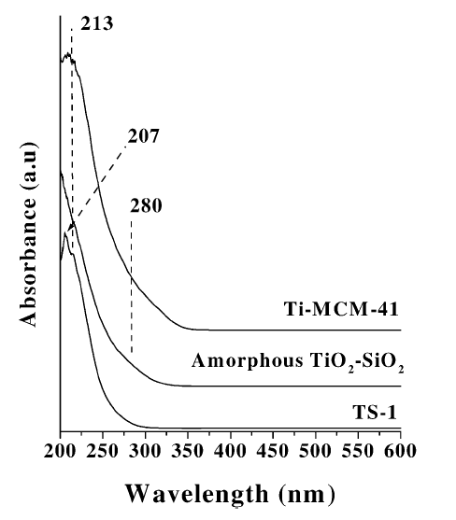Figure 27. DRUV spectrum of TS-1, Ti-MCM-41 and amorphous TiO₂-SiO₂

2.2.3 Sample preparation & data collection
Diffuse reflectance UV spectrometer is an ideal tool for characterizing powdered or crystalline materials. A flat surface of sample powder receives the incident radiation, and subsequently reflects in the forms of diffuse reflection and specular reflection.(Figure 28) Only diffuse reflection that is scattered within the sample and returned to the surface is collected by the accessory and directed to the detector optics. Strong specular reflection may cause spectral distortion for highly reflecting samples, which can be reduced by sample dilution. DRUV samples are usually diluted with a non-absorbing matrix such as potassium bromide (KBr), which leads to deeper penetration of the incident beam into the sample. The sample to matrix ratio varies with different compositions of the samples, and some studies recommended 1-5 wt%. In this research, all samples are titanosilicate materials with titanium content of 2-8 wt%. According to the relative intensity and shape of spectra, the sample to KBr ratio is optimized to be in the range of 50 wt% - 100 wt% (no KBr).
Wig-L-Bug® grinder/mixer is used to mix the sample powders with dry KBr as the matrix. The homogeneity of the mixture ensures the reliability and reproducibility of the spectra. Small particle size contributes to the quality of spectra by reducing specular reflection and with narrow bandwidths and better relative intensity. Finally, the mixture of powders is then loaded into a air-tight in situ cell, of which the main purpose in this research is to keep from air and moisture. The sample cup inside the in situ cell should be filled to the top edge with powder, and a smooth and flat top surface is also crucial. All preparations are completed under nitrogen atmosphere in a glove box. Absorption spectra of wavelength 200-600 nm are collected with UV-Vis spectrometer (Evolution 600) under scan mode. The spectrum of pure dry KBr is collected at 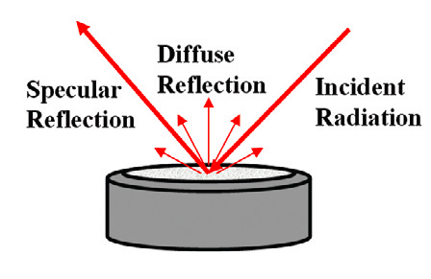the beginning of each measurement as the baseline to be subtracted from the sample spectra.
Figure 28. Diffuse reflection on the surface of sample powder
2.3 X-ray Absorption Spectroscopy (XAS)

2.3.1 Introduction
X-ray absorption spectroscopy (XAS) is a powerful tool to investigate the chemical environment of the absorber atoms in amorphous materials.⁸⁵ Kelly and et. al. has provided a explicit introduction about XAS that covers technical background and data processing.⁸⁶ X-ray absorption occurs when an atom acquires all the energy of an X-ray, which is used to excite electrons into higher energy electron orbitals that are unoccupied, or into the continuum where the electron is no longer associated with the atom. (Figure 29) The promotion of an electron into a higher energy state by X-ray absorption is short lived. Within approximately a femto-second (10⁻¹⁵ s), the core hole is filled by an electron that transitions from a higher energy orbital.
The number of X-rays transmitted (I_{t}) through a sample is given by the intensity of X-raysimpinging on the sample (I₀) decreased exponentially by the thickness of the sample (x) and the absorption coefficient of the sample (𝜇).
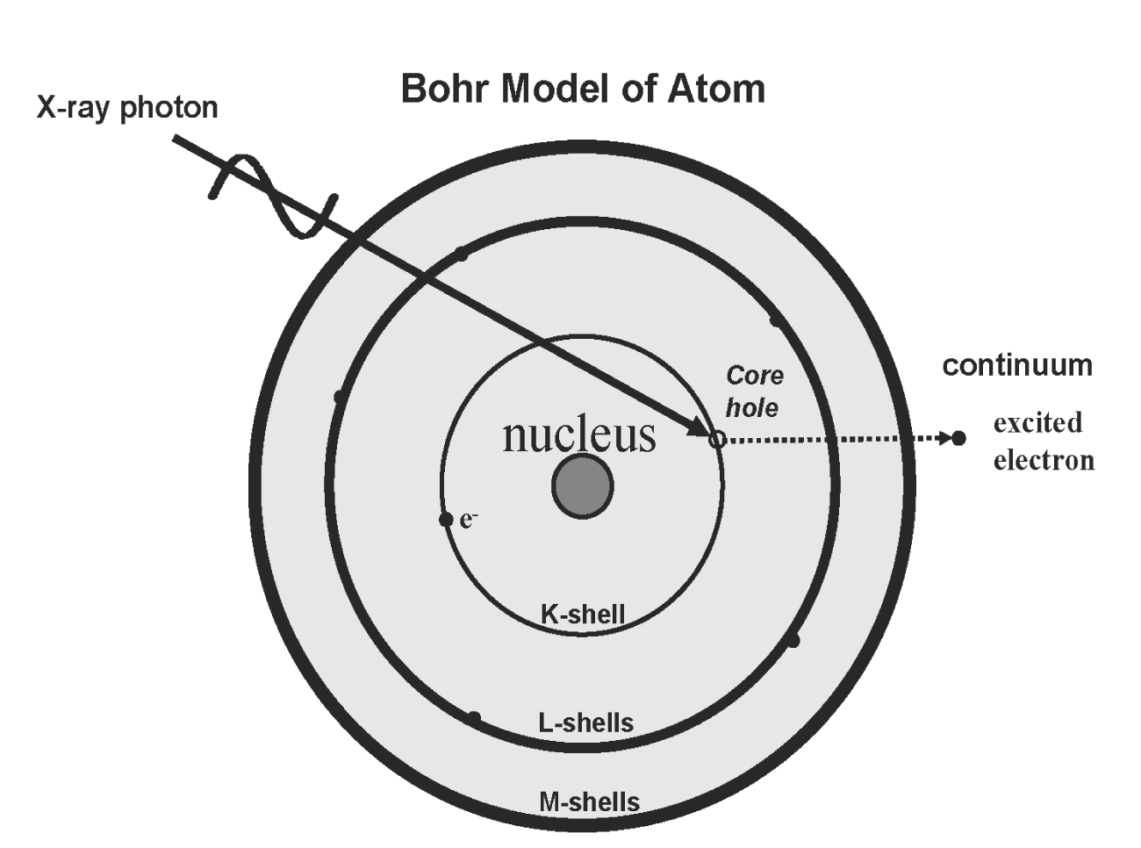Equation 2-5
Figure 29. A core electron is excited by a X-ray photon of the proper energy
The X-ray absorption coefficient (𝜇) is the probability for an X-ray to be absorbed by a sample. X-ray absorption spectroscopy involves measuring m as a function of X-ray energy. A typical experimental setup for XAS is shown in Figure 30. The X-rays go through an ionization chamber to measure the number of incident X-rays (I₀), then through the sample, and then through another ionization chamber to measure the number of transmitted X-rays (I_{t}). The X-ray absorption coefficient is determined by rearranging Equation 2-6.
Equation 2-6

X-ray fluorescence occurs when an electron from a higher-energy orbital fills the core hole by releasing an X-ray, the energy of which is equivalent to the energy difference between the two orbitals, and unique for a given electronic transition of each element. Therefore, florescence radiation is proportional to the number of core holes generated during excitation process. The absorption coefficient is derived from the number of florescence photons (I_{f}).
Equation 2-7

In either type of collection mode, transmission or florescence, the absorption coefficient (𝜇) is a function of the incident X-ray energy. The probability for absorption increases sharply when the incident X-ray energy equals the energy required to excite an electron to an unoccupied electron orbital. Figure 31 displays a typical XAS spectrum collected in transmission mode. The step in the absorption coefficient is called the absorption edge. In general, the EXAFS signal for transmission data decreases as the energy increases while the EXAFS signal for fluorescence data increases as the energy increases. The energy of a specific edge increases as the atomic number of the element increases. This is because elements with greater atomic numbers have more positively charged nuclei from a greater number of protons, and therefore, they have a greater binding energy of an electron in a given atomic orbital. For each element, the K-shell electrons are closest to the atom’s nucleus, and therefore they have greater binding energy than the L-shell electrons.
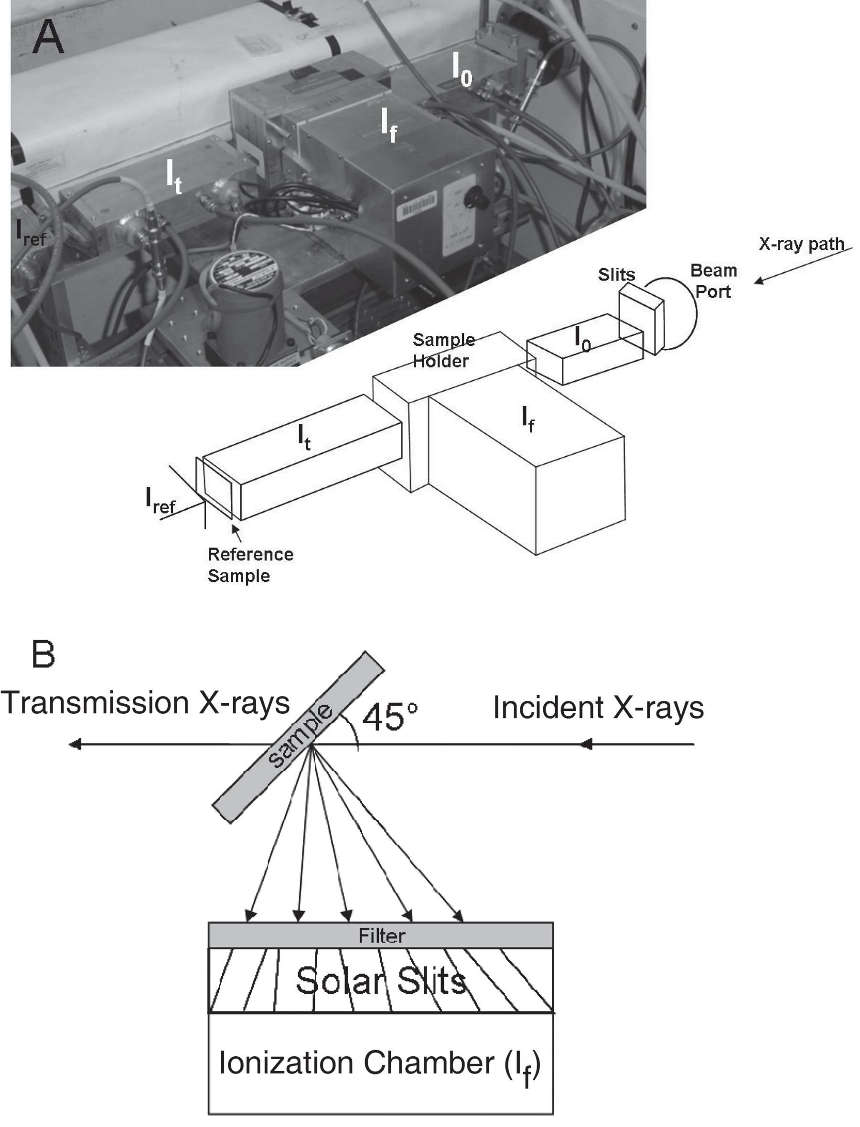Figure 30. (A) Picture and schematic drawing of an EXAFS experimental setup. (B) Fluorescence sample geometry and detector. (Reprinted from Kelly et. al. ⁸⁶)

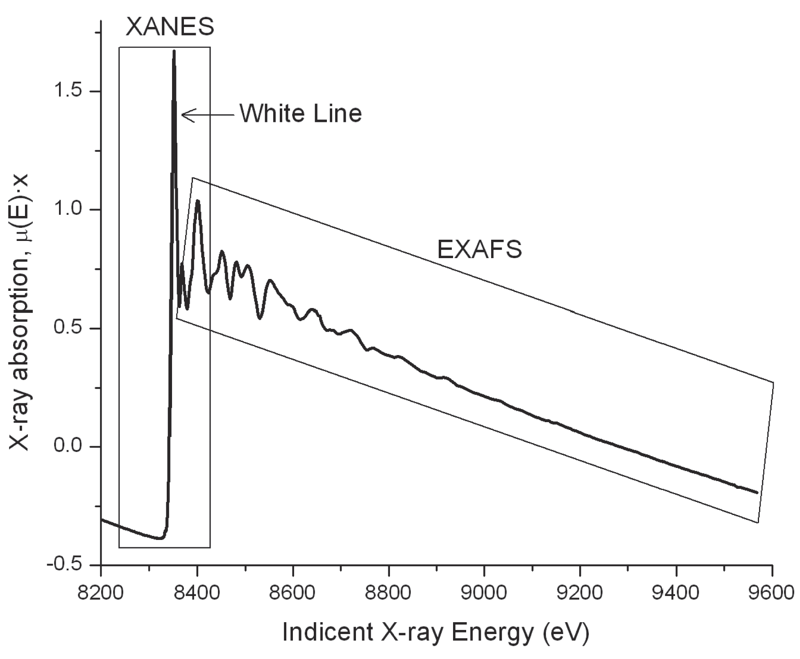Figure 31. An example of X-ray absorption spectrum of NiO

2.3.2 Sample preparation & data collection
A thin copper plate is used as the sample cell to contain the XAS sample. The thickness of the plate is 1 mm and a rectangular hole (15 mm × 7 mm) functions as the sample compartment. Thin polypropylene windows (7.5 μm) are fixed to the copper plate with two-sided transparent tape to seal the sample cell. Prior to being loaded into the cell, the sample was ground into fine powders with Wig-L-Bug. No noticeable improvement in the spectrum was observed from diluting the sample with boron nitride or graphite. All spectra reported here were collected with the pure sample powder. The unencessity of dilution may be because of the generally low content of absorber atoms (Ti) in the samples. All the sample preparation was carried out under nitrogen atmosphere in a glove box.
XAS spectra of Ti-containing samples were collected in fluorescence mode at the National Synchrotron Light Source (NSLS) beam lines X19A and X18B with a solid-state passivated implanted planar silicon (PIPS) detector. In this research, Ti(IV) is the absorber atom in all samples. The absorption K edge of titanium locates at the energy of approximately 4975-4985 eV. Titanium foil that shows a pre-edge peak at 4966 eV is used to calibrate the beam energy at the beginning and end of data collection. Figure 31 shows a typical XAS spectrum that consists of two regions: X-ray Absorption Near Edge Structure (XANES) and Extended X-ray Absorption Fine Structure (EXAFS). XANES refers to the region from -200 eV to +75 eV relative to the main edge, and EXAFS region is 75-1000 eV above the edge. During the collection of spectra, different step sizes and integration time are used in different energy ranges (step size, integration time, energy range): (5 eV, 1s, -200 to -15 eV), (0.5 eV, 2s, -15 to +75 eV), (1.5 eV, 3s, +75 to +550 eV), (5 eV, 4s, +550 to +1000 eV).
Three or four scans were collected for each sample and processed with IFFEFT data analysis software suite (Athena and Artemis programs) developed by Ravel, B. et. al. from NSLS. FEFF 8 modeling program was used to analyze EXAFS spectra. The theoretical phase and amplitude functions were generated from the function of FEFF 8 within Artemis.

2.3.3 General interpretation of XAS spectra
This study followed the standard XAS data processing reported previously.⁷⁵ Basic procedure includes glitch removal, truncating, aligning and averaging spectra, etc.. Absorption edge energy, or threshold energy, (E₀) is generally defined as the point of inflection of the absorption edge, and can provide information about the oxidation state of the absorbing atom. In this study, the energy at half height of the absorption edge is used to define E₀. Pre-edge and post-edge line are determined with two data points on the absorption curve, respectively. The difference between pre- and post-edge lines at the energy of E₀ determines the absorption step height. Normalization of the spectrum is done by dividing the measured spectra by the absorption step height and subtracting a regressed line determined by the pre-edge region from the entire spectra. A smooth absorption edge background curve is generated based on the absorption edge energy with Athena, and subtracted during the Fourier transform (FT) of EXAFS signal. Data processing and analysis can be performed using one of sevral computational programs (e.g. IFEFFIT, WinXAS, GNXAS). Abundant chemical and structural information about the metal sites, including coordination, backscattering shell of atoms and bond lengths, are available.
The basic processing of XAS spectra is crucial for the accuracy when fitting the data with the structural model. The step height determines the amplitude of the EXAFS oscillations and is therefore correlated to the EXAFS parameters such as the amplitude reduction factor (S₀²), and the coordination number (N). The pre-edge, post-edge, and resulting step height should always be checked before the spectrum is further processed. Normalized spectra (E) can be used in EXAFS analysis to visually check the alignment of the spectra and to look for spectral changes between successive scans from the same sample.
- XANES:
The absorption features in near-edge region of the spectrum, from -200 eV (below the main edge) to +75 eV (above the edge), correlate closely to the oxidation state and symmetry around the absorber atom. In the spectra of titanium K edge, the pre-edge intensity arising from the electronic transition from 1s to 3d orbital of titanium is sensitive to the coordination symmetry of titanium center. The position and height of pre-edge peak reveal abundant structural information about the titanium center. XANES region of 6-coordinated octahedral titanium (O_{h}) such as titania anatase exhibits multiple pre-edge peaks of low intensity. Because the excitation of the 1s electron to the empty 3d orbital of Ti(IV) in O_{h} symmetry is Laporte forbidden, namely A_{1g}→T_{2g}, A_{1g}→E_{g} for d⁰ configuration. Ti(IV) center in tetrahedral (T_{d}) geometry is characterized by a sharp and intense pre-edge peak arising from A₁→T₂ transition, which is allowed in T_{d} symmetry due to significant hybridization of the 3d and 4p orbitals.
The shape of main edge is associated with the ligands in coordination spheres. When the first coordination sphere around Ti(IV) contains only oxygen atoms, a smooth edge is usually observed. When chloride (Ti-Cl) is present, a pronounced absorption shoulder arises on the main edge. The intensity of the shoulder increases with the number of Ti-Cl bonds. The lower shoulder on the main edge has been previously assigned to a Ti-based 1s→4p shakedown transition.⁸⁷
Farges et al.⁸⁸ summarized the relation between pre-edge features and coordination number (CN) of Ti(IV) center in a number of Ti-containing metal oxides (Figure 32). It is clear that both pre-edge height and position shifts with varying CN. Pre-edge position shifts by 1-2 eV from 4- to 6-coordinated Ti. The study suggests that the shift in pre-edge position be associated with a shift in the Fermi energy due to the varying coordinations.⁸⁸ XANES and EXAFS were also applied to investigate the changes in coordination of the titanium centers in TS-1 with ammonia, pyridine and deuteriated acetonitrile (CD₃CN) as molecular probes.^{89, 90} The change in coordination from four to six coordination accompanies with progressive reduction in the pre-edge intensity in XANES spectra.

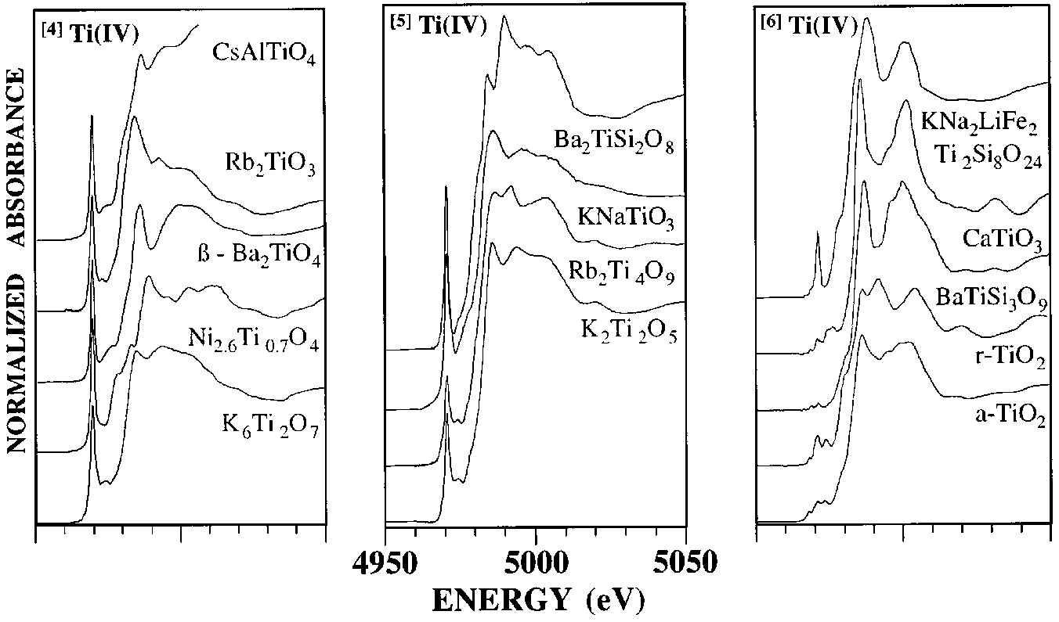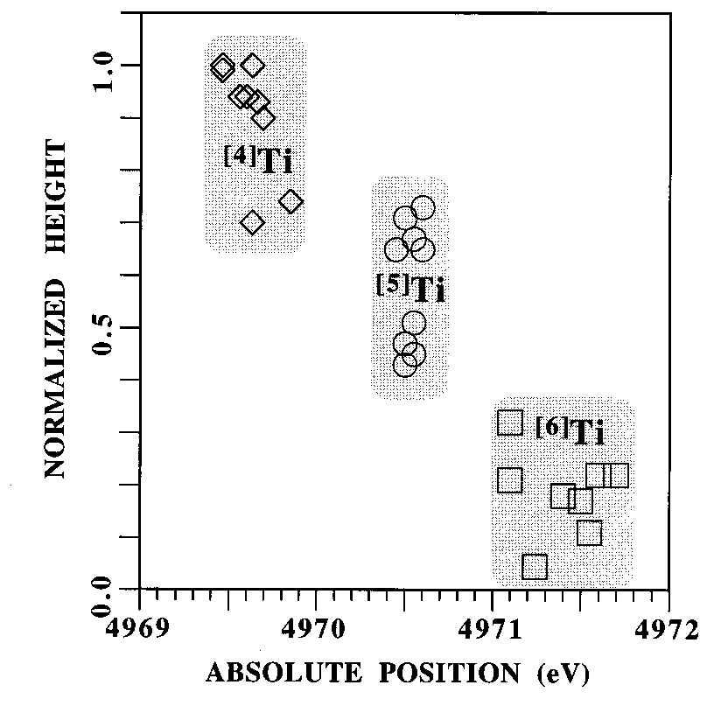Figure 32. (Top) Normalized XANES regions of 4-, 5- and 6-coordinated of Ti(IV) center in a series of metal oxide compounds; (Bottom) correlation between pre-edge feature and coordination of Ti center (Reprinted from Farges et al.⁸⁸)
- EXAFS:
Extended X-ray absorption fine structure (EXAFS) spectral region is used to determine local molecular bonding environments of elements. The oscillatory part of the spectrum contains information on the types and numbers of atoms in coordination with absorber atoms, their interatomic distances, and the degree of local molecular bonding disorder.⁸⁶
Above the absorption edge, the energy of X-ray excites an electron into the continuum. The remaining energy is released in the form of photoelectron with kinetic energy. The photoelectron waves are scattered only from the atoms surrounding the absorber. The oscillatory part of the absorption coefficient is associated with the relative phases of photoelectron waves, which depends on the wavelength (energy) and the interatomic distances between absorber and scattering atoms (bond distances).
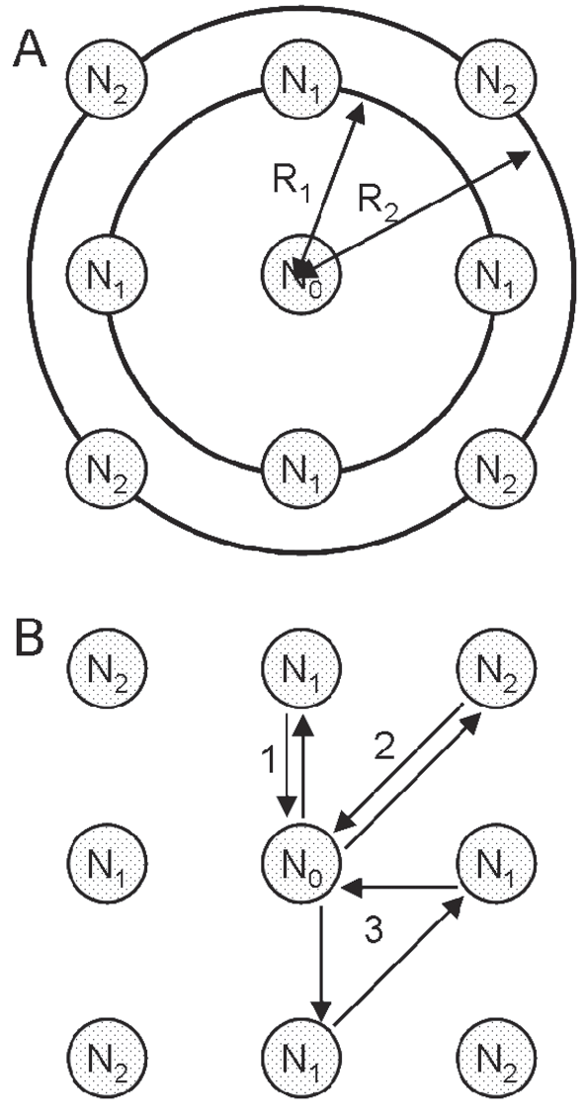Each atom at the same radial distance from the absorber, i.e. a shell, contributes to the same component of the EXASF signal. Single scattering paths are from one shell of atoms, and multiple scattering paths are from multiple shells. (Figure 33) Degeneracy of each scattering path is equivalent to the number of equivalent paths. In the case of single scattering path, the degeneracy equals to the coordination number (CN) in the corresponding shell. For example, in Figure 33 (B) path 1 or 2 has a degeneracy of 4, and path 3 has a degeneracy of 8.

Figure 33. (A) First (N₁) and second (N₂) shells around the absorber (N₀); (B) Single scattering paths labeled 1 (N₀-N₁-N₀) and 2 (N₀-N₂-N₀) and a triangular multiple scattering path labeled 3 (N₀-N₂-N₁-N₀) (Reprinted from Kelly et al.⁸⁶)
Figure 34 shows a typical k-space and R-space plots (solid lines). The spectra originally collected are E-space (energy-space) plots. Backscattering fine structure is extracted from the smooth absorption edge background and is displayed as in reciprocal space (k-space). The k-space data are then converted into R-space plots through Fourier transform.
A structural model is then constructed using estimates of bond lengths and angles found in literature. In this study, ChemDraw is used to generate and optimize these models based on bond length and angle data found in the literature.91-94 Scattering paths are generated by FEFF 8 after importing the structural model. In order to fit a model to experimental data, each path can be written in the following form:
Equation 2-8
Equation 2-9
Equation 2-10
to modify the amplitude of the EXAFS signal and do not have a k-dependence;
amplitude reduction factor (S₀²) usually has a value between 0.7 and 1.0; coordination number N_{i}
provided by the analysis software and does not affect any fit parameters
the inverse dependency on distance diminishes the EXAFS with increasing distance from the absorber (R_{i})
the oscillations in the EXAFS signal with a phase of [2kR_{i} + ϕ(k)]
contains a classic Debye-Waller factor (σ2), in order to model dynamic (thermal) disorder as well as static disorder (structural heterogeneity)
depends on λ(k), which is provided/calculated by the analysis software and does not affect any fit parameters
a change in the interatomic distance relative to the initial path length R_{i}
a change in the photoelectron energy which is used to align the energy scale of the theoretical spectrum to match the measured spectrum

The experimental data is compared with the function generated from the structural model (Figure 34, dotted lines). Fit parameters (S₀², N, ΔR, ΔE₀, σ²) are defined for each scattering path followed by an iterative refinement of these fit parameters. A fitting procedure by Artemis is fulfilled when the fit parameters converge to stable and acceptable values and the statistical measures of the fit (R-factor,, and reduced) are also acceptable.
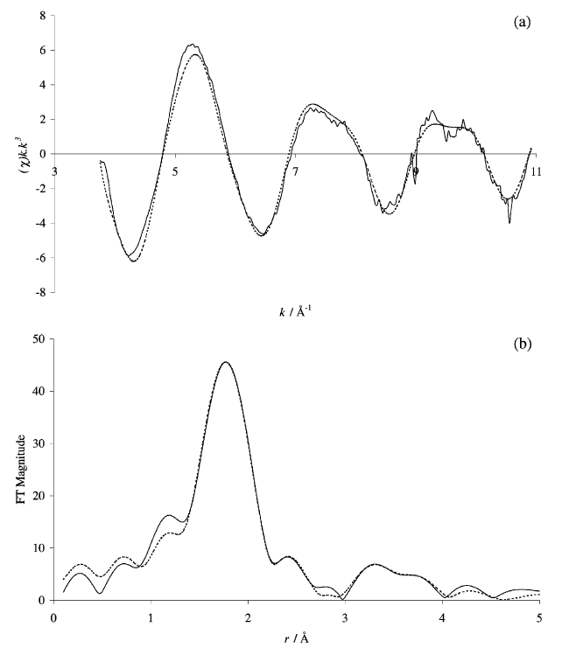
Figure 34. Best fit between experimental results and computed EXAFS employing the full multiple scattering method. (Reprinted from Thomas and Sanker ⁶⁶)

2.4 Other Characterization Techniques

2.4.1 ICP elemental analysis
Inductively coupled plasma atomic emission spectroscopy (ICP-AES) is a useful tool for quantifying trace metals in digestible solids or inorganic solutions. 5-6 solutions at different concentration of titanium (5 - 50 ppm) are first made of titanium standard solution for ICP purposes (1000 mg/L, Sigma-Aldrich) and de-ionized (DI) water. Once these solution is measured by ICP, a calibration curve of intensity to concentration is plotted automatically by the software provided.
The sample solution is made as following: 10-30 mg of sample powder (2-8 wt% Ti) was digested with concentrated nitric acid (~2 mL) and hydrofluoric acid (~2 mL), and diluted into ~50 g of solution with DI water. Three to four solution of each sample at different concentrations were analyzed with the average value reported finally.
Ti content is characterized as an important parameter for heterogeneous catalyst. Ideally, titanium from the precursor should be converted at 100% to the active sites in the final catalyst. Therefore, the number of active sites in a catalytic reaction can be calculated according to titanium wt%. More importantly, turn over frequency (TOF), which quantifies the catalytic capability on a per site basis, can be obtained.
In principle, the non-hydrolytic synthesis prior to passivation should not cause any loss of Ti. As mentioned above, the step of passivation involves the formation of hydrochloric acid, which is effective in removing the alkyltin groups but may possibly break Ti-O-Si linkages. ICP results show that the actual and estimated amount of titanium are consistent, indicating little loss of titanium during the synthetic process. More details will be discussed in Chapter III and IV.
According to the literature, titanium leaching is more commonly observed with titanosilicates in catalytic reactions with aqueous hydrogen peroxide. Thus, another important characterization by ICP is to quantify and compare titanium contents before and after catalytic reactions. Very little leaching was observed after multiple cycle of catalysis.

2.4.2 Nitrogen adsorption/desorption (BET)
Brunauer-Emmett-Teller (BET) surface area analysis provides precise specific surface area evaluation of materials by nitrogen multilayer adsorption measured as a function of relative pressure using a fully automated analyzer. The technique encompasses external area and pore area evaluations to determine the total specific surface area in m²/g.
Approximately 100 mg powder of the sample is used for surface area measurement. The samples include all Ti-containing catalysts after passivation, Ti-MCM-48 and Ti-free platform for comparison. Ti-containing catalysts and Ti-free platform in this study typically have surface areas in the range of 200-500 m²/g. Ti-MCM-48 prepared following a previous study⁹⁵ has a surface area of 1200 m²/g that is consistent with literature. Taking advantage of the sequential addition methodology described in this study, Barnes group has discovered that the surface area of these catalysts is adjustable by varying the ratio of linker-bb in each step of synthesis.

2.4.3 Vibrational spectroscopy
- IR
Infrared spectroscopy is one of the most common techniques used to characterize heterogeneous catalysts. Absorption bands in IR spectra correspond to specific vibrations in a molecule through changes in the dipole moment. The frequency and intensity of these bands are therefore useful for studying the molecules or bonds of the proper symmetry.
In the case of studying TS-1, the atomic substitution of titanium in the silicate framework gives rise to the characteristic vibrational bands. The vibrational band at 960 cm⁻¹ is a fingerprint thought to indicate lattice substitution of titanium centers, which was reported in the original TS-1 patent.⁵³ Based on many studies on infrared features of titanosilicates, it is concluded that the 960 cm⁻¹ band arises from the stretching of Si-O bonds in Ti-O-Si bridges.⁹⁶⁻⁹⁹ Figure 35 displays the 700-1050 cm⁻¹ range of typical IR spectra of TS-1 as well as Ti-free silicalite. While the 960 cm⁻¹ band is completely absent in Ti-free silicalite, the one in TS-1 increases proportionally with titanium content in both IR and Raman spectra.⁹⁶ Later an analogous band in 960-970 cm⁻¹ range characterizes other titanosilicates, namely, TS-2, Ti-ZSM-48, Ti-beta, and Ti-MCM-41.¹⁰⁰ It was concluded that the absorption in the range of 960-970 cm⁻¹ is associated with the stretching of Si-O bonds in Si-O-Ti linkages.⁹⁹ Another very strong band at 1125 cm⁻¹ is commonly present in titanosilicates. The fact that the 1125 cm⁻¹ band is enhanced by UV-excited Raman suggests the total symmetry of the vibrations with respect to the absorbing center. Thus, the 1125 cm⁻¹ band is unequivocally assigned to the symmetric stretching of the TiO₄ tetrahedron. These bands are convenient and effective in identifying the existence of atomically dispersed titanium in silicate. But the attempt to calculate titanium content by integrating the absorption bands has not met much success.
- Raman
Raman is a spectroscopic technique used to study the vibrational and rotational modes of a sample and is a complementary technique to IR. Besides of its high resolution and wide spectral range, another important advantage of Raman spectra over infrared lies in the fact that water does not produce a significant Raman signal. Raman spectra are acquired by irradiating a sample with an intense source of monochromatic radiation, typically a visible laser. Figure 36 illustrates that the monochromatic radiation can be scattered either elastically (i.e. Rayleigh scattering) or inelastically (i.e. Raman scattering). Only a small percentage of the light is inelastically scattered, and the amount is inversely proportional to the wavelength of the incident light to the fourth power. Raman scattering can be divided into two types: Stokes and anti-Stokes. The emitted photon of Stokes scattering has less energy than the incident photon, whereas in the case of anti-Stokes scattering, the emitted photon is blue-shifted relative to the incident photon.
In principle, the remaining organic groups such as trimethyltin (-SnMe3) and chloride groups (Ti-Cl, Si-Cl) must be observed in Raman spectra. But florescence is known to be a common problem when visible excitation sources are used. Because the intensity of fluorescence exceeds 10⁶ times of that of the Raman signal. Any impurity such as aromatic solvents can render the Raman signal undetectable. Fluorescence causes a major problem to all atomically dispersed titanium catalysts prepared in this study, i.e. 2C-, 3C- and 4C-Ti. But tetranuclear titanium center precursor and Ti₄ catalyst (after embedded in the bb matrix) were able to be measured. Reasonable spectra were obtained, and more details will be discussed in Chapter IV.
The sample powder was pressed into a self-supported pellet and then sealed in an air-tight container. The experiments were completed under nitrogen atmosphere in a glove box. Transparent windows are on both side of the container that allows the laser to pass through. The sample container was measured with the Raman spectrometer (Horiba Jobin-Yvon T64000) equipped with argon and krypton ion gas lasers, and a Ti-sapphire laser, spanning from 457.9 - 800 nm, as the laser excitation sources.

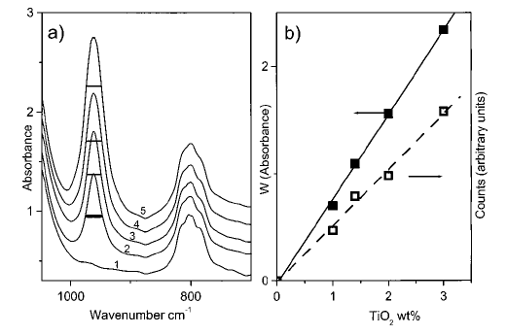Figure 35. (a) IR spectra of outgassed think pellets of Ti-free silicalite (curve 1) and TS-1 with increasing Ti-content x (curve 2-5). The horizontal line represents the fwhm of the 960 cm-1 band for sample 2-5. (b) Intensity W of the 960 cm-1 IR band (normalized) as a function of TiO2 wt% (full squares), and corresponding Raman counts (open squares) (Reprinted from Ricchiardi et al.⁹⁶)

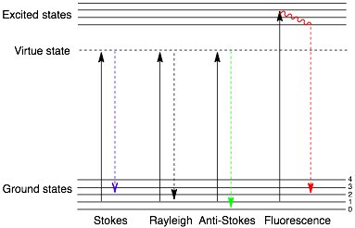Figure 36. Raman incidence and three types of excitation of photons (Rayleigh, Stokes and Anti-Stokes scattering).

Chapter III. Synthesis and Primary Characterization of Atomically Dispersed Titanosilicate Catalysts

3.1 Synthesis and Preliminary Characterization

3.1.1 Titanium precursors
The synthesis of atomically dispersed titanium catalysts requires mononuclear titanium compounds with chloride functional groups, namely, titanium tetrachloride TiCl₄, isopropoxy titanium trichloride TiCl₃(OiPr) and diisopropoxy titanium dichloride TiCl₂(OiPr)₂. The alkoxylated chlorotitanates were prepared by mixing titanium tetrachloride TiCl₄ and titanium tetraisopropoxide Ti(OiPr)₄, following the procedures developed by Kimigaito et al..⁷⁸ The stoichiometric ratios between the two reactions, TiCl₄ and Ti(OiPr)₄, need to be carefully controlled in order to obtain the desirable product rather than a mixture of two.
Equation 3-1
Equation 3-2
The starting materials include titanium tetrachloride (TiCl₄, 99%, Sigma-Aldrich), Titanium tetraisopropoxide (Ti(OiPr)₄, 98+%, Sigma-Aldrich). The chemicals were distilled and stored in a vacuumed glass vessel prior to use. The glassware for the reaction was silylated with trichlorosilane, and then kept in a oven at 80℃ prior to use. The amount of all reactants were measured by mass. Initially, Ti(OiPr)₄ is added into a silylated schlenk, followed by adding ~25 mL of dry n-hexane through vapor transfer at -78.2 ℃. TiCl₄ was then added through vapor transfer at a ratio of either 1Ti(OiPr)₄ : 1TiCl₄ or 1Ti(OiPr)₄ : 3TiCl₄, according to equation 3-1 and 3-2. The clear solution was kept stirring and cooled with dry ice when adding TiCl₄. Once all reactants were added, the solution was let warm back to room temperature and react for 3 hours. In the case of making either dichloride or trichloride, a light yellow to yellow precipitate forms almost immediately. Without examining the photo-sensitivity of the product, the schlenk was kept in darkness during the reaction in case of any decomposition by the light. Once the reaction was completed, the solvent and any volatiles were removed by vacuum without heating. The solid was left under vacuum over night at room temperature without exposing to the light.
Titanium dichloride and trichloride compounds have been found very reactive. To slow the rate of self-decomposition, storage under nitrogen in a glove box is recommended for these compounds, which gradually decolorize and turn gray within 1-2 weeks even under nitrogen atmosphere. In this study, alkoxylated chlorotitanates were stored under nitrogen and prepared less than 24 hours before use. NMR spectra of Ti(OiPr)Cl₃ and Ti(OiPr)₂Cl₂ in deuteriated benzene (C₆D₆) were collected and compared with that of Ti(OiPr)₄. As shown in Figure 37 (next page), when the ratio of TiCl₄ and Ti(OiPr)₄ are controlled to be exactly 1:1 or 3:1, the only peaks that are observed are from the desired products. The trend of the chemical shifts is consistent with the literature.⁷⁸ Peaks of impurity appear when TiCl₄ to Ti(OiPr)₄ ratio is inaccurate. The product can then be separated from the impurities through sublimation.

3.1.2 Synthesis & connectivity
The general process of preparing atomically dispersed titanium catalysts is described in Chapter II. The three types of titanium centers, i.e. 4-connected (4C-Ti), 3-connected (3C-Ti) and 2-connected (2C-Ti), were obtained respectively by using different titanium precursors in the first step of reaction (step #1 in section 2.1.4). Specifically, TiCl₄ is used for preparing 4C-Ti, TiCl₃(OiPr) for 3C-Ti, and TiCl₂(OiPr)₂ for 2C-Ti. It is critical to use the limiting amount of titanium precursor relative to bb to ensure all chlorides on titanium precursors are reacted. Following each step of synthesis, the volatiles were removed by vacuum and collected in a glass secondary trap kept cold in liquid nitrogen. The NMR spectra (Figure 38) of the volatiles confirm that the only byproduct is trimethyltin chloride (ClSnMe₃) as expected. Table 3 summarizes the preferable range of [Ti : bb] ratios in preparing 4C-, 3C- and 2C-Ti, and compare the estimated with the actual connectivity for each type of the catalyst. As described in Chapter II, gravimetric analysis provides critical information about the connectivity around titanium centers. The connectivities from gravimetric analysis is reproducible and highly consistent with the expectations with uncertainty less than 10 %. The result verifies the irreversible metathesis reaction between Si-O-SnMe₃ and Ti-Cl. More importantly, the gravimetric results as well as other characterization validate the effective control of the connectivity around titanium center by using different precursors.
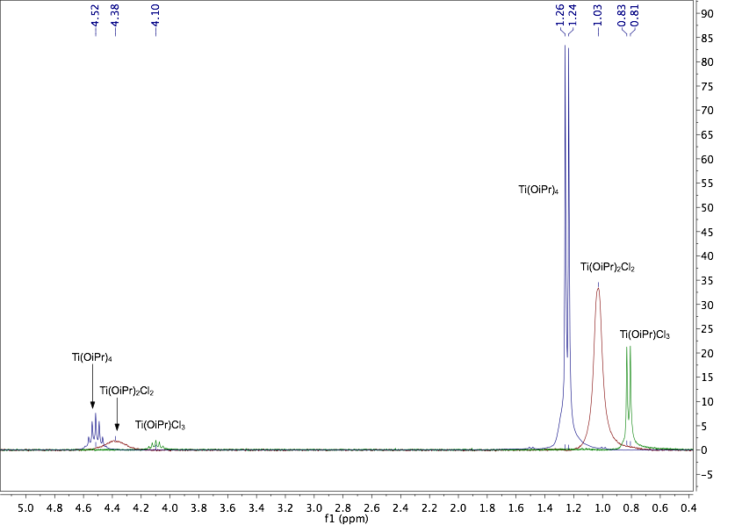Figure 37. Overlaid ¹H NMR spectra of (blue) Ti(OiPr)₄, (red) Ti(OiPr)₂Cl₂, (green) Ti(OiPr)Cl₃

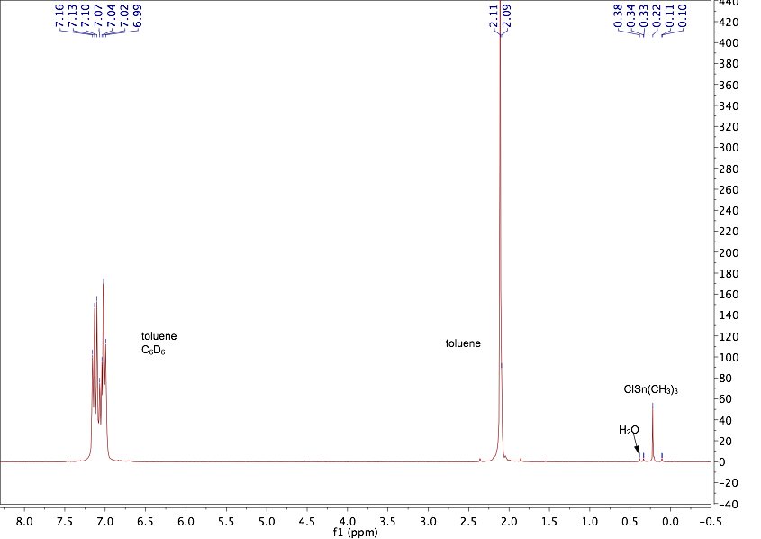Figure 38. NMR spectrum of the volatiles collected after each step of synthesis

Table 3. Ratios of [Ti : bb] ; estimated vs. actual connectivity
Ti Sample | Ti : bb = x : 1  x value | Estimated  Connectivity | Actual  Connectivity
4C-Ti | 0.5-0.7 | 4 | 4.0 ± 0.1
3C-Ti | 0.7-1.0 | 3 | 2.9 ± 0.1
2C-Ti | 1.0-2.0 | 2 | 1.8 ± 0.1

3.1.3 Elemental analysis (ICP)
The molecular composition of these catalysts can be predicted with the amount of reactants and gravimetric analysis. Titanium content (Ti wt%) can be estimated with [Ti : bb] ratio and the molecular formula. Higher titanium content (Ti : Si and titanium wt%) in these catalysts is expected than in TS-1 where titanium ions are incorporated through framework substitution. (Table 4) However, these estimations are based on the assumption that all titanium precursors are successfully embedded without leaching. During the first two steps of non-hydrolytic reactions titanium leaching is highly unlikely, but the following methanol passivation generates hydrochloric acid (HCl) that possibly breaks Ti-O-Si linkages.
To verify the titanium content in these catalysts, the passivated materials were analyzed with inductively coupled plasma atomic emission spectroscopy (ICP-AES). The results are shown in Table 5. The actual values of titanium wt% in 2C-, 3C- and 4C-Ti catalysts (column 3) are consistent with the estimated values, i.e. no titanium leaching occurred throughout synthesis and all titanium were incorporated and stabilized within the matrices. A very small amount of Sn (<1 Sn : 100 Si) is detected in the passivated catalysts. While changing the amount of titanium and silicon chloride linkers in synthesis, titanium to Sn ratio tends to vary and is generally above 4 titanium to 1 Sn.
Elemental analysis shown in Table 6 confirms that the final step of passivation eliminates majority of the remaining trimethyltin groups in the matrices by showing a drastic decrease in Sn wt% after passivation. Without leaching any Ti, a very small increase in titanium wt% (column 2, Table 6) is expected due to the total weight loss during passivation. The actual titanium content by ICP-AES measurement before and after passivation is consistent with the corresponding theoretical values. Therefore, it is concluded that any titanium initially added has been incorporated with the matrices. Methanol passivation effectively removes majority of tin without leaching titanium out of the matrices.
Table 4. Molecular formula; estimated Ti/Si ratio and Ti content
Ti Sample | xTi : 1bb ª | Molecular Formula | Ti wt% ^{b}
4C-Ti | 0.5-0.7 | Ti_{x}Si₁₀O₂₀(OCH₃)_{4x} | 3.5 – 4.6%
3C-Ti | 0.7-1.0 | Ti_{x}(OiPr)_{x}Si₁₀O₂₀(OCH₃)_{3x} | 4.7 – 6.4%
2C-Ti | 1.0-2.0 | Ti_{x}(OiPr)_{2x}Si₁₀O₂₀(OCH₃)_{2x} | 6.2 – 10.2%
TS-1 | 0.010-0.025  (xTi : 1Si) | (TiO₂)_{x}(SiO₂) | 0.8 – 1.9%
ª The range of Ti: Si ratio is estimated based on the ratio of [Ti : bb] in the first step of synthesis and subsequently [2SiCl₄ : bb] is used in the second step of synthesis
^{b} Calculated value of titanium wt% based on x (column 2) and molecular formula (column 3)
Table 5. Elemental Analysis of 4C-Ti, 3C-Ti, and 2C-Ti passivated materials
Ti Sample | Ti wt% _{(Theor.)}  (± 10%) | Ti wt% _{(ICP-AES)}  (± 10%) | Sn wt% _{(ICP-AES)}  (± 10%) | Ti : Sn (mol)
4C-Ti | 3.5 | 3.2 | 1.8 | 4.4 : 1
3C-Ti | 6.1 | 5.5 | 1.8 | 7.6 : 1
2C-Ti | 8.0 | 7.6 | 0.32 | 59 : 1
Table 6. Elemental analysis in effect of methanol passivation
2C-Ti ª | Ti wt% _{(Thero.)} ^{b}  (± 10%) | Ti wt% _{(ICP-AE)}  (± 10%) | Sn wt% _{(ICP-AE)}  (± 10%) | Ti : Sn (mol)
Before passivation | 2.5 | 2.3 | 5.1 | 1.1 : 1
After passivation | 2.7 | 2.6 | 0.47 | 14 : 1
ª 2C-Ti sample was synthesized with 0.6 mmol of TiCl₂(OiPr)₂ reacts with 1.0 mmol of bb, and then 3.0 mmol SiCl₄
^{b} titanium wt% _{(Theor.)} is estimated according to the initial amount of titanium added and the mass of the final product
3.2 Infrared spectroscopy

3.2.1 Sample preparation
The passivated catalysts, 2C-Ti, 3C-Ti and 4C-Ti, were characterized with IR spectroscopy. Besides of the catalysts, Ti-free platform was prepared with the bb methodology as described in Chapter II. Inert linker silicon tetrachloride (SiCl₄) was used to cross link the silica bb, followed by methanol passivation. Ti-free platform was characterized with IR and compared with the catalysts. The platform different from Ti-containing catalysts does not contain titanium-based structures, but meanwhile it shares similar bb-based matrices with the actual catalysts. Therefore, if comparing the spectra of platform and catalysts, it is reasonable to believe that different spectral features are associated with titanium-based structures, particularly Ti-O-Si linkages.
The sample powders of titanium catalysts and Ti-free platform were dried under vacuum at 80 °C before measurements. A small amount of sample powder (~3 mg) was mixed with potassium bromide (KBr, ~500 mg). The mixture was ground into fine powder with Wig-L-Bug, and then pressed into thin pellets. Transmittance spectra were collected in the wavenumber range of 400-4000 cm⁻¹ with Thermo Scientific IR100 FT-IR spectrometer in a glove box. All experiments are conducted under nitrogen atmosphere.

3.2.2 Result and conclusion
Two absorption bands at ~1080 cm⁻¹ and ~1200 cm⁻¹ are assigned to internal and external anti-symmetric Si-O stretching. A feature at ~800 cm⁻¹ is attributed to the symmetric stretching of Si-O bonds, and the position of which varies for each sample. In the spectra of titanium catalysts, a feature at 960-970 cm⁻¹ is clearly visible, indicating the successful incorporation of titanium with the silica matrix.⁵⁴ The absence of the feature in the Ti-free silicate platform confirms that the feature is associated with Ti-O-Si vibration. In some crystalline titanosilicates, silanol groups at the defect sites were considered to contribute to the feature at ~960 cm⁻¹. However, no obvious feature is noticed beyond 3500 cm⁻¹, indicating the absence of hydroxy groups.

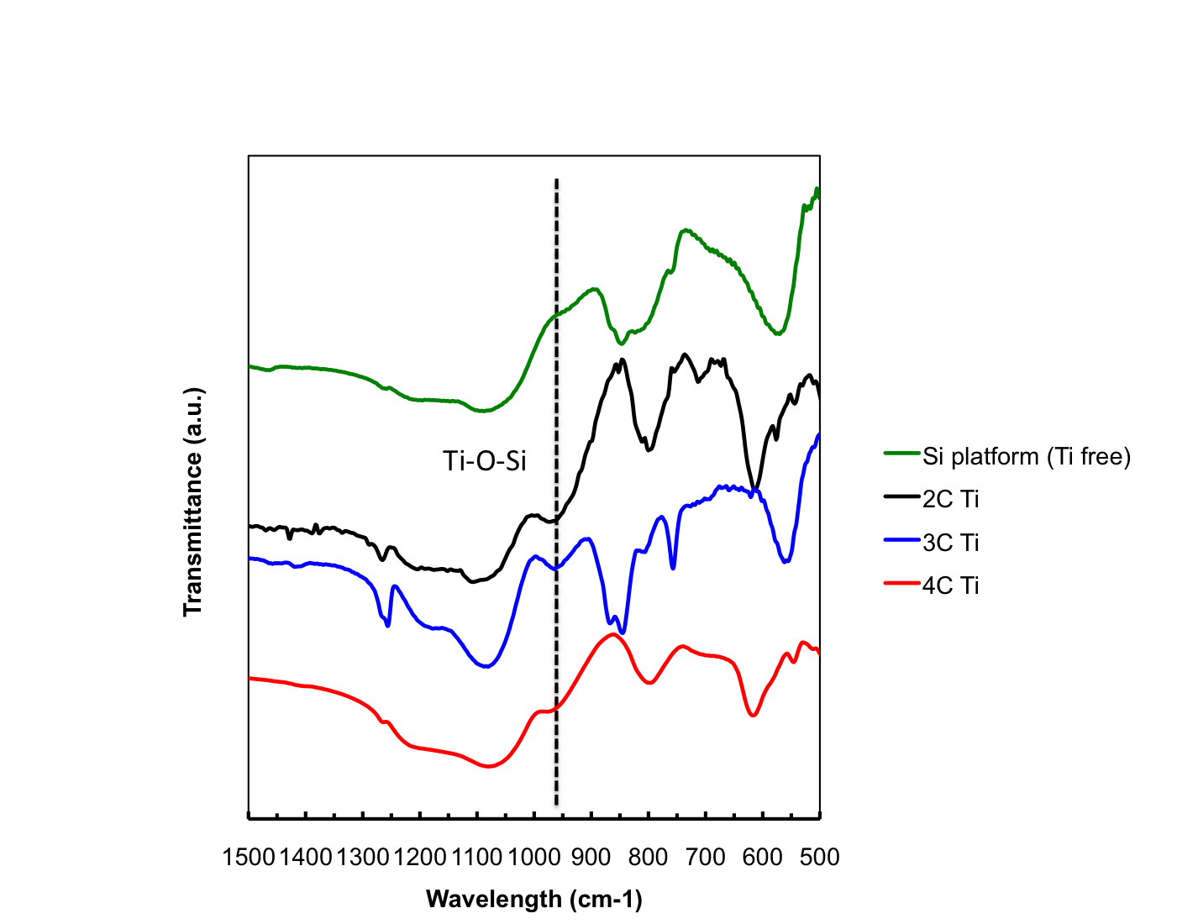
Figure 39. Infrared spectra of 2C-Ti, 3C-Ti and 4C-Ti in comparison with Ti-free silicon platform

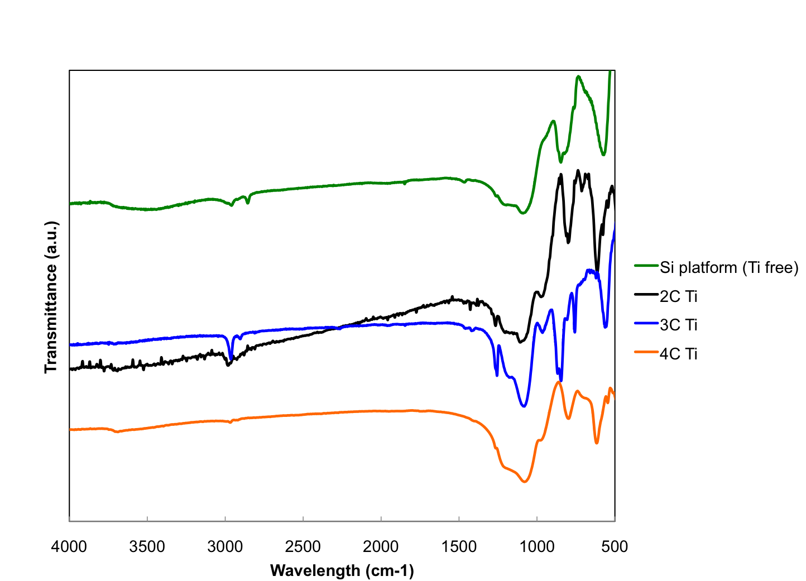
Figure 40. Full infrared spectra of 2C, 3C, 4C-Ti and Ti-free platform

3.3 Diffuse reflectance UV spectra

3.3.1 Sample preparation
Table 7 lists the samples that were prepared and characterized with diffuse reflectance UV spectroscopy (DRUV). The preparation process for 2C-Ti, 3C-Ti and 4C-Ti samples is illustrated in Figure 41-43. Three samples for each atomically dispersed titanium catalyst are prepared, specifically, after first crosslinking (stage 1), after passivation (stage 2), after exposed to aqueous hydrogen peroxide (H₂O₂/H₂O). DRUV spectra are collected with the sample at each stage.
Preparation for 2C-Ti samples are described below as an example.
Stage 1: After the first crosslinking between TiCl₂(OiPr)₂ and bb, 2-connected titanium-bb oligmers (sample 1) are formed. Gravimetric analysis suggests the connectivity should be approximately two.
Stage 2: The oligmers are reacted with inert linker SiCl₄, forming a porous matrix where titanium centers are embedded. Subsequently, these materials are passivated with methanol. At this stage the passivated catalyst is named as sample 2. Normally, these catalysts are stable with air and moisture, and ready to be used in a reaction. Infrared spectrum verifies the existence of Ti-O-Si linkages. Elemental analysis confirms that titanium centers are successfully incorporated into the matrix with essentially no leaching.
Stage 3: H₂O₂/H₂O (50% w/w, ~1 mL) is added to the catalyst (2C-Ti, 100 mg). The original white color turns to bright yellow instantly, and then slowly decolorizes when left in air. The sample is dried briefly until most liquid is removed and the sample appears a half dry yellow solid. It is important to collect DRUV spectra before significant decolorization that indicates the structural change on titanium center. In Figure 41-43, the Ti-peroxo species at sage 3 is one of the possible structures that hasn’t been confirmed. The structure was proposed for Ti(IV) in TS-1 by Bordiga et al..⁶² In this research, a lot of characterization data are in agreement with the hypothesized species that contain Ti-peroxo structure. More details are presented in following sections.
3C-Ti (sample 4-6) and 4C-Ti (sample 7-9) are prepared following similar procedure. Spectra collection condition is described in Chapter II.
Table 7. DRUV and XAS sample list
No. | Sample | Description
1 | 2C-1 dose | TiCl₂(OiPr)₂ + bb
2 | 2C-MeOH | methanol passivated catalyst
3 | 2C-H₂O₂ | Sample 2 + H₂O₂/H₂O
4 | 3C-1 dose | TiCl₃(OiPr) + bb
5 | 3C-MeOH | methanol passivated catalyst
6 | 3C-H₂O₂ | Sample 5 + H₂O₂/H₂O
7 | 4C-1 dose | TiCl₄ + bb
8 | 4C-MeOH | methanol passivated catalyst
9 | 4C-H₂O₂ | Sample 8+ H₂O₂/H₂O

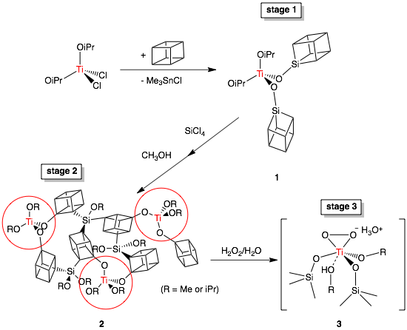Figure 41. Synthesis of 2C-Ti samples and proposed structures of Ti sites (sample 1, 2 and 3)

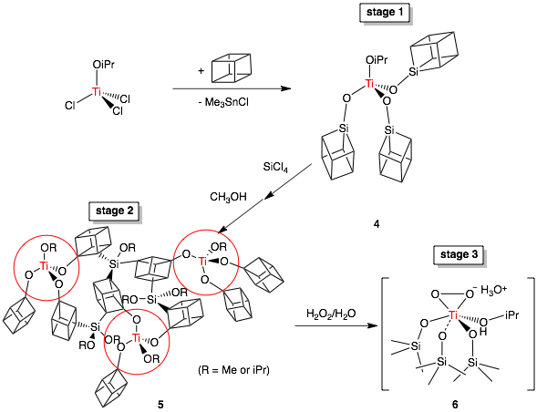Figure 42. Synthesis of 3C-Ti samples and proposed structures of Ti sites (sample 4, 5 and 6)

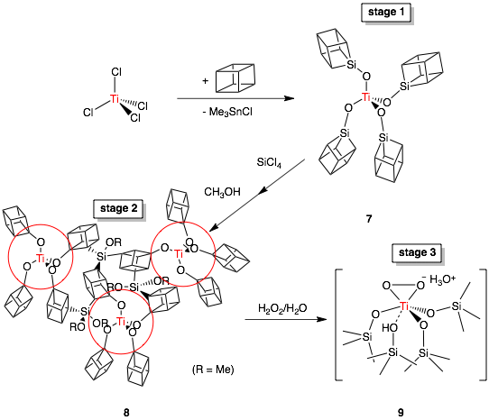Figure 43. Synthesis of 4C-Ti samples and proposed structures of Ti sites (sample 7, 8 and 9)

3.3.2 Result and discussion
The subject samples in this research are different from traditional titanosilicates in terms of the usage of tin-functionalized bb. When measuring DRUV spectra, any remaining alkyltin groups contribute to the absorption feature at 200-210 nm, close to where the absorption of tetrahedral titanium centers is (210-230 nm). Therefore, Ti-free platform was prepared (section 2.1.4, Chapter II) and DRUV spectrum was collected as a background, in order to correct the influence of tin. The spectrum function of platform is timed by an arbitrary coefficient (0.1-1.0) that depends on the amount of alkyltin in the material, and then subtracted from the sample spectrum. Figure 44 presents the original (top) and corrected (bottom) spectra of 2C-, 3C- and 4C-1 dose (sample 1, 4, 7). The absorption below 210 nm due to alkyltin decreases after the correction.
The three curves share very similar patterns, although each has different connectivity of titanium centers. The absence of absorption beyond 320 nm indicates the absence of titania (anatase) domain. 4-coordinated titanium centers are expected in these samples, but the absorption bands are broader than the well-defined band of TS-1 that contains exclusively tetrahedral titanium centers. It is important to notice that at this stage titanium-containing oligmers are structurally flexible, compared to TS-1 or other rigid silicate matrices. The broadness is consistent with the flexible species, in which a higher number of vibrational levels are superimposed on the electronic transitions. Besides of the broadness, the absorption maxima locate at higher wavelength of 230-250 nm than TS-1 (210 nm). Similar broad and red-shifted absorption bands have been observed in UV spectra of 4-coordinated Ti silsesquioxane complexes studied previously.⁶⁹ The reason for red shift may be the structural distortion from Td-geometry, associated with the strong intermolecular interactions at high concentration.⁶⁹
Spectra of 2C-, 3C- and 4C-Ti catalysts after passivated (sample 2, 5, 8) are presented in Figure 45. After passivation majority of alkyltin groups are removed. Therefore, the sharp absorption peak below 210 nm is no longer observed. The three spectral curves share similar patterns to one another. The maximum at 220-225 nm is unambiguously assigned to tetrahedral titanium center in silicate matrix. If look closely, the spectrum of 2C-Ti is slightly broader than 3C-Ti and 4C-Ti, which is consistent with the relatively less rigid structure of 2C-Ti. Titania anatase phase that is featured of the absorption at 330-350 nm is not observed. In summary, DRUV spectra are highly consistent with the expected 4-coordinated titanium centers in all samples.
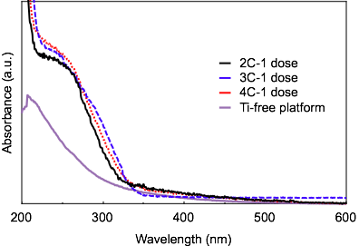
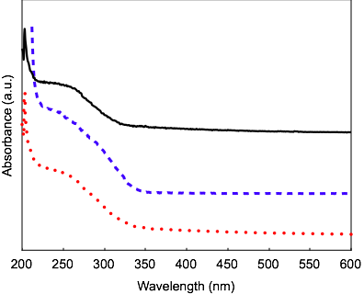
3C-H₂O₂
2C
3C
4C

Figure 44. DRUV spectra of 2C, 3C and 4C-1 dose before (top) and after (bottom) correction

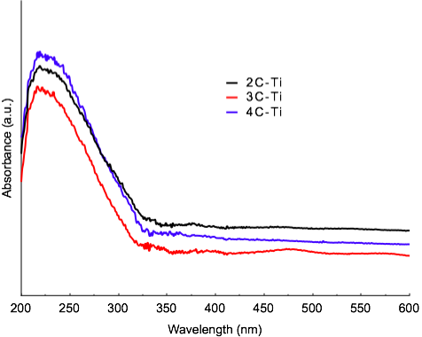
Figure 45. DRUV spectra of 2C-, 3C- and 4C-Ti catalysts after passivation (sample 2,4,6)

3.4 XANES & EXAFS

3.4.1 Sample preparation
The set of 9 samples described above (section 3.3, Figure 41-43 and Table 7 ) is also characterized with X-ray absorption spectroscopy (XAS). The sample packing is presented in Chapter II (section 2.3.2 and 2.3.3).

3.4.2 XANES results
XANES spectra for each type of titanium centers are presented in Figure 46-51 and the parameters summarized in Table 8. Spectra of samples at stage 1 and 2 are discussed below. Characterization of peroxide samples, namely 2C-H₂O₂, 3C-H₂O₂, and 4C-H₂O₂ (sample 3, 6, 9), is discussed in section 3.5.
1. 2C-1 dose, 2C-MeOH (sample 1, 2)
Figure 46-47 shows overlay plots of XANES spectra of 2-connected Ti sites, 2C-1 dose (sample 1), 2C-MeOH (2) and 2C-H₂O₂ (3). As discussed in Chapter II (section 2.3.1), the symmetry of the local environment around the absorber Ti atoms in these matrices affects both position and intensity of the pre-edge peaks. The samples synthesized in this research are amorphous materials that lack the long-range order found in TS-1. Sample 1 shows a less intense and slightly broader pre-edge peak (entry 1 in Table 8). Similar pre-edge peak broadening has been previously observed in materials lacking long-range order and understood as an effect of disorder, and the decrease in intensity is explained by the f-sum rule.¹⁰¹ According to the f-sum rule the overall integrated strength should remain constant even while disorder broadens the pre-edge feature. This should in turn lead to a decrease in the height of the pre-edge feature. The pre-edge position in the range of 4969-4970 eV is consistent with 4-coordinated Ti sites based upon a comprehensive study on a series of Ti-containing oxides and silicates.⁹³ 5- or 6-coordinated Ti usually exhibits a clearly different pre-edge peak located in the range of 4970~4972 eV. In summary, the existence of T_{d}-geometry Ti centers in 2C-1 dose (sample 1) is supported by the corresponding features in pre-edge region.

Table 8. Ti K-edge parameters
Entry | Samples | Description | Pre-edge Peak Energy/eV | Peak Width  ΔFWHM/eV | ªPeak Intensity/% | ^{b}Main Edge /eV
1 | 2C-1 dose | TiCl₂(OiPr)₂ + Si₈Sn₈ | 4969.4 | 2.1 | 51 | 4980.8
2 | 2C-MeOH | methanol passivated catalyst | 4969.4 | 2.3 | 34 | 4980.2
3 | 2C-H₂O₂ | 2 + H₂O₂/H₂O | 4970.8  (4968.8; 4973.8) | 2.3 | 20 | 4981.0
4 | 3C-1 dose | TiCl₃(OiPr) + Si₈Sn₈ | 4969.4 | 2.0 | 54 | 4980.7
5 | 3C-MeOH | methanol passivated catalyst | 4969.4 | 2.1 | 49 | 4980.3
6 | 3C-H₂O₂ | 5 + H₂O₂/H₂O | 4970.8  (4969.0, 4973.8)^{c} | 2.5 | 17 | 4980.5
7 | 4C-1 dose | TiCl₄ + Si₈Sn₈ | 4969.2 | 2.0 | 48 | 4980.8
8 | 4C-MeOH | methanol passivated catalyst | 4969.2 | 2.2 | 37 | 4980.4
9 | 4C-H₂O₂ | 8+ H₂O₂/H₂O | 4970.8  (4969.0, 4973.8) ^{c} | 2.7 | 21 | 4981.1
10 | Ti(OSiPh₃)₄ | 4-connected Ti compound | 4970 | 1.4 | 82 | 4980.4
11 | TS-1 | in vacuo; ref | 4967 | 1.4 | 79 | -
12 | TS-1/H₂O₂ | 10 + H₂O₂/H₂O; ref | - | 3.4 | 9 | -
ª Peak height relative to the edge jump normalized to 1.0;
^{b} Main edge position is determined by the energy at 50% full edge jump;
^{c} Multiple pre-edge features are observed in the peroxide samples.

2C-MeOH (sample 2) is prepared by further crosslinking 2C-1 dose oligmers with inert linker SiCl4 and then passivating with methanol. The proposed structure of sample 2 contains isolated [Ti(OSi)₂(OR)₂] units on a bb-based silica matrix. The pre-edge peak is seen to broaden slightly and become less intense (51%→34%). Several reasons could cause the reduction in pre-edge intensity. After passivation, the methoxy or hydroxy groups could coordinate with the titanium center, forming a distribution of 4-, 5- and 6-coordinated Ti. Therefore in the second crosslinking and passivation process, a range of four-, five- or six- coordinated 2C-Ti site may be present which would contribute to reduced intensity and broadening. In that case, however, changing from 4-coordinated to higher, the pre-edge position is expected to shift ~1-2 eV to higher energy. No such shift in pre-edge position was observed. This indicates that the majority of the Ti sites maintain 4-coordinated through the synthesis. It is possible that a fraction of the sites increase the coordination number via complexation of neutral ligands such as methanol.
2. 3C-1 dose, 3C-MeOH(sample 4, 5)
3C-Ti samples are synthesized following the same methodology and pseudo Td-symmetry Ti sites [Ti(OSi)₃(OiPr)] are predicted to be in 3C-1 dose (sample 4) and 3C-MeOH (sample 5). As expected, the pre-edge feature of 3C-1 dose is sharp and intense, characteristic of Td-symmetry Ti sites (Figure 48-49). After second cross-linking reaction and passivation, there is a small decrease (5 %) in pre-edge intensity along with a slight increase in peak width. As discussed in the case of 2C-Ti, such changes are most likely to be caused by structural disorder. The exact same pre-edge peak position of sample 4 and 5 is observed in the energy region corresponding to 4-coordinated Ti sites. Therefore, it is believed that the pseudo Td-symmetry type of sites are again dominant in the 3C-Ti catalyst.
3. 4C-1 dose, 4C-MeOH (sample 7, 8)
Figure 50-51 shows an overlay XANES region of 4C samples with the major parameters summarized in Table 8. The pre-edge feature indicates 4-coordinated Ti sites in 4C-1 dose (sample 7). After further cross linking and passivation, the slight peak broadening due to structural disorder is observed again in 4C-MeOH (sample 8), same as in 2C-MeOH and 3C-MeOH. It is worth noticing that 2C, 3C and 4C-Ti at each stage of synthesis share great similarity in XANES region. Pre-edge peak broadening and decreased intensity have been commonly observed in all catalysts in this study, due to structural disorder in amorphous materials. The results of XANES spectra are consistent with the existence of pseudo tetrahedral titanium sites in all samples except for the peroxide samples (sample 3, 6, 9).
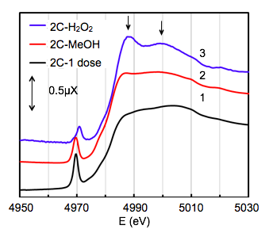Figure 46. Stacked XANES region of sample 1-3 of 2C-1 dose, 2C-MeOH and 2C-H₂O₂)
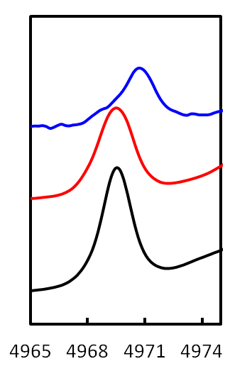Figure 47. Stacked pre-edge features of sample 1-3 of 2C-1 dose, 2C-MeOH and 2C-H₂O₂)
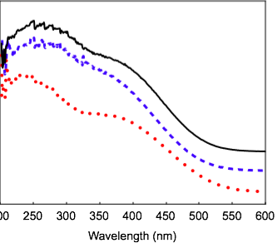

0.2 μX
E (eV)
3
2
1
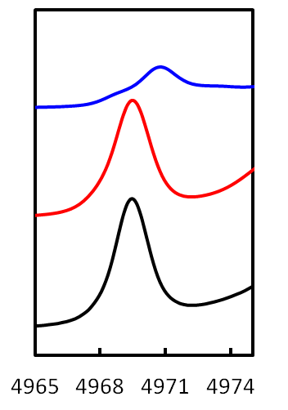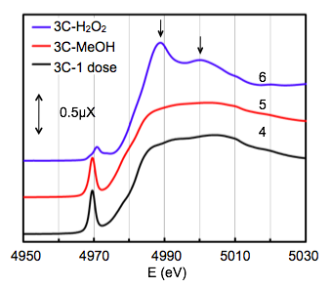Figure 48. Stacked XANES region of sample 4-6 of 3C-1 dose, 3C-MeOH and 3C-H₂O₂)

0.2 μX
E (eV)
6
5
4
Figure 49. Stacked pre-edge features of sample 4-6 of 3C-1 dose, 3C-MeOH and 3C-H₂O₂)
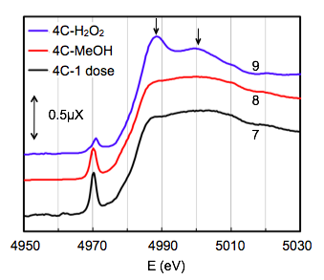Figure 50. Stacked XANES region of sample 7-9 of 4C-1 dose, 4C-MeOH and 4C-H₂O₂
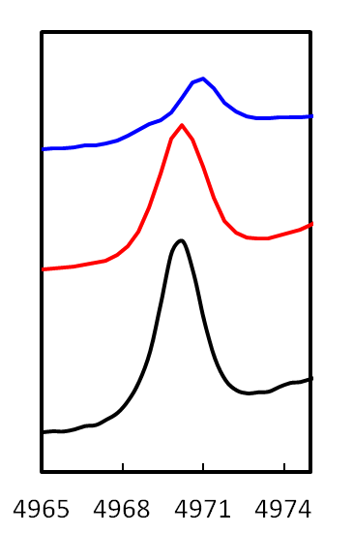Figure 51. Stacked pre-edge features of sample 7-9 of 4C-1 dose, 4C-MeOH and 4C-H₂O₂

0.2 μX
E (eV)
9

8

7

3.4.3 EXAFS results
Molecular models for each type of titanium center were built with ChemDraw based on the bond length and angle in literature. The connectivity, i.e. the number of Ti-O-Si linkage, around each titanium center is based on the gravimetric measurement after the initial cross-linking reaction in synthesis.
In the 2C, 3C and 4C-Ti samples described above, after first cross-linking reaction (sample 1, 4 and 7), gravimetric measurements indicate that the chloride ligands on Ti precursors have been removed from around Ti and replaced with oxygen from the corners of the different bb cubes. The absence of the chloride feature predicted to be at ~2.1 Å in the R space plots strongly supports the conclusion of the complete first cross linking reaction. Thus, the first shell around the Ti site is predicted to be composed of singly bound oxygen atoms from a mix of alkoxide (Ti-O-iPr) and silicate (Ti-O-Si) groups depending on the connectivity achieved for Ti at the time of synthesis. A combination of characterization including gravimetric measurement, NMR, IR, DRUV and XANES strongly indicates the existence of pseudo T_{d}-symmetry Ti sites (TiO₄) in these samples. The structural models, of the general form [Ti(OSi)_{x}(OiPr)_{4-x}] ( x = 2, 3 or 4), were proposed based on examples in the literature.[ref: bond lengths]
The first shells around 2C- or 3C-Ti centers are more complex than 4-connected by having two types of oxygen atoms. Accordingly, the structural models of 2C and 3C-Ti are built with two shells of oxygen at slight different distances (~1.78 vs. ~1.84 Å) from Ti. The two EXAFS signals from oxygen shells at distinct distances are essentially too close to be resolved from one another under the current spectrum resolution. k³-weighted phase-uncorrected R-space plots of 2C- and 3C-Ti after first cross linking reaction are shown in Figure 52 and 53. The feature below 1 Å (low-R) is an artifact generated from errors in background subtraction in the low k region, which is observed in the FT spectra of most samples in this study. Just beyond this low-R component, the R space plots show only single feature with the maximum at ~1.4 Å, presumably due to oxygen atoms in the first coordination sphere. Therefore, a simplified structural model composed of a single first shell of oxygen [TiO₄Si_{x}] (x = 2 or 3) was also investigated.
FEFF multiple scattering theory was used to derive theoretical phase and amplitude functions for single scattering paths used to model EXAFS data for each sample. Figure 52 displays χ(k) and R space plots overlaid with fits of 2C-1 dose sample. The data was fit to models involving both 2-shell and 1-shell oxygen models. Both models give reasonable fits to the data and the structural parameters are summarized in Table 9 including the goodness-of-fit (reduced chi square, χ²_{ν}). Changes in χ²_{ν} are commonly used to compare two EXAFS models statistically. The result from comparing 1-shell and 2-shell oxygen models suggests no significant difference between the two in modeling the EXAFS spectrum of 2C-1 dose. [ref: Shelly Kelly, chapter 14] In other words, EXAFS data is not able to resolve two distinct shells of oxygen atoms around the Ti centers for 2C-1 dose sample.
The EXAFS modeling and analysis on 3C-1 dose is displayed in Figure 53 and the main parameters summarized in Table 10. As in the case of the 2C-Ti, two shells of oxygen atoms make up the first coordination sphere around Ti centers. Unfortunately, EXAFS model containing two distinct shells of oxygen atoms is not statistically supported by the data. Therefore structural models contains a single shell of oxygen atoms are the most valid. Nevertheless, the EXAFS analysis concludes the existence of 4-coordinated Ti center in both 2C- and 3C-Ti after the first reaction in synthesis. The bond distance obtained from 1-shell model (1.80 Å) in either case is consistent with the values for T_{d}-geometry Ti-O reported in literature.
4C-1 dose, as expected, shows a well-defined single first-shell feature in R space (Figure 54). The correspondence between the theoretical functions and experimental EXAFS data validate the 4-connected [Ti(OSi)₄] model. Table 11 summarizes the final structural parameters obtained from the fit.
In 2C-, 3C- and 4C-Ti samples, a second shell of silicon atoms is expected to be present at ~3.2-3.6 Å from Ti [ref] with a CN equal to the connectivity of the center. A success in modeling the second shell was found in the case of 4C-1 dose. The R space has shown a relatively well-defined second shell feature and is subsequently modeled as such. However in the cases of 2C and 3C, it was quite challenging to model the second shell of silicon atoms with reliable CN’s. 2C-1 dose data shows a feature at ~3 Å in R space possibly corresponding to the second shell of silicon, but the feature only appears with large k-weight (≥ 3). In the case of 3C-1 dose, no feature above the noise level in the data is observed beyond 2.5 Å in R space (Fig. 5). Both thermal and structural disorder in these amorphous samples will broaden the second shell feature in cases of 2C and 3C, whereas the 4C-Ti center is less affected due to rigidity of the matrix around this embedded cross linking atom. Moreover, the low Ti wt% (~1.0-1.5%) is likely to decreases the signal to noise level, which helps explaining the low intensity of second shell feature.

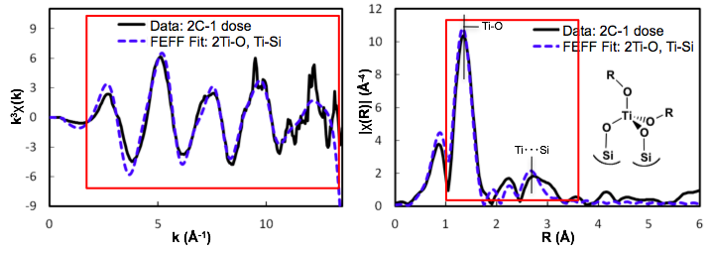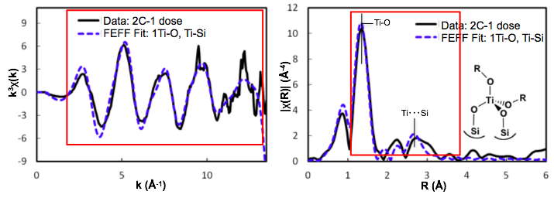
Figure 52. 2C-1 dose in χ(k) and k3-weighted R space functions with two structural models

Table 9. Structural parameters obtained from fits to 2C-1 dose
 | 2C-1 dose: 2Ti-O Model |  |  | 2C-1 dose: 1Ti-O Model
 | Ti-O (TiOSi) | Ti-O (TiOiPr) | Ti---Si | Ti-O | Ti---Si
CN (set) | 2 | 2 | 2 | 4 | 2
R (Å) | 1.78 ± 0.01 | 1.83 ± 0.01 | 3.19 ± 0.04 | 1.80 ± 0.01 | 3.19 ± 0.04
σ² (Å²) | 0.0054 |  | 0.0066 | 0.0059 | 0.0068
S₀² (set) | 0.96 |  |  | 0.96
E₀ (eV) | -6.8 ± 2.8 |  |  | -6.2 ± 2.6
Reduced Χ² | 162 |  |  | 141
R factor | 0.102 |  |  | 0.099

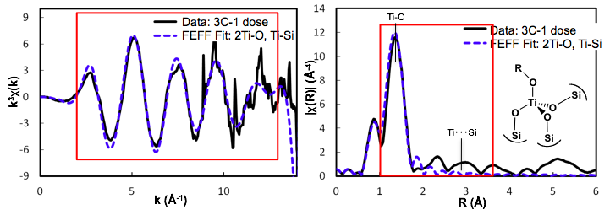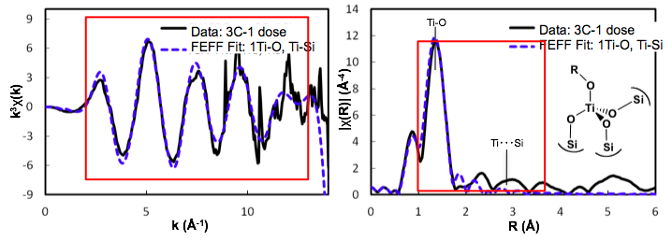
Figure 53. 3C-1 dose in χ(k) and k3-weighted R space functions with two structural models

Table 10. Structural parameters obtained from fits to 3C-1 dose
 | 3C-1 dose: 2Ti-O Model |  |  | 3C-1 dose: 1Ti-O Model
 | Ti-O (TiOSi) | Ti-O (TiOiPr) | Ti---Si | Ti-O | Ti---Si
CN (set) | 3 | 1 | 3 | 4 | 3
R (Å) | 1.79 ± 0.01 | 1.86 ± 0.01 | 3.44 ± 0.34 | 1.80 ± 0.01 | 3.40 ± 0.22
σ² (Å²) | 0.0035 |  | 0.0472 | 0.0044 | 0.0376
S₀² (set) | 0.96 |  |  | 0.96
E₀ (eV) | -3.3 ± 2.2 |  |  | -4.3 ± 2.3
Reduced Χ² | 24 |  |  | 27
R factor | 0.062 |  |  | 0.069

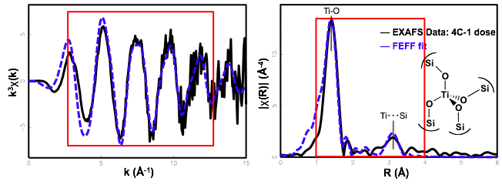Figure 54. 4C-1 dose in χ(k) and k3-weighted R space functions with two structural models
Table 11. Structural parameters obtained from fits to 4C-1 dose
4C-1 dose
 | Ti-O | Ti---Si
CN (set) | 4 | 4
R (Å) | 1.80 ± 0.00 | 3.49 ± 0.02
σ² (Å²) | 0.0041 | 0.0065
S₀² (set) | 0.96
E₀ (eV) | -6.8 ± 0.9
Reduced Χ² | 7.8
R factor | 0.081

1.4.2 After Passivation (sample 2, 5, 8)
The Ti centers in 2C-1 dose, 3C-1 dose, 4C-1 dose have been well characterized as 4-coordinated metal with four oxygen atoms in the first shell. These Ti oligmers were further linked with SiCl₄ to form rigid matrices with long-range structure. The materials were then passivated with methanol in the solvent of toluene before EXAFS data collection or being used as catalysts. k³-weighted R space plots of samples before and after passivation are presented in Figure 55-57.
In 2C-Ti (Figure 55), the first shell features of 2C-1 dose and 2C-MeOH are quite similar. DRUV spectra and XANES region suggest that 4-coordinated Ti sites remain the same geometry after undergone the further treatments. Accordingly, when modeling the FT spectra of 2C-MeOH, the similar structural model of 4-coordinated Ti was developed and the structural parameters were summarized in Table 12.
3C-MeOH (Figure 56 and Table 13) shows modified first shell feature with maxima at ~1.4 Å and ~1.9 Å in R space. EXAFS modeling suggests two types of oxygen atoms at slightly different distances from Ti, 1.82 Å and 2.10 Å. It also indicates the total number of four oxygen atoms around each Ti atom, of which the CN’s equal to 3 (~1.82 Å) and 1 (~2.10 Å), respectively. During passivation, the co-existence of methanol and chloride is likely to generate strong electrophile H⁺, which can then protonate the oxygen while weaken Ti-O bonds. As a result, approximately one Ti-O bond around each 4-coordinated Ti center is elongated to ~2.10 Å during the passivation.
Compare to 2C- and 3C-Ti, 4C-Ti center shows good stability through synthesis and remains the same geometry and connectivity due to the nature of its embedded structure. Figure 57 presents the overlay R space plots of 4C-1 dose and 4C-MeOH. The almost exact same distances of the coordinating atoms are obtained from modeling as summarized in Table 14.
In the cases of 3C- and 4C-Ti, the first shell feature in samples after passivation appears somewhat broader and less intense (Fig. 8 and 9). The decrease in amplitude usually comes with an increase in Debye-Waller factor. It is worth noticing that at the end of synthesis both 2C and 3C catalysts have the second shell features improved in intensity. Increase in structural rigidity, as a result of the further cross linking reaction, is likely to decrease the effect of thermal disorder and to cause less peak broadening. In addition, the signal to noise improves with higher Ti wt%. When majority of the trimethyltin functional groups were removed during the further treatment, Ti wt% increases by a factor of 2~5.

Figure 55
Table 12

Figure 56
Table 13

Figure 57
Table 14

3.5 Characterization of Ti-peroxide system

3.5.1 TS-1/peroxide system
It is crucial to understand the interaction between the Ti sites and aqueous H₂O₂. One of the major advantages of TS-1 over other titanosilicates is its prominent catalytic activity and stability with aqueous H₂O₂ as oxidant agent. Compared to alkyl peroxides, the oxidation reactions using H₂O₂ are more environmental friendly and generate only water as a by-product. DRUV and XAS studies have been conducted to investigate the structure of TS-1/H₂O₂, and suggest that the 4-coordinated Ti centers in TS-1 bind H₂O₂ in a side-on η²-fashion.⁶² The η²-peroxo complex exhibits a distinctive yellow color. It was also found that without excess of water present, the yellow Ti-η²-peroxo transforms to colorless η¹-hydroperoxide species. (Figure 58) Unsaturated coordination sphere is considered to be critical for catalytic activity. Similar to TS-1, the color change (yellow) was also observed with the titanium samples in these research upon contact with aqueous H₂O₂. It indicates that similar structural change may occur to these similar tetrahedral sites. Therefore, it is crucial to characterize these titanium-peroxide species, the formation of which is directly related to the catalytic activity of these sites.
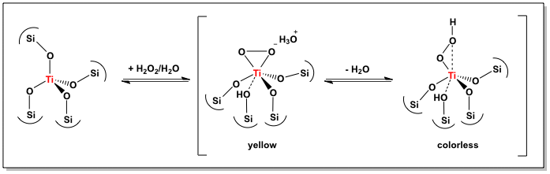Figure 58. Titanium center in TS-1 after exposed to aqueous hydrogen peroxide

3.5.2 DRUV spectra of peroxide samples
Ti catalysts/H₂O₂ system (sample 3, 6 and 9) has been investigated. Figure 58 presents the spectra of 2C-H₂O₂, 3C-H₂O₂ and 4C-H₂O₂. After contact with aqueous H₂O₂, significant changes are observed in the spectra (section 3.3). Instead of the Gaussian curves with single maximum as seen previously, these peroxide samples are characteristic of two prominent absorption features, one at 260-290 nm and the other at 370-390 nm. Similar pattern has been observed in TS-1/H₂O₂ system characterized of 6-coordinated Ti centers. Significant red shift of LMCT (Ti⁴⁺O^{2–}→ Ti³⁺O–) occurs. The maximum of the band locates at ~285 nm which is ascribable to higher coordination around Ti centers. A new feature at ~385 nm has been previously assigned to η²-peroxo moiety to Ti center with possible contribution from O²⁻ species. ⁶² Titanium-peroxo species form in 2C-, 3C-, and 4C-Ti species according to the DRUV spectra.
Absorbance (a.u.)

8

7

2C-H₂O₂
3C-H₂O₂
4C-H₂O₂
4C-H₂O₂
Figure 59. 2C- 3C- and 4C-Ti after contact with aqueous H₂O₂ (sample 3,6,9)

3.5.3 XAS results of peroxide samples
XANES and EXAFS spectra were collected on 2C-H₂O₂, 3C-H₂O₂ and 4C-H₂O₂ Exposure of the passivated samples described above to aqueous H₂O₂ causes an immediate color change in the powder from off-white to deep yellow. Same color change has been observed in the study of TS-1/H₂O₂ due to the formation of Ti-η2-peroxo structure. Ti-peroxo species decomposes in air and decolorize in air within ~5 hours. Ti-free silicate platform did not show any color change after contact with aqueous H₂O₂, supporting that the color change involves the structural change on titanium centers.
XANES spectra obtained from peroxide samples, 2C-H₂O₂ (sample 3), 3C-H₂O₂ (6), and 4C-H₂O₂ (9) are quite similar to one another and are completely different from those of the as-synthesized catalysts. After contact with aqueous H₂O₂, pre-edge peak in the XANES region changes significantly, decreasing in intensity. Pre-edge peaks with low intensity (<20% of the main edge) suggest that the tetrahedral Ti sites in these matrices have been transformed into 6-coordinated octahedral sites. Very weak shoulders are observed on each side of the pre-edge peak in these peroxide samples. Such multiple low intensity pre-edge peaks have been previously assigned to 6-coordinated pseudo Oh Ti sites, such as in TS-1 after contact with aqueous H₂O₂. Furthermore, the main pre-edge peak position blue shifts ~1-2 eV relative to that seen in the parent materials. Such a shift in pre-edge position is expected with a transition from Td to Oh-symmetry according to XANES calculations of the Fermi energy from several previous studies.^{88, 102} Finally, on top of the main absorption edge the white line splits into two peaks. The double-peak feature is considered to be a fingerprint for Ti-peroxo structure and has been observed in TS-1 and other titanium silicate materials exposed to aqueous H₂O₂.⁶²
The changes observed in the pre-edge and edge features of the data are consistent with the formation of pseudo octahedral Ti sites containing a η²-peroxo ligand. Also in agreement with this conclusion is the red shifting of the primary absorption in the UV-Vis spectra of samples exposed to aqueous H₂O₂. EXAFS models for the Ti centers in these samples will now be described.
It is clear that Ti sites have different coordination/geometry after contact with aqueous H2O2, supported by changes in XANES region. Pre-edge shape, position and intensity agree with 6-coordinated Ti site in the peroxide samples, also supported by a remarkable red shift in DRUV spectra. The formation of Ti-peroxo strucutre is proposed based on the observations in color changing and features on the main edge. The structural model [Ti(OSi)₄(η²-OOH₂)] is applied in EXAFS modeling.

3.6 Summary
-Successful synthesis of the materials
-Controllable connectivity and nuclearity based on a variety of characterization
-Ready for catalysis
DRUV and EXAFS modeling on the 4C-H₂O₂ (sample 9) agrees perfectly on the structure of 6-coordinated Ti centers with η²-peroxo.

Chapter IV. Synthesis and Primary Characterization of Isolated Tetranuclear Titanosilicate Catalyst

4.1 Experimental

4.1.1 Titanium precursor
-Why polynuclear precursors: Ti-O-Ti involved reaction
-Why choose [Ti₄Cl₆(µ₂-O₂CPh)₆(µ₃-O)₂]
-NMR
Benzoic acid (C₆H₅COOH, crystalline, ACS certified) was used without further purification. n-Octane (99+%, Fischer Scientific) was distilled and stored under nitrogen prior to use. [Ti₄Cl₆(µ₂-O₂CPh)₆(µ₃-O)₂] complex exhibits better stability that lasts for several months under nitrogen without noticeable change.

4.1.2 Synthesis of embedded polynuclear sites

4.2 Characterization of embedded tetranuclear titanium center

4.2.1 Gravimetric and elemental analysis
-Gravimetric and NMR of volatiles

4.2.2 DRUV
-Sample preparation
-Spectra and interpretation (Figure 60)
Figure 60.

4.2.3 IR
-Ti-O-Si feature (Figure 61)
Figure 61

4.2.4 Raman
-Ti-Cl feature went away after reaction with BB (Figure 62)
Figure 62.

4.2.5 XANES
-Sample preparation
-Data collection process
-shows major coordination change around titanium sites
-before and after reacting with BB
Spectrum (Figure 63, Table 15)
Figure 63
Table 15

4.3 Conclusion and proposed structures of titanium sites
-Figures and explanation (Figure 64)
-proposed reaction process and final products
Figure 64

Chapter V. Secondary Characterization: Catalytic Properties in Alkylphenol Oxidation with Aqueous Hydrogen Peroxide

5.1 Background

5.1.1 Heterogeneous activation of aqueous hydrogen peroxide
Catalytic oxidation is a key technology for converting petroleum-based feedstocks to useful chemicals. In these reactions, hydrogen peroxide (H₂O₂) as an oxidant offers advantages because the only byproduct is water and H₂O₂ has a high content of active oxygen species. A variety of sophisticated catalysts have been developed to activate H₂O₂ as the oxidant, including homogeneous molecular catalysts, biomimetic catalysts and single-site heterogeneous catalysts (SSHCs).
As mentioned in Chapter I, the major disadvantage of homogeneous catalysts is the difficulty of separating the often relatively expensive catalyst from the products at the end of the reaction. Thus, simple separation has been the initial driving force for preparing heterogeneous systems. Later many studies showed that the presence of support has beneficial effects more than merely an inert backbone. The bonding between metal center and support leads to preferred orientations of the substrate at the catalytic sites. In the cases of SSHCs, it is possible to stabilize catalytically active centers through site isolation, which prevents dimerization of the catalyst in aqueous environments to an inactive form.
One major issue with heterogeneous catalysts, however, is that the reaction has to occur at catalytically accessible sites, i.e. some unaccessible or inactive sites remain unused during the reaction. The catalytic property of each metal center not only relates to the method of preparation but also the ancestor of titanium and Si sources. Thus, in many ways SSHCs are preferred, because of the homogeneous distribution of active centers, resulting in high specific reactivity and chemo-, regio-, and stereoselectivity. Many of these catalysts are silicate supported early transition metals, among which TS-1 as maybe the most well-known example exhibits some remarkable activities and selectivities in especially epoxidation with H₂O₂. The possible interaction between TS-1 and H₂O₂ has been proposed by Khouw et. al (Figure 65) and later agreed by several others.^{91, 103, 104}
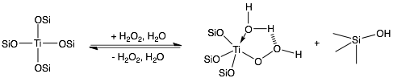Figure 65. Titanium center in TS-1 interacts with H₂O₂ during catalytic oxidation
Primarily three aspects to consider when design heterogeneous catalysts for activation of H₂O₂: (1) high activity ideally 100% conversion of titanium precursors into the desirable active centers; (2) high selectivity that relates to the uniform distribution of active centers in the matrix; (3) stability against dimerization or leaching, in other words, long catalyst life.

5.1.2 Phenol oxidation with aqueous hydrogen peroxide
Industrial meaning
Reason/benefits of breaking aromatic ring
Application of benzoquinone

5.2 Experimental

5.2.1 Catalytic reaction condition
The batch reaction is performed in 4 mL glass vials with septum caps at 80 ºC under 400 rpm stirring. 8-29 mg of titanium catalysts were used to introduce 0.012 mmol of titanium. 2,3,6-trimethylphenol (TMP) was purchased from Sigma-Aldrich and used without further purification. 27 mg (0.20 mmol) of TMP and 10 mg (0.065 mmol) biphenyl (BP) were introduced respectively as substrate and internal standard, followed by adding 3.0 mL of anhydrous acetonitrile as solvent. The suspension of white catalyst particles in a colorless solution was then brought to 80ºC and allowed to equilibrate for 5 min. To initiate the oxidation reaction, 163 mg (2.4 mmol) of aqueous H₂O₂ (50% w/w) was added. In all the cases involving titanium catalysts, the solution turned yellow within 5 min once H₂O₂ was added, indicating the formation of 2,3,5-trimethyl-benzoquinone (TMBQ).

5.2.2 Methods of quantification
Gas chromatograph-mass spectroscopy (GC-MS) and ¹H NMR are used to identify the desired product (TMBQ) that were first purified by silica gel chromatography. Small aliquots (0.5 μL) were taken periodically from the reaction suspension through the septum cap, and subsequently injected to GC-MS. The yield and conversion were quantified with the addition of internal standard biphenyl (BP). Figure 66 shows an example of TMP percentage, i.e. 100 - conversion (%) plotted as a function of time (min).

5.3 Evaluation of Catalytic Activity

5.3.1 Preparation of Ti-free blank and Ti catalysts
Blank: fumed silica, Si platform
Ti catalysts: TS-1, Ti-MCM-48; 2C, 3C, 4C, Ti4 catalysts

5.3.2 Conversion and selectivity
Mono- and polyatomic titanium catalysts have all exhibited interesting catalytic activity in the oxidation of TMP to TMBQ using aqueous hydrogen peroxide as oxidant. TMP conversion and yield of the desired product TMBQ are summarized along with Ti-free blank controls. (Table 16) Little to no conversion was observed in the cases of blank controls, i.e. no catalyst (blank), fumed silica or SiC₄ platform. Ti-free SiCl₄ platform was synthesized following procedures used for Ti-containing materials. Sn content of Ti-free platform material was characterized to be 1.6 wt% Sn, slight higher than Ti-containing catalyst (< 1.0 wt% Sn). The Ti-free platform and titanium catalysts have similar mesostructure and Sn content. Under the same reaction condition, the platform shows no significant catalytic activity (~3% loss of starting material; no product observed). The catalytic inactivity of these controls demonstrates that the activity is derived solely from the titanium centers in the matrices and neither the remaining tin nor the bb structure is responsible. Byproducts are identified to be 2,3-epoxy-benzoquinone; trimethylphenol dimer according to GC-MS.
Figure 66. Conversion vs. Time curve
Table 16. Results of catalytic properties in oxidation of TMP to TMBQ
Blank controls  &  Ti catalysts | TMP Conversion%  (± 3 %) | TMBQ Selectivity%  (± 3 %) | TMBQ  Yield% | Initial TOF  (min⁻¹)
TS-1 | 18 | 37 | 7 | 0.25
Ti-MCM-48 | 56 | 73 | 41 | 0.75
Ti₄ | 96 | 93 | 89 | 1.72
4C-Ti | 26 | 43 | 11 | 0.35
3C-Ti | 23 | 36 | 8 | 0.51
2C-Ti | 90 | 80 | 73 | 1.58
No catalyst | 0 | - | - | -
Silica, fumed | 1 | - | - | -
SiCl₄ platform | 3 | - | - | -

Distinct catalytic activity has been observed for 2C-, 3C- and 4C-Ti catalysts in the oxidation of TMP to TMBQ. Under the same reaction condition, 2C-Ti exhibited significantly higher TMP conversion and selectivity toward TMBQ than 3C- and 4C-Ti. Initial TOF of 2C-Ti at low conversion is also higher than 3C and 4C-Ti by a factor of three to five. The structural differences between titanium sites help to explain the observation. Comparing the three types of atomically dispersed sites, 2C-Ti contains the most accessible titanium centers, making it easier for the substrates (TMP) and H₂O₂ to coordinate. Catalytic mechanisms that require coordination of substrate and H₂O₂ simultaneously to the metal center have been proposed. [ref] In contrast, titanium centers with higher connectivity are surrounded by one or two more bulky bb’s and therefore are much less accessible to the small molecules.
Generally, 3C- and 4C-Ti decompose H₂O₂ into water and oxygen at a higher rate than 2C-Ti. Therefore, with the same substrate to peroxide ratio, 2C-Ti exhibits higher TMP conversion and yield of TMBQ, and also higher peroxide efficiency. .
Higher TMP conversion and TMBQ selectivity have been observed from tetraneculear species. The slightly higher selectivity of Ti₄ than that of 2C-Ti is in agreement with previous studies.⁵²

5.3.2 Stability and recyclability
The stability of catalytic sites is also crucial to heterogeneous catalysts. To evaluate the catalysts synthesized, titanium wt% in both the recycled catalysts and mother liquor are examined with ICP-OES and the results are summarized in the Table 17. After ~6 hours in presence with aqueous hydrogen peroxide, little to no titanium (< 0.1 wt%) was detected in the solution. The elemental analysis suggests majority of the titanium sites are stable in the matrix under reaction condition. All atomically dispersed titanium catalysts have shown excellent recyclability in agreement with the leaching study. The results for 2C-Ti, possibly the less stable of the three studied, are shown in Figure 67. During four consecutive reactions, 2C catalyst (7.6 wt% Ti) has shown consistent activity in terms of both conversion and selectivity.
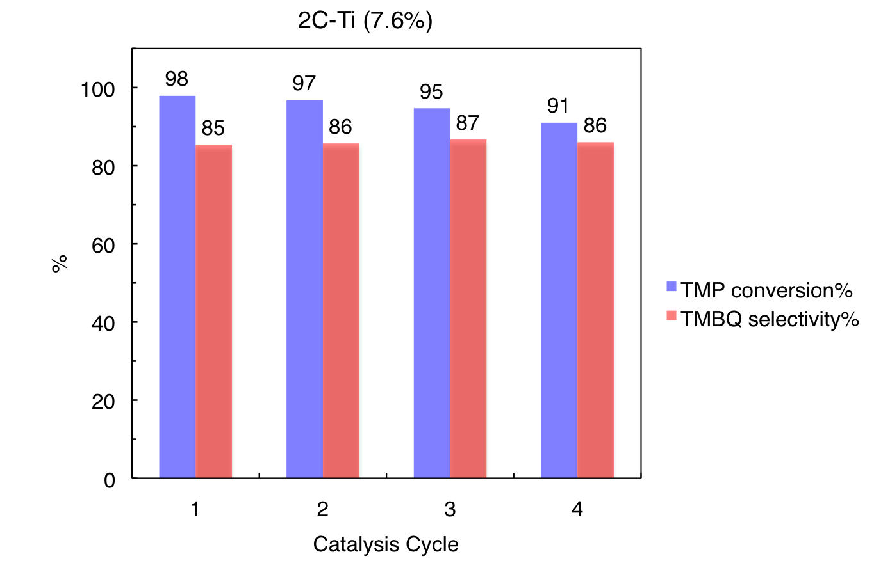
Figure 67. Recyclability of 2C-Ti catalyst in terms of conversion and selectivity
Table 17. Stability of titanium in building block supported matrices
Sample | Ti wt% |  |  | Ti leaching ^{c}  (%)
Sample | Initial Cat. | Recycled Cat.ª | Mother Liquor^{a,b} | Ti leaching ^{c}  (%)
2C-1 | 2.7 | 2.5 | 0.01 | 0.3
2C-2 | 7.6 | 6.8 | 0.10 | 1.4
4C-1 | 2.1 | 1.9 | 0.02 | 1.0
4C-2 | 3.2 | 2.6 | 0.02 | 0.9
a Recycled catalyst and mother liquor collected after multiple cycles (2~4) of reaction
b titanium (mg) / recycled catalyst (mg) × 100%
c [Mother Liquor] / ([Recycled Cat.] + [Mother Liquor]) × 100%
Many believe that surface-grafted titanium species by various syntheses are (more) susceptible to titanium leaching that causes the catalyst to deactivate. Because surface-grafted titanium centers are likely to have lower connectivity to silica matrix. When some Ti-O-Si linkages are hydrolyzed in aqueous environment, it is easier for the surface titanium centers to detach in the form of small molecules, than the fully embedded titanium species. Although in the past the studies about heterogeneous catalysts normally include the leaching study, most describe the results without explanation on the atomic or molecular level of the catalyst structure. One of the most detailed leaching studies on a microscopic scale was conducted on two types of Ti-silsesquioxane complexes that represent 1-connected and 3-connected titanium centers respectively. The research supports the hydrothermal stability of 3-connected titanium center, whereas significant titanium leaching occurs to 1-connected titanium complex.¹⁰⁵ The missing piece is 2-connected titanium center. To complete the study and take one step further, this research not only covers 2-connected titanium center but also extends to polynuclear titanium in silica. The family of titanosilicates include atomic titanium centers (2C, 3C, 4C-Ti) and tetranuclear titanium cluster within silica matrices. In addition, rather than using model complexes as in the previous study, single-site heterogeneous catalysts, as-synthesized and after catalysis, are carefully examined.

5.3.3 Mechanistic study
-lnrate vs. ln[H₂O₂] (Figure 68)

Figure 68. NMR spectrum of hydrogen peroxide with chloroform as internal standard

-H2O2 efficiency

5.3.4 Different catalytic mechanism
-Activation energies when coordinating H₂O₂ onto titanium sites, hydrolyzing Ti-O-Si
-Different accessibility of titanium sites

5.4 Summary
-Stable and efficient titanosilicate catalysts were made
-Clearly different catalytic result from different structures of titanium sites, demonstrates the effect on catalytic activity from connectivity around Ti
-Tetranuclear and 2C-Ti sites are the best catalysts in terms of both TMP conversion and selectivity, which helps direct the design of future catalysts
-In literature, drastically different catalytic results are often observed from the essentially the same titanosilicates that are made by slightly different methodologies. It implies that any changes in synthetic parameter may affect the final structure of the catalyst and thus catalytic properties. The current result demonstrates that the subtle structural difference in the coordination sphere around catalytic center plays an important role in both catalytic activity and selectivity. The study not only offers an explanation to the long lasting issue in making titanosilicate catalysts, but more importantly, an effective way to target specific type of titanium center.

Chapter VI. Conclusion and Future work

6.1 Non-aqueous Synthesis of Titanosilicates

6.1.1 Precise structural control of catalytic sites
-no ligand exchange besides metathesis reaction;
-need not calcination while successfully stabilizing the metal sites

6.2 Framework versus Surface Titanium Sites

6.3 Mononuclear versus Polynuclear Titanium Sites

References
1. Modak, J., Haber process for ammonia synthesis. Resonance 2002, 7, 69-77.
2. Bhaduri, S.; Mukesh, D., Homogeneous Catalysis. John Wiley & Sons, Inc.: 2002; p i-xiv.
3. Wróblewska, A., Liquid phase epoxidation of allylic compounds with hydrogen peroxide over titanium silicalite catalysts. Journal of Molecular Catalysis A: Chemical 2005, 229, 207-210.
4. Wróblewska, A.; Fajdek, A., Epoxidation of allyl alcohol to glycidol over the microporous TS-1 catalyst. Journal of Hazardous Materials 2010, 179, 258-265.
5. Katsuki, T. In Titanium-catalyzed epoxidation, 1998; Wiley-VCH Verlag GmbH: 1998; pp 261-271.
6. Bourikas, K.; Kordulis, C.; Lycourghiotis, A., The Role of the Liquid‐Solid Interface in the Preparation of Supported Catalysts. Catalysis Reviews 2006, 48, 363-444.
7. Valden, M.; Lai, X.; Goodman, D. W., Onset of Catalytic Activity of Gold Clusters on Titania with the Appearance of Nonmetallic Properties. Science 1998, 281, 1647-1650.
8. Koo, K. Y.; Roh, H.-S.; Seo, Y. T.; Seo, D. J.; Yoon, W. L.; Bin Park, S., A highly effective and stable nano-sized Ni/MgO–Al2O3 catalyst for gas to liquids (GTL) process. International Journal of Hydrogen Energy 2008, 33, 2036-2043.
9. Bell, A. T., The Impact of Nanoscience on Heterogeneous Catalysis. Science 2003, 299, 1688-1691.
10. Gamba, A.; Tabacchi, G.; Fois, E., TS-1 from First Principles. Journal Of Physical Chemistry A 2009, 113, 15006-15015.
11. Deschner, T.; Lonstad, B.-T.; Widenmeyer, M.; Anwander, R., Functionalization of MCM-41 and SBA-1 with titanium(iv) (silyl)amides. Journal of Materials Chemistry 2011, 21, 5620-5628.
12. Dinse, A.; Khennache, S.; Frank, B.; Hess, C., Oxidative dehydrogenation of propane on silica (SBA-15) supported vanadia catalysts: A …. Journal of Molecular Catalysis. A 2009, 307, 43-50.
13. Schreier, M.; Teren, S.; Belcher, L.; Regalbuto, J. R.; Miller, J. T., The nature of ‘overexchanged’ copper and platinum on zeolites. Nanotechnology 2005, 16.
14. Jiao, L.; Regalbuto, J. R., The synthesis of highly dispersed noble and base metals on silica via strong electrostatic adsorption: I. Amorphous silica. Journal of Catalysis 2008, 260, 329-341.
15. Woolery, G. L.; Alemany, L. B.; Dessau, R. M.; Chester, A. W., Spectroscopic evidence for the presence of internal silanols in highly siliceous ZSM-5. Zeolites 1986, 6, 14-16.
16. van der Lee, M. K.; van Dillen, J.; Bitter, J. H.; de Jong, K. P., Deposition Precipitation for the Preparation of Carbon Nanofiber Supported Nickel Catalysts. J Am Chem Soc 2005, 127, 13573-13582.
17. Lekhal, A.; Glasser, B. J.; Khinast, J. G., Impact of drying on the catalyst profile in supported impregnation catalysts. Chemical Engineering Science 2001, 56, 4473-4487.
18. Sanchez, C.; Livage, J.; Henry, M.; Babonneau, F., Chemical modification of alkoxide precursors. Journal of Non-Crystalline Solids 1988, 100, 65-76.
19. Hay, J. N.; Raval, H. M., Synthesis of Organic−Inorganic Hybrids via the Non-hydrolytic Sol−Gel Process. Chemistry of Materials 2001, 13, 3396-3403.
20. Andrianainarivelo, M.; J. P. Corriu, R.; Leclercq, D.; Hubert Mutin, P.; Vioux, A., Non-hydrolytic sol-gel process: zirconium titanate gels. Journal of Materials Chemistry 1997, 7, 279-284.
21. Andrianainarivelo, M.; Corriu, R.; Leclercq, D.; Mutin, P. H.; Vioux, A., Mixed oxides SiO2-ZrO2 and SiO2-TiO2 by a non-hydrolytic sol-gel route. Journal of Materials Chemistry 1996, 6, 1665-1671.
22. Thomas, J. M., The Bakerian Lecture, 1990: New Microcrystalline Catalysts. Philosophical Transactions of the Royal Society of London. Series A: Physical and Engineering Sciences 1990, 333, 173-207.
23. Mintova, S.; Olson, N. H.; Valtchev, V.; Bein, T., Mechanism of Zeolite A Nanocrystal Growth from Colloids at Room Temperature. Science 1999, 283, 958-960.
24. Corma, A.; Serra, J. M.; Serna, P.; Valero, S.; Argente, E.; Botti, V., Optimisation of olefin epoxidation catalysts with the application of high-throughput and genetic algorithms assisted by artificial neural networks (softcomputing techniques). Journal of Catalysis 2005, 229, 513-524.
25. Rashkeev, S. N.; Lupini, A. R.; Overbury, S. H.; Pennycook, S. J.; Pantelides, S. T., Role of the nanoscale in catalytic CO oxidation by supported Au and Pt nanostructures. Physical Review B 2007, 76, 035438.
26. Synthesis and characterization of TiO2-incorporated silica foams. Journal of Materials Science 2009.
27. Thomas, J.; Raja, R.; Lewis, D. W., Single-site heterogeneous catalysts. Angewandte Chemie-International Edition 2005, 44, 6456-6482.
28. McKittrick, M. W.; Jones, C. W., Toward Single-Site, Immobilized Molecular Catalysts: Site-Isolated Ti Ethylene Polymerization Catalysts Supported on Porous Silica. J Am Chem Soc 2004, 126, 3052-3053.
29. Maschmeyer, T.; Rey, F.; Sankar, G.; Thomas, J., Heterogenous Catalysts Obtained by Grafting Metallocene Complexes onto Mesoporous Silica. Nature 1995, 378, 159-162.
30. Jarupatrakorn, J.; Tilley, T. D., Silica-supported, single-site titanium catalysts for olefin epoxidation. A molecular …. J. Am. Chem. Soc 2002, 124, 8380-8388.
31. Thomas, J. M.; Raja, R., Significance of mesoporous crystals for catalytic application. In Studies in Surface Science and Catalysis, Osamu, T., Ed. Elsevier: 2004; Vol. Volume 148, pp 163-211.
32. Sakthivel, A.; Zhao, J.; Kühn, F. E., Cyclopentadienyl molybdenum complexes grafted on zeolites – synthesis and catalytic application. Catalysis Letters 2005, 102, 115-119.
33. Shannon, I. J.; Maschmeyer, T.; Oldroyd, R. D.; Sankar, G.; Thomas, J. M.; Pernot, H.; Balikdjian, J.-P.; Che, M., Metallocene-derived, isolated MoVI active centres on mesoporous silica for the catalytic dehydrogenation of methanol. Journal of the Chemical Society, Faraday Transactions 1998, 94, 1495-1499.
34. Fujdala, K. L.; Tilley, T. D., An Efficient, Single-Source Molecular Precursor to Silicoaluminophosphates. J. Am. Chem. Soc. 2001, 123, 10133-10134.
35. Drake, I. J.; Fujdala, K. L.; Bell, A. T.; Tilley, T. D., Dimethyl carbonate production via the oxidative carbonylation of methanol over Cu/SiO2 catalysts prepared via molecular precursor grafting and chemical vapor deposition approaches. Journal of Catalysis 2005, 230, 14-27.
36. Fujdala, K. L.; Tilley, T. D., New Vanadium Tris(tert-butoxy)siloxy Complexes and Their Thermolytic Conversions to Vanadia−Silica Materials. Chemistry of Materials 2002, 14, 1376-1384.
37. Pietrzyk, P.; Podolska, K.; Mazur, T.; Sojka, Z., Heterogeneous Binding of Dioxygen: EPR and DFT Evidence for Side-On Nickel(II)–Superoxo Adduct with Unprecedented Magnetic Structure Hosted in MFI Zeolite. J Am Chem Soc 2011, 133, 19931-19943.
38. Abbet, S.; Sanchez, A.; Heiz, U.; Schneider, W. D.; Ferrari, A. M.; Pacchioni, G.; Rösch, N., Acetylene Cyclotrimerization on Supported Size-Selected Pdn Clusters (1 ≤ n ≤ 30): One Atom Is Enough! J Am Chem Soc 2000, 122, 3453-3457.
39. Nicholas, C. P.; Ahn, H.; Marks, T. J., Synthesis, Spectroscopy, and Catalytic Properties of Cationic Organozirconium Adsorbates on “Super Acidic” Sulfated Alumina. “Single-Site” Heterogeneous Catalysts with Virtually 100 Active Sites. J Am Chem Soc 2003, 125, 4325-4331.
40. Raja, R.; Thomas, J. M.; Jones, M. D.; Johnson, B. F. G.; Vaughan, D. E. W., Constraining Asymmetric Organometallic Catalysts within Mesoporous Supports Boosts Their Enantioselectivity. J Am Chem Soc 2003, 125, 14982-14983.
41. Jones, M. D.; Raja, R.; Thomas, J. M.; Johnson, B. F. G.; Lewis, D. W.; Rouzaud, J.; Harris, K. D. M., Enhancing the Enantioselectivity of Novel Homogeneous Organometallic Hydrogenation Catalysts. Angewandte Chemie 2003, 115, 4462-4467.
42. Bianchini, C.; Burnaby, D. G.; Evans, J.; Frediani, P.; Meli, A.; Oberhauser, W.; Psaro, R.; Sordelli, L.; Vizza, F., Preparation, Characterization, and Performance of Tripodal Polyphosphine Rhodium Catalysts Immobilized on Silica via Hydrogen Bonding. J Am Chem Soc 1999, 121, 5961-5971.
43. Corma, A.; Garcia, H., Supramolecular Host-Guest Systems in Zeolites Prepared by Ship-in-a-Bottle Synthesis. European Journal of Inorganic Chemistry 2004, 2004, 1143-1164.
44. Knops-Gerrits, P.-P.; De Vos, D.; Thibault-Starzyk, F.; Jacobs, P. A., Zeolite-encapsulated Mn(II) complexes as catalysts for selective alkene oxidation. Nature 1994, 369, 543-546.
45. Trevisan, V.; Signoretto, M.; Colonna, S.; Pironti, V.; Strukul, G., Microencapsulated Chloroperoxidase as a Recyclable Catalyst for the Enantioselective Oxidation of Sulfides with Hydrogen Peroxide. Angewandte Chemie 2004, 116, 4189-4191.
46. Baur, W., On the cation and water positions in faujasite. The American Mineralogist 1964, 49.
47. Jacob, C. R.; Varkey, S. P.; Ratnasamy, P., Selective oxidation over copper and manganese salens encapsulated in zeolites. Microporous and Mesoporous Materials 1998, 22, 465-474.
48. Notari, B., Titanium silicalites. Catalysis Today 1993, 18.
49. Dutoit, D. C. M.; Schneider, M.; Hutter, R.; Baiker, A., Titania–Silica Mixed Oxides: IV. Influence of Ti Content and Aging on Structural and Catalytic Properties of Aerogels. Journal of Catalysis 1996, 161, 651-658.
50. Kholdeeva, O. A.; Trukhan, N. N., Mesoporous Titanium Silicates as Catalysts for the Liquid-Phase Selective Oxidation of Organic Compounds. Russian Chemical Reviews 2006, 75, 411-432.
51. Bouh, A.; Rice, G.; Scott, S., Mono- and Dinuclear Silica-Supported Titanium(IV) Complexes and the Effect of TiOTi Connectivity on Reactivity. J Am Chem Soc 1999, 121, 7201-7210.
52. Kholdeeva, O. A.; Ivanchikova, I. D.; Guidotti, M.; Pirovano, C.; Ravasio, N.; Barmatova, M. V.; Chesalov, Y. A., Highly Selective Oxidation of Alkylphenols to Benzoquinones with Hydrogen Peroxide over Silica-Supported Titanium Catalysts: Titanium Cluster Site versus Titanium Single Site. Advanced Synthesis & Catalysis 2009, 351, 1877-1889.
53. Taramasso, M.; Perego, G.; Notari, B., Preparation of porous crystalline synthetic material comprised of silicon and titanium oxides. 1983.
54. Bordiga, S.; Damin, A.; Bonino, F.; Lamberti, C., Single Site Catalyst for Partial Oxidation Reaction: TS-1 Case Study. Topics in Organometallic Chemistry 2005, 16, 37-68.
55. Notari, B., Titanium silicalites. Cafdysis Today 1993, 18.
56. Gleeson, D.; Sankar, G.; Catlow, C. R. A.; Thomas, J. M., The architecture of catalytically active centers in titanosilicate (TS-1) and related selective- …. Physical Chemistry Chemical Physics 2000.
57. Shannon, R., Revised effective ionic radii and systematic studies of interatomic distances in halides and chalcogenides. Acta Crystallographica Section A 1976, 32, 751-767.
58. Henry, P. F.; Weller, M. T.; Wilson, C. C., Structural Investigation of TS-1: Determination of the True Nonrandom Titanium Framework Substitution and Silicon Vacancy Distribution from Powder Neutron Diffraction Studies Using Isotopes. The Journal of Physical Chemistry B 2001, 105, 7452-7458.
59. Bordiga, S.; Bonino, F.; Damin, A.; Lamberti, C., Reactivity of Ti(iv) species hosted in TS-1 towards H2O2–H2O solutions investigated by ab initio cluster and periodic approaches combined with experimental XANES and EXAFS data: a review and new highlights. Physical Chemistry Chemical Physics 2007, 9, 4854.
60. Deka, R. C.; Nasluzov, V. A.; Shor, E. A. I.; Shor, A. M.; Vayssilov, G. N.; Rosch, N., Comparison of all sites for Ti substitution in zeolite TS-1 by an accurate embedded-cluster method. Journal Of Physical Chemistry B 2005, 109, 24304-24310.
61. Sheldon, R. A.; Wallau, M.; Arends, I.; Schuchardt, U., Heterogeneous catalysts for liquid-phase oxidations: Philosophers' stones or Trojan horses? Accounts Of Chemical Research 1998, 31, 485-493.
62. Bonino, F.; Damin, A.; Ricchiardi, G.; Ricci, M.; Spano, G.; Daloisio, R.; Zecchina, A.; Lamberti, C.; Prestipino, C.; Bordiga, S., Ti-Peroxo Species in the TS-1:H2O2:H2O System. 2009, 1-11.
63. De Vos, D. E.; Dams, M.; Sels, B. F.; Jacobs, P. A., Ordered Mesoporous and Microporous Molecular Sieves Functionalized with Transition Metal Complexes as Catalysts for Selective Organic Transformations. Chem. Rev 2002, 102, 3615-3640.
64. Blasco, T.; Corma, A.; Navarro, M.; Pariente, J., Synthesis, characterization, and catalytic activity of Ti-MCM-41 structures. Journal of Catalysis 1995, 156, 65-74.
65. Ratnasamy, P.; Srinivas, D.; Knözinger, H., Active Sites and Reactive Intermediates in Titanium Silicate Molecular Sieves. In Advances in Catalysis, Academic Press: 2004; Vol. Volume 48, pp 1-169.
66. Barker, C. M.; Gleeson, D.; Kaltsoyannis, N.; Catlow, C. R. A.; Sankar, G.; Thomas, J. M., On the structure and coordination of the oxygen-donating species in Ti[upward arrow]MCM-41/TBHP oxidation catalysts: a density functional theory and EXAFS study. Physical Chemistry Chemical Physics 2002, 4, 1228-1240.
67. Wan, Y.; Zhao, D., Ordered Mesoporous Materials. In Synthesis of Solid Catalysts, Wiley-VCH Verlag GmbH & Co. KGaA: 2009; pp 277-300.
68. Jung, W. Y.; Baek, S. H.; Yang, J. S.; Lim, K. T.; Lee …, M. S., Synthesis of Ti-containing SBA-15 materials and studies on their photocatalytic …. Catalysis today 2008.
69. Fraile, J. M.; Garcia, J. I.; Mayoral, J. A.; Vispe, E., Catalytic sites in silica-supported titanium catalysts: silsesquioxane complexes as models. Journal of Catalysis 2005, 233, 90-99.
70. Quadrelli, E. A.; Basset, J.-M., On silsesquioxanes’ accuracy as molecular models for silica-grafted complexes in heterogeneous catalysis. Coordination Chemistry Reviews 2010, 254, 707-728.
71. Aish, E. H.; Crocker, M.; Ladipo, F. T., Tripodal titanium silsesquioxane complexes immobilized in polydimethylsiloxane (PDMS) membrane: Selective catalysts for epoxidation of cyclohexene and 1-octene with aqueous hydrogen peroxide. Journal of Catalysis 2010, 273, 66-72.
72. Yoon, C.; Hirsekorn, K.; Neidig, M.; Yang, X.; Tilley, T., Mechanism of the Decomposition of Aqueous Hydrogen Peroxide over Heterogeneous TiSBA15 and TS-1 Selective Oxidation Catalysts: Insights from Spectroscopic and DFT Studies. ACS Catalysis 2011, 111004102855007.
73. Alcock, N. W.; Brown, D. A.; Roe, S. M., Synthesis of new titanium-oxo cluster compounds: X-ray structure of the tetranuclear oxide[Ti4Cl6(u2-O2CPh)6(u3-O)2]. Journal of the Chemical Society. Chemical Communication 1992, 846-848.
74. Clark, J. C.; Barnes, C. E., Reaction of the Si8O20(SnMe3)8 Building Block with Silyl Chlorides: A New Synthetic Methodology for Preparing Nanostructured Building Block Solids. Chemistry of Materials 2007, 19, 3212-3218.
75. Lee, M.-Y.; Jiao, J.; Mayes, R.; Hagaman, E.; Barnes, C. E., The targeted synthesis of single site vanadyl species on the surface and in the framework of silicate building block materials. Catalysis today 2011, 160, 153-164.
76. Hutter, R.; Mallat, T.; Baiker, A., Titania-Silica Mixed Oxides 2. Catalytic Behavior in Olefin Epoxidation. Journal of Catalysis 1995, 153, 177-189.
77. Feher, F. J.; Weller, K. J., Synthesis and characterization of labile spherosilicates:[(Me3SnO) 8Si8O12] and [(Me4SbO …. Inorganic Chemistry 1991, 30, 880882.
78. Kamigaito, M.; Sawamoto, M.; Higashimura, T., Alkoxy-Substituted Titanium(IV) Chlorides as Lewis Acid Activators for Living Cationic Polymerization of Isobutyl Vinyl Ether: Control of Lewis Acidity in the Design of Initiating Systems. Macromolecules 1995, 28, 5671-5675.
79. Zhang, F. Z.; Guo, X. W.; Wang, X. S.; Li, G.; Zhou, J. C., The active sites in different TS-1 zeolites for propylene epoxidation studied by ultraviolet …. Catalysis Letters 2001.
80. Srinivas, D.; Manikandan, P.; Laha, S. C.; Kumar, R.; Ratnasamy, P., Reactive oxo-titanium species in titanosilicate molecular sieves: EPR investigations and structure-activity correlations. Journal of Catalysis 2003, 217, 160-171.
81. Jørgensen, C. K., Modern aspects of ligand field theory. North-Holland, Amsterdam, 1971.
82. Gao, X.; Wachs, I. E., Titania–silica as catalysts: molecular structural characteristics and physico-chemical properties. Catalysis today 1999, 51, 233-254.
83. Le Noc, L.; Trong On, D.; Solomykina, S.; Echchahed, B.; Béland, F.; Cartier dit Moulin, C.; Bonneviot, L., Characterization of two different framework titanium sites and quantification of extra-framework species in TS-1 silicalites. In Studies in Surface Science and Catalysis, Joe W. Hightower, W. N. D. E. I.; Alexis, T. B., Eds. Elsevier: 1996; Vol. Volume 101, pp 611-620.
84. Halasz, I.; Liang, J.; Fitzgerald, G., Zeolite Confined Ti (OH) 4 Nanoparticles in Highly Active and Selective Oxidation Catalyst. Catalysis Letters 2011, 141, 948-953.
85. Bordiga, S.; Coluccia, S.; Lamberti, C.; Marchese, L.; Zecchina, A.; Boscherini, F.; Buffa, F.; Genoni, F.; Leofanti, G.; Petrini, G.; Vlaic, G., XAFS Study of Ti-Silicalite: Structure of Framework Ti(IV) in the Presence and Absence of
Reactive Molecules (H2O, NH3) and Comparison with Ultraviolet-Visible and IR Results. Journal of Physical Chemistry 1994, 98, 4125-4132.
86. Kelly, S. D.; Hesterberg, D.; Ravel, B., Analysis of soils and minerals using X-ray absorption spectroscopy. Methods of soil analysis, Part 5 -Mineralogical methods. Ulery, A. L. and Drees, L. R. Madison, WI, USA, Soil Science Society of America 2008, 367-463.
87. Fernández-García, M., XANES analysis of catalytic systems under reaction conditions. Catalysis Reviews 2002, 44, 59-121.
88. Farges, F.; Brown, G. E.; Rehr, J. J., Ti K-edge XANES studies of Ti coordination and disorder in oxide compounds: Comparison between theory and experiment. Physical Review B 1997, 56, 1809-1819.
89. Bolis, V.; Bordiga, S.; Lamberti, C.; Zecchina, A.; Carati, A.; Rivetti, F.; Spano, G.; Petrini, G., Heterogeneity of Framework Ti (IV) in Ti− Silicalite as Revealed by the Adsorption of NH3. Combined Calorimetric and Spectroscopic Study†. Langmuir 1999, 15, 5753-5764.
90. Bonino, F.; Damin, A.; Bordiga, S.; Lamberti, C.; Zecchina, A., Interaction of CD3CN and pyridine with the Ti (IV) centers of TS-1 catalysts: a spectroscopic and computational study. Langmuir 2003, 19, 2155-2161.
91. Bordiga, S.; Bonino, F.; Damin, A.; Lamberti, C., Reactivity of Ti(IV) species hosted in TS-1 towards H2O2-H2O Solutions investigated by ab initio cluster and periodic approaches combined with experimental XANES and EXAFS data: a review and new highlights. Physical Chemistry Chemical Physics 2007, 9, 4854-4878.
92. Bordiga, S.; Bonino, F.; Damin, A.; Lamberti, C., … cluster and periodic approaches combined with experimental XANES and EXAFS data: a review …. Physical Chemistry Chemical Physics 2007.
93. Farges, F., A Ti K-edge EXAFS study of the medium range environment around Ti in oxide glasses. Journal of Non-Crystalline Solids 1999, 244, 25-33.
94. Bordiga, S.; Coluccia, S.; Lamberti, C.; Marchese, L.; Zecchina, A.; Boscherini, F.; Buffa, F.; Genoni, F.; Leofanti, G.; Petrini, G.; Vlaic, G., XAFS Study of Ti-Silicalite: Structure of Framework Ti(IV) in the Presence and Absence of Reactive Molecules (H2O, NH3) and Comparison with Ultraviolet-Visible and IR Results. Journal of Physical Chemistry 1994, 98, 4125-4132.
95. Zhao, D.; Budhi, S.; Rodriguez, A.; Koodali, R., Rapid and facile synthesis of Ti-MCM-48 mesoporous material and the photocatalytic performance for hydrogen evolution. International Journal of Hydrogen Energy 2010.
96. Ricchiardi, G.; Damin, A.; Bordiga, S.; Lamberti, C.; Spano, G.; Rivetti, F.; Zecchina, A., Vibrational structure of titanium silicate catalysts. A spectroscopic and theoretical study. J Am Chem Soc 2001, 123, 11409-11419.
97. Lin, W. Y.; Frei, H., Photochemical and FT-IR probing of the active site of hydrogen peroxide in Ti silicalite sieve. J Am Chem Soc 2002, 124, 9292-9298.
98. Lu, J.; Kosuda, K. M.; Van …, R. P., Surface Acidity and Properties of TiO2/SiO2 Catalysts Prepared by Atomic Layer Deposition: UV− visible Diffuse Reflectance, DRIFTS, and Visible Raman …. The Journal of … 2009.
99. Scarano, D.; Zecchina, A.; Bordiga, S.; Geobaldo, F.; Spoto, G.; Petrini, G.; Leofanti, G.; Padovan, M.; Tozzola, G., Fourier-transform infrared and Raman spectra of pure and Al-, B-, Ti- and Fe-substituted silicalites: stretching-mode region. Journal of the Chemical Society, Faraday Transactions 1993, 89, 4123-4130.
100. Zimny, K.; Carteret, C.; Stebe, M. J.; Blin, J. L., Multitechnique Investigation of Mesoporous Titanosilicate Materials Prepared from Both the Self-Assembly and the Liquid Crystal Mechanisms. Journal Of Physical Chemistry C 2011, 115, 8684-8692.
101. Farges, F., Coordination of Ti in crystalline and glassy fresnoites: A high-resolution XANES spectroscopy study at the Ti K-edge. Journal of Non-Crystalline Solids 1996, 204, 53-64.
102. Li, G. G.; Bridges, F.; Booth, C. H., X-ray-absorption Fine-structure Standards: A Comparison of Experiment and Theory. Physical Review B 1995, 52, 6332-6348.
103. Khouw, C. B.; Dartt, C. B.; Labinger, J. A.; Davis, M. E., Studies on the Catalytic Oxidation of Alkanes and Alkenes by Titanium Silicates. Journal of Catalysis 1994, 149, 195-205.
104. Zalomaeva, O. V.; Trukhan, N. N.; Ivanchikova, I. D.; Panchenko, A. A.; Roduner, E.; Talsi, E. P.; Sorokin, A. B.; Rogov, V. A.; Kholdeeva, O. A., EPR study on the mechanism of H2O2-based oxidation of alkylphenols over titanium single-site catalysts. Journal Of Molecular Catalysis A-Chemical 2007, 277, 185-192.
105. Abbenhuis, H. C. L.; Krijnen, S.; vanSanten, R. A., Modelling the active sites of heterogeneous titanium epoxidation catalysts using titanium silasequioxanes: Insight into specific factors that determine leaching in liquid-phase processes. Chemical Communications 1997, 331-332.
106. Ahn, W. S.; Kang, K. K.; Kim, K. Y., Synthesis of TS-1 by microwave heating of template-impregnated SiO2–TiO2 xerogels. Catalysis Letters 2001, 72, 229-232.
107. Guo, X.; Li, G.; Zhang, X.; Wang, X., Synthesis of titanium silicalite-I from TPABr system. In Studies in Surface Science and Catalysis, Can, L.; Qin, X., Eds. Elsevier: 1997; Vol. Volume 112, pp 499-508.
108. Thangaraj, A.; Eapen, M. J.; Sivasanker, S.; Ratnasamy, P., Studies on the synthesis of titanium silicalite, TS-1. Zeolites 1992, 12, 943-950.

Vita

