Driving Volatility in Instantaneous Driving Behaviors: Studies Using Large-Scale Trajectory Data

A Dissertation Presented for the
Doctor of Philosophy
Degree
The University of Tennessee, Knoxville

Jun Liu
May 2015

Copyright © 2015 by Jun Liu
All rights reserved.

This dissertation is dedicated to my parents, Suhua Ma and Bisheng Liu, and my grandmother.
ACKNOWLEDGEMENTS

I would like to thank everyone who has supported, encouraged, and guided me through the long process of finishing my graduate education.

First, I would like to thank my major advisor, Dr. Asad Khattak, for providing guidance and sharing his knowledge and experiences with me. It was his great support that allowed me to accomplish the doctoral study, especially for the last two years of my doctoral study. It has been a pleasure to work with him on my research. I would also like to thank Dr. Stephen Richards and Dr. Lee Han for the instruction during the first two years of my doctoral study, as well as the care for the last two years. These three faculty members at University of Tennessee (UT) were my great mentors in both life and study. I am deeply grateful to them all.

This dissertation would not be possible without the assistance of my committee members, Dr. Hamparsum Bozdogan, who also served as my statistics advisor, and three abovementioned faculty members. Their comments have greatly helped to shape my research. I have really enjoyed taking classes from them and discussing projects with each of them. My work has also been greatly assisted by many others at UT, Dr. David Greene, Dr. Christopher Cherry, Dr. Shashi Nambisan, Dr. David Clarke and Dr. Xin Wang.

My work has been greatly supported through Southeastern Transportation Center (sponsored by the United States Department of Transportation through grant number DTRT13-G-UTC34) and TranLIVE University Transportation Center grant sponsored by the Research and Innovative Transportation Administration (now in the Office of the Secretary of Transportation), of United States Department of Transportation. Special thanks are extended to the following entities for their support at University of Tennessee: Center for Transportation Research, Transportation Engineering & Science Program and Initiative for Sustainable Mobility.

Last but not least, I want to thank all the other transportation students who have shared in my experiences: Stephanie Hargrove, Ryan Overton, Brian Casey Langford, Amber Woodburn, Andrew Campbell, Zane Pannell, Shanna Veilleux, Taekwan Yoon, Bryan Bartnik, Shuguang Ji, Wei Lu, Qiang Yang, Ziwen Ling, Jianjiang Yang, Meng Zhang, Hyeonsup Lim, Dua Abdelqader, Yang Zhang, Hunter McCracken, Luis Toboada, Bumjoon Bae, Kay Boakye, Ranjit Khatri, Ebony Lemons, and many others. They have all been great friends and have made the experience very memorable.

ABSTRACT

Increasing amounts of data, generated by electronic sensors from various sources that include travelers, vehicles, infrastructure and the environment, referred to as “Big Data”, represent an opportunity for innovation in transportation systems and toward achieving safety, mobility and sustainability goals. The dissertation takes advantage of large-scale trajectory data coupled with travel behavioral information and containing 78 million second-by-second driving records from 100 thousand trips made by nearly four thousand drivers. The data covers 70 counties across the State of California and Georgia, representing various land use types, roadway network conditions and population. The trajectories cover various driving practices made by vehicles of varied body types as well as different fuel types including conventional vehicles (CVs) consuming gasoline, hybrid electric vehicles (HEVs), battery electric vehicles (BEVs), diesel vehicles and other alternative fuel vehicles (AFVs). The dissertation establishes a framework for the research agenda in instantaneous driving behavior studies using the large-scale trajectory data. The dissertation makes both theoretical and empirical contributions: 1) Developing measures for driving volatility in instantaneous driving behaviors; 2) Understanding correlates of driving volatility in hierarchies & developing applications using large-scale trajectory data.

Before using second-by-second trajectories, a study, answering research questions concerning the relationships between data sampling rates and information loss, was conducted. Then, a study for quantifying driving volatility in instantaneous driving behaviors was presented. “Driving volatility”, as the core concept in the dissertation, captures extreme driving patterns under seemingly normal conditions. After that, the dissertation presents a study on exploration of the hierarchical nature of driving volatility embedded in travel survey data using multi-level modeling techniques, and highlights the role of AFVs in travel. Last, the dissertation presents a study for customizing driving cycles for individuals using large-scale trajectory data, given heterogeneous driving performance across drivers and vehicle types. The customized driving cycles help generate more accurate fuel economy information to support cost-effective vehicle choices. The implications of the findings and potential applications to fleet vehicles and driving population are also discussed in the dissertation.

TABLE OF CONTENTS

Chapter 1 INTRODUCTION 1
Chapter 2 HOW MUCH INFORMATION IS LOST WHEN SAMPLING INSTANTANEOUS DRIVING BEHAVIOR DATA? 7
ABSTRACT 8
2.1 INTRODUCTION 9
2.2 DATA DESCRIPTION 11
2.3 METHODOLOGY 12
2.3.1 Direct Detectability of Driving Decisions 13
2.3.2 Indirect Detectability of Driving Decisions 15
2.3.3 Instantaneous Driving Decision Loss 19
2.3.4 Measures Concerning Magnitudes 19
2.3.5 An Index for Magnitude of Information Loss (MIL) 22
2.4 RESULTS 23
2.4.1 Direct Detectability of Driving Decisions 23
2.4.2 Indirect Detectability of Driving Decisions 25
2.4.3 Instantaneous Driving Decision Information Loss 26
2.4.4 Measures Concerning Magnitudes 27
2.4.5 Extent of Information Loss 28
2.5 LIMITATIONS 30
2.6 CONCLUSIONS 30
Chapter 3 WHAT IS THE LEVEL OF VOLATILITY IN INSTANTANEOUS DRIVING BEHAVIORS? APPLICATIONS FOR SUPPORTING CALMER DRIVING 33
ABSTRACT 34
3.1 INTRODUCTION 35
3.2 LITERATURE REVIEW 37
3.3 DATA DESCRIPTION 40
3.4 METHODOLOGY 42
3.4.1 Measures of Instantaneous Driving Decisions 42
3.4.3 Patterns of Instantaneous Driving Decisions 43
3.4.3 Methodological Framework 45
3.5 RESULTS – EXTENT OF VOLATILITY IN DRIVING 46
3.5.1 Time Use Distribution 46
3.5.2 Variation Distribution 52
3.5.3 Combined Distribution 56
3.5.4 Driving Volatility Score 57
3.6 RESULTS – CORRELATES OF DRIVING VOLATILITY 59
3.7 POTENTIAL APPLICATIONS 66
3.8 LIMITATIONS 67
3.9 CONCLUSIONS 68
Chapter 4 THE ROLE OF ALTERNATIVE FUEL VEHICLES: USING BEHAVIORAL AND SENSOR DATA TO MODEL HIERARCHIES IN TRAVEL 71
ABSTRACT 72
4.1 INTRODUCTION 73
4.2 LITERATURE REVIEW 74
4.3 METHODOLOGY 77
4.3.1 Data Acquisition 78
4.3.2 Driving Volatility Score 79
4.3.3 Hierarchical Linear Modeling 80
4.4 RESULTS 82
4.4.1 Descriptive Statistics 82
4.4.2 Multi-Level Modeling 87
4.4.3 Variable Selection 93
4.4.4 Discussion of Key Predictors 95
4.5 LIMITATIONS 99
4.6 CONCLUSIONS 100
Chapter 5 CUSTOMIZING DRIVING CYCLES TO SUPPORT COST-EFFECTIVE VEHICLE CHOICES: A MORE ACCURATE FUEL ECONOMY ESTIMATION USING LARGE-SCALE TRAJECTORY DATA 103
ABSTRACT 104
5.1 INTRODUCTION 105
5.2 LITERATURE REVIEW 107
5.3 DATA DESCRIPTION 111
5.4 COMPARISONS OF REAL-WORLD DRIVING PRACTICES 112
5.4.1 Equivalent User Groups 112
5.4.2 Comparison of Driving Performance 114
5.5 DRIVING CYCLE DESIGN 119
5.5.1 Micro-Trip 119
5.5.2 Micro-Trip Clustering 120
5.5.3 Case Based System for Driving Cycle Design 124
5.5.4 Similarity Score 127
5.6 CASE STUDY 128
5.7 FUEL ECONOMY ESTIMATION 130
5.8 LIMITATIONS 131
5.9 CONCLUSIONS AND CONTINUING RESEARCH 131
Chapter 6 CONCLUSIONS 135
List of References 140
Vita 157

LIST OF TABLES

Table 2.1 Instantaneous Driving Decisions Information Loss 27
Table 2.2 Overall Magnitude of Information Loss 29
Table 3.1 Performance Thresholds for Defining Aggressive or Calm Driving 39
Table 3.2 United States certification drive cycles compared with Atlanta drive cycle [77] 49
Table 3.3 Descriptive statistics for dependent and independent variables 60
Table 3.4 Results of the mixed model using volatility score as the dependent variable 65
Table 4.1 Sample Characteristics 78
Table 4.2 Distributions of Observations at Each Hierarchy 82
Table 4.3 Distributions of Observations at Level-3 82
Table 4.4 Descriptive Statistics for Behavioral Data 84
Table 4.5 Comparisons between Conventional Gasoline Vehicles and AFVs (plus Hybrid) 86
Table 4.6 Outputs of Variance-Component Model 89
Table 4.7 Outputs of Random Intercept Model 91
Table 4.8 Outputs of Random Intercept and Slope Model 94
Table 5.1 Demographics of Groups Segmented by Vehicle Type 113
Table 5.2 Comparisons of Real-World Driving Performance 118

LIST OF FIGURES
Figure 1.1 Dissertation outline 6
Figure 2.1 Study steps and measures 13
Figure 2.2 Example of information loss in instantaneous driving decisions 15
Figure 2.3 Examples of missing information when examining speed data over time 17
Figure 2.4 Quantifying magnitude errors in sampled data 21
Figure 2.5 “Direct detectability” in different time intervals 24
Figure 2.6 Indirect detectability in different time intervals 26
Figure 2.7 Extent of information loss with different sampling rates 29
Figure 3.1 Comparison between speed, acceleration and vehicular jerk profiles on a trip 43
Figure 3.2 Different types of vehicular jerk during driving. 44
Figure 3.3 Methodological framework 46
Figure 3.4 Time use in acceleration, deceleration and constant speed at different speeds (N= 36 Million) 47
Figure 3.5 Time use in vehicular jerk patterns at different speeds (N= 36 Million) 51
Figure 3.6 Average acceleration/deceleration at different speeds (N=36 Million) 53
Figure 3.7 Vehicular jerk distribution by speed bins (N=36 Million) 55
Figure 3.8 3D distribution of time use and variations of instantaneous driving decisions at different speeds (N=36 Million) 57
Figure 3.9 Volatile driving identified by different methods 58
Figure 4.1 Hierarchical data structure used to understand driving behavior 81
Figure 4.2 Distributions of volatility scores at trip, driver, and regional levels 87
Figure 5.1 Comparisons of acceleration-speed cross time use 115
Figure 5.2 Clustering results 121
Figure 5.3 Results of principle component analysis (PCA) 123
Figure 5.4 Micro-trip cluster identified 124
Figure 5.5 Case based system for driving cycle design (CBDCD) 125
Figure 5.6 Driving cycles given specified micro-patters 129
Figure 5.7 Customized driving cycles for target user groups 130

INTRODUCTION

In the United States, the predominant mode of travel is by automobile, accounting for over 86.3% of passenger miles traveled in 2011 [1, 2]. Since 1899, National Highway Traffic Safety Administration (NHTSA) and Federal Highway Administration (FHWA) began to document and report the facts of motor vehicle traffic fatalities and fatality rates [3, 4]. In recent years , though researchers are claiming that the motor vehicle deaths drop to the lowest level since 1949 and the rate of decline in annual fatalities trend seems to have stabilized since 2009, we can still notice the large number of motor vehicle death [5]. During 1996-2011, the average of annual motor vehicle fatalities is 38,150. Recent five years, the number is still over 32, 000. In 2010, motor vehicle crashes account for 93 percent of transportation related death and transportation crashes account for 31.9 percent of all accidental deaths reported [6, 7]. Specifically, automobiles including passenger cars, light trucks and vans, account for around 80 percent of all highway motor vehicle fatalities [4, 8].

Automobile safety is still a topic of great interest and there is plenty of room to improve automobile safety. To improve automobile safety, we ought to figure out what causes contribute to automobile crashes. The critical causes can be attributed to the driver, vehicle, roadway or atmospheric condition [9, 10]. Early researchers pointed out driver behaviors were most intimately related to motor vehicle accident occurrence and its resultant loss [11]. In a NHTSA’s 2008 national motor vehicle crash causation survey, researchers examined the critical reasons for a nationally representative sample of 5,471 crashes from July 3, 2005 to December 31, 2007.
Critical reasons of 5,096 crashes (93%) were attributed to drivers. Driver-related reasons included recognition errors, decision errors, performance errors and nonperformance errors [9]. In short, driver plays the central role of automobile driving safety, though an increasingly number of modern technologies are being applied in transportation system for improving its safety. Continuing to undertake researches on driver behaviors is worthwhile, since there is a plenty of room to improve automobile driving safety from the angle of driver behaviors.

Driving style is a topic of great interests in driver behavior studies. Researchers often define driving styles such as aggressive or transient driving and calm or smooth driving, by giving cut-off thresholds. For example, Kim et al. reported that 1.47 m/s² (4.82 ft/s²) and 2.28 m/s² (7.47 ft/s²) are the thresholds for aggressive and extremely aggressive acceleration in urban driving environments [12]. While De Vlieger et al. defined the ranges for driving styles on city journeys: 0.45-0.65 m/s² (1.47-2.13 ft/s²) for calm driving, 0.65-0.80 m/s² (2.13-2.62 ft/s²) for normal driving and 0.85-1.10 m/s² (2.79-3.61 ft/s²) for aggressive driving [13]. Under different driving conditions (local roads vs. interstate, flat vs. rolling roads) and different speeds, drivers may behave heterogeneously, and speeds and accelerations are mixture outcomes of driver decision and driving contexts. Simply giving cut-off thresholds may not describe the driving behavior very well. Furthermore, owing to the limited data sources, the sample’s representativeness is another problem in above studies. The dissertation uses large-scale trajectory data (90 million records) regional travel surveys to explore the extents of instantaneous driving behaviors. The thresholds for identifying extreme driving decisions are established based on extents of 90 million records of driving decisions along speeds representing different driving contexts.

Connections between aggressive driving and safety were found in existing studies [14, 15]. Paleti et al. (2010) have explored aggressive pre-crash behaviors and defined aggressive driving to include “speeding, tailgating, changing lanes frequently, flashing lights, obstructing the path of others, making obscene gestures, ignoring traffic control devices, accelerating rapidly from stop, and stopping suddenly.” Their results show a positive association between injury severity and aggressive driving (given a crash).

Safety has the priority to receive attentions from automobile driving community and a large number of modern technologies are involved in improving driving safety. In addition, automobile driving is highly engaged with energy and the environment. Vehicular energy consumption and emission is another great concern in addition to safety. Studies have shown that emissions can vary according to the decisions including both strategic decisions (vehicle selection and maintenance tactical decisions (selection of routes, dealing with congestion, and operational decisions (idling, speed selection, and use of cruise control) [16]. A large number of studies have linked microscopic “aggressive” driving with emissions. Research has shown that peak emissions are associated with aggressive driving behavior including high speeds and extreme speed-ups or brake-downs [13, 17-20]. Factors describing speed, acceleration, power demand, and gear changing behavior are significantly associated with emissions (HC, NOx, and CO2) as well as fuel consumption [21]. An understanding of speed variation/ speed fluctuation/ driving dynamics, acceleration variation can further benefit research in energy and emissions.

The dissertation aims to establish a fundamental understanding of instantaneous driving behaviors, given “Big Data” environment with increasingly available large-scale trajectory data from various sensors. Current literature uses the term “aggressive” to describe driver behaviors that are threatening to driving safety. “Aggressive”, in its broadest sense, is a behavior or a disposition with forceful and somewhat hostile intonations (such as hard brake and acceleration), and implies intents of the driver. However, some extreme driving decisions may not be what the driver intents to do. Driving decisions can be volatile since they are intended to response to the instantaneous changes of surrounding circumstances, e.g., adjacent vehicles, roadway conditions, and geometric changes in the roadway, and weather conditions [22]. Thus, some extreme driving decisions (e.g., hard brake) are made because of the special driving contexts (e.g., crash in front, or pavement hole). This dissertation is to explore the variability of the instantaneous driving behaviors and identify some extreme driving behaviors based on the extents of instantaneous driving behaviors, therefore, an alternative term “driving volatility” is more preferred in this study context. Driving volatility is the key term used in the dissertation to describe driver behaviors in instantaneous driving decisions.

Potential applications can be drawn from the dissertation. Potential applications include establishing a new series of driving safety criteria based on driving volatility, providing suggestions to vehicle and accessory design, advising automobile insurance market, adding new functions into current traveler information systems and providing support to policy makers and planners concerning transportation safety, energy and emission.

The data used in the dissertation is large-scale trajectory data collected in large travel surveys, including California Household Travel Survey (CHTS) conducted by California Department of Transportation California during January 2012 through January 2013 [23] and Atlanta Regional Travel Survey (ARTS) conducted by Atlanta Regional Commission during February 2011 through October 2011 [24]. The sample from CHTS covers 58 counties across the State of California representing various land use types and populations and the sample from ARTS covers 20 counties in the region of Atlanta Regional Commission. The data include 117,022 trips made by 4,560 drivers residing in 78 counties across two states; all trips were recorded by in-vehicle GPS devices giving 90,759,197 second-by-second speed records [25].

The dissertation is organized in a journal article format since each chapter is a modified version of an article or combinations of multiple articles which are either published (or accepted) by an academic journal or presented at an academic/industrial conference. Following this chapter, the second chapter answers important research questions on sampling instantaneous driving behavior data. The third chapter quantifies driving volatility in instantaneous driving behaviors using a large-scale trajectory data, and then proposes a potential application to support calmer instantaneous driving decisions. The fourth chapter untangles the hierarchical nature of driving volatility embedded in travel survey data using multi-level modeling techniques, and highlights the role of alternative fuel vehicles in travel. The fifth chapter proposes a methodology to customize driving cycles for individuals using large-scale trajectory data and thus helps generate more accurate fuel economy information to support cost-effective vehicle choices. The dissertation makes both theoretical and empirical contributions: 1) Developing measures for driving volatility in instantaneous driving behaviors; 2) Understanding correlates of driving volatility in hierarchies & developing applications using large-scale trajectory data.
Figure 2.1 shows the overall outline of the dissertation and highlights in each chapter.
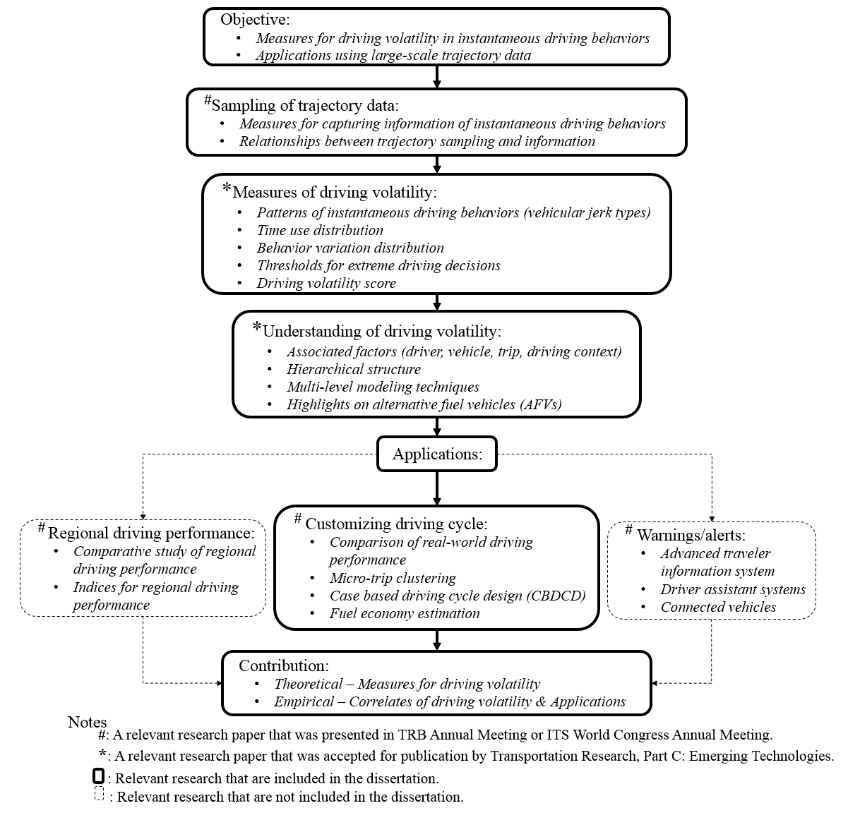

Figure 1.1 Dissertation outline

HOW MUCH INFORMATION IS LOST WHEN SAMPLING INSTANTANEOUS DRIVING BEHAVIOR DATA?
This chapter presents a modified version of a research paper by Jun Liu, Asad J. Khattak and Lee D. Han. The paper was presented (TRB 15-0968) at The 94th Annual Meeting of Transportation Research Board in Washington, D.C., in January 2015.

ABSTRACT
Individuals’ driving behavior data are becoming available widely through Global Positioning System devices and on-board diagnostic systems. These data can be used to make accurate estimates of vehicle fuel consumption, emissions, and safe driving. Storage and computing power have become readily available to the extent that scientists and engineers are presented with a wide range of options for balancing resource cost versus amount of data that needs to be stored. The incoming data can be sampled at rates ranging from one Hertz (or even lower) to hundreds of Hertz, i.e., one data point per second to hundreds of data points per second. Failing to capture substantial changes in vehicle movements over time by “undersampling” can cause loss of information and misinterpretations of the data, but “oversampling” can waste storage and processing resources. Empirical assessment of driving data is necessary because real-world vehicular movements are difficult to characterize mathematically and they vary substantially over time. A key objective of this study is to empirically explore how micro driving decisions to maintain speed, accelerate or decelerate, or change marginal rate of acceleration (known as vehicular jerk) can be best captured, without substantial loss of information. A framework for measuring information loss using several measures that are combined into an overall index is developed. Data from a driving simulator study collected at 20 Hertz are analyzed (N=718,481 data points from 35,924 seconds of driving tests). The results show that marginally more information is lost as data are sampled down from 20 Hz to 0.5 Hz. However, the relationship between loss of information and sampling rates is non-linear. The study provides a sound basis to help scientists easily identify data needs at the experimental design stage, and it has implications for designing monitoring systems.

2.1 INTRODUCTION
Increasingly detailed driving data are being collected with well-developed data acquisition technologies, such as Global Positioning System (GPS), video, Bluetooth, and on-board diagnostics. With the increasing amount of data from sensors, digging through detailed transportation data helps explore micro-level driver behaviors that were not possible until fairly recently. Instantaneous driving decisions are of particular interest, because they are related to energy consumption, emissions and safety. They include accelerating, decelerating, maintaining speed, altering acceleration/deceleration, etc. Driving reflects a chain of instantaneous driving decisions made by drivers according to changes in surrounding circumstances, e.g., adjacent vehicles, roadway conditions, and geometric changes in the roadway, and weather conditions [22]. The higher rate sampled data can capture more information about the instantaneous driving decisions. Current data collection in industry can go as high as 800 MHz [26] and it can contain valuable information [27]. One question is that, whether driving data need to be sampled by such high rates in the transportation context. High sampling rates can be expensive in terms of requiring extra storage and processing time, which is called oversampling [28]. Undersampling/inadequate sampling may cause loss of critical information [27]. Next Generation Simulation Program (NGSIM) collected detailed vehicle trajectory data in 10 Hz to develop behavioral algorithms in support of traffic simulation on microscopic modeling [29], as well as Safety Pilot Model Deployment (SPMD) sampling the safety messages (e.g., motion and location data) transmitted between connected vehicles and infrastructures at 10 Hz [30]. One problem for data sampled by high sampling rates is the data accuracy. The accuracy of NGSIM data is estimated at 2~4 ft. [31]. For NGSIM data, in 0.1 second, the distance travelled by a 60 mph vehicle is about 8.8 ft. but with a 2~4 ft. error. Therefore, the accuracy of NGSIM data might be jeopardized with high sampling rates. Jackson et al., discussed the validity of using in-vehicle GPS second-by-second (1 Hz) velocity data to track the 1-second driving operation modes, including acceleration and deceleration. Their results imply that the 1-second operation modes can be successfully measured by using GPS data sampled by 1 Hz [32], while the driving operation modes within 1-second are unknown. For example, if a driving command –“acceleration decelerationacceleration” occurs within one second, the 1 Hz sampled data may lose the information about the deceleration, though the deceleration exists in a very short time. Thus, another question is how much information we may lose if we only sampled data by 1 Hz or even lower rates. Current driving data are usually continuously sampled by rates from 0.2 to 10 Hz [24, 33-40]. Note that the continuous driving data are different from the traffic data collected by loop detectors [41, 42]. The focus of this study is the continuous driving data used to explore micro-driving behavior. The key question to be answered is what sampling rates are appropriate to capture micro-driving behavior without losing much information (i.e., by undersampling).

In the field of signal processing, Nyquist–Shannon sampling theorem gives the appropriate sampling rates for continuous signal. The Nyquist criterion for sampling rates is twice the bandwidth of a bandlimited signal or a bandlimited channel. The key question is to find out the bandwidth of a signal [43]. However, the driving behavior does not fulfill the features of bandlimited signal. Driving behavior varies according to the decisions a driver makes to respond the instantaneous driving circumstances. This study aims to find out the appropriate sampling rates for driving behavior data through exploring the nature of driver’s micro-driving behavior.

2.2 DATA DESCRIPTION
Data used in this study comes from the University of Tennessee Driving Simulator Lab (DSL). This driving simulator, Drive Safety DS-600c, is fully integrated and immersive to driving test subjects with its visual and audio effects in the front half cab of a Ford Focus sedan and it provides 300° horizontal field-of-view via five projectors and back sight via three rear mirror liquid crystal display displays [44]. The cab base is able to mimic pitch and 30 longitudinal motions. Since 2009, over 10 simulator studies have been conducted in DSL. The equipment has been recognized as a high-fidelity driving simulator and is qualified to be used to conduct driving behaviors associated research. The data of driver responses (e.g. speed) gathered from simulator driving tests can be used as surrogate measures of driving behavior [45, 46]. The driving data used in this study was collected from 24 subjects (13 males, 11 females, average licensed year – 17.6, standard deviation –7.87). Subjects were tested in a simulated driving scenario designed with various driving conditions, e.g., urban vs. rural environments. Each subject completed the driving test in 22 ~ 29 minutes, depending on their travel speed and responses to traffic controls. The driving speed was sampled at 20 Hz. The final dataset used in this study includes 718,481 data points from 35,924 seconds (598 minutes) of driving tests.

2.3 METHODOLOGY
A fundamental question to be answered is how much information is lost in going to lower sampling rates. Driving can be volatile as drivers made driving decisions (e.g., accelerating and braking) according to the instantaneous changes of surrounding circumstances, e.g., adjacent vehicles, roadway conditions, geometric changes in the roadway, and weather conditions [22]. Using the 20-Hz simulator driving data, this study creates a set of measures to quantify the magnitude of information loss (MIL):
a) MIL₁: Instantaneous driving decision loss (based on combined direct and indirect ‘detectability’ explained below) – Equations 1, 2, 3;
b) MIL₂: Percentage of out-of-range observations during driving– Equation 4;
c) MIL₃: Ratio of sampled to actual range in driving data– Equation 5;
d) MIL₄: Relative speed deviation from linear interpolation of under-sampled data (based on observed speed deviation over the under-sampled data) – Equations 6 and 7.

An index named Extent of information loss (EIL), given a sampling rate is created and it is shown in Equation 2.8. The overall methodological framework for this study is shown in Figure 2.1 and explained in more detail below. Each measure is calculated as a percentage in order to index the extent of information loss in different situations. The Extent of Information Loss (EIL) is an overall measure of information loss that combines the above measures. The study quantifies the relationship between information loss measures and sampling rates. A user can then select thresholds, e.g., 5% or 1% of information loss may be acceptable and find the appropriate sampling rate.
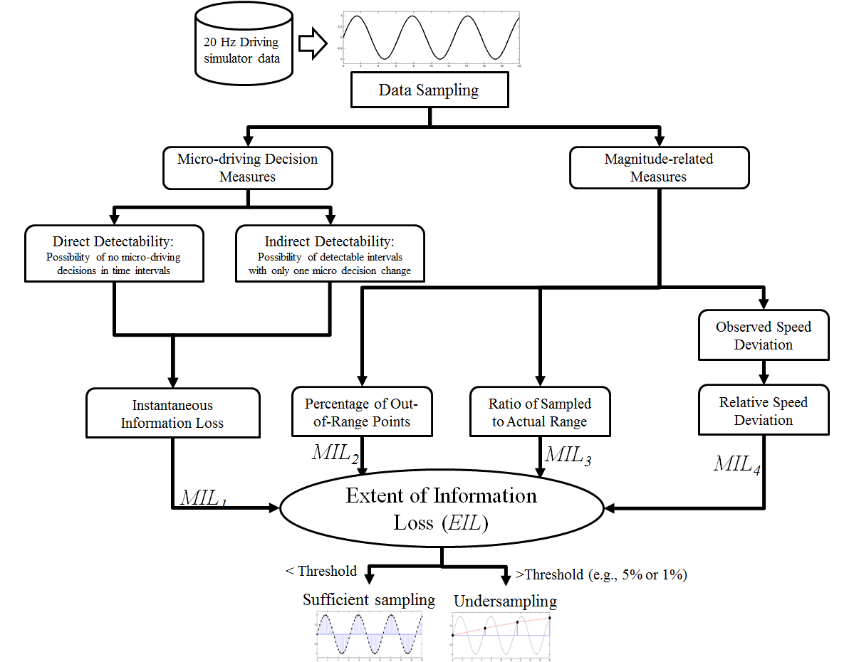
Figure 2.1 Study steps and measures

2.3.1 Direct Detectability of Driving Decisions
Driving decisions can be altered at any time and frequently when a vehicle is being operated. If the frequency of the driving decision alteration is considerably high and the data sampling rate is very low, then some driving decisions may be lost. As shown in Figure 2.2(i), the decision alteration– “acceleration to deceleration” between n and n+1 second is missed by the 1-Hz sampled data (red points), as the speeds at n and n+1 second are identical. In this case, undersampling causes information loss of micro driving decisions. The information about going from “acceleration to deceleration” between n and n+1 second is lost, while the information –“deceleration” or “no decision alternation” between n+1 and n+2 second is detected directly by the sampled data. This study uses the 20-Hz simulator driving data to count the number of decisions made given a specific time interval, and then computes the possibility of no decision made cases, termed Direct Detectability of Driving Decisions. The formula is as follows:
$$Direct Detectability=\frac{1}{N}\sum_{i=1}^{N}{w_{i}^{0}}$$ | Equation 2.1
Where,
$N=T×f$, the number of time slices during total data duration T in second;
$f$ = target sampling frequency/rates, e.g., 1 Hz;
$w_{i}^{0}=\left\{\begin{aligned}1, if\max{\{}v_{ij}-v_{i\left(j-1\right)}\}× \min{\{}v_{ij}-v_{i\left(j-1\right)}\}≥0, \\ 0,if\max{\{}v_{ij}-v_{i\left(j-1\right)}\}× \min{\{}v_{ij}-v_{i\left(j-1\right)}\}<0, \end{aligned}\right.$, indicator for micro-driving decision alternation during i^{th} time interval$t=\frac{1}{f}$, i= 1, 2, 3, …, N;
$v_{ij}$ = Speed at j^{th} location in i^{th} time interval, j=1, 2, 3, …, n;
$n=\frac{T}{N}=\frac{F}{f}$, number of available data points in a given time interval;
$F$ = sampling rate of original dataset, 20 Hz in this study.

In this study, time intervals without decisions made belongs to Case 0 (this includes constant acceleration or deceleration), as shown in Figure 2.2(ii), with one micro-decision made are referred to as Case 1, and with two decision alternations are referred to as Case 2. Case 1 will be further discussed below.

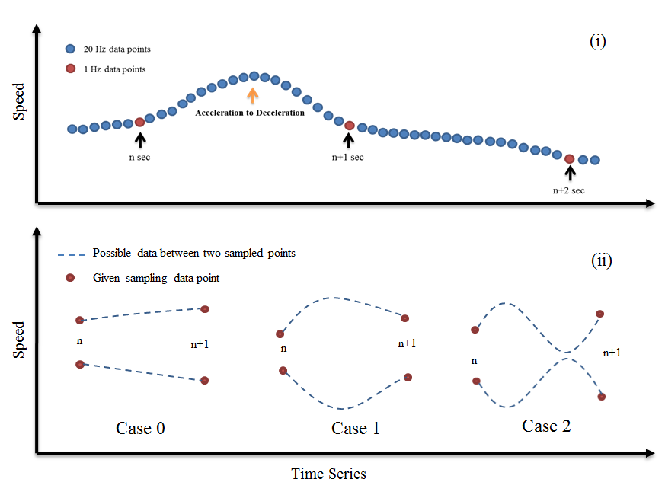
Figure 2.2 Example of information loss in instantaneous driving decisions

2.3.2 Indirect Detectability of Driving Decisions
Direct detectability tells the chance of detecting micro driving decisions directly with the sampled data. Next, this study discusses the chance of detecting driving decisions in Case 1. An assumption is made before we discuss the indirect detectability. We assume that driving speed is a continuous changing measurement without sharp changes. A sine wave illustrates the example of continuous changing measures, while square wave and sawtooth wave are examples of sharp changes [47].

With this assumption, using 20-Hz data, this study takes one second interval (corresponding to 1-Hz sampling rate) as the example for illustrating detection of driving decision alternation. Figure 2.3(i) presents six possible types of micro driving behavior of Case 1 within one second. Types (a) and(c) show that there is a micro-decision made from accelerating to decelerating between n and n+1 second. Types (b) and (d) show that there is a micro-decision made from decelerating to accelerating between n and n+1 second.

For Type (a), there is a micro-decision made from accelerating to decelerating between n and n+1 second, while the speed measurement at n and n+1 second implies a deceleration during that second. Therefore, the missing micro-decision made within this second could be observed by using given sampling data points at n and n+1 second, though the amount/intensity of the driving decision change is not necessarily accurate. In the same fashion, Type (b) illustrates information detection for the micro-decision made from decelerating to accelerating. Therefore, for Types (a) and (b), the micro-decision change can be detected but with an error.

Types (c) and (d) do not meet the situations in Types (a) and (b), since the sampled data do not show the correct micro-decision made between two sampled observations. Types (c) and (d) also include the cases that speed at n second is equal to n+1 second, shown in Figure 2.2(i), since in these cases, the sampled observations can also not tell the micro-decision correctly.

Therefore, we move our sight to next second, as shown in Figure 2.3(ii). In Type (c₁), the sampled speeds at n+1 and n+2 second give a deceleration which uncovers the lost micro-decision made between n and n+1 second, but with a temporal error. The time stamped for the micro-decision using sampled data is at n+1 second, but actually it occurred between n and n+1 second. Type (d₁) is similar to Type (c₁), but for detecting a micro-decision from decelerating to accelerating.
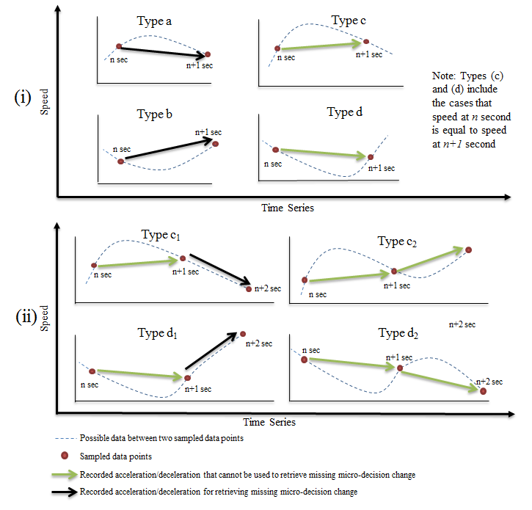
Figure 2.3 Examples of missing information when examining speed data over time

Types (c₂) and (d₂) illustrate these two types that the micro decision made between two sampled observations cannot be detected, since there are two micro-decisions made in two sequential time intervals. Besides, for cases with two or more micro-decisions made within one particular time interval, there is no way to detect them by above methods. This study mainly discusses Case1 with one micro-decision made and tries to find the possibilities of having Types (a), (b), (c₁) and (d₁) in Case 1 given a time interval. The measure, Indirect Detectability of Driving Decisions, is the sum of the possibilities of having Types (a), (b), (c₁) and (d₁). The formula is as follows:
$$Indirect Detectability=\frac{1}{\sum_{i=1}^{N}{d_{i}^{1} }}\sum_{i=1}^{N}{(w_{i}^{a}{+w}_{i}^{b}+w_{i}^{c_{1}}{+w}_{i}^{d_{1}})} Equation 2.2$$
Where,
$N=T×f$, the number of time slices during the total data duration T in second;
$f$ = target sampling frequency/rates, e.g, 1 Hz;
$w_{i}^{1}=\left\{\begin{aligned}1, if \sum_{j=1}^{n-1}{z_{j}}=1 \\ 0, if \sum_{j=1}^{n-1}{z_{j}}≠1\end{aligned}\right.$, indicator for whether there is only one decision change during i^{th} time interval$t=\frac{1}{f}$, i= 1, 2, 3, …, N;
$z_{j}=\left\{\begin{aligned}1, if {(v}_{ij}-v_{i\left(j-1\right)})×(v_{i\left(j+1\right)}-v_{ij})<0 \\ 0, if {(v}_{ij}-v_{i\left(j-1\right)})×(v_{i\left(j+1\right)}-v_{ij})≥0\end{aligned}\right.$, indicator for whether two consecutive driving statuses are both acceleration or deceleration;
$v_{ij}$ = Speed at j^{th} location in i^{th} time interval, j=1, 2, 3, …, n;
$n=\frac{T}{N}=\frac{F}{f}$, the number of available data points in a given time interval;
$F$ = sampling rate of original dataset, 20 Hz in this study.
$w_{i}^{a}=\left\{\begin{aligned}1, if{ d_{i}^{1}=1 and (v}_{ij}-v_{i\left(j-1\right)})>0 and {(v}_{i\left(j+n\right)}-v_{i\left(j+n-1\right)})<0 and v_{ij}>v_{i(j+n)} \\ 0 \end{aligned}\right.$, indicator for Type (a) error;
$w_{i}^{b}=\left\{\begin{aligned}1, if{ d_{i}^{1}=1 and (v}_{ij}-v_{i\left(j-1\right)})<0 and {(v}_{i\left(j+n\right)}-v_{i\left(j+n-1\right)})>0 and v_{ij}<v_{i(j+n)} \\ 0 \end{aligned}\right.$,
indicator for Type (b) error.
$w_{i}^{c}=\left\{\begin{aligned}1, if{ d_{i}^{1}=1 and d_{i+1}^{0}=1 and (v}_{ij}-v_{i\left(j-1\right)})>0 and {(v}_{i\left(j+n\right)}-v_{i\left(j+n-1\right)})<0 and, \\ v_{ij}<v_{i\left(j+n\right)} \\ 0 \end{aligned}\right.$indicator for Type (c₁) error;
$w_{i}^{d}=\left\{\begin{aligned}1, if{ d_{i}^{1}=1 and d_{i+1}^{0}=1 and (v}_{ij}-v_{i\left(j-1\right)})<0 and {(v}_{i\left(j+n\right)}-v_{i\left(j+n-1\right)})>0 and, \\ v_{ij}>v_{i\left(j+n\right)} \\ 0 \end{aligned}\right.$ indicator for Type (d₁) error.

2.3.3 Instantaneous Driving Decision Loss
With the direct and indirect detectability of driving decisions, we can detect micro-driving decision made given a particular sampling rate. The formula for instantaneous driving decision loss (MIL₁) is as follows:
$$Decision Loss=1-(Direct Detectability+\frac{1}{N} \sum_{i=1}^{N}{d_{i}^{1} }×Indirect Dectetability)$$
$$Equation 2. 3$$

Empirical results are shown later. Theoretically, higher sampling rates lower the possibility of missing critical decisions, but they increase the possibility of “noise” in the data and the data storage and processing requirements. The challenge is to not lose decision information while reducing the noise in the data.

2.3.4 Measures Concerning Magnitudes
It is important to know whether sampled values represent the population and the magnitude of errors, if any. In other words, whether the one point (e.g., 1 Hz data) can represent the 20 data points (20 Hz data) during the same second? If the 20 data points provide only marginally more information (such as constant speed during one second), one data point might be sufficient for sampling this second.

Figure 2. 4(i) shows an example using 20 Hz simulator data, along with two 1-Hz sampled points at the n and n+1 second. The speed is 10 mph at n second and 12 mph at n+1 second. The problem would be whether all speed values between n and n+1 second are within the micro speed range 10~12 mph. The example shows given one-second time interval, there are six data points, or 30% (6 out of 20) data points with speed values out of range 10~12 mph. In this case, two data points with records of 10 and 12 mph cannot fairly represent the driving behavior from n to n +1 second. The Percentage of Out-of-Range observation (MIL₂) is a measure that captures how many data points are out of the sampled micro speed range.

The formula for Percentage of Out-of-Range Observation (MIL₂) is:
$$Percentage of Out Range Observations=\frac{1}{N}\sum_{i=1}^{N}{\frac{\sum_{j=1}^{n}{{OR}_{ij}^{} }}{n} Equation 2.4}$$
Where,
${OR}_{ij}^{}=\left\{\begin{aligned}1, if v_{ij}>{\max{\{}v}_{i1, }v_{in}\} or{ v}_{ij}<{\min{\{}v}_{i1, }v_{in}\} \\ 0 \end{aligned}\right.$, indicator for out-of-rang observation.

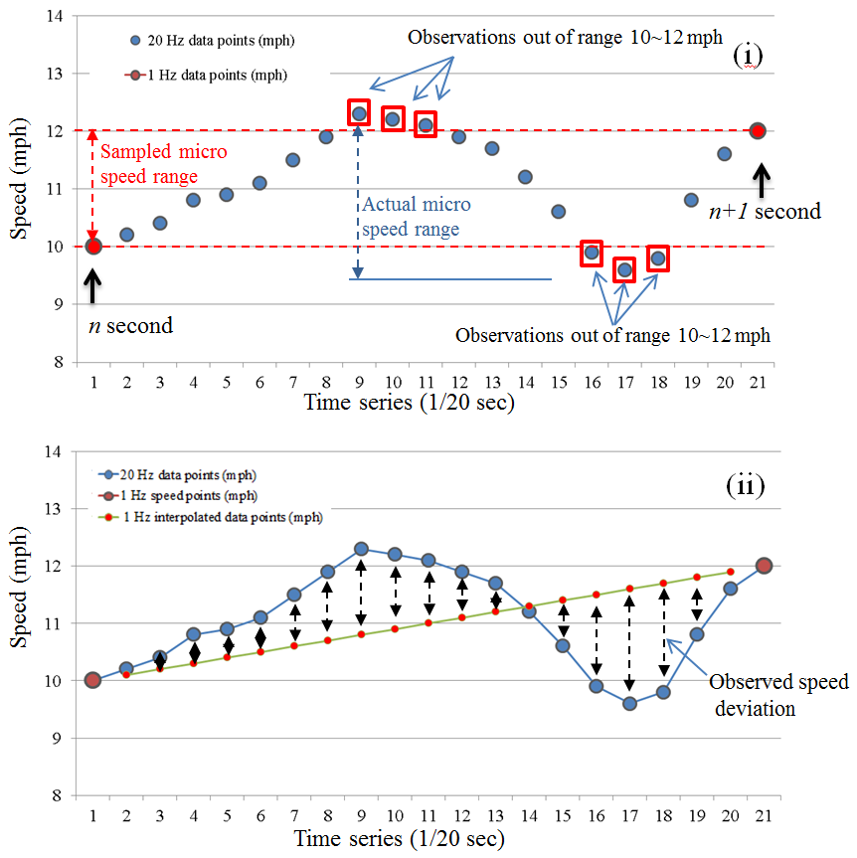
Figure 2.4 Quantifying magnitude errors in sampled data

The ratio of sampled micro speed range over actual micro speed range during the same second is another measure of information loss and it is termed Ratio of sampled to Actual Range (MIL₃). In the example, the sampled micro speed range is 12-10=2 mph, while the actual micro speed range is 12.3-9.6=2.7 mph. The ratio is 2/2.7=0.74, or 74%. The formula is as follows:
$$Ratio of Sampled to Actual Range=\frac{1}{N}\sum_{i=1}^{N}{\frac{R_{i}^{Sampled}}{R_{i}^{Actual}} Equation 2.5 }$$
Where,
$R_{i}^{Sampled}={|v}_{i1}- v_{(i+1)1}|$, sampled speed range for i^{th} time slice;
$R_{i}^{Actual}=\max\left\{v_{ij}\right\}-min⁡\{v_{ij}\}$, actual speed range for i^{th} time slice.

A measure of information loss is through speed deviations. The deviations are measured based on the linear distance between observed speeds and sampled speeds. Sampled data can be used to linearly interpolate the data points in between two timestamps. This can be compared with observed data at higher frequency (20 Hz in this case). Figure 2.4(ii) uses 20 Hz driving simulator data and measures Observed Speed Deviation, which is the mean of absolute deviations within time intervals. Another measure is Relative Speed Deviation (MIL₄), which is the average deviations over interpolated speed values, providing the extent of deviations. The formulas are as follows:
$$Observed Speed Deviation=\frac{1}{N} \sum_{i=1}^{N}{(\frac{1}{n}\sum_{j=1}^{n}{|v_{ij}-j×\frac{v_{i1}-v_{i\left(n+1\right)}}{n}|}}) Equation 2.6$$
$$Relative Speed Deviation=\frac{1}{N} \sum_{i=1}^{N}{(\frac{1}{n}\sum_{j=1}^{n}{\frac{|v_{ij}-j×\frac{v_{i1}-v_{i\left(n+1\right)}}{n}|}{v_{ij}}}}) Equation 2.7$$

2.3.5 An Index for Magnitude of Information Loss (MIL)
The Instantaneous Driving Decision Loss, Percentage of Out-of-Range Observation, Ratio of Sampled to Actual Range, and Relative Speed Deviation quantify the magnitude of information loss from different angles. All these measures are finally calculated in terms of percentage of information loss. Then, these measures can be combined (weighted equally) to create an index capturing the Extent of Information Loss Index, given a sampling rate. The formula is as follows:
$$Extent of Information Loss Index= \frac{{MIL}_{1}+{MIL}_{2}{+(1-MIL}_{3})+{MIL}_{4}}{4}$$
$$Equation 2.8$$
Where,
${MIL}_{1}$= Instantaneous driving decision loss;
${MIL}_{2}$= Percentage of out-of-range observations;
${MIL}_{3}$= Ratio of sampled to actual range;
${MIL}_{4}$= Relative speed deviation.

Users of data in the transportation context can either choose a threshold for information loss and find the appropriate sampling rate or vice versa.

2.4 RESULTS

2.4.1 Direct Detectability of Driving Decisions
To capture alternations between acceleration and deceleration within the given time interval (e.g., 1 second) corresponding to a sampling rate (e.g., 1 Hz), the number of alternations was counted by using 20 Hz data. All possible alternations within the data, given different time intervals and starting locations were counted. If all decisions made occur exactly at the sampled points, no information will be lost. For example in Figure 2.1, if the data was just sampled at n+0.5 second and n+1.5 second instead of n and n+1 second, then the driving decisions from accelerating to decelerating can be detected accurately, even if the data are still sampled at 1 Hz. The example in Figure 2.1 shows that there are 20 possible locations to start sampling the 1 Hz data.
Figure 2.5(i) presents the direct detectability, possibility of no decision made, given a specific time interval, and (ii) presents the distribution of the possibilities of the three Cases (discussed above) in different time intervals.

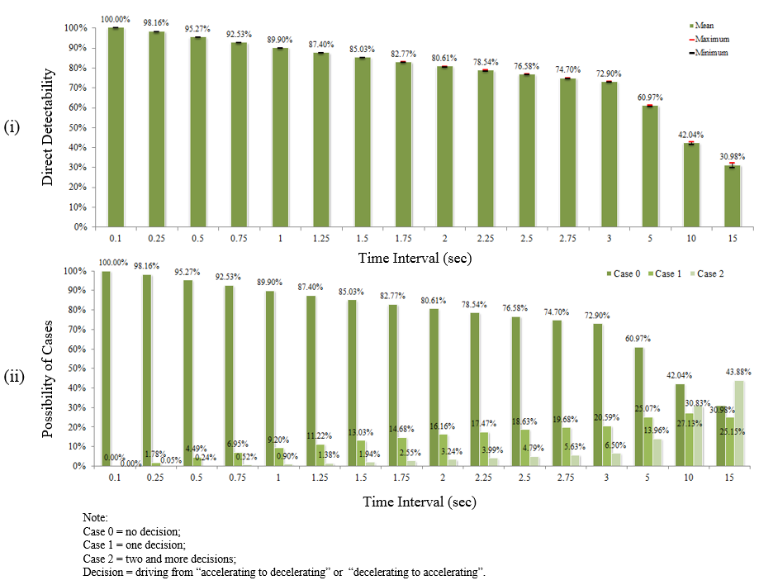
Figure 2.5 “Direct detectability” in different time intervals

In Figure 2.5(i), the maximum and minimum detectability is also indicated, according to observations from the different sampling locations. For short time intervals, the location does not have a significant influence on the data sampling. Specifically, for time interval of 1 second, the direct detectability is around 89.90%, i.e., no micro decision made during one second intervals. The reason is probably related to the driver reaction time, which is usually more than 1 second [48]. Thus, there is a large possibility that drivers do not make decisions during one second (N= 35,924 intervals out of 20-Hz sampled data).

In Figure 2.5(ii), the percentages of possibilities of the three Cases (i.e., no decision, one decision and two and more decisions made within the sample interval) are provided. Shorter time intervals (higher sampling rates) are related to the lower information loss in terms of instantaneous driving decisions, as expected.

2.4.2 Indirect Detectability of Driving Decisions
Figure 2.6(i) shows percentages of Types (a), (b), (c₁) and (d₁) in Case 1 (one decision change). Specifically, given a one second time interval (or 1-Hz sampling rate), Types (a), (b), (c₁) and (d₁) constitute 30.99%, 25.37%, 24.42% and 16.14% of the Case 1 where only one micro-decision made between two sampled data points. These four types of patterns contain detectable driving information. The indirect detectability is the sum of these possibilities, shown in Figure 2.6(ii). For one second time interval (or 1-Hz sampling rate), the indirect detectability is around 30.99%+25.37%+24.42%+16.14% =93.92%. With the time interval getting longer, this indirect detectability decreases.
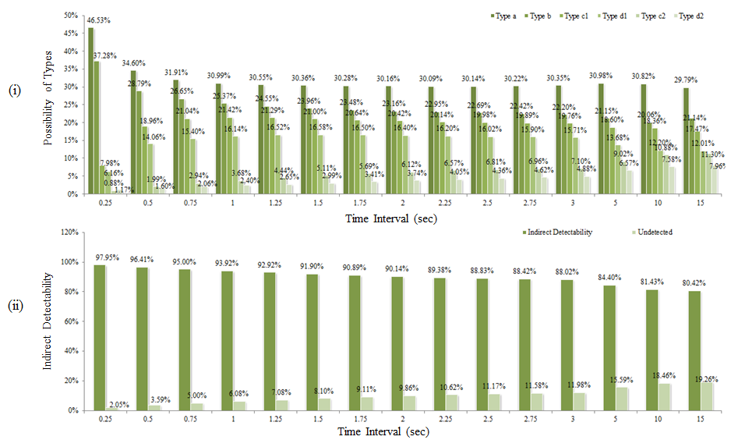
Figure 2.6 Indirect detectability in different time intervals

2.4.3 Instantaneous Driving Decision Information Loss
The combined results of instantaneous driving decision loss are shown in Table 2.1. There is an 89.90% chance that there is no micro-decision (Case 0) within one second (1-Hz sampling data, highlighted in Table 1) and 9.20% chance that there is one micro-decision (Case 1). For Case 1 with only one micro-decision, there is a 30.99% chance that the Type (a) decision pattern would occur, and 25.37%, 24.42% and 16.14% for Types (b), (c) and (d) respectively. These four types include micro-decisions that can be detected. Therefore, in summary, the feasibility of detecting micro-driving decisions for 1 Hz sampling data are 89.90% + 9.20% × (30.99% + 25.37% + 24.42% + 16.14%) = 98.54%, and 1.46% of information about micro-decisions would be lost. Data sampled by rates higher than 0.5 Hz can reflect more than 95% of micro-decisions and the instantaneous driving decision loss is less than 5%.

Table 2.1 Instantaneous Driving Decisions Information Loss
Sampling Rate (Hz) | Time Interval (second) | Percentage of total sample |  |  | Percentage of Case 1 |  |  |  |  |  | Feasibility of detecting micro-decisions | Instantaneous driving decision lost
Sampling Rate (Hz) | Time Interval (second) | Case 0 | Case 1 | Case 2 | Type a | Type b | Type c₁ | Type d₁ | Type c₂ | Type d₂ | Feasibility of detecting micro-decisions | Instantaneous driving decision lost
10 | 0.1 | 100.00% | 0.00% | 0.00% | 0.00% | 0.00% | 0.00% | 0.00% | 0.00% | 0.00% | 100.00% | 0.00% ^
4 | 0.25 | 98.16% | 1.78% | 0.05% | 46.53% | 37.28% | 7.98% | 6.16% | 0.88% | 1.17% | 99.91% | 0.09%
2 | 0.5 | 95.27% | 4.49% | 0.24% | 34.60% | 28.79% | 18.96% | 14.06% | 1.99% | 1.60% | 99.60% | 0.40%
1.333 | 0.75 | 92.53% | 6.95% | 0.52% | 31.91% | 26.65% | 21.04% | 15.40% | 2.94% | 2.06% | 99.13% | 0.87%
1 | 1 | 89.90% | 9.20% | 0.90% | 30.99% | 25.37% | 21.42% | 16.14% | 3.68% | 2.40% | 98.54% | 1.46%
0.8 | 1.25 | 87.40% | 11.22% | 1.38% | 30.55% | 24.55% | 21.29% | 16.52% | 4.44% | 2.65% | 97.83% | 2.17%
0.667 | 1.5 | 85.03% | 13.03% | 1.94% | 30.36% | 23.96% | 21.00% | 16.58% | 5.11% | 2.99% | 97.01% | 2.99%
0.571 | 1.75 | 82.77% | 14.68% | 2.55% | 30.28% | 23.48% | 20.64% | 16.50% | 5.69% | 3.41% | 96.11% | 3.89%
0.5 | 2 | 80.61% | 16.16% | 3.24% | 30.16% | 23.16% | 20.42% | 16.40% | 6.12% | 3.74% | 95.17% | 4.83%
0.444 | 2.25 | 78.54% | 17.47% | 3.99% | 30.09% | 22.95% | 20.14% | 16.20% | 6.57% | 4.05% | 94.16% | 5.84%
0.4 | 2.5 | 76.58% | 18.63% | 4.79% | 30.14% | 22.69% | 19.98% | 16.02% | 6.81% | 4.36% | 93.13% | 6.87%
0.364 | 2.75 | 74.70% | 19.68% | 5.63% | 30.22% | 22.42% | 19.89% | 15.90% | 6.96% | 4.62% | 92.10% | 7.90%
0.333 | 3 | 72.90% | 20.59% | 6.50% | 30.35% | 22.20% | 19.76% | 15.71% | 7.10% | 4.88% | 91.03% | 8.97%
0.2 | 5 | 60.97% | 25.07% | 13.96% | 30.98% | 21.15% | 18.60% | 13.68% | 9.02% | 6.57% | 82.13% | 17.87%
0.1 | 10 | 42.04% | 27.13% | 30.83% | 30.82% | 20.06% | 18.36% | 12.20% | 10.88% | 7.58% | 64.14% | 35.86%
0.0667 | 15 | 30.98% | 25.15% | 43.88% | 29.79% | 21.14% | 17.47% | 12.01% | 11.30% | 7.96% | 51.20% | 48.80%
Note: ^Extremely close to 0%.

2.4.4 Measures Concerning Magnitudes
Results in Table 2.2 show that lower sampling rates (or longer time intervals) are associated with larger percentages of out-of-range points, smaller ratio of sampled to actual range, larger speed deviations and relative speed deviations, as expected. Percentage of out-of-range points concerns the sampled micro speed range within a time interval. The sampled micro speed range is determined by two sequential recorded data points, as shown in Figure 2.4. The results show that, on average, 1.75 points (or 8.75%) are out of the sampled micro speed range for 1-second time interval (or 1-Hz data), because there is a large possibility that there is no micro-decision changes during one second. It is consistent with above finding that for the time interval of 1 second, the average possibility of no micro-decision change is 88.90%, see Figure 2.5. For 1-Hz data, the ratio of sampled to actual micro range is 0.957, which means the extent of representativeness of the 1-Hz data to 20-Hz data is about 95.7% in terms of magnitude. Though some data points are possibly out of the recorded micro ranges, these points do not deviate broadly. Further, 1-Hz data have an observed speed deviation of about 0.076 mph. Note that 1% percentile of 718,481 20-Hz speed records is 0.493 mph, thus the deviation of 0.076 mph is not substantial in the distribution of speed records. This is consistent with EPA drive cycle data, which is based on 10-Hz [49]. Further, the relative speed deviation, ratio of deviation over interpolated speeds, shows that 1-Hz data has a relative speed deviation to 20-Hz speed records at 0.87%, substantially lower than the 5% threshold.

2.4.5 Extent of Information Loss
The overall extent of information loss is an equally weighted measure, calculated using Equation 2.8. The results are shown in Table 2.2. We know if the sampling rate is 1-Hz, the percentage of out-of-range points is 8.77%, ratio of sampled to actual range is 95.71%, relative speed deviation is about 0.87%, and the instantaneous driving decision loss is about 1.46%. So, the overall extent of information loss is (8.77% + (100%-95.71%) + 0.87% + 1.46%)/4 = 3.85%. Thus, overall about 3.85% of the driving information, including the micro-driving decisions and speed magnitude, might be lost if the sampling rate is 1-Hz instead of 20 Hz.

Figure 2.7 presents the final results quantifying various information loss measures and different sampling rates. The results show that different measures have different levels of information loss at a given sampling rate and the relationship is non-linear. As sampling rate drops, more information about the out-of-range observations (MIL₂) is lost. This measure may be critical for some purposes, e.g., crash reconstruction and reporting. Therefore, for studies dealing with crashes, especially crash reconstruction studies that are highly sensitive to speed magnitude, higher sampling rates can be beneficial. The curves, including the overall information loss measure show that information loss becomes rather high between at 1 to 2-Hz level.

Table 2.2 Overall Magnitude of Information Loss
Sampling Rate (Hz) | Time Interval (second) | Count of out-of-range observations | MIL₂  Percentage of out-of-range observations | MIL₃  Ratio of sampled to actual range | Observed speed deviation (mph) | MIL₄  Relative Speed Deviation | MIL₁  Instantaneous driving decision loss  (from Table 1) | EIL  Extent of information loss
10 | 0.1 | 0.008 | 0.42% | 100.00% | 0.001 | 0.01% | 0.00% | 0.11%
4 | 0.25 | 0.100 | 2.00% | 99.37% | 0.005 | 0.05% | 0.09% | 0.69%
2 | 0.5 | 0.442 | 4.42% | 98.11% | 0.020 | 0.23% | 0.40% | 1.73%
1.3333333 | 0.75 | 1.010 | 6.73% | 96.87% | 0.045 | 0.52% | 0.87% | 2.81%
1 | 1 | 1.754 | 8.77% | 95.71% | 0.076 | 0.87% | 1.46% | 3.85%
0.8 | 1.25 | 2.677 | 10.71% | 94.68% | 0.115 | 1.24% | 2.17% | 4.86%
0.6666667 | 1.5 | 3.847 | 12.82% | 93.38% | 0.160 | 1.66% | 2.99% | 6.02%
0.5714286 | 1.75 | 5.050 | 14.43% | 92.40% | 0.208 | 2.00% | 3.89% | 6.98%
0.5 | 2 | 6.345 | 15.86% | 91.66% | 0.258 | 2.35% | 4.83% | 7.85%
0.4444444 | 2.25 | 7.848 | 17.44% | 90.65% | 0.316 | 2.78% | 5.84% | 8.85%
0.4 | 2.5 | 9.441 | 18.88% | 89.53% | 0.371 | 3.11% | 6.87% | 9.83%
0.3636364 | 2.75 | 11.216 | 20.39% | 88.63% | 0.426 | 3.45% | 7.90% | 10.78%
0.3333333 | 3 | 13.172 | 21.95% | 87.70% | 0.491 | 3.88% | 8.97% | 11.78%
0.2 | 5 | 30.058 | 30.06% | 81.42% | 0.974 | 6.15% | 17.87% | 18.17%
0.1 | 10 | 81.855 | 40.93% | 71.10% | 2.088 | 10.57% | 35.86% | 29.07%
0.0666667 | 15 | 139.545 | 46.51% | 64.73% | 3.131 | 14.52% | 48.80% | 36.28%

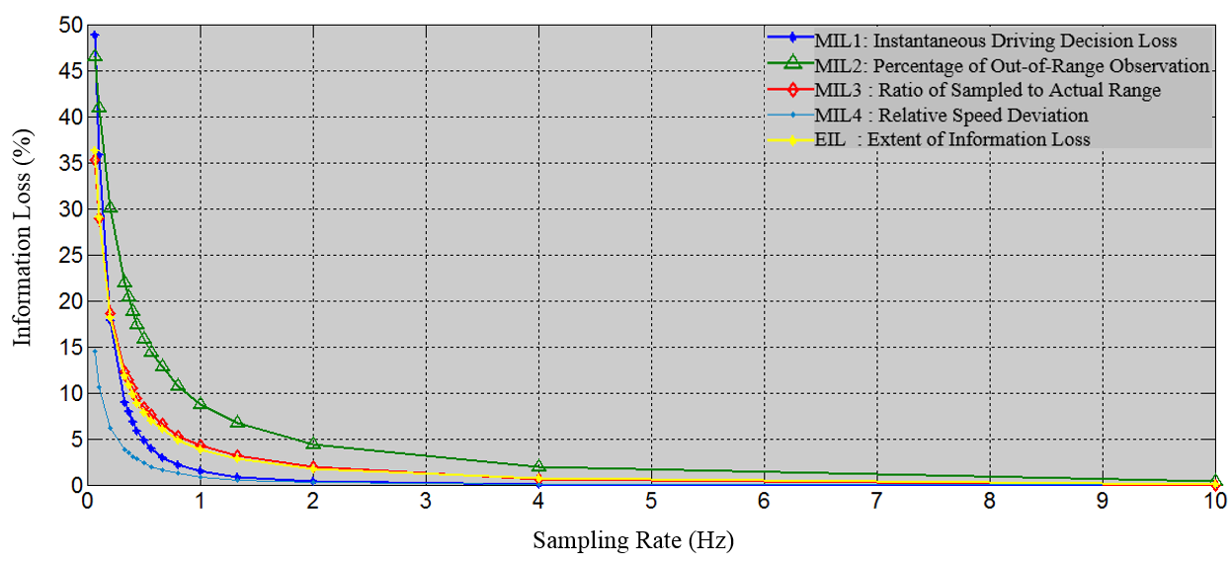
Figure 2.7 Extent of information loss with different sampling rates

2.5 LIMITATIONS
The data used in this study comes from a simulator driving test, i.e., they are from a hypothetical but controlled test environment. Having few test subjects is recognized as a limitation, though it is not very germane to this study. The data was sampled by 20 Hz. It is possible that micro driving decisions between the 20 Hz time-stamp data points were lost. This study assumes the chance of having micro decision changes within 0.05 second is very small, given a perception reaction times of about 1 second. In the future, driving data sampled at even higher sampling rates can be used to verify the results of this study. The proposed measures can be used for analysis of information loss with any range of sampling frequency.

2.6 CONCLUSIONS
The key question investigated in this study is: what sampling rates are appropriate to capture micro or short-term driving decisions? Oversampling can result in noisy data, and waste storage and processing resources. Undersampling can result in loss of information about important instantaneous driving decisions. This study developed measures of information loss and quantified their relationship with sampling rates. It discussed driving behavior information from two angles: instantaneous driving decisions and speed magnitudes. Four main measures were created to quantify the magnitudes of driving behavior information loss: a) MIL₁ –Instantaneous driving decision loss (combined direct and indirect ‘detectability’); b) MIL₂ – Percentage of out-of-range observations; c) MIL₃ – Ratio of sampled to actual range; and d) MIL₄ – Relative speed deviation from linear interpolation of sampled data (based on observed speed deviation over interpolated speed). These measures quantify the extent of information loss. With these four measures, the overall magnitude of information loss index was generated by equally weighting them. The index, termed by Extent of Information Loss (EIL), simply tells us how much information might be lost given a sampling rate.

The results show that shorter time intervals (i.e., higher sampling rates) are associated with larger direct detectability of instantaneous driving decisions. In other words, there is a smaller chance of having cases with micro-driving decisions between two sampled data points. Drivers typically keep constant acceleration/deceleration rates during a short time. Specifically, for the time interval 1 second (i.e., 1-Hz sampling rate) the direct detectability is 88.90%. The large possibility of no micro-decision in one second may be due to the driver reaction time. The reaction time includes the time for driver perception, identification, judgment and reaction [50]. The whole process usually takes more than 1 second [48]. This study further observed cases of one micro-driving decision made within a particular time interval and discussed the possibility of detecting such micro-driving decisions. Through defining the six possible micro driving decision patterns, the study found the four of six patterns include the micro-driving decisions that can be detected indirectly by using the sampled data points. These four patterns dominate the cases in short time intervals (less than 3 seconds). Specifically, the indirect detectability for one second time interval (or 1-Hz sampling rate) is around 93.92%. The feasibility of detecting micro-driving decisions combines direct detectability and indirect detectability. Thus, the feasibility of detecting micro-driving decisions by 1-Hz data are 89.90% + 9.20% × 93.92% = 98.54%, and 100%-98.54%= 1.46% of information about micro-decisions (MIL₁) will be lost by 1-Hz data.
The measures of information loss magnitude reveal that smaller sampling rates or longer time intervals are related to more missing data points because of their too large or too small values. Though there are some data points out of the micro speed ranges (about 8.77% of points out of the micro ranges for 1-Hz data, MIL₂), these points do not deviate broadly when sampling rates are equal to or higher than 1 Hz. Specifically, the ratio of sampled to actual ranges (MIL₃) is 95.7% for 1-Hz data. And 1-Hz data has average speed deviation of about 0.076 mph. The small deviation supports the assumption that driving behavior within one second shows nearly constant acceleration [49]. Further, the relative speed deviation (MIL₄) of 1-Hz data to 20-Hz is around 0.87%. With four measures of Magnitudes of Information Loss (MILs), the overall Extent of Information Loss (EIL) can be calculated. For 1-Hz sampling rate, the EIL is about 3.85%.

This study proposed measures to quantify the magnitude of information loss. The measures can be used individually or combined to create an index. The results show that lower sampling rates are associated with greater information loss, but the relationship is not linear. This study contributes by quantifying the relationship between sampling rates and information loss and depending on the objective of their study, researchers can choose the appropriate sampling rate necessary to get the right amount of accuracy. For some studies, e.g., quantifying energy consumption or emissions, 2 Hz sampling rate may be sufficient, whereas for safety studies, higher sampling rates may be required.

WHAT IS THE LEVEL OF VOLATILITY IN INSTANTANEOUS DRIVING BEHAVIORS? APPLICATIONS FOR SUPPORTING CALMER DRIVING

This chapter combines multiple research papers which Jun Liu made extensive contributions to. These papers include:
Paper 1- “What is the Level of Volatility in Instantaneous Driving Decisions?” by Xin Wang, Asad J. Khattak, Jun Liu, Golnush Masghati-Amoli and Sanghoon Son [22]. The paper was accepted for publication by Transportation Research Part C: Emerging Technologies, 2015. DOI: 10.1016/j.trc.2014.12.014. The paper was also presented (TRB 14-2780) at The 93rd Annual Meeting of Transportation Research Board in Washington, D.C., in January 2014.
Paper 2- “Generating Real-Time Volatility Information to Support Instantaneous Driving Decisions” by Jun Liu, Xin Wang, and Asad J. Khattak [51]. The paper was presented (ITSWC Paper #12468) at 2014 Intelligent Transportation Systems World Congress, in Detroit, MI, in September 2014. A revised version entitled “Supporting Instantaneous Driving Decisions through Trajectory Data” (Co-authors: Asad J. Khattak, Jun Liu and Xin Wang) was presented (TRB 15-1345) at The 94th Annual Meeting of Transportation Research Board in Washington, D.C., in January 2015 [52].

ABSTRACT
Driving styles can be broadly characterized as calm or volatile, with significant implications for traffic safety, energy consumption and emissions. How to quantify the extent of calm or volatile driving and explore its correlates is a key research question investigated in the study. This study contributes by leveraging a large-scale behavioral database to analyze short-term driving decisions and develop a new driver volatility index to measure the extent of variations in driving. The index captures variation in instantaneous driving behavior constrained by the performance of the vehicle from a decision-making perspective. Specifically, instantaneous driving decisions include maintaining speed, accelerating, decelerating, maintaining acceleration/deceleration, or jerks to vehicle, i.e., the decision to change marginal rate of acceleration or deceleration. A fundamental understanding of instantaneous driving behavior is developed by categorizing vehicular jerk reversals (acceleration followed by deceleration), jerk enhancements (increasing accelerations or decelerations), and jerk mitigations (decreasing accelerations or decelerations). Volatility in driving decisions, captured by jerky movements, is quantified using data collected in Atlanta, GA during 2011. The database contains 51,370 trips and their associated second-by-second speed data, totaling 36 million seconds. Further, this study explores how real-time vehicle trajectory data can be used to generate driver feedback through actionable alerts and warnings. The study provides a framework for how acceleration and braking monitoring can generate alerts and warnings, provided through advanced traveler information systems. Extreme driving patterns under seemingly normal conditions are the key to generating actionable personalized feedback. Rigorous statistical models explore correlates of volatility that include socioeconomic variables, travel context variables, and vehicle types. The implications of the findings and potential applications to fleet vehicles and driving population are discussed.

3.1 INTRODUCTION
As the most dominant transportation mode in USA, automobile driving has significant impacts on traffic safety, energy, and emissions. With widespread deployment of emerging information and communication technologies, massive amounts of driving data in high resolution are becoming available, allowing researchers to scrutinize driving behavior in far more detail than was possible before. Insights can be obtained by studying instantaneous decisions made during driving in nearly real-time. Also, such “Big data” provides opportunities that support visualization, analysis, and modeling in new ways that could not be imagined before. The combination of data and tools can help create new visions that can potentially transform the way we monitor and evaluate transportation system performance and potential improvement actions. This study takes advantage of large-scale data collected by in-vehicle Global Positioning System (GPS) devices and survey data to define instantaneous driving decisions as drivers’ choices of a set of options during driving. Such choices include maintaining speed, accelerating, decelerating, maintaining acceleration/deceleration, and vehicular jerk, i.e., the decision to change marginal rate of acceleration and deceleration. The sequential chaining of these short-term driving decisions can be volatile because they are intended to respond to the instantaneous changes in surrounding circumstances, such as approach of adjacent vehicles, pavement conditions, geometric transitions in the roadway, and weather conditions. Fluctuations in traffic flow can create challenges for safety, as well as challenges for energy consumption, tailpipe emissions and public health [53, 54]. Existing studies have shown that emissions and fuel usage vary significantly with different speed ranges [US EPA55]. Additionally larger deviations from mean speed can significantly increase crash risk [TRB56]. Accordingly it is important to understand and quantify variability in drivers’ instantaneous decisions and explore the associations with socioeconomic, vehicular, and contextual variables.

Driving involves making decisions based on information perceived by drivers instantaneously. The information perceived while driving can be roughly divided into two sets: a) Driving context, such as road condition, traffic flow, and weather, and b) Driving situation, such as vehicle speed, engine rotation speed, direction of vehicle, fuel consumption, etc. Currently, modern technologies are able to provide such real-time driving status information, to communicate how drivers behave while driving and react to the changing context.

Volatility in instantaneous driving decisions can be quantified by variability in vehicular movement, and the variability can be represented by speed and its derivative (acceleration/deceleration) as well as its second derivative (vehicular jerk). The questions to be answered in this study are:
- How to measure driving volatility?
- What is the level of volatility in instantaneous driving decisions?
- What are the key correlates of driving volatility?
- What are the potential applications?

3.2 LITERATURE REVIEW
Research has linked driving style with crash involvements. West et al. developed a questionnaire to investigate the relationships between driving style and traffic crash risk [57]. In their questionnaire, the speed limit was highlighted as a critical threshold for driving style. They reported a positive correlation between frequency of driving speed exceeding speed limit and the number of crashes over a three-year period. Fast driving is normally characterized as an aggressive or reckless driving and the speed limits are usually used as thresholds to discriminate a driver’s performance. However, the speed choice depends partly on speed limits (or road conditions) and traffic conditions. A driver’s compliance with speed limits is affected by traffic [58] and drivers cannot always choose their speeds freely [59].

Studies have explored maximum acceleration/deceleration to characterize driving styles and used several cutoff points in their study [59]. Thresholds of 1.47 m/s² (4.82 ft/s²) and 2.28 m/s² (7.47 ft/s²) for aggressive and extremely aggressive accelerations in urban driving environments were suggested by Kim et al [12]. De Vlieger defined the ranges for driving styles on city journeys as 0.45-0.65 m/s² (1.48 – 2.13 ft/s²) for calm driving, 0.65-0.80 m/s² ( 2.13-2.62 ft/s²) for “normal” driving and 0.85-1.10 m/s² (2.79-3.61 ft/s²) for aggressive driving [13]. Further, the ratio of standard deviation to average acceleration was used to define the aggressiveness and aggressive driving was identified when the ratio is greater than 100% [60]. Studies giving cut-off thresholds apply to all driving practices may ignore the varying driving behaviors under various driving contexts. Thus, Han et al. provided multiple critical acceleration values for characterizing dangerous driving behaviors at different speeds [61, 62], as shown in Table 3.1. These critical values are for identifying highly extreme driving moments, such as sudden hard brake or acceleration. These values were obtained based on designed driving tests, which could hardly represent real-world driving practices. Further, the value of acceleration also depends on the vehicle performance, especially for the peak values [63], and driving needs, e.g., entering the interstate from a local road. Therefore, simply focusing on the magnitude of acceleration cannot describe the driving style/performance correctly. Murphey et al. analyzed rate of change in acceleration/deceleration, which was called jerk, the derivative of the acceleration or the second derivative of the speed [64]. Vehicular jerk better captures the change of instantaneous driving decisions, such as going from accelerating to suddenly decelerating a vehicle. They focused on the ratio of standard deviation to average jerk within a time window to classify driving styles [64].They suggested two thresholds for identifying normal and aggressive driving: 0.5 for normal driving, 1.0 for aggressive driving.
Murphey et al. also used the fuel consumption rate to reflect driving styles, reporting that on average 22.35 miles per gallon for calm driving, 20.48 miles per gallon for normal driving, and 14.93 miles per gallon for aggressive driving [64]. Notably, fuel economy also highly relates to the vehicle model and engine efficiency, such as hybrid and electric vehicles [65]. Thresholds suggested in literature are summarized in Table 3.1.

Table 3.1 Performance Thresholds for Defining Aggressive or Calm Driving
Authors | Measures | Thresholds
Kim et al. [12] | Acceleration | 1.47 m/s² (4.82, ft/s²) aggressive driving  2.28 m/s² (7.47 ft/s²) extreme aggressive driving
Ericsson [21] | Acceleration | 1.5 m/s² (4.92 ft/s²) aggressive driving
De Vlieger et al. [13] | Acceleration | 0.45-0.65 m/s² (1.48 -2.13 ft/s²) calm driving in city  0.65-0.80 m/s² (2.13-2.62 ft/s²) normal driving in city  0.85-1.10 m/s² (2.79-3.61 ft/s²) aggressive driving in city
Han et al.  [61]. [62]. | Acceleration | Critical values for dangerous driving behaviors  < 20 km/h (12mph) 2.16 m/s² (7.1 ft/s²)  ~29 km/h (18 mph) 2.06 m/s² (6.8 ft/s²)  ~39 km/h (24 mph) 1.96 m/s² (6.4 ft/s²)  ~49 km/h (30 mph) 1.86 m/s² (6.1 ft/s²)  ~69 km/h (43 mph) 1.47 m/s² (4.8 ft/s²)  ~79 km/h (49 mph) 1.37 m/s² (4.5 ft/s²)  >80 km/h (50 mph) 1.27 m/s² (4.2 ft/s²)
Langari et al. [60] | Ratio of standard deviation (σ) to average (μ) of acceleration | If σ/μ>1 (or 100%) aggressive driving
Murphey et al. [64] | Ratio of standard deviation (σ) to average (μ) of jerk | If σ/μ>0.5 (or 50%)normal driving  If σ/μ>1 (or 100%)aggressive driving
Murphey et al. [64] | Fuel consumption | 22.35 miles per gallon calm driving  20.48 miles per gallonnormal driving  14.93 miles per gallonaggressive driving
More measures for characterizing driving styles have been discussed in the literature, such as horn honking [66], tailgating and running red traffic lights [67], traffic rule compliance [68, 69], frequent or unsafe lane changes, failing to signal, tailgating, failing to yield right of way, and disregarding traffic controls [70]. These behaviors also correlate with age [71, 72], gender [73], personality in vehicle choice [74], sense of time pressure or value of time [71, 72], and specific plan [75].

Aggressive driving behavior can be reflected by capturing various aspects of driving (speed, acceleration, jerk, fuel consumption and extreme driving decisions). However, there is no agreement on thresholds for aggressive driving behavior. Meanwhile, the word “aggressive”, in its broadest sense, indicates a behavior or a disposition with forceful and somewhat hostile and judgmental intonations. In this study, therefore, the term “volatility” is used instead. The argument of term difference between “aggressiveness” and “volatility” is similar to the terms “accident” and “crash” [76]. Using the term “volatility” to describe a driver’s driving performance is a more objective or impersonal practice and better suit our purposes.

3.3 DATA DESCRIPTION
Data used in this study come from the Atlanta Regional Commission (ARC)— A Regional Travel Survey with GPS Sub-Sample conducted in 2011 (survey period covered Feb. 2011 through Oct. 2011). It was a well-executed regional survey using CATI (Computer-assisted telephone interviewing), with 6% final response rate and 34% participate rate. The sample is large-scale, covering about 20 counties in the region of Atlanta, representing various land use types and populations. Overall, the data quality was reasonable and efforts were made to make the sample representative of the region. More details about the survey are available in the report [77]. Similar to a standard travel behavior survey, the instrument relies on the willingness of households to 1) provide demographic information about the household, its members and its vehicles; 2) have all household members recording all travel-related details for a specific 24-hour period on multiple travel days, including their trip purposes, travel modes and other standard trip diary questions; 3) in the GPS subsample, data were collected by in-vehicle GPS devices for each trip. The device captured travel date, time, latitude and longitude (however this information was removed from the public released database), and the speed data. The GPS data points were collected at a sampling rate of at least 0.25 Hz and the raw GPS data was fed through a processing routine that removed outlying speed values, interpolated missing data and smoothed the speed profile [78].

The final database contains different levels of data-personal data; household data, trip data, and microscopic second-by-second data for each trip. In all, 51,370 trips made by 1,653 drivers from 850 households were included in the database, which contained a total of more than 36 million seconds of records, covering driving practices on different road types by different type of vehicles.

The data was collected professionally, using state-of-the-art methods and upon examination show that it is reasonable. Specifically, for driving data, the speed data has reasonable ranges, with highest speed of 80 mph, average speed of 37 mph; acceleration changes ranged between -5.2ft/s² and 7.64ft/s², which are consistent with the numbers reported in the literature, e.g., 7.47ft/s² as extremely aggressive driving (Kim and Choi 2013). Vehicular jerk changes ranged between -5.53 ft/s³ and 8.28 ft/s³. For demographics, again the data are reasonable. Specifically, 47.24% of drivers were male; the average age of respondents was 47 years. This fairly represents the driving population in Atlanta. Comparing the sampled data with other data sources such as the census showed that 47.24% of male drivers in the sample is consistent with 47.4% in the Atlanta are population; average age of 47.18 years, this is consistent with Census (49% of population is between 25 to 54); and average vehicle age of 7.9 years is consistent with 33.8% of vehicles in Atlanta area that are between 6-10 years old.

3.4 METHODOLOGY

3.4.1 Measures of Instantaneous Driving Decisions
Distinct from strategic during decisions, instantaneous driving decisions refer to those micro-decisions to accommodate real-time situational changes during their journeys. These instantaneous driving decisions can include: accelerating, decelerating, maintaining constant speed (zero acceleration), jerking the vehicle (change in marginal rate of acceleration or deceleration), or maintaining constant acceleration and deceleration (zero vehicular jerk). As shown in Equation 3.1, vehicular jerk is the derivative of acceleration or the second derivative of speed, representing abrupt movement of vehicles. Therefore, while an acceleration profile shows how fast a driver speeds up and slows down, a vehicular jerk profile shows how fast a driver accelerates and decelerates, which is more suited to capture drivers’ abrupt adjustments in speeds. Figure 3.1 represents the speed, acceleration and vehicular jerk profile for a single sampled driving trip.
J = d(a)/d(t) Equation 3.1
= d²(v)/d(t)²
= d³(d)/d(t)³
Where J is vehicular jerk; a is acceleration; v is velocity; d is distance
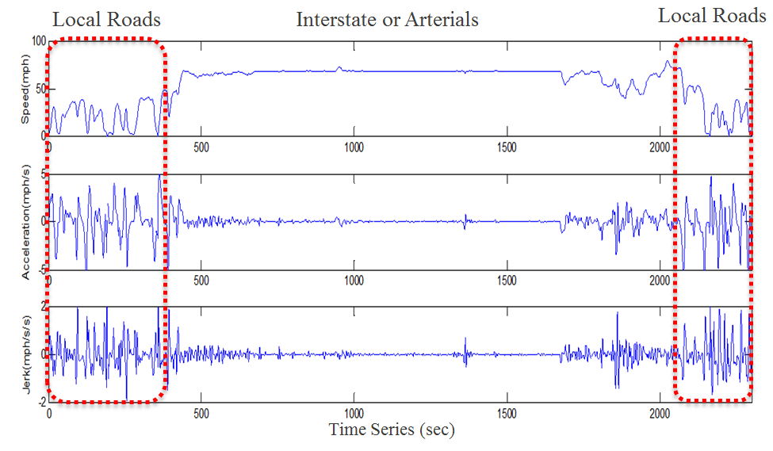
Figure 3.1 Comparison between speed, acceleration and vehicular jerk profiles on a trip

While these three profiles represent the same trip, they show significant differences, especially when speed fluctuates. The spikes in the vehicular jerk profile occur only when there are large changes in the accelerations, negatively or positively. The vehicular jerk profile acts as an amplification of speed changes since it is more sensitive to speed changes.

3.4.3 Patterns of Instantaneous Driving Decisions
Different patterns of instantaneous driving decisions can be observed based on how acceleration and deceleration are chained sequentially. Figure 3.2 shows six different vehicular jerk patterns during driving for illustrative purposes. The upper three graphs show vehicular jerks starting from acceleration and followed respectively by lower acceleration (a), higher acceleration (b), and deceleration (c). The lower graphs show vehicular jerks starting from a vehicle braking and followed respectively by a lower deceleration (d), higher deceleration (e), and acceleration (f). In these graphs, there is a decision point at second 10 when the driver has to decide whether he/she wants to change the current driving situation.

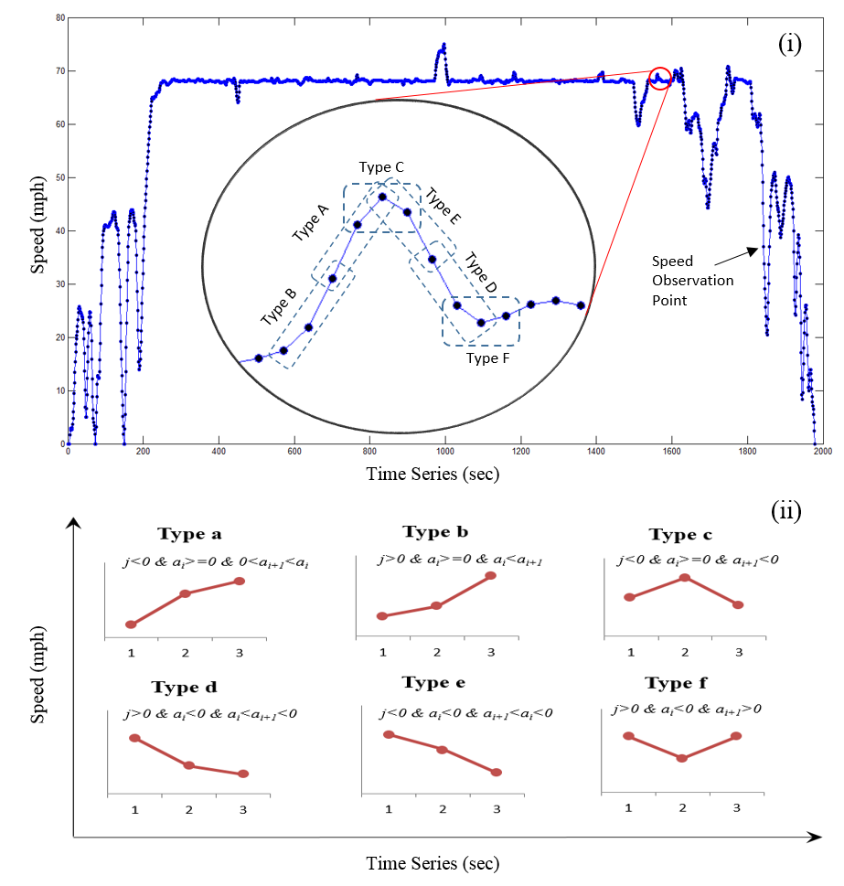
Notes: j=vehicular jerk; a_{i}=acceleration at time i; a_{i+1}=acceleration at time i+1
Figure 3.2 Different types of vehicular jerk during driving.

Since vehicular jerk is the second derivative of speed, it can be positive (b, d, f) or negative (a, c, e). Where vehicular jerk is zero, the driver operates the vehicle at a fixed acceleration/deceleration rate or simply maintains the speed. However, generally there can be a greater chance of collisions when negative vehicular jerk happens compared with positive vehicular jerk. In situations where vehicles are followed by other vehicles, negative vehicular jerks can result in abrupt shortening of distance between the vehicles and following vehicles, possibly creating a shockwave under condition c, e and a (a shockwave from strong to weak). Understanding the profiles of different vehicular jerk styles is important for safety and for energy and emissions.

3.4.3 Methodological Framework
Figure 3.3 shows the overall framework. The purpose of this study is to generate knowledge of short-term driving decisions by taking advantage of large-scale travel survey data that contain 36 million second-by-second trajectory records with travel behavioral data from 1,653 drivers. To do this, the research first defines different instantaneous driving decision patterns. Speed, acceleration, and vehicular jerk are extracted from the (large-scale) raw trajectory data, with decision patterns identified by chaining decisions with different sequences. Next, visualizing the data provides a complete picture of how drivers spend their time on these different driving decisions at different vehicular speeds. Then trip-based measures of short-term driving volatility are created based on acceleration and vehicular jerk profiles. Then, statistical models are estimated in order to explore the socio-demographic and travel correlates of driving volatility, generating new knowledge about volatility. Finally, potential applications for supporting calmer/smoother driving behavior and traffic management are proposed.

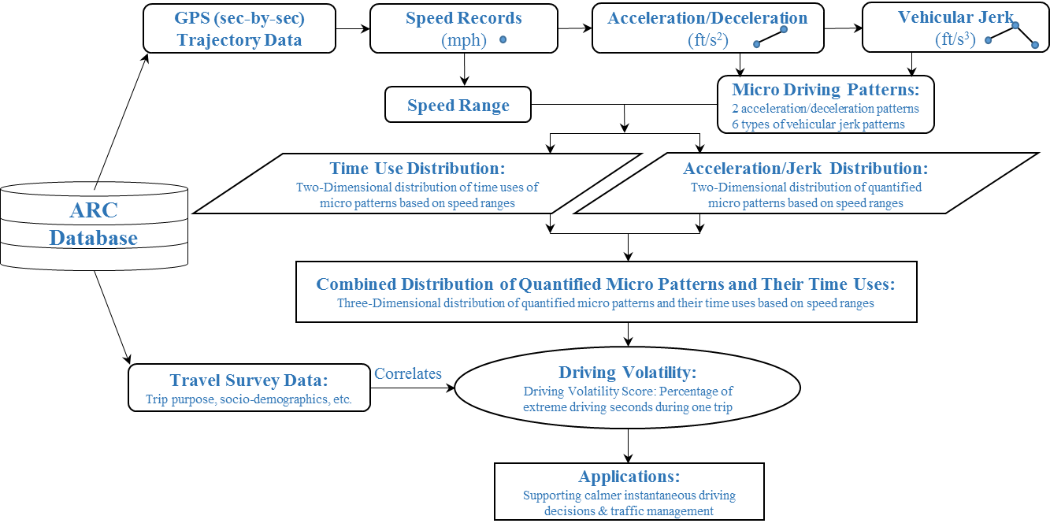
Figure 3.3 Methodological framework

3.5 RESULTS – EXTENT OF VOLATILITY IN DRIVING

3.5.1 Time Use Distribution

3.5.1.1 Acceleration/Deceleration
To understand driving time spent on different instantaneous decisions in a metropolitan environment, the frequency of acceleration, deceleration and zero acceleration by speed bin in 0.5 mph (mile per hour) increments were calculated based on 36 million driving seconds of total 51,370 trips (shown in Figure 3.4). On selection of speed bin, we have conducted sensitivity analysis and found that volatility can be somewhat sensitive to the selection of different speed bin widths. There is no ideal bin size, but we know that if the bin size is too large (e.g., 5 mph), then the data are overly aggregated and there is substantial loss of variability (note that there are only 16 bins for speeds ranging from 0 mph to 80 mph). If the bin size is too small (e.g., 0.1 mph), then data noise (random fluctuations) can become an issue, obscuring interpretation (for 0.1 mph speed bins there will be 800 bins for 0 to 80 mph range). The 0.5 mph (equivalent to 0.73 ft/s) speed bin is a reasonable compromise that gives a fairly accurate picture of the acceleration and jerk distributions with respect to driving speeds.

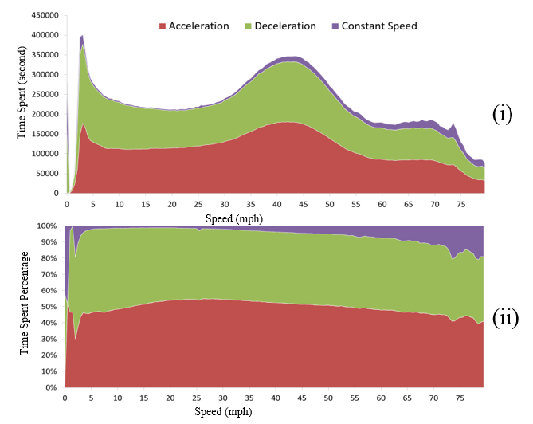
Figure 3.4 Time use in acceleration, deceleration and constant speed at different speeds (N= 36 Million)

Given that each sample represents one second of driving, the magnitude of frequency bars demonstrate the time used during trips on acceleration, deceleration and maintaining constant speed of the vehicle. Notably, very small accelerations or decelerations (0.03 mph, based on the 5th percentile of speed changes) were considered noise and coded as constant speed. Figure 3.4 (i) shows time use distribution and (ii) shows the percent of time spent on acceleration, deceleration and constant speed after standardization.

Overall 7% of driving time was spent driving at idling or low speeds (below 5 mph), 47% of driving time was spent on acceleration, 41% of driving time was spent on deceleration and 5% of driving time was spent maintaining constant speed, based on the massive amount of field data from GPS devices. The results can be compared with the Federal Test Procedure (FTP) drive cycle test (known as FTP-75 for the city driving cycle), which involves a decelerating drive mode for 34.5% of the time, and idling mode for 17.9% of the time [79, 80]. Table 3.2 shows major drive cycles designed to represent typical driving practices in order to certify vehicle fuel economy. The massive field driving data provides first-hand knowledge of real world driving practices, which can inform drive cycle design and provide insights.

Travel time spent at different speeds varies, depending on speed range, with 30-50 mph as the most common speed range. Less driving time was spent on driving at speeds higher than 50 mph. This result depends largely on regional road network structure. Overall greater amounts of driving time were spent on acceleration than deceleration, especially when speed was between 10-50 mph. However, more time was spent on deceleration compared with acceleration in lower speed bins (less than 10 mph). When speed is higher than 50 mph the travel time spent on acceleration and deceleration was nearly equal.

Table 3.2 United States certification drive cycles compared with Atlanta drive cycle [79]
Drive Cycle | Description | Data Collection Method | Year of Data | Top Speed | Avg. Speed | Max. Acc. | Distance | Time (min) | Idling time
FTP | Urban/City | Instrumented Vehicles/Specific route | 1969 | 56 mph | 20 mph | 1.48 m/s² | 17 miles | 31 min | 18%
C-FTP | city, cold ambient temp | Instrumented Vehicles/ Specific route | 1969 | 56 mph | 32 mph | 1.48 m/s² | 18 miles | 31min | 18%
HWFET | Free-flow traffic on highway | Specific route Chase-car/ naturalistic driving | Early 1970s | 60 mph | 48 mph | 1.43 m/s² | 16 miles | 12.5 min | None
US06 | Aggressive driving on highway | Instrumented Vehicles/ naturalistic driving | 1992 | 80 mph | 48 mph | 3.78 m/s² | 13 miles | 10min | 7%
SC03 | AC on, hot ambient temp | Instrumented Vehicles/ naturalistic driving | 1992 | 54 mph | 35 mph | 2.28 m/s² | 5.8 miles | 9.9 min | 19%
Atlanta | Urban/City | In-veh. GPS devices, Travel survey | 2011 | 80mph | 37mph | 5.10 m/s² | 7.1 mile^ | 12.7min^ | 7%*
Note:
1. FTP: Federal Test Procedure.
2. HWFET: The Highway Fuel Economy Test.
3. US06: The US06 Supplemental Federal Test Procedure (SFTP) for High Speed and High Acceleration Driving behavior.
4. SC03: A Supplemental Federal Test Procedure (SFTP) with Air Conditioning.
5. C- FTP: Federal Test Procedure under cold ambient temperature.
6. ^ mean values are used for Atlanta.
7. * idling & low speeds (below 5 mph)

Notably, time spent on maintaining constant speed is much less than time spent on speed alterations. Relatively higher proportion of time is spent on maintaining constant speed when speeds are higher; specifically, more than 10% in speed bins higher than 55 mph and more than 20% at speeds higher than 70 mph. This is reasonable since less stop-and-go traffic is expected on freeways with free flowing traffic, coupled with the use of cruise control on interstates. Notably, neither the data on the use of cruise control nor the road types and second-by-second geo-codes are available in the public use database. This makes it difficult to link the speed profile/bins with specific roadway types, especially when speed is less than 50 mph. For example, the roadway can be a congested interstate or signalized arterial with free flowing traffic. Nevertheless, the graphs reveal useful information that helps understand driving time use. Specifically, the driving time spent on idling (traveling below 5 mph) is below 10% in Atlanta; the time spent on accelerating and braking are roughly equal and substantially higher than time spent on maintaining speed during urban journeys.

3.5.1.2 Vehicular Jerk
To understand how much time drivers spent on different vehicular jerk decisions, the time spent for the speed bins was aggregated by different vehicular jerk types. Then the results were standardized by calculating the percent of time spent on each vehicular jerk style, shown in Figure 3.5. Similar to the time spent on acceleration, the percent of time spent on zero vehicular jerks remains a small portion, this is especially true when speed is more than 70 mph. Possible reasons are drivers seem to avoid jerks to vehicles at higher speeds, or the use of cruise control is more common at higher speeds. However, the cruise control usage information was not available in the database, otherwise it would have added valuable information to understand instantaneous driving decisions comprehensively.

Different vehicular jerk styles (shown in Figure 3.2) are observed within different speed bins. Specifically, for the speeding up behaviors (a, b), Style (a) has a very small share when speed is less than 5 mph then reaches its peak (30%) when speed is around 30 mph, after that, it starts to shrink slightly but remains at least 20%. While style (b) has its largest share when speed is around 10 mph then remains at a 20% share constantly. As for slowing down behavior (d, e), style (d) has its largest share (30%) when speed is 5 mph, then remains relatively constant at 20% when speed increases; style (e) has its largest share when speed is close to zero, representing the hard braking behavior when coming to a stop. When speed increases, the percent of style (e) has peaks at 25% with moderate speeds (between 20 mph and 30 mph) and then remains constantly at 20% when speed is higher than 30 mph. As for the other two styles when acceleration and deceleration behavior are chained, both of style (c) and style (f) account for about 5% and this percentage remains relatively constant at various speeds.

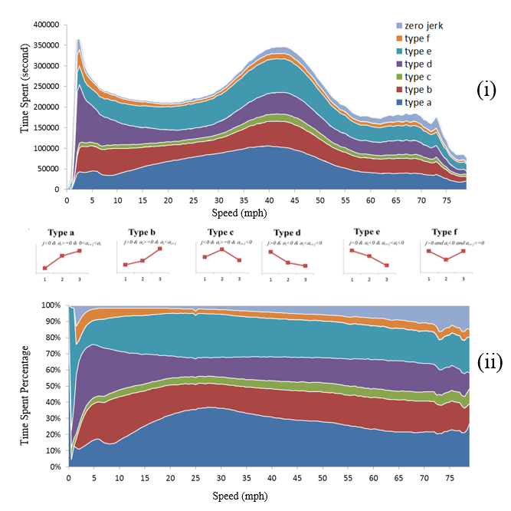
Figure 3.5 Time use in vehicular jerk patterns at different speeds (N= 36 Million)

3.5.2 Variation Distribution

3.5.2.1 Acceleration/Deceleration
Most existing studies have applied a single acceleration value as a threshold for identifying aggressive driving. Ahn et al. [80] have fitted a linear regression line showing that higher accelerations are associated with lower speeds. However, the nonlinear relationships between acceleration and speed in real-life driving situations are largely unexplored. Vehicle engines have to do more work in order to maintain the same acceleration at higher speeds to overcome the increasing air resistance. Therefore the ability to accelerate or decelerate a vehicle decreases naturally at higher speeds.

The speed vs. acceleration/deceleration profile (shown in Figure 3.6) is consistent with the above expectations. Upper and lower bands represent the means plus/minus one standard deviation bands for accelerations and they denote “typical driving practices.” The (red) points that are out of the bands are the “volatile” driving seconds. In general, 15% of the 36 million seconds of driving are volatile (15.73% for acceleration and 14.50% for deceleration). This is reasonable since approximately 68% of the mass will be within one standard deviation for a bell-shaped normal speed distribution. Note that in order to separate the typical behaviors of drivers from moderately and highly risky behaviors, the use of 1 standard deviation threshold is reasonable. Using a 2 or 3 standard deviation threshold instead (i.e., capturing 95% and 99.7% of the observations for normally distributed data), will only leave extreme outliers, that are 5% or even lower (at 0.3%) portion of the data, i.e., high risk behaviors.

Bandwidth is the difference between the upper band value and the lower band value. A falling bandwidth reflects decreasing variation and rising bandwidth reflects increasing variation in speed changes. The largest bandwidth is between 10 mph and 30 mph and it decreases substantially when speed is higher than 40 mph. This confirms that at higher speeds (typically on freeways with a good level of service) drivers usually do not or simply cannot accelerate and decelerate abruptly. When speed is above 55 mph, accelerations scarcely exceed 1.5 feet/sec², as reflected in the upper band.

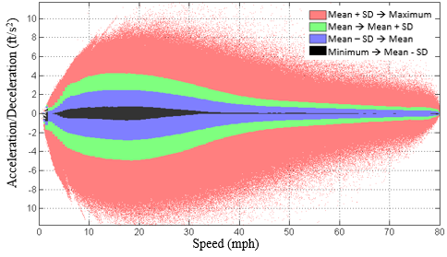
Bandwidth
Figure 3.6 Average acceleration/deceleration at different speeds (N=36 Million)

A similar trend is observed in the deceleration profile with minor differences. Compared with acceleration, the magnitude of the maximum mean of deceleration is higher. It is -3.0 feet/sec² for deceleration while the maximum mean value is less than 3.0 feet/sec² for acceleration. This finding is interesting when combined with information contained in Figure 4. It revealed that in the Atlanta area, on average, drivers spend more time braking and they brake harder compared with accelerations.

3.5.2.2 Vehicular Jerk
Figure 3.7 (i) shows the distribution of the average vehicular jerk by different types and Figure 3.7 (ii) the mean and standard deviation of vehicular jerk at different speeds. The difference in absolute magnitude of vehicular jerk reveals their intensity. Types (c) and (f) show the highest absolute magnitudes which is reasonable since both of them represent drivers reversing vehicle acceleration, i.e., going from acceleration to deceleration or vice versa. Note that type (f) has a higher absolute magnitude than its negative counterpart, i.e., type (c). This means that on average drivers jerk their vehicles more forcefully to accelerate after braking compared with the opposite. This is especially true when speed is less than 40 mph. The other two positive and the two negative jerk types show similar trends and values.

The upper band and lower band (mean plus/minus one standard deviation) are created respectively for the aggregated positive and negative vehicular jerk. For speed bins higher than 40 mph, the lower band of positive vehicular jerk is below zero and the upper band of negative vehicular jerk is above zero; hence zero were used in calculating the bandwidth in those cases. The upper band of the positive vehicular jerk and lower band of negative jerk collectively create a profile of regular practice for vehicular jerk. In other words, it represents the most typical driving practice on roadways regardless of road type. The bands can also serve as a critical threshold for identifying volatile driving behaviors, which are the red points falling outside the bands in Figure 7(b).

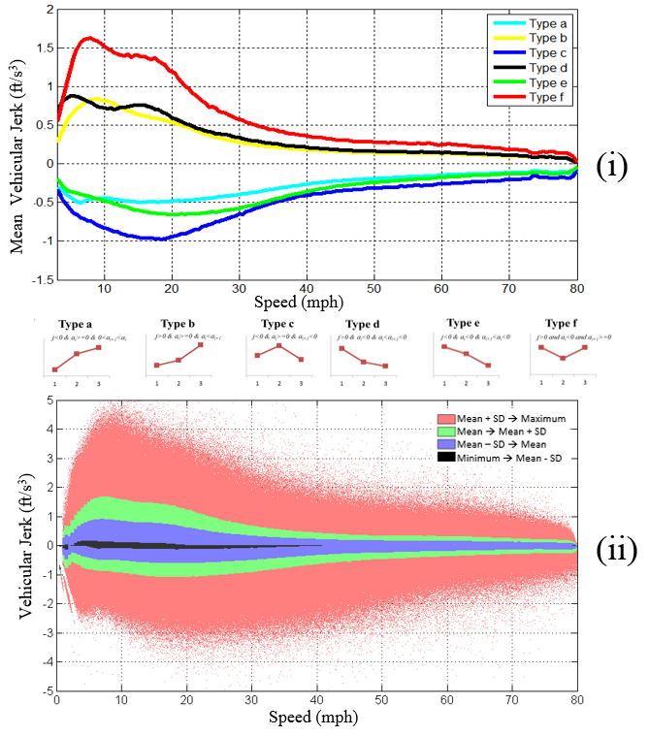
Figure 3.7 Vehicular jerk distribution by speed bins (N=36 Million)

Based on 36 million seconds of driving data, about 13.36% seconds are identified as volatile seconds when using the vehicular jerk profiles. This score represents the average volatility level for typical driving practices for the GPS subsample from the Atlanta Metropolitan Area. More volatile driving practices are found within at lower speeds, as expected. Specifically, 16.4% of the total time drivers are volatile (above 1 standard deviation) when speed is lower than 20 mph, while 13.6% of the time they are volatile when speed is between 20-40 mph. This percentage drops to 12.00% for speed range between 40-60 mph and it is 11.9% for speeds larger than 60 mph.

The critical values of vehicular jerk associated with volatile driving behavior vary by speed. There is a peaking of this measure at speeds of 7.5 mph then it decreases gradually as vehicular speed goes up, until it reaches a steady line with minor fluctuations at speeds between 45-52 mph. In general, the bandwidth is larger at relatively low speeds (less than 20 mph) and it is relatively narrower at higher speeds. This is to say that lower speeds have a boarder range of volatile driving, but this is not the case for higher speeds.

3.5.3 Combined Distribution
Figure 3.8 shows three dimensional distribution of time use and variations of instantaneous driving decisions at different speeds. The height shows the number of driving records with corresponding driving status (i.e., speed and acceleration/deceleration or vehicular jerk). At speeds 10 ~30 mph there are fewer driving records with zero acceleration or deceleration (see the trough in Figure 5); for higher speeds (> 60 mph), a large portion of time is spent in maintaining speed with small acceleration or deceleration (see the ridge in Figure 3.8). Differing from acceleration distributions, vehicular jerk distributions are more concentrated at zero. This implies that any quantified jerk patterns that are different from zero can be easily identified as abnormal micro driving patterns, e.g., sudden braking or accelerating.
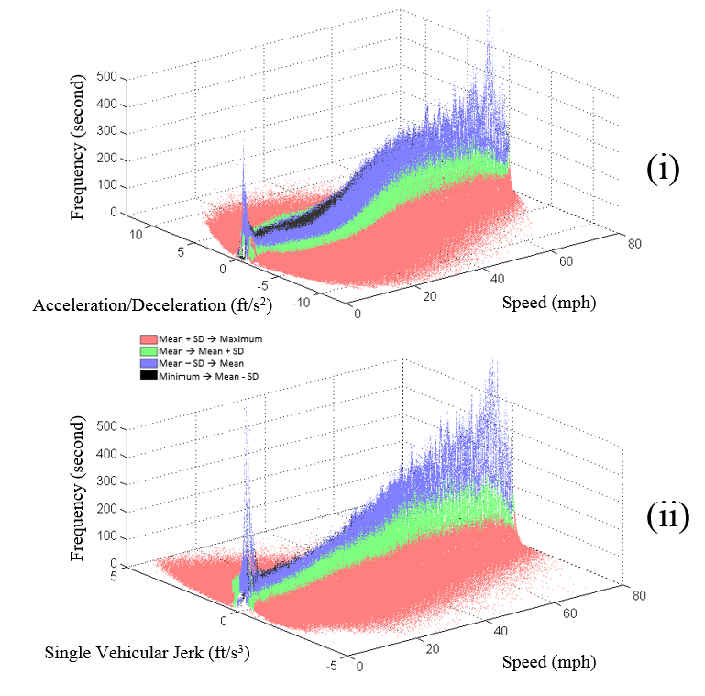
Figure 3.8 3D distribution of time use and variations of instantaneous driving decisions at different speeds (N=36 Million)

3.5.4 Driving Volatility Score
A new measure, termed driving volatility score was created after identify the volatile seconds. The idea is to measure individual volatility for each trip using the acceleration or vehicular jerk band. A driver’s volatility score is defined as a percentage of time tagged as volatile seconds over the entire trip. In other words, volatility is measured as the percentage of time when the driver’s acceleration or vehicular jerk goes beyond the typical driving thresholds (acceleration or vehicular jerk bands). The driving volatility score can be calculated by following equation:
$$Volatility Score \%= \frac{Volatile Seconds }{ Entire Trip Druation}×100$$ | Equation 3.2

Figure 3.9 shows a comparison between the volatility scores generated using acceleration bands versus using vehicular jerk bands for a sampled trip. Less volatile seconds were identified using jerk bands compared with using acceleration bands; volatility score was 8.5% with jerk bands vs. 6.0% with acceleration bands for the trips analyzed. The jerk-based volatile seconds are not always in concordance with volatile acceleration-based volatile seconds. That is to say, sometimes the driver accelerated at a higher than the upper band level but he/she did not jerk the vehicle during this period.

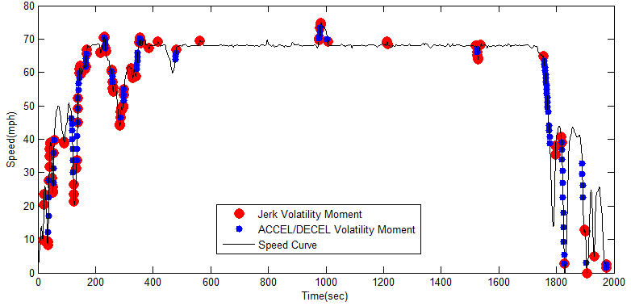
Figure 3.9 Volatile driving identified by different methods

Conceptually, it is important to understand and identify key decision points when the driver abruptly changes driving actions, e.g., goes from acceleration to deceleration. Based on the observations shown in Figure 3.9, jerk seems to capture critical decision points better than acceleration while acceleration has more tolerance for volatility. Vehicular jerk can serve as an effective measurement to identify abrupt instantaneous decision changes. Since the volatility score is calculated for each trip, when data on multiple trips for a single driver are collected, average volatility score can be generated for each driver. This makes it is possible to compare both the intra-trip volatility and volatility between different drivers.

3.6 RESULTS – CORRELATES OF DRIVING VOLATILITY
After calculating the volatility scores (based on vehicular jerk bands) for each trip in the database, statistical models were estimated to investigate relationships between the volatility and driver demographics, vehicle characteristics and trip specifics. The database contained 51,370 trips made by 1,653 survey respondents in. After removing observations with missing information, the final database sample contained 40,240 trips by 1,486 respondents-—these are unique driver-vehicle pairs, labeled as driver-vehicle ID. Table 3.3 presents the descriptive statistics for the dependent and independent variables. The average volatility score is 13.84, which means that driving was volatile during 13.84% of the travel time (above or below mean vehicular jerk plus or minus one standard deviation). Some trips show calm driving (minimum score is 0.1%) while some were highly volatile when 55.46% of the time was spent on jerking vehicles at a higher level (outside of the bands).

Table 3.3 Descriptive statistics for dependent and independent variables
Variables |  |  | N | Frequency | Mean/Percent | Std. Dev | Min | Max
Dependent | Volatility Score |  | 40240 | - | 13.840 | 6.701 | 0.1 | 55.46
Independent | Driver Variable | Gender [Male] | 1486 | 702 | 47.24% | 0.499 | 0 | 1
Independent | Driver Variable | Driver age (years) | 1486 | - | 47.183 | 13.319 | 15 | 91
Independent | Vehicle Age | Vehicle age (years) | 1486 | - | 7.908 | 5.417 | 0 | 50
Independent | Vehicle Type | Auto-sedan | 1486 | 652 | 43.88% | 0.496 | 0 | 1
Independent | Vehicle Type | Two-seated | 1486 | 58 | 3.90% | 0.194 | 0 | 1
Independent | Vehicle Type | Van | 1486 | 131 | 8.82% | 0.284 | 0 | 1
Independent | Vehicle Type | RV | 1486 | 3 | 0.20% | 0.045 | 0 | 1
Independent | Vehicle Type | SUV | 1486 | 409 | 27.52% | 0.447 | 0 | 1
Independent | Vehicle Type | Station wagon | 1486 | 31 | 2.09% | 0.143 | 0 | 1
Independent | Vehicle Type | Pickup | 1486 | 202 | 13.59% | 0.343 | 0 | 1
Independent | Vehicle Fuel Type | Gasoline | 1486 | 1429 | 96.16% | 0.192 | 0 | 1
Independent | Vehicle Fuel Type | Diesel | 1486 | 29 | 1.95% | 0.138 | 0 | 1
Independent | Vehicle Fuel Type | Hybrid | 1486 | 19 | 1.28% | 0.112 | 0 | 1
Independent | Vehicle Fuel Type | Flex fuel | 1486 | 9 | 0.61% | 0.078 | 0 | 1
Independent | Trip Variable | Rush hour [Yes] | 40240 | 18616 | 46.26% | 0.499 | 0 | 1
Independent | Trip Variable | Weekend [Yes] | 40240 | 9805 | 24.37% | 0.429 | 0 | 1
Independent | Trip Variable | Trip duration (min) | 40240 | - | 14.165 | 14.738 | 2.01 | 374.45
Independent | Trip Variable | Commute trip [Yes] | 40240 | 7843 | 19.49% | 0.396 | 0 | 1
Note: * Rush hours are AM (6:00 am-10:00 am) or PM (3:00 pm-7:00 pm)

In the final sample for modeling, 47.24% drivers were male; the mean age of respondent is 47.18, and a broad age range from 15 to 91. The mean vehicle age is 7.91 years and 43.88% of sampled vehicles were auto-sedans, 27.52% SUVs, and 13.59% pick-up trucks. As expected, 96.16% vehicles were gasoline-powered. 46.26% of trips were made during rush hours (6:00 am-10:00 am or 3:00 pm-7:00 pm); 24.37% were made on weekends; 19.49% were commute trips; the average trip duration was 14.17 minutes with an almost equal standard deviation–14.73. Overall, the data seems to be reasonable and in accordance with expectations.

The differences of volatility scores between trips can be result of the driving styles of different drivers (males vs. females, or young vs. older drivers), vehicle performance (new vehicles vs. older vehicles, body type, fuel type), or trip specifics (longer vs. shorter trips, commute vs. non-commute trips, and workday vs. weekend trips). Therefore simple Ordinary Least Squares (OLS) models were first estimated to test their associations. However, the traditional OLS models assume independence of observations and in this case multiple trips were made by the same drivers. Therefore, OLS will violate the independence assumption. One way to deal with correlated observations is to estimate a mixed-effect model, also called the mixed model. This model can capture correlated errors that arise from repeated observations in a group. In this study, the group variable is driver-vehicle pair; repeated variables are personal and vehicular characteristics; non-repeated variables are the measures for each specific trip. A “Driver-Vehicle ID” was created to represent different driver-vehicle pairs in the sample and was used as the random term in the mixed-effects model. The random term quantifies the error due to repeated variables. The mixed-effects regression model can contain both fixed and random terms, as shown in following equations.

$Y=βX+γZ+ε$ Equation 3.3
$γ\sim N(0, G)$
$ε\sim N(0,σ^{2}I_{n})$

Y is the response vector of volatility score for each trip in the data; X is a vector of fixed independent variables (age, gender, vehicle body type, fuel type, vehicle age, trip duration, commute or not, peak hour or off-peak, weekend or not); β is a vector of estimated fixed effects for matrix X; and Z is a vector of random independent variables (Driver-Vehicle ID); γ is a vector of estimated random effects for matrix Z; ε is a vector of unknown random errors; G is an diagonal matrix with identical entries for each fixed effect; I_{n} is an identity matrix; γ and ε are assumed to be independent.

Table 3.4 provides the modeling results for mixed models. Given that the distribution of vehicle jerk-based volatility scores is slightly right-skewed, square root transformed volatility score was tested as the dependent variable. However, the transformation improved the statistical properties of the model only marginally, e.g., significance of variables. Therefore, the original volatility score is used as the dependent variable, providing more intuitive parameter interpretation. Overall, the modeling results are reasonable, providing insights about a range of volatility correlates.

A key advantage of the mixed model over OLS model is that the random terms added into the mixed model structure can better model the effects of repeated observations within the group (driver-vehicle pair) by allowing various degrees of freedom for different variables according to their variations within groups. More specifically, all observations are treated equally in the OLS model regardless of their variations within or between groups. In this case, the overall sample size is 40,240 (the total number of trips). However, in the mixed model, only the sample size for generic variables [81], (i.e., trip characteristics) with variations within groups remains the same (40,240), while the sample size for alternative-specific socioeconomic variables (i.e., driver and vehicle characteristics) become 1,486, which is the count of unique driver-vehicle pairs. As a result, larger standard errors are reported for alternative-specific socioeconomic variables in the mixed model. The estimated coefficients in the OLS and mixed models are nearly identical, but with different standard errors for driver and vehicle related terms, as expected. The following modeling interpretation is based on the mixed-effects model using the untransformed volatility score.

Full and final models are presented, with the final model containing only the statistically significant variables (10% level). The results of the final are discussed. The models have a reasonably good fit, explaining 40.3% of the variation in volatility score. As expected, younger drivers exhibit higher volatility in driving (5% level). A ten year increase in driver age is associated with a decrease of 0.57 in volatility scores. However, there is no statistical evidence for association between volatility score and drivers’ gender. Driving volatility varies significantly with vehicle characteristics, including vehicle body type, vehicle age and fuel type. The results show that two-seat sports cars are associated with higher volatility, possibly due to their higher horse power. Trips made by two-seat sports cars drivers have 3.28 higher volatility scores, compared with trips made by drivers in the “base” category that includes sedans, RVs, station wagons, and SUVs. While van drivers show 1.82 lower volatility compared with drivers in the base category, perhaps due to their larger size and more sluggish performance. The use of hybrid vehicles shows lower volatility (-1.98) compared with gasoline and diesel vehicles. The volatility scores are lower for older vehicles, perhaps due to their engine performance. A year added to vehicle age is associated with a 0.10 units decline in the volatility score.

Volatility score also shows significant correlation with trip specific factors, including trip duration, time of day, day of the week, and trip purpose. Compared with non-rush hour trips, there is a 0.24 units increase in volatility score during rush hours. A further exploration has revealed that driving in morning rush hours is more volatile than non-rush hour driving. Driving in lunch and afternoon rush hours is not significantly from non-rush hour driving, in terms of driving volatility [51, 52]. Compared with workday trips, the decrease in volatility score for weekend trips is 0.30 units; for commute trips, the increase in volatility score is 0.36 units compared with non-commute trips; and a one-minute increase in trip duration is associated with a 0.04 units lower volatility score.

High levels of correlations among explanatory variables were checked and we did not find them to be high. One example is that of commute trips which are typically made during peak hours. In the data, 46.28% of the trips were made during rush hours and 19.51% of the trips were for commute purposes. While these two variables capture different aspects of travel, i.e., time of day and trip purpose, the correlation between them was relatively low (0.156), justifying their joint inclusion in the model.

Examination of the random effects, reported as variance component estimates, shows a sizable variation (34.84%) in the volatility score across driver-vehicle pairs. This further justifies the use of the mixed model. Note that the models presented in this paper show an effort to test whether the measurement of volatility can be used to quantify the relationships between instantaneous driving decisions and other variables that include personal, vehicular, situational context factors. The random effects model confirmed that volatility score varies significantly between different driver-vehicle pairs. However, it does not fully disentangle volatility variations between different driving trips made by the same driver. A more sophisticated hierarchical modeling framework will be needed for answering such questions [82].

Table 3.4 Results of the mixed model using volatility score as the dependent variable
Dependent = Volatility Score |  | Full model |  |  |  | Final model
Independent Variables |  | β |  |  | P-value | β |  |  | P-value
Constant |  | 16.6983 | ** |  | <.0001 | 17.6644 | ** |  | <.0001
Driver Variables | Gender [Male] | -0.0018 |  |  | 0.9871 | - |  |  | -
Driver Variables | Driver age (years) | -0.0573 | ** |  | <.0001 | -0.0574 | ** |  | <.0001
Vehicle Age Variable | Vehicle age (years) | -0.1079 | ** |  | <.0001 | -0.1036 | ** |  | <.0001
Vehicle Body Type Variable | Auto-sedan | Base |  |  |  | Base
Vehicle Body Type Variable | Two-seated | 3.8554 | ** |  | <.0001 | 3.2830 | ** |  | <.0001
Vehicle Body Type Variable | Van | -1.2621 | ** |  | 0.0084 | -1.8231 | ** |  | <.0001
Vehicle Body Type Variable | Recreational Vehicle-RV | -2.7353 |  |  | 0.1886 | Base |  |  | -
Vehicle Body Type Variable | Sports Utility Veh.-SUV | 0.3291 |  |  | 0.4249 | Base |  |  | -
Vehicle Body Type Variable | Station wagon | -0.2914 |  |  | 0.6843 | Base |  |  | -
Vehicle Body Type Variable | Pickup | -0.8836 | * |  | 0.0522 | -1.5596 | ** |  | <.0001
Vehicle Fuel Type Variable | Gasoline | Base |  |  |  | Base
Vehicle Fuel Type Variable | Diesel | -0.9484 |  |  | 0.1760 | Base |  |  | -
Vehicle Fuel Type Variable | Hybrid | -1.7512 | ** |  | 0.0295 | -1.9825 | ** |  | 0.0101
Vehicle Fuel Type Variable | Flex fuel | 1.8594 | * |  | 0.0742 | 1.5765 | * |  | 0.0947
Trip Variables | Rush hours [Yes] | 0.2375 | ** |  | <.0001 | 0.2376 | ** |  | <.0001
Trip Variables | Weekend [Yes] | -0.3038 | ** |  | <.0001 | -0.3036 | ** |  | <.0001
Trip Variables | Trip duration (min) | -0.0356 | ** |  | <.0001 | -0.0356 | ** |  | <.0001
Trip Variables | Commute trip [Yes] | 0.3627 | ** |  | <.0001 | 0.3630 | ** |  | <.0001
R² |  | 0.4028 |  |  |  | 0.4028
R² Adjusted |  | 0.4026 |  |  |  | 0.4027
Root Mean Square Error-RMSE |  | 5.2672 |  |  |  | 5.2672
Mean of Response |  | 13.8397 |  |  |  | 13.8397
Observations (or Sum Weights) |  | 40240 |  |  |  | 40240
Bayesian Information Criterion-BIC |  | 251937 |  |  |  | 251900
Variance Component Estimates
 |  | Var. Comp. |  | Percent  of Total |  | Var.  Comp. |  | Percent of Total
Variance Between Driver-Vehicle Pairs |  | 14.7136 |  | 34.66% |  | 14.8319 |  | 34.84%
Remaining Variance |  | 27.7429 |  | 65.34% |  | 27.7430 |  | 65.16%
Total Variance |  | 42.4564 |  | 100.00% |  | 42.5749 |  | 100.00%
Note:
1. Rush hours: AM (6:00 am-10:00 am), PM (3:00 pm-7:00 pm);
2. ** = significant at a 95% confidence level;
3. * = significant at a 90% confidence level;
4. For mixed model, the random term is Driver-Vehicle ID (N=1486);
5. REML=Restricted Maximum Likelihood;
6. Statistically significant variables (90% level) are kept in the final model.

3.7 POTENTIAL APPLICATIONS
Regional thresholds (e.g., Atlanta) are used to account for the driving context and highlight extreme driving. Two types of driving volatility information can be provided to drivers:
- Real time driving behavior information: Drivers may be alerted or warned when they exceed certain thresholds of acceleration or vehicular jerk, providing them with dynamic feedback on their volatility through Advanced Traveler Information Systems (ATIS). Displays can be designed to inform drivers their real-time driving volatility, without overly distracting them, e.g., through a light on the dashboard that turns yellow or red from green. This can also be supplemented via email notifications.
- Daily/monthly/yearly driving behavior summary information. Long-term advice on driving patterns can be provided to the driver based on analysis of their daily, monthly or yearly driving performance. Such information can be provided through websites, and may contain a record, analysis of driving patterns and customized advice on improving accelerations, braking, speeds, and turns, etc.

Thresholds of identifying extreme driving patterns can be based on combinations of accelerations, single vehicular jerk, expanded vehicular jerk and variance in these parameters [51]. While this study used the mean plus/minus one standard deviation thresholds for identifying extreme patterns, other threshold criteria can also be used, e.g., mean plus two or three standard deviations. Note that, the thresholds may be further adjusted based on time of day, weather, terrain, and roadway classification. They can be personalized based only on trips undertaken by the individual or use regional data to calculate thresholds. Adding these functions to current mobile devices has the potential for calmer driving.

3.8 LIMITATIONS
This study depends heavily on GPS data collected by in-vehicle devices. To some extent the accuracy and availability of location data constrain the analysis. Compared with high industrial sampling rates (e.g. 96 kHz), these data are limited by relatively low sampling frequency which gives only second-by-second speeds. A reasonable question is whether second-by-second speed data are good enough for identifying instantaneous driving decisions. To address this issue, additional analyses were conducted by collecting driving data at 20 Hz using a driving simulator [83]. This database includes 35,924 seconds speed data made by 24 drivers, generating 718,481 speed data points, which allows the investigation of micro-driving decision changes within one second. The results show that drivers made no change to their speed for 89.9% of the sampled seconds, i.e., drivers either kept accelerating, decelerating or just maintained speed during a second. Only 10.1% of the sampled seconds involve driver’s decision change. Overall, the analysis found that at least 98.5% instantaneous driving decision changes can be detected using second-by-second data compared with smaller intervals and that the second-by-second data are reasonably accurate for the purposes of this study.

Some other critical information remains unknown to the researchers due to privacy concerns. This includes the type of roads and the geo-codes for each second of driving. Missing geographically referenced information for trips prevents the researchers from extracting useful contextual factors. These include roadway segments used during trips and associated traffic counts, road geometry, traffic operations facilities, and surrounding land uses. Therefore, how the instantaneous decisions are associated with surrounding traffic, facility and land use can be analyzed adding interesting findings. This paper presents an attempt to enhance understanding of volatility in instantaneous driving decisions. More research is needed to investigate the impacts of network attributes, environmental attributes on instantaneous decisions, as shown in the conceptual framework. Expansion of the study can form the basis of future analysis of driver volatility and how it relates to energy, environment and safety.

3.9 CONCLUSIONS
In the context of using large-scale data for traffic safety improvement, tailpipe emissions and energy use reduction in a driving dominant environment, it is essential to understand drivers’ instantaneous driving decisions and their associated impacts. The research takes advantage of large-scale driving databases coupled by second-by-second GPS data to develop a framework for the research agenda in driving behavior studies addressing how to define the instantaneous driving decisions in a quantifiable way and how to quantify explicitly volatile driving in a defensible manner. The answer is to create a volatility indicator to measure the gap between an individual’s driving practice and the typical driving practice in that region. Assuming the typical driving practice applied by most people represents the norm of driving culture in that region, the driving practices standing out of that norm could be defined as volatile driving. The paper demonstrates a methodology to measure the volatility, which is based on variance in vehicular jerk between individual drivers and regional sample profiles. The creation of a robust volatility score that is able to quantify the extent of volatility, instead of simply labeling a driver as aggressive or non-aggressive is a key contribution.

To create a typical driving profile for the study metropolitan area, acceleration or vehicular jerk distributions were analyzed using speed bins and enveloped by an upper and lower band (mean plus/minus one standard deviation). While typical driving practices are identified when the acceleration or vehicular jerk fall between the bands, volatile driving is defined as accelerations or vehicular jerks that fall out of the bands range. A volatility score for each trip or each driver can be calculated by the percent of travel time spent on volatile driving. In this sense, developing a regional driving profile is critical since this driving profile serves as a “standard” to define individual’s driving volatility. Atlanta’s driving profile was developed through an innovative visualization of data, the time spent on each driving behavior was calculated. Specifically, overall 14% of the travel time spent on high vehicular jerk; 7% of driving time was spent on idling or traveling at speeds below 5 mph, 47% of driving time was spent on acceleration, 41% of driving time was spent on deceleration and 5% of driving time was spent on maintaining constant speed. This information can be useful for designing driving cycle in a local context for better emissions estimations. The methodology has great potential to be expanded to measure driving volatility on road infrastructures as an indicator of roadway safety. Roads with higher risk (those experiencing more hard braking and negative jerks) can be identified and proactive strategies can be designed.

The findings are useful for potential applications to fleet vehicles and the general driving population. Driving volatility information based on accelerations and vehicular jerk can be incorporated in driving assist systems, e.g., advanced traveler information systems (ATIS). Current traveler information systems (such as 511) are largely meant to support more macro driver decisions (e.g., route choice and route diversion) and do not provide much instantaneous information that can help drivers make more micro driving decisions. The real-time driving volatility information reflecting driving performance based on performance of fellow fleet vehicles or neighbors or just their own performance can support short-term micro decisions. This in turn can benefit the community or fleets in several ways: 1) calmer driving; 2) safer driving in general (especially on icy or slippery road surfaces where alert thresholds can be lowered); 3) lower fuel consumption and emissions; and 4) identification of dangerous road segments (such as poor sight distance) that may result in volatile driving.

THE ROLE OF ALTERNATIVE FUEL VEHICLES: USING BEHAVIORAL AND SENSOR DATA TO MODEL HIERARCHIES IN TRAVEL
This chapter presents a modified version of a research paper by Jun Liu, Asad J. Khattak and Xin Wang. The paper was accepted for publication by Transportation Research Part C: Emerging Technologies, 2015. DOI: 10.1016/j.trc.2015.01.028.

ABSTRACT
Greater adoption and use of alternative fuel vehicles (AFVs) can be environmentally beneficial and reduce dependence on gasoline. The use of AFVs vis-à-vis conventional gasoline vehicles is not well understood, especially when it comes to travel choices and short-term driving decisions. Using data that contains a sufficiently large number of early AFV adopters (who have overcome obstacles to adoption), this study explores differences in use of AFVs and conventional gasoline vehicles (and hybrid vehicles). The study analyzes large-scale behavioral data integrated with sensor data from global positioning system devices, representing advances in large-scale data analytics. Specifically, it makes sense of data containing 54,043,889 seconds of speed observations, and 65,652 trips made by 2,908 drivers in 5 regions of California. The study answers important research questions about AFV use patterns (e.g., trip frequency and daily vehicle miles traveled) and driving practices. Driving volatility, as one measure of driving practice, is used as a key metric in this study to capture acceleration, and vehicular jerk decisions that exceed certain thresholds during a trip. The results show that AFVs cannot be viewed as monolithic; there are important differences within AFV use, i.e., between plug-in hybrids, battery electric, or compressed natural gas vehicles. Multi-level models are particularly appropriate for analysis, given that the data are nested, i.e., multiple trips are made by different drivers who reside in various regions. Using such models, the study also found that driving volatility varies significantly between trips, driver groups, and regions in California. Some alternative fuel vehicles are associated with calmer driving compared with conventional vehicles. The implications of the results for safety, informed consumer choices and large-scale data analytics are discussed.

4.1 INTRODUCTION
Automobiles are the dominant mode of personal travel in the United States. While they are associated with economic development, automobiles also have adverse impacts on the environment, generate greenhouse gases, and result in dependence on petroleum. One solution to lowering petroleum dependence and reducing emissions is the wider adoption and use of Alternative Fuel Vehicles (AFVs). They are generally more fuel-efficient and environmentally-friendly compared with conventional fuel vehicles (gasoline and diesel) and fulfill expanding individual travel demands of the future [84, 85]. Driving behavior in alternative fuel vehicles is of particular interest, if they are to be purchased and used widely. AFVs include plug-in hybrid electric vehicles (PHEVs), battery electric vehicles (BEVs), and compressed natural gas (CNG). While most hybrid electric vehicles are not necessarily AFVs (i.e., are gasoline-based), they are more fuel efficient making use of a smaller engine coupled with electric battery. The key research questions are:
- Whether alternative fuel vehicles and hybrid vehicles have similar use characteristics (trip frequency, vehicle miles traveled, etc.) as conventional vehicles?
- Whether drivers of alternative fuel vehicles are more or less prone to abrupt maneuvers, e.g., aggressive accelerations or vehicular jerk?

The main motivation for the study comes from the potential to learn important lessons from examining the behaviors of early AFV adopters who typically have to overcome adoption barriers such as higher vehicle acquisition costs, shorter driving ranges, scarcity of refueling stations, and potential safety and reliability issues. The study provides a stronger behavioral basis for future tools that can be developed to potentially increase the adoption, diffusion, and use of AFVs and ultimately a large-scale energy transition to alternative fuels. There is an added sense of urgency to examine the use of AFVs as they are gaining greater acceptance and popularity.

Behavioral data used in this study are hierarchical, i.e., they are nested with multiple trips made by different drivers who reside in various regions. Multi-level models have been used for analysis of such data, but not widely in the travel behavior field. This study uses multi-level modeling in a novel way to study whether driving volatility (a key measure of driving performance) varies significantly between trips, driver groups, and regions in California. Relatively new and unique large-scale behavioral data integrated with sensor data from global positioning system devices are used to estimate models and learn from expanded data that has only recently become available [86-88].

4.2 LITERATURE REVIEW
Vehicle miles/hours traveled, trip frequency, and travel times/distances are often used as measures of performance in transportation. Increasingly, speed and acceleration data are the becoming available and these measures are increasingly used to characterize the driving behavior. Wang et al. used the average speed, average acceleration and the percentage of time in acceleration mode to capture the driving behavior in Chinese cities [89]. Hung et al. viewed the driving characteristics in a similar way and pointed out the associated factors, including land use, flow density, road width and road network [90]. Sciarretta et al. investigated the driving behavior of hybrid electric vehicle by collecting their speeds and accelerations. They pointed out that the driving conditions, driver characteristics and vehicle performance are important for understanding the driving experience of hybrid electric vehicle users [91]. Johannesson et al. also used the speed and acceleration to quantify driving behavior of hybrid vehicles [92]. Furthermore, the rates of fuel consumption and emissions were used to characterize the driving behavior of internal combustion engine vehicles [64]. Generally, hybrid vehicles have higher fuel economy than conventional vehicles [93, 94] and also there are zero-emission electric vehicles in use [95]. In order to be somewhat consistent with previous studies, this study uses measures related to the vehicle movement (speed) to characterize the driving behavior.

To understand driving behavior, researchers have defined driving styles, e.g., aggressive driving or calm driving. Typically, cut-off thresholds are used to demarcate driving behavior. Kim et al. gave 1.47 m/s² (4.82 ft/s²) and 2.28 m/s² (7.47 ft/s²) as thresholds for aggressive and extremely aggressive accelerations [12]. While De Vlieger et al. pointed out 0.45-0.65 m/s² for calm driving, 0.65-0.80 m/s² (2.13-2.62 ft/s²) for normal driving and 0.85-1.10 m/s² (2.79-3.61 ft/s²) for aggressive driving [13]. The somewhat arbitrary cut-off points ignore the heterogeneity of driving behavior under different speeds, which has been found in some of the previous studies by the authors [22, 51]. The results showed that at lower speeds on local/collector roads large acceleration/deceleration values are frequent but at higher speeds (typically on freeways with a good level of service) drivers often do not (or cannot) accelerate and decelerate abruptly. Notably, alternative fuel vehicles may have different performance outcomes because of their different power systems compared with conventional gasoline vehicles [96, 97].

This study uses the term driving “volatility” instead of “aggressiveness” to measure abrupt accelerations and decelerations, as mentioned in some of our previous studies [22, 51]. Using the term “volatility” is neutral and describes the driving behavior in a more objective and impersonal way. The method for measuring driving volatility is discussed in the next section.

A variety of statistical models have been used to explore links between driving behavior and associated factors, based on the data structure and research purposes. Analysis of variance (ANOVA), Chi-square test and T-tests are the most commonly used methods comparing various groups [98, 99]. Ordinary least square (OLS) models including linear and logistic regressions are frequently applied to find the relationships between outcomes and associated factors [100-103]. Some studies have noted the hierarchical nature of behavioral data and applied multi-level models to explain relationships [104-106]. They reported the possible variation of predictor effects across groups but did not clearly report whether there are sizable variances at each level. Although data may be structured hierarchically, predictors may not necessarily vary substantially across groups. Therefore, it is very important to report the extent of variations across groups. In this vein, we examine the variances at each level before modeling and report the explained/unexplained variances at each level when predictors are added.

Some studies have applied hierarchical modeling techniques (also called mixed-effects modeling) to handle unobserved heterogeneity [107, 108] by adding random effects in addition to fixed effects. Notably, mixed-effects models can be characterized as two-level hierarchical models with all predictors (except one random factor) at one level. The data used in this study are more complex and structured at three-levels with three sets of predictors. This study applies a three-level hierarchical model in a novel way to untangle the complex relationships between driving behavior and predictors at various levels.

4.3 METHODOLOGY
The early AFV adopters are likely to be different from the mainstream consumers in that they are willing to accept the difficulties of adopting alternative fuel vehicles, and likely value the social benefits of AFVs. The issue of self-selection is recognized as important, given that early AFV adopters may represent individuals with higher incomes who are working and traveling longer distances. This study focuses on exploring the differences in use (given adoption) by AFV and conventional vehicle drivers, and not on exploring if a larger market for AFVs exists based on early adopters. Therefore, the issue of self-selection is recognized, but it is not directly addressed in the study.

AFVs are innovations that have some advantages (but also disadvantages) and are diffusing through the system. This study takes advantage of the wealth of information about AFV and conventional vehicle driving contained in behavioral responses coupled with GPS data. It accounts for the hierarchical nature of the data, untangling complex relationships at various levels. The hierarchical model better accounts for lack of independence in explanatory variables and the fact that some independent variables can be different, depending on the level of hierarchy. The data, use measures, and hierarchical modeling structure are discussed in more detail below.

4.3.1 Data Acquisition
The data used in this study is driving behavioral data collected in a comprehensive travel survey - California Household Travel Survey (CHTS) conducted by California Department of Transportation California during January 2012 through January 2013[23]. The data are large-scale, covering 58 counties across the State of California representing various land use types and populations. This study partitioned the original data into five subsets, including three metropolitan areas (Los Angeles, San Francisco, and Sacramento), California central valley south (Fresno-Stockton), and other areas (mainly suburban and rural areas) in California.

In the CHTS survey, the driving behavior was recorded second-by-second by in-vehicle GPS and OBD (Global Positioning System and On-Board Diagnostics) devices during each trip. The devices captured travel date, time, latitude and longitude (however this geo-code information was removed from the public release database), speed and other standard GPS/OBD variables. Combined with other survey information, the final released data contains driver social demographic data, trip information, and second-by-second driving records for each trip. Table 4.1 shows the details of the subsets used in this study. The data are structured in a hierarchy—trips are nested within drivers and drivers are nested in regions.
Table 4.1 Sample Characteristics
Region | Abbreviation | Drivers  /Vehicles | Trips | Driving Records
 |  |  |  | (Seconds)
Los Angeles Metropolitan Area | LA | 1,258 | 29,373 | 24,185,380
San Francisco Metropolitan Area | SF | 636 | 14,417 | 12,579,345
Sacramento Metropolitan Area | SAC | 315 | 6,468 | 5,229,874
California Central Valley (south) | CCV | 289 | 6,878 | 5,204,840
Other California regions | Other | 410 | 8,516 | 6,844,450
Total |  | 2,908 | 65,652 | 54,043,889

4.3.2 Driving Volatility Score
In addition to various conventional travel measures, this study uses a relatively new measure of driving volatility to understand how AFVs and conventional vehicles are being used. The driving volatility score is defined as the percentage of abnormal driving seconds (i.e., large vehicular jerk values) over the duration of one entire trip. The value of vehicular jerk is the derivative of acceleration or the second derivative of speed, and is able to capture the instantaneous change of driving decisions (e.g., from accelerating to decelerating). Large values imply abnormal variability of instantaneous driving decisions. To generate the thresholds for recognizing abnormal driving seconds, 54 million driving records collected in CHTS survey are disaggregated in to 0.5 mph speed increment bins. For example, all driving records with speeds from 29.75 ~ 30.25 mph are gathered in the 30 mph bin to generate the mean and standard deviation of vehicle jerk values at 30 mph. If one driving second around 30 mph has a vehicular jerk value greater than the mean +/- 1 standard deviation of this speed range, this second is labeled “volatile driving second”. Thus volatile driving seconds reflect more abrupt driving behavior compared with the majority of driving behavior in the same speed range. Thus, the driving volatility score is a measure of driving behavior during one trip and can be calculated by following equation:
$$Volatility Score \%= \frac{Seconds of "\text{Vehicular Jerk"}> Threshold }{Seconds of Entire Trip }×100$$ | Equation 4.1
Where, threshold = μ (mean) +/- σ (standard deviation) of vehicular jerk values within a speed range k.
$$Vehicular Jerk, j= \frac{da}{dt}=\frac{d^{2}v}{dt^{2}}=\frac{d^{3}r}{dt^{3}}$$ | Equation 4.2
Vehicular jerk is the first derivative of acceleration (a) with respect to time, the second derivative of speed (v) and the third derivative of distance (r). The calculated score is the dependent variable for all models in this study. More details about the driving volatility score calculation are available in previous papers [22, 51].

4.3.3 Hierarchical Linear Modeling
Automobile driving behavior has been linked with a number of factors. Those factors influence driving behavior from different perspectives and form a hierarchical structure of associated factors. For instance, drivers in the same area face similar road network, terrain, and are potentially influenced by the similar driving cultures [109]. However, drivers also have their own characteristics, such as gender, age, education, income, employment, etc. Further, while drivers are making different trips, their driving behavior is associated with trip features, such as time of day, trip length, trip purpose, etc. Thus, putting these levels (region, driver, and trip) together regardless of the hierarchical features to understand their associations with driving behavior will miss important relationships.

The data used in this study are hierarchical, as shown in Figure 4.1. Level 1 is the trip level with 65,652 observations; Level 2 is driver level with 2,908 records, and Level 3 has 5 regions. Three levels are involved with three means and variances explained by associated factors in three levels. Level 1 has variables related to trips, such as trip lengths, trip duration, trip average speed, trip purpose, time of day and day of week. Level 2 has variables associated with driver and the vehicle used, such as driver age and gender, vehicle body type, age and fuel type. Note that, since one vehicle corresponds to one driver, the driver level includes both driver- and vehicle- related variables. Level 3 has indicator variables to indicate the region in California.
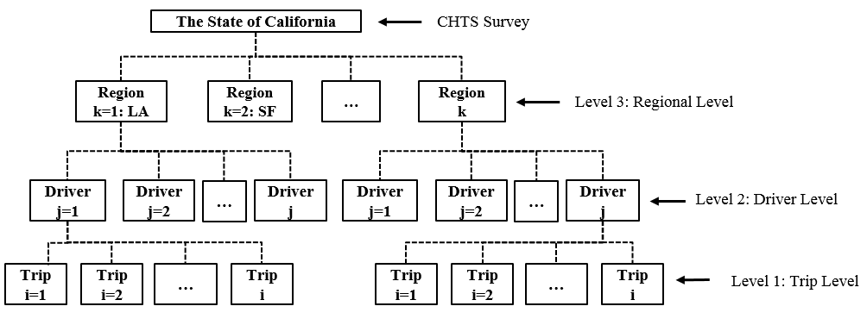
Figure 4.1 Hierarchical data structure used to understand driving behavior

Since the trips made by the same driver are not independent from each other, assumption of independent observations required for traditional OLS (Ordinary Least Squares) regression models is violated [110]. Therefore, the inter-driver difference and inter-trip difference cannot be estimated accurately without considering the multilevel nature of data and group differences. One method to statistically account for hierarchical structure of data is to use multi-level or hierarchical linear modeling. Hierarchical linear modeling can accommodate non-independence of observations and the heterogeneity of variance across repeated measures (i.e., the same driver made multiple trips). Using hierarchical linear modeling, both the within and between group associations are simultaneously taken into account. The modeling structures are further discussed along with the modeling outputs in next section.

4.4 RESULTS

4.4.1 Descriptive Statistics

4.4.1.1 Socio-Demographics and Travel Characteristics
Tables 4.2 and 4.3 present the statistics structured at each level of the hierarchy. Notably, observations with missing information (e.g., no driver age or gender) were removed. The final dataset contains 50,399 trips made by 2,356 drivers from five California regions. Specifically, there are 22,801 trips made by 1,030 drivers from LA, 10,736 trips made by 500 drivers from SF, 5,106 trips made by 255 drivers from SAC, 5,661 trips made by 245 drivers from CCV and 6,095 trips made by the rest of 326 drivers from other areas. For level-1, the trip level, there are no specific clusters. For level-2, driver level, there are 2,365 groups (or drivers); on average each driver made 21 trips (min = 1, max = 79). For level-3, the regional level, the distribution of observation is show in Table 4.

Table 4.2 Distributions of Observations at Each Hierarchy
Level | No. of Groups | Trips per Group
Level | No. of Groups | Minimum | Average | Maximum
Level 1 | 50,399 trips | 1 | - | 1
Level 2 | 2,356 respondents | 1 | 21.4 | 79
Level 3 | 5 regions | 5,106 | 10,080 | 22,801

Table 4.3 Distributions of Observations at Level-3
Region | Trips in Region | Percentage | Drivers in Region |  |  | Percentage
LA | 22,801 | 45.24% |  | 1,030 |  | 43.72%
SF | 10,736 | 21.30% |  | 500 |  | 21.22%
SAC | 5,106 | 10.13% |  | 255 |  | 10.82%
CCV | 5,661 | 11.23% |  | 245 |  | 10.40%
Other CA | 6,095 | 12.09% |  | 326 |  | 13.84%
Total | 50,399 | 100.00% |  | 2,356 |  | 100.00%

4.4.1.2 Descriptive Statistics of Hierarchical Linear Model
Descriptive statistics of key variables are shown in Table 5. The numbers seem reasonable and were error checked. Volatility score is measured for 50,399 trips in the database. The average volatility score is 14.31%. The average trip distance was 9.02 mile (min = 0.07 mile, max = 342.78 mile), corresponding to average trip duration of 14.57 minutes and average speed was 29.13 mph; 46.2% of trips were made during rush hours, 22.9% were made on weekends and 16.4% were commute trips (between home and school/work).

Among 2,365 respondents, the mean driver age was 48.9 years, ranging from 16 to 87 years; 48.7% were males. The mean vehicle age in the final dataset was 7 years. Trips were made with vehicles with various body types, fuel uses, transmissions and power systems. 42.6% of vehicles were auto sedans, 77.1 % of vehicles were of gasoline fuel type, 85.7% were automatic and 53% were front-wheel drive. Hybrid electric vehicles (HEV) were 13% of the sample, while AFVs were collectively about 5.5%, i.e., PHEV were 0.8%, CNG 1.0%, and BEV 3.7%.

The covariates at level-3 model are dummy variables for CA regions. Notably, for hierarchical modeling, in addition to the fixed-effects parameters in Table 4.4, there are random-effect parameters (or group variables) which are based on driver ID for level-1 observation groupings and region ID for level-2 observation groupings.

Table 4.4 Descriptive Statistics for Behavioral Data
Covariates |  |  | N |  | Mean | Std. Dev. | Min | Max
Dependent | Volatility Score |  | 50,399 |  | 14.305 | 7.534 | 0.000 | 67.969
Dependent | $$\sqrt{Volatility Score}$$ |  | 50,399 |  | 3.648 | 1.000 | 0.000 | 8.244
Level-1 Predictors | Trip Distance (Mile) |  | 50,399 |  | 9.015 | 15.259 | 0.077 | 342.477
Level-1 Predictors | Trip Duration (Minute) |  | 50,399 |  | 14.570 | 17.097 | 2.000 | 363.100
Level-1 Predictors | Trip Average Speed (MPH) |  | 50,399 |  | 29.129 | 12.718 | 2.213 | 71.255
Level-1 Predictors | *Rush Hour [Yes=1, No=0] |  | 50,399 |  | 0.462 | 0.499 | 0 | 1
Level-1 Predictors | Weekend [Yes=1, No=0] |  | 50,399 |  | 0.229 | 0.420 | 0 | 1
Level-1 Predictors | Commute Trip [Yes=1, No=0] |  | 50,399 |  | 0.164 | 0.370 | 0 | 1
Level-2 Predictors | Gender [Male=1, Female=0] |  |  | 2,356 | 0.487 | 0.500 | 0 | 1
Level-2 Predictors | Driver Age (years) |  |  | 2,356 | 48.907 | 13.387 | 16 | 87
Level-2 Predictors | Vehicle Age (years) |  |  | 2,356 | 7.048 | 4.722 | 0 | 52
Level-2 Predictors | Body Type | Auto-Sedan |  | 2,356 | 0.426 | 0.495 | 0 | 1
Level-2 Predictors | Body Type | Two Seated |  | 2,356 | 0.059 | 0.235 | 0 | 1
Level-2 Predictors | Body Type | Van |  | 2,356 | 0.057 | 0.232 | 0 | 1
Level-2 Predictors | Body Type | Hatchback |  | 2,356 | 0.081 | 0.272 | 0 | 1
Level-2 Predictors | Body Type | SUV |  | 2,356 | 0.193 | 0.395 | 0 | 1
Level-2 Predictors | Body Type | Station Wagon |  | 2,356 | 0.040 | 0.196 | 0 | 1
Level-2 Predictors | Body Type | Pickup |  | 2,356 | 0.131 | 0.337 | 0 | 1
Level-2 Predictors | Body Type | Convertible |  | 2,356 | 0.014 | 0.118 | 0 | 1
Level-2 Predictors | Fuel Type | Hybrid Elec. Vehicles |  | 2,356 | 0.130 | 0.337 | 0 | 1
Level-2 Predictors | Fuel Type | Gasoline Vehicles |  | 2,356 | 0.771 | 0.420 | 0 | 1
Level-2 Predictors | Fuel Type | Diesel Vehicles |  | 2,356 | 0.037 | 0.190 | 0 | 1
Level-2 Predictors | Fuel Type | Plug In Hybrid Elec. Veh. |  | 2,356 | 0.008 | 0.089 | 0 | 1
Level-2 Predictors | Fuel Type | CNG (C. Natural Gas) |  | 2,356 | 0.010 | 0.098 | 0 | 1
Level-2 Predictors | Fuel Type | BEV (Electric) Vehicles |  | 2,356 | 0.037 | 0.188 | 0 | 1
Level-2 Predictors | Fuel Type | Unknown Vehicle type |  | 2,356 | 0.007 | 0.082 | 0 | 1
Level-2 Predictors | Trans-mission | Automatic |  | 2,356 | 0.857 | 0.350 | 0 | 1
Level-2 Predictors | Trans-mission | Manual |  | 2,356 | 0.103 | 0.304 | 0 | 1
Level-2 Predictors | Trans-mission | Both |  | 2,356 | 0.035 | 0.184 | 0 | 1
Level-2 Predictors | Trans-mission | Unknown |  | 2,356 | 0.005 | 0.071 | 0 | 1
Level-2 Predictors | Power Train | Front-Wheel |  | 2,356 | 0.530 | 0.499 | 0 | 1
Level-2 Predictors | Power Train | Rear-Wheel |  | 2,356 | 0.174 | 0.379 | 0 | 1
Level-2 Predictors | Power Train | Four-Wheel |  | 2,356 | 0.190 | 0.392 | 0 | 1
Level-2 Predictors | Power Train | Unknown |  | 2,356 | 0.107 | 0.309 | 0 | 1
Level-3 Predictors # | Region Indicator | LA |  | 5 | - | - | 0 | 1
Level-3 Predictors # | Region Indicator | SF |  | 5 | - | - | 0 | 1
Level-3 Predictors # | Region Indicator | SAC |  | 5 | - | - | 0 | 1
Level-3 Predictors # | Region Indicator | CCV |  | 5 | - | - | 0 | 1
Level-3 Predictors # | Region Indicator | Other |  | 5 | - | - | 0 | 1
Note:
*: Rush hours are AM (6:30 am-10:00 am) or PM (3:30 pm-7:00 pm);
#: Level-3 predictors are regional indicators that are indicator variables (0 or 1). They provide information about the region of the driver/vehicles at level-2.

4.4.1.3 Comparisons of Alternative Fuel Vehicles with Conventional Vehicles
Several comparisons of AFV and conventional vehicle use are shown in Table 4.5, along with t-tests with conventional vehicles. While the results show some differences, they suggest that AFVs cannot be viewed as monolithic. There are important differences within AFV use and performance that need to be explored, i.e., there are subtle but important differences within AFVs (e.g., PHEV vs. BEV and PHEV vs. CNG).
The key results are summarized below:
- No statistically significant differences (p<0.05) were observed between AFVs and conventional vehicles in terms of total daily trips, except drivers of BEVs made significantly fewer trips (p<0.01).
- The daily distances traveled are shorter for some AFVs (BEV and PHEV) and longer for other AFVs (HEV and CNG) compared with gasoline vehicles.
- Drivers spent significantly longer time traveling daily in their HEV or CNG vehicles compared with conventional vehicles.
- While slightly more time was spent on deceleration by some AFVs (BEV and PHEV) compared with gasoline vehicles, clear trends did not emerge in terms of time spent on accelerations or deceleration.
- The differences between AFVs and conventional vehicles were not in the same direction when it comes to vehicular jerk.
- HEVs and BEVs had relatively smaller volatility score compared with gasoline vehicles, but PHEV and CNG showed higher volatility scores.
These comparisons have revealed important behavioral differences. A key measure of driving practices-the driving volatility is selected for further modeling. The next step is to use the hierarchical structure of the data to explore associations of AFVs and volatility, while controlling for other factors.

Table 4.5 Comparisons between Conventional Gasoline Vehicles and AFVs (plus Hybrid)
 | Conventional Vehicles |  |  | Alternative Fuel Vehicles
Travel Attributes | Gasoline Vehicle | Diesel Vehicle |  | Hybrid EV |  | PHEV |  | Battery EV |  | CNG (Natural Gas) Vehicle
Number of vehicles in dataset | 1817 | 88 |  | 307 |  | 19 |  | 86 |  | 23
% of large passenger vehicles ^ | 43.60% | 50% |  | 16% |  | 0 |  | 2.30% |  | 4.30%
Total trips in dataset | 38563 | 2011 |  | 6904 |  | 391 |  | 1708 |  | 484
Mean daily trips | 4.23 | 4.46 | * | 4.2 |  | 4.03 |  | 3.72 | *** | 4.4
Total VMT (mile) | 334418 | 23257.3 |  | 70669.57 |  | 2984.99 |  | 14477.14 |  | 5004.41
Mean daily VMT (mile) | 35.47 | 49.14 | *** | 43.54 | *** | 29.25 | * | 30.73 | ** | 47.98 | ***
Total duration (hour) | 9054.31 | 579.64 |  | 1876.37 |  | 88.6 |  | 421.47 |  | 129.81
Mean daily duration (hour) | 0.96 | 1.23 | *** | 1.14 | *** | 0.87 |  | 0.9 |  | 1.25 | ***
% of short trips (< 3 miles) | 41.63% | 35.20% |  | 35.81% |  | 37.60% |  | 34.37% |  | 35.96%
% of long trips (> 25 miles) | 7.43% | 11.79% |  | 9.57% |  | 3.58% |  | 6.85% |  | 9.71%
Mean % time on idling per trip | 9.50% | 8.99% | *** | 8.77% | *** | 9.06% |  | 8.60% | *** | 8.85% | **
Mean % time on extended stable driving per trip # | 5.16% | 7.03% | *** | 5.61% | *** | 4.82% |  | 6.92% | *** | 6.19% | ***
Mean % time on acceleration per trip | 44.89% | 44.02% | *** | 44.81% |  | 44.88% |  | 43.46% | *** | 45.08%
Mean % time on deceleration per trip | 39.59% | 39.21% | *** | 39.81% | *** | 40.50% | *** | 40.22% | *** | 39.13% | **
Mean speed (mph) | 28.59 | 30.06 | *** | 29.51 | *** | 28.85 |  | 28.94 |  | 31.19 | ***
Maximum speed (mph) | 80.16 | 80.06 |  | 80.07 |  | 80.01 |  | 80.05 |  | 80.05
Mean acceleration (ft/s²) | 1.47 | 1.36 | *** | 1.42 | *** | 1.49 |  | 1.44 | ** | 1.48
Maximum acceleration (ft/s²) | 14.37 | 13.57 |  | 12.11 |  | 11.95 |  | 12.42 |  | 9.54
Mean deceleration (ft/s²) | -1.60 | -1.46 | *** | -1.54 | *** | -1.60 |  | -1.49 | *** | -1.65 | *
Maximum deceleration (ft/s²) | -16.00 | -13.26 |  | -13.76 |  | -12.97 |  | -12.18 |  | -12.48
Mean positive vehicular Jerk (ft/s³) | 0.54 | 0.48 | *** | 0.52 | *** | 0.55 | * | 0.52 | *** | 0.54
Maximum positive vehicular Jerk (ft/s³) | 13.09 | 13.57 |  | 12.11 |  | 9.38 |  | 12.42 |  | 9.54
Mean negative vehicular Jerk (ft/s³) | -0.41 | -0.38 | *** | -0.40 | *** | -0.43 | ** | -0.40 | *** | -0.41
Maximum negative vehicular Jerk (ft/s³) | -5.84 | -6.51 |  | -5.17 |  | -4.94 | *** | -5.42 |  | -4.49
Mean driving volatility score (%) | 14.46 | 12.92 | *** | 13.86 | *** | 15.49 | *** | 13.69 | *** | 15.43 | ***
Maximum driving volatility score (%) | 67.97 | 57.7 |  | 51.64 |  | 46.33 |  | 56.34 |  | 48.48
Notes:
1. ^: Large passenger vehicles are VAN, SUV and Pickups, compared with auto-sedan, convertible, hatchback, etc.;
2. #: Extended stable driving was defined by speed is above 30 mph and acceleration is less than 0.088 (ft/s2). Acceleration threshold was calibrated using test driving data;
3. Variable in Italics show results of t-tests, for comparisons between vehicle group vs. conventional vehicles;
4. *** = t-test significant at a 99% confidence level; ** = t-test significant at a 95%confidence level; * = t-test significant at a 90% confidence level. The base for comparative t-tests are conventional Gasoline Vehicles (GV).

4.4.2 Multi-Level Modeling
Figure 4.2 shows the distributions of driving volatility score at each level. At the region level, Los Angeles has a relatively larger mean volatility score than other regions. The driver-level distribution is the distribution of mean volatility scores of 2,356 drivers, since on average one driver made 21 trips in the CHTS survey (as shown in Table 2). At the trip-level, the distribution is right-skewed, as shown in the figure at the top right. While other transformation were tested, a square-root transformation shifted the shape closer to normal, as shown in the bottom right figure. The dependent variable for the hierarchical model was the square-root of volatility score.
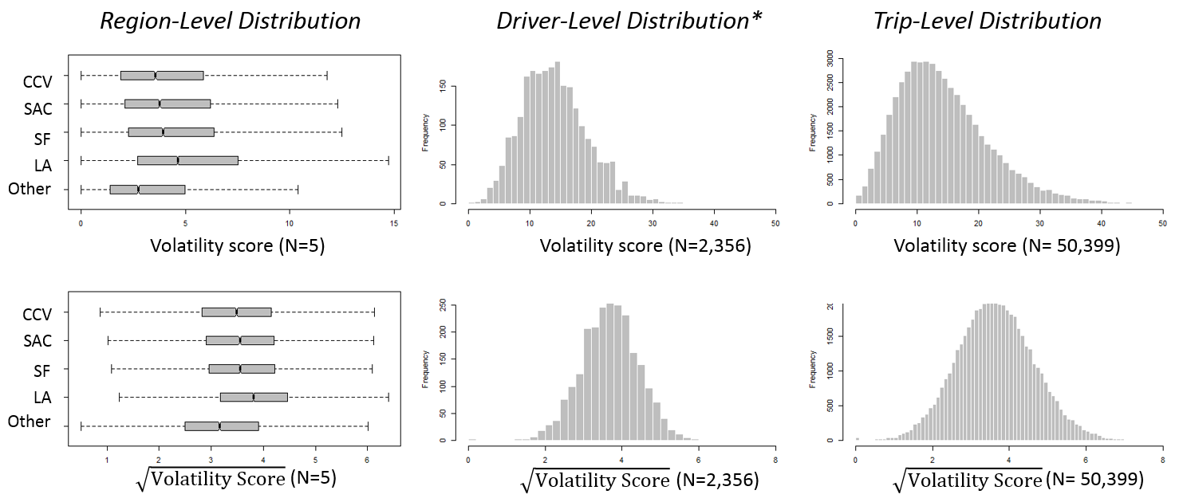
* Driver-level distribution is the distribution of mean volatility scores of 2,356 drivers
Figure 4.2 Distributions of volatility scores at trip, driver, and regional levels

4.4.2.1 Variance-Component Model
Before considering all correlates, which can have both fixed and random effects, this study examined the variances of responses (i.e., square-root driving volatility score) at each level by applying a simple Variance-Component Model, i.e., a constant only model. The model structure used for this is as follows:
$Y_{ijk}=β_{0jk}+e_{ijk}$
$β_{0jk}=π_{00k}+r_{0jk}$
$π_{00k}=γ_{000}+φ_{00k}$
Or,
$Y_{ijk}=γ_{000}+{ φ}_{00k}+r_{0jk}+e_{ijk}$ Equation 4.3
Where,
$Y_{ijk}$ = driving volatility score for trip (i) made by driver (j) in region (k);
$γ_{000}$ = grand mean (of transformed) driving volatility score of 50,399 trips;
$φ_{00k}$ = standard deviation at level-3 (regional level);
$r_{0jk}$ = standard deviation at level-2 (driver level);
$e_{ijk}$ = standard deviation at level-1 (trip level).

Note that the output of hierarchical modeling generally has three components: 1) fixed-effects parameters, 2) variance estimation of random-effects parameters, and 3) summary statistics. Since the second component is the major focus before the final hierarchical modeling step, the coefficients of fixed-effects parameters are not presented until the last modeling step owing to space limitations.

The outputs of Variance-Component Models are shown in Table 4.6. Results show that 3.526 is the estimate of grand mean (of the square-root) of driving volatility for 50,399 trips. Averaging across drivers and regions, the expected volatile driving time accounts for 3.526*3.526 =12.43% of the trip duration. The estimates of variance components reveal that there are 0.047 (4.6%), 0.452 (44.5%) and 0.517 (50.9%) variances at regional, driver and trip levels respectively. The standard deviations at each level are 0.216, 0.672 and 0.719 respectively. Clearly, driver level has a sizable variance (44.5%) component, so the use of hierarchal modeling is valuable.

Table 4.6 Outputs of Variance-Component Model
Effect Type | Terms | Coef. | Std. Err. | P-value | 95% Conf. Interval
 |  |  |  |  | Lower | Upper
Fixed-Effects | Constant, $γ$ | 3.526 | 0.098 | 0.000 | 3.334 | 3.718
Random-Effects | Region ID: Identity
Random-Effects | Variance (Constant) , $φ^{2}$ | 0.047 | 0.030 |  | 0.013 | 0.166
Random-Effects | Driver ID: Identity
Random-Effects | Variance (Constant), $r^{2}$ | 0.452 | 0.014 |  | 0.425 | 0.481
Random-Effects | Variance (Residual), $e^{2}$ | 0.517 | 0.003 |  | 0.511 | 0.524
SUMMARY STATISTICS | Number of Observations | 50399
SUMMARY STATISTICS | Number of Groups (Driver ID) | 2356
SUMMARY STATISTICS | Number of Groups (Region ID) | 5
SUMMARY STATISTICS | Log Likelihood | -58188.6
SUMMARY STATISTICS | Wald $χ^{2}$ | -
SUMMARY STATISTICS | Prob > $χ^{2}$ | -

4.4.2.2 Random Intercept Model
Covariates can be added to explain these variances. Level-related predictors can explain the corresponding variances estimated by variance-component model, as shown in Table 4.6. At this step, the predictors at higher level explain the variance of the intercept in the lower level model. In other words, only the intercepts are random and coefficients of predictors are fixed. The Random Intercept Model’s formulation is as follows:
$Y_{ijk}=β_{0jk}+β_{ijk}(Level 1 predictors)+e_{ijk}$
$β_{0jk}=π_{00k}+π_{01k}(Level 2 predictors)+r_{0jk}$
$π_{00k}=γ_{000}+γ_{001}(Level 3 predictors)+φ_{00k}$
Or,
$Y_{ijk}=γ_{000}+γ_{001}(Level 3 predictors)+φ_{00k}+π_{01k}(Level 2 predictors)+r_{0jk} +β_{ijk}(Level 1 predictors)+e_{ijk}$ Equation 4.4
Where,
$Y_{ijk}$ = driving volatility score for trip (i) made by driver (j) in region (k);
$γ_{000}$ = grand mean (of transformed) driving volatility score of 50,399 trips;
$γ_{001}$ = coefficients for level-3 predictors (i.e., dummy variable);
$π_{01k}$= coefficients for level-2 predictors (i.e., driver and vehicle characteristic);
$β_{ijk}$= coefficients for level-1 predictors (i.e., trip-related factors);
$φ_{00k}$ = root of unexplained variance at level-3 (regional level);
$r_{0jk}$ = root of unexplained variance at level-2 (driver level);
$e_{ijk}$ = root of unexplained variance at level-1 (trip level).

Table 4.7 presents the unexplained variances at the three levels from the Random Intercept Model. Since the focus is on unexplained variances at three levels, only the random-effects part is presented. The results in Table 4.7 show that the variances at three levels became smaller from those reported in Table 4.6, with predictors explaining some of the variation. Notably, the variance at level-3 (regional level) was explained nearly 100% by the level-3 predictors (nearly zero variance remains). Thus, level-1 and level-2 predictors have constant effects across regions and there is no need to add predictors to explain variances at level-3.

Table 4.7 Outputs of Random Intercept Model
Effect Type | Terms | Coef. | Std. Err. | P-value | 95% Conf. Interval
 |  |  |  |  | Lower | Upper
Fixed-Effects | Constant, $γ_{000}$ | 3.947 | 0.073 | 0.000 | 3.804 | 4.090
Fixed-Effects | Level-1 Predictors, $β_{ijk}$ | - | - | - | - | -
Fixed-Effects | Level-2 Predictors, $π_{01k}$ | - | - | - | - | -
Fixed-Effects | Level-3 Predictors,$γ_{001}$ | - | - | - | - | -
Random-Effects | Region ID: Identity
Random-Effects | Variance (Constant) , $φ^{2}$ | 1.25E-12 | 2.47E-11 |  | 1.62E-29 | 9.57E+04
Random-Effects | Driver ID: Identity
Random-Effects | Variance (Constant), $r^{2}$ | 0.388 | 0.012 |  | 0.365 | 0.414
Random-Effects | Variance (Residual), $e^{2}$ | 0.509 | 0.003 |  | 0.502 | 0.515
SUMMARY STATISTICS | Number of Observations | 50399
SUMMARY STATISTICS | Number of Groups (Driver ID) | 2356
SUMMARY STATISTICS | Number of Groups (Region ID) | 5
SUMMARY STATISTICS | Log Likelihood | -57627.017
SUMMARY STATISTICS | Wald $χ^{2}$ | 1409.78
SUMMARY STATISTICS | Prob > $χ^{2}$ | 0.000

4.4.2.3 Random Intercept and Slope Model
There is a sizable unexplained variance (0.388, 43.3%) at level-2. Two ways to reduce unexplained variance are: 1) by adding level-2 predictors (driver- and vehicle-related factors); 2) by adding random effects for level-1 (trip level) predictors. For this study, additional level-2 predictors are not available. Random effects of level 1 predictors can be revealed through hierarchical modeling. In addition to the intercepts at level-1 the slopes at level-1 also become the dependent variable at level-2. In this case, the effects of level-1 predictors have two components: fixed effects that explain level-1 variance and random effects that explain level-2 variance. The Random Intercept and Slope Model’s formulation is as follows:
$Y_{ijk}=β_{0jk}+β_{ijk}(Level 1 predictors)+e_{ijk}$
$β_{0jk}=π_{00k}+π_{01k}(Level 2 predictors)+r_{0jk}$
$β_{ijk}=π_{j0k}+ π_{j1k} (Level 2 predictors)+r_{ijk}$
$π_{00k}=γ_{000}+γ_{001}(Level 3 predictors)+φ_{00k}$
$π_{j0k}$ =${ γ}_{j00}+γ_{j01}(Level 3 predictors)+φ_{i0k}$
Or,
$Y_{ijk}=γ_{000}+γ_{001}(Level 3 predictors)+φ_{00k}+π_{01k}(Level 2 predictors)+r_{0jk}+{(γ}_{j00}+γ_{j01}(Level 3 predictors)+φ_{i0k} + π_{j1k} (Level 2 predictors)+r_{ijk}) (Level 1 predictors)+e_{ijk}$ Equation 4.5

From Table 4.7, we know that there is nearly zero unexplained variance left at level-3, the level-2 predictors, i.e., driver and vehicle characteristics, have only fixed effects across regions. Only level-1 predictors, i.e., trip attributes, have both fixed effects and random effects that need to be tested further. Thus, Equation 4.5 can be simplified to:
$Y_{ijk}=γ_{000}+γ_{001}\left(Level 3 predictors\right)+φ_{00k}+π_{01k}\left(Level 2 predictors\right)+r_{0jk}+{(β}_{ijk}+τ_{ijk}) (Level 1 predictors)+e_{ijk}$ Equation 4.6
Where,
$Y_{ijk}$ = driving volatility score for trip (i) made by driver (j) in region (k);
$γ_{000}$ = grand mean (of transformed) driving volatility score of 50,399 trips;
$γ_{001}$ = coefficients for level-3 predictors (i.e., dummy variable);
$π_{01k}$= coefficients for level-2 predictors (i.e., driver and vehicle characteristic);
$β_{ijk}$= coefficients for level-1 predictors (i.e., trip-related factors);
$τ_{ijk}$= root of variance of level-1 predictor coefficients across drivers;
$φ_{00k}$ = root of unexplained variance at level-3 (regional level);
$r_{0jk}$ = root of unexplained variance at level-2 (driver level);
$e_{ijk}$ = root of unexplained variance at level-1 (trip level).

Table 4.8 presents the results of Random Intercept and Slope Model, including estimates of fixed- and random- effects parameters with a reasonable goodness of fit. The results show noticeable variances of level-1 slopes i.e., the variances for weekend vs. weekday travel and commute vs. non-commute trip are relatively large. Finally, the percentage of explained variance is 13.3 % (1-0.448/0.517) at Level-1, 14.8% (1-0.385/0.452) at Level-2, and close to 100% at Level-3.

4.4.3 Variable Selection
Outputs of the model with all plausible variables (shown in Table 4.8) show that the factor of transmission does not have a significant estimate and the factor of gender does not show a significant correlation with driving volatility. Thus, the variable selection was conducted to eliminate insignificant variables. Considering the massive computation of multi-level model with a large number of observation as well as the fact that most variables show significant correlations with driving volatility, the backward elimination method is applied for the variable selection [111].

Further, we notice that, some levels of attributions of categorical variables, such as body type, fuel type and power train are not statistically significant. Insignificant levels are combined with the base level. The final model shows all selected variables have statistically significant correlates with driving volatility.
Table 4.8 Outputs of Random Intercept and Slope Model
Model |  |  | Full model |  |  | Model after  backward  elimination |  |  | Final model after  bases combined
Y = $\sqrt{Driving Volatility Score}$ |  |  | Coef. |  | P-value | Coef. |  | P-value | Coef. |  | P-value
Fixed-effects Parameters
Constant,$γ_{000}$ |  |  | 3.958 | *** | 0.000 | 3.954 | *** | 0.000 | 3.928 | *** | 0.000
Level-1 Predictors  $$β_{ijk}$$ | Trip Distance (Miles) |  | -0.008 | *** | 0.000 | -0.008 | *** | 0.000 | -0.008 | *** | 0.000
Level-1 Predictors  $$β_{ijk}$$ | Rush Hour [Yes=1, No=0] |  | 0.042 | *** | 0.000 | 0.042 | *** | 0.000 | 0.042  0.042 | *** | 0.000
Level-1 Predictors  $$β_{ijk}$$ | Weekend [Yes=1, No=0] |  | -0.077 | *** | 0.000 | -0.077 | *** | 0.000 | -0.077 | *** | 0.000
Level-1 Predictors  $$β_{ijk}$$ | Commute Trip [Yes=1, No=0] |  | 0.093 | *** | 0.000 | 0.093 | *** | 0.000 | 0.093 | *** | 0.000
Level-2 Predictors  $$π_{01k}$$ | Gender [Male=1, Female=0] |  | 0.006 |  | 0.836
Level-2 Predictors  $$π_{01k}$$ | Driver Age (years) |  | -0.008 | *** | 0.000 | -0.008 | *** | 0.000 | -0.007 | *** | 0.000
Level-2 Predictors  $$π_{01k}$$ | Vehicle Age (years) |  | -0.019 | *** | 0.000 | -0.020 | *** | 0.000 | -0.018 | *** | 0.000
Level-2 Predictors  $$π_{01k}$$ | Body Type | Auto-Sedan | Base
Level-2 Predictors  $$π_{01k}$$ | Body Type | Two Seated | 0.191 | *** | 0.002 | 0.179 | *** | 0.004 | 0.208 | *** | 0.001
Level-2 Predictors  $$π_{01k}$$ | Body Type | Van | -0.309 | *** | 0.000 | -0.302 | *** | 0.000 | -0.286 | *** | 0.000
Level-2 Predictors  $$π_{01k}$$ | Body Type | Hatchback | -0.103 | * | 0.068 | -0.106 | * | 0.061
Level-2 Predictors  $$π_{01k}$$ | Body Type | SUV | -0.114 | *** | 0.008 | -0.111 | *** | 0.009 | -0.074 | *** | 0.007
Level-2 Predictors  $$π_{01k}$$ | Body Type | Station Wagon | -0.024 |  | 0.750 | -0.028 |  | 0.712
Level-2 Predictors  $$π_{01k}$$ | Body Type | Pickup | -0.407 | *** | 0.000 | -0.409 | *** | 0.000 | -0.374 | *** | 0.000
Level-2 Predictors  $$π_{01k}$$ | Body Type | Convertible | 0.287 | ** | 0.017 | 0.278 | ** | 0.020 | 0.323 | *** | 0.007
Level-2 Predictors  $$π_{01k}$$ | Fuel Type | Hybrid Elec. Vehicles | -0.166 | *** | 0.000 | -0.162 | *** | 0.000 | -0.174 | *** | 0.000
Level-2 Predictors  $$π_{01k}$$ | Fuel Type | Gasoline Vehicles | Base
Level-2 Predictors  $$π_{01k}$$ | Fuel Type | Diesel Vehicles | -0.119 |  | 0.122 | -0.117 |  | 0.125
Level-2 Predictors  $$π_{01k}$$ | Fuel Type | Plug In Hybrid Elec. V. | -0.107 |  | 0.499 | -0.099 |  | 0.530
Level-2 Predictors  $$π_{01k}$$ | Fuel Type | CNG (C. Natural Gas) | -0.136 |  | 0.336 | -0.129 |  | 0.363
Level-2 Predictors  $$π_{01k}$$ | Fuel Type | BEV (Electric) Vehicles | -0.315 | *** | 0.000 | -0.300 | *** | 0.000 | -0.325 | *** | 0.000
Level-2 Predictors  $$π_{01k}$$ | Fuel Type | Unknown Vehicle type | 0.046 |  | 0.788 | 0.051 |  | 0.764
Level-2 Predictors  $$π_{01k}$$ | Trans-mission | Automatic | Base
Level-2 Predictors  $$π_{01k}$$ | Trans-mission | Manual | -0.070 |  | 0.145
Level-2 Predictors  $$π_{01k}$$ | Trans-mission | Both | 0.010 |  | 0.896
Level-2 Predictors  $$π_{01k}$$ | Trans-mission | Unknown | 0.125 |  | 0.535
Level-2 Predictors  $$π_{01k}$$ | Power Train | Front-Wheel | Base
Level-2 Predictors  $$π_{01k}$$ | Power Train | Rear-Wheel | 0.071 | * | 0.097 | 0.071 | * | 0.099
Level-2 Predictors  $$π_{01k}$$ | Power Train | Four-Wheel | -0.119 | *** | 0.007 | -0.118 | *** | 0.007 | -0.149 | *** | 0.000
Level-2 Predictors  $$π_{01k}$$ | Power Train | Unknown | 0.002 |  | 0.966 | 0.002 |  | 0.973
Level-3 Predictors  $$γ_{001}$$ | Region Indicator | LA | 0.529 | *** | 0.000 | 0.531 | *** | 0.000 | 0.528 | *** | 0.000
Level-3 Predictors  $$γ_{001}$$ | Region Indicator | SF | 0.358 | *** | 0.000 | 0.359 | *** | 0.000 | 0.352 | *** | 0.000
Level-3 Predictors  $$γ_{001}$$ | Region Indicator | SAC | 0.368 | *** | 0.000 | 0.371 | *** | 0.000 | 0.370 | *** | 0.000
Level-3 Predictors  $$γ_{001}$$ | Region Indicator | CCV | 0.227 | *** | 0.000 | 0.231 | *** | 0.000 | 0.236 | *** | 0.000
Level-3 Predictors  $$γ_{001}$$ | Region Indicator | Other | Base

Table 4.8 Outputs of Random Intercept and Slope Model (Continued)
Model | Full model |  |  | Model after  backward  elimination |  |  | Final model after  bases combined
Y = $\sqrt{Driving Volatility Score}$ | Coef. |  | P-value | Coef. |  | P-value | Coef. |  | P-value
Random-effects Parameters
Region ID: Identity
Variance (Constant), $φ^{2}$ | 1.90E-19 |  |  | 1.89E-19 |  |  | 1.87E-19
Driver ID: Identity
Variance (Distance), $τ_{1}^{2}$ | 0.000 |  |  | 0.000 |  |  | 0.000
Variance (Rush Hour), $τ_{2}^{2}$ | 0.039 |  |  | 0.039 |  |  | 0.039
Variance (Weekend), $τ_{3}^{2}$ | 0.110 |  |  | 0.110 |  |  | 0.110
Variance (Commute Trip), $τ_{4}^{2}$ | 0.107 |  |  | 0.107 |  |  | 0.107
Variance (Constant), $r^{2}$ | 0.385 |  |  | 0.385 |  |  | 0.387
Variance (Residual), $e^{2}$ | 0.448 |  |  | 0.448 |  |  | 0.448
Goodness of Fit
Number of Observations | 50399 |  |  | 50399 |  |  | 50399
Number of Groups (Driver ID) | 2356 |  |  | 2356 |  |  | 2356
Number of Groups (Region ID) | 5 |  |  | 5 |  |  | 5
Log Likelihood | -56580.394 |  |  | -56581.697 |  |  | -56586.955
Wald $χ^{2}$ | 919.89 |  |  | 916.760 |  |  | 903.550
Prob > $χ^{2}$ | 0.000 |  |  | 0.000 |  |  | 0.000
*** = significant at a 99% confidence level; ** = significant at a 95%confidence level; * = significant at a 90% confidence level.

4.4.4 Discussion of Key Predictors
In the final hierarchical linear model reported in Table 4.8, Level-1 predictors about trip characteristics have significant associations (95% confidence level) with the driving volatility but the associations vary across drivers, i.e., same trip level factors may have different estimated coefficients in different groups of drivers. Level-2 predictors, including driver demographics and vehicle features show significant associations with driving volatility except driver gender and vehicle transmission. Slopes of level-2 predictors do not vary substantially across the CA regions. Among level-2 predictors, the fuel types vehicles consume are of particular interest of this study, especially the driving volatility of alternative fuel vehicles. The examination of driving volatility between regions at Level-3 shows significant differences between regions. Note that, interactions among explanatory variables were tested, such as fuel type and gender, fuel type and age, etc., but none were found to be statistically significant (95% confidence level).

4.4.3.1 Vehicle Fuel Type
The volatility of several alternative fuel vehicles (PHEV, BEV, and CNG), and hybrid vehicles was explored in comparison with gasoline vehicles, which served as the “base.” Results show that hybrid electric vehicles are associated with lower volatility scores, by 0.174 units (square-root of driving volatility score). The marginal effects show 8% lower the volatility score magnitude. Note that, one unit lower/higher in volatility score refers to one percent decrease/increase in time spent on volatile/abnormal driving. This result is consistent with an EPA report pointing out that hybrid vehicle drivers tend to be more calm and are able to get better fuel economy [112]. The lower volatility score in this study corresponds to less variability of instantaneous driving behavior meaning calmer or smoother driving. In addition to driver attributes and preferences, special vehicle power systems may be part of the reason for the observed lower volatility, i.e., in eco-driving mode, the same acceleration pedal depression for hybrid vehicles generates smoother torque and traction [113]. Further, special driving instructions for hybrid vehicles are often provided to drivers. For example, Toyota suggests that when encountering a delay (intersection signal or congested traffic) drivers should release the brake pedal to allow the vehicle to move forward slightly while avoiding overuse of the acceleration pedal [113].

Among AFVs, battery electric vehicles are statistically significantly (95% confidence level) associated with lower volatility scores by 0.325 units (15% lower in terms of volatility score magnitude). While AFV drivers may be less aggressive compared with the same group of conventional vehicle drivers, it is also possible that the engine power of such vehicles may be lower in some instances. Specifically, the engine power of electric vehicles (including plug-in vehicles) depends on the battery level. Depending on the charge in batteries, they cannot always provide full power to the engine required by drivers to do hard accelerations [114]. Overall, there are clear differences between driver performance (volatility) of conventional and alternative fuel vehicles as revealed by analysis of large-scale behavioral data. While controlling for other factors the results from real-life data show that hybrid vehicles and BEV are associated with calmer driving patterns.

4.4.3.2 Vehicle Body Type
Vehicle type shows relatively large associations with the driving behavior in this study. Compared with the base including sedans, two-seated vehicles are associated with a 0.208 unit higher (square-root) volatility score average. Convertibles are also linked to an increased score, by 0.323 unit. All other types of vehicles are associated with lower levels of volatility score. Surprisingly, SUVs and pickups are associated with lower scores. The mass of vehicle may have impact on driving behavior. Compared with sedans, two-seated vehicles and convertibles, pickups and SUVs have greater weights and may not be maneuvered as easily as sedans.

4.4.3.3 Other Vehicle-Related Factors
Older vehicles are also associated with a decreased (square-root) volatility score of 0.018 unit. Vehicles using different transmissions do not show significant differences in terms of volatility. Four-wheel drive vehicles are related to lower driving volatility by 0.149 unit, compared with other vehicles.

4.4.3.4 Driver Demographics
Older drivers are seen to be less volatile than younger drivers. One year increase in driver age is associated with a 0.007 unit decrease in (square-root) driving volatility score. There is no significant difference between male and female drivers, in terms of driving volatility.

4.4.3.5 Trip Factors
The negative coefficient of trip distance implies a reverse relationship with driving volatility. Drivers are expected to be less volatile during longer trips and every 1 mile increase in trip distance is associated average 0.008 unit lower (square-root) volatility score with a variance less than 0.001 (standard deviation also less than 0.001). Compared with trips made during non-rush hours, trips made during rush hours are with an increased (square-root) driving volatility score by 0.042 with a variance of 0.039 (or standard deviation 0.198). Commute trips are expected to be with more volatile driving time, average by 0.093 with a variance of 0.107 (or standard deviation 0.327), compared with non-commute trips. Owing to lack of data availability, this study was unable to directly model the association of traffic congestion on driving volatility. However, commute trips and rush-hour trips are often made under congested driving conditions compared with non-commute or non-rush hour trips. This study captures congested driving through proxies of commute and rush hour trips, which are positively associated with higher driving volatility, as expected. Weekend trips are associated with a lower score by 0.077 with a variance of 0.11(or standard deviation 0.332). In short, only trip distance has a clearly negative association with the driving behavior across drivers and the associations of other predictors vary substantially between drivers (i.e., coefficients can be positive or negative across drivers).

4.4.3.6 Regional Comparisons
At level-3, the results showed that trips made in LA have a 0.528 unit higher (square-root) volatility score than the base (other regions of the CA). The SF and SAC regions have close expected volatility scores. Trips made in the Central Valley areas seem to be more volatile than the base areas, but are less volatile than the three metropolitan areas (i.e., LA, SF and SAC). Overall the magnitude of differences shows particularly volatile driving in LA.

4.5 LIMITATIONS
The data quality needs to be considered carefully. The response variable, driving volatility score, depends heavily on the second-by-second speed records. The records were generated from in-vehicle GPS and OBD devices and then processed by a professional survey research firm. Thus, the extent of measurement errors in the data is unknown.

Owing to the privacy issues related to driver information, the data sharing system does not release critical information that might help explain some of the variances between trips or drivers. The information includes geo-codes, roadway types used, traffic conditions when traveling, and surrounding land uses, etc. Self-selection in surveys is also a limitation of this study. This is a sample-based study, so reporting and coverage errors may be present.

4.6 CONCLUSIONS
This study contributes by exploring the use of alternative fuel vehicles by early adopters and comparing their use patterns with conventional vehicles. Firstly, the study uses a large-scale integrated behavioral and sensor database to explore use patterns, especially the short-term decisions made by drivers. Such databases have only recently become available, and also require substantial computing capability. Secondly, the challenge of simultaneously extracting valuable information from complex hierarchically structured data is achieved by the application of hierarchical modeling. Specifically, such modeling better controls for various associated factors, while exploring differences in driver behavior at three levels, i.e., trip level, driver/vehicle level and regional level.

The study answers important research questions about AFV use patterns and driving practices as they gain greater acceptance and popularity. In terms of use, AFV drivers make the same amount of trips as conventional vehicle drivers do, except that drivers of BEV make statistically significantly fewer trips (5% level). The daily distances traveled were shorter for some AFVs (BEV and PHEV) but longer for other AFVs (HEV and CNG) compared with conventional vehicles. Drivers spent significantly longer time traveling daily in their HEV or CNG vehicles compared with conventional vehicles.

The study also found important differences within AFV use patterns and driving practices. Specifically, the daily distances traveled are shorter for BEV and PHEV drivers and longer for HEV and CNG drivers compared with gasoline vehicles. HEV and BEV were found to be associated with calmer driving compared with conventional vehicles, i.e., they are less prone to aggressive accelerations and vehicular jerks. This result is consistent with an EPA study showing that hybrid vehicle drivers tend to be less aggressive. While there is statistical evidence that some AFVs are driven with lower volatility, conclusive evidence that all alternative fuel vehicles are associated with lower driving volatility compared with conventional vehicles was not found.
The implications of this research include:
- Potential benefits from improved safety. By studying driving volatility of individuals who use different vehicle types, implications for safer driving can be anticipated. Aggressive driving has been linked (statistically significantly) to higher injury severity, given a crash [15]. With AFVs driven less aggressively (especially HEV and BEV), safety benefits are expected to accrue. This information can be helpful to public agencies and also to the insurance industry that may offer different rates for AFVs.
- More informed vehicle use decisions. Findings from this study can help potential AFV users make more informed vehicle ownership and use choices. Based on the differences in behaviors highlighted in this study, the AFV industry can make customized marketing plans for promoting the use of AFVs in specific regions. Furthermore, potential buyers can see for themselves how the vehicles purchased are being used by early adopters. For example, this study found that users of BEV made fewer trips. Such information can be provided to potential buyers of BEVs.
- Improvements in accuracy of travel demand models. The study analyzes vehicle miles traveled, and daily trip frequency, etc. for various vehicle types. This has implications for travel demand models and their accuracy. If more AFVs are expected to diffuse through the system in the future then the forecasts can be adjusted accordingly. Specifically, trip generation can be adjusted based on AFV versus non-AFV vehicle ownership. Also, automobile ownership models are used to anticipate demand by regional planning agencies, international organizations (such as the World Bank), and the private sector (automobile manufacturers and oil companies). They are useful in forecasting tax revenues, energy use, and emissions. The results from this study can suggest that automobile ownership models should consider various AFV options available to consumers. The results also inform alternative fuel vehicle policies, given their usage, especially in communities that have (or are considering) favorable local and regional policies toward AFVs.
- Advancing large-scale data analytics. With an explosion in real-world large-scale behavioral and sensor/global positioning system data, this study comprehensively compares the performance of AFVs with conventional vehicles and suggests a timely methodology for analysis of such data.
Finally, more research is needed to further explore differences in AFV purchase and use patterns and how information about such decisions might be used to inform consumers’ future adoption decisions.

CUSTOMIZING DRIVING CYCLES TO SUPPORT COST-EFFECTIVE VEHICLE CHOICES: A MORE ACCURATE FUEL ECONOMY ESTIMATION USING LARGE-SCALE TRAJECTORY DATA
This chapter presents a revised version of a research paper by Jun Liu, Xin Wang and Asad J. Khattak. An early version entitled “Generating Fuel Economy Information to Support Cost-effective Vehicle Choices: Comparing Standard and Customized Driving Cycles” (Co-authors: Xin Wang, Jun Liu and Asad J. Khattak) was presented (TRB 15-4548) at The 94th Annual Meeting of Transportation Research Board in Washington, D.C., in January 2015.

ABSTRACT
Wider deployment of alternative fuel vehicles (AFVs) helps with increasing energy security and transitioning to clean vehicles. Ideally, adopters of AFVs are able to maintain as the same level of mobility as users of conventional vehicles while reducing energy use and emissions. Greater knowledge of benefits of using AFVs can better customers’ choices. The Environmental Protection Agency’s fuel economy ratings are a key source of potential benefits of using AFVs. However, the ratings are based on pre-designed and fixed driving cycles applied in laboratory conditions, neglecting the attributes of drivers and vehicle types. Ratings using pre-designed and fixed driving cycles may be with some bias across vehicle groups, given the assumption that drivers from various groups using different types of vehicles may behave differently. Thus, to better predict fuel economy for a specific groups of customers targeting a specific type of vehicles, it is important to find driving cycles that can well represent customers’ real-world driving practices instead of using pre-designed standard driving cycles. This paper presents a methodology for customizing driving cycles to provide convincing fuel economy predictions that are based on drivers’ characteristics and contemporary real-world driving. The methodology takes into account current micro-driving practices in terms of maintaining speed, acceleration, braking, idling, etc., on trips. Specifically, using a large-scale driving data collected by in-vehicle Global Positioning System as part of a travel survey, a micro-driving library for California drivers is created using 54 million seconds of vehicle trajectories on more than 60,000 trips, made by nearly 3,000 drivers. To generate customized driving cycles, a new tool, known as Case Based System for Driving Cycle Design, is developed. These customized cycles can better predict fuel economy of a conventional vehicle vis-à-vis AFV for a customer, based on a customer’s similarity in terms of vehicle, driver, and geographical characteristics, with a sample of micro-trips from the case library. The AFV driving cycles, created from real-world driving data, show significant differences from conventional driving cycles currently in use. This further highlights the need to enhance current fuel economy estimations by using customized driving cycles, helping customers make more informed vehicle purchase and use decisions.

5.1 INTRODUCTION
An alternative fuel vehicle (AFV) is a vehicle that runs on a fuel (e.g., battery electric) other than conventional petroleum fuels (gasoline or diesel) and also refers to any technology of powering an engine that does not involve solely petroleum (e.g., hybrid electric) [115]. Options for AFVs in market are vast but their penetration in fleets is still small, compared with conventional vehicles consuming gasoline or diesel. Enhanced energy security and cleaner travel are the major benefits that attract potential customers to transition from conventional vehicles to AFVs [116-119]. One of the most essential vehicle aspects concerned by customers is the fuel economy. Currently, the fuel economy is predicted by U.S. Environmental Protection Agency (EPA) using pre-designed standard driving cycles in a lab controlled condition. The accuracy of fuel economy estimation heavily relies on whether the driving cycle can represent the real-life driving practices. EPA has designed various driving cycles, such as FTP (Federal Test Procedure, often called EPA75), HWFET (Highway Fuel Economy Driving Schedule), SFTP (Supplemental Federal Test Procedure), US06 (representing aggressive driving on highway), SC03 (representing hot ambient when AC on) and C-FTP (representing city driving conditions in cold ambient temperature) [79, 120], to account for various travel needs and driving contexts. The question is - Can a limited number of driving cycles represent trillions of vehicle trips in real-world, especially for real-world driving of AFVs? If driving practices in real-world are inconsistent in different vehicle groups (i.e., conventional vehicles vis-à-vis AFVs), the answer would lean to be no.

The use of standard driving cycles in a lab controlled condition to test all vehicles has its own drawback. One issue is that the standard test is based on deterministic driving cycles-it basically assumes all driving activities to be similar irrespective of drivers’ individual characteristics. But in real-world traffic condition, vehicles could be driven differently depending on individual’s driving styles. Another issue is that the current driving cycles do not consider the use of advanced driving aid technologies, e.g. cruise control. While in reality, a greater portion of drivers has applied these technologies to ease them from driving tasks. Moreover, there is substantial uncertainty about whether AFV users drive differently given AFVs having different engine performance, which can impact their fuel economy. How to design a customized driving cycle in an appropriate manner, which can overcome the issue caused by deterministic driving cycle, are thus of interest for encourage customers transitioning to AFVs. The customized driving cycles for AFV transition should be able to
- Represent real-world driving practices according to customers’ individual characteristics; and
- Compare the fuel economy for customers when they are driving AFVs versus conventional vehicles.

Previously, limited-scale data restrained the diversity and customization of driving cycles. Using “one-fit-all” pre-designed driving cycles was a good option. However, with increasing amounts of data generated by electronic sensors from various sources that include travelers, vehicles, infrastructure and the environment, referred to as “Big Data”, customizing driving cycles for individuals using gasoline vehicles or even AFVs has become feasible. Using large-scale trajectory data merged with travel behavioral information, this study aims to construct a practical methodology to customize driving cycles based on real-world driving data for various users and vehicles using different power systems. These customized driving cycles can be used to better estimate fuel economy for customers based on their own driving style instead of using a “one-fit-all” pre-designed driving cycle. A more accurate fuel economy estimation could potentially help customers choose a more energy-efficient and cleaner vehicle to them. This study also provides instructions for manufacturer, environmental protection agencies, and energy related industries to optimize their driving cycles based on local or regional characteristics.

5.2 LITERATURE REVIEW
Other than vehicle purchase costs, energy use costs are what costumers are concerned with when making vehicle choices [121-123].. Driving cycles specified by DDS (Dynamometer Drive Schedule) are often used to estimate vehicle fuel economy which is highly associated with energy costs. Delucchi et al. compared the costs, including initial vehicle cost, operating and maintenance costs, and battery replacement costs, of Battery-powered Electric Vehicles (BEVs) with conventional vehicles (CVs) consuming gasoline [124]. They calculated vehicle energy use (a big component of operating costs) over a specified driving cycle - Federal Urban Drive Schedule (FUDS) which is used in conjunction with other driving cycles by the U.S. Environmental Protection Agency. They reported that though BEVs have advantages in energy security and environment protection, the manufacturing cost for batteries must be lowered enough, in order for BEVs to be cost-competitive with gasoline CVs [124]. Lave et al. compared the fuel economy of hybrid vehicles (HEVs), the Toyota Prius, with conventional vehicles (CVs), Toyota Corolla, based on both urban and highway driving cycles [125]. They found significant smaller energy costs and emissions among HEVs. However, the HEVs’ benefits from reduced energy costs and emissions are only a small fraction of the total cost including manufacturing costs. Prius would have a difficult time competing with Corolla given Corolla’s already high fuel economy and lower emissions [125].

Markel et al. examined the fuel consumption rates of conventional vehicles (CVs), hybrid electric vehicles (HEVs) and plug-in hybrid electric vehicles (PHEVs) over two standard driving cycles – UDDS and HWFET [126]. UDDS (Urban Dynamometer Driving Schedule) is designed for testing light-duty vehicles under city driving conditions and HWFET (Highway Fuel Economy Driving Schedule) represents the free-flow traffic condition on highway. They compared the costs (vehicle purchase and fuel consumption) and benefits (i.e., reduced fuel consumption) of PHEVs relative to CVs. Though there are higher retail costs for PHEVs compared with CVs, PHEVs with a big amount of reduced lifetime energy costs offer still significant benefits to customers. Markel et al. also mentioned that the fuel consumption rates on standard driving cycles may vary with actual in-use driving cycles [126]. Fontaras et al. realized the using standard driving cycles may under- or over-estimated the fuel economy and emissions, if driving cycles tested cannot represent the real-world driving practices [94]. They conducted fuel economy estimations for HEVs over pre-designed driving cycles, including cold New European Driving Cycle—NEDC (the combined legislated driving cycle), one hot Urban Driving Cycle—UDC (urban sub-cycle of NEDC) and flowingly the Artemis driving cycles [127], and real-world simulation driving cycles accounting for transient driving conditions. Compared with CVs, HEVs were found to have a substantial fuel economy benefits in addition to reduced emissions under urban driving conditions, thus HEVs have the potential to attract the interests of all stakeholders [94, 128].

Except those driving cycles abovementioned that were designed for estimating fuel economy (mpg-ratings) and vehicles emissions, U.S. Environmental Protection Agency provides more pre-designed driving cycles to test vehicles running under different driving conditions [49]. FTP (Federal Test Procedure, often called EPA75) simulates the city driving conditions. Three additional SFTP (Supplemental Federal Test Procedure) are used to adjust the city and highway estimates to account for higher speeds, air conditioning use, and colder temperatures. They include US06 (representing aggressive driving on highway), SC03 (representing hot ambient when AC on) and C-FTP (representing city driving conditions in cold ambient temperature). To account for more driving conditions, driving cycles to better represent local driving practices are also developed by U.S. Environmental Protection Agency [49]. The New York City Cycle (NYCC) features low speed stop-and-go traffic conditions. The California Air Resources Board LA92 Dynamometer Driving Schedule (often called the Unified driving schedule), was developed as a driving cycle having a higher top speed, a higher average speed, less idle time, fewer stops per mile, and a higher maximum rate of acceleration compared with FTP.

Researchers realized that driving cycles should show different characteristics in different regions, given different contextual conditions coming from roadway geometry, land use and culture of driving. More studies were conducted to develop driving cycles to better represent their local driving practices. Lin et al. constructed robust driving cycles for Los Angles, called LA01 [129, 130]. They used a maximum likelihood estimation (MLE) partitioning algorithm Markov process theory to construct driving cycle for three companion freeway cycles representing different level-of-service. Tong et al. develops a driving cycle for Hong Kong, extracting parts of the on-road speed data such that the summary statistics of the sample are close to that derived from the data population of the test runs [131]. Following Tong et al., Hung et al. constructed Hong Kong driving cycles through a random selection process. They focused on getting reasonable cycle length and more stringent criteria for selection of best driving cycles from the candidate cycle. Cycle was selected by ensuring assessment parameter was less than 5% different from the target mean values [37]. Saleh et al. applied a similar methodology that Hung et al. used to select a representative driving cycle from multiple driving cycles collected in Edinburgh. Parameters they used include speed, percentage time spent in cruise, accelerations, decelerations and idling, and their statistical validity over trip lengths [132]. Kamble et al. developed a driving cycle for Pune city in India [133] and André et al. collected driving data from France, the UK, Germany and Greece, to construct real-world European driving cycles [127, 134].

In above studies, assessment parameters were usually calculated to quantify driving characteristics of a cycle. Those parameters include the average speed, average running speed, average acceleration and deceleration, and proportions of idling, acceleration, cruising and deceleration, average number of acceleration–deceleration changes, etc. Driving cycle were selected according to these parameters, using various methods such as a random selection process [37], Markov process [129, 130], micro-trips analysis [133], etc. However, real-world driving practices cannot be represented by a set of pre-designed driving cycles, because of the complexity of real-world driving owing to uncertain engine performance, vehicle age, transient driver behaviors and various driving contexts [126, 135]. Most previous studies were limited by the sample size of data used. Some of them only targeted on certain trip purposes, e.g. commute trip during peak hours. Further, the test vehicles selection can be problematic, e.g. not randomly sampled, or vehicle types in the sample (body type and fuel type) are not diverse. All these issues may impact the representativeness of driving data used to construct driving cycles. Thus these pre-designed driving cycles may not represent real-world driving practices very well. Using large-scale trajectory data coupled with travel behavioral information, this study provides a practical methodology to customize driving cycles based on real-world driving data for various users and vehicles using different power systems.

5.3 DATA DESCRIPTION
The data used in this study is a GPS sub-sample from a large travel survey – California Household Travel Survey (CHTS) conducted by California Department of Transportation during January 2012 through January 2013 [23]. The sample from CHTS covers 58 counties across the State of California representing various land use types, roadway network conditions and population. The final database contains information for driver, household, trip, and more importantly, second-by-second speed tract data. The speed trajectory data were processed and separated into micro-trips (defined as a continuous driving activity between two stops, one trip can contain one or multiple micro-trips). The trip data were collected by in-vehicle GPS as well as OBD (On-Board Diagnostic) Sensors. The OBD device used in the study only provides five engine parameters at the five-second interval so they are not used in speed profile analysis, which requires second-by-second data.

The sample trips cover various driving practices on different road types, made by vehicles of varied body types as well as different fuel types. Specifically, the database includes 54 million seconds of driving tract records, including 236,404 micro trips and 65,652 trips made by 2,908 vehicles. These vehicles include 2,253 conventional vehicles (CVs) consuming gasoline, 364 hybrid electric vehicles (HEVs), 109 battery electric vehicles (BEVs), 110 diesel vehicles and a small portion of vehicles consuming other alternative fuel types, such as natural gas, biofuel, etc. These broad and diverse driving samples, with highly detailed operating information, constitute a rich large-scale database which allows for in-depth comparison and analysis through multiple lenses, e.g. vehicle fuel type, vehicle body type, micro-trip type, and many others.

5.4 COMPARISONS OF REAL-WORLD DRIVING PRACTICES

5.4.1 Equivalent User Groups
To have a general idea of how trips made by AFVs (i.e., BEVs and HEVs) are different from trips made by CVs consuming gasoline on roads, this study compares real-world driving practices by BEVs, HEVs and CVs in equivalent groups of users. Using equivalent groups given similar characteristics helps minimize the influences of other factors (e.g., driver demographics), and highlight the effects of vehicle types on driving practices. Since there are only 109 BEVs in our database, the same number of vehicles are randomly selected from 364 HEVs and 2253 CVs by one-to-one matching the demographics with BEV drivers. Eventually, each of the group has 106 vehicles, because some information are missing in three BEV observations. Table 5.1 shows the descriptive statistics of driver demographics in three selected vehicle groups and the total sample

Table 5.1 Demographics of Groups Segmented by Vehicle Type
Vehicle Group | Demographics |  | N | Mean  Percent | Std. Dev. | Min | Max
BEV  (Battery Electric Vehicle) | Age (years) |  | 106 | 49.415 | 10.403 | 16 | 71
BEV  (Battery Electric Vehicle) | Gender [Male] |  | 106 | 57.50% | 0.497 | 0 | 1
BEV  (Battery Electric Vehicle) | Household  Income | < 74,999 | 106 | 3.80% | 0.191 | 0 | 1
BEV  (Battery Electric Vehicle) | Household  Income | 75,000 - 99,999 | 106 | 12.30% | 0.33 | 0 | 1
BEV  (Battery Electric Vehicle) | Household  Income | 100,000 - 149,000 | 106 | 26.40% | 0.443 | 0 | 1
BEV  (Battery Electric Vehicle) | Household  Income | >150,000 | 106 | 57.50% | 0.497 | 0 | 1
HEV  (Hybrid Electric Vehicle) | Age (years) |  | 106 | 49.394 | 9.767 | 20 | 68
HEV  (Hybrid Electric Vehicle) | Gender [Male] |  | 106 | 57.50% | 0.497 | 0 | 1
HEV  (Hybrid Electric Vehicle) | Household  Income | < 74,999 | 106 | 3.80% | 0.191 | 0 | 1
HEV  (Hybrid Electric Vehicle) | Household  Income | 75,000 - 99,999 | 106 | 12.30% | 0.33 | 0 | 1
HEV  (Hybrid Electric Vehicle) | Household  Income | 100,000 - 149,000 | 106 | 26.40% | 0.443 | 0 | 1
HEV  (Hybrid Electric Vehicle) | Household  Income | >150,000 | 106 | 57.50% | 0.497 | 0 | 1
CV  (Conventional Gasoline Vehicle) | Age (years) |  | 106 | 49.415 | 10.403 | 16 | 71
CV  (Conventional Gasoline Vehicle) | Gender [Male] |  | 106 | 57.50% | 0.497 | 0 | 1
CV  (Conventional Gasoline Vehicle) | Household  Income | < 74,999 | 106 | 3.80% | 0.191 | 0 | 1
CV  (Conventional Gasoline Vehicle) | Household  Income | 75,000 - 99,999 | 106 | 12.30% | 0.33 | 0 | 1
CV  (Conventional Gasoline Vehicle) | Household  Income | 100,000 - 149,000 | 106 | 26.40% | 0.443 | 0 | 1
CV  (Conventional Gasoline Vehicle) | Household  Income | >150,000 | 106 | 57.50% | 0.497 | 0 | 1
All drivers | Age (years) |  | 2908 | 48.804 | 13.49 | 16 | 88
All drivers | Gender [Male] |  | 2908 | 48.00% | 0.5 | 0 | 1
All drivers | Household income | < 74,999 | 2908 | 31.20% | 0.216 | 0 | 1
All drivers | Household income | 75,000 - 99,999 | 2908 | 18.70% | 0.39 | 0 | 1
All drivers | Household income | 100,000 - 149,000 | 2908 | 23.20% | 0.422 | 0 | 1
All drivers | Household income | >150,000 | 2908 | 26.90% | 0.443 | 0 | 1

The age, gender and household income in three selected groups have similar distributions indicating the samples are controlled nicely. CVs are the control group in this study. Compared with all drivers in our database, higher percent of BEV drivers are female with similar average age (close to 50 years old), but BEV drivers have higher income (beyond one-half of BEV drivers earn more than $150k per year, while this percent for all drivers is below 30%).

5.4.2 Comparison of Driving Performance
After controlling driver demographics, driving performance is compared across BEVs, HEVs and CVs. Figure 5.1 presents the time spent on acceleration or deceleration by speed range in 0.5 mph increments, as well as the standardized time allocation percentages by speed bins. Time spent on accelerating or braking varies with speeds. Acceleration and deceleration are nearly equal in terms of time spent at all speed ranges. Major findings on comparison include:
- BEV trips have less time spent at high speeds (>60 mph) than peer groups.
- There are distinct spikes in BEV time use distribution (occur at near 55 mph, 60 mph and 65 mph). That implies those are speeds at which cruise control is used. This confirms our previous finding that BEV users are more likely to use cruise control during driving.
- With speed increasing, more time is spent driving at constant speed. This is more distinct for BEV and HEV groups compared with CV groups.
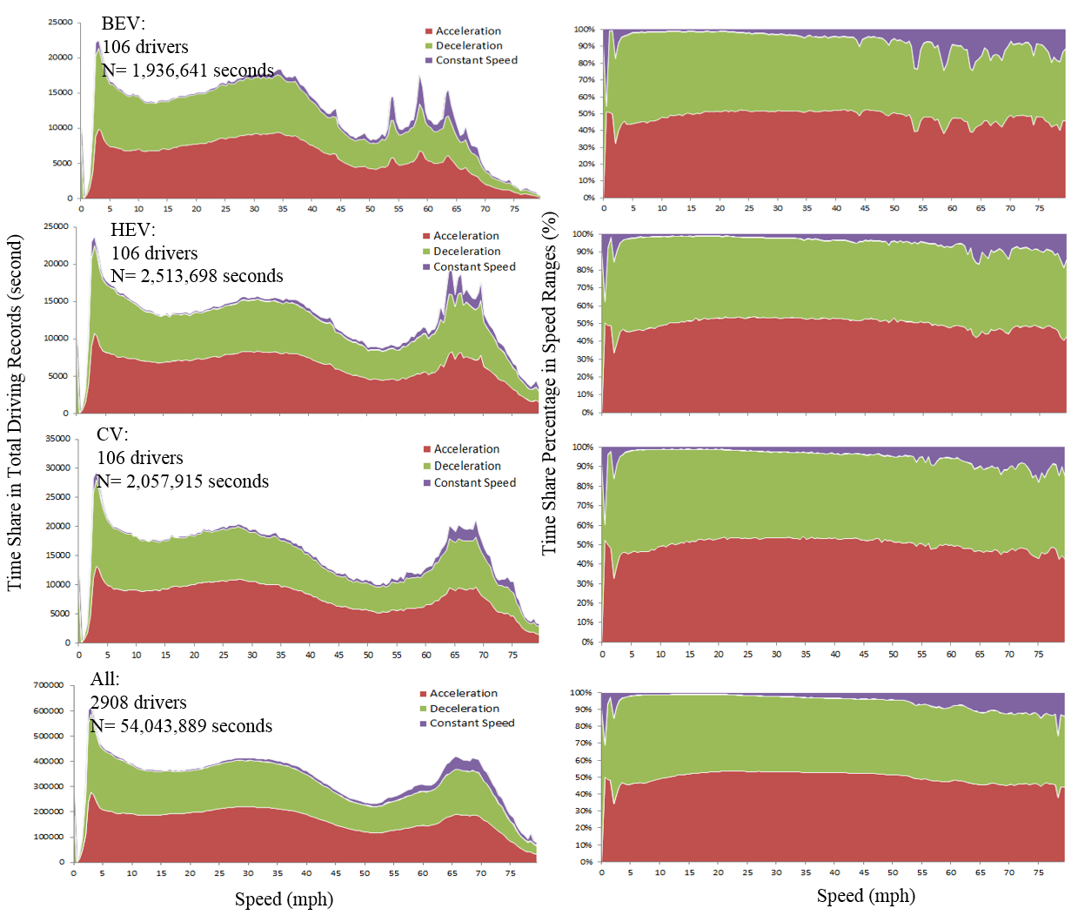
Figure 5.1 Comparisons of acceleration-speed cross time use

Given driving cycle is essential to fuel economy estimation and emissions modeling, key parameters representing real-world driving cycle were selected as measurements to compare driving performance of each driving cycle (i.e., real-world vehicle trip). These include:
- Parameters describing the range and average magnitude of driving activities: maximum acceleration, maximum deceleration, average deceleration, average acceleration, root mean squared acceleration, maximum speed, total average speed, driving average speed, total cycle duration, driving duration;
- Parameters representing time use during a trip: percent of time spent on idling, percent of time on acceleration, percent of time on deceleration, percent of time on cruise control;
- Events parameters: average number of acceleration/deceleration events per mile, and kinetic intensity.
- Volatility parameters to capture how drivers instantaneous driving decision changes during a trip: percentage of outlier acceleration or deceleration time (acceleration volatility score), maximum positive vehicular jerk (derivative of acceleration rate), average positive vehicular jerk, maximum negative vehicular jerk, average negative vehicular jerk and percentage of extreme vehicular jerk time (also called jerk volatility score). The calculation of volatility score using acceleration and jerk is based on previous studies [22, 25, 51, 119]. Note that the driving volatility score, defined as the percentage of outlier acceleration events or vehicular jerk events during one trip. The threshold for identifying outlier events is established based on all 54 million seconds driving records collected in CHTS.

Table 5.2 shows the comparison of major parameters used to quantify driving cycles. The driving cycles (i.e., real-world trips) in three equivalent groups are compared along with four EPA specified driving cycles as well as California Driving Cycle (LA92) and New York City Cycle (NYCC). As a result, significant differences are found between BEVs, HEVs and CVs. Key findings include:
- BEV-involved trips are shorter (both in total duration and driving duration) compared with HEV- and CV- involved ones made by similar drivers. The total duration and driving duration are nearly half of FTP, even shorter than LA92 but close to HWY.
- BEVs have a lower (statistically significant at 95% level) total average speed and driving average speed compared with HEVs and CVs. They are close to LA 92 but still show statistically significant differences (95% level).
- The maximum speed of BEV trips is near 50 mph, which is lower than HEVs and CVs. This value is also lower than four EPA standard driving cycles as well as LA92.
- BEV trips show higher average acceleration compared with HEVs, but lower than CVs. Maximum acceleration for BEVs is higher than that of HEVs and CVs, indicating BEVs are associated with higher variance in acceleration. However on average, BEV trips show less average deceleration magnitude and less maximum deceleration magnitude compared with HEVs and CVs.
- Average jerking level is similar for BEVs, HEVs and CVs. But BEV group has higher maximum positive vehicular jerk.
- The average acceleration/deceleration events per mile are similar for BEVs, HEVs and CVs. This is close to US06 but significantly higher than other existing driving cycles except NYCC.
- BEV trips have similar time on idling compared with HEVs and CVs. But there is more time on stable driving. The percent time on outlier acceleration/deceleration is lower for BEV trips compared with HEVs and CVs.
- BEV group shows similar kinetic intensity level compared with HEV and CV groups.

Table 5.2 Comparisons of Real-World Driving Performance
Vehicle Groups | BEV (N=2371) |  | HEV (N=2652) |  | CV (N=2397) |  | Regional (all vehicles) |  | Existing Drive Cycles
 |  |  |  |  |  |  | (N=65,652)
Drive Cycle Parameters | Mean | S.D. | Mean | S.D. | Mean | S.D. | Mean | S.D. | FTP | HWY | US06 | SC03 | LA92 | NYCC
Total duration (hrs) | 0.26 | 0.23 | 0.30 | 0.30 | 0.27 | 0.31 | 0.26 | 0.30 | 0.17 | 0.40 | 0.52 | 0.21 | 0.17 | 0.17
Driving duration (hrs) | 0.22 | 0.21 | 0.26 | 0.27 | 0.24 | 0.29 | 0.23 | 0.28 | 0.15 | 0.33 | 0.42 | 0.21 | 0.13 | 0.11
Total average speed (mph) | 26.89 | 10.91 | 28.07 | 12.61 | 27.80 | 12.16 | 27.28 | 12.37 | 47.97 | 24.61 | 21.20 | 48.20 | 21.44 | 7.09
Driving average speed (mph) | 27.22 | 10.89 | 28.38 | 12.59 | 28.14 | 12.13 | 27.62 | 12.35 | 51.85 | 29.40 | 26.20 | 48.58 | 26.62 | 10.92
Maximum speed (mph) | 49.30 | 15.83 | 51.96 | 17.83 | 51.45 | 17.11 | 50.22 | 17.43 | 80.30 | 67.20 | 56.70 | 59.90 | 54.80 | 27.70
Average acceleration (ft/s²) | 2.13 | 0.68 | 2.07 | 0.65 | 2.22 | 0.71 | 1.46 | 0.47 | 2.20 | 2.21 | 1.68 | 0.64 | 1.65 | 2.04
Average deceleration (ft/s²) | -2.19 | 0.64 | -2.24 | 0.68 | -2.38 | 0.76 | -1.58 | 0.50 | -2.39 | -2.47 | -1.89 | -0.72 | -1.98 | -1.99
Maximum acceleration (ft/s²) | 9.34 | 2.24 | 8.84 | 1.84 | 8.82 | 1.92 | 5.91 | 1.31 | 12.32 | 10.12 | 4.84 | 4.69 | 7.48 | 8.80
Maximum deceleration (ft/s²) | -9.94 | 2.36 | -10.25 | 2.47 | -10.37 | 2.47 | -6.91 | 1.70 | -10.12 | -12.91 | -4.84 | -4.84 | -8.95 | -8.65
Root mean square acceleration (ft/s²) | 1.47 | 0.43 | 1.46 | 0.44 | 1.56 | 0.48 | 1.03 | 0.32 | 3.24 | 2.61 | 2.07 | 0.98 | 2.26 | 2.21
Average positive vehicular jerk (ft/s³) | 0.77 | 0.29 | 0.77 | 0.30 | 0.80 | 0.30 | 0.54 | 0.21 | 1.32 | 1.25 | 0.78 | 0.28 | 1.02 | 1.41
Average negative vehicular jerk (ft/s³) | -0.60 | 0.20 | -0.60 | 0.20 | -0.63 | 0.20 | -0.42 | 0.14 | -1.22 | -1.19 | -0.66 | -0.27 | -0.80 | -1.28
Maximum positive vehicular jerk (ft/s³) | 6.48 | 2.08 | 6.35 | 2.05 | 6.40 | 2.19 | 4.25 | 1.51 | 11.15 | 9.53 | 5.13 | 2.93 | 6.31 | 8.21
Maximum negative vehicular jerk (ft/s³) | -2.94 | 0.81 | -2.92 | 0.72 | -2.94 | 0.76 | -1.97 | 0.52 | -8.65 | -12.32 | -3.81 | -2.35 | -4.11 | -6.16
Root mean square jerk (ft/s³) | 0.69 | 0.18 | 0.69 | 0.19 | 0.71 | 0.19 | 0.47 | 0.13 | 1.82 | 1.52 | 0.93 | 0.37 | 1.18 | 1.50
Acceleration/deceleration events (no. per mile) | 16.90 | 14.39 | 16.86 | 14.55 | 16.84 | 15.33 | 17.62 | 17.12 | 16.73 | 10.90 | 9.56 | 2.24 | 15.64 | 39.44
Percent time on idling | 20.64% | 13.06% | 20.00% | 13.02% | 21.03% | 13.46% | 20.85% | 13.93% | 11.15% | 24.58% | 23.84% | 1.57% | 24.46% | 51.75%
Percent time on acceleration | 37.89% | 6.82% | 39.50% | 6.84% | 38.97% | 7.21% | 39.10% | 7.33% | 44.09% | 34.96% | 37.28% | 43.86% | 40.27% | 24.87%
Percent time on deceleration | 40.71% | 9.27% | 39.75% | 8.64% | 39.25% | 8.85% | 39.26% | 9.21% | 39.27% | 28.76% | 31.47% | 38.12% | 31.45% | 21.87%
Percent time on stable driving | 5.60% | 7.85% | 4.76% | 6.16% | 4.41% | 6.16% | 4.57% | 6.34% | 5.49% | 7.38% | 3.52% | 16.45% | 2.16% | 0.00%
Percent time on extreme accel./decel. | 4.46% | 3.75% | 4.69% | 3.96% | 5.59% | 4.77% | 5.15% | 4.52%
Percent time on extreme vehicular jerk | 4.79% | 4.11% | 4.80% | 3.91% | 5.32% | 4.30% | 5.00% | 4.18%
Kinetic Intensity | 3.29 | 8.53 | 3.35 | 5.50 | 3.30 | 5.36 | 3.68 | 22.88
Note: *: N ＝ number of sample trips in groups.
**: stable driving was defined by speed is above 30 mph and acceleration is less than 0.088 (ft/s²).

Overall, by controlling for driver demographics, BEV trips are shorter and calmer shown by less driving volatility and more stable driving, and HEV trips are longer and calmer. None of the existing driving cycle represents BEV and HEV driving characteristics well.

5.5 DRIVING CYCLE DESIGN

5.5.1 Micro-Trip
In current travel surveys, a trip is usually defined as people moving from an origin to a destination. Focusing on vehicular trips, driving can be interrupted several times during one trip, e.g. stops at intersections or stopped by traffic congestion. This makes it possible to further separate out one single trip into several micro-trips. Each micro-trip is a continuous driving practice. Drivers often idle between two stops. Given each micro-trip is a driving activity without interruption; it shows more homogeneous driving characteristics than an entire vehicular trip. Therefore micro-trips can suitably become cases representing base elements of a complete driving cycle. Only when several micro-cycles are chained together, a complete driving cycle can be created. Therefore it is critical to create a collection of cases and then to design the mechanism of how micro-trips can be chained together.

As mentioned previously, CHTS database contains a large number of samples, including 236,404 micro-trips from 65,652 trips. This provides a large-scale source to developing micro-trip case systems. It also allows us to learn how micro-trips are chained together for a complete trip.

5.5.2 Micro-Trip Clustering
After extracting the driving parameters to quantify driving characteristics, qualitative analyses are also needed for better structuring the micro-trips in the case system so they can be ready to select as elements for driving cycle design. To this end, rigorous clustering techniques were applied to group these micro-trips based on the various driving parameters extracted. The principle is to cluster micro-trips that are similar to each other into one category meanwhile differentiating categories that are more different from each other.

Using the 23 driving cycle parameters extracted, all micro-trips were analyzed using K-means clustering algorithm [136]. The basic idea is: Given 236,404 observations (i.e., micro-trips) with a 23-dimentional real vector (i.e., 23 driving cycle parameters), K-means clustering aims to partition the all observations into k (<=236,404) clusters so as to minimize the within-cluster sum of squares. The objective function is
$J={\begin{aligned}argmin \\ k\end{aligned}}^{}\sum_{j=1}^{k}{\sum_{i=1}^{n}{{\left\|x_{i}^{(j)}-c_{j}\right\|}^{2}}}$ Equation 5.1
Where,
$x_{i}^{(j)}$= an observation (i.e., micro-trip) i in cluster j, i=1, 2, …, n, j=1, 2, …, k. Note that x is a 23-dimential real vector;
n = the number of observations, equal to 236,404;
k = the number of clusters, between 1 and 236,404;
$c_{j}$= the center of cluster j;
${\left\|x_{i}^{(j)}-c_{j}\right\|}^{2}$= the distance between an observation $x_{i}^{(j)}$ and the cluster center $c_{j}$.

The method of Cubic Clustering Criterion (CCC) was used to compare the fit statistics of different numbers of clusters [137]. Results shows the 5-cluster structure (Largest CCC= -4.6172) has the best fit statistics (i.e., largest CCC= -4.6172). Figure 5.2(i) shows the result of 5-cluster structure illustrated by micro-trip root mean square acceleration across micro-trip mean driving speed. Note that, since the micro-trip data are 23-dimentional (i.e., 23 parameters), the boarders between clusters are not very clear if the data are shown in two dimensions. Cluster 1 contains micro-trips of low speeds with large acceleration/deceleration. Abrupt acceleration/deceleration events from/to stopping status are possibly frequent in Cluster 1 micro-trips. Cluster 2 micro-trips are low speed driving but with small acceleration/deceleration. These trips may occur on roads that serve the neighborhoods. Cluster 3 micro-trips are driving on local roads with larger acceleration/deceleration than those in Cluster 4. Compared with Cluster 3, micro-trips are more possibly in fluent traffic on local roads. Micro-trips in Cluster 5 are possible freeway or arterial driving in high speeds with small acceleration or deceleration.

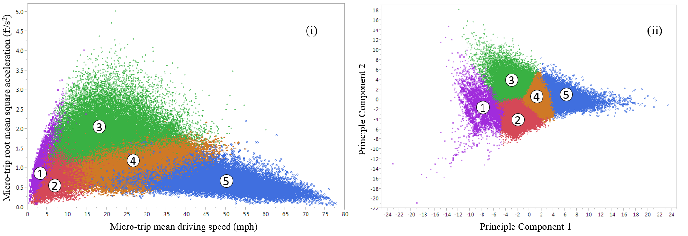
Figure 5.2 Clustering results

To better understand the characteristics of these five clusters, PCA (Principle Component Analysis) was applied. PCA is capable of sorting out parameters that are more determinative in forming a micro-trip cluster. PCA provides a smaller independent linear combinations (principal components) of 23 variables. Figure 5.2(ii) shows the 5-cluster structure illustrated by first two principle components, explaining sizeable variance across observations (36.9% and 21.8%, respectively). The boarders between clusters are clearer than those in Figure 5.2(i). The variables/parameters that have a large weight on the first two components are used to represent one cluster. Figure 5.3(i) presents the weight of each parameter on the first two components through their load matrix. Predictors having similar weights on the same principle are highly correlated, e.g., driving average speed, total average speed and maximum speed. Percent times on acceleration and on idling have the largest magnitudes (positive and negative) of weights on the first principle component. Root mean square acceleration and average deceleration have the largest weight on the second principle component. Therefore, these four parameters will be used to characterize the four micro-trip clusters. Besides these four parameters, two intuitive parameters, trip duration and maximum speed, are also used to represent the characteristics of five clusters. The relative mean magnitudes of these six parameters in five clusters are shown in Figure 5.3(ii) also. Figure 5.4 demonstrates a sample trip having five different micro-trips identified and labelled by the corresponding cluster number.

Micro-trips in Cluster 1 have the lowest maximum speed and shortest duration, together with longer idling percent of time (partially because of their low speed and short duration). Cluster 2 micro-trips also have a low speed but higher than cluster 1. The duration is also longer than those in Cluster 1. Cluster 1 and 2 micro-trips usually are the start or end leg of a trip. Cluster 3 has higher speeds than Cluster 1 and 2 but their speeds are still lower than 40 mph with medium idling time. Cluster 3 has the highest average acceleration/deceleration among five clusters. Cluster 4 has higher speeds than first three clusters. Cluster 3 and 4 micro-trips are mostly driven on arterials or collectors under different driving conditions. Cluster 5 has the highest average speed, limited 4 idling driving, largest deceleration and longest durations.

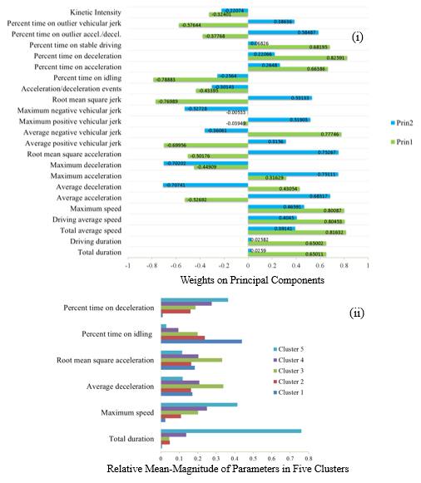
Figure 5.3 Results of principle component analysis (PCA)

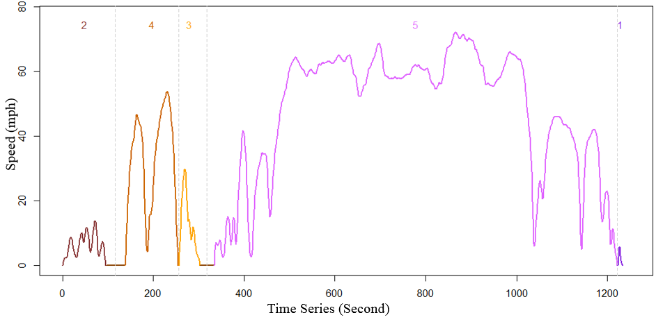
Figure 5.4 Micro-trip cluster identified

With the clustered micro-trips and their general characteristics, we can encode each driving cycle: 1 denotes the cluster with the lowest average speed and 4 denotes the cluster with the highest average speed. Then a trip can be represented by a code sequence indicating the order of micro-trips in the chain. For instance, the trip shown in Figure 5.4 has a code sequence 24351.

5.5.3 Case Based System for Driving Cycle Design
A Case Based System for Driving Cycle Design (CBDCD) is developed as a computer-aided machine learning tool. The system can take advantage of advanced modeling techniques to review, rank and synthesize micro-trip cases into a customized driving cycle by taking into account the qualitative (micro-trip cluster) and quantitative (performance parameter) information for each micro-trip. The designed driving cycle is selected by the degree of similarity between the result and the input. This methodology has the advantage of retaining the richness of historical large-scale data of individual micro-trip cases, synthesizing new candidate driving cycles from existing cases, and eventually finding the best candidate driving cycle closest to the input from the user. Figure 5.5 shows the framework of the CBDCD.

The CBDCD can be used to design two types of driving cycles: 1) a customized driving cycle based on user information given the user provide detailed information such as demographics, commute trip information, etc., and 2) a default typical driving cycle based on regional average if customer’s information is not detailed enough. The system has the capability to switch between using user’s individual information versus using regional average information to design driving cycles.

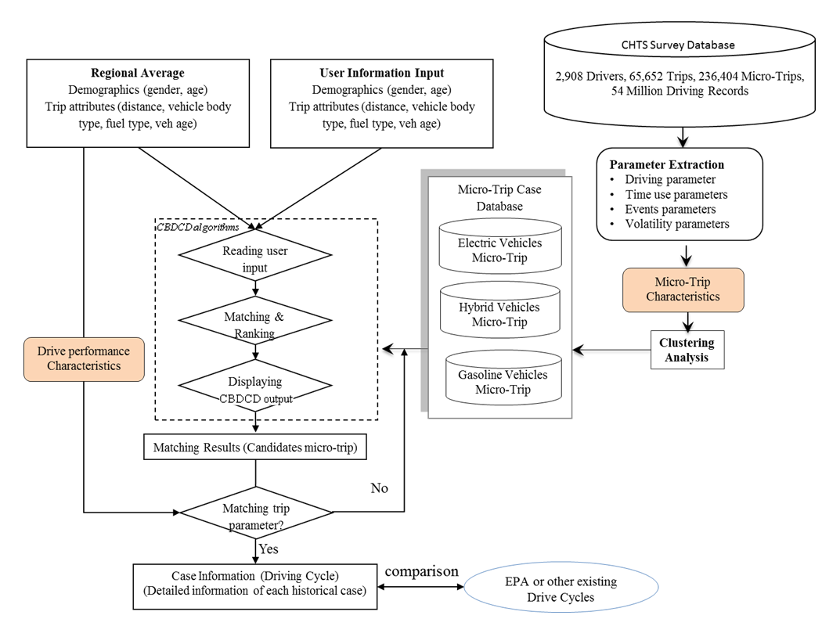
Figure 5.5 Case based system for driving cycle design (CBDCD)
The system has a rich background historical case collection that contains the real-world micro-trips collected by CHTS. These micro-trips can be clustered into different categories representing different driving condition, e.g. high-speed free flow driving, low-speed stop and go driving. Then the background case collection are processed by a set of CBDCD algorithms, that can read input information, rank and match historical micro-trip cases with input information, and display matching results and detailed information of each historical case. The output information includes: 1) structured information of candidate micro-trips based on calculated similarity scores and 2) detailed information of each candidate case including their driving performance parameters, e.g. a speed profile graph, average speed, time spent information on acceleration/deceleration, etc. Then the system tests different combinations of micro-trips. The combination are tested based on their chaining probability. For instance, if a certain micro-trip is more likely to be chained with another type of micro-trip, their combination may be tested first. Doing this can reduce computation time and enhance the efficiency of CBDCD.

After a trip is created, the trip level driving parameters are calculated and a similarity score can be calculated based on the trip-level driving performance parameters. If the combination of micro-trips results in a high similarity score compared with the input trip information, this combination can be regarded as the most representative driving cycle for the given driving information (e.g., trip length, maximum speed, number of stops). This trip combined by CBDCD can be accepted as a driving cycle for this user.

5.5.4 Similarity Score
Given the input information, appropriate micro-trips were selected and chained together randomly as candidate cycles. Then, a similarity score was calculated for each candidate cycle. The similarity score is based on the sum of relative error between the parameters of the candidate cycle and the target driving cycle. Given the values of target cycle parameters, the relative error of each parameter of the candidate cycle was calculated as following:
$ε_{βk}=\left|\frac{\left(M_{βk}-{\overline{M}}_{k}\right)}{{\overline{M}}_{k}}\right|×100\%$ Equation 5.2
Where,
$ε_{βk}$ = the relative error for the k^{th} parameter (e.g., total average speed) of the candidate cycle β, β is the number of candidate cycles and k=1,2,…,N, N is the total number of driving cycle parameters;
$M_{βk}$ = the magnitude of the k^{th} parameter of the candidate cycle β;
${\overline{M}}_{k}$ = the magnitude of the k^{th} driving cycle parameter of a target cycle.

Then, the similarity score of a candidate cycle can be calculated as follows:
$$S_{β}= 100\%-\frac{\sum_{k=1}^{N}{ε_{βk}}}{N}$$ | Equation 5.3
Where, $S_{β}$ is the similarity score for candidate driving cycle β. The similarity score is calculated by using 100% minus the average relative errors coming from the parameters of candidate driving cycle β. The score ranges from zero to 100% (100% means no errors and it matches with target cycle completely). The candidate cycle with the largest score is the best driving cycle that matches with the provided input information to its largest extent. Note that, the driving performance parameters were treated equally in the calculation. It could be reasonable to consider using weights in the calculation of similarity score. As in certain studies with purpose of investigating the hard acceleration impacts, some parameters (e.g., maximum acceleration) may be weighted more when calculating the sum of relative errors. The driving cycles that best match with the trip-level parameters were selected as the final driving cycles.

5.6 CASE STUDY
A case study of creating regional driving cycle for vehicle by different fuel types was conducted using the CBDCD system. Figure 5.6(i) presents representative driving cycles for BEVs, HEVs and CVs produced by CBDCD, given micro-trip pattern as 25432 and trips lasting 15~20 minutes. There are thousands of micro-trip pattern combinations. Driving cycles with the same pattern code represent those driving trips have the same number of stops, similar time spent on acceleration/deceleration, has gone through similar roads. Eventually, three representative driving cycles were selected for BEVs, HEVs and CVs.

Figure 5.6(ii) presents further comparisons of these three driving cycles given specified micro-trip patterns. Controlling the same micro-trip patterns for driving cycles could provide a better comparison of driving performance using different vehicles for the similar use (i.e., trip duration and number of stops). BEV cycle has a relatively larger average speed than HEV and CV cycles. Notably, BEV cycle has a significantly higher percentage of time spent on stable driving than HEV and CV. CV cycle has a highest percentage of time spent on idling and BEV has the smallest percentage. HEV cycle has the most acceleration/deceleration events while BEV has the least acceleration/deceleration events. As for the average root square acceleration and maximum acceleration, CV cycle has the largest magnitudes while HEV cycle has the smallest magnitudes.
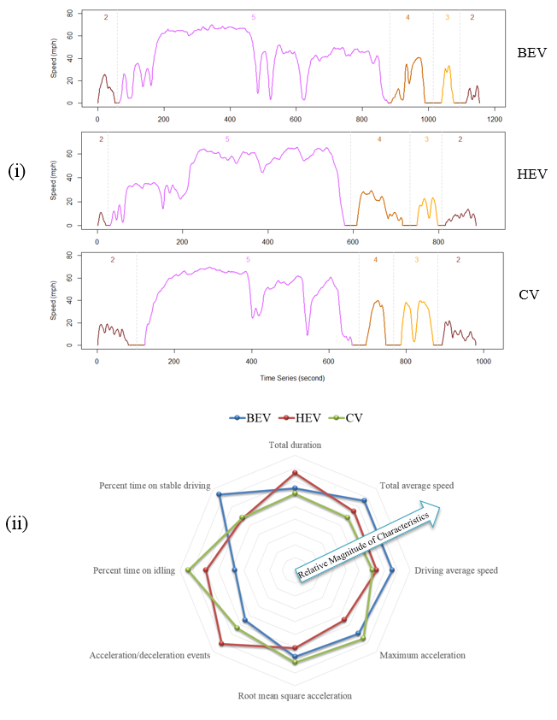
Figure 5.6 Driving cycles given specified micro-patters

Possibly, a more customized driving cycle can be generated given more potential user information. For instance, to compare the driving cycle of high-income drivers. Annual household income>$150k, and age is between 40-50 were set as input, the system automatically searches the micro-trip database for sorting and ranking candidate micro-trip cases (give similarity scores). Figure 5.7 shows the cauterized driving cycles for target user groups making trips coded as 543 and 54.

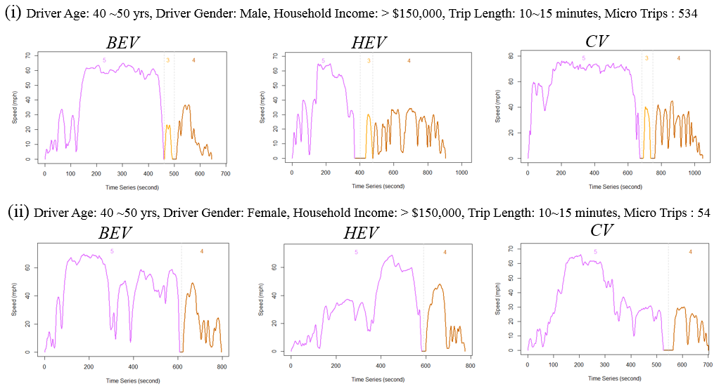
Figure 5.7 Customized driving cycles for target user groups

5.7 FUEL ECONOMY ESTIMATION
After customizing driving cycles for one type of vehicles given a target user group, fuel economy can be estimated specifically for this type of vehicles driven by a narrowed group of drivers. There are two options for using customized driving cycles to estimate fuel economy: 1) Applying Vehicle Specific Power (VSP) equation to calculate fuel consumption. VSP is defined as the instantaneous power per unit mass of the vehicle and is function of vehicle speed, acceleration, road grade, aerodynamic drag, and tire rolling resistance [138-140]. How to obtain fuel consumption using VSP equation can be found from many studies [36, 138-141]; and 2) Using the customized driving cycles to predict MPG ratings based on dynamometer tests [94, 124-127].
Estimated by non-customized driving cycles, the fuel economy of driving (e.g., 18 MPG for city and 22 MPG for highway, given a specific vehicle brand) may be applicable as an average performance of one type of vehicles running in one region. Using the customized driving cycle, BEV, HEV and CV users can obtain different MPG or MPGe (equivalent MPG) because of the differences between driving cycles of these three types of vehicles. The customized driving cycles can provide better information for customers when they are deciding which type of vehicles are better for them.

5.8 LIMITATIONS
This study depends heavily on trajectory data collected by in-vehicle GPS. To some extent the accuracy and availability of location data constrain the analysis. Some other critical information remains unknown to the researchers due to privacy concerns, e.g., the geo-codes for each second. Missing geographically referenced information for trips prevents the researchers from extracting accurate contextual factors, e.g., whether the road is interstate or arterial. Therefore the micro-trip clustering completely depends on using driving performance data without considering the surrounding contextual factors.

5.9 CONCLUSIONS AND CONTINUING RESEARCH
Knowledge about how AFVs perform in real-world is important for assessing their real fuel economy and for the realization of their benefits in terms of fuel saving and emissions reduction. A critical component of modeling fuel economy and emissions is the driving cycle. Given the shortcoming of using existing one-fits-all driving cycles for all types of vehicles, this paper creates a practical tool based on a comprehensive case-based reasoning system which can design customized driving cycles based on users’ inputs. The input information can be highly flexible, depending on different needs. The system takes advantage of emerging data mining and machine learning techniques to create driving cycles and relies heavily on a large-scale trajectory data collected.

Before proposing the methodology for customizing driving cycles, this study compares real-world driving performance of BEVs, HEVs and CVs in equivalent groups. Results shows heterogeneous driving performance across these three types of vehicles. Further, the real-world driving performance is clearly different from the characteristics of existing standard driving cycles. Thus, customizing driving cycles based on large-scale real-world driving practices could improve the accuracy of estimating fuel economy of vehicles powered different energy.

Given the high diversity of real-world driving performance made by various drivers and vehicles, this study extracts the information of micro-trips described by 23 driving performance parameters. The micro-trips are further grouped through machine learning techniques, such as principle component analysis and cluster analysis. Clustering of micro-trips helps separate a complete driving cycle into several sub-driving tasks facing various driving contexts (e.g., local roads and freeway). These micro-trips come into being a highly competitive micro-trip case collection which is the basis of designing high-quality driving cycles. A Case Based System for Driving Cycle Design (CBDCD) is then designed by embedding the case collection with algorithms which have the capability to review, sort cases and eventually synthesize micro-trip cases into different candidate driving cycles. A final driving cycle is selected according to how similar it is in terms of driving characteristics of a specific user/customer. In this way, a cycle is customized to respond to a user’s request as well as represent the real-world driving performance.

An application of CBDCD system is to customize driving cycles for potential users of BEV, HV and CV. Customizing driving cycle to show the uniqueness of each type of vehicle can be a good complement for transitioning out of one-fit-all driving cycles. A customized driving cycle through CBDCD given detailed user information, such as age, gender, income, commute trip distance and duration, etc. can be used to estimate fuel economy of a target vehicle, by applying VSP equation or using dynamometer tests.

The CBDCD can also provide default driving cycle design using regional average data without detailed customer information. Therefore, auto manufactures can use the driving cycle to provide customers with more accurate estimation of fuel economy information which could potentially help customers understand benefits of AFVs and help them make more informed vehicle purchase decisions.

In the future, a validation study is first needed to evaluate the accuracy of fuel economy estimated using customized driving cycles through field tests. The micro-trip database should be expanded to cover more population. This study uses a database from California travel survey [23]. Trajectory data from other regional surveys, e.g., Atlanta regional survey [78], can also be merged into the current micro-trip database, as well as other data sources which are increasingly available publically or privately, e.g., Naturalistic Driving Study (NDS) Data from the second Strategic Highway Research Program [35]. Further research should also do an in-depth exploration of the relationships between fuel economy, micro-trip patterns, vehicle types and user characteristics, and how the fuel economy estimated according to personal information influences vehicle purchase decisions.

CONCLUSIONS

Given the fact that automobile driving is the most dominant transportation mode in the United States, understanding automobile driving behavior serves as one of the critical keys to improvements of life quality, including safety, mobility and sustainability. With widespread deployment of emerging information and communication technologies, massive amounts of driving data in high resolution, referred to as “Big Data”, are becoming available, allowing researchers to scrutinize driving behavior in far more detail than was possible before. Short-term driving behavior is of a particular interest in the dissertation. Through digging large-scale second-by-second trajectory data coupled with travel behavioral information, the dissertation contributes a fundamental understanding of instantaneous driving behaviors under “Big Data” environments. “Driving volatility” is the core concept conveyed in the dissertation, describing the variability of instantaneous driver behaviors.
Trajectory data used in the dissertation were sampled in fairly high frequency of 1-Hz. However, there is still a possibility that the second-by-second trajectory data are undersampling for identifying instantaneous driving decisions. Compared with high industrial sampling rates (e.g. 96 kHz), data used in the dissertation may be limited by relatively low sampling frequency which gives only second-by-second speeds. Undersampling can result in loss of information about important instantaneous driving decisions. On the other hand, oversampling can also result in noisy data, and waste storage and processing resources. To address this issue, a study was conducted to answer the question: what sampling rates are appropriate to capture micro or short-term driving decisions? Analyses were conducted by collecting driving data at 20 Hz using a driving simulator. The study developed measures of information loss and quantified their relationship with sampling rates. It discussed driving behavior information from two angles: instantaneous driving decisions and speed magnitudes. The results showed that drivers made no change to their speed for 89.9% of the sampled seconds, i.e., drivers either kept accelerating, decelerating or just maintained speed during a second. Only 10.1% of the sampled seconds involve driver’s decision change. Overall, the analysis found that at least 98.5% instantaneous driving decision changes can be detected using second-by-second data compared with 20-Hz data and that the second-by-second data are reasonably accurate for the purposes of the dissertation.
Given the high acceptability of the sampling frequency of 1-Hz, a study for quantifying driving volatility in instantaneous driving behaviors using a large-scale trajectory data was conducted. The study takes advantage of large-scale travel behavioral data coupled by second-by-second GPS data. A framework was established to define driving style in instantaneous driving decisions. The study provided a quantifiable way to answer how to quantify explicitly volatile driving in a defensible manner. The answer is to create a volatility indicator to measure the gap between an individual’s driving practice and the typical driving practice in that region. Assuming the typical driving practice applied by most people represents the norm of driving culture in that region, the driving practices standing out of that normal driving could be defined as volatile driving. The paper demonstrated a methodology to measure the volatility, which is based on variation in vehicular jerk between individual drivers and regional sample profiles. The creation of a robust volatility score that is able to quantify the extent of volatility, instead of simply labeling a driver as aggressive or non-aggressive is a key contribution. The study then proposed a potential application to support calmer instantaneous driving decisions. Driving volatility information based on accelerations and vehicular jerk can be incorporated in driving assist systems, e.g., advanced traveler information systems (ATIS). Current traveler information systems (such as 511) are largely meant to support more macro driver decisions (e.g., route choice and route diversion) and do not provide much instantaneous information that can help drivers make more micro driving decisions. The real-time driving volatility information reflecting driving performance based on performance of fellow fleet vehicles or neighbors or just their own performance can support short-term micro decisions. This in turn can benefit the community or fleets in several ways: 1) calmer driving; 2) safer driving in general (especially on icy or slippery road surfaces where alert thresholds can be lowered); 3) lower fuel consumption and emissions; and 4) identification of dangerous road segments (such as poor sight distance) that may result in volatile driving.

Following the study on quantifying driving volatility in instantaneous driving behaviors, another study was conducted to disentangle the hierarchical nature of driving volatility embedded in travel survey data, using a sophisticated multi-level modeling framework. Further, the study highlighted the role of alternative fuel vehicles (AFVs) in travel. The study answered important research questions about AFV use patterns and driving practices as they gain greater acceptance and popularity. In terms of use, AFV drivers make the same amount of trips as conventional vehicle drivers do, except that drivers of BEV make statistically significantly fewer trips (5% level). The daily distances traveled were shorter for some AFVs (BEV and PHEV) but longer for other AFVs (HEV and CNG) compared with conventional vehicles. Drivers spent significantly longer time traveling daily in their HEV or CNG vehicles compared with conventional vehicles.
The study also found important differences within AFV driving practices. HEV and BEV were found to be associated with calmer driving compared with conventional vehicles, i.e., they are less prone to aggressive accelerations and vehicular jerks. To sum up, the challenge of simultaneously extracting valuable information from complex hierarchically structured data was achieved by the application of multi-level modeling. Specifically, such modeling better controls for various associated factors, while exploring differences in driver behavior at three levels, i.e., trip level, driver/vehicle level and regional level.

Drivers using different types of vehicles under various driving conditions behave differently, in terms of many driving performance measures including driving volatility. A study was further conducted to compare real-world driving performance of BEVs, HEVs and CVs in equivalent groups. Result consistently showed the heterogeneous driving performance across these three types of vehicles. Thus, to predict the accurate fuel economy for an individual and a specified vehicle type, the study constructed a Case Based System for Driving Cycle Design (CBDCD) system to customize driving cycles based on real-world driving data for various users and vehicles using different power systems. These customized driving cycles can be used to better estimate fuel economy for customers based on their own driving style instead of using a “one-fit-all” pre-designed driving cycle. A more accurate fuel economy estimation could potentially help customers choose a more energy-efficient and cleaner vehicle to them. This study also provided instructions for manufacturer, environmental protection agencies, and energy related industries to optimize their driving cycles based on local or regional characteristics.

The dissertation contributes to establishing a framework for research using large-scale behavioral data integrated with sensor data, e.g., trajectories from global positioning system devices, representing advances in large-scale data analytics.

List of References

1. FHWA, Highway Statistics. 2013, US Department of Transportation: Washington D.C.
2. Personal Transportation Factsheet. 2013: University of Michigan.
3. Keane, A.G. U.S. Highway Deaths Decline for a Fifth Year, Longest Streak Since 1899. 2011 [cited 2013 Decemeber 29]; Available from: http://mobile.bloomberg.com/news/2011-12-08/u-s-highway-deaths-decline-2-9-falling-for-fifth-year-1-.
4. NHTSA, Fatality Analysis Reporting System (FARS). National Highway Traffic Safety Administration: Washington, D.C.
5. Johnson, T.D. Online-only: U.S. traffic deaths drop to lowest level since 1949. 2011 [cited 2013 December 28]; Available from: http://thenationshealth.aphapublications.org/content/41/4/E17.full.
6. CDC, National Vital Statistics Reports (Volume 6, Number4), Deaths: Preliminary Data for 2010 2012, Centers for Disease Control: Atlanta, GA.
7. Chambers, M., Transportation Safety by the Numbers. 2012, Research and Innovative Technology Administration: Washington, D.C.
8. NTSB. Data & Statistics. 2013 [cited 2013 December 29]; Available from: http://www.ntsb.gov/data/.
9. NHTSA, National Motor Vehicle Crash Causation Survey: Report to Congress. National Highway Traffic Safety Administration Technical Report DOT HS, 2008. 811: p. 059.
10. Van Elslande, P., C.L. Naing, and R. Engel, Analyzing human factors in road accidents: TRACE WP5 Summary Report. 2008.
11. Näätänen, R. and H. Summala, Road-user behaviour and traffic accidents. Publication of: North-Holland Publishing Company, 1976.
12. Kim, E. and E. Choi. Estimates of Critical Values of Aggressive Acceleration from a Viewpoint of Fuel Consumption and Emissions. in 2013 Transportation Research Board Annual Meeting. 2013. Washington DC.
13. De Vlieger, I., D. De Keukeleere, and J. Kretzschmar, Environmental effects of driving behaviour and congestion related to passenger cars. Atmospheric Environment, 2000. 34(27): p. 4649-4655.
14. Renski, H., A. Khattak, and F. Council, Effect of Speed Limit Increases on Crash Injury Severity: Analysis of Single-Vehicle Crashes on North Carolina Interstate Highways. Transportation Research Record: Journal of the Transportation Research Board, 1999. 1665(-1): p. 100-108.
15. Paleti, R., N. Eluru, and C. Bhat, Examining the influence of aggressive driving behavior on driver injury severity in traffic crashes. Accident Analysis & Prevention, 2010. 42(6): p. 1839-1854.
16. Sivak, M. and B. Schoettle, Eco-driving: Strategic, tactical, and operational decisions of the driver that influence vehicle fuel economy. Transport Policy, 2012. 22(0): p. 96-99.
17. Nam, E., C. Gierczak, and J. Butler, A Comparison Of Real-World and Modeled Emissions Under Conditions of Variable Driver Aggressiveness, in Annual TRB Meeting, T.A.M. CD-ROM, Editor. 2003: Washington DC.
18. Rouphail, N., et al., Vehicle Emissions and Traffic Measures: Exploratory Analysis of Field Observations at Signalized Intersections, in 80th Annual Meeting of the Transportation Research Board. 2001: Washington D.C.
19. Nam, E., Proof of Concept Investigation for the Physical Emissions Estimator (PERE) for MOVES, EPA420-R-03-005. 2003, Office of Transportation and Air Quality, EPA.
20. Holmén, B. and D. Niemeier, Characterizing the effects of driver variability on real-world vehicle emissions. Transportation Research Part D: Transport and Environment, 1998. 3(2): p. 117-128.
21. Ericsson, E., Independent driving pattern factors and their influence on fuel-use and exhaust emission factors. Transportation Research Part D: Transport and Environment, 2001. 6(5): p. 325-345.
22. Wang, X., et al., What is the Level of Volatility in Instantaneous Driving Decisions? Transportation Research Part C: Emerging Technologies, 2015.
23. Caltrans. California Household Travel Survey. 2013 [cited 2014 May 2nd]; Available from: http://www.dot.ca.gov/hq/tsip/otfa/tab/chts_travelsurvey.html.
24. TSDC, Secure Transportation Data Project. Transportation Secure Data Center, National Renewable Energy Laboratory
25. Liu, J., A. Khattak, and X. Wang, Creating Indices for How People Drive in a Region: A Comparative Study of Driving Performance, in 94rd Annual Meeting of the Transportation Research Board 2015: Washington D.C.
26. Linear. LTC6412 - 800MHz, 31dB Range Analog-Controlled VGA. 2014 [cited 2014 May 1st]; Available from: http://www.linear.com/product/LTC6412.
27. Meade, M.L., C.R. Dillon, and C.R. Dillon, Signals and systems. Vol. 8. 1991: Springer.
28. Chawla, N.V., Data mining for imbalanced datasets: An overview, in Data Mining and Knowledge Discovery Handbook. 2010, Springer. p. 875-886.
29. Punzo, V., M.T. Borzacchiello, and B. Ciuffo, On the assessment of vehicle trajectory data accuracy and application to the Next Generation SIMulation (NGSIM) program data. Transportation Research Part C: Emerging Technologies, 2011. 19(6): p. 1243-1262.
30. Henclewood, D., Safety Pilot Model Deployment – One Day Sample Data Environment Data Handbook. 2014, Research and Technology Innovation Administration, US Department of Transportation: McLean, VA.
31. Open Source NGSIM community. 2014.
32. Jackson, E., et al., Evaluating the ability of global positioning system receivers to measure a real-world operating mode for emissions research. Transportation Research Record: Journal of the Transportation Research Board, 2005. 1941(1): p. 43-50.
33. Int Panis, L., S. Broekx, and R. Liu, Modelling instantaneous traffic emission and the influence of traffic speed limits. Science of the total environment, 2006. 371(1): p. 270-285.
34. Ahn, K. and H. Rakha, The effects of route choice decisions on vehicle energy consumption and emissions. Transportation Research Part D: Transport and Environment, 2008. 13(3): p. 151-167.
35. Campbell, K.L., The SHRP 2 naturalistic driving study: Addressing driver performance and behavior in traffic safety. TR News, 2012(282).
36. Wang, H., et al., Modelling of the fuel consumption for passenger cars regarding driving characteristics. Transportation Research Part D: Transport and Environment, 2008. 13(7): p. 479-482.
37. Hung, W., et al., Development of a practical driving cycle construction methodology: A case study in Hong Kong. Transportation Research Part D: Transport and Environment, 2007. 12(2): p. 115-128.
38. Lyons, T., et al., The development of a driving cycle for fuel consumption and emissions evaluation. Transportation Research Part A: General, 1986. 20(6): p. 447-462.
39. Boriboonsomsin, K., A. Vu, and M. Barth, Eco-driving: Pilot evaluation of driving behavior changes among US drivers. 2010.
40. Simpson, M. and T. Markel. Plug-in Electric Vehicle Fast Charge Station Operational Analysis with Integrated Renewables. in EVS26 (Electric Vehicle Symposium). 2012.
41. Bikowitz, E.W. and S.P. Ross, Evaluation and improvement of inductive loop traffic detectors. 1985.
42. Oh, S., S.G. Ritchie, and C. Oh, Real-time traffic measurement from single loop inductive signatures. Transportation Research Record: Journal of the Transportation Research Board, 2002. 1804(1): p. 98-106.
43. Landau, H., Sampling, data transmission, and the Nyquist rate. Proceedings of the IEEE, 1967. 55(10): p. 1701-1706.
44. Yang, Q., et al., Driver behaviours on rural highways with and without curbs–a driving simulator based study. International journal of injury control and safety promotion, 2013(ahead-of-print): p. 1-12.
45. Bédard, M., et al., Assessment of driving performance using a simulator protocol: Validity and reproducibility. The American Journal of Occupational Therapy, 2010. 64(2): p. 336-340.
46. Wang, Y., et al., The validity of driving simulation for assessing differences between in-vehicle informational interfaces: a comparison with field testing. Ergonomics, 2010. 53(3): p. 404-420.
47. Elmore, W.C. and M.A. Heald, Physics of waves. 2012: Courier Dover Publications.
48. AASHTO, A Policy on Geometric Design of Highways and Streets, 6th Edition, 2011. American Association of State Highway and Transportation Officials, Washington, DC, 2011. 1: p. 990.
49. EPA. Dynamometer Drive Schedules. 2013 [cited 2014 March 3rd]; Available from: http://www.epa.gov/nvfel/testing/dynamometer.htm.
50. TRB, Managing Speed: Review of current practice for setting and enforcing speed limits, in Transportation Research Board, National Research Council. 1998: Washington D.C.
51. Liu, J., X. Wang, and A. Khattak, Generating Real-Time Driving Volatility Information, in 2014 World Congress on Intelligent Transport Systems. 2014: Detroit, MI.
52. Khattak, A., J. Liu, and X. Wang, Supporting Instantaneous Driving Decisions through Trajectory Data, in 94th Annual Meeting of the Transportation Research Board. 2015: Washington D.C.
53. Ji, S., et al., Electric Vehicles in China: Emissions and Health Impacts. Environmental Science & Technology, 2011. 46(4): p. 2018-2024.
54. Wang, X., A. Khattak, and Y. Zhang, Is Smart Growth Associated with Reductions in Carbon Dioxide Emissions? Transportation Research Record: Journal of the Transportation Research Board, 2013. 2375(-1): p. 62-70.
55. U.S. Environmental Protection Agency. Techinical Guidance on the Use of MOVES2010 for Emission Inventory Preparation in State Implementation Plans and Transportation Conformity. 2010 [cited 2014 08-01]; Available from: http://www.epa.gov/otaq/models/moves/420b10023.pdf.
56. Transportation Research Board, TRB Special Report 254: Managing Speed: Review of Current Practice for Setting and Enforcing Speed Limits. 1998, Transportation Research Board: Washington D.C.
57. West, R., J. Elander, and D. French, Mild social deviance, Type‐A behaviour pattern and decision‐making style as predictors of self‐reported driving style and traffic accident risk. British Journal of Psychology, 1993. 84(2): p. 207-219.
58. Åberg, L., et al., Observed vehicle speed and drivers' perceived speed of others. Applied Psychology, 1997. 46(3): p. 287-302.
59. Lajunen, T., J. Karola, and H. Summala, Speed and acceleration as measures of driving style in young male drivers. Perceptual and motor skills, 1997. 85(1): p. 3-16.
60. Langari, R. and J.-S. Won, Intelligent energy management agent for a parallel hybrid vehicle-part I: system architecture and design of the driving situation identification process. Vehicular Technology, IEEE Transactions on, 2005. 54(3): p. 925-934.
61. Han, I. and K. Yang, Recognition of dangerous driving using automobile black boxes. Journal of Korean Society of Transportation, 2007. 25(5): p. 149-160.
62. Han, I. and K. Yang, Characteristic analysis for cognition of dangerous driving using automobile black boxes. International journal of automotive technology, 2009. 10(5): p. 597-605.
63. Rakha, H., et al., Vehicle dynamics model for predicting maximum truck acceleration levels. Journal of transportation engineering, 2001. 127(5): p. 418-425.
64. Murphey, Y., R. Milton, and L. Kiliaris. Driver's style classification using jerk analysis. in Computational Intelligence in Vehicles and Vehicular Systems, 2009. CIVVS'09. IEEE Workshop on. 2009. IEEE.
65. Greene, D.L., Vehicle Use and Fuel Economy: How Big is the" Rebound" Effect? The Energy Journal, 1992. 13(1): p. 117-144.
66. Shinar, D., Aggressive driving: the contribution of the drivers and the situation. Transportation Research Part F: Traffic Psychology and Behaviour, 1998. 1(2): p. 137-160.
67. Parker, D., T. Lajunen, and S. Stradling, Attitudinal predictors of interpersonally aggressive violations on the road. Transportation Research Part F: Traffic Psychology and Behaviour, 1998. 1(1): p. 11-24.
68. Lajunen, T., et al., Impression management and self-deception in traffic behaviour inventories. Personality and individual differences, 1997. 22(3): p. 341-353.
69. Lajunen, T., et al., Cross-cultural differences in drivers' self-assessments of their perceptual-motor and safety skills: Australians and Finns. Personality and Individual Differences, 1998. 24(4): p. 539-550.
70. NHTSA. Resource Guide Describes Best Practices For Aggressive Driving Enforcement 2000 [cited 2014 May 15th]; Available from: http://www.nhtsa.gov/About+NHTSA/Traffic+Techs/current/Resource+Guide+Describes+Best+Practices+For+Aggressive+Driving+Enforcement.
71. Parker, D., T. Lajunen, and H. Summala, Anger and aggression among drivers in three European countries. Accident Analysis & Prevention, 2002. 34(2): p. 229-235.
72. Shinar, D. and R. Compton, Aggressive driving: an observational study of driver, vehicle, and situational variables. Accident Analysis & Prevention, 2004. 36(3): p. 429-437.
73. Parker, D., et al., Driving errors, driving violations and accident involvement. Ergonomics, 1995. 38(5): p. 1036-1048.
74. Krahé, B. and I. Fenske, Predicting aggressive driving behavior: The role of macho personality, age, and power of car. Aggressive Behavior, 2002. 28(1): p. 21-29.
75. Choudhury, C.F., Modeling Driving Decisions with Latent Plans, in The Civil and Environmental Engineering. 2007, Massachusetts Institute of Technology.
76. Stewart, A. and J. Lord, Motor vehicle crash versus accident: a change in terminology is necessary. Journal of traumatic stress, 2002. 15(4): p. 333-335.
77. PTV Nustats in Association with Geostats. Atlanta Regional Commission Regional Travel Survey Final Report. 2011 [cited 2014 08-01]; Available from: http://www.atlantaregional.com/File%20Library/Transportation/Travel%20Demand%20Model/tp_2011regionaltravelsurvey_030712.pdf.
78. Atlanta Regional Commission. Atlanta Regional Commission (ARC) Regional Travel Survey. 2011 [cited 2014 08-01]; Available from: http://www.atlantaregional.com/transportation/travel-demand-model/household-travel-survey.
79. Berry, I., The Effects of Driving Style and Vehicle Performance on the Real-World Fuel Consumption of U.S. Light-Duty Vehicles, in Department of Mechanical Engineering and the Engineering Systems Division. 2010, Massachusetts Institute of Technology.
80. Ahn, K., et al., Estimating Vehicle Fuel Consumption and Emissions based on Instantaneous Speed and Acceleration Levels. Journal Of Transportation Engineering, 2002. 128(2): p. 182-190.
81. Ben-Akiva, M. and S. Lerman, Discrete choice analysis: theory and application to travel demand. 1985, Cambridge, Mass: MIT press.
82. Liu, J., A. Khattak, and X. Wang, The Role of Alternative Fuel Vehicles: Using Behavioral and Sensor Data to Model Hierarchies in Travel. submitted to Transportation Research Part C: Emerging Technologies, 2014.
83. Liu, J., A. Khattak, and L. Han, What is the Magnitude of Information Loss When Sampling Driving Behavior Data?, in 94th Annual Meeting of the Transportation Research Board. 2015: Washington D.C.
84. Lavrenz, S. and K. Gkritza, Environmental and Energy Impacts of Automated Electric Highway Systems. Journal of Intelligent Transportation Systems, 2013. 17(3): p. 221-232.
85. Ji, S., et al., Electric vehicles in China: emissions and health impacts. Environmental science & technology, 2012. 46(4): p. 2018-2024.
86. Lohr, S., The age of big data, in New York Times. 2012: New York, NY.
87. Siripirote, T., et al., Updating of travel behavior model parameters and estimation of vehicle trip chain based on plate scanning. Journal of Intelligent Transportation Systems, 2014. 18(4): p. 393-409.
88. Byon, Y.-J. and S. Liang, Real-Time Transportation Mode Detection using Smartphones and Artificial Neural Networks: Performance Comparisons between Smartphones and Conventional Global Positioning System sensors. Journal of Intelligent Transportation Systems, 2013. 18(3): p. 264-272.
89. Wang, Q., et al., Characterization of vehicle driving patterns and development of driving cycles in Chinese cities. Transportation research part D: transport and environment, 2008. 13(5): p. 289-297.
90. Hung, W.-T., et al., Comparison of driving characteristics in cities of Pearl River Delta, China. Atmospheric Environment, 2005. 39(4): p. 615-625.
91. Sciarretta, A. and L. Guzzella, Control of hybrid electric vehicles. Control systems, IEEE, 2007. 27(2): p. 60-70.
92. Johannesson, L., M. Asbogard, and B. Egardt, Assessing the potential of predictive control for hybrid vehicle powertrains using stochastic dynamic programming. Intelligent Transportation Systems, IEEE Transactions on, 2007. 8(1): p. 71-83.
93. Musardo, C., et al., A-ECMS: An adaptive algorithm for hybrid electric vehicle energy management. European Journal of Control, 2005. 11(4): p. 509-524.
94. Fontaras, G., P. Pistikopoulos, and Z. Samaras, Experimental evaluation of hybrid vehicle fuel economy and pollutant emissions over real-world simulation driving cycles. Atmospheric environment, 2008. 42(18): p. 4023-4035.
95. Lam, L. and R. Louey, Development of ultra-battery for hybrid-electric vehicle applications. Journal of power sources, 2006. 158(2): p. 1140-1148.
96. Hori, Y., Y. Toyoda, and Y. Tsuruoka, Traction control of electric vehicle: Basic experimental results using the test EV “UOT Electric March”. Industry Applications, IEEE Transactions on, 1998. 34(5): p. 1131-1138.
97. Moreno, J., M. Ortúzar, and L. Dixon, Energy-management system for a hybrid electric vehicle, using ultracapacitors and neural networks. Industrial Electronics, IEEE Transactions on, 2006. 53(2): p. 614-623.
98. Subhashini, M. and M. Arumugam, Analysis of variance (Anova). CMFRI Special Publication, 1981(7): p. 169-170.
99. Simons-Morton, B., N. Lerner, and J. Singer, The observed effects of teenage passengers on the risky driving behavior of teenage drivers. Accident Analysis & Prevention, 2005. 37(6): p. 973-982.
100. Khattak, A., J. Schofer, and M.-h. Wang, A simple time sequential procedure for predicting freeway incident duration. Journal of Intelligent Transportation Systems, 1995. 2(2): p. 113-138.
101. McElroy, F., A necessary and sufficient condition that ordinary least-squares estimators be best linear unbiased. Journal of the American Statistical Association, 1967. 62(320): p. 1302-1304.
102. Dissanayake, S. and L. Perera, A survey based study of factors related to older driver highway safety. Journal of Transportation Safety & Security, 2011. 3(2): p. 77-94.
103. Khattak, A. and M. Rocha, Are SUVs" Supremely Unsafe Vehicles"?: Analysis of Rollovers and Injuries with Sport Utility Vehicles. Transportation Research Record: Journal of the Transportation Research Board, 2003. 1840(1): p. 167-177.
104. Treno, A., J. Grube, and S. Martin, Alcohol availability as a predictor of youth drinking and driving: a hierarchical analysis of survey and archival data. Alcoholism: Clinical and Experimental Research, 2003. 27(5): p. 835-840.
105. Huang, H., H. Chin, and M. Haque, Severity of driver injury and vehicle damage in traffic crashes at intersections: a Bayesian hierarchical analysis. Accident Analysis & Prevention, 2008. 40(1): p. 45-54.
106. Kim, D.-G., et al., Modeling crash outcome probabilities at rural intersections: Application of hierarchical binomial logistic models. Accident Analysis & Prevention, 2007. 39(1): p. 125-134.
107. Anastasopoulos, P., et al., A study of factors affecting highway accident rates using the random-parameters tobit model. Accident Analysis & Prevention, 2012. 45: p. 628-633.
108. Chin, H. and M. Quddus, Applying the random effect negative binomial model to examine traffic accident occurrence at signalized intersections. Accident Analysis & Prevention, 2003. 35(2): p. 253-259.
109. Moeckli, J. and J. Lee, The making of driving cultures. Improving Traffic Safety Culture in the United States, 2007. 38(2): p. 185-192.
110. Hofmann, D., An overview of the logic and rationale of hierarchical linear models. Journal of management, 1997. 23(6): p. 723-744.
111. Sutter, J.M. and J.H. Kalivas, Comparison of forward selection, backward elimination, and generalized simulated annealing for variable selection. Microchemical journal, 1993. 47(1): p. 60-66.
112. U, Fuel Economy Labeling Of Motor Vehicles Revisions to Improve Calculation of Fuel Economy Estimates. 2006, U.S. Environment Protection Agency.
113. Toyota, Hybrid system features. 2014, Toyota Motor Sales, U.S.A., Inc.
114. Chan, C., The state of the art of electric, hybrid, and fuel cell vehicles. Proceedings of the IEEE, 2007. 95(4): p. 704-718.
115. Wikipedia. Alternative fuel vehicle. 2014 [cited 2015 Feburary 10]; Available from: http://en.wikipedia.org/wiki/Alternative_fuel_vehicle.
116. Struben, J. and J. Sterman, Transition challenges for alternative fuel vehicle and transportation systems. Environment and Planning B: Planning and Design, 2008. 35(6): p. 1070-1097.
117. Bunch, D.S., et al., Demand for clean-fuel vehicles in California: a discrete-choice stated preference pilot project. Transportation Research Part A: Policy and Practice, 1993. 27(3): p. 237-253.
118. Nesbitt, K. and D. Sperling, Myths regarding alternative fuel vehicle demand by light-duty vehicle fleets. Transportation Research Part D: Transport and Environment, 1998. 3(4): p. 259-269.
119. Liu, J., A. Khattak, and X. Wang, The role of alternative fuel vehicles: Using behavioral and sensor data to model hierarchies in travel. Transportation Research Part C: Emerging Technologies, 2015.
120. Davis, S., S. Diegel, and R. Boundy, Transportation Energy Data Book: Edition 28, ORNl-6984, Oak Ridge National Laboratory, Oak Ridge, Tennessee. Available from:/w ww. cta. ornl. gov/dataS, 2009.
121. Turrentine, T.S. and K.S. Kurani, Car buyers and fuel economy? Energy Policy, 2007. 35(2): p. 1213-1223.
122. Greene, D.L., How consumers value fuel economy: A literature review. 2010.
123. Lin, Z. and D. Greene, Predicting Individual Fuel Economy. 2011, SAE Technical Paper.
124. Delucchi, M.A. and T.E. Lipman, An analysis of the retail and lifecycle cost of battery-powered electric vehicles. Transportation Research Part D: Transport and Environment, 2001. 6(6): p. 371-404.
125. Lave, L.B. and H.L. MacLean, An environmental-economic evaluation of hybrid electric vehicles: Toyota's Prius vs. its conventional internal combustion engine Corolla. Transportation Research Part D: Transport and Environment, 2002. 7(2): p. 155-162.
126. Markel, T. and A. Simpson. Cost-benefit analysis of plug-in hybrid electric vehicle technology. in 22nd International electric vehicle symposium. 2006.
127. André, M., The ARTEMIS European driving cycles for measuring car pollutant emissions. Science of the total Environment, 2004. 334: p. 73-84.
128. Fontaras, G. and Z. Samaras, A quantitative analysis of the European Automakers’ voluntary commitment to reduce CO 2 emissions from new passenger cars based on independent experimental data. Energy Policy, 2007. 35(4): p. 2239-2248.
129. Lin, J. and D.A. Niemeier, An exploratory analysis comparing a stochastic driving cycle to California's regulatory cycle. Atmospheric Environment, 2002. 36(38): p. 5759-5770.
130. Lin, J. and D.A. Niemeier, Estimating regional air quality vehicle emission inventories: constructing robust driving cycles. Transportation Science, 2003. 37(3): p. 330-346.
131. Tong, H., W. Hung, and C. Cheung, Development of a driving cycle for Hong Kong. Atmospheric Environment, 1999. 33(15): p. 2323-2335.
132. Saleh, W., et al., Real world driving cycle for motorcycles in Edinburgh. Transportation research part D: transport and environment, 2009. 14(5): p. 326-333.
133. Kamble, S.H., T.V. Mathew, and G. Sharma, Development of real-world driving cycle: Case study of Pune, India. Transportation Research Part D: Transport and Environment, 2009. 14(2): p. 132-140.
134. André, M., et al., Real-world European driving cycles, for measuring pollutant emissions from high-and low-powered cars. Atmospheric Environment, 2006. 40(31): p. 5944-5953.
135. Ntziachristos, L. and Z. Samaras, Speed-dependent representative emission factors for catalyst passenger cars and influencing parameters. Atmospheric environment, 2000. 34(27): p. 4611-4619.
136. Hartigan, J.A. and M.A. Wong, Algorithm AS 136: A k-means clustering algorithm. Applied statistics, 1979: p. 100-108.
137. SAS, SAS Technical Report A-108, Cubic Clustering Criterion. 1983, SAS Institute Inc.: Cary, NC. p. 56.
138. Frey, H.C., et al., Comparing real-world fuel consumption for diesel-and hydrogen-fueled transit buses and implication for emissions. Transportation Research Part D: Transport and Environment, 2007. 12(4): p. 281-291.
139. Andrei, P., Real world heavy-duty vehicle emissions modeling. 2001, West Virginia University.
140. Zhai, H., H.C. Frey, and N.M. Rouphail, A vehicle-specific power approach to speed-and facility-specific emissions estimates for diesel transit buses. Environmental science & technology, 2008. 42(21): p. 7985-7991.
141. Song, Y.-y., et al., Emissions and fuel consumption modeling for evaluating environmental effectiveness of ITS strategies. Discrete Dynamics in Nature and Society, 2013. 2013.

Vita

Mr. Jun Liu was born on November 13, 1986, and grew up in a small village called Shimen in Santai, a county in Sichuan Province of China. After high school, Mr. Liu attended Huazhong University of Science & Technology in Wuhan, where he received his Bachelor’s degree in Transportation Engineering in 2008. In the same year, Mr. Liu was matriculated into a Master’s program at the same school exempt from admission exam. He received his Master’s degree in Transportation Planning and Management in 2011. In the same year, Mr. Liu went to the United States and continued his study at The University of Tennessee, Knoxville, pursuing his Ph.D. degree in Civil Engineering with a concentration in Transportation Engineering and his Master’s degree in Statistics. Mr. Liu’s research focuses on various types of innovations related to intelligent transportation systems, transportation safety, and sustainable transportation.

During his Ph.D. study, Mr. Liu received several scholarships and awards, including William L. Moore Jr. Scholarship, Graduate Student Senate Travel Award, and TSITE Student Paper Competition Award. Mr. Liu is an active ITE student member. He served as the president of ITE Student Chapter at The University of Tennessee. Mr. Liu also served as a reviewer for academic journals and conferences. Beyond his engineering life, Mr. Liu served as the vice president of Chinese Students & Scholars Association at The University of Tennessee and is an active choreographer with Circle Modern Dance in Knoxville, Tennessee.

