Serial eviction filing in Knox County, Tennessee

A Thesis Presented for the
Master of Science
Degree
The University of Tennessee, Knoxville

Anna Victoria Mesa

May 2025

“Caminante, son tus huellas
el camino y nada más;
caminante, no hay camino,
se hace camino al andar.
Al andar se hace camino,
y a volver la vista atrás
se ve la senda que nunca
se ha de volver a pisar.
Caminante, no hay camino
sino estelas en la mar.”

– Antonio Machado
Campos de Castilla

ACKNOWLEDGEMENTS
I would first like to thank my wonderful committee for their guidance, patience, and support. I would also like to thank the countless volunteers who contributed to this work and built the foundation upon which this thesis was built, I could not have done this without them. Lastly, to my family, friends, Christian and Cleo, this is for you.

ABSTRACT

The focus of this research is understanding the prevalence and patterns of serial eviction filing in Knox County, Tennessee. Within the broader literature on eviction there has been a recent emphasis on the role of landlords and their decision-making around filing for eviction. In that vein, the practice of serial eviction filing (multiple evictions filed against the same household over time) has been identified as a behavior employed by some landlords that places undue burden on tenants. However, the extent of serial filing is difficult to assess because of challenges in obtaining and analyzing eviction data at scale, leading existing research to be limited and focused on larger metropolitan areas. This study expands upon current knowledge by assessing serial filing in a mid-size metropolitan region – Knox County, Tennessee – during a period before, during, and after the CDC’s eviction moratorium. It was found that approximately 11% of all eviction filings issued during the period observed were associated with a serial filing chain, though most did not progress beyond a second filing. There were also key differences found in case outcomes, legal representation, and the landlord types responsible for issuing them. Lastly, policy recommendations intended to curb the practice of serial filing on a local level are discussed in the final chapter.

TABLE OF CONTENTS
CHAPTER ONE: Introduction 1
CHAPTER TWO: Literature Review 4
The harm of evictions 4
Serial eviction filings 6
Limitations of eviction data 11
The legal landscape of eviction 12
Knox County, Tennessee 13
Financialization of housing and evictions 15
CHAPTER THREE: Data and Methods 18
Eviction data 18
Knox County neighborhood data 22
Regression analysis 26
CHAPTER FOUR: Results 28
Serial eviction filing case outcomes 28
Landlord type and legal representation 30
Impacts of eviction moratorium 32
Neighborhood analysis 35
CHAPTER FIVE: Discussion 40
CHAPTER SIX: Recommendations 46
Direct policy measures 46
Indirect policy measures 47
REFERENCES 49
VITA 56

LIST OF TABLES

Table 3.1. Sequence and frequency of serial eviction filings in Knox County, Tennessee……………....29
Table 3.2. Case outcomes for first and second serial eviction filings within serial filing chains..……….29
Table 3.3. Legal representation of plaintiffs and defendants in serial eviction filing cases by landlord type……………………………………………………………………………………………....33
Table 3.4. Serial eviction filing case outcomes by legal representation of plaintiffs and defendants……33
Table 3.5. Tract-level summary statistics for variables used in regression analysis……………………..35
Table 3.6. Regression results estimating serial filings per tract………………………………………….37

LIST OF FIGURES

Figure 3.1. Frequency of non-serial and serial residential filings Knox County, Tennessee…………….29
Figure 3.2. Case outcomes for first, second, and third filings in serial eviction filing chains……………31
Figure 3.3. Legal representation in serial eviction cases by landlord type……………………………….31
Figure 3.4. Overall eviction filings per month in Knox County, Tennessee, before, during, and
after the eviction moratorium……………………………………………………………………………..33
Figure 3.5. Frequency of serial eviction filings per month by landlord type, before, during, and
after the eviction moratorium in Knox County, Tennessee…………...……………………………….….34
Figure 3.6. Tract-level maps of Knox County, Tennessee showing spatial distribution of select demographic characteristics…………………………………………………………………………….…37
Figure 3.7. Map of serial filing rate across Knox County, Tennessee…………………………………....38
Figure 3.8. Map of eviction filing rate across Knox County, Tennessee………………………………....38

CHAPTER ONE
INTRODUCTION
Every day, thousands of renting households across the United States are faced with the threat of eviction. Though eviction is not a new phenomenon, it was long neglected by researchers leading Hartman and Robinson (2003) to dub it “the hidden housing problem” at the turn of the century. Since then, there has been a renewed scholarly interest in eviction and recently, housing scholars have begun to conceptualize evictions as a process rather than a discrete event. This body of literature contends that the effects of eviction begin far before the moment of removal, beginning rather when the “threat” of eviction is first introduced against a household. The threat of eviction can be official, as an eviction filed with the court, or more nuanced, as when tenants, intimidated by their landlord, are ultimately compelled to leave. While studies suggest that there are multiple informal evictions for every formal eviction (Desmond, 2016; Gromis & Desmond, 2022; Leung, Hepburn, & Desmond, 2021), the informal process is significantly more difficult to study because it takes place extrajudicially producing little to no documentation. And though formal evictions have been the focus of most research – through the availability of data from courts – much remains to be uncovered about the diverse manifestations of the eviction process.
The threat of eviction does not impact all tenants equally. In addition to the racial and socioeconomic disparities that persist (Graetz et al., 2023; Hepburn, Louis & Desmond, 2020; McCabe & Rosen, 2020; Merritt & Farnworth, 2021), a more recent niche of eviction literature has found that the type of landlord from which a tenant rents is also a significant predictor of how the eviction process manifests and who is most at risk (Garboden & Rosen, 2019; Gomory, 2022; Leung, Hepburn, & Desmond, 2021). Landlords hold tremendous power over tenants, deciding whether, when, and how to evict, though they have only recently become a focus of eviction research.
In the case of what has been deemed “serial filing” i.e., filing multiple evictions against the same tenant household over time, landlords wield the threat of eviction strategically as a mechanism of tenant discipline and forceful rent extraction (Garboden & Rosen, 2019; Gomory, 2022; Immergluck et al., 2020; Leung, Hepburn, & Desmond, 2021; Porton et al., 2021). The limited research on serial filings has found that it is not employed uniformly across socioeconomic classes, legal landscapes, size of housing markets, landlord types (Leung et al. 2021), landlord portfolio scales (Immergluck et al. 2020; Watson, 2023), or building age and size (Immergluck et al., 2020). Understanding characteristics of landlords most likely to employ serial filing as a tactic in addition to identifying the characteristics of neighborhoods most at risk can help target legislation to curb the practice. These dual aims are the focus of the present research within the context of Knox County, Tennessee.
Previous analyses of serial filings have predominantly focused on larger metropolitan areas including Washington, D.C. (Watson et al., 2023), Atlanta (Immergluck et al., 2020), Boston (Gomory, 2022), and Dallas, Cleveland, and Baltimore (Garboden & Rosen, 2019). The present research is the first of its kind in Tennessee and the first exclusive examination of serial filings in a mid-sized metropolitan area. Though Leung et al. (2021) did examine serial filings in counties across 28 states, they were limited in their ability to examine all counties due to the lack of transparency in court recordkeeping that keeps eviction filing data elusive in places like Knox County, Tennessee. And while Princeton's Eviction Lab reports national eviction data for all fifty states and their respective counties, these data are only available for 2000-2018 and many are model-derived estimates (Eviction Lab, 2023). The dataset for the present study is the most recent dataset used (to date) to study serial eviction and includes full residential eviction filing data for Knox County spanning the period of January 2, 2019- April 29, 2022. This study examines the prevalence of serial filing in Knox County and a series of attributes related to those eviction filing cases as well as a neighborhood-level examination of the attributes most associated with serial filing in Knox County. Specifically, this study addresses the following research questions:
- What is the prevalence of serial filings in Knox County, TN?
- How does serial filing activity compare between “company” landlords and “individual” landlords?
- What are the spatial patterns of serial filings in Knox County, TN?
- What are the neighborhood characteristics associated with serial filings in Knox County, TN?
It was found that the prevalence of serial filings among all filings issued during the observation period was 11%. There were also several differences among the serial filings themselves that were notable including disparities case duration, legal representation, and landlord type issuing the serial filings. Changes to filing and serial filing frequency before, during, and after the eviction moratorium are also discussed.
Chapter Two provides an overview of the literature on evictions, serial eviction filings, and the legal, demographic, and housing context of Knox County, Tennessee. Chapter Three outlines the provenance and attributes of data utilized. Chapter Four summarizes the findings and Chapter Five includes a detailed discussion of the findings in the context of existing literature and offers avenues for future research. Last, Chapter Six provides policy recommendations for the mitigation of serial filing as a practice in Knox County, Tennessee.

CHAPTER TWO
LITERATURE REVIEW

The harm of evictions
Every year, a staggering 2.7 million households (7.6 million individuals) have an eviction filed against them (Graetz, 2023; Gromis et al. 2022). While most of those filings are initiated on the basis of non-payment of rent (Gromis et al., 2022; Nelson et al. 2021) and many will not be seen through to completion, every household filed against faces uncertainty with the threat of removal. This burden is not felt equally among tenants, however, as evictions are concentrated in economically distressed and majority-minority neighborhoods and contribute to significant residential churn that disrupts local support systems (Hartman & Robinson, 2003; Hepburn, Louis & Desmond, 2020; Merritt & Farnworth, 2021). Understanding the harm posed by evictions underpins the importance of the present research, as the findings point toward strategies to mitigate the prevalence of eviction filings and more specifically, serial eviction filings in Knox County.

Consequences of housing instability
Eviction is a major public health concern. Eviction harms physical health, contributes to financial instability (Gold, 2016; Hatch & Yun, 2021; Vásquez-Vera et al., 2017), increases the risk of homelessness (Treglia et al., 2023), threatens job security, complicates access to social services, and endangers future housing stability (Desmond, 2016). For children, eviction has been found to increase school turnover (Hartman & Robinson, 2003), exacerbate food insecurity (Leifheit et al., 2020; Ramphal et al., 2023), and is associated with worse birth outcomes and worse educational outcomes (Ramphal et al., 2023). In addition to physical manifestations, eviction is severely detrimental to mental health, fomenting anxiety, stress, and depression (Madden & Marcuse, 2016; Vásquez-Vera, 2017). Individuals who experience eviction have lower self-reported mental and physical well-being even years into the future (Hatch & Yun, 2021) and may experience what Mindy Fullilove (2016) terms “root shock” which describes the trauma resulting from the “destruction of all of one’s emotional ecosystem due to forced displacement” (p.11).
Madden and Marcuse (2016) point to the commodification of housing (i.e. housing treated as an exchangeable good rather than a right) as a root cause of these myriad negative impacts. They suggest that such commodification creates a state of precarity, insecurity, and disempowerment for tenants by threatening their “ontological security” – an emotional state closely linked to the concept of trust (Giddens, 1991; Madden & Marcuse, 2016). In terms of the home, ontological security refers to the specific sense of security endowed by the consistency and sense of belonging in a material and social environment where the work of social reproduction occurs (Dupuis & Thorns, 1998). Eviction – and arguably the threat of eviction – inherently threatens this sense of security and exacerbates emotional distress. And though the commodified housing system affects all, it does not impact all equally. Madden and Marcuse (2016) highlight this in the following passage:
“Ontological security has only ever been offered provisionally to poor people, to female-headed households, and to households of color. The freedom to reside without great difficulty or fear, to establish a household as a space of psychological and economic stability with relative ease, is today a form of privilege.” (p. 74)
In addition to the physical and emotional impacts, the financial impacts are severe and long-lasting. Often, evictions saddle tenants with sizable debts, and eviction filings linger on tenants’ public records. This diminishes their ability to secure future housing as landlords discriminate against tenants with eviction filings on their records (Burns, 2023; Desmond, 2016; Leung, Hepburn, & Desmond, 2021; Pappoe, 2023). In most jurisdictions, including Knox County, eviction filings are browsable via online docket systems and companies turn profits from collecting and selling that information to interested parties (Gold, 2016). In finding new tenants, landlords ease their decision-making by engaging any one of the many proliferating businesses that offer curated screening reports of a potential tenant’s credit history, residential history, criminal record, and civil litigation background (Burns, 2023; Dunn & Grabchuck, 2010; Kleysteuber, 2007). Private equity-backed screening tools operating with artificial intelligence are also emerging to give landlords even greater access to tenant’s – often erroneous or misleading – eviction records (Burns, 2023). And for the few tenants who can secure a housing voucher, an eviction permanently strips them of future rights to that voucher (Leung, Hepburn, & Desmond, 2021). For these reasons and more, it has been found that those who experience forced displacement, on average, end up in neighborhoods with poverty rates higher than those who moved to a new neighborhood willingly (Desmond & Schollenberger, 2015).
Not all households and communities are impacted equally by eviction. Non-Hispanic Black renters are vastly overrepresented in eviction filings (Hepburn, Louis, & Desmond, 2020; McCabe & Rosen, 2020; Robinson & Steil, 2021; Thomas et al., 2024), comprising 52.2% of the population threatened with eviction, but only 18.6% of the total population (Graetz et al., 2023). The presence of children in a household increases the risk of eviction filing for Black women in particular – 28.4% with children present, and 16.3% without children (Graetz et al., 2023). Gender disparities have also been found in evictions. In their analysis of eviction filings across nearly 1,200 U.S. counties, Hepburn, Louis, and Desmond (2021) found Black and Latinx female renters to have higher rates of eviction than their male counterparts. Researchers attribute this to non-White women being more likely to be named on leases, exposing them disproportionately to the negative consequences of eviction – both financially and in terms of securing future housing (Graetz et al., 2023; Hepburn, Louis, & Desmond, 2021). Last, evictions have been found to be concentrated in neighborhoods with a lower average educational attainment (Robinson & Steil, 2021).

Serial eviction filings
A niche area of study focused on understanding complex landlord-tenant dynamics is emerging in eviction research. One landlord behavior drawing increasing attention is serial eviction filing. Serial eviction filing, or simply serial filing, refers to the practice of a landlord filing multiple evictions against a single household over time.
In an examination of over one million eviction filings across 28 states, Leung, Hepburn, and Desmond (2021) found that 30.4% of all households threatened with eviction were serially filed against and the median number of filings for households serially filed against was two – though significant variation was observed from county to county. While most serial eviction studies operationalize serial filing dichotomously (either it is or is not) Watson et al. (2023) take the temporal variation of serial filings into account and treat them as chains of events to highlight the diversity of filing experiences among tenants. Households filed against once or twice over the course of two years have a fundamentally different experience than those who are filed against every other month.
What types of landlords are more likely to engage in serial filing?
The major metrics by which landlords are characterized is by their scale, i.e., how many units they own, and by their operating structure, i.e., whether they are incorporated or a smaller scale “mom and pop” operation (Gomory 2022). Researchers argue that this dichotomy is driven by different social and economic incentives that underpin the basic operating logics of how landlords manage and interact with their tenants. This underlying structural difference then drives their decision-making around when and how to evict. Current findings on serial filings support this contention.
Garboden and Rosen (2019) conducted the first study on serial filings and found that larger landlords employ more routine, automatic filing behaviors. Those initial findings were supported by Immergluck et al. (2020) who found the largest owners and the largest buildings to be responsible for large shares of serial filings in the Atlanta metropolitan area; Leung, Hepburn, and Desmond (2021) who found that neighborhoods with a larger percentage of businesses responsible for initiating eviction filings had more serial filings; Gomory (2022), who found large-scale landlords evict at two to three times the rate of small-scale owners in Boston; and Watson et al. (2023) who found larger landlords more likely to engage in serial filing than smaller scale landlords.

Why are landlords engaging in serial filing?
While the coercive nature of the landlord-tenant relationship exists within the very nature of renting (the same way homeownership is undergirded by the power of the bank-owned mortgage), the formality of an eviction filing draws the legal backing of the state to the fore, exerting immediate pressure upon tenants and making the tactic of repeated filings uniquely punitive, especially when the landlord has no intention of actually removing them (Garboden & Rosen, 2019). Garboden and Rosen (2019) as well as Leung, Hepburn, and Desmond (2021) found landlords exploit this coercive power to extract rent from their tenants and as a secondary income-generating mechanism via fee collection. There is also evidence to suggest that different types of landlords are more likely to turn to serial filing as a matter of routine business procedure (Leung, Hepburn, and Desmond, 2021; Leung et al., 2023) and are either incentivized or disincentivized to do so by the steps required to formally file an eviction with the court (Hatch & Yun, 2021).
Through in-depth interviews with landlords in Dallas, Baltimore, and Cleveland, Garboden and Rosen (2019) conducted one of the first studies of serial filings to understand the factors weighed by landlords in deciding whether, when, and how to evict. They found that landlords serially file to collect rent, and that “focusing on the filing rather than the execution turns the punitive action of evicting into a threat that can serve as a corrective action,” even when there is no intention of removing tenants, in addition to serving as a generous income generating tactic on its own via late fees (Garboden & Rosen, 2019, p. 651). Two studies by Leung and colleagues (Leung, Hepburn & Desmond, 2021; Leung et al., 2023) featured interviews with property managers involved in decision-making around eviction in both the private and public housing sectors. In each study they compared two regions identified to have high rates of serial filing – Charleston, South Carolina and Cleveland, Ohio (Cuyahoga Metropolitan Housing Authority) – with areas exhibiting lower rates of serial filing – Mobile, Alabama and Akron, Ohio (the Akron Metropolitan Housing Authority), respectively. In both locations with high rates of serial filing, property managers described using it as a tool of rent and fee collection rather than of displacement, whereas the property managers in areas of low serial filing were more likely to treat eviction filing as a last resort. The more conservative filers first employ alternative mechanisms for rent collection either because of the high barriers to filing (expensive filing fees etc.) or stricter rent collection policies such as requiring full rather than partial payment to settle an eviction once the process has begun (Leung, Hepburn, & Desmond, 2021; Leung et al., 2023). So, when ultimately filing, it was for possession. Lastly, in their analysis of serial filing chains, Watson et al. (2023) found longer filing chains less likely to end in an executed eviction, supporting the conjecture that some landlords are employing the use of serial filing with intentions other than tenant removal.
Some landlords interviewed by Garboden and Rosen (2019) expressed that under the threat of eviction “tenants are less antagonistic, less likely to report maintenance issues, and even willing to help with home repairs,” (p. 656). This informal labor arrangement was also described in Desmond’s ethnographic work in Milwaukee. Desmond (2016) found landlords and tenants regularly negotiated maintenance work in exchange for rent reduction or credit on back-rent owed, ultimately saving landlords substantial sums. And Balzarini and Boyd (2021) observed that small-scale landlords prefer to work with tenants rather than evict them because their perceived burdens of eviction are higher. The uncertainty of how long it will take to replace the current tenant, the responsibility of utilities shifting to the landlord, and the cost of repairs the unit may need before being rentable to a new tenant contribute to these perceptions (Balzarini & Boyd, 2021).
While these informal labor arrangements are certainly exploitative on the part of the landlord, there is concern that with the rise of corporate landlords and their automated processes, the ability for tenants to negotiate will cease altogether. For smaller-scale landlords, the relationship with their tenant makes the decision to evict more morally fraught opening space for negotiation. This contrasts larger-scale landlords who typically have a greater emotional and bureaucratic distance from tenants, facilitating more automatic financially-based decision making (Garboden & Rosen, 2019; Gomory, 2022).

Who is most at risk of serial filing?
Though findings on who is most at risk of serial filing are limited to few studies, there are several attributes of apartment buildings and neighborhoods that have been found to be associated with serial filings. Mirroring the racial disparities present in eviction filings, serial filing has also been found to disparately impact block groups with larger Black populations. In the greater Atlanta metropolitan area, Immergluck et al. (2020), found that an 80%-point increase in the proportion of renters in a block group who are Black was associated with a nearly 10% increase in serial filing share. In an analysis of millions of eviction records across 39 states, Hepburn, Louis, and Desmond (2020) found Black and Latinx renters more likely than white renters to experience serial filings, and non-serial filings. Leung et al. (2023) found that households were more likely to be filed against serially if at least one defendant (tenant) listed on the eviction filing was Black, relative to households with non-Black defendants on the filing. As with eviction filings, female-headed households and households with children in the greater Atlanta area were positively associated with serial filings rates (Immergluck et al., 2020; Leung, Hepburn & Desmond, 2021; Leung et al., 2023).
Newer buildings and buildings with more units have been associated with higher shares of serial filing, likely due to differing management strategies with smaller and older buildings (Immergluck et al., 2020). Areas with higher rental burdens (Immergluck et al., 2020) and larger renter populations overall (Leung, Hepburn, & Desmond, 2021) were positively associated with serial filing. Interestingly, Leung, Hepburn, and Desmond (2021) found serial filings to be “characteristic” of mid-range neighborhoods, finding serial filing to be associated with greater proportions of college-educated residents and fewer residents in service occupations. They attributed this to landlords’ targeting of tenants for serial filing based on their perceived ability to pay fees, arrears, and court costs (Leung, Hepburn, & Desmond, 2021). Therefore, they argue that their findings expand the breadth of those typically affected by eviction to also include mid-range, college-educated tenants. Additionally, the rental vacancy of neighborhoods was significantly associated with the serial filing rate such that neighborhoods with higher vacancy experienced less serial filing, potentially a function of landlord concerns about replacing tenants in slacker markets (Leung, Hepburn, & Desmond, 2021).
Leung, Hepburn, and Desmond (2021) found serial filing rates to be higher in areas with more filings overall (i.e., larger renter populations) and where there are fewer barriers for filing (Leung et al., 2023). Last, there is evidence to suggest that in many jurisdictions, serial filing rates are higher among residents of public housing than in the private rental market (Leung et al., 2023).
The literature on serial filings has been relatively consistent in its findings. Overall, landlords with larger portfolios and landlords with a business structure are more likely than smaller-scale or ”mom and pop” landlords to engage in serial filing. Neighborhoods with a larger percentage of businesses as plaintiffs in evictions overall are associated with higher serial filing rates. It was also consistently found that Black female tenants and households with children are most at risk of serial filings. However, other findings have been contradictory, such as the discrepancy in the literature about neighborhoods most at risk – mid-range neighborhoods (Leung, Hepburn, & Desmond, 2021) or the most rent-burdened neighborhoods (Immergluck et al., 2020). And some findings, such as Watson’s (2023) examination of serial filings as chains in Washington, D.C., have yet to be replicated in other regions. Much work remains to more precisely generalize the practice of serial filing among landlords. The present research addresses one missing piece by examining serial filings in the mid-sized metropolitan area of Knox County, Tennessee.

Limitations of eviction data
Despite all the work done to understand evictions, the identification of eviction disparities has been limited by the sparse information present in court records. These records, which are the primary source of data for these studies, typically contain only names, addresses, and varying degrees of case details, and rarely – if ever – demographic information about those targeted for eviction. There is no standardization in reporting nor in recording eviction case information across jurisdictions. In addition to the inconsistencies in the content of the data reported, there is a range of transparency in how the data are stored by housing courts. Thomas et al. (2024) describe stored eviction data as being structured (in tabular form and ready to be analyzed) or unstructured (in the form of scanned images of court records) which require processing to use, the latter of these being most common. Unstructured data greatly hinders researchers’ ability to understand the true burden and scope of housing instability (Graetz et al., 2023; Hepburn, 2024). And while there are federal standards under the 1975 Home Mortgage Disclosure Act (HMDA) requiring lenders to disclose borrower information, there is no equivalent for the rental market, in which low-income and minority populations are overrepresented (Desilver, 2021; Graetz et al., 2023).
Responding to a call from Hartman and Robinson (2003) efforts have been made to develop a comprehensive eviction database (e.g., Princeton’s Eviction Lab, Legal Services Corporation’s Civil Court Data Initiative, the Anti-Eviction Mapping Project, Eviction Research Network, Georgia Tech’s Atlanta Region Eviction Tracker). Challenges remain in generating a holistic picture of evictions nationwide due to inconsistencies and the antiquated data recording methods of housing courts across the country. And while these data initiatives have provided important insight on evictions, it has been much more difficult to obtain information from “unstructured data” preventing the creation of a truly comprehensive national database. There is promise in a natural language processing program created by the Eviction Research Network that uses image analysis to convert digital images to text, unfortunately this methodology does not work for handwritten documents, the form of Knox County’s eviction data records (Thomas et al., 2024).
To overcome the absence of demographic information available for renters, researchers have developed several strategies. Most commonly, race and gender are imputed using specialized algorithms (Desmond, 2012; Hepburn, Louis & Desmond, 2021; Raymond et al., 2018; Thomas et al., 2024; Watson, 2023) or, more simply, demographics are estimated on an aggregate level using census data from tracts or block groups (Immergluck et al., 2020; Leung, Hepburn, & Desmond, 2021). And most recently, through partnership with the United States Census Bureau, Graetz et al. (2023) linked millions of eviction records with census data to analyze demographic trends on an individual level.
It is important to acknowledge that the documentation of “formal” eviction proceedings in court records – the data upon which most eviction studies are based – necessarily underestimates the true ubiquity of eviction displacements because formal records do not register informal evictions (Leung, Hepburn, & Desmond, 2021). The threat of eviction looms large over far more households than those formally removed via court-ordered eviction (Garboden & Rosen, 2019) and estimates indicate that there are five and half informal evictions for each formal eviction (Gromis & Desmond, 2022). These formal and informal eviction displacement estimates also do not account for forms of forced displacement that are less direct, such as displacements due to gentrification or environmental degradation.

The legal landscape of eviction
The principle of due process has been replaced by mere process: Every
housing court would need to be adequately funded so that it could function like a
court instead of an eviction assembly line: stamp, stamp, stamp.
(Desmond, 2016, p. 304)
Housing courts across the country are consistently overburdened with the sheer volume of eviction cases flowing through them. Overwhelmed courts coupled with ambiguous procedures compound the disadvantages for tenants in the housing system. Because of the overwhelm, cases are heard in rapid succession. In Chicago the average eviction case is heard in one minute and forty-four seconds, and even faster if the landlord has an attorney and the tenant does not (Doran, 2003). The same study found that only 56% of tenants appeared themselves or via representative and were only represented by an attorney in 5% of those cases, while landlords appeared for 83% of monitored cases and were represented by an attorney in 53% of them (Doran, 2003).
Landlords and their attorneys benefit from familiarity with court norms and are more likely than tenants to possess the monetary and social capital to achieve a favorable outcome (Fleming-Klink et al., 2023). Landlords are also far more likely than tenants to have legal representation in eviction proceedings, contributing to an imbalance in the court system, and very few attorneys represent a majority of plaintiffs (Engler, 2010; Fleming-Klink et al., 2023). In stark contrast to the attorneys who are paid to be there, housing court can be challenging for tenants to attend, impacting their case outcomes when they are not present. Longer travel times to court have been associated with an increased likelihood of receiving a default eviction – a decision made when a tenant fails to appear in court (Hoffman & Strezhnev, 2022). And the effort to attend court for tenants often requires missed time at work (a loss of income) to spend an indeterminate amount of time in a crowded courthouse for an outcome not likely to favor them. Court hearings are intimidating, difficult to navigate, and it is unsurprising that tenants often fail to appear.
In addition to the power imbalance between landlords and tenants exacerbated by the court, the automated nature of eviction hearings potentially facilitates the behavior of serial filings by landlords. The presence of serial filings in the system serves as a positive feedback mechanism for court overwhelm, worsening these problems.

Knox County, Tennessee

Legal context of Knox County, Tennessee
In Knox County, Tennessee housing court is held approximately once per week at the Old Knox County Courthouse. Each week hundreds of eviction cases are heard but many tenants do not attend, resulting in default eviction judgements. Much like Desmond’s (2016) description of eviction court in Milwaukee, attorneys in their formal dress contrast the anxious demeanor of tenants there to make their case before the judge. Court proceedings last for hours and for the few tenants that are present, it is unclear when their turn will arrive. The courtroom is small so many must wait in the hallway for their name to be called. If tenants miss their turn, they might receive a default eviction. Meanwhile, landlord attorneys often address their cases in batches and leave once they have all been addressed.
Importantly for the present work, the period of study includes the Federal Eviction Moratorium enacted by the Centers for Disease Control and Prevention (CDC), which in Tennessee was in place from September 2020 until July 31, 2021 (Shepardson, 2021). The moratorium banned evictions on the basis of non-payment of rent during the height of the pandemic for tenants earning under $99,000 per year but left open loopholes for landlords to evict on the basis of other lease violations (Arnold, 2020). Data from the Eviction Lab suggest that the moratorium cut eviction filings nationwide in half (Hepburn et al. 2023). In Knox County, though the court was briefly closed in 2020, it was still possible to file creating a backlog of cases.

The housing and demographic landscape
Knox County, TN is home to half a million residents, forty percent of whom reside in Knoxville, the county seat (United States Census Bureau, 2023). The population of Knox County is predominantly White, comprising 85.5% of the county and 73.9% of Knoxville population. The Black population represents the largest minority present in the county, comprising 8.7% of the county population and 16.1% of the city population. And Knox County’s diversity is growing, with substantial Asian (1.6%), Latino (5.7%) and multiracial (6.4%) populations (United States Census Bureau, 2023). Approximately 30% of occupied housing units are renter-occupied, and the median gross rent hovers just above $1,000 in both the city and the county – below the national average of $1,268 but increasing at one of the fastest rates in the country (East Tennessee Realtors, 2024; United States Census Bureau, 2023). And while housing segregation persists, it has improved since the passage of the Fair Housing Act in the 1960s; block-level Black-White segregation (measured via dissimilarity index ranging zero to one, where one represents complete segregation) has decreased from 0.92 in 1970 to 0.52 in 2020 (City of Knoxville, 2024). Black residents are underrepresented among homeowners and overrepresented among renters, meaning issues affecting renters in Knox County disproportionately impact Black residents. Among owner-occupied households, 88.0% of householders are White, and 4.8% are Black, while among renter-occupied households, 71.8% are White, and 14.7% are Black (United States Census Bureau, 2023).
The housing market in Knox County, concentrated around the Knoxville metropolitan area, has been booming. Over the last four years, the housing market experienced the fastest-rising property prices in the country with the median listing price increasing 83% during that time (Thompson, 2024). In addition to the active property market, the rental market has experienced a spike in prices up 56% ($524) since the beginning of 2020 while average earnings increased a mere 3.4% during the same period, spurring the housing affordability crisis locally (East Tennessee Realtors, 2024). Knoxville’s rental occupancy is also among the highest in the country, hovering about 96% and peaking at 99% in 2022 (East Tennessee Realtors, 2024).
Leaders of Knox County and Knoxville (the county seat) have leaned into the issue of housing instability and homelessness, committing substantial resources to address the challenges the county is confronting. In 2023, a Knox-Knoxville Joint Office on Housing stability was established to centralize efforts (City of Knoxville, 2023). And in 2024 the City of Knoxville released a Fair Housing Equity Plan (a requirement by the U.S. Housing and Urban Development Department for the city to receive funding) outlining a path to provide equitable access to housing across the city and begin to undo the damage done to Black communities during urban renewal that began over fifty years ago (Wales, 2024). Local scholars and activists say urban renewal continues in the city to this day with the construction of a new minor league baseball stadium and a proposed children’s science museum (WUOT, 2021). In Knoxville, 70% of the those forced to move by urban renewal were Black, higher than the national average of 60% (Beck Cultural Exchange Center, n.d.)

Financialization of housing and evictions
Housing trends in Knox County are unique to the local environment yet simultaneously intertwined with the global housing market. Across the world and across sectors, there has been a relentless drive toward privatization. As a result, there has been a systematic dismantling of public housing and housing assistance programs (Rolnik, 2019) with finance increasingly occupying the roles of lenders, investors, and major landlords (Mykulyn & Raymond, 2022). In 2021, the top 50 firms on the National Multifamily Housing Council’s list collectively owned 10% (2.3 million units) of the entire nation’s apartment stock (Vogell, 2022).This trend toward the financialization of housing picked up significantly during and after the 2008 financial crisis in which millions lost their homes in foreclosure and financial interests seized the opportunity to purchase foreclosed homes at rock-bottom prices, convert them into rentals, and become notoriously neglectful landlords (Travis, 2019; Vogell, 2022). These investments are coveted by finance capital for several reasons: they can borrow against these properties at favorable rates, quickly squeeze a sizeable profit, and the beneficial owners (those who get the money for the investment) can shield themselves from responsibility (to tenants and local governments) by anonymizing themselves behind a limited liability corporate (LLC) structure – as most states do not require a named beneficial owner, just a point of contact upon registration (Mykulyn & Raymond, 2022; Wijburg et al., 2018).
Scholars Madden and Marcuse (2016) contend that corporate investors “purchase buildings on the assumption that rents can be doubled, tripled, or more,” (p. 32) as explained by Neil Smith’s rent gap theory (1979). This is illustrated perfectly by private equity’s explicit goal of rapid maximum returns, whatever the investment may be. According to investigative reporting by Heather Vogell of ProPubblica, “the most aggressive funds seek a profit of 20 percent or more on investors’ contribution, minus management fees” (p. 3). She further reports that federal institutions are essentially green lighting this practice by backing loans for private equity to further grow their residential portfolios, worrying researchers and advocates that they are facilitating the concentration of rental property ownership and driving rents up (Vogell, 2023). The percentage of rental units owned by non-individual investors has been steadily rising (Lee, 2017).
The large share of private equity ownership in the rental market also affords investors significant leverage to influence the legislation intended to regulate them, thereby protecting and expanding their comfortable positions in the market (Vogell, 2022). A clear example of this is the voting down of a 2018 California ballot measure to allow rent control following a $6.2 million opposition campaign by Blackstone, a major owner of single-family rental properties (Vogell, 2022). The U.S. Department of Justice is currently preparing a lawsuit against the software company RealPage Inc. for an alleged price-fixing scheme by which large landlords and property managers submit non-public pricing data into the system and the algorithm uses that data to recommend rent pricing, removing the competitive element entirely by allowing landlords to collude and maximize their gains collectively (Sisco, 2024; Vogell, 2023).
Importantly for the present research, previous work has observed different behaviors from larger-scale versus smaller-scale landlords. These differences have been attributed to their starkly different operational logics and incentives in providing rental housing to tenants. In Milwaukee, Travis (2019) found signs of housing disinvestment to increase when ownership transferred from individual to LLC ownership. And Vogell (2022) has documented numerous stories of tenants whose buildings transferred ownership to private-equity and the subsequent maintenance neglect paired with rent increases that pushed them out – otherwise known as “re-tenanting.” This contrasts with “mom and pop” landlords whose investments are primarily for long-term gains and stability sustained over time (Vogell, 2022). This is of increasing concern as rental properties become increasingly concentrated in few hands. There has been little focus in eviction literature on the structural forces driving these trends in the housing market and the implications for renters.
Summary
Evictions are harmful to individuals and communities. Those threatened with eviction far outnumber those who experience an executed eviction, but the threat alone activates a precarious period of housing instability and can set in motion a series of unfortunate events for tenants. Some landlords have been found to employ serial filing to extract rent and additional fees, and in some cases, to alter tenant’s behavior. Landlords differ in their approach to eviction decision-making and much of that variation has been attributed to their level of professionalization (i.e. the extent to which their processes are formalized) and size. Eviction data in Knox County, Tennessee is especially challenging because of the way it is stored and shared with the public. It is not unique in this way, however, so this work could provide insights into evictions in other similarly obscure jurisdictions. Understanding the neighborhoods most at risk and the characteristics of landlords most likely to employ serial filing is necessary prior to taking any policy action to protect tenants unduly burdened by the practice of serial filing. This is especially important with the rapidly rising presence of financial institutions in the rental market.

CHAPTER THREE
DATA AND METHODS

Eviction Data
Data used in this study included all evictions filed during the period of January 2, 2019 to April 30, 2022 in Knox County, Tennessee. These data were obtained via two modes from the Knox County Civil Sessions Court. Approximately half of the eviction filing data (n = 3,928) were obtained directly from the court and spanned the initial portion of the observation period, January 2019 - February 2020. The second half of the dataset (n = 4,416), spanning March 2020 - April 2022, was significantly more challenging to collect and was only possible with the help of many volunteers over the course of several years. To assist tenants facing eviction during the early stages of the Covid-19 pandemic, a coalition of community activists in Knoxville began assembling a database of evictees and their case details. This curated database allowed them to canvas homes threatened with eviction and share information about rental assistance, help tenants complete the proper paperwork to avoid eviction during the moratorium, and help them navigate the rapidly changing housing landscape.
Both datasets were cleaned by removing duplicate entries (multiple rows with the same case identifier), and conversely, by filling in cases that were missing from the sequential case identifier pattern used by the court. Details for each missing case were individually searched in the court’s “OnBase” database system. Records that did not generate any documents when searched were marked as “NA” while for those that did, missing details were recorded. Commercial evictions were also removed from the dataset as they did not pertain to the research questions about residential evictions. These were identified with three characteristics: 1) the defendant’s name was the name of a business, 2) the residential address of the tenant did not match the location of the property facing eviction, and 3) the property address was in a location zoned for commercial rather than residential use. Last, both datasets were combined into a dataset of 8,165 residential evictions filed January 2, 2019 – April 30, 2022.

Identifying serial filings
Once the full dataset of evictions was assembled and cleaned, serial filings were identified using the following procedure. First, addresses from the full dataset were geocoded in ArcGIS Pro using the “Geocode Addresses” tool to standardize them. This was necessary because of the inconsistent capitalization and abbreviations (e.g., Street and St. present in the original dataset). Next, the standardized address file was exported and conditional formatting was applied to highlight duplicates in the column containing the standardized tenant addresses. Highlighted addresses were considered “potential serial filings” and set aside for the subsequent round of cleaning. Care was also taken to ensure that addresses whose apartment numbers were dropped in the process of standardization were restored at this stage. This was done by comparing the original address to the ArcGIS-standardized matched address. Last, once the “potential” serial filings were identified (n = 2,024), the names of landlords and tenants involved in each case were compared to confirm whether they were truly “serial” i.e., whether they were initiated by the same landlord against the same tenant(s).
There were a few instances with multiple filings at the same address against the same tenants, but with different landlords. In these cases, the property details were accessed via the KGIS property web search portal to determine whether a sale occurred between the timing of the filings. If a sale did occur between filing dates for each case, they were not deemed serial. Conversely, if no sale occurred, they were considered serial. Once this final cleaning step was completed, the total number of serial filings during the period of observation came to 899.
Serial filing “chains,” as dubbed by Watson (2023), were identified as multiple filings against the same household. A variable capturing the sequence of each serial filing was assigned to each case based on where each filing fell inside its respective chain. For example, if a tenant received a filing on March 3, 2020 and again October 15th, 2020, their chain values would be one, and two, respectively. Of course, this has the limitation of not capturing cases that may have also been a part of a tenant’s “chain” of filings that occurred outside the scope of the period observed, though this is true of all similarly structured studies. And given that the median length between serial filings has been found to be 2.4 months previously (Leung, Hepburn & Desmond, 2021), the observation period of this study is likely to have captured a significant portion of the serial filing activity during this period.

Serial filing rate
After identifying the serial filings, serial filing rates were calculated for Knox County overall and for individual Knox County neighborhoods. This was done by dividing the unique number of households that experienced serial filing by the number of unique households that were filed against either serially or non-serially and multiplying by 100 (Leung, Hepburn, & Desmond, 2021). This represents the share of households serially filed against relative to all households filed against once or more. “Unique households” is a metric used in eviction research because it more clearly reflects the prevalence of households at risk (Eviction Lab, n.d.). By distinguishing between serial filings and non-serial filings, nuances in the experience of eviction are revealed. Like the serial filing rate, eviction filing rates were also calculated for the county overall and individual neighborhoods. It is the ratio of total filings to the number of occupied rental households multiplied by 100. This represents the share of filings issued relative to the number of households for which an eviction could be possible.

Eviction case characteristics
Several eviction filing characteristics relevant to the present research were also recorded in the dataset for each case. These included the landlord type (company or individual), presence or absence of legal representation for both plaintiffs (landlords) and tenants (defendants), the duration of each case, and the documented judgement for each case. The following section describes each of these in more detail, and how each was operationalized.
Landlord type was the only variable requiring some interpretation before being documented in the dataset. Landlords were classified as either “company” or “individual” based on the name of the plaintiff listed on the detainer warrant. Individual or couple names were coded as “individual” while any name containing words such as: Limited Liability Corporation (more commonly seen as LLC), Limited Partnership (LP), Limited Liability Partnership (LLP), management, property, company, agent, apartment, etc. were coded as “company.” This coding mechanism was adopted to allow for the parsing of eviction filings by landlord type. Those coded as “company” include either property managers, apartment complexes (e.g., “XYZ Realty Express”, or “Apartments for Rent LLC”). This is admittedly an imperfect metric, as it relies on plaintiff names from eviction filings where the plaintiffs listed are not always the owner of the unit, but rather property managers or attorneys. However, the literature on the landlord-tenant relationship suggests that the more important element is the level of professionalization of the person or entity making the decisions about when or how to evict, not necessarily the owner of the property (Gomory, 2022; Leung, Hepburn, & Desmond, 2021). This methodology mirrors the landlord classification employed by Leung et al. (2021) and is appropriate for the present research in that property managers, not owners, are the ones more directly involved in the landlord-tenant relationship and thus, their underlying business practices are more consequential in the decision-making process that affects their treatment of tenants (Gomory, 2022). And while this classification for landlord type is more likely to undercount the true number of “company” landlords (because it is more likely for individual names listed as plaintiffs to have an underlying corporate structure, and very unlikely for company-like names listed as plaintiffs to be individuals) any significant differences found between landlord types would likely be an underestimate of the true figures.
Given the importance of legal representation in eviction case outcomes, representation (or lack thereof) for both tenants and landlords was included in the dataset (Engler, 2010; Fleming-Klink et al., 2023). It was documented as a variable with a four-part coding scheme: either both the defendant (tenant) and plaintiff (landlord or property manager) had representation, neither had representation, or only the landlord or tenant had representation. Legal representation was determined by what was manually recorded in the detainer warrant for each case.
Case outcomes were recorded for each serial filing case as well. This variable highlights an important aspect of the serial filing process, addressing the question of – what happens to serial filings in the court system? An initial coding scheme consisted of twelve possible case outcomes which were documented exactly as written in the detainer warrants. These categories were later collapsed into five major outcome categories including: nonsuit, writ of possession, trial, agreed, and default. Nonsuit case outcomes also included those that were otherwise indeterminate and had no final judgment, including cases that were dismissed and those for which there was simply no outcome documented on the filing. Similarly, any judgment for which a writ of possession was issued was aggregated into the writ of possession category, regardless of whether it was agreed, default, or if the case went to trial before the writ was issued. This captured the prevalence at which writs of possession were issued among serial filings.
Last, to better understand the variation in timing among serial filing experiences, a case duration variable was calculated for each eviction filing. This was done by subtracting the filing date from the judgment date for a final case duration variable measured in days. Using dates recorded on court documents, case duration was calculated as the number of days elapsed between when the eviction was filed and when the judgment was reached. This did not include the dates on which a writ of possession was issued, if one or multiple were issued in a single case

Eviction Moratorium
The eviction moratorium was an unprecedented action that was taken in response to the Covid-19 pandemic to protect vulnerable renters. In Knox County, the moratorium lasted from mid-September 2020, when the initial order was given, to the end of July 2021. Eviction filings were deemed as occurring within or outside the moratorium period based on the filing date documented on each detainer warrant. This variable was used to assess changes in overall eviction filings and serial filings inside and outside of the eviction moratorium. This is the first study (to date) on serial filings to incorporate the pandemic period.

Knox County Neighborhood Data
The final research question addressed by this study aimed to understand characteristics associated with serial filing at the neighborhood level in Knox County, TN. To best reflect the count nature of the dependent variable a negative binomial regression model was fit to predict serial filings by several tract-level characteristics. As is common in social science and public health research, census tracts were used as a proxy for neighborhoods. Census tract data for Knox County were obtained from IPUMS’ National Historical Geographic Information System data download portal. To most closely match the observation period of the eviction data analyzed (2019-2022), 2022 American Community Survey (ACS) 5-year estimates were selected.
Based on previous studies, the tract-level variables chosen for inclusion in the model were race, educational attainment, rental burden, household type – specifically single female-headed households with children – rental vacancy, age of the housing stock, unemployment, and median gross rent. An additional tract-level variable representing the share of overall eviction filings attributed to “company” landlords was also calculated and included.
To understand the preparation of these tract-level variables, it is important to note that ACS variables are broken into crosstabs of raw counts per sub-category (e.g. the race variable is broken into nine subcategories). Simply put, to process the raw ACS data into a format amenable to regression analysis, each variable was collapsed and transformed. Below, the preparation for each variable and justification for inclusion in the model is explained.
Race
The population of Knox County is 85.7% White (U.S. Census Bureau, 2024) and the non-White population is largely concentrated in a few neighborhoods located near the urban core of the county, consistent with persistent patterns of urban racial segregation in metropolitan centers across the country. To model racial composition, the percentage non-White population was calculated for each census tract. It was expected that serial filings would increase as the non-White population in a tract increased, consistent with findings by Leung et al. (2021) and Immergluck et al. (2020).
Educational attainment
Previous findings on educational attainment identified a positive association between a neighborhood’s share (Leung, Hepburn, & Desmond, 2021) and a building’s share (Immergluck et al., 2020) of college educated adults and higher rates of serial filing. In the present study, educational attainment was collapsed into a variable reflective of the percentage of each tract’s population whose educational attainment did not exceed a high school diploma or GED equivalent. Consistent with previous findings, a negative association was expected between the neighborhood share of adults whose education did not exceed a high school level, and the serial filing rate. To calculate the educational attainment variable for this study, the ACS variable “Educational Attainment for the Population 25 and over” – which consists of twenty-four subcategories ranging from “no schooling completed” to “doctorate degree” – was collapsed and converted into a single proportion. The counts of each sub-category including and below the level of high school or GED equivalent were summed and divided by the number of adults over twenty-five (the denominator for that variable).
Rental burden
Mixed results on the relationship between rental burden and serial filings have been found in the limited existing research. Immergluck et al. (2020) found a positive association between serial filings and high neighborhood rental burden, and Leung et al. (2021) found serial filings to be highest in mid-range markets, where researchers hypothesize landlords know tenants can afford to keep up with rent payments, albeit not always on time. The rental burden was converted from a raw number to a percentage of census tract residents who spent thirty percent or more of their monthly income on gross rent, which includes estimated costs for household utilities and fuels. It was expected that more rent-burdened tracts would be associated with serial filing.
Household composition
To test whether single female-headed households with children were more at risk of serial filing, the share of households with single mothers as the head of household was included in the model. Previous findings have indicated a positive association between single female heads of household and serial filings (Immergluck et al., 2020; Leung, Hepburn, & Desmond, 2021) and the presence of children in the household and serial filings (Leung, Hepburn, & Desmond, 2021). It was expected that in Knox County, census tracts with higher percentages of single female-headed households with children would be associated with increased serial filing.

Rental vacancy
Another variable previously found to be a significant predictor of serial filings is the extent of rental vacancies in a neighborhood. Researchers hypothesize that serial filing is more prevalent in markets with lower rental vacancy because market saturation signals to landlords that their unit would be more easily filled once vacated, thereby making them more comfortable with the practice of threatening eviction via serial filing (Garboden and Rosen, 2019; Leung, Hepburn, & Desmond, 2021). Vacancy was assessed here as a percentage of rentals that were vacant and unrented, as a total of all rental units in each census tract. In line with previous findings, it was expected that rental vacancy would be negatively associated with serial filing i.e., that neighborhoods with more vacant units would exhibit less serial filing.
Age of housing stock
Age of housing stock has been less studied in the existing research, but Immergluck et al. (2020) found a negative association between the age of a residential building and serial filings, indicating fewer serial filings in older buildings. In the absence of building-level or rental-unit-level data, a proxy measure of percentage of housing units constructed before 1980 was calculated for each census tract. It was hypothesized that neighborhoods with a greater share of buildings constructed before 1980 would have lower serial filing rates.
Unemployment
Employment has been found to be a significant predictor for eviction filing. However, it has not been examined as a predictor of serial filings. Presumably, landlords would need to target tenants who are employed to reap the additional income generating benefits that landlords seek, and employment is necessary in order to pay rent and associated fees, even if late, rather than not at all. As Leung, Hepburn, and Desmond (2021) found, serial filing is associated with more mid-range income neighborhoods, where they hypothesize that landlords serially file against tenants who they presume can and will pay them back, albeit late. As such, it was hypothesized that unemployment would be negatively associated with serial filing, i.e., as unemployment in a neighborhood increases, serial filing was expected to decrease.

Eviction filing characteristics
Lastly, it was hypothesized that serial filings would also be positively associated with the share of eviction filings initiated by company plaintiffs, consistent with previous findings (Leung, Hepburn, & Desmond, 2021). Using the coding scheme for landlord types, a percentage of the overall eviction filings in each tract initiated by “company” landlords was calculated.

Regression analysis
Ordinary least squares is a traditional starting point in regression as it is the most basic technique, but it was not selected to model serial filing because it is a count variable, not a continuous variable. In modeling count variables it is common to begin with a Poisson regression and then assess the fit before moving to more specialized count models. However, Poisson models tend to be limited in their application to real-world data because of the underlying assumption that the mean of the dependent variable must equal the variance. So, to accommodate data that do not meet this strict Poisson requirement, other count models that allow for the mean and the variance to differ are applied instead. One of those is the negative binomial regression.
A negative binomial regression model was fit to explain the variation in serial filings among census tracts. This model was selected because it allows the mean and variance to differ and best suits the data given the overdispersed count nature of the dependent variable (Hilbe, 2011; Green, 2021). The variance of the negative binomial distribution is a quadratic function of the mean and the α parameter represents the overdispersion within the model (Coxe, West, & Aiken, 2009). The following represents the estimated negative binomial regression model formally:
Y ~ Negative Binomial (μ, μ + αμ² )
log (μ) = b₀ + b₁x₁ + b₂x₂ + b₃x₃ +...+ log(n)
The dependent variable represents the count of unique households serially filed against per tract, rather than all serial filings per tract (which would include multiples against the same household, thus violating the assumption of independence). An offset value n was also included in the model to adjust for the “exposure,” a measure that accounts for the number of events possible in each tract. Stated differently, the offset value accounts for the differential risk of “exposure” to serial filings present in tracts with many filings versus those with few filings. This adjustment is algebraically the same as a rate model (Coxe, West, & Aiken, 2009). This offset was included in the model as the log count of unique households filed against per census tract. The analysis was done in R using the glm.nb function in the MASS package. Additionally, robust standard errors for each parameter were calculated using the packages lmtest and sandwich.

CHAPTER FOUR
RESULTS
This study sought to answer four overarching research questions regarding serial filings in Knox County, TN. First was simply an assessment of the overall prevalence of serial filings during that period. The data revealed a total of 8,165 residential eviction filings against 7,685 unique households between January 2019 and April 2022. Five and a half percent (n = 419) of all households filed against were filed against more than once and 11% (n = 899) of all the residential eviction filings processed by the court were associated with serial filing chains. Overall, 2019 had the highest number of non-serial and serial filings, though this may be due to the eviction moratorium that spanned parts of 2020 and 2021 (Figure 3.1). What follows is a more detailed description of the attributes associated with serial filings in Knox County, TN.

Serial eviction filing case outcomes
A majority of the serial filing chains during this period ended after the second filing (88%; n=369). Far fewer serial filings continued onto third, fourth, or fifth instances (6%; n = 50), as shown in Table 3.1. The average case duration for first, second, and third filings was approximately the same, with a median length of 28 days for each. Most serial filings resulted in the equivalent of a nonsuit ruling. These included cases that were either formally recorded as “nonsuit,” “dismissed,” “returned to the court,” (simply denoted as ‘RTC’ on the detainer warrants) or that had no recorded outcome, as shown in Table 3.2 (For more information on this categorization see Chapter Two). The second most common case outcome was that a writ of possession was issued, meaning that the court gave the police permission to forcibly remove tenants and their possessions from their rental home. For initial filings that ended in writs of possession, it is presumed that though the authority was given to remove tenants forcibly, the writ was ultimately not executed allowing landlords to file again against the same household at a later date.
When broken down by serial filing sequence, the first filing in each chain most often resulted in nonsuit rulings (75% of first filings; n=313), followed in a distant second by default eviction rulings (9%; n=36) – which are typical when tenants fail to appear in court – agreed (8%; n=34), writ of possession (7%; n=28), and trial (2%; n=8), see Table 3.2.
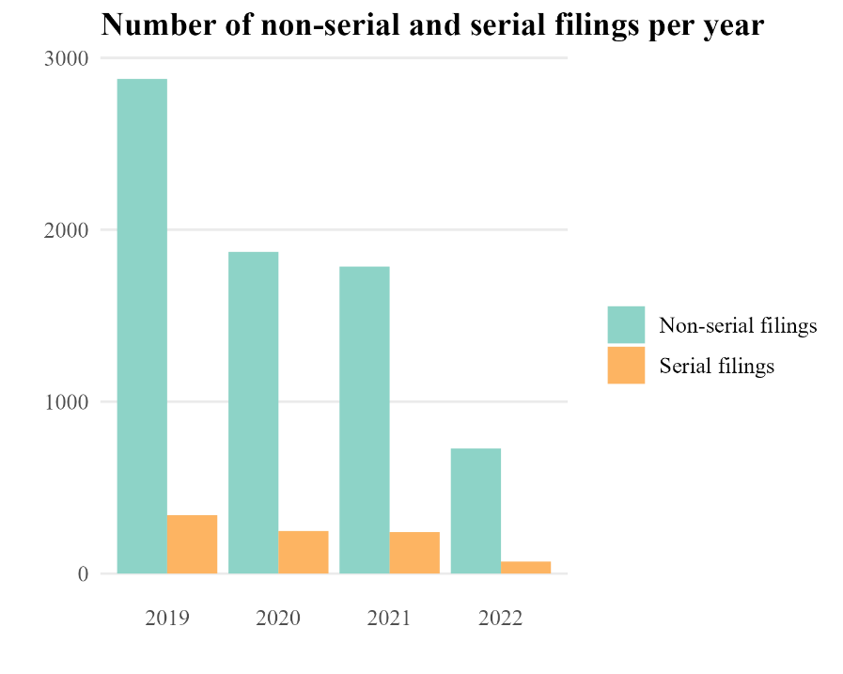
Figure 3.1 Frequency of non-serial and serial residential filings by year in Knox County, TN. Important note: 2022 only included four months of data and should not be compared 1:1 with 2019, 2020, or 2021 for which there was complete data.

Table 3.1. Sequence and frequency of serial eviction filings in Knox County, TN, January 2019 - April, 2022
Sequence | Count¹ | Unique Serial Filing Chains ending²
1 | 419 | -
2 | 419 | 369
3 | 50 | 40
4 | 10 | 9
5 | 1 | 1
Total | 899 | 419
¹ Includes the number of raw filings that were attributed with each sequential phase of unique serial filing chains.
² The number of unique households whose serial filing chain ended after two, three, four, or five filings.

Table 3.2. Case outcomes for first and second serial eviction filings within serial filing chains in Knox County, TN, January 2019 - April 2022
Case Outcome |  | All serial filings | First filing in chain | Second filing in chain
Nonsuit |  | 502 | 313 | 157
Default eviction |  | 126 | 36 | 81
Agreed |  | 91 | 34 | 50
Writ of possession issued |  | 162 | 28 | 123
Trial |  | 18 | 8 | 8
Total |  | 899 | 419 | 419

Looking at the second filing within serial filing chains, nonsuit outcomes were still the most common followed by default evictions, but the frequency of writs of possession issued jumped significantly relative to writs issued during the first filing. This is shown more clearly in Figure 3.2. In fact, among all serial filing outcomes, the second filing is when most of them (76%) were issued, suggesting that perhaps these writs were followed through upon after what was an initial threatening filing. And by the third filings, which were significantly less prevalent, nonsuit outcomes were most common followed by default evictions.

Landlord type and legal representation
In this study, landlords were characterized as either “individual” or “company” landlords given the hypothesis that the operational logic of a landlord necessarily impacts the landlord-tenant interaction. It has been found that individual, or “mom and pop” landlords tend to have closer, more informal relationships with their tenants relative to landlords who operate from a more business-like frame and strictly enforce protocols (Garboden & Rosen, 2019; Gomory, 2022). In Knox County 78.6% (n=707) of serial filings during the observation period were initiated by company landlords rather than individual landlords (n = 192; 21.3%). While this finding is also true of eviction filings overall and may simply be reflective of the share of rental properties owned by company landlords relative to individual landlords in Knox County, there are important policy implications to explore. These are further discussed in Chapter Five.
Another factor characterizing a majority of serial filings was the disparity of legal representation among plaintiffs and tenants. During data collection legal representation was operationalized via a four-part coding scheme shown in Figure 3.3. Either the plaintiff (landlord) alone had representation (LL), neither the plaintiff nor tenant had representation (neither), both had representation (both), or only the tenant had representation (tenant). Among the 899 serial filings examined it was far more common for plaintiffs to have representation than tenants. In more than three of every four serial filing cases, the plaintiff had representation while the tenant did not. The next most common was for neither the plaintiff nor defendant to have formal legal representation. In fact, cases in which the defendant (tenant) had representation and the landlord did not were the least common situation.
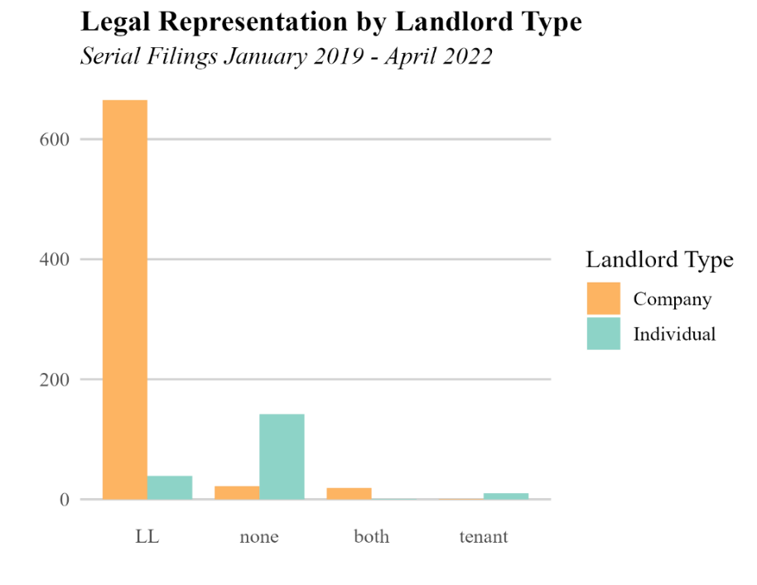
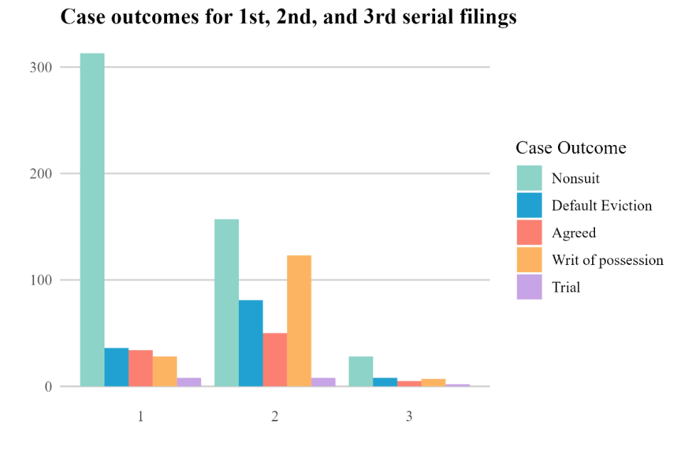
Figure 3.3. Legal representation in serial eviction cases by landlord type. Company landlords were the party most likely to be represented and be the solely represented entity during court eviction proceedings involving serial eviction cases.
Figure 3.2. Case outcomes for first, second, and third filings in serial eviction filing chain sequences. Most initial filings ended with a nonsuit outcome. Second filings had a much more pronounced prevalence of writs of possession issued. Far fewer chains went on to third filings and beyond.

Zooming in to further compare representation by landlord type, it was far more likely for a company landlord to have legal representation in eviction proceedings than an individual landlord (Figure 3.3). Looking solely at the 707 filings initiated by company landlords, they had representation in 96.7% of cases, and it was most common for them to be the solely represented entity in any given proceedings. This differed substantially from cases initiated by individual landlords in which they had legal representation only 20.8% of the time and the most common situation was for neither plaintiff nor defendant to have an attorney. Legal representation by landlord type is outlined in Table 3.3. Tenants were rarely the solely represented entity, and in these cases, the landlord was nearly always (10 of 11 instances) an individual landlord. Table 3.4 shows the outcomes of serial filing cases based on the legal representation of the tenants and defendants. In a plurality of cases (44.4%) the landlord was the only represented party and the outcome was nonsuit. It was notable during the data collection process that few attorneys represented a majority of plaintiffs.
Case duration was another attribute of serial filings assessed and was calculated as the number of days elapsed between when the eviction was filed and when the judgment was made. This did not include the dates on which a writ of possession was issued, if one or multiple were issued in a single case or cases for which there was no recorded date (n = 124). The average serial filing case was processed from filing to judgment in 46.7 days (sd = 52.2 days), approximately a month and a half. However, half of the cases were completed in a month’s time or less (median = 28 days). Comparing filings issued by company versus individual landlords, the mean case duration for each was significantly different (t = -2.55, p < 0.05) at 27 days and 32 days, respectively. Faster average case durations could be another factor attributable to the automation of processes by “company” landlords.

Impacts of eviction moratorium
Over the forty-month study period, an average of 204 residential evictions were filed monthly, though some differences were observed with the introduction of the eviction moratorium. Outside of the moratorium, an average of 218 residential evictions were filed monthly while during the moratorium this
dropped to 166 filings per month. The monthly frequency of overall eviction filings can be seen in Figure 3.4, where there is a clear dip in filing activity during the very early months of the pandemic in April and May
Table 3.3. Legal representation of plaintiffs and defendants in serial eviction filing cases, by landlord type
 | Landlord only | Tenant only | Both landlord and  tenant represented | No representation | Total
Company | 665 | 1 | 19 | 22 | 707
Individual | 39 | 10 | 1 | 142 | 192
Total | 704 | 11 | 20 | 164 | 899

Table 3.4. Serial eviction filing case outcomes by legal representation of plaintiffs and defendants
 | Nonsuit | Writ of Poss. Issued | Default | Trial | Agreed | Total
Landlord | 399 | 137 | 92 | 9 | 67 | 704
Tenant | 7 | 1 | 0 | 0 | 3 | 11
Both | 6 | 4 | 1 | 3 | 6 | 20
None | 90 | 20 | 33 | 6 | 15 | 164
Total | 502 | 162 | 126 | 18 | 91 | 899

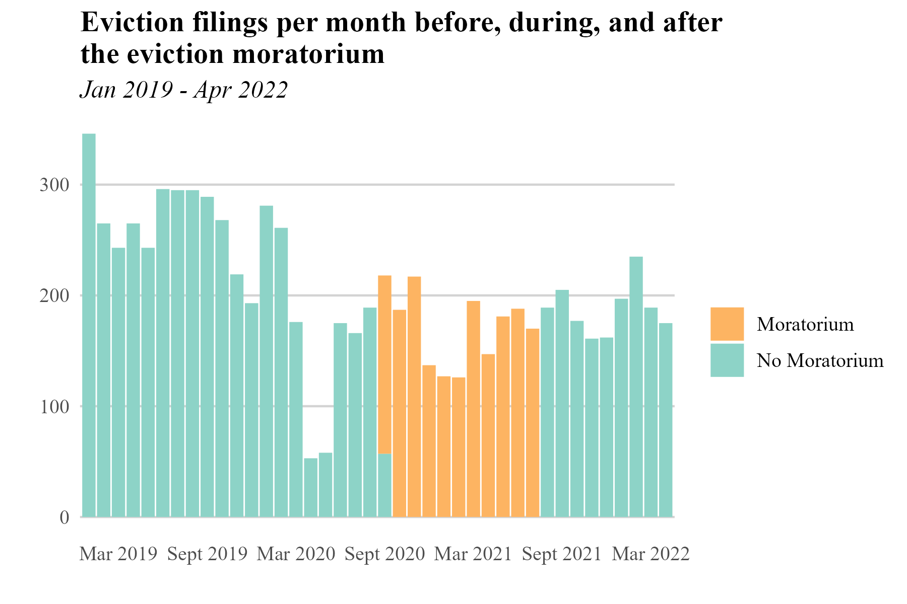

Figure 3.4. Overall eviction filings per month before, during, and after the eviction moratorium in Knox County, Tennessee.

2020 that picked up by June, though not to pre-pandemic levels. A similar but less significant drop also happened during the winter months in which the moratorium was in place. That pattern was echoed more closely by the company landlord filings than individual landlord filings, which appear to have continued their pattern of less frequent, and consistent filing behavior before, during, and after the moratorium (Figure 3.5).
During 2019, the only “normal” year during the period of observation (in that it was unencumbered by the pandemic and full eviction data were available), the average eviction filing rate across tracts was 4.6%, with a maximum of 13.1%. The areas with most filings in 2019, during the moratorium (and the whole observation period overall) were concentrated around the Knoxville downtown periphery, to the north, to the east between Interstate 40 and Magnolia Ave, and to the West hugging Interstate 40. During the 11-month moratorium period, the average eviction filing rate across tracts was cut to 2.6. A lesser drop was seen among serial filings, with the average serial filing rate dropping from 12.1% in 2019 to 11.5% during the moratorium.
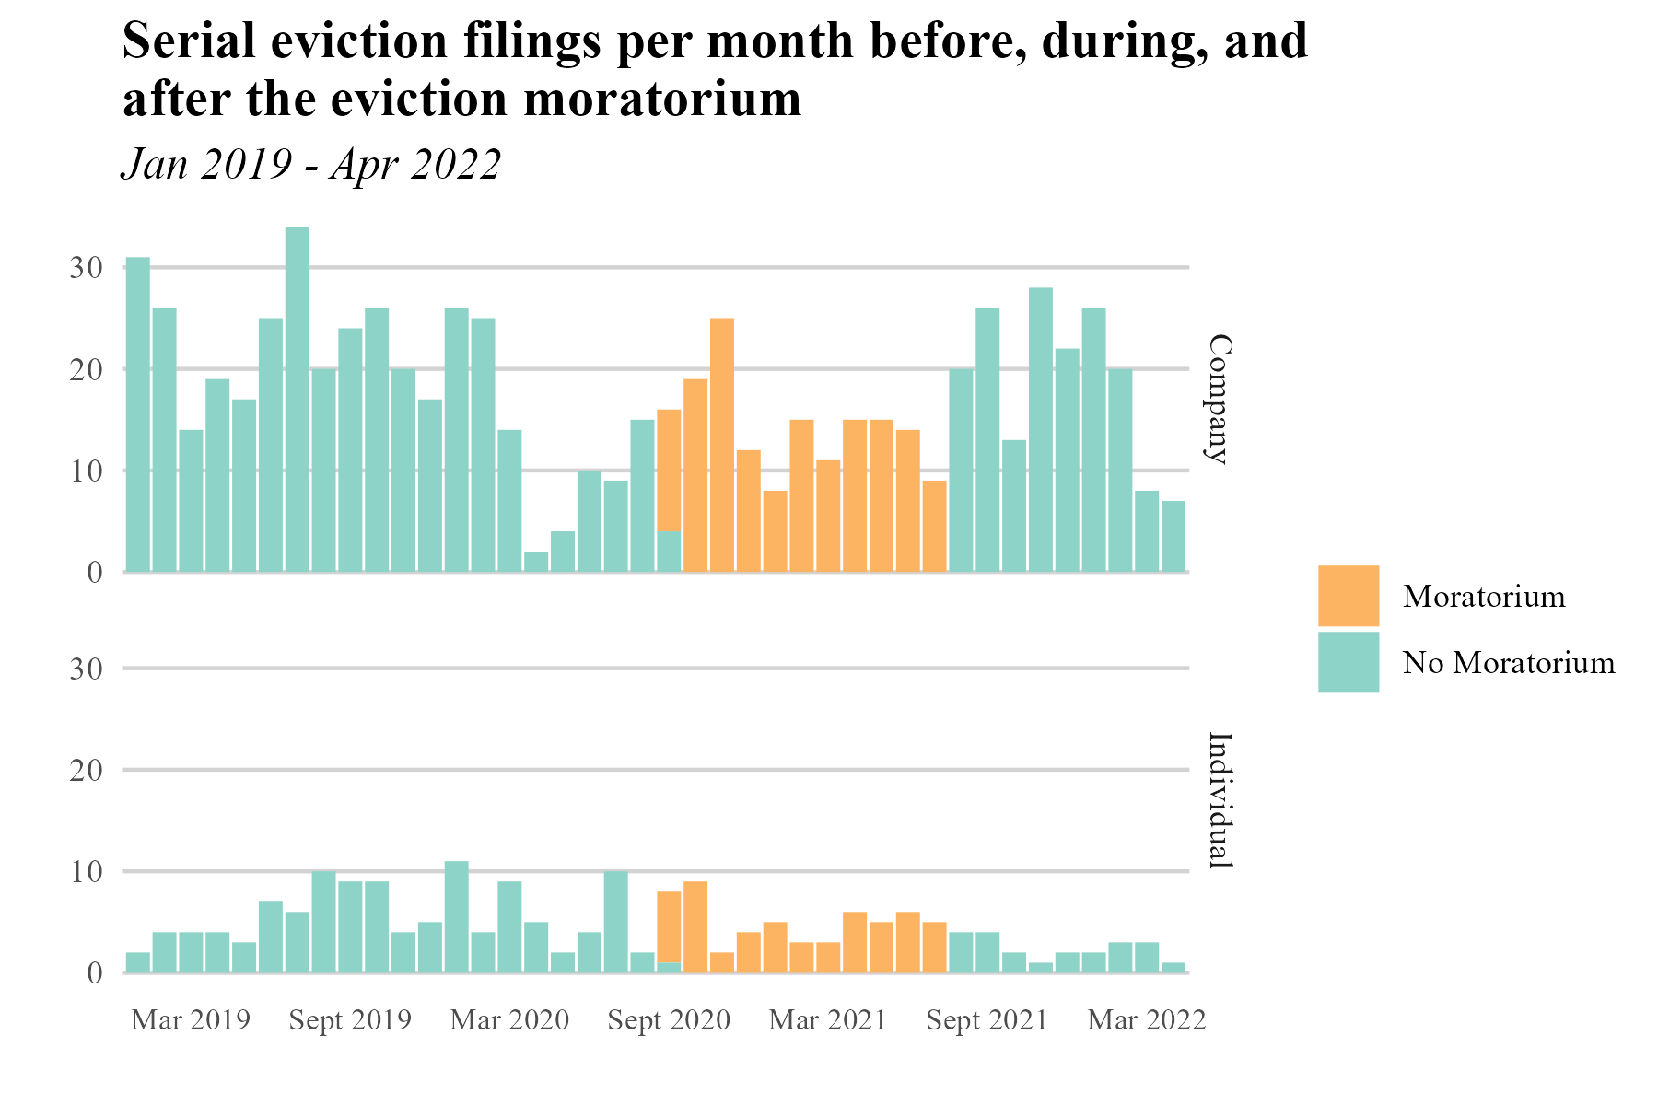
Figure 3.5. Frequency of serial eviction filings per month by landlord type before, during, and after the eviction moratorium in Knox County, Tennessee.

There were some differences in case duration between evictions filed during the moratorium and those filed outside of it. Given the outliers in case duration, median case duration is a more reliable measure of central tendency for both cases filed in and outside of the moratorium. The median case duration for evictions filed during the moratorium was 43 days, while outside the moratorium was 27 days. Cases
tended to resolve more quickly outside the moratorium period, this difference is likely attributable to the court being closed for proceedings but open to filings during a period of 2020.

Neighborhood Analysis

Tract-Level Summary Statistics
The tract-level summary statistics of the variables included in the regression analysis of serial eviction filings are presented here and in Table 3.5, followed by the results of the analysis. Knoxville’s non-White population is concentrated in a few pockets of the county with a mean non-White population of 18.3% across tracts, ranging from zero to 82.1%. This is visible in the map of Knox County (Figure 3.6a) in which

Table 3.5. Tract-level summary statistics for variables used in regression analysis
Tract-level variables (n=119) | Mean | SD | Minimum | Maximum
Neighborhood characteristics
Nonwhite (%) | 18.33 | 15.47 | 0 | 82.12
Occupied rental households (n) | 573.70 | 422.75 | 24 | 1980
High school or less education (%) | 33.96 | 14.67 | 4.59 | 76.31
Rent burden over 30% (%) | 43.98 | 19.08 | 0 | 100.00
Households single female-headed with children (%) | 4.92 | 4.80 | 0 | 25.29
Rental vacancy (%) | 5.86 | 6.13 | 0 | 24.56
Housing stock constructed pre-1980 (%) | 45.76 | 24.03 | 2.48 | 95.61
Labor force unemployed (%) | 3.84 | 2.98 | 0 | 15.37
Median Gross Rent ($) | 1131.90 | 293.62 | 389.00 | 2320.00
Eviction characteristics
¹Serial filing rate | 5.50 | 4.58 | 0 | 21.88
²Unique households filed against (n) | 55.12 | 56.42 | 1 | 327
³Eviction filing rate | 11.54 | 6.47 | 1.56 | 34.44
⁴Evictions initiated by company landlords (%) | 56.82 | 25.56 | 0 | 100.00
¹ Calculated as a ratio of the unique households serially filed against to the total number of unique households filed against, per tract, times 100.
² The number of unique households serially or non-serially filed against per tract.
³ Calculated as the ratio of eviction filings per tract to the number of occupied rental households, times 100.
⁴ Percentage of all evictions initiated by “company” landlords per tract.

the darker green areas indicate larger non-White populations as a percentage of the total population for that census tract. Approximately one in three residents have a high school education or less, though this reaches as high as three in four residents in certain tracts. The map of educational attainment in Knox County at the tract level (Figure 3.6b) suggests a significant east-west divide in the county, where wealthier, more-educated residents reside in the western half of the county and even more specifically, south of the Interstate-40 line which bisects the county laterally.
In terms of rental burden, the U.S. government defines households that spend 30% or greater of their monthly household income on rent to be cost-burdened (U.S Department of Housing and Urban Development, 2014); in the average Knox County census tract, 44.0% of rental households are cost-burdened. While the prevalence of households headed by single females with children is relatively low across the county, there are pockets with significantly higher proportions, where up to one in four households are headed by single females with children. Nearly half of the housing stock in the county was constructed pre-1980 (45.7%; Figure 3.6c), the median gross rent for the county is $1,131.90 per month, and the mean unemployment rate across tracts is 3.8%. Lastly, in terms of landlord type responsible for a majority of eviction filing activity across the county, more than half of all evictions filed were initiated by “company” landlords, and in some tracts all the evictions filed were initiated by company landlords as seen in Figure 3.6d.
At the tract level, 5.5 of every hundred households threatened with eviction in the county were filed against serially during the 40 months observed, however, this ranged from tracts with zero serial filings to others with nearly 22 serial filings per 100 households during the overall observation period (Figure 3.7). The eviction filing rate across tracts ranged from 1.6 to 34.4 filings per 100 renter households (Figure 3.8).

Regression results
The regression analysis (Table 3.6.) revealed several statistically significant variables associated with serial filings across Knox County. Of all the variables included in the model, race, age of the housing stock, and the share of eviction filings initiated by company plaintiffs were the only statistically significant variables
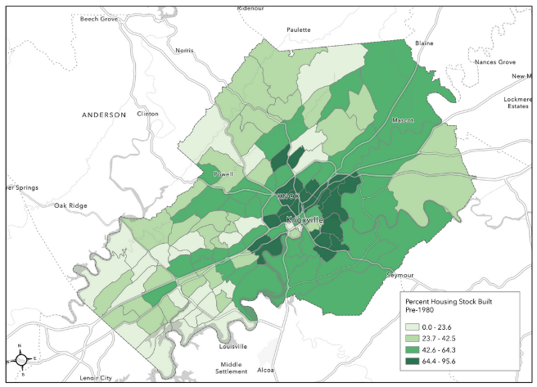  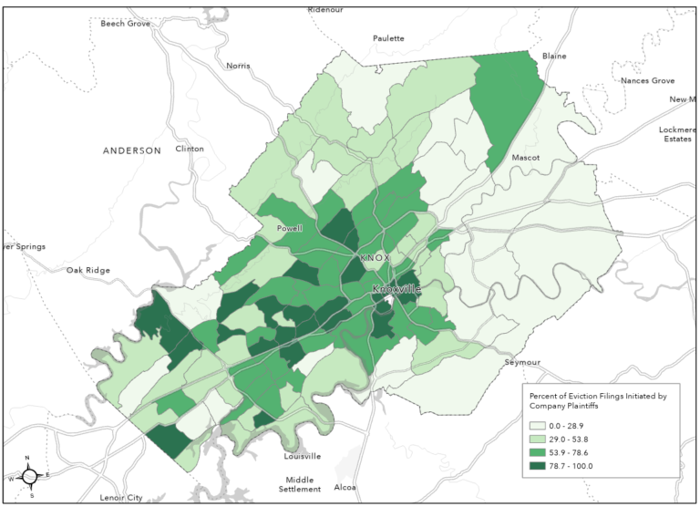  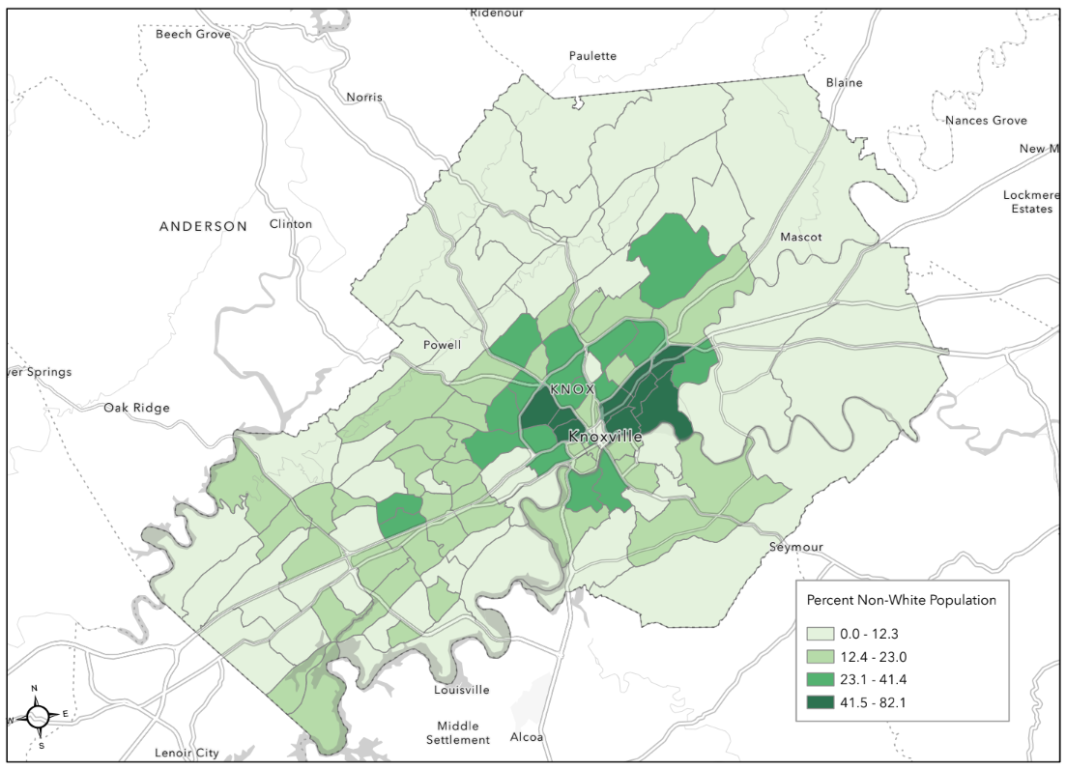  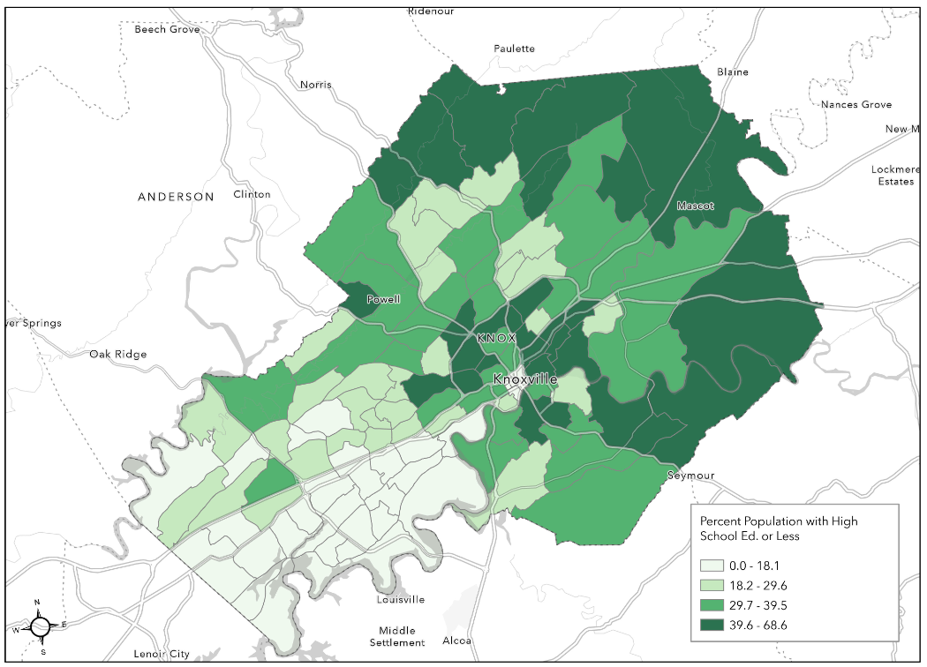  a. Non-White population | c. Share of housing stock built pre-1980
b. Share of population with high school education  or less | d. Share of total eviction filings initiated by company  landlords

Figure 3.6. Tract-level maps of Knox County of select demographic characteristics.
Source: ACS 2022 5-year estimates, IPUMS NHANES
Table 3.6. Regression results estimating serial filings per tract
Tract-level indicators (n=119) | Coefficient | Robust SE | Beta | Incidence Rate Ratio
Intercept | -3.103*** | (0.565) | . | 0.045
% Renters with rental burden >30% | -0.004 | (0.004) | -0.074 | 0.996
% Non-White (%) | 0.008* | (0.006) | 0.131 | 1.008
% High school education or less | -0.007 | (0.005) | -0.103 | 0.993
% Households single female-headed w/kids | 0.004 | (0.015) | 0.018 | 1.004
% Rental units vacant | -0.006 | (0.010) | -0.038 | 0.994
% Housing stock built pre -1980 | -0.005* | (0.003) | -0.121 | 0.995
% Labor force unemployed | -0.003 | (0.016) | -0.008 | 0.997
Median gross rent ($100s) | 0.020 | (0.025) | 0.058 | 1.020
% Share of filings from company plaintiffs | 0.010*** | (0.003) | 0.243 | 1.010
McFadden’s R² | 0.237
* p < .10, **p < .05, *** p < .01
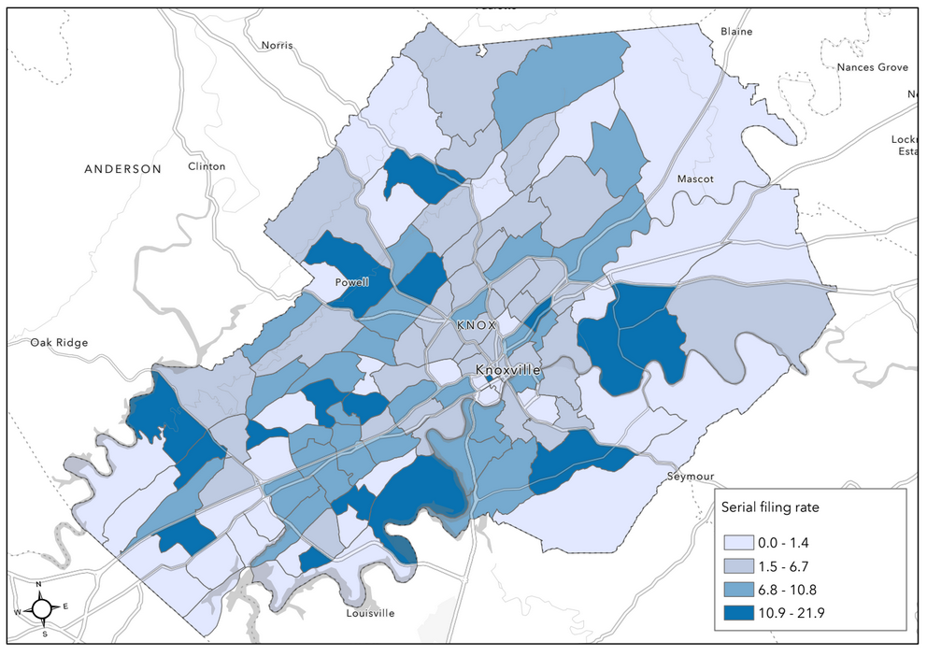
Figure 3.7. Serial filing rates by census tract in Knox County, Tennessee, January 2019 – April 2022. This represents the share of households filed against serially to all households threatened with eviction (individual households filed against either serially or non-serially).

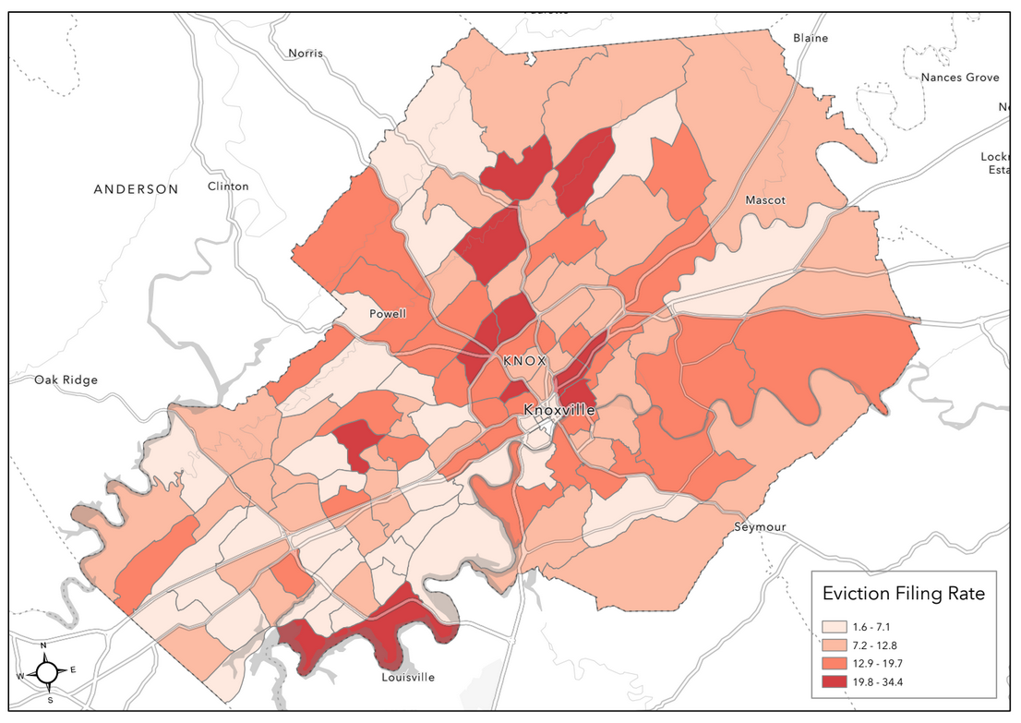
Figure 3.8. Eviction filing rates by census tract in Knox County, Tennessee, January 2019 – April 2022. This represents the share of eviction filings relative to the number of rental households per census tract. Higher eviction filing rates represent more filings per number of occupied rental households.

Rental burden, educational attainment, households headed by single females with children, unemployment, rental vacancy, and median gross rent were not found to be statistically significant in the final model. These variables, though not found to be significant, were retained to avoid a type II error, as they were found in previous studies to be important.
Tracts with larger non-White populations were associated with more serial filings. Tracts with greater shares of older housing stock (constructed prior to 1980) were negatively associated with serial filings, in other words, more older buildings in a census tract meant fewer serial filings. Last, higher shares of eviction filings (both serial and non-serial) that were initiated by “company” landlords was the strongest predictor (p < 0.01) for the number of serial filings present in each census tract. While median gross rent did not have a significant effect in this model, it did have a sizeable Beta coefficient (0.058) and incidence rate ratio (1.020). The implications of these and previously described findings are discussed further in the following chapter.

CHAPTER FIVE
DISCUSSION
The major findings of this research largely support existing literature and expand it into a difficult-to-assess legal jurisdiction not previously studied. Overall, 2019 experienced the greatest number of both non-serial and serial eviction filings among the years observed. Fluctuations in eviction filing and serial eviction filing occurred month to month and year to year, likely due to disruptions introduced during the Covid-19 pandemic and the subsequent eviction moratorium that was in place for approximately eleven months between September 2020 and July 2021. The annualized county eviction filing rate was highest in 2019 at 4.7%, declining in 2020 and 2021 to 3.1% and 3.0% respectively. This is significantly lower than the 7.2% average county-level eviction filing rate identified by Leung, Hepburn and Desmond (2021) in their analysis of 2014 eviction filings across 28 states, but in the ballpark of the Eviction Lab’s 2018 estimates for Knox County of 3.5% (Eviction Lab, n.d.). It is likely that the eviction moratorium was responsible for the drop seen in 2020 and 2021. And relative to other Tennessee counties, Knox County has among the highest eviction filing rates in the state, fourth behind Davidson, Shelby, and Hamilton Counties, where Nashville, Memphis, and Chattanooga are located, respectively (Eviction Lab, n.d.).
The median length for serial filing chains (individual series of filings against a single household) in Knox County was two, consistent with previous findings from Leung, Hepburn and Desmond (2021). There were a few chains that extended beyond two occurrences, with a maximum of five filings in the longest chain, far lower than the maximum observed in previous findings of chains of up to 26 serial filings (Watson et al., 2023). This suggests that serial filing, while relatively prevalent in Knox County (with a serial filing rate of 5.5% over the forty-month observation period, and 7.7% at its peak in 2019) is not as common as in jurisdictions such as Charleston, South Carolina (Leung, Hepburn, & Desmond, 2021) where more than half of all households filed against were filed against serially in 2014. It is, however, higher than some jurisdictions observed by Leung, Hepburn and Desmond (2019) where the serial filing rate was essentially zero. Thus, there is room for improvement in curbing the practice of serial filing in Knox County, TN.
The majority of serial filing chains resulted in nonsuit or equivalent rulings with a sizable increase in default eviction and writs of possessions issued by the second filings. Landlords may be using serial filings as an initial “warning” filing against tenants – who most likely fell behind on rent – and then followed through on that threat by the second filing. This would be consistent with findings by Garboden and Rosen (2019) who found landlords use eviction filings with “the goal not of removing them, but rather of collecting rent,” (p.639). Interestingly, very few filing chains went on to third, fourth, and fifth filings. This could be due to the eviction process perhaps being more burdensome than in jurisdictions with higher serial filing rates, thereby discouraging as much serial filing activity. Though, this would require further analysis to confirm.
By far, a majority of both serial and non-serial findings were initiated by company landlords. Among serial filings alone, 78% of chains were initiated by company landlords. This is consistent with previous findings that found larger landlords and landlords that operate within the framework of a formal organization are more likely to evict and to evict serially (Gomory, 2022) and neighborhoods with greater shares of company landlords initiating eviction filings have higher serial filing rates (Leung, Hepburn, & Desmond, 2021). There are likely several factors driving this disparity in filing initiation between landlord types. First, and most obviously, this is likely a function of the number of units held by individuals versus incorporated entities. Larger apartment complexes are seldom held by individuals. However, without connecting these eviction data to individual landlord portfolio sizes, as Immergluck et al. (2020), Gomory (2022) and Watson et al. (2023) were able to do, this is simply a hypothesis. This ownership gap could also be reflective of the increasing privatization and consolidation of rental properties in fewer hands. Secondly, as Gomory (2022) explains well, company landlords are far more likely to have formal processes in place which outline clear instructions for when and how to handle a tenant’s late rent and subsequent filing for eviction through the court. Individual landlords are less likely to evict until significant disagreement has accumulated with their tenant and are also less likely to have a routine plan for when and how to evict each tenant (Gomory, 2022). Furthermore, formalized landlords are able to maintain a bureaucratic distance with their tenants and make more “objective” business decisions without having to contend with landlord-tenant relationships (Gomory, 2022). It is suspected that these dynamics play into the disparities in both serial and non-serial filing by individual and company landlords observed here.
The stark disparities in legal representation observed between company and individual landlords is also perhaps reflective of the formalization of company landlords. Company landlords had legal representation in far more cases (96.7% of cases filed by company landlords) than individual landlords (20.8% of cases filed by individual landlords), highlighting a proximity to the court that individual landlords seem to not have. This changes the balance within the courtroom for tenants based on the type of landlord from which they rent. The proximity of company landlords to the court via their legal representation facilitates the ease with which they can file and manage tenants against whom they have filed for eviction. Tenants, on the other hand, rarely had legal representation (in only 31 of the 899 observed cases), and when they did, it was most often provided by legal aid. To current knowledge, this is the first study on serial filings to examine legal representation.
Another attribute examined was case duration. There was a significant difference observed in case duration among serial filings issued by company or individual landlords, with cases issued by company landlords receiving judgement five days faster. This could be further evidence of the formality and increased ease of processing evictions afforded to company versus individual landlords and would require further exploration to determine more certainly.
The results of the regression analysis suggest that serial filing trends in Knox County largely conform with the trends observed in other regions of the country. Variables found to be significantly associated with serial filing in Knox County have also been previously identified as significant predictors of serial filing in other jurisdictions, namely: neighborhoods with higher shares of non-White residents, neighborhoods with fewer older buildings, and neighborhoods with more eviction activity from company landlords.
Immergluck et al. (2020) similarly found block groups with higher shares of Black renters to have higher serial filing rates, consistent with what is known about non-White majority neighborhoods being most vulnerable for eviction filing generally (Graetz et al., 2023; Hepburn, Louis, & Desmond, 2021; McCabe & Rosen, 2020). In line with our finding that neighborhoods with greater shares of buildings built prior to 1980 were negatively associated with serial filings, Immergluck et al. (2020) also found older buildings to have lower serial filing shares. This could be attributable to the gentrification process, in which older buildings slowly filter out of the rental market through disrepair, or are purchased, flipped, and converted into higher-end rental properties that increase the rate of non-serial filing in those buildings. In fact, both Immergluck et al. (2020) and Gomory (2022) have found dramatic increases in non-serial filing rates following the sale of rental properties. This could be important to investigate further in Knox County to protect renters in buildings facing sales from mass non-serial eviction filings.
The variable with the largest effect in predicting serial filing in Knox County was the share of evictions initiated by company landlords as a total of all filings initiated against residents of each tract. The more filings initiated by company landlords, the higher the serial filing rate. This was also found in a much larger-scale study conducted across 28 states by Leung, Hepburn, and Desmond (2021). This is likely reflective of the disparity in eviction activity between company and individual landlords, tracts with more filings – especially filings generated by company landlords – are more likely to have serial filing activity relative to other tracts.
Several other variables hypothesized to be predictors of serial filing were not found to be statistically significant in the final model. It is possible that due to the limited geographic area of study – and therefore the limited number of observations in the model at the tract level – that variables found to be significantly associated with serial filing in previous studies remained undetected here.
A major contribution of this work is its exhaustive examination of all evictions filed over a three year and four month period in a jurisdiction where eviction data are difficult to obtain. This study is also a first look at legal representation in the context of serial filing, another important avenue for policy work to strengthen tenant rights. Notably, similar findings were observed here as in previously studied jurisdictions but more remains to be studied.
Scholars have come to understand the importance of theorizing eviction as a process of complex dynamics evolving over time between landlords and tenants, not simply a single event of expulsion (Garboden & Rosen, 2019). And as Immergluck et al. (2020) cautions, housing advocates and researchers should carefully distinguish between serial and non-serial filing as they describe two different phenomena and landlord intentions. Serial filings represent a unique scenario in which landlords exploit the legal system to extract outcomes other than those intended by the eviction system, placing undue burden on tenants, whereas non-serial filing is more focused on the intention of removal and repossession of the property. As has now been well-documented, serial filing is employed by landlords to varying extents, largely based on environmental factors such as the legal landscape in which they are operating to “threaten” or otherwise coercively extract rent and extra funds via late fees (Garboden & Rosen, 2019; Gomory, 2022; Leung, Hepburn, & Desmond, 2021; Watson et al., 2023). The process of eviction from an initial filing to judgement creates a precarious state of being for tenants that is extended when filed against repeatedly. As Leung, Hepburn, and Desmond (2021) have found, the impact of serial eviction filings extends the impact of eviction beyond demographic groups typically associated with eviction – low income, minority populations – to mid-range income groups as well.
Though serial filings in Knox County were not found to be as prevalent as in other areas of the country, there is room to reduce the current rate and put measures in place to prevent it from increasing further. This is of importance as the population of the county is expected to grow at a rapid pace, accompanied by corporate entities increasingly purchasing and consolidating the rental housing market. Since landlords with more formalized business practices are expected to engage in higher rates of serial filing, it would be expected that the serial filing rate in Knox County could potentially increase along with the shift in rental property ownership from smaller scale to larger scale landlords in coming decades. Rental price growth in Knoxville has been ranked among the most rapid in the country in recent years, not keeping pace with wage growth, contributing to the local housing crisis. There is also an affordable housing shortage as the creation of new affordable housing options is not keeping pace with the need. Policy proposals for both curbing and preventing the practice of serial filing in Knox County are discussed in the next chapter.
This study was not without limitations. The time span of study was selected based on data availability, though it was interesting and challenging in that it encompassed the Covid-19 eviction moratorium put in place in 2020. The estimations of evictions and filings are necessarily an undercount because of the number of informal evictions that take place but go undocumented. Lastly, the dichotomization of landlord types was an imperfect proxy intended to capture landlords’ underlying business practices. Given the opaque nature of LLC and similar business entities, it would have been outside the scope of this work to attempt to uncover the true ownership of rental properties based solely on plaintiff names in court records, though some effort was made at the beginning of the project. Nonetheless, the conclusions seem to reflect the findings of previous researchers, validating the decision of that classification of landlord types as an acceptable proxy here.
Avenues for future research include investigating the role of public housing in eviction in Knox County; both publicly operated and publicly subsidized (housing vouchers) rental housing. Additional work examining the structural forces impacting the housing market would be an interesting contribution to this work and an important step toward protecting renters from future housing market pressures. Extending the analysis of serial filings further into the past to understand the trend of serial filing locally could also provide valuable insights for policymakers. As would the incorporation of qualitative data to understand the views of tenants who have experienced serial filing and landlords who are responsible for serial filing. The following chapter provides a brief overview of policy recommendations collected during the process of this research, offered by housing researchers and advocates specifically to curb the practice of serial filing and protect tenants.

CHAPTER SIX
RECOMMENDATIONS
There are many policies that could curb the current practice and prevent the increase of serial filing in Knox County. Some deal with serial filing directly by addressing environmental and legal factors that facilitate the practice for landlords, and others are indirect in that they provide additional support for tenants facing eviction. As a politically conservative state, there are barriers in place at the state-level preempting local governments from implementing policies aimed at rent regulation or inclusionary zoning, both known to provide protection to tenants and increase the availability of affordable housing (Greene, Ramakrishnan, & Morales-Burnett, 2020). Because these are not allowed in Knox County, they are not included in the discussion below.

Direct policy measures to curb serial eviction filing
Given the disparities in legal representation between tenants and landlords in eviction proceedings, making representation more readily available would be an important step toward housing justice. As in criminal proceedings when a right to legal representation is guaranteed for defendants, civil proceedings should be similarly treated via the establishment of a right to counsel for tenants (Chapple, 2023; Immergluck et al., 2020). The right to counsel movement is growing steadily across U.S. jurisdictions. Efforts are currently underway in Knox County to establish a formal right to counsel and a pilot program has been funded to expand the legal aid program locally and provide more representation to tenants. This is important because most of the legal representation provided to tenants in cases observed in this study was provided by the local legal aid organization.
Another way to prevent the increase in serial filing in Knox County would be to increase the barriers to filing. As Leung, Hepburn, and Desmond (2021) found counties with more barriers to filing had lower serial eviction filing rates. One barrier commonly mentioned in the literature is the cost to file. Increasing filing fees (Garboden & Rosen, 2019; Leung, Hepburn & Desmond, 2021) and taking care to ensure the fees are not passed on to tenants (Lowrey, 2021) would be one way to curb the practice of repeated filing by landlords. Expanded pre-filing notice requirements to slow the process of eviction (Immergluck et al., 2020, Lowrey, 2021) giving tenants time to make rent, would also help. In Tennessee, there is a five-day grace period and landlords are required to provide a 14-day notice before filing a detainer warrant for eviction with the court. This 14-day period could be extended to give tenants more time to pay. This period lasts up to 30 days as in Washington, D.C. Last, because most evictions are initiated on the basis of nonpayment of rent, placing a minimum amount owed to landlords before they can file would help reduce the number of eviction cases heard by the court and would keep landlords for filing for eviction for – relatively – trivial amounts. For example, in Washington, D.C. landlords cannot file for less than $600 owed (Gomory, 2022).
Since previous findings have indicated many landlords and property management firms employ serial filing as a mechanism for extracting extra income via late fees – capping the fee amount allowable could make serial filing a less financially lucrative, and therefore less appealing endeavor (Leung, Hepburn, & Desmond, 2021). Leung, Hepburn, and Desmond (2021) highlighted the example of Washington, D.C. and their limitation on late rent fees capped at 5% of total monthly rent as a potential model to follow.

Indirect policy measures to curb serial eviction filing
Other measures that can be taken to prevent tenants from being filed against, or serially filed against involve strengthening the social safety net for tenants locally. Increasing the pool of affordable housing options in Knox County would be a critical measure to keep people housed (Chapple et al., 2023; Immergluck et al., 2020). Chapple et al. (2023) provide an excellent overview of policies implemented by local governments to prevent displacement and provide affordable housing for residents. Three major strategy categories they discuss include the production of new affordable housing, the preservation of existing affordable housing, and the stabilization of tenants with programs such as rental assistance and right to counsel. Rental assistance programs for both tenants and landlords create a barrier between a tenant’s inability to pay rent on time and the subsequent filing of an eviction against them.
There is also a need for transparency in eviction data and modernization and standardization of court recordkeeping practices (Hartman & Robinson, 2003; Immergluck et al., 2020; Thomas et al., 2024). Eviction data in Knox County are currently difficult to access due to the way they are stored in scanned documents of detainer warrants in which most case details are documented in handwriting. This lack of transparency makes it difficult for local researchers and housing advocates to fully understand the nature of eviction in Knox County, relying instead on piecemeal data and anecdotal information. Public records of tenant’s eviction filing history are already accessible to landlords who use background checks to screen potential renters, so the opacity of eviction data is not preventing landlords from viewing tenant histories, but it is impacting advocates’ ability to use the data to make a case on behalf of tenants to policymakers. Several thoughtful and impactful examples of making eviction data actionable for housing advocacy while protecting tenant privacy are described in Tran et al. (2024). They worked collaboratively with local activists in Georgia to create an interactive dashboard of eviction data to “challenge power,” based on principles outlined in Catherine D’Ignazio and Lauren Klein’s book Data Feminism. Another example is the Anti-Eviction Mapping Project’s Evictorbook tool (www.evictorbook.com) where San Francisco area tenants are empowered to look up their landlord or potential landlord and see their history of tenant eviction. Activists can use the tool for organizing purposes and explore the complex corporate networks of ownership governing their city’s rental property market.
Last, serial filing is particularly damaging to tenants because of the volume of eviction filings placed on their public records as a result. The mere presence of the filing on their record – whether it was dismissed or a judgment was made in favor of the tenant – impinges their ability to secure housing in the future. It is notoriously difficult to remove them from public record, so there should be a standardized, straightforward manner for tenants to do so. This discussion of policy recommendations is not meant to be exhaustive simply a starting point for future action and research to protect tenants against serial eviction filing.

REFERENCES

Anti-Eviction Mapping Project. (n.d.) Anti-Eviction Mapping Project. https://antievictionmap.com/
Arnold, C. (2020, September 1). CDC Issues Sweeping Temporary Halt On Evictions Nationwide Amid
Pandemic. NPR News. https://www.npr.org/sections/coronavirus-live-updates/2020/09/01/908 581048/ sweeping-new-eviction-ban-from-trump-administration
Atlanta Regional Commission. (December 30, 2023). Atlanta region eviction tracker. https://atl-eviction-
tracker.herokuapp.com/
Balzarini, J., & Boyd, M. L. (2021). Working With Them: Small-Scale Landlord Strategies for Avoiding
Evictions. Housing Policy Debate, 31(3–5), 425–445. https://doi.org/10.1080/10511482.2020. 1800779
Beck Cultural Exchange Center. (n.d.). Urban renewal. https://www.beckcenter.net/
Burns, R. (2023, June 27). Artificial intelligence is making the housing crisis worse. Lever News.
https://www.levernews.com/artificial-intelligence-is-making-the-housing-crisis-worse/
Chapple, K., Loukaitou-Sideris, A., Miller, A., & Zeger, C. (2023). The Role of Local Housing Policies in Preventing Displacement: A Literature Review. Journal of Planning Literature, 38(2), 200–214. https://doi.org/10.1177/08854122221137859
City of Knoxville. (2023, April 4). Mayors announce joint city office on housing stability.
https://www.knoxvilletn.gov/archived_news_stories/2023/mayors_announce_joint_office_on_housin
g_stability
City of Knoxville. (2024). City of Knoxville fair housing equity plan draft 7/31/2024. https://cdnsm5-
hosted.civiclive.com/UserFiles/Servers/Server_109478/File/CommunityDevelopment/EquityPlan/Final-Draft-Equity-Plan-073124.pdf
Coxe, S., West, S. G., & Aiken, L. S. (2009). The Analysis of Count Data: A Gentle Introduction to
Poisson Regression and Its Alternatives. Journal of Personality Assessment, 91(2), 121–136. https://doi.org/10.1080/00223890802634175

Desilver, D. (2021, August 2). As national eviction ban expires, a look at who rents and who owns in the
U.S. Pew Research Center. https://www.pewresearch.org/short-reads/2021/08/02/as-national-
eviction-ban-expires-a-look-at-who-rents-and-who-owns-in-the-u-s/
Desmond, M. (2012). Eviction and the Reproduction of Urban Poverty. American Journal of Sociology,
118(1), 88–133.
Desmond, M., & Shollenberger, T. (2015). Forced Displacement From Rental Housing: Prevalence and
Neighborhood Consequences. Demography, 52(5), 1751–1772. https://doi.org/10.1007/s13524-015-0419-9
Desmond, M. (2016). Evicted: Poverty and Profit in the American City.
Doran, K., Guzzardo, J., Hill, K., Kitterlin, N., Li, W., & Liebl, R. (2003). No time for justice: A study of
Chicago’s eviction court (Lawyers’ Committee for Better Housing). Chicago-Kent College of
Law.
Dunn, E., & Grabchuk, M. (2010). Background Checks and Social Effects: Contemporary Residential
Tenant-Screening Problems in Washington State. Seattle Journal for Social Justice, 9(1),
319–399.
Dupuis, A., & Thorns, D. C. (1998). Home, Home Ownership and the Search for Ontological Security.
The Sociological Review, 46(1), 24–47. https://doi.org/10.1111/1467-954X.00088
East Tennessee Realtors. (2024). 2024 Market Housing Forecast.
https://www.etnrealtors.com/assets/pdf/ETNR-2024-Forecast-Report/
Engler, R. (2010). Connecting Self-Representation to Civil Gideon: What Existing Data Reveal About
When Counsel is Most Needed. Fordham Urban Law Journal, 37(1).
Eviction Lab. (2023). Eviction Map: Knox County, Tennessee. Retrieved from
https://evictionlab.org/map/?m=modeled&c=p&b=efr&s=all&r=counties&y=2018&z=9.17&lat=35.99&lon=-83.96&lang=en&l=47093_-83.96_35.99
Eviction Lab. (n.d.). Help and FAQ “What is a threatened household? And why is it lower than the number of eviction filings? https://evictionlab.org/help-faq/#households-threatened
Eviction Research Network. (2022). Eviction Research Network. University of California, Berkeley.
https://evictionresearch.net/
Fleming-Klink, I., McCabe, B. J., & Rosen, E. (2023). Navigating an Overburdened Courtroom: How
Inconsistent Rules, Shadow Procedures, and Social Capital Disadvantage Tenants in Eviction
Court. City & Community, 22(3), 220–245. https://doi.org/10.1177/15356841221141889
Fullilove, M. T., Peterson, C. F., & Bassett, M. Travis. (2016). Root Shock : How Tearing up City
Neighborhoods Hurts America, and What We Can Do about It. New Village Press.
Garboden, P. M., & Rosen, E. (2019). Serial Filing: How Landlords use the Threat of Eviction. City &
Community, 18(2), 638–661. https://doi.org/10.1111/cico.12387
Giddens, A. (1990). The Consequences of Modernity.
Gold, A. (2016). No home for justice: How eviction perpetuates health inequity among low-income
and minority tenants. Georgetown Journal on Poverty Law and Policy, XXIV(1), 60-85.
Gomory, H. (2022). The Social and Institutional Contexts Underlying Landlords’ Eviction Practices.
Social Forces, 100(4), 1774–1805. https://doi.org/10.1093/sf/soab063
Graetz, N., Gershenson, C., Hepburn, P., Porter, S. R., Sandler, D. H., & Desmond, M. (2023). A
comprehensive demographic profile of the US evicted population. Proceedings of the National Academy of Sciences, 120(41), e2305860120. https://doi.org/10.1073/pnas.2305860120
Green, J. A. (2021). Too many zeros and/or highly skewed? A tutorial on modelling health behaviour
as count data with Poisson and negative binomial regression. Health Psychology and Behavioral Medicine, 9(1), 436–455. https://doi.org/10.1080/21642850.2021.1920416
Greene, S., Ramakrishnan, K., & Morales-Burnett, J. (2020). State Preemption of Local Housing Protections. Urban Institute.
Gromis, A., Fellows, I., Hendrickson, J. R., Edmonds, L., Leung, L., Porton, A., & Desmond, M. (2022).
Estimating eviction prevalence across the United States. Proceedings of the National Academy of Sciences, 119(21), e2116169119. https://doi.org/10.1073/pnas.2116169119

Hartman, C., & Robinson, D. (2003). Evictions: The hidden housing problem. Housing Policy Debate,
14(4), 461–501. https://doi.org/10.1080/10511482.2003.9521483\
Hatch, M. E., & Yun, J. (2021). Losing Your Home Is Bad for Your Health: Short- and Medium-Term
Health Effects of Eviction on Young Adults. Housing Policy Debate, 31(3–5), 469–489. https://doi.org/10.1080/10511482.2020.1812690
Hepburn, P., Louis, R., & Desmond, M. (2020). Racial and Gender Disparities among Evicted Americans. Sociological Science, 7, 649–662. https://doi.org/10.15195/v7.a27
Hilbe, J., M. (2007). Negative binomial regression. Cambridge University Press.
Hoffman, D., & Strezhnev, A. (2023). Longer trips to court cause evictions. Proceedings of the National
Academy of Sciences, 120(2). https://doi.org/10.1073/pnas.2210467120
Immergluck, D., Ernsthausen, J., Earl, S., & Powell, A. (2020). Evictions, large owners, and serial filings:
Findings from Atlanta. Housing Studies, 35(5), 903–924. https://doi.org/10.1080/02673037.
2019.1639635
Kleysteuber, R. (2007). Tenant Screening Thirty Years Later: A Statutory Proposal to Protect Public Records. The Yale Law Journal, 116(6), 1344. https://doi.org/10.2307/20455760
Knoxville Area Association of Realtors. (2023). 2023 State of Housing Report. Retrieved from:
https://www.etnrealtors.com/assets/pdf/2023-05+-+KAAR+-+State+of+Housing+Report/
Lee, H. (2017, August 8). Who owns rental properties, and is it changing? Joint Center for Housing Studies of Harvard University. https://www.jchs.harvard.edu/blog/who-owns-rental-properties-and-is-it-changing
Legal Services Corporation. (September 16, 2024). Civil Court Data Initiative Eviction Tracker.
https://civilcourtdata.lsc.gov/data/eviction
Leifheit, K. M., Schwartz, G. L., Pollack, C. E., Black, M. M., Edin, K. J., Althoff, K. N., & Jennings, J.
M. (2020). Eviction in early childhood and neighborhood poverty, food security, and obesity in later childhood and adolescence: Evidence from a longitudinal birth cohort. SSM - Population Health, 11. https://doi.org/10.1016/j.ssmph.2020.100575
Leung, L., Hepburn, P., & Desmond, M. (2021). Serial Eviction Filing: Civil Courts, Property
Management, and the Threat of Displacement. Social Forces, 100(1), 316–344. https://doi.org/10.1093/sf/soaa089
Leung, L., Hepburn, P., Hendrickson, J., & Desmond, M. (2023). No Safe Harbor: Eviction Filing in
Public Housing. Social Service Review, 97(3), 456–497. https://doi.org/10.1086/725777
Machado, A. (2001). Proverbios y cantares XXIX. Campos de Castilla.
Madden, D., & Marcuse, P. (2016). In Defense of Housing. Verso.
Manson, S., Schroeder, J., Van Riper, D., Knowles, K., Kugler, T., Roberts, F., & Ruggles, S. (2023)
National Historical Geographic Information System: Version 18.0 [dataset]. Minneapolis, MN:
IPUMS. http://doi.org/10.18128/D050.V18.0
McCabe, B. J., & Rosen, E. (2020). Eviction in Washington, DC: Racial and Geographic Disparities in
Housing Instability. Georgetown University.
Merritt, B., & Farnworth, M. D. (2021). State Landlord–Tenant Policy and Eviction Rates in Majority-
Minority Neighborhoods. Housing Policy Debate, 31(3–5), 562–581. https://doi.org/10.1080/10511482.2020.1828989
Nelson, K., Garboden, P., McCabe, B. J., & Rosen, E. (2021). Evictions: The Comparative Analysis Problem. Housing Policy Debate, 31(3–5), 696–716. https://doi.org/10.1080/10511482.2020.1867883
Pappoe, Y. N. (2023). The scarlet letter "e": how tenancy screening policies exacerbate housing inequity
for evicted black women. Boston University Law Review, 103(1), 269-310.
Porton, A., Gromis, A., & Desmond, M. (2021). Inaccuracies in Eviction Records: Implications for
Renters and Researchers. Housing Policy Debate, 31(3–5), 377–394.
https://doi.org/10.1080/10511482.2020.1748084
Ramphal, B., Keen, R., Okuzuno, S. S., Ojogho, D., & Slopen, N. (2023). Evictions and Infant and Child
Health Outcomes: A Systematic Review. JAMA Network Open, 6(4). https://doi.org/10.1001/jamanetworkopen.2023.7612
Raymond, E. L., Duckworth, R., Miller, B., Lucas, M., & Pokharel, S. (2018). From Foreclosure to Eviction. Cityscape: A Journal of Policy Development and Research, 20(3), 159-188. https://www.jstor.org/stable/10.2307/26524878
Robinson, D., & Steil, J. (2021). Eviction Dynamics in Market-Rate Multifamily Rental Housing.
Housing Policy Debate, 31(3–5), 647–669. https://doi.org/10.1080/10511482.2020.1839936
Rolnik, R. (2019). Urban Warfare: Housing under the empire of finance. Verso.
Shepardson, D. (2021, August 2). U.S. lawmakers fail to renew pandemic related residential eviction
ban. Reuters. https://www.reuters.com/legal/government/us-house-take-up-residential-eviction-
moratorium -extension-2021-07-30/
Sisco, J. (2024, July 12). Justice Department preparing rental market collusion lawsuit. Politico. https://www.politico.com/news/2024/07/12/justice-department-rental-market-collusion-lawsuit-00167838#
Smith, N. (1979). Toward a Theory of Gentrification: A Back to the City Movement by Capital, not
People. Journal of the American Planning Association, 45(4), 538–548. https://doi.org/10.1080/01944367908977002
Thomas, T., Ramiller, A., Ren, C., & Toomet, O. (2024). Toward a National Eviction Data Collection
Strategy Using Natural Language Processing. Cityscape: A Journal of Policy Development and
Research, 26(1), 241–260.
Thompson, M. (2024, July 26). Knoxville has the fastest-rising housing prices in America, new report
says. Knox News. https://www.knoxnews.com/story/news/local/2024/07/26/knoxville-has-the-fastest-rising-housing-prices-in-america/74528543007/
Travis, A. (2019). The Organization of Neglect: Limited Liability Companies and Housing Disinvestment. American Sociological Review, 84(1), 142–170. https://doi.org/10.1177/0003122418821339
Treglia, D., Byrne, T., & Tamla Rai, V. (2023). Quantifying the Impact of Evictions and Eviction Filings on Homelessness Rates in the United States. Housing Policy Debate, 1–12. https://doi.org/10.1080/10511482.2023.2186749
United States Census Bureau. (2023). QuickFacts: Knox County, Tennessee and Knoxville, Tennessee.
Retrieved August 14, 2024, from https://www.census.gov/quickfacts/fact/table/
knoxvillecitytennessee, knoxcountytennessee,US/PST045223
United States Department of Housing and Urban Development. (2014, September 22) Rental burdens: rethinking affordability measures. https://www.huduser.gov/portal/pdredge/pdr_edge_featd
_article_092214.html
Vogell, H. (2022, February 7). When Private Equity Becomes Your Landlord. ProPublica.
https://www.propublica.org/article/when-private-equity-becomes-your-landlord
Vogell, H. (2023, November 16). DOJ backs tenants in case alleging price-fixing by big landlords and a real estate tech company. ProPubblica. https://www.propublica.org/article/doj-backs-tenants-price-fixing-case-big-landlords-real-estate-tech
Wales, E. (2014, August 5). City of Knoxville working to eliminate racial disparities in housing market.
WATE Knoxville. https://www.msn.com/en-us/money/realestate/city-of-knoxville-working-to-eliminate-racial-disparities-in-housing-market/ar-AA1ohYUn
Watson, H., Garboden, P. M. E., McCabe, B. J., & Rosen, E. (2023). Every Month Like Clockwork?
Patterns and Prevalence of Serial Eviction Filing among Landlords. Socius: Sociological Research for a Dynamic World, 9, 1–17. https://doi.org/10.1177/23780231231196274
Wijburg, G., Aalbers, M. B., & Heeg, S. (2018). The Financialisation of Rental Housing 2.0: Releasing
Housing into the Privatised Mainstream of Capital Accumulation. Antipode, 50(4), 1098–1119.
https://doi.org/10.1111/anti.12382
WUOT. (May 13, 2021). Losing home: When urban renewal came to Knoxville. WUOT.
https://www.wuot.org/news/2021-05-13/losing-home-when-urban-renewal-came-to-knoxville

VITA
Anna Victoria Mesa received her undergraduate degree in Biology at the University of South Carolina Honors College where she also earned a minor in Italian and studied cello. After graduation she continued her education and earned a Master’s Degree in Public Health with a concentration in Health Promotion, Education, and Behavior, also from the University of South Carolina. After graduating she briefly entered the political field and worked on national electoral campaigns before returning to academia to study geography at the University of Tennessee.

Those to thank for this enormous data collection effort include Spring 2022 GIS in the community students, Statewide Organizing for Community eMpowerment activists, and many more. Data collection arose from a community effort to help protect tenants from eviction during the early days of the Covid-19 pandemic in 2020.

