Sensitivity Analysis of Flow Past a Rotating Cylinder Using a Harmonic Balance Method

A Thesis Presented for the Master of Science Degree

The University of Tennessee, Knoxville

Emily Michelle Buckman

July 2013

Copyright © 2013 by Emily Michelle Buckman
All rights reserved.

Dedication

Acknowledgements

Abstract

Two-dimensional laminar flow over a circular cylinder was investigated in this work. Three cases were considered in which the cylinder was either stationary, in constant rotation, or in periodic rotation. The purpose of this work was to investigate the effects of a rotating cylinder for lift enhancement, drag reduction, and the suppression of vortex shedding. The governing coupled nonlinear Navier-Stokes equations were solved using a finite difference discretization and Newton’s method. In this way, three flow solvers were developed for this research: a steady solver, an unsteady time-accurate solver, and an unsteady harmonic balance solver. The solutions for the steady solver are only physical in the steady laminar regime, but non-physical solutions for higher Reynolds numbers make for good initial solutions in the unsteady solvers. The force coefficients are of prime interest in this study. Favorable results are obtained using rotation as an active control for the flow over the cylinder. The cylinder in constant rotation results in lift enhancement, drag reduction and vortex suppression for increasing rotational speeds. A finite difference sensitivity analysis is performed for the periodic rotation case in order to determine the effect of the Strouhal number and forcing amplitude on the mean drag coefficient. It is determined that a minimum mean drag coefficient occurs in the non-lock on region for periodic rotation.

Table of Contents

Chapter 1: Introduction ........................................................................................................................................1

1.1 Research Motivation ........................................................................................................................1

1.2 Previous Work ....................................................................................................................................1

1.3 Applications .........................................................................................................................................1

Chapter 2: A Cylinder in Cross-Flow ...............................................................................................................2

2.1 Governing Equations .......................................................................................................................2

2.2 Coordinate Tranformation ............................................................................................................3

Chapter 3: Numerical Method ...........................................................................................................................8

3.1 Steady Cylinder ..................................................................................................................................8

3.1.1 Discretization ...................................................................................................................8

3.1.2 Newton’s Method .........................................................................................................12

3.1.3 Boundary Conditions and Force Coefficients ..................................................15

Streamfunction Boundary Conditions ................................................................15

Vorticity Boundary Conditions ..............................................................................18

Periodic Boundary Conditions ...............................................................................21

Force Coefficients ........................................................................................................24

3.1.4 Code Development ......................................................................................................26

3.2 Unsteady Cylinder ..........................................................................................................................28

3.2.1 Time Accurate Method ..............................................................................................28

3.2.2 Harmonic Balance Method .......................................................................................28

3.3 Solver Issues .....................................................................................................................................28
Chapter 4: Results ................................................................................................................................................29

4.1 Steady Cylinder ...............................................................................................................................29

4.1.1 Stationary Cylinder .....................................................................................................29

4.1.2 Constant Rotation ........................................................................................................31

4.2 Unsteady Cylinder ..........................................................................................................................38

4.2.1 Time Accurate Results ...............................................................................................38

Constant Rotation ......................................................................................................38

Periodic Rotation ........................................................................................................50

4.2.2 Harmonic Balance Method .......................................................................................50

4.3 Sensitivity Analysis ........................................................................................................................50

Chapter 5: Conclusion ........................................................................................................................................51

List of References ..................................................................................................................................................52

Vita ...............................................................................................................................................................................54

List of Figures

Figure 1: Flow geometry and polar coordinate system for a cylinder in cross-flow. ................3

Figure 2: Initial physical domain in polar coordinates. ..........................................................................6

Figure 3: Computational domain resulting from coordinate transformation. .............................7

Figure 4: Uniform computational grid (Δη=Δξ). .........................................................................................9

Figure 5: Computational domain pointer system. ...................................................................................10

Figure 6: Computational domain D(ξ) with equally spaced points in ξ using the adopted
pointer system. ...................................................................................................................................11

Figure 7: Visualization of determination of surface vorticity condition. ......................................20

Figure 8: Periodic boundary condition determination at cut ξ=0. ...................................................23

Figure 9: Periodic boundary condition determination at ξ=1. ..........................................................24

Figure 10: Sparsity pattern of the Jacobian matrix in the steady solver. 21x21 grid. .............27

Figure 11: Streamlines and vorticity of steady flow over a stationary cylinder. Re=20. .......30

Figure 12: Streamlines and vorticity of steady flow over a stationary cylinder. Re=40. .......30

Figure 13: Streamlines and vorticity of steady flow over a stationary cylinder. Re=100.
Non-physical solution. ...................................................................................................................31

Figure 14: Comparison of lift coefficients as a function of rotation rates. Re=20. ....................34

Figure 15: Comparison of drag coefficients as a function of rotation rates. Re=20. ................35

Figure 16: Validation of steady solver for the cylinder in steady rotation. Re=20.
Left: Ingham and Tang’s results. Right: Steady solver results. From top to
bottom the rotational parameter is α=0.1, 0.5, 2. ..............................................................36

Figure 17: Coefficient of lift as a function of the rotation rate. R² indicates the fit of the
trendline. Re=20. .............................................................................................................................37

Figure 18: Temporal variation of lift coefficient. Re=60. .....................................................................39

Figure 19: Temporal variation of lift and drag coefficients. Re=100. Ω=1. ..................................40

Figure 20: Variation of lift coefficient with rotational speed. Re=60. .............................................41

Figure 21: Effect of rotation speed on the surface vorticity distribution. Re=60, t=100. ......42

Figure 22: Effect of rotation speed on the surface vorticity distribution. Re=100, t=100. ....43

Figure 23: Variation of St_{d} with rotational speed. ...................................................................................44

Figure 24: Phase diagram of lift coefficient with drag coefficient for various Ω. Re=100. ....45

Figure 25: Temporal variation of the lift coefficient. Re=200. ...........................................................47

Figure 26: Phase diagrams of lift and drag coefficients. Re=200. ....................................................48

Figure 27: Effect of rotation speed on the surface vorticity distribution. Re=200, t=250. ....49

List of Tables

Table 1: Comparison of coefficients in steady rotation to previous works. Re=20.
181x181 grid. ……………………...………………………………………………………………………... 32

Table 2: Effect of coarser mesh on steady solver compared to previous works. Re=20.
41x41 grid. …………………………………………………………………………………………………… 33

Nomenclature

Chapter 1: Introduction

1.1 Research Motivation

1.2 Previous Work

1.3 Applications

Chapter 2: A Cylinder in Cross-Flow

2.1 Governing Equations

The flow around a circular cylinder was considered in this work. Three cases were considered in which the cylinder was either stationary, in steady rotation, or in unsteady rotation. The flow geometry is shown in Figure 1.
This fundamental problem is governed by the two-dimensional, incompressible, unsteady Navier-Stokes equations, which are given as

$∇^{2}ψ=-ω$ (1)
$\frac{∂ω}{∂t}+u∙∇ω=\frac{1}{Re}∇^{2}ω$ (2)

where ω is the vorticity, ψ is the streamfunction, Re is the Reynolds number, and u is the local velocity vector. These equations can be conveniently expressed in polar coordinates r and θ such that

$\frac{∂^{2}ψ}{∂r^{2}}+\frac{1}{r}\frac{∂ψ}{∂r}+\frac{1}{r^{2}}\frac{∂^{2}ψ}{∂θ^{2}}=-ω$ (3)
$\frac{∂ω}{∂t}+u_{r}\frac{∂ω}{∂r}+u_{θ}\frac{1}{r}\frac{∂ω}{∂θ}=\frac{1}{Re}\left[\frac{∂^{2}ω}{∂r^{2}}+\frac{1}{r}\frac{∂ω}{∂r}+\frac{1}{r^{2}}\frac{∂^{2}ω}{∂θ^{2}}\right]$ (4)
$u_{r}=\frac{1}{r}\frac{∂ψ}{∂θ} , u_{θ}= -\frac{∂ψ}{∂r}$ (5)

where u_{r} and u_{θ} are the polar velocities.

y
x
r

θ
U∞

u_{θ}

Figure 1: Flow geometry and polar coordinate system for a cylinder in cross-flow.

2.2 Coordinate Transformation

With inspiration from Ingham and Tang [], a coordinate transformation is performed. A new dependent variable f is defined such that

$ψ=rf+y=rf+r\sin{θ}$ (6)

The governing streamfunction equation can be modified with this new dependent variable by taking the appropriate partial derivatives. The first order partial derivatives are

$\frac{∂ψ}{∂r}=\frac{∂}{∂r}\left(rf+r\sin{θ}\right)=f+r\frac{∂f}{∂r}+\sin{θ}$ (7)
$\frac{∂ψ}{∂θ}=\frac{∂}{∂θ}\left(rf+r\sin{θ}\right)=r\frac{∂f}{∂θ}+r\cos{θ}$ (8)

The second order derivatives are found in the same fashion to be

$\frac{∂^{2}ψ}{∂r^{2}}=2\frac{∂f}{∂r}+r\frac{∂^{2}f}{∂r^{2}}$ (9)
$\frac{∂^{2}ψ}{∂θ^{2}}=r\frac{∂^{2}f}{∂θ^{2}}-r\sin{θ}$ (10)

By substitution, the streamfunction becomes

$r\frac{∂^{2}f}{∂r^{2}}+3\frac{∂f}{∂r}+\frac{1}{r}f+\frac{1}{r}\frac{∂^{2}f}{∂θ^{2}}=-ω$ (11)

Ingham and Tang [] discuss the choice of the boundary conditions for flow past a rotating cylinder. In previous works, difficulties arose in the determination of the boundary condition at large distances. Although many methods of approximating the far-field boundary condition had been proposed, it was not clear which approach was the most appropriate. To solve this, Ingham and Tang [] developed a new technique to avoid numerical errors by obtaining exact boundary conditions at infinity. To do this, Ingham and Tang introduce new independent variables, η and ξ, which are used to transform the original independent variables (θ and r) from the physical domain (1≤r≤∞, 0≤θ≤2π) to a computational domain (0≤η≤1, 0≤ξ≤1). The initial physical domain is shown in Figure 2. In this domain, the radius is defined by the range 1≤r≤∞, where the surface of the cylinder is r=1 and the far-field condition is r=∞. Similarly, the angle ranges from 0≤θ≤2π.
The new independent variables are taken to be

$η= \frac{1}{r}, 0≤η≤1$ (12)
$ξ= \frac{θ}{2π}, 0≤ξ≤1$ (13)

With these transformations, the physical domain is transformed into a finite rectangular region [Ingham]. The computational grid is mapped from the surface of the cylinder to the far-field. As can be seen in Figure 3, the far-field is mapped to η=0 while the cylinder surface corresponds to η=1. Periodic cuts occur at ξ=0 and ξ=1. This mapping is beneficial as it allows the far-field boundary condition to be placed at infinity (η=0). Additionally, the rectangular computational domain allows the governing equations to be discretized on a uniform grid using a finite-difference scheme.

The new independent variables are used to complete the transformation of the governing equations. The use of the chain rule gives that

$\frac{∂f}{∂r}=\frac{∂f}{∂η}\frac{∂η}{∂r}=-\frac{1}{r^{2}}\frac{∂f}{∂η}$ (14)
$\frac{∂f}{∂θ}=\frac{∂f}{∂ξ}\frac{∂ξ}{∂θ}=\frac{1}{2π}\frac{∂f}{∂ξ}$ (15)

The higher order partial derivatives can be found in the same fashion, and substitution of these derivatives yields the following transformed Navier-Stokes equations

$η^{3}\frac{∂^{2}f}{∂η^{2}}-η^{2}\frac{∂f}{∂η}+\frac{η}{4π^{2}}\frac{∂^{2}f}{∂ξ^{2}}+ηf=-ω$ (16)

$\frac{∂ω}{∂t}-η^{2}\left(\frac{1}{2π}\frac{∂f}{∂ξ}+\cos\left(2πξ\right)\right)\frac{∂ω}{∂η}-\frac{η}{2π}\left(f-η\frac{∂f}{∂η}+\sin\left(2πξ\right)\right)\frac{∂ω}{∂ξ}$ (17)
$=\frac{1}{Re}\left(η^{4}\frac{∂^{2}ω}{∂η^{2}}+η^{3}\frac{∂ω}{∂η}+\frac{η^{2}}{4π^{2}}\frac{∂^{2}ω}{∂ξ^{2}}\right)$

The resulting governing equations are coupled, and the vorticity equation has an unsteady term ($\frac{∂ω}{∂t}$). The solution of these equations is traditionally simplified by lagging the non-linear terms in each by a time step. Beran et. al. [] used this type of solution. (*expound a bit more once you get the paper*) This approach was not taken in this work. Instead, the coupled system is solved using an implicit approach.

θ
r

Figure 2: Initial physical domain in polar coordinates.

η
ξ
η=0
η=1
ξ=1
ξ=0

Figure 3: Computational domain resulting from coordinate transformation

Chapter 3: Numerical Method

3.1 Steady Cylinder

The steady cylinder will be considered for the development of the numerical method. The lack of the unsteady term $\left(\frac{∂ω}{∂t}\right)$ will simplify the discussion of the discretization and linearization of the governing equations.

3.1.1 Discretization

The initial step in the numerical method was the discretization of the governing equations. The governing equations for flow over a circular cylinder are shown as Equations (16) and (17). The steady process is resolved by the exclusion of the unsteady term in Eq. (17). The equations were discretized on a uniform grid shown in Figure 4.

The domain is defined by

$ξ_{i,j}= ∆ξ∙\left(i-1\right), i=1:N$ (18)
$η_{i,j}=∆η∙\left(j-1\right), j=1:M$ (19)

where N and M are the maximum number of points in the ξ and η directions, respectively. The spacings are determined with the equations

$∆ξ=\frac{1.0}{N-1}$ (20)
$∆η=\frac{1.0}{M-1}$ (21)

i,j
i+1,j
i,j+1
i-1,j
i,j-1
Δη
Δξ
η
ξ

Figure 4: Uniform computational grid (Δη=Δξ).

A pointer system was adapted to simplify the discretization. The pointer system is shown in Figure 5. In this system, each (i,j) point from Figure 4 is represented as k, and the surrounding points are given by

$\begin{matrix}\begin{matrix}k_{1}=k+1 \\ k_{2}=k+N \\ k_{3}=k-1\end{matrix} \\ k_{4}=k-N\end{matrix}$ (22)

k
k1
k2
k3
k4
Δη
Δξ
η
ξ

Figure 5: Computational domain pointer system.

The discretization was performed using second order central differences for the partial derivatives. The finite difference approximations for the derivatives are determined from a Taylor series approach. Hoffman [] goes into great detail about the Taylor series approach. Consider a computational domain D(ξ) that is discretized with equally spaced points in the ξ direction with the adopted pointer system as shown in Figure 6. The partial derivatives of the streamfunction and vorticity with respect to ξ can be derived from the Taylor series for a function of a single variable [Hoffman]. The finite difference approximations for the derivatives can be determined by combining the Taylor series for appropriate points. The finite difference approximation for the second derivative of the streamfunction (f) with respect to ξ was found in the following manner.

Consider the computational domain in Figure 6. Point k is chosen as the base point, and the Taylor series for f_{k1} and f_{k3} are written:

$f_{k1}=f_{k}+{\left.\frac{∂f}{∂ξ}\right|}_{k}∆ξ+{\left.\frac{∂^{2}f}{∂ξ^{2}}\right|}_{k}\frac{∆ξ^{2}}{2!}+{\left.\frac{∂^{3}f}{∂ξ^{3}}\right|}_{k}\frac{∆ξ^{3}}{3!}+⋯+{\left.\frac{∂^{n}f}{∂ξ^{n}}\right|}_{k}\frac{∆ξ^{n}}{n!}$ (23)

$f_{k3}=f_{k}-{\left.\frac{∂f}{∂ξ}\right|}_{k}∆ξ+{\left.\frac{∂^{2}f}{∂ξ^{2}}\right|}_{k}\frac{∆ξ^{2}}{2!}-{\left.\frac{∂^{3}f}{∂ξ^{3}}\right|}_{k}\frac{∆ξ^{3}}{3!}+⋯+{\left.\frac{∂^{n}f}{∂ξ^{n}}\right|}_{k}\frac{∆ξ^{n}}{n!}$ (24)

Adding Eq. (23) and (24) gives

$f_{k1}+f_{k3}=2f_{k}+{\left.\frac{∂^{2}f}{∂ξ^{2}}\right|}_{k}∆ξ^{2}+O(∆ξ^{4})$ (25)

Solving for the second derivative yields the second order central difference approximation:

${\left.\frac{∂^{2}f}{∂ξ^{2}}\right|}_{k}=\frac{f_{k1}-2f_{k}+f_{k3}}{∆ξ^{2}}+O(∆ξ^{2})$ (26)

k3
k
k1
ξ
D(ξ)

Figure 6: Computational domain D(ξ) with equally spaced points in ξ using the adopted pointer system

The remaining derivatives in Eq. (16) and (17) can be found in a similar fashion. The resulting discretized governing equations are determined to be

$η_{k}^{3}\frac{f_{k2}-2f_{k}+f_{k4}}{∆η^{2}}-η_{k}^{2}\frac{f_{k2}-f_{k4}}{2∆η}+\frac{η_{k}}{4π^{2}}\frac{f_{k1}-2f_{k}+f_{k3}}{∆ξ^{2}}+η_{k}f_{k}=-ω_{k}$ (27)

$-η_{k}^{2}\left(\frac{1}{2π}\frac{f_{k1}-f_{k3}}{2∆ξ}+\cos\left(2πξ_{k}\right)\right)\frac{ω_{k2}-ω_{k4}}{2∆η}-\frac{η_{k}}{2π}\left(f_{k}-η_{k}\frac{f_{k2}-f_{k4}}{2∆η}+\sin\left(2πξ_{k}\right)\right)\frac{ω_{k1}-ω_{k3}}{2∆ξ}$ (28)
$=\frac{1}{Re}\left(η_{k}^{4}\frac{ω_{k2}-2ω_{k}+ω_{k4}}{∆η^{2}}+η_{k}^{3}\frac{ω_{k2}-ω_{k4}}{2∆η}+\frac{η_{k}^{2}}{4π^{2}}\frac{ω_{k1}-2ω_{k}+ω_{k3}}{∆ξ^{2}}\right)$

where ω_{k}, ω_{k1}, ω_{k2}, … , f_{k}, f_{k1}, f_{k2}, … are the dependent variables. It should be noted that Eq. (27) and (28) are valid for the interior grid points. Boundary conditions must be applied to the boundary grid points. These conditions will be discussed in Section 3.1.3.
For convenience, let the previous equations be expressed as

$\overset{⃑}{S}\left(\overset{⃑}{f},\overset{⃑}{ω}\right)=0$ (29)
$\overset{⃑}{V}\left(\overset{⃑}{f},\overset{⃑}{ω}\right)=0$ (30)

As one can see in Eq. (28), the discrete vorticity equation is non-linear due to the products of dependent variables that occur through expansion of the terms. The system of non-linear equations given by Eq. (29) and (30) can be solved using Newton’s method.

3.1.2 Newton’s Method

Newton’s method is a well-known iterative technique used for the solution of non-linear equations. The method can be extended to systems of non-linear equations [Hoffman]. Fornberg [1985] discusses the advantages of using Newton’s method for the steady cylinder. The convergence is quadratic and is guaranteed to occur for approximations “sufficiently close” to an isolated solution. The quadratic convergence erases the possibility of physical instabilities being carried over through the iterations. However, a linear system must be solved for each iteration, and this results in a high computational cost [Fornberg 1985].

The equations in the governing nonlinear system (Eq. 29 and 30) are linearized using a perturbation assumption; the result is a linear system composed of the Jacobian matrix, the known right-hand sides, and the unknown changes in the functions of interest. For the steady solver, this linear system is iterated on until the changes in the transformed streamfunction and vorticity are within the given tolerance.

The linearization is performed using the following perturbation assumption

$f_{k}^{n+1}=f_{k}^{n}+δf_{k}$ (31)
$ω_{k}^{n+1}=ω_{k}^{n}+δω_{k}$ (32)

Eq. (31) and (32) were substituted into Eq. (27) to give the linearized streamfunction

$η_{k}^{3}\frac{δf_{k2}-2δf_{k}+δf_{k4}}{∆η^{2}}-η_{k}^{2}\frac{δf_{k2}-δf_{k4}}{2∆η}+\frac{η_{k}}{4π^{2}}\frac{δf_{k1}-2δf_{k}+δf_{k3}}{∆ξ^{2}}+η_{k}δf_{k}+δω_{k}$ (33)
$=-η_{k}^{3}\frac{f_{k2}^{n}-2f_{k}^{n}+f_{k4}^{n}}{∆η^{2}}+η_{k}^{2}\frac{f_{k2}^{n}-f_{k4}^{n}}{2∆η}-\frac{η_{k}}{4π^{2}}\frac{f_{k1}^{n}-2f_{k}^{n}+f_{k3}^{n}}{∆ξ^{2}}-η_{k}f_{k}^{n}-ω_{k}^{n}$

The vorticity equation was linearized in the same fashion. After the linearization is completed, the unknowns are the changes in the dependent variables ($δf_{k},δf_{k1},⋯,δω_{k},δω_{k1},⋯$) and the known values are the streamfunction and vorticity from the previous iteration ($f_{k}^{n}, f_{k1}^{n},⋯,ω_{k}^{n},ω_{k1}^{n}, ⋯$). If the unknown terms are collected, the linearized governing equations become

$\left(-\frac{2η_{k}^{3}}{∆η^{2}}-\frac{2η_{k}}{4π^{2}∆ξ^{2}}+η_{k}\right)δf_{k}+\left(\frac{η_{k}}{4π^{2}∆ξ^{2}}\right)δf_{k1}+\left(\frac{η_{k}^{3}}{∆η^{2}}-\frac{η_{k}^{2}}{2∆η}\right)δf_{k2}+\left(\frac{η_{k}}{4π^{2}∆ξ^{2}}\right)δf_{k3}$ (34)
$+\left(\frac{η_{k}^{3}}{∆η^{2}}+\frac{η_{k}^{2}}{2∆η}\right)δf_{k4}+δω_{k}=-η_{k}^{3}\frac{f_{k2}^{n}-2f_{k}^{n}+f_{k4}^{n}}{∆η^{2}}$
$+η_{k}^{2}\frac{f_{k2}^{n}-f_{k4}^{n}}{2∆η}-\frac{η_{k}}{4π^{2}}\frac{f_{k1}^{n}-2f_{k}^{n}+f_{k3}^{n}}{∆ξ^{2}}-η_{k}f_{k}^{n}-ω_{k}^{n}$

$\left(-\frac{η_{k}}{2π}\frac{ω_{k1}^{n}-ω_{k3}^{n}}{2∆ξ}\right)δf_{k}+\left(-\frac{η_{k}^{2}}{4π∆ξ}\frac{ω_{k2}^{n}-ω_{k4}^{n}}{2∆η}\right)δf_{k1}+⋯+\left[\frac{2}{Re}\left(\frac{η_{k}^{4}}{∆η^{2}}+\frac{η_{k}^{2}}{4π^{2}∆ξ^{2}}\right)\right]δω_{k}$ (35)
$+\left[-\frac{η_{k}}{4π∆ξ}\left(f_{k}^{n}-η_{k}\frac{f_{k2}^{n}-f_{k4}^{n}}{2∆η}+\sin\left(2πξ_{k}\right)\right)-\frac{η_{k}^{2}}{4π^{2}∆ξ^{2}Re}\right]δω_{k1}+⋯$
$=\frac{η_{k}}{2π}\left(f_{k}^{n}-η_{k}\frac{f_{k2}^{n}-f_{k4}^{n}}{2∆η}+\sin\left(2πξ_{k}\right)\right)\frac{ω_{k1}^{n}-ω_{k3}^{n}}{2∆ξ}+η_{k}^{2}\left(\frac{1}{2π}\frac{f_{k1}^{n}-f_{k3}^{n}}{2∆ξ}+\cos\left(2πξ_{k}\right)\right)\frac{ω_{k2}^{n}-ω_{k4}^{n}}{2∆η}$
$+\frac{1}{Re}\left(η_{k}^{4}\frac{ω_{k2}^{n}-2ω_{k}^{n}+ω_{k4}^{n}}{∆η^{2}}+η_{k}^{3}\frac{ω_{k2}^{n}-ω_{k4}^{n}}{2∆η}+\frac{η_{k}^{2}}{4π^{2}}\frac{ω_{k1}^{n}-2ω_{k}^{n}+ω_{k3}^{n}}{∆ξ^{2}}\right)$

Using the convenient form represented by Eq. (29) and (30), the linearized governing equations can be represented as a system of linear equations

${\left[\begin{matrix}\frac{∂\overset{⃑}{S}}{∂\overset{⃑}{f}} & \frac{∂\overset{⃑}{S}}{∂\overset{⃑}{ω}} \\ \frac{∂\overset{⃑}{V}}{∂\overset{⃑}{f}} & \frac{∂\overset{⃑}{V}}{∂\overset{⃑}{ω}}\end{matrix}\right]}_{n}\left[\begin{matrix}∆\overset{⃑}{f} \\ ∆\overset{⃑}{ω}\end{matrix}\right]={\left[\begin{matrix}-\overset{⃑}{S} \\ -\overset{⃑}{V}\end{matrix}\right]}_{n}$ (36)

where $∆\overset{⃑}{f}$ and $∆\overset{⃑}{ω}$ are the changes of the streamfunction and vorticity used to update the solution such that

${\overset{⃑}{f}}^{n+1}={\overset{⃑}{f}}^{n}+∆\overset{⃑}{f}$ (37)
${\overset{⃑}{ω}}^{n+1}={\overset{⃑}{ω}}^{n}+∆\overset{⃑}{ω}$ (38)

Note that the coefficient matrix seen in Eq. (36) is the Jacobian matrix from Newton’s method and that the unknowns in the linear system are the changes in the streamfunction and vorticity $\left(Δ\overset{⃑}{f}, Δ\overset{⃑}{ω}\right)$.

-insert image of the structure like fornberg’s, MxN results in 2*N*N

3.1.3 Boundary Conditions and Force Coefficients

The numerical solution of flow over a circular cylinder is dependent on the boundary conditions chosen. Previous works have alluded to this dependence [Ingham, Fornberg, Fornberg]. Fornberg recognized the “extreme sentivity of the final solution to small errors in these conditions” [1985]. Many previous investigators elected to use the Oseen approximation for boundary conditions at large distances from the cylinder [Dennis, Badr]. Fornberg [1980] showed that even for a symmetrical flow situation that the Oseen boundary condition can only be expected to be accurate at very small Reynolds numbers. Because of this dependency, Ingham and Tang developed a numerical technique to avoid the problems with satisfying the boundary conditions at large distances. This technique required the coordinate transformation discussed in Section 2.2. The boundary conditions are applied in the computational domain defined by (ξ, η). For the governing equations there are conditions for the streamfunction (f) and vorticity (ω) applied at the surface of the cylinder (η=1) and at the far-field (η=0). Additionally, there are periodic boundary conditions at the cut in the physical grid (ξ=0, ξ=1), which must be taken into consideration.

Streamfunction Boundary Conditions

There are two conditions on the cylinder surface (η=1) for the streamfunction for steady rotation.
$ψ=0$ (39)
$\frac{∂ψ}{∂r}=-u_{θ}=-u_{rot}$ (40)

Eq. (39) represents the assumption that the streamfunction is zero on the surface, and Eq. (40) is a no-slip condition in which the rotational component of the velocity matches the rotational speed of the cylinder.
Inserting the transformation variables given by Eq. (12) and (13) into Eq. (6) yields

$ψ=\frac{f+\sin\left(2πξ\right)}{η}$ (41)
or
$f=ψη-\sin\left(2πξ\right)$ (42)

Substituting the first surface condition into Eq. (42) yields the transformed streamfunction at the surface

$f\left(ξ,1\right)=-\sin\left(2πξ\right)$ (43)

The no-slip condition can be transformed to the new variables in the following manner. First, the partial derivative of the streamfunction with respect to the radial direction can be determined by substituting Eq. (12), (13), and (14) into Eq. (7) to yield

$\frac{∂ψ}{∂r}=f-η\frac{∂f}{∂η}+\sin\left(2πξ\right)$ (44)

The transformed no-slip condition is then determined to be

$u_{rot}=u_{θ}=-\left(f-η\frac{∂f}{∂η}+\sin\left(2πξ\right)\right)$ (45)

Noting that η=1 at the surface and rearranging the Eq. (45) gives

$u_{rot}=-\left(f\left(ξ,1\right)+\sin\left(2πξ\right)\right)+{\left.\frac{∂f}{∂η}\right|}_{η=1}$ (46)

Making use of the transformed streamfunction surface condition, the rotation speed becomes
$u_{rot}={\left.\frac{∂f}{∂η}\right|}_{η=1}$ (47)

This fact will be revisited in the determination of the surface vorticity condition.

The condition for the streamfunction at the far-field can be determined in a similar way [Ingham]. Revisiting Eq. (6) and rearranging for the transformed streamfunction gives
$f=\frac{ψ-y}{r}=η\left(ψ-y\right)$ (48)

At infinity (η=0), the condition for the transformed streamfunction at the far-field becomes
$f\left(ξ,0\right)=0$ (49)

This approach matches the boundary conditions mentioned in viscous flow literature [White]. For uniform flow past a solid body in the x-direction, White gives a boundary condition at infinity such that
$\frac{∂ψ}{∂y}=U_{∞}$ (50)

For an assumed free stream velocity of U∞=1, the condition implies that

$ψ=y$ (51)

and therefore from Eq. (48) that

$f\left(ξ, 0\right)=0$ (52)

Vorticity Boundary Conditions

Ingham [] suggests that the choice of a boundary condition for the vorticity is not as sensitive as the condition for the streamfunction. He cites a study in which Filon [] showed that the vorticity at large distances from the cylinder was approximately zero. This assumption has been made in this work resulting in a far-field boundary condition for the vorticity such that

$ω\left(ξ,0\right)=0$ (53)

It is equally necessary to specify the vorticity at the surface of the cylinder. Consider the transformed streamfunction given by Eq. (16) at the cylinder surface (η=1)

${\left.\frac{∂^{2}f}{∂η^{2}}\right|}_{η=1}-{\left.\frac{∂f}{∂η}\right|}_{η=1}+\frac{1}{4π^{2}}{\left.\frac{∂^{2}f}{∂ξ^{2}}\right|}_{η=1}+f\left(ξ, 1\right)=-ω\left(ξ,1\right)$ (54)

Using the surface streamfunction condition given by Eq. (43), the second order partial derivative with respect to ξ is determined to be

${\left.\frac{∂^{2}f}{∂ξ^{2}}\right|}_{η=1}=4π^{2}\sin\left(2πξ\right)$ (55)

Substituting this derivative into Eq. (54) along with algebraic simplifications yields

${\left.\frac{∂^{2}f}{∂η^{2}}\right|}_{η=1}-{\left.\frac{∂f}{∂η}\right|}_{η=1}=-ω\left(ξ, 1\right)$ (56)

The second-order derivative in Eq. (56) was approximated using second order one-sided finite differences. The finite difference equations can be determined using the Taylor series approach once again. Consider the computational domain shown in Figure 7. The base point is f₀ or (ξ,1), and the Taylor series can be written for the other points as follows

$f_{1}=f_{0}-{\left.\frac{∂f}{∂η}\right|}_{0}∆η+\frac{1}{2}{\left.\frac{∂^{2}f}{∂η^{2}}\right|}_{0}∆η^{2}-\frac{1}{6}{\left.\frac{∂^{3}f}{∂η^{3}}\right|}_{0}∆η^{3}+O\left({∆η}^{4}\right)$ (57)

$f_{2}=f_{0}-{\left.2\frac{∂f}{∂η}\right|}_{0}∆η+2{\left.\frac{∂^{2}f}{∂η^{2}}\right|}_{0}∆η^{2}-\frac{8}{6}{\left.\frac{∂^{3}f}{∂η^{3}}\right|}_{0}∆η^{3}+O\left({∆η}^{4}\right)$ (58)

In order to eliminate the third derivative term, the Taylor series for f₁ and f₂ are multiplied by appropriate constants and the difference is taken between the two. This process yields the following relation

$8f_{1}-f_{2}=7f_{0}-6{\left.\frac{∂f}{∂η}\right|}_{0}∆η+2{\left.\frac{∂^{2}f}{∂η^{2}}\right|}_{0}∆η^{2}+O\left(∆η^{4}\right)$ (59)

Thus, the second order partial derivative is approximated by

${\left.\frac{∂^{2}f}{∂η^{2}}\right|}_{η=1}=-\frac{7f\left(ξ,1\right)-8f\left(ξ,1-∆η\right)+f\left(ξ,1-2∆η\right)}{2∆η^{2}}+\frac{3}{∆η}{\left.\frac{∂f}{∂η}\right|}_{η=1}+O\left(∆η^{2}\right)$ (60)

where the values of f are determined from the solution of the streamfunction in the previous iteration.

(ξ,1)
(ξ,1-Δη)
Δη
η
ξ

(ξ,1-2Δη)
η=1
f₀
f₁
f₂

Figure 7: Visualization of determination of surface vorticity condition.

It should be noted that Eq. (60) is a function of the no-slip condition represented by Eq. (47) in the previous section. Substitution of the no-slip condition yields

${\left.\frac{∂^{2}f}{∂η^{2}}\right|}_{η=1}=-\frac{7f\left(ξ,1\right)-8f\left(ξ,1-∆η\right)+f\left(ξ,1-2∆η\right)}{2∆η^{2}}+\frac{3u_{rot}}{∆η}+O\left(∆η^{2}\right)$ (61)

Lastly, the vorticity on the surface of the cylinder is determined by substituting Eq. (61) into Eq. (56).

$ω\left(ξ,1\right)=\frac{7f\left(ξ,1\right)-8f\left(ξ,1-∆η\right)+f\left(ξ,1-2∆η\right)}{2∆η^{2}}-\left(\frac{3}{∆η}-1\right)u_{rot}$ (62)

Eq. (62) can be used to approximate the surface vorticity for steady rotation or unsteady oscillation in which the rotational speed is given. For a stationary cylinder, the rotational velocity is zero, and the equation is simplified.

Periodic Boundary Conditions

Periodic cuts (ξ=0, ξ=1) result from the coordinate transformation when switching from the physical domain (Fig. 4) to the computational domain (Fig. 5). The nodes at these ξ-locations are essentially the same points. If the computational domain was wrapped around the cylinder, these are the locations where the grid would make contact with itself. Because of this process, periodic boundary conditions must also be applied. The periodic conditions are as follows

$f\left(0,η\right)=f\left(1,η\right)$ (63)

$ω\left(0,η\right)=ω(1,η)$ (64)

The equations for these conditions are found in the same manner as the discrete governing equations (Eq. 27 and 28). Consider the computational domain shown in Figure 8. Let k be the point of interest on the periodic cut. The surrounding points are once again defined in the pointer system discussed in Section 3.1.1. However, there is a different treatment of the point to the west of k as it is on the boundary of the computational domain. The periodic conditions show that the point of interest at ξ=0 equals the point at the same η-location at ξ=1. Therefore, the west point is taken from the identical point at ξ=1. This results in a different set of equations for the pointer system than was previously given for the interior nodes:

$\begin{matrix}\begin{matrix}k_{1}=k+1 \\ k_{2}=k+N\end{matrix} \\ k_{3}=k+N-2 \\ k_{4}=k-N\end{matrix}$ (65)

The same process is completed for the other periodic cut, as shown in Figure 9. The locations of the neighboring points can be determined using

$\begin{matrix}\begin{matrix}k_{1}=k-N+2 \\ k_{2}=k+N\end{matrix} \\ k_{3}=k-1 \\ k_{4}=k-N\end{matrix}$ (66)

The streamfunction and vorticity at the periodic cuts can then be determined using the discrete governing equations given by Eq. (27) and (28).

It should be noted that the boundary conditions developed above must be linearized in the same fashion as the discrete governing equations in order to have the same variables for solution. A discussion of this linearization process can be re-visited in Section 3.1.2.

k
k1
k2
k3
k4
η
ξ
…
…
…
ξ=0

ξ=1

Figure 8: Periodic boundary condition determination at cut ξ=0.

k1
k2
k3
k4
η
ξ
k
…
…
…
ξ=1

ξ=0

Figure 9: Periodic boundary condition determination at ξ=1.

Force Coefficients

The force coefficients will help to analyze the various flows in this work. As the governing equations are derived with inspiration from Ingham and Tang, it seemed appropriate to use the same formulation for the lift and drag coefficients. The lift and drag coefficients are defined respectively as

$C_{L}=\frac{L}{ρU_{∞}^{2}r} , C_{D}=\frac{D}{ρU_{∞}^{2}r}$ (67)

where L and D are the lift and drag forces per unit cylinder length. Each force coefficient consists of components due to friction forces and the pressure, which can be written as

$C_{L}=C_{LF}+C_{LP} , C_{D}=C_{DF}+C_{DP}$ (68)

Integration of the forces over the cylinder yields

$C_{DF}=-\frac{2}{Re}\int_{0}^{2π}{{\left.ω\right|}_{η=1} \sin\left(θ\right) dθ} , C_{LF}=-\frac{2}{Re}\int_{0}^{2π}{{\left.ω\right|}_{η=1} \cos\left(θ\right) dθ}$ (69)

$C_{DP}=-\frac{1}{2}\int_{0}^{2π}{{\left.P\right|}_{η=1} \cos\left(θ\right) dθ , C_{LP}=}\frac{1}{2}\int_{0}^{2π}{{\left.P\right|}_{η=1} \sin\left(θ\right) dθ}$ (70)

where P is the non-dimensional pressure of the cylinder [Ingham]. On the cylinder surface, the following relationship exists [Badr, et. al.]

$\frac{∂P}{∂θ}=-\frac{4}{Re}{\left.\frac{∂ω}{∂η}\right|}_{η=1}$ (71)

The friction components given in Eq. (69) can be evaluated directly, while the pressure components are evaluated with integration by parts [Ingham, Badr]. With integration by parts, the pressure components in Eq. (70) become

$C_{DP}=-\frac{2}{Re}\int_{0}^{2π}{{\left.\frac{∂ω}{∂η}\right|}_{η=1} \sin\left(θ\right) dθ, C_{LP}=-\frac{2}{Re}\int_{0}^{2π}{{\left.\frac{∂ω}{∂η}\right|}_{η=1} \cos\left(θ\right) dθ}}$ (71)

The derivative of the vorticity at the surface seen in Eq. (71) was approximated using the following third-order accurate backward difference

${\left.\frac{∂ω}{∂η}\right|}_{η=1}≈\frac{11 ω\left(i,j\right)-18 ω\left(i,j-1\right)+9 ω\left(i,j-2\right)-2 ω\left(i,j-3\right)}{6Δη}+O\left({Δη}^{3}\right)$ (72)
The force coefficients were calculated for each iteration, and the integrals seen in Eq. (69) and (71) were evaluated using the Trapezoidal rule.

3.1.4 Code Development

As discussed in Section 3.1.2, the discretized and linearized governing equations for the steady cylinder lead to a large sparse system of linear equations. An example of the sparsity pattern is shown in Figure 10. There are two types of numerical techniques that can be used for the solution of the system of equations: direct methods and iterative methods.

Iterative methods are generally used when the system is large and sparse. However, iterative methods require diagonal dominance of the system for convergence. A matrix is diagonally dominant if the absolute value of each major diagonal element is greater than or equal to the sum of the absolute values of the other elements in its row. The diagonal element must be greater than the sum of the other elements for at least one row in the system [Hoffman]. It is defined by

$\left|a_{i,i}\right|≥\sum_{j=1,j≠i}^{N}{\left|a_{i,j}\right|} \left(i=1,…,N\right)$ (73)

It would seem that an iterative method might be the best approach for the solution of the resulting large, sparse system. However, the system is not diagonally dominant. Thus, direct methods are used. The downside to this approach is an extremely high computational cost. Iterative methods are preferred for large, sparse matrices. With these techniques, the coefficient matrix does not have to be built and stored. The use of direct methods to solve the resulting Jacobian matrix discussed in Section 3.1.2 requires that the Jacobian be created in the code. This significantly increases the computational cost. One direct method is to use the matrix inversion method. However, the matrix division operator (“\”) is used in the Matlab code instead. This operator is more memory efficient than actually forming the inverse of the matrix. It produces the solution to the system using Gaussian elimination [inv help file].

In the steady solver, the coefficient and right-hand side matrices are built using the discretized governing equations. The perturbations of the solutions are calculated in each iteration, and the streamfunction and vorticity are updated until the specified tolerance is met.

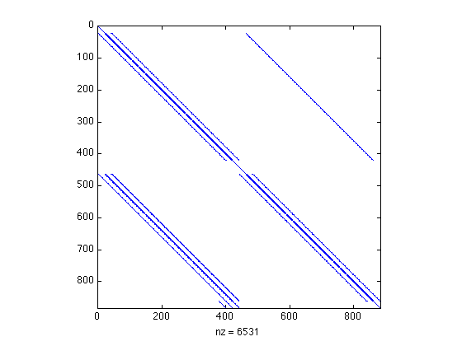

Figure 10: Sparsity pattern of the Jacobian matrix in the steady solver. 21x21 grid.

-add additional info from Fornberg

3.2 Unsteady Cylinder

3.2.1 Time Accurate Method

3.2.2 Harmonic Balance Method

3.3 Solver Issues

Chapter 4: Results

4.1 Steady Cylinder

4.1.1 Stationary Cylinder

In general, three flow regimes can be defined for flow over a stationary cylinder: the steady laminar regime (Re<47), the unsteady laminar 2D vortex shedding regime (47≤Re<200), and the unsteady 3D vortex shedding regime (Re>200)[Stojkovic]. At low Reynolds numbers in the steady laminar regime, the wake behind the cylinder has a steady circulation region with two symmetric vortices attached to the cylinder, whose size increases with increasing Reynolds number. Flow instabilities due to a large fluctuating pressure causes vortex shedding to occur in the wake behind the cylinder in the unsteady laminar regime. As the Reynolds number increases beyond the unsteady laminar regime, the flow behind the cylinder becomes three-dimensional and turbulent, with complex vortex shedding patterns [Kang]. To correctly determine the flow field, an unsteady flow solver should be used when Re≥47. While the steady cylinder problem is not physical for higher Reynolds numbers, it provides a good initial solution for the unsteady solvers developed. Thus, the higher Reynolds numbers have been investigated using the steady solver. The stationary cylinder was investigated for multiple Reynolds numbers, and the streamlines and vorticity contours for three of those cases are presented in Figures 11, 12 and 13 (181x181 grid). The figures show the characteristics expected from the steady laminar regime. Each figure has two symmetric vortices attached to the cylinder, and the size of these vortices grows from figure to figure (as Re increases). Figure 13 is not a physical solution. A Reynolds number of 100 falls within the unsteady laminar regime, and a steady solver is incapable of capturing the unsteady nature of the flow field. However, this solution is important as it is used as a baseline solution for the unsteady solver developed in this work .

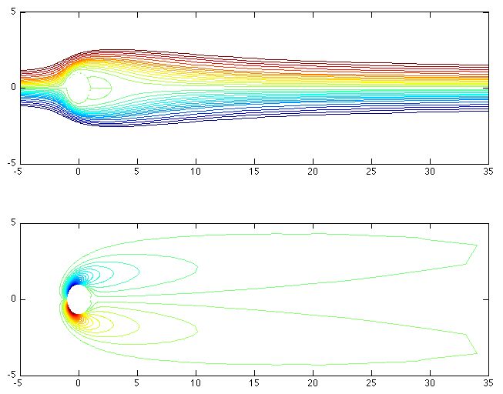

Figure 11: Streamlines and vorticity of steady flow over a stationary cylinder. Re=20.

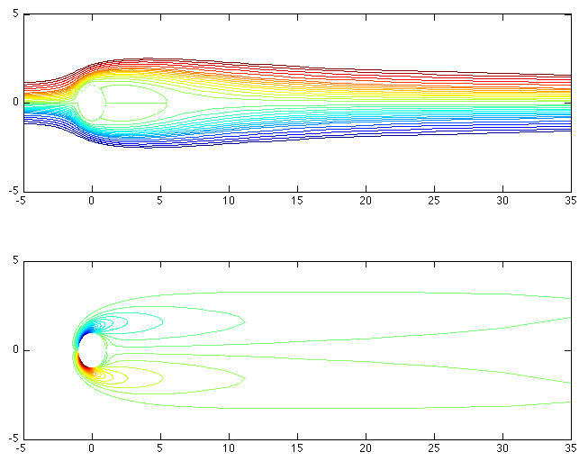

Figure 12: Streamlines and vorticity of steady flow over a stationary cylinder. Re=40.

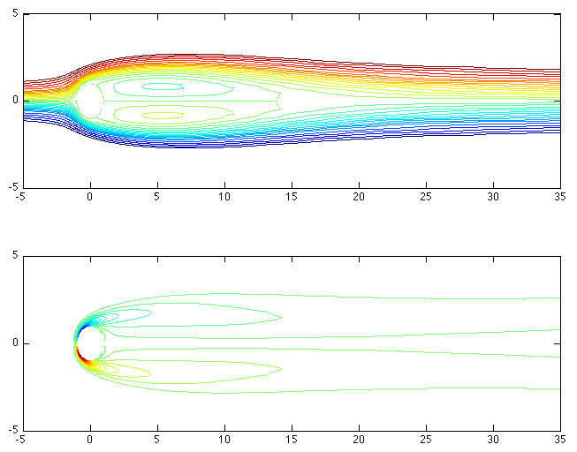

Figure 13: Streamlines and vorticity of steady flow over a stationary cylinder. Re=100. Non-physical solution.

4.1.2 Constant Rotation

Ingham and Tang [] conducted a numerical investigation of steady flow past a rotating cylinder. A comparison to their results assisted in the validation of the steady solver. The parameters for the steady cylinder in constant rotation are the Reynolds number and the rotational parameter α.

$Re=\frac{2aU}{ν}$ (74)
$α=\frac{aω_{0}}{U}$ (75)

where a is the radius of the cylinder, U is the free stream velocity, ω₀ is the angular velocity and ν is the kinematic viscosity. Ingham and Tang [] show a cylinder in steady rotation for a Reynolds number of 20 with a variety of rotational parameters and contour levels for a 41x41 computational grid. For comparison, multiple cases were run in the steady solver using the same parameters and contour levels as Ingham and Tang []. However, the chosen mesh of 181x181 for the steady solver was much finer than the literature.

A comparison of the lift and drag coefficients are presented in Table 1. The results match Ingham and Tang’s work qualitatively. An increase in the rotation rate yields higher lift coefficients and slightly lower drag coefficients. Quantitatively, the results are close with the highest percent difference equal to approximately 13%. The coefficients of lift are in fair agreement with those from Ingham and Tang’s results, as the max difference in the results is less than 5%. The drag coefficients are in even better agreement with the exception of the higher rotation rates—especially that of α=2. This increase in error for higher rotation rates is consistent with previous works [Ingham &Tang]. The steady solver consistently predicts higher lift coefficients than Ingham and Tang, while predicting smaller drag coefficients. These discrepancies led to an investigation of the numerical methods used to determine the lift and drag coefficients. The current solver uses trapezoidal integration to calculate the force coefficients, while Ingham and Tang use Simpson’s rule. A simple change to the numerical integration in the current solver made no difference in the resulting coefficients of lift and drag. To determine whether round-off errors could be the explanation for the differences, the current solver was run with single precision variables instead of the normal double precision process. This made no difference in the resulting lift and drag coefficients. This led to further investigation of previous works. Badr, Dennis and Young also conducted a study of steady flow past a rotating cylinder for low Reynolds numbers []. Comparison of the current work to these previous works is shown in Figures 14 and 15. The steady solver gives lift coefficients that are bounded by the previous work. While C_{L} is slightly higher than that of Ingham and Tang, it is slightly lower than Badr, et. al. The drag coefficient results are in great agreement with the previous works, except for the higher rotation rates. This is shown clearly in Figures 14 and 15—although the effect is exaggerated by the small scale of the vertical axis. The inconsistencies in the results can be attributed to the difference in the computational grid used. Ingham and Tang and Badr, et. al. used a much coarser mesh (41x41) while this work used a finer mesh (181x181). Ingham even suggests that previous works “severely underestimate” the lift coefficient due to their use of a coarse mesh, though this does not explain the discrepancy between their results and Badr, et.al. []. To investigate this effect, the steady solver was run for a mesh size of 41x41. The results are shown in Table 2. The coarser mesh yields lift coefficients that are closer to Ingham and Tang’s results, especially for the higher rotation rates. However, the coarser mesh also gives larger differences for the drag coefficient with the exception of the higher rotation rates. Stojkovic, et. al. notes that previous works could be in error for the higher rotation rates. Large gradients occur in the flow field for higher rotation rates, and these cannot be accurately detected for a coarse grid []. The current results are based on a mesh with higher fidelity, which yields better resolution than that of the previous works.

Table 1: Comparison of coefficients in steady rotation to previous works []. Re=20. 181x181 grid.

α | C_{L} (steady solver) | C_{L} (Ingham and Tang) | C_{L} % Difference | C_{D} (steady solver) | C_{D} (Ingham and Tang) | C_{D} % Difference
0.1 | 0.265 | 0.254 | 4.331 | 1.995 | 1.995 | 0.000
0.2 | 0.531 | 0.514 | 3.307 | 1.990 | 1.992 | 0.100
0.4 | 1.065 | 1.024 | 4.004 | 1.970 | 1.979 | 0.455
0.5 | 1.333 | 1.283 | 3.897 | 1.955 | 1.973 | 0.912
1 | 2.709 | 2.617 | 3.515 | 1.832 | 1.925 | 4.831
2 | 5.783 | 5.719 | 1.119 | 1.406 | 1.627 | 13.583

Table 2: Effect of coarser mesh on steady solver compared to previous works []. Re=20. 41x41 grid.

α | C_{L} (steady solver) | C_{L} (Ingham and Tang) | C_{L} % Difference | C_{D} (steady solver) | C_{D} (Ingham and Tang) | C_{D} % Difference
0.1 | 0.265 | 0.254 | 4.331 | 2.049 | 1.995 | 2.707
0.2 | 0.529 | 0.514 | 2.918 | 2.042 | 1.992 | 2.530
0.4 | 1.016 | 1.024 | 0.781 | 2.016 | 1.979 | 1.860
0.5 | 1.316 | 1.283 | 2.572 | 1.997 | 1.973 | 1.216
1 | 2.639 | 2.617 | 0.841 | 1.865 | 1.925 | 3.117
2 | 5.693 | 5.719 | 0.455 | 1.450 | 1.627 | 10.879

Figure 14: Comparison of lift coefficients as a function of rotation rates. Re=20.

Figure 15: Comparison of drag coefficients as a function of rotation rates. Re=20.

While there are discrepancies between the predicted lift and drag coefficients, the flow pattern around the cylinder nearly matches those of Ingham and Tang. The comparison of the streamlines are shown in Figure 16. Ingham and Tang noticed the same phenomenon. Their coefficients of lift and drag varied from previous works at the time, but their flow patterns were “graphically indistinguishable” []. Stojkovic, Breuer, and Durst noticed this result as well. They note that “there is a large scatter among the different authors concerning the predicted drag and the lift coefficient” for steady laminar flow []. They also suspect that these variations are due to the coarse mesh sizes used by the previous authors.

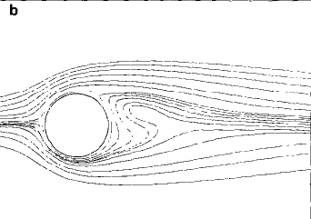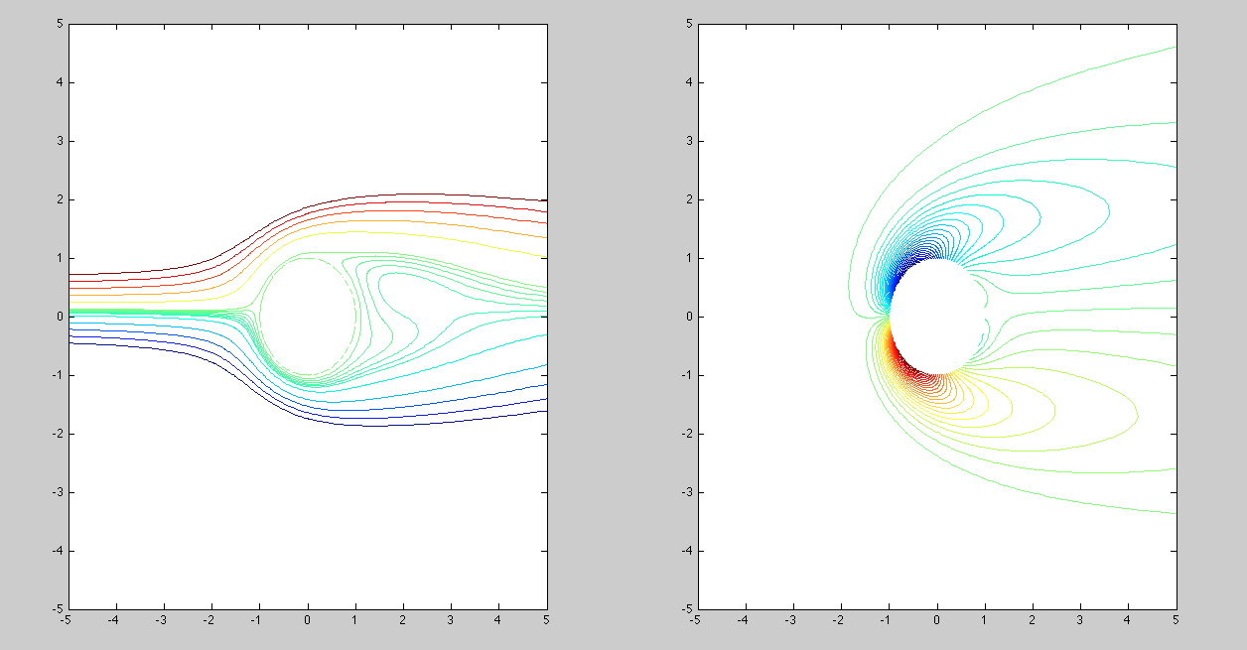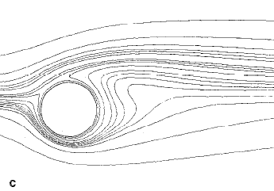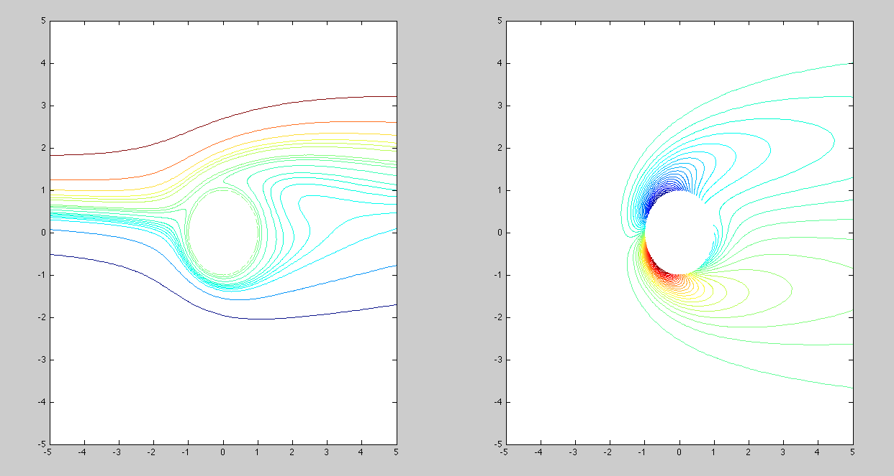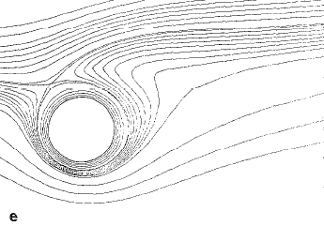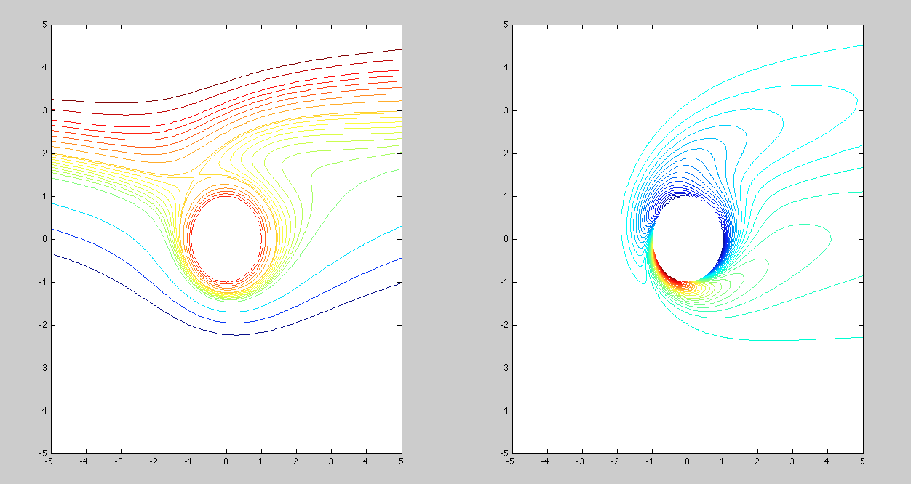

Figure 16: Validation of steady solver for the cylinder in steady rotation. Re=20. Left: Ingham and Tang’s results []. Right: Steady solver results. From top to bottom the rotational parameter is α=0.1, 0.5, 2.

Previous works have also determined a relationship between the coefficient of lift and the rotation rate. Ingham notes that for a small rotation rate, the lift coefficient is directly proportional to the rotation rate []. Stojkovic, et. al. also notes the linear relationship between the lift coefficient and the rotation rate. They found that for α≤2 the coefficient of lift is a linear function of α and at higher rotational speeds, an increasing lift coefficient results from an increasing Reynolds number []. This relationship has been investigated using results from the current steady solver. Figure 17 shows the lift coefficient as a function of the rotation rate (0≤α≤2). A linear trendline was added to the plot along with the coefficient of determination (R²). The R² value is used to determine how well a line fits the data [instruments book]. The coefficient of determination ranges from 0 to 1. A R² close to 0 indicates that the line does not fit the data well; whereas a R² close to 1 shows that the linear fit is good. The R² for the lift coefficient as a function of α≤2 is 0.999, which agrees with the results of previous works. The fit is even closer when the rotation rate range is 0≤α≤1, and the fit is slightly worse when the range includes a higher rotation rate (0≤α≤3).

Figure 17: Coefficient of lift as a function of the rotation rate. R² indicates the fit of the trendline. Re=20.

- can add higher Reynolds number steady solutions if needed – Ingham & Tang, Fornberg, Badr

4.2 Unsteady Cylinder

4.2.1 Time Accurate Results

The time-accurate solver was validated for two different classifications: constant rotation and oscillatory periodic rotation. The results of the cylinder in constant rotation are visited first.

Constant Rotation

This classification was similar to the steady cylinder cases in Section 4.1. However, in those low Reynolds number cases the flow tends to a steady state as the properties become independent of time [Badr, et. al]. For higher Reynolds numbers, the flow does not tend to a steady state. Instead, it develops a periodic vortex shedding pattern, which is associated with the Karman vortex sheet [Tang & Ingham 1991]. Many previous investigators have studied this problem of unsteady flow past a constantly rotating cylinder [Tang, Badr, Kang]. The unsteady time-accurate solver was validated for multiple Reynolds numbers by comparing the results to these previous investigators.

In the case of unsteady flow over a cylinder in constant rotation, the lift coefficient eventually reaches a periodic state. The problem is considered to converge at this point. The periodic development can be seen in Figure 18. The temporal variation of the lift coefficient agrees with previous works [Badr]. However, the solver has lower peaks than those of Badr et. al. Their work has higher initial peaks around t=8 for all rotation rates. The temporal variation of both the lift and drag coefficients were investigated for Re=100 and a rotational speed of 1. This is shown in Figure 19. The results are close to those of Badr, et. al. Once again, the initial peaks are lower with the current results, and the coefficients seem to be a bit lower compared to Badr et.al. Ingham and Tang mention this result in their work as well. They note that the lift coefficients estimated by Badr, et. al. are “a little higher than those obtained by all of the previous investigators” [Tang]. Previous works have espoused the importance of the conditions imposed at large distances [Tang]. The conditions at infinity were kept the same in the unsteady time-accurate solver as the previously mentioned steady solver as seen in Section 3.1.3. The differences between the current results as those of Badr et al. could likely be due to the difference in the condition set at infinity. While the solvers from this work use the condition discussed by Ingham and Tang [original], Badr et al. use the asymptotic Oseen solution for their far condition []. As with the steady solver, there is a discrepancy in the grid size for this case as well. The current results are determined from a much finer mesh than the previous works; the cases shown in Figures 18 and 19 were run with a 181x181 mesh.

Figure 18: Temporal variation of lift coefficient. Re=60.

Figure 19: Temporal variation of lift and drag coefficients. Re=100. Ω=1.

The average value of the lift coefficient was also investigated for a Re=60. The average lift coefficient was calculated over a complete periodic cycle and was compared to the previous work of Badr et al. Despite the discrepancies between the peak values in the temporal variations, the average value of the lift coefficient are in great agreement with the results of Badr et al. Figure 20 shows the variation of the average lift coefficient with the rotational speed. Ingham and Tang have slightly lower values for the average lift coefficient []. However, this result is consistent with those from the steady solver. The difference will once again be attributed to the coarse grid size of Ingham and Tang. Despite the slight disagreements, all results are in agreement with concern to the relationship between the average lift coefficient and the rotational speed. The average lift coefficient is a linear function of the rotational speed. This relationship is clearly seen in Figure 20. A linear trendline can be added to the results to determine the coefficient of determination for the data. The trendline results in a coefficient of determiniation of R²=0.999, which confirms that a linear trend is a good fit to the results.

Figure 20: Variation of lift coefficient with rotational speed. Re=60.

The rotational speed has an effect on the distribution of the surface vorticity as well as the force coefficients. Figures 21 and 22 show this effect for Re=60 and Re=100, respectively. In the figures, the surface vorticity at θ=0° and θ=360° are equal; this is not a surprising result. This equality between the surface vorticity is due to the periodic boundary conditions assigned to the cylinder. In addition to this, it can be seen that the peak values of the vorticity on the upper (0<θ<180°) and lower (180°<θ<360°) surfaces increases with increasing Ω for both Reynolds numbers. Figures 21 and 22 also show that the peak values for the upper surface are higher than those on the lower surface. Previous works have reached the same conclusions, and current results are in good agreement with them. Ingham and Tang present the same figures for steady flow over a constantly rotating cylinder [1991]. These results are in great agreement for Re=60. However, there are a few discrepancies for the Re=100 case. The trend is off near the periodic cut at θ=0°=360°, especially for Ω=0.1. These results were taken after t=100s. It is possible that a longer amount of time was needed to develop the correct trend for the higher Reynolds number. The difference is likely not attributed to the variation of the mesh sizes. Previous works have shown that the results for the surface vorticity distribution are graphically similar for Ω≤1 [Tang 1991]. Kang, Choi and Lee presented the mean vorticities around the cylinder surface for various rotational speeds []. Current results follow their trend, but the magnitudes disagree greatly. This is due to the fact that Kang et al. calculate their surface vorticity using a different condition than the one set in this study (see Section 3.1.3). Additionally, Figures 21 and 22 only represent the surface vorticity at t=100s rather than the mean surface vorticity for the entire process. For Ω=0 and Re=100, Kang et al. see negative and positive peak values at θ≈130° and θ≈230°, respectively. It can be seen in Figures 21 and 22 that the current results agree with this. Previous investigators have also determined that an increasing Reynolds numbers results in an increase in the surface vorticity [Kang]. The current results follow this trend as can be seen in Figures 21 and 22.

Figure 21: Effect of rotation speed on the surface vorticity distribution. Re=60, t=100.

Figure 22: Effect of rotation speed on the surface vorticity distribution. Re=100, t=100.

Previous investigators have also investigated the Strouhal number for unsteady flow with constant rotational speeds. In the time-accurate case, the Strouhal number can be used to measure the frequency of the vortex shedding when the vortex street develops [Badr]. The Strouhal number is given by the expression

${St}_{d}=\frac{2rΩ}{U_{∞}}$ (76)

where r is the radius of the cylinder and U∞ is the free stream velocity. The current work resulted in St≈0.14 and ≈0.16, respectively, for Re=60 and 100. This is consistent with previous works [Kang, Badr]. Figure 23 shows the variation of the Strouhal number with the rotational speed. The results for Re=100 match those of Kang et al. They suggest that the rotation of a cylinder does not significantly affect the Strouhal number in the range beneath a critical rotational speed, Ω_{L}. Their results showed that St_{d} stays nearly constant at low rotation speeds and decreases slightly as Ω approaches Ω_{L}. This is consistent with Badr et al, who assumed that the Strouhal number is independent of the rotation speed []. The trend for Re=60 for the time-accurate solver is the complete opposite of previous results. Instead of staying nearly constant then decreasing, the Strouhal number increases slightly with the rotation speed and then levels off to a constant. Regardless of the trend, the magnitude of Strouhal numbers are still close to those of the previous works [].

Behaviors of the lift and drag forces can be represented more clearly in the form of a phase diagram by plotting the lift coefficient as a function of the drag coefficient [Kang]. Figure 24 shows the phase diagram for Re=100. The closed loop shows that the flow becomes fully periodic [Kang]. It is clear in this figure that the lift coefficient increases and the drag coefficient decreases with an increase in the rotation speed, which is consistent with previous works [Kang]. The magnitudes of the lift and drag coefficients do not exactly match those of Kang et al. Although they are close, the size of the loops is not as large as those of previous works. This is an indication that the amplitudes of fluctuation are larger for Kang et al.

Figure 23: Variation of St_{d} with rotational speed.

Figure 24: Phase diagram of lift coefficient with drag coefficient for various Ω. Re=100.

Lastly, unsteady flow with steady rotation was investigated for a higher Reynolds number of Re=200. Figure 25 shows the time variation of the lift coefficient for this Reynolds number. The results can be compared to those of Mittal and Kumar []. The lift coefficient is in excellent agreement with the previous work with the exception of the higher rotational speeds. The results are slightly different for Ω=4.6, 4.7 and 5.0. The most notable difference is with Ω=5.0. Mittal and Kumar found this lift coefficient to be steady past approximately 150 s. As can be seen in Figure 25, the coefficient of lift continues to vary past this time, and still has not reached a steady value at 250 s. Figure 26 shows the phase diagrams of the lift and drag coefficients for this Reynolds number. Once again, a closed phase diagram shows that the flow becomes fully periodic. These results can be predicted by viewing Figure 25. If the lift coefficient is fully periodic by 250 s for a given rotational speed, then the phase diagram will be closed. If the lift coefficient has become steady by 250 s in Figure 25, the phase diagram will result in a singular point for that rotation rate. Figure 26 is consistent with this reasoning. Once again, the results are in good agreement with those of Mittal and Kumar, with the exception of the higher rotation speeds. The phase diagrams of these rotation speeds do not match the previous work because of the differences between the lift coefficients. The current solver does not yield a steady lift coefficient for Ω=5.0, so the phase diagram does not resolve to a single point. The effect of the rotation speed on the surface vorticity distribution was also investigated for Re=200. Figure 27 shows this effect. The general trend is similar to that for Re=60 and 100 (see Fig. 21 and 22). The peak value for the upper surface is higher than that of the lower surface, and the changes in the surface vorticity are greater for the upper surface than the lower [Mittal]. The peak positive value occurs in roughly the same location for all the rotation rates investigated. In contrast, the peak negative value varies greatly with the rotational speed [Mittal]. These results are generally in good agreement with those of Mittal and Kumar. They follow the trends mentioned above. The biggest discrepancies come from the lower rotation speeds, especially for Ω=0.5. The surface vorticity for this rotation speed should be lower than that of a stationary cylinder at the periodic cuts (θ=0°=360°). Another difference is with Ω=1.5. The surface vorticity appears to level off until approximately 50°; it should gradually increase here instead. Lastly, the peak values vary slightly from the previous works. The differences are likely attributed to the time step selected for the plot. The previous works plotted the surface vorticity for steady-state solutions, whereas Figure 27 is the surface vorticity at the final time from the solver. Taking into account that the lower rotation rates are fully periodic by 250 s, it is likely that an average surface distribution over a complete period would have yielded even better results for these speeds.

Figure 25: Temporal variation of the lift coefficient. Re=200.

Figure 26: Phase diagrams of lift and drag coefficients. Re=200.

Figure 27: Effect of rotation speed on the surface vorticity distribution. Re=200, t=250.

Periodic Rotation

4.2.2 Harmonic Balance Method

4.3 Sensitivity Analysis

Chapter 5: Conclusion

List of References

[] Ingham, D. B., and Tang, T., “A Numerical Investigation into the Steady Flow Past a Rotating Circular Cylinder at Low and Intermediate Reynolds Numbers,” Journal of Computational Physics, Vol. 87, 1990, pp. 91-107.

[] Hoffman, J. D., Numerical Methods for Engineers and Scientists, 2nd ed., Marcel Dekker, Inc., New York, 2001.

[] Fornberg, B., “A numerical study of steady viscous flow past a circular cylinder,” Journal of Fluid Mechanics, Vol. 98, No. 4, 1980, pp.819-855.

[] Fornberg, B., “Steady Viscous Flow Past a Circular Cylinder up to Reynolds Number 600,” Journal of Computational Physics, Vol. 61, 1985, pp. 297-320.

[] Dennis, S. C. R., “The computation of two-dimensional asymmetrical flows past cylinders,” Computational Fluid Dynamics, American Mathematical Society, Providence, RI, 1978, pp. 156-177.

[] Badr, H. M., Dennis, S. C. R., and Young, P. J. S., “Steady and Unsteady Flow Past a Rotating Circular Cylinder at Low Reynolds Numbers,” Computers & Fluids, Vol. 17, No. 4, 1989, pp. 579-609.

[] White, F. M., Viscous Fluid Flow, 3rd ed., McGraw-Hill, Boston, 2006.

[] Filon, L. N. G., “The Forces on a Cylinder in a Stream of Viscous Fluid,” Proceedings of the Royal Society A, Vol. 113, No. 763, 1926, pp. 7-27.

[] “Matrix inverse – MATLAB inv,” Mathworks, Natick, MA, 2013. [http://www.mathworks.com/help/matlab/ref/inv.html. Accessed 6/16/13.]

[] Stojkovic, D., Breuer, M., and Durst, F., “Effect of high rotation rates on the laminar flow around a circular cylinder,” Physics of Fluids, Vol. 14, No. 9, 2002, pp. 3160-3178.

[] Kang, S., Choi, H., and Lee, S., “Laminar flow past a rotating circular cylinder,” Physics of Fluids, Vol. 11, No. 11, 1999, pp. 3312-3321.

[] Figliola, R. S., and Beasley, D. E., Theory and Design for Mechanical Measurements, 4th ed., Wiley, Hoboken, NJ, 2006.

[] Tang, T., and Ingham, D. B., “On Steady Flow Past a Rotating Circular Cylinder at Reynolds Numbers 60 and 100,” Computers & Fluids, Vol. 19, No. 2, 1991, pp. 217-230.

[] Mittal, S., and Kumar, B., “Flow past a rotating cylinder,” Journal of Fluid Mechanics, Vol. 476, 2003, pp. 303-334.
Vita

