Proposed Best Practices for the Design and Management of Subsurface Drip Irrigation Fields in Tennessee

A Thesis Presented for the

Master of Science

Degree

The University of Tennessee, Knoxville

Jason A. Koehler
May 2025

DEDICATION
To my parents, for giving me everything I could ever need through school.

ACKNOWLEDGEMENTS

I would like to express my deepest gratitude to my major professor, Dr. Buchanan, for their unwavering support, guidance, and expertise throughout this research. I am equally thankful to my committee members, Dr. Yoder, and Dr. Essington, for their valuable feedback, thoughtful guidance, and expertise, which greatly enhanced the quality of this thesis.
This work was made possible by the support of the Tennessee Department of Environment and Conservation (TDEC) which provided the resources and data critical to this research.

ABSTRACT
Subsurface drip irrigation (SDI) systems are widely used for onsite wastewater dispersal, offering advantages such as improved effluent distribution and reduced surface contamination risks. However, variations in design, maintenance, and regulatory oversight contribute to inconsistent performance. This study evaluates SDI system design and management in Tennessee, comparing them with national regulations and manufacturer recommendations to develop Best Management Practices (BMPs) aimed at improving system efficiency and longevity.
A survey of SDI regulations across 31 states found that 20 states mandate reserve areas, 26 require or recommend flow meters with totalizing features, and 11 require telemetry-based monitoring, showing regulation of SDI systems exists across the US. Manufacturer recommendations and state regulation support drip line spacing between 12 to 24 inches as well as the use of flow monitoring and alarm systems to detect failures. In Tennessee, inconsistent inspections, design practices, an operator oversights can lead to system failures, highlighting the need for standardized regulations.
The proposed BMPs focus on drip line spacing, hydraulic loading rates, inspection protocols, operator accountability, and reserve areas. Key recommendations include biweekly visual inspections, monthly system performance checks, and annual inspections by the Tennessee Department of Environment and Conservation. Additionally, large SDI systems should designate a 100% reserve area to prevent catastrophic failures. Implementing these BMPs will align Tennessee’s SDI management with national standards, ensuring long-term system reliability, regulatory compliance, and improved environmental protection.
TABLE OF CONTENTS
Introduction 1
SDI issues in Tennessee 2
Research Questions 4
Methods 5
Background 7
Decentralized Wastewater Treatment Systems 7
Septic systems (STEP/STEG) 8
Secondary Treatment 9
Soil Treatment 9
Soil Maps 10
Drip Line Installation 12
Common Field Design 13
Drip Zones 14
Emitter and Lateral Line Spacing 14
Drip Lines 16
Field Maintenance 19
Chapter 1: United States Drip System Survey 21
General (US EPA region 1) 21
Design standards 22
Maintenance 25
Hydraulic Loading Rates / Field Sizing 25
General (US EPA region 2) 26
Design Standards 26
Maintenance 27
Hydraulic Loading Rates / Field Sizing 28
General (US EPA region 3) 28
Design Standards 30
Maintenance 31
Hydraulic Loading Rates / Field Sizing 31
General (US EPA region 4) 32
Design Standards 32
Maintenance 35
Hydraulic Loading Rates / Field Sizing 36
General (US EPA region 5) 37
Design Standards 37
Maintenance 39
Hydraulic Loading Rates / Field Sizing 40
General (US EPA region 6) 40
Design Standards 40
Maintenance 41
Hydraulic Loading Rates / Field Sizing 43
General (US EPA region 7) 44
Design Standards 44
Maintenance 46
Hydraulic Loading Rates / Field Sizing 46
General (US EPA region 8) 46
Design Standards 48
Maintenance 48
Hydraulic Loading Rates / Field Sizing 48
General (US EPA region 9) 48
Design Standards 50
Design Standards 50
Maintenance 51
Hydraulic Loading Rates / Field Sizing 51
General (US EPA region 10) 51
Design Standards 53
Maintenance 53
Hydraulic Loading Rates / Field Sizing 54
Chapter 1 Summary 54
Chapter 2: Tennessee SDI Systems 60
Loading rate and dripline placements 63
Management practices and recommendations 66
Summary 68
Chapter 3: Proposed BMP approaches 70
Introduction 70
Drip line spacing 70
Drip line depth 71
Soil maps 71
Hydraulic loading rates 72
Installation on slopes 73
Pretreatment / disinfection 73
Dosing 74
Pressure gauges 74
Flow meters 75
Alarms and control panel 75
Soil depth 76
Field maintenance 77
Field boundaries 77
Reserve areas 78
Inspections 78
Operator inspection 79
Summary 80
References 83
Vita 97

LIST OF TABLES
Table 1. Example of how dripline spacing affects amount needed and dose volumes per line. 18
Table 2. US EPA region 1 SDI design standards. 23
Table 3. US EPA region 2 SDI design standards. 27
Table 4. US EPA region 3 SDI design standards. 29
Table 5. US EPA region 4 SDI design standards. 33
Table 6. US EPA region 5 SDI design standards. 37
Table 7. US EPA region 6 SDI design standards. 41
Table 8. US EPA region 7 SDI design standards. 45
Table 9. US EPA region 8 SDI design standards. 47
Table 10. US EPA region 9 SDI design standards. 49
Table 11. US EPA region 10 SDI design standards. 52
Table 12. Loading rate and dripline design for working SDI systems in Tennessee 64
Table 13. Pretreatment, zone design, and operation time of working SDI systems in Tennessee 65
Table 14. Inspection routines, and operator recommendations for working SDI systems in Tennessee. 67

LIST OF FIGURES
Figure 1. Logic chart for determining areas of interest (AOIS). 6
Figure 3. Soil map in Henry County, TN (Web Soil Survey, 2021). 11
Figure 4. Soil hydraulic loading rates for Tennessee (TDEC, 2023b) 12
Figure 5. Simple design of a 2-zone drip dispersal field. 15
Figure 6. Water movement from drip lines in different soil types (Netafim, 2014b). 17
Figure 7. GIS map of lower 48 states with SDI regulation (Green), guidelines (Blue), no written laws or regulation (Yellow), unknown (Red) 56
Figure 8. States that require or recommend 2 ft spacing (green) and states that allow for 3ft spacing (blue). 56
Figure 9. States that recommend or require totalizing flow meters (blue) or totalizing flow meters with telemetry (green). 58

Introduction
Centralized wastewater treatment systems are the most common method of treating wastewater in the United States, serving about 75% of the population (EPA, 2015; EPA, 2004). These systems collect wastewater from within urban areas and remove oxygen-demanding substances, pathogens, nutrients, toxic metals, and chemicals (EPA, 2015). Despite their prevalence, centralized systems have several associated issues. They typically have high energy demand, often accounting for about 40% of an urban area’s energy consumption (Hamawand, 2023; EPA, 2015). Additionally, centralized systems are expensive to build and maintain due to the extensive infrastructure required such as sewer pipelines, pumping stations, and treatment facilities. (EPA, 2015). Depending on the designed capacity and treatment method, construction costs can quickly exceed 10 million USD for a plant treating two million (GPD), not including annual maintenance and operating costs (Sekandari, 2019). Centralized treatment is most effective in urban or industrial areas with high population densities because of the ability to treat large quantities of wastewater, and to distribute the infrastructure cost over many users (Sharma et al.,
A decentralized wastewater treatment systems (DWWTS) is defined as the collection, treatment, dispersal, and management of wastewater near its point of origin (Nelson, 2005). There are several variations on the type of treatment, but most systems use a land application system for dispersal of secondary treated effluent. This study focuses on systems that incorporate subsurface drip irrigation (SDI) dispersal component. Decentralized systems are easy to scale, treating wastewater generated from two or more dwellings or small communities (EPA, 2023). DWWTSs are advantageous because they offer a cost-effective strategy for treating effluent without the high costs associated with centralized collection (Massoud, 2009). DWWTSs have been implemented in many residential developments where a centralized method is not viable because of their low start-up and operation costs,
DWWTSs of interest typically contain a collection component, a treatment component, and a dispersal component. Collection is often septic tank effluent gravity (STEG) or a septic tank effluent pump (STEP). A STEP/STEG system preforms liquid solid separation near the source (Kaplan, 2014). From there, the effluent is moved to a secondary aerobic treatment device such as a recirculating sand filter. This reduces the biochemical oxygen demand (BOD) and total suspended solids (TSS) (EPRI, 2009). The last component, and the focus of this study, is the effluent dispersal using SDI. which is used to disperse the effluent underground, providing further treatment using the natural processes available in the soil (EPRI, 2009).
The expectations of properly working dispersal areas are that the area should not exhibit prolonged saturation or persistent ponding, and effluent should not leave the area via overland flow. When a dispersal field fails and effluent ponds on the soil surface, it allows unwanted contamination of surface waters, increasing the risk of human exposure. Contaminated surface waters can also flow into nearby streams or rivers, potentially spreading pollutants and pathogens over a wider area and impacting downstream water quality. Interaction with inadequately treated sewage can pose a great health risk, potentially causing bacterial infections like cholera to occur (Dickin et al., 2016).

SDI issues in Tennessee
In the context of decentralized wastewater systems, particularly subsurface drip irrigation (SDI), it is important to distinguish between laws, regulations, and guidelines, as each plays a different role in system implementation and oversight. Laws are enacted by legislative bodies and serve as the broad legal framework for environmental protection and public health. Regulations are more specific rules developed by state agencies to implement and enforce those laws. Regulations carry the force of law and are legally binding. Guidelines, on the other hand, are non-binding recommendations or best practices. While guidelines can influence system design and management, they are not enforceable unless explicitly incorporated into regulations or permits. In Tennessee, many aspects of SDI design such as line spacing, flushing frequency, and monitoring requirements are currently addressed only through informal guidelines or design criteria documents. This distinction contributes to inconsistent practices and a lack of accountability, ultimately impacting the performance and reliability of SDI systems across the state.
Whether a site is a suitable SDI location is largely determined by evaluating the texture and structure of the receiving soil and by the depth to any restrictive horizons. Some combinations of texture and structure are not allowed due to clay content, expansive potential, and/or lack of pore continuity. Once a site is determined to be suitable, guidelines are used to determine the design hydraulic loading rate. Typically given as gallons per day per square foot (GPD/SF), values range from 0.01 to 0.25, with 0.25 being the maximum loading rate allowed in Tennessee (TDEC, 2023). Because the maximum loading rate requires the smallest land area, many engineers will default to that value. TDEC has been concerned that sites were being hydraulically overloaded, with the potential result of discharges to surface waters.
During January and February of 2024, TDEC conducted a statewide survey of land application areas utilizing drip dispersal for wastewater management. Previously, inspection of these sites only occurred every five years when state operating permit was re issued. During these visits, TDEC was able to get visual assessments of 420 land application systems supporting 374 DWWTSs. TDEC’s inspections were only visual, and they did not collect information pertaining to the actual loading rates of the drip fields. The locations of all subsurface drip irrigation (SDI) systems and their observed issues were compiled and posted by TDEC and can be found here: (https://www.tn.gov/content/dam/tn/environment/water/land-based-systems-unit/wr_lbs_report-performance-of-wastewater-systems-utilizing-drip-dispersal-tn.pdf ). The survey will assist in determining what designs provides the best dispersal system design.
From these inspections, it has been determined that about 50% (180 systems) of the drip fields are out of compliance with the state operating permit. Twenty-seven percent (97 systems) of the systems are considered to have “major issues.” Major issues include discharging all effluent before reaching the drip field, infrastructure issues where the drip field was entirely or partially not engaged, and major ponding/overland flow across the drip field. The remaining 23% (83 systems) were found to have “minor issues”, such as the area being too overgrown with vegetation to realistically inspect, or the drip fields had localized areas of soil saturation and ponding.

Research Questions
While Tennessee is the established leader in the number decentralized wastewater treatment (DWWT) technology by the number of systems installed, there are no enforceable rules or best management practices (BMPs) in place for the design and maintenance of large-scale decentralized systems. Currently, drip systems serving single-family homes in Tennessee are required to adhere to prescribed regulations. However, large-scale systems, which often serve multiple residences, businesses, or community facilities, are not subject to the same regulatory oversight. Instead, only non-mandatory guidelines have been created by TDEC, which operators are not required to follow. This regulatory gap has led to inconsistent design practices and maintenance standards, contributing to the high failure rates observed in TDEC’s 2024 survey. To address these challenges and minimize failures in the dispersal component, TDEC has tasked the University of Tennessee Extension to document BMPs specifically tailored for the design and management of large-scale SDI systems.

Methods

The first action is a comprehensive review of other US state regulations regarding SDI systems will be conducted. This review aims to compare the design standards of other states with the guidelines set by TDEC. Several key design areas will be the focus of this review.
First, the soil hydraulic loading rates, which are typically based on soil physical properties such as texture and structure will be examined. Second, the maintenance practices and how site evaluations are conducted will be analyzed. Third, the evaluate the drip line lateral and emitter spacing to determine a common baseline of design.
TDEC expressed interest of understanding what other states in the US are doing and these design practices are important to ensuring the long-term functionality of the dispersal field. If hydraulic loading rates and expected flows are calculated loosely, it can lead to soil hydraulic overload. Drip line spacing that is wider than needed can result in wastewater being distributed over a smaller area, potentially causing ponding over time. Moreover, improper management and insufficient inspection can lead to unresolved issues.
The second action is to analyze TDEC's GIS map created from their statewide 2024 inspection. There is particular interest in fields where no soil saturation was observed. To identify the most suitable sites, we will use the logic tree shown in Figure 1. Subsequently, the designed loading rates of each system will be obtained from TDEC’s permitting data viewer (https://dataviewers.tdec.tn.gov/dataviewers/f?p=2005:34001:715307004260).
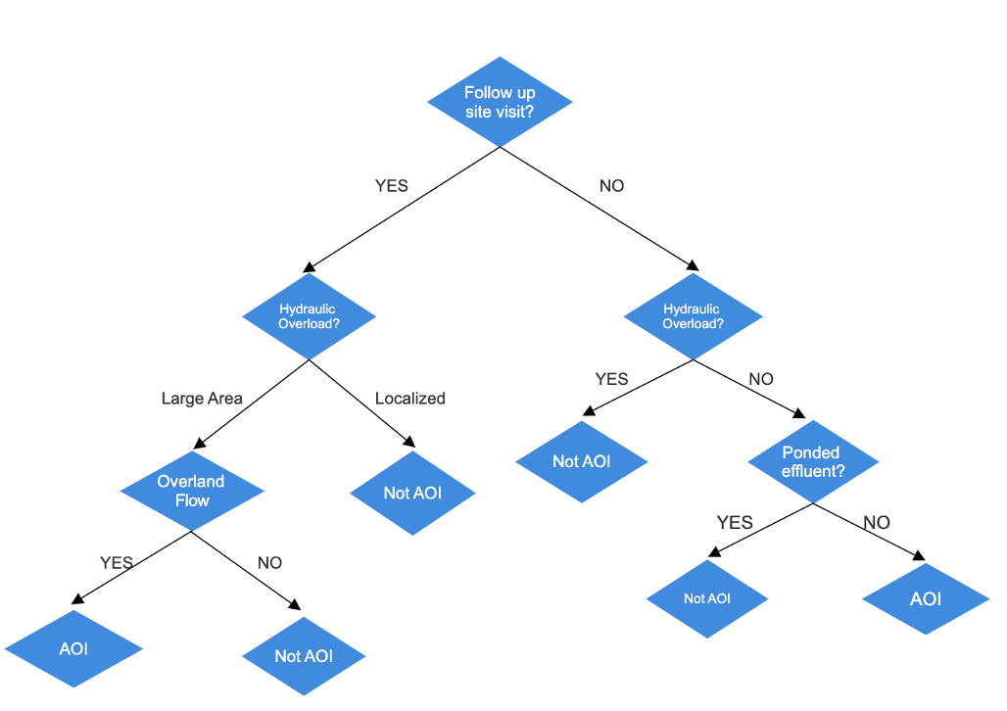
Figure 1. Logic chart for determining areas of interest (AOIS).

Management entities of the selected areas will be contacted to gather information on the actual loading rates of the systems, management practices such as inspection frequency, and the lateral drip line spacing/emitter spacing if it was not determined through visual inspection. The aim is to identify any common practices between
dispersal systems that show no observable issues in Tennessee. If commonalities are found, they could serve as a good basis for recommending those practices as BMP’s.
Similarly, sites that are not working properly will also be sorted out using the logic tree found in Figure 1. Fields that have localized issues possibly caused by a damaged line or emitter will be ignored due to those being easily repaired. The focus will be on fields experiencing hydraulic overload in large areas, resulting in overland flow. The same information gathered for the properly working fields will be gathered for the ones that are not. Comparing designed loading rates to actual loading rates, system layout, and management practices could be a useful way to determine key reasons as to why some dispersal fields are not working properly.
Figure 1 was used to systematically and consistently pick out SDI fields that are of interest. The first branch was based on whether a site as deemed to need a follow-up visit or not by the inspector. Typically, fields with significant issues required a follow-up visit, while those with minor repairs did not. This made it a good initial sorting decision. For this project, the focus is on systems with of saturated soils that result in overland flow. For the fields that are functioning well, the interest lies in those with no hydraulic overload, ponding, or overland flow. The logic tree follows this distinction.
The ultimate goal of this research is to produce a comprehensive list of Best Management Practices (BMPs) for the installation, design, and management of subsurface drip irrigation (SDI) fields in Tennessee. While some issues with SDI fields are inevitable due to their reliance on natural processes, this guide aims to significantly reduce the frequency and severity of these problems. By doing so, it is hoped to mitigate a direct discharge into surface waters.

Background

Decentralized Wastewater Treatment Systems
Figure 2 illustrates a conceptual layout of a decentralized wastewater treatment system serving a residential area. The wastewater from the house is directed to a collection unit, followed by secondary treatment, and ultimately discharged to the subsurface drip dispersal field. Decentralized wastewater treatment systems (DWWTS) help conserve land suitable for wastewater application, dedicating it solely to that purpose. In the eastern and plateau regions of Tennessee, soils are often shallow, which makes finding appropriate application areas more
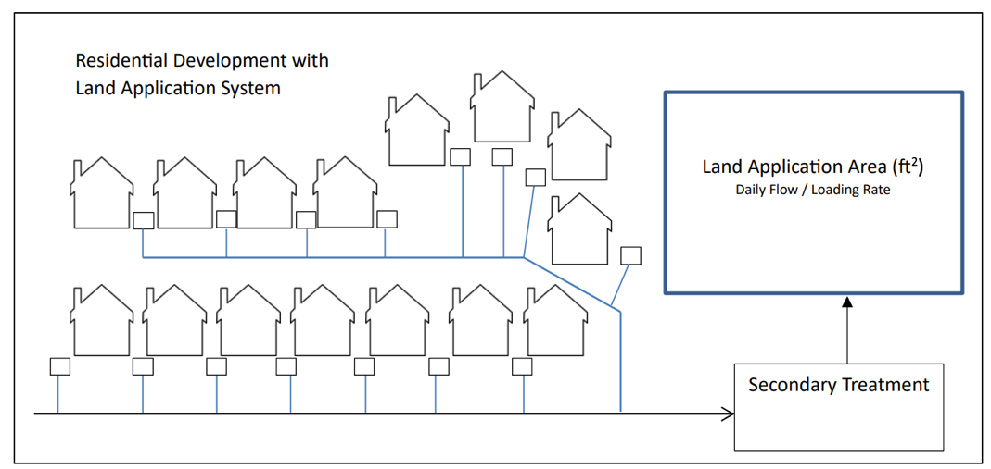
Figure 2. Conceptual layout of a decentralized wastewater treatment system (TDEC, 2023).

challenging. If each home had a conventional septic drain field installed on the viable soils, developers would be unable to build as many homes as possible, which is often the main reasoning for building DWWTs.

Septic systems (STEP/STEG)
The first process is to collect the wastewater coming from a home is a septic tank effluent pumping (STEP) or a septic tank effluent gravity (STEG) system. STEP tanks are usually pre-cast and can be built from different materials like concrete, fiberglass, and polyethylene (Crites and Tchobanoglous, 1997). The purpose of these is to receive sewage and hold it so that the solids can separate (Kaplan, 2014). During this period, oils, greases, hair, and toilet paper float to form a “scum” at the top of the tank, while settleable solids undergo anaerobic treatment forming “sludge” at the bottom of the tank (Bounds 1997). STEP / STEG systems can achieve a 60-80% debris removal rate (Baumann et al., 1978), and a BOD removal of up to 50-60% (Seabloom et al., 2004). In between the scum and sludge layers is the clarified sewage which is what ultimately leaves the tank and goes on to secondary treatment (Kaplan 2014).

Secondary Treatment
Secondary wastewater treatment is an aerobic process that reduces biochemical oxygen demand (BOD), total suspended solids, and converts ammonium to nitrate (Rodgers et al., 2004). In Tennessee, the most used method for secondary treatment is recirculating media filters (RMFs), which provide a fixed medium for the development of biofilms (Jantrania, 2006). Wastewater is circulated over the media in small quantities, allowing microbes to break down contaminants in aerobic conditions (Jantrania, 2006). Secondary treatment is essential when using subsurface drip irrigation (SDI) fields. By reducing suspended solids and lowing the BOD secondary treatment helps prevent clogging in SDI systems, thereby extending their lifespan (Gilbert, 1979).

Soil Treatment
Subsurface drip dispersal (SDI) fields release wastewater below the soil surface in small, controlled doses over time. This approach allows wastewater to be dispersed underground where natural soil processes provide additional treatment by removing pathogens, dissolved pollutants, and residual solids that remain after pretreatment (EPRI, 2009; Gill et al., 2007; Van Cuyk, 2007). Effluent in SDI systems is released intermittently, promoting unsaturated flow that enhances contact between the soil matrix, biofilms, and wastewater, thereby maximizing the soil’s treatment efficacy (Van Cuyk et al., 2001).
Research has demonstrated that soil-based treatment can achieve up to 90% removal efficiencies for biochemical oxygen demand (BOD), and suspended solids (SS) (Van Cuyk, 2007). Up to 99% of viral pathogens can be removed (Higgins et al., 1999). The soil can effectively remove wastewater constituents by natural processes including filtration of SS, biodegradation, pathogen predation, plant uptake, and adsorption (EPA, 2002). These treatment processes primarily occur within the underlying unsaturated soil zone where effluent is dispersed (EPA, 2002; Gill et al., 2007; Van Cuyk, 2004)

Soil Maps
Before the installation of an SDI field in Tennessee, a thorough soil evaluation must be conducted. The mapping process is done by a licensed Tennessee professional soil scientist. The soil scientist is responsible for creating an extra high intensity map that delineates the soil series present within an area and the boundaries between them using soil borings and pits (TDEC, 2023). This requires the map scale to be 1 inch to 100 feet, with a minimum size delineation of 100 square feet (DWR, 2014). An example of a general soil map can be found in Figure 3, taken from the Web Soil Survey. The different map units are shown in orange, differentiating between soil types. While the scale is not small enough to be considered a high-intensity map, it would be quite similar in appearance and symbols used to describe soil characteristics.
Getting a soil map of an area serves two main purposes. The first is determining if there are any restrictive horizons (EPRI, 2004). Restrictive horizons include water tables or impermeable layers of soil where effluent cannot infiltrate properly. If a soil is too shallow proper treatment of wastewater cannot occur through the soil profile. There also may be a higher risk of ponding over the soil area, defeating the purpose of subsurface dispersal.
The second is to determine the hydraulic loading rate of the soil, which is based off the texture and the structure of the soils. Figure 4 depicts the hydraulic loading rates of soils based off the associated texture and structure. It is important to note that the maximum allowable

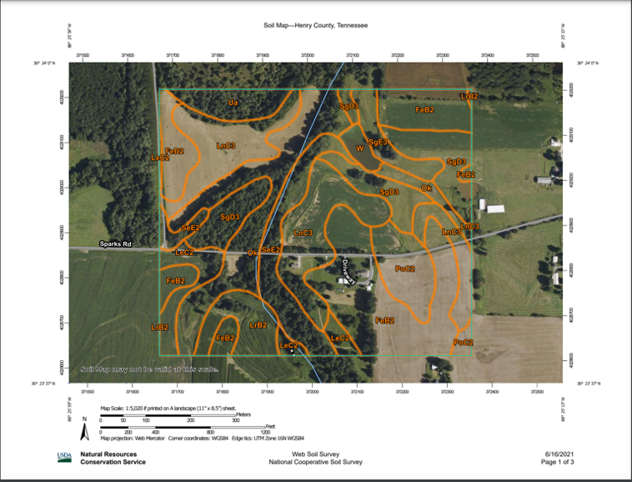
Figure 3. Soil map in Henry County, TN (Web Soil Survey, 2021).

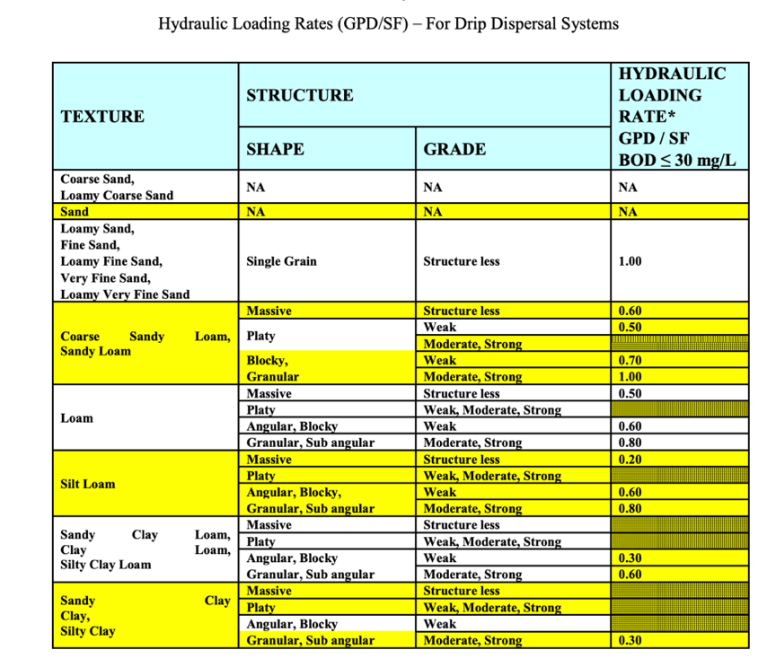
Figure 4. Soil hydraulic loading rates for Tennessee (TDEC, 2023b)
hydraulic loading rate in Tennessee is 10% of the minimum NRCS saturated vertical hydraulic conductivity or 0.25 gallons / day / square foot depending on which is lower (TDEC, 2023b). SDI fields need to have low amounts of effluent applied to have the most aerated soil conditions providing the nest treatment possible.

Drip Line Installation
After completing a soil map and determining the soil loading rate parameters, the installation of driplines can commence. Driplines are typically placed 6-10 inches below the soil surface using a vibratory plow to minimize soil disturbance (Netafim, 2012). Installing driplines near the soil surface serves several purposes. First, the upper soil horizons are the most biologically active and permeable, promoting effective effluent treatment and plant uptake (Norweco, 2024). Additionally, the topsoil dries more quickly after rainfall, helping maintain high adsorption rates compared to deeper soil layers (Norweco, 2024; Netafim, 2012).

Common Field Design
Subsurface drip irrigation (SDI) systems typically receive effluent that has undergone secondary treatment, followed by UV disinfection, before being directed into a pump chamber and then the dispersal field (Lesikar and Converse, 2004). The pump chamber, along with upstream septic tanks, provides temporary storage and helps regulate flow during dosing cycles, especially in the event of power or equipment failure.
From there, effluent is delivered to the SDI field through a central control or hydraulic unit, which manages the timing, volume, and frequency of both dosing and flushing cycles over a 24-hour period (Lesikar and Converse, 2004). The hydraulic unit often contains microfilters (typically 75 microns) that further remove fine solids, protecting the pressure-compensated drip lines from clogging and extending system life (AMCI, 2024). To maintain emitter performance and uniform distribution, pressure regulators are installed upstream of the field to maintain system pressure within the manufacturer's recommended PSI range. Air/vacuum relief valves are commonly installed at the high points of both the supply and return manifolds. These valves allow air to escape when the system fills and prevent vacuum formation during draining, which can damage drip tubing or disrupt flow (Norweco, 2024).
During normal field operation, treated effluent is distributed in timed pulses directly into the soil via drip emitters (AMCI, 2025). Each dosing event is typically followed by a resting period, allowing the soil to aerate and the effluent to infiltrate. Return lines, located at the end of each drip zone, are primarily used for flushing the system, not for routine flow during dosing (Converse, 2003). Flushing removes accumulated biofilm, solids, or debris that may clog emitters over time. It is generally performed every 2 to 4 weeks, depending on the effluent quality, system design, and loading frequency (AMCI, 2021). If return lines register flow during normal dosing, it may indicate clogged emitters, poor infiltration, or improper system balance. A basic schematic of a standard SDI field configuration is shown in Figure 5.

Drip Zones
Subsurface drip irrigation (SDI) fields managing large volumes of wastewater typically incorporate multiple drip zones. Zoning is essential when suitable soil areas are distributed across different locations and is widely adopted due to its numerous advantages. Smaller, separate zones reduce inflow volumes, allowing for the use of smaller pumps, filters, valves, and supply and return lines (Geoflow, 2007). In areas with varying soil types, zones are tailored to apply wastewater at specific rates suitable for each soil type (Geoflow, 2007). Additionally, zoning enables soils to rest between dosing cycles, enhancing soil aeration and boosting treatment capacity (Van Cuyk et al., 2001).

Emitter and Lateral Line Spacing
Emitter and lateral line spacing are critical design components in a drip field, as they determine the area over which effluent is dispersed across the soil surface. Emitter spacing refers to the distance between drip emitters along a subsurface drip tubing line, typically ranging from 1 to 2 feet. This spacing should be selected based on soil type (Netafim, 2017). In Tennessee, the most used emitter spacing for drip fields is 2 feet, though it is unclear whether this choice is driven by field characteristics or by cost considerations.
Lateral water movement beneath the soil surface is primarily influenced by soil type and application rate (Netafim, 2014a). In clayey soils, water movement is slower but spreads more laterally due to high capillary forces (Bresler & Hanks, 1975). Loamy soils allow for balanced lateral and vertical water movement, creating a more bulb-shaped wetting front (Guan, 2022). In contrast, sandy soils exhibit minimal horizontal movement because of their low capillary forces

Figure 5. Simple design of a 2-zone drip dispersal field.

(Guan, 2022). Figure 6 below illustrates the patterns of water movement from SDI lines across different soil types. As soil texture becomes coarser, incorporating smaller emitter and lateral spacing in designs should occur to improve effluent to soil surface contact.
Drip line horizontal spacing refers to the distance between each run of drip tubing within a dispersal field. While manufacturers’ recommendations vary slightly, they typically suggest spacing between 1 and 2 feet (Geoflow, 2007; Netafim, 2017; Norweco, 2024; AMCI, 2024). In Tennessee, lateral spacing commonly ranges from 2 to 10 feet. Notably, the spacing between lines does not impact the overall dispersal area size required. However, fields with wider line spacing (e.g., 5 feet) necessitate a higher minimum dose per line compared to fields with narrower spacing (e.g., 2 feet), resulting in higher effluent distribution down each line and reduced soil surface utilization for treatment. Larger lateral spacing also reduces the amount of SDI tubing required, thereby lowering overall field costs, making it the cost-effective choice. A simple example of how lateral line spacing can affect the amount of tubing needed and dose volumes per run of tubing can be found in Table 1.

Drip Lines
Drip lines SDI systems are typically constructed from flexible polyethylene tubing with integrated emitters designed to release a specific dose of effluent, generally ranging from 0.5 to 2.0 gallons per hour, across a pressure range of 10 to 60 psi (pressure compensated, meaning the emitters deliver a consistent flow rate regardless of variations in water pressure) (Geoflow, 2007). To ensure optimal pressure and emitter performance, drip line lengths are usually capped at 400 feet, depending on design and line specifications (AMCI, 2024; Netafim, 2014a). Emitter technology has advanced to address common challenges in SDI systems, such as clogging and root intrusion. Many modern emitters incorporate built-in filters or turbulent flow pathways that
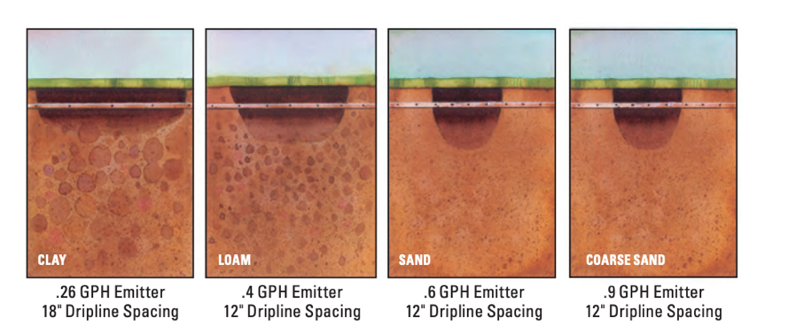
Figure 6. Water movement from drip lines in different soil types (Netafim, 2014b).

Table 1. Example of how dripline spacing affects amount needed and dose volumes per line.
Lateral spacing (ft) | Length of tubing / acre (ft)  (200ft runs)  (43,560 SF = 1 acre) | Dose volume of a single run of drip tubing (Gal)  (dose=833.33 Gal)
1 | 43,560 =  218 lines | 3.82
2 | 21,780 =  109 lines | 7.65
3 | 14,520 =  73 lines | 11.41
4 | 10,890 =  54 lines | 15.43
5 | 8,712 =  44 lines | 18.94
10 | 4,356 =  22 lines | 37.87

create a self-cleaning mechanism, expelling sediment buildup (Geoflow, 2007). Additionally, emitters may be treated with root- and microbe-inhibiting chemicals or equipped with physical barriers to prevent root intrusion at the outlet (Geoflow, 2007).

Field Maintenance
Proper maintenance of a drip field is one of the most important responsibilities for operators, as inadequate maintenance can lead to system failure within a short period. Consistent monitoring is essential for identifying and addressing issues promptly. Regular flushing of the field is needed to clear out biological and mineral growth that builds up over time inside of the drip lines (Netafim, 2012).
Installing totalizing water meters and pressure gauges throughout the system is recommended to support effective monitoring. Totalizing flow meters, unlike normal flow meters that measure the instantaneous flow rate, measure the total volume of liquid through a pipe over time. Water meters help ensure that the field is not being overloaded, while pressure gauges verify that pressure remains within the optimal range needed for emitter function (Netafim, n.d.). Variations in pressure can serve as early indicators of potential issues, such as broken or clogged lines, allowing for timely intervention (Netafim, n.d.). However, many fields in Tennessee lack totalizing water meters, making it challenging for operators to readily access accurate flow rate data.
Finally, physically managing the drip field is required. Grass cover is the preferred vegetation because of its minimal root protrusion and high evapotranspiration rates. The grass needs to be mowed for easy access to the field by foot. Fields should be fenced or marked so that no vehicles compact the drip area or crush the lines under the soil surface. Visual inspections should also occur on a regular basis to ensure that there are no ponding or other issues at the soil surface.

Chapter 1: United States Drip System Survey

During the summer of 2024, a nationwide survey of community scale subsurface drip dispersal systems in the United States was conducted. The objective was to understand the regulations governing SDI systems in different states and compare them with Tennessee's current practices. To gather this information, state regulators overseeing SDI systems were contacted, and publicly available state documents were reviewed. Data were successfully collected from 44 states, while information from six states remained unavailable due to a lack of contact and documentation. For organizational clarity, the collected data were categorized by EPA region.
The gathered information focused on the physical design standards required by states, reserve area requirements (a backup drip field to switch over to when the primary fails), and soil evaluator specifications. Additional data included hydraulic loading rates and the flow calculations utilized by other states. Previously, there had been no attempts to understand how these wastewater treatment systems were being implemented across the United States. The collected information provides insights into regional variation, or lack thereof, in SDI system design and regulation across the country. By analyzing and drawing from these various standards, opportunities for improving SDI system performance, ensuring long-term functionality, and minimizing environmental risks such as hydraulic overloading and water contamination can be identified.

General (US EPA region 1)
Information for all states in US EPA Region 1 was successfully gathered, except for Maine, where SDI systems do not exist (A. Pugh, personal communication, June 2024). In New England, subsurface drip dispersal systems are primarily designed by Perc Rite and installed by Oakson Inc., which serves as the sole distributor of this technology in the region (Oakson Inc., n.d.). Regulations governing SDI systems in these states are largely based on Perc Rite designs and Oakson installation guidelines, which are readily available online (Oakson, 2015; Connecticut Department of Public Health, 2018; Massachusetts Department of Environmental Protection, n.d. a,b; Oakson, 2012; Oakson, 2019; Vermont Department of Environmental Conservation, 2023). This information can be found in Table 2.

Design standards
Since there is relatively low variation among systems in terms of what is being installed, there is not much variation in the design standards in region 1. Center to center (C to C) spacing minimums range from 1-3 ft, however the recommended spacing is 2 ft in Massachusetts, New Hampshire, Connecticut, and Vermont (Massachusetts Department of Environmental Protection n.d. a; Oakson, 2012; Oakson, 2015; Vermont department of environmental conservation, 2023). Emitter spacing is almost always 2 ft across the board and is the typical design of the Perc Rite drip tubing from the manufacturer (AMCI, 2021). Minimum depths are almost entirely 6 inches which was surprising due to these states having colder climates. Maximum depths range from 18-24 inches (Oakson, 2015; Connecticut Department of Public Health, 2018; Massachusetts Department of Environmental Protection, n.d. a,b; Oakson, 2012; Oakson, 2019; Vermont Department of Environmental Conservation, 2023). All states in EPA Region 1 require some form of reserve drip area to serve as a backup in case the primary system fails (Oakson, 2015; Connecticut Department of Public Health, 2018; Massachusetts Department of Environmental Protection, n.d. a,b; Oakson, 2012; Oakson, 2019; Vermont Department of Environmental Conservation, 2023).
The requirements for soil evaluations vary across the region. In Connecticut, soil evaluations must be conducted by a professional engineer (Connecticut Department of Public.
Table 2. US EPA region 1 SDI design standards
State | Lateral Spacing (in inches) | Emitter Spacing (in inches) | Minimum Depth (in inches) | Maximum depth (in inches) | Reserve Area Requirements | Soil Evaluator Qualifications
Connecticut | 18-24 inches | 24 inches | 6 inches | 18 inches | Connecticut regulations require additional lands to be reserved as a contingency for system failure. | Soil evaluations can/will be conducted by any Connecticut Professional Engineer familiar with wastewater design.
Maine | Does not exist
Massachusetts | Minimum 12 inches. Typically, 24 inches | 24 inches | 6 inches | 24 inches | Owners must have reserve area that meet dimensional requirements of the primary reserve. | A soil scientist approved by the Massachusetts Environmental Protection Agency.
New Hampshire | 24 inches | 24 inches | 6 inches | No max. depth | New Hampshire requires a reserve area based on hydraulic loading rates and design flow | Soil evaluations are conducted by permitted designers, engineers, and other qualified professionals.
Rhode Island | No less than 12 inches | 24 inches | 6 inches | 24 inches | Size dependent on hydraulic loading rates. | Approved by state soil scientists.

Vermont | 24-36 inches | 12-24 inches | 6-12 inches | 18 inches | Drip field reserve required 100%; Unless they have a mound system. | Soil evaluations in Vermont are performed by soil scientists, engineers, and designers.
Table 2. Continued

a). In Rhode Island, only state-approved soil scientists are authorized to carry out evaluations (Oakson, 2019). Vermont allows soil evaluations to be conducted by a range of professionals, including soil scientists, designers, or engineers (Vermont Department of Environmental Conservation, 2023).

Maintenance
To maintain SDI systems in Connecticut, the designing engineer must specify the maintenance requirements that need to be followed (Connecticut Department of Public Health, 2018). In Massachusetts, SDI systems are required to have totalizing meters to track the flow passing through them (Massachusetts Department of Environmental Protection, n.d. a). Any SDI system handling over 2,000 GPD must undergo quarterly inspections and be maintained in accordance with the distributor's guidelines (Massachusetts Department of Environmental Protection, n.d. a). In Rhode Island, SDI systems with flow rates exceeding 2,000 GPD must include totalizing flow meters and remote telemetry (Oakson, 2019). Quarterly inspections for larger systems must be conducted by approved service providers, and inspections during construction are required to ensure proper system installation (Oakson, 2019). Vermont mandates that SDI systems receiving more than 1,200 GPD be fitted with totalizing flow meters and undergo biannual inspections, in addition to following manufacturer recommendations (Vermont Department of Environmental Conservation, 2023).

Hydraulic Loading Rates / Field Sizing
Connecticut’s hydraulic loading rates are determined based on soil percolation rates. For SDI system designs, loading rates are calculated as four times the square footage required for a traditional leaching field to meet the appropriate loading rate (Connecticut Department of Public Health, 2018). This means that the area required for a septic leaching field must be multiplied by four to comply with Connecticut’s regulations. In Massachusetts, the minimum dispersal area is determined by the soil’s loading rate, as specified in Oakson’s design guide, or by the limitations outlined in the system approval, depending on which is more restrictive (Massachusetts Department of Environmental Protection, n.d. a). Field sizing and loading rates are based on soil structure and texture and are provided by Oakson’s design specifications (Oakson, 2019). In Vermont, loading rates are determined through hydrogeological analysis (Vermont Department of Environmental Conservation, 2023).

General (US EPA region 2)
In EPA region 2, both New York and New Jerseys SDI design, installation, and management were readily available online and can be found in Table 3 below. New York State uses National Onsite Wastewater Recycling Association (NOWRA) as well as manufacturers for guidelines (New York State Department of Environmental Conservation, 2014). Whether or not the regulations of New Jersey apply to larger or smaller systems is less clear. While all the written regulations are based small residential systems (New Jersey Department of Environmental Protection, 2021), New Jersey Administrative Code (N.J.A.C.) 7:9A contains comparable information to other states for large systems using the laws of the Department of Environmental protection (New Jersey Administrative Code, 2025).

Design Standards
In New Jersey drip lines must be installed at least 6 inches below the surface and no more than 12 (New Jersey Department of Environmental Protection, 2021). Lateral C-C, and emitter spacing must be 2 feet apart (New Jersey Department of Environmental Protection, n.d.). A reserve area is required in New Jersey and is specified by the drip system manufacturer (New Jersey Department of Environmental Protection, 2021). Site evaluations can be conducted by a
Table 3. US EPA region 2 SDI design standards.
State | Lateral Spacing (in inches) | Emitter Spacing (in inches) | Minimum Depth (in inches) | Maximum depth (in inches) | Reserve Area Requirements | Soil Evaluator Qualifications
New Jersey | 24 inches | 24 inches | 6 inches | 12 inches | ES, installer specified | A licensed professional engineer, licensed health officer, registered environmental health specialist or soil scientist
New York | 24 inches | 24 inches | 6 inches | 18 inches | 100% reserve field | Soil scientists or engineers

wide array of professionals such as engineers, health officers, or soil scientists (New Jersey Department of Environmental Protection, 2021.). In New York drip lines must be at least 6 inches below and no more than 18 inches below the soil surface (New York State Department of Environmental Conservation, 2014). Site evaluations can be conducted by engineers or soil scientists, and a reserve area 100% equal to the size of the original is required in case the primary field fails (New York State Department of Environmental Conservation, 2014).

Maintenance
Inspection of SDI systems in New Jersey must have a contracted service provider that is permitted by the state to maintain, operate, and respond to emergencies (New Jersey Department of Environmental Protection, 2021). Property owners are responsible for keeping service contacts with licensed providers or they will be in violation of the law (New Jersey Department of Environmental Protection, 2021). All drip dispersal systems must have alarms, pressure gauges, and totalizing meters with remote readout capabilities (New Jersey Department of Environmental Protection, 2021).
New York suggests that SDI fields be equipped with monitoring systems and alarms to measure the inflow rates as well as detecting failures (New York State Department of Environmental Conservation, 2014). Any SDI system that is over 1,000 GPD must have a State Pollutant Discharge Elimination System (SPDES) permit (New York State Department of Environmental Conservation, 2014). This permit requires systems to have rigorous quality and design testing before becoming fully operational. (New York State Department of Environmental Conservation, 2014).

Hydraulic Loading Rates / Field Sizing
Soil Loading rates in New York are based on soil texture and structure with bedrooms of homes being considered to add 150 GPD of flow (New York State Department of Environmental Conservation, 2014). New Jersey’s loading rates are determined from the percolation rate of the soils, not by what the underlying texture and structures are (New Jersey Department of Environmental Protection, 2021). New Jersey’s loading rate requirements for SDI systems are lower than the EPA’s suggested based on soil type (EPA, 2002), which is what Tennessee uses for recommendations. While New York does have information regarding loading rates based upon soil types for many systems, they do not specifically have any for SDI.

General (US EPA region 3)
Information for all states in U.S. EPA Region 3 can be found in Table 4 and was readily accessible online, except for West Virginia, where no information was available, and the regulatory body for SDI systems was unresponsive. Pennsylvania’s dispersal regulations rely on certified alternative treatment plans, which primarily use Perc Rite systems. Pennsylvania does
Table 4. US EPA region 3 SDI design standards.
State | Lateral Spacing (in inches) | Emitter Spacing (in inches) | Minimum Depth (in inches) | Maximum depth (in inches) | Reserve Area Requirements | Soil Evaluator Qualifications
Delaware | 24 inches | 24 inches | 6 inches | 18 inches | 100% | Evaluations in Delaware are typically conducted by soil scientists or professional engineers.
Maryland | 12-36 inches | 24 inches | 6 inches | 12 inches | - | The Maryland Department of Health does soil evaluations.
Pennsylvania | 24 inches | 24 inches | 6 inches | 12 inches | - | Evaluation by professional soil scientists.
Virginia | 18-24 inches | 6-24 inches | 6 inches | No max. depth | Requires a 50% reserve area for sites with an estimate percolation rate above 45 min./inch; however, most localities have instituted local that require 100% | Private soil scientist must do the onsite soil evaluations. engineers can do the evaluations as well.
West Virginia | Information not found

not provide explicit regulations for community-scale SDI systems, manufacturers and engineers who design Perc Rite systems in the state also develop community-scale designs for other states. Despite the lack of specific community-scale guidance, information on Pennsylvania’s SDI regulations was still included in this review, as it provides valuable insight into the design and permitting of alternative treatment systems. Reserve area requirements could not be located for Maryland and Pennsylvania. Delaware and Pennsylvania are similar to EPA Region 1 states in their reliance on Perc Rite systems and adherence to manufacturer guidelines for proper installation (Delaware Department of Natural Resources and Environmental Control, 2018; Pennsylvania Department of Environmental Protection, 2012). While Maryland has published general guidelines, no specific laws or regulations governing SDI systems could be identified. According to the Director of the Division of Onsite Wastewater Services for the Virginia Health Department, fewer than 100 SDI systems exist in the state, and they are typically handled on a case-by-case basis.

Design Standards
Delaware and Pennsylvania's C to C and emitter spacing align with Perc Rite’s typical design of 24 inches (Delaware Department of Natural Resources and Environmental Control, n.d.; Pennsylvania Department of Environmental Protection, 2012). Delaware also mandates a reserve dispersal area equal to 100% of the active dispersal area (Delaware Department of Natural Resources and Environmental Control, n.d.). In Maryland, C to C spacing can range from 1 to 3 feet, with emitters spaced every 2 feet; however, 2 feet C to C is the most common configuration (Maryland Department of the Environment, 2016). Virginia specifies line spacing ranging from 18 to 24 inches, with emitter spacing between 6 and 24 inches (Virginia Department of Health, n.d. a). Virginia also requires a reserve area equal to 50% of the active dispersal area for SDI systems (Virginia Department of Health, n.d. a). Apart from Maryland, all states in this region require site evaluations to be conducted by soil scientists or engineers (Delaware Department of Natural Resources and Environmental Control, n.d.; Pennsylvania Department of Environmental Protection, 2012; Maryland Department of the Environment, 2016; Virginia Department of Health, n.d. a)

Maintenance
SDI systems in Delaware must be maintained in accordance with Perc Rites specifications and any other mandated conditions by the permit and inspected every 6 months to ensure it is properly working (Delaware Department of Natural Resources and Environmental Control, n.d.). SDI systems must also be fitted with remote monitoring and control capabilities (Delaware Department of Natural Resources and Environmental Control, 2018). Pennsylvania SDI systems are required to be able to accurately calculate flows, pump cycles, and flushing events (Pennsylvania Department of Environmental Protection, 2012). The manufacturer in Pennsylvania is responsible for assisting with system failures and inspection plans (Pennsylvania Department of Environmental Protection, 2012). Virginias SDI systems are not required to have remote telemetry, however systems with above 40,000 GPD of flow must have personnel onsite during the day and public inspection should occur at least once a year (Virginia Department of Health, n.d. a,b). No specific inspection plans or need for remote monitoring is specifically stated in Maryland’s documents.

Hydraulic Loading Rates / Field Sizing
Loading rates for fields in Delaware are determined based on soil texture and structure. All hydraulic loading rates, expressed in GPD, are significantly lower than the EPA’s recommendations (EPA, 2002), typically being less than half (Delaware Department of Natural Resources and Environmental Control, n.d.). Similarly, Pennsylvania’s loading rates are based on soil texture and structure and are also lower than the EPA’s suggested values (Pennsylvania Department of Environmental Protection, 2012). In Virginia, SDI loading rates are calculated using soil percolation rates and the treatment level of the effluent (Virginia Department of Health, n.d. a). Virginia’s rates often fall below the EPA’s recommendations, depending on the percolation rate. Maryland’s loading rates stand out, as the state does not permit rates higher than 0.18 GPD/SF or 2 inches per week (Maryland Department of the Environment, 2016).

General (US EPA region 4)
Alabama and Florida’s SDI regulations were readily available online, although reserve area requirements could not be found (Alabama Department of Public Health, 2017; Florida Department of Health, n.d.). Georgia’s SDI design standards were also accessible, except for details on the maximum depth of drip lines (Georgia Department of Public Health, 2012). Information on Kentucky’s drip systems was obtained from a program evaluator at their public health department. Mississippi’s Department of Environmental Quality informed us that the SDI systems that are studying do not exist in the state. North Carolina had all the necessary information readily available online (North Carolina Department of Health and Human Services, n.d.), and their health department personnel were also helpful in providing additional details. South Carolina’s health department does not permit SDI systems for flows exceeding 1,500 GPD. TDEC has published recommendations online (TDEC, 2023). This information can be found in Table 5.

Design Standards
Alabama, Florida, and Georgia require 2-foot center-to-center (C to C) spacing and emitter spacing for drip lines (Alabama Department of Public Health, 2017; Florida Department of
Table 5. US EPA region 4 SDI design standards.
State | Lateral Spacing (in inches) | Emitter Spacing (in inches) | Minimum Depth (in inches) | Maximum depth (in inches) | Reserve Area Requirements | Soil Evaluator Qualifications
Alabama | 24 inches | 24 inches | 6 inches | 12 inches | - | Professional Engineer, Geologist, Professional Land Surveyor
Florida | 24 inches | 24 inches | 6 inches | 12 inches | - | Soil evaluations performed by certified soil scientists, engineers, or experts in OSTDS.
Georgia | 24 inches | Based on manufacturer | 8 inches | - | 100% reserve | Soil Classifiers Certification Advisory Committee approved
Kentucky | 18 inches | Unknown; likely 24 inches | 6-8 inches | 24 inches (in perfect soil) | 100% Repair area. Does not need to be evaluated. | 98% are done by local health environmentalists; Soil scientists are permitted.
North Carolina | 24-36 inches | 12-24 inches | ~6 inches | ~18 inches | Equivalent of 100% of primary field | Soil evaluations conducted by soil scientists, engineers, or environmental health specialists
South Carolina | Does not exist

Table 5. Continued

Tennessee | 24 inches  (Recommended | 12 – 24 inches | 6 inches | - | 100% land area (for single home) | Professional soil scientist
South Carolina | Does not exist
Mississippi | Does not exist

Health, n.d.; Georgia Department of Public Health, 2012). North Carolina allows ranges of 1-3 feet for C to C spacing and 1-2 feet for emitters, but a health department environmental engineer indicated that 2 feet is the standard for both. Tennessee recommends a 2-foot C to C spacing for drip lines and 1-2 feet for emitters (TDEC, 2023). All states specify minimum depths of 6-8 inches and maximum depths that ensure placement within the soil’s aerobic zone (Alabama Department of Public Health, 2017; Florida Department of Health, n.d.; Georgia Department of Public Health, 2012; North Carolina Department Health and Human Services, 2024.; TDEC, 2023).
Information on whether Alabama and Florida require reserve areas was not available online. Georgia, Kentucky, and North Carolina all mandate reserve distribution areas equal to 100% of the primary field. Tennessee requires reserve areas for single home systems but none for communities. All states, except Tennessee, allow various professionals to conduct site evaluations for SDI field suitability. Tennessee, however, restricts these evaluations to professional soil scientists (TDEC, 2023).

Maintenance
Alabama has no readily available maintenance or inspection protocols for SDI systems, which may be due to the limited number of such systems within the state. In contrast, Florida has detailed regulations for maintaining SDI systems. Before approval, a maintenance, design, and installation manual must be submitted by the designing engineer (Florida Department of Health, n.d.). Additionally, annual operating permits are required, along with a maintenance contract with an approved provider to ensure proper upkeep (Florida Department of Health, n.d.). No telemetry or flow meters are specified as requirements for SDI systems in Florida. Georgia requires any SDI system with a flow exceeding 2,000 GPD to have a special operation plan determined locally (Georgia Department of Public Health, 2012). These plans must include monitoring requirements, drip field cycling, maintenance schedules, and application rates (Georgia Department of Public Health, 2012). All systems in Georgia are also required to be equipped with totalizing meters to measure exact inflow (Georgia Department of Public Health, 2012). In Kentucky, the program evaluator indicated that SDI systems must also have totalizing meters installed and must be managed by a qualified entity to ensure proper operation. North Carolina has conducts inspections on fields once a year (North Carolina Department of Health and Human Services, 2024). Tennessee has very little on maintenance procedure and monitoring equipment in the guidelines.

Hydraulic Loading Rates / Field Sizing
Alabama uses percolation rates and soil groups to determine the loading rate of a drip dispersal field (Alabama Department of Public Health, 2017). Loading rates in Alabama are higher than Tennessee’s in coarser soil texture classes, but they become much smaller as the soils transition to finer grain textures (Alabama Department of Public Health, 2017). Specific loading rates for SDI systems could not be identified for Florida. Georgia’s loading rates are based on soil texture classes and are significantly lower than Tennessee’s, ranging from coarse loams to clays. Kentucky’s loading rates are similar to Alabama’s in that they exceed Tennessee’s recommended maximum of 0.25 GPD for coarser soils but drop significantly lower in finer soil classes. North Carolina’s loading rates are well-documented, with ranges that are either much smaller than Tennessee’s or relatively similar, depending on the soil type. Tennessee’s loading rates are based on the EPA’s chart, but designers are restricted to a maximum of 0.25 GPD for any given soil.

General (US EPA region 5)
All states had some written regulation for the design of SDI systems in EPA region 5 except Minnesota and Ohio. A pollution control agent in Minnesota stated that SDI systems are handled on a case-by-case basis are rare to see. Ohio and Wisconsin have written recommendations based largely off manufacturer manuals (Ohio Environmental Protection Agency, 2008; Wisconsin Department of Commerce, Division of Safety and Buildings, 1999). Michigan has specifications that SDI systems must adhere to but do not have the specific spacing of emitters or drip laterals listed (Michigan Department of Environment, Great Lakes, and Energy, 2013). Region 5 has information such as reserve area, maximum line depth, and lateral/ emitter spacing that could not be found for some states. This information can be found in Table 6 below.

Design Standards
All states in US EPA region 5 (other than Michigan) require 2 feet spacing of lateral drip lines and emitters (Illinois Department of Public Health, 2024.; Indiana State Department of Health, 2001; Ohio Environmental Protection Agency, 2008; Wisconsin Department of Commerce, Division of Safety and Buildings, 1999). Minimum depths range from 4-6 while maximums range from 14-24 inches (Illinois Department of Public Health, 2024; Indiana State Department of Health, 2001; Wisconsin Department of Commerce, Division of Safety and Buildings, 1999). Indiana and Michigan both require reserve areas that can provide a complete replacement if the main dispersal field fails (Michigan Department of Environment, Great Lakes, and Energy, 2013; Indiana State Department of Health, 2001).

Table 6. US EPA region 5 SDI design standards.
State | Lateral Spacing (in inches) | Emitter Spacing (in inches) | Minimum Depth (in inches) | Maximum depth (in inches) | Reserve Area Requirements | Soil Evaluator Qualifications
Illinois | 24 inches | 24 inches | 6 inches | 12 inches | - | Engineer or health department worker with experience.
Indiana | 24 inches | 24 inches | 6 inches | - | 100% Land Area | Evaluations done by soil scientists.
Michigan | - | - | 4 inches | 24 inches | An accessible area shall be available and reserved to provide for a minimum of one replacement system without utilization or distribution of the initial installation. | The agency shall assure that soil evaluations must be completed and accurately reported by a soil evaluator experienced with the USDA Soil Classification System.
Minnesota | Does not exist
Ohio | 24 Inches | 24 inches |  |  |  | Professional soil Scientist
Wisconsin | 24 inches | 24 inches | 6 inches | - | Not Required | Evaluations by a certified soil scientist

Wisconsin does not require a reserve area but has regulation around them if one is provided on the site (Wisconsin Department of Commerce, Division of Safety and Buildings, 1999). Indiana, Michigan, Ohio, and Wisconsin all require soil scientists to conduct soil evaluations (Indiana State Department of Health, 2001; Michigan Department of Environment, Great Lakes, and Energy, 2013; Wisconsin Department of Commerce, Division of Safety and Buildings, 1999; Ohio Environmental Protection Agency, 2008). Illinois relies on health department workers to complete site evaluations (Illinois Department of Public Health, 2024).

Maintenance
Illinois Requires manufactures of the drip systems to have maintenance plans for them (Illinois Department of Public Health, 2024). Alarms and meters with totalizing features are required to be installed in SDI systems but no telemetry is required (Illinois Department of Public Health, 2024). In Indiana, authorized service providers must conduct inspections on a regular basis and send reports to the department of health once a year (Indiana State Department of Health, 2001). Totalizing meters and alarms are required so that the proper flow rates and pressures are maintained throughout the lifetime of a system (Indiana State Department of Health, 2001). Michigan has detailed regulations regarding the requirements for the maintenance of SDI systems. In addition to detailed maintenance plans that are required to be submitted before construction approval site with daily flows over 10,000 GPD must undergo monthly inspection (Michigan Department of Environment, Great Lakes, and Energy, 2013). SDI systems mut also be outfitted with flow meters, alarms, and pressure gauges with telemetry (Michigan Department of Environment, Great Lakes, and Energy, 2013). Ohio’s guidelines for maintenance are brief, but they do require a maintenance plan before construction approval (Ohio Environmental Protection Agency, 2008). Wisconsin requires inspections twice a year and requires flow meters, alarms, and pressure gauges that do not need telemetry (Wisconsin Department of Commerce, Division of Safety and Buildings, 1999).

Hydraulic Loading Rates / Field Sizing
Illinois has a detailed loading rate chart based on soil structures that has higher loading rates than ones used in Tennessee (Illinois Department of Public Health, 2024). Indiana loading rates are comparably higher than Tennessee in courser soils while lower in finer soils (Indiana State Department of Health, 2001). Michigan’s loading rates are based off soil type and structure and are mostly 0.4 GPD/SF (Michigan Department of Environment, Great Lakes, and Energy, 2013) which is unusually high. Ohio has no specific loading rate charts posted and only recommends using a specific one that was unable to be found. Wisconsin has loading rates based on soils and the level of treatment of effluent. For effluent with secondary treatment, loading rates are above 0.6 GPD/SF until the silt loam classifications where they begin to drop down to 0.30 GPD/SF (Wisconsin Department of Commerce, Division of Safety and Buildings, 1999).

General (US EPA region 6)
SDI regulations in Louisiana do not exist and are managed on a case-by-case basis. Information on SDI systems in New Mexico could not be found online and attempts to contact the environmental department were unsuccessful. Arkansas, Texas, and Oklahoma have regulations that are readily available online (Arkansas Department of Health, 2022; Oklahoma Department of Environmental Quality, 1999; Texas Commission on Environmental Quality, n.d.).

Design Standards
Arkansas requires 2-foot lateral spacing for driplines and allows a range of emitter spacings depending on the design (Arkansas Department of Health, 2022). Driplines must be installed at a depth of at least 6 inches but no more than 10 inches (Arkansas Department of Health, 2022). A reserve area is required to serve as a backup in case of system failure, and site evaluations can be conducted by various professionals, including engineers, land surveyors, and health department workers (Arkansas Department of Health, 2022). This can be found in Table 7.
In Oklahoma, 2-foot center-to-center (C-to-C) spacing is required for driplines, and emitter spacing can range from 1 to 2 feet depending on soil type (Oklahoma Department of Environmental Quality, 1999). The minimum and maximum installation depths for driplines are 8 and 10 inches, respectively. No specific requirements for reserve areas could be found in Oklahoma's regulations. Like Arkansas, Oklahoma permits various licensed professionals to conduct soil evaluations (Oklahoma Department of Environmental Quality, 1999).
Texas allows C-to-C and emitter spacing to range from 1 to 3 feet (Texas Commission on Environmental Quality, n.d.). No information on reserve area requirements in Texas could be identified.
Soil evaluations in Texas are conducted by geoscientists or professional engineers (Texas Commission on Environmental Quality, n.d.).

Maintenance
Arkansas requires SDI systems to be serviced at least once every three months (Arkansas Department of Health, 2022). Drip system owners must maintain a service contract with certified maintenance personnel approved by the Arkansas Department of Health (Arkansas Department of Health, 2022). These systems must also be equipped with totalizing flow meters, accessible pressure gauges, and both audio and visual alarms (Arkansas Department of Health, 2022). Oklahoma provides detailed specifications for the physical design standards of drip
Table 7. US EPA region 6 SDI design standards.
State | Lateral Spacing (in inches) | Emitter Spacing (in inches) | Minimum Depth (in inches) | Maximum depth (in inches) | Reserve Area Requirements | Soil Evaluator Qualifications
Arkansas | 24 inches | 6-24 inches | 6 inches | 10 inches | It does need a primary area, and then an alternate area if primary fails. | Registered professional engineers, registered land surveyors, licensed master plumbers and sanitarians.
Louisiana | Does not exist
New Mexico | Information not found
Oklahoma | 24 inches | Dependent on the soil type | 8 inches | 10 inches | - | Soil tests performed by professional engineers, professional land surveyors, and environmental specialists. Must be registered by the state of OK.
Texas | 12-36 inches | 12-36 inches | 6 inches | 48 inches | - | Licensed professional engineer or licensed professional geoscientist.
systems but offers limited guidance on maintenance protocols or requirements for flow meters and pressure gauges (Oklahoma Department of Environmental Quality, 1999). In Texas, drip systems with designed flows exceeding 15,000 GPD must be inspected monthly (Texas Commission on Environmental Quality, n.d.). These systems must also include pressure gauges, alarms, and totalizing meters with telemetry to ensure proper functionality (Texas Commission on Environmental Quality, n.d.).

Hydraulic Loading Rates / Field Sizing
Arkansas uses unique dispersal field loading rate charts. These tables categorize soils into low, medium, or high hydraulic loading rates (Arkansas Department of Health, 2022). The tables are further divided based on depths to a restrictive horizon and the classification of seasonal water tables as brief, moderate, or long, to determine loading rates in GPD/SF (Arkansas Department of Health, 2022). Arkansas’s loading rates are relatively higher than Tennessee’s when there are brief water tables and significant depths to limiting layers. However, loading rates are much lower in areas with long water tables and shallow limiting layers. Oklahoma’s field sizing tables are unique in that they are based on soil groups and the number of bedrooms in a residence (Oklahoma Department of Environmental Quality, 1999). As the number of bedrooms increases, the length of drip tubing required also increases (Oklahoma Department of Environmental Quality, 1999). Specific loading rates in GPD/SF for Oklahoma were not identified. In Texas, loading rates are capped at 0.1 GPD/SF for two-thirds of the western part of the state (Texas Commission on Environmental Quality, 2020). In the remaining third of the state, equations must be used to calculate appropriate loading rates (Texas Commission on Environmental Quality, 2020).

General (US EPA region 7)
SDI regulations for US EPA region 7 can be found in Table 8. Regulations for SDI systems do not exist in Kansas or Nebraska. This was confirmed through discussions with representatives from the Kansas Department of Environment and Health and the Nebraska Department of Environment and Energy. Missouri has established SDI regulations which are accessible online, and the Missouri Department of Natural Resources provided helpful support. Iowa has detailed design guidance available, which serves as a baseline for SDI system design. Iowa’s manual was produced to jumpstart the use of SDI technology within the state (Iowa Department of Natural Resources, 2024).

Design Standards
Both Iowa and Missouri require 24-inch center-to-center (C-to-C) spacing for drip lines and emitters (Missouri Department of Natural Resources, 2024; Iowa Department of Natural Resources, 2024). Iowa specifies line depths ranging from a minimum of 6 inches to a maximum of approximately 12 inches (Iowa Department of Natural Resources, 2024). Missouri also mandates a minimum line depth of 6 inches, but no maximum depth is specified (Missouri Department of Natural Resources, 2024). Missouri requires a 100% reserve area in case the primary field fails, whereas Iowa requires a 50% reserve area (Iowa Department of Natural Resources, 2024; Missouri Department of Health and Senior
Services, 2023). For soil evaluations, Iowa allows either engineers or soil scientists, while Missouri permits only soil scientists to perform these evaluations (Missouri Department of Natural Resources, 2024; Iowa Department of Natural Resources, 2024).

Table 8. US EPA region 7 SDI design standards.
State | Lateral Spacing (in inches) | Emitter Spacing (in inches) | Minimum Depth (in inches) | Maximum depth (in inches) | Reserve Area Requirements | Soil Evaluator Qualifications
Iowa | 24 inches | 24 inches | 8 inches | ~12 inches | Needs an area of 50% reserve. | Soil Evaluations done by either soil scientists or engineers.
Kansas | Does not exist
Missouri | 24 inches | 24 inches | 6 inches | - | 100 % Reserve area requirements | You must be a soil scientist doing these evaluations.
Nebraska | Does not exist

Maintenance
Iowa has detailed inspection and maintenance guidelines. Drip fields should be visually inspected quarterly and detailed records should be kept that include maintenance records, run times, sampling results, and other component monitoring (Iowa Department of Natural Resources, 2024). SDI systems
should be equipped with alarms, totalizing meters, and pressure gauges that have remote readout capabilities (Iowa Department of Natural Resources, 2024). Audio and visual alarms are required on SDI systems in Missouri, but flow meters are not (Missouri department of Natural Resources, 2024). Detailed maintenance protocols could not be located for Missouri.

Hydraulic Loading Rates / Field Sizing
Iowa’s hydraulic loading rates are standard in that they are based off physical soil properties (Iowa Department of Natural Resources, 2024). In relation to Tennessee’s Iowa’s loading rates are lower in the finer soil textures. Hydraulic loading rate charts could not be found for Missouri. Calculations for their field sizing’s are stated and are the standards daily flow / hydraulic loading rate of the soil (Missouri department of Natural Resources, 2024).

General (US EPA region 8)
Subsurface drip dispersal (SDI) systems in most of the US EPA Region 8 were confirmed to not exist and can be found in Table 9. Professionals from Colorado, Montana, North Dakota, South Dakota, and Utah provided insights on this matter. Wyoming, however, had no available regulations online, and attempts to contact the health department were unsuccessful. Montana had accessible drip system regulations published by the Department of Environmental Quality.

Table 9. US EPA region 8 SDI design standards.
State | Lateral Spacing (in inches) | Emitter Spacing (in inches) | Minimum Depth (in inches) | Maximum depth (in inches) | Reserve Area Requirements | Soil Evaluator Qualifications
Colorado | Does not exist
Montana | 24 inches | 24 inches | 8 inches | No max. depth | Yes, there are reserve area requirements, 100% reserve | Evaluations done by engineers
North Dakota | Does not exist
South Dakota | Does not exist
Utah | Does not exist
Wyoming | Information not found

Design Standards
Montana specifies a 2-foot center-to-center (C-to-C) spacing for drip lines, along with defined emitter spacing (Montana Department of Environmental Quality, 2023). The minimum depth for drip lines is 8 inches, though no maximum depth is indicated (Montana Department of Environmental Quality, 2023). Additionally, Montana mandates a 100% reserve area for drip fields to serve as a backup in case the primary field fails (Montana Department of Environmental Quality, 2023). Soil evaluations in Montana must be conducted by qualified engineers (Montana Department of Environmental Quality, 2023).

Maintenance
Montana requires that SDI systems be installed with audio and visual alarms to ensure operational safety (Montana Department of Environmental Quality, 2023). It is not specified whether systems are required to include telemetry capabilities. Operation and maintenance manuals must be provided and reviewed prior to system installation (Montana Department of Environmental Quality, 2023).

Hydraulic Loading Rates / Field Sizing
Loading rates in Montana are based on water percolation through soils (Montana Department of Environmental Quality, 2023). Loading rates in course soils range from 0.8-0.6 GDP/SF and 0.5-0.15 GPD/SF in finer soils.

General (US EPA region 9)
SDI design standards for US EPA region 9 can be found in Table 10. Arizona’s and California’s Drip dispersal regulations were able to be found online. Hawaii and Nevada had no information on drip dispersal systems online and the health departments were unresponsive.

State | Lateral Spacing (in inches) | Emitter Spacing (in inches) | Minimum Depth (in inches) | Maximum depth (in inches) | Reserve Area Requirements | Soil Evaluator Qualifications
Arizona | 12-14 inches | 24 inches | 6 inches | - | Required | Professional Engineers, Sanitarians, and Geologists
California | 24 inches | 12 inches | 6 inches | 18 inches | 200% land area reserve | Registered professionals of the state of California; they can also be designers too.
Hawaii | Information not found
Nevada | Information not found
Table 10. US EPA region 9 SDI design standards.

Design Standards
Arizona requires a center-to-center (C-to-C) spacing of 1 to 2 feet and a 2-foot emitter spacing in drip fields (Arizona Department of Environmental Quality, 2005). According to Arizona law, drip lines must be buried at a minimum depth of 6 inches, with no maximum depth specified (Arizona Department of Environmental Quality, 2005). A reserve area is mandated, but specific sizing details relative to the primary area could not be determined (Arizona Secretary of State, 2023). Soil evaluations in Arizona can be conducted by registered engineers, sanitarians, and geologists (Arizona Secretary of State, 2023).

Design Standards
Arizona requires a center-to-center (C-to-C) spacing of 1 to 2 feet and a 2-foot emitter spacing in drip fields (Arizona Department of Environmental Quality, 2005). According to Arizona law, drip lines must be buried at a minimum depth of 6 inches, with no maximum depth specified (Arizona Department of Environmental Quality, 2005). A reserve area is mandated, but specific sizing details relative to the primary area could not be determined (Arizona Secretary of State, 2023). Soil evaluations in Arizona can be conducted by registered engineers, sanitarians, and geologists (Arizona Secretary of State, 2023).
In California, a minimum C-to-C spacing of 2 feet is required, with a spacing of 3 feet mandated for slopes exceeding 20% (County of Napa, 2019). Driplines must be installed at a depth of at least 6 inches but no deeper than 18 inches (County of Napa, 2019). California also requires a reserve area that is equal to 200% of the original system's area, which must be designated prior to installation (County of Napa, 2019). Site evaluations in California must be performed by registered professionals (California State Water Resources Control Board, 2019).

Maintenance
Arizona has detailed maintenance requirements for the entirety of an SDI system. Components must be maintained according to the permit specification and operation manuals provided by the manufacturers (Arizona Secretary of State, 2023). Critical system components and operations must also be inspected quarterly (Arizona Department of Environmental Quality, 2005). Arizona requires alarms and totalizing meters to be installed in SDI systems (Arizona Secretary of State, 2023). California’s county health departments will inspect systems once a year if they are not operated by a permitted service provider (County of Napa, 2019). In addition to this, system owners must submit reports twice a year and renew their permit annually (County of Napa, 2019). Alarms and totalizing meters are required to be installed (County of Napa, 2019).

Hydraulic Loading Rates / Field Sizing
For courser soils and soils in high clay content in Arizona, site specific soil adsorption rates must be found (Arizona Secretary of State, 2023). Adsorption rates for loamy soils range from 0.53-0.13 GPD/SF (Arizona Secretary of State, 2023). California uses the typical soil class to determine the loading rates of soils (County of Napa, 2019). Loading rates in sands are 1.2 GPD/SF and go down to .25 GPD/SF in some clays and loams (County of Napa, 2019).

General (US EPA region 10)
SDI design standards for US EPA region 10 can be found in Table 11. It was confirmed through communication with the manager of the Department of Environmental Conservation that no drip dispersal fields exist in Alaska. In Oregon, no drip dispersal regulations were available online, and attempts to contact the health or environmental department were unsuccessful, leaving it uncertain whether SDI systems exist in the state. Idaho has readily accessible design
Table 11. US EPA region 10 SDI design standards.
State | Lateral Spacing (in inches) | Emitter Spacing (in inches) | Minimum Depth (in inches) | Maximum depth (in inches) | Reserve Area Requirements | Soil Evaluator Qualifications
Alaska | Does not exist
Idaho | 24 inches | 24 inches | 12 inches | 18 inches | 100% reserve area | Soil evaluations done by soil scientists and engineers.
Oregon | Information not found
Washington | 12-24 inches | 6-24 inches | 8 inches | 36 inches | A second land area that can handle the current needs if the other fails. | Soil evaluations are done by certified septic designers within the state of Washington.

manuals concerning SDI systems, and the Idaho Department of Environmental Quality provided helpful information. In Washington, extensive regulations regarding SDI systems are available online, contacting the health department was unnecessary.

Design Standards
In Idaho, driplines should be installed with a minimum center-to-center (C-to-C) spacing of 2 feet, and emitters can be spaced no more than 2 feet apart (State of Idaho Department of Environmental Quality, 2024). Driplines are required to be buried at depths ranging between 12 and 18 inches below the soil surface (State of Idaho Department of Environmental Quality, 2024). Idaho also requires a reserve drip field equal to 100% of the primary system's size (State of Idaho Department of Environmental Quality, 2024). Pre-construction site evaluations can be conducted by state-licensed engineers or soil scientists (State of Idaho Department of Environmental Quality, 2024).
In Washington, driplines may be spaced between 1 and 2 feet, with emitters spaced from 6 inches to 2 feet apart (Washington State Legislature, 2022). A reserve dispersal area capable of handling the system's inflows in the event of a failure is required (Washington State Legislature, 2022). Soil evaluations must be conducted by licensed septic designers (Washington State Legislature, 2022).

Maintenance
Before construction of a drip dispersal system, the designing engineer must submit an operation and maintenance manual for the system to receive a permit in Idaho (State of Idaho Department of Environmental Quality, 2024). Gauges to measure flow rates and pressures are needed to monitor for system failures (State of Idaho Department of Environmental Quality, 2024). Alarms must also be installed to notify residences if there is a failure, telemetry is not stated as being required for alarms or monitoring equipment (State of Idaho Department of Environmental Quality, 2024). Systems that are permitted in Washington to be build must have detailed operation and maintenance manuals (Washington State Legislature, 2022). Owners of SDI systems are required to have a contract with a licensed professional to maintain it (Washington State Legislature, 2022). Inspection must also occur on a regular basis and the frequency is dependent on the size (Washington State Legislature, 2022). Alarms, flow meters, and pressure gauges with telemetry are required to be installed (Washington State Legislature, 2022).

Hydraulic Loading Rates / Field Sizing

While a soil loading rate chart could not be found for Idaho, they do have sample calculations on how field sizing works. They take the expected daily flow (GPD) and multiply it by 1.5; from there multiply the GPD by the soils loading rate (Gal/SF) and then divide it by 2 SF/ft which is the distribution tube application area, the amount of drip tubing needed (State of Idaho Department of Environmental Quality, 2024). Washington only allows for 900-1575 GPD/Acre depending on the soil type of the area (Washington State Legislature, 2022). There are loading rate charts provided based on soil texture and structure for Washington. Loading rates range from 1-0.4 GPD/SF (Washington State Legislature, 2022).

Chapter 1 Summary
The primary purpose of this chapter was to conduct a comprehensive nationwide survey of drip dispersal regulation. By gathering data from state regulators and public documents this chapter aimed to identify design standards, maintenance requirements, and regulatory frameworks for SDI systems. Through this analysis, the goal was to uncover regional trends, commonalities, and variations in how states implement drip dispersal systems. This effort provides a foundation to pull from that can inform and enhance Tennessee’s practices, ensuring the long-term functionality and environmental safety of SDI systems.
For nearly all states where information was available, there is additional detail regarding SDI systems that extends beyond what was covered in this chapter. Many states provide extensive guidelines on installation techniques, permitting specifications, and detailed design standards. Similarly, comprehensive protocols, such as specific inspection practice, telemetry requirements, and specific designs, are often outlined but were not fully explored here. The decision to limit the scope of this chapter was made to focus on important regulatory elements relevant to Tennessee's context. However, this additional depth of information is available if it is wanted.
Across the surveyed regions, subsurface drip irrigation (SDI) systems have significant uniformity in design standards for lateral spacing. Of the 31 states with available SDI information only 6 were guidelines (Idaho, Iowa, Maryland, Ohio, Tennessee, Wisconsin). This can be observed in Figure 7. 28 states have lateral spacing within a range of 12–24 inches, aligning closely with manufacturer recommendations of 1–2 feet (AMCI, 2021; Netafim USA, 2014b; NOWRA, 2006; Toro Company, 2020). A smaller subset of states (3) allows for greater variability, with spacing ranging from 12 to 36 inches. Information online spacing by state can be seen in Figure 8. No states suggest that there should be lateral spacing greater than 36 inches. Similarly, most states require 24-inch emitter spacing or rely on manufacturer recommendation to decide.
Drip line depth requirements across states also show considerable overlap. Nearly all states mandate a minimum burial depth of 6 inches for driplines, ensuring proper coverage to protect against surface exposure and enhance soil-based treatment processes. Only six states
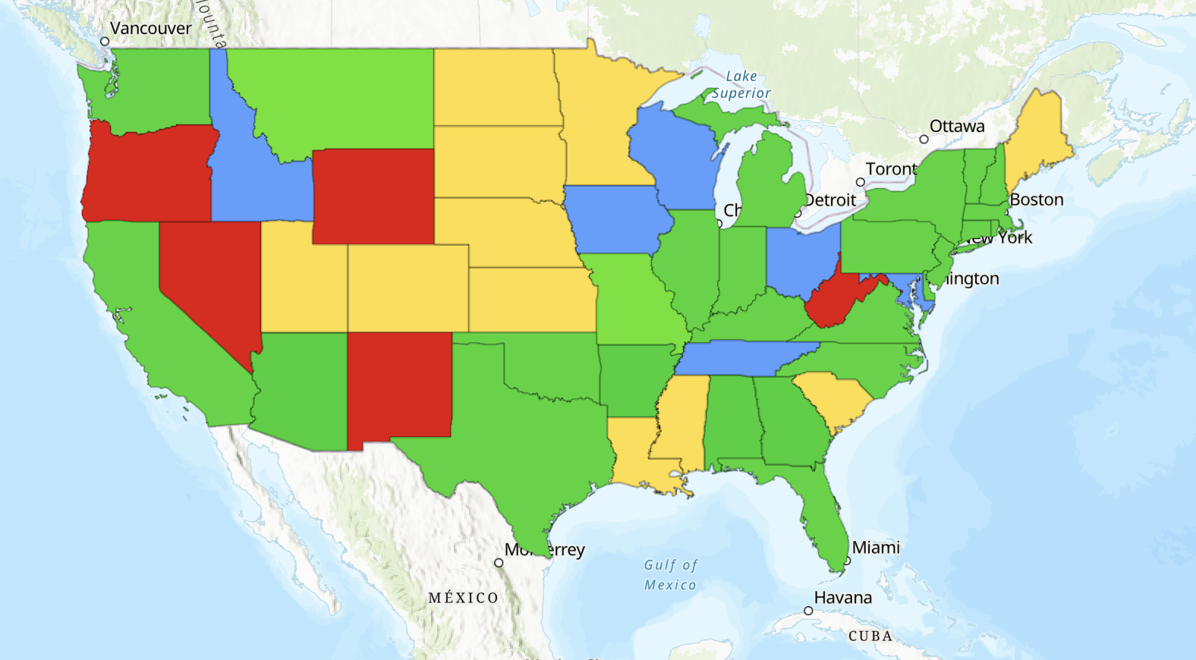
Figure 7. GIS map of lower 48 states with SDI regulation (Green), guidelines (Blue), no written laws or regulation (Yellow), unknown (Red)
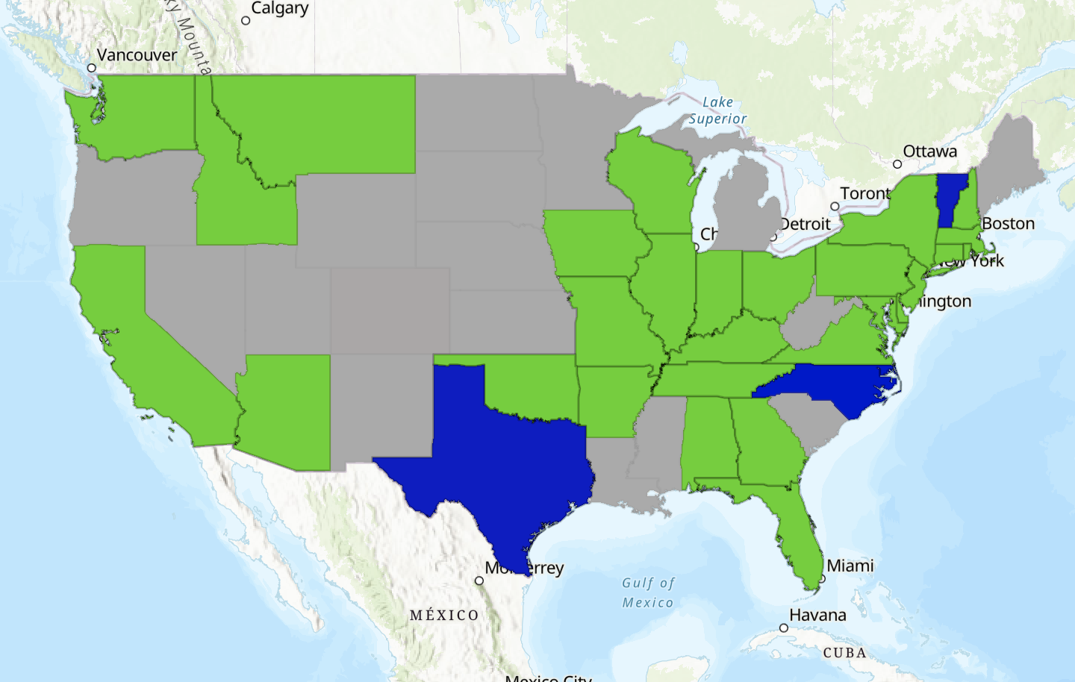
Figure 8. States that require or recommend 2 ft spacing (green) and states that allow for 3ft spacing (blue).
require a minimum depth of 8 inches or more likely because of colder climate conditions. Furthermore, only a few states allow for driplines to be installed deeper than 24 inches. Greater depths may reduce treatment efficiency in the biologically active upper soil layers.
Reserve areas are required of various sizes in 20 of the 31 with SDI information. Reserve areas are a needed component in SDI design because failures of the primary field may be liable to occur if the system is in operation for multiple decades. All states include some form of requirement for soil evaluations to assess site suitability. Most states allow professional engineers to conduct these evaluations. All states have some requirement for soil evaluations. Most states have professional engineers to conduct the evaluations, while 6 (including Tennessee) only allow for soil scientists.
Regular maintenance routines vary from state to state but typically includes regular inspection, and measure to ensure long term functionality. Most states require regular inspection by the SDI system operators and quarterly or annual inspections by the regulatory organization. For a system to be permitted in states like North Carolina, Arizona, and Washington they must have a contract licensed provider to maintain the system to remain in operation. The level of detail for maintenance protocols is variable with some states relying on manufacturer recommendations while others have them listed in detail.
Almost all states (23) with SDI regulation require monitoring equipment such as totalizing flow meters for the system and advanced alarm systems to detect any operational failure. 11 states specifically require telemetry for the monitoring equipment. A small subset of states had no findable regulations on whether systems needed alarms, flow meters, and pressure gauges. A visualization of the regulation around flow meters can be found in Figure 9.
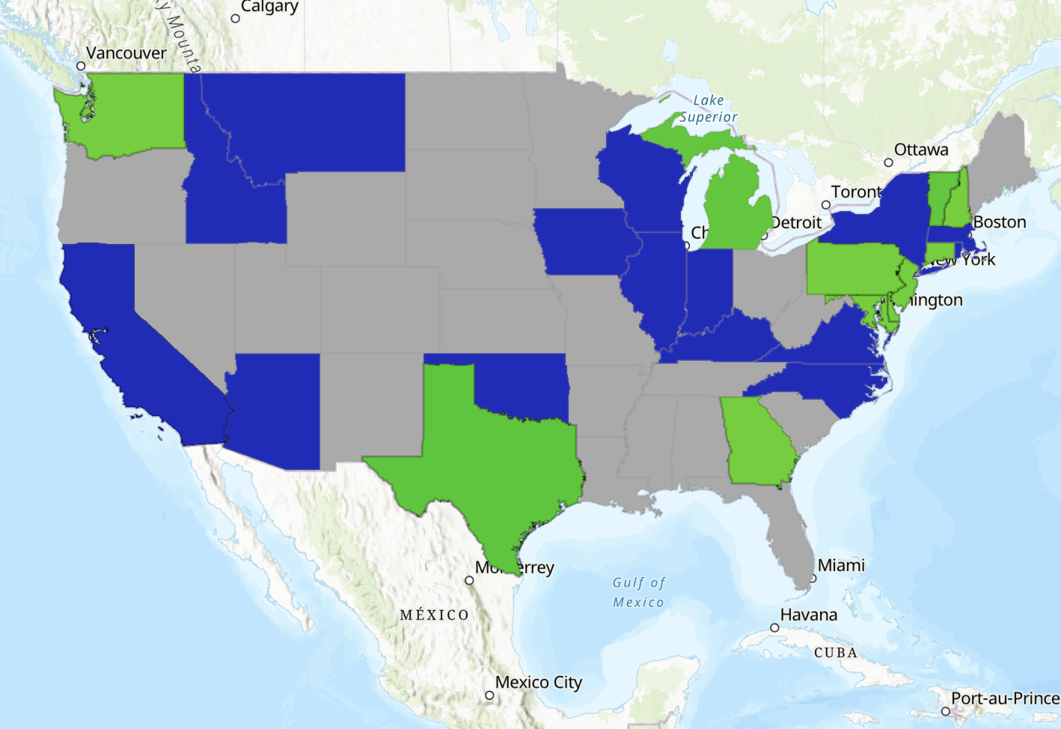
Figure 9. States that recommend or require totalizing flow meters (blue) or totalizing flow meters with telemetry (green).

Field sizes in many states are determined by soil loading rates and the daily expected flows into the system. Detailed information for specific states can often be found in the provided citations. However, in some cases field sizes are difficult to compare due to the absence of specific data or the lack of standardized soil loading rate charts for drip emitters. Among the states that use a methodology like Tennessee’s, nine have lower loading rates for finer soil.
Tennessee’s extensive use of drip dispersal systems underscores the need for standardized regulation and design standards for them in the future. Without clear regulation, there is an increased risk of inconsistent design, installation, and maintenance practices, which could lead to system failures Of the 31 states that have SDI systems, 25 have established regulartion that must be followed, providing
clear guidelines for their implementation and management. While Tennessee leads the nation in the number of SDI systems in use, it lacks set standards leaving room for improvement in how these systems are designed and regulated.

Chapter 2: Tennessee SDI Systems
SDI systems have been widely adopted in Tennessee because of their ability to handle wastewater in rural areas with challenging soil conditions, limited infrastructure, and dispersed populations. SDI systems provide a cost-effective treatment for wastewater and are easily scalable for larger communities making them ideal when centralized treatment methods are not viable.
Despite the advantages offered by SDI systems, their widespread use in Tennessee has highlighted significant challenges stemming from a lack of enforceable regulation around the design and management of SDI fields. The 2024 visual inspection on SDI fields conducted by TDEC revealed that nearly 50% were out of compliance of the state operating permits at the time of inspection. Some were minor issues (23%) such as localized areas of soil saturation and vegetation, but many were major issues (27%) such as effluent discharge before reaching the field, infrastructure failures, and ponding or overland flow. While some of these failures have been addressed, there remains a lack of regular inspections to ensure systems continue to operate properly over time. Some problems are so extensive, like severe hydraulic overloading or large-scale infrastructure failures that they cannot be easily resolved. These failures not only compromise the performance of individual systems but may also pose environmental and public health risks.
The primary challenge of understanding why a system is working or it is not in Tennessee is the significant lack of information regarding how SDI systems are designed and managed. Many systems operate with unknown design specifications, including critical factors such as drip line spacing, emitter spacing, and the actual daily flow going into drip field. Additionally, there are no standards that must be met for field maintenance. All of these are factors that should be known and taken care of to maintain a working drip field.
The main purpose of Chapter 2 is to investigate the design and maintenance practices of SDI systems in Tennessee with a focus on identifying the factors that contribute to both successful and unsuccessful system performance. Understanding these distinctions will provide a look into why systems are successful or failing. This chapter seeks to use these findings to develop a set of best management practices (BMPs) that can guide the design, operation, and maintenance of SDI systems.
To address the issues faced with SDI systems in Tennessee, a comprehensive review of TDEC’s GIS map from the 2024 statewide inspection was first conducted. The review focused on fields that were identified as either functioning properly or exhibiting significant failures. From there, SDI fields of interest were chosen based off Figure 1. Data from TDEC’s permitting database were also examined to gather information on the designed hydraulic loading rates and pretreatment designs. In total, 92 functioning fields and 42 problematic fields were chosen for the study. Operators managing four or more of these systems were contacted to provide information on key design and maintenance aspects, including line spacing, line depth, actual loading rates, dosing cycles, time in operation, and regular maintenance practices. In addition to this, other operators were contacted.
The approach to focus on operators with multiple systems was made for several reasons. First, operators with multiple systems could provide a larger dataset in a shorter amount of time increasing the efficiency at which information was gathered. Second, these operators were thought to have detailed knowledge about the design and maintenance practices of their systems since they have so many under their care. Lastly, conducting individual inspections for each of the selected fields was not feasible due to the large number of systems included in the study. If fields were inspected individually, it would be difficult to get all design standards and flow rates if systems do not have flow meters. By focusing on operators managing multiple fields, the study could efficiently collect meaningful data to identify patterns and inform best management practices for SDI systems in Tennessee.
In total, there was an effort to get information on 38 working SDI systems and 18 problematic systems. From the contacts, information was provided for 10 working systems. However, no contacts gave information on any of the problematic systems of interest. This discrepancy in response rates may highlight a reluctance among operators of non-working systems to share information. During the outreach process, several operators initially expressed a willingness to provide insights into problematic systems but then ceased communication without explanation.
Some operators might be concerned about potential regulatory or legal repercussions if system failures are documented and linked to operational or design shortcomings. Others may fear that sharing details about non-compliant systems could prompt further scrutiny from TDEC or negatively impact their reputation within the industry. Additionally, in cases where systems are severely neglected or improperly maintained, operators may not have access to accurate data or may be unwilling to disclose the extent of management lapses.
These challenges in obtaining data on problematic and working systems not only limit the study's ability to draw balanced comparisons but also underscore a potential gap in transparency and accountability within the management of decentralized wastewater treatment systems in Tennessee.

Loading rate and dripline placements
Table 12 presents the data collected on hydraulic loading rates and dripline placements for 10 functioning SDI systems in eastern and middle Tennessee. Notably, four of the ten systems lacked precise records of their actual hydraulic loading rates, highlighting a gap in monitoring practices around totalizing flow meters. Many SDI systems may not be equipped with flow meters, making it impossible to know how much wastewater flow is going into the dispersal field with any level of accuracy. Among
The six systems that did provide this data, actual loading rates were calculated based off the homes connected and were consistently much lower than the originally designed rates. This discrepancy could be a factor contributing to the absence of soil saturation issues, despite the systems utilizing relatively wide drip line spacing of 4 to 5 feet. The observed line depths ranged from 6 to 10 inches, which aligns with standard installation practices. The broad range in reported depths suggests that operators may not have an accurate or consistent understanding of the exact installation depths. This uncertainty could indicate a lack of detailed documentation during the installation or a lack of record keeping.
Table 13 displays information on the pretreatment of effluent, zone design, and the duration of operation for each of the ten working SDI systems. All systems incorporate a standard pretreatment design before the effluent reaches the dispersal stage, demonstrating consistent adherence to established design principles.
Operators of the first six systems provided detailed information on the number of zones and daily dosing cycles, except for System 2, where dosing frequency remains unclear. However, for the last four systems, critical operational details including the number of zones and dosing cycles, are entirely unknown. This lack of information is concerning, as it suggests potential gaps
Table 12. Loading rate and dripline design for working SDI systems in Tennessee
System # | Designed Loading Rate (MGD) | Actual Loading Rate (MGD) | Line Spacing(Ft) | Line Depth (in)
1 | 0.0213 | 0.006 | 5 | 8 ± 2
2 | 0.012 | 0.004 | 5 | 8 ± 2
3 | 0.021 | 0.006 | 5 | 8 ± 2
4 | 0.074 | 0.045 | 5 | 8 ± 2
5 | 0.121 | 0.061 | 5 | 8 ± 2
6 | 0.022 | 0.014 | 4 | 8 ± 2
7 | 0.011 | Unknown | 5 | 6-8
8 | 0.02 | Unknown | 5 | 6-8
9 | 0.03 | Unknown | 5 | 6-8
10 | 0.02 | Unknown | 5 | 6-8
Table 13. Pretreatment, zone design, and operation time of working SDI systems in Tennessee
System # | Pretreatment | Zone Design | Operation Time (Years)
1 | Septic tanks, effluent collection system, recirculating sand filter, akral filter, and drip irrigation. | 9 zones: 4 doses / zone / day: 15 min dosing cycle | 20
2 | Septic tanks, effluent collection system, recirculating sand filterand drip irrigation | 6 zones: unsure of doses per day | 23
3 | Septic tanks, effluent collection system, recirculating sand filter, UV disinfection, and fenced drip irrigation | 7 zones: 3 doses / zone / day: 15 min dosing cycle | 12
4 | Septic tanks, effluent collection system, recirculating sand filter, and drip irrigation | 12 zones: 5 doses / zone / day: 15 min dosing cycle | 18
5 | Septic tanks, effluent collection system, recirculating sand filter, and drip irrigation | 36 zones: 6 doses / zone / day: 15 min dosing cycle | 16
6 | Septic tanks, collection system, recirculating sand filter, and fenced drip irrigation | 11 zones: 3 doses / zone / day: 15 min dosing cycle | 7
7 | Septic tank, recirculating sand filter | Unknown | 8
8 | Septic tank, Advantex AX Max | Unknown | 17
9 | Septic tank, Bioclere | Unknown | 12
10 | Septic tank, Bioclere | Unknown | 11

in operational knowledge or documentation. The absence of specific data could indicate that system operators may not have a comprehensive understanding of how their systems function daily. This knowledge gap could pose risks to system performance, maintenance practices, and regulatory compliance. Without clear records, it becomes difficult to assess whether these systems are being operated within design parameters or if they are at risk of failure due to inappropriate dosing practices.
The unknowns also highlight a broader issue in the management of decentralized wastewater treatment systems in Tennessee. Namely, the need for standardized record-keeping and training.
Ensuring that operators are well-informed about system design and operation is critical to maintaining long-term functionality and preventing issues such as hydraulic overloading or inconsistent dosing.
The ages of the SDI systems in this study range from 7 to 23 years, offering a valuable perspective on system longevity and performance. Systems that have been in operation for over two decades demonstrate the potential durability and resilience of well-designed and well-maintained subsurface drip irrigation systems. These older systems provide insights into best management practices that contribute to long-term success, such as consistent maintenance schedules, appropriate hydraulic loading rates, and effective pretreatment processes.

Management practices and recommendations
Table 14 shows the individual management practices of the fields and what operators thought could be done to make the systems better. Site visits for all systems seem to be standard and robust. With site inspections occurring 1-2 times a month and regular field management, any problems arising in the SDI fields can be taken care of before they get worse.
Table 14. Inspection routines, and operator recommendations for working SDI systems in Tennessee.
System # | Inspection Notes | Recommendation
1 | Sites visited twice a month by site operators and once a month by land management. Each site has a maintenance log filled out every visit. Fields are equipped with hawk monitoring system providing alarm systems that can notify operators remotely. | Measure the return flows and pressures to ensure proper flushing and track loading rates by soil type.
2
3
4
5
6
7 | Site are visited monthly. Fields are mowed every 4-6 weeks. | Adding more monitoring to fields such as SCADA to get real time monitoring of flows and scheduled doses.
8 | Site are visited monthly. Fields are mowed every 4-6 weeks.
9 | Site are visited monthly. Fields are mowed every 4-6 weeks.
10

Operators also provided ideas for potential improvements for the systems. Suggestions such as integrating advanced monitoring technologies like SCADA systems, enhancing data collection on flow rates and pressures, and adjusting dosing cycles could lead to more efficient management and better long-term performance of the SDI fields. These recommendations suggest a proactive approach to system optimization through technology adoption and data-driven management practices.

Summary
Chapter 2 examined the design, management practices, and performance of subsurface drip irrigation systems in Tennessee, focusing on insights gathered from TDEC inspections and direct outreach to system operators. Efforts were made to collect detailed information on 38 working systems and 18 problematic systems. While information was successfully obtained for 10 working systems, no operators of problematic systems provided data, showing a significant discrepancy in response rates and cooperation for both categories.
This chapter identified factors contributing to the successful operation of 10 SDI fields in Tennessee. Regular site visits (1-2 times per month) allowed operators to detect and address potential issues early, preventing problems such as soil saturation, ponding, and overland flow. The analysis also revealed that some systems were operating well below their designed hydraulic loading rates, likely contributing to the fact that there was no soil saturation observed during the 2024 TDEC inspection.
However, the chapter also highlighted significant gaps in knowledge for systems, particularly regarding SDI field design and operational parameters. For instance, operators lacked precise information on inflow rates, actual dosing volumes, and specific field design characteristics such as exact drip line depths. This lack of detailed knowledge could indicate inadequate documentation practices during installation or a disconnect between system designers and current operators. The absence of key data not only hampers effective management but also limits the ability to fully evaluate system performance against design expectations.
These gaps in knowledge may pose risks to long-term system functionality, as operators who do not fully understand their systems’ design limitations might struggle to make informed decisions about maintenance and management. Furthermore, without accurate data on inflow rates and field design, it becomes challenging to assess whether the systems are being operated within safe loading parameters or if there is a risk of hydraulic overload under changing conditions.

Chapter 3: Proposed BMP approaches

Introduction
Chapters 1 and 2 highlighted the current national regulatory landscape of surface drip dispersal systems and the operational challenges observed in Tennessee’s current systems. Drawing from the nationwide survey and the field performance in Tennessee, the inconsistent application of design standards, maintenance practices, and monitoring protocols has led to widespread variability in system performance. This chapter consolidates the findings of that research into a set of proposed Best Management Practices (BMPs) tailored specifically for Tennessee's regulatory and environmental conditions. The BMPs are designed to serve as a foundation for standardized design and operation of large-scale decentralized wastewater treatment systems utilizing SDI. The BMPs address critical areas such as line spacing, loading rates, inspection schedules, treatment requirements, and system monitoring. These practices were developed based on observed success factors from working systems, alignment with manufacturer guidelines, and regulatory trends in other states. The goal of this chapter is to provide a comprehensive and practical set of recommendations that, if adopted, would significantly reduce system failure rates, improve long-term functionality, and promote environmental protection across Tennessee.

Drip line spacing
Establishing a standardized spacing requirement for future SDI systems is essential for consistency and system performance. In the U.S., 28 states mandate dripline spacing between 12 to 24 inches, a range also recommended by major drip irrigation line manufacturers such as (Geoflow, 2007; Netafim, 2017; Norweco, 2024; AMCI, 2024). In Tennessee, lateral dripline spacing varies with designers and installer.
In Tennessee, lateral spacing should be no less than two feet and no more than three feet, center to center. A three-foot spacing provides a cost-effective design option by reducing the amount of dripline required while still maintaining sufficient soil surface area for effluent dispersal. This balance ensures that treated effluent is distributed effectively without significantly compromising treatment efficiency. An example illustrating this relationship can be found in Table 1.

Drip line depth
Drip line depths are prescribed across the U.S., with nearly all states (25) that regulate SDI systems requiring a minimum of six inches of soil cover above the lines. The guidelines for drip line depths in Tennessee range from six to ten inches. This work suggests that drip lines should be installed at a depth of six to eight inches. While a depth of ten inches is likely a fine depth for soil dispersal, maintaining a range of six to eight inches allows for improved soil treatment by maximizing aerobic activity and enhancing effluent permeation through the soil. The upper soil horizons are the most biologically active and permeable, promoting effective effluent treatment (Norweco, 2024). Shallower placement also allows the topsoil to dry more quickly after rainfall, which helps maintain higher adsorption rates compared to deeper soil layers (Norweco, 2024; Netafim, 2012). This placement also allows for a greater width between driplines and possible restrictive horizons in dispersal areas.

Soil maps
Obtaining a soil map before the installation of the SDI field is a crucial step in the design process. Soil maps provide information about soil texture, depth, drainage class, and the presence of restrictive layers such as fragipans, clay lenses, or shallow bedrock. This allows for the proper selection of suitable areas to build an SDI field as well as the correct soil hydraulic loading rate choice. Without accurate soil data, systems risk being overloaded, which can lead to ponding, effluent surfacing, or long-term soil clogging.
In Tennessee, TDEC requires a high-intensity soil map to be completed prior to the installation of any subsurface wastewater dispersal system. A high intensity soil map has delineation of soil mapping units at a scale of 1 inch to 100 feet, with a minimum mapping unit size of 100 square feet (DWR, 2014). The requirement for high-intensity soil mapping is a critical safeguard in the permitting process and should be maintained as a standard practice for all large-scale SDI systems. These maps, when interpreted by a licensed soil scientist, provide the foundational data needed to properly design the field layout, select an appropriate loading rate, and avoid long-term system failures.

Hydraulic loading rates
The hydraulic loading rates currently used for drip fields in Tennessee are previously shown in Figure 4. The maximum allowable rate of 0.25 GPD/SF for all soil types but silt loams that are massive and structureless. Compared to other states with SDI regulations, Tennessee’s prescribed loading rates tend to be lower in coarser soils, which may contribute to improved long-term system performance by reducing the risk of hydraulic overloading.
The existing maximum loading rate of 0.25 GPD/SF if the soils do not have platy or massive structure is recommended, as it provides a conservative yet effective approach to effluent dispersal. If soils are platy or massive, a test to determine the actual loading rate of the soil is recommended to be conducted, when applied alongside appropriate drip line spacing and well-regulated dosing schedules, this hydraulic loading scheme is sufficient to maintain system functionality while preventing soil saturation and excessive moisture buildup in the dispersal field. Maintaining this rate will help ensure system longevity and continued compliance with regulatory standards.

Installation on slopes

When installing drip irrigation systems on slopes, it's necessary to align the drip lines perpendicular to the slope (Rain Bird, n.d.; Toro Company, 2020; Hunter Industries, n.d.). This orientation achieves better effluent distribution and minimizes breakout at the bottom of the slope. When the system is depressurized, gravity causes the remaining effluent in the tubing to flow downward, collecting at the lowest point of the slope. This can lead to overloading of the lower sections of the field, creating conditions for soil saturation, ponding, and potential surfacing of effluent. For good practices of line installation, driplines should always be placed perpendicular to the slope.

Pretreatment / disinfection

This study recommends wastewater should undergo secondary treatment, denitrification, and disinfection before being dispersed into the SDI field. Secondary treatment reduces suspended solids and lowers BOD to levels lower than 30 mg/L, which helps prevent clogging within the drip irrigation system (Gilbert, 1979). Beyond protecting the driplines, treated effluent also preserves soil permeability by preventing the gradual clogging of soil pores from the added organic loading. Effluent with high TSS levels can cause pore blockages over time, reducing infiltration and potentially leading to system failure, whereas higher-quality treated effluent minimizes this risk (Sepaskhah, 2010). For larger systems, secondary treatment is needed for their long-term operational success.
Disinfection is also recommended for larger systems in Tennessee. Disinfection is a critical step in wastewater treatment before effluent is introduced into an SDI system, particularly for larger-scale applications or those near sensitive environmental areas. While secondary treatment effectively reduces organic matter and suspended solids, disinfection further enhances effluent quality by inactivating pathogens, bacteria, and viruses.

Dosing
Dosing of drip dispersal fields should be applied in small, frequent doses evenly distributed throughout the day to maintain consistent soil moisture levels and prevent hydraulic overloading. Short dosing cycles rather than infrequent, high-volume applications promote better soil absorption and minimizes saturation risks. Proper dosing schedules should also incorporate resting periods between applications to allow for soil aeration and microbial activity, which are essential for maintaining healthy soil structure and enhancing effluent treatment (Van Cuyk et al., 2001). Allowing the soil to drain and reoxygenate between doses helps prevent anaerobic conditions, which can lead to reduced infiltration rates, clogging, and the buildup of organic material in the root zone. By balancing dosing frequency with adequate resting intervals, SDI systems can operate more efficiently, ensuring uniform effluent dispersal while preserving the long-term permeability and biological health of the soil.

Pressure gauges
At a minimum, this study recommends having pressure gauges in the hydraulic controls, as maintaining precise pressure levels is crucial for system performance and uniform water distribution in a dispersal field. Gauges are recommended to be checked monthly to ensure that fields are operating within designed pressure ranges. Pressure gauges monitor and manage systems by providing real-time data on operating pressures. Ideally, pressure gauges should be required at key points in the system including at the pump station, before and after filtration units, and at distribution points to ensure proper flow and pressure distribution (North Carolina Department of Health and Human Services, 2024; Rivulis, n.d.).

Flow meters
As discussed in Chapter One, 26 states with established regulations or recommendations for SDI systems require the use of flow meters with totalizing features to track the amount of effluent going through a system accurately. Additionally, 11 of these states mandate flow meters equipped with telemetry, allowing for remote monitoring and real-time data collection.
Flow meters play a critical role in the maintenance of SDI systems by providing accurate measurements of flow rates and cumulative effluent volumes. Without them, operators lack essential data needed to assess whether a system is functioning within its designed hydraulic loading limits. At the very least, this study recommends that all SDI systems be equipped with flow meters that have totalizing features at the supply and return lines of the drip field. This would provide a baseline level of monitoring, allowing operators to track total effluent dispersal over time and ensure systems are not exceeding their permitted hydraulic loading rates. While telemetry systems that include flow meters would provide additional benefits through remote monitoring and real-time alerts, totalizing flow meters are a minimum necessary standard for SDI systems.

Alarms and control panel
If an SDI system is properly equipped with flow meters and pressure gauges connected to a control panel, it can automatically detect issues, monitor performance, and alert operators to potential failures. This setup enables real-time monitoring, early issue detection, and automated system responses, ensuring efficient operation and preventing long-term damage. At the very least, it is recommended that operators have cellular, or telephone lines connected to alarms so they can receive immediate notifications if the system detects abnormal conditions or failures.
In addition to detecting pressure and flow irregularities, a fully integrated system allows for precise control overdosing schedules, ensuring effluent is evenly distributed throughout the day to prevent hydraulic overload. High-water alarms can notify operators of excessive flow conditions, leaks, or ponding risks. Low-pressure alarms can indicate blockages, pump failures, or clogged emitters. The ability to track and adjust dosing times helps maintain optimal soil moisture balance, promoting proper effluent treatment and preventing saturation issues.
Given the size and complexity of many SDI systems in Tennessee, these monitoring and control features are needed for ensuring regulatory compliance, minimizing maintenance costs, and extending the lifespan of the systems. Large SDI fields are recommended to have control panels with integrated flow and pressure monitoring to provide continuous oversight and automated response capabilities. These measures will enhance operational efficiency, reduce system failures, and improve overall wastewater dispersal performance.

Soil depth
Currently, TDEC recommends that there must be 12 inches of undisturbed soil between the driplines and restrictive layers of soil (TDEC, 2023b). This buffer provides adequate space for effluent treatment and soil absorption, reducing the risk of surfacing effluent and ensuring the long-term functionality of the SDI system. However, to improve system reliability and reduce the likelihood of hydraulic failures, it is recommended Tennessee make this a mandatory requirement rather than a recommendation. Establishing this as a regulatory standard would ensure that all SDI systems are installed in conditions that support proper infiltration and treatment, preventing premature system failure due to inadequate separation from restrictive layers.

Field maintenance
SDI fields are typically located in grassy areas, which can aid in wastewater treatment by naturally absorbing nitrogen and phosphorus, if left after treatment as the effluent is dispersed beneath the soil surface. However, without regular maintenance these fields can become overgrown, making inspections and system management difficult. Routine mowing is needed so that operators have clear access to inspect for leaks, pressure issues, and overall system functionality. In order to maintain proper system performance and facilitate routine inspections, this study proposes an established requirement for field operators to mow SDI fields on a schedule that prevents excessive growth and keeps the area accessible for maintenance and regulatory evaluations.

Field boundaries
Drip field operators in Tennessee at a minimum, are recommended to have boundaries clearly marked to ensure proper identification and prevent unintended disturbances. Marking the perimeter of SDI fields with visible indicators such as stakes or signs helps operators, maintenance personnel, and property owners recognize the designated dispersal area. This reduces the risk of accidental damage from vehicles, or unauthorized activities. In areas where the risk of trespassing, livestock intrusion, or soil disturbance is higher, fencing should also be considered as an added protective measure. Implementing these measures will help maintain the integrity, functionality, and longevity of SDI fields across Tennessee.

Reserve areas
Reserve areas are a critical component of SDI system design, ensuring that an alternative dispersal area is available in the event of system failure. In 20 of the 31 states with SDI regulations, reserve areas of varying sizes are required to provide long-term system reliability. SDI systems are expected to operate for multiple decades, failures in the primary field due to soil saturation, clogging, or infrastructure degradation may eventually occur. Without a designated reserve area, system failure could lead to untreated effluent surfacing, regulatory violations, and costly emergency interventions. For large SDI systems in Tennessee, a 100% reserve area is proposed. If a large system’s primary field completely fails, the consequences could be catastrophic. There would be no immediate alternative for effluent dispersal. Requiring a reserve area ensures that a replacement field is available when needed, preventing environmental contamination, and reducing system downtime.

Inspections
Inspections of SDI systems by TDEC has previously occurred on an infrequent basis. This has led to an oversight of system performance and maintenance issues that were highlighted in the 2024 SDI survey that was conducted. To ensure these systems continue operating efficiently and remain in compliance with regulatory standards, it is recommended that annual or biannual inspections performed by TDEC should occur.
North Carolina implements annual inspections by the health department for large wastewater treatment systems, demonstrating a proactive approach to ensuring system functionality and regulatory compliance (North Carolina Department of Health and Human Services, 2024). Adopting a similar inspection schedule for large SDI systems in Tennessee would hold operators accountable for proper system management and maintenance. Regular inspections ensure that operators are adhering to dosing schedules, maintaining flow meters and pressure gauges, and preventing system failures due to neglect or mismanagement. Mandatory inspections would also encourage better record keeping and compliance with regulatory requirements set in place by TDEC.

Operator inspection
Even with proper monitoring equipment, drip fields must be visually inspected by operators on a consistent basis. While advanced systems with flow meters, pressure gauges, and automated alarms can detect many operational issues, visual inspections may catch problems that technology alone could miss.
This study proposes that operators conduct bi-weekly visual inspections of drip fields to ensure ongoing system integrity. During these inspections, they should look for signs of surface ponding or effluent surfacing, which may indicate clogged emitters, hydraulic overloading, or soil saturation. Checking vegetation health and growth patterns can also reveal areas of uneven effluent distribution, potentially pointing to blockages or malfunctions within the system. Physical damage to components, such as exposed or broken drip tubing caused by burrowing animals or erosion, should likewise be identified, and addressed. Finally, regular site visits allow operators to verify that fencing and boundary markers remain intact, preventing unauthorized intrusion and helping to maintain optimal system performance.
In addition to bi-weekly inspections, operators are recommended to keep a maintenance log updated every month. This documentation ensures accountability and provides a record of system performance over time, that can be valuable for troubleshooting recurring issues. Components like flow meters and dosing schedules should be noted in the monthly log to ensure they are functioning properly. If a system is fully integrated, this information would be easily accessible on the control panel or viewed remotely. Reports should be accurate and detailed, as they would be validated by TDEC during their annual visit to confirm compliance and proper system operation.

Summary
The BMP’s outlined in this research are designed to improve the functionality and efficacy of SDI systems in Tennessee. The prescribed practices focus on standardizing drip line spacing and depth, optimizing hydraulic loading rates, improving monitoring and alarm systems, enhancing field maintenance and inspections, and implementing reserve areas. Currently, Tennessee lacks mandatory enforcement of almost any standard designs, which has contributed to high failure rates among SDI systems.
One of the most widely adopted design practices across the United States is standardized drip line spacing and depth. Twenty-eight states require spacing between 12 to 24 inches, with manufacturers such as Geoflow, Netafim, and Norweco (Geoflow, 2007; Netafim, 2017; Norweco, 2024) recommending similar spacing ranges to optimize effluent dispersal and soil treatment. The proposed 2- to 3-foot spacing in Tennessee balances cost-effectiveness with adequate soil coverage, aligning with both state regulations and industry standards. Similarly, the recommendation to install drip lines at a 6- to 8-inch depth aligns with national guidelines, ensuring that effluent is dispersed within the biologically active zone of the soil.
The use of flow meters, pressure gauges, and alarm systems is another common requirement in many states with robust SDI regulations. In 26 states, flow meters with totalizing features are required, and 11 states mandate telemetry monitoring for real-time performance tracking. Major SDI equipment manufacturers recommend these features to help operators detect issues such as leaks, blockages, or underloading before they escalate into full system failures. The Tennessee BMPs ensure that all large SDI systems would be equipped with at least totalizing flow meters, with remote monitoring encouraged for better oversight and efficiency.
Additionally, inspection and maintenance schedules proposed in these BMPs reflect the annual inspection schedules seen in North Carolina. North Carolina requires annual inspections by the health department for wastewater treatment systems, a model that Tennessee could follow to ensure accountability and compliance. Likewise, the emphasis on biweekly visual inspections and monthly system performance checks aligns with both U.S. state-level requirements and manufacturer maintenance guidelines, that stress the importance of regular monitoring to prevent emitter clogging, hydraulic failures, and soil saturation issues.
Finally, the proposal for a 100% reserve area aligns with 20 of the 31 states that mandate reserve areas of varying sizes. This precaution is widely recognized as an essential failsafe, ensuring that if the primary field fails, there is an alternative dispersal site available. Manufacturers and regulatory agencies alike emphasize that without a designated reserve, large SDI system failures can result in severe environmental and operational consequences, making this a component needed in responsible system design.
The best management practices outlined in this study align closely with regulatory requirements in other states across the U.S. as well as manufacturer recommendations for SDI system design and operation. Many of the 31 states with established SDI regulations already require specific design standards, monitoring protocols, and operational guidelines that mirror the BMPs proposed for Tennessee. These are not new ideas, but standards that should have been implemented in Tennessee before hundreds of DWWTs were utilized.
By integrating these practices into statewide regulations, TDEC can establish clear expectations for system design, operation, and maintenance, ensuring that operators are held accountable for maintaining system integrity. Proactive management will lead to fewer system failures, improved water quality, and better environmental outcomes.

References
- Alabama Department of Public Health. (2017). 420-3-1-.62. Subsurface drip irrigation systems. Alabama Administrative Code. Retrieved from: https://admincode.legislature.state.al.us/administrative-code/420-3-1-.62
- American Manufacturing Company, Inc. (AMCI). (2021). Perc-Rite ASD engineer manual. Retrieved from: https://www.americanonsite.com/wp-content/uploads/2021/12/ASD_Engineer_Manual-with-new-Logo.pdf
- American Manufacturing Company, INC. (AMCI). (2024). What is Drip Dispersal? Retrieved from: https://www.americanonsite.com/resources/what-is-drip-dispersal/
- American Manufacturing Company, Inc. (AMCI). (2025). Recommended guidance for drip dispersal system design. Retrieved from: https://www.americanonsite.com/design/engineering-tables-charts/recommended-guidance-for-drip-dispersal-system-design/
- Arkansas Department of Health. (2022). Drip dispersal rule. Retrieved from: https://healthy.arkansas.gov/wp-content/uploads/Drip_Dispersal_Rule_.pdf
- Arizona Department of Environmental Quality. (2005). On-site wastewater treatment facilities: Design and permitting guidance. Retrieved from: https://legacy.azdeq.gov/environ/water/engineering/download/rules/oss_422.pdf
- Arizona Secretary of State. (2023). Title 18, Chapter 9: Department of Environmental Quality - Water pollution control. Retrieved from: https://apps.azsos.gov/public_services/title_18/18-09.pdf

- Bounds, T. R. (1997). Design and performance of septic tanks. ASTM Special Technical Publication, 1324, 217–234. https://doi.org/10.1520/stp13800s
- Baumann, E.R., E.E. Jones, W.M. Jakubowski, and M.C. Nottingham. 1978. Septic Tanks. In Home Sewage Treatment: Proceedings of the Second National Home Treatment Symposium. American Society of Agricultural Engineers, St. Joseph, MI.
- Beach, D. N. H., et al. (2005). Temporal changes in hydraulic conductivity of sand porous media biofilters during wastewater infiltration due to biomat formation. Journal of Hydrology, 311(1), 230–243. https://doi.org/10.1016/j.jhydrol.2005.01.024
- Brandes, M. (1978). Accumulation Rate and Characteristics of Septic Tank Sludge and Septage. Journal of Water Pollution Control Federation., 50-5, 936–943. http://www.jstor.org/stable/25039657
- Bresler, E., & Hanks, R. J. (1975). "Water movement in soils by capillarity and the effect of soil texture." Water Resources Research, 11(1), 14-20.
- Beal, C. D., Gardner, E. A., & Menzies, N. W. (2005). Process, performance, and pollution potential: a review of septic tank-soil absorption systems. Australian Journal of Soil Research, 43(8).
- California State Water Resources Control Board. (2019). Water quality control policy for siting, design, operation, and maintenance of onsite wastewater treatment systems. Retrieved from: https://www.waterboards.ca.gov/water_issues/programs/owts/docs/owts_policy.pdf
- Connecticut Department of Public Health. (2018). Technical standards for subsurface sewage disposal systems. Retrieved from https://portal.ct.gov/-/media/departments-and-agencies/dph/dph/environmental_health/environmental_engineering/2018-uploads/technical-standards-2018-master-011918.pdf
- Converse, J. C. (2003). Drip distribution of domestic wastewater in cold and/or wet climates. University of Wisconsin–Madison, Department of Biological Systems Engineering. Retrieved from: https://www.americanonsite.com/wp-content/uploads/2021/08/ConverseCOLD22.pdf
- Crites, R. W., Middlebrooks, E. J., Bastian, R. K., & Reed, S. C. (2014). An Overview. In Natural wastewater treatment systems (pp. 1-10) (Second edition.). IWA Publishing
- County of Napa. (2019). Design, construction, and installation of alternative sewage treatment systems. Retrieved from: https://www.countyofnapa.org/DocumentCenter/View/3940/ASTS-Standards-PDF
- Delaware Department of Natural Resources and Environmental Control. (n.d.). Delaware regulations governing the design, installation, and operation of on-site wastewater treatment and disposal systems. Retrieved from: https://documents.dnrec.delaware.gov/Water/Septics/delaware-on-site-regulations-with-exhibits.pdf
- Delaware Department of Natural Resources and Environmental Control. (2018). Approval of American Wastewater Drip Dispersal System. Retrieved from: https://documents.dnrec.delaware.gov/Water/Septics/Approved/Innovative/American%20WD%20Approval%202018rev.pdf
- Dickin, S. K., Schuster-Wallace, C. J., Qadir, M., & Pizzacalla, K. (2016). A Review of Health Risks and Pathways for Exposure to Wastewater Use in Agriculture. Environmental health perspectives., 124-7, 900–909. https://doi.org/10.1289/ehp.1509995
- EPA. (2002). Onsite Wastewater Treatment Systems Manual. Washington, DC: EPA. Retrieved from: https://www.epa.gov/sites/default/files/2015-06/documents/2004_07_07_septics_septic_2002_osdm_all.pdf
- EPA. (2004). Primer for Municipal Wastewater Treatment Systems. Washington, DC: EPA. Retrieved from: https://www3.epa.gov/npdes/pubs/primer.pdf
- EPA. (2015). Energy Use in Wastewater Treatment Plants. Washington, DC: EPA. Retrieved from: https://www.energystar.gov/sites/default/files/tools/DataTrends_Wastewater_20150129.pdf
- EPA. (2015). Decentralized Wastewater Treatment: A Sensible Solution. Washington, DC Retrieved from: https://www.epa.gov/sites/default/files/2015-06/documents/mou-intro-paper-081712-pdf-adobe-acrobat-pro.pdf
- EPA. (2023).Types of Septic systems. 1200 Pennsylvania Avenue N.W. Washington, DC: EPA. Retrieved from: https://www.epa.gov/septic/types-septic-systems#:~:text=Cluster%20%2F%20Community%20System,-A%20cluster%20(or&text=It%20conveys%20the%20wastewater%20to,in%20places%20like%20rural%20subdivisions
- EPRI. (2004). Wastewater Subsurface Drip Distribution: Peer Reviewed Guidelines for Design, Operation, and Maintenance. EPRI. Palo Alto, CA. Tennessee Valley Authority, Chattanooga, TN. Retrieved from: http://onsite.tennessee.edu/Drip_Guidelines.pdf
- Florida Department of Health. (n.d.). Chapter 64E-6: Standards for onsite sewage treatment and disposal systems. Retrieved from: https://www.flrules.org/gateway/notice_Files.asp?ID=3202181
- Geoflow. (2007). Subsurface Drip Dispersal and Reuse. Design, Installation and Maintenance Guidelines. Corte Madera, CA: Retrieved From: https://www.rcworst.com/Shared/content/mfr/geoflow/docs/geoflow_design_manuall_oct_2007.pdf
- Georgia Department of Public Health. (2012). Drip emitter study guide. Retrieved from: https://gnrhealth.com/wp-content/uploads/2012/01/Drip-Emitter-Study-Guide.pdf
- Gilbert, R. G. (1979). Trickle Irrigation: Prevention of Clogging. Transactions of the ASAE, 22(3), 514–519. https://doi.org/10.13031/2013.35052
- Gill, L. W., O’Súlleabháin, C., Misstear, B. D. R., & Johnston, P. J. (2007). Treatment Performance of Different Subsoils in Ireland Receiving On-Site Wastewater Effluent. Journal of Environmental Quality, 36(6), 1843–1855. https://doi.org/10.2134/jeq2007.0064
- Guan, W., Maynard, L., & Egel, D. (2022). Understanding wetting patterns in drip irrigation. Vegetable Crops Hotline. Purdue University.
- Hamawand, I. (2023). Energy Consumption in Water/Wastewater Treatment Industry-Optimization Potentials: MDPI AG., 16-5. http://dx.doi.org.utk.idm.oclc.org/10.3390/en16052433

- Hunter Industries. (n.d.). Drip irrigation design & installation guide. Hunter Industries. Retrieved from: https://www.hunterirrigation.com/sites/default/files/dg_plddesignguide_dom.pdf
- State of Idaho Department of Environmental Quality. (2024). Technical Guidance Manual. Individual and Subsurface Sewage Disposal Systems. Retrieved from: https://www2.deq.idaho.gov/admin/LEIA/api/document/download/14470
- Illinois Department of Public Health. (2024). Private sewage disposal code. Retrieved from: https://richd.org/docs/PrivateSewageDisposalCode.pdf
- Indiana State Department of Health. (2001). Standards for subsurface drip distribution systems. Retrieved from: https://www.in.gov/health/eph/files/Standard_SDS_09-12-01.pdf
- Iowa Department of Natural Resources. (2024). Design guidance manual for onsite wastewater treatment and dispersal systems. Retrieved from: https://www.iowadnr.gov/portals/idnr/uploads/water/wastewater/files/dg_dispersal_manual.pdf
- Higgins, JJ., Heufelder, G., Foss, S. (1999). Removal efficiency of standard septic tank and leach trench septic systems for MS2 Coliphage. In 'Proceedings 10th Northwest On-site Wastewater Shortcourse'. University of Washington, Seattle WA.
- Jantrania, R. Anish. (2006). Media Filters. In Advanced Onsite Wastewater Systems Technologies (pp. 73-113). CRC Press
- Kaplan, O. B. (2014). The Septic System. In Septic systems handbook (pp. 10-20) (2nd edition.). CRC Press

- Lesikar, B.J. and J.C. Converse 2005. Subsurface Drip Dispersal Text. in (M.A. Gross and N.E. Deal, eds.) University Curriculum Development for Decentralized Wastewater Management. National Decentralized Water Resources Capacity Development Project. University of Arkansas, Fayetteville, AR. Retrieved from: http://onsite.tennessee.edu/Drip%20Dispersal%20Text.pdf
- Loomis, W. George. (2015). Soil Based Wastewater Treatment. NC state extension. Plymouth, NC: Retrieved from: https://vernonjames.ces.ncsu.edu/eleventh-annual-on-site/soil-based-wastewater-treatment/
- Maryland Department of the Environment. (2016). Wastewater design guidelines. Retrieved from: https://mde.maryland.gov/programs/Permits/WaterManagementPermits/Documents/WastewaterDesignGuidelines-2016.pdf
- Massachusetts Department of Environmental Protection. (n.d.). (a) Perc-Rite® drip dispersal system models ASD-15, ASD-25, ASD-40 by American Manufacturing Company. Retrieved from: https://www.mass.gov/doc/perc-rite-drip-dispersal-system-models-asd-15-asd-25-asd-40-by-american-manufacturing-company-2/download
- Massachusetts Department of Environmental Protection. (n.d.). (b) Pressure distribution guidance. Retrieved from https://mass.gov/doc/pressure-distribution-guidance-0/download
- Massoud, May A., Akram Tarhini, and Joumana A. Nasr. (2009). Approaches to Wastewater Treatment and Management: Applicability in Developing Countries. Journal of environmental management., 90-1: 652–659. https://doi.org/10.1016/j.jenvman.2008.07.001
- Michigan Department of Environment, Great Lakes, and Energy. (2013). Michigan criteria for on-site wastewater treatment. Retrieved from https://www.michigan.gov/-/media/Project/Websites/egle/Documents/Programs/DWEHD/Onsite-Wastewater-Management/Michigan-Criteria-for-On-Site-Wastewater-Treatment.pdf?rev=4a6c60a69574452a80baffca2203a605
- Missouri Department of Natural Resources. (2024). 10 CSR 20-8: Design of small onsite wastewater treatment systems. Retrieved from: https://www.sos.mo.gov/cmsimages/adrules/csr/current/10csr/10c20-8.pdf
- Missouri Department of Health and Senior Services. (2023). Onsite wastewater treatment reference manual. Retrieved from: https://health.mo.gov/living/environment/onsite/pdf/onsite_ref_book.pdf
- Montana Department of Environmental Quality. (2023). Standards for subsurface wastewater treatment systems (DEQ-4). Retrieved from: https://deq.mt.gov/files/Water/WQInfo/Documents/Subdivisions/DEQ-4-2023.pdf
- Netafim USA. (2012). Wastewater reuse and drip dispersal design guide. Netafim Wastewater Division. Retrieved from: https://www.netafimusa.com/bynder/8D06B0DF-C84A-46F9-A45069017E245C8B-w062-ww-design-guide.pdf
- Netafim USA. (2014a). Subsurface Dripline Guide. Selection, Installation & Operation Guidelines. Fresno, CA. Retrieved from: https://www.netafimusa.com/bynder/B0751742-113B-48BF-8FCBF687EBA5C3B5-lsubgd2--subsurface-dripline-guide-booklet.pdf

- Netafim USA. (2014b). Subsurface Dripline Guide. Fresno, CA. Retrieved from: https://www.netafimusa.com/bynder/0F43C7CD-DED3-46F0-A290842908030D7D-lsubgd--subsurface-dripline-guide-2014.pdf
- Netafim USA. (2017). Techline DL Design Guide. Fresno, CA. Retrieved from: https://www.netafimusa.com/bynder/41497DDE-82FB-4B06-A9F71DCCBA8B4F6B-tdg-techline-design-guide.pdf
- Netafim USA. (n.d.). Drip system operation and maintenance.Fresno, CA. Retrieved from: https://www.netafimusa.com/bynder/315B6CDD-68DA-4A15-AC82FA9C2FDAB129-a012-drip-system-ops-maint.pdf
- New Jersey Administrative Code. (2025). Section 7:9A-10.8: Specific requirements for drip dispersal. New Jersey Department of Environmental Protection. Retrieved from: https://casetext.com/regulation/new-jersey-administrative-code/title-7-environmental-protection/chapter-9a-standards-for-individual-subsurface-sewage-disposal-systems/subchapter-10-disposal-fields/section-79a-108-specific-requirements-for-drip-dispersal
- New Jersey Department of Environmental Protection. (2021). Standards for individual subsurface sewage disposal systems (N.J.A.C. 7:9A). Retrieved from: https://dep.nj.gov/wp-content/uploads/rules/njac7_9a.pdf
- New York State Department of Environmental Conservation. (2014). Design standards for intermediate sized wastewater treatment systems. Retrieved from: https://extapps.dec.ny.gov/docs/water_pdf/2014designstd.pdf

- New York State Department of Health. (n.d.). Appendix 75-A: Wastewater treatment standards – Residential onsite systems. Retrieved from https://www.health.ny.gov/environmental/water/drinking/docs/appendix_75a.pdf
- North Carolina Department of Health and Human Services. (2024). 15A NCAC 18E: On-site wastewater rules. Retrieved from https://ehs.dph.ncdhhs.gov/oswp/docs/rules/15A-NCAC-18E-BandW.pdf
- Norweco. (2024). Subsurface drip disposal systems. Design, installation and maintenance guidelines. Norwalk, OH. Retrieved from: https://norweco.com/wp-content/uploads/2018/10/Guidelines-Drip-Disposal.pdf
- National Onsite Wastewater Recycling Association (NOWRA). (2006). Guidance for the use of drip dispersal for onsite wastewater treatment. Retrieved from: https://www.nowra.org/Customer-Content/www/CMS/files/Resources/DRIP-Guidance-edited-adopted.pdf
- Oakson, Inc. (2012). New Hampshire design guide for septic tank effluent and treated effluent disposal using Perc-Rite drip dispersal systems. Retrieved from: https://oakson.com/wp-content/uploads/2017/03/NH-Guide-STE-Treated-June-2012.pdf
- Oakson, Inc. (2015). Connecticut Perc-Rite design guide. Retrieved from: https://oakson.com/wp-content/uploads/2017/03/Connecticut-Perc-Rite-Design-Guide-October-2015.pdf

- Oakson, Inc. (2019). Rhode Island design guide for Perc-Rite drip dispersal systems. Retrieved from: https://oakson.com/wp-content/uploads/2019/08/Rhode-Island-Design-Guide-Aug-2019.pdf
- Oakson, Inc. (n.d.). Perc-Rite® drip dispersal. Retrieved from: https://oakson.com/perc-rite-drip-dispersal/
- Ohio Environmental Protection Agency. (2008). Permit-to-install guidance: Application for on-site sewage treatment systems. Retrieved from https://dam.assets.ohio.gov/image/upload/epa.ohio.gov/Portals/35/guidance/pti5.pdf
- Oklahoma Department of Environmental Quality. (1999). Title 252: Chapter 641: Individual and small public on-site sewage treatment systems. Retrieved from: https://www.deq.ok.gov/wp-content/uploads/deqmainresources/641.pdf
- Pennsylvania Department of Environmental Protection. (2012). Approval of American Perc-Rite drip dispersal system. Retrieved from: https://files.dep.state.pa.us/water/bpnpsm/wastewatermanagement/act537/OnlotDisposalSystem/OnlotAltTechListings/AmericanPerc-RitePrimary030112.pdf
- Rain Bird. (n.d.). Drip tip: Dripline layout on slopes. Rain Bird. Retrieved from: https://www.rainbird.com/designer/drip-tip-dripline-layout-slopes
- Rivulis. (n.d.). Pressure gauges & flow meters. Rivulis. Retrieved from: https://www.rivulis.com/knowledge-hub/overview-of-drip-irrigation-systems-components/drip-emission-drip-tapes-drip-lines-and-online-drippers/pressure-gauges-flow-meters/

- Rodgers, M., E. Clifford, J. Mulqueen, and P. Ballantyne. (2004). Organic Carbon and Ammonium Nitrogen Removal in a Laboratory Sand Percolation. Journal of Environmental Science. 39:2355–2368.
- Seabloom, R. W., Bounds, T. R., & Loudon, T. L. (2004). University curriculum development for decentralized wastewater management: Septic tanks. Seattle, WA: Retrieved from: https://greentechnologiessolutions.com/wp-content/uploads/2022/11/Seabloom.pdf
- Sekandari, A. W. (2019). Cost comparison analysis of wastewater treatment plants: Int. J. Sci. Technol. Eng., 6-1, 65-72. https://www.ijste.org/articles/IJSTEV6I1021.pdf
- Sepaskhah, R., Ali, A., & Sokoot, M. (2010). Effects of wastewater application on saturated hydraulic conductivity of different soil textures. Journal of Plant Nutrition and Soil Science, 173(4), 510–516. https://doi.org/10.1002/jpln.200900115
- Sharma, Ashok K. et al. (2013). Decentralized Systems - Water Science and Technology, 67-9, 2091–2101. https://doi.org/10.2166/wst.2013.093.
- TDEC. (2014). Soils handbook of Tennessee. Nashville, TN: TDEC. Retrieved from: https://www.tn.gov/content/dam/tn/environment/water/policy-and-guidance/DWR-SSD-G-01-Soil-Handbook-071518.pdf
- TDEC. (2023). (b) Design Guidelines for Wastewater Disposal Using Drip Dispersal. CH17. Nashville, TN: TDEC. Retrieved from: https://www.tn.gov/content/dam/tn/environment/water/documents/wr-wq_pub_design-criteria-ch17.pdf

- TDEC. (2023). (a) Report on the Performance of Wastewater Systems Utilizing Drip Dispersal in Tennessee. Nashville, TN: TDEC. Retrieved from: https://www.tn.gov/content/dam/tn/environment/water/land-based-systems-unit/wr_lbs_report-performance-of-wastewater-systems-utilizing-drip-dispersal-tn.pdf
- Texas Commission on Environmental Quality. (n.d.). Title 30, Part 1, Chapter 222, Subchapter D: Drip irrigation systems. Retrieved from: https://www.law.cornell.edu/regulations/texas/title-30/part-1/chapter-222/subchapter-D
- Texas Commission on Environmental Quality. (2020). Title 30, Part 1, Chapter 222, Section 83: Hydraulic application rates. Retrieved from: https://texreg.sos.state.tx.us/public/readtac$ext.TacPage?sl=R&app=9&p_dir=&p_rloc=&p_tloc=&p_ploc=&pg=1&p_tac=&ti=30&pt=1&ch=222&rl=83
- Toro Company. (2020). Landscape dripline design guide. Retrieved from: https://cdn2.toro.com/en/~/media/Files/Toro/professional-contractor/Landscape-Drip/Drip-In-PC-Brown-Dripline/dripline_design_guide.ashx
- Van Cuyk, S., Siegrist, R., Logan, A., Masson, S., Fischer, E., & Figueroa, L. (2001). Hydraulic and purification behaviors and their interactions during wastewater treatment in soil infiltration systems. Water Research (Oxford), 35(4), 953–964. https://doi.org/10.1016/S0043-1354(00)00349-3
- Van Cuyk, Sheila et al. “Evaluating Microbial Purification during Soil Treatment of Wastewater with Multicomponent Tracer and Surrogate Tests.” Journal of environmental quality 33.1 (2004): 316–329. https://doi-org.utk.idm.oclc.org/10.2134/jeq2004.3160
- Van Cuyk, S., & Siegrist, R. L. (2007). Virus removal within a soil infiltration zone as affected by effluent composition, application rate, and soil type. 41(3), 699–709. https://doi.org/10.1016/j.watres.2006.07.021
- Vermont Department of Environmental Conservation. (2023). Wastewater system and potable water supply rules. Retrieved from: https://dec.vermont.gov/sites/dec/files/dwgwp/rorules/pdf/Wastewater%20System%20and%20Potable%20Water%20Supply%20Rules%20Effective%2011.06.2023.pdf
- Virginia Department of Health. (n.d.). (a). 12VAC5-610-950. General design. Virginia Administrative Code. Retrieved from: https://law.lis.virginia.gov/admincode/title12/agency5/chapter610/section950/
- Virginia Department of Health. (n.d.) (b). 12VAC5-613-160. Design standards for pressure distribution and drip dispersal systems. Virginia Administrative Code. Retrieved from: https://law.lis.virginia.gov/admincode/title12/agency5/chapter613/section160/
- Washington State Legislature. (2022). 246-272B. Large Onsite Sewage System Regulation. Retrieved from: https://app.leg.wa.gov/wac/default.aspx?cite=246-272B
- Wisconsin Department of Commerce, Division of Safety and Buildings. (1999). Drip-line effluent dispersal component manual for private onsite wastewater treatment systems (SBD-10657-P N.6/99). Retrieved from: https://garyklinka.com/Manuals/SB-PowtsManualDripLine.pdf

Vita
Jason A. Koehler was born in Knoxville, Tennessee. He earned a Bachelor of Science degree in Environmental and Soil Science from the University of Tennessee, Knoxville (UTK) and is currently pursuing a Master of Science degree in Biosystems Engineering Technology at UTK. He has attended the university since 2019.
His research interests lie in onsite wastewater treatment, with a particular focus on the soil interactions and treatment processes within these systems. During his graduate studies, he has gained valuable experience working in the UT Soil Chemistry Lab, where he assisted with research on per- and polyfluoroalkyl substances (PFAS). Additionally, he has worked on various research farms through UT’s East Tennessee Research and Education Center (ETREC), contributing to agricultural and environmental research projects.
After completing his degree, Jason plans to continue applying his expertise in soil science and wastewater treatment by becoming a soil scientist in the state of Tennessee.

