Investigating Helium-Hydrogen Synergies in Tungsten Using a Combination of Experimental Techniques

A Dissertation Presented for the
Doctor of Philosophy
Degree
The University of Tennessee, Knoxville

Wendy A. Garcia
August 2022

Dedication

Acknowledgements
My acknowledgements will go here.

Abstract
Tungsten (W), the leading candidate for plasma facing materials in future fusion reactors and the material of choice for the divertor in ITER will face a challenging environment during reactor operation. While in service W will be subject to intensive flux of particles (hydrogen (H) isotopes, Helium (He), and 14 MeV neutrons) as well as high thermal flux. As a result, W will experience He bubble formation, displacement damage, surface erosion, and enhanced H isotope retention. A key concern for the W divertor is H isotope retention and permeation, influenced by the near surface formation of He bubbles. Therefore, understanding He - H isotope synergies, in W, is crucial to further the development of future fusion reactors.
Polycrystalline W sample discs measuring 6 mm by 0.5 mm have been exposed to a low-energy (70 eV) He plasma using a low flux ($1.3×{10}^{17}\frac{He}{m^{2}∙s}$) [1.3 times 10 to the 17 Helium per meter squared per second] ECR source located at the University of Tennessee in Dr. Donovan's laboratory. The samples were exposed to three different He fluences ($5×{10}^{19}\frac{He}{m^{2}}, 5×{10}^{20}\frac{He}{m^{2}}, and 5×{10}^{21}\frac{He}{m^{2}}$) [5 times 10 to the 19 Helium per meter squared, 5 times 10 to the 20 Helium per meter squared, 5 times 10 to the 21 Helium per meter squared] at surface temperatures of ~300 K, 600 K and 900 K. These He fluences and temperatures provide a systematic study to evaluate the deuterium permeation behavior in W, as a function of He fluence and sample surface temperature. Laser-Induced Breakdown Spectroscopy (LIBS) and Laser Ablation Mass Spectrometry (LAMS) experiments were subsequently performed to determine the location and quantity of He present within the W material. Deuterium was introduced into the W using the Wirth group upstream gas permeation system located at Oak Ridge National Laboratory. LIBS/LAMS experiments were once more performed, to determine the location and quantity of deuterium and He, and to construct spatial profiles of deuterium and He within W. The results of these experiments give insight into existing synergies between H and He in W and the effects of He fluence and W surface temperature on deuterium retention and permeation.
Table of Contents
Chapter 1 Current and Projected Energy Consumption 1
1.1 USA and World Energy Consumption 1
1.1.1 USA energy over the years 1
1.2 Renewable Energy Sources 3
1.2.1 Heading 3 3
Chapter 2 Fusion Energy 5
2.1 Fusion in a TOKAMAK 5
2.1.1 Plasma Material Degradation 5
2.2 Tritium in Fusion 5
2.2.1 Fuel – Tritium Retention 7
Chapter 3 Permeability Measurements of Hydrogen Isotope 8
3.1 Gas Permeability in Metals 8
3.1.1 Arrhenius Dependence 8
3.2 Gas Diffusivity in Materials 8
3.2.1 The Time-lag Method 9
List of References 10
Appendix 12
Vita 14

List of Tables
Table 2.1 Bubble size, fluence, surface temperature, and flux. 7

List of Figures
Figure 1.1 Energy consumption in USA. 2
Figure 1.2 Energy consumption worldwide 4

Current and Projected Energy Consumption
This is where the text before a sub-header will go if applicable. Main body text will be distributed and included under the below sub-headers. Example of one in text citation [1]. This is an example of two in text citations in line [2, 3]. My figures will be in a separate page following the text that describes them.

USA and World Energy Consumption
This is where the text for the first sub-header will go. It will reference figures when applicable. The figures will be in a separate page following the text. Here I give the example where Figure 1.1 not fit in this page so it is included in the following page. The words for Figure 1.1 are also a hyperlink to take the reader to that figure within the document.

USA energy over the years
In this example the figure was mentioned in the above sub-header, but I continued writing text. The previous header included the reference attached to the figure that helps the reader refer to the correct figure. The figure also has its own caption below it to give a summary of the figure. In this example the figure is included in the below page.

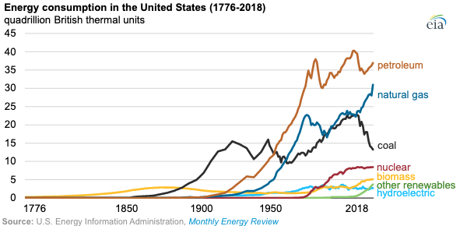
Figure 1.1 History of energy consumption as a function of the energy sources used such as petroleum, natural gas, coal, nuclear, biomass, renewables, and hydroelectric.

Renewable Energy Sources
In this example the text will stop halfway into this page. The text will describe a figure and reference this figure. After the text has described the figure enough, I will then include a figure in following page. In this example the text will continue halfway into the next page. Here I will include the Figure 1.2 now. No additional text will be included below the figure as stated in chapter 3 of the original thesis template.

Heading 3
This just shows how the text would continue in the next page after the figure. It also shows how links would appear when applicable. http://gradschool.utk.edu/ddategraduation.shtml). This is the end of the chapter so there is some blank space left over.

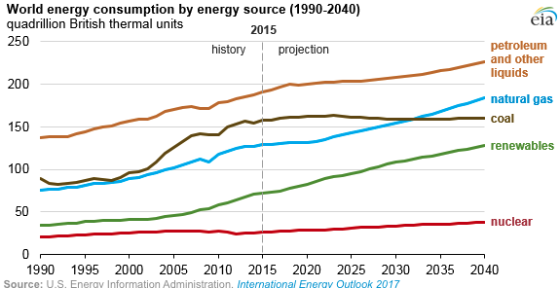
Figure 1.2 This is the caption for the figure above. This figure is able to be added after the text.

Figure 1.1 History of energy consumption as a function of the energy sources used such as petroleum, natural gas, coal, nuclear, biomass, renewables, and hydroelectric.Figure 1.2 This is the caption for the figure above. This figure is able to be added after the text.

Fusion Energy
In this chapter I give examples of tables. I first include some text, and some sections under different sub-headers. It is important to note that not every chapter will have text in this area. Most chapters will only include text starting under sub-header 2.

Fusion in a TOKAMAK
I understand that just like the figures, the tables should not be sandwiched between text. The pages should be full of text unless it is the end of a chapter. The table has to be included in the next blank page after the table has been mentioned.

Plasma Material Degradation
More text to increase the length of this chapter. This chapter 2 will consist of one page only for this template. In my final thesis it will be a complete chapter. For now, I want to show the table Table 2.1 appears in the following page even though it is mentioned here.

Tritium in Fusion
Here I include more text just to complete the chapter so the next page shows a blank area after the end of the chapter and then the table shows on the next page. Here I include more text just to complete the chapter so the next page shows a blank area after the end of the chapter and then the table shows on the next page.

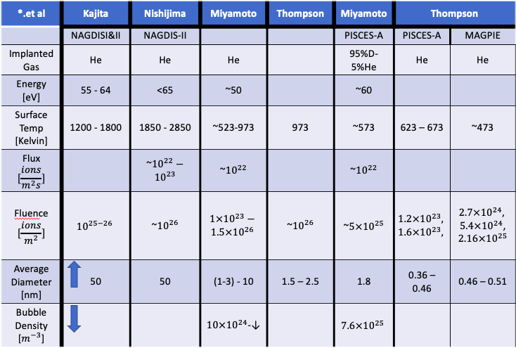
Table 2.1 Table showing values for bubble size, fluence, surface temperature, and flux.

Here I include more text just to complete the chapter so the next page shows a blank area after the end of the chapter and then the table shows on the previous page. Here I include more text just to complete the chapter so the previous page shows a blank area after the end of the chapter and then the table shows on the next page.

Fuel – Tritium Retention
Tables and figures may also be placed in an appendix at the end of the thesis/dissertation but I prefer to include them within the text near the point where
they are mentioned. The chapter ends here.

Permeability Measurements of Hydrogen Isotope

Gas Permeability in Metals
In this chapter I did not include text between the main header and the first sub-header. As stated above there won’t always be text in that region. However, there will always be text under the first sub-header.

Arrhenius Dependence
Here I want to show how equations would show up under their respective sections. This equation expresses the flux at a pressure:
 | $$ϕ=\frac{δ}{\sqrt{p}}J_{∞}$$ | ( 3-1)

Gas Diffusivity in Materials
In this chapter I did not include text between the main header and the first sub-header. As stated above there won’t always be text in that region. However, there will always be text under the first sub-header.

The Time-lag Method
Here I want to show how equations would show up under their respective sections. This equation expresses the relationship between the permeability values and the inverse temperature:
 | $\ln\left(ϕ\right)=\ln\left(ϕ_{o}\right)-\frac{E_{o}}{R}*\frac{1}{T}$ | ( 3-2)

List of References

1. DOE/EIA. International Energy Outlook 2019 with projections to 2050. Office of Energy Analysis September 2019; Available from: https://www.eia.gov/todayinenergy/detail.php?id=12251.
2. Energy, D.E.T.i. EIA projects nearly 50% increase in world energy isage by 2050, led by growth in Asia. Sptember 24 2019; Available from: https://www.eia.gov/todayinenergy/detail.php?id=41433.
3. M. Shimada, C.N.T., R. J. Pawelko, and B.J.M. L. C. Cadwallader, Tritium Plasma Experiment Upgrade and Improvement of Surface Diagnostic Capabilities at STAR Facility for Enhancing Tritium and Nuclear PMI Sciences. 11th International Conference on Tritium Science & Technology (2016), April 2016.

Appendix

My appendix material will include the scripts used to do my data analysis.

Vita
I will include life information in this section

