Synthesis of a novel COX-2 inhibitor analog for PET scan imaging

A Thesis Submitted to the Faculty

Of the University of Tennessee

By

Rebecca Neighbor

April 2016
Department of Chemistry, University of Tennessee, Knoxville, TN
Honors Thesis, University of Tennessee Knoxville, Chancellor’s Honors Program

Thesis Defense Committee:

Dr. George Kabalka, Advisor

Dr. Brian Long

Dr. Tessa Calhoun
Table of Contents

List of Tables and Figures 3
Abbreviation List 4
Abstract 5
Chapter 1: Introduction 6
Chapter 2: Experimental Procedure 10
2.1 Synthesis Overview 10
2.2 Synthesis of 1-(2-Bromocyclopent-1-enyl)-4-methoxybenzene (3) 11
2.3 Synthesis of 1-Methoxy-4-(2-(4-(methansulfonyl)phenyl)cyclopent-1-enyl)-benzene (5) 12
2.4 Synthesis of 4-(2-(4-Methanesulfonyl-phenyl)-cyclopent-1-enyl)-phenol (6) 13
2.5 Synthesis of 2-(4-(2-(4-(Methylsulfonyl)phenyl)cyclopent-1-enyl)phenoxy)ethyl methanesulfonate (7) 14
2.6 Synthesis of 1-(2-(Fluoro-¹⁸F)ethoxy)-4-(2-(4-(methylsulfonyl)phenyl)cyclopent-1-enyl)benzene (8) 15
Chapter 3: Discussion and Conclusions 16
References 19
Appendices 22
Appendix I: NMR Spectra 22
Appendix II: Radio TLC 27

List of Tables and Figures

Figure 1. Examples of the structures of selective COX-2 inhibitors.

Figure 2. Overall reaction scheme for synthesis of precursor for radiolabeling, compound 7.

Figure 3. Reaction scheme for first Suzuki coupling reaction.

Figure 4. Reaction scheme for second Suzuki coupling reaction.

Figure 5. Reaction scheme for synthesis of phenol intermediate.
Figure 6. Reaction scheme for addition of bromoethyl methanesulfonate to the phenol intermediate.

Figure 7. Reaction scheme for the addition of ¹⁸F to the mesylated precursor.

Spectrum 1. Proton NMR of 1-(2-Bromocyclopent-1-enyl)-4-methoxybenzene, compound 3.

Spectrum 2. Proton NMR of 1-Methoxy-4-(2-(4-(methansulfonyl)phenyl)cyclopent-1-enyl)-benzene, compound 5.

Spectrum 3. Proton NMR of 4-(2-(4-Methanesulfonyl-phenyl)-cyclopent-1-enyl)-phenol, compound 6.

Spectrum 4. Proton NMR of 2-(4-(2-(4-(Methylsulfonyl)phenyl)cyclopent-1-enyl)phenoxy)ethyl methanesulfonate, compound 7.

Spectrum 5. Proton NMR of the unlabeled standard of compound 8.

Spectrum 6. Radio TLC of 1-(2-(Fluoro-¹⁸F)ethoxy)-4-(2-(4-(methylsulfonyl)phenyl)cyclopent-1-enyl)benzene, compound 8.

Abbreviation List

COX: Cyclooxygenase

PET: Positron emission tomography

NSAID: Nonsteroidal anti-inflammatory drug

PGE2: Prostaglandin E2

¹⁸F: Radioactive fluorine-18

NMR: Nuclear magnetic resonance

TLC: Thin layer chromatography

DMF: N,N-Dimethylformamide

K2.2.2: Kryptofix-2.2.2

RCY: Radiochemical yield

d.c.: Decay corrected

Synthesis of a Novel COX-2 inhibitor Analog for PET Scan Imaging

Abstract

Tumor imaging is a rapidly growing and important area of medical research. COX-2 is an enzyme found in large quantities in tumors, and its inhibitors are of special interest as carrier molecules of radiolabeled atoms for PET scans of the body. Fluorine-18 is a commonly used PET isotope because its half-life of 110 minutes provides an adequate amount of time to incorporate it into appropriate PET imaging molecules, but it does not cause as much damage from radiation as other longer lasting isotopes. The present study describes the synthesis and radiofluorination of a novel COX-2 inhibitor analog, 2-(4-(2-(4-(methylsulfonyl)phenyl)cyclopent-1-enyl)phenoxy)ethyl methanesulfonate, for use in PET scans as a potential imaging agent. The synthesis was accomplished first through the creation of a diaryl heterocycle via two Suzuki coupling reactions and then through the addition of a mesylate leaving group, which was exchanged with ¹⁸F to give the desired compound. This reaction scheme resulted in an overall radiochemical yield, non decay corrected, of 11%.

Chapter 1: Introduction

The inflammatory process is a crucial part of how the body deals with infection and irregularities in homeostasis.¹ Cyclooxygenase (COX), also known as prostaglandin G/H synthase, is an enzyme which is recruited to the site of inflammation during such a process and acts by catalyzing the reaction of arachidonic acid to prostanoids such as prostaglandins and thromboxanes.² These prostanoids are responsible for downstream effects of many physiologic responses. COX exists in multiple forms, the most common being the constitutive and induced forms, termed COX-1 and COX-2 respectively. COX-2 is located primarily in the brain and kidney and is transiently expressed in response to stimuli such as cytokines, growth factors, and hormones. COX-2 has also been shown to be overexpressed in many types of cancer.³ COX-1, however, is normally expressed in most resting tissues and serves a protective function in maintaining the integrity and homeostasis of the gastric and renal systems.⁴
Some of the most common drugs which work to reduce pain and the inflammatory response are the nonsteroidal anti-inflammatory drugs (NSAIDs) such as ibuprofen and naproxen, which compete for the active site of COX enzymes and effectively block their function. However, while the functions of the two forms of COX are different, their structure and action are very similar. NSAIDs not only block the inflammatory response of COX-2 but also disrupt the constitutive expression of COX-1.⁵ Long term COX-1 inhibition and use of NSAIDs has been found to cause serious health defects especially relating to the gastric tract (stomach ulcers, etc.), as the protective abilities of COX-1 are suspended.⁶ Therefore, the need for drugs which reduce or eliminate these harmful side effects spurred the search for COX-2 selective inhibitors. The first to be discovered was DuP-697, an anti-inflammatory agent which did not produce negative gastric side effects.⁷ It was discovered that, though COX-1 and COX-2 have very similar structures, the active site of COX-2 has an extra “pocket” and is slightly larger. The diaryl heterocyclic structure of DuP-697 was found to fit very well in both the main active site and the extra “pocket” while having poor affinity for the COX-1 active site.⁸ The binding kinetics and selectivity of COX-2 over COX-1 enzymes can be controlled by modifying certain points in this base structure. It was found that at least one of the phenyl substituents of the compound should have a sulfonyl or sulfonamide group in the para position for greatest COX-2 selectivity and other sites could be changed as well, including the components of the heterocycle itself.⁹ Many such preferential drugs have since been developed using the diaryl heterocyclic structure as a base, including Celecoxib, Rofecoxib and Valdecoxib, Figure 1. It should be noted that the structure of these molecules is of great importance since unexpected physiological responses may occur as observer for Rofecoxib. This drug was taken off the market after studies showed increased adverse cardiovascular events in patients with coronary artery disease. This is due to the ability of Rofecoxib to act as a weak base, and easily oxidized.¹⁰
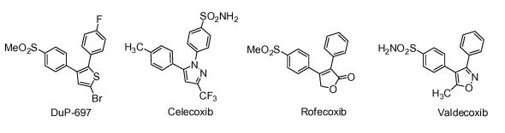
Figure 1. Examples of the structures of selective COX-2 inhibitors.

As previously noted, overexpression of COX-2 is involved in cancer. The inflammatory process is triggered when a cell begins to divide out of control, recruiting a variety of molecules to the site. COX-2 in particular has been implicated in multiple steps of cancer progression including its initiation, proliferation, and metastasis. Mechanisms that have been proposed for its involvement deal with increased production of PGE2 by the overexpressed COX-2. It has been shown to be a factor in the effective blockage of programmed cell death and anticancer treatments, and through the creation of reactive oxygen species which cause DNA damage and mutations. Increased PGE2 is most often associated with colon, breast, and lung cancers and has recently been found to be associated with some lymphomas as well.¹¹⁻¹³ Radiolabeled COX-2 inhibitors, therefore, are considered to be very effective candidates for visualization of tumors and cancer metastases.
Positron emission tomography (PET) is a broadly used method of imaging biological and molecular processes. In particular, it is useful in research and nuclear medicine.¹⁴ PET functions through the use of a radiolabeled molecule such as biologically active small molecules, peptides, ligands, or enzyme inhibitors which localize at a site of interest. The radioactive atom attached to the biologically active molecule emits positrons which decay into to photons travelling in opposite (nearly 180⁰) directions that can be traced back to the point of origin to form an image.¹⁵ Fluorine-18 is a popular radiotracer because of its half-life of 110 minutes, keeping the radioactive material from lingering too long in the body, and because it can be easily attached to molecules found normally in the body. Other radioactive elements such as ¹²⁴I have also been studied but are less efficient, have longer half-lives, and produce higher energy gamma rays which expose patients to higher levels of radiation and decrease the quality of the image.¹⁶
The need for a variety of biological molecules which can be easily radiolabeled for PET imaging has caused a surge in research in this area of nuclear medicine. COX-2 inhibitor analogs in particular have been of interest because of their presence in tumors. Many of those previously synthesized had low success rates due to the properties of the molecule chosen or because they required a large amount of time to incorporate the ¹⁸F into the molecule, reducing their effectiveness. This has led to the study of the factors which will increase the success of this reaction. It has been found that aliphatic nucleophilic substitutions of ¹⁸F into target molecules are particularly useful, efficient, and easy to prepare if a good leaving group such as a halogen or sulfonate is present in the molecule.¹⁶ Sulfonic acid esters (such as tosylate or mesylate functionalities) have high reactivity and can be easily synthesized without threatening the structural integrity of the molecule. In addition to modifying and optimizing the site of reaction, the base molecule can be modified to make the reaction easier. In particular, 1,2-diarylcyclopentenes and their derivatives have shown to be effective structural motifs in COX-2 inhibitors by having increased selectivity over COX-1 inhibitors.¹⁸
The present study aims to improve upon the radiolabeling procedure presented by Laube, et al.¹⁹ in which a ditosylate is first radiolabeled with ¹⁸F and then attached to 4-(2-(4-methanesulfonyl-phenyl)-cyclopent-1-enyl)-phenol (compound 6). This method, though successful, is lengthy, and limits the time available from when the radiotracer is incorporated into the molecule to the time of use. By synthesizing the radiolabeled precursor in its entirety before incorporating the ¹⁸F, it is hypothesized that a higher radiochemical yield can be obtained.

Chapter 2: Experimental Procedure

2.1 Synthesis Overview
The synthesis of the precursor molecule 7 for radiolabeling is shown in the reaction scheme presented in Figure 2 below. It was carried out in four steps, involving the creation of a 1,2-diarylcyclopentene through two Suzuki cross-coupling reactions, the conversion of the methoxy group to a hydroxyl moiety, and finally the addition of the bromoethyl methanesulfonate. The general procedure used was based on a modification of that given by Wuest, et al.²⁰ All non-radioactive compounds were purified by flash chromatography as outlined by Still, et al²¹ and analyzed by ¹H-NMR spectroscopy. Precursor 7 was then labeled with ¹⁸F. The radiolabeled compound 8 was analyzed by radio-TLC (see appendix for spectra).
Figure 2. Overall reaction scheme for synthesis of precursor for radiolabeling, compound 7.

2.2 Synthesis of 1-(2-Bromocyclopent-1-enyl)-4-methoxybenzene (3)

The starting materials, 1,2-dibromocyclopentene, 1, (1.0 g, 4.4 mmol) and 4-methoxyphenyl boronic acid 2 (336 mg, 2.20 mmol) were added to a roundbottomed flask. Toluene, ethanol, and 2M sodium carbonate were then added in a 1:1:1 ratio using 30 mL of each reagent. The roundbottomed flask was then capped and vacuum was applied for 15 minutes to remove any dissolved oxygen. The Pd(PPh₃)₄ catalyst (127 mg, 0.110 mmol) was then carefully added with the resulting solution placed under argon atmosphere and refluxed for 2 hours at 90 ⁰C with stirring. The reaction progress was monitored by thin layer chromatography (TLC, 50% ethyl acetate/hexanes) every 30 minutes until completion. After the reaction was complete, 250 mL of water was added and the product solution was extracted with ethyl acetate. The ethyl acetate extract was then dried over anhydrous sodium sulfate and a rotary evaporator was used to remove the solvent. The residue was then purified by flash chromatography (50% ethyl acetate/hexanes), checking for the presence of the desired compound 3 in each fraction by TLC. The fractions containing 3 were then placed on the rotary evaporator to give 330 mg of a yellow oil. The reaction yield was 59% based on compound 2.

Figure 3. Reaction scheme for first Suzuki coupling reaction.

2.3 Synthesis of 1-Methoxy-4-(2-(4-(methansulfonyl)phenyl)cyclopent-1-enyl)-benzene (5)

The starting materials 1-(2-bromocyclopent-1-enyl)-4-methoxybenzene, 3, (300 mg, 1.18 mmol) and 4-(methylsulfonyl)phenylboronic acid 4 (236.8 mg, 1.18 mmol) were added to a roundbottomed flask. Toluene, ethanol, and 2M aqueous sodium carbonate were then added in a 1:1:1 ratio of 16 mL each. The roundbottomed flask was then capped and placed under vacuum for 15 minutes to remove any dissolved oxygen. The Pd(PPh₃)₄ catalyst (70 mg, 0.06 mmol) was then carefully added with the resulting solution placed under argon atmosphere and refluxed for 1 hour at 90 ⁰C with stirring. The reaction progress was monitored by TLC (50% ethyl acetate/hexanes) every 30 minutes until completion. After the reaction was complete, 100 mL of water was added and the product solution was extracted with ethyl acetate. The ethyl acetate extract was then dried over anhydrous sodium sulfate and a rotary evaporator was used to remove the solvent. The residue was then purified by flash chromatography (50% ethyl acetate/hexanes), checking for the presence of the desired compound 5 in each fraction by TLC. The fractions containing 5 were then placed on the rotary evaporator to give 112 mg of a white/yellow solid with a melting point of 128-130 ⁰C. The reaction yield was 29%.
Figure 4. Reaction scheme for second Suzuki coupling reaction.

2.4 Synthesis of 4-(2-(4-Methanesulfonyl-phenyl)-cyclopent-1-enyl)-phenol (6)
1-Methoxy-4-(2-(4-(methansulfonyl)phenyl)cyclopent-1-enyl)-benzene, 5, (112 mg, 0.34 mmol) was dissolved in 1.3 mL of dichloromethane in a stirring roundbottomed flask. The mixture was cooled to -78 ⁰C in a dry ice/acetone bath and 1M boron tribromide in dichloromethane (0.39 mL, 0.39 mmol) was added, turning the solution brown. The solution was then warmed to room temperature and allowed to stir for one hour, monitoring the reaction progress by TLC (30% ethyl acetate/hexanes). The solution was again cooled to -78 ⁰C using a dry ice/acetone bath and 0.65 mL of methanol was added, turning the solution a dark green, before warming the mixture to 0 ⁰C in an ice water bath for an additional hour. The solvent was then evaporated using a rotary evaporator and the compound was purified by flash chromatography (30% ethyl acetate/hexanes), checking for the presence of the desired compound 6 in each fraction by TLC. The fractions containing 6 were then placed on the rotary evaporator to give 48 mg of a solid with a melting point of 154-156 ⁰C. The reaction yield was 45%.
Figure 5. Reaction scheme for synthesis of phenol intermediate.

2.5 Synthesis of 2-(4-(2-(4-(Methylsulfonyl)phenyl)cyclopent-1-enyl)phenoxy)ethyl methanesulfonate (7)
4-(2-(4-Methanesulfonyl-phenyl)-cyclopent-1-enyl)-phenol, 6, (48 mg, 0.15mmol) was dissolved in a roundbottomed flask in 5 mL of acetone. Cesium carbonate (73.3 mg, 0.225 mmol) and 2-bromoethyl methanesulfonate (45 mg, 0.23 mmol) were then added and the resulting solution was placed under argon atmosphere and refluxed and stirred at 50 ⁰C in an oil bath for 3 hours. The reaction progress was monitored by TLC (20% ethyl acetate/hexanes) every 30 minutes until completion. The resulting product was then put on a rotary evaporator to remove the solvent. The residue was then purified by flash chromatography (20% ethyl acetate/hexanes), checking for the presence of the final compound 7 in each fraction by TLC. The fractions containing 7 were then placed on the rotary evaporator to give 17 mg of a liquid. The reaction yield was 26%.
Figure 6. Reaction scheme for addition of bromoethyl methanesulfonate to the phenol intermediate.

2.6 Synthesis of 1-(2-(Fluoro-¹⁸F)ethoxy)-4-(2-(4-(methylsulfonyl)phenyl)cyclopent-1-enyl)benzene (8)
The final step in this reaction scheme involves the radiolabeling of precursor 7 with fluorine-18. 2-(4-(2-(4-(Methylsulfonyl)phenyl)cyclopent-1-enyl)phenoxy)ethyl methanesulfonate 7 (4.0 mg, 9.2 µmol) was dissolved in t-amyl alcohol (0.75 mL), acetonitrile (0.083 mL) and DMF (0.17 mL) before adding a Kryptofix-2.2.2, potassium carbonate, and [¹⁸F]fluoride to the mixture. The radiofluorination was carried out at 100⁰C for 20 minutes. Unreacted fluoride was then removed by adding 5 mL of water to the reaction and passing it through an alumina N Sep-Pak cartridge. A radio-TLC of the product was carried out in 60% ethylacetate/40% hexanes and determined an overall non-decay corrected radiochemical yield of 11% (12.5% decay corrected).

Figure 7. Reaction scheme for the addition of ¹⁸F to the mesylated precursor.

Chapter 3: Discussion and Conclusions

The synthesis of compound 8 was successfully completed using the method described above. However, a few revisions from the originally planned experimental procedure were necessary for the complete synthesis of 8.
The Suzuki coupling reaction steps for synthesis of 3 and 5 were originally planned to utilize refluxing conditions for 24 hours as described by Wuest, et al. However, TLC analysis during the first two hours of each reaction showed that the reactants were consumed and a product was formed. The reaction was allowed to run for the full 24 hours, but all of the desired product was completely dehalogenated upon spectral analysis, indicating too long of a reaction time. The reaction was run again and monitored very carefully by TLC, and was stopped after 2 hours when all reactant was converted to product. This unexpected phenomenon was likely due to the removal of dissolved oxygen before adding the catalyst during this experiment, a step which was not outlined in the paper by Wuest, et al. The tetrakis(triphenylphosphine)palladium(0) catalyst is highly sensitive to oxygen and light and is not optimally active when these factors are present.²² This is believed to be the reason for the better action of the catalyst and therefore the faster reaction time during the present experiment.
Another complication encountered during the experiment was in the synthesis of 7. As the purpose of this experiment was to improve upon the radiolabeling method presented by Laube, et al., the same leaving group, ethylen-1,2-ditosylate, was originally used during the synthesis of 7. However, upon spectral analysis, there was no evidence of the correct product 7 and excess ditosylate was found to be present. This led to the conclusion that 6 reacted twice with the ditosylate, displacing both tosylate groups and creating an undesired product. This possibility was considered during the experimental design and to be avoided by using 2.5 equivalents of the ditosylate as compared to 6, but this did not appear to have stopped the undesired reaction from occurring. Consequently, 2-bromoethyl methanesulfonate was used in place of the ethylen-1,2-ditosylate. This compound functions in the same manner as the ditosylate but since only one end of the molecule has the more reactive sulfonic acid ester for radiofluorination, the aforementioned problem was not encountered. The mesylate group has actually been found to be a more reactive leaving group than the tosylate group in ¹⁸F-fluorinations and therefore was chosen as a useful substitute for the present experiment.¹⁶
The radiochemical yield (RCY) of 8 was 11% non-decay corrected. Previous attempts at creating 8 via a different method as presented by Laube, et al resulted in a decay-corrected RCY of 7.8%, which translates to 4.7% non-decay corrected RCY after 80 minutes as described.¹⁹ This demonstrates that the new method more than doubled the non-decay RCY and is thus provides a more efficient means of producing this compound. In general, the yields of the non-radioactive reaction steps were lower than expected, especially when compared to those reported by Wuest. This is likely due human error during steps such as extraction and purification by flash chromatography. However, in chapter 2.5, the poor yield of 26% is likely due to a mixture of products formed due to the leaving group capacity of both bromine and the mesylate group. It should be noted that the radio-TLC of compound 8 has a small impurity at 20 mm which was identified as a trace of the unreacted fluoride that went through the alumina cartridge.
While many molecules for PET scan imaging are already available, there is a growing demand for easier and more efficient processes by which to incorporate the precursors into radio-labeled compounds. By synthesizing compound 6 in its entirety before fluorinating it with ¹⁸F, the RCY was greatly increased from the previous method of synthesis as described by Laube, et al and others in the literature. The improvement allows for a larger window of time from the end of synthesis to potential use as a PET scan imaging agent. The present study cannot predict how effective compound 8 will be in vivo. It is hoped that future studies with this COX-2 inhibitor analog will determine its efficacy in preclinical trials on small animals such as rats to see how well the compound mimics COX-2 inhibitor activity. While there are several steps involved in its synthesis, the ease of the process combined with the advantages noted above provide a promising method for producing another COX-2 inhibitor analog for PET scan imaging.

References
¹Kotas, M. E.; Medzhitov, R. Homeostasis, inflammation, and disease susceptibility. Cell 2015, 160(5): 816-827.
²Ricciotti, E.; FitzGerald, G. A. Prostaglandins and inflammation. Arteriosclerosis, thrombosis, and vascular biology 2011, 31(5): 986-1000.
³Dubois, R. N.; Abramson, S. B.; Crofford, L.; Gupta, R. A.; Simon, L. S.; Van De Putte, L. B.; Lipsky, P. E. Cyclooxygenase in biology and disease. FASEB Journal 1998, 12: 1063–1073.
⁴Smith WL, DeWitt DL, Garavito RM. Cyclooxygenases: Structural, cellular, and molecular biology. Annual Review of Biochemistry 2000, 69: 145–182.
⁵Herschman, H. R.; Talley, J. J.; DuBois, R. Cyclooxygenase 2 (COX-2) as a target for therapy and noninvasive imaging. Molecular Imaging and Biology 2003, 5(5): 286-303.
⁶Ong, C. K. S.; Lirk, P.; Tan, C. H.; Seymour, R. A. An evidence-based update on nonsteroidal anti-inflammatory drugs. Clinical Medicine and Research 2007, 5(1): 19–34.
⁷Gans, K. R.; Galbraith, W.; Roman, R. J.; et al. Anti-inflammatory and safety profile of DuP 697, a novel orally effective prostaglandin synthesis inhibitor. Journal of Pharmacology and Experimental Therapeutics 1990, 254: 180-187.
⁸Copeland, R. A.; Williams, J. M.; Giannaras, J; et al. Mechanism of selective inhibition of the inducible isoform of prostaglandin G/H synthase. Proceedings of the National Academy of Sciences, USA 1994, 91: 11202-11206.
⁹Penning, T. D.; Talley, J. J.; Bertenshaw, S. R.; et al. Synthesis and biological evaluation of the 1,5-diarylpyrazole class of cyclooxygenase-2 inhibitors: Identification of 4-[5-(4-methylphenyl)-3-(trifluoromethyl)-1H-pyrazol-1yl]benzenesulfonamide (SC-58635, Celecoxib). Journal of Medicinal Chemistry 1997, 40: 1347-1365.
¹⁰Reddy, L. R.; Corey, E. J. Facile air oxidation of the conjugate base of rofecoxib, a possible contributor to chronic human toxicity. Tetrahedron Letters 2005, 46(6): 927-929.
¹¹Sobolewski,C.; Cerella, C.; Dicato, M.; et al. The role of cyclooxygenase-2 in cell proliferation and cell death in human malignancies. International Journal of Cell Biology 2010. http://dx.doi.org/10.1155/2010/215158.
¹²Marnett, L. J.; Kalgutkar A. S. Cyclooxygenase 2 inhibitors: discovery, selectivity and the future. Trends in Pharmacological Sciences 1999, 20(11): 465-469.
¹³Chan, M. W.; Wong, C. Y.; Cheng, A. S.; et al. Targeted inhibition of COX-2 expression by RNA interference suppresses tumor growth and potentiates chemosensitivity to cisplatin in human gastric cancer cells. Oncology Reports 2007, 8(6): 1557–1562.
¹⁴Rennen, H. J.; Corstens, F. H.; Oyen, W. J.; Boerman O. C.; New concepts in infection/inflammation imaging. The Quarterly Journal of Nuclear Medicine and Molecular Imaging 2001, 45: 167-173.
¹⁵Kim, D. W.; Jeong, H. J.; Lim, S. T.; Sohn, M. H. Recent Trends in the Nucleophilic [¹⁸F]-radiolabeling Method with No-carrier-added [¹⁸F]fluoride. Nuclear Medicine and Molecular Imaging 2010, 44(1): 25-32.
¹⁶Wester, H. J. Pharmaceutical Radiochemistry. Volume 1 of Munich Molecular Imaging Handbook Series. Furstenfeldbruck, Germany: Scintomics. 2010.
¹⁷Kim, D. W.; Choe, Y. S.; Chi, D. Y. A new nucleophilic fluorine-18 labeling method for aliphatic mesylates: reaction in ionic liquids shows tolerance for water. Nuclear Medicine and Biology 2003, 30(4): 345-350.
¹⁸Black, C. W.; Brideau, C.; Chan, C. C.; et al. 2,3-Diarylcyclopentenones as orally active, highly selective cyclooxygenase-2 inhibitors. Journal of Medicinal Chemistry 1999, 42: 1274-1281.
¹⁹Laube, M.; Kniess, R.; Steinbach, J.; Pietzsch, J. P-312 automated ¹⁸F-fluoroethylation – a labeling method for new potential COX-2 inhibitors. Journal of Labelled Compounds and Radiopharmaceuticals 2013, 56: 399.
²⁰Wuest, F.; Kneiss, T.; Bergmann, R.; Pietzsch, J. Synthesis and evaluation in vitro and in vivo of a ¹¹C-labeled cyclooxygenase (COX-2) inhibitor. Bioorganic and Medicinal Chemistry 2008, 16: 7662-7670.
²¹Still, W. C.; Kahn, M.; Mitra, A. Rapid chromatographic technique for preparative separations with moderate resolution. Journal of Organic Chemistry 1978, 43(14): 2923-2925.
²²Ioele, M.; Ortaggi, G.; Scarsella, M.; Sleiter, G. A rapid and convenient synthesis of tetrakis(triphenylphosphine)palladium(0) and -platinum(0) complexes by phase-transfer catalysis. Polyhedron 1991, 10(20/21): 2475-2476.

Appendices

Appendix I: NMR Spectra
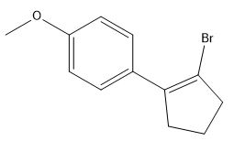
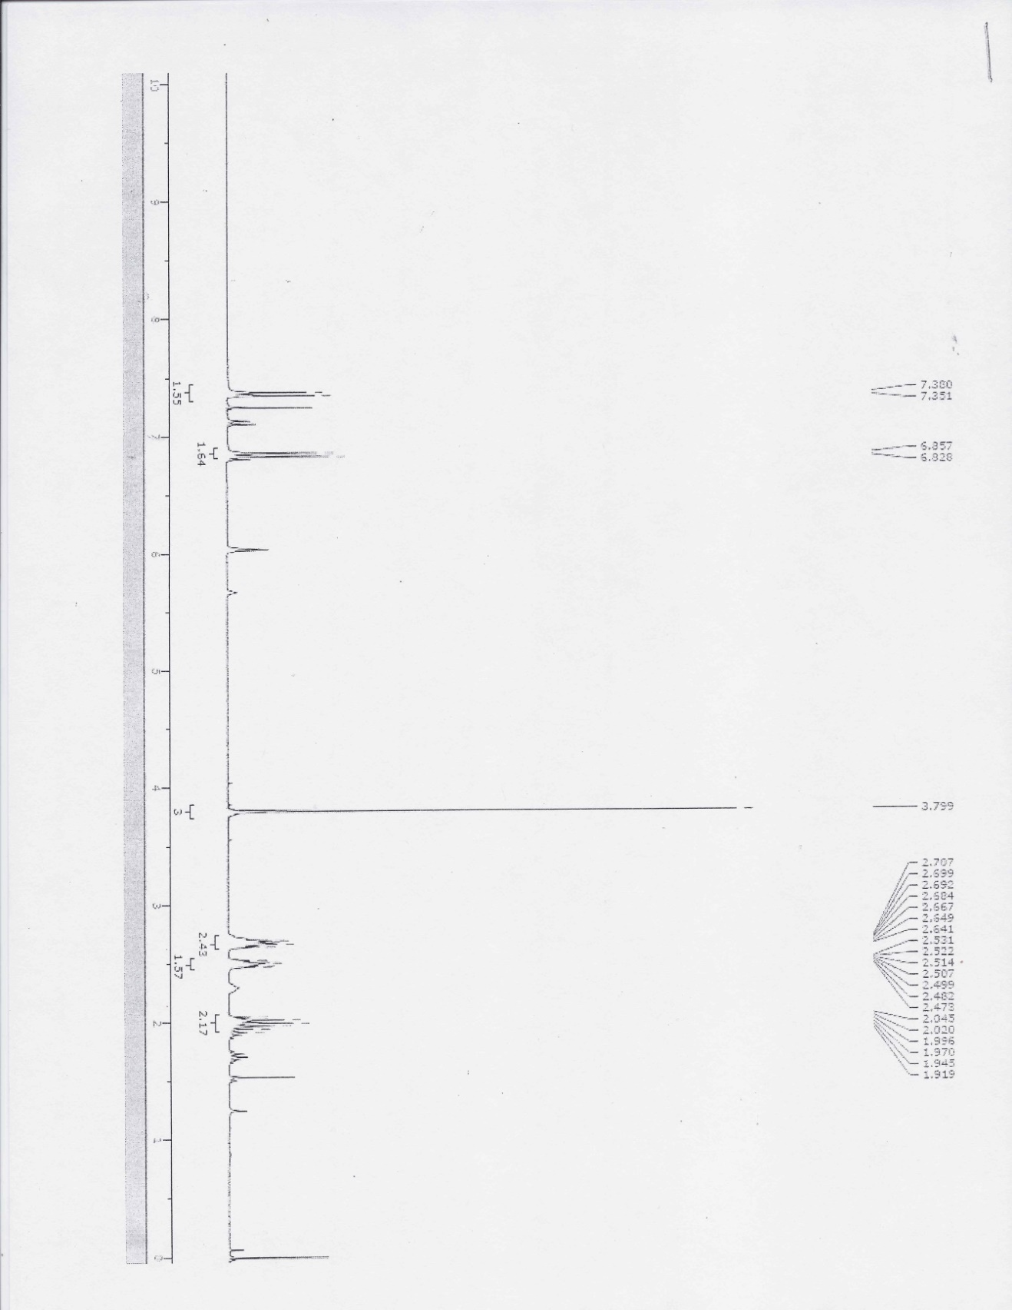
Spectrum 1. Proton NMR of 1-(2-Bromocyclopent-1-enyl)-4-methoxybenzene, compound 3, at 300MHz.

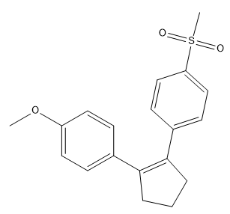
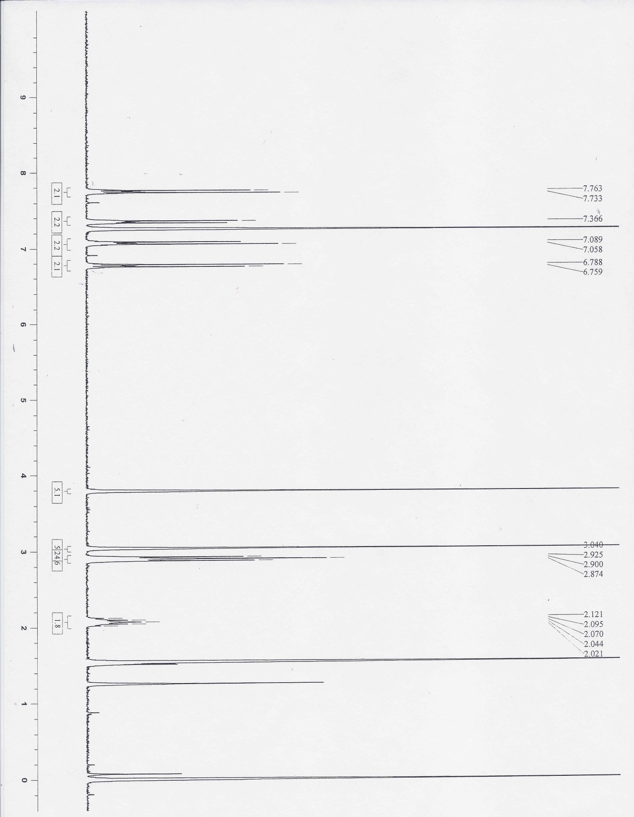
Spectrum 2. Proton NMR of 1-Methoxy-4-(2-(4-(methansulfonyl)phenyl)cyclopent-1-enyl)-benzene, compound 5, at 300 MHz.
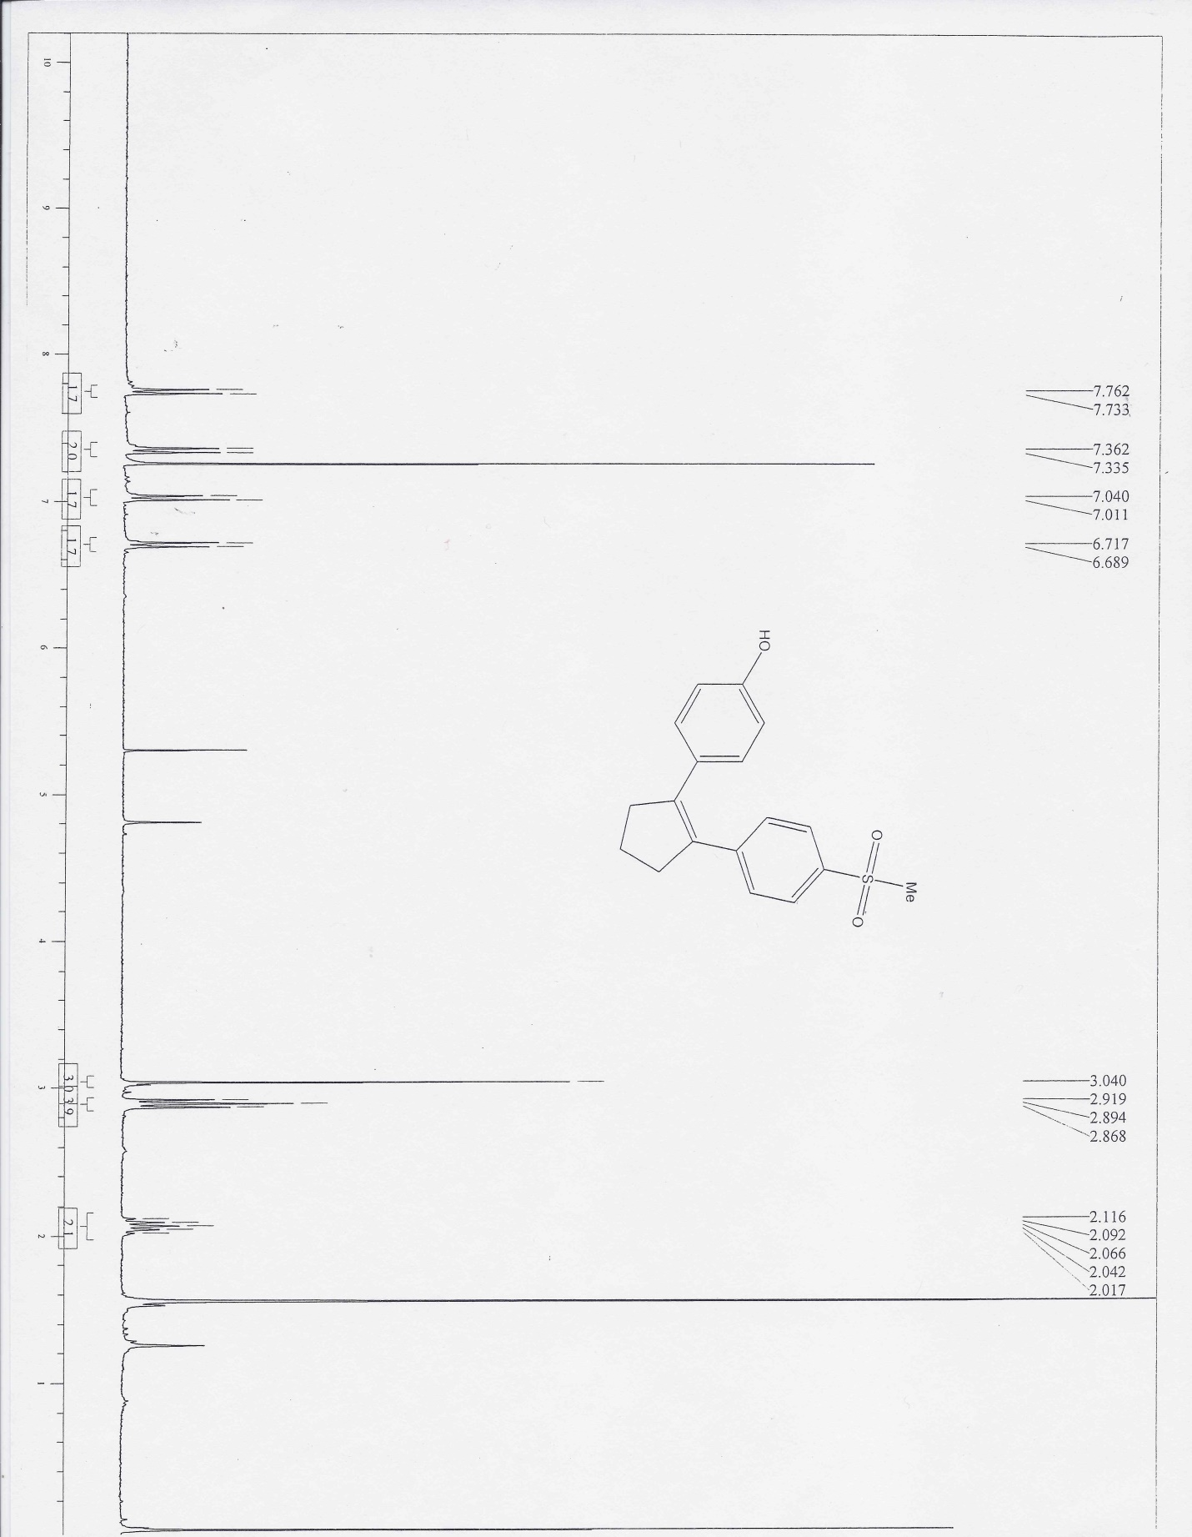
Spectrum 3. Proton NMR of 4-(2-(4-Methanesulfonyl-phenyl)-cyclopent-1-enyl)-phenol, compound 6, at 300 MHz.

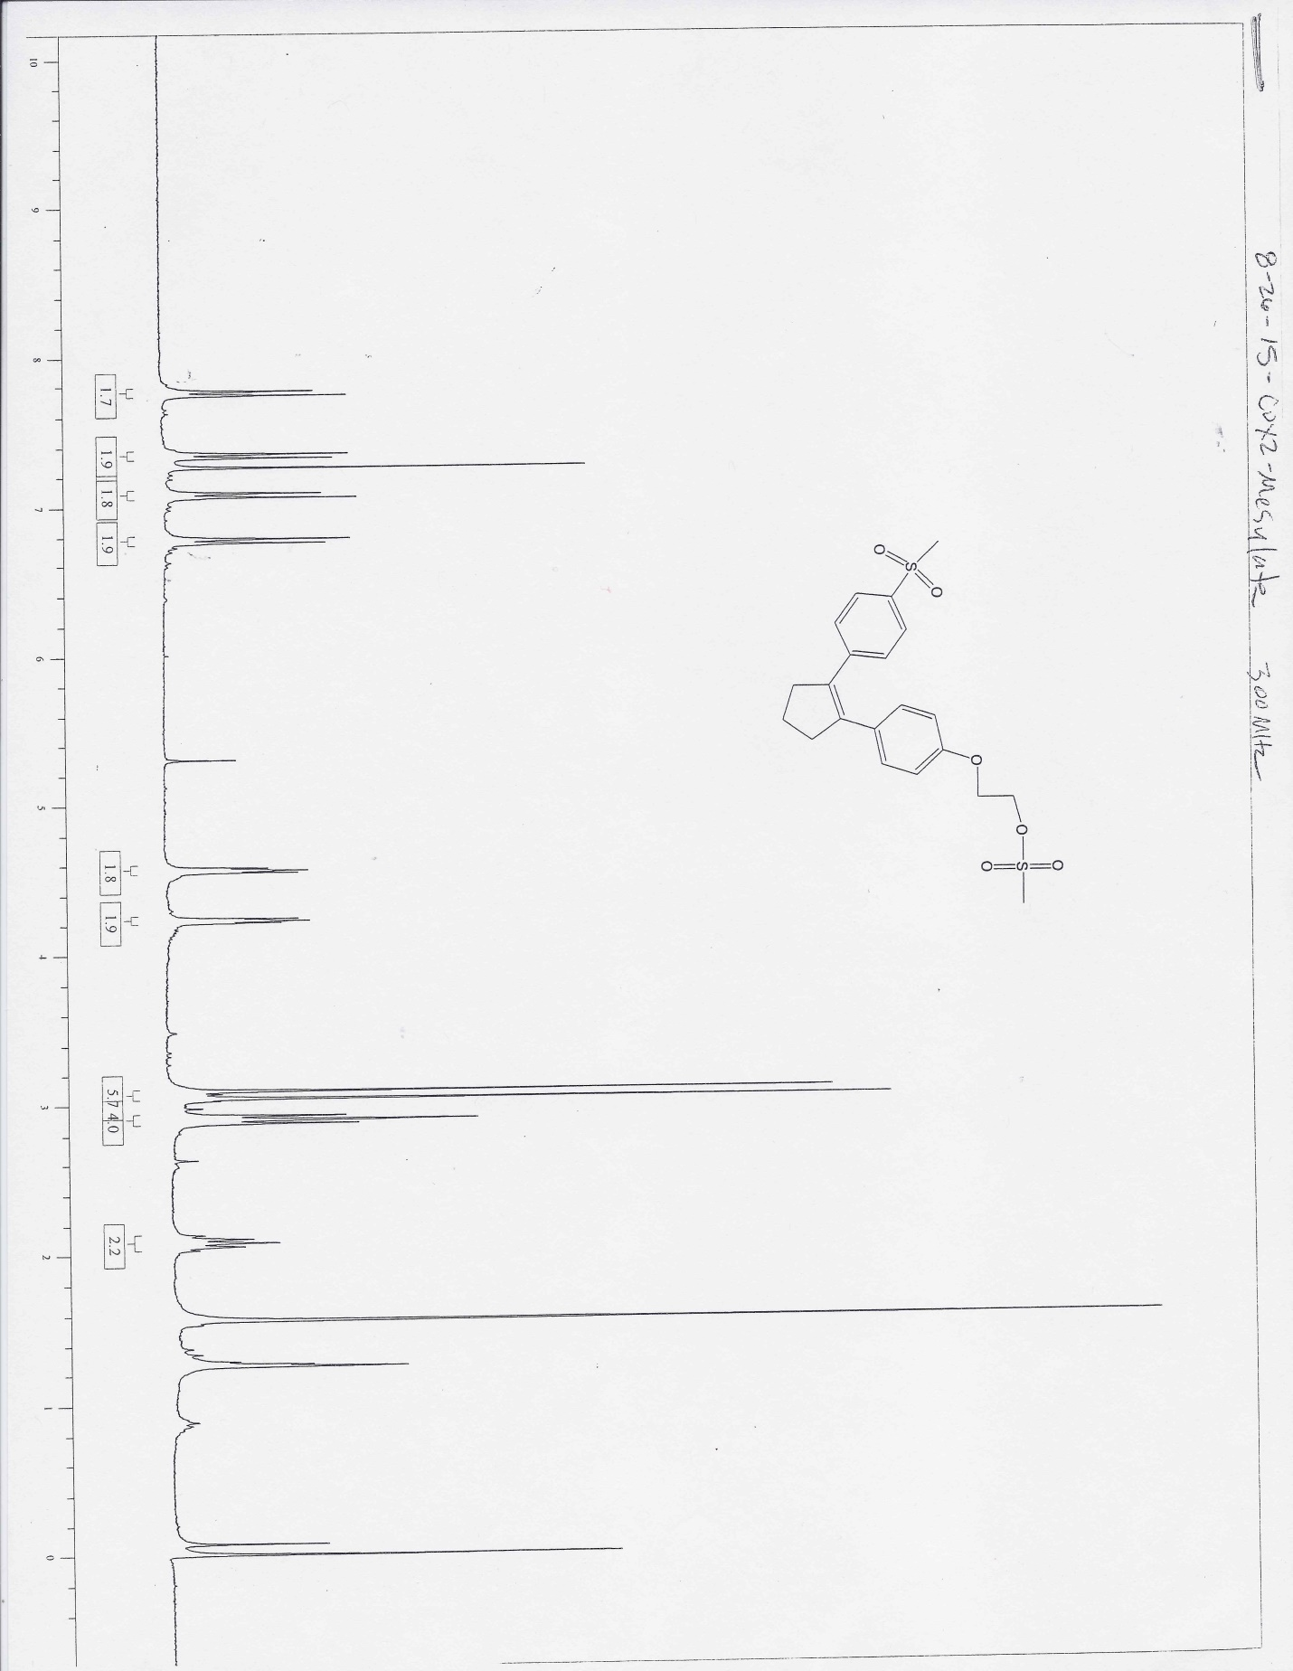
Spectrum 4. Proton NMR of 2-(4-(2-(4-(Methylsulfonyl)phenyl)cyclopent-1-enyl)phenoxy)ethyl methanesulfonate, compound 7, at 300 MHz.

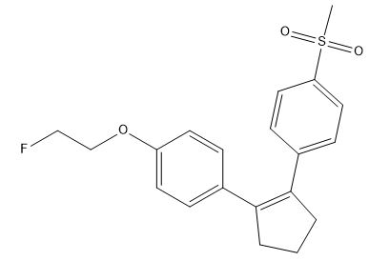
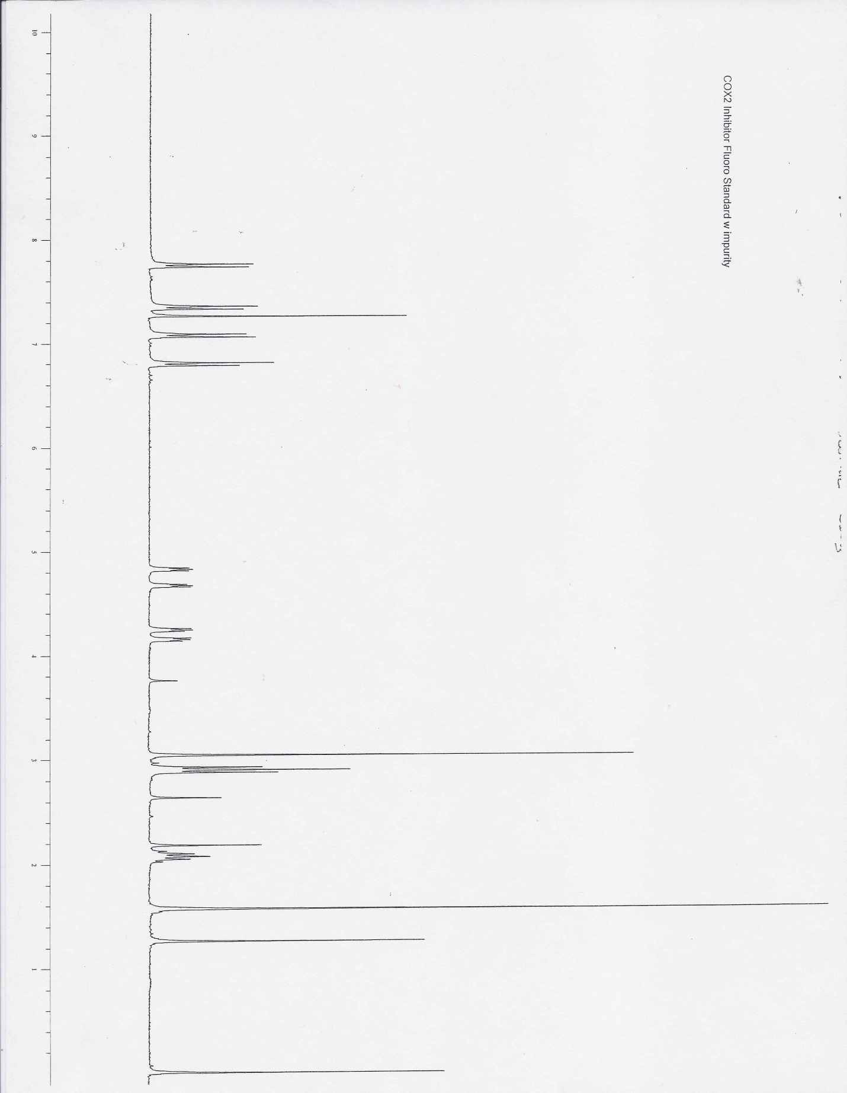
Spectrum 5. Proton NMR of the Non-radioactively Labeled Compound 8, at 300 MHz.

Appendix II: Radio TLC

Spectrum 6. Radio TLC of 1-(2-(Fluoro-¹⁸F)ethoxy)-4-(2-(4-(methylsulfonyl)phenyl)cyclopent-1-enyl)benzene, Compound 8.

