RIGS OF REFUGE:
SPATIAL AGENCY AND
ITS ROLE IN CONFLICT

A Thesis Presented for the
Master of Architecture
Degree
The University of Tennessee, Knoxville

Brittany L. McGraw
August 2017

Copyright © 2017 by Brittany L. McGraw
All rights reserved.

ACKNOWLEDGEMENTS

For my parents, who were surprisingly happy to have a boomerang kid and always made sure my dog was well taken care of during those late night studio sessions.

And for Thomas, who is endlessly supportive and always willing to listen to my rants, academic and otherwise.
ABSTRACT

Amidst settings of conflict, hyper-responsive architectural systems can counteract landscapes of authority by returning spatial agency to users.

As the means of providing such a system, oil rigs should be repurposed as a network of deployable crisis response hubs.
PREFACE

This page is optional.

Table of Contents

Chapter One CIRCUMSTANCE 1
Architecture as a Political Act 1
Current Inequitable Situations 1
Energy Crisis or Opportunity? 4
Crisis Solving Crisis 4
List of References 6
Vita 9

LIST OF FIGURES

Figure 1.1. UN Displacement Map - 2015 2
Figure 1.2. Maslow’s Pyramid of Needs 2

CIRCUMSTANCE

Architecture as a Political Act

We all live within landscapes of authority. The first images that spring to mind under this topic are always the most egregious: Nazi Soldiers goose stepping through a square, Guantanamo Bay, Soviet era monuments. But the reality is most of us live our day to day lives within a much subtler hierarchy of societal, economic, and political influences that are reflected in the spaces we inhabit. We wander through the windowless box stores that let us focus on spending. In the city we stroll past raised planters with diminutive cast sculptures protruding every two feet and benches subdivided so citizens can sit (and only sit, you hear?) and enjoy their surroundings. We work in places where the boss sits at the head or middle of the table. These are the subtle turnings of authority at play.

In truth, there’s no way around this. The spaces we make and the interactions they foster are inherently political. Those who own or craft space may intend them for a set purpose, while the occupiers or users (who normally outnumber those with authority) may wish to use them in another manner entirely. In Anarchitecture, Lebbeus Woods acknowledges this conflict. He states that “dialogue is an essential part of heterarchy, as are other forms of interaction between people and things, such as buildings and spaces for living and work, such as the city itself. By contrast, in the hierarchical city [...] dialogue is always overshadowed by the monologues of authority, which issue from the apex of social and political pyramids of authority in the city and filter down (11).” Shifting monologues may disrupt the identity and lifestyle of a community. If these changes are drastic and unwelcome, at what point is that faction justified in establishing its own framework instead?

In the face of alienation and resentment, how can architecture be used to reintroduce an equitable dialogue between authority and community? This project seeks to explore the role of spatial agency in conflict by examining the dichotomous relationship between landscapes of authority and autonomy.

Current Inequitable Situations

If this project is to explore the role of spatial agency in conflict, it stands to reason that the end users of this project should be a community that regularly operates in landscapes of authority and would benefit from greater ownership in their environment. Some of the groups that best fit these descriptions are Internally Displaced Persons (IDPs) and refugees, whose numbers can be seen on the UNHCR map in Figure 1.1. With so many lives thrust into turmoil, it is disheartening that the best solution we are willing to offer is the ubiquitous blue tent within a delineated area set by the host country. While shelter options are beginning to benefit from new innovation, the methods of organizing and operating a camp have seen no such overhaul. Often times, camps meant to shelter refugees are run from the top down method, giving residents little say in how they are to operate within the framework of their new environment. This may lead to strategies that are out of touch or insufficient for the needs of a particular culture.

If spaces do not reflect the identity of a culture, then its people will never feel that it belongs to them. But that begs the question, if they are not the owners and operators then who is? As Jenny Donovan, head of Inclusive Design, states, “Intervention can warp surviving social structures by seating places that people don’t feel belong to them and create a new and unfamiliar landscape of authority (Donovan, 2).” Without agency, refugees’ perception of the situation shifts from one of autonomous resilience to one of authority. Prior to the Cold War, Refugees had legal precedent to both move freely about their country of asylum and seek employment. As states’ concerns of safety and nationalism began to shift, camps have become mechanisms of segregation designed to keep refugees and IDPs at arm’s length from the rest of the population, casting them in the role of the ubiquitous “Other.”
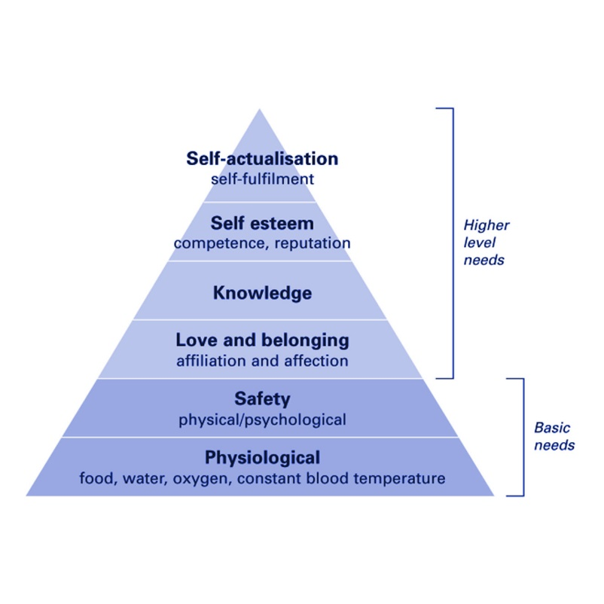
The fact of the matter is, if you have no say in where you live, how you live, or what you earn, then you have lost three major elements of control in life. When people lose this autonomy, they are essentially forced into a state of dependency. Traditionally speaking, when individuals (especially heads of house) feel dependent on others, they lack fulfillment in their role as providers or contributors and self-worth begins to falter. From here, Maslows’ pyramid (Fig. 1.2) begins to crumble, creating a host of internal conflicts that exacerbate an already difficult situation.
Figure 1.2 Maslow’s Pyramid of Needs

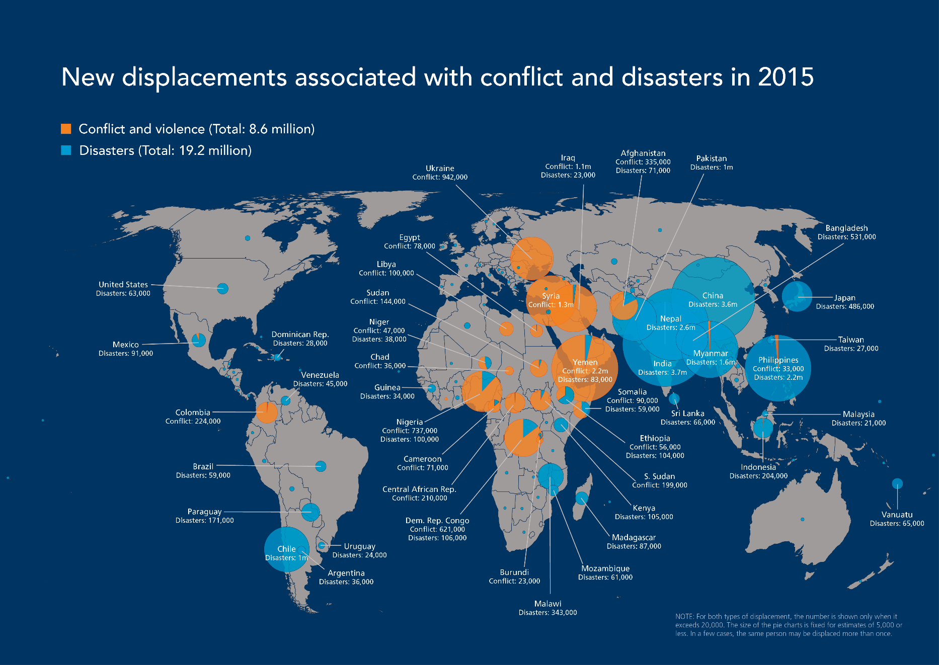
Figure 1.1 UN Displacement Map - 2015

Energy Crisis or Opportunity?

As of December 2016, there were 1412 offshore oil rigs in the world (“Global Offshore”). Many of these rigs are no longer actively extracting oil, but instead sit idle while awaiting new contracts or to be decommissioned entirely. Over the last 5 years, oil production has slowed due to a combination of factors. Many of the reserves located below the relatively shallow waters of the continental shelf have been depleted by earlier exploits, pushing drilling operations into deeper waters and requiring larger, more advanced machinery. As oil prices began to plummet in 2014, the return on investment for the creation and operation of such rigs also decreased, making them cost prohibitive for most oil companies. While a steady stream of decommissioning has already begun in mature oil fields like the Gulf of Mexico, other areas must rapidly transition to dismantling a formerly lucrative industry. According to the Financial Times, British oil producers will spend £30-60 billion by 2050 to remove around 470 platforms, 5,000 wells, 10,000km of pipelines and 40,000 concrete blocks from the North Sea (Kiran).

In many parts of the world companies are legally required to remove rigs, but the high expense of doing so often causes them to delay the process. But what if this cost could be shared through a mutually beneficial partnership? Communities whose lives have been disrupted by conflict and breaches of authority could choose to extricate themselves and form their own micro-societies. In the past, micro nations such as Sealand have done just that on a small scale, operating loosely within the framework of both British and independent citizenry. Instead of leaving rigs in the sea waiting to be scrapped, they should be repurposed by encouraging oil companies to partner with other organizations and communities to introduce a new phase of the rigs lifecycle. There are already successful precedents for such partnerships, including Rigs to Reefs. In this program, oil producers pay the government half of what it would have cost to dismantle a rig, and in return the government uses the money to recycle the platform and transform the sub-sea structure into a reef (“Rigs to Reefs”). The reefs support aquatic life and in turn draw tourist for fishing and scuba diving.

Crisis Solving Crisis

Currently over half of the UN High Commission of refugees top 20 donor are oil producing countries. As the use of offshore rigs becomes less and less viable, countries could initiate programs that share the cost of repurposing oil rigs between the state and private companies therein. Not only would this save oil companies money, it would also provide the state with ownership of a fleet of rigs that could either be lent in-kind as part of an aid package or retained for use in their own country.

This project will base its designs on a jack up rig, which is both the most prevalent type and easiest to relocate. While other types like the floating platform would be able to host significantly more people, there are only dozens of these behemoths as opposed to the hundreds of jackups in existence. The goal of using rigs is to redress the current landscapes of authority and dependency inherent in current camps. This will be achieved through the following measures:

1. Return spatial agency to residents so that they feel ownership rather than alienation.

1-A. Since it is not practical to custom build a solution for every culture, Repurposed rigs should be hyper-adaptive in order to allow for maximum user manipulation in order to best meet their needs and allow for cultural expression.

1-B. Returning autonomy to users is not to prevent state sponsored aid groups and NGOs from crafting spaces for their needs, but rather that their spaces and ideas should engage refuge spaces as a dialogue instead of the authoritative monologue that Lebbeus Woods warned against.

2. Rigs should provide economic opportunity to support financial stability upon repatriation or immigration.

3. Refugees should be allowed to transfer freely between traditional camps and rigs. If they don’t have freedom of movement within their country of asylum, at least there would be a network of mobility that is independent of any individual state.

List of References

After Spring. Dir. Steph Ching and Ellen Martinez. 2016. Film.

Betts, Alexander et al. UNHCR: the Politics and Practice of Refugee Protection
into the 21st Century. Abingdon, Oxon, Routledge, 2012.

Debord, Guy. “Theory of the Dérive.” Les Lèvres Nues, vol. 9, Nov. 1956,
Situationist International Online, www.cddc.vt.edu

Donovan, Jenny. Designing to Heal :Planning and Urban Design Response to
Disaster and Conflict. Collingwood, Australia, Csiro Publishing, 2013.

Easterling, Keller. Enduring Innocence: Global Architecture and Its Political
Masquerades. Cambridge, MA, MIT Press, 2005.

Easterling, Keller. Extrastatecraft: the Power of Infrastructure Space. London,
Verso, 2014.

Frank, Arno. “Forbidden City of Oil Platforms: The Rise and Fall of Stalin’s
Atlantis .” Spiegel Online, Der Spiegel, 14 Nov. 2012,
www.spiegel.de/international

“Global Offshore Oil Rig Activity Data.” Rig Zone, Rig Zone,
www.rigzone.com/oil/data/riglogix/.

Lischer, Sarah Kenyon. Dangerous Sanctuaries: Refugee Camps, Civil War, and
the Dilemmas of Humanitarian Aid. Ithaca, NY, Cornell University Press,
2006.

Number Offshore Rigs Worldwide by Region 2015 | Statistic.” Statista,
www.statista.com

Rawlence, Ben. City of Thorns: Nine Lives in the World’s Largest Refugee Camp.
New York: Picador, 2016.

Refugee Republic. Prod. Bruno Felix and Femke Wolting. Refugee Republic.
Submarine Channel, 2016. Web.

“Rigs-to-Reefs.” Texas Parks &Amp; Wildlife , Texas Parks &Amp; Wildlife
Department, tpwd.texas.gov

Salam Neighbor. Dir. Chris Temple and Zach Ingrasci. Prod. Salam Darwaza and
Mohab Khattab. Living on One, 10 June 2016. Web. 8 Oct. 2016.

Stacey, Kiran, and Alan Livsey. “North Sea Oil: The £30bn Break-Up.” Financial
Times, Financial Times, 8 June 2016, www.ft.com.

Wigley, Mark. Constant’s New Babylon: The Hyper-Architecture of Desire.
Rotterdam: Witte De With, Center for Contemporary Art, 1998.

Woods, Lebbeus. Anarchitecture: Architecture Is a Political Act. London,
Academy Editions, 1992.

Wolfensberger, Marc. “Oil Rocks - City Above the Sea.” Vimeo, Thin Line
Productions, 12 July 2009. vimeo.com/ondemand/oilrocks/

Vita

Brittany L. McGraw decided to go back to school to get her professional degree so she could become a licensed architect. She likes her thesis but is currently holding a grudge against it since she would much rather be sleeping and earning money in a real job. As an avid backpacker, she also fantasizes about escaping to the Appalachian Trail and hiking all 2,189 miles of it.

