Formulation development and cure kinetics of UV curing vinyl ester photopolymers towards application in large-format additive manufacturing

A Dissertation Presented for the
Doctor of Philosophy
Degree
The University of Tennessee, Knoxville

Alexander Stiles
May 2022

Copyright © 2022 by Alexander Stiles.
All rights reserved.

ACKNOWLEDGEMENTS

Many thanks to my wife, Adriana, and my children Oscar, Artemis, and Gabriel, for supporting me through this dissertation. I also thank my fellow graduate students and committee members for their guidance and my advisor Dr. Uday Vaidya for giving me the freedom to pursue my own path.

Many student interns helped make this dissertation possible, including Thomas-Allan Tison, Liam Pruitt, Jacob Williams, Zachary Papiez, Omar Iqbal, Sarah Wheeler, Will Kobler, Alex Allen, Brian Roberts, Nate Oliver, and Kayla Sims.
ABSTRACT
Large-Format Additive Manufacturing (LFAM) has emerged as an effective method for rapidly building tooling from engineering polymers. While most current LFAM systems utilize thermoplastic polymers, photopolymers are advantageous because they process in ambient conditions and react within seconds upon exposure to ultraviolet (UV) light. One key application for LFAM is tooling for oven curing composites, but few thermoplastics can withstand the required 120 °C to 180 °C cure conditions. Bisphenol A ethoxylate dimethacrylate (Bis-EMA) is a suitable photopolymer oligomer for oven curing applications. However, the typical LFAM layer thickness (2 mm to 4 mm) restricts photopolymer cure kinetics.

The objectives of this work were to study: (1) thermal cycling effects and the influence of pentaerythritol triacrylate (PETIA) on through-thickness cure response, (2) effects of photoinitiator selection and concentration, and (3) multi-layer irradiation response in both unreinforced and fiberglass-reinforced photopolymers. In objective 1, 20 wt% PETIA content provided the ideal combination of improved cure response while retaining a T_{g} of 150 ºC. This 80:20 blend of Bis-EMA: PETIA was then used to produce a composite tool, and after five part cycles at 135 ºC, the tool had dimensional changes < 0.1 mm. In objective 2, a concentration of 0.1 wt% bis(2,4,6-trimethylbenzoyl)-phenylphosphine oxide (BAPO) achieved a rapid cure response, with over 45% degree of conversion (DC) at 3 mm depth after 1.0 s irradiation. In objective 3, multi-layer effects were analyzed by irradiating up to five layers and measuring the level of cure across the depth profile. Cure gradients only improved with multiple irradiations at 0.8 s irradiation times, but the recommended minimum irradiation time to achieve >65% DC was < 2 s. Multiple layers of fiberglass composite were also tested. At a higher irradiation time of 3.5 s, the bond strength between layers was equal to or greater than the fiber-matrix shear strength within a layer.

This work demonstrated that oven-cure capable photopolymers could be formulated to cure rapidly under conditions suitable for LFAM.
TABLE OF CONTENTS

INTRODUCTION 1
Large-Format Additive Manufacturing 1
Photopolymers in LFAM 4
Photopolymer Formulation 6
Photopolymer Cure Kinetics 8
Laws of Photochemistry 8
Measuring Cure in Photopolymers 9
Bis-EMA cure in Photopolymers 11
Preliminary DC findings for Polynt Bis-EMA 12
Photopolymer Formulation for LFAM 14
Dissertation Objectives 15
CHAPTER I Photopolymer formulation towards large scale additive manufacturing of autoclave capable tooling 16
Abstract 18
1.0 Introduction 19
2.0 Literature Review 21
3.0 Materials and Methods 26
3.1 Light Source and Materials 26
3.2 Specimen Preparation 26
3.3 Uncured Polymer Characterization 28
3.4 Cured Polymer Testing 29
4.0 Results 30
4.1 Rheology 30
4.3 Cure Response with variation in PETIA content 32
4.4 Tensile Modulus 33
4.5 Glass Transition Temperature 36
4.6 Volumetric Shrinkage 36
4.7 Formulation down selection and thermal treatment characterization 38
4.8 Proof of concept tooling using layer-based additive processing 41
4.9 Tooling stock material degradation assessment via hardness testing 44
4.10 Tooling stock material degradation assessment via DMA 44
4.11 Tooling degradation assessment via laser scanning 48
5.0 Discussion 48
5.1 Viscosity and process suitability 48
5.2 Improvement in Cure Response with PETIA 50
5.3 Influence of PETIA content on T_{g} 50
5.4 Mechanical properties and cure-induced shrinkage 51
5.5 Tooling Study 52
5.6 Optimal Formulation for Large Scale AM 53
6.0 Conclusions 53
Acknowledgements 54
CHAPTER II Photoinitiator selection and concentration in photopolymer formulations towards large format additive manufacturing 55
Abstract 57
1.0 Introduction 58
2.0 Literature Review 61
3.0 Optical Model 65
4.0 Materials and Methods 67
4.1 Light Source and Materials 67
4.2 PI Absorptivity 68
4.3 Specimen Preparation 68
4.4 Continuous Irradiation Testing 68
4.5 Pulse Irradiation Testing 70
4.6 Flexural Testing 70
5.0 Results and Discussion 70
5.1 Absorption Spectra 70
5.2 Optical Model for Photobleaching 72
5.3 Radiometry for 60 s Irradiation 75
5.4 Rate of Conversion and Degree of Conversion for 60 s Irradiation 75
5.5 FTIR analysis for Pulse Irradiation Testing 79
5.6 Flexural Testing 80
6.0 Overall Discussion 82
7.0 Conclusions 84
Acknowledgments 86
CHAPTER III Investigation of multi-layer cure effects in photopolymers towards large format additive manufacturing 87
Abstract 89
1.0 Introduction 90
2.0 Literature Review 91
3.0 Materials and Methods 94
3.1 Light Source and Materials 94
3.2 Post Cure Testing 94
3.3 RT-FTIR Neat Resin Testing 95
3.4 Neat Resin Nanoindentation and FTIR Microscopy 95
3.5 Preparation of Fiberglass Composite 97
3.6 Composite Characterization 98
3.7 Composite Nano-indentation 101
4.0 Results and Discussion 101
4.1 Post Cure Testing 101
4.2 Cure depth profile on single-layer neat resin 108
4.3 RT-FTIR on multi-layer neat resin 109
4.4 Cure depth heat map on multi-layer neat resin 112
4.5 Cure depth profile on multi-layer fiberglass composite 113
4.6 ILSS on Multi-Layer Fiberglass Composite 117
4.7 Single-Layer Fracture Surface Analysis 119
4.8 Multi-Layer Fracture Surface Analysis 122
5.0 Overall Discussion 122
5.1 Single-layer neat resin depth profile via FTIR microscopy versus nanoindentation 122
5.2 Multi-Layer neat resin results 125
5.3 ILSS 126
6.0 Conclusions 128
Acknowledgements 130
OVERALL CONCLUSIONS 131
Closing Remarks 138
REFERENCES 139
APPENDICES 158
Oligomer Characterization 159
Electrospray Ionization Mass Spectroscopy (ESI-MS) 160
Nuclear magnetic resonance spectroscopy (NMR) 160
Thermogravimetric Analysis (TGA) 160
Radiometry 164
UV-Vis Spectroscopy 164
Chapter 1 Supplemental Information 166
Shear-Rate Calculations 166
Tensile Properties 166
Change in FTIR Spectrum with PETIA 168
DMA Curves 170
Chapter 2 Supplemental Information 173
MATLAB script for polychromatic optical model 173
Values for BAPO molar absorptivity 175
Values for 25% Power Lamp Output 177
Values for 80:20 Bis-EMA:PETIA light absorptivity 179
Chapter 3 Supplemental Information 181
Tensile Curves 182
DSC Thermograms 182
Dark Cure Testing 182
VITA 186

LIST OF TABLES

Table 1 Mechanical properties for Bis-EMA and unreinforced ABS. 7
Table 2 Effect of PETIA content on rheological properties of photopolymer 31
Table 3 Summary of UV cured polymer test results with varying PETIA content. 39
Table 4 Thermal aging effects for 20 wt% PETIA photopolymer. 40
Table 5 Average VHN with thermal aging 47
Table 6 Average flexural properties from three-point bend testing. 81
Table 7 UV Dose equivalence for static irradiation vs. linear stage 99
Table 8 Summary of tensile properties with various cure conditions. 103
Table 9 Summary of average interlaminar shear strength and fiber volume fraction 121
Table 10 Tensile properties for neat resin blends of Bis-EMA and PETIA 167

LIST OF FIGURES

Figure 1 Schematic of a typical FDM material extrusion process. 3
Figure 2 Large-scale thermoplastic AM examples in the tooling industry 3
Figure 3 Photopolymers are emerging as a polymer feedstock for LFAM 5
Figure 4 Material extrusion AM method with photopolymers 5
Figure 5 Typical photopolymer formulation components. 7
Figure 6 Chemical structure for Bis-EMA 7
Figure 7 Schematic of photopolymer reaction in thick polymer systems 10
Figure 8 Scission reaction of BAPO 10
Figure 9 Absorption spectra of TPO 10
Figure 10 Degree of conversion as measured in FTIR 13
Figure 11 Thermal DSC results for Bis-EMA formulated as thermoset. 13
Figure 12 Schematic of photopolymer reaction in thick polymer systems 22
Figure 13 Chemical structures of Bis-EMA and PETIA 27
Figure 14 Absorption spectrum for BDMB 27
Figure 15 Apparent viscosity vs. shear rate for neat resin formulations of Bis-EMA with varying PETIA content 31
Figure 16 Vickers hardness (VHN) with increasing PETIA level 34
Figure 17 FTIR results with varying PETIA content 34
Figure 18 Tensile stress-strain curves with varying PETIA content 35
Figure 19 Tensile modulus variation by PETIA content 35
Figure 20 Tan(δ) curves for Bis-EMA formulations with varying levels of PETIA. 37
Figure 21 Change in cure-induced shrinkage with PETIA content 39
Figure 22 Thermogravimetric analysis of cured 20 wt% PETIA photopolymers 40
Figure 23 Fiberglass laminate curing and pseudo-additive manufacturing process 43
Figure 24 Schematic for the design, fabrication and durability analysis of tooling 43
Figure 25 UV cured tools used in case study 45
Figure 26 UV cured tools after thermal curing cycles 46
Figure 27 Vickers hardness for tooling stock with thermal cycling 47
Figure 28 Tan delta response with thermal aging 49
Figure 29 Deviation analysis for the tooling post thermal cycling. 49
Figure 30 Schematic depicting the UV-DIW printing process 59
Figure 31 Chemical structures of Bis-EMA and PETIA 69
Figure 32 Chemical structures of BAPO and BDMB 69
Figure 33 Specimen setup for 60 s irradiation testing at 3 mm specimen thickness 71
Figure 34 The molar absorptivity of BAPO and BDMB with lamp spectrum 73
Figure 35 Molar absorptivity of BAPO and BDMB PIs and PI byproducts 73
Figure 36 Photoinitiation rate for BAPO system at 1.0 wt% concentration 74
Figure 37 Photoinitiation rate at 3 mm depth with varying concentrations of BAPO. 74
Figure 38 Experimental values for transmitted light intensity at varying PI wt%. 76
Figure 39 Polymerization rate for BAPO and BDMB at various concentrations 76
Figure 40 DC post 60 s UV irradiation, measured at 3 mm polymer depth 78
Figure 41 Cage effect, which can apply to occluded PI molecules 78
Figure 42 DC for all six formulas as measured at 3 mm depth 81
Figure 43 Predicted transmitted light intensity at t=0 across the 3.0 mm depth 85
Figure 44 Chemical structure of Bis-EMA and PETIA. 96
Figure 45 Schematic of multi-layer in situ curing of neat resin 96
Figure 46 Schematic of fiberglass laminate curing and multi-layer process 99
Figure 47 Photo of UV LED lamp mounted to a linear stage 100
Figure 48 Partial set of measurements for nanoindentation dataset locations 102
Figure 49 Example nanoindentation pattern for photopolymer composites 102
Figure 50 Top and bottom surface DC with various cure conditions 103
Figure 51 DMA curves for various cure conditions 104
Figure 52 TGA results for various cure conditions 107
Figure 53 DSC results for liquid 80:20 blend of Bis-EMA:PETIA 107
Figure 54 Degree of conversion across the depth of a 3 mm specimen 110
Figure 55 Hardness values via nanoindentation across specimen depth for neat resin 110
Figure 56 DC on the bottom surface with multi-layer irradiation 111
Figure 57 FTIR microscopy results for five-layer Low Dose specimens. 114
Figure 58 FTIR microscopy results for Medium Dose specimens.. 115
Figure 59 FTIR microscopy results for High Dose specimens 116
Figure 60 Centerline depth profile of post cured five-layer specimens 118
Figure 61 Nanoindentation hardness profile across composite layers 118
Figure 62 Interlaminar shear strength for 1 layer composites 120
Figure 63 For multi-layer, multi-irradiation composites 120
Figure 64 Interlaminar shear strength for 1 layer and 2 layer composites 121
Figure 65 Fracture surface for 1 layer composite at high UV dose, post cured 123
Figure 66 The low UV dose 2 layer fracture surface. 123
Figure 67 Fracture surfaces for 2 layer specimens 124
Figure 68 FTIR Microscopy results for a poorly cured Low Dose specimen 127
Figure 69 Chemical structure of Bis-EMA. 161
Figure 70 ESI-MS results for CG Bis-EMA. 161
Figure 71 ESI-MS results for DG Bis-EMA. 162
Figure 72 Comparison of mass loss in uncured CG Bis-EMA and DG Bis-EMA. 163
Figure 73 Comparison of mass loss with temperature adjusted 163
Figure 74 Transmitted light intensity resin comparison. 165
Figure 75 UV-Vis absorption spectrum resin comparison 165
Figure 76 Nozzle diameter vs. shear rate for various deposition rates 167
Figure 77 FTIR spectra for uncured polymer with varying PETIA content. 169
Figure 78 Full DMA curves for PETIA content ranging from 0 wt% to 50 wt% 171
Figure 79 DMA curves comparing single cantilever and film tension. 172
Figure 80 Stress-strain curves for tensile specimens after various cure conditions. 183
Figure 81 DSC Thermogram for liquid Bis-EMA. 184
Figure 82 DSC Thermogram for 80:20 Bis-EMA:PETIA with 0.1 wt% BAPO. 184
Figure 83 Post-irradiation change in degree of conversion 185

INTRODUCTION

Large-Format Additive Manufacturing
Additive Manufacturing (AM) is a process by which three-dimensional (3D) objects are produced using successive joining of material as specified by 3D model data [1]. AM technologies first emerged in the 1980s with stereolithography, which used ultraviolet (UV) light to selectively cure polymers in a vat [2]. More AM technologies followed in rapid succession, and ASTM 52900 divides these into seven categories: (1) Binder Jetting; (2) Directed energy deposition; (3) Material extrusion; (4) Material jetting; (5) Powder bed fusion; (6) Sheet lamination; (7) Vat polymerization.

Often referred to as 3D printing or rapid prototyping, AM technologies have been available commercially since the 1990s, but the first 3D printers sold for upwards of $300,000 and had limited early adoption [3]. During the 2000s, companies such as Stratasys began marketing more affordable desktop printers, but these still sold for $10,000 to $50,000 [2]. It wasn’t until the original patents protecting these technologies expired that desktop printers began to emerge that were affordable for hobbyists. Most notably, in 2009, the patent held by Stratasys expired for a material extrusion process called Fused Deposition Modeling (FDM), and start-up MakerBot introduced a competing $750 3D printer kit based on FDM technology. MakerBot became one of a new generation of 3D printer companies to help create a market for affordable personal 3D printers, ushering in broader public interest in AM technologies [4] [5]. As of 2020, the global AM market had grown to $12.6 billion [6].

The availability of AM technology continues to grow at a rapid pace, with applications ranging from prototypes to final parts and from nanoscale [7] to the size of a building [8]. In 2020 during the early days of the COVID-19 pandemic, the University of Tennessee turned to 3D printing when tasked with producing face shields to supply medical personnel throughout the state. The author reached out to student “maker” clubs, and within hours had assembled a team of more than a dozen students who volunteered to use their personal 3D printers while quarantined at home. Staff members, professors, and 3D printing labs across campus joined in the effort, and in three days, this ad hoc production team had printed over 1,500 face shield headbands [9].

FDM is now the most ubiquitous 3D printer technology used at home, in classrooms, and in small-scale 3D printing labs. Such printers use spools of thermoplastic polymer filament as feedstock, which is fed into a heated tube and liquified before being extruded to form the series of thin beads of polymer that form the printed component (see Figure 1). In material extrusion methods such as FDM, the layer height and bead width influence the resolution of the printed object. A typical layer height for FDM printers is 0.2 mm, with a typical bead profile aspect ratio of 2:1 for width to height. There are practical limits to print speed for a given printer, such as mechanical limitations of a gantry and momentum effects that decrease resolution in corners. For material extrusion printers, the material deposition rate drops with the square of the increase in resolution. While filament-based FDM printers are available with part build volumes up to 2 m³, at a 0.2 mm layer height, it would take days to print an object of that size [10]. Therefore, material extrusion printers sacrifice part resolution to achieve higher deposition rates and shorter print times.

Large-scale AM, also referred to as Large Format Additive Manufacturing (LFAM), fundamentally differs from desktop-scale AM because it favors increased throughput and print volume over part resolution. One of the first LFAM printers was the Big Area Additive Manufacturing (BAAM) system, which used pellet feedstock instead of filament to deposit material at up to 45 kg/hr (as of 2019) [10], [11]. A typical layer height for the BAAM is 2-4 mm, with a typical 8 mm nozzle diameter [10]. A common feedstock for the BAAM printer is the thermoplastic polymer acrylonitrile butadiene styrene (ABS). ABS is often blended with chopped carbon fiber to improve mechanical properties and reduce warping in large printed parts [12]–[14].
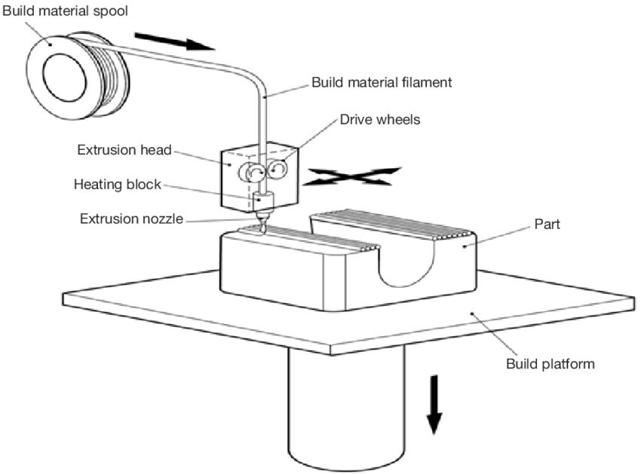
Figure 1 Schematic of a typical FDM material extrusion process. Most small-scale thermoplastic 3D printers utilize a spool of filament feedstock (Reproduced from [15])

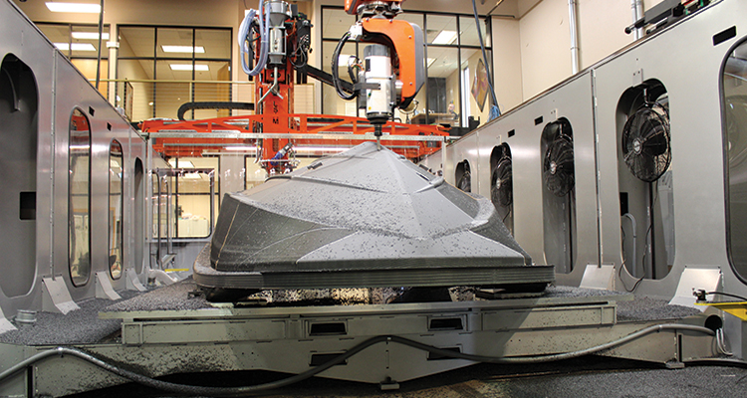
Figure 2 Large-scale thermoplastic AM is focused primarily on the tooling industry. Materials such as carbon fiber-filled ABS are used in marine applications such as this boat hull mold, which was printed on a Thermwood Large Scale Additive Manufacturing (LSAM) system with a 10’ x 20’ work table (Source: Composites World[16]).

Photopolymers in LFAM
In addition to thermoplastic polymers, other material extrusion LFAM methods print with concrete, clay, thermoset polymers, and UV curing photopolymers. LFAM printers have been used to print tooling for the marine and aerospace industries (see Figure 2), bridges, and even entire buildings (see Figure 3) [8], [17]–[19]. The scope of the present work will limit the discussion to polymeric feedstocks and applications such as tooling.

In 3D printed tooling, one challenge is thermal stability at the oven/autoclave curing temperatures typical in composites manufacturing, which range from 121 – 177 °C. Autoclavable 3D printed tooling has been produced from high-temperature thermoplastics such as polyetherimide (PEI) and polyphenylene sulfide (PPS) [18]. Still, these are more costly than ABS and must be heated to 300 – 450 °C to extrude. Unlike thermoplastics, thermoset polymers undergo an irreversible chemical curing reaction during solidification. Many thermosets can process at ambient temperatures, and some are sufficiently stable for oven/autoclave use. Because thermoset curing reactions take place over minutes or hours, dynamic viscosity in uncured resin is key to object stability during printing. Cure time must be also be balanced with exothermic reaction temperatures to prevent viscosity drop and wall collapse [20], [21].

Photopolymers have recently emerged as a potential material for LFAM printers, as demonstrated by Massivit and Mighty Buildings within the past decade [8] (see Figure 3). The main advantage of photopolymers over thermoset polymers is rapid ambient curing. While most thermoset polymers cure in minutes, hours or days, photopolymers can cure in seconds or even milliseconds [22]. Photopolymers are used in applications requiring rapid curing of thin polymer layers such as graphic arts, coating and finishing lines, dentistry, and vat polymerization AM. Photopolymers react when exposed to UV light and are stable as one-component systems. Material extrusion systems such as Direct Ink Writing (DIW) can deposit photopolymer inks, irradiating and curing printed layers immediately after deposition (see Figure 4).

Figure 3 Photopolymers are emerging as a polymer feedstock for LFAM, with applications such as this 3D printed 350 sq. ft. building. Note the use of limited infill and thick beads, as in other LFAM methods (Source: Mighty Buildings [8]).

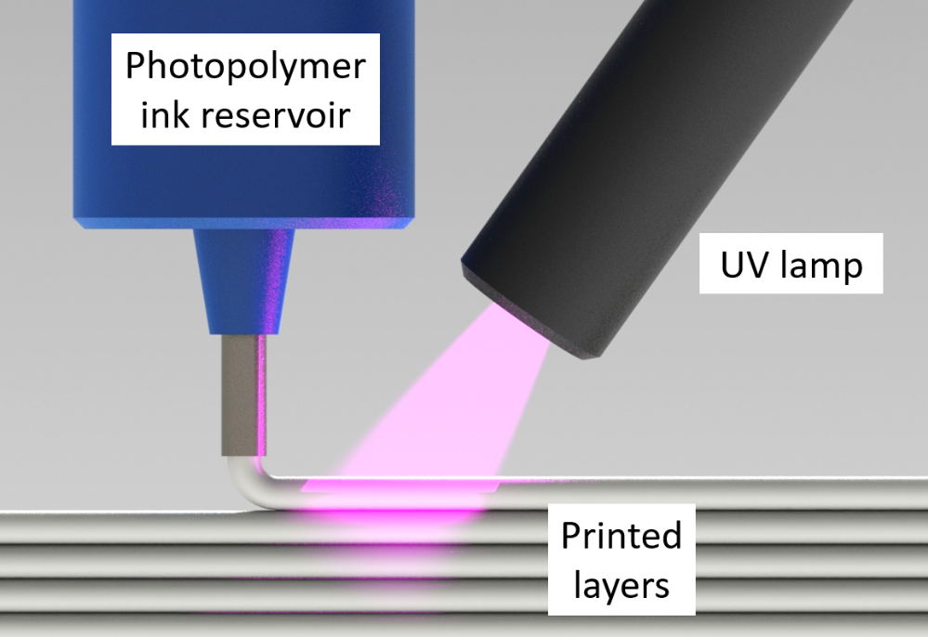
Figure 4 Material extrusion AM method with photopolymers, in which liquid resin ink is deposited in layers and immediately cured in-situ using UV light.

Photopolymer Formulation
The primary constituents of most photopolymer formulations are oligomers, monomers, additives, and PI, as shown in Figure 5. Oligomers are a polymer chain consisting of several identical repeating units and generally the primary ingredient in the formula, often with the highest molecular weight and the largest contribution to the overall properties of the polymer. Monomers are molecules that can react with each other to form polymer chains or networks, and in this context generally refer to low molecular weight ingredients that act as reactive diluents, serving both to reduce the viscosity of the resin and improve reaction speed. Additives serve to adjust the behavior of the formula in some way and include viscosity modifiers, flame retardants, UV inhibitors, fillers, pigments, surface agents, plasticizers, etc. While PIs are critical in initiating a free-radical curing reaction, they constitute 1-5 wt% of the formulation or less [23].

In thermosetting resins, three of the most common oligomers or base resins are epoxies, vinyl esters, and polyesters, with the latter as the lowest cost system [24], [25]. Polyesters and vinyl esters cure via free-radical reactions and are used in photopolymer formulations [22], [26]. Polyester resins are often formulated with styrene monomers to reduce viscosity and improve reaction rates [25], [27], but styrene can inhibit curing with some PI systems [23] and presents a hazard to workers [20], [21]. Unlike polyesters, vinyl esters have reactive groups (C=C bonds) on the chain ends. This difference in structure makes vinyl esters more reactive and reduces or even eliminates the need for additional monomers [25]. Most free-radical curing photopolymer oligomers are vinyl esters and are usually distinguished as acrylate or methacrylate chemistries, depending on the pendant groups.

For the present work, the primary oligomer selected was Bisphenol A ethoxylate dimethacrylate (Bis-EMA), shown in Figure 6. This oligomer was selected because of its thermal stability when cured, with a reported glass transition temperature (T_{g}) as high as 170 °C (338 °F). The resin supplier, Polynt USA, also markets their Bis-EMA as suitable
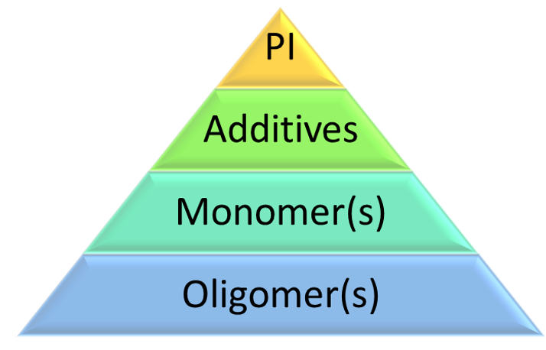
Figure 5 Typical photopolymer formulation components.

Figure 6 Chemical structure for Bis-EMA, a di-functional vinyl ester oligomer with methacrylate pendant groups.

Table 1 Mechanical properties reported for “commodity grade” Bis-EMA and unreinforced ABS as used in the BAAM printer.
Polymer | Tensile Modulus (GPa) | Tensile Strength (MPa) | Flexural Modulus (GPa) | Flexural Strength (MPa)
Bis-EMA (Polynt) | 3.5 | 46.9 | 3.7 | 96.5
ABS (BAAM) [10], [13] | 2.1 - 2.3 | 27.2 - 40.2 | 1.87 - 2.45 | 58.6 - 68.3

for tooling applications when formulated as a thermoset polymer, and can be considered a “Commodity Grade” Bis-EMA (see Table 1 and Appendices). “Dental Grade” Bis-EMA is a common component in dental photopolymers, most often combined with other oligomers and reactive diluents [28]–[31]. To the author’s knowledge, no research beyond the studies presented in this work has investigated the potential for Bis-EMA as a primary oligomer system in LFAM applications.

Photopolymer Cure Kinetics
Unlike thermosets, which experience a self-sustaining reaction throughout the bulk of the polymer above a given temperature, photopolymer reactions progress from the irradiated surface down (see Figure 7). The most common photopolymers have acrylate or methacrylate functional groups and cure via free-radical reactions. A free-radical curing reaction follows three steps: photoinitiation, propagation, and termination [23], [32], [33]. Photoinitiation commences when a photoinitiator (PI) molecule absorbs light and forms free radicals. For scission-type PIs, the PI separates into two or more free radicals (see Figure 8). These react with C=C bonds in the monomer/oligomer to form a reactive monomer/oligomer radical. During propagation, the monomer/oligomer radical starts a chain reaction with other monomer/oligomer molecules until a termination reaction causes a polymer chain to stop growing. Chain propagation can also lead to crosslinking when multifunctional monomers or oligomers are used [23].

Laws of Photochemistry

The reaction of a PI follows the Grotthus-Draper Law [34], which states that only the light absorbed by a molecule can be effective in producing photochemical changes in the molecule. The polymer and PI both absorb light to varying extents depending on the material and wavelength of light. The energy absorbed by one mole of the PI is given by the Bohr Frequency condition (Equation 1):

$$E=hv (1)$$

where E is the energy difference needed to induce free radical generation, $v$ is the
frequency of incident light, and $h$ is Plank’s constant (see Figure 8). The generation of free radicals per quantum of incident light is described by the term quantum yield ($ϕ$), shown in Equation 2 [34]:

$$ϕ=\frac{number of molecules partificpating in a process}{number of light quanta absorbed} (2)$$

The Stark-Einstein law [34] states that every absorbed quantum of light produces one photochemical reaction, or $ϕ$ = 1. In practice, the quantum yield magnitude can vary during the reaction, with $ϕ$ > 1 indicating a chain reaction while $ϕ$ < 1 indicates competing chemical reactions or effects such as cage recombination that reduce reaction efficiency [34]–[37].

As a PI or other absorbing material in a photopolymer formulation absorb light, the depth of light penetration is related to the Beer-Lambert Law [34], [38] (Equation 3):

$$A=εbC (3)$$

where absorbance $A$ is the product of molar absorptivity $ε$, the length of the light path $b$ and the concentration $C$ of the absorbing material at a specific wavelength of light. As $ε$ increases, light penetration is restricted, and the depth of cure can be inhibited [39]. As shown in Figure 9, each PI will have a unique light absorbance spectrum. Reaction efficiency can be improved by matching lamp output peaks with PI absorbance peaks, but a PI can still react as long as it has some absorbance within the output spectrum of the light source [22], [23], [40].

Measuring Cure in Photopolymers
Photopolymer cure is often described in terms of the degree of conversion (DC) of C=C bonds in the monomer/oligomer. For a given photopolymer, higher DC generally
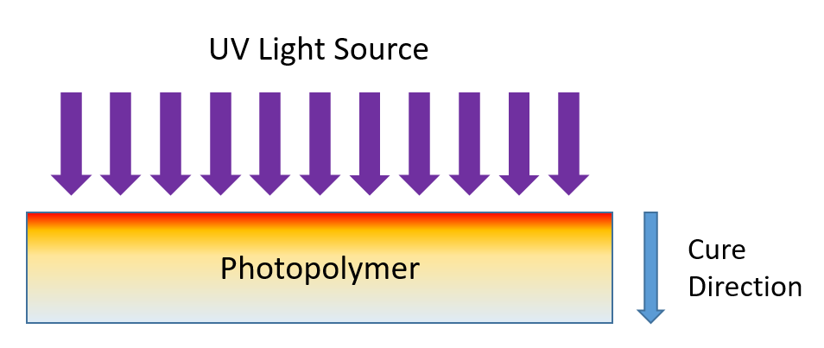
Figure 7 Unlike thermoset curing reactions, a photopolymer reaction progresses from the UV incident surface down into the bulk.

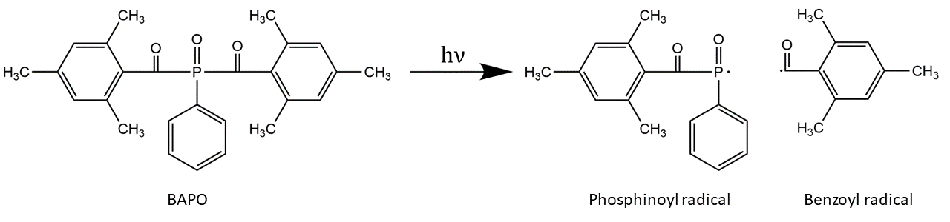
Figure 8 Scission reaction of BAPO, a common phosphine oxide photoinitiator, which cleaves into two free radicals after absorbing light [23].

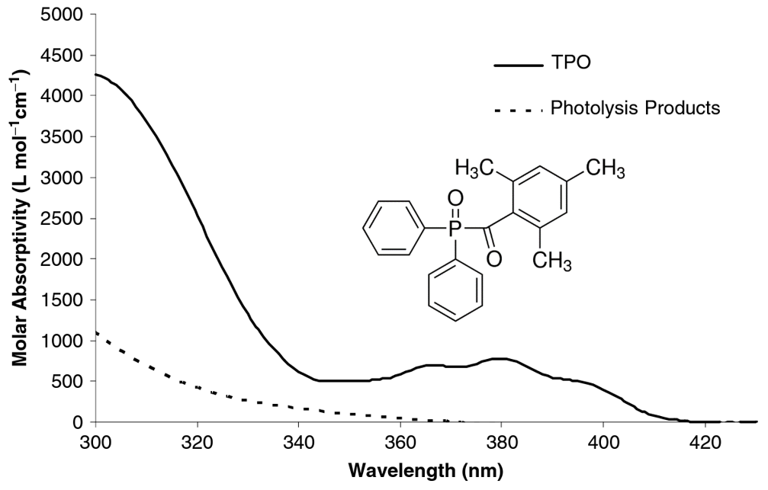
Figure 9 Absorption spectra of TPO (Reproduced from [41] with structure added).
yields an increase in hardness, modulus of elasticity, and strength due to more extensive crosslinking [42],[43]. Increased DC has been linked to an increase in T_{g} for Bis-GMA/TEGDMA dental resins [44].

Photopolymer DC is typically measured using methods such as UV differential scanning calorimetry (Photo-DSC), Fourier-transform infrared spectroscopy (FTIR), and hardness testing [38], [45]–[48]. In Photo-DSC, specimens are irradiated under inert atmosphere and the heat of reaction is used to calculate DC with reference to either a theoretical heat of reaction for the monomer (i.e. “absolute conversion”) or with reference to the maximum observed heat of reaction (i.e. “relative conversion”) [49]. FTIR is considered more accurate and more responsive in capturing real-time changes in conversion than DSC methods [50]–[54],[40], [52]–[57]. As shown in Figure 10, FTIR measures the relative C=C bond conversion by monitoring the change in the ratio of a reactive peak (e.g. methacrylate) to a reference peak (e.g. aromatic). Hardness testing is an indirect but common method for measuring cure [48], [51], [58]–[61], and Vickers microhardness has been shown to have a linear relationship with FTIR DC in some resins [51].

Bis-EMA cure in Photopolymers

Bis-EMA is often used as one component in dental photopolymers, and ultimate DC can vary for a given formula composition, light intensity and spectral output, UV dose, ambient conditions, etc. LeCamp et al. measured a maximum absolute DC of ~62% using Photo-DSC for Bis-EMA irradiated at ambient temperature. However, at a curing temperature of 90 ºC, the DC increased to ~85% [49]. Collares et al. irradiated >1 mm thickness specimens for 40 s under a 1.2 W/cm² LED, reporting a maximum ambient cure DC of 78% via FTIR. They discussed various baselines and peaks for measuring Bis-EMA DC via FTIR, and concluded that the 1608 cm⁻¹ reference peak and 1637 cm⁻¹ methacrylate peak as shown in Equation 4 provided results most consistent with other published literature [31].

$$\%DC=\left[1-\frac{\left(\frac{1637 cm^{-1}}{1608 cm^{-1}}\right) Peak height cured}{\left(\frac{1637 cm^{-1}}{1608 cm^{-1}}\right) Peak height uncured}\right] x 100 (4)$$

The highest maximum DC found for a Bis-EMA system was 93.7%, reported by Par et. al. and measured using Raman Spectroscopy with peaks of 1640 cm⁻¹ and 1610 cm⁻¹. This high DC was obtained with a 60:40 blend of Bis-EMA and TEGDMA, and measured after a UV dose of 23.7 J/cm² and a 1 hr post cure at 150 ºC [29]. While Par et al. did not discuss the influence of TEGDMA on ultimate DC, their findings confirm the potential benefit of thermal post curing, which has previously been shown to increase photopolymer DC [62], [63].

Preliminary DC findings for Polynt Bis-EMA

As discussed in the Appendices, the Bis-EMA supplied by Polynt and used in this dissertation differs from dental grade Bis-EMA. It has a higher residual methacrylic acid content, unknown inhibitor package and reduced light transmission, but it is also available at lower cost and is better suited to LFAM applications.

To understand the ultimate DC for the Polynt Bis-EMA, several preliminary tests were conducted by the resin supplier and the results were provided to the author. The resin was formulated as a thermoset, with 1% BPO as initiator. A DSC thermal sweep of 0 ºC to 250 ºC was performed on the uncured resin, and the reported heat of reaction was 207 J/g - 220 J/g (see Figure 11). Similar thermal sweeps were performed on cured specimens after with a three-step post cure regimen of 16 hrs 54 ºC, 2 hrs at 66 ºC and 2 hrs at 121 ºC. The resin supplier reported a 100% relative DC (no observable exotherm).

FTIR results for the same thermoset cure conditions showed that the post cured specimen achieved 90.5% DC, which will be the target FTIR DC for the photopolymer formulation work in this dissertation. The resin supplier recommended a post cure cycle of 2 hrs at 66 ºC and 2 hrs at 121 ºC for subsequent photopolymer work.
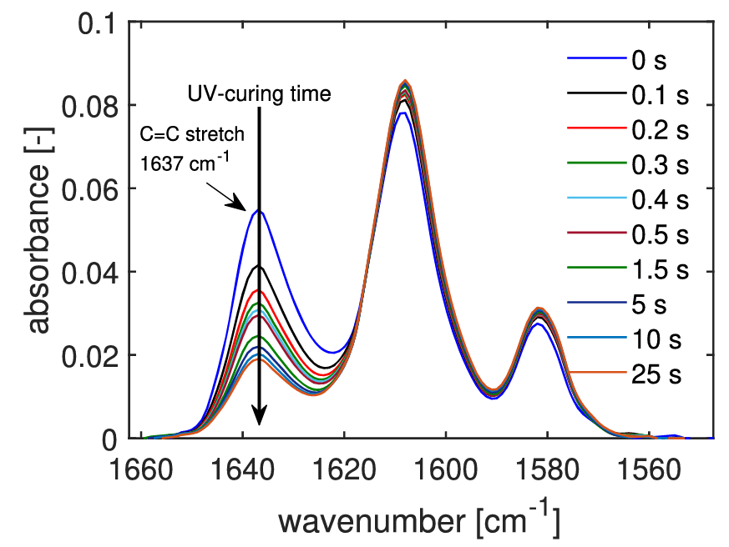
Figure 10 Degree of conversion is measured in FTIR by monitoring the decrease in absorbance from a reactive peak relative to a reference peak (Reproduced from [64]).

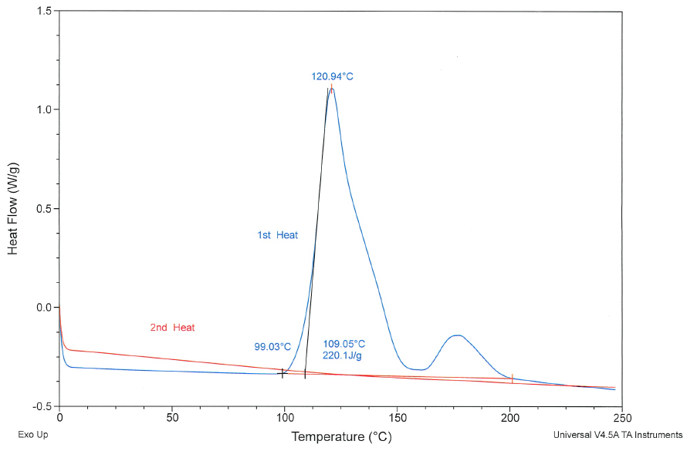
Figure 11 Thermal DSC results for Bis-EMA formulated as thermoset, showing exothermic reaction peak (provided by Polynt USA).

Photopolymer Formulation for LFAM
A primary objective in LFAM printing is to achieve high material deposition rates with materials that have adequate properties for a given end-use. If Bis-EMA photopolymers can achieve the properties reported by the manufacturer for thermoset formulations, they should be well-suited for application in oven/autoclave cure tooling applications. In determining the suitability of Bis-EMA for use in LFAM, several questions remain:

- What is considered “full cure” for a Bis-EMA photopolymer, and how rapidly can photopolymers achieve full cure throughout a 2-4 mm layer thickness?
- At full cure, is a Bis-EMA photopolymer suitable for use in oven/autoclave tooling applications?
- How does the presence of a monomer influence the cure speed at LFAM layer thickness?
- Can through-thickness cure speed be reduced with PI selection and concentration?
- As irradiation time decreases and theoretical material deposition rate increases, how does the cure gradient within a layer change?
- To what extent can multiple irradiation cycles improve cure in a previous layer?
- What influence does a reinforcing filler such as fiberglass have on curing?
- What influence does irradiation time have on the adhesion between printed layers of fiberglass reinforced photopolymer?
- Does thermal post curing improve layer adhesion?

The work presented in this dissertation attempts to address these questions and provides a detailed study of Bis-EMA as a potential photopolymer for LFAM applications. Several controls were in place to limit the scope in conducting this research. First, the lamp system used was an Altair 75 area lamp with a light-emitting diode (LED) array and reported peak emission at 395 nm wavelength. This lamp was maintained at a constant 10 mm distance from the polymer surface, with irradiation intensity held constant as much as could be allowed by the various mold configurations employed. Second, all through-thickness cure testing was performed on specimens at an optimal layer thickness of 3 mm, representing an average value for the typical layer thicknesses in LFAM. Third, the only reinforcing fiber used was fiberglass, and no other fillers were used in formulations. While additional fillers such as fumed silica are often used in material extrusion AM methods for photopolymers, the primary objective of this research was to study Bis-EMA as an oligomer for LFAM. This research should not be considered an exhaustive study of the many possible formulation combinations, nor does it attempt to recommend a complete formulation for LFAM. Instead, it is an investigation into the several factors that influence Bis-EMA photopolymer cure kinetics and recommend baseline formulations that could be further enhanced for a specific printer configuration.

Dissertation Objectives
The present work can be segmented into three primary objectives, each focused on Bis-EMA as an oligomer for use in formulations towards application in LFAM. These have been structured into three chapters, each of which is a manuscript that has either already been published or is being submitted for publication in a peer-reviewed journal(s).

- Monomer concentration
  - Explore the effect of monomer concentration on through-thickness cure response
  - Oven-cure tooling case study and investigation of thermal effects on Bis-EMA photopolymer
- PI selection and concentration
  - Implement optical model as a pre-screening tool
  - Compare photobleaching vs. non-photobleaching PI effects
  - Study the influence of PI concentration and irradiation time on cure
- Multi-layer effects
  - Examine cure behavior with multiple irradiation cycles
  - Observe the influence of irradiation dose and thermal post cure on cure
  - Compare neat resin versus fiberglass composite cure gradient
  - Test interlaminar bonding in multi-layer fiberglass composite

CHAPTER I
Photopolymer formulation towards large scale additive manufacturing of autoclave capable tooling

A version of this chapter was originally published by Alexander Stiles, William Kobler, Pritesh Yeole and Uday Vaidya:

A. Stiles, W. Kobler, P. Yeole, and U. Vaidya, “Photopolymer formulation towards large scale additive manufacturing of autoclave capable tooling,” Additive Manufacturing, vol. 50 (2022), https://doi.org/10.1016/j.addma.2021.102571.
Alexander Stiles was the involved in the conceptualization, investigation, formal analysis, visualization, and writing of this publication. He wrote the original draft, as well as reviewing and editing in all drafts through to submission and publication. Will Kobler was involved specifically in conducting Dynamic Mechanical Analysis (DMA), as well as visualization of Figures related to DMA, and original draft preparation. Pritesh Yeole was involved in the laser scanning investigation and formal analysis, as well as related visualizations. Uday Vaidya was responsible for funding acquisition, and review & editing of the manuscript drafts.

Abstract
Large-scale polymeric additive manufacturing (AM) is emerging as a method for producing prototype tooling in the aerospace industry. However, material options for oven/autoclave-capable tooling are currently limited to costly thermoplastics such as polyetherimide (PEI) and polyphenylene sulfide (PPS). Photopolymers can be formulated for oven/autoclave use and have advantages over thermoplastics such as ambient processing and rapid curing under low-energy ultraviolet light emitting diode (UV LED) lamps.

This study presents initial photopolymer formulation work towards large-scale AM with bisphenol A ethoxylate dimethacrylate (Bis-EMA), a vinyl ester suitable for moderate autoclave/oven-curing temperatures (100 - 135 °C, 212 – 275 °F). Bis-EMA photopolymers were prepared and cured in 3 mm thick specimens by UV irradiation to simulate large-scale AM conditions. Bis-EMA was also blended with pentaerythritol triacrylate (PETIA) to determine the influence of a high-functionality acrylate on cure response and material properties. For the same UV dose, an increase in PETIA content up to 50 wt% increased the Vickers Hardness Number (VHN) on the irradiated surface from 22.6 to 25.0. It also improved the ratio of top to bottom surface hardness from 65% to 91%, indicating possible improvement in through-thickness cure response. The addition of PETIA decreased the tensile modulus from 2.8 GPa to 2.1- 2.3 GPa, and PETIA content above 20 wt% reduced the glass transition temperature (T_{g}) below the Bis-EMA control.

A blend of 80 wt% Bis-EMA with 20 wt% PETIA yielded an optimal balance of improved through-thickness hardness over the Bis-EMA control while retaining thermal stability. To investigate suitability for oven/autoclave-capable tooling, this 80:20 photopolymer blend was reinforced with fiberglass and used to produce UV cured demonstration tooling via a pseudo-additive process. The tools were subjected to five oven cure molding cycles, and laser scanning showed an average deviation < 0.05 mm, indicating negligible degradation in the tool geometry. The hardness values of the tool stock material did not change significantly with thermal cycling, and the T_{g} increased from 154 °C to 172 °C.

This study is the first report of Bis-EMA/PETIA blends towards use in photopolymers for large-scale AM. The data confirm that Bis-EMA photopolymer formulations can achieve adequate through-thickness cure at the layer thicknesses typical of large-scale AM. An 80:20 Bis-EMA/PETIA blend was thermally stable within the low volume thermal cycles expected of a 3D printed prototype tool.

Keywords: Large-scale, additive manufacturing, autoclave, photopolymer, methacrylate, acrylate

1.0 Introduction
Large-scale AM is a nascent technology emerging as an efficient method for producing tooling, especially in low volume composites manufacturing applications [14], [65]–[67]. Most large-scale 3D printers use thermoplastic feedstock, with some printers such as the Big Area Additive Manufacturing (BAAM) system capable of depositing material at a maximum rate of 36 kg/hr (80 lbs/hr) [11]. The most common feedstock for such printers is acrylonitrile butadiene styrene (ABS), often blended with chopped carbon fiber to improve mechanical properties and reduce warping in large printed parts [12]–[14]. While ABS is suitable for room temperature applications such as layup and trim tools, many tooling applications in the aerospace industry demand materials capable of withstanding the higher temperatures needed for curing epoxy/carbon fiber “pre-pregs” [68]. Pre-pregs typically cure at 121 – 177 °C (250 – 350 °F) and are subjected to autoclave or oven-cure molding. Autoclavable 3D printed tooling has been produced from high-temperature thermoplastics such as PEI and PPS [18]. Still, these are more costly than ABS and print at higher temperatures of 300 – 450 °C (572 – 842 °F), increasing energy consumption and equipment costs.

Unlike thermoplastics, thermosetting materials can cure at ambient temperatures, although they often require thermal post-curing to achieve a complete cure. A large-scale thermoset printer, the Reactive Additive Manufacturing (RAM) system, was developed at the Oak Ridge National Laboratory’s Manufacturing Demonstration Facility (ORNL-MDF). The RAM utilizes vinyl ester and polyester resins that are potentially capable of withstanding autoclave temperatures [69]. At present, some challenges of thermoset printers include: balancing cure time and exotherm temperatures to retain wall integrity with uncured resins, limited build height due to wall collapse, and worker safety hazards from volatiles such as styrene [20], [21].

Photopolymers are a subset of thermosets that cure in seconds vs. minutes or hours [22]. In AM methods such as direct ink writing (DIW), a printed photopolymer path is cured immediately with UV lamps after deposition [70]. Unlike thermoset printers, photopolymer DIW (UV-DIW) printers do not require a mixing head, and the inks cure rapidly enough to avoid wall collapse. UV-DIW printers can achieve high deposition rates and are emerging in large-scale printing applications [8], [71]. Large-scale UV 3D printing companies such as Massivit 3D (Lod, Israel) and Mighty Buildings (Oakland, USA) utilize a gel deposition technique comparable to UV-DIW for their printers and have successfully printed small buildings. Continuous Composites (Coeur d'Alene, USA) and Moi Composites (Pero, Italy) employ a method most comparable to automated fiber placement, and they have printed boats and demonstration wing sections. Despite these successes, few studies are available regarding photopolymer formulations suitable for large-scale AM. To the authors’ knowledge, no prior studies have reported on photopolymer formulations for 3D printing autoclave/oven-capable materials at the 2 - 4 mm (0.08 – 0.16 in.) layer heights typical of large-scale AM [10].

Many photopolymers and some thermosets cure via free-radical reactions. An initiator breaks apart or enters an excited state and generates molecules with unpaired electrons that react to grow a polymer chain or create cross-links between chains. In a thermoset printer such as the RAM, a polymer reacts once initiators are in a specific temperature range, and reactions are self-sustaining throughout the bulk of the polymer. In photopolymers, a photoinitiator reacts upon exposure to UV light, and reactions commence at the irradiated surface before progressing through the polymer bulk (see Figure 12). As layer thickness increases, the progressive through-thickness cure reaction is hindered by light attenuation from fillers, initiators, and even the polymer itself. These factors can significantly reduce free-radical generation and inhibit curing through the depth of the layer [22], [23], [39], [48]. Longer UV exposure times can often overcome this light attenuation [72], but this reduces the print speed and throughput achieved by the 3D printer. Therefore, a key objective of this paper is to assess the influence of polymer formulation on through-thickness cure speed at a 3 mm layer thickness.

When considering tooling for producing composite parts, there are several objectives. All tools must have a smooth finish on the molding surface that has vacuum integrity and is compatible with typical mold release agents. If the tool is going to be used in an oven, it must be capable of withstanding pre-preg curing thermal cycles and have a predictable thermal expansion. In autoclave use, it must also be stable at pressures up to 100 psi [6.9 Bar]. 3D printed tooling is typically used for prototype applications of 1-20 part cycles. In large-scale 3D printing, tooling is often produced as a shell with minimal internal geometry. The molding face is typically machined and coated with a thermosetting polymer to create a smooth, void-free surface [18], [67]. A photopolymer printer with 3 mm layer height will likely require similar post processing, but while thermoplastics require heated extrusion, photopolymers can process in ambient conditions. The UV LED lamp used in this study consumes 32 W of power.

2.0 Literature Review
Photopolymers are currently used in three categories of additive manufacturing: Vat Polymerization, Material Jetting, and Material Extrusion. Vat polymerization typically utilizes photopolymers and includes stereolithography (SLA), digital light processing (DLP), multiphoton lithography, and continuous digital light processing (cDLP). Vat
Figure 12 Unlike thermoset curing reactions, a photopolymer reaction progresses from the UV incident surface down into the bulk [23].

polymerization methods produce 3D printed parts from a tray or vat of uncured resin by
selectively curing the desired part geometry with a laser or projected light source. Multiphoton lithography can achieve part resolution from 0.1 – 5 μm, but most conventional SLA, DLP, or cDLP printers have typical feature resolutions of 25 – 100 μm [73]–[77]. Layer heights for DLP have been reported as low as 19 μm [77]. Lateral overcuring can be a concern in vat polymerization methods, as it can affect part resolution. Light-blocking agents are utilized in some formulations to restrict cure behavior [76]. Most vat polymerization methods rely on a precise gap between the build plate and bottom of the resin tray to determine layer height. Lower viscosity resins are preferred to allow rapid resin flow into this small gap. Typical vat polymerization resins have a viscosity ranging from 0.2 – 10 Pa-s at low shear, as high viscosities can limit resin flow and lead to bubble formation, restricting print speeds [74], [75], [77], [78]. Vat polymerization printers typically have build volumes below 0.03 m³.

Material jetting is an inkjet-based system that deposits droplets of photopolymer on a print bed and cures layers by scanning a UV lamp over the print bed. Material jetting can achieve resolutions of 25 μm and print multiple materials and colors within a single part [73], [79]. However, low viscosity inks are required, with typical maximum printable viscosity reported between 0.02-0.04 Pa-s [80], [81]. Material jetting printers typically have build volumes below 0.5 m³.

Material extrusion methods include conventional thermoplastic printing methods such as fused deposition modeling (FDM), and broader printing methods such as DIW encompass thermosets, hydrogels, and low melt temperature metals. For thermoset and photopolymer inks, typical inside nozzle diameters range from 100-1000 μm, with layer heights of 50-500 μm [82]–[85]. Dynamic viscosity is an important consideration for DIW inks to create stable printed beads, and thixotropic agents such as fumed silica and nanoclay can improve shear-thinning behavior [70], [86], [87]. While thermosetting inks must be capable of supporting the weight of multiple layers in an uncured state [70], UV-cured inks undergo rapid crosslinking and achieve gelation before the addition of new layers. UV cured inks do not have the same stability requirements as other thermosetting inks, but ink stability improves final part resolution [70]. Farahani et al. reported on UV- DIW inks that cured rapidly enough to print self-supporting spans of 8 mm, observing an ideal ink apparent viscosity >140 Pa-s at low shear [88]. To enhance part resolution, improve overhangs and reduce cure-induced shrinkage and warp, photopolymer inks are often formulated with additives such as fumed silica, fiberglass, silica, carbon fiber, and carbon nanotubes [70], [84], [85].

While most photopolymer and thermoset research in 3D printing reports layer heights of 25-500 μm, few studies are available that consider the 2 - 4 mm (0.08 – 0.16 in.) layer heights more common in large-scale AM. At present, the only photopolymer research that considers such thicknesses is in dentistry and fiberglass-reinforced composites. In dental fillings, a standard method for determining cure through a given polymer thickness is by comparing the hardness of an irradiated specimen's top (UV incident) and bottom surfaces. Abedian et al. [89] correlated Vickers hardness with the extent of cure, and Orefice et al. [51] found a linear relationship between microhardness and the degree of double bond conversion within a given polymer system as measured using Fourier-transform infrared spectroscopy (FTIR). Alrahlah et al. tested Vickers hardness across the depth of an irradiated specimen. They found that the hardness decreased with depth, introducing a guideline that a dental filling may be considered fully cured when the bottom surface hardness value achieves 80% of the hardness value on the irradiated surface [48]. The advantage of this guideline is that it is independent of photopolymer formulation, enabling a basic framework for comparing cure across many photopolymer options.

One challenge in formulating photopolymers for AM of autoclave/oven-cure tooling is balancing temperature resistance with printer deposition rate. Temperature resistance is determined by factors such as polymer chemistry and degree of cure, while deposition rate is limited by the through-thickness cure response. Bis-EMA has a reported glass transition temperature (T_{g}) as high as 170 °C (338 °F). However, the methacrylate functionality of Bis-EMA can reduce cure speed when compared with less temperature-resistant acrylate-based photopolymers [90]. Arceneaux reported improved cure response in thin films when using acrylates with a higher number of functional groups [90], and PETIA in particular has been shown to consistently improve cure speeds in formulations cured under UV LED lamps [91]. While PETIA has the potential to improve cure response, higher functionality components can also limit the achievable degree of double bond conversion and reduce T_{g} [23], [92], [93], and the addition of this monomer could increase cure-induced volumetric shrinkage [18, 26]. While Bis-EMA has been studied in combination with other oligomers and reactive diluents [28]–[31], to the authors’ knowledge no prior studies report on the photocuring of Bis-EMA combined with PETIA.

The present study focused on formulation to improve the cure response of Bis-EMA in thick sections under a high-intensity UV LED lamp with a short irradiation time, simulating conditions typical of a large-scale photopolymer 3D printer. The authors hypothesized that the through-thickness cure response would improve with this polymer combination for a constant UV dose. Uncured Bis-EMA formulations with increasing levels of PETIA were tested for viscosity range and potential process suitability. Each formula was cured via UV LED irradiation in 3 mm thick layers, then tested for the change in hardness on the top and bottom surfaces, degree of conversion, tensile modulus, T_{g,} and cure-induced shrinkage.

Based on these results, a blend of 80 wt% Bis-EMA with 20 wt% PETIA was selected for its optimal balance of through-cure response and T_{g}. This formula was then tested for response to thermal aging and used to fabricate fiberglass-reinforced composite tooling (molds). Five oven-cured composite parts were produced with each tool, and the tools were analyzed for thermal aging effects on hardness, T_{g}, and tool geometry.

3.0 Materials and Methods

3.1 Light Source and Materials
The lamp was an Altair 75 high-intensity UV LED area lamp from Heraeus Noblelight (Cambridge, UK), with an emitting window of 80 mm x 13 mm and peak irradiance of 3.7 W/cm² at 395 nm. The primary oligomer in this study was Bis-EMA (see Figure 13). The reactive diluent was PETIA, a 50:50 molar mixture of tri- and tetra-acrylate esters of pentaerythritol supplied by Allnex (Frankfurt am Main, Germany). The photoinitiator was 2-Benzyl-2-dimethylamino-1-(4-morpholinophenyl)-butanone-1 (BDMB), a highly reactive alkylaminoacetophenone supplied by Lambson (West Yorkshire, UK). Absorption properties of BDMB were determined by ultraviolet-visible (UV-Vis) spectroscopy on an Evolution 300 spectrometer from Thermo Fisher Scientific (Waltham, USA). BDMB was dissolved in methanol at 0.01 wt%, and the solution was tested in a 1400 microliter quartz cuvette with a lid from Thorlabs, Inc. (Newton, USA), with a scan range of 200 to 600 nm and a bandwidth of 2.0 nm. As Figure 14 shows, BDMB has a high molar absorptivity at lower wavelengths and a weak UV absorbance tail in the UV-A range. The lower initiator absorptivity at 395 nm increases the depth of cure that can be achieved with BDMB [23].

3.2 Specimen Preparation
Bis-EMA formulations were prepared with 0, 10, 20, 30, 40, and 50 wt% PETIA, with BDMB added to the mixture at 1 wt%. Formulations were mixed under low heat using a hot plate stirrer for 10 minutes, then allowed to rest for at least 24 hours prior to irradiation at ambient temperatures. Cured specimens for tensile testing, hardness testing, dynamic mechanical analysis, and helium pycnometry were all irradiated for 5 seconds at a distance of 10 mm from the lamp to the surface of the photopolymer. Molding fixtures were positioned to center specimens in the emitting window, with hardness and dynamic mechanical analysis (DMA) specimens using a glass microscope slide treated with a mold release agent (Frekote 770 NC, Loctite, Hartford) as the top mold surface. Through
Figure 13 Primary oligomer Bis-EMA is di-functional while PETIA has tri- and tetra-functionality.

Figure 14 Absorption spectrum for BDMB shows a tail that extends into the UV-A range, compatible with 395 nm LED systems.
the treated glass, 5 second irradiation provided an average incident intensity on the polymer surface of 1.7 W/cm² and a dose of 8.0 J/cm², as measured by an ILT800
radiometer from International Light Technologies (Peabody).

The specimens for tensile testing were cured in a while acrylic mold with 3 mm depth and a single cavity with geometry per ASTM D638 Type V. Specimens for hardness testing were cured in a polytetrafluoroethylene (PTFE) mold with five cavities of 6 mm diameter, 3 mm depth. To ensure a smooth molded surface and minimize the effects of oxygen inhibition, glass microscope slides treated with mold release were used as the top and bottom sides of the molds. Tensile bars from one formula were thermally treated by placing them in an oven within one hour of UV irradiation. These specimens were treated at 135 °C (275 °F) for increments of 10 and 20 hours, then tested for polymer degradation via thermogravimetric analysis (TGA).

DMA specimens were prepared in a PTFE mold with cavities measuring 5 mm x 30 mm x 1 mm, using a polished stainless-steel surface as the bottom mold face and a treated glass microscope slide as the top mold face.

Helium pycnometry density specimens were cured using the DMA mold, with a red-tinted transparent nylon bagging film instead of a glass slide on the top surface to limit oxygen inhibition while allowing volumetric shrinkage during curing.

3.3 Uncured Polymer Characterization
Rheological characterization was conducted on a Discovery Hybrid Rheometer-2 (DHR-2) from TA Instruments (New Castle, USA), outfitted with 25 mm-diameter disposable aluminum platens at ambient temperature. With a gap of 1.1 mm, specimens from each formula were subjected to a logarithmic flow sweep from 1.0 to 300.0 1/s shear rate. A minimum of three tests were conducted for each of the six photopolymer formulations.

3.4 Cured Polymer Testing
tests were conducted after a minimum of 24 hours post irradiation. Tensile testing was conducted at a strain rate of 1 mm/min on an Instron 5960 load frame with a 5 kN
load cell (Norwood, USA).

Hardness was measured on the top and bottom surfaces of the 3 mm thick disc specimens, with “top” indicating the UV incident face and “bottom” indicating the point farthest from the UV lamp. Vickers hardness testing was conducted at a loading of 50 g on a Buehler 1600 Series microhardness tester (Lake Bluff, USA). Three specimens were measured from each formulation, with a minimum of five measurements taken from the top and bottom of each specimen.

The T_{g} was measured via DMA testing, conducted on a TA Instruments Q800 (New Castle, USA). Samples were tested in single cantilever mode with the UV incident side facing up. The oscillation frequency was 1 Hz, strain amplitude of 0.05%, and a temperature range of ambient to 200 °C with a ramp rate of 3 °C/min. T_{g} was measured as the maximum value of the tan delta curve.

Cured specimen density was measured via helium pycnometry using a 10 cm³ chamber on the AccuPyc II 1340 (micromeritics, Gwinnett County, USA) with a minimum of three specimens per formulation. Liquid density was determined for each formula at 25 °C using a calibrated 25 ml manual pycnometer (Eisco Labs, Ambala, India) and digital scale.

TGA was performed on specimens from one formula after UV irradiation and after subsequent thermal treatments of 10 and 20 hours at 135 °C (275 °F). Testing was conducted on a TA Instruments Q50 (New Castle, USA), with a thermal sweep from ambient to 600 °C at a ramp rate of 10 °C/min under a nitrogen atmosphere.
FTIR was used to characterize double bond conversion in the cured photopolymers. Testing was conducted on a Nicolet iS50 FTIR Spectrometer with an attenuated total reflectance (FTIR-ATR) module, both from Thermo Fisher Scientific (Waltham, USA). Each test consisted of 64 scans across a wavenumber range of 525 to 4000 cm⁻¹ at a resolution of 4 cm⁻¹ and a gain of 8.0. FTIR is a common method for determining the degree of cure of photopolymers by measuring the relative reduction in carbon-carbon double bonds reacting during crosslinking. The degree of conversion for Bis-EMA formulations was calculated using Equation 4 [61]:

$$\%DC=\left[1-\frac{\left(\frac{1637 cm^{-1}}{1608 cm^{-1}}\right) Peak height cured}{\left(\frac{1637 cm^{-1}}{1608 cm^{-1}}\right) Peak height uncured}\right] x 100 (4)$$

Peak height was measured using Essential FTIR software, v3.50.203 (Operant LLC, Houston, USA), with DC averaged over a minimum of three specimens.

4.0 Results

4.1 Rheology
Figure 15 confirms a drop in apparent viscosity as PETIA content increases, from 2.38-2.05 Pa-s (2380-2050 cP) for pure Bis-EMA down to 1.74-1.56 Pa-s (1740-1560 cP) for a 50:50 blend of Bis-EMA and PETIA. These results are expected, given the reported viscosities of 1800 cP for Bis-EMA and 700-1500 cP for PETIA. The measured apparent viscosity for Bis-EMA was within the expected range but somewhat higher than the reported value obtained via Brookfield viscometry.

The shear-thinning behavior for each formulation was studied within the shear rate range of 50-250 1/s, which was selected as a suitable range for the conditions present in the nozzle of small-scale and large-scale DIW or extrusion-based AM methods [68], [83] (see Appendices). The presence of shear-thinning was determined by fitting the apparent viscosity vs. shear rate curves to the power law model (Equation 5) [82], [86], [87]:

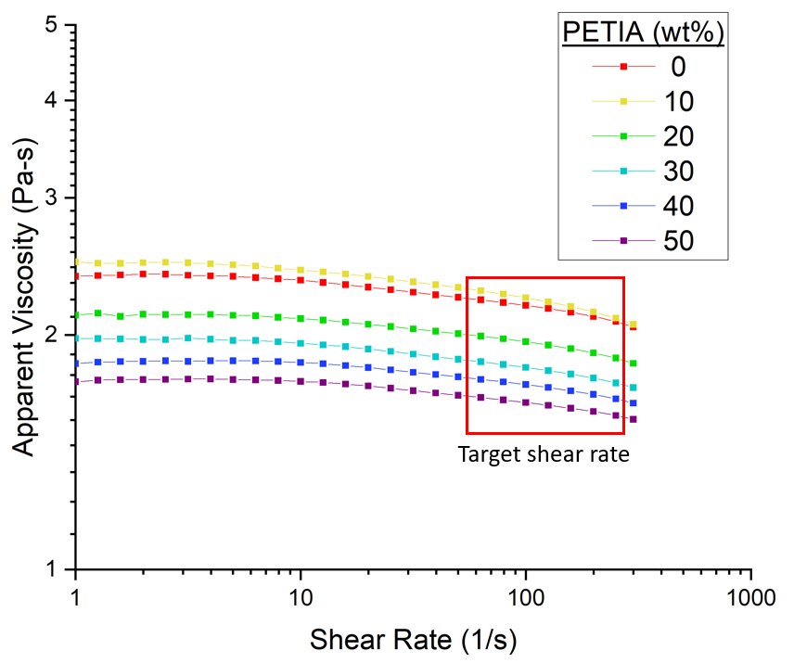
Figure 15 Apparent viscosity vs. shear rate for neat resin formulations of Bis-EMA with varying PETIA content. In the target shear rate region for large-scale AM, a slight drop in viscosity indicates minimal shear thinning behavior.

Table 2 Effect of PETIA content on rheological properties of photopolymer
wt% PETIA | K (Pa-s) | n
0 | 2.706 | 0.953
10 | 2.825 | 0.944
20 | 2.435 | 0.952
30 | 2.237 | 0.954
40 | 2.094 | 0.958
50 | 1.956 | 0.961

$$η=K{\dot{γ}}^{n-1} (5)$$

where $η$ is the apparent viscosity, $K$ is the consistency index, $\dot{γ}$ is shear rate, and $n$ is the flow index. The $n$ and $K$ values were determined using linear regression, with calculated values for each formula given in Table 2.

The calculated $n$ values range from 0.944 to 0.961, with Newtonian behavior indicated by a value of 1. The overall behavior of the formulations can be considered as very near Newtonian, with minimal shear thinning in at the low shear rates expected in large-scale material deposition AM. There is a direct relationship between $n$ value and PETIA content, indicating a trend towards more Newtonian behavior as PETIA content increases. The exception to this trend is the formulation with 10 wt% PETIA, which has both the lowest $n$ value at 0.944 and an apparent viscosity that is slightly higher than the pure Bis-EMA formula.

4.3 Cure Response with variation in PETIA content

Vickers Hardness
The Vickers hardness number (VHN) on the top surface of these specimens showed a consistent upward trend from 22.6 to 25.0 as PETIA content increased from 0 wt% to 50 wt% (see Figure 16). The bottom surface hardness showed a more pronounced increase from 14.7 to 22.7 over the same range of PETIA content. Formulas with a PETIA content of 30 wt% or higher achieved full cure, with an average bottom surface hardness at $≥$80% of the top surface hardness value. The formula with 20 wt% PETIA content fell just below the full cure standard with 79% of maximum VHN on the bottom surface. A more conservative estimation of full through cure was to apply one-way analysis of variance (ANOVA) of each formulation to determine when the top and bottom hardness were statistically similar. By this measure, only at 50 wt% PETIA did any of the tested specimens achieve P-values above 0.005, indicating that the difference between the top and bottom hardness was not statistically significant.

Tukey’s Honestly Significant Difference Procedure (Tukey HSD) was applied to the data sets for the bottom hardness measurements using MATLAB software (MathWorks, Natick). Multiple comparison of means for one-way ANOVA determined that all formulations except the 20 wt% and 30 wt% PETIA pair differed significantly from each other. This confirms that all formulations with PETIA exhibited improved hardness on the bottom surface over the Bis-EMA baseline formulation, and that increased PETIA content generally improved the through thickness cure response.

FTIR-ATR Degree of Conversion
As shown in Figure 17, the range in DC was from 61.5–79.0 % and the 10 wt% PETIA formulation had both the highest standard deviation and lowest average DC. As with hardness testing, the bottom surface DC was consistently lower than the top surface DC.

4.4 Tensile Modulus
For each of the formulations tested, the tensile stress-strain curve exhibited an initial non-linear region followed by a more linear behavior and a final brittle fracture without a distinct yield point (see Figure 18). Because of the two distinct regions, tangent moduli were calculated from the initial slope and from the linear region, reported respectively as the Initial and Second Tensile Modulus in Figure 19. The average failure stress varied from 25 to 50 MPa and failure strain varied from 1.5 to 3.0%, with no clear trends emerging between the formulations due to high variation in sample failure (see Appendices).

The tensile modulus decreased with the addition of PETIA, with the largest drop at the addition of 10 wt% PETIA, from an average initial modulus of 2.81 GPa for pure Bis-EMA to 2.07 GPa for the 10 wt% PETIA formulation. The modulus of the second linear portion from each formula was consistently lower than the initial modulus, by an average 10 to 20% reduction.
Figure 16 Vickers hardness (VHN) with increasing PETIA level as measured on top (UV incident) and bottom surface (3mm depth). Error bars indicate +/- one standard deviation.

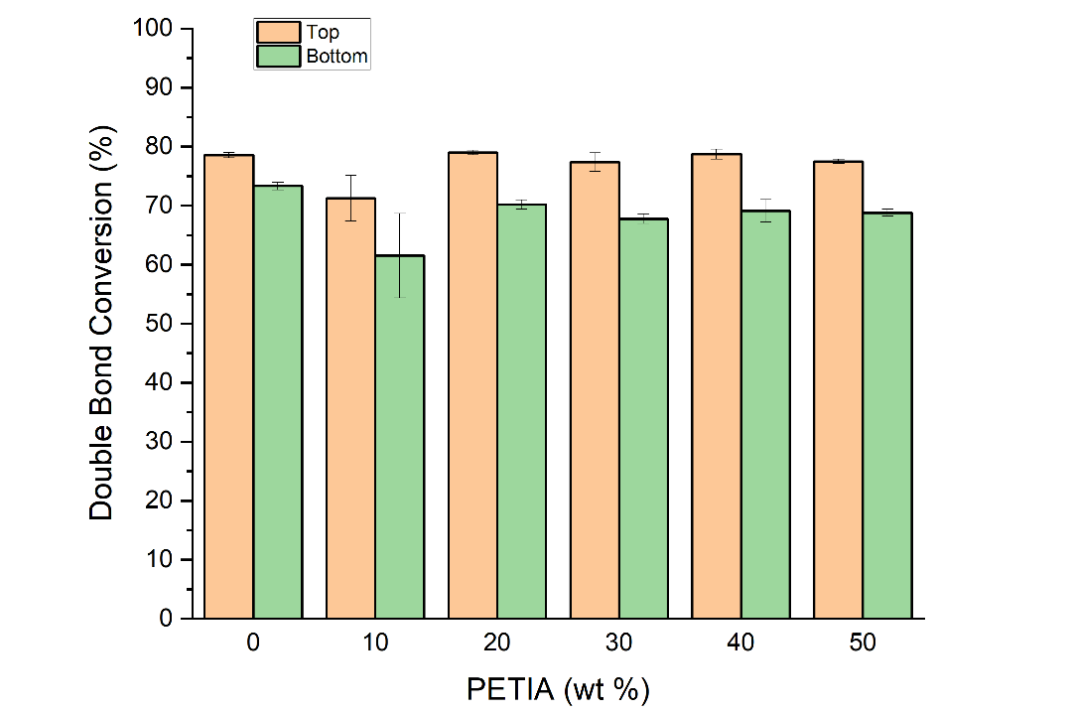
Figure 17 C=C double bond conversion on the UV irradiated (Top) and non-incident (Bottom) faces of cured Bis-EMA photopolymers with varying concentrations of PETIA.
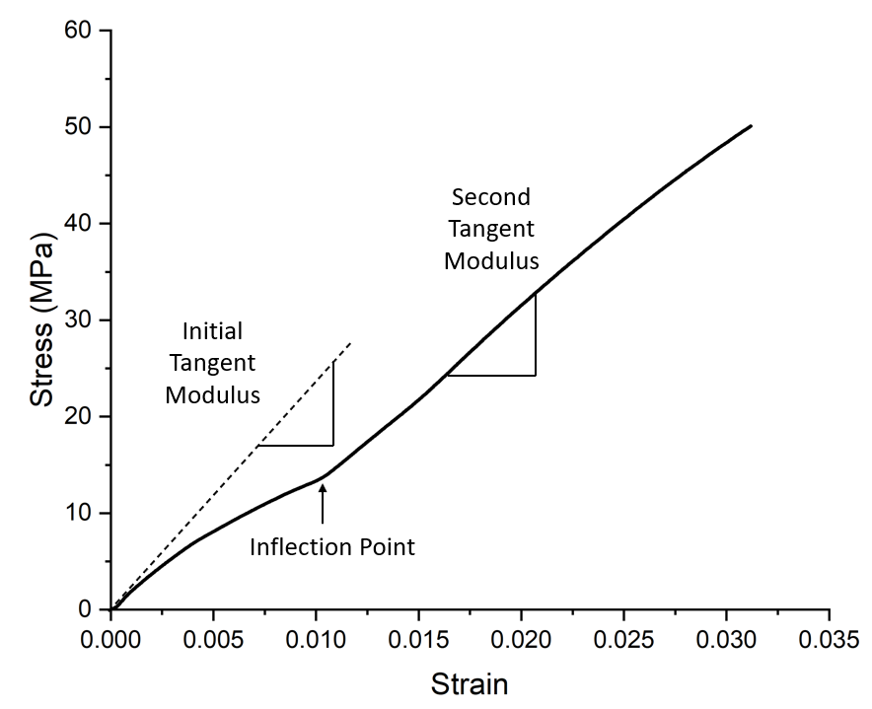
Figure 18 Tensile stress-strain curves for each formula exhibited two distinct regions, an initial non-linear behavior followed by a linear region.

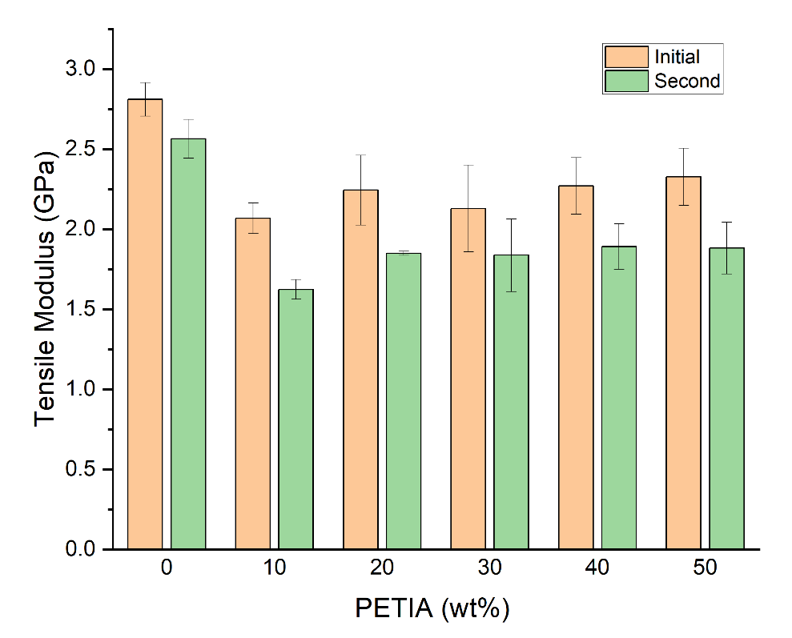
Figure 19 Tensile modulus variation by PETIA content, with increased PETIA causing a drop in modulus from the pure Bis-EMA baseline. Error bars indicate +/- one standard deviation.

4.5 Glass Transition Temperature
The DMA curves with varying concentrations of PETIA are shown in Figure 20. The peaks of the tan(δ) curve were used to approximate T_{g}, with peak width defining the full range of the glass transition region [94]. The pure Bis-EMA formulation had a T_{g} of 146 °C, and with 10% PETIA content T_{g} increased to 172 °C while also moderately widening the glass transition region. Higher PETIA content resulted in a reduction in T_{g}, with 20 wt% nearly matching the pure Bis-EMA level and any further PETIA increase dropping the T_{g} below that of pure Bis-EMA. Increasing levels of PETIA also resulted in significant widening of the glass transition region. The lower and wider peaks with higher PETIA content indicate a reduction in the dissipative effects of the Bis-EMA and a shift towards more elastic behavior. Each formulation also exhibited a minor transition at ~60 °C, which could indicate some movement in the Bis-EMA portions of the polymer network [95].

4.6 Volumetric Shrinkage
To assess the change in volume accompanied by curing, the liquid density $ρ_{liquid}$ of each formulation was compared against the cured polymer $ρ_{cured}$ according to Equation 6:

$$∆V=\left(\frac{ρ_{liquid}-ρ_{cured}}{ρ_{liquid}}\right)x 100\% (6)$$

where volumetric shrinkage $∆V$ is expressed as a percentage reduction from the liquid state. The measured liquid density varied from 1.118 g/cm³ for pure Bis-EMA to 1.149 g/cm³ with 50 wt% PETIA, with density measurements closely matching the values predicted by the rule of mixtures. The cured specimen density also increased with higher PETIA content, ranging from 1.177 g/cm³ for pure Bis-GMA to 1.233 g/cm³ with 50 wt% PETIA. The calculated volumetric change (see Figure 21) indicates a steady increase in cure-induced shrinkage with higher PETIA content. Tukey HSD was applied to the data sets, and multiple comparison of means for one-way ANOVA confirmed no statistically significant difference between 0 wt% and 10 wt% PETIA or between 40 wt% and 50 wt% PETIA. 40 wt% PETIA, however, differed significantly from all other formulations
Figure 20 Tan(δ) curves for Bis-EMA formulations with varying levels of PETIA, indicating a rise and fall of Tg with increasing PETIA content accompanied by a broadening of the Tan(δ) peaks.

and had the highest average cure shrinkage. A summary of the UV polymer cure test results is given in Table 3.

4.7 Formulation down selection and thermal treatment characterization
To demonstrate the viability of Bis-EMA/PETIA formulations in a composite tooling application, the 20 wt% PETIA formulation was selected for a tooling case study. Both the 10 and 20 wt% PETIA formulations had a T_{g} comparable to or higher than the baseline Bis-EMA, but the 10 wt% PETIA formulation had a lower tensile modulus and lower hardness ratio than the 20 wt% PETIA formulation. The tensile modulus was highest for the baseline Bis-EMA and lowest with 10 wt% PETIA. Because of its improved bottom surface hardness and acceptable T_{g} , the 20 wt% PETIA formulation was selected for further study.

To understand the effects of elevated temperature service on the UV cured polymers, 3mm thick tensile dog bone specimens were prepared from the 20 wt% PETIA formula and subjected to thermal treatment at 135 °C (275 °F) for 10 hours and 20 hours. These specimens were characterized by tensile testing, TGA and FTIR. In Figure 22, the TGA results show that the UV only baseline, 10 hr and 20 hr thermal treatment specimens all saw onset of significant mass loss between 370 – 390 °C (700 – 735 °F) under a nitrogen atmosphere.

Tensile and FTIR results are given in Table 4. The average initial tangent modulus increased from 2.24 GPa with no thermal treatment to 2.57 GPa after 20 hours of thermal treatment, and multiple comparison of means confirms that this increase is statistically significant. At 10 hours of thermal treatment, the increase to 2.47 GPa did not differ significantly from the baseline 2.24 GPa tensile modulus.

The FTIR results provide an indication of the extent of curing in the 20 wt% formula at the different levels of thermal treatment. Note that the DC does not reach 100% at any point, which is typical for a glassy polymer system due to vitrification [40]. The UV

Figure 21 Change in cure-induced shrinkage with PETIA content, showing a slight increase with higher PETIA levels.

Table 3 Summary of UV cured polymer test results. Increasing PETIA content consistently improves through thickness cure response, can improve Tg at low levels and causes some increase in cure-induced shrinkage.
 |  | Vickers Hardness
wt% PETIA |  | Top | Bottom | Ratio (%) |  | Tg (°C) | Cure Shrinkage (%)
0 |  | 22.6 [1.6] | 14.7 [0.8] | 65% |  | 146 | 5.3 [0.6]
10 |  | 23.8 [1.6] | 16.8 [1.5] | 71% |  | 172 | 5.2 [0.7]
20 |  | 23.7 [1.0] | 18.6 [1.2] | 79% |  | 150 | 7.1 [0.6]
30 |  | 24.0 [0.6] | 19.2 [1.4] | 80% |  | 137 | 6.9 [0.4]
40 |  | 25.0 [1.1] | 21.3 [1.4] | 85% |  | 132 | 7.8 [0.4]
50 |  | 25.0 [1.6] | 22.7 [1.4] | 91% |  | 123 | 7.3 [0.4]
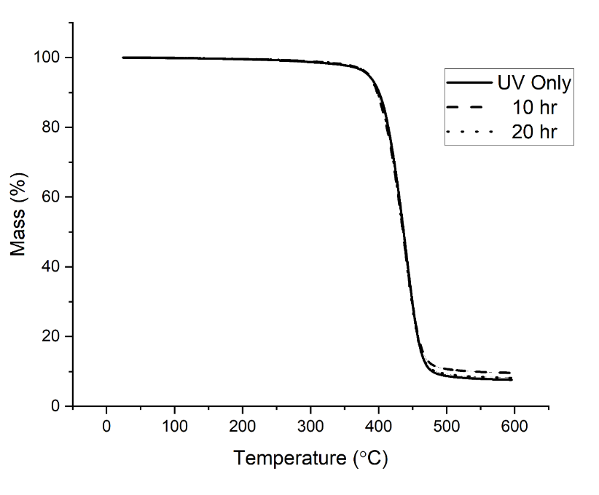
Figure 22 Thermogravimetric analysis of cured 20 wt% PETIA photopolymers, comparing the effect of varying lengths of thermal treatment at 135 °C (275 °F) post UV irradiation. Negligible change is observed between the different treatment conditions.

Table 4 Effect of thermal aging on modulus and degree of conversion (DC) for 20 wt% PETIA photopolymer.
Thermal History | Initial Tangent Modulus (GPa) |  | Degree of Conversion (%)
Thermal History | Initial Tangent Modulus (GPa) |  | Top | Bottom
UV Only | 2.24 [0.22] |  | 78.7 [1.8] | 69.4 [3.2]
10 hrs at 135 °C | 2.47 [0.18] |  | 79.3 [1.8] | 72.8 [1.2]
20 hrs at 135 °C | 2.57 [0.10] |  | 79.7 [0.9] | 71.9 [4.2]

incident (Top) and non-incident (Bottom) faces of the tensile specimens were measured for DC, and in all instances the specimens had a lower average DC on the bottom surface than the top surface. DC ranged from 71.9% to 79.7% across the treatments, and multiple comparison of means shows that while top and bottom faces differed across nearly all treatments, there was no statistically significant change in DC with increased thermal treatment.

These findings confirm that the 20 wt% PETIA formulation can withstand 20 hrs of thermal treatment at temperatures comparable to those witnessed by autoclave tooling. FTIR indicates no additional crosslinking is occurring at the measured surfaces under prolonged heating. Tensile testing shows a 15% increase in the modulus after 20 hrs of heating, which may indicate some molecular realignment due to improved mobility at the elevated temperatures. Both DC and VHN indicate that the 20 wt% PETIA formulation has a lower level of cure on the non-incident face at 3 mm thickness.

4.8 Proof of concept tooling using layer-based additive processing
To demonstrate the viability of Bis-EMA in a composite tooling application, a small tool for pre-preg composite part layup was constructed using a pseudo-additive manufacturing technique. The stock material for the tool measured 100 mm x 150 mm x 9 mm and was made by infusing 20 wt% PETIA formulation into a laminate of nonwoven fiberglass mats under vacuum. Each laminate consisted of twelve layers of chopped strand fiberglass mat at 229 grams per square meter areal mass (F-454 from Composite Envisions, Wausau), and cured laminates measured 3 mm thick. Infused laminates were irradiated through a glass plate using a dynamic lamp setup to scan the Altair 75 UV
lamp across the laminate at a constant rate of 5 mm/s, equivalent to a static dose of 6.0 J/cm² incident on the laminate surface (see Figure 23). The stock material was built up in
three successive laminates cured in separate UV scans, imitating the curing conditions of a large-scale additive manufacturing process. Early process testing determined that
fiberglass was necessary to prevent warping and cracking when curing a relatively large surface area at 3 mm thickness.
The block of photopolymer composite, once irradiated, was then post cured in an oven with the same thermal cycle as the tooling would undergo during pre-preg curing, 90 minutes at 135 °C (275 °F). Thermal post curing is common for thermosets as a mean of driving the cure reaction further, and can be effective in improving degree of cure in photopolymers [34, 36]. While FTIR testing of the neat resin indicated no further curing upon additional heating, post curing was performed on the tooling stock as a matter of caution to mitigate any potential warping of the tool geometry due to further polymer changes during thermal cycles.

After post curing, the photopolymer block was machined to create the tool geometry, which was then further sealed with a polymeric top coating to ensure a smooth finish. Two tools were produced with the same geometry and sealed using distinct top coatings. Tool #1 was coated with TD Seal HT™ (TruDesign, Knoxville), a sprayable thermoset coating developed for 3D printed tooling [96] with a vinyl ester base chemistry and temperature resistance up to 177 °C (350 °F). After coating, Tool #1 was post cured for an additional hour at 121 °C (250 °F) per manufacturer recommendations. Tool #2 was coated with the same 20 wt% PETIA photopolymer formulation as the stock material and cured under UV light. After initial UV cure, Tool #2 was thermally post cured for an additional 90 minutes at 135 °C (275 °F).

After post curing the coating, both tools were treated with Frekote 770 NC mold release and used to fabricate five carbon fiber composite parts. Each part had a laminate consisting of two layers of 2x2 twill carbon fiber-epoxy pre-preg from Rock West Composites (Salt Lake City). Once the pre-preg was laid up in the tooling, the entire tool was placed under vacuum in an envelope bag, debulked for a minimum of 15 minutes, then oven cured for 90 minutes at 135 °C (275 °F). Figure 24 outlines the tool manufacturing and dimensional analysis steps, Figure 25 shows the tools before any part cycles, and Figure 26 shows the tools after several part cycles with an example carbon fiber composite part. Note that Tool #1 has a darker appearance than Tool #2 because of
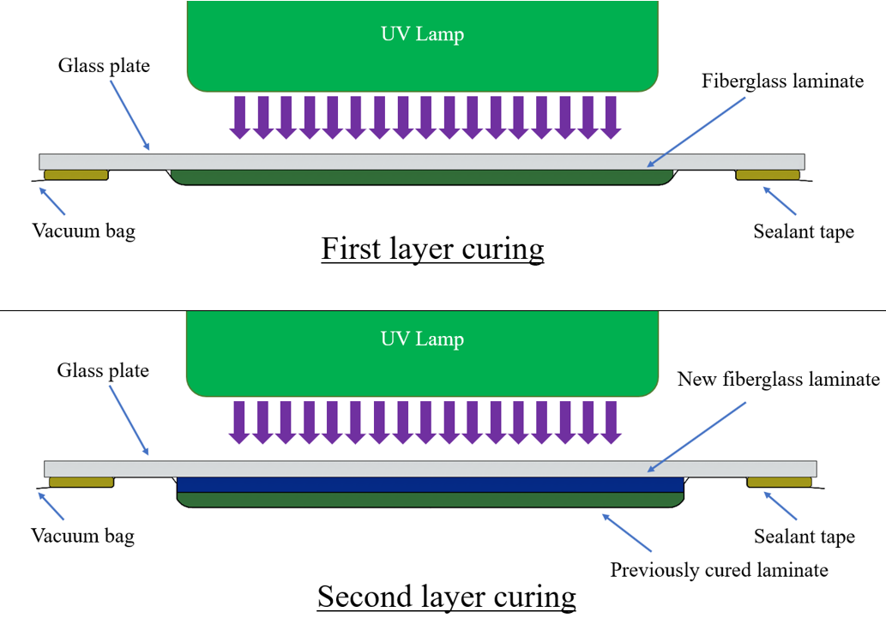
Figure 23 Fiberglass laminate curing and pseudo-additive manufacturing process in which new laminates are infused and cured while in direct contact with the previously cured laminate.

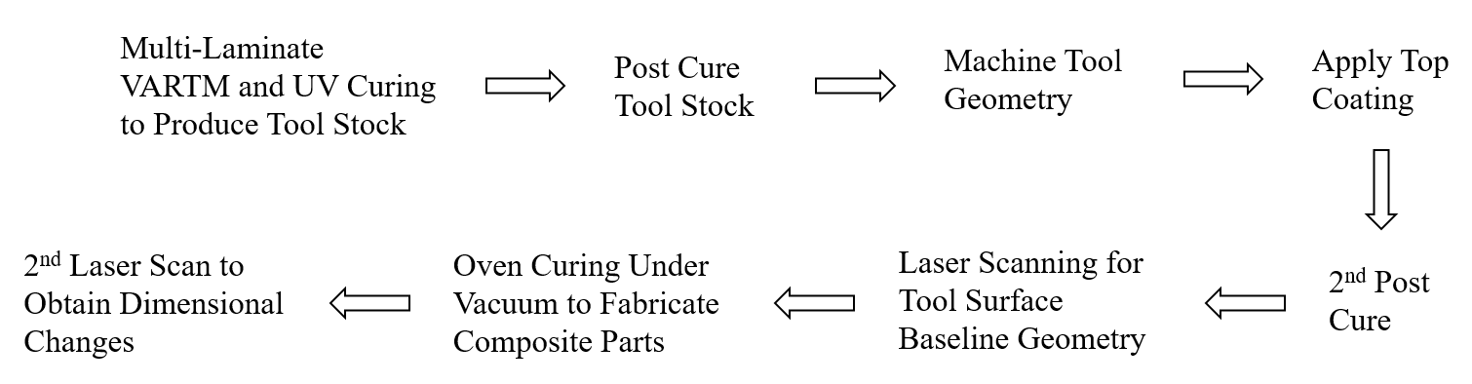
Figure 24 Schematic for the design, fabrication and durability analysis of the UV cured tooling.

the specialty surface coating on the tool face, and after multiple part cycles the surface finish of Tool #1 became duller.

4.9 Tooling stock material degradation assessment via hardness testing
The photopolymer tooling was first assessed using Vickers hardness to determine the impact of the thermal history on polymer degree of cure. A section of stock material was reserved from both tools and received the same thermal history as the tools themselves. Vickers hardness was measured on the top and bottom stock faces for each tool section. The stock material was kept uncoated to ensure the same polymer was being measured on both faces, and care was taken during measurement to test only resin rich areas and avoid fibers. The “top face” of the stock material was the first cured laminate while the “bottom face” was the third and last cured laminate layer (see Figure 26). Measurements were taken after UV irradiation, after machining and post curing, and after five part cycles. The results are shown in Table 5.

Tukey HSD was applied to the data sets, and multiple comparison of means for one-way ANOVA confirmed no statistically significant differences over the thermal history. However, there was a statistically significant difference between the third and first laminate layers, which remained consistent throughout the thermal history. When comparing Tool #1 and Tool #2, only data from the third layer could be obtained. Tool #2 had a lower third layer hardness than Tool #1, averaging between 20.6 and 20.7, but this difference was not statistically significant.

4.10 Tooling stock material degradation assessment via DMA
To assess the impact of multiple thermal cycles on T_{g} and viscoelastic behavior of the fiberglass-photopolymer composite, sections of tooling stock from Tool #2 were machined into 30 mm x 5 mm x 1 mm specimens and tested via DMA using the same parameters as the neat resin testing. Specimens were tested from tool stock with UV cure only and from tool stock with post cure and 5 molding cycles, and they were machined
from the third layer and tested with the UV incident side facing up in the test fixture. DMA results are shown in Figure 28.
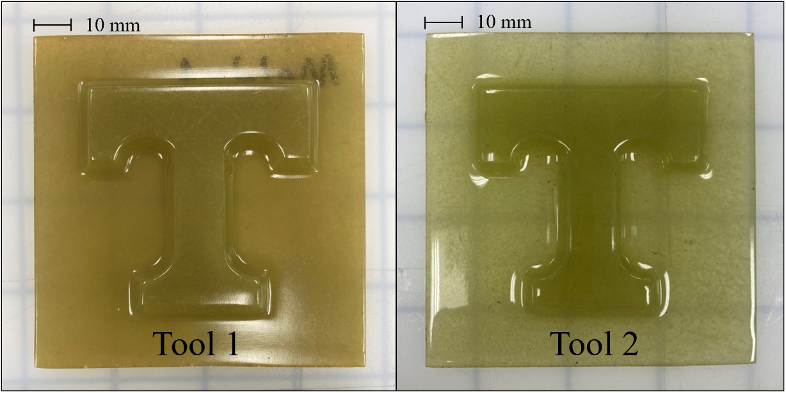
Figure 25 Tool #1 was coated with TD Seal HT™, a common coating for autoclave-capable 3D printed tooling, while Tool #2 was coated with the same photopolymer used in the stock material.
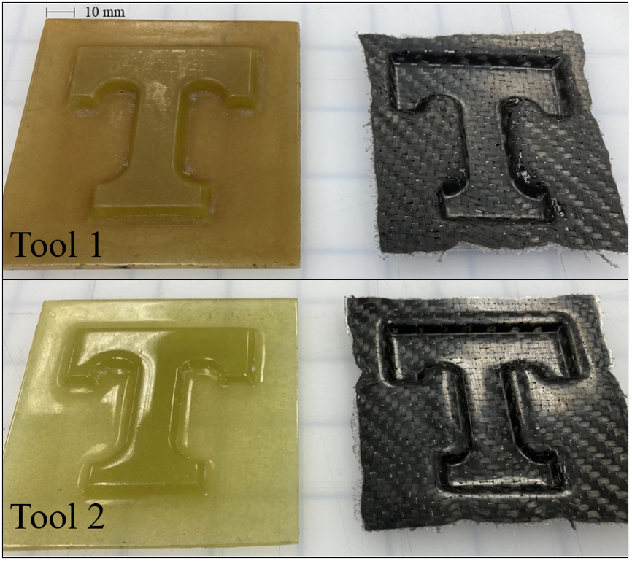
Figure 26 Tool #1 and Tool #2 after multiple part cycles and an example part produced using the tooling. The finish on Tool #1 had become matte in texture, while Tool #2 remained glossy.

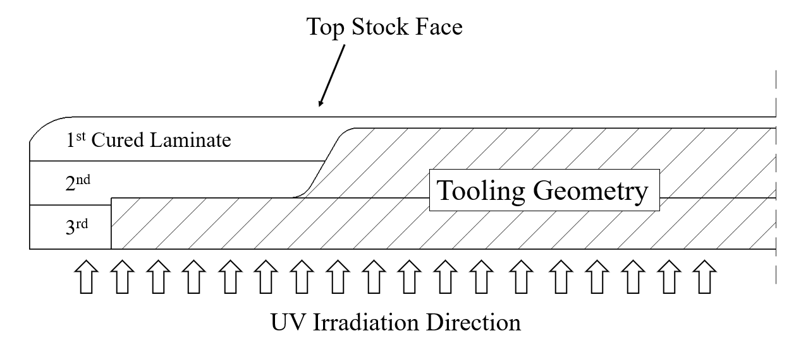
Figure 27 Vickers hardness measured from the top and bottom stock faces, as indicated relative to the machined tooling geometry. Note that the tooling mold face (Power T) primarily consists of the 1st and 2nd cured laminate layers

Table 5 Average VHN from top stock face (First) and bottom stock face (Third) of the tool stock at varying thermal aging. The third laminate layer was measured at the UV incident face for its respective cure cycle.
 | Tool #1 |  |  | Tool #2
Thermal History | First | Third |  | First | Third
UV Only | 20.1 [2.1] | 22.3 [2.8] |  | - | 20.6 [0.6]
Post Cured | 20.2 [1.6] | 22.4 [2.1] |  | - | 20.7 [1.1]
5 Molding Cycles | 18.7 [1.0] | 22.3 [1.0] |  | - | 20.6 [1.4]

The tan delta curve of the “UV Only” baseline closely matches that of the unreinforced 20 wt% PETIA formulation, with a T_{g} of 154 °C. After multiple thermal cycles, however, the T_{g} shifts up to 172 °C, which is equivalent to the highest reported T_{g} for the neat resin formulations. The peak also narrows and drops in amplitude, which could indicate a shift towards more elastic behavior.

4.11 Tooling degradation assessment via laser scanning
A baseline high resolution 3D model of the tool surface was generated for both tools using a FaroArm portable coordinate measuring machine (CMM) equipped with Laser Line Probe (FARO Technologies Inc., Lake Mary). After composite part fabrication, a second scan was performed on each tool and the scans were analyzed for geometric deviation using Geomagic Control X software (3D Systems, Rock Hill). Tool #1 showed an average deviation of +0.03 mm/-0.03 mm (+0.001”/-0.001”) while Tool #2 had an average deviation of +0.05 mm/-0.02 mm (+0.002”/-0.001”). For comparison, Kunc et al. found that autoclavable PPS 3D printed tooling showed deformations not exceeding 0.1 mm (0.004”) after one cure cycle of a larger tool with simple geometry [67]. As shown in Figure 29, both tools exhibit a positive deviation around the perimeter of the T shape, an area more prone to residue build-up after part demolding. Tool #1 had more visible residue build up at this perimeter region than Tool #2, but overall Tool #1 had a lower average deviation. The low average deviation of both tools indicates that this polymer formulation and the 3mm layer pseudo-additive manufacturing process are suitable for creating tooling durable and stable enough to oven cure multiple composite parts.

5.0 Discussion

5.1 Viscosity and process suitability
The measured viscosity of the various Bis-EMA/PETIA formulations ranged from 2.38-2.05 Pa-s at low shear, which is too high for inkjet printing at ambient conditions but falls
within an acceptable range for SLA, DLP and cDLP [74], [75], [77], [78]. While some vat polymerization printers exist with build areas greater than 2 m² [97], the 3mm layer height targeted in the present study is best suited for material extrusion methods such as
UV-DIW. The measured viscosity falls below the 100-10,000 Pa-s range reported for
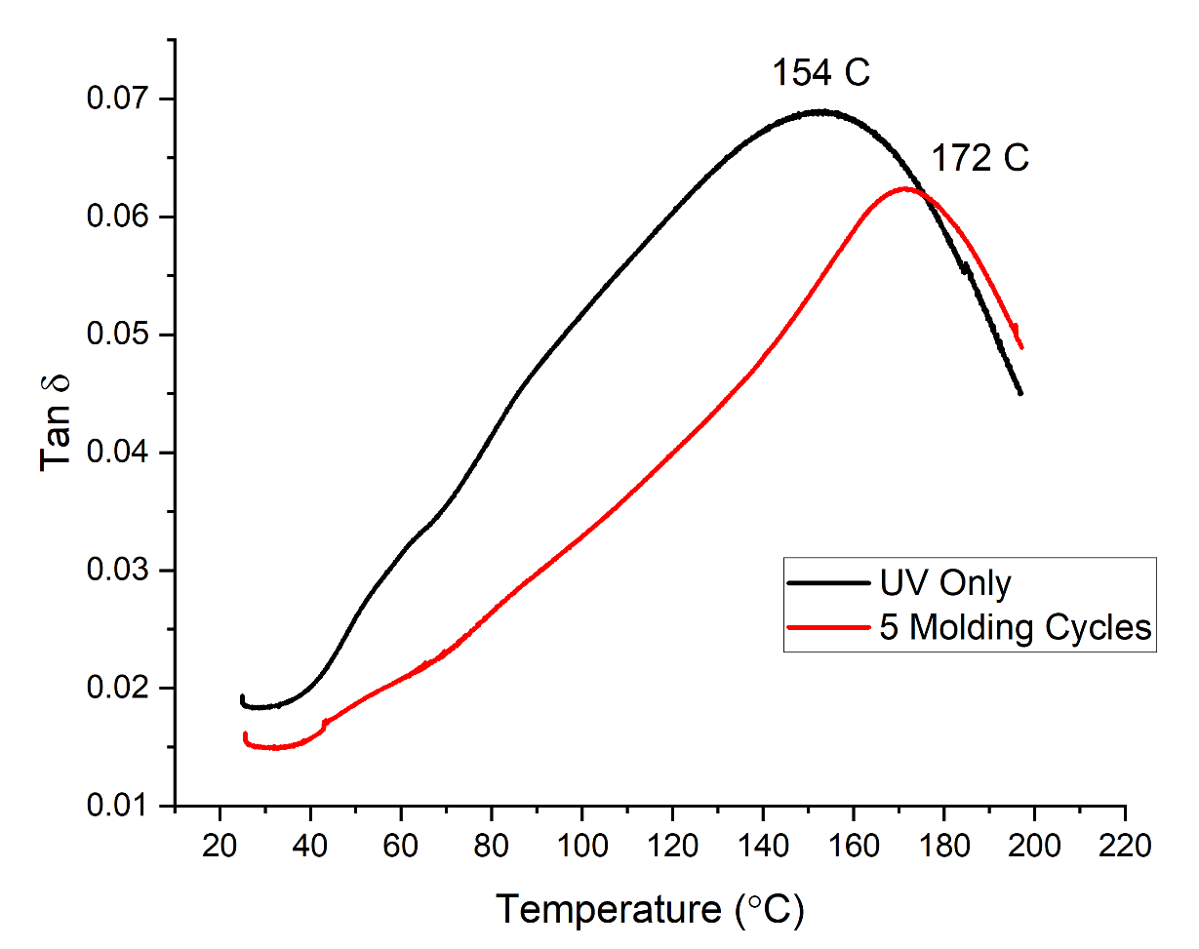
Figure 28 Tan delta response for samples extracted from tooling stock show an increase in T_{g} after thermal post cure and five part molding cycles.

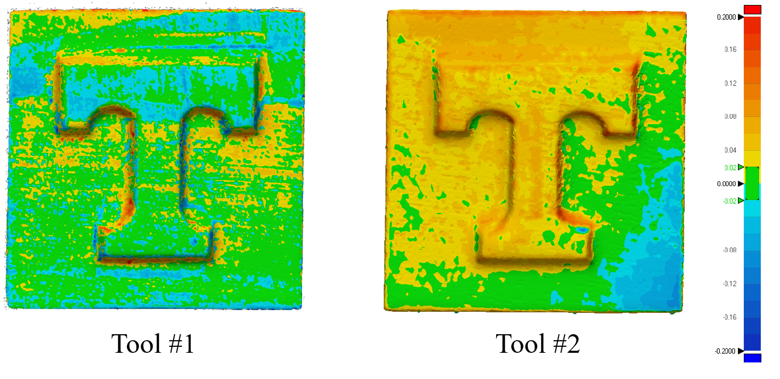
Figure 29 Deviation analysis for the scan performed after five part cure cycles in comparison to the baseline scan. Tool #1 was coated with TD Seal HT™ and Tool #2 coated with 20 wt% PETIA/ 80 wt% Bis-EMA photopolymer.
UV-DIW photopolymer inks [70], [88]. It is anticipated that future ink development work can develop suitable viscosities and shear-thinning behavior in Bis-EMA/PETIA formulations by incorporating fillers such as fumed silica, fiberglass, silica, carbon fiber and carbon nanotubes [70], [84], [85].

5.2 Improvement in Cure Response with PETIA
By combining Bis-EMA with PETIA, it was hypothesized that the through thickness cure response would improve for a given UV dose. Hardness testing results show a consistent trend of improved through cure with higher levels of PETIA in the formulations, with the bottom surface hardness and hardness ratio improving from 65% for pure Bis-EMA to 91% with a 50:50 blend of Bis-EMA and PETIA. However, FTIR analysis showed no statistically significant difference in the bottom surface DC for all formulas except at 10 wt% PETIA, which was lower in both top and bottom surface hardness than all other formulas.

This initial hypothesis was that PETIA would improve cure reaction rates because the acrylate pendant groups cause less steric hindrance than methacrylate groups and acrylate-based photopolymers generally have a higher polymerization rate than methacrylate-based photopolymers [47], [90]. PETIA also has higher overall reactivity than Bis-EMA, with three to four carbon double bonds available to react with a free-radical while Bis-EMA has two. The higher bottom surface hardness appears to indicate an increase in crosslink density linked to the increased functionality of PETIA [23], [90], [98]. The FTIR results appear to indicate that PETIA has limited influence on the overall degree of conversion for a given dose. However, since both PETIA and Bis-EMA influence the 1637 cm⁻¹ peak, it is difficult to determine if one polymer component is achieving higher double bond conversion than the other.

5.3 Influence of PETIA content on T_{g}
As the level of PETIA present in the formulation increased, the measured T_{g} increased at 10 wt% but decreased with higher PETIA content. Increased functionality typically results in a higher crosslink density, which in turn can yield a polymer network with lower mobility and a higher T_{g} [23], [93]. Higher cure shrinkage, specimen fracture during curing at the highest PETIA loadings, and increasing rigidity of the polymer corresponding with the lower and wider glass transition regions [95], [99]. Increasing PETIA content has a two-fold effect: it reduces the number of aromatic groups in the formulation from Bis-EMA, while increasing the number of carbon double bonds from PETIA. Aromatic groups are a key component in the backbone of high T_{g} thermosets such as epoxy novolac resins [24], [25], [40], [100] and a reduction in the aromatic content of the formulations may contribute to the observed drop in T_{g}. The increase in carbon double bonds may also reduce T_{g} due to the cage effect, and higher functionality acrylates have been reported to leave more unreacted double bonds available after irradiation as free radicals become trapped or “caged” in the vitrified polymer network, reducing the degree of double bond conversion and T_{g} [40], [92]. PETIA may improve cure response and crosslink density over Bis-EMA while also reducing the T_{g}. Future studies can investigate methods of alleviating the cage effect and increasing T_{g} in Bis-EMA/PETIA formulations by heating the irradiated polymer above its T_{g} [47], [62] or irradiating at elevated temperature [49].

5.4 Mechanical properties and cure-induced shrinkage
Increasing PETIA content decreased the tensile modulus of the polymer blend. All formulations exhibited a bi-modal tensile behavior, which may indicate initial stretching in the amorphous chains between crosslinks in the polymer regions with lower crosslink density followed by more elastic behavior under higher loading. The modulus of 2.07 to 2.81 GPa is within the same 2.2-2.3 GPa range as the unfilled ABS base polymer used in the BAAM printer [13]. The reported modulus for the Bis-EMA used in the present study is 3.5 GPa when formulated as a thermoset and post cured. Thermal aging increased the tensile modulus of the 20 wt% PETIA formulation, and future work can investigate the potential influence of thermal post cure temperature on improving Bis-EMA/PETIA photopolymer mechanical properties.

The cure-induced shrinkage steadily increases with higher PETIA loadings from 5.3% to 7.7%, which is expected due to an increase in the number of acrylate functional groups present in the polymer. As these functional groups react and form crosslinks, the long-distance Van der Waals forces within the liquid monomer are replaced with short covalent bonds between monomer units, causing shrinkage [101]. The incorporation of fillers such as ceramics and/or blending in non-acrylate chemistries such as epoxies can reduce this shrinkage by reducing the number of methacrylate and acrylate functional groups present in a given volume [102].

5.5 Tooling Study
The purpose of the thermal post cure after machining was to improve the degree of cure or help homogenize degree of cure across the laminate and prevent tooling warp. Hardness testing indicated that the thermal cycles had no measurable effect on the hardness of the tooling stock and failed to improve the cure gradient, although the T_{g} did increase. Thermal post cure cycles do not generate additional free radicals in a photopolymer, but Decker et al. found that when vitrified photopolymers are raised above their T_{g} some chain mobility is restored and trapped free radicals are able to react, enhancing the degree of cure [62], [63]. DMA testing of 1 mm thick specimens found that the tooling stock could achieve a T_{g} >150 °C without any post curing, and it is possible that the subsequent thermal cure cycles of 135 °C were at too low of a temperature to restore chain mobility and improve curing. Because the tooling stock achieved a T_{g} > 135 °C through a 3 mm laminate with only UV irradiation, thermal post cure steps may be unnecessary to achieve the final part properties needed for autoclave/oven-cure tooling.

One interesting observation is the significant difference between the first and third cured layers in the tooling stock (see Figure 27). In previous layer-by-layer studies of fiberglass-reinforced photopolymer s, the bottom layer of a laminate was found to increase degree of cure with additional layers, up to a thickness of 1 mm [103], [104]. UV light transmission through any photopolymer decreases with increased thickness according to the Beer-Lambert law [38], [105], [106], and photoinitiators such as BDMB have photoproducts that absorb some UV light [107], further impeding UV transmission through thick layers. The tooling hardness data for this study indicate that, at 3 mm layer thicknesses with the 20 wt% PETIA formula, the beneficial effect of multiple UV doses appears to be limited. Instead, at large layer thickness a similar cure gradient appears to exist within each laminate layer as was found in the neat resin static cure testing.

5.6 Optimal Formulation for Large Scale AM
The 80 wt% Bis-EMA, 20 wt% PETIA formula tested in this study was selected for striking the best balance of improved cure response while maintaining T_{g} from the base resin. From hardness measurements, this formula achieved near complete through cure at a 36% lower UV dose than the Bis-EMA control formulation. Other formulation adjustments may further enhance through-thickness cure. For example, the fiberglass-reinforced tooling stock achieved a higher hardness ratio than the equivalent neat resin formulation (84-90% vs. 79%) and a comparable T_{g} at a lower UV dose. This further improvement may indicate some beneficial effect from multiple UV exposures, or faster cure response due to the presence of fiberglass [108].

6.0 Conclusions
This study investigated the effect of adding PETIA, a highly reactive acrylate, to Bis-EMA in concentrations up to 50 wt%. 3 mm thick specimens were irradiated on the top surface with a 5 second burst of monochromatic UV light, and Vickers hardness was measured on top and bottom surfaces to assess cure response. PETIA was found to consistently improve the bottom surface hardness at increasing concentrations, but FTIR results indicated no significant change in bottom surface DC with increasing PETIA content. DMA testing indicated that PETIA content initially raised the Tg at 10 wt% but reduced the Tg below Bis-EMA baseline at concentrations above 20 wt%. Likewise, cure shrinkage did not change with a 10 wt% loading of PETIA, but steadily increased with higher PETIA loadings from 5.3% to 7.7%. At a constant UV dose, the addition of 20 wt% PETIA to Bis-EMA appears to have the best balance of improved through-thickness hardness while retaining autoclave temperature resistance. Post-irradiation thermal treatment of the 20 wt% PETIA formula increased the tensile modulus by 15%, but FTIR indicated no significant change in DC. Tooling was produced using the 20 wt% PETIA formulation in 3 mm layers via a pseudo-additive process and used to manufacture five composite parts with cure cycles at 135 °C (275 °F). Hardness testing of the tooling stock material indicated no change after these thermal cycles, but DMA indicated an increase in T_{g} from 154 °C (309 °F) to 172 °C (342 °F). 3D scans of the photopolymer tooling showed average dimensional changes < 0.1 mm (0.004”). While other formulation and process adjustments may be made to further improve cure response, this study confirms 1) PETIA can provide significant improvements in Bis-EMA formulations when curing thick sections under UV LED, and 2) UV only cure of a Bis-EMA/PETIA photopolymer at ambient temperatures can produce durable oven-cure composite tooling with layer thicknesses matching those of other large-scale AM methods.

Acknowledgements
The authors would like to thank Alex Allen, Zachary Papiez, Liam Pruitt, and Jacob Williams for their contributions to this work as undergraduate student interns at the Fibers and Composites Manufacturing Facility at the University of Tennessee, Knoxville. They would also like to thank Ryan Spencer for his help in proofreading the manuscript, and Stian Romberg for rheology training. The funding for this work was provided in part by the Office of Energy Efficiency and Renewable Energy (EERE), U.S. Department of Energy, under Award Number DE-EE0006926 and gratefully acknowledged. We thank the Institute of Advanced Composites Manufacturing Innovation (IACMI), Knoxville, TN, USA for partial support of this work, as well as Polynt Composites USA and Lambson for donating materials.

CHAPTER II

Photoinitiator selection and concentration in photopolymer formulations towards large format additive manufacturing

A version of this chapter was originally prepared for publication by Alexander Stiles, Thomas-Allen Tison, Liam Pruitt, and Uday Vaidya:

This manuscript was submitted as “Photoinitiator selection and concentration in photopolymer formulations towards large format additive manufacturing” to the ACS Applied Polymer Materials journal (ISSN 2637-6105) on February 26, 2022. The Manuscript ID is ap-2022-00349y.
Alexander Stiles was the involved in the conceptualization, investigation, formal analysis, visualization, and writing of this publication. He wrote the original draft, as well as reviewing and editing in all drafts through to submission and publication. Thomas-Allen Tison was involved primarily in investigating and writing the MATLAB script for the optical model, which was further refined by Alexander Stiles. Liam Pruitt was involved in preparing photopolymer formulations and FTIR investigation. Uday Vaidya was responsible for funding acquisition, and review & editing of the manuscript drafts.

Abstract
Photopolymers are an attractive option for large-format additive manufacturing (LFAM) because they can be formulated from structural thermosets and cure rapidly in ambient conditions under low-energy ultraviolet light-emitting diode (UV LED) lamps. Photopolymer cure is strongly influenced by depth penetration of UV light, which can be limited in the 2-4 mm layer thicknesses typical of LFAM. Photoinitiator (PI) systems that exhibit photobleaching have proven useful in thick section cure applications by generating a photoinitiation wavefront, but this effect is time-dependent. This study investigates the light transmission and through-thickness cure behavior in vinyl ester photopolymer formulations with the photobleaching initiator bis(2,4,6-trimethylbenzoyl)-phenylphosphine oxide (BAPO). Utilizing an optical model developed by Kenning et al., lower concentrations (0.1 wt% to 0.5 wt%) of BAPO were predicted to yield rapid onset of photoinitiation. Is-situ cure measurements were taken under constant irradiation. At 3 mm depth, a 0.1 wt% concentration of BAPO achieved peak polymerization rate within 2.5 s. Under a 1.0 s irradiation with high intensity (1.7 W/cm²) UV LED lamps, the 0.1 wt% BAPO formulation achieved the highest level of cure of the formulas tested. For an irradiation dose of 5.5 J/cm² at a duration of 3.7 s, cured polymer specimens achieved flexural strength and flexural modulus exceeding ABS (1.9 GPa – 2.5 GPa flexural modulus, 59 MPa – 68 MPa flexural strength for ABS). This study demonstrates the utility of optical modeling as a potential screening tool for new photopolymer formulations, primarily in identifying an upper limit to PI concentration for the desired cure depth. The results also show that photobleaching provides only a limited benefit for LFAM applications with short (1.0 s to 3.7 s) UV irradiation times and indicate that excess PI concentration can inhibit light transmission even under extended irradiation times up to 60 s.

Keywords: Large-scale, large format, additive manufacturing, photopolymer, photobleaching, BAP

1.0 Introduction
Large-format additive manufacturing (LFAM) is a nascent technology emerging as an efficient method for producing structural components and tooling for low volume composites manufacturing [14], [65]–[67]. LFAM refers to polymer extrusion-deposition methods that achieve both large scale and high material throughput during printing. Most large format three-dimensional (3D) printers use thermoplastic feedstock, and as of 2016, the Big Area Additive Manufacturing (BAAM) system had a reported maximum deposition rate of 36 kg/hr [11]. Thermosets such as vinyl ester and polyester have also been used in large format printers such as the Reactive Additive Manufacturing (RAM) system developed at the Oak Ridge National Laboratory’s Manufacturing Demonstration Facility (ORNL-MDF). Some challenges of thermoset polymer printers include: (a) balancing cure time and exotherm temperatures to retain wall integrity with uncured resins, (b) limited build height due to wall collapse, and (c) worker safety hazards from volatiles such as styrene [20], [86].

Photopolymers are a subset of thermosets that cure in seconds vs. minutes or hours [22]. In additive manufacturing (AM) methods such as direct ink writing (DIW), ultraviolet (UV) lamps can be utilized to cure a photopolymer ink immediately after deposition [70] (see Figure 30). Unlike thermoset printers, this photopolymer DIW (UV-DIW) prevents wall collapse issues via in-situ curing and has been used to print self-supporting spans of at least 8 mm [88]. While most photopolymer and thermoset research in AM is focused on layer heights of 25-500 μm, a typical layer height for the BAAM is 2-4 mm [10]. Stiles et al. formulated vinyl ester photopolymers towards LFAM scale, focusing on monomer selection as an approach to minimize cure gradients. They reported that 3 mm layers could be fully cured with an irradiation time of 5 seconds under high-intensity UV LED lamps [109].

In photopolymers, a curing reaction follows three steps: photoinitiation, propagation, and termination [23], [32], [33]. Photoinitiation commences when a photoinitiator (PI) molecule absorbs light and forms free radicals. For scission-type PIs such as BAPO, the
Figure 30 Schematic depicting the UV-DIW printing process, in which a photopolymer ink is deposited and rapidly cured in-situ.

PI separates into two or more free radicals, and these react with C=C bonds in the monomer to form a reactive monomer radical. During propagation, the monomer radical starts a chain reaction with the monomer in the formulation until a termination reaction causes a polymer chain to stop growing. Chain propagation can also lead to crosslinking when multifunctional monomers are used [23]. Early in a reaction, the predominant mechanism is bimolecular termination. As the reaction progresses, the viscosity of the solution increases, and radicals can become occluded in the growing polymer network. This radical trapping is a prevalent termination step for glassy photopolymers that become vitrified when curing resins such as Bis-EMA [43], [62], [110]–[113].

Because light absorption initiates photopolymer reactions, the reaction commences at the irradiated surface before progressing through the polymer bulk. The depth of cure in a photopolymer system is guided by the Beer-Lambert Law (Equation 3):

$$A=εbC (3)$$

where absorbance $A$ is the product of molar absorptivity $ε$, the length of the light path $b$ and the concentration $C$ of the absorbing material. The polymer and PI both absorb light to varying extents depending on the material and wavelength of light. With greater light absorbance, light penetration is restricted, and the depth of cure can be inhibited [39]. Hybrid methods such as incorporating thermal initiators or cationic curing chemistry to enable greater shadow curing have been employed for a deep cure. The curing occurs through the thickness upon UV irradiation [105], [114]–[116]. Nanoparticles have also been incorporated into photopolymers to act as internal lamps, enabling cure through the thickness as high as 137 mm [117]. One common method to improve the depth of cure without using hybrid methods or exotic materials is by employing photobleaching PIs, whose reaction byproducts are UV transparent. In a process known as photofrontal polymerization, UV light penetrates deeper into the polymer as the PI reacts. It initiates free radicals at the new depth spurring an initiation wavefront [36], [41], [45], [107]. Applications in dentistry regularly apply photobleaching PIs for depth of cure as high as 6 mm [118]. Cure depths as great as 52 mm were reported for a novel methacrylate photopolymer using photobleaching TPO-L as the PI [119].

The present study focused on BAPO as a photobleaching PI to improve the cure response of Bis-EMA vinyl ester in 3 mm thick layers. Formulations with PI concentrations of 0.1 wt%, 0.5 wt%, and 1.0 wt% were cured under a high-intensity UV LED lamp with a short irradiation time (< 5.0 s), simulating conditions expected of a large-format UV-DIW 3D printer. For a constant UV dose, the authors hypothesized that the level of cure at 3 mm depth would improve at BAPO concentrations of 0.5 wt% or lower. For the same PI concentration, BAPO formulations were also predicted to achieve a higher degree of cure at 3 mm depth than non-photobleaching BDMB control formulations.

2.0 Literature Review
For material extrusion printers such as LFAM systems, Chesser et al. calculated that the material deposition rate drops with the square of the increase in resolution [10]. There are practical limits to print speed for a given printer, such as mechanical limitations of a gantry and momentum effects that decrease resolution in corners. Since machine speed is limited, LFAM printers maximize throughput by increasing layer height. In formulating photopolymers for LFAM, a critical limiting factor is the exposure time required for full through-cure at layer heights of 2-4 mm [109]. Therefore, deposition rates at these layer heights can be improved by decreasing the UV irradiation time required to achieve full through-cure.

In general, for free-radical initiated (meth)acrylate photopolymers, increased UV lamp intensity and curing temperature have been demonstrated to increase the overall DC for a given formulation while also reducing reaction time [40], [120], [121]. Decker found that increased lamp intensity improved acrylate DC even in ambient conditions. An increase in lamp intensity caused a corresponding rise in exotherm temperature within the polymer, increasing reaction rates [40]. The improved DC associated with increased lamp intensity is often attributed to an excess free volume due to rapid polymerization under high light intensity [37], [122]. Unsurprisingly, based on these findings, a standard method for reducing cure time is by increasing lamp intensity, which can range widely from 0.5 mW/cm² to 25 W/cm² or more [38], [40], [118], [120], [121], [123]. Various filled dental resins can achieve complete cure through 2 mm to 6 mm thickness with irradiation times ranging from 20 s to 40 s and lamp intensities of 400 mW/cm² to 1200 mW/cm² [29], [48], [59], [124]. DiPietro reported a full through-cure in 8 mm thick fiberglass laminates after 15 seconds using a photobleaching PI and a high intensity 25 W/cm² spotlight [123]. For LFAM applications, an exposure time of 5 seconds under a 1.7 W/cm² incident light intensity has been correlated with a linear deposition rate of 5 mm/s [109].

In selecting PIs, the peak light-absorbing wavelengths of the PI are often matched to the peak wavelengths for the lamp output to maximize photoinitiation rates (see Equation 1). The two primary options for UV lamps systems are mercury vapor lamps and UV LED lamps. The latter are ideal for LFAM because they are more compact and can cycle rapidly without a ‘warm-up’ period to achieve peak output intensity. UV LED lamps are predominantly available in the UVA emission range (320 to 400 nm). Phosphine oxides such as TPO, TPO-L, and BAPO all absorb light in the UVA range and are photobleaching, making them strong candidates for thick polymer systems (e.g., greater than 0.5 mm). BAPO, in particular, is less sensitive to styrene and is commonly used in photopolymer formulations for curing fiberglass-reinforced composites [22], [114], [125], [126].

While selecting a UVA lamp system improves light penetration depth, the PI type and PI concentration also strongly influence light penetration and cure kinetics [23]. High PI concentration can block light from penetrating deeper into a polymer, creating a cure gradient [41], [107], [112]. The ideal PI concentration varies for a given formulation and desired depth of cure. Lee et al. reported cured gel thickness increased up to 1.2 mm as PI concentration reduced from 0.25 wt% to 0.02 wt% and UV dose increased from 0.9 J/cm² to 22.3 J/cm² [127]. Lecamp et al. found that a dimethacrylate oligomer with Darocur 1173 cured in thin films exhibited an increased conversion rate with increasing PI concentration up to 1.25 wt% but achieved peak ultimate conversion at 0.75 wt% [49]. However, Lecamp et al. also reported that as PI concentration was reduced below 0.75 wt%, the ultimate degree of conversion and resulting glass transition temperature (T_{g}) dropped. PI concentration must therefore achieve a balance in a thick polymer system. Decreasing PI concentration can improve the depth of cure but can also lead to incomplete curing [119] and poor surface cure [23].

An optical model utilizes the Beer-Lambert Law to predict the light intensity and free radical initiation rates within a photopolymer system. Several optical models have been proposed using experimental inputs such as PI molar absorptivity, polymer absorptivity, PI concentration, incident light intensity. These values can be obtained by standard test methods such as UV-Vis spectroscopy and radiometry [41], [107]. Because an optical model does not require formulation work to implement, it may be helpful as a potential formulation screening tool in predicting the effect of PI selection and concentration for a given light input and desired cure depth. The Kenning optical model has been selected for the present study because of its suitability for polychromatic light sources [41], [107]. The Kenning model builds on Ivanov and Decker's initially proposed model [128] based on the Beer-Lambert Law, which predicted the optical density (i.e., absorbance) at a given depth in the polymer based on PI concentration and PI molar absorptivity. This model was later expanded by Miller et al. [36] to account for light attenuation due to the polymer and photolysis byproducts. The Ivanov/Decker and Miller models assumed monochromatic light sources, but Kenning expanded the Miller model to include polychromatic light sources. As with the previous models, the Kenning model predicts light intensity throughout a polymer at a given irradiation time, and by extension, it also predicts rates of free-radical generation [45]. Because free-radical generation initiates the curing reaction, the Kenning model may provide an indirect means of pre-screening a series of formulations for potential cure response under irradiation from the polychromatic UV LED system in the present study. To the author’s knowledge, no prior studies have attempted to use the Kenning optical model as a screening tool for formulations in LFAM or other high-intensity (>100 mW/cm²), short irradiation (>5 s) formulations for curing thick polymer systems.

While the Kenning optical model predicts free radical generation, it is limited because it does not include reaction rate coefficients or temperature dependence. These factors are included in cure kinetics models, which do not predict free radical generation but instead describe the rate at which polymerization occurs. Such models require experimental input on the extent of curing in the polymer obtained via techniques such as UV differential scanning calorimetry (Photo-DSC), Fourier-transform infrared spectroscopy (FTIR), or dielectric analysis [38], [45]–[47]. Of these techniques, FTIR is the most common for monitoring relative C=C bond conversion due to its capability to capture rapid reactions in real-time [50]–[54]. Cure kinetics models are capable of describing termination mechanisms of a reaction and change as the degree of conversion increases [33], [47], [129]. While cure kinetic models include light intensity as a factor [40], [47], [49], [113], [130], most studies assume thin-film curing and do not account for light attenuation in thick polymer systems. Saenz-Dominguez and others [38], [45], [46], [118] have proposed an empirical autocatalytic cure kinetics model, which has been demonstrated for photopolymer systems up to 2 mm thick. Such models can provide an accurate description of the state of cure through the depth of a polymer system, but they also require extensive testing of the target formulation. They are not helpful as a pre-screening tool but can be used as an analytical technique for an existing formulation.

The present study investigated the effect of BAPO in formulations for LFAM, assuming 2-4 mm layer heights and high intensity (>100 mW/cm²) UV LED light sources under short (<5 s) irradiation times. Formulations were prepared at PI concentrations from 0.1 wt% to 1.0 wt% utilizing BAPO, with BDMB as a control PI, and irradiated at 3 mm thickness under simulated LFAM conditions. The Kenning optical model was used to predict radical initiation rates, and this was compared against experimental results using FTIR. A primary objective was to assess the utility of optical modeling as a screening tool in developing formulations for LFAM, as these models can be utilized before formulation.

3.0 Optical Model
For the present work, the optical model developed by Kenning et al. was used to predict the temporal and spatial evolution of light intensity through a 3 mm thick photopolymer [41], [107]. The Kenning model has several experimental inputs specific to the lamp setup and photopolymer formulation. Inputs include incident light intensity and lamp spectral output, PI molar concentration, the molar light absorptivity of the PI, and absorptivity of the polymer. In the present study, the spectral output was centered at the peak of 398 nm for an Altair 75 UV LED lamp (see Figure 34). BAPO was used as the PI with molar concentrations of 0.00267 mol/L, 0.01329 mol/L, and 0.02645 mol/L. These concentrations are equivalent to 0.1 wt%, 0.5 wt%, and 1.0 wt%, respectively. UV-Vis spectroscopy was used to obtain the molar absorptivity for BAPO and Bis-EMA. Once these data were obtained, it was then possible to predict the light intensity and photoinitiation rate for Bis-EMA formulations with BAPO PI before actual formulation work.

The governing equations of the Kenning optical model are shown in Equations 7-9:

$$\frac{∂C_{i}\left(z,t\right)}{∂t}=-\frac{C_{i}\left(z,t\right)}{N_{A}h}\sum_{j}{\left(\frac{ε_{ij}ϕ_{j}I_{j}\left(z,t\right)}{υ_{j}}\right) (7)}$$
$$\frac{∂C_{p}\left(z,t\right)}{∂t}=-\frac{C_{i}\left(z,t\right)}{N_{A}h}\sum_{j}{\left(\frac{ε_{ij}ϕ_{j}I_{j}\left(z,t\right)}{υ_{j}}\right)} (8)$$
$$\frac{∂I_{j}\left(z,t\right)}{∂z}=-\left[ε_{ij}C_{i}\left(z,t\right)+A_{mj}+ε_{pj}C_{p}\left(z,t\right)\right]I_{j} (9)$$

where $j$ is an index with a different value for each wavelength of light considered. $C_{i}\left(z,t\right)$ is initiator molar concentration at depth z and time t, while $C_{p}\left(z,t\right)$ is photolysis product molar concentration and $I_{j}\left(z,t\right)$ is incident light intensity of a specific wavelength. $ε_{ij}$ is the initiator Napierian molar absorptivity of a specific wavelength, and $ϕ_{j}$ is quantum yield of the PI at a specific wavelength (assumed as 0.2) [36], [107]. $N_{A}$ is Avogadro’s number and $h$ is Planck’s constant, while $υ_{j}$ is the frequency of light in units of inverse seconds. $A_{mj}$ is the absorption coefficient of the monomer and the polymer repeat units.

Miller and Kenning assume that initial initiator concentration is uniform through the polymer depth at time 0 (see Equation 10):

$$C_{i}\left(z,0\right)=C_{0} (10)$$

At any time, the incident intensity is constant on the polymer surface (see Equation 11):

$$I\left(0,t\right)=I_{0} (11)$$

Once Equations 7 and 9 are solved numerically, the resulting concentration and light intensity values can be used to determine the rate of photoinitiation, $R_{i}\left(z,t\right)$ in Equation 12:
$$R_{i}\left(z,t\right)=2C_{i}(z,t)\sum_{j}{{\left[I\left(z,t\right)\right]}_{j}ϕ_{j}ε_{ij} (12)}$$

$C_{i}\left(z,t\right), I_{j}\left(z,t\right), { and R}_{i}\left(z,t\right)$ were solved numerically by discretizing and using the method of finite differences in MATLAB software (MathWorks). In addition to neglecting reaction byproducts, the monomer was assumed to be pure Bis-EMA. PETIA was neglected, as were contaminants such as residual methacrylic acid content. As Miller noted, this model also neglects any change in the molar absorptivity of the monomer during curing [36].

4.0 Materials and Methods

4.1 Light Source and Materials
The lamp was an Altair 75 high-intensity UV LED area lamp from Heraeus Noblelight with an emitting window of 80 mm x 13 mm and peak irradiance of 3.7 W/cm² at 395 nm. The primary oligomer in this study was bisphenol A ethoxylate dimethacrylate (Bis-EMA) (see Figure 31). The reactive diluent was PETIA, a 50:50 molar mixture of tri- and tetra-acrylate esters of pentaerythritol supplied by Allnex. The primary PI was BAPO, supplied as Omnirad 819 by IGM Resins, and the control PI was BDMB, a highly reactive alkylaminoacetophenone supplied by Lambson (see Figure 32).

In the present study, 3 mm thick photopolymer formulations used BAPO as the primary PI and BDMB as a control PI. The experiments and model were separated into two parts:

- Optical Model – PI absorptivity values from UV-Vis spectroscopy results were used to build an optical model and predict photoinitiation rates at 3 mm depth for BAPO concentrations of 0.1 wt%, 0.5 wt%, and 1.0 wt%. Formulations were then prepared at the same concentrations for both BAPO and BDMB, and 3 mm thick specimens were irradiated continuously for 60 s while monitoring cure via FTIR. The FTIR results were used to determine the cure rate at 3 mm depth and compared against the optical model.
- Pulse Irradiation Response - To simulate the curing conditions of LFAM processing, formulations were also irradiated at short irradiation times of 1.0 s and 3.7 s, and FTIR was used to determine the cure response at 3 mm depth. The four formulations with the highest degree of C=C conversion under 3.7 s irradiation were selected and further tested for mechanical properties under the same irradiation conditions.

The results of the short irradiation testing were then compared against the optical model to determine the potential value of light absorption as a screening mechanism for LFAM photopolymer formulations.

4.2 PI Absorptivity
Absorption properties of BAPO and BDMB were determined by ultraviolet-visible (UV-Vis) spectroscopy on an Evolution 300 spectrometer from Thermo Fisher Scientific. PI was dissolved in methanol at 0.01 wt%, and the solution was tested in a 1400 microliter quartz cuvette with a lid from Thorlabs, Inc. The scan range was 200 to 600 nm, with a bandwidth of 2.0 nm. Specimens were tested before and after 60 s of UV irradiation.

4.3 Specimen Preparation
A base polymer formulation was prepared with 80 pph Bis-EMA and 20 pph PETIA. Formulations were then prepared with each of BAPO and BDMB at PI concentrations of 0.1, 0.5, and 1.0 pph. These were mixed under low heat using a hot plate stirrer for 10 minutes, then allowed to rest for at least 24 hours before UV irradiation at ambient temperatures. All test specimens were cured in a polytetrafluoroethylene (PTFE) molding fixture measuring 25 mm in diameter with a mold cavity of 6 mm in diameter 3 mm in thickness. Each specimen was cured with the mold positioned to center specimens in the emitting window. The specimens were irradiated at 10 mm from the top surface of the photopolymer to the UV lamp emitting window.

4.4 Continuous Irradiation Testing
The formulations were irradiated for 60 seconds at an incident intensity of 380 mW/cm² on the polymer surface, as measured using an ILT800 radiometer from International Light Technologies. Two studies were conducted under this continuous irradiation: radiometry to measure transmitted light intensity and FTIR to measure the degree of cure at 3 mm depth in the polymer specimen. In the radiometry study, all specimens were tested with a PET film and 1 mm thick quartz discs covering the top and bottom of the mold to mitigate oxygen inhibition and control sample thickness. For the FTIR study, testing was conducted on a Nicolet iS50 FTIR Spectrometer with an attenuated total reflectance (ATR) module, both from Thermo Fisher Scientific. To ensure intimate contact of the cured polymer with the diamond crystal of the ATR, the mold and lamp were positioned directly over the crystal. Specimens were irradiated in situ for 60 s. During irradiation, measurements were taken in real-time (RT-FTIR) in a series of scans
Figure 31 Primary oligomer Bis-EMA is di-functional while PETIA has tri- and tetra-functionality.

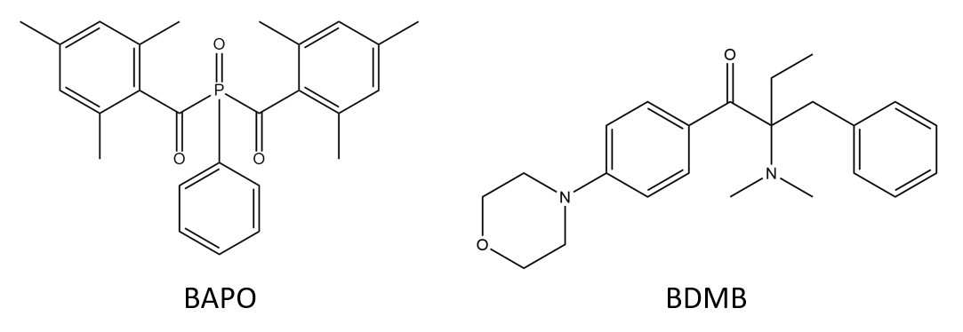
Figure 32 BAPO is a common photobleaching PI, while BDMB is highly reactive.

at 4 cm⁻¹ resolution and a gain of 8.0. An additional scan was taken at 10 minutes post-irradiation 64 scans at 4 cm-1 resolution for each test. A minimum of three specimens of each formula were tested for both radiometry and RT-FTIR, with the specimen setup shown in Figure 33.

4.5 Pulse Irradiation Testing
Each BAPO and BDMB formulation was irradiated for 1.0 s and 3.7 s at an incident intensity of 1600 mW/cm² and a total equivalent dose of 1.4 J/cm² and 5.5 J/cm², respectively. Samples were prepared in the same setup as RT-FTIR, irradiated in situ on a diamond ATR accessory. Scans were taken before testing for baseline polymer levels and 10 minutes post-irradiation, with 64 scans at 4 cm⁻¹ resolution.

4.6 Flexural Testing
Two BAPO formulations and two BDMB formulations were selected for further mechanical testing based on FTIR results. Flexural specimens were prepared with nominal dimensions of 12.7 mm width x 3 mm depth x 58 mm length. Specimens were cured in white acrylic molds at 3.7 s pulse irradiation at 1600 mW/cm² incident light intensity, with PET film and 1 mm thick glass microscope slides on top and bottom. Three-point bend testing was conducted per ASTM D790, with a minimum of six specimens per formula.

5.0 Results and Discussion

5.1 Absorption Spectra
As shown in Figure 34, both BAPO and BDMB have some absorptivity in the UV-A range, overlapping the spectral output of the Altair 75 lamp. BDMB is considered a highly reactive PI because of its high molar absorptivity at lower wavelengths. However, in the UV-A range, BAPO has higher absorptivity than BDMB. At the peak lamp output wavelength of 398 nm, BDMB has a molar absorptivity of 249.9 L/mol-cm while BAPO is 679.9 L/mol-cm. This higher absorptivity blocks light transmission and can impede the depth of cure during initial irradiation. Since BAPO has UV transparent photoproducts (see Figure 6), light can penetrate deeper into a specimen as the PI reacts.
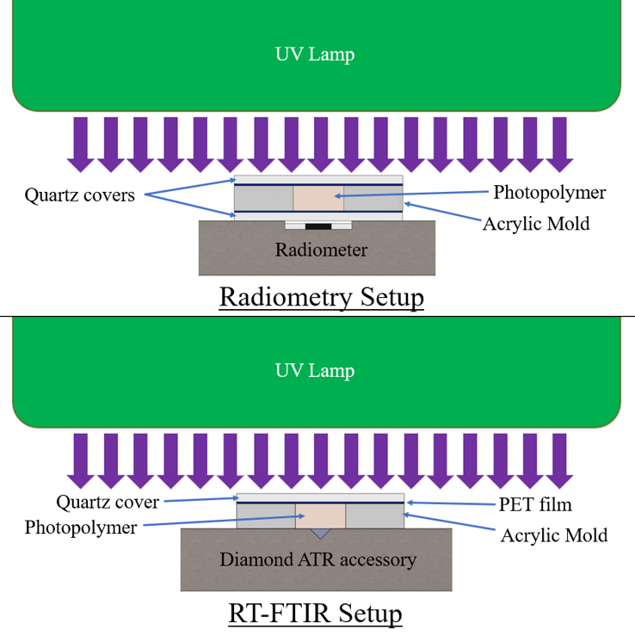
Figure 33 Specimen setup for 60 s irradiation testing at 3 mm specimen thickness.

BDMB, on the other hand, has limited photobleaching and nearly no change in absorptivity within the spectral output of the lamp in the present study.

5.2 Optical Model for Photobleaching
Based on UV-Vis results, the “Post UV” molar absorptivity shown in Figure 35 indicates that BAPO has reaction byproducts that are UV transparent in the 350 to 450 nm range. Therefore, when modeling BAPO, the reaction byproducts are assumed to have no absorptivity in the emitting range of the UV LED. This eliminates Equation 8 and reduces Equation 9 to the modified Equation 13:

$$\frac{∂I_{j}\left(z,t\right)}{∂z}=-\left[ε_{ij}C_{i}\left(z,t\right)+A_{mj}\right]I_{j} (13)$$

Utilizing Equations 7 and 10-12, the model was solved for BAPO at 0.1 wt%, 0.5 wt%, and 1.0 wt%, which are equivalent to molar concentrations of 0.00267 mol/L, 0.01329 mol/L, and 0.02645 mol/L, respectively. A continuous, constant UV irradiation was assumed, with an intensity output matching the Altair 75 lamp, at peak irradiation of 380 mW/cm².

Figure 36 shows the theoretical photoinitiation rates for BAPO at the 1.0 wt% concentration. Note that the peak photoinitiation rate shifted over a 10 s period from 0.5 mm depth at 0.5 s to a depth of 4.7 mm, indicating an initiation wavefront due to photobleaching. The peak initiation rate occurred closest to the irradiated surface, and as photoinitiation progressed into the polymer, the peak rate also decreased. Kenning reported this same trend for BAPO at 0.0268 mol/L concentration and a 93 mW/cm² light intensity, with falling peak initiation rates at increasing time and depth [107].

The predicted photoinitiation rates at a depth of 3 mm are shown in Figure 37. As this figure shows, the Kenning optical model predicted the most rapid onset of photoinitiation at the 0.1 wt% BAPO concentration. In contrast, the highest PI concentration of 1.0 wt% BAPO yielded the highest photoinitiation rate. However, at the 1.0 wt% BAPO
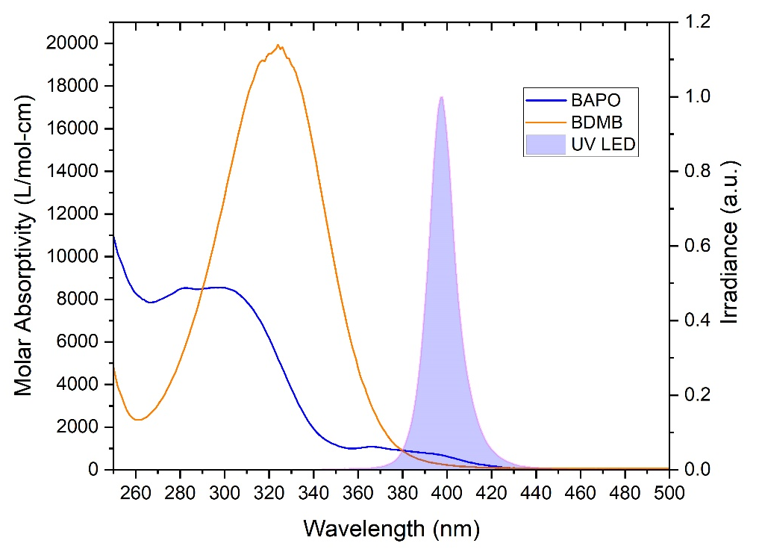
Figure 34 The molar absorptivity of BAPO and BDMB compared with the spectral output of an Altair 75 lamp using 395 nm LEDs. The measured spectral output indicated a peak UV output at 398 nm.

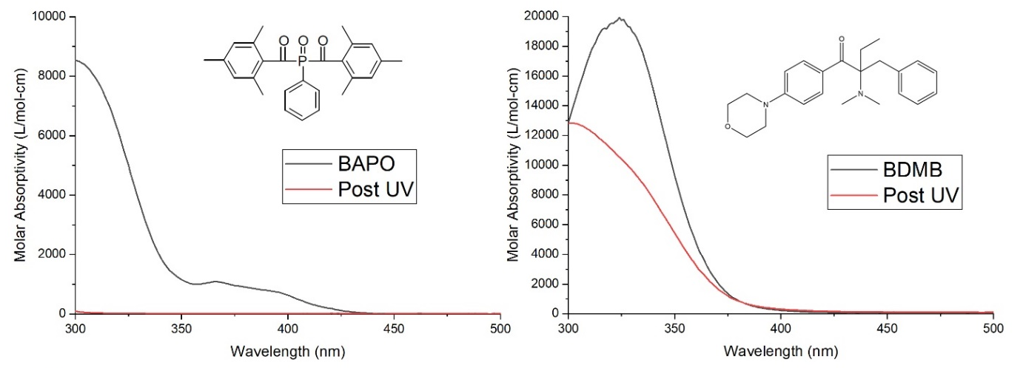
Figure 35 Comparison of initial molar absorptivity of the BAPO and BDMB PIs with the absorptivity of PI byproducts. Reaction byproduct molar absorptivity is indicated by ‘Post UV.’

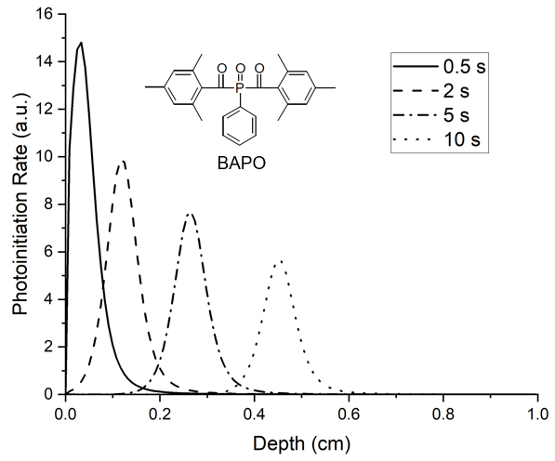
Figure 36 Photoinitiation rate for BAPO system at 1.0 wt% concentration, showing the temporal and spatial evolution of photoinitiation as the BAPO photobleaches.

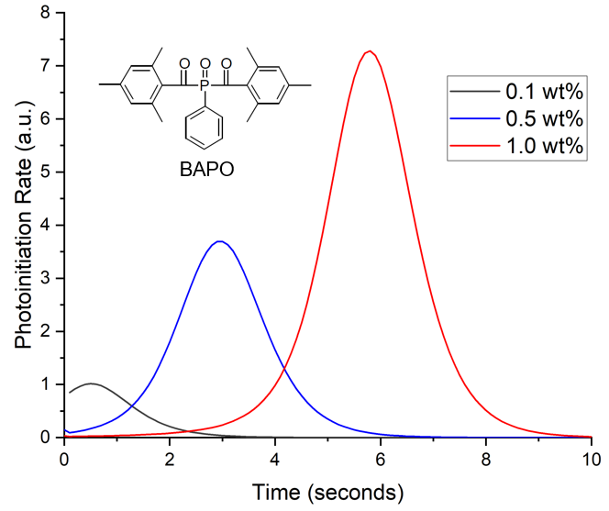
Figure 37 Photoinitiation rate at 3 mm depth with varying concentrations of BAPO.
concentration peak photoinitiation rate was not achieved until nearly 6 seconds of continuous irradiation.

5.3 Radiometry for 60 s Irradiation
With continuous irradiation of 380 mW/cm² for 60 s, the measured transmitted light intensity increased with time for BAPO and the BDMB control formulations. As shown in Figure 38, the formulations with the 0.1 wt% PI concentration allowed greater light transmission than the higher tested concentration levels. The BDMB control formulations also consistently allowed more light transmission than BAPO formulations at the same wt% concentration. For the BAPO formulations, the highest transmitted light intensity at 60 s is 74.0 mW/cm², only 19% light transmission. The peak transmitted light intensity for the baseline Bis-EMA/PETIA without any PI was 136 mW/cm², or 36% light transmission. These findings indicate that complete photobleaching had not occurred by 60 s of irradiation even at 0.1 wt% BAPO.

5.4 Rate of Conversion and Degree of Conversion for 60 s Irradiation
Using a previously described method [109], the degree of conversion (DC) of C=C was measured as the change in the ratio of the 1637 cm-1 methacrylate/acrylate pendant group peak with 1608 cm-1 as an internal reference peak [31]. As shown in Figure 39, DC was calculated from RT-FTIR results over the 60 s irradiation time and converted into a polymerization rate.

The polymerization rate in Figure 39 clearly distinguishes the curing behavior of BAPO formulations and the BDMB control. As was predicted by the optical model in Figure 37, higher concentrations of BAPO resulted in a delayed onset of the peak polymerization rate. The BDMB control formulations exhibited a less consistent delay, with the slowest start of polymerization for the lowest concentration of 0.1 wt%. This delay confirms the influence of photobleaching on BAPO curing behavior during continuous irradiation and the presence of an initiation wavefront created by free-radical generation in response to changing light penetration over time. However, the delay in cure observed by RT-FTIR is higher than the delay in photoinitiation predicted by the optical model.
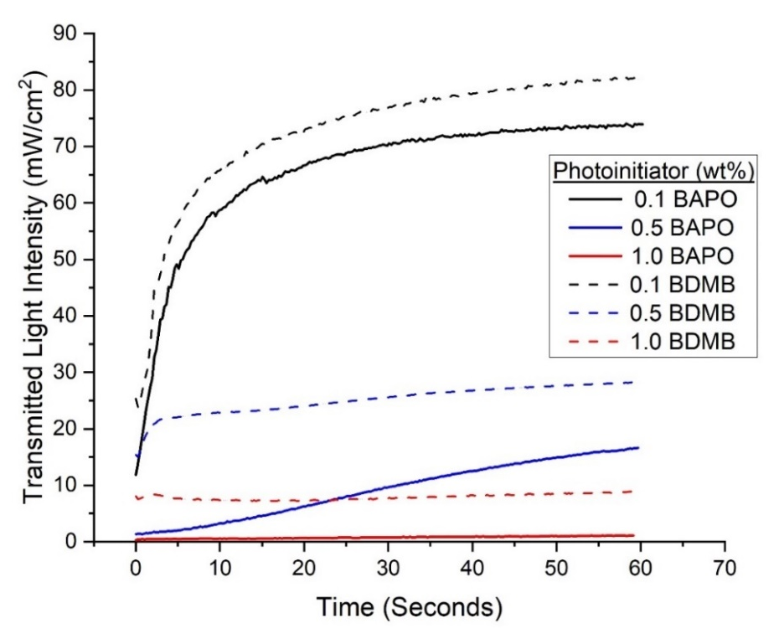
Figure 38 Experimental values for transmitted light intensity at varying concentrations of PI for BAPO and BDMB through 3 mm thickness of Bis-EMA/PETIA polymer.

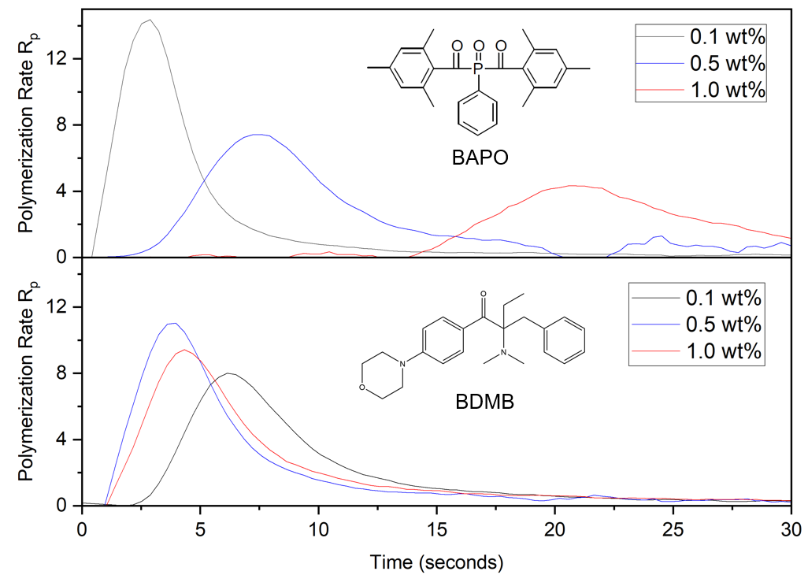
Figure 39 Polymerization rate for BAPO and BDMB at various concentrations, measured at 3 mm depth under continuous irradiation of 380 mW/cm² UV light.
For the 1.0 wt% concentration of BAPO, peak polymerization rate occurred after 20 s, while the optical model predicted peak photoinitiation at 6 s. Most notably, the trend in polymerization rate (see Figure 39) versus predicted photoinitiation rate (see Figure 37) is
the opposite, with the polymerization rate peak decreasing as the PI concentration increases.

As shown in Figure 40, the ultimate DC for each photopolymer formulation was measured 10 min after 60 s of UV irradiation. The average DC was calculated with a minimum of three specimens per formulation.

For statistical analysis, Tukey’s Honestly Significant Difference Procedure (Tukey HSD) was applied to the data sets for the bottom hardness measurements using MATLAB software [48], [109], [131]. Multiple comparison of means for one-way ANOVA determined that 0.1 wt% and 1.0 wt% BAPO formulations differed significantly, but 0.5 wt% BAPO was not significantly different from 1.0 wt% BAPO in the final DC. The 1.0 wt% BAPO formulation had the lowest average DC, comparable to the 0.1 wt% BDMB formulation. The 0.5 wt% BDMB formulation had the highest average DC but did not differ significantly from the 0.1 wt% BAPO formulation.

Discussion: While complete cure occurs when all of the double bonds have been converted (100 % DC), phenomena such as the cage effect can trap unreacted free radicals within a growing polymer network and limit ultimate DC [40], [62] (see Figure 41). Ultimate DC below 100% is typical for glassy acrylate polymers, as radical occlusion can surpass bimolecular termination by a ratio of 4 to 1 during vitrification [113]. Trapped free radicals in a glassy system reportedly exceed active (e.g., mobile) free radicals at as low as 36% DC [37]. The Bis-EMA: PETIA blend in the present study is a glassy polymer system as indicated by its (meth)acrylate chemistry, reported T_{g} of 150 ºC, high stiffness (tensile modulus >2.0 GPa), and brittle failure [109].

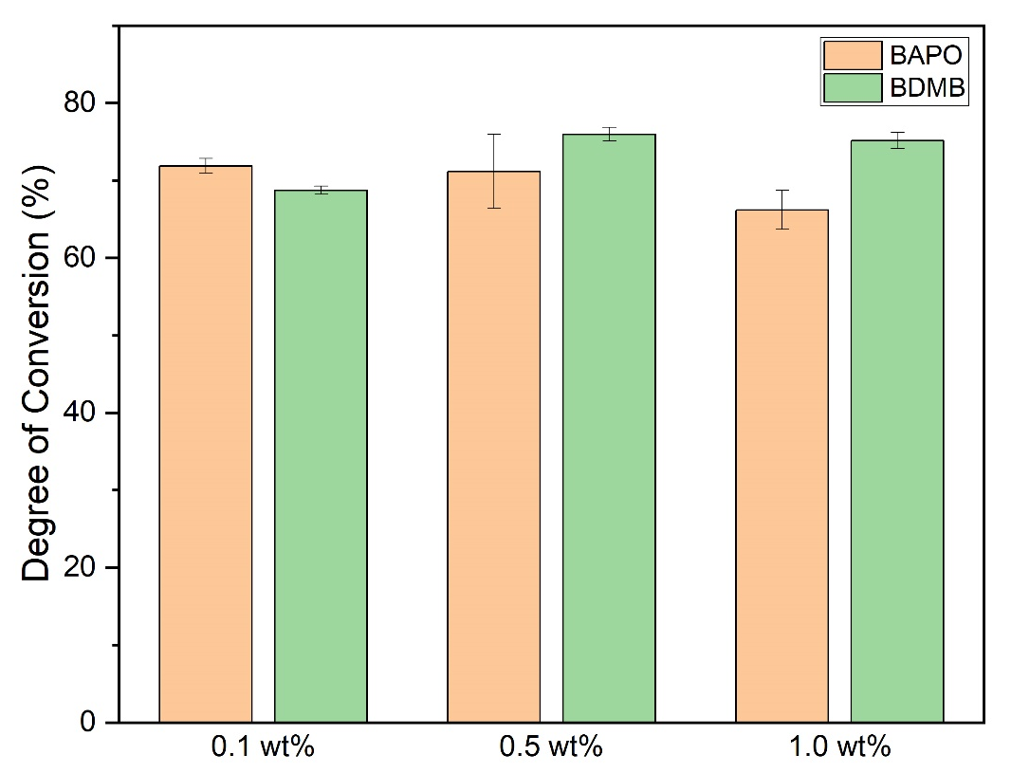
Figure 40 DC post 60 s UV irradiation, measured at 3 mm polymer depth 10 minutes post irradiation. Error bars indicate +/- one standard deviation.

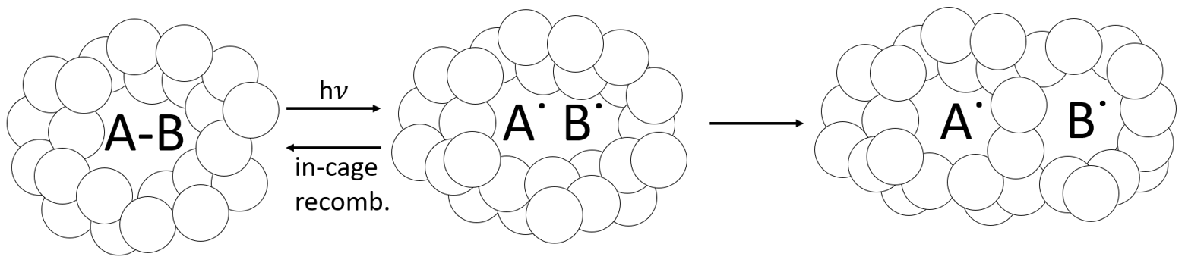
Figure 41 Cage effect, which can apply to occluded PI molecules. As PI absorbs light and reacts, its reaction byproducts can become trapped within the tightly packed vitrified polymer network, and these will either recombine or dissociate. Some free radicals can still react via diffusion, even in the glassy polymer.

In previous FTIR testing of 1.0 wt% BDMB formulations of an 80:20 Bis-EMA: PETIA blend, the highest reported DC was 78.7% following a UV dose of 8.0 J/cm² [109]. The 60 s irradiation results shown in Figure 40 followed a UV dose of 24.0 J/cm², but the highest average DC was 76.0%, as measured at the bottom surface of the 0.5 wt% BDMB
formulation. When compared against the previous finding of 78.7% DC at the irradiated surface, the results shown in Figure 40 indicate the presence of a cure variation even after extended 60 s irradiation times.

5.5 FTIR analysis for Pulse Irradiation Testing
Specimens from each formulation were cured under high-intensity UV light for an interval of 1.0 s or 3.7 s, equivalent to a dose of 1.4 J/cm² and 5.5 J/cm², respectively. These specimens were irradiated at a higher lamp intensity than the 60 s irradiation specimens. The lower intensity was used for the 60 s specimens to help improve resolution in the RT-FTIR data by reducing cure rates.

At 10 min post-irradiation, FTIR was used to determine the DC at 3 mm depth, with the 1.0 s irradiation indicated as ‘Low Dose’ in Figure 42. In contrast, the 3.7 s irradiation is labeled ‘High Dose.’ While all formulations achieved a high DC in the 60 s irradiation testing, the 0.5 wt% and 1.0 wt% BAPO formulations had < 5% DC at the Low Dose,
indicating no cure on the bottom (non-irradiated) surface. Even at the higher dose, the
1.0 wt% BAPO formulation was still uncured at 3 mm depth, while both 0.5 wt% and 0.1 wt% BAPO formulations achieved > 50% DC. Among the BDMB controls, only the 0.1 wt% BDMB formulation did not cure at the Low Dose, although the higher concentration formulas only achieved >50% DC at the higher dose. Of the formulas tested, the 0.1 wt% BAPO formulation achieved the highest DC at Low Dose.

Discussion:
As mentioned in the introduction, increased lamp intensity is a common approach to reducing through-cure time, and it can even lead to increased overall DC for a given dose. The pulse irradiation had a total dose of 5.5 J/cm² maximum, only 23% of the total 24.0 J/cm² dose of the 60 s irradiated specimens. However, the lamp intensity under this short irradiation time was 1600 mW/cm², 4.2 times higher than the 380 mW/cm² irradiation of the 60 s irradiated specimens. All formulas achieved a lower overall DC with pulse irradiation than a 60 s continuous irradiation at a lower lamp intensity. When comparing the high dose to 60 s irradiation, the 0.5 wt% BDMB formula had the highest DC of any tested formula and the smallest difference between the two doses, with only a 15.6% DC drop. When comparing Low Dose to 60 s irradiation, the 0.1 wt% BAPO formula had the smallest difference between the two doses of any formula, with a 25.4% DC drop. It is significant that the 0.1 wt% BAPO formula achieved >45% DC at 3 mm depth even at 1.0 s irradiation. It demonstrates that this formula is not as sensitive to changes in dose as the other formulations.

5.6 Flexural Testing
The pulse irradiation DC results selected four formulations for further mechanical testing: 0.5 wt% BAPO, 0.1 wt% BAPO, 0.5 wt% BDMB, and 1.0 wt% BDMB. Flexural test specimens were irradiated at the high dose of 5.5 J/cm². Specimens were tested a minimum of 24 h post-irradiation, with the UV irradiated side facing up in the three-point bend fixture. The test results shown in Table 6 show that the four formulations exhibited similar mechanical properties. By Tukey HSD and multiple comparison of means, none of the groups differ in flexural strength. However, the 0.5 wt% BAPO formula had the lowest flexural modulus, while 0.1 wt% BAPO and 0.5 wt% BDMB had the highest flexural modulus.

Discussion:
The most common feedstock for LFAM printers is acrylonitrile butadiene styrene (ABS), often blended with chopped fibers to improve mechanical properties and reduce warp [12]–[14]. The reported flexural modulus for neat ABS used in the BAAM printer ranges from 1.87 GPa – 2.45 GPa, while flexural strength varied from 58.6 MPa – 68.3 MPa, depending on the processing [132]. All tested photopolymer formulations in the present study exceeded the flexural strength of ABS by an average of 46-71% and flexural
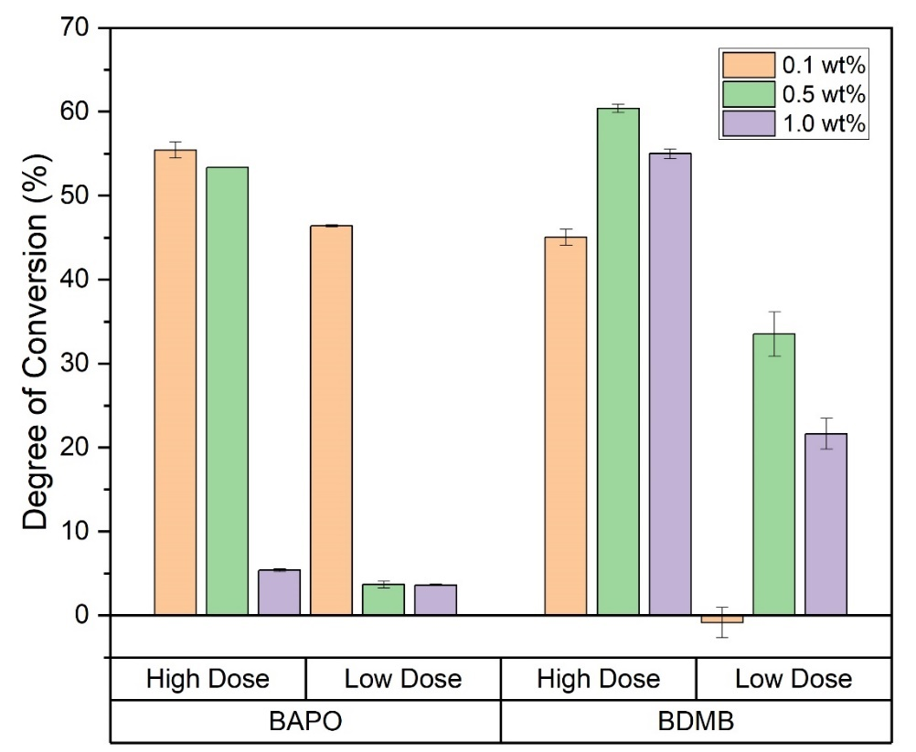
Figure 42 DC for all six formulas as measured at 3 mm depth, with Low Dose irradiation of 1.4 J/cm² or High Dose irradiation of 5.5 J/cm². Error bars indicate +/- one standard deviation.

Table 6 Average flexural properties from three-point bend testing, [x] indicates standard deviation.
 | BAPO |  | BDMB
 | 0.1 wt% | 0.5 wt% | 0.5 wt% | 1.0 wt%
Flexural Strength (MPa) | 108.4 [11.8] | 92.5 [9.1] | 103.6 [11.6] | 95.4 [14.9]
Flexural Modulus (GPa) | 3.1 [0.1] | 2.7 [0.1] | 3.1 [0.1] | 2.9 [0.1]
Failure Strain (%) | 4.2 [1.1] | 4.0 [0.7] | 3.7 [0.7] | 3.7 [0.9]

modulus of ABS by an average of 25-44%. It is important to note that the photopolymer formulations achieved these mechanical properties despite the presence of a cure gradient. The DC at the non-irradiated surface was between 53% and 60% when measured 10 minutes post-irradiation (see Figure 42), which was below the 66% to 75% DC measured under longer irradiation time (see Figure 40). Therefore, these findings indicate that Bis-EMA: PETIA photopolymers do not have to achieve the maximum possible DC to achieve mechanical properties higher than ABS.

6.0 Overall Discussion
Effect of PI Concentration
Of the formulations tested, the 0.1 wt% BAPO concentration proved the optimal concentration of BAPO for 3 mm layer thickness. Radiometry testing demonstrated a high level of light transmission, which correlated with the rapid onset of curing at depth as measured by RT-FTIR. The 0.5 wt% BDMB control formula achieved the highest average DC in the high dose pulse and continuous irradiation. Still, flexural testing showed that the 0.1 wt% BAPO formula achieved comparable mechanical properties even with a slightly lower DC of 55.5% vs. 60.4% for 0.5 wt% BDMB as measured at 3 mm depth.

Optical model
In the present study, the Kenning optical model proved helpful in predicting the delayed onset of photoinitiation with a photobleaching initiator. However, there was an inverse correlation between the predicted photoinitiation rate and the conversion rates measured via RT-FTIR. The trend in the Kenning model is supported experimentally by Christmann et al., albeit for thin-film specimens of 25 $μm$ thickness and low light intensity of 10 mW/cm² [33]. They reported that doubling the concentration of TPO in a glassy acrylate system from 0.5 wt% to 1.0 wt% increased the polymerization rate by 140% and reduced the time interval to peak conversion rate by half [33]. Christmann et al.’s findings support the trends predicted by the Kenning optical model, but not the present study results. At thin films such as those in Christmann et al.’s study, the light intensity is assumed to be equal throughout the entire specimen, with no light gradient and therefore no gradient in photoinitiation or photofrontal polymerization [45], [47]. The difference between the predicted light gradient and the measured light gradient is a likely cause for the discrepancy between the optical model and the conversion rate.

Effect of radical trapping
As described in section 5.4, glassy polymers such as Bis-EMA can cause significant radical trapping as the polymer network vitrifies. These trapped free radicals can become dislocated and eventually react through diffusion, or they can recombine back into a PI molecule. Eibel et al. considered recombination the most likely side reaction for initiator radicals, noting that this becomes insignificant at high monomer concentration [133]. However, when monomer concentration drops and a polymer network vitrifies, the likelihood of in-cage recombination increases [134]. In addition to reducing the effective quantum yield of a reaction [135], in-cage recombination could also serve to counteract photobleaching as recombined PI molecules absorb light in regions that have already vitrified. This phenomenon is not factored into the optical model, which does not predict DC or the likelihood of free-radical trapping. The radiometry data support the hypothesis of free-radical trapping and in-cage recombination, with transmitted light intensity 100 times lower for 1.0 wt% BAPO than for 0.1 wt% BAPO after 60 s of irradiation. The delayed curing reaction observed in RT-FTIR provides evidence of photobleaching. Still, the lower reaction rate and low light transmission at higher PI concentrations may indicate a high residual PI content trapped within the cured polymer. This trend is confirmed by Christmann et al., who reported that increased PI concentration increases radical trapping by occlusion in the glassy 3D polymer networks [33]. The optical model from Kenning and Miller does not account for this behavior directly, although it could be considered as ‘partial photobleaching’ where $ε_{pj}≠0$ as described by Hayki et al [45].

Utility of optical properties in formulation pre-screening
For applications such as LFAM where a short irradiation time (< 5 s) is desirable, another potential pre-screening tool is the predicted light intensity through the polymer at $t=0$, or the starting point of irradiation. As shown in Figure 43, the Kenning optical model predicts light intensity > 0 throughout the entire 3 mm polymer thickness for formulations with 0.1 wt% BAPO, 0.1 wt% BDMB, and 0.5 wt% BDMB. Two of these formulas proved the best suited for rapid cure under short irradiation times, but the 0.1 wt% BDMB formulation had the lowest DC of the tested BDMB formulations. This limited use of the Kenning optical model may be a helpful tool for screening out formulations with too much PI, but other approaches such as FTIR are required to screen for formulations with PI levels too low for complete cure.

7.0 Conclusions
This study investigated light transmission and through-thickness cure behavior in vinyl ester photopolymer formulations with the photobleaching initiator BAPO cured at 3 mm thickness. Formulations with BDMB were also tested as a control. A theoretical optical model was employed to predict photoinitiation rates with BAPO as a potential screening tool for LFAM formulations. The model predicted an increase in photoinitiation rate at higher initiator concentrations, accompanied by a temporal delay in the onset of peak initiation due to photobleaching. BAPO formulations were prepared and irradiated for 60 s for comparison against the optical model. At 3 mm depth, experimental results indicate increasing BAPO concentration from 0.1 wt% to 1.0 wt% delayed peak conversion time by over 18 s, confirming photobleaching behavior. Increased BAPO concentration also reduced peak conversion rate by 75% over the same range, an inverse trend to the optical
model predictions. This reduction may be attributed to in-cage recombination of photoinitiators in the vitrified polymer, which increases light attenuation. This hypothesis is supported by radiometry results, which show that peak light transmission at 0.1 wt% BAPO is 50% lower than the light transmission through the polymer without any photoinitiator.

Although predicted photoinitiation rates from optical modeling did not match measured polymerization rates, the optical model does offer some utility as a screening tool for establishing an upper limit initiator concentration. The tested formulations that cured
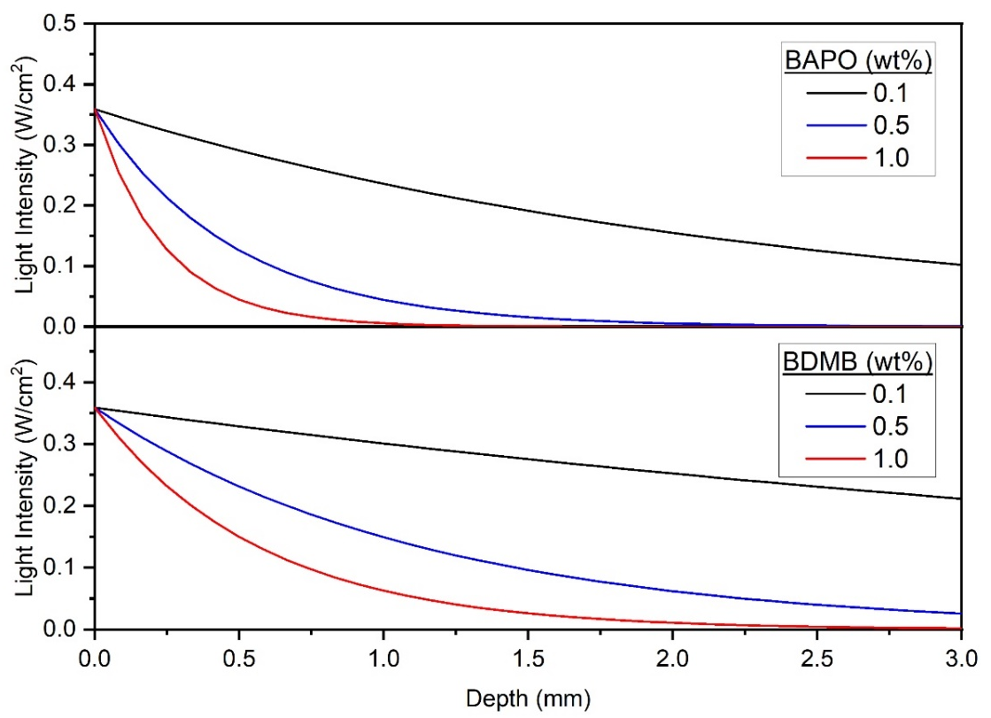
Figure 43 Predicted transmitted light intensity at t=0 across the 3.0 mm polymer depth, at 398 nm wavelength and an incident light intensity of 380 mW/cm².

most rapidly through 3 mm thickness also had predicted light transmission > 0
throughout the thickness at t=0. For the resin and lamp configuration in this study, an absorbance <1.1 at 3.0 mm depth yielded the most rapid through-thickness cure. These potential screening tools confirm the importance of balancing PI concentration with PI light absorption to allow the greatest initial light transmission.

For a layer thicknesses of 3 mm, this study found that an 80:20 Bis-EMA: PETIA achieved the most rapid through-thickness cure response with BAPO as PI at a concentration of 0.1 wt%. For the same 3.7 s irradiation, 0.1 wt% BAPO and 0.5 wt% BDMB formulations achieved an average flexural strength >100 MPa and flexural modulus of 3.1 GPa, superior to ABS and well-suited to comparable LFAM applications. While photobleaching in BAPO appeared to provide minimal benefit under simulated LFAM conditions, the higher molar absorptivity of BAPO relative to BDMB enabled comparable performance at lower concentrations. With the most rapid through-cure response under irradiation times < 5s, the 0.1 wt% BAPO formulation is recommended over the previously reported 1.0 wt% BDMB formulation for potential LFAM applications.

Acknowledgments
The authors would like to thank Alex Allen and Jacob Williams for their contributions to this work as undergraduate student interns at the Fibers and Composites Manufacturing Facility at the University of Tennessee, Knoxville. The funding for this work was provided in part by the Office of Energy Efficiency and Renewable Energy (EERE), U.S. Department of Energy, under Award Number DE-EE0006926 and gratefully acknowledged. We thank the Institute of Advanced Composites Manufacturing Innovation (IACMI), Knoxville, TN, USA, for partial support of this work. We also thank Polynt Composites USA, Allnex, Lambson, and IGM Resins for donating materials.

                - CHAPTER III
                - Investigation of multi-layer cure effects in photopolymers towards large format additive manufacturing

A version of this chapter was originally prepared for publication by Alexander Stiles, Vivek Chawla, Dayakar Penumadu, Liam Pruitt, Jacob Williams, and Uday Vaidya:

This manuscript has not yet been submitted for publication.
Alexander Stiles was the involved in the conceptualization, investigation, formal analysis, visualization, and writing of this publication. He wrote the original draft, as well as reviewing and editing in all drafts through to submission and publication. Vivek Chawla and Dayakar Penumadu were involved in developing the nanoindentation procedure. Vivek Chawla also conducted the nanoindentation testing and helped with analysis. Liam Pruitt was involved in preparing photopolymer formulations and FTIR investigation, as well as nanoindentation analysis and microscopy. Jacob Williams prepared the fiberglass composite panels, conducted ILSS testing and performed some ILSS analysis. Uday Vaidya was responsible for funding acquisition, and review & editing of the manuscript drafts.

Abstract
In layer-based manufacturing methods such as stereolithography and filament winding, photopolymers can achieve greater throughput by relying on multiple irradiation cycles of ultraviolet (UV) light to improve cure in previously deposited layers. Large format additive manufacturing (LFAM) techniques have recently been developed that also utilize photopolymers, but at the 2-4 mm layer heights typical of LFAM processing, light attenuation may limit the potential multi-irradiation benefit and restrict printer throughput.

In this study, single layer and 5-layer specimens of vinyl ester photopolymer were irradiated under varying doses of UV light, and cross sections were tested using Fourier-transform infrared spectroscopy (FTIR) microscopy and nanoindentation to measure the cure depth profile. At a Low Dose of 1.4 J/cm², multiple irradiation cycles improved the degree of conversion (DC) on the bottom surface from 25% DC to 33% DC, but at a High Dose of 5.5 J/cm² multiple irradiations had no measurable effect. A cure gradient was present in each layer for all tested UV doses, although at the High Dose a plateau region of 80% DC extended to 2 mm depth.

Fiberglass composites were also prepared at 3 mm thickness and exposed to the same UV doses, in 1 Layer and 2 Layer configurations simulating an LFAM process. As with the unreinforced photopolymers, nanoindentation results showed a larger cure gradient with Low Dose versus a High Dose, with no clear beneficial effect from multiple irradiations. At High Dose with a post cure, the interlaminar shear strength in the 2 Layer specimen averaged 29.4 MPa, and fracture occurred within the laminate instead of at the layer interface. This study demonstrates that, while cure gradients exist in photopolymers cured at 3 mm thickness, this can be controlled with processing conditions and high bond strength between layers can be achieved.

Keywords: Large-scale, additive manufacturing, composite, photopolymer, layer adhesion

1.0 Introduction
Among additive manufacturing (AM) technologies, large format additive manufacturing (LFAM) is emerging as a high throughput process for printing components >1 m³ in volume [14], [65]–[67]. LFAM printers such as the Big Area Additive Manufacturing (BAAM) system use pellet-based extrusion to deposit thermoplastic materials on a print bed. They are distinct from fused deposition modeling (FDM) printers by virtue of their high deposition rate and correspondingly lower part resolution [10]. As of 2019, the BAAM had a reported deposition rate up to 45 kg/hr [10] at average layer heights of 2 - 4 mm [10]. While thermoplastic polymer-based LFAM methods require heating during deposition, ambient processing is possible with thermoset-based systems such as the Reactive Additive Manufacturing (RAM) printer and the photopolymer-based system developed to print houses at Mighty Buildings [8], [69], [71]. Photopolymer printing is of particular interest because these resin systems can cure within seconds under ultraviolet (UV) radiation even at LFAM layer heights [109]. By curing in-situ, photopolymers also have the potential to overcome thermoset printing issues such as limited build height due to wall collapse and the need to balancing cure time against exotherm temperatures [86], [136], [137].

In LFAM applications, a polymer is often blended with additives to adjust viscosity and flow characteristics and/or improve mechanical properties. For thermoplastic printing in particular, fiber reinforcements such as carbon fiber help ensure strong layer adhesion by reducing warp in printed beads [138]–[140]. Cure-induced shrinkage can be severe in photopolymers, with shrinkage as high as 15% reported for acrylates [101]. Fiber reinforcements and other additives such as fumed silica, fiberglass, silica, carbon fiber, and carbon nanotubes have proven effective in reducing this shrinkage or enhancing other aspects of printing such as part resolution [70], [84], [85].

Of the potential additives for photopolymers, fiberglass has long been used to enhance mechanical properties such as stiffness and strength [22], [27], [141]. This is because fiberglass has high UV transparency, allowing greater fiber loadings than opaque fiber systems [22]. Dental photopolymers and UV direct ink write (UV-DIW) printing have utilized chopped glass fibers as reinforcement [29], [70], [89], [142]. Companies such as Continuous Composites [143] and Moi Composites [71] have employed a method most comparable to automated fiber placement (ATP) to additively manufacture photopolymer composites with continuous fiberglass fibers [144].

In layer-based photopolymer processing, a key consideration is adhesion between layers. Stereolithography (SLA) can achieve near-isotropic mechanical properties in printed parts by partially curing each layer, relying on irradiation through successive layers and UV post curing after printing to attain full cure [145], [146]. Likewise, in UV filament winding, layers are irradiated with a minimal UV dose to cause the resin to gel, and the level of cure in a layer increases as irradiation passes through successive layers [22], [104]. With a partial cure, more C=C bonds will be also available to react between layers, and multi-layer irradiation has the potential to allow for greater interlayer adhesion via chemical crosslinking between layers [147]. Partial cure within a single layer also has the advantage of improving the process throughput, since each layer receives a shorter irradiation time during deposition than it would otherwise require to achieve a full cure.

In the present study, a vinyl ester photopolymer was cured under short irradiation times (< 5 s) in 3 mm layer thickness to simulate LFAM conditions. Multi-layer specimens were prepared and analyzed for the influence of multiple irradiations on cure within the layers. Continuous fiberglass fabric was added, and composite specimens were irradiated to determine the effect of the reinforcement on through-thickness cure behavior. Multi-layer composites were prepared and tested to determine the effect of irradiation time and thermal post cure on layer adhesion.

2.0 Literature Review
To improve material deposition rate, a typical layer height for the BAAM is 2-4 mm [10], but this cure depth can be challenging for photopolymer systems. Thick photopolymer systems (>100 $μm)$ can suffer from a cure gradient due to light attenuation through the thickness [36], [107], [128]. In formulating photopolymers for LFAM, deposition rate will primarily be limited by the through-thickness cure response and the need to minimize cure gradient [48], [109].

Stiles et al. demonstrated the presence of a cure gradient within neat (unfilled) photopolymers at 3 mm thickness [109], and with fillers and additives this light attenuation can be exacerbated. Alrahlah et al. used Vickers hardness testing on cross sections of highly filled dental photopolymers up to 6 mm in depth to demonstrate the presence of a non-linear drop in cure with increasing depth [48]. In fiberglass filament winding, Duan et al reported that a 365 nm UV LED system curing thin (0.3 mm) layers of fiberglass composite had a maximum effective penetration depth of 5 layers, or ~1.5 mm [104].

Near complete through-thickness cure is often achievable with sufficient irradiation time. The LFAM target 3 mm thickness has been demonstrated previously in fiberglass-photopolymer laminates [26], [114], [123], [148]. Cvetanovska found that the hardness was only 3.8% lower on the non-exposed side after a 10-minute irradiation with an UV area lamp. This was attributed to a small difference to diminished light intensity through the 6 mm laminate thickness [148]. Di Pietro and Compston reported that a high intensity spotlight achieved full cure through an 8 mm laminate in 15 seconds when utilizing a high intensity (25 mW/cm²) spot light [123].

In studying the effect of fiberglass on UV transmission, Endruweit et al. reported that UV transmission decreases with increasing fiber packing density, fiber volume fraction and laminate thickness. They also found that the time for complete through-cure was longer in a fiberglass laminate than a neat resin system with the same photopolymer [39]. However, Crivello et al. reported findings that conflict with those of Endruweit et al., with fiberglass composites curing to a greater thickness more rapidly than the pure resin [108]. Fiberglass may attenuate and scatter light in a photopolymer composite, but it also displaces photopolymer in a system and reduces the volumetric concentration of light absorbing compounds such as photoinitiators (PIs) [22], [39], [108].
Interlaminar shear strength (ILSS) testing is a common method for assessing the quality of cure in a fiberglass composite. This short-beam 3-point flexural test induces shear failure in a laminate, often along the neutral axis. Di Pietro found that, when compared to a post cured thermoset control, fiberglass laminates cured under 15 s high intensity UV irradiation achieved nearly identical ILSS values [123]. Most notably, Compston and Cvetanovska reported on a multi-layer laminate cured in two UV irradiation steps (10 minutes each), and found that the UV cured secondary bonded laminate achieved similar ILSS values to a post cured thermoset control without any secondary bond [26]. In both studies, fiber-matrix bond characteristics did not appear to be affected by UV cure versus a thermoset resin control.

The present study investigated the effects of both multi-layer irradiation and fiberglass reinforcement on the cure behavior of a vinyl ester photopolymer. It expanded upon the work of Di Pietro, Cvetanovska and Compston [26], [123], [148], [149] by utilizing a high intensity UV LED lamp and even shorter irradiation times of less than 5 s to better simulate LFAM conditions. Neat resin and fiberglass composite specimens were compared under the same irradiation times. Neat resin samples were cured stepwise up to 5 layers thick while monitoring cure in real time using Fourier-transform infrared spectroscopy (FTIR) on the non-exposed side of the bottom layer. Cross sections were taken and tested via FTIR microscopy and nanoindentation to assess the cure gradient. Composite samples were irradiated up to two layers thick and tested for bond strength via ILSS, and nanoindentation was used to assess the cure gradient in comparison to the neat resin. Thermoset resin control composites were also prepared and tested via ILSS. Fracture surface analysis was used to compare the relative fiber-matrix bond characteristics of UV cure versus thermoset cure. To the author’s knowledge, this is the first time findings using nanoindentation as a means of assessing UV cure gradient in a laminated fiberglass composite have been reported.

3.0 Materials and Methods

3.1 Light Source and Materials
The lamp was an Altair 75 high-intensity UV LED area lamp from Heraeus Noblelight with an emitting window of 80 mm x 13 mm and peak irradiance of 3.7 W/cm² at 395 nm. The primary oligomer in this study was bisphenol A ethoxylate dimethacrylate (Bis-EMA, see Figure 44). The reactive diluent was PETIA, a 50:50 molar mixture of tri- and tetra-acrylate esters of pentaerythritol supplied by Allnex. The photoinitiator was bis (2,4,6-trimethybenzoyl)-phenylphosphine oxide (BAPO), supplied under the trade name Omnirad 819 by IGM Resins (Charlotte). Saertex 955 g/m² stitched unidirectional e-glass (Saertex GmbH, Saerbeck, Germany) was used in fiberglass laminate testing.
The photopolymer formulation used in this study was a ratio of 80:20 of Bis-EMA and PETIA, with 0.1 wt% BAPO as photoinitiator (PI). The formulation was mixed under low heat using a hot plate stirrer for 10 minutes, then allowed to rest for at least 24 hours prior to irradiation at ambient temperatures.

3.2 Post Cure Testing
Unreinforced specimens were prepared for tensile testing, DMA, TGA and FTIR to assess the effect of thermal post cure on polymer properties. Sheets of nominal 1 mm thickness were cast between two glass plates with spacers and irradiated in a linear stage at a scan rate of 5 mm/s, equivalent to a dose of 5.5 J/cm². Cured photopolymer sheets were then post cured for either 2 hrs at 66 ºC + 2 hrs at 121 ºC (Post Cure A) or 2 hrs at 200 ºC (Post Cure B), both options recommended by the Bis-EMA supplier. Specimens were then machined from the cured polymer sheets. Tensile specimens were produced and tested per ASTM D638 Type V. DMA specimens were machined to 5 mm width x 20 mm length, then tested in film tension configuration with a temperature range of ambient to 300 ºC, a ramp rate of 3 ºC/minute, a frequency of 1 Hz and a strain amplitude of 0.05%. TGA testing was performed under a nitrogen atmosphere at a temperature range of ambient to 600 ºC and a ramp rate of 10 ºC/minute. FTIR was measured 1 week post irradiation on the top and bottom surfaces of the tensile specimens, with 64 scans at 4 cm⁻¹ resolution and a gain of 8.0.

3.3 RT-FTIR Neat Resin Testing
Unreinforced resin specimens were prepared for FTIR. Photopolymer was cast in 3 mm thick white acrylic molds with 6 mm square cavities. To simulate LFAM conditions and allow rapid addition of multiple layers, all specimens were cured with the mold uncovered in ambient atmosphere. Specimens were irradiated with the lamp positioned 10 mm above the polymer surface with either a “High Dose” of 5.5 J/cm² over 3.5 s or a “Low Dose” of 1.4 J/cm² over 0.8 s, with an incident light intensity of 1.7 W/cm² as measured by an ILT800 radiometer from International Light Technologies. One set of specimens at each dose were prepared with a single 3 mm layer, monitored over the course of 10 minutes post irradiation using real-time FTIR (RT-FTIR). A second set of specimens at each dose were prepared by casting additional layers directly over the previous layer (see Figure 45), with a new layer irradiated every 2 minutes for a total of five layers in 10 minutes. The 10 mm gap held constant for each additional layer.
Testing was conducted on a Nicolet iS50 FTIR Spectrometer with an attenuated total reflectance (ATR) module, both from Thermo Fisher Scientific. To ensure intimate contact of the cured polymer with the diamond crystal of the ATR, the mold and lamp were positioned directly over the crystal and the specimens were irradiated in situ. Measurements were taken in a series of scans at 4 cm⁻¹ resolution and a gain of 8.0. A minimum of five specimens were tested for each condition.

3.4 Neat Resin Nanoindentation and FTIR Microscopy
After irradiation and curing, the single and multi-layer specimens from the RT-FTIR testing were potted and polished for nanoindentation and FTIR Microscopy. Single-layer specimens were mounted on acrylic and potted in epoxy resin to obtain a cross section during polishing. Multi-layer specimens were sectioned using an IsoMet 1000 precision sectioning saw (Buehler) at 275 rpm cutting speed and 300 g weight, then potted in epoxy resin to obtain a cross section. Potted specimens were polished up to 0.05 $μm$ using an AutoMet 250 grinder-polisher (Buehler).

Nanoindentation was conducted using the iMicro system (Nanomechanics inc,) to evaluate the hardness and modulus of the specimens. Specimens were indented with a
Figure 44 Primary oligomer Bis-EMA is di-functional while PETIA has tri- and tetra-functionality.

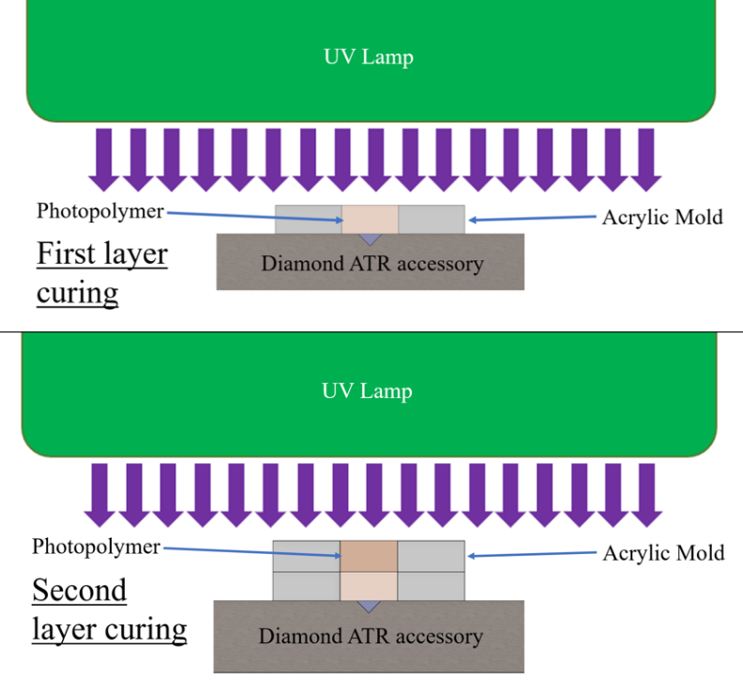
Figure 45 Multi-layer in situ curing of neat resin, with bottom surface of first layer in contact with FTIR-ATR diamond for degree of conversion measurement.
Berkovich tip (3-sided pyramid with 67.3 degrees inscribed angle) using an actuator with a 1000mN force limit and 40 µm displacement range. The continuous stiffness method (CSM) was employed, in which specimens were loaded dynamically to calculate the unloading contact stiffness as a function of depth. The dynamic displacement used was an oscillation of 2 nm at a frequency of 110 Hz. Assuming a Hertzian contact, obtained stiffness was used to evaluate the modulus and hardness based on the Oliver-Pharr formulation [150]. Specimens were loaded to a target depth of 1 µm with a constant strain rate and a 1 s hold time at peak load. The resulting properties were calculated as an average between 500 nm - 1000 nm. For single-layer neat resin specimens, sets of indentations were conducted with a minimum of six indentations per row, with rows spaced every 200 µm along the entire specimen depth.

FTIR Microscopy was conducted on a Bruker Lumos, in ATR configuration with a computer-controlled stage. Multi-layer and single-layer neat resin specimens were tested by collecting a grid pattern of measurements with rows spaced at 300 $μm$ and a minimum of four columns spaced at 1500 $μm$ across the entire polymer specimen. Each measurement consisted of 64 scans at 4 cm⁻¹ resolution.

3.5 Preparation of Fiberglass Composite
Fiberglass composites were produced using the vacuum assisted resin transfer molding process (VARTM) per setup displayed in Figure 46. Each composite “layer” was 3 mm nominal thickness, consisting of four plies of non-crimp fabric stacked all at 0° aligned with the UV scan direction (see Figure 47). After debulking under vacuum, a layer was infused resin and the mold was inverted such that the glass plate was faced towards the UV lamp. Infused panels were irradiated with the lamp mounted on a linear stage at UV scan rates of 5 mm/s, 10, mm/s, 15 mm/s, and 20 mm/s. UV light transmission through the glass plate was measured using the radiometer, and equivalent doses are listed in Table 7. See Appendices for further information on the comparison between static and dynamic irradiation for the Altair 75 lamp system. The High Dose, Medium Dose, and Low Dose designations were selected because of the doubling effect, with a Medium Dose at twice that of a Low Dose and half of a High Dose.

Double-layer panels were prepared by irradiating the first layer, then adding new dry fabric plies between the first layer and the glass plate (see Figure 46). This was debulked and infused again, followed by a second irradiation. Half of the composite panels were thermally post cured in a programmable DS44 Drying Oven by Baxter Scientific Products. All post cure commenced within an hour of the first layer irradiation, and the post cure cycle was 2 hours at 66 °C, followed by 2 hours at 121 °C.

3.6 Composite Characterization
Specimens for interlaminar shear strength testing (ILSS) were machined from each composite panel, followed by precision wet sanding to achieve final part dimensions per ASTM D2344. Single layer specimens had a nominal dimensions of 18 mm x 6 mm x 3 mm while double layer specimens had nominal dimensions of 36 mm x 12 mm x 6 mm. A minimum of five specimens from each panel were tested on a Test Resources load frame with a 50 kN load cell.

After ILSS testing, specimens were sectioned and conditioned in an environmental chamber for a minimum of 48 hours prior to microscopy. The fracture surface was then imaged using a Hitachi TM3030 tabletop scanning electron microscope (SEM). Images were collected in the energy dispersive X-Ray mode (EDX) to achieve the greatest contrast between the polymer and fiberglass fiber.

Additional specimens were machined from each panel and used in determining fiber volume fraction and nanoindentation testing. For fiber volume fraction, the specimen were heated to 500 °C for a minimum of 6 hours using a muffle furnace per ASTM D3171 Procedure G. Note that a lower temperature was used based on TGA results for cured Bis-EMA/PETIA resin.

Figure 46 Fiberglass laminate curing and multi-layer process in which new laminates are infused and cured while in direct contact with the previously cured laminate

Table 7 UV Dose equivalence for static irradiation vs. linear stage
ID | UV Dose (J/cm²) | Scan Rate (mm/s) | Irradiation Time (s)
High | 5.52 | 5 | 3.5
Medium | 2.75 | 10 | 1.7
- | 1.79 | 15 | -
Low | 1.37 | 20 | 0.8

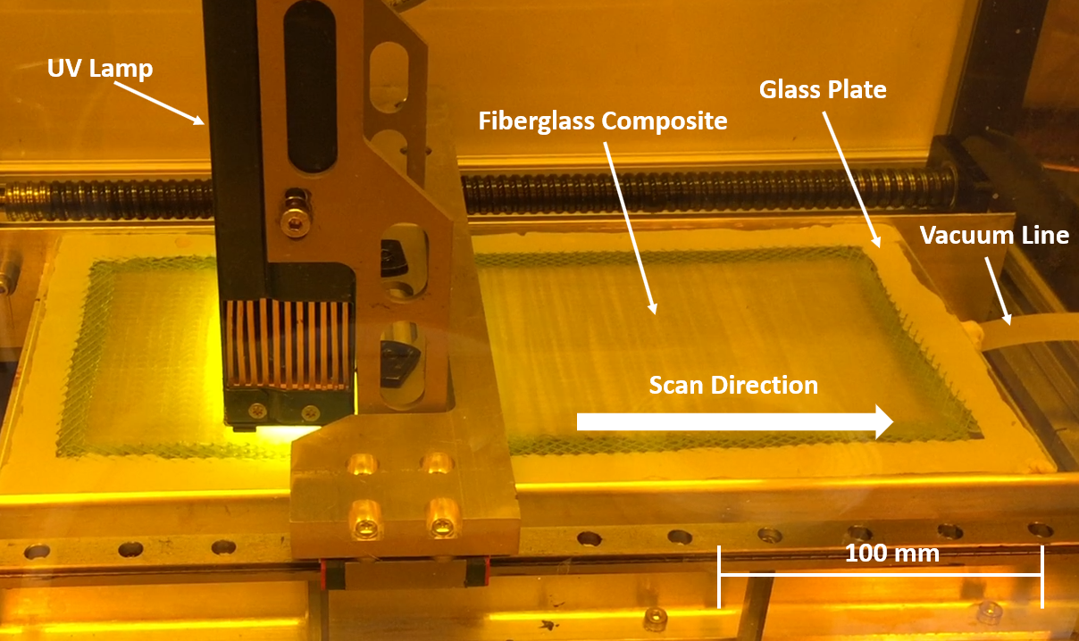
Figure 47 UV LED lamp mounted to a linear stage with variable scan rate

3.7 Composite Nano-indentation
Additional specimens were machined from each panel, potted in epoxy and polished for nano-indentation analysis. Measurements were taken in data sets of 25 indentations, with a minimum of 20 sets of measurements collected across the depth of the specimen (see Figure 48). To ensure that each data set measured only the polymer properties, great care was taken to take measurements in resin-rich pockets found sporadically throughout the specimen (see Figure 49). After indentation, the data sets were then analyzed using optical microscopy to measure the data set depth perpendicular to the irradiated surface.

4.0 Results and Discussion

4.1 Post Cure Testing

FTIR
Degree of conversion (DC) was measured on the top (i.e. irradiated) and bottom surfaces of 1 mm thick tensile specimens, with results shown in Figure 50. There was no significant difference between top and bottom surface DC among the various cure treatments. There was also no significant difference between UV Only and Post Cure A (2 hrs at 66 ºC + 2 hrs at 121 ºC), with average DC between 66% and 68%. With Post Cure B (2 hrs at 200 ºC), the average DC increased to 98%, which is effectively full C=C bond conversion.

Tensile Testing
Tensile properties were determined for the various cure conditions, as shown in Table 8. Post cure increased tensile strength by 40% and tensile modulus by 30% above the UV Only cure condition. However, there was no significant change between Post Cure A and Post Cure B. The post cured tensile strength of 55 MPa was also 17% higher than the 47 MPa tensile strength reported for Bis-EMA by the resin supplier, while the tensile modulus of 3.0 GPa was 15% lower than the reported value.

DMA
Dynamic Mechanical Analysis results for the various cure conditions are shown in Figure 51. The change in Tan Delta peak indicates a shift towards increasing T_{g} with post cure
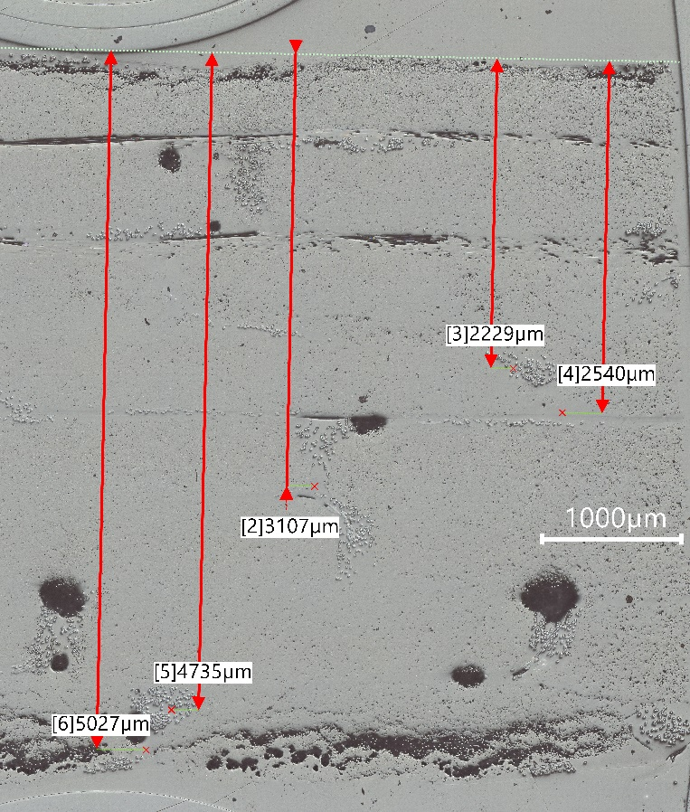
Figure 48 Partial set of measurements for nanoindentation dataset locations of the 2 Layer-Low Dose, No Post Cure specimen, with depth measured relative to the irradiated surface.

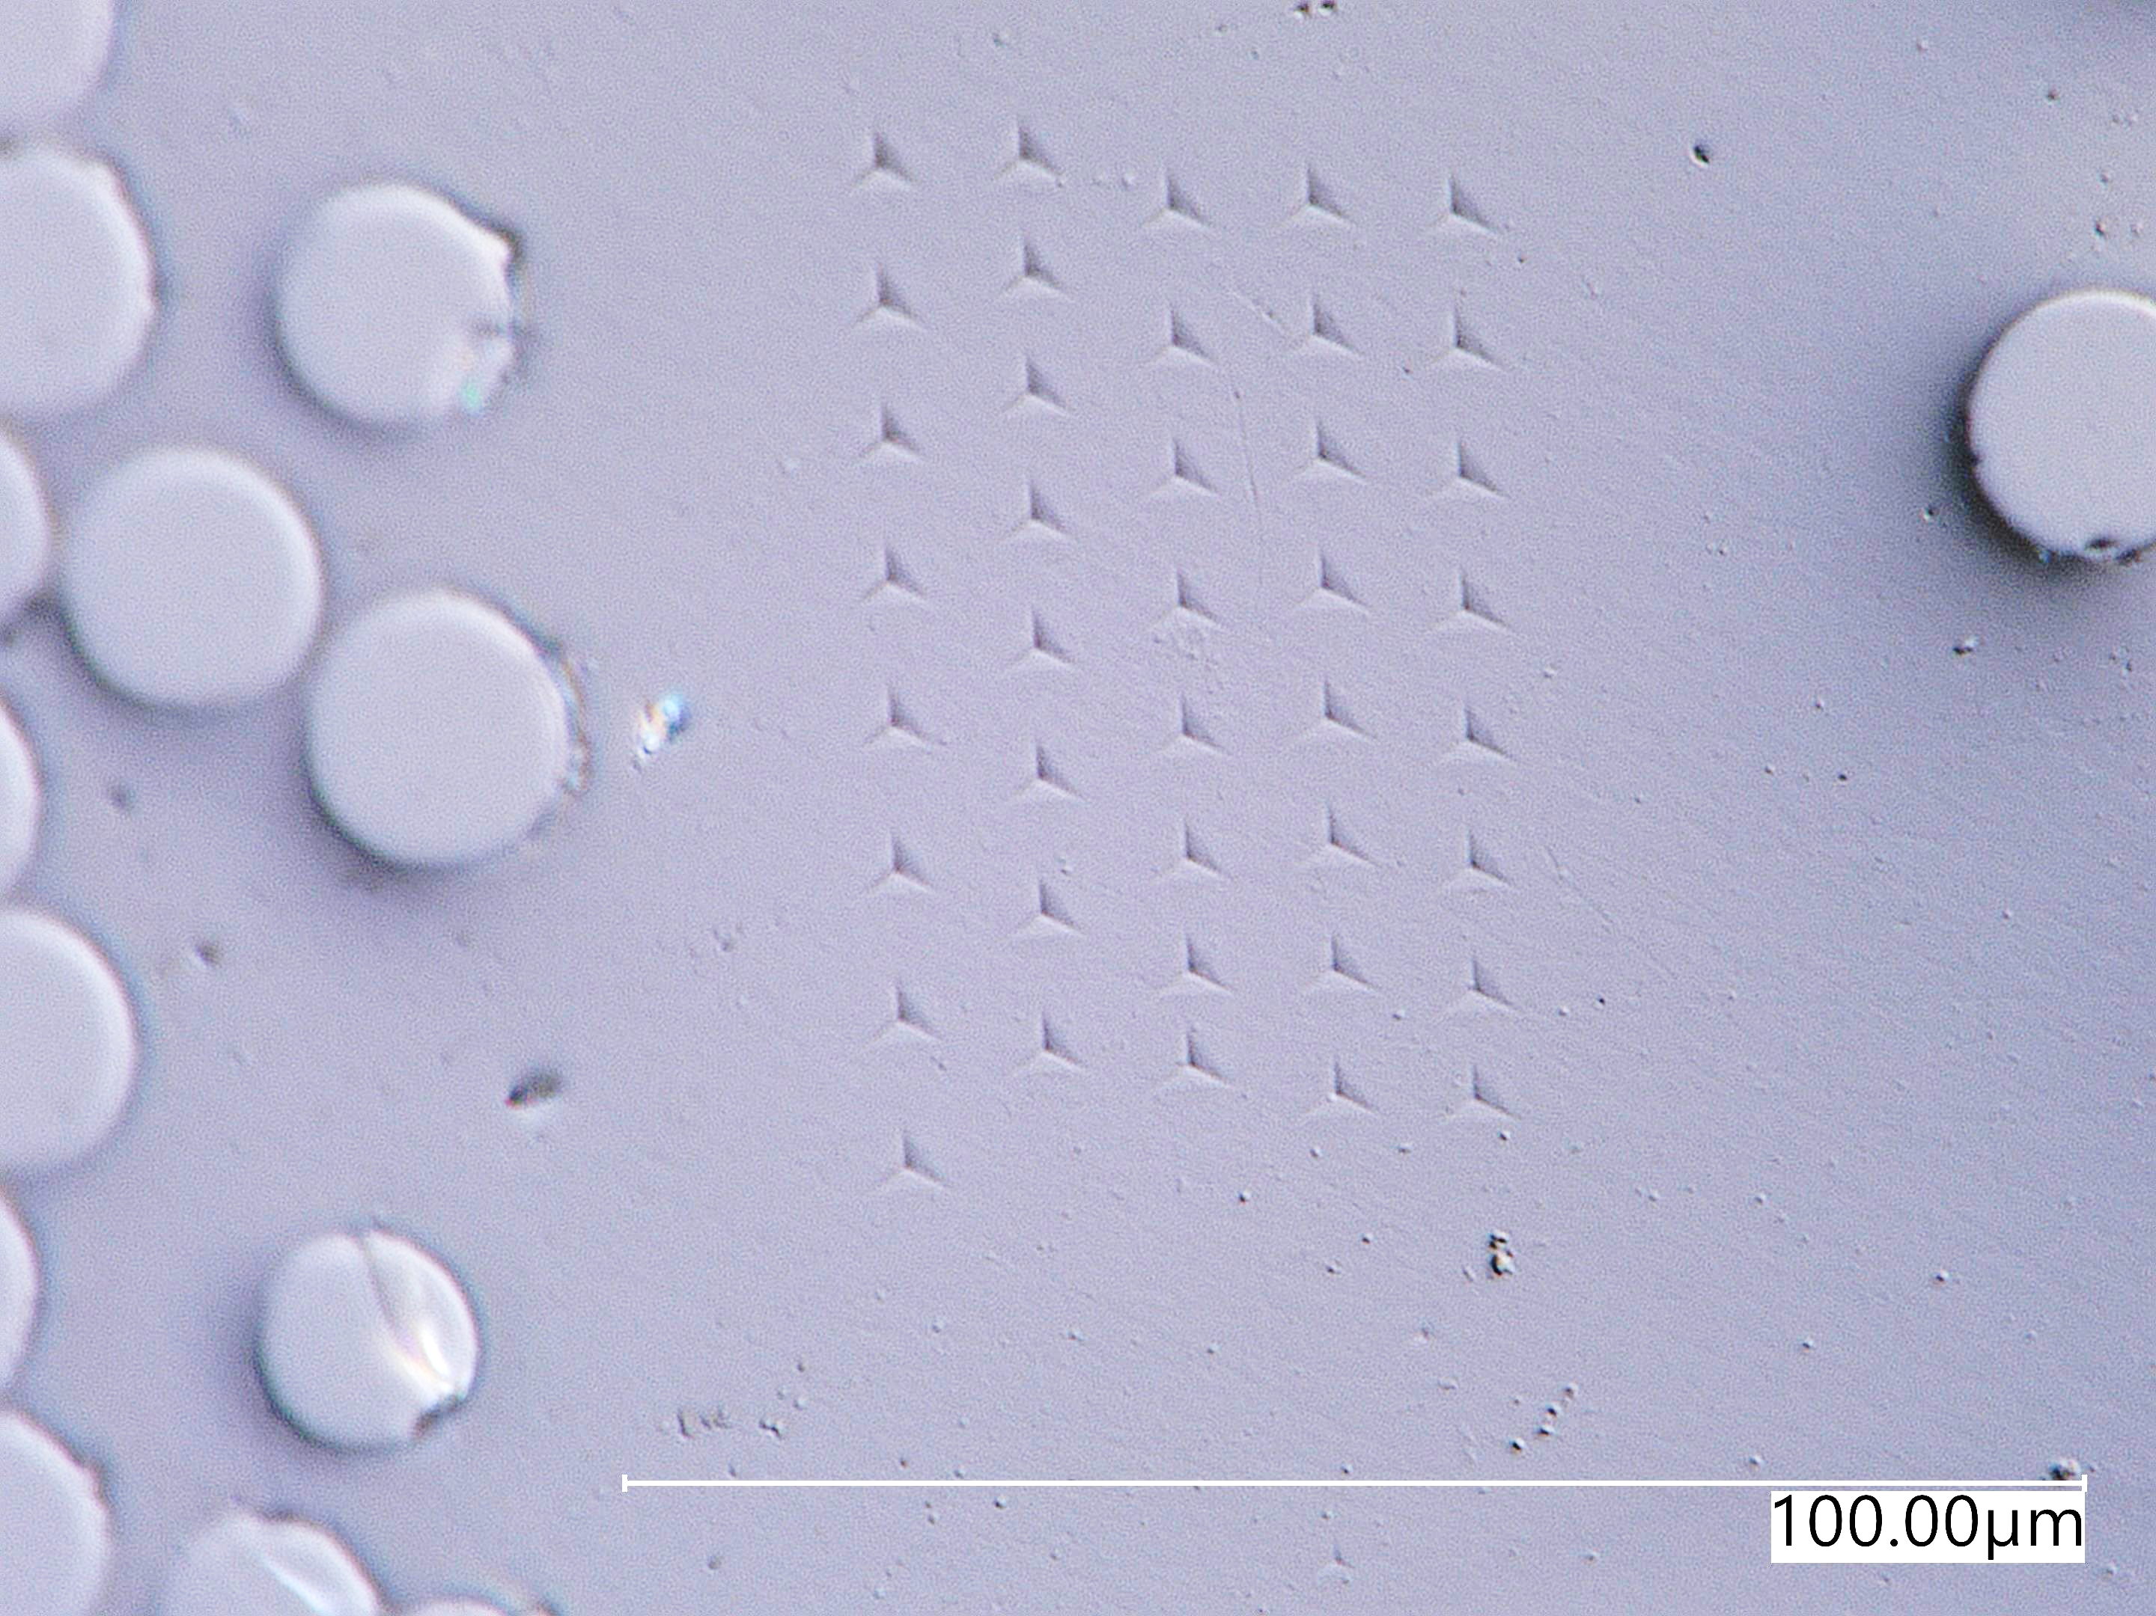
Figure 49 Example nanoindentation pattern for photopolymer composites. Indentations were taken in grid patterns clustered within resin pockets, e.g. in between fiberglass roving or plies.
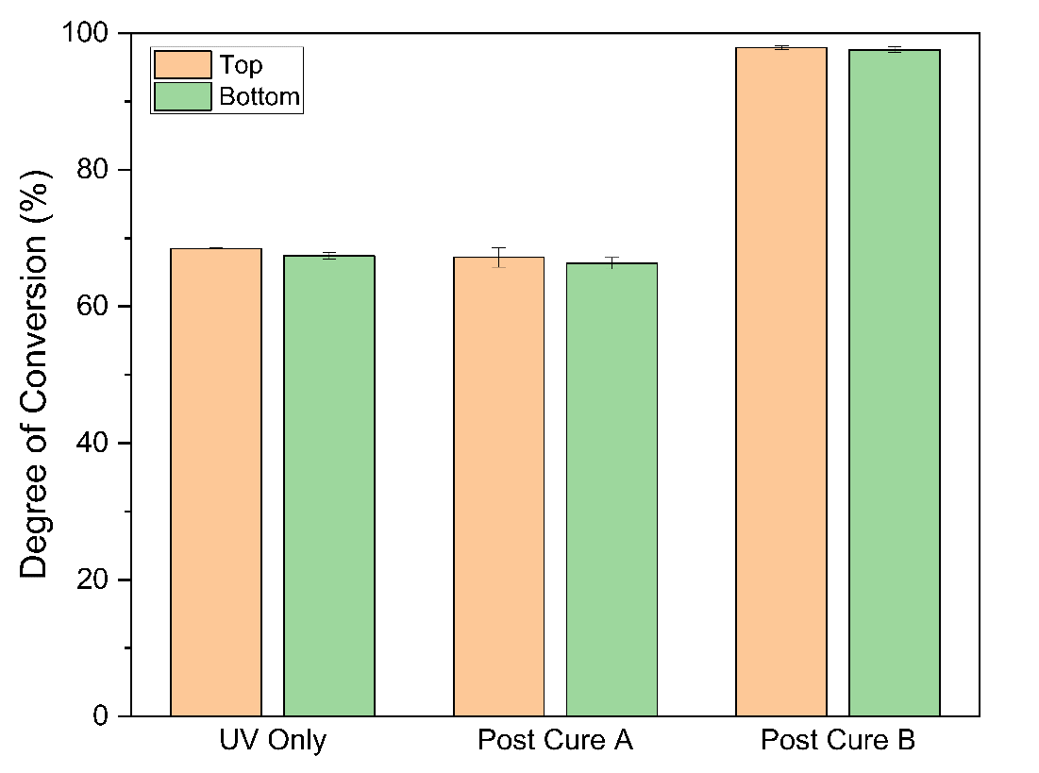
Figure 50 Top and bottom surface DC with various cure conditions. Post Cure B, 200 ºC for 2 hrs, achieved an average 98% DC.

Table 8 Summary of tensile properties with various cure conditions.
Cure Conditions | Tensile Strength (MPa) | Tensile Modulus (GPa) | Failure Strain
UV Only | 39.61 [4.29] | 2.27 [0.06] | 2.32 [0.37]
Post Cure A | 55.28 [4.37] | 2.95 [0.09] | 2.40 [0.34]
Post Cure B | 55.29 [4.59] | 3.04 [0.04] | 2.28 [0.29]

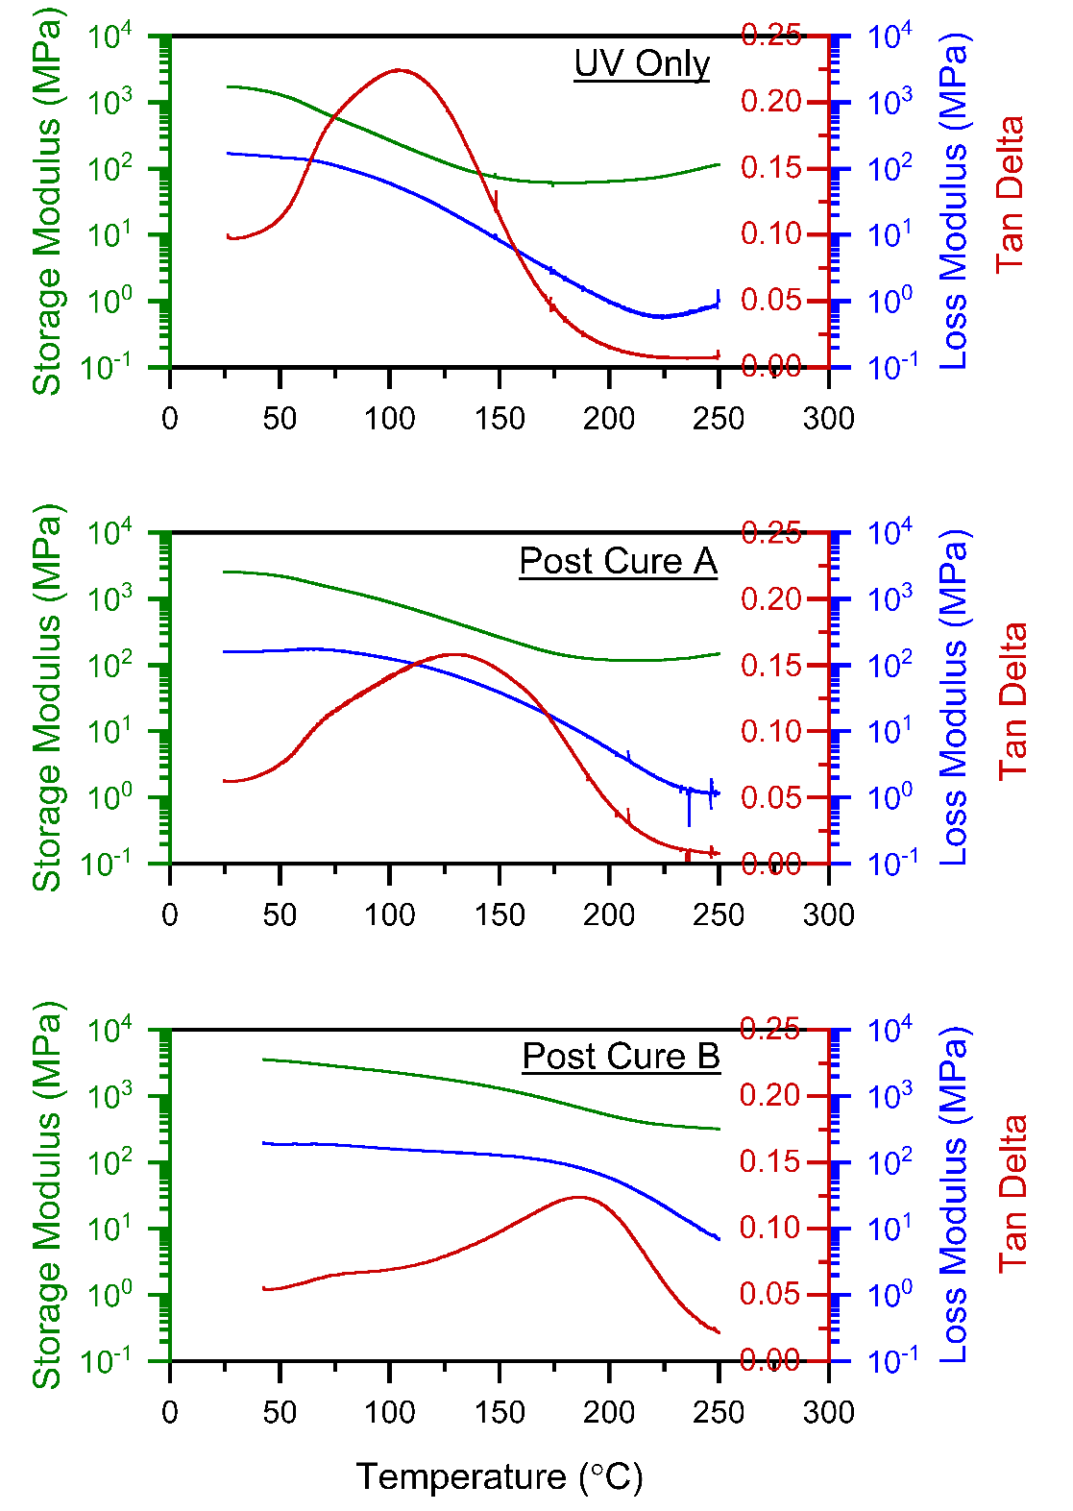
Figure 51 DMA curves for various cure conditions. Note the shift in Tg as indicated by the Tan Delta peak, which increases with post curing.

treatment, and with Post Cure B the peak also becomes narrower. With UV Only and Post Cure A, the Storage Modulus and Loss Modulus curves both indicate a broad transition region. With Post Cure B, there is a clear transition in both Storage Modulus and Loss Modulus that coincides with the Tan Delta peak. The T_{g} as measured by this peak is 103 ºC for UV Only, 133 ºC for Post Cure A, and 186 ºC for Post Cure B. This highest T_{g} is 9% higher than the value reported by the resin supplier, and 8% higher than the value reported for Bis-EMA:PETIA photopolymer tooling after thermal cycling at 135 °C [109].

TGA
Thermogravimetric analysis was performed on the three cure conditions, with results shown in Figure 52. The mass loss curves were similar, with most mass loss occurring at temperatures >380 °C. Both Post Cures dropped below 95% mass at ~380 °C, while the UV Only specimen dropped below 95% mass at ~360 °C.

Discussion:
For the cure conditions tested, a high temperature post cure of 2 hrs at 200 °C (Post Cure B) yields both the highest T_{g} (186 °C) and the highest DC (98%). TGA results also indicate the highest thermal stability with Post Cure B, and a small (< 5% mass loss) but observable trend of increased thermal stability with either post cure. DMA and FTIR both confirm that Post Cure B achieves the most complete cure and is higher than the 90.5% DC reported by the resin supplier for Bis-EMA when cured as a thermoset with a post cure cycle similar to Post Cure A (see p.12). However, there is no significant improvement in the tensile properties with Post Cure B versus Post Cure A.

In photopolymers, Decker et al. postulated that thermal post cure cycles do not generate additional free radicals in a photopolymer, but that the thermal energy can restore some chain mobility and allow trapped free radicals to react [62], [63]. Therefore, one explanation for the improved DC with Post Cure B versus Post Cure A is the higher temperature, and specifically a temperature above the T_{g}. However, in addition to potential improved free-radical mobility, at 200 °C the Bis-EMA:PETIA blend is likely undergoing thermally induced polymerization. Gilmer et al. reported thermal polymerization occurred for TEGDMA, a common methacrylate monomer, at 134 °C -138 °C without any initiator [151]. The MSDS for PETIA states that the monomer is polymerized by 220 °C, but no polymerization temperature was listed in the MSDS for Bis-EMA. To assess this behavior, DSC testing was conducted on uncured 80:20 Bis-EMA:PETIA without a PI. With a temperature sweep of 0 °C to 350 °C and a ramp of 5 °C/min, the system exhibited a strong exothermic reaction starting at ~170 °C (see Figure 53). Further DSC testing showed that the addition of 0.1 wt% BAPO did not change this reaction onset temperature, and that Bis-EMA alone had a much lower reaction enthalpy than the Bis-EMA:PETIA blend (see Appendix). The DSC testing confirmed the potential for post curing at 200 ºC to improve DC by thermally induced polymerization.

The tensile properties for UV Only were comparable to those reported previously [109] for an 80:20 Bis-EMA:PETIA blend. This previous work used a higher dose of 8.0 J/cm², 1.0 wt% BDMB as PI, and 3 mm thick tensile specimens. Most significantly, the thinner 1 mm specimens tested in the present work had a much lower standard deviation in tensile strength, at 4.29 MPa versus 15.91 MPa for the 3 mm specimens. The tensile curves also did not exhibit the inflection point and two distinct modulus regions reported for the 3 mm specimens. As shown in the Appendix, all three cure modes for the 1 mm thick specimens exhibited a more typical thermoset stress-strain curve. These results and the similar top and bottom FTIR confirm that the 1 mm thick specimens had a more even cure through the thickness than the 3 mm thick specimens tested previously.

From a practical perspective, Post Cure B was found to increase warping in parts, and some panels cracked during the post cure process. While Post Cure A did not achieve as high of a DC or T_{g} as Post Cure B, it achieved comparable tensile properties and did not suffer from the same processing issues. Therefore, Post Cure A was selected for further study, and throughout the remainder of the chapter all post cured specimens will use this regimen. Further testing is needed to assess whether the post cure cycle can be improved to induce thermal polymerization without causing these processing issues.
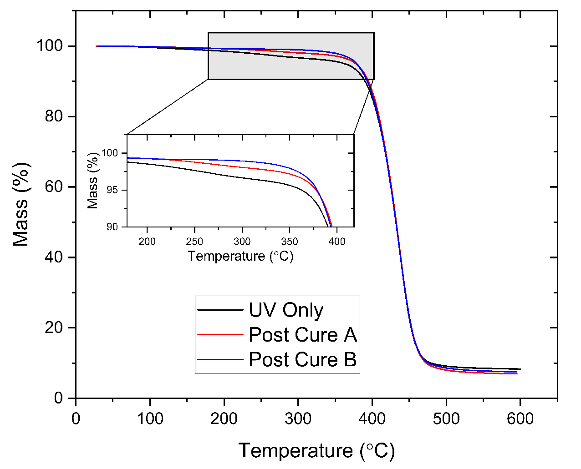
Figure 52 TGA results for various cure conditions. Note that there is less mass loss up to ~380 °C with post curing.

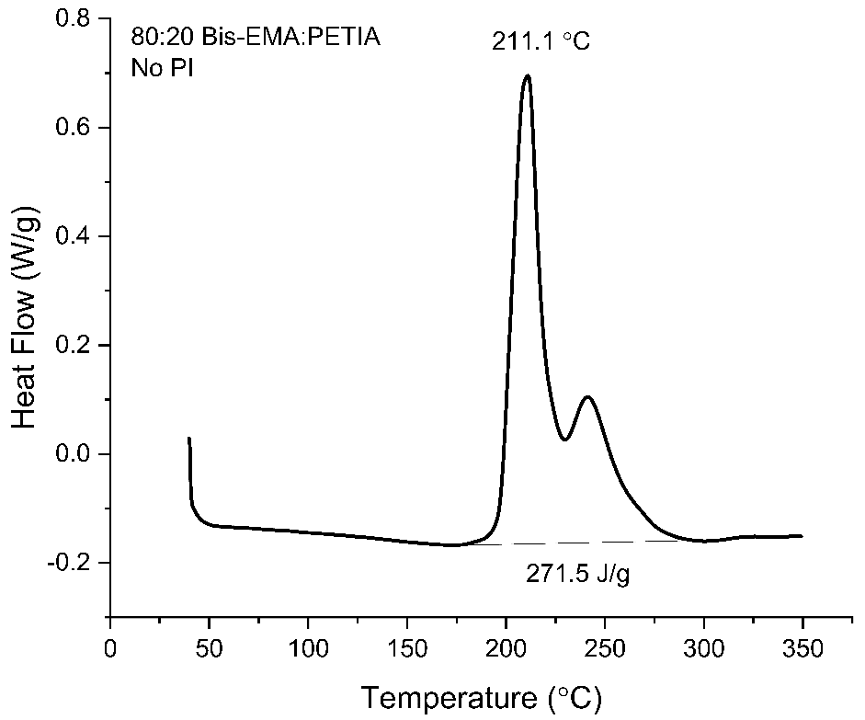
Figure 53 DSC results for liquid 80:20 blend of Bis-EMA:PETIA. Without any initiator or UV exposure, the system polymerized starting at ~170 °C.

4.2 Cure depth profile on single-layer neat resin

FTIR Microscopy
Degree of conversion (DC) was measured on potted and polished specimens from the RT-FTIR testing, with some specimens thermally post cured. Figure 54 indicates that
DC is high at shallow depths closest to the irradiated surface, with a non-linear drop in DC across the polymer depth. The highest DC values for the High Dose specimens were 7-8% DC higher than those of the Low Dose specimens, while the lowest DC values at depth differed by 20-28% DC. The percent difference in DC between Low Dose and High Dose specimens at depth is comparable to the difference measured via RT-FTIR, although all DC values were higher than those measured 10 minutes post irradiation. 70-80% DC is comparable to the values reported in earlier work with the same resin system and cure depth [109], although the UV dose was higher than the High Dose tested in the present work. In both instances, the FTIR spectra were collected more than a month post irradiation, which implies that the additional ~20% DC may be the result of extended dark cure. This assertion is supported by the slight drop in DC values closest to the irradiated surface, which may be lower than values at ~1 mm depth because of free radical scavenging limiting propagation reactions as oxygen diffuses into the polymer over time.

Thermal post cure, which commenced within one hour of initial irradiation, appeared to have minimal effect on the High Dose specimen, with an increase of less than 3% DC at the deepest measured point. The post cure did appear to have a more pronounced effect on improving the cure in the Low Dose specimens, by up to 9% at 2 mm depth.

Nanoindentation
The indentation hardness in nanoindentation is calculated using the projected area of an indent. This was converted to Vickers hardness (HV), which is calculated using surface area, by applying a conversion factor of 94.5. As shown in Figure 55, the calculated HV for the neat resin specimens was consistently higher for the High Dose specimens than for the Low Dose specimens. This cure gradient is most pronounced with the Low Dose, as HV drops from a maximum of 30 – 32 near the irradiated surface down to 3 at a depth of 2500 $μm$. Post cure appears to improve overall HV for the High Dose specimens, with an improvement of 1.5 to 4.8 HV for all depths versus the non-post cured specimens. This improvement is greatest at the depths of 2300 $μm$ to 2900 $μm$, and the cure gradient in terms of HV decreases from 13.8 with the High Dose – No Post Cure to 12.5 with the High Dose – Post Cure specimens. The results indicate a non-linear cure gradient in neat resin, similar to those reported by Alrahlah et al. for highly filled dental photopolymers [48]. As expected, the cure gradient is more pronounced at a lower dose and shorter irradiation time.

4.3 RT-FTIR on multi-layer neat resin
Neat resin formulations were first tested for their cure behavior under a Low or High UV dose. Single layer specimens were irradiated with the top surface uncovered, and degree of conversion (DC) was monitored at 3 mm depth in real-time for 10 minutes post irradiation. As shown in Figure 56, a rapid onset of cure occurred within the first 30 s, followed by a gradual further increase in cure over the remaining 10 minutes. This effect is known as “dark cure,” and is the result of continuing reactions from the free radicals generated during irradiation [56], [152], [153]. The initial slope of the High Dose specimens is higher than that of the Low Dose, indicating a higher initial polymerization rate with a longer irradiation time. While DC improved over time, the dark cure effect was limited. Without new free radical generation from further UV exposure, the maximum cure after 10 minutes varied widely for the Low Dose specimens from 16-35% DC, with an average of 25% DC. At a High Dose, the cure behavior at 3 mm depth was consistently within 52-53% DC at 10 minutes for all five tested specimens.

For 5 Layer specimens, a new layer was added and irradiated every 2 minutes, and with each irradiation the UV lamp moved a further 3 mm from the original layer. The combined effect of additional distance from the light source and additional polymer leads to light attenuation that restricts the ability for new free radicals to form at the bottom surface of the first layer. For the High Dose specimens, no observable changes occurred
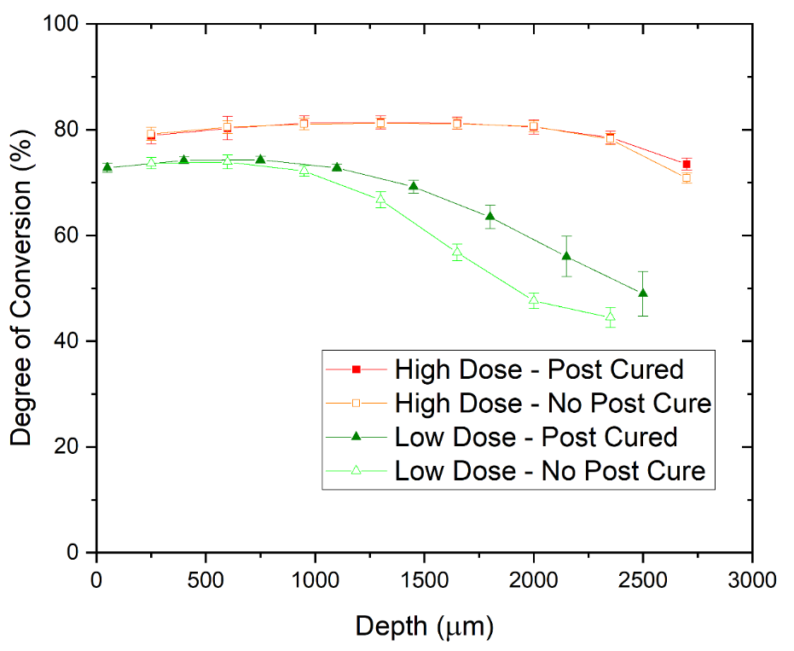
Figure 54 Degree of conversion across the depth of a 3 mm specimen. At High Dose, the DC is both higher and has less of a gradient than the Low Dose specimen. The shift in depth for the onset of cure gradient may indicate some photobleaching effect.

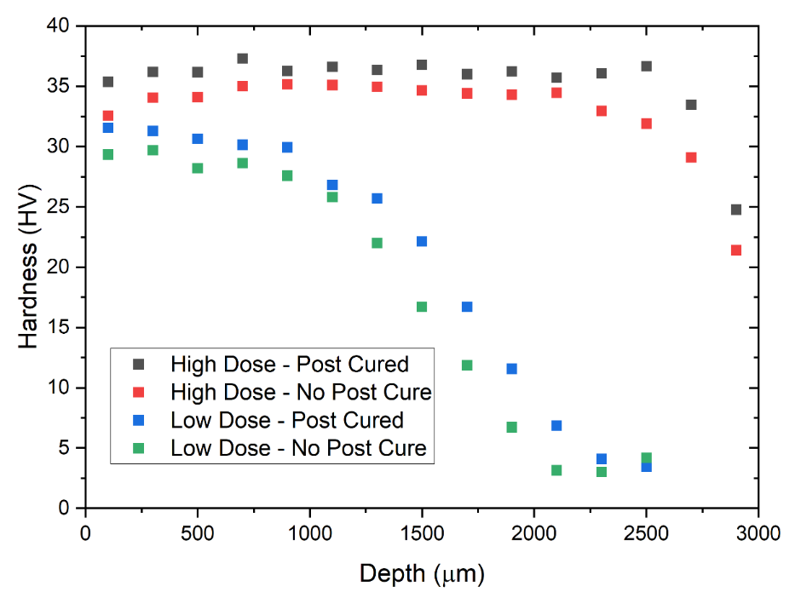
Figure 55 Hardness values via nanoindentation across specimen depth for neat resin. Note that both nanoindentation and FTIR microscopy results used the same specimens, with nanoindentation measurements taken from the center region of each specimen.

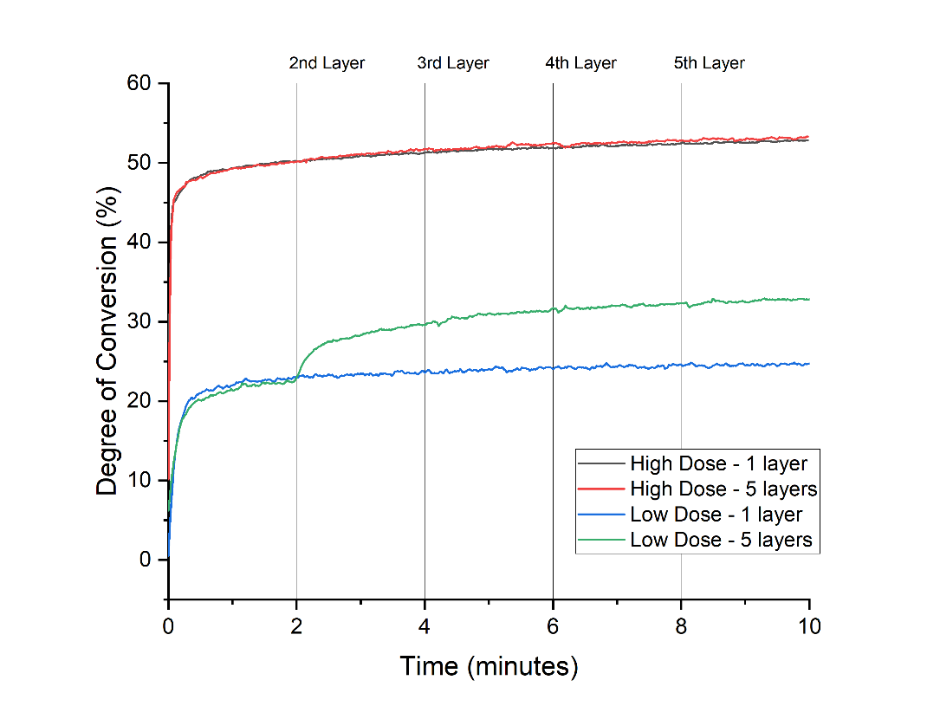
Figure 56 Degree of conversion on the bottom surface over time, with 1-layer specimens irradiated once at t=0 and dark cure occuring over the course of 10 minutes. 5-layer specimens were irradiated at 2 minute intervals with the addition of new 3 mm layers. At Low Dose, the DC improves with the 2nd dose irradiation, but the multi-layer effect appears to be limited.

at the bottom surface as new layers were added and irradiated. However, for the Low Dose specimens, the irradiation of the 2nd layer induced a measurable improvement in the DC of the bottom layer, with final DC at the bottom surface improving from 25% DC up to 33% on average. This effect was limited only to the 2nd layer, and further additional
layers had no effect on the bottom surface cure. Note that even with multi-layer improvements for the Low Dose specimen, the final DC remained 20% lower than that of the High Dose specimens.

4.4 Cure depth heat map on multi-layer neat resin
Heat maps of DC values were generated for the FTIR microscopy measurements of 5 Layer neat resin specimens irradiated under Low, Medium and High Doses with 350 μm spacing between rows in a 45 x 4 grid. As shown in Figure 57, Figure 58, and Figure 59, in order to fully capture the specimens the grid spacing extended beyond the top of the specimens and into the potting epoxy. Measurements in the epoxy and invalid test results are shown as blank white spaces.

In comparing the different dose levels, a clear trend emerges of an overall increase in DC with higher UV dose. Without post cure, the average DC increased from 53.8% at Low Dose to 74.1% at Medium Dose and 78.3% at High Dose. The average DC did not change significantly with post cure. Layers are easily distinguished at all doses, the result of a cure gradient within each layer. The difference in DC from the top to bottom of a given layer varies widely from 18.7% to 51.0% in the Low Dose specimens. In the Medium Dose specimens, the cure gradient ranged from 6.9% DC to 17.1% DC, and for High Dose specimens the gradient further reduced to a range of 3.6% DC to 10.3% DC. As expected, the cure gradient diminishes with longer irradiation times and higher dose. However, if the 1st layer were removed, the cure gradient becomes even smaller, at 6.9% to 11.6% for Medium Dose and 3.6% to 7.6% for High Dose specimens. Even after taking layer thickness variations into consideration, the first layer for all Medium Dose and High Dose specimens had a bottom surface DC that was consistently lower than any subsequent layers, which contradicts the hypothesized effect of multi-irradiation curing. Because this surface was in direct contact with the FTIR-ATR accessory, the conclusion is that the high thermal conductivity of the steel ATR platform effectively restricted exotherm reaction temperatures, reducing overall DC. Layers 2-4 were better insulated during curing and could achieve a higher exotherm.

For further analysis, the two centermost data points from post cured each specimen were averaged and used to construct a depth profile through the five-layer specimens (see Figure 60). The trend observed in single layer specimens (see Figure 54) is also found in Figure 60, with the High Dose specimens achieving the highest DC values at a depth of 850 μm to 1200 μm for each layer. Likewise, there is some indication that the Low Dose layer cure improves with multiple irradiations, as the 1st layer has the highest bottom surface DC of any layer at 49.7 %. Layers 2 and 3 in the Low Dose specimen also have higher DC values at their bottom surfaces, while Layers 4 and 5 have the lowest bottom surface DC values and the fewest irradiation cycles. The Low bottom surface DC of Layer 5 (21.9%) may also be the result of its comparatively high layer thickness of 3.55 mm. At 2.96 mm thick, layer 4 also has a low bottom surface DC of 35.6% and more clearly demonstrates the multi-irradiation effect.

4.5 Cure depth profile on multi-layer fiberglass composite
To assess the potential cure gradient in composite specimens, nano-indentation was performed in the pockets of polymer in between densely packed fiber bundles. The fiber structure in the laminate was primarily unidirectional, with approximately 8% of fibers in the transverse direction and 1% polyester stitching fibers between the roving. Stitching, transverse fibers, alignment of rovings between layers, and gaps in roving may all influence light transmission and the resulting local cure in the polymer. Therefore, nanoindentation sites were selected to encompass the extent of a sample and minimize local variations as much as possible.

As shown in Figure 61, the trends observed in the neat resin (see Figure 55) were similar in the fiberglass composite specimens. The peak hardness values for the composite
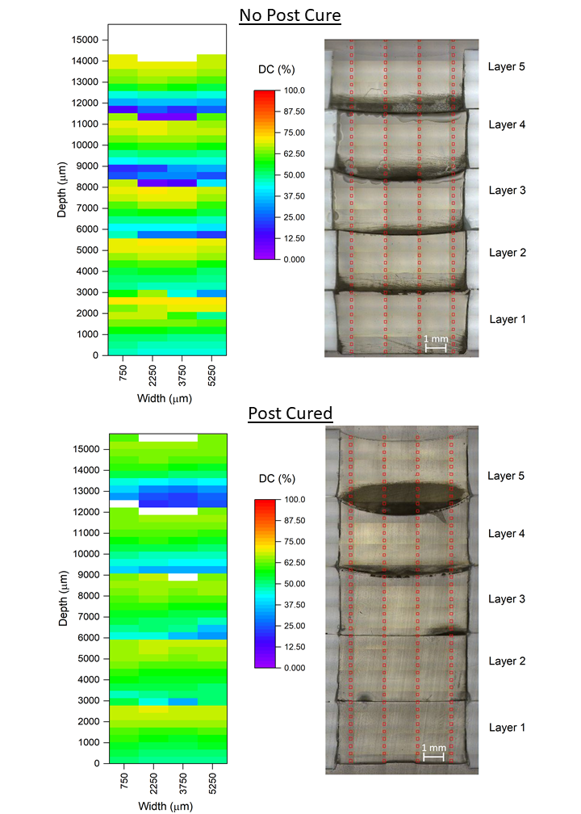
Figure 57 FTIR microscopy results (left) for five-layer Low Dose specimens. Note that the darker regions in the optical microscopy (right) correspond with a low DC.
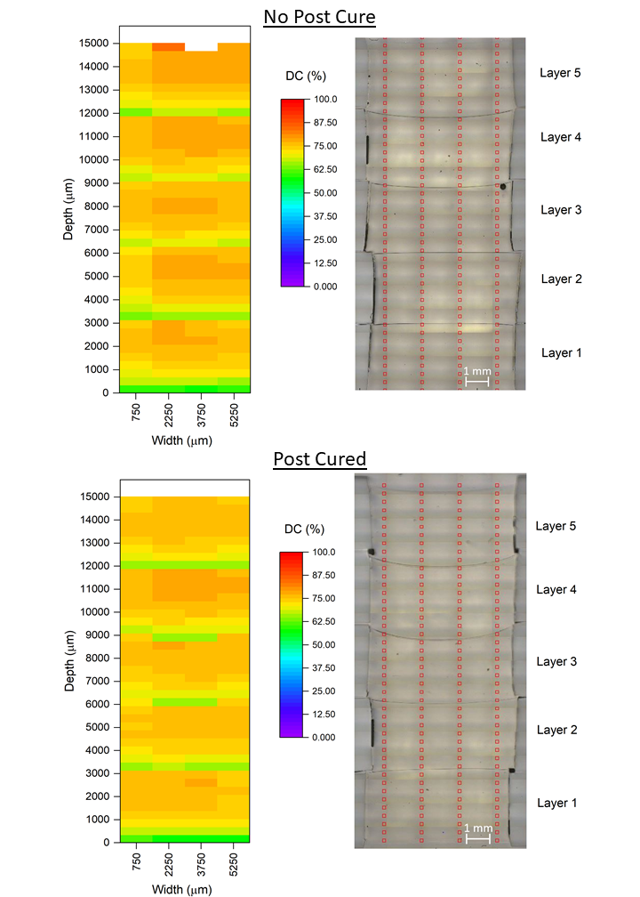
Figure 58 FTIR microscopy for Medium Dose specimens. The overall DC is higher than the Low Dose specimens, but layers are easily distinguished by the cure gradient.
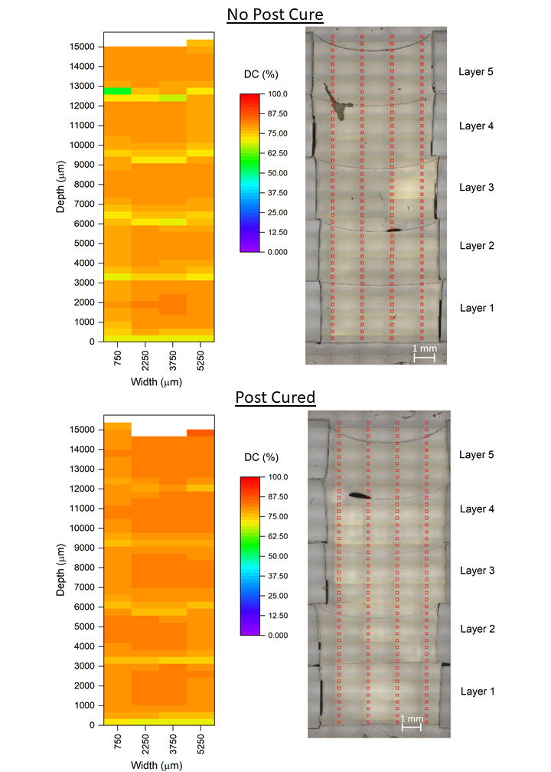
Figure 59 FTIR microscopy for High Dose specimens. Some cure gradient is still present, and a defect in the top two layers of the No Post Cure specimen was identified with lower DC.
specimens were consistently lower than the peak values for the neat resin specimens, by 1.1 to 5.2 HV. There was no clear improvement from the multiple irradiations, but thermal post curing yielded an overall increase in hardness values for both doses.

As with the neat resin FTIR microscopy results (see Figure 60), each layer had a cure gradient and hardness increased at the layer interface for the Low Dose specimens. For the Low Dose composite specimens, the HV gradient varied from 12.0 to 18.9 without a post cure and from 8.9 to 14.9 with a post cure, indicating a reduced cure gradient.

As shown in Figure 61, the High Dose composite specimens exhibited a plateau region with higher HV and a drop in hardness within the 2-3 mm depth range of a layer. For the High Dose composite specimens, the Layer 2 without post cure had a higher amount of scatter than the other specimens, but Layer 1 had less scatter and a hardness gradient of 4.3. With a post cure the hardness gradient increased to a range of 6.1 to 6.9 HV, although the median hardness also increased from 27.3 without a post cure to 33.2 with a post cure.

4.6 ILSS on Multi-Layer Fiberglass Composite
To better assess the influence of the cure gradient on bond strength at the layer interface, ILSS testing was conducted on both single and multi-layer composites. Four dose levels were tested equivalent to the High, Medium, and Low static doses, with an additional intermediate dose at a 15 mm/s scan rate (see Table 7). In Figure 62, there does not appear to be a clear trend in ILSS with increasing dose for 1-layer specimens. However, thermal post cure improved the average ILSS by 5-9 MPa for all except the 10 mm/s equivalent dose, which had a high standard deviation in results.

With two layers of composite, the total thickness of the ILSS samples increased to 6 mm. As indicated by Figure 63, average ILSS values improved consistently with increasing UV dose. Likewise, thermal post cure consistently improved average ILSS, increasing by as much as 4.0 to 4.5 MPa at the High Dose and Medium Dose levels. From the High
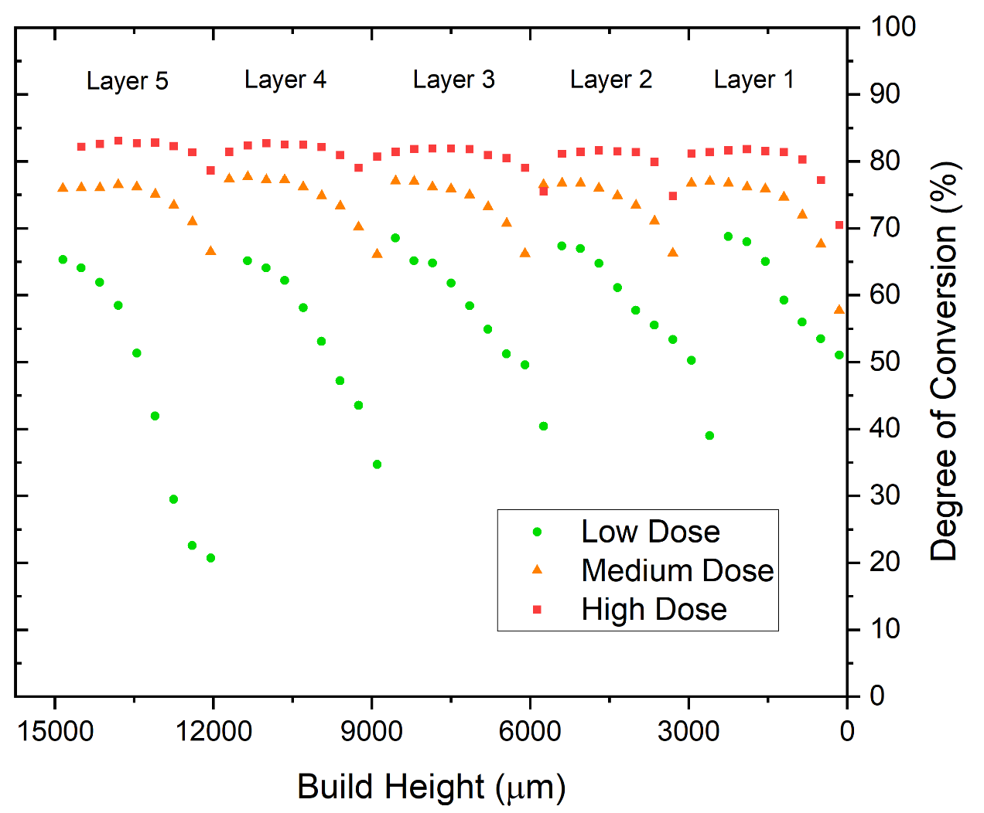
Figure 60 Centerline depth profile of post cured five-layer specimens. The cure gradient decreases and overall DC increases with longer irradiation times.

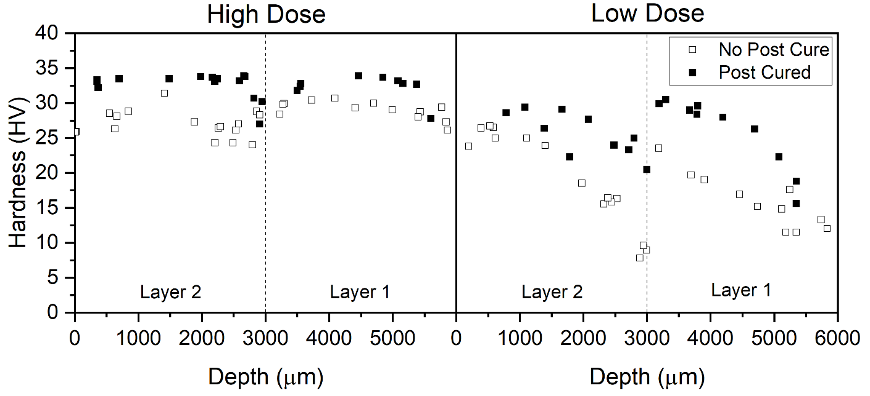
Figure 61 Nanoindentation hardness profile across layers, with 0 $μm$ and 3000 μm depths as the UV irradiated surfaces. The dotted line represents the interface between the two layers.
Dose to the Low Dose, the average ILSS improves by 5 MPa without a post cure, and by 8 MPa with a post cure, the latter a 40% improvement in adhesion between layers. Figure 64 summarizes the 1 Layer and 2 Layer composite ILSS results for High and Low Dose.

The ILSS values decrease for the 2 Layer versus 1 Layer specimens. For the Low Dose, this drop varies from 5.3 MPa without post cure to 11.1 MPa with post cure. The High Dose average values nearly match between 1 Layer and 2 Layer, with the 1 Layer ILSS 2.1 MPa higher without post cure and 2.9 MPa higher with post cure.

As shown in Table 9, this difference in manufacturing method is apparent in the fiber volume fraction, with the 2-layer thermoset controls achieving a V_{f} equivalent to the 1-layer specimen average of 54.2%. The 2-layer UV cured composites had a lower average of 49.6% fiber volume fraction, which can be attributed to the resin rich surfaces created at the planar interface between the previously cured layer and the second layer infusion.

Within the 2-layer panels, it is also notable that all panels at High Dose and Low Dose achieved lower ILSS than their equivalent 1 Layer counterparts. The most obvious explanation for this is the difference in the quality of the secondary bond between layers vs. the interlaminar bonds within an infused layer, which was investigated using SEM.

4.7 Single-Layer Fracture Surface Analysis
SEM imaging was used to assess the fracture surfaces of the various ILSS configurations for the single-layer laminates. Few differences were apparent among the UV cured specimens, and all imaged specimens had evidence of fracture across the entire face of the exposed fracture surface, often with some exposed transverse fibers. As shown in
Figure 65, a typical fracture surface exhibited hackling within the polymer, an indicator of mode II shear failure that was also observed by Di Pietro in similar UV-cured composite ILSS testing [123]. All specimens exhibited regions with exposed glass fibers and regions with polymer bearing the imprints of fibers that had pulled away from the polymer during or after fracture.
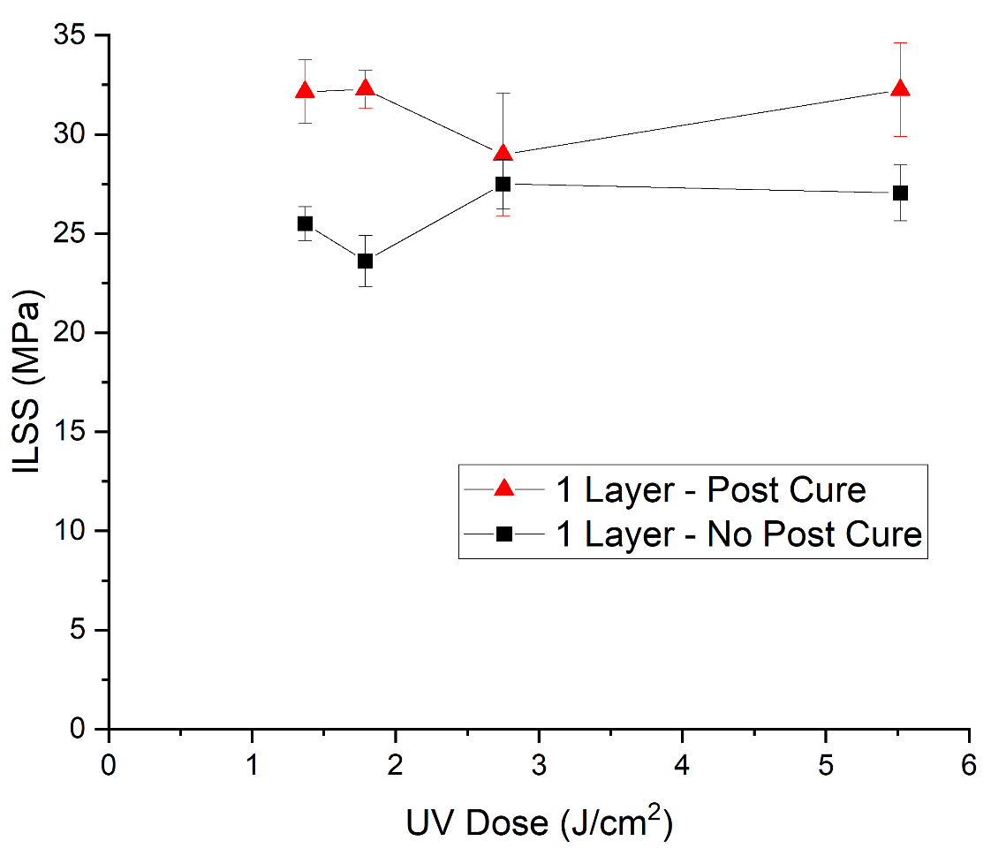
Figure 62 Interlaminar shear strength for 1 layer composites, with typical failure occuring at the mid-plane between to plies of non-crimp fiberglass fabric.

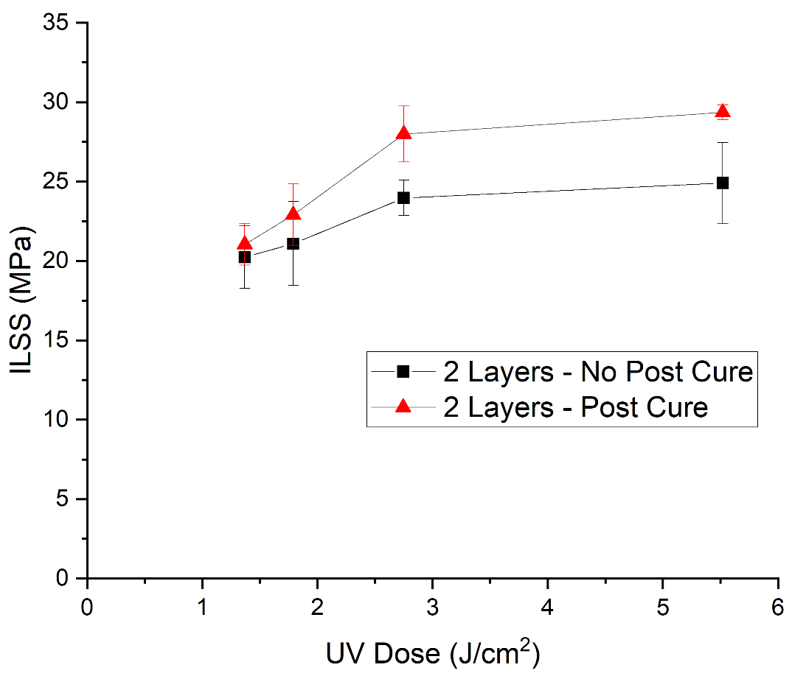
Figure 63 For multi-layer, multi-irradiation composites, increasing UV dose and applying thermal post cure appear to both improve adhesion between layers.
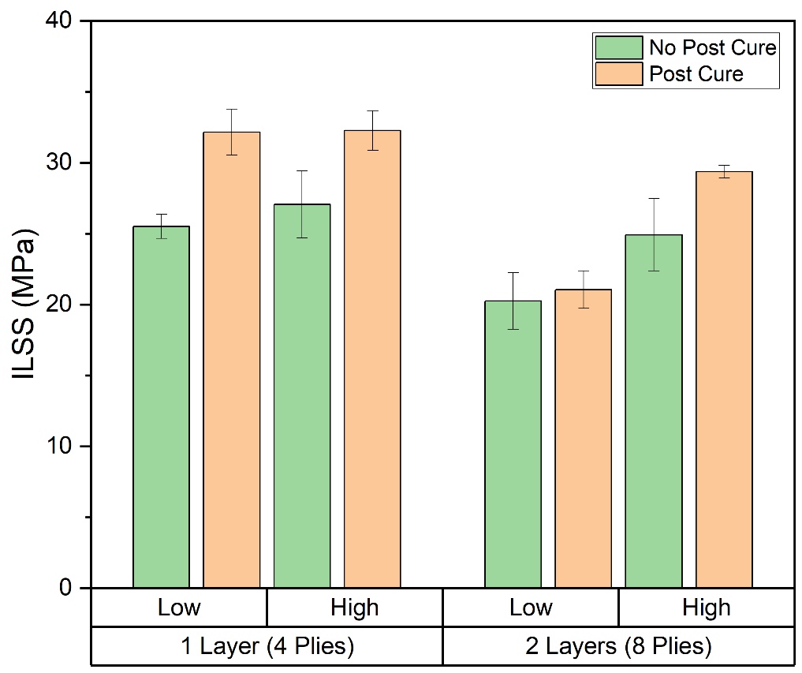
Figure 64 Interlaminar shear strength for 3 mm single layer laminates and 6 mm double-layer laminates, with different thermal treatments and Low Dose versus High Dose irradiation. Note the general trend of lower ILSS for double layer versus single layer.

Table 9 Summary of average interlaminar shear strength and fiber volume fraction results, excluding the 10 mm/s and 15 mm/s scan rates. [x] indicates standard deviation.
 | Dose | Post Cure | V_{f} (%) | ILSS (MPa)
1 layer (4 plies) | Low | N | 50.9 [0.9] | 25.5 [0.8]
1 layer (4 plies) | High | N | 54.6 [0.7] | 27.0 [2.4]
1 layer (4 plies) | Low | Y | 55.4 [0.7] | 31.2 [1.6]
1 layer (4 plies) | High | Y | 55.4 [1.0] | 32.3 [1.4]
2 layers (8 plies) | Low | N | 49.7 [0.9] | 20.2 [2.0]
2 layers (8 plies) | High | N | 47.1 [1.6] | 24.9 [2.5]
2 layers (8 plies) | Low | Y | 51.5 [1.3] | 21.0 [1.3]
2 layers (8 plies) | High | Y | 50.0 [0.8] | 29.4 [0.5]

4.8 Multi-Layer Fracture Surface Analysis
When observing multi-layer specimens, a clear difference emerges in the UV cured specimens. As Figure 66 shows, many UV double-layer specimens had fracture surfaces featuring large smooth regions interspersed with several fracture zones. Within these
smaller regions, the expected signs of fracture are present such as resin cracking, hackling, exposed fibers and fiber imprints. Within the smooth region, very few features are apparent under SEM.

For single-layer specimens there was no secondary bond region and thus all specimens failed between fiberglass plies, typically along the neutral axis. Most of the double layer specimens, on the other hand, failed at the resin-rich secondary bond interface between infused layers, which ILSS has shown is generally a weaker bond than the interlaminar bonds for the UV doses tested. The exception to this failure mode is the High Dose, post cured sample set. During ILSS testing, the typical failure mode for this set was a series of fractures along the lower, tension-dominated half of the specimen, with fiberglass plies separating and sliding past each other. In Figure 67, typical fracture surfaces are shown for each of the High Dose and Low Dose methods for 2-layer UV cured composites. While a, b, and c show regions of smooth polymer outside of fracture regions, only the High Dose post cured specimens exhibited signs of fracture across its entire face.

5.0 Overall Discussion

5.1 Single-layer neat resin depth profile via FTIR microscopy versus nanoindentation
The same single-layer neat resin specimens were used for both nanoindentation and FTIR microscopy, and the results follow similar trends. A plateau region is present in both test
results, with DC values >70% up to 1 mm depth at Low Dose and >80% up to 2 mm depth at High Dose. This increasing plateau region confirms the photofrontal cure behavior predicted for photopolymers with initiators such as BAPO. Photofrontal cure is
possible as certain PIs react and photobleach, allowing increased light penetration and inducing a progressive cure through the polymer depth with increasing irradiation time [36], [41], [107], [128].
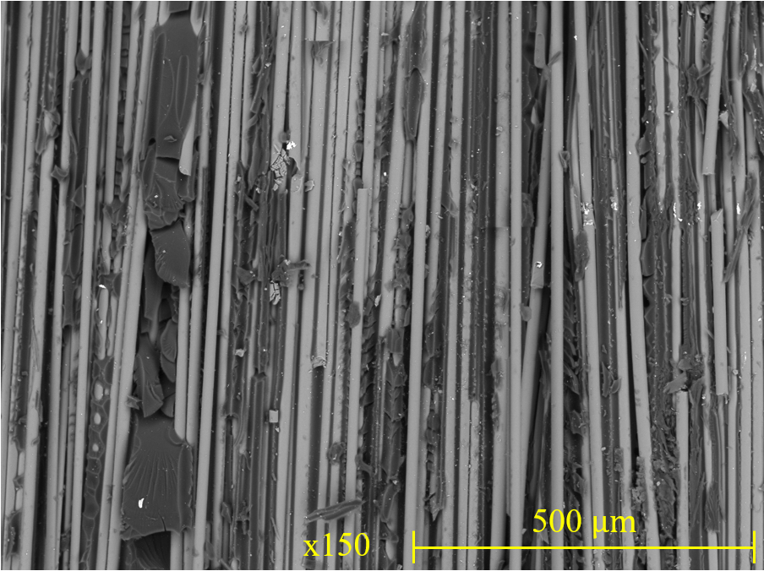
Figure 65 The interlaminar fracture surfaces for a single layer laminate at high UV dose, post cured. Note the visible hackling in the polymer.

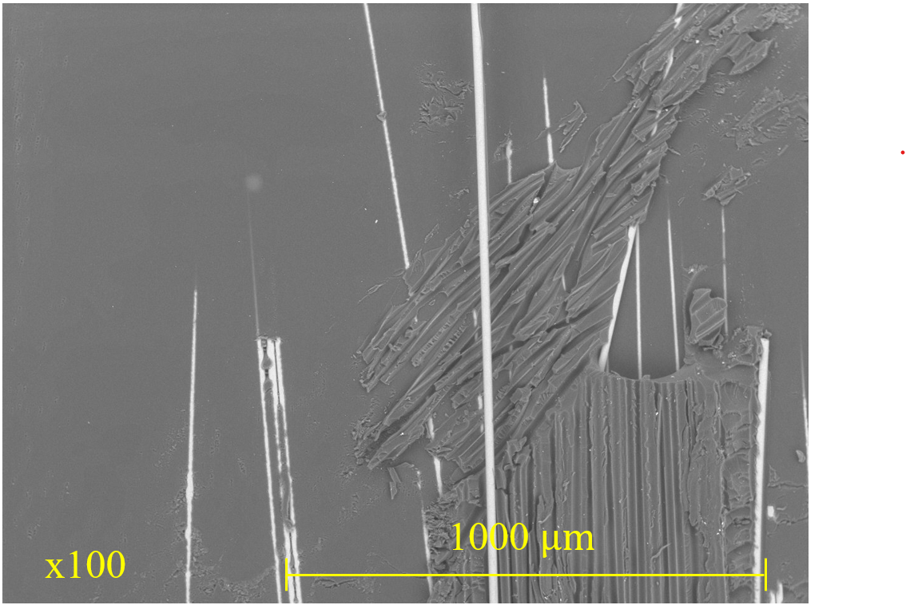
Figure 66 The low UV dose double-layer fracture surface is primarily smooth and featureless, with several regions that exhibit signs of fiber tearing and polymer fracture.
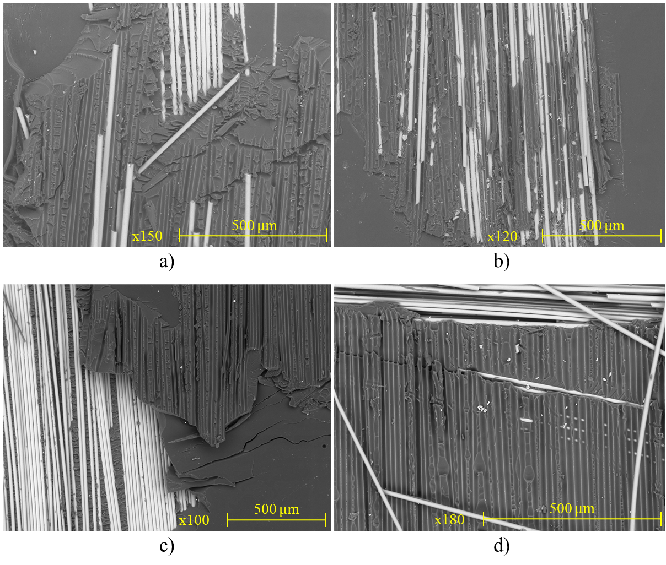
Figure 67 Fracture surfaces for double-layer specimens: a) Low dose, no post cure, b) Low dose, post cured, c) High dose, no post cure, d) High dose post cured. Specimens a-c failed at the interface between infused layers, while d failed within a laminate.

Thermal post cure improved HV and DC in both dose levels, but the improvement indicated by the results for Low Dose – Post Cure specimens is lower for nanoindentation than with FTIR microscopy. This is explained in part by the difference in measurement locations, as the FTIR microscopy results for a given depth were taken at 1600 $μm$ intervals along the x-axis, while nanoindentation results were all taken close to the center line for a given specimen. As shown in Figure 48, the standard deviation is highest for the Low Dose – Post Cured specimen. This is because the average DC for the measurements along the outer vertical edge of each specimen are higher than the DC values at the center line. At 1650 $μm$ depth, this difference was an average 1.6 % DC, increasing to 7.1 % DC by 2700 $μm$ depth. It is unclear why the DC along the outer edges was higher in these specimens, as this was not present in the multi-layer specimens.

5.2 Multi-Layer neat resin results
The Low Dose specimens proved somewhat challenging to prepare. In RT-FTIR, Low Dose specimens had a much larger variation in DC after the first irradiation in comparison with the High dose specimens, although samples consistently improved to nearly identical final DC after the 2nd layer irradiation. The low DC, especially at the layer interface, resulted in multi-layer specimens that were delicate after testing and prone to separate into individual layers upon handling. For some potted specimens, the low DC portions were prone to smearing during polishing, and in microscopy these regions were apparent as darker than the surrounding polished surfaces.

For example, the first Low Dose – No Post Cure specimen tested using FTIR microscopy was ultimately a failed depth profile measurement because of a large defect between layers 2 and 3 (see Figure 68). This was either due to underfill or leakage prior to irradiation resulting in an exceptionally thin layer 2 (1.45 mm at centerline) and an exceptionally thick layer 3 (3.74 mm at centerline). The average layer thickness for the specimens shown in Figures 10-13 was 2.97 mm, with a standard deviation of 0.26 mm due to slight variations in fill height, cure shrinkage and possible mold leakage. However, at 3.74 mm height, the resulting bottom surface cure was so low that some of the polymer smeared upwards across the layer during polishing. At the darkest region of layer 3, the average DC is only 20.5%, and across the entire layer interface the average is 23.8%. Not surprisingly, the layer 2 bottom surface DC is much higher (54%) due to the shallower depth. Similar effects with even lower DC values and some missing data points were observed in the other Low Dose specimens as shown in Figure 57.

The failed specimen in Figure 68 illustrates the importance of consistent layer height during a process such as LFAM. It could also have implications on DIW print paths, as certain path configurations may result in partial road overlapping, overhangs or even bridging, all of which will influence the aspect ratio of the bead and change the effective depth of the layer. For LFAM, care must be taken when optimizing print speeds to factor in effective layer heights, and certain path trajectories that alter bead aspect ratio may need to have print speed reduction factors incorporated into the slicing software.

The results in Figure 68 also illustrate the efficacy of FTIR microscopy as a tool for investigating depth of cure. The test was strongly influenced by the smeared polymer sections, and there is a clear correlation between the drop in DC and the defective regions. It is apparent that a DC of >30% is preferable when polishing specimens cured from the Bis-EMA:PETIA blend in the present study.

5.3 ILSS
The observed failure mode of the 3 mm 1 Layer specimens was primarily at the specimen mid-line, which falls along the interface between the second and third plies of fiberglass. This is assumed as the area of highest shear stress according to a parabolic shear stress distribution [141]. At this depth of 1.5 mm, composite nanoindentation results indicate that the level of cure in a Low Dose laminate varied between 15 to 24 HV without a post cure and 26 to 29 HV with a post cure. With a High Dose, the HV at 1.5 mm depth was equivalent to the peak HV values in the laminate, at approximately 30 without a post cure and 33 to 34 with a post cure. Despite the lower HV at the mid-plane, the Low Dose 1-

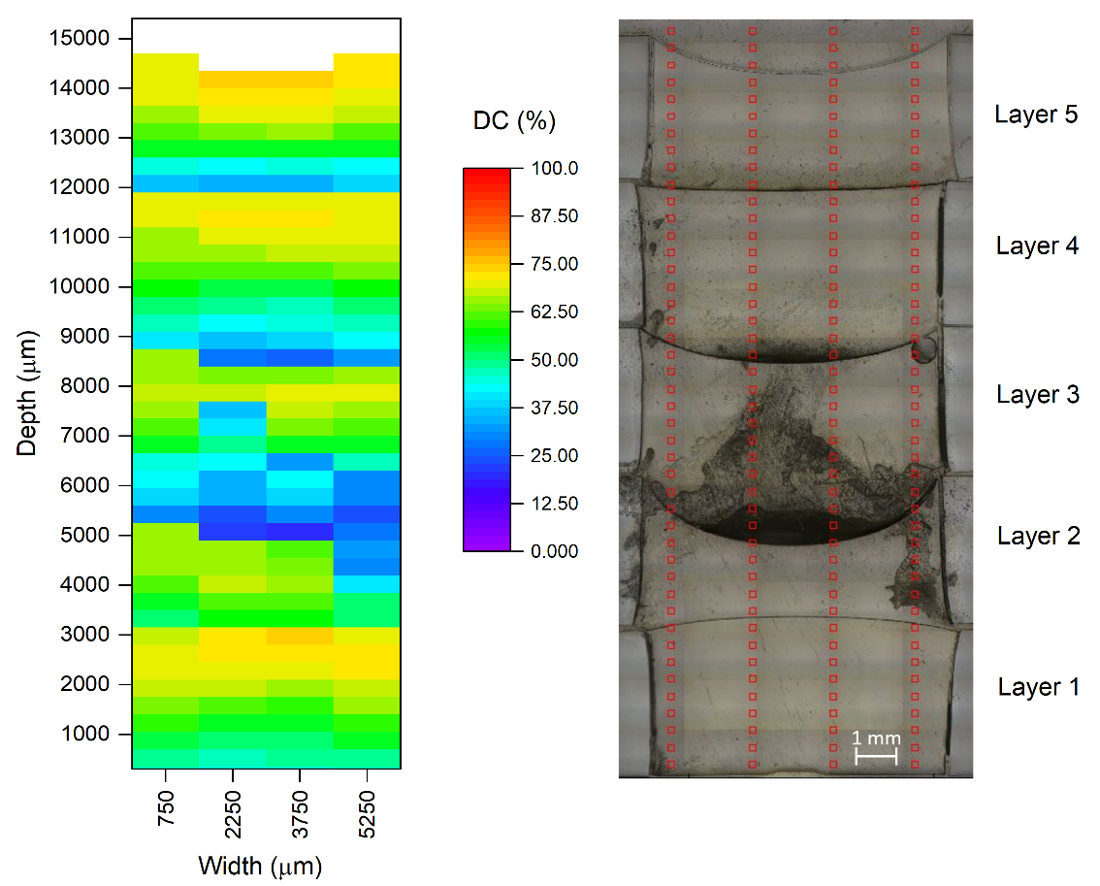
Figure 68 FTIR Microscopy results for a 5-layer specimen irradiated under Low Dose, no post cure. Note that the microscopy technique identifies defective regions as having a low DC.

Layer specimens had nearly equivalent ILSS values with the High Dose specimens for the same thermal treatment. This behavior is not yet well understood, but further testing on fiber-matrix interactions may provide insight.

ILSS results indicate that bond strength between 3 mm thick layers in a multi-layer AM process is generally lower than the interlaminar strength within each layer. This is somewhat intuitive, as the 2 Layer ILSS will have the highest shear stress at the interface between layers, which is a resin-rich area that relies on secondary bonding for adhesion. FTIR microscopy and nanoindentation both confirm the presence of a cure gradient within the composite layers, and because of this one layer in the interface will always be at its lowest DC. The original hypothesis was that this lower DC would allow for more crosslinking potential between layers with additional irradiations. However, while the Low Dose 2 Layer composite specimens had the highest cure gradient and potential DC improvement, these specimens also had the lowest ILSS values of any UV dose tested. Instead, the High Dose – Post Cured specimens had both the highest ILSS values and the smallest cure gradient. For these specimens, the secondary bond strength at the layer interface was robust enough that the failure mode diverted into the plies. Because they did not fail at the layer interface, the High Dose – Post Cured samples demonstrate that at LFAM layer thickness, a photopolymer composite can achieve adhesive strength comparable to the polymer shear strength within a layer.

6.0 Conclusions
In layer-based processing methods such as additive manufacturing (AM), UV curing photopolymers can benefit from multiple irradiation cycles with successive layers. However, large-format AM processing has an average layer height of 2-4 mm, and light attenuation at this thickness can lead to cure gradients within a layer. To assess the presence of a cure gradient and the effect of multi-layer processing at 3 mm layer thickness, a vinyl ester photopolymer formulation was tested at several UV doses, with and without a thermal post cure. Single layer irradiated specimens were tested using nanoindentation and FTIR microscopy to assess cure across the profile depth. Results showed that degree of conversion (DC) was highest at the irradiated polymer surface and dropped across a specimen depth, and that this gradient was reduced as the UV Dose increased from 1.4 J/cm² to 5.5 J/cm². Across all UV doses, a plateau region up to 2 mm in depth occurred with a high DC between 70% and 80%. Post cure increases DC and hardness, but it was less effective than increased UV dose. FTIR microscopy and real-time FTIR testing were conducted on 5 Layer irradiated specimens, and the beneficial effect of multiple irradiations only occurred at the lowest UV dose of 1.4 J/cm². At higher doses, there was no measurable multi-irradiation effect, and even with the beneficial effect of multiple irradiations the specimens irradiated at 1.4 J/cm² had the largest cure gradient of any dose level tested.

Unidirectional fiberglass composites were also prepared to 3 mm thickness and irradiated at the same UV doses as the neat resin. Nanoindentation across the composite profile showed similar gradient trends to the neat resin with UV dose and post cure, but the maximum hardness values were 2.2 HV to 6.9 HV lower in the composite. Interlaminar shear strength (ILSS) testing was conducted on 1 Layer and 2 Layer composites. In both cases, the thermal post cure had a more pronounced effect on improving ILSS than increasing UV dose, improving ILSS by up to 37% for the 1 Layer composites and by up to 18% in the 2 Layer composites. The ILSS values were lower for the 2 Layer composites, and SEM imagery showed that at 1.4 J/cm² the fracture surface predominantly featured smooth polymer surfaces, indicative of a weak secondary bond. However, the 2 Layer failure mode shifted with a higher dose of 5.5 J/cm² and a thermal post cure, which achieved ILSS values of 29.4 MPa and did not fracture at the layer interface.

This study confirmed that, although cure gradients exist under LFAM processing conditions, these can be minimized by controlling UV dose and applying a thermal post cure. It also demonstrated that, under the right processing conditions, photopolymer composites can achieve high bond strength between layers equal to or higher than the fiber-matrix bonds within a layer.

Acknowledgements
The authors would like to thank Alex Allen for his contributions to this work as an undergraduate student intern at the Fibers and Composites Manufacturing Facility at the University of Tennessee, Knoxville. The funding for this work was provided in part by the Office of Energy Efficiency and Renewable Energy (EERE), U.S. Department of Energy, under Award Number DE-EE0006926 and gratefully acknowledged. We thank the Institute of Advanced Composites Manufacturing Innovation (IACMI), Knoxville, TN, USA for partial support of this work, as well as Polynt Composites USA and Lambson for donating materials. A portion of this research was conducted at the Center for Nanophase Materials Sciences, which is a DOE Office of Science User Facility.

OVERALL CONCLUSIONS

This dissertation investigated Bis-EMA photopolymers to establish benchmark formulations for oven and/or autoclave cure capable polymers for use in large format additive manufacturing (LFAM) techniques. This work tested all formulations at 3 mm, which was considered an optimal layer thickness for LFAM based on current thermoplastic polymer technologies. A key consideration for LFAM application was the through-thickness cure response, as measured using various hardness and FTIR techniques. A primary objective in the formulation work was reducing the irradiation time needed to achieve a full cure, thereby improving the hypothetical photopolymer deposition rate.

At the beginning of this work, several questions were posed to help focus the experiments and address issues of particular significance to photopolymers for LFAM applications. With the experiments conducted thus far, these can now be addressed.

- What is considered “full cure” for a Bis-EMA photopolymer, and how rapidly can photopolymers achieve full cure throughout a 2-4 mm layer thickness?
- At full cure, is a Bis-EMA photopolymer suitable for use in oven/autoclave tooling applications?

In the Introduction, thermally cured and post cured specimens of Bis-EMA were found to achieve 100% relative cure via DSC and 90.5% DC as measured by FTIR. As a photopolymer with additional PETIA monomer content, it was unclear at the beginning of this work the level of cure that could be achieved in with the “commodity grade” Bis-EMA under UV irradiation.

In Chapter 1, photopolymers were considered fully cured when the top surface to bottom surface hardness ratio was ~80% or greater, per the standard proposed by Alrahlah et al.[48]. By this standard, an 80:20 Bis-EMA: PETIA formula with 1 wt% BDMB achieved nearly full cure under an 8.0 J/cm² dose, with a top surface hardness of 23.7 and a bottom surface hardness of 18.6 VHN. This formula and UV dose were used to produce tooling via an additive process. The tool was used to manufacture five composite parts at 135 °C. After up to 20 hrs thermal aging at 135 ºC, TGA testing indicated that the cured polymer was chemically stable, with no change in degradation behavior versus specimens cured without aging. T_{g} increased from 154 °C to 172 °C with thermal aging but remained within the values reported by the resin manufacturer. 3D scans of the photopolymer tooling showed minimal average dimensional changes < 0.1 mm. The 80:20 Bis-EMA: PETIA photopolymer formulation was considered suitable for low-volume oven and/or autoclave tooling applications at temperatures up to 135 ºC.

Chapter 1 demonstrated that the 70-80% degree of conversion (DC) range measured in the fiberglass-photopolymer tool stock material is sufficient for the desired application. Chapter 3 showed that a reduced irradiation of 5.5 J/cm² dose at a duration of 3.5 s could achieve ~80% DC with only a 2% variation in DC through 2 mm thickness and a 10% variation through 3 mm thickness. Chapter 3 also showed that 98% DC could be achieved with a post cure of 2 hrs at 200 °C, but these parts also had significant warping and cracking issues. In Chapter 2, flexural testing of 3 mm thick specimens irradiated at the 5.5 J/cm² dose had an average flexural modulus of 3.1 GPa and flexural strength of 108 MPa. Compared with the reported ideal values for thermoset Bis-EMA, the flexural modulus was 16% lower, and flexural strength was 12% higher (see Table 1). In Chapter 3, a UV dose of 5.5 J/cm² followed by a more moderate post cure of 2 hrs at 66 °C + 2 hrs at 121 °C yielded a tensile strength of 55 MPa and a tensile modulus of 3.0 GPa, which was 17% higher tensile strength and 15% lower tensile modulus than the thermoset Bis-EMA reported value. It is unclear why the modulus is consistently lower in the Bis-EMA:PETIA photopolymers, but this work demonstrates that high mechanical properties can be achieved with 70-80% DC. Even at 98% DC, the tensile properties did not improve further (see Table 8).

With reduced cure time as the goal, Chapter 3 also demonstrated that an even lower dose of 2.8 J/cm² and irradiation time of 1.7 s could achieve an average of 74.1% DC in neat resin. While the bottom surface at this lower dose had DC below 70%, a dose of 2.8 J/cm² may prove effective in the target oven and/or autoclave tooling applications. When considering 2 mm depth instead of 3 mm layer thickness, the cure gradient at the 2.8 J/cm² dose fell entirely within the optimal 70-80% DC window.

- How does the presence of a monomer influence the cure speed at LFAM layer thickness?

Chapter 1 investigated the effect of adding PETIA, a highly reactive acrylate, to Bis-EMA in concentrations up to 50 wt%. 3 mm thick specimens were irradiated for 5 seconds. Increased PETIA content consistently improved the through-thickness cure response rate, as indicated by bottom surface hardness. However, DMA testing indicated that PETIA content >20 wt% reduced the T_{g} below the Bis-EMA baseline. The 80 wt% Bis-EMA, 20 wt% PETIA formula tested in this study was selected because it improved through-thickness cure response while maintaining the same ~150 ºC T_{g} as the baseline Bis-EMA photopolymer. This formula achieved near full cure from hardness measurements at a 36% lower UV dose than the Bis-EMA control formulation.

- Can through-thickness cure speed be reduced with PI selection and concentration?

Yes. Chapter 2 further investigated the 80:20 baseline formula for the effect of BAPO, a photobleaching PI, on the through-thickness cure response. Formulations were prepared at 0.1 wt%, 0.5 wt%, and 1.0 wt% with BAPO or BDMB as PI and irradiated for 1.0 s and 3.7 s (1.4 J/cm² and 5.5 J/cm²). BAPO as PI at a concentration of 0.1 wt% achieved the most rapid through-thickness cure response, with >45% DC on the bottom surface after only 1.0 s of irradiation (measured 10 minutes post-irradiation). Further testing in Chapter 3 showed that the 0.1 wt% BAPO formulation achieved an inconsistent bottom surface cure at this low dose, and multi-layer specimens proved too fragile for practical application. Still, at a higher dose of 5.5 J/cm², both the 0.1 wt% BAPO formulation and 0.5 wt% BDMB formulation achieved a higher bottom surface DC than the 1.0 wt% BDMB formulation introduced in Chapter 1. Low concentrations showed improved through-thickness cure speed for BAPO due to lower light absorption and increased depth of light penetration with lower PI concentration. However, for BDMB, at 0.1 wt%, the photopolymer did not cure at all at 3 mm depth under 1.4 J/cm² dose, indicating that each PI will have a lower concentration limit for a desired depth of cure and irradiation condition.

- As irradiation time decreases and theoretical material deposition rate increases, how does the cure gradient within a layer change?
- To what extent can multiple irradiation cycles improve cure in a previous layer?

In Chapter 3, FTIR microscopy was used to assess the cure gradients within multi-layer specimens irradiated with three different dose levels: 1.4 J/cm², 2.8 J/cm², and 5.5 J/cm², which corresponds to irradiation times of 0.8 s, 1.7 s, and 3.5 s, respectively. The average DC across all five layers increased as irradiation time increased, with 53.8% at 0.8 s to 74.1% at 1.7 s and 78.3% at 3.5 s. At the 0.8 s irradiation time, the cure gradients within a layer varied widely from 18.7% to 51.0%. After excluding first layer effects, the cure gradient at the 1.7 s irradiation time varied from 6.9% to 11.6%, and at 3.5 s irradiation, the gradient dropped to 3.6% to 7.6%. Thus, as irradiation time decreased, the cure gradient and variation in gradient increased.

The potential benefit of multi-layer irradiation was analyzed using FTIR microscopy across the profile depth and RT-FTIR at the bottom surface of layer 1 in a five-layer specimen. Each layer in a specimen was irradiated at the same dose, with the hypothesis that some light from a new layer irradiation would penetrate the previous layer and induce a higher DC. This did occur at the lowest 0.8 s irradiation time, with the bottom surface DC improving from 25% DC up to 33% DC at 10 minutes after the first layer irradiation. The improvement to the bottom surface only occurred after the second layer irradiation, and there was no measurable change in bottom surface DC at the higher 3.5 s irradiation time. The FTIR microscopy results also provide evidence of this beneficial multi-irradiation effect at the same 0.8 s dose, with reduced cure gradients in the lower layers compared with higher layers. However, the photopolymer cure proved highly sensitive to layer thickness at this low irradiation time. Ultimately, the beneficial effect of multi-layer irradiation did not overcome the high cure gradient at the lowest irradiation time. At higher irradiation times, there was no observed benefit to multiple irradiations.

The beneficial effect at the lowest irradiation time is most likely because, at 20% DC, a glassy polymer such as Bis-EMA is not yet fully vitrified. Vitrification reportedly occurs at DC levels as low as 36%, at which point trapped free radicals exceed active (e.g., mobile) free radicals [37]. At 20% DC, limited light penetration through the 6 mm depth of a 2-layer system will have a higher likelihood of generating active free radicals that can form new polymer chains and increase DC. With the higher irradiation times of 1.7 s and 3.5 s, the lowest measured bottom surface DC was >55% for a single layer. At this DC, new free radical generation is more likely to be restricted by the vitrified polymer network, reducing the effectiveness of multiple irradiations.

- What influence does a reinforcing filler such as fiberglass have on curing?

In Chapter 3, fiberglass composites were prepared at the same 3 mm layer thickness as the neat resins and irradiated with the same UV doses. Stitched unidirectional fabric was used, and overall V_{f} varied from 47.1% to 55.4%. Nanoindentation across the composite profile showed similar non-linear cure gradient trends as the neat resin, with no clear cure gradient at the higher 5.5 J/cm² dose and a cure gradient of 12.0 to 18.9 HV at the lower 1.4 J/cm² dose. Overall, the peak hardness values for the composite specimens were consistently lower than the peak values for the neat resin specimens by 1.1 to 5.2 HV. This confirms the findings of Endruweit et al., who reported that woven fiberglass reinforcement increased the time required for through-cure versus a neat resin system [39].

- What influence does irradiation time have on the adhesion between printed layers of fiberglass reinforced photopolymer?
- Does thermal post curing improve layer adhesion?

In Chapter 3, fiberglass photopolymer composites were prepared at both 1 layer (3 mm) and 2 layer (6 mm) thickness, with each layer using 4 plies of stitched unidirectional fiberglass. Interlaminar shear strength (ILSS) testing was used to indicate bond strength between layers for the 2 layer specimens. ILSS results indicate that bond strength between 3 mm thick layers in a multi-layer AM process is generally lower than the interlaminar strength within each layer. This is somewhat intuitive, as the 2 Layer ILSS will have the highest shear stress at the interface between layers, a resin-rich area that relies on secondary bonding for adhesion. The original hypothesis was that specimens with a lower DC at the layer interface could achieve a higher bond strength because of their higher crosslinking potential. However, the composites with the 1.4 J/cm² irradiation dose also had the lowest ILSS values of any UV dose tested. These specimens failed at the layer interface, and SEM imagery revealed poor bonding with largely smooth surfaces and small fracture regions.

Thermal post cure and increased irradiation dose improved the ILSS values for the 2 layer specimens. At a 5.5 J/cm² dose with a thermal post cure, the 2 Layer composites achieved ILSS values of 29.4 MPa. They did not fracture at the layer interface, indicating bond strengths equal to or greater than the fiber-matrix adhesion within a layer. For this fracture, SEM imagery showed a fracture surface across the entire observed face, with hackling in the polymer indicating shear fracture.

Closing Remarks
The work presented in this dissertation provides a framework from which future Bis-EMA photopolymer formulation work can develop. PETIA was confirmed to improve the cure response of Bis-EMA without reducing thermal stability at 20 wt%, and photopolymers were successfully used in low-volume oven/autoclave tooling. The formulation cure response was further improved by using BAPO as PI at 0.1 wt% concentration. However, the photobleaching effect of BAPO was found to provide minimal benefit at the short irradiation times needed for LFAM. Under conditions similar to LFAM, photopolymer-fiberglass composites achieved strength between layers equal to or higher than the fiber-matrix bonds within a layer. Future work can investigate direct ink write formulations with short fiber reinforcement and fillers such as fumed silica. The presence of a plateau region across specimen depth also indicates that improved material deposition rates may be possible at reduced layer thicknesses. Future work can study the balance of layer thickness and material deposition rates in direct ink write formulations.

REFERENCES

[1] “ISO/ASTM 52900:2015(en), Additive manufacturing — General principles — Terminology.” [Online]. Available: https://www.iso.org/obp/ui/#iso:std:iso-astm:52900:ed-1:v1:en. [Accessed: 13-Jul-2017].
[2] T. Wohlers and T. Gornet, “History of additive manufacturing,” 2014.
[3] “The Evolution of 3D Printing: Past, Present and Future - 3D Printing Industry.” [Online]. Available: https://3dprintingindustry.com/news/evolution-3d-printing-past-present-future-90605/. [Accessed: 01-Mar-2022].
[4] “3D printing - Explore - Google Trends.” [Online]. Available: https://trends.google.com/trends/explore?date=all&q=3D printing. [Accessed: 01-Mar-2022].
[5] “The Complete History of 3D Printing: From 1980 to 2022 - 3DSourced.” [Online]. Available: https://www.3dsourced.com/guides/history-of-3d-printing/. [Accessed: 01-Mar-2022].
[6] “3D Hubs AM Trends Report reveals 3D printing grew 21% despite Covid-19 - 3D Printing Industry.” [Online]. Available: https://3dprintingindustry.com/news/3d-hubs-am-trends-report-reveals-3d-printing-grew-21-despite-covid-19-189087/. [Accessed: 19-Feb-2022].
[7] “From nano to macro: Nanoscale 3D printing that is fast, smooth, and scalable - Mechanical Engineering - Purdue University.” [Online]. Available: https://engineering.purdue.edu/ME/News/2021/no-more-jagged-edges-nanoscale-3d-printing-that-is-fast-smooth-and-repeatable. [Accessed: 19-Feb-2022].
[8] “Interview: Mighty Buildings Co-founder Sam Ruben on gaining a $30m investment and 3D printing houses - 3D Printing Industry.” [Online]. Available: https://3dprintingindustry.com/news/interview-mighty-buildings-co-founder-sam-ruben-on-gaining-a-30m-investment-and-3d-printing-houses-174712/. [Accessed: 19-Nov-2020].
[9] “UT Labs Producing Face Shield Components to Protect Health Care Workers in Tennessee - Tickle College of Engineering.” [Online]. Available: https://tickle.utk.edu/ut-labs-producing-face-shield-components-to-protect-health-care-workers-in-tennessee/. [Accessed: 11-Sep-2021].
[10] P. Chesser et al., “Extrusion control for high quality printing on Big Area Additive Manufacturing (BAAM)systems,” Addit. Manuf., vol. 28, pp. 445–455, Aug. 2019.
[11] “BAAM: Fact Sheet,” 2016. [Online]. Available: http://wwwassets.e-ci.com/PDF/Products/baam-fact-sheet.pdf. [Accessed: 15-Jul-2017].
[12] L. J. Love et al., “The importance of carbon fiber to polymer additive manufacturing,” J. Mater. Res., vol. 29, no. 17, pp. 1893–1898, Jun. 2014.
[13] C. E. Duty et al., “Structure and mechanical behavior of Big Area Additive Manufacturing (BAAM) materials,” Rapid Prototyp. J., vol. 23, no. 1, pp. 181–189, Jan. 2017.
[14] A. Hassen, R. Springfield, J. Lindahl, and B. Post, “The Durability of Large-Scale Additive Manufacturing Composite Molds,” in CAMX Anaheim, 2016.
[15] J. M. Otton, N. S. Birbara, T. Hussain, G. Greil, T. A. Foley, and N. Pather, “3D printing from cardiovascular CT: A practical guide and review,” Cardiovasc. Diagn. Ther., vol. 7, no. 5, pp. 507–526, Oct. 2017.
[16] “TAHOE Boats’ T16 uses 3D printed tooling from Thermwood | CompositesWorld.” [Online]. Available: https://www.compositesworld.com/articles/tahoe-boats-t16-uses-3d-printed-tooling-from-thermwood. [Accessed: 01-Mar-2022].
[17] B. K. Post, R. F. Lind, P. D. Lloyd, V. Kunc, J. M. Linhal, and L. J. Love, “THE ECONOMICS OF BIG AREA ADDITIVE MANUFACTURING.”
[18] D. D. Greenwood, “Fleet Readiness Center – East: Large format additive manufacturing research projects,” Marine Corps Air Station Cherry Point, 2017.
[19] “Tecla house 3D-printed from locally sourced clay.” [Online]. Available: https://www.dezeen.com/2021/04/23/mario-cucinella-architects-wasp-3d-printed-housing/. [Accessed: 19-Feb-2022].
[20] “Styrene Reasonably Anticipated to Be a Human Carcinogen, New Report Confirms | National Academies.” [Online]. Available: https://www.nationalacademies.org/news/2014/07/styrene-reasonably-anticipated-to-be-a-human-carcinogen-new-report-confirms. [Accessed: 01-Oct-2020].
[21] J. Sloan, “Styrene & cobalt: Headed for the exit?,” CompositesWorld, 01-Apr-2014.
[22] A. Endruweit, M. S. Johnson, and A. C. Long, “Curing of composite components by ultraviolet radiation: A review,” Polym. Compos., vol. 27, no. 2, pp. 119–128, Apr. 2006.
[23] W. A. Greene, Industrial Photoinitiators, 1st ed. Boca Raton: Taylor & Francis, 2010.
[24] S. H. Goodman and D. Hanna, Handbook of thermoset plastics. William Andrew, 2014.
[25] A. B. Strong, Fundamentals of composites manufacturing : materials, methods and applications. Society of Manufacturing Engineers, 2008.
[26] P. Compston, J. Schiemer, and A. Cvetanovska, “Mechanical properties and styrene emission levels of a UV-cured glass-fibre/vinylester composite,” Compos. Struct., vol. 86, no. 1–3, pp. 22–26, Nov. 2008.
[27] D. Spurr, Heart of Glass: Fiberglass Boats and the Men Who Built Them, 1st ed. International Marine/Ragged Mountain Press, 1999.
[28] J. C. Silva, M. M. Moreira, C. F. de A. Nobre, V. G. Araújo Neto, D. Lomonaco, and V. P. Feitosa, “Influence of hydrophobic layer of Bis-EMA with different ethoxilations on adhesive’s bonding efficacy and mechanical properties,” Int. J. Adhes. Adhes., vol. 105, p. 102796, Mar. 2021.
[29] M. Par, N. Spanovic, T. T. Tauböck, T. Attin, and Z. Tarle, “Degree of conversion of experimental resin composites containing bioactive glass 45S5: the effect of post-cure heating,” Sci. Rep., vol. 9, no. 1, pp. 1–9, Dec. 2019.
[30] I. Sideridou, V. Tserki, and G. Papanastasiou, “Effect of chemical structure on degree of conversion in light-cured dimethacrylate-based dental resins,” Biomaterials, vol. 23, no. 8, pp. 1819–1829, Apr. 2002.
[31] F. M. Collares, F. F. Portella, V. C. B. Leitune, and S. M. W. Samuel, “Discrepancies in degree of conversion measurements by FTIR,” Braz. Oral Res., vol. 28, no. 1, pp. 9–15, Jan. 2014.
[32] C. Decker, “The use of UV irradiation in polymerization,” Polym. Int., vol. 45, no. 2, pp. 133–141, Feb. 1998.
[33] J. Christmann, C. Ley, X. Allonas, A. Ibrahim, and C. Croutxé-Barghorn, “Experimental and theoretical investigations of free radical photopolymerization: Inhibition and termination reactions,” Polymer (Guildf)., vol. 160, pp. 254–264, Jan. 2019.
[34] C. G. Roffey, Photogeneration of Reactive Species for UV Curing, 1st ed. Chichester: John Wiley & Sons, Ltd, 1997.
[35] J. T. Barry, D. J. Berg, and D. R. Tyler, “Radical Cage Effects: The Prediction of Radical Cage Pair Recombination Efficiencies Using Microviscosity Across a Range of Solvent Types,” J. Am. Chem. Soc., vol. 139, no. 41, pp. 14399–14405, Oct. 2017.
[36] G. A. Miller, L. Gou, V. Narayanan, and A. B. Scranton, “Modeling of Photobleaching for the Photoinitiation of Thick Polymerization Systems,” J Polym Sci Part A Polym Chem, vol. 40, pp. 793–808, 2002.
[37] M. Wen and A. V. McCormick, “A Kinetic Model for Radical Trapping in Photopolymerization of Multifunctional Monomers,” Macromolecules, vol. 33, no. 25, pp. 9247–9254, Dec. 2000.
[38] I. Saenz-Dominguez, I. Tena, M. Sarrionandia, J. Torre, and J. Aurrekoetxea, “An analytical model of through-thickness photopolymerisation of composites: Ultraviolet light transmission and curing kinetics,” Compos. Part B Eng., vol. 191, Jun. 2020.
[39] A. Endruweit, W. Ruijter, M. S. Johnson, and A. C. Long, “Transmission of ultraviolet light through reinforcement fabrics and its effect on ultraviolet curing of composite laminates,” Polym. Compos., vol. 29, no. 7, pp. 818–829, Jul. 2008.
[40] C. Decker, “Kinetic study and new applications of UV radiation curing,” Macromol. Rapid Commun., vol. 23, no. 18, pp. 1067–1093, Dec. 2002.
[41] N. Stephenson Kenning, D. Kriks, M. El-Maazawi, and A. Scranton, “Spatial and temporal evolution of the photoinitiation rate for thick polymer systems illuminated with polychromatic light,” Polym. Int. Polym Int, vol. 55, pp. 994–1006, 2006.
[42] C. Alía, J. A. Jofre-Reche, J. C. Suárez, J. M. Arenas, and J. M. Martín-Martínez, “Influence of post-curing temperature on the structure, properties, and adhesion of vinyl ester adhesive,” J. Adhes. Sci. Technol., vol. 29, no. 6, pp. 518–531, Mar. 2015.
[43] L. G. Lovell, K. A. Berchtold, J. E. Elliott, H. Lu, and C. N. Bowman, “Understanding the kinetics and network formation of dimethacrylate dental resins,” Polym. Adv. Technol., vol. 12, no. 6, pp. 335–345, Jun. 2001.
[44] L. G. Lovell, H. Lu, J. E. Elliott, J. W. Stansbury, and C. N. Bowman, “The effect of cure rate on the mechanical properties of dental resins,” Dent. Mater., vol. 17, no. 6, pp. 504–511, Nov. 2001.
[45] N. Hayki, L. Lecamp, N. Désilles, and P. Lebaudy, “Kinetic Study of Photoinitiated Frontal Polymerization. Influence of UV Light Intensity Variations on the Conversion Profiles,” Macromolecules, vol. 43, no. 1, pp. 177–184, Jan. 2009.
[46] L. Lecamp, B. Youssef, C. Bunel, and P. Lebaudy, “Photoinitiated polymerization of a dimethacrylate oligomer: 2. Kinetic studies,” Polymer (Guildf)., vol. 40, no. 6, pp. 1403–1409, Mar. 1999.
[47] K. S. Anseth, C. M. Wang, and C. N. Bowman, “Reaction behaviour and kinetic constants for photopolymerizations of multi(meth)acrylate monomers,” Polymer (Guildf)., vol. 35, no. 15, pp. 3243–3250, Jul. 1994.
[48] A. Alrahlah, N. Silikas, and D. C. Watts, “ScienceDirect Post-cure depth of cure of bulk fill dental resin-composites,” Dent. Mater., vol. 30, pp. 149–154, 2014.
[49] L. Lecamp, B. Youssef, C. Bunel, and P. Lebaudy, “Photoinitiated polymerization of a dimethacrylate oligomer: 1. Influence of photoinitiator concentration, temperature and light intensity,” Polymer (Guildf)., vol. 38, no. 25, pp. 6089–6096, Jan. 1997.
[50] K. C. Wu and J. W. Halloran, “Photopolymerization monitoring of ceramic stereolithography resins by FTIR methods,” J. Mater. Sci., vol. 40, no. 1, pp. 71–76, Jan. 2005.
[51] R. . Oréfice, J. A. . Discacciati, A. . Neves, H. . Mansur, and W. . Jansen, “In situ evaluation of the polymerization kinetics and corresponding evolution of the mechanical properties of dental composites,” Polym. Test., vol. 22, no. 1, pp. 77–81, Feb. 2003.
[52] N. Silikas, G. Eliades, and D. . Watts, “Light intensity effects on resin-composite degree of conversion and shrinkage strain,” Dent. Mater., vol. 16, no. 4, pp. 292–296, Jul. 2000.
[53] T. Y. Lee et al., “The kinetics of vinyl acrylate photopolymerization,” Polymer (Guildf)., vol. 44, no. 10, pp. 2859–2865, Apr. 2003.
[54] T. Scherzer and U. Decker, “Real-time FTIR–ATR spectroscopy to study the kinetics of ultrafast photopolymerization reactions induced by monochromatic UV light,” Vib. Spectrosc., vol. 19, no. 2, pp. 385–398, Apr. 1999.
[55] T. Y. Lee, C. A. Guymon, E. S. Jönsson, and C. E. Hoyle, “The effect of monomer structure on oxygen inhibition of (meth)acrylates photopolymerization,” Polymer (Guildf)., vol. 45, no. 18, pp. 6155–6162, Aug. 2004.
[56] C. Decker and K. Moussa, “A new method for monitoring ultra‐fast photopolymerizations by real‐time infra‐red (RTIR) spectroscopy,” Die Makromol. Chemie, vol. 189, no. 10, pp. 2381–2394, Oct. 1988.
[57] C. A. Anand Yokesh, P. Hemalatha, M. Muthalagu, and M. Robert Justin, “Comparative evaluation of the depth of cure and degree of conversion of two bulk fill flowable composites,” J. Clin. Diagnostic Res., vol. 11, no. 8, pp. ZC86–ZC89, Aug. 2017.
[58] A. Santini, V. Miletic, M. D. Swift, and M. Bradley, “Degree of conversion and microhardness of TPO-containing resin-based composites cured by polywave and monowave LED units,” J. Dent., vol. 40, no. 7, pp. 577–584, Jul. 2012.
[59] S. El-Safty, R. Akhtar, N. Silikas, and D. C. Watts, “Nanomechanical properties of dental resin-composites,” Dent. Mater., vol. 28, no. 12, pp. 1292–1300, Dec. 2012.
[60] A. Visvanathan, N. Ilie, R. Hickel, and K.-H. Kunzelmann, “The influence of curing times and light curing methods on the polymerization shrinkage stress of a shrinkage-optimized composite with hybrid-type prepolymer fillers,” Dent. Mater., vol. 23, no. 7, pp. 777–784, Jul. 2007.
[61] J. Zorzin et al., “Bulk-fill resin composites: Polymerization properties and extended light curing,” Dent. Mater., vol. 31, no. 3, pp. 293–301, Mar. 2015.
[62] C. Decker and K. Moussa, “Radical trapping in photopolymerized acrylic networks,” J. Polym. Sci. Part A Polym. Chem., vol. 25, no. 2, pp. 739–742, Feb. 1987.
[63] C. Decker, “Light-induced crosslinking polymerization,” Polym. Int., vol. 51, no. 11, pp. 1141–1150, Nov. 2002.
[64] R. Anastasio, W. Peerbooms, R. Cardinaels, and L. C. A. Van Breemen, “Characterization of Ultraviolet-Cured Methacrylate Networks: From Photopolymerization to Ultimate Mechanical Properties,” Macromolecules, vol. 52, no. 23, pp. 9220–9231, Dec. 2019.
[65] S. Black, “A growing trend: 3D printing of aerospace tooling : CompositesWorld,” CompositesWorld, 2015. [Online]. Available: http://www.compositesworld.com/articles/a-growing-trend-3d-printing-of-aerospace-tooling. [Accessed: 15-Jul-2017].
[66] D. Brosius, “Tooling: 3D printing’s ‘killer app’ | CompositesWorld,” Composites World, Nov-2017.
[67] V. Kunc, J. Lindahl, R. Dinwiddie, and B. Post, “Investigation of In-Autoclave Additive Manufacturing Composite Tooling,” in CAMX Anaheim, 2016.
[68] V. Kishore et al., “Additive manufacturing of high performance semicrystalline thermoplastics and their composites.”
[69] V. Kunc, J. R. Ilkka, S. L. Voeks, and J. M. Lindahl, “Vinylester and Polyester 3D Printing,” Oak Ridge, 2018.
[70] M. Invernizzi, G. Natale, M. Levi, S. Turri, and G. Griffini, “UV-Assisted 3D Printing of Glass and Carbon Fiber-Reinforced Dual-Cure Polymer Composites,” Materials (Basel)., vol. 9, no. 7, p. 583, Jul. 2016.
[71] “Moi Composites debuts 3D-printed glass fiber boat | CompositesWorld.” [Online]. Available: https://www.compositesworld.com/news/moi-composites-debuts-3d-printed-glass-fiber-boat. [Accessed: 19-Nov-2020].
[72] M. Dewaele et al., “Influence of curing protocol on selected properties of light-curing polymers: Degree of conversion, volume contraction, elastic modulus, and glass transition temperature,” Dent. Mater., vol. 25, no. 12, pp. 1576–1584, Dec. 2009.
[73] S. C. Ligon, R. Liska, J. Stampfl, M. Gurr, and R. Mülhaupt, “Polymers for 3D Printing and Customized Additive Manufacturing,” Chem. Rev., vol. 117, no. 15, pp. 10212–10290, Aug. 2017.
[74] T. Chartier, A. Badev, Y. Abouliatim, P. Lebaudy, and L. Lecamp, “Stereolithography process: Influence of the rheology of silica suspensions and of the medium on polymerization kinetics – Cured depth and width,” J. Eur. Ceram. Soc., vol. 32, no. 8, pp. 1625–1634, Jul. 2012.
[75] Y. Luo, G. Le Fer, D. Dean, and M. L. Becker, “3D Printing of Poly(propylene fumarate) Oligomers: Evaluation of Resin Viscosity, Printing Characteristics and Mechanical Properties,” Biomacromolecules, vol. 20, no. 4, pp. 1699–1708, Apr. 2019.
[76] D. Dean et al., “Continuous digital light processing (cDLP): Highly accurate additive manufacturing of tissue engineered bone scaffolds,” http://dx.doi.org.utk.idm.oclc.org/10.1080/17452759.2012.673152, vol. 7, no. 1, pp. 13–24, Mar. 2012.
[77] Q. Mu et al., “Digital light processing 3D printing of conductive complex structures,” Addit. Manuf., vol. 18, pp. 74–83, Dec. 2017.
[78] J. W. Choi, R. Wicker, S. H. Lee, K. H. Choi, C. S. Ha, and I. Chung, “Fabrication of 3D biocompatible/biodegradable micro-scaffolds using dynamic mask projection microstereolithography,” J. Mater. Process. Technol., vol. 209, no. 15–16, pp. 5494–5503, Aug. 2009.
[79] I. Gibson, D. W. Rosen, and B. Stucker, Additive Manufacturing Technologies Rapid Prototyping to Direct Digital Manufacturing. Springer, 2010.
[80] B. Derby and N. Reis, “Inkjet Printing of Highly Loaded Particulate Suspensions,” MRS Bull., vol. 28, no. 11, pp. 815–818, 2003.
[81] B. J. De Gans, P. C. Duineveld, and U. S. Schubert, “Inkjet Printing of Polymers: State of the Art and Future Developments,” Adv. Mater., vol. 16, no. 3, pp. 203–213, Feb. 2004.
[82] N. S. Hmeidat, D. S. Elkins, H. R. Peter, V. Kumar, and B. G. Compton, “Processing and mechanical characterization of short carbon fiber-reinforced epoxy composites for material extrusion additive manufacturing ,” Compos. Part B, vol. 223, pp. 1359–8368, 2021.
[83] B. G. Compton and J. A. Lewis, “3D-Printing of Lightweight Cellular Composites,” Adv. Mater., vol. 26, no. 34, pp. 5930–5935, Sep. 2014.
[84] R. D. Farahani, L. L. Lebel, and D. Therriault, “Processing parameters investigation for the fabrication of self-supported and freeform polymeric microstructures using ultraviolet-assisted three-dimensional printing,” J. Micromechanics Microengineering, vol. 24, no. 5, p. 055020, May 2014.
[85] G. Griffini, M. Invernizzi, M. Levi, G. Natale, G. Postiglione, and S. Turri, “3D-printable CFR polymer composites with dual-cure sequential IPNs,” 2016.
[86] S. K. Romberg et al., “Linking thermoset ink rheology to the stability of 3D-printed structures,” Addit. Manuf., p. 101621, Oct. 2020.
[87] N. S. Hmeidat, J. W. Kemp, and B. G. Compton, “High-strength epoxy nanocomposites for 3D printing,” Compos. Sci. Technol., vol. 160, pp. 9–20, May 2018.
[88] R. D. Farahani et al., “Direct-write fabrication of freestanding nanocomposite strain sensors,” Nanotechnology, vol. 23, 2012.
[89] B. Abedian, F. Garcia-Godoy, and F. Garcia-Godoy, “A study of localized curing of glass-filled composites using microhardness measurements,” J. Appl. Polym. Sci., vol. 97, no. 1, pp. 426–431, Jul. 2005.
[90] J. A. Arceneaux, “Mitigation of Oxygen Inhibition in UV LED, UVA, and Low Intensity UV Cure,” in RadTech UV&EB 2014, 2014.
[91] “Lab Report: Raw Material Selection for UV LED,” 2017. [Online]. Available: https://www.rahn-group.com/en/energycuring/led-feature-copy/.
[92] K. S. Anseth, C. N. Bowman, and N. A. Peppas, “Dynamic mechanical studies of the glass transition temperature of photopolymerized multifunctional acrylates,” Polym. Bull., vol. 31, no. 2, pp. 229–233, Aug. 1993.
[93] C. N. Bowman, A. L. Carver, S. N. Kennett, M. M. Williams, and N. A. Peppas, “Polymers for information storage systems III. Crosslinked structure of polydimethacrylates,” Polymer (Guildf)., vol. 31, no. 1, pp. 135–139, Jan. 1990.
[94] R. B. Prime and J. Gotro, “Experimental Aspects of Dynamic Mechanical Analysis (DMA),” in Thermoset Characterization Handbook, 1st ed., Rancho Santa Margarita: InnoCentrix, LLC, 2021, pp. 58–61.
[95] A. Rudin and P. Choi, “Mechanical Properties of Polymer Solids and Liquids,” in The Elements of Polymer Science & Engineering, 3rd ed., Cambridge: Academic Press, 2013, pp. 149–229.
[96] A. A. Hassen, J. Lindahl, and S. Kim, “LARGE SCALE ADDITIVELY MANUFACTURED TOOLING FOR COMPOSITES 15 TH JAPAN INTERNATIONAL SAMPE SYMPOSIUM AND EXHIBITION,” 2017.
[97] “Materialise’s Mammoth Stereolithography – 3D Printing on a Grand Scale! | Materialise - Innovators you can count on.” [Online]. Available: https://www.materialise.com/en/blog/materialises-mammoth-stereolithography-3d-printing-on-a-grand-scale. [Accessed: 16-Nov-2021].
[98] Y. Heischkel et al., “Influence of Crosslinking Density of Radiation Curable Coatings on Scratch Resistance, Hardness and Flexibility.”
[99] J. P. Scholte, “Effects of prepolymer structure on photopolymer network Effects of prepolymer structure on photopolymer network formation and thermomechanical properties formation and thermomechanical properties,” 2017.
[100] E. Desnoes, L. Toubal, D. Thibeault, A. H. Bouazza, and D. Montplaisir, “Bio-sourced vinyl ester resin reinforced with microfibrillar cellulose: Mechanical and thermal properties.”
[101] A. Moeck, S. Roberto Bianchi, and D. Helsby, “Shrinkage of UV Oligomers and Monomers.”
[102] J. Fouassier and J. Rabek, “An introduction to the basic principles in UV curing,” in Radiation curing in polymer science and technology, 1st ed., London: Elsevier Applied Science, 1993.
[103] Y. Duan et al., “Effects of compaction and UV exposure on performance of acrylate/glass-fiber composites cured layer by layer,” J. Appl. Polym. Sci., vol. 123, no. 6, pp. 3799–3805, Mar. 2012.
[104] X. Zhang, Y. Duan, X. Zhao, and D. Li, “UV stepwise cured fabrication of glass fiber/acrylate composites: Effects of exposure dose on curing uniformity and interlaminar shear strength,” J. Compos. Mater., vol. 50, no. 10, pp. 1395–1401, May 2016.
[105] B. Golaz, V. Michaud, Y. Leterrier, and J. A. E. Mnson, “UV intensity, temperature and dark-curing effects in cationic photo-polymerization of a cycloaliphatic epoxy resin,” Polymer (Guildf)., vol. 53, no. 10, pp. 2038–2048, Apr. 2012.
[106] J. G. Kloosterboer and G. F. C. M. Lijten, “Photopolymers exhibiting a large difference between glass transition and curing temperatures,” Polymer (Guildf)., vol. 31, no. 1, pp. 95–101, Jan. 1990.
[107] N. Stephenson Kenning, B. A. Ficek, C. C. Hoppe, and A. B. Scranton, “Spatial and temporal evolution of the photoinitiation rate for thick polymer systems illuminated by polychromatic light: selection of efficient photoinitiators for LED or mercury lamps,” Polym. Int. Polym Int, vol. 57, pp. 1134–1140, 2008.
[108] J. V Crivello, R. Narayan, and S. S. Sternstein, “Fabrication and Mechanical Characterization of Glass Fiber Reinforced UV-Cured Composites from Epoxidized Vegetable Oils,” John Wi-ley Sons, Inc. J Appl Polym Sci, vol. 64, pp. 2073–2087, 1997.
[109] A. Stiles, W. Kobler, P. Yeole, and U. Vaidya, “Photopolymer formulation towards large scale additive manufacturing of autoclave capable tooling,” Addit. Manuf., vol. 50, Feb. 2022.
[110] J. Leprince et al., “Kinetic study of free radicals trapped in dental resins stored in different environments,” Acta Biomater., vol. 5, no. 7, pp. 2518–2524, Sep. 2009.
[111] C. Oliva, E. Selli, A. Ponti, I. R. Bellobono, and R. Morelli, “EPR/ENDOR study of the decay of trapped radicals in photopolymerized butane-1,4-diol diacrylate,” J. Phys. Org. Chem., vol. 5, no. 1, pp. 55–61, Jan. 1992.
[112] M. Schmitt, “Introduction to analyzing the solidification of multifunctional acrylic esters by ESR,” Analyst, vol. 138, no. 13, pp. 3758–3770, Jul. 2013.
[113] C. Decker and K. Moussa, “Photopolymerization of multifunctional monomers in condensed phase,” J. Appl. Polym. Sci., vol. 34, no. 4, pp. 1603–1618, Sep. 1987.
[114] E. Lackey and J. G. Vaughan, “Enhanced Pultrusion Using Photocure to Supplement Standard Thermal Cure,” in Convention and Trade Show Composites Fabricators Association, 2003.
[115] D. Bomze, P. Knaack, T. Koch, H. Jin, and R. Liska, “Radical Induced Cationic Frontal Polymerization as a Versatile Tool for Epoxy Curing and Composite Production,” J. Polym. Sci., Part A Polym. Chem, vol. 54, pp. 3751–3759, 2016.
[116] R. Plenderleith, D. Anderson, T. Norton, H. Mokbel, and J. Lalevée, “The benefits of cationic and cationic / free radical hybrid curing for 3D applications.”
[117] R. Liu, H. Chen, Z. Li, F. Shi, and X. Liu, “Extremely deep photopolymerization using upconversion particles as internal lamps,” Polym. Chem., vol. 7, no. 14, pp. 2457–2463, Mar. 2016.
[118] S. Dalle Vacche, V. Rie Geiser, Y. Leterrier, and J.-A. E. A. E. Månson, “Time-intensity superposition for photoinitiated polymerization of fluorinated and hyperbranched acrylate nanocomposites,” Polymer (Guildf)., vol. 51, no. 2, pp. 334–341, Jan. .
[119] C. Ebner, J. Mitterer, P. Eigruber, S. Stieger, G. Riess, and W. Kern, “Ultra-High Through-Cure of (Meth)Acrylate Copolymers via Photofrontal Polymerization,” Polym. 2020, Vol. 12, Page 1291, vol. 12, no. 6, p. 1291, Jun. 2020.
[120] F. Jiang and D. Drummer, “Curing kinetic analysis of acrylate photopolymer for additive manufacturing by photo-DSC,” Polymers (Basel)., vol. 12, no. 5, p. 1080, May 2020.
[121] M. C. Rusu, C. Block, G. Van Assche, and B. Van Mele, “Influence of temperature and UV intensity on photo-polymerization reaction studied by photo-DSC,” in Journal of Thermal Analysis and Calorimetry, 2012, vol. 110, no. 1, pp. 287–294.
[122] D. Truffier-Boutry et al., “A physico-chemical explanation of the post-polymerization shrinkage in dental resins,” Dent. Mater., vol. 22, no. 5, pp. 405–412, May 2006.
[123] A. Di Pietro and P. Compston, “Resin hardness and interlaminar shear strength of a glass-fibre/vinylester composite cured with high intensity ultraviolet (UV) light,” J. Mater. Sci., vol. 44, no. 15, pp. 4188–4190, Aug. 2009.
[124] M. S. Soh and A. U. J. Yap, “Influence of curing modes on crosslink density in polymer structures,” J. Dent., vol. 32, no. 4, pp. 321–326, May 2004.
[125] I. Tena, M. Sarrionandia, J. Torre, and J. Aurrekoetxea, “The effect of process parameters on ultraviolet cured out of die bent pultrusion process,” Compos. Part B Eng., vol. 89, pp. 9–17, Mar. 2016.
[126] I. Tena, A. Esnaola, M. Sarrionandia, I. Ulacia, J. Torre, and J. Aurrekoetxea, “Out of die ultraviolet cured pultrusion for automotive crash structures,” Compos. Part B Eng., vol. 79, pp. 209–216, May 2015.
[127] J. H. Lee, R. K. Prud’homme, and I. A. Aksay, “Cure depth in photopolymerization: Experiments and theory,” 2001.
[128] V. V Ivanov and C. Decker, “Kinetic study of photoinitiated frontal polymerization.”
[129] E. Andrzejewska, “Photopolymerization kinetics of multifunctional monomers,” Progress in Polymer Science (Oxford), vol. 26, no. 4. Pergamon, pp. 605–665, 01-May-2001.
[130] T. F. Scott, W. D. Cook, and J. S. Forsythe, “Photo-DSC cure kinetics of vinyl ester resins. I. Influence of temperature,” Polymer (Guildf)., vol. 43, no. 22, pp. 5839–5845, Sep. 2002.
[131] N. Salkind, “Tukey’s Honestly Significant Difference (HSD),” Encycl. Res. Des., Oct. 2012.
[132] V. Kumar et al., “High-performance molded composites using additively manufactured preforms with controlled fiber and pore morphology,” Addit. Manuf., vol. 37, p. 101733, Jan. 2021.
[133] A. Eibel, D. E. Fast, and G. Gescheidt, “Choosing the ideal photoinitiator for free radical photopolymerizations: predictions based on simulations using established data,” Polym. Chem., vol. 9, no. 41, pp. 5107–5115, Oct. 2018.
[134] P. Nissenson, C. J. H. Knox, B. J. Finlayson-Pitts, L. F. Phillips, and D. Dabdub, “Enhanced photolysis in aerosols: evidence for important surface effects,” Phys. Chem. Chem. Phys., vol. 8, no. 40, pp. 4700–4710, Oct. 2006.
[135] J. T. Barry, D. J. Berg, and D. R. Tyler, “Radical Cage Effects: The Prediction of Radical Cage Pair Recombination Efficiencies Using Microviscosity Across a Range of Solvent Types,” J. Am. Chem. Soc., vol. 139, no. 41, pp. 14399–14405, Oct. 2017.
[136] S. K. Romberg, C. J. Hershey, J. M. Lindahl, W. Carter, B. G. Compton, and V. Kunc, “Large-scale additive manufacturing of highly exothermic reactive polymer systems,” Int. SAMPE Tech. Conf., vol. 2019-May, 2019.
[137] S. K. Romberg, A. I. Abir, C. J. Hershey, V. Kunc, and B. G. Compton, “Structural stability of thin overhanging walls during material extrusion additive manufacturing of thermoset-based ink,” Addit. Manuf., vol. 53, p. 102677, May 2022.
[138] C. Duty et al., “What makes a material printable? A viscoelastic model for extrusion-based 3D printing of polymers,” J. Manuf. Process., vol. 35, pp. 526–537, Oct. 2018.
[139] H. L. Tekinalp et al., “Highly oriented carbon fiber–polymer composites via additive manufacturing,” Compos. Sci. Technol., vol. 105, pp. 144–150, 2014.
[140] L. J. Love et al., “Breaking Barriers in Polymer Additive Manufacturing (Conference) | OSTI.GOV,” in SAMPE, 2015.
[141] I. M. Daniel and O. Ishai, Engineering mechanics of composite materials. Oxford University Press, 2006.
[142] A. Tezvergil, L. V. J. Lassila, and P. K. Vallittu, “The effect of fiber orientation on the polymerization shrinkage strain of fiber-reinforced composites,” Dent. Mater., vol. 22, no. 7, pp. 610–616, Jul. 2006.
[143] “3D printing with continuous fiber: A landscape | CompositesWorld.” [Online]. Available: https://www.compositesworld.com/articles/3d-printing-with-continuous-fiber-a-landscape. [Accessed: 13-Nov-2020].
[144] A. Brasington, C. Sacco, J. Halbritter, R. Wehbe, and R. Harik, “Automated fiber placement: A review of history, current technologies, and future paths forward,” Compos. Part C Open Access, vol. 6, p. 100182, Oct. 2021.
[145] Z. Zguris, “How Mechanical Properties of Stereolithography 3D Prints are Affected by UV Curing.”
[146] C. M. Cheah, J. Y. H. Fuh, A. Y. C. Nee, L. Lu, Y. S. Choo, and T. Miyazawa, “Characteristics of photopolymeric material used in rapid prototypes: Part II. Mechanical properties at post-cured state,” J. Mater. Process. Technol., vol. 67, no. 1–3, pp. 46–49, May 1997.
[147] N. P. Levenhagen and M. D. Dadmun, “Reactive Processing in Extrusion-Based 3D Printing to Improve Isotropy and Mechanical Properties,” Macromolecules, 2019.
[148] A. Cvetanovska and P. Compston, “Degree of cure and tensile properties of vinylester resin cured with ultraviolet light,” J. Mater. Sci., vol. 39, no. 5, pp. 1791–1793, Mar. 2004.
[149] P. Compston and D. Dexter, “The effect of ultraviolet (UV) light postcuring on resin hardness and interlaminar shear strength of a glass-fibre/vinylester composite,” J. Mater. Sci., vol. 43, no. 14, pp. 5017–5019, Jul. 2008.
[150] W. C. Oliver and G. M. Pharr, “An improved technique for determining hardness and elastic modulus using load and displacement sensing indentation experiments,” 1992.
[151] D. Gilmer et al., “An in-situ crosslinking binder for binder jet additive manufacturing,” Addit. Manuf., vol. 35, p. 101341, Oct. 2020.
[152] J. Pavlinec and N. Moszner, “Dark reactions of free radicals trapped in densely crosslinked polymer networks after photopolymerization,” J. Appl. Polym. Sci., vol. 89, no. 3, pp. 579–588, Jul. 2003.
[153] D. A. Abu-Elenain, S. H. Lewis, and J. W. Stansbury, “Property evolution during vitrification of dimethacrylate photopolymer networks,” Dent. Mater., vol. 29, no. 11, pp. 1173–1181, Nov. 2013.
[154] G. Postiglione, G. Natale, G. Griffini, M. Levi, and S. Turri, “UV-assisted three-dimensional printing of polymer nanocomposites based on inorganic fillers,” Polym. Compos., vol. 38, no. 8, pp. 1662–1670, Aug. 2017.
[155] J. D. Menczel and R. B. Prime, “Thermal analysis of polymers,” p. 688, 2009.
[156] M. J. Idacavage and N. Cramer, “UV-EB Professional Short Course,” in RadTech UV & EB 2018, 2018.

                - APPENDICES

Oligomer Characterization
The primary oligomer in this dissertation is Bisphenol A ethoxylate dimethacrylate (Bis-EMA) supplied by Polynt Composites USA, which has the general structure shown in Figure 69. While Bis-EMA is most often reported in dental applications, Polynt’s Bis-EMA was developed to serve the composites industry for tooling applications and may be considered as “commodity grade”. It has a reported T_{g} of 172 ºC, and a lower cost than the “dental grade” Bis-EMA commonly used in literature. The lower cost and high temperature resistance make it attractive as material for LFAM tooling applications. However, this lower cost commodity-grade (CG) Bis-EMA has impurities not found in dental grade (DG) Bis-EMA. For example, the MSDS indicates a 1-3% wt. of residual methacrylic acid and <0.5 wt% toluene content. Also, while DG Bis-EMA is water clear, CG Bis-EMA has an amber color, which may affect light transmission.

To assess differences between grades of Bis-EMA, several tests were performed on the CG Bis-EMA in comparison with X-970-0000, a common DG Bis-EMA from Esstech, Inc. This DG Bis-EMA has a reported molecular weight of 496.58 and an average of 2 to 4 ethoxylation units (m + n = 3). It is supplied with a purity > 87%, a room temperature viscosity of 775 cps and is inhibited with 4-methoxyphenol (MeHQ). By comparison, CG Bis-EMA has a room temperature viscosity of 1400-2200 cps at 25 °C. The number of ethoxylation units and average molecular weight are not listed, and the inhibitor was considered proprietary.

To compare the two resin systems, the following tests were performed:
- ESI-MS spectroscopy
- NMR spectroscopy
- Thermogravimetric analysis (TGA)
- Radiometry
- UV-Vis Spectroscopy

Electrospray Ionization Mass Spectroscopy (ESI-MS)
Uncured resin samples of both resins were tested to determine molecular weight. From the ESI-MS results shown in Figure 70 and Figure 71, peaks appear as [M+Na]⁺ adducts and are shifted 22.9898 mass units higher. The two resins differ in terms of the average number of ethoxylation groups, with CG Bis-EMA primarily m + n = 2 (indicated as a shifted peak at 475.21 g/mol) with a peak for m + n = 3 at half of the strength (shifted peak at 519.26 g/mol). The DG Bis-EMA had a dominant peak for m + n = 4 (563.26 g/mol). After adjusting these values to account for the adduct, the dominant peaks for the CG Bis-EMA indicate a molecular weight of 452.55 g/mol. The dominant peaks for the DG Bis-EMA indicate an average molecular weight of 540.27 g/mol, which is higher than the reported value.

Nuclear magnetic resonance spectroscopy (NMR)
NMR testing confirmed that both resins are primarily Bisphenol A ethoxylate dimethacrylate. It also confirmed the presence of residual methacrylic acid in the CG Bis-EMA, but not in the DG Bis-EMA specimens.

Thermogravimetric Analysis (TGA)
The first test comparing the two resins was thermogravimetric analysis, or TGA. Uncured specimens were tested in a nitrogen environment with a ramp rate of 10 °C/min and a range of room temperature to 500 °C. Both polymers exhibited similar TGA curves, with the CG Bis-EMA exhibiting significantly more loss of mass at temperatures below 200 °C (see Figure 72). At 200 °C, the DG Bis-EMA had only lost 0.3% of its mass while the CG Bis-EMA had lost 3.5%. These could be attributed to the listed toluene and methacrylic acid content, both of which are low molecular weight components with boiling points below 200 °C. With the TGA results adjusted to consider the mass as 100% at 200 °C for both polymers, the adjusted results for CG Bis-EMA closely resemble those of the DG Bis-EMA (see Figure 73). This supports the hypothesis that the initial mass loss is due to low MW impurities.

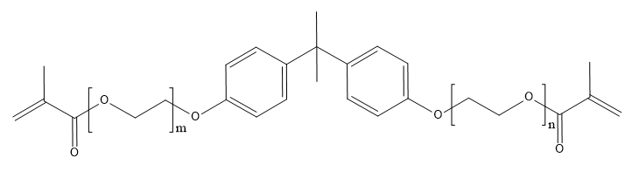
Figure 69 Ethoxylated Bisphenol A Dimethacrylate, also known as Bis-EMA.

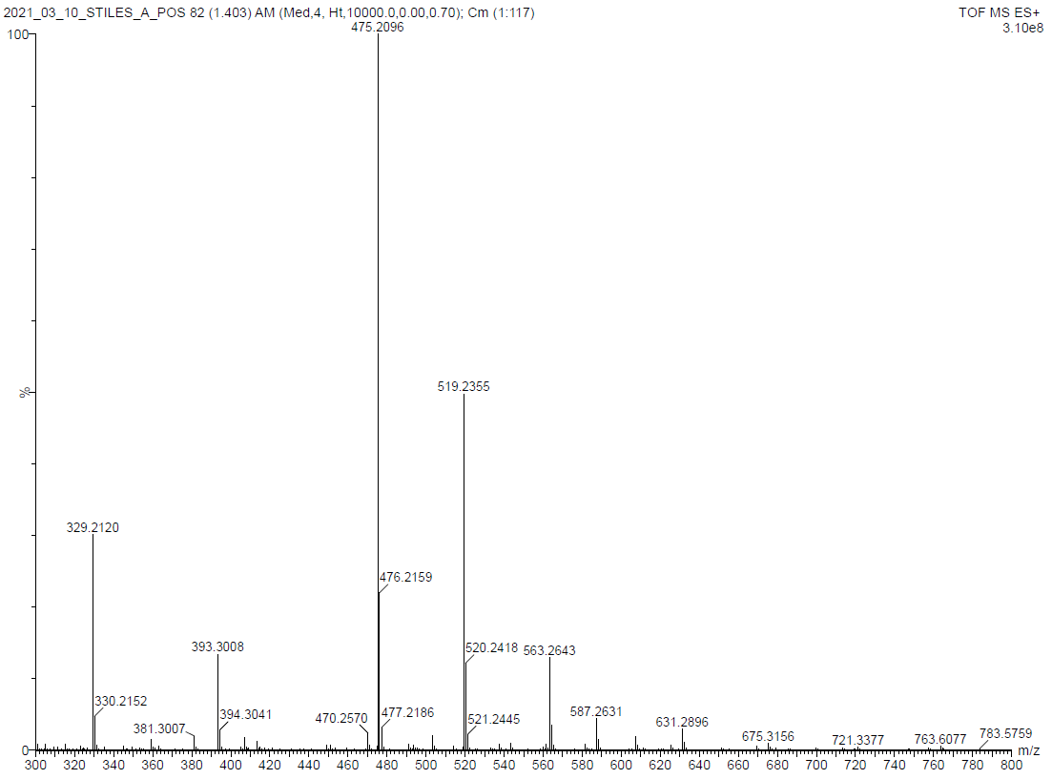
Figure 70 ESI-MS results for CG Bis-EMA.

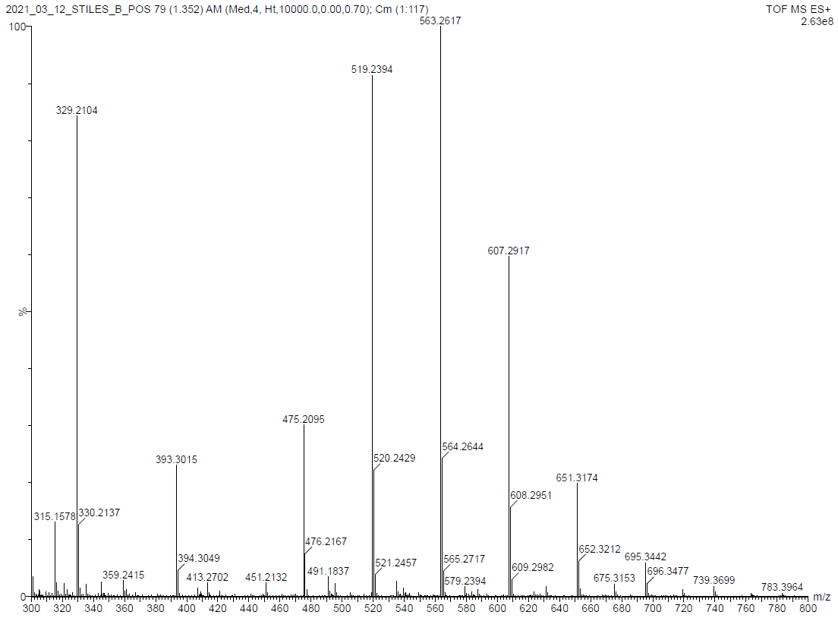
Figure 71 ESI-MS results for DG Bis-EMA.

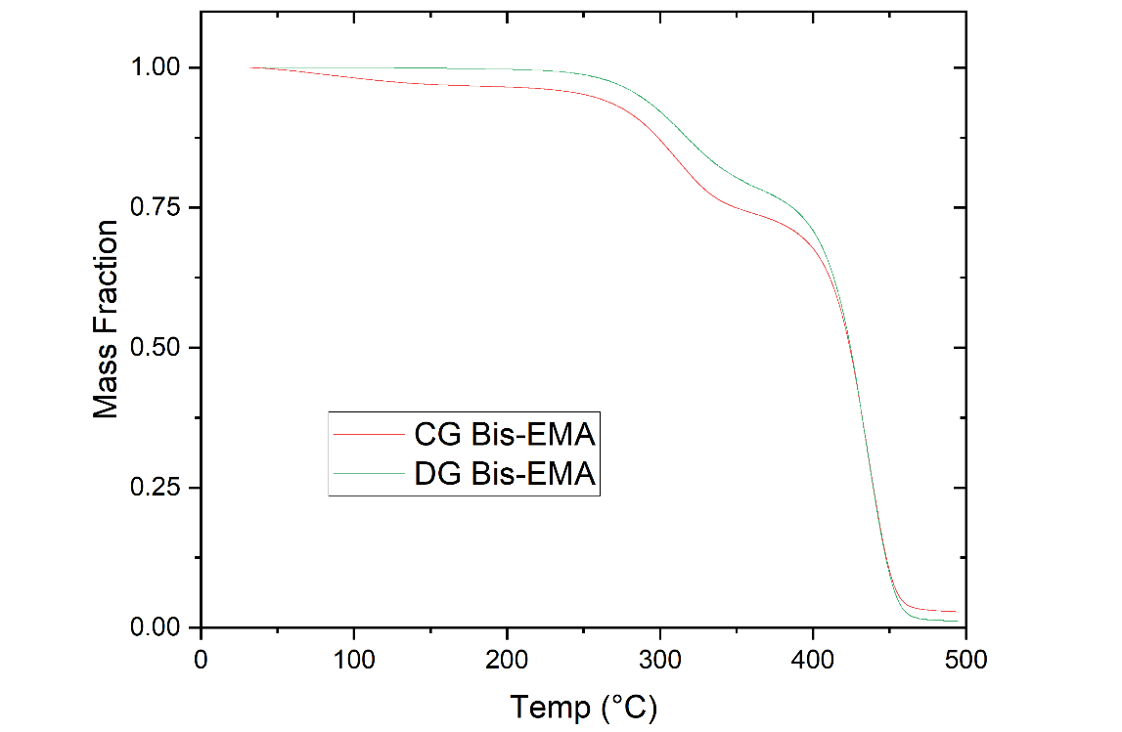
Figure 72 Comparison of mass loss in uncured CG Bis-EMA and DG Bis-EMA specimens heated under nitrogen environment.

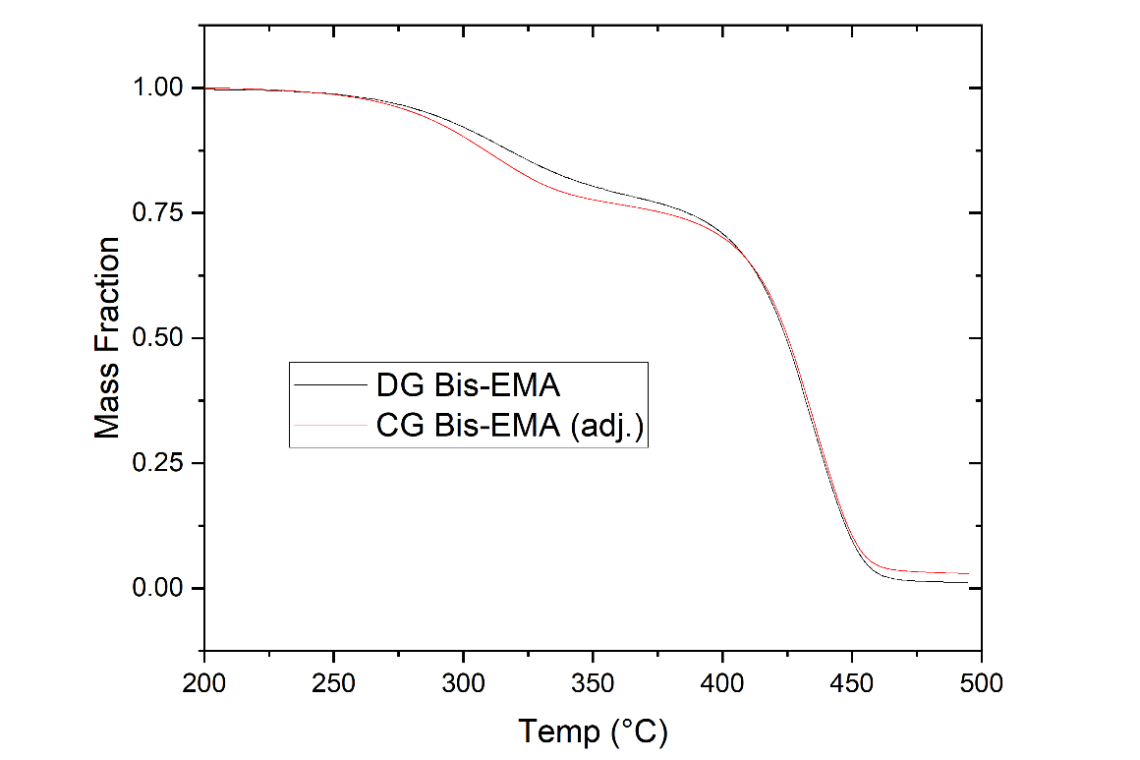
Figure 73 Comparison of mass loss with temperature, CG Bis-EMA adjusted to compensate for mass lost below 200 ºC.

Radiometry
Light transmission through 3 mm neat resin was monitored with the Altair 75 UV LED system used throughout the dissertation, under an incident light intensity of 380 mW/cm². As shown in Figure 74, the X-970-000 has the highest light transmission and maintains near constant transmission of 78% of the incident light intensity throughout 60 s irradiation time. The CG Bis-EMA has higher absorbance due to the residual methacrylic acid and possible other unidentified impurities, which results in much lower transmission. With 20 wt% PETIA added, the transmitted light intensity improves above the baseline CG Bis-EMA but is only 29% at 60 s. Note that the transmission of the resins containing CG Bis-EMA increases over time with UV exposure, which is due to the curing reaction induced in CG Bis-EMA without the presence of any initiator. The hypothesis is that this reaction is due to the residual methacrylic acid content, which has functional groups that can cause a polymerization reaction. This initiator-free polymerization was not observed in the DG Bis-EMA, which has a lower residual methacrylic acid content and inhibitors. The inhibitor package of the CG Bis-EMA is unknown, and it is unclear whether the initiator-free polymerization is due to the methacrylic acid absorbing light and reacting, or if other impurities are absorbing light and potentially inducing a thermal reaction.

UV-Vis Spectroscopy
Absorption properties were determined for uncured resin specimens using an Evolution 300 spectrometer from Thermo Fisher Scientific. Resins were dissolved at 5 wt% in spectroscopy-grade acetone (Uvasol®, MilliporeSigma), and the solution was tested in a 3500 microliter quartz cuvette with a lid from Thorlabs, Inc. The scan range was 300 to 500 nm, with a bandwidth of 2.0 nm. Due to the absorbance range of acetone, only the absorbance >325 nm could be used. As shown in Figure 75, the CG Bis-EMA had the highest light absorbance of the resins tested, while the DG Bis-EMA had very low light absorbance. The addition of 20 wt% PETIA reduced the absorbance in the CG Bis-EMA:PETIA blend used throughout Chapters 2 and 3. The UV-Vis results confirm the trends observed in the Radiometry results, with residual methacrylic acid content and other contaminants leading to higher UV absorption. This is significant because it will limit overall light transmission through a thick polymer system.
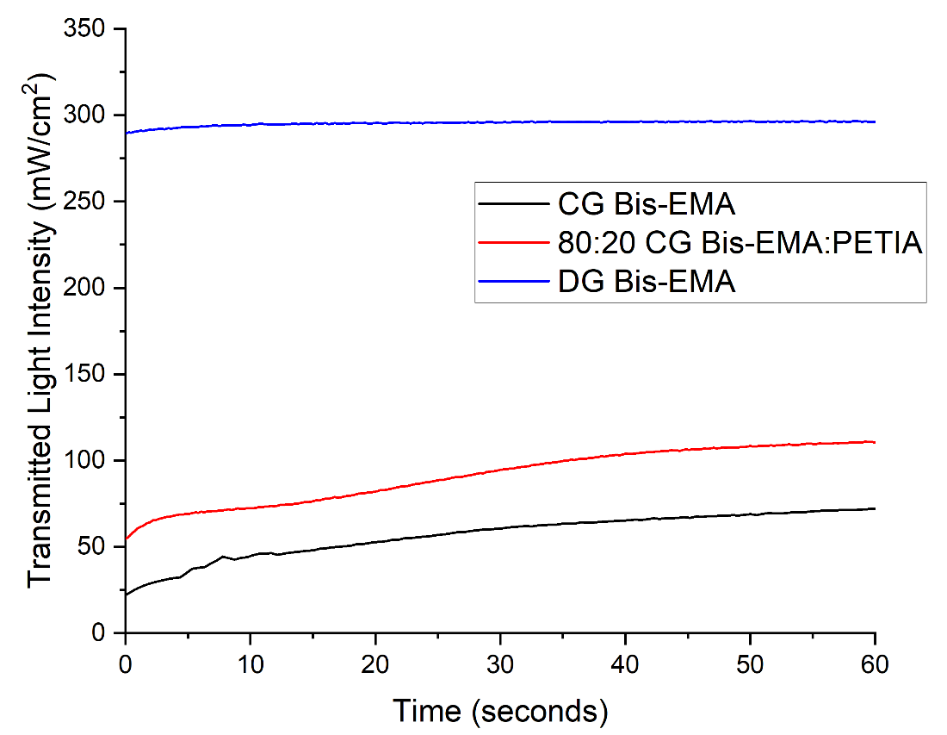
Figure 74 Transmitted light intensity for two grades of Bis-EMA and the 80:20 Bis-EMA:PETIA blend used throughout Chapters 2 and 3.

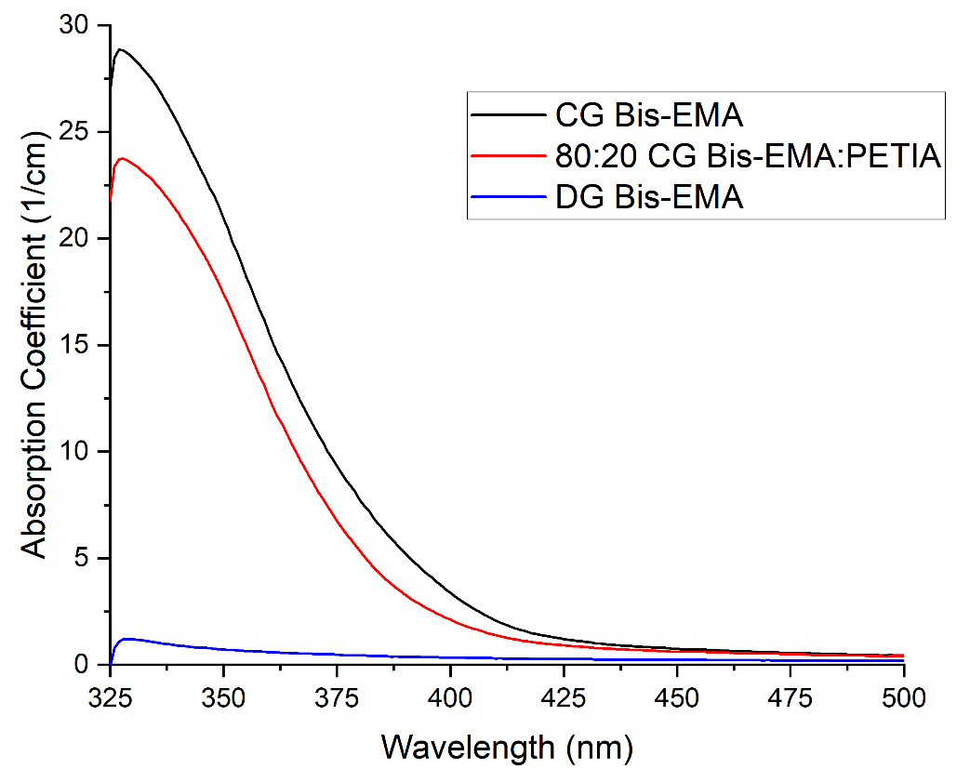
Figure 75 UV-Vis absorption spectrum for two grades of Bis-EMA and the 80:20 Bis-EMA:PETIA blend used throughout Chapters 2 and 3.

Chapter 1 Supplemental Information

Shear-Rate Calculations
To assess shear thinning behavior in neat resin formulations, the photopolymer deposition method was assumed to be a material extrusion method such as direct ink writing (DIW). By assuming no significant shear thinning in a neat resin system, the target shear rate range was calculated using Equation 14, the Hagen-Poiseuille equation [154]:

$$\dot{γ}=\frac{4Q_{V}}{πr^{3}} (14)$$

where $\dot{γ}$ is the shear rate (1/time), $Q_{V}$ is the volumetric flow rate (volume/time), and $r$ is the nozzle radius (length). For a large-scale printer such as the BAAM a typical 8 mm nozzle diameter is used for a 2-4 mm layer height, with deposition rates typically in the 10-20 kg/hr range but upwards of 40 kg/hr at maximum output [10]. For a liquid resin density of 1.1 g/cm³, the relationship between nozzle diameter, deposition rate and shear rate for the neat resin is shown in Figure 76.

Studies on small-scale, conventional DIW thermoset and photopolymer deposition report shear rates between 50 and 1000 1/s [82], [83], [86], with typical nozzle diameters between 0.1 and 0.9 mm [70], [82]–[84], [86], [87], [154]. As Figure 76 shows, such small-scale printers would typically print at a deposition rate on the order or 0.01 to 0.1 kg/hr. In the present work, the target layer height of 3 mm has a corresponding nozzle diameter of 6 mm when using the 2:1 ratio convention typical of FDM printing. At the target deposition range of 5-20 kg/hr, a typical shear rate for large-scale AM of a neat resin with no shear-thinning was calculated as 50 to 250 1/s.

Tensile Properties
The complete tensile test results for the neat resin formulations after 5 s UV irradiation are given in Table 9. All samples exhibited brittle failure, with a high standard deviation in tensile strength.
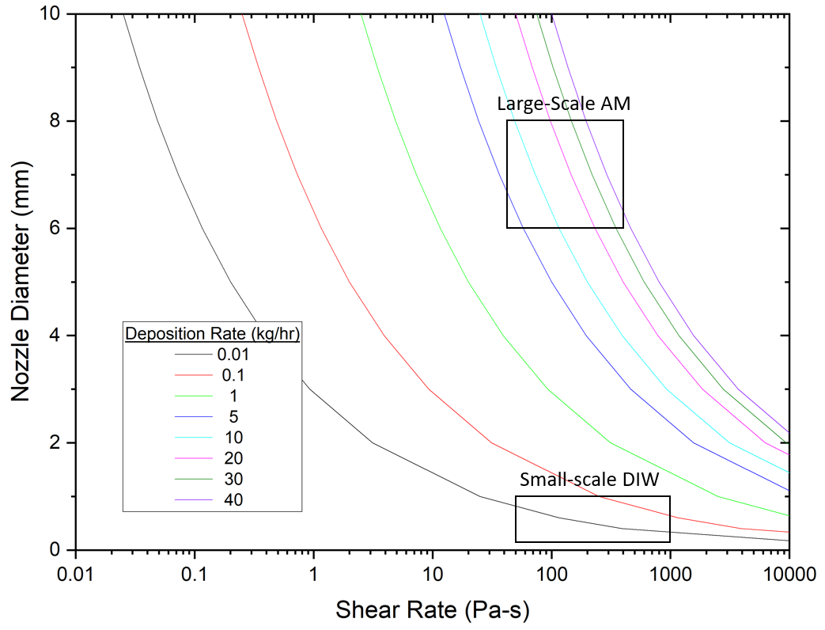
Figure 76 Nozzle diameter vs. shear rate for various deposition rates, calculated for liquid densities typical of Bis-EMA and PETIA. There is a positive correlation between deposition rate and shear rate, and an inverse correlation between nozzle diameter and shear rate.

Table 10 Tensile properties for neat resin blends of Bis-EMA and PETIA.
PETIA (wt%) | Tensile Strength (MPa) | Initial Tensile Modulus (GPa) | Failure Strain
0 | 40.53 [14.03] | 2.81 [0.10] | 2.35 [0.65]
10 | 44.66 [10.94] | 2.07 [0.10] | 2.95 [0.73]
20 | 41.16 [15.91] | 2.25 [0.31] | 2.51 [1.11]
30 | 24.99 [10.10] | 2.13 [0.27] | 1.55 [0.52]
40 | 43.32 [15.33] | 2.27 [0.18] | 2.69 [0.96]
50 | 49.54 [5.94] | 2.33 [0.18] | 2.97 [0.34]

Change in FTIR Spectrum with PETIA
As shown in Figure 77, the FTIR spectrum for baseline uncured polymer changes with increasing PETIA content. The peak used for calculating change in acrylate/methacrylate C=C conversion was 1637 cm⁻¹, with the reference peak as 1608 cm⁻¹. As PETIA content increased the 1608 cm⁻¹ peak absorbance decreased, and pure PETIA did not feature any 1608 cm⁻¹ peak. This is because, unlike Bis-EMA, PETIA does not have any aromatic groups, and the trend is confirmed by the disappearance of the 1582 cm⁻¹ peak. The 1637 cm⁻¹ peak increases with higher PETIA content, because PETIA has more functional groups than Bis-EMA. A new peak emerges at 1617 cm⁻¹, which is associated with O-H deformation. Unlike Bis-EMA, PETIA has a secondary hydroxyl group present in the tri-acrylate portion, which is responsible for this new peak.

One challenge in conducting FTIR studies to assess DC in that they rely on comparing peak height ratios of a functional group vs. a reference peak. Because both acrylate and methacrylate groups are typically measured using the 1637 cm⁻¹ peak, it is difficult to use FTIR to distinguish between the contribution of Bis-EMA versus PETIA to the overall DC. Also, because the nominal peak heights shift with changing ratios of PETIA and Bis-EMA, it is difficult to ascertain when a change in DC between formulations is the result of improved cure kinetics. In Chapter 1, the FTIR results were reported as only one measure of DC. The hardness results were considered more accurate in describing the state of cure in the polymer, as they are not sensitive to changes in chemistry.

In Chapters 2 and 3, the baseline formulation does not change, only the PI type and concentration. No changes were observed in the FTIR spectra at the 1637 cm⁻¹ and 1608 cm⁻¹ peaks with PI adjustment. While the baseline tested in these chapters includes 20 wt% PETIA, because the baseline FTIR spectrum remains consistent, the FTIR results were considered as an accurate measure for comparing DC between formulations. In Chapter 3, a direct comparison of FTIR versus nanoindentation hardness showed similar trends across the profile depth, confirming the accuracy of FTIR as tool for measuring cure when the baseline chemistry is controlled.
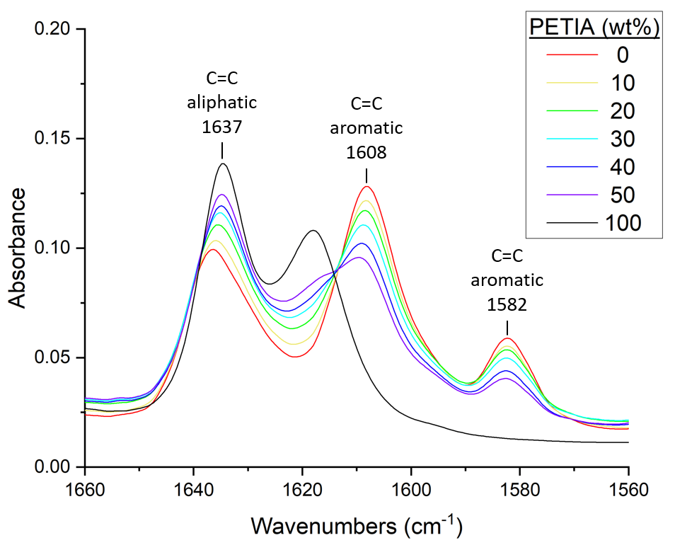
Figure 77 FTIR spectra for uncured polymer within the target region used for measuring DC. As PETIA content increases, the aromatic peaks from Bis-EMA decrease.

DMA Curves
While the Tan Delta curves for the various PETIA:Bis-EMA formulations are given in Chapter 1, Figure 78 also shows the Storage Modulus and Loss Modulus. In each case, the Storage Modulus decreases with increasing temperature, while the Loss Modulus exhibits the peak at ~60 °C that is reflected in the shoulder region of the Tan Delta curves. Within the observed 25 °C to 200 °C range, only the 0 wt% PETIA formula shows a distinct glass transition in the Storage Modulus. At higher concentrations, the changes in Storage Modulus and Loss Modulus at temperatures > 60 °C are less distinct and the glass transition is broad. The Tan Delta peak was reported for T_{g} per the standard used by the resin supplier, but the full glass transition region appears to not be fully resolved at 200 °C for formulations with >10 wt% PETIA content.

To further investigate the glass transition, the 20 wt% PETIA formula was also tested in a film tension configuration, with the same cure and test parameters but an extended temperature window. As shown in Figure 79, by 250 °C the glass transition peak had resolved and both the Storage Modulus and Loss Modulus appear to have reached a plateau. Above 250 °C there is significant noise in the data. The overall trends remain the same in both test configurations, and the T_{g} by Tan Delta peak was 146 ºC for the film tension specimen versus a T_{g} of 150 ºC for the single cantilever specimen.

A broad glass transition region is common for photopolymers with multiple monomer components [155]. Because PETIA has higher functionality that Bis-EMA, it is more prone to achieve a lower overall DC as the polymer vitrifies, leaving residual unreacted C=C bonds that can reduce cured polymer properties [156]. The presence of unreacted monomer within the crosslinked network is assumed to be the cause of the broader Tan Delta peak and reduced T_{g} with higher PETIA content. This assumption was later supported in Chapter 3, where a post cure at 200 °C for a 20 wt% PETIA formula yielded a 98% DC. With this more complete reaction, the T_{g} increased in 186 °C and DMA results showed a distinct transition in both Loss Modulus and Storage Modulus that closely coincided with the Tan Delta peak (see Figure 51).
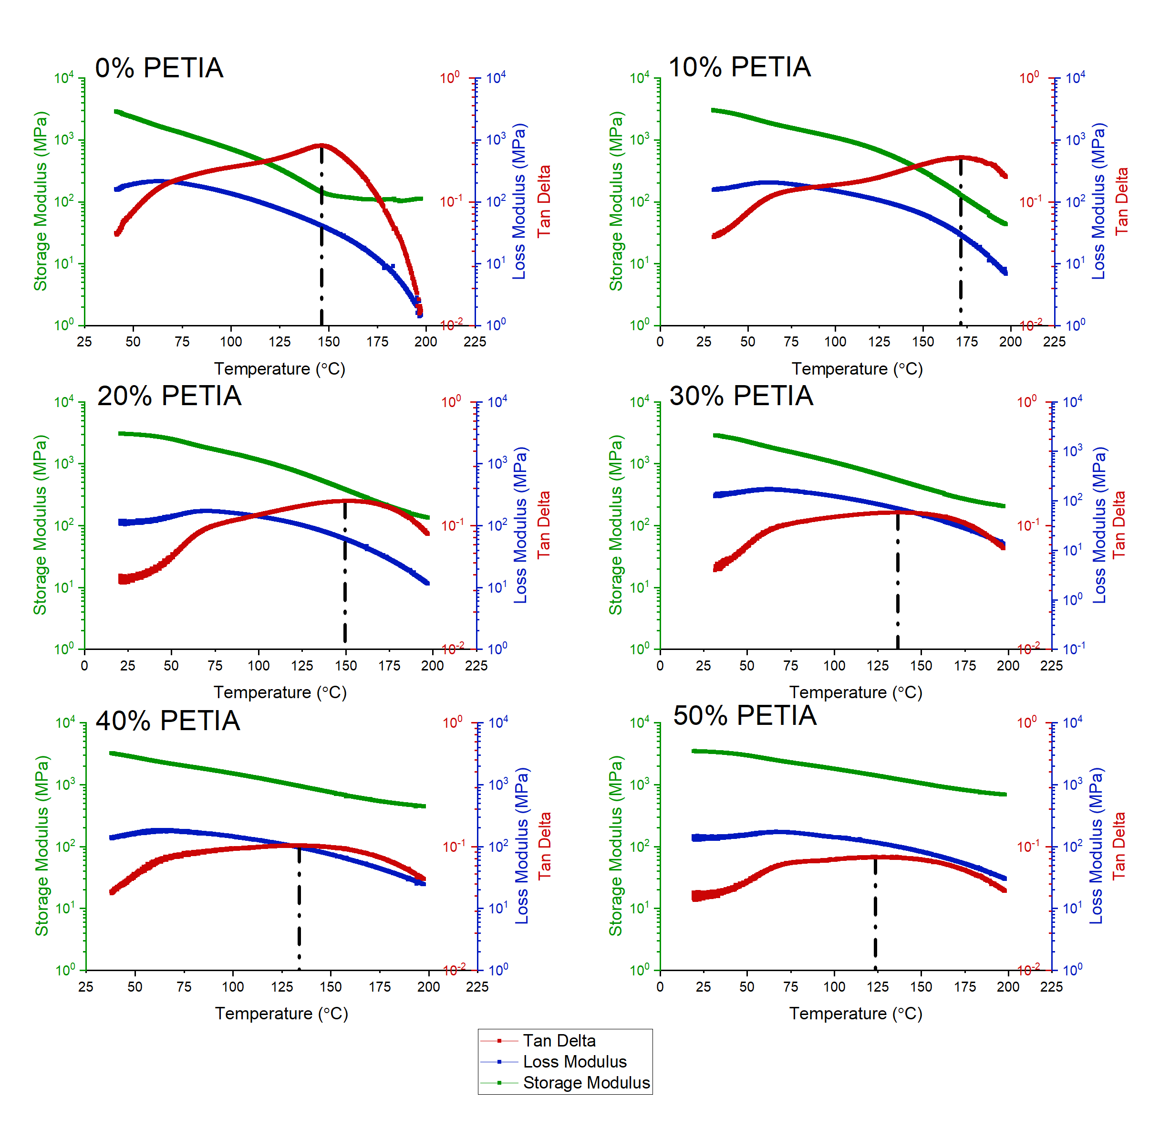
Figure 78 Full DMA curves for PETIA content ranging from 0 wt% to 50 wt%, irradiated with 8.0 J/cm² and tested in single cantilever configuration.

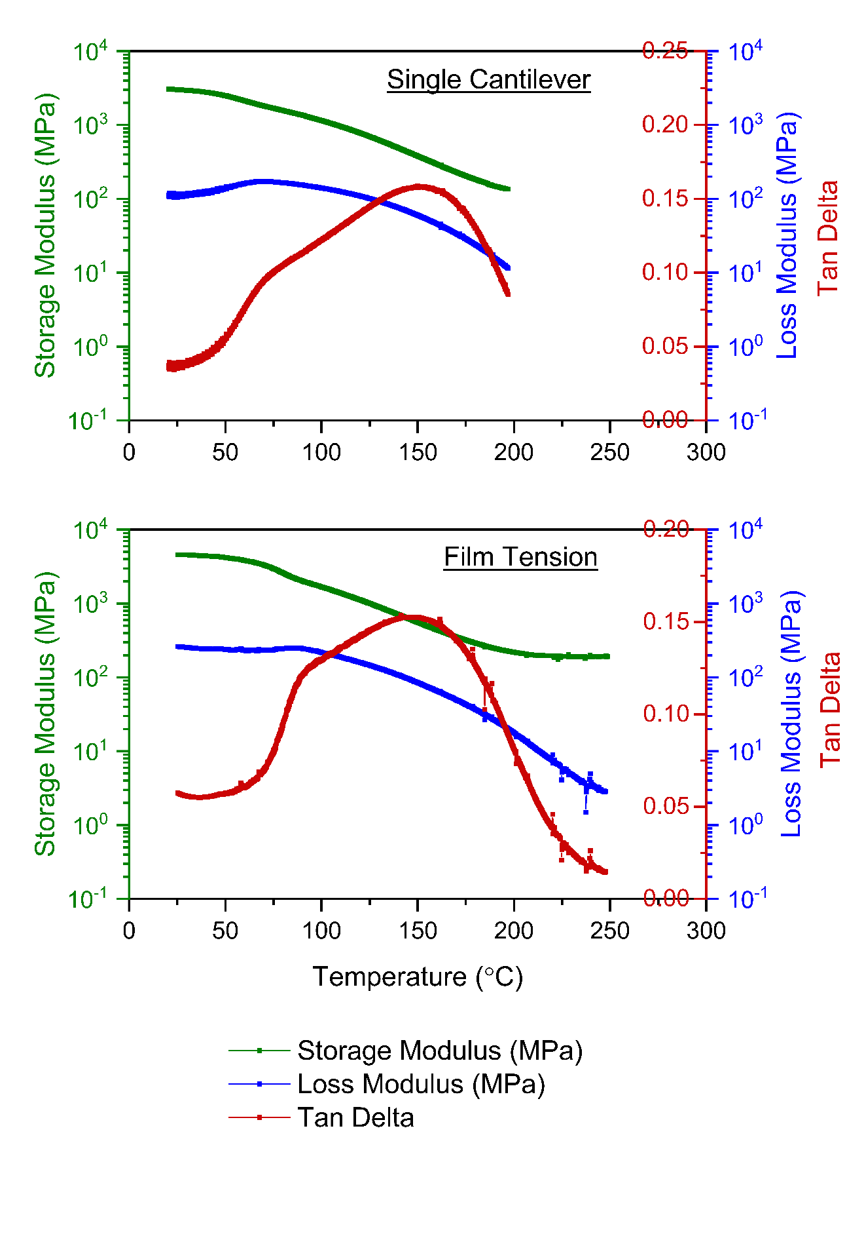
Figure 79 DMA curves comparing the same 80:20 Bis-EMA:PETIA formula in single cantilever versus film tension configurations. Both specimens had 1 wt% BDMB as PI and were irradiated at 8.0 J/cm².

Chapter 2 Supplemental Information

MATLAB script for polychromatic optical model

clc, clear all, close all

% Polychromatic optical model based on Kenning et al.
% Code written by Thomas-Allan Tison and Alex Stiles

% Constants
Con0 = 0.002645; % Molar Conc. of photoinitiator : mol/L
phi = 0.2; % Quantum yield : no units
h = 6.626*10^(-34); % Planck's constant : kgm^2/(s)
Avo = 6.022*10^(23); % Avogadro's number : 1/mol
Depth = 0.3; % Target depth : cm
DepthMax = 1; % Maximum layer thickness : cm

% Create wavelength array
wav = 344:454; %from 344 to 454 nm, output of Altair 75
wav = wav'; %rotate array to vertical
n = 111; %number of wavelengths in range

% Read in molar absorptivity values
Filename = 'BAPO_ei.txt'; %read in values for BAPO molar abs.
temp = readtable(Filename);
e_i = table2array(temp); %create column vector for PI molar abs.

% Read in lamp intensity values
File2 = '25pow_I.txt'; %read in values for 25% lamp output
temp2 = readtable(File2);
Int0 = table2array(temp2); %create column vector for lamp output

% Read in monomer absorptivity values
File3 = '8020_Am.txt'; %read in absorptivity for high purity BisEMA
temp3 = readtable(File3);
A_m = table2array(temp3); %cream column vector for monomer abs.

% Set time intervals for calculations (must be increments of 5)
TimeMaxVT = 120; % Total number of time steps

%% Equations/Constants
x = linspace(0,DepthMax,(DepthMax*TimeMaxVT)+1); % vector of depth values
t = 0:1/DepthMax:TimeMaxVT; % vector of time values
div = (length(x)-1);

dx = 1/TimeMaxVT; % depth increment
dt = 0.25; % time increment

% Constants/Conversions
K = (1000*dt)/(Avo*h); % the constants found in Eqn 8 from the Miller Paper
cspeed = 299792458; % speed of light (m/s)
v = zeros(n,1);
for i = 1:n
v(i,1) = cspeed/(wav(i,1)*10.^(-9)); % conversion from wavelength to frequency : nm -> Hz
end
Con0 = Con0;

% Making the Grid for both Concentration and Intensity
Con = zeros(length(t)+1,length(x)+1); % 2D is time x depth
Int = zeros(length(t)+1,length(x)+1);
for w = 1:n
Int(:,:,w)=zeros;
end

% Initial Condition for Intensity at Depth=0
for w = 1:n
Int(1,:,w) = ((Int0(w))/1000); %Each page in the array corresponds to a different wavelength, adjust mW to W
end

% Initial Condition for Concentration at Time=0
Con(:,1) = Con0;

%Summation formula for polychromatic portions
poly = zeros(length(t)+1,length(x)); % 2D is time x depth

% Logarithmic Beer-Lambert's Law for Intensity at Time=0
for w=1:n
for i=1:length(t)-1
Int(i+1,1,w) = Int(i,1,w)*10^(-(e_i(w)*Con(i,1))*dx);
end
end

%Set of FOR Loops to complete the Concentration and Intensity grids
for i=2:length(t)
for j=1:length(x)
for w=1:n
poly(i,j) = poly(i,j)+((e_i(w)*phi)/v(w))*Int(i,j,w);
end
Con(i,j+1) = Con(i,j)*(1-K*poly(i,j));
Con(i,j+1)=(abs(Con(i,j+1))+Con(i,j+1))/2; %neg values to zero
if (Con(i,j+1)<= min_Con)
phi = new_Phi;
else phi = phi;
end
for w=1:n
Int(i,j+1,w) = Int(i-1,j+1,w)*(1-((e_i(w)*Con(i-1,j+1))+ A_m(w))*log(10)*dx);
end
end
end

%Rate of photoinitiator generation
R_i = zeros(length(t)+1,length(x)); % 2D is time x depth
sum = zeros(length(t)+1,length(x)); % 2D is time x depth
col_1 = zeros(length(t)+1,n); % check for column 1
for i=1:n
col_1 (:,i)= Int(:,1,i);
end

for i=1:length(t)
for j=1:length(x)
for w=1:n
sum(i,j) = sum(i,j)+phi*e_i(w)*Int(i,j,w);
end
R_i(i,j) = 2*Con(i,j)*sum(i,j);
if (Con(i,j)<= min_Con)
phi = new_Phi;
else phi = phi;
end
end
end

Values for BAPO molar absorptivity

1506
1432
1370
1309
1254
1207
1161
1120
1083
1057
1030
1013
1004
995
997
1006
1022
1027
1044
1052
1074
1080
1081
1081
1076
1062
1046
1022
1008
986
972
956
946
937
930
921
909
897
886
872
860
849
837
819
810
798
794
779
768
761
750
733
720
701
680
653
631
602
574
548
511
486
461
435
405
380
352
333
310
291
268
255
238
225
208
192
183
171
151
143
132
113
102
92
83
76
70
62
51
46
41
30
32
28
21
21
18
11
14
9
9
4
7
9
9
5
4
4
7
4
11

Values for 25% Power Lamp Output

0.535037
0.493503
0.409183
0.468773
0.625827
0.764067
0.789053
0.727597
0.768070
0.905370
0.964910
0.871053
0.964157
0.978117
0.929467
1.089627
1.211100
1.387167
1.468767
1.323867
1.320800
1.456000
1.656400
1.998000
2.318300
2.708433
2.960633
3.275867
3.916100
4.709100
5.540733
6.527333
7.870100
9.650433
12.037000
15.043333
18.993667
23.710667
29.759000
37.275667
45.821000
56.618000
70.369000
86.590667
106.213333
130.170000
157.406667
186.783333
219.890000
259.260000
294.896667
324.140000
346.786667
358.210000
358.863333
342.780000
322.110000
295.603333
260.510000
224.600000
192.690000
166.420000
144.476667
125.250000
107.380000
93.259000
81.438667
70.556667
61.294667
53.292000
46.075000
39.720000
34.693667
29.869333
25.822000
22.679000
19.782667
17.471667
15.384000
13.373333
11.738000
10.430000
9.211133
8.075300
7.243600
6.405867
5.503433
4.921033
4.293833
3.707400
3.450467
3.159000
2.737600
2.508800
2.200000
1.926600
1.804000
1.716400
1.552300
1.330000
1.151733
1.045073
0.969267
0.929257
0.870080
0.676877
0.609763
0.667380
0.597953
0.530943
0.503863

Values for 80:20 Bis-EMA:PETIA light absorptivity

19.82864868
19.47677338
19.12489808
18.72547206
18.30702576
17.86004902
17.41307229
16.96609556
16.50009854
15.99606095
15.51104364
15.03553648
14.54100903
14.00844101
13.54244399
13.11448754
12.57240938
12.0493515
11.62139505
11.26951975
10.85107345
10.38507643
9.966630126
9.557693966
9.186798379
8.815902793
8.445007206
8.074111619
7.760276892
7.417911735
7.104077008
6.761711851
6.447877123
6.162572826
5.905798958
5.64902509
5.363720793
5.087926639
4.850173057
4.59339919
4.384176038
4.18446303
3.984750022
3.785037013
3.623364578
3.471202286
3.300019708
3.138347272
3.01471541
2.891083548
2.757941542
2.643819823
2.529698104
2.415576385
2.31096481
2.215863377
2.120761945
2.016150369
1.93055908
1.854477934
1.768886644
1.702315642
1.645254782
1.578683779
1.502602633
1.445541774
1.388480914
1.340930198
1.302889625
1.245828766
1.217298336
1.16974762
1.131707047
1.103176617
1.074646187
1.046115757
1.017585328
0.989054898
0.979544755
0.960524468
0.931994038
0.922483895
0.903463609
0.874933179
0.865423036
0.846402749
0.836892606
0.817872319
0.78934189
0.779831746
0.76081146
0.76081146
0.751301317
0.73228103
0.73228103
0.713260744
0.7037506
0.7037506
0.694240457
0.675220171
0.675220171
0.665710027
0.646689741
0.646689741
0.637179598
0.618159311
0.618159311
0.618159311
0.608649168
0.618159311
0.608649168

Chapter 3 Supplemental Information

Tensile Curves
As shown in Figure 80, the tensile curves from the three tested cure regimens did not exhibit the same inflection point observed in Chapter 1. This is attributed to the thinner specimen size and absence of a cure gradient and is the most likely reason for the observed improvement in standard deviation within the test results. A minimum of 10 specimens were tested from each sample set, and only specimens that broke within the gage length were included in the results.

DSC Thermograms
In addition to the 80:20 Bis-EMA:PETIA blend tested as a liquid without photoinitiator, tests were performed on pure Bis-EMA without initiator (see Figure 81) and on the 80:20 Bis-EMA:PETIA blend with 0.1 wt% BAPO (see Figure 82). While the Bis-EMA cured thermally without an initiator, the reaction enthalpy observed was much lower than that of the 80:20 blends. The presence of BAPO did not significantly change the total heat of reaction, which was ~270 J/g. While the exothermic peak was fully resolved for the 80:20 Bis-EMA:PETIA blend without PI (see Figure 53), at 350 ºC the Bis-EMA peak was not fully resolved. Higher temperatures were not attempted, as TGA testing indicated that significant mass loss occurs at temperatures above 350 ºC.

Dark Cure Testing
In Chapter 3, RT-FTIR showed that DC increased during the first 10 minutes post irradiation (see Figure 56), and after over 1 month post irradiation the DC had further increased by 10-16% (see Figure 59). To observe this “dark cure” effect more closely, a preliminary study monitored the change in DC after irradiation of 5.5 J/cm² for the 0.1 wt% BAPO formulation. 3 mm thick specimens were measured on the bottom surface at 10-minute intervals in-situ for the first hour, followed by measurements at 10 hours and 268 hours post irradiation. As shown in Figure 83, the most significant DC increase occurs during the first 10 hours post irradiation, jumping by 9% in the first hour alone. Further testing is needed to determine what effect specimen size, filler content and storage conditions may have on this dark cure effect in Bis-EMA photopolymers.
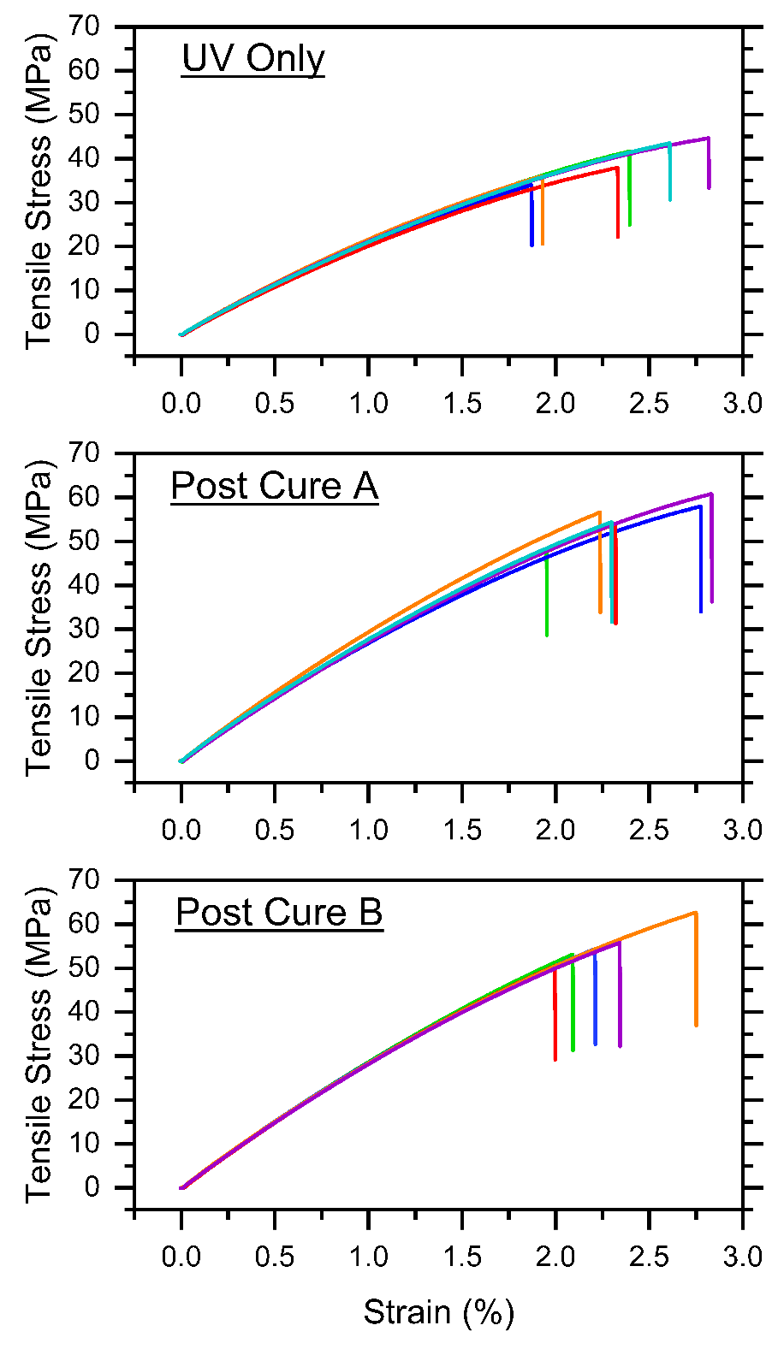
Figure 80 Stress-strain curves for tensile specimens after various cure conditions. Note that the specimens did not exhibit the inflection point observed in the tensile testing from Chapter 1.

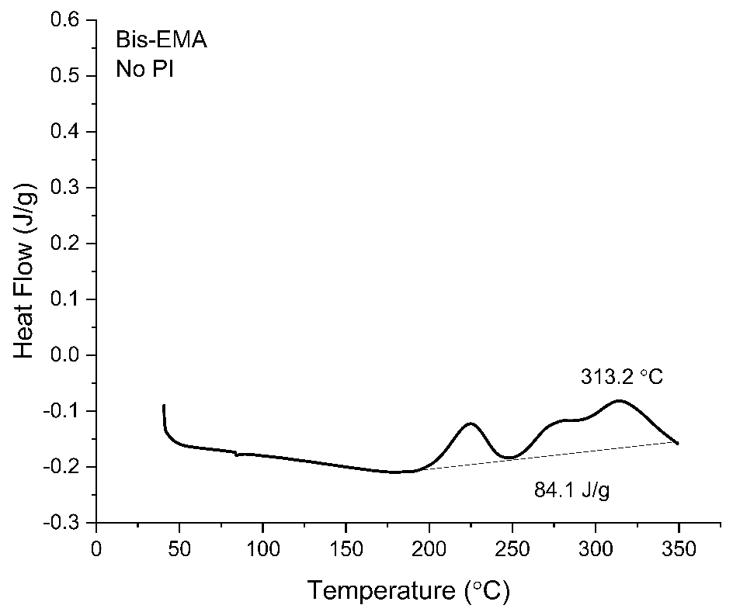
Figure 81 DSC Thermogram for liquid Bis-EMA, which exhibits some exothermic reaction starting at ~200 °C, and the peak is not fully resolved by 350 ºC.

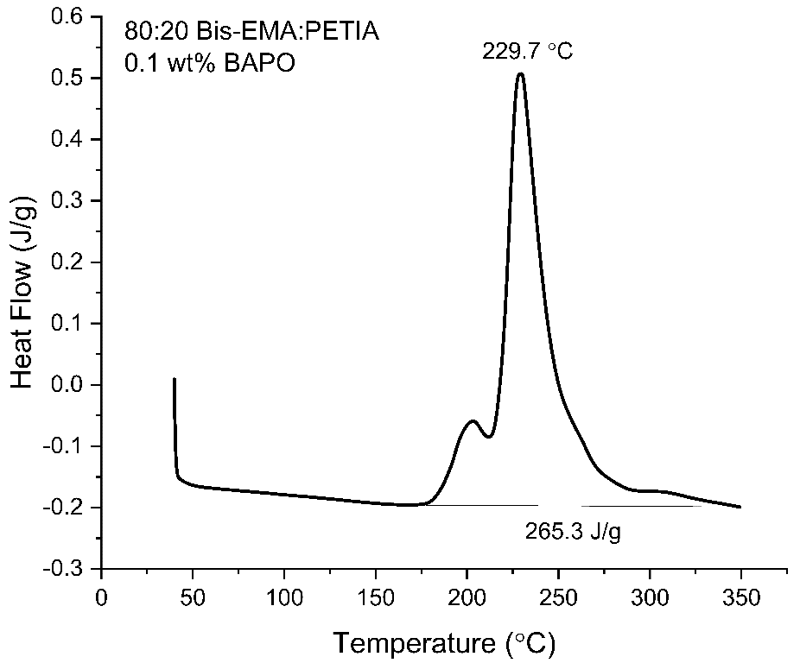
Figure 82 DSC Thermogram for 80:20 Bis-EMA:PETIA with 0.1 wt% BAPO. The reaction enthalpy is comparable to the 80:20 formula without PI.

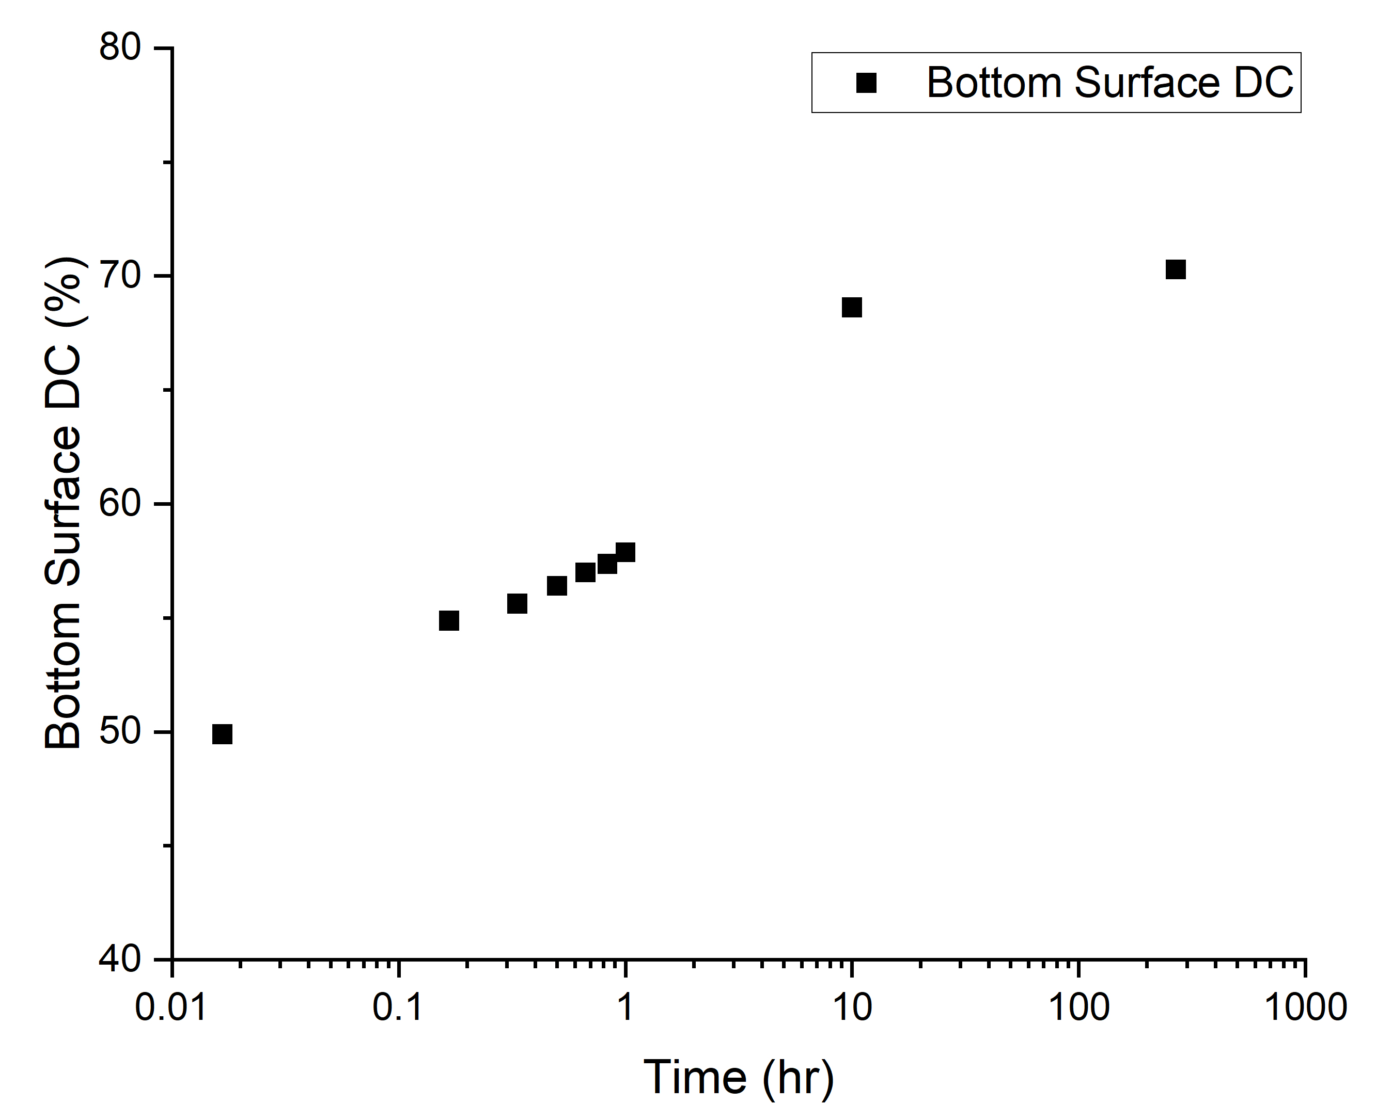
Figure 83 Post-irradiation change in degree of conversion for the 80:20 Bis-EMA:PETIA formula with 0.1 wt% BAPO, as measured at 3 mm depth post 5.5 J/cm² UV dose.

VITA
Alex Stiles received a Bachelors of Science in Mechanical Engineering from the Illinois Institute of Technology in 2012, and worked as a Product Engineer at Holland LP before joining the Fibers and Composites Manufacturing Facility at the University of Tennessee, Knoxville to study advanced composites manufacturing and photopolymers.

