Defining and Modeling Parameters Associated with Double-Planted Areas in Row Crop Production Fields

A Thesis
Presented for the
Master of Science
Degree
The University of Tennessee, Knoxville

Brandon Michael Jernigan
August 2012
DEDICATION

This Thesis is dedicated to my parents for their unconditional love and support throughout all of my endeavors.

ACKNOWLEDEGMENTS
I would first like to thank Dr. William E. Hart and Dr. Michael J. Buschermohle for providing me with research and teaching assistantship opportunities while completing my graduate studies. Their guidance and friendship over the past two years have been invaluable.
Gratitude is expressed toward Dr. John B. Wilkerson and Dr. Margarita M. Velandia for their great ideas and open door policies while serving on my graduate committee.
Appreciation is also extended to Dr. Ed Barnes of Cotton Incorporated for providing funding to complete this research project.
Several individuals contributed to this study. I would like to thank Mr. David Smith for developing the data acquisition system, Mr. Philip Allen for creating the data logging program used during planting, Dr. Robert S. Freeland for assisting with data collection during the 2010 planting season, Tim Prather for his knowledge and expertise with ArcGIS, and Dr. Arnold M. Saxton for his assistance during statistical analysis.
Employees at the Research and Education Center at Milan, Tennessee are also recognized for their assistance during plot studies. Dr. Blake Brown, Mr. Darol Copley, Mr. Jason Williams, Mr. James McClure, Mr. Chad Hicks, and Mr. Mark Coffman were all a pleasure to work with.
The following producers played an influential role in this study: Mr. John Lindamood, Mr. Jeff Hill, Mr. Ed Keiser, Mr. Scott Fullen, Mr. Eugene Pugh, Mr. Steve Dixon, Mr. King Dixon, Mr. Martin Daniels, Mr. Danny Powell, and Mr. John Crafton. Without their patience and cooperation, this research would not have been possible.
I would like to thank my parents Darren and Daphne Jernigan as well as my sister Brittney and brother Brent for their unwavering love and support throughout my life. They all
believed in me and provided me with encouragement. Other family and friends are also appreciated for their support over the past two years.
Finally, I want to thank God for all my blessings and opportunities.
ABSTRACT
Automatic Section Control (ASC) utilizes current Global Positioning System (GPS) location of a planter and previously planted coverage maps to control individual planter row units, or sections of planter row units, depending on accuracy desired by equipment operators. ASC eliminates double-planting in areas of agricultural fields where planter overlap is unavoidable, such as end rows, point rows, and around internal field obstacles. Due to costs associated with purchasing ASC, farm managers are interested in rate of return on investment, which depends on several factors such as field boundary irregularity, operator response time, and crop yield response to double-planting.
Georeferenced planting data was collected for 52 fields in order to create maps in ArcGIS for calculating percent minimum double-planted area and operator response time. Cotton and corn yield data were collected from test plots at the Research and Education Center at Milan, Tennessee to analyze effects of double-planting on crop yields. Average field size was 33.2 acres and average percent double-planted area was 4.55%. Twenty-two geometry factors were calculated for each field to be used as independent variables in predicting percent minimum double-planted area. Variable selection and Principal Component Analysis (PCA) where conducted to develop best fit models for predicting percent double-planted area and validated using multiple and simple linear regression. The model with the best goodness of fit retained six variables with an R² of 0.83 (p < 0.0001). Two spatial models were also developed in ArcGIS for estimating percent minimum double-planted area of a field. The simplest model only required a field boundary shapefile and could be automated using the Model Builder function in ArcGIS. Operator response time was calculated using original planting maps. Operators over-planted 58.8% of the time by an average of 8.2 feet and under-planted 41.2% of the time by an average of 9.0 feet. Tukey’s mean separation method was used to determine if cotton and corn yields differed significantly between single-planted plots and double-planted plot treatments. Significant differences were identified in cotton yields but not in corn at an alpha level of 5%.

TABLE OF CONTENTS

Chapter 1: Introduction 1
Justification 3
Objectives 3
Chapter 2: Review of Literature 5
GPS as a Data Collection Tool During Planting 5
Machinery Overlap 6
ASC Decision Aid Tools 10
Planting Density Effects on Cotton and Corn Yield 11
Chapter 3: Materials and Methods 13
Data Collection 13
Creating Planting Maps for Model Validation 16
Calculating Geometry Factors for Statistical Models 19
Statistical Model Development for Predicting Double-Planted Areas 21
Map-Based Model Development for Estimating Double-Planted Areas 22
Field Boundary Model 22
Field Boudnary + GPS Tracklog Model 23
Determining Operator Influence on Double-Planted Area 24
Double-Planting Test Plot Experiments 25
2010 Cotton Study 26
2011 Corn Study 28
Statistical Analysis 32
Chapter 4: Results 33
Statistical Model Results 36
Map-Based Model Results 47
Operator Influence Analysis Results 57
Double-Planting Test Plot Experiment Results 58
2010 Cotton Study 58
2011 Corn Study 62
Chapter 5: Discussion and Conclusions 66
BIBLIOGRAPHY 69
APPENDICES 72
APPENDIX A: Glossary of Geometry Factor Variables 73
APPENDIX B: Calculated Geometry Factor Values for Each Field 76
APPENDIX C: Correlation Matrix 79
Vita 81

LIST OF TABLES
Table 1. Summary of sample field characteristics and planting information. 33

Table 2. Summary of variation between variable selection model predicted percent double-planted area and actual percent double-planted area calculated using planting maps. 39

Table 3. Summary of variation between 2 variable model predicted percent double-planted area and actual percent double-planted area calculated using planting maps. 42

Table 4. Eigenvalues along with proportion of variance accounted for by each component. 44

Table 5. Rotated matrix displaying correlation coefficients for each variable and principal component. 45

Table 6. Standardized component scores for retained variables. 46

Table 7. Summary of variation between field boundary model predicted percent double-planted area and actual percent double-planted area calculated using planting maps. 49

Table 8. Summary of variation between field boundary + GPS tracklog model predicted percent double-planted area and actual percent double-planted area calculated using planting maps. 55

Table 9. Average kernel count losses per treatment with yield conversion. 63

LIST OF FIGURES
Figure 1. Examples of double-, over-, and skipped-planting in end rows.. 2

Figure 2. Momentary switch mounted on a John Deere planter unit to indicate planting status. 14

Figure 3. Fiberglass enclosure containing monitor, cellular modem, and computer. 15

Figure 4. Data acquisition check prior to planting. 16

Figure 5. GPS data imported into ArcGIS showing differentiation of planter status. 17

Figure 6. Zoomed portion of planting map created in ArcGIS. 19

Figure 7. Examples of over-planting and under-planting based on direction of travel. 25

Figure 8. Double-planted cotton plot (photo taken 44 days after planting date). 26

Figure 9. Plot layout for 2010 double-planting cotton study. 27

Figure 10. Harvesting cotton plots with 2-row Case IH plot picker. 28

Figure 11. Double-planted corn plot (photo taken 37 days after planting date). 29

Figure 12. Plot layout for 2011 double-planting corn study. 30

Figure 13. Collecting corn harvest loss samples. 32

Figure 14. Relationship between field area and percent double-planted area. 35

Figure 15. Relationship between P/A ratio and percent double-planted area. 37

Figure 16. Predicted percent double-planted area versus actual percent double-planted area for the optimum variable selection model. 38

Figure 17. Predicted percent double-planted area versus actual percent double-planted area for the optimum variable selection model after removing correlated variables. 41

Figure 18. Relationship between principal component versus percent double-planted area. 47

Figure 19. Flow chart design for field boundary model created in ArcGIS using Model Builder. 48

Figure 20. Estimated percent double-planted area calculated by field boundary model versus actual percent double-planted area. 49

Figure 21. Example of a rotated boundary indicating the entire outer ring of the field being used as end rows in the field boundary model. 52

Figure 22. Field image showing path orientation changes that cause internal double-planted areas. 53

Figure 23. Estimated percent double-planted area calculated by field boundary + GPS tracklog versus actual percent double-planted area. 54

Figure 24. Portion of map illustrating centerlines being extended or trimmed to different buffers, depending on angle of encroachment. 57

Figure 25. Average seed cotton yield per treatment in pounds per acre – first pick only. Yields with different letter groupings are significantly different (p < 0.0001). 59

Figure 26. Cotton not harvested during the first pass of double-planted plots. 60

Figure 27. Illustration showing picker header limitations on harvesting crossing rows. 60

Figure 28. Average seed cotton yield per treatment in pounds per acre – second pick added to first pick. Yields with the same letter grouping do not differ significantly (p < 0.0001). 61

Figure 29. Average corn yield per treatment in bushels per acre. Yields with the same letter grouping do not differ significantly (p < 0.0001). 63

Figure 30. Average corn harvest losses per treatment in bushels per acre. Yields with different letter groupings are significantly different (p < 0.0001). 64

Figure 31. Average corn yield per treatment with average harvest losses per treatment added in bushels per acre. Yields with the same letter grouping do not differ significantly (p < 0.0001). 65

Chapter 1: Introduction
Precision agriculture can be defined as the practice of managing crop production inputs on a site-specific basis to increase profits, reduce waste, and maintain the quality of the environment (Ess and Morgan et al. 2010). Simply stated, it is the process of dispensing or applying desired amounts of seeds, pesticides, and fertilizers in specific areas of an agricultural field in order to maximize productivity. There are several technologies commercially available today to monitor and actuate these production inputs based on the site-specific location of farm equipment in the field. One example of this technology is Automatic Section Control (ASC) for row crop planters.
ASC for planters can be operated either pneumatically, electrically, or hydraulically to engage or disengage seed metering devices in areas of a field where planter overlap is unavoidable such as end rows and point rows, or around internal field obstacles such as grass waterways and ditches (Fulton et al. 2010). ASC utilizes the current Global Positioning System (GPS) location of the planter and previously planted coverage maps to control individual planter rows or sections of planter rows, depending on accuracy desired by producers/equipment operators. By eliminating double-planted areas, ASC has the potential to reduce seed input costs and profit losses due to increased plant competition and/or reduced harvest efficiency. ASC for planters can be purchased separately to retrofit older planters or can be purchased as an option on new planters (Fulton et al. 2010).
By adopting ASC for planters, double-planting can be reduced or totally eliminated from areas where planter overlap normally occurs. Planter overlap is dependent on several factors such as field boundary irregularity, planter width, and equipment operator accuracy. Fields with higher boundary irregularity tend to result in increased implement overlap. Also, as agriculture is continuously trending toward larger farming operations with increased acreage (Key and Roberts 2007); producers are purchasing wider equipment to speed up farming operations (Luck et al. 2009). As implement width increases, a potential risk of increasing swath overlap, especially in end rows and point rows, has been shown to occur (Luck et al. 2009). Precision of equipment operators can also cause planter overlap. Equipment operators can add to minimum double-planting by over-planting at the beginning and/or ends of planter passes (Figure 1).

Over-Plant Area

Skipped Area
Minimum Double-Planted Area
Figure 1. Examples of double-, over-, and skipped-planting in end rows.
Justification
As with any other precision agriculture technology, adoption rate of ASC for planters depends on economic benefits of implementing the technology or rate of return on investment. Factors that need to be considered when determining rate of return on investment of ASC are currently adopted technology (i.e. GPS receiver, controller, software), accuracy desired (i.e. individual row control vs. section control), cost of seed, total acres planted, planter width, geometry of fields being planted (i.e. numerous end rows/point rows and/or internal field obstacles), equipment operator accuracy, any yield losses in double-planted areas (i.e. physiological and/or mechanical), etc. This study has focused on the latter three factors.
Farm managers are constantly researching new ways to increase profitability of their farming operations. If information were made available to allow producers to estimate areas of double-planting in their fields, accuracy of their equipment operators while planting, and potential yield losses in double-planted areas, this information could be used as a basis for investment decisions regarding the adoption of ASC technology.

Objectives
The main research objective of this study was to define parameters that will ultimately aid producers in making investment decisions regarding ASC for planters. Data was collected and analyzed in order to accomplish the following specific objectives:
- Develop statistical models that could predict the amount of double-planted area in a field based on geometric properties such as irregularity and compactness that were specific to each field.
- Create two map-based models in ArcGIS to estimate the amount of double-planted area that occurs in row crop production fields. The first model would require a field boundary shapefile and a specified planter width. The second model would require a field boundary shapefile, a specified planter width, plus a GPS tracklog.
- Evaluate the influence that equipment operator response time had on double-planted areas.
- Determine potential yield reduction due to physiological or mechanical harvest losses in double-planted cotton and corn test plots.

Chapter 2: Review of Literature
GPS as a Data Collection Tool During Planting
Taylor et al. (2001) conducted a study to measure field efficiencies and capacities of row crop planters. By logging latitude and longitude position of equipment as it traversed a field, field efficiencies and capacities for different planter widths were determined. Corn was planted on over 2700 acres using three different planter widths; 15-feet (6-row), 30-feet (12-row), and 40-feet (16-row). All three planters were operated at approximately 4.7 mph so that speed differences would not interfere with field efficiency and capacity calculations. Results indicated wide ranges of field efficiencies for all three planter widths; however the general trend indicated that as planter width increased, field efficiency decreased. The opposite trend was noticed for field capacity with higher capacities occurring with wider planters (Taylor et al. 2001).
Grisso et al. (2002) conducted a similar study in which GPS was used to log time-in-motion data during planting operations. Rather than focusing on machine width, this study concentrated on evaluating field efficiencies for two crop production systems as well as two different field traffic patterns. The objectives of this study were to analyze differences in field efficiencies for planting corn versus planting soybeans, while at the same time assess differences in field efficiencies for agricultural fields that were flat with straight rows versus sloping with contoured rows. Results indicated that less than 2% of the corn acreage was planted above 6.5 mph, whereas 30% of the soybean acreage was planted above this same speed. Differences in speed between crops were concluded to be caused by the need for improved stand uniformity and singulation in corn when compared to soybeans. It was determined that traffic patterns played a significant role in planting field efficiency. The contour planted soybean field saw a near 10% reduction in field efficiency compared to the straight row planted soybean field. Similarly, the authors reported that field efficiency was 10% to 20% lower for the contour planted corn field compared to the two, straight row planted corn fields (Grisso et al. 2002).

Machinery Overlap
Previous studies have indicated that field boundary irregularity and internal field obstacles have an effect on implement overlap (Luck et al. 2010). Most of these studies were based on agricultural sprayers rather than planters; however, the concept was virtually the same. When agricultural sprayer booms overlap a portion of a field that has already been sprayed, over-application of sensitive crop production inputs (pesticides and fertilizers) occurs. Over-application of inputs results in increased production costs and could potentially damage the crop and/or environment. The same principle can be applied when planting a field where seed is the input being managed instead of pesticides or fertilizers. The following precision spraying studies were designed to document the amount of overlap occurring in farm fields.
Batte and Ehansi (2006) conducted an economic analysis of using precision Real-Time Kinematic (RTK) guidance coupled with ASC on self-propelled sprayers. This study used three hypothetical fields of equal size (acreage) but with different shapes to determine sprayer overlap costs with and without the use of GPS guidance and ASC. The first hypothetical field used in the analysis was a rectangular shaped, 100-acre field with two grassed waterways; one approximately 1700 feet long at a 45 degree angle relative to the traveled rows, and another about 1500 feet long at a 30 degree angle relative to the traveled rows. The same grassed waterway configuration was used in the analysis for the remaining two fields. The second field was a 100-acre parallelogram with two shorter parallel field edges being 10 degrees off-square of two longer parallel field edges. The third field was a 100-acre trapezoid with the longest field edge causing numerous point row areas. Results showed potential for high input savings for all scenarios as sprayer boom width increased for each field when precision guidance and ASC were used. Also, inclusion of internal field obstacles, such as hypothetical grassed waterways, showed potential for increased input savings with precision guidance and ASC (Batte and Ehansi, 2006).
A 2009 study conducted in Kentucky compared total pesticide applications for three fields using ASC with 30, 5, and 3 control sections as well as Manual Section Control (MSC) with 1 control section on a self-propelled sprayer with an approximate boom width of 81-feet (Luck et al. 2009). The sprayer utilized a lightbar guidance system with differential GPS corrections provided by a U.S. Coast Guard radio beacon. Results of their study indicated that for the three fields used in this study, reductions in overlapped areas ranged from 15.2% to 17.5% for the 30 control section configuration, 11.2% to 11.5% for the five control section configuration, and 8% to 8.5% for the three control section configuration when compared to MSC of entire boom. A secondary objective of this study was to analyze differences in percentage of time that control sections were spraying relative to their location on the boom. Their study found that control sections located near the outsides of the boom were shut off more and, therefore, sprayed less than control sections near the center of the boom. This was attributed to the fact that even with lightbar assisted manual guidance; parallel swath overlap still occurred due to inaccuracy of differential GPS corrections (Luck et al. 2009).
A similar study was conducted by Luck et al. (2010) in 21 agricultural fields to determine differences in pesticide applications using MSC of five boom sections versus ASC of seven boom sections and to determine the correlation between sprayer overlap and a variable known as Perimeter-to-Area (P/A) ratio for each field. P/A was the ratio of the field boundary perimeter to the field area. Results of their study showed a 6.2% average reduction in sprayer overlap was achieved by switching from a manually-controlled five boom section sprayer to an automatically-controlled seven boom section sprayer. Moderate, positive correlations were observed between P/A for each field and percentage of sprayer overlap for both five section manually-controlled and seven section automatically-controlled configurations with R² values of 0.4682 and 0.5218 respectively (Luck et al. 2010).
Luck et al. (2011) developed single and multiple regression models to predict percentage of sprayer overlap for three boom section control system scenarios based on certain field geometry factors. Six geometry factors were calculated in ArcGIS and Microsoft Excel for 74 fields to be used as predicting variables for percentage of sprayer overlap. These field geometry factors included: field area (A), field boundary perimeter (P), length of longest parallel pass (L), perimeter-to-area ratio (P/A), field circularity (C), and square-perimeter index (SPI). Single regressions were analyzed comparing each geometry factor to percentage of sprayer overlap for each sprayer configuration. P/A was determined to be the most significant independent variable for predicting percent overlap with R² values of 0.569, 0.647, and 0.593 for five control section MSC, seven control section ASC, and nine control section ASC respectively. Multiple regressions were run comparing linear combinations of these geometry factors to percent overlap for each sprayer configuration. Results from these analyses showed that no combination of these predicting variables greatly improved model goodness of fit compared to a simpler linear model using only P/A ratio for these fields. Their study also revealed that switching from seven control section ASC to nine control section ASC did not significantly reduce sprayer overlap.
Few studies have addressed benefits of using ASC for planters or the effects that increased planter width has on double-planting in fields due to equipment overlap. Fulton et al. (2010) conducted a study to determine typical seed savings on farms in Alabama if ASC was used during planting. Results of this study indicated seed savings from as low as 1% to as high as 12% for each planter pass across the sample fields when planters were equipped with ASC. An average of 4.3% seed savings was observed for these fields with some fields benefitting as high as 7%, depending on boundary irregularity and presence of internal field obstacles (Fulton et al. 2010).
A West Tennessee study focused on the effects of increased planter width on double-planting (Jernigan et al. 2011). RTK GPS data was collected for 28 cotton fields totaling 1122 acres and analyzed in ArcGIS. Planting maps were generated for a 38-feet (12-row) planter width to determine the minimum double-planted area that occurred in each field based on field boundary irregularity. Additional double-planting due to operator response time was not included in this analysis. Based on these planting maps, minimum double-planted area across all 28 fields was calculated to be 13.8 acres or 1.2% of the total area planted. Super-imposed 57-feet (18-row) and 76-feet (24-row) planter passes were added to each planting map to determine the influence wider planters had on minimum double-planted area for a particular field. Minimum double-planted area for 18- and 24-row planter widths totaled 31.0 and 44.1 acres respectively or 2.8% and 3.9% of the total planted area. Increase in double-planted area when going from 12- to 18- or 24-row planters occurred not only in end rows and point rows where double-planting is expected but in the last planter pass of the field. In fact, 12.2 acres (39%) and 18.5 acres (42%) of the minimum double-planted area occurred in the last pass for the 18- and 24-row planting maps.
ASC Decision Aid Tools
Several decision aid tools have been developed regarding investment in ASC for farm machinery. One such tool, known as the Guidance & Section Control Profit Calculator (GSCPC), was developed in cooperation with the Department of Agricultural Economics at Kansas State University and the PrecisionAg Institute (Dhuyvetter et al. 2010). This web-based tool was developed to approximate return on investment for implementing GPS guidance and ASC on farm machinery. To use the GSCPC, a representative field of the entire farming operation in terms of size and boundary irregularity must be selected to extract pertinent numerical data to enter into the calculator. The GSCPC used this information to calculate an average angle that parallel passes intersect with end row passes. By knowing this angle, implement width, and certain economic parameters such as cost of agricultural inputs, number of acres worked, and cost of technology, etc.; rate of return on investment was estimated. Creators of this tool indicated that there were inherent errors associated with this analysis due to the fact that one field or a small group of fields were used to represent the entire farm operation. More specifically, it was noted that large errors could occur on smaller fields worked with wider equipment (Dhuyvetter et al. 2010).
Zandonadi et al. (2011) developed a computational tool for calculating potential machinery overlap errors. The objective of this study was to develop a tool that used a Graphical User Interface (GUI) to import and edit data so that overlap analyses could be completed. The Field Coverage Analysis Tool (FieldCAT) was created in MatLab for the purpose of calculating an estimated machinery overlap error based on nine field boundary shapefiles and implement width. Different variations of field coverage could be applied to the tool so that minimum overlap or maximum field efficiency could be achieved. The authors stressed the importance of path orientation by FieldCAT in estimating machinery overlap errors (Zandonadi et al. 2011). Specifically, the effects of path orientations could be different in minimizing overlap and maximizing field efficiency in some instances.
A decision aid tool was also recently developed in conjunction with the Department of Agricultural and Resource Economics and the Biosystems Engineering and Soil Science Department at the University of Tennessee. This tool, known as the Automatic Section Control for Planters Cost Calculator (ASCCC), was developed as a spreadsheet in Microsoft Excel. The tool allowed users to input certain parameters pertaining to a specific farming operation such as number of acres being planted per crop with a single planter, planter configuration, seed costs, seeding rates, and variation in field geometry as a percentage of all fields based on three categories: low double-planted cost, moderate double-planted cost, and high double-planted cost. These cost categories were determined based on results from field maps created in ArcGIS for calculating percent double-planted areas.

Planting Density Effects on Cotton and Corn Yield
Another benefit of planting with ASC is the potential to eliminate plant competition and/or mechanical harvest losses due to high plant populations in double-planted areas. Studies have shown the effects that increased plant populations have on yield from a physiological standpoint; however, very little information has been reported in the literature regarding potential decreases in crop yield due to complications associated with harvest. According to Halfmann et al. (2005), cotton is a unique crop that has compensating ability to produce the same number of bolls per unit area regardless of planting density. In other words, cotton plants growing under high density stress, such as those growing in double-planted areas, will produce less lint per plant in order to compensate for extra plants nearby. However, due to the fact that plant populations are doubled in these areas, total yields have been shown to be equivalent to plants growing at half the population density. In theory, this would not be an issue if all bolls in these areas could be efficiently harvested with a mechanical picker. However, in practice, pickers must be operated in line with planted rows whereas double-planted areas have crossing rows. Due to the effective harvest width of individual picker chutes, some cotton plants in these crossing rows will be missed and possibly tracked over during end row harvesting, resulting in a downed crop unavailable for harvest. This translates to reduced profit due to potential yields that could have been obtained had all plants been picked.
Research has also shown that increased seeding rates in corn can increase yield to a point of diminishing returns when yields start to diminish due to plant competition for nutrients and sunlight. Hashemi et al. (2005) reported that corn yield per plant decreased linearly with an increase in plant density. Similar to cotton behavior, if all corn ears in double-planted areas could be effectively harvested, yield reductions due to physiological limitations of corn plants would not be a factor. However, due to harvesting methodology constraints of combine corn headers, corn must be harvested in line with planted rows. This results in the same situation described in the above discussion of a downed, unharvested cotton crop in double-planted areas.

Chapter 3: Materials and Methods
Data Collection
Geo-referenced planting data was collected for 52 agricultural fields totaling approximately 1724 acres. Sample fields were provided by eight cooperating Tennessee producers at various locations throughout middle and western regions of the state. RTK GPS planting data was collected using a data acquisition system mounted on producer planting equipment at each location. The data acquisition system consisted of the following components: Trimble EZ-Guide 500 monitor with a built-in GPS receiver, Trimble AgGPS 25 antenna, Intuicom RTK Bridge cellular modem, netbook computer with a data logging program, and various implement switches depending on the manufacturer of the planter being used at each location. Real-time differential corrections were provided by the Tennessee Department of Transportation (TDOT) Virtual Reference Station (VRS) network. The data logging program recorded a standard GGA NMEA string with an additional column recording planter status (i.e. planting or not planting) along with positional data (i.e. latitude and longitude) every 1/10th of a second.
Planting operations were monitored without interfering with producers’ normal planting regimes. An implement switch was mounted on an individual planter unit on each planter to indicate planter status (Figure 2). The momentary switches closed the circuit when planters were lowered (i.e. planting) or opened the circuit when planters were raised (i.e. not planting).
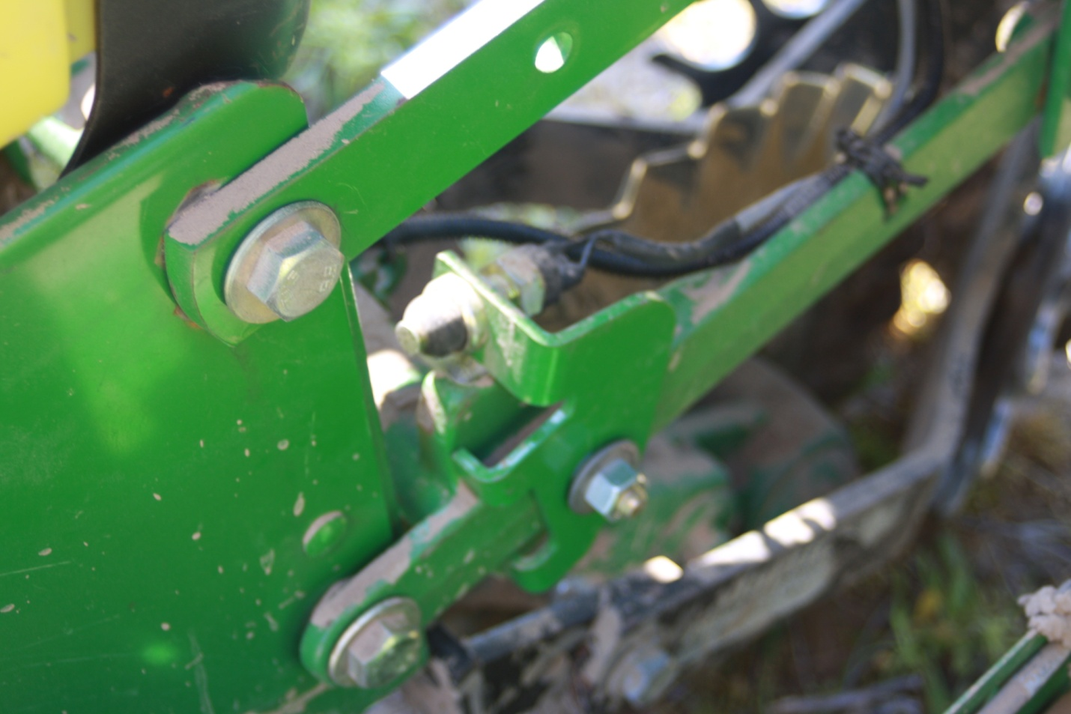
Figure 2. Momentary switch mounted on a John Deere planter unit to indicate planting status.

A temporary wiring harness was used to connect switch output from the planter to the tractor cab. The GPS antenna was located on the tractor cab roof or on top of the planter and centered left to right in order to obtain unobstructive satellite reception. Antenna output wiring was also routed into the tractor cab. Other components were stored inside the tractor cab. Electronic components such as the netbook computer, GPS monitor, and cellular modem were housed in a fiberglass enclosure with appropriate wiring and electrical devices for communication between components (Figure 3).
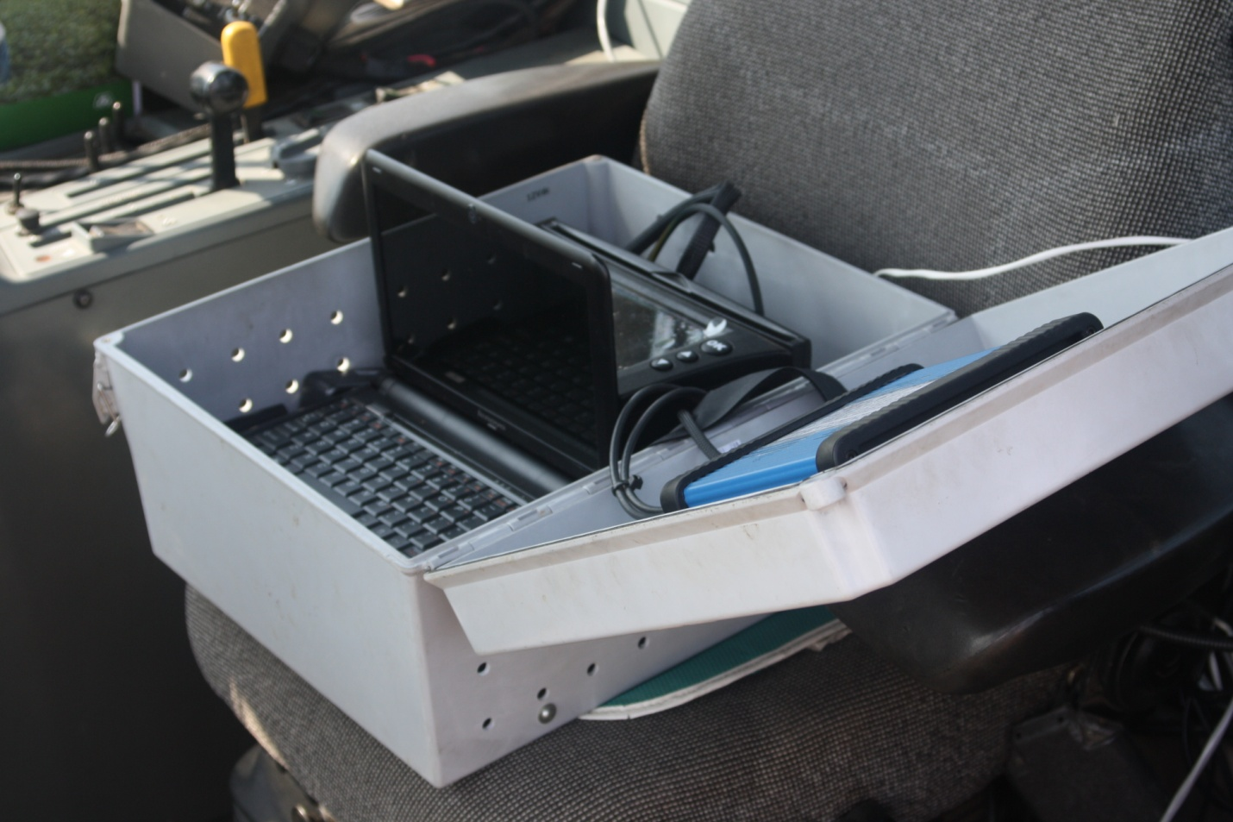
Figure 3. Fiberglass enclosure containing monitor, cellular modem, and computer.

Electrical power for the data acquisition system was obtained from the tractor’s 12-volt battery. At the beginning of each field, a data acquisition check was made by raising and lowering the planter to determine if the switch was functioning properly (Figure 4) and to confirm that the system was receiving RTK-GPS positional data. Data was saved as a Comma Separated Values (CSV) file with new files being automatically created once the data logging program was started on the netbook computer. Files were saved in a specific folder for each producer and named by producer, field number, and date planted or by a specific field ID.
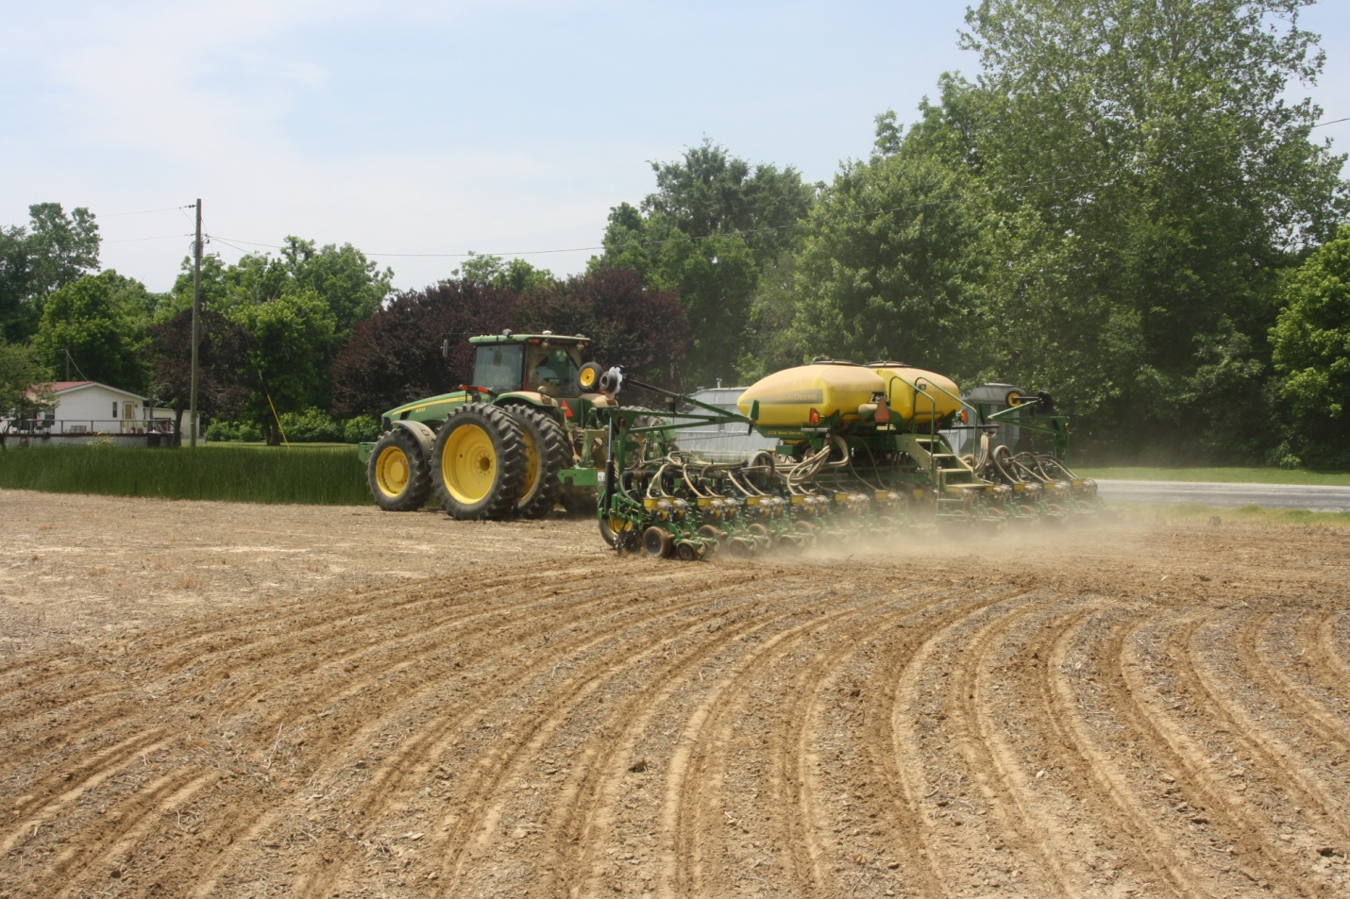
Figure 4. Data acquisition check prior to planting.

Creating Planting Maps for Model Validation
Geo-referenced planting data was manipulated using ArcGIS, version 9.3 software to create a planting map for each field. Positional data was imported into ArcGIS using the WGS 1984 geographic coordinate system and then projected into the NAD 1983 UTM Zone 16 coordinate system for further analysis. CSV events were exported into a shapefile to allow for editing of GPS data. GPS data points were shifted in ArcGIS in order to offset the distance between the location of the GPS antenna and the planter unit’s seed drop tube equipped with the planting status switch. This offset distance was determined during equipment installation in the field. Points were shifted in ArcGIS by selecting points based on travel direction and the measured offset distance and correcting the planter status attribute for each point to the appropriate value. Data points were categorized based on planter status with green points symbolizing that the planter was lowered and planting and red points symbolizing that the planter was raised during turning or crossing no-plant zones (Figure 5).

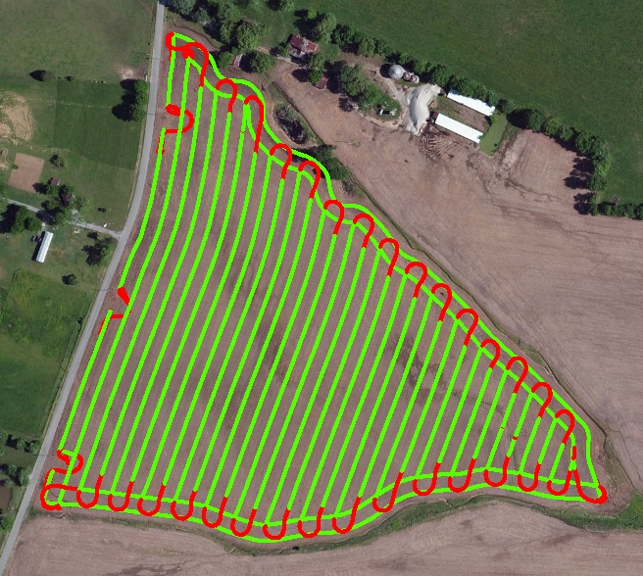
Figure 5. GPS data imported into ArcGIS showing differentiation of planter status.
Once data points were categorized, a new polyline shapefile was created to symbolize the centerline of the tractor and planter as they traveled across the field. Centerlines were created in ArcGIS by overlaying planting data points with a line. On each side of the new centerlines, planting boundaries were offset half the width of a single planting pass, depending on the planter width used for each field. Area between these planting boundaries represented the planted area that occurred within each planter pass across the field. In order to accurately depict the minimum amount of double-planted area in each field, polygons were manually drawn over all planting pass lines that overlapped (Figure 6). Polygons were drawn such that double-planting in end rows would be at a minimum by drawing a perpendicular line from where the lagging planter edge crossed the end row to where the leading planter edge had traveled in relation to the end row. Polygon areas were calculated in acres using the calculate geometry feature in ArcGIS. Areas were summed to obtain the total amount of minimum double-planted area in each field. A polygon shapefile was manually drawn around the outer most planter boundary lines to represent the field boundary. This field boundary area was used to calculate total acreage planted for each field. Total double-planted area was divided by the field boundary area for each field, resulting in a calculated percentage of minimum double-planted area. This actual minimum double-planted percentage for each field was used to validate predicted percentages for both statistical and map-based models.
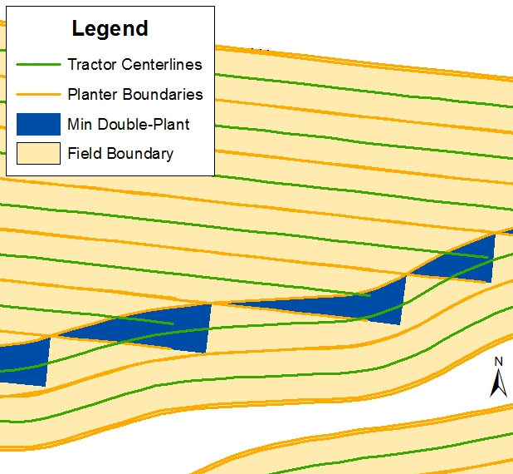
Figure 6. Zoomed portion of planting map created in ArcGIS.

Calculating Geometry Factors for Statistical Models
Twenty-two geometry factors were calculated in ArcGIS, version 10 and Microsoft Excel for all 52 sample fields to determine if any relationships existed between these factors and/or combinations of these factors and percent double-planted area (perdp). All 22 geometry factors gave some indication of irregularity and/or compactness of the field boundary since previous research has shown that implement overlap is directly related to these phenomena.
The 22 independent variables with their corresponding abbreviations that were analyzed in this study were:
- Perimeter-to-Area Ratio (pa)
- Circularity (cir)
- Square-Perimeter Index (spi)
- Row Length Range Difference (ls)
- Row Length Range Difference to Average Row Length Ratio (lsavg)
- Average End Row Length to Average Parallel Row Length Ratio (aeap)
- Centroid to Boundary Vertices Length Standard Deviation (cbstddev)
- Envelope Area to Field Area Ratio (eaa)
- Envelope Perimeter to Field Perimeter Ratio (epp)
- Envelope Perimeter/Envelope Area to Field Perimeter/Field Area Ratio (epeapa)
- Circle Area to Field Area Ratio (caa)
- Circle Perimeter to Field Perimeter Ratio (cpp)
- Circle Perimeter/Circle Area to Field Perimeter/Field Area Ratio (cpcapa)
- Convex-Hull Area to Field Area Ratio (chaa)
- Convex-Hull Perimeter to Field Perimeter Ratio (chpp)
- Convex-Hull Perimeter/Convex-Hull Area to Field Perimeter/Field Area Ratio (chpchapa)
- Rectangle-by-Width Area to Field Area Ratio (rwaa)
- Rectangle-by-Width Perimeter to Field Perimeter (rwpp)
- Rectangle-by-Width Perimeter/Rectangle-by-Width Area to Field Perimeter/Field Area Ratio (rwprwapa)
- Rectangle-by-Area Area to Field Area Ratio (raaa)
- Rectangle-by-Area Perimeter to Field Perimeter Ratio (rapp)
- Rectangle-by-Area Perimeter/Rectangle-by-Area Area to Field Perimeter/Field Area Ratio (rapraapa)

A detailed description of these variables can be found in Appendix A.

The first three variables listed above were selected from a previous study conducted by Luck et al. (2011). Remaining variables have not been previously documented in literature for use in research of this kind. The last 15 variables were derived from Minimum Bounding Geometry (MBG) tools located in ArcGIS. Appendix B contains a table summarizing the calculated values of each geometry factor for all fields.

Statistical Model Development for Predicting Double-Planted Areas
One of the main objectives of this research was to develop statistical models that could predict percent double-planted area in a field. Statistical Analysis Software (SAS), version 9.3 was used for all statistical analyses. A Pearson correlation matrix was first generated to determine if any of the 22 independent variables significantly affected percent double-planted area and to see if any independent variables showed signs of collinearity. Two variable reduction methods were applied to determine optimum models for predicting percent double-planted area based on combinations of geometry factors. The two methods used for variable reduction in SAS were variable selection and Principal Component Analysis (PCA).
According to the SAS/STAT 9.2 User’s Guide, variable selection is an important step in developing a useful linear regression model because of its ability to reduce the number of insignificant variables that may have negligible effects on the overall model. Also, by reducing the number of predicting variables, the chance of developing a model that is tailored to a specific set of data is reduced. Variable selection allows all possible combinations of independent variables to be evaluated and ranked based on Adjusted R-square and Cp values for a given number of variables in a model. The objective of this analysis was to choose a model with the highest possible Adjusted R-square, an acceptable Cp value, and the fewest number of variables. According to Saxton et al. (2011), acceptable Cp values should not be much greater than the number of variables retained in the model plus one (p + 1). Once a model was selected, it was validated using multiple linear regression.
Due to the fact that all independent variables essentially measured irregularity and/or compactness of the study fields, PCA was conducted to determine if variables could be grouped together based on similar characteristics to form principal components as predicting factors of percent double-planted area. By grouping variables into principal components, individual variable redundancy can be reduced in cases where all variables are measuring a similar concept (Hatcher et al. 1994). One issue of performing PCA for this study was a lack of sample fields. It has been reported in the literature that for proper PCA, sample size should equal at least 100 or five times the number of original independent variables (Hatcher et al. 1994). In this study, data was collected for only 52 sample fields; however, it was decided to complete the analysis since PCA follows a more logical sequence compared to variable selection.

Map-Based Model Development for Estimating Double-Planted Areas
Procedures for two map-based estimation models were developed in ArcGIS, version 10 for estimating minimum percent double-planted area for the 52 sample fields. One model required only a field boundary shapefile for analysis. The other model required a field boundary shapefile and a GPS tracklog from a planting, harvesting, or spraying operation of that field. For both models, georeferenced data were imported into ArcGIS using the NAD 1983 UTM Zone 16 projected coordinate system. Procedures for both models are outlined below.
Field Boundary Model
- Field boundary shapefile was imported into ArcGIS and rotated so that the longest, straightest edge of the field was oriented north to south and positioned along the western field edge.
- Using the buffer tool, field boundary shapefile was negatively buffered by a total distance of number of end row passes multiplied by planter width for each field.
- Using the erase tool, output from the negative buffer analysis was used to remove the area of the original field boundary with the area covered by the negative buffer to create an outside ring around the field to represent end row passes.
- Using the fishnet tool, a polygon grid was added to the map with its extents matching that of the negative field buffer. Grid cell width was set to match the planter width used for each field and grid cell height was set at approximately 0.5 meters for improved spatial resolution.
- Using the select by location tool, fishnet grid cells were selected that intersected with the negative field buffer and then created into a new layer based on this selection.
- Using the intersect tool, fishnet grid cells from the previous selection output that intersected with output from the erase analysis were delineated and areas were calculated to represent total double-planted area.
- The final step of this model was to divide the total intersected area by the original field boundary area to calculate an estimated percent double-planted area.

Field Boundary + GPS Model
- With the field boundary and data frame projected, GPS tracklog events were imported into ArcGIS using WGS 1984 coordinates. Prior to this, latitude and longitude columns in the CSV file were converted to decimal degrees.
- GPS point data was exported into the same projected coordinate system as the field boundary and data frame and necessary edits were made to clean the point data.
- The attribute table for the newly created GPS shapefile was opened and four new fields (columns) were added to the table: North and East columns and North_Next and East_Next columns. X and Y coordinates for each point were calculated in the appropriate North and East fields using the calculate geometry tool.
- The GPS database file was opened and all cells from the second North cell to the last North cell were copied into the first cell of the North_Next column. This process was repeated to copy cells from the East column to the East_Next column.
- Changes to the database file were saved as an excel file and then steps 1 and 2 were repeated.
- Using the XY to line tool, appropriate columns from the newly created GPS shapefile attribute table were entered so that line segments were created connecting all GPS points.
- A field was added to the XY to line attribute table named length and then each segment length was calculated using calculate geometry. Any line segments that were over ten feet or under a tenth of a foot were deleted.
- Using the unsplit line tool, line segments were merged to create centerlines that the machinery used to traverse the field.
- Using the buffer tool, the field boundary shapefile was negatively buffered by a total distance of number of end row passes multiplied by planter width for each field.
- Using the erase tool, the output from the negative buffer analysis was used to erase the area of the original field boundary with the area covered by the negative buffer to create an outside ring around the field to represent end row passes.
- Two to three additional buffers were created to the outside of the initial negative buffer in increments of 1/4th the length of the planter width, depending on the irregularity of the field and the range of angles of encroachment from the straight, parallel passes to the end row passes.
- Centerlines created by the unsplit tool that had their centroid within the original negative buffer were selected and created into a new layer.

- Selected centerlines were trimmed or extended to the appropriate field buffer created in the previous steps so that each end of each centerline was represented close as possible to obtain the minimum amount of double-planted area. This allowed for a much closer estimation rather than trimming or extending all centerlines to the same length.
- Centerlines were buffered half the distance of a planter width to create parallel swaths used to plant each field. Buffer ends were set to be flat instead of round.
- Using the intersect tool, locations where centerline buffers and the output from the erase procedure intersected were delineated and areas were calculated to represent double-planted zones.
- The final step of this model was to divide the total intersected area by the original field boundary area to calculate an estimated percent double-planted area.

Estimated percent double-planted areas calculated by both procedures were compared to actual percent double-planted areas of the original planting maps using simple linear regression.

Determining Operator Influence on Double-Planted Area
Operator influence on double-planted area was calculated for fields that had no switch errors during data collection. Also during the study period, some producers upgraded to using ASC during the 2011 planting season. Fields planted using ASC were not used in the operator influence analysis because it was observed during data collection that operators using ASC were less precise when raising or lowering the planter compared to operators who were not using ASC during planting operations. Operator influence was calculated by measuring the distance that planter centerlines extended past or fell short of the minimum double-planted areas in ArcGIS planting maps (Figure 7). Over-planting occurred when the planter was raised past the minimum double-planting reference at the end of a pass or when the planter was lowered before the minimum double-planting reference at the start of a pass. Under-planting occurred when the planter was raised too early at the end of a pass or lowered too late at the start of a pass.
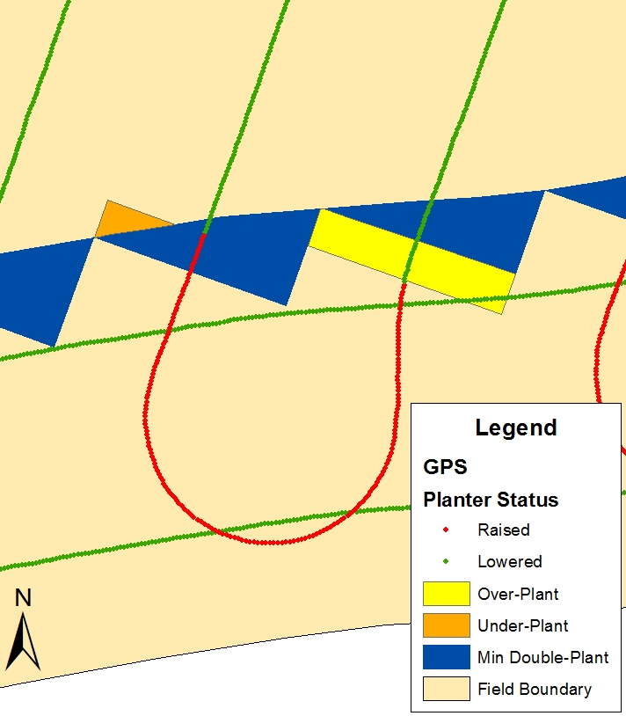
Figure 7. Examples of over-planting and under-planting based on direction of travel.

Double-Planting Test Plot Experiments
Two double-planting experiments were conducted at the Research and Education Center (REC) at Milan, TN during the 2010 and 2011 growing seasons. These experiments were designed to evaluate potential harvest yield losses in cotton and corn due to different angles of encroachment in double-planted areas. Both experiments were conducted using typical no-till farming practices and planted with Roundup® resistant seed varieties for both crops.
2010 Cotton Study
Cotton was planted in field S3-2 of the South Tract on May 25, 2010 with a 4-row John Deere planter on 40-inch rows. Deltapine® 0912 was the seed variety used for this experiment, which is a common cotton variety planted throughout the mid-south. Test plots were 30-feet long by 13.5-feet wide (4 rows of cotton per plot). Three double-planted treatments were used for this experiment at angles of 30°, 60°, and 90° in relation to the straight rows (Figure 8). These three treatments were replicated three times with each double-planted plot having a single-planted control plot spaced four rows to the left for a total of four treatments (Figure 9).

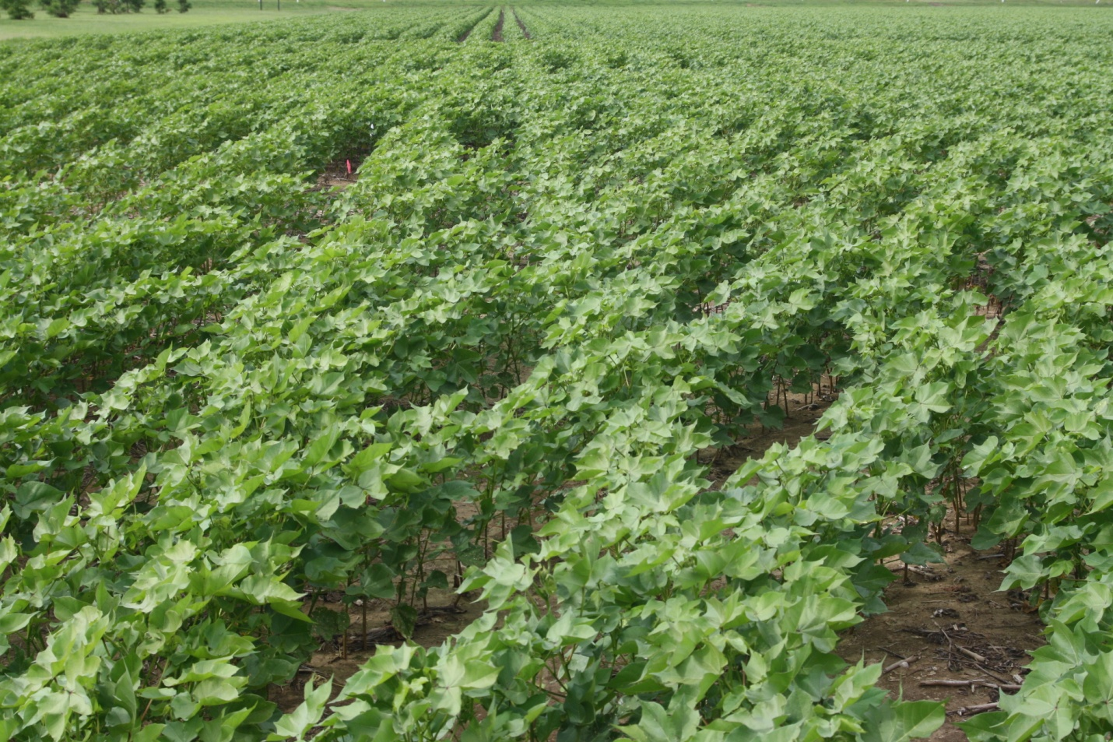
Figure 8. Double-planted cotton plot (photo taken 44 days after planting date).
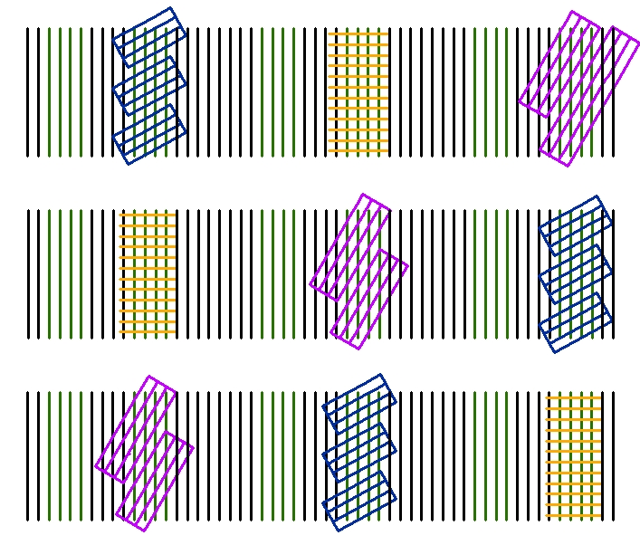
Figure 9. Plot layout for 2010 double-planting cotton study.

All plots were managed using the same agronomic practices throughout the growing season. Cotton plots were harvested on October 5, 2010 with a 2-row Case IH plot picker (Figure 10), and moisture content was uniform among plots. Harvest methodology consisted of making two passes through each plot, picking only straight rows first and weighing the picked cotton after each pass. Double-planted plots were then picked a second time in the direction of the angled cross rows and weighed. Weights from the second picking were kept separate from the first. All measured weights were converted to pounds of seed cotton per acre.
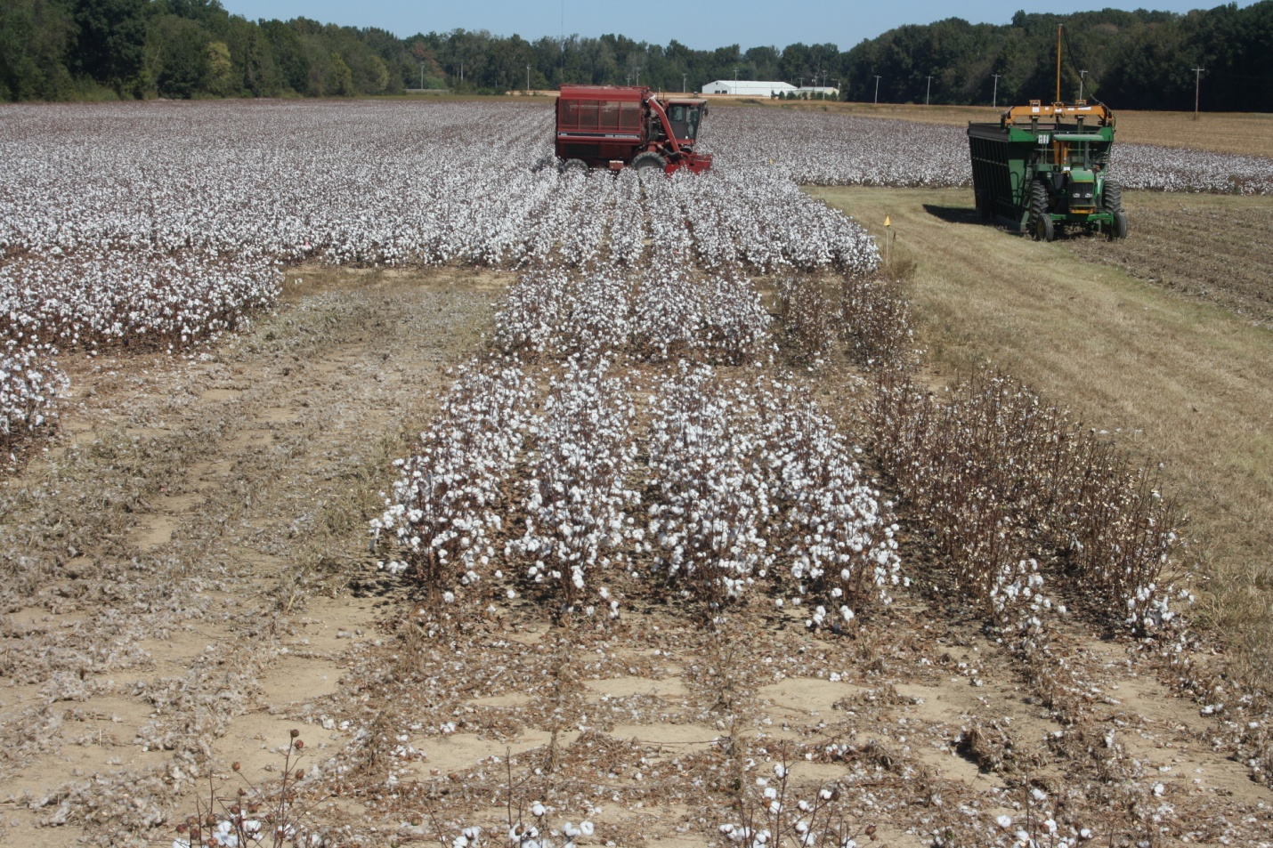
Figure 10. Harvesting cotton plots with 2-row Case IH plot picker.

2011 Corn Study
Corn was planted on April 13, 2011 in field N34-2 of the North Tract. A 4-row John Deere planter was used to plant corn on 30-inch rows (Figure 11). Dekalb® 64-69 seed variety was used in this experiment, which had a 114 day relative maturity and is a popular corn variety throughout the southeast. Test plots were 30-feet long by 10-feet wide (4 rows of corn per plot). Five treatments were used in this experiment and replicated four times for a total of 20 plots. Treatments included single-planted, 30° double-planted, 60° double-planted, 90° double-planted, and 60° double-planted with an extra sidedress nitrogen application (Figure 12).

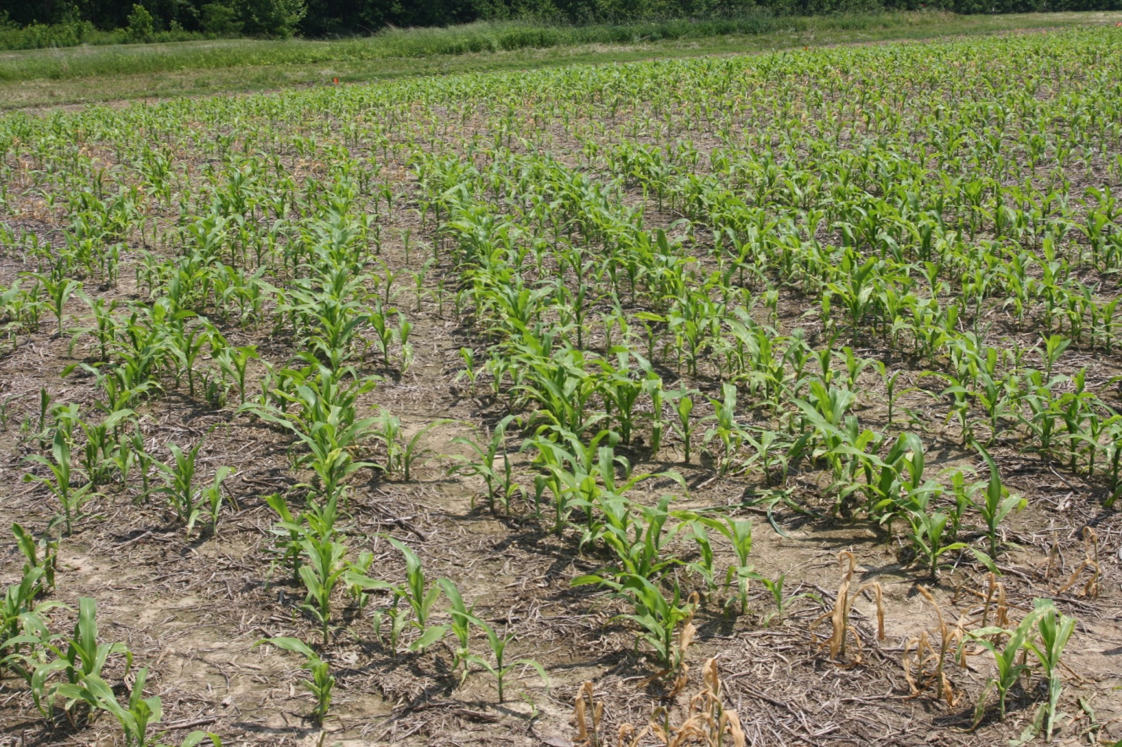
Figure 11. Double-planted corn plot (photo taken 37 days after planting date).

Figure 12. Plot layout for 2011 double-planting corn study.

Corn plots were harvested on September 6, 2011 with a 2-row plot combine. Plots were harvested by making two swaths through the plots in the direction of the straight planted rows. After each combine pass, corn in the hopper was weighed and measured for moisture content and then converted to bushels per acre at 15.5% moisture. Mechanical harvest losses were determined using procedures outlined in chapter eight of the University of Arkansas Corn Production Handbook (Espinoza and Ross 2011). Three samples were taken from random locations in each plot. Sampling was achieved by gathering any corn kernels and/or ears left on the ground within a rectangular area of 30-inches by 48-inches (10 sq. ft.). A PVC pipe frame was built to meet these specifications and then centered over a row of corn at each sampling location (Figure 13). Ears collected from each sample location were hand threshed and bagged along with individual kernels from the same sample site. Kernels were counted and then converted to bushels per acre to calculate harvest losses (2 kernels per sq. ft. is approximately 1 bu/ac loss). Measured harvest losses from the three sampling sites were averaged to determine the average harvest loss for each plot.

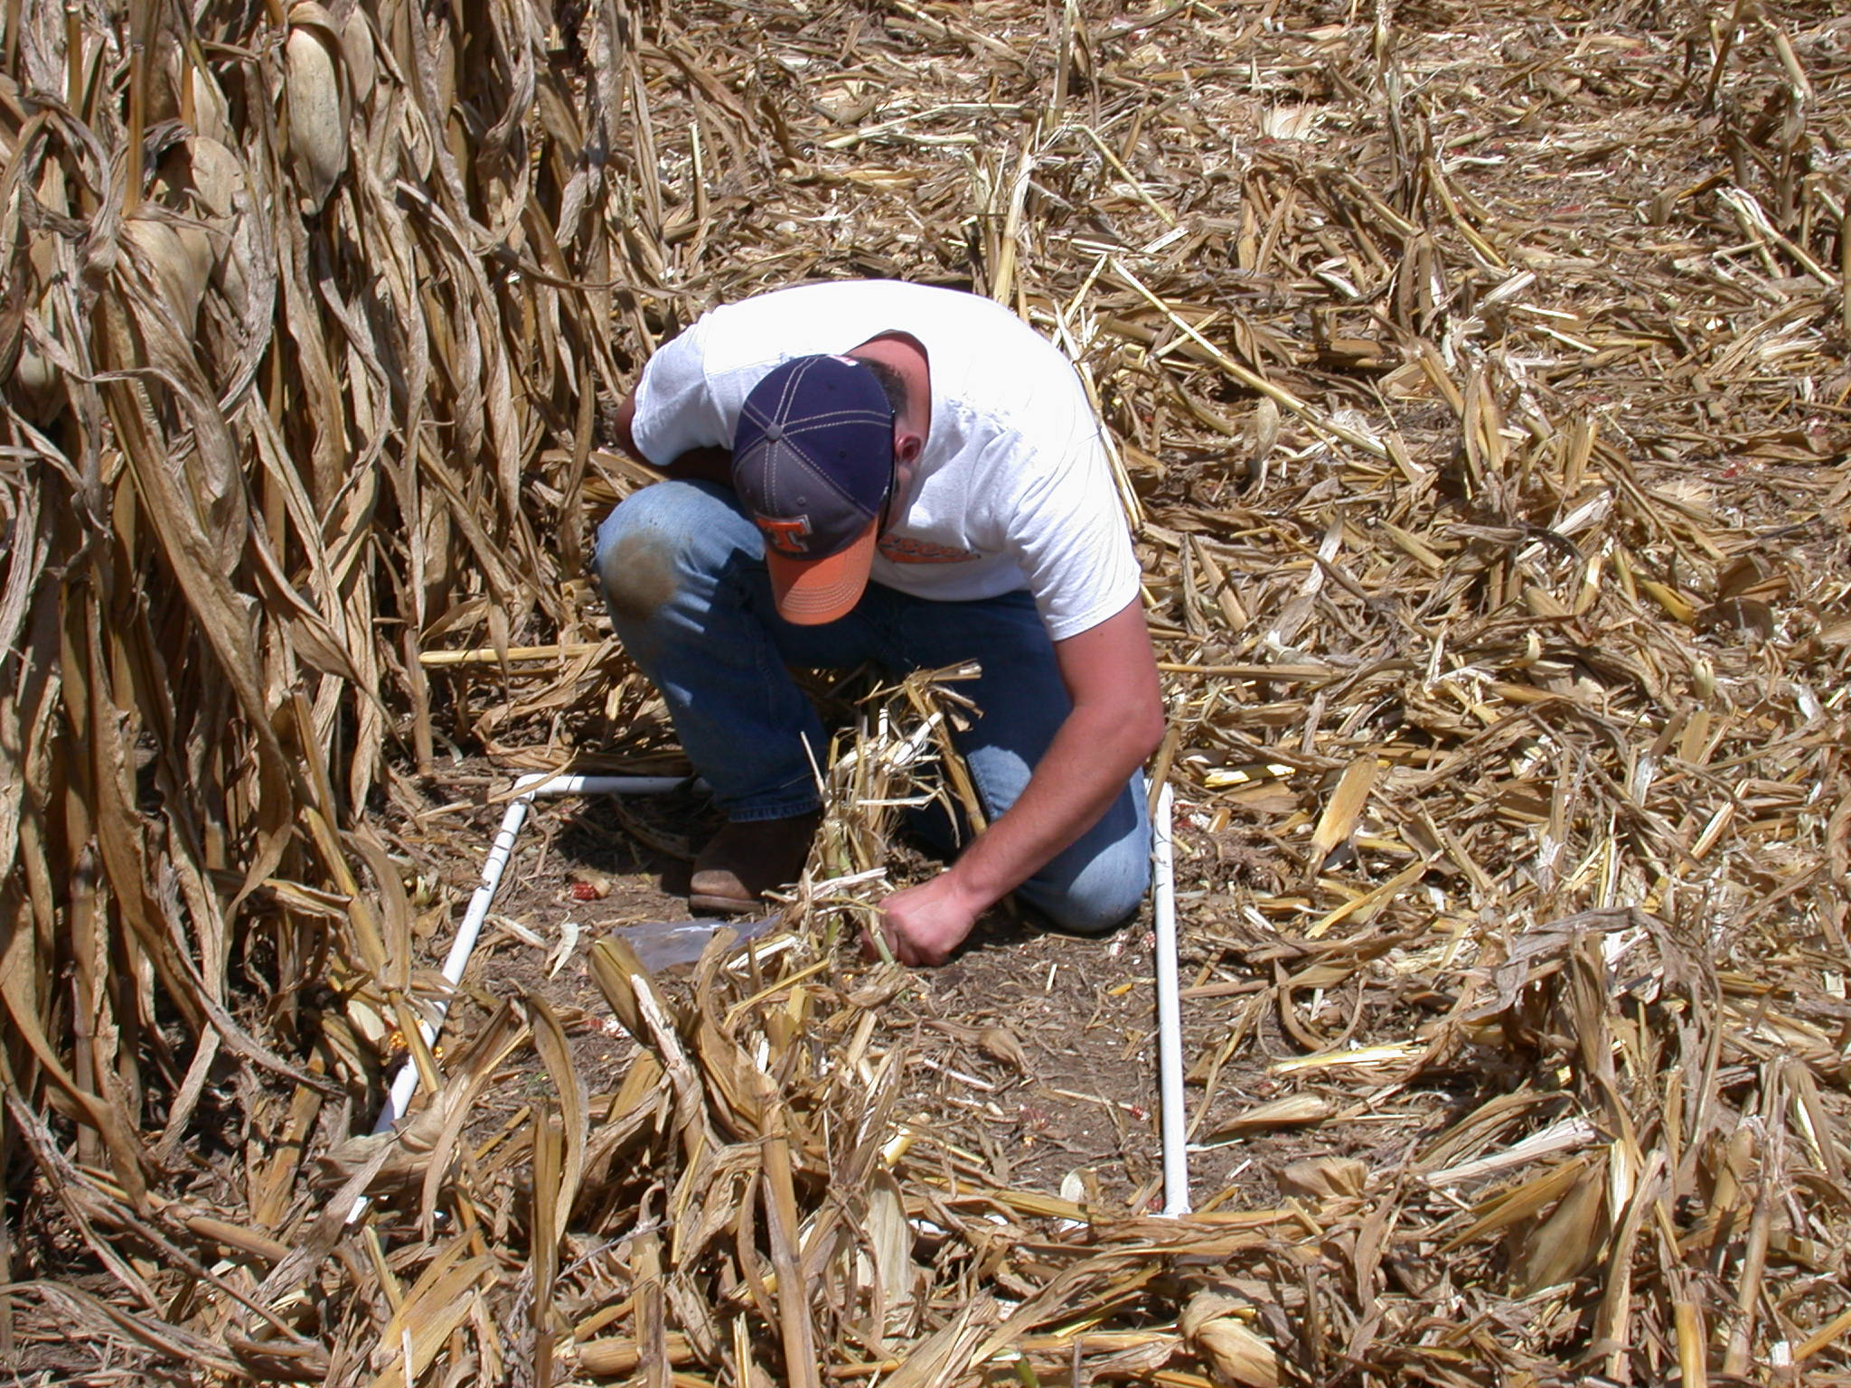
Figure 13. Collecting corn harvest loss samples.

Statistical Analysis
Tukey’s mean separation was used for both experiments to determine if average yield response to treatment means were statistically different. Cotton yield averages were compared both with and without the second picking added to the first picking. Corn yield averages were compared separately from average corn yield losses. All tests were conducted using an alpha level of 5%.

Chapter 4: Results
Planting maps were created for 52 sample fields so that minimum double-planted area could be calculated for each field. Field characteristics were calculated using ArcGIS and are summarized from lowest to highest percent double-planted area along with planting information in Table 1.

Table 1. Summary of sample field characteristics and planting information.
Field  ID | Field  Area (ac) | Field  Perimeter (ft) | Double-Plant Area (ac) | Percent Double-Plant | Planter Width (ft) | Number Parallel Passes | Traveled  Parallel  Rows (ft) | Traveled  End  Rows (ft)
LEF | 66.5 | 7986 | 0.1 | 0.08 | 38 | 25 | 72190 | 3847
LWF | 105.6 | 9515 | 0.1 | 0.10 | 38 | 39 | 115589 | 5945
LW | 79.9 | 7626 | 0.1 | 0.11 | 38 | 59 | 83388 | 8645
PBDT | 77.5 | 7916 | 0.2 | 0.30 | 38 | 65 | 84220 | 5376
KWT | 71.4 | 7926 | 0.2 | 0.31 | 38 | 31 | 77644 | 5200
HF2 | 15.7 | 4083 | 0.1 | 0.36 | 38 | 11 | 16462 | 1601
KF1 | 105.9 | 9718 | 0.5 | 0.46 | 38 | 55 | 111602 | 9623
HF7 | 21.9 | 4083 | 0.1 | 0.49 | 38 | 19 | 23908 | 1339
HF11E | 69.4 | 7308 | 0.4 | 0.63 | 38 | 24 | 70870 | 7346
KCL | 88.8 | 7944 | 0.7 | 0.83 | 38 | 46 | 96859 | 6982
HF4B | 18.2 | 4064 | 0.2 | 0.85 | 38 | 14 | 18282 | 2523
HF4A | 8.2 | 3601 | 0.1 | 1.09 | 38 | 6 | 8664 | 747
PowF3 | 34.4 | 7352 | 0.4 | 1.20 | 40 | 34 | 31934 | 5292
HF11D | 40.5 | 7141 | 0.6 | 1.39 | 38 | 24 | 42124 | 4668
FFA | 22.7 | 6039 | 0.4 | 1.56 | 38 | 12 | 24524 | 1494
PMI | 26.4 | 4620 | 0.5 | 1.86 | 38 | 28 | 27224 | 3560
PowF8 | 31.9 | 4869 | 0.7 | 2.12 | 40 | 25 | 30882 | 4158
HF1 | 22.5 | 4345 | 0.5 | 2.14 | 38 | 23 | 21984 | 5263
PugF7 | 27.8 | 4519 | 0.6 | 2.15 | 38 | 22 | 28891 | 2931
HF5 | 20.4 | 3716 | 0.5 | 2.26 | 38 | 25 | 20077 | 5061
PugF5 | 37.6 | 7117 | 0.9 | 2.33 | 38 | 20 | 39011 | 3100
PowF1 | 23.8 | 4597 | 0.6 | 2.36 | 40 | 35 | 6043 | 1829
FF13 | 32.0 | 5260 | 0.8 | 2.38 | 38 | 28 | 34318 | 3401
PFJS | 32.3 | 5209 | 0.8 | 2.57 | 38 | 31 | 33255 | 4451
PSLF | 30.3 | 4975 | 0.9 | 2.90 | 38 | 33 | 30463 | 2650
PTH | 58.8 | 14017 | 1.8 | 3.08 | 38 | 27 | 66563 | 8743
PBBT | 16.4 | 3886 | 0.5 | 3.10 | 38 | 19 | 16435 | 2278
PowF6 | 20.1 | 4437 | 0.6 | 3.16 | 40 | 32 | 14585 | 7307
Field | Field | Field | Double- | Percent | Planter | Number | Traveled | Traveled
ID | Area | Perimeter | Plant | Double- | Width | Parallel | Parallel | End
 | (ac) | (ft) | Area (ac) | Plant | (ft) | Passes | Rows (ft) | Rows (ft)
PAA | 32.1 | 7850 | 1.0 | 3.22 | 38 | 47 | 30414 | 7815
DF1 | 23.5 | 6899 | 0.8 | 3.31 | 30 | 38 | 26362 | 8340
PowF2 | 26.0 | 4847 | 0.9 | 3.48 | 40 | 24 | 20863 | 7825
HF3 | 16.3 | 4170 | 0.6 | 3.68 | 38 | 15 | 15771 | 4045
PugF6 | 44.9 | 9638 | 1.9 | 4.31 | 38 | 36 | 50470 | 2751
FF7 | 23.4 | 6336 | 1.0 | 4.47 | 38 | 17 | 25415 | 2843
PowF4 | 9.3 | 2999 | 0.4 | 4.53 | 40 | 12 | 5886 | 4292
HF11C | 8.4 | 4457 | 0.4 | 4.60 | 38 | 5 | 9705 | 497
HF11B | 6.6 | 3343 | 0.3 | 5.22 | 38 | 14 | 2437 | 5667
PowF7 | 15.9 | 6670 | 1.1 | 6.78 | 40 | 13 | 9907 | 7754
PugF12 | 42.3 | 8074 | 3.5 | 8.22 | 38 | 35 | 39475 | 12883
PugF13 | 32.3 | 8660 | 2.8 | 8.61 | 38 | 65 | 24952 | 16209
CF1 | 42.5 | 12349 | 3.7 | 8.65 | 40 | 69 | 31134 | 20610
PugF8 | 24.1 | 7970 | 2.2 | 8.93 | 38 | 43 | 20854 | 10041
HF11A | 4.1 | 2221 | 0.4 | 8.94 | 38 | 6 | 3253 | 1933
PugF18 | 9.1 | 3313 | 0.8 | 8.95 | 38 | 12 | 7904 | 3587
PugF16 | 26.9 | 9507 | 2.5 | 9.30 | 38 | 31 | 19582 | 14273
PugF19 | 20.5 | 6375 | 2.1 | 10.22 | 38 | 25 | 17566 | 7948
PugF20 | 1.9 | 1177 | 0.2 | 11.11 | 38 | 4 | 566 | 1943
PugF17 | 32.0 | 11249 | 3.6 | 11.11 | 38 | 50 | 21605 | 19028
PugF21 | 36.3 | 14879 | 4.8 | 13.33 | 38 | 69 | 30395 | 15768
PF11A | 18.8 | 7500 | 2.6 | 13.65 | 38 | 37 | 17171 | 7899
PugF15 | 3.5 | 1648 | 0.5 | 14.34 | 38 | 8 | 2361 | 2342
PugF9 | 16.7 | 8905 | 2.6 | 15.32 | 38 | 31 | 7806 | 14513
Avg | 33.2 | 6440 | 1.0 | 4.55 |  | 29 | 32497 | 6272
St Dev | 25.0 | 2922 | 1.1 | 4.24 |  | 17 | 28065 | 4722

As shown in Table 1, field size ranged from a low of 1.9 acres to a high of 105.9 acres with an average of 33.2 acres. Total area planted over the course of this study was approximately 1724 acres. Percentage of minimum double-planted area ranged from 0.08% to 15.32% with an average of 4.55% across all study fields. Total minimum double-planted area was calculated to be 54.3 acres, which represented approximately 3.15% of the total area planted. Figure 14 shows field area plotted versus percent double-planted area. Generally, fields above 50 acres were less than 1% double-planted while fields below 50 acres ranged from 0.36 to 15.32 percent double-planted.

Figure 14. Relationship between field area and percent double-planted area.

In order to determine precision of manually drawn features in planting maps, 28 double-planted polygons and 13 field boundaries were randomly selected to be tested. Sampled features were redrawn using the same methods as the original drawings and then errors where calculated. Polygon feature errors totaled 439.2 feet-squared and were divided by the total sampled area of 25618.3 feet-squared to obtain the polygon measurement uncertainty of 1.71%. Field boundary feature errors totaled 1.0 acre compared to a total sampled area of 619.7 acres. This resulted in a field boundary error term of 0.16%. These independent error terms were combined and Root-Mean-Square-Error (RMSE) was calculated to be 1.72% for manually drawn features in ArcGIS.

Statistical Model Results
Field geometry factors, shown in Appendix B, were calculated for each field, and used in two variable reduction procedures in order to determine the best possible combination of independent variables for predicting percent double-planted area. The two methods consisted of: 1) evaluating models based on Adjusted R-square and Cp values for all possible combinations of variables, and 2) principal component analysis (PCA). Both variable reduction procedures were conducted using SAS.
Before using the aforementioned reduction methods, potential variables to be included in models were evaluated using Pearson’s correlation analysis to determine relationships between percent double-planted area (Y-variable) and all geometry factors (X-variables) to be included in models. Variables pa, spi, lsavg, epeapa, chaa, chpp, chpchapa, rwaa, rwprwapa, raaa, rapraapa were found to be highly correlated (r ≥ 0.50 and significant at p < 0.0001) with percent double-planted area and were, therefore, considered as potential candidates to be used in variable reduction methods. See Appendix C for correlation matrix.
The single most significant variable in predicting percent double-planted area was pa with a correlation of 0.74 (p < 0.0001). Simple linear regression, shown in Figure 15, revealed a moderate relationship between pa and percent double-planted area with an R² of 0.55 and a RMSE of 2.89% (p < 0.0001). These results were fairly consistent with results reported by Luck et al. (2010).

Figure 15. Relationship between P/A ratio and percent double-planted area.

Variable selection was conducted using the previously mentioned geometry factors that were found to be highly correlated with percent double-planted area. The optimum model detected using this method retained the following six geometry factors: pa, lsavg, epeapa, chpp, rwaa, rwprwapa. Results of this analysis showed that a strong, positive relationship existed between a linear combination of these geometry factors and percent double-planted area (Figure 16). The linear equation for the model is as follows:

$\%DP=-8.97915+\left(0.01787*pa\right)+\left(1.60847*lsavg\right)+\left(4.74894*epeapa\right)+\left(-13.50523*chpp\right)+\left(5.99229*rwaa\right)+(9.48378*rwprwapa)$
This model produced an R² of 0.83 with a RMSE of 1.85% (p < 0.0001). Adjusted R-square equaled 0.81 and the Cp value for this model was 7.94, which was within the allowable range. The slope of the regression line was nearly equal to one. Normality tests also indicated a normal distribution of the data. Table 2 summarizes model predicted values, actual values, and differences between the two.

Y = X
R² = 0.83
Figure 16. Predicted percent double-planted area versus actual percent double-planted area for the optimum variable selection model
Table 2. Summary of variation between variable selection model predicted percent double-planted area and actual percent double-planted area calculated using planting maps.

Field  ID | Actual  Percent | Predicted  Percent | Error  (AP - PP) | Absolute  Error
LEF | 0.08 | -0.45 | 0.53 | 0.53
LWF | 0.10 | -0.07 | 0.17 | 0.17
LW | 0.11 | -0.55 | 0.66 | 0.66
PBDT | 0.30 | -1.11 | 1.42 | 1.42
KWT | 0.31 | 0.75 | -0.44 | 0.44
HF2 | 0.36 | 1.43 | -1.07 | 1.07
KF1 | 0.46 | 0.08 | 0.38 | 0.38
HF7 | 0.49 | 0.91 | -0.42 | 0.42
HF11E | 0.63 | -0.39 | 1.01 | 1.01
KCL | 0.83 | 0.25 | 0.57 | 0.57
HF4B | 0.85 | 1.65 | -0.81 | 0.81
HF4A | 1.09 | 3.72 | -2.63 | 2.63
PowF3 | 1.20 | 4.84 | -3.64 | 3.64
HF11D | 1.39 | 2.33 | -0.94 | 0.94
FFA | 1.56 | 1.28 | 0.27 | 0.27
PMI | 1.86 | 2.14 | -0.28 | 0.28
PowF8 | 2.12 | 2.39 | -0.27 | 0.27
HF1 | 2.14 | 2.59 | -0.45 | 0.45
PugF7 | 2.15 | 2.05 | 0.10 | 0.10
HF5 | 2.26 | 2.63 | -0.38 | 0.38
PugF5 | 2.33 | 2.12 | 0.22 | 0.22
PowF1 | 2.36 | 5.14 | -2.78 | 2.78
FF13 | 2.38 | 2.61 | -0.22 | 0.22
PFJS | 2.57 | 1.79 | 0.78 | 0.78
PSLF | 2.90 | 3.54 | -0.64 | 0.64
PTH | 3.08 | 3.60 | -0.52 | 0.52
PBBT | 3.10 | 4.07 | -0.97 | 0.97
PowF6 | 3.16 | 4.14 | -0.98 | 0.98
PAA | 3.22 | 3.72 | -0.50 | 0.50
DF1 | 3.31 | 5.51 | -2.21 | 2.21
PowF2 | 3.48 | 3.00 | 0.47 | 0.47
HF3 | 3.68 | 3.17 | 0.51 | 0.51
PugF6 | 4.31 | 2.90 | 1.41 | 1.41
FF7 | 4.47 | 4.79 | -0.32 | 0.32
PowF4 | 4.53 | 5.89 | -1.36 | 1.36
HF11C | 4.60 | 4.49 | 0.11 | 0.11
HF11B | 5.22 | 10.33 | -5.12 | 5.12
PowF7 | 6.78 | 7.62 | -0.84 | 0.84
PugF12 | 8.22 | 4.19 | 4.03 | 4.03
PugF13 | 8.61 | 7.43 | 1.18 | 1.18
CF1 | 8.65 | 9.65 | -1.00 | 1.00
PugF8 | 8.93 | 7.75 | 1.18 | 1.18
HF11A | 8.94 | 7.72 | 1.22 | 1.22
PugF18 | 8.95 | 6.62 | 2.33 | 2.33
PugF16 | 9.30 | 8.71 | 0.59 | 0.59
PugF19 | 10.22 | 11.30 | -1.08 | 1.08
PugF20 | 11.11 | 11.08 | 0.03 | 0.03
PugF17 | 11.11 | 8.29 | 2.81 | 2.81
Field | Actual | Predicted | Error | Absolute
ID | Percent | Percent | (AP – PP) | Error
PugF21 | 13.33 | 14.15 | -0.82 | 0.82
PF11A | 13.65 | 10.41 | 3.24 | 3.24
PugF15 | 14.34 | 8.87 | 5.47 | 5.47
PugF9 | 15.32 | 15.52 | -0.20 | 0.20
Avg | 4.55 | 4.55 |  | 1.18
St Dev | 4.24 | 3.89 |  | 1.25

Average percent minimum double-planted area predicted by the model was equal to the average actual percent minimum double-planted area calculated by the planting maps at 4.55%. Average absolute error between actual versus predicted was 1.18% with a standard deviation of 1.25% and ranged from 0.11 to 5.47 percent.
Based on the Pearson correlation analysis, the majority of the independent variables selected for this model were found to be collinear with each other. Collinearity is an issue that can be addressed by removing correlated predicting variables from the analysis. Variables epeapa, chpp, rwaa, rwprwapa were removed from the model, thus leaving pa and lsavg. These two variables exhibited strong, positive correlations (0.74 and 0.68 respectively) with percent double-planted area while simultaneously showing a weak correlation between each other (0.33, p = 0.02). A combination of pa and lsavg produced the following linear equation:

$\%DP=-3.58352+\left(0.01834*pa\right)+(2.44751*lsavg)$

Goodness of fit for this model was measured at R² = 0.76 (p < 0.0001). RMSE was 2.12% and the slope was nearly equal to one (Figure 15). Adjusted R-square and Cp values were 0.75 and 20.13 respectively. Table 3 lists actual minimum double-planted values with predicted values estimated by the model along with errors between the two for each field. Average absolute error between actual and predicted values for the two variable model was 1.58% with a standard deviation of 1.34% and a range from a low of 0.01% to a high of 5.45%.

Y = X
R² = 0.76
Figure 17. Predicted percent double-planted area versus actual percent double-planted area for the optimum variable selection model after removing correlated variables.

Table 3. Summary of variation between 2 variable model predicted percent double-planted area and actual percent double-planted area calculated using planting maps.

Field  ID | Actual  Percent | Predicted  Percent | Error  (AP - PP) | Absolute  Error
LEF | 0.08 | -1.27 | 1.35 | 1.35
LWF | 0.10 | -0.68 | 0.78 | 0.78
LW | 0.11 | -1.60 | 1.70 | 1.70
PBDT | 0.30 | -0.88 | 1.18 | 1.18
KWT | 0.31 | 1.35 | -1.04 | 1.04
HF2 | 0.36 | 1.42 | -1.06 | 1.06
KF1 | 0.46 | 0.91 | -0.45 | 0.45
HF7 | 0.49 | 0.25 | 0.24 | 0.24
HF11E | 0.63 | -1.12 | 1.75 | 1.75
KCL | 0.83 | -0.43 | 1.26 | 1.26
HF4B | 0.85 | 1.14 | -0.30 | 0.30
HF4A | 1.09 | 4.55 | -3.46 | 3.46
PowF3 | 1.20 | 5.86 | -4.66 | 4.66
HF11D | 1.39 | 2.93 | -1.54 | 1.54
FFA | 1.56 | 2.67 | -1.11 | 1.11
PMI | 1.86 | 2.64 | -0.78 | 0.78
PowF8 | 2.12 | 2.11 | 0.01 | 0.01
HF1 | 2.14 | 3.11 | -0.97 | 0.97
PugF7 | 2.15 | 1.89 | 0.27 | 0.27
HF5 | 2.26 | 2.04 | 0.22 | 0.22
PugF5 | 2.33 | 2.65 | -0.32 | 0.32
PowF1 | 2.36 | 4.88 | -2.52 | 2.52
FF13 | 2.38 | 2.98 | -0.59 | 0.59
PFJS | 2.57 | 1.25 | 1.31 | 1.31
PSLF | 2.90 | 2.88 | 0.02 | 0.02
PTH | 3.08 | 6.20 | -3.13 | 3.13
PBBT | 3.10 | 4.64 | -1.54 | 1.54
PowF6 | 3.16 | 3.86 | -0.70 | 0.70
PAA | 3.22 | 3.90 | -0.68 | 0.68
DF1 | 3.31 | 5.89 | -2.58 | 2.58
PowF2 | 3.48 | 3.66 | -0.18 | 0.18
HF3 | 3.68 | 3.59 | 0.09 | 0.09
PugF6 | 4.31 | 3.80 | 0.51 | 0.51
FF7 | 4.47 | 5.47 | -1.00 | 1.00
PowF4 | 4.53 | 5.52 | -0.98 | 0.98
HF11C | 4.60 | 6.21 | -1.62 | 1.62
HF11B | 5.22 | 10.67 | -5.45 | 5.45
PowF7 | 6.78 | 9.17 | -2.39 | 2.39
PugF12 | 8.22 | 4.71 | 3.51 | 3.51
PugF13 | 8.61 | 7.15 | 1.46 | 1.46
CF1 | 8.65 | 7.94 | 0.71 | 0.71
PugF8 | 8.93 | 6.54 | 2.39 | 2.39
HF11A | 8.94 | 9.58 | -0.64 | 0.64
PugF18 | 8.95 | 6.64 | 2.31 | 2.31
PugF16 | 9.30 | 7.12 | 2.18 | 2.18
PugF19 | 10.22 | 7.97 | 2.25 | 2.25
PugF20 | 11.11 | 10.30 | 0.80 | 0.80
PugF17 | 11.11 | 9.43 | 1.67 | 1.67
Field | Actual | Predicted | Error | Absolute
ID | Percent | Percent | (AP - PP) | Error
PugF21 | 13.33 | 14.59 | -1.25 | 1.25
PF11A | 13.65 | 10.23 | 3.41 | 3.41
PugF15 | 14.34 | 8.91 | 5.44 | 5.44
PugF9 | 15.32 | 11.17 | 4.15 | 4.15
Avg | 4.55 | 4.55 |  | 1.58
St Dev | 4.24 | 3.69 |  | 1.34

The second variable reduction procedure evaluated was Principal Component Analysis (PCA). As mentioned above, results from the Pearson correlation analysis indicated some collinearity among independent variables. PCA is designed to account for collinearity by combining similar independent variables into new predicting factors known as principal components. Therefore, a PCA was conducted using the eleven variables that were highly correlated with percent double-planted area. Analysis was conducted in SAS using the proc factor function following the procedures outlined in Hatcher et al. (1994). Originally, eleven components (one for each input variable) were created. The first step in PCA was to identify which components were accounting for the majority of the variance in the data. This was accomplished using the information in Table 4. Components with an eigenvalue greater than or equal to one that accounted for at least 5% of the total variance were retained for further analysis.

Table 4. Eigenvalues along with proportion of variance accounted for by each component.

Component | Eigenvalue | Difference | Proportion | Cumulative
 |  | from Total | of Variance | Variance
1 | 7.9190 | 6.8775 | 0.7199 | 0.7199
2 | 1.0415 | 0.2209 | 0.0947 | 0.8146
3 | 0.8206 | 0.3001 | 0.0746 | 0.8892
4 | 0.5205 | 0.1449 | 0.0473 | 0.9365
5 | 0.3756 | 0.1917 | 0.0341 | 0.9706
6 | 0.1839 | 0.0766 | 0.0167 | 0.9874
7 | 0.1073 | 0.0845 | 0.0098 | 0.9971
8 | 0.0228 | 0.0165 | 0.0021 | 0.9992
9 | 0.0063 | 0.0037 | 0.0006 | 0.9998
10 | 0.0026 | 0.0025 | 0.0002 | 1.0000
11 | 0.0001 |  | 0.0000 | 1.0000

Based on Table 4, only the first two components were used in subsequent PCA steps. The varimax (orthogonal) rotation method was used to perform a linear transformation on the original factor matrix created in SAS. Variables in the rotated matrix were flagged if they made a significant contribution to either of the two principal components (i.e. contained a correlation coefficient whose absolute value was equal to or greater than 0.4). The rotated factor matrix of correlation coefficients indicating correlations between each variable and the two original components are shown in Table 5.

Table 5. Rotated matrix displaying correlation coefficients for each variable and principal component.

Variable | PC 1 |  | PC 2
pa | -0.48 | * | 0.26
spi | 0.69 | * | -0.37
lsavg | -0.53 | * | 0.61 | *
epeapa | 0.72 | * | -0.56 | *
chaa | -0.49 | * | 0.78 | *
chpp | 0.94 | * | -0.13
chpchapa | 0.88 | * | -0.41 | *
rwaa | -0.28 |  | 0.95 | *
rwprwapa | 0.75 | * | -0.62 | *
raaa | -0.28 |  | 0.95 | *
rapraapa | 0.76 | * | -0.62 | *
*Indicates variables that account for a significant amount of variance among components.

Variables that were flagged on both components were removed from the analysis because they explained significant amounts of variance on more than one component. Once all necessary variables were removed, the number of principal components retained decreased from two to one because each component required a minimum of three significant variables. None the less, standardized component scores (weights) were calculated for the remaining variables (Table 6) by including the nfact=1 (number of components equals one) command in the SAS code.

Table 6. Standardized component scores for retained variables.

Variable | Principal
 | Component
pa | 0.20884
spi | -0.25458
chpp | -0.22400
rwaa | 0.29272
raaa | 0.29220

Component scores were multiplied by their corresponding, standardized variable to develop a linear combination of optimally weighted variables for the principal component. Simple linear regression was conducted comparing the calculated principal component values to percent double-planted area (Figure 18). Goodness of fit for this model was moderate with an R² of 0.66 and a RMSE of 2.50% (p < 0.0001).

Figure 18. Relationship between principal component versus percent double-planted area.

Map-Based Model Results
Two spatial models were developed using ArcGIS according to the procedures outlined under the section entitled Map-Based Model Development for Estimating Double-Planted Areas in Chapter 3. The first model, known as the field boundary model, required only a field boundary polygon shapefile. This model did not account for path orientation of farm machinery as it traversed a field due to the absence of a GPS tracklog. Other characteristics of this model included its ease of operation and lack of intermediate processing steps when compared to the second model. The simplicity of this model made it possible to create a tool for estimating double-planted areas in ArcGIS using Model Builder. The Model Builder flow chart used to create the model is shown in Figure 19.
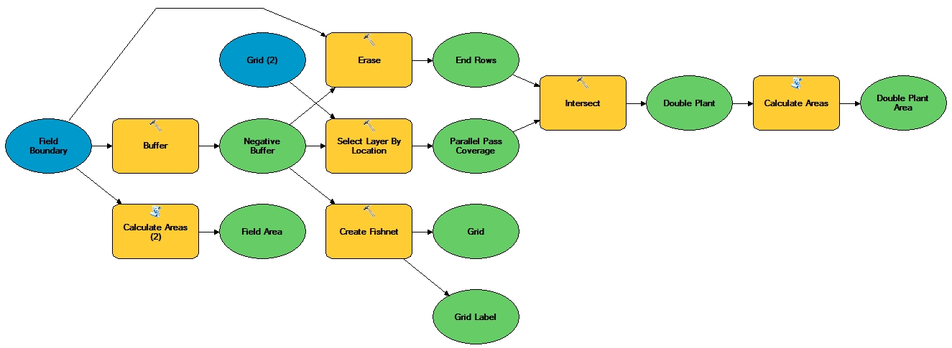

Figure 19. Flow chart design for field boundary model created in ArcGIS using Model Builder.

The field boundary model was validated by comparing the estimated percent minimum double-planted area to the actual values calculated in original planting maps (Figure 20). Simple linear regression was conducted using the %reg function in SAS. Analysis showed a fairly strong, positive correlation between estimated and actual percent minimum double-planted area with R² = 0.73 and RMSE = 2.22% (p < 0.0001). Model predicted values, actual values, and differences between the two values are summarized in Table 7.

Y = X
R² = 0.73
Figure 20. Estimated percent double-planted area calculated by field boundary model versus actual percent double-planted area.

Table 7. Summary of variation between field boundary model predicted percent double-planted area and actual percent double-planted area calculated using planting maps.

Field  ID | Actual  Percent | Predicted  Percent | Error  (AP - PP) | Absolute  Error
LEF | 0.08 | 0.27 | -0.19 | 0.19
LWF | 0.10 | 0.35 | -0.25 | 0.25
LW | 0.11 | 0.21 | -0.10 | 0.10
PBDT | 0.30 | 0.94 | -0.64 | 0.64
KWT | 0.31 | 0.53 | -0.22 | 0.22
HF2 | 0.36 | 0.42 | -0.06 | 0.06
KF1 | 0.46 | 0.67 | -0.21 | 0.21
HF7 | 0.49 | 1.00 | -0.51 | 0.51
HF11E | 0.63 | 0.79 | -0.16 | 0.16
KCL | 0.83 | 1.02 | -0.19 | 0.19
HF4B | 0.85 | 1.09 | -0.25 | 0.25
HF4A | 1.09 | 1.15 | -0.06 | 0.06
PowF3 | 1.20 | 3.52 | -2.32 | 2.32
Field | Actual | Predicted | Error | Absolute
ID | Percent | Percent | (AP - PP) | Error
HF11D | 1.39 | 2.10 | -0.71 | 0.71
FFA | 1.56 | 5.18 | -3.62 | 3.62
PMI | 1.86 | 3.39 | -1.53 | 1.53
PowF8 | 2.12 | 1.43 | 0.69 | 0.69
HF1 | 2.14 | 2.34 | -0.20 | 0.20
PugF7 | 2.15 | 0.68 | 1.48 | 1.48
HF5 | 2.26 | 2.39 | -0.13 | 0.13
PugF5 | 2.33 | 4.69 | -2.36 | 2.36
PowF1 | 2.36 | 4.02 | -1.66 | 1.66
FF13 | 2.38 | 4.53 | -2.15 | 2.15
PFJS | 2.57 | 2.66 | -0.10 | 0.10
PSLF | 2.90 | 4.60 | -1.70 | 1.70
PTH | 3.08 | 8.32 | -5.24 | 5.24
PBBT | 3.10 | 3.88 | -0.78 | 0.78
PowF6 | 3.16 | 3.07 | 0.09 | 0.09
PAA | 3.22 | 3.53 | -0.31 | 0.31
DF1 | 3.31 | 7.41 | -4.10 | 4.10
PowF2 | 3.48 | 3.81 | -0.34 | 0.34
HF3 | 3.68 | 3.54 | 0.13 | 0.13
PugF6 | 4.31 | 4.10 | 0.21 | 0.21
FF7 | 4.47 | 4.67 | -0.20 | 0.20
PowF4 | 4.53 | 4.38 | 0.15 | 0.15
HF11C | 4.60 | 6.46 | -1.86 | 1.86
HF11B | 5.22 | 6.56 | -1.34 | 1.34
PowF7 | 6.78 | 9.96 | -3.18 | 3.18
PugF12 | 8.22 | 5.57 | 2.65 | 2.65
PugF13 | 8.61 | 8.28 | 0.34 | 0.34
CF1 | 8.65 | 8.07 | 0.58 | 0.58
PugF8 | 8.93 | 8.04 | 0.89 | 0.89
HF11A | 8.94 | 9.74 | -0.80 | 0.80
PugF18 | 8.95 | 6.67 | 2.28 | 2.28
PugF16 | 9.30 | 9.28 | 0.02 | 0.02
PugF19 | 10.22 | 8.58 | 1.65 | 1.65
PugF20 | 11.11 | 8.25 | 2.86 | 2.86
PugF17 | 11.11 | 10.09 | 1.02 | 1.02
PugF21 | 13.33 | 11.81 | 1.53 | 1.53
PF11A | 13.65 | 9.69 | 3.96 | 3.96
PugF15 | 14.34 | 4.65 | 9.69 | 9.69
PugF9 | 15.32 | 12.05 | 3.27 | 3.27
Avg | 4.55 | 4.62 |  | 1.36
St Dev | 4.24 | 3.37 |  | 1.73

Average percent minimum double-planted area calculated by the planting maps was 4.55% compared to the field boundary model predicted average of 4.62%. Average absolute error between the actual versus predicted was 1.36% with a standard deviation of 1.73% and a range from 0.02 to 9.69 percent. It was noticed that the field boundary model predicted percent minimum double-planted area fairly well on fields with actual percent double-planted areas below 5% but above 5%, the model was not as effective in predicting percent double-planted areas due to increased field boundary irregularity.
Discrepancies between field boundary model output and actual percent minimum double-planted area for each field most likely occurred due to the fact that some fields had parallel passes that were planted on the contour of a field boundary whereas simulated planter passes created by the model were always straight. Also, the field boundary model treated the entire outside portions of a field as end rows (Figure 21) when in reality; some fields only had a few edges being used as end rows. In cases where path orientation changed; double-planting occurred at the interface of these direction changes (Figure 22). The field boundary model did not account for these situations because a single direction of travel was used and only double-planting occurring in end rows was considered.

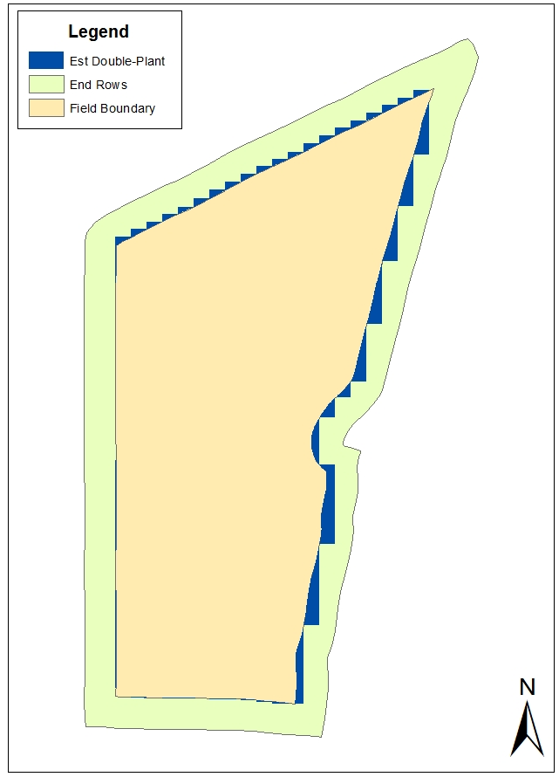
Figure 21. Example of a rotated boundary indicating the entire outer ring of the field being used as end rows in the field boundary model.

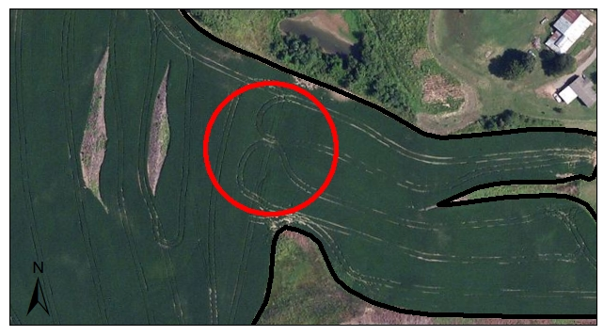
Figure 22. Field image showing path orientation changes that cause internal double-planted areas.

The second model, known as the field boundary + GPS tracklog model, required a field boundary polygon shapefile similar to the first model as well as a GPS tracklog from a planting, harvesting, or spraying operation. This type of model was developed in an attempt to examine the effects path orientation and direction changes of equipment had on predicting minimum double-planted areas in irregular-shaped fields. The procedures required to complete model analysis were much more complex when compared to the field boundary model. Several steps required human intervention, which in turn, caused bias in the analysis and difficulties in model automation. These properties of the field boundary + GPS tracklog model prevented a reliable tool from being created in Model Builder.
Estimated percent double-planted area output from the field boundary + GPS tracklog model was compared to the actual minimum percent double-planted area for a total of 36 fields (Figure 23). All sample fields were not used for this analysis due to incomplete GPS tracklogs. The %reg function in SAS was used for model validation. Results of the analysis showed a moderate, positive relationship (R² = 0.53) existed between the model estimated values and the actual values calculated from the planting maps with a RMSE of 2.85% (p < 0.0001). Actual minimum double-planted values, predicted values estimated by the model, and errors between the two are shown in Table 8.

Y = X
R² = 0.53
Figure 23. Estimated percent double-planted area calculated by field boundary + GPS tracklog versus actual percent double-planted area.

Table 8. Summary of variation between field boundary + GPS tracklog model predicted percent double-planted area and actual percent double-planted area calculated using planting maps.

Field  ID | Actual  Percent | Predicted  Percent | Error  (AP - PP) | Absolute  Error
LEF | 0.08 | 0.27 | -0.19 | 0.19
LW | 0.11 | 0.19 | -0.08 | 0.08
PBDT | 0.30 | 0.86 | -0.56 | 0.56
HF2 | 0.36 | 0.42 | -0.06 | 0.06
HF4A | 1.09 | 1.12 | -0.04 | 0.04
PowF3 | 1.20 | 1.61 | -0.40 | 0.40
HFllD | 1.39 | 2.33 | -0.94 | 0.94
FFA | 1.56 | 4.10 | -2.54 | 2.54
PowF8 | 2.12 | 0.98 | 1.14 | 1.14
HF1 | 2.14 | 3.13 | -0.99 | 0.99
PugF7 | 2.15 | 1.86 | 0.29 | 0.29
HF5 | 2.26 | 2.62 | -0.36 | 0.36
PugF5 | 2.33 | 3.33 | -1.00 | 1.00
PowF1 | 2.36 | 1.89 | 0.47 | 0.47
PowF6 | 3.16 | 2.69 | 0.47 | 0.47
PAA | 3.22 | 3.87 | -0.64 | 0.64
PowF2 | 3.48 | 2.74 | 0.73 | 0.73
HF3 | 3.68 | 3.62 | 0.06 | 0.06
PugF6 | 4.31 | 1.75 | 2.56 | 2.56
PowF4 | 4.53 | 3.08 | 1.45 | 1.45
HF11C | 4.60 | 6.71 | -2.11 | 2.11
HF11B | 5.22 | 6.28 | -1.07 | 1.07
PowF7 | 6.78 | 5.36 | 1.42 | 1.42
PugF12 | 8.22 | 4.14 | 4.08 | 4.08
PugF13 | 8.61 | 14.01 | -5.40 | 5.40
CF1 | 8.65 | 6.33 | 2.33 | 2.33
PugF8 | 8.93 | 5.85 | 3.08 | 3.08
HF11A | 8.94 | 7.20 | 1.74 | 1.74
PugF18 | 8.95 | 8.77 | 0.19 | 0.19
PugF16 | 9.30 | 4.50 | 4.80 | 4.80
PugF19 | 10.22 | 8.39 | 1.83 | 1.83
PugF20 | 11.11 | 9.78 | 1.32 | 1.32
PugF17 | 11.11 | 9.91 | 1.20 | 1.20
PugF21 | 13.33 | 8.84 | 4.49 | 4.49
PugF15 | 14.34 | 4.45 | 9.89 | 9.89
PugF9 | 15.32 | 6.89 | 8.43 | 8.43
Avg | 5.43 | 4.44 |  | 1.90
St Dev | 4.37 | 3.24 |  | 2.28

Average absolute error between actual and predicted values for the field boundary + GPS tracklog model was 1.9% with a standard deviation of 2.28% and ranged from as low as 0.04 to as high as 9.89 percent. This model also tended to estimate percentages fairly well in fields with actual minimum double-planted percentages below 5% but over estimated in fields with actual percentages above 5%.
Variations from the field boundary + GPS model output and actual calculated values can be characterized similarly to the differences observed by the field boundary model output. As previously stated, the entire outside edge of each field was treated as end rows even though some field edges in the actual planting maps were treated as normal, parallel planter passes. Also similar to the first model, double-planting caused by direction changes was not accounted for in cases where overlap occurred between adjacent parallel passes. Probably the most influential factor causing estimation errors was the method used to extend and/or trim centerlines to the appropriate length based on negative field boundary buffers. Centerline length modifications (Figure 24) were needed to account for angle of encroachment changes where parallel passes intersected end row passes, however, a more definitive method is needed rather than relying on arbitrary buffer distances.

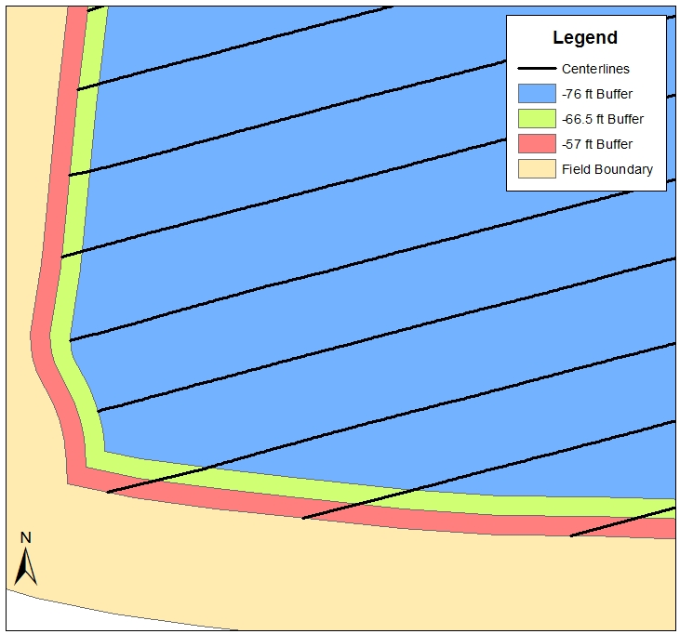
Figure 24. Portion of map illustrating centerlines being extended or trimmed to different buffers, depending on angle of encroachment.

Operator Influence Analysis Results
Twenty-two fields totaling 656.4 acres were used to determine operator influence effects on double-planting. Results from the operator accuracy analysis indicated that over- or under-planting occurred at the start or end of all planter passes studied. Of the 448 planter passes analyzed, equipment operators increased double-planting 58.8% of the time by lowering the planter too early at the start of a pass or raising the planter too late at the end of the pass. The average over-planted distance was observed to be 8.2 feet. An average under-planted distance of 9.0 feet was observed when the operator lowered the planter too late at the start of a pass and raised the planter too early at the end of a pass. Equipment operators tended to under-plant at the start or end of a planter pass 41.2% of the time which resulted in skipped areas that were not planted.
The most frequently used planters during the course of this study had effective widths of 38-feet. By multiplying this width by the average over-plant distance of 8.2 feet, an estimated over-planted area of 0.007 acres was calculated. To account for each planter pass having a start and end, the 448 planter passes used in the analysis was doubled and then multiplied by 58.8% to calculate hypothetical over-planting occurrences. This resulted in approximately 527 start or end zones being over-planted, which increased double-panted area by 3.7 acres above the minimum. Based on total acreage of these 22 fields, operator response time increased double-planting by 0.6%.

Double-Planting Test Plot Experiment Results
2010 Cotton Study
The double-planting cotton study was designed to analyze yield reductions due to the harvest system typically found in West Tennessee cotton production operations. Traditionally, cotton end rows are picked first, regardless of double-planted area prevalence, and then stalks are mowed with a rotary cutter. All cotton plots were picked once in the direction of the straight rows and weighed to determine if yields differed statistically among treatments using Tukey’s mean separation. As shown in Figure 25, seed cotton yields from the single-planted plots were statistically different from the double-planted plots. The average seed cotton yield from the single-planted plots was 3626 pounds per acre compared to 2743, 2552, and 2457 pounds per acre for the double-planted plots with rows crossing at 30, 60, and 90 degrees respectively. These differences in yield were attributed to the fact that some plants in the crossing rows were not harvested (Figure 26) due to the configuration of the picker header as shown in Figure 27. However, angle of encroachment did not have a significant impact on the amount of cotton left behind in double-planted plots after a single harvest pass.

Figure 25. Average seed cotton yield per treatment in pounds per acre – first pick only. Yields with different letter groupings are significantly different (p < 0.0001).

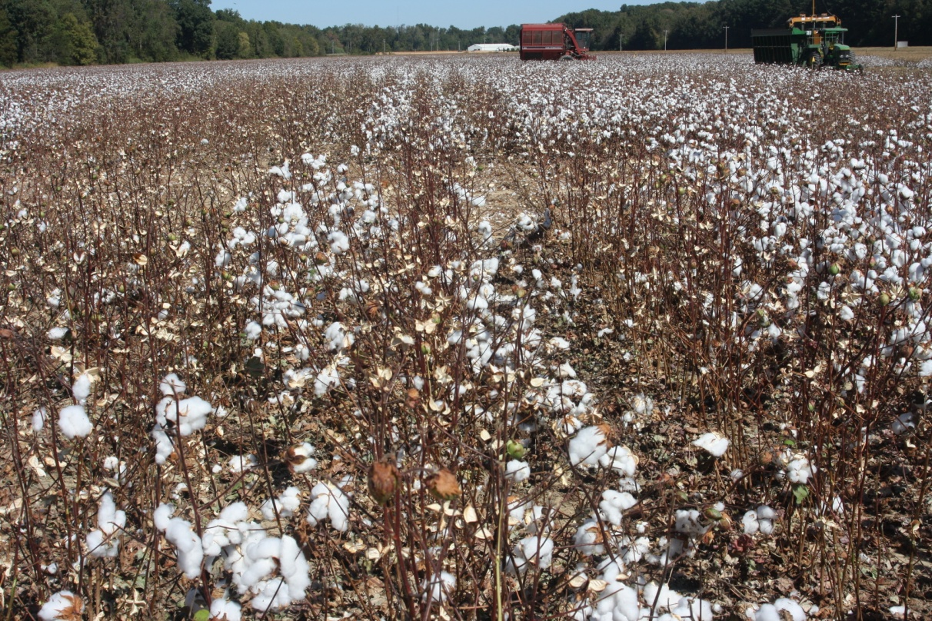

Figure 26. Cotton not harvested during the first pass of double-planted plots.

Figure 27. Illustration showing picker header limitations on harvesting crossing rows.
Double-planted cotton plots were picked a second time in the direction of the crossing rows to determine if the amount of cotton left behind in combination with the first picking showed statistical differences among treatments (Figure 28). After being picked a second time and having both picking weights combined, seed cotton yield averages in all double-planted plots were found to be statistically similar to the single-planted plot yield average. This result indicated that no significant losses in yield occurred due to plant competition, which is consistent with literature stating cotton has the physiological ability to compensate for higher plant populations.

Figure 28. Average seed cotton yield per treatment in pounds per acre – second pick added to first pick. Yields with the same letter grouping do not differ significantly (p < 0.0001).
2011 Corn Study
Corn yields were analyzed by harvesting each plot with a plot combine and determining average yield per plot. Plots with the same treatment were then averaged so yield differences among treatments could be analyzed using Tukey’s mean separation method (Figure 29). As indicated in Figure 29, corn yields for double-planted plots were not significantly different than yields for single-planted plots with averages of 184.5, 171.7, 161.7, 159.6, and 179.6 bushels per acre for treatments of single, 30, 60, 90, and 60 degree plus nitrogen respectively. The general trend in this data showed that yield decreased slightly as angle of encroachment approached 90 degrees. This trend shows the potential for increased harvest losses as fields become more regular shaped, especially if operator response time is an issue. However, average yields for the 60 degree double-planted plots with an extra sidedress nitrogen application were approximately the same for the single-planted plots.
In order to calculate an estimated harvest loss, each plot was sampled three times by implementing the procedure described in Chapter 3 under the section entitled Double-Planting Test Plot Experiments. Average kernel counts with the corresponding yield conversion for each treatment are summarized in Table 9. Samples were averaged per plot and then treatment averages were determined and compared (Figure 30).

Figure 29. Average corn yield per treatment in bushels per acre. Yields with the same letter grouping do not differ significantly (p < 0.0001).

Table 9. Average kernel count losses per treatment with yield conversion.

Treatment | Average Kernel Count | Average Yield Loss (bu/ac)
Single | 58 | 2.9
30° | 181 | 9.1
60° | 204 | 10.2
90° | 344 | 17.2
60°+N | 289 | 14.5

Treatment
Figure 30. Average corn harvest losses per treatment in bushels per acre. Yields with different letter groupings are significantly different (p < 0.0001).

As shown in Figure 30, corn harvest losses did differ significantly between the single-planted plots and the 90 degree double-planted and the 60 degree double-planted with extra nitrogen plots. This was most likely caused by frequent lodging during harvest passes in these double-planted plots. Lodging is normally caused by storm damage or diseases that may weaken the stalk but can also be related to yield and variety. When harvesting double-planted corn, combine headers can severely damage corn stalks in the crossing rows which can cause increased harvest losses. Average harvest losses were added to the original average plot yields to determine the effect harvest losses had on corn yields (Figure 31). Corn yields in this experiment were not affected significantly by including harvest losses.

Figure 31. Average corn yield per treatment with average harvest losses per treatment added in bushels per acre. Yields with the same letter grouping do not differ significantly (p < 0.0001).

Chapter 5: Discussion and Conclusions
The main focus of this study was to determine parameters associated with double-planting in row crop fields so that farm managers could make better decisions regarding the adoption of ASC technology for planters on their operations. One problem producers face is deciding if the types of fields they are farming have an impact on planter overlap. This depends on irregularity of field boundaries and presence of internal field obstacles. This issue was addressed during this research by developing statistical models that predicted values for percent double-planted area of a field based on geometry factors that quantified field boundary irregularity. The statistical model with the best goodness of fit was a six variable model with an R² of 0.83 and a Cp of 7.94. Due to the fact that some independent variables in this model were correlated, a two variable model was created with R² = 0.76 and a much higher Cp of 20.13.
Both models have advantages and disadvantages regarding the trade-off between goodness of fit and model simplicity. Another model was developed using Principal Component Analysis (PCA) as the method for variable reduction. The main limitation of this procedure was a small sample size of 52 fields due to data collection constraints. More reliable results may have been obtained with a larger sample size. Future research efforts should focus on developing new geometry factors that could be more effective in predicting percent double-plant areas. Also, planting speed and planter width may be related to percent double-planted area but were not analyzed in this study due to little variation among these operating parameters during data collection.
Two map-based methods for estimating double-planted areas were also developed during this research. The simplest, most accurate spatial model, known as the field boundary model, estimated actual percent double-planted area of a field with a moderately strong relationship (R² = 0.73). This estimation model could be automated using Model Builder in ArcGIS for timely analysis of multiple fields. The second model, known as the field boundary + GPS model, was not very effective at predicting double-planted areas (R² = 0.53) and was also much more complicated than the field boundary model due to the added GPS data requirement. Future work should address modification of the second model, perhaps through programming, for more efficient operation and automation. Limitations of both spatial models consisted of 1) assumed end row area coverage around the entire outside portion of all field boundaries and 2) not being able to account for double-planting occurring in areas other than end rows.
Another objective of this study was to determine the effects operator response time had on double-planting. Operator response time can be described as the equipment operator’s ability to raise and lower the planter at the precise moment to minimize double-planting and eliminate over- and under-planting. On average, equipment operators in this study over-planted a distance of 8.2 feet 58.8% of the time or under-planted a distance of 9.0 feet 41.2% of the time. This information can be valuable to farm managers because it indicates the importance of experienced equipment operators or upgrading to ASC.
Plot experiments were also conducted to evaluate differences in cotton and corn yields between double-planted and single-planted treatments. Tukey’s mean separation analysis revealed that seed cotton yields at time of harvest differed significantly from single-planted to double-planted treatments but did not differ significantly amongst double-planted treatments. Average seed cotton yield for single-planted plots was 3626 pounds per acre compared to an average of 2584 pounds per acre for all double-planted treatments. It was determined that differences in yields were not influenced by increased plant population but instead were caused by harvest methodology. A similar corn experiment was conducted and analyzed. Average corn yield for single-planted plots at time of harvest was 184.5 bushels per acre. Average corn yield for all double-planted plots was 168.1 bushels per acre. While some significant differences in harvest losses were found, corn yields at harvest were not statistically different between single-planted or double-planted plots.

BIBLIOGRAPHY

Batte, M. T. and M. R. Ehansi. 2006. The Economics of Precision Guidance with Auto-Boom
Control for Farmer-Owned Agricultural Sprayers. Computers and Electronics in Agriculture. Vol. 53: 28-44.

Dhuyvetter, K. C., C. S. Smith, D. L. Kastens, and T. L. Kastens. 2010. Guidance and Section
Control Profit Calculator – User’s Tutorial. Kansas State University. Ag Manager Info.

Espinoza, L. and J. Ross. 2011. Chapter 8 – Harvesting. In Corn Production Handbook, 65-72. Little Rock, AR. Cooperative Extension Service University of Arkansas.

Ess, D. R., and M. T. Morgan. 2010. The Precision-Farming Guide for Agriculturists. 3rd ed.
Moline, Ill. Deere & Company. John Deere Publishing.

Fulton, J., A. Winstead, B. Ortiz, D. Mullenix, S. Basinger, and S. Norwood. 2010 Automatic
Section Control (ASC) Technology for Planters. Alabama Cooperative Extension Service. Available at: http://www.aces.edu/anr/precisionag/Section_Control.php. Assessed 17 November 2011.

Grisso, R. D., D. E. Rolofson, and P. J. Jasa. 2002. Analysis of Traffic Patterns and Yield Monitor Data for Field Efficiency Determination. Applied Engineering in Agriculture. Vol. 18(2): 171-178.

Halfmann, S. W. 2005. Planting Density Effects on Lint Yield and Quality of Three Stacked
Gene Cotton Cultivars. Master’s Thesis, Texas A&M University.

Hatcher, L. 1994. A Step-by-Step Approach to Using SAS for Factor Analysis and Structural Equation Modeling. Cary, NC. SAS Publishing.

Hashemi, A. M., D. H. Putnam, and S. J. Herbert. 2005. Yield Response of Corn to Crowding
Stress. Agronomy Journal. Vol. 97: 839-846.

Jernigan, B. M., M. J. Buschermohle, W. E. Hart, J. B. Wilkerson, R. S. Freeland. 2011. Influence of Planter Width on Double-Planted Acreage in Cotton Fields. In 2011 Beltwide Cotton Conference Proceedings, 523-530.

Key, N., M. J. Roberts. 2007. Measures in Trends of Farm Size Tell Differing Stories. Amber
Waves. Vol. 5. Issue 5.

Luck, J. D., C. R. Dillon, J. P. Fulton, S. A. Shearer, S. F. Higgins, S. K. Pitla, and T. G. Mueller. 2009. Potential for Pesticide and Nutrient Savings via Map-Based Automatic Boom Section Control of Spray Nozzles. Computers and Electronics in Agriculture. Vol. 70(1): 19-26

Luck, J. D., R. S. Zandonadi, B. D. Luck, S. A. Shearer. 2010. Reducing Pesticide Over
Application with Map-Based Automatic Boom Section Control on Agricultural Sprayers. Transactions of the ASABE. Vol. 53(3): 685-690

Luck, J. D., R. S. Zandonadi, S. A. Shearer. 2011. A Case Study to Evaluate Field Shape Factors
for Estimating Overlap Errors with Manual and Automatic Section Control. Transactions of the ASABE. Vol. 54(4): 1237-1243

SAS Institute Inc. 2008. SAS/STAT® 9.2 User’s Guide. Cary, NC: SAS Institute Inc.

Saxton, A. M. 2011. Design and Analysis for Biological Research. Knoxville, TN. University of Tennessee, Department of Animal Science.

Taylor, R. K., M. D. Schrock, and S. A. Staggenborg. 2001. Using GPS Technology to Assist
Machinery Management Decisions. Mid-Central Conference of the ASAE. Paper number MC01-204. St. Joseph, Mich.: ASAE.

Zandonadi, R. S., J. D. Luck, T. S. Stombaugh, M. P. Sama, S. A. Shearer.2011.
A Computational Tool for Estimating Off-Target Application Errors in Agricultural Fields. Transactions of the ASABE. Vol. 54(1): 41-49

APPENDICES

APPENDIX A: Glossary of Geometry Factor Variables

Perimeter-to-Area Ratio (pa) – Ratio of field boundary length divided by field area

Circularity (cir) – describes how much a field deviates from a circle $C=\frac{4πA}{P^{2} }$

Square-Perimeter Index (spi) – compares the field boundary perimeter to the boundary of a
square of equal area to the field $SPI=\frac{4√A}{P}$

Row Length Range Difference (ls) – difference between the longest parallel pass and the
shortest parallel pass used to plant a field (measured in feet)

Row Length Range Difference to Average Row Length Ratio (lsavg) – difference between
the longest parallel pass and the shortest parallel pass used to plant a field divided by the average parallel pass length

Average End Row Length to Average Parallel Row Length Ratio (aeap)

Centroid to Boundary Vertices Length Standard Deviation (cbstddev) – standard deviation
of the lengths measured between a field’s centroid and each of its boundary vertices (measured in feet)

Envelope Area to Field Area Ratio (eaa) – area of a rectangle covering the outer most extent of
a field divided by the field area

Envelope Perimeter to Field Perimeter Ratio (epp) – perimeter length of a rectangle covering
the outer most extent of a field divided by the field boundary perimeter length

Envelope Perimeter/Envelope Area to Field Perimeter/Field Area Ratio (epeapa) – ratio of
the previous two variables divided by the pa ratio for a field

Circle Area to Field Area Ratio (caa) – area of the smallest circle that can enclose a field
divided by the field area

Circle Perimeter to Field Perimeter Ratio (cpp) – perimeter length of the smallest circle that
can enclose a field divided by the field boundary perimeter length

Circle Perimeter/Circle Area to Field Perimeter/Field Area Ratio (cpcapa) – ratio of the
previous two variables divided by the pa ratio for a field

Convex-Hull Area to Field Area Ratio (chaa) – area of the smallest non-concave polygon that
can enclose a field divided by the field area

Convex-Hull Perimeter to Field Perimeter Ratio (chpp) – perimeter length of the smallest
non-concave polygon that can enclose a field divided by the field boundary perimeter length

Convex-Hull Perimeter/Convex-Hull Area to Field Perimeter/Field Area Ratio (chpchapa)
– ratio of the previous two variables divided by the pa ratio for a field

Rectangle-by-Width Area to Field Area Ratio (rwaa) – area of the smallest rectangle that
encloses a field with the narrowest possible width divided by the field area

Rectangle-by-Width Perimeter to Field Perimeter (rwpp) – perimeter length of the smallest
rectangle that encloses a field with the narrowest possible width divided by the field boundary perimeter length

Rectangle-by-Width Perimeter/Rectangle-by-Width Area to Field Perimeter/Field Area
Ratio (rwprwapa) - ratio of the previous two variables divided by the pa ratio for a field

Rectangle-by-Area Area to Field Area Ratio (raaa) – area of the smallest rectangle that
encloses a field based on the smallest area possible divided by the field area

Rectangle-by-Area Perimeter to Field Perimeter Ratio (rapp) – perimeter length of the
smallest rectangle that encloses a field based on the smallest area possible divided by the field boundary perimeter length

Rectangle-by-Area Perimeter/Rectangle-by-Area Area to Field Perimeter/Field Area Ratio
(rapraapa) - ratio of the previous two variables divided by the pa ratio for a field

APPENDIX B: Calculated Geometry Factor Values for Each Field
Field  ID | pa | cir | spi | ls | lsavg | aeap | cbstd  dev | eaa | epp | epea  pa | caa | cpp | cpca  pa | chaa | chpp | chpcha  pa | rwaa | rwpp | rwprwa  pa | raaa | rapp | rapraa  pa
LEF | 120.1 | 0.6 | 0.9 | 136 | 0.0 | 0.3 | 83.9 | 1.2 | 1.1 | 0.9 | 2.9 | 1.3 | 0.4 | 1.0 | 1.0 | 1.0 | 1.0 | 1.0 | 1.0 | 1.0 | 1.0 | 1.0
LWF | 90.1 | 0.6 | 0.9 | 1515 | 0.5 | 0.3 | 124.5 | 1.2 | 1.0 | 0.9 | 2.2 | 1.2 | 0.5 | 1.0 | 1.0 | 1.0 | 1.1 | 1.0 | 0.9 | 1.1 | 1.0 | 0.9
LW | 95.5 | 0.8 | 1.0 | 137 | 0.1 | 1.5 | 54.5 | 1.1 | 1.0 | 1.0 | 1.7 | 1.1 | 0.7 | 1.0 | 1.0 | 1.0 | 1.0 | 1.0 | 1.0 | 1.0 | 1.0 | 1.0
PBDT | 102.2 | 0.7 | 0.9 | 446 | 0.3 | 1.0 | 70.3 | 2.0 | 1.3 | 0.7 | 1.9 | 1.1 | 0.6 | 1.1 | 1.0 | 0.9 | 1.2 | 1.1 | 0.9 | 1.2 | 1.0 | 0.9
KWT | 111.1 | 0.6 | 0.9 | 2627 | 1.2 | 0.3 | 78.4 | 1.5 | 1.1 | 0.8 | 2.6 | 1.3 | 0.5 | 1.0 | 1.0 | 1.0 | 1.1 | 1.1 | 0.9 | 1.1 | 1.1 | 0.9
HF2 | 260.9 | 0.5 | 0.8 | 133 | 0.1 | 0.3 | 60.6 | 1.5 | 1.1 | 0.7 | 3.5 | 1.3 | 0.4 | 1.0 | 1.0 | 1.0 | 1.0 | 1.0 | 1.0 | 1.0 | 1.0 | 1.0
KF1 | 91.7 | 0.6 | 0.9 | 2331 | 1.1 | 0.8 | 115.6 | 1.7 | 1.2 | 0.7 | 2.3 | 1.2 | 0.5 | 1.1 | 1.0 | 0.9 | 1.4 | 1.1 | 0.8 | 1.4 | 1.1 | 0.8
HF7 | 186.8 | 0.7 | 1.0 | 209 | 0.2 | 0.5 | 33.3 | 1.3 | 1.1 | 0.8 | 2.1 | 1.2 | 0.6 | 1.0 | 1.0 | 1.0 | 1.1 | 1.1 | 1.0 | 1.1 | 1.1 | 1.0
HF11E | 105.3 | 0.7 | 1.0 | 355 | 0.2 | 0.6 | 53.5 | 1.4 | 1.1 | 0.8 | 2.1 | 1.2 | 0.6 | 1.1 | 1.0 | 0.9 | 1.3 | 1.1 | 0.8 | 1.3 | 1.1 | 0.8
KCL | 89.5 | 0.8 | 1.0 | 1249 | 0.6 | 0.8 | 48.3 | 1.1 | 1.0 | 1.0 | 1.7 | 1.1 | 0.7 | 1.0 | 1.0 | 1.0 | 1.1 | 1.0 | 1.0 | 1.0 | 1.0 | 1.0
HF4B | 223.5 | 0.6 | 0.9 | 335 | 0.3 | 0.3 | 53.1 | 1.4 | 1.1 | 0.8 | 2.7 | 1.3 | 0.5 | 1.0 | 1.0 | 1.0 | 1.1 | 1.1 | 0.9 | 1.1 | 1.1 | 0.9
HF4A | 440.3 | 0.3 | 0.7 | 36 | 0.0 | 0.1 | 83.9 | 1.9 | 1.1 | 0.6 | 5.6 | 1.4 | 0.2 | 1.0 | 1.0 | 1.0 | 1.0 | 1.0 | 1.0 | 1.0 | 1.0 | 1.0
PowF3 | 213.5 | 0.3 | 0.7 | 2003 | 2.3 | 0.4 | 91.9 | 1.6 | 0.9 | 0.6 | 2.9 | 1.0 | 0.3 | 1.2 | 0.8 | 0.6 | 1.4 | 0.9 | 0.6 | 1.4 | 0.9 | 0.6
HF11D | 176.5 | 0.4 | 0.7 | 1710 | 1.3 | 0.3 | 72.6 | 1.3 | 0.9 | 0.7 | 2.3 | 1.0 | 0.4 | 1.0 | 0.8 | 0.8 | 1.1 | 0.8 | 0.8 | 1.1 | 0.8 | 0.8
FFA | 266.0 | 0.3 | 0.7 | 1379 | 0.6 | 0.2 | 108.2 | 2.1 | 1.2 | 0.5 | 6.0 | 1.4 | 0.2 | 1.0 | 1.0 | 1.0 | 1.2 | 1.1 | 0.9 | 1.2 | 1.1 | 0.9
PMI | 175.3 | 0.7 | 0.9 | 1239 | 1.2 | 1.2 | 49.7 | 1.9 | 1.3 | 0.7 | 2.4 | 1.3 | 0.5 | 1.0 | 1.0 | 1.0 | 1.4 | 1.1 | 0.8 | 1.4 | 1.1 | 0.8
PowF8 | 152.8 | 0.7 | 1.0 | 1258 | 1.2 | 0.3 | 31.6 | 1.3 | 1.1 | 0.9 | 1.6 | 1.1 | 0.7 | 1.0 | 1.0 | 0.9 | 1.1 | 1.0 | 0.9 | 1.1 | 1.0 | 0.9
HF1 | 192.9 | 0.7 | 0.9 | 1232 | 1.3 | 1.1 | 44.3 | 1.7 | 1.2 | 0.7 | 2.6 | 1.3 | 0.5 | 1.0 | 1.0 | 1.0 | 1.5 | 1.1 | 0.8 | 1.5 | 1.1 | 0.8
PugF7 | 162.4 | 0.7 | 1.0 | 1337 | 1.0 | 1.1 | 46.1 | 1.3 | 1.2 | 0.9 | 1.9 | 1.2 | 0.6 | 1.0 | 1.0 | 1.0 | 1.0 | 1.0 | 1.0 | 1.0 | 1.0 | 1.0
HF5 | 182.4 | 0.8 | 1.0 | 746 | 0.9 | 1.6 | 21.8 | 1.2 | 1.1 | 0.9 | 1.6 | 1.1 | 0.7 | 1.0 | 1.0 | 1.0 | 1.2 | 1.1 | 0.9 | 1.2 | 1.1 | 0.9
PugF5 | 189.0 | 0.4 | 0.7 | 2208 | 1.1 | 0.4 | 132.5 | 1.8 | 1.2 | 0.6 | 5.0 | 1.4 | 0.3 | 1.1 | 1.0 | 0.9 | 1.6 | 1.1 | 0.7 | 1.6 | 1.1 | 0.7
PowF1 | 192.8 | 0.6 | 0.9 | 348 | 2.0 | 2.6 | 43.6 | 1.9 | 1.2 | 0.6 | 2.3 | 1.2 | 0.5 | 1.1 | 1.0 | 0.9 | 1.9 | 1.2 | 0.7 | 1.8 | 1.2 | 0.7
FF13 | 164.3 | 0.6 | 0.9 | 1777 | 1.4 | 0.9 | 62.8 | 1.5 | 1.2 | 0.8 | 2.5 | 1.2 | 0.5 | 1.1 | 1.0 | 0.9 | 1.4 | 1.1 | 0.8 | 1.4 | 1.1 | 0.8
PFJS | 161.2 | 0.7 | 0.9 | 852 | 0.8 | 1.4 | 40.2 | 1.7 | 1.2 | 0.7 | 1.7 | 1.0 | 0.6 | 1.1 | 0.9 | 0.9 | 1.4 | 1.1 | 0.8 | 1.4 | 1.1 | 0.8
PSLF | 164.1 | 0.7 | 0.9 | 1305 | 1.4 | 2.9 | 63.0 | 1.7 | 1.2 | 0.7 | 2.1 | 1.2 | 0.6 | 1.1 | 1.0 | 0.9 | 1.7 | 1.2 | 0.7 | 1.6 | 1.2 | 0.7
PTH | 238.6 | 0.2 | 0.5 | 5452 | 2.2 | 0.6 | 298.5 | 7.9 | 1.3 | 0.2 | 14.1 | 1.5 | 0.1 | 1.5 | 1.0 | 0.6 | 2.1 | 1.1 | 0.5 | 2.1 | 1.1 | 0.5

Field  ID | pa | cir | spi | ls | lsavg | aeap | cbstddev | eaa | epp | epeapa | caa | cpp | cpcapa | chaa | chpp | chpchapa | rwaa | rwpp | rwprwapa | raaa | rapp | rapraapa
PBBT | 237.6 | 0.6 | 0.9 | 1365 | 1.6 | 2.6 | 49.4 | 2.0 | 1.3 | 0.6 | 2.7 | 1.3 | 0.5 | 1.0 | 1.0 | 1.0 | 1.7 | 1.2 | 0.7 | 1.7 | 1.2 | 0.7
PowF6 | 221.1 | 0.6 | 0.8 | 630 | 1.4 | 1.3 | 43.8 | 1.7 | 1.1 | 0.7 | 2.5 | 1.2 | 0.5 | 1.1 | 0.9 | 0.8 | 1.6 | 1.1 | 0.7 | 1.6 | 1.1 | 0.7
PAA | 244.9 | 0.3 | 0.6 | 808 | 1.2 | 0.6 | 67.0 | 1.3 | 0.7 | 0.5 | 1.8 | 0.7 | 0.4 | 1.1 | 0.6 | 0.6 | 1.1 | 0.6 | 0.6 | 1.1 | 0.6 | 0.6
DF1 | 293.8 | 0.3 | 0.6 | 1293 | 1.7 | 0.5 | 50.0 | 1.4 | 1.0 | 0.8 | 2.5 | 1.1 | 0.5 | 1.1 | 0.9 | 0.8 | 1.3 | 1.0 | 0.8 | 1.3 | 1.0 | 0.8
PowF2 | 186.8 | 0.6 | 0.9 | 1356 | 1.6 | 1.1 | 71.1 | 1.8 | 1.2 | 0.7 | 2.8 | 1.3 | 0.5 | 1.1 | 1.0 | 0.9 | 1.5 | 1.2 | 0.8 | 1.5 | 1.2 | 0.8
HF3 | 255.2 | 0.5 | 0.8 | 1070 | 1.0 | 0.6 | 55.4 | 1.7 | 1.1 | 0.7 | 3.3 | 1.3 | 0.4 | 1.1 | 1.0 | 0.9 | 1.5 | 1.1 | 0.8 | 1.4 | 1.1 | 0.8
PugF6 | 214.5 | 0.3 | 0.6 | 1734 | 1.4 | 0.3 | 72.7 | 1.5 | 1.1 | 0.8 | 3.2 | 1.3 | 0.4 | 1.0 | 1.0 | 1.0 | 1.1 | 1.0 | 1.0 | 1.1 | 1.0 | 1.0
FF7 | 270.6 | 0.3 | 0.6 | 2501 | 1.7 | 0.5 | 114.9 | 2.0 | 1.1 | 0.6 | 6.3 | 1.4 | 0.2 | 1.2 | 1.0 | 0.8 | 1.8 | 1.1 | 0.6 | 1.8 | 1.1 | 0.6
PowF4 | 322.2 | 0.6 | 0.8 | 640 | 1.3 | 1.1 | 30.1 | 1.6 | 1.1 | 0.7 | 2.4 | 1.2 | 0.5 | 1.1 | 0.9 | 0.8 | 1.5 | 1.1 | 0.7 | 1.5 | 1.1 | 0.7
HF11C | 529.3 | 0.2 | 0.5 | 69 | 0.0 | 0.1 | 93.8 | 2.3 | 1.1 | 0.5 | 8.9 | 1.4 | 0.2 | 1.1 | 1.0 | 0.9 | 1.3 | 1.0 | 0.8 | 1.3 | 1.0 | 0.8
HF11B | 509.8 | 0.8 | 1 | 349 | 2.0 | 2.7 | 14.0 | 1.5 | 0.8 | 0.5 | 1.7 | 0.7 | 0.4 | 1.0 | 0.6 | 0.6 | 1.3 | 0.7 | 0.6 | 1.3 | 0.7 | 0.6
PowF7 | 419.8 | 0.2 | 0.5 | 1705 | 2.1 | 1.3 | 79.3 | 1.7 | 1.1 | 0.6 | 6.0 | 1.4 | 0.2 | 1.2 | 1.0 | 0.8 | 1.6 | 1.1 | 0.7 | 1.6 | 1.1 | 0.7
PugF12 | 191 | 0.4 | 0.7 | 2146 | 2.0 | 0.9 | 88.3 | 1.6 | 1.2 | 0.7 | 3.0 | 1.3 | 0.4 | 1.1 | 0.9 | 0.9 | 1.4 | 1.1 | 0.8 | 1.4 | 1.1 | 0.8
PugF13 | 267.9 | 0.5 | 0.8 | 886 | 2.4 | 2.3 | 62.7 | 2.0 | 0.8 | 0.4 | 2.4 | 0.8 | 0.3 | 1.3 | 0.6 | 0.5 | 1.7 | 0.7 | 0.4 | 1.7 | 0.7 | 0.4
CF1 | 290.7 | 0.2 | 0.4 | 1125 | 2.5 | 1.3 | 83.0 | 2.0 | 0.6 | 0.3 | 2.2 | 0.6 | 0.3 | 1.4 | 0.5 | 0.4 | 1.9 | 0.6 | 0.3 | 1.9 | 0.6 | 0.3
PugF8 | 331 | 0.2 | 0.5 | 785 | 1.7 | 1.0 | 60.1 | 1.6 | 0.7 | 0.4 | 2.1 | 0.7 | 0.3 | 1.3 | 0.6 | 0.4 | 1.7 | 0.7 | 0.4 | 1.6 | 0.7 | 0.4
HF11A | 536.8 | 0.5 | 0.8 | 735 | 1.4 | 1.2 | 34.8 | 3.0 | 1.3 | 0.4 | 4.2 | 1.4 | 0.3 | 1.1 | 1.0 | 0.9 | 1.5 | 1.1 | 0.7 | 1.5 | 1.1 | 0.7
PugF18 | 364.8 | 0.5 | 0.8 | 878 | 1.4 | 0.9 | 35.5 | 2.1 | 1.1 | 0.5 | 3.3 | 1.2 | 0.4 | 1.1 | 0.9 | 0.8 | 1.7 | 1.1 | 0.6 | 1.7 | 1.1 | 0.6
PugF16 | 353.4 | 0.2 | 0.5 | 1090 | 1.7 | 1.2 | 75.0 | 1.7 | 0.6 | 0.4 | 2.6 | 0.7 | 0.2 | 1.2 | 0.5 | 0.4 | 1.7 | 0.6 | 0.4 | 1.7 | 0.6 | 0.4
PugF19 | 310.6 | 0.3 | 0.6 | 1618 | 2.4 | 1.4 | 71.6 | 2.9 | 1.0 | 0.4 | 3.3 | 1.0 | 0.3 | 1.7 | 0.8 | 0.5 | 2.8 | 1.0 | 0.4 | 2.8 | 1.0 | 0.4
PugF20 | 622.5 | 0.8 | 1 | 143 | 1.0 | 2.3 | 9.3 | 1.6 | 1.2 | 0.8 | 1.9 | 1.2 | 0.6 | 1.0 | 1.0 | 1.0 | 1.6 | 1.3 | 0.8 | 1.5 | 1.2 | 0.8
PugF17 | 351.4 | 0.1 | 0.4 | 1137 | 2.7 | 1.4 | 103.2 | 1.8 | 0.8 | 0.4 | 3.9 | 0.9 | 0.2 | 1.3 | 0.7 | 0.5 | 1.5 | 0.7 | 0.5 | 1.5 | 0.7 | 0.5
PugF21 | 409.4 | 0.1 | 0.3 | 1839 | 4.4 | 1.1 | 85.8 | 2.3 | 0.9 | 0.4 | 4.8 | 1.0 | 0.2 | 1.5 | 0.7 | 0.5 | 2.2 | 0.9 | 0.4 | 2.1 | 0.9 | 0.4
PF11A | 399.2 | 0.4 | 0.7 | 1168 | 2.7 | 0.8 | 39.1 | 1.7 | 0.6 | 0.4 | 2.6 | 0.7 | 0.3 | 1.2 | 0.5 | 0.4 | 1.6 | 0.6 | 0.4 | 1.5 | 0.6 | 0.4
PugF15 | 467.2 | 0.7 | 0.9 | 378 | 1.6 | 2.0 | 17.1 | 1.7 | 1.2 | 0.7 | 2.0 | 1.2 | 0.6 | 1.0 | 1.0 | 1.0 | 1.6 | 1.2 | 0.8 | 1.6 | 1.2 | 0.8
PugF9 | 533.6 | 0.1 | 0.4 | 511 | 2.0 | 3.8 | 59.9 | 3.1 | 0.7 | 0.2 | 3.2 | 0.6 | 0.2 | 1.7 | 0.5 | 0.3 | 2.5 | 0.6 | 0.2 | 2.3 | 0.6 | 0.3

APPENDIX C. Correlation Matrix

 | %dp | pa | cir | spi | ls | lsavg | aeap | cbstddev | eaa | epp | epeapa | caa | cpp | cpcapa | chaa | chpp | chpchapa | rwaa | rwpp | rwprwapa | raaa | rapp | rapraapa
%dp | 100 | 74 | -50 | -53 | -5 | 68 | 46 | -15 | 21 | -45 | -63 | 5 | -49 | -45 | 60 | -60 | -67 | 67 | -39 | -73 | 65 | -43 | -73
pa | 74 | 100 | -42 | -44 | -25 | 33 | 33 | -18 | 23 | -25 | -56 | 27 | -19 | -51 | 34 | -36 | -40 | 41 | -24 | -47 | 39 | -27 | -47
cir | -50 | -42 | 100 | 99 | -32 | -53 | 13 | -49 | -41 | 50 | 76 | -53 | 25 | 90 | -66 | 54 | 67 | -48 | 55 | 65 | -49 | 54 | 65
spi | -53 | -44 | 99 | 100 | -31 | -56 | 8 | -48 | -42 | 52 | 77 | -52 | 29 | 88 | -70 | 57 | 70 | -50 | 57 | 67 | -52 | 56 | 68
ls | -5 | -25 | -32 | -31 | 100 | 42 | -23 | 77 | 60 | 14 | -27 | 55 | 22 | -32 | 34 | 7 | -14 | 27 | 6 | -20 | 31 | 9 | -20
lsavg | 68 | 33 | -53 | -56 | 42 | 100 | 36 | 14 | 30 | -42 | -63 | 11 | -45 | -46 | 66 | -58 | -71 | 68 | -38 | -78 | 70 | -39 | -78
aeap | 46 | 33 | 13 | 8 | -23 | 36 | 100 | -34 | 8 | -12 | -24 | -27 | -39 | 10 | 32 | -30 | -31 | 53 | -5 | -44 | 48 | -11 | -43
cbstddev | -15 | -18 | -49 | -48 | 77 | 14 | -34 | 100 | 71 | 7 | -38 | 79 | 27 | -54 | 39 | 5 | -16 | 19 | -6 | -17 | 22 | -3 | -17
eaa | 21 | 23 | -41 | -42 | 60 | 30 | 8 | 71 | 100 | 18 | -63 | 80 | 17 | -52 | 60 | -3 | -29 | 53 | 2 | -39 | 55 | 2 | -39
epp | -45 | -25 | 50 | 52 | 14 | -42 | -12 | 7 | 18 | 100 | 46 | 21 | 88 | 40 | -40 | 93 | 81 | -18 | 95 | 63 | -17 | 96 | 64
epeapa | -63 | -56 | 76 | 77 | -27 | -63 | -24 | -38 | -63 | 46 | 100 | -48 | 42 | 84 | -77 | 67 | 82 | -71 | 56 | 87 | -73 | 56 | 88
caa | 5 | 27 | -53 | -52 | 55 | 11 | -27 | 79 | 80 | 21 | -48 | 100 | 45 | -68 | 36 | 16 | -8 | 26 | 8 | -16 | 29 | 10 | -16
cpp | -49 | -19 | 25 | 29 | 22 | -45 | -39 | 27 | 17 | 88 | 42 | 45 | 100 | 11 | -42 | 92 | 81 | -28 | 85 | 66 | -26 | 87 | 66
cpcapa | -45 | -51 | 90 | 88 | -32 | -46 | 10 | -54 | -52 | 40 | 84 | -68 | 11 | 100 | -62 | 46 | 61 | -49 | 47 | 63 | -51 | 46 | 64
chaa | 60 | 34 | -66 | -70 | 34 | 66 | 32 | 39 | 60 | -40 | -77 | 36 | -42 | -62 | 100 | -56 | -79 | 85 | -44 | -80 | 85 | -46 | -80
chpp | -60 | -36 | 54 | 57 | 7 | -58 | -30 | 5 | -3 | 93 | 67 | 16 | 92 | 46 | -56 | 100 | 94 | -41 | 92 | 82 | -40 | 94 | 83
chpchapa | -67 | -40 | 67 | 70 | -14 | -71 | -31 | -16 | -29 | 81 | 82 | -8 | 81 | 61 | -79 | 94 | 100 | -64 | 82 | 93 | -64 | 84 | 94
rwaa | 67 | 41 | -48 | -50 | 27 | 68 | 53 | 19 | 53 | -18 | -71 | 26 | -28 | -49 | 85 | -41 | -64 | 100 | -14 | -81 | 99 | -17 | -81
rwpp | -39 | -24 | 55 | 57 | 6 | -38 | -5 | -6 | 2 | 95 | 56 | 8 | 85 | 47 | -44 | 92 | 82 | -14 | 100 | 62 | -14 | 100 | 62
rwprwapa | -73 | -47 | 65 | 67 | -20 | -78 | -44 | -17 | -39 | 63 | 87 | -16 | 66 | 63 | -80 | 82 | 93 | -81 | 62 | 100 | -81 | 64 | 100
raaa | 65 | 39 | -49 | -52 | 31 | 70 | 48 | 22 | 55 | -17 | -73 | 29 | -26 | -51 | 85 | -40 | -64 | 99 | -14 | -81 | 100 | -16 | -81
rapp | -43 | -27 | 54 | 56 | 9 | -39 | -11 | -3 | 2 | 96 | 56 | 10 | 87 | 46 | -46 | 94 | 84 | -17 | 100 | 64 | -16 | 100 | 65
rapraapa | -73 | -47 | 65 | 68 | -20 | -78 | -43 | -17 | -39 | 64 | 88 | -16 | 66 | 64 | -80 | 83 | 94 | -81 | 62 | 100 | -81 | 65 | 100
Correlation coefficients are multiplied by 100 and rounded to the nearest integer
VITA
Brandon Michael Jernigan was born in Gallatin, Tennessee on August 5, 1987. He attended elementary and middle schools in his hometown of Portland, Tennessee and graduated from Portland High School in May 2006.
In August of that year, he entered Tennessee Technological University where he graduated with a Bachelor of Science in Agriculture with a concentration in Agriculture Engineering Technology in May 2010. During his final semester at TTU, Brandon was initiated into the Delta Tau Alpha National Agricultural Honor Society. In the fall of 2010 he was welcomed to the graduate school at The University of Tennessee, Knoxville where he accepted both graduate research and teaching assistantships with the Biosystems Engineering and Soil Science Department. He joined the UT Chapter Gamma Sigma Delta in the spring of 2012. He received his Master of Science degree in August 2012.

