Computational Design of Oligopeptides as Carbon Capture Agents

A Dissertation Presented for the
Doctor of Philosophy
Degree
The University of Tennessee, Knoxville

Amarachi G. Sylvanus
August 2025

Copyright © 2025 by Amarachi Grace Sylvanus
All rights reserved.

Dedicated to God and my parents; Mr. Peter U. Sylvanus Mbadugha and Mrs. Charity Sylvanus Mbadugha.

Acknowledgements
I want to thank my entire family, including my parents and siblings, for believing in me from the very beginning and providing firm support throughout this journey. I want to express my sincere gratitude to my partner, Victor–my beloved–for his love and support during this period. I am incredibly blessed to have you as a constant source of encouragement and a reminder of my goals when I was on the verge of giving up. I am truly grateful to share this achievement with all of you.
To my past mentors from the University of Ibadan, Dr. Helen Alabi and Prof. B. B. Adeleke, I want to sincerely thank you for not only teaching me and equipping me with essential skills in physical and analytical chemistry but also for guiding me and connecting me with alumni from the university who have taken similar career leaps. I am especially grateful to Dr. Emmanuel Ogunkunle, Dr. Damilola Oluwatoba, Dr. Jerred Russell, Dr. Great Umenweke, and Dr. Virginia White for their ongoing academic support and mentorship, for encouraging me toward excellence. Thank you all for being so resourceful and supportive throughout my graduate studies. To my friends Elizabeth, Yvonne, Bukky, and Ofure, thank you for your friendship during this period of graduate studies.
To my current mentor, Dr. Konstantinos D. Vogiatzis, thank you for believing in me and having confidence in me. Thank you for your patience and for sharing your vast knowledge and wisdom with me. You have helped transform me from a young Ph.D. student into a research scientist. To my committee, Dr. Fred Heberle, Dr. Joshua Baccile, and Dr. David Keffer, thank you all so much for your support and guidance throughout my Ph.D. journey. Thank you for showing up and guiding me to become a better scientist.
Lastly, I thank God for the strength and wisdom I have been blessed with throughout this journey. Grateful to God for good health, courage, and divine providence in reaching this point.

Abstract
This work presents a computational framework for understanding and designing bioinspired materials for CO₂ capture. We started by calculating highly accurate reference interaction energies with electronic structure theory for amino acid-CO₂ complexes and benchmarking different density functionals for performing large-scale DFT calculations on oligopeptide-CO₂ molecular systems. Building on this, we explored all possible dipeptides, revealing that cooperative effects significantly enhance CO₂ binding, particularly in sequences containing polar residues. We then developed TriScore, a descriptor-based ranking metric, to screen 8000 tripeptides for CO₂ interaction. DFT and SAPT0 analyses confirmed that the top-ranking tripeptides exhibit stronger, electrostatically driven non-covalent interactions. Finally, we extended our investigation to amino acids in solution to evaluate their potential in solvent-based direct air capture systems. This progression from single amino acids to solution-phase systems offers a scalable strategy for designing oligopeptide-based CO₂ sorbents.
Table of Contents

Chapter 1 Introduction to CO₂ Capture and Separation Using Amino Acids 1
1.1 Generation of Greenhouse Gases and Climate Change 1
1.2 Carbon Capture and Storage (CCS) 4
1.3 Bioinspired Approach to Carbon Capture 8
1.4 Direct Air Capture 11
1.5 Computational Chemistry for Amino Acid-Based CO₂ Capture 14
1.6 Dissertation Organization 14

Chapter 2 Accurate Interaction Energies of CO₂ with the 20 Naturally Occurring Amino Acids 16
2.1 Introduction 16
2.2 Computational Methods 19
2.2.1 Geometry Optimizations 19
2.2.2 Explicitly Correlated Coupled-Cluster Calculations 19
2.2.3 DFT Calculations 20
2.3 Results and Discussion 21
2.3.1 Correlation Effects: Serine-CO₂ as a Test Case 21
2.3.2 CCSD(F12)(T) Reference Data 26
2.3.3 Discussion on Leucine, Isoleucine and Valine Interacting with CO₂ 31
2.3.4 Screening of Different Density Functionals 33
2.4 Summary of Key Results 38

Chapter 3 In Silico Screening of CO₂-Dipeptide Interactions for Bioinspired Carbon Capture 39
3.1 Introduction 39
3.2 Computational Methodology 42
3.2.1 Database Generation 42
3.2.2 Generation of Initial Dipeptide-CO₂ Geometries 43
3.2.3 Quantum Chemical Calculations 45
3.2.4 Data Curation - Removal of Outliers 46
3.2.5 Automated Identification of CO₂-philic Sites 51
3.3 Results and Discussion 53
3.4 Summary of Key Results 66

Chapter 4 Assessing Tripeptide Interactions with CO₂ through Computational Studies 68
4.1 Introduction 68
4.2 Computational Details 71
4.2.1 Database Development 71
4.2.2 Molecular Structure Formation 72
4.2.3 TriScore Metric Development 73
4.2.4 Quantum Chemical Conformational Screening and Geometry Optimization of Tripeptides 77
4.3 Results and Discussion 78
4.3.1 Statistical Analysis of the Dataset 78
4.3.2 GFN2-xTB/DFT/SAPT Workflow for Interaction Energy Analysis 87
4.4 Summary of Key Results 94

Chapter 5 Comparative Mechanistic Study of CO₂ Capture by Amino Acids in Aqueous Solution 97
5.1 Introduction 97
5.2 Computational Methodology 101
5.3 Results and Discussion 101
5.3.1 Proposed Reaction Mechanism 101
5.3.2 Analysis of Result 104
5.3.3 Discussion of Observed Trend Among Various Classes of Amino Acid 119
5.4 Summary of Key Results 123

Chapter 6 Closing Remarks 124

References 127

Vita 155

List of Tables
Table 2.1. Individual cc-pVDZ-F12 energy contributions to the interaction energy of CO₂ with serine. $δE$ represents the interaction energy contribution of the different correlation terms (corrections to HF) and ΔE_{int} represents the total interaction energy (HF + corrections). 24
Table 2.2. Individual aug-cc-pVDZ-F12 energy contributions to the interaction energy of CO₂ with serine. $δE$ represents the interaction energy contribution of the different correlation terms (corrections to HF) and ΔE_{int} represents the total interaction energy (HF + corrections). 25
Table 2.3. CCSD(F12)(T)/CBS reference interaction energies (E_{Int}, in kcal/mol) and interatomic distances (in Å) of the 20 naturally occurring AAs and CO₂ (in alphabetical order). Bold font indicates the most preferable interaction site. A dash (-) indicates that no favorable interaction was found between CO₂ and the side groups (e.g., the methyl group of alanine). 27
Table 2.4. MAE, MAD, RMSE, and MAX Error of the interaction energy (in kcal/mol) of the different density functionals and def2-TZVPP basis sets 34
Table 4.1. PBE0-D4/def2-TZVPP interaction energy, TriScore, NH_{2,} and C=O counts for the top 20 tripeptides ranked by the TriScore metric. 85
Table 4.2. PBE0-D4/def2-TZVPP interaction energy, TriScore, NH_{2,} and C=O counts for the bottom 20 tripeptides ranked by the TriScore metric. 86

List of Figures
Figure 1.1. The United States’ greenhouse gas emissions, categorized into different economic sectors without indirect electricity contribution [A] and including electricity indirect contribution [B]. Due to independent rounding, the percentages do not sum to exactly 100% [2]. 2
Figure 1.2. Global surface temperature increase $(℃)$ from 1850–2019, with projections for 2020–2050 as a function of cumulative CO₂ emissions [1]. 3
Figure 1.3. Adsorption of gas molecules through physisorption and chemisorption processes [35]. 7
Figure 1.4. Bioinspiration from amino acids, the building blocks of enzymes used in industrial carbon capture 10
Figure 1.5. Schematic illustration of direct air capture of CO₂ with utilization and storage. Redrawn from David Sandalow et al. (2018). [83] 13
Figure 2.1. CCSD(F12)(T)/CBS interaction energies and the respective interatomic distances of the 20 naturally occurring AAs and CO₂ at different interaction points. 28
Figure 2.2. Optimized geometries of the 20 naturally occurring AAs and CO₂ (in alphabetical order). The most preferable interaction site with CO₂ is shown. 29
Figure 2.3. (A) Interaction energies of leucine, isoleucine, and valine with CO₂ calculated at the CCSD(F12)(T)/CBS limit. (B) Molecular structures of the three AAs. (C) Optimized geometries at the PBE0-D3(BJ)/def2-TZVPP level (top view) and (D) rotated by 90° (side view). 32
Figure 2.4. Mean Absolute Error (MAE) for the interaction energies (top) in kcal/mol and the interatomic distances (bottom) in Å of the different functional and def2-TZVPP and def2-TZVP basis sets, relative to the CCSD(F12)(T)/CBS reference values. 37
Figure 3.1. Schematic representation of the automated CO₂ molecule placement next to the carbonyl groups of a dipeptide structure. The coordinates R, θ, and φ correspond to the distance between C(CO₂) and O(CO) of the dipeptide, the bond angle between C(CO₂) and the carbonyl group of the dipeptide, and the dihedral angle between C(CO₂), the carbonyl group and the nearest carbon atom to the CO group (represented as R'), respectively. A planar conformation (φ = 0) was chosen as reference, and the evolution of the molecular structures was monitored after geometry optimizations, where φ is varied. 44
Figure 3.2. The two different conformations obtained by DFT between the isoleucine-proline dipeptide and CO₂. Dashed lines indicate the primary CO₂ interaction sites. 47
Figure 3.3. The two different conformations obtained by DFT between the alanine-alanine dipeptide and CO₂. Dashed lines indicate the primary CO₂ interaction sites. 49
Figure 3.4. SAPT2+3δ_{MP2}/aug-cc-pVDZ energy decomposition analyses of some dipeptides-CO₂ complexes. For each of the dipeptides-CO₂ complexes chosen, we performed the analyses on the configurations with the lowest interaction energies. 50
Figure 3.5. Schematic overview of the algorithm for determining interaction sites of CO₂ with dipeptides. The algorithm utilizes (A) the Cartesian (xyz) coordinates of the dipeptide-CO₂ system, (B) determines the n-closest atoms in the dipeptide that interact with CO₂, (C) converts the xyz coordinates into RDKit mol objects, and (D) identifies what subgroups in the dipeptide primarily interact with CO_{2.} 52
Figure 3.6. Box plot distributions of the CO₂ interaction energies (in kcal/mol) of (A) the single AAs and dipeptides. The CO₂ interaction energies of all dipeptides are further analyzed with respect to the dehydroxylated AA subunit A, that is reported on the x-axis in (B). In both plots, the circles denote values that are considered outliers based on whether they are above or below the upper and lower whisker limit, respectively. 55
Figure 3.7. Distributions of the most common dehydrogenated subunit B that have (A) strongest and (B) weakest interaction energies with CO₂. 57
Figure 3.8. Percent amount of dipeptides with stronger (S) or weaker (W) interaction energies than the analogous single amino acids that correspond to the dehydroxylated subunit A (left) and dehydrogenated subunit B (right). 59
Figure 3.9. Percent improvement distribution bar plots of the for each subunit A for each subunit B (x-axis). 60
Figure 3.10. Violin plots of the combined percent improvement (y-axis) for both subunit A and B for each amino acid (x-axis). The red X marks denote the mean percent improvement while the black dashed line denotes zero percent improvement. 61
Figure 3.11: Boxplots of the interaction site for the dehydroxylated (A; top row (A-D)) and dehydrogenated (B; bottom row (E-H)) dipeptide subunits. The enumeration on the x-axis denotes the number of CO₂ atoms that are near to the specific site of the dipeptide. In each plot, the circles denote values below and above the lower and upper whisker limit, respectively, while the numbers above each box denote the population of each case. 63
Figure 4.1. The structural conformation of Gly-Ala-Val tripeptides includes three carbonyl groups and one primary amine group, both of which are considered in calculating the TriScore. 74
Figure 4.2. The structural conformation of Gln-Asn-Arg tripeptides includes three carbonyl groups and one primary amine group, both of which are considered in calculating the TriScore. 76
Figure 4.3. TriScore normal distribution plot, with threshold markers indicating the bottom 20 tripeptides, having TriScore $≤$ 5.05, and top 20 tripeptides having $≥$ 15.77. 79
Figure 4.4. Comparative tripeptide interaction energies (in kcal/mol) with CO₂ computed across 40 tripeptides and grouped by TriScore classification. High TriScore sequences (green) demonstrate generally stronger interactions than Low TriScore sequences (yellow), consistent with their differing functional group enrichments. 80
Figure 4.5. Box plot distributions illustrating the DFT-D4/def2-TZVPP interaction energies of tripeptides and CO₂ (in kcal/mol) to compare the interaction energies of the top 20 (teal green), and bottom 20 tripeptides (orange) ranked by the TriScore metric. High TriScore tripeptides have more stable interaction energies than low TriScore tripeptides. 82
Figure 4.6. Asn-Glu-Asn complex interacting with CO₂ group primarily through two peptide groups and a carboxylic acid functional group. 83
Figure 4.7. DFT-D4/def2-TZVPP conformation of the Asn-Glu-Asn tripeptide and CO₂, with dashed lines indicating interaction points. 89
Figure 4.8. DFT-D4/def2-TZVPP conformation of the Glu-Gln-Asn tripeptide and CO₂, with dashed lines indicating interaction points. 91
Figure 4.9. DFT-D4/def2-TZVPP conformation of the Gly-Ala-Ala tripeptide and CO₂, with dashed lines indicating interaction points. 92
Figure 4.10. DFT-D4/def2-TZVPP conformation of the Pro-Gly-Val tripeptide and CO₂, with dashed lines indicating interaction points. 93
Figure 4.11. Distribution of SAPT0 Energy Components Across Tripeptides. Each panel displays the distribution of one SAPT0 interaction component: electrostatics, exchange, induction, and dispersion, calculated in kcal/mol. Histograms illustrate the frequency of energy values across tripeptides, while overlaid kernel density estimates (KDE) demonstrate the probability density. Dashed vertical lines represent the mean energy for each component. Electrostatics and dispersion dominate the stabilizing interactions (negative values), while exchange is consistently repulsive (positive). Induction shows the least variability across the dataset and is moderately stabilizing. 95
Figure 5.1. Possible routes for carbamate formation from amino acid ionic liquid anion considered in this study. A1 and A2 correspond to the steps involved in the formation of carbamate from one amino acid anion. B1, B2 and B3 correspond to the formation of carbamate from two amino acid anions. In all the reactions depicted, 1 corresponds to amino acid anion, 2 corresponds to zwitterion intermediate that undergoes proton abstraction to form 3, which is the carbamate product. 103
Figure 5.2. Free energy surface (FES, kcal/mol) for the formation of carbamate from CO₂ and glycine anions, which proceeds via intermolecular proton transfer to COO⁻. The reaction begins with the unbound reactant 1 which comprises isolated AA anions and CO₂; TS₁₋₂ denotes the transition state moving from the isolated three-body system to the zwitterion intermediate and AA anion; 2 represents the fully formed zwitterion intermediate along with the second anion, and TS₂₋₃ is the transition state for proton transfer from the zwitterion intermediate to the second anion; and 3 is the product featuring a pair of carbamate and neutral amino acid. All energies were calculated with CPCM (water)/PBE0-D4/def2-TZVPP. 108
Figure 5.3. Free energy surface (FES, kcal/mol) for the formation of carbamate from CO₂ and glycine anions, which proceeds via intermolecular proton transfer to NH₂. The reaction begins with the unbound reactant 1 which comprises isolated AA anions and CO₂; TS₁₋₂ denotes the transition state moving from the isolated three-body system to the zwitterion intermediate and AA anion; 2 represents the fully formed zwitterion intermediate along with the second anion, and TS₂₋₃ is the transition state for proton transfer from the zwitterion intermediate to the second anion; and 3 is the product featuring a pair of carbamate and neutral amino acid. All energies were calculated with CPCM (water)/PBE0-D4/def2-TZVPP. 109
Figure 5.4. Free energy surface (FES, kcal/mol) for the formation of carbamate from CO₂ and glycine anions, which proceeds via intramolecular proton transfer to the carboxylate originating from the amino acid backbone. The reaction begins with the unbound reactant 1 comprising one isolated AA anion, one water molecule, and CO₂; TS₁₋₂ denotes the transition state moving from the isolated three-body system to the zwitterion intermediate and water molecule; 2 represents the fully formed zwitterion intermediate along with the water molecule, and TS₂₋₃ is the transition state for proton transfer from the zwitterion intermediate to the primary carboxylate ion through the water molecule; and 3 is the product featuring a pair of carbamate and water molecule. All energies were calculated with CPCM (water)/PBE0-D4/def2-TZVPP. 110
Figure 5.5. Free energy surface (FES, kcal/mol) for the formation of carbamate from CO₂ and threonine anions, which proceeds via intermolecular proton transfer to COO⁻. The reaction begins with the unbound reactant 1 which comprises isolated AA anions and CO₂; TS₁₋₂ denotes the transition state moving from the isolated three-body system to the zwitterion intermediate and AA anion; 2 represents the fully formed zwitterion intermediate along with the second anion, and TS₂₋₃ is the transition state for proton transfer from the zwitterion intermediate to the second anion; and 3 is the product featuring a pair of carbamate and neutral amino acid. All energies were calculated with CPCM (water)/PBE0-D4/def2-TZVPP. 112
Figure 5.6. Free energy surface (FES, kcal/mol) for the formation of carbamate from CO₂ and threonine anions, which proceeds via intermolecular proton transfer to NH₂. The reaction begins with the unbound reactant 1 which comprises isolated AA anions and CO₂; TS₁₋₂ denotes the transition state moving from the isolated three-body system to the zwitterion intermediate and AA anion; 2 represents the fully formed zwitterion intermediate along with the second anion, and TS₂₋₃ is the transition state for proton transfer from the zwitterion intermediate to the second anion; and 3 is the product featuring a pair of carbamate and neutral amino acid. All energies were calculated with CPCM (water)/PBE0-D4/def2-TZVPP. 113
Figure 5.7. Free energy surface (FES, kcal/mol) for the formation of carbamate from CO₂ and threonine anions, which proceeds via intramolecular proton transfer to the carboxylate originating from the amino acid backbone. The reaction begins with the unbound reactant 1 comprising one isolated AA anion, one water molecule, and CO₂; TS₁₋₂ denotes the transition state moving from the isolated three-body system to the zwitterion intermediate and water molecule; 2 represents the fully formed zwitterion intermediate along with the water molecule, and TS₂₋₃ is the transition state for proton transfer from the zwitterion intermediate to the primary carboxylate ion through the water molecule; and 3 is the product featuring a pair of carbamate and water molecule. All energies were calculated with CPCM (water)/PBE0-D4/def2-TZVPP. 114
Figure 5.8. Free energy surface (FES, kcal/mol) for the formation of carbamate from CO₂ and leucine anions, which proceeds via intermolecular proton transfer to COO⁻. The reaction begins with the unbound reactant 1 which comprises isolated AA anions and CO₂; TS₁₋₂ denotes the transition state moving from the isolated three-body system to the zwitterion intermediate and AA anion; 2 represents the fully formed zwitterion intermediate along with the second anion, and TS₂₋₃ is the transition state for proton transfer from the zwitterion intermediate to the second anion; and 3 is the product featuring a pair of carbamate and neutral amino acid. All energies were calculated with CPCM (water)/PBE0-D4/def2-TZVPP. 116
Figure 5.9. Free energy surface (FES, kcal/mol) for the formation of carbamate from CO₂ and leucine anions, which proceeds via intermolecular proton transfer to NH₂. The reaction begins with the unbound reactant 1 which comprises isolated AA anions and CO₂; TS₁₋₂ denotes the transition state moving from the isolated three-body system to the zwitterion intermediate and AA anion; 2 represents the fully formed zwitterion intermediate along with the second anion, and TS₂₋₃ is the transition state for proton transfer from the zwitterion intermediate to the second anion; and 3 is the product featuring a pair of carbamate and neutral amino acid. All energies were calculated with CPCM (water)/PBE0-D4/def2-TZVPP. 117
Figure 5.10. Free energy surface (FES, kcal/mol) for the formation of carbamate from CO₂ and leucine anions, which proceeds via intramolecular proton transfer to the carboxylate originating from the amino acid backbone. The reaction begins with the unbound reactant 1 comprising one isolated AA anion, one water molecule, and CO₂; TS₁₋₂ denotes the transition state moving from the isolated three-body system to the zwitterion intermediate and water molecule; 2 represents the fully formed zwitterion intermediate along with the water molecule, and TS₂₋₃ is the transition state for proton transfer from the zwitterion intermediate to the primary carboxylate ion through the water molecule; and 3 is the product featuring a pair of carbamate and water molecule. All energies were calculated with CPCM (water)/PBE0-D4/def2-TZVPP. 118
Figure 5.11. Activation energy barrier ($ΔG‡)$in kcal mol⁻¹ for the intermolecular proton transfer to COO⁻ (A), intermolecular proton transfer to NH₂ (B), and intramolecular proton transfer –water-mediated (C) of amino acid anions, categorized by amino acid class. 122

Introduction to CO₂ Capture and Separation Using Amino Acids

Generation of Greenhouse Gases and Climate Change
Greenhouse gas emission is a major global concern due to its impact on the environment, particularly with extreme climate changes.¹ Carbon dioxide (CO₂) is the leading greenhouse gas, accounting for 79% of all emissions from human activities, according to the U.S. Environmental Protection Agency (EPA). The main sources of CO₂ emission include fossil fuel combustion for transportation, electric power, and heat in residential and commercial sectors, agriculture, and land use changes such as deforestation, as well as industrial processes like cement production. In the United States, the transportation sector is heavily dependent on petroleum-based fuels, followed by electricity production. A report released by the United States Environmental Protection Agency (EPA) in 2022 (Figure 1.1)² states that 94% of transportation fuel and 60% of electricity is obtained from fossil fuels.³ Industrial emissions come from both fuel combustion and chemical reactions, while commercial and residential emissions arise from fossil fuel used for heating and refrigeration, with buildings consuming 75% of the electricity produced in the US. Agricultural emissions stem from livestock, soil management, and rice production.
Deforestation is an important channel for the production of atmospheric CO₂, but the land use and forestry sector still act as a net carbon sink to offset more carbon than is produced through deforestation.⁴ This is consistent with the Intergovernmental Panel on Climate Change’s (IPCC) report that the observed warming from 1850-1900, which represents the pre-industrial, to 2010-2019 (Figure 1.2),¹ can be attributed to human activities, emphasizing the urgency to mitigate CO₂ emissions from both industrial and land-use sectors to limit future temperature rise.

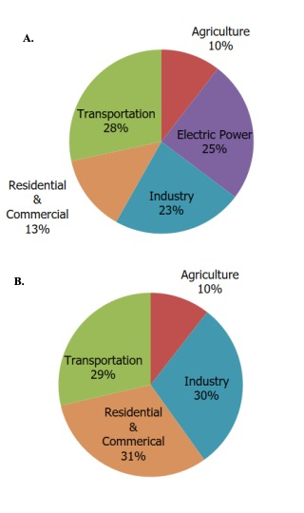
Figure 1.1. The United States’ greenhouse gas emissions, categorized into different economic sectors without indirect electricity contribution [A] and including electricity indirect contribution [B]. Due to independent rounding, the percentages do not sum to exactly 100% [2].

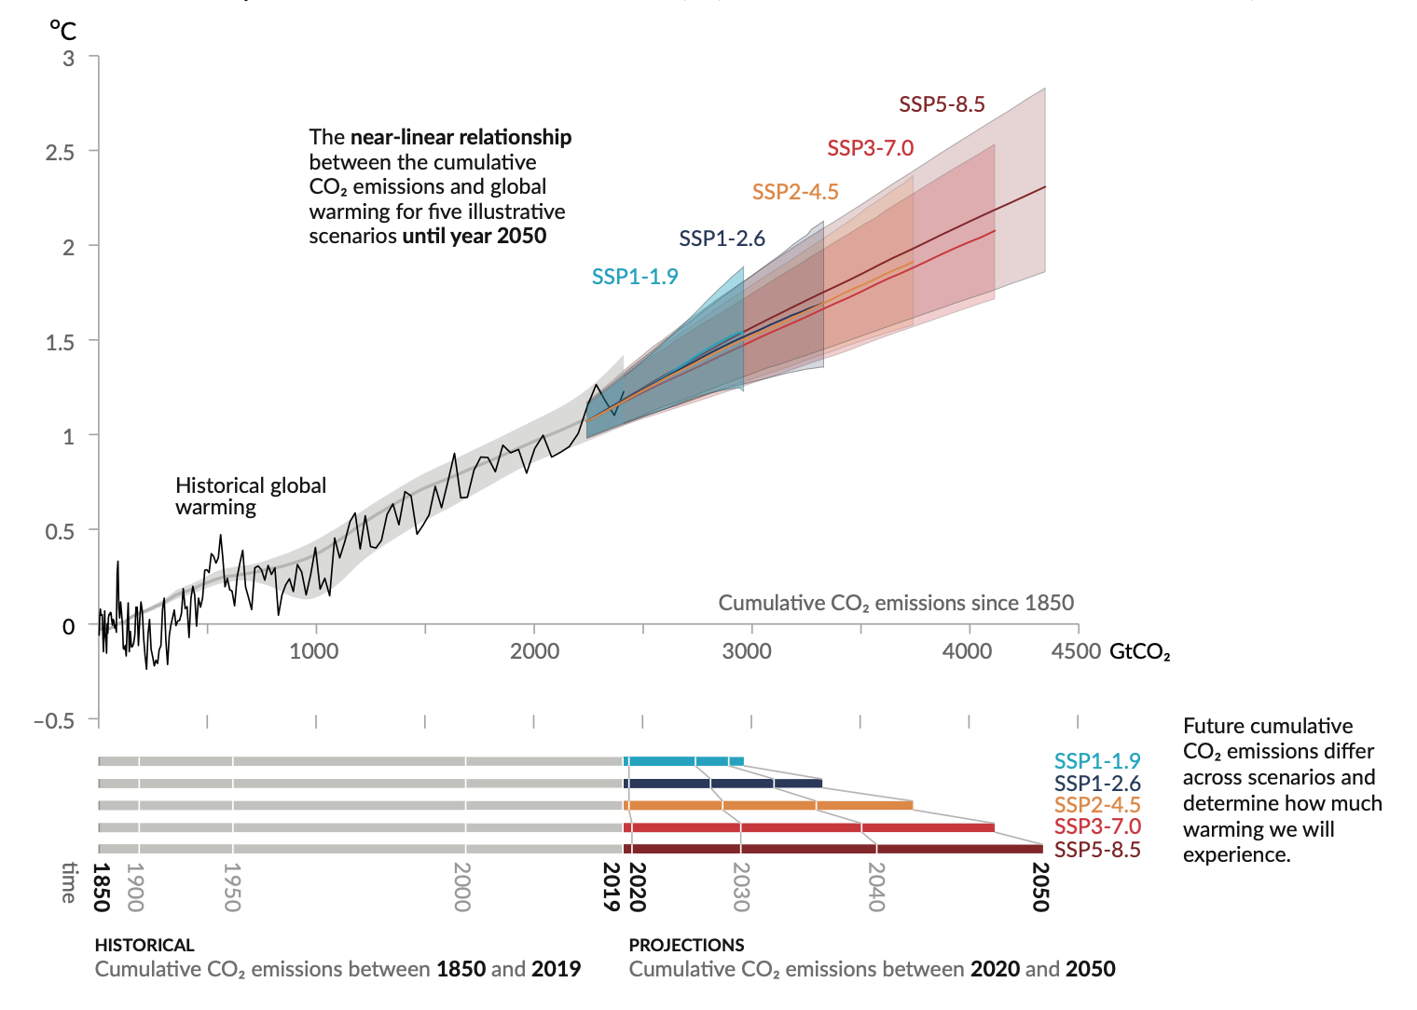
Figure 1.2. Global surface temperature increase $(℃)$ from 1850–2019, with projections for 2020–2050 as a function of cumulative CO₂ emissions [1].

Carbon Capture and Storage (CCS)
Carbon capture and storage (CCS) have been developed to reduce greenhouse gas emissions while maintaining the use of fossil fuels across various sectors of the economy.^{5, 6} CCS has three stages: capturing the CO₂ generated, transporting it, and storing it in the safest form. The first stage, carbon capture, involves the capture of CO₂ by separating it from other gases generated from the industrial processes. The second stage is a connection between the first and last stages, which comprises the compression and transportation of CO₂ for storage. The third stage involves the emplacement of the captured and transported CO₂ into storage sites in underground rocks.⁷
The capturing stage is classified into three technological concepts: pre-combustion, oxy-fuel-combustion, and post-combustion. Pre-combustion, as the name implies, involves capturing CO₂ before the combustion process takes place. This method cannot be applied in conventional steam power plants but can be utilized in Integrated Gasification Combined Cycle (IGCC) plants. This capture technology proceeds with first the gasification of fuel. For instance, the feedstock (coal) is partially oxidized in steam and air to produce syngas (a mixture of H₂, CO, and CO₂). The syngas is converted to H₂ and CO₂ via a water-gas shift reaction. Pre-combustion technology produces CO₂-rich gaseous products, but at a high cost of technological implementation.⁸ Oxyfuel combustion involves the combustion of fossil fuel using oxygen-rich air to produce CO₂ and steam with a minimal amount of impurities. This technology is primarily applied to metallurgical industries and coal-fired plants, with other industries barely embracing this technology.⁹ Post-combustion technology captures CO₂ after the combustion of fossil fuel. This is the most widely applicable capture in use. Relative to pre-combustion and oxyfuel-combustion, post-combustion is the easiest technology to implement of the three because it can be retrofitted to the plant without major changes made to the combustion process. A major drawback of this method is the low concentration of CO₂ in the gas effluent, which reduces its efficiency for CO₂ capture.¹⁰
Post-combustion technology is primarily divided into capture-based techniques (absorption¹¹ and adsorption^{12, 13}) and membrane-based techniques,^{14, 15} with chemical absorption demonstrating the highest efficiency.¹⁶ Chemical absorption involves the capture of CO₂ from a gas stream into a chemical solvent, distinguishing it from adsorption techniques.¹⁷ In an absorption chamber, CO₂-lean solvent is allowed to flow counter-currently at a low temperature of about 40-60$℃$ and interacts with CO₂-rich flue gas, thus facilitating a transfer of CO₂ into the liquid solvent. Then, the CO₂-rich solvent is directed to the thermal stripper^{18, 19} where it undergoes regeneration at a high temperature of about 120-160$℃$. The CO₂-lean solvent is recycled back to the absorber column to be used in multiple cycles, with its effectiveness depending on the efficiency of the regeneration process.
Several forms of chemical absorbents, such as alkanol amines,^{20, 21} aqueous ammonia,^{22, 23} dual alkali,²⁴ and sodium carbonate slurry,^{25, 26} are used for CO₂ capture. Aqueous alkanol amines have gained much traction in over 60 years due to their high CO₂ affinity.²⁷ Several studies explore the use of various alkanol amines for CO₂ absorption, including primary amines like monoethanolamine (MEA) and diglycolamine (DGA), secondary amines like diethanolamine (DEA), and tertiary amines like triethanolamine (TEA), and 2-amino-2-methyl-1-propanol (AMP) in aqueous solutions.^{28, 29} The bond between CO₂ and amines is reversible with the application of heat, with about 83.6 kJ/mol of heat released when carbamate and bicarbonate solutions are formed.³⁰ The limitations of alkanolamines include the high energy requirement for regenerating the solvent, their high vapor pressure, and the corrosive and toxic nature of by-products such as nitrosamines, which can lead to equipment corrosion.³¹⁻³³ Therefore, it is essential to develop improved solvents to reduce energy consumption while ensuring minimal degradation and corrosion.
Adsorption offers a cost-effective alternative for post-combustion CO₂ capture, which utilizes either physical (physisorption) or chemical (chemisorption) processes to trap gas molecules on the surface of a solid adsorbent (Figure 1.3),³⁴ releasing heat in the process. In physisorption, CO₂ molecules adhere to the adsorbent through van der Waals forces and dipole-dipole interactions,³⁵ with adsorption efficiency closely linked to the pore texture of the adsorbent. Porous materials are materials containing vacant spaces that allow for selective physisorption or chemisorption.³⁶ Porous materials, like metal-organic frameworks (MOFs),³⁷⁻³⁹ zeolites,⁴⁰ and covalent organic frameworks (COFs)⁴¹ are a useful class of materials for carbon capture due to the multiple possible species that have and can potentially be designed from this class of materials. In addition to this, they possess properties such as pore size and surface chemistry that dictate their functions. In physisorption, an optimal pore size is heavily influenced by operating pressure and temperature. The heat released during physisorption ranges from approximately -25 to -40 kJ/mol.⁴² Physisorption is a reversible process where the gas-free adsorbent can be regenerated at elevated temperatures and reduced pressures.⁴³
Chemisorption represents an improvement over physisorption due to enhanced gas selectivity achieved through the introduction of Lewis base functional groups that interact with CO₂. ^{40, 44, 45} The amine functional group is the most used in this modification. ³⁵ In this process, CO₂ forms chemical bonds with the basic functional groups on the adsorption sites. While physisorption typically occurs at room temperature, chemisorption takes place at elevated temperatures of about 140$℃$.⁴⁶ The heat released during chemisorption ranges from approximately -60 to -100 kJ/mol, depending on the specific functional group incorporated into the adsorbent. ⁴⁴ Selecting suitable solvents and sorbent materials for CO₂ capture involves a significant tradeoff, requiring careful consideration of factors such as CO₂ loading capacity, regeneration energy, operational cost, absorption/desorption rate, degradation rate, stability, and toxicity.⁴⁷ Although chemical absorption using aqueous amines like MEA is the most commonly employed method due to its high absorption rate and low solvent cost,⁴⁸ its toxicity and the high energy demands for solvent regeneration have led to the development of improved solvents for CO₂ chemical absorption. This progress also extends to the development of materials suitable for other methods, including adsorption and membrane-based technologies.

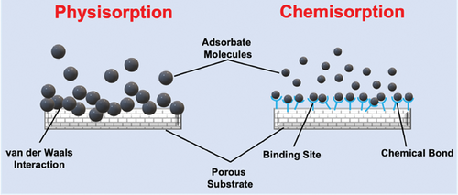

Figure 1.3. Adsorption of gas molecules through physisorption and chemisorption processes [35].

Bioinspired Approach to Carbon Capture
To tackle the environmental challenges posed by conventional CO₂ capture methods, bioinspired approaches have garnered attention as sustainable alternatives.^{49, 50} These methods offer safer, more stable, and eco-friendly solutions, especially when combined with existing technologies.⁵¹⁻⁵³ Natural biomaterials feature a highly complex but organized arrangement with varied chemical compositions, enabling them to carry out multiple functions within biological systems. In addition, their multifunctionality makes them competitive materials, attracting attention from researchers seeking inspiration for novel and improved materials. Bioinspired approaches involve developing solutions to existing technological challenges by drawing inspiration from natural biomaterials. ⁵⁴ In carbon capture, these technologies aim to address CO₂ capture in the most sustainable way possible.⁵⁵ Numerous studies suggest using amino acids as substitutes for amine-based methods, stemming from the inspiration provided by the interactions between amino acid building blocks and CO₂ in biological systems.⁵⁶⁻⁶¹
Carbonic anhydrase (CA) is an enzyme, with an active site containing Zn²⁺ bound to hydroxide and is used for the interconversion between CO₂ and bicarbonate (Equation 1.1).⁶²⁻⁶⁶ It enables the transport of CO₂ or hydrated CO₂ in the form of bicarbonate to pathways that need them.⁶⁷ CA is promising to enhance CO₂ absorption and desorption, accelerating reaction kinetics at lower energy demands. Even with all these benefits, CA has limited industrial use in carbon capture due to its low stability at elevated temperatures, basic pH, and instability around flue gas components like SO_{x} and NO_{x}.⁶⁸ Therefore, there is a need to produce better-engineered enzyme-based materials for carbon capture.
 | $$CO_{2}+H_{2}O\underset{↔}{\begin{aligned}Carbonic \\ anhydrase\end{aligned}}H_{2}{CO}_{3}↔H_{2}{{CO}_{3}}^{-}+H^{+}↔{{CO}_{3}}^{2-}+2H^{+}$$ | Equation 1.1
Another significant natural biomaterial utilized in carbon capture is ribulose-1,5-bisphosphate carboxylase-oxygenase (RuBisCO). RuBisCO plays a crucial role in the conversion of CO₂ into energy-rich molecules in plants and certain bacteria. However, RuBisCO operates relatively slowly, fixing only approximately three molecules of CO₂ per second. Furthermore, this enzyme displays poor specificity for CO₂, as it can also bind to oxygen, which has a lower molecular weight than CO₂.⁶⁹ Despite this, RuBisCO remains a source of inspiration for designing improved materials for sustainable carbon capture and separation, thereby promoting an environmentally friendly method for CO₂ capture and separation.
Amino acids (AAs), which serve as the building blocks of enzymes, represent viable alternatives to conventional amine-based solvent capture techniques, as they can be gotten from various biosources and used for industrial carbon capture ⁶⁹ as shown in Figure 1.4. They employ principles inspired by the interactions between these enzymatic building blocks and carbon dioxide for the purpose of selective carbon capture.⁵⁶⁻⁶¹ They have similar chemical functionalities to amine solvents, resulting in a strong affinity for CO₂. However, they offer distinct advantages over amine solvents due to their low toxicity,⁷⁰ non-volatility,¹⁶ resistance to oxidative degradation,^{71, 72} and the potential for production from numerous bio-sources. ^{73, 74}

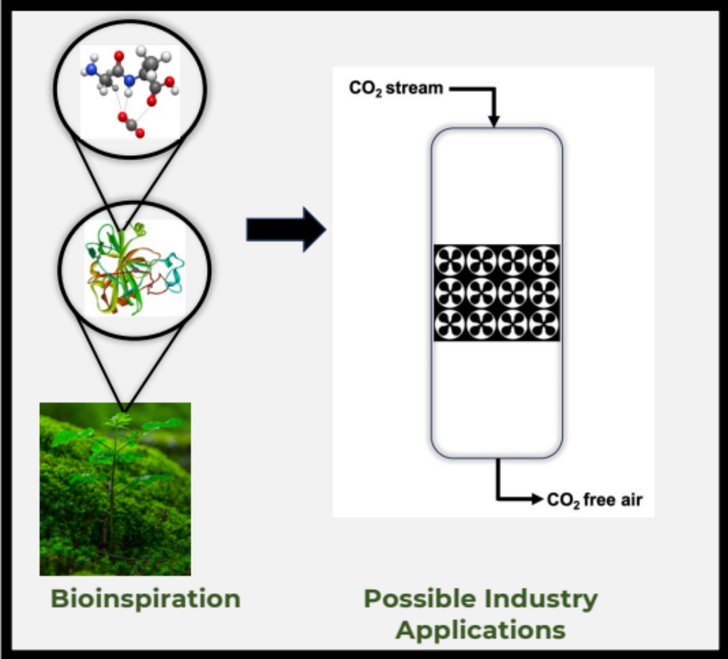
Figure 1.4. Bioinspiration from amino acids, the building blocks of enzymes used in industrial carbon capture

Direct Air Capture
According to the Intergovernmental Panel on Climate Change (IPCC), transportation sector accounts for approximately 23% of global atmospheric carbon dioxide.⁷⁵ Most post-combustion capture techniques are able to account for carbon dioxide generated on site, without an account for mobile sources like transportation sector. This highlights the necessity of accounting for CO₂ emissions from both point and distributed sources, as well as historical emissions, in order to reduce the atmospheric concentration of CO₂ to well below 2$℃$ above pre-industrial levels.⁷⁶ This necessitates the implementation of a diversity of carbon capture technologies to eliminate approximately 100 to 1000 GtCO₂ by the year 2100.⁷⁷
Direct air capture (DAC) is a promising carbon capture technology that can capture CO₂ from both point and distributed sources.⁷⁸⁻⁸¹ This potential is especially enhanced when it is combined with a renewable energy source. There are several emerging DAC approaches, that determine the nature of the sorbent being used. Cryogenic DAC cools air to isolate solid CO₂, which can then be stored in this solid form or converted back into high-quality CO₂ for industrial use.⁸²⁻⁸⁴ Moisture-swing adsorption is a DAC technology that captures CO₂ in dry environments and releases it upon exposure to water, reducing energy requirements while increasing water usage.⁸⁵⁻⁸⁷ Voskian and Hatton proposed electro-swing DAC adsorption, which binds CO₂ to a specialized material when electrically charged and releases it when discharged, eliminating the need for heat-based regeneration.⁸⁸ Alkaline-based DAC employs reactive materials like magnesium oxide (MgO) to chemically absorb CO₂ from the air.⁸⁹ The solid sorbent DAC method captures CO₂ from mixed gas streams by employing hierarchically porous materials through an adsorption process. Depending on the strengths and nature of the interaction, this can be either physisorption or chemisorption, with the former utilizing weak intermolecular forces and the latter relying on stronger covalent bonds.⁹⁰ The liquid DAC method removes CO₂ by dissolving the gas into the liquid phase, resulting in a CO₂-depleted gas stream exiting the system and a CO₂-enriched liquid stream for further processing to regenerate the liquid sorbent. To maximize efficiency, this approach often employs structured packing, which enhances surface contact between the gas and liquid phases, thereby improving CO₂ capture efficiency.^{91, 92} These DAC approaches follow similar process where ambient air comes in contact with the capture medium containing the sorbent, followed by the regeneration of the sorbent to enable the repetition of this cycle (Figure 1.5).⁹³
Among the various DAC methods, liquid solvent and solid sorbent techniques are the most advanced, with amino acid-based DAC receiving significant attention in recent years due to its sustainable benefits. Brethomé et al. investigated the DAC process using aqueous amino acid solutions as the liquid sorbent, which are then regenerated through crystallization with guanidine compounds.⁹⁴ Custelcean et al. utilized aqueous amino acids in the DAC of CO₂ and subsequently regenerated their amino acid solvents using meta-benzene-bis(iminoguanidine) (m-BBIG).⁶⁰ Recker et al. employed ionic liquid derived from waste amino acids for DAC of CO₂. This process involved a laboratory-scale experiment utilizing a mixture of valine, leucine, and isoleucine procured from biowaste sources, such as feathers and furs. ⁹⁵ Recently, Yaghi and colleagues incorporated various amino acids (glycine, proline, lysine, and arginine) into a porous metal-organic framework (MOF-808) to serve as a solid sorbent-based DAC.⁹⁶
Numerous obstacles impede the broad implementation of DAC technology. These challenges consist of significant operational expenses, the need for prolonged monitoring, transforming captured CO₂ into useful products such as fuels, and worries regarding possible CO₂ leakage from underground storage.^{78, 97, 98} Furthermore, the extremely low concentration of CO₂ in the atmosphere poses a considerable challenge, resulting in high energy usage and competition from other gases like water vapor, which can hinder CO₂ capture efficiency.
To enhance DAC efficacy, the ideal sorbent material needs to have several essential qualities: a high capacity for CO₂ adsorption, adequate binding strength to capture CO₂ without creating significant energy barriers for its release, strong CO₂ selectivity, and durability over time. Current research aims to optimize these elements by creating economical and energy-efficient sorbents, ensuring that the costs of raw materials and the synthesis process do not become financially burdensome.⁹⁹ Thus, the motivation behind the work presented in Chapter 2 and Chapter 3 is the extensive analysis of natural amino acids and their dipeptide products for their potential in solid-sorbent-based DAC of CO₂.
In this study, the DAC process is proposed as a prospective pathway for the incorporation of the peptides for CO₂ capture and separation. By determining the strengths of the interactions between these peptides and CO₂, the feasibility of this technology can be better understood.

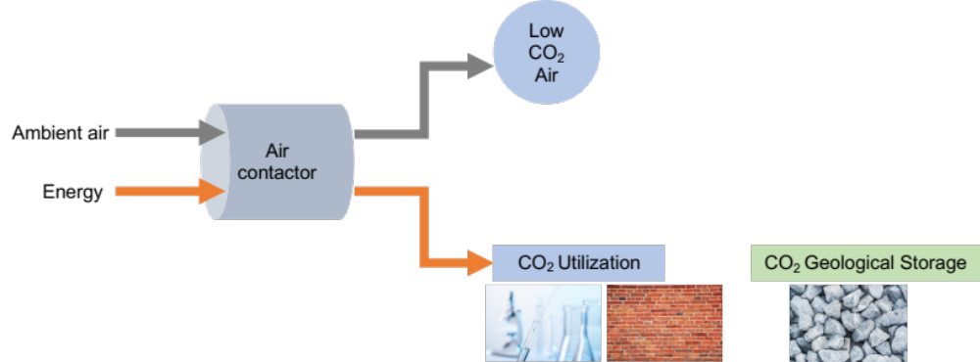
Figure 1.5. Schematic illustration of direct air capture of CO₂ with utilization and storage. Redrawn from David Sandalow et al. (2018). [83]

Computational Chemistry for Amino Acid-Based CO₂ Capture
By assessing the strengths of the interactions between these amino acids and oligopeptides with CO₂, a comprehensive understanding of the feasibility of this technology can be obtained. However, the number of experiments permissible during the trial phase is limited. Consequently, electronic structure theory or quantum chemical methods are essential for calculating the interaction energies as electrons move around in molecules. The application of statistical mechanics to the results of electronic structure analysis allows for the determination of bulk properties such as heat capacity, Gibbs free energy, and others. Such methodologies can be employed to yield insights into the experimental design of oligopeptides aimed at carbon dioxide capture.¹⁰⁰

Dissertation Organization
The structure of this dissertation, following the introductory chapter, is as follows. Chapter 2 offers precise reference data on non-covalent interactions between CO₂ and amino acids across different compound regions, alongside a DFT benchmark that establishes the foundation for the computational methods explored in later chapters. Chapter 3 expands on the previous chapter by examining the cooperative interactions in dipeptides compared to amino acids. Additionally, it discusses various functional groups–carboxylic acid, carbonyl, amines, hydroxyl, and thiol groups–and how these interactions influence the overall affinity for CO₂ binding. Chapter 4 details a high-throughput screening of a vast tripeptide database using a novel metric that decomposes non-covalent interaction terms into quantitative components, leveraging molecular descriptors to predict tripeptide interaction energies with CO₂ through machine learning. Chapter 5 significantly shifts focus by presenting a comparative study on the mechanistic exploration of amino acids and CO₂ in solution, analyzing the free energy surfaces that describe the energy landscape of various reaction mechanisms related to each intermediate complex. Lastly, Chapter 6 summarizes the main objective of this dissertation, which is to deliver reference data and an innovative algorithm that enriches the understanding of employing amino acids and oligopeptides for bioinspired carbon capture, particularly within direct air capture technologies. This approach can be implemented in various locations, thereby enhancing accessibility and efficiency in reducing atmospheric CO₂.

Accurate Interaction Energies of CO₂ with the 20 Naturally Occurring Amino Acids
Disclosure: The following chapter has been modified, with permission from a journal article published in ChemPhysChem in 2023, volume 24, issue 13.¹⁰¹ Dr. Konstantinos D. Vogiatzis (principal investigator) and I authored this publication. Electronic structure theory calculations, including density functional theory and explicitly correlated coupled cluster, as well as database generation, curation, and data analyses, were performed by me. All sections were written by me and Dr. Konstantinos D. Vogiatzis.

Introduction
Carbon dioxide (CO₂) is the prime greenhouse gas produced mainly from transportation, power plants, chemical plants, and other industrial processes, and has become a major concern across the globe as a prime cause of extreme climate changes.¹⁰² CO₂ capture and separation comprise several technologies that capture, store and transport CO₂ at various stages from point sources.¹⁰³ On an industrial scale, amine-based solvents are largely used for CO₂ capture via chemisorption, which is an energy-intensive and prone to corrosion process.³¹ This is an outcome of the high cost of solvent regeneration, the corrosive nature of the byproducts, and the high vapor pressure of the solvent leading to release of toxic amine gases into the atmosphere upon heating. In addition, the high energy required to remove the adsorbed CO₂ and break the carbamide bond formed between the CO₂ and the amine defeats the whole purpose of carbon reduction, towards mitigating climate change. This has propelled several researchers to seek alternatives to the capture of CO₂ via conventional chemisorption processes. These alternative methods range from the use of membrane,¹⁰⁴ porous materials as adsorbents such as zeolites and metal-organic frameworks (MOFs),¹⁰⁵ carbon molecular sieves,^{106, 107} cryogenic methods,¹⁰⁸ and ionic liquids.¹⁰⁹ These techniques are mostly used to capture CO₂ from post-combustion industrial sources. Although there are different methodologies for CO₂ capture, the challenge remains to find a balance between sustainable, cost-effective, and environmentally friendly technologies. Several studies have proposed the use of bio-inspired materials for the selective capture of CO₂, where amino acids (AAs), the building blocks of enzymes, can effectively bind CO₂ as suitable alternatives to conventional amine-based solvent capture. ^{56, 58-61, 110} In addition, AAs have low toxicity,⁷⁰ are non-volatile,¹⁶ have high resistance to degradation,⁷¹ and could be produced from various bio-sources.^{73, 74}
The 20 naturally occurring AAs are the building blocks of enzymes that catalyze biochemical reactions. They are composed of a carboxylic acid group and an amino group while they differ by their side groups (R) which can contain among others alkyl, aromatic, hydroxy, amine, or carboxylic acid groups. The presence of nucleophilic side chains makes AAs promising units for selective interactions with CO₂. The formation of weak, noncovalent interactions would eliminate the high regenerative cost of separating CO₂ from the conventional capture media that requires stronger carbamide bonds with CO₂. Also, the variety of nucleophilic groups on AAs offer synergistic binding with 2:1 ratio between AAs and one CO₂ molecule, which further increases the efficacy of the physisorption process. These AAs-based separation techniques can be used in post-combustion processes (high composition of CO₂), like amine solvents, or in direct air capture (DAC) processes by physisorption. The DAC can be used to capture CO₂ from smaller-scale and mobile sources like transportation media. DAC also bypasses the problem of storage and transportation of CO₂ and therefore can be incorporated into technologies that directly use CO₂ as feedstock. ^{111, 112}
Although there are numerous reports on amino acid-functionalized MOFs,¹¹³⁻¹²⁰ amino acid salts and amino acid ionic liquids,^{16, 121} there are limited available theoretical data on the interaction strength of isolated AAs with CO₂. Hussain et al. reported the strength of the covalent and non-covalent interactions of the 20 naturally occurring AAs with CO₂ at various interaction sites.¹²² This computational study utilized density functional theory (DFT) with the M05-2X exchange-correlational functional. A more recent work illustrated how the introduction of an extra carboxylate group on the AAs can increase their interaction with CO₂.¹²³ A combination of spectroscopic methods and quantum chemical calculations demonstrated how these introduced groups could reduce the negative inductive effect of an amino group and accelerate the interaction of the molecule with CO₂. Another computational study focused on the chemisorption of CO₂ on amino acid ionic liquids using molecular dynamics (MD) simulations and DFT calculations performed with the M06-2X functional.¹²⁴
In this work, the non-covalent interaction energies of the CO₂-AA molecular systems are explored with accurate quantum chemical methods. For that purpose, we have computed reference interaction energies using highly accurate explicitly correlated coupled-cluster singles-and-doubles with perturbative triples (abbreviated as CCSD(F12)(T)) at the complete basis set (CBS) limit.^{125, 126} We have explored a variety of possible CO₂ binding sites per AA and the generated reference data are used for benchmarking common density functionals. The theoretical methods used in this study are presented in 2.2, while 2.3 introduces the CCSD(F12)(T)/CBS reference results. A detailed discussion for the CO₂-serine system is presented, followed by the analysis of the full CO₂-AA molecular dataset and the DFT benchmark study. Conclusions are provided in 2.4 which will serve as the basis for future computational examination of biologically inspired macrostructures and materials for AA-based CO₂ separations.

Computational Methods

Geometry Optimizations
Initial structures were generated with the OPLS-AA force field in a periodic box at 200 K in the NVT ensemble with a Nosé-Hoover thermostat using a 1.0 ps time constant and a 1.0 fs time step.¹²⁷ All the force-field inputs were generated using the LigParGen software package.¹²⁸ The simulation was carried out using the Large Atomic/Molecular Massively Parallel Simulator (LAMMPS)¹²⁹ software package in 10,000 iterative steps. The 30 most stable conformations were selected and optimized using DFT. The PBE0 functional¹³⁰ with Grimme’s dispersion correction (D3),¹³¹ the Becke-Johnson (BJ) damping function, the resolution of identity (RI) approximation,¹³² and the def2-TZVPP¹³³ basis set were used. All DFT calculations were performed with the TURBOMOLE 7.2.1¹³⁴ quantum chemical program package.

Explicitly Correlated Coupled-Cluster Calculations
To verify the suitable geometries needed for the reliable coupled-cluster calculations, constrained geometry optimizations were carried out on AA-CO₂ supersystems. These constrained geometry optimizations were performed at the PBE0-D3(BJ)/def2-TZVPP level of theory by systematically varying the AA-CO₂ bond distance around the PBE0 minimum and the energetically most stable geometries were used in the CCSD(F12)(T) calculations. The conventional CCSD(T) method has a strong basis set dependence, leading to slower convergence with increasing basis set size. Slow convergence can be addressed by using F12 methods, which include terms in the wavefunction that explicitly depend on the interelectronic distance r₁₂. ¹³⁵⁻¹³⁷ The CCSD(F12)(T) calculations were performed using the cc-pVXZ-F12^{138, 139} basis sets (X = D, T) and the corresponding complementary auxiliary basis sets (CABS). The cc-pVXZ-F12 auxiliary basis sets were used to fit the F12 and electron-repulsion integrals (CBAS) as well as the two-electron contributions to the Fock matrix (JKBAS). The 2B ansatz was used in all F12 calculations.¹⁴⁰ The two-point formula of Helgaker and co-workers¹⁴¹ was used for extrapolation towards the CBS of the perturbative triples:
 | $$E_{CCSD(F12)(T)/CBS}= E_{HF/TZ}+δE_{CABS S/TZ}+ δE_{CCSD(F12)/TZ }+δE_{(T)/CBS}$$ | Equation 2.1

 | $δE_{(T)/CBS}$ = $\frac{δE_{(T)/XZ}X^{3} - δE_{(T)/YZ}Y^{3}}{X^{3}-Y^{3}}$ | Equation 2.2
where $E_{HF/TZ}$ is the Hartree-Fock (HF) energy while the $δE$ terms represent electron correlation energies. The term “CABS S” represents the CABS singles correction to the HF energy.¹⁴² The cc-pVDZ-F12 and cc-pVTZ-F12 basis sets are abbreviated by their cardinal numbers X = 2 and Y = 3, respectively. The (T) was computed from cluster amplitudes of the conventional CCSD(T). All CCSD(F12)(T) calculations were performed with the TURBOMOLE 7.2.1¹³⁴ software package.

DFT Calculations
DFT geometry optimizations for all 20 AA-CO₂ supersystems, AA monomers, and isolated CO₂ were performed using TURBOMOLE¹³⁴ 7.2.1 software package with the D3(BJ) dispersion correction, and the RI approximation. In this study, 11 density functionals were tested and the obtained interaction energies (E_{int}) were compared to the highly accurate reference CCSD(F12)(T)/CBS energies. The density functionals used in the study are: PBE,¹⁴³ BP86,¹⁴⁴ BLYP,^{145, 146} TPSS,¹⁴⁷ PW6B95, BHLYP,¹⁴⁸ PBE0,¹³⁰ TPSSH,¹⁴⁹ B3LYP,¹⁵⁰ B97D,¹⁵¹ B973C.¹⁵² The geometry optimizations were performed with each of these functionals, using the def2-TZVPP, def2-TZVP, and def2-SVP basis sets and the m4 grid. ^{133, 153} The interaction energies were computed as the difference in the energy of the optimized supersystem and the energies of the optimized AA and CO₂ geometries.
For assessing the accuracy of the selected density functionals, we have computed the mean absolute error (MAE):
 | Mean absolute error (MAE) $=\frac{\sum_{i=1}^{n}{|y_{i}-x_{i}|}}{n}$ | Equation 2.3
where$y_{i}$ is the CCSD(F12)(T)/CBS reference energies, $x_{i}$ is the DFT energy for each AA per density functional, and n is the number of AAs (n=20). The root mean square error (RMSE) is defined as:
 | Root mean square error (RMSE) $=\sqrt{\frac{\sum_{i=1}^{n}{{\left(y_{i}-x_{i}\right)}^{2}}}{n}}$ | Equation 2.4

Results and Discussion

Correlation Effects: Serine-CO₂ as a Test Case
Serine has been selected in this study as a representative example of the different electron correlation term contributions to the CO₂ interaction energies. In this analysis, we will abbreviate the two basis sets selected for these calculations (cc-pVDZ-F12 and cc-pVTZ-F12) as DZ and TZ, respectively. The slow convergence to the complete basis sets limit, an effect that originates from the poor description of the electron cusp when a truncated basis is used in post-HF calculations,¹⁵⁴ is addressed by the introduction of explicitly-correlated terms (F12). Since it is known that coupled-cluster methods require large basis sets to provide highly accurate results, we wanted to analyze the individual electron correlation terms on the interaction energy of a representative molecular system before we consider the full AA database. For that purpose, we have selected serine-CO₂, one of the simplest AA, and we have performed a detailed analysis of the individual electron correlation terms (Table 2.1). For this analysis, the most stable geometry of the serine-CO₂ supersystem was used, which involves a CO₂ weakly bound on the COOH site of the AA.
The HF/TZ interaction energy is -2.10 kcal/mol, while the CABS singles correction to HF with the same basis is positive (0.02 kcal/mol). The CCSD correction to the HF interaction energy with the double- and triple-zeta basis sets is -2.22 and -2.34 kcal/mol, respectively, while the CCSD(F12)/TZ converges to -2.36 kcal/mol. Note that the CCSD(F12) energy term computed with the smaller basis set (DZ, -2.34 kcal/mol) is identical to the conventional CCSD with the larger triple-zeta basis. Thus, the gain from the explicit correlation becomes evident since the CCSD(F12)/DZ calculation requires less computational effort than a conventional CCSD calculation with a triple-zeta basis set. The perturbative triples (T) correction term contributed about 0.5 kcal/mol to the CCSD method, which corresponds to ~19% of the total correlation energy of the CO₂-serine interaction. Note that the (T) energy term computed from the CCSD(F12)(T) level of theory (shown as (T)F12 in Table 2.1) differs from the conventional CCSD(T) since the computed $t_{i}^{a}$ and $t_{ij}^{ab}$ amplitudes have different values when the explicit correlation is included in the coupled-cluster projected equations. However, both extrapolated (T)_{con}/DT and (T)_{F12}/DT terms from (Equation 2.1) are identical (-0.56 kcal/mol), which means that both approaches converge to the same CBS limit. For that reason, we have used the (T)_{F12}/DT term for the computation of the reference values of the 20 AA-CO₂ supersystems (see below). Addition of the (T)con/DT to the ${δE}_{CCSD(F12)/TZ}$ (-2.36 kcal/mol) provides the best estimate for the total correlation energy to the CBS (-2.91 kcal/mol). Interestingly, extrapolation of the total correlation energies computed at CCSD(F12)(T)/DZ and CCSD(F12)(T)/TZ levels by applying (Equation 2.1) provides a ${δE}_{CCSD(F12)/TZ}$ = -2.92 kcal/mol, which is almost identical (difference of 0.01 kcal/mol) with the energy term computed from the separate extrapolation of the CCSD via explicit correlation and (T) via the two-point Helgaker formula. Addition of the HF energy and the first-order correction from CABS Singles provides the best estimate (-4.99 kcal/mol) for the interaction energy between serine and CO₂.
The contributions to the serine-CO₂ interaction energy from the aug-cc-pVXZ basis sets (X=D, T), abbreviated as aVXZ are outlined in Table 2.2. Surprisingly, the conventional HF energies from aVDZ and aVTZ (-2.49 and -2.24 kcal/mol, respectively) significantly deviate from the equivalent values from the cc-pVXZ-F12 basis sets (-2.06 and -2.10 kcal/mol). On the contrary, both families of basis sets converge to the same HF limit upon addition of the first-order correction from CABS Singles (-2.08 and -2.09 kcal/mol for TZ and aVTZ, respectively). The ${δE}_{CCSD(F12)}$ correlation energy terms are in reasonable agreement (-2.36 and -2.43 kcal/mol for TZ and aVTZ, respectively), while the (T)F12/DT extrapolated energies converge to almost the same value (-0.56 and -0.54 kcal/mol for DZ/TZ and aVDZ/aVTZ, respectively). Overall, the best estimates for the total interaction energies of serine-CO₂ system are in fair agreement (-4.99 and -5.05 kcal/mol).
In the next paragraph, the sum of E_{CCSD(F12)/TZ} + E_{(T)/DT} is used for the generation of a balanced set of accurate reference energies for the interaction of CO₂ with the 20 naturally occurring AAs. For sake of simplicity, we will refer to these energies as CCSD(F12)(T)/CBS.

Table 2.1. Individual cc-pVDZ-F12 energy contributions to the interaction energy of CO₂ with serine. $δE$ represents the interaction energy contribution of the different correlation terms (corrections to HF) and ΔE_{int} represents the total interaction energy (HF + corrections).
METHODS | $δE$[kcal/mol]  cc-pVDZ-F12 | cc-pVTZ-F12 | ΔE_{int} [kcal/mol]  cc-pVDZ-F12 | cc-pVTZ-F12
HF | 0.00 | 0.00 | -2.06 | -2.10
CABS S | 0.00 | 0.02 | -2.06 | -2.08
CCSD | -2.22 | -2.34 | -4.29 | -4.43
CCSD(F12) | -2.34 | -2.36 | -4.40 | -4.44
(T)con | -0.49 | -0.54
CCSD(T) | -2.72 | -2.87 | -4.78 | -4.97
(T)F12 | -0.48 | -0.53
CCSD(F12)(T) | -2.82 | -2.89 | -4.88 | -4.97
(T)con/DT |  | -0.56
(T)F12/DT |  | -0.56
CCSD(F12)+(T)/DT | -2.87 | -2.91 | -4.95 | -4.99
Table 2.2. Individual aug-cc-pVDZ-F12 energy contributions to the interaction energy of CO₂ with serine. $δE$ represents the interaction energy contribution of the different correlation terms (corrections to HF) and ΔE_{int} represents the total interaction energy (HF + corrections).
METHODS | $δE$[kcal/mol]  aug-cc-pVDZ-F12 | aug-cc-pVTZ-F12 | ΔE_{int} [kcal/mol]  aug-cc-pVDZ-F12 | aug-cc-pVTZ-F12
HF | 0.00 | 0.00 | -2.49 | -2.24
CABS S | 0.35 | 0.15 | -2.14 | -2.09
CCSD(F12) | -2.38 | -2.43 | -4.52 | -4.52
(T)F12/DT |  | -0.54
CCSD(F12)+(T)/DT | -2.92 | -2.96 | -5.06 | -5.05

CCSD(F12)(T) Reference Data
An isolated AA has three potential sites that can form weak interactions with CO₂; the alpha amine (α-NH₂), the carboxylic group (COOH), and the side group R that is unique for each AA. For the purpose of this study, and for providing a complete dataset of highly accurate reference values, we have computed at the CCSD(F12)/TZ + (T)/DT level the CO₂ interaction energies for all 20 AAs and for all three different sites (α-NH₂, COOH, side group R). All reference data for the interaction energies and optimal atom distances between CO₂ and the AA atom closest to the carbon atom of CO₂ are included in Table 2.3, while all energies are shown graphically as a plot in Figure 2.1. Figure 2.2 shows the optimized geometries of the strongest interaction site for all the AA-CO₂ supersystems.
For almost all AAs, the interactions of CO₂ with the carboxylic acid (about -4.0 to -5.0 kcal/mol) are stronger than the interaction with the α-NH₂ group (about -2.5 to -3.5 kcal/mol). There is an exception to this with arginine, where the CO₂ interaction with the α-NH₂ group is further stabilized by interactions between O (CO₂) and H (side chain -NH₂), and C (CO₂) and N (side chain NH₂). Although CO₂ primarily interacts with the α-NH₂ group, this cooperative effect further enhances the CO2 affinity of arginine.

Table 2.3. CCSD(F12)(T)/CBS reference interaction energies (E_{Int}, in kcal/mol) and interatomic distances (in Å) of the 20 naturally occurring AAs and CO₂ (in alphabetical order). Bold font indicates the most preferable interaction site. A dash (-) indicates that no favorable interaction was found between CO₂ and the side groups (e.g., the methyl group of alanine).
 | α-NH₂ |  | COOH |  | Side Group
AA | E_{Int} | R_{N…C} | E_{Int} | R_{O…C} | E_{Int} | R_{X…C}
Ala | -2.55 | 3.058 | -3.89 | 2.834 | - | -
Arg | -5.24 | 3.553 | -4.46 | 2.838 | -6.12 | 2.804
Asn | -2.45 | 3.054 | -3.37 | 2.951 | -6.08 | 2.791
Asp | -2.36 | 3.065 | -4.05 | 3.492 | -5.53 | 2.881
Cys | -2.59 | 3.024 | -3.93 | 2.866 | -3.62 | 3.540
Glu | -2.58 | 3.018 | -5.19 | 2.911 | -3.89 | 2.809
Gln | -2.67 | 3.003 | -4.46 | 2.884 | -4.85 | 2.796
Gly | -2.36 | 3.040 | -3.84 | 2.830 | - | -
His | -2.58 | 3.045 | -4.55 | 2.784 | -4.75 | 2.836
Ile | -2.42 | 3.079 | -4.20 | 2.845 | - | -
Leu | -2.89 | 3.112 | -6.17 | 2.859 | - | -
Lys | -2.43 | 3.060 | -4.05 | 3.307 | -4.14 | 3.025
Met | -2.44 | 3.046 | -4.16 | 2.815 | -2.78 | 3.296
Phe | -3.08 | 3.120 | -4.60 | 2.835 | - | -
Pro | -4.19 | 2.878 | -4.43 | 3.096 | - | -
Ser | -2.65 | 3.014 | -4.99 | 2.810 | -4.00 | 2.805
Thr | -2.61 | 3.020 | -4.61 | 2.845 | -4.37 | 2.785
Trp | -3.39 | 3.120 | -3.92 | 2.993 | -4.26 | 3.175
Tyr | -2.54 | 3.044 | -5.28 | 2.835 | -4.66 | 3.751
Val | -2.43 | 3.066 | -4.15 | 2.847 | - | -

Figure 2.1. CCSD(F12)(T)/CBS interaction energies and the respective interatomic distances of the 20 naturally occurring AAs and CO₂ at different interaction points.

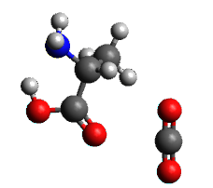  $$---$$  2.834 | 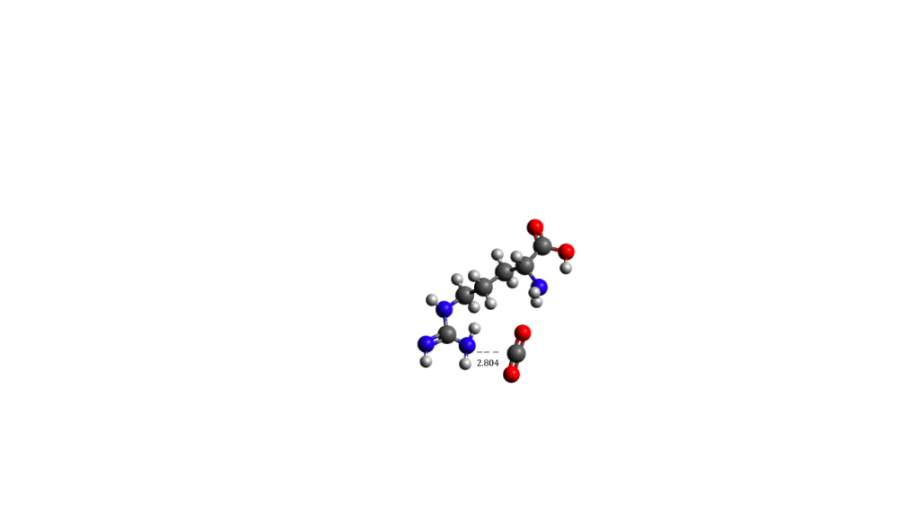 | 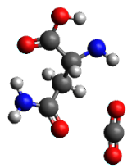  $--$ $-$  2.791 | 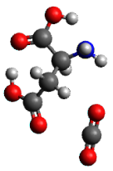  $--$ $-$  2.881 | 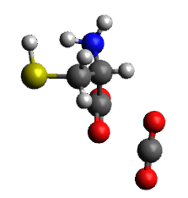  $$--$$  2.866
(1) Ala-CO₂ | (2) Arg-CO₂ | (3) Asn-CO₂ | (4) Asp-CO₂ | (5) Cys-CO₂
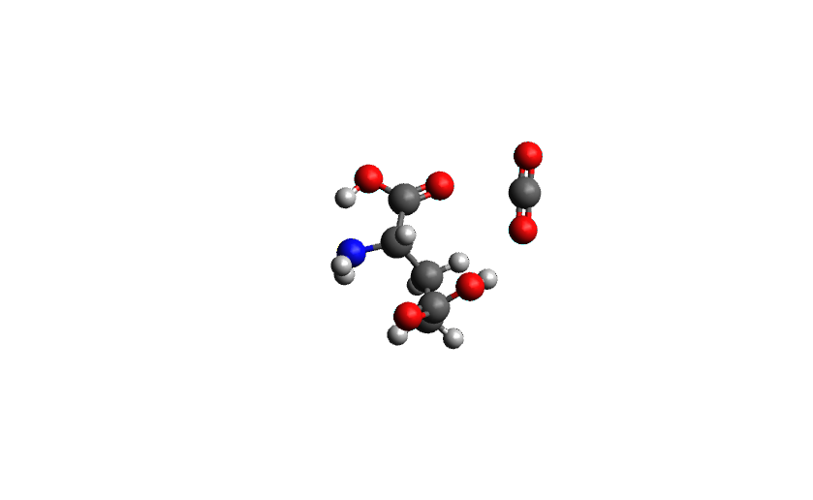  $$---$$  2.911 | 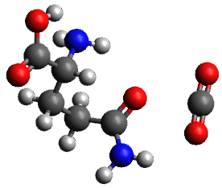  $$--$$  2.796 | 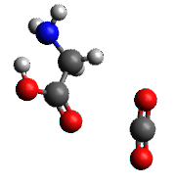  $$---$$  2.830 | 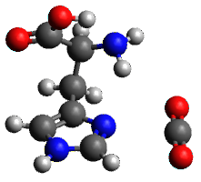  $$---$$  2.836 | 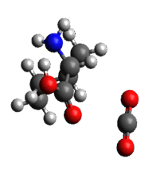  $$---$$  2.845
(6) Glu-CO₂ | (7) Gln-CO₂ | (8) Gly-CO₂ | (9) His-CO₂ | (10) Ile-CO₂
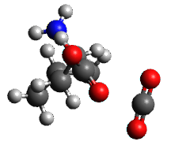  $$--$$  2.859 | 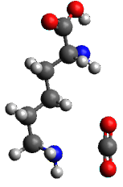  $$--$$  3.025 | 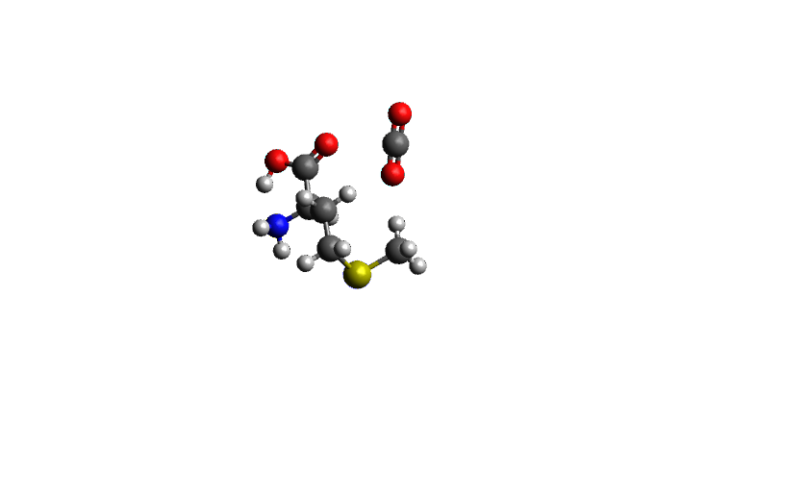  $$---$$  2.815 | 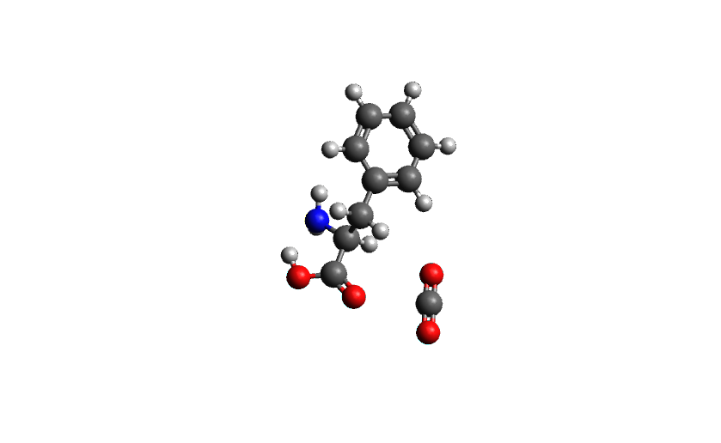  $$---$$  2.835 | 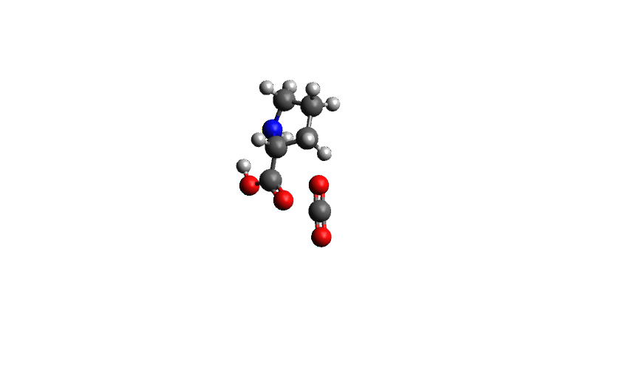  $$--$$  3.096
(11) Leu-CO₂ | (12) Lys-CO₂ | (13) Met-CO₂ | (14) Phe-CO₂ | (15) Pro-CO₂
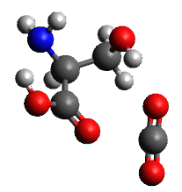  $$--$$  2.810 | 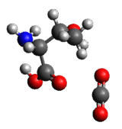  $$--$$  2.845 | 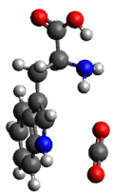  $$--$$  3.175 | 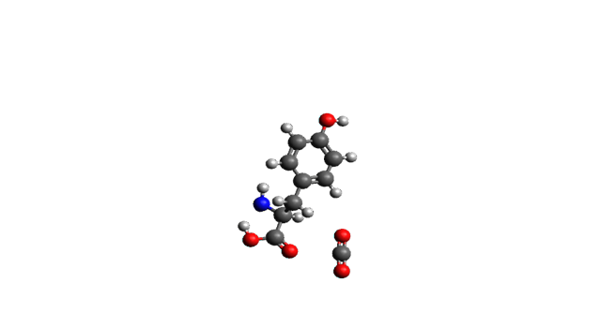  $$--$$  2.835 | 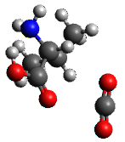  $$---$$  2.847
(16) Ser-CO₂ | (17) Thr- CO₂ | (18) Trp-CO₂ | (19) Tyr-CO₂ | (20) Val- CO₂
Figure 2.2. Optimized geometries of the 20 naturally occurring AAs and CO₂ (in alphabetical order). The most preferable interaction site with CO₂ is shown.

Leucine (Leu-CO₂) exhibits the strongest interaction energy (-6.17 kcal/mol) in the entire series (Table 2.3), where CO₂ preferably interacts with the COOH group. This can be attributed to the dipole-induced dipole interactions between the C(CO₂) and the O(COOH) as well as additional stabilizing hydrogen bonding interactions that are absent in other AAs.^{155, 156} These arise from the interactions of H atoms located on the side chain methyl groups and the oxygen atoms of CO₂. This interaction is also present in isoleucine–structural isomer of leucine, but in a form of head-on interaction compared to the parallel position of CO₂ next to leucine. Arginine (Arg-CO₂) has the second strongest interaction energy (-6.12 kcal/mol) with CO₂ interacting with the side chain that has three amine groups. This rich nucleophilic center results in the observed interaction energy with CO₂. In addition, there is a stabilizing hydrogen bonding between the O (CO₂) and the H (primary NH₂). Asparagine (Asn-CO₂) has the third strongest interaction energy (-6.08 kcal/mol) where CO₂ is in close proximity to the side chain amide group. This dipole-induced dipole interaction is stabilized by hydrogen bonding. Asparagine also has one of the shortest interatomic distances with CO₂ with a value of 2.791Å. For all other AAs, the report of all possible interactions between AA and CO₂ has interaction energies are between -2.36 kcal/mol to -5.24 kcal/mol. Most of the AAs interacted preferentially with CO₂ through the primary carboxyl group, with an average interaction energy of -4.43 kcal/mol and an average interatomic distance of 2.92 Å. On the other hand, interactions at the α-amine groups displayed the weakest energies (average E_{INT} = -2.73 kcal/mol) and longest interatomic distances (average R_{N…C(CO2)} = 3.09 Å). in a few cases, we found an intramolecular interaction between the H(COOH) and N(α-NH₂) on the AA backbone, which competes with the CO₂-N(α-NH₂) and eventually reduces the strength of the CO₂ interaction.

Discussion on Leucine, Isoleucine and Valine Interacting with CO₂
In this section, the differences and similarities of the interaction energies between CO₂ and leucine, isoleucine and valine are discussed. These three AAs have similar, non-polar side groups, but their computed interaction energies with CO₂ show significant deviations (Figure 2.3(A)). While leucine has one of the strongest CO₂ interaction energies (-6.17 kcal/mol at the CCSD(F12)(T)/CBS level), isoleucine and valine found to have a significantly weaker interaction with CO₂ (-4.20 and -4.15 kcal/ mol at the CCSD(F12)(T)/CBS level, respectively).
All three systems are stabilized with dipole-induced dipole interactions between C(CO₂) and O(COOH) (~ 2.86 Å for all three cases), while weak “hydrogen bonding interactions” between H(methyl) and O(CO2) provide additional stability. For all three cases, the closest O(CO₂)...H(methyl) distance is ~ 2.67 Å. However, the orientation and angular placement of CO₂ in the leucine supersystem differ from the isoleucine and valine cases. In particular, the absence of a methyl group in beta position from the COOH group in leucine creates less steric repulsion and allows CO₂ to be in close proximity to the AA. This is shown in Figure 2.3(B), and it is also validated by the measured distance between the second O(CO₂) that its distance from the AA is ~ 3.0 Å. On the contrary, the presence of the beta methyl group in isoleucine and valine (shown in dashed red circle in Figure 2.3(B)) introduces steric repulsion to CO₂ (Figure 2.3(D)), and the distance of the second O(CO₂) exceeds the 3.5 Å from the AA (both isoleucine and valine).

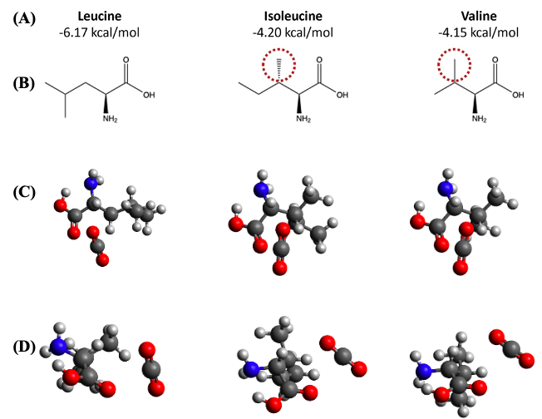
Figure 2.3. (A) Interaction energies of leucine, isoleucine, and valine with CO₂ calculated at the CCSD(F12)(T)/CBS limit. (B) Molecular structures of the three AAs. (C) Optimized geometries at the PBE0-D3(BJ)/def2-TZVPP level (top view) and (D) rotated by 90° (side view).

Screening of Different Density Functionals
The stable conformers from the classical mechanics simulations were further optimized with different density functionals (PBE, BP86, BLYP, TPSS, PW6B95, BHLYP, PBE0, TPSSH, B3LYP, B97D, and B973C) and basis sets (def2-SVP, def2-TZVP, and def2-TZVPP). The performance of each of these density functionals was evaluated with respect to the CCSD(F12)(T)/CBS reference energies. This analysis would identify which density functionals that describe to a considerable degree the noncovalent interactions of CO₂ and AAs. The MAE, MAD, RMSE, and MAX error values of the different density functionals with def2-TZVPP basis sets are shown in Table 2.4.

Table 2.4. MAE, MAD, RMSE, and MAX Error of the interaction energy (in kcal/mol) of the different density functionals and def2-TZVPP basis sets
Density Functional | MAE | RMSE | MAX
PBE0-D3(BJ) | 0.13 | 0.16 | 0.36
B3LYP-D3(BJ) | 0.17 | 0.21 | 0.41
PW6B95-D3(BJ) | 0.19 | 0.26 | 0.73
M06-2X | 0.23 | 0.29 | 0.61
BLYP-D3(BJ) | 0.24 | 0.27 | 0.51
PBE-D3(BJ) | 0.31 | 0.53 | 2.07
TPSSh-D3(BJ) | 0.59 | 0.77 | 2.57
B97d-D3(BJ) | 0.6 | 0.65 | 1.08
BHLYP-D3(BJ) | 0.62 | 0.64 | 1.01
TPSS-D3(BJ) | 0.7 | 0.87 | 2.79
M06 | 0.81 | 0.85 | 1.41
BP86-D3(BJ) | 0.87 | 1.04 | 3.10
B97-3c-D3(BJ) | 0.92 | 0.95 | 1.43

The MAE for the interaction energy (kcal/mol) and interatomic distances (Å) of the different functionals and def2-TZVPP and def2-TZVP basis sets are presented in Figure 2.4. Of all the functionals used in this study, the GGA density functionals B97-3c-D3(BJ) and BP86-D3(BJ) provided the lowest accuracy, with MAE of 0.92 kcal/mol and 0.87 kcal/mol, respectively (def2-TZVPP basis set). The hybrid density functionals PBE0-D3(BJ) and B3LYP-D3(BJ) provided the highest accuracy and lowest MAE (0.13 kcal/mol and 0.17 kcal/mol, respectively, with the def2-TZVPP basis set). A similar behavior was observed for the def2-TZVP basis sets, while results with the smaller def2-SVP basis sets and for all density functionals significantly deviated from the reference values. For example, the density functionals BHLYP-D3(BJ) had the highest MAE of 3.06 kcal/mol. The MAD and RMSE values computed with BP86-D3(BJ)/def2-TZVPP were the highest of all methods used in this study (0.33 kcal/mol and 1.04 kcal/mol respectively), while PBE0-D3(BJ)/def2-TZVPP had the lowest MAD and RMSE (0.08 kcal/mol and 0.16 kcal/mol, respectively). It is noteworthy that B3LYP-D3/BJ had also a low RMSE of 0.21 kcal/mol. Overall, all density functionals together with the triple-zeta quality basis sets were in good agreement with respect to the reference values, with RMSEs not exceeding the 1.04 kcal/mol.
The source of the large deviations from the smaller def2-SVP basis set is probably due to the basis set incompleteness which leads to the basis set superposition error (BSSE). In order to test this, we applied the counterpoise correction proposed by Boys and Bernardi¹⁵⁷ in the serine-CO₂ system. We found that the counterpoise corrected energy, -5.14 kcal/mol, compared to the uncorrected interaction energy of -7.66 kcal/mol. These counterpoise corrected and uncorrected energies were computed at PBE0-D3(BJ)/def2-SVP level of theory.
For the interatomic distances, the GGA density functionals B97-3c-D3(BJ) and B97D-D3(BJ) provided the lowest accuracy with a MAE of 0.12 Å with def2-TZVPP basis sets. On the contrary, B3LYP-D3(BJ) was in excellent agreement with the PBE0-D3(BJ)/def2-TZVPP geometry that was used as reference on this study (MAE of 0.01 Å, def2-TZVPP). The def2-TZVP data followed a similar behavior, with density functionals PBE0-D3(BJ) and B3LYP-D3(BJ) providing the lowest MAE. There was an observed deviation in accuracy when the def2-SVP basis set was used.

Figure 2.4. Mean Absolute Error (MAE) for the interaction energies (top) in kcal/mol and the interatomic distances (bottom) in Å of the different functional and def2-TZVPP and def2-TZVP basis sets, relative to the CCSD(F12)(T)/CBS reference values.

Summary of Key Results
Inspired by recent work on CO₂ capture and separation through bio-inspired materials, we have performed a quantum chemical study on the noncovalent interactions between the 20 natural AAs and CO₂. The AAs contain various nucleophilic groups, like amine, carboxyl, hydroxyl, and thiol groups, that can interact favorably with CO₂, exceeding the -6.0 kcal/mol (e.g. arginine-CO₂ supersystem). We started by performing explicitly-correlated CCSD calculations together with perturbative triples at the CBS limit for the computation of accurate interaction energies of the systems of interest. The CCSD(F12)(T)/CBS energies for every possible interaction site of the 20 AAs with CO₂ served as reference data for testing different density functional and basis sets. We concluded that the hybrid density functionals PBE0-D3(BJ) and B3LYP-D3(BJ) provide the highest accuracy, with MAEs of 0.13 kcal/mol and 0.18 kcal/mol, respectively (def2-TZVPP basis set). In the future, we are planning to utilize conclusions extracted from this work in hybrid quantum chemical/machine learning studies for the elucidation of noncovalent interactions between oligopeptides and CO₂. The presence of a large variety of nucleophilic side chains on the oligopeptides would be a key feature in enhancing the optimal physisorption of CO₂.

In Silico Screening of CO₂-Dipeptide Interactions for Bioinspired Carbon Capture
Disclosure: The following chapter has been modified, with permission, from a journal article published in ChemPhysChem in 2024, volume 26, issue 4.¹⁵⁸ The first authorship was shared between Dr. Grier M. Jones and me. The database generation, creation of initial dipeptide-CO₂ geometries, quantum chemical calculations, and data curation were carried out by me, under the guidance of Dr. Konstantinos D. Vogiatzis. The automated identification of CO₂-philic groups and data analyses were performed by Dr. Grier M. Jones, also under the guidance of Dr. Konstantinos D. Vogiatzis. All sections pertaining to the results and discussion were written and edited by Dr. Konstantinos D. Vogiatzis, Dr. Grier M. Jones, and me. Dr. Radu Custelcean and Dr. Konstantinos D. Vogiatzis initiated the original idea for this bioinspired study using dipeptides for CO₂ capture.

Introduction
A key goal in addressing climate change involves the control of greenhouse gases in the atmosphere. CO₂ is the primary greenhouse gas emitted from human activities through fixed sources such as fossil-based power plants, as well as smaller-scale distributed sources, which include transport and residences among other sources. Current efforts can provide efficient ways for carbon capture and storage (CCS), especially from major sources like flue gas streams.¹⁵⁹ An emerging methodology that allows the capture of CO₂ at any location is direct air capture (DAC). DAC holds promise in sectors with widespread distribution that contribute significantly to the carbon footprint, such as the aviation and shipping sectors.¹⁶⁰
Solvent-based DAC technologies share similar chemistries with conventional solvent-based capture methods that utilize absorption or adsorption beds. However, while aqueous amine solvents are commonly used in flue gas scrubbing,¹⁰⁹ they are associated with high costs for solvent regeneration, high vapor pressure, and the production of corrosive and toxic intermediates like nitrosamines.³¹ Furthermore, the utilization of solvents in DAC technologies may necessitate a significant volume of air to be passed over the solvent, potentially resulting in solvent loss, particularly if the solvent employed is volatile. These limitations highlight the need for less volatile and less corrosive alternatives in CO₂ capture, such as amino acids.
In response to the environmental concerns associated with traditional CO₂ capture techniques, bioinspired approaches have emerged as promising solutions,^{49, 50} which offer environmentally friendlier, safer, and more stable alternatives, especially when coupled with already developed technologies.⁵¹⁻⁵³ Bioinspired strategies involve identifying a technological challenge, seeking parallels in biological systems with similar problems and solutions, and drawing inspiration from nature to address the technological issue.⁵⁴ Such methodologies are specifically geared towards addressing challenges in atmospheric CO₂ capture with an emphasis on sustainability.⁵⁵ Several studies have suggested the utilization of bioinspired chemical environments, particularly amino acids (AAs), as potential substitutes for traditional amine-based solvent capture methods, which consider the implementation of principles or mechanisms inspired by interactions between the enzymatic building blocks and CO₂ for selective carbon capture.⁵⁶⁻⁶¹ AAs offer distinct advantages over aqueous amine solvents due to their functional groups, which exhibit a high affinity for CO₂, along with characteristics such as low toxicity,⁷⁰ non-volatility,¹⁶ resistance to degradation,⁷⁰ and could be produced from various bio-sources.^{73, 74} To enhance the efficiency of AA-based CO₂ capture, it is recommended to tailor them for use in both distributed and fixed sources with DAC technologies.^{56, 78-80, 94, 161} Custelcean et al. employed aqueous oligopeptides in the DAC process to capture CO₂,⁶⁰ while Recker et al. utilized ionic liquids derived from waste AAs for DAC of CO₂. The latter study involved a laboratory-scale experiment using a mixture of valine, leucine, and isoleucine obtained from biowaste sources, such as feathers and furs.⁹⁵ More recently, Yaghi and coworkers introduced different AAs (glycine, proline, lysine, and arginine) in a porous metal-organic framework (MOF-808) for DAC with solid materials.⁹⁶
Herein, we explore the applicability of AAs and dipeptides and their capacity for CO₂ physisorption considering that weak, noncovalent interactions are the first step of capture before they can react with CO₂. Thus, these interactions influence the subsequent covalent binding. Our primary focus is the quantification of cooperative interactions that enhance the noncovalent, one-to-one (1:1) interactions between AAs and CO₂.¹⁶² These cooperative interactions, such as those occurring in a 2:1 or 3:1 ratio, significantly strengthen CO₂ binding, offering considerable improvement in various industrial settings.^{163, 164} In a previous study, we performed accurate quantum chemical calculations for the computation of noncovalent interactions between the 20 naturally occurring AAs and CO₂. The AAs possess diverse nucleophilic groups such as amine, carboxylic acid, and side-chains such as hydroxyl, thiol, amine, carboxylic acid and carbonyl groups, which exhibit favorable interactions with CO₂. These results further illustrate that polar functional groups enhance favorable interactions with CO₂.¹⁰¹ This observation is particularly significant as we scale up the size of the oligopeptides and incorporate more polar functional groups, providing valuable insights into expected outcomes. Here, we have explored the interaction of CO₂ and dipeptides at various interaction sites using novel algorithms for fast data analysis of the collected results. We performed a comprehensive computational study to reveal where each of the 400 dipeptides, formed from the twenty naturally occurring AAs, interact with CO₂. We examine the interactions of CO₂ with the carboxylic acid groups, carbonyl groups, primary and secondary amine groups, hydrogens connected to linking carbons, and the unique side-chains of the constituent AAs. To this end, we developed a novel algorithm to help identify the interaction sites of CO₂ with the dipeptides and provide statistical insights into how these interactions affect their overall affinity for CO₂ binding. We also analyze the cooperative effects between the dipeptides and CO₂ by comparing the interaction energies of the dipeptides with the corresponding AAs that compose them, and an in-depth analysis of the statistical insights provided, together with a discussion on design strategies for mitigating CO₂ emissions.

Computational Methodology

Database Generation
First, we formed a database that includes all possible combinations of dipeptides. The permutation of the 20 natural AAs in different sequences results in a diverse set of molecular structures. The Python implementation of RDKit¹⁶⁵ was utilized to generate initial optimized dipeptide geometries with molecular mechanics. Initially, AAs were represented as Simplified Molecular-Input Line-Entry System (SMILES) strings,^{166, 167} a molecular representation that encodes chemical information from molecular graphs as a unique ASCII string.^{168, 169} We explicitly included the chirality of each AA in the SMILES string since chirality determines their biochemical properties. By specifying chirality, we confined all resulting dipeptides to L-enantiomeric products, consistent with the prevalence of L-amino acids as the fundamental constituents of proteins.¹⁷⁰ The molecular structures were then converted into Cartesian coordinates using the experimental-torsion basic knowledge distance geometry (ETKDG)¹⁶⁴ implemented in RDKit.¹⁶⁵

Generation of Initial Dipeptide-CO₂ Geometries
To delve into the complex interactions between dipeptides and CO₂, it is essential to consider the unique characteristics provided by the polar functional groups present in each chemical structure. These diverse molecular units include carboxylic acid, carbonyl, amino, peptide, hydroxyl, and thiol groups, and provide distinct chemical properties that influence the overall interactions with CO₂. For instance, the carboxylic acid functional group interacts with CO₂ through a dipole-induced dipole interaction, which is further stabilized by hydrogen bonding between the oxygen atom of CO₂ [abbreviated as O(CO₂)] and the hydrogen atom of the carboxylic acid group [abbreviated as H(COOH)]. Furthermore, the contrasting chemical behavior of dipeptide products, like alanine and glycine (ala-gly) versus glycine and alanine (gly-ala), emphasize the distinctiveness and broad variability within the chemical space of dipeptides and their CO₂ interactions under study. With these considerations in mind, we developed a computational process to efficiently position CO₂ around the carbonyl groups within dipeptide structures without user intervention. Our algorithm aims to generate initial molecular geometries where CO₂ can interact with the dipeptides before optimization. This becomes evident since each dipeptide inherently contains at least one carbonyl group resulting from the peptide bond, along with one or more additional carboxylic acid groups stemming from the primary carboxylic acid group of one amino acid subunit and side-chain functional groups. Overall, the CO₂-placement algorithm produced 960 conformations with CO₂ interacting with carbonyl groups.
The initial phase includes identifying the carbonyl group(s) present within a dipeptide structure. Subsequently, the placement of the carbon atom of the CO₂ molecule is determined relative to the carbonyl groups by employing logical parameters for bond distance, bond angle, and dihedral angle, as shown schematically in Figure 3.1. The carbon atom of the CO₂ molecule [or C(CO₂)] is positioned at a bond distance R = 2.8 Å from the oxygen atom of the carbonyl group [or O(CO)] and forms a bond angle θ = 180° with C(CO). Then, the dihedral angle between C(CO₂), the carbonyl group, and the first atom next to the carbonyl group is set at φ = 0°. Similarly, the two oxygen O(CO₂) atoms are placed on the same plane with C(CO₂) and with bond distances R_{C-O} = 1.15 Å. Following this, the initial dipeptide-CO₂ structure is further optimized at the density functional theory (DFT) level.
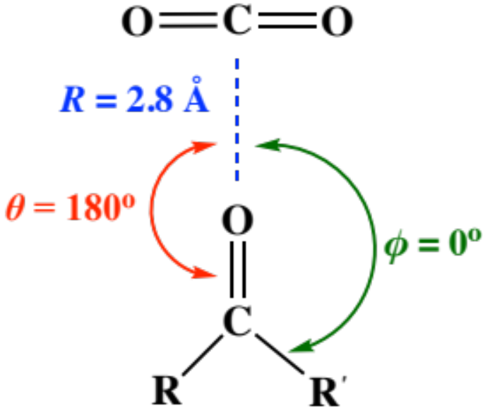
Figure 3.1. Schematic representation of the automated CO₂ molecule placement next to the carbonyl groups of a dipeptide structure. The coordinates R, θ, and φ correspond to the distance between C(CO₂) and O(CO) of the dipeptide, the bond angle between C(CO₂) and the carbonyl group of the dipeptide, and the dihedral angle between C(CO₂), the carbonyl group and the nearest carbon atom to the CO group (represented as R'), respectively. A planar conformation (φ = 0) was chosen as reference, and the evolution of the molecular structures was monitored after geometry optimizations, where φ is varied.

Quantum Chemical Calculations
DFT geometry optimizations were performed with the PBE0 density functional,¹³⁰ Grimme’s dispersion correction (D3)¹³¹ together with the Becke-Johnson (BJ) damping function, the resolution of identity (RI) approximation,¹³² the def2-TZVPP¹³³ basis set and the m4 grid.^{133, 153} Molecular vibrational frequencies were computed for the optimized geometries for the validation of locating minima across the potential energy surfaces. All DFT calculations were performed with the TURBOMOLE 7.2.1¹⁷¹ quantum chemical program package. The interaction energies E_{int} were computed as the difference in the energy of the optimized supersystem and the energies of the optimized dipeptide and CO₂ geometries:
 | $${E_{int}=E}_{Dipeptide-{CO}_{2}} -E_{Dipeptide}- E_{{CO}_{2}}$$ | Equation 3.1
The basis set and density functional choice was chosen based on our previous benchmark study, where PBE0 density functional with the def2-TZVPP basis provided the most accurate results relative to highly accurate reference interaction energies, generated with the explicitly-correlated coupled-cluster singles-and-doubles with perturbative triples or CCSD(F12)(T) at the complete basis set limit (CBS).¹⁰¹
Symmetry-adapted perturbation theory (SAPT) calculations were performed for obtaining additional insights into the nature of the non-covalent interactions between CO₂ and dipeptides. SAPT analysis decomposes the interaction energy terms into electrostatics, induction, dispersion, and exchange repulsion, and offers a physical interpretation to non-covalent interactions.¹⁷² The SAPT calculations with the aug-cc-pVDZ basis were performed using density fitting, as implemented in the Psi4 program.¹⁷³⁻¹⁷⁶ The higher level SAPT2+3δ_{MP2} method¹⁷⁷ was used as the δ_{MP2} term captures the third and higher-order interactions between induction and dispersion.

Data Curation - Removal of Outliers
DFT energies were computed for the initial raw dataset consisting of 960 conformers. Multiple geometry optimizations positioned the CO₂ molecule closer to the amino groups of the dipeptides, suggesting these sites as more CO₂-philic. The computed 960 interaction energies were further analyzed in a systematic manner. First, selection criteria were established with cutoff values between -17 kcal/mol and -2 kcal/mol, so that interactions outside this range are excluded as either unphysical or indicative of very weak noncovalent interactions with an unbound CO₂ molecule. The low threshold was selected based on one optimized structure where CO₂ has been significantly distorted and was not bound through an expected non-covalent interaction. That was an outcome of an erroneous initial structure, that was then fixed manually, and the geometry optimization was repeated successfully. Subsequently, only the dipeptide configurations with the lowest interaction energy were selected, resulting in a final dataset with 400 unique entries.
Two representative examples are discussed here to further justify the data curation step that was applied in the full 960-entry dataset. The first case is the isoleucine-proline dipeptide, where we obtained two different conformations with CO₂ (Figure 3.2). In Figure 3.2 (A), CO₂ is stabilized through long-range dispersion interactions and hydrogen bonding between H(CH₂)- O(CO₂) and H(NH₂)-O(CO₂), with a total E_{int(1)} = -8.63 kcal/mol. These energy contributions were verified by SAPT computations.¹⁷² Based on our SAPT2+3δ_{MP2}/aug-cc-pVDZ calculations, the strongest contribution to stabilization of the complex (Figure 3.2 (A)) comes from electrostatics, particularly through hydrogen bonding interactions between H(CH₂) and O(CO₂), and H(NH₂) and O(CO₂). Dispersion interactions followed as the second most significant contribution. In the second conformation (Figure 3.2 (B)), CO₂ predominantly interacts with the carboxylic acid and the pyrrole ring through dipole-induced dipole interactions, and it is further stabilized by hydrogen bonding interactions between H(CH₂)-O(CO₂) and H(NH₂)-O(CO₂). From our SAPT2+3δ_{MP2}/aug-cc-pVDZ calculations, while electrostatics play a role, the dispersion interactions dominate because of the large, delocalized $π$-electrons that create temporary dipoles and in turn create a dipole in CO₂. The second conformation has a stronger interaction energy than the first by almost 0.5 kcal/mol (E_{int(2)} = -9.13 kcal/mol) and thus, it was preferred in the 400-instance dataset instead of the first. Furthermore, in the first conformation, the alignment of the CO₂ molecule primarily enables interaction with one oxygen atom. In addition, it is positioned away from the lone pair of electrons on the nearest N atom. Contrastingly, in the second conformation, the alignment of CO₂ enables the interaction with both the lone pair of electrons on the oxygen atom (carboxylic acid) and the nitrogen atom (pyrrole ring).
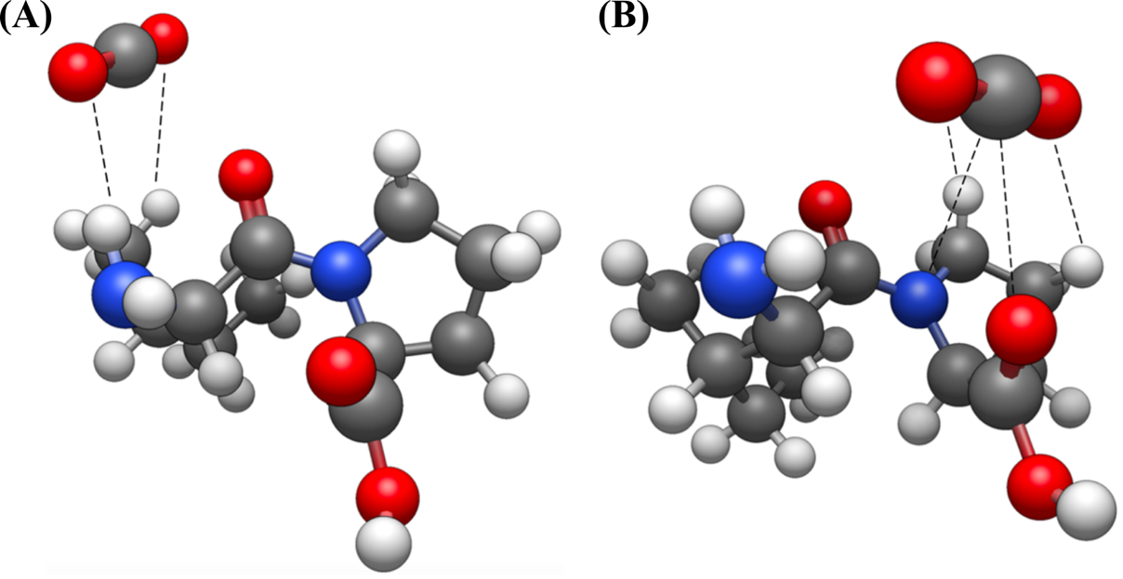
Figure 3.2. The two different conformations obtained by DFT between the isoleucine-proline dipeptide and CO₂. Dashed lines indicate the primary CO₂ interaction sites.
Another example is the conformation differences of alanine-alanine (Figure 3.3) interacting with CO₂ via carbonyl groups and carboxylic acid groups (Figure 3.3 (A)), CO₂ is stabilized through long-range dispersion interactions and hydrogen bonding between H(CH₂)-O(CO₂) and H(NH₂)-O(CO₂). Based on our SAPT2+3δ_{MP2}/aug-cc-pVDZ calculations, the strongest contribution to stabilization of this complex comes from electrostatics, particularly through hydrogen bonding interactions, followed by dispersion interactions. Figure 3.3 (B), the second conformation is shown where, apart from the primary interaction site of the alanine dimer carboxylic acid group, the weak hydrogen bonding interactions are now between a hydrogen atom bonded to the nitrogen participating in the peptide bond and O (CO₂). Based on our SAPT2+3δ_{MP2}/aug-cc-pVDZ calculations, the strongest contribution to stabilization of this complex comes from electrostatics, particularly through hydrogen bonding interactions, followed by dispersion interactions. The first conformation has an interaction energy of E_{int(1)} = -3.82 kcal/mol while the second conformation has an interaction energy of E_{int(2)} = -4.03 kcal/mol. Therefore, we have considered the second geometry in the 400-instance dataset. The reason for this slight stabilization of the energy in the second conformer is possibly due to the alignment of the CO₂ that polarizes the electron-rich carboxylic acid and N-H centers. Figure 3.4 shows the comparison from the SAPT2+3δ_{MP2}/aug-cc-pVDZ calculations between additional dipeptide-CO₂ complexes.
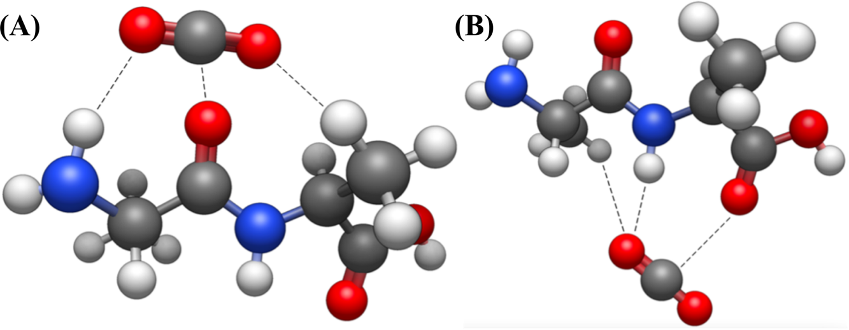
Figure 3.3. The two different conformations obtained by DFT between the alanine-alanine dipeptide and CO₂. Dashed lines indicate the primary CO₂ interaction sites.

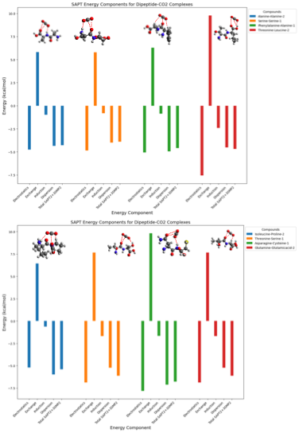
Figure 3.4. SAPT2+3δ_{MP2}/aug-cc-pVDZ energy decomposition analyses of some dipeptides-CO₂ complexes. For each of the dipeptides-CO₂ complexes chosen, we performed the analyses on the configurations with the lowest interaction energies.

Automated Identification of CO₂-philic Sites
For the automated determination of the interaction sites of the 400 molecular geometries obtained by DFT, we developed a computational workflow, shown schematically in Figure 3.5. The first step in our algorithm is to read the Cartesian coordinates (Figure 3.5 (A)) and identify the n-closest atoms to the CO₂ (Figure 3.5 (B)). In this study, we choose n = 1 per atom since this can account for the nearest-neighbor interactions with each atom in CO₂ and a given atom in an interaction site. This means that for a given binding site, a maximum of three n = 1 neighbors can be considered, one for each atom of the CO₂ molecule. We then converted the Cartesian coordinates into RDKit mol objects using RDKit and NetworkX¹⁷⁸ via xyz2graph¹⁷⁹ (Figure 3.5 (C)). Both methods are utilized as a quality control step to account for various issues that can occur when converting Cartesian coordinates into RDKit mol objects or when converting the graphs from xyz2graph into RDKit mol objects, such as incorrect valencies and aromaticities.
Using both methods and comparing them with the RDKit mol objects generated by the SMILES of the lone dipeptide, allowed us to ensure that the subsequent mol objects used for substructure searches on the dipeptide-CO₂ system maintain proper indexing and chemical properties that are found in the original Cartesian coordinates. We then partitioned the dipeptide into the dehydroxylated subunit, referred to herein as subunit A, and dehydrogenated subunit, referred to as subunit B, since both offer unique CO₂-philic sites and due to the simplicity of this partitioning scheme important for the data analysis that is presented in the next section. Next, we determined whether the n-closest atoms correspond to atoms in the dehydroxylated (Figure 3.5 (D), red section labeled A) or the dehydrogenated (Figure 3.5 (D), blue section labeled B) dipeptide subunit. In Figure 3.5 (D), each of the possible interaction sites in subunits A and B is highlighted in a unique color. If CO₂ resides close to subunit A, we then determined if it interacts with the carbonyl group (green), primary amine group (red), hydrogen on the linking carbon (dark green), or the side-chain (blue). If CO₂ interacts with subunit B, we determined whether it interacts with the carboxylic acid group (light blue), secondary amine group (purple), hydrogen on the linking carbon (dark red), or side-chain (gold). In the following section, we utilize this algorithm to provide statistical insights into where CO₂ interacts with the dipeptides.
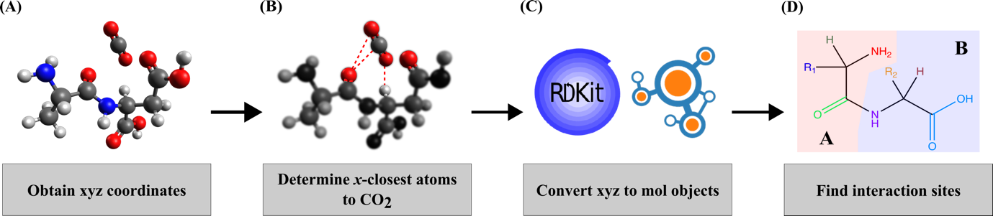
Figure 3.5. Schematic overview of the algorithm for determining interaction sites of CO₂ with dipeptides. The algorithm utilizes (A) the Cartesian (xyz) coordinates of the dipeptide-CO₂ system, (B) determines the n-closest atoms in the dipeptide that interact with CO₂, (C) converts the xyz coordinates into RDKit mol objects, and (D) identifies what subgroups in the dipeptide primarily interact with CO_{2.}

Results and Discussion
Given the complexity that arises from the comparison of multiple, nonadditive interactions of CO₂ with dipeptides (400 molecular supersystem structures, 2:1 ratio) versus the single AA-CO₂ supersystem (20 structures, 1:1 ratio), it becomes evident that a statistical analysis of the computational results can provide a deeper understanding of the underlying electronic phenomena relevant to CO₂ capture. Thus, we present here a comprehensive breakdown of the interactions between CO₂ and dipeptides, as well as a comparison with their individual AA components, for the demonstration of the effects that enhance the CO₂-philicity of dipeptides.
All DFT computed results are summarized in Figure 3.6, where panel (A) of Figure 3.6 presents the distributions (as boxplots) of the interaction energies between CO₂ and single AA, as well as CO₂ with dipeptides, while the breakdown of the interaction energies of the dipeptides per individual AA is given in panel (B). In both boxplots, the minimum or maximum values outside of the lower or upper whisker limit, respectively, are denoted by a circle in Figure 3.6. We have partitioned all 400 data into 20 groups based on their common subunit A (x-axis of the plot in Figure 3.6 (B)), and their corresponding distributions of the interaction energies are given as boxplots. We chose this partitioning scheme to simplify the data analysis since there are 20 possible subunits A, all of which have 20 different subunits B that affect the interaction energies of the corresponding dipeptides uniquely. When compared to the lone amino acids, we found that the dipeptides have a wider spread of interaction energies (Figure 3.6 (A)), ranging from -3.26 kcal/mol (aspartic acid-glycine) to -9.13 kcal/mol (isoleucine-proline). Overall, the 400 dipeptides have a mean interaction energy of -5.22 kcal/mol with a standard deviation of 0.90 kcal/mol, while the mean interaction energy of the AAs is -4.69 kcal/mol with a standard deviation of 0.73 kcal/mol.
The isoleucine-proline dipeptide exhibits the strongest interaction energy (-9.13 kcal/mol) in the data series and thus, we would like to provide some additional discussion on the nature of the noncovalent interactions between CO₂ and the organic molecule. In the optimized supersystem geometry, CO₂ primarily interacts with the carboxylic acid and the pyrrole ring through dipole-induced dipole interactions and is further stabilized by hydrogen bonding interactions between H(CH₂)-O(CO₂), and H(NH₂)-O(CO₂), as it is shown in Figure 3.2 (B). These effects result from the interactions of H atoms located on the pyrrole ring with the more electronegative O(CO₂), and the C(CO₂) with the more electronegative N(pyrrole) and O(COOH). Similar interactions were observed in the single AA-CO₂ supersystems involving isoleucine and proline.¹⁰¹ In the isoleucine-CO₂ supersystem, CO₂ primarily interacts through the carboxylic acid group of the amino acid, specifically with the C(CO₂) and O(COOH), and H(CH₂) with the O(CO₂), yielding an interaction energy of -4.09 kcal/mol. Similar interactions are noted in leucine, where the strongest interaction energy in that single AA series is observed (-5.99 kcal/mol), with CO₂ positioned parallel to leucine rather than head-on as in isoleucine. Proline interacts with CO₂ mainly via its carboxylic acid group and is additionally stabilized by hydrogen bonding interactions between H(pyrrole ring) and O(CO₂), resulting in an interaction energy of -4.25 kcal/mol.
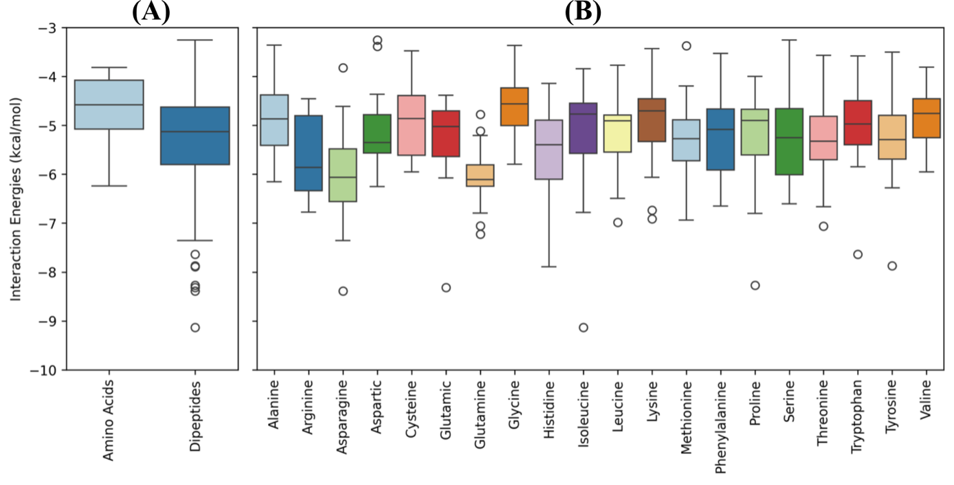
Figure 3.6. Box plot distributions of the CO₂ interaction energies (in kcal/mol) of (A) the single AAs and dipeptides. The CO₂ interaction energies of all dipeptides are further analyzed with respect to the dehydroxylated AA subunit A, that is reported on the x-axis in (B). In both plots, the circles denote values that are considered outliers based on whether they are above or below the upper and lower whisker limit, respectively.

The analysis of the box plots from the partitioning scheme in Figure 3.6 (A) allowed us to further refine the effect of subunits B on the CO₂-philicity of dipeptides and identify what subunits weaken (i.e. the least negative) or strengthen (i.e. most negative) the CO₂ interaction energies. For each of the A subunits (shown in Figure 3.6 (B) on the x-axis), we determined which B subunit corresponded to the strongest interaction based on the absolute minimum, which will be either the lower whisker limit or absolute lower limit, and weakest interaction, which will be either the upper whisker limit or absolute upper limit. The distributions of the strongest and weakest interaction energies are given in Figure 3.7. Overall, the strongest interaction energies per subunit A have a mean of -7.14 kcal/mol, a standard deviation of 0.94 kcal/mol, a minimum value of -9.13 kcal/mol (isoleucine-proline), and a maximum value of -5.80 kcal/mol. We found that asparagine is the most common subunit B for the strongest interaction energies of each dipeptide (Figure 3.7 (A)), which comprises 20% of this molecular subset. In these cases, CO₂ is attracted by the side-chain of the asparagine, which contains a polar formamide functional group linked by a methylene that adds flexibility to the molecular supersystem. The nature of the noncovalent interaction here is mainly an induced dipole-dipole interaction between the polar functional groups and the CO₂. The next subspace is composed of 10% each of histidine, glutamic acid, and glutamine. These amino acids are characterized by polar, CO₂-philic functional groups. Histidine has an imidazole functional group that can form a stable complex with CO₂. In addition to this, the nucleophilic N and O atoms on histidine provide points of interactions via weak hydrogen bonding. Similarly, glutamine and glutamic acids are polar amino acids that can exhibit stabilized non-covalent interactions with CO₂. These include electrostatic interactions, particularly hydrogen bonding interactions, and van der Waals interactions. We conclude that these functional groups, when present in oligopeptides, would enable stabilized non-covalent interactions with CO₂, which are further enhanced via cooperativity with neighboring amino acids.
Using the computational procedure proposed in Figure 3.5, we determined that the most common interactions with CO₂ occur either with the side-chain of subunit B or the carbonyl group of subunit A in these dipeptides.

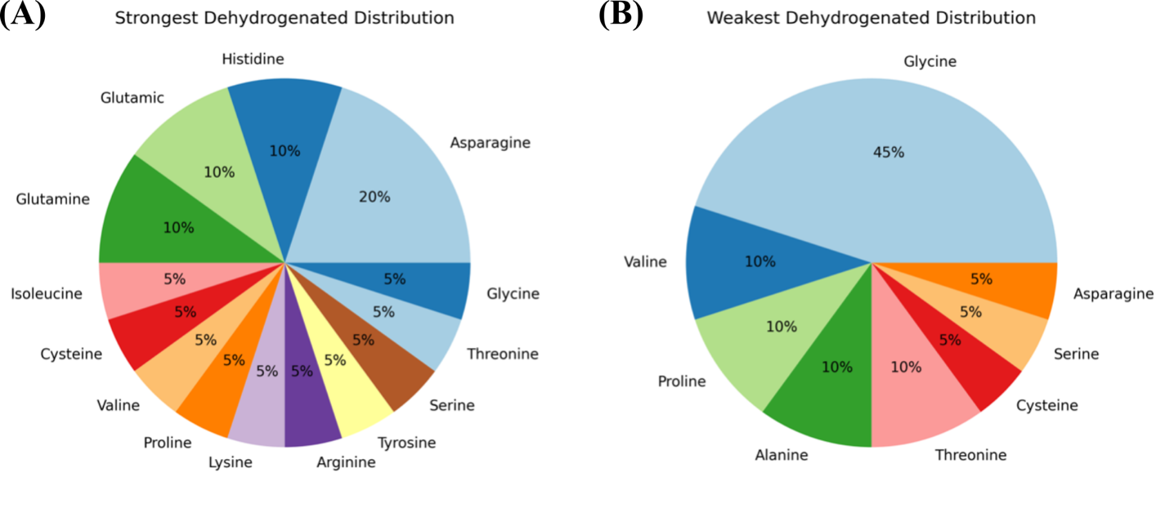
Figure 3.7. Distributions of the most common dehydrogenated subunit B that have (A) strongest and (B) weakest interaction energies with CO₂.

The weakest interaction energies per subunit A, i.e. the upper extrema or least negative values on the box plots, have a mean of -3.74 kcal/mol, standard deviation of 0.43 kcal/mol, minimum of -4.78 kcal/mol, and maximum of -3.26 kcal/mol. Concerning this space, we found that the most common subunit B for the weakest interaction energies of each dipeptide, shown in Figure 3.7 (B), corresponds to glycine, which composes 45% of this space. For this subspace that contains 45% B subunits, the corresponding A subunits are alanine, asparagine, aspartic acid, cysteine, leucine, methionine, proline, threonine, and valine. Our analysis determined that the main interaction sites are the carbonyl group, primary amine, or side-chain of subunit A. For the glycine-containing dipeptides, analysis of the subunit B revealed that the interaction occurs at the secondary amine or the carboxylic acid groups. For these systems, none of the interactions occur with the linking hydrogen of subunit A or the linking and side-chain hydrogens of subunit B, since glycine has less favorable interaction energies due to the absence of a flexible side-chain molecular group. In general, for the dipeptide subset with the weakest interactions, CO₂ is attracted mostly by the carbonyl or carboxylic acid groups of these dipeptides.
Next, we examined the 2:1 cooperative binding from the presence of multiple CO₂-phylic groups in the dipeptide molecular structures. For that purpose, we organized the 400 dipeptides based on the AA types in subunits A and B, and we compared the computed interaction energies with those obtained from single AAs. This analysis provided the net effect (increasing or decreasing) introduced by the molecular cooperativity. Precisely, we noticed a 74% and 72% increase in the interaction energies of the dipeptides for subunits A and B, respectively, as compared to those from the lone AAs (Figure 3.8). With respect to the dipeptides with interaction energies that are less favorable than their corresponding subunits, 26% subunit A and 28% subunit B (Figure 3.8), the two most common A subunits are glycine and alanine, and B subunits are valine and alanine. These three AAs (glycine, valine, and alanine) are characterized by short side-chains (-H, -CH(CH₃)₂, and -CH₃, respectively), and they have a CO₂-phobic character that does not help stabilize the CO₂ interaction within the compound. A detailed analysis of the percent improvement of each dipeptide subunit with respect to the lone AAs is shown in Figure 3.9. These results are then condensed in Figure 3.10 to show that, on average, when leucine is present as subunit A or B, the interaction energy has a -1.25% percent improvement with respect to the lone leucine AA, and that the subunits with the five best percent improvements (ranging from 19-25%) are glutamine, isoleucine, cysteine, proline, and tryptophan.
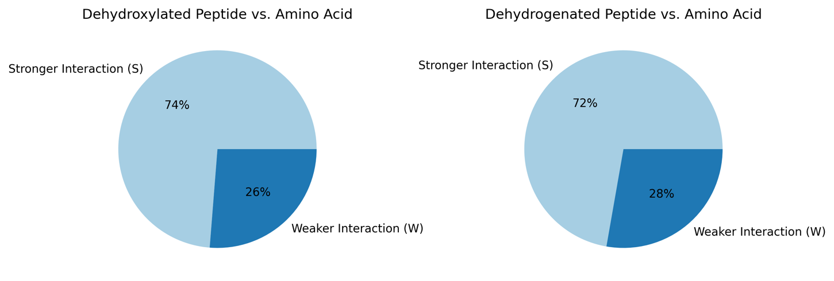
Figure 3.8. Percent amount of dipeptides with stronger (S) or weaker (W) interaction energies than the analogous single amino acids that correspond to the dehydroxylated subunit A (left) and dehydrogenated subunit B (right).


Figure 3.9. Percent improvement distribution bar plots of the for each subunit A for each subunit B (x-axis).
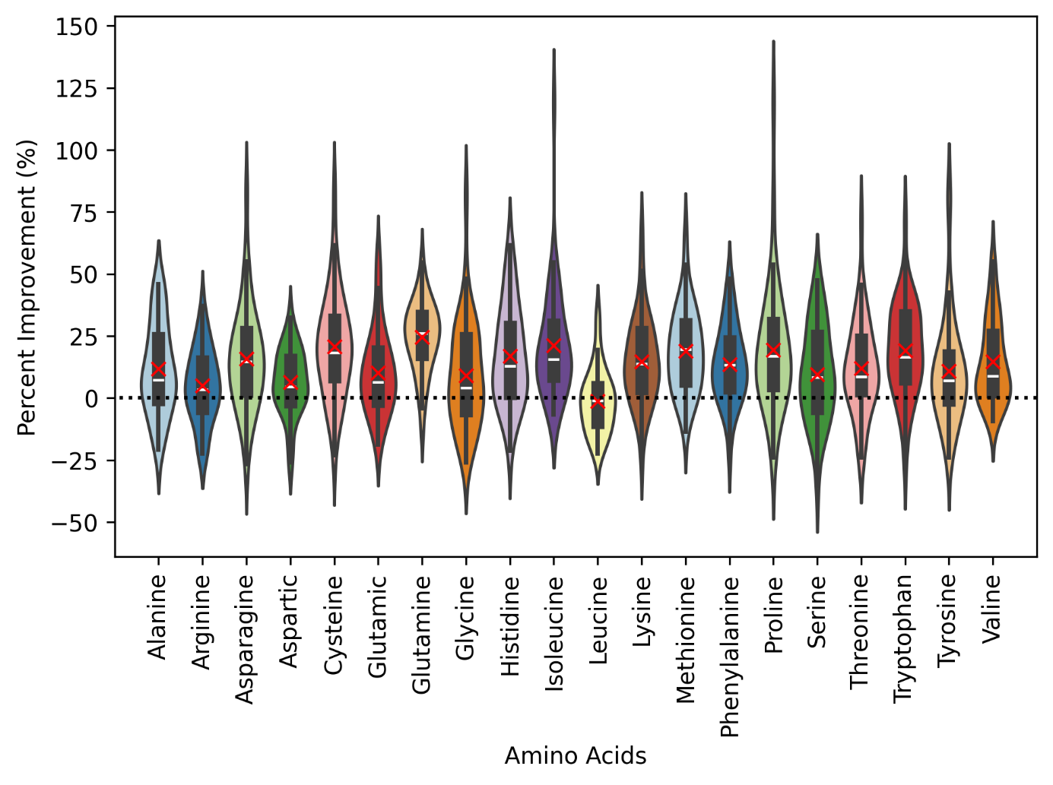
Figure 3.10. Violin plots of the combined percent improvement (y-axis) for both subunit A and B for each amino acid (x-axis). The red X marks denote the mean percent improvement while the black dashed line denotes zero percent improvement.

Lastly, we analyzed the collected results concerning the number of interactions to a predetermined molecular group, as shown in Figure 3.11. All interaction energies are grouped into different boxplots based on the type of the interaction site. Overall, we considered four different molecular types: amine groups, carbonyl groups, carboxylic acid groups, hydrogen forming weak hydrogen bonds, and side chain groups characteristic of each AA. Since we used n = 1 for the number of neighbors that can interact with each atom in CO₂, three possible interactions can occur between CO₂ and the interaction site. In all plots of Figure 3.11, the x-axis denotes the number of CO₂ atoms that interact with the predominant sites of the dipeptides. For example, the value three means that all atoms of the CO₂ molecule are close to the atoms in a specific substructure of the dipeptide. In the first column of Figure 3.11, we compare the interaction energies of the amine groups of subunits A (Figure 3.11 (A)) and subunits B (Figure 3.11 (E)). The distribution of the interaction energies of CO₂ with the dipeptides where A subunits interact via the amine group have a mean of -5.47 kcal/mol, median of -5.40 kcal/mol, maximum of -3.26 kcal/mol, and minimum of -9.13 kcal/mol, while the B subunits via the amine group have a mean of -5.14 kcal/mol, median of -4.89 kcal/mol, maximum of -3.77 kcal/mol, and minimum of -8.39 kcal/mol. Overall, interactions with the secondary amine in subunit B appear more often (111 interaction sites) versus the primary amine in subunit A (75 interaction sites). Of these 111 cases, 79 correspond to one-, 26 to two-, and 6 to three interactions with CO₂, whereas subunit A only has 63 one- and 12 two-nearest-neighbor interactions with the secondary amine.
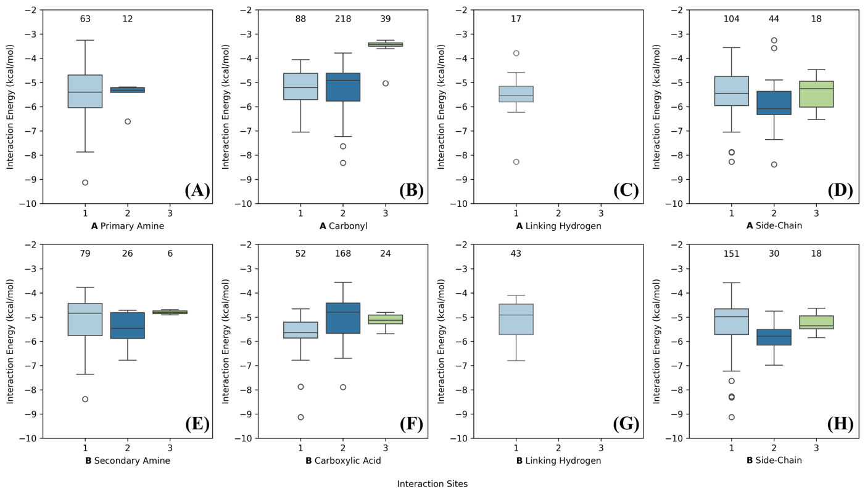
Figure 3.11: Boxplots of the interaction site for the dehydroxylated (A; top row (A-D)) and dehydrogenated (B; bottom row (E-H)) dipeptide subunits. The enumeration on the x-axis denotes the number of CO₂ atoms that are near to the specific site of the dipeptide. In each plot, the circles denote values below and above the lower and upper whisker limit, respectively, while the numbers above each box denote the population of each case.

For the carbonyl groups (subunit A; Figure 3.11 (B)) and carboxylic acid group (subunit B; Figure 3.11 (F)), the interaction energies of the A subunits have a mean of -5.13 kcal/mol, median of -4.94 kcal/mol, maximum of -3.26 kcal/mol, and minimum of -8.31 kcal/mol, while the interaction energies of the B subunits have a mean of -5.27 kcal/mol, median of -5.18 kcal/mol, maximum interaction energy of -3.57 kcal/mol, and minimum interaction energy of -9.13 kcal/mol. For this group of interactions, CO₂ is preferably attracted by the carbonyl group of subunit A (345 interaction sites) over the carboxylic acid of subunit B (244 interaction sites). Unlike with the other sites in Figure 3.11 (amine groups, linking hydrogen forming weak hydrogen bonds, and side chain groups characteristic of each AA), for this two-nearest neighbor class of interactions, CO₂ prefers to be in close proximity to either the carbonyl (218) or carboxylic acid (168) groups of subunits A and B, respectively. The second most common interactions for this class are for one-nearest-neighbor interactions, 88 and 52, for subunits A and B, respectively. The least common site for the carbonyl/carboxylic acid interactions are three-nearest-neighbor interactions, where subunit A has 39 interactions and subunit B has 24.
The third class of interactions are the least common type, where the interactions occur between CO₂ and the hydrogen on the linking carbon of either subunit A (Figure 3.11 (C)) or B (Figure 3.11 (G)), 17 and 43 interactions, respectively. For those cases, the A subunits have a mean of -5.53 kcal/mol, median of -5.55 kcal/mol, maximum interaction energy of -3.79 kcal/mol, and minimum interaction energy of -8.27 kcal/mol, while the B subunits have a mean of -5.10 kcal/mol, median of -4.92 kcal/mol, maximum interaction energy of -4.10 kcal/mol, and minimum interaction energy of -6.80 kcal/mol.
Lastly, we analyze the distributions of the interaction energies with the side-chains of each dipeptide subunit. We found that this class of interactions are the second most common, with a total of 365 cases between subunits A (Figure 3.11 (D)) and B (Figure 3.11 (H)), since carbonyl/carboxylic acid have a total of 589 sites. For subunits A, the one-, two-, and three-nearest-neighbors have a count of 104, 22, and 6, respectively, whereas the B subunits have a count of 151, 15, and 6, respectively. We see that the A subunits have a mean of -5.51 kcal/mol, median of -5.49 kcal/mol, maximum of -3.26 kcal/mol, and minimum of -8.39 kcal/mol, while the B subunits have a mean of -5.33 kcal/mol, median of -5.10 kcal/mol, maximum interaction energy of -3.58 kcal/mol, and minimum interaction energy of -9.13 kcal/mol. Overall, more interactions occur with the B subunits, which also have a more attractive maximum and minimum interaction energy. Based on the previous analysis, we observe on average that the interaction with the primary amine of the A subunits is more favorable than the interaction energy of the secondary amine group on the B subunits. We also observe that, while more interactions occur with the secondary amine on subunit B, this interaction is less energetically favorable. This is due to the additional stabilization introduced by hydrogen bonding interactions in the A subunit coming from both hydrogen atoms of the amine groups, as opposed to just one H atom in the B subunit. We also found that the most common type of interactions of CO₂ with dipeptides occur through the carbonyl or carboxylic acid groups of subunits A and B, respectively. The interactions with the carboxylic acid of the B subunits are more energetically favorable, but less common than the interactions with the carbonyl group of the A subunits. Next, we analyzed the least common interaction, which occurs between CO₂ and the hydrogen attached to the linking carbon in a single AA. Overall, there are more interactions with subunit B, which has a tighter statistical distribution, than with subunit A, which has a higher maximum and lower minimum interaction energy. Lastly, we found that the interaction of CO₂ with the side-chains of subunits A and B have very similar distributions, with very similar counts. Overall, the side-chain of A is slightly more favorable than the side-chain on the B subunit. A plausible explanation to this observation is that there is less steric hinderance on the side group of the dehydroxylated A subunit which has three terminal atoms (NH₂ group) compared to the dehydrogenated B subunit that has four terminal atoms (carboxylic acid).

Summary of Key Results
In this study, we have explored physicochemical aspects on CO₂ capture utilizing a bioinspired strategy based on molecular structures of dipeptide units. We hypothesized that an AA pair can cooperatively bind CO₂ molecules through noncovalent interactions which is relevant to direct air capture technologies, given than physisorption is the first step prior to the formation of covalent bonds. We have developed a computational workflow based on cheminformatics tools for the examination of all possible AA pairs and the automated evaluation of computational chemistry data. The developed approach systematizes the placement of CO₂ onto 400 unique dipeptide structures, generating initial geometries for DFT computations. Subsequently, the second algorithm identifies complex interaction sites for statistical analysis. Our analysis found that, in general, dipeptides have more diverse and increased interaction energies than the lone single AA that compose them, an argument on CO₂ binding enhancement introduced by cooperative effects. We found that the choice of dehydrogenated subunits (B subunits) affects the overall interaction energies of the dipeptides. Most dipeptides (72-74%) have stronger CO₂-philicity than their single AAs counterparts. The most common B subunit in a dipeptide that weakens the interaction energy corresponds to glycine (45% occurrence), while the most common B subunit that strengthens the interaction energies is asparagine (20% occurrence). With respect to the effects of nearest-neighbor interactions, the most common interactions occur between CO₂ and the carbonyl and carboxylic acid groups of subunits A and B, respectively. An important observation based on the nearest-neighbor interactions is that among the 10 dipeptides with the strongest CO₂ affinity, none of them have a 3-nearest-neighbor interaction with CO₂ from a single site.
Based on these insights, we propose the targeted design of materials that integrate dipeptide molecular units, such as those composed of asparagine, histidine, glutamic acid, and glutamine subunits. These AA subunits, characterized by their polar and flexible side chains, exhibit enhanced interaction energies with CO₂. Furthermore, our previous research identified certain lone single AAs such as leucine, and asparagine, which also demonstrate increased interactions with CO₂, when compared to other AAs.¹⁰¹ One strategy to incorporate the outcomes from our statistical analysis into innovative DAC technologies is to exploit cooperative interactions aimed at developing novel materials integrated with CO₂-philic groups. The statistical insights highlight the significance of cooperative interactions among electron-rich functional groups in dipeptides for CO₂ capture. These findings offer valuable guidance for designing novel dipeptide-based materials for DAC of CO₂. Given than AAs and dipeptides are present in solution as zwitterions, conclusions from this study are applicable to solid sorbents. Alternatively, to optimize the process design of AAs integrated into solvent-based DAC technologies, it is imperative to optimize the kinetics, thermodynamics, and solvent regeneration energies, as well as conducting techno-economic analyses becomes essential for estimating their real-world performance, particularly concerning cyclic capacities and regeneration energies. Our group is currently exploring this parameter space for the further optimization of the chemical environments that can enhance selective CO₂ capture in solution.

Assessing Tripeptide Interactions with CO₂ through Computational Studies
Disclosure: The following chapter is the current draft of a manuscript scheduled for submission in Summer 2025, authored by Dr. Konstantinos D. Vogiatzis (principal investigator) and me. Electronic structure theory calculations, including density functional theory and symmetry-adapted perturbation theory, database generation and curation of 8000 tripeptides, TriScore metric development, and data analyses were performed by me. All sections were written by me under the supervision of Dr. Konstantinos D. Vogiatzis.

Introduction
Carbon dioxide (CO₂) is the main greenhouse gas produced by human activity, released in large amounts through routine socio-economic activities such as transportation, energy generation, chemical production, and various industrial processes.¹⁸⁰ Its prolonged accumulation in the atmosphere has significantly accelerated climate change, a scenario that demands increasing attention. This urgency emphasizes the essential need for reaching net zero by fully eliminating CO₂ emissions.¹⁸¹ While the transition to renewable energy and the reduction of carbon emissions are critical components of this effort, carbon capture, utilization, and storage (CCUS) technologies have also become vitally important.¹⁸²⁻¹⁸⁵
Carbon capture technologies are generally divided into three segments: post-combustion, pre-combustion, and oxyfuel combustion.¹⁸⁶ Among them, post-combustion carbon capture stands out as the most commonly used technology, frequently employed in industrial settings, especially by upgrading existing fossil fuel power plants with capture systems.¹⁸⁷ The post-combustion carbon capture method captures CO₂ after burning fuel sources like natural gas or coal.¹⁸⁸ Pre-combustion capture extracts CO₂ from syngas before it is burned.¹⁸⁹ Oxyfuel combustion employs an oxygen-rich reaction process, resulting in a high concentration of CO₂ in the flue gas, although it incurs significant costs.¹⁹⁰ In contrast, direct air capture extracts CO₂ directly from the atmosphere, regardless of location.^{191, 192}
Carbon capture processes utilize various methods to capture CO₂, including absorption, adsorption, cryogenic, and membrane-based separation. The absorption method involves solvents such as alkanolamines and sodium carbonate that chemically bond with CO₂, creating reversible bonds only at very high temperatures.¹⁹³ Adsorption methods primarily employ solid sorbents like MOFs, zeolites, and activated carbon, which provide excellent adsorption capacity and thermal stability, though they suffer from low selectivity and moisture resistance.¹⁹⁴ Cryogenic technologies chill CO₂-rich flue gas to subzero temperatures, allowing for the separation of solid CO₂ and the production of a compressed CO₂ stream from an atmospheric pressure light-gas feed.¹⁹⁵ Membrane-based CO₂ capture uses selective materials that allow CO₂ to pass preferentially from a gas mixture. This separation leverages differences in gas permeation behavior, which is influenced by the relative diffusivity of each gas and its tendency to adsorb onto the membrane's surface.¹⁹⁶
Amine-based chemisorption is widely used in industry due to its strong reactivity. However, regenerating amine solvents demands significant energy and may generate corrosive degradation products, high volatility, and harmful amine emissions. Consequently, there is growing interest in alternative CO₂ capture techniques that lower energy use while maintaining selectivity and chemical stability.
Nature provides key design principles for selective CO₂ binding. The enzyme ribulose-1,5-bisphosphate carboxylase/oxygenase (RuBisCO) binds atmospheric CO₂ by forming a carbamate at a lysine residue in its active site.^{197, 198} Nonetheless, RuBisCO is inadequate for engineered systems due to its low CO₂ turnover, significant molecular weight, and high water dependence. Despite this, RuBisCO–especially its active site–can inspire the development of sustainable carbon capture technologies.^{199, 200} This bioinspiration can be realized by incorporating key amino acids or oligopeptides into carbon capture systems.
Amino acids have advantageous properties such as rapid CO₂ reactivity, minimal toxicity, chemical adjustability, low volatility, and environmental compatibility.⁷¹ More recently, these small peptides have gained attention as viable options for CO₂ capture, particularly because of their structural flexibility and the potential to precisely modify their reactivity by altering their sequences and lengths. 56, 78-80, 90, 94, 96, 101, 158, 161
One major challenge in fully exploring the potential of peptides for CO₂ capture and separation is predicting the interactions between CO₂ and peptides of different sizes and complexities. Although individual amino acid interactions with CO₂ have been extensively studied, the transition to oligopeptides introduces cooperative interactions and conformational effects that remain partially characterized. Dannenberg examined peptide behavior within a solid-state framework and discovered that these peptides undergo cooperative interactions not completely represented in solution-based models.²⁰¹ Mahadevi and Sastry emphasized in their research on supramolecular chemistry and biomolecular folding that cooperativity is vital for stabilizing biomolecules. This synergistic effect is essential when designing peptide-based capture systems. Likewise, similar behavior is anticipated when peptide units within an oligopeptide interact with CO₂.²⁰²
In our previous work, we investigated the cooperative interactions evident in dipeptides-CO₂ complexes compared to natural amino acid-CO₂. We discovered that polar functional groups greatly improve the stability of these interactions. This is particularly crucial as we examine larger oligopeptides, such as tripeptides, in this study. Without a framework that accounts for these synergistic effects, the rational design of effective peptide-based CO₂ sorbents remains limited.
In this study, we present a structure-based metric that incorporates the distribution of polar functional groups alongside the intrinsic energetic profiles of amino acid and dipeptide building blocks to facilitate a high-throughput screening of thousands of candidates, establishing a systematic approach for peptide optimization. A subset of predicted high- and low-performing tripeptides was further assessed using DFT and SAPT0 calculations to measure gas-phase CO₂ interaction energies.

Computational Details

Database Development
To construct the initial dataset, we generated all possible tripeptide combinations from the 20 natural amino acids, taking into account sequence order to produce a diverse set of molecular structures with 8,000 molecular entries. The molecular representations of the amino acid units were first created using the Simplified Molecular Input Line Entry System (SMILES), ^{166, 167} a widely used format that encodes chemical connectivity and stereochemical information as ASCII strings.^{168, 169} Chirality was explicitly defined within the SMILES representation to ensure that all amino acids adopted the L-enantiomeric configuration, reflecting the biological standard of proteinogenic amino acids, which are naturally incorporated into proteins. ¹⁷⁰ The Cartesian coordinates were generated from the initial three-dimensional geometries of the generated tripeptides using the experimental torsion knowledge distance geometry (ETKDG)¹⁶⁴ algorithm as implemented in RDKit.¹⁶⁵

Molecular Structure Formation
To investigate the nuanced interactions between tripeptides and CO₂, careful consideration is needed regarding the diverse polar functional groups embedded within their structures. Functional groups such as carboxylic acids, carbonyls, amines, peptide bonds, hydroxyls, and thiols influence the unique electronic effects that significantly impact CO₂ binding. For example, carboxylic acid can engage in dipole-induced dipole interactions with CO₂, further stabilized through hydrogen bonding between the oxygen of CO₂ [O(CO₂)] and the hydrogen of the carboxylic acid [H(COOH)]. Across the tripeptides' structural database, we also observe sequence-specific variations resulting from the permutation of amino acid units. For instance, six distinct tripeptides can be formed from the amino acid subunits Glycine (Gly), Alanine (Ala), and Valine (Val): Ala-Gly-Val, Gly-Ala-Val, Val-Gly-Ala, Gly-Val-Ala, Val-Ala-Gly, and Ala-Val-Gly. This diversity introduces variations across the tripeptides' chemical space, which can affect the CO₂ interaction profiles. We also expect that cooperative effects will be observed due to the presence of a collection of functional groups in the tripeptides, as noted in our previous study, where, on average, dipeptides interact more stably with CO₂ than amino acids.¹⁵⁸
We previously developed an algorithm capable of systematically generating initial CO₂-ologopeptide complexes, and we used that algorithm to generate the initial CO₂-tripeptide complexes targeting the carbonyl-rich regions of the molecules.¹⁵⁸ Each tripeptide has at least three carbonyl groups resulting from peptide/amide bonds, primary carboxylic acid groups, and additional side chain carbonyl or carboxylate groups. Using this protocol, we developed 8,000 distinct CO₂-tripeptide geometries for further analysis. The algorithm first identifies carbonyl functional groups within the tripeptide structure. A CO₂ molecule is then positioned relative to the carbonyl oxygen at a fixed bond distance (R) of 2.8 Å between the CO₂ carbon atom [C(CO₂)] and the carbonyl oxygen [O(CO)], while maintaining a bond angle (θ) of 180° with the carbonyl carbon atom [C(CO)]. A dihedral angle (φ) of 0° is enforced between the carbon of CO₂ and the carbonyl group, as well as the nearest R'. The CO₂ oxygen atoms are symmetrically arranged around the carbon center, with C-O bond distances set to 1.15 Å (Figure 3.1).

TriScore Metric Development
To quantify the potential of tripeptides to strongly interact with CO₂, we developed a scoring function called the TriScore metric (Equation 4.1). This metric integrates structural and energetic factors: the number of carbonyl (C=O) groups, the number of primary amine (-NH₂) groups, the normalized interaction energies of the three amino acid residues within the tripeptide, and the normalized interaction energies of all ordered dipeptide combinations formed from these residues.
The interaction energies are normalized using an inverted min-max scaling function, applied separately to the amino acid and dipeptide datasets (Equation 4.2). Within each dataset, the most favorable, that is, the most negative interaction energy, is assigned a value of 1, while the least favorable is assigned a value of 0. This inversion ensures that higher TriScore values reflect tripeptides composed of more energetically favorable amino acid and dipeptide subunits. Structural contributions from carbonyl and primary amine groups were included based on previous studies involving amino acids^{101, 122, 203, 204} and dipeptides,¹⁵⁸ which suggested that these functional groups often participate in stabilizing non-covalent interactions with CO₂.
 | TriScore Metric = $\left(number of CO\right)+$ $\left(number of {primary NH}_{2}\right)+\sum_{i=1}^{3}{Norm E_{int\left(AA\left(i\right)-{CO}_{2}\right)}}+\sum_{\begin{aligned}I,j=1 \\ i≠j\end{aligned}}^{3}{Norm E_{int\left(AA\left(i\right)-AA\left(j\right)-{CO}_{2}\right)}}$ | Equation 4.1
 | Modified/inverted min-max scaler (lowest value =1)  $$=Norm E_{int}=1-\frac{E_{int}-E_{int_min}}{E_{int_max}-E_{int_min}}$$ | Equation 4.2

For example, the TriScore for the tripeptide Gly-Ala-Val was determined by adding the contributions from three carbonyl groups, one primary amine group, the normalized interaction energies of the three amino acids, and the nine potential dipeptide combinations derived from them. This calculation resulted in a normalized energy contribution of 1.3085, alongside four structural points from functional groups, yielding a total TriScore of 5.3085.
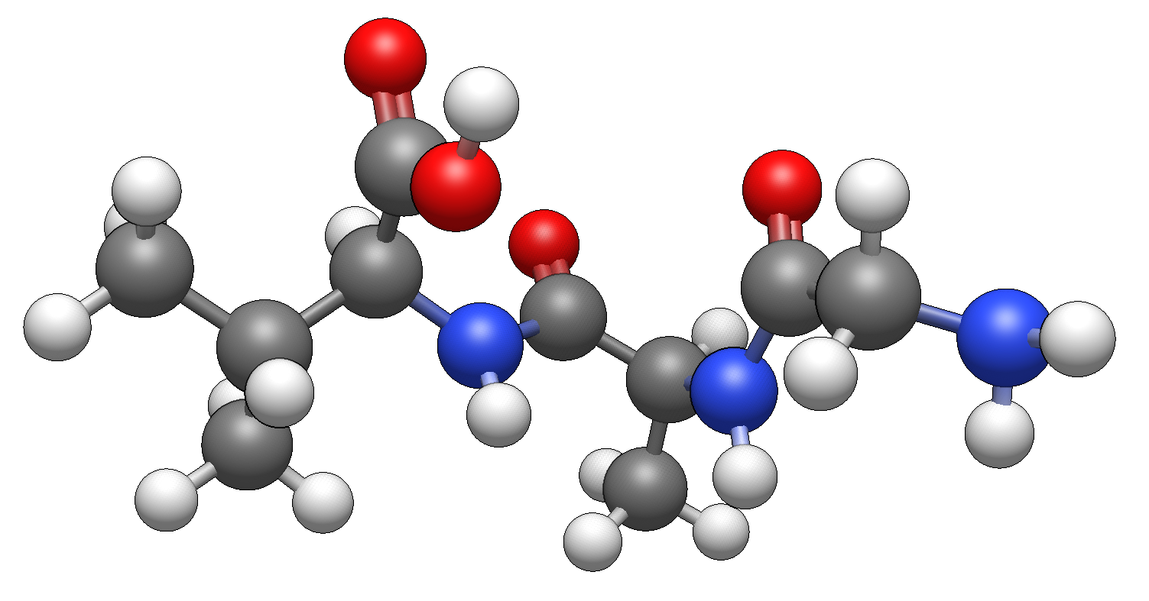
Figure 4.1. The structural conformation of Gly-Ala-Val tripeptides includes three carbonyl groups and one primary amine group, both of which are considered in calculating the TriScore.

In contrast, the tripeptide Gln-Asn-Arg, which has a greater concentration of polar functional groups such as multiple amides and a guanidinium moiety, achieved a notably higher score. This tripeptide accounted for nine structural points (from five carbonyl and four primary amine groups) and had a normalized energy sum of 6.8992, giving a TriScore of 15.8992. The significant discrepancy between Gly-Ala-Val and Gln-Asn-Arg highlights how TriScore accurately captures both the energetic favorability of the constituent subunits and the critical role of polar functional groups in CO₂ binding. Together, these components make TriScore, a predictive and interpretable metric for high-throughput screening of tripeptides with strong CO₂ binding affinity.
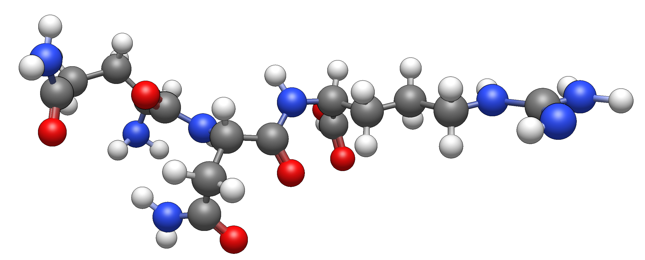
Figure 4.2. The structural conformation of Gln-Asn-Arg tripeptides includes three carbonyl groups and one primary amine group, both of which are considered in calculating the TriScore.

Quantum Chemical Conformational Screening and Geometry Optimization of Tripeptides
Tripeptides possess numerous conformational possibilities due to their flexible backbones. This necessitates conducting a conformational screening to effectively explore the conformational space and identify low-energy conformations that more accurately represent the molecules' properties. The Conformer-Rotamer Ensemble Sampling Tool (CREST, version 3.0.2)²⁰⁵ was utilized alongside the GFN2-xTB²⁰⁶ method to explore the conformational space of the molecules and optimize their structures. The most stable tripeptide conformers were further analyzed using geometry optimization with density functional theory (DFT). The same workflow was applied to determine the most stable supersystems for each tripeptide, which included the tripeptide and a molecule of CO₂.
DFT geometry optimizations were carried out using the PBE0 density functional along with Grimme’s dispersion correction (D3),²⁰⁷ the resolution of identity (RI) approximation,¹³² the def2-TZVPP¹³³ basis set, and the m4 grid.^{133, 153} To confirm the identification of minima across the potential energy surfaces, molecular vibrational frequencies were calculated for the optimized geometries. All DFT calculations were performed using the TURBOMOLE 7.2.1¹⁷¹ quantum chemical program package. The interaction energies E_{int} were calculated as the difference between the energy of the optimized supersystem and the energies of the optimized dipeptide and CO₂ geometries:
 | $${E_{int}=E}_{Tripeptide-{CO}_{2}} -E_{Tripeptide}- E_{{CO}_{2}}$$ | Equation 4.1
This is a supermolecular approach²⁰⁸ to determining the noncovalent interaction energy. PBE0-D4/def2-TZVPP level of theory was selected as it has been proven to perform well in describing non-covalent interactions in amino acids, oligopeptides and similar organic molecules, based on benchmark results using explicitly-correlated coupled-cluster singles-and-doubles with perturbative triples or CCSD(F12)(T) at the complete basis set limit (CBS).¹⁰¹
Another approach to determining the non-covalent interaction energy is the perturbative approach,²⁰⁸ which directly computes the interaction energy of the system as a perturbation to the individual monomers. The most common example is the symmetry-adapted perturbation theory (SAPT) where the dimer’s Hamiltonian with respect to monomers A and B is described as follows:
 | $$H=F_{A}+W_{A}+F_{B}+W_{B}+V$$ | Equation 4.4
Where F is the Fock operator, W is the fluctuation potential of each monomer, and V is the interaction potential. The interaction energy is calculated via perturbative expansions of W and V while F is treated as zeroth-order Hamiltonian.¹⁷² The main advantage of SAPT is to decompose non-covalent interaction energy into electrostatic, induction, dispersion, and exchange repulsion terms, which is the reason for its use in this study. The aug-cc-pVDZ basis sets were used for this SAPT analysis, with density fitting using the Psi4 program.¹⁷³⁻¹⁷⁶

Results and Discussion

Statistical Analysis of the Dataset
We conducted a statistical analysis to assess the predictive capabilities of our TriScore metric regarding the interaction energies of tripeptides with CO₂. Specifically, we compared the energetic properties of the top 20 and bottom 20 tripeptides as ranked by TriScore. This approach verifies that the TriScore, which captures structural features like carbonyl and amine group counts as well as normalized energetic contributions, effectively correlates with the interaction energies.
Firstly, we obtained the normal curve of the full TriScore distribution across 8000 tripeptides, which reveals that the mean TriScore value is approximately 8.0 (Figure 4.3). Vertical dashed lines are used to highlight the two extremes of the distribution: the bottom 20 tripeptides (TriScore ≤ 5.05) and the top 20 (TriScore ≥ 15.77). These subsets, each constituting 0.25% of the total dataset, were chosen for further analysis, as they represent molecules that are abundant or deficient in pivotal functional groups.
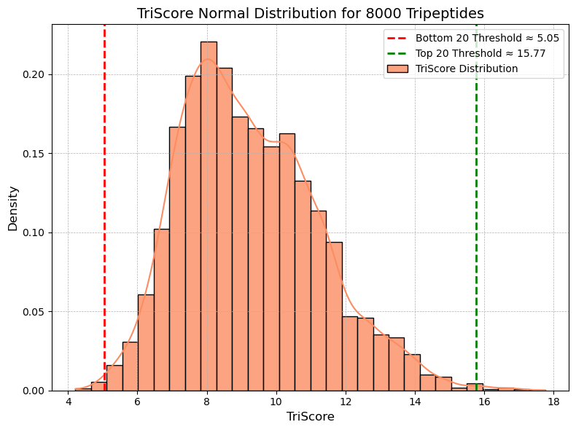
Figure 4.3. TriScore normal distribution plot, with threshold markers indicating the bottom 20 tripeptides, having TriScore $≤$ 5.05, and top 20 tripeptides having $≥$ 15.77.

DFT-D4/def2-TZVPP calculations were performed to determine the interaction energies for all 40 tripeptides in the high and low TriScore subsets. The tripeptides with high TriScores show more favorable interaction energies with CO₂, averaging -14.25 kcal/mol, whereas those with low TriScores demonstrate weaker interaction energies with CO₂, averaging -9.39 kcal/mol. An illustration of these statistical differences is presented in Figure 4.4. This variation indicates that the TriScore metric effectively identifies features that enhance noncovalent binding, such as hydrogen bond donors (e.g., NH₂) and electron-rich acceptors (e.g., C=O groups), which promote dipole–quadrupole and hydrogen bonding interactions with CO₂.
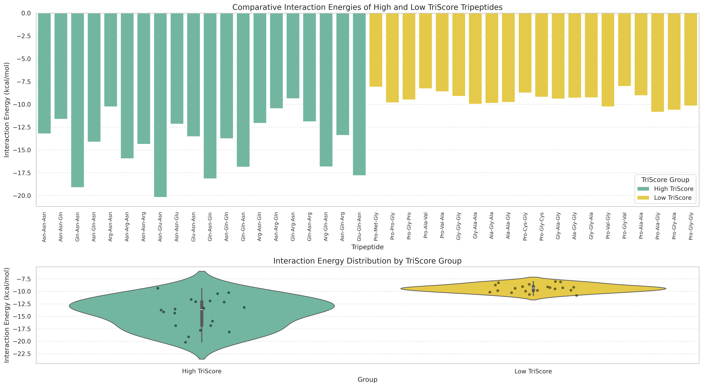
Figure 4.4. Comparative tripeptide interaction energies (in kcal/mol) with CO₂ computed across 40 tripeptides and grouped by TriScore classification. High TriScore sequences (green) demonstrate generally stronger interactions than Low TriScore sequences (yellow), consistent with their differing functional group enrichments.

We found that the high TriScore tripeptides exhibit greater variability in binding strength compared to the low TriScore tripeptides (Figure 4.5), ranging from -9.36 to -20.18 kcal/mol and -8.09 to -10.84 kcal/mol, respectively. This spread likely reflects a diversity in polar functional groups, such as carbonyl, amine, amide, hydroxyl, carboxylic acid, and thiol, which enables more opportunities for strong electrostatic interactions and hydrogen bonding with CO₂. Asn-Glu-Asn tripeptide, which exhibits the highest interaction energy with CO₂ (-20.18 kcal/mol) interacts strongly with CO₂ via the two-peptide backbone (amide functional groups) mainly through a combination of dispersion and electrostatics interactions. The configuration of this complex has CO₂ positioned where it cooperatively interacts closely with functional groups like the amide functional groups, and long range interaction through groups like carboxylic acid and amine (Figure 4.6). In contrast, low TriScore tripeptides show fewer variations in polar functional groups, thereby limiting the opportunities for non-covalent interactions with CO₂.

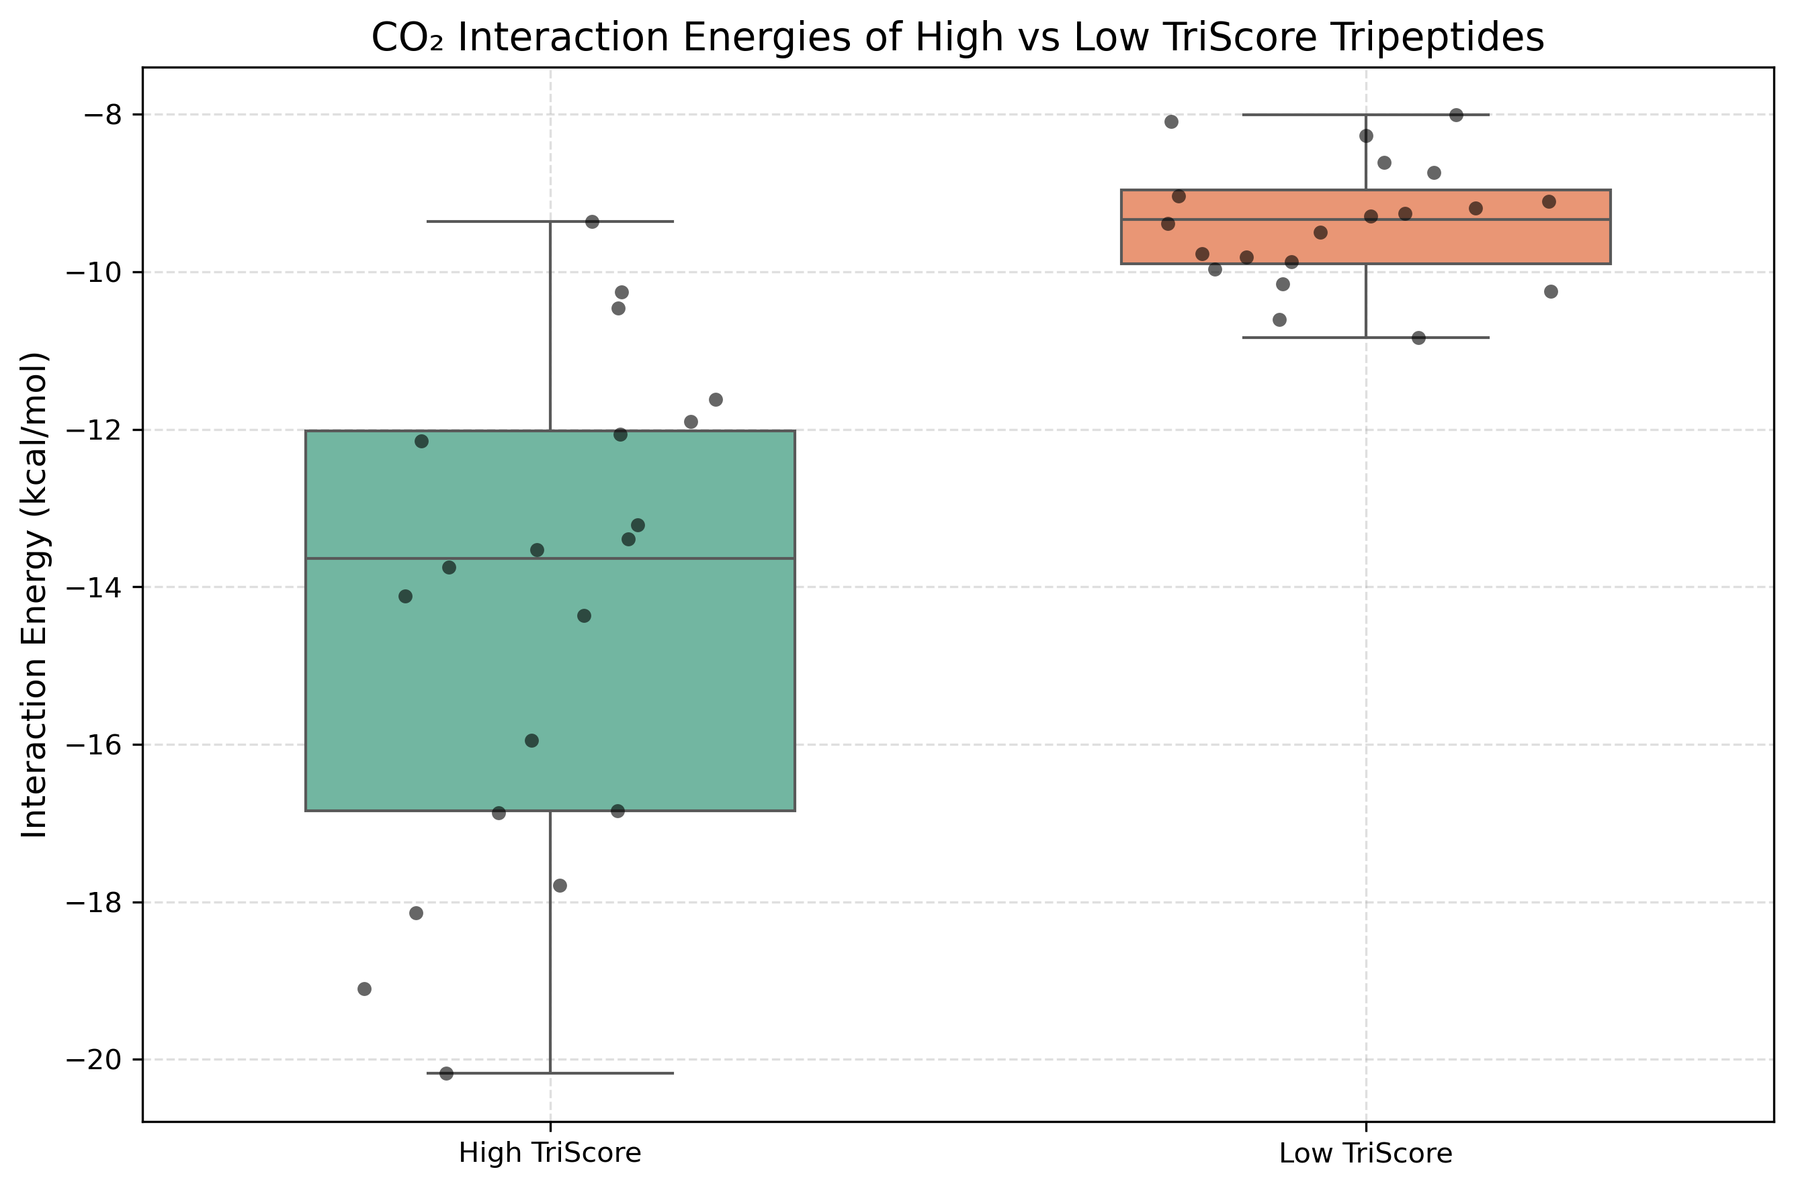
Figure 4.5. Box plot distributions illustrating the DFT-D4/def2-TZVPP interaction energies of tripeptides and CO₂ (in kcal/mol) to compare the interaction energies of the top 20 (teal green), and bottom 20 tripeptides (orange) ranked by the TriScore metric. High TriScore tripeptides have more stable interaction energies than low TriScore tripeptides.

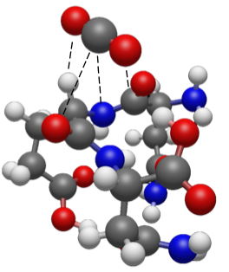
Figure 4.6. Asn-Glu-Asn complex interacting with CO₂ group primarily through two peptide groups and a carboxylic acid functional group.

Overall, these data support the conclusion that TriScore is a chemically meaningful and statistically robust metric for assessing the propensity of CO₂ interactions with tripeptides. The observed correlation between the metric scores and the interaction energy can facilitate rapid library screening before quantum chemical calculations are performed. In the next section, we explore specific representative examples from both the high and low TriScore groups, for which we also performed DFT as well as SAPT computations to quantitatively describe the different contributions to the non-covalent interactions with CO₂. Following that, we present a machine learning model for predicting the DFT interaction energies from SAPT0-derived features from GFN2-xTB-generated conformers that have not undergone any prior DFT optimization. A complete table listing the DFT-D4 interaction energies and TriScore of the 40 analyzed tripeptides is provided in Table 4.1 and Table 4.2 below.

Table 4.1. PBE0-D4/def2-TZVPP interaction energy, TriScore, NH_{2,} and C=O counts for the top 20 tripeptides ranked by the TriScore metric.
 | Tripeptides name | TriScore | NH₂ count | C=O count | Interaction energy (kcal/mol)
1 | Asn-Asn-Asn | 17.76 | 4 | 6 | -13.21
2 | Asn-Asn-Gln | 17.01 | 4 | 6 | -11.62
3 | Gln-Asn-Asn | 17.01 | 4 | 6 | -19.10
4 | Asn-Gln-Asn | 17.01 | 4 | 6 | -14.12
5 | Arg-Asn-Asn | 16.69 | 4 | 5 | -10.26
6 | Asn-Arg-Asn | 16.69 | 4 | 5 | -15.95
7 | Asn-Asn-Arg | 16.69 | 4 | 5 | -14.36
8 | Asn-Glu-Asn | 16.60 | 3 | 6 | -20.18
9 | Asn-Asn-Glu | 16.60 | 3 | 6 | -12.15
10 | Glu-Asn-Asn | 16.60 | 3 | 6 | -13.53
11 | Gln-Asn-Gln | 16.30 | 3 | 6 | -18.14
12 | Asn-Gln-Gln | 16.30 | 3 | 6 | -13.75
13 | Gln-Gln-Asn | 16.30 | 3 | 6 | -16.87
14 | Arg-Asn-Gln | 15.90 | 4 | 5 | -12.06
15 | Asn-Arg-Gln | 15.90 | 4 | 5 | -10.46
16 | Gln-Arg-Asn | 15.90 | 4 | 5 | -9.36
17 | Gln-Asn-Arg | 15.90 | 4 | 5 | -11.90
18 | Arg-Gln-Asn | 15.90 | 4 | 5 | -16.84
19 | Asn-Gln-Arg | 15.90 | 4 | 5 | -13.39
20 | Glu-Gln-Asn | 15.77 | 3 | 6 | -17.79
Table 4.2. PBE0-D4/def2-TZVPP interaction energy, TriScore, NH_{2,} and C=O counts for the bottom 20 tripeptides ranked by the TriScore metric.
 | Tripeptides name | TriScore | NH₂ count | C=O count | Interaction energy (kcal/mol)
1 | Pro-Met-Gly | 5.05 | 0 | 3 | -8.09
2 | Pro-Pro-Gly | 5.05 | 0 | 3 | -9.81
3 | Pro-Gly-Pro | 5.05 | 0 | 3 | -9.50
4 | Pro-Ala-Val | 4.99 | 0 | 3 | -8.27
5 | Pro-Val-Ala | 4.99 | 0 | 3 | -8.61
6 | Gly-Gly-Gly | 4.94 | 0 | 3 | -9.11
7 | Gly-Ala-Ala | 4.93 | 0 | 3 | -9.97
8 | Ala-Gly-Ala | 4.93 | 0 | 3 | -9.87
9 | Ala-Ala-Gly | 4.93 | 0 | 3 | -9.77
10 | Pro-Cys-Gly | 4.87 | 0 | 3 | -8.74
11 | Pro-Gly-Cys | 4.87 | 0 | 3 | -9.19
12 | Gly-Ala-Gly | 4.83 | 0 | 3 | -9.39
13 | Ala-Gly-Gly | 4.83 | 0 | 3 | -9.29
14 | Gly-Gly-Ala | 4.83 | 0 | 3 | -9.26
15 | Pro-Val-Gly | 4.82 | 0 | 3 | -10.25
16 | Pro-Gly-Val | 4.82 | 0 | 3 | -8.01
17 | Pro-Ala-Ala | 4.44 | 0 | 3 | -9.04
18 | Pro-Ala-Gly | 4.22 | 0 | 3 | -10.84
19 | Pro-Gly-Ala | 4.22 | 0 | 3 | -10.61
20 | Pro-Gly-Gly | 4.21 | 0 | 3 | -10.15

GFN2-xTB/DFT/SAPT Workflow for Interaction Energy Analysis
To validate the efficiency of our metric, we selected the top 20 and bottom 20 TriScore tripeptides for geometry optimization using DFT (PBE0-D4/def2-TZVPP), following a sampling with GFN2-xTB, where we identified the top performers. The top 20 TriScore tripeptides generally exhibit more stable interaction energies, ranging from approximately -10.26 to -20.18 kcal/mol, compared to the bottom 20, which demonstrate significantly weaker interaction energies ranging from about -8.09 to -10.84 kcal/mol. This suggests that the TriScore is predictive of the qualitative CO₂-tripeptide interactions based on structural characteristics, such as the presence of polar functional groups and the energetic values of subunits.
The top-performing TriScore tripeptides contain rich polar amino acid residues, including Asparagine (Asn), Glutamine (Gln), Glutamic acid (Glu), and Arginine (Arg), which feature NH₂ and C=O functional groups that cooperatively interact with CO₂, resulting in stabilized interaction energies. In contrast, the bottom-performing TriScore tripeptides lack polar side chains in their amino acid residues, including Glycine (Gly), Alanine (Ala), Valine (Val), and Proline (Pro), leading to less stable interactions with CO₂. A comparison of these interaction energies is depicted in a boxplot, as shown in Figure 4.5.
Consider Asn-Glu-Asn, a top-performing TriScore tripeptide (TriScore of 17.01), for instance, which exhibits E_{int} of -20.18 kcal/mol with CO₂. The CO₂ molecule interacts with the cup-like pocket geometry of the tripeptide, strongly interacting strongly with two carbonyl groups, two secondary amine groups, and one hydroxyl group. This interaction is described as a long-range dispersion forces and hydrogen bonds between H(CH₂)-O(CO₂), H(OH)-O(CO₂), and H(NH₂)-O(CO₂). To validate the quantitative energy contributions, SAPT calculations were conducted. Our SAPT0/aug-cc-pVDZ calculations indicate that the predominant factor contributing to the stabilization of the complex (Figure 4.7) is electrostatics, specifically the hydrogen bonds between H(CH₂)-O(CO₂), H(OH)-O(CO₂), and H(NH₂)-O(CO₂). Dispersion interactions rank as the second most significant contributor.

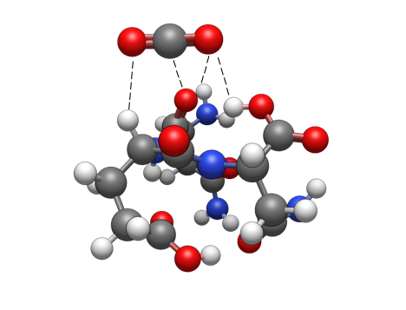
Figure 4.7. DFT-D4/def2-TZVPP conformation of the Asn-Glu-Asn tripeptide and CO₂, with dashed lines indicating interaction points.

Another example of a leading TriScore tripeptide is Glu-Gln-Asn (TriScore = 15.77). It also features a cup-like pocket geometry, enabling CO₂ to interact with multiple functional groups simultaneously, with an interaction energy of -17.79 kcal/mol. It primarily interacts with CO₂ through a carbonyl group (O(C=O)···C(CO₂)) via dispersion interaction, a hydroxyl group (O(OH)···C(CO₂)), and the hydrogen atoms on two primary amine groups (H(NH₂)···O(CO₂)) via electrostatic interactions, particularly hydrogen bonding interactions (Figure 4.8). SAPT0/aug-cc-pVDZ computations confirmed our intuition, as the intermolecular interactions are primarily dominated by contributions from electrostatic interactions, followed by dispersion interactions.

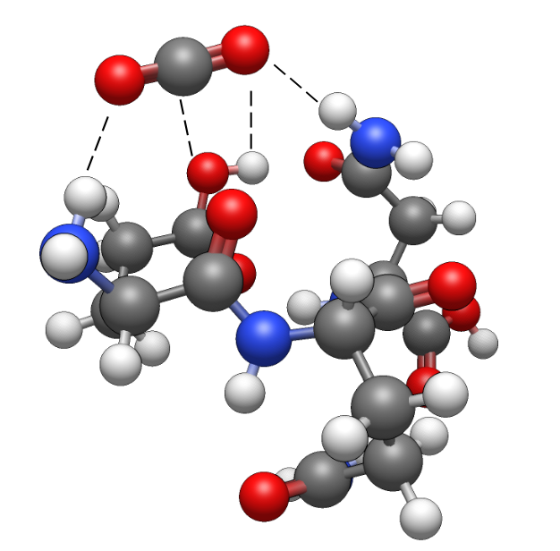
Figure 4.8. DFT-D4/def2-TZVPP conformation of the Glu-Gln-Asn tripeptide and CO₂, with dashed lines indicating interaction points.

An example of a bottom TriScore tripeptide is the Gly-Ala-Ala tripeptide (TriScore of 4.93), which interacts with CO₂ with an interaction energy of -9.97 kcal/mol. This interaction is mainly stabilized by two carbonyl groups, a secondary amine, and adjacent hydrogen atoms on the peptide. The primary forces at play include long-range dispersion and hydrogen bonding, particularly between H(CH₂) and the oxygen of CO₂, as well as H(NH₂)···O(CO₂). Our SAPT0/aug-cc-pVDZ calculations indicate that the interaction is predominantly stabilized by electrostatic forces, particularly the hydrogen bonds with CO₂, while dispersion contributes in a secondary but essential role to the overall stability of the complex, which aligns with our chemical intuition regarding the distribution of the intermolecular forces (Figure 4.9).
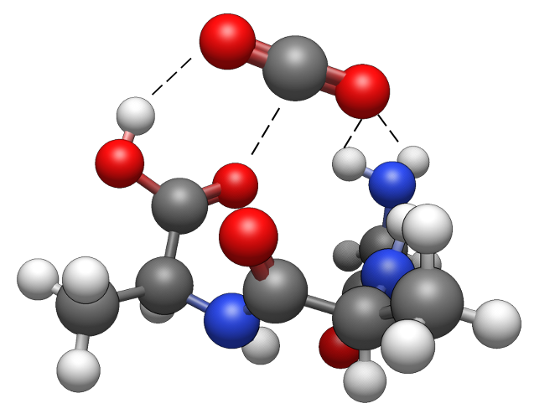
Figure 4.9. DFT-D4/def2-TZVPP conformation of the Gly-Ala-Ala tripeptide and CO₂, with dashed lines indicating interaction points.

Another example of a bottom TriScore tripeptide is the Pro-Gly-Val tripeptide (TriScore = 4.82), which primarily interacts with CO₂ through two carbonyl groups, one secondary amine group, and other hydrogen atoms within the tripeptide, resulting in an interaction energy of -8.01 kcal/mol. This interaction is characterized by long-range dispersion forces and hydrogen bonds involving H(CH₂)-O(CO₂) and H(NH₂)-O(CO₂). Our SAPT0/aug-cc-pVDZ calculations reveal that the main factor in stabilizing the complex (Figure 4.10) is electrostatics, particularly the hydrogen bonds between H(CH₂)-O(CO₂) and H(NH₂)-O(CO₂). Dispersion interactions are the second most important contributor.
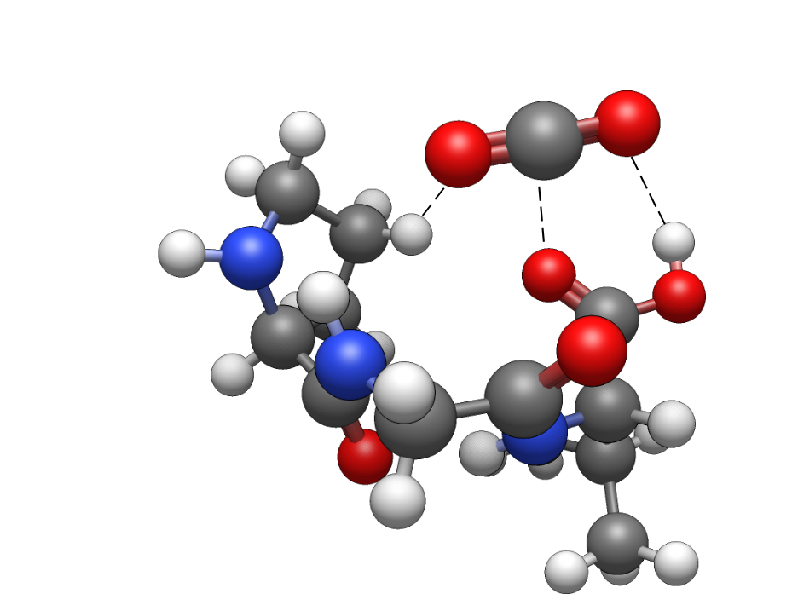
Figure 4.10. DFT-D4/def2-TZVPP conformation of the Pro-Gly-Val tripeptide and CO₂, with dashed lines indicating interaction points.

While SAPT2+3 $δ_{mp2}$ is a more accurate level of SAPT computation than SAPT0,²⁰⁹ it is limited by its high computational cost and memory usage, especially for larger systems as those of the tripeptides considered in this study. For that reason, we ensured that SAPT0 level of theory was a suitable alternative level of theory by benchmarking. We benchmarked this method using Ala-Ala-Gly and Pro-Val-Ala. Ala-Ala-Gly exhibited interaction energy of -6.06 kcal/mol and -7.84 kcal/mol with SAPT2+3$δ_{mp2}/\text{aug-cc-p}\text{VDZ}$ and SAPT0$/\text{aug-cc-p}\text{VDZ}$ respectively. Similarly, Pro-Val-Ala exhibited interaction energy of -7.16 kcal/mol and -9.31 kcal/mol with SAPT2+3$δ_{mp2}/\text{aug-cc-p}\text{VDZ}$ and SAPT0$/\text{aug-cc-p}\text{VDZ}$ respectively.
Following this benchmark studies, we extend the shortlisted tripeptides from 40 to 200 (top and bottom 100 tripeptides based on TriScore), on which we performed SAPT0/aug-cc-pVDZ calculations and obtained a quantitative decomposition of the non-covalent energetic component into electrostatics, exchange, induction, and dispersion terms. Figure 4.11 illustrates the results of these calculations. The plot shows that most tripeptides exhibit strong stabilizing electrostatic interactions with an average of -8.2 kcal/mol. In some instances, these energy values can reach as low as -12 kcal/mol, indicating significant stability. Dispersion has the second strongest contribution to stabilizing interactions within the tripeptide-CO₂ complexes, with a mean energy value of -6.26 kcal/mol. Induction contributes moderately to stabilization, with a mean value of -1.48 kcal/mol. In contrast, the exchange interaction is destabilizing due to the Pauli exclusion principle. A detailed comparison of the chemical intuition and quantitative results using specific examples has been previously presented in section 4.3.2.

Summary of Key Results
Understanding the molecular factors influencing tripeptide-CO₂ interactions is essential for improving oligopeptide-based carbon capture technologies. This study presents TriScore, a quantitative metric that combines structural characteristics–specifically the counts of carbonyl and amine groups–with normalized energetic contributions to evaluate the affinity of tripeptides for CO₂. An analysis of 8000 tripeptides showed a normal distribution of TriScores, allowing for the identification of both high and low-ranked sequences for targeted investigation.
Density functional theory calculations (DFT-D4/def2-TZVPP) on the top and bottom 20 tripeptides revealed a strong correlation between TriScore and CO₂ binding strength. High TriScore peptides demonstrated significantly more negative interaction energies, averaging -14.25 kcal/mol, compared to their lower-scoring counterparts, which averaged -9.39 kcal/mol. Analyses using symmetry-adapted perturbation theory (SAPT0/aug-cc-pVDZ) confirmed that electrostatic forces, particularly hydrogen bonding with polar side chains, primarily govern these interactions, while dispersion provides secondary stabilization.
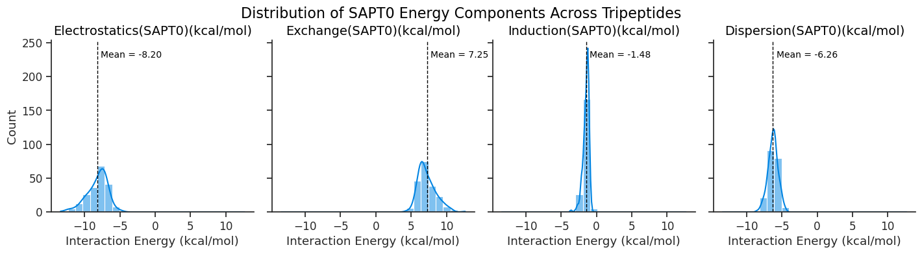
Figure 4.11. Distribution of SAPT0 Energy Components Across Tripeptides. Each panel displays the distribution of one SAPT0 interaction component: electrostatics, exchange, induction, and dispersion, calculated in kcal/mol. Histograms illustrate the frequency of energy values across tripeptides, while overlaid kernel density estimates (KDE) demonstrate the probability density. Dashed vertical lines represent the mean energy for each component. Electrostatics and dispersion dominate the stabilizing interactions (negative values), while exchange is consistently repulsive (positive). Induction shows the least variability across the dataset and is moderately stabilizing.

Representative high-scoring peptides, such as Asn-Glu-Asn and Glu-Gln-Asn, have polar residues arranged in cup-like conformations that facilitate cooperative binding to CO₂. In contrast, low-scoring peptides, like Gly-Ala-Ala and Pro-Gly-Val, lack functional group density, leading to weaker and less varied interactions. These results position TriScore as a significant and computationally effective tool for quickly screening tripeptide libraries and prioritizing candidates for advanced quantum mechanical modeling.
We expanded the dataset by computing SAPT0 interaction energies for 200 DFT-optimized tripeptides-CO₂ complexes comprising the top and bottom 200 TriScore-ranked tripeptides. This provides a better description of the non-covalent interaction energies and offers a quantitative decomposition of the energy terms. We observed that electrostatic contributions predominated the most, followed by dispersion, which can be explained by the presence of long-range dispersion interactions in the tripeptides, as well as nucleophilic groups that undergo various types of electrostatic interactions, such as hydrogen-bonding interactions. Even with a relatively small dataset of 40 instances, our model has demonstrated significant potential to be improved further by leveraging the larger and more accurate dataset of SAPT0/aug-cc-pVDZ energies.

Comparative Mechanistic Study of CO₂ Capture by Amino Acids in Aqueous Solution
Disclosure: The following chapter is the current manuscript of a manuscript scheduled for submission in Summer 2025, authored by Dr. Konstantinos D. Vogiatzis (principal investigator) and me. Electronic structure theory calculations, including density functional theory along with transition state search and free energy profile generation were performed by me. All sections were written by me under the supervision of Dr. Konstantinos D. Vogiatzis.

Introduction
A critical strategy in combating climate change is managing greenhouse gas emissions, with carbon dioxide (CO₂) being the significant contributor from human activities. CO₂ emissions arise from large stationary sources like fossil-fuel power plants, as well as distributed sources such as energy use for transportation, residential use, and other sectors. Recent efforts focus on providing methods for carbon capture and storage (CCS), particularly from significant sources such as flue gas streams.¹⁵⁹
Amine-based solvents are widely used on an industrial scale for CO₂ capture through chemisorption. However, this approach is faced with significant drawbacks ranging from the high energy for solvent regeneration, production of corrosive byproducts,³¹ and the release of toxic intermediates into the atmosphere due to the solvents’ high volatility during heating. These limitations have prompted extensive research into alternative CO₂ capture methods that move beyond conventional chemisorption with amine-based solvents. Despite advancements, the main challenge remains the development of CO₂ capture technologies that are sustainable, cost-effective, and environmentally friendly. Bio-inspired materials have emerged as a compelling alternative, ^{49, 50} particularly amino acids (AAs), which have demonstrated excellent potential for selective CO₂ capture. AAs are inherently non-toxic,⁷⁰ non-volatile,¹⁶ highly resistant to degradation,⁷¹ and can be derived from renewable biological sources,^{73, 74} making them an eco-friendly and efficient solution for addressing the challenges of CO₂ capture. Studies show that AAs effectively bind CO₂, offering a promising substitute for traditional amine-based solvents.56, 78-80, 90, 94, 96, 101, 158, 161
One important benefit of AAs in carbon capture is their ability to form amino acid (AA) salts through a reaction with a base, such as sodium hydroxide or potassium hydroxide, in a solution. ²¹⁰ This leads to the neutralization of the COO⁻ ion with the base, producing the resulting salts of the amino acids. AA salts have a competitive advantage in carbon capture due to a number of reasons. First, their low volatilities provide benefits in solvent regeneration processes, resulting in less solvent loss at high temperatures and low pressure.²¹¹ Additionally, AA salts have high surface tension, which plays a crucial role in gas-liquid interface reactions, such as those seen in CO₂ chemisorption reactions.²¹² Furthermore, AA salts show strong resistance to oxidative degradation, which is a crucial factor when addressing CO₂ in flue gas that contains substantial levels of oxygen.²¹³
Existing approaches for CO₂ absorption utilize amino acid salts, which can occur as either solid amino acid salts ^{58, 210} or amino acid ionic liquids. ²¹⁴⁻²¹⁶ Solid amino acid salts are formed by neutralizing amino acids dissolved in deionized water with an equimolar amount of bases such as potassium hydroxide or sodium hydroxide. ²¹⁷ Amino acid ionic liquids (AAILs), on the other hand, are salts that contain no solvent, only ions, but exist in a liquid state. AAILs are typically produced through a two-step procedure: ion exchange followed by neutralization. Initially, a standard ionic liquid is transformed into its hydroxide form utilizing an anion exchange resin. Next, this hydroxide ionic liquid is neutralized with an AA under regulated conditions, resulting in a crude amino acid ionic liquid, which is then purified and dried for diverse applications.²¹⁸ AAILs stand out as exceptional materials for CO₂-capture due to their unique properties, such as negligible vapor pressure, adjustable structural and functional characteristics, and biodegradability.^{219, 220}
In both solid AA salts and AAILs, the negatively charged form of AA, the anion, reacts with CO₂.^{216, 221} The reaction typically follows a 2:1 stoichiometry, similar to the reaction of amines with CO₂, where two amine-based compounds react with one CO₂. This process begins with the chemisorption of CO₂ onto one of the AA anions (Equation 5.1), followed by proton abstraction with the second AA anion (Equation 5.2) or it can exhibit a 1:1 stoichiometry if the second reaction step is hindered or inefficient. ^{216, 221, 222}
The reaction follows a 2:1 stoichiometry where two AA anions are made to react with one CO₂, first by a chemisorption of CO₂ unto one of the AA anions and then proton abstraction with the second AA anion, ²²³ or a 1:1 stoichiometry if the second reaction step is hindered or inefficient.^{216, 221, 222}
 | $$RNH_{2}+CO_{2}→RNHCO_{2}H$$ | Equation 5.1
 | $RNHCO_{2}H+RNH_{2}→RNH{CO_{2}}^{-}+N{H_{3}}^{+}$ | Equation 5.2
Previous computational efforts to understand CO₂ chemisorption in amino acids have largely focused on discrete reaction pathways or enhancing capture efficiency in select ionic liquids. ^{122, 124, 224-227} While these studies have provided valuable mechanistic insights, they typically center on individual amino acids or specific reaction models, offering limited exploration of the broader diversity in proton transfer pathways and side-chain influences. Onofri et al. explored computational techniques aimed at improving the CO₂ absorption molar ratio in amino acid ionic liquids by investigating two reaction mechanisms.²¹⁶ Their findings suggest that the choice of anions can significantly boost the CO₂ molar ratio. Yoon and Voth analyzed three proton transfer mechanisms related to serine ionic liquids and CO₂, underscoring the crucial roles of dynamic and kinetic factors in the CO₂ chemisorption process.²¹⁵ While prior studies on amino acid-based CO₂ capture have primarily focused on thermodynamic binding or bulk absorption properties, often using a small subset of amino acids, they seldom probe the detailed proton transfer mechanisms or the influence of side chain structure on reaction thermodynamics on a more comparative scale. This work addresses this gap by systematically exploring the complete reaction pathways for all 20 natural amino acid anions through various mechanistic routes and by incorporating implicit solvation using a conductor-like polarizable continuum model (CPCM) approximation that employs parametrization for a solvent with a medium dielectric constant. ^{228, 229} This study also includes water-mediated intramolecular transfer, as it has been shown to occur simultaneously for amines in the aqueous phase.^{230, 231}
We utilized density functional theory (DFT) to perform a combined geometry optimization and vibrational frequency calculations to ensure that geometries with imaginary frequencies are excluded. The Gibbs’ free energy values for the reaction pathways were computed and provided insight into the energy barriers associated with different reaction steps, as depicted in Figure 5.1. This allows us to explore the thermodynamics and energy barriers in systems characterized by different levels of steric hindrance in condensed phases. We investigate how the structural variation, and flexibility of the amino acids’ anions influence the intramolecular and intermolecular interactions, which is pivotal in the carbon capture performance.

Computational Methodology
All DFT calculations were performed with the ORCA quantum chemical program package version 5.0.4,²³² using the conductor-like polarizable continuum model (CPCM) in the aqueous phase. ^{228, 229} The geometry optimization and frequency calculations were performed using PBE0 density functional, ¹³⁰ the def2-TZVPP¹³³ basis set, def2/j auxiliary basis set,²³³ the defgrid2 integration grid, ²³⁴ the D4 dispersion correction model,^{207, 235, 236} using the resolution of identity approximation within the ‘chain of spheres’ algorithm, which integrates a semi-numeric approach for handling all exchange terms for all Coulomb-type contributions (RIJCOSX)²³⁷. Fully unconstrained transition state optimizations were performed, and minima and saddle points of the potential energy surfaces were confirmed by analyzing the Hessian. The Gibbs free energies at 298.1 K and 1 atm were determined by incorporating the zero-point energy and thermal corrections for enthalpy and entropy derived from vibrational and rotational analyses of the lowest-energy conformers, utilizing the harmonic approximation implemented in ORCA.

Results and Discussion

Proposed Reaction Mechanism
Amino acids can form carbamate products with CO₂ in liquid (or water) phase. There are a few proposed mechanisms that exist in the literature for CO₂ absorption with amine: a 1:1 amine/CO₂ mole ratio (1:1 mechanism) ^{216, 221, 222} and a 2:1 amine/CO₂ mole ratio (2:1 mechanism).²²³ The mechanism of the chemisorption process comprises two steps–zwitterion formation and proton abstraction. In a 1:1 mechanism, the zwitterion intermediate is formed (Figure 5.1,A1) and may undergo a water-mediated intramolecular proton transfer to form a carboxylic acid from the carboxylate functional group (Figure 5.1, A2). In a 2:1 mechanism, the zwitterion is initially formed using one amino acid anion and CO₂ (Figure 5.1, B1), which can then subsequently follow one of two possible pathways involving proton transfer to amine (Figure 5.1, B2) and carboxylate groups (Figure 5.1, B3). Similar reaction mechanism has been observed in anions of amino acids, ^{214, 215, 238} and amino acid ionic liquids (AAILs).²¹⁵ Minor changes in the local structure of the R group of the amine or amino acid can either promote or impede the second reaction of proton transfer step, influencing the amine/CO₂ mole ratio.

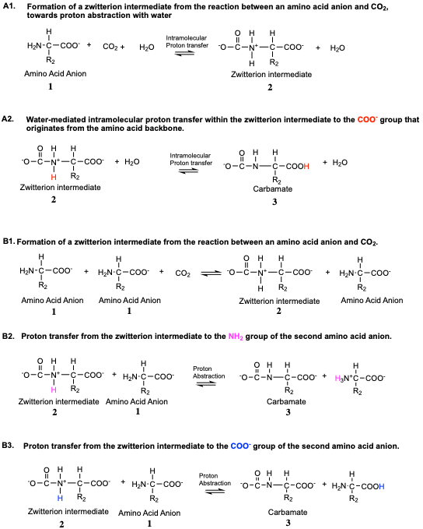
Figure 5.1. Possible routes for carbamate formation from amino acid ionic liquid anion considered in this study. A1 and A2 correspond to the steps involved in the formation of carbamate from one amino acid anion. B1, B2 and B3 correspond to the formation of carbamate from two amino acid anions. In all the reactions depicted, 1 corresponds to amino acid anion, 2 corresponds to zwitterion intermediate that undergoes proton abstraction to form 3, which is the carbamate product.
In this study, we have studied the mechanism of amino acid reaction with CO₂ following either of these three routes of (Figure 5.1) using quantum chemical methods. In all reaction routes, we refer to 1 as the amino acid anion, 2 is the zwitterion intermediate that undergoes proton abstraction to form 3, which is the carbamate product. In the 1:1 reaction (A1,A2), one AA anion (1) reacts with a CO₂ molecule and a H₂O molecule to form the zwitterion intermediate (2), which undergoes proton abstraction to the primary carboxylate group to form carbamate (3). In the 2:1 reactions, (B1, B2, B3), two amino acid anions (1) react with one CO₂ molecule to form a zwitterion intermediate (2), which undergoes a proton abstraction to the NH₂ group of the second amino acid anion to form carbamate product (3) as seen in reaction B2, or a proton abstraction to the COO⁻ group of the second amino acid anion to form carbamate product (3) as seen in reaction B3.

Analysis of Result
CO₂ capture by AAILs through a chemisorption process is initiated by a nucleophilic attack of the electrophilic C in CO₂ by the N atom in the AA anion, leading to the formation of a zwitterion. Then, the zwitterion proceeds through any of the proton transfer routes described in Figure 5.1 , to form the carbamate species. The formation of carbamate species largely governs the chemisorption mechanism of CO₂ capture by AAILs.^{214, 215, 221} To examine the potential of each of the 20 natural AAs in the chemisorption of CO₂, we construct free-energy surfaces (FES) to better understand how the reaction mechanism is affected by steric factors and side chain groups. We obtained our results at 298.1K in an implicit solvation model using DFT. The Supplementary Information includes a database of energy barriers for intermolecular proton transfer to neighboring NH₂ and intermolecular proton transfer to neighboring COO⁻, and intramolecular proton transfers present therein. The Gibbs Free reaction energies $(∆G)$, as well as the Gibbs Free activation energy barrier $({ΔG}^{‡})$ of the overall reaction channel present therein.
The reaction pathway for CO₂ capture via amino acids involves multiple energy-stable configurations and transition states. This study defines several key energy differences that help elucidate the proton transfer processes occurring during the reaction. In the intermolecular proton transfer process, 1 indicates the isolated AA anions and CO₂; TS₁₋₂ denotes the transition state moving from the isolated three-body system to the zwitterion intermediate and AA anion. 2 represents the fully formed zwitterion intermediate along with the second anion, and TS₂₋₃ is the transition state for proton transfer from the zwitterion intermediate to the second anion. Finally, 3 is the product featuring a pair of carbamate and neutral amino acid. Similarly, in the water mediated intramolecular proton transfer process, 1 indicates one isolated AA anion, one water molecule and CO₂; TS₁₋₂ denotes the transition state moving from the isolated three-body system to the zwitterion intermediate and water molecule. 2 represents the fully formed zwitterion intermediate along with the water molecule, and TS₂₋₃ is the transition state for proton transfer from the zwitterion intermediate to the primary carboxylate ion through the water molecule. Finally, 3 is the product featuring a pair of carbamate and water molecule. The water-mediated mechanism highlights the role of solvent in stabilizing the transition state, similar to findings in research involving alkanolamines. ²³⁹
${ΔG}^{‡}$(TS₁₋₂-1) and ${ΔG}^{‡}$(TS₂₋₃-1) are crucial as they indicate the energy barrier to form the zwitterion intermediate and the energy barrier to transfer a proton. Analyzing these energy barriers helps us understand the competitive pathways between different proton transfer routes. These energy differences, along with the contributions from both intermolecular and intramolecular proton transfer mechanisms, provide valuable insights into the efficacy of amino acids in CO₂ capture. By understanding these reaction pathways, we can better evaluate the potential of AAs as environmentally friendly alternatives to traditional amine-based solvents for carbon capture.
As a representative example, we will discuss in detail glycine anion before we proceed to the full set of the 20 AAs. The FES for the full reaction pathway toward carbamate formation from amino acid and CO₂ [that is, (1) $→$ (TS₁₋₂) $→$ (2) $→$ (TS₂₋₃) $→($3)] is shown in Figure 5.2. The reaction commences with the formation of zwitterion intermediate, through a reaction barrier of 1.71 kcal/mol, which then undergoes proton abstraction via intermolecular proton transfer to COO⁻ (barrierless step of -4.57 kcal/mol). When the same calculation was done towards intermolecular proton transfer to NH₂ (Figure 5.3), the zwitterion intermediate was formed through a barrier of 0.83 kcal/mol, which then undergoes proton abstraction via intermolecular proton transfer to NH₂ (barrierless step of -10.41 kcal/mol). This suggests that the energy pathway for intermolecular proton transfer to COO⁻ and NH₂ is spontaneous and does not necessarily present a barrier, considering that two glycine anions are used to form carbamate with CO₂, and solvent-induced constraints are approximated using an implicit solvation model. The third possibility studied here involves an intramolecular proton transfer to the COO⁻ group on the zwitterion. For all 20 amino acids, excluding proline, there are two possible COO⁻ groups from which a hydrogen atom could be abstracted. These are the primary COO⁻ group of the amino acid backbone and the COO⁻ group derived from the CO₂ bonded to the amine group. Using glycine as a case study, we examined the most favorable intramolecular pathways. When the proton is transferred to the primary COO⁻ group, the activation energy barrier is 2.20 kcal/mol (Figure 5.4). In contrast, transferring the proton to the other COO⁻ group (from the bonded CO₂) requires 10.11 kcal/mol to form carbamic acid. Since the pathway involving proton transfer to the primary COO⁻ group is the least energetically demanding, we focus on this pathway for the remaining amino acids in the series. The only exception is proline, which contains a 5-membered ring. In this case, nitrogen is bonded to only one hydrogen, and its orientation allows for only intramolecular transfer to form carbamic acid, with a barrier of 8.13 kcal/mol. These results align with those of Said et al. regarding the CO₂ formation mechanism using methylamine to produce carbamate, where H₂O serves as the Brønsted base, resulting in a barrier of 15.1 kcal/mol.²³⁰ To summarize the results for glycine, the free energy barriers for carbamate formation are 1.71 kcal/mol for intermolecular proton transfer to COO⁻, 0.83 kcal/mol for intermolecular proton transfer to NH₂, and 2.20 kcal/mol for water-mediated intramolecular proton transfer. Our studies reveal that the most facile step with the lowest energy barrier for the formation of glycine is the intermolecular proton transfer to NH₂, followed by the intermolecular proton transfer to COO⁻ and then the intramolecular proton transfer.

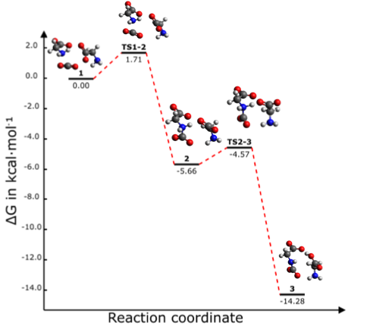
Figure 5.2. Free energy surface (FES, kcal/mol) for the formation of carbamate from CO₂ and glycine anions, which proceeds via intermolecular proton transfer to COO⁻. The reaction begins with the unbound reactant 1 which comprises isolated AA anions and CO₂; TS₁₋₂ denotes the transition state moving from the isolated three-body system to the zwitterion intermediate and AA anion; 2 represents the fully formed zwitterion intermediate along with the second anion, and TS₂₋₃ is the transition state for proton transfer from the zwitterion intermediate to the second anion; and 3 is the product featuring a pair of carbamate and neutral amino acid. All energies were calculated with CPCM (water)/PBE0-D4/def2-TZVPP.

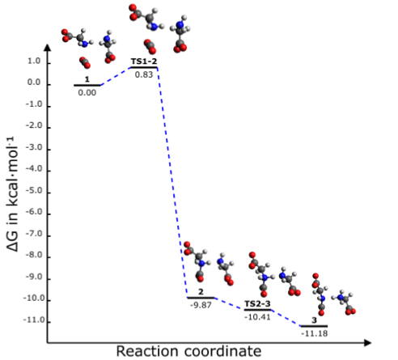
Figure 5.3. Free energy surface (FES, kcal/mol) for the formation of carbamate from CO₂ and glycine anions, which proceeds via intermolecular proton transfer to NH₂. The reaction begins with the unbound reactant 1 which comprises isolated AA anions and CO₂; TS₁₋₂ denotes the transition state moving from the isolated three-body system to the zwitterion intermediate and AA anion; 2 represents the fully formed zwitterion intermediate along with the second anion, and TS₂₋₃ is the transition state for proton transfer from the zwitterion intermediate to the second anion; and 3 is the product featuring a pair of carbamate and neutral amino acid. All energies were calculated with CPCM (water)/PBE0-D4/def2-TZVPP.

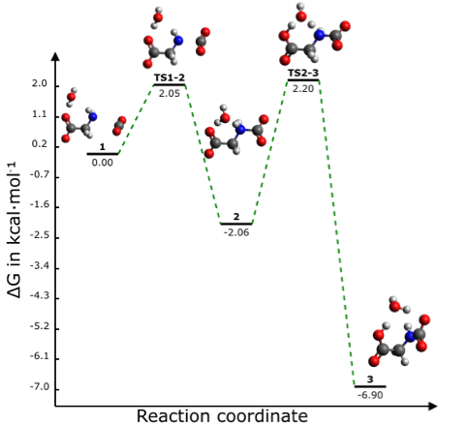
Figure 5.4. Free energy surface (FES, kcal/mol) for the formation of carbamate from CO₂ and glycine anions, which proceeds via intramolecular proton transfer to the carboxylate originating from the amino acid backbone. The reaction begins with the unbound reactant 1 comprising one isolated AA anion, one water molecule, and CO₂; TS₁₋₂ denotes the transition state moving from the isolated three-body system to the zwitterion intermediate and water molecule; 2 represents the fully formed zwitterion intermediate along with the water molecule, and TS₂₋₃ is the transition state for proton transfer from the zwitterion intermediate to the primary carboxylate ion through the water molecule; and 3 is the product featuring a pair of carbamate and water molecule. All energies were calculated with CPCM (water)/PBE0-D4/def2-TZVPP.

Next, consider threonine, a polar/hydrophilic uncharged amino acid. The reaction commences with the formation of zwitterion intermediate, through a reaction barrier of 3.73 kcal/mol, which then undergoes proton abstraction via intermolecular proton transfer to COO⁻(barrierless step of -2.48 kcal/mol) as shown in Figure 5.5. When the same calculation was done towards intermolecular proton transfer to NH₂ (Figure 5.6), the zwitterion intermediate was formed through a barrier of 2.69 kcal/mol , which then undergoes proton abstraction via intermolecular proton transfer to NH₂ (barrierless step of -5.91 kcal/mol). This suggests that the energy pathway for intermolecular proton transfer to COO⁻ and NH₂ is spontaneous and does not necessarily present a barrier, considering that two threonine anions are used to form carbamate with CO₂, and solvent-induced constraints are approximated using an implicit solvation model. Lastly, the water-mediated intramolecular proton transfer exhibits an activation energy barrier of 3.15 kcal/mol (Figure 5.7). This study reveal that the most facile step with the lowest energy barrier for the formation of threonine is the intermolecular proton transfer to NH₂, followed by the intramolecular proton transfer and then the intermolecular proton transfer to COO⁻.

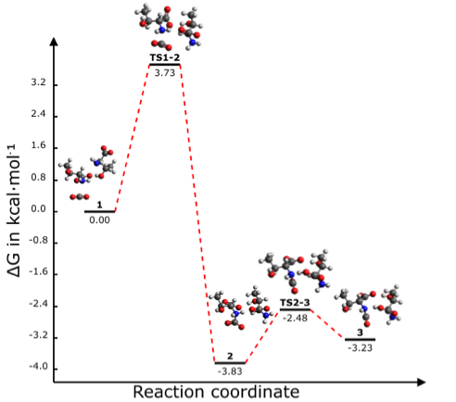
Figure 5.5. Free energy surface (FES, kcal/mol) for the formation of carbamate from CO₂ and threonine anions, which proceeds via intermolecular proton transfer to COO⁻. The reaction begins with the unbound reactant 1 which comprises isolated AA anions and CO₂; TS₁₋₂ denotes the transition state moving from the isolated three-body system to the zwitterion intermediate and AA anion; 2 represents the fully formed zwitterion intermediate along with the second anion, and TS₂₋₃ is the transition state for proton transfer from the zwitterion intermediate to the second anion; and 3 is the product featuring a pair of carbamate and neutral amino acid. All energies were calculated with CPCM (water)/PBE0-D4/def2-TZVPP.

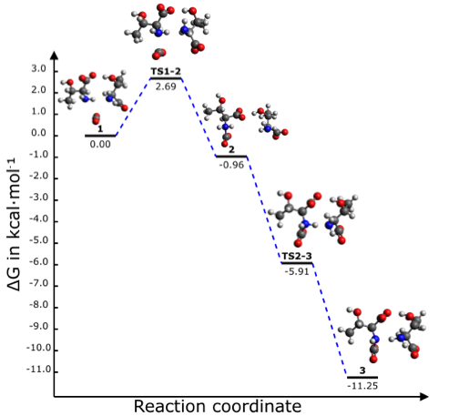
Figure 5.6. Free energy surface (FES, kcal/mol) for the formation of carbamate from CO₂ and threonine anions, which proceeds via intermolecular proton transfer to NH₂. The reaction begins with the unbound reactant 1 which comprises isolated AA anions and CO₂; TS₁₋₂ denotes the transition state moving from the isolated three-body system to the zwitterion intermediate and AA anion; 2 represents the fully formed zwitterion intermediate along with the second anion, and TS₂₋₃ is the transition state for proton transfer from the zwitterion intermediate to the second anion; and 3 is the product featuring a pair of carbamate and neutral amino acid. All energies were calculated with CPCM (water)/PBE0-D4/def2-TZVPP.

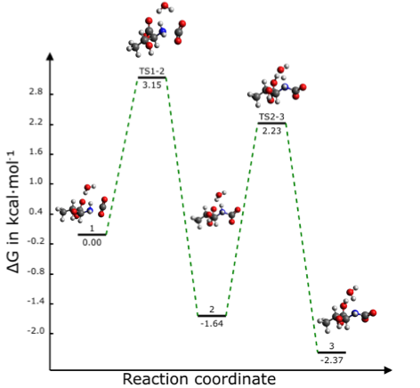
Figure 5.7. Free energy surface (FES, kcal/mol) for the formation of carbamate from CO₂ and threonine anions, which proceeds via intramolecular proton transfer to the carboxylate originating from the amino acid backbone. The reaction begins with the unbound reactant 1 comprising one isolated AA anion, one water molecule, and CO₂; TS₁₋₂ denotes the transition state moving from the isolated three-body system to the zwitterion intermediate and water molecule; 2 represents the fully formed zwitterion intermediate along with the water molecule, and TS₂₋₃ is the transition state for proton transfer from the zwitterion intermediate to the primary carboxylate ion through the water molecule; and 3 is the product featuring a pair of carbamate and water molecule. All energies were calculated with CPCM (water)/PBE0-D4/def2-TZVPP.
Leucine, a non-polar aliphatic amino acid, was also examined. The free energy barrier for the zwitterion intermediate is 4.44 kcal/mol, which then undergoes proton abstraction via intermolecular proton transfer to COO⁻ (barrierless step of -5.12 kcal/mol) as seen in Figure 5.8. When the same calculation was done towards intermolecular proton transfer to NH₂ (Figure 5.9), the zwitterion intermediate was formed through a barrier of 0.65 kcal/mol, which then undergoes proton abstraction via intermolecular proton transfer to NH₂ (barrierless step of -10.83 kcal/mol). This suggests that the energy pathway for intermolecular proton transfer to COO⁻ and NH₂ is spontaneous and does not necessarily present a barrier, considering that two leucine anions are used to form carbamate with CO₂, and solvent-induced constraints are approximated using an implicit solvation model. Lastly, the water-mediated intramolecular proton transfer exhibits an activation energy barrier of 2.15 kcal/mol (Figure 5.10). Here, the lowest energy barrier for the formation of leucine is the intermolecular proton transfer to NH₂, followed by the intramolecular proton transfer and then the intermolecular proton transfer to COO⁻.

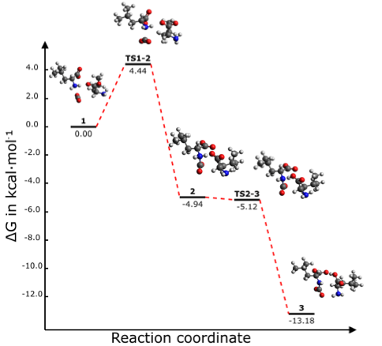
Figure 5.8. Free energy surface (FES, kcal/mol) for the formation of carbamate from CO₂ and leucine anions, which proceeds via intermolecular proton transfer to COO⁻. The reaction begins with the unbound reactant 1 which comprises isolated AA anions and CO₂; TS₁₋₂ denotes the transition state moving from the isolated three-body system to the zwitterion intermediate and AA anion; 2 represents the fully formed zwitterion intermediate along with the second anion, and TS₂₋₃ is the transition state for proton transfer from the zwitterion intermediate to the second anion; and 3 is the product featuring a pair of carbamate and neutral amino acid. All energies were calculated with CPCM (water)/PBE0-D4/def2-TZVPP.

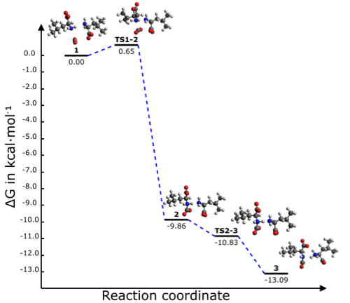
Figure 5.9. Free energy surface (FES, kcal/mol) for the formation of carbamate from CO₂ and leucine anions, which proceeds via intermolecular proton transfer to NH₂. The reaction begins with the unbound reactant 1 which comprises isolated AA anions and CO₂; TS₁₋₂ denotes the transition state moving from the isolated three-body system to the zwitterion intermediate and AA anion; 2 represents the fully formed zwitterion intermediate along with the second anion, and TS₂₋₃ is the transition state for proton transfer from the zwitterion intermediate to the second anion; and 3 is the product featuring a pair of carbamate and neutral amino acid. All energies were calculated with CPCM (water)/PBE0-D4/def2-TZVPP.

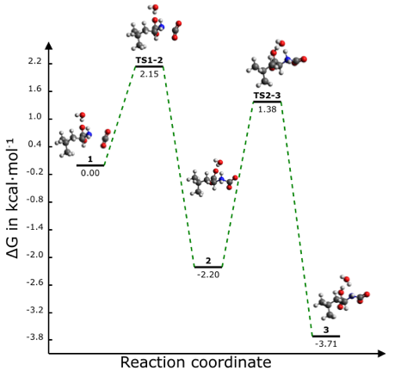
Figure 5.10. Free energy surface (FES, kcal/mol) for the formation of carbamate from CO₂ and leucine anions, which proceeds via intramolecular proton transfer to the carboxylate originating from the amino acid backbone. The reaction begins with the unbound reactant 1 comprising one isolated AA anion, one water molecule, and CO₂; TS₁₋₂ denotes the transition state moving from the isolated three-body system to the zwitterion intermediate and water molecule; 2 represents the fully formed zwitterion intermediate along with the water molecule, and TS₂₋₃ is the transition state for proton transfer from the zwitterion intermediate to the primary carboxylate ion through the water molecule; and 3 is the product featuring a pair of carbamate and water molecule. All energies were calculated with CPCM (water)/PBE0-D4/def2-TZVPP.

Discussion of Observed Trend Among Various Classes of Amino Acid
The activation energy plots for intermolecular proton transfer to COO⁻, NH_{2,} and intramolecular water-mediated proton transfer reveal unique characteristics that are summarized in Figure 5.11. Generally, the intermolecular proton transfer to NH₂ group tends to occur with a low, but positive barrier, with arginine as an exception. On the other hand, the intermolecular proton transfers to the COO⁻ are generally higher, with a few exceptions like glutamic acid, arginine, proline, tyrosine and glutamine which exhibit barrierless reactions, described by slightly negative ${ΔG}^{‡}$ values.
Arginine carries a positive charge in its natural form as a unit of a protein, due to the protonated guanidine group, which causes positive delocalization.^{240, 241} This makes it unlikely to undergo proton transfer to NH₂, thus the observed high barrier in H⁺ transfer to NH₂ and barrierless transfer to COO⁻, a conjugate base. Glutamic acid undergoes a barrierless step for proton transfer to the COO⁻, signifying a strong tendency to donate a proton as an acid in an aqueous environment. This process is further stabilized by electrostatic interactions with the polar groups on glutamic acid.
Nonpolar aliphatic amino acids like glycine, valine, and alanine, reflect the behaviors of the amino acids in an aqueous environment without stabilization or hindrances coming from the side chains. In their anionic forms, they generally demonstrate lower activation energy for proton transfer to NH₂, which is more basic and likely to accept a proton than COO⁻, a weak base. In contrast, polar amino acids like glutamic acid and glutamine provide side-chain stabilization that can alter these natural proton transfer tendencies in the anionic state.
Water-mediated intramolecular proton transfer demonstrates how water can act as a medium for this reaction process and also provides stability for the intermediates. This stability comes in the form of hydrogen bonds with reacting and intermediate species, which may cause a slowdown and create high energetic barriers in the proton transfer mechanism. Proline, which has a unique five-member cyclic structure containing a secondary amine, exhibits the highest activation energy barrier in water-mediated proton transfer, likely due to its constrained conformation and orientation that permit only intramolecular transfer to form carbamic acid at a high energy barrier. These trends reveal the variation in the functionality of different amino acids, which is crucial for understanding their mechanism of chemisorption with CO₂ in water.
Our findings closely match the absence of an energy barrier noted in the ab initio study conducted by da Silva and Svendsen, which investigated the most probable mechanism for the reaction between CO₂ and MEA. They discovered that carbamate species initially form through zwitterion intermediate formation, followed by proton transfer. Notably, there is no intrinsic energy barrier when one water molecule is present, whereas an energy barrier exists with three water molecules, highlighting the hydrogen bonds that CO₂ must first overcome.²⁴² In a similar study, Shim et al. utilized DFT with the PCM model to investigate the formation of carbamate from MEA and CO₂, while also examining the effects of an additional MEA or H₂O. The zwitterionic intermediate formation faced a Gibbs free energy barrier of 5.5 kcal/mol. They observed that when proton transfer was facilitated by MEA, it occurred without an energy barrier, whereas using H₂O required overcoming an energy barrier.²⁴³
Our results reflect the efficiency of the intrinsic reaction pathway under polar conditions and align with the expected reactivity of deprotonated amino acids toward CO₂. Utilizing an implicit solvation model like PCM facilitates rapid and systematic comparison across a wide range of amino acids while still capturing key electrostatic stabilization effects, especially for polar transition states and charged intermediates. Although explicit solvent interactions are not modeled directly, the continuum approach provides a computationally efficient and chemically meaningful framework for identifying trends in reactivity and relative barrier heights. The low barriers observed suggest that, in the absence of significant steric or solvent-induced constraints, carbamate formation is thermodynamically favored with minimum energy barrier. Additionally, the overall carbamate formation reaction scheme proceed exothermically, as noted in comparable studies.²¹⁶ An experimental study by Yu et al. found that H₂O molecules in CO₂ adsorption with amines enhanced binding strength yet slowed the CO₂ adsorption reaction rate due to stabilization from hydrogen bonding.²³¹ This aligns with the increased activation energy barrier, and the stabilized reaction energy noted when explicit solvation is modeled for CO₂ capture using amines or amino acids through computational methods.^{214, 215, 227, 244} Further refinement with explicit solvation models could offer a more detailed view of solute-solvent interactions, but the implicit model employed here effectively captures the inherent reactivity of amino acid anions toward CO₂ under idealized polar conditions.
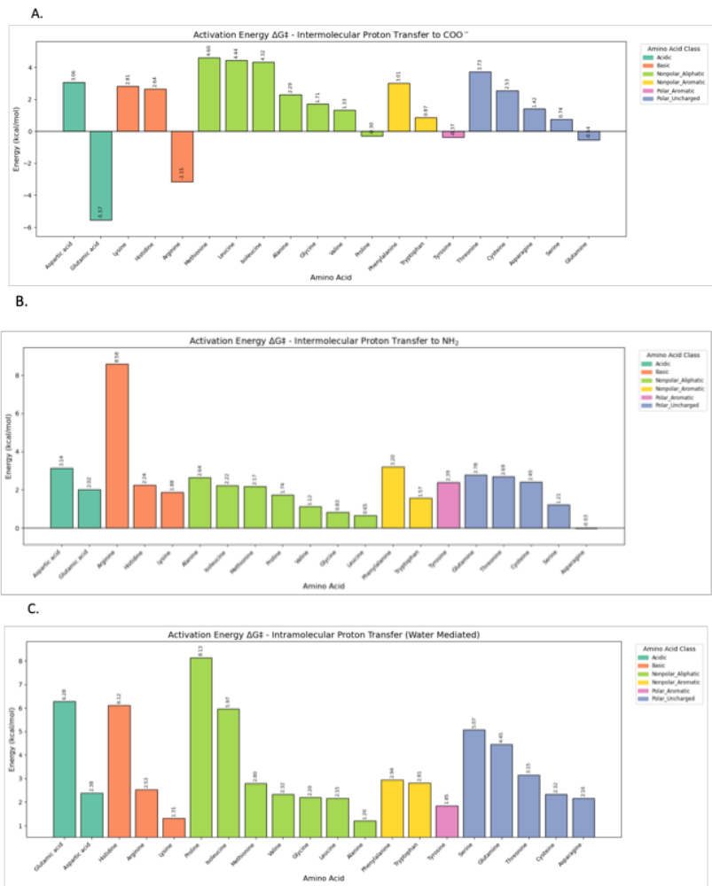
Figure 5.11. Activation energy barrier ($ΔG^{‡})$in kcal mol⁻¹ for the intermolecular proton transfer to COO⁻ (A), intermolecular proton transfer to NH₂ (B), and intramolecular proton transfer –water-mediated (C) of amino acid anions, categorized by amino acid class.

Summary of Key Results
This study explores the chemisorption of CO₂ using amino acid anions (AAILs) as a sustainable alternative to conventional amine-based solvents, which are faced with limitations like high volatility and toxicity. Amino acids (AAs) are promising candidates for CO₂ capture as they offer advantages such as non-toxicity, renewable sourcing, and stability. They form carbamates with CO₂ through a chemisorption process that proceeds through a nucleophilic attack on the carbon of the CO₂, followed by proton transfer. Three proton transfer mechanisms are analyzed: intermolecular proton transfer to COO⁻, intermolecular proton transfer to NH₂, and intramolecular (water-mediated) proton transfer. In this study, we investigated the free energy surface (FES) associated with CO₂ capture by all 20 natural amino acid anions and evaluated how steric effects and side chain interactions with solvents influence the reaction pathway. We found that the amino acids demonstrate varied behaviors that are attributed to their unique side chains and predominant zwitterion form in aqueous environment. For the nonpolar aliphatic amino acids, they represent the behaviors of the amino acid anions, with little influence from their side chains, with lower energy barrier for proton transfer to basic NH₂ group than COO⁻. Constrained configuration can further influence the reaction, as observed in proline which exhibits the highest activation energy in water-mediated intramolecular proton transfer. The barrierless intermolecular proton transfer observed in some cases as well an exothermic product formation have been noted in comparable studies. ²¹⁶ This study provides insights into the thermodynamic of the CO₂ capture by amino acid anions through chemisorption by revealing how structural and electronic effects contribute to the proton transfer pathways.

Closing Remarks
This dissertation presents a series of projects that focus on various sub-aims, all designed to enhance scientific contributions toward achieving a carbon-negative global community. Amino acids have emerged as a promising alternative to traditional carbon capture techniques, such as amine-based solvent capture. These bio-sustainable substances are found throughout nature and are fundamental components of proteins in all living organisms. Additionally, amino acids have gained popularity recently due to their low toxicity, non-volatility, and strong resistance to degradation. Beyond addressing the atmospheric carbon emitted from point sources like cement and other chemical industries with significant post-combustion releases, it is crucial to consider carbon emissions from distributed sources. Therefore, this study recommends direct air capture utilizing amino acids as integral materials within the direct air capture technology platform.
The interactions of CO₂ with molecular amino acids and small oligopeptides have been studied through quantum chemical methods. Quantum chemistry offers insights into reaction mechanisms and how different structural functionalities influence amino acids' properties for carbon capture. This understanding improves mapping functionalities to larger applications, detailing subtle molecular interactions and supporting the design of new oligopeptide-based products with synergistic properties for CO₂ capture.
In the initial study, exploratory research examined all three regions (primary amine, carboxylic acid, and side chains) of the 20 natural amino acids, focusing on their non-covalent interactions with CO₂. Using CCSD(F12)(T), this study achieved high accuracy and improved basis set convergence, resulting in commendable accuracy with moderate computational efficiency. This research generated reference data on interaction energies that also helped benchmark density functionals suitable for evaluating larger peptides while identifying functionalities that enhance carbon capture. This can help guide the design of carbon capture technologies, such as direct air capture systems embedded with amino acids that contain polar functional groups like carboxylic acids, amines, and amides.
The second section of this dissertation presents novel algorithms for automating the generation of different conformations of dipeptide-CO₂ complexes, where CO₂ interacts with various regions on the dipeptides. Additionally, we conducted a statistical analysis of the cooperative interactions among other functional groups within the dipeptides. We compared the interaction energies between the dipeptides and their corresponding amino acid subunits. In the quantum chemical calculations performed in this study, we used DFT, selecting the density functional that provided the best benchmark results from previous research. This study highlights cooperative effects in dipeptides compared to their amino acid subunits, which can be utilized in designing more effective carbon capture materials.
In the third study of this dissertation, we introduce a metric that utilizes the molecular structure of tripeptides, along with the scaled energetic properties of dipeptides and amino acid subunits, to estimate CO₂ binding affinity. This enables high-throughput screening of tripeptide libraries with thousands of candidates, showing effectiveness as a preliminary measure before conducting detailed quantum chemical studies on the shortlisted candidates. For the selected candidates, we performed symmetry-adapted perturbation theory (SAPT) calculations and found that electrostatic and dispersion interactions significantly contribute to the non-covalent interaction energies. These can be explained chemically by hydrogen-bonding and long-range dispersion interactions with CO₂ through the polar groups abundantly present in the tripeptides.

In conclusion, the fourth study in this dissertation presents our investigation into the mechanistic interactions between CO₂ and amino acids in an aqueous environment. This research is essential for developing more efficient solvent-based direct air capture technologies, based on insights gained from a comprehensive examination of the complete reaction pathways of all 20 natural amino acid anions through various mechanistic pathways. Our study evaluated the Gibbs free energy associated with different reaction steps, improving our understanding of how structural variations affect amino acids' properties in solution related to CO₂ capture. We found that while the intermolecular proton transfers to NH₂ and COO⁻ have lower barriers, the intramolecular proton transfer in the presence of a water molecule is more hindered, which can be explained by hydrogen bonding interactions that stabilize the intermediates, making proton transfer and product formation less likely.

References
(1) Lee, H.; Calvin, K.; Dasgupta, D.; Krinner, G.; Mukherji, A.; Thorne, P.; Trisos, C.; Romero, J.; Aldunce, P.; Barret, K. IPCC, 2023: Climate change 2023: synthesis report, summary for policymakers. contribution of working groups I, II and III to the sixth assessment report of the intergovernmental panel on climate change [core writing team, H. Lee and J. Romero (eds.)]. IPCC, Geneva, Switzerland. 2023.
(2) Sources of greenhouse gas emissions. In United States Environmental Protection Agency, 2022.
(3) Denton, F.; Halsnæs, K.; Akimoto, K.; Burch, S.; Morejon, C. D.; Farias, F.; Jupesta, J.; Shareef, A.; Schweizer-Ries, P.; Teng, F. Accelerating the transition in the context of sustainable development. In Climate change 2022: Mitigation of climate change, the working group III contribution, 2022; pp 2816–2915.
(4) Jia, G.; Shevliakova, E.; Artaxo, P.; De Noblet-Ducoudré, N.; Houghton, R.; House, J.; Kitajima, K.; Lennard, C.; Popp, A.; Sirin, A.; et al. Land-climate interactions. In: Climate Change and Land: an IPCC special report on climate change, desertification, land degradation, sustainable land management, food security, and greenhouse gas fluxes in terrestrial ecosystems. 2019.
(5) Shu, D. Y.; Deutz, S.; Winter, B. A.; Baumgärtner, N.; Leenders, L.; Bardow, A. The role of carbon capture and storage to achieve net-zero energy systems: Trade-offs between economics and the environment. Renew. Sustain. Energy Rev. 2023, 178, 113246.
(6) Ratanpara, A.; Ricca, J. G.; Gowda, A.; Abraham, A.; Wiskoff, S.; Zauder, V.; Sharma, R.; Hafez, M.; Kim, M. Towards green carbon capture and storage using waste concrete based seawater: A microfluidic analysis. J. Environ. Manag. 2023, 345, 118760.
(7) Peletiri, S. P.; Rahmanian, N.; Mujtaba, I. M. CO₂ pipeline design: A review. Energies 2018, 11 (9), 2184.
(8) Hua, W.; Sha, Y.; Zhang, X.; Cao, H. Research progress of carbon capture and storage (CCS) technology based on the shipping industry. Ocean Eng. 2023, 281, 114929.
(9) Zhang, Z.; Li, X.; Luo, C.; Zhang, L.; Xu, Y.; Wu, Y.; Liu, J.; Duan, Y.; Zheng, C. Investigation on the thermodynamic calculation of a 35 MWth oxy-fuel combustion coal-fired boiler. Int. J. Greenh. Gas Control. 2018, 71, 36–45.
(10) Gür, T. M. Carbon dioxide emissions, capture, storage and utilization: review of materials, processes and technologies. Prog. Energy Combust. Sci. 2022, 89, 100965.
(11) Zhang, Z.; Cai, J.; Chen, F.; Li, H.; Zhang, W.; Qi, W. Progress in enhancement of CO₂ absorption by nanofluids: a mini review of mechanisms and current status. Renew. Energy 2018, 118, 527–535.
(12) Liu, H.; Liu, B.; Lin, L.-C.; Chen, G.; Wu, Y.; Wang, J.; Gao, X.; Lv, Y.; Pan, Y.; Zhang, X. A hybrid absorption-adsorption method to efficiently capture carbon. Nat. Commun. 2014, 5 (1), 5147.
(13) Kim, J.; Lin, L.-C.; Swisher, J. A.; Haranczyk, M.; Smit, B. Predicting large CO₂ adsorption in aluminosilicate zeolites for postcombustion carbon dioxide capture. JACS 2012, 134 (46), 18940–18943.
(14) Rezakazemi, M.; Heydari, I.; Zhang, Z. Hybrid systems: Combining membrane and absorption technologies leads to more efficient acid gases (CO₂ and H₂S) removal from natural gas. J. CO₂ Util. 2017, 18, 362–369.
(15) Wang, M.; Wang, Z.; Zhao, S.; Wang, J.; Wang, S. Recent advances on mixed matrix membranes for CO₂ separation. Chin. J. Chem. Eng. 2017, 25 (11), 1581–1597.
(16) Zhang, Z.; Li, Y.; Zhang, W.; Wang, J.; Soltanian, M. R.; Olabi, A. G. Effectiveness of amino acid salt solutions in capturing CO₂: A review. Renew. Sustain. Energy Rev. 2018, 98, 179–188.
(17) Spigarelli, B. P.; Kawatra, S. K. Opportunities and challenges in carbon dioxide capture. J. CO₂ Util. 2013, 1, 69–87.
(18) Olajire, A. A. CO₂ capture and separation technologies for end-of-pipe applications–A review. Energy 2010, 35 (6), 2610–2628.
(19) Pires, J. C.; Martins, F. G.; Alvim-Ferraz, M. C.; Simões, M. Recent developments on carbon capture and storage: An overview. Chem. Eng. Res. Des. 2011, 89 (9), 1446–1460.
(20) Yu, C.-H.; Tan, C.-S. Mixed alkanolamines with low regeneration energy for CO₂ capture in a rotating packed bed. Energy Procedia 2013, 37, 455–460.
(21) Maceiras, R.; Cancela, Á. Measurement of the interfacial area during CO₂ capture with alkanolamines. Chem. Eng. J. 2011, 172 (1), 335–340.
(22) Zhang, M.; Guo, Y. Rate based modeling of absorption and regeneration for CO₂ capture by aqueous ammonia solution. App. Energy 2013, 111, 142–152.
(23) Kim, Y.; Lim, S.-R.; Park, J. M. The effects of Cu (II) ion as an additive on NH₃ loss and CO₂ absorption in ammonia-based CO₂ capture processes. Chem. Eng. J. 2012, 211, 327–335.
(24) Mondal, M. K.; Balsora, H. K.; Varshney, P. Progress and trends in CO₂ capture/separation technologies: A review. Energy 2012, 46 (1), 431–441.
(25) Knuutila, H.; Svendsen, H. F.; Anttila, M. CO₂ capture from coal-fired power plants based on sodium carbonate slurry; a systems feasibility and sensitivity study. Int. J. Greenh. Gas Control. 2009, 3 (2), 143–151.
(26) Nelson, T. O.; Coleman, L. J.; Green, D. A.; Gupta, R. P. The dry carbonate process: carbon dioxide recovery from power plant flue gas. Energy Procedia 2009, 1 (1), 1305–1311.
(27) Uma Maheswari, A.; Palanivelu, K. Carbon dioxide capture and utilization by alkanolamines in deep eutectic solvent medium. Ind. Eng. Chem. Res. 2015, 54 (45), 11383–11392.
(28) Gohar, R. M.; Taghikhani, V.; Ghotbi, C.; Saifkordi, A.; Najibi, H. Correlation and prediction of solubility of CO₂ in amine aqueous solutions. 2010.
(29) Kundu, M.; Chitturi, A.; Bandyopadhyay, S. Prediction of equilibrium solubility of CO₂ in aqueous alkanolamines using differential evolution algorithm. Can. J. Chem. Eng. 2008, 86 (1), 117–126.
(30) Herzog, H.; Golomb, D. Carbon capture and storage from fossil fuel use. Encyclopedia of energy 2004, 1 (6562), 277–287.
(31) Ünveren, E. E.; Monkul, B. Ö.; Sarıoğlan, Ş.; Karademir, N.; Alper, E. Solid amine sorbents for CO₂ capture by chemical adsorption: A review. Petroleum 2017, 3 (1), 37–50.
(32) Karl, M.; Wright, R. F.; Berglen, T. F.; Denby, B. Worst case scenario study to assess the environmental impact of amine emissions from a CO₂ capture plant. Int. J. Greenh. Gas Control. 2011, 5 (3), 439–447. DOI: 10.1016/j.ijggc.2010.11.001.
(33) Kittel, J.; Idem, R.; Gelowitz, D.; Tontiwachwuthikul, P.; Parrain, G.; Bonneau, A. Corrosion in MEA units for CO₂ capture: Pilot plant studies. Energy Procedia 2009, 1 (1), 791–797.
(34) Singh, R.; Wang, L.; Ostrikov, K.; Huang, J. Designing carbon‐based porous materials for carbon dioxide capture. Adv. Mater. Interfaces 2024, 11 (4), 2202290.
(35) Cabriga, C. K. C.; Clarete, K. V. B.; Zhang, J. A. T.; Pacia, R. M. P.; Ko, Y. S.; Castro, J. C. Evaluation of biochar derived from the slow pyrolysis of rice straw as a potential adsorbent for carbon dioxide. Biomass Convers. Biorefinery 2021, 1–8.
(36) Bennett, T. D.; Coudert, F.-X.; James, S. L.; Cooper, A. I. The changing state of porous materials. Nat. Mater. 2021, 20 (9), 1179–1187.
(37) Li, J.-R.; Sculley, J.; Zhou, H.-C. Metal-organic frameworks for separations. Chem. Rev. 2012, 112 (2), 869–932.
(38) Zhou, H.-C.; Long, J. R.; Yaghi, O. M. Introduction to metal-organic frameworks. Chem. Rev. 2012, 112 (2), 673–674.
(39) Safaei, M.; Foroughi, M. M.; Ebrahimpoor, N.; Jahani, S.; Omidi, A.; Khatami, M. A review on metal-organic frameworks: Synthesis and applications. TrAC 2019, 118, 401–425.
(40) Chen, B.; Yang, Z.; Zhu, Y.; Xia, Y. Zeolitic imidazolate framework materials: recent progress in synthesis and applications. J. Mater. Chem. A 2014, 2 (40), 16811–16831.
(41) Geng, K.; He, T.; Liu, R.; Dalapati, S.; Tan, K. T.; Li, Z.; Tao, S.; Gong, Y.; Jiang, Q.; Jiang, D. Covalent organic frameworks: design, synthesis, and functions. Chem. Rev. 2020, 120 (16), 8814–8933.
(42) Wang, J.; Yuan, X.; Deng, S.; Zeng, X.; Yu, Z.; Li, S.; Li, K. Waste polyethylene terephthalate (PET) plastics-derived activated carbon for CO₂ capture: a route to a closed carbon loop. Green Chem. 2020, 22 (20), 6836–6845.
(43) Nandi, M.; Uyama, H. Exceptional CO₂ adsorbing materials under different conditions. Chem. Rec. 2014, 14 (6), 1134–1148.
(44) Berger, A. H.; Bhown, A. S. Comparing physisorption and chemisorption solid sorbents for use separating CO₂ from flue gas using temperature swing adsorption. Energy Procedia 2011, 4, 562–567.
(45) Chen, W.-Y.; Suzuki, T.; Lackner, M. Handbook of climate change mitigation and adaptation; Springer International Publishing Cham, Switzerland, 2017.
(46) Vinodh, R.; Babu, C. M.; Abidov, A.; Palanichamy, M.; Jang, H. T. Facile synthesis of amine modified silica/reduced graphene oxide composite sorbent for CO₂ adsorption. Mater. Lett. 2019, 247, 44–47.
(47) Zarogiannis, T.; Papadopoulos, A. I.; Seferlis, P. Systematic selection of amine mixtures as post-combustion CO₂ capture solvent candidates. J. Clean. Prod. 2016, 136, 159–175.
(48) Liang, Z.; Fu, K.; Idem, R.; Tontiwachwuthikul, P. Review on current advances, future challenges and consideration issues for post-combustion CO₂ capture using amine-based absorbents. Chin. J. Chem. Eng. 2016, 24 (2), 278–288.
(49) Jin, C.; Zhang, S.; Zhang, Z.; Chen, Y. Mimic Carbonic Anhydrase Using Metal-Organic Frameworks for CO₂ Capture and Conversion. Inorg. Chem. 2018, 57 (4), 2169–2174.
(50) Migliardini, F.; De Luca, V.; Carginale, V.; Rossi, M.; Corbo, P.; Supuran, C. T.; Capasso, C. Biomimetic CO₂ Capture Using a Highly Thermostable Bacterial α-carbonic Anhydrase Immobilized on a Polyurethane Foam. J. Enzyme Inhib. Med. Chem. 2014, 29 (1), 146–150.
(51) Simsek-Ege, F. A.; Bond, G. M.; Stringer, J. A Biomimetic Route to Environmentally Friendly CO₂ Sequestration: Catalyst Immobilization. In The Global Climate Change: A Coordinated Response by Electrochemistry and Solid-state Science and Technology, Proceedings of the First International Symposium, 2001; J. Electrochem. Soc.: Vol. 2000, p 162.
(52) Verma, M.; Bhaduri, G. A.; Phani Kumar, V. S.; Deshpande, P. A. Biomimetic Catalysis of CO₂ Hydration: A Materials Perspective. Ind. Eng. Chem. Res. 2021, 60 (13), 4777–4793.
(53) Russo, M. E.; Olivieri, G.; Capasso, C.; De Luca, V.; Marzocchella, A.; Salatino, P.; Rossi, M. Kinetic Study of a Novel Thermo-Stable α-Carbonic Anhydrase for Biomimetic CO₂ Capture. Enzyme Microb. Technol. 2013, 53 (4), 271–277.
(54) Cohen, Y. H.; Reich, Y. Biomimetic Design Method for Innovation and Sustainability; Springer, 2016.
(55) Ilieva, L.; Ursano, I.; Traista, L.; Hoffmann, B.; Dahy, H. Biomimicry As a Sustainable Design Methodology—Introducing the ‘Biomimicry for Sustainability’ framework. Biomimetics. 2022, 7 (2), 37.
(56) Custelcean, R.; Garrabrant, K. A.; Agullo, P.; Williams, N. J. Direct Air Capture of CO₂ with Aqueous Peptides and Crystalline Guanidines. Cell Rep. Phys. Sci. 2021, 2 (4), 100385.
(57) Stamberga, D.; Thiele, N. A.; Custelcean, R. Synergistic Direct Air Capture of CO₂ with Aqueous Guanidine/Amino Acid Solvents. MRS Adv. 2022, 7 (19), 399–403.
(58) Ramezani, R.; Mazinani, S.; Di Felice, R. State-of-the-art of CO₂ capture with amino acid salt solutions. Rev. Chem. Eng. 2022, 38 (3), 273–299.
(59) Sang Sefidi, V.; Luis, P. Advanced amino acid-based technologies for CO2 capture: A review. Ind. Eng. Chem. Res. 2019, 58 (44), 20181–20194.
(60) Custelcean, R.; Williams, N. J.; Garrabrant, K. A.; Agullo, P.; Brethomé, F. M.; Martin, H. J.; Kidder, M. K. Direct air capture of CO₂ with aqueous amino acids and solid bis-iminoguanidines (BIGs). Ind. Eng. Chem. Res. 2019, 58 (51), 23338–23346.
(61) Bavoh, C. B.; Lal, B.; Osei, H.; Sabil, K. M.; Mukhtar, H. A Review on the Role of Amino Acids in Gas Hydrate Inhibition, CO₂ Capture and Sequestration, and Natural Gas Storage. J. Nat. Gas Sci. Eng. 2019, 64, 52–71.
(62) Huesemann, M. H.; Hausmann, T. S.; Bartha, R.; Aksoy, M.; Weissman, J. C.; Benemann, J. R. Biomass productivities in wild type and pigment mutant of Cyclotella sp.(Diatom). Appl. Biochem. Biotechnol. 2009, 157 (3), 507–526.
(63) Greer, T.; Bedelbayev, A.; Igreja, J. M.; Gomes, J.; Lie, B. A simulation study on the abatement of CO₂ emissions by de‐absorption with monoethanolamine. Environ. Technol. 2010, 31 (1), 107–115.
(64) Bond, G. M.; Stringer, J.; Brandvold, D. K.; Simsek, F. A.; Medina, M.-G.; Egeland, G. Development of integrated system for biomimetic CO₂ sequestration using the enzyme carbonic anhydrase. Energy Fuels 2001, 15 (2), 309–316.
(65) Supuran, C. T. Structure-based drug discovery of carbonic anhydrase inhibitors. J. Enzyme Inhib. Med. Chem. 2012, 27 (6), 759–772.
(66) Supuran, C. T. Advances in structure-based drug discovery of carbonic anhydrase inhibitors. Expert Opin. Drug Discov. 2017, 12 (1), 61–88.
(67) Shi, J.; Jiang, Y.; Jiang, Z.; Wang, X.; Wang, X.; Zhang, S.; Han, P.; Yang, C. Enzymatic conversion of carbon dioxide. Chem. Soc. Rev. 2015, 44 (17), 5981–6000.
(68) Sharma, T.; Sharma, S.; Kamyab, H.; Kumar, A. Energizing the CO₂ utilization by chemo-enzymatic approaches and potentiality of carbonic anhydrases: A review. Journal of Cleaner Production 2020, 247, 119138.
(69) Iñiguez, C.; Capó‐Bauçà, S.; Niinemets, Ü.; Stoll, H.; Aguiló‐Nicolau, P.; Galmés, J. Evolutionary trends in RuBisCO kinetics and their co‐evolution with CO₂ concentrating mechanisms. TPJ 2020, 101 (4), 897–918.
(70) Eide-Haugmo, I.; Brakstad, O. G.; Hoff, K. A.; Sørheim, K. R.; da Silva, E. F.; Svendsen, H. F. Environmental impact of amines. Energy Procedia 2009, 1 (1), 1297–1304.
(71) Hu, G.; Smith, K. H.; Wu, Y.; Mumford, K. A.; Kentish, S. E.; Stevens, G. W. Carbon dioxide capture by solvent absorption using amino acids: A review. Chin. J. Chem. Eng. 2018, 26 (11), 2229–2237.
(72) Kiani, A.; Conway, W.; Abdellah, M. H.; Puxty, G.; Minor, A. J.; Kluivers, G.; Bennett, R.; Feron, P. A study on degradation and CO₂ capture performance of aqueous amino acid salts for direct air capture applications. Greenh. Gases: Sci. Technol. 2024, 14 (5), 859–870.
(73) Hirasawa, T.; Shimizu, H. Recent advances in amino acid production by microbial cells. Curr. Opin. Biotechnol. 2016, 42, 133–146.
(74) Allison, M. J. Biosynthesis of amino acids by ruminal microorganisms. J. Anim. Sci. 1969, 29 (5), 797–807.
(75) Jaramillo, P.; Kahn Ribeiro, S.; Newman, P.; Dhar, S.; Diemuodeke, O. E.; Kajino, T.; Lee, D. S.; Nugroho, S. B.; Ou, X.; Hammer Strømman, A. Transport (Chapter 10). 2022.
(76) IEA, K. The role of CCUS in low-carbon power systems. International Energy Agency Paris, France: 2020.
(77) Rogelj, J.; Shindell, D.; Jiang, K.; Fifita, S.; Forster, P.; Ginzburg, V.; Handa, C.; Kheshgi, H.; Kobayashi, S.; Kriegler, E. Mitigation pathways compatible with 1.5 C in the context of sustainable development. In Global warming of 1.5 C, Intergovernmental Panel on Climate Change, 2018; pp 93–174.
(78) Sanz-Pérez, E. S.; Murdock, C. R.; Didas, S. A.; Jones, C. W. Direct Capture of CO₂ from Ambient Air. Chem. Rev. 2016, 116 (19), 11840–11876.
(79) Keith, D. W. Why Capture CO₂ from the Atmosphere? Science 2009, 325 (5948), 1654–1655.
(80) Lackner, K. S.; Brennan, S.; Matter, J. M.; Park, A.-H. A.; Wright, A.; Van Der Zwaan, B. The Urgency of the Development of CO₂ Capture from Ambient Air. Proc. Natl. Acad. Sci. 2012, 109 (33), 13156–13162.
(81) Takeda, Y.; Okumura, S.; Tone, S.; Sasaki, I.; Minakata, S. Cyclizative atmospheric CO2 fixation by unsaturated amines with t-BuOI leading to cyclic carbamates. Org. Lett. 2012, 14 (18), 4874–4877.
(82) Agee, E.; Orton, A.; Rogers, J. CO₂ snow deposition in Antarctica to curtail anthropogenic global warming. J. Appl. Meteorol. Climatol. 2013, 52 (2), 281–288.
(83) Agee, E. M.; Orton, A. An initial laboratory prototype experiment for sequestration of atmospheric CO₂. J. Appl. Meteorol. Climatol. 2016, 55 (8), 1763–1770.
(84) von Hippel, T. Thermal removal of carbon dioxide from the atmosphere: energy requirements and scaling issues. Clim. Change 2018, 148 (4), 491–501.
(85) Lackner, K. S. Capture of carbon dioxide from ambient air. Eur. Phys. J.Spec. Top. 2009, 176 (1), 93–106.
(86) Wang, T.; Lackner, K. S.; Wright, A. B. Moisture-swing sorption for carbon dioxide capture from ambient air: a thermodynamic analysis. Phys. Chem. Chem. Phys. 2013, 15 (2), 504–514.
(87) Shi, X.; Xiao, H.; Kanamori, K.; Yonezu, A.; Lackner, K. S.; Chen, X. Moisture-driven CO₂ sorbents. Joule 2020, 4 (8), 1823–1837.
(88) Voskian, S.; Hatton, T. A. Faradaic electro-swing reactive adsorption for CO₂ capture. Energy Environ. Sci. 2019, 12 (12), 3530–3547.
(89) McQueen, N.; Kelemen, P.; Dipple, G.; Renforth, P.; Wilcox, J. Ambient weathering of magnesium oxide for CO₂ removal from air. Nat. Commun. 2020, 11 (1), 3299.
(90) McQueen, N.; Gomes, K. V.; McCormick, C.; Blumanthal, K.; Pisciotta, M.; Wilcox, J. A Review of Direct Air Capture (DAC): Scaling up Commercial Technologies and Innovating for the Future. Prog. Energy. 2021, 3 (3), 032001.
(91) Holmes, G.; Keith, D. W. An air–liquid contactor for large-scale capture of CO₂ from air. Philos. Trans. R. Soc. A 2012, 370 (1974), 4380–4403.
(92) Keith, D. W.; Holmes, G.; Angelo, D. S.; Heidel, K. A process for capturing CO₂ from the atmosphere. Joule 2018, 2 (8), 1573–1594.
(93) Sandalow, D.; Friedman, J.; McCormick, C.; McCoy, S. Direct Air Capture of Carbon Dioxide Innovation for Cool Earth Forum (ICEF). 2018.
(94) Brethomé, F. M.; Williams, N. J.; Seipp, C. A.; Kidder, M. K.; Custelcean, R. Direct Air Capture of CO₂ via Aqueous-phase Absorption and Crystalline-phase Release using Concentrated Solar Power. Nat. Energy. 2018, 3 (7), 553–559.
(95) Recker, E. A.; Green, M.; Soltani, M.; Paull, D. H.; McManus, G. J.; Davis Jr, J. H.; Mirjafari, A. Direct Air Capture of CO₂ via Ionic Liquids Derived from “Waste” Amino Acids. ACS Sustain. Chem. Eng. 2022, 10 (36), 11885–11890.
(96) Chen, O. I.; Liu, C. H.; Wang, K.; Borrego-Marin, E.; Li, H.; Alawadhi, A. H.; Navarro, J. A. R.; Yaghi, O. M. Water-Enhanced Direct Air Capture of Carbon Dioxide in Metal-Organic Frameworks. J. Am. Chem. Soc. 2024, 146 (4), 2835–2844. DOI: 10.1021/jacs.3c14125 From NLM PubMed-not-MEDLINE.
(97) Kulkarni, V.; Panda, D.; Singh, S. K. Direct air capture of CO₂ over amine-modified hierarchical silica. Ind. Eng. Chem. Res. 2023, 62 (8), 3800–3811.
(98) Shi, Y.; Ni, R.; Zhao, Y. Review on multidimensional adsorbents for CO₂ capture from ambient air: recent advances and future perspectives. Energy & Fuels 2023, 37 (9), 6365–6381.
(99) Chatterjee, S.; Huang, K.-W. Unrealistic energy and materials requirement for direct air capture in deep mitigation pathways. Nat. Commun. 2020, 11 (1), 3287.
(100) Gibbs, J. W. Elementary principles in statistical mechanics: developed with especial reference to the rational foundations of thermodynamics; C. Scribner's sons, 1902.
(101) Sylvanus, A. G.; Vogiatzis, K. D. Accurate Interaction Energies of CO₂ with the 20 Naturally Occurring Amino Acids. ChemPhysChem 2023, 24 (13), e202300027.
(102) H.-O. Pörtner, D. C. R., M. Tignor, E.S. Poloczanska, K. Mintenbeck, A. Alegría, M. Craig, S. Langsdorf, S. Löschke, V. Möller, A. Okem, B. Rama (eds.). IPCC, 2022: Climate Change 2022: Impacts, Adaptation, and Vulnerability. Contribution of Working Group II to the Sixth Assessment Report of the Intergovernmental Panel on Climate Change; 2022.
(103) Boot-Handford, M. E.; Abanades, J. C.; Anthony, E. J.; Blunt, M. J.; Brandani, S.; Mac Dowell, N.; Fernández, J. R.; Ferrari, M.-C.; Gross, R.; Hallett, J. P. Carbon capture and storage update. Energy Environ. Sci. 2014, 7 (1), 130–189.
(104) Kentish, E. S.; Scholes, A. C.; Stevens, W. G. Carbon dioxide separation through polymeric membrane systems for flue gas applications. Recent Pat. Chem. Eng. 2008, 1 (1), 52–66.
(105) Chaffee, A. L.; Knowles, G. P.; Liang, Z.; Zhang, J.; Xiao, P.; Webley, P. A. CO₂ capture by adsorption: Materials and process development. Int. J. Greenh. Gas Control. 2007, 1 (1), 11–18.
(106) Cao, M.; Zhao, L.; Xu, D.; Ciora, R.; Liu, P. K.; Manousiouthakis, V. I.; Tsotsis, T. T. A carbon molecular sieve membrane-based reactive separation process for pre-combustion CO₂ capture. J. Membr. Sci. 2020, 605, 118028.
(107) Carruthers, J. D.; Petruska, M. A.; Sturm, E. A.; Wilson, S. M. Molecular sieve carbons for CO₂ capture. Microporous Mesoporous Mater. 2012, 154, 62–67.
(108) Burt, S.; Baxter, A.; Baxter, L. Cryogenic CO₂ Capture to Control Climate Change Emissions. 2009.
(109) Torralba-Calleja, E.; Skinner, J.; Gutiérrez-Tauste, D. CO₂ capture in ionic liquids: a review of solubilities and experimental methods. J. Chem. 2013, 2013 (1), 473584.
(110) Stamberga, D.; Thiele, N. A.; Custelcean, R. Synergistic direct air capture of CO₂ with aqueous guanidine/amino acid solvents. MRS Advances 2022, 7 (19), 399–403.
(111) Lackner, K. S. The thermodynamics of direct air capture of carbon dioxide. Energy 2013, 50, 38–46.
(112) Kumar, A.; Madden, D. G.; Lusi, M.; Chen, K. J.; Daniels, E. A.; Curtin, T.; Perry IV, J. J.; Zaworotko, M. J. Direct air capture of CO₂ by physisorbent materials. Angew. Chem., Int. Ed. 2015, 54 (48), 14372–14377.
(113) Vaidhyanathan, R.; Bradshaw, D.; Rebilly, J. N.; Barrio, J. P.; Gould, J. A.; Berry, N. G.; Rosseinsky, M. J. A family of nanoporous materials based on an amino acid backbone. Angew. Chem. Int. Ed. 2006, 45 (39), 6495–6499.
(114) Xie, Y.; Yu, Z.; Huang, X.; Wang, Z.; Niu, L.; Teng, M.; Li, J. Rational design of MOFs constructed from modified aromatic amino acids. Chem. Eur. J. 2007, 13 (33), 9399–9405.
(115) Görbitz, C. H. Microporous organic materials from hydrophobic dipeptides. Chem. Eur. J. 2007, 13 (4), 1022–1031.
(116) Perez Barrio, J.; Rebilly, J. N.; Carter, B.; Bradshaw, D.; Bacsa, J.; Ganin, A. Y.; Park, H.; Trewin, A.; Vaidhyanathan, R.; Cooper, A. I. Control of porosity geometry in amino acid derived nanoporous materials. Chem. Eur. J. 2008, 14 (15), 4521–4532.
(117) Soldatov, D. V.; Moudrakovski, I. L.; Ripmeester, J. A. Dipeptides as microporous materials. Angew. Chem. Int. Ed. 2004, 116 (46), 6468–6471.
(118) Koukaras, E. N.; Zdetsis, A. D.; Froudakis, G. E. Theoretical study of amino acid interaction with metal organic frameworks. J. Phys. Chem. Lett. 2011, 2 (4), 272–275.
(119) Rabone, J.; Yue, Y.-F.; Chong, S.; Stylianou, K.; Bacsa, J.; Bradshaw, D.; Darling, G.; Berry, N.; Khimyak, Y.; Ganin, A. An adaptable peptide-based porous material. Science 2010, 329 (5995), 1053–1057.
(120) Vaidhyanathan, R.; Iremonger, S. S.; Shimizu, G. K.; Boyd, P. G.; Alavi, S.; Woo, T. K. Direct observation and quantification of CO₂ binding within an amine-functionalized nanoporous solid. Science 2010, 330 (6004), 650–653.
(121) Wang, X.; Akhmedov, N. G.; Duan, Y.; Luebke, D.; Hopkinson, D.; Li, B. Amino acid-functionalized ionic liquid solid sorbents for post-combustion carbon capture. ACS Appl. Mater. Interfaces 2013, 5 (17), 8670–8677.
(122) Hussain, M. A.; Soujanya, Y.; Sastry, G. N. Evaluating the Efficacy of Amino Acids as CO₂ Capturing Agents: A First Principles Investigation. Environ. Sci. Technol. 2011, 45 (19), 8582–8588. DOI: 10.1021/es2019725.
(123) Chen, F. F.; Huang, K.; Zhou, Y.; Tian, Z. Q.; Zhu, X.; Tao, D. J.; Jiang, D. e.; Dai, S. Multi‐molar absorption of CO₂ by the activation of carboxylate groups in amino acid ionic liquids. Angew. Chem. Int. Ed. 2016, 128 (25), 7282–7286.
(124) Shaikh, A. R.; Karkhanechi, H.; Kamio, E.; Yoshioka, T.; Matsuyama, H. Quantum mechanical and molecular dynamics simulations of dual-amino-acid ionic liquids for CO₂ capture. J. Phys. Chem. C 2016, 120 (49), 27734–27745.
(125) Gill, P. M.; Head‐Gordon, M.; Pople, J. A. An efficient algorithm for the generation of two‐electron repulsion integrals over gaussian basis functions. Int. J. Quantum Chem. 1989, 36 (S23), 269–280.
(126) Helgaker, T.; Klopper, W.; Tew, D. P. Quantitative quantum chemistry. Mol. Phys. 2008, 106 (16-18), 2107–2143.
(127) Jorgensen, W. L.; Maxwell, D. S.; Tirado-Rives, J. Development and testing of the OPLS all-atom force field on conformational energetics and properties of organic liquids. J. Am. Chem. Soc. 1996, 118 (45), 11225–11236.
(128) Dodda, L. S.; Cabeza de Vaca, I.; Tirado-Rives, J.; Jorgensen, W. L. LigParGen web server: an automatic OPLS-AA parameter generator for organic ligands. Nucleic Acids Res. 2017, 45 (W1), W331–W336.
(129) Plimpton, S. Fast parallel algorithms for short-range molecular dynamics. J. Comput. Phys. 1995, 117 (1), 1–19.
(130) Perdew, J. P.; Ernzerhof, M.; Burke, K. Rationale for mixing exact exchange with density functional approximations. J. Chem. Phys. 1996, 105 (22), 9982–9985.
(131) Grimme, S.; Ehrlich, S.; Goerigk, L. Effect of the Damping Function in Dispersion Corrected Density Functional Theory. J. Comput. Chem. 2011, 32 (7), 1456–1465.
(132) Eichkorn, K.; Treutler, O.; Öhm, H.; Häser, M.; Ahlrichs, R. Auxiliary Basis Sets to Approximate Coulomb Potentials. Chem. Phys. Lett. 1995, 240 (4), 283–290.
(133) Weigend, F.; Ahlrichs, R. Balanced basis sets of split valence, triple zeta valence and quadruple zeta valence quality for H to Rn: Design and assessment of accuracy. Phys. Chem. Chem. Phys. 2005, 7 (18), 3297–3305.
(134) Ahlrichs, R.; Bär, M.; Häser, M.; Horn, H.; Kölmel, C. Electronic Structure Calculations on Workstation Computers: The Program System Turbomole. Chem. Phys. Lett. 1989, 162 (3), 165–169.
(135) Kutzelnigg, W. r 12-Dependent terms in the wave function as closed sums of partial wave amplitudes for large l. Theoretica chimica acta 1985, 68 (6), 445–469.
(136) Klopper, W.; Kutzelnigg, W. Møller-Plesset calculations taking care of the correlation cusp. Chem.Phys. Lett. 1987, 134 (1), 17–22.
(137) Kutzelnigg, W.; Klopper, W. Wave functions with terms linear in the interelectronic coordinates to take care of the correlation cusp. I. General theory. J. Chem. Phys. 1991, 94 (3), 1985–2001.
(138) Tew, D. P.; Klopper, W.; Neiss, C.; Hättig, C. Quintuple-ζ quality coupled-cluster correlation energies with triple-ζ basis sets. Phys. Chem. Chem. Phys. 2007, 9 (16), 1921–1930.
(139) Hättig, C.; Tew, D. P.; Köhn, A. Communications: Accurate and efficient approximations to explicitly correlated coupled-cluster singles and doubles, CCSD-F12. J. Chem. Phys. 2010, 132 (23), 231102.
(140) Klopper, W.; Samson, C. C. Explicitly correlated second-order Møller–Plesset methods with auxiliary basis sets. J. Chem. Phys. 2002, 116 (15), 6397–6410.
(141) Halkier, A.; Helgaker, T.; Jørgensen, P.; Klopper, W.; Koch, H.; Olsen, J.; Wilson, A. K. Basis-set convergence in correlated calculations on Ne, N₂, and H₂O. Chem. Phys. Lett. 1998, 286 (3-4), 243–252.
(142) Köhn, A.; Tew, D. P. Towards the Hartree–Fock and coupled-cluster singles and doubles basis set limit: A study of various models that employ single excitations into a complementary auxiliary basis set. J. Chem. Phys. 2010, 132 (2), 024101.
(143) Perdew, J. P.; Burke, K.; Ernzerhof, M. Generalized gradient approximation made simple. Phys. Rev. Lett. 1996, 77 (18), 3865.
(144) Perdew, J. P. Density-functional approximation for the correlation energy of the inhomogeneous electron gas. Phys. Rev. B 1986, 33 (12), 8822.
(145) Becke, A. D. Density-functional exchange-energy approximation with correct asymptotic behavior. Phys. Rev. A 1988, 38 (6), 3098.
(146) Lee, C.; Yang, W.; Parr, R. G. Development of the Colle-Salvetti correlation-energy formula into a functional of the electron density. Phys. Rev. B 1988, 37 (2), 785.
(147) Tao, J.; Perdew, J. P.; Staroverov, V. N.; Scuseria, G. E. Climbing the density functional ladder: Nonempirical meta–generalized gradient approximation designed for molecules and solids. Phys. Rev. Lett. 2003, 91 (14), 146401.
(148) Becke, A. D. A new mixing of Hartree–Fock and local density‐functional theories. J. Chem. Phys. 1993, 98 (2), 1372–1377.
(149) Staroverov, V. N.; Scuseria, G. E.; Tao, J.; Perdew, J. P. Comparative assessment of a new nonempirical density functional: Molecules and hydrogen-bonded complexes. J. Chem. Phys. 2003, 119 (23), 12129–12137.
(150) Becke, A. Density-functional thermochemistry. III. The role of exact exchange. J. Chem. Phys. 1993, 98, 5648.
(151) Grimme, S. Semiempirical GGA‐type density functional constructed with a long‐range dispersion correction. J. Comput. Chem. 2006, 27 (15), 1787–1799.
(152) Brandenburg, J. G.; Bannwarth, C.; Hansen, A.; Grimme, S. B97-3c: A revised low-cost variant of the B97-D density functional method. J. Chem. Phys. 2018, 148 (6), 064104. DOI: 10.1063/1.5012601 From NLM.
(153) Hellweg, A.; Hättig, C.; Höfener, S.; Klopper, W. Optimized accurate auxiliary basis sets for RI-MP2 and RI-CC2 calculations for the atoms Rb to Rn. Theor. Chem. Acc. 2007, 117 (4), 587–597.
(154) Townsend, J.; Kirkland, J. K.; Vogiatzis, K. D. Post-Hartree-Fock methods: configuration interaction, many-body perturbation theory, coupled-cluster theory. In Math. Phys. Theor. Chem., Elsevier, 2019; pp 63–117.
(155) Vogiatzis, K. D.; Klopper, W.; Friedrich, J. Non-covalent interactions of CO₂ with functional groups of metal-organic frameworks from a CCSD (T) scheme applicable to large systems. JCTC 2015, 11 (4), 1574–1584.
(156) Vogiatzis, K. D.; Mavrandonakis, A.; Klopper, W.; Froudakis, G. E. Ab initio study of the interactions between CO₂ and N‐containing organic heterocycles. ChemPhysChem 2009, 10 (2), 374–383.
(157) Boys, S. F.; Bernardi, F. The calculation of small molecular interactions by the differences of separate total energies. Some procedures with reduced errors. Mol. Phys. 1970, 19 (4), 553–566.
(158) Sylvanus, A. G.; Jones, G. M.; Custelcean, R.; Vogiatzis, K. D. In Silico Screening of CO₂‐Dipeptide Interactions for Bioinspired Carbon Capture. ChemPhysChem 2025, 26 (4), e202400498.
(159) Bui, M.; Adjiman, C. S.; Bardow, A.; Anthony, E. J.; Boston, A.; Brown, S.; Fennell, P. S.; Fuss, S.; Galindo, A.; Hackett, L. A. Carbon Capture and Storage (CCS): The Way Forward. Energy Environ. Sci. 2018, 11 (5), 1062–1176. DOI: 10.1039/C7EE02342A.
(160) Custelcean, R. Direct Air Capture of CO₂ Using Solvents. Annu. Rev. Chem. Biomol. Eng 2022, 13, 217–234.
(161) Peters, M.; Köhler, B.; Kuckshinrichs, W.; Leitner, W.; Markewitz, P.; Müller, T. E. Chemical technologies for exploiting and recycling carbon dioxide into the value chain. ChemSusChem 2011, 4 (9), 1216–1240.
(162) Hilser, V. J.; Dowdy, D.; Oas, T. G.; Freire, E. The structural distribution of cooperative interactions in proteins: analysis of the native state ensemble. Proc. Natl. Acad. Sci. 1998, 95 (17), 9903–9908.
(163) Luo, X.; Guo, Y.; Ding, F.; Zhao, H.; Cui, G.; Li, H.; Wang, C. Significant Improvements in CO₂ Capture by Pyridine‐Containing Anion‐Functionalized Ionic Liquids Through Multiple‐site Cooperative Interactions. Angew. Chem. 2014, 126 (27), 7173–7177.
(164) Zeng, S.; Zhang, X.; Bai, L.; Zhang, X.; Wang, H.; Wang, J.; Bao, D.; Li, M.; Liu, X.; Zhang, S. Ionic-liquid-based CO₂ capture systems: structure, interaction and process. Chem. Rev. 2017, 117 (14), 9625–9673.
(165) Landrum, G. Rdkit Documentation. Release. 2013, 1 (1-79), 4.
(166) Gómez-Bombarelli, R.; Wei, J. N.; Duvenaud, D.; Hernández-Lobato, J. M.; Sánchez-Lengeling, B.; Sheberla, D.; Aguilera-Iparraguirre, J.; Hirzel, T. D.; Adams, R. P.; Aspuru-Guzik, A. Automatic Chemical Design Using a Data-driven Continuous Representation of Molecules. ACS Cent. Sci. 2018, 4 (2), 268–276.
(167) Olivecrona, M.; Blaschke, T.; Engkvist, O.; Chen, H. Molecular De-novo Design Through Deep Reinforcement Learning. J. Cheminf. 2017, 9 (1), 1–14.
(168) Jones, G. M.; Story, B.; Maroulas, V.; Vogiatzis, K. D. Molecular Representations for Machine Learning; ACS, 2023.
(169) Weininger, D. SMILES, a chemical language and information system. 1. Introduction to methodology and encoding rules. J. Chem. Inf. Comput. Sci. 1988, 28 (1), 31–36.
(170) Nelson, G.; Chandrashekar, J.; Hoon, M. A.; Feng, L.; Zhao, G.; Ryba, N. J.; Zuker, C. S. An Amino-Acid Taste Receptor. Nature 2002, 416 (6877), 199–202.
(171) Balasubramani, S. G.; Chen, G. P.; Coriani, S.; Diedenhofen, M.; Frank, M. S.; Franzke, Y. J.; Furche, F.; Grotjahn, R.; Harding, M. E.; Hättig, C. Turbomole: Modular Program Suite for ab initio Quantum-chemical and Condensed-matter Simulations. J. Chem. Phys. 2020, 152 (18).
(172) Patkowski, K. Recent developments in symmetry‐adapted perturbation theory. Wiley Interdiscip. Rev. Comput. Mol. Sci. 2020, 10 (3), e1452.
(173) Parrish, R. M.; Burns, L. A.; Smith, D. G.; Simmonett, A. C.; DePrince III, A. E.; Hohenstein, E. G.; Bozkaya, U.; Sokolov, A. Y.; Di Remigio, R.; Richard, R. M. Psi4 1.1: An open-source electronic structure program emphasizing automation, advanced libraries, and interoperability. JCTC 2017, 13 (7), 3185–3197.
(174) Vahtras, O.; Almlöf, J.; Feyereisen, M. Integral approximations for LCAO-SCF calculations. Chem. Phys. Lett. 1993, 213 (5-6), 514–518.
(175) Dunlap, B. I.; Connolly, J.; Sabin, J. On some approximations in applications of Xα theory. J. Chem. Phys. 1979, 71 (8), 3396–3402.
(176) Whitten, J. L. Coulombic potential energy integrals and approximations. J Chem Phys 1973, 58 (10), 4496–4501.
(177) Hohenstein, E. G.; Sherrill, C. D. Efficient evaluation of triple excitations in symmetry-adapted perturbation theory via second-order Møller–Plesset perturbation theory natural orbitals. J Chem Phys 2010, 133 (10).
(178) Hagberg, A.; Swart, P.; S Chult, D. Exploring Network Structure, Dynamics, and Function Using NetworkX; Los Alamos National Lab.(LANL), Los Alamos, NM (United States), 2008.
(179) Mykola, Z. Xyz2graph (Version 3.5.0): In Github. 2023.
(180) Overview of greenhouse gas emissions. In United States Environmental Protection Agency, 2022.
(181) Pathak, M.; Slade, R.; Pichs-Madruga, R.; Ürge-Vorsatz, D.; Shukla, R.; Skea, J. Climate change 2022 mitigation of climate change: Technical summary. 2022.
(182) Dziejarski, B.; Krzyżyńska, R.; Andersson, K. Current status of carbon capture, utilization, and storage technologies in the global economy: A survey of technical assessment. Fuel 2023, 342, 127776.
(183) Wilberforce, T.; Olabi, A.; Sayed, E. T.; Elsaid, K.; Abdelkareem, M. A. Progress in carbon capture technologies. Sci. Total Environ. 2021, 761, 143203.
(184) Osman, A. I.; Hefny, M.; Abdel Maksoud, M.; Elgarahy, A. M.; Rooney, D. W. Recent advances in carbon capture storage and utilisation technologies: a review. Environ. Chem. Lett. 2021, 19 (2), 797–849.
(185) Yan, J.; Zhang, Z. Carbon capture, utilization and storage (CCUS). App. Energy 2019, 235, 1289–1299.
(186) Cuéllar-Franca, R. M.; Azapagic, A. Carbon capture, storage and utilisation technologies: A critical analysis and comparison of their life cycle environmental impacts. J. CO₂ Util. 2015, 9, 82–102.
(187) Yáñez, E.; Ramírez, A.; Núñez-López, V.; Castillo, E.; Faaij, A. Exploring the potential of carbon capture and storage-enhanced oil recovery as a mitigation strategy in the Colombian oil industry. Int. J. Greenh. Gas Control. 2020, 94, 102938.
(188) Wang, M.; Lawal, A.; Stephenson, P.; Sidders, J.; Ramshaw, C. Post-combustion CO₂ capture with chemical absorption: A state-of-the-art review. Chem. Eng. Res. Des. 2011, 89 (9), 1609–1624.
(189) Jansen, D.; Gazzani, M.; Manzolini, G.; van Dijk, E.; Carbo, M. Pre-combustion CO₂ capture. Int. J. Greenh. Gas Control. 2015, 40, 167–187.
(190) Stanger, R.; Wall, T.; Spörl, R.; Paneru, M.; Grathwohl, S.; Weidmann, M.; Scheffknecht, G.; McDonald, D.; Myöhänen, K.; Ritvanen, J. Oxyfuel combustion for CO₂ capture in power plants. Int. J. Greenh. Gas Control. 2015, 40, 55–125.
(191) Breyer, C.; Fasihi, M.; Bajamundi, C.; Creutzig, F. Direct air capture of CO₂: a key technology for ambitious climate change mitigation. Joule 2019, 3 (9), 2053–2057.
(192) Azarabadi, H.; Lackner, K. S. Postcombustion capture or direct air capture in decarbonizing US natural gas power? Environ. Sci. Technol. 2020, 54 (8), 5102–5111.
(193) Songolzadeh, M.; Soleimani, M.; Takht Ravanchi, M.; Songolzadeh, R. Carbon dioxide separation from flue gases: a technological review emphasizing reduction in greenhouse gas emissions. Sci. World J. 2014, 2014 (1), 828131.
(194) Leung, D. Y.; Caramanna, G.; Maroto-Valer, M. M. An overview of current status of carbon dioxide capture and storage technologies. Renew. Sustain. Energy Rev. 2014, 39, 426–443.
(195) Hoeger, C.; Burt, S.; Baxter, L. Cryogenic carbon capture™ technoeconomic analysis. 2021.
(196) Olabi, A.; Alami, A. H.; Ayoub, M.; Aljaghoub, H.; Alasad, S.; Inayat, A.; Abdelkareem, M. A.; Chae, K.-J.; Sayed, E. T. Membrane-based carbon capture: Recent progress, challenges, and their role in achieving the sustainable development goals. Chemosphere 2023, 320, 137996.
(197) Stec, B. Structural mechanism of RuBisCO activation by carbamylation of the active site lysine. Proc. Natl. Acad. Sci. U.S.A. 2012, 109 (46), 18785–18790.
(198) Cleland, W. W.; Andrews, T. J.; Gutteridge, S.; Hartman, F. C.; Lorimer, G. H. Mechanism of Rubisco: the carbamate as general base. Chem. Rev. 1998, 98 (2), 549–562.
(199) Cocon, K. D.; Luis, P. The potential of RuBisCO in CO₂ capture and utilization. Prog. Energy Combust. Sci. 2024, 105, 101184.
(200) Muelleman, A.; Schell, J.; Glazer, S.; Glaser, R. Thermochemistry of a biomimetic and rubisco-inspired CO₂ capture system from air. C 2016, 2 (3), 18.
(201) Dannenberg, J. The Importance of Cooperative Interactions and a solid‐state paradigm to proteins: What peptide chemists can learn from molecular crystals. Adv. Protein Chem. 2005, 72, 227–273.
(202) Mahadevi, A. S.; Sastry, G. N. Cooperativity in noncovalent interactions. Chem. Rev. 2016, 116 (5), 2775–2825.
(203) Xiao, Y. C.; Sun, S. S.; Zhao, Y.; Miao, R. K.; Fan, M.; Lee, G.; Chen, Y.; Gabardo, C. M.; Yu, Y.; Qiu, C. Reactive capture of CO₂ via amino acid. Nat. Commun. 2024, 15 (1), 7849.
(204) Li, Y.; Duan, X.; Song, W.; Ma, L.; Jow, J. Reaction mechanisms of carbon dioxide capture by amino acid salt and desorption by heat or mineralization. Chem. Eng. J. 2021, 405, 126938.
(205) Pracht, P.; Grimme, S.; Bannwarth, C.; Bohle, F.; Ehlert, S.; Feldmann, G.; Gorges, J.; Müller, M.; Neudecker, T.; Plett, C. CREST—A program for the exploration of low-energy molecular chemical space. J. Chem. Phys. 2024, 160 (11).
(206) Bannwarth, C.; Ehlert, S.; Grimme, S. GFN2-xTB—An accurate and broadly parametrized self-consistent tight-binding quantum chemical method with multipole electrostatics and density-dependent dispersion contributions. J. Chem. Theory Comput. 2019, 15 (3), 1652–1671.
(207) Caldeweyher, E.; Ehlert, S.; Hansen, A.; Neugebauer, H.; Spicher, S.; Bannwarth, C.; Grimme, S. A generally applicable atomic-charge dependent London dispersion correction. J. Chem. Phys. 2019, 150 (15).
(208) Jeziorski, B.; Moszynski, R.; Szalewicz, K. Perturbation theory approach to intermolecular potential energy surfaces of van der Waals complexes. Chem. Rev. 1994, 94 (7), 1887–1930.
(209) Hohenstein, E. G.; Sherrill, C. D. Density fitting of intramonomer correlation effects in symmetry-adapted perturbation theory. J. Chem. Phys. 2010, 133 (1).
(210) van Holst, J.; Versteeg, G.; Brilman, D. W. F.; Hogendoorn, J. Kinetic study of CO₂ with various amino acid salts in aqueous solution. Chem. Eng. Sci. 2009, 64 (1), 59–68.
(211) Goan, J.; Miller, R.; Piatt, V. Alkazid M as a regenerative carbon dioxide absorbent. NRL Report 1960, 5465.
(212) Kumar, P.; Hogendoorn, J.; Feron, P.; Versteeg, G. New absorption liquids for the removal of CO₂ from dilute gas streams using membrane contactors. Chem. Eng. Sci. 2002, 57 (9), 1639–1651.
(213) Kumar, P.; Hogendoorn, J.; Timmer, S.; Feron, P.; Versteeg, G. Equilibrium solubility of CO₂ in aqueous potassium taurate solutions: Part 2. Experimental VLE data and model. Ind. Eng. Chem. Res. 2003, 42 (12), 2841–2852.
(214) Yoon, B.; Chen, S.; Voth, G. A. On the Key Influence of Amino Acid Ionic Liquid Anions on CO₂ Capture. JACS 2024, 146 (2), 1612–1618.
(215) Yoon, B.; Voth, G. A. Elucidating the molecular mechanism of CO₂ capture by amino acid ionic liquids. JACS 2023, 145 (29), 15663–15667.
(216) Onofri, S.; Adenusi, H.; Le Donne, A.; Bodo, E. CO₂ capture in ionic liquids based on amino acid anions with protic side chains: a computational assessment of kinetically efficient reaction mechanisms. ChemistryOpen 2020, 9 (11), 1153–1160.
(217) Navarro, S. S.; Leron, R. B.; Soriano, A. N.; Li, M.-H. Thermophysical property characterization of aqueous amino acid salt solution containing serine. J. Chem. Thermodyn. 2014, 78, 23–31.
(218) Fukumoto, K.; Yoshizawa, M.; Ohno, H. Room temperature ionic liquids from 20 natural amino acids. JACS 2005, 127 (8), 2398–2399.
(219) Shaikh, A. R.; Vidal-López, A.; Brotons-Rufes, A.; Pajski, J. J.; Zafar, S.; Mahmood, R. A.; Khan, M. U.; Poater, A.; Chawla, M.; Cavallo, L. Amino acid ionic liquids as efficient catalysts for CO₂ capture: A combined static and dynamic approach. Results Surf. Interfaces 2024, 14, 100175.
(220) Yang, Q.; Wang, Z.; Bao, Z.; Zhang, Z.; Yang, Y.; Ren, Q.; Xing, H.; Dai, S. New insights into CO₂ absorption mechanisms with amino‐acid ionic liquids. ChemSusChem 2016, 9 (8), 806–812.
(221) Liu, A. H.; Ma, R.; Song, C.; Yang, Z. Z.; Yu, A.; Cai, Y.; He, L. N.; Zhao, Y. N.; Yu, B.; Song, Q. W. Equimolar CO₂ capture by N-substituted amino acid salts and subsequent conversion. Angew. Chem. 2012, 51 (45), 11306–11310.
(222) Gurkan, B. E.; de la Fuente, J. C.; Mindrup, E. M.; Ficke, L. E.; Goodrich, B. F.; Price, E. A.; Schneider, W. F.; Brennecke, J. F. Equimolar CO₂ absorption by anion-functionalized ionic liquids. JACS 2010, 132 (7), 2116–2117.
(223) Versteeg, G. F.; Van Dijck, L.; van Swaaij, W. P. M. On the kinetics between CO₂ and alkanolamines both in aqueous and non-aqueous solutions. An overview. Chem. Eng. Commun. 1996, 144 (1), 113–158.
(224) Firaha, D. S.; Kirchner, B. Tuning the carbon dioxide absorption in amino acid ionic liquids. ChemSusChem 2016, 9 (13), 1591–1599.
(225) Mercy, M.; de Leeuw, N. H.; Bell, R. G. Mechanisms of CO₂ capture in ionic liquids: a computational perspective. Faraday Discuss. 2016, 192, 479–492.
(226) Gorantla, K. R.; Mallik, B. S. Reaction mechanism and free energy barriers for the chemisorption of CO₂ by ionic entities. J. Phys. Chem. A 2020, 124 (5), 836–848.
(227) Shaikh, A. R.; Ashraf, M.; AlMayef, T.; Chawla, M.; Poater, A.; Cavallo, L. Amino acid ionic liquids as potential candidates for CO₂ capture: Combined density functional theory and molecular dynamics simulations. Chem. Phys. Lett. 2020, 745, 137239.
(228) Barone, V.; Cossi, M. Quantum calculation of molecular energies and energy gradients in solution by a conductor solvent model. J. Phys. Chem. A 1998, 102 (11), 1995–2001.
(229) Cossi, M.; Rega, N.; Scalmani, G.; Barone, V. Energies, structures, and electronic properties of molecules in solution with the C‐PCM solvation model. J. Comput. Chem. 2003, 24 (6), 669–681.
(230) Said, R. B.; Kolle, J. M.; Essalah, K.; Tangour, B.; Sayari, A. A unified approach to CO₂-amine reaction mechanisms. ACS omega 2020, 5 (40), 26125–26133.
(231) Yu, J.; Chuang, S. S. The role of water in CO₂ capture by amine. Ind. Eng. Chem. Res. 2017, 56 (21), 6337–6347.
(232) Neese, F. Software update: The ORCA program system—Version 5.0. Wiley Interdiscip. Rev. Comput. Mol. Sci. 2022, 12 (5), e1606.
(233) Weigend, F. Accurate Coulomb-fitting basis sets for H to Rn. Phys. Chem. Chem. Phys. 2006, 8 (9), 1057–1065.
(234) Garcia‐Ratés, M.; Neese, F. Efficient implementation of the analytical second derivatives of hartree–fock and hybrid DFT energies within the framework of the conductor‐like polarizable continuum model. J. Comput. Chem. 2019, 40 (20), 1816–1828.
(235) Caldeweyher, E.; Bannwarth, C.; Grimme, S. Extension of the D3 dispersion coefficient model. J. Chem. Phys. 2017, 147 (3).
(236) Caldeweyher, E.; Mewes, J.-M.; Ehlert, S.; Grimme, S. Extension and evaluation of the D4 London-dispersion model for periodic systems. Phys. Chem. Chem. Phys. 2020, 22 (16), 8499–8512.
(237) Neese, F.; Wennmohs, F.; Hansen, A.; Becker, U. Efficient, approximate and parallel Hartree–Fock and hybrid DFT calculations. A ‘chain-of-spheres’ algorithm for the Hartree–Fock exchange. Chem. Phys. 2009, 356 (1-3), 98–109.
(238) Kumar, N.; Bryantsev, V. S.; Roy, S. The role of nonequilibrium solvent effects in enhancing direct CO₂ capture at the air–aqueous amino acid interface. JACS 2024.
(239) Guido, C. A.; Pietrucci, F.; Gallet, G. A.; Andreoni, W. The fate of a zwitterion in water from ab initio molecular dynamics: Monoethanolamine (MEA)-CO₂. J. Chem. Theory Comput. 2013, 9 (1), 28–32.
(240) Maksić, Z. B.; Kovačević, B. Neutral vs. zwitterionic form of arginine—an ab initio study. J. Chem. Soc. Perkin Trans. 2 1999, (11), 2623–2629.
(241) Armstrong, C. T.; Mason, P. E.; Anderson, J. R.; Dempsey, C. E. Arginine side chain interactions and the role of arginine as a gating charge carrier in voltage sensitive ion channels. Sci. Rep. 2016, 6 (1), 21759.
(242) Da Silva, E. F.; Svendsen, H. F. Ab initio study of the reaction of carbamate formation from CO₂ and alkanolamines. Ind. Eng. Chem. Res. 2004, 43 (13), 3413–3418.
(243) Shim, J.-G.; Kim, J.-H.; Jhon, Y. H.; Kim, J.; Cho, K.-H. Dft calculations on the role of base in the reaction between co₂ and monoethanolamine. Ind. Eng. Chem. Res. 2009, 48 (4), 2172–2178.
(244) Ismael, M.; Sahnoun, R.; Suzuki, A.; Koyama, M.; Tsuboi, H.; Hatakeyama, N.; Endou, A.; Takaba, H.; Kubo, M.; Shimizu, S. A DFT study on the carbamates formation through the absorption of CO₂ by AMP. Int. J. Greenh. Gas Control. 2009, 3 (5), 612–616.

Vita
Amarachi Grace Sylvanus was born and raised in Lagos, Nigeria. She completed her secondary education at Bosworth College International in 2015 and then attended the University of Ibadan, Nigeria, where she earned her B.Sc. in Chemistry (summa cum laude) in 2019. During her undergraduate years, she was named to the Dean’s Roll of Honors in 2018. She also had the opportunity to complete two industrial internships at the Federal Institute of Industrial Research, Oshodi (FIIRO), and SAAG Chemical Nigeria Limited in 2017 and 2018, respectively, which enhanced her knowledge of industrial, green, and analytical chemistry. Under the mentorship of Prof. B.B. Adeleke, she focused her undergraduate thesis on experimental and computational studies of Schiff bases for drug development, sparking her interest in Physical and Computational Chemistry. With her passion for these fields, she pursued a Ph.D. in Physical Chemistry at the University of Tennessee, Knoxville, under the guidance of Dr. Konstantinos Vogiatzis, who fostered an environment encouraging critical thinking and professional growth. During her time at UTK, Amarachi received the Outstanding Ph.D. Candidate Award in 2023 and the Eugene John Barber Fellowship in Physical Chemistry in 2025. She is confident that the support from senior mentors, faculty, and colleagues will enable her to make meaningful contributions to the field of Physical and Computational Chemistry and to address global challenges, while also mentoring future generations to pass on a legacy of excellence.

