Social-Ecological Systems Considerations
for Wildlife Reintroduction and Conservation

A Dissertation Presented for the
Doctor of Philosophy
Degree
The University of Tennessee, Knoxville

Cristina Elisa Watkins
August 2020

ABSTRACT

Wildlife management, especially projects requiring reintroduction, are complex undertakings requiring interdisciplinary approaches. This dissertation combines social science, ecology, economics, and policy to advance wildlife reintroduction science and improve conservation outcomes. The central focus of this dissertation involves wildlife reintroduction management, with a specific emphasis on the reintroduction of elk into East Tennessee. The dissertation is divided by three studies, each taking a unique interdisciplinary approach to wildlife reintroduction. The first study uses structural equation modeling to examine the social psychology constructs of risk perception and trust to examine their influence on attitudes towards reintroduced elk in Tennessee and support for continued restoration of the species. The second study takes an economic approach to examine support for elk reintroduction and continued restoration. The third chapter takes a socio-ecological systems approach to develop a framework for analyzing and managing wildlife reintroductions. The goal of this research is to take a wholistic approach to wildlife reintroduction management by studying the social and ecological systems that interplay and lead to reintroduction longevity and sustainability.

Table of Contents
CHAPTER I INTRODUCTION 1
1.1 Background 2
1.2 Problem Statement 3
1.3 Objectives 6
1.4 Dissertation Overview 6
1.5 Survey Methodology 8
1.5.1 Study Area & Sample 8
1.5.2 Survey Instrument 10
1.5.3 Data Collection 11
CHAPTER II THE INFLUENCE OF TRUST ON RISK PERCEPTIONS AND SUPPORT FOR WILDLIFE REINTRODUCTION 14
Abstract 15
2.1 Introduction 16
2.1.1 Theoretical Framework 22
2.2 Objectives and Hypotheses 24
2.3 Methodology 25
2.3.1 Survey Design & Variables 25
2.3.2 Structural Model 28
2.3.3 Data Analysis 30
2.4 Results 32
2.4.1 Exploratory Factor Analysis for Risk Perception Construct 34
2.4.2 Confirmatory Factor Analysis for Trust Construct 34
2.4.3 Full CFA Model 36
2.4.4 Structural Model 36
2.4.5 Partial Mediation 39
2.5 Discussion 40
2.6 Conclusion 42
2.7 References 46
Appendix A. Local Residents Attitudes towards elk in Tennessee Survey Materials 51
CHAPTER III IMPACT OF PSYCHOSOCIAL FACTORS ON WILLINGNESS TO PAY FOR ELK CONSERVATION 64
Abstract 65
3.1 Introduction 66
3.2 Objectives & Hypotheses 72
3.3 Methodology 73
3.3.1 Survey Design 73
3.3.2 Data Analysis 75
3.3.3 Empirical Model 76
3.3.4 Willingness to Pay Calculations 80
3.4 Results 81
3.4.1 Factor Analysis of risk and trust scales 82
3.4.2 Estimates from logistic regression 84
3.5 Discussion 88
3.6 Conclusions 90
3.7 References 93
Appendix B. STATA output for logistic regression models 99
CHAPTER IV SOCIAL-ECOLOGICAL SYSTEMS MODEL TO GUIDE WILDLIFE REINTRODUCTION 102
Abstract 103
4.1 Introduction 104
4.2 Objectives 107
4.3 Comparative Analysis of Global Reintroduction Case Studies 107
4.3.1 Reintroduction of the Sea Eagle into Ireland and Scotland 107
4.3.2 Reintroduction of the Rimatara lorikeet to Atiu Island, Cook Islands 109
4.3.3 Reintroduction of the Sea Otter to Northeast Pacific USA and Canada 111
4.4 Conceptual Model for Wildlife Reintroductions 113
4.5 Application of the Model on the Case Study of elk reintroduction in Tennessee 119
4.5.1 Background 119
4.5.2 Application of Model 121
4.6 Management Recommendations 126
4.7 Conclusion 129
4.8 References 131
CHAPTER V CONCLUSIONS 137
VITA 141

LIST OF TABLES

Table 2.1 Survey items measuring social trust in the state wildlife management agency in charge of elk reintroduction and grouped by confidence and trust in agency components 26
Table 2.2 Survey items used to measure risk perceptions towards reintroduced elk in Tennessee 27
Table 2.3 Survey items used to measure attitudes towards elk 27
Table 2.4 Descriptive Statistics for residents of the 5-county area surrounding the Elk Reintroduction Zone 33
Table 2.5 Indicators for perceived risks, trust, confidence, attitudes towards elk and elk reintroduction support 37
Table 2.6 Structural equation model path results and goodness of fit test measures for model of elk reintroduction support in Tennessee 38
Table 2.7 Partial Mediation Conditions for model of elk reintroduction support in Tennessee 40

Table 3.1 Studies assessing Willingness to Pay for wildlife conservation 68
Table 3.2 Definitions and descriptive statistics of variables in the regression model of willingness to pay for long term conservation of reintroduced elk in Tennessee 79
Table 3.3 Risk perception factors used in the logistic regression of willingness to pay for conservation of reintroduced elk in Tennessee 83
Table 3.4 Social trust factors used in the logistic regression of willingness to pay for conservation of reintroduced elk in Tennessee 84
Table 3.5 Estimates from logistic regression of willingness to pay for conservation of reintroduced elk in Tennessee 85
Table 3.6 Aggregate WTP for reintroduced elk conservation at 5-county level 87

Table 4.1 Definitions of selected elements from model and case study examples 122

LIST OF FIGURES

Figure 1.1 Five County Area Surrounding the Tennessee Elk Restoration Zone (ERZ) 8

Figure 2.1 Proposed Structural Equation Model with hypothesized relationships between risk perceptions, trust, confidence, attitudes towards elk, and support 27
Figure 2.2 Confirmatory Factor Analysis for the risk perception construct showing acceptable model fit 34
Figure 2.3 Confirmatory Factor Analysis for the agency trust constructs 34
Figure 2.4 Full structural model showing the relationships between risk perceptions, agency trust, agency confidence, attitudes towards elk, and support for elk reintroduction; all model parameters are significant at p < 0.05 37

Figure 3.1 Survey question to assess WTP for reintroduced elk conservation 73
Figure 3.2 Percentage of “yes” responses to the WTP question as a function of the bid amount 81

Figure 4.1 Social-Ecological Systems (SES) model for wildlife reintroduction management (adapted from Lischka et al., 2018 & Virapongse et al., 2016) 113
Figure 4.2 Examples of key concepts within the SES model for wildlife reintroductions 114

CHAPTER I

INTRODUCTION

1.1 Background

Wildlife reintroduction is the process of releasing a species into its indigenous range, from which it has disappeared, with the goal of re-establishing a viable population. Due to global declines in biodiversity, the popularity of wildlife reintroduction as a conservation approach is growing. However, the science surrounding reintroductions is in its early stages and success rates for reintroduction programs have traditionally been low (Reading, Miller, & Shepherdson, 2013). The existing science tends to focus on ecological factors (i.e. animal behavior, population genetics, etc.) and overlooks the broad social and economic factors that can have large influences on reintroduction success or failure (Clark & Wallace, 2002; Sutton, 2015). More often than not, major reported issues with managing wildlife reintroductions are not in the biological factors, but social ones such as monitoring issues, lack of funding, and lack of public support (Berger-Tal, Blumstein, & Swaisgood, 2019).
Natural resources, like wildlife populations, exist within a complex ecological and human context, so the management and conservation of those systems requires an interdisciplinary approach. Assessing wildlife reintroductions from a Social-Ecological Systems (SES) approach allows for the incorporation of social drivers into an ecological framework (Walker et al., 2006). Understanding social issues such as stakeholder attitudes towards wildlife, concerns about potential risks, trust towards wildlife managers, and overall support, both financial and behavioral, are critical to effectively manage conservation programs like reintroductions. By assessing the social factors that influence wildlife reintroductions, they can be incorporated into management plans along with ecological knowledge, to improve outcomes.
Considering the significance of social concerns to species reintroduction success, it becomes relevant to study these concepts in relation to the reintroduction of elk into Tennessee. Over 150 years ago, herds of wild Eastern North American Elk (C. canadensis canadensis) roamed the forests of eastern Tennessee. As settlers moved into the area, however, they altered the habitat and overharvested the elk population, leading to its decline and extirpation. Spurred by restoration efforts in other eastern U.S. states (Pennsylvania, Kentucky, Arkansas, etc.), the Tennessee Wildlife Resources Agency (TWRA) decided to reintroduce elk to the state in the late 1990’s. The elk restoration project ultimately released 201 elk in a 670,000-acre restoration zone located in Scott, Morgan, Campbell, Anderson and Claiborne counties in Tennessee, with the center of the zone being the 196,000 acre North Cumberland Wildlife Management Area.
Elk were reintroduced into Tennessee roughly two decades ago and their continued presence in the area provides an example of a successful wildlife reintroduction (TWRA, 2017). However, the elk herd has expanded since the initial releases in the early 2000s and with that expansion has come a need for a revised management approach. Elk are now forefront on the minds of many natural resource managers and rural property owners near the elk restoration zone, but they disagree over the best ways to manage them. Some landowners may view the potential for hunting elk positively, while others might be concerned about competition with other wildlife or disease risk to livestock. Stakeholder trust and confidence in managerial skills and technical knowledge may play important roles in minimizing risk perceptions, improving attitudes towards reintroduced species, and securing support during and after reintroduction. Understanding these concerns in terms of this reintroduction will help ensure its continued success into the future.

1.2 Problem Statement

Success rates for wildlife reintroduction have traditionally been low (Griffith et al., 1989; Beck et al., 1994; Fisher & Lindenmayer, 2000; Jule, Leaver, & Lea, 2008) and efforts to improve them have generally relied on improving biological knowledge. However, it has been suggested that greater attention should be given to social concerns regarding species reintroduction to improve success rates (Clark & Wallace, 2002; Sutton, 2015). Wildlife reintroductions are complex and often controversial programs that attempt to restore species to habitats with ecological and human influences. As such, they require interdisciplinary approaches to improve management, secure positive outcomes, and ensure longevity.
Understanding the various psycho-social factors that influence support for wildlife reintroductions can be useful to improving public engagement and reintroduction outcomes. Gaining local support has been noted as a necessary component for successful wildlife reintroductions (Berger-Tal et al., 2019; IUCN, 2013). However, these types of conservation programs often face considerable resistance from local residents who may have concerns over the risks associated with the species being reintroduced and may have little confidence in the capability of those in charge to manage the situation. Trust and confidence have been shown to be important factors in managing risk and generating cooperation with management programs (Hamm, 2017; Siegrist, Earle, & Gutscher, 2003; Vaske, Timmons, Beaman, & Petchenik, 2004). However, their roles have not been assessed in terms of their impact on attitudes towards reintroduced species or backing for wildlife reintroduction. Thus, there is a critical need to understand how trust, confidence, and risk perception interact to influence wildlife reintroduction support. This information can aid wildlife managers and decision-makers in prioritizing efforts to encourage public support for reintroduction.
In addition to assessing support in terms of behavior, being able to determine financial support, in terms of willingness to pay (WTP), can also improve reintroduction management outcomes. Several thoroughly studied factors exist to influence WTP for species conservation such as species type, conservation need, and species characteristics (Richardson & Loomis, 2008). However, there is a gap in the literature in terms of the relevant factors for determining WTP to conserve a reintroduced species. The value local residence place on reintroduced species may partly depend on psychosocial factors like the risk they perceive from the species, and trust and confidence they may have on wildlife agencies to effectively manage the population of restored species. Despite the important role they may play, no studies have quantified the roles of risk perceptions or trust on WTP for wildlife conservation. Determining public WTP for continued conservation efforts can be crucial in helping decision-makers in justifying the costs of those programs.
Wildlife reintroductions are prone to failure, often because they are managed and researched from disciplinary perspectives. Social-ecological systems (SES) approaches allow for the consideration of ecological and social factors that influence natural resources and frameworks have been developed to apply SES approaches to environmental management contexts (Ostrom, 2009; Binder et al., 2013; Virapongse et al., 2016) and understanding human interactions with wildlife (Lischka et al., 2018). There is a critical need for such an interdisciplinary framework to understand the interconnected nature of social and ecological elements relevant to wildlife reintroductions. This may assist wildlife practitioners to integrate social and ecological considerations into reintroduction programs.
In order to fill the above-mentioned gaps in knowledge, this dissertation examines three separate approaches to improving the science surrounding wildlife reintroduction management and applying them to the case of elk reintroduction in Tennessee. The dissertation as a whole, argues for interdisciplinary research and the full integration of social analysis into wildlife reintroduction planning.

1.3 Objectives

The specific objectives of this dissertation are to:
- Examine the relationships between risk perceptions, trust, and confidence on attitudes towards reintroduced elk and support for elk reintroduction in Tennessee
- Evaluate the psychosocial and sociodemographic factors that influence the value local residents place on the existence of reintroduced elk in east Tennessee
- Propose a conceptual model for the integration of social and ecological information to inform wildlife reintroduction planning and apply the model to explain the case of elk reintroduction in Tennessee
These objectives will be achieved by combining a mail survey along with individual methods of data collection and analysis specific to the related research questions. Study details for each objective are presented in individual essays, a brief overview of which is detailed in the next section.

1.4 Dissertation Overview

The first essay in this dissertation (Chapter II) focuses on agency trust and confidence in professionals and their impact on risk perceptions towards reintroduced species and support for conservation. Risk perceptions towards wildlife have been shown to negatively impact support for wildlife conservation programs (Langin & Jacobson, 2012). It has also been shown that trust and confidence can negatively influence risk perceptions, meaning that higher levels of trust and confidence correspond with lower levels of perceived risk (Siegrist et al., 2003; Siegrist et al., 2005). However, this has not been assessed in terms of risks from wildlife reintroductions. By examining the case of an elk reintroduction in Tennessee, this study explores the role of trust and confidence as partial mediators between risk perceptions and attitudes towards reintroduced elk which influence support for continued elk restoration efforts. This study will confirm the need for wildlife agencies to build trust with stakeholders when attempting wildlife restoration programs.
The second essay (Chapter III) examines the psychosocial factors influencing WTP for the conservation of reintroduced elk. Specifically, it examines how trust, confidence, risk perceptions, and sociodemographic characteristics influence economic support for conservation. While elk are native to Tennessee, they have been extirpated for more than a century, meaning that residents living near the elk reintroduction zone have little to no past experiences in living with elk in the area. Thus, it is important to understand how local residents value the existence of elk and how their conservation behavior, measured in terms of WTP to conserve elk, relates to their personal characteristics and their trust of the managing agency and confidence in wildlife professionals. Results from this study show whether agencies can invest in improving relationships and restoring confidence to generate more public support for restoration, and more specifically, generate public funding to finance such projects.
The third essay (Chapter IV) adapts a social-ecological systems model to integrate social and ecological factors into wildlife reintroduction management to improve success rates. It also applies that model to the case of elk reintroduction in Tennessee with lessons learned from other reintroductions around the world to demonstrate its utility. Building trust and confidence in wildlife agencies is crucial to gaining support for reintroduction programs, although these are not the only important factors for consideration. By assessing wildlife reintroduction in the United States and abroad, this study examines the social, psychological, economic, institutional, and organizational factors, as well as feedback mechanisms between them, that lead to reintroduction success and failure. This model offers a comprehensive framework for integrating social and ecological systems into wildlife reintroduction planning.

1.5 Survey Methodology

The data used for the studies in Chapter II and III were derived from a mail survey of residents surrounding the elk reintroduction zone in East Tennessee during the winter of 2018. To avoid redundancy within this dissertation, the methodology for the study area, sample selection, development of the survey instrument, and data collection is described below.

1.5.1 Study Area & Sample

Data on stakeholder attitudes towards elk reintroduction were collected from a mail survey of residents in the five-county area surrounding the elk restoration zone in Tennessee (Figure 1.1). This zone is centered on the North Cumberland Wildlife Management Area (NCWMA), which includes a system of several linked wildlife management areas (WMAs). The counties surrounding this zone include Anderson, Claiborne, Campbell, Morgan, and Scott Counties. The sample is representative of the population of all Tennessee residents living within those five counties aged 18 and older and allows for representative results for three strata: Tennessee residents living within the elk restoration zone, Tennessee residents living within the elk buffer zone, and Tennessee residents living within the five-county region but outside of the elk restoration and buffer zone.
According to 2010 census data, there were 90,347 households (191,000 people) within this 5-county area. To minimize sampling error and achieve a 95% confidence level, a sample size approaching 400 would be adequate to sample this population (Dillman, 2014). However,
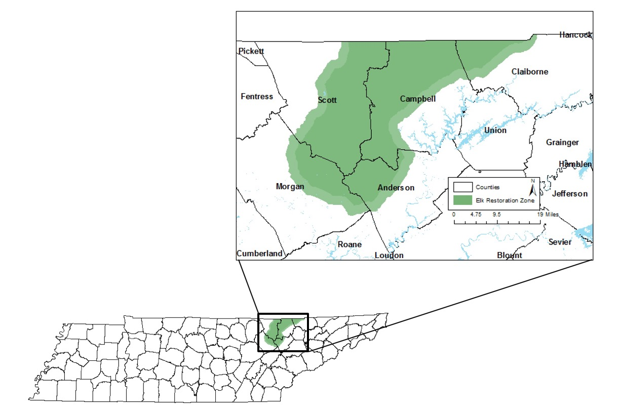
Figure 1.1 Tennessee Elk Restoration Zone (ERZ) with 5 counties included in the study area (Morgan, Scott, Campbell, Anderson, & Claiborne)

certain hypotheses being tested in this study required segmenting the population for analyses, which increases sampling error (Vaske, 2008). Therefore, in order to be able to compare subgroups with minimal sampling error, the sample size was increased. In total, 5,000 households were sampled in total to gain adequate information to generalize to the population.
A stratified random sample was used as the sampling frame for this study. As the purpose of this study was to assess opinions and attitudes of residents towards elk, the sample was stratified to increase the chances that residents would have had experiences with elk. It was assumed that residents who reside within the elk zone or the elk buffer zone would have seen more elk, had a greater chance of having experienced elk damage, or were more likely to possess stronger opinions on elk than those who live outside the zone. However, as it is possible that anyone within this region has had some experience with elk, the whole area was sampled. The sample was stratified by household address and oversampled from those whose addresses are located within the elk zone. Addresses were selected so that 60% were located within the elk zone, 20% were located within the buffer zone, and 20% were located in the rest of the county.
Participants for this survey were recruited from a database aquired by an address database company, Survey Sampling International. The addresses in the database were categorized into census groupings such as census divisons, tracts, and blocks. The initial plan was to sample from the address database by census tract. However, due to the rural location of these counties, these proved to be too large to group respondents in the manner desired. Therefore, census block groups were used to stratify the sample.

1.5.2 Survey Instrument

The survey instrument (Appendix A) was developed based on issues and comments raised during a half-day workshop with TWRA regional elk biologists and managers. Questions were developed to address a multitude of issues about elk reintroduction in addition to the main questions of this academic study. The 9-page questionnaire was developed to assess residents’ opinions and attitudes towards various aspects of elk reintroduction, damage, and management. A number of questions recently tested and used for similar surveys in nearby states were used to develop the preliminary instrument (Crank et al., 2010; Linehan et al., 2014; Longmire, 2013; Lee et al., 2003). Feedback on the questionnaire was collected from survey research experts, social psychologists, and wildlife biologists with knowledge of the specific issues regarding elk reintroduction in this area. The University of Tennessee Institutional Review Board (IRB Approval #UTK IRB-17-04149-XP) approved the survey instrument and protocols.
The questions on the survey are organized into four sections. The first section included questions regarding the respondents’ property characteristics. The questions in this section were designed to assess how a respondents’ property characteristics relate with their general interest and attitudes towards elk. The second section specifically asked questions about respondents’ experiences with elk on their property. This section was designed to assess actual damage to property caused by elk, concerns about potential damage, and their attitudes towards allowing elk hunting on their property. The third section asked questions regarding elk management options. The final section contained questions about respondents’ demographics such as age, sex, employment, annual income, and whether they hunt.
Perception and attitude questions utilized appropriately labeled 5-point Likert scales, (i.e. 1-Strongly disagree ↔ 5-Strongly agree or 1-Not important ↔ 5-Very important). Likert scales are a widely used fixed choice response format in survey design and are well known for measuring attitudes and other cognitive constructs (Vaske, 2008). The use of these scales also allows for responses to be easily entered and coded for data analysis. Other questions were either structured (multiple choice, Yes or No) or open-ended where applicable.
Returned completed surveys were organized by ID number and cataloged in a spreadsheet as they were received, along with the date in which they were received. The survey data was coded and entered into an excel spreadsheet for further analysis. The physical surveys were stored in cabinets in a locked office on the University of Tennessee campus and destroyed one year after the survey was implemented.

1.5.3 Data Collection

The selected respondents were surveyed via a mail questionnaire since respondents were stratified by residential location within the 5-county region and thusly, the data acquired for the respondents included addresses but no telephone numbers. Moreover, many people no longer use landline telephones. Additionally, respondents have been found to be more likely to choose answering surveys by mail rather than other modes (Dillman, 2014). Mail surveys are also more likely to ensure respondent anonymity and confidentiality and avoid interviewer bias (Vaske, 2008). Lastly, as the survey contained many questions, a paper format allowed the participants to have ample time to carefully read all of the questions and complete the survey.
The mail survey was administered following a modified tailored design method (Dillman, 2014). The survey packet included a questionnaire, personalized cover letter, and a business reply envelope. The envelope in which the survey was sent contained information indicating that this was a survey project sponsored by the University of Tennessee and the TWRA. It also included the return address for the primary researcher and a pre-paid business reply envelope
The first mailing of the survey packet contained an initial invitation cover letter, inviting people to participate in the survey. This cover letter was personalized for each individual, described the purpose of the study, how the study would be useful to respondents, ensured confidentiality of identifying information, and included contact information for the primary researcher. Roughly a week after the initial mailing, a thank you reminder postcard was sent. Then, 3 weeks later, another survey packet was sent to respondents who had not yet sent back their initial survey. The cover letter for this packet reminded participants about the packet sent earlier and request that they fill out and return this survey. Lastly, a final reminder letter was sent to those who had not yet returned their completed survey 2-4 weeks later.
The first round of the survey was mailed out in early January 2018 with follow-up mailings sent out later the same month and into February. This timing was chosen as it was the end of the elk rutting season. During this time, elk are very active so there is a greater likelihood that people living near the elk restoration zone would have had some recent contact or experience with them. As this time period is right after the busy holidays, it also ensured that most people would be at home and ready to accept their mailed survey.
Similar projects surveying landowners on elk reintroduction through mail surveys reported response rates ranging from 20 to 70% (i.e., Crank et al., 2010: 27% in Nebraska; Linehan et al., 2014: 41% in North Carolina; Longmire, 2013: 61% in South Dakota; Lee et al., 2003: 68% in Arizona). As such, it is difficult to predict response rates for this survey, but several protocols were put in place to ensure high response rates. Following Dillman (2014), the survey materials included information about how responses will help wildlife managers in the area adapt the elk policy, which was intended to add a sense of reward to respondents as well as telling them how the results will be useful to them. Sponsorship for the study was indicated by logos of supporting organizations (University of Tennessee and TWRA) on the cover of the questionnaire. This enhanced credibility for the study and promote survey completion.
To test for nonresponse error, similarities in key demographic characteristics were compared among survey respondents, non-respondents, and the sample as a whole. The nonresponse data was assessed through age and gender information collected from the address database. Responses were also compared between the three strata of residents located within the ERZ, in the buffer zone, and within the 5-county area but not within the ERZ. Additional similarities in demographic characteristics were examined as they appeared in the data.

CHAPTER II
THE INFLUENCE OF TRUST ON RISK PERCEPTIONS AND SUPPORT FOR WILDLIFE REINTRODUCTION

Abstract

Local support is necessary in order to have successful wildlife reintroduction projects. However, these projects often face resistance from local residents who see potential conflicts with the species or lack trust or confidence in the agencies and professionals who are in charge of implementing the reintroduction. Yet, the linkages between trust, confidence, risk perceptions, attitudes toward the species, and local support for its reintroduction are not well known, nor understood. This study sheds light on these linkages by exploring the potential roles trust and confidence play as mediators between risk perceptions and attitudes towards reintroduced elk in a case study of local support for elk reintroduction in the state of Tennessee within the USA. A structural equation model based on survey data of households (N = 1,005) in the 5-county area in east Tennessee surrounding the North Cumberland Elk Restoration Zone, revealed that trust and confidence play positive roles in mitigating risk perceptions and improving support for wildlife restoration and elk reintroduction. Findings confirm the roles public trust and confidence play in wildlife reintroductions and they should help agencies work towards building local trust and confidence, minimizing risks, improving attitudes, and increasing the chances for successful outcomes for the species and the people.

Keywords: SEM, elk reintroduction, restoration, local residents

2.1 Introduction

Wildlife reintroductions are becoming a common practice as global biodiversity rates continue to decline, however the social implications surrounding these types of conservation projects are not well understood. These projects can be controversial and often face considerable resistance from local human communities, whose interests are varied but may have value conflicts with the species being reintroduced. For example, efforts to reintroduce wolves into Arizona, black bears in East Texas, and panthers in Florida were all halted over human concerns (Shoenecker & Shaw, 1997; Williams et al., 2011; Taylor, 1998). The reintroduction of wolves to Yellowstone National Park was also met with large levels of resistance from ranchers and those who live near the park but was counteracted by management tactics to mitigate concerns (Browne-Nunez & Taylor, 2002). While reintroductions of herbivores like elk may be less controversial, they are still subject to the same public pressures. The human influence on wildlife reintroduction has such an impact on the success of these programs that the International Union for Conservation of Nature (IUCN) Guidelines for Reintroductions include social feasibility as a main design element in implementing a successful reintroduction (IUCN, 2013).
Part of the public outrage and opposition to reintroduction programs stems from the perceived risk associated with the species in question along with a lack of trust or confidence in the management agency in charge. Trust and confidence have been shown to be important factors in managing risk and generating cooperation (Siegrist, Earle, & Gutscher, 2003). Stakeholder confidence in the technical and managerial skills of wildlife professionals along with the belief that professionals can be relied upon may play important roles in minimizing perceived risks associated with reintroduced species and generating positive attitudes and support during program implementation. With the case of elk reintroduction in Tennessee, the present study investigates the role of trust and confidence as partial mediators between risk perceptions and attitudes towards reintroduced elk, and the effect of this relationship on support for continued elk restoration efforts.
Perceived risk is the degree to which individuals believe they are threatened by some hazard or danger (Siegrist & Cvetkovich, 2000; Harper, Miller & Vaske, 2015). Major concerns over wildlife reintroduction often come from risks associated with the species being reintroduced such as potential damage to property, altering of the ecosystem, spreading of disease, and predation of livestock or crops. The perception of risk is subjective, with people having varying degrees of concern about the same hazard (Siegrist, Gutscher & Earle, 2005). For example, residents living in the same metropolitan area in Chicago, Illinois were found to perceive a variety of risk perceptions towards coyotes, ranging from not at all concerned to extremely concerned (Sponarski, Miller, & Vaske, 2018). Social science research thus far has identified several factors explaining risk perceptions towards certain objects including level of knowledge, uncertainty, voluntariness, newness, catastrophic potential, control over risk, and social trust (Siegrist, Cvetkovich, & Roth, 2000; Slovic, 1987).
Regardless of the reasons behind differences in individual risk perceptions, research has shown that they can influence preferences for management alternatives and support for species recovery. A study of Florida residents’ perceptions of risk towards and support for Florida Panther recovery found a negative correlation, suggesting that risk perceptions do have a negative impact on support for recovery (Langin & Jacobson, 2012). However, risk perceptions in this case were not significant predictors of support for panther recovery because, as the authors theorized, the small population size of the species led the public to see them as nonthreatening. In contrast, risk perceptions did influence public support for wildlife in Montana as those with higher risk perceptions were found to have lower capacities to accept cougars (Riley & Decker, 2000). Shoenecker & Shaw (1997) also found that risks towards livestock and human safety were often-cited reasons for opposing wolf reintroduction in Arizona. These studies suggest that when risk perceptions are higher, they have a negative impact on support for wildlife reintroductions, but when perceived risks are lower, the effect is insignificant.
In the case of elk reintroduction to Tennessee, risks could be larger or smaller, depending on an individual’s proximity to the elk reintroduction zone, frequency of visitation to the area, and personal values. For example, people driving through the area may incur risks of hitting an elk with their car, while property owners may incur risks such as damage to fences, erosion from elk trails, and damage to crops. A study of elk in an urban-wildlife interface in Flagstaff, Arizona found that residents were very concerned about vehicle accidents involving elk, but less concerned about property damage (Lee & Miller, 2003). Wildlife viewers or hunters may incur perceived risks from elk such as outcompeting deer, spreading of disease such as Chronic Wasting Disease (CWD) to other members of the deer family, or bodily harm if encountering an elk in the wild. The risks involved with elk reintroduction can also disproportionally affect people, running from small risks incurred by large amounts of people to large risks incurred by a few landowners. A study in North Carolina predicted that with expansion of elk population, landowners interaction with elk will increase, which in turn would lead to decreased support for elk (Linehan & Palmer, 2014).
Social trust is a multidimensional construct that has been theorized differently depending on the context being studied. In the risk management literature, however, a dual-mode model of cooperation based on both trust and confidence as separate constructs has been posited (Siegrist, Earle, & Gutscher, 2003; Siegrist at al., 2005). Trust is the belief that those in charge can be relied upon, while confidence is the belief that everything is under control. Trust is based on an individual’s willingness to make themselves vulnerable to another based on a judgement of similarity of values (Siegrist et al., 2003). Confidence, alternatively, is based on a history of successful past experiences that lead individuals to believe that future events will go as expected (Siegrist et al., 2003). Trust, therefore, is placed on people within any context, while confidence is placed in relation to the capable management of a risk-inducing item or situation.
In broader terms, social trust is often seen as the willingness to rely on those who are responsible for managing a specific hazard or realm of public safety (Siegrist et al., 2000). It has been shown that trust and confidence can negatively influence risk perception, meaning that higher levels of trust and confidence correspond with lower levels of perceived risk (Siegrist et al., 2003; Siegrist et al., 2005). Social trust is especially important in predicting risk perceptions when other predictors are absent, such as lack of knowledge, increasing uncertainty, or large potential for catastrophe. Public policies based on scientific expertise, such as wildlife management policies, are often cases where people lack such information. Social trust, can therefore, play a crucial role in promoting positive perceptions and interactions between humans and wildlife.
Emergent literature on Chronic Wasting Disease (CWD) has shown a link between risk perceptions and social trust. Hunter participation in CWD impacted counties in Wisconsin was higher among those who trusted information about the disease shared by the state wildlife agency (Vaske, Timmons, Beaman, & Petchenik, 2004). A similar study in eight western states found that hunters who trusted the agency perceived less risk from CWD although the trust was a rather poor predictor of risk perception (Needham & Vaske, 2008). More recently, support for CWD management has been found to be higher among hunters who perceived higher risk from the disease and placed more trust on the managing agency (Harper et al., 2015).
In addition to mitigating risks, trust has also been shown to improve attitudes towards wildlife and increase support for natural resource management programs. Trustworthiness was found to be an important factor in driving cooperation behavior with an invasive species management program in Michigan (Hamm, 2017). Trust in the management agency was also found to be an important influence on attitudes and management preferences towards wolves in Alberta, Canada (Sponarski et al., 2014). When local residents have trust and confidence in the managing agency, attitudes towards the wildlife management program tend to be more positive, which leads to more support. Another study in the Midwestern U.S. found that citizens who exhibit greater levels of trust are more likely to trust that the agency has their interests in mind (Smith, Leahy, Anderson, & Davenport, 2013). These studies suggests that residents who trust the managing agency are more likely to cooperate with management practices and programs.
Attitudes can also be an important predictor of support for management programs. Positive attitudes towards wildlife in general or the species of conservation interest have been shown to have positive impacts on support for their management (Manfredo, 2012; Sponarski et al., 2014). Positive implications of wildlife reintroduction such as benefits to the environment, economic impacts, and hunting rights can also work to counteract associated risk perceptions and influence support for management.
Conflicts surrounding wildlife reintroductions can stem from negative attitudes towards the species as well as lack of trust and loss of confidence in managing wildlife agencies and their professionals. These social factors can often be more important in driving conflict than actual damage or incidents (Dickman, 2010). For example, the stocking of non-native striped bass to the Norris Reservoir in eastern Tennessee by the Tennessee Wildlife Resource Agency (TWRA) for the purpose of improving trophy fishing led to perceived declines in native fish species, backlash among anglers, and unsuccessful reconciliation efforts (Churchill, et al., 2002). The failure of the managing agency to engage with local anglers about stocking efforts and loss in confidence may have led to the negative outcomes in this scenario. A more severe consequence took place in Ireland, where the reintroduction of the endangered white-tailed sea eagle led to conflict with sheep farmers and eventually to the death of several eagles due to ingestion of poisoned lamb meat (O’Rourke, 2013). These case studies assert the need to study trust in wildlife reintroduction scenarios and highlight the importance of building trust with local residents to influence attitudes and increase support.
The importance of building social trust cannot be overstated, as other methods of improving public support for wildlife reintroductions have been shown to be less successful. For example, priming individuals with information and persuasive arguments have been shown to be ineffective in gaining public support for wolf reintroductions (Wilson & Bruskotter, 2009; Meadow, Reading, Phillips, Mehringer, & Miller, 2005). This suggests that education and communication alone may not be enough to improve support for reintroductions.
Specific to the case of elk reintroduction and restoration in Tennessee, assessing risk perceptions, trust levels, and attitudes towards elk are important for two reasons. The first is in the practical sense that it will assist wildlife managers on-the-ground in Tennessee to alter their management and perhaps help wildlife managers in other states to act pre-emptively to minimize risk perceptions and increase support for planned reintroductions. Secondly, it will help advance the existing theory in understanding how trust, confidence and perceived risk can impact public attitudes towards wildlife reintroductions and support for management of reintroduced species.

2.1.1 Theoretical Framework

The Dual-Mode Model of Cooperation suggests that social trust can be measured in terms of general confidence, based on performance, and general trust, based on shared values (Siegrist, Earle, & Gutscher, 2003). This model views social trust as a multi-dimensional construct on behavioral cooperation (i.e. support) in situations involving risks. It suggests that both trust and confidence play important roles in mitigating risk perceptions and explaining human behavior. As reintroduced elk impose several risks for residents living near the reintroduction site, and residents must rely on professionals to manage those risks, this model may be useful in predicting the impact of social trust in the managing wildlife agency on risk perceptions and support for reintroduction.
The Cognitive Hierarchy Model (CHM) is a conceptual framework and measuring approach to help wildlife management researchers map out individual factors thought to be driving environmental behavior and public support for conservation efforts (Fulton et al. 1996, Vaske & Donnelly 1999, Whittaker et al. 2006, Sponarski et al. 2014). It is based on the premise that “cognitions and behaviors are organized into a hierarchy leading from general values to behavior” (Whittaker et al. 2006). As human behavior is more variable and subject to change, the measurement of cognitions lower on the hierarchy, like attitudes and values, can be a useful tool to predict behavior.
CHM also asserts that general measures of attitudes, such as attitudes towards wildlife restoration, are better predictors of a general set of behaviors or practices supporting wildlife restoration, while, more specific measures of attitudes such as attitudes towards elk restoration are better predictors of specific actions and practices designed to restore them (Manfredo 2012, Sponarski et al. 2014). Attitudes towards reintroduced elk, therefore, are more likely to predict support for elk restoration than more general attitudes toward wildlife restoration and values.
This study combines elements of Cognitive Hierarchy Model with the Dual-Mode Model of Cooperation to assess how trust and confidence work to mediate the relationship between risk perceptions and attitudes in order to influence behavior. Sponarski et al. (2014) used a portion of this model to examine the relationship between social value similarity, trust in agency, attitudes towards wolves, and support for wolf management. This study expands the above model to include the dual-mode model of cooperation, to further investigate the complexities involved with agency trust, and include risk perceptions because they are an important factor in determining attitudes and support for reintroduced species. This study additionally predicts that trust and confidence act as mediators in the relationship between risk perceptions and attitudes towards reintroduced elk, as risk perceptions have both a direct and indirect effect on attitudes via trust and confidence.
This study presents a model to explain how risk perceptions towards a reintroduced species are influenced by both trust and confidence in the managing wildlife agency and how this relates to both attitudes towards the species and support for continued restoration. Little is known about the interaction between trust and confidence outside of risk management literature and no studies have been conducted to test the dual-mode model of trust and confidence towards wildlife management agencies in the context of wildlife reintroductions. Another contribution of this work is the addition of risk perceptions and attitudes into a model to predict support for a specific public policy. This study postulates a model to test the impact of trust and confidence on the relationship between risk perceptions and attitudes towards reintroduced elk to predict support for continued elk restoration. Findings may help us better understand the influence of these social concepts on the long-term success of species reintroductions.

2.2 Objectives and Hypotheses

The overall objectives of this study are to examine the relationships between risk perceptions, trust, and confidence on attitudes towards reintroduced elk and support for elk reintroduction in Tennessee. Specifically, the objectives are as follows:
- To test the dual-mode model of trust and confidence in the applied context of wildlife reintroduction risk perceptions
- To assess the impact of risk perceptions on attitudes towards reintroduced elk and support for elk reintroduction in Tennessee
- To examine the mediating effect of trust and confidence on the relationship between perceived risk and attitudes towards reintroduced elk in Tennessee.
The dual-mode model of trust and confidence is expected to be confirmed for its use in the wildlife reintroduction risk context as it has been confirmed in several studies in the risk management literature. Based on results from similar studies, perceived risks are expected to be negatively related to attitudes towards reintroduced elk in Tennessee, while trust and confidence are expected to interact to mediate the relationship between perceived risks and attitudes to influence support for elk reintroduction. The resulting model will be able to explain the importance of trust and confidence in decreasing risk perceptions and increasing public support for wildlife reintroduction programs.

2.3 Methodology

2.3.1 Survey Design & Variables

Data for this study was collected from a mail survey of 5,000 land-owning residents from the 5-county area surrounding the elk restoration zone in East Tennessee. Survey implementation was completed following a modified tailored design method (Dillman, Smyth, & Christian, 2014). For detailed information on the study site and sampling design see Section 1.5.
The constructs for this study were defined using multiple item indicators in order to reflect a full understanding of the underlying concepts (Vaske, 2008). As the main objective of this project was to assess how social trust relates to support for elk reintroduction, a well-established trust scale was adapted for this survey. This allowed testing the extent to which each statement reflects the underlying concept using Cronbach’s alpha to measure reliability (Vaske, 2008). For example, levels of social trust for the managing wildlife agency were assessed with the direction, “Please indicate your level of agreement with each of the following statements.” Participations were then presented with a list of statements such as “I am confident in the wildlife agency’s capacity to manage elk in the region” and “Wildlife agency professionals share similar goals as me.” Level of agreement with each statement was indicated on a 5-point Likert scale (strongly disagree=1, strongly agree=5). Items measuring this construct are shown in Table 2.1.
The exogenous construct being explored in this study is that of elk-related risk perceptions on a continuum from less concerned to more concerned. To measure this, a 9-item Likert response scale was included in the survey asking respondents to rate their level of concern for risks associated with elk. Options ranged from “elk/vehicle accidents,” “damage to fences,” to “spreading disease to cattle/pets.” Level of concern for each statement could be indicated on a 5-point Likert scale (Not at all concerned=1, Very concerned=5).
Table 2.1 Survey items measuring social trust in the state wildlife management agency in charge of elk reintroduction and grouped by confidence and trust in agency components
Statements | Symbol in Path Diagram
Confidence in Agency
I am confident in the wildlife agency’s capacity to manage  elk in Tennessee | CA1
Wildlife agency professionals…
Can effectively manage elk in Tennessee | CA2
Are capable of preventing elk-human conflicts | CA3
Can help us deal with nuisance elk | CA4
Trust in Agency
Wildlife agency professionals…
Listen to our concerns | TA1
Know what is best for local residents | TA2
Share similar goals as me | TA3

Two factor analyses were conducted on the risk perception variables to reduce the data and remove redundancies. Factor analysis is a statistical procedure that reduces data so that the variations in a large number of variables may be reflected in the variations of a smaller number of underlying variables. The first factor analysis created one underlying factor using the variables, “damage to trees,” “damage to fences,” “damage to gardens” and “damage to haystacks,” as these variables correlated highly with each other and related to property damage. The second factor analysis created one underlying factor combining the variables “competing with cattle for forage” and “competing with deer for forage” as these variables correlated highly with each other and related to competition. The final items measuring risk are shown in Table 2.2.

Table 2.2 Survey items used to measure risk perceptions towards reintroduced elk in Tennessee
Risk Statements |  | Symbol in Path Diagram
Elk/Vehicle accidents | PR1
Damage to Property | PR2
Competing for forage | PR3
Spreading disease to cattle/pets | PR4
Elk trails causing erosion | PR5

Attitudes towards reintroduced elk were measured via a 5-item Likert response scale in the survey, which asked respondents to rate their level of agreement with several statements about elk in Tennessee from 1 (strongly disagree) to 5 (strongly agree). The items indicated various aspects of attitudes towards reintroduced elk in Tennessee from statements such as “elk are a valuable part of nature” to “future generations should be able to see elk in Tennessee.” Items measuring this construct are shown in Table 2.3.
Lastly, support was measured through one survey item, which asked respondents to rate their level of agreement with the statement “I support establishing a healthy population of elk in my region.” This was also rated on a 5-point Likert scale from 1 (strongly disagree) to 5 (strongly agree).

Table 2.3 Survey items used to measure attitudes towards elk
Statement | Symbol in Path Diagram
Even if I never see an elk in the wild, it is important for me to know they exist in Tennessee | AE1
Elk have the right to exist wherever they may occur | AE2
Elk are a valuable part of nature | AE3
Future generations should be able to see elk in Tennessee | AE4
Having elk helps maintain balance in the natural environment | AE5

2.3.2 Structural Model

The proposed model (Figure 2.1) aimed to test the relationships between risk perceptions, social trust, attitudes towards reintroduced elk and support for elk restoration. Studies have shown that risk perceptions can negatively impact attitudes towards wildlife (Needham & Vaske, 2008), while trust in the managing wildlife agency can positively impact attitudes towards wildlife (Harper et al., 2015). Research on the dimensionality of trust suggest that social trust is a complex construct with multiple levels that play defining roles. Several dimensions of trust have been found in risk analysis research such as credibility, reliability, care, fairness, and value similarity (Poortinga & Pidgeon, 2003). The model in this study attempts to test the dual mode model of trust posited by Siegrist et al. (2005) in the context of wildlife reintroduction risk. Two components of trust are trust in wildlife agency personnel and confidence in the capability of the wildlife agency to effectively manage elk. The model tests the impact of trust and confidence on

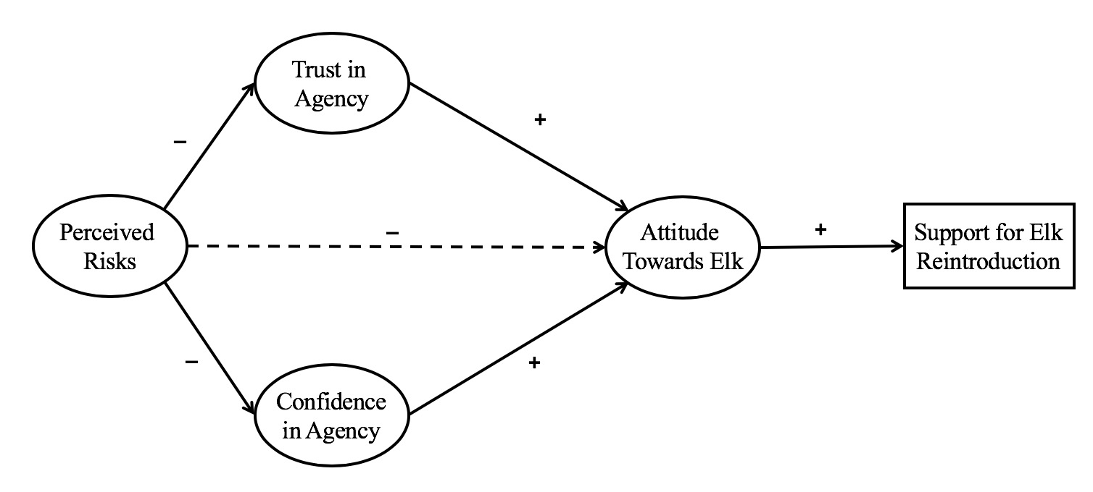
Figure 2.1 Proposed Structural Equation Model with hypothesized relationships between risk perceptions, trust, confidence, attitudes towards elk, and support for elk reintroduction

the relationship between risk perceptions and attitudes towards reintroduced elk and its’ effect on support for elk restoration in Tennessee.
Risk perceptions alone have been shown to negatively impact support for wildlife reintroduction. Trust in expert authorities, however, has been shown to mitigate perceived risks and lead to positive outcomes (Siegrist et al., 2000). Trust has also been shown to positively impact attitudes towards certain species, which can have positive impacts on behavioral support (Sponarski et al., 2014). Therefore, it is hypothesized that increasing levels of trust in wildlife agencies leads to positive elk attitudes and greater reintroduction support. The dual-mode model of trust suggests that individuals may place varying degrees of influence on the two components of social trust. In this model, some people may feel that individual members of wildlife agencies are looking out for them but may not feel confident in the management capability of the agency as a whole. Conversely, some may feel that the agency is competent in their management of elk, but past experiences with individuals within that agency have led them to have less trust. It is hypothesized that these two components of trust have varying degrees of positive impact on the relationship between risk perceptions and attitudes towards reintroduced elk, with confidence playing a larger role than trust. Positive attitudes towards elk will then have a positive influence on support for elk reintroduction.
The model assumes that risk perceptions have a negative impact on support for elk reintroduction. However, when the dual social trust dimensions of trust and confidence are added to the model, that relationship is expected to become positive, with confidence having a larger influence than trust. This model predicts the mediation effect of social trust and confidence between risk perceptions and attitudes towards reintroduced elk and support for reintroduction. Generally speaking, as risk perceptions towards elk increase, attitudes towards elk and support for elk reintroduction decreases. However, the model explains that as trust in wildlife agency personnel and confidence in the agency to manage elk increase, the negative effect of risk perceptions on attitudes will diminish. Furthermore, as risk perceptions decrease because of this interaction, support for elk reintroduction will increase.

2.3.3 Data Analysis

The hypothesized model described in Section 2.3.2 was constructed via Confirmatory Factor Analyses (CFA), Exploratory Factor Analysis (EFA), and Structural Equation Modeling (SEM) using STATA SEM software. CFA’s were performed on the multi-item trust scale to test the hypothesized dual-mode model of social trust as well as on the attitudes towards elk scale. An EFA was conducted on the construct of risk perceptions to find the minimum number of factors that account for covariation in the model. Once the measurement models were validated, the structural equation model was formed to test the relationships between the variables being examined.
Factor analyses generally test whether the measurement items used to measure the constructs in the model actually do so by testing for convergent and discriminant validity simultaneously (Byrne, 2016). First-order CFA’s were conducted on the social trust and attitude constructs to validate the pre-existing theories on the dual mode model of trust and attitudes. An EFA was conducted on the risk perception construct as the link between the observed items and the latent variable were uncertain and the minimum number of underlying factors needed to be determined. Following Vaske (2008), stringent cutoffs were utilized in each analysis so that only variables having an item total correlation of at least 0.5 were considered for the analysis. Cronbach’s alpha was also used to test the internal consistency of the factors that emerged from performing the factor analyses.
The results from the factor analyses were analyzed for skewness and kurtosis to test for normality, as well as goodness of fit. Goodness of fit was examined using the confirmatory fit index (CFI), Chi-square (CMIN) test, Tucker-Lewis Index (TLI), and the root mean square error of approximation (RMSEA) test, shown in the STATA CFA output. CFI measures relative fit, relative to how poorly the model could fit and TLI is an incremental fit index. The RMSEA test accounts for the trend of large sample sizes to cause the Chi-square statistic to show significant differences between the observed data and model expectations. For the CFI test, a relative fit above 0.9 is generally accepted, with a fit about 0.95 is considered more robust (Byrne, 2016). Similarly, a value of 0.95 was considered acceptable fit for TLI, with 0.97 considered more robust (Cangur & Ercan, 2015). A RMSEA score approaching 0.05 was considered the threshold for good fit (Byrne, 2016). These tests were conducted to ensure that the manifest variables adequately measure the constructs, that the manifest variables measure the correct constructs, and that there are no extraneous variables in the final model. Adjustments to the model such as removing irrelevant variables or adjusting relationships were made through post-hoc analyses.
A structural equation model was then developed to examine the correlation of the latent variables, which in this case are trust, confidence, risk perceptions, attitudes towards elk, and support for reintroduction. The structural equation model constrains the covariance of constructs according to theory (Byrne, 2016). Tests of goodness of fit were again examined using the confirmatory fit index (CFI), Tucker-Lewis Index (TLI), Chi-square (CMIN) test, and the root mean square error of approximation (RMSEA) test.
Mediation in the SEM model was tested following a four-step process detailed in Baron and Kenny (1986). The tests described in the following steps are simplified regression structural equation models showing the relationship between only two variables in the model at a time. First, a test was conducted to show that the risk perception construct is correlated with attitudes towards reintroduced elk, which established that there is an effect that may be mediated. Second, tests were conducted to show that the risk perception construct is correlated with each mediator (trust and confidence). Third, tests were conducted to show that each mediator, not only is correlated with, but also affects attitudes towards reintroduced elk. Lastly, to establish complete mediation, the effect of risk perception, controlling for trust and confidence, should be zero. If this path is only diminished, and not completely removed with the addition of the mediator variables to the model, then partial mediation is indicated.

2.4 Results

Out of 5,000 contacts, 18 were returned because the person being contacted was deceased or had moved from the stated address. A total of 1,005 surveys were returned, yielding an adjusted response rate of 20.17%. The response rate reported in our survey is consistent with several recent surveys that utilized randomized local residents as the sampling frame in a mail survey (e.g. Crank et al., 2010: 27% in Nebraska) and is sufficient for the study area population of five counties, with 95% confidence interval and 5% margin of error (Vaske, 2008). The age of respondents ranges from 18 to 98, with the majority (78%) ranging between 45 and 70 years of age with an average age of 49 (Table 2.4). The majority of respondents (65%) were female and non-hunters (64%). Of 953 participants that responded to the education attainment question, 10% had some high school education, 34% had a high school diploma or GED, 35% had some college or associate degree, 12% had a bachelor’s degree, and the remaining 8% had post-graduate degrees. Of 806 participants that responded to the income question, 55% indicated to have less than $50,000 in annual household gross income in 2017, another 31% reported between $50,000 and the remaining 14% more than $100,000. When comparing sample demographics to the population of interest, the
Table 2.4 Descriptive Statistics for residents of the 5-county area surrounding the Elk Reintroduction Zone
 | Descriptive Statistics
Demographics | n | M (SD) | % of Respondents
Average Age (years) | 957 | 59.82
< 45 years | 153 |  | 16%
45 – 60 | 311 |  | 33%
61 – 70 | 260 |  | 27%
71 – 80 | 169 |  | 18%
> 80 years | 64 |  | 7%
Gender (female) | 622 |  | 65%
Hunter Status
Hunter | 340 |  | 36%
Non-hunter | 616 |  | 64%
Educational Achievement | 953
Some high school | 99 |  | 10%
High school diploma | 326 |  | 34%
Some College | 241 |  | 25%
Associate Degree | 88 |  | 9%
Bachelor’s Degree | 116 |  | 12%
Post-graduate Degree | 83 |  | 8%
Annual Household Income | 806
< $25,000 | 202 |  | 25%
$25,000 to $49,999 | 242 |  | 30%
$50,000 to $74,999 | 145 |  | 18%
$75,000 to $99,999 | 105 |  | 13%
$100,000 to $124,999 | 56 |  | 7%
$125,000 + | 56 |  | 7%

data overrepresented females (65% female response rate) and was weighted accordingly to match the proportion of females in the population (50%).

2.4.1 Exploratory Factor Analysis for Risk Perception Construct

An exploratory factor analysis was conducted on the initial nine risk perception items in order to find the minimum number of factors that account for covariation in the model. All nine variables were tested in the first model, however, this model presented a poor fit of the data (X² (27) = 442.55, p < 0.001, CFI = 0.94, TLI = 0.92, RMSEA = 0.13). Due to the poor fit of this model, two factor analyses were conducted to reduce the data and remove redundancies. The resulting model included only five risk items and had a much better model fit (X² (5) = 35,45, p <
0.001, CFI = 0.99, TLI = 0.98, RMSEA = 0.07) (Figure 2.2). Standardized regression weights exceeded the minimum threshold of 0.4 (Vaske, 2008) and ranged from 0.67 (RP1) to 0.88 (RP2).

2.4.2 Confirmatory Factor Analysis for Trust Construct

A confirmatory factor analysis (CFA) was conducted to test the idea posited by Siegrist, et al. (2005) that trust can be explained by a dual mode model of cooperation comprised of trust and confidence. The model shown in Figure 2.3 confirms this relationship, as the data provided an acceptable model fit for the two constructs of trust and confidence (X² (13) = 151.20, p < 0.001, CFI = 0.97, TLI = 0.96, RMSEA = 0.09). The seven variables also support the multi-dimensionality of the two constructs as the factor scores exceeded the minimum threshold of 0.4 (Vaske, 2008). The standardized regression weights (factor scores) ranged from 0.80 (wildlife agency professionals know what is best for local residents (TA2)) to 0.84 (wildlife agency professionals listen to our concerns (TA1)) for the trust construct and from 0.80 (I am confident in the wildlife agency’s capacity to manage elk in the region (CA1)) to 0.93 (I trust wildlife professionals to effectively manage elk in Tennessee (CA2)).

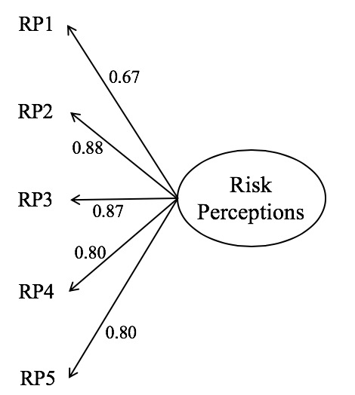
Figure 2.2 Confirmatory Factor Analysis for the risk perception construct showing acceptable model fit

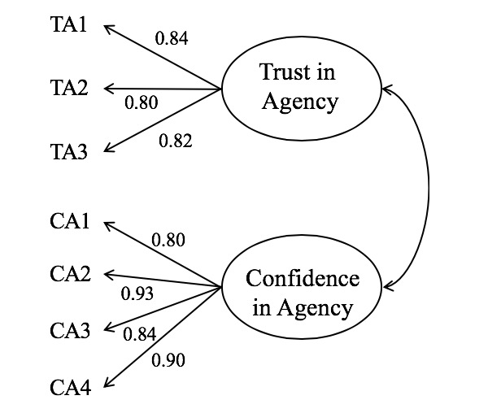
Figure 2.3 Confirmatory Factor Analysis for the agency trust constructs

2.4.3 Full CFA Model

Results from the final CFA model constructs including tests for internal consistency, means, and standardized regression weights are shown in Table 2.5. Perceived risks were relatively low, with means ranging from 1.87 to 2.66 on a 5-point Likert scale. Items measuring trust and confidence were moderate, with means ranging from 3.10 to 3.49 for trust items and 3.64 to 3.93 for confidence items on 5-point Likert scales. Items measuring attitudes towards reintroduced elk were relatively higher, ranging from 3.83 to 4.48 on a 5-point Likert scale. Support for elk reintroduction also rated highly with a score of 4.11 on a 5-point Likert scale. The Cronbach’s alpha test revealed high scores for each construct, between 0.86 and 0.92, suggesting high internal consistency. A Cronbach’s alpha test was also conducted with the deletion of each item. This test revealed that the scales, as they are in the model, would have less internal consistency if any one of the items were removed. Including all the variables in the full model altered the standardized regression weights for each construct slightly, however, they still exceeded the minimum threshold of 0.4 and ranged from 0.70 to 0.92.

2.4.4 Structural Model

The final structural equation model is shown in Figure 2.4. The model shows the causal relationship between risk perceptions and support for elk reintroduction with trust and confidence shown as partial mediators. The model path coefficients and goodness of fit tests are shown in Table 2.6 and reveal that the model presents a good fit to the data (X² (128) = 504.48, p < 0.001, CFI = 0.97, TLI = 0.97, RMSEA = 0.06). The relationship between risk perceptions and trust and confidence in the agency explains 46% of the variance in attitudes towards elk. Furthermore, the model reflecting risk perceptions, trust and confidence, and attitudes towards elk explains 61% of the variance in support for elk restoration.
Table 2.5 Indicators for perceived risks, trust, confidence, attitudes towards elk and elk reintroduction support
 |  | Final model
 | Item | Mean (S.D) | Cronbach’s α if item deleted | Cronbach’s α | Std. weights
Perceived Risk |  |  |  | 0.88
 | Elk/vehicle accidents (PR1ª) | 2.66 (1.45) | 0.87 |  | 0.71
 | Property Damage (PR2) | 2.18 (1.24) | 0.84 |  | 0.88
 | Competing with deer/livestock for forage (PR3) | 2.27 (1.28) | 0.84 |  | 0.86
 | Spreading disease to cattle/pets (PR4) | 2.47 (1.47) | 0.84 |  | 0.76
 | Elk trails causing erosion (PR5) | 1.87 (1.20) | 0.85 |  | 0.77
Trust in Agency |  |  |  |  | 0.86
 | Wildlife agency professionals
 | … listen to our concerns (TA1) | 3.49 (1.08) | 0.81 |  | 0.82
 | … know what is best for local residents (TA2) | 3.10 (1.17) | 0.80 |  | 0.79
 | … share similar goals as me (TA3) | 3.35 (1.04) | 0.80 |  | 0.83
Confidence in Agency |  |  |  |  | 0.92
 | I am confident in the wildlife agency’s capacity to manage elk in TN (CA1) | 3.93 (1.07) | 0.91 |  | 0.84
 | Wildlife agency professionals
 | … can effectively manage elk in TN (CA2) | 3.83 (1.10) | 0.88 |  | 0.92
 | … are capable of preventing elk-human conflicts (CA3) | 3.64 (1.12) | 0.90 |  | 0.82
 | … can help us deal with nuisance elk (CA4) | 3.83 (1.11) | 0.88 |  | 0.87
Attitudes towards Reintroduced Elk |  |  |  |  | 0.88
 | Even if I never see an elk in the wild, it is important for me to know they exist in TN (AE1) | 4.23 (1.07) | 0.86 |  | 0.77
 | Elk have a right to exist in TN (AE2) | 4.03 (1.20) | 0.88 |  | 0.70
 | Elk are a valuable part of nature (AE3) | 4.37 (0.99) | 0.84 |  | 0.87
 | Future generations should be able to see elk in TN (AE4) | 4.48 (0.97) | 0.84 |  | 0.89
 | Having elk helps maintain balance in the natural environment (AE5) | 3.83 (1.09) | 0.87 |  | 0.77
Elk Reintroduction Support
 | I support establishing a healthy population of elk in my region | 4.11 (1.17) |  |  | 0.82
Note. All standardized weights are significant ( p < .001). Higher mean scores represent greater risk, greater trust and confidence, stronger positive attitudes, and greater support based on scores from 1 to 5. ªAbbreviations for items as shown in Figure 2.4.

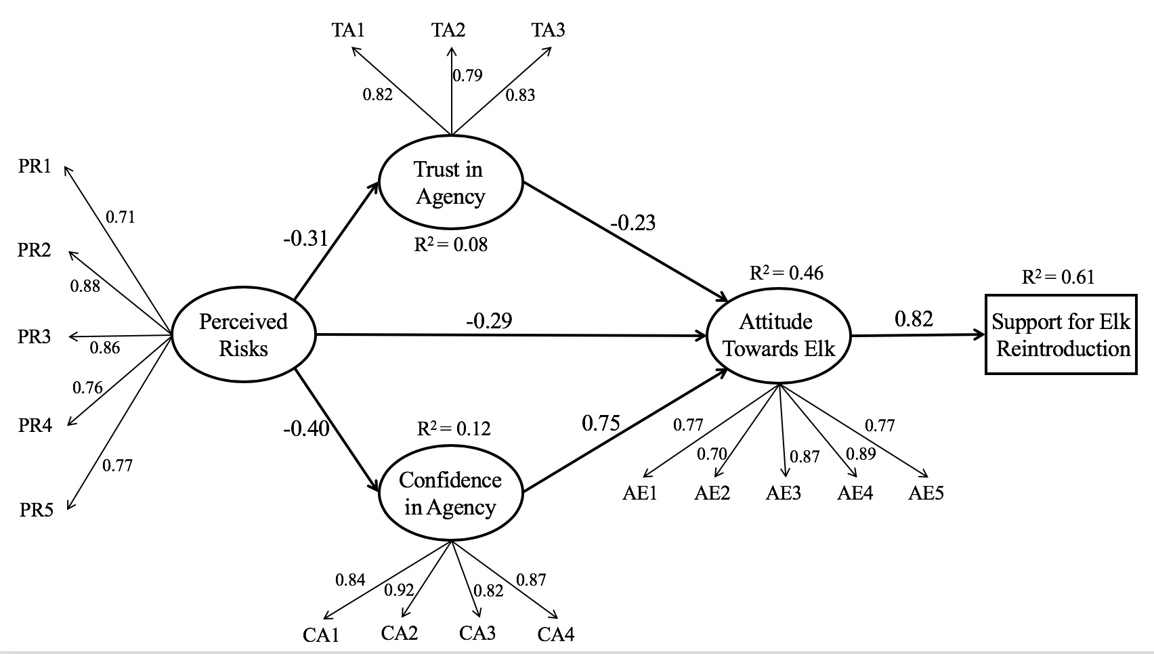
Figure 2.4 Full structural model showing the relationships between risk perceptions, agency trust, agency confidence, attitudes towards elk, and support for elk reintroduction; all model parameters are significant at p < 0.05

Table 2.6 Structural equation model path results and goodness of fit measures for model of elk reintroduction support in Tennessee
Model Path | Coefficient (S.E) | Significance
Trust
Perceived Risk | -0.31 (0.32) | 0.00**
Confidence
Perceived Risk | -0.40 (0.03) | 0.00**
Attitudes towards Elk
Trust | -0.23 (0.09) | 0.03*
Confidence | 0.75 (0.09) | 0.00**
Perceived Risk | -0.29 (0.33) | 0.00**
Support for Elk Reintroduction
Attitudes towards Elk | 0.82 (0.02) | 0.00**
X² (df) | 504.48 (128)
CFI | 0.97
TLI | 0.97
RMSEA | 0.06
Note: *indicates significant at p < 0.05; **indicates significant at p < 0.01
The model shows perceived risk has a negative and significant effect on attitudes towards reintroduced elk ($β$ = -0.29, p < 0.001) as well as on trust ($β$ = -0.31, p < 0.001) and confidence ($β$ = -0.40, p < 0.001). However, as the path from perceived risk to elk attitudes goes through trust, the negative relationship is weakened ($β$ = -0.23, p < 0.05). Additionally, as the path from perceived risk to elk support goes through confidence, the negative relationship is transformed to
positive and substantially strengthened ($β$ = 0.75, p < 0.001). Lastly, the entire model has a positive and significant effect on support for elk restoration ($β$ = 0.82, p < 0.001).

2.4.5 Partial Mediation

As described in section 2.3.3 and detailed in Baron and Kenny (1986), this model meets three of the four conditions in establishing mediation, suggesting partial mediation. As shown in Table 2.7, when tested alone, perceived risk is significantly related to attitudes towards reintroduced elk ($β$ = -0.45, p < 0.001). Perceived risk is also significantly related to the mediator variables of trust ($β$ = -0.31 p < 0.001) and confidence ($β$ = -0.40, p < 0.001). To meet the third condition, trust is significantly related to attitudes towards elk ($β$ = 0.51, p < 0.001), as is confidence to attitudes towards elk ($β$ = 0.62, p < 0.001). In the full model (Fig. 2), the negative effect of perceived risk on elk reintroduction support is diminished ($β$ = -0.29, p < 0.001) but not completely eliminated, suggesting partial mediation. As the strength of the path between perceived risk and attitudes towards elk is weakened by the inclusion of trust and confidence, it can be concluded that these variables act as partial mediators in this relationship.

Table 2.7 Partial Mediation Conditions for model of elk reintroduction support in Tennessee
Paths | Coefficient (S.E) | Significance
Perceived Risk Attitudes towards Elk | -0.45 (0.03) | 0.00
Perceived Risk Trust in Agency | -0.31 (0.04) | 0.00
Perceived Risk Confidence in Agency | -0.40 (0.03) | 0.00
Trust in Agency Attitudes towards Elk | 0.51 (0.03) | 0.00
Confidence in Agency Attitudes towards Elk | 0.62 (0.02) | 0.00

2.5 Discussion

Results of this study indicate that residents in the 5-county area surrounding the elk restoration zone have moderate to high levels of trust and confidence in the managing wildlife agency and generally low perceptions of risk, and that those factors interact to effect support for elk reintroduction. More specifically, results show that trust and confidence have unique significant partial mediation effects on the relationship between risk perceptions and attitudes towards reintroduced elk, which predicts support for reintroduction. Results suggest that trust and confidence in the managing agency can play key roles in reducing risk perceptions and garnering long-term support for wildlife reintroductions.
Results confirm that risk perceptions have a negative effect on attitudes towards reintroduced elk. These results are similar to other studies on wildlife reintroductions. For example, risk perceptions had a negative impact on attitudes towards panther recovery in Florida, cougar recovery in Montana, and natural recolonization of gray wolves in Minnesota (Chavez, Gese, & Krannich, 2005; Langin & Jacobson, 2012; Riley & Decker, 2000). While results show that risk perceptions were generally low in this population (ranging from 1.87-2.69 on a 5-point scale), they still had a negative impact on attitudes. This suggests that all levels of risk perceptions should be taken seriously by wildlife agencies and groups attempting reintroductions as even small amounts of risk can lead to backlash and negative attitudes from the public.
Results also confirm the influence of the dual-mode model of trust and confidence on risk perceptions posited by Siegrist et al. (2005) and show its application in wildlife management. Alone, both trust and confidence in the agency had positive and significant effects on attitudes towards reintroduced elk, which positively affected support for restoration. Results are similar to findings from Canada, suggesting that trust in the managing agency positively impacted attitudes towards wolves, which positively impacted support for wolf management (Sponarski et al., 2014).
The model presented in this paper showed that trust and confidence were partial mediators of the relationship between risk perceptions and attitudes towards reintroduced elk. Risk perceptions were minimized, but still remained after the introduction of trust and confidence in the model. Needham & Vaske (2008) found similar findings in that hunters who trusted the managing wildlife agency perceived less risk from Chronic Wasting Disease in the U.S, but still perceived some level of risk (Needham & Vaske, 2008). Sponarski et al., (2014) also found that trust acts as a partial mediator in their model predicting attitudes and support for wolves.
Results also show that the magnitude of the partial mediation effect differed between the two mediation variables. Trust in agency personnel simply minimized the negative effect of risk perceptions on support for reintroduction (from -0.49 to -0.21), while confidence in the agency’s management capability changed the relationship from negative to positive (from -0.49 to 0.74). These results are consistent with Siegrist et al. (2005), who also found that confidence was a more important predictor of risk judgements than trust. While both trust and confidence are important factors, confidence plays a bigger role than trust as confidence changes the relationship between risk perceptions and support for reintroduction into a positive one, while trust simply reduces the magnitude of the negative relationship.
Results from this study establish the interplay of relationships between risk perceptions, trust, confidence, attitudes towards reintroduced elk and support for continued restoration. In addition to confirming the role of the dual-mode model of trust and confidence in reducing risk perceptions, this study also established its role in the wildlife management context. As the model explained 63% of the variance in support for elk restoration, it can be concluded that risk perceptions, trust, and confidence play large roles in attitudes towards reintroduced species and support for their restoration. Regardless of how small the risk of a wildlife management action or program is to local residents, it can still receive opposition. Therefore, investing in building trust with residents and instilling confidence through consistent, competent management can be important factors in garnering support. Results also suggest that prioritizing confidence through capable management may be beneficial.

2.6 Conclusion

This study demonstrates that building trust can be a very important factor in gaining support for wildlife reintroduction. Other research has shown that trust is fragile, however, as negative actions tend to have a larger effect than positive actions (White & Eiser 2005; Davenport et al. 2007). For this reason, it is important for management agencies attempting to build trust in order to boost support for management programs to be consistent and patient with efforts. Trust can improve support for programs, but it may take time and a great deal of effort to see results. As confidence in management capabilities plays a larger role than trust in agency personnel, and confidence is built upon past experiences, consistency is key. Therefore, it will be important for the agency in Tennessee (TWRA) to consistently follow the strategy laid out in the strategic elk management plan (TWRA, 2017) for dealing with nuisance elk. If residents see consistent, fair, and rational responses to negative encounters with elk, risk perceptions will decrease, and public support will increase.
Several methods have been suggested for increasing trust. Management agencies can encourage the belief that they share similar values as their constituents by surveying public opinion and attitudes (Stern, 2008). Sharing information with residents to communicate the benefits of reintroduction programs could also help to build trust and cooperation (Hamm, 2017). Allowing for flexibility in management objectives and allowing for more individual freedom can also help to gain trust (Sponarski, 2014). For the case of elk in Tennessee, some methods for gaining trust can be giving locals preferences for elk hunting permits, offering educational materials about the reintroduced elk, providing clear mechanisms so concerns can be addressed, and having clear methods for dealing with nuisance elk and property damage.
Future studies could compare methods for gaining public support for wildlife reintroductions, to find the most effective combination. Future studies could also add complexity to the model in this paper by testing antecedents of trust such as value similarity, willingness to accept vulnerability, and motivation as they have been studied in similar contexts (Needham & Vaske, 2008; Sponarski et al., 2014; Hamm, 2017). By assessing the antecedents of trust and adding them to this model, a more complete picture of the influence of trust on attitudes towards reintroduced wildlife and willingness to support reintroductions may be achieved.
Future studies could also test this model on support for reintroduction of different species like carnivores that are more controversial and generally incur larger levels of risk. It is unknown whether trust and confidence play the same role of partial mediation when risks are higher and whether the mediating role of social trust varies for different species depending on the level of risk incursion. This model could also be tested on the same population once the elk herd has expanded and people have more encounters with elk to see if the frequency of encounters causes greater perceptions of risks.
Some limitations of this study should be noted. The construct of support was measured via a single item indicator. Scales using multiple-item indicators tend to be more reliable and have greater internal consistency (Vaske, 2008). However, single-item scales have been used in the literature to measure behavior in structural equation models. For example, Hamm (2017) used a single-item behavioral measure (willingness to sign up for email list) in their study on trust and motivation in natural resource management. Another limitation of the study is that not all of the items used to measure trust and confidence were conceptualized in the context of elk reintroduction. For example, while some items did this, (“I trust wildlife agency professionals to manage elk in Tennessee”) other items were not phrased in the context of reintroduction like “wildlife agency professionals share similar goals as me.” Having phrased each item within the context of the elk reintroduction in Tennessee would have improved the reliability of the study.
Beyond the benefit that this study will have on the elk restoration zone in Tennessee and the intellectual merit of advancing human dimensions of wildlife management, it also provides a broader impact. It helps to clarify the role of social trust, explained by the dual-mode model of trust and confidence, in successful wildlife reintroduction programs. When agencies ignore human dimensions and fail to properly build trust with stakeholders, conflicts and public relations issues can abound. As global biodiversity continues to decline, wildlife reintroductions will become an increasingly more common practice, so the importance of trust in gaining support to improve long-term success rates will need to be well understood. Additionally, as the population of reintroduced elk in Tennessee grows, it will become more important to track local residents’ attitudes towards the species as larger numbers of elk will increase the chances of human encounters and more risk perceptions. It will also become more important for wildlife managers to effectively deal with nuisance elk and show willingness to cooperate with residents in order to gain and keep their trust. If the elk reintroduction program in Tennessee is to succeed long-term, the agency will need to continue working on gaining trust to ensure continued support for this program and overall success for the reintroduction.

2.7 References

Baron, R. M., & Kenny, D. A. (1986). The moderator-mediator variable distinction in social psychological research: Conceptual, strategic and statistical considerations. Journal of Personality and Social Psychology, 51, 1173-1182.
Browne-Nuñez, C. & Taylor, J. G. (2002). Americans’ attitudes towards wolves and wolf reintroduction: an annotated bibliography. Fort Collins, CO: U.S. Geological Survey.
Byrne, B. (2016). Structural Equation Modeling with AMOS: Basic concepts, applications, and programming (3rd Edition). New York, New York: Routledge Press.
Cangur, S. & Ercan, I. (2015). Comparison of model fit indices used in structural equation modeling under multivariate normality. Journal of Modern Applied Statistical Methods, 14(1): 152-167.
Chavez, A. S., Gese, E. M., & Krannich, R. S. (2005). Attitudes of rural landowners toward wolves in northwestern Minnesota. Wildlife Society Bulletin, 33(2), 517-527.
Churchill, T. N., Bettoli, P. W., Peterson, D. C., Reeves, W. C., & Hodge, B. (2002). Angler conflicts in fisheries management: A case study of the Striped Bass controversy at Norris Reservoir, Tennessee. Fisheries, 27(2), 10-19.
Crank, R. D., Hygenstrom, S. E., Groepper, S. R., & Hams, K. M. (2010). Landowner attitudes toward elk management in the Pine Ridge region of north-western Nebraska. Human-Wildlife Interactions, 4(1), 67-76.
Davenport, M.A., Leahy, J.E., Anderson, D.H. & Jakes, P.J. (2007). Building trust in natural resource management within local communities: a case study of the Midewin National Tallgrass Prairie. Environmental Management, 39, 353-368.
Dickman, A. J. (2010). Complexities of conflict: The importance of considering social factors for effectively resolving human-wildlife conflict. Animal Conservation, 13, 458-466.
Dillman, D. A., Smyth, J. D., & Christian. L. M. (2014). Internet, Phone, Mail, and Mixed-Mode Surveys: The Tailored Design Method (4th Edition). Hoboken, NJ: John Wiley & Sons.
Fishbein, M. & Ajzen, I. (2010) Belief, Attitude, Intention and Behaviour: An Introduction to Theory and Research. New York, NY, USA: Psychology Press Taylor and Francis.
Hamm, J. A. (2017). Trust, trustworthiness, and motivation in the natural resource management context. Society & Natural Resources, 30(8), 919-933.
Harper, E. E., Miller, C. A., & Vaske, J. J. (2015). Hunter perceptions of risk, social trust, and management of Chronic Wasting Disease in Illinois. Human Dimensions of Wildlife, 20(5), 394-407.
IUCN. (2013). Guidelines for Reintroductions and other Conservation Translocations. Version 1.0. Gland Switzerland: IUCN Species Survival Commission.
Langin, C., & Jacobson, S. (2012). Risk and resident influences on public support for Florida Panther recovery. Wildlife Society Bulletin, 36(4), 713-721.
Lee, M. L., & Miller, R. (2003). Managing elk in the wildland-urban interface: Attitudes of Flagstaff, Arizona residents. Wildlife Society Bulletin, 31(1), 185-191.
Linehan, K. & Palmer, D. (2014). Landowner views of elk in Western North Carolina. North Carolina Wildlife Resources Commission.
Manfredo, M. J., Teel, T. L., Sullivan, L., & Dietch, A. M. (2017). Values, trust, and cultural backlash in conservation governance: The case of wildlife management in the United States. Biological Conservation, 214, 303-311.
Meadow, R., Reading, R. P., Phillips, M., Mehringer, M., & Miller, B. J. (2005). The influence of persuasive arguments on public attitudes toward a proposed wolf restoration in the southern Rockies. Wildlife Society Bulletin, 33(1), 154-163.
Needham, M. D., Vaske, J. J., & Manfredo, M. J. (2004). Hunters’ behavior and acceptance of management actions related to chronic wasting disease in eight states. Human Dimensions of Wildlife, 9, 211-231.
O’Rourke, E. (2014). The reintroduction of the white-tailed sea eagle to Ireland: People and wildlife. Land Use Policy, 38, 129-137.
Poortina, W. & Pidgeon, N. F. (2003). Exploring the dimensionality of trust in risk regulation. Risk Analysis, 23(5), 961-972.
Riley, S. J., & Decker, D. J. (2000). Risk perception as a factor in wildlife stakeholder acceptance capacity for cougars in Montana. Human Dimensions of Wildlife, 5, 50-62.
Shoenecker, K. A. & Shaw, W. W. (1997). Attitudes toward a proposed reintroduction of Mexican gray wolves in Arizona. Human Dimensions of Wildlife, 2(3), 42-55.
Siegrist, M., Cvetkovich, G., & Roth, C. (2000). Salient value similarity, social trust, and risk/benefit perception. Risk Analysis, 20, 353-362.
Siegrist, M., & Cvetkovich, G. T. (2000). Perception of hazards: The role of social trust and knowledge. Risk Analysis, 20, 713-719.
Siegrist, M., Earle, T. C., & Gutscher, H. (2003). Test of a trust and confidence model in the applied context of electromagnetic field (EMF) risks. Risk Analysis, 23(4), 705-716.
Siegrist, M., Gutscher, H., & Earle, T. C. (2005). Perception of risk: The influence of general trust, and general confidence. Journal of Risk Research, 8, 145-156.
Slovic, P. (1987). Perception of risk. Science, 236(4799), 280-285.
Smith, J. W., Leahy, J. E., Anderson, D. H., & Davenport, M. A. (2013). Community/agency trust and public involvement in resource planning. Society & Natural Resources, 26, 452-471.
Sponarski, C. C., Vaske, J. J., Bath, A. J., & Musiani, M. M. (2014). Salient values, social trust, and attitudes toward wolf management in south-western Alberta, Canada. Environmental Conservation, 41(4), 303-310.
Sponarski, C.C., Miller, C., & Vaske, J. J. (2018). Perceived risks and coyote management in an urban setting. Journal of Urban Ecology, 4(1), 1-5.
Stern, M. J. (2008). Coercion, voluntary compliance and protest: the role of trust and legitimacy in combating local opposition to protected areas. Environmental Conservation, 35(3), 200-210.
Stern, M. J., & Coleman, K. J. (2014). The multidimensionality of trust: Applications in collaborative natural resource management. Society & Natural Resources, 28, 117-132.
Taylor, T. A. (1998). Public acceptability of Florida panther reintroduction. Technical report for the Florida Conflict Resolution Consortium.
Tennessee Wildlife Resources Agency. (2017). Tennessee Strategic Elk Management Plan 2018-2027.
White, M.P. & Eiser, J.R. (2005). Information specificity and hazard risk potential as moderators of trust asymmetry. Risk Analysis, 25, 1187-1198.
Whittaker, D., Vaske, J.J., & Manfredo, M.J. (2006) Specificity and the cognitive hierarchy: value orientations and the acceptability of urban wildlife management actions. Society and Natural Resources, 19: 515–530.
Williams, P. S., Darville, R., Keul, A., Legg, M., Garner, N., & Comer, C. (2011). Stakeholders’ attitudes towards black bear in east Texas. Human Dimensions of Wildlife, 16: 414-424.
Wilson, R. S. & Bruskotter, J. T. (2009). Assessing the impact of decision frame and existing attitudes on support for wolf reintroduction in the United States. Human Dimensions of Wildlife, 14, 353-365.
Vaske, J. J., Timmons, N. R., Beaman, J., & Petchenik, J. (2004). Chronic wasting disease in Wisconsin: Hunter behavior, perceived risk, and agency trust. Human Dimensions of Wildlife, 9, 193-209.
Vaske, J. J. (2008). Survey research and analysis: Application in parks, recreation, and human dimensions. State College, PA: Venture.

Appendix A. Local Residents Attitudes towards elk in Tennessee Survey Materials

Dear FIRST_NAME MI LASTNAME
ADDRESS1
CITY, STATE_ABBR ZIP ZIP4

In the next few days, you will receive in the mail a request to complete a brief survey for an important project that is being conducted by researchers at the University of Tennessee. The project, supported by the Tennessee Wildlife Resource Agency (TWRA), is an effort to learn how local residents, like yourself, feel about the presence of elk in the region.

In 2000, elk were released in the North Cumberland Wildlife Management area to restore their population in the region and are now in various parts of Anderson, Scott, Campbell, Morgan, and Claiborne counties. You are one of the very few residents being randomly selected from these counties to help in this study. Whether you see elk regularly near your home or even if elks are not currently present on or near your land, your response is extremely important in designing programs to effectively manage elk in the region. Once you receive the survey, please complete as many questions as you can and return it in the prepaid envelope being provided.

Sincerely,

Dr. Neelam C. Poudyal
Associate Professor
Department of Forestry, Wildlife, & Fisheries
The University of Tennessee
274 Ellington Plant Sciences
Knoxville, TN 37996
(865) 974-8771

January 26, 2018



Dear FIRST_NAME MI LASTNAME
ADDRESS1
CITY, STATE_ABBR ZIP ZIP4

We are contacting you to ask for your help in a study that is very important for elk management in the 5- county region of Morgan, Scott, Anderson, Campbell, and Claiborne counties. This study is an effort to learn how residents of these counties value elk and what concerns they have regarding elk management. You are one of a small number of residents chosen at random and invited to participate in this study. Your response is extremely important. Even if elk are currently not present on your land, please answer as many questions as you can and return the survey in the enclosed postage paid envelope.

While the North Cumberland Wildland Management Areas (WMAs) serve as prime habitat for elk herds, some elk may roam outside the WMAs, specifically on surrounding private farms and ranchlands. This leads to a variety of situations where elk interact with local residents like you in many ways. Your answers will be critical in understanding local residents’ views and experience with elk, and help wildlife agencies develop effective elk management programs in your area.

Once the survey is returned, your name will be deleted from our contact list. Completing this survey takes about 15 minutes, is voluntary, and the information you give us is strictly confidential. Your name will not be placed on the survey or associated with your responses. Return of this survey constitutes consent to participate in this study. If you are below 18 years old, please do not complete this survey.

If you have any questions about this study, please feel free to contact me at the address given below. If you have questions about your rights as a research participant, contact the University of Tennessee’s Office of Research Compliance Officer at (865) 974-7697.

Thank you very much for your assistance in this research project.

Sincerely,


Dr. Neelam C. Poudyal
Associate Professor
Email: npoudyal@utk.edu
(865) 974-8771

Local Residents’ Attitudes towards Elk in Tennessee
(A survey of residents in Anderson, Scott, Campbell, Morgan, and Claiborne County)

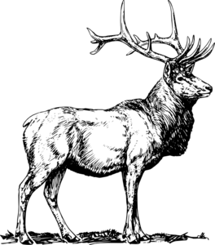

Department of Forestry, Wildlife, and Fisheries
University of Tennessee
2018

You are one of the few randomly selected residents from the 5-county region in Tennessee to participate in this survey. Your help is critical for understanding how local residents value and perceive the benefits and impacts of elk in the region. Regardless of elk presence on your property, the answers you provide will help agencies in effectively restoring and managing elk in Tennessee. Your responses will be fully confidential and not shared with anyone.
A study conducted by University of Tennessee with the support of Tennessee Wildlife Resource Agency.


Section A. Property Characteristics
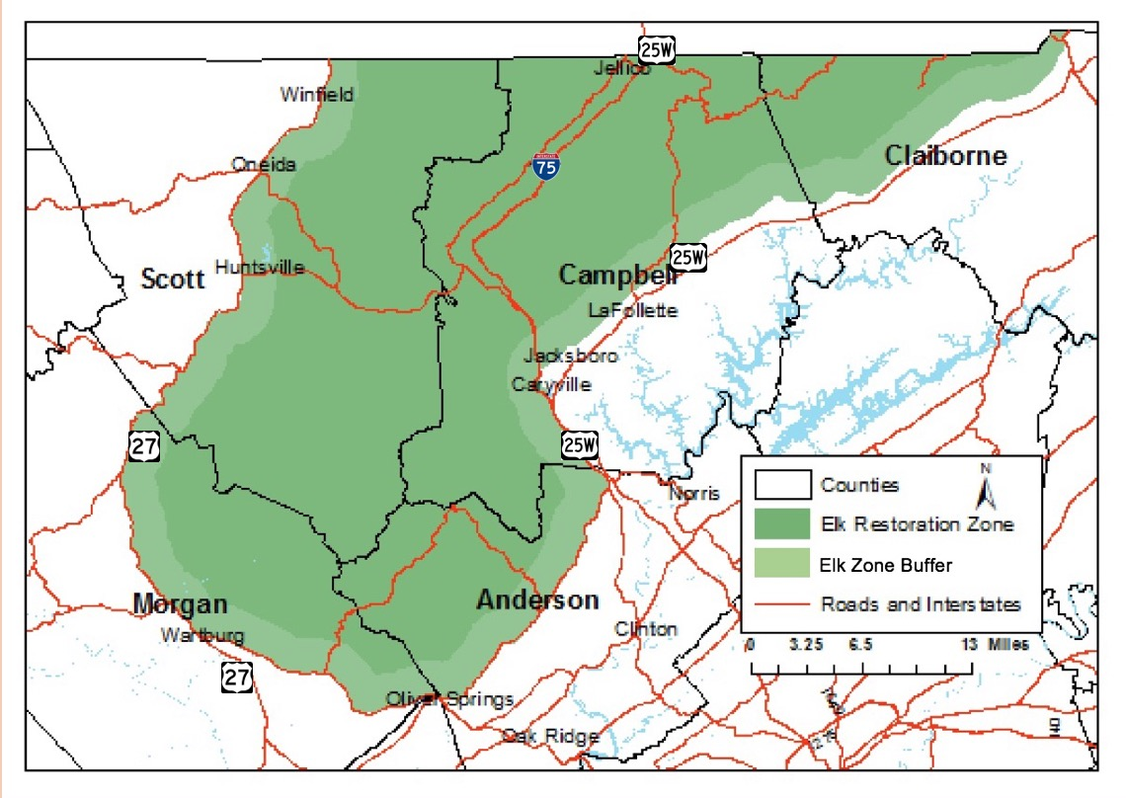

- Do you live or own property in the elk restoration zone as indicated on the map above?
_____Yes _____No, please go to Q. 3

- How long have you lived or owned this property inside the elk restoration zone?
__________ years

- How many acres do you own or lease in the 5 county region of Anderson, Scott, Campbell, Morgan, and Claiborne County?

Own: ________acres
Lease or rent: ________acres
I live in the region but do not currently own or rent land, Skip to Q. 5

- Which of the following describes your uses for the largest tract of land you own in this region? (check all that apply)
_____A residence for myself/family | _____Cropland (other than hay or pasture land)
_____Commercial horticulture | _____Growing plants for non-commercial use
_____Hay or pasture land | _____Orchards
_____Timber production | _____Operating a commercial business
_____Cattle production | _____Other (please specify)
_____Other livestock production | _______________________________________
- Before receiving this survey, did you know that there are elk present in Tennessee?
_____Yes _____No

- How interested are you in the following activities related to elk in Tennessee? (circle one number for each row)
 | Not at all Interested | Interest |  |  | Very Interested
Watching elk | 1 | 2 | 3 | 4 | 5
Hunting elk | 1 | 2 | 3 | 4 | 5
Having elk in Tennessee | 1 | 2 | 3 | 4 | 5
Learning more about elk management | 1 | 2 | 3 | 4 | 5
Providing input for decisions about elk management | 1 | 2 | 3 | 4 | 5

- Have you visited the Hatfield Knob elk viewing tower in Campbell County?
_____Yes _____No, go to Q 9

- How many times did you or others in your family visit this tower in 2017?
_____ times

- Have you visited any other places in Tennessee to view or photograph elk?
_____Yes, please specify where (……………………………………………………………………..)
_____No, go to Q 12

- How many times did you or others in your family visit this other place in 2017?
_____ times

- Approximately, how far (in miles) is this other place from your residence?
_____miles one way

- To what extent do you agree or disagree with the following statements about elk in TN?
 | Strongly disagree | Somewhat disagree | Neutral | Somewhat agree | Strongly agree
Even if I never see an elk in the wild, it is important for me to know they exist in Tennessee | 1 | 2 | 3 | 4 | 5
Elk bring economic benefits to our communities through tourism | 1 | 2 | 3 | 4 | 5
No need to protect elk in Tennessee because there are healthy populations elsewhere | 1 | 2 | 3 | 4 | 5
Elk have the right to exist wherever they may occur | 1 | 2 | 3 | 4 | 5
Elk are a valuable part of nature | 1 | 2 | 3 | 4 | 5
Future generations should be able to see elk in Tennessee. | 1 | 2 | 3 | 4 | 5
Elk threaten the economic prosperity of farmers in Tennessee | 1 | 2 | 3 | 4 | 5
Elk compete with other wildlife for food and resources. | 1 | 2 | 3 | 4 | 5
I enjoy having elk around my home and property | 1 | 2 | 3 | 4 | 5
Having elk helps maintain balance in the natural environment | 1 | 2 | 3 | 4 | 5
The cost of managing elk outweighs the benefits they bring | 1 | 2 | 3 | 4 | 5
Management should focus on doing what is best for people instead of what is best for elk | 1 | 2 | 3 | 4 | 5
I support establishing a healthy population of elk in my region | 1 | 2 | 3 | 4 | 5

- Which of the following describes your familiarity with elk within the 5-county region of Anderson, Scott, Campbell, Morgan, and Claiborne County? (check all that apply)
_____I have seen elk on my property, Continue to Q. 14
_____I have seen elk on my neighbors’ properties, Continue to Q. 14
_____I have seen elk within region, but not near my property, Continue to Q. 14
_____I have not seen elk in the region, Skip to Section C

Section B. Elk on your property in 5-county region in Tennessee
- Have elk ever caused any noticeable damage to your land or property?
_____Yes, continue to Q. 15 _____No, skip to Q. 17

- In 2017 alone, what is the approximate estimate of damage (e.g., crops, pasture, garden, timber, vehicle) due to elk?
$.......................

- How would you describe the severity of the elk damage on your land?
Not a problem at all | Small problem | Moderate problem | Big problem | Severe problem

- Do you currently allow elk hunting on your property?
_____Yes, skip to Q. 19 _____No, continue to Q. 18

- Would you be willing to allow elk hunting on your property in the future?
_____Yes, continue to Q. 19
_____No, skip to Q. 21
_____Maybe, with compensation, continue to Q.19
- If interested in allowing elk hunting, what is the minimum fee a hunter will have to pay you to access your property during one hunting season? Note that elk hunting season in your region typically lasts for three weeks in Fall (from late September to mid-October).

$........................ per hunting season

- Which of the following best describes your motivation for allowing elk hunting on your property now or in future?
To reduce crop or property damage | To generate extra income
To help control elk population | I don’t like wild animals on my property
I believe we should be able to hunt elk just like other game animals | Other (specify)____________________________

- If you said “No” in Q. 18, please state your reason for not allowing elk hunting on your property. (check all that apply)
I enjoy seeing them alive on my property | Potential liability/lawsuits
Lack of interested hunters | Not enough land/compensation
Potential injury to family or neighbors | I am not sure if this is legal
I would rather hunt myself than letting others in | Other (please specify)________________ ______________________ _______________________

Section C: Your concerns about elk and views towards management options
- How concerned are you about the following problems with elk occurring in the area where you live? (Please circle one number for each statement & place a check mark in the box if you have already had that problem yourself.)
Already have this problem |  | Not at all Concerned | Concern |  |  | Very Concerned
____ | Elk/ vehicle accidents | 1 | 2 | 3 | 4 | 5
____ | Damage to haystacks | 1 | 2 | 3 | 4 | 5
____ | Damage to trees/shrubs in yard | 1 | 2 | 3 | 4 | 5
____ | Damage to fences | 1 | 2 | 3 | 4 | 5
____ | Damage to flower/ vegetable gardens | 1 | 2 | 3 | 4 | 5
____ | Competing with deer for forage | 1 | 2 | 3 | 4 | 5
____ | Competing with cattle and horses for forage | 1 | 2 | 3 | 4 | 5
____ | Spreading disease to cattle/pets | 1 | 2 | 3 | 4 | 5
____ | Elk trails causing erosion | 1 | 2 | 3 | 4 | 5
____ | Other _______________________ | 1 | 2 | 3 | 4 | 5

- Below are four situations that indicate various levels of interactions between people and elk. Please check the box for your preferred situation on or near your property. (please check one)

Situation A  - No elk exist. | Situation B  - Elk are almost never seen.  - Residents including you rarely have damage to fences, crops, gardens, or trees  - A low number of elk are present for wildlife viewing or other activities
Situation C  - Elk are sometimes seen  - Residents including you have occasional damage to fences, gardens, crops, or trees  - A moderate number of elk are present for wildlife viewing or other activities | Situation D  - Elk are regularly seen  - Residents including you have regular damage to fences, gardens, crops, or other trees  - Many elk are present for wildlife viewing or other activities

- In your opinion, which of the above four situations best describes the current level of elk population and your interaction with them in the area you live.
_____ Situation A | _____ Situation B | _____ Not sure
_____ Situation C | _____ Situation D

- The Tennessee Wildlife Resource Agency along with its partners including Campbell County Outdoor Recreation Association, University of Tennessee, and Tennessee Wildlife Resource Federation have helped reintroduce Elk in Tennessee. Suppose that budget cuts eliminate programs supporting elk restoration and that a non-profit trust fund is set up to fully restore and make sure elk permanently exist in Tennessee. If this were to happen, elk would not continue to exist in Tennessee unless this fund is created. Knowing your contribution goes towards conserving elk habitat on public lands in the region and compensating local farmers that have elk damage to crops/fences, would you contribute $Bid per year for the foreseeable future to this non-profit fund?

_____Yes, Skip to Q. 27 _____No, Continue to Q. 26

- If you said NO above, which of the following describes your opinion? (please check all that apply)
_____I cannot afford to pay this amount
_____I don’t want elk in the region because they are damaging my property
_____I don’t think it is worth paying that much to maintain an elk population in the region

- Please rate your level of acceptance for the following elk management strategies in the 5-county region in Tennessee.
Management action | Completely unacceptable | Somewhat unacceptable | Neutral | Somewhat acceptable | Completely acceptable
Use fencing to keep elk off of private property | 1 | 2 | 3 | 4 | 5
Haze elk away from private land | 1 | 2 | 3 | 4 | 5
Allow landowners and their designees to hunt elk on private land | 1 | 2 | 3 | 4 | 5
Trap elk and relocate to another location | 1 | 2 | 3 | 4 | 5
Install signs and speed limits near highways to avoid elk collision | 1 | 2 | 3 | 4 | 5
Educate people about living with elk | 1 | 2 | 3 | 4 | 5
Allow regulated hunting by licensed hunters | 1 | 2 | 3 | 4 | 5
Expand protection for elk by protecting more land in or around the restoration zone | 1 | 2 | 3 | 4 | 5
Offer nuisance elk control permit to landowners | 1 | 2 | 3 | 4 | 5
Construct elk food plots and open habitats within Wildlife Management Areas | 1 | 2 | 3 | 4 | 5
- Please rate your level of acceptance for the following elk management strategies in Tennessee.
Management action | Completely unacceptable | Somewhat unacceptable | Neutral | Somewhat acceptable | Completely acceptable
Promote elk hunting opportunities for all | 1 | 2 | 3 | 4 | 5
Develop elk viewing opportunities in multiple locations | 1 | 2 | 3 | 4 | 5
Design and implement statewide promotion of elk tourism | 1 | 2 | 3 | 4 | 5
Establish a private land elk hunting program | 1 | 2 | 3 | 4 | 5
Give priority for local landowners in elk permit lottery drawing | 1 | 2 | 3 | 4 | 5

- How important is restoration and conservation of elk in Tennessee to you?
Very Unimportant | Somewhat unimportant | Neutral | Somewhat Important | Very Important

- How satisfied are you with the current elk management effort in Tennessee?
Very Unsatisfied | Somewhat Unsatisfied | Neutral | Somewhat Satisfied | Very Satisfied

- Please indicate your level of agreement with each of the following statements.
Statements | Strongly disagree | Somewhat disagree | Neutral | Somewhat agree | Strongly agree
I am confident in wildlife agency’s capacity to manage elk in the region | 1 | 2 | 3 | 4 | 5
Wildlife agency professionals listen to our concerns | 1 | 2 | 3 | 4 | 5
Wildlife agency professionals know what is best for local residents | 1 | 2 | 3 | 4 | 5
Wildlife agency professionals share similar goals as me | 1 | 2 | 3 | 4 | 5
I trust wildlife agency professionals to effectively manage elk in Tennessee | 1 | 2 | 3 | 4 | 5
Wildlife agency professionals are capable of managing elk-human conflicts | 1 | 2 | 3 | 4 | 5
I trust wildlife agency professionals to help us deal with nuisance elk | 1 | 2 | 3 | 4 | 5

Section D: Demographics: Questions below will help us ensure people being surveyed are representative of all residents in 5-county regions. Answers will be kept confidential.
- What is your age? ______ years

- What is your gender? ______ Male ______ Female

- How many people live in your household?
_____ # total
_____ # under 18 years
_____ # hunters

- What is the highest level of education you have completed?
_____ Some high school | _____ Associate degree
_____ High School diploma, GED | _____ Bachelor’s degree
_____ Some college | _____ Post-graduate degree

- What is your current employment status?
_____ Full-time job | _____ Unemployed | _____ Retired
_____ Part-time job | _____ Student | _____ Military
- Approximately what percent of your household’s income is derived from farming and ranching?
_____0% | _____26-50% | _____76-100%
_____1-25% | _____51-75%

- Do you hunt for big or small game in Tennessee or elsewhere?
_____Yes _____No

- Have you applied for elk hunting permit in Tennessee since elk hunting opened in Tennessee?
_____Yes _____No

- In 2017, what was your approximate annual household income before taxes?
_____Less than $25,000 | _____$100,000 to $124,999 | _____$200,000 to $224,999
_____$25,000 to $49,999 | _____$125,000 to $149,999 | _____$225,000 to $249,999
_____$50,000 to $74,999 | _____$150,000 to $174,999 | _____$250,000 and higher
_____$75,000 to $99,999 | _____$175,000 to $199,999

Thank you for completing this survey!
Please use the space provided below for any additional elk related comments.

If you have any additional questions, please contact
Dr. Neelam Poudyal – 865.974.8771; npoudyal@utk.edu
Please return this survey in the enclosed postage-paid envelope. If you have misplaced the envelope, send the completed survey to:
Dr. Neelam C. Poudyal ID
Associate Professor
Department of Forestry, Wildlife, & Fisheries
University of Tennessee
274 Ellington Plant Science Bldg.,
Knoxville, TN 37996

February 15, 2018

Dear NAME
STREET ADDRESS
CITY, STATE ZIP

Recently, we invited you to participate in a research survey regarding elk in Tennessee. If you have already responded, please accept our sincere thanks. If not, we would like to renew our invitation.

We are contacting you to ask for your help in a study that is very important for management of elk in five county region of Morgan, Scott, Anderson, Campbell, and Claiborne in Tennessee. This study is part of an effort to learn how local residents in these counties value elk and feel about elk management. You are one of a small number of residents chosen at random and invited to participate in this study by completing the enclosed survey. Your response is extremely important. Even if Elk are currently not present on your land, please answer as many questions as you can and return the survey in enclosed business reply envelope.

While North Cumberland Wildland Management Areas (WMAs), serve as prime habitat for elk herds, it is natural for some to roam outside the WMAs, specifically on private farms and ranchlands in the surroundings. This leads to a variety of situations where elk interact with local residents like you in many ways. Your answers will be critical in understanding the opinions of local communities about elk, and help wildlife agencies develop effective elk management programs in your area.

Once the survey is returned, your name will be deleted from our contact list. Completing this survey takes about 15 minutes, is voluntary, and the information you give us is strictly confidential. Your name will not be placed on the survey or associated with your responses. Return of this survey constitutes consent to participate. If you are younger than 18 years, please do not complete this survey.

If you have any questions about this study, please feel free to contact me at the address given below. If you have questions about your rights as a research participant, contact the University of Tennessee’s Office of Research Compliance Officer at (865) 974-7697.

Thank you very much for your assistance in this research project.

Sincerely,
Dr. Neelam C. Poudyal
Associate Professor
Email: npoudyal@utk.edu
(865) 974-8771

CHAPTER III
IMPACT OF PSYCHOSOCIAL FACTORS ON WILLINGNESS TO PAY FOR ELK CONSERVATION

Abstract

Economic valuation can aid decision-makers in justifying the costs of conservation programs like wildlife reintroduction. The contingent valuation method can be useful in determining the existence value of reintroduced species and in quantifying publicly derived benefits from reintroduction programs. The inclusion of psychosocial parameters may be necessary to determine accurate estimates of WTP for reintroduced species conservation. Factors like stakeholder trust and confidence in conservation professionals for their ability to take control of the situation and manage risks may play an important role in determining how local residents support and value conservation of reintroduced species. This study uses the case of elk reintroduction in East Tennessee to assess local residents’ willingness to pay (WTP) for conservation of elk and evaluate the role of psychosocial factors such as perceived risk, agency trust, and confidence in residents’ WTP. Analysis of data collected from a household survey in and around the North Cumberland Elk Restoration Zone in East Tennessee shows residents’ mean WTP for long-term conservation of recently reintroduced elk to be $45.53 per household. Moreover, WTP was positively related with their trust and confidence in agency professionals, and negatively related with perceived risks associated with elk. In addition, WTP also varied according to resident dependence on land for income and demographic characteristics. Results shed light on the significance and importance of psychosocial factors in WTP for conservation programs, and offer guidance in characterizing the economic benefit of wildlife conservation programs in general and elk restoration in particular.

Keywords: elk reintroduction, social trust, risk perceptions, contingent valuation

3.1 Introduction

Global decreases in biodiversity in recent years have made wildlife conservation projects like species reintroduction a major management and policy concern. With limited public funding available for conservation, however, policy makers and management officials need to be able to justify public investment in wildlife restoration and management. Determining the benefits to local residents from wildlife conservation can be a useful tool for practitioners to justify the costs of those projects. Because public support can be crucial to the success of conservation programs like wildlife reintroductions, it has been argued that public preferences should be considered (Ferrato, Brown, & McKinney, 2016; White, Alison, Bennett, & Hayes, 2001). One form of assessing public preferences for conservation programs is through economic valuation. This allows for the quantification of preferences in economic terms, which allows decision-makers to prioritize funding allocations.
The total economic value of an ecological resource, such as reintroduced wildlife, incorporates both its use and existence values (Stevens, Echeverria, Glass, Hager & More, 1991). Use values are revealed in direct-use payments for goods like hunting licenses and equipment. Existence values encompass the benefits accrued to those who do not use wildlife but still have a vested interest in it. While more difficult to perceive, these values make up an important part of individual perceptions and attitudes towards wildlife conservation. For example, someone who is not a hunter or who has no intention of ever travelling to an area to see wildlife may derive satisfaction from simply knowing they exist and be willing to pay for their conservation. Determining non-use, existence, benefits can be useful for decision-makers to quantify the social benefits of an environmental resource.
The contingent valuation method is one method commonly used to estimate the economic value on non-use benefits such as the conservation of reintroduced wildlife. Contingent valuation is a stated preference method, which requires a survey-based stated preference approach whereby participants are asked how much they are willing to pay for a particular good, service, or conservation project, or how much they are willing to accept to put up with environmental degradation. Willingness-to-pay (WTP) can be interpreted as the monetary measure of how much the conservation program is worth to a household. Contingent valuation studies have been conducted on people’s WTP for increasing species numbers, avoiding species loss, reintroducing extirpated species, and increasing chance of survival (Richardson & Loomis, 2008). Studied species include charismatic species such as whooping cranes, salmon, bald eagles and sea otters as well as rare species such as squawfish, golden cheeked warblers, and brown hares (Bell, Huppert, & Johnson, 2003; Bowker & Stoll, 1988; Cummings, Ganderton, & McGuckin, 1994; Ferrato et al., 2016; Swanson, 1993; White et al., 2001). The existence value of a species has been shown to broadly depend on the type of species, the size of the species population, whether and how people value the species, and the species’ charismatic attributes (Richardson & Loomis, 2008).
Beyond wildlife valuation, several studies have examined specific factors that affect public WTP for wildlife conservation (Table 3.1). For example, a study of WTP for wildlife conservation in Great Britain found including charismatic species such as otters among the list of species to be conserved increased WTP, while the inclusion of the less charismatic species such as brown hares decreased WTP (White et al., 2001). Similarly, Ericsson, Bostedt, & Kindberg (2008) found that when wolves were included in a list of large carnivores, WTP for conservation efforts in Sweden decreased. The status of a species as a native or game species were also
Table 3.1 Studies assessing Willingness to Pay for wildlife conservation
Study | Species/Subject | Factors Influencing WTP | WTP
Dalrymple et al., 2012 | Non-game conservation | Importance of conservation, frequency of watching wildlife, education, age | $65 phh
Ericsson et al., 2008 | Large carnivores (wolves, bears, lynx, & wolverines) | Large carnivores with & without wolves in list, presence of wolves, urban areas, demographics | Carnivores: ~$50 pp, wolves: ~$25 pp
Ferrato et al., 2016 | Golden-cheeked warbler | Knowledge of existence, belief species holds value | $22 pp
Loomis & Ekstrand, 1997 | Threatened & Endangered Species | View on endangered species protection | $48 phh
 | Mexican Spotted Owl |  | $41 phh
Richardson & Loomis, 2009 | Species meta-analysis | Charismatic megafauna promised % change in species size | varies
Rubin, et al., 1991 | Northern spotted owl | Demographics | $44 phh
Stevens et al., 1991 | Bald eagles | Importance of conservation, membership in environmental group, demographics | $19 pp
 | Wild turkey |  | $12 pp
 | coyotes |  | Control: $4 pp  Pres.: $5 pp
 | Salmon |  | $8 pp
Philip & MacMillan, 2005 | Beaver reintroduction | Survey conducted in group meeting vs. telephone interview | $24 phh in meeting, $27 phh via telephone
White et al., 2001 | Brown Hare, Red Squirrel, Otter, & Water Vole | Membership in environmental group, awareness of threats, knowledge of threats, charismatic nature of species, gender, income, age | $24 pp
 | Brown Hare alone |  | $0 pp
 | Red Squirrel alone |  | $3 pp
*pp (per person); phh (per household)

shown to be more important predictors of local residents WTP for conservation than factors like whether the species is declining or extirpated (Dayer, Bright, Teel, & Manfredo, 2016). These findings suggest that characteristics of the species in question may play a critical role in determining the public’s WTP. However, non-game species that exist in small areas and sparse populations have also found support in terms of WTP for conservation (Ferrato et al., 2016).
Many factors determine public WTP for wildlife conservation, but some may be more important than others in determining WTP for the conservation of reintroduced species. The value local residence place on reintroduced species may partly depend on psychosocial factors like the risk they perceive from the species, and trust and confidence they may have on wildlife agencies to effectively manage the population of restored species. When a species is introduced onto a landscape there can be conflicts with the residents closest to the situation. Therefore, trust in the managing conservation groups and wildlife agencies can be critical to gaining public support. Trust can play an important role in risk reduction and can affect public perceptions towards wildlife programs (Harper, Miller, & Vaske, 2015; Vaske, Timmons, Beaman, & Petchenik, 2004). It is unknown, however, how these variables interact to influence WTP for reintroduced species conservation.
Risk perceptions have been studied in many contexts and risks have been shown to influence individual decisions and behavior (Harper et al., 2015; Siegrist & Cvetkovich, 2000; Sponarski, Miller, & Vaske, 2018). While few studies have been conducted on risk perceptions and WTP for wildlife conservation, several exist in other fields of study. For example, risk perceptions were an equally important factor to benefit perception in explaining WTP for an elite sports funding policy in Japan (Funahashi & Mano, 2015). People were willing to pay more for road projects that reduced greater risks of personal injuries in France (Haddak, 2017). Lastly, those perceiving greater risks from climate change are more likely to support climate change policy and have higher WTP for such policies (Smith & Mayer, 2018).
Risk perceptions have been shown to be able to be counteracted by social trust, meaning that individuals that trust those in charge of managing a hazard will perceive less risks from that hazard (Siegrist & Cvetkovich, 2000). Trust can be explained by a dual mode model of cooperation where social trust is comprised of the belief that those in charge can be relied upon (trust) and the belief that everything is under control (confidence) (Siegrist, Gutscher, & Earle, 2005). Trust is placed on people and is important when familiarity with the hazard is low, whereas confidence can be placed on anything and is dependent on past experiences to prove that future events will occur as expected (Siegrist et al., 2005).
Trust in a wildlife management agency has been shown to mitigate the risks associated with wildlife-related damage (Harper et al., 2015; Vaske et al., 2004). While no studies exist on the role of trust and WTP for reintroduced wildlife conservation, studies in other fields show that increased trust in a government agency can increase WTP (Habibov, Cheun, & Auchynnikava, 2018; Oh & Hong, 2011). A study on trust and perceived risks associated with climate change showed that trust in information sources can mediate perceived risks associated with climate change (Vainio, Paloneimi, & Varho, 2017). Citizen’s trust in the government increases WTP for public projects in South Korea (Oh & Hong, 2011). Lastly, a study on 28 European countries found that increased institutional trust was significantly related to higher WTP for social programs to help the needy (Habibov et al., 2018).
The case of the recent reintroduction of elk into Tennessee presents a unique opportunity to study the valuation of a recently reintroduced species. Elk were reintroduced to East Tennessee beginning in the year 2000 and the population has grown over this time, at times wandering outside of the protected Elk Restoration Zone (ERZ) and onto private property. Stakeholder trust in conservation professionals and confidence in the managing conservation agency’s capability to manage risks associated with reintroduced elk may play an important role in determining WTP for continued conservation efforts. Several economic valuation studies have examined elk in various contexts such as the economic impact of elk-related tourism and elk hunting license sales (Donovan & Champ, 2009; Fix, Manfredo, & Loomis, 2005; Loomis & Caughlin, 2004; Lord, Strauss, & Powell, 2002; Shafer, Carline, Guldin & Cordell, 1993). However, no studies have focused on residents’ WTP for elk conservation in the reintroduction context. For this reason, a stated preference-based study to quantify WTP for the conservation of reintroduced elk allows us to understand the existence value of a reintroduced species among local residents.
The studies listed above indicate that WTP for species conservation is dependent upon many factors that may play important roles in species restoration. Elk are a charismatic game species that do not pose the same level of threat to human livelihoods as large predators. Moreover, their extirpated status from the eastern U.S. could increase their conservation value to the public. However, they can pose risks to humans in terms of property damage and can have potentially negative impacts on livestock and other wildlife. Therefore, it is possible that the risks associated with reintroduced wildlife impact how resident value its existence may lower WTP for its conservation in the areas closest to the reintroduction site, but the true impacts of risks are unknown.
This study assesses residents’ WTP for elk conservation and evaluates whether and how risk perception regarding elk and trust as well as confidence in the wildlife management agency impacts their WTP for elk conservation. In other words, the study evaluates the role of psychosocial factors such as risk perception, trust and confidence in agency impacts public support for conservation of reintroduced wildlife. As discussed, several well-studied factors exist to examine WTP for species conservation. However, there is a gap in the literature in terms of WTP to conserve a reintroduced species. As reintroduced species illicit unique responses from stakeholders, it is important to understand the existence value placed on them. Additionally, several studies have shown the effects of socio-demographics on WTP (Rubin et al., 1991), but this study is novel in its attempt to show the effect of social psychological features such as trust, confidence, and risk perceptions on WTP for conservation funding as these factors may be unique to reintroduced species conservation. This study aims to add to the literature on WTP for environmental conservation by filling this gap in knowledge.

3.2 Objectives & Hypotheses

The overall goal of this project is to understand the psychosocial, and sociodemographic factors that influence the value local residents place on the existence of reintroduced elk in east Tennessee. The specific objectives are:
- To estimate the public value of recently reintroduced elk population in Tennessee in terms of household WTP for its conservation
- To evaluate whether and how resident’s perception of risk associated with elk and their trust and confidence in wildlife agency impact their WTP for elk conservation
Based on results from similar studies, diverse factors are expected to influence Tennessee landowner WTP for reintroduced elk conservation. Confidence and trust in the managing wildlife agency are expected to have positive effects on the existence value or WTP for the long-term conservation and restoration of elk, while risk perceptions are expected to have a negative effect. Interactions among the predictor variables are also expected to be related to WTP for reintroduced elk conservation.

3.3 Methodology

3.3.1 Survey Design

Data for this study were collected from a mail survey of 5,000 land-owning residents from the 5-county area surrounding the elk restoration zone in East Tennessee. Residents who live outside of the elk restoration zone were oversampled compared to residents who live within the zone. This was done to ensure responses from a group who were deemed less likely to respond to a survey concerning elk management due to lack of contact with elk. No post-stratification weighting was applied because the response rate was consistent across the strata. For detailed information on the sampling design and study area, see Section 1.5.
The latent constructs for this study (i.e. trust, confidence, and risk perceptions) were defined using multiple item indicators. As one of the main objectives of this study was to assess how social trust and risk perceptions influence WTP, well-established Likert type response scales were adapted from the literature (Harper et al., 2015; Siegrist et al., 2005; Sponarski, Vaske, Bath, & Musiani, 2014) to measure those constructs. To measure risk perceptions, a 9-item Likert response scale was included in the survey asking respondents to rate their level of concern for problems associated with elk. Options were determined after discussion with TWRA wildlife experts familiar with the reintroduction and ranged from “elk/vehicle accidents,” “damage to fences,” to “spreading disease to cattle/pets.” Level of concern for each problem could be indicated on a 5-point Likert scale (Not at all concerned=1, Very concerned=5). Levels of social trust for the managing wildlife agency were assessed via a 7-item scale with statements including “I am confident in the wildlife agency’s capacity to manage elk in the region” and “Wildlife agency professionals share similar goals as me.” Level of agreement with each statement could be indicated on a 5-point Likert scale (strongly disagree=1, strongly agree=5).
Data on WTP were obtained through a dichotomous choice question on the survey soliciting “yes” or “no” responses to a single dollar amount, which varied across respondents (Figure 3.1). This method for eliciting WTP values was recommended by the National Oceanic and Atmospheric Administration expert panel on contingent valuation methodology (Arrow et al.,1993). Following Boyle (2003), the information component of the question first provided a detailed information about the item being valued including a background of elk reintroduction in the study area, the key organizations involved with conservation efforts, and information about the status of elk restoration in the area. The valuation scenario highlighted that a non-profit trust fund would be critical to fully restore and sustain elk population in the area. The method of provision was described as establishing a non-profit trust that would be created to fund elk restoration via conserving habitat on public lands in the region and compensating local farmers experiencing elk-related damage.
The payment vehicle was in the form of a voluntary annual contribution to the elk conservation trust for the foreseeable future. As the state of Tennessee has no state income tax,

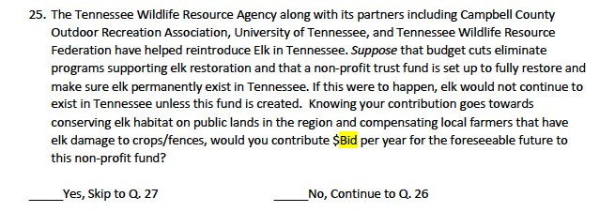
Figure 3.1 Survey question to assess WTP for reintroduced elk conservation
and property tax is not a popular payment vehicle in the region, a donation mechanism was chosen over a proposed tax increase. A study on whooping crane restoration in Wisconsin compared actual payment data with values estimated from a contingent valuation study utilizing donations at the payment mechanism and found no statistical differences between the two values (Moore, Bishop, Provenchar, & Champ, 2010). Therefore, this mechanism was expected to elicit accurate estimates of WTP. Additionally, each respondent was presented with one of the ten randomly assigned bid amounts ($5, $10, $15, $20, $25, $50, $75, $100, $150, $250). This random assignment of bid amounts was chosen was based on the literature in valuation of wildlife conservation (Ferrato et al., 2016; Loomis & Elkstrand, 1997; Moore et al., 2010).

3.3.2 Data Analysis

Data were entered into Excel and was analyzed using the STATA software package. A factor analysis was first conducted on the seven social trust variables as well as the nine risk perception variables to combine multiple scales into common themes representing constructs of interest. Factor analysis is a statistical technique for data reduction that reduces the number of variables in an analysis and creates clusters of similarly related variables. The risk perception variables were forced to load onto a single factor, allowing for ease of interpretation and categorization of respondents into high and low risk perception groups. The seven social trust variables loaded onto two factors and were interpreted using the dual-mode model of social trust (Siegrist & Gutscher, 2005). Varimax rotation was used on the social trust variables as it allowed for the maximization the variance of loadings on each factor and eases interpretation (Vaske, 2008). Rotation was not necessary for the risk perception variables as they were loaded onto a single factor. Cronbach’s alpha was then employed to test the reliability of the factors in representing each of the underlying constructs of trust, confidence, and risk perception. A Cronbach’s alpha value of 0.8 was considered the threshold for acceptability (Vaske, 2008).
To understand factors associated with landowners’ WTP for reintroduced elk conservation, a multivariate binomial logistic regression model was used. Because the probability of WTP was modeled as a binary response (“1” if the participant was willing to pay and “0” otherwise), logistic regression was the most appropriate approach (Bohon & Nagle, 2017). Several model specifications were tested with various independent variables included. This was done to test the strength of the original model (with only WTP and the Bid amounts as variables) and to evaluate whether and how adding or omitting a predictor variable would impact the mean WTP. A likelihood ratio chi-squared test was run to compare the models and model fit was compared using Akaike information criterion (AIC) and likelihood ratio tests (Burnham & Anderson, 2002; Ferrato et al., 2016). Lastly, parameters estimated from the logistic regression model were utilized to estimate the mean WTP per household following Loomis et al., 2000.

3.3.3 Empirical Model

The dependent variable in the model is the resident’s willingness to accept a bid presented in the question regarding WTP for reintroduced elk conservation. Several models were tested measuring different independent variables; however, the base model includes the bid amount as the sole predictor. Following Welsh and Poe (1998), the Bid-only logit model to explain WTP is shown below:
$$Y_{i}^{*}=β_{0}+\sum_{k=1}^{k}{β_{k}{Bid}_{ki}}+ε_{i}$$
[1]
Where Y* is the latent variable, which was not observed. However, the observable dummy variable as indicated in response to WTP questions was represented, so
Y = 1 if Y* > 0
Y = 0, otherwise
Yi * ~ N(0,1)
Bid_{ki} represent the response of the ith respondent to the explanatory variable. Similarly, β₀ represents the intercept of the equation, β_{k} is a vector of regression coefficients corresponding to each of the k explanatory variables, and ε_{i} is an independently distributed stochastic error term. The model assumes that a household’s utility is Y_{i}, which is a function of a vector of explanatory variables including the payment made to enjoy elk’s presence in the landscape, Y_{i} = 1 if the respondent is willing to contribute the amount being asked, and Y_{i} = 0 if not willing to do so.
The model including the Bid amount as well as sociodemographic predictors is shown as:
$$Y_{i}^{*}=β_{0}+\sum_{k=1}^{k}{β_{k}{Bid}_{ki}}+\sum_{l=1}^{l}{β_{l}X_{li}}+ε_{i}$$
[2]
which expands upon Eq. 1 by adding X_{li} to represent the response of the ith respondent to the l sociodemographic variables.
The full model including the Bid amount, sociodemographic characteristics and psychosocial predictors is shown as:
$$Y_{i}^{*}=β_{0}+\sum_{k=1}^{k}{β_{k}{Bid}_{ki}}+\sum_{l=1}^{l}{β_{l}X_{li}}+{\sum_{m=1}^{m}{β_{m}Z_{mi}}+ε}_{i}$$
[3]
which expands upon Eq. 1 & 2 by adding Z_{mi} to represent the response of the ith respondent to the m psychosocial variables.
Several variables were chosen as predictors for WTP in the model, including the two social trust variables (i.e. trust and confidence) as well as risk perceptions (Table 3.2). Confidence may play a key role in this study as the reintroduction in Tennessee began several years before the initiation of this study, so residents in and around the reintroduction area have experience in observing elk management and risk mitigation strategies conducted by the managing wildlife agency. As social trust components have been shown to positively impact WTP in other fields (Habibov et al., 2018; Oh & Hong, 2011), both trust and confidence were expected to have positive impacts on WTP. Conversely, the risk perception variable was expected to have a negative impact on WTP as those that perceive greater risks from elk reintroduction will be less likely to pay for its conservation. In addition to these variables, the bid amount was included as well and was predicted to have a negative impact on WTP as many studies have shown that as the WTP bid amount increases in price, WTP decreases (Richardson & Loomis, 2009).
Several sociodemographic variables were also included in the model. Age was included in the model as a continuous variable and was expected to have a negative relationship with WTP as reported in previous studies (Dalrymple et al., 2012; Stanley, 2005). With respect to gender and education, it has been shown that these variables are related to wildlife conservation (Dalrymple et al., 2012) and that women and more educated individuals are more likely to engage in pro-environmental behavior (Chen et al., 2011). In this model, gender was included as a dummy variable (1 = female; 0 = male) and education was included as a binary variable (1 = Bachelor’s degree or higher; 0 = less than bachelor’s degree). Both variables were predicted to positively impact WTP. Income was included in the model and coded as a dummy variable (1= income > $75,000; 0 otherwise). Economic theory suggests that household consumption
Table 3.2 Definitions and descriptive statistics of variables in the regression model of willingness to pay for long term conservation of reintroduced elk in Tennessee
Variables | Definition | Mean (S.D.)
Explanatory Variables
Bid | Bid amount, $5,10,15,20,25,50,75,100,150,250 | 73.77 (77.85)
Sociodemographic characteristics
Age | Age of respondents in years in 2017 | 59.82 (14.56)
Female | Dummy variable, 1 if female, 0 otherwise | 0.50 (0.48)
Education | Dummy variable, 1 if bachelor’s degree or higher, 0 otherwise | 0.21 (0.41)
Income | Dummy variable, 1 if respondent has > $75,000 in annual income, 0 otherwise | 0.27 (0.45)
Land dependence | Dummy variable, 1 if >25% income derived from land, 0 otherwise | 0.03 (0.17)
Psychosocial Factors
Confidence in agency | Factor component score for ordinal variable | -2.15x10⁻⁹ (0.86)
Trust in agency | Factor component score for ordinal variable | 1.31x10⁻⁹ (0.74)
Risk Perception | Factor component score for ordinal variable | 1.34x10⁻⁸ (0.98)
Dependent Variable
Willingness to pay | Dichotomous, 1 if yes, 0 if no | 0.26 (0.44)

decisions are constrained by their budget limit, which can significantly impact their ability to affordability of non-market goods and benefits such as wildlife conservation (Brown, 2005). Because of possible its effect on WTP, household income is considered an important control variable and is expected to be positively related to WTP. Missing income data for 110 respondents was replaced with the median income for the respondent’s zip code. Lastly, a variable “land dependence” was included as a binary variable to capture household’s level of dependence on the property for annual income (1 = >25% of income derived from property; 0 = otherwise). This is because residents’ dependence on their land for income could affect their WTP for elk conservation due to expected damage and risks that elk pose to landowners. This variable was predicted to have a negative relationship with WTP.

3.3.4 Willingness to Pay Calculations

Mean willingness to pay (WTP) was estimated for several tested models using the following equation (Loomis et al., 2000):
$$Mean WTP=\left(1/{β_{1}}\right)* \ln\left(1+e^{β_{0}}\right)$$

[4]
Where β₁ represents the coefficient estimate on the bid amount and β₀ represents either the estimated constant (in the bid-only model) or the grand constant (when multiple independent variables are added to the initial model). The grand constant was calculated as the sum of the estimated constant in addition to the product of the other coefficients multiplied by the means of the independent variables (Loomis et al., 2000). Confidence intervals for the mean WTP for each model were calculated following Park, Loomis, & Creel (1991) and Loomis et al. (2000).

3.4 Results

Out of 5,000 contacts, 18 were returned because the person being contacted was deceased or had moved from the stated address. Thus, a total of 1,005 surveys were returned, yielding an adjusted response rate of 20.17%. The response rate reported in our survey is consistent with several recent surveys that utilized randomized local residents as the sampling frame in a mail survey (e.g. Dalrymple et al., 2012: 21% in North Carolina; Dayer et al., 2016: 15% in Nevada and 24% in Colorado) and is sufficient for the study area population of five counties, with 95% confidence interval and 5% margin of error (Vaske, 2008). When comparing sample demographics to the population of interest, the data overrepresented females (65% female response rate) and was weighted accordingly to match the proportion of females in the population (50%).
Summary statistics of the model variables are presented above in Table 3.2. The average age of respondents was 59.8. Of the 963 individuals who responded to the gender question, 64.6% were female. There was a wide range of education attainment with 10.4% of respondents having some high school experience, 34.2% having a high school diploma, 34.5% reporting some college education, 12% having a bachelor’s degree, and 8.7% having a post-graduate degree. In terms of income, 25.0% of respondents reported earning less than $25,000 per year, 30.3% reported earning between $25,000 and $50,000, 17.5% reported earning between $50,000 and $75,000, and 27.2% reported earning over $75,000. When asked what percentage of respondent’s household income was derived from farming or ranching their property (land dependence), 83.1% of respondents stated 0%, 13.9% of respondents stated 1-25%, and 3.1% stated over 25%.
Bid amounts for the WTP question were evenly distributed with each bid amount making up between 9% and 11% of responses. The mean bid amount was $73.77 and 26.2% of respondents stated they were willing to pay their given bid amount (N=937). As Figure 3.2 shows, the proportion of respondents willing to pay the bid amount decreased as the bid amount increased. This result is consistent with other WTP studies (Welsh & Poe, 1998) and economic theory stating that as prices increase, less people will be willing to pay for a good or service.

3.4.1 Factor Analysis of risk and trust scales

As shown in Table 3.3, residents perceive relatively low levels of concern towards elk-related risks. The item with the highest mean level of concern was “elk/vehicle accidents” with a mean of 2.69 on a five-point scale. The item of lowest concern was “elk trails causing erosion” with a mean of 1.87. Results from the factor analysis show that all items loaded at 0.6 or above and ranged from 0.67 (elk/vehicle accidents) to 0.90 (damage to fences). The Cronbach’s alpha coefficient was 0.94, which is above the suggested threshold (i.e. 0.7), suggesting high internal consistency (Vaske, 2008).

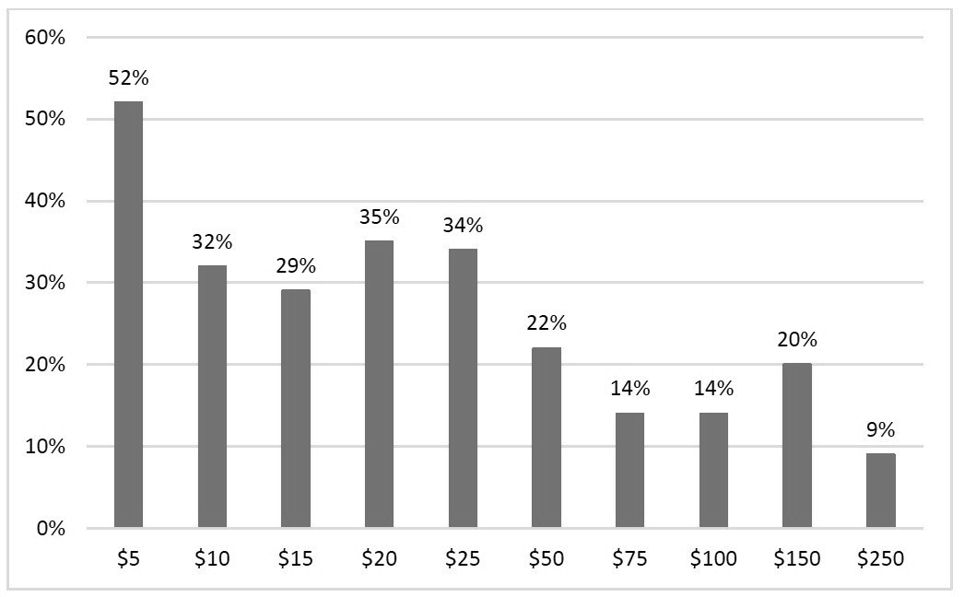
Figure 3.2 Percentage of “yes” responses to the WTP question as a function of the bid amount

Table 3.3 Risk perception factors used in the logistic regression of willingness to pay for conservation of reintroduced elk in Tennessee
Item | Mean (S.E.) | Factor Loading | Cronbach’s alpha
Risk Perceptions |  |  | 0.94
Elk/vehicle accidents | 2.69 (1.45) | 0.67
Damage to haystacks | 1.92 (1.22) | 0.84
Damage to trees/shrubs in yard | 2.09 (1.30) | 0.88
Damage to fences | 2.21 (1.38) | 0.90
Damage to flower/ vegetable gardens | 2.35 (1.41) | 0.86
Competing with deer for forage | 2.35 (1.37) | 0.73
Competing with cattle and horses for forage | 2.18 (1.38) | 0.86
Spreading disease to cattle/pets | 2.49 (1.46) | 0.77
Elk trails causing erosion | 1.87 (1.20) | 0.76
Analysis n = 863
Note: variables coded on 5-point scale: 1 = not at all concerned; 5 = very concerned

Scale means for the seven items measuring social trust, shown in Table 3.4, suggest neutral to high levels of trust and confidence in the wildlife management agency. Overall, respondents scored items relating to confidence slightly higher, with a mean score of 3.8, than items relating to trust, with a mean score of 3.3, suggesting that residents in this area may have more confidence in the agency’s capability to manage elk than trust that agency individuals can be relied upon. This is reflected in the items with the highest (“I am confident in the agency’s capacity to manage elk in this region”) and lowest (“wildlife agency professionals know what is best for local residents”) mean scores.
The factor analysis conducted on the seven-item Likert-type response scale resulted in two distinct components of social trust. Following Siegrist et al., 2005, items having high loadings on the first component were categorized into the scale labeled ‘confidence,’ as they

Table 3.4 Social trust factors used in the logistic regression of willingness to pay for conservation of reintroduced elk in Tennessee
 |  |  | Factor Loadings
Social Trust Component |  | Mean (S.D.) | 1 | 2 | Cronbach’s Alpha
Confidence in Agency |  |  |  |  | 0.92
 | I am confident in the agency’s capacity to manage elk in this region | 3.92 (1.07) | 0.69 | 0.40
 | Wildlife agency professionals
 | … can effectively manage elk in Tennessee | 3.82 (1.10) | 0.79 | 0.46
 | … are capable of managing elk-human  conflicts | 3.63 (1.12) | 0.72 | 0.42
 | … can help us deal with nuisance elk | 3.83 (1.11) | 0.82 | 0.37
Trust |  |  |  |  | 0.86
 | Wildlife agency professionals
 | … listen to our concerns | 3.47 (1.08) | 0.55 | 0.61
 | … know what is best for local residents | 3.09 (1.17) | 0.46 | 0.64
 | … share similar goals as me | 3.34 (1.04) | 0.49 | 0.64
Analysis n = 925
Note: variables coded on 5-point scale: 1 = strongly disagree, 5 = strongly agree; Loadings above 0.6 are in bold print.

pertained to confidence in the management capability of the agency. Items having high loadings on the second component were categorized into the scale labeled ‘trust,’ as they pertained to trust in agency professionals. The internal consistency was satisfactory for the four items measuring confidence at 0.92 and for the three items measuring trust at 0.86, using Cronbach’s alpha coefficient.

3.4.2 Estimates from logistic regression

Parameter estimates from regression models are presented in Table 3.5 for the three model specifications. The first model (i.e. bid only) examined only the relationship between the bid
Table 3.5 Estimates from logistic regression of willingness to pay for conservation of reintroduced elk in Tennessee
 | Bid Only Model | Bid & Sociodemographic Model | Bid, Sociodemographic, and Psychosocial Model
Variables | Coefficients (S.E.) | Coefficients (S.E.) | Coefficients (S.E.)
Bid | -0.01 (0.00)*** | -0.01 (0.00)*** | -0.01 (0.00)***
Sociodemographic characteristics
Age |  | -0.02 (0.01)** | -0.02 (0.01)**
Female |  | 0.49 (0.18)** | 0.60 (0.20)***
Education |  | 0.65 (0.19)** | 0.69 (0.21)***
Income |  | 0.41 (0.19)*** | 0.64 (0.19)***
Land dependence |  | 0.65 (0.47) | 1.42 (0.41)**
Psychosocial factors
Confidence |  |  | 0.55 (0.13)***
Trust |  |  | 0.47 (0.14)***
Risk Perceptions |  |  | -0.24 (0.11)**
Constant | -0.52 | -0.10 | -0.42
Grand Constant |  | -0.49 | -0.53
Mean WTP  (95% CI) | $54.10  ($41.13, $76.53) | $53.77  ($40.94, $78.12) | $45.53  ($34.12, $67.25)
Model F | 32.57*** | 13.77*** | 12.12***
Likelihood-ratio test |  | 57.90*** | 57.80***
AIC | 1028.27 | 938.62 | 790.05
N | 915 | 881 | 781
Note: **indicates significant at P < 0.05; ***indicates significant at P < 0.01

amount and WTP. In this model, the coefficient on the bid variable was negative and significant (p < 0.001), suggesting that as the bid amount increased, likelihood of accepting the bid decreased. In this model, per household mean WTP for the conservation of reintroduced elk was $54.10, with a 95% confidence interval of $41.13 to $76.53.
The second model (i.e. combined bid and sociodemographic variables) tested the same relationships but controlled for income effect and several sociodemographic characteristics. The coefficient on the bid variable remained negative and significant (p < 0.001) in this model, meaning that WTP decreased with increasing bid amounts. Of the sociodemographic variables, only land dependence was not significant (p = 0.16). Conversely, the coefficients for age, gender, education, and income were positive and significantly related to likelihood of accepting the bid. This suggests that women, those who are older, and those that are more educated and have higher incomes are more likely to pay for elk conservation than their respective counterparts. In this model, the mean WTP per household was $53.77.
The third model (i.e. combined bid, sociodemographic, and psychosocial variables) expanded the first two models by including the psychosocial constructs (trust, confidence, and risk perceptions) being examined in this study. The bid amount remained negative and significant (p < 0.001) in this model as well, suggesting the robustness of this relationship relative to model specification. All of the sociodemographic variables were significant, with the coefficients for gender, education, and income remaining positive and significantly related to WTP and the coefficient for land dependence being positive and becoming significant (p < 0.05)
in this model. The coefficients for confidence (p < 0.001) and trust (p < 0.05) were positive and significantly related to WTP. The coefficient for risk perceptions was negative and also significantly related to WTP (p < 0.05). In this model, the mean WTP per household was $45.53. The likelihood ratio tests found that adding the variables from the second and third model resulted in significant improvements in model fit. Likewise, the AIC value decreased between each moved, also suggesting improved model fit.
As shown in Table 3.6, multiplying the mean WTP for the full model by the total number of households in the 5-county area in and outside of the elk restoration zone, the aggregate WTP for this area was found to be $3.41 million. As not all households in the study area are likely to be willing to pay for elk conservation a conservative estimate was also calculated. The proportion of respondents who stated they were willing to pay for elk conservation from each county is shown in the fourth column of table 3.6. Limiting the extrapolation of the sample mean WTP to this segment of the population yielded a WTP estimate of $1.29 million.

Table 3.6 Aggregate WTP for reintroduced elk conservation at 5-county level
County | Number of households | Aggregated WTP across 100% of households | % from county responding “yes” WTP | Aggregated WTP across “yes” responses
Anderson | 30,612 | $1,393,764 | 45% | $627,194
Campbell | 15,996 | $728,298 | 38% | $276,753
Claiborne | 12,705 | $578,459 | 26% | $150,399
Morgan | 7,370 | $335,556 | 43% | $144,289
Scott | 8,309 | $378,309 | 25% | $94,577
Total WTP |  | $3.41 million |  | $1.29 million
Note: WTP per household = $45.53

3.5 Discussion
The results of this study indicate that residents in the 5-county area surrounding the elk restoration zone currently have moderate to high levels of confidence and neutral levels of trust in the managing wildlife agency and generally low perceptions of risk, and that those factors significantly affect WTP for reintroduced elk conservation in Tennessee. As the aggregate WTP estimates for the study area show, residents place a great deal of value on the reintroduced elk in this area and are willing to pay to aid in conservation efforts. Risk perceptions were also shown to negatively impact WTP for continued elk conservation, while trust and confidence in the wildlife management agency were shown to positively impact WTP. Results suggest that psychosocial factors like trust, confidence, and risk perceptions are important factors to consider when assessing public value of and WTP for wildlife conservation programs.
Willingness to pay for reintroduced elk conservation ranged between $45 to $54 per household depending on the model specifications. Similar to Welsh and Poe (1998), the WTP estimate for the bid-only model ($54) was similar to the model with sociodemographic information included ($53). The WTP estimate in the full model that controlled for sociodemographic characteristics and psychosocial factors was lower at $45, which may be a better representation of actual WTP per household. While few studies exist on WTP for wildlife reintroduction conservation, specifically, results from the full model of this study are similar to findings from other studies on wildlife conservation more generally. For example, Dalrymple et al. (2012) found household WTP for non-game conservation to be $71 (in 2018 dollars) in North Carolina, Loomis and Elkstrand (1997) found per household WTP for threatened and endangered species conservation in a nationwide study to be $75 per household. Similarly, Ericsson et al. (2008) found WTP for carnivore conservation in Norway to be roughly $58 per household. Studies on conservation of smaller, non-game species have generally found smaller WTP estimates per household ($23 for golden-cheeked warblers, Ferrato et al., 2016; $31 for beavers, Phillip & MacMillan, 2005; and $34 for river otters, White et al., 2001). However, due to the nature of elk in Tennessee as a large, charismatic game species, the larger WTP estimate found in this study is consistent with literature.
Results from this study show that gender (being female), education, income, and land dependence were positively and significantly related to WTP for elk conservation, while age had a negative, relationship with WTP. These results are consistent with those of other contingent valuation studies including sociodemographic variables in their model, with some exceptions. Being female has been found to have positive, significant impacts on WTP for ecosystem services and pro-environmental behavior (Chen et al., 2011; Dalrymple et al., 2012). Education and income have been found to have positive, significant impacts on WTP for species conservation as well (Dalrymple et al., 2012; Garrod & Willis, 1994; Nielsen-Pincus et al., 2017). The negative effect of age on WTP as found in the current study corroborates the findings of Dalrymple et al. (2012), Garrod & Willis (1994), and Nielsen-Pincus et al. (2017). Land dependency for income from farming or ranching has never been used as a variable in the wildlife conservation field, and therefore, there are no studies to compare to the current study. This suggests more research is necessary to determine its utility in valuation of wildlife conservation.
The study results are also consistent with the literature on trust and risk perceptions in terms of wildlife reintroductions. The negative relationship between risk perceptions and WTP found in this study has also been shown in studies on carnivore reintroduction. For example, Stevens et al. (1991) found that, when compared to bald eagles and wild turkeys, WTP for coyote conservation was significantly lower due to the increased risks. Ericsson et al. (2008) also found that the inclusion of wolves in a list of species being conserved (in addition to bears, lynx, and wolverines) decreased public WTP for conservation. While elk do not pose the same level of risks to livestock and human health as coyotes and wolves, results in this study suggest that potential damages caused by non-carnivorous species can reduce WTP.
Converse to the relationship between risk perceptions and WTP, trust and confidence were found to have positive relationships with WTP. As the relationship between social trust and WTP for wildlife conservation has not been studied before, there is no literature to compare WTP estimates. However, several studies have shown that trust in the wildlife management agency can improve support for wildlife management objectives (Harper et al., 2015; Needham & Vaske, 2008;). Gaining trust can also increase the chance that people will believe and comply with information provided by the managing agency about mitigating risks (Vaske et al., 2004).
In addition to establishing the relationship between social trust and WTP for wildlife conservation, this study also confirmed the dual mode model of social trust. As Siegrist et al. (2005) suggest in the field of technological hazards research, social trust can be comprised of general trust and general confidence. Results from the factor analysis indicate that trust and confidence are unique components of social trust that uniquely relate with attitudes and therefore have importance in the field of wildlife conservation.

3.6 Conclusions

This study quantified willingness to pay for the long-term conservation of a reintroduced species. While studies on public opinions towards proposed wildlife reintroductions are common in the literature, the importance of research on wildlife reintroductions over time should be noted. As reintroduction projects have generally low success rates globally, it is important to continually assess these programs through time and not simply at their inception. Many reintroduced species require continued attention and management for several years beyond initial translocation. Findings from this study allow agencies to understand the economic benefit from the existence value that local residents place on reintroduced wildlife many years after reintroduction, when the species of interest is becoming established and the population is growing. Agencies may benefit from these findings to highlight and demonstrate the long-term social value of wildlife reintroduction and conservation projects. Future studies should continue to assess the progress of reintroduction programs, including efforts to sustain public support.
This study also found empirical evidence to support the theory that psychosocial factors like risk perceptions, trust, and confidence are important predictors of WTP for wildlife conservation. Failure to control for these factors will lead to model misspecification and biased results that can mislead policy decisions. In addition, failure to control for risk perception can also over-estimate benefit estimates. Findings also imply that agencies need to invest in building trust and improving confidence with local residents and expanding outreach and communication to get local support for wildlife reintroduction and conservation. This could be done by effective communication and engagement. Equally important is investing in education and outreach so that perceptions of risk could be minimized either by education or assurance of risk mitigation.
When controlling for psychosocial factors, findings also showed that residents dependent on their land for income were actually supportive of conserving reintroduced elk. This is interesting as residents dependent on their land may have the most to lose from the reintroduction of wildlife that impose risks on their livelihoods. These results suggest that the omission of psychosocial factors like trust and risk perceptions can mask this relationship, and that the inclusion of those factors is important in uncovering such a relationship. Moreover, it suggests that if agencies can work on education and assurance to minimize perceived risk, and work on winning trust and confidence, it is possible that even those who may be against the species restoration may be willing to come onboard and be willing to pay for conservation.
Assessing how public values reintroduced species and whether and how much they are willing to pay for its long-term conservation is of interest to those in the wildlife conservation field. The case of elk reintroduction is of particular importance and relevance at the present time as many states in the eastern U.S. have either recently completed elk reintroductions or are planning one in the future. While the findings from this study were based on data from Tennessee, the benefit transfer method may be used to transfer estimates of WTP to other states with comparable socioeconomic characteristics. Other states may then be able to project the anticipated public benefit of recently completed reintroduction projects or ones currently being planned.

3.7 References
Arrow, K., Solow, R., Portney, P., Leaer, E., Radner, R., & Schuman, H. (1993). Report of the NOAA panel on contingent valuation. Federal Register, 58, 4602-614.
Bell, K. P., Huppert, D., & Johnson, R. L. (2003). Willingness to pay for local coho salmon enhancement in coastal communities. Marine Resource Economics, 18, 15-31.
Bowker, J. M., & Stoll, J. R. (1988). Use of dichotomous choice nonmarket methods to value the whooping crane resource. American Journal of Agricultural Economics 70, 372-381.
Boyle, K. (2003). Contingent valuation in practice. In P.A. Champ, K. J. Boyle, & T. C. Brown (Eds.) A Primer on Nonmarket Valuation. (pp. 111-148). New York, NY: Springer.
Brown, T. C. (2005). Loss aversion without the endowment effect, and other explanations for the WTP-WTA disparity. Journal of Economic Behavior & Organization, 57, 367-379.
Burnham, K. P., & Anderson, D. R. (2002). Model selection and multi-model inference: a practical information-theoretic approach. Second edition. Springer-Verlag, New York, New York, USA.
Chen, X., Peterson, M. N., Hull, V., Lu, C., Lee, G. D., Hong, D., & Liu, J. (2011). Effects of attitudinal and socio-demographic factors on pro-environmental behaviour in urban China. Environmental Conservation, 38, 45-52.
Cummings, R., Ganderton, P., & McGuckin, T. (1994). Substitution effects in CVM values. American Journal of Agricultural Economics, 76, 205-214.
Dalrymple, C. J., Peterson, M. N., Cobb, D. T., Sills, E. O., Bondell, H. D., & Dalrymple, D. J. (2012). Estimating public willingness to fund nongame conservation through state tax initiatives. Wildlife Society Bulletin, 36(3), 483-491.
Dayer, A. A., Bright, A. D., Teel, T. L., & Manfredo, M. J. (2016). Application of a stated choice approach to assessing public preferences for wildlife conservation funding. Human Dimensions of Wildlife, 21(5), 379-390.
Donovan, G., & Champ, P. (2009). The economic benefits of elk viewing at the Jewell Meadows Wildlife Area in Oregon. Human Dimensions of Wildlife, 14(1), 51-60.
Ericsson, G., Bostedt, G., & Kindberg, J. (2008). Wolves as a symbol of people’s willingness to pay for large carnivore conservation. Human Dimensions of Wildlife, 21(4), 294-309.
Ferrato, J. R., Brown, D. J., & McKinney, A. (2016). Assessment of public knowledge and willingness to pay for recovery of an endangered songbird, the Golden-Cheeked Warbler. Human Dimensions of Wildlife, 21(1), 86-94.
Fix, P. J., Manfredo, M. J., & Loomis, J. B. Assessing validity of elk and deer license sales estimated by contingent valuation. Wildlife Society Bulletin, 33(2), 633-642.
Funahashi, H., & Mano, Y. (2015). Socio-psychological factors associated with the public’s willingness to pay for elite sport policy: Does risk perception matter? Managing Sport and Leisure, 20(2), 77-99.
Garrod, G. D., & Willis, K. G. (1994). Valuing biodiversity and nature conservation at a local level. Biodiversity and Conservation, 3, 555-565.
Habibov, N., Cheung, A., & Auchynnikava, A. (2018). Does institutional trust increase willingness to pay more taxes to support the welfare state? Sociological Spectrum, 38(1), 51-68.
Haddak, M. M. (2017). Road user’s willingness to pay to reduce injury risk. 10th European Public Health Conference: Parallel Sessions, 27, 271.
Harper, E. E., Miller, C. A., & Vaske, J. J. (2015). Hunter perceptions of risk, social trust, and management of Chronic Wasting Disease in Illinois. Human Dimensions of Wildlife, 20(5), 394-407.
Krinsky, I., & Robb, A. L. (1986). On approximating the statistical properties of elasticities. Review of Economics and Statistics, 68, 715-19.
Loomis, J., & Ekstrand, E. (1997). Economic benefits of critical habitat for the Mexican Spotted Owl: A scope test using a multiple-bounded contingent valuation survey. Journal of Agricultural and Resource Economics, 22(2), 356-366.
Loomis, J., Kent, P., Strange, L., Fausch, K., & Covich, A. (2000). Measuring the total economic value of restoring ecosystem services in an impaired river basin: results from a contingent valuation survey. Ecological economics, 33(1), 103-117.
Loomis, J., & Caughlin, L. (2004). Linking intended visitation to regional economic impact models of Bison and Elk management. Human Dimensions of Wildlife, 9(1), 17-33.
Lord, B. E., Strauss, C. H., & Powell, M. J. (2002). Elk viewing in Pennsylvania: An evolving eco-tourism system.
Moore, R., Bishop, R. C., Provenchar, B., & Champ, P. (2010). Accounting for respondent uncertainty to improve willingness to pay estimates. Canadian Journal of Agricultural Economics, 58, 381-401.
Needham, M. D., & Vaske, J. J. (2008). Hunter perceptions of similarity and trust in wildlife agencies and personal risk associated with Chronic Wasting Disease. Society & Natural Resources, 21, 197-214.
Nielsen-Pincus, M., Sussman, P., Bennet, D. E., Gosnell, H., & Parker, H. (2017). The influence of place on the willingness to pay for ecosystem services. Society & Natural Resources, 30(12), 1423-1441.
Oh, H., & Hong, J. H. (2012). Citizens’ trust in government and their willingness to pay. Economics Letters, 115, 345-347.
Park, T., Loomis, J. B., & Creel, M. (1991). Confidence intervals for evaluating benefits estimates from dichotomous choice contingent valuation studies. Land Economics, 67(1), 64-73.
Phillip, L. J., & MacMillan, D. C. (2005). Exploring values, context and perceptions in contingent valuation studies: The CV market stall technique and willingness to pay for wildlife conservation. Human Dimensions of Wildlife, 48(2), 257-274.
Richardson, L., & Loomis, J. (2009). The total economic value of threatened, endangered, and rare species: An updated meta-analysis. Ecological Economics, 68, 1535-1548.
Siegrist, M., & Cvetkovich, G. T. (2000). Perception of hazards: The role of social trust and knowledge. Risk Analysis, 20, 713-719.
Siegrist, M., Gutscher, H., & Earle, T. C. (2005). Perception of risk: The influence of general trust, and general confidence. Journal of Risk Research, 8(2), 145-156.
Smith, E. K., & Mayer, A. (2018). A social trap for the climate? Collective action, trust, and climate change risk perception in 35 countries. Global Environmental Change, 49, 140-153.
Sponarski, C. C., Vaske, J. J., Bath, A. J., & Musiani, M. M. (2014). Salient values, social trust, and attitudes toward wolf management in south-western Alberta, Canada. Environmental Conservation, 41(4), 303-310.
Sponarski, C.C., Miller, C., & Vaske, J. J. (2018). Perceived risks and coyote management in an urban setting. Journal of Urban Ecology, 4(1), 1-5.
Stanley, D. L. (2005). Local perception of public goods: recent assessments of willingness-to-pay for endangered species. Contemporary Economic Policy, 23, 165-179.
Stevens, T. H., Echeverria, J., Glass, R. J., Hager, T., & More, T. A. (1991). Measuring the existence value of wildlife: What do CVM estimates really show? Land Economics, 67(4), 390-400.
Stoll, J. R. & Ditton, R. B. (2006). Understanding anglers’ willingness to pay under alternative management regimes. Human Dimensions of Wildlife, 11(1), 27-42.
Swanson, C., (1993). Economics of non-game management: Bald eagles on the Skagit river bald eagle natural area, Washington. In: Ph.D. Dissertation, Department of Agricultural Economics, The Ohio State University, OH, USA
Vainio, A., Paloniemi, R., & Varho, V. (2017). Weighing the risks of nuclear energy and climate change: Trust in difference information sources, perceived risks, and willingness to pay for alternatives to nuclear power. Risk Analysis, 37(3), 557-569.
Vaske, J. J., Timmons, N. R., Beaman, J., & Petchenik, J. (2004). Chronic wasting disease in Wisconsin: Hunter behavior, perceived risk, and agency trust. Human Dimensions of Wildlife, 9, 193-209.
Vaske, J. J. (2008). Survey research and analysis: Application in parks, recreation, and human dimensions. State College, PA: Venture.
Welsh, M. P., & Poe, G. L. (1998). Elicitation effects in contingent valuation: comparisons to a multiple bounded discrete choice approach. Journal of environmental economics and management, 36(2), 170-185.
White, P. C. L., Bennett, A. C., & Hayes, E. J. V. (2001). The use of willingness to pay approaches in mammal conservation. Mammal Review, 31(2), 151-167.

Appendix B. STATA output for logistic regression models

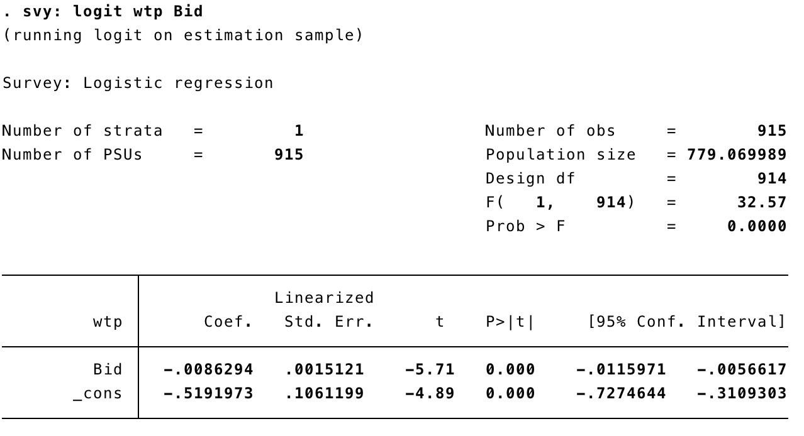
Model 1. WTP and Bid Only

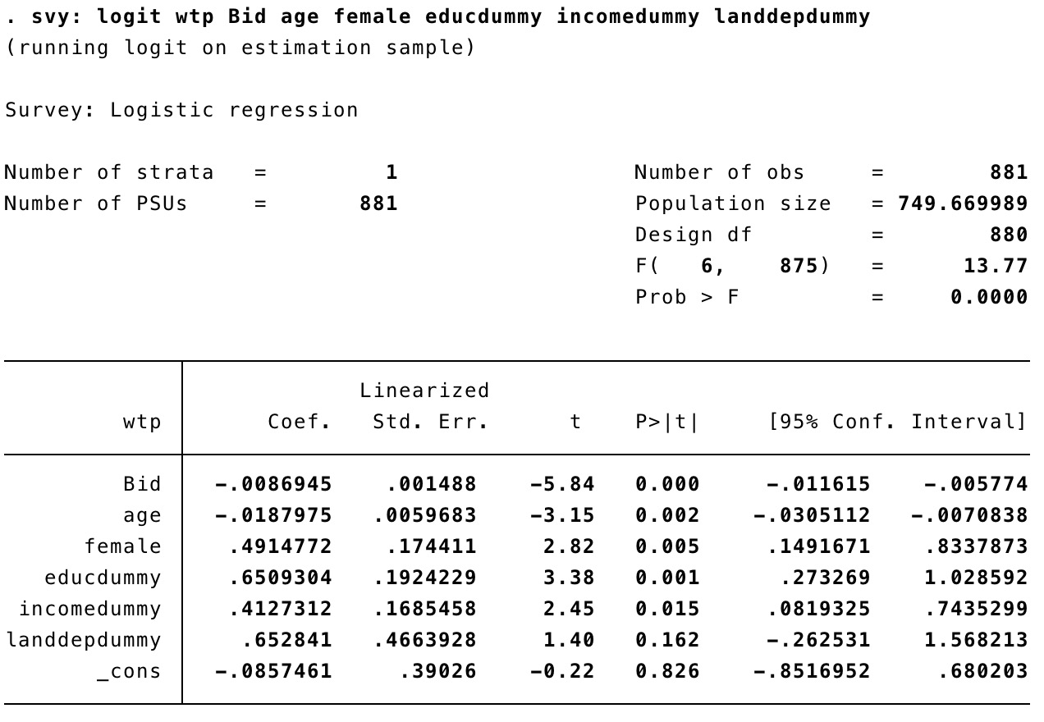

Model 2. WTP, Bid, and Sociodemographic variables
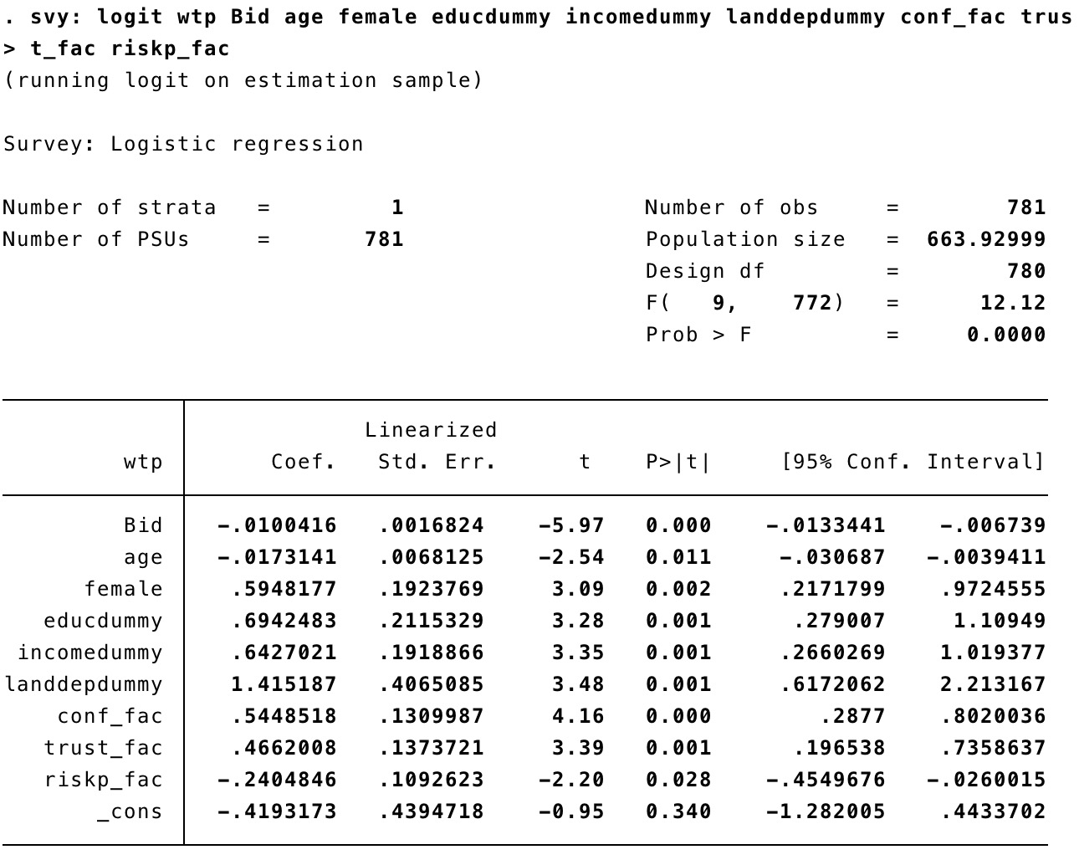

Model 3. Full Model including psychosocial characteristics

CHAPTER IV
SOCIAL-ECOLOGICAL SYSTEMS MODEL TO GUIDE WILDLIFE REINTRODUCTION

Abstract

Wildlife reintroductions are complex species restoration efforts that are gaining considerable attention due to growing concerns over global losses in biodiversity, yet suffer from low success rates. Past efforts to improve reintroduction outcomes have relied heavily on ecological criteria, and often ignored social considerations. However, it is well understood that natural resources are embedded in complex social-ecological systems and conservation strategies like reintroductions demand knowledge from ecological, social, economic, and political fields. Successful reintroduction programs depend on the extent a program can integrate key element of social and ecological systems into the planning process. Drawing upon the findings from the previous two chapters as well as new findings from emerging literature in restoration, this paper adopts and extends previously developed models to explain the importance of integrating social and ecological factors into the wildlife reintroduction process and implementation. This paper further demonstrates the utility of this model by expanding it to explain the programmatic outcomes of several reintroductions programs around the world. By accounting for a diverse array of elements embedded within ecological and social systems and accounting for the different scales by which these elements operate as well as the feedback mechanisms and interactions between them, this model offers a comprehensive framework for integrating social and ecological systems into wildlife reintroduction planning. Guidance is also offered for applying integrated socio-ecological systems approaches to wildlife reintroductions.
Key words: wildlife reintroduction, case study analysis, conceptual model, wildlife management

4.1 Introduction

Wildlife reintroductions are conservation programs that attempt to address the global environmental crisis of species loss (Soorae, 2018). Traditionally, reintroductions have been based on biological and ecological restoration science. However, natural resources exist within multifaceted Social-Ecological Systems (SES) and it has been recognized that major environmental problems cannot be addressed with disciplinary approaches alone. Hence, addressing such complex problems requires interdisciplinary approaches that recognize and address the interconnectedness between social and ecological systems. Wildlife reintroductions are complex undertakings that can benefit from such an interdisciplinary consideration.
Because of their complex nature, wildlife reintroductions are prone to failure (Griffith et al., 1989; Beck et al., 1994; Fischer & Lindenmayer, 2000; Jule, Leaver, & Lea, 2008). The traditional approach for determining best practices in wildlife reintroductions has relied on ecological knowledge, like habitat management and site selection, with little to no input from other disciplines (Reading et al., 2002; Sutton, 2015). However, this reliance on disciplinary knowledge may contribute to low success rates. A meta-analysis of 293 global case studies found that in addition to issues related to species biology, external social-ecological conditions and administrative issues were the most reported difficulties with conservation translocations (Berger-Tal, Blumstein, & Swaisgood et al., 2019). This shows that reintroduction practitioners are reporting multiple difficulties with reintroductions including social and administrative issues, but the research in this area is mostly focused on biological and ecological solutions.
Reintroductions are prone to failure for many reasons that are ecological and social in nature, though it is often the social processes that are overlooked or ignored. Compared to ecological considerations, wildlife reintroduction literature has paid little attention to social considerations (O’Rourke, 2013; Sutton, 2015; Berger-Tal et al., 2019). Some suggest that success rates could be improved with greater attention given to addressing social concerns (Clark & Wallace, 2002). One mechanism for incorporating social processes into an ecologically-dominant wildlife management culture is by adopting a Social-Ecological Systems (SES) approach (Walker et al., 2006). SES approaches recognize the interconnected nature of the social and ecological processes that can influence environmental systems. As such, they are the ideal method for incorporating social processes into the traditionally ecology-centered reintroduction framework to improve outcomes.
Because social processes are often overlooked, it is important to address their influence on reintroductions. As reintroduction often involves bringing a species back to a landscape where they had been absent for some time, these efforts can be met with mixed results. Human populations living near a proposed wildlife reintroduction site can have a myriad of reactions, including fear, apathy, opposition, and support (O’Rourke, 2013; Sutton, 2015 ). The resulting human interactions with the species being reintroduced can lead to positive reintroduction outcomes such as protection of biodiversity or negative outcomes such as species endangerment (Clark & Wallace, 2002; Soorae, 2016; Soorae, 2018).
Social support and involvement with reintroductions can take the form of volunteer support during initial reintroductions, community fundraising, and involvement with citizen science projects like monitoring the location of reintroduced individuals. Social support for reintroductions can also involve community eradication of predators to the reintroduced species like trapping of household rodents or controlling non-native populations (Lieberman & McCormack, 2018). When large landowners are supportive of conservation efforts, they can even host reintroduction on their property, as was the case with the Bolson tortoise (Gopherus flavomarginatus) reintroduction on Ted Turner’s private ranch in New Mexico (Wiese & Hillard, 2016). Getting the public on board through timely and effective communication and education about the reintroduction program is key in securing funding, influencing pro-environmental behavior, and successful implementation.
Conversely, public opposition to wildlife reintroductions can limit the success of those programs. Not having any of the supportive elements listed above, like citizen science volunteers and fundraising efforts, can limit management capabilities. Without these elements, reintroductions can suffer from insufficient funding, short-sighted recovery plans, and inadequate staffing to implement successfully. Active protests against reintroductions can reflect poorly on the managing agencies and organizations that can lead to halting of programs or de-prioritization of management efforts. In extreme circumstances, anger and resentment towards the reintroduction can lead to poisoning, poaching, or other harmful actions taken against the reintroduced species (O’Rourke, 2013; Sutton, 2015) or to litigation (Steinhardt, 2018).
As stated by Elinor Ostrom in her pivotal work on social-ecological systems, “without a common framework to organize findings, isolated knowledge does not cumulate” (Ostrom, 2009). This paper attempts to provide such a framework that will assist management professionals, researchers, conservation organizations, and others interested in improving wildlife reintroduction success rates in understanding the interconnected nature of social and ecological elements. The paper begins with a comparative analysis of reintroduction case studies from around the world and then uses the case study of elk reintroduction in Tennessee to explain concepts and illustrate the utility of the model and provides suggestions for applying integrated approaches. The framework developed in this paper can be used by practitioners to integrate social and ecological considerations into reintroduction programs and by researchers to conduct empirical analysis and predict success of other restoration programs. Wildlife reintroductions will only succeed when social system elements are considered, and interventions are selected to increase support for that goal.

4.2 Objectives

The overall goal of this paper is to develop and demonstrate the applicability of a conceptual model for integrating social and ecological considerations to inform wildlife reintroduction planning. Specifically, the objectives are to:
- Qualitatively analyze reintroduction case studies from around the globe to assess the influence of social and ecological systems on reintroduction outcomes.
- Propose a conceptual model for integrating social and ecological processes into successful wildlife reintroduction management.
- Demonstrate the utility of the conceptual model with an illustration of elk reintroduction in Tennessee.

4.3 Comparative Analysis of Global Reintroduction Case Studies

4.3.1 Reintroduction of the Sea Eagle into Ireland and Scotland

White-tailed sea eagles (Haliaeetus albicilla) historically occupied a large range stretching from Greenland and across northern Europe to Asia. The species was driven to extirpation in Ireland and Scotland in the late 19th and early 20th century, respectively. A reintroduction was conducted in Killarney National Park in 2007, as part of a larger project to reintroduce several species of raptors back to Ireland (O’Rourke, 2013). In Scotland, the “Sea Eagle Recovery Project” reintroduced eagles in several locations across the country between 1975 and 2012 (Sutton & Lopez, 2014; Sutton, 2015). These two reintroductions provide examples of how varying degrees of ecological and social systems integration by those in charge of managing the reintroduction led to very different reintroduction outcomes.
The reintroduction program in Ireland began with a habitat suitability assessment conducted by ecologists and wildlife experts from Ireland and Norway (the source site for the proposed translocated eagles). This assessment emphasized the ecological and biological aspects of habitat suitability without a full assessment of the social aspects (O’Rourke, 2013). The main actors within the social system surrounding this reintroduction of sea eagles were the local sheep farmers, who opposed reintroduction over concerns about predation on young lambs and fear that it would impact local livelihoods. As a result, roughly a quarter of the reintroduced birds between 2007 and 2013 died due to ingesting bait made of poisoned meat, traditionally used by farmers as a deterrent for foxes. The setting of poisoned bate for foxes was a common practice among sheep farmers in the area and they had refused to alter their behavior for the benefit of the sea eagles, whose existence in the area felt like an imposition to the farmers (O’Rourke, 2013). It remains up for debate whether any bait was placed with the specific intention of harming the eagles directly.
Similar to the case in Ireland, by 2004, 25% of sea eagle deaths in Scotland were attributed to “persecution” actions like poisoning and illegal taking (Love, 2006; Sutton, 2015). In response to this, leaders of the Sea Eagle Recovery Project shifted their public relations strategy and adopted a more culturally-sensitive approach to include locals in the process (Sutton, 2015). Rather than framing the project as conservation agenda driven by external interests, they embarked on a comprehensive plan to involve locals. The management team educated locals about the eagles and involved the public by asking them to monitor eagle nests. This made the people in the area feel like the eagles belonged to them and were part of their regional identity. This strategy became a leading factor in the success of this reintroduction (Sutton, 2015).
These two cases exemplify the importance of how a thorough consideration of the social and ecological systems surrounding reintroductions is vital for their success. The local sheep herders in both communities were apprehensive towards the reintroduction due to the eagles’ potential to eat their lambs and harm their livelihoods. However, after noticing a similar pattern to the situation in Ireland, the conservation team in Scotland was able to regroup and reassess the social aspect of their reintroduction plan. They were able to educate and involve the sheep herders to take ownership of the conservation project early enough in the process to not hinder the overall success of the program. In addition to assessing the social elements, an assessment of the characteristics of the species being reintroduced could have helped those in charge understand both the potentials for conflict and collaboration earlier.
Had the social component been better considered at the outset of the reintroduction, both reintroduction cases would not have suffered those early losses. O’Rourke (2013) suggested that improved consideration of the social component prior to reintroduction in Ireland could have involved a broader rural development initiative or plans to involve local farmers and adequate funding to support better facilitation, education, communication, and conflict mitigation. The adaptive approach taken by the Sea Eagle Recovery Project in Scotland was able to incorporate these elements, which ultimately led to the success of their program.

4.3.2 Reintroduction of the Rimatara lorikeet to Atiu Island, Cook Islands

The Rimatara lorikeet (Vini kuhlii) had a native range across several islands of the South Pacific Ocean but is now limited to three islands in French Polynesia and Kiribati, including the island of Rimatara, from which it gets its name. The bird became extinct in the Cook Islands in the late 18th century and is considered endangered by the International Union for Conservation of Nature (IUCN). A reintroduction project began in 2007 on the island of Atiu (Cook Islands) as an effort to establish a reserve population of the species on an island free of its main predator, the ship rat (Rattus rattus). The case study of this project provides an example of how effective community engagement can contribute to the success of the reintroduction of this rare and endangered species.
The reintroduction of the Rimatara lorikeet involved translocating birds from the island of Rimatara in French Polynesia to Atiu Island in the Cook Islands. The initial obstacle for this reintroduction was in obtaining permission from the governments of the two countries and the support from the local communities of Rimatara to allow the removal of birds from their island and the support from the local community of Atiu to allow reintroduction there (Lieberman & McCormack, 2008). In addition to this, the island of Atiu had a population of non-native common myna (Acridotheras tristis), which threatened the success of the reintroduction because of its aggressive behavior towards lorikeet fledglings (Lieberman et al., 2018). The groups involved with the reintroduction, consisting mainly of biologists, were able to gain support from the community to the extent that they participated in a program to eradicate the common myna (Lieberman et al., 2018). In addition to this, they led a community education program to warn about the impacts that ship rats would have on the native bird. This community engagement led to the eradication of the common myna on the island and success of the reintroduction.
This case study shows how the interactions between ecological and social elements were considered prior to and during a reintroduction. As this reintroduction was conducted by biologists from large international conservation organizations, it could easily have been interpreted by local communities as an imposition on them. However, the reintroduction team was able to gain community support without which, the eradication of the common myna would not have been possible and the survival of the Rimatara lorikeet would have been jeopardized. This further illustrates the interconnectedness of the social and ecological systems surrounding reintroduction. Individual and community-wide support led to pro-reintroduction behavior, which influenced the ecological community, ultimately leading to reintroduction success. This case succeeded in being able to understand and predict how social and ecological systems would interact with each other to improve outcomes.

4.3.3 Reintroduction of the Sea Otter to Northeast Pacific USA and Canada

Sea otters (Enhydra lutris) historically occupied all nearshore habitats along the pacific coast of the United States and Canada. However, the commercial fur trade of the 18th and 19th centuries led to their overharvesting and catastrophic population declines. The California and Southwest Alaska populations of sea otters are currently listed as threatened under the U.S. Endangered Species Act and all sea otter populations are listed as endangered by the IUCN (Larson & Bodkin, 2018). Since the mid 1900s, several reintroductions have taken place along their native range in attempts to restore the species but not all have been successful.
The removal of sea otters, a keystone species, resulted in the increased abundance of various species of clams, crab, mussels, and urchins, upon which several commercial and recreational fisheries were developed. The reintroduction of sea otters as a predator for these invertebrate species created a source of competition for the fisheries, leading to conflict (Lawson & Bodkin, 2018). For example, a reintroduction of sea otters in San Nicolas Island, off the coast of California, in the 1980s cited secondary take in the local lobster and crab fisheries to be a major cause of adult mortality (Benz, 1996). Many sea otters were dying in this case because the fishing industry was unwilling to adapt their fishing practices to benefit the otters. In an effort to appease the fishing industry, this reintroduction was paired with a declaration of the southern California coast as a “no-otter” zone. This was met with years of lawsuits from environmental organizations and counter-lawsuits from fishing groups, which ended in 2018 with a decision by the U.S. Supreme Court not to hear an appeal to re-establish the “no-otter” zone. This conflict and litigation led to a failure of the San Nicolas island reintroduction and a very slow recovery process for California sea otters generally (Steinhardt, 2018).
In British Columbia, Canada, sea otter reintroduction was a source of conflict with local native communities over similar concerns that they would diminish the invertebrate species populations on which they rely for subsistence (Hume, 2014). However, this potential conflict diminished when chiefs of the Nuu-chah-nulth First Nations community decided to support sea otter recovery after meeting with ecologists and developing a plan for coexistence, allowing for native groups to take a sustainable limit of sea otters. The official sea otter recovery strategy also contains language placing communication and collaboration with First Nations as a top priority for recovery success (Sea Otter Recovery Team, 2007).
In both of these cases, sea otter reintroduction was impacted by social and ecological systems. The reintroduction of sea otters created ecosystem-wide trophic cascades that not only affected the ecological systems, but also the social systems. Their addition to this ecosystem altered the populations of predators and prey throughout the food chain that changed the structure of the entire ecosystem. Their reintroduction also impacted the fisheries industry and the social processes linked to it like the local communities depending on the industry for income and livelihoods. In the case of California, considerations at the social level were not sufficient to handle human concerns, leading to litigation and eventual reintroduction failure. However, in the case of British Columbia, reintroduction scientists were able to work with local communities in order to aid in the reduction of concerns and create a powerful ally for reintroduction programming in this area.

4.4 Conceptual Model for Wildlife Reintroductions

The case studies described above illustrate the powerful influence of social systems on reintroduction success. As such, the model presented in Figure 4.1 conceptualizes wildlife reintroduction management as the full integration of ecological and social systems, with considerations at multiples system scales. Described as Social-Ecological Systems, reintroductions are conservation programs that can be described as the interacting of two interconnected social and ecological systems influenced by political, economic, and environmental conditions. They are ecological endeavors that exist solely by human intervention, meaning that wildlife reintroductions cannot occur without human involvement. Therefore, the conceptual model shows this interconnectivity with overlapping spheres and arrows suggesting feedbacks among the social and ecological factors. Following Lischka et al. (2018), these influences exist in different scales from individual influences to ecosystem and societal influences, which are nested to show the interdependency of each level. Moreover, the overlapping portion in the center of the diagram (Social-ecological characteristics) indicate the ecological parameters that are purely imposed upon by humans, exemplifying the interdependent nature of the social and ecological systems in wildlife reintroductions. Figure 4.2 highlights two scales within each system of special importance to reintroduction planning, with examples of considerations for each.
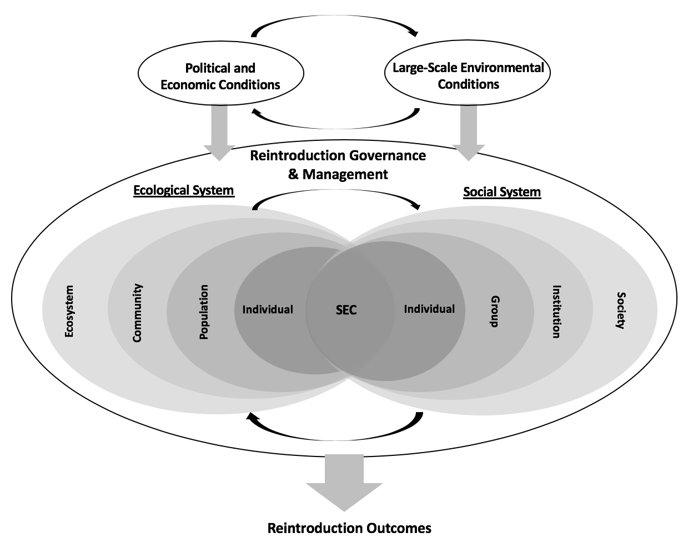
Figure 4.1 Social-Ecological Systems (SES) model for wildlife reintroduction management (adapted from Lischka et al., 2018 & Virapongse et al., 2016)

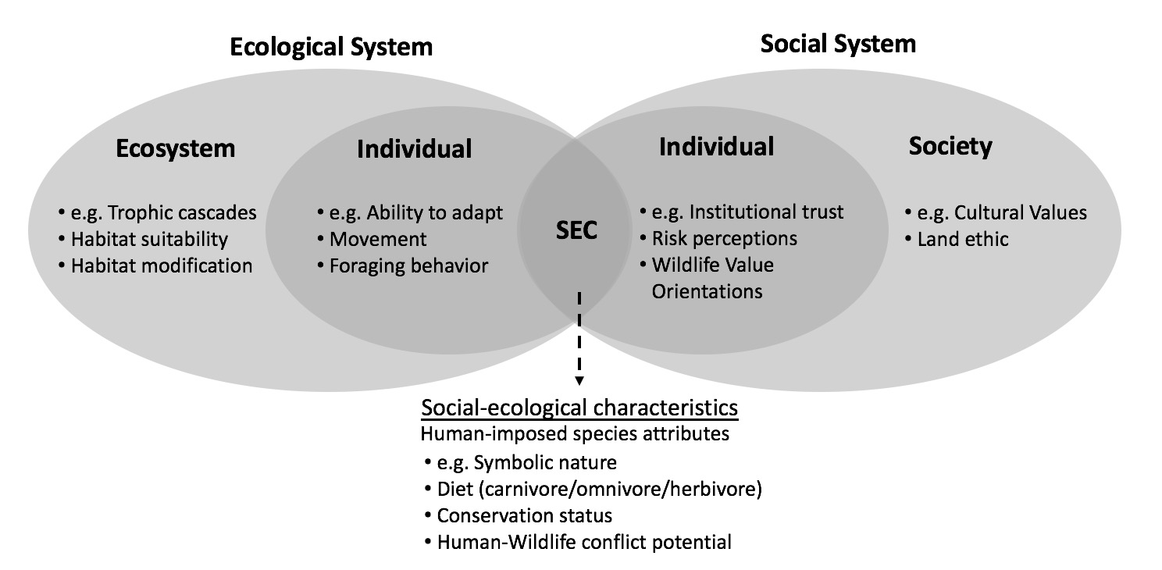
Figure 4.2 Examples of key concepts within the SES model for wildlife reintroductions

The ecological system presented in the model (Figure 4.1) utilizes the classical hierarchical organization of life from the individual level to the population, community, and ecosystem scale that help to identify the nested levels of ecological considerations necessary for successful reintroductions (Pidwirny, 2006). At the individual level, characteristics of the species such as survival rates, nesting success, and reproductive ability will affect its’ ability to thrive once it is reintroduced. At the population scale, factors such as the appropriate number of individuals included in the reintroduction over time and the degree of genetic variation within the population need to be determined. At the community scale, interactions among species in and around the reintroduction need to be considered so the reintroduced species can adapt to change. Lastly, at the ecosystem scale, the abiotic as well as the biotic components of the reintroduction site must be considered.
The nested nature of the ecological system model suggests the interdependent nature of these levels. For example, the fertility of an individual may be influenced by the abundance of food and habitat suitability. Likewise, ecosystems provide the landscape driving food availability, which drives the processes of communities such as predation and competition. This, in turns affects population growth and diversity. Large scale ecosystem considerations such as trophic cascades, habitat suitability, and climate change resiliency should be considered through space and time during all life stages of the reintroduced species. For wildlife reintroductions to result in stable populations, the interdependent nature of these ecological influences must be assessed.
Similar to the ecological system, the social system presented in the model organizes social influences of reintroductions in a hierarchical nested approach from the individual to the broader society. At the societal level, broad social forces influence public attitudes towards and support for reintroductions. For example, the land ethic, pioneered by Aldo Leopold, describes a societal worldview towards environmental conservation and stewardship that has impacted wildlife reintroductions by making conservation a moral imperative (Leopold, 1949). At the institutional level, the management of reintroductions involves an organizational hierarchy, decision-making structures, policies and management plans, and plans for community engagement. Actions taken by the local, state, and federal agencies as well as other organizations managing the reintroduction are crucial to its success. At the group level, factors such as group norms, socio-demographics, and social impacts (e.g., impacts of reintroduction on local economy) affect reintroductions. At the individual level, attributes such as personal norms, propensity to trust managing agencies, individual risk perceptions, and personal wildlife value orientations all influence behavior towards wildlife reintroductions.
The interdependent nature of this social systems model stems from human tendencies to organize into groups which are both influenced by individuals and have influence upon them (Manfredo, Teel, Gavin, & Fulton, 2014). Societal-scale considerations such as environmental stewardship ethics have influences on community attitudes towards wildlife reintroductions. For example, the societal view of conservation as a moral imperative may positively influence communities in support of a reintroduction, even if there are negative economic ramifications. Furthermore, individual attitudes can influence group norms, which can influence community attitudes towards specific wildlife reintroduction cases. When these attitudes are negative, there can be lasting impacts with opposition towards reintroductions.
The final element of the model involves the human-imposed species attributes. These are characteristics that are described in ecological terms, but are purely human constructs that lead to value judgements on reintroduced species. These attributes are characteristics of the species being reintroduced such as its status as a carnivore, status as endangered, the charismatic nature of the species, whether it is a game species, and whether it has potential to cause human-wildlife conflict. These attributes are important to reintroductions as they can influence human attitudes and behavior towards reintroductions (Dayer, Bright, Teel, & Manfredo, 2016; Ferrato, Brown, & McKinney, 2016). For example, large, carnivorous species such as wolves or bears might incur more negative attitudes as they can prey on livestock and cause bodily harm to humans. Conversely, herbivorous species such as elk might incur relatively less conflict as they do not directly harm livestock or human life. The charismatic nature of the species is also important as charismatic species tend to get more support for conservation (Metrick & Weitzman, 1996) and the public may be more tolerant of damage incurred by charismatic species (Duda, 2010). Awareness of the status of a species as threatened or endangered can also help to increase public support for its reintroduction (Ferrato et al., 2016).
The two interconnected systems in the model are enveloped by a broader sphere indicating governance and management of wildlife reintroductions. This is so because the success of any reintroduction depends on how well the governance system in place (coordination of conservation organizations, state/federal natural resource agencies, etc.) integrates social and ecological considerations into reintroduction planning. Aspects of the reintroduction process itself are also vital to understanding social and environmental responses to species reintroductions. They include things such as timing, management policies, funding, technical support, organizational support, and many other factors.
All factors within this model are subject to change from broad political, economic, and environmental conditions that can influence the success of the reintroduction program. The capacity for any governing institution to integrate the social and ecological systems considerations depends on the availability of resources (both economic and natural), as well as their political power, knowledge, and other factors. For example, the Rimatara lorikeet’s natural range extended across a number of remote islands belonging to separate nations in the southern Pacific Ocean, each of which may have differing capacities to enforce conservational policies to benefit reintroduction. The fragmentation of natural landscapes along political lines may be a limiting factor for success in many wildlife reintroduction and conservation programs. Similarly, the alterations in ecosystems brought on by climate change may also impact their longevity.
The capability of the governing institutions to efficiently and effectively integrate the social and ecological systems in conducting the reintroduction can be a major determinant of the overall success of the program. Without proper consideration of any single element and of the interdependent and connected nature of the system as a whole, it is susceptible to collapse. For example, individual factors such as wildlife value orientations are influenced by social-ecological characteristics like species attributes. Failure to consider how group norms are affected by species characteristics can cause negative attitudes towards a reintroduction, which had adverse implications for reintroduction success. Because the social-ecological system of wildlife reintroduction is so interdisciplinary in nature, a clear line cannot be drawn between social and ecological factors. Therefore, this model presents a fully integrated examination of the ecological and social factors influencing reintroduction programs.

4.5 Application of the Model on the Case Study of elk reintroduction in Tennessee

4.5.1 Background

Eastern elk (Cervus canadensis) once inhabited a range extending across southern Canada and much of the United States but was extirpated from the eastern U.S. in the mid 1800s due to habitat loss and overharvest (Cox, 2011). Elk reintroduction into Tennessee began in 1997 with a Tennessee Wildlife Resource Agency (TWRA) proposal to establish an elk restoration project in West Tennessee. However, failure of this proposal, largely due to opposition from agricultural interests led to another proposal in East Tennessee in 2000 (TWRA, 2017). A 670,000-acre Elk Reintroduction Zone (ERZ) was selected, centered around the 196,000-acre North Cumberland Wildlife Management Area (NCWMA) in East Tennessee. This location was selected due to its proximity to an elk reintroduction site in Kentucky, relatively low human population, potential for elk viewing and hunting, and comparatively few agricultural crops (Wathen et al., 1997).
The initial feasibility study concluded that the ERZ could sustain 1,400-2,000 elk, so the initial proposal called for 400 elk to be released into the NCWMA from Elk Island National Park in Alberta, Canada. Thirty-one elk were also transferred from Land Between the Lakes (LBL) in Kentucky in 2003. This is a high-fenced operation which also was originally stocked with elk from EINP (Kindall et al., 2011). Only 136 elk were moved from Canada to Tennessee between 2000 and 2002, while another importation was denied in 2006 due to concerns of spreading the disease, Brucellosis (TWRA, 2018). Perceived threats from this and the spread of Chronic Wasting Disease (CWD) in the United States, inhibited further attempts of international translocation. However, 65 elk were transferred from Kentucky’s reintroduced elk population in 2003 and 2008. Continuing threats about spreading of disease halted any further reintroduction attempts, bringing the total number of reintroduced elk to 201 individuals. Today, the population in this area is estimated to be around 400, with a wide confidence interval (TWRA, 2017).
The case study of elk reintroduction in East Tennessee provides a way to show the utility of the SES model presented above and for understanding elk reintroduction. Analyzing the case of elk restoration in Tennessee allows for the application of the conceptual model to a real-world reintroduction scenario and determine if social and ecological elements were considered and if they were integrated to inform the management process. Unlike the case studies discussed in section 4.3, this study describes additional concerns over the reintroduction of a terrestrial mammal that may cause property damage and lead to conflicts about land use. This case study is especially useful to analyze the model because the reintroduction program began twenty years ago and a healthy population of elk has been established. Hence, it can be regarded as a successful reintroduction. The conceptual model can be further used to assess the potential for future success of this program and recommend actions that may ensure longevity of elk restoration.

4.5.2 Application of Model

Table 4.1 presents the conceptual model and gives examples from the case study. Beginning with the ecological system, various environmental elements that operate within and between different levels influence the reintroduction of elk in Tennessee. The ecosystem of the ERZ has a varying range of elevations, precipitation levels and other climactic factors. It is characterized by deciduous forests and grasslands comprised of wildlife openings and mine reclamation sites. The deciduous forests are comprised of species like sugar maple (Acer saccharum), yellow poplar (Tulipifera liriodendron L.), northern red oak (Quercus rubra L.) and chestnut oak (Quercus prinus L.), while grassland areas are comprised of tall fescue (Lolium arundinaceum) and Serecia Lespedeza (Lespedeza cuneata) (Lupardus et al., 2005). While habitat suitability for elk reintroduction was considered at great length prior to reintroduction, the impacts that elk would have on the ecosystem were less considered (Wathen, 1997; Lupardus, 2005; Anderson, 2009; Kindall et al., 2011). It has been noted that elk and other ungulates have the ability to modify ecosystems by triggering trophic cascades, accelerating successional processes, and influencing nutrient cycling (Cox, 2011).
Narrowing the scale, the community surrounding the elk reintroduction includes a diverse array of plant and animal species that provide food for elk such as grasses, forbs, and acorns. No natural predators of elk currently exist in the ERZ, and while coyotes (Canis latrans) are present
in the area, they have not had a significant impact on elk mortality (TWRA, 2017). Elk do compete with white-tailed deer (Odocoileus virginianus) for much of the same food and resources, however, this has not been described as a major influence on the elk population in the area (Kindall et al., 2011). Poaching, vehicle accidents, and disease from meningeal worm Parelaphostrongylus tenuis) have been noted as causes for low survival rates, putting the
Table 4.1 Definitions of selected elements from model and case study examples
Term |  |  | Definition | Case Study Example
Ecological System^{a, b}
 | Ecosystem |  | The biotic and abiotic components of the environment | Climate and vegetation that influence elk habitat
 |  | Trophic cascades | Removal or introduction of species that initiates a chain of impacts on the ecosystem | Unknown cascading effects of Elk reintroduction
 |  | Habitat suitability | Presence or absence of environmental variables to ensure resources | Availability of plant species that provide food for elk
 |  | Habitat Modification | Changes in habitat created by species activities like grazing, etc. | Elk grazing altering plant composition in the habitat
 | Community |  | Interaction of species that populate a given area | Interaction of species that populate a given area
 | Population |  | Members of a single species in a given area at a given time | Members of a single species in a given area at a given time
 | Individual |  | Individual resource units | Individual resource units
 |  | Movement | Movement of individuals | Elk moving into fields on private property
Social Systemª
 | Society |  | Broad social forces that influence large groups of humans | Societal shift toward mutualist wildlife value orientations
 | Institutions |  | Formal and informal structures that govern behavior and allocate resources | Tennessee state code that imposes penalty for poaching
 | Group |  | Formal and informal human associations with shared definitions of who they are | Groups interested in assisting reintroductions like Campbell Outdoor Recreation Association
 |  | Group norms | Behavioral or social expectations that define what is acceptable | Expectations about appropriate behavior for elk viewing
 |  | Local attitudes^{c} | Categorizations of an object along an evaluative dimension | Support for reintroduction and management of elk
 | Individual |  | Individual members of a community | Individuals affected by elk reintroduction
 |  | Institutional | Willingness to rely on those in charge | Trust in the Tennessee Wildlife Resource Agency
 |  | Wildlife Value Orientations^{d} | Pattern of direction and intensity among a set of basic beliefs regarding wildlife | Wildlife benefits/existence & wildlife rights/use
 |  | Risk Perceptions | The degree to which individuals believe they are threatened by some hazard or danger | Risks pertaining to elk like crop depredation, car accidents, etc.
Social-Ecological Characteristics
 | Symbology |  | Symbolic nature of species (charismatic, emblematic, etc.) | Elk as large game species with iconic imagery
 | Diet |  | Status of species as carnivore, herbivore, etc. | Status of elk as an herbivore
 | Conservation status |  | Status of species as endangered, threatened, extirpated, etc. | Status of elk as extirpated
 | Human Wildlife Conflict |  | Negative human-wildlife interactions | Elk damage to fences or other property
ª Lischka et al., 2018; ^{b} Pidwirny, 2006; ^{c}Zanna & Rempel, 1988; ^{d}Fulton, Manfredo & Lipscomb, 1996
(population at risk for decline (Kindal et al., 2011). Individual attributes like reproductive success and mobility also influence wildlife reintroduction success. For example, several elk have been roaming outside of the ERZ, getting onto private property and causing property damage and other conflicts with humans.
Within the social system, societal forces like the cultural values of harmony and mastery or wildlife value orientations (WVOs) of wildlife benefits/existence and rights/use represent preferred ways of responding to human-wildlife issues (Manfredo et al., 2016). The societal shift from domination to mutualist wildlife value orientations (Manfredo et al., 2009) may influence general support for conservation programs like reintroductions. Formal institutions like the TWRA and Tennessee state legislature were key players in the planning, implementation, and monitoring of the reintroduction. At the group level, the Rocky Mountain Elk Foundation and local groups such as the Campbell Outdoor Recreation Association and the Tennessee Wildlife Federation provided technical assistance and funding support for elk reintroduction. Several individual attributes also impact elk reintroduction in East Tennessee. For example, a mail survey of residents in the ERZ found that individuals had relatively little concern over different risks imposed by elk (Poudyal, Watkins, & Chapagain, 2018). Those who trusted wildlife management agency professionals and felt confident in their ability to manage elk were also more likely to have positive attitudes towards elk and support continued elk recovery (Poudyal et al., 2018). Other studies have shown that individual wildlife value orientations can impact attitudes towards reintroduced species (Hermann et al., 2013).
Social-ecological characteristics also influenced elk reintroduction in Tennessee. Elk have been noted as charismatic megafauna and are appreciated for their signature bugle, made by bulls during the fall rut. The effect of their charismatic nature is evident through the roughly 16,000 visitors per year who come to the Hatfield Knob Tower in the ERZ to view elk (Poudyal, et al., 2018). Elk also have the benefit of being herbivores, which tend to receive fewer negative attitudes than reintroduced carnivores, like wolves. While not endangered, elk were extirpated from the Eastern United States due to overharvesting and habitat loss (Cox, 2011). Its status as extirpated is what has led many states in the Eastern U.S., including Tennessee, to begin the process of conducting a reintroduction in the first place and may play an important factor in influencing support for their restoration (Watkins, 2020). In addition to these factors that positively influenced elk restoration, the potential for elk to cause human-wildlife conflict through damage to property has had some negative impact as well. Risk perceptions can have a negative influence on support for reintroduction and has caused individuals within the ERZ to state their opposition at public forums (TWRA, 2016).
The case of elk reintroduction in Tennessee was also influenced by broad political, economic, and environmental conditions. For example, the success of the neighboring elk reintroduction in Kentucky that began a few years prior to Tennessee’s bolstered the political possibility of reintroduction in Tennessee (Wathen et al., 1997). That successful reintroduction gave decision-makers in Tennessee confidence that a reintroduction within the state could be successful and that it could provide economic opportunities in terms of hunting and tourism. Additionally, the spread of Chronic Wasting Disease (CWD) in the mid 2000s halted transportation of additional elk into Tennessee, which meant that the final number of individual elk included in the reintroduction was lower than initially planned (TWRA, 2017).
The varying scales that two systems operate upon create multiple feedbacks that affect each other. For example, a study in 2011 found that the elk herd population was at risk for decline based on low individual survival rates due to social factors like poaching and vehicle accidents, as well as disease from meningeal worm (Kindal et al., 2011). In response to this, a policy was added to the Tennessee State Code (70-4-116) to address poaching, requiring a penalty of at least $1,500 for each elk taken illegally with larger penalties for elk illegally taken with larger antlers (TWRA, 2017). An incident then made headlines across Tennessee, when a local resident was publicly charged with the illegal poaching of an elk in the ERZ, which was radio-collared and part of a research study at the University of Tennessee (Mojica, 2019). In this chain of events, the ecological process of population decline was followed by a social intervention to influence individual behavior. As a further example of the broad political forces at play in this social-ecological system, a comparison can be made with the reintroduction of elk in the neighboring Smoky Mountains National Park on the Tennessee-North Carolina border. This population has been estimated to have positive growth rates as poaching is not a significant problem (Murrow, 2007). Therefore, the decision to center Tennessee’s elk reintroduction on a wildlife management area, which allows hunting for deer and other wildlife species as well as 4-wheeler use with extensive trail system, may have had unintended consequences for the success of the species’ survival.
An evaluation of the overall integration of the social and ecological systems of this reintroduction is also worth noting. As shown through the number of articles and technical publications prior and throughout the duration of this reintroduction process, it is evident that careful attention was paid to the ecological system. While major social concerns like crop predation were assessed prior to reintroduction, it is evident that less attention was paid to social system characteristics compared to the ecological. However, after the initial reintroduction phase, efforts by the managing wildlife agency to assess stakeholder concerns and attitudes were conducted. Public forums were held in 2016 and an elk conflict response plan was included in the 2017 Strategic Elk Management Plan (TWRA, 2017). Future efforts by management officials to further integrate these social and ecological systems will have a lasting impact on the longevity of this program.

4.6 Management Recommendations

As presented in this paper, full integration of social and ecological systems can lead to successful program outcomes for wildlife reintroductions. While growing literature supports this notion, full social-ecological integration in reintroduction programs is often not attained in practice (Lischka et al., 2018; Reading et al., 2002; Rust et al., 2017). This paper sought to bridge theory with practice by providing a conceptual model for reintroduction management and applying it to real-world case studies. Through this application of the model, several guiding principles for integrating social and ecological systems in future wildlife reintroductions were developed.
The first and foremost management recommendation is to consider elements of the social system as thoroughly as the elements of the ecological system prior to implementing a reintroduction. This can take the form of assessing local opinions, addressing concerns, developing mechanisms for communication and problem-solving, involving locals in the decision-making process, and developing education and awareness materials with input from local residents. Providing information, acknowledging the potential positive and negative impacts of a reintroduction can also help to gain trust and support with local residents. Considering both sets of these elements with equal care and consideration can help to identify potential areas for conflict and potential allies to bolster support for reintroduction and help with implementation.
Beyond simply considering the social factors prior to reintroduction, actively seeking social input and involvement from local communities is crucial to success. In each of the case studies analyzed in this paper, active social groups of local stakeholders either contributed to the success of the reintroduction or provided challenges needing to be overcome. When conservation groups or management agencies include members of local communities in reintroduction planning, it gives them ownership of the project and on-the-ground management support. When the community feels engaged and included from the beginning of the reintroduction process, they can also be called upon to help monitor species movement, educate others about the impacts of individual actions on the species being reintroduced, and volunteer for management actions. In the reintroduction of the Rimatara lorikeet, the local community was so engaged that they fully eradicated an invasive species, a goal that could not have been achieved without high levels of support.
Another management recommendation is to consider how elements at different scales within the two systems influence each other. As noted previously, the different scales within each system provide feedback loops that influence each other within and across systems. For example, human-wildlife conflicts surrounding reintroductions tend to exist at the local community scale, while species conservation and recovery goals tend to exist at much larger scales. The role of individual reintroduction programs must be considered within the larger recovery and conservation efforts of the species. Recognizing this difference in scales requires comprehensive management plans that simultaneously make large-scale decisions, while considering local-scale repercussions.
Acknowledging human-imposed wildlife characteristics and their impacts on reintroduction priorities, funding, and allocation of resources is critical as well. Species level social-ecological characteristics can influence institutional decision-making processes, that impact ecological communities and ecosystems. An example of this is how funding for conservation is disproportionally allocated to more charismatic species, regardless of the abundance of their population or biological need for restoration (Metrick & Weitzman, 1996). Acknowledging this contradiction can help decision-makers ensure that resources are allocated in an equitable manner.
A final recommendation is to creatively design flexibility in implementing wildlife reintroductions in order to enhance resiliency. Resilient social-ecological systems are ones that can adapt to disturbances and changes to the environment (Berkes et al., 2003; Young et al., 2006). Building resilient systems is key to reintroduction management as these programs only exist due to the vast changes in ecosystems that comes with human development, global climate change, and habitat fragmentation. Making wildlife reintroductions resilient to change requires techniques like adaptive impact management (AIM) and adaptive governance, which advocate integrating ecological and social processes in decision-making and decentralizing decision-making to equalize power dynamics and enhance stakeholder engagement (Riley et al., 2003; Virapongse et al., 2016).
Regardless of the method, flexibility in decision-making is key. For example, when concerns over spreading of disease halted the translocation of elk from Canada to Tennessee, the reintroduction team was able to collaborate with practitioners in a reintroduction program in an adjacent state (LBL) to move individuals from their reintroduction site into Tennessee (TWRA, 2017). Additionally, addressing poaching at the reintroduction site required cooperation between wildlife biologists, state legislators, and game wardens to develop and enforce new policies. In these examples, the reintroduction management team was able to adapt to new challenges.
Models of social-ecological systems provide useful frameworks for assessing wildlife reintroductions. When reintroduction practitioners alter their role from external specialists with conservation agendas to impose on local communities to recognizing their part as another player within the social-ecological system, they can become co-developers of knowledge (Virapongse et al., 2016). Incorporating local knowledge, opinions, and concerns with scientific knowledge can engage stakeholders, enhance resiliency, and address scale issues. Taking a systems-level approach to reintroductions allows managers and practitioners to better understand and predict the social and ecological consequences of intervention and help to inform future management actions and policies.

4.7 Conclusion

With the growing importance of wildlife reintroduction as a conservation tool to address threats from climate change, deforestation, and global losses in biodiversity, it is critical to understand the social-ecological systems surrounding such programs. The model illustrated in this paper offers an integrated multi-scaled heuristic framework for managers and researchers to identify and understand the individual social and ecological elements pertinent to reintroduction, as well as their drivers and feedbacks. The case studies provide examples of both successful reintroductions and ones that struggled substantially to integrate social and ecological components. The lessons learned from them can be useful to managers attempting reintroductions in the future because successful wildlife reintroductions depend on how well the reintroduction team integrates social and ecological systems into the planning process.
While a number of studies have attempted to solve the problem of reintroduction failures, many have taken a primarily biological approach in doing so. Studies that have examined social considerations have done so on a case by case basis, drawing conclusions based on individual events. This paper fills a gap in the literature by adapting and elaborating previously developed frameworks for the integration of ecological and social considerations to better inform management actions in the context of wildlife reintroduction. Future researchers and practitioners can use this model to assess other reintroductions, guide future reintroductions, and foster interdisciplinary communication and research. Moreover, researchers could apply this framework to other conservation programs involving reintroduction or restoration to further our understanding of social-ecological systems as a tool for natural resource management and to empirically predict outcomes of reintroduction efforts.
As human-driven changes to the environment and losses in biodiversity continue to threaten the global environment, wildlife conservation programs like reintroductions will become more frequent. It is therefore, beneficial to global biodiversity that conservation practitioners and researchers understand the importance of integrating social and ecological systems in environmental management. Human involvement in reintroduction programs and interactions with reintroduced wildlife is inevitable, even in the most remote locations. Because of this, assessing and understanding the social dimensions of wildlife reintroductions will be just as important as understanding their ecology. It is my hope that this model can be a useful tool for those planning future reintroductions to incorporate both social and ecological systems.

4.8 References

Anderson, G. (2009). Population estimates of the elk herd on the northern Cumberland Plateau of Tennessee for 2006 and 2007. Tennessee Wildlife Resources Agency Wildlife Technical Report 09-04. 1-13.
Beck, B. B., Rapaport, L. G., Stanley-Price, M. R., & Wilson, A. C. (1994). Reintroduction of captive-born animals. In: Olney, P. J. S., Mace, G. M., Feistner, A. T. C., (eds.) Creative conservation: interactive management of wild and captive animals. London: Chapman & Hall, 265-284.
Benz, C. (1996). Evaluating attempts to reintroduce sea otters along the California coastline. Endangered Species Update, 13(12), 31-35.
Berger-Tal, O. Blumstein, D. T., & Swaisgood, R. R. (2019). Conservation translocations: a review of common difficulties and promising directions. Animal Conservation, doi:10.1111/acv.12534
Berkes, F., Colding, J., & Folke, C. (2003). Navigating Social-ecological Systems: Building Resilience for Complexity and Change. Cambridge University Press, Cambridge, UK.
Binder, C. R., Hinkel, J., Bots, P., & Pahl-Wostl, C. (2013). Comparison of frameworks for analyzing social-ecological systems. Ecology and Society, 18(4), 26-45.
Clark, T. W., & Wallace, R. L. (2002). Understanding the human factor in endangered species recovery: An introduction to human social process. Endangered Species Update, 19(4), 87-94.
Cox, J. J. (2011). Tales of repatriated megaherbivore: Challenges and opportunities in the management of reintroduced elk in Appalachia. Proceedings of the 17th Central Hardwood Forest Conference, 632-642.
Duda, M. D. (2010). Anchorage residents’ opinions on bear and moose population levels and management strategies. Technical report conducted by responsive management for the Alaska Department of Fish and Game.
Fischer J., & Lindenmayer, D. B. (2000). An assessment of the published results of animal relocations. Biological Conservation, 96, 1-11.
Fulton, D., Manfredo M. J., & Lipscomb, J. F. (1996). Wildlife value orientations: A conceptual and measurement approach. Human Dimensions of Wildlife, 1(2), 24-47.
Hermann, N., Voß, C., & Menzel, S. (2013). Wildlife value orientations as predicting factors in support of reintroducing bison and of wolves migrating to Germany. Journal for Nature Conservation, 21, 125-132.
Hume, M. (2014, July). The remarkable comeback of sea otters to the B.C. coast. The Globe and Mail. http://www.theglobeandmail.com/news/british-columbia/the-remarkable-comeback-of-sea-otters-to-the-bc-coast/article19681665/
Jule, K. R., Leaver, L. A., & Lea, S. E. G. (2008). The effects of captive experience on reintroduction survival in carnivores: a review and analysis. Biological Conservation, 141, 355-363. doi 10.1016/j.biocon.2007.11.007.
Kindall, J. L., Muller, L. I., Clark, J. D., Lupardus, J. L., & Murrow, J. L. (2011). Population viability analysis to identify management priorities for reintroduced elk in the Cumberland Mountains, Tennessee. Journal of Wildlife Management, 75, 1745-1752.
Larson, S. & Bodkin, J. (2018). Sea otter reintroductions into previously occupied habitat, Northeast Pacific, USA and Canada. In P. Soorae (Ed.), Global re-introduction Perspectives: 2018. Case Studies from around the globe. (pp. 110-114). IUCN.
Lieberman, A. & McCormack, G. (2008). An island endemic: reintroduction of the Kuhl’s Lory. PsittaScene, 20(4), 8-11.
Lieberman, A. McCormack, G., Rideout, B., & Malcom, R. (2018). Translocation and re-establishment of the Rimatara lorikeet from Rimatara Island, Austral Islands, French Polynesia to Atiu Island, Cook Islands. In P. Soorae (Ed.), Global re-introduction Perspectives: 2018. Case Studies from around the globe. (pp. 110-114). IUCN.
Leopold, A. (1949). A Sand County Almanac and Sketches Here and There. Oxford University Press, New York.
Lischka, S. A., Teel, T. L., Johnson, H. E., Reed, S. E., Breck, S., Don Carlos, A., & Crookes, K. R. (2018). A conceptual model for the integration of social and ecological information to understand human-wildlife interactions. Biological Conservation, 225, 80-87.
Love, J. A. (2006). Sea eagles: naturally Scottish. Perth: Scottish Natural Heritage Publishing Unit.
Lupardus, J. L. (2005). Seasonal forage availability and diet of reintroduced elk in the Cumberland Mountains, Tennessee. Master of Science thesis. The University of Tennessee, Knoxville.
Manfredo, M. J., Teel, T. L., & Henry, K. (2009). Linking society and environment: A multi-level model of shifting wildlife value orientations in the Western United States. Social Science Quarterly, 90(2), 407-427.
Manfredo, M. J., Teel, T. T., Gavin, M., & Fulton, D. (2014). Considerations in representing individuals in social-ecological models. In: Manfredo, M.J., Rechkemmer, A., Vaske, J.J. (Eds.), Understanding Society and Natural Resources: Forging New Strands of Integration Across the Social Sciences. Springer Press, New York.
Manfredo, M. J., Bruskotter, J. T., Teel, T. L., Fulton, D., Schwartz, S. H., Arlinghaus, R., Oishi, S., Uskul, A. K., Redford, K., Kitayama, S., & Sullivan, L. (2016). Why social values cannot be changed for the sake of conservation. Conservation Biology, 31(4), 772-780.
Mojica, A. (2019, December). Suspect captured in illegal killing of Tennessee elk which was part of research study. Fox 17 Nashville. https://fox17.com/news/local/suspect-captured-in-illegal-killing-of-tennessee-elk-which-was-part-of-research-study
O’Rourke, E. (2013). The reintroduction of the white-tailed sea eagle to Ireland: People and wildlife. Land Use Policy, 38, 129-137.
Ostrom, E. (2009). A general framework for analyzing sustainability of social-ecological systems. Science, 325, 419-422.
Pidwirny, M. (2006). Organization of Life: Species, Populations, Communities, and Ecosystems. Fundamentals of Physical Geography, 2nd Edition. http://www.physicalgeography.net/fundamentals/9d.html
Poudyal, N. C., Watkins, C., & Chapagain, B. P. (2018). Local Residents’ Attitudes towards Elk in Tennessee. Research Project Report Submitted to Tennessee Wildlife Resource Agency, Nashville, TN.
Riley, S., Siemer, W., Decker, D., Carpenter, L., Organ, J., & Berchielli, L. (2003). Adaptive impact management: An integrative approach to wildlife management. Human Dimensions of Wildlife, 8(2), 81-95.
Rust, N. A., Abrams, A., Challender, D. W. S., Chapron, G., Ghoddousi, A., Glikman, J. A., Gowan, C. H., Hughes, C., Rastogi, A., Said, A., Sutton, A., Taylor, N., Thomas, S., Unnikrishnan, H., Webber, A. D., Wordingham, G., & Hill, C.M. (2017). Quantity does not always mean quality: The importance of qualitative social science in conservation research. Society & Natural Resources, 30(10): 1304-1310.
Sea Otter Recovery Team. (2007). Recovery Strategy for the Sea Otter (Enhydra lutris) in Canada. Species at Risk Act Recovery Strategy Series. Fisheries and Oceans Canada, Vancouver. 56 pp.
Soorae, P.S. (Ed.). (2016). Global re-introduction perspectives: 2016. Case studies from around the globe. Gland, and Abu Dhabi: IUCN/SSC Re-introduction Specialist Group and Environment Agency Abu Dhabi.
Soorae, P.S. (Ed.). (2018). Global re-introduction perspectives: 2018. Case studies from around the globe. Gland, and Abu Dhabi: IUCN/SSC Re-introduction Specialist Group and Environment Agency Abu Dhabi.
Steinhardt, K. (2018, October). Supreme court halts effort to reinstate failed “no otter zone” in California. EarthJustice: https://earthjustice.org/news/press/2018/supreme-court-halts-effort-to-reinstate-failed-no-otter-zone-in-california
Sutton, A. E. & Lopez, R. (2014). Findings from a survey of wildlife reintroduction practitioners. F1000Research, 3(29), 1-13. doi: 10.12688/f1000research.3-29.v1
Sutton, A. (2015). Leadership and management influences the outcome of wildlife reintroduction programs: findings from the Sea Eagle Recovery Project. Peer, 3(1012), 1-22.
TWRA. (2016). TFWC Committee Meeting 051216.2. Video transcript of Committee Meeting of the Tennessee Fish & Wildlife Commission held at AEDC - Tullahoma, TN. Accessed from: https://www.youtube.com/watch?v=EZ8MByDJT4M&feature=youtu.be&list=PLrHYtWwg-24BWpUS3eHROzKT-s3vyoK1D
TWRA. (2017). Elk Strategic Management Plan. Tennessee Wildlife Resource Agency, Nashville, TN. 1-32.
Virapongse, A., Brooks, S., Metcalf, E. C., Zedalis, M., Gosz, J., Kliskey, A., & Alessa, L. (2016). A social-ecological systems approach for environmental management. Journal of Environmental Management, 178, 83-91.
Walker, B., Gunderson, L., Kinzig, A., Folke, C., Carpenter, S., & Schultz, L. (2006). A handful of heuristics and some propositions for understanding resilience in social-ecological systems. Ecology and Society, 11(1), 13.
Wathen, G., Marcum, L., Peterson, A., & Layton, B. (1997). Elk reintroduction in Tennessee: An evaluation of its potential. TWRA Technical Report 97-7. Tennessee Wildlife Resources Agency, Nashville, Tennessee USA.
Watkins, C. (2020). The influence of trust on risk perceptions and support for wildlife reintroductions. Unpublished dissertation. University of Tennessee.
Wiese, C., & Hillard, S. (2016). Restoration of the Bolson tortoise in the northern portion of its prehistoric range in the southwestern U.S.A. In P. Soorae (Ed.), Global re-introduction Perspectives: 2016. Case Studies from around the globe. (pp. 56-61). IUCN.
Young, O. R., Berkhout, F., Gallopin, G. C., Janssen, M. A., Ostrom, E., & van der Leeuw, S., (2006). The globalization of socio-ecological systems: an agenda for scientific research. Global Environmental Change, 16 (3), 304-316.
Zanna, M. P. & Rempel, J. K (1988). Attitudes: A new look at an old concept. In D. Bar-Tal & A. W. Kruglanski (Eds.), The social psychology of knowledge (pp. 315-334). New York: Cambridge University Press.

CHAPTER V

CONCLUSIONS

In response to global decline in biodiversity, projects of wildlife reintroduction have been undertaken in many places across the world. Understanding the importance of social elements and integrating them with ecological systems will be key in wildlife reintroduction management. Despite substantial research on the ecological aspects associated with reintroductions, several gaps in literature still exist regarding the social components. In this context, the studies presented in this dissertation shed some light on previously unanswered questions about the roles of risk perceptions, trust, confidence, attitudes towards reintroduced species, in support for reintroduced species and existence value. This dissertation additionally provides a framework for integrating social and ecological components to better inform reintroduction planning. Each chapter addresses broad questions in wildlife reintroduction, using empirical data from the case of elk reintroduction in Tennessee. Findings are derived from theoretically grounded methods in social science and help advance the literature on the human dimensions of wildlife reintroductions.
The first study concluded that risk perceptions, trust, and confidence play large roles in attitudes towards reintroduced species and support for their restoration. Findings confirmed the negative relationship between risk perceptions and support for reintroductions and explained the role that trust can play in mediating this relationship. While it has been established that the reintroduction of species incurring high levels of risks, like wolves, can lead to strong opposition, this study confirmed that even moderate levels of concern about a species, as was the case for elk in Tennessee, can have a negative impact on restoration support. This finding is useful to those interested in planning a reintroduction, so they can be prepared to mitigate potential backlash even for reintroductions involving less risk-inducing species.
This study also highlighted the importance of social trust in mitigating risks towards reintroduced species and increasing support for reintroductions. It explains the role of social trust, as described by the dual-mode model of trust and confidence, in successful wildlife reintroduction programs. The finding that confidence plays a stronger role than trust in mediating the relationship between risk perceptions and attitudes towards reintroduced wildlife suggests that agencies will have to show consistency in managing/mitigating reintroduction-related risks in order to secure support. While confidence was found to play a larger role, gaining trust with individuals through sharing of values can also be beneficial to wildlife agencies considering reintroduction plans.
The second study found empirical evidence to support the theory that psychosocial factors like risk perceptions, trust, and confidence are important predictors of existence value (i.e. WTP for conservation). It also confirmed that residents dependent on their land for income may be supportive of conserving reintroduced elk, when psychosocial factors were controlled for. These results suggest that the omission of psychosocial factors like trust and risk perceptions can mask this relationship. Additionally, failing to control for any of the psychosocial factors can lead to an over-estimation of the welfare benefit associated with wildlife conservation, model misspecification, and biased results that can mislead policy decisions. Moreover, the findings suggest that if agencies can focus their attention on minimizing perceived risk and winning trust and confidence, it is possible that even the concerned public may ultimately be willing to come onboard and make financial contribution for conservation.
The other notable implication of this study is based on the finding that residents are willing to pay for the long-term conservation of a reintroduced species. This empirical analysis showed the existence value that residents place on reintroduced wildlife many years after reintroduction. Wildlife agencies may benefit from these findings to demonstrate the long-term social value of wildlife reintroduction and conservation projects. The benefit transfer method may be used to transfer estimates of WTP to other states with comparable socioeconomic characteristics to project the anticipated long-term public benefit of reintroduction.
The third study also assists agencies and practitioners by providing a heuristic framework that illustrates the individual social and ecological elements pertinent to successful reintroduction, as well as their drivers and feedbacks. This essay filled a gap in the literature by adapting and elaborating previously developed frameworks for integrating ecological and social considerations to better inform management actions in the context of wildlife reintroduction. The lessons learned from these can be useful to managers currently considering reintroductions because successful wildlife reintroductions depend on how well the reintroduction team integrates social and ecological systems into the planning process.
In addition to the contributions of this dissertation to the literature and to management, it also has implications for policy. Reintroduction governance is typically guided by administrative policies that influence funding allocation, program staffing, coordination between reintroduction sites, and other important implementation factors. Findings from the three essays in this dissertation suggest that policies allowing for adaptive management and involvement of stakeholders in decision-making may be the most beneficial for reintroduction success. Governance structures that encourage stakeholder participation rather than top-down approaches can be useful for improving trust, reducing risk perceptions, and improving support for reintroductions. As these factors influence individual willingness to pay for conservation, they can be important elements in securing funding for projects as well. When local residents are engaged in the reintroduction process, they can act as fundraisers and volunteers, and they can use their influence to convince decisions makers and secure political support.

VITA

Cristina Watkins (formerly Cristina Maldonado) is from Springfield, Virginia. She earned a B.A. in Environmental Science from the University of Virginia and worked with Teach for America as a high school environmental science teacher in North Carolina post-graduation. She earned a Master’s Degree in Forestry in 2017 from the University of Tennessee and then began her doctoral degree in Natural Resources at the University of Tennessee that same year. In addition to her PhD in Natural Resources, she is receiving a minor in Environmental Policy and is graduating in May of 2020. After graduation, she plans to continue working as a natural resource professional, using her quantitative social science skills to contribute to natural resource science and management.

To test the effect of the location of resident within or outside the ERZ, the models were run with this variable and this was found to have an insignificant impact on willingness to pay for elk conservation.

