CHAPTER TWO
Candida albicans mutants lacking phosphatidylserine and de novo phosphatidylethanolamine exhibit a differential regulation of gylcophosphatidylinostol (GPI) anchor genes, sensitivity to low pH, susceptibility to cell wall perturbing drugs, and a defective iron response.

ABSTRACT
Phospholipid biosynthetic pathways in fungi have been well studied and there is an abundance of information about how phospholipids are synthesized in yeast. However, there remain significant gaps in our understanding of how lipids influence key biological processes such as protein trafficking, cell division, membrane-protein function and cell wall biogenesis. In Candida albicans, phosphatidylserine (PS) is synthesized from cytidyldiphosphate-diacylglycerol and serine by the enzyme Cho1. PS is then converted to phosphatidylethanolamine (PE) by PS decarboxylase enzymes, Psd1 and Psd2. We found that Candida albicans exhibits a differential response to a loss of PS and de novo PE. In particular, there is a unique regulation of GPI anchor related genes related to a loss of PS. We also observed that a loss of PS or de novo PE leads to increased sensitivity to low pH, cell wall perturbing drugs and a defective response to iron limitation. Through lipid profiling, we identified PS 34:2 as the major lipid species absent in the cho1∆/∆ mutant and a decrease in both PE 34:n and PC 34:n species in the cho1∆/∆ and psd1∆/∆psd2∆/∆ mutants. This indicates that PS 34:2 is a major species trafficked through the de novo pathway in C. albicans. Our study also underscores the importance of elucidating roles of key lipids in C. albicans independently of the baker’s yeast S. cerevisiae. S. cerevisiae has proven a valuable tool for the elucidation of pathways related to both phospholipid biosynthesis and basic yeast cell wall biochemistry. However, differing evolutionary pathways exists between these two fungal species and the mechanisms they use to respond to changes in levels of aminophospholipids. Our data suggests that the response to a loss of PS and de novo PE is not identical between C. albicans and S. cerevisiae. The major genes up- or down- regulated and response pathways transcriptionally activated due to loss of PS and de novo PE, will illuminate how C. albicans responds to changes in aminophospholipids and how these changes in phospholipid levels contribute directly or indirectly to cell wall biogenesis and the ability of C. albicans to sense and respond to its external environment.

INTRODUCTION

RESULTS
Lipid profiling of phospholipid biosynthesis mutants
To analyze the global lipidomic changes associated with disruption of phospholipid biosynthesis, the lipid profiles of C. albicans mutants blocked in phosphatidylserine and de novo phosphatidylethanolamine biosynthesis were compared. For the lipidomic analysis, the C.albicans strains were grown in YPD medium for 6 hrs at 30°C with shaking and total lipids were extracted as described in the materials and methods. Extracted lipids were subjected to ESI- MS/MS. The total lipids were quantified and normalized to internal standards PC 28:0 and PS 28:0. We found that the amount of both PE 34:n and PC 34:n species were decreased in the cho1∆/∆ and psd1∆/∆ psd2 ∆/∆ mutants.
Transcriptional profiling of PS- and de novo PE- deficient Candida albicans mutants by RNA sequencing
The transcriptional profiles of the PS lacking cho1∆/∆ mutant and the de novo PE lacking psd1∆/∆psd2∆/∆ double mutant strains were compared using RNA sequencing to identify major differences in transcriptional regulation in response to altered aminophospholipid levels. Genes were normalized to five housekeeping genes and then log transformed followed by hierarchical clustering using Cluster 3.0 software. An absolute value of 4 was chosen as a strict cutoff for a gene to be considered up- or down- regulated versus the WT (SC5314) strain. In other words, a gene was considered up- or down- regulated only if it was at least four-fold up or down regulated after normalization. The data (Tables) revealed that while many common transcriptional changes were observed, a specific group of cell wall glycerophosphoinositol (GPI) anchored proteins were differentially expressed upon loss of PS versus de novo PE biosynthesis (discussed in the next section). Interestingly, these transcriptional changes cannot be explained by loss of downstream synthesized PE alone as similar changes were not observed in the psd1∆/∆psd2∆/∆ double mutant.
A total of 69 genes were transcriptionally up-regulated in the PS lacking cho1∆/∆ mutant compared to WT (SC5314). In contrast, a total of 100 genes were up-regulated in the psd1∆/∆psd2∆/∆ double mutant. However, their average fold changes had a lower absolute value. Similarly, the psd1∆/∆psd2∆/∆ mutant also showed a higher number of down-regulated genes with 47 genes down-regulated versus 10 genes down-regulated in the cho1∆/∆ mutant. The cho1 ∆/∆ mutant and psd1∆/∆psd2∆/∆ mutants shared 9 genes that were down-regulated (Table 2-).
GPI anchor genes are differentially regulated upon loss of PS and PE
RNA sequencing indicated a differential regulation of specific GPI anchor genes. A total of 11 GPI anchor genes were up-regulated in the cho1∆/∆ mutant. These include ALS2, ALS3, ECM331, INO1, PGA10, PGA13, PGA23, PGA31, PGA58, RBR1 and HWP1. Out of these, five genes were up-regulated both in the cho1∆/∆ and psd1∆/∆psd2∆/∆ mutants (Table 5).
The absence of PGA13, PGA23, PGA31, PGA58, HWP1 and RBR1 genes in the transcriptional profile of the psd1∆/∆psd2∆/∆ mutant indicates a role for PS in the up-regulation of these specific GPI anchor genes. A total of 8 of the 100 up-regulated genes in psd1∆/∆psd2∆/∆ mutant were related to GPI anchor biosynthesis, of these GPI1, PGA6 and PGA15 were specific to the loss of PE (since they were not up-regulated in the cho1∆/∆ mutant).
GPI-anchored proteins regulate cell wall integrity and cell-cell interactions in C.albicans (Richard et al., 2000; Plaine et al., 2008). A recently published study reported that phospholipid levels plays an important role in cell wall biogenesis (Dagley et al., 2010) presumably by influencing the activity of β-glucan synthase. Based on these observations coupled with our findings that GPI-anchor related proteins are differentially regulated upon loss of PS and PE, we propose a role for these phospholipid biosynthetic genes in cell wall integrity and biogenesis. This hypothesis will be explored in this study.
Sensitivity of the cho1∆/∆ and psd1∆/∆psd2∆/∆ mutants to cell wall perturbing agents
The finding that disruption of phospholipid biosynthesis in C.albicans results in significant changes in the transcriptional levels of GPI anchor biosynthetic genes, suggests that these mutants may have a defective cell wall. Since many enzymes that are required for cell wall biogenesis are GPI-anchored and since PE is required for GPI anchor synthesis (Imhof et al., 2000; Biner et al., 2001), we hypothesized that disruption of phospholipid biosynthesis would result in cell wall defects and increased sensitivity to cell wall stress-inducing agents.
As depicted in Fig:2-2, the cho1∆/∆ and psd1∆/∆psd2∆/∆ mutants display increased sensitivity to calcofluor white and congo red compared to the wild-type strain. The psd1∆/∆ mutant on the other hand was moderately susceptible to these cell-wall perturbing agents compared to the wild-type.
Loss of PS and de novo PE synthesis in C.albicans results in increased sensitivity to low pH
Interestingly, many of the GPI anchor genes up regulated in the cho1∆/∆ and psd1∆/∆psd2∆/∆ mutants were related directly or indirectly to pH response and sensing. These include PGA23, PGA10, RBR1 and ECM331. Therefore, we tested the cho1∆/∆ and psd1∆/∆psd2∆/∆ mutants’ sensitivity to low pH and found that both strains were sensitive to low pH in vitro compared to the wild-type (Fig:2-3).
Growth of the mutants on iron limited and iron replete media
Several of the GPI genes that were differentially regulated in the psd1∆/∆psd2∆/∆ mutant were either directly or indirectly involved in iron sensing or response. We thus hypothesized that the mutant may be defective in iron sensing and may exhibit reduced growth under iron-limited conditions. BPS was added to the minimal media to remove free iron and iron sulfate was then added back as a control to determine if growth was restored upon addition of iron. We observed no differences in the growth response to low iron or upon replenishment with iron sulfate on solid media (Fig:2- 4).
Sensitivity to drugs targeting the membrane
Sensitivity of the cho1∆/∆ and psd1∆/∆psd2∆/∆ mutants to the antifungal drugs fluconazole and amphotericin B was tested. Fluconazole and amphotericin B were chosen because both the cho1∆/∆ and psd1∆/∆psd2∆/∆ mutants have distinct lipid profiles from the wild type strain and may, therefore, show differential responses to membrane targeted drugs. Also, up-regulation of GPI anchors and anchor biosynthesis genes have been shown to affect ergosterol levels and contribute to fluconazole resistance. In addition, it has been shown that alteration of membrane lipids can lead to fluconazole sensitivity. We observed no difference in the sensitivity between the mutant and the wild-type strains to amphotericin B (data not shown).The cho1∆/∆, psd1∆/∆, psd1∆/∆psd2∆/∆ mutants were found to be hyper-sensitive to fluconazole compared to the wild-type (Fig:2-5), suggesting that a fluconazole-targeted pathway may be important in the compensatory response to a change in phospholipids in these strains. Moreover, since amphotericin B has no effect on these mutants, ergosterol is not likely to be the major compensatory lipid.
Saccharomyces cerevisiae cho1∆ mutant has less severe cell wall defects compared to the C.albicans cho1∆/∆ mutant
Saccharomyces cerevisiae provides an attractive model system for studying basic biological processes of Candida albicans since many processes are conserved between these two distantly related species. Using S. cerevisiae as a surrogate model helps circumvent the problems associated with carrying out genetic manipulations in C.albicans. To compare the cell wall phenotypes between the C. albicans cho1∆/∆ mutant and S. cerevisiae cho1∆ mutant, the susceptibility of the S. cerevisiae cho1∆ mutant to cell wall perturbing drugs was tested. It was observed that like the C. albicans cho1∆/∆ mutant, the S. cerevisiae cho1∆ mutant is sensitive to cell wall perturbing drugs (Fig:2-6).
Agents that cause cell wall stress or mutations that impair cell wall biosynthesis in yeast activate the cell wall integrity signaling pathway, which is the principal pathway responsible for maintenance of the cell wall in response to stress. Under cell wall stress-inducing conditions, this pathway activates a cascade of effectors which collectively regulate cell wall remodeling and biosynthesis. One key effector pathway is the PKC1-activated mitogen-activated-protein kinase cascade. We hypothesized that this effector pathway may be compromised due to disruption of phospholipid biosynthesis and this may contribute to the hypersensitivity of the mutants to cell wall stress inducing conditions such as low pH and cell wall perturbing drugs. If this hypothesis holds true, then epigenetic expression of PKC1 in the cho1∆ mutant should ideally rescue the growth defect in the presence of congo red and calcofluor white. However, we show that it epigenetic expression of PKC1 fails to rescue the cell wall defects and causes enhanced sensitivity to cell wall perturbing drugs in the cho1∆ mutant (Fig:2-6).
Previously, it was reported that the cho1∆/∆ mutant in C. albicans (Fig:1-) has higher chitin content in the cell wall due to increased chitin deposition in the defective cell wall. However, the effect of disruption of PS biosynthesis on the cell wall in S. cerevisiae has not been explored. We show that the loss of PS in S. cerevisiae does lead to increased chitin content as evidenced by calcofluor white (CFW) staining (Fig:2-7). However, the increase in chitin is about two- fold in the S.cerevisiae cho1∆ mutant, whereas in C. albicans the cho1∆/∆ mutant has a ten-fold higher chitin content compared to the wild-type strain. Therefore, the effect of loss of PS on the cell wall differs between S. cerevisiae and C. albicans.

Phenotypic differences in response to a loss of PS or de novo PE synthesis between C. albicans and S. cerevisiae is further highlighted by the fact the ultrastructure of the cell wall differs between the two mutant strains. Transmission electron microscopy was performed to examine the ultra-structure of the cell wall and quantify its thickness. The C.albicans cho1∆/∆ mutant displays a thick, irregular cell wall compared to the wild-type strain. However, unlike in C. albicans, the S. cerevisiae cho1∆ mutant does not display a disordered or thick cell wall. The cell wall appears to be identical to the wild type strain in both thickness and observable structure (Fig: 2-8).

DISCUSSION
C. albicans is an important fungal pathogen and accounts for a majority of the cases of invasive candidiasis. Phospholipid biosynthesis, in particular the PS synthase Cho1p enzyme, has recently been shown to be required for virulence in a mouse model of systemic candidiasis (Chen et al., 2010). The mechanism underlying the avirulence of the cho1∆/∆ mutant remains unknown. However, we have found that this mutant , along with the psd1∆/∆ psd2∆/∆ mutant, have a defective cell wall as demonstrated by increased chitin content and a disordered ultrasctructure in transmission electron microscopy. An enormous amount of scientific effort has been spent in understanding the fungal cell wall both as a plausible and effective antifungal drug target and for the intrinsic scientific value of elucidating how such a durable and complex structure can arise in nature. In fact, the cell wall has been likened to an organelle oweing to its dynamic and complex structure as well as the essential nature of its existence in the fungi’s environment. In Candida albicans the cell wall is noted both for its structural components and its role in maintaining cell structure during cell growth and damage. It is crucial to environmental sensing and has been shown to be important in response to the host(ref). In fact, the immune recognition of Candida cells is mediated by interaction with the fungal cell wall.
There is currently a lack of information in regard to how phospholipids, in particular PS and PE, influence and lead to such notable cell wall . In order to test the effect of a depletion of PS and de novo PE biosynthesis on the transcriptome of Candida albicans, we used rna sequencing to measure changes in transcripts associated with blocking phosopholipid biosynthesis in our mutants. The transciptome of each of the mutants was analysed by RNA sequencing and compared to the wild type strain. RNA sequencing revealed differences in transcriptional regulation of genes involved in GPI anchor synthesis between the PS lacking cho1∆/∆ mutant and the de novo PE lacking psd1∆/∆ psd2∆/∆ mutant. The Glycosylphophatidylinositol (GPI) anchor proteins play a critical role in cell wall construction and remodeling. The main identifiers of whether a protein is considred GPI anchored is derived from its having an N terminus and C terminus conserved sequences. In addition, we found that the cho1∆/∆ and psd1∆/∆psd2∆/∆ mutants were sensitive to low pH, the cell wall perturbing drugs calcofluor white and congo red as well as to the antifungal drug fluconazole. In addition, we noted a defective response to iron limitation. We identified the major lipid profiles of the cho1∆/∆ and psd1∆/∆psd2∆/∆ mutants. In particular, PS 34:2 was found to be absent in the cho1∆/∆ mutant and PE 34:2 was decreased in both the cho1∆/∆ and psd1∆/∆ psd2∆/∆ mutants suggesting that this species is trafficked through the de novo pathway in C. albicans. We saw a difference in iron response between these mutants and identified differential transcription of genes associated with iron sensing.However, the difference in Iron response was limited to liquid aerated culture and we saw no difference on solid media. The model of fungal phospholipid biosynthesis is based upon work done in S cerevisiae and in regard to response to altered aminophospholipids, the phenotypes between the S. cerevisiae cho1∆ mutant and that of C albicans are contrasted. In particular, we demonstrated that the S. cerevisiae cho1∆ mutant does not have disorderd and thicker cell walls, has a diminished increase in chitin content, and is not sensitive to a lowered pH.The chtin content, while increased, was only two-fold increased compared to a ten-fold increase in the C. albicans cho1∆/∆ mutant. The roles of PS and PE in the function and construction of the fungal cell wall has not been well understood. Our work demonstrates the effects of a loss of PS and de novo PE on the structure and maintenance of the fungal cell wall.

APPENDIX B: TABLES AND FIGURES
Table 1: Candida albicans strains used in this study
Strain | Genotype | Reference
SC5314 | Prototroph wild-type | Gillum et al. 1984
YLC 337 | cho1∆/∆ | Y.Chen et al. 2010
YLC 344 | cho1∆/∆::CHO1-SAT1 | Y.Chen et al. 2010
YLC 345 | cho1∆/∆::CHO1-SAT1 | Y.Chen et al. 2010
YLC 280 | psd1∆/∆ | Y.Chen et al. 2010
YLC 294 | psd1∆/∆::PSD1-SAT1 | Y.Chen et al. 2010
YLC 375 | psd1∆/∆psd2∆/∆ | Y.Chen et al. 2010

Table 2: Saccharomyces cerevisiae strains used in this study
Strain | Genotype | Reference
TRY153 | Prototroph wild-type
TRY155 | cho1∆

Table 3: Plasmids used in this study

Table 5: Putative GPI or GPI-related genes up-regulated in both the cho1∆/∆ and psd1∆/∆psd2 ∆/∆ mutants.

Gene Name | cho1∆/∆  (fold up) | psd1∆/∆psd2∆/∆  (fold up) | Function
INO1 | 49 | 7 | Verified ORF; Inositol-1-phosphate synthase
ECM331 | 9 | 5 | Verified ORF; GPI-anchored protein
ALS3 | 6 | 5 | Verified ORF; ALS family cell wall adhesin
PGA10 | 10 | 4 | Verified ORF; Plasma membrane protein of heme-iron utilization.
ALS2 | 8 | 4 | Verified ORF; ALS family protein; role in adhesion

Table 6: cho1∆/∆ specific up-regulated GPI anchor genes

Gene Name | cho1∆/∆ (fold up) | Function
PGA31 | 87 | Uncharacterized ORF
PGA23 | 33 | Verified ORF; Putative GPI-anchored protein of unknown function
RBR1 | 32 | Uncharacterized ORF; (GPI)-anchored cell wall protein
PGA58 | 13 | Uncharacterized ORF; Putative GPI-anchored protein
PGA13 | 6 | Uncharacterized ORF; Putative adhesin-like GPI-anchored protein
HWP1 | 19 | Hyphal cell wall protein

Table 7: psd1∆/∆psd2∆/∆ specific up-regulated GPI anchor genes

Gene | psd1∆/∆psd2∆/∆  (Fold Up) |  | Function
PGA6 | 6 |  | Uncharacterized ORF; Putative GPI-anchored cell wall adhesin-like protein; transcriptionally induced under high iron conditions;
PGA15 | 5 |  | Uncharacterized ORF; Putative GPI-anchored protein
GPI1 | 4 |  | Uncharacterized ORF; Putative protein of GPI synthesis; expression is reduced in a fluconazole-resistant isolate

Table 8: All genes down-regulated in both the cho1∆/∆ and psd1∆/∆psd2∆/∆ mutants
Gene | cho1∆/∆  (fold down) | psd1∆/∆psd2∆/∆ | Function
orf 19.1774 | -21 | -115 | Uncharacterized ; virulence group correlated
CFI2 | -9 | -10 | Putative oxidoreductase
orf 19.6899 | -9 | -8 | Verified ORF; putative oxidoreductase
HAK1 | -8 | -8 | Putative potassium transporter
orf19.4921.1 | -8 | -18 | Uncharacterized ORF
orf19.1117 | -7 | -51 | Uncharacterized; formate dehydrogenase
TRY6 | -6 | -16 | Transcriptional regulator of yeast form adherence
orf19.6586 | -5 | -7 | Late stage biofilm-induced gene
GIT1 | -5 | -14 | Glycerophosphoinositol permease
FDH1 | -4 | -73 | Uncharacterized formate dehydrogenase

Table 9: All genes down-regulated in the cho1∆/∆ mutant not down regulated in the psd1∆/∆psd2∆/∆ mutant
Gene | cho1∆/∆  (fold down) |  | Function
FRE10 | -4 |  | Putative cystolic Iron-Sulfer protein assembly

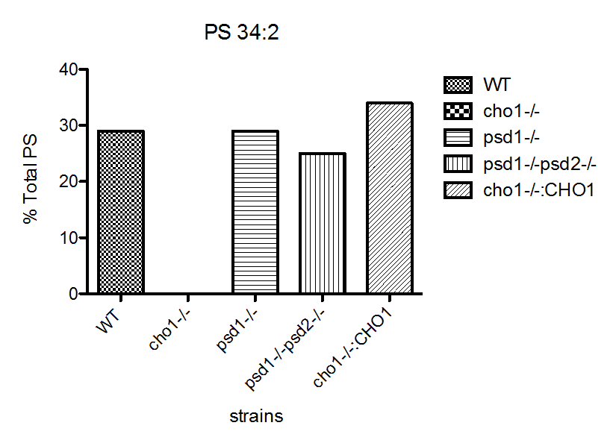
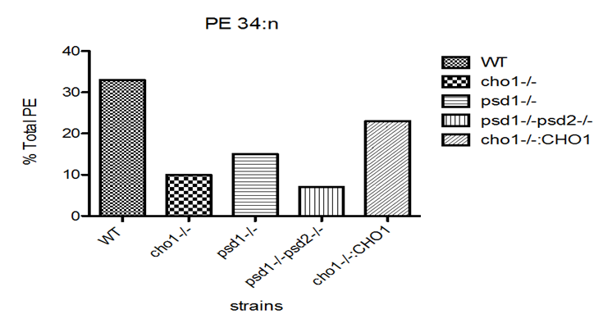
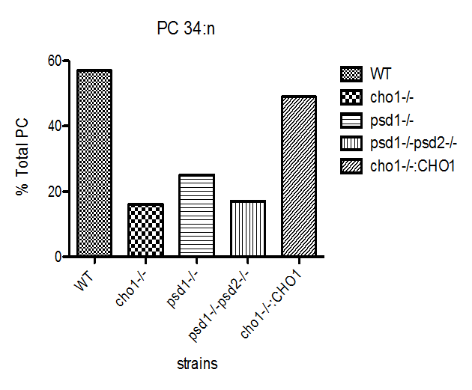
A
B
C

Figure 2-1: Phospholipid profiles of C.albicans phospholipid biosynthetic mutants. Total lipids were extracted by a chloroform:methanol extraction method and subjected to ESI-MS/MS by direct infusion of lipid extracts. Results are represented as percentage total (A) phosphatidylserine (B) phosphatidylethanolamine and (C) phosphatidylcholine for each of the mutant strains.

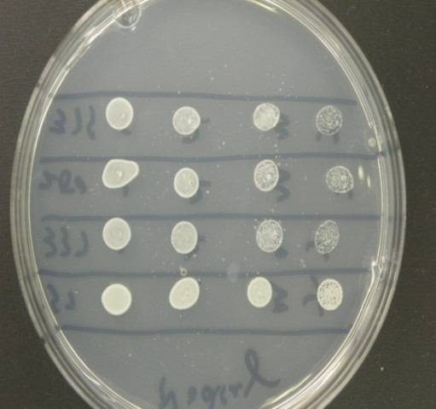
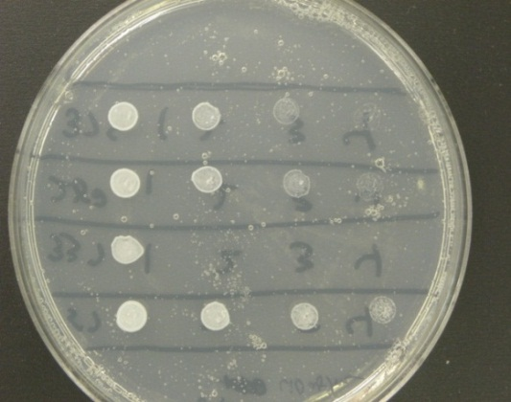
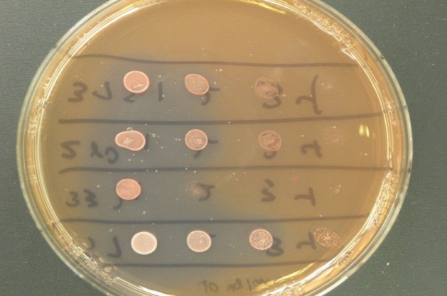
psd1∆/∆/psd2∆/∆
No Drug
Calcofluor White
(20µg/ml)
Congo Red
(40µg/ml)
WT
cho1∆/∆
psd1∆/∆
Figure 2-2: Sensitivity to the cell wall perturbing agents Calcofluor White and Congo Red. Candida albicans strains exposed to cell wall perturbing drugs on minimal media. Overnight cultures were spot diluted at an initial concentration of 1 O.D./ml.

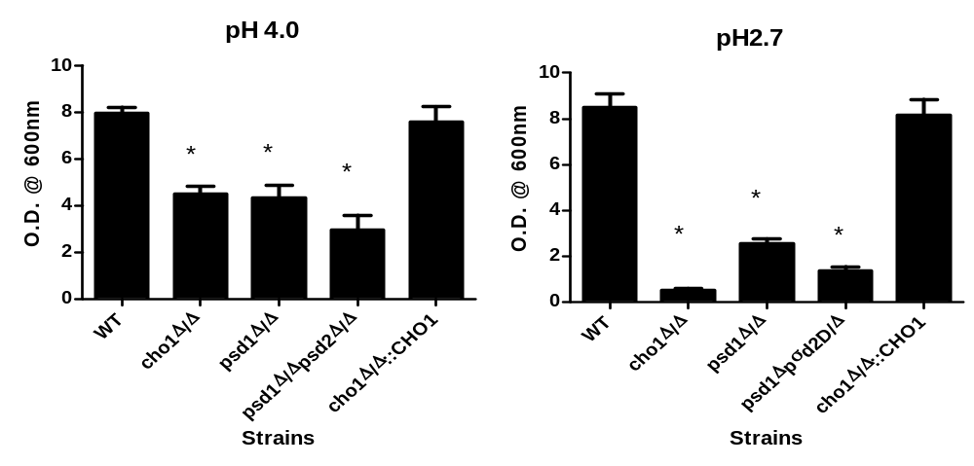

Figure 2-3: Sensitivity of C.albicans strains to low pH. The C.albicans strains were grown in minimal media at the indicated pH at 30°C with shaking and the O.D. was measured

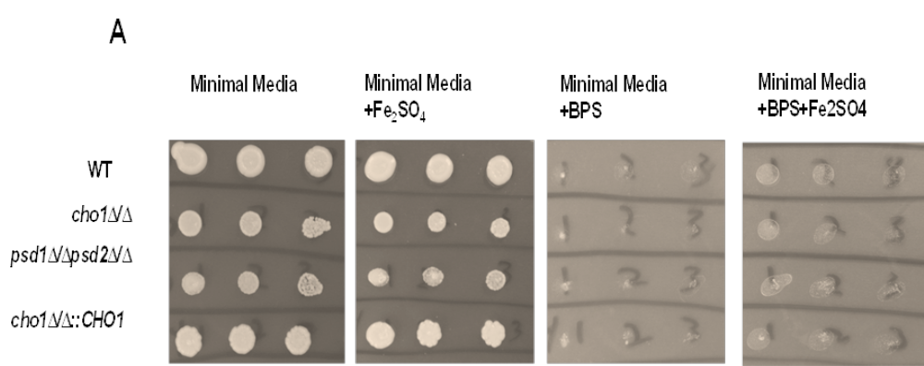

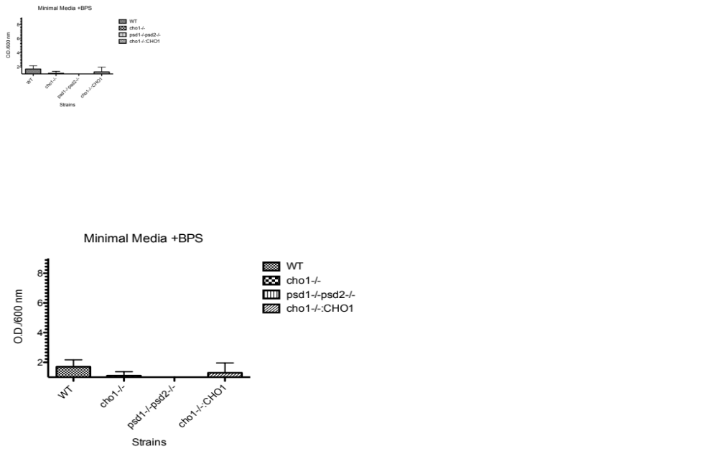

Figure 2-4:

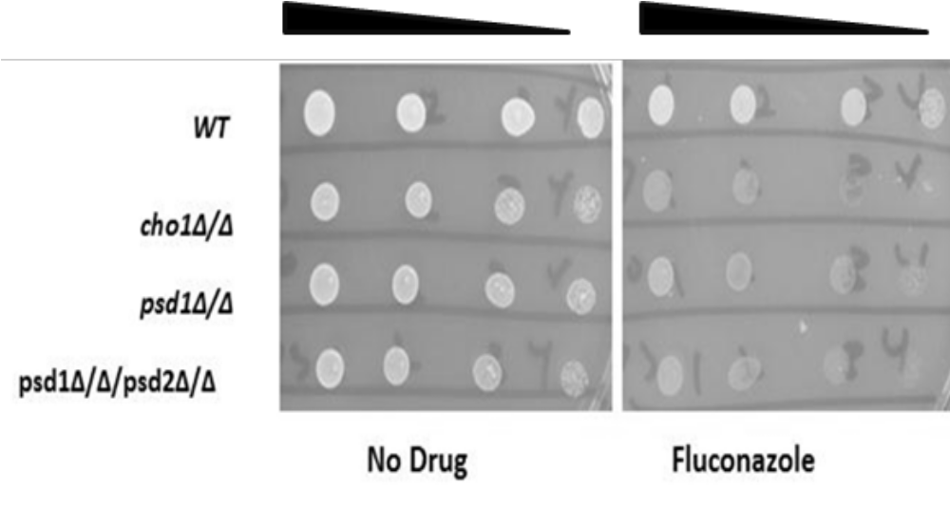

Figure 2-5: Sensitivity to the membrane-targeting antifungal drug fluconazole. The cells were grown overnight and then spot diluted at five- fold dilutions from 1 O.D./ml on minimal media with or without fluconazole (2µg/ml) and incubated at 37ºC/ 48 hrs.
