A Profile of Physical Activity in Knoxville Parks

Margaret Rose Bailey
Chancellor’s Honors Program Thesis
Thesis Advisor: Dr. Eugene Fitzhugh
A Profile of Physical Activity in Knoxville Parks
A B S T R A C T
Purpose: In the city of Knoxville only 48% of adults live within a 10-minute walk to a local neighborhood park. The purpose of this study is to create a demographic profile of park users across Knoxville. Methods: Out of the 95 local parks in Knoxville, 12 were randomly selected with an equal distribution by size (small to large). The System for Observing Play and Recreation in Communities approach was utilized for direct observations on 4 days of the week (Monday, Wednesday, Saturday and Sunday), 3 times each day (morning, lunch and evening) during one week in October. Park users were classified by age group, gender, race, and physical activity (PA) intensity level as reflected by mean metabolic equivalents values (METS). Results: In total, 1700 people were observed using the selected parks. Park users were predominately adults (54.5%), males (54.0%), white (68.3%), and were sedentary (45.7%). The mean intensity of physical activity for users ranged between 2.1 to 4.0 METS. Discussion: In general, park users did not reflect the census of Knoxville. Males and children were more likely to be observed using the local parks, and males performed at higher average intensity levels of PA than women. Also, higher intensity levels of PA were observed in largely lower socioeconomic status (SES) neighborhoods.

Purpose
Physical activity can reduce one’s risk of cardiovascular disease, type 2 diabetes, cancer, hypertension, obesity, osteoporosis, depression, and even premature death (Warburton et al). Sedentary behavior, however, can increase the risk of the aforementioned chronic diseases. Local neighborhood parks are a great, free location to incorporate leisure activities in meeting one’s daily physical activity needs. The assumption, however, that everyone has access to these local parks may not be entirely true. To explore this assumption, one must first look at the types of individuals who use the park and then compare those profiles of park users with the local community profile. In this project, I will analyze the use of local parks across physical activity levels, gender, age, and race in order to allow a community-level comparison.
The Physical Activity Guidelines for Americans recommends an equivalent of 150-300 minutes of moderate aerobic physical activity per week for adults (age 18-64 years). They believe that, if this goal is met, adults will gain numerous health benefits, including the ones outlined above, as well as an increased aptitude for carrying out daily tasks, improved muscular and cardiorespiratory fitness, better sleep and enhanced quality of life. They also recommend both aerobic and muscle strengthening activities in order to best achieve these benefits. Many Americans, however, are not meeting these guidelines, across all age groups. In 2017, the National Health Interview Survey estimated that 53.1% of adults met their aerobic guidelines, and only 23.5% met the guidelines for both aerobic and muscle strengthening activities (National Center for Health Statistics). Finally, children and adolescents have a physical activity guideline to acquire 60 minutes of moderate and vigorous-intensity activity each day of the week.
The City of Knoxville has ninety-five parks featuring 2,332 acres total. There are sixty-two parks containing playground structures, over one hundred sports courses, sixteen fields, sixty-five baseball fields, and over fifty-eight miles of trails, fifty-four of which are paved. These statistics show that there are plenty of public areas in Knoxville for play and activity. The research project from which I have drawn my data surveyed twelve local parks on their accessibility, amenities, facility components, and direct observation of physical activity, which is what this project will be focusing on.
The purpose of this study is to create a demographic profile of park users across Knoxville, specifically from twelve different parks across the city. The assumption that everyone has access to their local parks was a main concept that was tested.

Methodology
This is a sub-study from a larger overall study concerning park usage in Knoxville, and this portion focuses on direct observation in the parks. The direct observation of park usage and type of physical activity was done using the SOPARC method, or the System for Observing Play and Recreation in Communities. SOPARC was created as the need arose for a new tool to explore physical activity and estimate the park and user characteristics (Ward et al).

Park Sample
Out of the ninety-five local parks in Knoxville, twelve were randomly selected with an equal distribution by size (small to large). The twelve parks vary greatly in size, ranging from two to forty-six acres, the wealthiest neighborhood in Knoxville to one of the poorest, as well as demographic make-up of the surrounding area, from almost all white to almost all minority.
As for our data collection in the parks, SOPARC requires that the park in question be split into different “zones,” typically separated into open spaces, playgrounds, athletic fields or courts, or a combo of open space and another classification. I used satellite images to separate each park into zones, and Dr. Fitzhugh visited each park to conclusively establish the zone lines. We decided upon six different zone classifications, including open space, playground, athletic field, athletic court, pavillion+open space, and pavillion+athletic. Maps were then created using the Scribble Maps website, where I demarcated the areas each zone would include, provided pinpoints of locations for parking, as well as the best area to stand in each zone in order to see the entire zone from one point and conduct accurate observations.

Physical Activity Observation
Two trained observers directly observed physical activity using the System for Observing Play and Recreation in Communities (SOPARC) over 1-week (Oct. 8th-14th), 4-days (Monday, Wednesday, Saturday and Sunday), and 3-times each day (morning, midday and evening) for each of the twelve parks. Training consisted of watching videos made by the creators of SOPARC, the RAND (Research ANd Development) Corporation, description by Dr. Eugene Fitzhugh, the lead on the project who has previously used SOPARC, as well as an in-person practice run at Tyson Park. All observers visited their assigned park prior to the week of observations in order to familiarize themselves with directions, parking, zone layout, and to get a general feel of the park and its users. Observers were instructed to not speak with park goers, so as to avoid participant bias, unless the observer was approached and questioned as to what they were doing there, in which case they were provided with an informative handout that explained the nature of the research.

Measures
SOPARC counts park users by age group, gender, race, and physical activity (PA) intensity level (McKenzie et al), as reflected by mean metabolic equivalents values (METS). This was done by using a tally sheet for each zone and period of collection, with areas to denote primary and secondary activity of both males and females, as well as each individual’s age, ethnicity, and physical activity level. There were enough tally sheets for there to be one per zone, for all three collection periods, for all four days. At the end of the week, each observer input all of their data into an excel spreadsheet, which was then all combined into a master spreadsheet. I researched census data for each surrounding area of all twelve parks, and took down information on each park tract’s average income, demographic make-up, and percent of people living below the poverty line. Descriptive statistics were calculated using the Statistical Package for the Social Sciences (SPSS) software in order to determine potential relationships between demographics and park usage. Microsoft excel was used in order to compile all direct observation and census data, as well as to create multiple graphs and tables to explore variable relationships.

Results
Park Use Characteristics
Figure 1. Descriptive statistics of park users at all twelve parks throughout the week.
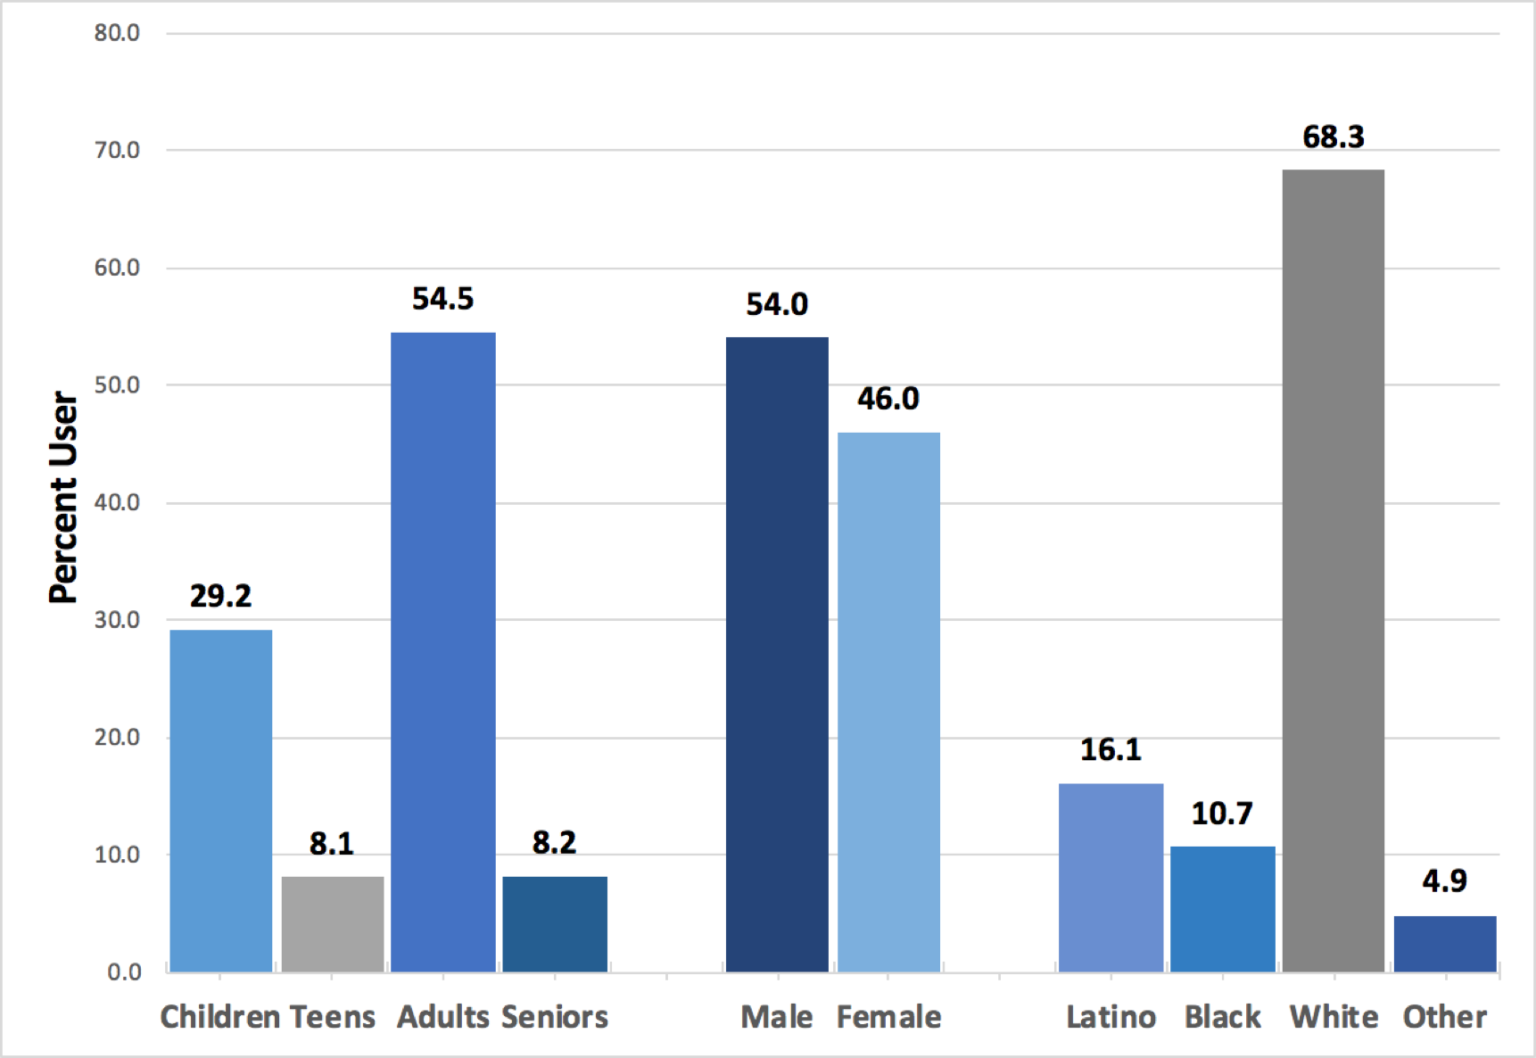
Figure 1 shows that park users (N=1702) were predominately adults (54.5%), males (54.0%), and white (68.3%). While females were not too far behind the males, at 46.0%, for the other two categories, the predominant users had much higher numbers than the other descriptors for both categories. The next highest age range was children, at 29.2%, followed by seniors and teens being almost equal at just over 8%. For ethnicity, white park users greatly outnumbered every other ethnicity. Latinos came in at 16.1%, and black park goers not far behind at 10.7%.

Physical Activity Levels of Park Users
Figure 2. The relationship between physical activity intensity and park, differentiated by male and female users.
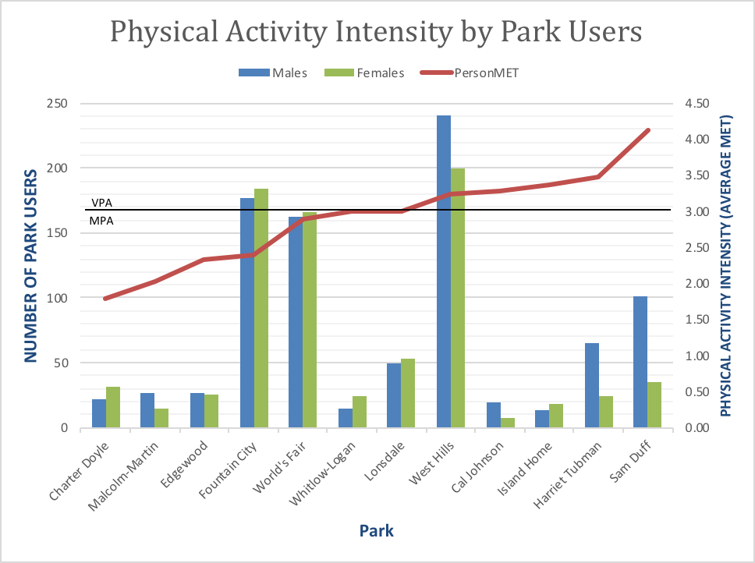
Figure 2 shows that West Hills, the largest park at 46 acres, also had the most users (N=440) and Cal Johnson, a small pocket park at just 4 acres, had the fewest users (N=27) over the course of the week. West Hills also happens to be located in a high-SES area, while Cal Johnson is in a low-SES area. This figure also represents that 54.3% of people used the park at moderate- or vigorous-intensity levels (MVPA) equal to a mean MET intensity of 2.91. Users at five parks had a mean MET value within vigorous-intensity levels. Four of those five parks had a higher proportion of male users. Users at seven parks had a mean MET value below moderate-intensity levels. Five of those seven parks had a higher proportion of female users.

Discussion
SES and Park Use
Prior to investigating the results, it was hypothesized that minority users in the parks would be much more prevalent than the census reflected of that area. However, this was not found to be true. Park users consisted of 31.7% minority, which greatly reflected the racial make-up of the explored geographical areas of 32.0% minorities (Census profile). However, the range of minority representation was wide, with 3 parks having zero minority users (Charter Doyle, Whitlow-Logan, and Island Home Parks) to a high of 92.6% minority (Cal Johnson Park). In general, census tracts with a higher percentage of minority residents are also located in lower socioeconomic areas. Even though it was found that there were not more minority users in the parks than the census make-up, we explored if minority users perform at higher mean MET intensity levels; the answer is not clear-cut. Out of the five parks seen in figure 2 that have mean MET values in the vigorous-intensity range, three are located in lower-SES areas. All of the parks below the vigorous-intensity level, however, range from low- to high-SES areas. Thus, it seems that there is not a direct correlation between ethnicity status and SES area.

Gender and Park Use
It seems that males use the parks for more vigorous activity than females do (perhaps running versus walking). This was evidenced with five out of the twelve parks having a mean MET value in the vigorous-intensity levels; four out of these five parks had a higher proportion of male users. Consequently, the other seven parks, which tended to have a higher proportion of female users, had mean MET values in the sedentary- to moderate-intensity range. The reasoning for this relationship could be due to more women going to the parks as a social outing, rather than for purely exercise. Multiple women were observed going on walks with their friends, taking their children to the playground, walking their dogs, etc. While men were also observed in these same activities, it is hypothesized that they also go to parks with the purpose of exercising, such as running, cycling, or playing basketball.

Amenities and Park Use
The parks with the greatest number of users had areas designated for walking. These parks (West Hills, Fountain City, and World’s Fair) are all designed around greenways or walking trails. Park usage was not correlated to the population of the surrounding census tract, SES level, or size of the park itself. All ages, genders, and ethnicities were observed using designated walking areas, whether it was a greenway, track, or just paved trails through the park. A large amount of these walkers also had their dogs with them, were on a walk with friends or family members, etc. Thus, it seems that the trails attract more people for leisurely activities, as opposed to running or biking on them (though there were some of these as well).
Parks designed with athletic courts, particularly basketball and pickleball, had the highest mean MET intensity levels among their users. This is not surprising given that these activities are typically performed at higher MET values. Interestingly, most of these highly active parks are some of the smallest parks. Thus arises the conclusion that large acreage in a park is not necessary for people to perform at high MET intensities. For example, West Hills, by far the largest park, has tennis, basketball, volleyball and pickleball courts, soccer and baseball fields, walking trails, plenty of open space, and multiple playgrounds, while Harriet Tubman, a much smaller park, has a playground, track, tennis and basketball courts. West Hills has 46 acres, while Harriet Tubman has just over 4, and Harriet Tubman saw a significantly higher average MET value. Thus, while amenities are important for encouraging a higher physical activity intensity, the space over which these amenities span is not as important.

Implications for Practice
Through this study, we have seen how Knoxville residents use their parks, and to what extent. In general, more men than women are seen at the parks, men perform at higher physical activity levels in the parks, the ethnicities seen at the parks largely reflect the racial make-up of the park’s surrounding area, and there are more children seen at parks than the portion of the population the census reflects they make up. The relationships that have been observed through this study indicate that designated areas for walking are a necessary park feature to encourage physical activity, especially at higher levels. There also needs to be more done to encourage females to go to parks in order to exercise at higher intensity levels than they do currently-- perhaps some motivational materials should be posted at parks for people to see.
References
Census profile: Knoxville, TN. (2018). Retrieved from:
https://censusreporter.org/profiles/16000US4740000-knoxville-tn/
HHS Office, & Council on Sports. (2019, February 01). Physical Activity Guidelines for
Americans.
McKenzie, T. L., Cohen, D. A., Sehgal, A., Williamson, S., & Golinelli, D. (2006). System for
Observing Play and Recreation in Communities (SOPARC): Reliability and Feasibility Measures. Journal of physical activity & health, 3Suppl1, S208–S222.
National Center for Health Statistics. (2017, January 20). Retrieved January 26, 2019, from
https://www.cdc.gov/nchs/fastats/exercise.htm
Physical Activity Guidelines. Retrieved January 26, 2019 from
https://health.gov/paguidelines/second-edition/pdf/Physical_Activity_Guidelines_2nd_edition.pdf#page=55
Warburton, D. E., Nicol, C. W., & Bredin, S. S. (2006). Health benefits of physical activity: the
evidence. CMAJ : Canadian Medical Association journal, 174(6), 801–809
Ward, P., McKenzie, T. L., Cohen, D., Evenson, K. R., Golinelli, D., Hillier, A., . . . Williamson, S.
(2014, January 02). Physical activity surveillance in parks using direct observation. Preventing chronic disease, 2014(11).

