Climate Drivers of Wildfire Activity in the Magdalena Mountains of
New Mexico, U.S.A.

A Thesis Presented for the
Master of Science
Degree
The University of Tennessee, Knoxville

Elizabeth Anne Schneider
August 2014
Copyright © Elizabeth Anne Schneider
All rights reserved

ACKNOWLEDGEMENTS
I would first like to graciously thank my advisor, Dr. Henri Grissino-Mayer – without his direction, this project would not have been possible. Henri gave me every possible opportunity while working in the Laboratory of Tree-Ring Science. I was able to gain extra experience in fieldwork, conduct research projects outside of my own, and experience mentoring of undergraduates working in the lab. Henri’s guidance in the field, classroom, and lab gave me the tools to succeed with this research. I would also like to thank my two committee members, Drs. Sally Horn and Yingkui Li, for their encouragement and guidance and for their suggestions for improving this research and thesis. I thank the International Association of Wildland Fire, the Biogeography Specialty Group of the Association of American Geographers, the Stewart K. McCroskey Memorial Fund, and the Department of Geography for funding the fieldwork portion of this thesis. The fieldwork in the Magdalena Mountains would not have been possible without Lauren Stachowiak, who I especially thank for driving all the way to New Mexico and helping out in the field. I owe a large debt of gratitude to Lauren, Alex Dye, Sarah Wayman, and Dorothy Rosene as they supported me and gave me friendship while I was a member of the Laboratory of Tree-Ring Science. We greatly appreciate personnel from the Magdalena Ranger District for their assistance in providing a permit for fieldwork in the Magdalena Mountains, especially Dennis Aldridge, Herbert Ray, and Suzanne DeRosier.
Finally, I wish to thank my family for their constant support and love through my master’s degree. I am eternally grateful to my partner, Magoo, who stood by all of my sleepless nights and long weekends working in the lab. Without his presence and encouragement, I would not have developed the courage and motivation to succeed.

ABSTRACT
In recent years, crown fires have raged through mixed-conifer forests in the American Southwest that historically experienced frequent, low-severity wildfires. Land management agencies now wish to restore wildfires to their historical range of variability, but this requires information on fire regimes before Euro-American disturbance took place. We characterized the historical fire regime of a high elevation, mixed-conifer forest in the Magdalena Mountains, New Mexico. This research evaluated the different climate drivers, represented by the Palmer Drought Severity Index (PDSI), the El Niño-Southern Oscillation (ENSO), the Pacific Decadal Oscillation (PDO), and the Atlantic Multidecadal Oscillation (AMO), that influence the occurrence of wildfire. To characterize the fire regime we developed fire frequency statistics and evaluated the seasonality of wildfire events across the period of 1630 to 1890. To test short-term (interannual) variations in climate and their influence on wildfire occurrence we relied on Superposed Epoch Analysis (SEA). To test the relationship between wildfire events and long-term climate oscillations (decadal to multidecadal), we used Bivariate Event Analysis (BEA). BEA was used to test whether fire events and climate events operate synchronously, asynchronously, or independently of each other. We found that fire frequency ranged from 7 to 8 years from 1630 to 1890, and fires primarily occurred in the early portion of the growing season (late spring to early summer). Fires ceased after 1890 with only two recorded fire events in 1906 and 1953. Based on SEA of PDSI, ENSO, and PDO, conditions 2 to 3 years before a fire event were wetter than average, while in the year prior to, and in the year of a fire event, conditions were drier than average. BEA revealed an asynchronous relationship with extreme wildfire years and El Niño events, while all other relationships between wildfire events and positive and negative phases of ENSO, PDO, and AMO were independent. We conclude that interannual climate variability is the main driver of the frequent, low-severity wildfire regime in the mixed-conifer forests of the Magdalena Mountains, while long-term (multidecadal) climate trends do not appear to influence the occurrence of wildfires.

TABLE OF CONTENTS

1. INTRODUCTION AND QUESTIONS 1
1.1 Research Questions 5
2. LITERATURE REVIEW 6
2.1 Fire History in the American Southwest 6
2.2 Climate of the American Southwest 11
2.2.1 El Niño-Southern Oscillation 11
2.2.2 Pacific Decadal Oscillation 13
2.2.3 Atlantic Multidecadal Oscillation 14
2.3.4 ENSO, PDO, and AMO Interactions 15
2.3 Climate-Fire Interactions 16
3. CLIMATE DRIVERS OF WILDFIRE ACTIVITY IN THE MAGDALENA MOUNTAINS
OF NEW MEXICO, U.S.A. 23
3.1 Introduction 23
3.2 Study Site 27
3.3 Methods 29
3.3.1 Field Methods 29
3.3.2 Laboratory Methods 31
3.3.3 Analytical Methods 38
3.3.3.1 Climate Variables 38
3.3.3.2 Fire History 40
3.3.3.3 Short-term Climate Drivers 41
3.3.3.4 Long-term Climate Drivers 41
3.4 Results 44
3.4.1 Fire History 44
3.4.2 Short-term Climate Drivers 46
3.4.3 Long-term Climate Drivers 49
3.5 Discussion 53
3.5.1 Fire History in the Magdalena Mountains 53
3.5.2 Effects of Climate on Fire Occurrence 58
4. SUMMARY AND CONCLUSIONS 63
4.1 Major Conclusions 63
4.1.1 What is the historic wildfire regime for high elevation, mixed conifer forests in
the Magdalena Mountains? 63
4.1.2 What is the relationship between wildfire occurrence and short-term (annual to
interannual) climate patterns? 65
4.1.3 Is there a relationship between historic wildfire activity and long-term
(multidecadal) climate oscillations? 66
4.2 Future Research 67
REFERENCES 68
APPENDICES 77
VITA 99

LIST OF FIGURES
Figure 3.1: Map of the study site in the Magdalena Mountains, New Mexico, and the
location of the samples collected 30
Figure 3.2: Close up of a fire-scarred tree with multiple scars and a tree flagged for
sampling 32
Figure 3.3: Use of a chain saw to extract a partial cross section from a living tree and
a short snag 33
Figure 3.4: Example of a partial cross section with the site name and number added
and each fire scar labeled with an arrow 34
Figure 3.5: Close up of a fire-scarred sample with the years labeled in which each fire
occurred 37
Figure: 3.6: Fire history plot for the Magdalena Mountains (1426–2013) 45
Figure 3.7: Superposed Epoch Analysis of PDSI and ENSO 48
Figure 3.8: Superposed Epoch Analysis of PDO and Atlantic SSTA 50
Figure 3.9: Results from Bivariate Event Analysis between fire events (all fires scarred
and 50% fire-scarred class) and the extreme negative phases of ENSO, PDO,
and Atlantic SSTA 51
Figure 3.10: Results from Bivariate Event Analysis between fire events (all fires scarred
and 50% fire-scarred class) and the extreme positive phases of ENSO, PDO,
and Atlantic SSTA 52
Figure 3.11: Results from Bivariate Event Analysis between large fire years (50% scarred)
and pairwise combinations of ENSO and PDO 54
Figure 3.12: Results from Bivariate Event Analysis between large fire years (50% scarred)
and pairwise combinations of ENSO and Atlantic SSTA 55
Figure 3.13: Results from Bivariate Event Analysis between large fire years (50% scarred)
and pairwise combinations of PDO and Atlantic SSTA 56
CHAPTER ONE
INTRODUCTION AND QUESTIONS
In the American Southwest, wildfires are considered a natural part of ponderosa pine (Pinus ponderosa Douglas ex C. Lawson) forests, initiating low density, uneven-aged forest stands (Madany and West 1983; Covington and Moore 1994). For much of the 20th century, however, wildfires were considered destructive and unnatural events, which led to fires being purposely excluded from the landscape by forest managers. Evidence indicates that this decrease in wildfires caused fuels to accumulate, thus leading to higher severity and more spatially-extensive fire events (Cooper 1960; Covington and Moore 1994; Grissino-Mayer et al. 2004). Research has since challenged this idea by reconstructing past fire regimes and confirming that wildfires were frequent prior to Euro-American settlement (Swetnam 1983; Swetnam 1990; Grissino-Mayer et al. 1994; Grissino-Mayer 1995). Land managers now aim to reintroduce frequent, low-severity wildfires into ponderosa pine forests, returning fire to its historical range of variability. To understand the natural fire regime, research is needed on both the historical frequency of wildfire and the driving mechanisms of wildfire occurrence.
The American Southwest is an ideal region to study past fire regimes and the influence climate has on wildfires. In ponderosa pine forests, low-severity fires were common prior to Euro-American settlement (Swetnam 1983; Baisan and Swetnam 1990; Swetnam 1990; Touchan and Swetnam 1995). These frequent, low-severity fires mainly reduced surface fuels while rarely killing mature trees. Euro-American settlement initially decreased the frequency of wildfires through the introduction of livestock grazing that removed fuel biomass, and through active fire suppression (Grissino-Mayer et al. 1994; Touchan et al. 1995; Grissino-Mayer et al. 2004). Fire suppression efforts began in the 1930s by land management agencies. This fire exclusion promoted seedling establishment, causing an increase in stand densities, and increased the depth of the needle and brush layer. Exclusion also lowered canopy base heights causing an overall increase in crown fire potential in current Southwestern forests (Brown 2010).
Understanding the influence climate has on wildfire occurrence is necessary when evaluating the presettlement fire regime and for better understanding the likelihood of future fires. Precipitation changes the landscape characteristics by increasing the amount of vegetative growth, thus increasing the amount of fuel available for a fire to burn and spread (Brown 2010). The most important climate pattern conducive for wildfires in the American Southwest is a wet year(s) followed by a dry year(s) (Westerling and Swetnam 2003; Grissino-Mayer et al. 2004). This wet/dry-lagging pattern allows fuel to accumulate in a wet year(s), and then desiccate in a subsequent dry year, allowing combustion to occur at a lower temperature which allows for easy ignition and spread (Grissino-Mayer and Swetnam 2000; Westerling and Swetnam 2003; Brown 2006). Knowledge on these climate patterns or wet/dry-lagging sequences allows for fire frequency to be more easily modeled and managed for wildfire risk assessment.
Seasonal precipitation in the American Southwest is characterized by an arid late spring and foresummer, with monsoonal rains occurring in early July and August (Swetnam and Betancourt 2010). During the arid foresummer, fuels are dry. Convective storms common to the monsoon season generate lightning, causing the potential for the maximum area burned to occur in June (Westerling et al. 2006; Swetnam and Betancourt 2010). Later in summer, moisture levels increase from monsoonal rainfall, resulting in a decrease in the potential for area burned. This annual variability of climate in the Southwest is linked to shifts in upper air westerlies and short-term climate oscillations, such as those causing drought, influencing the occurrence and severity of wildfire (Westerling et al. 2006; Swetnam and Betancourt 2010). An important short-term oscillation in the American Southwest is the El Niño-Southern Oscillation (ENSO), with a positive (El Niño) phase associated with wetter conditions and reduced wildfire activity, and a negative (La Niña) phase associated with a drier climate and increased wildfire activity.
Research on fire regimes and the associated climate drivers is important for predicting when and where fuel management would be most effective to reduce the risk of large fire. Baisan and Swetnam (1990) conducted fire-climate research in the mixed-conifer forests of the Rincon Mountains in Southern Arizona. Based on their research they found that the forests were dominated by early season surface fires with a mean fire interval of 9.9 years from 1748 to 1886. Two years prior to these frequent surface fire events, the mean July precipitation was higher than average, increasing the production of fine fuels. During subsequent dry years, fire was more likely to occur. Grissino-Mayer et al. (2004) reported similar fire-climate interactions in the southern San Juan Mountains of Colorado. Fires were frequent prior to 1880 with a fire interval of 6 to 10 years. They found a relationship between climate and fire not only at the annual scale, but also at the interannual to multidecadal scale, driven by interactions between precipitation, ENSO, and the Pacific Decadal Oscillation (PDO). They hypothesized that cold ocean waters off the western coast of North America (negative PDO) decreased temperatures in the Southwest and thus reduced fire occurrence. ENSO also influences wildfire occurrence by altering monsoonal rainfall at the interannual scale.
Traditionally, research has put an emphasis on the short-term climatic effects on fire occurrence, while more recent studies have focused on analyzing the effects of longer-term climatic mechanisms on wildfires (Westerling and Swetnam 2003; Grissino-Mayer et al. 2004; Kitzberger et al. 2007; Schoennagel et al. 2007; Stahle et al. 2009; Rother and Grissino-Mayer 2014). To better understand fire occurrence, the influence of both interannual and multidecadal climate variability on wildfires needs to be evaluated. Our study is a site-specific reconstruction of fire history that will provide data needed to test the relationship between wildfire and longer-term climate oscillations. Data derived from our reconstructions can advance our knowledge of climate-fire interactions at multiple temporal and spatial scales including the local scale (Magdalena Mountains), the regional scale (New Mexico), and the broad scale (Southwest), and can be incorporated in land management efforts by the USDA Forest Service.
The Magdalena Mountains have seen little human activity and have been overlooked in fire reconstruction research, possibly for their small size, but the mountain range has high potential for research in climate-fire interactions. No accounts of logging have been recorded in the Magdalena Mountains, leaving forests in good conditions to study wildfire (Basham 2011). Mining was the main human disturbance beginning around 1866–1867 (Basham 2011), but mining only affected the western slopes of the mountain range at lower elevations where piñyon-juniper forests dominate. In 1963, the Water Canyon Road was constructed, extending from the northern portion of the mountains up to South Baldy, the highest peak in the Magdalena Mountains (Westpfahl et al. 2000). Active fire suppression officially began in the mountain range in the 1930s.

Research Questions
The purpose of this research is to reconstruct the history of wildfires in the Magdalena Mountains and investigate both short-term and long-term climate mechanisms that may have contributed to fire activity in the past. A detailed fire history can provide vital information and baseline data on the frequency of wildfires prior to human interaction for researchers and wildlife officials. Evaluating the relationship between fire and climate is essential to understand why fires occurred when they did and the mechanisms that cause fires to be low-severity or high-severity. The following three questions were addressed in this thesis:
- What is the historic wildfire regime for high elevation, mixed conifer forests in the Magdalena Mountains?
- What is the relationship between wildfire occurrence and short-term (annual to interannual) climate patterns?
- Is there a relationship between historic wildfire activity and long-term (multidecadal) climate oscillations?

CHAPTER TWO
LITERATURE REVIEW

2.1 Fire History in the American Southwest
Fire is an important part of ponderosa pine (Pinus ponderosa Douglas ex C. Lawson) forests of the American Southwest, where low-severity fires contribute to low tree density and uneven-aged forest stands (Madany and West 1983; Covington and Moore 1994). Research in the Southwest has shown that fire is a natural disturbance and occurred frequently prior to 1900. Examples of fire-free intervals in the Southwest include 6.1 years in the Rincon Mountains of south-central Arizona (Baisan and Swetnam 1990), 4.2 years in the Pinaleño Mountains in Arizona (Grissino-Mayer et al. 1994), and 4 to 8 years in the Gila Wilderness in New Mexico (Swetnam 1983). Periodic and low-severity fires reduce the fuel loadings on the forest floor and raise the general canopy level, reducing the potential for high severity crown fires (Covington and Moore 1994; Touchan et al. 1995). However, Euro-American settlement after about 1880 has led to fewer fire events (Swetnam 1983; Grissino-Mayer et al. 2004; Huffman et al. 2008), changing the structure of ponderosa pine forests in the American Southwest.
The main Native American tribe in west-central New Mexico was the Apaches, who controlled the Magdalena-Datil region from the seventeenth century until they were subjugated by U.S. troops in the Apache Wars in the late nineteenth century (Opler 1983; Seklecki et al. 1996). The presence of Native Americans specifically in the Magdalena Mountains is not well documented; however, the Apaches were present in the area and possibly used the Magdalena Mountains either as a settlement or a pass through and a hiding ground (Opler 1983). Understanding Native American presence in a mountain range is important because they historically used fire as a means of hunting, agriculture, and warfare (Cooper 1960; Swetnam 1983; Touchan et al. 1995; Swetnam and Baisan 2003).
Euro-American settlement caused a decrease in fire activity for several reasons. Roads and trails were built, breaking up fuel continuity, causing a decrease in the ability of fire to spread across the landscape (Covington and Moore 1994; Touchan et al. 1995). The removal of Native Americans from the area caused their landscape burning practices to cease (Swetnam 1983; Swetnam and Baisan 2003). Livestock was introduced early to the landscape with Euro-American colonization. Livestock impacted the landscape through grazing which removed fine fuels from the forest floor (Touchan et al. 1995). The most important influence on fire activity, however, was the introduction of fire suppression practices. A principal assignment of early foresters was to exclude fire from the landscape at all costs (Cooper 1960). Fires were seen as destructive to vegetation, and with increasing human populations, fires destroyed homes and even turned deadly. Anthropogenic influences on the landscape led to an increase in younger and smaller trees that were able to grow and survive in the absence of fire. Cooper (1960) observed that the presettlement (before 1880) ponderosa pine forests in the Southwest had a tree density of about 40% because of the numerous fires that swept through the forests. After 1880, tree density in montane regions increased, causing present-day stands to be susceptible to crown fires, experience low tree vigor, and be more prone to mortality from drought, insects, and diseases (Covington and Moore 1994). Ponderosa pine forests now have higher tree densities because of increased growth of shade intolerant species and an increase in the overall brush-needle layer on the surface, all of which increase the risk of crown fires (Covington and Moore 1994; Ireland et al. 2012).
Many different hypotheses have been offered to explain why fire occurrence decreased in the late 19th century. Two of these hypotheses are a change to less favorable climate conditions, or the pyroclimatic hypothesis (Biondi et al. 2011), and changes in land use due to the arrival of Euro-Americans that resulted in a cessation of frequent fires. Fulé et al. (2012) evaluated the pyroclimatic hypothesis by testing the change in fire frequency between two different sites, one in Southern Arizona, and the other in Northern Mexico. This research compared fire history from Mesa de las Guacamayas in northwestern Chihuahua with fire history data from the Chiricahua Mountains in southeastern Arizona (Seklecki et al. 1996). Both areas have similar fire histories and are located in similar high-elevational forests. These sites were further chosen to test the pyroclimatic hypothesis based on their differing land use histories, yet comparable climate regimes. Fulé et al. (2012) found that Mesa de las Guacamayas had no Euro-American interference and retained fire-climate links through the 1900s. The Chiricahua Mountains in Arizona, however, experienced significant effects from Euro-American settlement, overriding important climate driven wildfires. Fulé et al. (2012) determined that human-caused livestock grazing, logging, and fire suppression drastically altered the surface fire regimes beginning in the late 19th century, thus rejecting the pyroclimatic hypothesis put forth by Biondi et al. (2011).
Swetnam and Baisan (2003) summarized fire history research in the Mogollon Mountains in New Mexico and in the Santa Catalina Mountains in Arizona, specifically focusing on fire effects of human occupation in the late 19th and early 20th centuries. They were able to show that a high association existed between the introduction of livestock, land use changes, and fire suppression on the landscape with the decrease in fire occurrence. Permanent roads, irrigation for livestock, and livestock grazing were initial causes of the fire disruption. Herbivory by sheep and cattle removed fine fuels necessary for fire spread, while the building of roads broke up fuel continuity. This disruption began between 1870 and 1900, but fire suppression efforts were not adopted by the federal government until the early 1900s (Cooper 1960; Covington and Moore 1994). Infrequent, high-intensity fires are now more common (Cooper 1960; Baisan and Swetnam 1990; Touchan et al. 1995; Grissino-Mayer and Swetnam 1997; Swetnam and Baisan 2003).
Huffman et al. (2008) analyzed the fire history of piñyon-juniper and ponderosa pine ecotones in the Tusayan Ranger District of the Kaibab National Forest in Arizona, and in the Canjilon Ranger District on the Carson National Forest in New Mexico. The goal of their research was to evaluate the fire regimes of piñyon-juniper ecosystems at ecotonal boundaries with ponderosa pine forests in the Southwest. More specifically they wanted to determine whether historical fires at these ecotones were mainly infrequent and stand replacing, or if fires were frequent and nonlethal. They found that fire scars were more abundant than expected in the ponderosa pine dominated forest, compared to the piñyon-juniper dominated ecosystem. Fire-scar analysis revealed that surface fires were frequent in the ponderosa pine dominated forests with a Weibull Median Interval (WMI) of 7.2–7.4 years in Tusayan and a WMI of 11.1 years in Canjilon. No scars were found at lower elevations or within the piñyon-juniper dominated areas, suggesting that historical fires did not spread from ponderosa pine stands into the piñyon-juniper woodlands. Further fire history analysis showed that at both of these sites there was no significant temporal change in the fire regime between pre-and post-settlement periods, although the post-settlement fires were likely the result of human activity.
Heinlein et al. (2005) reconstructed the historical and contemporary fire regime for ponderosa pine-mixed conifer forests in the San Francisco Peaks in northern Arizona. Using fire-scar analysis, they evaluated the fire regime, how fire patterns have changed since fire exclusion, and how the current forest composition compares with the pre-fire exclusion forest structure. Two sites were chosen, one with a north-east aspect, and the other with a south-west aspect. The sites were further chosen on the basis that the forests have increased in shade-tolerant and fire-intolerant tree species in the absence of recent, twentieth century fires. They found that this increase in shade-tolerant species has amplified the risk of high severity crown fires that are considered atypical for mixed-conifer forests. The pre- 1900s mean fire interval for both sites ranged from 5.2 to 5.4 years (east side and west side of the study site, respectively). The seasonal distribution of past wildfires showed that fires generally occurred in the summer months, with some fires occurring in the late spring, which corresponds to the dry period of the season. Their results showed a disruption in the fire regime beginning in the late 1800s, and they concluded that the cessation of frequent, low-severity fires can be attributed to the initiation of livestock grazing in the area, resulting in a disruption in the fuel continuity.

2.2 Climate of the American Southwest
The American Southwest is characterized by low annual rainfall, clear skies, and a warm climate (Swetnam and Betancourt 1990). The precipitation is a bimodal with most precipitation occurring in the summer months from thunderstorms associated with the North American Summer Monsoon (Andrade and Sellers 1988; Swetnam 1990; Sheppard et al. 2002). The climate system of the American Southwest is considered complex owing to variable topography, proximity to the Pacific Ocean, and location between the mid-latitude and subtropical atmospheric circulation regimes. Precipitation is strongly influenced by mountains that cause dry conditions on leeward slopes and wet conditions on windward slopes. However, in general, montane regions are wetter and valleys tend to be warmer and drier (D’Arrigo and Jacoby 1991; Sheppard et al. 2002). The Southwest is also strongly influenced by shifts in sea surface temperatures in the tropical and extratropical Pacific Ocean. These shifts result in changes in moisture transport into the Southwest and occur at interannual (El Niño-Southern Oscillation) and interdecadal time scales (Pacific Decadal Oscillation).

2.2.1 El Niño-Southern Oscillation
The El Niño-Southern Oscillation (ENSO) has two phases: a positive (warm) phase called El Niño, and a negative (cold) phase termed La Niña. ENSO oscillates between these phases at a periodicity of 2–10 years (Ropelewski and Halpert 1987). This oscillation occurs primarily in the eastern tropical Pacific Ocean with the strongest changes along the western coast of South America. The primary change that occurs during ENSO is a fluctuation in sea-level pressure, which influences sea surface temperatures (SST), tradewinds, and the development of storms (Rasmusson and Wallace 1983). A way to quantify the development and intensity of ENSO events is to calculate the Southern Oscillation Index (SOI), which is the difference between pressure at Tahiti in the eastern Pacific and Darwin, Australia in the western Pacific (Rasmusson and Wallace 1983; Ropelewski and Halpert 1987; Ropelewski and Jones 1987).
An El Niño event is associated with warmer than average water that forms across the eastern and central tropical Pacific, and lower than average sea-level pressure in the eastern Pacific (Rasmussen and Wallace 1983; Sheppard et al. 2002). Warm waters cause the tradewinds to weaken, resulting in stronger subtropical westerlies. The stronger westerly winds associated with an El Niño phase bring tropical storms into the Southwest, resulting in more moisture (Swetnam and Betancourt 2010). The midlatitude storm track over North America also shifts, moving southward, and sometimes splits into two branches (Swetnam and Betancourt 2010). As a result of these perturbations, a “tropospheric wavetrain” moves out from the equator to regions of higher latitudes, affecting the subtropical jet and associated moisture transport (Sheppard et al. 2002). Storms that travel in the lower branch may pick up moisture from the lower latitudes of the eastern Pacific resulting in wet winters in the American Southwest, causing an increase in plant growth (Rasmussen and Wallace 1983; D’Arrigo and Jacoby 1991; Sheppard et al. 2002).
La Niña has the opposite effect, with a decrease in SSTs and no shifting of the active center of atmospheric convection from the western equatorial Pacific (Andrade and Sellers 1988; Sheppard et al. 2002). During La Niña events, the tradewinds strengthen and colder than average ocean waters extend into the eastern tropical Pacific. This climate anomaly hinders rainfall and results in warmer and drier winter conditions in the Southwest (Gutzler et al. 2002; Sheppard et al. 2002). Drought in the Southwest predominately occurs during La Niña phases, with stronger events (colder SSTs) associated with more extreme drought years.

2.2.2 Pacific Decadal Oscillation
The Pacific Decadal Oscillation (PDO) is an extratropical (northern Pacific) variation in SSTs with a periodicity of 20–40 years. A positive (warm) phase PDO occurs when SSTs tend to be cool in the central Pacific with anomalously warm SSTs along the west coast of North America (Mantua and Hare 2002; Sheppard et al. 2002). From November to March, sea-level pressure (SLP) is low along the west coast of North America, enhancing counterclockwise winds (Mantua and Hare 2002). A positive phase brings winds and moisture from the Pacific to the American Southwest and coincides with wet periods, with the strongest atmospheric episodes of PDO corresponding with unusually low sea-level pressure. A cool phase PDO occurs when SSTs are warm in the central Pacific and cool along the west coast of North America (Mantua and Hare 2002; MacDonald and Case 2005). During a cool phase, November to March SLP is high in the North Pacific, creating clockwise winds and drier than average conditions in the American Southwest (MacDonald and Case 2005).
MacDonald and Case (2005) studied the variability of the Pacific Decadal Oscillation and its influence on climate in western North America using tree rings from limber pine (Pinus flexilis E. James) in California and Alberta. The goal of their research was to create a reconstruction of PDO and assess the long-term variability in the strength and periodicity of PDO. They found that from about AD 900–1300, a strong negative PDO state was persistent, corresponding to a period of dry conditions in the southwestern United States. For roughly the past 200 years PDO has had a persistent periodicity of about 20 to 40 years, oscillating between a negative to a positive phase. More recently, a positive PDO regime was dominant between 1977 and 1997 and is currently moving to a negative phase. MacDonald and Case (2005) showed that PDO variability over large time scales is uncertain and that testing for the persistence or dominance of a particular phase of PDO is a concern in predicting future climate variability in the Southwest. PDO variability has not been stable, and could cause concern when trying to predict when a certain phase would dominate. In western North America positive phases of PDO are similar to El Niño events, causing increased moisture in the Southwest. The same is true for negative PDO and La Niña events, which result in drier than average conditions. Knowing when certain phases of PDO will be dominant can provide insight into when drought might occur in the Southwest. MacDonald and Case (2005) argue for caution to be taken when evaluating the multidecadal behavior of PDO in the 21st century.

2.2.3 Atlantic Multidecadal Oscillation
The Atlantic Multidecadal Oscillation (AMO) is a low-frequency change in SST that occurs in the Atlantic Ocean from 0–70 °N. AMO switches from a warm to cool phase at 50–80 year periods (Gray et al. 2004; Schoennagel et al. 2007). Atlantic SSTs may affect atmospheric forcing by altering evaporation, precipitation, and ocean-atmospheric heat exchanges (Gray et al. 2004). McCabe et al. (2004) showed that different periods of drought in the American Southwest can be identified with different periods of sea surface temperature anomalies in the North Atlantic basin. Warm phases, or warm Atlantic sea surface temperatures, occurred during 1860–1880 and 1930–1960, while cool phases occurred during 1905–1925 and 1970–1990. Two of the most severe droughts of the 20th century occurred during positive values of the AMO between 1930 and 1960: the Dust Bowl of the 1930s and the 1950s drought. The drought in the 1950s was also associated with a negative PDO phase, greatly impacting the Southwest, while the 1930s drought was associated with a positive PDO phase, sparring most of the Southwest. Since 1995 AMO has been positive and has mirrored the positive phase of 1930 to 1960, creating concerns for the possibility of severe drought.

2.3.4 ENSO, PDO, and AMO Interactions
The three climate oscillations (ENSO, PDO, and AMO) often interact, with one phase intensifying effects of another during times of synchrony. The longer-term PDO intensifies ENSO conditions when the positive and negative phases of the two coincide (McCabe et al. 2004). The intensity of the PDO also likely depends on phases of ENSO, with a growing ENSO influencing PDO the following winter/spring (Newman et al. 2003; Westerling and Swetnam 2003). An El Niño phase (warm SSTs in the eastern tropical Pacific) and a positive PDO phase (with warm SSTs along the west coast of North America) are associated with wet winters over New Mexico in both instrumental data and reconstructed data (Enfield et al. 2001; Stahle et al. 2009). The opposite association exists for dry conditions in New Mexico (La Niña and a negative PDO) (Gutzler et al. 2002; Stahle et al. 2009). When a La Niña phase and a negative PDO are in synchrony and persist for long durations, the American Southwest experiences a strong decrease in soil moisture and water availability (Morehouse et al. 2006; Kitzberger et al. 2007).
Multidecadal drought in the Southwest can be attributed to synchrony or asynchrony with PDO and AMO. McCabe et al. (2004) examined the relationships between AMO, PDO, and drought frequency in the United States. Approximately half of the spatial and temporal variance on multidecadal drought frequency can be explained by PDO and AMO. They were able to show that drought is more frequent in the American Southwest during a negative PDO phase and a positive AMO phase. Long-term variability in climate can be dominated by a single mode of sea surface temperature variability, and can further be strengthened when certain phases of PDO and AMO are in synchrony. Research from western Colorado (Schoennagel et al. 2007) showed similar results, that drought conditions are more extreme during periods of combined positive AMO, negative PDO, and negative ENSO, leading to higher severity and extent of wildfires.

2.3 Climate-Fire Interactions
Research that investigates climate-fire relationships is important for evaluating how climate affected fire regimes in the past and how climate might impact fire in the future. The synchronous nature of climate phases and their associated influence on fire frequency also needs to be studied further in the Southwest. With increasing temperatures and associated changes in precipitation patterns, climate-fire research becomes even more important for land management agencies in the coming years (Brown 2006; Margolis and Balmat 2009; Ireland et al. 2012). Climate is the greatest influence on wildfire activity, and wildfires are expected to increase in the western U.S. in response to the projected increase in droughts in the 21st century (Brown 2006; Westerling et al. 2006). Climate influences the moisture content of soil and vegetation which in turn influences wildfire activity. Evidence of regional and broad scale synchrony or asynchrony between climate and wildfire is needed in the American Southwest to properly address the projected change in drought. This can be accomplished by investigating the interacting relationships between ENSO, PDO, and AMO and their influences on wildfire occurrence.
In the Southwest, research has shown that large fire years are significantly drier on an annual to interannual scale, whereas smaller fires, on average, occur in wetter years (Swetnam 1990). Precipitation two years prior to a fire is generally greater, particularly during the spring and early summer months, with wet years promoting fuel production on the forest floor (Baisan and Swetnam 1990; Grissino-Mayer and Swetnam 2000; Grissino-Mayer et al. 2004). More fuel build-up on the landscape in wet years leads to larger fires in drought years, because the vegetation that grew in the wet years creates fuel to burn in a later fire (Swetnam and Betancourt 1990). Conditions usually one year prior to and during the fire year are on average drier. Drought conditions during the fire year, dries the vegetation creating optimum conditions for fire ignition (Brown 2006). For large-scale fires, drought several years before a fire is usually more severe because fuel accumulates in the few years of wet conditions prior to the fire (Swetnam 1990; Collins et al. 2006). Frequent, low-severity fires on the landscape consume fuel on the forest floor that would accumulate in the absence of fire (Swetnam 1990). Low-severity, frequent fires keep fuel accumulation at a minimum.
El Niño-Southern Oscillation (ENSO) events can be positively associated with increased growth in trees and other moisture-sensitive plants (Ropelewski and Halpert 1986; Swetnam and Betancourt 1990). During an El Niño phase, southwestern forests often experience increased growth because of the associated increase in precipitation. La Niña causes a decrease in precipitation, drying out vegetation and resulting in fuel conditions conducive for fire occurrence and spread. The wet-dry events often coincide with specific El Niño-La Niña (ENSO) events that affect seasonal rainfall patterns through oceanic-atmospheric teleconnections (Sheppard et al. 2002; Swetnam and Baisan 2003; Swetnam and Betancourt 2010). La Niña events are associated with large fires in the Southwest, while El Niño events are associated with years of low fire frequency in the Southwest (Swetnam 1990; Swetnam and Betancourt 1998). Kitzberger et al. (2007) found that in northwestern New Mexico, the production of fine fuels that carry forest fires (such as grass, needles, and low-lying shrubs) is increased in the wet years preceding a fire, which is often associated with an El Niño phase. Fire is more likely to occur in the Southwest when these warm (El Niño) phases are followed by La Niña events and the associated drought conditions.
When different climate phases are in synchrony associated changes in precipitation and storm tracks influence fire occurrence. A warm-phase PDO can reduce fire occurrence because of associated higher temperatures in the northeastern Pacific. Higher temperatures in the northeastern Pacific increase convectional uplift causing storms that can travel to the Southwest, increasing precipitation and vegetation moisture and decreasing fire occurrence (Sheppard et al. 2002; Stahle et al. 2009). When both PDO and ENSO are in a cool phase, a delay in summer monsoon rainfall occurs, causing fire occurrence to increase in the latter part of the growing season (McCabe et al. 2004; Collins et al. 2006, Kitzberger et al. 2007). A delay in the summer monsoon can lower moisture content of fuel especially during the summer months, and increases the likelihood of fire ignition and spread.
Margolis and Balmat (2009) reconstructed the fire history for the ponderosa pine dominated forests in the Santa Fe Municipal Watershed, New Mexico. The purpose of their research was to reconstruct the fire history and evaluate the fire-climate relationships in the Santa Fe River Watershed to provide data to guide forest management. They found the WMI from 1550 to 1880 to be 3.8 years (all fires) and 8 years (10% scarred). The wet/dry-lagging pattern commonly observed in the Southwest was present in this ponderosa pine dominated forest. Increases in moisture were observed 2 to 3 years prior to a fire event and were associated with El Niño events. Decreases in moisture, or drought conditions, occurred during the fire year and were associated with La Niña events. This relationship results in an increase in fine fuels during wet years which carry fire and burn in subsequent dry years. They also tested the influence PDO might have on wildfire, but they did not find a relationship. Since Euro-American settlement in the late 1800s, forest structure and composition changed resulting in an increase in fire intolerant and shade tolerant species, such as white fir (Abies concolor (Gord. & Glend.) Lindl. ex Hildebr.) and quaking aspen (Populus tremuloides Michx.). Historically, frequent fires were responsible for white fir and quaking aspen mortality, however, because of fire exclusion these trees survived to occupy a dominate canopy position. This growth in fire-intolerant species increases the possibility for fires to reach the canopy, thus causing crown fires. Margolis and Balmat (2009) suggested that restoring or treating fuels in the Santa Fe Municipal Watershed would reduce the risk of crown fires in the area.
Ireland et al. (2012) investigated the influence of top-down and bottom-up controls on historical wildfire activity at Mount Dellenbaugh in northwestern Arizona. If fire dates were synchronous across the study area then this would indicate possible top-down controls, such as climate regulating fire activity and spread. If fire dates were asynchronous then this would suggest that bottom-up controls, such as discontinuous fuels or ignition sources, were the more important influence on the historical fire regime. Ireland et al. (2012) found that bottom-up controls such as fuel productivity and continuity influence fire at finer spatial scales, while top-down drivers of wildfires, such as climate, synchronize fire across broad regions. Climate oscillations such as ENSO, PDO, and AMO influence wildfire synchrony at larger spatial scales by effecting regional moisture and temperature patterns. They found that in the ponderosa pine forest, dry conditions occurred in the year of the fire and wet conditions occurred in the years preceding the fire. Flatley et al. (2011) determined that during dry years fires burned irrespective of the topographic setting, while in wetter years fires were restricted to the most xeric settings, emphasizing the conclusions from Ireland et al. (2012) in which bottom-up controls strongly influenced fire occurrence at fine spatial scales.
Collins et al. (2006) evaluated the influence of AMO and PDO phases on interannual relationships between climate and wildfire-burned area in the Interior West to improve the ability to predict burned area for a particular fire season. Both ENSO and PDO have been shown to influence moisture availability by altering precipitation and temperature patterns, and thus influence fuel moisture and quantity. AMO has been shown to modulate the strength of ENSO and PDO-related precipitation. They found that short term fuel accumulation is critical in leading to an increase in wildfire extent, which is driven by changes in PDSI. The strength of PDSI is somewhat reliant on AMO, ENSO, and PDO phases, affecting the moisture availability and burned area across the Interior West. They were further able to show that a warm-phase AMO corresponds to periods in which moisture availability is strongly tied to burned area.
Kitzberger et al. (2007) analyzed wildfire chronologies from 238 sites across western North America and independent reconstructions of sea surface temperatures, to examine the relationship of multicentury patterns of climate and fire synchrony. Through the use of rotated principal component analysis, they were able to show that widespread synchronous wildfires are most likely driven by longer-term climate mechanisms such as ENSO, PDO, and AMO. They further determined that since ca. 1550, wildfires across the West were most commonly synchronous during positive phases of AMO. The severity of drought-induced wildfires was the strongest during positive AMO events, combined with negative PDO and La Niña phases. These relationships suggest that different modes of sea surface temperatures result in changes in atmospheric processes in the American Southwest. The relationship between continental scale drought and sea surface temperatures can help explain the interannual to multidecadal variability in wildfire occurrence. Kitzberger et al. (2007) concluded that a positive phase AMO would bring future long-term drought throughout the Southwest, which could result in increased widespread, synchronous wildfires.

CHAPTER THREE

Climate Drivers of Wildfire Activity in the Magdalena Mountains of

New Mexico, U.S.A.

This chapter is intended for publication in the journal Forest Ecology and Management. The research topic was originally developed by me and my advisor and second author, Dr. Henri Grissino-Mayer. The use of “we” throughout the text refers to me and Dr. Grissino-Mayer, who assisted with project development, site selection, field collection, and text editing. My contributions to this chapter include field collection, processing and dating of samples, data analysis, interpretation and graphic displays of results, and writing the manuscript.

3.1 Introduction
The American Southwest is an area strongly influenced by oceanic-atmospheric processes of the subtropics and the central Pacific (Kitzberger et al. 2007). Changes in sea surface temperatures of the Pacific Ocean across multiple time scales influence the variability of moisture in the troposphere, resulting in a near global shift in precipitation patterns (Sheppard et al. 2002). These changes occur at high-frequency interannual time scales, such as the El Niño-Southern Oscillation (ENSO), and at low-frequency multidecadal time scales, such as the Pacific Decadal Oscillation (PDO). The Southwest is also influenced by changes in sea surface temperatures in the Atlantic Ocean, such as the Atlantic Multidecadal Oscillation (AMO). The ENSO has a period of variation of approximately 2–10 years (Rasmussen and Wallace 1983; Cook et al. 2008), the PDO has a 20–40 year periodicity (Mantua and Hare 2002; D’Arrigo and Wilson 2006), and the AMO has a periodicity of 50–80 years (Gray et al. 2004). ENSO has two phases, a negative phase termed La Niña, which is associated with drought in the Southwest, and a positive phase called El Niño, which is associated with wetter conditions in the Southwest. PDO has positive and negative phases as well and influences Southwestern climate in much the same way as ENSO (Sheppard et al. 2002; McCabe et al. 2004; D’Arrigo and Wilson 2006; Kitzberger et al. 2007). AMO has a positive phase, associated with warm waters in the North Atlantic Ocean causing drought conditions in the Southwest, and a negative phase with cool ocean waters in the Atlantic and associated wet conditions in the Southwest (McCabe et al. 2004; Kitzberger et al. 2007).
Extensive research on relationships between high-frequency climate patterns and fire activity has been conducted in the American Southwest (Dieterich and Swetnam 1984; Baisan and Swetnam 1990; Swetnam 1990; Grissino-Mayer et al. 1994; Grissino-Mayer et al. 2004). For example, wetter than average conditions correspond with El Niño phases, while drier conditions occur during La Niña years (Andrade and Sellers 1988; D’Arrigo and Jacoby 1991; Westerling and Swetnam 2003). These ENSO driven changes in climate can help explain the annual to interannual variability in wildfire occurrence in ponderosa pine forests of the Southwest. Above average antecedent moisture is important for wildfires because it increases fine fuels necessary for surface fires to ignite and spread. Drought in the year before a fire event and in the year of the fire event desiccates fuels for burning. Research in the Southwest has found this relationship when evaluating historic wildfire regimes prior to Euro-American settlement. However, this wet/dry-lagging pattern is no longer the predominate mode in driving wildfires because of human-caused alterations to the environment. Since this disruption of frequent fires, fuels have built up on the landscape. When a strong wet/dry pattern does occur, wildfire risk is even greater because of the increase in fine fuels, generating concern for the occurrence of widespread and possibly more intense crown fires (Westerling and Swetnam 2003; Brown 2006).
The long-term climate variability of the American Southwest can influence the occurrence and severity of wildfires, with some years more prone to fire than others due to the variability in ocean-atmosphere oscillations, in particular certain phase combinations of positive and negative ENSO, PDO, and AMO cycles (Kitzberger et al. 2007). Our research investigated the short-term influences of variations in climate using Superposed Epoch Analysis (SEA) (Baisan and Swetnam 1990; Grissino-Mayer 1995; Touchan and Swetnam 1995), and the possible influence of longer term, low-frequency fluctuations in climate using Bivariate Event Analysis (BEA) (Gavin 2010). The relationships between wildfire, the Palmer Drought Severity Index (PDSI), ENSO, PDO, and AMO will be evaluated using SEA and BEA, methods used to test the relationship between fire occurrence and a certain climate variable. We used these analyses to test how the contingent state of sea surface temperatures in both the Pacific and the Atlantic Oceans may influence drought-induced wildfire in the American Southwest.
Fire scars embedded within tree rings can be absolutely dated to exact calendar years, and used to determine the historical range of wildfire activity (Swetnam 1983; Dieterich and Swetnam 1984; Swetnam 1990). Using these dates, researchers can calculate several measures of central tendency (such as the mean fire interval and the Weibull Median Interval) that provide important measures of fire activity (Grissino-Mayer et al. 1994). Such metrics on fire regimes are necessary for management of ecosystems because they show how fire once operated across the landscape before human alterations occurred. Once the history of fire activity has been developed, it can be compared with reconstructed climate data (such as precipitation, drought, and sea surface temperatures) to provide further information about how fire fluctuated on interannual to interdecadal time scales in possible response to changing climate. Knowledge on these relationships could be important for fire management because it can provide insights into whether a year may be more prone to wildfire occurrence.
Our research was conducted in the Magdalena Mountains of the Cibola National Forest in west-central New Mexico. The mountain range is fairly untouched by human activity, with no recorded logging, making it a good site to study the historic fire regime. The population of the threatened Mexican spotted owl (Strix occidentalis lucida Xantus de Vesey) amplifies the need for research on the historical range of wildfire activity. This species of owl greatly relies on the ponderosa pine ecosystem, which is at risk of crown fires because of fuel build up from fire exclusion practices (Ganey et al. 1999).
The purpose of our research is to investigate climate-wildfire interactions for a site in the American Southwest over a broad range of temporal scales. In this study, we addressed the three research questions. (1) What is the historic wildfire regime for high elevation, mixed conifer forests in the Magdalena Mountains, in particular the frequency and the variability in the seasonality of wildfires? (2) What is the relationship between wildfire occurrence and short-term (annual to interannual) climate patterns? (3) Does a relationship exist between historic wildfire activity and long-term (multidecadal) climate oscillations, such as the El Niño-Southern Oscillation, the Pacific Decadal Oscillation, and the Atlantic Multidecadal Oscillation?

3.2 Study Site
The Magdalena Mountains are located in west-central New Mexico in the Cibola National Forest. The mountains run north-south for approximately 28 km and represent the third highest range in southern New Mexico (Basham 2011), with the highest point being South Baldy at 3300 m (all elevations are reported as meters above sea level). The mountain range provides important recreational activities, such as hiking, camping, and bird watching, but also supports an important ecological habitat for the Mexican spotted owl, a threatened species (Ganey et al. 1999). The owls inhabit primarily the upper elevational regions, above 2400 m, living in cavities excavated in dead standing trees (“snags”). The Magdalena Ranger District monitors and tracks the movements of the owl population, designating particular areas as Protected Activity Centers.
Annual temperature ranges from an average monthly low of 4 °C in January to an average monthly high of 20 °C in August and annual precipitation averages 320 mm with most of the precipitation occurring in July and August (NCDC 2014). This summer precipitation generally occurs as intense thunderstorms, which is a part of the summer monsoon and often accounts for over half of the annual moisture. An increase in late summer rainfall from the monsoon decreases wildfire activity, while moderate temperatures characterize the fall season with drying vegetation from October through November (Basham 2011).
Vegetation of the Magdalena Mountains transitions with increasing elevations from interior chaparral at the lowest elevations, to piñyon-juniper woodland, montane mixed conifer forest, subalpine conifer forest, and subalpine grassland at the highest elevations (Elmore 1976). The mountains represent the northeastern limit of interior chaparral of New Mexico and are unique in having both interior chaparral and subalpine conifer forest on the same mountain range (Elmore 1976; Basham 2011). The piñyon-juniper belt begins at approximately 1980 m and consists of one-seed juniper (Juniperus monosperma (Engelm.) Sarg.), Rocky Mountain juniper (Juniperus scopulorum Sarg.), alligator juniper (Juniperus deppeana Steud.), and Colorado piñyon (Pinus edulis Engelm.) (Elmore 1976). Between 1980 and 2400 m the forest grades into predominantly ponderosa pine, mountain mahogany (Cercocarpus montanus Raf.), and Gambel oak (Quercus gambelii Nutt.). Higher elevations of the mountains above 2400 m support a mixed-conifer overstory that consists of Douglas-fir (Pseudotsuga menziesii (Mirb.) Franco), white fir (Abies concolor (Gord. & Glend.) Lindl.), southwestern white pine (Pinus strobiformis Engelm.), and ponderosa pine (Pinus ponderosa Douglas ex C. Lawson).
Ponderosa pine forests are capable of supporting a diverse understory of grasses and shrubs (Allen et al. 2002). The understory vegetation is important because it contributes to the ignition, severity, and extent of wildfires. The primary understory species consist of sagebrush (Artemisia tridentata Nutt.), New Mexican locust (Robinia neomexicana A. Gray), and shrub forms of Gambel oak and mountain mahogany. The mesic, northeast-facing slope has a larger amount of shrubs than the drier, south-facing slope. Both slopes, however, had a thick needle layer, increasing the risk for fire ignition and spread.
The Apaches occupied the Magdalena-Datil region until they were subjugated by U.S. troops in 1886. They often used fire as a means of hunting, agriculture, and warfare (Opler 1983; Seklecki et al. 1996). Euro-Americans came to the mountain range around 1866 to 1867 and began mining on the western side of the range, continuing until the 1930s (Basham 2011). Water Canyon Road was constructed in 1963 extending from the lowest elevations on the north side of the mountains up to South Baldy Peak (Westpfhal et al. 2000). The current main research focus of the mountains is tracking and observing lightning storms as well as studying astronomy. The Langmuir Research Site located on South Baldy Peak was founded in 1963, and was built and is currently operated by the New Mexico Institute of Mining and Technology (Westpfhal et al. 2000; Klinglesmith III. et al. 2004).

3.3 Methods

3.3.1 Field Methods
Within the mixed-conifer forest (2500 to 3000 m elevation), we chose a site along a prominent ridge for sampling (Figure 3.1), and divided this large site into three smaller plots based on aspect and elevation. Plot 1 was along the northeast-facing side of the slope, Plot 2 was along the south-facing slope, and Plot 3 had the same aspect as Plot 2, but was lower in elevation. We chose these plots because they were located just outside of Protected Activity Centers for the Mexican spotted owl, were dominated by two conifer species (ponderosa pine and southwestern white pine, both known to be excellent recorders of fire events), and had relatively steep slopes, a site characteristic known to facilitate scarring of pines by fire. We first located stumps, logs, snags, remnant, and living trees with visible fire scars and differentiated these scars from other wounds (such as those caused by a lightning strike) to ensure they were caused by fire. When a tree is scarred from fire, it will leave a characteristic wound called a
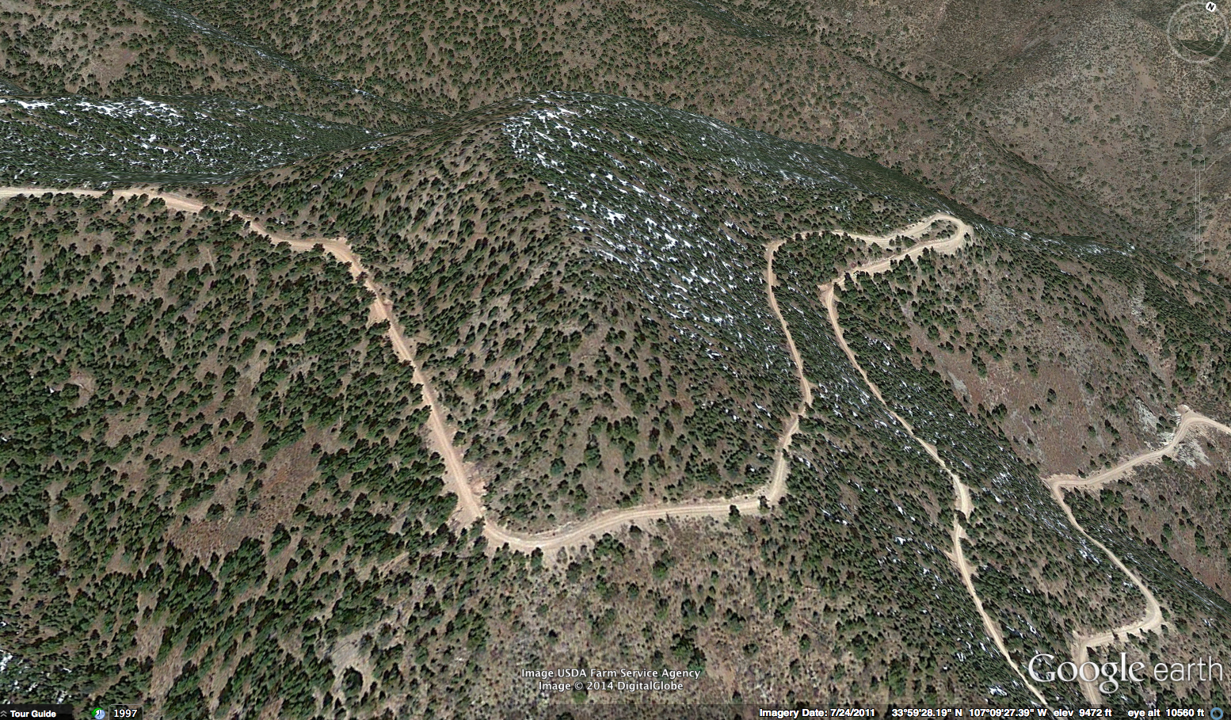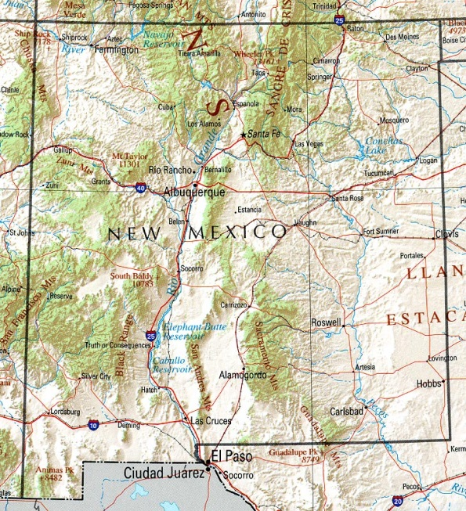
C.
B.
A.

Figure 3.1: (A) Google Earth photo of site showing where the samples were obtained (outlined in red), (b) location of the site within the Magdalena Mountains, and (c) location of the Magdalena Mountains within New Mexico.

“catface,” that occurs when repeated fires kill the active cambium layer and the tree subsequently grows over the wound (Figure 3.2a). Once a fire-scarred tree was found, we flagged the tree with tape (Figure 3.2b), recorded its coordinates with a GPS, took photographs of the tree and the surrounding environment, and recorded notes describing the sample and the surrounding landscape. Only southwestern white pine and ponderosa pine were sampled, because they scar readily and are resistant to decay. Such a targeted sampling approach has been statistically validated and ensures that the fire record is both long and complete (Van Horne and Fulé 2006), compared to other sampling methods based on random sampling or grid-point sampling.
We collected 69 cross sections from the three plots using a chain saw from the flagged fire-scarred pine logs, stumps, snags, remnants, and living trees. To sample a living tree, a non-lethal method of fire-scar extraction was used, where only a small section was taken from the tree (Figure 3.3a). When sampling dead trees, logs, and stumps, we took either a partial or a whole cross section. (Figure 3.3b) We then labeled the samples with the appropriate site name and sample number, marked each fire scar (Figure 3.4), and then carefully wrapped the sample in plastic wrap for transport back to the Laboratory of Tree-Ring Science.

3.3.2 Laboratory Methods
In the laboratory, we mounted each sample on ply-board with wood glue for stabilization and used a band saw to remove uneven chainsaw cuts. In certain cases, multiple cuts were taken with the bandsaw because some scars may show up better on different portions
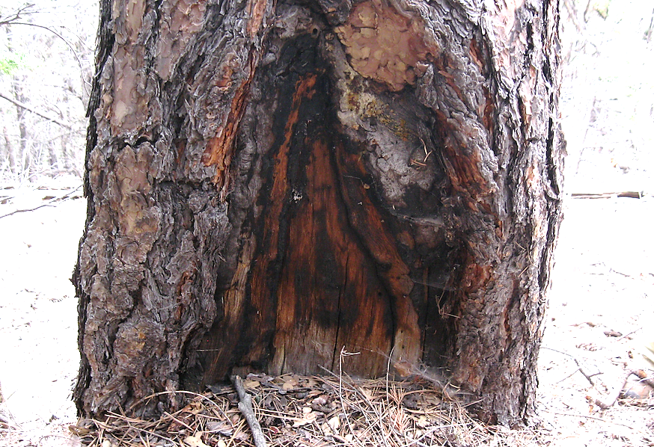
A.
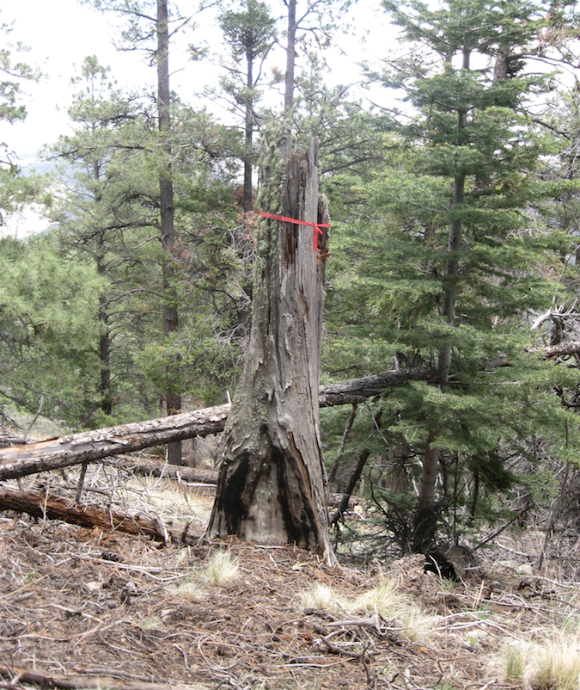
Figure 3.2: (A) Close up of a fire-scarred tree with multiple scars. (B) Example of a fire-scarred snag that has been flagged for sampling.
B.

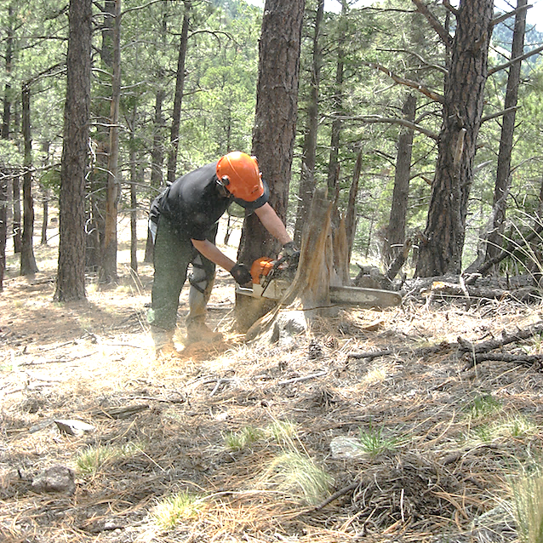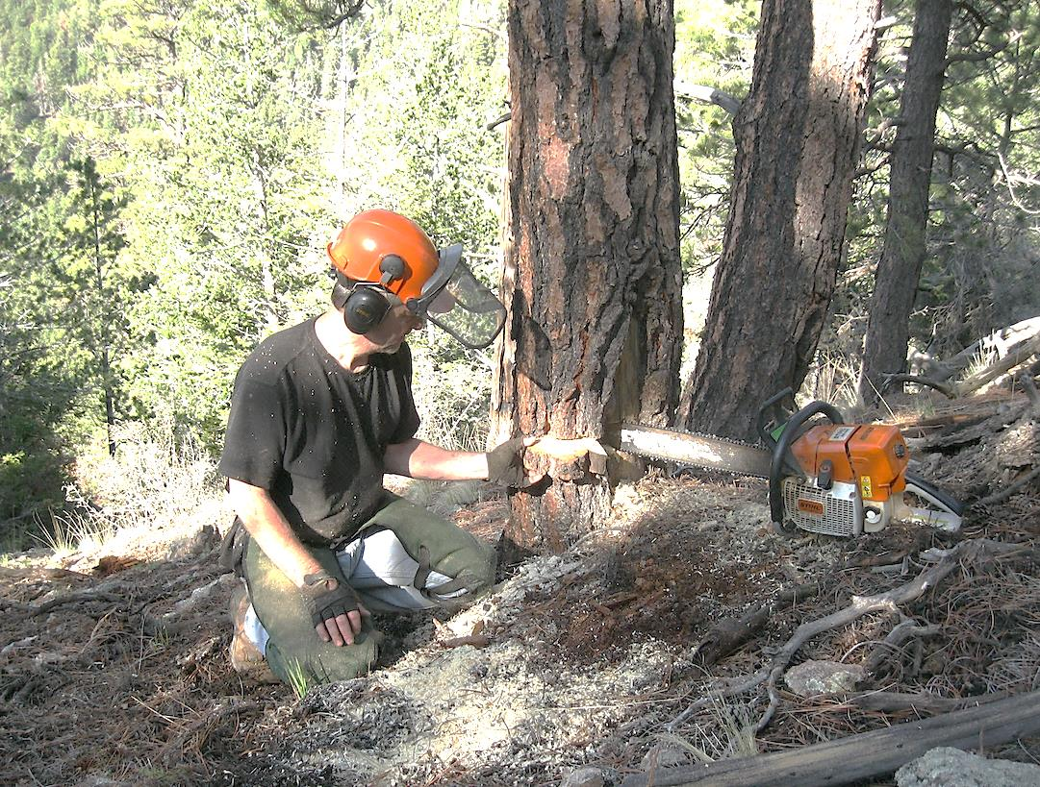
Figure 3.3: (A) A partial cross section taken from a living tree. (B) Use of a chain saw to extract a cross section from a short snag.
B.
A.

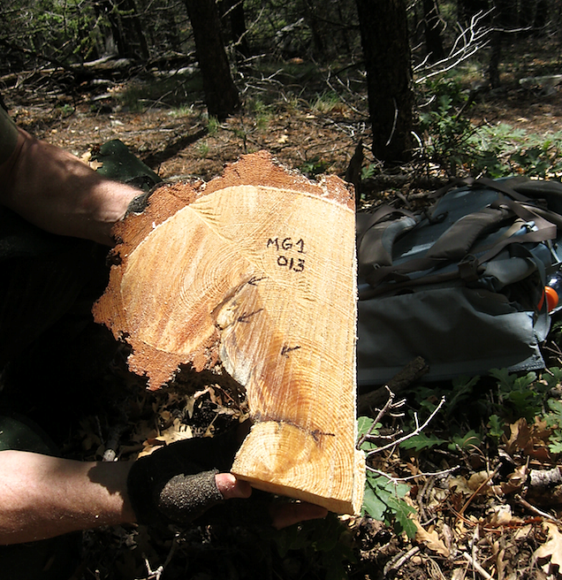
Figure 3.4: Example of a partial cross section with the site name and number added and each fire scar labeled with an arrow.

of the wood sample. We then surfaced each fire-scarred sample with progressively smaller grit sandpaper, using a belt sander and starting with ANSI 40 grit, then moving through 80, 100, 150, 220, and 320 grit, and then finished with 400 grit (Orvis and Grissino-Mayer 2002). When necessary, samples were hand-sanded with 1200 grit until the wood cells were clearly visible under 10x magnification.
For each fire-scarred sample, we drew a line through the clearest rings extending from the pith to the outer portion of the wood. We then measured each ring to the nearest 0.001 mm using a Velmex measuring system coupled with Measure J2X software. For samples taken from living trees, the outer ring (last ring) formed in 2013 and these were crossdated against the master southwestern white pine chronology developed by Grissino-Mayer et al. (1997). We used COFECHA to confirm that we assigned correct calendar years to all tree rings (Holmes 1983; Grissino-Mayer 2001). COFECHA is a computer program widely used to aid in the crossdating process and relies on segmented times series analysis. The program calculates numerous correlation coefficients to determine if ring-width patterns match between the sample and the chronology. Segments with correlation values that fall below a pre-designated critical threshold (r = 0.37, p > 0.01) are flagged as problematic and must be re-examined. Once dating was confirmed, we combined the measurements with those used to create the master chronology.
For samples taken from dead trees, we measured the series beginning with year “1” (innermost complete ring) from the pith out to the outer portion of the wood. We then crossdated the “floating” series with the master chronology to find a systematic dating adjustment. For undated “floating” series, COFECHA will suggest a shift that will place the series in its appropriate place in time. When shifts for all tested segments were statistical significant (r > 0.37, p < 0.01), the sample was considered appropriately placed in time. Using both visual and statistical crossdating, we then assigned the exact calendar year to each ring. We next analyzed the fire scars under a microscope, and all visible fire scars and injuries were dated (Figure 3.5). Rings with a large resin pocket, or rings that showed increased resin ducts, were noted because some trees will show indirect evidence of fires other than having a fire scar. Death dates were also carefully analyzed because synchronous outer ring dates could suggest mortality from a fire event.
Recorder years were determined based on the structure and the condition of the outer surface of the fire-scarred sample. Recorder years provide an accurate representation of fire occurrence by not including years where fire information is possibly missing (Grissino-Mayer 1995). A tree becomes a recorder of fire only after the first fire scar and if the fire-edge was not burned out from subsequent fires. If a sample was burned causing later fire events to be missing, these years were considered to be non-recording years and were not used for further statistical analysis. The designation of non-recorder years and recorder years is important for determining the sample size in any given year. For example, non-recorder years are not included in the sample size for fire frequency analysis because no information on fire is available from tree rings in those years (Grissino-Mayer 1995).
The position of each scar tip within an individual tree ring was carefully noted for analysis of seasonality (Table 3.1). Evaluating the seasonality of a fire is important for studying
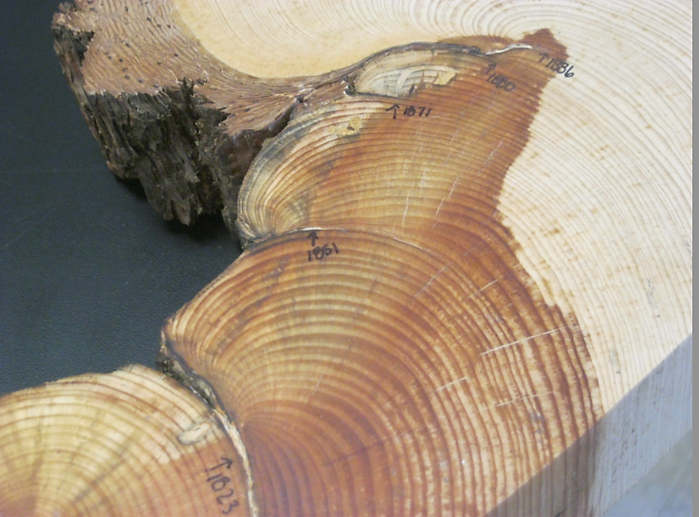
Figure 3.5: Close up of a fire-scarred sample with the years labeled in which each fire occurred.

possible changes of the season when past fire occurred. Fire scars within the early portion of the earlywood occur after the tree breaks dormancy until about late May. Scars positioned in the middle of the earlywood generally indicate fires occurred between late May and early July, while late earlywood scars suggest fires that generally occurred from late July to August (Baisan and Swetnam 1990; Grissino-Mayer 1995). Fire scars located directly in the latewood suggest fires that occurred in the latter part of the growing season, usually in late August to October, near when the tree stops growing. Fires that occurred in the dormant season are considered to represent spring fires in the Southwest (Baisan and Swetnam 1990). In certain cases, a fire scar season could not be determined because the tree rings were too heavily decayed or distorted to identify the exact placement of the scar tip.
Table 3.1: Characteristics to determine the seasonality of each fire scar within the tree ring.
Season | Identifying Characteristics
Dormant season fire (D) | Scar tip occurs between the latewood of the previous ring and the earlywood of the subsequent ring.¹
Early season fire (E) | Scar tip occurs in the first one-third portion of the earlywood.
Middle season fire (M) | Scar tip occurs in the middle one-third portion of the earlywood.
Late season fire (L) | Scar tip occurs in the last one-third portion of the earlywood.
End of growing season fire (A) | Scar tip occurs in the latewood.
Unknown fire event (U) | Fire scar is present, but distortion or decay prevents seasonal assignment.
¹Dormant scars may have formed either in early spring or late summer/fall. Because the exact
seasonality of these scars cannot be determined, we followed convention and assumed that these
scars formed as the result of a spring fire (Swetnam and Baisan 1990; Grissino-Mayer et al. 2004).

3.3.3 Analytical Methods

3.3.3.1 Climate Variables
Four climate indices were compared with fire occurrence: PDSI, ENSO, PDO, and AMO. PDSI is a measure of the duration and intensity of drought, based on precipitation and temperature. It uses a 0 value to indicate normal conditions, while drought is depicted with negative numbers ranging from –1 to –6 and wet spells range from 1 to 6 (Palmer 1965; Cook et al. 2004). ENSO is a tropical fluctuation in sea surface temperature and pressure in the Pacific Ocean and has a period of variation of approximately 2–10 years (Rasmussen and Wallace 1983; Cook et al. 2008). A positive phase of ENSO is referred to as El Niño, and occurs when sea surface temperatures rise in the eastern equatorial Pacific. El Niño is associated with increased moisture in the Southwest. A negative phase of ENSO is referred to as La Niña, and occurs when sea surface temperatures drop in the eastern equatorial Pacific. La Niña years result in drier than average conditions in the Southwest (Sheppard et al. 2002). PDO has a 20–40 year periodicity and has two phases, a positive and negative phase, corresponding to either warmer than average sea surface temperatures along the west coast of North American (positive), or cooler than average sea surface temperatures (negative) (Mantua and Hare 2002; D’Arrigo and Wilson 2006). The effects of PDO on climate in the Southwest resemble those of ENSO but are less intense and longer lived (MacDonald and Case 2005).
AMO has a periodicity of 50–80 years and is calculated using a 10-year moving average. To avoid autocorrelation that results from using a moving average, we used sea surface temperature anomaly (SSTA) data on which the AMO is based (Kaplan 1998). AMO has a positive and negative phase as well, corresponding to either warmer or cooler than average Atlantic Ocean temperatures, respectively (Gray et al. 2004). Warmer than average Atlantic sea surface temperatures result in drought conditions in the Southwest, while cooler sea surface temperatures are associated with increased moisture (McCabe et al. 2004; Kitzberger et al. 2007). AMO has been shown to modulate the strength of ENSO and PDO-related precipitation (Enfield et al. 2001; Collins et al. 2006). This modulation effect warrants an exploration of how the phases of AMO affect other climate-fire relationships.

3.3.3.2 Fire History
After the tree rings on all samples were dated and each fire scar and wound was assigned both a calendar year and a season, the data were entered into FHX2 (Grissino-Mayer 2001). All records were also kept in Excel including: (1) sample identification, (2) species, (3) geographic coordinates, (4) inner and outer year, (5) number of fire scars, and (6) the dates and season of each fire year. We used FHX2 to analyze fire seasonality and fire frequency, and created a fire-history chart in the program FHAES (Fire History Analysis and Exploration System) that depicts the master fire chronology for the three sites. These charts allow for visual examination of past wildfire occurrence (Grissino-Mayer 2001; Fulé et al. 2003).
Fire frequency was characterized using both the Mean Fire Interval (MFI) and the Weibull Median Interval (WMI). Each statistic is used to determine central tendency in the statistical distribution of fire interval data and assist in evaluating past fire regimes. The MFI (average number of years between fires), standard deviation, and the variance were determined for the period from 1630 to 1890. The WMI was also calculated because it is unresponsive to outliers and often is a better representation of central tendency for skewed data. Two fire-scarred classes were analyzed for both of the fire interval statistics: (1) all scarred and (2) 25% and greater scarred (considered large fire events). For the 25% scarred class, the minimum number of samples scarred in a particular year was two (Swetnam and Baisan 2003; Grissino-Mayer et al. 2004).
To analyze seasonality of fire activity across our study site, early season fire events were classified as dormant (D) and early (E) fire scars. Late season fire events were classified as middle (M), late (L), or latewood (A) (Table 3.1). To determine the dominant season in which past fires occurred, we compared the percentage of early- versus late-season scars for the period of analysis. We then assessed changes in seasonality at finer temporal scales to determine if the dominant season of fire occurrence changed throughout the analysis period of 1630 to 1890.

3.3.3.3 Short-term Climate Drivers
We used SEA to evaluate how short-term climate influenced past wildfires. SEA takes all fire years, stacks them on top of each other, and then calculates the mean climate conditions before a fire event (1–6 years), during the fire event (year 0), and 2 years after the fire event. We tested both fire-scarred classes (all and 25%) and used reconstructed data for the PDSI, ENSO, PDO, and AMO (Table 3.2) for this analysis. Bootstrapping was performed using 1000 Monte Carlo simulations of climate data to determine the 95%, 99% and 99.9% confidence intervals.

3.3.3.4 Long-term Climate Drivers
To test the relationship between long-term climate oscillations and wildfire activity we used K1D software (Gavin 2010), which uses Bivariate Event Analysis to detect whether two or more event types are synchronous or asynchronous across multidecadal times scales. BEA is a temporal modification of spatial point pattern analysis for one-dimensional data. Rather than testing the spatial arrangement of points separated by distance in space, BEA tests for the temporal arrangement of events separated by distance in time (Gavin et al. 2006; Sherriff and
Table 3.2: Climate data used for statistical analyses.

Climate Variable | Source | Details
Precipitation | Grissino-Mayer et al. 1997 | 1,373 year reconstruction of precipitation for the Magdalena Mountains
Palmer Drought Severity Index | Cook et al. 2004a | Reconstructed drought from a gridded network. Average of data from Gridpoints 119 and 120.
El Niño-Southern Oscillation | Cook et al. 2008a | Reconstruction of Niño 3.4 index based on tree-ring data.
Pacific Decadal Oscillation | D’Arrigo and Wilson 2006a | Reconstruction of PDO index from tree-ring data.
Atlantic Multidecadal Oscillation | Gray et al. 2004a | SST anomaly data on which AMO is based.

Veblen 2008). BEA provides the ability to test temporal relationships between wildfire events and climate events associated with different climate oscillations. This type of statistical analysis cannot be conducted with SEA because climate oscillations often have strong autocorrelation and because SEA relies on establishing significance based on blocks of specific years. Further, BEA is appropriate because extreme climate events are tested rather than time series data (such as used with SEA). The number of fire events (F) during and following climate events (C) were counted and scaled for different lags t, using a minor modification of the bivariate K function:
${ K}_{\left(FC\right)}\left(t\right)$= $\frac{T}{n_{F}n_{C}}\sum_{i=1}^{n_{F}}{\sum_{j=1}^{n_{C}}{I}}\left[(F_{i}-C_{j}\right] ≤t (F_{i} ≥ C_{j})$
where t is time (years), T is the length of the record, n_{c} and n_{F} are the number of climate and fire events, C_{j} and F_{i} are times of climate events j and fire events i, and the identity function I counts the number of fire events during and following extreme climate years. To remove time dependence from the K-function, the L-function was calculated by: $L_{FC}\left(t\right)= K_{FC}\left(t\right)- t$ (Gavin et al. 2006; Sherriff and Veblen 2008; Hallett and Anderson 2010).
BEA is performed by having the K1D software read a text file with the fire and climate data. One column has a list of all the extreme climate events and the next column has a list of the fire events (either all and 50% scarred class). The Bivariate-Forward Selection was chosen, based on the assumption that a fire event follows a climate event, and then the K-function and the L-function was calculated by the software. Confidence intervals were developed at the 90% level using 1000 Monte Carlo simulations. These simulations were based on randomizing the extreme climate years. If the L-hat value falls below the lower 90% envelope, then the events are asynchronous. If the L-value falls above the upper 90% envelope, then the events are synchronous. If the values fall between the two, the events are independent (Gavin et al. 2006; Sherriff and Veblen 2008).
Extreme climate events of ENSO, PDO, and AMO were needed for this BEA. These events were calculated in R by computing the upper and lower percentiles of the data. Several different percentile values were calculated and tested (5%, 12%, 15%, and 20%) and we chose the 25th percentile to use in the analysis because it allowed us to test more climate events against fire events by providing the 65 highest or lowest annual values for each of the climate indices. Previous research has defined extreme climate events using stricter filters, such as 1 standard deviation (Rother and Grissino-Mayer 2014) or the 12th percentile (Schoennagel et al. 2007). Our analysis allowed us to test the synchrony between fire events and climate events using a more lenient filter while also being able to compare our filtering method to the methods used in previous research. The extreme climate events were calculated by finding the most positive or negative 25th percentile value of AMO, PDO, and ENSO and then extracting the years with values below the 25% value and all values above the 75% value. Climate indices values that fell below the 25% value were classified as extreme negative (cool) phases of AMO, PDO, and ENSO. Values that fell above the 75% value were classified as extreme positive (warm) phases of each of the climate indices.

3.4 Results

3.4.1 Fire History
The final tree-ring chronology for the Magdalena Mountains extended 588 years from 1426 to 2013, and the fire history dates ranged from 1448 to 1953 (Figure 3.6). The period of reliability is 1630 to 1890 because the chronology has a low sample depth prior to 1630 and after 1890. The master chronology contained 68 of the 69 samples collected (1 sample was not included because it could not be absolutely dated), and each sample had an average of five fire scars. Two samples recorded 15 fire events (MG1 009 and MG1 016). Examples of extreme fire years (based on the percentage of recording trees scarred) were 1665 (100%), 1717 (87%), 1773 (91%), 1851 (91%), and 1870 (76%). Fires were frequent prior to 1890 with a Mean Fire Interval (MFI) of 7.5 years for all fire events, and 8.2 years for fires that scarred 25% or more of the samples (Table 3.3). The Weibull Median Interval (WMI) was similar with intervals of 7.1 and 7.9 years for all fire years and for the 25% fire scarred class, respectively. The fire interval of 7 to
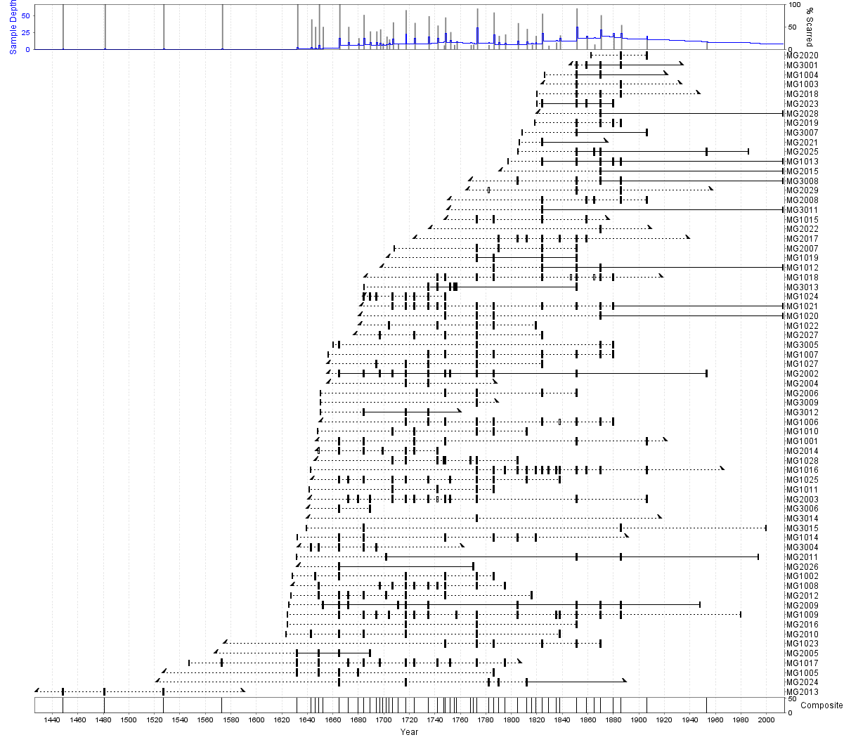
Figure 3.6: Fire history plot for the Magdalena Mountains (1426–2013). Dashed portions of each horizontal line indicate non-recorder years while solid lines indicate recorder years. Long, vertical tic-marks indicate a year when the sample recorded a fire. Shorter, hollow tic-marks indicate other injuries that may or may not be fire-related.

8 years compares favorably with the results from other fire history research in the Southwest with fire intervals ranging from 3 to 12 years (Swetnam 1983; Grissino-Mayer et al. 1994; Touchan and Swenam 1995; Grissino-Mayer et al. 2004).
For all fire events, the shortest fire-free interval was 2 years (1702–1704), and the longest fire-free interval was 21 years (1752–1773). For fires that scarred 25% or more of the samples, the shortest fire-free interval was 3 years (1694–1697), while the longest interval was 21 years (1752–1773) (Table 3.3). The Lower Exceedance Interval, which delimits unusually short intervals for fire occurrence (Grissino-Mayer 2001), ranged from 3.1 to 3.7 years, while the Upper Exceedance Interval, which delimits unusually long intervals, ranged from 12.2 to 13 years across both percent-scarred classes. The Maximum Hazard Interval, the fire interval associated with the longest period the study site can go without burning, ranged from 17.2 to 18.1 years for both scarred classes. The early season of growth (late spring to early summer) had the highest percentage (63%) of fire occurrence, while 37% of fire events occurred in the middle portion of the growing season (Table 3.4).

3.4.2 Short-term Climate Drivers
SEA revealed statistically significant relationships between several climate variables and wildfire during the period 1630–1890. During the year prior to and during the fire event PDSI values were strongly negative, indicating extreme drought (Figure 3.7a), while three years prior to the fire event PDSI was barely insignificant at the 95% confidence interval. Drought in the year before and in the year of the fire likely dried out fuels after increased precipitation several
Table 3.3: Fire history statistics for period of analysis (1630–1890). Results include statistics for all fires and fires that scarred 25% of the samples (minimum of 2 trees scarred).

 | All | 25%
Mean Fire Interval | 7.47 | 8.19
Median Fire Interval | 6.50 | 7.00
Weibull Median Interval | 7.05 | 7.85
Weibull Modal Interval | 5.98 | 7.01
Standard Deviation | 4.07 | 4.09
Coefficient of Variation | 0.54 | 0.50
Skewness | 1.33 | 1.21
Kurtosis | 1.87 | 1.23
Minimum Fire Interval | 2 | 3
Maximum Fire Interval | 21 | 21
Lower Exceedance Interval | 3.09 | 3.68
Upper Exceedance Interval | 12.23 | 13.01
Maximum Hazard Interval | 18.08 | 17.72

Table 3.4: Results of the seasonal analyses of wildfire events for 1630 to 1890.
Season* | Number | Percentage
D Fires | 3 | 1.2
E Fires | 157 | 61.8
M Fires | 77 | 30.3
L Fires | 17 | 6.7
A Fires | 0 | 0.0
U Fires | 82 | 24.4
DE Fires | 160 | 63.0
MLA Fires | 94 | 37.0
* See Table 3.1 for notation

Figure 3.7: Superposed Epoch Analysis showing the relationship between fire occurrence and (a) the Palmer Drought Severity Index (PDSI), and (b) the El Niño-Southern Oscillation (ENSO) for the 1630–1890 period during fire years (year 0) relative to 1–6 years prior and two years after these events. Shaded black bars indicate significance.

years prior. Two years prior to the fire event, ENSO values were significantly positive (Figure 3.7b). Positive values of ENSO indicate El Niño conditions preceded fire events, increasing precipitation and thus increasing fuel accumulation. In the year of the fire event, ENSO conditions were significantly negative (Figure 3.7b). Negative values of ENSO indicate La Niña conditions in the year of a fire event, corresponding to drought in the Southwest. La Niña conditions dries out the fuel that accumulated during the previous El Niña phase, and fires are able to ignite and spread. In the six years before the fire event PDO was positive (Figure 3.8a). These results are barely insignificant at the 95% confidence interval, however, the pattern of a climate index before a fire events is key to understanding how PDO might influence wildfire activity. In the year of the fire, PDO conditions were significantly negative, indicating that drought-induced wildfires are influenced by a cool (negative) phase PDO (Figure 3.8a). No significant relationship was found between wildfire activity and the Atlantic sea surface temperature anomaly (Figure 3.8b).

3.4.3 Long-term Climate Drivers
Negative phases of ENSO, PDO, and AMO showed no relationship with wildfire events (Figure 3.9). Fire events in the 50 percent scarred class were asynchronous with extreme positive phases of ENSO (Figure 3.10b). All other relationships between extreme positive phase events of ENSO, PDO, AMO and both fire scarred classes showed independence (Figure 3.10). We also tested all of the possible two-way phase combinations of the extreme climate years of ENSO, PDO, and AMO and tested their relationship with large wildfire events (50% scarred). All two-
Figure 3.8: Superposed Epoch Analysis showing the relationship between wildfire occurrence and (a) the Pacific Decadal Oscillation (PDO), and (b) the Atlantic sea surface temperature anomaly (SSTA) for the 1630–1890 period during fire years (year 0) relative to 1–6 years prior (1–10 years prior for AMO) and two years after these events. Shaded black bars indicate significance.

50 % Fire Scarred Class
All Fire Years
L_{FC}(t)
Years
Years
Figure 3.9: Results from bivariate event analysis of the negative phases of ENSO, PDO and Atlantic SSTA for both all fires and fires in the 50 % scarred class. Dashed lines are the 90% confidence envelopes and the solid black lines are the Lhat values.

50 % Fire Scarred Class
All Fire Years
Years
Years
L_{FC}(t)
Figure 3.10: Results from bivariate event analysis of the positive phases of ENSO, PDO and Atlantic SSTA for both all fires and fires in the 50 % scarred class. Dashed lines are the 90% confidence envelopes and the solid black lines are the Lhat values. Asynchronous relationship is shaded in gray.

way phase combinations showed independence with wildfire events (Figures 3.11, 3.12, and 3.13).

3.5 Discussion
The fire history of the Magdalena Mountains, New Mexico, was developed by analyzing fire scarred trees, stumps, snags, logs, and remnant wood, which allowed us to evaluate the historical range of wildfire activity. These data provide new information on the specific years in which fire occurred, the variability of fire events over time, and the seasons in which fires were most common in the past. This new information on wildfire activity also allowed us to evaluate the different mechanisms that influence fire occurrence. This research identified statistically significant annual and interannual relationships between wildfires and climate in west-central New Mexico. We found that interannual climate variability is the main driver of wildfire activity in this mixed-conifer forest in the Magdalena Mountains, while longer-term (multidecadal) climate trends do not appear to influence the occurrence of wildfires.

3.5.1 Fire History in the Magdalena Mountains
In the mixed-conifer forest of the Magdalena Mountains, fires were frequent and low in severity from 1630 to 1890 with an interval of 7 to 7.5 years. Trees that have multiple fire scars indicate a low-severity fire regime because fires are not severe enough to kill the majority of the trees. Low-severity fires generally burn only surface fuels and scar trees, killing the active cambium layer, and after which the tree begins to grow over the wound in subsequent years (Arno and Allison-Bunnell 2002). The surface fuel layer in these low-severity forests are
Years
Years
L_{FC}(t)
Figure 3.11: Bivariate event analysis of two-way phase combinations with extreme El Niño-Southern Oscillation years, extreme climate years of the Pacific Decadal Oscillation, and large wildfire years (50% scarred class). Dashed lines are the 90% confidence envelopes and the solid black lines are the Lhat values.

Years
Years
L_{FC}(t)

Figure 3.12: Bivariate event analysis of two-way phase combinations with extreme El Niño-Southern Oscillation years, extreme climate years of the Atlantic sea surface temperature anomaly (SSTA), and large wildfire years (50% scarred class). Dashed lines are the 90% confidence envelopes and the solid black lines are the Lhat values.

Years
Years
L_{FC}(t)
Figure 3.13: Bivariate event analysis of two-way phase combinations with extreme Pacific Decadal Oscillation years, extreme climate years of the Atlantic sea surface temperature anomaly (SSTA), and large wildfire years (50% scarred class). Dashed lines are the 90% confidence envelopes and the solid black lines are the Lhat values.

dominated by grasses and pine needles which dry easily and promote the spread of frequent surface fires (Arno and Allison-Bunnell 2002). Fire scarred trees were common in this forest and the structure of this forest suggests an uneven-aged forest where higher severity fires were uncommon. Therefore, we did not perform an age-structure analysis, which tests for pulses of tree establishment that would indicate higher-severity fires.
The Maximum Hazard Interval (MHI) of 18 years can be interpreted as the maximum time this forest can go without burning. This value is comparable to the MHI for sites in both New Mexico (Grissino-Mayer 1999) and southern Colorado (Grissino-Mayer et al. 2004) that are classified as low-severity fire regimes. In contrast, the vegetation composition, forest structure, and fuel complex of the 20th and 21st centuries promote wildfires of moderate to high severity. These fires burn hotter, longer, and are more extensive than historic fires, often killing both young and mature trees (Cooper 1960; Covington and Moore 1994; Allen et al. 1998; Schoennagel et al. 2004). Changes in wildfire regimes across the Southwest occurred in the late 1800s and can be attributed to fire suppression, livestock grazing, logging, and forest fragmentation. Results from our research reflect this change in the fire regime with a cessation of fire beginning after 1890 at our study site. Only two fire events were recorded after 1890 (1906 and 1953), suggesting that Euro-American arrival in the Magdalena Mountains in the late 1800s caused significant changes to the forests and altered the fire regime. These findings are consistent with results of similar studies conducted in the American Southwest (Swetnam 1983; Swetnam and Baisan 1990; Grissino-Mayer et al. 2004; Heinlein et al. 2005; Huffman et al. 2008; Margolis and Balmat 2009; Rother and Grissino-Mayer 2014), with the fire intervals in ponderosa pine and mixed-conifer forests ranging from 3 to 30 years.
Fires occurred primarily early in the growing season (late spring to early summer), while almost no fires occurred in the latter part of the growing season. This seasonal distribution of wildfires is expected for the Southwest because of the dry spring and foresummer which can be associated dry lightning storms (Heinlien et al. 2005; Westerling et al. 2006; Swetnam and Betancourt 2010). These spring and early summer convective storms increase the potential for fires to ignite and spread because of the high temperatures, low atmospheric moisture, and dry fuels. Beginning in mid-to late summer (usually by July), the monsoon season begins with rainstorms moving into New Mexico, increasing the moisture levels of fuels (Sheppard et al. 2002; Westerling et al. 2006). Therefore, fire risk is the highest in the late spring to early summer and then decreases in mid-to late summer when the monsoon season begins and moisture increases.

3.5.2 Effects of Climate on Fire Occurrence
From 1630 to 1890, interannual climate variability influenced the occurrence of wildfire in the Magdalena Mountains. Drought conditions occurred in the year before the fire and during the year of the fire event. Drought conditions lead to lower combustion temperatures of fuel, increasing both the potential for fuels to ignite and for fires to spread (Grissino-Mayer and Swetnam 2000; Westerling and Swetnam 2003; Brown 2006). Wetter than average conditions occurred three years before a fire event, although this year was barely insignificant at the 95% confidence interval. Such wet conditions can prime future fires by increasing growth of grasses that can later serve as fine fuels for a fire event. Fires are more likely to occur during a year of significant drought conditions, preceded by one or more years of wetter than average conditions. These results are comparable to other research in the Southwest, which evaluated the relationship between PDSI and fire events. In the Rincon Mountain Wilderness of Arizona, fire years were preceded by wetter than average conditions, while during the fire year PDSI was near average (Swetnam and Baisan 1990). Margolis and Balmat (2009) also found similar results in both ponderosa pine and mixed-conifer forests of the Santa Fe Municipal Watershed, New Mexico. They found that in the year of a fire drought is a major driver of wildfire activity, and is especially significant in the mixed-conifer forests.
The interannual climate variation of El Niño and La Niña is important when predicting wildfire occurrence. Our results indicate that the sea surface temperatures in the eastern tropical Pacific Ocean are significantly warmer than normal (positive ENSO or a warm El Niño phase) in the years prior to a fire event, increasing the production of fine fuels (Baisan and Swetnam 1990; Swetnam and Betancourt 1998; Grissino-Mayer and Swetnam 2000; Sherriff and Veblen 2008). In contrast, sea surface temperatures during the year of a fire event are significantly cooler (negative ENSO or a cool La Niña phase). La Niña years coincide with drought periods that cause fuels to dry out, increasing the risk for wildfires (Baisan and Swetnam 1990; Swetnam and Betancourt 1998; Grissino-Mayer and Swetnam 2000; Sherriff and Veblen 2008). Fires are most likely to occur during a La Niña phase after a few years of an El Niño phase. This wet/dry pattern suggests increased moisture leads to an increase in fine fuels, followed by a year when conditions are drier than average, leading to an increase in fire risk. This is due to the accumulation of fuel that dries up and becomes an ignition source for fires and also increases the potential for wildfires to spread.
Fires are more likely to occur during a year when sea surface temperatures are significantly cooler than average along the west coast of North America (negative PDO phase). The fire year is preceded by warmer than average sea surface temperatures (positive PDO) along the west coast of North America, but this was barely insignificant at the 95% confidence interval. This overall pattern of PDO influence is important to note and should include years that are barely insignificant because a temporal pattern in the climate oscillation can emerge. PDO phases have been found to modulate ENSO conditions (Gershunov and Barnett 1998). When a negative PDO phase lines up with a La Niña phase, then drought conditions in the Southwest intensify, causing the increased chance of wildfire occurrence. This link between wildfire and this wet/dry pattern in climate has been found at other sites across the American Southwest (Westerling and Swetnam 2003; Collins et al. 2006; Margolis and Balmat 2009; Ireland et al. 2012; Rother and Grissino-Mayer 2014), with above moisture typically two to three years prior to a fire event and drought conditions occurring in the year of a fire event.
We also tested whether wildfire events are synchronous with extreme climate phases of ENSO, PDO, and AMO at long time scales using BEA. We found relationships between wildfire occurrence (all fires and 50% scarred) and extreme climate phases were independent, except we found an asynchronous relationship between 50% fires and positive ENSO (El Niño) phases across multiple time scales. These results suggest that climate patterns that operate at longer time scales do not influence the occurrence of wildfires in this high elevation, mixed-conifer forest in the Magdalena Mountains. The asynchronous relationship that was found between extreme El Niño phases and large wildfire years could possibly suggest that large fires do not occur during extreme El Niño phases. During these extreme phases moisture increases, especially winter and spring moisture, thus decreasing the potential for fires to ignite and spread.
Rother and Grissino-Mayer (2014) found similar results in the ponderosa pine forests of the Zuni Mountains, New Mexico. They found that interannual variability of PDSI and ENSO were strong drivers of wildfire, with wetter conditions one to two years prior to a widespread fire event and drought during the fire year. This research also included BEA, testing for synchrony between large wildfire events and the extreme phases of ENSO, PDO, and AMO from 1700 to 1880. Their results confirm ours, with wildfire and long-term trends in climate showing independent relationships. Rother and Grissino-Mayer (2014) analyzed extreme climate years defined using a 1 standard deviation threshold, while our research defined the extreme events based on percentiles (25%), providing more extreme events to test against fire years. The differences in the approach of defining extreme events, and yet finding similar results, shows the strength of our results and the results Rother and Grissino-Mayer (2014) found in northwestern New Mexico.
Previous research by Schoennagel et al. (2007) evaluated the relationship between multidecadal trends in climate and wildfire occurrence using BEA for subalpine forests in western Colorado. They found significant relationships between long-term climate oscillations and wildfire activity, and determined that wildfires are driven by multidecadal patterns in climate. However, differences exist between our research and the research in Schoennagel et al. (2007), including forest type, location within the continental Unites States, and the fire regime (high-severity). While our research does not contradict their results, we were unable to show a similar relationship using the same methodology between long-term (multidecadal) trends in climate and the occurrence of wildfires in the mixed-conifer forests of western New Mexico.
We conclude that annual to interannual climate variability is the main driver of wildfire activity in this mixed-conifer forest in the Magdalena Mountains, while long-term (multidecadal) climate trends do not appear to influence the occurrence of wildfires. Fires are driven by the amount and moisture level of fuels. In this fuel limited forest, short-term climate variability is more critical because annual and interannual changes in moisture vastly influence the amount of fuel available to ignite and burn. These high-frequency changes in climate drive the frequent, low-severity fires in the Magdalena Mountains. PDSI, ENSO, and PDO are all important drivers of wildfire at interannual scales, and therefore the phase occurrence of each climate index should be carefully monitored to manage wildfire activity in the Magdalena Mountains.

CHAPTER FOUR
SUMMARY AND CONCLUSIONS

4.1 Major Conclusions
As a result of century-long fire suppression, current vegetation conditions in the Southwest are potentially highly flammable, causing a fire environment prone to catastrophic wildfire. Changes in fire regimes in the twentieth and twenty-first centuries have fueled large, stand-replacing crown fires in southwestern mixed-conifer forests (Cooper 1960; Covington and Moore 1994; Allen et al. 1998; Schoennagel et al. 2004). Historically, frequent, low-severity fires would consume surface fuels and maintain gaps in vertical fuel continuity, preventing fires from moving to the crowns. The fire history for our study site was characterized by frequent, low-severity fires prior to 1890, followed by a cessation of fires during the twentieth and twenty-first centuries. Wildfires are mostly driven by short-term annual to interannual variations in climate with the Palmer Drought Severity Index (PDSI), the El Niño-Southern Oscillation (ENSO), and the Pacific Decadal Oscillation (PDO) as the main drivers. Pre-1890 fires in the Magdalena Mountains in New Mexico occurred in years of severe drought with above average precipitation in years prior to a fire event.

4.1.1 What is the historic wildfire regime for high elevation, mixed conifer forests in the Magdalena Mountains?
Wildfires were frequent prior to 1890 with a Mean Fire Interval of 7.5 years and a Weibull Median Interval of 7 years. The MFI for widespread fires, or fires that scarred 25% or more of the samples, was 8.2 years and the Weibull Median Interval was 7.9 years. Fire-free intervals ranged anywhere from 2 to 21 years across the entire site from 1630 to 1890. Historically, the maximum interval this forest could go without a fire was about 18 years. Results from this research suggest that fires prior to Euro-American settlement were frequent and low in severity, killing the brush layer and scarring trees. Wildfires almost completely ceased after 1890 with only two recorded fire events (1906 and 1953). Fire exclusion can be attributed to the arrival of Euro-Americans to the Southwest in the late 1800s, with early disruption of the landscape beginning with livestock grazing. By1930, forest rangers began to actively suppress wildfires in the Magdalena Mountains. Similar historic fire regimes have been found in other areas of the American Southwest, with fire intervals ranging from 4 to 11 years (Swetnam 1983; Swetnam and Baisan 1990; Grissino-Mayer et al. 2004; Heinlien et al. 2005; Huffman et al. 2008).
Fire events between 1630 and 1890 primarily occurred in the early portion of the growing season (late spring to early summer), while few fires occurred in the latter portion of the growing season (mid-to late summer). During late spring through early summer, the Southwest experiences dry lightning, producing storms causing high fire risk. During this time fuels are dry, increasing the chance of ignition from lightning. Later in the growing season (mid- to late summer), the monsoon season begins, increasing moisture levels of fuels and decreasing the risk of wildfire.

4.1.2 What is the relationship between wildfire occurrence and short-term (annual to interannual) climate patterns?
Interannual climate variability significantly influenced the occurrence of wildfires in the mixed-conifer forest of the Magdalena Mountains. Superposed Epoch Analysis revealed a wet/dry-lagging pattern with climate indices characterized by PDSI, ENSO, and PDO. PDSI conditions indicated drought occurred in the year before a fire event and in the year of a fire event. El Niño occurred two years prior to a fire event, while La Niña occurred during the year of a fire event. In the Southwest, an El Niño phase is associated with warmer eastern tropical Pacific sea surface temperatures which cause an increase in moisture in the Southwest, while a La Niña phase is associated with cooler eastern tropical Pacific temperatures which cause an increase in drought conditions. This El Niño/La Niña sequence or wet/dry-lagging pattern influences the amount and moisture levels of fuel. During an El Niño phase, fuel accumulation increases, and the fuels then dry in a following La Niña phase. PDO showed a cool phase in the year of a fire event, preceded by a PDO warm phase. Wildfires are more likely to occur during a year of extreme drought and during a negative PDO phase and a La Niña phase.
In this mixed-conifer forest, above average antecedent moisture was important for wildfires because it increased fine fuels necessary for surface fires to spread. Drought in the year before a fire event and in the year of the fire event desiccated fuels for burning. Similar patterns were found in the Rincon Mountain Wilderness (Baisan and Swetnam 1990), El Malpais National Monument (Grissino-Mayer and Swetnam 1997), and the San Juan Mountains (Grissino-Mayer et al. 2004). Westerling and Swetnam (2003) suggested that larger fires occurred in association with an El Niño-La Niña sequence, often following a major shift from positive to negative PDO. On an annual scale, fires are associated with anomalously dry conditions. These patterns are consistent with prior moisture that promotes fuel accumulation, followed by drought that promotes fuel flammability. This relationship was essential for frequent, low-severity fires in the mixed-conifer forests of the Magdalena Mountains. The wet/dry-lagging pattern promoted frequent surface fires that are necessary to keep fine fuel loads at a minimum and keep the density of trees sparse.

4.1.3 Is there a relationship between historic wildfire activity and long-term (multidecadal) climate oscillations?
We found that wildfire events were independent of long-term fluctuations in climate, suggesting that low-frequency variations in ocean temperatures do not influence the occurrence of wildfires in the mixed-conifer forest of the Magdalena Mountains. However, one asynchronous relationship was found between large wildfire events (50% scarred class) and extreme positive years of the El Niño-Southern Oscillation (El Niño). This relationship likely reflects our previous results that suggest large wildfires do not occur in years of extreme El Niño phases. Large wildfire risk is less when ocean temperatures in the eastern tropical Pacific Ocean are anomalously warm. We also tested the relationship between wildfire and pairwise combinations of extreme climate phases, but found no statistically significant relationships.

4.2 Future Research
Ourfire history research was site specific and a more detailed study of fire history, with sites throughout the mountain range, would greatly improve this research. An in-depth fire history study that also examines tree establishment dates would provide stronger information on the occurrence of large wildfires as well as give insight to fire severity and extent. The fire record could potentially be extended further back in time with the collecting of more samples, especially taking advantage of the remnant fire scars left across the forest floor.
Extending the fire chronology would increase the analyses period and would be useful when testing the influence climate has on wildfire occurrence. The longer the fire chronology, the more fire events can be tested against climate events. This is particularly pertinent because AMO has a cycle of 40–80 years. With a longer fire chronology, the low-frequency patterns would stand out and more cycles could be tested. The pairwise interactions between climate indices also need to be further evaluated. This can be done by testing specific times when these combinations match up, and testing the combinations against fire occurrence. More knowledge on how the sea surface temperatures in the Atlantic basin interact with SSTs in the Pacific would greatly assist in understanding the teleconnections and how drought-induced fires are caused.

REFERENCES

Allen C.D., J.L. Betancourt, T.W. Swetnam. 1998. Landscape changes in the southwestern United States: Techniques, long-term data sets, and trends. Perspectives on the Land-Use History of North America: A Context for Understanding Our Changing Environment. Fort Collins, Colorado: US Geological Survey: 71–84 pp.

Allen, C.D., M. Savage, D.A. Falk, K.F. Suckling, T.W. Swetnam, T. Schulke, P.B. Stacey,
P. Morgan, M. Hoffman, and J.T. Klingel. 2002. Ecological restoration of southwestern
ponderosa pine ecosystems: a broad perspective. Ecological Applications, 12(5): 1418–1433.

Andrade, Jr., E.R., and W.D. Sellers. 1988. El Niño and its effect on precipitation in Arizona
and western New Mexico. International Journal of Climatology, 8(4): 403–410.

Arno, S.F., and S. Allison-Bunnell. 2002. Flames in our Forests: Disaster or Renewal? Island Press,
Washington, DC.

Arno, S.F., and K.M. Sneck. 1977. A method for determining fire history in coniferous forests of
the Mountain West. Intermountain Forest and Range Experiment Station, Forest
Service, US Department of Agriculture. General Technical Report INT-42.

Baisan, C.H., and T.W. Swetnam. 1990. Fire history on a desert mountain range: Rincon
Mountain Wilderness, USA. Canadian Journal of Forest Research, 20(10): 1559–1569.

Basham, M. 2011. Magdalena Ranger District Background For Survey. Manuscript on file,
USDA Forest Service, Cibola National Forest, Magdalena, New Mexico.

Bigler, C., D.G. Gavin, C. Gunning, and T.T. Veblen. 2007. Drought induces lagged tree
mortality in a subalpine forest in the Rocky Mountains. Oikos, 116(12): 1983–1994.

Biondi, F., L.P. Jamieson, S. Strachan, and J. Sibold. 2011. Dendroecological testing of the
pyroclimatic hypothesis in the central Great Basin, Nevada, USA. Ecosphere, 2(1), doi:10.1890/ES10-00068.1.

Brown, P.M. 2006. Climate effects on fire regimes and tree recruitment in Black Hills ponderosa
pine forests. Ecology, 87(10): 2500–2510.

Brown, P. M. 2010. Wildfire risk and ecological restoration in mixed-severity fire regimes.
In M. Stoffel, M. Bollschweiler, D.R. Butler, and B.H. Luckman, eds., Tree Rings and
Natural Hazards. Springer Netherlands: 361–363.

Collins, B.M., P.N. Omi, and P.L. Chapman. 2006. Regional relationships between climate and wildfire-burned area in the Interior West, USA. Canadian Journal of Forest Research, 36(3): 699–709.
Cook, E.R., C.A. Woodhouse, C.M. Eakin, D.M. Meko, and D.W. Stahle. 2004. Long-term
aridity changes in the western United States. Science, 306: 1015–1018.

Cook, E.R., U. Lall, C.A. Woodhouse, and D.M. Meko. 2004. North American PDSI
Reconstructions. Downloaded from National Climatic Data Center, National Oceanic and Atmospheric Administration ( http://hurricane.ncdc.noaa.gov/pls/paleox/f?p=
519:1:::::P1_STUDY_I D:6232). Last accessed: September 2013.

Cook, E.R., R.D. D’Arrigo, and K.J. Anchukaitis. 2008. ENSO reconstructions from long tree-
ring chronologies: unifying the differences? Talk presented at a special workshop, Reconciling ENSO chronologies for the past 500 years, April 2–3, 2008, Moorea, French Polynesia.

Cook, E.R., R.D. D'Arrigo, and K.J. Anchukaitis. 2008. 700 Year Tree-Ring ENSO Index
Reconstructions. Downloaded from National Climatic Data Center, National Oceanic
and Atmospheric Administration (http://hurricane.ncdc.noaa.gov/pls/paleox/f?p=
519:1:::::P1_STUDY_ID:8704). Last accessed: September 2013.

Cooper, C.F. 1960. Changes in vegetation, structure, and growth of southwestern pine forests
since white settlement. Ecological Monographs, 30(2): 129–164.

Covington, W.W., and M.M. Moore. 1994. Southwestern ponderosa forest structure. Journal of
Forestry, 92(1): 39–47.

D'Arrigo, R.D., and G.C. Jacoby. 1991. A 1000-year record of winter precipitation from
northwestern New Mexico, USA: A reconstruction from tree-rings and its relation to El
Niño and the Southern Oscillation. The Holocene, 1(2): 95–101.

D'Arrigo, R., and R. Wilson. 2006. On the Asian expression of the PDO. International Journal of
Climatology, 26(12): 1607–1617.

D'Arrigo, R., and R. Wilson. 2006. Spring Pacific Decadal Oscillation Index Reconstruction.
IGBP PAGES/World Data Center for Paleoclimatology Data Contribution Series # 2006-
095.NOAA/NCDC Paleoclimatology Program, Boulder CO, USA.

Dieterich, J.H., and T.W. Swetnam. 1984. Dendrochronology of a fire-scarred ponderosa pine.
Forest Science, 30(1): 238–247.

Elmore, F.H. 1976. Shrubs and Trees of the Southwest Uplands. Southwest Parks and
Monuments Association Publications. Tucson, Arizona.

Enfield, D.B., A.M. Mestas-Nunez, and P.J. Trimble. 2001. The Atlantic multidecadal
oscillation and its relation to rainfall and river flows in the continental U.S. Geophysical
Research Letters, 28(10): 2077–2080.

Flatley, W.T., C.W. Lafon, and H.D. Grissino-Mayer. 2011. Climatic and topographic controls
on patterns of fire in the southern and central Appalachian Mountains, USA. Landscape
Ecology, 26(2): 195–209.

Fulé, P.Z., T.A. Heinlein, W.W. Covington, and M.M. Moore. 2003. Assessing fire regimes on
Grand Canyon landscapes with fire-scar and fire-record data. International Journal of
Wildland Fire, 12(2): 129–145.

Fulé, P.Z., L.L. Yocom, C.C. Montaño, D.A. Falk, J. Cerano, and J. Villanueva-Díaz. 2012.
Testing a pyroclimatic hypothesis on the Mexico-United States border. Ecology, 93(8):
1830–1840.

Ganey, J.L., W.M. Block, J.S. Jenness, and R.A. Wilson. 1999. Mexican spotted owl home range
and habitat use in pine-oak forest: implications for forest management. Forest Science,
45(1): 127–135.

Gavin, D.G., F.S. Hu, K. Lertzman, and P. Corbett. 2006. Weak climatic control of stand-scale
fire history during the Late Holocene in southeastern British Columbia. Ecology, 87(7): 1722–1732.

Gavin, D.G. 2010. K1D: Multivariate Ripley’s K-function for one-dimensional data. Department
of Geography, University of Oregon. Downloaded from (http://geography.uoregon.edu/
envchange/pbl/software.html). Last accessed: September 2013.

Gershunov, A., and T.P. Barnett. 1998. Interdecadal modulation of ENSO teleconnections.
Bulletin of the American Meteorological Society, 79(12): 2715–2725.

Gray, S.T., L.J. Graumlich, J.L. Betancourt, and G.T. Pederson. 2004. A tree-ring based
reconstruction of the Atlantic Multidecadal Oscillation since 1567 A.D. Geophysical
Research Letters 31(12), L12205, doi: 10.1029/2004GL019932.

Gray, S.T., L.J. Graumlich, J.L. Betancourt, and G.T. Pederson. 2004. Atlantic Multidecadal
Oscillation (AMO) Index Reconstruction. IGBP PAGES/World Data Center for
Paleoclimatology Data Contribution Series #2004-062. NOAA/NGDC Paleoclimatology
Program, Boulder CO, USA.

Grissino-Mayer, H.D. 1995. Tree-Ring Reconstructions of Climate and Fire History at El Malpais National Monument, New Mexico, Ph.D. dissertation, The University of Arizona,
Tucson. 407 pp.

Grissino-Mayer, H.D. 2001. Evaluating crossdating accuracy: a manual and tutorial for the
computer program COFECHA. Tree-Ring Research, 57(1): 205–221.

Grissino-Mayer, H.D., C.H. Baisan, and T.W. Swetnam. 1994. Fire history in the Pinaleño
Mountains of southeastern Arizona: effects of human-related disturbances. USDA Forest
Service, Rocky Mountain Forest Range Experiment. General Technical Report RM–264: 399–407.

Grissino-Mayer, H.D., and T.W. Swetnam. 1997. Multi-century history of wildfire in the
ponderosa pine forests of El Malpais National Monument. In K. Mabery, eds., Natural
history of El Malpais National Monument. New Mexico Bureau of Mines and Mineral
Resources Bulletin 156, Socorro, New Mexico. 163–171 pp.

Grissino-Mayer, H.D., C.H. Baisan, and T.W. Swetnam. 1997. A 1,373-year reconstruction of
annual precipitation for the southern Rio Grande Basin. Fort Bliss, Texas: Unpublished
Final Report to the Legacy Program, Directorate of Environment, Natural Resources
Division.

Grissino-Mayer, H.D., and T.W. Swetnam. 2000. Century-scale climate forcing of fire regimes in
the American Southwest. The Holocene, 10(2): 213–220.

Grissino-Mayer, H.D., W.H. Romme, M.L. Floyd, and D.D. Hanna. 2004. Climatic and human
influences on fire regimes of the southern San Juan Mountains, Colorado, USA. Ecology,
85(6): 1708–1724.

Gutzler, D.S., D.M. Kann, and C. Thornbrugh. 2002. Modulation of ENSO-based long-lead
outlooks of southwestern US winter precipitation by the Pacific Decadal Oscillation.
Weather and Forecasting, 17(6): 1163–1172.

Hallett, D.J., and R.S. Anderson. 2010. Paleofire reconstruction for high-elevation forests in the
Sierra Nevada, California, with implications for wildfire synchrony and climate
variability in the late Holocene. Quaternary Research, 73(2): 180–190.

Heinlein, T.A., M.M. Moore, P.Z. Fulé, and W.W. Covington. 2005. Fire history and stand
structure of two ponderosa pine-mixed conifer sites: San Francisco Peaks, Arizona, USA.
International Journal of Wildland Fire, 14(3): 307–320.

Holmes, R.L. 1983. Computer-assisted quality control in tree-ring dating and measurement.
Tree-Ring Bulletin, 43: 69–78.

Huffman, D.W., P.Z. Fulé, K.M. Pearson, and J.E. Crouse. 2008. Fire history of piñyon-juniper
woodlands at upper ecotones with ponderosa pine forests in Arizona and New Mexico.
Canadian Journal of Forest Research, 38(8): 2097–2108.

Ireland, K.B., A.B. Stan, and P.Z. Fulé. 2012. Bottom-up control of a northern Arizona
ponderosa pine forest fire regime in a fragmented landscape. Landscape Ecology, 27(7): 983–997.

Kaplan, A., M.A. Cane, Y. Kushnir, A.C. Clement, M.B. Blumenthal, and B. Rajagopalan. 1998.
Analyses of global sea surface temperature 1856–1991. Journal of Geophysical Research:
Oceans, 103(C9): 18567–18589.

Klinglesmith III, D.A., R. Alvarado, M.J. Creech-Eakman, B. O'Donovan, E.B. Seneta, and J.S. Young. 2004. Astronomical site monitoring system for the Magdalena Ridge
Observatory. In Astronomical Telescopes and Instrumentation. International Society for Optics and Photonics: 1301–1309 pp.

Kitzberger, T., P.M. Brown, E.K. Heyerdahl, T.W. Swetnam, and T.T. Veblen. 2007.
Contingent Pacific–Atlantic Ocean influence on multicentury wildfire synchrony over western North America. Proceedings of the National Academy of Sciences of the United States of America, 104(2): 543–548.

Madany, M.H., and N.E. West. 1983. Livestock grazing-fire regime interactions within montane
forests of Zion National Park, Utah. Ecology, 64(4): 661–667.

MacDonald, G.M., and R.A. Case. 2005. Variations in the Pacific Decadal Oscillation over the
past millennium. Geophysical Research Letters, 32, L08703, doi: 10.1029/2005GLO22478.

Mantua, N.J., and S.R. Hare. 2002. The Pacific Decadal Oscillation. Journal of Oceanography, 58(1):
35–44.

Margolis, E.Q., and J. Balmat. 2009. Fire history and fire–climate relationships along a fire regime gradient in the Santa Fe Municipal Watershed, NM, USA. Forest Ecology and Management, 258(11): 2416–2430.

McCabe, G.L., M.A. Palecki, and J.L. Betancourt. 2004. Pacific and Atlantic Ocean influences
on multi-decadal drought frequency in the United States. Proceedings of the National
Academy of Sciences of the United States of America, 101(12): 4136–4141.

Morehouse, B., G. Christopherson, M. Crimmins, B. Orr, T. Overpeck, T. Swetnam, and S.R.
Yool. 2006. Modeling interactions among wildland fire, climate and society in the context of climatic variability and change in the US Southwest. In M. Ruth, K. Donaghy, P. Kirshen, eds., Regional Climate Change and Variability: Impacts and Responses. Edward Elgar Publishing, Cheltenham, UK: 58–78.

NCDC. 2014. NOAA Station ID #NM295353. Downloaded from National Climatic Data Center,
National Oceanic and Atmospheric Administration (http://www.ncdc.noaa. gov/cag/).
Last accessed: September 2014.

Newman, M., G.P. Compo, and M.A. Alexander. 2003. ENSO-forced variability of the Pacific
Decadal Oscillation. Journal of Climate, 16(23): 3853–3857.

Opler, M.E. 1983. Chiricahua Apache. Handbook of North American Indians, 10: 401–418.

Orvis, K.H., and H.D. Grissino-Mayer. 2002. Standardizing the reporting of abrasive papers
used to surface tree-ring samples. Tree-Ring Research, 58(1): 47–50.

Palmer, W.C. 1965. Meteorological Drought. Washington, DC, USA: US Department of Commerce,
Weather Bureau. 58 pp.

Rasmusson, E.M., and J.M. Wallace. 1983. Meteorological aspects of the El Niño-Southern
Oscillation. Science, 222: 1195–1202.

Ropelewski, C.F., and M.S. Halpert. 1986. North American precipitation and temperature
patterns associated with the El Niño/Southern Oscillation (ENSO). Monthly Weather Review, 114(12): 2352–2362.

Ropelewski, C.F., and M.S. Halpert. 1987. Global and regional scale precipitation patterns
associated with the El Niño-Southern Oscillation. Monthly Weather Review, 115(8): 1606–
1626.

Ropelewski, C. F., and P.D. Jones. 1987. An extension of the Tahiti-Darwin southern oscillation
index. Monthly Weather Review, 115(9): 2161–2165.

Rother M.T., H.D. Grissino-Mayer. 2014. Climatic influences on fire regimes in ponderosa pine
forests of the Zuni Mountains, NM, USA. Forest Ecology and Management, doi: 10.1016/
j.foreco.2014.02.034.

Schoennagel, T., T.T. Veblen, and W.H. Romme. 2004. The interaction of fire, fuels, and climate
across Rocky Mountain forests. BioScience, 54(7): 661–676.

Schoennagel, T., T.T. Veblen, D. Kulakowski, and A. Holz. 2007. Multidecadal climate
variability and climate interactions affect subalpine fire occurrence, western Colorado
(USA). Ecology, 88(11): 2891–2902.

Seklecki, M.T., H.D. Grissino-Mayer, and T.W. Swetnam. 1996. Fire history and the possible
role of Apache-set fires in the Chiricahua Mountains, Southeastern Arizona. In P.F
Ffolliott, L.F. DeBano, M.B. Baker, G.L. Gottfried, G. Solis-Garza, C.B. Edminster, D.G.
Neary, L.S. Allen, and R. Hamre, tech. coord., Effects of Fire on the Madrean Province
Ecosystem. Ft. Collins, CO: USDA Forest Service. General Technical Report RM–289: 238– 246.

Sheppard, P.R., A.C. Comrie, G.D. Packin, K. Angersbach, and M.K. Hughes. 2002. The
climate of the US Southwest. Climate Research, 21(3): 219–238.

Sherriff, R.L., and T.T. Veblen. 2008. Variability in climate-fire relationships in ponderosa
pine forests in the Colorado Front Range. International Journal of Wildland Fire, 17(1): 50–59.

Stahle, D.W., M.K. Cleaveland, H.D. Grissino-Mayer, R.D. Griffin, F.K. Fye, M.D. Therrell,
D.J. Burnette, D.M. Meko, and J. Villanueva-Diaz. 2009. Cool- and warm-season precipitation reconstructions over western New Mexico. Journal of Climate, 22(13): 3729– 3750.

Swetnam, T.W. 1983. Fire History in the Gila Wilderness, New Mexico. M.S. thesis, The
University of Arizona, Tucson. 143 pp.

Swetnam, T.W. 1990. Fire history and climate in the southwestern United States. In
Proceedings of Symposium on Effects on Fire in Management of Southwestern Natural
Resources. USDA Forest Service. General Technical Report RM–191: 6–17.

Swetnam, T.W., and C.H. Baisan. 2003. Tree-ring reconstructions of fire and climate history in
the Sierra Nevada and Southwestern United States. In T.T. Veblen, W. Baker, G.
Montenegro, and T.W. Swetnam, eds., Fire and Climatic Change in Temperate Ecosystems of
the Western Americas. Springer, New York: 158–195.

Swetnam, T.W., and J.L. Betancourt. 1990. Fire-Southern Oscillation relations in the
southwestern United States. Science, 249: 1017–1020.

Swetnam, T.W., and J.L. Betancourt. 2010. Mesoscale disturbance and ecological response to
decadal climatic variability in the American Southwest. Journal of Climate, 11: 3128–3147.

Touchan, R., and T.W. Swetnam. 1995. Fire history in ponderosa pine and mixed-conifer forests
of the Jemez Mountains, northern New Mexico. Final Report, USDA Forest Service and
USDI National Park Service, Bandelier National Monument, Los Alamos, New Mexico. 87 pp.

Touchan, R., T.W. Swetnam, and H.D. Grissino-Mayer. 1995. Effects of livestock grazing on
pre-settlement fire regimes in New Mexico. In J.K. Brown, R.W. Mutch, C.W. Spoon,
and R.H. Wakimoto, eds., Proceedings: Symposium on Fire in Wilderness and Park Management, 1993 March 30–April 1. Missoula, Montana. USDA Forest Service General Technical Report RM–320: 268–272.

Van Horne, M.L., and P.Z. Fulé. 2006. Comparing methods of reconstructing fire history using
fire scars in a southwestern United States ponderosa pine forest. Canadian Journal of Forest Research, 36(4): 855–867.

Westerling, A.L., H.G. Hidalgo, D.R. Cayan, and T.W. Swetnam. 2006. Warming and earlier
spring increase western U.S. forest wildfire activity. Science, 313: 940–943.

Westerling, A.L., and T.W. Swetnam. 2003. Interannual to decadal drought and wildfire in the
western United States. EOS-Transactions of the American Geophysical Union, 84(49): 545– 560.

Westpfahl, D.J., G.C. Loos, V.D. Romero, and J.F. Friedman. 2000. The Magdalena Ridge
Observatory: a look ahead. In Astronomical Telescopes and Instrumentation. International
Society for Optics and Photonics: 731–739.

APPENDICES

APPENDIX 1

Sample Information for the Master Fire Chronology, Magdalena Mountains, New Mexico.

Sample information for master fire chronology

Site | Number of Samples | Number of Fire Scars | Chronology Length (yr) | Fire Scars Per Tree
 |  |  |  | Min. | Max. | Mean
MG1 | 27 | 184 | 487 | 2 | 15 | 6.8
MG2 | 28 | 119 | 587 | 1 | 13 | 4.1
MG3 | 13 | 43 | 381 | 1 | 9 | 3.3
TOTAL | 68 | 346 | -- | -- | -- | --

APPENDIX 2

Years of fires that scarred all samples in the Magdalena Mountains, New Mexico.

Years of fires that scarred all samples for the period of analysis (1630–1890)

Year | Ratio of the number of scarred samples to the total number of recording samples | Percent scarred (%)
1632 | 3:3 | 100
1643 | 2:3 | 67
1649 | 5:5 | 100
1665 | 17:17 | 100
1672 | 5:10 | 50
1680 | 2:8 | 25
1684 | 13:17 | 76
1689 | 4:10 | 40
1694 | 4:10 | 40
1697 | 3:9 | 33
1702 | 2:7 | 29
1707 | 9:15 | 60
1717 | 20:23 | 87
1724 | 10:17 | 59
1735 | 14:19 | 74
1742 | 9:17 | 53
1748 | 17:24 | 71
1752 | 5:13 | 38
1773 | 29:32 | 91
1786 | 18:22 | 82
1790 | 3:10 | 30
1795 | 3:9 | 33
1805 | 6:11 | 55
1812 | 5:11 | 45
1824 | 19:24 | 79
1851 | 30:33 | 91
1859 | 6:20 | 30
1870 | 22:29 | 76
1880 | 8:24 | 33
1886 | 14:24 | 54

APPENDIX 3

Graphic depicting (A) years with large fires occurrence (25% scarred), represented by + symbols, (B) reconstructed PDSI, (C) ENSO, (D) PDO, and (E) Atlantic sea surface temperature anomaly (SSTA), are shown for the analysis period of 1630 to 1890.

Time (years)
Index Values
A. Fire Events

APPENDIX 4
Fire history data for Magdalena Mountains
Summary statistics from FHX2 from each fire scarred sample. Includes series identification, innermost ring date, outermost ring date, length of sample, number of recorder years, year of fire scar, season of fire scar, total number of fire scars, sample mean fire interval, and average number of years per fire for each individual sample.

Sample: 1 Code: MG1001
Inner Ring: 1646
Outer Ring: 1922
Length of sample: 277
Number of recorder years in sample: 6
Information on Fire History:
1665 E
1684 M FI = 19
1724 E FI = 40
1748 E FI = 24
1851 M FI = 103
1906 U FI = 55
Total number of fire scars: 6
Total number of all indicators: 6
Average number years per fire: 1.0
Sample mean fire interval: 48.2

Sample: 2 Code: MG1002
Pith Ring: 1628
Length of sample: 159
Number of recorder years in sample: 6
Information on Fire History:
1646 U
1665 M FI = 19
1717 M FI = 52
1748 E FI = 31
1773 U FI = 25
1786 U FI = 13
Total number of fire scars: 6
Total number of all indicators: 6
Average number years per fire: 1.0
Sample mean fire interval: 28.0

Sample: 3 Code: MG1003
Inner Ring: 1823
Outer Ring: 1934
Length of sample: 112
Number of recorder years in sample: 36
Information on Fire History:
1851 E
1886 U FI = 35
Total number of fire scars: 2
Total number of all indicators: 2
Average number years per fire: 18.0
Sample mean fire interval: 35.0

Sample: 4 Code: MG1004
Pith Ring: 1826
Outer Ring: 1923
Length of sample: 98
Number of recorder years in sample: 73
Information on Fire History:
1851 E
1870 E FI = 19
Total number of fire scars: 2
Total number of all indicators: 2
Average number years per fire: 36.5
Sample mean fire interval: 19.0

Sample: 5 Code: MG1005
Inner Ring: 1526
Length of sample: 261
Number of recorder years in sample: 5
Information on Fire History:
1632 M
1649 M FI = 17
1665 M FI = 16
1680 E FI = 15
1786 U FI = 106
Total number of fire scars: 5
Total number of all indicators: 5
Average number years per fire: 1.0
Sample mean fire interval: 38.5

Sample: 6 Code: MG1006
Inner Ring: 1649
Length of sample: 232
Number of recorder years in sample: 9
Information on Fire History:
1717 E
1735 U FI = 18
1748 E FI = 13
1773 E FI = 25
1786 M FI = 13
1824 E FI = 38
1838 u
1851 U FI = 27
1870 U FI = 19
1880 U FI = 10
Total number of fire scars: 9
Total number of all indicators: 10
Average number years per fire: 1.0
Sample mean fire interval: 20.4
Sample: 7 Code: MG1007
Pith Ring: 1656
Length of sample: 225
Number of recorder years in sample: 8
Information on Fire History:
1735 E
1748 E FI = 13
1773 E FI = 25
1786 M FI = 13
1824 U FI = 38
1851 M FI = 27
1870 M FI = 19
1880 U FI = 10
Total number of fire scars: 8
Total number of all indicators: 8
Average number years per fire: 1.0
Sample mean fire interval: 20.7

Sample: 8 Code: MG1008
Inner Ring: 1627
Length of sample: 169
Number of recorder years in sample: 10
Information on Fire History:
1649 L
1697 L FI = 48
1707 U FI = 10
1717 U FI = 10
1724 M FI = 7
1735 M FI = 11
1742 E FI = 7
1748 E FI = 6
1773 U FI = 25
1795 U FI = 22
Total number of fire scars: 10
Total number of all indicators: 10
Average number years per fire: 1.0
Sample mean fire interval: 16.2

Sample: 9 Code: MG1009
Pith Ring: 1624
Bark Ring: 1980
Length of sample: 357
Number of recorder years in sample: 15
Information on Fire History:
1665 U
1684 E FI = 19
1694 E FI = 10
1704 M FI = 10
1717 E FI = 13
1724 L FI = 7
1735 E FI = 11
1758 L FI = 23
1773 M FI = 15
1805 E FI = 32
1835 U FI = 30
1838 M FI = 3
1851 U FI = 13
1870 E FI = 19
1886 U FI = 16
Total number of fire scars: 15
Total number of all indicators: 15
Average number years per fire: 1.0
Sample mean fire interval: 15.8

Sample: 10 Code: MG1010
Pith Ring: 1648
Length of sample: 165
Number of recorder years in sample: 81
Information on Fire History:
1707 E
1724 M FI = 17
1773 M FI = 49
1786 U FI = 13
1812 U FI = 26
Total number of fire scars: 5
Total number of all indicators: 5
Average number years per fire: 16.2
Sample mean fire interval: 26.2

Sample: 11 Code: MG1011
Pith Ring: 1641
Length of sample: 146
Number of recorder years in sample: 4
Information on Fire History:
1707 E
1742 M FI = 35
1773 U FI = 31
1786 U FI = 13
Total number of fire scars: 4
Total number of all indicators: 4
Average number years per fire: 1.0
Sample mean fire interval: 26.3

Sample: 12 Code: MG1012
Inner Ring: 1697
Bark Ring: 2013
Length of sample: 317
Number of recorder years in sample: 191
Information on Fire History:
1786 E
1824 E FI = 38
1851 E FI = 27
1870 E FI = 19
Total number of fire scars: 4
Total number of all indicators: 4
Average number years per fire: 47.8
Sample mean fire interval: 28.0

Sample: 13 Code: MG1013
Pith Ring: 1797
Bark Ring: 2013
Length of sample: 217
Number of recorder years in sample: 190
Information on Fire History:
1824 M
1851 E FI = 27
1870 E FI = 19
1880 E FI = 10
1886 L FI = 6
Total number of fire scars: 5
Total number of all indicators: 5
Average number years per fire: 38.0
Sample mean fire interval: 15.5

Sample: 14 Code: MG1014
Pith Ring: 1632
Outer Ring: 1892
Length of sample: 261
Number of recorder years in sample: 24
Information on Fire History:
1665 M
1684 E FI = 19
1748 M FI = 64
1786 U FI = 38
1805 E FI = 19
1819 U FI = 14
Total number of fire scars: 6
Total number of all indicators: 6
Average number years per fire: 4.0
Sample mean fire interval: 30.8

Sample: 15 Code: MG1015
Inner Ring: 1747
Outer Ring: 1877
Length of sample: 131
Number of recorder years in sample: 4
Information on Fire History:
1773 E
1786 U FI = 13
1824 E FI = 38
1859 E FI = 35
Total number of fire scars: 4
Total number of all indicators: 4
Average number years per fire: 1.0
Sample mean fire interval: 28.7

Sample: 16 Code: MG1016
Pith Ring: 1642
Outer Ring: 1967
Length of sample: 326
Number of recorder years in sample: 99
Information on Fire History:
1773 E
1786 M FI = 13
1795 E FI = 9
1805 E FI = 10
1812 E FI = 7
1819 E FI = 7
1824 E FI = 5
1829 E FI = 5
1835 M FI = 6
1838 E FI = 3
1851 U FI = 13
1859 E FI = 8
1870 M FI = 11
1906 U FI = 36
Total number of fire scars: 14
Total number of all indicators: 14
Average number years per fire: 7.1
Sample mean fire interval: 10.2

Sample: 17 Code: MG1017
Pith Ring: 1547
Outer Ring: 1808
Length of sample: 262
Number of recorder years in sample: 12
Information on Fire History:
1573 E
1632 D FI = 59
1649 U FI = 17
1672 E FI = 23
1684 E FI = 12
1697 D FI = 13
1717 E FI = 20
1724 U FI = 7
1742 M FI = 18
1752 M FI = 10
1773 M FI = 21
1795 U FI = 22
Total number of fire scars: 12
Total number of all indicators: 12
Average number years per fire: 1.0
Sample mean fire interval: 20.2
Sample: 18 Code: MG1018
Inner Ring: 1684
Outer Ring: 1919
Length of sample: 236
Number of recorder years in sample: 49
Information on Fire History:
1742 L
1748 E FI = 6
1773 M FI = 25
1786 M FI = 13
1824 E FI = 38
1847 u
1851 E FI = 27
1865 u
1870 M FI = 19
1880 E FI = 10
Total number of fire scars: 8
Total number of all indicators: 10
Average number years per fire: 6.1
Sample mean fire interval: 19.7

Sample: 19 Code: MG1019
Inner Ring: 1702
Length of sample: 150
Number of recorder years in sample: 79
Information on Fire History:
1773 M
1786 L FI = 13
1824 U FI = 38
1851 U FI = 27
Total number of fire scars: 4
Total number of all indicators: 4
Average number years per fire: 19.8
Sample mean fire interval: 26.0

Sample: 20 Code: MG1020
Inner Ring: 1680
Bark Ring: 2013
Length of sample: 334
Number of recorder years in sample: 147
Information on Fire History:
1748 E
1773 E FI = 25
1786 E FI = 13
1870 E FI = 84
Total number of fire scars: 4
Total number of all indicators: 4
Average number years per fire: 36.8
Sample mean fire interval: 40.7

Sample: 21 Code: MG1021
Inner Ring: 1681
Bark Ring: 2013
Length of sample: 333
Number of recorder years in sample: 145
Information on Fire History:
1707 L
1717 E FI = 10
1724 M FI = 7
1735 E FI = 11
1742 E FI = 7
1748 E FI = 6
1773 E FI = 25
1786 E FI = 13
1824 M FI = 38
1851 M FI = 27
1870 E FI = 19
1880 E FI = 10
Total number of fire scars: 12
Total number of all indicators: 12
Average number years per fire: 12.1
Sample mean fire interval: 15.7

Sample: 22 Code: MG1022
Inner Ring: 1680
Length of sample: 140
Number of recorder years in sample: 5
Information on Fire History:
1704 E
1742 E FI = 38
1773 E FI = 31
1786 M FI = 13
1819 U FI = 33
Total number of fire scars: 5
Total number of all indicators: 5
Average number years per fire: 1.0
Sample mean fire interval: 28.8

Sample: 23 Code: MG1023
Inner Ring: 1574
Length of sample: 297
Number of recorder years in sample: 6
Information on Fire History:
1748 E
1773 M FI = 25
1786 M FI = 13
1824 M FI = 38
1851 M FI = 27
1870 U FI = 19
Total number of fire scars: 6
Total number of all indicators: 6
Average number years per fire: 1.0
Sample mean fire interval: 24.4

Sample: 24 Code: MG1024
Inner Ring: 1683
Length of sample: 66
Number of recorder years in sample: 9
Information on Fire History:
1684 M
1689 E FI = 5
1694 L FI = 5
1707 E FI = 13
1717 E FI = 10
1724 L FI = 7
1735 E FI = 11
1748 U FI = 13
Total number of fire scars: 8
Total number of all indicators: 8
Average number years per fire: 1.1
Sample mean fire interval: 9.1

Sample: 25 Code: MG1025
Inner Ring: 1642
Length of sample: 197
Number of recorder years in sample: 11
Information on Fire History:
1665 M
1672 M FI = 7
1684 E FI = 12
1707 U FI = 23
1717 E FI = 10
1735 M FI = 18
1752 M FI = 17
1773 E FI = 21
1786 U FI = 13
1812 U FI = 26
1838 U FI = 26
Total number of fire scars: 11
Total number of all indicators: 11
Average number years per fire: 1.0
Sample mean fire interval: 17.3

Sample: 26 Code: MG1027
Inner Ring: 1655
Length of sample: 170
Number of recorder years in sample: 5
Information on Fire History:
1694 U
1717 E FI = 23
1735 M FI = 18
1773 U FI = 38
1824 U FI = 51
Total number of fire scars: 5
Total number of all indicators: 5
Average number years per fire: 1.0
Sample mean fire interval: 32.5

Sample: 27 Code: MG1028
Inner Ring: 1645
Length of sample: 161
Number of recorder years in sample: 8
Information on Fire History:
1707 E
1717 E FI = 10
1742 E FI = 25
1747 E FI = 5
1768 M FI = 21
1773 M FI = 5
1805 U FI = 32
Total number of fire scars: 7
Total number of all indicators: 7
Average number years per fire: 1.1
Sample mean fire interval: 16.3

Sample: 28 Code: MG2002
Inner Ring: 1655
Length of sample: 299
Number of recorder years in sample: 289
Information on Fire History:
1665 E
1684 E FI = 19
1696 D FI = 12
1707 E FI = 11
1717 E FI = 10
1735 E FI = 18
1748 E FI = 13
1752 E FI = 4
1773 E FI = 21
1786 E FI = 13
1851 E FI = 65
1953 U FI = 102
Total number of fire scars: 12
Total number of all indicators: 12
Average number years per fire: 24.1
Sample mean fire interval: 26.2

Sample: 29 Code: MG2003
Inner Ring: 1640
Length of sample: 267
Number of recorder years in sample: 12
Information on Fire History:
1672 E
1680 E FI = 8
1689 U FI = 9
1707 U FI = 18
1717 U FI = 10
1724 E FI = 7
1735 E FI = 11
1742 m
1748 U FI = 13
1752 E FI = 4
1773 U FI = 21
1851 U FI = 78
1906 U FI = 55
Total number of fire scars: 12
Total number of all indicators: 13
Average number years per fire: 1.0
Sample mean fire interval: 21.3

Sample: 30 Code: MG2004
Inner Ring: 1655
Outer Ring: 1789
Length of sample: 135
Number of recorder years in sample: 2
Information on Fire History:
1717 E
1735 M FI = 18
Total number of fire scars: 2
Total number of all indicators: 2
Average number years per fire: 1.0
Sample mean fire interval: 18.0

Sample: 31 Code: MG2005
Inner Ring: 1567
Length of sample: 123
Number of recorder years in sample: 58
Information on Fire History:
1632 E
1649 M FI = 17
1665 L FI = 16
1689 U FI = 24
Total number of fire scars: 4
Total number of all indicators: 4
Average number years per fire: 14.5
Sample mean fire interval: 19.0

Sample: 32 Code: MG2006
Pith Ring: 1650
Length of sample: 202
Number of recorder years in sample: 78
Information on Fire History:
1748 E
1773 M FI = 25
1824 M FI = 51
1851 U FI = 27
Total number of fire scars: 4
Total number of all indicators: 4
Average number years per fire: 19.5
Sample mean fire interval: 34.3

Sample: 33 Code: MG2007
Pith Ring: 1708
Length of sample: 144
Number of recorder years in sample: 4
Information on Fire History:
1773 M
1790 E FI = 17
1824 L FI = 34
1851 U FI = 27
Total number of fire scars: 4
Total number of all indicators: 4
Average number years per fire: 1.0
Sample mean fire interval: 26.0

Sample: 34 Code: MG2008
Inner Ring: 1750
Length of sample: 157
Number of recorder years in sample: 5
Information on Fire History:
1824 L
1859 M FI = 35
1865 E FI = 6
1886 U FI = 21
1906 U FI = 20
Total number of fire scars: 5
Total number of all indicators: 5
Average number years per fire: 1.0
Sample mean fire interval: 20.5

Sample: 35 Code: MG2009
Pith Ring: 1625
Bark Ring: 1948
Length of sample: 324
Number of recorder years in sample: 297
Information on Fire History:
1652 E
1665 E FI = 13
1672 E FI = 7
1711 M FI = 39
1717 E FI = 6
1735 U FI = 18
1805 E FI = 70
1851 M FI = 46
1870 E FI = 19
1886 M FI = 16
Total number of fire scars: 10
Total number of all indicators: 10
Average number years per fire: 29.7
Sample mean fire interval: 26.0

Sample: 36 Code: MG2010
Pith Ring: 1623
Length of sample: 216
Number of recorder years in sample: 6
Information on Fire History:
1643 E
1665 E FI = 22
1684 E FI = 19
1717 M FI = 33
1773 E FI = 56
1838 U FI = 65
Total number of fire scars: 6
Total number of all indicators: 6
Average number years per fire: 1.0
Sample mean fire interval: 39.0

Sample: 37 Code: MG2011
Pith Ring: 1631
Bark Ring: 1994
Length of sample: 364
Number of recorder years in sample: 293
Information on Fire History:
1702 U
1851 M FI = 149
1886 E FI = 35
Total number of fire scars: 3
Total number of all indicators: 3
Average number years per fire: 97.7
Sample mean fire interval: 92.0

Sample: 38 Code: MG2012
Pith Ring: 1627
Length of sample: 190
Number of recorder years in sample: 69
Information on Fire History:
1649 M
1665 E FI = 16
1672 E FI = 7
1684 M FI = 12
1702 M FI = 18
1717 E FI = 15
1748 E FI = 31
1816 U FI = 68
Total number of fire scars: 8
Total number of all indicators: 8
Average number years per fire: 8.6
Sample mean fire interval: 23.9

Sample: 39 Code: MG2013
Inner Ring: 1426
Outer Ring: 1591
Length of sample: 166
Number of recorder years in sample: 3
Information on Fire History:
1448 U
1481 M FI = 33
1527 U FI = 46
Total number of fire scars: 3
Total number of all indicators: 3
Average number years per fire: 1.0
Sample mean fire interval: 39.5

Sample: 40 Code: MG2014
Inner Ring: 1646
Length of sample: 97
Number of recorder years in sample: 6
Information on Fire History:
1649 e
1665 M
1684 U FI = 19
1699 M FI = 15
1717 U FI = 18
1724 U FI = 7
1742 U FI = 18
Total number of fire scars: 6
Total number of all indicators: 7
Average number years per fire: 1.0
Sample mean fire interval: 15.4
Sample: 41 Code: MG2015
Inner Ring: 1790
Bark Ring: 2013
Length of sample: 224
Number of recorder years in sample: 144
Information on Fire History:
1870 E
Total number of fire scars: 1
Total number of all indicators: 1
Average number years per fire: 144.0
Sample mean fire interval: NA

Sample: 42 Code: MG2016
Pith Ring: 1624
Length of sample: 228
Number of recorder years in sample: 58
Information on Fire History:
1717 E
1773 E FI = 56
1851 U FI = 78
Total number of fire scars: 3
Total number of all indicators: 3
Average number years per fire: 19.3
Sample mean fire interval: 67.0

Sample: 43 Code: MG2017
Inner Ring: 1723
Outer Ring: 1940
Length of sample: 218
Number of recorder years in sample: 7
Information on Fire History:
1790 U
1805 E FI = 15
1812 U FI = 7
1824 U FI = 12
1838 U FI = 14
1851 E FI = 13
1859 E FI = 8
Total number of fire scars: 7
Total number of all indicators: 7
Average number years per fire: 1.0
Sample mean fire interval: 11.5

Sample: 44 Code: MG2018
Pith Ring: 1820
Outer Ring: 1948
Length of sample: 129
Number of recorder years in sample: 36
Information on Fire History:
1851 M
1870 E FI = 19
1886 L FI = 16
Total number of fire scars: 3
Total number of all indicators: 3
Average number years per fire: 12.0
Sample mean fire interval: 17.5

Sample: 45 Code: MG2019
Pith Ring: 1818
Length of sample: 69
Number of recorder years in sample: 31
Information on Fire History:
1851 E
1870 E FI = 19
1880 M FI = 10
1886 U FI = 6
Total number of fire scars: 4
Total number of all indicators: 4
Average number years per fire: 7.8
Sample mean fire interval: 11.7

Sample: 46 Code: MG2020
Pith Ring: 1862
Length of sample: 45
Number of recorder years in sample: 2
Information on Fire History:
1886 E
1906 U FI = 20
Total number of fire scars: 2
Total number of all indicators: 2
Average number years per fire: 1.0
Sample mean fire interval: 20.0

Sample: 47 Code: MG2021
Pith Ring: 1806
Outer Ring: 1876
Length of sample: 71
Number of recorder years in sample: 53
Information on Fire History:
1824 M
Total number of fire scars: 1
Total number of all indicators: 1
Average number years per fire: 53.0
Sample mean fire interval: NA

Sample: 48 Code: MG2022
Inner Ring: 1735
Outer Ring: 1910
Length of sample: 176
Number of recorder years in sample: 1
Information on Fire History:
1870 E
Total number of fire scars: 1
Total number of all indicators: 1
Average number years per fire: 1.0
Sample mean fire interval: NA

Sample: 49 Code: MG2023
Pith Ring: 1820
Length of sample: 61
Number of recorder years in sample: 57
Information on Fire History:
1824 U
1851 E FI = 27
1859 L FI = 8
1870 E FI = 11
1880 U FI = 10
Total number of fire scars: 5
Total number of all indicators: 5
Average number years per fire: 11.4
Sample mean fire interval: 14.0

Sample: 50 Code: MG2024
Inner Ring: 1521
Outer Ring: 1890
Length of sample: 370
Number of recorder years in sample: 134
Information on Fire History:
1665 M
1717 U FI = 52
1782 U FI = 65
1790 E FI = 8
1812 E FI = 22
Total number of fire scars: 5
Total number of all indicators: 5
Average number years per fire: 26.8
Sample mean fire interval: 36.8

Sample: 51 Code: MG2025
Pith Ring: 1805
Bark Ring: 1986
Length of sample: 182
Number of recorder years in sample: 136
Information on Fire History:
1851 E
1865 E FI = 14
1870 E FI = 5
1953 U FI = 83
Total number of fire scars: 4
Total number of all indicators: 4
Average number years per fire: 34.0
Sample mean fire interval: 34.0

Sample: 52 Code: MG2026
Inner Ring: 1631
Length of sample: 140
Number of recorder years in sample: 106
Information on Fire History:
1665 E
1770 U FI = 105
Total number of fire scars: 2
Total number of all indicators: 2
Average number years per fire: 53.0
Sample mean fire interval: 105.0

Sample: 53 Code: MG2027
Inner Ring: 1676
Length of sample: 149
Number of recorder years in sample: 5
Information on Fire History:
1697 M
1724 M FI = 27
1748 E FI = 24
1773 E FI = 25
1824 U FI = 51
Total number of fire scars: 5
Total number of all indicators: 5
Average number years per fire: 1.0
Sample mean fire interval: 31.8

Sample: 54 Code: MG2028
Inner Ring: 1819
Bark Ring: 2013
Length of sample: 195
Number of recorder years in sample: 144
Information on Fire History:
1870 E
Total number of fire scars: 1
Total number of all indicators: 1
Average number years per fire: 144.0
Sample mean fire interval: NA

Sample: 55 Code: MG2029
Inner Ring: 1764
Outer Ring: 1958
Length of sample: 195
Number of recorder years in sample: 2
Information on Fire History:
1782 u
1851 U
1886 E FI = 35
Total number of fire scars: 2
Total number of all indicators: 3
Average number years per fire: 1.0
Sample mean fire interval: 35.0

Sample: 56 Code: MG3001
Inner Ring: 1845
Outer Ring: 1935
Length of sample: 91
Number of recorder years in sample: 78
Information on Fire History:
1851 U
1859 E FI = 8
1870 E FI = 11
1886 M FI = 16
Total number of fire scars: 4
Total number of all indicators: 4
Average number years per fire: 19.5
Sample mean fire interval: 11.7

Sample 57 Code: MG3002
Inner Ring: 1649
Outer Ring: 1886
Length of sample: 237
Number of recorder years in sample: 9
Information on Fire History:
1724 E
1742 E FI = 18
1776 U FI = 34
1786 E FI = 10
1805 U FI = 19
1851 U FI = 46
1859 E = 8
1870 M = 11
1886 U = 15
Total number of fire scars: 9
Total number of all indicators: 9
Average number years per fire: 26.3
Sample mean fire interval : 20.1

Sample: 58 Code: MG3004
Inner Ring: 1632
Outer Ring: 1763
Length of sample: 132
Number of recorder years in sample: 5
Information on Fire History:
1643 E
1648 L FI = 5
1665 E FI = 17
1684 E FI = 19
1694 E FI = 10
Total number of fire scars: 5
Total number of all indicators: 5
Average number years per fire: 1.0
Sample mean fire interval: 12.8

Sample: 59 Code: MG3005
Pith Ring: 1660
Length of sample: 221
Number of recorder years in sample: 4
Information on Fire History:
1665 E
1773 E FI = 108
1870 U FI = 97
1880 U FI = 10
Total number of fire scars: 4
Total number of all indicators: 4
Average number years per fire: 1.0
Sample mean fire interval: 71.7

Sample: 60 Code: MG3006
Inner Ring: 1639
Length of sample: 51
Number of recorder years in sample: 2
Information on Fire History:
1665 E
1689 U FI = 24
Total number of fire scars: 2
Total number of all indicators: 2
Average number years per fire: 1.0
Sample mean fire interval: 24.0

Sample: 61 Code: MG3007
Pith Ring: 1808
Bark Ring: 1905
Length of sample: 98
Number of recorder years in sample: 55
Information on Fire History:
1851 E
Total number of fire scars: 1
Total number of all indicators: 1
Average number years per fire: 55.0
Sample mean fire interval: NA

Sample: 62 Code: MG3008
Inner Ring: 1766
Bark Ring: 2013
Length of sample: 248
Number of recorder years in sample: 146
Information on Fire History:
1806 E
1851 U FI = 45
1870 E FI = 19
1886 E FI = 16
Total number of fire scars: 4
Total number of all indicators: 4
Average number years per fire: 36.5
Sample mean fire interval: 26.7

Sample: 63 Code: MG3009
Pith Ring: 1650
Outer Ring: 1790
Length of sample: 141
Number of recorder years in sample: 1
Information on Fire History:
1773 U
Total number of fire scars: 1
Total number of all indicators: 1
Average number years per fire: 1.0
Sample mean fire interval: NA

Sample: 64 Code: MG3011
Inner Ring: 1749
Bark Ring: 2013
Length of sample: 265
Number of recorder years in sample: 190
Information on Fire History:
1824 U
Total number of fire scars: 1
Total number of all indicators: 1
Average number years per fire: 190.0
Sample mean fire interval: NA

Sample: 65 Code: MG3012
Pith Ring: 1650
Outer Ring: 1761
Length of sample: 112
Number of recorder years in sample: 78
Information on Fire History:
1684 M
1717 E FI = 33
1735 E FI = 18
Total number of fire scars: 3
Total number of all indicators: 3
Average number years per fire: 26.0
Sample mean fire interval: 25.5

Sample: 66 Code: MG3013
Pith Ring: 1684
Length of sample: 168
Number of recorder years in sample: 111
Information on Fire History:
1735 M
1742 M FI = 7
1752 M FI = 10
1755 L FI = 3
1757 M FI = 2
1851 U FI = 94
Total number of fire scars: 6
Total number of all indicators: 6
Average number years per fire: 18.5
Sample mean fire interval: 23.2

Sample: 67 Code: MG3014
Inner Ring: 1639
Outer Ring: 1918
Length of sample: 280
Number of recorder years in sample: 1
Information on Fire History:
1773 M
Total number of fire scars: 1
Total number of all indicators: 1
Average number years per fire: 1.0
Sample mean fire interval: NA

Sample: 68 Code: MG3015
Pith Ring: 1639
Bark Ring: 2000
Length of sample: 362
Number of recorder years in sample: 2
Information on Fire History:
1684 E
1886 E FI = 202
Total number of fire scars: 2
Total number of all indicators: 2
Average number years per fire: 1.0
Sample mean fire interval: 202.0

VITA

Elizabeth Schneider was born and raised in Salem, Oregon as the youngest of four children. She graduated from North Salem High School in 2007, and earned a Bachelor of Science degree in Geography from the University of Oregon in 2011. She gained an interest in dendrochronology and fire ecology after working in the tree-ring lab at U of O under the direction of Drs. Daniel Gavin and Aquila Flower. Following the completion of her B.S., she continued her education in Geography at the University of Tennessee-Knoxville, focusing on dendrochronology and biogeography. While a student at UT, she worked as a Graduate Teaching Assistant for the introductory courses on physical and regional geography in fall 2012 and spring 2013. In the fall of 2013, she served as Head Graduate Teaching Assistant for the physical geography course, and also served as the GTA for the 400-level dendrochronology course in the spring of 2014. Elizabeth will be continuing her education as a PhD student in the Geography, Environment, and Society Department at the University of Minnesota studying under Drs. Kurt Kipfmueller, Scott St. George, and Dan Griffin.

