To the Graduate Council:

I am submitting herewith a [dissertation or thesis] written by Emily Reagan Pritchard entitled “Polymeric Microsensors for Intraoperative Contact Pressure Measurement.” I have examined the final electronic copy of this dissertation for form and content and recommend that it be accepted in partial fulfillment of the requirements for the degree of Doctor of Philosophy, with a major in Biomedical Engineering.

Mohamed R. Mahfouz , Major Professor

We have read this dissertation
and recommend its acceptance:

William R. Hamel, Ph.D.

Richard D. Komistek, Ph.D.

Wei He, Ph.D.

Ray Wasielewski, M.D.

Accepted for the Council:

Carolyn R. Hodges
Vice Provost and Dean of the Graduate School

(Original signatures are on file with official student records.)

Polymeric Microsensors for Intraoperative Contact Pressure Measurement

A Dissertation Presented for the
Doctor of Philosophy Degree
The University of Tennessee, Knoxville

Emily Pritchard
May 2010

Copyright © 2010 Emily Pritchard
All rights reserved.

Dedication

“But by the grace of God I am what I am, and his grace to me was not without effect.”
1 Corinthians 15:10a

This dissertation is dedicated to my wonderful husband for his unwavering support.

Acknowledgements

I am grateful to the many people who have helped me grow and have supported me as I worked on this dissertation, especially my advisor and mentor Dr. Mohamed Mahfouz, who got me excited about MEMS and whose ideas on clinical applications got this whole project rolling. Thank you for mentoring me and exposing me to many of the facets of biomedical engineering; I would not be the engineer I am today without the Cornell training, all the conference presentations, and free reign to explore. The collaborative environment, interdisciplinary classes, research, and advice form the framework which supports this proposal.
There are many others who have helped in experimental assistance, use of equipment, guidance on relevant theories, and ongoing support for my work. I thank Dr. Hamel for his thoughtfulness and care when others overlooked; I thank Dr. Komistek for his level head at critical moments. Dr. Wasielewski I would like to thank for his contagious enthusiasm and clinical advice. I thank Dr. He for her graceful example as a new faculty member. I am grateful to Dr. Gary Alley for his unabated encouragement, solid leadership example, and use of ORNL cleanroom space. I would like to thank Dr. Penumadu and David Lane for their help in mechanical testing. Many thanks to Dr. Fathy for his responsiveness and lessons on grants and peer review. Thanks to Dr. Islam for support in circuit design. Thanks to Dr. Reece Roth and Sirous Nourgostar, who graciously allowed me use of surface testing equipment.
I thank both past and present students at the Center for Musculoskeletal Research for all the camaraderie and support. Specifically, I would like to thank Boyd Evans III for his patience and thoughtful advice. Thank you, Gary To, for always putting up with me, whether a question over a circuit design or roaming around Hong Kong. Thank you to Sazia Eliza and Mohammad Haider for their careful design and electrical testing, and for teaching me how. I am also grateful to Michael Kuhn, Brandon Merkl, Emam El Hak ElFatah, Brian Doll, Andrea North, and many more. And last but certainly not least, thanks to Rebecca Robertson for being who she is and always being around.

Abstract
Biocompatible sensors have been demonstrated using traditional microfabrication techniques modified for polymer substrates and utilize only materials suitable for implantation or bodily contact. Sensor arrays for the measurement of the load condition of polyethylene spacers in the total knee arthroplasty (TKA) prosthesis have been developed. Arrays of capacitive sensors are used to determine the three-dimensional strain within the polyethylene prosthesis component. Data from these sensors can be used to give researchers a better understanding of component motion, loading, and wear phenomena for a large range of activities. This dissertation demonstrates both analytically and experimentally the fabrication of these sensor arrays using biocompatible polymer substrates and dielectrics while preserving industry-standard microfabrication processing for micron-level resolution.
An array of sensors for real-time measurement of pressure profiles is the long-term goal of this research. A custom design using capacitive-based sensors is an excellent selection for such measurement, giving high spatial resolution across the sensing surface and high load resolution for pressures applied normal to that surface while operating at low power.

Table of Contents
Abstract 2
Table of Contents 3
List of Figures 5
List of Tables 8
Acknowledgements 9
A. Fundamental Contributions 10
B. Background and Significance 11
B.1. Total Joint Replacement 11
B.1.1 Intraoperative Sensing 14
B.1.2 Instrumented Joint Prostheses 18
B.2. Strain Sensing Modalities 22
B.2.1 Flexible Technologies 23
B.3. Materials 25
C. Research Design and Methods 27
C.1. Introduction 27
C.2. Concept for Application in Orthopaedic Surgery 29
C.3. Theoretical Analysis 31
C.3.1 Electrical Effects of Parallel Plate Capacitors 31
C.3.1.1 Basic Principles of Parallel Plate Capacitors 31
C.3.1.2 A Classical Approach 33
C.3.1.3 Capacitance and Stress-Strain Relationships 35
C.3.2 Sensor Design 37
C.4. Experimental Design and Methodology 40
C.4.1 Photolithography 40
C.4.2 Materials Selection 42
C.4.2.1 Surface Modification of Substrates 45
C.4.2.2 Choice of Dielectric 47
C.4.3 Mechanical Testing 49
D. Preliminary Results 49
D.1. Sensors on Silicon Substrate 49
D.1.1 Fabrication 50
D.1.2 Validation and Testing 50
D.2. Conformable Arrays 51
D.2.1 Proof of Concept 52
D.2.2 Design and Fabrication 54
D.2.3 Sensor Testing 56
D.3. Read-Out Circuitry 62
E. Future Work 65
E.1.1 Engineering Improvements 65
E.1.1.1 Surface Characterization 66
E.1.2 Cadaver and Clinical Trials 67
F. Conclusion 68
G. Schedule of Performance 69
H. Residency Requirement 70
I. References 71
Appendix A : Course Schedule 77

List of Figures
Figure 1. Number of joint replacement surgeries and revisions by year, from the National Institute for Arthritis and Musculoskeletal and Skin Disease (a division of the National Institutes of Health) (reformatted from [5]). 12
Figure 2. Anterior view of the knee showing normal, osteoarth 14
Figure 3. An example of a flexion tensioning device by Booth et al. [9] 15
Figure 4. A tensioning device for extension (left) and flexion (right) marketed by Zimmer, Inc [13]. 16
Figure 5. Posterior cruciate ligament tensioning spacer [11]. 16
Figure 6. Wasielewski reported unbalanced (left) and balanced (right) pressure maps [18]. 18
Figure 7. a.) Instrumented femoral head by Hodge, et al. as reported in 1989. Black dots indicate non-functioning sensors. [24] 19
Figure 8. Bergmann’s design utilizing 6 strain gauges to measure the three forces and three moments occurring within the tube. The tube is then placed inside various implants for in vivo force monitoring. [27] 20
Figure 9. Location of strain gauges (SG), and encasing tube (1) from Bergmann et al. Typically 6 strain gauges are used. 21
Figure 10. Typical foil strain gauge design. 23
Figure 11. Conceptual illustration of a parallel plate capacitor under incrementally increased loading. 29
Figure 12. Concept of 2D pressure profile display for intraoperative use. Pressure values and contact areas are updated in real time. 30
Figure 13. Clinical intraoperative trials utilizing a knee positioner that slides the ankle forward to yield consistent passive flexion of the knee. A surgical navigation system measures the actual flexion obtained. 30
Figure 14. (a) Unstressed capacitor, (b) Applied axial stress and resulting deformation, δ, and (c) deformation θ due to shear stress. 35
Figure 15. Circular electrode design with varying dielectric thicknesses. 38
Figure 16. Capacitance change with large dielectric deformation up to 1 μm (ε= 666,666 microstrain). 39
Figure 17. Analytically-predicted change in capacitance for small scale deformation up to 6 nm 39
Figure 18. Photolithography method using polyimide as a substrate. 41
Figure 19. Photolithography process for fabrication of microelectrodes on the material. 42
Figure 20. Polyethylene, showing five blocks. Crosslinking can be obtained by crosslinking agents during polymerization or by gamma irradiation. 44
Figure 21. Chemical composition of polyimide (Kapton® Dupont) after curing. Variation may occur between brands and can be changed for intended use (e.g. photosensitivity, etc). 44
Figure 22. Parylene deposition process. 45
Figure 23. Chemical composition of PMMA, showing a chain of three monomers. 45
Figure 24. Chemical composition of PDMS. 45
Figure 25. Plasma surface modification scheme. 46
Figure 26. Contact angles: large >90° , medium 90°, and small >90°. Dotted lines show the contact angle; the half-angle measurement method is shown in solid lines. 47
Figure 27. Capacitance using 500 µm diameter plates and laboratory-accessible dielectrics of practical thicknesses. 48
Figure 28. Parallel plate array fabricated on silicon wafer and mounted on FR4 printed-circuit board for testing. 49
Figure 29. Load profile for capacitance array test. Test is from array element B2, which is a 5 pF capacitor [46]. 51
Figure 30. Prototype unicondylar flexible arrays placed on a provisional. 53
Figure 31. First iteration standard flex unicondylar arrays flat on spacer block. 53
Figure 32. Flexible 3 pF capacitive array on provisional (right) and spacer block (left). 54
Figure 33. Wafer with multiple size test arrays. 55
Figure 34. Test sensor arrays mounted on the articulating surface of a knee provisional, showing the conformability of the array on the instrument surface. 56
Figure 35. Microfabricated sensor arrays of varying size and spacing mounted on FR4 circuit boards for testing. Sensor Diameter:Center-to-center spacing, in mm: a) 1:2 b) 1:1.5 c) .5:2 d) .5:1 . 57
Figure 36. Raw rata for three consecutive load/unload cycles of sensor with 21.077 pF nominal capacitance. Baseline is manually selected from raw data. Maximum applied pressure is 2.25 MPa plus 0.05 MPa preload. 57
Figure 37. Data with noise correction for sensor with 21.077 pF nominal capacitance. 58
Figure 38. Loading and unloading of 2.25 MPa for three sensors in a row, with noise removal. Sensors are 0.5 mm in diameter with 0.5 mm edge to edge spacing. 59
Figure 39. Change in capacitance for alternating 25 and 50 lb loads on representative sensor 3,7 on array (a) from Figure 23, 23 pF nominal capacitance. Note that change in capacitance is plotted (raw data). 59
Figure 40. Loads (25 and 50 lbs) applied to three .5 mm diameter sensors (a row in array (c) in Figure 35). Absolute capacitance values are shown (raw data). 60
Figure 41. Loading and unloading raw data for a sensor in large dense array (to 700 kPa) and small dense array (to 350 kPa). Nominal values are 4.505 pF and 21.023 pF, respectively. 60
Figure 42. Capacitive array design. 61
Figure 43. Capacitive sensor array bottom layer fabricated on polyimide on a silicon wafer. 61
Figure 44. Analog Devices Capacitance to Digital chip, model 7745¹. 62
Figure 45. Printed circuit board iteration 1 used to interact with the CDC chip (left) and capacitive sensors on silicon (right) ready for readout. 63
Figure 46. Noise for a reference capacitance of 4.532 pF as measured using the Analog Devices chip. Shift in the baseline (~0.001 pF) is attributed to additional capacitance within the readout circuit. 63
Figure 47. Testing setup showing CDC board connected to sensor board under loading. 63
Figure 48. Capacitive sensor load testing with AD CDC chip and readout board. 64
Figure 49. Second iteration PCB design for interfacing with Analog Devices CDC chip, showing provisional footprint with only connectors outside the main footprint for research purposes. 65
Figure 50. Design for cadaver experiment using an isolated knee, where flexion angle θ is measured while the sensing provisional records pressure profiles. 67

List of Tables
Table 1. Summary of Instrumented Joint Prostheses 21
Table 2. Common applications for pressure sensing arrays. 28
Table 3. Materials Selected for Initial Investigation 43
Table 4. Parallel plate sensors on silicon substrates: Testing Results. Data reformatted from [45]. 50
Table 5. Summary of Various Fabrication Iterations. 53
Table 6. Comparison of capacitive response for repeated loads. 58
Table 8. Course Schedule 78
Table 9. Course Requirements for PhD in Biomedical Engineering 79

Background and Significance
The need for flexible pressure mapping systems for non-planar surfaces has been recognized by several research fields, particularly biomedical measurements and robotics. These applications often require high sensitivity in low pressure ranges, up to about 1 megaPascal (MPa). Two dimensional pressure profiling is useful in determining contact area and inference of stress concentrations at the contact interface. In addition, biomedical applications require low operating voltages, robust fabrication, and small package size, making microelectromechanical systems (MEMS) a natural place to develop novel solutions.

Total Joint Replacement
Osteoarthritis (OA) is a degenerative, metabolically active disease that affects synovial joints throughout the body, resulting in progressively more extensive and painful joint damage if left untreated. As the most common type of arthritis, OA affects over 45 million Americans, according to the Centers for Disease Control and Prevention [1]. OA is characterized by the loss of hyaline cartilage and joint inflammation, and the surrounding muscles and ligaments are also affected due to physical and biological changes within the joint space and by altered function as a result of biomechanical changes and lower patient activity to manage pain. The complex nature of OA has led to extensive research to better understand the biochemical, genetic, and biomechanical factors that contribute to the disease.
For end-stage OA, total knee arthroplasty (TKA) is a well-established surgical treatment with high success rates (>90%) with longevity from 8-20 years [2-4]. TKA involves resection of the distal femur and proximal tibial surfaces and placement of metal implants over the ends of the bone as shown in Figure 2.
Usually both femoral condyles are resected, but when only one condyle is degenerated (usually the medial condyle), a uni-condylar joint replacement is used, and all the natural ligatures are preserved. In total joint replacement, an ultra-high molecular weight polyethylene (UHMWPE) bearing surface is inserted between the metal components to provide a low friction, self-lubricating articulating surface.

Figure 1. Number of joint replacement surgeries and revisions by year, from the National Institute for Arthritis and Musculoskeletal and Skin Disease (a division of the National Institutes of Health) (reformatted from [5]).

TKA implant designs vary in geometry and fixation technique. Fixed bearing knee replacements were the first to be used, where the polyethylene component is rigidly fixed to the tibial baseplate, and the addition of mobile bearing polyethylene inserts were introduced in the 1990’s, allowing the polyethylene to freely rotate. Implants can also be classified by their treatment of ligamentous structures. In all TKA surgeries, the anterior cruciate ligament (ACL) is removed. Posterior-cruciate retaining knees preserve the posterior cruciate ligament (PCL) for a passive constraint in the joint; posterior-stabilized knees, require resection of the PCL and its function compensated with a cam-post incorporated in the polyethylene piece. The PCL or the cam-post constrains the knee to mimic the natural knee to allow slipping as the knee is flexed, maintaining a desirable anterior-posterior position of the femoral condyles on the tibial component. Most designs attempt to approximate the kinematics of the natural knee and minimize stresses occurring within the implant during weight-bearing activities. Fixation is achieved using polymethylmethacrylate (PMMA) bone cement to fill the medullary and cortical cavities; a cementless design encourages bone to grow up to or even intertwined with a porous implant face.
The number of TKAs in the United States is on the rise as the population ages and as TKA has become a mainstream surgical intervention (Figure 1). However, revision of the joint due to implant failure still constitutes about 15% or more of all TKA surgeries. Revision is even more invasive than primary TKA and involves removal of the old implant and additional bone resection to prepare for the second implant. Revision surgeries are more difficult to perform and generally have poorer outcomes compared to primary TKA.
Despite the success of TKA, clinical outcomes are not always ideal, and the rate of revision is increasing faster than the increase in number of primary surgeries (Figure 1). Failure mechanisms depend on proper patient selection, implant design, surgical technique, and post-operative rehabilitation and compliance [6]. Short-term failure of primary TKA is due to infection of the joint; however, infection affects less than one percent of all primary TKA cases. Long-term failure due to polyethylene wear is the most common cause for TKA failure because the weight-bearing knee applies stresses to the polyethylene that are at or above the yield strength of the polyethylene (15-21 MPa, depending on UHMWPE formulation and treatment). As a percentage of all revisions, polyethylene wear accounts for 25%, mechanical loosening 24%, instability 20% and infection 17%, with the remaining portion due to lesser causes such as arthrofibrosis, fracture, and other factors [6]. The classification of implant failure is not clear-cut; the majority of patients in a recent study on revision had coexisting contributors [7]. Instability can cause situations of higher stresses which lead to increased abnormal polyethylene wear. Similarly, malalignment can cause abnormal biomechanics and increased stresses within the knee, which also result in increased polyethylene wear. Wear debris can also lodge in the joint space, causing heightened inflammation, aseptic loosening, osteolysis, and accelerating further wear.
Appropriate ligament balancing is a crucial factor in reducing contact stresses and preventing abnormal wear patterns in the polyethylene insert. When one of the collateral ligaments is significantly tighter than the other, the stresses on one side of the polyethylene implant will be higher due to increased compressive forces [8]. However, when the ligaments are too lax, instability in the knee can cause abnormal biomechanics which results in adverse stresses and thus increased wear. The intraoperative balancing of the medial and lateral ligaments is achieved by incremental release at the attachment site of the tight ligament. In the case of extreme laxity of both sides, a thicker polyethylene component is inserted to provide adequate tension for a balanced knee.

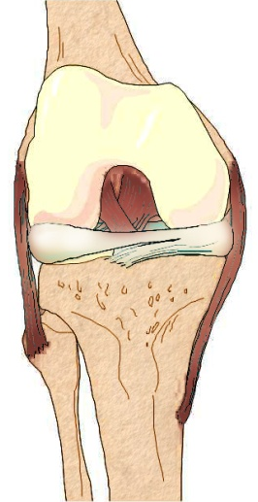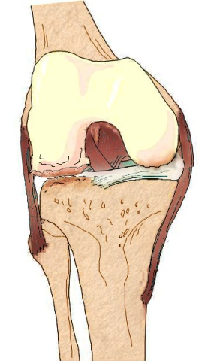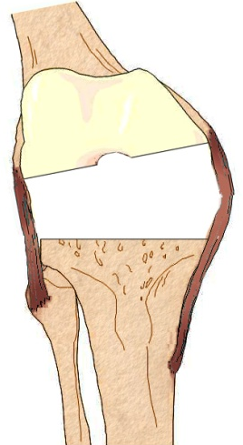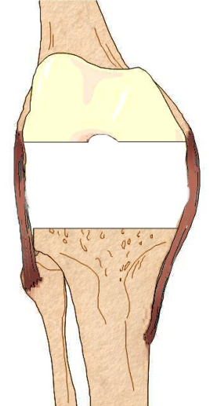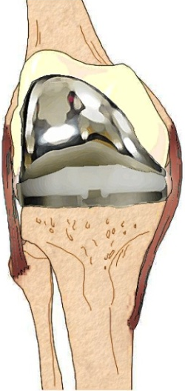
normal osteoarthritc bone cuts lateral release implanted
(valgus deformity) (unbalanced) (balanced)

Figure 2. Anterior view of the knee showing normal, osteoarthritic, and implanted knees.

Intraoperative Sensing
Incorporating sensors on standard surgical instrumentation during orthopaedic surgery is not a new goal for improving surgical outcomes, but it remains elusive in implementation with sufficient information gathering (sensing) and relevant, timely display to the surgeon. Computer-assisted surgery, or surgical navigation, is becoming more common in assessing bone resection and measuring implant alignment. Thus position-tracking devices (e.g. infrared passive/active, electromagnetic) comprise the bulk of the system; few, if any, companies have incorporated active sensors (e.g. pressure, temperature, etc.). Thus the alignment may be measured within millimeters but ligament balancing may be far from satisfactory, ultimately leading to premature failure of the prosthesis. Because of the high cost of surgical navigation systems, many are used for research purposes by highly experienced surgeons; the true intention of these systems is to allow precise surgeries for inexperienced surgeons or infrequent cases. The experienced surgeon may not require a navigation system except to complete unusual cases, to assess the quality of his or her skill, or to research new implants or approaches. However, the more inexperienced surgeon may benefit from a navigated approach to ensure proper implant placement, and is also more likely to mis-balance the medial/collateral ligament balancing.

Figure 3. An example of a flexion tensioning device by Booth et al. [9]

Various groups have developed devices to measure ligament balance in the knee during TKA. These devices are usually defined as tension measurement (distraction force measurement) or pressure measurement; tension measurement often has variable distraction distances so that force and distance stretched are measured in pairs. Pressure-sensing devices usually sense at a given height or distraction distance. Tensioning devices were developed first as a way to approximate the actual tension in the ligament, often using springs or screw mechanisms to apply forces to separate bones to stretch the ligaments. An example of this type of tensioner is shown in Figure 3. Tonichi, Inc, of Japan offers a torque gear system which is calibrated to measures distraction forces for soft tissue balancing. Asano, et al. found extension forces were 70.8-182 N and 70.8-169 N for flexion and showed no correlation between ligament tension and amount of post-operative flexion [10]. Using posterior cruciate ligament (PCL) spacers to tension ligaments, Wymenga et al. reported knee flexion gaps to vary between 17.3 and 20.5 mm with 100 N and 200 N tensions, respectively [11]. The tibial forces were measured to infer the ligamental tension (Figure 5). Viskontas, et al. used a tensioning device but noted no significant change in clinical outcome for the tension-balanced patients [12].
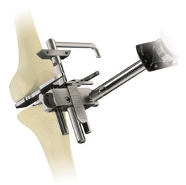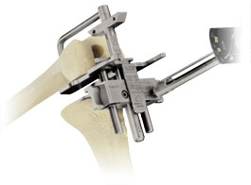
Figure 4. A tensioning device for extension (left) and flexion (right) marketed by Zimmer, Inc [13].

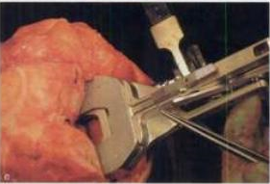
Figure 5. Posterior cruciate ligament tensioning spacer [11].

Designs that focus on pressure or force measurement rather than a net distraction force yield a more complete picture of the loading across the joint; however, inference of the amount of ligament tension is still necessary since no direct tension measurements are made. Moreover, the actual amount of tension in the ligament is rather unimportant, as the pressure distributions across the implant contact areas is the true variable the surgeon would like to affect during a balancing procedure with the goal of reducing stress and preventing wear to increase implant longevity. A pressure measurement device may be applied after initial resection but may be most useful if measurements are also taken after initial installation of the femoral and tibial components. The amount of externally applied load, especially by manual manipulation of flexion-extension exercises, could greatly affect the amount of load perceived by the sensor; thus a true passive flexion is ideal (no active muscle loads, no external loads- soft tissue passive constraint only).
Fuji pressure-sensitive films were initially used as a qualitative measurement of contact areas and peak pressures present within the knee (Fujifilm® Prescale Measurement Film). Two thin films encase a layer of microcapsules which rupture under applied pressure and react with a color developer; the stronger the pressure, the more beads ruptured, resulting in a darker areas for higher pressures. The ability to distinguish contact areas and pressure gradients make this the earliest, simplest type of “pressure profile”, and the 0.2-0.5 mm thick sheets can easily be used between any two articulating bodies. However, the static nature of the imprint (i.e., a single imprint for an entire range of motion) is a significant drawback, as is the subjectivity of quantifying or calibrating the dark imprints, making comparison between patients and between surgeons difficult. The Fuji films are also temperature and humidity sensitive, and the amount of time a given pressure is held may influence the outcome. Even using low-pressure prescale film, pressures lower than about 2 MPa are not discernable [14]. Takahashi et al. used such a film to examine contact pressure orientation across the tibial trial and aid in ligament balancing, finding improved lateral stability in Fujifilm® assessed patients and no difference in post-operative range of motion with subjects not examined with Fujifilm®.
The simplest pressure sensing device measures a single point on each side of the knee to return net forces acting through those points. Problems with this approach include underestimating the applied force if the force is not located directly above the sensor; there is no ability to locate the maximum pressure or amount of contact between the femur and the tibia. Wu et al. placed three load cells on each condyle so that the anterior, middle, and posterior thirds could be measured [15]. Suzuki, et al. present a similar design with three 12-mm force transducers per condyle [16]. Wallace used a Tekscan® (South Boston, MA) flexible resistive sensor sheet to measure contact areas and loads during various intraoperative loading conditions, and reported pressures up to 50 MPa for the unbalanced knee, and contact areas consistently less than 0.7 cm² [17]. Wasielewski, et al. used Novel® (Munich, Germany) capacitive sensing arrays to measure intra-articular pressure profiles during surgery, reporting forces up to 1.6 MPa (160 N/cm²) and contact areas up to approximately 4 cm² [18]. Optimal, balanced pressures were reported to be less than 0.4 MPa (40 N/ cm²). Harris compared a high-resolution resistive sensor (K-Scan by Tekscan®) with Fujifilm® Prescale measurement, and noted 11-36% decrease in contact area reported by analysis of the film as opposed to Tekscan digital measurements [19].

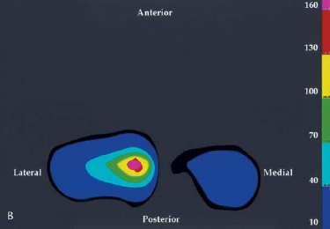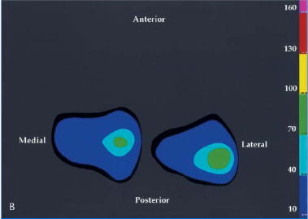
Figure 6. Wasielewski reported unbalanced (left) and balanced (right) pressure maps [18].

Instrumented Joint Prostheses
It is desirable to directly measure forces across joint replacements in vivo to assess surgical outcomes, implant design, and evaluate patient-specific biomechanics directly. A few research groups have done exploratory studies with instrumented joint prostheses on a small number of patients. Rydell was the first to measure in vivo forces that act within the femoral neck. He measured forces using a disk outfitted with a central strain gauge [20], and in 1966 published results using multiple strain gauges on the femoral head for hemiarthroplasty [21]. Using two different patients, Rydell reported 2.3 and 2.8 times bodyweight for static single leg stance and 2.9 and 3.3 times bodyweight, respectively, for dynamic measurements during gait. The sensors were accessed via wires through the skin. In 1979, English and Kilvington also instrumented a femoral stem for the hip that included telemetric readout, reporting loads of 0.17 times bodyweight supine on the operating table, 0.72 times bodyweight supine in bed one day post-operatively, and 2.56 times bodyweight during gait [22]. Hodge implanted a telemetric hip prosthesis for hemiarthroplasty in 1984 that included 14 load transducers at various positions across the femoral head, as shown in Figure 7. Ten of these sensors were viable at the time of implantation, and data was collected over the course of 3 years, with the sensors articulating directly onto acetabular cartilage [23, 24]. In each sensor, a diaphragm deflects due to articular pressures, which is detected by a strain-gauge based system utilizing a silicon-crystal cantilever. Radiofrequency (RF) telemetry was used to transmit the data wirelessly. For passive leg motion shortly after implantation, Hodge reports pressures around 1.7 MPa. Weight-bearing activities recorded include 5.5 MPa for unassisted walking, and the largest reported pressure, 18 MPa, was found during a standard chair-rise one year post-operatively [24].
Davy and Kotzar also explored in vivo measurement of forces acting across the hip by outfitting the femoral neck of a total hip replacement with three sets of strain gauges to form a triaxial telemetric load cell which was placed at the base of the ball as shown in Figure 7b [25]. Results were reported in terms of axial load and transverse in and out-of-plane loading. Passive loads and unassisted gait were not reported. Results
(a) (b)
Figure 7. a.) Instrumented femoral head by Hodge, et al. as reported in 1989. Black dots indicate non-functioning sensors. [24]
b.) Triaxial strain-gauge based telemetric hip implant by Davy as reported in 1988. [25]

No review of orthopaedic telemetric implants would be complete without reference to the seminal work of Bergmann et al., who started work in the early 1990s on telemetric sensing prostheses for joint arthroplasty. Beginning with the hip, strain gauges were used to measure resultant forces transmitted through the hip during various activities. During slow walking, maximum forces were 2.8 and 4.1 times bodyweight, respectively, for two patients [26]. Significantly higher forces were recorded for faster walking and stumbling. Refinements of the strain gauge placement, temperature compensation, and resultant shear force calculation and extensive study of post-operative kinematics has made Bergmann’s work a hallmark for in vivo telemetric sensing, both in terms of electronics and its impact on the biomechanics community to substantiate various models of the hip.
Figure 8. Bergmann’s design utilizing 6 strain gauges to measure the three forces and three moments occurring within the tube. The tube is then placed inside various implants for in vivo force monitoring. [27]

Bergmann’s work has since expanded to include the knee, utilizing a split-tibial component system incorporating six semiconductor strain gauges in the stem of the tibia, a 9-channel temperature sensing telemetry system, and a sampling rate of 125 Hz [27]. During in vitro mechanical testing at known points, Bergmann reports a load accuracy of 3%. The design was implanted in 2007.
Figure 9. Location of strain gauges (SG), and encasing tube (1) from Bergmann et al. Typically 6 strain gauges are used.

Table 1. Summary of Instrumented Joint Prostheses

Group | Joint | Details | Year
Rydell | hip | wires through skin | 1961, 1966
Carlson | hip | telemetric | 1971
English and Kilvington | hip | telemetric, battery powered | 1979
Barlow | hip | in vitro tests of instrumented implant only | 1984*
Davy and Kotzar | hip | telemetric, battery powered | 1988
Hodge‡ | hip | telemetric, inductively powered | 1989
Bergmann et al. | hip | telemetric | 1993
Rohlmann et al. | spine | internal fixation implant | 1995
Kaufman, et al. | knee | modified implant design, axial forces only 1996, tri-axial 2006 | 1996*
Bassey et al. | hip | telemetric, inductively powered, axial only, massive femoral | 1997
Bergmann et al. | shoulder | telemetric, inductively powered | 2001*
Bergmann et al. | knee | telemetric | 2005*
* indicates published material on the implant design without in vivo data, which was published later (with the exception of Barlow, et al.)
‡ Hodge continued the earlier work of Carlson.

Strain Sensing Modalities
The strain gauge is a foundational sensor in mechanical measurements because it couples mechanical and electrical effects to yield the measurement of strain in a particular direction. The change in length of a material when undergoing a given stress is related to the change in electrical resistance of a conducting wire or foil. Lord Kelvin first noted this phenomenon in 1856 when measuring wire resistance under tensile stress. In the 1930’s, Edward Simmons and Arthur Ruge used thin metal foil to create conducting traces on insulating sheets, or “carriers”. The assembly is then glued to the object to be stressed. Today, the foil lines are placed in a serpentine shape with the longest loops in the direction to be sensed, giving a compact sensor with a higher effective conductor length, which multiplies the change in resistance of the conductor for a given strain compared the change in resistance of a single straight foil line. An example of a typical strain gauge is shown in Figure 10. This enables a highly sensitive measurement of strains when measured with appropriate circuitry. Both tensile and compressive strains can be measured, provided no plastic deformation of the gauge occurs. The concept of the strain gauge has been fine tuned to produce reliable data primarily for measurement of tensile and bending surface stresses. Because a strain gauge only measures strains in a single direction, rosettes with gauges at various angles are often constructed to resolve strains in multiple directions to and enable calculation of stress tensors. However, the design of a conventional strain gauge mounted on a flat surface, as shown in Figure 10, does not enable measurement of out-of-plane strains; it must be mounted within a rosette such that the strains can be calculated from a system of equations generated by nearby strain sensors. It is also noted that the gauge area limits the ability to resolve the exact location of the strain; rather the measured change in resistance is a result of strains experienced across the active grid length of each loop. When arranged in a rosette, the spatial location between sensors also contributes to this error, albeit a minute error. These individual strains may vary from location to location across the surface of the specimen, but the active grid area is generally assumed to be small enough that the average value suffices.
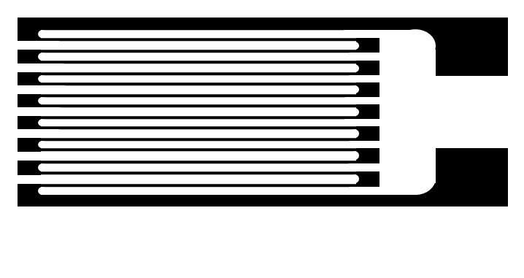
active grid length
solder pads
Figure 10. Typical foil strain gauge design.

The advent of semiconductor strain gauges enabled shrinking of the overall sensor, and increased sensitivity; the output of the sensor for a given strain is typically up to 50 times more than a typical foil gauge. Semiconductor gauges also perform over a larger range because of this increased sensitivity, and have higher fatigue lifetimes. However, they are more expensive than their foil counterparts,

Flexible Technologies
Flexible circuit technology has been available for interconnects, traces, and component mounting. Standard technology uses polyimide base layers with metal traces, which can be stacked to form multi-layer flex circuits. Polyimide is used for its desirable mechanical, electrical, and chemical and thermal properties, well as its low cost for mass production. Polyimide, trade name Kapton™ (DuPont®), may be used in sheet form, cast onto thin copper sheets, or spun onto silicon wafers as a step in the microfabrication process. Metal is deposited via electroplating or sputtering (with a nickel or chrome seed layer). The cheapest option is to adhere a rolled copper layer to the polyimide and subsequently etch away the unwanted copper. Typically layers are adhered together with acrylic adhesives or epoxy, which introduces an additional thickness which varies depending on manufacturer. Cast polyimide and sputtered copper approaches are both adhesiveless systems, yielding thinner, more flexible circuits. Stiffeners such as FR4 can be added for mechanical durability of connections with standard plugs and jacks. Flex circuits have become commonplace for applications with space constraints such as laptops, cameras, and phones. Process parameters have been optimized to allow trace widths down to about 50 micrometers.
Flexible sensing modalities specialized to pressure sensing include piezoresistive, piezoelectric, and capacitive approaches [28]. Resistive-based systems are available commercially using semi-conductive pressure-sensitive inks or resistive changes due to percolating networks within polymer-conductor composites. Tekscan® is probably the most popular company using this type of approach [29]. Commercial flexible resistive strain measurement is highly non-linear; therefore careful, frequent calibration may be necessary [30]. Performance may change due to environmental factors such as temperature, humidity, and load history. Classic metal-foil strain gauges have significant spatial resolution limitations; so some researchers have harnessed the accuracy and reliability of a semiconductor strain gauge on flexible substrates. Hwang et al. demonstrate silicon islands embedded in polyimide [31].
Capacitive measurement has also been successful on the market by layering driving lines and sensing lines across a top and bottom layer and placing a dielectric material between them. XSensor® uses a fabric-based approach with conductive threads and foam dielectric [32]. Novel® and Pressure Profile Systems® have also seen success in its capacitive force sensing arrays and offers stretchable arrays, but Novel® is more prevalent in clinical research [33, 34]. Capacitive measurement is valued for its high sensitivity and robust performance, but capacitor size constraints may limit spatial resolution. The change in capacitance must be large enough to reliably detect, making the high precision specialty electronics an essential and often expensive factor. Hierold et al. incorporate a micromachined capacitive sensor into the CMOS process itself [35, 36].
Piezoelectric pressure sensors typically yield low spatial resolution and poor temperature stability. However, piezoelectric sensors have been fabricated on flexible substrates by Akiyama and colleagues [37].
The desirable flexibility of polymers also carries inherent drawbacks such as hysteresis and creep; the extent of such influence can be accounted for during calibration. Many polymers have been incorporated into flexible strain sensing arrays as substrates or as dielectrics. The most common material is polyimide; other polymers used include polymethyldisiloxane (PDMS), polyethylene terephthalate (PET), SU-8 resin, parylene, liquid crystals, and various rubbers . Diaphragms are the most familiar capacitive design, but the micromachined silicon sensors have been difficult to effectively incorporate in flexible designs. Diaphragms of compliant materials make it difficult to keep strains within the elastic limit of the material which may reduce the sensor life and performance significantly. Solid construction using thin (nm) metals directly on flexible polymers is promising for contact pressure profiling.

Materials
Materials are of utmost importance in any sensor design; material properties dictate biocompatibility, processing parameters, and even sensing mechanisms.
Microelectromechanical systems (MEMS) emerged as a promising new field in the 1990s and has subsequently spread to include many biomedical applications in the last decade. However, the materials and processes used in microfabrication have been generally governed by the needs of the semiconductor industry. The Williams Dictionary of Biomaterials defines biocompatibility as “the ability of a material to perform with an appropriate host response in a specific application,” and few semiconductor materials can live up to this standard [38]. Functional requirements vary greatly between bioMEMS applications, thus requiring different levels of biocompatibility. Thus the biocompatibility of certain materials is tested according to ISO 10993 at minimum and tested according to the prescribed use as outlined in the United States Food and Drug Administration (FDA) blue book memorandum #G95-1, including animal implantation studies for the specific device materials, configuration, and enough data to demonstrate biocompatibility sufficient for patient safety over the life of the implant. Many successful bulk materials are currently in use with various implantable devices on the market are not compatible with traditional MEMS fabrication processes.
Two scenarios are available for in vivo operation of MEMS devices: 1.) use of standard MEMS techniques and implementation of a hermitic seal for biological use or 2.) utilization of biocompatible materials for design fabrication. Examples of hermitic seals include pacemakers’ laser-welded titanium cases, glass encapsulation of telemetric antennae [26], and many of these techniques require high temperature levels which are undesirable for bioMEMS devices. Wafer-level sealing techniques such as eutectic, anodic, and fusion bonding also necessitate the use of traditional semiconductor materials such as silicon, silicon dioxide, and polysilicon.
Deposition of thin polymer coatings have also been used to increase the biocompatibility of silicon-based MEMS devices by shielding non-compatible materials from the bodily environment and reducing corrosion and biofouling. Hanein, et al., demonstrate photolithographic patterning to create (poly) ethylene glycol-like polymer coverings on silicon substrates using glow discharge plasma polymerization of tetraglyme [39]. Ethylene glycol is a common biocompatible polymer know for its anti-fouling properties. Parylene has also been used to protect MEMs devices that cannot withstand high temperature processes, as its polymerization procedure at room temperature yields a pin-hole free completely conformal layer. Due to its non-polar nature, parylene shows poor adhesion to non-organic surfaces, and adhesion promoters such as silanes are not bio-friendly. Hsu et al. demonstrate hermitic sealing using parylene C on a neural probe “bed of nails” design [].
A few researchers have turned to the second option of direct fabrication from biocompatible which allows device electrode contact with the body, which is essential for many bioMEMS applications, such as neural interfaces and drug delivery devices. In cases where mechanical loading may cause surface wear, surface materials must also show sufficient fatigue strength to determine that undue wear does not occur. The coefficient of friction is a factor in wear consideration, and all layers must be biocompatible so that any wear debris that may be released is not additionally irritating to the body. In addition, many traditional MEMS materials such as silicon are brittle and unsuitable to undergo loading in the body due to cracking, and do not match the compliance of other implant biomaterials and could thus cause stress shielding or stress concentrations, depending on the application.
As bioMEMS have been developed for monitoring in vivo conditions, existing integrated circuit fabrication materials and processing techniques have been harnessed for bioMEMS purposes. At first, there was little or no substantive evidence of biocompatibility of these materials. First efforts involved testing of materials in for specific applications such as implant coatings , not necessarily MEMs applications. Kotzar et al. performed baseline ISO 10993 biocompatibility and sterilization tests on single crystal silicon (Si), polysilicon, silicon oxide (SiO₂), silicon nitride (Si₃N₄), single crystal cubic silicon carbide (3C-SiC or b-SiC), titanium (Ti), and SU-8 epoxy photoresist [40]. The results are promising, and silicon-based microdevices show good results in animal testing.
An opposite approach is to take existing biomaterials and develop new microfabrication techniques or tweak cleanroom processes to accommodate existing biomaterials.
This dissertation focuses on MEMS pressure sensor arrays intended for eventual in vivo operation, with the recognition that the fabrication processes here may be applied to other types of bioMEMS devices.

Research Design and Methods

Introduction
The sensing array must be optimized for the application pressure range. Various design constraints include the following:
- Maximize sensor pressure resolution (i.e. maximize change in capacitance within the desired pressure range)
  - linear sensor response
- Maximize array spatial resolution
  - minimize crosstalk
  - minimize parasitic capacitance
- Maintain sensor output levels within range for readout

In addition, requirements for material selection include the following:
- Biocompatible for prolonged bodily contact
- Sterilizable without harm to the sensor or electronics OR disposable
- Maintain elastic deformation- no permanent deformation

Table 2. Common applications for pressure sensing arrays.
Application | Pressure
Vascular pulse (75-150 mmHg) | 10 – 20 kPa
Human fingertip texture, shape sensing | 10 – 40 kPa
Hand grip | 0 – 100 kPa
Fingerprint sensor | 1 – 2 kPa
In-shoe pressures | < 1 MPa
Tactile robotics | 10 – 100 kPa
Passive knee flexion  Wasielewski  Wallace | 0 – 1.6 MPa*  0 – 50 MPa*
Weight-bearing knee flexion | 0 – 32 MPa†
* Wasielewski reported contact areas around 4 cm² [18], while Wallace reports contact areas around 0.5 cm² [17]. Both used sensing arrays to take intraoperative measurements.
†Maximum individual pressure reported by Sharma, et al. from patients with mobile and fixed-bearing total knee replacements [41].

Strain sensing is accomplished by embedding pairs of electrodes with specific geometries in a biocompatible material. Deformation of the embedding materials causes changes in the configuration of the capacitor electrodes. This deformation is sensed as a change in capacitance by the ultra-sensitive readout electronics, as illustrated in Figure 11.

Signal
Time
no force
Figure 11. Conceptual illustration of a parallel plate capacitor under incrementally increased loading.

The theoretical relationship between strain and change in capacitance is discussed in section C.3.1.

Concept for Application in Orthopaedic Surgery
The proposed capacitive pressure-sensing arrays can be used at multiple junctures during TKA, depending on which instrument is outfitted with sensors. When mounted on a flat spacer block, the ligament balance after initial bony resection can be measured; the gaps between the distal femur and the proximal tibia (in extension) and the gap between the anterior femur and proximal tibia (in flexion) can be checked for correct resection amount and resection angle. When adhered to a provisional (mimicking the shape of the polyethylene insert), the knee can be checked after final installation of the femoral and tibial components; the height of the polyethylene component can be varied for optimal ligament tension and medial or lateral release as required to optimally balance the knee. The pressure-sensing provisional provides pressure and contact area information for any angle within the range of motion of the knee, allowing the surgeon to detect and correct any abnormal tightness or laxity at any flexion angle.
The output of the pressure sensing array is a two-dimensional colormap so that areas of high and low pressure are easily identified by color, as shown in Figure 12. Numerical values for average pressure and area per condyle are also updated in real time on the screen.
Figure 12. Concept of 2D pressure profile display for intraoperative use. Pressure values and contact areas are updated in real time.

Figure 13. Clinical intraoperative trials utilizing a knee positioner that slides the ankle forward to yield consistent passive flexion of the knee. A surgical navigation system measures the actual flexion obtained.

Theoretical Analysis

Electrical Effects of Parallel Plate Capacitors
An understanding of dielectric material properties is necessary to interpret the performance of a capacitive sensor. Metals and other conductors have loosely bound outer electrons or “free electrons” that are available to move about the material, enabling the conduction electrical current (flow of electrons). Electrical conductivity is a measure of the relative mobility of free electrons within the material. Dielectrics are a subset of insulators which do not contain many, if any, free electrons, which inhibits electrical conduction. The term “dielectric” was coined by William Wehwell [42] and describes insulators (non-metals) which can sustain electric fields.
The electric susceptibility of the material, χ_{e} , measures the ability of a dielectric material to polarize under an electric field and is directly related to the dielectric constant as shown in Equation.
$$χ_{e}=ε_{r}-1$$ | (1)
The dielectric constant is also called the relative static permittivity. The permittivity of free space, $ε_{0}$, is the permittivity of a perfect vacuum in farads per meter and is defined to be
$$ε_{0}≝\frac{1}{cμ_{0}}≈\frac{1}{2.9979∙{10}^{8}(4π∙{10}^{-7})}≈8.854∙{10}^{-12}$$ | (2)
Where c is the speed of light in meters per second and $μ_{0}$ is the permeability of free space in henrys per meter, also known as the magnetic constant [43]. Thus $ε_{0}$ has units of farads per meter and $ε_{r}$ is therefore unitless, as shown in Equation. In some texts, the dielectric constant is referred to with the symbol κ, and has given rise to the terms “high- κ” and “low- κ” to designate dielectrics at each extreme.
$$ε_{r}=κ=\frac{ε_{s}}{ε_{0}}$$ | (3)

Basic Principles of Parallel Plate Capacitors
The operation of a parallel plate capacitor and the influence of a dielectric material can be easily understood working from basic principles. A single, infinite charged plate in a vacuum carries a surface charge, σ, and the resulting electric field is constant at a given distance away from the plate, i.e. electric field lines run parallel to the infinite plate (Equation ). Points closer to the plate experience a larger electric field, and the magnitude of the field decreases as the observation point is moved farther from the plate.
$$E=2πkσ=\frac{σ}{2ε_{0}} where σ=\frac{Q}{A}.$$ | (4)
In placing two infinite sheets of equal but opposite charge next to each other, separated by a distance, d, the electric fields cancel out, resulting in a net zero electric field.
$$E=-\frac{σ}{2ε_{0}}+\frac{σ}{2ε_{0}}=0$$ | (5)
Between the plates, however, the electric field is additive, resulting in a net electric field given by
$$E=\frac{σ}{2ε_{0}}+\frac{σ}{2ε_{0}}=\frac{σ}{ε_{0}}.$$ | (6)
The electric field is constant between the two oppositely charged plates, forming a capacitor. The electric field is the negative gradient of the voltage,
$$\overset{⃑}{E}=-∇V.$$ | (7)

If we define a coordinate axes so that the plates lie within x-y planes separated by a distance, d, along the z-axis, we can then see that the electric field (a vector quantity), points in the z-direction (neglecting edge effects). Then Equation can be reduced to form Equation . In the case of a parallel plate capacitor, since the electric field is constant (Equation), and the distance between plates, d, is fixed, then
$$\overset{⃑}{E}=-\frac{dV}{dz}= -\frac{V}{d}.$$ | (8)
The capacitance is related to the voltage by the relation
$$C=\frac{Q}{V}$$ | (9)
If the plates are then separated by a dielectric medium with a relative dielectric constant, $ε_{r}$, then equation becomes
$$E=\frac{σ}{ε_{0}ε_{r}}=\frac{Q}{ε_{0}ε_{r}A}.$$ | (10)
The introduction of a dielectric medium results in a net reduction of the electric field within the capacitor by a factor of 1/$ε_{r}$. Combining Equations and , we see that the capacitance is constant regardless of the voltage applied and is related to the plate area, A, the plate separation distance, d, and the dielectric constant of the material between the plates, as shown in Equation.
$$C=\frac{Q}{Ed}=\frac{Q}{\left(-\frac{Q}{ε_{0}ε_{r}A}\right)d}=\frac{ε_{0}ε_{r}A}{d}.$$ | (11)

A Classical Approach
In a classical model of dielectrics, each individual atom is represented by a positive point charge surrounded by a negatively charged electron cloud. When an electric field is applied, the negative charge cloud is distorted, creating a dipole between the positive charge and the net position of the negative charge cloud. The dipole moment is a function of the applied electric field. The specific dielectric properties of a given material are influenced by atomic interactions, molecular structure, homogeneity, isotropy, and presence of contaminants.
The polarization of the dielectric material creates an opposing electric field which yields a smaller net electric field within the dielectric without altering the direction. The polarization, $\overset{⃑}{P}$, is defined between the center of the negative (shifted) electron cloud and the positive center, and can be shown to be frequency dependent in time-varying electric fields.
$$\overset{⃑}{P}=ε_{0}χ_{e}\overset{⃑}{E}$$ | (12)
The flux density within the dielectric is a vector field given by
$$\overset{⃑}{D}=ε_{0}ε_{r}\overset{⃑}{E}$$ | (13)
Using equations #, #, and #, the flux density is related to the polarization density
$$\overset{⃑}{D}=ε_{0}\overset{⃑}{E}+\overset{⃑}{P}$$ | (14)
In a simple parallel plate capacitor, two conducting plates are separated by a dielectric material; a voltage is then applied across the capacitor, causing charge to build up. To calculate the flux density, D, within a parallel plate capacitor, Gauss’ law is applied with Equation #, the total charge, Q, is
$$Q=\oint_{A}{\overset{⃑}{D} dA}$$ | (15)
$$∇∙\overset{⃑}{E}=\frac{ρ_{v}}{{ε_{0}ε}_{r}}$$ | (16)
where $ρ_{v}$ is the volumetric charge density. The gradient of the voltage gives the electric field, as shown in equation #.
$$\overset{⃑}{E}=-∇V$$ | (17)
Combining equations # and #, the Poisson equation is obtained:
$$-∇∙∇V={-∇}^{2}V=\frac{ρ_{v}}{ε_{0}ε_{r}}$$ | (18)
The net volumetric charge density within the dielectric is zero, and the Laplace equation is then formed.
$$∇^{2}V=0$$ | (19)
For the case of a parallel plate capacitor, a voltage, V₀, is applied to one plate, and the other plate, at some distance d from the first plate, carries zero voltage, which allows the formation of Equation 20 from Equation 17, showing that the electric field has constant magnitude between the conductive plates and inversely proportional to their separation distance; electric field direction is also constant and normal to the plate orientation. In Cartesian coordinates, it is customary to define the plate geometry within the x-y plane, which results in an electric field in the z-direction.
$$E=-\frac{V_{0}}{d}$$ | (20)
Combining with Equation 17, an expression for the total charge is obtained:
$$Q=ε_{0}ε_{r}AE=-ε_{0}ε_{r}A\frac{V_{0}}{d}.$$ | (20)

Similarly, if the individual charges, q, are evenly distributed across each plate of the capacitor and the plate area is significantly larger than the plate separation distance, the electric field, $\overset{⃑}{E}$, can be written in terms of the charge across the plates
$$E\left(t\right)=-\frac{q(t)}{ε_{0}ε_{r}A}$$ | (21)
Combining with Equation 17,
$$-∇V=-\frac{q(t)}{ε_{0}ε_{r}A}$$ | (22)
which parallels Equation 10 in the previous section. Capacitance is defined as the ratio of charge carried versus applied voltage:
$$C=\frac{Q}{V}.$$ | (23)
Rearranging Eq. 20 or Eq. 22 yields the expression for capacitance of a parallel plate,
$$C=\frac{ε_{0}ε_{r}AV_{0}/d}{V_{0}}=\frac{ε_{0}ε_{r}A}{d}.$$ | (24)

Practically speaking, a higher dielectric constant causes further reduction of the electric field within the dielectric material, which increases the charge stored and thus increases the capacitance. For a parallel plate capacitor, capacitance is independent of the voltage applied.

Capacitance and Stress-Strain Relationships
Changes in stress affect the dielectric material, causing changes in capacitance. The following section describes the relationship between applied stress and corresponding changes in capacitance for a parallel plate capacitor undergoing loading. The nominal capacitance, defined in Eq. 24, corresponds to a capacitor in an unstressed state.
Figure 14. (a) Unstressed capacitor, (b) Applied axial stress and resulting deformation, δ, and (c) deformation θ due to shear stress.
In the case of axial stress, deformation in the axial direction causes the capacitive plates to move closer to one another. Due to Poisson effects, compressive loading also results in slight lengthening of the dielectric in directions perpendicular to loading, which yields a larger electrode area. When undergoing pure shear, the distance between plates remains unchanged except by Poisson effects, and the effective electrode area of the parallel plate configuration is reduced (Figure 14c).
Investigation of these loading effects is best illustrated with a rectangular parallel-plate capacitor, where Eq. 24 defines the theoretical capacitance as
$$C=\frac{ε_{0}ε_{r}LW}{D}.$$ | (25)
Where L and W are the electrode length and width in the x and y directions respectively, and D is the plate separation in the z direction. Upon loading the capacitor in the z-direction, deformation occurs within the dielectric in each of the three Cartesian directions to produce
$$C=\frac{ε_{0}ε_{r}\left(L+δ_{L}\right)(W+δ_{W})}{(D+δ_{D})}.$$ | (26)
The strain is defined as
$$ε_{x}=\frac{δ_{L}}{L} , ε_{y}=\frac{δ_{W}}{W} , and ε_{z}=\frac{δ_{D}}{D} .$$ | (27)
Eq. 26 is rewritten in terms of strains
$$C=\frac{ε_{0}ε_{r}\left(L(1+ε_{x}\right))\left(W(1+ε_{y})\right)}{\left(D(1+ε_{z})\right)}.$$ | (31)
The Poisson ratios coupling the different directions are given by
$$\frac{ν_{xy}}{E_{x}}=\frac{ν_{yx}}{E_{y}} , \frac{ν_{xz}}{E_{x}}=\frac{ν_{zx}}{E_{z}} , and \frac{ν_{yz}}{E_{y}}=\frac{ν_{zy}}{E_{z}} .$$ | (28)
For axial loading of the parallel plate capacitor, the coupling with the z direction is of primary interest. Only the dielectric is considered for simplicity, but thin film properties and anisotropy make further simplifying assumptions a necessity. A generalized Hooke’s law is employed:
$$ε_{x}=\frac{1}{E}[σ_{x}-ν\left(σ_{y}+σ_{z}\right)]$$ | (33)
$$ε_{y}=\frac{1}{E}[σ_{y}-ν\left(σ_{x}+σ_{z}\right)]$$ | (34)
$$ε_{z}=\frac{1}{E}[σ_{z}-ν\left(σ_{x}+σ_{y}\right)]$$ | (35)
With loading only applied in the z direction, Eqns. 33-35 are simplified to
$$ε_{x}=\frac{-νσ_{z}}{E}$$ | (33)
$$ε_{y}=\frac{-νσ_{z}}{E}$$ | (34)
$$ε_{z}=\frac{σ_{z}}{E},$$ | (35)
which can be substituted into Eq. 31 to obtain an equation for the capacitance under applied axial loading, as shown in Eq. 36.
$$C_{σ_{z}}=\frac{ε_{0}ε_{r}\left(L(1-\frac{νσ_{z}}{E})\right)\left(W(1-\frac{νσ_{z}}{E})\right)}{\left(D(1+\frac{σ_{z}}{E})\right)},$$ | (36)
which simplifies to
$$C=\frac{ε_{0}ε_{r}LW}{D}∙\frac{{\left(1-\frac{νσ_{z}}{E}\right)}^{2}}{\left(1+\frac{σ_{z}}{E}\right)}.$$ | (37)
For a parylene dielectric layer with ε_{r} = 3.1, E = 2.76 GPa, and ν = 0.4, the Poisson effect is negligible, making the term${\left(1-\frac{νσ_{z}}{E}\right)}^{2}≈1.$
This can be generalized to calculate the predicted capacitance under axial strain using any plate geometry of area A within the x-y plane:
$$C=\frac{ε_{0}ε_{r}A}{D\left(1+ε_{z}\right)} .$$ | (39)
For a negative (compressive) strain, the capacitance increases. Similarly, the change in capacitance is derived as
$$∆C=\frac{ε_{0}ε_{r}A}{Dε_{z}} .$$ | (39)

Sensor Design
Sensor output optimization includes consideration of factors like electrode shape, size, spacing, dielectric thickness, dielectric properties, and material modulus. To judge what electrode size and shape is appropriate, the electrode size (area, A) was plotted against capacitance (Equation 11). Various dielectric thicknesses were plotted to visualize the inversely proportional relationship between capacitance and dielectric thickness.
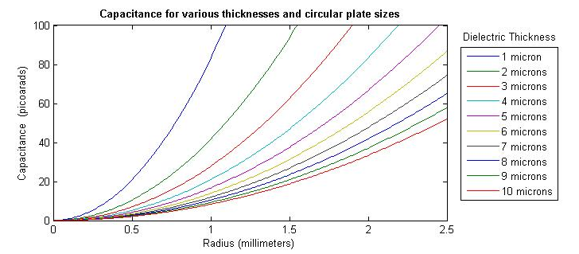Figure 15. Circular electrode design with varying dielectric thicknesses.

As seen in Figure 15, a circular electrode with a 0.5 mm radius and 1.0 micron thickness results in a nominal capacitance of about 20 picofarads. A thicker dielectric experiences more displacement between the electrodes when a normal force is applied, but thicker dielectrics also cause decreased nominal capacitance. Thus the dielectric thickness must be thin enough to maintain a reasonable nominal capacitance but thick enough and soft enough to yield a measurable change in capacitance when strained.
A square design was also plotted for comparison (Error! Reference source not found.). A 1 mm side dimension yields a capacitance of (compared to the ~20 pF for the 0.5 radius circular design).
With a parylene dielectric thickness of 1.5 μm and a desired nominal capacitance of 5 pF, the redius of the required circular electrode is 295 μm. Because the capacitance is inversely proportional to the dielectric thickness, the change in capacitance is expected to be highly non-linear for large deformations, as shown in Figure 16.
Figure 16. Capacitance change with large dielectric deformation up to 1 μm (ε= 666,666 microstrain).

However, such large deformations are not realistic for most dielectric materials. For the case of a parylene dielectric described above, an applied axial stress of 2 MPa results in a strain of 725 microstrain, which corresponds to a dielectric deformation of 1.09 nm.
Figure 17. Analytically-predicted change in capacitance for small scale deformation up to 6 nm
(ε= 4,000 microstrain, corresponding to σ=11000 GPa). Dotted line denotes estimated operating range of the sensor.

As Figure 17 shows, when the applied stress is within the MPa or even GPa range, the predicted sensor output is quasi-linear.
The sensor may be considered “solid state”, as there are no moving parts (e.g. diaphragms), and the pressure ranges and output capacitance can be controlled by the choice of dielectric medium. Stiffer dielectrics enable higher pressure operating ranges, while softer dielectrics enhance resolution of lower pressure ranges. For a fixed plate dimension, the dielectric constant of the material determines the nominal capacitance and influences the change in capacitance for a given load, making higher dielectric constant materials more desirable.

Experimental Design and Methodology
First, a robust microfabrication scheme must be established, and then experimental study of performance and fabrication changes for various dielectrics and substrates can be carried out. The processing parameters, material properties, and electrical characteristics are all influenced by the microfabrication process; standard semiconductor processing uses silicon wafers. Once a process has been established, the sensors are made on a variety of substrates, changing process parameters as needed to accommodate the variance in properties from one material to the next. The devices must be inspected for electrical continuity and electrodes inspected for proper adhesion to the substrate. The sensors are then removed from the wafer and mounted on FR4 printed circuit boards (PCBs). Last, the sensors are tested under axial loading conditions to establish their performance and robustness. This experimental flow is iterated until both the design and method are firmly established for the chosen materials and desired performance specifications.

Photolithography
A modified photolithographic fabrication approach is proposed, where a 4-inch silicon wafer is covered with a base film and a number of photolithography, metallization, and liftoff steps are used to create the two electrode layers and the dielectric layer separating the electrodes. Since polyimide is more common in semiconductor fabrication, it is used first to establish the protocols necessary for a polymeric substrate, which can then be customized for other substrate materials.
Figure 18. Photolithography method using polyimide as a substrate.

A photolithography plan is shown in Figure 19 and is used to pattern one layer of the sensing array. The process is repeated for subsequent layers that require electrode patterning.
Figure 19. Photolithography process for fabrication of microelectrodes on the material.

Materials Selection
Selection of appropriate materials is one of the most important factors in ensuring proper function and longevity of the sensing array. The elastic (Young’s) modulus and Poisson ratio affect the amount of strain present for a given stress; the amount of strain is related to the change in capacitance. The dielectric and conductive properties of the materials give also directly affect the nominal capacitance of the sensor. However, the practicality of fabrication and the necessity of biocompatibility impose the primary design constraints. Practicality of fabrication includes the following considerations:
- Ability to process in conventional machines designed for semiconductor use:
  - Must not contaminate the machine with byproducts during development, etching, and exposure to ultraviolet radiation.
  - Must not significantly degrade, lose bulk properties, or become inherently non-biocompatible when exposed to solvents, mild bases (i.e., developer), reactive ion etching, or vacuum conditions.
- Must be flexible.
- Must be manufactured to ensure uniform thin film thickness of the material.
For intraoperative use, biocompatibility dictates that the material must not produce an adverse reaction for the given exposure time (i.e. minutes). The material must also not release any harmful debris or substance if damaged during typical use. For implant use, the material must remain inert for an extended period of time (i.e. years), remain functional and intact while withstanding weightbearing loads, and, if cover material is eroded away by wear mechanisms, must not further irritate the joint when the sensor is exposed. In addition, the material must be integrated with existing surgical or implant components while maintaining structural integrity and. This requires compliance matching and shape considerations to decrease or eliminate stress concentrations within the instrument and must also maintain the structural integrity of the device.
Materials that meet basic biocompatibility requirements were selected for initial testing of fabrication. These materials and their reason for initial selection are listed in Table 3.
Table 3. Materials Selected for Initial Investigation
Material | Reason for Selection
Ultra-high molecular weight polyethylene (UHMWPE) | FDA-approved. Common material in joint replacement.
Polyimide | Used in standard flexible circuits (via electroplating). Demonstrates basic biocompatibility. [44]
Parylene C | Biocompatible conformal thin film coating.
Polydimethylsiloxane (PDMS) | generally biocompatible in animal studies, flexibility can be varied by adjusting amount of stiffener
Polymethylmethacrylate (PMMA) | Used as photoresist for electron-beam lithography, also used in bulk form in orthopedic implant fixation.
SU-8 | biocompatible epoxy-based photoresist

The method of manufacture is the primary factor in final material thickness. Thickness affects the overall flexibility of the sensing array when used as a substrate, and when used as a dielectric, the thickness should be as thin as possible to maximize the nominal capacitance. In addition, for materials that cannot be deposited directly onto the substrate, a layer of adhesive may be necessary to assemble the device, which introduces additional thickness. Medical-grade UHMWPE (Figure 20) is often manufactured by compression molding which substantially limits the ability to make thin specimens, which may also require subsequent annealing to flatten thin samples. Implant components can also be made from machining extruded UHMWPE rods. High and low molecular weight polyethylene may be extruded into sheets or even films, and can be used a tape when an adhesive is applied to one side of a polyethylene film. Polyethylene films are typically low to mid molecular weights designed for non-stick tape applications. Polyimide can also be manufactured in extruded sheet form, and is available in liquid form for spinning directly onto a wafer to obtain thinner layers. The amount of solvent present affects the viscosity of the polyimide and thus dictates thickness when spinning. Care must be taken to properly cure the polyimide to obtain the material properties desired in the final polyimide film. Some formulations of polyimide are photoreactive and can be used in place of photoresist. Parylene C is deposited in a vacuum chamber by a vaporization-pyrolysis-deposition process as shown in Figure 22. Manufactured by Dow Corning as Sylgard Elastomer 184, PDMS is prepared by mixing the base with stiffener, pouring, and subsequent curing. PDMS can also be spun onto a substrate to obtain thinner layers; additives may be necessary to thin the liquid prior to spinning to obtain thinnest results. The basic chemical composition of PDMS is shown in Figure 24. The length and temperature of curing, presence of additives, and method of mixing all influence whether pinholes are present in the final film. PMMA is commonly used in semiconductor processes as a resist (i.e. for electron beam lithography) or as a sacrificial layer. Both applications utilize spin-on and partial or full curing by baking (Figure 23). PMMA is used in bulk form in orthopaedics as bone cement for implant fixation. Polymerization is rapid and exothermic, requiring mixing in the operating room directly prior to application to the bone.
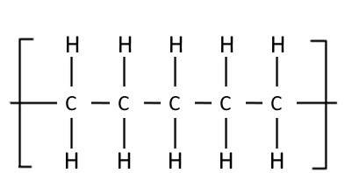
Figure 20. Polyethylene, showing five blocks. Crosslinking can be obtained by crosslinking agents during polymerization or by gamma irradiation.

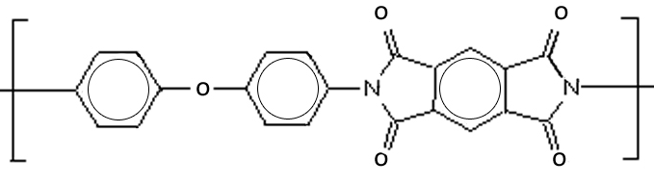
Figure 21. Chemical composition of polyimide (Kapton® Dupont) after curing. Variation may occur between brands and can be changed for intended use (e.g. photosensitivity, etc).


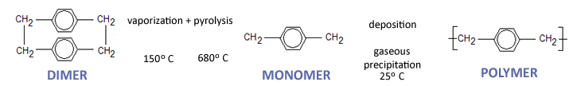
Figure 22. Parylene deposition process.
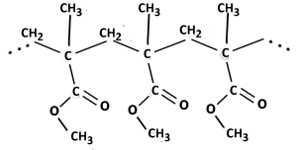

Figure 23. Chemical composition of PMMA, showing a chain of three monomers.
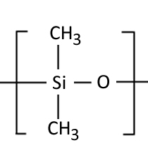
Figure 24. Chemical composition of PDMS.

Surface Modification of Substrates
Any of the materials in the previous section can be used as a substrate; the only requirements are a flat, 4-inch disk for processing in semiconductor equipment, flexibility upon device completion, and proper adhesion of electrodes and dielectrics. The low surface energy of polyimide and especially polyethylene may require surface modification to improve adhesion characteristics prior to sensor fabrication on these substrates. A plasma surface activation and nanoroughening is proposed to improve adhesion and raise the overall surface energy. The reactive ion etch (i.e. plasma) bombards the surface with high energy gas, resulting in physical removal of material (roughening) and also undergoing chemical reaction with surface polymer chains, breaking them, or reacting with them to form functionalized groups (Figure 25). It is proposed to test both oxygen and nitrogen low-pressure plasmas’ effects on polyethylene to optimize the surface for microfabrication. Plasma gas, flow, power, exposure time, and shelf life are all factors affecting the surface modification.

Figure 25. Plasma surface modification scheme.

A simple measure of surface energy can be obtained via sessile drop contact angle measurement; deionized water is a standard fluid for contact angle measurement. High contact angles represent low surface energies; lower contact angles correspond to higher surface energies. Other fluids can be measured to create enough datapoints to calculate the surface energy of the sample. The half-angle measurement method measures the radius of the drop and the height of the drop to find half the contact angle, as illustrated in Figure 26. In a typical sessile drop measurement setup, a microdrop is dispensed onto the surface of interest, and the drop is magnified and projected onto a measurement grid for reading. The reading must be taken quickly before the microdrop evaporates; evaporation causes a rapid decrease in contact angle.

Figure 26. Contact angles: large >90° , medium 90°, and small >90°. Dotted lines show the contact angle; the half-angle measurement method is shown in solid lines.

Contact angle measurement is an economical and repeatable method of establishing whether or not the plasma treatment has indeed modified the surface of the polymer. Young’s equation [45] describes the behavior of the drop:
$$cosθ=\frac{γ_{solid-}γ_{interface}}{γ_{liquid}}.$$ | (22)
Similarly, the work of adhesion is described as

$$W_{adhesion}=γ_{liquid}\left(1+cosθ\right)=γ_{substrate}+γ_{film}-γ_{interface}.$$ | (23)

The surface roughness before and after plasma treatment can be characterized by profilometry and/or atomic force microscopy.
To measure the amount and type of surface functionalization, the surface should be measured immediately after treatment. Ideally measurement occurs in a vacuum environment before the sample is exposed to air to reduce oxidation and degradation of functional groups. X-ray photoelectron spectroscopy (XPS) can identify the composition of surface elements within the top 1-10 nm and their chemical states, while also giving an idea of the distribution of those elements when multiple scans are combined. Secondary Ion Mass Spectrometry (static or dynamic) is also capable of measuring surface elements on the sample; a focused ion beam is directed at the surface while ejected surface atoms are measured. Static SIMS may only damage the top few angstroms of the sample, but dynamic SIMS may damage deeper levels (i.e. microns). However, both XPS and SIMS systems are expensive and access is often limited.

Choice of Dielectric
Based on the manufacturing processes governing thickness and the dielectric constant of each material, the theoretical capacitance was calculated for a capacitor with 500 µm diameter plates using different dielectric materials, as shown in Figure 27. Parylene is the optimal material, resulting in a theoretical capacitance of 3.5 pF, primarily due to the 1-2 µm dielectric thickness and absence of adhesive. Parylene was selected as the dielectric for future experiments.
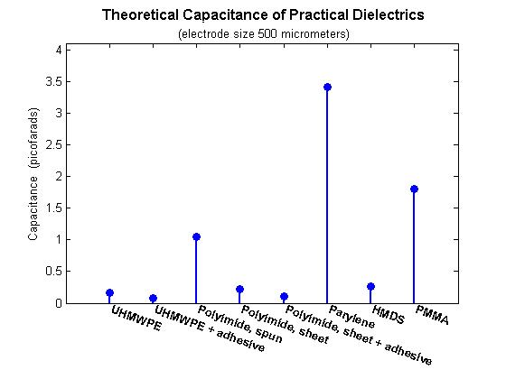
Figure 27. Capacitance using 500 µm diameter plates and laboratory-accessible dielectrics of practical thicknesses.

Mechanical Testing
The sensing array should be calibrated and validated within the application pressure range on a mechanical testing machine. The sensor response to loading and unloading, hysteresis, baseline drift, and resolution are established under known compressive loads from 0 to 2 MPa (Table 2). The ability to map pressure profiles across the sensing array is also demonstrated in benchtop testing.

Preliminary Results

Sensors on Silicon Substrate
An array of parallel plate sensors was designed to find normal forces by measuring axial strain [46]. This array was also used to verify the ability to use a row-column addressing technique to measure the values of individual capacitors. As shown in Figure 15, the upper electrodes of the sensors are connected in series by row and the lower electrodes are connected in series by column.
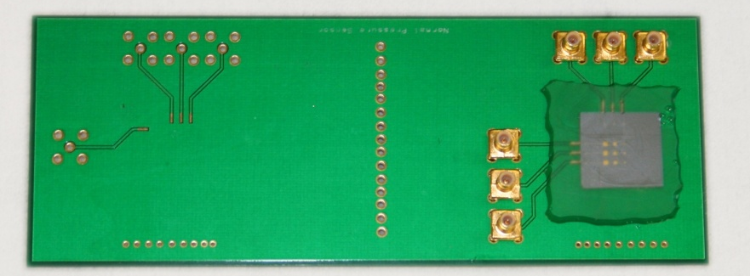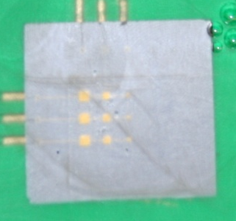
Figure 28. Parallel plate array fabricated on silicon wafer and mounted on FR4 printed-circuit board for testing.

Individual sensors are addressed by activating the row and column of the sensor of interest. A 3x3 array was constructed with one row each of 10 pF, 5 pF, and 1 pF predicted nominal capacitance using square electrodes.

Fabrication
In order to determine the effect of nominal capacitance on noise and sensitivity, 1 picofarad (pF), 5 pF, and 10 pF capacitors with the dimensions of 275 by 275 micrometers (μm), 614 x 614 μm, and 867 by 867 μm, respectively. The electrodes are a 10 nm titanium layer for adhesion and 300 nm of gold with a 2 μm layer of parylene as a dielectric.

Validation and Testing
The array of sensors was tested using an MTS (Eden Prairie, MN) 858 mechanical testing machine with a 2.5 kN load cell. The sensors were loaded at a rate of 2.5 pounds per second until the peak load was achieved, and then held for 2 minutes before unloading at a rate of 2.5 pounds per second. Peak loads were 25, 50, and 75 pounds and were run consecutively with 2 minutes hold at zero load after each load/unload cycle. Figure 29 shows a plot of the loading profile and corresponding sensor output.
Capacitance was measured with an Agilent (Santa Clara, CA) 4285A LCR meter at 1 MHz. Calibration of the meter was performed both shorted and open with the shielded cables to eliminate cable and other fixtures’ capacitance contributions. Sixteen samples per second were taken, and average values were recorded every second to Labview via GPIB (National Instruments, Austin, TX). Load cell data was also recorded each second.

Table 4. Parallel plate sensors on silicon substrates: Testing Results. Data reformatted from [46].
Sensor | R² Coefficient | Capacitance Change with Pressure
 |  | per kPa | per psi
10 pF | 0.936 | 2.887 aF | 64.1 aF
5 pF | 0.992 | 1.87 aF | 41.5 aF
1 pF | 0.938 | .500 aF | 11.1 aF

Figure 29. Load profile for capacitance array test. Test is from array element B2, which is a 5 pF capacitor [46].

Conformable Arrays
Although stiff sensor arrays can be configured for adequate pressure measurement on flat surfaces, such as a surgical spacer block, flexible arrays offer significant promise for use in surgical instrumentation. These custom capacitive sensors can operate in a flat configuration or conformed to a curved surface and secured with adhesive, as illustrated in Figure 30. Prototype unicondylar flexible arrays placed on a provisional.. The sensors measure forces normal to the surface, which is especially useful for contact pressures between articulating surfaces. The ability to flex should be distinguished from the ability to stretch. Flexibility implies the ability to bend in multiple directions, while stretchability adds the ability to withstand significant strain within the plane of the sensing array. A flexible circuit favors uses where there is bending primarily about a single axis, since large angles of bending about other axes may cause wrinkling of the material. Thus a stretchable material enables better conformity for an irregular surface, especially at sharp points. In the experimental sections and discussion that follow, “flexible” and “conformable” are used interchangeably and do not imply any stretchability (i.e. a flexible film can be conformed to a surface given no sharp changes in surface topology).

Proof of Concept
First, a flexible parallel plate capacitive array of 5 picofarads (pF) nominal capacitance each was designed for fabrication in a standard flex circuit facility. Unicondylar sensor arrays, designed in house and fabricated at Advanced Circuits (Aurora, CO) successfully underwent preliminary testing with compressive loading (Figure 3). An improved flexible array utilizing standard flex circuit technology was designed. Both these first two iterations utilize stiffener for attachment of shielded connections for sensor readout. The second array is comprised of 3 pF nominal capacitance sensors in an array, shown in Figure 30. Each individual sensor shows a low, non-linear change with loading to 100 lbs.
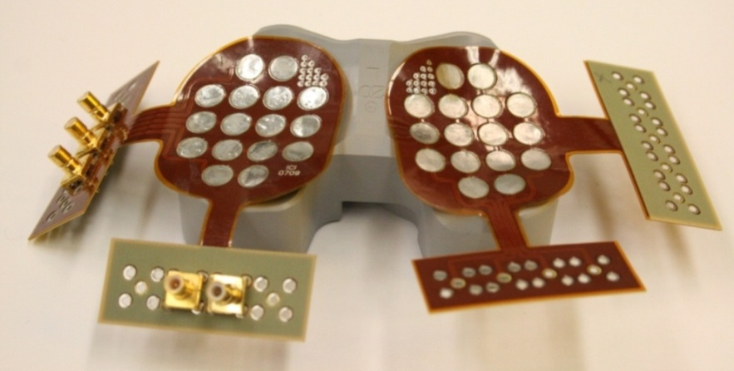
Figure 30. Prototype unicondylar flexible arrays placed on a provisional.

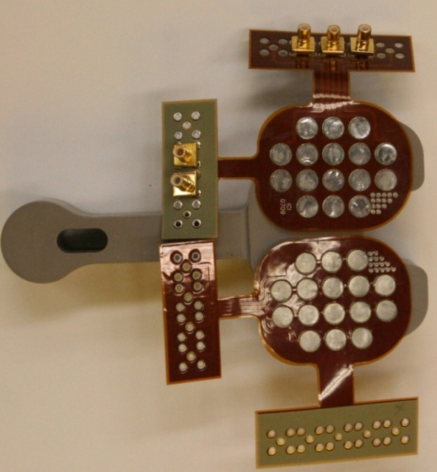
Figure 31. First iteration standard flex unicondylar arrays flat on spacer block.

Table 5. Summary of Various Fabrication Iterations.
Iteration | Description | Capacitance | Flexibility* | Notes
1 | standard flex,  proof of concept |  | 5
2 | standard flex with ground plane,  proof of concept | 3 pF | 2 | ground plane increased stiffness
3a | microfabricated, 25 µm polyimide | 5 pF,  20 pF | 9 | wrinkles easily,  50-75 µm adhesive
3b | microfabricated, 50 µm polyimide | 5 pF,  20 pF | 7 | 50-75 µm adhesive
3c | microfabricated, spin-on polyimide | 5 pF,  20 pF | 0 | no release
3d | microfabricated, ~10 µm parylene | 5 pF,  20 pF | 10 | too thin-wrinkles and tearing
3e | microfabricated, 50 µm UHMWPE | 5 pF,  20 pF | 7 | difficult to release,  50-75 µm adhesive
4a | Full tibial tray microfabricated on 50 µm polyimide | 5 pF | 7 | 50-75 µm adhesive
4b | Full tibial tray microfabricated on UHMWPE | 5 pF | 7 | difficult to release,  50-75 µm adhesive
*rated from 0 – 10: rigid to very flexible
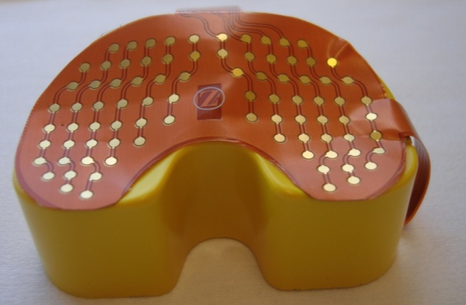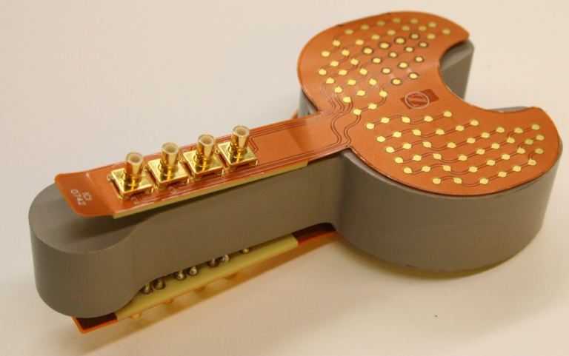
Figure 32. Flexible 3 pF capacitive array on provisional (right) and spacer block (left).

Further reductions of capacitive size are achievable with photolithography-based microfabrication; the limiting factor is ability to read the sensor (i.e. reliably detect minute changes in capacitance). Custom substrates, thinner dielectric materials, and biocompatibility options are all advantages to these new sensors, but care must be taken for electrical cross talk between excited sensors. In addition, the smaller the sensor, the smaller the change in capacitance with applied load; changes can become hard to detect even with custom cutting-edge readout circuitry.

Design and Fabrication
Smaller arrays were designed with greatly reduced footprint, as shown in Figure 18. Built using MEMS photolithography processes, these tiny capacitors are currently in fabrication and testing in compressive loading (loading comparable to passive flexion of the knee intra-operatively), and in electrical probing designed to quantify the inter-sensor cross talk of the array. Each circular sensor is .5 mm across. Polyimide was demonstrated as a substrate material, and parylene as the dielectric material (1.5 μm). It is noted that parylene has served as a substrate layer in early capacitve fabrication when the sensor was left on the silicon wafer, but it poses a problem due to adhesion and mechanical strength of the thin film during removal from the silicon substrate. A negative-resist based photolithography fabrication was implemented to reduce time and number of steps for fabrication. The electrodes consist of a 10 nanometer (nm) titanium adhesion layer and 300 nm of gold deposited on the substrate via physical vapor deposition.
Array design is multi-faceted to understand the behavior of the sensors at a small scale and to optimize design to boost readout speed, increase nominal capacitance, and decrease crosstalk and parasitic effects specific to the configuration of this array. Increasing nominal capacitance is most easily achieved through larger electrode size and thinner dielectric layers, thus presenting a tradeoff between keeping sensor size to a minimum and nominal capacitance at an appropriate level for accurate measurement. Similarly, the spacing needs to be optimized between closeness (providing high spatial resolution across the array), and crosstalk (sensors too close to one another affecting readout, although excitation timing also plays a role). As shown in figures 18 and 19, four sensor layouts were designed; 1mm electrodes with 1 mm between sensors (2mm center-to-center), 1 mm electrodes with .5 mm between electrodes (1 mm center-to-center), .5 mm electrodes with 1.5 mm between electrodes (2mm center-to-center), and .5mm electrodes with .5 mm between electrodes (1 mm center-to-center).

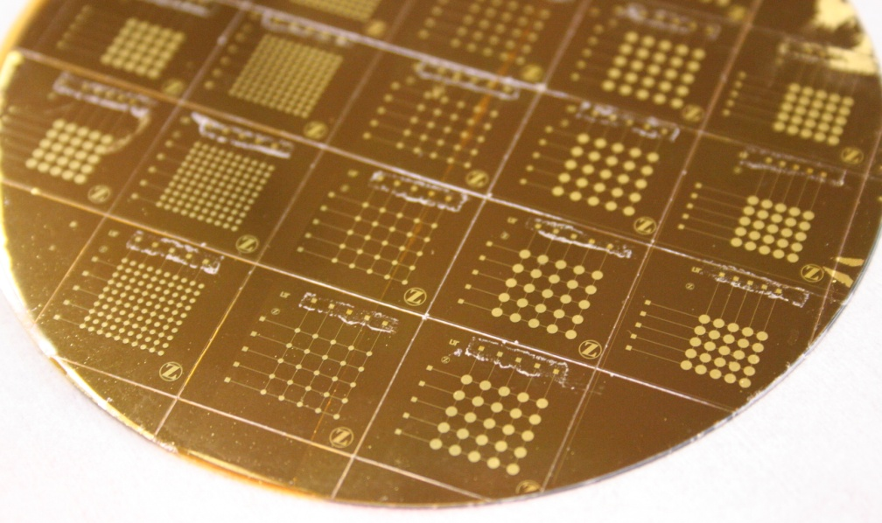
Figure 33. Wafer with multiple size test arrays.

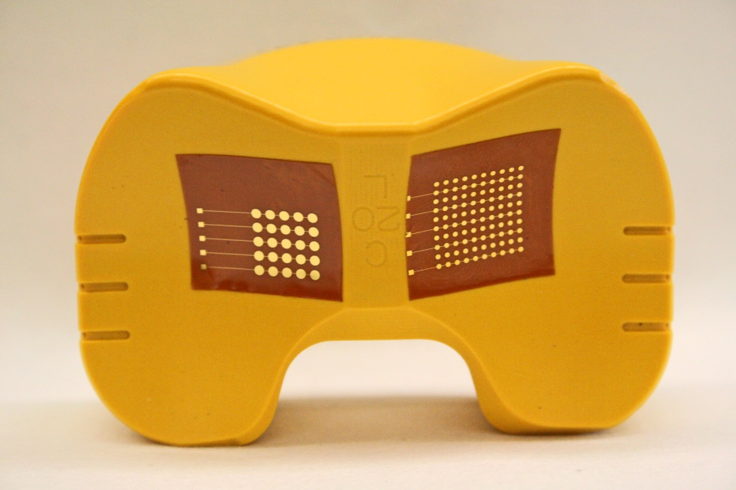
Figure 34. Test sensor arrays mounted on the articulating surface of a knee provisional, showing the conformability of the array on the instrument surface.

Sensor Testing
Sensor arrays were diced by hand on the surface of the wafer and removed with a spatula. They were then adhered to FR4 printed circuit boards and conductive silver-filled epoxy was used to connect the sensors to the circuit board. A protective polyimide layer was placed over the electrodes and a second protective layer over the entire assembly after the epoxy had cured. Sensor arrays were mounted flat on FR4 printed circuit boards for capacitance reading via subminiature B (SMB) using a 4285 LCR meter (Agilent, Santa Clara, CA). After calibration of the shielded lead wires, nominal capacitance of each individual sensors within each array was measured without load, pre-loaded with 5 lb, and then monitored continuously with loading up to 444 N and 667 N (80 lb and 155 lb at 1.5 lb/min) on a hydraulic MTS (Eden Prairie, MN) 858 mechanical testing machine with a 2.5 kN load cell. The arrays were unloaded at the same rate. A 1MHz frequency was used at 2 volt peak-to-peak excitation on the LCR meter. An average value of 16 samples per second was recorded each second via GPIB cable to a computer. The MTS testing machine recorded data at the same interval. Data from the LCR meter was read and saved with Labview software (National Instruments, Austin, TX). Machined polymer pieces (polyacetal resin) were used to administer the load to minimize noise.
The standard flex circuit design incorporated rigid flex so the SMB connector could be directly attached for measurement with the LCR meter.

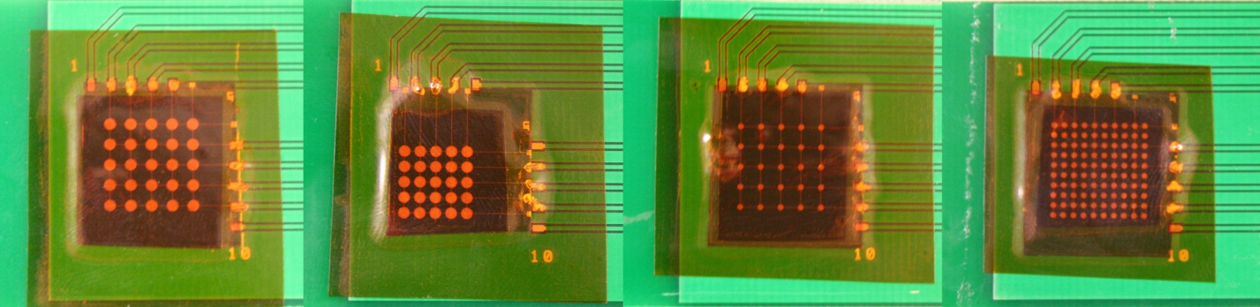
(a) (b) (c) (d)
Figure 35. Microfabricated sensor arrays of varying size and spacing mounted on FR4 circuit boards for testing. Sensor Diameter:Center-to-center spacing, in mm: a) 1:2 b) 1:1.5 c) .5:2 d) .5:1 .

Figure 36. Raw rata for three consecutive load/unload cycles of sensor with 21.077 pF nominal capacitance. Baseline is manually selected from raw data. Maximum applied pressure is 2.25 MPa plus 0.05 MPa preload.

Figure 37. Data with noise correction for sensor with 21.077 pF nominal capacitance.

Table 6. Comparison of capacitive response for repeated loads.
Capacitance rates for 1 lb/sec loading
0.000665 pF/sec | loading cycle 1
-0.000669 pF/sec | unloading cycle 1
0.000717 pF/sec | loading cycle 2
-0.000676 pF/sec | unloading cycle 2
0.000720 pF/sec | loading cycle 3
-0.000720 pF/sec | unloading cycle 3

Figure 38. Loading and unloading of 2.25 MPa for three sensors in a row, with noise removal. Sensors are 0.5 mm in diameter with 0.5 mm edge to edge spacing.

Time (sec)

Figure 39. Change in capacitance for alternating 25 and 50 lb loads on representative sensor 3,7 on array (a) from Figure 23, 23 pF nominal capacitance. Note that change in capacitance is plotted (raw data).

Sensor 2,3 Sensor 2,4 Sensor 2,5
Figure 40. Loads (25 and 50 lbs) applied to three .5 mm diameter sensors (a row in array (c) in Figure 35). Absolute capacitance values are shown (raw data).

Large
Small
Figure 41. Loading and unloading raw data for a sensor in large dense array (to 700 kPa) and small dense array (to 350 kPa). Nominal values are 4.505 pF and 21.023 pF, respectively.

The 23 pF sensor showed 30 fF of capacitance change per pound load in our test (Figure 39), which can also be interpreted as 15 fF change for each 10 kPa of pressure applied. Similarly, the 5 pF capacitor showed 1.4 fF capacitance change per pound load, or 0.7 fF per 10 kPa (.01 MPa) applied pressure. For comparison, previous studies have shown 1.6 MPa maximum pressure in the intraoperative knee with a resolution of .3 MPa (300 kPa)[18]. Thus our capacitive sensors are deemed to have adequate load resolution. In addition, the density of the sensing array provides superior spatial resolution, which is higher than the sensor-to-sensor spacing with standard post-processing interpolation but has not yet been quantified.
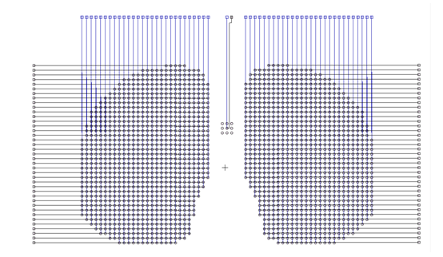
Figure 42. Capacitive array design.

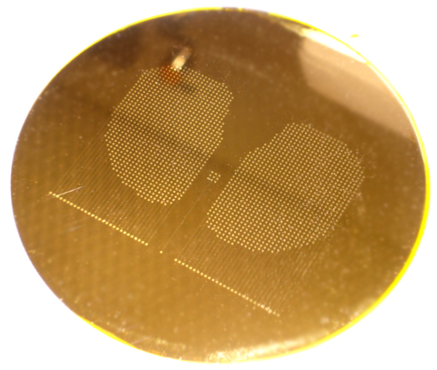
Figure 43. Capacitive sensor array bottom layer fabricated on polyimide on a silicon wafer.
Array has 970 sensors per condyle.

Two large capacitive arrays were designed with the dense 5 pF configuration (electrode diameter .5 mm and center-to-center spacing of 1 mm). Sensor density is 100 sensors per square centimeter. A reference capacitor is included between the condyles to enable the option of differential capacitive measurement which not only reduces noise but also compensates temperature effects. Dummy sensor pads are placed around the reference capacitor for appropriate matching with sensors in the array during measurement. This array can be adhered to a curved provisional surface as visualized in Figure 34.

Read-Out Circuitry
A printed circuit board (PCB) and Labview program have been implemented to utilize an existing 24-bit capacitance to digital chip from Analog Devices¹. The printed circuit board iteration 1, shown in Figure 45 is designed to utilize the chip for reading hardwired capacitors and monitors the capacitance at a rate of 50 Hz. The RMS error is 3.77556 fF for a reference capacitance of 4.255 pF.
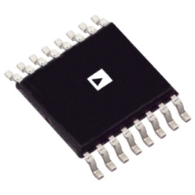
Figure 44. Analog Devices Capacitance to Digital chip, model 7745¹.
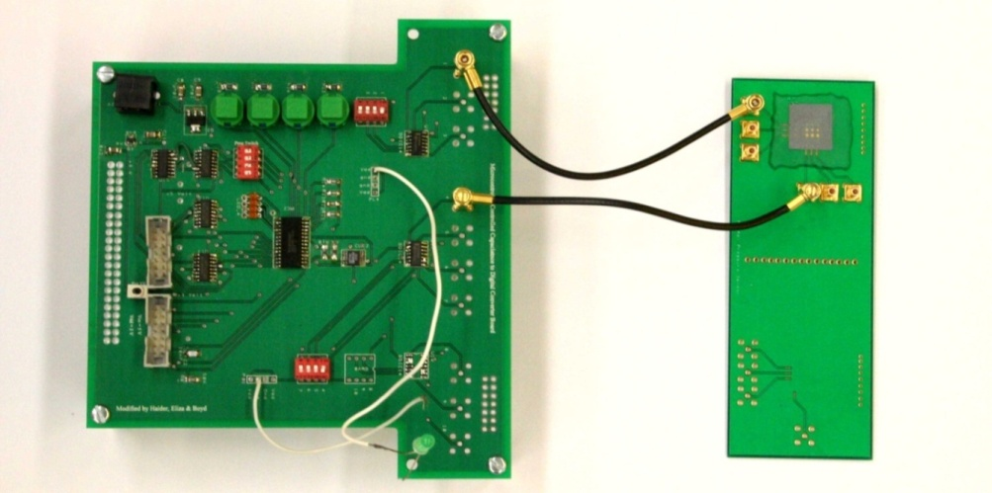
Figure 45. Printed circuit board iteration 1 used to interact with the CDC chip (left) and capacitive sensors on silicon (right) ready for readout.
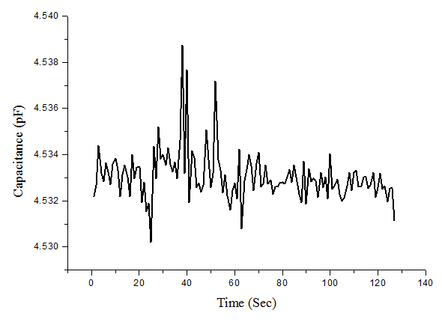
Figure 46. Noise for a reference capacitance of 4.532 pF as measured using the Analog Devices chip. Shift in the baseline (~0.001 pF) is attributed to additional capacitance within the readout circuit.

The AD chip and readout board were tested with the custom flex capacitive sensors under loading, as shown in Figure 48. A slight shift in baseline after the load test is attributed to sensor hysteresis of the flex system, not abnormalities in the readout. (Testing of the same sensor with the LCR meter confirms this.) There is also a sign change in the signal processing to lend a more intuitive presentation of the capacitive data for trend comparison purposes.

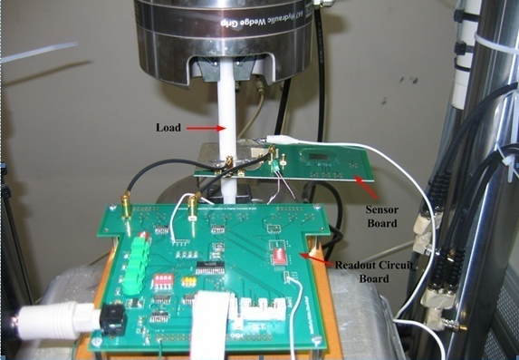
Figure 47. Testing setup showing CDC board connected to sensor board under loading.
― load
― capacitance

Figure 48. Capacitive sensor load testing with AD CDC chip and readout board.

A second iteration of PCB board utilizing the AD chip has been designed, as shown in Figure 49. The footprint of the board has been reduced to fit within the provisional shape and additional functionality has been added. Multiplexers have been added for automated sensor addressing so that a 4x4 array can be read with each sensor readout cycle. Bluetooth capability has been added for wireless data transmission to a receiver. A microcontroller is used for programming the capacitance to digital chip and configuring the Bluetooth antenna. The PCB is designed to interface with the small 1x1 cm arrays (Figure 35) and the large provisional array (Figure 43). It is noted that with smaller array reading capability the sensors to be read are evenly spaced throughout the large array until suitable electronics to read the entire array can be designed. This PCB design has not yet been fabricated or tested.
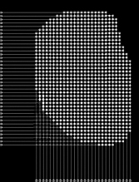
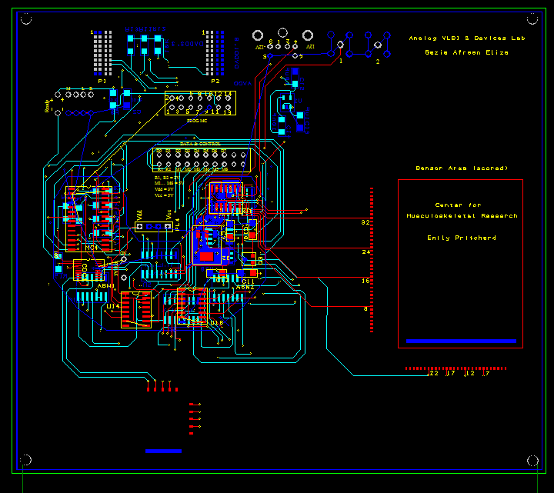
Analog Devices CDC chip
test sensor array
full sensor array
(reading 4x4 only)
Bluetooth antenna

to DAQ
serial interface
SMB out
to bluetooth antenna
Figure 49. Second iteration PCB design for interfacing with Analog Devices CDC chip, showing provisional footprint with only connectors outside the main footprint for research purposes.

Future Work

Engineering Improvements
Ideally, the sensor performance should be verified under a knee simulator. Fatigue lifetime of the sensing array is also best obtained in a simulation of repetitive moves that the device will experience in service. Future tests can verify that knee simulation results correspond to the benchtop mechanical testing that is performed as part of this dissertation.
The wireless output of the sensor should be upgraded from the current Bluetooth capability; an on-chip transmitter and custom antenna at the 1.4 GHz medical band is optimal for data transmission in a hospital. Existing work by Wenchao et al and Haider, et al will make the conversion process smoother and customized for the capacitive pressure sensor application through two application-specific integrated circuits (ASIC). Wenchao et al. provide a superior analog to digital conversion chip, while Haider, et al. provide a differential high-resolution capacitance-to-voltage converter and on-chip medical telemetry transmitter. A 1.4 GHz custom antenna design would complete the package for application specific optimized readout-electronics for the large sensor design. It is noted that incorporating Haider et al.’s approach involves the addition of an AC injected signal at a shared node for the reference and signal sensor.
The readout circuit should also be refined to operate without DAQ control. This allows the device to operate more seamlessly; refinements to the microcontroller hardware configuration and programming should eliminate this step. In addition, customized software on the receiving PC can be written for enhanced processing and visualization. Optimization of the virtual order and grouping of sensors can enhance the total read time; post-processing of each real-time update of the array can also allow increased resolution through improved interpolation and updating between sensor nodes.

Surface Characterization
Various topics to further explore the cause and effects of plasma-modification of UHMWPE surfaces include the following:
- Fourier-Transform Infrared Spectroscopy- measure surface functionalization after plasma treatment
- Explore the effects of atmospheric plasma in air (a combination of nitrogen and oxygen, and no need for expensive, slow vacuum pumps)
- Investigate the use of standard hospital plasma sterilization machines for polyethylene surface treatment (which, if useful, would assist in mass-production of activated polyethylene surfaces for commericial use by circumventing the need to design a new plasma treatment machine or the need to buy a machine with versatile capability when only one known recipe family is needed)

Cadaver and Clinical Trials
Cadaver and live patient clinical trials are a natural capstone to show the sensing array in use in its intended application. The expected intraoperative (e.g. passive) compartmental pressures are not well established to date. Cadaver testing requires special consideration to mimic intraoperative live patient use. The flexion angle should be tracked in 3D space while the provisional records pressure data so that the pressure profiles correspond to a specific flexion angle. This can be achieved using any surgical navigation system independent of mode of operation (e.g. optical, electromagnetic, radiofrequency). A registration step for the femur and tibia is required with a method of bone tracking in order to locate the joint in 3D space during the entire range of motion.
Figure 50. Design for cadaver experiment using an isolated knee, where flexion angle θ is measured while the sensing provisional records pressure profiles.

Further possibilities for clinical studies include:
- Multiple implants (by family or by manufacturer or both)
  - Compare PS and PCR
  - Mobile bearing vs. rigid
- Multiple sizes
  - Effect on contact area
  - Effect on pressure
- Affix a sensing array to the cam of a posterior-stabilized knee design to investigate soft tissue impingement and locking mechanism at high flexion

Conclusion and Future Directions

Biomedical applications requiring high sensitivity in low pressure ranges can benefit greatly from the developed capacitive MEMS pressure sensing array. The biocompatibility and flexibility of the array also allow it to be used in a variety of applications, including joint arthroplasty, surgical navigation, gait analysis, tactile robotics, and any contact-pressure measurement surface, especially between rigid bodies with curved surfaces. The two-dimensional pressure profiling is useful in determining contact area and inference of stress concentrations at the contact interface.

Schedule of Performance
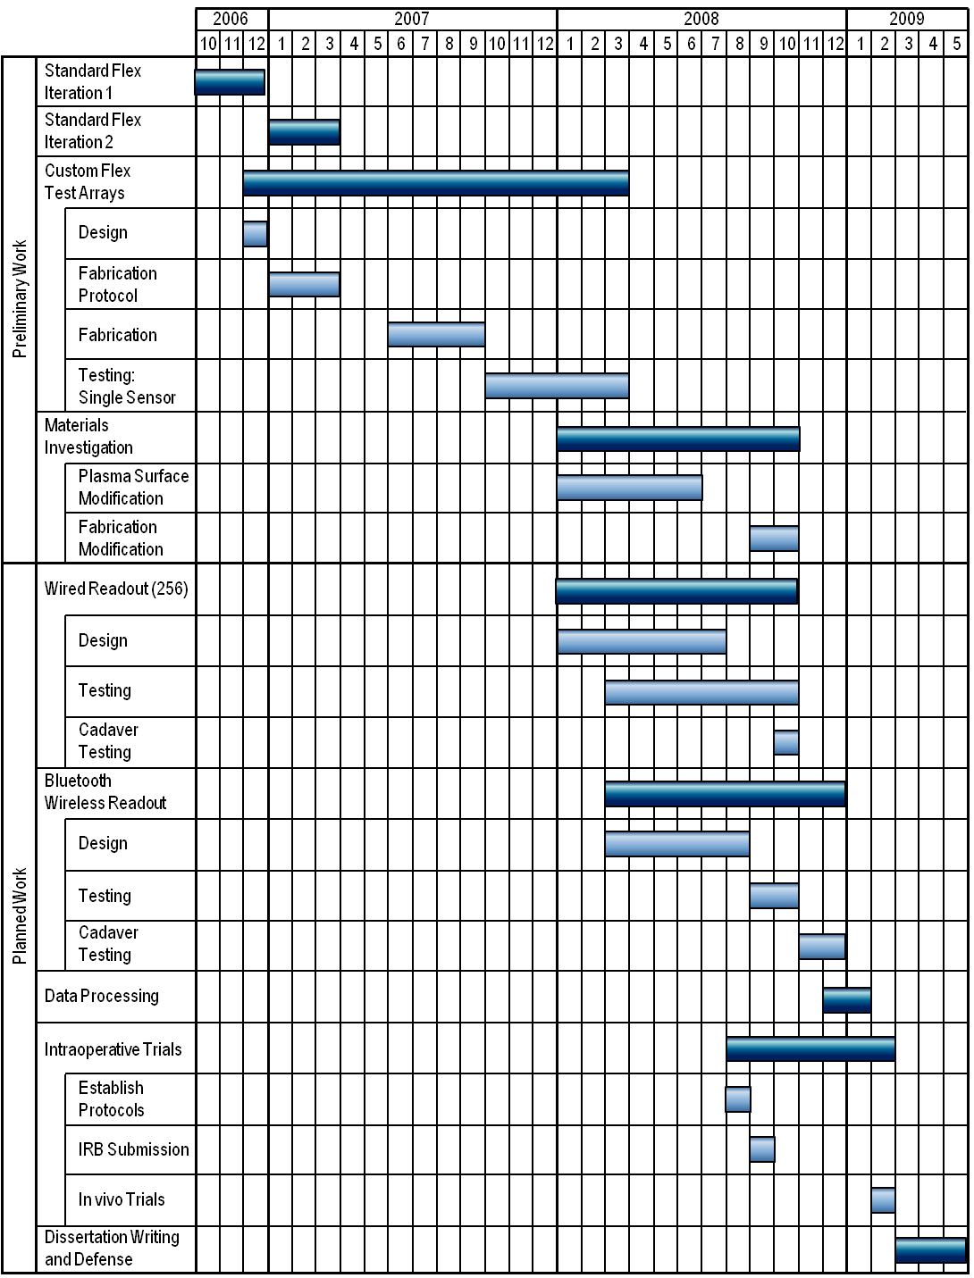

Residency Requirement
As outlined in the University of Tennessee 2008-2009 Graduate Catalog, the last two consecutive semesters prior to graduation will be completed at the Knoxville campus with full-time registration. With a projected graduation of August 2009, the Spring 2009 and Summer 2009 semesters will be completed with full time registration consisting of coursework and/or dissertation hours. For fall and spring semesters, a maximum of 15 is allowable, so special permission will be required to register for 16 hours (1 credit hour seminar being the reason for overload). If needed, a minimum of 9 hours for the Summer 2009 term will be registered to maintain full-time enrollment and fulfill the last two consecutive semester residency requirement. For a schedule of predicted registration listed with individual classes, please see Appendix A.

References
[1] "Osteoarthritis," National Institute of Arthritis and Musculoskeletal and Skin Diseases 2006.
[2] V. Pavone, F. Boettner, S. Fickert, and T. Sculco, "Total Condylar Knee Arthroplasty: A Long-Term Followup," Clinical orthopaedics and related research, vol. 368, pp. 18-25, 2002.
[3] J. Rodriguez, H. Bhende, and C. Ranawat, "Total Condylar Knee Replacement A 20-Year Followup Study," Clinical orthopaedics and related research, vol. 388, pp. 10-17, 2001.
[4] P. Sharkey, "Why are total knee arthroplasties failing today?," Clinical orthopaedics and related research, vol. 404, pp. 7-13, 2002.
[5] K. Bozic and H. Rubash, "Modes of Failure in Revision Hip and Knee Replacement," Center for Disease Control, National Center for Health Statistics, 2004.
[6] F. Orozco, "Why Are Knee Replacements Failing Today?," presented at American Academy of Orthopaedic Surgeons 69th Annual Meeting, 2002.
[7] K. Mulhall, H. Ghomrawi, S. Scully, J. Callaghan, and K. Saleh, "Current etiologies and modes of failure in total knee arthroplasty revision," Clinical orthopaedics and related research, vol. 446, pp. 45-50, 2006.
[8] J. N. Insall, G. R. Scuderi, R. D. Komistek, K. Math, D. A. Dennis, and D. T. Anderson, "Correlation Between Condylar Lift-Off and Femoral Component Alignment," Clinical Orthopaedics, vol. 403, 2002.
[9] R. Booth, G. Stalcup, R. Bays, B. Sisk, S. Dietzel, and T. Miller, "Instrumentation for Use in Orthopaedic Surgery." USA, 1997.
[10] H. Asano, A. Hoshina, and T. Wilton, "Soft-Tissue Tension Total Knee Arthroplasty," Journal of Arthroplasty, vol. 19, pp. 558-561, 2004.
[11] A. Wymenga, B. Christen, and U. Wehrli, "Posterior Cruciate Ligament Balancing in Total Knee Arthroplasty with a Dynamic PCL Spacer," in Total Knee Arthroplasty, J. Bellemans, Ed. Berlin: Springer, 2005.
[12] D. Viskontas, T. Skrinskas, J. Johnson, G. King, M. Winemaker, and D. Chess, "Computer-Assisted Gap Equalization in Total Knee Arthoplasty," Journal of Arthroplasty, vol. 22, pp. 334-342, 2007.
[13] I. Zimmer, "Variable Soft Tissue Alignment Tensor (V-STAT)," 1997.
[14] "Prescale Measurement Film," vol. 2008, F. Global, Ed., 2008.
[15] J. Wu, Y. Wang, K. Dai, Q. Wei, D. Ye, X. Li, and M. Zhao, "A method for dynamically measuring the Soft Tissue Balance in the Total Knee Replacement," in World Congress on Medical Physics and Biomedical Engineering 2006, 2007, pp. 723-727.
[16] M. Suzuki, J. Miyagi, I. Sakuramoto, K. Fujiwara, I. Michihiro, and K. Kuramoto, "Dynamic Soft Tissue Balancing Sensor for Total Knee Arthroplasty," presented at International Society for Technology in Arthroplasty, Paris, France, 2007.
[17] A. Wallace, M. Harris, W. Walsh, and W. Bruce, "Intraoperative assessment of tibiofemoral contact stresses in total knee arthroplasty.," The Journal of arthroplasty, vol. 13, pp. 923-927, 1998.
[18] R. Wasielewski, D. Galat, and R. Komistek, "An intraoperative pressure-measuring device used in total knee arthroplasties and its kinematics correlations.," Clinical orthopaedics and related research, pp. 171-178, 2004.
[19] M. Harris, P. Morberg, W. Bruce, and W. Walsh, "An Improved Method for Measuring Tibiofemoral Contact Areas in Total Knee Arthroplasty: A Comparison of K-Scan Sensor and Fuji Film," Journal of Biomechanics, vol. 32, pp. 951-958, 1999.
[20] N. Rydell, "A new apparatus for the measurement of the compression between two bony surfaces and a construction for compression in fractures of the femoral neck. A preliminary report.," Acta orthopaedica Scandinavica, vol. 31, pp. 1-17, 1961.
[21] N. Rydell, "Forces acting on the femoral head-prosthesis. A study on strain gauge supplied prostheses in living persons.," Acta orthopaedica Scandinavica, vol. 37, 1966.
[22] T. English and M. Kilvington, "In vivo records of hip loads using a femoral implant with telemetric output (a preliminary report)." Journal of biomedical engineering, vol. 1, pp. 111-115, 1979.
[23] W. Hodge, R. Fijan, K. Carlson, R. Burgess, W. Harris, and R. Mann, "Contact pressures in the human hip joint measured in vivo.," Proceedings of the National Academy of Sciences of the United States of America, vol. 83, pp. 2879-2883, 1986.
[24] W. Hodge, K. Carlson, R. Fijan, R. Burgess, P. Riley, W. Harris, and R. Mann, "Contact pressures from an instrumented hip endoprosthesis," J Bone Joint Surg Am, vol. 71, pp. 1378-1386, 1989.
[25] D. Davy, G. Kotzar, R. Brown, K. Heiple, V. Goldberg, K. Heiple, J. Berilla, and A. Burstein, "Telemetric force measurements across the hip after total arthroplasty," J Bone Joint Surg Am, vol. 70, pp. 45-50, 1988.
[26] G. Bergmann, F. Graichen, and A. Rohlmann, "Hip joint loading during walking and running, measured in two patients.," Journal of biomechanics, vol. 26, pp. 969-990, 1993.
[27] G. Bergmann, F. Graichen, A. Rohlmann, P. Westerhoff, and B. Heinlein, "Design and Calibration of Load Sensing Orthopaedic Implants," Journal of Biomechanical Engineering, vol. 130, pp. 2-9, 2008.
[28] C. Ashruf, "Thin flexible pressure sensors," Sensor Review, pp. 322-327, 2002.
[29] "Tekscan." South Boston, MA.
[30] H. Hsiao, J. Guan, and M. Weatherly, "Accuracy and precision of two in-shoe pressure measurement systems.," Ergonomics, vol. 45, pp. 537-555, 2002.
[31] E.-S. Hwang, Y.-J. Kim, and B.-K. Ju, "Flexible polysilicon sensor array modules using "etch-release" packaging scheme," Micromechanics section of Sensors and Actuators, based on contributions revised from the Technical Digest of the 16th IEEE International conference on Micro Electro mechanical Systems (MEMS 2003)
Sensors and Actuators A: Physical, vol. 111, pp. 135-141, 2004.
[32] "XSensor Technology Corporation." Calgary, AB, Canada.
[33] "Novel." Munich, Germany.
[34] "Pressure Profile Systems." Los Angeles, CA.
[35] C. Hierold, B. Clasbrumme, D. Behrend, T. Scheiter, M. Steger, K. Oppermann, H. Kapels, E. Landgraf, D. Wenzel, and D. Etuodt, "Implantable low power integrated pressure sensor system for minimal invasive telemetric patient monitoring," presented at Micro Electro Mechanical Systems, 1998. MEMS 98. Proceedings., The Eleventh Annual International Workshop on, 1998.
[36] C. Hierold, B. Clasbrummel, D. Behrend, T. Scheiter, M. Steger, K. Oppermann, H. Kapels, E. Landgraf, D. Wenzel, and D. Etzrodt, "Low power integrated pressure sensor system for medical applications," Sensors and Actuators A: Physical, vol. 73, pp. 58-67, 1999.
[37] M. Akiyama, Y. Morofuji, T. Kamohara, K. Nishikubo, M. Tsubai, O. Fukuda, and N. Ueno, "Flexible piezoelectric pressure sensors using oriented aluminum nitride thin films prepared on polyethylene terephthalate films," Journal of Applied Physics, vol. 100, 2006.
[38] D. F. Williams, Williams Dictionary of Biomaterials. Liverpool, U.K.: Liverpool University Press, 1999.
[39] Y. Hanein, Y. Pan, B. Ratner, D. Denton, and K. Böhringer, "Micromachining of Non-fouling Coatings for Bio-MEMS Applications," Sensors and Actuators B: Chemical, vol. 81, pp. 49-54.
[40] G. Kotzar, M. Freas, P. Abel, A. Fleischman, S. Roy, C. Zorman, J. Moran, and J. Melzak, "Evaluation of MEMS materials of construction for implantable medical devices.," Biomaterials, vol. 23, pp. 2737-2750, 2002.
[41] A. Sharma, R. Komistek, C. Ranawat, D. Dennis, and M. Mahfouz, "In Vivo Contact Pressures in Total Knee Arthroplasties," Journal of Arthroplasty, vol. 22, pp. 404-416, 2007.
[42] J. Daintith, Biographical Encyclopedia of Scientists: CRC Press, 1994.
[43] B. N. Taylor and P. J. Moore, "NIST Reference on Constants, Units, and Uncertainty," National Institute of Standards and Technology 2003.
[44] P. Rousche, D. Pellinen, D. Pivin, J. Williams, R. Vetter, and D. Kirke, "Flexible polyimide-based intracortical electrode arrays with bioactive capability," IEEE Transaction on Biomedical Engineering, vol. 48, pp. 361-371, 2001.
[45] H. K. Yasuda, Plasma Polymerization and Plasma Interactions with Polymeric Materials: John Wiley and Sons, 1990.
[46] B. Evans III, "MEMS Capacitive Strain Sensing Elements for Integrated Total Knee Arthroplasty
Prosthesis Monitoring," in Department of Mechanical, Aerospace, and Biomedical Engineering. Knoxville: University of Tennessee, 2007.

Appendix A : Course Schedule
Course schedule in fulfillment of course requirements for the degree of Ph.D. in Biomedical Engineering are listed in and summary of course fulfillments in Table 8.
TERM | COURSE | HOURS | GRADE
Summer 2006 | - Admission  - BME 502: Use of facilities | 3 | S
Fall 2006 | - BME 599: Advanced Engineering Mathematics  - BME 599: Ultrasound Instrumentation  - BME 595: Seminar | 3  3  1 | A  B+  S
Spring 2007 | - BME 610: Advanced Topics- Engineering and Anatomy  - Engineering Science 581: Gross Anatomy  - ME 595: Seminar | 3  3  1 | A  A  S
Summer 2007 | - BME 531: Advanced Biomechanics I | 3 | A
Fall 2007 | - Exercise Science 513: Biomechanics of Orthopaedic Rehab  - Math 475: Industrial Mathematics  - BME 595: Seminar | 3  3  1 | A  A  S
Spring 2008 | - BME 682: Biological Application of Micro/Nano Systems  - BME 559: Advanced Mechanics of Materials  - MSE 576: Cell and Tissue Biomaterials Interaction  - BME 595: Seminar | 3  3  3  1 | A  B+  A  S
Summer 2008 | PROPOSAL & PHD QUALIFYING EXAMS  - Dissertation hours | 9
Fall 2008 | - MATH 535: Partial Differential Equations  - ME 539: Continuum Mechanics  - Dissertation hours  - BME 595: Seminar | 3  3  9  1
Spring 2009 | - BME 600-level TBD  - EM 533: Intro to Engr Management  - Math TBD  - Dissertation hours  - BME 595: Seminar | 3  3  9  1
Other | - BME 599: Introduction to MEMS/NEMS, taken for graduate credit Spring 2005 | 3 | A
Cumulative credits | Academic Coursework  Courses  Seminar  Dissertation | 48  6  27 | 3.91

Table 7. Course Schedule
TERM | COURSE | HOURS | GRADE
Summer 2006 | - Admission  - BME 502: Use of facilities | 3 | S
Fall 2006 | - BME 599: Advanced Engineering Mathematics  - BME 599: Ultrasound Instrumentation  - BME 595: Seminar | 3  3  1 | A  B+  S
Spring 2007 | - BME 610: Advanced Topics- Engineering and Anatomy  - Engineering Science 581: Gross Anatomy  - ME 595: Seminar | 3  3  1 | A  A  S
Summer 2007 | - BME 531: Advanced Biomechanics I | 3 | A
Fall 2007 | - Exercise Science 513: Biomechanics of Orthopaedic Rehab  - Math 475: Industrial Mathematics  - BME 595: Seminar | 3  3  1 | A  A  S
Spring 2008 | - BME 682: Biological Application of Micro/Nano Systems  - BME 559: Advanced Mechanics of Materials  - MSE 576: Cell and Tissue Biomaterials Interaction  - BME 595: Seminar | 3  3  3  1 | A  B+  A  S
Summer 2008 | PROPOSAL & PHD QUALIFYING EXAMS  - Dissertation hours | 9
Fall 2008 | - MATH 535: Partial Differential Equations  - ME 539: Continuum Mechanics  - Dissertation hours  - BME 595: Seminar | 3  3  9  1
Spring 2009 | - BME 600-level TBD  - EM 533: Intro to Engr Management  - Math TBD  - Dissertation hours  - BME 595: Seminar | 3  3  9  1
Other | - BME 599: Introduction to MEMS/NEMS, taken for graduate credit Spring 2005 | 3 | A
Cumulative credits | Academic Coursework  Courses  Seminar  Dissertation | 48  6  27 | 3.91

Table 8. Course Requirements for PhD in Biomedical Engineering

REQUIREMENT | HRS REQ’D | COURSES | HRS MET | HRS PLANNED
Math  500 and above  400 and above | 6  6 | BME 599  MATH 475 | 3  3 | 3  3
MABE Department  500 and above  BME  600 and above | 24  (12)  (9) | BME 610, BME 682 | 30  24  6 | 6  3  3
Seminar | 1/semester | BME/ME 595
Total Academic Hrs | 48 |  | 33 | 15
Total Dissertation Hrs (minimum) | 24 | BME 600 | 0 | 27
TOTAL HOURS | 72 |  | 33 | 42

This is not a true average; the change in resistance of the gauge is influenced by Poisson effects, shear strains, design geometry, and homogeneity of underlying carrier and specimen.
Wasielewski reported contact areas around 4 cm² [18] R. Wasielewski, D. Galat, and R. Komistek, "An intraoperative pressure-measuring device used in total knee arthroplasties and its kinematics correlations.," Clinical orthopaedics and related research, pp. 171-178, 2004., while Wallace reports contact areas around 1 cm² [17] A. Wallace, M. Harris, W. Walsh, and W. Bruce, "Intraoperative assessment of tibiofemoral contact stresses in total knee arthroplasty.," The Journal of arthroplasty, vol. 13, pp. 923-927, 1998.. Both used sensing arrays to take intraoperative measurements.
Maximum individual pressure reported by Sharma, et al. from patients with mobile and fixed-bearing total knee replacements [41] A. Sharma, R. Komistek, C. Ranawat, D. Dennis, and M. Mahfouz, "In Vivo Contact Pressures in Total Knee Arthroplasties," Journal of Arthroplasty, vol. 22, pp. 404-416, 2007..
Parallel plate sensors on a silicon wafer were initially reported by Boyd Evans, III in his December 2007 dissertation at the University of Tennessee. I assisted Dr. Evans during the fabrication and testing of these arrays. They serve as a foundation for later sections of this dissertation proposal, and thus a summary is presented in section A.5. For more detail, please refer to [46] B. Evans III, "MEMS Capacitive Strain Sensing Elements for Integrated Total Knee Arthroplasty Prosthesis Monitoring," in Department of Mechanical, Aerospace, and Biomedical Engineering. Knoxville: University of Tennessee, 2007..
Values given are not intended to represent sensor resolution; rather, they indicate the amount of change for applied loads for comparison between sensors and calculation of total expected change for a given pressure.
Silicon dioxide sacrificial layers to release spun-on polyimides have been demonstrated in the literature. No release layer was used in the initial experiments presented in Table 5, and no release was attempted for spin-on polyimide.
As outlined in the Mechanical, Aerospace, and Biomedical Engineering Graduate Handbook, Fall 2007.
Includes both 500 and 600-level BME courses.

