Spatial, temporal, and tri-trophic distribution of imidacloprid, olefin and 5-hydroxy and their effect on hemlock woolly adelgid, Adelges tsugae Annand, (Hemiptera: Adelgidae).

A Dissertation
Presented for the
Doctor of Philosophy
Degree
The University of Tennessee, Knoxville

Carla Irene Coots
December 2012

Copyright © 2012 by Carla Irene Coots
All rights reserved

DEDICATION

To
Scottie Lamar Coots
my husband

who has been my anchor throughout this project and in life, who has taught me the meaning of the phrase “attitude is the difference between an ordeal and an adventure”, and in the tradition of nautical star symbolism, has instilled the undying desire to dream and hope for safe passages home no matter where in the world I may roam, and for his undying love and support in everything I do.

and

Grace Irene Snelbaker & Robert Levi Snelbaker
my parents
who have always given me undying support and love in all my endeavors, for teaching me the value of nature, and for all the sacrifices they have made to ensure my education, and making me realize that it is possible to make what seems impossible, possible. They have instilled in me notions best described by Thomas Jefferson “Nothing can stop the man with the right mental attitude from achieving his goal; nothing on earth can help the man with the wrong mental attitude” and by Henry David Thoreau “You cannot dream yourself into a character: you must hammer and forge yourself into one” and for that I am eternally grateful.
and

Myra Coots & Erwin Coots
mother-in-law and father-in-law

for all their support and love throughout life’s adventures
and
Elizabeth Snelbaker & Donald Snelbaker
Aunt and Uncle

for all their love and support of my education, they have been inspirational along life’s path and will never know the true positive impact they have had on my life. Their actions often invoke the words of Henry David Thoreau “Go confidently in the direction of your dreams. Live the life you have imagined”.

ACKNOWLEDGEMENTS

I am grateful to all of those who have assisted in this research project. First, I would to like to thank my major professor Dr. Paris Lambdin, for his invaluable mentoring, consistent motivation, taxonomic expertise, and providing me with opportunities to take my education to new levels, and shaping my future. “A teacher affects eternity: he can never tell where his influence stops” –Henry Adams, this is a fitting quote for Dr. Lambdin and his influence in my academic and family life. I thank my committee members, Dr. Jerome Grant, Dr. Nicole Labbé, Dr. Jennifer Franklin, and Mr. James Rusty Rhea, for all their mentoring and input into this project, and providing me with a variety of tools from a variety of disciplines to address my research questions and develop new ones.
I would like to extend my thanks to: Dave Paulsen for all his field and laboratory assistance, Dr. Greg Wiggins for all his guidance through various aspects of my graduate experience and for assisting with field collections, Dr. Ashley Lamb for her mentoring, and Dr. Tom Gould at Bayer for his chemistry guidance. I would also like to thank the personnel at the Tellico Plains, Tennessee, Ranger Station, for all their assistance. This project would not have been possible without funding, so I would like to finally thank Mr. James Rusty Rhea and the U.S.D.A. Forest Service and the Smoky Mountain Conservation Association for funding.

ABSTRACT

Extensive mortality of eastern hemlock, Tsuga canadensis (L.) Carrière, resulting from infestation by hemlock woolly adelgid, Adelges tsugae Annand (Hemiptera: Adelgidae) (HWA), has occurred throughout the eastern United States. Imidacloprid, a systemic insecticide, is used to control hemlock woolly adelgid. The metabolism of imidacloprid in eastern hemlock produces two metabolites of toxicological interest, olefin and 5-hydroxy. The objectives of this study were to 1.) determine the distribution and persistence of the metabolites in eastern hemlock in the southern Appalachians, 2.) their effect on hemlock woolly adelgid mortality, 3.) assess the tri-trophic movement of these compounds, 4.) evaluate the effects of hemlock woolly adelgid infestation levels on water stress, and 5.) assess the use of near-infrared spectroscopy for predicting imidacloprid concentrations in needle tissue.
Imidacloprid and 5-hydroxy concentrations in sap was highest at 12 months post-treatment and in twig and needle tissue was highest at 15 months post-treatment. Imidacloprid was detected through month 36 post-treatment and 5-hydroxy was detected through month 15 post-treatment. Olefin concentrations progressively increased in both sap and twig and needle tissue through month 36 post-treatment. Concentrations of imidacloprid were highest in the bottom stratum of the canopy and lowest in the top stratum. Concentrations of olefin and 5-hydroxy were highest in the top stratum and lowest in the bottom stratum. A significant relationship was found between imidacloprid concentrations > 158 ppb and olefin concentrations > 7 ppb and hemlock woolly adelgid mortality greater than 80% in field studies. In dose-response tests imidacloprid concentrations greater than 131 ppb and olefin concentration greater than 7 ppb were associated with high levels of hemlock woolly adelgid mortality (> 80%). Tri-trophic movement of imidacloprid and olefin was documented through 2 years post-treatment. The highest level of water stress was found in those trees with hemlock woolly adelgid infestation levels greater than 75%. The lowest level of water stress was found in those trees with less than 25% hemlock woolly adelgid infestation levels. Near-infrared spectroscopy results indicate that it can be used to predict concentrations of imidacloprid in needle tissue.

TABLE OF CONTENTS

CHAPTER 1. LITERATURE REVIEW……………………………………………...1
Invasive Forest Insects…………………………………………………..........1
Eastern Hemlock………….…………………...………..……………………..3
Hemlock Woolly Adelgid, Adelges tsugae Annand (Hemiptera: Adelgidae..13
Hemlock Woolly Adelgid Management Strategies.………………………….18
Research Objectives……………….………………………………………....30
CHAPTER II. SPATIAL AND TEMPORAL DISTRIBUTION OF
IMIDACLOPRID,OLEFIN AND 5-HYDROXY IN EASTERN HEMLOCK
IN THE SOUTHERN APPALACHIANS….……….…..……………….……..…...32
Introduction……...………………….………….…………………………….32
Materials and Methods……………………..…………………….................35
Results and Discussion……………………....……………………………….39
Conclusions….………………………………….……………………………56
CHAPTER III. EFFICACY OF IMIDACLOPRID AND ITS METABOLITES,
OLEFIN, AND 5-HYDROXY ON HEMLOCK WOOLLY ADELGID,
ADELGES TSUGAE ANNAND (HEMIPTERA:ADELGIDAE).............................57
Introduction……...……………………………………...……………………57
Materials and Methods….….…...………………...……………………….…58
Results and Discussion...………….………………………………………….63
Conclusions….……………………………………………………………….71
CHAPTER IV. TRI-TROPHIC MOVEMENT OF IMIDACLOPRID, OLEFIN,
AND 5-HYDROXY IN EASTERN HEMLOCKS IN THE SOUTHERN
APPALACHIANS…………………………………………………………………...73
Introduction…………………………………………………………………..73
Materials and Methods……………………………………………………….74
Results and Discussion……………………………………………………….78
Conclusions…………………………………………………………………..87
CHAPTER V. INFLUENCE OF HEMLOCK WOOLLY ADELGID INFESTATION
LEVELS ON WATER STRESS IN EASTERN HEMLOCKS IN THE
GREAT SMOKY MOUNTAINS NATIONAL PARK…...……...…………..……..88
Introduction…………………………………………………………………...88
Materials and Methods………………………………………………………..91
Results and Discussion…………….………………………………………….93
Conclusions…………………………………………………………………....97
CHAPTER VI. EVALUATION OF NEAR-INFRARED SPECTROSCOPY FOR
PREDICTING IMIDACLOPRID CONCENTRATION IN EASTERN
HEMLOCK NEEDLES…………………..…………….……………………...........99
Introduction………………………….………………………………………..99

TABLE OF CONTENTS
Materials and Methods…………….………………………………..101
Results and Discussion………….…………………………………..105
Conclusions………………………………………………………….109
CHAPTER VII.SUMMARY……………………………………...……...…...……111
Literature Cited...…….…………...…………………………….…………………...114
Appendix……....………….…………………………………………………….…...130
Vita………………………………………………...………………………………...133

LIST OF TABLES

Table Page

- Summary of PROC MIXED ANOVA results for the effects
of application method, months post-treatment, tree strata, and
timing of application on imidacloprid, olefin, and 5- hydroxy
concentration in sap extracted from eastern hemlocks…………………….43

- Summary of PROC MIXED ANOVA results for the effects
of application method, months post-treatment, tree strata,
and timing of application on imidacloprid, olefin,
and 5-hydroxy concentration in twig and needle tissue
from eastern hemlocks……………………………………………………..44

- Imidacloprid (ppb) ± SE, determined using HPLC/MS/MS
in sap from branches of eastern hemlock, Tsuga canadensis
(L.) Carrière at bottom, middle, and top strata……………………………….............................................................46

- Olefin (ppb) ± SE, determined using HPLC/MS/MS, in sap
from branches of eastern hemlock, Tsuga canadensis (L.) Carrière at
bottom, middle, and top strata….……………………………………………....................................47

- 5-hydroxy (ppb) ± SE, determined using HPLC/MS/MS, in sap
from branches of eastern hemlock, Tsuga canadensis (L.) Carrière
at bottom, middle, and top strata.…………………………………………..48

- Imidacloprid concentrations (ppb) ± SE, determined using
HPLC/MS/MS, in twig and needle tissue from branches of
eastern hemlock, Tsuga canadensis (L.) Carrière at bottom,
middle, and top strata…………….………………………………………………………….49

- Olefin concentrations (ppb) ± SE, determined using
HPLC/MS/MS, in twig and needle tissue from branches
of eastern hemlock, Tsuga canadensis (L.) Carrière at
bottom, middle, and top strata…….……………………………………….50

LIST OF TABLES

Table Page

- 5-Hydroxy concentrations (ppb) ± SE, determined using
HPLC/MS/MS, in twig and needle tissue from branches
of eastern hemlock, Tsuga canadensis (L.) Carrière at bottom,
middle, and top strata……………………………………………………..51

- Summary of factorial analysis of variance results testing
effects of imidacloprid, olefin, and 5-hydroxy concentrations
on hemlock woolly adelgid mortality……………………………………..70

- Insect herbivores and predators associated with eastern
hemlock at Coal Creek Recreational area, Oliver Springs,
TN, analyzed for imidacloprid, olefin, and 5-hydroxy……………..…79-80

- Results summary for univariate regression models constructed
using near-infrared spectra peak intensities for spectra
at 939 nm, 942 nm, and 947 nm for needles from imidacloprid
treated and untreated eastern hemlocks…………………………………..107

- Appendix A. Tree characteristics for trees evaluated in chapters
1 and 2 at Indian Boundary in Cherokee National Forest, TN…………..130

- Appendix B. Tree characteristics for trees evaluated in
chapter 3 at Coal Creek Recreation Area in Oliver Springs, TN………..132

LIST OF FIGURES

Figure Page
- Native range of eastern hemlock in North America………………………….4

- Native range of Carolina hemlock in North America …………………........6

- Chemical names and structures of imidacloprid, olefin, and 5-hydroxy..….24

- Metabolic pathway of imidacloprid and its metabolites in plants……..…...29

- Representative extracted ion chromatogram of imidacloprid m/z
256/209, with peak intensity occurring at 8.1 minutes………….................40

- Representative extracted ion chromatogram of olefin m/z 254/205,
with peak intensity occurring at 4.49 minutes…………………………….....41

- Representative extracted ion chromatogram of 5-hydroxy m/z 272/191,
with peak intensity occurring at 5.26 minutes…………………….…….......42

- Dose-response relationships of hemlock woolly adelgid mortality on
excised foliage systemically spiked with varying imidacloprid
concentrations…………………………………………………………….....64

- Dose-response relationships of hemlock woolly adelgid mortality on
excised foliage systemically spiked with varying olefin
concentrations……………………………………………………………….65

- Dose-response relationships of hemlock woolly adelgid mortality on
excised foliage systemically spiked with varying 5-hydroxy
concentrations……………………………………………………………….67

- Mean ± SE yearly concentrations of imidacloprid, olefin, and
5-hydroxy and mean± SE yearly hemlock woolly adelgid mortality
and corresponding concentration lines developed from dose-response
tests, indicating levels of high (> 80%) hemlock woolly adelgid
mortality………………………………………………………………..…...69

LIST OF FIGURES

Figure Page

- Mean chemical concentration ± SE of imidacloprid, olefin,
and 5-hydroxy in sap, twig and needle tissue, herbivore tissue,
and predator tissue………………………………………………………....82

- Mean chemical concentration ± SE of imidacloprid and
olefin recovered in insect herbivore tissue found in association
with eastern hemlock at Coal Creek recreational area,
Oliver Springs, TN, during different collection times
throughout two years……………………………………………………...83

- Mean chemical concentration ± SE of imidacloprid and
olefin recovered in insect predator tissue found in association
with eastern hemlock at Coal Creek recreational area, Oliver
Springs, TN, during different collection times throughout two
years………………………………………………………………………..84

- Influence of elevation and HWA infestation level on stem
water potential (Ψ) as an indicator of water stress. Adjusted
means (n= 96) (± SE) with different letters are significantly
different (Student-Newman-Keuls Test; P < 0.05)………………..………95

- Temporal variation of adjusted water stress as a function
of adjusted mean stem water potential (Ψ) as an indicator
of water stress from August 2011-August 2012…………………………...96

- Near-infrared absorbance spectra collected for needles of
eastern hemlocks that were treated with imidacloprid and
for needles of eastern hemlock needles that were not treated…………....106

- Results of PLS regression showing correlation between
predicted imidacloprid concentration (ppb) and measured
imidacloprid content in the calibration model and
cross-validation model…………………………………………………...108

Chapter I: Literature Review

Invasive Forest Insects

Since the beginning of life on earth, organisms have been restricted in movement by natural geographical barriers, such as oceans and mountains, as well as physiological and morphological barriers. These barriers construct a natural range in which a species is considered native. Movement of native species outside their natural range is considered the introduction of an exotic, and an exotic species is categorized as invasive, if it has or has the potential to cause environment or economic harm, or poses a threat to animal or human health (USDA 2012). During the last century, increases in international travel and trade, and other human activities have bridged these barriers, leading to a progressive increase in biological invasions.
Invasive forest insects can often cause disturbance to forest ecosystems impacting local, regional, national, and international economies (Liebhold et al. 1995). Biological invasions are often broken down into three phases, arrival, establishment, and spread. Species that are naturally mobile, have association with human activity and technology, and have resistant or dormant life stages are attributes that are associated with a successful arrival stage (Liebhold et al. 1995). Species that have high reproductive rates, wide host preference, tolerant climatic extremes, efficient mate location, and high genetic or phenotypic plasticity are associated with high establishment rates (Liebhold et al. 1995).
Gypsy moth, Lymantria dispar (L.), pine shoot beetle, Tomicus piniperda L., winter moth, Operopthera brumata L., European pine sawfly, Neodiprion sertifer (Geoffroy), balsam woolly adelgid, Adelges piceae (Ratzeburg), hemlock woolly adelgid, Adelges tsugae Annand, Asian longhorn beetle, Anoplophora glabripennis (Mots), Eurasian spruce bark beetle, Ips typographus L., and emerald ash borer, Agrilus planipennis Fairmaire are a few examples of exotic forest species that are considered invasive due to the damage these species inflict on North American forests.
Invasive forest insects can cause damage that can result in not only economic loss, but also in environmental damage. Damage to trees may result from several factors including: species that damage or destroy flowers and seed, species that stunt, deform, or kill young trees by damaging or destroying the buds, shoots, or roots; species that cause loss of vitality and growth reduction by eating the foliage; species that feed under the bark of living trees resulting in girdling; and destructive species that bore into and damage wood, resulting in the loss of potential wood products such as saw-timber, seasonal lumber, rustic construction, posts, and wood furnishings (Drooze 1985).
Factors that are conducive to invasive forest insect outbreaks are elusive. However, some factors favor the likelihood of outbreaks. Trees that are in pure stands or monocultures are more likely to have insect outbreaks than those trees that are in mixed stands (Drooze 1985). Mature tree stands are more conducive to insect outbreaks than immature stands (Drooze 1985), while plantations are more susceptible to invasive forest insect outbreaks than natural stands. Environmental factors, such as hailstorms, flood, wind, drought, disease, fire, or defoliation, can foster insect outbreaks (Drooze 1985). All these factors may contribute to the decrease or change in natural control factors that enable invasive forest pest outbreaks. Changes in age and genetic composition of populations as well as the density of a stand are known to influence invasive forest insect outbreaks (Drooze 1985).

“Insects are among the most destructive agents affecting forest and shade trees. They are not only responsible for the death of valuable trees but also for the loss of growth from surviving damaged trees. They are responsible for serious losses, both tangible and intangible, disrupting management plans, creating fire hazards, impairing watersheds and wildlife habitats, polluting streams and lakes, contributing to floods, and impacting the attractiveness of parks and recreational areas. Heavy investments in tree improvement programs also are jeopardized or upset by the destruction of seeds and cones or valuable seed trees in seed orchards. Stand composition is often changed, leading to the displacement of valuable tree species by others of lesser value. Numerous shade and ornamental trees around homes or along roadsides and street trees or towns and cities are killed or their attractiveness is greatly reduced or destroyed” (Drooze 1985). Control and suppression of these invasive insect species is imperative to protect biological diversity, environmental and economic stability.
Eastern Hemlock

Distribution and Life History of Eastern Hemlock
Eastern hemlock, Tsuga canadensis (L.) Carrière, a native shade-tolerant tree species found within the eastern United States, is a slow growing conifer (Ward et al. 2004) found on nearly eight million hectares of forest in the eastern United States and was the dominant tree on about one million of those hectares (Schmidt and McWilliams 1996). The geographic range of eastern hemlock extends from Nova Scotia south to northern Georgia and west to Tennessee and Minnesota (Figure 1). Throughout its range, eastern hemlock occurs at elevations between 300 m
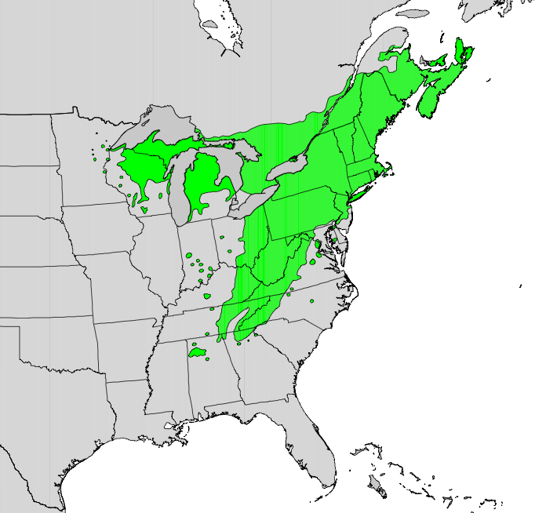
Figure 1. Native range of eastern hemlock in North America
(Little 1971).

and 1,520 m (984 ft - 5,000 ft). Carolina hemlock, Tsuga caroliniana Engelmann, is another native species of hemlock found within the eastern United States. Carolina hemlock is less prevalent than eastern hemlock, and is considered a rare relic species found in isolated stands and limited in range to the Blue Ridge Mountains in the Southern Appalachians with populations found within eastern Tennessee, northeastern Georgia, northwestern South Carolina, and western North Carolina and Virginia (Figure 2).
Eastern hemlocks are monoecious trees that reach maturity after 15 years and begin to produce male strobili developing from flower clusters in the axis of the needles. Bud scales develop around the strobili forming the male conelet and short, ovate flowers produce female conelets on the terminals of the previous year’s branchlets. Mature female cones contain multiple bracts from which two ovules develop on each of the bracts and begin to open in the spring. Leaf buds burst open releasing pollen in the spring that is dispersed by the wind for two weeks.
After pollination receptivity, the conelets droop and the cone scales reclose. Fertilization takes up to six weeks to complete. During this time, pollen is sensitive to drying, which is the primary cause of seed failure (Nienstaedt and Kriebel 1955). Cones reach full size in late-August through September, during which time winter buds begin to form. Cones open mid-October, and seed dispersal extends into the winter. Opened cones may persist on the trees for slightly more than one year.
Seedling establishment is limited by the germinative capacity which is usually less than 25% (USDA 1974). Ten weeks at or below freezing temperatures are required for the seed to break partial dormancy. Alternatively, light exposure can aid in breaking partial dormancy.

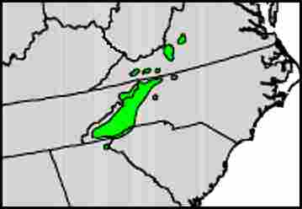

Figure 2. Native range of Carolina hemlock in North America (Little 1971).

Seedling germination begins at temperatures above 7º C and is epigeal leaving the seedling susceptible to drying (USDA 1974). The seedling stage is slow in growth with most seedlings reaching an average of 1.3 m in height (4.2 ft) and with relatively shallow roots. In addition to being highly intolerant of drought during this period, survival and growth of seedlings has been shown to be greatly reduced by deer browsing (Ward 2002). In some forest preserves with large herds of deer, seedlings are almost absent (Frelich and Lorimer 1985).
After completion of the sapling stage, the tree enters a pole stage consisting of a diameter at breast height (DBH) less than 20 cm (8 in), but greater than 2.5 cm (1 in) DBH (Godman and Lancaster 2003). Trees in this stage tend to retain good health despite suppression by overstory crowding (Tubbs 1977; Godman and Lancaster 2003). Trees are considered mature once they reach a DBH greater than 20 cm (8 in). Eastern hemlocks generally reach maturity between 250-300 years, with some trees having life spans over 800 years (Godman and Lancaster 1990). The largest documented eastern hemlock has a height of 50 m (165 ft) with a circumference measuring 513 cm (202 in) (Blozan et al. 1995) and is located in the Great Smoky Mountains National Park. The longest lived eastern hemlock record holder was measured to be 988 years old (Godman and Lancaster 1990).

Understory Characteristics of Eastern Hemlock
Two main characteristics of eastern hemlock allow its high survival rate as an understory tree. One is the high degree of shade tolerance exhibited by eastern hemlocks that contributes to the tree’s survival in the understory with as little as 5 % of full sunlight (Godman and Lancaster 1990). As a result, eastern hemlocks often produce dense canopies extending almost to the forest floor (Ward et al. 2004). The deep, dense canopies form cool, moist microclimates contrasted to other hardwood stands of similar age in the same area (Daubenmire 1931; Friesner and Potzger 1932, 1934, 1936, 1944; Hough 1945; Moore et al. 1924; Oosting and Hess 1956; Shreve 1927; Ward et al. 2004). The second characteristic is the ability of eastern hemlocks to maximize rates of photosynthate production during the winter when surrounding hardwoods are bare, enabling development under a variety of deciduous trees (Hadley and Schedlbauer 2002; Ward et al. 2004). As a late successional climax species capable of colonizing established forest stands, they can become a dominant species within the stand, if left undisturbed (Graham 1941; Hough 1936; Martin 1959; Quimby 1996).

Eastern Hemlock Root Systems
Eastern hemlocks have a shallow fibrous root system resulting in a high level of drought and flood intolerance (Graham 1943; McIntyre and Schnur 1936; Secrest et al. 1941; Stickel 1933) and vulnerability to wind throw (Willis and Coffman 1975). Fibrous root systems do not extend off a taproot and can grow from any part of the hemlock that is in soil. The shallow branching fibrous roots comprise a web of roots that grow laterally in the soil. The shallow lateral movement of these roots results in competition for resources with surrounding plants.
Seedlings have roots that extend less than 1.3 m below the soil, but once the tree reaches a height of 1-2 m, the root system will reach a depth that is not readily impacted by surface drying. The healthiest eastern hemlock stands are found on north- and east-facing slopes and in gorges characterized by high humidity and cool temperatures during all seasons (Benzinger 1994a, 1994b, 1994c; Thornthwaite 1948), where root systems can consistently acquire water and nutrients.

Transpiration, Photosynthesis, Carbon Exchange, and Carbon Storage
Eastern hemlocks in the southern Appalachians maintain year round transpiration rates with the highest rates measured in the spring (Ford and Vose 2007) and lowest in the winter (Ford and Vose 2007). This differs from transpiration rates for eastern hemlocks located in the northeastern United States, with transpiration and photosynthesis rates in eastern hemlocks do not drop with the onset of winter but slow down when air temperatures drop to below -10 ºC (Burkle and Logan 2003). Rates slow when air temperature falls below -10 ºC or rise above 20 ºC, and increasing net photosynthetic rates are seen as temperatures rise from 4-20 ºC (Burkle and Logan 2003). Photosynthetic rates in eastern hemlock saplings within the understory are minimally affected by temperature from late spring through early fall with net photosynthetic rate increasing between 11 and 15 ºC, but not changing between 15 and 30 ºC (Hadley 2000). Maximum photosynthate storage occurs mid-day. Carbon storage and annual photosynthesis are aided by mild winters with fewer frosts and extended thaws (Hadley 2000), with greatest rates occurring in May (Hadley 2000). Carbon exchange in autumn and winter is most affected by daily minimum air temperature while in the spring and fall, it is most affected by time of day, water vapor pressure deficit, and air temperature. Carbon storage was negligible from December through March, and was reduced by nocturnal frost and sub-zero temperatures (Hadley and Schedlbauer 2002).

Associated Forest Types and Cover
Eastern hemlock is associated with 29 forest cover types (Eyre 1980). It is dominant in four forest cover types: white pine hemlock (Type 22) in the northeast, eastern hemlock (Type 23), hemlock-yellow birch (Type 24), and yellow-poplar-eastern hemlock (Type 58) in the mid-west. It is commonly found in association with seven forest cover types: white pine-northern red oak-red maple (Type 20), eastern white pine (Type 21), red spruce-yellow birch (Type 30), red spruce-sugar maple-beech (Type 31), red spruce (Type 32), red spruce-balsam fir (Type 33), and red spruce-Fraser fir (Type 34). In addition, it is a minor component of 18 forest cover types (Eyre 1980).
The deep dense evergreen canopy produced in mature eastern hemlock stands reduces the amount of light that reaches the forest floor resulting in reduced ground cover (Simpson et al. 1990). Dominant plants in the understory are well adapted to developing in minimal sunlight and include: great rhododendron, Rhododendron maximum (L.), doghobble, Leucothoe fontanesiana (Steud.), common witchazel, Hamamelis virginiana (L.), mountain silverbell, Halesia tetraptera var. monticola (L.), mountain pepperbush, Clethra acuminate Michx., sourwood, Oxydendrum arboreum (L.), woodfern, Dryopteris spp., goldthread, Coptis groenlandica Salisbury, sedges (Carex spp.), moss, (including Polytrichum spp), starflower, Trientalis borealis (Hook), and clubmoss, Lycopodium spp. (Rogers 1980; Eyre 1980; Willis and Coffman 1975; Alverson et al. 1988).

Importance of Eastern Hemlock and Impact of Hemlock Woolly Adelgid
Eastern hemlocks are a vital component of biological diversity, environmental stability, and economic stability within their geographic range (Beatty 1984; Buck et al. 2005; Kelty 1989; DeGraaf et al. 1992; Snyder et al. 2004). It is considered a foundational species (Ellison et al. 2005), which is defined as “a single species that defines much of the structure of a community by creating locally stable conditions for other species, and modulating and stabilizing fundamental ecosystem processes” (Dayton 1972). Mortality of eastern hemlocks due to hemlock woolly adelgid infestations will decrease the biological diversity found in association with these trees and change the environmental and economic stability within their geographic range.
Eastern hemlock provides imperative cover species for turkey (Meleagris spp.), ruffed grouse (Bonasa umbellus (L.)), snowshoe rabbit (Lepus americanus Erxleben), rabbit (Oryctolagus spp.), and porcupine (Erethizon dorsatum (L.)) (Jordan and Sharp 1967; Quimby 1996; Wydeven and Hay 1996). More than 120 vertebrate species have been found to utilize mature hemlock stands (DeGraaf 1992). Several bird species are associated with eastern hemlock forests (Tingley et al. 2002), including the black-throated green warbler, Dendroica virens, the Blackburnian warbler, Dendroica fusca, and the Acadian flycatcher, Empidonax virescen. In addition, eastern hemlock is a vital foliage resource for deer in the winter (Lapin 1994; Reay et al. 1990), eastern hemlock is correlated to avian community composition (Tingley et al. 2002; Ward et al. 2004), is associated with more than 300 species of insects (Buck et al. 2005; Wallace and Hain 2000; Lynch et al. 2006; Dilling et al. 2007; Coots 2012; Coots 2012), and its canopy is a preferred habitat for a variety of mammals (Ward et al. 2004; Wydeven and Hay 1996). Eastern hemlocks also serve as a key component of riparian habitats lowering stream temperature, stabilizing diel variation in stream temperature, regulating streamflow, and producing an aquatic environment favorable to fish and aquatic macroinvertebrates (Evans 2002; Snyder et al. 2004).
Eastern hemlock also fulfills unique ecological roles that contribute to environmental stability. Hemlock decline and death from hemlock woolly adelgid is leading to transformations in canopy biomass and distribution, such as the increasing prevalence of early successional species, such as black birch (Betula lenta L.) (Orwig and Foster 1998; Stadler et al. 2005), and late successional species, such as black gum (Nyssa sylvatica L.) and yellow-poplar (Liriodendron tulipifera L.) (Ford and Vose 2007). Other species gaining from hemlock decline include white pine (Pinus strobes L.) and the exotic invasives tree-of-heaven (Ailanthus altissima (P. Mill.) Swingle), Japanese barberry (Barberis thunbergii DC), Asiatic bittersweet (Celastrus orbiculatus Thunb.), and Japanese stiltgrass (Microstegium vimineum (Trin.) A. Camus.) (Orwig and Foster 1998, Evans 2002). Regeneration of eastern hemlocks may be hindered since it cannot sprout or re-foliate after defoliation and relies on seeds and seed banks to propagate; seeds are viable for only 1 to 4 years (Orwig and Foster 1998). Heavy deer-browse pressure may also impede hemlock regeneration (Orwig and Foster 1998). Hemlocks are often pre-emptively logged before deterioration from hemlock woolly adelgid infestation begins (Orwig and Kizlinski 2002), a process that can lead to nitrogen loss and other detrimental environmental changes compared with naturally deteriorating stands (Orwig and Kizlinski 2002). Widespread hemlock decline could lead to higher nitrification in the forest floor and to water pollution from nitrate leaching (Jenkins et al.1999). Hemlocks play an important role in hydrological processes in forest ecosystems. Their decline and subsequent replacement by rhododendron in many southern Appalachian riparian communities will impact nutrient and carbon cycling, riparian vegetative transpiration, and will reduce soil moisture and seasonal transpiration rates (Ford and Vose 2007). The disappearance of hemlocks would be comparable to the loss of elms and chestnuts, relative to loss of vegetative diversity and establishment (Orwig and Kizlinski 2002, Evans 2002) and alterations of forest micro-environments and vegetation (Orwig and Kizlinski 2002).
The coverage produced by deep dense canopies in hemlock dominant stands moderate cold temperatures and snow depths in extreme northern climates (Lishawa et al. 2007). Deep shade and slowly decomposing acidic litter result in a microclimate characterized by temperature reduction, moisture retention, lowered rates of nitrogen cycling, and nutrient poor soils (Jenkins et al. 1999). Eastern hemlocks fill two hydrological roles, maintaining transpiration rates year-round and constituting a dominant tree along riparian corridors (Ford and Vose 2007).
Economically, eastern hemlock forests provide revenue in the form of tourism in eastern Tennessee (Travel Industry Association 2006), support production of over four million cubic feet of timber annually in the northeastern United States, are components of ornamental nursery stock worth millions of dollars (Brisbin 1970; Rhea 1996; Woodsen 2001), and comprise 22% of the softwood growing stock in the northeastern United States (Powell et al. 1993). The wood harvested from eastern hemlock is used for making a variety of low-value containers like boxes and crates (Brisbin 1970). Eastern forests contain enough hemlock wood fiber for 1.5 million conventional homes and 15 billion newspapers (Rhea 1996). Hemlock can be used for pulpwood and lumber, and plantings are often used in ornamental settings and landscapes (McClure et al. 2001). As an ornamental, eastern hemlock is valued for its landscape appeal and shade qualities, and nursery industries have invested millions of dollars in this species (Rhea 1996).

Hemlock Woolly Adelgid,
Adelges tsugae Annand (Hemiptera: Adelgidae)

Origin, Distribution, and Life History
Throughout its expansion into North America, eastern hemlock populations have gone through two major declines. The first decline coincided with an increase in human forest resource use about 200 year ago (McMartin 1992). The second and most rapid decline is the direct result of the introduced hemlock woolly adelgid. Hemlock woolly adelgid has proven to be detrimental to both eastern hemlock, and Carolina hemlock in eastern North America, first detected in Richmond, Virginia in 1951 (McClure 1990, 1991a; Souto et al. 1996; Royle and Lanthrop 1997; Danoff–Burg and Bird 2002). It now ranges as far north as Massachusetts, south to North Carolina and north Georgia, and west to Tennessee and West Virginia.
This pest of eastern hemlocks was discovered and described by Annand in Oregon around 1924 where it had minimal impact on western hemlock, Tsuga heterophylla (Raf.) and mountain hemlock, Tsuga mertensiana (Annand) (Havill et al. 2006; McClure and Cheah 1999; Stoetzel 2002). Mitochondrial DNA analysis of the hemlock woolly adelgid introduced in western and eastern United States indicates that they represent different lineages from one another (Havill et al. 2006). The lineage of hemlock woolly adelgid found in the eastern United States matches the lineage of hemlock woolly adelgid from Honshu, Japan. The lineage introduced in the western United States. is from an unknown source (Havill et al. 2006). For several decades after the initial detection in Richmond, Virginia, hemlock woolly adelgid was not considered a pest because of its non-pestiferous status in Japan, Taiwan, and western North America (Ward et al. 2004).
The lifecycle of hemlock woolly adelgid is parthenogenetic and bivoltine on eastern hemlock: the winter generation is known as sistens (present in the southern Appalachians from –middle May - late spring) and the spring generation known as progrediens (present in the southern Appalachians from late February–mid July) (Deal 2006). Progredien and sisten generations overlap in middle to late spring (McClure 1989). Sistens produce progredien eggs (100-300 eggs per female). Progrediens develop into first instars also known as crawlers in April and search branches, settle, and insert their stylet into the plant tissue at the base of the hemlock needles for feeding. Once inserted into the plant tissue the stylet will penetrate the xylem ray parenchyma cells in the branch (Young 1995). Settled progredien crawlers progress through four nymphal instar stages before reaching maturity in late May – early June. A portion of this progredien generation will develop into winged sexupara, flying from the tree in search of spruce (Picea spp.), which is needed to complete this sexupara lifecycle in late May and early June. Because these species of spruce (P. jezoensis hondoensis (Sieb. and Zucca.) and P. polita (Carrière)) does not exist in North America, the adult starves to death before it is able to reproduce. It is suggested that the winged sexupara is density dependent and are produced in greater numbers when the health of the tree is declining (McClure 1991a). After summer aestivation in late May and early June, wingless progredien females remaining on the tree lay less than 100 eggs per female within a protective woolly wax coating, producing the sistens generation eggs. The sisten eggs develop into first instars and search branches, settle, and then aestivate as nymphs from late June until late October. In late October, the sisten generation breaks aestivation dormancy, begins feeding, and nymphs develop through, 2nd, 3rd, and 4th instars and in February and March develop into adults.
The phenology of hemlock woolly adelgid feeding is a major contributor to the success of this invasive forest insect pest. Progredien generation feeding (April-June) and sisten generation feeding (October – March) is synchronous with a high abundance of photosynthate and plant nutrients in hemlock twigs. During “leaf off “, when deciduous trees have dropped their leaves, eastern hemlocks have the highest abundance of photosynthate and nutrients within the twig and needles (Ward et al. 2004). Evidence suggests that the increased nutrient load during this period may impact hemlock woolly adelgid fecundity (Ward et al. 2004) resulting in the sisten (winter) generation laying twice as many eggs as the progredien (spring) generation (Ward et al. 2004).
Eggs and crawlers are reported to be transported by wind, birds, humans, and other mammals (McClure 1990), as well as through nursery stock (Gibbs 2002; McClure 1987, 1989; Ouellette 2002). Roads, riparian corridors, and major trails all have a high degree of connectivity, which enables long-distance dispersal of hemlock woolly adelgid (Koch et al.2006). These factors all aid in the rapid dispersal rate of hemlock woolly adelgid estimated at 20-30 km per year (McClure 2001).
After establishment of hemlock woolly adelgid on eastern hemlock, there are two primary mortality factors limit population sizes. Cold winter temperatures have been shown to reduce hemlock woolly adelgid populations in the northeastern United States (McClure 1995; Parker et al. 1998, 1999); however, there may be low abundances of cold tolerant individuals within a population resulting in propagation of the population on a host tree (Parker et al.1998). Intraspecific competition in the northeastern United States, limits hemlock woolly adelgid populations through negative density dependent feedback (McClure 1991a; McClure and Cheah 2002). Interspecific competition with other herbivores, such as the elongate hemlock scale, hemlock looper, and hemlock borer, is hypothesized to limit hemlock woolly adelgid populations, but competition between such species has not been convincingly documented (McClure 2001). In Japan, native predators, parasitoids, and competition severely limit hemlock woolly adelgid populations, and as such, they never reach pest status (McClure 1995;McClure and Cheah 1999).
Hemlock mortality is caused by reduced carbohydrate reserves in the tree as a direct result of adelgid feeding (Ward et al. 2004) and affects trees of all size and age classes (McClure 2001). Carbohydrates are critical for proper growth, maintenance, reproduction, defense, and storage (Shigo 1991), and reduction of carbohydrate reserves slows or suspends development (Ward et al. 2004). Mortality generally occurs within 2 to 12 years, depending on the level of infestation (McClure 2001; Mayer 2002; Orwig 2002). Declining tree health is characterized by branch dieback, foliage thinning, and needle drop (McClure 2001).

Susceptibility of Eastern Hemlocks to Hemlock Woolly Adelgid Infestation
Tree chemistry may play a role in hemlock susceptibility to hemlock woolly adelgid infestation. Higher nitrogen and potassium concentrations increase hemlock palatability by hemlock woolly adelgid. High calcium and phosphorous concentrations are reported to discourage heavier infestations (Pontius et al. 2006). Terpenoids are naturally occurring tree chemicals that can inhibit acetylcholinesterase and thereby repel or display toxicity against feeding insects. Terpenoid composition plays a role in tree susceptibility to hemlock woolly adelgid infestation, with myrcene and germacrene D in the leaf cushion deterring settling and feeding by hemlock woolly adelgid and isobornyl acetate acting as a potential chemical attractant for hemlock woolly adelgid feeding (Lagalante and Montgomery 2003). The adelgid lifecycle on eastern hemlock closely parallels changing terpenoid levels within the leaf cushion as HWA avoids variable levels of terpenoids by entering a non-feeding aestivation in the summer. This feeding avoidance corresponds to unstable and variable levels of terpenoids in hemlock leaf tissues, while adelgids preferentially reproduce and feed during the spring on new growth tissue that has a relatively stable and low concentration of terpenoids in the parenchyma cells (Lagalante and Montgomery 2003). Thus, the chemistry of hemlock foliage seems to be a primary component affecting adelgid population densities on hemlock branches. The composition of volatile emissions of terpenoids from eastern hemlocks is affected by the presence or absence of hemlock woolly adelgid infestation (Broeckling and Salom 2003). Northwestern American and Asian Tsuga species are considered resistant to hemlock woolly adelgid and infestations hemlock woolly adelgid infestations are often found at lower densities compared with the Tsuga species in the eastern United States, this is possibly as a consequence of differences in tree terpenoid chemistry (Lagalante and Montgomery 2003, Lagalante et al. 2006) and tree nutritional components (Pontius et al. 2006),tree host resistance (Cheah and McClure 2000), genetic differences among the different geographic populations of hemlock woolly adelgid (Havill et al.5 2006), and the presence of a complex of natural enemies in the pacific-northwest and Asia (McClure et al. 2000; Wallace and Hain 2000; Mausel 2005).

Hemlock Woolly Adelgid Management Strategies
Overview
Numerous methods have been established for controlling populations of hemlock woolly adelgid. Both short-term and long-term management strategies combine the use of a variety of methods that enable the suppression of hemlock woolly adelgid populations below a damaging level in urban and limited forest environments. The first step in developing a management strategy is prioritizing hemlock stands or individual trees. Priorities will vary greatly relative to the agency, land manager, or private owner interested in implementing control tactics. Prioritizing hemlock stands usually include criteria for determining the importance of one stand over another in terms of economic, ecological, and aesthetic factors (Ward et al. 2004). Economic criteria includes public safety (trees that may pose a hazard to hikers or recreation use areas), restoration costs, cost of control for hemlock woolly adelgid, public water supply, wildfire potential and potential for viable salvage harvest (Ward et al. 2004). Ecological criteria includes current health of hemlocks and potential decline rate, water quality protection; habitat protection for rare, threatened, or endangered species, vulnerability to invasive species, and potential as wildlife habitat (Ward et al 2004). Aesthetic criteria include potential decline in tourism due to the decline in quality of recreational activities (such as hiking, kayaking, camping), trail closure, presence of standing dead or dying trees and significant logging slash (Ward et al. 2004). Selection of stands should consider stand characteristics, such as age, diameter, volume, and accessibility, and site quality. Hemlocks are drought intolerant and the chance of improved health after implementing management strategies are increased if the site has appropriate moisture regimes (Ward et al. 2004).
Monitoring prioritized eastern hemlocks for the insect pest and infestation level determination in trees where hemlock woolly adelgid has been detected are the next steps in developing a management plan. Small scale monitoring consists of stands of 10-25 trees, with 2-4 branches per tree inspected for hemlock woolly adelgid (Ward et al. 2004). Decision for treatment is dependent upon cost-benefit analysis relative to locality (Ward et al. 2004). Proportional/percentage infestation estimates (Evans 2002) and hemlock woolly adelgid counts per 100 needles (Mayer et al. 2002) are the standards for determining infestation levels. The decision to treat is usually based on the detection of hemlock woolly adelgid infestations greater than 45% (Evans 2002) and at or greater than 30 hemlock woolly adelgid per 100 needles (Mayer et al. 2002).
Several cultural, biological, and chemical control methods have been established to control or suppress hemlock woolly adelgid populations. As part of a more long-term solution for this pest, a suite of biological control agents have shown stepwise progression to establishment and are actively and extensively being researched, however, there is an immediate need for treatment of these valued trees. Hemlock woolly adelgid has been successfully controlled in both urban and limited forest settings (Cowles et al. 2006; McClure 1991b; Steward and Horner 1994; Cowles and Cheah 2002a, 2002b; Doccola et al. 2003; Webb et al. 2003) using several chemical application methods. The integration of cultural, biological, and chemical controls is considered to be the best long-term solution for controlling hemlock woolly adelgid.

Cultural
Maintaining healthy eastern hemlock trees helps to increase tolerance to higher densities of hemlock woolly adelgid (McClure 1995). Eastern hemlocks are drought intolerant trees and become easily stressed. Two prophylactic steps are recommended for reducing drought stress: 1) mulching around the tree to aid in water retention and 2) irrigation (Ward et al. 2004). Fertilizers can help improve the overall health of the tree; however, fertilizers containing nitrogen should be avoided as they increase survival and reproduction of hemlock woolly adelgid and elongate hemlock scale (McClure 1991c). Although wind is the primary means of dispersal of this exotic, birds, deer, and other mammals have been documented as dispersers of eggs and crawlers. Discouraging these animals by removal of animal feeders or other food products near hemlock stands that would encourage wildlife into the area is recommended.
Human movement between infested and non-infested areas is another mechanism for dispersal. Cleaning vehicles, clothing, camping gear, and recreational equipment reduce the risk of spreading hemlock woolly adelgid (Ward et al. 2004). Reducing the movement of wood products like firewood from areas of known infestations can reduce the spread of hemlock woolly adelgid (Ward et al. 2004).
Silviculturally, stands can be irrigated, reducing drought-induced stress, and large infested trees that may act as a reservoirs of infestation can be removed (McClure 1995). Replanting areas where there has been significant hemlock decline with natives such as white pine and the two western hemlock species, T. heterophylla and T. mertensiana, which are resistant to hemlock woolly adelgid, is recommended as these trees act as the closest ecological homologies in North America (McClure 1995).

Biological
Several non–native biological control agents (i.e., the derodontid Laricobius nigrinus Fender, and the coccinellids: Sasajiscymnus tsugae (Sasaji and McClure), Scymnus sinuanodulus Yu & Yao, Scymnus ningshanensis Yu & Yao, and Scymnus campodromus Yu & Yao) have been evaluated for mass release into infested regions as long-term biological control agents for the hemlock woolly adelgid. Two of these species, S. tsugae and L.nigrinus have been reared and released in the eastern United States. Scymnus tsugae is native to Japan, and in 1922, was observed feeding on hemlock woolly adelgid in Honshu, Japan. The adelgid does not reach damaging population levels within its native range. Over 90% mortality of hemlock woolly adelgid was observed at sampled sites where S. tsugae was present (Sasaji and McClure 1997; Cheah and McClure 2000), making it a favored biological control agent (Cheah and McClure 2000). L. nigrinus, native to the western United States, has been augmented in several locations throughout the eastern United States. Successful recovery of L. nigrinus infers this species has a high potential for establishment and potentially control of hemlock woolly adelgid. Currently, these predators are not uniformly established in hemlock forest throughout eastern North America, but some or showing stepwise progression of establishment and research is promising and continues in this area. Predators, such as the multicolored lady beetle, Harmonia axyridis (Pallas) (Coleoptera: Coccinellidae), brown lacewings (Neuroptera: Hemerobiidae), and green lacewings (Neuroptera: Chrysopidae), have been reported to feed on hemlock woolly adelgid; however, they have not been documented as being effective in reducing hemlock woolly adelgid (Wallace and Hain 2000).

Chemical
Imidacloprid, horticultural oil and soap are the primary chemical compounds used to control hemlock woolly adelgid in both urban (McClure 1991b; Steward and Horner 1994; Cowles and Cheah 2002a, 2002b; Doccola et al. 2003; Webb et al. 2004) and limited forest (Cowles et al. 2006) environments. Forest treatment is limited to trees that are of high value as treatment of an entire forest is not practical or economically feasible. High value trees are chosen based on economic (public safety, control versus removal costs, or salvage harvest), ecological (water quality, protection of endangered or threatened species, and impact on species associated with hemlock), or aesthetic criteria (decline in tourism to area due to closed trails, and visual impact of dead trees) (Ward et al. 2004).
In addition to imidacloprid, horticultural oil and soap, dinotefuran (Safari), a neonicotinoid insecticide has shown to be effective at suppressing populations of hemlock woolly adelgid. In 2009, Valent received an EPA label for use of dinotefuran as a trunk application for hemlock woolly adelgid. Pyrethroids and other chemicals such as diazinon, ethion,and malathion have proven effective (Cowles and Cheah 2002a; Rhea 1996), however, these chemicals have poor environmental and toxicological profiles in comparison to imidacloprid and as such are less preferred. The unique mode of action of imidacloprid, degree of systemic and contact activity, multiple application methods, low application rates, extended residual control, resilient binding to soil organic matter, and good environmental and toxicological profiles result in imidacloprid being one of the most widely used insecticides globally and one of the most preferred for management of hemlock woolly adelgid (Elbert et al. 1990; Elbert et al. 1991; Kagabu 1997; Cox et al. 1997; Cox et al. 1998; Silcox 2002).

Imidacloprid
In 1985, Nihon Bayer Agrochem chemists initially synthesized imidacloprid (Elbert et al. 1990) by coupling the 6-chloro-pyrid-3-ylmethlyheterocyclic group to the 2-(N-nitroimino)-imidazolidine heterocyclic group (Figure 3). Imidacloprid has two chemical names: one given by the International Union of Pure and Applied chemistry [IUPAC], 1-(6-chloro-3-pyridylmethyl)-N- nitroimidazolidin-2-ylideneamine, the other by the Chemical Abstracts Services [CAS], 1-[(6-chloro-3-pyridinyl) methyl]-N-nitro-2 imidazolidinimine. Imidacloprid is a neonicotinoid insecticide, classified in toxicity classes II (moderately toxic) and III (slightly toxic) by the Environmental Protection Agency. Insecticides that contain imidacloprid have a variety of tradenames: Admire®, Bayer Advanced® Condifor®, Gaucho®, Leverage®, Premier®, Premise®, Provado®, Marathon®, Merit®, and Trimax®. This compound is synthesized from nicotine and binds to post-synaptic nicotinergic acetylcholine receptors (nAChR), disrupting nerve impulse transmission and resulting in death within 24–48 hours after contact or ingestion (Bai et al. 1991; Kid and James 1991; Mullins and Christie 1995). The electrostatic interactions of the nitrogen atoms in the chloronicotinyl group and imidazolindine ring determine how effectively imidacloprid will bind within the insects nAChR sites (Kagubu et al. 2007; Mencke 2002). The 6-cholor-3-pyridyl moiety increases the affinity of imidacloprid for an insects nAChR sites. An insect’s central nervous system has a high density of nAChRs.

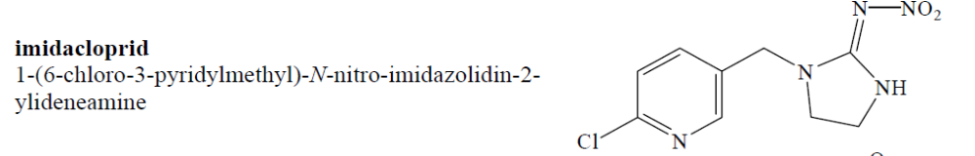

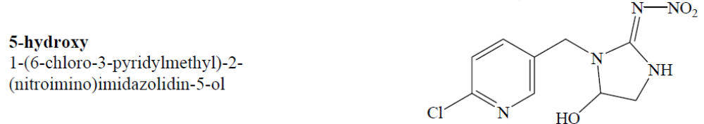

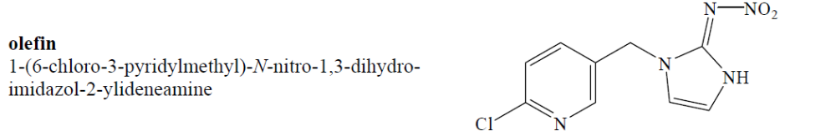

Figure 3. Chemical names and structures of imidacloprid, 5-hydroxy, and olefin.

An insect’s nAChRs are neurotransmitter-gated ion channels that are agonist regulated and responsible for rapid transmission of nerve impulses (Tomizawa 2000). After absorption of imidacloprid, the nAChR regions of nerve tissue is bound with imidacloprid leading to the opening of the sodium ion channel. At the nicotinic acetylcholine receptor, acetylcholine normally binds and then is quickly decomposed by acetylcholine esterace (AChE). Imidacloprid absorbed in an insect is not removed by the AChE and causes disruption of the insect’s nervous system, leading to hyper-excitation, paralysis, and death. Imidacloprid has a high selectivity towards insect receptors compared to mammalian receptors and as such is a highly favored insecticide.
Imidacloprid has been effectively used in management strategies against several insects. In turfgrass and ornamental settings, imidacloprid has been shown to effectively control adelgids, aphids, lace bugs, leafminers, mealybugs, scales, thrips, whiteflies, elm leaf beetles, leafhoppers, and Japanese beetles (Dotson 1994). In forested settings, specifically trees, shrubs, flowers, and groundcover, imidacloprid is recommended for the control of adelgids, aphids, armored scale, black vine weevil larvae, emerald ash borer, eucalyptus longhorn borer, flathead borers, Japanese beetles, lace bugs, leaf beetles, leafhoppers, leafminers, mealybugs, pine tip moth larvae, psyllids, royal palm bugs, sawfly larvae, soft scales, thrips, white grub larvae, and whiteflies (Bayer 2007).
Imidacloprid is usually applied by soil drench, soil injection, tree injection, foliar spray, granular application, or time released pellets. All of these methods, with the exception of the foliar spray, are considered systemic because the chemical is taken up by the plant and diffused across plant tissue. The foliar application is sprayed directly on the plant and has a direct contact impact. In systemic applications, imidacloprid is transported through the xylem (Steward et al. 1998; Tattar et al. 1998). In eastern hemlock, the chemical diffuses into the xylem ray parenchyma cells located in twigs of trees (Young et al. 1995), where hemlock woolly adelgid feeds. Applications of imidacloprid for hemlock woolly adelgid may be applied either in the fall or the spring. Foliar applications, soil injections, and soil drenches of imidacloprid have been evaluated and shown to be successful in the control of hemlock woolly adelgid (Steward and Horner 1994; Rhea 1996; Steward et al 1998; Fidgen et al. 2002; and Cowles et al. 2006). Tree health has been shown to be important in the effectiveness of imidacloprid treatments. Tree injections have been shown to be less effective than foliar application, soil injections, and soil drenches (Cowles et al. 2006), and are preferred less because of tree wounding from the injection. Tree injections not only damage the tree tissue, but the wounds can act as a portal for diseases (Steward and Horner 1994; Marion and Foster 2000; McClure et al. 2001; Smith and Lewis 2005). Trees under drought stress and those with needle loss and dieback have difficulty transporting systemic insecticides into the canopy (McClure et al. 2001). Damage to the tree from heavy adelgid infestations reduces the ability of the hemlock to transport imidacloprid throughout the tree (McClure et al. 2001; Webb et al. 2003). Translocation of imidacloprid in trees that have been treated with a soil injection or tree injection have been shown to occur in eastern hemlock; however, concentrations of the insecticide were only monitored for three months (Tattar et al. 1998). Reduction of adelgid populations as the result of imidacloprid treatment has shown to dramatically increase new growth, even trees in poor conditions recovered, although the rate of recovery is highly dependent on the health of the tree at the beginning of therapy (Webb et al. 2003).
Shortly after translocation begins throughout the tree, 13 primary metabolites are produced through biological, chemical, and photochemical pathways (Placke and Gustin 1993) (Figure 5). Two metabolites are of toxicological interest, olefin and 5–hydroxy (Figures 3 and 4). The olefin metabolite has been shown to be at least ten times more active than its parent compound (Nauen et al. 1998). The 5–hydroxy metabolite is slightly less active than the parent imidacloprid (Nauen et al. 1998). These findings suggest a more long-term residual effect that may be catalyzed by the breakdown of imidacloprid, resulting in longer control of pest insects (Nauen et al. 1998). The imidacloprid molecule consists of three primary groups; chloropyridinylmethyl, imidazolidine, and nitroamine (Schultz-Jander 2002), changes occurring to these groups affect how imidacloprid and produced metabolites react in the plant.
Multiple analytic techniques for imidacloprid quantification exist, these include high-pressure liquid chromatography (HPLC) (Fernandez-Alba et al. 1996, Baskaran et al. 1997, and Obana et al. 2002), high pressure liquid chromatography coupled with tandem mass spectroscopy (HPLC/MS/MS) (Schöning 2001, Schöning and Schmuck 2003), liquid chromatography-mass spectrometry (LC/MS) (Bonmatin et al. 2003), flow injection analysis (FIA) (Lagalante and Greenbacker 2007) and gas chromatography-mass spectrometry (GC/MS) (Vilchez et al. 1996). It can be difficult to quantify imidacloprid using these techniques because of the insecticide’s inherent molecular characteristics of low solubility in non-polar solvents, biological efficacy at low concentrations (ppb range) and low vapor pressure (Fernandez-Alba et al. 1996, Cowles et al. 2006, Lagalante and Greenbacker 2007).

Regulatory Control
Regulatory control is a critical component of the prevention of entry and establishment of foreign

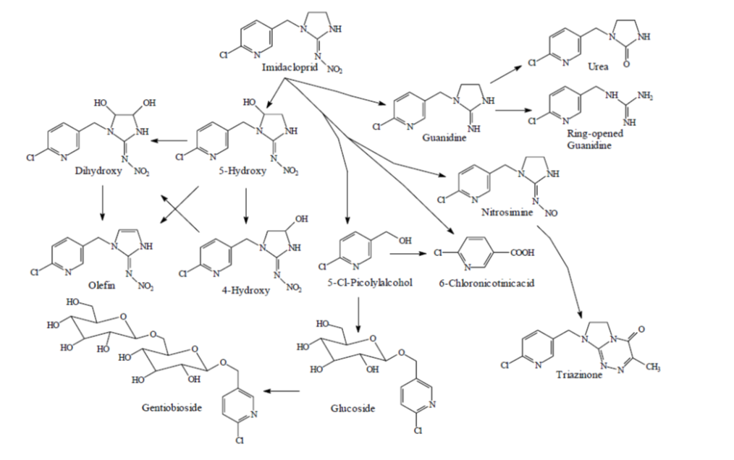

Figure 4. Metabolic pathway of imidacloprid and its metabolites in plants (Placke and Gustin 1993).

plant and animal pests. Regulatory control directs management strategies to aid in suppression,
containment, and eradication of invasive pests that become established in limited areas (Drooze 1985). The passage of the Federal Insect Pest Act in 1905 enabled the federal government to regulate the importation and interstate movement of articles that might spread insect pests. The Plant Quarantine Act of 1912 aided the regulation and enforcement by the Secretary of Agriculture of strategies to reduce the introductions of insects and plant diseases. In 1928 the passage of the McNary-McSweeney Act, a federal policy used to enforce management of forest insects and diseases was passed. The passage of the Forest Pest Control Act in 1947, enabled the United States government to act alone or in cooperation with States, territories, or private land owners to control destructive forest insects or diseases (Drooze 1985).
Integrated Pest Management
The term” Integrated Pest Manangement” is designed to identify management programs that incorporate all effective control techniques and methods of pest prevention and suppression, while maintaining ecological stability and pest population levels below those considered injurious. The synchronous goals of integrated pest management is to suppress pest populations of threatening pests, based upon the application of a range of techniques designed to maximize pest management within economic tolerance and minimize or eliminate environmental trauma (Drooze 1985). Integrating both biological and chemical control tactics has the potential for long-term control over large areas. Chemical control provides initial short-term control whereas biological control offers a sustained long-term solution for control of hemlock woolly adelgid on eastern hemlock. However, these biological control organisms require several years to establish (Mausel et al. 2010), and the rapid decline of hemlock trees impedes their ability to colonize areas where they are released, which makes establishment problematic. Acute toxicity has been shown to occur in one of the introduced biological control agents (L. nigrinus) when feeding on imidacloprid-contaminated prey (Eisenback et al. 2010) in the laboratory; however, field results from this study were less conclusive. The tri-trophic movement and persistence of imidacloprid and its metabolites, from tree tissue into primary (herbivore - HWA) and then into secondary (predators of primary consumers - predators of HWA) consumers, are unclear. A more thorough understanding of the tri-trophic movement and persistence of imidacloprid and its metabolites is critical for effectively combining biological control strategies with imidacloprid treatments. Expanded knowledge of the spatial, temporal, and tri-trophic distribution of imidacloprid and toxicologically relevant metabolites, olefin and 5-hydroxy, will help target retreatment times and minimize potential negative, adverse non-target impacts on beneficial insects while maximizing mortality of hemlock woolly adelgid. Integrating chemical and biological control tactics into an effective integrated pest management strategy will extend the time available for predators to become established and avoid potential negative impacts on predators (non-targets), ultimately encouraging healthy and effective predator populations to become established resulting in the conservation of eastern hemlock stands.

Objectives of Research

The overall goal of this research was to document the movement and persistence of imidacloprid, olefin, and 5-hydroxy and their effects on hemlock woolly adelgid mortality in the southern Appalachians. Furthermore, improvements to systemic treatment strategies can be developed by evaluating factors that may influence the homogenous movement of imidacloprid and monitoring imidacloprid concentrations in the field. Therefore the objectives of this study were to: 1.) quantify the spatial and temporal distribution of imidacloprid, olefin, and 5-hydroxy in sap and twig and needle tissue, 2.) assess the efficacy of imidacloprid, olefin, and 5-hydroxy, on hemlock woolly adelgid mortality in field studies and laboratory dose-response tests, 3.) determine the tri-trophic movement and persistence of imidacloprid, 5-hydroxy, and olefin through eastern hemlocks and primary (herbivores of eastern hemlock) and secondary (predators of primary consumers) consumers, 4.) evaluate the influence of site characteristics and hemlock woolly adelgid infestation level on water stress, and 5.) assess the use of near infra-red spectroscopy for predicting imidacloprid concentration in eastern hemlock needles. Completion of these objectives will provide critical information that will help developed hemlock woolly adelgid management strategies that result in the optimal use of imidacloprid.

CHAPTER II. SPATIAL AND TEMPORAL DISTRIBUTION OF IMIDACLOPRID, OLEFIN, AND 5-HYDROXY IN EASTERN HEMLOCK IN THE SOUTHERN APPALACHIANS
Introduction
Extensive mortality of eastern hemlock, Tsuga canadensis (L.) Carrière, resulting from infestation by hemlock woolly adelgid, Adelges tsugae Annand (Hemiptera: Adelgidae), has occurred throughout the eastern United States. Eastern hemlock is the predominant species on 2.3 million acres (Schmidt and McWilliams 2000) and are considered a foundation species representing a vital component of biological diversity and contributes to the environmental stability of the forests within their geographical range (Buck et al. 2005; Dilling et al. 2007). As such, control of the exotic hemlock woolly adelgid is imperative. Insecticides offer an immediate and effective control tactic in accessible areas. The efficacy of insecticides range from a few weeks to a few years and is extremely important until more long-term solutions, such as using biological control agents, can be established.
The primary insecticide used to control hemlock woolly adelgid is imidacloprid, a systemic insecticide transported by the xylem and diffused into the xylem ray parenchyma cells located within twigs (Steward et al. 1998) where the hemlock woolly adelgid feeds (Young et al. 1995; McClure 1987, 1991). Imidacloprid is a neonicotinoid, which acts as an agonist at the acetylcholine receptors (nAChR) of the central nervous system, resulting in death within 24-48 hours after contact or ingestion. Imidacloprid can be applied using soil drench, soil injection, trunk injections, time released tablet, and foliar spray application methods. Soil drench, soil injection and foliar applications require water usage. Large quantities of required water can inhibit where these treatments can be made. These methods of application in forests are limited due to adverse terrain, mass coverage area, and required equipment and water. Bayer Corporation recently introduced an imidacloprid product, CoreTect® which is a waterless time- release tablet, capable of removing these adverse constraints. Differences in concentrations of imidacloprid found in the canopy of eastern hemlocks have been shown to occur across different methods of application (Cowles et al. 2006; Dilling et al. 2010). However, it is unknown if there are disparities in the spatial and temporal dynamics of imidacloprid in eastern hemlocks that have been treated using CoreTect® to those treated using standard soil injection methods..
Imidacloprid can be applied year round, although it is believed to be most effective against hemlock woolly adelgid when applied in the fall or spring (Steward et al. 1998; Tattar et al. 1998; Cowles et al. 2006). The treatment rate varies depending upon application method and tree diameter at breast height (DBH). For example, the recommended rates for soil drench, soil injection, and tree injection treatments range from 0.75 g AI/2.5 cm DBH to 1.5 g AI/2.5 cm DBH. Because transpiration occurs year round in eastern hemlocks in southern Appalachians it allows for constant movement of imidacloprid throughout the tree (Ford and Vose 2007). It is unknown if disparities in insecticide concentrations exist as a result of seasonal timing of application (summer, fall, winter, spring),
Imidacloprid has been shown to persist in the tree canopy (Cook 2008; Cowles et. al. 2006; Dilling 2007; Dilling et al. 2010; Tattar et. al. 1998; Turcott 2007) in concentrations correlated with effective control of hemlock woolly adelgid for several years (Cowles et al. 2006; Cook 2008; Dilling 2007; Dilling et al 2010). The metabolism of imidacloprid in plants produces two metabolites of toxicological interest, NTN 33893-5-hydroxy and NTN 33893-olefin (Schöning and Schmuck 2003; Nauen et al. 1998). The olefin metabolite has been shown to be at least ten times more active than its parent compound against the green peach aphid, Myzus persicae (Sulzer), and the cotton aphid, Aphis gossypii Glover (Nauen et al. 1998). The 5–hydroxy metabolite, although slightly less active than the parent imidacloprid (Nauen et al. 1998), still retains toxicological properties that may work in synchrony with these other compounds. These findings suggest a more long-term residual effect resulting from the breakdown of imidacloprid resulting in longer control of pest insects (Nauen et al. 1998; Cook 2008). Little is known about the temporal and spatial distribution of these metabolites within eastern hemlock.
Imidacloprid has been demonstrated to be both heterogeneously (Dilling et al. 2010) and homogeneously (Cook 2008) distributed throughout the canopy. These disparities can partially be explained by multiple physiological and environmental factors. One explanation for these disparities may be temporal differences in transpiration. In the southeastern United States, eastern hemlocks transpire year round, with peak transpiration rates occurring in the spring, prior the emergence of leaves on co-occurring hardwoods, with the lowest transpiration occurring in December and January (Ford and Vose 2006). In the northeastern United States, eastern hemlocks have a lower transpiration rate in the spring, and no transpiration occurring in the winter (Catovsky et al. 2002). In the Cherokee National Forest in southeastern Tennessee, Dilling et al. (2010) found a general trend in the distribution of imidacloprid within full canopies of eastern hemlock, in which imidacloprid concentrations significantly decreased the higher the stratum. Cook et al. (2008) found no significant differences in the vertical distribution of imidacloprid from samples taken from West Virginia, Connecticut, and Pennsylvania. Differences in environmental conditions at these sites, hemlock woolly adelgid infestation level, and physiological disparities in the trees, and sampling may be important factors influencing these differing results. However, understanding these regional disparities are important to establish effective control tactics. Since hemlock woolly adelgid settles and feeds throughout the canopy, distribution of effective concentrations throughout the canopy is an important factor for the control of this invasive pest. The objective of this study was to determine the effect of treatment timing (fall, winter, spring, and summer) and application method (CoreTect and soil injection) on imidacloprid, olefin, and 5-hydroxy concentrations at bottom, middle, and top strata within the canopy of eastern hemlock over three-years to better understand the spatial and temporal dynamics of these compounds, in the southern Appalachians.

Materials and Methods
Study Site-Experimental Design
Eastern hemlocks (n = 60) with moderate adelgid populations (35 – 50 % infestation) were selected at Indian Boundary in Cherokee National Forest in southeastern Tennessee (35º23’06.728” N, 84º 06’23.529” W, elevation: 567 m) on 5 May 2008. The test site was arranged in a split (three strata within the tree) - split plot, 4 (timing of application: fall, winter, spring and summer) x 3 (treatments: soil injection, CoreTect®, untreated control) factorial complete randomized block design, with five replications. Within each replication, trees were arranged in groups of four with one of the trees treated in the summer (July 2008), one in the fall (November 2008), one in the winter (January 2009), and one in the spring (April 2009). To monitor translocation of imidacloprid within the tree, each tree was divided into three strata (bottom, middle, and top) with each stratum representing ca. one-third of the tree. Each tree was marked with a numbered identification metal tag. Tree characteristics were documented (tree height, DBH, density, crown class, crown condition, live crown ratio, foliage color, and overall heatlh) (Table 12; Appendix A). All trees had approximately similar heights (12 -15 m) and diameters at breast height (DBH) (23.5 – 29.5 cm). Tree selection was limited to those eastern hemlocks with a maximum of 15 m to be able to reach the top strata for branch collection with a pole prunner. Trees with heavy populations of hemlock woolly adelgid were not selected due to the density dependent feedback mechanism known to cause population crashes in the northeastern United States (McClure 1991a).

Insecticide Application
The CoreTect pellets were applied to the soil as specified by the label. The application rate was 1 g AI/2.5 DBH, applied as two tablets per cm DBH. This treatment was compared to soil injections made using the Kioritz® soil injector (Kioritz Corp. Tokyo, Japan) for uptake and concentration of imidacloprid at three strata in the tree. Merit® 75 WP insecticide (Bayer, Kansas City, MO) was diluted to 1 g AI/2.5 DBH in 60 ml of water. Soil injections were made using the basal system in which injections were made within 45 cm of the base of the trunk and were spaced evenly around the tree at a depth of 7 cm below the soil surface with individual injections delivering 30 ml of insecticide based on label.

Branch Sampling
Branch samples were taken every week post-treatment until initial uptake was determined and then every three months post-treatment for three years. Four (24 cm) branch clippings were taken at each stratum (bottom, middle, top) using a 10 m pole pruner. Branch samples were immediately placed in plastic bags, packed in ice, transported to the laboratory, and stored in a freezer at -20°C until sap extraction from branches was performed.

Branch Sap Extraction
Sap was extracted using a PMS pressure chamber (PMS instrument Co., Albany, OR). A 12 cm section of the 24 cm branch was placed with the excised end of the branch inserted into a gland gasket and the remaining portion of the branch placed into the pressurized chamber. The chamber was incrementally pressurized with nitrogen to 575 psi (40 bars). Branch sap sample size consisted of 300 - 400 μl of sap micro-pipetted from a collecting chamber located on top of the pressure chamber. Sap was placed into the freezer at -18°C until chemical extraction and cleanup could be initiated.

Twig and Needle Tissue Preparation
To determine the amount of imidacloprid in twig and needle tissue, a 12 cm portion of the 24 cm clipped branch was dried in an drying oven at 60º C for 2 hours. The dried tissue was then pulverized using a coffee grinder (KitchenAid, model BCG1000OB, Shelton CT). Samples were then placed in amber vials to prevent photodegredation.

Extraction, Clean-Up, and Quantification of Chemicals
To determine imidacloprid concentration in sap and twig and needle tissue, the chemical extractions, sample clean-up, and HPLC/MS/MS quantification protocol established by Schöning and Schmuck (2003) was used, except for the modification of replacing methanol as an extracting solvent with acetonitrile to avoid possible inflated recoveries of metabolites (Cook 2008). Acetonitrile has been reported as having higher rates of recovery and no over inflation of imidacloprid, olefin, and 5-hydroxy in eastern hemlock tissue (Cook 2008).

HPLC/MS/MS
HPLC/MS/MS was carried out using an Hewlett Packard HP 1100 high pressure liquid chromatograph coupled with a tandem triple quadrupole Applied Biosystems API 3000 mass spectrometer fitted with a Phenomenex Luna C18 reversed phase column (15 cm length x 4.6 mm i.d.). Parameters for the HPLC/MS/MS were as follows: injection volume: 50 µl, oven temperature :40º C, mobile phase A : Water + 0.1 ml acetic acid per liter, mobile phase B: Acetonitrile + 0.1 ml acetic acid per liter, gradient; 0-10 minutes 20% mobile phase B, 11-15 minutes 90% mobile phase B, 16-19 minutes 20% mobile phase B, stop time: 19 minutes, flow (column/MS): 1.0 / 0.15 ml/minute, retention time for olefin: approximately 4.6 minutes, retention time for hydroxyl: approximately 5.4 minutes, retention time for imidacloprid: approximately 9.1 minutes, interface: electrospray, turbo-ion spray potential: + 5000 V, temperature: 300º C, scan type: multiple reaction monitoring (MRM), polarity: positive, collision gas: nitrogen 5.0 (99.999% purity), 0.87 l/minute. Chemicals were obtained from Sigma-Aldrich (St. Louis, MO) and consisted of HPLC grade water, (99.9%), and acetonitrile (99.9%). Standards of Imidacloprid (96.9%), olefin (97.9%), and 5-hydroxy (99.3%) were obtained from Bayer Chemical Corporation (Stillwell, KS).
Calculations and Data Analysis
Residuals in parts per billion (ppb) of imidacloprid and its metabolites (NTN 33893-5-hydroxy and NTN 33893-olefin) were calculated using the average of peak areas of imidacloprid, olefin, and 5-hydroxy and conversions for each analyte by the formula described
by Schöning and Schmuck (2003). Shapiro-Wilks W test for normality and Levene’s test of homogeneity of variances were used to verify that chemical concentration data conformed to the assumptions of analysis of variance (ANOVA). Representative chromatograms of imidacloprid (Figure 5), olefin (Figure 6), and 5-hydroxy (Figure 7) indicated good separation of these compounds. Imidacloprid, olefin, and 5-hydroxy concentration data were converted from ng g⁻¹ of each analyte to parts per billion (ppb) and placed into an Excel® file and analyzed using mixed proc ANOVA in SAS (SAS 2005). ANOVA and Least Significant Differences (LSD) procedures were run on chemical concentration data (P<0.05) to determine concentration differences across time and treatments. ANOVA mixed model type 3 test of fixed effects was used to determine interactions among application timing, treatment, and strata level.

Results and Discussion
Spatial Distribution of Imidacloprid, Olefin, and 5-Hydroxy
Significant main effects of application method, months post-treatment, and tree strata on imidacloprid, were documented in both branch sap (Table 1) and twig and needle tissue (Table 2). Timing of treatment was not a significant main effect in both branch sap (Table 1) and twig and needle tissue (Table 2). Significant interactions among application method, month post-treatment, and tree strata for imidacloprid (F = 45.25, df = 4, P < 0.0001), olefin (F = 32.17, df = 4, P < 0.0001), and 5-hydroxy (F = 40.29, df = 4, P < 0.0001) concentrations in branch sap and in imidacloprid (F = 52.09, df = 4, P < 0.0001), olefin (F = 41.21, df = 4, P < 0.0001), and 5-hydroxy (F = 44.29, df = 4, P < 0.0001) concentrations in twig and needle tissue were documented. No significant interactions were inferred for imidacloprid (F = 1.09, df = 4, P =
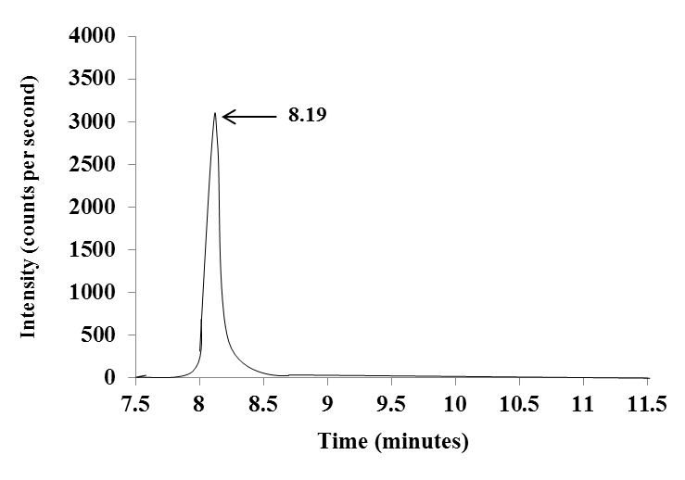

Figure 5. Representative extracted ion chromatogram of imidacloprid m/z 256/209, with peak intensity occurring at 8.19 minutes.

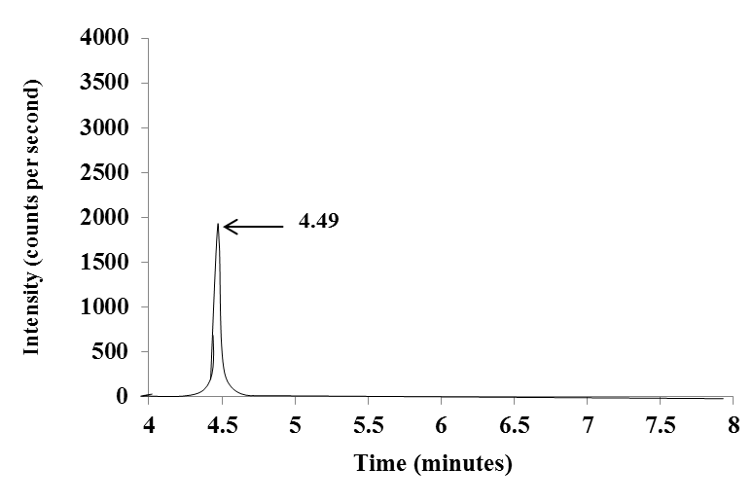

Figure 6. Representative extracted ion chromatogram of olefin m/z 254/205, with peak intensity occurring at 4.49 minutes.

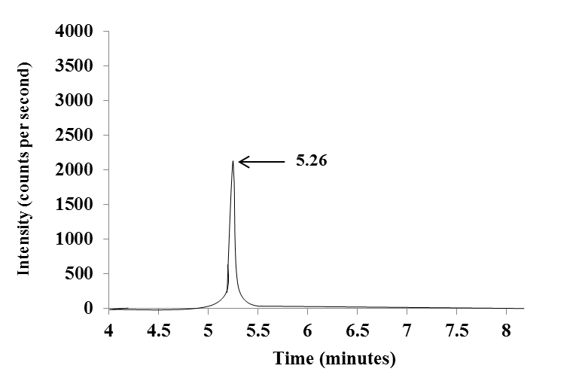
Figure 7. Representative extracted ion chromatogram of 5-hydroxy m/z 272/191, with peak intensity occurring at 5.26 minutes.

Table 1. Summary of PROC MIXED ANOVA results for the effects of application method, months post-treatment, tree strata, and timing of application on imidacloprid, olefin, and 5- hydroxy concentration in sap extracted from eastern hemlocks.

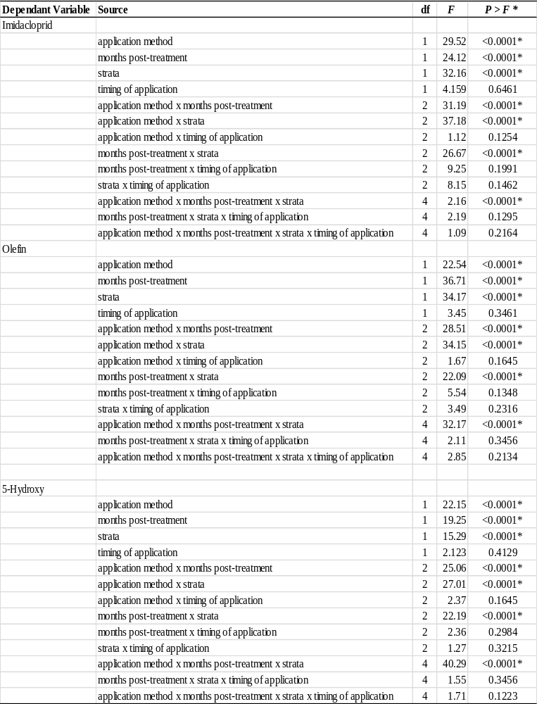
*Indicates significance (P < 0.05)
Table 2. Summary of PROC MIXED ANOVA results for the effects of application method, months post-treatment, tree strata, and timing of application on imidacloprid, olefin, and 5-hydroxy concentration in twig and needle tissue from eastern hemlocks.
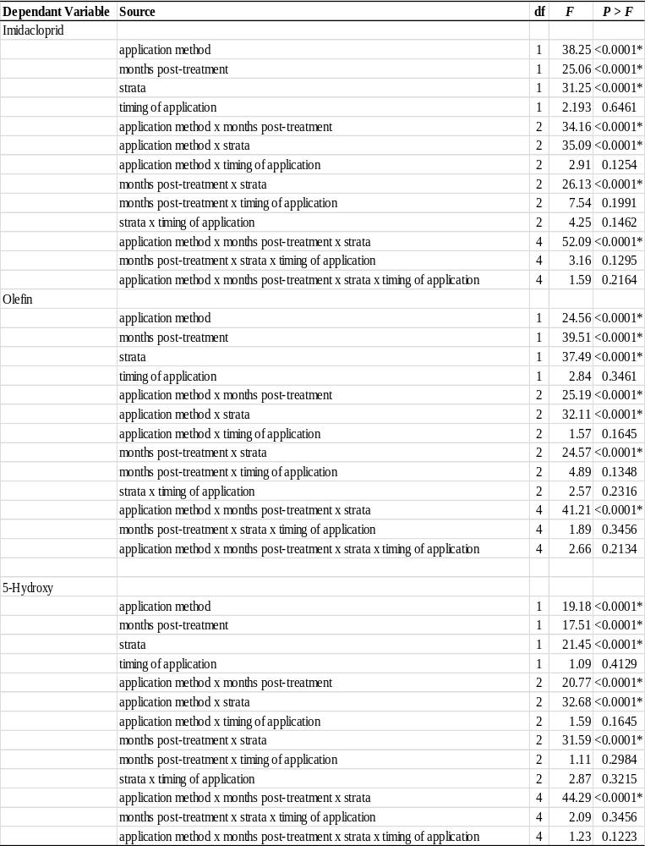
*Indicates significance (P < 0.05)

0.2164), olefin (F = 2.85, df = 4, P = 0.2134), and 5-hydroxy (F = 1.71, df = 4, P = 0.1223) concentrations in branch sap (Table 1) and in imidacloprid (F = 1.59, df = 4, P = 0.2164), olefin
(F = 2.66, df = 4, P = 0.2134), and 5-hydroxy (F = 1.23, df = 4, P = 0.1223) concentrations in twig and needle tissue for application method, months post-treatment, tree strata, or timing of
application. Significant spatial differences in concentrations (LSD test; P < 0.05) of imidacloprid, olefin, and 5-hydroxy were documented in both branch sap (Tables 3- 5) and twig and needle tissue (Tables 6-8). Significant spatial differences of imidacloprid concentrations occurred in the sap of branches (LSD test: P < 0.05) (Table 3) and twig and needle tissue (LSD test; P < 0.05) (Table 6) among CoreTect® and soil injection application methods and months post-treatment in bottom, middle, and top strata. In both CoreTect® and soil injection application methods, significantly higher concentrations of imidacloprid, olefin, and 5-hydroxy in both sap (Table 1) and twig and needle tissue (Table 2) were found in the bottom stratum. The detection of these compounds in the branch sap indicates continuous movement of these compounds throughout the tree, while detection in the twig and needle tissue indicates accumulation of these compounds within eastern hemlock tissue.
Concentrations of imidacloprid were significantly lower in the middle and top strata relative to the bottom stratum with the top stratum having the lowest concentrations of imidacloprid in both CoreTect® and soil injections, in both branch sap and twig and needle tissue. This similar trend in spatial disparity of imidacloprid concentrations has previously been documented by Dilling et al. (2010) in eastern hemlocks treated by soil drench and soil injection. The soil injection application method resulted in relatively rapid initial translocation of

Table 3. Imidacloprid (ppb) ± SE, determined using HPLC/MS/MS in sap from branches of eastern hemlock, Tsuga canadensis (L.) Carrière at bottom, middle, and top strata.
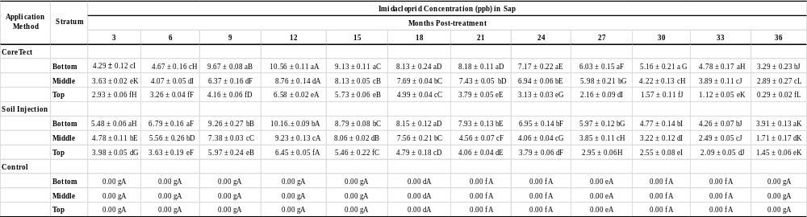
Means (n=20) within columns followed by the same lowercase letter(s) and means (n=20) within the same row followed by the same uppercase letter(s) are not significantly different (LSD test; P > 0.05)).
Table 4. Olefin (ppb) ± SE, determined using HPLC/MS/MS, in sap from branches of eastern hemlock, Tsuga canadensis (L.) Carrière at bottom, middle, and top strata.

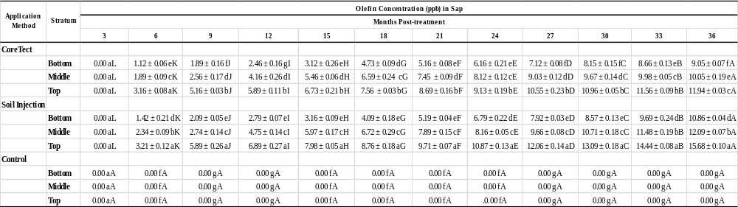
Means (n=20) within columns followed by the same lowercase letter(s) and means (n=20) within the same row followed by the same uppercase letter(s) are not significantly different (LSD test; P > 0.05).

Table 5. 5-hydroxy (ppb) ± SE, determined using HPLC/MS/MS, in sap from branches of eastern hemlock, Tsuga canadensis (L.) Carrière at bottom, middle, and top strata.
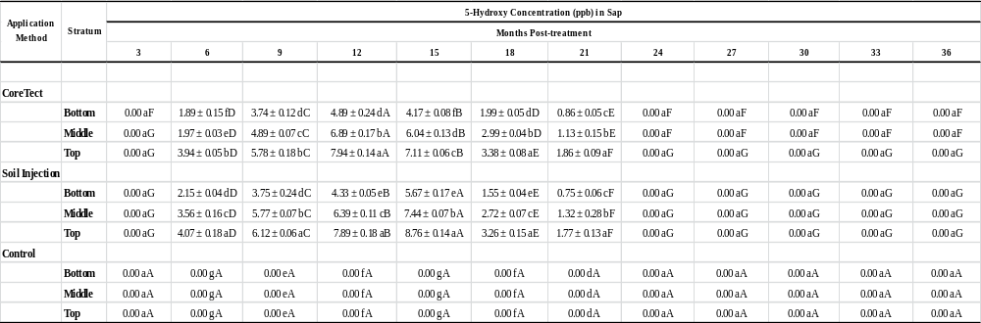
Means (n=20) within columns followed by the same lowercase letter(s) and means (n=20) within the same row followed by the same uppercase letter(s) are not significantly different (LSD test; P > 0.05).

Table 6. Imidacloprid concentrations (ppb) ± SE, determined using HPLC/MS/MS, in twig and needle tissue from branches of eastern hemlock, Tsuga canadensis (L.) Carrière at bottom, middle, and top strata.
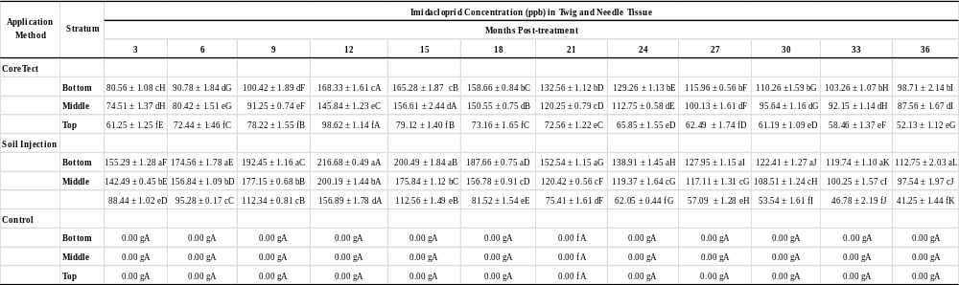
Means (n=20) within columns followed by the same lowercase letter(s) and means (n=20) within the same row followed by the same uppercase letter(s) are not significantly different (LSD test; P > 0.05).

Table 7. Olefin concentrations (ppb) ± SE, determined using HPLC/MS/MS, in twig and needle tissue from branches of eastern hemlock, Tsuga canadensis (L.) Carrière at bottom, middle, and top strata.
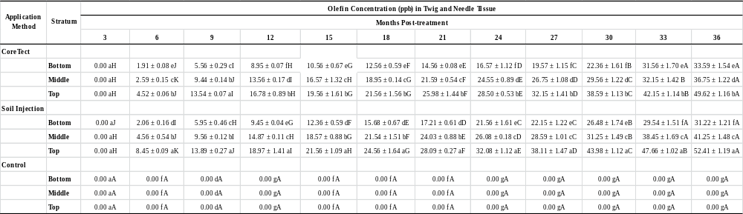
Means (n=20) within columns followed by the same lowercase letter(s) and means (n=20) within the same row followed by the same uppercase letter(s) are not significantly different (LSD test; P > 0.05).
Table 8. 5-Hydroxy concentrations (ppb) ± SE, determined using HPLC/MS/MS, in twig and needle tissue from branches of eastern hemlock, Tsuga canadensis (L.) Carrière at bottom, middle, and top strata.
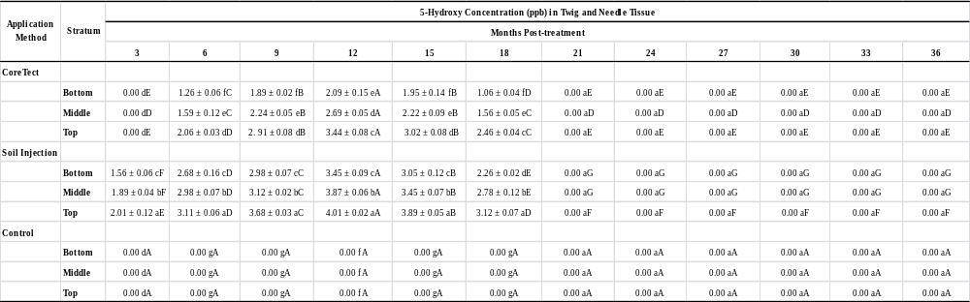
Means (n=20) within columns followed by the same lowercase letter(s) and means (n=20) within the same row followed by the same uppercase letter(s) are not significantly different (LSD test; P > 0.05)

significantly higher (LSD test; P < 0.05) concentrations of imidacloprid, than did the CoreTect®, with subsequently significantly higher (LSD test; P < 0.05) concentrations of olefin and 5-hydroxy. Olefin and 5-hydroxy had significantly higher concentrations in the top stratum and progressively declined in concentration through the bottom stratum in both CoreTect® and soil injection methods. This heterogeneous distribution may be due in part to the top stratum having
a higher rate of transpiration and photosynthesis resulting in a higher rate of imidacloprid metabolism in that particular region of the tree, resulting in higher concentrations of these metabolites. Although initial concentrations of imidacloprid were significantly lower (LSD test; P < 0.05) in the top stratum relative to the bottom and middle stratum, a higher metabolic activity can occur demonstrated by a rapid appearance and high concentrations of these metabolites compared to areas with a higher concentration of imidacloprid but lower metabolic rates, resulting in a slower appearance and lower concentrations of metabolites.
Hemlock woolly adelgid infestations tend to exhibit a clumped distribution throughout the tree in which there is no apparent vertical stratification of this species. As such, distribution of imidacloprid, olefin, and 5-hydroxy in effective concentrations throughout all strata in the canopy is tantamount for effective control. The significant spatial differences found among these compounds throughout bottom, middle, and top strata should be taken into consideration when optimal control is the prime objective. While the highest concentrations of imidacloprid were detected in the bottom stratum, the highest concentrations of olefin, a more toxic compound, were detected in the top stratum. The production of olefin produces a more delayed efficacy in the top stratum, however, it is also more persistent throughout time. In this study, the detected olefin concentrations were at or above concentration levels equated with high levels of pest mortality in other systems (Nauen et al. 1998).

Temporal Distribution of Imidacloprid, Olefin, and 5-Hydroxy
Significant main effects of application were documented for months post-treatment in both branch sap (Table 1) and twig and needle tissue (Table 2). Significant interactions among application method, month post-treatment, and tree strata for imidacloprid (F = 45.25, df = 4, P < 0.0001), olefin (F = 32.17, df = 4, P < 0.0001), and 5-hydroxy (F = 40.29, df = 4, P < 0.0001) concentrations in branch sap and in imidacloprid (F = 52.09, df = 4, P < 0.0001), olefin (F = 41.21, df = 4, P < 0.0001), and 5-hydroxy (F = 44.29, df = 4, P < 0.0001) concentrations in twig and needle tissue were documented. These results indicate temporal differences in imidacloprid, olefin, and 5-hydroxy concentrations. Mean separation of significant interacting factors revealed significant temporal differences (LSD test; P < 0.05) in the sap of branches (Tables 3-5) and twig and needle tissue (Tables 6-8) among CoreTect® and soil injection application methods and months post-treatment in bottom, middle, and top stratum. Concentrations of imidacloprid were detected in both sap and twig and needle tissue in CoreTect® and soil injection application methods between 3 - 36 months post-treatment. Imidacloprid concentrations in branch sap were highest 12 months post-treatment and in twig and needle tissue 15 months post-treatment in both CoreTect® and soil injection application methods. Concentrations of olefin were detected 6 – 36 months post-treatment in sap and twig and needle tissue and were highest 36 months post-treatment and lowest in 6 months post-treatment in CoreTect® and soil injection application methods. Concentrations of 5-hydroxy were detected 6 - 21 months post-treatment in sap and twig and needle tissue and were highest 12 months post-treatment and lowest 21 months post-treatment. Similar temporal data was recorded for imidacloprid in eastern hemlocks treated by soil injections and soil drench (Dilling et al. 2010).
The temporal differences in concentrations of imidacloprid, olefin, and 5-hydroxy were expected based on the known metabolism of imidacloprid in plants. However, the rates at which imidacloprid metabolizes can vary from tree to tree, based on environmental and physiological factors (i.e., changes in pH, temperature, catalyst concentrations, and light). These factors can influence metabolic activity, such as hydroxylation, oxidation, isomerization, or dehydration of metabolic molecules. The imidacloprid molecule consists of three functional groups: chloropyridinylmethyl, imidazolidine, and nitroimine. After imidacloprid is introduced to the tree, it can undergo processes that will hydrolyze, oxidize, isomerize, or dehydrate to make 13 primary metabolites (Wamhoff and Schneider 1999). The imidazolidine group in imidacloprid can undergo hydroxylation in which 5-hydroxy forms (Wamhoff and Schneider 1999). Further hydroxylation results in the production of dihydroxy and subsequent dehydration resulting in the production of olefin (Wamhoff and Schneider 1999). The metabolic pathway of imidacloprid has been documented in apples, potatoes, corn, and eggplant (Placke and Gustin 1993). Of these plants, apples result in similar oxidative pathways with eastern hemlock, resulting in higher concentration of olefin relative to 5-hydroxy (Placke and Gustin 1993). The data in this study support this chronological metabolite production, in which the initial compound detected is imidacloprid followed by 5-hydroxy and olefin.
Timing of application was not a statistically significant interacting factor in this study. For example, fall, winter, spring, and summer application times resulted in similar concentration distribution spatially and temporally. However, synchronizing effective or maximum chemical concentrations with active hemlock woolly adelgid feeding times are important for effective control strategies. The lifecycle of hemlock woolly adelgid is parthenogenetic and bivoltine on eastern hemlock, the winter generation is known as sistens (present in the southern Appalachians from mid-July through mid-March) and the spring generation known as progrediens (present in the southern Appalachians from mid March–mid June) (Deal 2006). Feeding in the sisten generation (2nd, 3rd, and 4th instar nymphs) usually occurs from November - March in the southern Appalachians. Feeding in the progredien generation (2nd, 3rd, 4th instar nymphs and adults) occurs in April – mid June in the southern Appalachians. Effective control of hemlock woolly adelgid has been correlated with imidacloprid concentrations of >120 ppb in a forest setting (Cowles et al. 2006) which have been observed to occur at 3 months post-treatment in twig and needle tissue in trees treated with a soil application. Trees treated with CoreTect® were slower to accumulate concentrations greater than 120 ppb, and reached effective concentrations at 12 months post-treatment. Knowing the active feeding times of both generations of hemlock woolly adelgid provides a target time range between November – May, to accumulate effective concentrations. Therefore, soil injection treatments made by the end of July or beginning of August would facilitate maximal uptake of effective concentrations of imidacloprid to synchronize with the active feeding time of hemlock woolly adelgid in the southern Appalachians. Based on data from this study, CoreTect® treatments made in November would take one year to reach effective concentrations that would provide effective suppression in the subsequent years. The effect of olefin and 5- hydroxy on hemlock woolly adelgid is unknown and represents an area of future research.

Conclusions
Extensive mortality of eastern hemlock, Tsuga canadensis (L.) Carrière, resulting from infestation by hemlock woolly adelgid, Adelges tsugae Annand (Hemiptera: Adelgidae) (HWA), has occurred throughout the eastern United States. Imidacloprid, a systemic insecticide, is one of the primary chemical compounds used to control hemlock woolly adelgid in both urban and limited forest environments. With the widespread distribution of HWA within forests, optimized control of this invasive species is imperative. Imidacloprid concentrations progressively declined from the bottom stratum to the top stratum. The metabolism of imidacloprid in eastern hemlock produced the metabolites, olefin and 5-hydroxy, which progressively increased from the bottom stratum to the top stratum. Imidacloprid and 5-hydroxy concentrations in sap was highest at 12 months post-treatment and in twig and needle tissue was highest at 15 months post-treatment. Imidacloprid was detected through month 36 post-treatment and 5-hydroxy was detected through month 15 post-treatment. Olefin concentrations in both sap and twig and needle tissue was highest at 36 months post-treatment and was detected in high concentrations through 36 months post-treatment. The heterogeneous spatial and temporal dynamics of imidacloprid, olefin, and 5-hydroxy are important to understand to synchronize effective concentrations of these compounds with the active feeding times of hemlock woolly adelgid. Synchronizing effective compound concentrations and active feeding times will facilitate optimized control strategies.
CHAPTER III. EFFICACY OF IMIDACLOPRID AND ITS METABOLITES, OLEFIN AND 5-HYDROXY, ON HEMLOCK WOOLLY ADELGID, ADELGES TSUGAE ANNAND (HEMIPTERA: ADELGIDAE)

Introduction
Imidacloprid is one of the most widely used insecticides in the world (Gervais et al. 2010), with major uses in; agriculture, arboriculture, home protection, turf, gardening, and as flea protection externally applied on domestic animals. Imidacloprid, primarily a systemic insecticide, belongs to the neonicotinoid class of insecticides (Matsuda et al.2001). Neonicotinoids act as an agonist at the acetylcholine receptors (nAChR) of the central nervous system, resulting in death within 24-48 hours after contact or ingestion. Imidacloprid has a high selectivity to binding strongly to insect neuron receptors relative to mammal receptors, thus, having less toxic impact on mammals (Gervais et al. 2010). Hemlock woolly adelgid, Adelges tsugae Annand, has caused extensive mortality to eastern hemlocks, Tsuga canadensis (L.) Carrière, throughout their range in the eastern United States. Imidacloprid is one of the primary chemicals used to control and suppress populations of hemlock woolly adelgid.
Imidacloprid has been shown to persist in the canopy of eastern hemlock (Cook 2008; Cowles et. al. 2006; Dilling 2007; Dilling et al. 2010; Tattar et. al.1998; Turcott 2007) in concentrations correlated with effective control of hemlock woolly adelgid for several years post-treatment (Cowles et al. 2006; Cook 2008; Dilling 2007; Dilling et al. 2010). The LC₅₀ of imidacloprid on hemlock woolly adelgid based on exposure for 20 days was determined to be 300 ppb (Cowles et al. 2006) and for 30 day exposure 242 ppb (Eisenback et al. 2010) in dose-response tests. A high level of suppression was found associated with eastern hemlocks that contained >120 ppb of imidacloprid (Cowles et al 2006). However, the metabolism of imidacloprid in plants produces two metabolites of toxicological interest, NTN 33893-5-hydroxy and NTN 33893-olefin (Schöning and Schmuck 2003; Nauen et al. 1998). The olefin metabolite has been shown to be at least ten times more active than its parent compound against the green peach aphid, Myzus persicae (Sulzer), and the cotton aphid, Aphis gossypii Glover (Nauen et al. 1998). Additionally, the olefin metabolite progressively increases over time as the parent imidacloprid compound decreases. The 5–hydroxy metabolite although slightly less active than the parent imidacloprid (Nauen et al. 1998), still retains toxicological properties that may work in synchrony with these other compounds. These findings suggest a more long-term residual effect that may be catalyzed by the breakdown of imidacloprid resulting in longer control of pest insects (Nauen et al. 1998; Cook 2008). However, the effect of these metabolites independently and synchronously on hemlock woolly adelgid is unknown. The main objective of this study was to evaluate the causal relationship between various imidacloprid, olefin, and 5-hydroxy concentrations and hemlock woolly adelgid mortality in dose-response and field tests.
Materials and Methods

Study Site-Experimental Design
Eastern hemlocks (n = 60) with moderate (35 - 55 %) adelgid populations were selected at Indian Boundary in Cherokee National Forest in southeastern Tennessee (35º23’06.728” N, 84º 06’23.529” W, elevation: 567 m) on 5 May 2008. The test site was arranged in a 3 (three strata within the tree) x 3 (treatments: soil injection, CoreTect®, and untreated control) factorial complete randomized block design, with five replications. To monitor imidacloprid, olefin, 5-hydroxy, and hemlock woolly adelgid mortality within the tree, each tree was divided into three strata (bottom, middle, and top). Each strata representing ca. one-third of the tree, which was approximately 5, 10 and 15 m above the base of each tree, respectively. Each tree was marked with a numbered identification metal tag. Tree characteristics were documented (tree height, DBH, density, crown class, crown condition, live crown ratio, foliage color, and overall heatlh) (Table 12; Appendix A). All trees represented approximately similar heights (12 -15 m) and diameters at breast height (DBH) (23.5 – 29.5 cm). Tree height was limited to a maximum of 15 m to be able to reach the top strata for branch collection. Trees with heavy populations of hemlock woolly adelgid were not selected due to the density dependent feedback mechanism known to cause population crashes in the northeastern United States (McClure 1991).

Assessing the Mortality of HWA in Dose-Response Tests
The short-term response of hemlock woolly adelgid mortality to imidacloprid, olefin, and 5-hydroxy was determined in laboratory dose-response tests. Hemlock woolly adelgid in excess of 40 living adelgids were excised from the untreated branches (24 cm). Eastern hemlock branches were placed into 100 ml glass flasks and spiked with 40 ml of varying concentrations of imidacloprid (25 ppb, 50 ppb, 100 ppb, 150 ppb, and 200 ppb), olefin (5 ppb, 10 ppb, 15 ppb, 20 ppb, and 25 ppb), and 5-hydroxy solutions (5 ppb, 10 ppb, 50 ppb, 100 ppb, and 150 ppb), and water (a control). Each concentration within each chemical group was replicated 20 times. Serial dilutions of imidacloprid, olefin, and 5-hydroxy solutions were created from standards (99.2% purity diluted with distilled water). Preliminary tests showed that spiking 25 cm eastern hemlock branches took 15 days for full uptake and homogenous movement into the target insect, as such branches were left to sit for 15 days with breathable plastic on top of them, in a humidity chamber set at 80% humidity to deter desiccation of the needles and encourage regular uptake function. Percent mortality was determined by probing for motion of the adelgid, selecting 40 adelgids on each treated branch. Concentrations of imidacloprid, olefin, and 5-hydroxy were determined from these branches using HPLC/MS/MS procedures established by Schöning and Schmuck (2003).

Mortality of Hemlock Woolly Adelgid in Response to Imidacloprid, Olefin, and 5-Hydroxy in Field Tests
Fifteen branch samples (25 cm) were taken from each tree, five branches from each stratum (bottom, middle, top), monthly between October and June 2008 - 2012. Branches were transported to the laboratory, and 100 adelgids for each tree were observed and probed for activity, non-movement and desiccation as an indication of mortality, and percent mortality and life stage were recorded. These branches were then dried, hemlock woolly adelgid removed, and prepared for chemical analysis, as per the protocol established by Schöning and Schmuck (2003). Concentrations of imidacloprid, olefin, and 5-hydroxy were determined from these branches using HPLC/MS/MS procedures established by Schöning and Schmuck (2003).

Twig and Needle Tissue Preparation
To determine the amount of imidacloprid in twig and needle tissue from corresponding branches in both field and laboratory dose-response tests, the entire 24 cm branch was dried in an drying oven at 60º for 2 hours, and the dried tissue was then pulverized using a coffee grinder (KitchenAid, model BCG1000OB, Shelton CT). Samples were then placed in amber vials to prevent photodegredation.

Extraction, Clean-Up, and Quantification of Imidacloprid, Olefin, and 5-Hydroxy
To determine imidacloprid concentration in twig and needle tissue, the chemical extraction, sample clean-up, and HPLC/MS/MS quantification protocol established by Schöning and Schmuck (2003) was used, with the exception of replacing methanol as an extracting solvent with acetonitrile. This replacement of methanol with acetonitrile was done to avoid possible inflated recoveries of metabolites that have been reported with using methanol and methanol/water mixes as solvents for extractions in hemlock tissue matrices (Cook 2008). Acetonitrile has been reported as having higher rates of recovery and no over inflation of imidacloprid, olefin, and 5-hydroxy in eastern hemlock tissue, that has been associated with methanol extraction (Cook 2008).

HPLC/MS/MS
HPLC/MS/MS was carried out using an Hewlett Packard HP 1100 high pressure liquid chromatograph coupled with a tandem triple quadrupole Applied Biosystems API 3000 mass spectrometer fitted with a Phenomenex Luna C18 reversed phase column (15 cm length x 4.6 mm i.d.). Parameters for the HPLC/MS/MS were as follows: injection volume: 50 µl, oven temperature :40º C, mobile phase A : Water + 0.1 ml acetic acid per liter, mobile phase B: Acetonitrile + 0.1 ml acetic acid per liter, gradient; 0-10 minutes 20% mobile phase B, 11-15 minutes 90% mobile phase B, 16-19 minutes 20% mobile phase B, stop time: 19 minutes, flow (column/MS): 1.0 / 0.15 ml/minute, retention time for olefin: approximately 4.6 minutes, retention time for hydroxyl: approximately 5.4 minutes, retention time for imidacloprid: approximately 9.1 minutes, interface: electrospray, turbo-ion spray potential: + 5000 V, temperature: 300º C, scan type: multiple reaction monitoring (MRM), polarity: positive, collision gas: nitrogen 5.0 (99.999% purity), 0.87 l/minute. Chemicals were obtained from Sigma-Aldrich (St. Louis, MO) and consisted of HPLC grade water, (99.9%), and acetonitrile (99.9%). Standards of Imidacloprid (96.9%), olefin (97.9%), and 5-hydroxy (99.3%) were obtained from Bayer Chemical Corporation (Stillwell, KS).
Data Analysis
Data were entered into an excel file and results were subjected to the Shapiro-Wilks W test for normality and Levene’s test of homogeneity of variances we to verify the data conformed to the assumptions of ANOVA. Dose-response data were analyzed using linear regression analysis PROC REG (SAS Institute 2006) to determine relationship between concentrations of imidacloprid, olefin, and 5-hydroxy and hemlock woolly adelgid mortality. Probit analysis was conducted for hemlock woolly adelgid mortality 15 days (d) after treatment, based on imidacloprid, olefin, and 5-hydroxy concentrations recovered by HPLC/MS/MS. Probit analysis established a 15 d LC₅₀ for imidacloprid, olefin, and 5-hydroxy in dose-response tests. Hemlock woolly adelgid mortality in untreated control branches in both field and dose-response tests was corrected for using Abbott’s formula (Abbott 1925). To evaluate the effect of imidacloprid, olefin, and 5-hydroxy concentrations on hemlock woolly adelgid mortality, field data were analyzed using factorial analysis of variance (ANOVA), using PROC GLM (SAS Institute 2006) procedures with sampling time (months post-treatment) and strata (bottom, middle, and top) as fixed effects.

Results and Discussion
Dose-Response Test
In the dose-response tests, high levels of hemlock woolly adelgid mortality (> 80%) were highly correlated with imidacloprid concentrations greater than or equal to 131 ppb (Figure 8). This supports what was documented in the field tests. Olefin concentrations were found to be 14.28 times more toxic than imidacloprid at concentrations of greater than or equal to 7 ppb resulting in hemlock woolly adelgid mortality of greater than 80% (Figure 9). The olefin dose-response tests also support data in the field test with a high level of hemlock woolly adelgid suppression correlated with concentrations of olefin
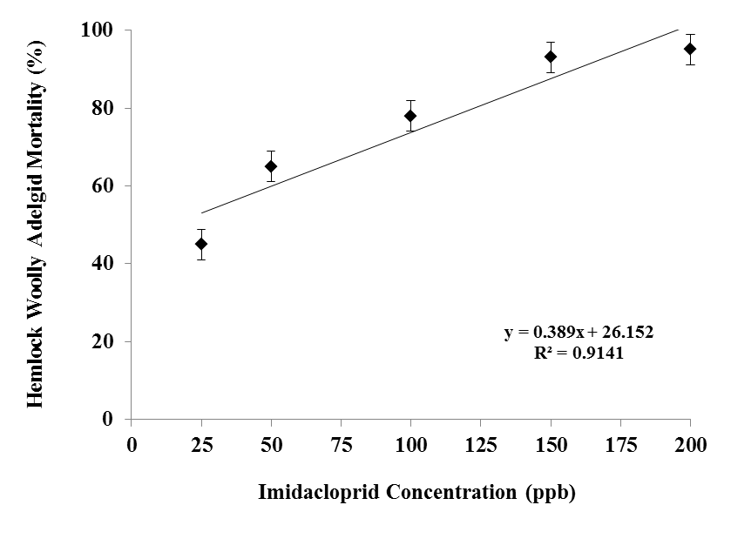
Figure 8. Dose-response relationships of hemlock woolly adelgid mortality on excised foliage systemically spiked with varying imidacloprid concentrations. There was 10% mortality in the untreated check group. Average mortality ± SE is given for Abbott’s corrected values, with 40 individuals per replicate (n= 20).
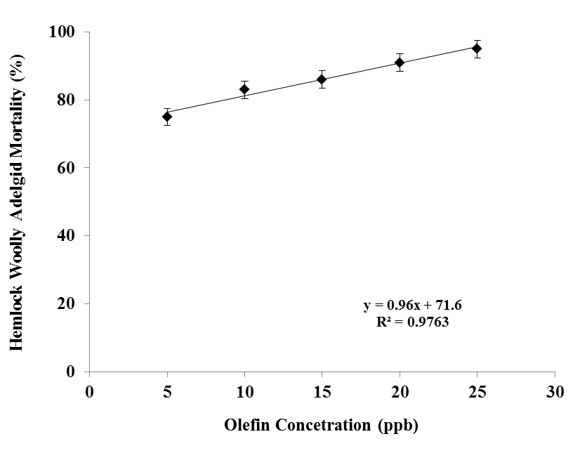
Figure 9. Dose-response relationships of hemlock woolly adelgid mortality on excised foliage systemically spiked with varying olefin concentrations. There was 10% mortality in the untreated check group. Average mortality ± SE is given for Abbott’s corrected values, with 40 individuals per replicate (n= 20).

greater than or equal to 7 ppb. Concentration of 5-hydroxy greater than or equal to 142 ppb resulted in hemlock woolly adelgid mortality greater than 80% (Figure 10), however, concentrations of 5-hydroxy in the field tests never exceeded 4.01ppb. Probit analysis of hemlock woolly adelgid mortality after 15 days integrated with quantified imidacloprid, olefin, and 5-hydroxy concentration determined form the twig and needle tissue from the branches in dose response tests determined the LC₅₀ of imidacloprid, olefin, and 5-hydroxy to be 112 ppb, 6 ppb, and 132 ppb, respectively. These results vary with other dose-response tests which resulted in 30 d LC₅₀ of imidacloprid being reported at 300 ppb (Cowles et al. 2006) and 20 d LC₅₀ of 242 ppb (Eisenback et al. 2010). Theses disparities may be due to differences in experimental design, spiking rates, and quantification of imidacloprid.
A variety of environmental and physiological factors can influence the rate of metabolism in eastern hemlock branches, therefore it is important to note, that in the imidacloprid dose-response tests, no 5-hydroxy and olefin were detected in the branches. A negative detection indicates that metabolism had not occurred and the results reflect an independent response of hemlock woolly adelgid mortality to imidacloprid concentration independent of the constituents of further metabolic breakdown. 5-hydroxy is an intermediate metabolite of olefin and dihydroxy, and further metabolism of the compound could result in non-independent results. Dose-response tests of 5-hydroxy resulted in no detection of olefin or dihydroxy, indicating further metabolism had not occurred and the results reflect an independent response of hemlock woolly mortality to

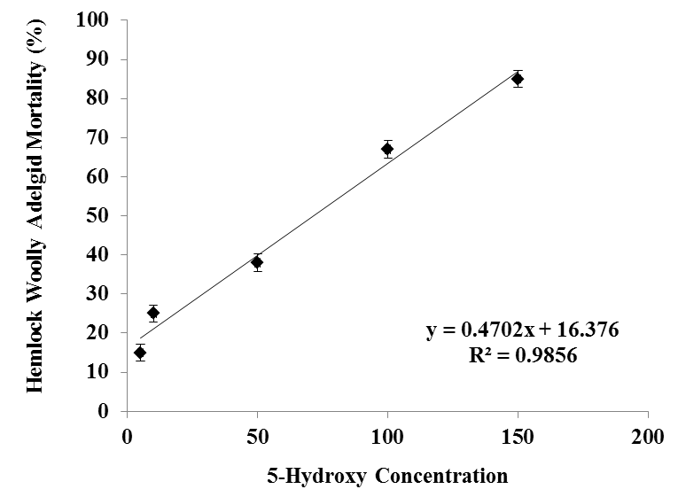
Figure 10. Dose-response relationships of hemlock woolly adelgid mortality on excised foliage systemically spiked with varying 5-hydroxy concentrations. There was 10% mortality in the untreated check group. Average mortality ± SE is given for Abbott’s corrected values, with 40 individuals per replicate (n= 20).

5-hydroxy. Olefin is a metabolic end product and does not undergo further metabolism. The dose-response tests of olefin result in an independent response of hemlock woolly adelgid mortality to this olefin occurring independent of the other metabolic constituents.
Field Tests
Imidacloprid, olefin, and 5-hydroxy concentrations and hemlock woolly adelgid mortality data collected from the field study indicated that a high level of hemlock woolly adelgid mortality (> 80 %) was associated with concentration levels of imidacloprid greater than 158 ppb and olefin greater than 7 ppb (Figure 11). Concentrations of 5-hydroxy were not documented at levels that corresponded with hemlock woolly adelgid mortality greater than 80%. Factorial ANOVA results indicated significant main effects of imidacloprid (F = 0.234; df = 1; P = 0.036) and olefin (F = 0.426; df = 1; P = 0.021) on mean hemlock woolly adelgid mortality (Table 9). Additionally, interactions between imidacloprid and olefin were significant (F = 3.346; df = 2; P = 0.013) (Table 4). These significant interactions between imidacloprid and olefin, indicate that the effect of one chemical at a specific concentration level on hemlock woolly adelgid mortality changes in relationship to the levels of the other chemical. The associated low concentrations of 5-hydroxy in the field study with high levels of hemlock mortality is likely due to the synchrony of imidacloprid and olefin during the time when 5-hydroxy is present in twig and needle tissue in all strata. Dose--response tests indicate that independently high levels (142 ppb) of 5-hydroxy are needed for control of hemlock woolly adelgid, which

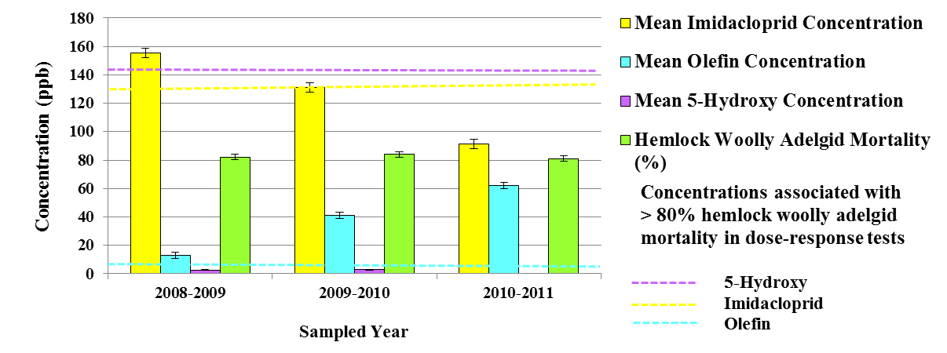

Figure 11. Mean ± SE yearly concentrations of imidacloprid, olefin , and 5-hydroxy, and mean± SE yearly hemlock woolly adelgid mortality and corresponding concentration lines developed from dose-response tests, indicating levels of high (> 80%) hemlock woolly adelgid mortality.

Table 9. Summary of factorial analysis of variance results testing effects of imidacloprid, olefin, and 5-hydroxy concentrations on hemlock woolly adelgid mortality.
Factor | F Statistic | df | P Value*
Hemlock Woolly Adelgid Mortality
Imidacloprid | 0.234 | 1 | 0.036*
Olefin | 0.426 | 1 | 0.021*
5-Hydroxy | 0.121 | 1 | 0.235
Imidacloprid x Olefin | 3.346 | 2 | 0.013*
Imidacloprid x 5-Hydroxy | 1.261 | 2 | 0.215
5-Hydroxy x Olefin | 1.347 | 2 | 0.314
Imidacloprid x Olefin x 5-Hydroxy | 3.019 | 3 | 0.023*
Bonferroni multiple comparisons were used to evaluate differences among groups with significance. * Indicates significant differences at α < 0.05.

never occurred in the field study (Figure 11). Levels of imidacloprid never declined below 110 ppb in the bottom stratum through month 36 post-treatment. In the middle and top stratum, levels of imidacloprid declined below 110 ppb, however, levels of olefin were always above 9 ppb in the middle and top stratum, after month 9 post-treatment and progressively increased over the three year period. The heterogeneous distribution of imidacloprid and olefin is likely to result in homogenous protection throughout the entire canopy.

Conclusions

Mortality of eastern hemlock, Tsuga canadensis (L.) Carrière, resulting from infestation by hemlock woolly adelgid, Adelges tsugae Annand (Hemiptera: Adelgidae) (HWA), has occurred throughout the eastern United States. Imidacloprid, a systemic insecticide, is one of the primary chemical compounds used to control hemlock woolly adelgid in both urban and limited forest environments. The metabolism of imidacloprid in eastern hemlock produces two metabolites of toxicological interest, NTN 33893-olefin, and NTN 33893-5-hydroxy. A significant relationship was found between imidacloprid concentrations > 158 ppb and olefin concentrations > 7 ppb and hemlock woolly adelgid mortality greater than 80% in field studies. In dose-response tests imidacloprid concentrations greater than 131 ppb and olefin concentration greater than 7 ppb were associated with high levels of hemlock woolly adelgid mortality (> 80%).
The relationship between field concentrations of 5-hydroxy and HWA mortality are suspected to be the result of synchronous activity with imidacloprid and olefin, dose-response tests indicate a much higher concentration of 5-hydroxy is needed for a high degree of suppression than what was detected in the field for this study. Knowledge of the toxicity of olefin and 5-hydroxy in addition to imidacloprid is important to in order to understand how these compounds work independently and synchronously to influence hemlock woolly adelgid mortality. The findings in this study suggest a more long-term residual toxicity catalyzed by the metabolism of imidacloprid within eastern hemlock, resulting in longer suppression and control of hemlock woolly adelgid in eastern hemlock in the southern Appalachians.

CHAPTER IV. TRI-TROPHIC MOVEMENT OF IMIDACLOPRID, OLEFIN, AND 5-HYDROXY THROUGH EASTERN HEMLOCKS IN THE SOUTHERN APPALACHIANS
Introduction
Eastern hemlock, Tsuga canadensis (L.) Carrière, populations have dramatically declined as a result of the introduction of hemlock woolly adelgid, Adelges tsugae Annand (Hemiptera: Adelgidae), in the eastern United States. The primary insecticide used to control infestations of hemlock woolly adelgid is systemic imidacloprid. The translocation persistence, and toxicity of imidacloprid and two toxicologically relevant metabolites, olefin and 5-hydroxy, have been examined in eastern hemlock (Dilling et al. 2010). Imidacloprid and olefin have been documented to persist at least three years post-treatment, with olefin having 14 times the toxicity and longer active persistence than the parent imidacloprid on hemlock woolly adelgid mortality.
The tri-trophic movement and persistence of these insecticidal compounds, from tree tissue into primary (herbivore) and secondary (predators of herbivores) consumers, is unclear. Understanding their tri-trophic movement and persistence is critical for implementing biological control strategies into insecticide management programs with reduced impact on predatory beetle survivorship, fecundity, and mortality. Biological control agents show potential for suppressing populations of hemlock woolly adelgid in forest landscapes. Chemical treatments can effectively suppress and control hemlock woolly adelgid infestations on a short-term scale, while allowing time for the establishment of biological control agents. However, little is known about the tri-trophic movement and persistence of these chemicals. Such knowledge will allow for the development of chronological control strategies that reduce the impact to non-target biological control agents and facilitate management strategies that combine these two tactics.

Materials and Methods
Study Site- Experimental Design

Eastern hemlocks (n=30) with moderate adelgid populations were selected at Coal Creek recreational area in Oliver Springs, Tennessee (36º06’58.73” N, 84º 33’51.11” W) in April 2010. Treatments at this study site were arranged in a complete randomized design. Tree characteristics were documented (tree height, DBH, density, crown class, crown condition, live crown ratio, foliage color, and overall health) (Table 13;Appendix B). All trees represented approximately the same height (14-17 m), DBH (23-31 cm), and hemlock woolly adelgid infestation level (15- 25 %).

Insecticide Application

Soil injections were made in April 2010 using the Kioritz® soil injector (Kioritz Corp. Tokyo, Japan). Merit® 75 WP insecticide (Bayer, Kansas City, MPO) was diluted to 1 g AI/ 2.5 cm DBH in 60 ml of water. Also, 5 ml of internally labeled stable isotope standards of imidacloprid (imidacloprid-pyridine-4-d-methylene-d₂, ¹³C), 5-hydroxy (imidacloprid 5-hydroxy- ¹³C₃, ¹⁵N, D), and olefin (imidacloprid olefin ¹³C₃, ¹⁵N, D) were injected at the base of each tree. Soil injections were made using basal system injections, which were made within 45 cm of the base of the trunk and were spaced evenly around the tree at a depth of 7 cm below the soil surface with individual injections delivering 30 ml of insecticide.

Branch Sampling and Preparation
Branch samples were taken bi-weekly for 24 months post-treatment. Four, 24 cm branch clippings were taken from the bottom, middle, and top strata of the canopy using a 12 m pole pruner. Branches were packed in ice and transported to the laboratory immediately for sap extraction and twig and needle tissue preparation. To determine the amount of imidacloprid in twig and needle tissue, two 12 cm branches taken on each sampling date, were dried and pulverized using a coffee grinder. Sap was extracted using a PMS pressure chamber (PMS instrument Co. Albany OR). A 12 cm section of each branch was placed with the cut end of the branch inserted into gland gasket and the remaining portion of the branch placed into the pressurized chamber. The pressure chamber was incrementally pressurized with nitrogen to 575 psi (40 bars). Branch sap sample size consisted of 300-400 µl of sap micro-pipetted from a collecting chamber.The sap was maintained in a freezer at -18º C.

Collection of Arthropods and Preparation of Insect Tissue
Bi-monthly sampling methods for arthropods consisted of beat-sheet, direct sampling (visual observations/handpicking/trunk vacuuming), and branch cuttings. Sampling was done throughout the canopy, however, sampling was limited to heights accessible within the canopy. Beat-sheet samples (four per tree) were taken at each cardinal direction by striking each branch five times with a one-meter stick in the lower level of the canopy. Direct sampling was conducted on each tree for 15 min per tree. All of the foliage in the lower canopy was visually inspected and insects handpicked upon observation. Also, arthropods were obtained by trunk vacuuming any insect observed on the bottom 1.5 m of the trunk of the tree. Samples were placed in pre-labeled (date collected, tree number, and collecting method) 6 dram vials and taken to the laboratory for sorting and identification. To assess sedentary insect species, 12 cm branch samples (four per tree), one in each of the cardinal directions, were collected bi-monthly from a height of 1.5 m. Collected arthropods were sorted and identified to species levels, and were classified into functional feeding categories either as primary consumer (herbivore) or secondary consumer (predator). Those species that have a known association with eastern hemlock were used for analysis, if they were collected in the lifecycle associated with herbivory on eastern hemlock or predation. Species identified that did not fit into those functional feeding categories were not associated with eastern hemlock, or were found in a lifecycle not associated with herbivory or predation on eastern hemlock, were excluded from this study. Live and dead specimens were collected from eastern hemlock for identification and chemical analysis. Specimens were stored in vials for one week, and then dried at 70º C for 48 hours, weighed, and transformed into a homogeneous liquid phase by adding 200 µl of hydrogen peroxide and 400 µl sub-boiled nitric acid, and then digested in a microwave autoclave.

Detecting Imidacloprid, Olefin, and 5-Hydroxy in Matrices
Imidacloprid, 5-hydroxy, and olefin concentrations (part per billion) in sap, twig and needle tissue, and insect tissue were determined using high pressure liquid chromatography coupled with tandem mass spectrometry as described by Schöning and Schmuck (2003) for determination in different matrices.

HPLC/MS/MS
HPLC/MS/MS was carried out using an Hewlett Packard HP 1100 high pressure liquid chromatograph coupled with a tandem triple quadrupole Applied Biosystems API 3000 mass spectrometer fitted with a Phenomenex Luna C18 reversed phase column (15 cm length x 4.6 mm i.d.). Parameters for the HPLC/MS/MS were as follows: injection volume: 50 µl, oven temperature :40º C, mobile phase A : Water + 0.1 ml acetic acid per liter, mobile phase B: Acetonitrile + 0.1 ml acetic acid per liter, gradient; 0-10 minutes 20% mobile phase B, 11-15 minutes 90% mobile phase B, 16-19 minutes 20% mobile phase B, stop time: 19 minutes, flow (column/MS): 1.0 / 0.15 ml/minute, retention time for olefin: approximately 4.6 minutes, retention time for hydroxyl: approximately 5.4 minutes, retention time for imidacloprid: approximately 9.1 minutes, interface: electrospray, turbo-ion spray potential: + 5000 V, temperature: 300º C, scan type: multiple reaction monitoring (MRM), polarity: positive, collision gas: nitrogen 5.0 (99.999% purity), 0.87 l/minute. Chemicals were obtained from Sigma-Aldrich (St. Louis, MO) and consisted of HPLC grade water, (99.9%), and acetonitrile (99.9%). Standards of Imidacloprid (96.9%), olefin (97.9%), and 5-hydroxy (99.3%) were obtained from Bayer Chemical Corporation (Stillwell, KS).
Data Analysis

Residues in part per billion (ppb) of imidacloprid, olefin, and 5-hydroxy were calculated using the average peak areas and conversions for each analyte by the formula described by Schöning and Schmuck (2003). Shapiro-Wilks W test for normality and Levene’s test of homogeneity of variances were used to verify that chemical concentration data conformed to the assumptions of analysis of variance (ANOVA). Imidacloprid, olefin, and 5-hydroxy concentration data were converted from ng g⁻¹ to parts per billion (ppb) and placed into an excel file and analyzed using PROC MIXED ANOVA in SAS (SAS 2006). ANOVA and Least Significant Differences (LSD) procedures were conducted on chemical concentration data (P < 0.05) to determine concentration differences in imidacloprid, olefin, and 5-hydroxy, in sap, twig and needle tissue, herbivores, and predators.

Results and Discussion

This study resulted in 3,875 insect herbivore and predator specimens collected and analyzed for imidacloprid, olefin, and 5-hydroxy concentrations (Table 10). Tri-trophic movement of imidacloprid and olefin was quantified and documented through the sap, twig and needle tissue, herbivore tissue, and predator tissue. Mean concentrations of imidacloprid and olefin were significantly different among sap, twig and needle tissue, herbivore tissue, and predator tissue (F= 3.25; df = 3; P < 0.001). The mean imidacloprid and olefin concentrations were significantly higher (LSD test; P < 0.05) in twig and needle tissue, followed by herbivore tissue, predator tissue, and sap, respectively (Figure
Table 10. Insect herbivores and predators associated with eastern hemlock at Coal Creek Recreational area, Oliver Springs, TN, analyzed for imidacloprid, olefin, and 5-hydroxy.
Order | Family | Genus | Species | Author | Trophic Level | # of specimens collected | # of specimens testing postive for imidacloprid and olefin
Hemiptera | Anthocoridae | Anthocoris | borealis | Dallas | P | 112 | 97
Coleoptera | Cantharidae | Rhagonycha | angulatus | Say | P | 22 | 19
Coleoptera | Cantharidae | Podabrus | tomentosus | (Say) | P | 24 | 18
Coleoptera | Cantharidae | Rhagonycha | oriflava | (LeConte) | P | 33 | 28
Coleoptera | Cantharidae | Silis | bidentatus | (Say) | P | 12 | 10
Coleoptera | Cantharidae | Trypherus | latipennis | Germar | P | 3 | 3
Coleoptera | Carabidae | Agonum | melanarium | DeJean | P | 15 | 14
Coleoptera | Carabidae | Agonum | tenue | LeConte | P | 4 | 4
Coleoptera | Carabidae | Calosoma | externus | Say | P | 19 | 17
Coleoptera | Carabidae | Calosoma | marginalis | Casey | P | 26 | 20
Coleoptera | Carabidae | Carabus | sylvosus | Say | P | 28 | 24
Coleoptera | Carabidae | Cyclotrachelus | conviva | LeConte | P | 45 | 25
Coleoptera | Carabidae | Dicaelus | politus | DeJean | P | 13 | 10
Coleoptera | Carabidae | Dicaelus | teter | Bonelli | P | 9 | 7
Coleoptera | Carabidae | Harpalus | penylvanicus | DeGeer | P | 18 | 10
Coleoptera | Carabidae | Lebia | analis | DeJean | P | 26 | 24
Coleoptera | Carabidae | Scaphinotus | debilis | LeConte | P | 18 | 10
Coleoptera | Carabidae | Scaphinotus | andrewsii | Harris | P | 34 | 21
Coleoptera | Carabidae | Scaphinotus | guyotii | LeConte | P | 61 | 50
Coleoptera | Carabidae | Scarites | subterraneus | Fab. | P | 34 | 22
Coleoptera | Carabidae | Sphaeroderus | stenostomus | Weber | P | 27 | 24
Coleoptera | Cerambycidae | Leptura | subhamata | Randall | H | 16 | 12
Coleoptera | Cleridae | Cymatodera | bicolor | (Say) | P | 66 | 45
Coleoptera | Cleridae | Enoclerus | muttkowski | (Wolcott) | P | 109 | 87
Coleoptera | Cleridae | Phyllobaenus | unifasciatus | (Say) | P | 117 | 79
Coleoptera | Cleridae | Placopterus | thoracicus | (Olivier) | P | 128 | 64
Coleoptera | Coccinellidae | Anatis | labiculata | (Say) | P | 201 | 157
Coleoptera | Coccinellidae | Chilocorus | stigma | (Say) | P | 198 | 146
Coleoptera | Coccinellidae | Cycloneda | munda | (Say) | P | 156 | 112
Coleoptera | Coccinellidae | Harmonia | axyridis | (Pallas) | P | 167 | 145
* P= Predator, H=Herbivore

Table 10 Continued. Insect herbivore and predators associated with eastern hemlock at Coal Creek recreational area, Oliver Springs, TN, analyzed for imidacloprid, olefin, and 5-hydroxy.
Order | Family | Genus | Species | Author | Trophic Level | # of specimens collected | # of specimens testing positive for imidacloprid and olefin
Coleoptera | Coccinellidae | Hyperaspis | signata | (Olivier) | P | 116 | 89
Coleoptera | Coccinellidae | Rhyzobius | lophanthae | (Blaisdell) | P | 78 | 72
Coleoptera | Coccinellidae | Scymnillus | horni | Gordon | P | 174 | 103
Coleoptera | Coccinellidae | Scymnus | loewii | Mulsant | P | 189 | 97
Coleoptera | Lampyridae | Photuris | pennsylvanica | (DeGeer) | P | 67 | 51
Coleoptera | Lycidae | Plateros | centralis | Green | P | 13 | 8
Coleoptera | Staphylinidae | Bisnius | blandus | (Gravenhorst) | P | 34 | 27
Coleoptera | Staphylinidae | Philonthus | cyanipennis | (Fab.) | P | 15 | 7
Coleoptera | Staphylinidae | Tachinus | fimbriatus | Gravenhorst | P | 22 | 15
Neuroptera | Coniopterygidae | Conwentzia | pineticola | Enderlein | P | 34 | 23
Neuroptera | Hemerobiidae | Hemerobius | stigma | Stephens | P | 18 | 14
Lepidoptera | Gelechiidae | Coleotechnites | apicitripunctella | (Clemens) | H | 37 | 28
Lepidoptera | Geometridae | Caripeta | divisata | Walker | H | 231 | 188
Lepidoptera | Geometridae | Cladara | limitaria | (Walker) | H | 34 | 21
Lepidoptera | Geometridae | Ectropis | crepuscularia | Denis & Schiffermüller | H | 67 | 33
Lepidoptera | Geometridae | Eufidonia | notataria | (Walker) | H | 51 | 41
Lepidoptera | Geometridae | Eupithecia | palpate | Packard | H | 28 | 16
Lepidoptera | Geometridae | Hydriomena | divisaria | Walker | H | 31 | 27
Lepidoptera | Geometridae | Hypagyrtis | piniata | (Packard) | H | 24 | 18
Lepidoptera | Geometridae | Lambdina | athasaria | Walker | H | 207 | 176
Lepidoptera | Geometridae | Lambdina | fiscellaria | (Guenée) | H | 238 | 164
Lepidoptera | Geometridae | Macaria | fissinotata | (Walker) | H | 235 | 118
Lepidoptera | Geometridae | Macaria | signaria | (Hübner) | H | 24 | 12
Lepidoptera | Geometridae | Prochoerodes | transversata | (Drury) | H | 21 | 18
Lepidoptera | Geometridae | Protoboarmia | porcelaria | (Guenée) | H | 38 | 24
Lepidoptera | Lymantriidae | Orgyia | leucostigma | (Smith) | H | 16 | 6
Lepidoptera | Tortricidae | Amorbia | humerosana | Clemens | H | 31 | 18
Lepidoptera | Tortricidae | Choristoneura | fumiferana | (Clemens) | H | 27 | 12
Lepidoptera | Tortricidae | Eucosma | tocullionana | Heinrich | H | 34 | 24
* P=Predator, H= Herbivore

12). Concentrations of 5-hydroxy were only documented in sap and twig and needle tissue, therefore, no tri-trophic movement was documented in this study. The mean concentrations of imidacloprid (110.1 ppb) and olefin (7.13 ppb) detected in herbivore tissue have been associated with high levels of toxicity in insects. Of the 1,390 herbivore specimens analyzed, 956 tested positive for imidacloprid and olefin, and 878 specimens were dead when collected (Table 10). Herbivore specimens that were collected live and tested positive for imidacloprid and olefin had concentrations of imidacloprid and olefin that have not been associated with high lethality or sub-lethal intoxication. There were 794 predator specimens analyzed, 618 tested positive for imidacloprid and olefin, and 554 of the specimens were dead when collected. All herbivore and predator specimens that tested positive for imidacloprid and olefin had the internally labeled stable isotope ¹³C present, confirming that these compounds came from our initial application source. The herbivore in the highest abundance (n=238) was the hemlock looper, Lamdina fiscellaria (Guenèe) (Lepidoptera: Geometridae), with 164 of the specimens testing positive for imidacloprid and olefin (Table 10). The predator in the highest abundance (n=201) was the fifteen spotted lady beetle, Anatis labiculata (Say) (Coleoptera: Coccinellidae), with 157 of the specimens testing positive for imidacloprid and olefin (Table 10). While these species tested positive for imidacloprid and olefin, this may represent a small proportion of the actual population. Further research is needed to understand if there are population level impacts.
Imidacloprid and olefin were found to persist throughout the 24 month post-treatment sampling period (Figures 13 and 14). Imidacloprid concentrations were
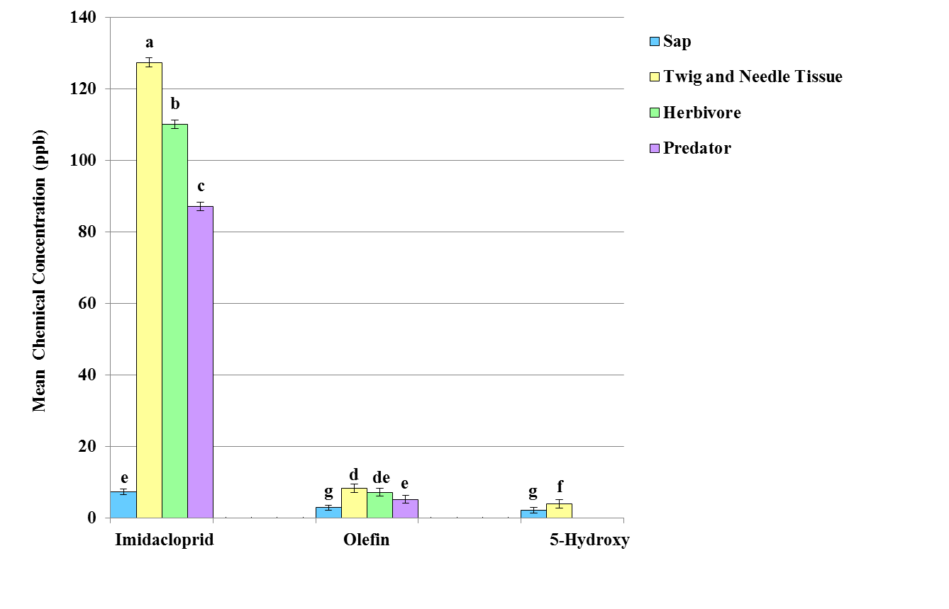
Figure 12. Mean chemical concentration ± SE of imidacloprid, olefin, and 5-hydroxy in sap, twig and needle tissue, herbivore tissue, and predator tissue. Means with the same lowercase letter(s) are not significantly different (LSD test; P > 0.05).

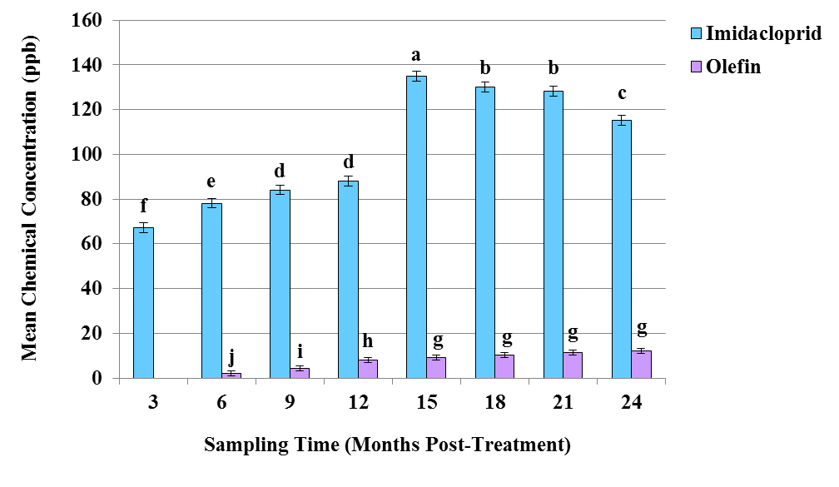

Figure 13. Mean chemical concentration ± SE of imidacloprid and olefin recovered in insect herbivore tissue found in association with eastern hemlock at Coal Creek recreational area, Oliver Springs, TN, during different collection times throughout two years. Means with the same lowercase letter(s) are not significantly different (LSD test; P > 0.05).

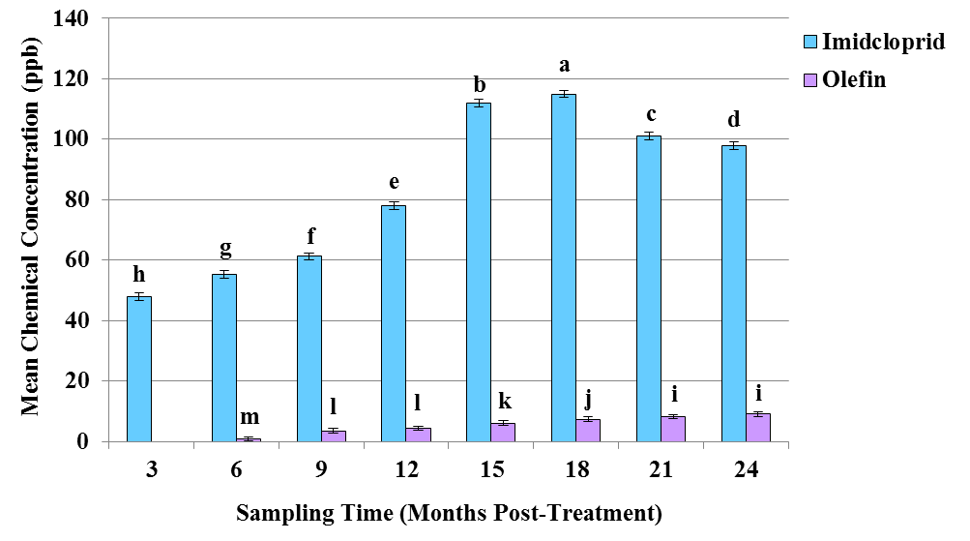

Figure 14. Mean chemical concentration ± SE of imidacloprid and olefin recovered in insect predator tissue found in association with eastern hemlock at Coal Creek recreational area, Oliver Springs, TN, during different collection times throughout two years. Means with the same lowercase letter(s) are not significantly different (LSD test; P > 0.05).

significantly higher in insects collected month 15 post-treatment in herbivorous insects (LSD test; P < 0.05) (Figure 12) and month 18 post-treatment in predatory insects (LSD test; P < 0.05) (Figure 13). Olefin concentrations gradually increased during 15 months post-treatment sampling time, then leveled off between months 15 and 24 post-treatment in herbivores. In predators, olefin gradually increased through months 21 post-treatment and plateaued months 21-24 post-treatment. The temporal dynamics of imidacloprid and olefin in sap and twig and needle tissue coincide with what was reported in chapter 2 of this dissertation. The movement of imidacloprid and olefin into herbivores and predators appears to occur relatively quickly and persisted through the 24 month post-treatment sampling time. However, while specimens were collected during a specific time post-treatment, the time since ingestion and death is unknown, since a majority of the specimens were collected dead. There is a temporal variation in the species present as the majority of species sampled occur at certain life stages on eastern hemlock. For example, all the Lepidoptera analyzed were collected as larvae and feed on eastern hemlock, however, each species is not present year round on eastern hemlock in the southern Appalachians.
Additionally, one predaceous spider and six psocopteran species known to be primarily fungivores were analyzed for imidacloprid, olefin, and 5-hydroxy. The predaceous spider, Phidippus audax (Hentz) (Araneae; Salticidae) (n=119) is commonly known as the daring jumping spider and observed frequently on eastern hemlocks in the southern Appalachian (pers. obs.). Of the 119 specimens of Phidippus audax (Hentz), 48
specimens all dead upon collection tested positive for imidacloprid and olefin. Six psocopteran species were tested for imidacloprid, olefin, and 5-hydroxy, as decreases in
their populations on imidacloprid-treated eastern hemlocks have been documented (Dilling et al. 2009) the mechanism for population declines is unknown. It is hypothesized that certain species of Psocoptera may be feeding on epiphytic fungi or lichen living on eastern hemlock that could possibly be translocating imidacloprid. Valenzuela flavidus (Stephens) (n= 215), Xanthocaecilius sommermanae (Mockford) (n=189), Peripsocus maculosus Mockford (n=174), Peripsocus subfasiatus (Rambur) (n=116), Aaroniella badonneli (Danks) (n=168), and Blaste opposita (Banks) (n=151) were analyzed for imidacloprid and olefin concentrations and of the number of specimens collected 115 Valenzuela flavidus (Stephens), 156 Xanthocaecilius sommermanae (Mockford), 114 Peripsocus maculosus Mockford, 98 Peripsocus subfasiatus (Rambur), 128 Aaroniella badonneli (Danks), and 131 Blaste opposita (Banks) tested positive for imidacloprid and olefin with all the specimens that tested positive had been collected dead. The large number of psocopteran specimens testing positive for imidacloprid and olefin suggests movement into epiphytic fungi or lichen living on eastern hemlocks and represents an area of further research.
Biological control using introduced predatory beetles, such as Sasajiscymnus tsugae and Laricobius nigrinus Fender, infers a slow stepwise progression to establishment in forest settings. Acute toxicity has been shown to occur in L. nigrinus when feeding on contaminated prey (Eisenback et al. 2010) in the laboratory. Results suggest that tri-trophic movement of imidacloprid and olefin has toxicological effects on herbivore and predator trophic levels which can persist at least two years post-treatment. Further research is needed to determine how long this persistence can last and what are the population level effects of these compounds.

Conclusions

Chemical treatments can effectively suppress and control hemlock woolly adelgid infestations on a short-term scale, while allowing time for the establishment of biological control agents. The tri-trophic movement and persistence of imidacloprid and olefin is important to understand in developing control strategies where biological control agents are to be implemented. Tri-trophic movement through sap, twig and needle tissue, known insect herbivores, and associated predators of eastern hemlock was documented. Additionally, the movement of imidacloprid and olefin was documented in six psocopteran species that are known fungivores. Concentrations of imidacloprid and olefin detected in dead specimens were comparable to those concentrations associated with high levels of toxicity in chapter 3. Concentrations of imidacloprid and olefin persisted in sap, twig and needle, herbivores, and predators through the 24 month sampling period. Knowledge of this will allow for the development of chronological control strategies that reduce the impact to non-target biological control agents and facilitate management strategies that combine these two tactics.

CHAPTER V. INFLUENCE OF HEMLOCK WOOLLY ADELGID INFESTATION LEVELS ON WATER STRESS IN EASTERN HEMLOCKS IN THE GREAT SMOKY MOUNTAINS NATIONAL PARK

Introduction

Extensive mortality of eastern hemlock resulting from infestation by hemlock wooly adelgid, Adelges tsugae Annand (Hemiptera: Adelgidae) has occurred throughout the eastern United States, and although imidacloprid treatment can reduce tree mortality, its effectiveness is influenced by several factors including tree water stress (Ford et al. 2007). The relationship between water stress and infestation rates is unknown, and an understanding of these could greatly increase the efficiency of management for this invasive insect. Two species of hemlock are found in the eastern United States, eastern hemlock, Tsuga canadensis (L.) Carrière, and Carolina hemlock, Tsuga caroliniana Engelmann. Eastern hemlock is a shade tolerant, slow growing and drought intolerant conifer species (Ward 2002) found on nearly eight million hectares of forest in the eastern United States. It is considered to be the dominant tree on about one million of those hectares (Schmidt and McWilliams 1996) and comprises approximately 1,528 hectares in the Great Smoky Mountains National Park. Its geographic range extends from Nova Scotia south to northern Georgia and west to Minnesota. Throughout its range, eastern hemlock occurs at elevations between 300 m (984.25 ft) and 1,520 m (5,000 ft). Carolina hemlock is considered a rare relic species limited in range to the Blue Ridge Mountains in the Southern Appalachians.
Eastern hemlock is considered foundational species and as such, is a vital component of biological diversity, environmental stability, and economic stability within its geographic range (Buck et al. 2005; Kelty 1989; DeGraaf et al. 1992; Snyder et al. 2004). Eastern hemlock is a vital foliage resource for deer in the winter (Lapin 1994), is correlated to avian community composition (Ward et al. 2004), and is associated with more than 400 species of insects (Buck et al. 2005, Dilling et al. 2007; Dilling et al. 2009). Eastern hemlocks also serve as a key component of riparian habitats, lowering stream temperature, stabilizing diel variation in stream temperature, regulating streamflow, and producing an aquatic environment favorable to fish and aquatic macroinvertebrates (Evans 2002; Snyder et al. 2004). Eastern hemlocks fulfill unique ecological roles that contribute to environmental stability. Deep shade and slowly decomposing acidic litter result in a distinct microclimate characterized by temperature reduction, moisture retention, lowered rates of nitrogen cycling, and nutrient poor soils (Jenkins et al. 1999).
The hemlock woolly adelgid has proven to be detrimental to both eastern hemlock and Carolina hemlock in eastern North America since its introduction in Richmond, Virginia in 1951. It now ranges as far north as Massachusetts, south to North Carolina and north Georgia, and west into Tennessee and Kentucky. Hemlock mortality is caused by reduced carbohydrate reserves in the tree as a direct result of adelgid feeding in the ray parenchyma cells (Ward et al. 2004) affecting trees of all size and age classes (McClure 2001). Damage to the tree from heavy adelgid infestation reduces the ability of the hemlock to transport imidacloprid, one of the primary systemic chemicals used to treat infestations of hemlock woolly adelgid, throughout the tree (McClure et al. 2001; Webb et al. 2003). Hemlock woolly adelgid infestations have shown to cause abnormal wood production in the xylem (Walker-Lane 2010), similar to what has been documented in Frasier fir with balsam woolly adelgid (Arthur and Hain 1985). This abnormal wood production obstructs water movement within the tree causing water stress.
Eastern hemlocks under drought stress and those with needle loss and dieback have difficulty transporting systemic insecticides into the canopy (McClure et al. 2001). This difficulty may be the result of low transpiration rates of stressed leaves, which limits the uptake and movement of water. Reduction of adelgid populations as the result of imidacloprid treatment has been shown to dramatically increase new growth, resulting in the recovery of trees that had been in poor condition, although the rate of recovery is highly dependent on the health of the tree at the beginning of treatment as well as the degree of water stress (Webb et al. 2003). Translocation of imidacloprid has been shown to occur in eastern hemlock throughout the entire canopy, and has been shown to persist for more than two years (Dilling et al. 2010); however, trees in that study were under minimal drought stress and low infestation levels of hemlock woolly adelgid prior to treatment. Little is unknown how water stress is related with differing hemlock woolly adelgid infestation levels. Knowledge of how infestation levels may influence water stress is critical for targeting treatments to trees in which they will be most beneficial, and making effective treatment decisions to protect this important resource. The primary objective of this study is to assess water stress at three levels of hemlock woolly adelgid infestation.
Materials and Methods

Study Site and Experimental Design
The study was conducted at three sites within the Great Smoky Mountains National Park (Tennessee). The experiment was arranged in a 3 (<25%, 25- 75%, and >75% hemlock woolly adelgid infestation ratings) factor randomized block design with three replications, using air temperature, rainfall, relative humidity, soil temperatures, and soil moisture as covariates. The three sites represented the elevation range of eastern hemlock in the southern Appalachians in the Great Smoky Mountains National Park. The low elevation site was established at 327 m (1,075 ft) at Shop Creek in Tennessee (35º31’56” N, 83º56’31” W). The mid elevation site was established at 792 m (2,600 ft) in Cosby, Tennessee (35º46’40’’ N, 83º28’41” W). The high elevation site was established at 1,490 m (4,889 ft) on Sugarland Mountain in Tennessee (35º36’34” N, 83º28’41” W). Eastern hemlocks selected (n=27) were of similar height (12 – 15m) and diameter at breast height (DBH) (25-38cm) to reduce error due to the effects these factors have on water uptake in eastern hemlock. Of these trees selected, nine were established within each site and arranged in groups of three, with each group of trees representing one of the three infestation rating categories with each infestation rating category represented.

Sampling and Measurements
Water stress was determined as a measurement of stem water potential (Ψ), using a portable pressure chamber. The higher the degree of water stress the more negative the water potential. Two 12 cm branches were cut from the apical end of the branch on each tree, two from the bottom and two from the top of the canopy. A pole pruner was used to acquire branch samples from the top stratum of the tree. Measurements from foliage were taken once a month for 13 months (August 2011 – August 2012), resulting in a total of 1,296 branch samples. Measurements were made mid-day, when plant moisture stress was at its maximum. Pressure measurements were made in bars (1bar = 14.5 PSI). The extensive elevation range of eastern hemlock in the southern Appalachians results in varying site characteristics that may influence water stress in the tree. Upland soils are thinner, more coarsely textured, and lower in organic matter than are soils at lower elevations, conditions which generally impose a greater frequency and intensity of water stress. These varying site characteristics were monitored using HOBO’s were placed within each group of trees and soil sensors placed around the base of trees at a depth of 36 cm. HOBO’s were used to record daily ambient air temperature (ºC), rainfall (cm/hr), relative humidity (%), soil temperature (ºC), and soil moisture (% volume).

Data Analysis
All data were entered into an Excel database. Data were subjected to verification of the assumptions of normality and homoscedasticity. Daily ambient air temperature (ºC), rainfall (cm / hr), relative humidity (%), soil temperature (ºC), and soil moisture (% volume) measurements were treated as covariates. Least squares regression was used to determine the relationship between water stress and covariates. Because least squares means involve multiple statistical comparisons, a Bonferroni corrected α was used to avoid type I errors. Analysis of covariance (ANCOVA) was conducted to assess for significant regression relationships among water stress and covariates, adjusting data for the effects of covariates using SAS statistical software (SAS Institute 2006). ANCOVA adjusted means were separated using Student-Newman-Keuls post-hoc test (α=0.05) for differences in water stress across three hemlock woolly adelgid infestation levels.

Results and Discussion

A significant relationship was found between all covariates (daily ambient air temperature (ºC), rainfall (cm/hr), relative humidity (%), soil temperature (ºC), and soil moisture (% volume) and water stress (F = 2.25, df = 14, P < 0.0001), effects of covariates were adjusted for using ANCOVA. This significant relationship indicates that these environmental factors (ambient air temperature, rainfall, relative humidity, soil temperature, and soil moisture) are good indicators of water stress in eastern hemlocks. Changes in environmental factors result in variations in micro-climate and site characteristics. These variations may partially explain disparities in water stress and systemic insecticide movement between geographic locations (local, region, and national), and is an area that warrants more research. Water stress in eastern hemlocks was significantly different (Student-Newman-Keuls test; P < 0.05) between varying levels of hemlock woolly adelgid infestation (Figure 1). Eastern hemlocks with high infestation levels (> 75%) had significantly higher water stress (Student-Newman-Keuls test; P < 0.05) than those trees with moderate level infestations (25 - 75%) and low level infestations (< 25%) (Figure 15). Eastern hemlocks with low level infestations had the lowest water stress out of all infestation levels (Figure 15). Temporal differences in water stress were documented across all hemlock woolly adelgid infestation levels (Figure 16). Water stress was significantly highest (Student-Newman-Keuls Test; P < 0.05) across all infestation levels in April, which coincides with documented peak transpiration of eastern hemlock in the southern Appalachians in the spring (Ford and Vose 2006). However, this is when the highest average monthly rainfall (10.12 cm) and the highest average monthly soil moisture (37.3%) were recorded. This suggests that ample water is present in the environment, but the movement of the water through the tree is limited due to physiological constraints. Additionally, the significant differences (Student-Newman-Keuls Test; P < 0.05) documented between infestation levels indicate that the higher the hemlock woolly adelgid infestation level, the higher the constraint of water movement, resulting in the increase of water stress within the tree. This supports research by Walker-Lane (2010) in which the mechanism for this constraint was correlated with abnormal wood production in the xylem, resulting in greater water stress within the tree. The lowest water stress occurred across all infestation levels in January, which coincides with reduced transpiration rates of eastern hemlock in the southern Appalachians (Ford and Vose 2006). The lowest average monthly rainfall was documented in January (8.02 cm).
Accelerated mortality in eastern hemlocks is likely to occur at high hemlock woolly adelgid infestation levels. Two natural forces govern the movement of water in plants: (1) the mechanics of cohesion theory and (2) an osmotic gradient from the soil to
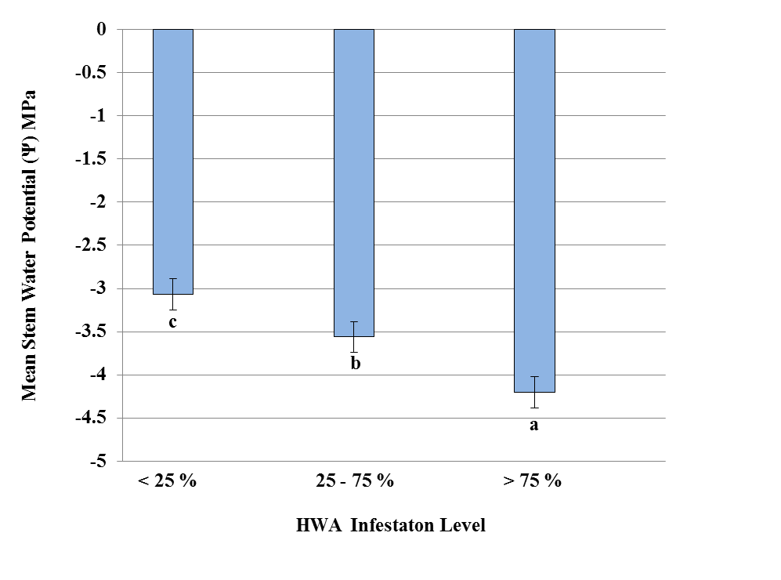
Figure 15. Influence of elevation and HWA infestation level on stem water potential (Ψ) as an indicator of water stress. Adjusted means (n= 96) (± SE) with different letters are significantly different (Student-Newman-Keuls Test; P < 0.05). The more negative the stem water potential (Ψ), the more water stress is occurring in the tree.

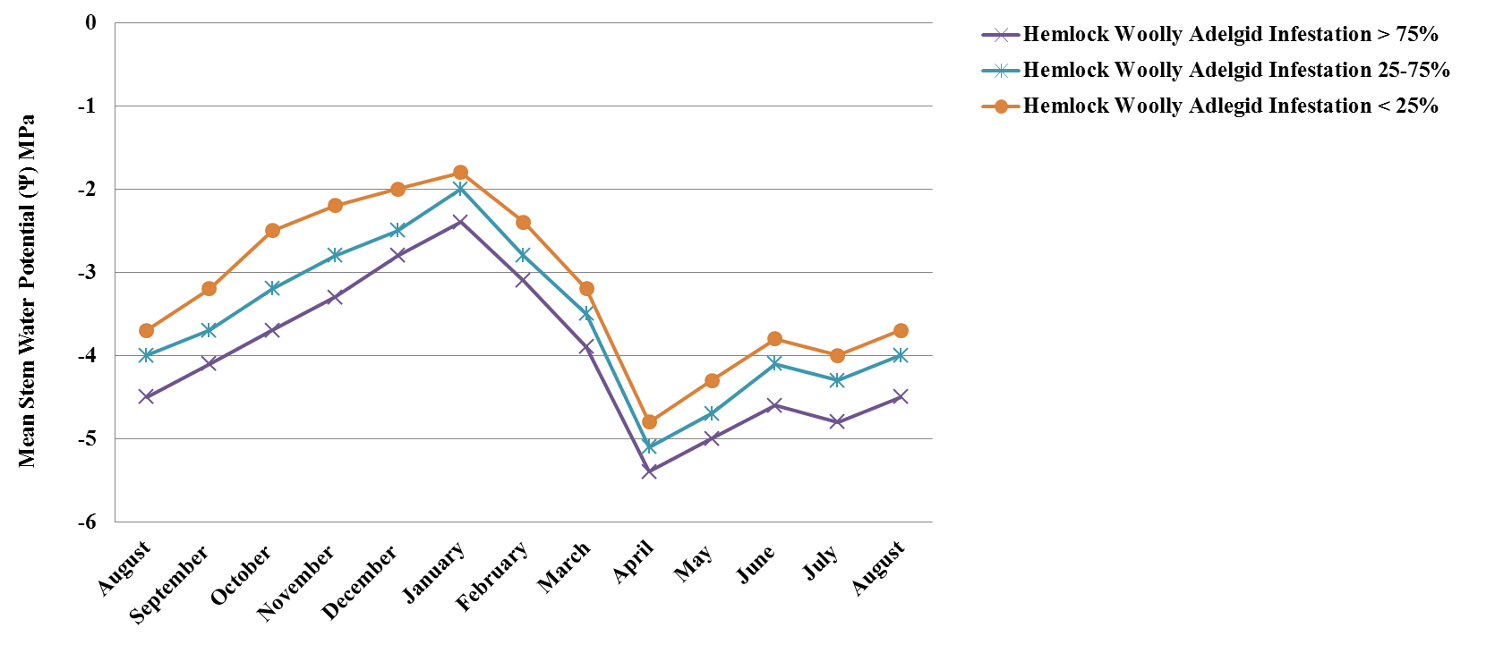

Figure 16. Temporal variation of adjusted water stress as a function of adjusted mean stem water potential (Ψ) as an indicator of water stress from August 2011- August 2012. The more negative the stem water potential (Ψ), the more water stress is occurring in the tree. Mean stem water potential (Ψ) was significantly different between all infestation levels within each month (Student-Newman-Keuls Test; P < 0.05).

the root, however, interruptions in these forces can cause water stress in a tree resulting in detrimental effects to growth, photosynthesis, and transpiration. Hemlock woolly adelgid infestations can influence water movement within eastern hemlocks by causing the formation of abnormal xylem structures, resulting in greater number of annual rings, increased amounts of ray tissue, and a reduction in the number of conducting pit pores and encrusted membranes (Timell 1986; Hollingsworth et al. 1991). These characteristics are conducive to limiting the movements of water within eastern hemlocks (Walker-Lane 2010), similar conclusions have been documented in Fraser fir, Abies fraseri (Pursch) Poir (Pinales: Pinaceae), with balsam woolly adelgid, Adelges piceae Ratzeburg (Hempitera: Adelgidae) (Balch 1964). These attributes cause decreased water conduction within the tree resulting in increased susceptibility to environmental stress and external symptoms of water-stress.
Integrating the relationship between hemlock woolly adelgid infestation levels and environmental factors may contribute to developing models to predict water stress in eastern hemlocks. The prediction of water stress can help land managers and owners develop management strategies that can prioritize hemlock stands in areas where systemic insecticide treatments would be most beneficial.
Conclusions
Because the initial emphasis is placed on the immediate control of exotic pests to suppress mortality in host trees, little attention has been given to the impact of water stress has on the health of the tree and its ability to withstand pest infestations. The results from this study indicate that as hemlock woolly adelgid infestations increase, water stress increases. Eastern hemlock trees with hemlock woolly adelgid infestations greater than 75% had the highest water stress, tress with infestations between 25-75% had moderate water stress, and trees with < 25% infestation had significantly lower water stress. Temporal differences in water stress indicate that highest water stress in eastern hemlocks occurs in Environmental factors, such as, ambient air temperature, rainfall, relative humidity, soil temperature, and soil moisture, can vary between sites and have the potential to impact water-stress. Knowledge of these effects can contribute to more effective chemical management strategies of hemlock woolly adelgid by understanding the implications these factors have in the movement of systemic insecticides within the tree as a result of high or relatively lower water stress.

CHAPTER VI. EVALUATION OF NEAR-INFRARED SPECTROSCOPY FOR PREDICTING IMIDACLOPRID CONCENTRATION IN EASTERN HEMLOCK NEEDLES

Introduction
The establishment of hemlock woolly adelgid, Adelges tsugae Annand (Hemiptera: Adelgidae), in the eastern United States has resulted in extensive mortality of eastern hemlocks, Tsuga canadensis (L.) Carrière. Imidacloprid is the primary insecticide used to control and suppress insect pest populations. By monitoring imidacloprid concentrations in eastern hemlock needle tissue is important to determine optimal re-treatment times and to assess the efficacy of a treatment. Imidacloprid has been reported to persist in the tree canopy (Cook 2008; Cowles et. al. 2006; Dilling 2007; Dilling et al. 2010; Tattar et. al. 1998; Turcott 2007) in concentrations correlated with effective control of hemlock woolly adelgid for several years (Cowles et al. 2006; Cook 2008; Dilling 2007; Dilling et al.2010). Monitoring imidacloprid concentrations in targeted trees, re-retreatment may be prolonged and financial cost may be significantly reduced. However, qualitative and quantitative measurements of imidacloprid in eastern hemlock matrices have primarily been measured using wet chemistry techniques, such as high pressure liquid chromatography coupled with mass spectrometry, competitive enzyme-linked immunosorbent assay (ELISA), and flow injection analysis. These techniques are limited to laboratories and are cost and labor intensive.
Near-infrared spectroscopy (NIR) has been used to detect pesticides in a variety of matrices, such as water, soil, and plant tissues (Vissar 1993). The use of NIR has many advantages. Samples can be measured directly without dilution and with little sample preparation. Spectroscopic methods are ideal since the sample is measured directly and is retained; thus, there is no tedious sample preparation, like extraction and clean-up procedures, reducing the use of toxic solvents. NIR spectrometers can analyze the sample and provide a result in seconds thereby providing instant answers while increasing sample throughput. Since NIR methods significantly reduce sample preparation the amount of sampling error is reduced thereby improving the accuracy and reproducibility of the measurement. Furthermore, since the sample is not destroyed during the analysis the measurement can be repeated. Once the instrument is calibrated the day to day analysis is a simple task and does not require learning elaborate procedures. In comparison to other chemistry techniques, NIR has an inverse relationship with respect to sample quantity and cost. The major cost for NIR is incurred in initial implementation of the method, so as the number of samples increase the cost per analysis is decreased. While wet chemistry techniques are restricted to laboratories, NIR spectrometers are portable and can be taken into the field, where the user can acquire instant feedback. NIR has been used effectively to predict early stages of eastern hemlock decline before visual symptoms become apparent (Pontius et al. 2005). However, it is unknown if this technology can be used for predicting imidacloprid concentrations in eastern hemlock needle tissue.
The goal of this study was to examine the relationship between NIR spectra and imidacloprid concentrations determined by high pressure liquid chromatography coupled with tandem mass spectrometry by (1) determining which wavelengths were most strongly correlated with imidacloprid concentration using PLS regression, (2) use this information to develop a simple linear equation to predict imidacloprid concentration using these wavelengths independently, and (3) compare the predictive capabilities of the simple linear equation to a partial least squares regression (PLS) based full and partial spectrum NIR.

Materials and Methods
Study Site-Experimental Design
Eastern hemlocks (n = 60) with moderate adelgid populations were selected at Indian Boundary in Cherokee National Forest in May 2008. The test site was arranged in a complete randomized block design complete randomized block design. Each tree was divided into three strata (lower, middle, and top) or sections with each strata representing ca. one-third of the tree (this constitutes the first split in the experimental design) and samples taken from each strata. Each tree was marked with a numbered identification metal tag. All trees represented approximately similar heights (12 -15 m) and diameters at breast height (DBH) (23.5 – 29.5 cm). Tree height was limited to a maximum of 15 m to be able to reach the top strata for branch collection.
Insecticide Application
CoreTect® pellets were applied to the soil as specified by the label. The application rate was 1 g AI / 2.5 DBH, applied as 2 tablets per cm DBH. This treatment was compared to soil injections made using the Kioritz® soil injector Kioritz Corp. Tokyo, Japan). Merit ® 75 WP insecticide (Bayer, Kansas City, MO) was diluted to 1 g AI / 2.5 DBH in 60 mL of water. Soil injections were made using the basal system in which injections were made within 45 cm of the base of the trunk and were spaced evenly around the tree at a depth of 7 cm below the soil surface with individual injections delivering 30 mL of insecticide based on label.
Branch Sampling
Branch samples were taken quarterly for four years (2008-2012). Four, 24 cm branch clippings were taken at each stratum (lower, middle, top) using a 10 m pole pruner. Branches were immediately placed in plastic bags, packed in ice, transported to the laboratory, and stored in a freezer at -20°C until sap extraction from branches was performed.
Spectral Data Collection
To assess the use of NIR to determine concentration ranges, eight needles were randomly selected from each branch and scanned (needles with sedentary insects were excluded as they interfere with the analysis). A background reference scan was made prior to scanning each set of eight needles. The NIR collection was done using a NIRSystems 6500 spectrometer. Individual needle tissue spectra were collected from 250 to 2500 nm, with a spectral resolution of 1-nm-wide contiguous channel acquired in absorbance mode. Spectra data were imported and treated in Unscrambler version 9.9 software (CAMO Technologies). The same needles were then prepared for imidacloprid quantification.
Needle Tissue Preparation
To quantify the concentration of imidacloprid in corresponding needle tissue, eight needles scanned from each 12 cm branch were dried and pulverized using a coffee grinder (KitchenAid, model BCG1000OB, Shelton CT). The protocol established by Schöning and Schmuck (2003) for chemical extraction and clean-up of imidacloprid using HPLC/MS/MS was used.

HPLC/MS/MS
HPLC/MS/MS was conducted using a Hewlett Packard HP 1100 high pressure liquid chromatograph coupled with a tandem triple quadrupole Applied Biosystems API 3000 mass spectrometer fitted with a C18 Luna (Phenomenex) reversed phase column (15 cm length x 4.6 mm i.d.). Parameters for the HPLC/MS/MS were as follows: injection volume: 50 µL, oven temperature: 40º C, mobile phase A: Water + 0.1 mL acetic acid per liter, mobile phase B: acetonitrile + 0.1 mL acetic acid per liter, gradient; 0-10 minutes 20% Solvent B, 11-15 minutes 90% solvent B, 16-19 minutes 20% solvent B, Interface: electrospray, turbo-ion spray potential: + 5000 V, temperature: 300º C, scan type: multiple reaction monitoring (MRM), polarity: positive, and collision gas: nitrogen 5.0.
Spectral Data Analysis
A randomly selected 5,760 sample subset of samples from 2009, 2010, 2011, and 2012 (n=11,820) were used to create imidacloprid predictive models. Raw absorbance data underwent mean normalization and multiple scatter correction (MSC) pre-treatments. Eight needles were individually scanned and spectra data were averaged across all eight needles to attain one spectrum per branch sample. In order to identify spectral regions that may contribute to predicting imidacloprid concentrations, pre-treated absorbance data were examined for all samples and a partial least squares regression model (PLSR) was constructed to determine significant wavelengths that may possibly be used to predict imidacloprid concentration. PLSR is known as partial least squares regression or projection to latent structures. PLSR the regression of a response variable (y) onto multiple linear combinations of the x variables (PC’s, also known as loading weights) that are used to detect significant variations in response to the (y) response variable. Wavelengths that were identified as significant in predicting imidacloprid concentrations were used to construct univariate linear regression and multivariate partial least squares regression (PLSR) models. The wavelengths identified coincided with the near-infrared wavelengths (925 – 947 nm) ranges that have been used to predict imidacloprid in various leaf matrices (Ma et al. 2006). Univariate linear regression predictive models were constructed by correlating the measured imidacloprid concentration determined by HPLC/MS/MS to peak intensities of spectra of significance (939 nm, 942 nm, and 947 nm). Calibrations were obtained using the Partial Least Square (PLS) method. Final predictive statistics were formulated from cross-validation of 2/3 (n=4,320) of the samples using Unscrambler version 9.9 (CAMO, Woodbridge NJ).

Results and Discussion

Near-infrared spectral data were collected from treated and untreated eastern hemlock needles. These data were analyzed using partial least square regression, to identify spectral regions that may potentially predict imidacloprid concentration (Figure 18). Multiple wavelengths (939 nm, 942 nm, and 947 nm) were significantly associated with predicting imidacloprid concentrations in eastern hemlock needles in PLS regression models.

Univariate Linear Regression

Univariate linear regression models were constructed to assess the ability for selected absorbance spectra peak intensities at 939 nm, 942 nm, and 947 nm to predict imidacloprid concentrations determined using HPLC/MS/MS. The univariate model with the highest predictive capability was obtained using the wavelength 947 nm (Table 11). However, all univariate models had low R values and high root mean square error of calibration values, indicating that these bands independently are poor predictors of imidacloprid concentrations.

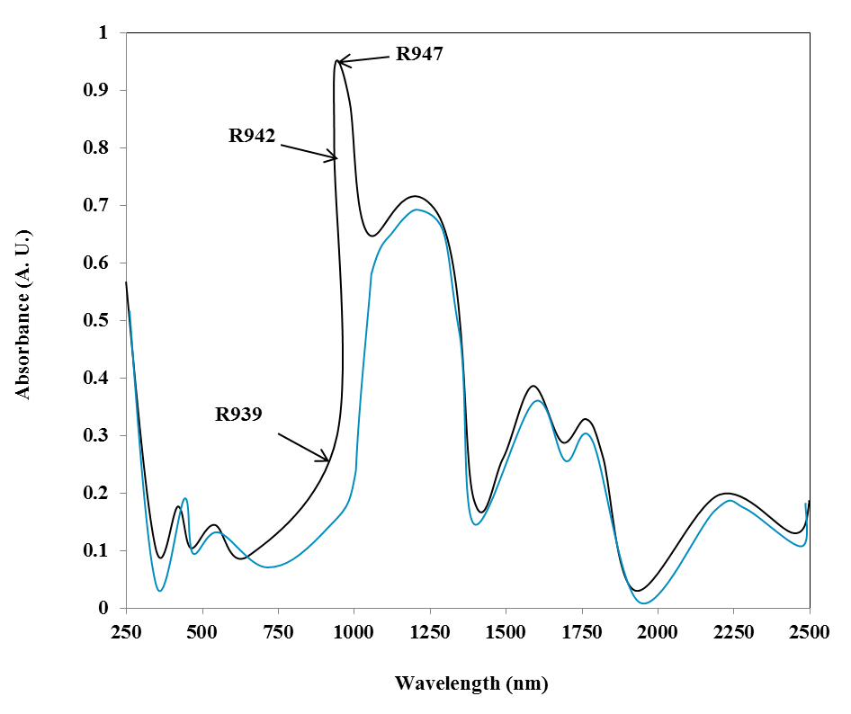

Figure 17. Near-infrared absorbance spectra collected for needles of eastern hemlocks that were treated with imidacloprid and for needles of eastern hemlock needles that were not treated. Wavelengths (939 nm, 942 nm, and 947 nm) that were significant in the full spectrum PLS regression model for predicting concentrations of imidacloprid are indicated.

Table 11. Results summary for univariate regression models constructed using near-infrared spectra peak intensities for spectra at 939 nm, 942 nm, and 947 nm for needles from imidacloprid treated and untreated eastern hemlocks.

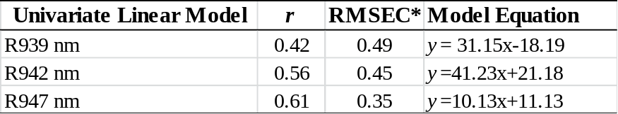
* RMSEC is the root mean square error of calibration, is a measure of the precision of the
model, the lower the RMSEC the higher the precision of the model.

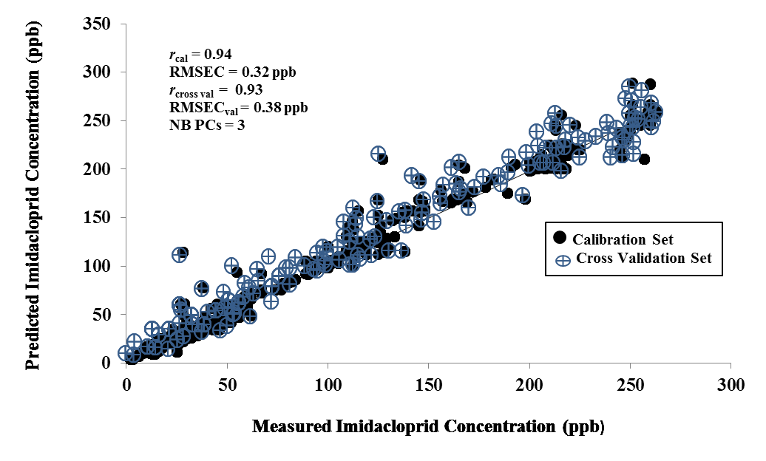
r_{cal} = 0.94
RMSEC = 3.2 ppb
r_{cross val} = 0.93
RMSEC_{cross val} = 3.8 ppb
NB PCs = 3

Figure 18. Results of PLS regression showing correlation between predicted imidacloprid concentration (ppb) and measured imidacloprid content in the calibration model and cross-validation model. Calibration and cross validation models based on partial spectrum (750 nm – 2500 nm) pre-treated absorbance data generated the highest correlation of coefficient for the calibrations model(r= 0.94) and the lowest root mean square error of calibration (RMSEC) (3.2 ppb), indicating a high accuracy of prediction capabilities.

Multivariate Partial Least Square Regression

A three factor PLS regression model based on partial spectrum (750 nm – 2500 nm) pre-treated absorbance data generated the highest correlation of coefficient for the calibrations model (r= 0.94) and the lowest root mean square error of calibration (RMSEC) (3.2 ppb), indicating a high accuracy of predication capabilities (Figure 18). Cross validation of the PLS regression model resulted in a high correlations of coefficient value (r= 0.93) and low RMSEC (3.8 ppb) (Figure 18). The wavelengths with the highest regression coefficients in the PLS regression model were located at 939 nm, 942 nm, and 947 nm. PLS regression model based on full spectral (350 nm – 2500 nm) pre-treated absorbance data generated a slightly lower correlation of coefficient for the calibration model (r=0.91) and a slightly higher RMSEC (5.66 ppb). These results indicate that PLS regression models based on full spectrum and partial spectrum analysis are able to accurately predict concentrations of imidacloprid. The partial spectrum PLS regression model had a higher accuracy to predict concentration of imidacloprid, which may be due to reducing variation in spectral data collected from wavelengths between 350-750 nm.

Conclusions

The results of this study indicate that near-infrared absorbance data can be used to predict concentrations of imidacloprid in eastern hemlock needles. PLS regression inferred wavelengths 939 nm, 942 nm, and 947 nm were significantly associated with predicting imidacloprid concentrations in eastern hemlock. Univariate linear regression analysis based on wavelengths 939 nm, 942 nm, and 947 nm, had low levels of prediction accuracy. The multivariate procedure, PLS regression, resulted in a prediction model between NIR spectra and imidacloprid concentrations that has a high level of predicting capabilities. Both full spectrum and partial spectrum PLS regression produced highly accurate prediction models.
The resulting method has the capability of allowing for a high throughput of samples in the lab, removing time and cost restraints associated with wet chemistry techniques, while maintaining a high level of prediction accuracy. Additionally, the equipment used for NIR detection is portable. Portable hand held near-infrared spectrometers are a much needed tool for rapid determination of imidacloprid in the field. This technology would allow for land managers to assess trees for re-retreatment, potential efficacy, and quality control, and represents an area of future research.

CHAPTER VII. SUMMARY

Extensive mortality of eastern hemlock due to the invasive hemlock woolly adelgid has warranted the development of integrated pest management plans to control populations of this pest. Integrated pest management plans developed before infestations of hemlock woolly adelgid and resulting damage to eastern hemlocks are critical to optimize the potential impact of these plans. However, due to the rapid rate of spread and the high rate of fecundity associated with hemlock woolly adelgid, management strategies in a majority of the range of eastern hemlock have been retrospective in a sense that implementation of these strategies has occurred after detection of significant damage to trees. Prioritizing eastern hemlocks based on a variety of criteria (economic, ecological, and aesthetic) and implementing integrated pest management strategies that incorporate cultural and chemical controls and augment the establishment of biological control agents offers both an immediate and long-term management strategy for effective control of hemlock woolly adelgid infestations.
Imidacloprid has proven to be an effective chemical control against hemlock woolly adelgid. The heterogeneous spatial and temporal dynamics of imidacloprid, olefin, and 5-hydroxy is important to understand to synchronize effective concentrations of these compounds with the active feeding times of hemlock woolly adelgid. Synchronizing effective compound concentrations and active feeding times will facilitate optimized control strategies. For example, soil injection treatments made by the end of July or beginning of August would facilitate enough time for maximal uptake of effective concentrations of imidacloprid to synchronize with the active feeding time of hemlock woolly adelgid in the southern Appalachians and CoreTect® treatments made in November would reach effective concentrations associated with effective control in subsequent years. Knowledge of the high toxicity and progressive persistence of olefin suggests a more long-term residual toxicity catalyzed by the metabolism of imidacloprid within eastern hemlock resulting in longer suppression and control of hemlock woolly adelgid in eastern hemlock in the southern Appalachians. The persistence and toxicity of olefin, reduces the need to retreat trees and as such reduces the cost associated with imidacloprid treatments.
The tri-trophic movement and persistence of imidacloprid and olefin are important to understand in developing integrated pest management plans where biological control agents are to be augmented or non-target impacts may be a concern. The documented tri-trophic movement through herbivore and predator guilds on eastern hemlock allows for the development of chronological control strategies that reduce the impact to non-target biological control agents and facilitate management strategies that combine these two tactics.
Because the initial emphasis is placed on the immediate control of exotic pests to suppress mortality in host trees, little attention has been given to the impact water stress has on the health of the tree and its ability to withstand pest infestations. The data represent the first documentation of the effect of infestation level on water stress on eastern hemlocks. Water stress progressively increased as hemlock woolly adelgid infestation levels increased. Knowledge of this effect can contribute to more effective chemical management strategies of hemlock woolly adelgid by understanding the implications these factors have in the movement of systemic insecticides within the tree as a result of high or relatively lower water stress. Additionally, this information can be used to help prioritize eastern hemlock stands for chemical treatment.
Monitoring imidacloprid concentrations in targeted trees may prolong the need for re-retreatment and result in reduced financial costs associated with effort to suppress populations of hemlock woolly adelgid. Additionally, if imidacloprid can be detected, olefin will be present, due to the known chronological metabolism of imidacloprid. Olefin has been shown to be 14 times more toxic to hemlock woolly adelgid than imidacloprid and progressively increases in concentration as imidacloprid declines over time. However, qualitative and quantitative measurements of imidacloprid in eastern hemlock matrices have primarily been measured using chemistry techniques limited to laboratories and are cost and labor extensive. This study indicates that near-infrared absorbance data can be used with a high degree of accuracy to predict concentrations of imidacloprid in eastern hemlock needles. The portable hand held near-infrared spectrometer would provide a much needed tool for rapid determination of imidacloprid in the field. This technology would allow for land managers to assess trees for re-retreatment, potential efficacy, and quality control.

LITERATURE CITED

Abbot, W. S. 1925. A method of computing the effectiveness of an insecticide. Econ.
Entomol. 18:265-267.

Alverson, W. S, D. M. Waller, and S. L. Solheim. 1988. Forests too deer: edge effects in
northern Wisconsin. Conserv. Biol. 2:348-358.

Arthur, F. H. and F. P. Hain. 1985. Seasonal history of the balsam woolly adelgid
(Homoptera: Adelgidae) in natural stands and plantations of Frasier fir. Econ. Entomol. 77:1154-1158.

Bai, D., S. C. R. Lummis, W. Leicht, H. Breer, and D. B. Sattelle. 1991. Actions of
imidacloprid and a related nitromethylene on cholinergic receptors of an identified insect motor neuron. Pestic. Sci. 33:197-204.

Balch, R. F. 1964. Studies of the balsam woolly aphid, Adelges piceae (Ratz.), and its
effect on balsam fir, Abies balsmea (L.) Mill. Can. Dept. Agricul. 867:1-15.

Baskaran, S., R.S. Kookana, and R. Naidu. 1997. Determination of the insecticide imidacloprid in water and soil using high-performance liquid chromatography. J.
Chromat. A. 787: 271-275.

Bayer. 2007. Merit® product label. Bayer Corporation Publication. Pp. 6.

Beatty, S. W. 1984. Influence of microtopography and canopy species on spatial patterns
of forest understory plants. Ecol. 65:1406-1419.

Benzinger, J. 1994a. Hemlock decline and breeding birds. Rec. N. J. Birds. N. J.
Audubon Soc. 20:2-12.

Benzinger, J. 1994b. References for hemlock decline and breeding birds. Rec. N. J.
Birds. N. J. Audubon Soc. 20:1-8.

Benzinger, J. 1994c. Hemlock decline and breeding birds. Rec. N. J. Birds. N. J.
Audubon Soc. 20:34-51.

Blozan, W. J., J. Boetsch, and M. Davie. 1995. National Register of Big Trees–Eastern
Hemlock, Tsuga canadensis. http:www.americanforests.org/resources/
bigtrees/register.php?details=2053.

Bonmatin, J. M., I. Moineau, R. Charvet, C. Fleche, M.E. Colin, and E. R. Bengsch.
2003. A LC/APCI-MS/MS method for analysis of imidacloprid in soils, in plants, and in pollens. Analyt. Chem. 75:2027-2033.

Brisbin, R. L. 1970. Eastern hemlock: (Tsuga canadensis (L.) Carr.). U.S. Department
of Agriculture. Amer. Woods. FS-239. Pp.14.
Buck, S., P. Lambdin, D. Paulsen, J. Grant, and A. Saxton. 2005. Checklist of insect species associated with eastern hemlock in the Great Smoky Mountains National
Park and environs. Tennessee Acad. Sci. 80:1-10.

Burkle, L. A. and B. A. Logan. 2003. Seasonal acclimation of photosynthesis in eastern
hemlock and partridgeberry growing in different light environments. Northeast. Natural. 10:1-16.

Catovsky, S. N. M. Holbrook, and F. A. Bazzaz. 2002. Coupling whole tree transpiration
and canopy photosynthesis in coniferous and broad-leaved tree species. Canad. Forest Reasearch. 32:295-309.

Cheah, C. A. S. –J., and M. S. McClure. 2000. Seasonal synchrony of life cycles
between the exotic predator, Pseudoscymnus tsugae (Coleoptera: Coccinellidae), and its prey, the hemlock woolly adelgid, Adelges tsugae (Homoptera: Adelgidae). Agric.Forest Entomol. 2:241-251.

Cook, F. B. 2008. Liquid chromatography tandem mass spectrometry (LC/MS/MS)
determination of the uptake, persistence, and metabolism of imidacloprid in treated hemlock trees. M. S. thesis, Villanova University, Philadelphia, PA. Pp. 64.

Coots, C. I., P. L. Lambdin, J. F. Grant, J. R. Rhea, and E. L. Mockford. 2012a. Vertical
stratification and co-occurrence patterns of the Psocoptera community associated with eastern hemlock, Tsuga canadensis (L.) Carrière,in the Southern Appalachians. Forests 3(1)127-136.

Coots, C. I., P. L. Lambdin, J. F. Grant, and J. R. Rhea. 2012b. Diversity, stratification,
and co-occurrence patterns of the mycetophilid community found in association with Eastern Hemlock, Tsuga canadensis (L.) in the southern Appalachians. Forests 3(4)986-996.

Cowles, R. S., and C. A. S. -J. Cheah. 2002a. Foliar sprays for control of hemlock
woolly adelgid. Arthropod Manage. Tests 27:G48.

Cowles, R. S., and C. A. S. -J. Cheah. 2002b. Systemic control of hemlock woolly adelgid. Arthropod Manage. Tests 27:G47.

Cowles, R. S., M. E. Montegomery, and C. A. S. -J. Cheah. 2006. Activity and residues
of imidacloprid applied to soil and tree trunks to control hemlock woolly adelgid (Hemiptera: Adelgidae) in forests. Econ. Entomol. 99:1259-1267.

Cox, L., W. C. Koskinen, and P. Y. Yen. 1997. Sorption – desorption of imidacloprid
and its metabolites in soils. J. Agric. Food Chem. 45:1468-1472.
Cox, L., W. C. Koskinen, R. Celis, P. Y. Yen, M. C. Hermosin, and J. Cornejo. 1998.
Sorption of imidacloprid and soil clay mineral and organic components. Amer. J. Soil Sci. Soc. 62:911-915.

Danoff-Burg, J. A. and S. Bird. 2002. Hemlock woolly adelgid and elongate hemlock
scale: Partners in Crime?, pp. 254–268. In B. Onken, R. Reardon, and J. Lashomb [eds.], Proceedings, Hemlock Woolly Adelgid in the Eastern United States Symposium, 5–7 February 2002. Rutgers University, New Brunswick, NJ. USA.

Daubenmire, R. F. 1931. Factors favoring the persistence of a relic association of
eastern hemlock in Indiana. Butler Univ. Bot. Studies. 2:29-32.

Dayton, P. K. 1972. Toward an understanding of community resilience and the potential
effects of enrichments to the benthos at McMurdo Sound, Antarctica, pp. 1–13. In B. C. Parker [ed.], Proceedings of the colloquium on conservation problems in Antarctica. Lawrence, KS. Allen Press.

Deal, I. K. 2006. Life history of hemlock woolly adelgid, Adelges tsugae Annand, on
eastern hemlock, Tsuga canadensis (L.) Carriere, in the southern Appalachians and assessment of egg releases of Sasajiscymnus tsugae (Sasaji and McClure) for its management. M. S. thesis, University of Tennessee, Knoxville. Pp 63.

DeGraaf, R. M., M. Yamasaki, W. B. Leak, and J.W. Lanier. 1992. New England
wildlife: management of forested habitats. Gen. Tech . Rep. NE–144. U. S. Department of Agriculture, Forest Service, Northeastern Forest Experiment Station, Radnor, PA. USA. Pp. 15.

Doccola, J. J., P. M. Wild, I. Ramasamy, P. Castillo, and C. Taylor. 2003. Efficacy
of Arborjet VIPER microinjections in the management of hemlock woolly adelgid. J. Arboric. 29:327-330.

Dotson, J. A. 1994. Bayer Corp. MERIT Product Information Manual. Pp. 110.

Dilling, C. I., P. L. Lambdin, J. F. Grant, and S. L. Buck. 2007. Insect guild structure
associated with eastern hemlock in the southern Appalachians. Environ. Entomology. 36:1408-1414.

Dilling, C. I., P. L. Lambdin, J. F. Grant, and J. R. Rhea. 2009. Community response of non-target phytophagous and transient insects associated with eastern hemlock, Tsuga canadensis (L.) Carrière, to imidacloprid and horticultural oil treatments. Environ. Entomology. 38:53-66.

Dilling, C. I., P. L. Lambdin, J. F. Grant, and J. R. Rhea. 2010. Spatial and temporal distribution of imidacloprid in eastern hemlock in the southern Appalachians.
Econ.Entomology. 103:368-373.

Drooze, A. T. 1985. Insects of Eastern Forests. USDA Forest Service. U.S. Dept of
Agriculture, Washington DC. USA. Pp. 579.

Eisenback, B.M., S. M. Salom, L.T. Kok, and A. F. Lagalante. 2010. Lethal and sublethal effects of imidacloprid on hemlock woolly adelgid (Adelges tsugae, Hempitera: Adelgidae) and two introduced predator species in the laboratory.
Econ. Entomol. 103:1222-1234.

Elbert, A., H. Overback, K. Iwaya, and S. Tsuboi. 1990. Imidacloprid, a novel systemic
nitromethyleneanalogue Insecticide for Crop Protection, pp. 21–28. In Proc.
Brighton Crop Protection Conference, Pests and Diseases. Lavenham Press..Pp. 28.

Elbert, A., B. Becker, J. Hartwig, and C. Erdelen. 1991. Imidacloprid, a New
Systemic Insecticide. Pflanz–Nach. Bayer 44:113-136.

Ellison, A. M., M. S. Bank, B. D. Clinton, E. A. Colburn, K. E. Elliott, C. R. Ford, D. R.
Foster, B. D. Kloeppel, J. D. Knoepp, G. M. Lovett, J. Mohan, D. A. Orwig, N. L.
Rodenhouse, W.V. Sobczak, K. A. Stinson, J. K. Stone, C. M. Swan, J. Thompson, B. Von Holle, and J. R. Webster. 2005. Loss of foundational species: consequences for the structure and dynamics of forested ecosystems. Front. Ecol. Environs. 3:479-486.

Evans, R. A. 2002. An ecosystem unraveling? pp. 254–268. In B. Onken, R. Reardon,
and J. Lashomb [eds.], Proceedings, Hemlock Woolly Adelgid in the Eastern
United States Symposium, 5–7 February 2002, East Brunswick, NJ. Rutgers University, New Brunswick, NJ. USA.

Eyre, F.1980. Forest cover types of the United States and Canada. Soc. Amer.
Amer. Foresters. Washington, DC. Pp.1480

Fernandez-Alba, A. R. A. Valverde, A. Aguera, M. Contreras, and S. Chiron. 1996.
Determination of imidacloprid in vegetables by high-preformance liquid chromatography with diode-array detection. J. Chromat. A. 721:97-105.

Fidgen, J. G., Q. C. McClellan, and S. M. Salom. 2002. Efficacy and residual activity of
two systemic insecticides for control of hemlock woolly adlegid. pp. 329-334. In B. Onken and R. Reardon [eds.], Proceedings of the Third Symposium on Hemlock woolly adelgid in the Eastern United States. 1–3 February 2002, Asheville, NC. USA.

Ford, C. R. and J. M. Vose. 2007. Tsuga canadensis (L.) Carr. mortality will impact
hydrological processes in the southern Appalachian forest ecosystems. Ecol. Appl. Pp. 218-315.

Frelich, L. E. and C. G. Lorimer. 1985. Current and predicted long–term effects of deer
browsing in hemlock forests in Michigan, USA. Biol. Conser.34:99-120.

Friesner, R. C. and J. E. Potzger. 1932. Studies in forest ecology. I. Some factors
concerned in hemlock reproduction in Indiana. II. The ecological significance of Tsuga candensis in Indiana. Butler Univ. Bot. Studies. 2:133-149.

Friesner, R. C. and J. E. Potzger. 1934. Climax conditions and ecological status of Pinus
strobus, Taxus canadensis, and Tsuga canadensis in the Pine Hills region of Indiana. Butler Univ. Bot.Studies. 3:65-83.

Friesner, R. C. and J. E. Potzger. 1936. Soil moisture and the nature of the Tsuga and
Tsuga –Pinus forest association in Indiana. Butler Univ. Bot. Studies. 3:207-209.

Friesner, R. C. and J. E. Potzger. 1944. Survival of hemlock seedlings in a relict colony
under forest conditions. Butler Univ. Bot. Studies. 6:102-115.

Gervais, J.A., B. Luukinen, K. Buhl, and D. Stone. 2010. "Imidacloprid Technical
Fact Sheet". National Pesticide Information Center. http://npic.orst.edu/factsheets/imidacloprid.pdf. Retrieved 12 April 2012.

Gibbs, A. 2002. Regulating hemlock woolly adelgid in noninfested states, pp. 310-312.
In B. Onken, R. Reardon, and J. Lashomb [eds.], Proceedings, Hemlock woolly
adelgid in the Eastern United States symposium; 2002 February 5-7; East Brunswick, NJ. Rutgers University, New Brunswick, NJ. USA.

Godman, R. M. and K. Lancaster. 1990. Tsuga canadensis (L.) Carr. Eastern hemlock.
pp. 604–612. In R. M. Burns, B. H. Honkala [tech. cords.], Silvics of North America: Volume 1, Conifers , Agricultural Handbook 654. Washington DC: U.S.

Godman, R. and K. Lancaster. 2003. Trees of Western North Carolina – Eastern
Hemlock. USDA For. Serv. http://wildnc.org/trees/Tsuga_canadensis.html.

Graham, S. A. 1941. Climax forests in the upper peninsula of Michigan. Ecol. 22:355-
362.
Graham, S. A. 1943. Causes of hemlock mortality in northern Michigan. Bull. 10. Ann
Arbor: University of Michigan, School of Forestry and Conservation. Pp. 61.

Hadley, J. L. 2000. Effect of daily minimum temperature on photosynthesis in eastern
hemlock (Tsuga canadensis L.) in autumn and winter. Arct. Alp. Research. 32:368-374.
Hadley, J. L. and J. L. Schedlbauer. 2002. Carbon exchange of an old-growth eastern
hemlock (Tsuga canadensis) forest in central New England. Tree Physiol. 22: 1079-1092.

Havill, N. P., M. E. Montgomery, G. Yu, S. Shiyake, and A. Caccone. 2006.
Mitochondrial DNA from hemlock woolly adelgid (Hemiptera: Adelgidae) suggests cryptic speciation and pinpoints the source of introduction into Eastern North America. Ann. Entomol. Soc. Amer. 99:195-203.
.
Hollingsworth, R.G., U. Blum, and F.P. Hain. 1991. The effect of adelgid-altered wood
on sapwood conductance of Fraser fir Christmas trees. IAWA Bulletin. 12:253-239.

Hough, A.F. 1936. A climax forest community on East Tionesta Creek in northwestern
Pennsylvania. Ecol. 17:9-28.

Hough, A. F. 1945. Frost pockets and other microclimates in forests of the northern
Allegheny Plateau. Ecol. 26:230-250.

Jenkins, J., J. D. Aber, C. D. Canham. 1999. Hemlock woolly adelgid impacts on community structure and N cycling rates in eastern hemlock forests. Can. J. For. Res. 29:630-645.

Jordan, J. S. and W. M. Sharp. 1967. Seeding and planting hemlock for ruffed grouse
cover. Res. Pap. NE-83. U. S. Dept. of Agriculture, For. Serv. 1-17.

Kagabu, S. 1997. Chloronicotinyl insecticides – discovery, application and future
perspective. Rev. Toxicol. 1:75-129.

Kagabu, S., R. Ishihara, Y. Hieda, K. Nishimura, and Y. Naruse. 2007. Insecticidal and
neuroblocking potencies of variants of the imidazoline moiety of imidacloprid related neonicotinoids and the relationship to partition coefficient and charge density on the pharmacophore. Ag.and.Food Chem. 55:812-818.

Kelty, M. J. 1989. Productivity of New England hemlock / hardwood stands as affected
by species composition and canopy structure. For. Ecol. Management.
28:237-257.
Kidd, H. and D.R. James. 1991. In the Agrochemicals Handbook, 3rd ed. Royal
Society of Chemistry Information Services: Cambridge, UK. Pp. 234-236.

Koch, F. H., H. M. Cheshire, and H. A. Devine. 2006. Landscape-scale prediction of
hemlock woolly adelgid, Adelges tsugae (Homoptera: Adelgidae), infestation in the southern Appalachian mountains. Environ. Entomol. 35:1313-1323.

Lapin, B. 1994. The impact of hemlock woolly adelgid on resources in the lower
Connecticut River Valley. Rpt. NE Ctr. For. Health Res. Pp. 10.

Lagalante, A. F. and M. E. Montgomery. 2003. Analysis of terpenoids from hemlock
(Tsuga) species by solid phase microextraction/gas chromatography/ ion trap mass spectrometry. Ag. and Food Chem. 51:2115-2120.

Lagalante, A. F., N. Lewis, M. E. Montegomery, and K. S. Shields. 2006. Temporal and
spatial variation of terpenoids in eastern hemlock (Tsuga canadensis) in relation to feeding by Adelges tsugae. Chem. Ecol. 32:2389-2403.

Lagalante, A. F. and P. W. Greenbacker. 2007. Flow injection analysis of imidacloprid
in natural waters and agricultural matrixes by photochemical dissociation, chemical reduction, and nitric oxide chemiluminescence detection. Analytica Chimica Acta. 590:151-158.

Liebhold, A. M., W. L. MacDonald, D. Bergdahl, and V. C. Mastro. 1995. Invasion by
exotic forest pests: a threat to forest ecosystems. For. Sci. Mono. 30:1-49.

Little, E.L., Jr. 1971. Atlas of United States trees, volume 1, conifers and important
Hardwoods. U.S. Department of Agriculture Miscellaneous Publication 1146, Pp. 200.

Lishawa, S. C., D. R. Bergdahl, and S. D. Costa. 2007. Winter conditions in eastern
hemlock and mixed-hardwood deer wintering areas in Vermont. Can. J. For. Res. 37:697-703.

Lynch, C., P. Lambdin, J. Grant, R. Reardon, and R. Rhea. 2006. Survey for established
predators of elongate hemlock scale in Tennessee. Fla. Ent. 89:527-528.

Ma, G. X., C. L. Wang, D. W. Fan, D. Xing, L. Qian, J. H. Wang, S. H. Liu. 2006.
Quantitative determination of imidacloprid by infrared absorption spectrometry. Spectroscopy and Spectral Analysis. 26:434-437.

Marion, D. F., and D. Foster. 2000. Woolly adelgid hits New England. Superintendents
News. 2:9.

Martin, N. D. 1959. An analysis of forest succession in Algonquin Park, Ontario. Ecol.
Monog. 29: 187-218.

Matsuda, K., S. D. Buckingham, D. Kleier, J. J. Rauh, M. Grauso, and D. B. Sattelle.
2001. Neonicotinoids: insecticides acting on insect nicotinic acetylcholine receptors. Trends Pharamacol. Sci. 22:573-580.

Mausel, D. 2005. Monitoring of Laricobius nigrinus (Coleoptera: Derodontidae) for
biological control of the hemlock woolly adelgid in the eastern U.S. Ph.D. Dissertation. VT. Blacksburg, VA. Pp. 161.

Mausel, D. L., S. M. Salom, L. T. Kok, and G. A. Davis. 2010. Establishment of
hemlock woolly adelgid predator, Laricobius nigrinus (Coleoptera: Derodontidae), in the eastern United States. Environ. Entomol. 39:440-448.

Mayer, M., R. Chianese, T. Scudder, J. White, K. Vongpaseuth, and R. Ward. 2002.
Thirteen years of monitoring the hemlock woolly adelgid in New Jersey forests. pp. 50-60. In B. Onken, R. Reardon, and J. Lashomb [eds.], Proceedings , Hemlock woolly adelgid in the Eastern United States symposium; 2002 February 5–7; East Brunswick, NJ. Rutgers University, New Brunswick, NJ. USA.

McClure, M. S. 1987. Biology and control of hemlock woolly adelgid. Bull.
Connecticut Agric. Exp. Stat., 851. New Haven, CT. Pp. 8.

McClure, M. S. 1989. Evidence of a polymorphic life cycle in the hemlock woolly
adelgid, Adelges tsugae (Homoptera: Adelgidae). Ann. Entomol. Soc. Amer. 82: 50-54.

McClure, M.S. 1990. Role of wind, birds, deer, and humans in the dispersal of
hemlock woolly adelgid, Adelges tsugae (Homoptera: Adelgidae). Environ. Entomol. 19:36-43.

McClure, M. S. 1991a. Density-dependent feedback and population cycles in Adelges
tsugae (Homoptera:Adelgidae) on Tsuga canadensis. Environ. Entomol. 19:36- 43.

McClure, M. S. 1991b. Pesticides will protect ornamentals from hemlock woolly
adelgid. Front. Plant Sci. 44:2-3.

McClure, M. S. 1991c. Nitrogen fertilization of hemlock increases susceptibility to
hemlock woolly adelgid. J. Arbor. 17:227-229.

McClure, M. S. 1995. Managing hemlock woolly adelgid in ornamental landscapes.
Bull. 925. Conn. Agric. Exper. Stat. Pp. 7.

McClure, M. S. 2001. Biological control of hemlock woolly adelgid in the eastern
United States. FHTET 2000-08. Morgantown, WV: U.S. Department
of Agriculture, For. Serv., For. Health Tech. Enterprise Team. Pp. 10.

McClure, M. S. and C. A. S.–J. Cheah. 1999. Reshaping the ecology of invading
populations of hemlock woolly adelgid , Adelges tsugae (Homoptera: Adelgidae), in eastern North America. Biol. Invas. 1:247-254.

McClure, M. S., S. Salom, and K. S. Shields. 2001. Hemlock Woolly Adelgid. Forest
Health Technology Enterprise Team. U. S. Forest Service Publication. FHTET – 2001–03. Morgantown, WV. USA. Pp. 14.

McClure, M. S. and C. A. S.–J. Cheah. 2002. Important mortality factors in the life cycle
of hemlock woolly adelgid, Adelges tsugae Annand (Homoptera: Adelgidae), in the northeastern United States, pp. 13-22. In B. Onken, R. Reardon, and J. Lashomb [eds.], Proceedings, Hemlock Woolly Adelgid in the Eastern United States Symposium, 5–7 February 2002, East Brunswick, NJ. Rutgers University, New Brunswick, NJ. USA.

McIntyre, A. C. and G. L. Schnur. 1936. Effects of drought on oak forests. Bull. 325.
The Pennsylvania State College, School Agric. Exper. Stat. Pp. 43.

McMartin, B. 1992. Hides, hemlocks, and Adirondack history. Utica, NY. North
Country Books. Pp. 214.

Mencke, N. J. P. 2002. Therapy and prevention of parasitic insects in veterinary
medicine using imidacloprid. Top.Med.Chem. 2:701-715.

Moore, B., H. M. Richards, H. A. Gleason, and A. B. Stout. 1924. Hemlock and its
environment. NY Bot. Gard. Bull. 12:325-350.

Mullins, J. W. and D. Christie. 1995. Imidacloprid: A new nitroguanidine insecticide.
Am. Chem. Soc. Symp. Ser. 524:183-198.

Nauen, R. K. Tietjen, K. Wagner, and A. Elbert. 1998. Efficacy of plant metabolites of
imidacloprid against Myzus persicae and Aphis gossypii (Homoptera: Aphididae). Pestic. Sci. 52:53-57.

Nienstaedt, N. and H. Kriebel. 1955. Controlled pollination of eastern hemlock.
For. Sci. 1:115-120.

Obana, H. H., M. M. Okihashi, K. K. Akutsu, Y. Y. Kitagawa, S. S. Hori. 2002.
Determination of acetamiprid, imidacloprid, and nitenpyram residues in vegetables and fruits by high-performance liquid chromatography. J. Agri. Food Chem. 50:4464-4467.

Oosting, H. J. and D. W. Hess. 1956. Microclimate and relict stand of Tsuga canadensis
in the lower Piedmont of North Carolina. Ecol. 37: 28-39.

Orwig, D. A.and D. R. Foster. 1998. Forest response to the introduced woolly adelgid in
southern New England, USA. J. Torrey Bot. Sci. 125:60-73.

Orwig, D. A. 2002. Landscape patterns of hemlock decline in New England due to the
introduced hemlock woolly adelgid. J. Biogeog. 29:1475-1487.

Orwig, D. A. and M. L. Kizlinski. 2002. Vegetation response following hemlock
woolly adelgid infestation, hemlock decline, and hemlock salvage logging, pp. 106–117. In B. Onken, R. Reardon, and J. Lashomb [eds.], Proceedings, Hemlock Woolly Adelgid in the Eastern United States Symposium, 5–7 February 2002, East Brunswick, NJ. Rutgers University, New Brunswick, NJ. USA.

Ouellette, D. 2002. Responding to the artificial introduction of hemlock wooly adelgid
(Adelges tsugae), pp. 276–279. In B. Onken, R. Reardon, and J. Lashomb [eds.], Proceedings, Hemlock Woolly Adelgid in the Eastern United States Symposium, 5–7 February 2002, East Brunswick, NJ. Rutgers University, New Brunswick, NJ. USA.

Parker, B. L., M. Skinner, S. Gouli, and T. Ashikaga. 1998. Survival of hemlock woolly
adelgid (Homoptera: Adelgidae) at low temperatures. For. Sci. 44:1-7.

Parker, B. L., M. Skinner, S. Gouli, and T. Ashikaga. 1999. Low lethal temperature for
hemlock woolly adelgid (Homoptera: Adelgidae). Environ. Entomol. 28:1085-1091.

Placke, F. J. and F. Gustin. 1993. Method of determining imidacloprid residues in plants.
Pflanzenschutz-Nachr. Bayer. 109-182.

Pontius, J., R. Hallet, and J. Jenkins. 2006. Foliar chemistry linked to infestation and
susceptibility of hemlock woolly adelgid (Homoptera: Adelgidae). Environ. Entomol. 35:112-120.

Powell, D. S., J. L. Faulkner, D. R. Darr, Z. Zhu, and D. W. MacCleery. 1993. Forest
resources of the United States. Gen. Tech. Rep. RM – 234. U.S. Department of Agriculture, For. Serv., Rocky Mountain Res. Stat.

Quimby, J. W. 1996. Value and importance of hemlock ecosystems in the eastern United
States, pp. 1–8. In S. M. Salom, T. C. Tigner, and R. C. Reardon [eds.], Proceedings of the First Hemlock Woolly Adelgid Review, 12 October 1995, Charlottesville, VA. Forest Health Technology Enterprise Team, Morgantown, WV, USA.

Reay, R. S., D. W. Blodgett, B. S. Burns, S. J. Weber, and T. Frey. 1990. Management guide for deer wintering areas in Vermont. Vermont Fish and Wildlife Dept. Pp. 35.

Rhea, J. R. 1996. Preliminary results for the chemical control of hemlock woolly
adelgid in ornamental and natural settings, pp. 113-125. In S. M. Salom, T. C. Tigner, and R. C. Reardon [eds.], Proceedings of the First Hemlock Woolly Adelgid Review, 12 October 1995, Charlottesville, VA. FHTET 96–10. Forest Health Technology Enterprise Team, Morgantown, WV. USA.

Rogers, R. 1980. Hemlock stands from Wisconsin to Nova Scotia: transitions in understory composition along a floristic gradient. Ecol. 61:178-193.

Royle, D. D. and R. G. Lantrop. 1997. Monitoring hemlock forest health in New Jersey
using Landstat TM data and change direction techniques. For. Sci. 43:327-335.

SAS Institute. 2006. SAS user’s guide, statistics. SAS Institute, Cary, NC. Pp 225.

Sasaji, H. and M. S. McClure. 1997. Description and distribution of Pseudoscymnus
tsugae sp. nov. (Coleoptera: Coccinellidae), an important predator of hemlock woolly adelgid in Japan. Ann. Entomol. Soc. Amer. 90:563-568.

Schmidt, T. L. and W. H. McWilliams. 1996. Status of eastern hemlock in the northern
U.S. In G. Mroz and J. Martin [eds.], Proceedings of ecology and management
of eastern hemlock. University of Wisconsin. Madison, WI. Pp. 61-72.

Schöning, R. 2001. Analytic method for determination of residues of imidacloprid, NTN
33893-5-hydroxy, and NTN 33893-olefin by HPLC with electrospray MS/MS-detection in plant and other materials. Pflanzenschutz-Nachrichten. Bayer. 54:413-445.

Schöning, R. and R. Schmuck. 2003. Analytical determination of imidacloprid and
relevant metabolite residues by LC/MS/MS. Bull. Insectol. 56:41-50.

Schultz-Jander, D. A.,W.M. Leimkuehler, and J. E. Casida. 2002. Neonicotinoid
insecticides: reduction and cleavage of imidacloprid nitroimine substituent by liver microsomal and cytosolic enzymes. Chemical Research in Toxicology. 15:1158-1165.
Secrest, H. C., H. J. Macaloney, and R. C. Lorenz. 1941. Causes of the decadence of
hemlock at the Menominee Indian Reservation, Wisconsin. J. For. 39:3-12.

Shigo, A. L. 1991. Modern Arboriculture: A Systems Approach to the Care of Trees and
their Associates. Shigo and Trees, Associates, Durham, NH.

Shreve, F. 1927. Soil temperature in redwood and hemlock forests. Torrey Bot. Club
Bull. 54: 649-656.

Silcox, C. A. 2002. Using imidacloprid to control hemlock woolly adelgid, pp. 280-
287. In B. Onken, R. Reardon, and J. Lashomb [eds.], Symposium on the Hemlock Woolly Adelgid in Eastern North America, 5-7 February 2002, East Brunswick, NJ. NJ Agricultural Experiment Station Rutgers, New Brunswick, NJ.

Simpson, T. B., P. E. Stewart, B. V. Barnes. 1990. Landscape ecosystems and cover
types of reserve areas and adjacent lands of the Huron Mountain Club. Occassional paper number 4 of the Huron Mountain Wildlife Foudation. Big Bay, Michigan, USA. Pp. 34.

Smith, K. T. and P. A. Lewis. 2005. Potential concerns for tree wound response from
stem injections, pp. 173-178. In B. Onken and R. Reardon [eds.], Symposium on the Hemlock Woolly Adelgid in Eastern North America, 1-3 February 2005, Asheville, NC.

Snyder, C., J. Young, D. Smith, D. Lemarie, R. Ross, and R. Bennett. 2004. Stream
ecology linked to eastern hemlock decline in Delaware Water Gap National Recreation Area. U. S. Geological Survey, Kearneysville, WV. (www.lsc.usgs.gov/aeb/2048-03/dewa.asp).

Souto, D., T. Luther, and B. Chianese. 1996. Past and current status of hemlock woolly
adelgid in eastern and Carolina hemlock stands, pp. 9–15. In Salom, S. M., T. C. Tignor, and R. C. Reardon [eds.]. Proc. First Hemlock Woolly Adelgid Review. 12 October 1995, Charlottesville, Virginia. U. S. Dept. Agric., Forest Service, Morgantown, WV. USA.

Stadler , B., T. Müller, and D. Orwig. 2005. Hemlock woolly adelgid in New England
forests: Canopy impacts transforming ecosystem processes and landscapes. Ecosyst.8:233-247.

Steward, V. B. and T. A. Horner. 1994. Control of hemlock woolly adelgid using soil
injections of systemic insecticides. J. Arboric. 20:287-288.

Steward, V. B., G. Braness, and S. Gill. 1998. Ornamental pest management using
imidacloprid applied with the Kioritz soil injector. J. Arboric. 20:344-346.

Stickel, P. W. 1933. Drought injury in hemlock–hardwood stands in Connecticut. J.
For. 31:573-577.

Stoetzel, M. B. 2002. History of the introduction of Adelges tsuga based on voucher
specimens in the Smithsonian Institute national collection of insects, pp. 12. In B. Onken, R. Reardon, and J. Lashomb [eds.], Symposium on the Hemlock Woolly Adelgid in Eastern North America, 5-7 February 2002, East Brunswick, NJ. NJ Agric. Exper. Stat. Rutgers, New Brunswick, NJ.

Tattar, T. A., J. A. Dotson, M. S. Ruizzo, and V. B. Steward. 1998. Translocation of
imidacloprid in three tree species when trunk and soil injected. J. Arbori. 24:54-56.

Thornthwaite, C. W. 1948. An approach toward a rational classification of climate.
Geog. Rev. 38:55-94.

Timell, T.E. 1986. Compression wood in gymnosperms. Vol. 3. Springer Verlag, Berlin.

Tingley, M. W., D. Orwig, R. Field, and G. Motzkin. 2002. Avian response to removal of
a forest dominant: consequences of hemlock woolly adelgid infestations. J. Biogeogr. 29:1505-1516.

Tomizawa, M. L. D. L. Casida. 2000. Neonicotinoid insecticides: molecular features
conferring selectivity for insect versus mammalian nicotinic receptors. J. Agric. Food Chem. 48:6016-6024.

Travel Industry Association. 2006. The economic impact of travel on Tennessee
Counties, 2005. Res. Dept. Travel Ind. Assoc. Amer., Washington, D.C. Pp. 82.

Tubbs, C. 1977. Manager’s handbook for northern hardwoods in the North Central
States. USDA Forest Service, General Technical Report NC – 39. North Central Forest Experiment Station, St. Paul, MN. USA. Pp. 29

Turcotte, R. M. 2007. Spatial and temporal distribution of imidacloprid in eastern
hemlock. In Gottschalk, Kurt W., ed. Proceedings, 17th U.S. Department of Agriculture interagency research forum on gypsy moth and other invasive species 2006; Gen. Tech. Rep. NRS-P-10. Newtown Square, PA: U.S. Department of Agriculture, Forest Service, Northern Research Station: 101.

[USDA] U.S. Department of Agriculture, Forest Service. 1974. Seeds of woody plants in
the United States. C. S. Schopmeyer, Tech. Coord. U.S. Department of Agriculture, Agric. Handbook 450. Washington, DC. Pp. 883.

[USDA] U.S. Department of Agriculture, Forest Service. 2012. Hemlock woolly adelgid
distribution. http://www.na.fs.fed.us/fhp/hwa/maps/hwa_2011.jpg.

Vissar, T. 1993. Infrared spectra of pesticides. Marcel Dekkar Inc. Publishing, New
York, New York. Pp. 402.
Vilchez, J. L., R. El-Khattabi, J. Fernández, A. González, and A. Navalón 1996.
Determination of imidacloprid in water and soil samples by gas chromatography-mass spectrometry. J. Chroma. A. 746:289-294.

Walker-Lane, L. N. 2009. The effect of hemlock woolly adelgid infestation on water
relations of Carolina and eastern hemlock. M.S. Thesis. North Carolina State University. Raleigh, N.C. USA. Pp. 63.

Wallace, M. S. and F. P. Hain. 2000. Field surveys and evaluation of native and
established predators of the hemlock woolly adelgid (Homoptera: Adelgidae) in the southeastern United States. Environ. Entomol. 29:638-644.

Ward, J. S. 2002. Restoration of damaged stands: dealing with the after effects of
hemlock woolly adelgid, pp. 118-126. In B. Onken, R. Reardon, and J. Lashomb [eds.], Proceedings, hemlock woolly adelgid in the eastern United States symposium; 2002 February 5-7; East Brunswick, NJ. Rutgers University, New Brunswick, NJ. USA.

Ward. J. S., M. E. Montgomery, C. A. S. –J. Cheah, B. P. Onken, and R. S. Cowles.
2004. Eastern hemlock forests: guidelines to minimize the impacts of hemlock
woolly adelgid. U.S. Dep. Agric FS Northeastern Area State and Private Forestry Publication NA – TP - 03 - 04, Morgantown, WV. USA. Pp. 27.

Webb, R. E., J. R. Frank, and M. J. Raupp. 2003. Eastern hemlock recovery from
hemlock woolly adelgid damage following imidacloprid therapy. J. Arboric. 29:
298-302.

Willis, G. L. and M. S. Coffman. 1975. The history and status of the hemlock –
hardwood forests of the Allegheny Plateau. J. Ecol. 78:443-458.

Woodsen, M. M. 2001. Forest invaders-insects that invade hemlock trees. Amer.
Forests. 4:12-13.

Wydeven, A. P. and R. W. Hay. 1996. Mammals, amphibians and reptiles of hemlock
forests in the Lake Superior Region. pp. 115-124. In: G. Mroz and J. Martin [eds.]. Proceedings of a Regional Conference on ecology and management of eastern hemlock. University of Wisconsin. Madison, WI. USA.

Young, R. F., K. S. Shields, and G. P. Berlyn. 1995. Hemlock woolly adelgid
(Homoptera: Adelgidae): stylet bundle insertion and feeding sites. Ann. Entomol. Soc. Amer. 88:827-835.

Appendix

Table 12. Appendix A: Tree characteristics for trees evaluated in chapters 1 and 2 at Indian Boundary in Cherokee National Forest, TN.
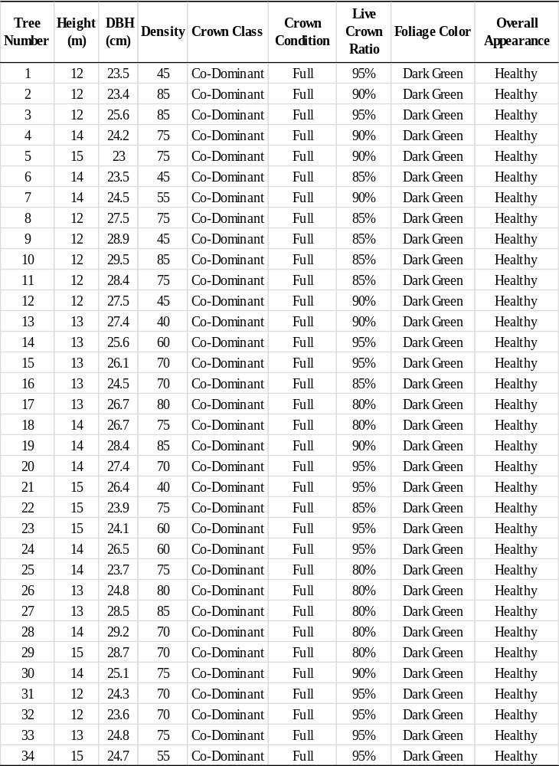

Table 12. Appendix A Continued.
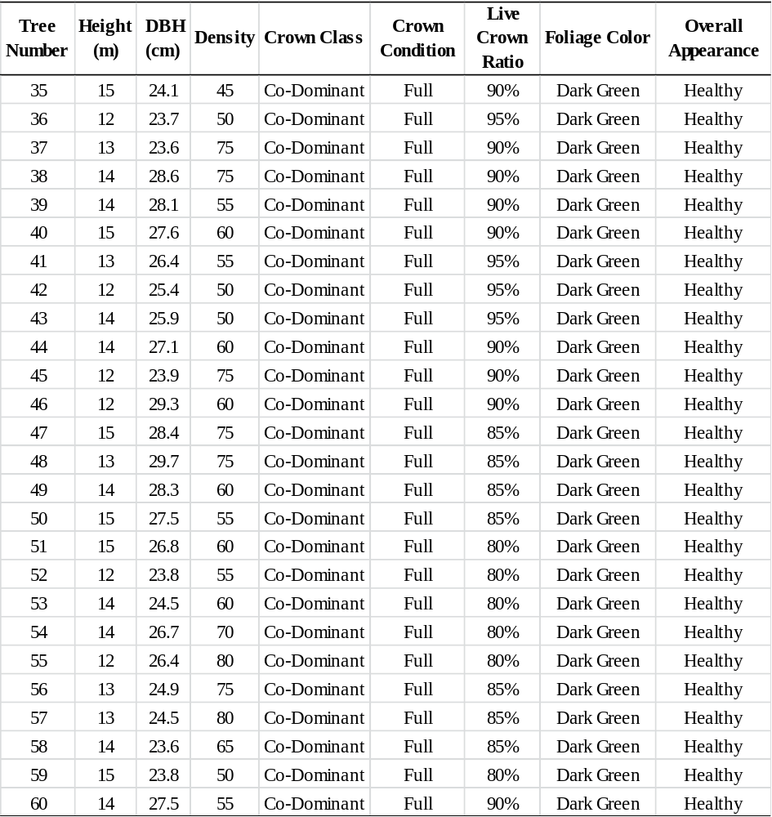

Table 13. Appendix B. Tree characteristics for trees evaluated in chapter 3 at Coal Creek Recreation Area in Oliver Springs, TN.
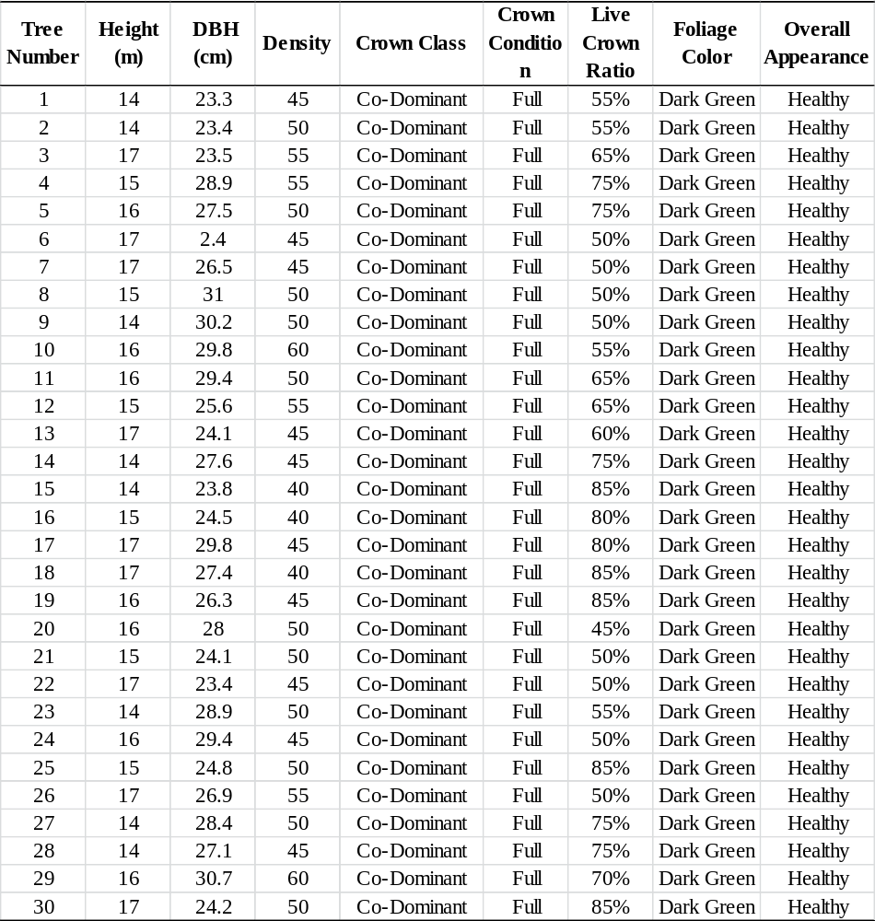

VITA

Carla Irene Coots was born in Mechanicsburg, Pennsylvania, on December 3, 1975. She grew up in Mechanicsburg, Pennsylvania, where she graduated from Mechanicsburg Area High School in 1994. Carla earned a Bachelor of Science in ecology and evolutionary biology and a Bachelor of Arts in anthropology from Ohio State University in December 2004. She came to the University of Tennessee in January of 2005, where she worked as a research assistant/lab technician in the Department of Forestry, Fisheries, and Wildlife. In August 2007 she completed her Masters of Science program at the University of Tennessee in the Department of Entomology and Plant Pathology under the direction of Dr. Paris Lambdin. In August 2007 she began her Ph.D. program the University of Tennessee in the Department of Entomology and Plant Pathology. During her time in the doctoral program at the University of Tennessee, she gave numerous oral and poster presentations and has received awards for teaching and research. Carla Irene Coots is a member of the Entomological Society of America, Ecological Society of America, Tennessee Entomological Society, Pennsylvania Entomological Society, Association of Southeastern Biologists, and Gamma Sigma Delta Agricultural Honor Society.

